Achieving a Quantitative Understanding of Quorum Sensing Systems using Synthetic Isotope Labeled Internal Standards for Isotope Dilution Mass Spectrometry and Distinguishing Metabolic Profiles of Rat Insulinoma cells via Tandem Mass Spectrometry

A Thesis Presented for the

Master of Science

Degree

The University of Tennessee, Knoxville

Mary E. Eisenhauer

August 2011

Copyright © 2011 by John X. “This Page is Optional” Doe
All rights reserved.

DEDICATION

ACKNOWLEDGEMENTS

ABSTRACT

TABLE OF CONTENTS
INTRODUCTION 1
CHAPTER I Achieving a quantitative understanding of QUORUM SENSING 2
Abstract 3
backgroung and significance 5
Quorum Sensing 6
AI-2 mediated Quorum Sensing 7
N-Acylhomoserine lactone mediated Quorum Sensing 8
Biosynthesis of Quorum Sensing molecules 10
Vibrio harveyi and Escherichia coli Background 11
Analytical methods 13
High Performance Liquid Chromatography Tandem Mass Spectrometry 14
Isotope Dilution Tandem Mass Spectrometry 16
RESULTS AND DISCUSSION 16
Design Rationale for the Synthesis of Stable Isotope Labeled AHLs 17
Synthesis of Deuterated N-Acyl Homoserine Lactones 18
Separation and Detection of AHLs and AI-2 21
Profiling Bacterial Species for Autoinducer production 22
Results: Vibrio fischeri 23
Results: Edwardsiella tarda 26
Characterization of an enteropathogen 27
Results: Yersinia enterocolitica needs work 27
EXPERIMENTAL 29
General Methods 29
Bacterial Strains and Growth conditions 29
Chromatographic Details for AI-2 29
Chromatagraphic Details for AHLs 29
General Mass Spectrometric Detection parameters for both AI-2 and AHLs 30
Measurement of AI-2 concentration [AI-2] 30
Measurement of AHL concentration(s) [AHL(s)] 30
Data Handling for the calculation of [AI-2] 31
Data Handling for the calculation of [AHL(s)] 31
Measurement of Glucose Concentration by Colourimetric Glucose Oxidation Assay 31
N-Boc-(4,4-²H₂)homoserine-α-OtBu ester, # 32
N-Boc-(4,4-²H₂)homoserine-γ-OMs-α-OtBu ester, # 33
N-Boc-(4,4-²H₂)methionine-OtBu ester, # 34
(4,4-²H₂)methionine, # 34
N-Fmoc-(4,4-²H₂)methionine, # 35
Representative N-Fmoc-(4,4-²H₂)methionine resin loading protocol 35
Representative synthesis of (²H₂) AHLs, N-hexanoyl-(4,4-²H₂) acylhomoserine lactone 36
References 36
Appendix 36
CHAPTER II METABOLOMICs- title 37
Background and significance 39
Metabolomics Background 39
Metabolic profiling vs. fingerprinting 40
Sample Type 41
Sampling and Extracting 41
Analytical methods 42
Mass Spectrometry Based Metabolomics 42
Data Analysis 44
Pancreatic B-cell death 44
Pancreatic β-cell death is likely the result of a non-apoptotic mechanism 45
RESULTS AND DISCUSSION 47
Distinction between cell death via exposure to pro-inflammatory cytokines versus genuine apoptosis inducers 47
Metabolic profiling by Tandem Mass Spectrometry 48
EXPERIMENTAL 51
General Methods 51
Cell Extraction Procedure 51
Chromatographic Details 51
Mass Spectrometric Detection Parameters 52
Data Handling and Statistical Anaylsis 53
References 54
CONCLUSION 55
Heading 2 55
VITA 56

LIST OF TABLES

Table 1. Table title. 6
Table 2: This Is The Second Table Error! Bookmark not defined.

LIST OF FIGURES

Figure 1. Shapes. 47

INTRODUCTION
Life in all of its forms is fundamentally chemical in nature. At the unique intersection of chemistry and biology, chemistry is the universal language which governs all biological systems. Over the years, the discipline of chemical biology has grown to include the tools of the core disciplines of chemistry such as analytical and synthetic chemistry. Applications of these tools have been essential for the probing and understanding of relevant biological problems.

CHAPTER I
Achieving a quantitative understanding of QUORUM SENSING

A version of this chapter was originally published by John X. Doe and Juanita Q. Vera:
John X. Doe, Juanita Q. Vera. “Towards A Theory of Page Rage.” Journal of Infomatic Bloat 221 (2009): 102-105.

The student must add a brief explanatory statement at the beginning of each article, stating how the article was revised and/or detailing the student’s involvement in the article. Any co-researchers should be identified and their role clarified as part of this statement.

Abstract
The quorum sensing signal AI-2 is thought to be an interspecies signal, and while its signaling abilities are not disputed in all cases, there has been evidence of an alternative use for AI-2. Its biosynthesis is linked to the activated methyl cycle, which has raised the question as to whether its function is strictly signaling, metabolic or a combination of the two. Conversely, only Gram negative bacteria are known to produce the quorum sensing signals N-acyl homoserine lactones (AHLs), or AI-1s. These molecules are produced by an intersection of two biosynthesis pathways that ordinarily serve unrelated metabolic functions. Often, one species will produce more than one AHL and/or integrate a different class of quorum sensing molecules such as AI-2. Our lab has designed a strategy for the determination of the role of AI-2 through detection and quantification, and previous studies employing these strategies have led to a basic definition of quorum sensing. Currently, there are no such tools available for the quantitation of AI-1s. From here we aimed to develop a similar set of tools for the detection and quantitation of AHLs. First, we have designed and carried out a synthesis of stable isotope labeled AHLs that incorporates the use of solid phase techniques, and has produced any AHL sought-after, due to the strategic placement of the isotope into the conserved lactone core. With these stable isotopes in hand, we then sought to develop chromatographic and spectrometric methods in order to use the technique of isotope dilution tandem mass spectrometry. Using all the tools developed by our lab, we were able to accurately quantitate exact concentrations of AHLs from biological samples, as well as continue to probe these species for AI-2 production, to begin to understand the relationship between these different quorum sensing systems.

backgroung and significance
For many years it had been postulated that the bacterial world possessed a means by which cooperative behaviors could ensure that the efforts of many outweighed the efforts of few. It was noted that the communal nature of bacteria was beneficial for survival.^{ref} While intrinsically interesting, the methods by which many bacteria communicate with each other are of particular interest because of their physiological implications. One of these methods consists of the synthesis, accumulation, and recognition of small diffusible molecules that has been termed quorum sensing. Quorum sensing was first discovered decades ago, but it has gained interest recently due to the role this mechanism plays in biofilm formation. Understanding the underlying mechanisms of biofilm formation is of importance because of the role they play in chronic infections persistent in diseases such as cystic fibrosis.^{1, 2} Several pathogenic bacteria have been found that produce quorum sensing-dependent biofilms, and many of them are antibiotic resistant. The ability to interrupt these quorum sensing pathways could potentially lead to novel anti-infective agents that have several advantages over traditional agents. Though many significant discoveries have been made, there is still more to be understood about quorum sensing and the molecules involved. One basic problem is the lack of a definition of the term quorum sensing. Currently, the term is used to encompass all phenotypic expressions which are found to be regulated by the production and recognition of diffusible chemical signals, regardless of whether the purpose is to transmit information on local cell density. However, it is becoming more evident with increasing interest, that the pathways and mechanisms of quorum sensing circuits are more dynamic, diverse and complex than originally thought. For example, there are now many reports of bacteria that posses quorum sensing machinery, yet do not employ quorum sensing molecules in order to measure cell density. Conversely, other bacteria utilize multiple quorum sensing molecules and systems in order to regulate a single behaviour. There are many questions about this sometimes oversimplified mechanism that need to be answered if a definite and comprehensive understanding of quorum sensing molecules and pathways is to be achieved. The analytical techniques that have been used previously have been focused toward the detection of these quorum sensing molecules in biological systems. If the original thought that the production of these molecules is strictly a means for bacteria to essentially “count” cell numbers, then quantifying these molecules should be the next logical step in determining the information content of signaling molecules. It is our belief that characterizing the function of quorum sensing on an individual basis will begin with the quantitation of quorum sensing molecules. The work presented in this chapter is built upon the tools previously employed by our lab for the quantitation of quorum sensing molecules, and demonstrates the effectiveness of synthetic isotopically labeled internal standards coupled with unbiased and sensitive analytical techniques for quantiation in a variety of bacterial species.

Quorum Sensing
Quorum Sensing is the term that has been given to the unique capability by which bacterial communities monitor population and adjust behaviors accordingly, allowing them to adapt to different environmental factors and ques. This is accomplished by a variety of small diffusible signaling molecules, and there are now many known examples of signaling mechanisms in a broad range of bacteria that act as quorum sensing systems. The mechanisms have been shown to be cell density dependent; while each single cell may emit a low concentration of these small molecules, at high cell densities high concentrations of signal will consequently be reached¹ (Figure 1).
Figure 1: Quorum sensing is cell density dependant.
Thus, a quorum is necessary for the community to recognize its own minimal population density in order to regulate gene expression. The physiological processes and behaviors that are regulated by the gene expression resulting from quorum sensing are usually thought to be beneficial to the population and can range anywhere from biofilm formation to virulence depending on the species. Other examples include motility, bioluminescence, and anti-biotic resistance. One of the genes regulated by quorum sensing, discovered in early studies, is the production of the signaling molecules themselves which gives them their common name autoinducers (AI).
Quorum sensing can be interspecies or intraspecies. Major classes of intraspecies signaling systems include those of Gram negative bacteria, which produce N-acyl homoserine lactones (AHLs), or AI-1s³, and Gram positive bacteria, which produce cyclic peptides (AIPs)⁴. The interspecies signals that are variations of (S)-4,5-dihydroxy-2,3-pentandione (DPD), are known as AI-2, and have been found in both Gram positive and Gram negative bacteria⁵. Both types function similarly. The work presented in this thesis will focus on intraspecies AI-1 as well as interspecies AI-2 signaling molecule. Both AIs will be profiled in strains that utilize one or both signaling systems. The relationship between the two signaling pathways will be examined in species possessing both systems.

AI-2 mediated Quorum Sensing
Initially, it was thought that a quorum sensing molecule produced by a particular species was the primary means by which that species “talked” among its own kind. However, the only known quorum sensing signal common to both Gram negative and Gram positive bacteria, AI-2, is used throughout a wide variety of bacteria. The molecule was first discovered in 19XX by [NAME] and its structure was elucidated in 19XX by [NAME]. AI-2 in its active form has many different chemical forms. Each species recognizes a different chemical from. As shown in Figure 2, it can spontaneously rearrange and can also be hydrated or borated. Its synthetic precursor, DPD, is synthesized by the LuxS enzyme.⁶ LuxS was identified by [NAME] as the AI-2 synthase in 1999, although this
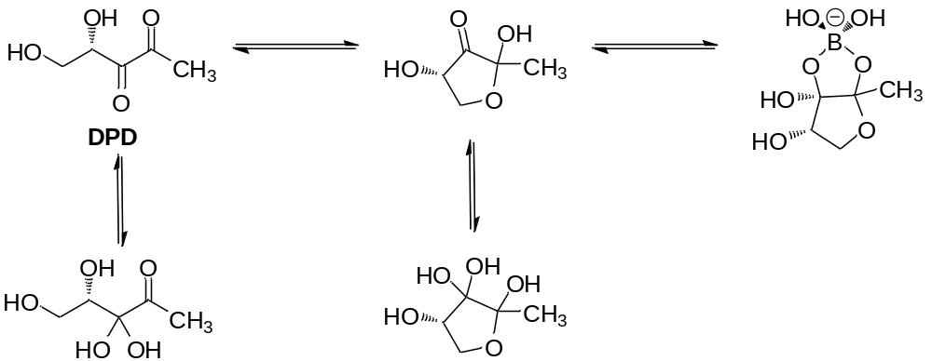
Figure 2: (S)-4,5-dihydroxy-2,3-pentandione (DPD) spontaneously rearranges, hydrates or borates to form different chemical forms

enzyme had previously been identified in 1960 as a part of the activated methyl cycle.^{ref} This enzyme is well conserved; nearly half of all sequenced bacteria, both Gram positive and Gram negative, contain a LuxS homologue lending support to the idea that AI-2 is an interspecies signal.⁵

N-Acylhomoserine lactone mediated Quorum Sensing
Many gram negative bacteria produce one or more acylated homoserine lactone molecules to be utilized as signaling molecules. AHL-mediated quorum sensing was first identified in V. fischeri.^{3, 7} The molecule produced was identified as (3S)-N-[3-oxo-hexyl]-homoserine lactone. From here, several other signaling systems were identified in a wide range of species.^{1, 3} Once thought to be unique to marine bacteria, it is now clear that AHL signaling is a well conserved regulatory system that is widespread throughout Proteobacteria.^{ref}
The process by which quorum sensing bacteria produce and utilize AHLs has been extensively studied and is relatively well characterized. Mechanistically, it is fairly simple. Acyl homoserine lactones are synthesized by a family of proteins of the LuxI-

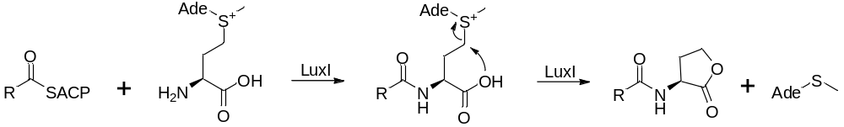
Scheme 1: A proposed mechanism for the biosynthesis of N-acylhomoserine lactones (AHL)
type. When the quorum is reached, another protein, encoded in the same lux operon, of the LuxR-type detects and interacts with the AHLs, which then causes changes in genotypic and phenotypic expression by transcriptional activation.^{3, 8} These complexes catalyze the formation of the amide bond between the amino group of S-Adenosyl methionine (SAM) and the acyl chain from an Acyl carrier protein (ACP).¹ Scheme 1
depicts a proposed mechanism by which AHLs are synthesized by LuxI. The acyl chains can vary in length but are usually even numbered due to the fact that they are originated in lipid synthesis pathways. They may also be unsaturated, have branching or be oxidized in the 3 position (Figure 3). AHLs are named by the chain length and by additional substituent in the 3 position. Given that the synthesis of these molecules involves the integration of two biological pathways that ordinarily serve different purposes, it raises the question as to whether quorum sensing is strictly that, or if there is a metabolic implication for the production of AHLs.

Biosynthesis of Quorum Sensing molecules
The activated methyl cycle (AMC) is a major metabolic pathway responsible for the recycling of sulfur containing amino acids as well as the methylation of important biomolecules such as DNA and RNA. In this cycle S-adenosyl methionine (SAM) is produced by a reaction with methionine and adenosine triphosphate (ATP), catalyzed by the enzyme MetK. SAM is then converted into S-adenosyl-homocysteine (SAH), and then detoxified to generate S-ribosyl homocysteine (SRH). The pinnacle enzyme LuxS,

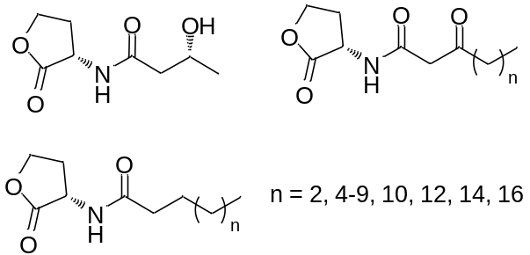
Figure 3: N-acylhomoserine lactones (AHLs)
AHLs are named by their chain length and by substituent in the 3 position.

which catalyzes the conversion of SRH to homocysteine, is consequently responsible for the production of AI-2 in the same process. Eukaryotes often replace the former two
step process with a single conversion of SAH to homocysteine by the enzyme S-adenosyl-homocysteine hydrolase (SahH).^{ref} The conversion of homocysteine back to methionine then completes the cycle, as shown in Figure 4.
AI-1 or AHL production is also linked to the activated methyl cycle, as it is synthesized directly from SAM by LuxI. Further, the acyl chain of ALHs is delivered directly from an acyl carrier protein either from lipid synthesis pathways. The realization that both of these quorum sensing molecules are tied to biological pathways that ordinarily serve an alternative purpose, have raised questions as to the purpose of these molecules in various bacterial species. An alternative thought is that the production of these molecules is simply a metabolic side product.

Vibrio harveyi and Escherichia coli Background
The quorum sensing circuit that utilizes AI-2 was first discovered in Vibrio harveyi, and since then, several homologues of LuxS have been identified in a wide variety of bacteria.⁹ V. harveyi also utilizes AI-1 quorum sensing. It has been shown that this species uses both of these systems to regulate bioluminescence and that their biological pathways converge.¹⁰ Because of this unique intersection it has been

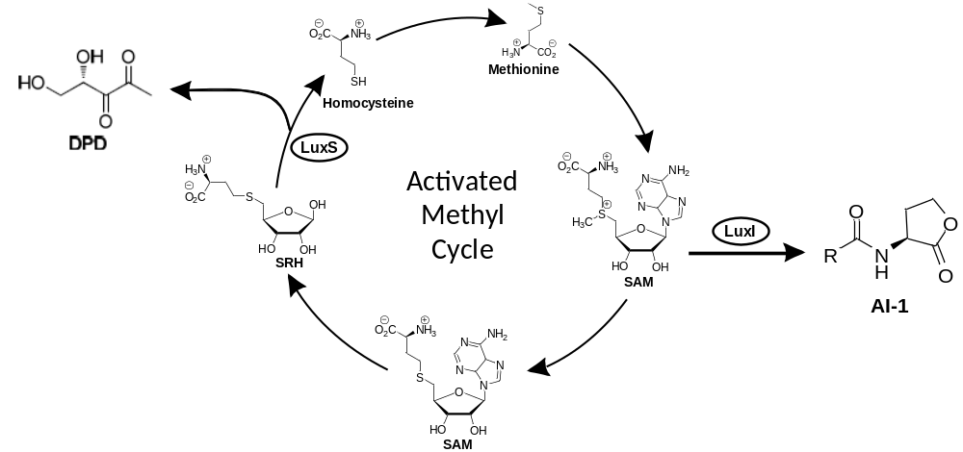
Figure 4: Both AI-2 and AHL production are linked to the activated methyl cycle. LuxS catalyzes the formation of homocysteine from SRH while also producing DPD. AI-1s, or AHLs, are produced from SAM by the enzyme LuxI.

hypothesized that the integration of these two different systems allows V. harveyi to identify itself from other species.
Escherichia coli is of interest due to the fact that it is known to contain AI-2 producing
and transporting enzymes, although it does not appear to use them for quorum sensing signaling.⁵ Figure # shows the quorum sensing pathways found in E. coli. Of interest is the AI-2 receptor, LsrB, which upon recognition of AI-2, upregulates the importation and catabolism of AI-2.^{ref} This has led to the belief that AI-2 has a strictly metabolic purpose in E. coli. In studies conducted by our lab, these two species were selected for investigation in order to gain a molecular definition of quorum sensing.¹¹ The central hypothesis was that if the bacterial species of interest was indeed using AI-2 to transmit information about cell density, then the concentration of AI-2 per cell number should remain constant under all conditions, including time, growth phase and most importantly, nutrient conditions. DPD concentrations in E. coli, and DPD and HAI-1 (AI-1 produced by V. harveyi) concentrations in V. harveyi, were monitored as cultures grew
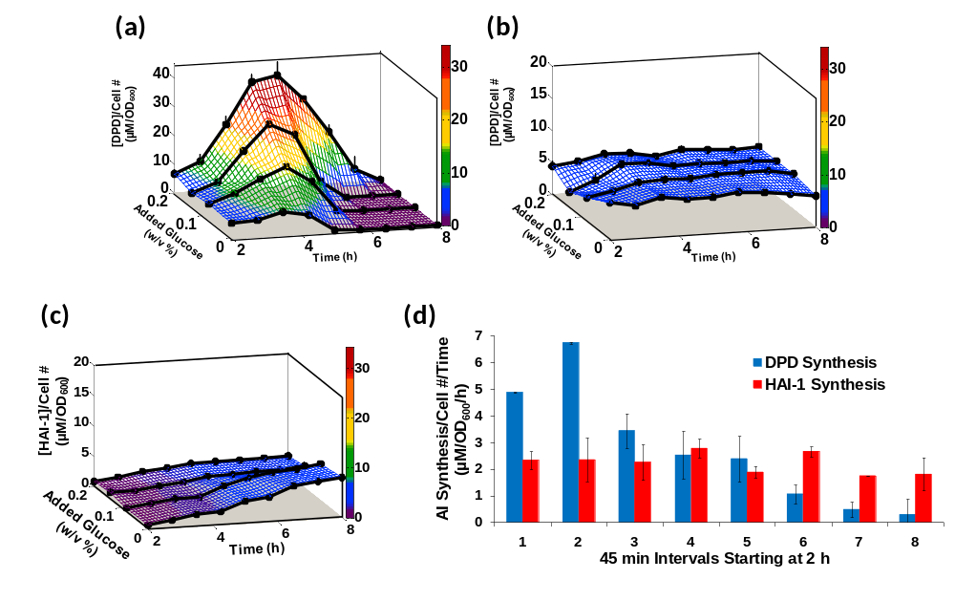

Figure 5:
from exponential to stationary phase. Each species was grown with one of four different glucose concentrations, 0.0, 0.08, 0.14, or 0.20% (w/v). As glucose concentrations
increased, i.e. added nutrients increased, neither E. coli nor V. harveyi demonstrated a considerable increase in cell density. It was found that [DPD]/cell density in E. coli varied from 4.8 ± 0.5 to 39 ± 4.8 µM/OD₆₀₀, indicating that E. coli is not capable of regulating cell density information without regulation of metabolism (Figure 5a). Conversely, [DPD]/cell density in V. harveyi remained nearly constant under all the glucose concentrations (Figure 5b), indicating its use as a quorum sensing signal. When [HAI-1]/cell density was examined, the ratio did increase from 0.7 ± 0.2 to 6.6 ± 0.4 µM/OD₆₀₀. (Figure 5c), however with added glucose concentrations, [HAI-1] showed no significant changes during exponential phase. This led us to believe that HA1-1 is not used as a quorum sensing signal in V. harveyi. Additionally, the rate at which V. harveyi produces DPD decreased over time, while the rate of production of HAI-1 stayed constant (Figure 5d).
The initial studies of these two species are what led to the following definition of quorum sensing¹¹:
$$\frac{extracellular signal concentration}{cell density} =constant$$

These studies effectively validated a method by which future studies on a wide variety of bacteria could be studied. Using this definition of quorum sensing, [AI-2] can be quickly screened for in various bacteria to determine if the species of interest uses AI-2 as a quorum sensing signal.

Analytical methods
Methods of detection for both AI-2 and AHLs have included bioassays, chromatography, and spectrometry.¹ Previously, many of the reported studies had focused on genomics and proteomics, or the genotypic and phenotypic expression of quorum sensing-dependant behaviors such as the observation of bioluminescence in order to detect the presence of autoinducers in biological samples. The function of AI-2 and other autoinducers has also been studied by constructing and utilizing luxS and other genetic mutants.
Bioassays are used mainly for detection and often rely on reporter strains to obtain quantitation.¹³ Several different methods of detecting and even quantifying AI-2 and AHLs have been reported. Up until now, the most widely used method for detecting AI-2 was the V. harveyi bioassay. Quantitation with this method is problematic as this method has a very small linear range and is not very reproducible. Other problems with detecting AI-2 are that it has many chemical forms, it degrades upon concentration and has no chromophore. In the case of AHL detection, crucial drawbacks of bioassay methods are that sensitivity varies greatly between different AHLs, and a different assay is needed for different species of bacteria. Although these methods were initially useful in determining the presence of AIs, they are lacking in the ability to produce a quantitative understanding of quorum sensing molecules. One of the earliest quantitative methods developed was a radioactive assay in which [1-¹⁴C]-L-methionine is incorporated into production of AHLs via SAM.¹⁴ Using this method, relative amounts of AHLs can be quantified, however the use of [1-¹⁴C]-L-methionine is costly, and this method failed to identify all of the AHLs previously reported for the bacteria of interest suggesting a lack of sensitivity. Gas chromatography combined with mass spectrometry has also been implemented for the identification and quantitation of [AHL].^{15, 16}

High Performance Liquid Chromatography Tandem Mass Spectrometry
Profiling of AHLs have been completed using LC/MS techniques and have been successful in establishing a methodology in which semi-quanititative information can be rapidly produced.^{17, 18} While our approach uses similar technology, it ultimately provides direct quantitation that combines a number of preferred attributes not previously seen before in the field. Using high performace liquid chromatography tandem mass spectrometry in conjunction with selected reaction monitoring (SRM) produces a method that is adequately sensitive, facile and universal. This method was first used for the detection and quantitation of [AI-2] by our lab in the V. harveyi and E. coli experiments with good results.¹⁹ After separation by liquid chromatography, samples can be analyzed by the method of selected reaction monitoring events (SRM) on a triple quadrupole mass spectrometer. In this method a precursor ion of m/z is selected in the first quadrupole. This parent ion is then fragmented in the second quadrupole and a characteristic fragment of the ion is selected in the third. This allows compounds of the same mass to be separated as well as co-eluting compounds. This method is perfectly suited for detection of AHLs as they have two specific fragmentations reactions, both of which can be detected by SRM (Scheme 2a). In the case of AI-2, the chemical
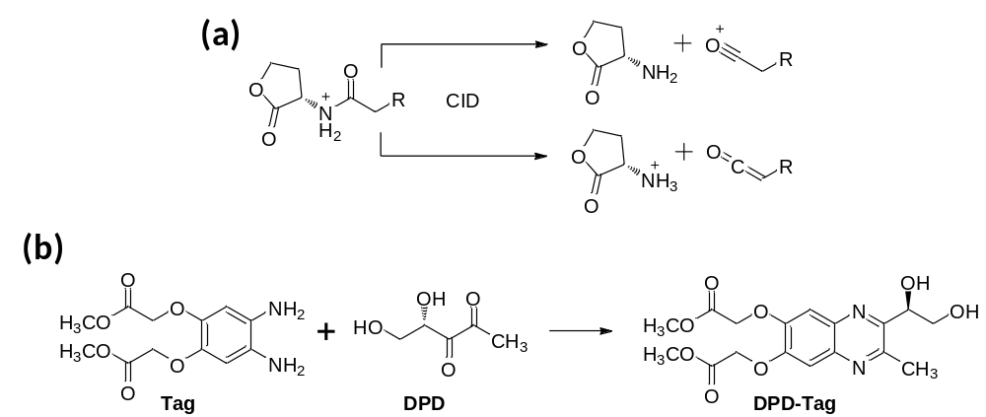
Scheme 2:

properties of DPD have made its detection difficult. Our lab has designed a method by which DPD is first derivatized (Scheme 2b).¹⁹ As a stable quinoxline, it can then be detected with ease by the techniques just described.
Another advantage to the use of these techniques is the availability of methods previously developed by our laboratory metabolomics (see Chapter II). If desired, approximately 200 known metabolites, at least one from every major biosynthetic pathway, could be detected and measured. Being able to monitor concentrations of metabolites would be useful in answering questions concerning AI’s role in metabolism because of their links to specific metabolic pathways. Major disturbances in important biological pathways could result in changes in metabolite concentrations which would be detectable by MS.

Isotope Dilution Tandem Mass Spectrometry
Quantitative analysis of naturally occurring [AI-2] and/or [AHL(s)] from biological samples is best accomplished by addition of isotope labeled internal standard in conjunction with the techniques just described. This technique, called isotope dilution mass spectrometry, is a useful tool for exact quantification due to its high accuracy and sensitivity at low concentrations, and eliminates the need to construct an external calibration curve. Isotope labeled versions of autoinducers of interest were added to the collected biological sample and analyzed by LC-MS/MS techniques described. Difficulties arise with attempts to quantitate without the use of isotope labeled internal standards. Differences in factors such as media, bacteria, and phases of growth contribute to matrix effects.¹⁷ Because isotope dilution involves isotopes of the compound to be analyzed, chemical effects and biological matrix effects are eliminated as both compounds are affected equally. Using SRMs, compounds can be separated by mass and the relative ratio of unlabeled to labeled provides accurate quantitation of the natural product.

RESULTS AND DISCUSSION
To move away from observation-based methods, we sought to first profile different bacterial strains of interest for AHLs as well as AI-2 and then quantitate their concentrations ([AHL]), ([AI-2]). The backbone of the work presented in this thesis implements the use of liquid chromatography-mass spectrometry techniques to obtain direct quantitation of various natural autoinducers produced by multiple bacterial species during normal growth cycles. Combining the use of stable isotope labeled versions of autoinducers and isotope dilution mass spectrometry, we were be able to quantify AI-2 and/or any desirable AHL, and through relatively straight forward and well detailed experiments, piece together the role that these molecules play in bacterial species that contain quorum sensing pathways. The preferred tools necessary for detection and quantitation include: the synthesis of stable isotopically labeled internal standards, and the ability to detect and separate these compound by LC-MS/MS techniques. Stemming from the initial V. harveyi and E. coli studies conducted by our lab, the work presented in this thesis uses similar methods and protocols with slight modification. A synthesis of ¹³C labeled AI-2 has previously been developed.^{ref} Therefore, the synthetic work pertaining to this thesis focuses on the development of a method for detecting and quantitating AHLs, although the bacterial species studied were indeed profiled for both AI-2 and AHLs. A logical design for the synthesis of doubly deuterated AHLs was proposed and completed and these molecules have been implemented in several biological studies. Further, chromatographic and spectrometric techniques for the detection of AI-2 have been improved upon. Methods for AHLs have been developed and refined to the point that future experiments can be executed with ease.

Design Rationale for the Synthesis of Stable Isotope Labeled AHLs
Although N-acyl-homoserine lactones have been made previously, their proteo-versions have only been used as reference compounds for chromatographic techniques.¹⁶ Use of isotope labeled acyl-homoserine lactones for the quantitation of [AHLs] has been reported²¹, however they did not take advantage of solid phase techniques. Furthermore, they failed to produce enantiomerically pure products. There were several specific goals when we first considered the synthesis of stable isotope labeled AHLs. The first goal was to easily and effectively produce all AHLs by using solid phase synthesis techniques. The reason for the use of solid phase chemistry was to increase yields and eliminate the need for further purification. Using this technique also enables the synthesis to be biomimetic. In order to easily produce any AHL desirable with minimal steps, the isotope should be incorporated in the conserved part of the molecule, in this case, the lactone ring. The proposed synthesis should have also yielded an enantiomerically pure product, which would further reduce the chance of the occurrence of matrix effects leading to invalid measurements. The incorporation of deuteriums as opposed to a ¹³C label is preferred due to the much lower natural abundance of deuteriums. Additionally, the use of two deuteriums, as opposed to the use of one, allows the internal standard to be distinguishable from the appearance of a natural ¹³C isotopomer.

Synthesis of Deuterated N-Acyl Homoserine Lactones
In order to implement the chosen method of incorporating any acyl chain into AHLs by using solid phase chemistry, we decided that (S)-[4,4,²H₂]-N-fmoc-methionine (6) would be a useful intermediate. Preceding the key solid phase steps of the reaction sequence, shown in Scheme 5, commercially available aspartate was protected and through a series of known steps,²² and was converted to (1). Initially, these steps yielded a racemic product, however changing protecting groups and modifying esterification conditions allowed us to obtain (1). Introduction of the isotopes began with converting the free acid of (1) with ethylchloroformate to the acyl ethyl carbonate. This intermediate allowed us to selectively reduce the acid over the t-butyl ester using NaBD₄ in D₂O to give (2) in 84 % yield. Mesylation of the resulting alcohol followed by a displacement reaction with NaSMe gave (4). Global deprotection of (4) with TFA gave (5). In order to introduce this molecule to the solid phase using standard solid phase conditions, protection with 9-Fluorenylmethyl succinimidyl carbonate gave (S)-[4,4,²H₂]-N-fmoc-methionine (6).
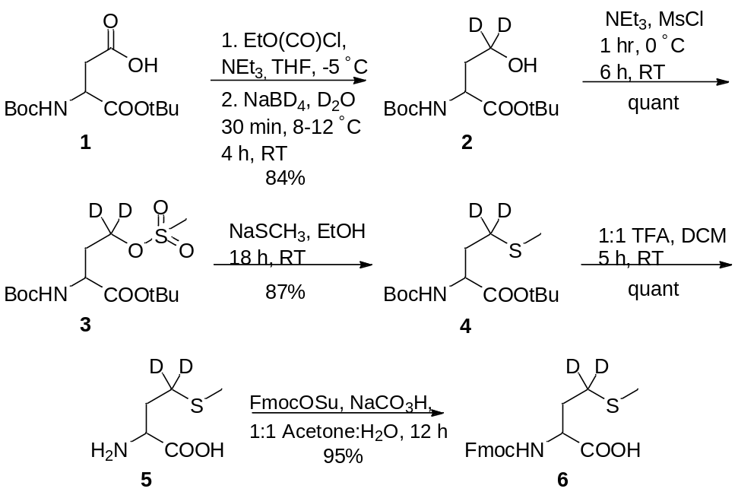
Scheme 3: Solution phase synthesis of (S)-[4,4,²H₂]-N-fmoc-methionine
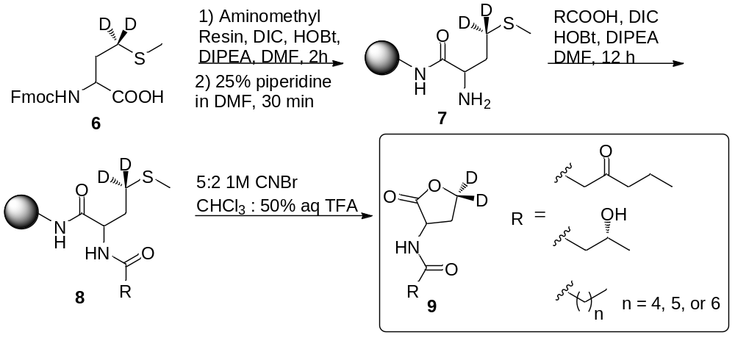Coupling of (6) to an aminomethyl polystyrene resin was accomplished with diisopropylcarbodiimide (DIC), hydroxybenzotriazole (HOBt) and Hünig’s Base (DIPEA) in DMF as shown in Scheme 6. The Fmoc goup was then deprotected with 25 % piperidine in DMF to give (7), followed directly by coupling of the acyl side chain using the same coupling conditions to afford (8). Acyl chains that were oxidized in the 3 position were protected with an ethylene glycol acetal. Treatment of (8) with 5:2 1M CNBr in CHCl₃ : 50% aqueous TFA for 24 hours allowed cyclization to form the homoserine lactone moiety and provided cleavage from the resin to give (9) without further purification. In syntheses involving acetal protection, cleavage conditions were sufficient for removing the protecting group. Although it was originally proposed to obtain enantiomerically pure product, initial results proved that racemization occurred readily, and at many points in the reaction scheme. This could be attributed to the basic conditions of the coupling reactions. An attempt to modify the synthesis and avoid these conditions was carried out. However, it was ultimately decided that the elegant nature of the original synthesis outweighed the one downfall of failing to obtain enantiomerically pure product. Additionally, it was not necessary for biological studies to utilize one enantiomer preferentially as bacterial systems do not produce their AIs as one enantiomer.
Scheme 4: Solid phase synthesis of various AHLs

Separation and Detection of AHLs and AI-2
As previously mentioned, the chemical properties of DPD and its various active forms have made its detection problematic. A simple derivatization, developed by our lab^{ref}, allows such complications to be avoided. Although it was not an initial focus of this project, a shorter 4 minute LC-MS/MS method was developed for the quantitation of AI-2. Using an isocratic gradient, the throughput for the analysis of biological samples was subsequently increased.
Previous methods for AHL separation have been long, ranging from ~30-50 minutes. Two shorter methods have been reported, although these methods used high column temperatures or atypical additives in the mobile phase such as ethylenediaminetetraaceticacid (EDTA). These conditions are often not suitable for most LC-MS methods. To ensure a high throughput for the detection and quantitation of multiple AHLs, a shorter, 12 minute, liquid chromatography method was developed. Addition of additives to the mobile phase such as EDTA was most likely done to prevent the formation of aggregates that the long hydrophobic chains of AHLs can form. To address this issue, 0.1% acetic acid in water was included in the mobile phase. Some bacteria only make short chain AHLs, while others make longer ones such as C12 and C14 AHLs. With a slight change in chromatography, conditions can be optimized for either scenario. Figure 6 shows the separation of the C8, C7, C6, 3-oxo-C6, 3-OH-C4 AHLs by time as well as by SRM, and table # shows the structure, abbreviations and SRMs of each AHL analyzed.
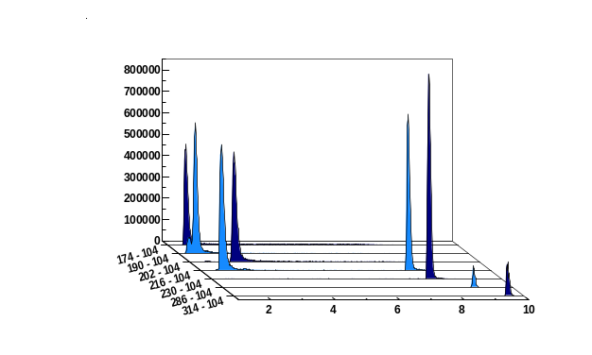

Profiling Bacterial Species for Autoinducer production
There are a variety of species of bacteria known to produce AI-1s and AI-2. Table # summarizes the strains that have already been partially studied by our lab as well as species to be used in future studies. These species were selected based on whether they possess a LuxS or LuxI homologue, availability, as well as the ability to grow them in the lab. Two wild type strains of Vibrio fischeri have been profiled for both AI-2 and AHL production. The ainS mutant of Vibrio fischeri, CL21, which lacks the ability to produce the C8 AHL as well as VCW2G7, the LuxI mutant were profiled for AHL production. Again, LuxI is responsible for producing the 3-oxo-C6 AHL. Ralstonia pickettii (data not shown), Edwarseilla tarda and Yersinia enterocolitica have all been profiled for AI-2 production. In each of these studies, AI production was monitored as cultures grew from exponential to stationary phase. Optical density was taken along the way to measure growth. And cultures were studied with added glucose concentrations of 0, 0.08, 0.14 %, or a combination of these.

Results: Vibrio fischeri
Initial studies were conducted on wild type stains ES114 (Figure 8a), and MJ-1 (Figure 8b) of Vibrio fischeri. Concentrations of various AHLs were calculated and plotted to visualize their production and degradation. Of particular interest were the identification of two unreported AHLs, C6 AHL and C7 AHL. The maximum concentrations of C6 and C7 AHLs reached were 0.047 ± 0.005 µM and 0.034 ± 0.007 µM, respectively, for MJ-1. Maximum concentrations of 3-oxo-C6 AHL and C8 AHL reached xx ± xx uM and xx ± uM respectively. While probing ES114 and MJ-1 for AHLs, production of AI-2 was also examined as wild type V. fischeri is known to produce DPD. Results for ES114 and MJ-1 (Figure 5a and c) show an expected increase in [DPD] during exponential phase with maximum concentrations reaching 1.79 and 1.29 µM, respectively. Figure 7 shows all of the autoinducers produced by MJ-1 and ES114. What was noted was that the onset of the production of the C6 and C7 AHLs occurred later in growth during stationary phase. In fact, the production of all AHLs in both MJ-1 and ES114 seem to happen sequentially with production of every AHL occurring during stationary phase after AI-2 production has ceased. This was an interesting result as we typically reason that AI production will increase as cell numbers are increasing exponentially. This result was unexpected and has brought forth further questions about production and utilization of multiple AHLs.
Further AHL studies were conducted on strains CL21, ainS⁻ mutant, (Figure 8c), and VCW2G7, luxI⁻ mutant, (Figure 8d) of Vibrio fischeri. Expected results for CL21 should indicate an absence in the production of C8 AHL. Surprisingly, results showed that no other AHL was produced. This could be a consequence of the absence of the C8 AHL, if they were indeed produced in a step-wise manner. Results for the luxI⁻ mutant indicated that the 3-oxo-C6 AHL was not produced in sufficient amounts however; the luxI⁻ mutant is a mutant of the ES114 strain of V. fischeri which also produces negligible concentrations of the 3-oxo-C6 AHL. Taken together, these preliminary studies of Vibrio fischeri have introduced the idea that the production of certain autoinducers in Vibrio fischeri may implicate a different means of communication, one not reliant on cell numbers.
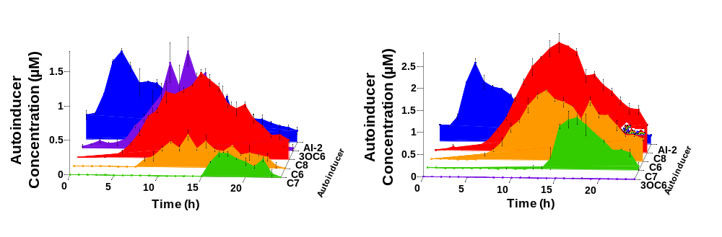
Figure 7:

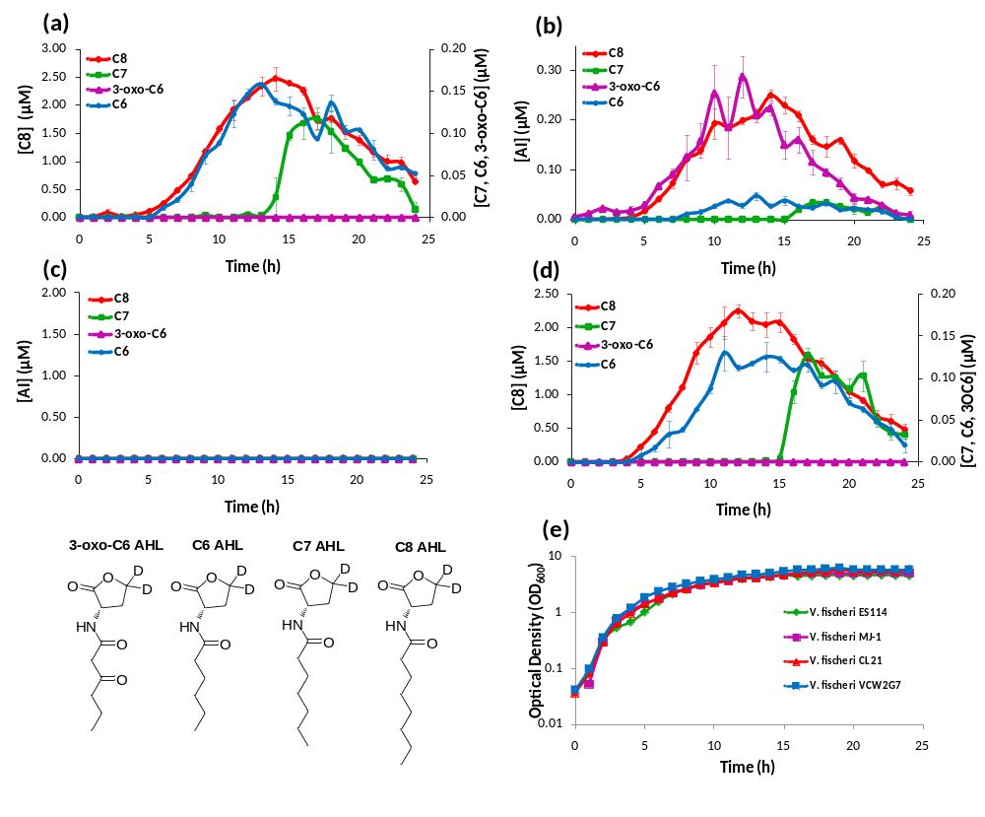
Figure #:

Results: Edwardsiella tarda
Edwardsiella tarda is a Gram negative pathogen. This particular species infects fish but is also found as a human pathogen. E. tarda was profiled for AI-2 production for 24 hours with glucose concentration of 0 and 0.14%. Results showed that AI-2 production reached a maximum concentration of xx ± xx µM and xx ± xx µM at 12 and 17 hours for the 0% and 0.14% glucose concentrations respectively (Figure 9). It was also noted that E. tarda grew at a slightly faster rate with the added glucose. Also, the duration of AI-2 production was extended for the culture with added glucose. No detectable concentration of AI-2 was found after 15 hours for the culture with no added glucose, while AI-2 production continued for an additional 5 hours in the culture with 0.14% (w/v) glucose. In both cultures, the detectable amounts of [AI-2] were found as both cultures entered stationary phase at approximately 6 hours.
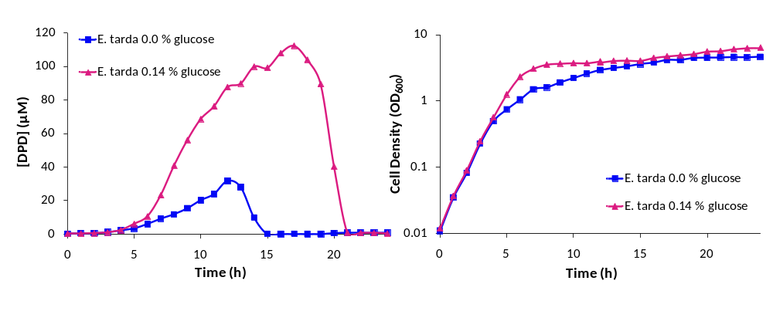
Figure #:

Characterization of an enteropathogen
Yersinia enterocolitica was the second pathogen that was studied. This species is a mammalian pathogen and because it belongs to the same genus as Yersinia pestis, otherwise known as the plague, it is of particular interest in the research community. Preliminary studies on Y. enterocolitica found that this species produced AI-2 in the µM range at a maximum of approximately 100 µM. As a focus, AI-2 production in the species Yersinia enterocolitica was characterized in two different mediums, and in all four different glucose concentrations. In each experiment, all measurements were taken in duplicate.

Results: Yersinia enterocolitica needs work
Yersinia enterocolitica was first profiled for AI-2 production in a brain and heart infusion (BHI) media, the standard for this species. It was profiled for 16 hours as it was found in the preliminary studies that this species hits stationary phase at approximately 8 hours and continued to produce DPD until 14 hours. Four separate experiments were conducted in duplicate. Glucose concentrations of 0, 0.08, 0.14, and 0.20 % (w/v) were added to the media prior to inoculation. In all of the concentrations, DPD production began as the cultures began to enter stationary phase and continued for 14 hours. In Y. enterocolitica, [DPD] increased with any concentration of glucose added and a maximum concentration of xx ± xx uM DPD was found. Concentrations of DPD in the 0.0 % glucose culture reached a maximum of xx ± xx uM. The maximum [DPD]/OD₆₀₀ in all of the glucose concentrations range from 28 ± xx uM to 36 ± xx uM. Results from the colourimetric glucose oxidation assay revealed that glucose levels in each culture dissipated to 0 % over the course of ~2-3 hours during the time that DPD concentrations were increasing. Because BHI contains 3 g glucose per 1 L, it was attempted to repeat these experiments, with the same conditions, in a medium that contained low glucose and sugar carbon sources such as LB. Results, as indicated by measurement of OD₆₀₀ showed that Y. enterocolitica grew similarly in LB as in BHI. When experiments were repeated with identical glucose concentrations, it was noted that the production of DPD then increased in maximum amount and with time as glucose concentrations increase as shown in figure #.
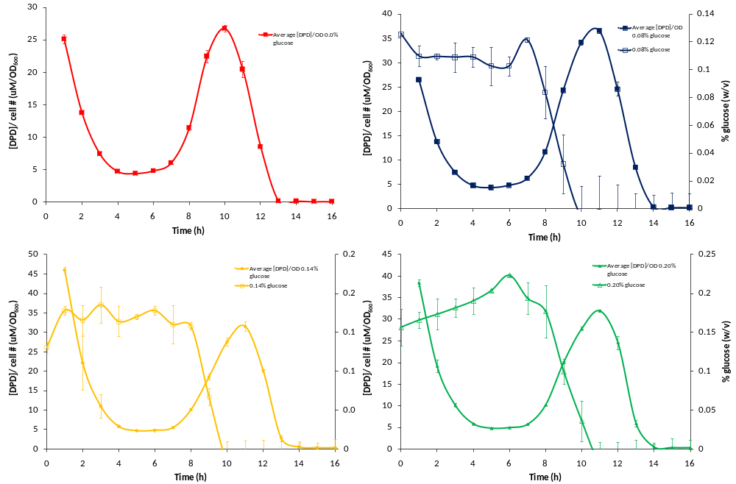

EXPERIMENTAL

General Methods

Bacterial Strains and Growth conditions

Chromatographic Details for AI-2
A 4 minute LC-MS/MS method for the separation and detection of AI-2 was developed that was built upon the previously reported 7 minute high performance liquid chromatography (HPLC) method.^{ref} For all samples, 10 uL was inject onto the column via delivery by autosampler. The column temperature was # and a XXX µL/min flow rate was used. In the new method, an isocratic gradient of 95% HPLC grade acetonitrile and 5% of a 1% acetic acid solution in HPLC grade water was used to elute the AI-2.

Chromatagraphic Details for AHLs
HPLC was used for the separation of various AHLs. For all samples, 10 uL was injected onto the column via autosampler delivery. The column temperature was 25 C and a flow rate of 200 uL/min was used. The HPLC mobile phases used were 0.1% Acetic Acid in HPLC H₂O (A) and HPLC grade Acetonitrile (B). These were used to develop the following 7 minute gradient elution profile: (t) 0 min, 99% solvent A, 1% solvent B; (t) 0.5 min, 95% solvent A, 5% solvent B; (t) 3 min, 90% solvent A, 10% solvent B; (t) 5 min, 25% solvent A, 75% solvent B; (t) 6 min, 25% solvent A, 75% solvent B; (t) 6.5 min, 99% solvent A, 1% solvent B; (t) 7 min, 99% solvent A, 1% solvent B.

General Mass Spectrometric Detection parameters for both AI-2 and AHLs
After delivery by HPLC, samples were introduced into the electrospray ionization chamber (ESI) through a 0.1 mm diameter fused silica capillary. The voltage for the ESI source was set to 4500 V. Detection of both AI-2 and AHL(s) occurred in positive mode. Nitrogen was used as the sheath gas (40 psi) and the inlet capillary temperature was 290C. Argon was used in the second quadrupole as the collision gas at a pressure of 1.5 mTorr. Samples were analyzed using selected reaction monitoring (SRM) with a scan time set to 0.05 s and a scan width of 1 m/z.

Measurement of AI-2 concentration [AI-2]
In each experiment, a preliminary growth curve was constructed in order to determine the time needed to reach stationary phase and was measured by optical density at 600 nM (OD₆₀₀). Once determined, the following procedure was used for each biological experiment conducted with limited modification necessary. Incubation temperature, growth medium, and duration of the experiment varied with the bacteria. Cell cultures were grown in duplicate. Every hour, a 300 µL sample was taken from each culture and placed into a 1.5 mL microcentrifuge tube containing a solution of ¹³C-DPD. The contents were then mixed thoroughly by vortexing and centrifuged to remove cells and other particulates. A portion of the supernatants (260 µL) were placed in a subsequent microcentrifuge tube containing 26 µL of DPD-Tag. The contents were allowed to react for 45 minutes before extraction with ethyl acetate (2 x 130 µL), followed directly by LC-MS/MS analysis.

Measurement of AHL concentration(s) [AHL(s)]
In each experiment, the [AHL] was measured as cultures grew from exponential phase through stationary phase in optimal conditions. A preliminary growth curve was constructed in order to determine the time needed to reach stationary phase and was measured by OD₆₀₀. Once determined, the following procedure was used for each biological experiment conducted with limited modification necessary. Incubation temperature, growth medium, and duration of the experiment varied with the bacteria. Cell cultures were grown in duplicate. Every hour, a 300 µL sample was taken from each culture and placed into a 1.5 mL microcentrifuge containing a solution of respective deuterated AHLs. The contents were mixed thoroughly by vortexing and centrifuged to remove cells and other particulates. The resulting supernatants (260 µL) were extracted two times with half volume of ethyl acetate and transferred to 300 µL autosampler vials. If an extraction could not be performed, supernatants were taken directly after centrifugation for analysis.

Data Handling for the calculation of [AI-2]
Data from the SRMs 381-202 and 382-203 (parent-product ion) at a collision energy of 41 eV were selected and analyzed by manual integration of chromatographic peak area to obtain [AI-2]. The SRM 381-202 and 382-203 corresponds to the ¹²C and ¹³C derivatized DPD quinoxilines.
Because [deuterated AI-2] was known, we were able to apply the following equation to obtain [AI-2]:
Two correction factors were applied

Data Handling for the calculation of [AHL(s)]
Data from the SRMs xx-xx, xx-xx, xx-xx etc. at a collision energy of 11 eV were selected and analyzed by manual integration of chromatographic peak area to obtain respective [AHL].

Measurement of Glucose Concentration by Colourimetric Glucose Oxidation Assay
At each time point, a 120 uL sample of culture was taken an placed into an empty microcentrifuge tube and centrigfuged ( XX ) to remove cell particulates. The supernatents (90 uL) were then placed in a separate microcentrifuge tube and immediately stored at -80 °C for analysis for the glucose oxidation assay. To obtain glucose concentration at each time point ([glucose]), an external calibration curve was first constructed in a 96 well plate by diluting 2 uL of a 40% (w/v) glucose solution into 198 uL of DI water followed by two-fold serial dilutions. The set of calibration included 0.4, 0.2, 0.1, 0.05 % (w/v) glucose. This calibration curve was then diluted 1:10 into LB (10 uL into 90 uL LB) in order to accommodate all glucose concentrations in the linear range of the assay. If multiple plates were used, one calibration curve from the first was diluted into the second for consistency. The calibrations were then used to generate a calibration equation by least-squares linear regression of the data. This varied with each plate but ranged anywhere from X to X %:
Equation
This equation was then used to calculate [glucose] at each time point in a given experiment. First 10 uL aliquot from each sample was diluted into 90 uL of LB on the same plate as the calibration curve. A 200 uL aliquot of a reagent^{ref} containing 0.30 M Tris, 0.36 M NaH₂PO₄2H₂O, 5.4 M glycerol, 1.0 mM o-dianisidine, 3kU/L peroxidase an 1 kU/L glucose oxidase type X in water was added to both the wells that contained samples and the diluted calibration curve and the plate was incubated at 37 °C for 15 hours. At this time, the absorbance at 500 nm was measured, and the [glucose] was calculated using the equation generated as described.

N-Boc-(4,4-²H₂)homoserine-α-OtBu ester, #
To a stirring solution of X (X g, XX mmol) and triethylamine (x g, X mL, XX mmol) in 50 mL anhydrous THF, at -5 °C, was added ethylchloroformate (x g, X mL, XX mmol) in # mL anhydrous THF via cannula addition. After stirring continuously at -5 C for 45 minutes a precipitate had formed. This precipitate was then filtered and the filtrate added dropwise over 30 minutes to a stirring solution of NaBD₄ (X g, XX mmol) in 7 mL D₂O at 10-12 °C. The reaction was then allowed to proceed at room temperature for 4 hours. After 4 hours, the solution was acidified with 1 M HCl to pH 2-3. The product was extracted with diethyl ether (3 X # mL), dried, filtered and concentrated in vacuo to give a yellow oil. The crude product was purified by silica chromatography eluted with 7:3 hexanes:ethyl acetate. Purified product (x g, xx mmol) was isolated in 85% yield as a clear oil.
R_{f} = 0.49 (1:1 hexanes:ethyl acetate); IR (neat) 3380, 2978, 2098, 1713, 1510, 1366, 1247, 1161 cm⁻¹; ¹H NMR (300 MHz, CDCl₃) σ 5.35 (d, J=7.5 Hz, 1H), 4.42-4.23 (m, 1H), 3.46 (s, 1H), 2.11 (dd, J=13.8, 3.1 Hz, 1H), 1.56-1.48 (partially under protons at 1.46 ppm, m, 1H), 1.46 (s, 9H), 1.43 (s, 9H) ppm; ¹³C NMR (XXMHz, CDCl₃) σ 172.00, 156.60, 82.28, 80.30, 59.16-55.74 (m), 50.86, 36.36, 28.25, 27.97 ppm; HRMS-DART (m/z): [M+H]⁺ calculated for C₁₃H₂₄²H₂NO₅ 278.19365; found, 278.19338.

N-Boc-(4,4-²H₂)homoserine-γ-OMs-α-OtBu ester, #
To a solution of # (x g, xx mmol), in anhydrous CH₂Cl_{2,} at 0 °C, was added triethyl amine (x mL, xx mmol) followed immediately by mesyl chloride (x g, x mL, xx mmol). After stirring at 0 °C for 2 hours, the reaction was allowed to warm to room temperature and proceed for an additional 5 hours. At this time, the reaction was concentrated in vacuo and immediately redissolved in CH₂Cl₂. This solution was washed with water (3 x # mL) and the water layers extracted with CH₂Cl₂ (3 x #mL). All organic layers were combined, dried with MgSO₄, filtered and concentrated in vacuo to give a yellow oil (x g, xx mmol, quant., 80% purity). This crude product was carried through to the next reaction without purification. An analytical sample was purified twice via silica chromatography eluted first with 9:1, hexanes:ethyl acetate and second by 100% pentane for ~3 column volumes then 1:1 pentane:ethyl actetate. The purified product was isolated as a white solid.
R_{f} = 0.32 (7:3 hexanes:ethyl acetate); IR (neat) 3381, 2979, 1715, 1513, 1358, 1249, 1166 cm⁻¹; ¹H NMR (300 MHz, CDCl³) σ 5.16 (s, 1H), 4.28 (d, J=4.2 Hz, 1H), 3.02 (s, 3H), 2.28 (dd, J=14, 2.6 Hz, 1H), 2.03 (dd, J=14.5, 7.5 Hz, 1H), 1.47 (s, 9H), 1.43 (s, 9H) ppm; ¹³C NMR (XX MHz, CDCl₃) σ 170.77, 155.35, 82.75, 80.09, 66.51-64.29 (m), 50.89, 37.30, 32.02, 28.28, 27.95 ppm; HRMS-DART

N-Boc-(4,4-²H₂)methionine-OtBu ester, #
To a stirring solution of # (xg, xx mmol) in x mL 95% EtOH was added a 15% aqueous solution of sodium thiomethoxide (x g, xx mL, xx mmol). The reaction was allowed to run for 8 hours at room temperature. At this time, a saturated solution of NH₄Cl was added to the reaction mixture until a white precipitate formed. The product was the extracted with ethyl acetate (3 x # mL) and the combined organic layers were dried, filtered and concentrated in vacuo to give # (x g, xx mmol) in 89% yield and 81% purity. The yellow oil was carried through to the next reaction. An analytical sample was purified via silica column chromatography eluted with 9:1 hexanes:ethyl acetate.
R_{f}= 0.68 (7:3 hexanes:ethyl acetate); IR (neat) 3354, 2976, 2928, 1795, 1508, 1541, 1364, 1248, 1192, 1048 cm⁻¹; ¹H NMR (300 MHz, CDCl₃) σ 5.12 (d, J=7.9 Hz, 1H), 4.21 (dd, J=12.5, 7.5 Hz, 1H), 2.10-1.95 (overlapping protons, m, 4H), 1.83 (dd, J=13.9, 7.5 Hz, 1H), 1.42 (s, 9H), 1.39 (s, 9H) ppm; ¹³C NMR ( XXMHz, CDCl₃) σ 171.35, 155.32, 82.08, 79.73, 53.41, 28.66-30.19 (m), 28.31, 28.00, 15.37; HRMS-DART (m/z): [M+H]⁺ calculated for C₁₄H₂₆²H₂NO₄S, 308.18646; found, 308.18597.

(4,4-²H₂)methionine, #
A 1:1 mixture of trifluoroacetic acid (TFA) and CH₂Cl₂ (14 mL), was added to a flask containing # (xg, xx mmol). After stirring for 5 hours the TFA was removed in vacuo to give a brown oil. This oil was washed 4 times with DCM to remove any additional TFA. Ethyl ether was then added to precipitate a white solid. The product was then extracted with water (2 x # mL) and the water layers were washed with ethyl ether (2 x # mL). The combined water layers were then concentrated in vacuo to give the TFA salt # (xg, xx mmol) in quantitative yield as a white solid. The product was carried through as the TFA salt in the next reaction. Trituration of the TFA salt in 95% EtOH solubilized the TFA and any impurities to give the pure sample after filtration for analytical analysis.
mp = 218 °C (decomp.); IR (KBr) 3440, 2952, 2762, 2659, 2106, 1583, 1414, 1338, 1259, 1156 cm⁻¹; ¹H NMR (300 MHz, D₂O) σ 3.79 (dd, J= 7.1, 5.4 Hz, 1H), 2.17-1.99 (overlapping protons, m, 5H); ¹³C NMR (XX MHz, D₂O) σ 174.13, 53.82, 29.41, 27.75-28.73 (m), 13.76; HRMS-DART (m/z): [M+H]⁺ calculated for C₅H₁₀²H₂NO₂S 152.07143; found, 152.07072.

N-Fmoc-(4,4-²H₂)methionine, #
To a stirring solution of the TFA salt of # (x g, xx mmol) was added sodium bicarbonate (x g, xx mmols) in 60 mL 1:1 acetone:water. After the reaction became homogeneous, Fmoc-OSu was added in one portion (x g, xx mmol). The reaction was allowed to run for 18 hours before the acetone was removed by evaporation under reduced pressure. The solution was then acidified with 1 M HCl to pH 2. The product was extracted with ethyl acetate and the combined organic layers were dried with MgSO₄, filtered, and concentrated in vacuo to give # (x g, xx mmol) as an off-white solid in 95% yield and 91% purity. The product could be coupled directly to the solid phase or purified via recrystalization from CH₂Cl₂:hexanes (77% recovery).
R_{f} = 0.166 (7:3 hexanes:ethyl acetate); mp = 144-146 °C; IR (neat) 3321, 3050, 1524, 1447, 1334, 1263, 1056, 746 cm⁻¹; ¹H NMR (500 MHz, CDCl₃) σ 7.77 (d, J= 7.5 Hz, 2H), 7.60 (s, 2H), 7.41 (t, J= 7.5 Hz, 2H), 7.32 (t, J= 7.5 Hz, 2H), 5.45 (d, J=7.6 Hz, 1H), 4.64-4.49 (m, 1H), 4.45 (d, J= 6.7 Hz, 2H), 4.24 (t, J= 6.8 Hz, 1H), 2.22 (dd, J= 13.8, 4.0 Hz, 1H), 2.11 (s, 3H), 2.01 (dd, J= 14.0, 7.9 Hz, 1H) ppm; ¹³C NMR (XX MHz, CDCl₃) σ 176.02, 156.12, 143.69, 141.36, 127.78, 127.11, 125.02, 120.03, 67.19, 52.94, 47.17, 31.27, 15.32; HRMS-DART (m/z); [M+H]⁺ calculated for C₂₀H₂₀²H₂NO₄S, 374.13951; found, 374.13825.

Representative N-Fmoc-(4,4-²H₂)methionine resin loading protocol
Amino methyl polystyrene resin (x g, xx mmol) was placed into a 5 mL peptide vessel and washed with DMF, H₂O, EtOH, Acetone and CH₂Cl₂. Approximately 10 mL of each solvent was used for each washing and vessel was agitated for ~5 seconds for each washing to insure removal of the prior solvent. To swell the resin after washing, 1 mL of CH₂Cl₂ was added to the vessel. In a vial, an activated solution of N-Fmoc-(4,4-²H₂)methionine, #, (x g, xx mmol), 1-hydroxybenzotriazole (HOBT), (x g, xx mmol), N,N-diisopropylcarbodiimide (DIC), (xg, xx mmol), and diisopropylethylamine (DIPEA), (x g, xx mmol) was prepared in 2 mL DMF. After the activated solution sat at room temperature for 15 minutes it was added to the peptide vessel containing the resin. The resulting solution was then shaken for 2 hours at room temperature. The resin was then filtered, and washed using the procedure described above. This material was then stored and used to synthesize various ²H₂ AHLs as needed.

Representative synthesis of (²H₂) AHLs, N-hexanoyl-(4,4-²H₂) acylhomoserine lactone
[TEXT]

References

Place references for this chapter here, or you can collect all of your references into a reference section at the end of the document (before the appendix if you have one for the entire ETD, and before the vita). If you have one reference section, the heading for this section should be treated as a major heading, and the title should get its own page.

Appendix

You can place references for this chapter here, or you can collect all of your references into a reference section at the end of the document (before the appendix if you have one for the entire ETD, and before the vita). If you have one reference section, the heading for this section should be treated as a major heading, and the title should get its own page.

CHAPTER II
METABOLOMICs- title

A version of this chapter was originally published by J. Jason Collier, Susan J. Burke, Mary E. Eisenhauer, Danhong Lu, Renee C. Sapp, Carlie J. Frydman, and Shawn R. Campagna.

J. Jason Collier, Susan J. Burke, Mary E. Eisenhauer, Danhong Lu, Renee C. Sapp, Carlie J. Frydman, and Shawn R. Campagna. “Pancreatic beta-cell Death in Response to Pro-inflammatory Cytokines is Distinct from Genuine Apoptosis.” PLoS one (2011): 102-105.

ABSTRACT

Background and significance

In the past 10 years, systems biology has grown in regards to technological platforms in which information can be investigated an interpreted on the molecular level, with the emergence of metabolomics being the newest of these platforms. The ability to accurately detect, identify and quantitate the metabolites present in living organisms can provide a wealth of information that complements other technologies such as genomics and proteomics in a variety of real world applications. This chapter focuses on one of those applications. Type 1 Diabetes is known to be caused by the reduction of β-cell mass due to the death of these cells. It has been proposed that the method of β-cell death proceeds by one of two mechanisms, necreosis or apotosis, and that these mechanisms are independent of each other and that one will prevail over the other preferentially.^{ref} Until now, Diabetes type 1 has been studied mainly by [genomic and proteomics] techniques. While these techniques are the standard in this field of research, a chemical approach, particularly at the level of metabolism provides a better representation of what is happening in a system in real time. In this chapter, a targeted mass spectrometry approach was used to measure the metabolome of rat islet β-cells, in an effort to determine a metabolic profile for the two proposed mechanisms of β-cell death.

Metabolomics Background

Biologists rely on a number of analytical techniques to study the often complex systems of living organisms. Starting at the genotypic level, there is what is described as the “omics” cascade that consists of all the technology from which systems biology research is conducted. The newest discipline to emerge is also closest to the phenotypic level and deals with the metabolome. The metabolome refers to the set of small molecule metabolites found in a biological sample, and the technological platform has been termed metabolomics. Currently, there is no single platform for the complete analysis of all the metabolites present in a single system, however, over the past 10 years there have been in increasing number of papers published that use metabolomics as an analytical technique, demonstrating its usefulness as an analytical tool.^{ref}
One possible reason that metabolomics has lagged behind other techniques such as genomics and proteomics is that the metobolome is often dynamic and complex. There are an estimated 2,000 major metabolites in mammalian organisms and up to ~200,000 in the plant kingdom and these compounds represent a broad variety of chemical classes with different chemical properties. Metabolite pools can change on the order of seconds and even slight environmental changes, such as a minor temperature change, can result in changes in the metabolome. Despite the challenges associated with metabolomics, one can easily recognize its benefits. Metabolism gives an accurate and timely view of the state of the system and is often associated with the overall well-being of the organism or cell.

Metabolic profiling vs. fingerprinting
The two major approaches to metabolomics include metabolic profiling and metabolic finger printing. In most cases, metabolic profiling refers to the analysis of a certain group of metabolites that is usually hypothesis driven and quantitative, also called a targeted analysis. An example would be the analysis of fatty acids in a mammalian tissue. An even more specific application is the selection of specific compounds for identification that may serve as biomarkers of a disease or toxin exposure. This type of targeted analysis can be useful in supporting the data collected from other technical “omics” platforms.
Conversely, metabolic fingerprinting is the global analysis of samples with the intent to obtain a characteristic metabolite pattern or “fingerprint” and therefore, inherently an untargeted approach. This application is useful in showing the overall change in metabolism in response to a treatment or alteration such as genetic manipulations. Regardless of the sample or application, the steps leading to a metabolomics data set are the same: sample collection, extraction, analysis, data analysis.

Sample Type
Clinical applications of metabolomics have been useful in the field of human biology, where fluids, such as serums and urine, can be quickly analysed for changes in metabolic profiles in response to disease, diet, toxins etc. This application, however, only provides information on the metabolism of the organism as a whole, which usually provides no quantitative information, and can also result in the introduction of additional variables. When dealing with individual cell types, variables such as gender, environmental exposures, and contributions from different tissues, essentially become non-existent due to the fact that the sample is often derived from a controllable cell line as opposed to a human or animal model.

Sampling and Extracting

The sampling in a metabolomics experiment should be determined by the experimental design and type. In any case, the best results are obtained when the following are taken into consideration: replication and quality control. Inter-day and multiple-day replications should be taken in order to reduce biological variability. Additionally, the appropriate use of control samples and/or internal standards can greatly enhance the statistical validity of the data set. Once an experiment has been designed and the samples have been acquired, they must be handled with extreme care as to not cause any disturbances in the existing metabolome. Often this requires the use of cold temperatures to suspend metabolism. Some techniques used include flash freezing, freeze clamping or immediate quenching. In cases where the metabolome is not immediately extracted, the sample should be kept cold and the length of time before extraction should be kept constant between all samples. The extraction technique will vary with the experiment, but careful measures should be taken to ensure that all parameters of a given experiment remain the same for all samples to be analyzed once an extraction technique has been validated. Usually, the metabolome is extracted in order to separate the metabolites from the complex biological matrices in which they are found, however direct injection is one method of sample preparation. The extraction solvent should be suitable for the type of sample. For example, a cold methanolic solution is usually used for mammalian tissue^{ref}, whereas more complex solvents, such as [….], are typically used for bacterial cultures. Here, the use of an internal standard spike can provide another means by which the data set can be validated. It should be noted that in no experiment will the whole metabolome remain intact. The very nature of the sample preparation step will guarantee that some metabolites will be lost due to the fact that not all metabolites can be extracted by one method.

Analytical methods

After the sample has been collected and extracted, the final stages in a metabolomics experiment are the analyses of the metabolites which include: separation, detection, and if possible, quantification. Some of the requirements for obtaining scientifically relevant metabolomics data are that the instruments used for analysis have excellent sensitivity and resolution for a wide range of molecules, the ability to work with a variable range of metabolite concentrations, relatively short analysis times, and reasonable reproducibility. Currently, the two most widely used methods for metabolic analysis are nuclear magnetic resonance (NMR), and mass spectrometry (MS). Both have their own particular advantages and disadvantages. With NMR, samples require minimal preparation which preserves the sample. NMR also offers the ability to directly quantitate the relative abundance of metabolites in a sample, which can be difficult to do with mass spectrometry.

Mass Spectrometry Based Metabolomics
Mass spectrometry has come to the forefront of metabolomics research since becoming a successful tool in drug metabolite analysis.^{ref} The application of modern mass spectrometry to cell culture metabolism is particularly useful because of its high sensitivity and possibility for metabolite quantitation. Several variations of mass spectrometry (MS) have been implemented to study metabolism. Of the simplest, direct injection has been useful for samples with sufficient metabolite content and concentrations such as urine.^{ref} The major drawback of this method is that the biological matrix in which the sample is located will usually reduce signal quality. Another problem associated with direct injection is the inability to distinguish between analytes of the same mass-to-charge ratio (m/z). When working with cell cultures, additional steps, such as the incorporation of chromatography, are typically required for the analysis of global metabolism. Variations such as GC and LC-MS are often used in order to increase the number of metabolites seen, however because of the complexity often involved with sample preparation in GC-MS, LC has taken a leading role in most MS metabolomics research. Considerations when choosing a LC-MS method include 1) separation of the metabolites from the biological matrix 2) separation using chromatography 3) analyte ionization 4) detection of the fragment 5) identification. Again, separation of the metabolome from the matrix as well as using chromatography is important for the overall signal quality; reduction of the number of analytes at a given time reduces the occurrence of ion suppression, and provides another level of specificity. The ionization method most widely used for metabolomics has been electrospray ionization (ESI).^{ref} ESI is a soft ionization technique that ionizes liquid samples directly into the gas phase which is well suited for LC-MS. The number of metabolites measured increases when both positive and negative ion modes are used. Metabolites such as amines will ionize best in positive ion mode while acidic metabolites such as phosphates will ionize better in negative mode. The two most common mass analyzers used in metabolomics directed research are time-of-flight (TOF) and quadrupole analyzers. As mentioned in the previous chapter, the preferred MS method used by our lab is detection by selected reaction monitoring (SRM) on a triple quadrupole mass spectrometer. Coupled with separation by high performance liquid chromatography, this method has the sensitivity and selectivity required to detect up to ~200 polar metabolites as developed by Rabinowitz and co-workers. The target experiments that will use this method will require that both the parent and product mass be known however, a library of the 200 metabolites was also created by Rabinowitz using chemical standards that will be used in the studies presented in this chapter.

Data Analysis
The data sets generated by MS metabolomics techniques are often large and complex. The first challenge encountered after data collection is the organization of these data into similar classes by correctly identifying each individual metabolite. Often, the differences in metabolite pools are of interest so it is imperative that metabolites are identified correctly. The use of chemical standards and databases can greatly enhance identification although these tools are still in the beginning stages of development. Software for the identification and selection of chromatographic peaks has been important for evaluation of untargeted metabolomics data sets. Once the metabolite has been identified, certain normalization factors will often be applied to the raw data in order to correct for variability in the experiment. Once these have been applied, the final task is to assemble the data for visualization.

Pancreatic B-cell death
Type 1 diabetes mellitus (IDDM) is the autoimmune disease that is characterized as the loss of the beta-cell mass of the islets of the Langerhans in the pancreas that results in insulin deficiency. Pro-inflammatory cytokines, such as IL-1β and γ-IFN, induce the expression of genes that produce inflammatory mediators, such as nitric oxide synthase (iNOS), and the production and accumulation of nitric oxide inside the cell will inevitably decrease β-cell viability.^{ref} While it is known that the secretion of pro-inflammatory cytokines play a role in β-cell death, the initial cause and the precise method by which β-cells are destroyed are not fully understood. Two mechanisms of cell death that are generally accepted, yet debated, are an apoptotic pathway, and/or a necrosis pathway. Apoptosis is a programmed form of cell death that causes morphological changes in the cell which lead to irreversible damage. It is known to be activated by a cascade of different caspases. With regards to β-cell death, initiation of the apoptoside cascade results in targeted degradation of intracellular proteins that lead to cellular death. One of these caspases, Caspase 3 (CASP3) is responsible for the CASP3 activity is a known marker for apoptosis mediated cell death. The pathways of non-apoptosis forms of cell death, such as necrosis are even less understood.
The first used animal model for diabetes was the non-obese diabetic (NOD) mouse model. Developed in 1970^{ref}, this strain develops the autoimmune disease spontaneously, similar to human type-1 diabetes. Other models such as [NAME] have been used. Still, the exact cellular mechanism behind β-cell death is unknown; the complexity of the pathways involved in several different rat modeling systems has added confusion as to which, if any of these pathways is actually involved in human IDDM.

Pancreatic β-cell death is likely the result of a non-apoptotic mechanism
In a series of studies, conducted by Collier et al, pro- and anti-apoptotic proteins were subject to manipulation in order to test the hypothesis that if apoptosis is indeed the primary pathway involved in β-cell death, then exposure to cytokines known to be involved in a non-apoptotic method of cell death (IL-1β and γ-IFN) should be protected the cell from damage. Several methods were implemented in order to first show that apoptosis was not occurring in cells exposed to pro-inflammatory cytokines. First, the effects of cytokines were compared with the effects of a known apoptosis inducer, camptothecin, in both a normal cytokine sensitive cell line (832/13) and a cell line selected for cytokine resistance (833/15). Results indicated an 40% decrease in viability in the 832/13 cell line when exposed to cytokines, and an identical 80% decrease in viability in both cell lines with exposure to camptothecin, showing that selectivity for cytokine resistance protected against death by exposure to the cytokines but offered no protection against exposure to apoptosis induced cell death. Next the 832/13 cell line was subjected to overexpression of the anti-apoptotic protein kinase Akt1. This provided protection against cell death when the cells were treated with camptothecin but not with cytokines. Additionally, si-RNA mediated suppression of the proapoptotic protein Bax enhanced cell viability in those treated with apoptosis inducers but provided no protection in cells treated with cytokines. In apoptosis, caspase 3 activity can be measured via radioimmunoassay and it was verified that camptothecin induced caspase 3 cleavage in both cell lines as well as isolated primary cells. In contrast, NO is known to prevent caspase activity^{ref}; this was consistent with the finding that no increase in caspase activity occurred in these cell lines treated with pro-inflammatory cytokines. Another marker of apoptotic cell death, annexin V staining, was used and results again showed that camptothecin and not IL-1B γ-IFN caused increases in staining. Finally, intracellular ATP levels were examined. It has been suggested that ATP levels could be an important biomarker for a switch from necrosis to apoptosis; caspase activity requires energy and so it is presumed that intracellular ATP will be higher if apoptosis is occurring, while ATP levels will drop if a switch to a non-apoptosis pathway has occurred.^{ref} Results in these studies indeed showed that ATP levels increased in both sensitive and resistant cell lines treated with camptothecin, while IL-1B γ-IFN decreased ATP levels in the sensitive cell line 832/13 and had no effect on the intracellular levels of ATP in the cytokine resistant cell line 833/15. Taken together, these studies initiated by Dr. Collier clearly support the idea that pro-inflammatory cytokine mediated β-cell death proceeds by a mechanism independent and distinct from those known to occur in apoptotic mediated pathways. It should be noted that contradictory results failed to employ a control for apoptosis such as a genuine apoptosis inducer. Several biomarkers are proven to be useful when attempting to distinguish between the two proposed pathways. Therefore, we intended to study the metabolome of rat insulinoma cells which had been exposed to either pro-inflammotory cytokines or known apoptosis inducers. If the information obtained from the metabolome were consistent with the previous findings, then cell lines treated with known apoptotic inducers should show differences in metabolites when contrasted with cell lines treated with pro-inflammatory cytokines.

RESULTS AND DISCUSSION

The unique intersection of the strategies previously employed by the Collier lab and mass spectrometry based metabolomics developed by our lab aimed to further support the findings that a non-apoptosis pathway is predominate in rat islet cells. The initial goal was to first develop an extraction method to analyze the metabolome of rat islet cells from two different cell lines. Given that this type of analysis has never been initiated in any islet cell line, it was unknown as to whether this method would ultimately provide any metabolic information. A preliminary extraction was done using a typical mammalian tissue protocol^{ref}, and the supernatants analyzed via liquid chromatography tandem mass spectrometry in SRM mode. Results indicated the extraction performed and method of analysis was suitable for the islet cells, so a series of studies was conducted on islet cells of various treatments. The treatments used were specifically selected in order to compare the metabolic differences in islet cells where apoptosis was induced versus cytokine exposure. This preliminary hypothesis presumes that these two cellular mechanisms are independent and involve discretely separate metabolic pathways, and therefore metabolic profiling of cells undergoing these two different mechanisms of cell death will reveal differences in metabolite pools.

Distinction between cell death via exposure to pro-inflammatory cytokines versus genuine apoptosis inducers
In a second series of studies, the concept that pro-inflammatory cytokines and apoptosis inducers differed in the mechanism by which cell death occurs was further explored. In an effort to prove that the cytokine sensitive cell line 832/13 used in these and past studies was just as sensitive to cytokine and apoptosis mediated killing as other cell lines used in contradictory studies, an INS-1E derived cell line was first tested for viability when exposed to both. It was found that both cell lines were equally sensitive to both inducers. In order to further support the hypothesis that cytokine mediated cell death proceeds by a different mechanism than apoptosis, key components from known pathways of each mechanism were manipulated and tested for viability in response to both IL-1B and γ-IFN and camptothecin. Manipulation of apoptosome by siRNA-mediated suppression of APAF-1 or a dominant-negative form of capsase-9, protected against killing by camptothecin but not IL-1β and γ-IFN. Inhibition of IKKβ, a known component of the NF-kB signaling pathway, by pharmacological inhibitor TPCA or overexpression of an IκBα super repressor, blunted cytokine inducer nitric oxide production and provided protection against losses in β-cell viability. No protection against camptothecin mediated apoptosis was observed with either method.

Metabolic profiling by Tandem Mass Spectrometry
From here, the metabolome of 832/13 rat islet cells treated separately with both IL-1β and γ-IFN and camptothecin was first extracted, and then analyzed using the previously validated LC-MS/MS technique.^{ref} Again, stemming from the previous findings, it was hypothesized that the metabolic profiling of the differently treated cell lines would reveal differences in some metabolite pools and no differences in others because the two different methods of β-cell death would be using different metabolic pathways; cytokines induce cell death by increasing levels of intracellular nitric oxide into the micromolar range, while apoptosis induces DNA damage through the caspase cascade. To show these differences, fold changes in both treatments relative to a non-treated 832/13 cell sample was considered. Figure # is a representative heatmap that displays these fold changes. Approximately # metabolites were measured in positive mode and # were measured in negative mode. Of these, 90 metabolites were verified to have changed with respect to the control samples. Additionally, a table of p-values was constructed in order to determine the probability that the differences seen in the treated cells relative to the non-treated cells were indeed due to addition of the treatment. In both cases, a distinct metabolic profile was seen. However, it should be noted that although the concentration of most metabolites in both the IL-1β and γ-IFN and camptothecin treated cells increase, this does not necessarily indicate that these cells are more metabolically active than the control cells. Metabolism changes can both be the result of a build-up of a metabolite or an increased use of a metabolite and it is impossible to distinguish between the causes of these changes in pool size measurements. Regardless, obvious differences in the metabolic response to the two different treatments were observed. One of the most notable changes was the 400-fold increase in citrulline in cells treated with IL-1β and γ-IFN. Citrulline is an end product of the inducible nitric oxide synthase reaction, and these results support the previous findings that nitric oxide levels will increase in cells treated with IL-1β and γ-IFN.
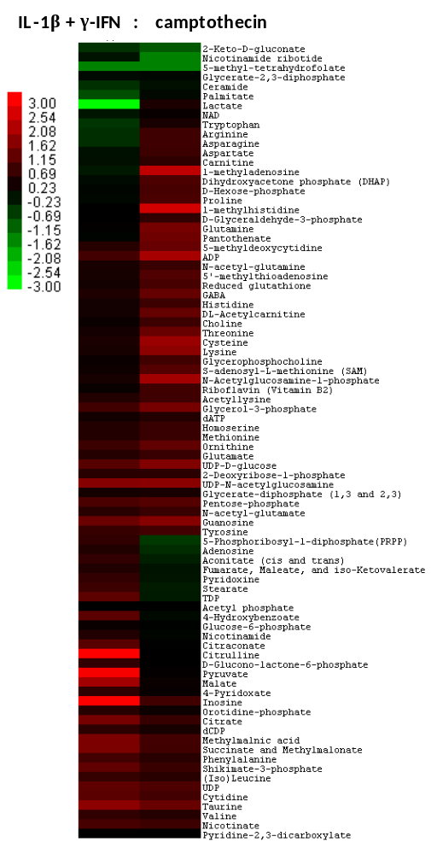

Figure 7:

EXPERIMENTAL

General Methods
Extract from below to produce a general method section.

Cell Extraction Procedure
832/13 cells were grown to confluence in 15cm dishes and treated as indicated in the figure legends. At the end of the treatment period, cells were washed twice with ice cold PBS, scraped and pelleted at 500 x g; the aspirated dry cell pellets were immediately flash frozen using liquid N_{2.} Four individual experiments were performed in duplicate on each of 3 days. Prior to extraction, the collected cell pellets were weighed, and 30-50 mg of each was placed into a microcentrifuge tube at -78 °C. A solution of cold methanol and water (8:2 v/v, 1.5 mL) kept at -80 °C was then added to the tube to extract the metabolome from the cells. The contents were mixed by vortexing and allowed to sit at the extraction temperature for 20 min. Particulates were then removed from the samples by centrifugation, and the supernatants were transferred to autosampler vials for further analysis by the LC-MS/MS methods described below.

Chromatographic Details
High performance liquid chromatographic (HPLC) separation of the metabolites was performed via a slight modification of previously reported methods.^{ref} Due to slight changes, methods are also reported below. A quaternary pump was used to generate a gradient for the elution of compounds from the stationary phase. In total, two HPLC runs are necessary to fully characterize the metabolome for each sample since separate detection for positively ionizing and negatively ionizing compounds is required. For all samples, 10 µL was injected onto the column via an Finnigan Surveyor Autosampler (Thermo Electron, Waltham, Massachusetts) cooled to 4 °C. For positive mode analyses, a Luna 5µ NH₂ 100Å HILIC column (250 x 2.00 mm, 5µ) (Phenomenex, Torrance, California) was used. The mobile phase flow rate was 150 µL/min, and a gradient of two solvents was used for elution. Solvent A was a mixture composed of 95% 20 mM ammonium acetate, 20 mM ammonium hydroxide in HPLC grade water buffered at pH = 9.4 with 5% HPLC grade acetonitrile. Solvent B was pure HPLC grade acetonitrile. These were used to construct the following 40 min gradient elution proﬁle: t ) 0 min, 15% solvent A, 85% solvent B; t ) 15 min, 100% solvent A, 0% solvent B; t ) 28 min, 100% solvent A, 0% solvent B; t ) 30, 15% solvent A, 85% solvent B; t ) 40, 15% solvent A, 85% solvent B. Separations were performed with the column temperature set at 10 ºC. For negative mode analyses, a Synergi 4µ Hydro-RP 80Å C18 column (150 x 2.00 mm, 4 µ) (Phenomenex, Torrance, California) was used. The mobile phase flow rate was 200 µL/min, and a gradient of two solvents was again used for elution. Solvent A consisted of a mixture containing 97% 11 mM tributylamine and 15 mM acetic acid in HPLC grade water and 3% HPLC grade methanol. Solvent B was pure HPLC grade methanol. These were used to construct the following 50 min gradient elution proﬁle: t ) 0 min, 100% solvent A, 0% solvent B; t ) 5 min, 100% solvent A, 0% solvent B; t ) 10 min, 80% solvent A, 20% solvent B; t ) 15, 80% solvent A, 20% solvent B; t ) 30, 35% solvent A, 65% solvent B; t ) 33, 5% solvent A, 95% solvent B t ) 37, 5% solvent A, 95% solvent B; t ) 38, 100% solvent A, 0% solvent B; t ) 50, 100% solvent A, 0% solvent B. Separations were performed with the column temperature maintained at 25 ºC. For both positive and negative mode analyses, the eluent was introduced directly into the MS for ion detection.

Mass Spectrometric Detection Parameters
Samples were introduced into the electrospray ionization (ESI) chamber of a Finnigan TSQ Quantum Discovery Max triple quadrupole MS (Thermo Electron, Waltham, Massachusetts) through a 0.1 mm internal diameter fused silica capillary after delivery by HPLC as described above. The spray voltage for the ESI source was set to 4500 V, if detection occurred in positive ion mode. If detection occurred in negative mode, the spray voltage for the ESI source was set to 3000 V. Nitrogen was used as the sheath gas (40 psi), and the inlet capillary temperature was 290 °C. Argon was used as the collision gas at a pressure of 1.5 mTorr. Samples were analyzed using selected reaction monitoring (SRM) with the scan time for each SRM set to 0.05 s and a scan width of 1 m/z. See Figure X and Table X for a list of detected metabolites. Full selected reaction monitoring (SRM) detection parameters for most compounds have been previously reported by Rabinowitz and coworkers.^{ref}

Data Handling and Statistical Anaylsis
Raw files from each sample were processed using the Xcalibur MS analysis software (Thermo Electron, Waltham, Massachusetts). The peak for each detected metabolite was manually integrated to determine the peak area using the Quan Browser function of Xcalibur. The integration values were then directly entered into an Excel (Microsoft, Redmond, Washington) spreadsheet where they were normalized to the mass of tissue extracted. Since inter-day variability in the ion counts for metabolites was observed due to MS sampling variation, the treated samples were compared only to the control samples run on the same day. This comparison consisted of averaging the ion counts for the duplicate measurements of a metabolite from a treated sample on a given day and then dividing this number by the average of the duplicate measurements of the same metabolite from the control sample obtained on the same day to generate the fold change for the compound. The fold changes for the metabolite from each of the three days were then averaged and clustered and displayed in heat map format using the freely available Cluster 3.0 (www.falw.vu/~huik/cluster.htm) and Java Treeview^{ref} data analysis packages. The p value for each metabolite fold change was obtained by performing an F-test using the data analysis tool pack in Microsoft Excel. The variance in the fold changes for the metabolites in the treatment group was compared to a set of standardized fold changes for the metabolites from the control group that was generated by taking the intra-day ratio of the ion counts from the duplicate measurements of the control.

References

CONCLUSION

The chemical tools available to biologists and chemists alike can be one of the most effective in the

Heading 2
Write here.
AHL | SRM  (parent-product)  (m/z – m/z)

VITA

John X. Doe was born. He wrote a thesis. He graduated. This page really is required.

