Spectroscopic Studies of Molecular Magnetic Materials

Molecular Magnetism of Metal Complexes

A Dissertation Presented for the

Doctor of Philosophy

Degree

The University of Tennessee, Knoxville

Alexandria Nicole Bone

July 2023
Copyright © 2023 by Alexandria Nicole Bone.
All rights reserved.

DEDICATION

To my husband and closest companion, Alan Fried.
I love you eternally.

ACKNOWLEDGEMENTS
Thank you all for your help. However, this page is optional.

ABSTRACT

This is a sample Word document that can be used as a template in formatting your thesis/dissertation. It cannot exceed 350 words.

If you use any special characters (including superscripts and subscripts) in your abstract, you must write out the term in plain English in square brackets immediately following the first use of the character. For example: H2O [water] and µ [micron]. This has nothing to do with how common the term is in your field of study-- our catalogers have to enter the abstract in our records using a plain text format that cannot accommodate the special characters, but has no problem with word substitutes.

TABLE OF CONTENTS

TABLE OF CONTENTS vi
LIST OF FIGURES x
LIST OF SYMBOLS AND ABBREVIATIONS 1
CHAPTER I 3
1.1. Molecular Magnetism 4
1.1.1. Energetic Structure and Anisotropy of Transition Metal Complexes 5
1.1.2. Energetic Structure and Anisotropy of Lanthanide Complexes 8
1.2. Experimental Methods 9
1.2.1. Inelastic Neutron Scattering (INS) 9
1.2.2. Far-IR Magneto-Spectroscopy (FIRMS) and Raman Spectroscopy 9
1.2.3. High-Field, High-Frequency Electron Paramagnetic Resonance (HFEPR) 9
1.2.4. Computational Techniques 9
1.3. Current Dissertation 10
1.4. Chapter II 10
1.5. Chapter III 10
1.6. Chapter IV 10
1.7. Chapter V 10
CHAPTER II 11
CHAPTER III 12
3.1. Abstract 14
3.2. Results and Discussion 15
3.2.1. Experimental Determination of Magnetic and Phonon Transitions 15
3.2.2. LFT of the Co-X Series (X = Cl, Br, I) 29
3.2.3. Experimental and Calculated Phonon Spectra and Studies of Spin-Phonon Couplings 34
CHAPTER IV 45
4.1. Abstract 47
4.2. Results and Discussion 48
4.2.1. Crystal Structures of 2·CHCl₃, 2·CH₂Cl₂, 3·CHCl₃, 3·CDCl₃ and 3·1.5CHCl₃ 48
4.2.2. Hirshfeld Surface Analyses 53
4.2.3. Magnetic Susceptibility 60
4.2.4. HFEPR Studies 62
4.2.5. INS Studies 66
CHAPTER VIII 72
APPENDICES 75
Appendix A. 76
Appendix B. Supporting Information for Chapter 3 77
B.1. Magneto-Raman Studies 87
B.2. Ligfield Results for Co-Cl 102
B.3. Ligfield Results for Co-Br 108
B.4. Ligfield Results for Co-I 115
B.5. DDN Output for Co-X Series 122
Appendix C. Supporting Information for Chapter 4 125
C.1. Crystallographic Data, Figures, Tables, and CShM Calculations 125
VITA 160
Appendices 14
Appendix A. Supporting Information for Chapter 2 1
Appendix B. Supporting Information for Chapter 3 1

LIST OF TABLES

No table of figures entries found.

LIST OF FIGURES

Figure 0-1 10

LIST OF SYMBOLS AND ABBREVIATIONS
2-D or 2D | Two-dimensional
Λ | Spin-phonon coupling constant
CShM | Continuous shape measure calculations
D | Single-ion axial anisotropy
DCS | Disc Chopper Spectrometer
DDN | Program written by J. Telser
DFT | Density functional theory
E | Transverse or rhombic anisotropy
EPR | Electron paramagnetic resonance
FIRMS | Far-IR magneto-spectroscopy
FD | Frequency-domain
FD-FT THz EPR | Frequency-domain FT terahertz EPR
FT | Fourier transform
g | g-factor
HFEPR | High-frequency and -field EPR
INS | Inelastic neutron scattering
IR | Infrared
KD | Kramers doublet
LFT | Ligand-field theory
LMCT | Ligand-to-metal charge transfer
MCD | Magnetic circular dichroism
MDS | Magnetic-field-division
m_{l} | Magnetic quantum number
M_{s} or m_{s} | Spin quantum number
Qubit | Quantum bit
S | Spin
SH | Spin Hamiltonian
SMM | Single-molecule magnet
SOC | Spin-orbit coupling
VASP | Vienna ab initio simulation package
VISION | Vibrational Spectrometer
VT | Variable-temperature
ZFS | Zero-field split

CHAPTER I

Introduction

1.1. Molecular Magnetism
In 1993, Sessoli et al. reported a novel material— [Mn₁₂O₁₂(AcO)₁₆(H₂O)₄]·2AcOH, commonly known as Mn₁₂—that exhibited long magnetic relaxation in the absence of an external magnetic field.¹ This magnet was the first of a class of materials coined “single-molecule magnets” (SMMs), which display hysteresis due to the electronic configuration(s) of individual spin centers rather than bulk magnetic ordering. In the decade that followed Sessoli’s report, efforts to develop novel SMMs focused on similar transition metal clusters with high spin multiplicities.² In 2003, Ishikawa and coworkers forged a new branch of single-molecule magnetism with a seminal report on [Pc₂Ln]⁻·TBA⁺ (Ln = Tb³⁺, Dy³⁺).² This lanthanide double-decker complex exhibited hysteresis due to the electronic structure of the single lanthanide center and was aptly called a single-ion magnet (SIM). SMM and SIM systems have since garnered intense technological interest, as they are promising candidates for data storage (as binary bits) and quantum computing (as quantum bits, or qubits) applications. Compared to traditional bulk magnets, SIM-based computing offers a potential increase in storage density and processing speeds.³⁻⁴
One parameter for slow relaxation in SMM and SIM systems is U_{eff}, or the effective energy barrier between spin states. A greater U_{eff} affords longer magnetic relaxation times, as the molecule is required to overcome a larger energy barrier to undergo spin reversal. The original approach to maximizing U_{eff} was to maximize the number of spin centers in a cluster compound; however, Ishikawa’s [Pc₂Ln]⁻·TBA⁺ far surpassed Mn₁₂ in U_{eff} magnitude and retained slow relaxation at higher temperatures, despite having only one spin center per molecule.² Ishikawa’s work established a need for more complex design criteria to maximize hysteresis, which could only be achieved with deeper understanding of the energetic structures of SIM and SMM candidates.

1.1.1. Energetic Structure and Anisotropy of Transition Metal Complexes
In transition metal-, lanthanide-, and actinide-based SIMs, U_{eff} is a function of magnetic anisotropy, which arises when the energy of magnetization is dependent on the orientation of the magnetic moment.⁵ How magnetic anisotropy is induced depends on the nature of the spin center, and is best described in terms of the perturbations that introduce anisotropy for different spin centers.

1.1.1.1. Fe(III) Porphyrin Complexes
meso-Tetraphenylporphyrins Fe(TPP)Cl (TPP²⁻ = meso-tetraphenylporphyrinate) and [Fe(TPP)(HIm)₂]Cl (HIm = 1H-imidazole) are models for hemes. Fe(TPP)Cl is a high-spin (S = 5/2) d⁵ complex with molecular C_{4v} symmetry, leading to ZFS of the six-fold degenerate states into three doublets (M_{S} = ±1/2, ±3/2, ±5/2; Figure 1.#). For Fe(TPP)Cl, the SH is given in Eq. 1.#:
${\hat{H}}_{s}=D\left[{\hat{S}}_{z}^{2}- S\left(S+1\right)/3\right]$ (Eq. 1.#)
where D is the axial ZFS parameter. Splitting diagrams for the d-orbitals and six-fold degenerate magnetic states are shown in Figure 1.#.
[Discussion of X = Br, I]

1.1.1.2. Mn(III) Porphyrin Complexes
Five-coordinate Mn(III) tetraphenylporphyrin complexes, Mn(TPP)X (X = Br, I) described in Chapter IV, are paramagnetic d⁴ complexes with spin S = 1 and quenched angular momenta. ZFS of these complexes is described by the SH in Eq. 1.#:
$\hat{H}=D\left[{\hat{S}}_{z}^{2}-S\left(S+1\right)/3\right]+E\left({\hat{S}}_{x}^{2}-{\hat{S}}_{y}^{2}\right)$ Eq. 1.#
where D and E are the axial and rhombic ZFS parameters, respectively.
For compounds with both 4-fold molecular and crystallographic symmetry, the SH in Eq. 1.# is simplified to Eq. 1.# in Section 1.1.1.1.
For d⁴ Mn(III), S = 2 complexes, the splitting diagrams for five degenerate states are shown in Figure 1.#. When D > 0, in the case of easy-plane anisotropy, ZFS affords a M_{S} = 0 ground state. In the case of easy-axis anisotropy, when D < 0, ZFS gives M_{S} = ±2 ground states. In the absence of 4-fold symmetry in either the molecule or crystal structure, x ≠ y, and the rhombic ZFS parameter E ≠ 0, leading to splittings shown in Figure 1.#. Inside a magnetic field, the Zeeman effect leads to a change in the relative energies of the five states. For an easy-plane (D > 0) compound, transitions between the ground M_{S} = 0 and either first excited M_{S} = -1 or second excited M_{S} = +1 state (ΔM_{S} = ±1) are magnetically allowed. For an easy-axis (D < 0, E = 0) compound inside a magnetic field, the transition from the ground M_{S} = -2 to the first excited M_{S} = +2 state (ΔM_{S} = +4) is forbidden, as magnetically-allowed transitions have ΔM_{S} = 0 or ±1.
Complexes with spin quintet (S = 2) ground states and 4-fold molecular and crystallographic symmetries have been historically considered ‘EPR-silent’ using the criterion of not giving an EPR signal on a spectrometer operating at conventional frequency (generally X-band, e.g., 9.5 GHz). However, when either molecular or crystallographic symmetry deviates from 4-fold, the rhombic ZFS parameter E ≠ 0, leading to state mixing. In particular, it makes a nominally forbidden transition between the M_{S} = |+2⟩ and |-2⟩ levels partially allowed, and given the generally small energy difference between these levels, this results in a frequent observation of that transition in X-band at low field. Examples of Mn(III) coordination complexes exhibiting such X-band low-field EPR signals are Mn(salen) complexes such as Mn(salen)Cl [salen = (R,R)-(−)-N,N’-bis(3,5-di-tert-butylsalicylidene)-1,2-cyclohexanediamine], Mn(acac)₃ (acac = acetylacetonate), and corrole Mn(tpfc) [tpfc = 5,10,15-tris(pentafluorophenyl)corrole trianion.

1.1.1.3. Tetrahedrally Coordinated Co(II) Complexes
In tetrahedrally coordinated, d⁷ Co(II) complexes, such as the Co(PPh₃)X₂ (X = Cl, Br, I) described in Chapter III, the ligand field affords the high-spin electronic ground state ⁴A₂. In paramagnetic complexes with S ≥ 1 and quenched orbital angular momentum, ZFS of electronic states arises due to second-order SOC, splitting the ⁴A₂ state into two levels: m_{S} = ±1/2 and m_{S} = ±3/2 (Figure). Lowering the symmetry to D_{2d} and further to C_{2v} results in ⁴B₁ and ⁴A₂ electronic ground states, respectively, affording an axial ZFS parameter D that is highly sensitive to the difference in energy between ground and excited states. The energy difference between the two m_{S} = ±1/2 and m_{S} = ±3/2 levels can be described by an SH in Eq. 1.1, which includes both ZFS and the Zeeman effect:
${\hat{H}}_{S}=D({\hat{S}}_{z}^{2}-5/4)+E({\hat{S}}_{x}^{2}-{\hat{S}}_{y}^{2})+μ_{B}g_{x}B_{x}{\hat{S}}_{x}+μ_{B}g_{y}B_{y}{\hat{S}}_{y}+μ_{B}g_{z}B_{z}{\hat{S}}_{z}$ (Eq. 1.1)
where $\hat{S}$ = spin operator, $μ$_{B} = electron Bohr magneton, $g_{x, y, z}$ = g- tensor components, B = applied magnetic field.

1.1.2. Energetic Structure and Anisotropy of Lanthanide Complexes
A suitable Hamiltonian operator for Ln³⁺-based complexes is:
$H=\sum_{i=1}^{n}{\left[\frac{1}{2m}p_{i}^{2}-\frac{Ze^{2}}{r_{i}}\right]+\sum_{i<j}^{n}{\frac{e^{2}}{r_{ij}}+\sum_{i=1}^{n}{ξ\left(r_{i}\right)l_{i}s_{i}+H_{E}+H_{B}+H_{N}}}}$ (Eq. 1.2)
where the first summation represents the kinetic term and the Coulombic interaction between electrons and the nucleus, the second represents interelectronic Coulombic repulsion, and the third is the spin-orbit interaction. The final three terms—H_{E}, H_{B}, and H_{N}—represent ligand field, Zeeman, and hyperfine interactions, respectively. A generic Ln³⁺ energy level diagram is given in Figure.
In rare earth 4f^{n} systems, the 14!((14-n)!n!)-fold degenerate ground state of the free ion is split by interelectronic Coulombic repulsion. After considering the effects of interelectronic repulsion, the “new” ground state is that with the greatest orbital degeneracy and spin multiplicity, as derived by the Russell-Saunders coupling scheme. For example, a Dy³⁺ ion has the configuration.
Compared to the 3d valence orbitals of transition metals, the deeply embedded 4f orbitals of lanthanide ions are heavily shielded from the ligand field environment. As a result, lanthanide complexes generally have unquenched orbital momentum, which induces strong spin-orbit coupling effects. The spin-orbit coupling interaction splits the Coulombic states into multiplets defined by the total angular momentum J, where the ground state is the term with J = L – S when n < 7 and J = L + S when n > 7. The energies of the ^{2S+1}L_{J} terms are given by E_{LSJ} = (λ/2)[J(J+1) – L(L+1) – S(S+1)], where λ is the Russell-Saunders spin-orbit coupling parameter. Continuing with the Dy³⁺ example, this gives a ground state of ___, which is separated from the lowest-lying excited state by ___.

1.1.2.1. Dy(III)

1.1.2.2. Ce(III)

1.2. Experimental Methods

1.2.1. Inelastic Neutron Scattering (INS)

1.2.2. Far-IR Magneto-Spectroscopy (FIRMS) and Raman Spectroscopy

1.2.3. High-Field, High-Frequency Electron Paramagnetic Resonance (HFEPR)

1.2.4. Computational Techniques

1.3. Current Dissertation

1.4. Chapter II

1.5. Chapter III

1.6. Chapter IV

1.7. Chapter V

CHAPTER II

Studies of Intermolecular Magnetic Interactions in Metalloporphyrins M(TPP)Cl (M = Fe³⁺, Mn³⁺) via Inelastic Neutron Scattering

CHAPTER III

Spectroscopic Studies of Magnetic Transitions and Spin-Phonon Couplings in the Single-Molecule Magnets, Co(PPh₃)₂X₂ (X = Cl, Br, I)

This chapter is based on the following paper:
Alexandria N. Bone, Chelsea N. Widener, Duncan H. Moseley, Zhiming Liu, Zhengguang Lu, Yongqiang Cheng, Luke L. Daemen, Mykhaylo Ozerov, Joshua Telser, Komalavalli Thirunavukkuarasu, Dmitry Smirnov, Samuel M. Greer, Stephen Hill, J. Krzystek, Karsten Holldack, Azar Aliabadi, Alexander Schnegg, Kim R. Dunbar, Zi-Ling Xue, Applying Unconventional Spectroscopies to the Single-Molecule Magnets, Co(PPh₃)₂X₂ (X = Cl, Br, I): Unveiling Magnetic Transitions and Spin-Phonon Coupling. Chem. Eur. J. 2021, 27, 11110-11125. https://doi.org/10.1002/chem.202100705

The author processed and interpreted experimental FIRMS and Raman results, as well as results of calculations (performed by Yongqiang Cheng) of the phonons, INS spectra, far-IR spectrum of Co(PPh₃)₂Cl₂, and spin densities. In addition, the author generated phonon animations and assigned symmetries of the calculated phonons. Results from HFEPR performed by S. M. Greer, J. Krzystek, and S. Hill, LFT by J. Telser, and FT-FD THz-EPR by K. Holldack, A. Aliabadi, and A. Schnegg are included for a complete presentation of the studies.

INS studies of Co(PPh₃)₂X₂ (X = Cl, Br, I) are reported in the thesis of Zhiming Liu and are presented here for completeness.

3.1. Abstract
Large separation of magnetic levels and slow relaxation in metal complexes are desirable properties of single-molecule magnets (SMMs). Spin-phonon coupling (interactions of magnetic levels with phonons) is ubiquitous, leading to magnetic relaxation and loss of memory in SMMs and quantum coherence in qubits. Direct observation of magnetic transitions and spin-phonon coupling in molecules is challenging. We have found that far-IR magnetic spectra (FIRMS) of Co(PPh₃)₂X₂ (Co-X; X = Cl, Br, I) reveal rarely observed spin-phonon couplings as avoided crossings between magnetic and u-symmetry phonon transitions. Inelastic neutron scattering (INS) gives phonon spectra. Calculations using VASP and phonopy programs give phonon symmetries and movies. Magnetic transitions among zero-field split (ZFS) levels of the
S = 3/2 electronic ground state were probed by INS, high-frequency and -field EPR (HFEPR), FIRMS, and frequency-domain FT terahertz EPR (FD-FT THz EPR), giving magnetic excitation spectra and determining ZFS parameters (D, E) and g values. Ligand-field theory (LFT) was used to analyze earlier electronic absorption spectra and give calculated ZFS parameters matching those from experiments. DFT calculations also gave spin densities in Co-X, showing that the larger Co(II) spin density in a molecule, the larger its ZFS magnitude. The current work reveals dynamics of magnetic and phonon excitations in SMMs. Studies of such couplings in the future would help to understand how spin-phonon coupling may lead to magnetic relaxation and develop guidance to control such coupling.

3.2. Results and Discussion

3.2.1. Experimental Determination of Magnetic and Phonon Transitions

3.2.1.1. INS
For Co-Cl, both variable-field (with a 10 T magnet) and VT INS studies were conducted. The former gave spectra in Figure 3.1-Top with low signal-to-noise ratio of the peaks, as the magnet blocked many detectors. A comparison of the spectra at 0 and 10 T shows that the peak at 29.7(2) cm⁻¹ at 0 T disappears at 10 T, indicating its magnetic nature [i.e., 2D’ = 29.7(2) cm⁻¹]. VT INS spectra of Co-Cl at 5, 30, 60, and 90 K are presented in Figure 3.1-Bottom. At zero applied field, only one magnetic transition from the m_{s} = ±3/2 ground level to the m_{s} = ±1/2 excited level is expected in the INS spectra. After Bose-correction of the VT INS spectra to make the intensities of phonon peaks relatively constant, the intensity of the magnetic transition should decrease with increasing temperature, as the m_{s} = ±1/2 excited level is increasingly thermally populated at the expense of the m_{s} = ±3/2 ground level. Figure 3.1-Bottom shows that the magnetic transition at 5 K by VT INS is at 2D’ = 29.5(2) cm⁻¹. The sign of the D parameter, as those of Co-Br and Co-I below, was based on the HFEPR results, as the INS results cannot determine the sign.
For Co-Br and Co-I, VT INS studies were similarly conducted and the spectra are given in Figure 3.2. Magnetic transitions of Co-Br and Co-I area clearly observed at 2D’ = 27.6(4) cm⁻¹ and 27.3(0.3) cm⁻¹, respectively.

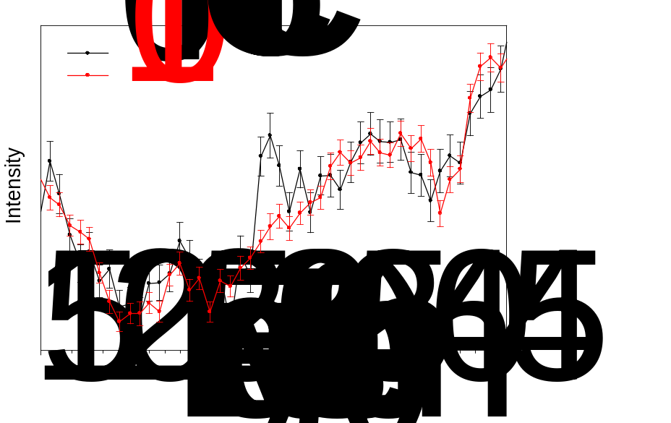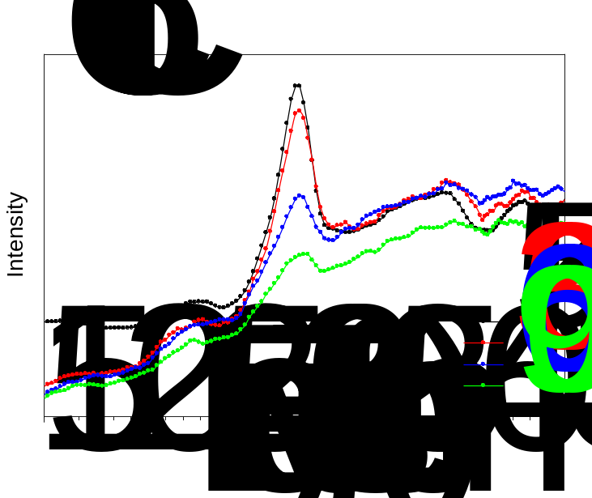
Figure 0-1
Figure 3.1. (Top) Variable-field INS spectra at DCS at 1.5-1.6 K; (Bottom) Bose-corrected forward-scattering VT INS spectra at VISION. Figure B.1 in Appendix B shows additional VT INS spectra of Co-Cl, revealing phonon excitations and their symmetry assignments.
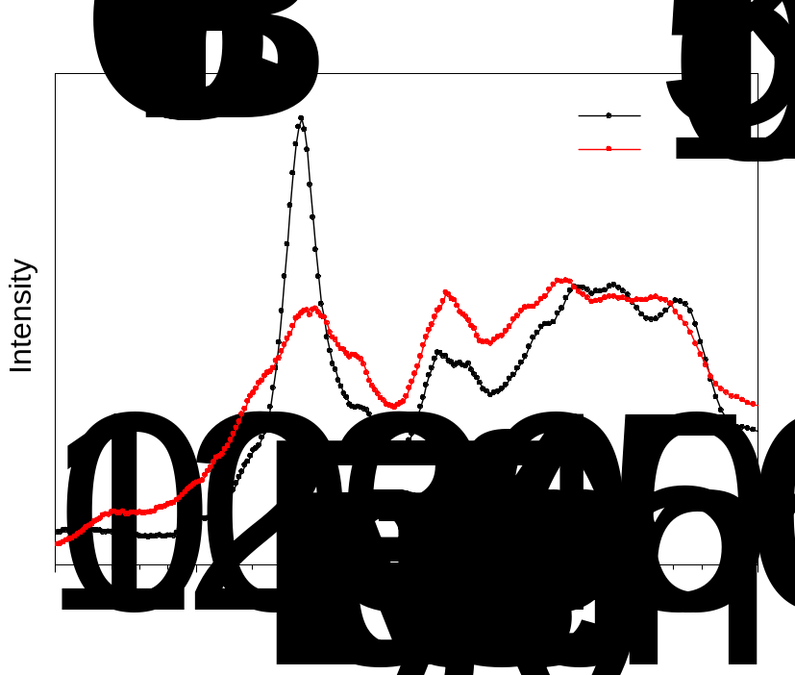
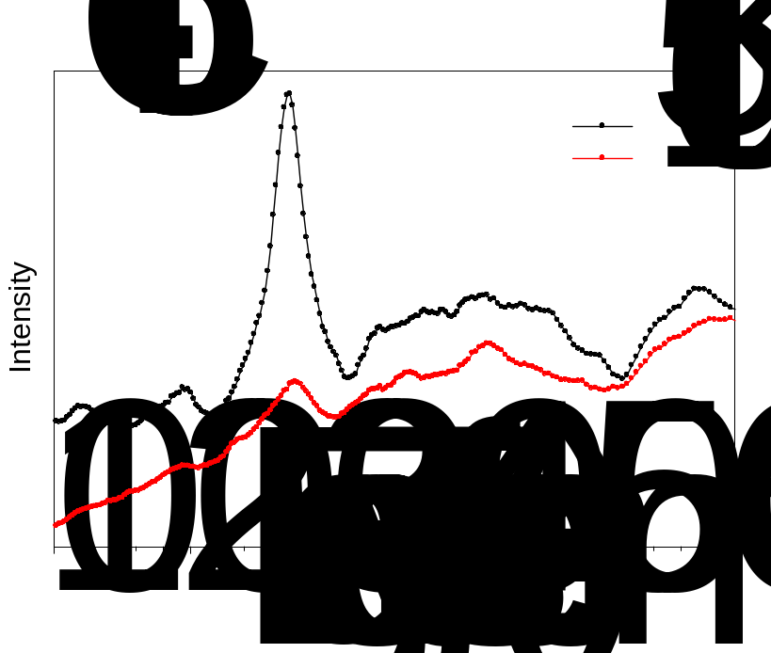
Figure 3.2. Bose-corrected forward-scattering VT INS spectra on VISION: (Top) Co-Br. (Bottom) Co-I. Additional VT INS spectra of Co-Br and Co-I by VISION revealing phonon excitations are given in Figures B.2 and B.3 in Appendix B, respectively.

3.2.1.2. FIRMS
Magnetic transitions (at 0 T) between the two ZFS sublevels (e.g., m_{s} = -3/2
-1/2 and m_{s} = +3/2 +1/2) in Co-X are magnetic-dipole-allowed by symmetry and selection rules (Δm_{s} = 0, ±1).⁶⁻⁷ In C_{2v} local symmetry around the Co(II) ion, the magnetic dipole moment operators have B₂, B₁, and A₂ symmetries as the rotations R_{x}, R_{y}, and R_{z}, respectively. In the double group C_{2v}’, both m_{s} = ±3/2 and ±1/2 levels are represented by E_{1/2}.⁸⁻⁹ Thus, the magnetic transitions are observable in far-IR. Frequency-domain spectroscopy (i.e., FIRMS) using high magnetic fields, revealing how the Zeeman effect changes the transitions between ZFS levels, is ideal to probe magnetic transitions in addition to studying IR-active phonon excitations.^{6-7, 10-22} In the present S = 3/2, D < 0 case, the m_{s} = +3/2 level can be excited to the m_{s} = +1/2 level and spin-Hamiltonian parameters can then be extracted from the spectra.
Transmittance of Co-Cl, Co-Br, and Co-I at 0 and 17 T in Figure 3.3 reveals the changes caused by the external magnetic fields with additional FIRMS spectra and assignments of phonon symmetries for Co-Cl and Co-Br in Figures B.4-B.6 in Appendix B. Transmission spectra normalized by the average are shown as a function of magnetic fields in Figure 3.4. The largest transmission changes are presented in the blue color and are proportional to the intensity of the transitions between the levels split under magnetic field, while the yellow color corresponds to regions lacking magnetic-dependent spectral features. The magnetic resonance absorption is most intense at 0 T, allowing direct determination of the energy gap between the ±3/2 and ±1/2 levels from FIRMS spectra as
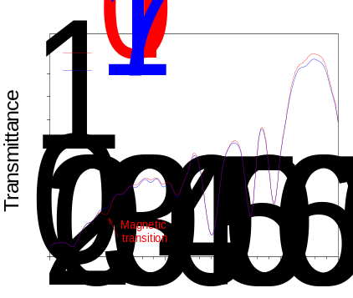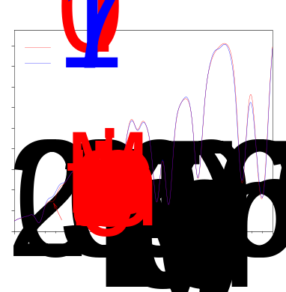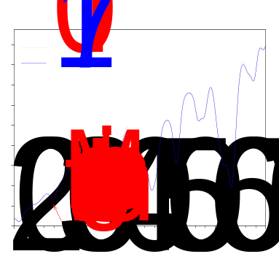
Figure 3.3. FIRMS spectra of the complexes at 5 K and 0 and 17 T: (Left) Co-Cl, (Middle) Co-Br, (Right) Co-I. Assignments of the phonon peaks in Co-Cl and Co-Br are given in Figures B.4-B.6. The phonons in Co-I could not be assigned.

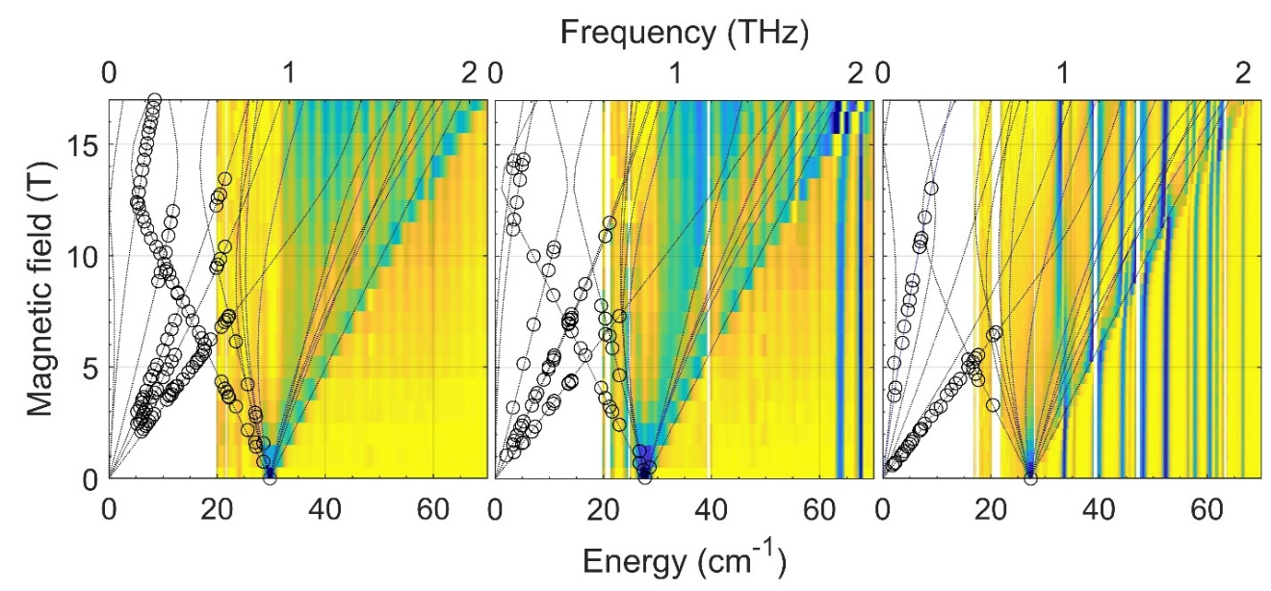
Figure 3.4. FIRMS maps (normalized transmission vs. field and energy/frequency): (Left) Co-Cl, (Middle) Co-Br, (Right) Co-I with HFEPR results superimposed. The color trend from blue to yellow corresponds to a decrease of the magnetic absorption. The lines are simulations of turning points in the powder spectra that assume the (best-fitted) spin-Hamiltonian parameters in Table 3.1. The circles correspond to the observed HFEPR resonances, except for the zero-field resonance in Co-I obtained from FIRMS spectra. The equidistant vertical stripes are due to instrumental artifacts, while the white regions correspond to the spectral ranges without reliable data. Spin-phonon couplings in the FIRMS plots normalized by average are presented below in Figure 3.5 (for Co-Br and Co-I) and Figure 3.8 (for Co-Cl).
follows: Co-Cl, 29.85(13) cm⁻¹; Co-Br, 27.62(11) cm⁻¹; and Co-I, 27.38(15) cm⁻¹ (Figure 3.4). The intensity of the magnetic absorption decreases and spreads out in high magnetic fields, because the intensity and the frequency of the transitions are defined by the direction of the magnetic field relative to the magnetic anisotropy D- and g-tensors using microcrystalline samples with random orientations. The black lines in Figure 3.4 show calculated field dependences of turning points²³ in the powder spectra. While the low-energy turning points are revealed in HFEPR spectra (shown as circles in Figure 3.4), turning points with energies larger than 2D’ show up in FIRMS maps (black lines). The maps are consistent with D < 0, and these results are in excellent agreement with calculated powder spectra of magnetic absorption (Figure B.7) using the spin-Hamiltonian parameters from HFEPR in Table 3.1, thus confirming the HFEPR determination of the parameters. One additional finding from Figure 3.3-Right is that, for Co-I, the phonon at 33.3(1) cm⁻¹ (phonon B in Figure 3.5-Bottom and Table 3.2 below) is coupled to the magnetic transition even at 0 T, pushing each other apart. At 17 T, when the magnetic transition (peak A in Figure 3.5-Bottom) is shifted away after several avoided crossings, it is no longer coupled to this phonon. In fact, the original peak of magnetic transition, A, has become the phonon (through the coupling during the avoided crossing with B) and now “returned” to a new position (at 32.8 cm⁻¹ to the left of the original position of B at 0 T).
Magneto-Raman spectra of Co-Cl, Co-Br, and Co-I under 0-14 T magnetic fields (Figures B.8-B.10) do not reveal the magnetic transitions in these complexes.
Table 3.1. Energies of phonons involved in spin-phonon couplings and the coupling constants.
Co-Cl
Phonon | B |  |  |  | C |  |  |  |  | D |  |  | E
Phonon peak (cm⁻¹) | 42.2(1) |  |  |  | 48.1(3) |  |  |  |  | 54.8(2) |  |  | 58.9(3)
Λ (cm⁻¹) | 1.3(2) |  |  |  | 1.3(1) |  |  |  |  | 1.3(2) |  |  | 1.4(3)
Co-Br
Phonon | B |  | C |  |  |  | D |  | E |  |  | F |  | G
Phonon peak (cm⁻¹) | 39.5(3) |  | 47.5(1) |  |  |  | 50.0(1) |  | 55.6(2) |  |  | 64.0(2) |  | 68.1(2)
Λ (cm⁻¹) | 1.0(3) |  | 1.3(4) |  |  |  | 1.1(3) |  | 1.5(3) |  |  | 1.4(4) |  | 1.8(4)
Co-I
Phonon | B | C |  | D |  | E |  | F |  |  | G | H | I |  | J
Phonon peak (cm⁻¹) | 33.3(1) | 35.3(1) |  | 39.5(2) |  | 44.1(1) |  | 47.7(2) |  |  | 52.3(2) | 56.7(1) | 61.0(2) |  | 63.0(1)
Λ (cm⁻¹) | 1.3(2) | 0.9(3) |  | 1.5(3) |  | 1.6(2) |  | 1.8(2) |  |  | 1.6(3) | 1.8(3) | 2.0(4) |  | 1.1(3)

Figure 3.5. FIRMS plots of far-IR spectra normalized by average, which minimize phonon features that do not change with magnetic field: (Top) Co-Br; (Bottom) Co-I, revealing simulations of spin-phonon couplings. The color trend from red to blue corresponds to a decrease of absorption. The white lines show the results of the spin-phonon coupling model using a 7 × 7 matrix for Co-Br and a 10 × 10 matrix for Co-I, which are similar to those of the 5 × 5 matrix in Eq. 3.3 and are given in Appendix B. Figure 3.5-Left (Co-Br) and -Right (Co-I) are also given in Figures B.5-Bottom and B.6-Bottom, respectively, without the white simulation lines here to more clearly show the avoided crossings.

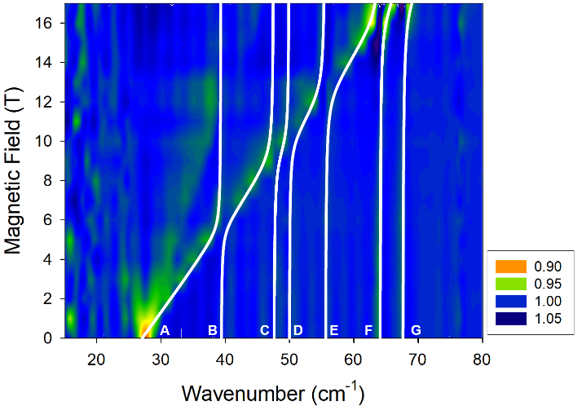
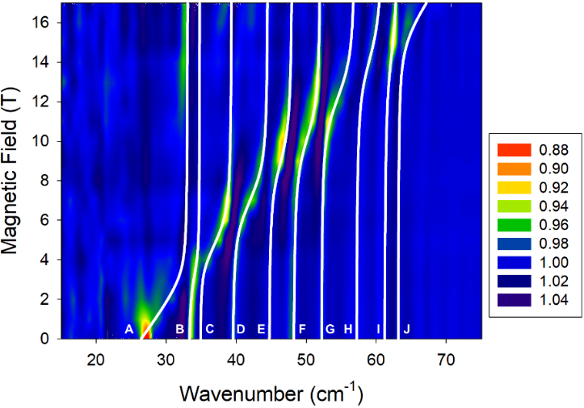

Phonon features of the Raman spectra of Co-X at 0 T are discussed below.

3.2.1.3. FD-FT THz-EPR
Figure 3.6 depicts FD-FT THz-EPR of Co-X at 0-7 T with a spectral resolution of 0.5 cm⁻¹. Division by a reference spectrum measured under identical conditions, but with a field offset, leads to FD-FT THz-EPR magnetic-field-division spectra (MDS, details in Appendix B) containing only the field-dependent components of the spectrum. Magnetic resonances in MDS are similar to those in first-derivative EPR spectra. Field-independent phonons are cancelled by this technique. However, in the case of spin-phonon couplings, phonons shift in an applied magnetic field and therefore lead to peaks of magnetic transitions similar to EPR resonances. Discrimination between magnetic transitions originating from EPR resonances and spin-phonon coupled peaks requires the comparison with simulated spectra using the spin-Hamiltonian in Equation. In Figure 3.6, EPR spectra simulated with Eq. # are plotted alongside measured spectra. Field vs. frequency plots in Figure 3.6 are equivalent to Figure 3.4, but allow for more convenient comparison of measured and simulated spectra.
The simulations were performed with the EasySpin program and its extensions for frequency-domain EPR.¹⁹ Very good estimates of 2D’ can be directly obtained from the zero-field FD-FT THz-EPR spectrum. However, more accurate D’ and g values are available from simulations of MDS at different external magnetic fields, giving the SH parameters for Co-X in Table #. Simulations of the spectra can also provide estimates of E. However, these values are usually less accurate than those from HFEPR.²⁴ Thus, the E
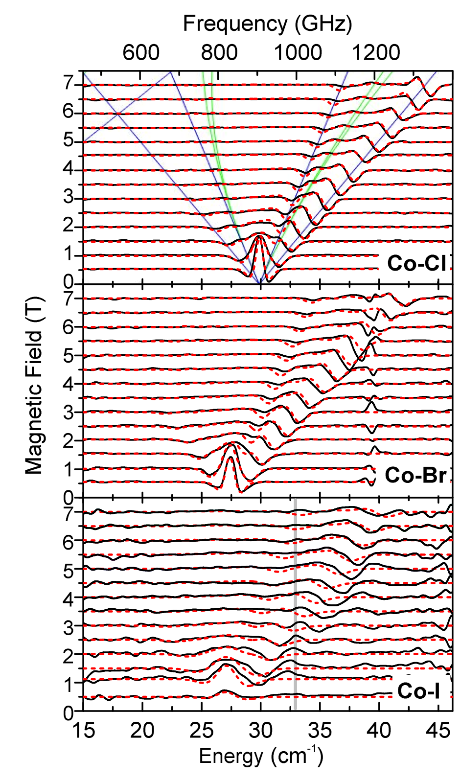
Figure 3.6. FD-FT THz-EPR MDS at 5 K: (Top) Co-Cl, (Middle) Co-Br, (Bottom) Co-I. Spectra are plotted as offset to corresponding magnetic field. Experimental spectra (black) are overlaid on spin-only simulations (dashed red; simulation parameters available in Table). In the top panel, simulated transition energies for magnetic fields parallel (blue) and perpendicular (green) to the z-axis of the ZFS tensor are shown. The red shaded bar in the lower panel marks the transition energy of a phonon at 33 cm⁻¹.
parameters from FD-FT THz-EPR are not given in Table #.
A very good match between experiment and simulation was achieved for Co-Cl. No indication of spin-phonon coupling is found in the spectral window. Similarly, good agreement was found for Co-Br. However, a distortion around 39.5 cm⁻¹ is observed, originating from a strong (phonon) absorption (see Figures 3.3 and B.11 for a view of the phonon). For MDS spectra of Co-Br between 5.5 T and 6.5 T, a partial overlap with this absorption leads to a deviation of the simulated and measured spectrum. However, despite the high quality of the data, no clear assignment of spin-phonon coupling is possible in this case. Interestingly, spectra of both Co-Cl and Co-Br show low energy phonon modes at ~25 cm⁻¹, which are very close to the zero-field EPR peaks (see Figure 3.3). Yet, neither of these modes appears to couple to the magnetic resonance (or the coupling is too weak to be observed here), when they overlap with the magnetic transitions at elevated fields, and therefore does not alter the MDS of Co-Cl and Co-Br.
Spectra of Co-I, on the contrary, show pronounced spin-phonon coupling between 2.5 T and 5.5 T, leading to clear deviations between calculated and experimental MDS [see dashed spectra in Figure 3.6-Bottom simulated with Eq. # (without spin-phonon coupling)]. While experimental spectra and simulations match very well below 2 T and above 5.5 T, spectra in the intermediate field range exhibit an additional splitting, which is not reproduced by the SH simulations. The splitting of the magnetic resonance by spin-phonon coupling is most obvious in the 3 T MDS of Co-I, where the predicted magnetic resonance (without spin-phonon coupling) overlaps with the phonon at 33 cm⁻¹ (phonon B in Figure 3.5-Bottom and Table 3.1), as discussed earlier in Figure 3.3-Right. The experimental MDS clearly reveals two minima centered around 33 cm⁻¹, which originate from an avoided crossing of the Co(II) spin resonance and phonon B.²⁵

3.2.1.4. HFEPR
Co-Cl was the subject of an earlier detailed HFEPR and MCD study by some of us.²⁶ In the current work, we have confirmed the previous results and added spectra at several high frequencies to the 2-D field vs. frequency map of turning points²³ (Figure 3.4-Left and Figure B.12-Top), which were unavailable earlier.²⁶ One such spectrum, obtained at 815 GHz, which is just below the frequency (~890 GHz) of the transition between the m_{s} = ±3/2 and m_{s} = ±1/2 levels as determined at zero field by FIRMS and FD-FT THz EPR, is shown in Figure B.13.
Co-Br generated a very good HFEPR response, similarly to Co-Cl. Three representative HFEPR spectra (Figures B.14-B.16) are shown in Appendix B. Figure B.14 gives an optically modulated spectrum recorded at the frequency corresponding almost exactly to the zero-field transition frequency (~830 GHz) between the m_{s} = ±3/2 and m_{s} = ±1/2 levels. Figure B.15 shows a conventional, magnetically modulated spectrum at 473 GHz, while Figure B.16 displays a spectrum at a low frequency of 98 GHz, where it is possible to observe all three turning points of the intra-Kramers m_{s} = -3/2 +3/2 transition. The full 2-D map of HFEPR turning points in Co-Br is shown in Figure 3.4-Middle and Figure B.12-Middle.
The HFEPR response of Co-I was weaker than those of the other two congeners. In particular, most of the observed resonances originated from the intra-Kramers m_{s} =
-3/2 +3/2 transition within the m_{s} = ±3/2 doublet. Only in one narrow frequency region (ca. 500 GHz) were we able to record resonances belonging to the inter-Kramers m_{s} =
-3/2 +1/2 transition, which are informative with regard to ZFS (Figure B.17). Figure B.18 shows a spectrum at the low end of available frequencies (63 GHz) which turned out to be the only frequency at which we were able to observe all three turning points of the intra-Kramers m_{s} = -3/2 +3/2 transition. As a result, a least-square fit to the 2-D field vs. frequency map (Figure 3.4-Right and Figure B.12-Bottom) yielded lower accuracy in the spin-Hamiltonian parameters of Co-I than those for Co-Cl and Co-Br.
Least-square fits of the Hamiltonian parameters to the 2-D field vs. frequency maps for the three complexes resulted in the following values: D = -14.76(2), |E| = 1.141(8) cm⁻¹ for Co-Cl; D = -13.82(2), |E| = 0.29(1) cm⁻¹ for Co-Br; and D = -13.13(10), |E| = 2.11(5) cm⁻¹ for Co-I, along with most g (g_{x}, g_{y}, g_{z}) values listed in Table.

3.2.2. LFT of the Co-X Series (X = Cl, Br, I)

3.2.2.1. LFT Background of the Co-X Series
As is typical for roughly tetrahedral open-shell complexes, electronic absorption spectra of the Co-X (X = Cl, Br, I) series are rich and informative, and the complete series was thoroughly studied many years ago. For Co-Cl, Simo and Holt provided a comprehensive analysis of the single-crystal electronic absorption of Co-doped Zn(PPh₃)₂Cl₂ (Co/Zn-Cl).²⁵ Tomlinson et al. did the same for Co-doped Zn(PPh₃)₂Br₂ (Co/Zn-Br) and Zn(PPh₃)₂I₂ (Co/Zn-I).²⁷ In Co-X with C_{2v} point group symmetry, the molecular z axis lies along the C₂ axis (i.e., bisecting the X-Co-X and P-Co-P bond angles as shown in Figure), the x axis lies in the X-Co-X plane (σ_{v}), and the y axis lies in the P-Co-P plane (σ_{v}′). The spectroscopic results are summarized in Table B.1 in SI, which corrects a minor discrepancy between the analysis described by Tomlinson et al. and data in a table in their paper.²⁷ In C_{2v} point group symmetry, the ground electronic state of Co-X is ⁴A₂, derived from the parent ⁴A₂(F) term in T_{d} symmetry (e⁴t₂³ in strong-field notation). The quartet excited states are ⁴T₂(F) (e³t₂⁴), ⁴T₁(F) (e²t₂⁵), and ⁴T₁(P) (e³t₂⁴) in T_{d} symmetry and each splits into ⁴A₁ (for ⁴T₂) or ⁴A₂ (for ⁴T₁), ⁴B₁, and ⁴B₂ states. The electronic transition ⁴A₂ → ⁴A₁ is symmetry forbidden, but ⁴A₂ → ⁴A₂ is allowed with z polarization, ⁴A₂ → ⁴B₁ is allowed with y polarization, and ⁴A₂ → ⁴B₂ is allowed with x polarization. Transitions to the states derived from ⁴T₂ would be in the mid-IR region and thus very difficult, although not impossible,²⁸⁻²⁹ to observe. Transitions to those derived from ⁴T₁(F, P) are in the visible region and all were observed experimentally with their polarization assignments.^{25, 27} These states are given in Figure 3.7, which also shows the descent in symmetry for a Co(II) from the free-ion to a hypothetical, tetrahedral [CoX₄]²⁻ complex,³⁰ to a hypothetical tetragonally compressed [CoX₄]²⁻ complex, to the CoX₂(PPh₃)₂ system which has C_{2v} symmetry.
These results can then be used with a ligand-field theory (LFT) analysis using the Angular Overlap Model (AOM) to provide a quantitative comparison among the three complexes. The above geometrical model is employed, with the experimental bond
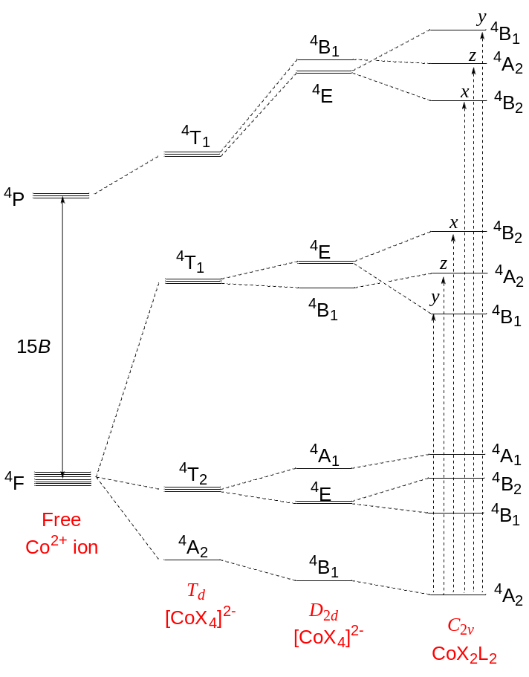
Figure 3.7. Electronic states of quartet states of 3d⁷ Co²⁺ as a free-ion, in a tetrahedral (T_{d}) ligand-field, in a tetragonally compressed ligand field (D_{2d}), and in a rhombic (C_{2v}) ligand-field as in Co-X. This figure is based on one derived for Ni(II) (3d⁸) as in NiX₂(PPh₃)₂.³¹ The electronic transitions are also indicated, together with their polarization, fully for the C_{2v} case,²⁷ and partially for the D_{2d} case, which is relevant to the discussion of previous work.^{25, 27} Inclusion of spin-orbit coupling (not shown) would split each of the quartets into two degenerate levels, affording the observed ZFS. This effect is shown graphically in Figure 3e of the paper by Sundararajan et al.³² and in tabular format in Tables in SI.
angles ∠X-Co-X and ∠P-Co-P in each case, as given in Table B.2.
Use of the AOM satisfactorily fitted the experimental data given in Table B.1. As simplifying assumptions, the two halide ligands and the two phosphine ligands were held equivalent. Both ligand types were constrained to have cylindrical π-interactions; donating for X and accepting for P. The fit values for Co-Cl and Co-Br can be compared to those determined by Davies et al.,³³ who used single-crystal magnetic susceptibility data in combination with the same literature electronic absorption data as was used here. As shown in Table B.3, the two analyses are in reasonable agreement, the chief difference being that in the present work the π-acidity of the PPh₃ ligands is proposed to be greater. As also evident in Table B.3, the σ- and π-donor strength of the halide ligands in Co-X decreases in the order Cl⁻ > Br⁻ > I⁻, in agreement with the spectrochemical series.³⁴ The values determined here, and previously,³³ for the Racah interelectronic repulsion parameter B are ~60% of the free-ion value,³⁵ which is plausible for a highly covalent compound. The complete output listing of the electronic states and orbital descriptions (using the Ligfield software³⁶) for each of the Co-X series is given in Appendices B.2-B.4.
It can be seen there that inclusion of the Racah C parameter, so that C/B = 4.26, the free-ion ratio,³⁵ gives a plethora of doublet excited states well above the quartet states, but there are relatively lower lying doublet states in the ranges of 9500–12 500 cm⁻¹ and 14 000–17 500 cm⁻¹ above the ground state [i.e., close to quartet states derived from ⁴T₁(F, P)]. These doublet excited states might contribute to ZFS and possibly to the observed absorption bands. For a more tractable depiction of the doublet states, Appendix B.5.1 gives the complete d⁷ electronic states for a hypothetical [CoX₄]²⁻ ion with ideal T_{d} symmetry.

3.2.2.2. Analysis of ZFS in Co-X by Ligand Field Theory
Spin-orbit coupling can be included into the above LFT-AOM analysis to reproduce experimental ZFS parameters (Table S11). Davies et al. used ζ = 500 cm⁻¹, which is only slightly lower than the free-ion value (533 cm⁻¹).³⁷ We find that, for Co-Cl, use of ζ = 459 cm⁻¹ (86% of the free-ion value, perhaps more realistic than 94% used earlier) exactly reproduces the experimental ZFS parameters (Table 1 in comparison to those from HFEPR). It is not possible to deconvolute this splitting into D and E components, nor to their sign. The spin expectation value of each of the levels of the ground state quartet does not readily afford the spin-only values of m_{S} = ±1/2, ±3/2 (Tables S7b, S8b, S9b, S10, and S11), e.g., for Co-Cl, m_{S} = ±0.14 and m_{S} = ±0.85 (Table S7b). However, inclusion of an applied field [300 mT, as in conventional, X-band EPR; using the locally written (J. Telser) program DDN] sheds light on this situation, as shown for the electronic states of the lowest spin quartet state for a hypothetical [CoX₄]²⁻ ion with D_{2d} symmetry (Table S10) and for the real Co-X complexes with C_{2v} symmetry (Table S11). These cases give observed g_{eff} values for Co-Cl as follows: g_{x(max)} = 6.96, g_{y(min)} = 0.57, g_{z(mid)} = 0.91 (Table S11a). The assignment to x, y, and z components of g_{eff} is a consequence of the chosen AOM coordinate system, but in general for S = 3/2, observed g_{eff} values in which one is large and two are very small (for intrinsic g = 2.00, g_{eff} = [6, 0, 0]³⁸) are characteristic of D < 0, as is the case for Co-Cl.³⁹ Smaller values of ζ (~65% of the free-ion value; See Table 1) exactly reproduce the experimental ZFS for Co-Br and Co-I, again with negative sign, as demonstrated by their g_{eff} components (Tables S11b and S11c, respectively). The origin of the ZFS in Co-X is discussed in Supporting Information.

3.2.3. Experimental and Calculated Phonon Spectra and Studies of Spin-Phonon Couplings
Crystals of Co-Cl [P2/c, No. 13, 293(2) and 295 K],⁴⁰⁻⁴¹ Co-Br (P2/c, 295 K),⁴⁰ and Co-I [P2₁/c, No. 14, 110(2) K]⁴² in the current work are all monoclinic with C_{2h} crystallographic lattice symmetry. Thus, phonon modes of their crystalline solids have one of the four symmetries: A_{g}, B_{g}, A_{u}, and B_{u}.⁴³ Phonons of the A_{u} and B_{u} modes are IR-active, while those of A_{g} and B_{g} modes are Raman-active.
Phonon modes of the three complexes, energies of the modes, and INS spectra were obtained by VASP and phonopy calculations.⁴⁴ Spin-phonon coupling simulations were conducted for the avoided crossings in FIRMS spectra using Hamiltonians in Eqs. 3.1 and 3.3 below.

3.2.3.1. Phonon Excitations in FIRMS, INS, and Raman Spectra, Calculated INS Spectra, and Computations of Phonon Excitations and Symmetries
Accurate phonon calculations are a critical step to understand the atomic displacements leading to spin-phonon coupling in SMMs. In the most general sense, the atomic displacement pattern associated with a specific vibrational mode can change the bond length and angle, resulting in changes of electronic and magnetic structure. Different vibrational modes at different frequencies can affect the electronic and magnetic structure differently. The DFT phonon calculations of the INS spectra were conducted using the reported single-crystal structures of the three complexes (Table B#) with two goals: (1) Determine the symmetries of phonon modes and their energies; (2) Give calculated INS spectra to compare with the experimental ones. The lattice symmetry for all three crystal structures is C_{2h}, which was used to assign symmetries to each phonon mode. The calculated phonon modes and their energies for Co-Cl, Co-Br, and Co-I are given in Tables B#-B# in Appendix B. In addition, the DFT calculations gave calculated INS spectra in Figures B#, B#, and B# for comparison with the experimental INS spectra of the three compounds. It is noted that, unlike (optical) far-IR and Raman spectroscopies, there are no symmetry-based INS selection rules. Thus, all phonon modes are active. Overall, there is a good match between experimental (by VISION at 5 K) and calculated INS in the region above 150 cm⁻¹. However, low-energy modes are difficult to calculate accurately. It should be pointed out that the current calculations do not account for any peaks of magnetic origin or spin-phonon coupling. In addition, the VASP and phonopy⁴⁴ calculations, while giving phonons (and their symmetries and energies) and spin densities discussed below, are not able to address spin-phonon coupling in the solids. Spin-phonon couplings in other SMMs, particularly their roles in magnetic relaxation, have been the subject of recent computations or modeling studies.⁴⁵⁻⁴⁹
Far-IR and Raman spectra of the three complexes recorded at 0 T and 5 K, revealing IR- (u-symmetry) and Raman-active (g symmetry) phonons, are given in Appendix B (Co-Cl, Figure B#; Co-Br, Figure B#; Co-I, Figure B#). Since spin-phonon couplings, discussed below, involve some of the IR-active phonons and were observed in FIRMS, animations of the A_{u} and B_{u} phonons near the peaks of the magnetic transition around 20-75 cm⁻¹ (14, 16, and 31 movies for Co-Cl, Co-Br, and Co-I, respectively) have been made based on the VASP and phonopy calculations and are provided in the Appendix. These animations show atomic displacements with contributions from both external and internal modes.

3.2.3.2. Studies of Spin-Phonon Couplings in FIRMS Spectra
Multiple phonons were found to be involved in spin-phonon couplings with the magnetic transition in FIRMS spectra of Co-Cl (Figures 3.6 and B#), leading to avoided crossings (also known as non-crossings or anticrossings). An avoided crossing is, in essence, the result of interactions between two states/levels of the same symmetries, leading to two new states/levels from mixing of the two original states/levels, as shown in Figure 3.6-Left.⁵⁰ When 1s orbitals from two H atoms interact to form σ bonding and σ* antibonding orbitals, it is essentially an avoided crossing of two 1s orbitals. Spin-phonon coupling here reflects how a vibration (with a periodic motion of the atoms in a molecule) affects the magnetic levels in Figure #. Recently, a vibronic model was used to account for similar couplings of vibrations in Co(acac)₂(H₂O)₂ (S = 3/2) with the m_{s} = ±1/2, ±3/2 levels.¹¹
In the FIRMS spectra of Co-Cl (Figures 3.6-Right and B#-Bottom), when a magnetic (spin) peak (A) is close to a phonon peak (B) with the same symmetry (i.e., both excitations belong to the same irreducible representation in the C_{2h} point group), the two couple, causing the peak of the magnetic transition to take on the characteristic of the phonon peak and vice-versa. That is, the two coupled peaks carry both magnetic and phonon features.¹¹ The avoided crossings are observed as peak A is blue-shifted by the increasing magnetic field. In Figure 3.6-Right and more clearly in Figure B#-Bottom without the white lines, peak B progressively picks up more magnetic features as the magnetic field increases, until it becomes the peak of the magnetic transition undergoing a blue-shift itself, while peak A turns into a phonon peak. Peak B continues the blue-shift
until encountering another phonon (C) with the same symmetry. At this point, B and C undergo new spin-phonon coupling, resulting in another avoided crossing. This process is repeated with two additional phonon peaks D and E. It should be pointed out that there might be spin-phonon couplings involving additional phonons. However, if they exist, they are not easily identified in Figure 3.8-Right. The observations of the spin-phonon couplings between magnetic transitions and IR-active u-symmetry phonons here are in contrast with the spin-phonon couplings in Co(acac)₂(H₂O)₂ and its isotopologues,¹¹ in which the couplings were observed with Raman-active g phonons.
For the 2-D FIRMS map in Figure 3.8-Right, a simplified Hamiltonian for the coupling between the magnetic excited level $\left|\left.ϕ_{j}\right\rangle \right.$ and one phonon excited state $\left|\left.n\right\rangle \right.$ is given by the following 2 × 2 matrix in Eq. 3.1:¹¹
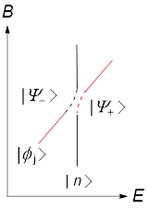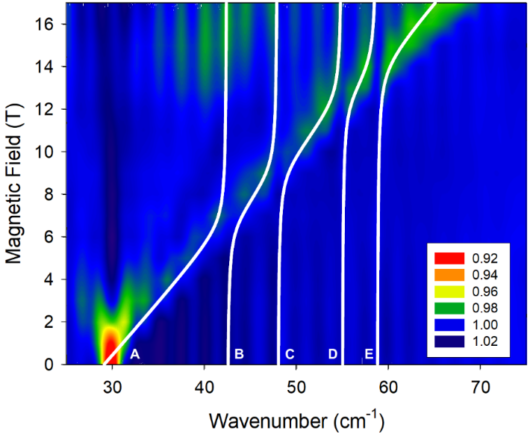
Figure 3.8. (Left) Schematic representation of an avoided crossing. Some of us have recently provided more detailed schematic views of the spin-phonon couplings in a Co(II) complex with axial anisotropy (D < 0).¹³ (Right) FIRMS plot of Co-Cl spectra normalized by average, which minimizes phonon features that do not change with magnetic fields. The color trend from red to blue corresponds to absorption decrease. The white lines show the results of the spin-phonon coupling model using a 5 × 5 matrix in Eq. # below. Figure 3.8-Right is also shown in Figure B#-Bottom in Appendix B without the white lines to more clearly reveal the avoided crossings. The blue shifting transition is from the lowest magnetic level to the highest magnetic level of the ground spin quartet and corresponds to a specific direction of the external field with respect to the spin coordinate system (i.e., a turning point). These levels are not well-defined by m_{s} quantum numbers due to the mixing.⁵¹⁻⁵²

$H=\left(\begin{matrix}E_{sp} & Λ \\ Λ & E_{ph}\end{matrix}\right)$ (Eq. 3.1)
in which E_{sp} and E_{ph} are expected energies of the magnetic and phonon excitations, respectively, and Λ is a spin-phonon coupling constant.
Solving the matrix gives two eigenvalues E± (with the associated avoided crossing peaks $\left|\left.Ψ_{±}\right\rangle \right.$) in the secular Eq. 3.2:
$\left|\begin{matrix}E_{sp}-E_{±} & Λ \\ Λ & E_{ph}-E_{±}\end{matrix}\right|=0$ (Eq. 3.2)
During the spin-phonon coupling, $\left|Ψ_{+}\right.$ shifts to higher E₊, while $\left|Ψ_{-}\right.$ shifts to lower E₋ in the avoided crossing, as shown in Figure 3.8-Left. Equations 3.1 and 3.2 give a model to understand spin-phonon coupling in the FIRMS map and calculate the coupling constants Λ.
This model can be expanded to a 5 × 5 matrix in Eq. 3.3 involving the couplings of the magnetic transition with all four phonons B, C, D, and E simultaneously. Eq. 3.3 ignores interactions (couplings) among phonons, as the off-diagonal elements between any two phonons are set to be 0. The ZFS peak (E_{sp}) was modeled every 0.5 T from 0 to 17 T for the transmittance peak, giving the coupling constants Λ₁-Λ₄ of 1.3(1)-1.4(3)
cm⁻¹ in Table 1. If the spectra are instead fit using multiple 2 × 2 matrices in Eq. 3.1, the coupling constants are not appreciably different. It should be pointed out that B, C, D, and E are those phonons in the crystalline solid of Co-Cl that are observed to undergo spin-phonon couplings, even though there are additional IR-active phonons in the 30-80 cm⁻¹ region, as listed in Table B#.
$H=\left(\begin{matrix}E_{sp} & Ʌ_{1} & Ʌ_{2} & Ʌ_{3} & Ʌ_{4} \\ Ʌ_{1} & E_{ph1} & 0 & 0 & 0 \\ Ʌ_{2} & 0 & E_{ph2} & 0 & 0 \\ Ʌ_{3} & 0 & 0 & E_{ph3} & 0 \\ Ʌ_{4} & 0 & 0 & 0 & E_{ph4}\end{matrix}\right)$ (Eq. 3.3)
Spin-phonon couplings are also observed in FIRMS maps of Co-Br (Figure 3.5-Top) and Co-I (Figure 3.5-Bottom) and also in Figures S2-Bottom and Figure S3-Bottom, respectively, without the white lines of spin-phonon couplings. Six phonons in the crystalline solid of Co-Br are noticed to couple with the magnetic transition, giving rise to avoided crossings as the latter blue-shifts due to the Zeeman effect (IR-active, u-symmetry phonons B-G in the 30-80 cm⁻¹ region, Table S2). Simulations using a 7 × 7 matrix (Eq. S2 in SI) give the coupling constants of 1.0(3)-1.8(4) cm⁻¹ in Table 1. For a crystalline solid of Co-I, nine phonons (B-J in Figure 3.5-Bottom) are shown to couple to the magnetic transition leading to several avoided crossings, as peak A moves to higher energy with increasing external magnetic field. Simulations using a 10 × 10 matrix (Eq. S3 in SI) give the coupling constants of 0.9(3)-2.0(4) cm⁻¹ in Table 1.

3.2.3.3. Calculated Spin Densities of Atoms in Co-X Complexes
The DFT calculations using VASP also give spin densities, ρ_{s}, in Co-X, as summarized in Table 2 with detailed lists for each atom in Tables S13-S14 in SI. Although the VASP calculations here are not of high-level, they provide a quantitative scale, revealing how the spin is dispersed onto X, P, C and peripheral H atoms in the molecules.⁵³ VASP partitions electrons according to the Wigner-Seitz radius a_{e} in Eq. 3.4:⁵⁴
a_{e} = (3/4πn_{e})^{1/3} (Eq. 3.4)
where n_{e} is the particle density of electrons; a_{e} is the radius “occupied” by one atom in a sample, and each atom is considered as a sphere.
Table 3.2. Calculated spin densities ρ_{s} of atoms in Co-X
Atom | Co-Cl | Co-Br | Co-I
Co | 2.585 | 2.570 | 2.553
X | 6.69 × 10⁻² (Cl) | 6.85 × 10⁻² (Br) | 6.01 × 10⁻² to 6.39 × 10⁻² (I)
P | 2.06 × 10⁻² | 1.92 × 10⁻² | 1.55 × 10⁻² to 1.94 × 10⁻²
C | -2.02 × 10⁻⁴ to -6.38 × 10⁻⁴  1.21 × 10⁻⁴ to 2.98 × 10⁻³ | -1.50 × 10⁻⁴ to -5.36 × 10⁻⁴  3.90 × 10⁻⁴ to 2.93 × 10⁻³ | -6.62 × 10⁻⁶ to -1.04 × 10⁻³  4.40 × 10⁻⁸ to 5.07 × 10⁻³
H | -1.77 × 10⁻⁵ to -5.65 × 10⁻⁵ 2.40 × 10⁻⁷ to 8.40 × 10⁻⁵ | -1.89 × 10⁻⁵ to -4.92 × 10⁻⁵  1.21 × 10⁻⁶ to 9.47 × 10⁻⁵ | -2.70 × 10⁻⁶ to -4.10 × 10⁻⁵  5.85 × 10⁻⁶ to 8.85 × 10⁻⁵
Total | 2.797 | 2.783 | 2.747

This method does not include spin densities in bonds between atoms. Therefore, the total spin densities (sums of those on all atoms) of 2.80, 2.78 and 2.75 for Co-Cl, Co-Br and Co-I, respectively, are smaller than 3 (= 3 unpaired electrons) on the molecules. The results in Table 2 show that the unpaired electron densities are transferred from the central Co(II) ions to ligand atoms, although the metal ions retain 2.59, 2.57 and 2.55 unpaired electrons (>92% of total spin in each of the three compounds, not counting the spin densities between bonds), respectively. That the spin density is mostly on the Co(II) ion in Co-X is consistent with the above simple LFT that describes the complexes as pure d⁷ systems, i.e., as having nearly “innocent” ligands. This is in contrast to the case of a diiodide complex of Mn(III) (d⁴, S = 2) wherein a valence tautomer that can be described as [Mn^{II}I•]²⁺, as opposed to the innocent [Mn^{III}I⁻]²⁺, leads to unusual ZFS.⁵⁵ Among ligand atoms, the halides X carry very small, yet the highest spin densities (6.01 × 10⁻² to 6.85 × 10⁻²), followed by the P atoms (1.55 × 10⁻² to 2.06 × 10⁻²). These densities are positive, as those of some C and H atoms of the phenyl groups in the PPh₃ ligands (Tables S13 and S14), indicating that spins on the α atoms in the molecules are parallel to those on the Co(II) ion. Other C and H atoms, however, have negative spin densities, i.e., the spin densities on these atoms have opposite polarization to that on the Co(II) ion, X, and P atoms.
The results here are consistent with NMR studies of paramagnetic compounds, which show ligand resonances are typically shifted by electron spin densities on the ligand atoms.⁵⁶⁻⁵⁸ The signs of ρ_{s} in Table 2 indicate that both spin delocalization and polarization mechanisms, which are used as a model to explain spin delocalization in paramagnetic molecules,⁵⁶⁻⁵⁷ likely account for the transfer of spin densities in Co-X.
It is interesting to note that the slight decrease of spin density on the Co(II) ion from Co-Cl (2.585), Co-Br (2.570), to Co-I (2.553) parallels the drop of D′ from 14.89(2), to 13.83(2), and to 13.63(10) cm⁻¹ (HFEPR results) for the three complexes, as shown in Figure S29 in SI. For Co(acac)₂(H₂O)₂, also a SMM,^{11, 53, 59} but with only light atom (Period 2) donor ligands, the calculated spin density of 2.81 (by the same VASP program) on its Co(II) ion and D′ of 57 cm⁻¹ are both larger than those of Co-X. At least among these four Co(II) complexes, the larger spin density on a metal ion is, the larger ZFS in the complex is. It should be pointed out that the number of complexes here [four including Co(acac)₂(H₂O)₂] is limited, and different DFT programs may give different calculated spin densities. Studies of more compounds are needed to see if there is a correlation between the spin densities and magnetitudes of ZFS. In addition, the VASP calculations here are not able to address spin-phonon coupling,⁴⁵⁻⁴⁹ as indicated earlier. Thus, additional studies are needed to understand how the spin density affects ZFS in a complex and how the the lattice and molecular motions (i.e., phonons) that are coupled to the magnetic excited levels impact the spin density.

CHAPTER IV

Studies of Structures and Magnetic Properties of Metalloporphyrinates Mn(TPP)X (X = Br, I)

This chapter is based on the following paper:
Alexandria N. Bone, Shelby E. Stavretis, J. Krzystek, Zhiming Liu, Qiang Chen, Zheng Gai, Xiaoping Wang, Carlos A. Steren, Xian B. Powers, Andrey A. Podlesnyak, Xue-Tai Chen, Joshua Telser, Haidong Zhou, Zi-Ling Xue, Manganese tetraphenylporphyrin bromide and iodide. Studies of structures and magnetic properties. Polyhedron 2020, 182, 114488. https://doi.org/10.1016/j.poly.2020.114488

The author grew crystals of 2·CHCl₃, 2·CH₂Cl₂, and 3·CHCl₃, performed and interpreted all DC and AC susceptibility measurements, conducted X-ray single-crystal diffraction studies of 2·CHCl₃, 2·CH₂Cl₂, 3·CHCl₃, and 3·1.5CHCl₃, and performed CShM and Hirshfeld surface calculations with X. Wang. Results from HFEPR performed by J. Krzystek and J. Telser, as well as results of X-ray single-crystal diffraction of 3·CHCl₃ and INS performed by S. Stavretis, are included for a complete presentation of the studies.

Did Zhiming include any of this data in his thesis?

4.1. Abstract
Manganese tetraphenylporphyrin bromide and iodide Mn(TPP)X (X = Br, 2; I, 3; TPP²⁻ = meso-tetraphenylporphyrinate) are synthetic analogs of Mn(III) geoporphyrins. Crystal structures of 2 and 3 with chloroform in the lattices, Mn(TPP)Br·CHCl₃ (2·CHCl₃), Mn(TPP)I·CHCl₃ (3·CHCl₃), Mn(TPP)I·CDCl₃ (3·CDCl₃) in a different space group from 3·CHCl₃), Mn(TPP)I·1.5CHCl₃ (3·1.5CHCl₃), and 2 with dichloromethane in the lattice, Mn(TPP)Br·CH₂Cl₂ (2·CH₂Cl₂), have been determined by single-crystal X-ray diffraction at 100 K or 298 K. Hirshfeld surface analyses of the crystal structures of 2·CHCl₃, 2·CH₂Cl₂, 3·CHCl₃, 3·CDCl₃ and 3·1.5CHCl₃ have been performed. Surprisingly the Mn(III)−Br and Mn(III)−I bonds in Mn(TPP)X (2-3) are about 0.2 (8%) longer than Fe(III)−Br and Fe(III)−I bonds in S = 5/2 Fe(TPP)X (X = Br, 4; I, 5), although both Mn(III) and Fe(III) ions have the same radii. Magnetic properties of 2 and 3 have been studied by direct current (DC) and alternating current (AC) susceptibility measurements, high-field electron paramagnetic resonance (HFEPR), and inelastic neutron scattering (INS). With four unpaired electrons in Mn(TPP)X (X = Br, 2; I, 3), the bromide complex 2 in 2·CDCl₃ possesses easy-axis anisotropy, as the chloride analog Mn(TPP)Cl (1), with the axial (D) and rhombic (E) zero-field splitting parameters of D = −1.091(3) cm⁻¹ and |E| = 0.087(2) cm⁻¹. The iodide complex 3 in 3·CDCl₃ becomes easy-plane with D = +1.30(1) cm⁻¹ and |E| = 0.010(5) cm⁻¹. Axial ZFS parameters D change from −2.24(2) cm⁻¹ in 1, reported earlier, to −1.091(3) cm⁻¹ in 2 and +1.30(1) cm⁻¹ in 3.

4.2. Results and Discussion

4.2.1. Crystal Structures of 2·CHCl₃, 2·CH₂Cl₂, 3·CHCl₃, 3·CDCl₃ and 3·1.5CHCl₃
Crystallographic data of the five structures are given in Tables C.1 and C.2 along with their cif files in Appendix C. Crystal structures of 2·CHCl₃ and 3·CHCl₃ are discussed below. ORTEP drawings of three other structures, Mn(TPP)X in 2·CH₂Cl₂, 3·CDCl₃ and 3·1.5CHCl₃, are given in Figures C.1, C.2 and C.3, respectively with their selected bond lengths and angles in Tables C.3, C.4 and C.5, respectively. Continuous shape measure (CShM) calculations using the SHAPE program⁶⁰⁻⁶¹ were performed on all five structures as well as 2·toluene and 3·toluene⁶² to analyze the degree of deviation from ideal geometry, and results are provided in Tables C.6 and C.7.
Crystals of 2·CHCl₃ adopt the monoclinic space group P2₁/n. An ORTEP diagram of the molecule is given in Figure 4.1. Selected bond lengths and angles for 2·CHCl₃ are included in Table 4.1. The penta-coordinated Mn^{III} center adopts a distorted square pyramidal geometry with the Mn—Br and four Mn—N bonds in axial and equatorial positions, respectively. In the equatorial plane, the linear N1—Mn1—N3 bonds are slightly elongated [with bond lengths of 2.018(2) and 2.014(2) Å, respectively] than the other N2—Mn1—N4 bonds [bond lengths of 2.001(2) and 2.008(2) Å, respectively]. CShM calculations performed on the solvent-containing structures of Mn(TPP)Br (2) [2·CHCl₃, 2·toluene and two independent Mn(TPP)Br (2) molecules in 2·CH₂Cl₂ (Table C.6)] show that Mn(TPP)Br molecules in all three analogs exhibit only slight distortion from square pyramidal geometry. Comparison of the Mn—Br bond
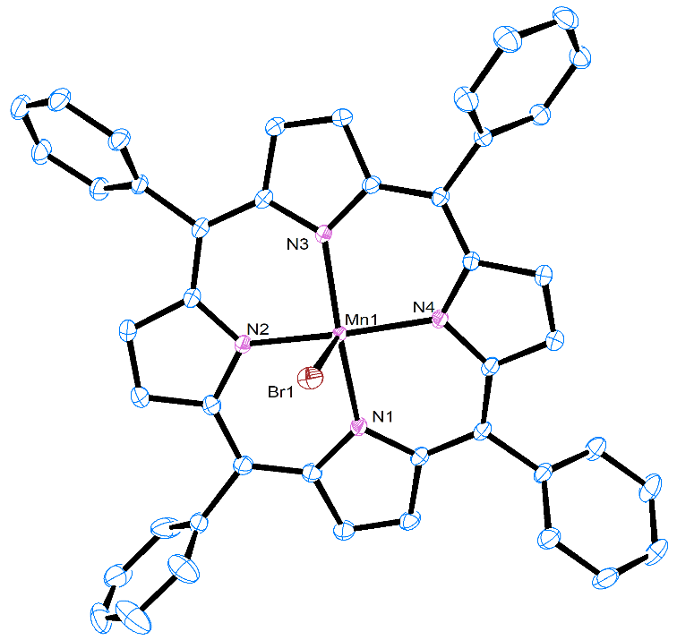
Figure 4.1. ORTEP diagram of the structure of Mn(TPP)Br (2) in the crystal of 2·CHCl₃. CHCl₃ in the lattice and H atoms are omitted.

Table 4.1. Selected bond lengths (Å) and angles (°) for 2·CHCl₃ and 3·CHCl₃ at 100(2) K.
2·CHCl₃ |  | 3·CHCl₃
Atoms | Length (Å) or angle (°) | Atoms | Length (Å) or angle (°)
Mn1—Br1 | 2.5363(5) | Mn1—I1 | 2.7494(4)
Mn1—N1 | 2.018(2) | Mn1—N1 | 2.0162(18)
Mn1—N2 | 2.001(2) | Mn1—N2 | 2.0148(18)
Mn1—N3 | 2.014(2) | Mn1—N3 | 2.0101(18)
Mn1—N4 | 2.008(2) | Mn1—N4 | 2.0126(18)
N1—Mn1—Br1 | 94.60(6) | N1—Mn1—I1 | 99.36(5)
N2—Mn1—Br1 | 90.88(7) | N2—Mn1—I1 | 93.99(5)
N3—Mn1—Br1 | 100.72(6) | N3—Mn1—I1 | 96.32(5)
N4—Mn1—Br1 | 100.77(6) | N4—Mn1—I1 | 97.16(5)
N1—Mn1—N2 | 89.98(9) | N1—Mn1—N2 | 89.42(7)
N2—Mn1—N3 | 88.73(8) | N2—Mn1—N3 | 89.27(7)
N3—Mn1—N4 | 89.37(8) | N3—Mn1—N4 | 89.06(7)
N4—Mn1—N1 | 88.81(8) | N4—Mn1—N1 | 89.21(7)
N1—Mn1—N3 | 164.64(9) | N1—Mn1—N3 | 164.32(8)
N2—Mn1—N4 | 168.35(9) | N2—Mn1—N4 | 168.83(8)

length here with that of Fe—Br in Fe(TPP)Br (4) is given below.
Mn(TPP)I (3) crystallized in layered pentane/CHCl₃ solution at 23 °C to give crystals of 3·CHCl₃ (monoclinic space group P2₁/n). An ORTEP diagram of the molecule is given in Figure 4.2 with selected bond lengths and angles for 3·CHCl₃ in Table 4.1. The structure shares features with its bromo analog 2·CHCl₃ discussed earlier, as comparisons in Table 4.1 show. CShM calculations of all four structures of Mn(TPP)I (3) [3·CHCl₃, 3·CDCl₃, 3·1.5CHCl₃ and 3·toluene] by the SHAPE program⁶⁰⁻⁶¹ (Table C.7) show slight deviations of the Mn(TPP)I molecules (3) in all structures from the square pyramid.
Five-coordinate Mn(III) and Fe(III) ions have identical radii of 0.72 .⁶³ Yet, both Mn—Br and Mn—I bonds in Mn(TPP)X (2-3) in the crystals (bond lengths of 2.490-2.536 and 2.730-2.784 , respectively) are about 0.2 (or 8%) longer than Fe—Br and Fe—I bonds (bond lengths of 2.348 and 2.554 , respectively) in Fe(TPP)X (X = Br, 4; X = I, 5)⁶⁴⁻⁶⁵, as a comparison in Table 4.2 below shows. This is surprising, as Fe(TPP)X (4-5) have higher spin (S = 5/2) than Mn(TPP)X (2-3, S = 2), and the extra d electron in the former resides in an antibonding orbital, as a qualitative MO diagram for the square pyramid complex with C_{4v} symmetry in Figure C.4 shows. The Fe—X bonds in Fe(TPP)X (4-5) are expected to be longer (not shorter) than the Mn—X bonds in M(TPP)X (2-3). Extensive studies of octahedral spin crossover complexes⁶⁶ and metalloporphyrins⁶⁷ have shown that high-spin complexes have more elongated M—L bonds than low-spin complexes as a result of adding electrons to antibonding d_{x2}-_{y2}
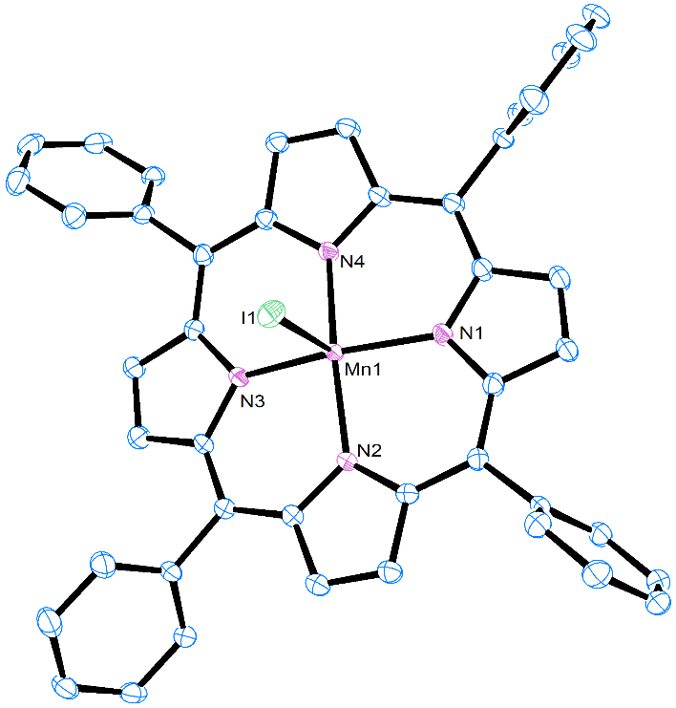
Figure 4.2. ORTEP diagram of Mn(TPP)I in 3·CHCl₃. CHCl₃ and H atoms are omitted.

and/or d_{z2} orbitals, although the comparison here involves complexes of the same metal ions. Another difference between the structures of Mn(TPP)X (2-3) and its iron(III) analogs Fe(TPP)X (4-5) is that the former have smaller distances between the Mn(III) ions and the center of the TPP²⁻ ligand [0.236-0.295 for Mn(TPP)Br (2) and 0.213-0.259 for Mn(TPP)I (3)] than those [0.489 for Fe(TPP)Br (4) and 0.459 for Fe(TPP)I (5)] in the latter. In fact, the X⁻−TPP²⁻ (center) distances of 2.760-2.785 in Mn(TPP)Br (2) and 2.954-3.041 in Mn(TPP)I (3) are similar to 2.837 in Fe(TPP)Br (4) and 3.013 in Fe(TPP)I (5), as shown in Table 4.2. In other words, the shorter Fe—X bond lengths are compensated by the longer Fe—TPP²⁻ (center) distances. Temperatures, affecting crystal structures, are known to change Hirshfeld surfaces and volumes.⁶⁸ However, Hirshfeld surfaces and volumes of Mn(TPP)X (surfaces and volumes are 637.8-656.7 ² and 816.6-845.8 ³ for 2; 648.7-662.3 ² and 826.6-858.0 ³ for 3) with different solvents and temperatures [100(2) or 293-298 K] are similar to those of Fe(TPP)X (4-5) at 293-295 K with no solvent, as shown in Table 4.2 and discussed below. The average lengths of the Mn—N bonds in Mn(TPP)X (2-3) [between the Mn(III) ions and N atoms in the TPP²⁻ ligands] are similar at 2.002-2.010 . The Mn—N bonds are slightly shorter than 2.066-2.069 of the Fe—N bonds in Fe(TPP)X (4-5).

4.2.2. Hirshfeld Surface Analyses
Hirshfeld surface analyses and fingerprint plots of Mn(TPP)Br∙CHCl₃ (2∙CHCl₃, Figures. 4.3-4.4) and Mn(TPP)I∙CHCl₃ (3∙CHCl₃, Figures. 4.5-4.6) are discussed below,
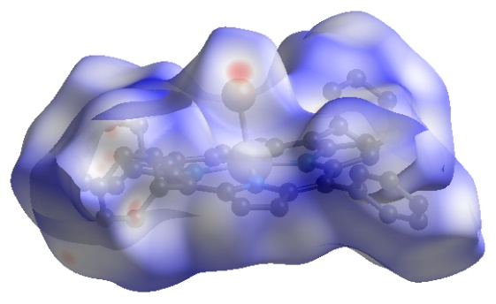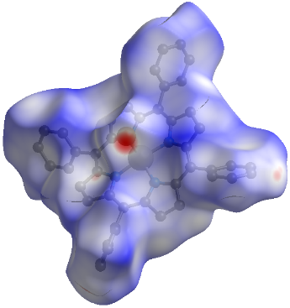
Figure 4.3. Two views of the Hirshfeld surface of 2∙CHCl₃ showing normalized close distances of the pro-molecule and neighboring molecules at 100(2) K.⁶⁹ The red-white-blue coloring scheme demonstrates decreasing contacts. Sites of close contacts are shown in red dots. Semi-transparent view reveals the enclosed molecule. Hereafter the same below for the coloring scheme, sites of close contacts and semi-transparent view.

H∙∙∙H close contact (blue) below Br∙∙∙H close contact (blue) below
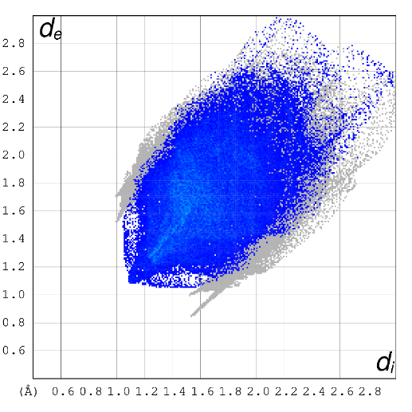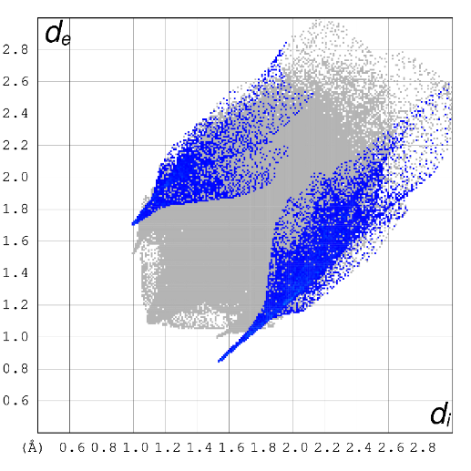
Figure 4.4. Hirshfeld fingerprint plots for 2∙CHCl₃. The closest contacts correspond to the minimum d_{i} + d_{e} values in each plot, hereafter the same below. d_{i} and d_{e} are distances from the Hirshfeld surface to the nearest atom interior and exterior to the surface, respectively.⁷⁰

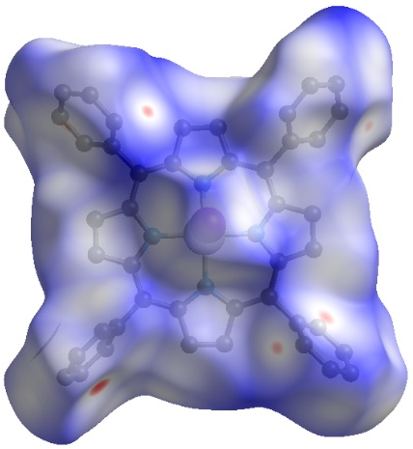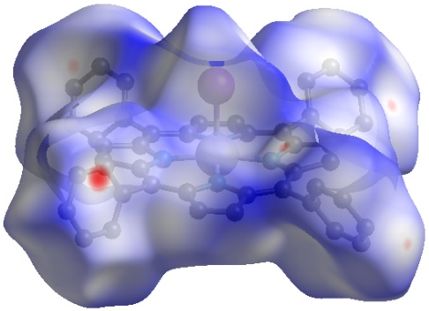
Figure 4.5. Two views of the Hirshfeld surface of 3∙CHCl₃ showing normalized close distances of the pro-molecule and neighboring molecules at 100(2) K.⁶⁹
H∙∙∙H close contact (blue) below I∙∙∙H close contact (blue) below
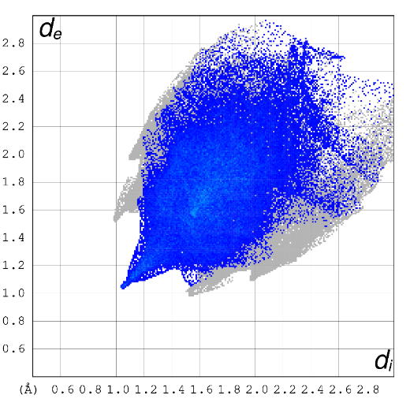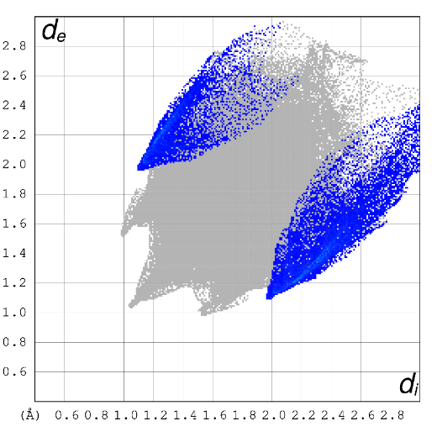

Figure 4.6. Hirshfeld fingerprint plots for 3·CHCl₃.

with the analyses of 2∙CH₂Cl₂ (Figures C.5-C.6), 3∙CDCl₃ (Figures C.10-C.11) and 3∙1.5CHCl₃ (Figures C.12-C.13) given in Appendix C. We have conducted Hirshfeld surface analyses of the reported structures of 2∙toluene (Figures C.7-C.8) and 3∙toluene (Figures C.14-C.15). The results are provided in Appendix C. Views of the Hirshfeld surfaces for these structures (e.g., Figures 4.3 and 4.5) show that they all have sites of close contacts (red spots). In addition to a comparison of structure features, Hirshfeld areas, Hirshfeld volumes and void volumes in Table 4.2, Figures C.9 and C.16 give percentage contributions to the Hirshfeld surface areas for various intermolecular close contacts for Mn(TPP)Br (2) and Mn(TPP)I (3) molecules, respectively, in various crystal structures.
Hirshfeld analyses of the single molecule in the unit cell of Mn(TPP)Br∙CHCl₃ (2∙CHCl₃) in the P2₁/n space group (100 K) give areas and volumes 643.0 ² and 819.6 ³ (Figure 4.3, Table 4.2), respectively, that are similar to those (637.8-655.7 ² and 816.6-821.6 ³, Figure C.5, Table 4.2) of the two independent molecules in the unit cell of 2∙CH₂Cl₂ which is also in the P2₁/n space group (100 K). The two structures also have similar percent void volumes (12.22% and 11.66% for 2∙CHCl₃ and 2∙CH₂Cl₂, respectively). Hirshfeld fingerprint plots in Figures 4.4 and C.6 for 2∙CHCl₃ and 2∙CH₂Cl₂, respectively, emphasize close intermolecular interactions. For both structures with different solvent molecules, the H∙∙∙H and H∙∙∙Br close contacts involving 2 in 2∙CHCl₃ (Figure 4.4) and the Mn1 molecule in 2∙CH₂Cl₂ (Figure C.6-Top) are fairly similar to each other and to those in 2∙toluene at 298 K (Figure C.8) containing non-halogen solvent toluene. The molecules of Mn1 and Mn2 in 2∙CH₂Cl₂ form pairs of Mn1...Mn1 and Mn2...Mn2 dimers in which the Mn-Br bonds point inwards with each other in each of the dimer units. Br1 in the molecule of Mn1 has close contact to the terminal H atoms on a phenyl ring of the adjacent Mn1 molecule. In the molecule of Mn2, one of the phenyl groups is facing Br2 with much longer Br2…H(phenyl) distances. The difference in the Hirshfeld fingerprint plots for the Br∙∙∙H close contacts in Figure C.6 reflects the packing difference of Mn1 and Mn2 molecules in 2∙CH₂Cl₂.
Although both Hirshfeld surfaces and fingerprint plots for the structures of 3∙CHCl₃ (P2₁/n) and 3∙1.5CHCl₃ (P$\overline{1}$) determined at 100(2) K reveal sites of close contacts (Figures 4.5 and C.12) and similar H∙∙∙H and I∙∙∙H close contacts (Figures 4.6 and C.13), the Hirshfeld surface area (662.3 ²) and volume (849.2 ³) in 3∙CHCl₃ are slightly larger than those (651.4-656.5 ² and 826.6-834.8 ³) of both independent Mn(TPP)I (3) molecules in 3∙1.5CHCl₃ (Table 4.2). Structures of both Mn(TPP)I∙CDCl₃ (3∙CDCl₃ in P2₁/c) and 3∙toluene (P$\overline{1}$)⁶² were determined at room temperatures. Since the D atom in CDCl₃ has the same electron density as an H atom, the D atom was refined as an H atom. The two independent molecules in the unit cells of both crystals show sites of close contacts (Figures C.10 and C.14). Although the patterns of fingerprint plots for the two are similar, the minimum d_{i} + d_{e} I∙∙∙H/D values of about 2.6-2.7 in 3∙CDCl₃ (Figure C.11), indicating the closest I∙∙∙H/D contacts, are smaller than about 3.0-3.1 in 3∙toluene (Figure C.15).

4.2.3. Magnetic Susceptibility
DC magnetic susceptibility χ versus temperature T for Mn(TPP)Br∙CHCl₃ (2∙CHCl₃) measured between 2 and 300 K in an applied magnetic field of 0.5 T is given as a plot of χ_{M}T versus T in Figure 4.7-Top, yielding effective magnetic moment μ_{eff} ≈ 5.2 BM. Volatile CHCl₃ molecules in the lattice are expected to be partially (or completely) removed before and/or in the measurements, as the experiments were conducted under vacuum (~5 torr). If the same data were processed for solvent-free Mn(TPP)Br (2) as shown in Figure C.17-Top, they gave effective magnetic moment μ_{eff} ≈ 4.6 BM. For a spin-only, S = 2 complex, μ_{eff} = 4.9 BM is expected. Thus, μ_{eff} ≈ 5.2 and 4.6 BM calculated for 2∙CHCl₃ and solvent-free 2, respectively, are about 7% higher and lower than 4.9 BM. The discrepancies here suggest that a significant portion of the solvent CHCl₃ molecules in the lattice was removed under vacuum (5 torr) during the measurements. Upon cooling below 20 K, χ_{M}T exhibits a sharp decrease from a constant 3.259 cm³∙K∙mol⁻¹ to 2.561 cm³∙K∙mol⁻¹ at 2 K. This decrease is likely due to ZFS of the Mn(III) ion in the complex, as observed for 1.⁷¹ An M-H plot of 2∙CHCl₃ is given in Figure C.18-Top. No frequency-dependent out-of-phase signals (χ_{M}″) were observed with the AC frequency of 1-1488.1 Hz at 1.8 K using 0 or 0.14 magnetic field (Figure C.18-Bottom), suggesting that 2∙CHCl₃ does not exhibit SMM properties.
DC susceptibility data of Mn(TPP)I∙CHCl₃ (3∙CHCl₃) give plots such as those in Figure 4.7-Bottom for data at 0.5 T, yielding μ_{eff} ≈ 5.5 BM. However, if the same data were processed for solvent-free Mn(TPP)I (Figure C.17-Bottom), μ_{eff} ≈ 4.9 BM. The
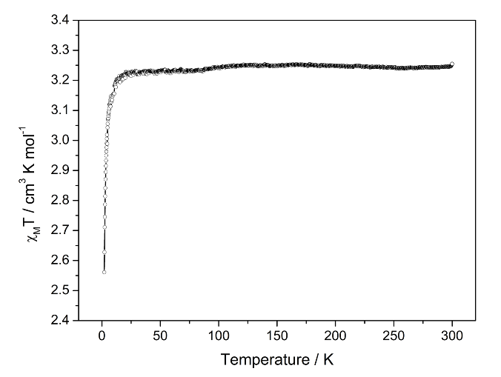
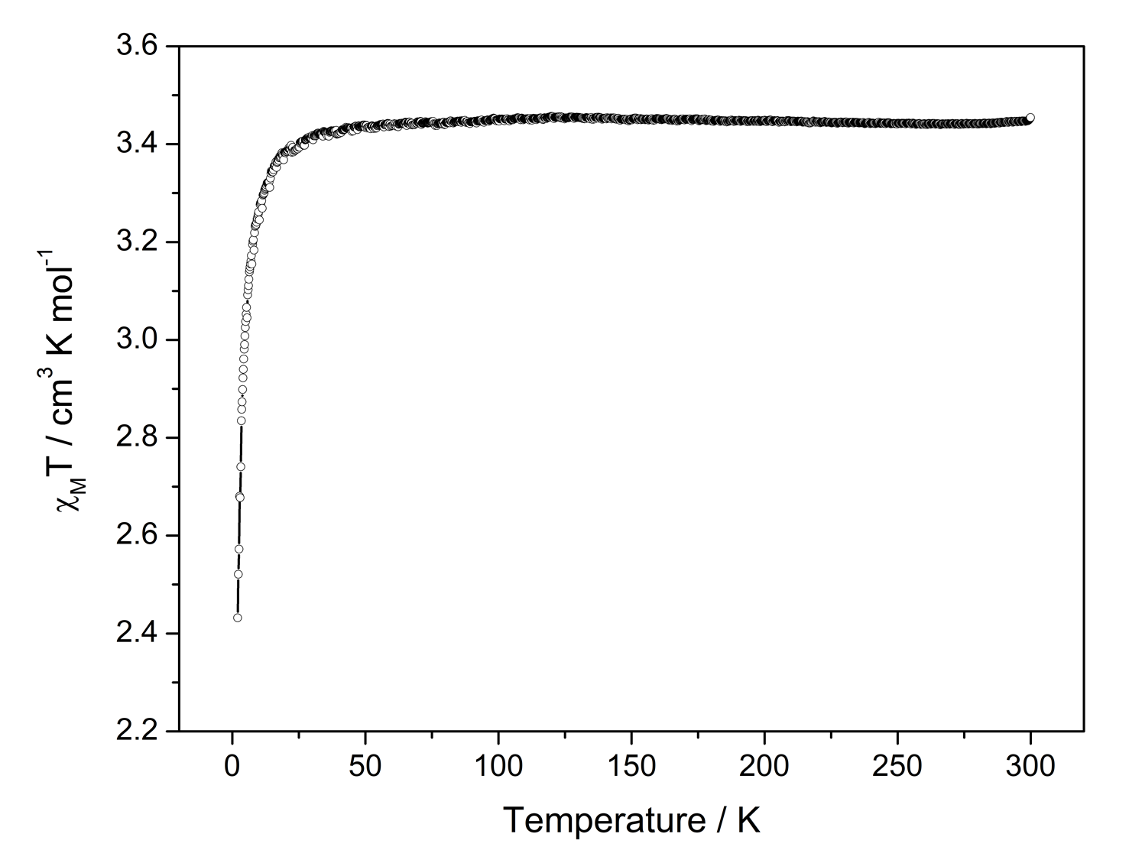
Figure 4.7. Variable-temperature DC susceptibility data under applied DC field of 0.5 T: (Top) 2·CHCl₃. (Bottom) 3·CHCl₃. Fits are included to guide the eye.

results suggest that nearly all CHCl₃ molecules in 3∙CHCl₃ were removed before or during the measurements. Like 2∙CHCl₃, 3∙CHCl₃ exhibits a decrease in χ_{M}T from 3.454 cm³∙K∙mol⁻¹ to 2.432 cm³∙K∙mol⁻¹ upon cooling below 50 K; this may also be attributed to the ZFS of the Mn(III) complex. An M-H plot of 3∙1.5CHCl₃ is given in Figure C.19-Top. AC susceptibility measurements of 3∙1.5CHCl₃ show no slow magnetic relaxation (Figure C.19-Bottom).

4.2.4. HFEPR Studies
HFEPR response of Mn(TPP)Br∙CDCl₃ (2∙CDCl₃) represents powder spectra of an S = 2 spin species with moderate negative ZFS on the order of −1 cm^{–1}. Figure 4.8-Top shows a typical spectrum recorded at 10 K, and at the highest end of frequencies used, 322 GHz, along with its simulations. Two more spectra, recorded at lower frequencies, are shown in Figure C.20-Top and Figure C.21-Top in Appendix C. Although the spectra show a presence of more than one species, spin Hamiltonian parameters for the dominant species could be well established using tunable-frequency EPR methodology⁷², as shown in Figure 4.9-Top. Spin Hamiltonian parameters obtained from computer fits, and used in the simulations, are collected in Table 4.2. From a visual comparison of the single-frequency spectra and the two cases of simulations for each of them, one for D < 0, and the other D > 0, it is apparent that D is negative in Mn(TPP)Br∙CDCl₃ (2∙CDCl₃).
HFEPR response of Mn(TPP)I∙CDCl₃ (3∙CDCl₃) is very different from that of Mn(TPP)Br∙CDCl₃ (2∙CDCl₃). Figure 4.8-Bottom shows a typical spectrum recorded at
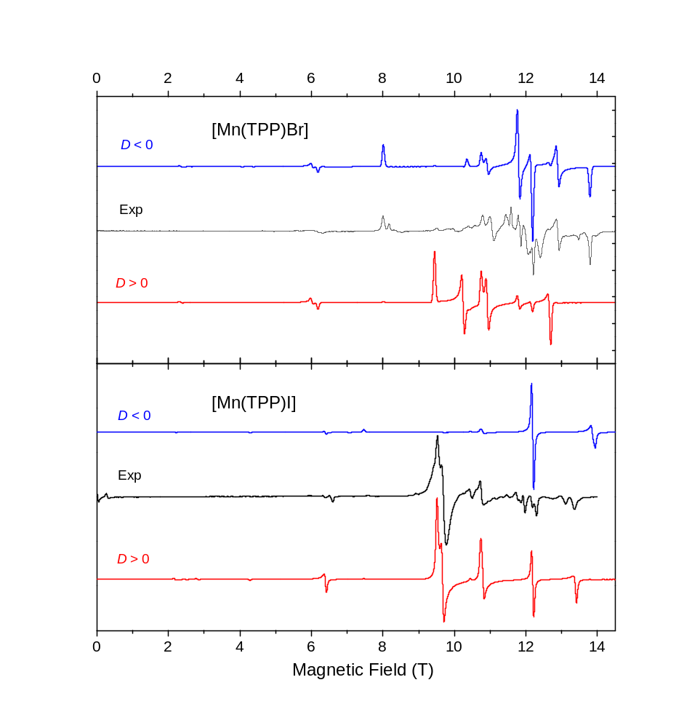
Figure 4.8. HFEPR spectra of Mn(TPP)Br∙CDCl₃ (2∙CDCl₃, Top) and Mn(TPP)I∙CDCl₃ (3∙CDCl₃, Bottom) at 10 K and 321.6 GHz (black traces) and their powder-pattern simulations (colored traces). The spin Hamiltonian parameters used in simulations were the same as in Table 4.2 for 2∙CDCl₃ and slightly adjusted for 3∙CDCl₃: D = +1.34 cm^{–1}, E = +0.013 cm^{–1} (E/D = 0.01); g = [1.965(5), 1.971(10), 1.930(5)]. Blue traces: D < 0; red traces: D > 0. Two near-zero field resonances in the spectrum of 3∙CDCl₃ indicate a minority spin species with ZFS on the order of 4 cm^{–1}, typical for octahedrally-coordinated Mn(III) ions.
Figure 4.9. 2-D field/frequency (energy) maps of turning points in HFEPR spectra of Mn(TPP)Br∙CDCl₃ (2∙CDCl₃) (Top) and Mn(TPP)I∙CDCl₃ (3∙CDCl₃) (Bottom, black squares in each case). The curves are simulations using spin Hamiltonian parameters as in Table 2. Red curves: turning points with magnetic field parallel to the x axis of the ZFS tensor; blue: B₀ || y; black: B₀ || z. Off-axis turning points, of which there are several depending on frequency, are not plotted as they were not used in the fits. The vertical dashed lines represent frequencies, at which spectra shown in Figure 4.12-Top, Figure C.20-Top, and Figure C.21-Top for 2∙CDCl₃ and Figure 4.12-Bottom, Figure C.20-Bottom and Figure C.21-Bottom for 3∙CDCl₃.
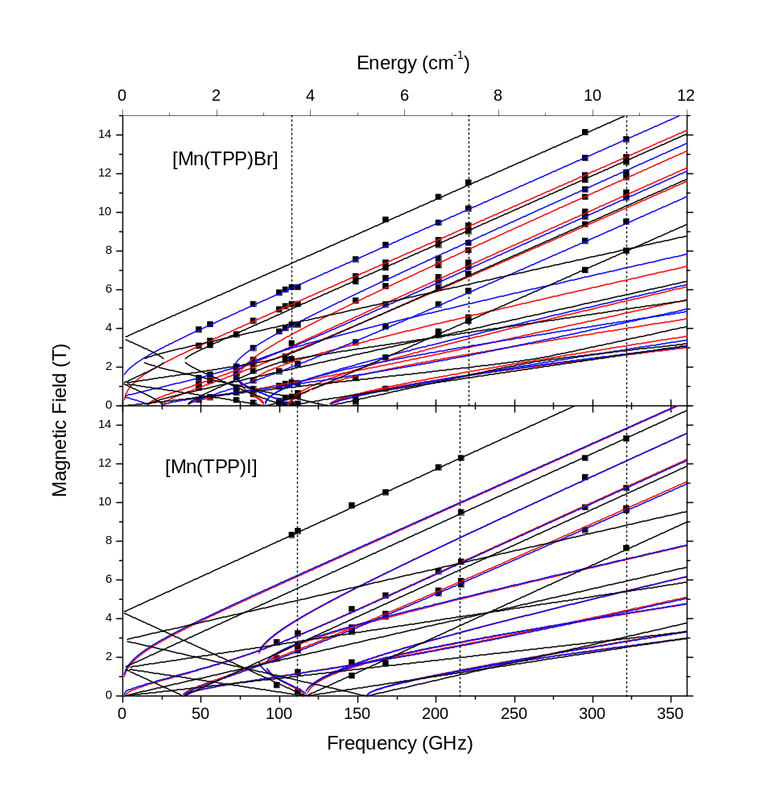

10 K, and at the same frequency as the bromide analog, 322 GHz, along with its simulations. Two more spectra, recorded at lower frequencies, are shown in Figure C.20-Bottom and Figure C.21-Bottom in Appendix C. Although the quality of the spectra is somewhat lower than that of 2∙CDCl₃, and there is noticeable presence of a minority spin species, it is beyond doubt that the sign of D in Mn(TPP)I∙CDCl₃ (3∙CDCl₃) is positive. In addition, both single-frequency spectra and the 2-D field vs. frequency (energy map) (Figure 4.9-Bottom) show that the g-values in 3∙CDCl₃ (1.93-1.97) are markedly lower than 1.99-2.01 which are the usual numbers found in Mn coordination complexes at any oxidation state.
While molecules of Mn(TPP)Br (2) and Mn(TPP)I (3) have 4-fold symmetry, crystals of Mn(TPP)Br∙CHCl₃ (2∙CHCl₃, P21/n) and Mn(TPP)I∙CDCl₃ (3∙CDCl₃, P21/c) do not have 4-fold symmetry. Although the structure of 2∙CDCl₃ used for the HFEPR studies was not directly determined, it is expected to be in a monoclinic space group. Since in monoclinic unit cells, x ≠ y, additional ZFS occurs, as shown in Eq. 1. Thus, in addition to axial ZFS parameters D, both 2∙CDCl₃ and 3∙CDCl₃ have rhombic ZFS parameters E, as observed in the HFEPR spectra.

4.2.5. INS Studies
In neutron scattering processes, the incident neutrons are scattered from interactions with either atomic nuclei or unpaired electrons in the sample.⁷³⁻⁷⁵ The cross section of magnetic scattering, from the interactions between neutron spins and electron spins, corresponds to the number of neutrons scattered per second due to the magnetic interaction into a solid angle dΩ with energy transfer between ω and (ω + dω) divided by the flux of the incident neutrons. If unpolarized neutrons are scattered from identical magnetic ions with localized electrons, the magnetic scattering cross section for spin-only scattering is expressed by Eq. 4.1:^{73, 76-77}
$\frac{d^{2}σ}{dΩdω}={\left(γr_{0}\right)}^{2}\frac{k_{f}}{k_{i}}\left[\frac{1}{2}gF{\left(Q\right)}^{2}e^{-2W\left(Q\right)}\sum_{α,β}{\left(δ_{αβ}-\frac{Q_{α}∙Q_{β}}{Q^{2}}\right)S^{αβ}\left(Q,ω\right)}\right]$ (Eq. 4.1)
where σ = neutron cross section; γ = gyromagnetic ratio; $r_{0}$ = classical radius of an electron; g = Landé g-factor; F(Q) = dimensionless magnetic form factor defined as the Fourier transform of the normalized spin density associated with magnetic ions; e^{-2W(Q)} = Debye-Waller factor caused by thermal motion; $S^{αβ}(Q,ω)$ = magnetic scattering function; $\left(δ_{αβ}-\frac{Q_{α}Q_{β}}{Q^{2}}\right)$ = polarization factor which implies neutrons can only couple to magnetic moments or spin fluctuations perpendicular to Q; $ω$ = energy change experienced by the sample; $ω$ = angular frequency of neutron.
In the scattering processes, some neutrons transfer energies with the sample during the scattering process, thus changing both their direction and energy in what is thus inelastic neutron scattering (INS). There are two types of INS instruments, direct-geometry and indirect-geometry time-of-flight (TOF) spectrometers. Their features and use for coordination chemistry research have been reviewed.⁷⁴ In a direct-geometry spectrometer, the selected incident energy E_{i} is fixed (monochromatic) and final energy E_{f} is measured by TOF to determine the energy transfer (E_{i} - E_{f} ).⁷³⁻⁷⁴ CNCS used in the current work is a direct-geometry instrument.^{74, 78-81}
The variable-temperature INS spectra of Mn(TPP)Br∙CDCl₃ (2∙CDCl₃) in Figure 4.10-Top confirm that its D value is negative, as for Mn(TPP)Cl (1).⁸² The easy-axis ZFS (D < 0) was identified for 2∙CDCl₃ based on temperature dependence of the neutron energy loss (right) side of the spectra. The peaks centered around +3.3 cm⁻¹ (= ~3D) are present at low temperatures while the peaks at about +0.8 to +1.4 cm⁻¹ (= ~D) become stronger as the temperature is increased to 25 K. This is expected for an easy-axis (D < 0) system, as shown in Scheme 2-Right. The multiple peaks around +3.3 cm⁻¹ are consistent with the presence of rhombic parameter E for 2∙CDCl₃. From the INS data, if E = 0, D = −1.07 cm⁻¹. This is close to the parameters from HFEPR: D = −1.091(3) cm⁻¹ and |E| = 0.087(2) cm⁻¹ discussed above.
Variable-temperature INS spectra of Mn(TPP)I (3) in 3∙CDCl₃ (Figure 4.10-Bottom) point to an easy-plane (D > 0) compound based on the neutron energy gain (left) side of the spectra. The peaks around −0.8 to −1.1 cm⁻¹ [= ~(-D)] are present at low temperatures while the peaks around −2.4 to −3.3 cm⁻¹ [= ~(-3D)] become stronger as the temperature is increased to 25 K. This is expected for an easy-plane (D > 0) system (Scheme 2-Left). At lower temperatures of 1.7 and 10 K, most molecules are at the M_{S} = 0 and ±1 states. Relaxation from the M_{S} = ±1 states to M_{S} = 0 state gives the peaks around −0.8 to −1.1 cm⁻¹. When the temperature is at 25 K, more molecules are at the M_{S} = ±2 states which relax back to the M_{S} = ±1 states, making the higher energy peaks around −2.4 to −3.3 cm⁻¹ stronger. The multiple INS peaks, such as those around ∼D and ∼3D, are consistent with the presence of rhombic parameter E for 3∙CDCl₃. If E = 0, the INS
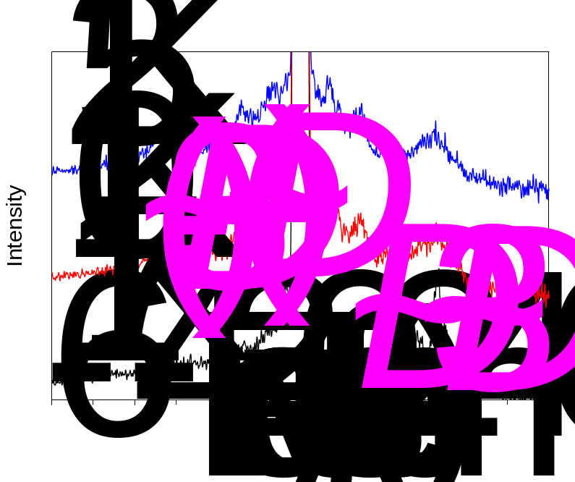
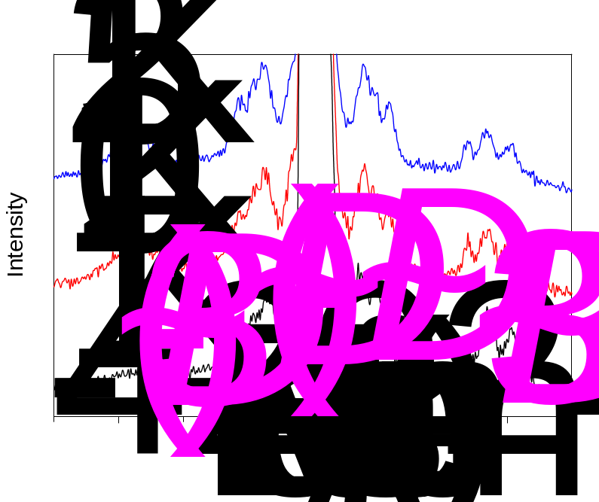
Figure 4.10. INS spectra of Mn(TPP)Br∙CDCl₃ (2∙CDCl₃, Top) and Mn(TPP)I∙CDCl₃ (3∙CDCl₃, Bottom) at 1.7, 10 and 25 K. The E parameter leads to the splitting of the INS peaks.
spectra gave D ≈ 0.90 cm⁻¹. Although the value is close D = 1.30 cm⁻¹ and E = 0.01 cm⁻¹ by HFEPR discussed above, the result also demonstrates that E, although small, is critical here.
It is interesting to point out the trend in D values for Mn(TPP)Cl (1), Mn(TPP)Br (2) and Mn(TPP)I (3): −2.24, −1.09, and +1.30 cm⁻¹, respectively.⁸² The degree of axial anisotropy decreases from the chloride to the bromide analog. Such decreases of axial anisotropy from chloride to bromide analogs have been reported in other Mn(III) chlorides and bromides such as Mn(Me₂dbm)X (X = Cl, Br; Me₂dbm⁻ = anion of 4,4'-dimethyldibenzoylmethane) and Mn(OEP)X (X = Cl, Br; OEP²⁻ = 2,3,7,8,12,13,17,18-octaethylporphinate).⁸³ A qualitative summary of the studies is given here. For the Mn(III) chloride and bromide complexes such as Mn(OEP)X, the second-order spin-orbital couplings of the four unpaired electrons in the ground electronic quintet state are with the excited electronic states from d-d transitions in the Mn(III) ion.⁸³⁻⁸⁵ Such ZFS generates easy-axis (D < 0) ZFS states, as the equatorial ligand field between the Mn(III) ion and the four N atoms of the OEP²⁻ ligand dominates the spin-orbital couplings. Since both Cl⁻ and Br⁻ complexes have the same equatorial ligand OEP²⁻, the axial ligand field (along the Mn−X axis) determines the magnitude of the |D|. This decrease in |D| is primarily due to a weaker axial ligand field for the Br⁻ complex than its Cl⁻ analog.⁸³ We think the decrease in |D| from Mn(TPP)Cl (1) to Mn(TPP)Br (2) is similar to those in Mn(Me₂dbm)X and Mn(OEP)X.
How is it that the iodide analog Mn(TPP)I (3) becomes an easy-plane (D > 0) complex? Such a change from easy-axis (D < 0) to easy-plane (D > 0) between metal halide analogs has been reported in Mn(III) complexes trans-[Mn(cyclam)Br₂]Br (cyclam = 1,4,8,11-tetraazacyclotetradecane) and trans-[Mn(cyclam)I₂]I.⁵⁵ The positive D value for the iodide analog here is attributed to the presence of ligand-to-metal charge transfer (LMCT) from the lone pair electrons on I⁻ ions (in trans-[Mn(cyclam)I₂]⁻) to a 3d orbital of the Mn(III) ion, generating low-lying excited electronic LMCT states with atomic iodine character. The second-order spin-orbital interactions of the four unpaired electrons in the ground electronic quintet state of trans-[Mn(cyclam)I₂]⁻ are primarily mediated by spin-orbit coupling, which is very large for iodine, with the excited electronic LMCT states, leading to the unique easy-plane (D > 0) zero-field splitting (ZFS) states.⁵⁵ In other words, ZFS in Mn(TPP)Cl (1) and Mn(TPP)Br (2) are mainly the results of ligand fields on the metal ions, while ZFS in Mn(TPP)I (3) reflects the participation of LMCT.

CHAPTER VIII

Conclusion and Recommendations

The work in Chapter III on the Co-X (X = Cl, Br, I) series demonstrates that FIRMS is a powerful technique to probe spin-phonon coupling in SMMs, give the intensity of these interactions, and determine magnetic excited levels in the complexes. Additionally, it shows that INS spectroscopy is a unique, zero-field technique to identify both magnetic transitions in the molecules, providing an insight as to the phonons involved in these couplings when combined with DFT phonon and INS calculations. For Co-X with centrosymmetric, C_{2h} crystallographic symmetry, INS spectra, showing all phonons, in combination with far-IR and Raman spectra showing u- and g-symmetry phonons, respectively, give a comprehensive characterization of phonons in the region of interest. The determination of complete spin Hamiltonian parameters of Co-X by a combination of spectroscopies provides a rare view of the magnetic separations in these complexes from different spectroscopic perspectives. Ligand-field work accurately calculated the D, E parameters and pointed to the origin of the ZFS for the three complexes. These studies of spin-phonon coupling will contribute to the understanding of magnetic relaxation in SMMs and molecular qubits and help develop guidance to reduce or avoid the couplings.
It should be noted that the work in Chapter III experimentally determines the magnetic excited levels and degrees of their couplings with nearby phonons (as coupling constants). Additional studies, especially those with computation or modeling as recently reported for other compounds,⁴⁵⁻⁴⁹ are needed to provide an insight into the spin-phonon coupling. Such investigations are expected to correlate the magnetic and phonon properties of the compounds, including why only u-symmetry phonons in Co-X are involved in spin-phonon coupling, how the coupling phonons impact the ZFS parameters and spin densities, and how the intensity of this coupling affects other interactions such as crystal field, ZFS, and Zeeman splittings.
The work described in Chapter IV on Mn(TPP)X (X = Br, I) shows that the Mn(TPP)X complexes may accommodate different solvents in the lattice. The Mn(III)—Br and Mn(III)—I bonds in S = 2 Mn(TPP)X are unexpectedly longer than Fe(III)—Br and Fe(III)—I bonds in S = 5/2 Fe(TPP)X (X = Br, I). HFEPR and INS studies show that the axial ZFS parameter (D) decreases from Mn(TPP)Cl to Mn(TPP)Br, likely as a result of a weaker axial (Mn—Br) ligand field in 2 than that (Mn—Cl) in 1. Unlike 1 and 2, Mn(TPP)I has easy-plane anisotropy, presumably as a result of [I⁻ to Mn(III)] LMCT.

APPENDICES

Appendix A.

Appendix B. Supporting Information for Chapter 3
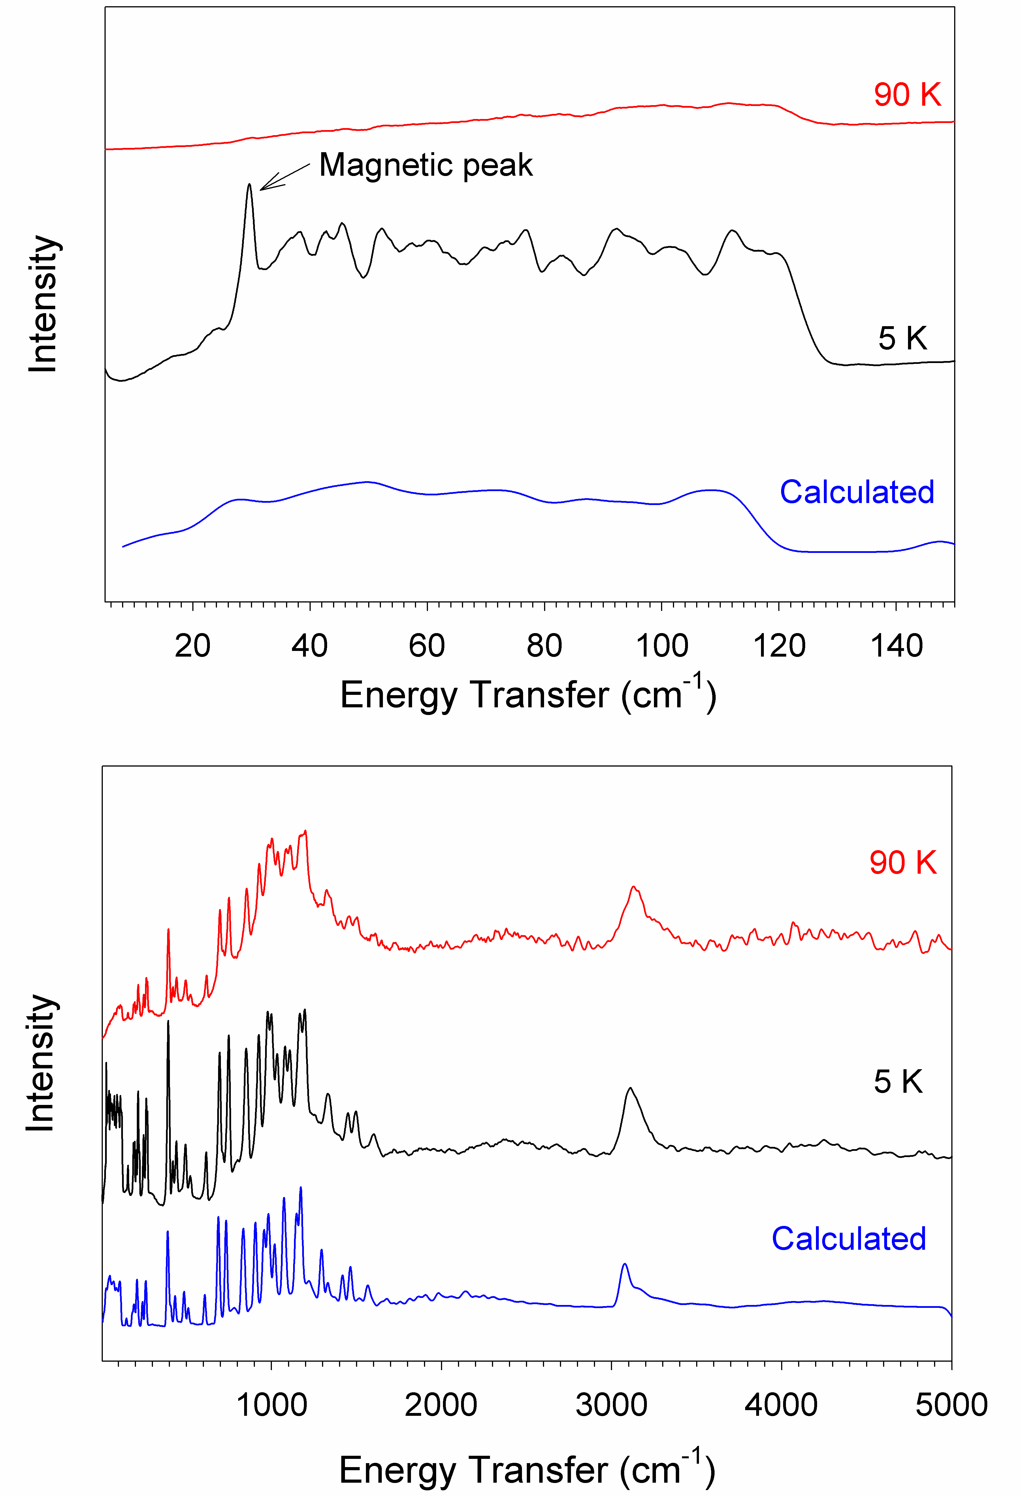
Figure B.1. Bose-corrected, forward-scattering variable-temperature INS spectra (5-5000 cm⁻¹) of Co-Cl (by VISION) with the VASP calculated INS spectrum.
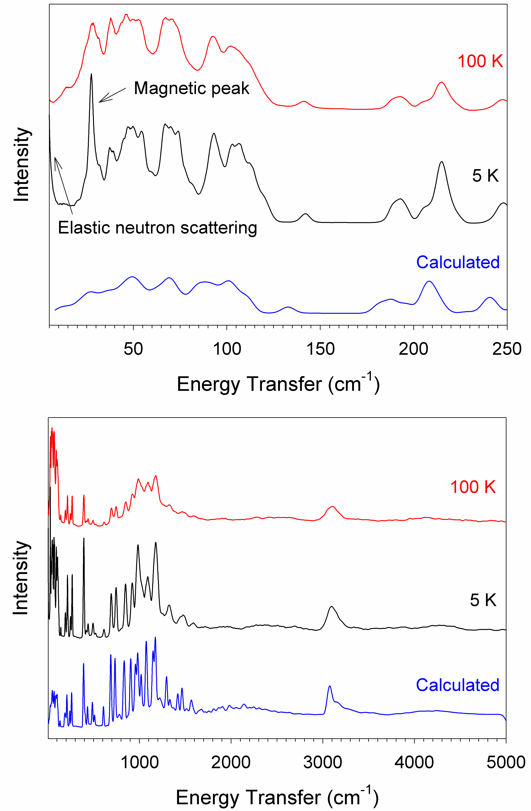
Figure B.2. Bose-corrected, forward-scattering variable-temperature INS spectra (5-5000 cm⁻¹) of Co-Br (by VISION) with the VASP calculated INS spectrum.

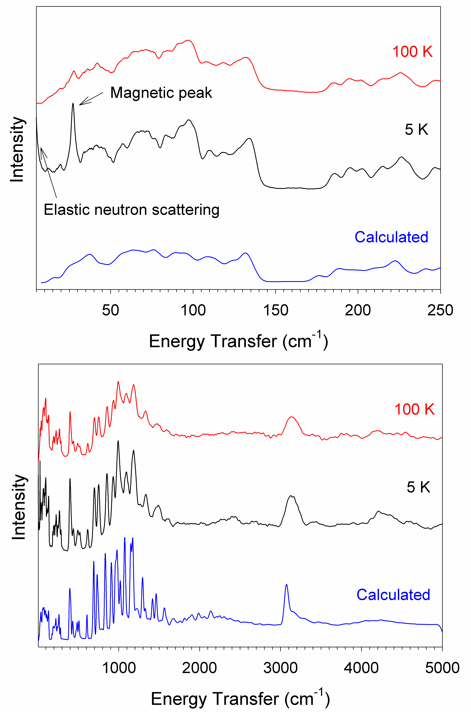
Figure B.3. Bose-corrected, forward-scattering variable-temperature INS spectra (5-5000 cm⁻¹) of Co-I (by VISION) with the VASP calculated INS spectrum.

Figure B.4. (Top) Far-IR transmittance spectra of Co-Cl at 0 and 17 T with assignments of phonon peaks based on the calculated u phonons in Table S1. A few calculated u phonons in the range were not assigned. (Bottom) Plot of spectra normalized by average, which minimizes phonon features that do not change with magnetic fields.

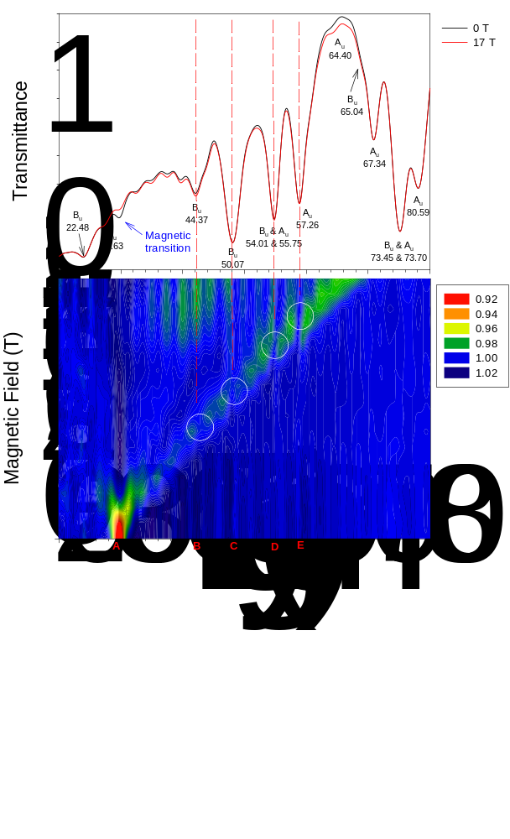

Figure B.5. (Top) Far-IR transmittance spectra of Co-Br at 0 and 17 T with assignments of phonon peaks based on the calculated u phonons in Table S2. A few calculated u phonons in the range were not assigned. (Bottom) Plot of spectra normalized by average, which minimizes phonon features that do not change with magnetic fields.

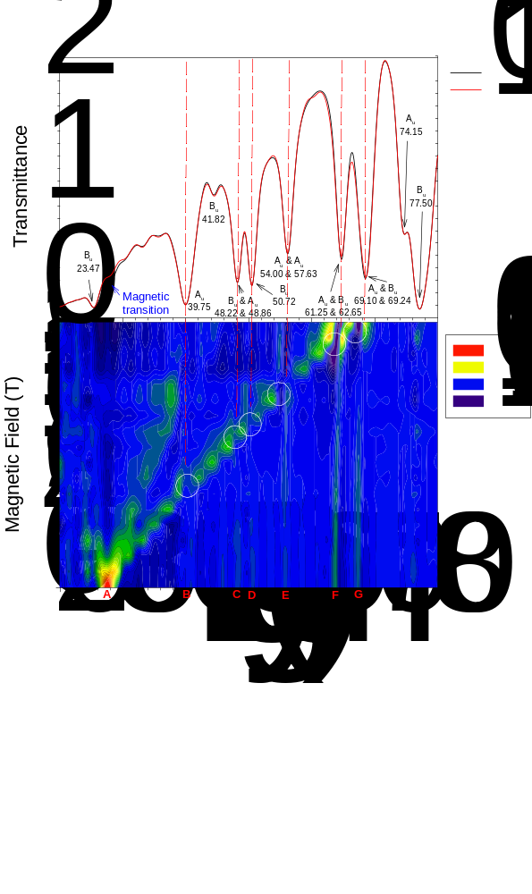

Figure B.6. (Top) Transmittance far-IR spectra of Co-I at 0 and 17 T. We were not able to assign many u phonons in the 0 T spectrum based the calculated phonons in Table S3 below–No calculated phonons were thus assigned to the spectrum. (Bottom) Plot of spectra normalized by average, which minimizes phonon features that do not change with magnetic fields.

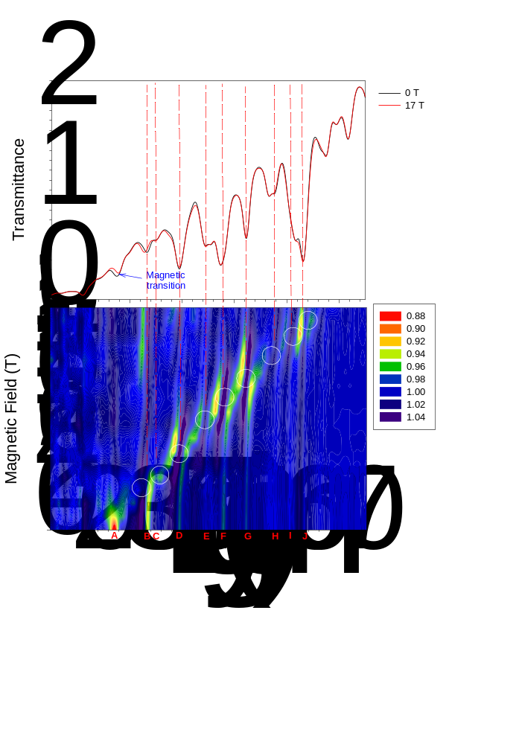
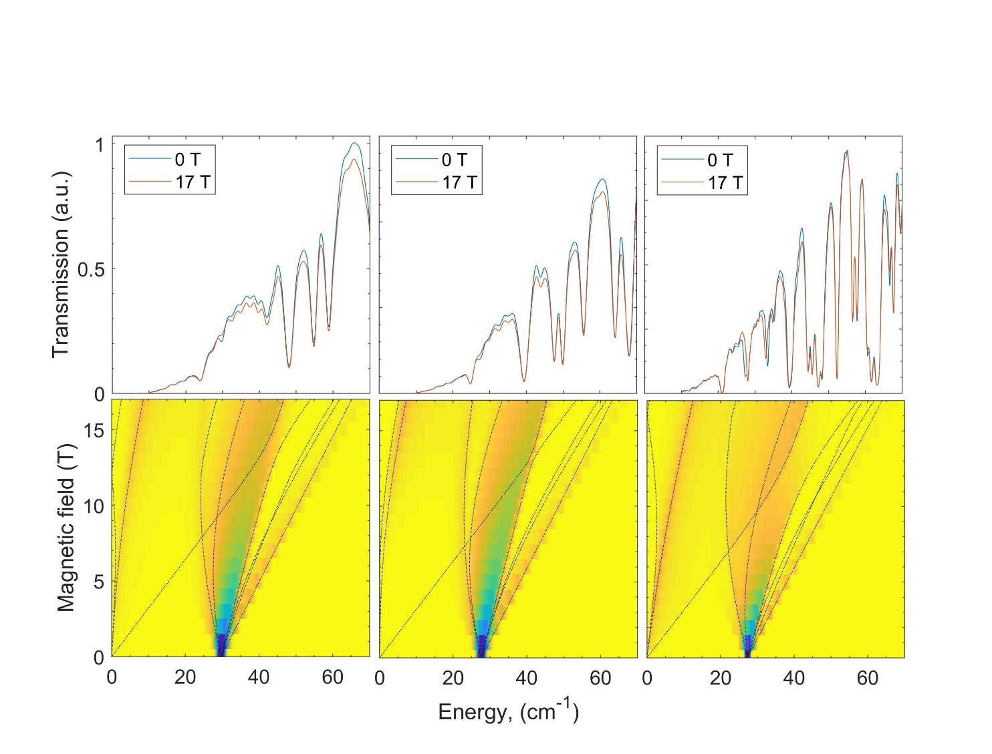

Figure B.7. Plots of magnetic resonance absorptions (intensity vs. field and energy) calculated for Co-Cl (left), Co-Br (middle), and Co-I (right). The EasySpin package⁸⁶⁻⁸⁷ was used to simulate the powder spectrum in the frequency domain, while the spin Hamiltonian parameters were taken from Table 1 in the main text. The lines show turning points in the powder-patterned HFEPR spectra.

B.1. Magneto-Raman Studies
Raman spectroscopy, a light-scattering technique based upon exciting the molecule from the ground state to a higher virtual state, followed by the relaxation of the molecule back to a different state, can also be used to determine the energies of the excited states. Some of us have shown recently that spin-phonon couplings with Raman-active phonons in Co(acac)₂(H₂O)₂, Co(acac)₂(D₂O)₂, and Co(acac-d₇)₂(D₂O)₂ impart both spin and phonon features to the coupled peaks, leading to the observations of the coupled peaks and distinct spin-phonon couplings in the magneto-Raman spectra, even though the magnetic transitions between ground and excited states in the complexes are vanishingly weak in conventional Raman spectroscopy.

B.1.1. Experimental
Raman samples were prepared with unoriented single crystals of Co-Cl, Co-Br, and Co-I. Data were collected by a backscattering Faraday geometry using a 532 nm laser at a 14 T Superconducting Magnet (SCM) in the Electron Magnetic Resonance (EMR) facility. Crystals of samples were cooled at 5 K. Collected scattered light was guided via an optical fiber to a spectrometer equipped with a liquid nitrogen-cooled CCD camera.

B.1.2. Spectra
Magneto-Raman spectroscopy at 0-14 T magnetic fields was also used to characterize Co-Cl, Co-Br, and Co-I. The Raman spectra do not reveal the peak corresponding to the ZFS transitions in the complexes. The magneto-Raman spectra of Co-Cl, Co-Br, and Co-I in the 20-75 cm⁻¹ are shown in Figures S5, S6, and S7, respectively. Raman spectra of the three complexes at 0 T with an extended energy range are used below in the discussion of phonon spectra.
There are many VASP-calculated g, Raman-active modes in the 20-75 cm⁻¹ range (Tables S1-S3 below). Attempts to assign them to the peaks in Figures B.8-B.10 were not successful.

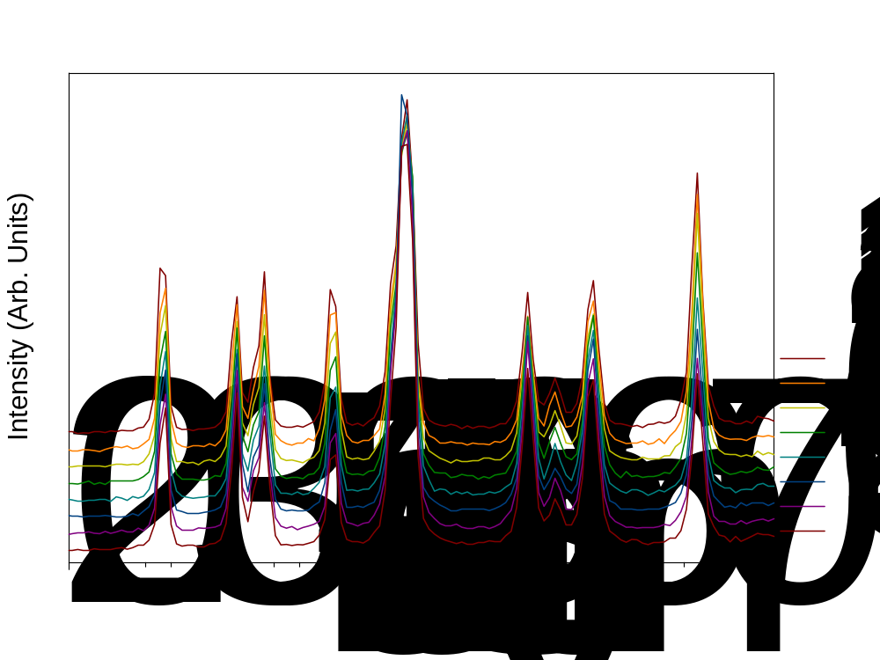
Figure B.8. Magneto-Raman spectra of Co-Cl at 5 K.

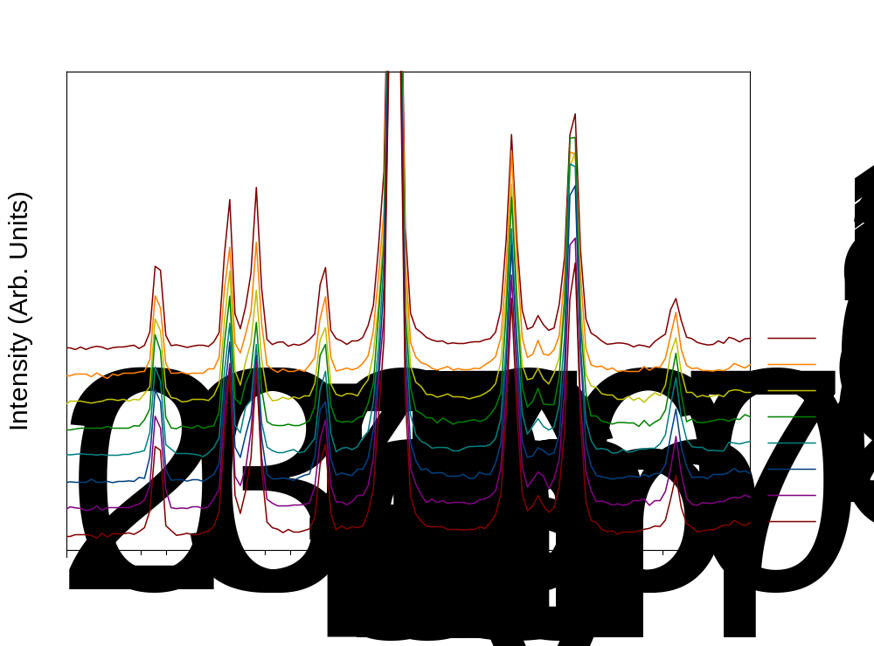
Figure B.9. Magneto-Raman spectra of Co-Br at 5 K.

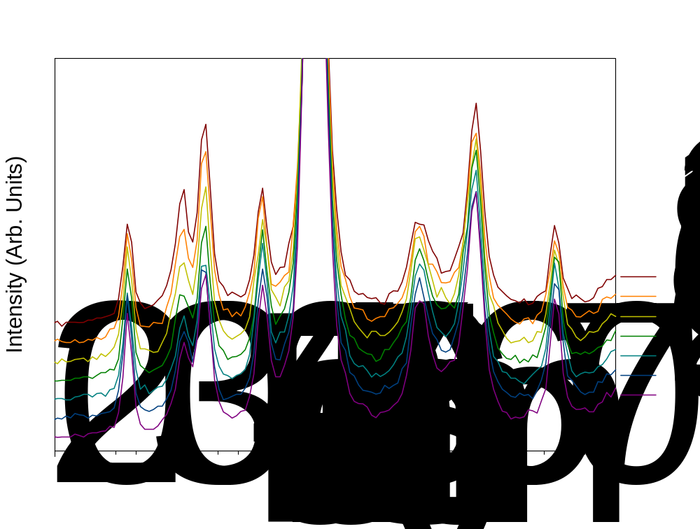
Figure B.10. Magneto-Raman spectra of Co-I at 5 K.

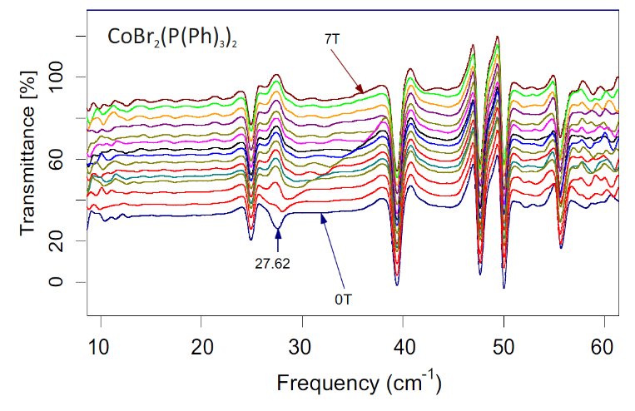
Energy (cm⁻¹)
Co(PPh₃)₂Br₂
Figure B.11. Relative transmittance at 5 K in Co-Br upon changing the field from 0 to 7 T. The magnetic resonance at 27.62 cm⁻¹ splits upon field change, while all other peaks are field-independent.

Figure B.12. 2-dimentional maps (field vs. frequency/energy) of turning points in the HFEPR spectra of Co-Cl (top), Co-Br (middle), and Co-I (bottom). The squares are experimental points. The red squares in the top window represent new data points obtained within this work. The curves were drawn using best-fitted spin Hamiltonian parameters as in Table. Red curves: resonances with B||x axis of the ZFS tensor; blue: B||y, black: B||z. The dashed vertical lines represent the frequencies at which the spectra shown in Figures S14-S18 were recorded.

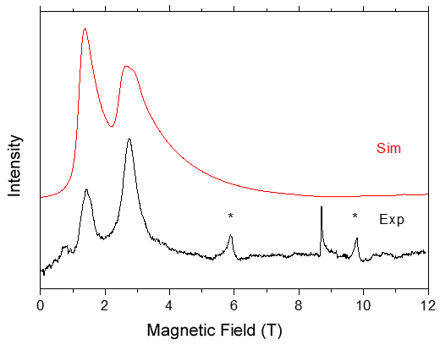
Figure B.13. HFEPR spectra of loose (unrestrained) sample of Co-Cl at 815 GHz and 10 K (black trace), accompanied by a powder-pattern simulation using spin Hamiltonian parameters in Table 1 (red trace). The experimental spectrum was obtained using optical modulation (chopping) of the sub-THz wave beam and thus resulted in an absorptive shape. All the resonances are parallel (B₀||z) turning points due to field-induced alignment (torqueing) of the crystallites. The sharp resonance at ~8.7 T is the nominally forbidden intra-Kramers m_{S} = −3/2 → +3/2 transition that particularly benefits from field torqueing and thus does not show up in the simulation. The two other resonances in the upper spectrum marked by asterisks originate from a Mn^{III} complex used to calibrate the frequency.
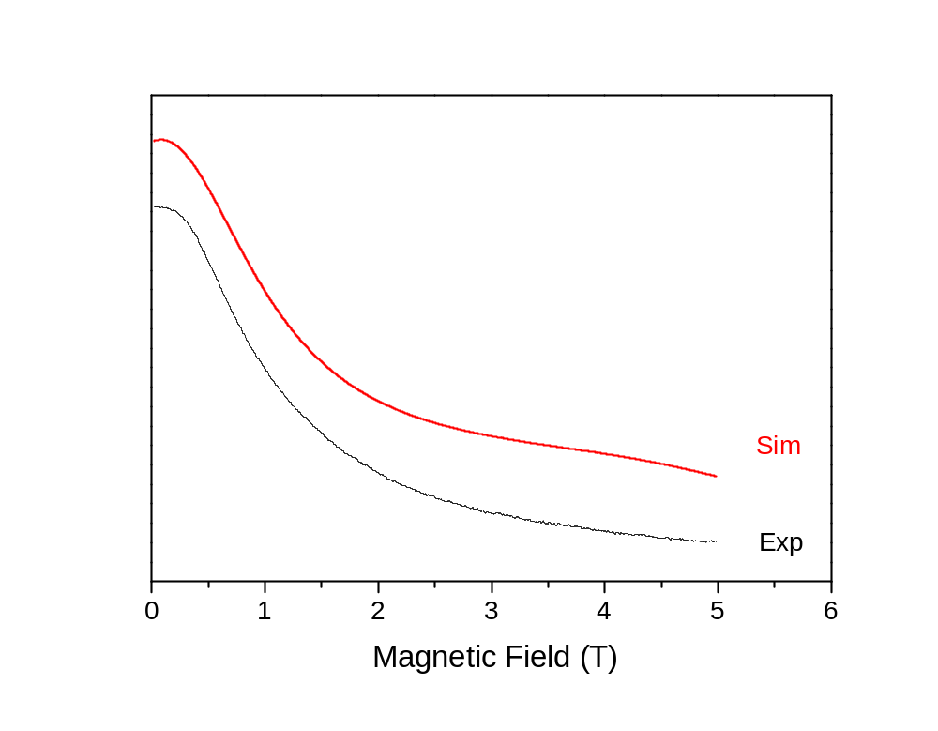
Intensity
Figure B.14. Optically-modulated HFEPR spectrum of a loose (unrestrained) sample of Co-Br at 830 GHz and 10 K (black trace), accompanied by a simulation using spin Hamiltonian parameters as in Table 1 (red trace). This frequency almost exactly matches the zero-field gap energy of this particular system (27.6 cm^{–1} = 828 GHz as obtained from both FIRMS and FD-FT THz-EPR) and results in a characteristic “half-dome” shape of the resonance recorded in the absorption mode.

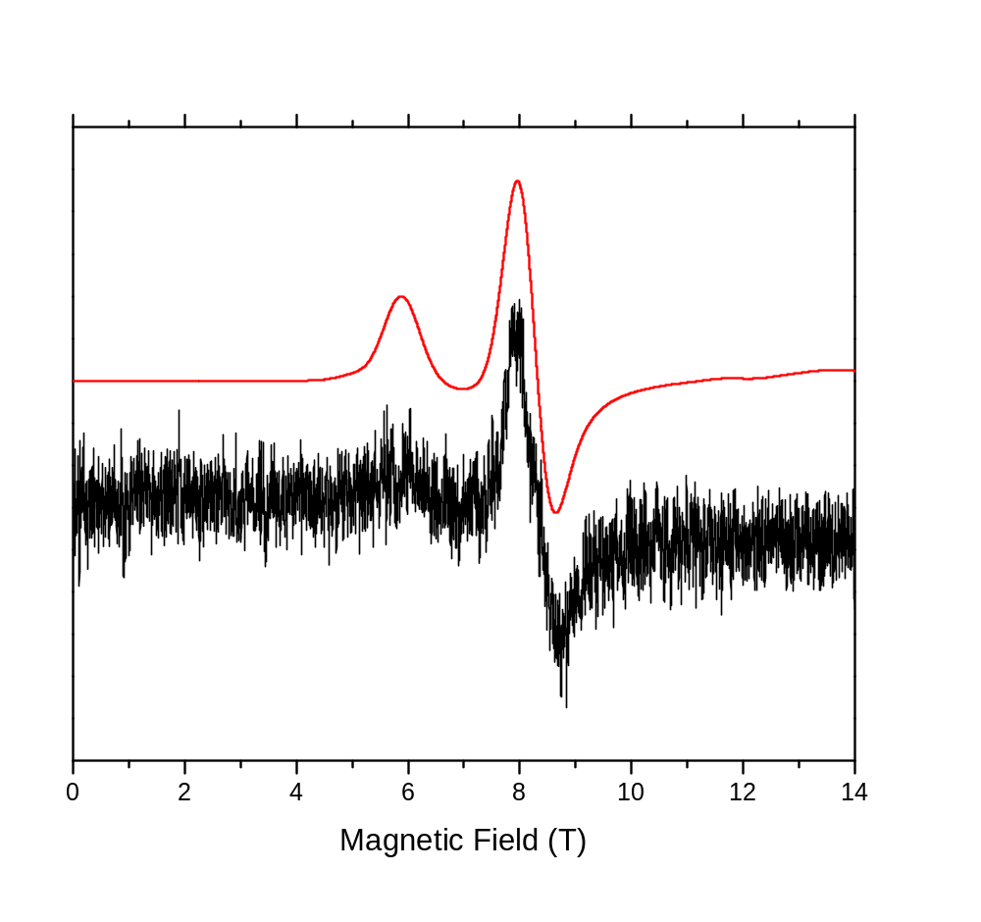
Intensity
Figure B.15. Magnetically-modulated HFEPR spectrum of a Co-Br pellet at 473 GHz and 10 K, resulting in the conventional derivative shape of the resonances and its simulation using spin Hamiltonian parameters as in Table 1 (red trace). The resonance at ~6 T is the parallel turning point of the m_{S} = −3/2 → +3/2 transition. The stronger signal at ~8.3 T is the parallel turning point of the inter-Kramers m_{S} = −3/2 → +1/2 transition and thus informative with regard to ZFS.

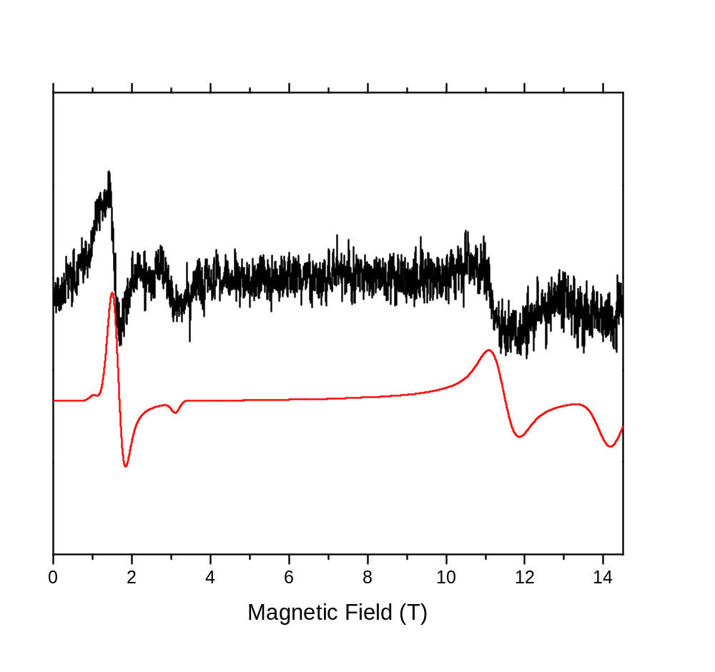
Intensity
Figure B.16. Magnetically-modulated HFEPR spectrum of a Co-Br pellet at 98 GHz and 10 K, resulting in the conventional derivative shape of the resonances (black trace) and its simulation using spin Hamiltonian parameters as in Table 1 (red trace). The signals at 3.0, 11.5 and 14.15 T represent the z, y and x turning points, respectively, of the nominally forbidden intra-Kramers m_{S} = −3/2 → +3/2 transition. The resonance at 1.7 T is the perpendicular turning point of the m_{S} = −1/2 → +1/2 transition in the excited Kramers doublet.

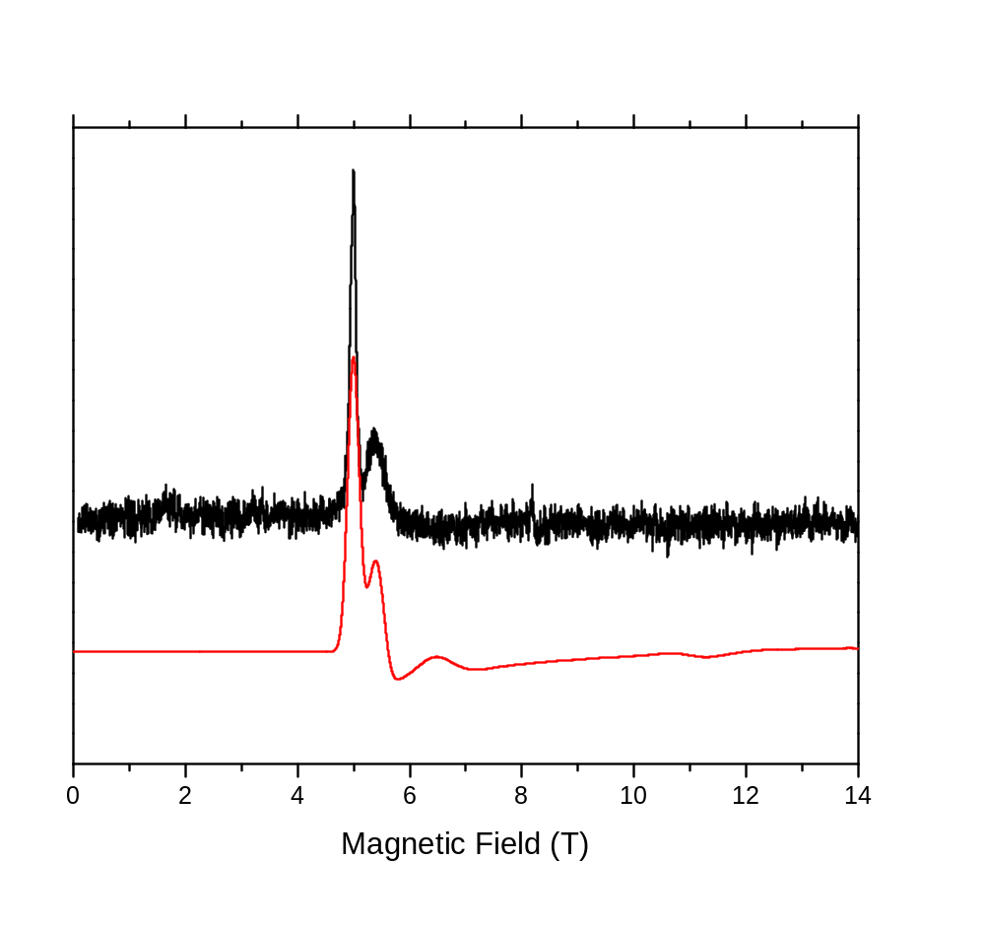
Figure B.17. Magnetically-modulated HFEPR spectrum of a Co-I pellet at 473 GHz and 10 K, resulting in the conventional derivative shape of the resonances and its simulation using spin Hamiltonian parameters: D = −13.0 cm⁻¹, E = −2.14 cm⁻¹, g = [2.23, 2.23, 2.32]. The stronger resonance at ~5 T is the parallel turning point of the m_{S} = −3/2 → +3/2 transition. The weaker signal at ~5.4 T is the parallel turning point of the inter-Kramers m_{S} = −3/2 → +1/2 transition and thus informative with regard to ZFS.

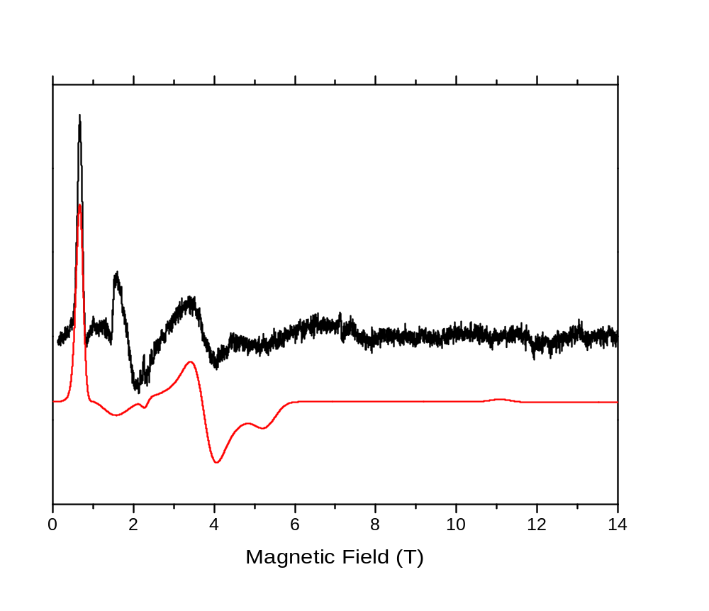
Figure B.18. Magnetically-modulated HFEPR spectrum of a Co-I pellet at 63 GHz and 10 K, resulting in the conventional derivative shape of the resonances and its simulation using spin Hamiltonian parameters as in Table 1 except g_{z} = 2.15. The strong resonance at ~0.6 T is the parallel turning point of the intra-Kramers m_{S} = −3/2 → +3/2 transition. The weaker and broader signals at ~3.75 and ~5.15 T are the perpendicular turning points of the same transition. The resonance at ~1.9 T is an impurity present in the probe and is thus not simulated.

Table B.1. Electronic Transitions (in cm⁻¹) for Co-X in Doped Single-Crystals of Co/Zn-X (X = Cl, Br, I)^{25, 27} with Calculations from the AOM
Complexes |  |  |  | Molecular Polarization | Assignment  ⁴A₂[⁴A₂(F)] →
Source | Co-Cl | Co-Br | Co-I | Molecular Polarization | Assignment  ⁴A₂[⁴A₂(F)] →
calc ^{[a]} | 3874 | 3695 | 3575 | y | ⁴B₁[⁴T₂(F)]
calc | 4009 | 3951 | 3612 | x | ⁴B₂[⁴T₂(F)]
calc | 5719 | 5506 | 4136 | forbidden | ⁴A₁[⁴T₂(F)]
expt | 6400 | 6000 | 5800 | y | ⁴B₁[⁴T₁(F)]
calc | 6378 | 6112 | 5816 | y | ⁴B₁[⁴T₁(F)]
expt | 8000 | 7600 | 7100 | z | ⁴A₂[⁴T₁(F)]
calc | 8018 | 7476 | 7100 | z | ⁴A₂[⁴T₁(F)]
expt | 10 700 | 9700 | 9200 | x | ⁴B₂[⁴T₁(F)]
calc | 10 699 | 9736 | 9189 | x | ⁴B₂[⁴T₁(F)]
expt | 13 550 | 13 500 | 12 800 | x | ⁴B₂[⁴T₁(P)]
calc | 13 550 | 13 484 | 12 761 | x | ⁴B₂[⁴T₁(P)]
expt | 15 750 | 14 900 | 13 800 | z | ⁴A₂[⁴T₁(P)]
calc | 15 759 | 14 884 | 13 884 | z | ⁴A₂[⁴T₁(P)]
expt | 17 000 ^{[b]} | 15 900 | 14 700 | y | ⁴B₁[⁴T₁(P)]
calc | 16 991 | 15 920 | 14 655 | y | ⁴B₁[⁴T₁(P)]
[a] Calculations used (in cm⁻¹): B = 602.5 (Cl), 586.7 (Br), 559.7 (I); ε_{σ(X)} = 3313.6 (Cl), 2560.7 (Br), 2177.2 (I); ε_{π(X)} = 1818.6 (Cl), 1068.1 (Br), 633.1 (I); ε_{σ(P)} = 3641.5 (Cl), 3089.7 (Br), 2501.6 (I); ε_{π(P)} = -1635.4 (Cl), -1752.6 (Br), -1482.4 (I). These values are also given in Table S6.
[b] This is the average of bands reported at 16 555, 16 778, 16 863, 17 065, 17 153, and 17 405 cm⁻¹. Bands were also reported at 17 645 and 18 315 cm⁻¹.²⁵
Table B.2. Key Metrics for the AOM of the Co-X Series (X = Cl, Br, I)
Metric | Co-Cl ^{[a]} | Co-Br ^{[b]} | Co-I ^{[c]}
∠X-Co-X (deg) | 117.27 | 115.23 | 111.44
∠P-Co-P (deg) | 115.87 | 117.45 | 108.25
d(Co-X) (Å) | 2.212 | 2.350 | 2.543, 2.558
d(Co-P) (Å) | 2.384 | 2.385 | 2.390, 2.413
[a] These values are taken from the structure reported by Carlin et al.⁴⁰ (CSD code: BIHGEE); that reported by Yang et al.⁴¹ (CSD code: BIHGEE01) is essentially the same: ∠Cl-Co-Cl = 117.12º, ∠P-Co-P = 115.86º; d(Co-Cl), 2.211 Å, d(Co-P), 2.386 Å. For comparison, in Cs₂CoCl₄, the two angles in the [CoCl₄]²⁻ unit are: ∠Cl-Co-Cl = 107.5º and 116.1º.
[b] These values are taken from the structure reported by Carlin et al.⁴⁰ (CSD code: BIHGII).
[c] These values are taken from the structure reported by Saber and Dunbar⁴² (CSD code: HONQOS). Note that this structure was determined at low temperature (110 K), and identified different Co-(X,P) bond distances, while the others (Co-Cl and Co-Br) were all recorded at room temperature.

Table B.3. LFT AOM parameters (in cm⁻¹) determined for the Co-X series (X = Cl, Br, I)
Complex |  |  | AOM parameter ^{[a,b]}
Co-Cl | Co-Br | Co-I
602.5 | 586.7 | 559.7 | B
575 | 575 | --- | B
3313.6 | 2560.7 | 2177.2 | ε_{σ(X)}
3500 | 3500 | --- | ε_{σ(X)}
1818.6 | 1068.1 | 633.1 | ε_{π(X)}
2000 | 1500 | --- | ε_{π(X)}
3641.5 | 3089.7 | 2501.6 | ε_{σ(P)}
4000 | 3500 | --- | ε_{σ(P)}
−1635.4 | −1752.6 | −1482.4 | ε_{π(P)}
−1000 | −1000 | --- | ε_{π(P)}
[a] The second row of values for each complex are taken from Davies et al.³³ There is a typo in their Table 7, as ε_{σ(X)} is given twice, but we assume that the second entry is ε_{π(X)}.
[b] For comparison, Horrocks and Barlone found B = 740 cm⁻¹, ε_{σ(Cl)} = 2300 cm⁻¹ for [CoCl₄]²⁻ in both Cs₃CoCl₅ (elongated D_{2d} symmetry) and Cs₂CoCl₄ (compressed C_{2v} symmetry); π-interactions were considered, but not deemed necessary for adequate fitting of the optical and magnetic data.⁸⁸

B.2. Ligfield Results for Co-Cl

B.2.1. Edited Ligfield Output for Co-Cl without SOC
These matrices were generated from the following terms: ⁴P ⁴F ²P ²D₁ ²D₂ ²F ²G ²H of d⁷ in SLMSML-basis. One electron parametrization was taken from: AOM. The AOM-parametrization were based on the following premises: Maximum lambda value included: π. The AOM-matrices were not barycentered.

Table B.4. [Placeholder title]
Ligator | Theta | Phi | Psi | Linear
Cl | 58.64 | 0 | 0 | Yes
Cl | 58.64 | 180 | 0 | Yes
P | 122.06 | 90 | 0 | Yes
P | 122.06 | 270 | 0 | Yes

Table B.5. Parameters derived from Ligfield output for Co-Cl without SOC
Parameter | Value (cm⁻¹)
ε_{σ}(Cl) | 3313.55
ε_{π}(Cl) | 1818.61
ε_{σ}(P) | 3641.46
ε_{π}(P) | -1635.42
Racah B | 602.50
Racah C | 2567.00

B.2.1.1. Eigenvalues and Eigenfunction Labeling
Energy: 0.00000000
Spin labels: (2S+1)= 4.00000
Symmetry of eigenfunction: B1(D2) A1(C2) A2 in C2v
z² yz xz xy x²−y²
1.953777 1.005077 1.005077 1.994923 1.041146 (e⁴ t₂³)
------------------------------------------------------------------------------
Energy: 3873.54821160
Spin labels: (2S+1)= 4.00000
Symmetry of eigenfunction: B2(D2) B1(C2) B1 in C2v
z² yz xz xy x²−y²
1.542971 1.259440 1.740560 1.259440 1.197588
------------------------------------------------------------------------------
Energy: 4008.76916920
Spin labels: (2S+1)= 4.00000
Symmetry of eigenfunction: B3(D2) B1(C2) B2 in C2v
z² yz xz xy x²−y²
1.175479 1.202564 1.797436 1.797436 1.027085
------------------------------------------------------------------------------
Energy: 5719.16845893
Spin labels: (2S+1)= 4.00000
Symmetry of eigenfunction: A1(D2) A1(C2) A1 in C2v
z² yz xz xy x²−y²
2.000000 1.000000 1.000000 1.000000 2.000000 (e³ t₂⁴)
------------------------------------------------------------------------------
Energy: 6378.24727434 (expt. 6400)
Spin labels: (2S+1)= 4.00000
Symmetry of eigenfunction: B2(D2) B1(C2) B1 in C2v
z² yz xz xy x²−y²
1.044779 1.637217 1.362783 1.637217 1.318004
------------------------------------------------------------------------------
Energy: 8018.39170302 (expt. 8000)
Spin labels: (2S+1)= 4.00000
Symmetry of eigenfunction: B1(D2) A1(C2) A2 in C2v
z² yz xz xy x²−y²
1.028836 1.696064 1.696064 1.303936 1.275100
=================================================
Energy: 9635.74232253
Spin labels: (2S+1)= 2.00000
Symmetry of eigenfunction: B3(D2) B1(C2) B2 in C2v
z² yz xz xy x²−y²
1.659595 1.008814 1.874521 1.980599 0.476471
=================================================
Energy: 10698.74902783 (expt. 10 700)
Spin labels: (2S+1)= 4.00000
Symmetry of eigenfunction: B3(D2) B1(C2) B2 in C2v
z² yz xz xy x²−y²
1.514710 1.954035 1.045965 1.045965 1.439326
=================================================
Energy: 10777.28135075
Spin labels: (2S+1)= 2.00000
Symmetry of eigenfunction: A1(D2) A1(C2) A1 in C2v
z² yz xz xy x²−y²
1.839760 0.329588 1.712146 1.962169 1.156337
------------------------------------------------------------------------------
Energy: 11202.66591430
Spin labels: (2S+1)= 2.00000
Symmetry of eigenfunction: B1(D2) A1(C2) A2 in C2v
z² yz xz xy x²−y²
1.888443 1.066314 1.058707 1.933443 1.053093
------------------------------------------------------------------------------
Energy: 12314.27513435
Spin labels: (2S+1)= 2.00000
Symmetry of eigenfunction: B1(D2) A1(C2) A2 in C2v
z² yz xz xy x²−y²
1.944779 0.963995 1.103970 1.882343 1.104912
------------------------------------------------------------------------------
Energy: 12505.13188223
Spin labels: (2S+1)= 2.00000
Symmetry of eigenfunction: B2(D2) B1(C2) B1 in C2v
z² yz xz xy x²−y²
1.882135 1.137832 1.088488 1.899757 0.991788
=================================================
Energy: 13550.39370570 (expt. 13 550)
Spin labels: (2S+1)= 4.00000
Symmetry of eigenfunction: B3(D2) B1(C2) B2 in C2v
z² yz xz xy x²−y²
1.309811 1.843401 1.156599 1.156599 1.533590
=================================================
Energy: 14082.84791112
Spin labels: (2S+1)= 2.00000
Symmetry of eigenfunction: A1(D2) A1(C2) A1 in C2v
z² yz xz xy x²−y²
1.116827 1.656780 1.748826 1.810499 0.667068
------------------------------------------------------------------------------
Energy: 14583.80708076
Spin labels: (2S+1)= 2.00000
Symmetry of eigenfunction: B2(D2) B1(C2) B1 in C2v
z² yz xz xy x²−y²
1.616330 1.107390 1.783779 1.214153 1.278348
------------------------------------------------------------------------------
Energy: 14945.67854247
Spin labels: (2S+1)= 2.00000
Symmetry of eigenfunction: B3(D2) B1(C2) B2 in C2v
z² yz xz xy x²−y²
1.388234 1.079742 1.349290 1.822282 1.360452
------------------------------------------------------------------------------
Energy: 15649.27829215
Spin labels: (2S+1)= 2.00000
Symmetry of eigenfunction: B2(D2) B1(C2) B1 in C2v
z² yz xz xy x²−y²
1.738168 1.376945 1.501138 1.467447 0.916302
================================================
Energy: 15758.98092449 (expt. 15 750)
Spin labels: (2S+1)= 4.00000
Symmetry of eigenfunction: B1(D2) A1(C2) A2 in C2v
z² yz xz xy x²−y²
1.017387 1.298859 1.298859 1.701141 1.683754
=================================================
Energy: 15865.51965375
Spin labels: (2S+1)= 2.00000
Symmetry of eigenfunction: A1(D2) A1(C2) A1 in C2v
z² yz xz xy x²−y²
1.701832 1.414172 0.886066 1.495820 1.502111
------------------------------------------------------------------------------
Energy: 16854.49075803
Spin labels: (2S+1)= 2.00000
Symmetry of eigenfunction: B3(D2) B1(C2) B2 in C2v
z² yz xz xy x²−y²
1.487513 1.097115 1.095783 1.871515 1.448073
================================================
Energy: 16991.38128023 (expt. 17 000)
Spin labels: (2S+1)= 4.00000
Symmetry of eigenfunction: B2(D2) B1(C2) B1 in C2v
z² yz xz xy x²−y²
1.412250 1.103343 1.896657 1.103343 1.484407
================================================
Energy: 17049.05313967
Spin labels: (2S+1)= 2.00000
Symmetry of eigenfunction: B3(D2) B1(C2) B2 in C2v
z² yz xz xy x²−y²
1.535041 1.539267 1.442340 1.458102 1.025250
------------------------------------------------------------------------------
Energy: 17401.54529460
Spin labels: (2S+1)= 2.00000
Symmetry of eigenfunction: B1(D2) A1(C2) A2 in C2v
z² yz xz xy x²−y²
1.684128 0.868703 1.775792 1.107035 1.564342
------------------------------------------------------------------------------
Energy: 17421.44118715
Spin labels: (2S+1)= 2.00000
Symmetry of eigenfunction: B2(D2) B1(C2) B1 in C2v
z² yz xz xy x²−y²
1.209262 1.545617 1.035615 1.947564 1.261941
------------------------------------------------------------------------------
Energy: 17758.22124040
Spin labels: (2S+1)= 2.00000
Symmetry of eigenfunction: A1(D2) A1(C2) A1 in C2v
z² yz xz xy x²−y²
1.763762 1.346808 1.063800 1.299339 1.526292
------------------------------------------------------------------------------
Energy: 18605.75024525
Spin labels: (2S+1)= 2.00000
Symmetry of eigenfunction: A1(D2) A1(C2) A1 in C2v
z² yz xz xy x²−y²
1.810755 1.431186 0.842867 1.404030 1.511161
------------------------------------------------------------------------------
Energy: 19153.59242210
Spin labels: (2S+1)= 2.00000
Symmetry of eigenfunction: B2(D2) B1(C2) B1 in C2v
z² yz xz xy x²−y²
1.359468 1.413641 1.443352 1.474645 1.308893
------------------------------------------------------------------------------
Energy: 19253.60926503
Spin labels: (2S+1)= 2.00000
Symmetry of eigenfunction: B1(D2) A1(C2) A2 in C2v
z² yz xz xy x²−y²
1.467416 1.627080 0.775750 1.365752 1.764002
------------------------------------------------------------------------------
Energy: 20060.08023618
Spin labels: (2S+1)= 2.00000
Symmetry of eigenfunction: B3(D2) B1(C2) B2 in C2v
z² yz xz xy x²−y²
1.747859 1.577720 1.408313 0.878855 1.387253
------------------------------------------------------------------------------
Energy: 20268.97221526
Spin labels: (2S+1)= 2.00000
Symmetry of eigenfunction: B1(D2) A1(C2) A2 in C2v
z² yz xz xy x²−y²
1.203074 1.420134 1.344736 1.435846 1.596209
------------------------------------------------------------------------------
Energy: 20801.49540695
Spin labels: (2S+1)= 2.00000
Symmetry of eigenfunction: B1(D2) A1(C2) A2 in C2v
z² yz xz xy x²−y²
1.159416 1.762034 1.677766 1.136746 1.264039
------------------------------------------------------------------------------
Energy: 22167.71416202
Spin labels: (2S+1)= 2.00000
Symmetry of eigenfunction: B3(D2) B1(C2) B2 in C2v
z² yz xz xy x²−y²
1.270283 1.729615 1.264259 1.070548 1.665295
------------------------------------------------------------------------------
Energy: 22315.07356635
Spin labels: (2S+1)= 2.00000
Symmetry of eigenfunction: A1(D2) A1(C2) A1 in C2v
z² yz xz xy x²−y²
0.581733 1.826195 1.781208 1.684419 1.126444
------------------------------------------------------------------------------
Energy: 22394.75923705
Spin labels: (2S+1)= 2.00000
Symmetry of eigenfunction: B2(D2) B1(C2) B1 in C2v
z² yz xz xy x²−y²
1.482121 1.650719 1.322491 0.921313 1.623356
------------------------------------------------------------------------------
Energy: 23058.47485935
Spin labels: (2S+1)= 2.00000
Symmetry of eigenfunction: B3(D2) B1(C2) B2 in C2v
z² yz xz xy x²−y²
1.183802 1.858132 1.135715 0.939086 1.883265
------------------------------------------------------------------------------
Energy: 23262.22344800
Spin labels: (2S+1)= 2.00000
Symmetry of eigenfunction: B2(D2) B1(C2) B1 in C2v
z² yz xz xy x²−y²
1.152356 1.533284 1.442023 1.143695 1.728642
------------------------------------------------------------------------------
Energy: 24714.66603094
Spin labels: (2S+1)= 2.00000
Symmetry of eigenfunction: A1(D2) A1(C2) A1 in C2v
z² yz xz xy x²−y²
1.045761 1.963460 1.409661 0.622469 1.958648
doublet states above 25 000 cm⁻¹ truncated

B.2.2. Edited Ligfield Output for Co-Cl with SOC
All parameters as in Appendix B.2.1, but also with ζ = 459 cm⁻¹.

Energy: 0.00000000 (doublet)
Spin labels: (2S+1)= 3.99479 (m_{S})= ±0.13979
Symmetry of eigenfunction: E'(D2*)
z² yz xz xy x²−y²
1.941870 1.014130 1.014352 1.985219 1.044429
------------------------------------------------------------------------------
Energy: 29.82084412 (doublet)
Spin labels: (2S+1)= 3.99644 (m_{S})= ±0.85334
Symmetry of eigenfunction: E'(D2*)
z² yz xz xy x²−y²
1.948342 1.007608 1.011624 1.988187 1.044239
------------------------------------------------------------------------------

B.3. Ligfield Results for Co-Br

B.3.1. Edited Ligfield Output for Co-Br without SOC
These matrices were generated from the following terms: ⁴P ⁴F ²P ²D₁ ²D₂ ²F ²G ²H of d⁷ in SLMSML-basis. One electron parametrization was taken from: AOM. The AOM-parametrization were based on the following premises: Maximum lambda value included: π. The AOM-matrices were not barycentered.

Table B.6. [Placeholder title]
Ligator | Theta | Phi | Psi | Linear
Br | 57.62 | 0 | 0 | Yes
Br | 57.62 | 180 | 0 | Yes
P | 121.28 | 90 | 0 | Yes
P | 121.28 | 270 | 0 | Yes

Table B.7. Parameters derived from Ligfield output for Co-Cl without SOC
Parameter | Value (cm⁻¹)
ε_{σ}(Br) | 2560.7
ε_{π}(Br) | 1068.1
ε_{σ}(P) | 3089.7
ε_{π}(P) | -1752.6
Racah B | 586.7
Racah C | 2500.00

B.3.1.1. Eigenvalues and Eigenfunction Labeling
Energy: 0.00000000
Spin labels: (2S+1)= 4.00000
Symmetry of eigenfunction: B1(D2) A1(C2) A2 in C2v
z² yz xz xy x²−y²
1.970377 1.003339 1.003339 1.996661 1.026284
------------------------------------------------------------------------------
Energy: 3695.33526458
Spin labels: (2S+1)= 4.00000
Symmetry of eigenfunction: B3(D2) B1(C2) B2 in C2v
z² yz xz xy x²−y²
1.161122 1.180869 1.819131 1.819131 1.019748
------------------------------------------------------------------------------
Energy: 3951.30914539
Spin labels: (2S+1)= 4.00000
Symmetry of eigenfunction: B2(D2) B1(C2) B1 in C2v
z² yz xz xy x²−y²
1.465898 1.426331 1.573669 1.426331 1.107771
------------------------------------------------------------------------------
Energy: 5505.87640832
Spin labels: (2S+1)= 4.00000
Symmetry of eigenfunction: A1(D2) A1(C2) A1 in C2v
z² yz xz xy x²-y²
2.000000 1.000000 1.000000 1.000000 2.000000
------------------------------------------------------------------------------

Energy: 6111.76884843 (expt. 6000)
Spin labels: (2S+1)= 4.00000
Symmetry of eigenfunction: B2(D2) B1(C2) B1 in C2v
z² yz xz xy x²−y²
1.116690 1.465332 1.534668 1.465332 1.417978
------------------------------------------------------------------------------
Energy: 7475.92944373 (expt. 7600)
Spin labels: (2S+1)= 4.00000
Symmetry of eigenfunction: B1(D2) A1(C2) A2 in C2v
z² yz xz xy x²−y²
1.019543 1.669312 1.669312 1.330688 1.311145
------------------------------------------------------------------------------
Energy: 9735.95277684 (expt. 9700)
Spin labels: (2S+1)= 4.00000
Symmetry of eigenfunction: B3(D2) B1(C2) B2 in C2v
z² yz xz xy x²−y²
1.473608 1.961274 1.038726 1.038726 1.487665
================================================
Energy: 9924.49335707
Spin labels: (2S+1)= 2.00000
Symmetry of eigenfunction: B3(D2) B1(C2) B2 in C2v
z² yz xz xy x²−y²
1.700634 1.010615 1.835391 1.982232 0.471128
------------------------------------------------------------------------------
Energy: 10662.10995555
Spin labels: (2S+1)= 2.00000
Symmetry of eigenfunction: A1(D2) A1(C2) A1 in C2v
z² yz xz xy x²−y²
1.859211 0.378029 1.660199 1.965494 1.137067
------------------------------------------------------------------------------
Energy: 11018.59546632
Spin labels: (2S+1)= 2.00000
Symmetry of eigenfunction: B1(D2) A1(C2) A2 in C2v
z² yz xz xy x²−y²
1.909587 1.065614 1.055723 1.934378 1.034697
------------------------------------------------------------------------------
Energy: 11945.05946312
Spin labels: (2S+1)= 2.00000
Symmetry of eigenfunction: B1(D2) A1(C2) A2 in C2v
z² yz xz xy x²−y²
1.954430 0.973067 1.094348 1.888636 1.089519
------------------------------------------------------------------------------
Energy: 12116.01057531
Spin labels: (2S+1)= 2.00000
Symmetry of eigenfunction: B2(D2) B1(C2) B1 in C2v
z² yz xz xy x²−y²
1.893074 1.123416 1.064703 1.923242 0.995565
================================================
Energy: 13484.22901686 (expt. 13 500)
Spin labels: (2S+1)= 4.00000
Symmetry of eigenfunction: B3(D2) B1(C2) B2 in C2v
z² yz xz xy x²−y²
1.365270 1.857857 1.142143 1.142143 1.492587
================================================
Energy: 13663.30540964
Spin labels: (2S+1)= 2.00000
Symmetry of eigenfunction: A1(D2) A1(C2) A1 in C2v
z² yz xz xy x²−y²
1.145173 1.636458 1.734402 1.806108 0.677860
------------------------------------------------------------------------------
Energy: 14298.16839186
Spin labels: (2S+1)= 2.00000
Symmetry of eigenfunction: B3(D2) B1(C2) B2 in C2v
z² yz xz xy x²−y²
1.339658 1.080714 1.420616 1.831037 1.327976
------------------------------------------------------------------------------
Energy: 14530.67008887
Spin labels: (2S+1)= 2.00000
Symmetry of eigenfunction: B2(D2) B1(C2) B1 in C2v
z² yz xz xy x²−y²
1.566984 1.210560 1.759819 1.240169 1.222468
================================================
Energy: 14884.21763395 (expt. 14 900)
Spin labels: (2S+1)= 4.00000
Symmetry of eigenfunction: B1(D2) A1(C2) A2 in C2v
z² yz xz xy x²−y²
1.010080 1.327349 1.327349 1.672651 1.662571
================================================
Energy: 15274.90321010
Spin labels: (2S+1)= 2.00000
Symmetry of eigenfunction: A1(D2) A1(C2) A1 in C2v
z² yz xz xy x²−y²
1.657464 1.452383 0.886265 1.563649 1.440240
------------------------------------------------------------------------------
Energy: 15278.32793954
Spin labels: (2S+1)= 2.00000
Symmetry of eigenfunction: B2(D2) B1(C2) B1 in C2v
z² yz xz xy x²−y²
1.781242 1.365324 1.407467 1.548480 0.897487
================================================
Energy: 15919.84762727 (expt. 15 900)
Spin labels: (2S+1)= 4.00000
Symmetry of eigenfunction: B2(D2) B1(C2) B1 in C2v
z² yz xz xy x²−y²
1.417412 1.108338 1.891662 1.108338 1.474251
================================================
Energy: 16152.75376703
Spin labels: (2S+1)= 2.00000
Symmetry of eigenfunction: B3(D2) B1(C2) B2 in C2v
z² yz xz xy x²−y²
1.490106 1.081206 1.094988 1.882407 1.451292
------------------------------------------------------------------------------
Energy: 16546.61476838
Spin labels: (2S+1)= 2.00000
Symmetry of eigenfunction: B3(D2) B1(C2) B2 in C2v
z² yz xz xy x²−y²
1.555744 1.505269 1.433676 1.490071 1.015241
------------------------------------------------------------------------------
Energy: 16604.74656926
Spin labels: (2S+1)= 2.00000
Symmetry of eigenfunction: B2(D2) B1(C2) B1 in C2v
z² yz xz xy x²−y²
1.190912 1.578202 1.036281 1.953338 1.241266
------------------------------------------------------------------------------
Energy: 17064.38833397
Spin labels: (2S+1)= 2.00000
Symmetry of eigenfunction: B1(D2) A1(C2) A2 in C2v
z² yz xz xy x²−y²
1.750219 0.762044 1.676777 1.139960 1.671000
------------------------------------------------------------------------------
Energy: 17114.69333072
Spin labels: (2S+1)= 2.00000
Symmetry of eigenfunction: A1(D2) A1(C2) A1 in C2v
z² yz xz xy x²−y²
1.763924 1.366701 0.968299 1.351119 1.549957
------------------------------------------------------------------------------
Energy: 17866.30048701
Spin labels: (2S+1)= 2.00000
Symmetry of eigenfunction: A1(D2) A1(C2) A1in C2v
z² yz xz xy x²−y²
1.764083 1.352344 1.009570 1.340280 1.533724
------------------------------------------------------------------------------
Energy: 18468.37042104
Spin labels: (2S+1)= 2.00000
Symmetry of eigenfunction: B2(D2) B1(C2) B1 in C2v
z² yz xz xy x²−y²
1.371999 1.342738 1.534478 1.398366 1.352419
------------------------------------------------------------------------------
Energy: 18588.05552480
Spin labels: (2S+1)= 2.00000
Symmetry of eigenfunction: B1(D2) A1(C2) A2 in C2v
z² yz xz xy x²−y²
1.394580 1.553764 0.875939 1.433950 1.741767
------------------------------------------------------------------------------
Energy: 19390.23129975
Spin labels: (2S+1)= 2.00000
Symmetry of eigenfunction: B1(D2) A1(C2) A2 in C2v
z² yz xz xy x²−y²
1.188513 1.454581 1.220984 1.489936 1.645985
------------------------------------------------------------------------------
Energy: 19556.43153835
Spin labels: (2S+1)= 2.00000
Symmetry of eigenfunction: B3(D2) B1(C2) B2 in C2v
z² yz xz xy x²−y²
1.705083 1.615486 1.374227 0.968999 1.336206
------------------------------------------------------------------------------
Energy: 20099.72634372
Spin labels: (2S+1)= 2.00000
Symmetry of eigenfunction: B1(D2) A1(C2) A2 in C2v
z² yz xz xy x²−y²
1.163812 1.813169 1.762579 1.053672 1.206767
------------------------------------------------------------------------------
Energy: 21103.05020280
Spin labels: (2S+1)= 2.00000
Symmetry of eigenfunction: A1(D2) A1(C2) A1 in C2v
z² yz xz xy x²−y²
0.568488 1.795288 1.740735 1.725854 1.169635
------------------------------------------------------------------------------
Energy: 21344.86275247
Spin labels: (2S+1)= 2.00000
Symmetry of eigenfunction: B3(D2) B1(C2) B2 in C2v
z² yz xz xy x²−y²
1.254976 1.757311 1.241158 0.974886 1.771670
------------------------------------------------------------------------------
Energy: 21648.71946966
Spin labels: (2S+1)= 2.00000
Symmetry of eigenfunction: B2(D2) B1(C2) B1 in C2v
z² yz xz xy x²−y²
1.127979 1.490368 1.471882 1.312253 1.597518
------------------------------------------------------------------------------
Energy: 22023.45322522
Spin labels: (2S+1)= 2.00000
Symmetry of eigenfunction: B3(D2) B1(C2) B2 in C2v
z² yz xz xy x²−y²
1.212393 1.817479 1.181634 0.902625 1.885869
------------------------------------------------------------------------------
Energy: 22103.12144175
Spin labels: (2S+1)= 2.00000
Symmetry of eigenfunction: B2(D2) B1(C2) B1 in C2v
z² yz xz xy x²−y²
1.471218 1.601424 1.396970 0.689703 1.840685
------------------------------------------------------------------------------
Energy: 24009.64541747
Spin labels: (2S+1)= 2.00000
Symmetry of eigenfunction: B1(D2) A1(C2) A2 in C2v
z² yz xz xy x²−y²
0.621855 1.899488 1.867275 1.094948 1.516434
------------------------------------------------------------------------------
Energy: 24117.97504104
Spin labels: (2S+1)= 2.00000
Symmetry of eigenfunction: A1(D2) A1(C2) A1 in C2v
z² yz xz xy x²−y²
1.065252 1.954117 1.491158 0.535522 1.953951
doublet states above 25 000 cm⁻¹ truncated

B.3.2. Edited Ligfield Output for Co-Br with SOC
All parameters as in Appendix B.3.1, but also with ζ = 338 cm⁻¹.

Energy: 0.00000000 (doublet)
Spin labels: (2S+1)= 3.99720 (m_{S})= ±0.04783
Symmetry of eigenfunction: E'(D2*)
z² yz xz xy x²−y²
1.962803 1.009095 1.008456 1.991555 1.028091
------------------------------------------------------------------------------
Energy: 13.85878438 (doublet)
Spin labels: (2S+1)= 3.99790 (m_{S})= ±0.94810
Symmetry of eigenfunction: E'(D2*)
z² yz xz xy x²−y²
1.966447 1.004955 1.007598 1.992624 1.028377
-------------------------------------------------------------------------------

B.4. Ligfield Results for Co-I

B.4.1. Edited Ligfield Results for Co-I without SOC
These matrices were generated from the following terms: ⁴P ⁴F ²P ²D₁ ²D₂ ²F ²G ²H of d⁷ in SLMSML-basis. One electron parametrization was taken from: AOM. The AOM-parametrization were based on the following premises: Maximum lambda value included: π. The AOM-matrices were not barycentered.

Table B.8. [Placeholder title]
Ligator | Theta | Phi | Psi | Linear
I | 55.72 | 0 | 0 | Yes
I | 55.72 | 180 | 0 | Yes
P | 125.88 | 90 | 0 | Yes
P | 125.88 | 270 | 0 | Yes

Table B.9. Parameters derived from Ligfield output for Co-Cl without SOC
Parameter | Value (cm⁻¹)
ε_{σ}(I) | 2177.2
ε_{π}(I) | 633.1
ε_{σ}(P) | 2501.6
ε_{π}(P) | -1482.4
Racah B | 559.7
Racah C | 2384.0

B.4.1.1. Eigenvalues and Eigenfunction Labeling
Energy: 0.00000000
Spin labels: (2S+1)= 4.00000
Symmetry of eigenfunction: B1(D2) A1(C2) A2 in C2v
z² yz xz xy x²−y²
1.965906 1.003632 1.003632 1.996368 1.030462
------------------------------------------------------------------------------
Energy: 3574.78329166
Spin labels: (2S+1)= 4.00000
Symmetry of eigenfunction: B2(D2) B1(C2) B1 in C2v
z² yz xz xy x²−y²
1.558041 1.181442 1.818558 1.181442 1.260517
------------------------------------------------------------------------------
Energy: 3612.16581633
Spin labels: (2S+1)= 4.00000
Symmetry of eigenfunction: B3(D2) B1(C2) B2 in C2v
z² yz xz xy x²−y²
1.151714 1.175857 1.824143 1.824143 1.024143
------------------------------------------------------------------------------
Energy: 4135.94981038
Spin labels: (2S+1)= 4.00000
Symmetry of eigenfunction: A1(D2) A1(C2) A1 in C2v
z² yz xz xy x²−y²
2.000000 1.000000 1.000000 1.000000 2.000000
------------------------------------------------------------------------------
Energy: 5815.82406487 (expt. 5800)
Spin labels: (2S+1)= 4.00000
Symmetry of eigenfunction: B2(D2) B1(C2) B1 in C2v
z² yz xz xy x²−y²
1.007212 1.676699 1.323301 1.676699 1.316089
------------------------------------------------------------------------------
Energy: 7099.65871996 (expt. 7100)
Spin labels: (2S+1)= 4.00000
Symmetry of eigenfunction: B1(D2) A1(C2) A2 in C2v
z² yz xz xy x²−y²
1.024263 1.605565 1.605565 1.394435 1.370172
------------------------------------------------------------------------------
Energy: 9188.55382712 (expt. 9200)
Spin labels: (2S+1)= 4.00000
Symmetry of eigenfunction: B3(D2) B1(C2) B2 in C2v
z² yz xz xy x²−y²
1.405612 1.979377 1.020623 1.020623 1.573765
================================================
Energy: 9636.30703045
Spin labels: (2S+1)= 2.00000
Symmetry of eigenfunction: A1(D2) A1(C2) A1 in C2v
z² yz xz xy x²−y²
1.828933 0.278257 1.765858 1.960705 1.166246
------------------------------------------------------------------------------
Energy: 9849.11038797
Spin labels: (2S+1)= 2.00000
Symmetry of eigenfunction: B3(D2) B1(C2) B2 in C2v
z² yz xz xy x²−y²
1.681843 1.013188 1.783982 1.979600 0.541387
------------------------------------------------------------------------------
Energy: 10509.01143790
Spin labels: (2S+1)= 2.00000
Symmetry of eigenfunction: B1(D2) A1(C2) A2 in C2v
z² yz xz xy x²−y²
1.898221 1.059108 1.047893 1.940873 1.053904
------------------------------------------------------------------------------
Energy: 11241.48108258
Spin labels: (2S+1)= 2.00000
Symmetry of eigenfunction: B1(D2) A1(C2) A2 in C2v
z² yz xz xy x²−y²
1.950264 0.917706 1.142609 1.833444 1.155977
------------------------------------------------------------------------------
Energy: 11275.56279760
Spin labels: (2S+1)= 2.00000
Symmetry of eigenfunction: B2(D2) B1(C2) B1 in C2v
z² yz xz xy x²−y²
1.927946 0.656998 1.118742 1.846988 1.449326
================================================
Energy: 12760.93994646 (expt. 12 800)
Spin labels: (2S+1)= 4.00000
Symmetry of eigenfunction: B3(D2) B1(C2) B2 in C2v
z² yz xz xy x²−y²
1.442674 1.844767 1.155233 1.155233 1.402093
================================================
Energy: 13293.11143978
Spin labels: (2S+1)= 2.00000
Symmetry of eigenfunction: A1(D2) A1(C2) A1 in C2v
z² yz xz xy x²−y²
1.461069 1.312202 1.440717 1.533206 1.252806
------------------------------------------------------------------------------
Energy: 13359.73338730
Spin labels: (2S+1)= 2.00000
Symmetry of eigenfunction: B3(D2) B1(C2) B2 in C2v
z² yz xz xy x²−y²
1.485401 1.080186 1.195593 1.763772 1.475049
------------------------------------------------------------------------------
Energy: 13503.48699682
Spin labels: (2S+1)= 2.00000
Symmetry of eigenfunction: B2(D2) B1(C2) B1 in C2v
z² yz xz xy x²−y²
1.595171 1.152158 1.828254 1.171641 1.252776
================================================
Energy: 13884.11162334 (expt. 13 800)
Spin labels: (2S+1)= 4.00000
Symmetry of eigenfunction: B1(D2) A1(C2) A2 in C2v
z² yz xz xy x²−y²
1.009831 1.390802 1.390802 1.609198 1.599367
================================================
Energy: 14167.92959700
Spin labels: (2S+1)= 2.00000
Symmetry of eigenfunction: A1(D2) A1(C2) A1 in C2v
z² yz xz xy x²−y²
1.793405 1.263150 0.988366 1.254554 1.700525
================================================
Energy: 14655.25856321 (expt. 14 700)
Spin labels: (2S+1)= 4.00000
Symmetry of eigenfunction: B2(D2) B1(C2) B1 in C2v
z² yz xz xy x²−y²
1.434747 1.141859 1.858141 1.141859 1.423394
================================================
Energy: 14900.51379439
Spin labels: (2S+1)= 2.00000
Symmetry of eigenfunction: B2(D2) B1(C2) B1 in C2v
z² yz xz xy x²−y²
1.763590 1.553952 1.421657 1.553100 0.707702
------------------------------------------------------------------------------
Energy: 15151.81064489
Spin labels: (2S+1)= 2.00000
Symmetry of eigenfunction: B3(D2) B1(C2) B2 in C2v
z² yz xz xy x²−y²
1.362896 1.053871 1.314322 1.914378 1.354534
------------------------------------------------------------------------------
Energy: 15257.93728367
Spin labels: (2S+1)= 2.00000
Symmetry of eigenfunction: B1(D2) A1(C2) A2 in C2v
z² yz xz xy x²−y²
1.833370 0.629156 1.621333 1.209047 1.707093
------------------------------------------------------------------------------
Energy: 15937.97542306
Spin labels: (2S+1)= 2.00000
Symmetry of eigenfunction: B3(D2) B1(C2) B2 in C2v
z² yz xz xy x²−y²
1.490830 1.476920 1.509269 1.521422 1.001558
------------------------------------------------------------------------------
Energy: 16034.06721373
Spin labels: (2S+1)= 2.00000
Symmetry of eigenfunction: B2(D2) B1(C2) B1 in C2v
z² yz xz xy x²−y²
1.195015 1.546774 1.124917 1.855602 1.277692
------------------------------------------------------------------------------
Energy: 16220.31302875
Spin labels: (2S+1)= 2.00000
Symmetry of eigenfunction: A1(D2) A1(C2) A1 in C2v
z² yz xz xy x²−y²
1.539766 1.672028 0.952212 1.675867 1.160126
------------------------------------------------------------------------------
Energy: 16874.88917157
Spin labels: (2S+1)= 2.00000
Symmetry of eigenfunction: A1(D2) A1(C2) A1 in C2v
z² yz xz xy x²−y²
1.631610 1.543684 1.069382 1.559622 1.195701
------------------------------------------------------------------------------
Energy: 17325.68106370
Spin labels: (2S+1)= 2.00000
Symmetry of eigenfunction: B1(D2) A1(C2) A2 in C2v
z² yz xz xy x²−y²
1.422136 1.531089 0.817107 1.441699 1.787969
------------------------------------------------------------------------------
Energy: 17445.36591198
Spin labels: (2S+1)= 2.00000
Symmetry of eigenfunction: B2(D2) B1(C2) B1 in C2v
z² yz xz xy x²−y²
1.305349 1.486547 1.465412 1.452245 1.290447
------------------------------------------------------------------------------
Energy: 18154.16738257
Spin labels: (2S+1)= 2.00000
Symmetry of eigenfunction: B1(D2) A1(C2) A2 in C2v
z² yz xz xy x²−y²
1.152254 1.454025 1.155231 1.540247 1.698243
------------------------------------------------------------------------------
Energy: 18319.79410460
Spin labels: (2S+1)= 2.00000
Symmetry of eigenfunction: B3(D2) B1(C2) B2 in C2v
z² yz xz xy x²−y²
1.742290 1.549701 1.450270 0.795913 1.461826
------------------------------------------------------------------------------
Energy: 19270.34849226
Spin labels: (2S+1)= 2.00000
Symmetry of eigenfunction: B1(D2) A1(C2) A2 in C2v
z² yz xz xy x²−y²
1.086398 1.884148 1.854820 1.040688 1.133945
------------------------------------------------------------------------------
51 ; Energy: 19970.11879626
Spin labels: (2S+1)= 2.00000
Symmetry of eigenfunction: B3(D2) B1(C2) B2 in C2v
z² yz xz xy x²−y²
1.301392 1.764150 1.235215 1.046135 1.653109
------------------------------------------------------------------------------
Energy: 20238.63870036
Spin labels: (2S+1)= 2.00000
Symmetry of eigenfunction: B2(D2) B1(C2) B1 in C2v
z² yz xz xy x²−y²
1.597524 1.643257 1.354911 0.679479 1.724830
------------------------------------------------------------------------------
Energy: 20521.35701337
Spin labels: (2S+1)= 2.00000
Symmetry of eigenfunction: B3(D2) B1(C2) B2 in C2v
z² yz xz xy x²−y²
1.162318 1.864979 1.127621 0.960757 1.884325
------------------------------------------------------------------------------
Energy: 20535.31742806
Spin labels: (2S+1)= 2.00000
Symmetry of eigenfunction: A1(D2) A1(C2) A1 in C2v
z² yz xz xy x²−y²
0.519928 1.835279 1.790056 1.738311 1.116425
------------------------------------------------------------------------------
Energy: 20553.97322528
Spin labels: (2S+1)= 2.00000
Symmetry of eigenfunction: B2(D2) B1(C2) A1 in C2v
z² yz xz xy x²−y²
1.016880 1.556294 1.436419 1.421206 1.569202
------------------------------------------------------------------------------
Energy: 22360.92005799
Spin labels: (2S+1)= 2.00000
Symmetry of eigenfunction: A1(D2) A1(C2) A1 in C2v
z² yz xz xy x²−y²
1.045471 1.941098 1.550463 0.508198 1.954770
------------------------------------------------------------------------------
Energy: 22776.10068141
Spin labels: (2S+1)= 2.00000
Symmetry of eigenfunction: B1(D2) A1(C2) A2 in C2v
z² yz xz xy x²−y²
0.535879 1.888757 1.844149 1.108131 1.623083
------------------------------------------------------------------------------
Energy: 24936.05388577
Spin labels: (2S+1)= 2.00000
Symmetry of eigenfunction: B1(D2) A1(C2) A2 in C2v
z² yz xz xy x²−y²
1.457251 1.468924 1.247212 1.511112 1.315501
doublet states above 25 000 cm⁻¹ truncated

B.4.2. Edited Ligfield Output for Co-I with SOC
All parameters as in Appendix B.4.1, but also with ζ = 355 cm⁻¹.
Energy: 0.00000000 (doublet)
Spin labels: (2S+1)= 3.99640 (m_{S})= ±0.34981
Symmetry of eigenfunction: E'(D2*)
z² yz xz xy x²−y²
1.958444 1.009101 1.009473 1.988463 1.034520
------------------------------------------------------------------------------
Energy: 13.62754370 (doublet)
Spin labels: (2S+1)= 3.99753 (m_{S})= ±0.64552
Symmetry of eigenfunction: E'(D2*)
z² yz xz xy x²−y²
1.961199 1.005493 1.009255 1.989965 1.034088
------------------------------------------------------------------------------

B.5. DDN Output for Co-X Series

B.5.1. Edited DDN Output for a Calculation of [CoX₄]²⁻ in Idealized T_{d} Symmetry without SOC
----- ELECTRONIC CONFIGURATION: d7 -----

SINGLE-ELECTRON SPIN-ORBIT COUPLING CONSTANT:
zeta = 0.00 cm-1
RACAH INTER-ELECTRONIC PARAMETERS:
B = 600.00 C = 2550.00 cm-1 (C/B = 4.25)

++++++++++++++++++++ AOM PARAMETERS ++++++++++++++++++++
LIGAND # 1 - X1 HAS BONDING ANGLES:
theta= 54.736 phi= 45.000 psi= 0.000 DEGREES
LIGAND # 2 - L1 HAS BONDING ANGLES:
theta= 125.264 phi= 135.000 psi= 0.000 DEGREES
LIGAND # 3 - X2 HAS BONDING ANGLES:
theta= 54.736 phi= 225.000 psi= 0.000 DEGREES
LIGAND # 4 - L2 HAS BONDING ANGLES:
theta= 125.264 phi= 315.000 psi= 0.000 DEGREES

LIGANDS # 1 – 4 BONDING PARAMETERS:
e(sigma) = 3000.0000 (cm-1)
e(pi-s (y))= 0.0000 e(pi-c (x))= 0.0000 (cm-1)

###### DIAGONALIZED d ORBITALS, ASCENDING ENERGY, ######

d ORBITAL EIGENVALUE (1, 2) RELATIVE ENERGY= 0.00000 cm-1 0.0000000 eV
d ORBITAL EIGENVECTOR, Re c(i)^2=
1.000000 0.000000 0.000000 0.000000 0.000000
dx2-y2 dxy dxz dyz dz2
0.000000 0.000000 0.000000 0.000000 1.000000

d ORBITAL EIGENVALUE (3, 4, 5) RELATIVE ENERGY= 4000.00000 cm-1 0.4959368 eV
d ORBITAL EIGENVECTOR, Re c(i)^2=
0.000000 1.000000 0.000000 0.000000 0.000000
dx2-y2 dxy dxz dyz dz2
0.000000 0.000000 0.500000 0.500000 0.000000
dx2-y2 dxy dxz dyz dz2
0.000000 0.000000 0.500000 0.500000 0.000000

* * * * * * * * * * * * * * * * * * * * * * * * * * * * * * * * * * * *

**** WAVE FUNCTION # 1 - 4 **** 4A2(F) e⁴t₂³
-- ABSOLUTE ENERGY = -.2100000000E+05 - RELATIVE ENERGY = 0.0000 cm-1 --

**** WAVE FUNCTION # 5 - 16 **** 4T2(F) e³t₂⁴
-- ABSOLUTE ENERGY = -.1700000000E+05 - RELATIVE ENERGY = 4000.0000 cm-1 --

**** WAVE FUNCTION # 17 - 28 **** 4T1(F) e³t₂⁴
-- ABSOLUTE ENERGY = -.1416742416E+05 - RELATIVE ENERGY = 6832.5758 cm-1 --

**** WAVE FUNCTION # 29 - 32 **** 2E (G, some H) e³t₂⁴
-- ABSOLUTE ENERGY = -.9525559184E+04 - RELATIVE ENERGY = 11474.4408 cm-1 --

**** WAVE FUNCTION # 33 - 38 **** 2T1(G, some H, P) e⁴t₂³
-- ABSOLUTE ENERGY = -.9038094214E+04 - RELATIVE ENERGY = 11961.9058 cm-1 --

**** WAVE FUNCTION # 39 - 40 **** 2A1(G) e³t₂⁴
-- ABSOLUTE ENERGY = -.6950000000E+04 - RELATIVE ENERGY = 14050.0000 cm-1 --

**** WAVE FUNCTION # 41 - 52 **** 4T1(P) e³t₂⁴
-- ABSOLUTE ENERGY = -.6832575836E+04 - RELATIVE ENERGY = 14167.4242 cm-1 --

**** WAVE FUNCTION # 53 - 58 **** 2T2(G, some D) e³t₂⁴, e⁴t₂³
-- ABSOLUTE ENERGY = -.6446236900E+04 - RELATIVE ENERGY = 14553.7631 cm-1 --

**** WAVE FUNCTION # 59 - 64 **** 2T2(H, some G) e⁴t₂³, e³t₂⁴
-- ABSOLUTE ENERGY = -.4987961646E+04 - RELATIVE ENERGY = 16012.0384 cm-1 --

**** WAVE FUNCTION # 65 - 70 **** 2T1(H, some G, P) e³t₂⁴
-- ABSOLUTE ENERGY = -.4627439024E+04 - RELATIVE ENERGY = 16372.5610 cm-1 --
**** WAVE FUNCTION # 71 - 74 **** 2E (H, some D) e³t₂⁴
-- ABSOLUTE ENERGY = -.3299622685E+04 - RELATIVE ENERGY = 17700.3773 cm-1 --

**** WAVE FUNCTION # 75 - 80 **** 2T1(H, P) e³t₂⁴
-- ABSOLUTE ENERGY = -.2192627174E+04 - RELATIVE ENERGY = 18807.3728 cm-1 --

**** WAVE FUNCTION # 81 - 86 **** 2T1(H, some G) e³t₂⁴
-- ABSOLUTE ENERGY = -.7962272703E+03 - RELATIVE ENERGY = 20203.7727 cm-1 --

**** WAVE FUNCTION # 87 - 92 **** 2T2(D, some H, G) e²t₂⁵
-- ABSOLUTE ENERGY = -.1947371564E+03 - RELATIVE ENERGY = 20805.2628 cm-1 --

**** WAVE FUNCTION # 93 - 96 **** 2E (D, some H, G) e¹t₂⁶
-- ABSOLUTE ENERGY = 0.2395530056E+04 - RELATIVE ENERGY = 23395.5301 cm-1 --

**** WAVE FUNCTION # 97 - 98 **** 2A2(F) e³t₂⁴
-- ABSOLUTE ENERGY = 0.5050000000E+04 - RELATIVE ENERGY = 26050.0000 cm-1 --

**** WAVE FUNCTION # 99 -104 **** 2T2(F) e³t₂⁴
-- ABSOLUTE ENERGY = 0.5448899349E+04 - RELATIVE ENERGY = 26448.8993 cm-1 --

**** WAVE FUNCTION #105 -110 **** 2T1(F) e³t₂⁴
-- ABSOLUTE ENERGY = 0.6904387682E+04 - RELATIVE ENERGY = 27904.3877 cm-1 --

**** WAVE FUNCTION #111 -114 **** 2E (D) e³t₂⁴
-- ABSOLUTE ENERGY = 0.1902965181E+05 - RELATIVE ENERGY = 40029.6518 cm-1 --

**** WAVE FUNCTION #115 -120 **** 2T2(D) e²t₂⁵
-- ABSOLUTE ENERGY = 0.1983003635E+05 - RELATIVE ENERGY = 40830.0364 cm-1 --

* * * * * * * * * * * * * * * * * * * * * * * * * * * * * * * * * * * *

Appendix C. Supporting Information for Chapter 4

C.1. Crystallographic Data, Figures, Tables, and CShM Calculations

C.1.1. Crystallographic Data, Figures, and Tables
Table C.1. Crystallographic data for 2·CHCl₃ and 2·CH₂Cl₂
 | Mn(TPP)Br·CHCl₃ (2·CHCl₃) | Mn(TPP)Br·CH₂Cl₂ (2·CH₂Cl₂)
Molecular formula | C₄₅H₂₉BrCl₃MnN₄ | C₄₅H₃₀BrCl₂MnN₄
CCDC No. | 1977356 | 1977357
Formula weight | 866.92 | 832.48
Temperature | 100(2) K | 100(2) K
Crystal system | Monoclinic | Monoclinic
Space group | P2₁/n | P2₁/n
a (Å) | 12.1478(5) | 11.9351(5)
b (Å) | 21.9344(9) | 45.8490(19)
c (Å) | 14.4549(6) | 14.3311(6)
α (°) | 90 | 90
β (°) | 101.521(2) | 104.5960(10)
γ (°) | 90 | 90
V (Å³) | 3774.0(3) | 7589.1(5)
Z | 4 | 8
D_{calc} (g/cm³) | 1.526 | 1.457
μ (mm⁻¹) | 1.661 | 1.580
F(000) | 1752 | 3376
θ range (°) | 2.21-31.51 | 2.18-25.68
Reflns collected | 36191 | 75086
R_{int} | 0.0365 | 0.0882
Indep. reflns | 12271 | 14431
[I > 2σ(I)] | 9694 | 10839
Data/restr./paras | 12271/0/487 | 14431/25/966
Table C.1. Continued
 | Mn(TPP)Br·CHCl₃ (2·CHCl₃) | Mn(TPP)Br·CH₂Cl₂ (2·CH₂Cl₂)
Goodness-of-fit on F² | 1.039 | 1.119
R₁, wR₂ [I > 2σ(I)] | 0.0527/0.1296 | 0.0817/0.1704
R₁, wR₂ [all data] | 0.0720/0.1393 | 0.1105/0.1830

Table C.2. Crystallographic data for 3·CHCl₃, 3·CDCl₃ and 3·1.5CHCl₃
 | Mn(TPP)I·CHCl₃  (3·CHCl₃) | Mn(TPP)I·CDCl₃  (3·CDCl₃) | Mn(TPP)I·1.5CHCl₃  (3·1.5CHCl₃)
Molecular formula | C₄₅H₂₉Cl₃IMnN₄ | C₄₅H₂₈DCl₃IMnN₄ | C_{45.50}H_{29.50}Cl_{4.5}IMnN₄
CCDC No. | 1977355 | 1977353 | 1977354
Formula weight | 913.91 | 914.91 | 973.59
Temperature | 100(2) K | 293(2) K | 100(2) K
Crystal system | Monoclinic | Monoclinic | Triclinic
Space group | P2₁/n | P2₁/c | P$\overline{\text{1}}$
a (Å) | 13.5192(8) | 17.310(4) | 13.0316(12)
b (Å) | 18.0774(11) | 22.039(4) | 15.3967(14)
c (Å) | 15.9581(9) | 20.706(4) | 20.7018(19)
α (°) | 90 | 90 | 77.333(2)
β (°) | 91.221(2) | 99.07(3) | 88.214(2)
γ (°) | 90 | 90 | 85.568(2)
V (Å³) | 3899.1(4) | 7800.(3) | 4040.0(6)
Z | 4 | 8 | 4
D_{calc} (g/cm³) | 1.557 | 1.556 | 1.601
μ (mm⁻¹) | 1.374 | 1.374 | 1.428
F(000) | 1824 | 3648 | 1940
θ range (°) | 2.25-28.28 | 1.19-26.02 | 2.09-31.51
Reflns collected | 39482 | 59507 | 148051
R_{int} | 0.0406 | 0.0261 | 0.0374
Indep. reflns | 9666 | 15364 | 26930
[I > 2σ(I)] | 7939 | 12527 | 23364
Data/restr./paras | 9666/0/487 | 15364/1/1007 | 26930/127/1053
Goodness-of-fit on F² | 0.974 | 1.074 | 1.012
R₁, wR₂ [I > 2σ(I)] | 0.0302/0.0690 | 0.0442/0.1070 | 0.0426/0.1006
R₁, wR₂ [all data] | 0.0421/0.0764 | 0.0559/0.1141 | 0.0510/0.1077
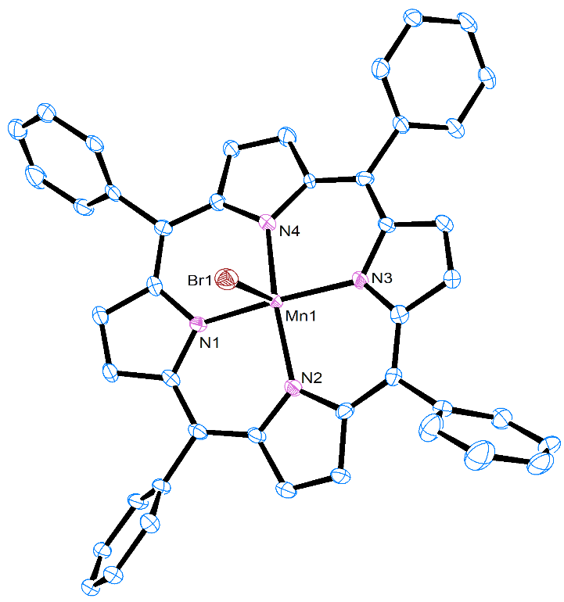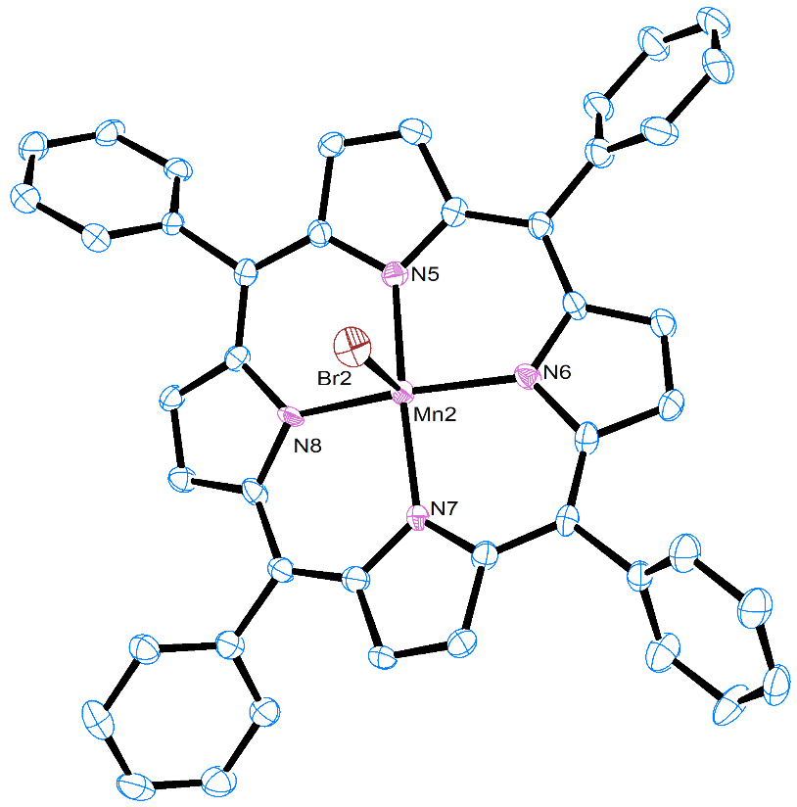
Figure C.1. ORTEP diagrams of the two independent Mn(TPP)Br molecules in 2∙CH₂Cl₂. CH₂Cl₂ and H atoms are omitted. One CH₂Cl₂ molecule is disordered, as discussed in Experimental.

Table C.3. Selected bond lengths (Å) and angles (°) for Mn(TPP)Br·CH₂Cl₂ (2·CH₂Cl₂)
Atoms | Length (Å) or angle (°) | Atoms | Length (Å) or angle (°)
Mn1—Br1 | 2.5247(12) | Mn2—Br2 | 2.5200(13)
Mn1—N1 | 1.999(5) | Mn2—N5 | 2.000(5)
Mn1—N2 | 2.017(5) | Mn2—N6 | 2.011(5)
Mn1—N3 | 2.008(5) | Mn2—N7 | 2.006(5)
Mn1—N4 | 2.008(5) | Mn2—N8 | 2.004(5)
N1—Mn1—N2 | 89.8(2) | N5—Mn2—N6 | 89.0(2)
N2—Mn1—N3 | 89.1(2) | N6—Mn2—N7 | 89.0(2)
N3—Mn1—N4 | 88.9(2) | N7—Mn2—N8 | 88.3(2)
N1—Mn1—N4 | 88.9(2) | N5—Mn2—N8 | 89.9(2)
N1—Mn1—Br1 | 92.42(16) | N5—Mn2—Br2 | 91.31(16)
N2—Mn1—Br1 | 95.59(15) | N6—Mn2—Br2 | 98.89(17)
N3—Mn1—Br1 | 98.52(16) | N7—Mn2—Br2 | 101.06(17)
N4—Mn1—Br1 | 101.40(16) | N8—MN2—Br2 | 98.99(16)
N1—Mn1—N3 | 169.1(2) | N5—Mn2—N7 | 167.6(2)
N2—Mn1—N4 | 163.0(2) | N6—Mn2—N8 | 162.1(2)

Mn(TPP)I (3) crystallized in deuterated chloroform at 23 °C into 3·CDCl₃ with the monoclinic space group P2₁/c. Using CHCl₃ alone as solvent at either 23 or -33 °C, crystallization gave 3·1.5CHCl₃ (triclinic space group P$\overline{\text{1}}$, SM). As indicated in the main text, 3 in layered pentane/CHCl₃ gave 3·CDCl₃.
3·CDCl₃ and 3·1.5CHCl₃ each have two crystallographically distinct Mn(TPP)I (3) molecules in the unit cells, while there is only one Mn(TPP)I (3) molecule in the unit cell of 3·CHCl₃. ORTEP diagrams of one molecule of 3 in 3·CDCl₃ and 3·1.5CHCl₃ are given in Figs. C.2 and C.3, respectively.

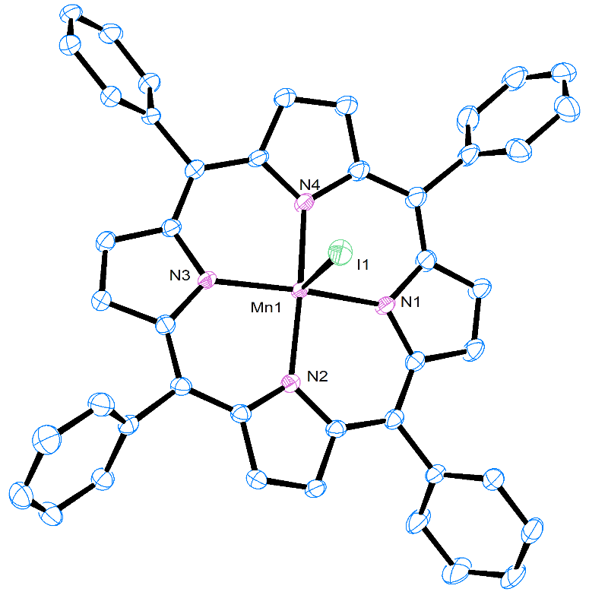
Figure C.2. ORTEP diagram of the structure of one molecule of Mn(TPP)Cl (3) in the crystal of 3·CDCl₃. CDCl₃ in the lattice and H atoms are omitted.

Table C.4. Selected bond lengths (Å) and angles (°) for one molecule of 3 in 3·CDCl₃
Atoms | Length (Å) or angle (°) | Atoms | Length (Å) or angle (°)
Mn1—I1 | 2.7437(9) | Mn1—N1 | 2.013(3)
Mn1—N2 | 2.007(3) | Mn1—N3 | 2.006(3)
Mn1—N4 | 2.006(3)
N1—Mn1—N2 | 89.2(1) | N2—Mn1—N3 | 89.1(1)
N3—Mn1—N4 | 89.3(1) | N1—Mn1—N4 | 89.5(1)
N1—Mn1—I1 | 96.65(9) | N2—Mn1—I1 | 99.88(8)
N3—Mn1—I1 | 98.25(9) | N4—Mn1—I1 | 91.80(9)
N1—Mn1—N3 | 165.1(1) | N2—Mn1—N4 | 168.3(1)

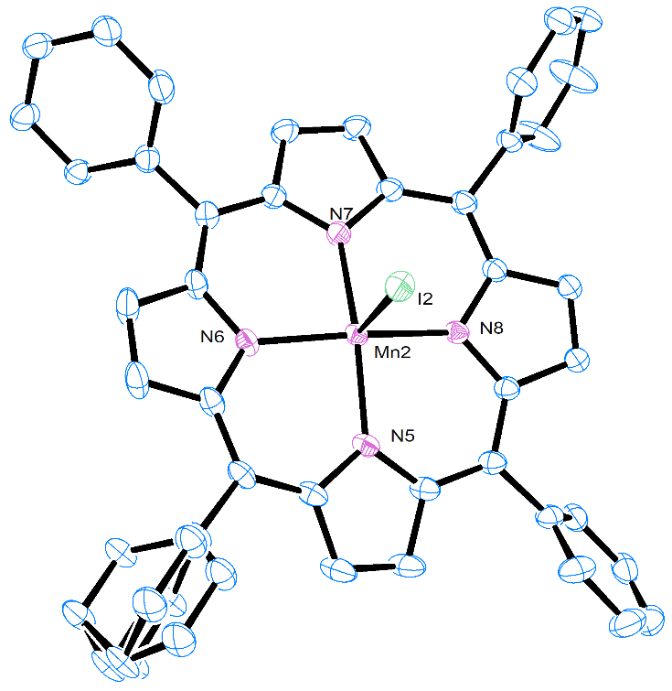
Figure C.3. ORTEP diagram of the structure of the molecule containing Mn2 in the crystal of Mn(TPP)I·1.5CHCl₃ (3·1.5CHCl₃). CHCl₃ and H atoms are omitted. The structure was disordered, as discussed in Experimental.

Table C.5. Selected bond lengths (Å) and angles (°) for Mn(TPP)I·1.5CHCl₃ (3·1.5CHCl₃)
Atoms | Length (Å) or angle (°) | Atoms | Length (Å) or angle (°)
Mn1—I1 | 2.7423(4) | Mn2—I2 | 2.7843(4)
Mn1—N1 | 2.0179(19) | Mn2—N5 | 2.007(2)
Mn1—N2 | 2.0041(18) | Mn2—N6 | 2.0084(19)
Mn1—N3 | 2.018(2) | Mn2—N7 | 2.006(2)
Mn1—N4 | 2.0000(19) | Mn2—N8 | 2.0109(19)
N1—Mn1—N2 | 89.22(7) | N5—Mn2—N6 | 89.65(8)
N2—Mn1—N3 | 89.76(8) | N6—Mn2—N7 | 88.69(8)
N3—Mn1—N4 | 89.17(8) | N7—Mn2—N8 | 89.26(8)
N1—Mn1—N4 | 89.58(8) | N5—Mn2—N8 | 88.66(8)
N1—Mn1—I1 | 96.92(5) | N5—Mn2—I2 | 100.97(6)
N2—Mn1—I1 | 93.44(5) | N6—Mn2—I2 | 95.81(6)
N3—Mn1—I1 | 99.37(6) | N7—Mn2—I2 | 96.05(6)
N4—Mn1—I1 | 94.56(6) | N8—Mn2—I2 | 96.82(6)
N1—Mn1—N3 | 163.71(8) | N5—Mn2—N7 | 162.98(8)
N2—Mn1—N4 | 172.00(8) | N6—Mn2—N8 | 167.35(8)

C.1.2. Results of the CShM Calculations by the SHAPE Program
CShM calculations were performed on the solvent-containing structures of Mn(TPP)Br (2) [2·CHCl₃, 2·toluene and two independent Mn(TPP)Br (2) molecules in 2·CH₂Cl₂ (Table C.7)] show that Mn(TPP)Br molecules in all three analogs exhibit only slight distortion from square pyramidal geometry. However, distortion value of 2·toluene (0.448) is lower than those of both the chloroform analog 2·CHCl₃ (0.645) and 2·CH₂Cl₂ (0.593-0.597). The Mn—Br bond lengths of 2.5363(5) in 2·CHCl₃ and 2.5200(13)-2.5247(12) of two Mn(TPP)Br molecules in 2·CH₂Cl₂ are all longer than 2.490(1) in 2·toluene.⁶²

Table C.7. CShM results for Mn(TPP)Br·CHCl₃ (2·CHCl₃), Mn(TPP)Br·CH₂Cl₂ (2·CH₂Cl₂), and Mn(TPP)Br·toluene (2·toluene)
CSM | 2·CHCl₃ | 2·CH₂Cl₂ |  | 2·toluene ⁶²
CSM | 2·CHCl₃ | Mn1 | Mn2 | 2·toluene ⁶²
Pentagon | 31.067 | 31.846 | 32.256 | 34.068
Vacant octahedron  (Johnson square pyramid) | 2.003 | 1.986 | 2.117 | 2.085
Trigonal bipyramid | 5.300 | 4.855 | 4.933 | 4.720
Square pyramid | 0.645 | 0.593 | 0.597 | 0.448
Johnson trigonal bipyramid | 8.796 | 8.380 | 8.472 | 8.420

Table C.8. CShM results for Mn(TPP)I·CHCl₃ (3·CHCl₃), Mn(TPP)I·CDCl₃ (3·CDCl₃), Mn(TPP)I·1.5CHCl₃ (3·1.5CHCl₃) and Mn(TPP)I·toluene (3·toluene)
CSM | 3·CHCl₃ | 3·CDCl₃ |  | 3·1.5CHCl₃ |  | 3·toluene ⁶²
CSM | 3·CHCl₃ | Mn1 | Mn2 | Mn1 | Mn2 | Mn1 | Mn2
Pentagon | 33.706 | 33.029 | 33.621 | 34.242 | 34.082 | 34.167 | 33.746
Vacant octahedron (Johnson square pyramid) | 2.851 | 2.876 | 2.879 | 2.759 | 3.233 | 3.037 | 2.817
Trigonal bipyramid | 5.339 | 5.596 | 5.025 | 4.808 | 5.447 | 5.617 | 5.589
Square pyramid | 0.938 | 0.978 | 0.998 | 0.986 | 1.062 | 1.002 | 0.871
Johnson trigonal bipyramid | 9.279 | 9.535 | 9.098 | 8.847 | 9.525 | 9.658 | 9.619

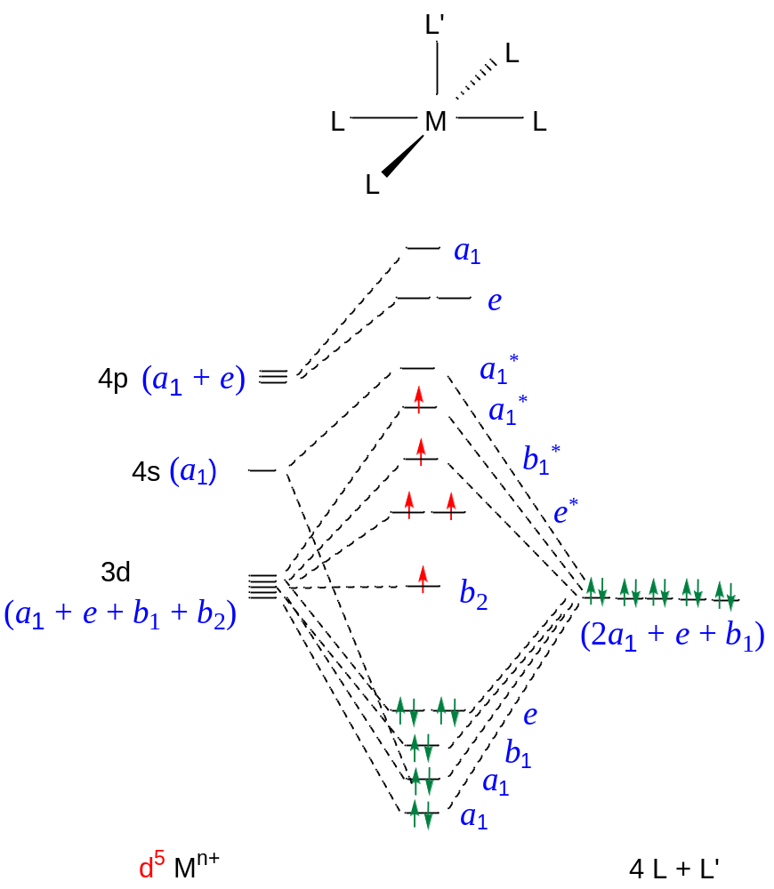

Figure C.4. Qualitative MO diagram in a d⁵ square pyramid complex with C_{4v} symmetry.
Mn1 Molecule
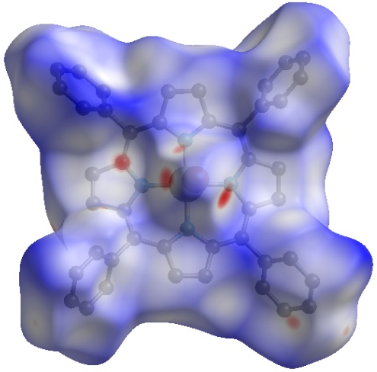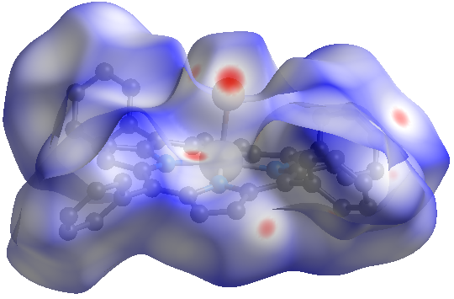
Mn2 Molecule
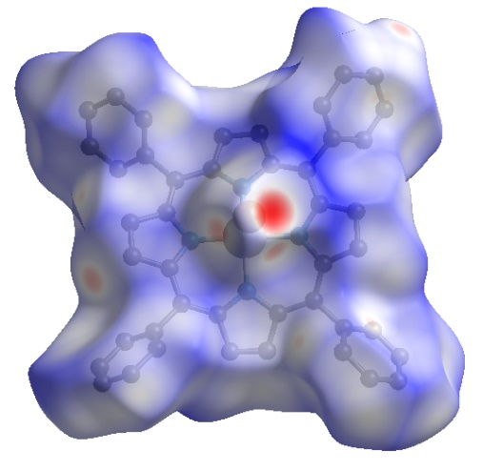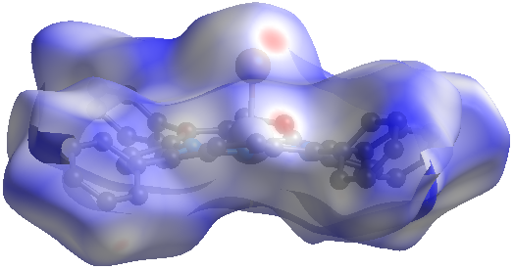
Figure C.5. Two views of the Hirshfeld surface of the Mn1 (Top) and Mn2 (Bottom) molecules Mn(TPP)Br∙CH₂Cl₂ (2∙CH₂Cl₂) showing normalized close distances of the pro-molecule and neighboring molecules at 100(2) K.⁶⁹ The red-white-blue coloring scheme demonstrates decreasing contacts. Sites of close contacts are shown in red dots. Semi-transparent view reveals the enclosed molecule. Hereafter the same below for the coloring scheme, sites of close contacts and semi-transparent view.
Figure C.6. Hirshfeld fingerprint plots for 2∙CH₂Cl₂: (Top) Molecule containing Mn1 atom; (Bottom) Molecule containing Mn2 atom. The closest contacts correspond to the minimum d_{i} + d_{e} values in each plot, hereafter the same below. d_{i} and d_{e} are distances from the Hirshfeld surface to the nearest atom interior and exterior to the surface, respectively.⁷⁰

Molecule of Mn1
H∙∙∙H close contact (blue) below Br∙∙∙H close contact (blue) below
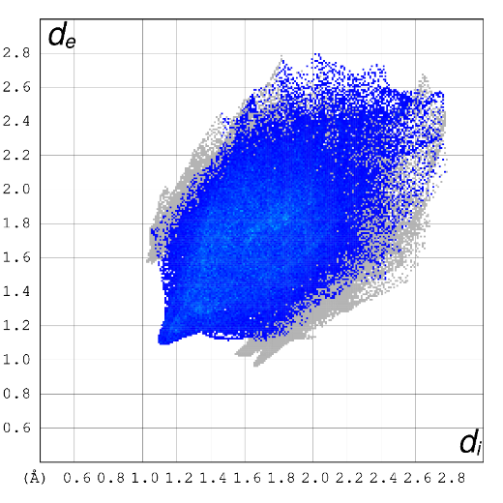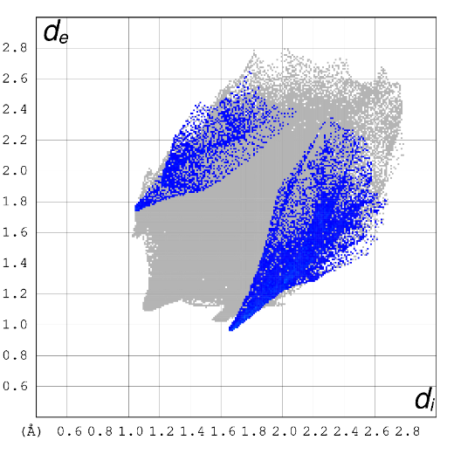
Molecule of Mn2
H∙∙∙H close contact (blue) below Br∙∙∙H close contact (blue) below
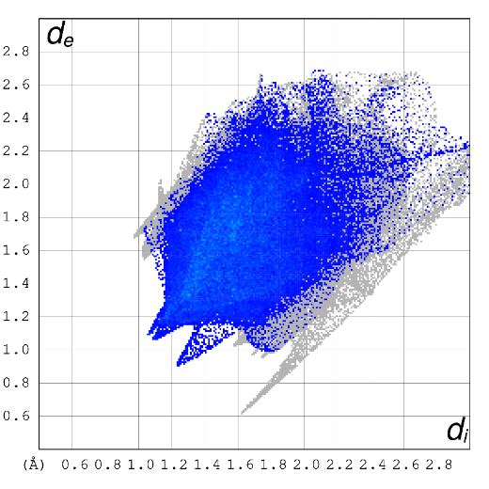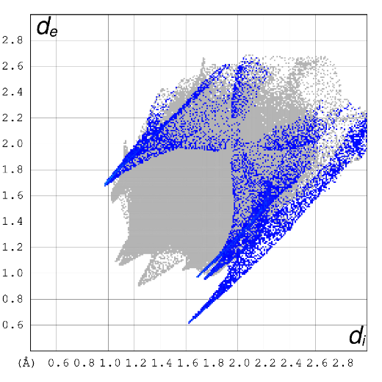

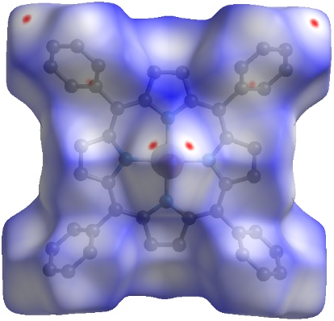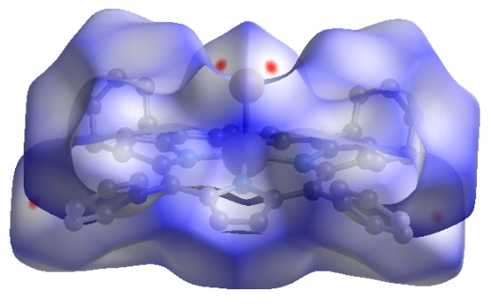
Figure C.7. Hirshfeld surface of Mn(TPP)Br∙toluene (2∙toluene) showing normalized close distances of the pro-molecule and neighboring molecules at 100(2) K.⁶⁹
H∙∙∙H close contact (blue) below Br∙∙∙H close contact (blue) below
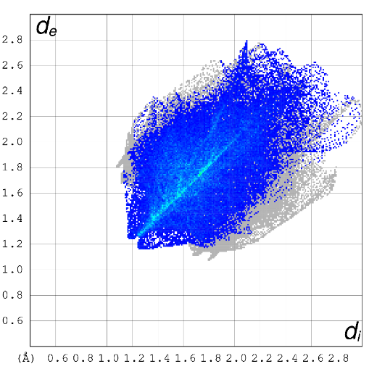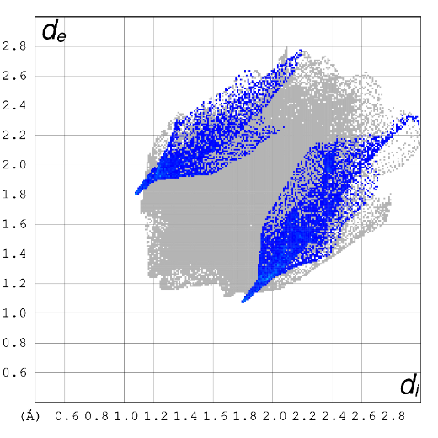
Figure C.8. Hirshfeld fingerprint plots for 2·toluene.

C.1.3. Comparison of Contributions to the Hirshfeld Surface Areas for Mn(TPP)Br (2) Molecules in Various Crystal Structures
The contributions to the Hirshfeld surface areas for various intermolecular close contacts for Mn(TPP)Br (2) molecules in various crystal structures are compared in Figure C.9.
The percentage contributions of the intermolecular H∙∙∙H (46.0%-48.9%) and C∙∙∙H (24.9%-28.5%) close contacts to the Hirshfeld surface area for Mn(TPP)Br (2) molecules in 2∙CHCl₃ and 2∙CH₂Cl₂ (Figure C.9) are similar but lower than those (54.7% and 31.3% for H∙∙∙H and C∙∙∙H close contacts, respectively) in 2∙toluene likely because the solvent toluene in the latter, containing eight H atoms, increases the percentage.

Figure C.9. Percentage contributions to the Hirshfeld surface areas for various intermolecular close contacts for Mn(TPP)Br (2) molecules in various crystal structures.

Mn1 Molecule
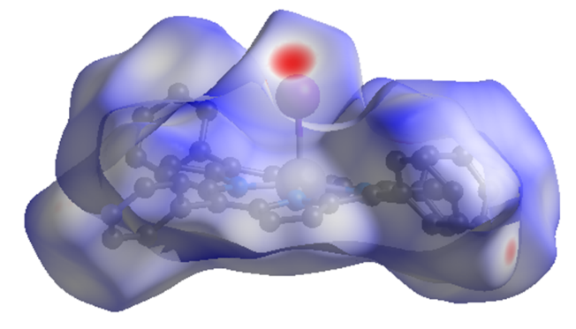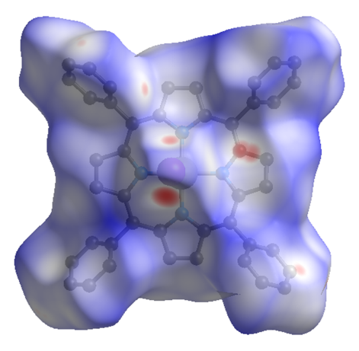

Mn2 Molecule
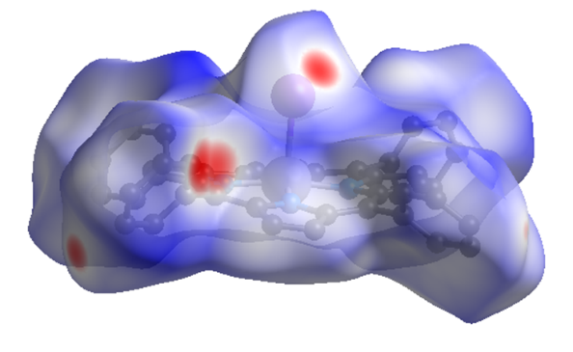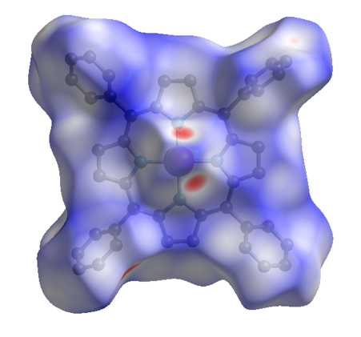
Figure C.10. Two views of the Hirshfeld surfaces of the Mn1 (Top) and Mn2 (Bottom) molecules 3∙CDCl₃ showing normalized close distances of the pro-molecule and neighboring molecules at 100(2) K.⁶⁹

Mn1 Molecule
H/D∙∙∙H/D close contact (blue) below I∙∙∙H/D close contact (blue) below
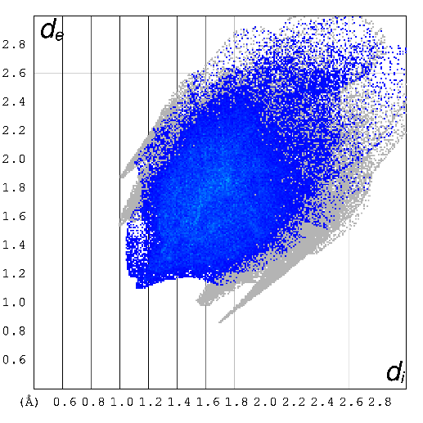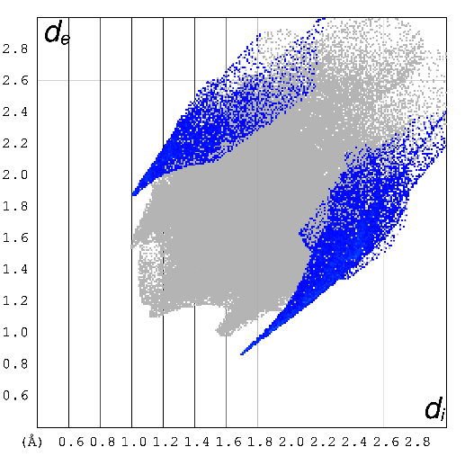
Mn2 Molecule
H/D∙∙∙H/D close contact (blue) below I∙∙∙H/D close contact (blue) below
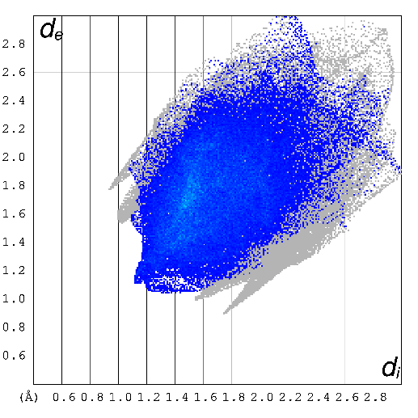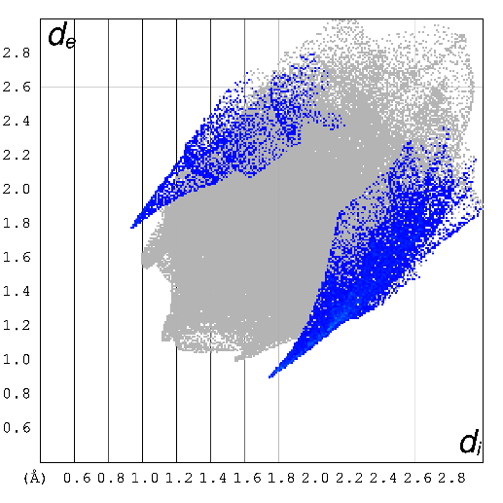
Figure C.11. Hirshfeld fingerprint plots for 3∙CDCl₃: (Top) Molecule containing the Mn1 atom; (Bottom) Molecule containing the Mn2 atom.

Mn1 Molecule
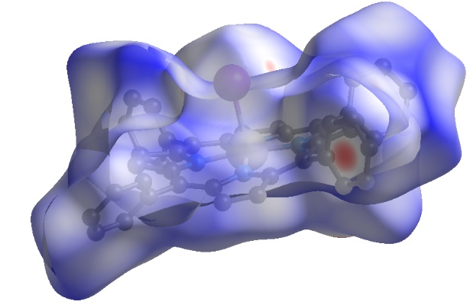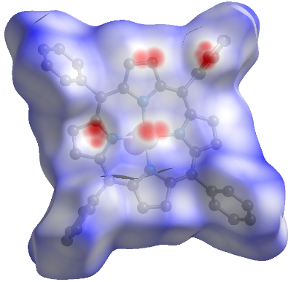
Mn2 Molecule
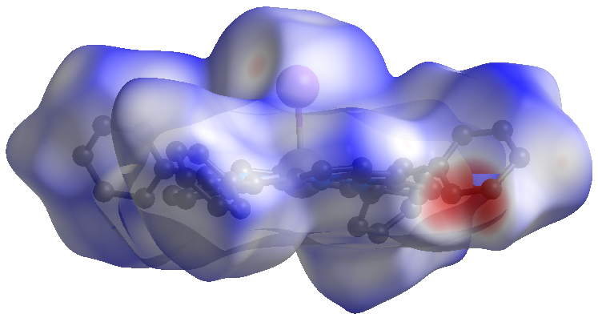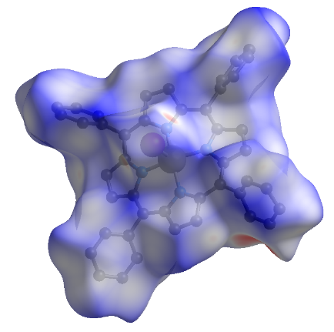
Figure C.12. Two views of the Hirshfeld surfaces of the Mn1 (Top) and Mn2 (Bottom) molecules 3∙1.5CHCl₃ showing normalized close distances of the pro-molecule and neighboring molecules at 100(2) K.⁶⁹

Mn1 Molecule
H∙∙∙H close contact (blue) below I∙∙∙H close contact (blue) below
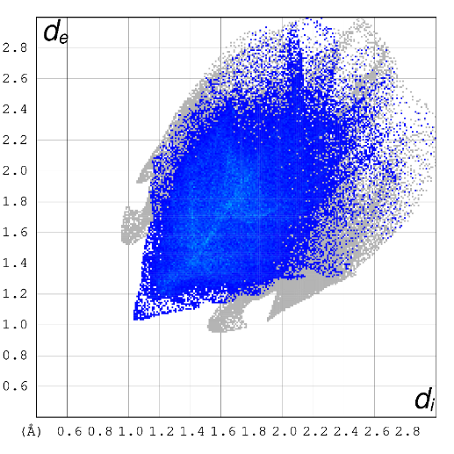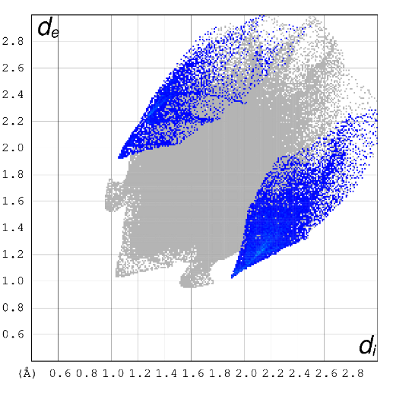
Mn2 Molecule
H∙∙∙H close contact (blue) below I∙∙∙H close contact (blue) below
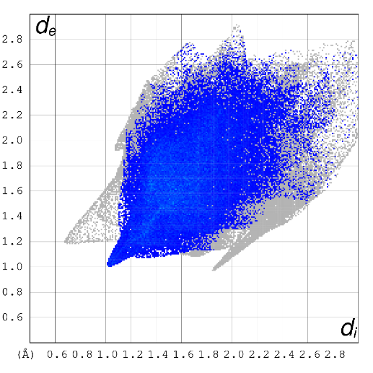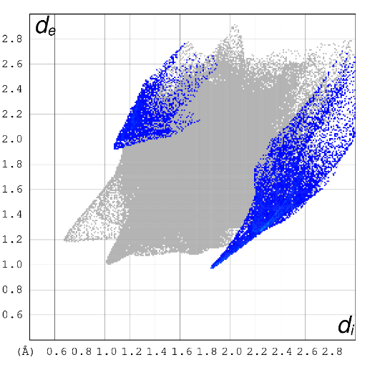
Figure C.13. Hirshfeld fingerprint plots for 3∙1.5CHCl₃: (Top) Molecule containing the Mn1 atom; (Bottom) Molecule containing the Mn2 atom.

Mn1 Molecule
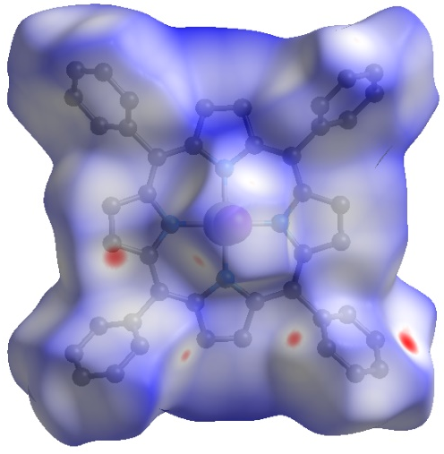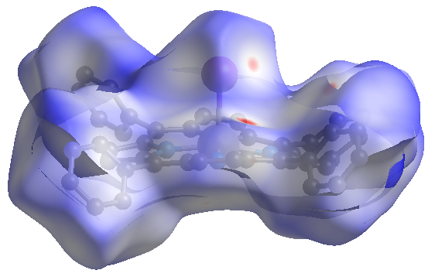

Mn2 Molecule
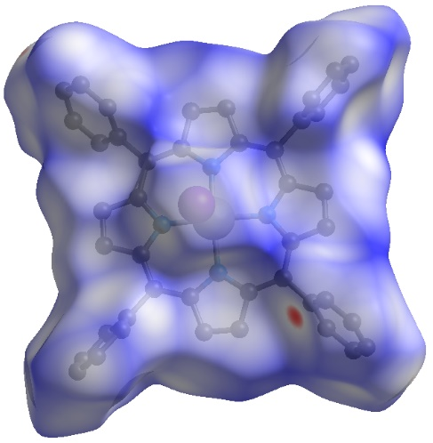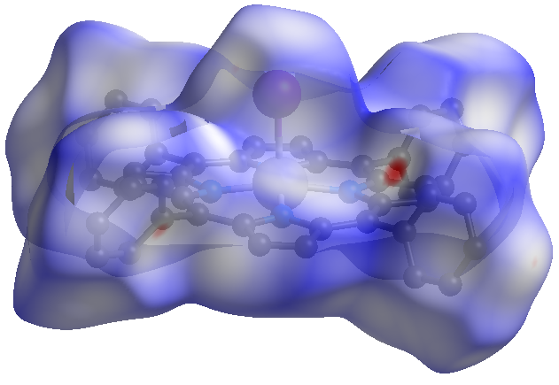
Figure C.14. Two views of the Hirshfeld surface of the Mn1 (Top) and Mn2 (Bottom) molecules of Mn(TPP)I∙toluene (3∙toluene) showing normalized close distances of the pro-molecule and neighboring molecules at 100(2) K.⁶⁹

Mn1 Molecule
H∙∙∙H close contact (blue) below I∙∙∙H close contact (blue) below
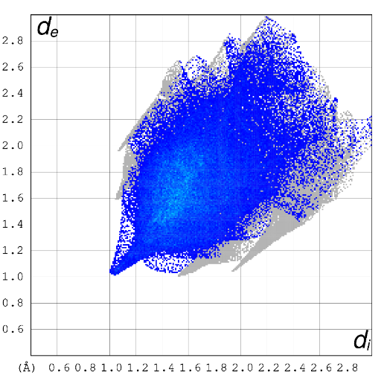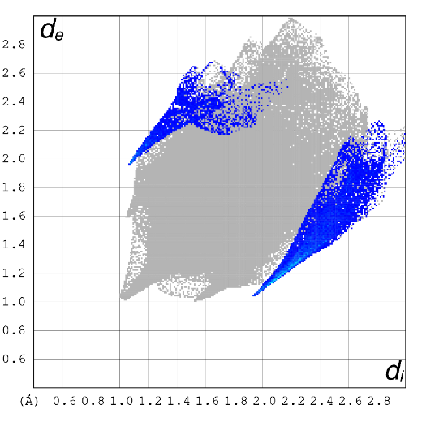
Mn2 Molecule
H∙∙∙H close contact (blue) below I∙∙∙H close contact (blue) below
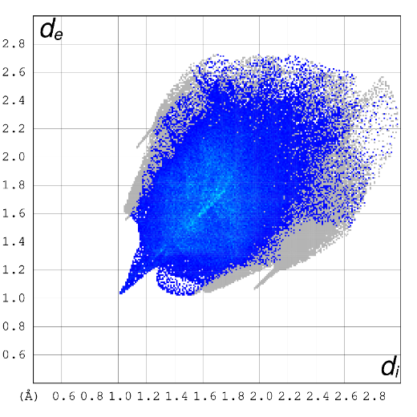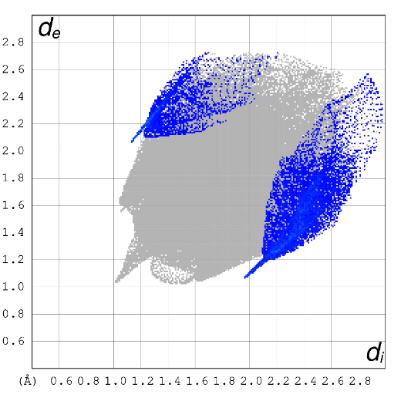
Figure C.15. Hirshfeld fingerprint plots for Mn(TPP)I∙toluene (3∙toluene): (Top) Molecule containing Mn1 atom; (Bottom) Molecule containing Mn2 atom.

C.1.4. Comparison of Contributions to the Hirshfeld Surface Areas for Mn(TPP)I (3) Molecules in Various Crystal Structures
The contributions to the Hirshfeld surface areas for various intermolecular close contacts for Mn(TPP)I (3) molecules in various crystal structures are compared in Figure C.16.
Comparison of percentage contributions to the Hirshfeld surface area for different intermolecular close contacts for Mn(TPP)I (3) molecules in various crystal structures (Fig. C.15) shows that 3∙toluene has the highest contributions from close H∙∙∙H and C∙∙∙H contacts likely as a result of the toluene solvent in the lattice.

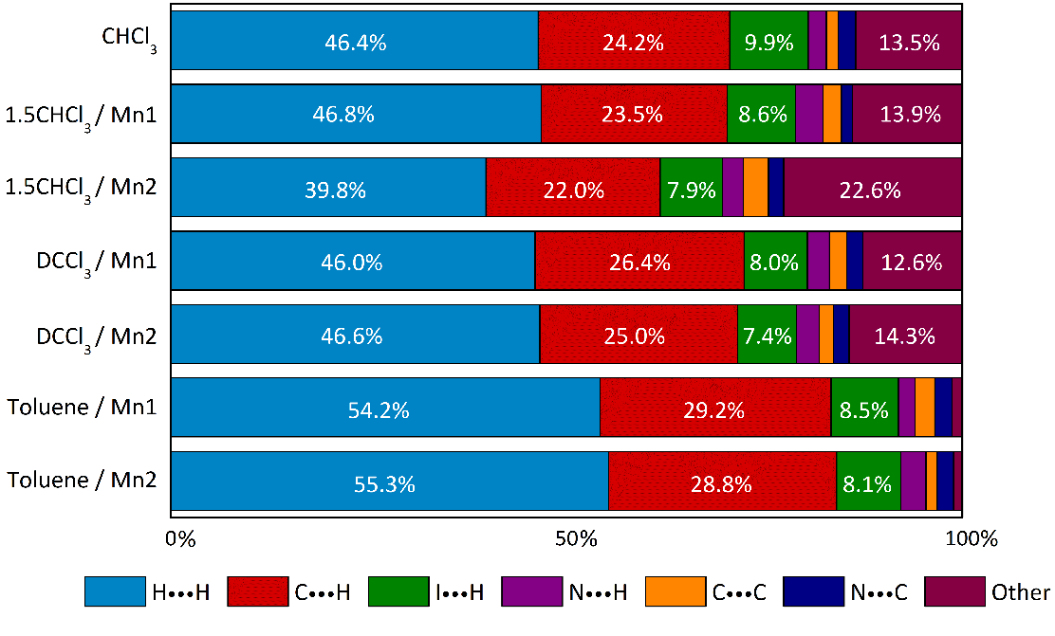
Figure C.16. Percentage contributions to the Hirshfeld surface areas for various intermolecular close contacts for Mn(TPP)I (3) molecules in various crystal structures.

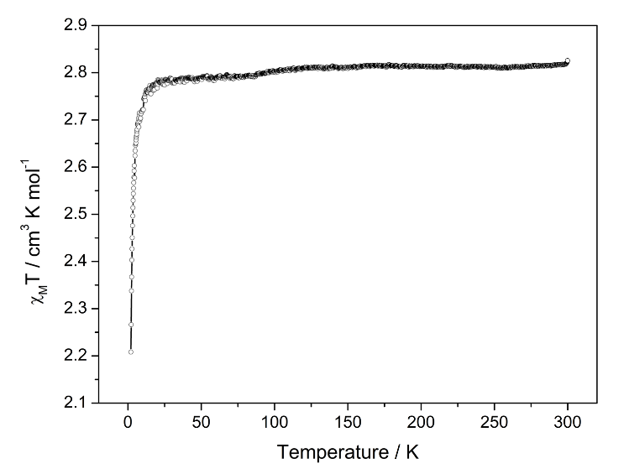
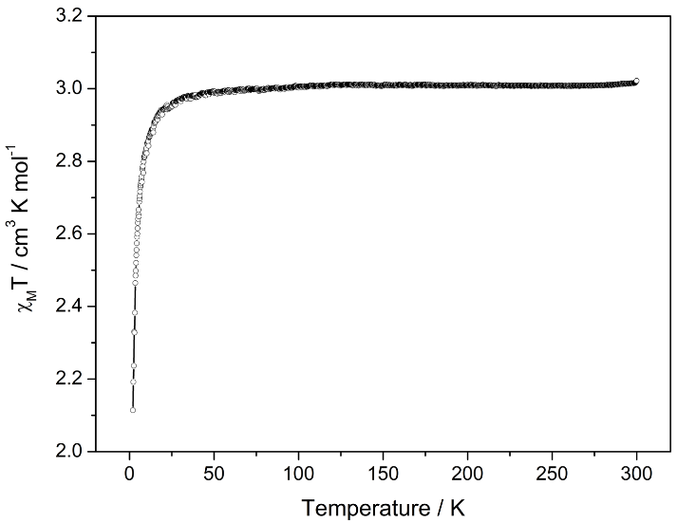
Figure C.17. Variable-temperature DC susceptibility data under applied DC field of 0.5 T fitted for solvent-free samples: (Top) Mn(TPP)Br (2). (Bottom) Mn(TPP)I (3). Fits are included to guide the eye.
Figure C.18. (Top) M-H plot for 2·CHCl₃ at 1.8 K. The red line indicates the Brillouin function for a system with S = 2.0 and g = 1.42. The M-H plot shows deviation from the Brillouin function for spin state S = 2.0 (with g = 2.0 and no ZFS). Since HFEPR of 2∙CDCl₃ gives g = 1.99-2.00, using the M-H plot to yield the g value was not pursued further. (Bottom) AC susceptibility data (χ_{M}′ = filled circles, χ_{M}″ = empty circles) for Mn(TPP)Br∙CHCl₃ (2∙CHCl₃) with a DC field of 0.14 T and 2.74 Oe driving amplitude.

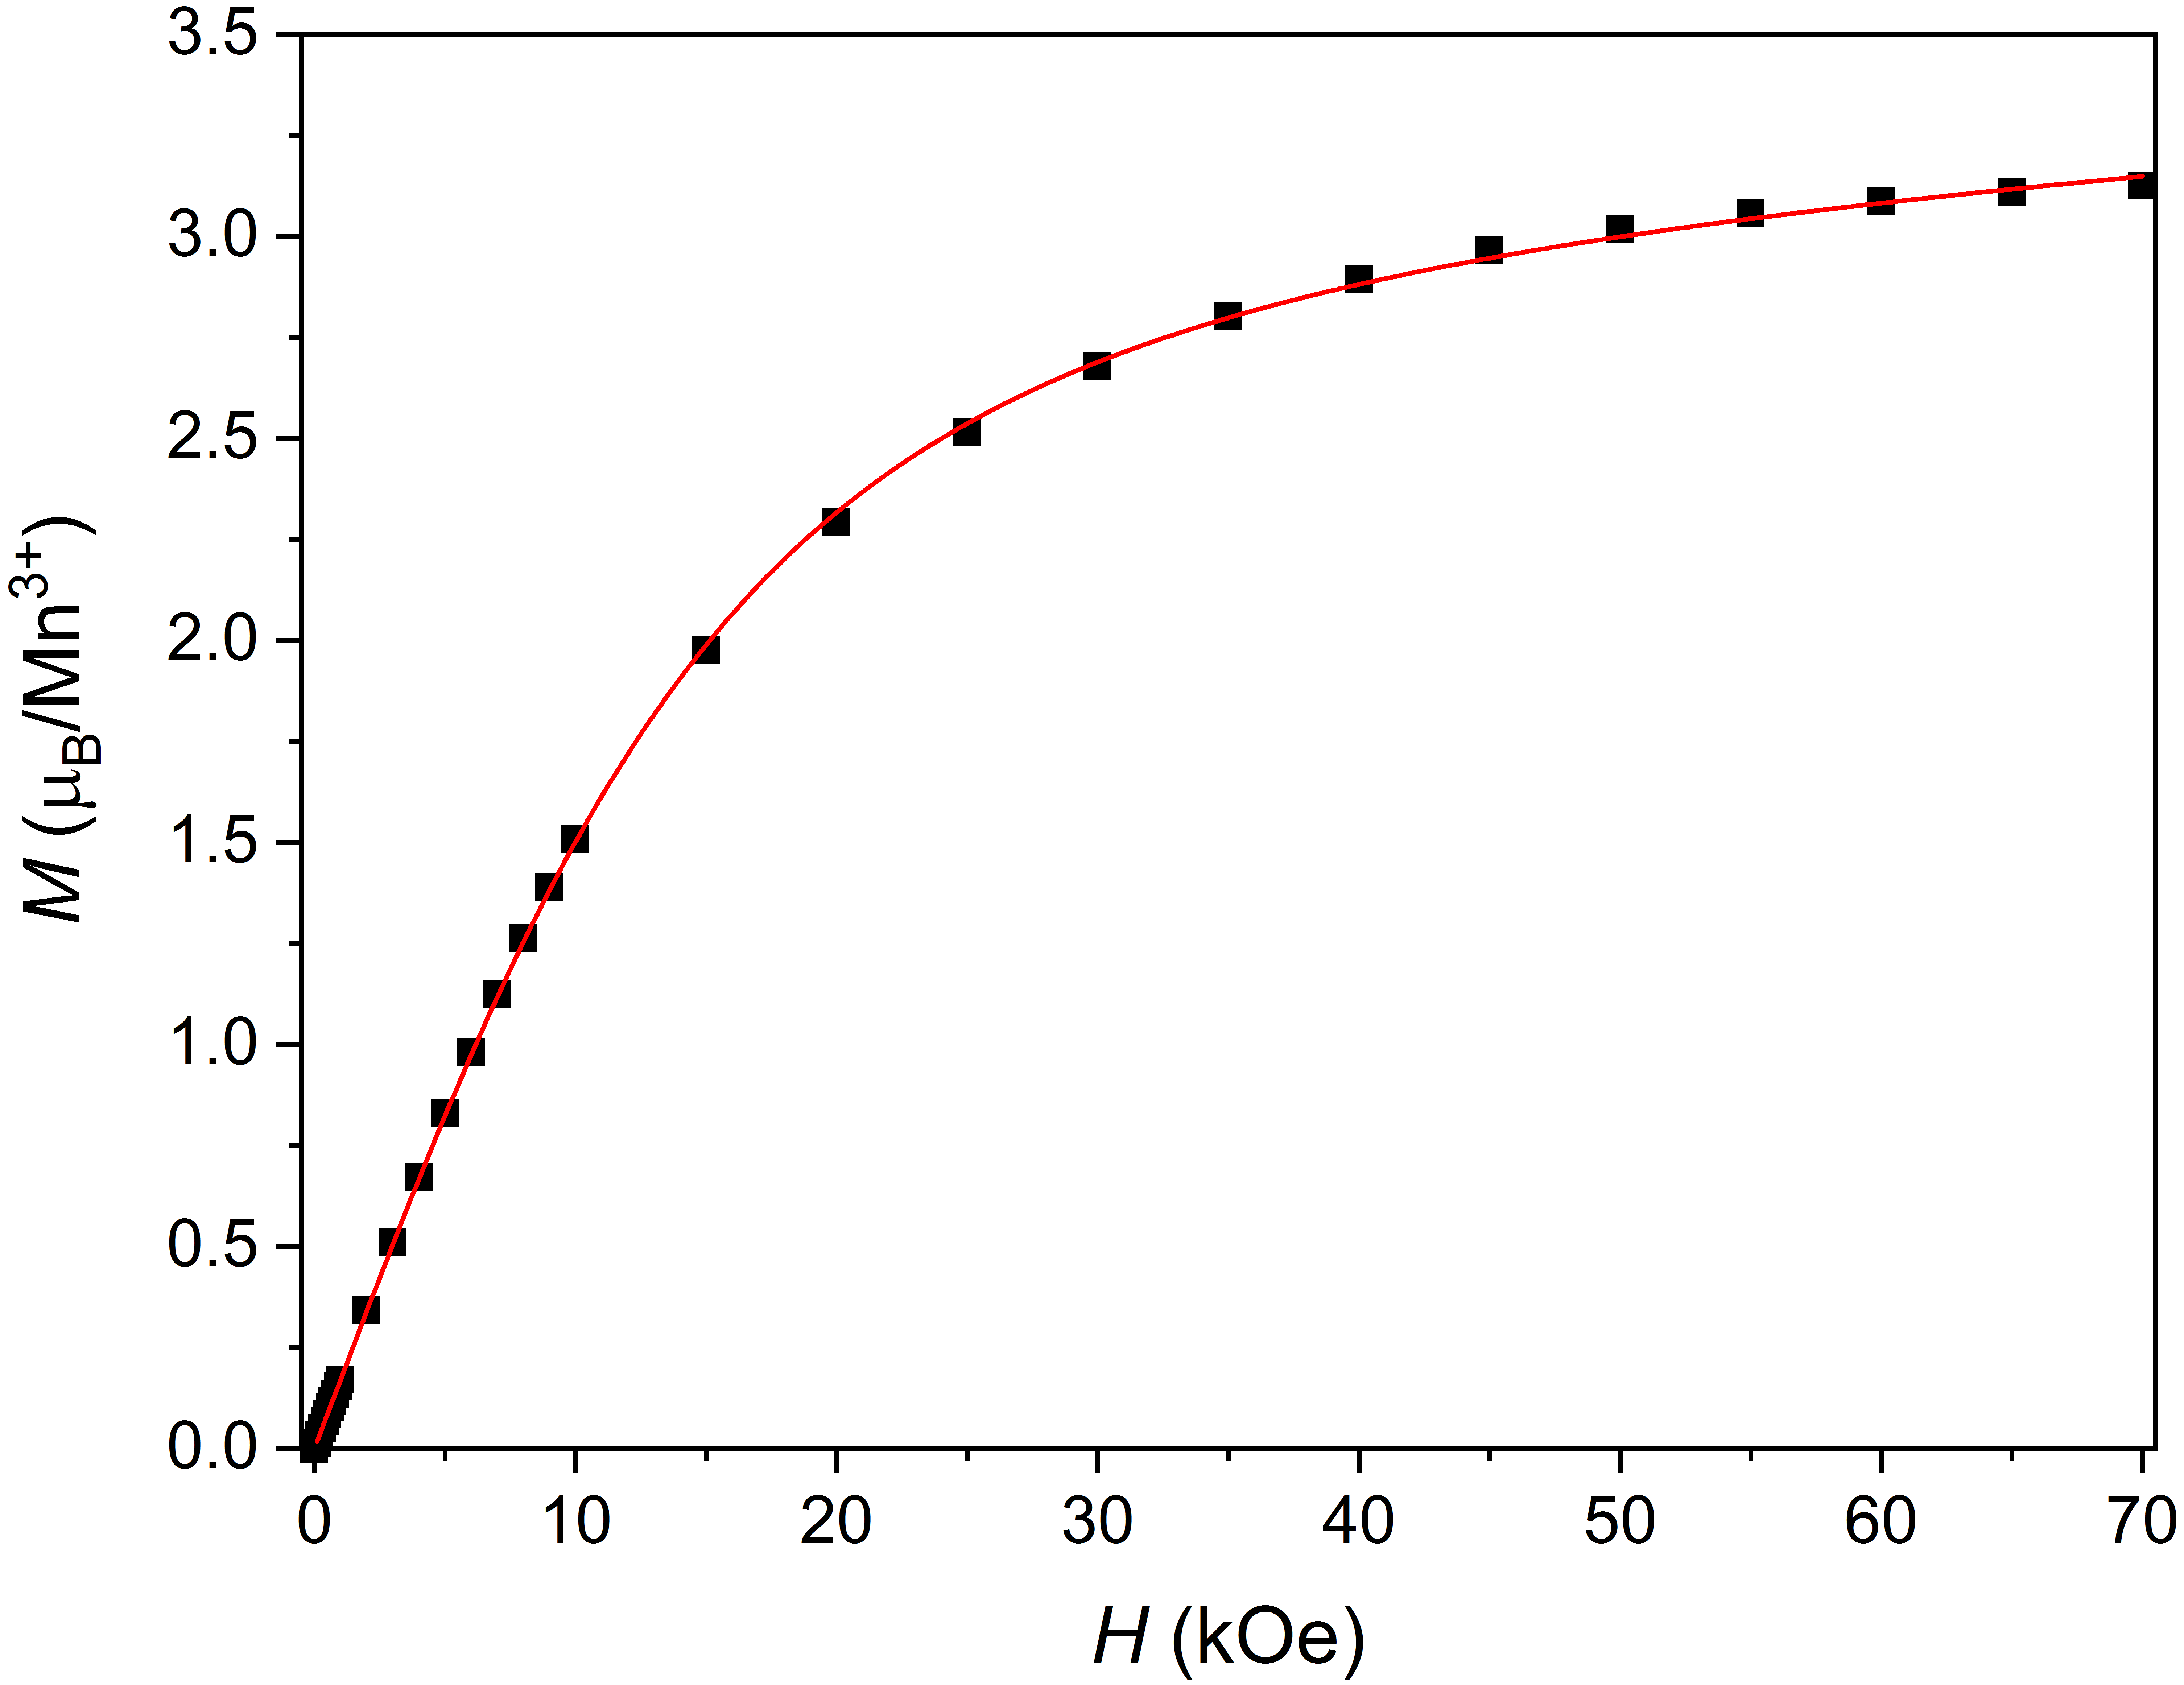

Figure C.19. (Top) M-H plot for 3∙1.5CHCl₃ at 1.8 K. The red line indicates the Brillouin function for a system with S = 2.0 and g = 1.54. The M-H plot shows deviation from the Brillouin function for spin state S = 2.0 (with g = 2.0 and no ZFS). Since HFEPR of 3∙CDCl₃ gives g = 1.93-1.97, using the M-H plot to yield the g value was not pursued further. (Bottom) AC susceptibility data (χ_{M}′ = filled circles, χ_{M}″ = empty circles) for Mn(TPP)I∙1.5CHCl₃ (3∙1.5CHCl₃) with a DC field of 0.14 T and 2.74 Oe driving amplitude.
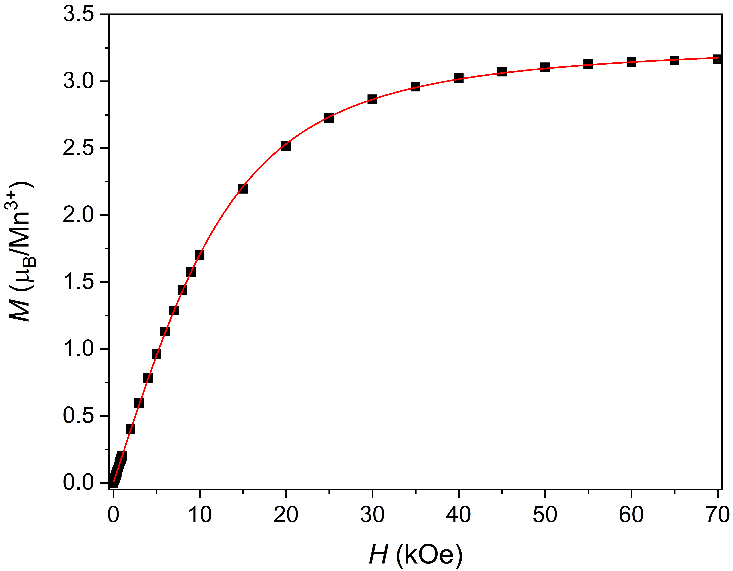

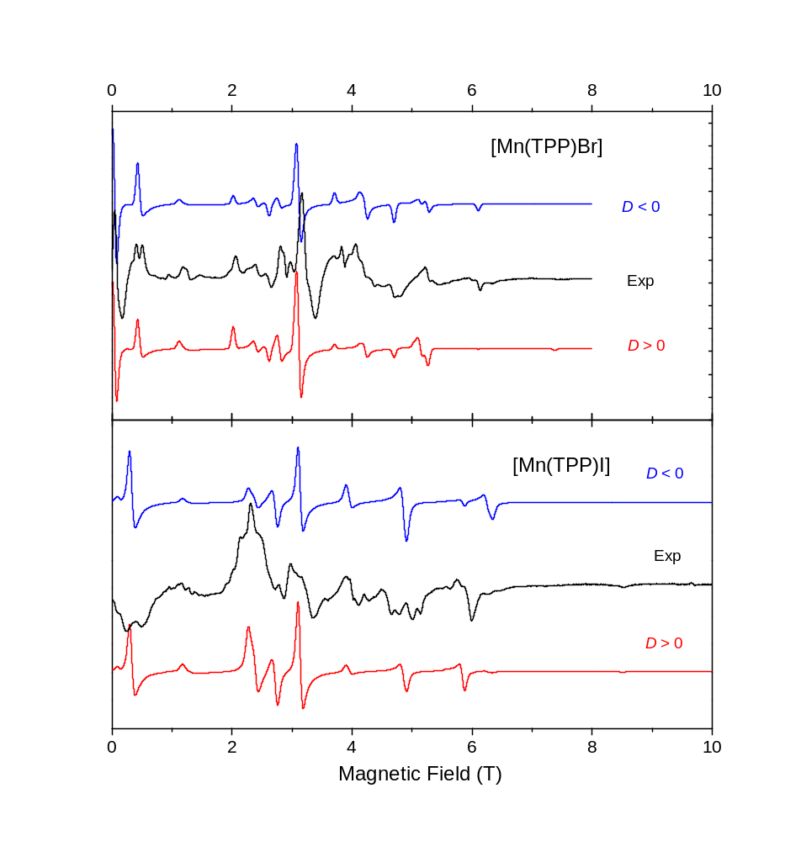
Figure C.20. HFEPR spectra of Mn(TPP)Br∙CDCl₃ (2∙CDCl₃, Top) and Mn(TPP)I∙CDCl₃ (3∙CDCl₃, Bottom) at 10 K and 108 GHz and 112 GHz, respectively (black traces) and their powder-pattern simulations (colored traces). The spin Hamiltonian parameters used in simulations were the same as in Table 4.4. Blue traces: D < 0; red traces: D > 0.

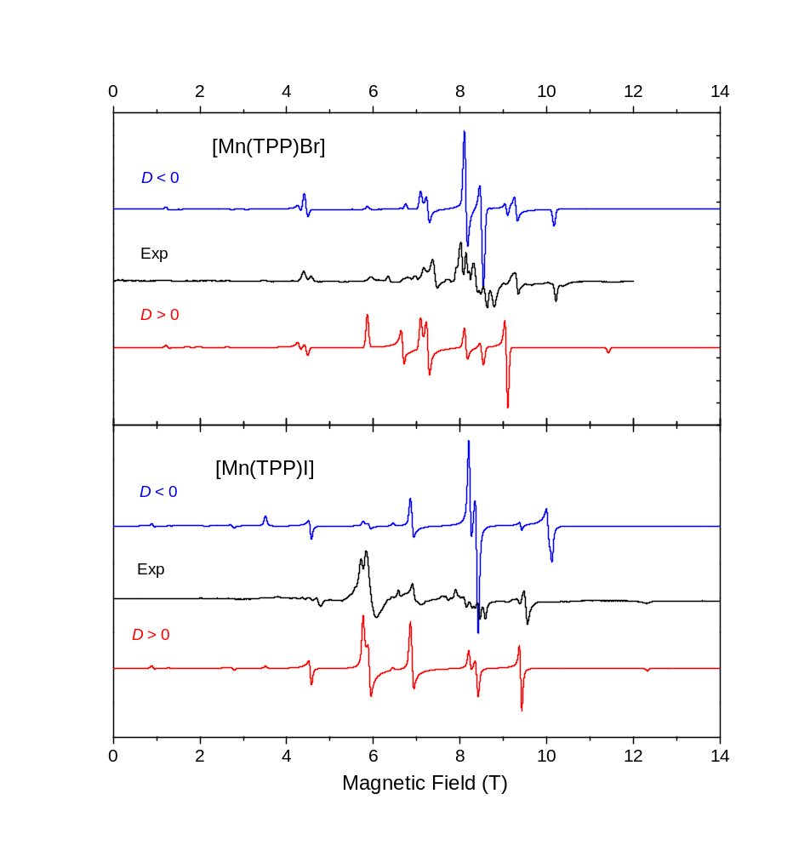
Figure C.21. HFEPR spectra of Mn(TPP)Br∙CDCl₃ (2∙CDCl₃, Top) and Mn(TPP)I∙CDCl₃ (3∙CDCl₃, Bottom) at 10 K and 216 GHz and 220.8 GHz, respectively (black traces) and their powder-pattern simulations (colored traces). The spin Hamiltonian parameters used in simulations were the same as in Table 4.3. Blue traces: D < 0; red traces: D > 0.

VITA

Alexandria N. Bone was born in Knoxville, TN.

1. Sessoli, R.; Gatteschi, D.; Caneschi, A.; Novak, M. A., Magnetic Bistability in a Metal-Ion Cluster. Nature 1993, 365 (6442), 141-143.
2. Ishikawa, N.; Sugita, M.; Ishikawa, T.; Koshihara, S.; Kaizu, Y., Lanthanide double-decker complexes functioning as magnets at the single-molecular level. J Am Chem Soc 2003, 125 (29), 8694-8695.
3. Woodruff, D. N.; Winpenny, R. E. P.; Layfield, R. A., Lanthanide Single-Molecule Magnets. Chem Rev 2013, 113 (7), 5110-5148.
4. Gupta, S. K.; Murugavel, R., Enriching lanthanide single-ion magnetism through symmetry and axiality. Chem Commun 2018, 54 (30), 3685-3696.
5. Liddle, S. T.; van Slageren, J., Improving f-element single molecule magnets. Chem Soc Rev 2015, 44 (19), 6655-6669.
6. Brackett, G. C. Ph.D. dissertation, University of California, Berkeley, 1970.
7. Brackett, G. C.; Richards, P. L.; Caughey, W. S., J. Chem. Phys. 1971, 54, 4383-4401.
8. Jacobs, P. W. M., Group Theory with Applications in Chemical Physics. Cambridge University Press: Cambridge, UK, 2005.
9. Koster, G. F.; Dimmock, J. O.; Wheeler, R. G.; Statz, H., Properties of the Thirty-Two Point Groups. MIT Press: Cambridge, MA, 1963.
10. Rechkemmer, Y.; Breitgoff, F. D.; Meer, M. v. d.; Atanasov, M.; Hakl, M.; Orlita, M.; Neugebauer, P.; Neese, F.; Sarkar, B.; Slageren, J. v., Nat. Commun. 2016, 7, 10467.
11. Moseley, D. H.; Stavretis, S. E.; Thirunavukkuarasu, K.; Ozerov, M.; Cheng, Y.; Daemen, L. L.; Ludwig, J.; Lu, Z.; Smirnov, D.; Brown, C. M.; Pandey, A.; Ramirez-Cuesta, A. J.; Lamb, A. C.; Atanasov, M.; Bill, E.; Neese, F.; Xue, Z.-L., Nat. Commun. 2018, 9, 2572.
12. Ray, K.; Begum, A.; Weyhermüller, T.; Piligkos, S.; Slageren, J. v.; Neese, F.; Weighardt, K., J. Am. Chem. Soc. 2005, 127, 4403-4415.
13. Stavretis, S. E.; Moseley, D. H.; Fei, F.; Cui, H.-H.; Cheng, Y.; Podlesnyak, A. A.; Wang, X.; Daemen, L. L.; Hoffmann, C. M.; Ozerov, M.; Lu, Z.; Thirunavukkuarasu, K.; Smirnov, D.; Chang, T.; Chen, Y.-S.; Ramirez-Cuesta, A. J.; Chen, X.-T.; Xue, Z.-L., Chem. Eur. J. 2019, 25, 15846-15857.
14. Świtlicka, A.; Machura, B.; Penkala, M.; Bieńko, A.; Bieńko, D. C.; Titiš, J.; Rajnák, C.; Boča, R.; Ozarowski, A.; Ozerov, M., Inorg. Chem. 2018, 57, 12740-12755.
15. Bunting, P. C.; Atanasov, M.; Damgaard-Møller, E.; Perfetti, M.; Crassee, I.; Orlita, M.; Overgaard, J.; van Slageren, J.; Neese, F.; Long, J. R., Science 2018, 362, eaat7319.
16. Jiang, S.-D.; Maganas, D.; Levesanos, N.; Ferentinos, E.; Haas, S.; Thirunavukkuarasu, K.; Krzystek, J.; Dressel, M.; Bogani, L.; Neese, F.; Kyritsis, P., J. Am. Chem. Soc. 2015, 137, 12923-12928.
17. Liu, J.-J.; Meng, Y.-S.; Hlavička, I.; Orlita, M.; Jiang, S.-D.; Wang, B.-W.; Gao, S., Dalton Trans. 2017, 46, 7408-7411.
18. Hay, M. A.; Sarkar, A.; Craig, G. A.; Bhaskaran, L.; Nehrkorn, J.; Ozerov, M.; Marriott, K. E. R.; Wilson, C.; Rajaraman, G.; Hill, S.; Murrie, M., Chem. Sci. 2019, 10, 6354-6361.
19. Nehrkorn, J.; Holldack, K.; Bittl, R.; Schnegg, A., J. Magn. Reson. 2017, 280, 10-19.
20. Schnegg, A.; Behrends, J.; Lips, K.; Bittl, R.; Holldack, K., Phys. Chem. Chem. Phys. 2009, 11, 6820-6825.
21. Kumar, P.; SantaLucia, D. J.; Kaniewska-Laskowska, K.; Lindeman, S. V.; Ozarowski, A.; Krzystek, J.; Ozerov, M.; Telser, J.; Berry, J. F.; Fiedler, A. T., Inorg. Chem. 2020, 59, 16178-16193.
22. Pedersen, K. S.; Dreiser, J.; Nehrkorn, J.; Gysler, M.; Schau-Magnussen, M.; Schnegg, A.; Holldack, K.; Bittl, R.; Piligkos, S.; Weihe, H.; Tregenna-Piggott, P.; Waldmann, O.; Bendix, J., Chem. Commun. 2011, 47, 6918-6920.
23. Ibers, J. A.; Swalen, J. D., Phys. Rev. 1962, 127, 1914-1917.
24. Nehrkorn, J.; Telser, J.; Holldack, K.; Stoll, S.; Schnegg, A., J. Phys. Chem. B 2015, 119, 13816-13824.
25. Simo, C.; Holt, S., Inorg. Chem. 1968, 7, 2655-2657.
26. Krzystek, J.; Zvyagin, S. A.; Ozarowski, A.; Fiedler, A. T.; Brunold, T. C.; Telser, J., J. Am. Chem. Soc. 2004, 126, 2148.
27. Tomlinson, A. A. G.; Bellitto, C.; Piovesana, O.; Furlani, C., J. Chem. Soc. Dalton Trans. 1972, 350-354.
28. Stapele, R. P. v.; Beljers, H. G.; Bongers, P. F.; Zijlstra, H., J. Chem. Phys. 1966, 44, 3719-3725.
29. Jesson, J. P.; Trofimenko, S.; Eaton, D. R., J. Am. Chem. Soc. 1967, 89, 3148-3158.
30. In Cs₃CoCl₅, the [CoCl₄]²⁻ unit has D_{2d} symmetry, but is tetragonally elongated: Cl-Co-Cl angle = 106º. The labels used are appropriate for each of T_{d}, D_{2d}, and C_{2v} point group symmetry. Horrocks and Barlone use a different convention that leads to the ground state being ⁴A₁ in all three point group symmetries, but gives non-standard symmetry labels to the T_{d} and D_{2d} cases, which we find to be confusing, even if technically correct.
31. Krzystek, J.; Park, J.-H.; Meisel, M. W.; Hitchman, M. A.; Stratemeier, H.; Brunel, L.-C.; Telser, J., Inorg. Chem. 2002, 41, 4478-4487.
32. Sundararajan, M.; Ganyushin, D.; Ye, S.; Neese, F., Multireference ab initio studies of zero-field splitting and magnetic circular dichroism spectra of tetrahedral Co(II) complexes. Dalton Trans. 2009, (30), 6021-6036.
33. Davies, J. E.; Gerloch, M.; Phillips, D. J., J. Am. Chem. Soc. 1979, 1836-1842.
34. Miessler, G.; Fischer, P. J.; Tarr, D. A., Inorganic Chemistry. New York, 2013; Vol. 5.
35. Brorson, M.; Schaeffer, C. E., Inorg. Chem. 1988, 27, 2522-2530.
36. Bendix, J., 2.55 - Ligfield, in Comprehensive Coordination Chemistry II. Oxford: Pergamon, 2003.
37. Bendix, J.; Brorson, M.; Schaffer, C. E., Accurate empirical spin-orbit coupling parameters ζ_{nd} for gaseous nd^{q} transition metal ions. The parametrical multiplet term model. Inorg. Chem. 1993, 32 (13), 2838-2849.
38. Telser, J., EPR Interactions – Zero-Field Splittings. In eMagRes, 2017; Vol. 6, pp 207-234.
39. The upper doublet gives g_{x}(min) = 2.28, g_{y}(max) = 4.98, g_{z}(mid) = 3.76, which is typical of D > 0 (g_{eff} = [4, 4, 2] for intrinsic g = 2.00). Thus, LFT does give the right sign.
40. Carlin, R. L.; Chirico, R. D.; Sinn, E.; Mennenga, G.; De Jongh, L. J., Inorg. Chem. 1982, 21, 2218-2222.
41. Yang, F.; Zhou, Q.; Zhang, Y.-Q.; Zeng, G.; Li, G.; Shi, Z.; Wang, B.; Feng, S., Chem. Commun. 2013, 49, 5289.
42. Saber, M. R.; Dunbar, K. R., Chem. Commun. 2014, 50, 12266.
43. Cotton, F. A., Chemical Applications of Group Theory. 3rd ed.; Wiley: New York, 1990.
44. Togo, A. VASP and Phonopy Calculation, https://phonopy.github.io/phonopy/vasp-dfpt.html, 2009.
45. Aravena, D.; Ruis, E., Dalton Trans. 2020, 49, 9916-9928.
46. Lunghi, A.; Totti, F.; Sessoli, R.; Sanvito, S., Nat. Commun. 2017, 8, 14620.
47. Escalera-Moreno, L.; Suaud, N.; Gaita-Ariño, A.; Coronado, E., J. Phys. Chem. Lett. 2017, 8, 1695-1700.
48. Mirzoyan, R.; Hadt, R. G., Phys. Chem. Chem. Phys. 2020, 22, 11249-11265.
49. Czap, G.; Wagner, P. J.; Li, J.; Xue, F.; Yao, J.; Wu, R.; Ho, W., Phys. Rev. Lett. 2019, 123, 106803.
50. Cohen-Tannoudji, C.; Diu, B.; Laloë, F., Quantum Mechanics. Herman: Paris, 1977; Vol. 1.
51. Pilbrow, J. R., J. Magn. Reson. 1978, 31, 479-490.
52. Gast, P.; Groenen, E. J. J., EPR Interactions - g-Anisotropy. In eMagRes, 2016; pp 1435-1444.
53. Stavretis, S. E.; Mamontov, E.; Moseley, D. H.; Cheng, Y.; Daemen, L. L.; Ramirez-Cuesta, A. J.; Xue, Z.-L., Effect of magnetic fields on the methyl rotation in a paramagnetic cobalt(II) complex. Quasielastic neutron scattering studies. Phys. Chem. Chem. Phys. 2018, 20, 21119-21126.
54. Reinhard, P.-G.; Suraud, E., Gross Properties and Trends. In Introduction to Cluster Dynamics, Wiley-VCH Verlag GmbH: 2008; pp 133-178.
55. Mossin, S.; Weihe, H.; Barra, A.-L., Is the Axial Zero-Field Splitting Parameter of Tetragonally Elongated High-Spin Manganese(III) Complexes Always Negative? J. Am. Chem. Soc. 2002, 124 (30), 8764-8765.
56. La Mar, G. N., NMR of Paramagnetic Molecules. Principles and Applications. Academic Press: New York, 1973.
57. Bertini, I.; Luchinat, C.; Parigi, G.; Ravera, E., NMR of Paramagnetic Molecules: Applications to Metallobiomolecules and Models. 2nd ed.; Elsevier: 2017.
58. Walker, F. A., NMR and EPR Spectroscopy of Paramagnetic Metalloporphyrins and Heme Proteins. In Handbook of Porphyrin Science, Kadish, K. M.; Smith, K. M.; Guilard, R., Eds. World Scientific: 2010; Vol. 6, pp 1-337.
59. Stavretis, S. E.; Cheng, Y.; Daemen, L. L.; Brown, C. M.; Moseley, D. H.; Bill, E.; Atanasov, M.; Ramirez-Cuesta, A. J.; Neese, F.; Xue, Z.-L., Probing Magnetic Excitations in Co^{II} Single-Molecule Magnets by Inelastic Neutron Scattering. Eur. J. Inorg. Chem. 2019, 2019 (8), 1119-1127.
60. Alvarez, S.; Alemany, P.; Casanova, D.; Cirera, J.; Llunell, M.; Avnir, D., Shape maps and polyhedral interconversion paths in transition metal chemistry. Coord. Chem. Rev. 2005, 249, 1693-1708.
61. Cirera, J.; Ruiz, E.; Alvarez, S., Continuous Shape Measures as a Stereochemical Tool in Organometallic Chemistry. Organometallics 2005, 24, 1556-1562.
62. Turner, P.; Gunter, M. J.; Skelton, B. W.; White, A. H., Crystal Structures of the Pentacoordinate Bromo, Isocyanato, Iodo, Acetato and Isothiocyanato Complexes of the meso-Tetraphenylporphyrinatomanganese Cation. Aust. J. Chem. 1998, 51, 835-852.
63. Shannon, R. D., Revised effective ionic radii and systematic studies of interatomic distances in halides and chalcogenides. Acta Cryst. A 1976, 32, 751-767.
64. Skelton, B.; White, A., Crystal structure of Bromo(tetraphenylporphyrin)iron(III). Aus. J. Chem. 1977, 30, 2655-2660.
65. Hatano, K.; Scheidt, W. R., Molecular stereochemistry of iodo(meso-tetraphenylporphinato)iron(III). Inorg. Chem. 1979, 18, 877-879.
66. Collet, E.; Guionneau, P., Structural analysis of spin-crossover materials: From molecules to materials. C. R. Chimie 2018, 21, 1133-1151.
67. Scheidt, W. R., Systematics of the Stereochemistry of Porphyrins and Metalloporphyrins. In The Porphytin handbook, Kadish, K. M.; Smith, K. M.; Guilard, R., Eds. Academic Press: 2000; Vol. 3, pp 49-112.
68. Hunter, S. C.; Smith, B. A.; Hoffmann, C. M.; Wang, X.; Chen, Y.-S.; McIntyre, G. J.; Xue, Z.-L., Intermolecular Interactions in Solid-State Metalloporphyrins and Their Impacts on Crystal and Molecular Structures. Inorg. Chem. 2014, 53, 11552-11562.
69. Spackman, M. A.; Jayatilaka, D., Hirshfeld surface analysis. CrystEngComm 2009, 11, 19-32.
70. Spackman, M. A.; McKinnon, J. J., Fingerprinting intermolecular interactions in molecular crystals. CrystEngComm 2002, 4, 378-392.
71. Pascual-Álvarez, A.; Vallejo, J.; Pardo, E.; Julve, M.; Lloret, F.; Krzystek, J.; Armentano, D.; Wernsdorfer, W.; Cano, J., Field-Induced Slow Magnetic Relaxation in a Mononuclear Manganese(III)–Porphyrin Complex. Chem. Eur. J. 2015, 21, 17299-17307.
72. Krzystek, J.; Zvyagin, S. A.; Ozarowski, A.; Trofimenko, S.; Telser, J., Tunable-frequency high-field electron paramagnetic resonance. J. Magn. Reson. 2006, 178 (2), 174-183.
73. Furrer, A.; Mesot, J.; Strässle, T., Neutron Scattering in Condensed Matter Physics. World Scientific Publishing Company: 2009.
74. Xue, Z.-L.; Ramirez-Cuesta, A. J.; Brown, C. M.; Calder, S.; Cao, H.; Chakoumakos, B. C.; Daemen, L. L.; Huq, A.; Kolesnikov, A. I.; Mamontov, E.; Podlesnyak, A. A.; Wang, X., Neutron Instruments for Research in Coordination Chemistry. Eur. J. Inorg. Chem. 2019, (8), 1065-1089.
75. Bacon, G. E., Neutron Scattering in Chemistry. Butterworth: London, 1977.
76. Stavretis, S. E.; Atanasov, M.; Podlesnyak, A. A.; Hunter, S. C.; Neese, F.; Xue, Z.-L., Magnetic Transitions in Iron Porphyrin Halides by Inelastic Neutron Scattering and Ab Initio Studies of Zero-Field Splittings. Inorg. Chem. 2015, 54, 9790-9801.
77. Basler, R.; Boskovic, C.; Chaboussant, G.; Güdel, H. U.; Murrie, M.; Ochsenbein, S. T.; Sieber, A., Molecular Spin Clusters: New Synthetic Approaches and Neutron Scattering Studies. ChemPhysChem 2003, 4 (9), 910-926.
78. Carpenter, J. M.; Loong, C. K., Elements of Slow-Neutron Scattering: Basics, Techniques, and Applications. Cambridge University Press: Cambridge, 2015.
79. Ehlers, G.; Podlesnyak, A. A.; Niedziela, J. L.; Iverson, E. B.; Sokol, P. E., The new cold neutron chopper spectrometer at the Spallation Neutron Source: Design and performance. Rev. Sci. Instrum. 2011, 82, 085108.
80. CNCS website: https://neutrons.ornl.gov/cncs.
81. Mitchell, P. C. H.; Parker, S. F.; Ramirez-Cuesta, A. J.; Tomkinson, J., Vibrational Spectroscopy with Neutrons: With Applications in Chemistry, Biology, Materials Science and Catalysis. World Scientific Publishing Company: 2005.
82. Hunter, S. C.; Podlesnyak, A. A.; Xue, Z.-L., Magnetic Excitations in Metalloporphyrins by Inelastic Neutron Scattering: Determination of Zero-Field Splittings in Iron, Manganese, and Chromium Complexes. Inorg. Chem. 2014, 53 (4), 1955-1961.
83. Krzystek, J.; Telser, J.; Knapp, M. J.; Hendrickson, D. N.; Aromí, G.; Christou, G.; Angerhofer, A.; Brunel, L. C., High-frequency and -field electron paramagnetic resonance of high-spin manganese(III) in axially symmetric coordination complexes. Appl. Magn. Reson. 2001, 21, 571-585.
84. Dugad, L. B.; Behere, D. V.; Marathe, V. R.; Mitra, S., Magnetic properties and electronic structure of manganese(III) porphyrins. Chem. Phys. Lett. 1984, 104, 353-356.
85. Krzystek, J.; Telser, J.; Pardi, L. A.; Goldberg, D. P.; Hoffman, B. M.; Brunel, L.-C., High-Frequency and -Field Electron Paramagnetic Resonance of High-Spin Manganese(III) in Porphyrinic Complexes. Inorg. Chem. 1999, 38, 6121-6129.
86. Stoll, S.; Schweiger, A., EasySpin, a comprehensive software package for spectral simulation and analysis in EPR. J. Magn. Reson. 2006, 178 (1), 42-55.
87. Stoll, S. EasySpin - EPR spectrum simulation. https://www.easyspin.org/ (accessed October 25, 2020).
88. Horrocks, W. D.; Burlone, D. A., Toward a theory of the spectral and magnetic properties of transition metal ions occupying low-symmetry sites in metalloproteins. Application of the angular overlap model to distorted tetrahedral tetrachlorocobaltate(2-) ions. J. Am. Chem. Soc. 1976, 98 (21), 6512-6516.

