

Non-Destructive Assay of Uranium Enrichment Facilities

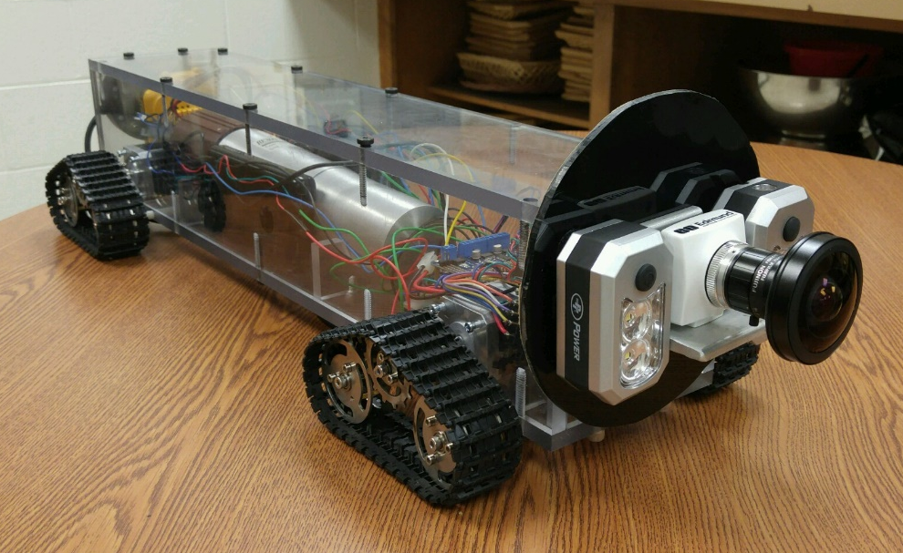
NE 472, Spring 2017

Submitted by:

Submitted by:
Katie Bales - Weston Bogart - Tyler Camarena - Sarah Creasman - Eric Nelius

NDA-2:
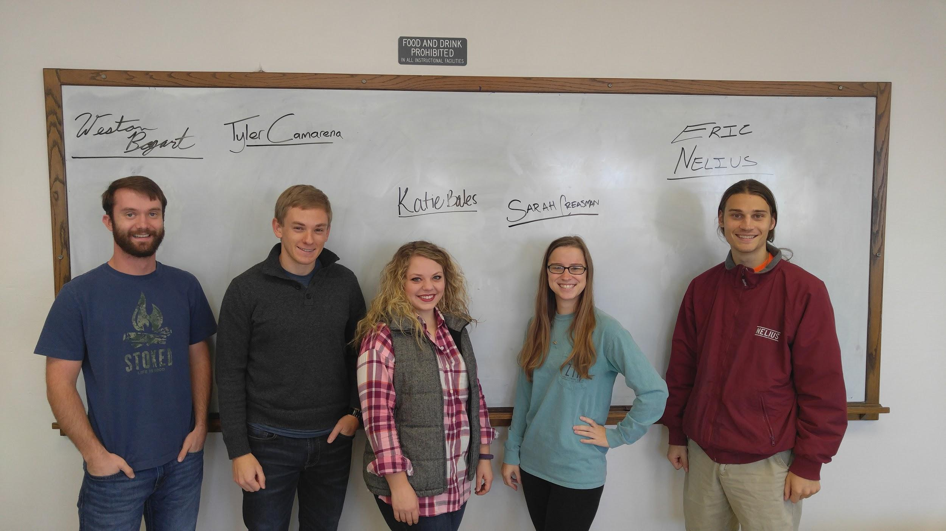

And our fearless leader,
Dr. Walford

Table of Contents:

Introduction and Background Information: 4
Objectives: 4
Design Constraints: 6
Standards and Regulations: 6
Systems: 8
Design: 9
Results: 12
Work Breakdown: 17
Future Work for Design Improvement: 19
Benefit of Classes: 21
Conclusion: 22
Appendix A: Results and Code of Material Analysis 23
Appendix B: End Piece Design 27
Appendix C: Results and Code for Camera Calibration 29
Appendix D: Results from LiDAR Analysis 43
Appendix E: Design of Adaptive LiDAR Mount 47

Introduction and Background Information:
Throughout the Cold War, uranium refineries in Portsmouth, Ohio used gaseous diffusion to separate uranium-235 (U-235) from uranium-238 (U-238). The uranium is pumped through miles of piping as gaseous uranium hexafluoride (UF₆) while U-235 is enriched to higher concentrations. The piping is not completely airtight and water vapor leaks into the pipes through small cracks or bad seals. The water vapor reacts with the UF₆ to create hydrofluoric acid and solid uranyl fluoride (UO₂F₂). The acid eats away at the pipe and creates small areas in which uranyl fluoride can form deposits. These facilities are now being decommissioned and the deposits in these pipes need to be identified and disposed of in a safe manner.
The current method is based on holding a detector some distance away from the pipe and observing changes in the detection spectrum as the detector is moved along the length of the pipe. There is a high probability of interference from human factors involved in this method, resulting in inaccurate measurements. It is easy for an operator to skip some of the deposit or even miss the deposit all together. It also relies on the operator’s ability to hold the detector in the same position for extended periods of time. This method also introduces a small solid angle of detection, making the process less geometrically efficient as well. In addition to these factors, the personnel must dress out in radiation protection equipment and risk exposure to radioactive material. The economics of this process are not optimal, as the operation is long and costly, especially considering that the results may not be very accurate.
As technologies evolve and advance, many new options are open to the nuclear industry that can help meet the demands of a competitive industry, and this part of the decommissioning process can be improved by using these technologies. This project examines another method of finding uranium deposits in pipes that utilizes new equipment and methods to improve the results and efficiency while decreasing the health risks of those involved.

Objectives:
The main objective is to design a system that can incorporate inputs from several different sensors that will be used in tandem to locate and quantify uranium deposits. The method we are approaching has less chance of failure from human error and reduces the exposure of workers to radiation. The location of the uranium is important because it will allow the section of piping being examined to be taken care of appropriately. Characterizing the size of the deposit is important for health and safety reasons and will determine how the radioactive material should be handled. To obtain this information, a camera and a Light Detection and Ranging (LiDAR) system will be used alongside a traditional sodium iodide (NaI) scintillation detector.
The camera will be used primarily to identify the UO₂F₂ deposits since they have a characteristic yellow color. It will also be used to calculate an approximate area of the deposits. Trained operators or automated computer programs can be utilized to analyze the colors and identify the uranium on the pipe walls. The LiDAR would be most effective at finding the thickness of the deposits coating the wall by comparing the dimensions of the pipe to the perturbed measurements as it passes over the uranium. These two systems, when combined with a radiation detector, will be a powerful tool in the characterization of the radioactive material inside the pipe.
This project is being done between two groups at the University of Tennessee with collaborative efforts from different multidisciplinary external organizations. Our group is focused mainly on the camera and LiDAR, while the other senior design group is working mainly on characterizing the detector and constructing a vehicle that will hold all of the systems. Our mentor, Dr. Walford, has been in contact with people from the Portsmouth facility and has relayed information between our groups. He has also reached out to some students at Texas A&M University who have done some work on modeling the detector. Working on this project necessitated communication with these other parties to combine our ideas. Constructing the hardware also required a collaborative effort with one of UTK’s machine shops. If this project is to be used industrially, many more interdisciplinary efforts will be needed to polish the performance of this detection system.

Design Constraints:
There are several constraints involved in the design: the size of the system as determined by the pipe dimensions, minimizing radiation exposure, and the mobile capacity of the device so that it can map out the uranium along the length of the pipe. For real-world applications, this project will need to be adapted to different sizes of pipe. This would require different designs suited for each specific scenario. This is a proof of principle project, and as such, we will only be using a 12-inch pipe. The method will be optimized using a steel sample pipe located in the Pasqua Engineering Building at the University of Tennessee, Knoxville (UTK). We also want the risk from the contaminated material to personnel and equipment to be as low as possible. By introducing a system that can be operated remotely, the dose received by the workers will drop significantly. The cart upon which all of our sensors and electronics will rest must have enough mobility to move over the different deposits inside the pipe while making reliable measurements.
Another important constraint to consider is the security implications of the design. Bringing a camera into a secure facility is currently against the policy of most installations. Security is a primary concern during the operation of nuclear procedures and allowing cameras into secure zones would be an obvious risk. Another security related constraint involves the transmission of data. A wireless communication system would be very useful as it would remove the need to have long cords attached to the device, but would also be very risky. Wireless signals are much easier to hack and provide more electronic noise that might interfere with the facility’s equipment. For these reasons, it is necessary that the implementation of this design includes the input of the security personnel where applicable. Consideration of the improved efficiency and economics should be taken into account when decisions are made regarding the integration of the design into current operations.

Standards and Regulations:
This project must meet industry standards including the Department of Energy Quality Assurance Order 414 (DOE O 414.1D), the Quality Systems for Non-Destructive Assay (QSNDA), and other measurement considerations as specified by organizations such as the American Society for Testing and Materials (ASTM), the Institute of Electrical and Electronic Engineers (IEEE), and the American National Standards Institute (ANSI). The DOE Quality Assurance order was made to ensure that products and services meet the customer's requirements and expectations of the DOE including the National Nuclear Security Administration (NNSA). It is meant to achieve quality of work based on several principles:

- work conducted through an effective and integrated system,
- management support for planning, organization, direction, resources, and control to provide quality assurance,
- thorough, rigorous assessments with appropriate corrective actions to ensure quality performance and improvement,
- responsible personnel to achieve and maintain quality, and
- minimization of associated risks while maximizing reliability and performance.

There are ten criteria associated with DOE O 414.1D that deal with personnel training and qualification, quality improvement, documentation, design, testing, and independent assessment. Also included are documents containing requirements for contractors to ensure quality assurance, a plan to prevent suspect or counterfeit items, and requirements for safety software. The standard for Quality System for Nondestructive Assay Characterization (QSNDA), in relation to DOE O 414.1D, was written specifically for the Portsmouth/Paducah Project. It requires that service providers have an approved quality system for the characterization of non-destructive assay (NDA) implemented before any work takes place. It addresses conditions necessary to establish, implement, and maintain an effective system with applicable regulations and requirements taken into account at every stage of the process. It states that the design must be a quality operating system, be technically proficient, and generate valid, defensible data. It outlines specific rules to follow at every stage of development and validation of the NDA system. Fluor-B&W Portsmouth has its own QSNDA document that ensures that risks and environmental impacts are identified and minimized, as well as making sure reliability, performance, and safety are optimized. All of these regulations and standards outline safety measures that will maximize results, while minimizing risks to personnel.

Systems:
To fully verify and quantify uranium deposits, three individual systems will provide data that, when analyzed together, will give a more complete picture of the deposits. The three components are the NaI radiation detector, the camera, and the LiDAR system. The NaI detector will be able to find the axial location of a uranium deposit, but will not be able to identify the size of the deposit. The camera and LiDAR will be able to characterize more fully the dimensions of the deposit, but will not be able to determine its activity. When these systems work together, the location and activity of any radioactive material can be more accurately identified. The details of these systems, including the results from our work and further development needed, will be discussed in this section.
DETECTOR
The detector and its related components is one of the focuses of the other UTK senior design group (NDA-1) that we are working with. As such, discussion of it will be reserved for their project.
CAMERA
The camera was mounted on the front of the cart, to image down the pipe. The camera is powered and transmits data via a USB port on the side opposite the lens. Two lasers in the camera’s field of view were intended to determine the camera’s orientation. The lens on the camera is interchangeable, which allows for different configurations according to what works best for a given situation. By using the red-green-blue (RGB) values for the pixels, the color can be analyzed to show where the color varies from that of the pipe. Using the information gathered from the color analysis, an approximate area can be determined. The goal is to have a computer program analyze the data and provide information in real-time to the operators. This will allow them to see where the uranium is located and then let them utilize the other systems to characterize the anomalies. Essentially, the camera works to find where the surface of the pipe is interrupted and cues the operators to engage the other systems to determine what the abnormality is.
LiDAR
The LiDAR was mounted on the back of the cart and is used to measure the thickness of any buildup. The LiDAR works by using a laser and receiver to measure the distance from the emitter to an object. They are mounted on a rotor, which allows the LiDAR to capture a 360-degree planar view of the environment. Knowing the location of the LiDAR and the radius of the pipe, an approximation of the buildup thickness can be calculated. The LiDAR measures a continuous spiral on the inside of the pipe with the distance between rings directly corresponding to the speed of the system as it travels down the pipe. Thus, the resolution and accuracy of the LiDAR measurements will be subject to the speed at which the cart travels. Incorporating all LiDAR measurements together will create a topographic profile of the inside of the pipe. This will be examined and will aid in determining the volume of uranium buildup inside of the pipe.

Design:
The systems described above need to be incorporated into a single vehicle so that they can travel down the pipe and make their measurements simultaneously. This is the main objective of the design aspect of this project. Two designs were built for consideration: a metal canister that can be attached to different apparatuses and a Plexiglas cart. The first design we built was the canister, but the design that was actually completed was the cart. The Plexiglas cart was primarily designed by NDA-1 and only a brief description of it will be included in this report. Both designs needed to be simple, sturdy, and protective so that the equipment inside would be able to function reliably. They also needed to be as small as possible in order to easily fit inside the pipe.
The metal canister was the main design our group worked with. Aluminum pipe was chosen to house the detector. This allows radiation to penetrate the housing and enter the detector while also being sturdy and protective. The specific pipe chosen was 2.5-inch diameter schedule 5 aluminum. It was large enough to allow the detector to fit inside while still leaving extra space around it for any wires or cables that needed to pass through the canister. The length of this pipe was determined after the other parts for the canister were made. It was based on the length of the detector, the end pieces, and an estimation of the space needed for the electronics. The camera was to be mounted to the front of the canister so that it would be able to capture images of the interior of the pipe, while the LiDAR was to be attached at the back, so that it would have an unobstructed line-of-sight on all sides of the pipe.
To attach both devices to the canister, two end caps were designed and constructed. They needed to be able to close off the pipe and hold the camera and LiDAR in place. The caps were designed to fit inside the aluminum pipe and were to be secured in place using several bolts to prevent rotation. They also cover the sides of the equipment as much as possible to shield them from radiation. It was determined that they should be made of steel to protect the electronics and enhance the efficiency of the detector. This was determined by using an MCNP model, and the results of the experiment can be found in Appendix A. By blocking out radiation in front of and behind the detector, the field of view becomes more vertical, which will be helpful in specifying the location of uranium.
The design of the piece that holds the camera was originally meant to also hold two lasers that were to be used in image analysis. As more work was done with the camera, it was determined that the lasers were no longer needed, but the piece could hold them if desired. Lights could be added to illuminate the interior of the pipe as well. To stabilize these parts, several discs were added inside the main shell and were attached using separators to keep them spaced enough to hold the hardware in place. The piece that holds the LiDAR was a little more straightforward, though it required more work to get the LiDAR to fit. The design had a small tolerance for the LiDAR to fit in but when the piece was made, it ended up being a little too small. To solve this problem, we made an intermediary plate that could easily attach the LiDAR to the end cap. The designs of these end caps are included in Appendix B.

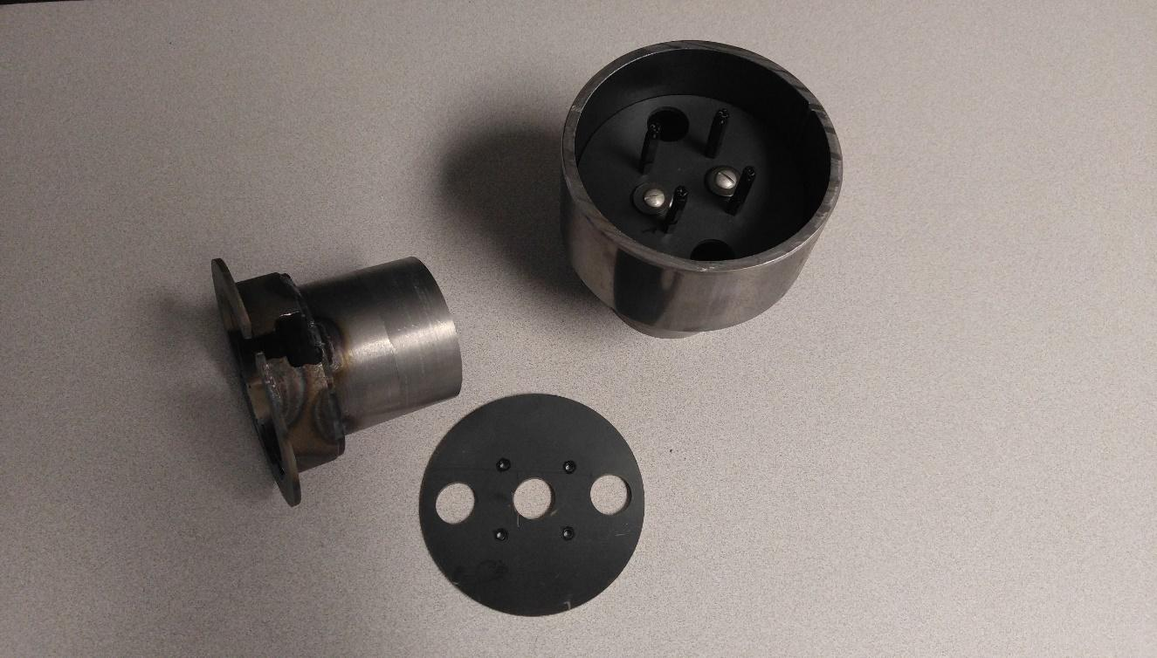
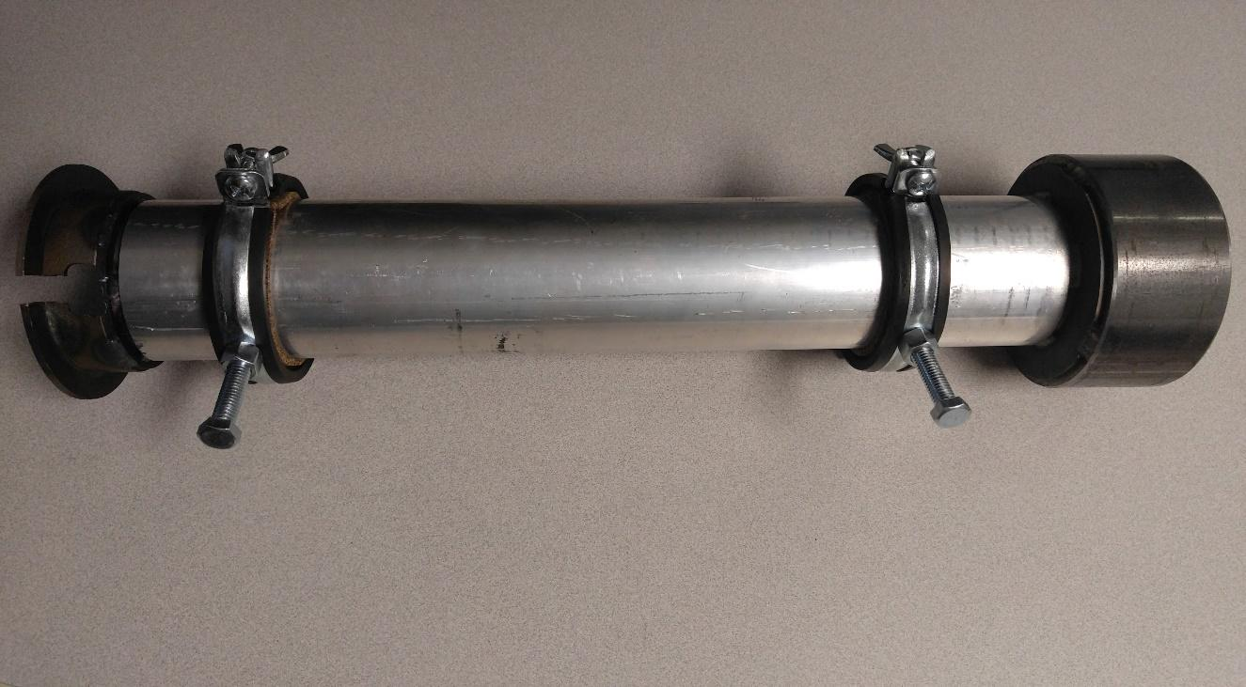

Figure 1: Finished end caps and canister.

One of the issues we encountered was that the canister was very heavy since the design was made of aluminum and steel. This would require stronger motors to move the canister and is one of the reasons that we decided to use the Plexiglas cart. It was also easier to fit everything inside of the Plexiglas cart, such as the Raspberry Pi and the motors. As previously mentioned, the design of this cart is the work of NDA-1 and will not be discussed in depth in this report. One thing to note is that the plate originally used to attach the LiDAR to the end cap of the canister was adopted by NDA-1 to attach the LiDAR to the Plexiglas cart.

Results:
The results obtained from the work with the camera and LiDAR are contained in this section. This includes progress made, complications that arose, and data obtained. The information for each component will be presented in the following subsections.
CAMERA
A regular and fisheye lens have been tested and analyzed for use on the cart. Prior to analyzing data, the camera needed to be calibrated. To do this, an image from the end of the pipe was taken with the camera aimed axially down the pipe. A 1 square inch grid was printed on two 10 by 16 inch pieces of paper that were attached with one inch of space between them. By using GNU Image Manipulation Program (GIMP), the pixel values of each point on the grid were recorded and circles were fit to the points at one inch increments down the pipe. The results of this can be found in Appendix C along with the MATLAB code used to analyze the data. When all the results were compiled, a function relating the distance down the pipe to the distance from the center pixel was determined. Figure 2 shows an image of the setup, and Figures 3 and 4 contain the resulting calibration plots for the normal lens. Figure 5 maps the pixel values as recorded by the fisheye lens at various distances down the pipe. It can be seen that the pixels converge concentrically as the point of reference moves further from the camera, converging on the axis of the pipe. This data was used in the calibration and the following analyses.

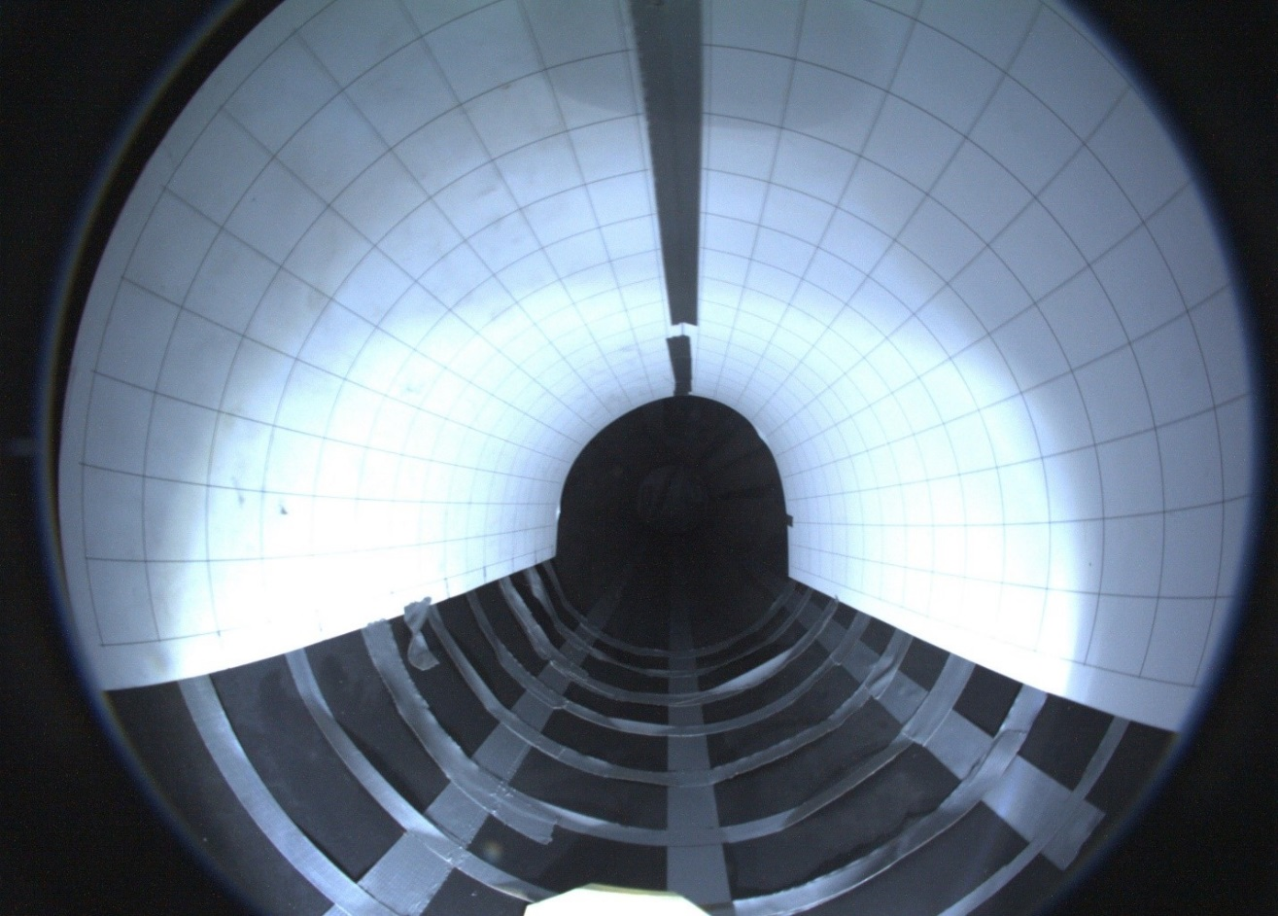

Figure 2: Image taken by the fisheye camera of the grid placed inside the pipe.
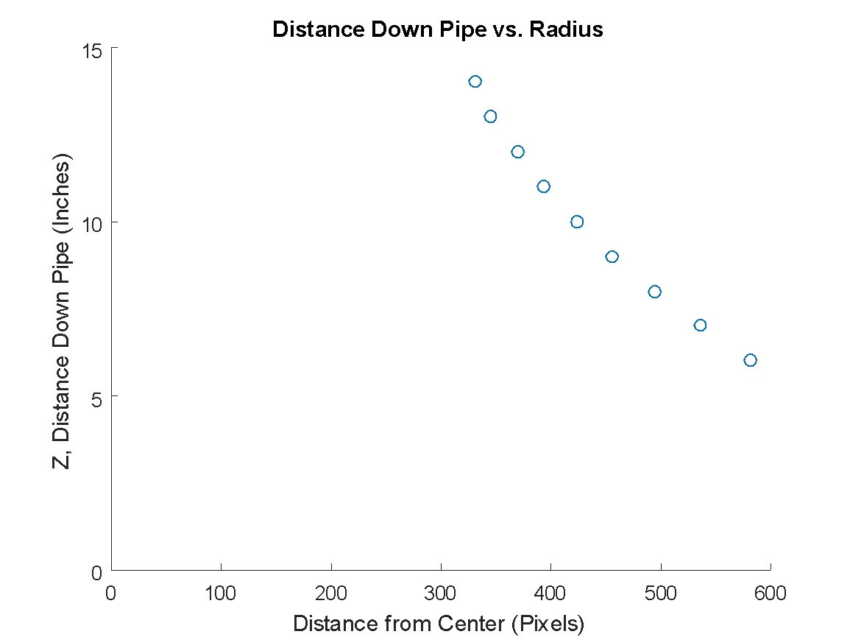

Figure 3: Radius of pixels as a function of distance from the camera using the normal lens.

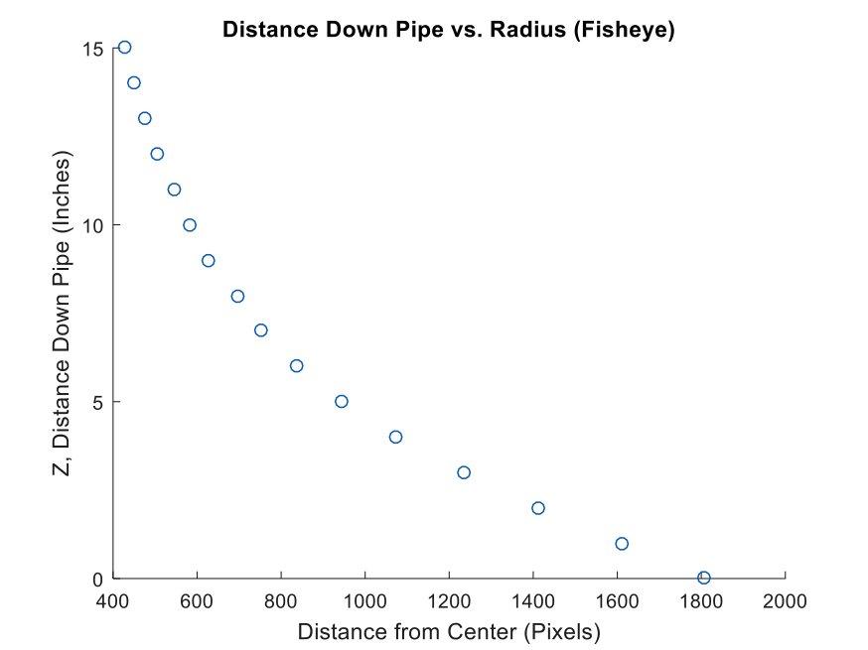

Figure 4: Radius of pixels as a function of distance from the camera using the normal lens.

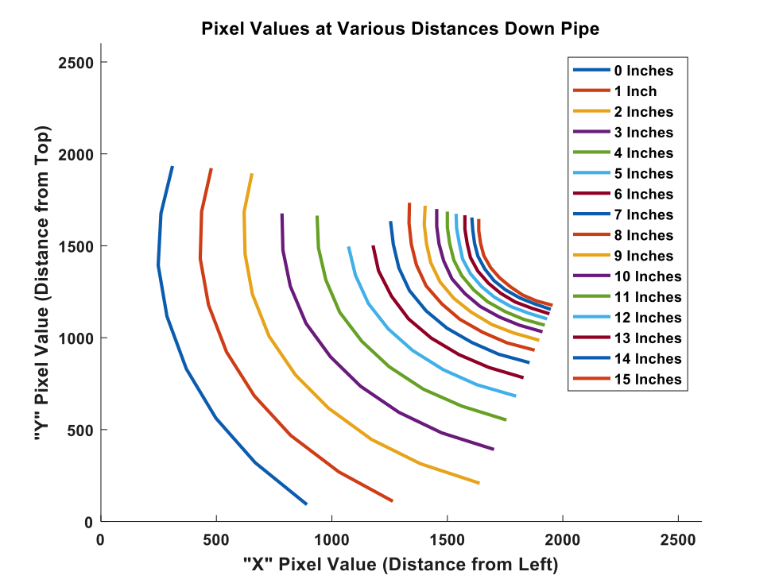

Figure 5: Pixel values of points used to map the Pipe. Note the collinearity of the most clockwise points.
The camera is mostly used to find the location of the uranium, but it can also provide information about the size of the deposit. In order to use the camera to measure deposit size, the following procedure can be implemented. First, an image of the inside of the pipe was captured. The software can save the images as *.BMP, *.JPG, or *.PNG files depending on whichever is more useful for the circumstance. Second, the areas of interest are identified either manually or by a computer program that compares RGB values of the image to predetermined thresholds. Third, the pixel locations on the area of interest closest and furthest from the center point are taken and their distances are noted. Fourth, the angle subtended by the deposit from the center point is calculated by subtracting the largest angle value from the smallest. These values, along with the distance of the pixels from the center of the pipe, are input into a function that returns distance down the pipe. The output values are subtracted from the input values to yield the axial length of the deposit. The inner diameter of the pipe is known to be 12 inches, so the inner radius is 6 inches. Using all of this information, the area of the deposit can be estimated. When combined with the information from the LiDAR, an approximate volume of the deposits can be calculated.
This method was implemented using a 2.5-inch square Post-it note that served as a makeshift deposit. This object was photographed at various distances down the pipe. The size of the Post-it note was calculated using a MATLAB script and was compared to the known dimensions. Table 1 contains the results from this test. The calculated width is much closer to the true value of 2.5 inches at all distances than the length, which had a wider variation of measurements. When averaged together, the area of the note was within one standard deviation of its actual measurement. The MATLAB script used in this analysis is also included in Appendix C. These results prove the validity of this calculational method, though some refinement will be needed to achieve more accurate results.

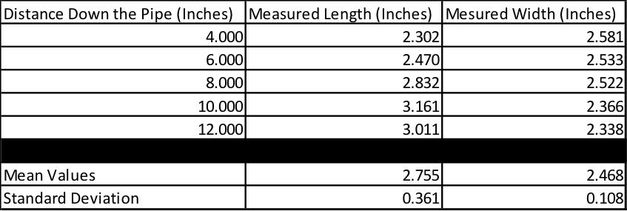

Table 1: Experimentally measured size of the Post-it note at various distances down the pipe.

One of the early ideas was to use a pair of lasers to help identify whether or not the camera was centered down the pipe. The idea behind this was that if the cart traveled over some irregularity in the pipe, the lasers would move from their position centered on the pipe’s axis, and the operators would know that there was some sort of deposit at the cart’s location. It was decided that this feature would not be necessary as the camera’s capabilities were expanded. It was determined that more light was needed, so the lasers were removed in favor of mounting light emitting diodes (LEDs). The Plexiglas cart didn’t include the lasers in the design and only factored in the LEDs.
LiDAR
Some of the major complications were problems attributed to the LiDAR. The manufacturer’s manual for Slamtec RpLiDAR A2 states that the minimum functioning distance is 0.15 meters, or about 5.9 inches. Fortunately, we found that the particular LiDAR device used for this project has a minimum range of around 4 inches under an operating condition of about 2 Hz. A 4-inch minimum distance prevents us from using the LiDAR in an 8-inch pipe, but it does work in 10- and 12-inch pipes. We also found that the LiDAR can penetrate through Plexiglas without any distortion. The images of the data collected with and without the Plexiglas obstruction are in Appendix D.
Another problem encountered while using the LiDAR was creating a uniform resolution around the pipe. The LiDAR takes a measurement in set angular distances. If the LiDAR is not centered in the pipe, more data points will be taken of the portion of the pipe closer to the LiDAR due to basic geometry. To remedy the resolution and minimum distance problems, a design for an adjustable LiDAR mount was designed. The mount consists of two stepper motors and two aluminum plates, controlled by a Raspberry Pi. One plate connects the two motors and the other connects a motor to the LiDAR. The data generated by the LiDAR will be sent to the Raspberry Pi to aid in keeping the LiDAR centered.
The Raspberry Pi will take two points on opposite sides of the pipe and find the midpoint between the two. An algorithm involving geometric triangulation between the two LiDAR data points and the known location of the LiDAR will determine the radial distance each motor will need to turn. This system will be continuously adapting to the environment within the pipe including any buildup of deposits in a particular location. While this system will normally function autonomously, the operator of the cart will have the ability to fully control the LiDAR mount if a particular area of interest needs to be further investigated by the LiDAR. The programming required to get the LiDAR to communicate to the Raspberry Pi and to control the stepper motors is beyond the current knowledge of our group, and it was determined that the time required to learn about and complete the task would be more than the available time. The design of the mount was created in SOLIDWORKS and the schematics of the assembled system can be found in Appendix E.

Work Breakdown:
Our four main goals for this project consisted of the design of the cart, construction of the cart, collection of data, and completion of reports. The Gantt chart in Figure 6 shows a timeline of when each goal was completed. The work breakdown chart used is included in Figure 7.

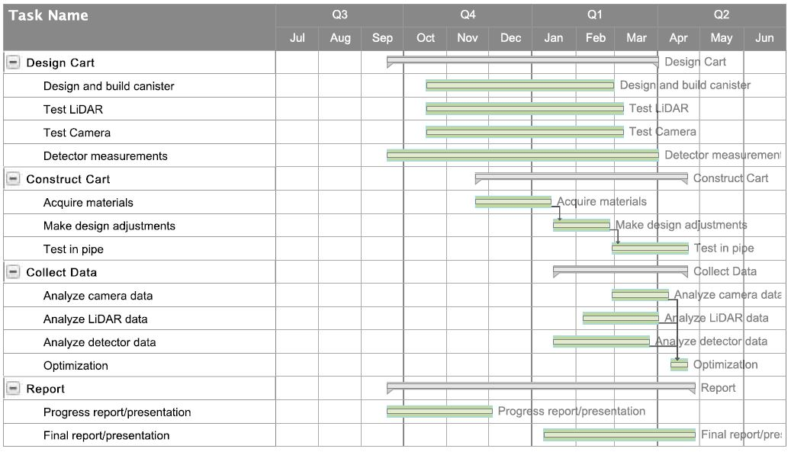

Figure 6: Gantt chart for the project.

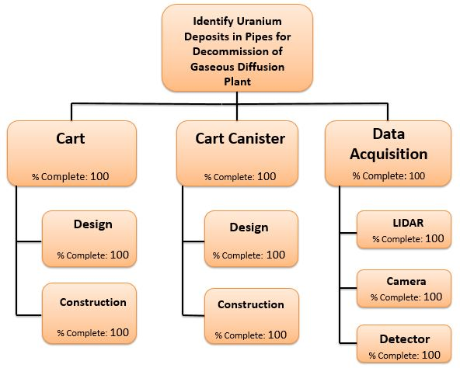

Figure 7: Work breakdown chart for the project.
Tyler and Sarah concentrated their efforts on the design and construction of the canister. This involved working with the machine shop in the Tickle Engineering Building and the shop on the first floor of Pasqua. They finished this and then worked with NDA-1 to determine how to incorporate the camera and LiDAR into their design. Weston’s area of focus in the project was testing and calibrating the LiDAR. He set up the LiDAR software on his computer and worked with a software expert in Atlanta to modify the code and get the system working properly. He conducted experiments with the LiDAR in various locations and on various surfaces to establish the limitations of the device. He also designed the LiDAR mount that adapts to the dimensions of the pipe. Eric and Katie have been working on the camera aspect of the project. Eric has downloaded the software for the camera onto his computer and they have tested the camera to make sure that it functions as desired. They developed a MATLAB script to process the information received from the camera as the cart travels down the pipe. The weekly reports were done as a group and Katie usually submitted them. The whole group worked together to write the formal reports and create the presentations.

Future Work for Design Improvement:
The design of any device can always be further improved. There are always flaws with the finished product that will become apparent over time. This is why it is important to include conceived ideas for future iterations. This project is primarily a proof of principle, and there are many different features that can be implemented in the finished design. This section is dedicated to a collection of concepts, their descriptions, and the problems that they address.
An important feature that should be developed is a component that would measure the distance that the cart has traveled in the pipe. This measurement would be more important for real world applications. Since our testing was carried out in a pipe that is only about 8 feet long, the cart can be seen at all times and its location is easily measured. With this feature, operators would be able to determine exactly where in the pipe the uranium deposit is located by knowing the location of the cart relative to the outside frame of reference. In the event that the device ceases responding to commands, the last known distance traveled in the pipe could also be used in recovery efforts. Further development of this idea would be important in making this project useful to industry.
Future work involving the camera and the LiDAR mainly center around program development and the integration into the full system. Regarding the camera, a challenge presents itself in the analysis of data. Thus far, there is no software to automatically identify the different colors manifested by UO₂F₂. To remedy this, a code will need to be written to analyze the images. The code will break the image files down into matrices of red, green, and blue values. The values in each corresponding element in all three matrices will be compared to certain values that characterize the color of the deposit, and if it is determined to be the correct color, the pixel will be recorded as having material of interest in it.
The LiDAR adaptive mount is a key programming challenge if it is to be implemented in an industrial design. The first task would be to make the individual parts for the mount using the parts that have already been designed in SOLIDWORKS. The next step would be to change the LiDAR software to communicate simultaneously with the Raspberry Pi so that analysis of the data can be done in real time. The computing power and speed of data acquisition might come into question if a Raspberry Pi is used. Another concern is whether or not the cart can be controlled by the same Raspberry Pi. It may be possible to control all of the hardware from a computer and run a cable to each device on the cart. Further research into the required processing capabilities of the Raspberry Pi will also be necessary.
Another possible use for the LiDAR is assisting in the placement of the cart in the pipe. One of the primary goals for this design is to minimize the amount of radiation exposure to personnel. The LiDAR can be attached to a forklift and integrated into a more robust system, perhaps involving cameras so that the forklift can be controlled remotely. The LiDAR can determine the exact location of the pipe being studied and therefore the relative distance the forklift needs to travel. The LiDAR will then help guide and position the forklift in the correct placement for the cart to move into the pipe. This system may provide another significant reduction in radiation exposure to personnel.
The results of each system can be analyzed manually by a trained operator, but it can be done more reliably and efficiently by a computer. Software will need to be developed that can combine the output of each of the components in a way that will make the results clear to an operator. This is perhaps the largest challenge to overcome in future work with regard to this measurement system. Ideally, the software will be able to determine the size and activity of the deposits inside the pipe from the various inputs. A key element will be the human factors component of the software interface and the array of sensory stimuli. Future work with experts in the areas of audiology and sensory perception would be required. Due to the lack of software-building knowledge, this was not a focus of our project and is something to be further developed by those who would use this system in practice.

Benefit of Classes:
Many of the classes in our curriculum were valuable to us during the development of this project. The engineering design process as explained in both semesters of our Senior Design class provided a structure for how we refined and shaped the project. It gave us a framework that we used as we exchanged ideas and refined our design. Since we worked with many different groups the lectures we had about multidisciplinary teams were especially helpful for us as well. One of our Engineering Fundamentals courses taught us how to use MATLAB. This was the program that we used in the analysis of the data acquired by the camera. This class provided us the skills to analyze the information and, as such, was very helpful to us for this project. Many of our nuclear classes provided the basic understanding that we needed to be able to design an effective detection system. Our Introduction to Health Physics class gave us the basic understanding of radiation that we needed to design the canister. Most importantly, our classes gave us the knowledge to completely understand the problem we were facing which is the first step in designing a solution.
The main problem we had in this project involved programming. The adaptive LiDAR mount required the use of a Raspberry Pi and a program to analyze data and send out signals depending on the input. None of us were experienced with this type of programming and so we were unable to implement this idea. Another programming challenge is coordinating the data from the three sensors on the cart. This would require far more experience than we have. We took a Numerical Methods class that taught us basic computing and programming skills but they were implemented in Fortran, which is an outdated software in the robotic world. The basics of this class may have been helpful, but the program would need to do so much more than we were capable of creating. This is why it is left to future development. This key aspect will be crucial in the industrial application of this project but as a proof of principle, our design still shows the potential benefits of the system discussed in this report.

Conclusion:
The objective of this report was to illustrate the viability of an industry-revolutionizing concept, its limitations, and further improvements. The design was created through various adaptations of ideas and the collaborative effort of members with a variety of backgrounds from various organizations. The concept of focus was to quantify UO₂F₂ deposits on the inside of the piping of a gaseous diffusion plant using a combination of data-collecting devices mounted on a mobile platform. The cart utilizes an NaI detector to determine the activity of uranium deposits, a LiDAR distance measurement system to create a surface profile of the deposits, and a camera to locate areas of interest. All three systems were tested and calibrated in various conditions to determine their limitations and statistical reliability. The final cart design involved a Plexiglas casing serving as both a structural support and a radiation contamination resistant medium. This design has the potential to change the way non-destructive assay is done in not only decommissioning of gaseous diffusion plants but also in other areas of radiation detection. It requires further development, but as a proof of principle, it demonstrates the validity of the collaborative method discussed in this report.

Appendix A: Results and Code of Material Analysis

The decision to use steel for the endcaps was made by running an MCNP simulation of a detector inside a steel pipe with various materials in front of the detector. A point source was moved down the pipe at various distances from the detector and the efficiency of the detector was measured. A graphical representation of the model was made using AutoCAD and can be seen in Figure A-1. For reference, the back end of the NaI crystal was placed at 0 cm. Steel and polyethylene were evaluated as shielding materials and the results of the models can be seen in Figure A-2.
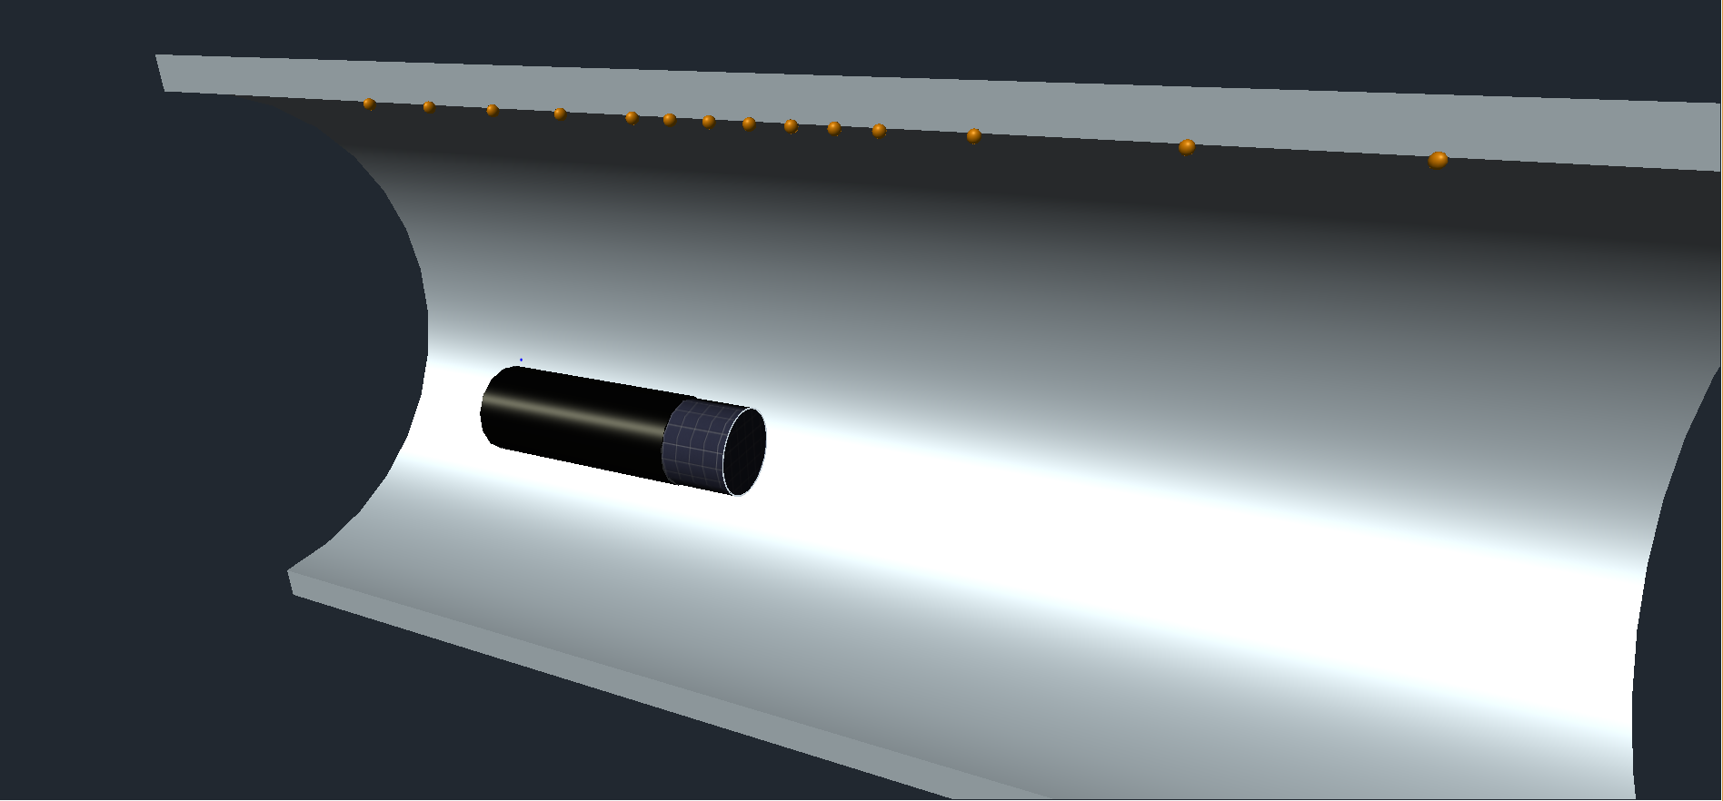

Figure A-1: Visual representation of MCNP model.

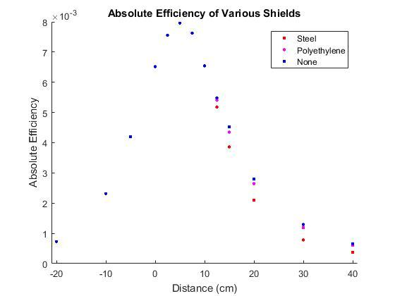
Figure A-2: Absolute detector efficiencies as a function of distance and shield material.

Figure A-2 shows that placing steel in front of the detector attenuated gamma rays more efficiently that polyethylene and air, so it was chosen as the material for the end caps. The MCNP code used in this evaluation is included below.

Inside Pipe Experiment, NE 402
c Tyler Camarena and Weston Bogart
c Nov. 8, 2016
c ----------
c Cell cards
c ----------
c Cells 101-105 are universe 1, the detector
c 101 - NaI crystal
c 102 - Electronics
c 103 - Casing
c 104 - Shield
c 105 - Air around detector
c Cells 106-109 are the real world
c 106 - Cell for universe
c 107 - Air inside the pipe
c 108 - Pipe
c 109 - Air outside the pipe
c 110 - Void outside environment
101 805 -3.67 -3 imp:p=1 u=1
102 804 -2.7 -4 imp:p=1 u=1
103 804 -2.7 -5 3 4 imp:p=1 u=1
104 803 -.93 -6 imp:p=1 u=1
105 801 -0.001225 6 5 imp:p=1 u=1
106 0 -8 fill=1 imp:p=1
107 801 -0.001225 8 -1 imp:p=1
108 802 -7.87 1 -2 imp:p=1
109 801 -0.001225 2 -7 imp:p=1
110 0 7 imp:p=0
c --------------
c End cell cards
c --------------

c -------------
c Surface cards
c -------------
c 1 - Inner pipe surface
c 2 - Outer pipe surface
c 3 - NaI crystal
c 4 - Aluminum cylinder to represent PMT, etc
c 5 - Aluminum casing
c 6 - Shield
c 7 - Environment
c 8 - Universe boundary
1 RCC -150 0 0 400 0 0 12.7
2 RCC -150 0 0 400 0 0 13.4938
3 RCC 23.88 0 0 10.16 0 0 2.54
4 RCC 0.02 0 0 23.86 0 0 2.54
5 RCC 0 0 0 34.04 0 0 2.56
6 RCC 34.04 0 0 2.54 0 0 2.56
7 RPP -10000 10000 -10000 10000 -10000 10000
8 RCC -150 0 0 400 0 0 3
c -----------------
c End surface cards
c -----------------

c --------------
c Material cards
c --------------
c 801 - Air
c 802 - Type 304 stainless steel
c 803 - Polyethelyne
c 804 - Aluminum
c 805 - NaI
M801 7014 0.78 8016 0.21 18000 0.01
M802 24000 0.202087 25055 0.020133 26000 0.688268 28000 0.089514
M803 1001 0.667 6000 0.333
M804 13000 1.0
M805 11000 0.5 53000 0.5
c ------------------
c End material cards
c ------------------
c
c -------------
c Control cards
c -------------
MODE P
NPS 1E6
sdef par=p pos=38.88 0 12.65 erg=D1
si1 l 0.185715 .7664 1.001
sp1 d 1.0 1.0 1.0
c -----------------
c End control cards
c -----------------
c
c -----------
c Tally cards
c -----------
F8:p 101
E8:p .18571 .18572 .76635 .76645 1.00095 1.00105
c ---------------
c End tally cards
c ---------------

Appendix B: End Piece Design

The drawings used in the fabrication of the end pieces are shown below.
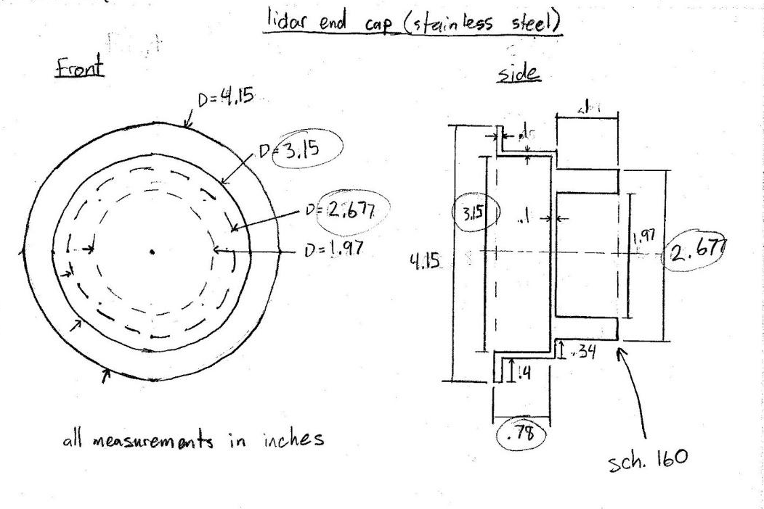
Figure B-1: Drawing of LiDAR end piece.
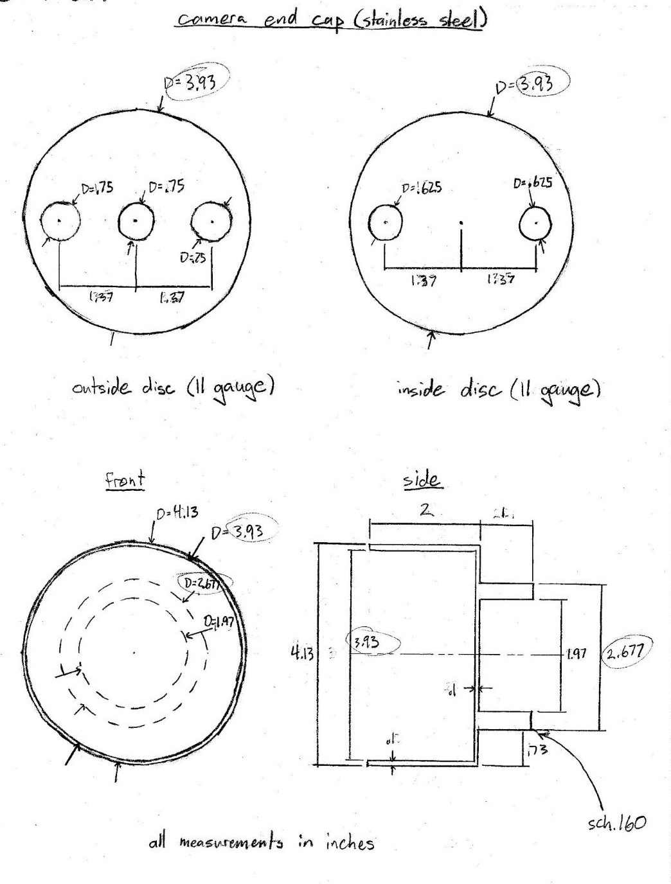
Figure B-2: Drawing of camera end piece.

Appendix C: Results and Code for Camera Calibration

Normal Lens Camera
This section contains the results of the X and Y pixel locations from the calibration of the camera. The following figures show the pixel locations for specified distances from the camera. The MATLAB code used in the calibration can be found after the images.
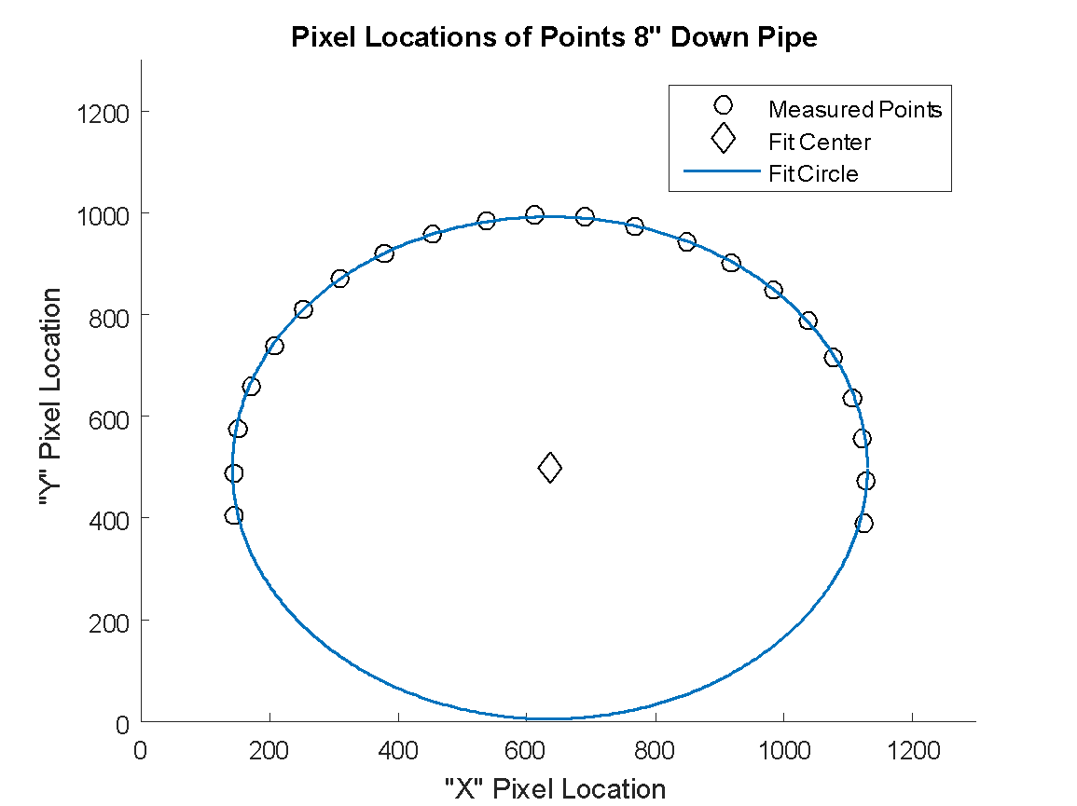
Figure C-1: Pixel map at a distance of 8 inches from the camera.
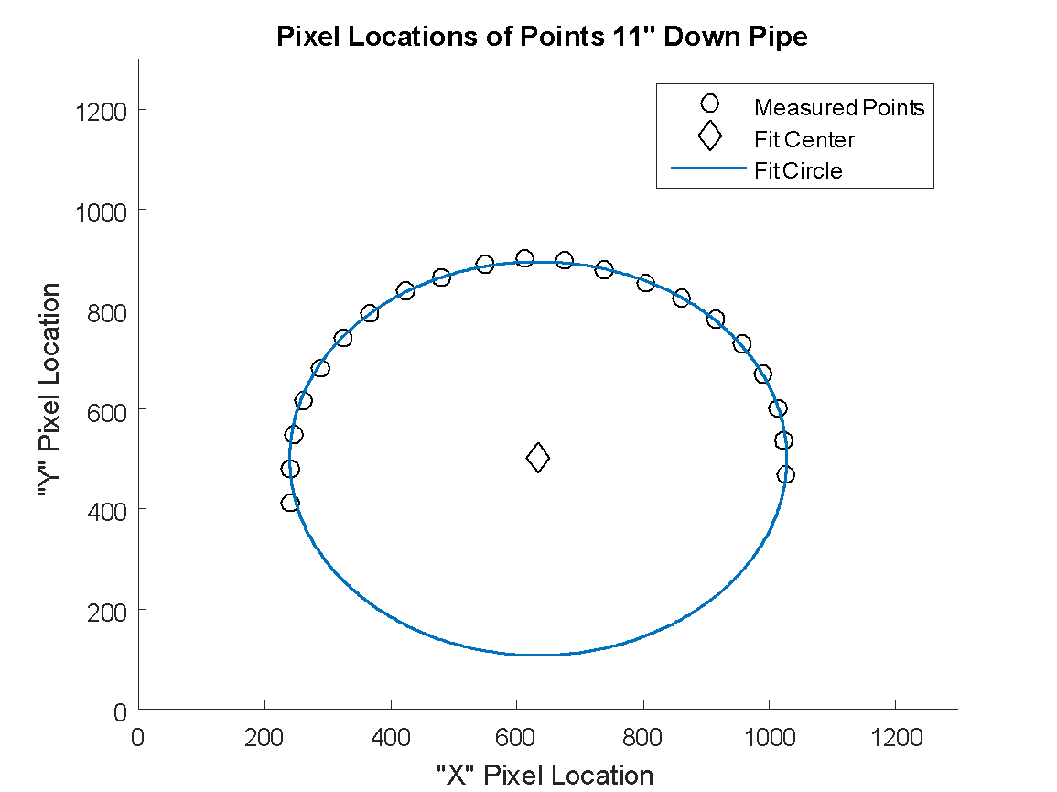
Figure C-2: Pixel map at a distance of 11 inches from the camera.
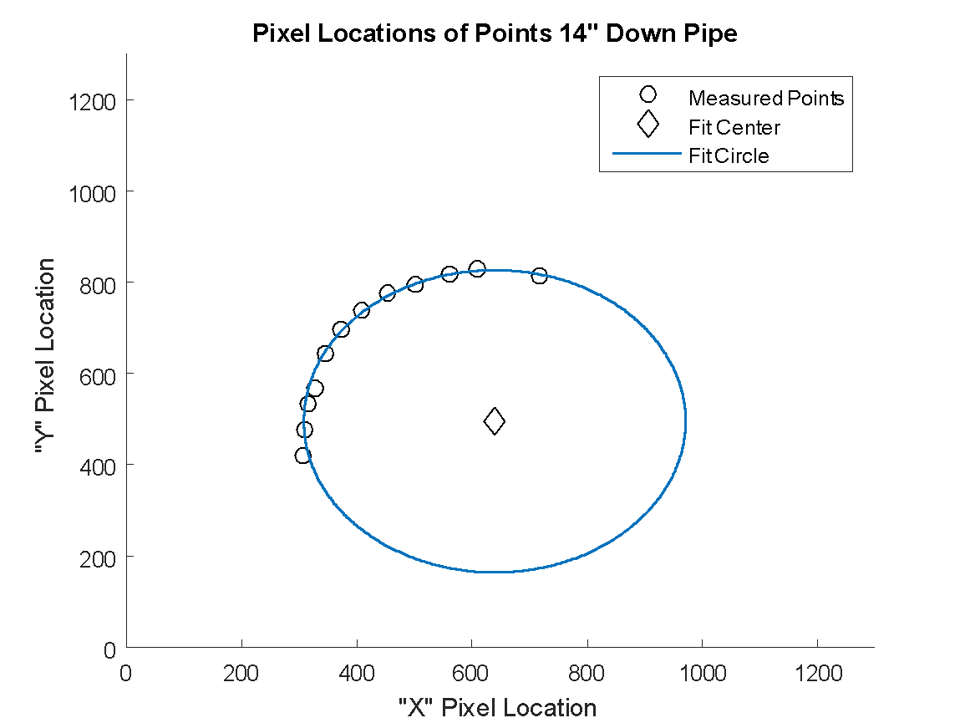
Figure C-3: Pixel map at a distance of 14 inches from the camera.
MATLAB Code:
%% Function for plotting the points
close all;
set(gca,'FontWeight', 'bold')
xc=zeros(14,1);
yc=zeros(14,1);
R=zeros(14,1);

%% 6 Inches From Camera
figure(1)
hold on;
plot(x6,y6,'ko','MarkerSize',7)
title('Pixel Locations of Points 6" Down Pipe')
axis ([0 1300 0 1300])
[xc(6),yc(6),R(6),~]=circfit(x6,y6);
plot(xc(6),yc(6),'kd','MarkerSize',9)
circlep(xc(6),yc(6),R(6))

xlabel('"X" Pixel Location')
ylabel('"Y" Pixel Location')
legend('Measured Points','Fit Center','Fit Circle')

%% 7 Inches From Camera
figure(2)
hold on;
plot(x7,y7,'ko','MarkerSize',7)
title('Pixel Locations of Points 7" Down Pipe')
axis ([0 1300 0 1300])
[xc(7),yc(7),R(7),~]=circfit(x7,y7);
plot(xc(7),yc(7),'kd','MarkerSize',9)
circlep(xc(7),yc(7),R(7))

xlabel('"X" Pixel Location')
ylabel('"Y" Pixel Location')
legend('Measured Points','Fit Center','Fit Circle')
%% 8 Inches From Camera
figure(3)
hold on;
plot(x8,y8,'ko','MarkerSize',7)
title('Pixel Locations of Points 8" Down Pipe')
axis ([0 1300 0 1300])
[xc(8),yc(8),R(8),~]=circfit(x8,y8);
plot(xc(8),yc(8),'kd','MarkerSize',9)
circlep(xc(8),yc(8),R(8))

xlabel('"X" Pixel Location')
ylabel('"Y" Pixel Location')
legend('Measured Points','Fit Center','Fit Circle')
%% 9 Inches From Camera
figure(4)
hold on;
plot(x9,y9,'ko','MarkerSize',7)
title('Pixel Locations of Points 9" Down Pipe')
axis ([0 1300 0 1300])
[xc(9),yc(9),R(9),~]=circfit(x9,y9);
plot(xc(9),yc(9),'kd','MarkerSize',9)
circlep(xc(9),yc(9),R(9))

xlabel('"X" Pixel Location')
ylabel('"Y" Pixel Location')
legend('Measured Points','Fit Center','Fit Circle')

%% 10 Inches From Camera
figure(5)
hold on;
plot(x10,y10,'ko','MarkerSize',7)
title('Pixel Locations of Points 10" Down Pipe')
axis ([0 1300 0 1300])
[xc(10),yc(10),R(10),~]=circfit(x10,y10);
plot(xc(10),yc(10),'kd','MarkerSize',9)
circlep(xc(10),yc(10),R(10))

xlabel('"X" Pixel Location')
ylabel('"Y" Pixel Location')
legend('Measured Points','Fit Center','Fit Circle')

%% 11 Inches From Camera
figure(6)
hold on;
plot(x11,y11,'ko','MarkerSize',7)
title('Pixel Locations of Points 11" Down Pipe')
axis ([0 1300 0 1300])
[xc(11),yc(11),R(11),~]=circfit(x11,y11);
plot(xc(11),yc(11),'kd','MarkerSize',9)
circlep(xc(11),yc(11),R(11))

xlabel('"X" Pixel Location')
ylabel('"Y" Pixel Location')
legend('Measured Points','Fit Center','Fit Circle')

%% 12 Inches From Camera
figure(7)
hold on;
plot(x12,y12,'ko','MarkerSize',7)
title('Pixel Locations of Points 12" Down Pipe')
axis ([0 1300 0 1300])
[xc(12),yc(12),R(12),~]=circfit(x12,y12);
plot(xc(12),yc(12),'kd','MarkerSize',9)
circlep(xc(12),yc(12),R(12))

xlabel('"X" Pixel Location')
ylabel('"Y" Pixel Location')
legend('Measured Points','Fit Center','Fit Circle')

%% 13 Inches From Camera
figure(8)
hold on;
plot(x13,y13,'ko','MarkerSize',7)
title('Pixel Locations of Points 13" Down Pipe')
axis ([0 1300 0 1300])
[xc(13),yc(13),R(13),~]=circfit(x13,y13);
plot(xc(13),yc(13),'kd','MarkerSize',9)
circlep(xc(13),yc(13),R(13))

xlabel('"X" Pixel Location')
ylabel('"Y" Pixel Location')
legend('Measured Points','Fit Center','Fit Circle')

%% 14 Inches From Camera
figure(9)
hold on;
plot(x14,y14,'ko','MarkerSize',7)
title('Pixel Locations of Points 14" Down Pipe')
axis ([0 1300 0 1300])
[xc(14),yc(14),R(14),~]=circfit(x14,y14);
plot(xc(14),yc(14),'kd','MarkerSize',9)
circlep(xc(14),yc(14),R(14))

xlabel('"X" Pixel Location')
ylabel('"Y" Pixel Location')
legend('Measured Points','Fit Center','Fit Circle')

%% Finding the R to Z function
r(:)=R(6:end);
z=6:14;

figure(10)
hold on;
plot(r,z,'o');
title('Distance Down Pipe vs. Radius')
xlabel('Distance from Center (Pixels)')
ylabel('Z, Distance Down Pipe (Inches)')
axis([0 600 0 15]);

Fisheye Lens Camera
The fisheye lens is capable of imaging a greater area of the pipe with greater accuracy. The MATLAB codes used to calibrate the lens and demonstrate that the area of deposits could be found are included below.

Circfit: This function is used to fit a circle to a set of points. It plots the input points, the fit circle, and the center of the fit circle. It returns the radius and X and Y coordinates of the center of the fit circle.
function [xc,yc,R,a] = circfit(x,y)
%
% [xc yx R] = circfit(x,y)
%
% fits a circle in x,y plane in a more accurate
% (less prone to ill condition )
% procedure than circfit2 but using more memory
% x,y are column vector where (x(i),y(i)) is a measured point
%
% result is center point (yc,xc) and radius R
% an optional output is the vector of coeficient a
% describing the circle's equation
%
% x^2+y^2+a(1)*x+a(2)*y+a(3)=0
%
% By: Izhak bucher 25/oct /1991,
% Modified, E.W. Nelius, 22 Apr 2017
% This function is intended to accompany the FisheyeCal.m script
x=x(:); y=y(:);
a=[x y ones(size(x))]\[-(x.^2+y.^2)];
xc = -.5*a(1);
yc = -.5*a(2);
R = sqrt((a(1)^2+a(2)^2)/4-a(3));
plot(x,y,'ko','MarkerSize',7)

Circlep: This function plots a circle from an input center point and radius.
function [ ] = circlep( xc, yc, r )
%CIRCLEP Plots a circle centered at (xc,yc) with radius r

% This function is intended to accompany FisheyeCal.m
theta=linspace(0,2.*pi,200);
plot(xc+r.*cos(theta),yc+r.*sin(theta),'LineWidth',2)
plot(xc,yc,'kd','MarkerSize',9,'LineWidth',2)
set(gca, 'FontWeight', 'bold')
end

SetFisheyePoints: This function was used to initialize the vectors used in the FisheyeCal script. It also plotted all the points on a single page (see figure 5).

% SetFisheyePoints.m
% This script sets the values for the calibration curve
% of the fisheye lens

%% Set points %%

x0=[310 260 248 286 370 498 668 892]';
y0=[1934 1676 1394 1116 830 562 320 92]';

x1=[478 436 430 466 544 664 822 1030 1264]';
y1=[1922 1686 1430 1178 922 684 468 270 110]';

x2=[654 620 624 656 728 842 986 1172 1384 1640]';
y2=[1894 1684 1456 1236 1008 798 616 446 314 208]';

x3=[784 788 820 888 994 1124 1290 1476 1702]';
y3=[1676 1476 1280 1078 896 736 594 482 392]';

x4=[936 942 974 1034 1130 1248 1396 1562 1756]';
y4=[1664 1488 1314 1138 980 842 720 628 552]';

x5=[1072 1102 1158 1244 1350 1482 1628 1798]';
y5=[1496 1340 1186 1048 930 826 744 682]';

x6=[1178 1202 1258 1332 1430 1550 1680 1830]';
y6=[1502 1364 1226 1102 998 908 838 782]';

x7=[1254 1266 1290 1336 1408 1498 1606 1722 1856]';
y7=[1634 1508 1380 1256 1146 1052 974 910 864]';

x8=[1336 1334 1344 1366 1408 1476 1554 1652 1758 1878]';
y8=[1734 1624 1508 1396 1282 1184 1100 1030 972 932]';

x9=[1404 1400 1410 1428 1468 1528 1602 1692 1786 1898]';
y9=[1718 1616 1510 1408 1304 1214 1140 1072 1026 986]';

x10=[1454 1454 1464 1484 1520 1576 1642 1726 1812 1912]';
y10=[1700 1606 1510 1418 1320 1240 1170 1112 1068 1032]';

x11=[1500 1500 1510 1528 1562 1614 1674 1750 1830 1922]';
y11=[1686 1600 1512 1422 1338 1260 1196 1142 1100 1068]';

x12=[1538 1540 1552 1566 1600 1648 1704 1774 1850 1932]';
y12=[1674 1596 1512 1428 1348 1278 1220 1170 1134 1102]';

x13=[1576 1576 1586 1600 1632 1678 1730 1794 1866 1942]';
y13=[1666 1590 1512 1436 1362 1296 1242 1194 1160 1130]';

x14=[1606 1610 1618 1632 1662 1702 1752 1814 1878 1948]';
y14=[1654 1586 1512 1444 1374 1310 1260 1216 1184 1154]';

x15=[1636 1636 1644 1658 1688 1726 1774 1826 1886 1956]';
y15=[1646 1582 1512 1446 1380 1326 1276 1232 1200 1176]';

%% Set Plot
figure()
set(gca,'FontWeight','bold')
hold on;
plot(x0,y0,'LineWidth',2)
plot(x1,y1,'LineWidth',2)
plot(x2,y2,'LineWidth',2)
plot(x3,y3,'LineWidth',2)
plot(x4,y4,'LineWidth',2)
plot(x5,y5,'LineWidth',2)
plot(x6,y6,'LineWidth',2)
plot(x7,y7,'LineWidth',2)
plot(x8,y8,'LineWidth',2)
plot(x9,y9,'LineWidth',2)
plot(x10,y10,'LineWidth',2)
plot(x11,y11,'LineWidth',2)
plot(x12,y12,'LineWidth',2)
plot(x13,y13,'LineWidth',2)
plot(x14,y14,'LineWidth',2)
plot(x15,y15,'LineWidth',2)
title('Pixel Values at Various Distances Down Pipe')
xlabel('"X" Pixel Value (Distance from Left)')
ylabel('"Y" Pixel Value (Distance from Top)')
axis([0 2600 0 2600])
legend('0 Inches','1 Inch','2 Inches','3 Inches','4 Inches','5 Inches','6 Inches','7 Inches','8 Inches','9 Inches','10 Inches','11 Inches','12 Inches','13 Inches','14 Inches','15 Inches');

FisheyeCal: This function was used in the calibration of the fisheye lens camera.
% FisheyeCal
% This function is used to calibrate and map the
% inside of the 12-inch pipe to the fisheye lens.

%% Initial Clean-up
close all; clc;
xc=zeros(16,1);
yc=zeros(16,1);
R=zeros(16,1);

AX=[0 3000 0 3000]; % Axis Settings
% Heads up: The 1st row is 0 inches down the pipe.
% PLEASE SCALE ACCORDINGLY

%% 0 Inches From Camera
figure(1)
hold on;
title('Pixel Locations of Points 0" Down Pipe')
axis (AX)
[xc(1),yc(1),R(1),~]=circfit(x0,y0);
circlep(xc(1),yc(1),R(1))

%% 1 Inch From Camera
figure(2)
hold on;
title('Pixel Locations of Points 1" Down Pipe')
axis (AX)
[xc(2),yc(2),R(2),~]=circfit(x1,y1);
circlep(xc(2),yc(2),R(2))

%% 2 Inches From Camera
figure(3)
hold on;
title('Pixel Locations of Points 2" Down Pipe')
axis (AX)
[xc(3),yc(3),R(3),~]=circfit(x2,y2);
circlep(xc(3),yc(3),R(3))

%% 3 Inches From Camera
figure(4)
hold on;
title('Pixel Locations of Points 3" Down Pipe')
axis (AX)
[xc(4),yc(4),R(4),~]=circfit(x3,y3);
circlep(xc(4),yc(4),R(4))

%% 4 Inches From Camera
figure(5)
hold on;
title('Pixel Locations of Points 4" Down Pipe')
axis (AX)
[xc(5),yc(5),R(5),~]=circfit(x4,y4);
circlep(xc(5),yc(5),R(5))

%% 5 Inches From Camera
figure(6)
hold on;
title('Pixel Locations of Points 5" Down Pipe')
axis (AX)
[xc(6),yc(6),R(6),~]=circfit(x5,y5);
circlep(xc(6),yc(6),R(6))

%% 6 Inches From Camera
figure(7)
hold on;
title('Pixel Locations of Points 6" Down Pipe')
axis (AX)
[xc(7),yc(7),R(7),~]=circfit(x6,y6);
circlep(xc(7),yc(7),R(7))

%% 7 Inches From Camera
figure(8)
hold on;
title('Pixel Locations of Points 7" Down Pipe')
axis (AX)
[xc(8),yc(8),R(8),~]=circfit(x7,y7);
circlep(xc(8),yc(8),R(8))

%% 8 Inches From Camera
figure(9)
hold on;
title('Pixel Locations of Points 8" Down Pipe')
axis (AX)
[xc(9),yc(9),R(9),~]=circfit(x8,y8);
circlep(xc(9),yc(9),R(9))

%% 9 Inches From Camera
figure(10)
hold on;
title('Pixel Locations of Points 9" Down Pipe')
axis (AX)
[xc(10),yc(10),R(10),~]=circfit(x9,y9);
circlep(xc(10),yc(10),R(10))

%% 10 Inches From Camera
figure(11)
hold on;
title('Pixel Locations of Points 10" Down Pipe')
axis (AX)
[xc(11),yc(11),R(11),~]=circfit(x10,y10);
circlep(xc(11),yc(11),R(11))

%% 11 Inches From Camera
figure(12)
hold on;
title('Pixel Locations of Points 11" Down Pipe')
axis (AX)
[xc(12),yc(12),R(12),~]=circfit(x11,y11);
circlep(xc(12),yc(12),R(12))

%% 12 Inches From Camera
figure(13)
hold on;
title('Pixel Locations of Points 12" Down Pipe')
axis (AX)
[xc(13),yc(13),R(13),~]=circfit(x12,y12);
circlep(xc(13),yc(13),R(13))

%% 13 Inches From Camera
figure(14)
hold on;
title('Pixel Locations of Points 13" Down Pipe')
axis (AX)
[xc(14),yc(14),R(14),~]=circfit(x13,y13);
circlep(xc(14),yc(14),R(14))

%% 14 Inches From Camera
figure(15)
hold on;
title('Pixel Locations of Points 14" Down Pipe')
axis (AX)
[xc(15),yc(15),R(15),~]=circfit(x14,y14);
circlep(xc(15),yc(15),R(15))

%% 15 Inches From Camera
figure(16)
hold on;
title('Pixel Locations of Points 15" Down Pipe')
axis (AX)
[xc(16),yc(16),R(16),~]=circfit(x15,y15);
circlep(xc(16),yc(16),R(16))

%% Finding the R to Z Function

Z=0:15; % Inches down the pipe
figure()
hold on;
plot(R,Z,'o');
title('Distance Down Pipe vs. Radius (Fisheye)')
xlabel('Distance from Center (Pixels)')
ylabel('Z, Distance Down Pipe (Inches)')

SetRockCalibPoints : This script was used to return the width and length values of the Post-it note used as the test case.
% SetRockCalibPoints
% Tests the accuracy of the method on hardcoded values
%% Set up initial stuff
DW=zeros(5,1);
DZ=zeros(5,1);

% For brevity's sake, we will use the outermost circle to find the center
%% "Rock" is 2 inches down pipe
% x2=[310;260;248;286;370;498;668;892];
% y2=[1934;1676;1394;1116;830;562;320;92];
% [cx2,cy2,~,~]=circfit(x2,y2);
% WL2=[ ]; WR2=[ ]; %[X,Y] values of near and far side of "rock"
% DF2=[ ]; DN2=[ ]; %[X,Y] values of near and far side of "rock"
% [DW(1), DZ(1)]=GetDim(WL2,WR2,DF2,DN2,[cx2 cy2]);
% Couldn't see the "rock"
%% "Rock" is 4 inches down pipe
x4=[247; 232; 253; 318; 429; 582; 768];
y4=[1701; 1435; 1152; 889; 623; 385; 171];
[cx4,cy4,~,~]=circfit(x4,y4);
WL4=[1481 2543]; WR4=[1987 2660]; %[X,Y] values of near and far side of "rock"
DF4=[1907 2398]; DN4=[1840 2742]; %[X,Y] values of near and far side of "rock"
[DW(2), DZ(2)]=GetDim(WL4,WR4,DF4,DN4,[cx4 cy4]);

%% "Rock" is 6 inches down pipe
x6=[281; 248; 256 ; 314; 418; 569; 757];
y6=[1765;1496;1211; 936; 661; 406; 186];
[cx6,cy6,~,~]=circfit(x6,y6);
WL6=[1577 2298]; WR6=[1974 2375]; %[X,Y] values of near and far side of "rock"
DF6=[1901 2181]; DN6=[1866 2440]; %[X,Y] values of near and far side of "rock"
[DW(3), DZ(3)]=GetDim(WL6,WR6,DF6,DN6,[cx6 cy6]);

%% "Rock" is 8 inches down pipe
x8=[313; 244 ;219 ;242 ;311; 429; 582; 790];
y8=[1940;1674;1393;1115;830; 558; 312; 86];
[cx8,cy8,~,~]=circfit(x8,y8);
WL8=[1736 2127]; WR8=[2059 2143]; %[X,Y] values of near and far side of "rock"
DF8=[2001 2009]; DN8=[1976 2205]; %[X,Y] values of near and far side of "rock"
[DW(4), DZ(4)]=GetDim(WL8,WR8,DF8,DN8,[cx8 cy8]);

%% "Rock" is 10 inches down pipe
x10=[298 ;248 ;240 ;275 ;358;486;655;880];
y10=[1857;1605;1328;1053;775;513;275;58];
[cx10,cy10,~,~]=circfit(x10,y10);
WL10=[1714 2047]; WR10=[1980 2073]; %[X,Y] values of near and far side of "rock"
DF10=[1938 1957]; DN10=[1911 2118]; %[X,Y] values of near and far side of "rock"
[DW(5), DZ(5)]=GetDim(WL10,WR10,DF10,DN10,[cx10 cy10]);

%% "Rock" is 12 inches down the pipe
x12=[281; 218 ;193 ;219 ;294;421;591];
y12=[1890;1631;1347;1065;769;493;239];
[cx12,cy12,~,~]=circfit(x12,y12);
WL12=[1731 1933]; WR12=[1968 1952]; %[X,Y] values of near and far side of "rock"
DF12=[1934 1863]; DN12=[1907 1989]; %[X,Y] values of near and far side of "rock"
[DW(6), DZ(6)]=GetDim(WL12,WR12,DF12,DN12,[cx12 cy12]);

GetDim: This function was made to accompany the previous script.
function [ DW, DZ ] = GetDim( W1, W2, D1, D2, C)
%UNTITLED3 W=Points to Measure Width [X,Y] Pixel Value
% D=Points to Measure Depth [X,Y] Pixel Value
% C=Center Point to be Measured From [X,Y]
% Returns the width (DW) and the depth (DZ) of the rock

%% Find the width
V1=[W1(1)-C(1), W1(2)-C(2)];
V2=[W2(1)-C(1), W2(2)-C(2)];
theta=abs(acos((dot(V1,V2))./(norm(V1).*(norm(V2)))));
DW=theta.*6; %Width in inches

%% Find the depth of the "Rock"
% Hard-Code Values From Calibration, for simplicity
R=[1807.68010690150;1612.05915329634;1411.13753788348;1236.45315576600;1074.37019665076;945.043929061452;836.886012838575;753.646089113953;695.176943629546;626.495118489012;584.110039288733;544.819335120927;505.948098881528;474.881234548136;450.254891404893;428.613446923150];
Z=[0;1;2;3;4;5;6;7;8;9;10;11;12;13;14;15];

PD1=sqrt((D1(1)-C(1)).^2+(D1(2)-C(2)).^2); % Pixel Distance to D1
PD2=sqrt((D2(1)-C(1)).^2+(D2(2)-C(2)).^2); % Pixel Distance to D2
Z1=interp1(R,Z,PD1);
Z2=interp1(R,Z,PD2);
DZ=abs(Z1-Z2);

end

Appendix D: Results from LiDAR Analysis

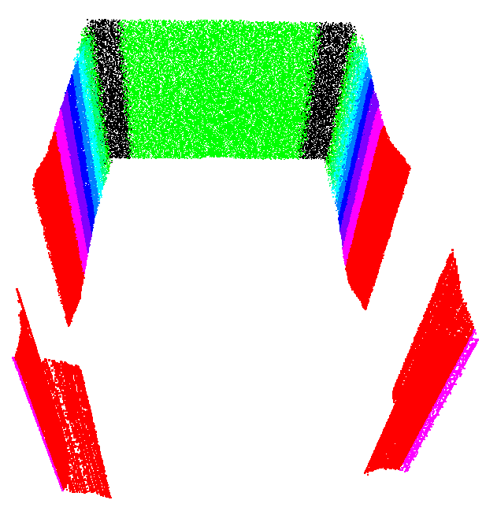
The following figures are scans from the LiDAR taken during the analysis phase in Weston’s bedroom. The first was done using a shoebox as a controlled environment for the testing of different materials and surfaces. The scan begins to distort in the red section and the LiDAR was unable to measure the distance where the scan is discontinuous. The second was a spectrum of a smooth wall to determine the effects of Plexiglas. As the two scans are the same (except for one line which corresponds to the LiDAR being moved slightly), it was determined that Plexiglas does not impede the LiDAR’s functionality.

Figure D-1: LiDAR scan of a shoebox showing the distortions relative to distance.
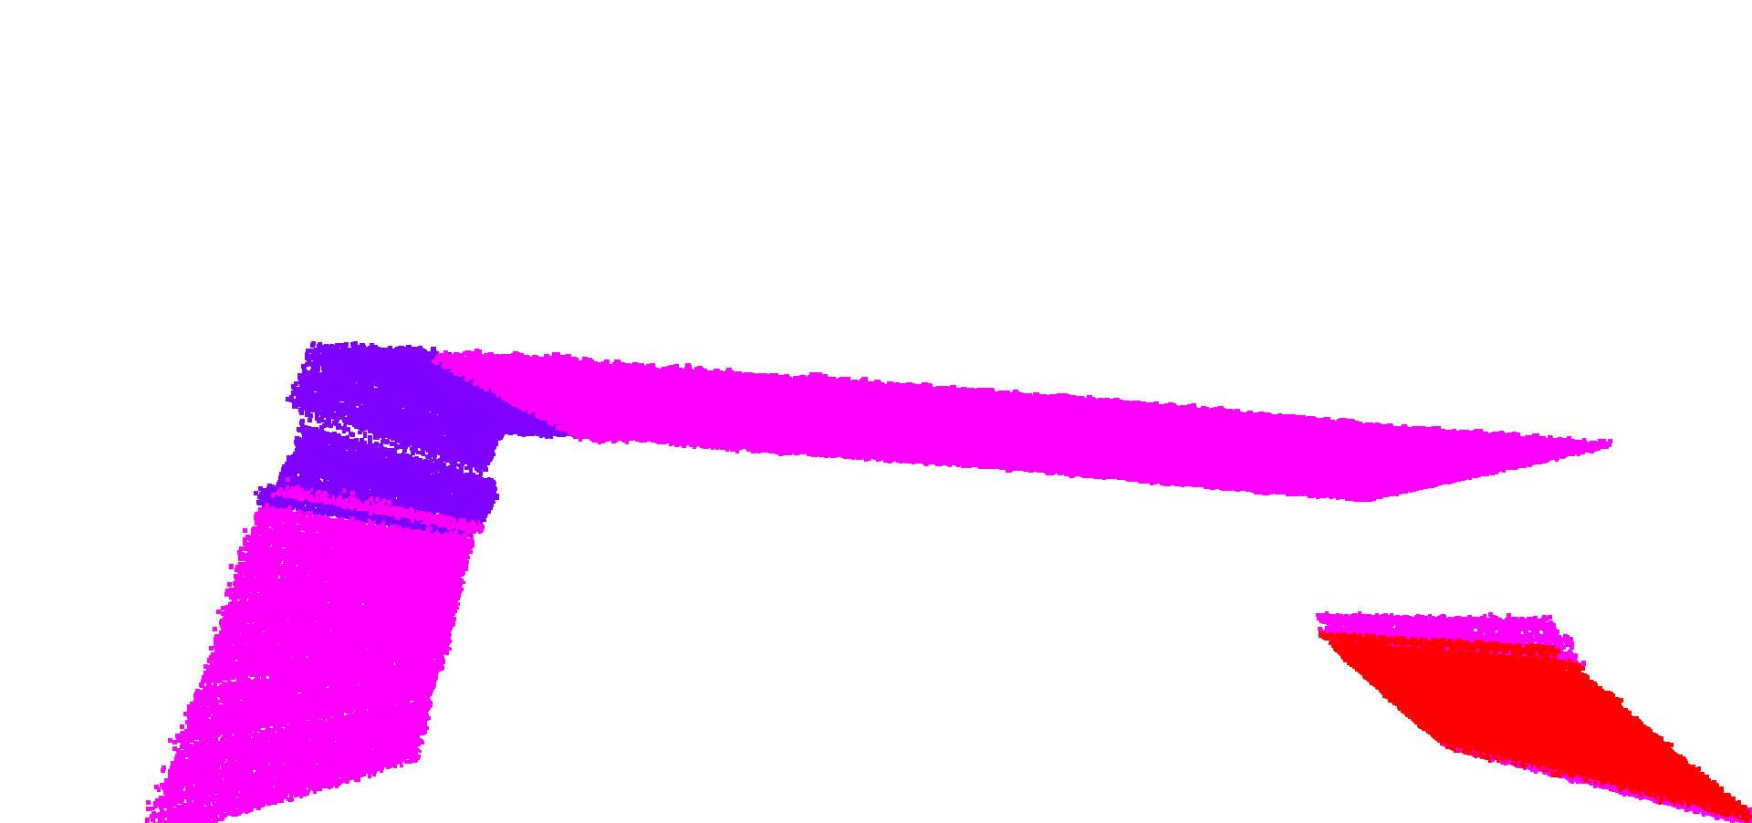
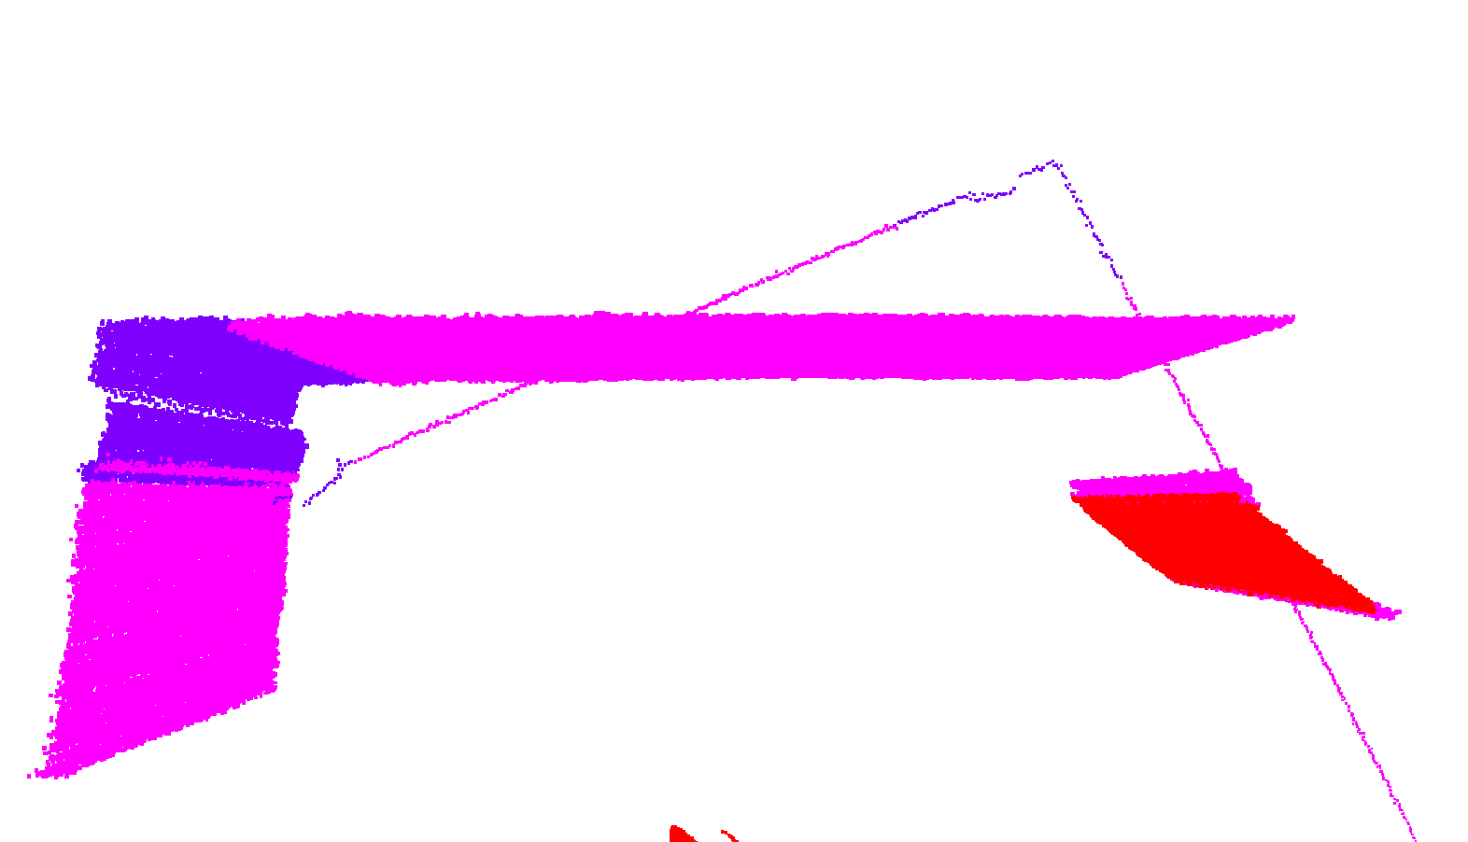

Figure D-2: The top image is a scan from the LiDAR of Weston’s bedroom without the Plexiglas and the bottom image is a scan with the Plexiglas.

Several tests were performed to determine if the LiDAR could distinguish between very small changes in thickness at various distances. The test was performed using a sliding mount system. The LiDAR was mounted on a stationary plate while a metal surface was attached to a moveable one. A barrier was placed on the slide that would prevent the metal surface from sliding when it reached a desired distance. A feeler gauge was used at a setting of 0.015 inches and was placed between the barrier and the metal surface such that it was exactly 0.015 inches closer to the LiDAR. A measurement was taken with the feeler gauge in position and without the gauge to determine how well the LiDAR can measure the difference. These results can be found in Figure D-3. The data indicates that the LiDAR is capable of detecting a difference of 0.015 inches reliably.
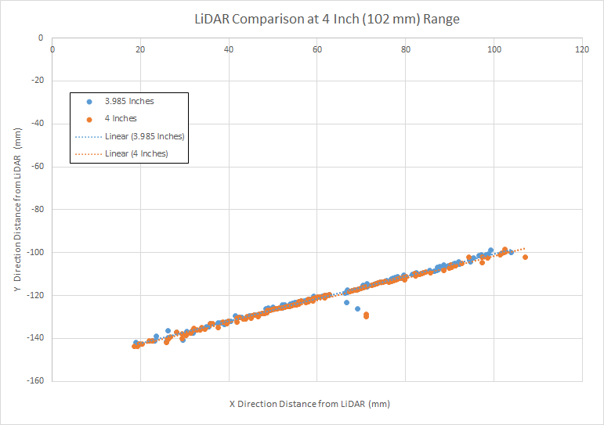

Figure D-3: A comparison of two LiDAR scans taken of the same surface at slightly different distances.

Figure D-4 shows a scan of a flat metal surface at a distance of 3.25 inches from the LiDAR. The trendline is included to illustrate that the scan is not completely straight and slightly deviates near the edges. There is also a large inconsistency near the middle of the plate. Several other materials, including various polymers, were tested to further illustrate this point. The discrepancy may lie in the texture of the surface being measured. This data indicates that the LiDAR still needs further analysis to be completely characterized and consistently accurate.

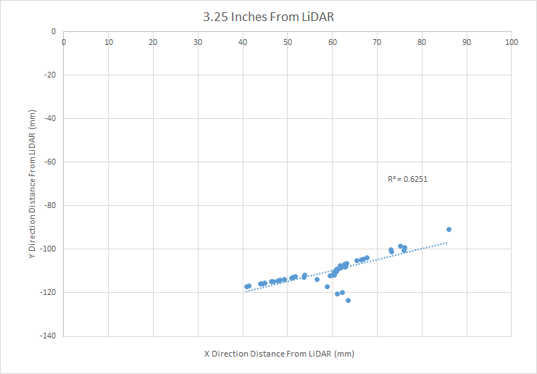

Figure D-4: LiDAR scan taken at 3.25 inches away from a metal surface.

Appendix E: Design of Adaptive LiDAR Mount

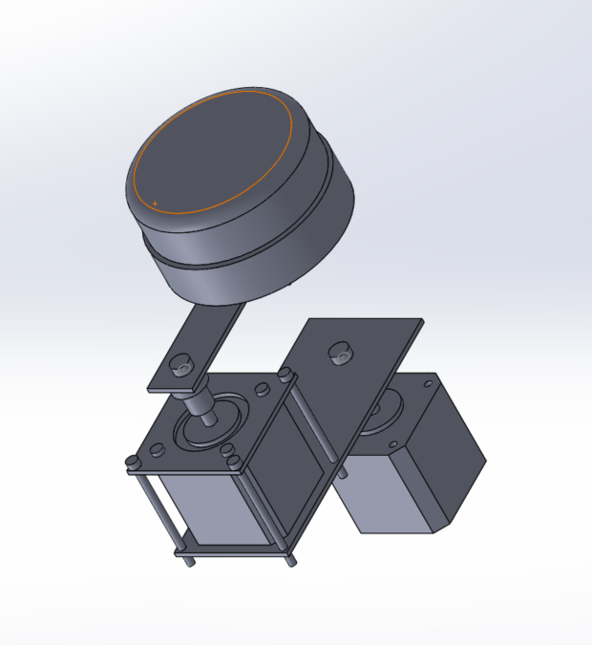
This section contains a schematic of the LiDAR centering contraption. It was created using SOLIDWORKS.

Figure E-1: Theoretical LiDAR centering system.

