Defining Bee Pollinator Community Composition in Tennessee Soybean

A Thesis Presented for the

Master of Science

Degree

The University of Tennessee, Knoxville

Andrew Lowell Lawson

December 2020

Copyright © 2020 by Andrew Lowell Lawson
All rights reserved.

DEDICATION

First and foremost, I want to dedicate this thesis to the big man upstairs, without him none of this would be possible. Secondly, I want to dedicate this thesis to my patient and understanding wife. She has been my rock through this whole process.

ACKNOWLEDGEMENTS

Dr. Scott Stewart
Dr. John Adamczyk (USDA)
Dr. Laura Russo
Dr. John Skinner
Dr. Feng Chen
Dr. Katherine Parys (USDA)
Sandy Steckel
Matthew Williams
Dawson Kerns
Dr. Vincent Pantalone
Summer workers at WTREC
University of Tennessee Department of Entomology and Plant Pathology
USDA ARS

ABSTRACT

Two planting dates of various soybean varieties were planted in Jackson and Knoxville, TN during 2018 and 2019 with the overall intent of surveying the diversity bee (Hymenoptera) genera in these agroecosystems and also to assess the potential for using late maturing soybean as a food resource for bees during the dearth of floral resources that often occurs during the fall. We also investigated how manipulating planting dates and soybean variety selection affected the occurrence of insect pests that occurred in the soybean.
Both active (netting) and passive (bee bowls and blue-vane traps) sampling were used to collect the bees, and during the course of this study, 2,294 bees comprising 4 families and 20 genera were caught. However, the indices of generic richness and diversity were generally higher Jackson. Both locations had a dominant genus that was collected much more frequently than others, specifically Melissodes (Apidae) in Jackson and Lasioglossum (Halictidae) in Knoxville, but the specimens collected in Jackson were more evenly distributed across genera than in Knoxville. Foraging on the floral resources in our soybean plots clearly increased around mid-August and was sustained into mid-September. However, it would likely take substantial acres to meaningfully impact overall pollinator populations over a wide geography, and one limitation was that the varieties which seemed to fit best is this role had a determinate growth pattern. Thus, they would only provide a significant food source for pollinators during a relatively short blooming window during the R1 and R2 growth stages.
The occurrence of insect pests in soybean often followed a predictable pattern related to the developmental stage of the soybean. Although some pests occurred at economically damaging levels, we did not observe serious insect infestations specifically associated with the use of late soybean maturity groups or the unusually late planting dates in this study. However, these results are not necessarily typical of early vs. late production soybean systems. Yield data were not collected in this study, but yield penalties were evident owing to late planting and the use of later maturing varieties.

TABLE OF CONTENTS
CHAPTER 1
INTRODUCTION AND LITERATURE REVIEW
Introduction and Literature Review……….……………………………………………….......... 2
Objectives...................................................................................................................................... 10
Appendix A.................................................................................................................................... 11
References Cited............................................................................................................................ 12

CHAPTER 2 INSECT PEST POPULATIONS IN TENNESSEE SOYBEAN: A GENERAL
ANALYSIS OF THE AFFECT OF VARIETAL MATURITY AND PLANTING DATE
Abstract.......................................................................................................................................... 23
Introduction.................................................................................................................................... 24
Materials and Methods................................................................................................................... 27
Results............................................................................................................................................ 30
Discussion...................................................................................................................................... 33
Appendix A.................................................................................................................................... 40
Appendix B.................................................................................................................................... 43
References Cited............................................................................................................................ 52

CHAPTER 3 THE DIVERSITY OF BEE POLLINATOR COMMUNITIES
FOUND IN TENNESSEE SOYBEAN FIELDS
Abstract......................................................................................................................................... 57
Introduction .................................................................................................................................. 58
Materials and Methods.................................................................................................................. 63
Results........................................................................................................................................... 67
Discussion...................................................................................................................................... 72
Appendix A.................................................................................................................................... 78
Appendix B ................................................................................................................................... 80
References Cited ........................................................................................................................... 91
Vita ................................................................................................................................................ 98

CHAPTER ONE • INTRODUCTION AND LITERATURE REVIEW

Introduction and Literature Review
Importance of Bee Pollinators
The interaction between plant and pollinator is likely one of the most important ecological relationships in nature. In angiosperm plants, transfer of pollen from stamen to stigma is the main way in which sexual reproduction and crossing of genetic material takes place resulting in a genetically diverse community. The process of pollination can be vectored in a finite amount of ways including wind, animal mediated, self-pollination, and seldomly water pollination (Proctor et al. 2012). Pollen, however, is costly for plants to produce and there are many types of flowering plants, therefore different plants have developed specialized strategies to help ensure pollination takes place (Proctor et al. 2012).
Self-compatibility is a strategy in plants to ensure pollination, fertilization, and subsequent generations. Although this may limit genetic diversity in a plant community, it can be advantageous to plants where pollinator communities are not present or are in low numbers. Self-pollination can occur by autogamy, where pollination takes place within a single flower, and allogamy, where pollination occurs between two flowers either on the same plant (geitonogamy) or different plants (xenogamy) (Faegri & Van Der Pijl 1979).
Self-incompatible flowering plants rely on animals, insects, and wind for pollination.
Plants that do not require a biological organism for pollination (e.g. wind pollination) generally have inconspicuous scentless flowers and produce mass amounts of pollen rather than using energy on showy flowers that attract pollinators visually or with a complex of volatile compounds (Dowding 1987). However, according to Ollerton (2011), 87.5% of flowering plants do require pollination from an animal or insect, and will often have attractive inflorescence, emit a floral volatile, and contain a nectar reward to encourage visitors (Faegri & Van Der Pijl 1979, Proctor et al. 2012). Many of these types of flowers attract bees (Hymenoptera: Anthophila) looking for pollen and nectar for nutrients. Furthermore, bees are the only organisms that collect pollen as a source of nutrients to feed themselves as well as their developing larvae with few exceptions (Kearns et al. 1998). In order to collect sufficient amounts of pollen, bees inherently make more visitation to flowers than other insects. This drive to collect pollen for future generations enhances the effectiveness of bees as pollinators (Proctor et al. 2012).
Bees that serve as pollinators have multiple functions and provide a variety of ecosystem services (Kearns et al. 1998). Bees help preserve biodiversity of plants that require pollination and promote density in these plant communities, also contributing to secondary services such as air filtration through plant respiration, ecosystem temperature regulation from plant canopies, and carbon sequestration from plant growth (Klein et al. 2018). Of the estimated 70,000 species of Hymenoptera, approximately 20,000 species are bees (Wardhaugh 2015). Almost all species of bees collect pollen and nectar as a source of nutrients and energy (Danforth et al. 2006, Michener, 2000). In the United States, native bees contribute to pollination ranging in size, life cycle, and behavior patterns (Losey & Vaughan 2006).
The roles of both wild and managed bee pollinators on a global level are said to be valued over 177 billion U.S dollars annually, however, this does not take in to account various crop seed and forage grown for the production of meat and dairy (Klein et al. 2018). It is estimated that 35% of the world’s food crop production depends on pollination by bees (Klein et al. 2007).Within the United States (USA), the economic dependence on pollination services provided by wild and managed bees in agriculture is estimated at a value of $14.2 - $23.8 billion and will continue to grow with declines in pollinator survival (Chopra et al. 2015, Potts et al. 2010). Annual pollination to fruit and vegetable crops by native bee species in the U.S. was valued at $3.07 billion in 2006 and is undoubtably higher now (Losey & Vaughan 2006).
Bee Declines
Suggested causes of bee decline include parasites, loss of habitat, abundance and diversity of floral resources, pesticide use, and the negative impacts of invasive species (Bartomeus & Winfree 2013). Invasive pests or pathogens may have a magnified effect on vulnerable pollinator populations already suffering from habitat loss and decreased diversity of food sources (S. Klein et al. 2017). Similar stresses can be observed from losses in monarch butterfly (Danaus plexippus (L.), Lepidoptera: Nymphalidae) populations, which have steeply declined across Mexico and North America (Flockhart et al., 2015, Semmens et al. 2016). A study conducted between 2007 and 2009 found 4 species of bumble bees in the U.S. have decreased in relative abundance by 96% and have decreased their geographic ranges by 23-87% (Cameron et al. 2011). More concentrated sampling efforts have offered further evidence of bumble bee decline in Arkansas (Tripodi & Szalanski 2015), Illinois (Grixti et al. 2009), Oklahoma (Figueroa & Bergey 2015), and the northeastern U.S. (Jacobson et al. 2017, Richardson et al. 2018). The continuation of habitat loss, farming expansion, and deficit of foraging resources caused by human disturbance shows no sign of decelerating with human population projections expected to increase steadily (Tscharntke et al. 2005, Cumming et al. 2014). As the human population grows, there will be an increasing demand for agricultural products that must be satisfied by increasing agricultural land use and/or increased yields (Cumming et al. 2014). Maintaining the ecosystem services provided by bees and other pollinators in agricultural landscapes by actively incorporating conservational practices may be necessary as additional land is converted for agronomic use (Tscharntke et al. 2005). Additionally, identifying crop pollinators at a local and regional scale can help target conservation methods for improved agroecosystem services (Garratt et al. 2014, Kearns et al. 1998, Klein 2011).
Honey Bees
Honey bees (Apis mellifera L., Hymenoptera: Apidae) are the world’s most economically important pollinating insects and heavily managed through most of their introduced range (Southwick & Southwick 1992). Agriculturally, honey bee contributions are valued at billions of dollars in fruit, vegetable, and nut pollination (Klein et al. 2007). Compared to other bee species, the social honey bee has been noted to substantially increase crop yields in insect pollinated crops such as fruit, seed, and nut crops (Klein et al. 2007, Rader et al. 2013, Southwickl & Southwick 1992). Research has shown that a low quality or quantity of resources can negatively affect reproduction in honey bees, weakening the following generation (Di Pasquale et al., 2016). Additionally, honey bees that are pollen stressed during development have been known to display low activity, uninformative waggle dancing, poor foraging behavior, and shorter life span (Scofield & Mattila 2015). Waggle dancing in honey bees is a key mode of communicating to the rest of the hive about available resources (Frisch 1967). Waggle dancers can share information with the rest of the hive, including: how far away the food source is, what direction it is in, and recruiting other foragers to assist in retrieval (Frisch 1967). Poor dancing may contribute to colony decline (Scofield & Mattila 2015). In contrast, it has been shown that honey bees that have adequate access to resources are less susceptible to pathogen stress and have improved tolerance to pesticide exposure (DeGrandi-Hoffman & Chen 2015, Dolezal & Toth 2018, Naug 2009, Schmehl et al. 2014)

Floral Resources in Agricultural Landscapes
Pollen and nectar provide bees with protein and energy-rich fuel, which in combination provide bees with protein, carbohydrates, lipids, and micronutrients necessary for normal activity, reproduction, and resistance to biotic and abiotic stressors (Vaudo et al. 2015).
Floral structure and color can influence a plant’s attractiveness to bees of different kinds, and floral structure also influences the type of pollinator that is best suited to forage on its flowers (Knuth 1906, Proctor 2012). Thus, habitats with diverse floral community often support a more diverse pollinator community (Mallinger et al. 2016). Habitat loss and fragmentation of landscapes from expanding urban growth and intensive agricultural practices alter plant biodiversity across the landscape, and this can result in either spatial or temporal areas where there are low floral resources and/or diversity, also referred to as a dearth (Hodson n.d., Kremen et al. 2002, Potts et al. 2010, Di Pasquale et al. 2016). These periods of dearth often occur late in the summer or early fall, after agricultural crops have finished blooming, at a time when floral resources are in high demand but in low availability (Corby-Harris et al. 2018).
Mass flowering crops have been observed to enhance the abundance of some species of non-Apis bees (Holzschuh et al. 2013, Warzecha et al. 2016, Westphal et al. 2003). However, honey bee health and overwinter survival are negatively impacted by a lack of resources during a late season dearth (Scofield & Mattila 2015). In agricultural environments, providing floral resources during this dearth may be an important tool in mitigating declines in bee populations. Promoting mass flowering crops that flower in dearth periods may help supplement resources where they would otherwise lack, and potentially support insects that are attracted to the crop’s flowers (Diekötter et al. 2014).

Soybean in Tennessee
Soybean is one of the world’s most widely cultivated row crops (Chiari et al. 2005). The high content of protein, oil, and carbohydrates make soybean one of the most traded and economically valuable commodities by exporter countries. In 2010, the world production of soybean was 264.9 million tons produced on 102.5 million hectares (de O. Milfont et al. 2013). The most current data provided by the Food and Agriculture Organization of the United Nations shows that in five years world production in tonnage of soybean has risen 20% from 2013 to 2018 reaching 348.7 million tons with land coverage increasing 11% to 124.9 million hectares (FAOSTAT n.d.). The United States is a major producer, accounting for roughly 30% of world production (FAOSTAT n.d.). In 2018, Tennessee harvested 675,825 hectares of soybean with an estimated value over $664 million dollars (USDA/NASS n.d.).
The geography of Tennessee allows for a unique comparison of very dissimilar areas. Tennessee spans a distance of 432 miles from east to west and consists of eight level III ecoregions (Griffith et al., 1997). The eastern border of the state is dominated by the Great Smokey Mountains, whereas western Tennessee’s relatively level ground, and row-crop agriculture covers much of the landscape. While farmland in Tennessee is more plentiful on the western side of the state, soybean are widely grown and is routinely in the top three in cash receipts for row crops (Flinchum 2001).
The vast majority of soybean grown in Tennessee are maturity group IV, with group III and V maturity groups representing less than one-third of the production (UTcrops.com n.d., S. D. Stewart, pers. comm.) Because the soybean flowering is photoperiod sensitive and influenced by variety and planting date (Mourtzinis & Conley, 2017), not all varieties will provide floral resources to pollinators at the same time. Also, most ‘late maturing’ varieties, such as those belonging to group V and VI maturity groups, are determinate. Determinate varieties have a relatively long vegetative growth phase, followed by a relatively short flowering period; whereas, indeterminate varieties continue to grow vegetatively after flowering has begun (Wilcox & Zhang 1997). Thus, it is important to understand on how flowering patterns are affected by both variety selection and planting date, especially if one goal is to provide a resource for pollinators when other floral resources are in short supply. Further, a change in flowering patterns is expected to change the timing and intensity of insect pests that occur in soybean.
Insect Pests in Tennessee Soybean
In Tennessee and in the South in general, there are many insects that routinely cause yield loss in soybean, although this varies geographically and annually across the regions (Stewart & McClure 2020). In the South, later maturing soybean fields often have a higher frequency of economically damaging insect populations (Sij et al. 1999). There are many insects that can injure soybean in Tennessee but only rarely cause yield loss. Information about biology, ecology and pest status of soybean arthropod pests in North America was reviewed by Higley & Boethel (1994). The most important insect pest complexes in Tennessee include various species of stink bugs and lepidopteran larvae (Musser et al. 2019). Common insect pests found in Tennessee soybean fields are listed in Appendix A, Table 1. Stink bug species of primary concern in Tennessee include the green stink bug, (Chinavia hilaris) and brown stink bug, (Euschistus servus), but several other species are also found including the recently invasive brown marmorated stink bug (Halyomorpha halys) (Stewart & McClure 2020). Caterpillars that commonly cause yield losses in Tennessee soybean include green cloverworm, the looper complex primarily consisting of cabbage looper, Trichopulsia ni (Lepidoptera: Noctuidae) and soybean looper, and the corn earworm (Soybean Insect Guide n.d.). Of course, many other arthropods are found in soybean including predators, parasitoids, and other beneficial insects such as pollinators. Therefore, the incidence of these pests, particularly during the flowering window, should be considered as this could affect the potential exposure of pollinators to insecticides.
Bees in Soybean
Although soybean flowers are predominantly cleistogamous, there is evidence showing that native bees and particularly non-native managed honey bees systematically utilize the mass flowering crop as an important source of pollen and nectar in agricultural landscapes (Blettler et al. 2018, de O. Milfont et al. 2013, Woodcock et al. 2013). Moreover, although controversial, some older studies have suggested soybean yield increases are associated with the presence of honey bees (de O. Milfont et al. 2013, E. H. Erickson et al. 1978, Erickson 1975, Monasterolo et al. 2015).
The soybean flower can be purple or pink, to white producing up to 800 flowers throughout the flowering cycle of a single plant. Each flower is capable of producing only one seed pod. However, flower abortion rates can surpass 75% in some varieties (Delaplane & Mayer 2000). The soybean flower is classified as a raceme inflorescence with concealed nectaries forming as a circular mound between the central gynoecium and the stamen ring (Horner et al. 2003, Leppik 1966). Flowers with concealed nectar have nectar that is not visible at any point. These flowers commonly conceal the nectar with pubescent hairs in the flower, bulging floral sections, or in sac-like pouches at the base of the flower. Because most of the nectar in these flowers is concealed at depths of only a few millimeters, it can be easily obtained by short and long-tongued bees (Proctor et al. 2012). Studies have shown that a single hectare of soybean can produce up to 1.3-1.4 million flowers per day, generating 150 kg of nectar per season (Gordienko 1977). Assuming 150 kg of nectar per hectare, then Tennessee soybean flowers produced roughly 100,000 metric tons of nectar in 2017. While this estimate is based off historical varieties, this calculation demonstrates the potential impact of soybean on bee communities, and ultimately, the potential benefit that soybean could provide if late planted in providing nectar and pollen resources during a dearth.
Studies have been done that describe pollinator community composition in soybean (Gill & O’Neal 2015, Wheelock et al. 2016), however these data are specific to the midwestern United States. To date, studies concerning agricultural bee community identification in Tennessee have been on smaller farms that did not produce soybean, but rather concentrated in fruits, and vegetables (Wilson et al. 2015). There is a lack of information available on the pollinator community that occurs in and around soybeans in Tennessee that could be used for conservation management practices. By assessing this pollinator community composition in Tennessee and identifying the phenology and diversity of this community, we can better understand the role or potential role that soybean could play in providing nutrition to pollinators such as the honey bee. Further, better knowledge the current diversity and density of pollinating species found in soybean may help to recognize future changes in pollinator populations.
Objectives
The primary objective of this research was to document the diversity and density of the bee pollinating community that occurs in and around soybean fields from two distinct ecoregions of Tennessee, represented by Jackson (west) and Knoxville (east). Sub-objectives were to determine: 1) if manipulating soybean planting dates or the selection of different maturity groups could be done to provide floral resources, essentially a food plot, for pollinators during a time when a late-season dearth typically occurs; and 2) what influence this might have on the occurrence of soybean insect pests.

APPENDIX A • TABLES
Table 1: Soybean insect pests of concern in Tennessee.

Green cloverworm | Hypena scabra F. | Lepidoptera: Erebidae
Soybean looper | Chrysodeixis includens Walker | Lepidoptera: Noctuidae
Cabbage looper | Trichopulsia ni Hübner | Lepidoptera: Noctuidae
Bean leaf beetle | Cerotoma trifurcata Forster | Coleoptera: Chrysomelidae
Threecornered alfalfa hopper | Spissistilus festinus Say | Hemiptera: Membracidae
Fall armyworm | Spodoptera frugiperda Smith | Lepidoptera: Noctuidae
Corn earworm | Helicoverpa zea Boddie | Lepidoptera: Noctuidae
Green stink bug | Chinavia hilaris Say | Hemiptera: Pentatomidae
Brown stink bug | Euschistus servus Say | Hemiptera: Pentatomidae
Brown marmorated stink bug | Halyomorpha halys Stål | Hemiptera: Pentatomidae
Grape colaspis | Colaspis brunnea F. | Coleoptera: Chrysomelidae
Kudzu bug | Megacopta cribraria F. | Hemiptera: Plataspidae
Dectes stem borer | Dectes texanus LeConte | Coleoptera: Cerambycidae
Saltmarsh caterpillar | Estigmene acrea Drury | Lepidoptera: Erebidae

References
Bartomeus, I., & Winfree, R. (2013). Pollinator declines: reconciling scales and implications for ecosystem services. F1000Research, 2, 1–5. https://doi.org/10.12688/f1000research.2-146.v1
Blettler, D. C., Fagúndez, G. A., & Caviglia, O. P. (2018). Contribution of honeybees to soybean yield. Apidologie, 49(1), 101–111. https://doi.org/10.1007/s13592-017-0532-4
Cameron, S. A., Lozier, J. D., Strange, J. P., Koch, J. B., Cordes, N., Solter, L. F., & Griswold, T. L. (2011). Patterns of widespread decline in North American bumble bees. Proceedings National Acad. Sci. United States Amer., 108(2), 662–667. https://doi.org/10.1073/pnas.1014743108
Chiari, W. C., De Toledo, V. D. A. A., Ruvolo-Takasusuki, M. C. C., Braz De Oliveira, A. J., Sakaguti, E. S., Attencia, V. M., Costa, F. M., & Mitsui, M. H. (2005). Pollination of soybean (Glycine max L. Merril) by honeybees (Apis mellifera L.). Brazilian Archives Biology Technol., 48(1), 31–36. https://doi.org/10.1590/S1516-89132005000100005
Chopra, S. S., Bakshi, B. R., & Khanna, V. (2015). Economic dependence of U.S. industrial sectors on animal-mediated pollination service. Environ. Sci. Technol., 49(24), 14441–14451. https://doi.org/10.1021/acs.est.5b03788
Corby-Harris, V., Bowsher, J. H., Carr-Markell, M., Carroll, M. J., Centrella, M., Cook, S. C., Couvillon, M., DeGrandi-Hoffman, G., Dolezal, A., Jones, J. C., Mogren, C. L., V Otto, C. R., Lau, P., Rangel, J., Schürch, R., & St Clair, A. (2018). Pollinator nutrition: lessons from bees at individual to landscape levels. Bee World, 96(1). https://doi.org/10.1080/0005772X.2018.1535951
Cumming, G. S., Buerkert, A., Hoffmann, E. M., Schlecht, E., von Cramon-Taubadel, S. & Tscharntke, T (2014). Implications of agricultural transitions and urbanization for ecosystem services. Nature. 515, 50–57. http://dx.doi.org.proxy.lib.utk.edu:90/10.1038/nature13945
National Research Council. 2007. Status of Pollinators in North America. Washington, DC: National Academies Press. https://doi.org/10.17226/11761.
Danforth, B. N., Sipes, S., Fang, J., & Brady, S. G. (2006). The history of early bee diversification based on five genes plus morphology. Proceed. National Acad. Sci. United States Amer., 103(41), 15118–15123. https://doi.org/10.1073/pnas.0604033103
Delaplane, K., & Mayer, D. (2000). Soybean. In Delaplane, K., & Mayer, D. (Ed.). Crop pollination by bees. 254-256. CABI Publishing.
de O. Milfont, M., Rocha, E. E. M., Lima, A. O. N., & Freitas, B. M. (2013). Higher soybean production using honeybee and wild pollinators, a sustainable alternative to pesticides and autopollination. Environ. Chem. Letters, 11(4), 335–341. https://doi.org/10.1007/s10311-013-0412-8
DeGrandi-Hoffman, G., & Chen, Y. (2015). Nutrition, immunity and viral infections in honey bees. Curr. Opin. Insect Sci., 10, 170–176. https://doi.org/10.1016/j.cois.2015.05.007
Di Pasquale, G., Alaux, C., Conte, Y. Le, Odoux, J. F., Pioz, M., Vaissière, B. E., Belzunces, L. P., & Decourtye, A. (2016). Variations in the availability of pollen resources affect honey bee health. PLoS ONE, 11(9), 1–15. https://doi.org/10.1371/journal.pone.0162818
Diekötter, T., Peter, F., Jauker, B., Wolters, V., & Jauker, F. (2014). Mass-flowering crops increase richness of cavity-nesting bees and wasps in modern agro-ecosystems. Bioenergy, 6(3), 219–226. https://doi.org/10.1111/gcbb.12080
Dolezal, A. G., & Toth, A. L. (2018). Feedbacks between nutrition and disease in honey bee health. Curr. Opin. Insect Sci., 26, 114–119. https://doi.org/10.1016/j.cois.2018.02.006
Dowding, P (1987). Wind pollination mechanisms and aerobilology. Intern. Rev. Cytol., 107, 421-437. https://www.sciencedirect.com/science/article/pii/S0074769608610840
Erickson, E. H., Berger, G. A., Shannon, J. G., & Robins, J. M. (1978). Honey bee pollination increases soybean yields in the Mississippi delta region of Arkansas and Missouri. J. Econ. Entomol., 71(4), 601–603. https://doi.org/10.1093/jee/71.4.601
Erickson, E. H. (1975). Effect of honey bees on yield of three soybean cultivars. Crop Sci., 15(1), 84–86. https://doi.org/10.2135/cropsci1975.0011183x001500010025x
Faegri, K. & Van Der Pijl, L. (1979). Pollination in angiosperms. K. Faegri & L. Van Der Pijl (Ed.). Principles of pollination ecology. 3(13-33). Pergamon
FAOSTAT. (n.d.). Retrieved May 7, 2020, from http://www.fao.org/faostat/en/#data/QC
Flinchum, W. T. (2001). Soybean production in Tennessee: field & commercial crops. (PB1608). Univ. of Tenn. https://trace.tennessee.edu/utk_agexcrop/51
Flockhart, D.T.T., Pichancourt, J.‐B., Norris, D.R. and Martin, T.G. (2015), Unravelling the annual cycle in a migratory animal: breeding‐season habitat loss drives population declines of monarch butterflies. J Anim Ecol, 84: 155-165. https://besjournals-onlinelibrary-wiley-com.proxy.lib.utk.edu/doi/full/10.1111/1365-2656.12253
Frisch, K. (1967). The dance language and orientation of bees. Belknap Press of Harvard Univ. Press.
Garratt, M. P. D., Coston, D. J., Truslove, C. L., Lappage, M. G., Polce, C., Dean, R., Biesmeijer, J. C., & Potts, S. G. (2014). The identity of crop pollinators helps target conservation for improved ecosystem services. Biol. Conserv., 169, 128–135. https://doi.org/10.1016/j.biocon.2013.11.001
Gill, K. A., & O’Neal, M. E. (2015). Survey of soybean insect pollinators: Community identification and sampling method analysis. Environ. Entomol., 44(3), 488–498. https://doi.org/10.1093/ee/nvv001
Gordienko, V. (1977). Sexual hybrids of soybean obtained by direct bee pollination. Pollination of agricultural crops by bees, 381–388. Amerind Pub Co.
Griffith, G. G., Omernick, J. M., & Azevedo, S. H. (1997). Ecoregions of Tennessee. EPA/600/R-97/022, U. S. Environmental Protection Agency, Western Ecology Division.
Grixti, J. C., Wong, L. T. Cameron, S. A & Favret, C. (2009). Decline of bumble bees (Bombus) in the North American Midwest. Biol. Conserv. 142, 75–84. https://www-sciencedirect-com.proxy.lib.utk.edu/science/article/pii/S0006320708003698
Higley, L. G., Boethel, D. J., & Entomological Society of America. (1994). Handbook of soybean insect pests. Handbook series (USA). Entomological Society of America. http://agris.fao.org/agris-search/search.do?recordID=US9548068
Holzschuh, A., Dormann, C. F., Tscharntke, T., & Steffan-Dewenter, I. (2013). Mass-flowering crops enhance wild bee abundance. Oecologia, 172(2), 477–484. https://doi.org/10.1007/s00442-012-2515-5
Horner, H. T., Healy, R. A., Cervantes-Martinez, T., & Palmer, R. G. (2003). Floral nectary fine structure and development in Glycine max L. (Fabaceae). Internat. J. Plant Sci. 164(5), 675-690. http://www.jstor.org/stable/10.1086/377060.
Kearns, C. A., Inouye, D. W., & Waser, N. M. (1998). Endangered mutualism: the conservation of plant pollinator interactions. Annu. Rev. Ecol. Syst., 29, 83-112. https://www-annualreviews-org.proxy.lib.utk.edu/doi/pdf/10.1146/annurev.ecolsys.29.1.83
Kevan, P. G. (1999). Pollinators as bioindicators of the state of the environment: Species, activity and diversity. Agricul., Ecosystems and Environ., 74(1–3), 373–393. https://doi.org/10.1016/S0167-8809(99)00044-4
Klein, A. M. (2011). Plant-pollinator interactions in changing environments. Basic Appl. Ecol., 12(4), 279–281. https://doi.org/10.1016/j.baae.2011.04.006
Klein, A. M., Boreux, V., Fornoff, F., Mupepele, A. C., & Pufal, G. (2018). Relevance of wild and managed bees for human well-being. Curr. Opin. Insect Sci., 26, 82–88. https://doi.org/10.1016/j.cois.2018.02.011
Klein, A. M., Vaissière, B. E., Cane, J. H., Steffan-Dewenter, I., Cunningham, S. A., Kremen, C., & Tscharntke, T. (2007). Importance of pollinators in changing landscapes for world crops. Proceed. Royal Soc. Biol. Sci., 274(1608), 303–313. https://doi.org/10.1098/rspb.2006.3721
Klein, S., Cabirol, A., Devaud, J. M., Barron, A. B., & Lihoreau, M. (2017). Why bees are so vulnerable to environmental stressors. Trends Ecol. Evol., 32(4), 268–278. https://doi.org/10.1016/j.tree.2016.12.009
Knuth, P. (1906). Handbook of flower pollination: based upon Hermann Müller’s work “The fertilisation of flowers by insects”. Oxford: Clarendon Press.
Kremen, C., Williams, N. M., & Thorp, R. W. (2002). Crop pollination from native bees at risk from agricultural intensification. Proceed. Nat. Acad. Sci. United States Amer., 99(26), 16812–16816. https://doi.org/10.1073/pnas.262413599
Leppik, E. E. (1966). Floral evolution and pollination in the Leguminosae. Annales Botanici Fennici 3(3). Finnish Zoological and Botanical Publishing Board. https://www.jstor.org/stable/i23724222
Losey, J. E., & Vaughan, M. (2006). The economic value of ecological services provided by insects. BioScience, 56, 311–323. https://academic.oup.com/bioscience/article/56/4/311/229003
Mallinger, R. E., Gibbs, J., & Gratton, C. (2016). Diverse landscapes have a higher abundance and species richness of spring wild bees by providing complementary floral resources over bees’ foraging periods. Landsc. Ecol., 31(7), 1523–1535. https://doi.org/10.1007/s10980-015-0332-z
McGregor, S. E. (1976). Insect pollination of cultivated crop plants. Agricultural Research Service, U.S. Dept. of Agriculture, U.S. Govt. Print. Off.
Michener, C. D. (2000). The Bees of the World. Johns Hopkins University Press.
Monasterolo, M., Musicante, M. L., Valladares, G. R., & Salvo, A. (2015). Soybean crops may benefit from forest pollinators. Agricul. Ecosystems and Environ., 202, 217–222. https://doi.org/10.1016/j.agee.2015.01.012
Mourtzinis, S., & Conley, S. P. (2017). Delineating soybean maturity groups across the United States. Agron. J., 109(4), 1397–1403. https://doi.org/10.2134/agronj2016.10.0581
Musser, F. R., Catchot, A. L., Conley, S. P., Davis, J. A., Difonzo, C., Greene, J. K., Lorenz, G. M., Owens, D., Reed, T., Reisig, D. D., Roberts, P., Royer, T., Seiter, N. J., Stewart, S. D., Taylor, S., Tilmon, K., Villanueva, R. T., & Way, M. O. (2019). Midsouth entomologist 2018 soybean insect losses in the United States. 17. www.midsouthentomologist.org.msstate.edu
Naug, D. (2009). Nutritional stress due to habitat loss may explain recent honeybee colony collapses. Biol. Conserv., 142(10), 2369–2372. https://doi.org/10.1016/j.biocon.2009.04.007
Potts, S. G., Biesmeijer, J. C., Kremen, C., Neumann, P., Schweiger, O., & Kunin, W. E. (2010). Global pollinator declines: Trends, impacts and drivers. Trends Ecol. Evol., 25(6), 345–353. https://doi.org/10.1016/j.tree.2010.01.007
Proctor, M., Yeo, P., Lack, A. (2012). The natural history of pollination. HarperCollins publishers
Publication | Honey Bee Colonies | ID: rn301137d | USDA Economics, Statistics and Market Information System. (n.d.). Retrieved May 11, 2020, from https://usda.library.cornell.edu/concern/publications/rn301137d?locale=en
Rader, R., Reilly, J., Bartomeus, I., & Winfree, R. (2013). Native bees buffer the negative impact of climate warming on honey bee pollination of watermelon crops. Global Change Biol., 19(10), 3103–3110. https://doi.org/10.1111/gcb.12264
Schmehl, D. R., Teal, P. E. A., Frazier, J. L., & Grozinger, C. M. (2014). Genomic analysis of the interaction between pesticide exposure and nutrition in honey bees (Apis mellifera). J. Insect Physiol., 71, 177–190. https://doi.org/10.1016/j.jinsphys.2014.10.002
Scofield, H. N., & Mattila, H. R. (2015). Honey bee workers that are pollen stressed as larvae become poor foragers and waggle dancers as adults. PLoS ONE, 10(4), 1–19. https://doi.org/10.1371/journal.pone.0121731
Semmens B. X., Semmens D. J., Thogmartin W. E., Wiederholt R., López-Hoffman L., Diffendorfer J. E., Pleasants J. M., Oberhauser K. S., Taylor O. R. (2016) Quasi-extinction risk and population targets for the Eastern, migratory population of monarch butterflies (Danaus plexippus). Sci. Rep. 6, 23265. https://www.nature.com/articles/srep23265
Sij, J. W., Bowers, G. R., Way, M. O., & Boykin, D. L. (1999). Insect defoliation and population dynamics in blends of resistant and susceptible soybean cultivars. Agron. J., 91(1), 82–87. https://doi.org/10.2134/agronj1999.00021962009100010013x
Southwick, E. E., & Southwick, L. (1992). Estimating the economic value of honey bees (Hymenoptera: Apidae) as agricultural pollinators in the United States. J. Econ. Entomol., 85(3), 621–633. https://doi.org/10.1093/jee/85.3.621
Soybean insect guide - UT crops pest guides. (n.d.). Retrieved May 13, 2020, from https://guide.utcrops.com/soybean/soybean-insect-guide/
Stewart, S., & McClure, A. (2020). Insect control recommendations for field crops cotton, soybean, field corn, sorghum, wheat and pasture. (PB1768). Univ. Tenn. https://extension.tennessee.edu/publications/Documents/PB1768.pdf
Tripodi, A. D., and A. L. Szalanski. 2015. The bumble bees (Hymenoptera: Apidae: Bombus) of Arkansas, fifty years later. J. Melittology 50, 1–17. https://journals.ku.edu/melittology/article/view/4834/4451
Tscharntke, T., Klein, A. M., Kruess, A., Steffan-Dewenter, I. & Thies, C. (2005). Landscape perspectives on agricultural intensification and biodiversity – ecosystem service management. Ecol. Lett., 8, 857-874. https://onlinelibrary-wiley-com.proxy.lib.utk.edu/doi/full/10.1111/j.1461-0248.2005.00782.x
USDA/NASS QuickStats Ad-hoc Query Tool. (n.d.). Retrieved May 7, 2020, from https://quickstats.nass.usda.gov/results/4CCC5013-9668-3FD2-82D3-E7BE75F86525
UTcrops Soybean. (n.d.). Retrieved May 11, 2020, from http://www.utcrops.com/soybean/index.htm
Vaudo, A. D., Tooker, J. F., Grozinger, C. M., & Patch, H. M. (2015). Bee nutrition and floral resource restoration. Current Opin. Insect Sci., 10, 133–141. https://doi.org/10.1016/j.cois.2015.05.008
Wardhaugh, C. W. (2015). How many species of arthropods visit flowers? Arthropod Plant Interact., 9(6), 547–565. https://doi.org/10.1007/s11829-015-9398-4
Warzecha, D., Diekötter, T., Wolters, V., & Jauker, F. (2016). Intraspecific body size increases with habitat fragmentation in wild bee pollinators. Landscape Ecol., 31(7), 1449–1455. https://doi.org/10.1007/s10980-016-0349-y
Westphal, C., Steffan-Dewenter, I., & Tscharntke, T. (2003). Mass flowering crops enhance pollinator densities at a landscape scale. Ecol. Lett., 6(11), 961–965. https://doi.org/10.1046/j.1461-0248.2003.00523.x
Wheelock, M. J., Rey, K. P., & O’Neal, M. E. (2016). Defining the insect pollinator community found in Iowa corn and soybean fields: Implications for pollinator conservation. Environ. Entomol., 45(5), 1099–1106. https://doi.org/10.1093/ee/nvw087
Wilcox, J. R., & Zhang, G. (1997). Relationships between seed yield and seed protein in determinate and indeterminate soybean populations. Crop Sci., 37(2), 361–364. https://doi.org/10.2135/cropsci1997.0011183X003700020009x
Wilson, M. E., Skinner J. A., Wszelaki A. L., & Drummond, F. (2015). Using nonmetric multidimensional scaling to analyze bee visitation in east Tennessee crops as an indicator of pollination services provided by honey bees (Apis mellifera L.) and native bees. Environ. Entomol. 45(2), 390-396. https://academic-oup-com.proxy.lib.utk.edu/ee/article/45/2/390/2464825
Woodcock, B. A., Edwards, M., Redhead, J., Meek, W. R., Nuttall, P., Falk, S., Nowakowski, M., & Pywell, R. F. (2013). Crop flower visitation by honeybees, bumblebees and solitary bees: behavioural differences and diversity responses to landscape. Agricul. Ecosystems and Environ., 171, 1–8. https://doi.org/10.1016/j.agee.2013.03.005

CHAPTER TWO • INSECT PEST POPULATIONS IN TENNESSEE SOYBEAN: AFFECT OF VARIETAL MATURITY AND PLANTING DATE

Abstract
Within a late planted soybean production system, research was done at two locations and across two years to investigate how planting date and soybean maturity group affected the occurrence of insect pests in Tennessee. This was done in context with a concurrent goal of providing pollinators with pollen and nectar resources during late summer and early fall. Overall, serious insect infestations were not associated with the use of later than ordinary soybean maturity groups or the unusually late planting used in this study. Indeed, it appeared the latest maturing soybean escaped significant infestations of certain pests. However, these results are not necessarily typical of early vs. late production soybean systems. Yield data were not collected in this study, but yield penalties were evident owing to late planting and the use of later maturing varieties. Nevertheless, there appears to be some opportunity to use a late soybean production system as a ‘food plot’ for pollinators (including honey bees) during the dearth that commonly occurs in late summer or early fall. However, it would likely take substantial acres to meaningfully impact overall pollinator populations over a wide geography, and one limitation was that the varieties which seemed to best fit this role had a determinate growth pattern. Thus, they would only provide a significant food source for pollinators during a relatively short window during the R1 and R2 growth stages.

Introduction
Infestations of insect pests frequently cause yield loss in soybean, Glycine max (L.), especially in the southern United States (Baur et al. 2000). The cost of these insect pest management as well as the cost of yield loss is assumed by the farmer. In a 2018 multi-state survey involving 40% of the harvested US soybean, the average amount spent on insect pest management was $26.67/ac with an average yield loss of 2.7% (Musser et al. 2019). Monetarily, the major insect pests associated with soybean in Tennessee and the southeastern US include the stink bug complex, (Hemiptera: Pentatomidae), corn earworm, Helicoverpa zea (Lepidoptera: Noctuidae), soybean looper, Chrysodeixis includens (Lepidoptera: Noctuidae), and bean leaf beetle, Ceratoma trifurcata (Coleoptera: Chrysomelidae) (Musser et al. 2019). In 2018, the highest yield loss in Tennessee soybean was caused by stink bugs and the dectes stem borer, Dectes texanus texanus (Coleoptera: Cerambycidae) (Musser et al. 2019). However, in recent years Kudzu bug, Megacopta cribraria (Hemiptera: Plataspidae), an invasive insect, has become a more prevalent insect pests in parts of Tennessee (Stewart n.d.).
Planting dates can be manipulated as a cultural practice for pest management, generally with the intent to lessen late season insect infestations by planting early (Bateman 2017). Prior to the promotion of the early soybean production system, soybean in the South were often planted later in the season and would endure late season drought and higher yield losses from phytophagous lepidopteran larvae (Baur et al. 2000, McPherson et al. 2001). Nonetheless, some farmers still practice dual cropping with winter wheat, which will normally push the planting date for soybean later in the season (e.g., June in Tennessee) (Egli et al. 1987). While planting date may be an important tool for evading some pests, the varietal maturity or maturity group (MG) can also play a large role in the success of a crop.
Maturity groups (MG) in soybean are used as a classification system separating varieties based on the photoperiod required to initiate the flowering process (Purcell & Ashlock 2014). These maturity groups range from 000 to X and can have determinate or indeterminate growth habit (Mourtzinis & Conley 2017). MG group IV and V soybean are now the predominate varieties grown in the mid-southern U.S., including Tennessee, and are generally indeterminate (MG IV) and determinate (MG V). Indeterminate varieties (MG IV and lower) flower earlier in the season but continuing vegetative growth while flowering, whereas determinate varieties (generally MG V and higher) grow vegetatively until flowering, which is triggered by shortening day lengths and occurs and over a relatively short duration (The Soybean Plant n.d.). The reproductive development of soybeans is classified into 8 reproductive stages (R1-R8) where R1 denotes first bloom and when pod development begins, and R8 represents full maturity (Fehr et al. 1971). Full bloom occurs at R2, and by R4 flowering is complete in determinate varieties and waning in indeterminate varieties. Thus, resources for pollinators will be most abundant during the R1-R3 growth stages. It is during reproductive growth when insect infestations are most likely to cause yield loss, not only because plants are more susceptible, but also because pest populations tend to increase as the season progresses.
In Tennessee and in the South in general, there are many insects that routinely cause yield loss in soybean, although this varies geographically and annually across the regions (Stewart & McClure 2020). The most important insect pest complexes include various species of stink bugs and lepidopteran larvae (Musser et al. 2019). Stink bug species of primary concern in Tennessee include the green stink bug, (Chinavia hilaris) and brown stink bug, (Euschistus servus), but several other species are also found including the recently invasive brown marmorated stink bug (Halyomorpha halys). Both adult and immature stink bugs reduce yield by feeding on the seed within pods with piercing-sucking mouthparts (Stewart & McClure 2020). Consequently, they are most likely to occur in high populations later in the season as more pods are developing (R5 – R6) (Higley et al. 1994). Caterpillars that commonly cause yield losses in Tennessee soybean include green cloverworm, the looper complex primarily consisting of cabbage looper, Trichopulsia ni (Lepidoptera: Noctuidae) and soybean looper, and the corn earworm. The green cloverworm and looper complex are defoliating insects the feed almost exclusively on leaves. The corn earworm primarily feeds on flowers and developing pods (Soybean Insect Guide n.d.).
Other insect pests that only occasionally cause significant yield loss but are frequently observed in soybean include the bean leaf beetle, kudzu bug, threecornered alfalfa hopper (Spissistilus festinus; Hemiptera: Membracidae) (Lahiri & Reisig 2016, Pedigo & Zeiss 1996, Stewart & McClure n.d.). Bean leaf beetle adults will feed on both leaves and pods and may also vector bean pod mottle virus (Hadi et al. 2012). Adult and immature kudzu bugs, a recent invasive insect form Asia, feeds on the phloem of plants and are primarily found on the stems of plants (Lahiri & Reisig 2016). The threecornered alfalfa hopper also feed on phloem, and although they may be present season long, it is the girdling feeding behavior of both adults and nymphs on the stems of seedling plants that may ultimately lead to lodging (Pulakkatu-thodi 2010). Small larvae of dectes stem borer feed within leaf petioles and move into the main stem as they grown. Large larvae tunnel within the stem before ultimately overwintering inside the stem at the base of the plant. This sometimes results in late season lodging that can reduce harvest efficiency and yield (Buschman & Sloderbeck 2010). There are many other insects that can injure soybean in Tennessee but only rarely cause yield loss. Information about biology, ecology and pest status of soybean arthropod pests in North America was reviewed by Higley & Boethel (1994). Of course, many other arthropods are found in soybean including predators, parasitoids, and other beneficial insects such as pollinators.
The purpose of this research was to investigate how planting date and soybean maturity group affected the occurrence of potential insect pests in Tennessee in a late planted soybean system in context with a concurrent goal of providing pollinators with pollen and nectar resources during late summer and early fall. Thus, the choice of planting dates and varieties were not always compatible with typical production practices designed to maximize yield and reduce the incidence of late season pests.
Materials and Methods
Study Sites
Data for this experiment were collected from soybean grown at two study sites located in Jackson and Knoxville, TN during the 2018 and 2019 growing season. These locations are on opposite sides of the state, allowing for a contrasting assessment of the soybean pollinator community in western and eastern Tennessee. Test locations are University of Tennessee agricultural research centers, both possessing intensively managed agricultural crops including soybean. However, unlike grower fields, crops on these experiment stations were grown in a relatively patchy mosaic that also includes corn, Zea mays L. (both locations), and cotton, Gossypium hirsutum L. (Jackson).
Experimental Design
At each location and each year, an early and late planting was made. For each planting date, three varieties were planted in a randomized complete block design with four replicates. Individual plots were eight rows wide (72.6 cm spacing) and 10.6 m. long. A group III, IV, and VI soybean variety was used in the early planting, and a group IV, V, and VI was planted later and immediately adjacent to the early test. Plots were sown at a rate 26.2 seed per meter. Planting dates and the varieties used are listed in Appendix A, Table 1. For tests at both locations, soybean were grown with typical no-till production under standard production methods of fertility and weed management (Flinchum 2001). No insecticides were applied. Plots at the Jackson location were occasionally irrigated as needed based on the researcher’s judgement.
In Knoxville during 2019, geese destroyed the early planted soybean during late July, therefore the early planting was abandoned. During the week of August 7th, geese feeding in the late planted soybean caused significant injury. This delayed data collection until plants had recovered enough to flower and withstand sampling.
Sampling
For each variety, beginning at R1 and continuing until R7, 25 sweeps using a standard 38.1 cm sweep net were taken weekly in each plot. Sweep net sample were inverted into a clear 3.8-l storage bag, labeled by location, plot number, planting date, and date of collection. Samples were stored in a freezer until processed. Each week, beginning at R1, all plots were visually assessed to determine growth stage (R1-R8). Yield data were not collected.
Sample Processing
Data recordings included hymenopteran pollinators, counted and separated by genera and species when possible (see Chapter Three). Pollinator samples were stored in scintillation vials containing 70% EtOH for further processing and identifying. Data on pest and pollinators were categorized and recorded by location, plot number, date of planting, and date of collection. Counts of pest insects included bean leaf beetle, various caterpillar by type (e.g., green cloverworm, corn earworm, loopers, etc.), kudzu bugs, adult dectes stem borer, and the various stink bugs by type (e.g., brown, green, brown marmorated, etc.). Other insects counted included threecornered alfalfa hopper, fall armyworm, Spodoptera frugiperda (Lepidoptera: Noctuidae), tarnished plant bug, Lygus lineolaris (Hemiptera: Miridae), grape colaspis, Colaspis brunnea (Coleoptera: Chrysomelidae), spotted cucumber beetle, Diabrotica undecimpunctata (Coleoptera: Chrysomelidae), and salt marsh caterpillar, Estigmene acrea (Lepidoptera: Erebidae).
Data Analysis
Data on pollinators collected in these samples are reported in Chapter Three. For the data reported below, samples taken at R6 and beyond were grouped as R6. Data from the early planting in Knoxville during 2019 were not collected because geese destroyed the plots. Although maturity group (i.e., variety) was a main effect in this study, our goal was to manipulate the timing of flowering. It was assumed that varietal effects were minimal other than how they impacted when and how long the flowering and reproductive growth occurred. Thus, growth stage (R1 – R6) and planting date (early, late) were used as main (fixed) effect in our analyses. Site year (Jackson 2018, Jackson 2019, Knoxville 2018, Knoxville 2019) and replicates within site year were considered random effects in the models. Statistical analysis was done in SAS version 9.4 using PROC GLIMMIX and the Tukey-Kramer Grouping of Least Square Means for mean separation (α = 0.05). Insects that occurred in numbers sufficient to justify statistical analyses were kudzu bug, green cloverworm, bean leaf beetle, total stink bugs including all phytophagous species, threecornered alfalfa hopper, and adult dectes stem borer.

Results
General Observations
During the sampling period from R1 – R7, many potential insect pests were counted during this study (Appendix B, Fig. 1). Kudzu bug, threecornered alfalfa hopper, bean leaf beetles, green cloverworm, and the various stink bug species occurred in sufficient numbers to allow for meaningful analysis of treatment effects. Adult dectes stem borer were also included in analyses because, while seasonal average populations were low, they occurred at high enough populations for a short time to make statistical comparisons. Across both years, green cloverworm was the most common insect observed at the Knoxville location, averaging about 13 larvae per 25 sweeps across the season while averaging less than 3 larvae per 25 sweeps in Jackson (Appendix B, Fig. 2). Relative to the Jackson site, few bean leaf beetles and stink bugs were found in Knoxville. Kudzu bugs were the most common insect found overall (Appendix B, Fig. 1) and in both years of the study (Appendix B, Fig. 3). Kudzu bug populations averaged approximately 23 bugs per 25 sweeps at the Jackson location across both years, but populations were substantially lower in Knoxville. The numbers and kinds of insects found were generally similar in 2018 and 2019 when averaged across locations (Appendix B, Fig. 3).
Impact of Maturity Group and Planting Date on Soybean Development
As expected, the impact of maturity group (MG) on soybean development varied by planting date and location (Appendix A, Table 2). In the early plantings, within a location, the MG:III and MG:IV varieties began blooming (R1) at about the same time and also reached full seed (R6) on about the same date in late August. In the early planting, the MG:VI variety did not begin blooming until early August, about one month later than the other varieties and did not reach R6 until mid- to late-September. In the late plantings, with the MG:IV, MG:V, and MG:VI varieties, blooming began in mid- to late-August and varieties did not reach R6 until mid-September to mid-October, with the MG:VI variety being the latest maturing variety followed by the MG:V and MG:IV variety respectively. For the MG:IV variety, late planting delayed bloom by at least one month, to mid- to late-August, relative to the blooming period in the early planting. The MG:V reached full bloom (R2) 2 – 13 days later than the MG:IV variety, depending upon the year and location, when both were planted late. The MG:VI variety, planted late, reached full bloom at a similar time as the MG:V variety. However, blooming was less delayed when the MG:VI variety was planted late. Relative to the early plantings, blooming was delayed by 7-20 days depending on the planting date and location. It took less time for all varieties to progress from R1 to R6 when they were planted late.
Effects of Growth (R) Stage and Planting Date on Insect Pest Populations
There were some obvious trends on how growth stage affected the density of insect pests when averaged across locations, years and planting date. (Appendix B, Fig. 4). With the exception of kudzu bug, which were more common in the early planted soybean plots, again averaged across years, the effects of planting date were less obvious (Appendix B, Fig. 5). The effects of growth stage, planting date, and their interaction are reported below for kudzu bug, threecornered alfalfa hopper, adult bean leaf beetles, green cloverworm larvae, total stink bug, and adult dectes stem borer. Results of statistical these comparisons are shown in Appendix A, Table 3.
For kudzu bug, there was significant main effect of growth stage and an interaction between growth stage and planting date (Appendix A, Table 2; Appendix B, Fig. 6). In the early planting, kudzu bug populations remained relatively consistent until increasing sharply at R6 and continuing to increase at R6 and beyond when populations exceed two kudzu bugs per sweep. In contrast, numbers of kudzu bugs were lower in the late planting, and there was no significant different in density from R1 – R6.
There were also significant main effects of growth stage, planting date, and a significant interaction between growth stage and planting date on the number of green cloverworms found in our samples (Appendix A, Table 3; Appendix B, Fig. 7). In early plantings, green cloverworm populations peaked at R4, averaging 22 larvae per 25 sweeps before a substantial decrease in populations at R5. However, the numbers of green cloverworm in the late planting were substantially lower and occurred at a statistically similar level regardless of growth stage. The average number of green cloverworm found per 25 sweeps was higher at Knoxville (12.94 ± 1.54) than Jackson (2.99 ± 0.33) (Appendix B, Fig. 2). On average, we also caught slightly more green cloverworms in 2018 than in 2019 (Appendix B, Fig. 3).
Bean leaf beetle adults were most prevalent in the late plantings, particularly during the R2-R5 growth stages after which there was a significant decline in numbers (Appendix B, Fig. 8). There were significant main effects of R-stage, planting date, and a significant interaction between R-stage and planting date (Appendix A, Table 3). Bean leaf beetle infestations were generally lower in the late planting except for the R5-R6 growth stage when numbers were similar to those in the early plantings. During the course of the study, 100% of the bean leaf beetle adults were found at the Jackson site. The average number of adults per 25 sweeps was similar in 2018 (5.42 ± 0.46) and 2019 (7.39 ± 0.88).
Similarly, for stink bugs, there was a significant effect of R-stage, planting date, and a significant interaction between these main effects on the numbers of stink bugs observed in our samples (Appendix A, Table 3; Appendix B, Fig. 9). Although stink bugs numbers were about twice as high in the early plantings, infestations peaked during the R5-R6 growth stages regardless of planting date. Overall, green stink bug made up a vast majority (73%) of stink bugs collected during this study with an average of (1.71±0.15) adults captured per 25 sweeps across both locations and both years. Brown stink bug and brown marmorated stink bug populations were not as prevalent only comprising 15% and 12% respectively of the total population sampled. Stink bug observations were almost exclusively restricted to the Jackson, TN location making up 95% of all stink bug samples.
For threecornered alfalfa hopper there was only a significant main effect of R-stage on populations (Appendix A, Table 3; Appendix B, Fig. 10). During R1-R6, populations of threecornered alfalfa hopper were very similar between the planting dates. In both planting dates, the highest infestation levels were found in samples taken at R6 or beyond, averaging (10.44 ± 1.13) adults or immatures per 25 sweeps across both planting dates, about twice as high as found in sample taken from R1-R4. Overall, the average number of threecornered alfalfa hoppers was about three times high at the Jackson site vs. Knoxville (Appendix B, Fig. 2), with more hoppers found in 2019 than 2018 (Appendix B, Fig. 3).
Data for dectes stem borer adults also showed significant main effect of R-stage, planting date, and a significant interaction between R-stage and planting date (Appendix A, Table 2, Fig. K). Almost all dectes adults were found during the R1-R3 growth stages and also in the early planting. Also, all dectes stem borer adults were found in Jackson (100%) ( Appendix B, Fig. 2) compared with Knoxville, and most were also found in 2019 (87%%) (Appendix B, Fig. 3) versus 2018.
Discussion
Although different soybean varieties were planted as part of this study, the goal was to evaluate how changes in planting date and maturity group affected the blooming window (providing resources for pollinators) and also affected crop maturity in general (potentially impacting the occurrence of insect pests). Thus, the effects evaluated in our statistical models were how planting date (early vs. late) and reproductive growth stage (which varied by variety) affected insect pest populations. It should be remembered that even the early planted plots would be considered late planted by soybean producers. Indeed, the late planting dates in our study would represent the latest possible dates that growers would generally plant soybean in Tennessee.
Not surprisingly, delaying planting by approximately one month had the most obvious impact on when the soybean varieties began to flower (Appendix A, Table 2). For the early planting, the MG3 and MG4 varieties began blooming at about the same time during early to mid-July, regardless of location. Thus, these varieties were at peak bloom (R2, Appendix A, Table 2), before an anticipated late-season dearth for pollinators, while other crops including soybean and cotton would still be flowering. The MG6 variety, when planted early, was at full bloom from Aug. 11-24, depending upon the location. At this time, other pollinator resources in most cropping fields would be expected to be waning in Tennessee. Late planting a MG4, MG5, or MG6 generally resulted in reaching full bloom even later in the season, but this varied by location and maturity group. In regard to providing a resource to pollinators, perhaps the best strategy was to plant a MG5 or MG6 relatively late, which resulted in peak flowering from August 14 – September 4), depending on the year and location. This is expected to coincide with peak demand, at least for honey bees, and low availability of other pollinator resources. Indeed, increased bee foraging was observed in the latest flowering soybeans in these tests (see Chapter 3). Unfortunately, the varieties that reached peak bloom the latest in the season (MG5 and MG6) were determinate, and thus, the active blooming period (R1-R2) was relatively short lived, lasting approximately one week.
With the exception of kudzu bug and stink bug infestations that reached economic threshold in some plots at the Jackson location, no other pests occurred at levels that would have justified an insecticide application. One expectation was that pest populations would be higher late in the season, and consequently be attracted to and concentrated in later maturing varieties as earlier varieties in the tests and surrounding field matured and became less attractive. However, this was not universally true. In fact, the overall trend would suggest little impact of late planting, which resulted in later maturity, on the pest populations we observed (Appendix B, Fig. 5).
Kudzu bug populations peaked in the early planting beginning about R5 (Appendix B, Fig. 6). In both plantings, relatively low numbers were found during the R1-R4 growth stages. However, this can be misleading because sampling efficiency for small nymphs is very low using a sweep net. Initial adult colonization and egg laying on soybean often occurs in Tennessee during mid-July as the first generation matures on kudzu (S. D. Stewart, personal observation). Soybean in early flowering (R1-R3) are most attractive to adults for oviposition’s (McRight 2018, Yang et al. 2017). Thus, the early planted MG3 and MG4 soybean would be more attractive based on the timing of their flowering coinciding with the migration of kudzu bug adults from kudzu. It was evident at the Jackson location, where kudzu bug infestations were substantially higher in both years of the study, that nymphs were present on the plants of the earlier maturing varieties, and it was not until larger nymphs and newly emerged adults were present beginning about R5 that sweep net samples became better at catching kudzu bugs. It was also evident that the smaller peak of kudzu bugs observed at R6 in the late plantings were primarily adults originating from earlier maturing plots, presumably looking for a late season food resources before overwintering. One other factor to consider was the impact of Beauveria bassiana, a fungal pathogen of kudzu bug which was readily observed at the Jackson location. This pathogen is known to cause substantial mortality of kudzu bugs and typically becomes more prevalent as the season progresses (Britt 2016). Thus, later maturing soybean may have benefitted from increasing mortality of kudzu bug as the season progressed, but the incidence of Beauveria bassiana was not measured in these tests.
Green cloverworm were also more abundant in the earlier plantings, particularly from R2-R4 growth stages and at the Knoxville location (Appendix B, Figs. 2 and 7). This is consistent with previous observations of this pest where populations tend to subside later in the season and as the soybean mature (Higley et al. 1994), and this is at least partly the result of pathogens which frequently cause epizootics in populations of this insect (Thorvilson 1984).
Bean leaf beetle adults were commonly observed at the Jackson location during both years of the study. There was an evident progression of adults becoming more numerous as the season progressed in the early planting and then becoming even more common in the late plantings (Appendix B, Fig. 8). Adults are very mobile, and will often congregate in later maturing, ‘greener’ fields as earlier varieties begin to mature (Hadi et al. 2012). This likely explains why the later plantings had higher bean leaf beetle numbers than the early planting, as our late planting was unusually late and presented a green oasis for some pests. The sharp drop in numbers that began occurring beginning at R6 in the late planting probably reflects diminishing attractiveness of these soybean as they matured and/or adults leaving to seek overwintering habitats, as overwintering typically does not occur within soybean fields (Lam et al. 2002).
A complex of stink bugs occurred at both locations, but stink bugs were most common at Jackson (Appendix B, Fig. 9) during both years of the study. Throughout this study, green stink bug numbers made up a majority of the total stink bug population observed representing 79% of the stink bugs caught. This has historically been the case in Tennessee soybean (S. D. Stewart, per. observation) although there has been no data published on the spacial distribution of individual species within state (Musser et al., 2009). Brown marmorated stink bug, an invasive species from Asia, was discovered in Tennessee in 2008 and has been a pest of concern for homeowners as well as a potential risk to agricultural production (Jones & Lambdin 2009). However, brown stink bug and brown marmorated stink bug were less common, only accounting for about 21% of the total stink bugs collected. As anticipated, stink bug infestations began peaking at R5 in both planting dates. This is typical as immature stink bugs begin to grow in size and accumulate over time. Adult stink bugs primarily feed on seed (Koch & Rich 2015), and generally prefer to begin laying eggs on plants beginning about R3 as seed begin to develop (Nielsen et al. 2011). Although not significantly different, there was a trend of lower numbers of stink bugs in the later plantings, possibly suggesting that the later maturing soybean avoided oviposition by adults by not reaching at attractive growth stage until late August or early September.
Infestations of threecornered alfalfa hopper were similar in both planting dates and followed a similar pattern of peaking at R6. Similar to stink bugs this was expected. The sweep net is relatively inefficient at catching nymphs (Beyer et al. 2017), but as nymph develop into adults, higher numbers are expected to be found. Also, adults are very mobile and often migrate to later maturing soybean as the season progresses (Beyer et al. 2017), and our experimental design would facilitated movement between plots and planting dates. However, threecornered alfalfa hoppers cause minimal or little economic injury during reproductive growth stages (Musser et al. 2019).
Finally, Dectes stem borer adults were not commonly found except in Jackson (Appendix B, Fig. 2) and almost exclusively during the R1 – R3 developmental stages in the early planting date (Fig. 10). This was expected because overwinter larvae pupate and emerge as adults, typically during June and early July (Michaud & Grant 2005). Adults have a strong preference to oviposit on soybean during the early reproductive growth stages (Michaud & Grant 2005), and they have only one generation per year. Thus, the late planted beans in this study were almost certainly not far enough along in development to be attractive while the adults were still active.
Overall, serious insect infestations were not associated with the use of later than ordinary soybean maturity groups or unusually late planting in this study. Indeed, it appeared the latest maturing soybean escaped infestations of kudzu bug, green cloverworm, Dectes stem borer, and perhaps stink bugs. At face value, it would appear there was not a significant penalty for planting late and late-maturing varieties as a late-summer and early fall food source for pollinating insects. However, these results are not necessarily typical of early vs. late production soybean systems, as a touted advantages of early soybean production systems is the avoidance of soybean pathogens, late season insect pests such as soybean looper and corn earworm, and improved harvest efficiency (Baur et al. 2000, McPherson et al. 2001). Yield data were not collected in this study, but yield penalties were evident for the later planting and the later maturing varieties. Indeed, the near universal switch of mid-southern soybean growers to an early season soybean system indicates a significant economic advantage of this approach.
There appears to be some opportunity to use a late soybean production system as a ‘food plot’ for pollinators (including honey bees) during the dearth that commonly occurs in late summer and early fall. However, it would take substantial acres to meaningfully impact overall pollinator populations over a wide geography, and one limitation was that the varieties which seemed to fit best is this role had a determinate growth pattern. Thus, they would provide a significant food source for pollinators during a relatively short window during the R1 and R2 growth stages.

APPENDIX A • TABLES
Table 1. Planting dates and varieties used during this study.
Planting Date | Varieties and Maturity Group^{1,2}
Early 2018 | AgVenture 38H4R (III) | AgVenture 49W3X (IV) | AgVenture 67W7X (VI)
Late 2018 | AgVenture 49W3X (IV) | AgVenture 54KRR (V) | AgVenture 67W7X (VI)
Early 2019 | AgVenture 38H4R (III) | Asgrow 49X9 (IV) | AgVenture 67W7X (VI)
Late 2019 | Asgrow 49X9 (IV) | AgVenture 56W6R (VI) | AgVenture 67W7X (VI)

Table 2. The effects of planting dates and maturity group on soybean development through reproductive growth stages (R1-R6) during 2018 and 2019 in Knoxville and Jackson, TN. Shaded cells indicate peak bloom and when plants should be most attractive to pollinators.
Knoxville 2018 |  |  |  |  | Jackson 2018
Early Planting Date -- 06/11/2018 |  |  |  |  | Early Planting Date -- 06/06/2018
MG | 3 | 4 | 6 |  | MG | 3 | 4 | 6
R1 | 7/11/18 | 7/11/18 | 8/9/18 |  | R1 | 7/4/18 | 7/4/18 | 8/7/18
R2 | 7/16/18 | 7/16/18 | 8/11/18 |  | R2 | 7/9/18 | 7/9/18 | 8/14/18
R3 | 7/30/18 | 7/30/18 | 8/14/18 |  | R3 | 7/25/18 | 7/25/18 | 8/19/18
R4 | 8/11/18 | 8/11/18 | 8/24/18 |  | R4 | 8/7/18 | 8/7/18 | 8/24/18
R5 | 8/14/18 | 8/14/18 | 8/28/18 |  | R5 | 8/24/18 | 8/24/18 | 9/4/18
R6 | 8/24/18 | 8/24/18 | 9/12/18 |  | R6 | 8/29/18 | 8/29/18 | 9/18/18
Late Planting Date -- 7/03/2018 |  |  |  |  | Late Planting Date -- 7/02/2018
MG | 4 | 5 | 6 |  | MG | 4 | 5 | 6
R1 | 8/24/18 | 8/24/18 | 8/28/18 |  | R1 | 8/7/18 | 8/14/18 | 8/14/18
R2 | 8/28/18 | 8/30/18 | 8/30/18 |  | R2 | 8/14/18 | 8/24/18 | 8/24/18
R3 | 8/30/18 | 9/5/18 | 9/5/18 |  | R3 | 8/19/18 | 8/29/18 | 9/4/18
R4 | 9/5/18 | 9/12/18 | 9/12/18 |  | R4 | 8/24/18 | 9/4/18 | 9/9/18
R5 | 9/12/18 | 9/21/18 | 9/21/18 |  | R5 | 9/4/18 | 9/13/18 | 9/18/18
R6 | 9/21/18 | 9/25/18 | 9/25/18 |  | R6 | 9/18/18 | 9/18/18 | 10/3/18
Knoxville 2019 |  |  |  |  | Jackson 2019
Late Planting Date -- 07/18/2019 |  |  |  |  | Early Planting Date -- 05/28/2019
MG | 4 | 5 | 6 |  | MG | 3 | 4 | 6
R1 | 8/16/19 | 8/21/19 | 8/26/19 |  | R1 | 7/2/19 | 7/9/19 | 8/1/19
R2 | 8/21/19 | 9/4/19 | 9/4/19 |  | R2 | 7/9/19 | 7/14/19 | 8/6/19
R3 | 9/4/19 | 9/13/19 | 9/13/19 |  | R3 | 7/14/19 | 7/29/19 | 8/14/19
R4 | 9/13/19 | 9/27/19 | 9/27/19 |  | R4 | 7/23/19 | 8/1/19 | 8/21/19
R5 | 9/27/19 | 10/3/19 | 10/3/19 |  | R5 | 8/1/19 | 8/29/19 | 8/29/19
R6 | 10/3/19 | 10/13/19 | 10/13/19 |  | R6 | 8/29/19 | 9/6/19 | 9/27/19
 |  |  |  |  | Late Planting Date -- 6/24/2019
 |  |  |  |  | MG | 4 | 5 | 6
 |  |  |  |  | R1 | 8/6/19 | 8/21/19 | 8/21/19
 |  |  |  |  | R2 | 8/21/19 | 8/26/19 | 8/29/19
 |  |  |  |  | R3 | 8/26/19 | 8/29/19 | 9/2/19
 |  |  |  |  | R4 | 8/29/19 | 9/6/19 | 9/6/19
 |  |  |  |  | R5 | 9/6/19 | 9/12/19 | 9/20/19
 |  |  |  |  | R6 | 9/27/19 | 9/27/19 | 10/4/19

Table 3. The effect of growth stage, planting date, and their interaction in Tennessee soybean across 2018-2019 growing season for kudzu bug, threecornered alfalfa hopper, adult bean leaf beetles, green cloverworm larvae, total stink bug, and adult dectes stem borer.
Insect | Effect | DF | F | P-Value
Kudzu Bugs | R-Stage | 5,482 | 13.39 | < 0.0001
 | Planting Date | 1,484 | 2.99 | 0.0845
 | Interaction | 5,482 | 9.68 | < 0.0001
Threecornered Alfalfa Hopper | R-Stage | 5,481 | 19.39 | < 0.0001
 | Planting Date | 1,483 | 3.14 | 0.0771
 | Interaction | 5,481 | 1.62 | 0.1518
Bean leaf beetle | R-Stage | 5,474 | 5.82 | < 0.0001
 | Planting Date | 1,476 | 35.2 | < 0.0001
 | Interaction | 5,474 | 6.19 | < 0.0001
Green cloverworm | R-Stage | 5,481 | 4.54 | 0.0005
 | Planting Date | 1,483 | 64.01 | < 0.0001
 | Interaction | 5,481 | 14.63 | < 0.0001
Total Stink Bugs | R-Stage | 5, 474 | 43.94 | < 0.0001
 | Planting Date | 1, 476 | 15.62 | < 0.0001
 | Interaction | 5, 474 | 9.07 | < 0.0001
Dectes stem borer | R-Stage | 5,483 | 14.67 | < 0.0001
 | Planting Date | 1,481 | 56.2 | < 0.0001
 | Interaction | 5,482 | 9.99 | < 0.0001

APPENDIX B • FIGURES

Figure 1. Seasonal average number of green cloverworms (GCW), loopers, bean leaf beetles (BLB), threecornered alfalfa hoppers (TCAH), Fall armyworm (FAW), corn earworm (CEW), green stink bug (GSB), brown stink bug (BSB), brown marmorated stink bug (BMSB), other stink bugs, total stink bugs, tarnished plant bug (TPB), grape colaspis (GrapeC), kudzu bugs, spotted cucumber beetle, Dectes stem borer, and salt marsh caterpillar (SMC) found during the reproductive stages of soybean per 25 sweeps when averaged across both locations, both planting dates, and both years.

Figure 2. Seasonal average number of green cloverworms (GCW), bean leaf beetles (BLB), threecornered alfalfa hoppers (TCAH), total stink bugs, kudzu bugs, and Dectes stem borer found per 25 sweeps during reproductive cycle in soybean in Knoxville, and Jackson Tennessee, averaged across both years.

Figure 3. Average number of green cloverworms (GCW), bean leaf beetles (BLB), threecornered alfalfa hoppers (TCAH), total stink bugs, kudzu bugs, and Dectes stem borer found in soybean sweeps during reproductive cycle between 2018 and 2019, averaged across both locations.

Figure 4. Seasonal average number of green cloverworms (GCW), bean leaf beetles (BLB), threecornered alfalfa hoppers (TCAH), total stink bugs, kudzu bugs, and Dectes stem borer found during the reproductive stages of soybean (R-stage) per 25 sweeps, averaged across both locations and years.

Figure 5. Seasonal average number of green cloverworms (GCW), bean leaf beetles (BLB), threecornered alfalfa hoppers (TCAH), total stink bugs, kudzu bugs, and Dectes stem borer found in early and late plantings of Tennessee soybean during the reproductive stages per 25 sweeps, averaged across both locations and both years.

Figure 6. Seasonal average number between early and late planting dates by R-stage of kudzu bugs found per 25 sweeps in soybean in 2018 and 2019, averaged across both locations.

Figure 7. Seasonal average number between early and late planting dates by R-stage of green cloverworms (GCW) found per 25 sweeps in soybean in 2018 and 2019, averaged across both locations.

Figure 8. Seasonal average number between early and late planting dates by R-stage of bean leaf beetles (BLB) found per 25 sweeps in soybean in 2018 and 2019, averaged across both locations.

Figure 9. Seasonal average number between early and late planting dates by R-stage of total stink bugs found per 25 sweeps in soybean in 2018 and 2019, averaged across both locations.

Figure 10. Seasonal average number between early and late planting dates by R-stage of threecornered alfalfa hoppers (TCAH) found per 25 sweeps in soybean in 2018 and 2019, averaged across both locations.

Figure 11. Seasonal average number between early and late planting dates by R-stage of dectes stem borer found per 25 sweeps in soybean in 2018 and 2019, averaged across both locations.
References
Bateman, R. N. (2017). Impact of planting date and maturity group on management strategies for insect pests in soybean. Masters Theses. https://ir.library.msstate.edu/bitstream/handle/11668/17536/etd-03212017-074842.pdf?sequence=1&isAllowed=y
Baur, M. E., Boethel, D. J., Boyd, M. L., Bowers, G. R., Way, M. O., Heatherly, L. G., Rabb, J., & Ashlock, L. (2000). Arthropod populations in early soybean production systems in the mid-south. Environ. Entomol., 29(2), 312–328. https://doi.org/10.1093/ee/29.2.312
Beyer, B. A., Srinivasan, R., Roberts, P. M., & Abney, M. R. (2017). Biology and management of the threecornered alfalfa hopper (Hemiptera: Membracidae) in alfalfa, soybean, and peanut. J. Integr. Pest Manag., 8(1). https://doi.org/10.1093/JIPM/PMX003
Britt, K. (2016). An ecological study of the kudzu bug in east Tennessee: life history, seasonality, and phenology. Masters Theses. https://trace.tennessee.edu/utk_gradthes/
Buschman L. L. & Sloderbeck P. E. (2010). Pest status and distribution of the stem borer, Dectes texanus in Kansas. J. Insect Sci. 10(1), 198. https://academic.oup.com/jinsectscience/article/10/1/198/890220
Egli, D. B., Guffy, R. D., & Heitholt, J. J. (1987). Factors associated with reduced yields of delayed plantings of soybean. J. Agron. Crop Sci., 159(3), 176–185. https://doi.org/10.1111/j.1439-037X.1987.tb00083.x
Fehr, W. R., Caviness, C. E., Burmood, D. T., & Pennington, J. S. (1971). Stage of development descriptions for soybeans, Glycine Max (L.) Merrill L . Crop Sci., 11(6), 929–931. https://doi.org/10.2135/cropsci1971.0011183x001100060051x
Flinchum, W. T. (2001). Soybean production in Tennessee field & commercial crops. (PB1608). Univ. Tenn. https://trace.tennessee.edu/utk_agexcrop/51
Hadi, B. A. R., Bradshaw, J. D., Rice, M. E., & Hill, J. H. (2012). bean leaf beetle (Coleoptera: Chrysomelidae) and bean pod mottle virus in soybean: biology, ecology, and management. J. Integr. Pest Manag., 3(1), B1–B7. https://doi.org/10.1603/ipm11007
Higley, L. G., Boethel, D. J., & Entomological Society of America. (1994). Handbook of soybean insect pests. Handbook series (USA). Entomological Society of America. http://agris.fao.org/agris-search/search.do?recordID=US9548068
Jones, J. R., & Lambdin, P. L. (2009). New county and state records for Tennessee of an exotic pest, Halyomorpha halys (Hemiptera: Pentatomidae), with potential economic and ecological implications. http://www.usapple.org/industry/
Koch, R. L., & Rich, W. A. (2015). Stink bug (Hemiptera: Heteroptera: Pentatomidae) feeding and phenology on early-maturing soybean in Minnesota. J. Econ. Entomol., 108(5), 2335–2343. https://doi.org/10.1093/JEE/TOV218
Lahiri, S., & Reisig, D. D. (2016). Ecology and management of Kudzu bug (Hemiptera: Plataspidae) in southeastern soybeans. J. Integr. Pest Manag., 7(1). https://doi.org/10.1093/jipm/pmw013
Lam, W.-K. F., Pedigo, L. P., & Hinz, P. N. (2002). Spatial distribution and sequential count plans for overwintering bean leaf beetles (Coleoptera: Chrysomelidae). J. Agric. Urban Entomol.,19(2). http://scentsoc.org/Volumes/JAUE/v19/73.pdf
McPherson, R. M., Wells, M. L., & Bundy, C. S. (2001). Impact of the early soybean production system on arthropod pest populations in Georgia. Environ. Entomol., 30(1), 76–81. https://doi.org/10.1603/0046-225x-30.1.76
McRight Jr, M. W. (2018). Evaluation of kudzu bug as a pest in Mississippi soybean production systems. Masters Theses. https://www.mssoy.org/uploads/files/17-2017-mcright-thesis.pdf
Michaud, J. P., & Grant, A. K. (2005). The biology and behavior of the longhorned beetle, Dectes texanus on sunflower and soybean. J. Insect Sci., 5. https://doi.org/10.1093/JIS/5.1.25
Mourtzinis, S., & Conley, S. P. (2017). Delineating soybean maturity groups across the United States. Agron. J., 109(4), 1397–1403. https://doi.org/10.2134/agronj2016.10.0581
Musser, F. R., Catchot, A. L., Conley, S. P., Davis, J. A., Difonzo, C., Greene, J. K., Lorenz, G. M., Owens, D., Reed, T., Reisig, D. D., Roberts, P., Royer, T., Seiter, N. J., Stewart, S. D., Taylor, S., Tilmon, K., Villanueva, R. T., & Way, M. O. (2019). Midsouth entomologist 2018 soybean insect losses in the United States. 17. www.midsouthentomologist.org.msstate.edu
Musser, F. R., Stewart, S. D., & Catchot, A. L. (2009). midsouth entomologist 2008 soybean insect losses for Mississippi and Tennessee. http://www.nass.usda.gov/Statistics_by_State/Mississippi/index.asp.
Nielsen, A. L., Hamilton, G. C., & Shearer, P. W. (2011). community and ecosystem ecology, seasonal phenology, and monitoring of the non-native Halyomorpha halys (Hemiptera: Pentatomidae) in soybean. Environ. Entomol., 40(2), 231–238. https://doi.org/10.1603/EN10187
Pedigo, L. P., & Zeiss, M. R. (1996). Effect of soybean planting date on bean leaf beetle (Coleoptera: Chrysomelidae) abundance and pod injury. J. Econ. Entomol., 89(1), 183–188. https://doi.org/10.1093/jee/89.1.183
Pulakkatu-thodi, I. (2010). Injury and damage by threecornered alfalfa hopper, Spissistilus festinus (Say), in group IV soybean. Master’s Thesis. https://search.proquest.com/openview/0ac50c02ca2fe0103dfcab70914789f7/1?pq-origsite=gscholar&cbl=18750&diss=y
Purcell, L. C., & Ashlock, L. (2014). Soybean growth and development - chapter 2 Arkansas soybean production handbook - MP197. https://www.uaex.edu/publications/pdf/ mp197/ chapter2.pdf
Soybean insect guide - UT crops pest guides. (n.d.). Retrieved May 13, 2020, from https://guide.utcrops.com/soybean/soybean-insect-guide/
Stewart, S. (n.d.). UTcrops soybean insects. Retrieved May 13, 2020, from http://www.utcrops.com/soybean/soybean_insects/SoybeanKudzuBug.htm
Stewart, S., & McClure, A. (2020). Insect control recommendations for field crops cotton, soybean, field corn, sorghum, wheat and pasture. (PB1768). Univ. Tenn. https://extension.tennessee.edu/publications/Documents/PB1768.pdf
The soybean plant | NC state extension publications. (n.d.). Retrieved May 13, 2020, from https://content.ces.ncsu.edu/north-carolina-soybean-production-guide/the-soybean-plant
Thorvilson, H. G. (1984). The ecology of Nomuraea rileyi (Fungi : Deuteromycotina) and other natural enemies of the green cloverworm in Iowa agroecosystems. https://lib.dr.iastate.edu/rtd
Yang, L., Hu, X. P., van Santen, E., & Zeng, X. N. (2017). Attractiveness of host plants at different growth stage to kudzu bug, Megacopta cribraria (Heteroptera: Plataspidae): behavioral responses to whole plant and constitutive volatiles. J. Econ. Entomol., 110(6), 2351–2356. https://doi.org/10.1093/jee/tox214
CHAPTER THREE • THE DIVERSITY OF BEE POLLINATOR COMMUNITY FOUND IN TENNESSEE SOYBEAN FIELDS

Abstract
Two planting dates of various soybean varieties were planted in Jackson and Knoxville, TN during 2018 and 2019 with the overall intent of surveying the diversity of bee genera (Hymenoptera: Anthophila) in these agroecosystems and to assess the potential for using late maturing soybean as a food resource for bees during the dearth of floral resources that often occurs during the fall. Both active (sweep-netting) and passive (bee bowls and blue vane traps) were used to collect the bees, and during the course of this study, 2,294 bees comprising 4 families and 20 genera were caught. West and east Tennessee are geographically very different, but the genera collected in Knoxville and Jackson were identical. However, the indices of generic richness and diversity were generally higher Jackson. Both locations had a dominant genus that was collected much more frequently than others, specifically Melissodes in Jackson and Lasioglossum in Knoxville, but the specimens collected in Jackson were more evenly distributed across genera than in Knoxville. Passive, color-based trapping appeared to provide a good assessment of bee diversity in each study area but clearly recruited bees that spent little time foraging in soybean as based on sweep-netting samples taken within the soybean. Interest in the floral resources of our soybean plots clearly increased around mid-August and were sustained into mid-September. Thus, as other nectar or pollen supplies are in high demand, the possibility of bees utilizing late maturing soybean as a foraging source may be increased. The limitations of using soybean as late-season forage source for pollinators are discussed.

Introduction
Bee pollinators serve many functions and provide many services in ecosystems throughout the world. Bees help promote plant reproduction through pollination, which in turn preserves biodiversity and sustains viable ecosystems (Klein et al. 2018, Maldonado et al. 2013). In the United States native bees contribute to pollination ranging in size, life cycle, and behavior patterns (Kearns et al. 1998). Of the expected 70,000 hymenopteran species (Wardhaugh 2015), 20,000 are bees, which almost all visit flowers for a source of immediate nutrients as well as nutrients to supplement the larvae of the next generation (Danforth et al. 2006, Michener 2000). Annual pollination to fruit and vegetable crops by native bee species in the U.S. was valued at $3.07 billion in 2006 (Losey & Vaughan 2006). The economic dependence on pollination services provided by wild and managed bees in U.S. agricultural division is estimated at a value of $14.2 - 23.8 billion and will continue to grow with declines in pollinator survival (Chopra et al. 2015, Potts et al. 2010). Agriculturally, honey bee contributions are valued at billions of dollars alone in fruit, vegetable, and nut pollination (Klein et al. 2007). Maintaining the ecosystem services provided by bee pollinators in agricultural landscapes by actively incorporating conservational practices will be necessary as additional land is converted for agronomic use.
The threats to pollinators, including managed honey bees and the services they provide, has been a concern in the scientific community. In Tennessee, beekeepers reported that 75% of their colonies were lost through the winter of 2017-2018 (Bee Informed Partnership n.d.). There has been much speculation about the cause of this decline including loss of habitat from landscape alteration, lack of food sources and diversity of food sources, pesticide use, air pollutants, parasites, and the negative impacts of invasive species (Bartomeus & Winfree 2013, Fuentes et al. 2016). Bees foraging on ample and diverse floral resources have a superior abilities of navigation, learning, and memory (Klein et al. 2017). Habitat loss and fragmentation of landscapes from expanding urban growth and intensive agricultural practices alter plant biodiversity, and this can result in areas or times of the season where there are low floral resources and/or diversity (Hodson n.d., Kremen et al. 2002, Potts et al. 2010, Di Pasquale et al. 2016). Additionally, a study in cooperation with Smithsonian Institution’s National Museum of Natural History Archives Division states that due to rising atmospheric CO₂, protein levels in goldenrod pollen have dropped 6% with most of the change likely taking place majorly during the twentieth century (Ziska et al. 2016). This is not fully understood and must be further studied to allow for more definitive answers and to determine if and how widespread this phenomenon is occurring.
Throughout the whole lifecycle of a bee, every action that consumes energy is powered by pollen and nectar (Kevan 1999, Knuth 1906). Together, they provide bees with protein, carbohydrates, lipids, and micronutrients necessary for normal activity, reproduction, and resistance to biotic and abiotic stressors (Vaudo et al. 2015). For example, honey bees that are pollen stressed during development have been known to display low activity, uninformative waggle dancing, poor foraging behavior, and shorter life span (Scofield & Mattila 2015). Honey bees use waggle dancing as a unique way of communicating to the rest of the hive foragers about available resources. Waggle dancers tell the colony how far away the food source is, the direction it is located, and recruits other foragers to assist in retrieval (Frisch 1967). Poor dancing may contribute to colony decline by causing confusion or miscommunication leading to additional time and energy used to locate resources (Scofield & Mattila 2015).
Floral structure and color play a large role in the interactions with pollinators because they impact the attractiveness of the reproductive structures to different types of insects. How the floral structures are composed also has the capability to influence the type of pollinator that is best equipped to use the specific flowers (Knuth 1906, Proctor 2012). For example, short-tongued versus long-tongued bees; flowers that have deep set nectaries sometimes use petal or bract structure that prevents short-tongued bees from approaching the reproductive structures to collect a nectar or pollen reward. Therefore, these types of plants are more suited for long-tongued bees simply from an accessibility standpoint (Knuth 1906, Proctor 2012). Additionally, some flowers can be differentially attractive to pollinators because of nectar content or emission of specific volatile compounds (Burger et al. 2012). Due to these phenotypic selections of pollinators along with other environmental and ecological factors, bees and flowering plants have evolved together forming an interdependence on each other.
Studies have shown that diverse landscapes have a higher diversity and density of wild bee pollinators (Mallinger et al. 2016) and that bees benefit nutritionally from a greater diversity of foraging options (Woodard & Jha 2017) which can lead to higher fecundity rates and overwintering survival (Ricigliano et al. 2018). Research has shown that high nectar-yielding plants within a community have the ability to influence preference of pollinators. (Russo et al. 2016). Generalist pollinators such as species in genus Bombus (bumble bees, Hymenoptera: Apidae), Xylocopa (carpenter bees, Hymenoptera: Apidae), more well-known species like the honey bee, and many others collect pollen and nectar from an assortment of flowers and are responsible for pollinating the vast majority of flowering plants (Maldonado et al. 2013).
Bees that only forage on a select few plants or even one specific plant are considered specialist pollinators. Bees like these can normally have physical adaptations, be nutritionally dependent, or possess superior learning ability which aids in the process or efficiency of exploiting the pollen or nectar reward of the specific plant (Neff et al. 2017; Pemberton 2010; Tepedino 1981). Peponapis and Xenoglossa (Hymenoptera: Apidae), both recently reclassified into Eucera (Dorchin et al. 2018), are commonly known as squash bees. Squash bees are known specialist pollinators of cucurbit plants and have been observed to be highly effective pollinators. Squash bees only use pollen from cucurbits to raise the following generation, therefore inherently visit more male flowers consequently spreading higher densities of genetic material than other bees just searching for sugary nectar from female flowers (Tepedino 1981). Therefore, ecosystems that retain a high diversity of flowering plants with sufficient density could support a more diverse pollinator community (Mallinger et al. 2016). Since agricultural ecosystems are notorious for containing monocultures, and thus are not normally ideal for providing a variety of floral nutrition, promoting mass flowering crops that flower in dearth periods may help supplement resources where they would otherwise lack, and potentially support insects that are attracted to the crop’s flowers (Diekötter et al. 2014).
To date, the research of bee pollinator communities in US soybean is limited. Older research has been chiefly restricted to honey bee pollination for crop improvement or yield increases (E. Erickson 1984, E. H. Erickson et al. 1978). Recent research considering pollinator community composition has mainly emerged out of the midwestern US where in 2011-2012 soybean fields were sampled with bee bowls, yellow sticky traps, and sweep net compiling 2,791 bee specimens across the two years with Agapostemon (Hymenoptera: Halictidae) being most abundant followed by Lasioglossum (Hymenoptera: Halictidae), and then Melissodes (Hymenoptera: Apidae) (Gill & O’Neal 2015). In 2012-2013 a similar study was conducted using bee bowls sampling in corn and soybean where a total 2,582 bee specimens were captured in soybean between the two years with Lasioglossum representing the largest proportion of bee pollinators followed by Agapostemon, and lastly Melissodes (Wheelock et al. 2016). Both of these studies suggest that although honey bees often utilize soybean as a source of nectar and pollen provisions, native bees may be benefiting as much or more from this mass flowering crop.
Collecting samples to survey a pollinator community can be accomplished in many ways. Pan trapping (bee bowls) consisting of blue, yellow and white cups or bowls filled with liquid (Appendix B, Fig. 1) along with sweep netting has been successfully used in various experiments involving bee pollinator community sampling (Parys et al. 2020; Roulston et al. 2007; Tuell & Isaacs 2009; Wheelock et al. 2016). Bee bowls however, are not efficient in capturing larger bodied bees such as carpenter and bumble bees (Wilson et al. 2008). When using bee bowls ultraviolet colors were observed to increase sample size, however trap size has been shown to have relatively no effect on number of specimens caught (Droege 2005). There has been limited evidence of any genera or species of bee specifically targeting any of the three trap colors, although recent research has revealed that there may be connections in color preference after all (Sircom et al. 2018). An alternative to sampling with bee bowls for bee pollinators is blue-vane traps (Appendix B, Fig. 2). Blue vane traps, although originally designed to catch beetles, have been used increasingly in agroecosystem pollinator community surveys with reports of effectively catching larger bodied bees than bee bowls (Kimoto et al. 2012, Stephen & Rao 2014).
The primary objective of this research was to document the diversity of the bee pollinating community that occurs in and around soybean fields from two distinct ecoregions of Tennessee, represented by the Southeastern Plains (Jackson) and Ridge and Valley (Knoxville). Secondary objectives were to determine 1) if manipulating soybean planting dates or the selection of different maturity groups could be done to provide floral resources for pollinators during a time when a late-season dearth typically occurs; and 2) determine how various sampling techniques influenced the kinds of bees that were collected.
Materials and Methods
Study Sites
Bees were collected from soybean grown at two study locations in Jackson and Knoxville, TN during the 2018 and 2019 growing season as described in Chapter Two. These locations represent two distinct ecoregions of the state and also a vastly different intensity in agricultural production, with the West Tennessee location representing a relatively intense agricultural setting. However, both areas are located on the edge of urban areas and the soybean plots sampled were relatively small and part a patchy mosaic of crops that is typical of university experiment stations, and thus, may not fully reflect the pollinator community that might be found in large, commercial soybean fields in more rural areas (Appendix B, Fig 3). Other crops grown on these stations primarily included corn, Zea mays L. (both locations), and cotton, Gossypium hirsutum L. (Jackson). The different planting dates (early and late) and maturity groups that were planted were intended to provide a resource of soybean flowers at each test site that would be attractive to pollinators over an extended period of time stretching from mid-summer through early fall
Bee Samples
To collect bees, soybeans were sampled weekly while blooms were present within the study area. Multiple sampling methods were used including sweep net sampling, visual observation and netting of bees observed foraging within the canopy, and passive sampling using bee traps (see below). In 2019 at the Knoxville location, geese destroyed early planted plots the week of 7-24-19 when plants had 3-4 trifoliate leaves on each plant. The week of 8-07-19, geese returned and fed in the late planted area, stunting and delaying roughly 50% of the plants. Thus, adjacent soybean fields that had been planted earlier and were still flowering were passively sampled for bees for two weeks using bee bowls and blue vane traps until the test plots recovered.
Active Sampling
Sweep net samples were taken in each plot beginning at R1 and continued until R7. Methods of sample processing were described in Chapter Two. With the exception of sweep net sampling which was done in all plots weekly, other samples and traps were focused in plots that were most actively flowering, generally in the R2 or R3 growth stages. Presumably, bee captures in sweep net samples were likely to be foraging on soybean nectar or pollen (Gill & O’Neil 2015).
Netting of bees observed foraging in blooming soybean, was done opportunistically by walking through the test areas and capturing bees foraging on soybean flowers. This was done to potentially collect species underrepresented by other sampling methods. While walking slowly through, or standing stationary in plots, bees found actively foraging on soybean flowers were caught using an aerial bug net and labeled with date, location, and method of sampling. Apart from sweep netting, visual observations were carried out weekly for approximately 5 min in each actively blooming plot. The intent was to count the numbers of honey bees and other pollinators observed in each plot and track changes in bee foraging intensity as the season progresses.
Passive Sampling (Traps)
To survey and quantify the bee pollinator community in soybean, a modified design of an elevated pan trapping system was used. The body of the trap was constructed from 1” PVC piping cut to roughly to 38 cm. Trap arms consists of three elbow shelf brackets (20.32 cm / 27.94 cm) screwed to the PVC pipe with sheet metal screws. On the tips of the trap arms opposing Velcro® tabs were placed so that a bee bowl could be securely anchored to each trap arm. Rebar (½”, 1.27 cm diameter) measuring approximately 1.8 m in length was used for the stand of the trap and were painted orange to improve visibility for equipment operators. Traps were assembled by sliding the PVC piping over rebar, which was held up by a 1” (2.54 cm) electrical cable to conduit connector tightened on to the rebar that could be loosened to adjust height of trap to match height of canopy.
Bee bowls were affixed to the shelf brackets with Velcro®. The bowls were 89 ml (3.5 oz) Solo® cups that were painted flat white, fluorescent blue, or fluorescent yellow (Guerra Paint and Pigment n.d.). Water to fill bowls attached to traps was mixed at a ratio of 1-2 tablespoons (15-30 ml) of a scentless laundry detergent in 3.78 l of tap water. This was used to lessen the surface tension of water to allow for more effective trapping. Water was prepared prior to arrival at field and transferred to a smaller container for easier transportation (Cane et al. 2011, Gill & O’Neal 2015, Schmidt et al. 2008, Stephen & Rao 2014).
Bee bowls were used to sample pollinators on at least a weekly basis beginning at the onset of flowering (R1) for any variety within each planting date. Sampling continued until all varieties were no longer blooming. A total of eight pan traps, each having three bowls (one of each color), were used at each location. Pan traps were deployed for 24 h when the weather forecast was clear of significant precipitation, preferably with minimal cloud cover. Traps were divided evenly within flowering plots between early and late plantings, totaling four individual traps within each planting date. Because flowering for each soybean variety did not occur synchronously, traps were moved as needed to individual plots with actively blooming plants but were otherwise spaced as evenly as possible across the plots.
In 2019, blue-vane traps (BVT) were also used in synchrony with bee bowls to better sample larger bodied bees. A total of four BVT were used at each location. The same mixture of water used in bee bowls was used to fill traps. BVT were placed within the field in a quadrant formation hung within the alleyways of plots using a metal shepherds hook plant hanger and zip ties. BVT were placed at same time of bee bowls and were deployed between 24-72 h, depending on weather. Traps were then transported to lab where bees were separated from other insects, washed, and placed in labeled scintillation vials containing 70% EtOH and stored for further identification.
Sample Processing
Processing and record keeping for bee pollinators in sweep net samples was previously described (Chapter Two). For passive trapping, bees were washed of trap liquid containing detergent, and then transferred into labeled scintillation vials containing 70% EtOH for further processing and identifying. Records were kept of the sample locations, collection date, and sample method. The entirety of this collection is stored at the University of Tennessee in the Dr. Laura Russo lab.
Data Analysis
For analyses, bee specimens collected in sweep net samples described in Chapter 2 were combined with opportunistic sweep-netting samples from each location. It is presumed that these bees were foraging within the soybean canopy, and previous research would indicate this was true (Gill & O’Neal 2015).
Rarefication is a technique to estimate species, or in our case genera, richness (Chao 1984). Rarefication curves for the number of genera collected at each location were made to assess the thoroughness of each sampling method. Provided sufficient sampling, the asymptote of a rarefication curve estimates how many samples are likely needed to maximize the number of species (or genera) collected. Diversity analysis consisted of two indices used to describe the community structure. Simpson’s diversity index was used to take into account the dominance of any genera along with the relative abundance of all genera in the area (Simpson 1949). Shannon’s diversity index was used to measure diversity as a product of richness and evenness (Spellerberg & Fedor 2003). We used these indices in tandem as a comparative analysis. The rarefaction, richness, Simpson’s and Shannon’s diversity curves and 95% confidence intervals were all generated in R (R Team 2018), using the iNEXT (T. C. Hsieh, K. H. Ma 2020) and ggplot2 (Wickham 2016) packages acquired from the CRAN repository. The lack of overlapping confidence intervals was used to indicate statistical differences of richness or diversity indices between locations.
Results
Effect of Location on Observed Bee Community Composition
During the growing seasons of 2018 and 2019, and between both locations of Jackson and Knoxville, 2,294 bees comprising 4 families and 20 genera were caught in soybean using 173 bee bowl samples, 56 blue-vane trap samples, and 509 sweep-netting samples. A total of 59 sampling days were used to obtain the samples. The number of bees collected at the two locations were similar with 1,139 and 1,155 specimens collected in Jackson and Knoxville, respectively. Overall, ground nesting Melissodes (Apidae) and Lasioglossum (Halictidae) species were by far the most abundant bees collected. Lasioglossum was the most abundant genus with 807 specimens comprising 33.7% of all samples, and Melissodes spp. made up 28.7% of total bees collected. Melissodes was the most abundant genus in Jackson, making up 49.5% of samples followed by Bombus and Ptilothirix bombiformis (both Apidae) at 9.6% and 5.9%, respectively. Bee specimens from Knoxville were mostly Lasioglossum spp. (59.5%) followed by Apis mellifera (Apidae) and Bombus making up 5.1% and 4.9% respectively.
Collections events using bee bowls represented 33.3% of the total specimens collected across both locations and years with 796 bees collected including 17 genera. Across both years and both locations, bee bowls were deployed for 26 days in the field. More bees were collected in Knoxville (483) than in Jackson (313). However, 16 genera were found in Jackson while only 12 were found in Knoxville. In Jackson, the most common genera found in bee bowls were Melissodes, Halictus (Halictidae), and Lasioglossum which made up 53.6%, 16.2%, and 9.9%, respectively. Bee bowls in Knoxville mainly collected Lasioglossum (85.7%) followed by Agapostemon (Halictidae) and Halictus accounting for 4.7% and 3.3%, respectively. The rarefaction curve for bee bowls at both locations reached an asymptote at around 300 specimens with a sample coverage value of 0.99 for Jackson and 0.98 for Knoxville (Appendix B, Fig. 4). Thus, we likely maximized the number of genera that could have been caught.
The estimated richness of genera in bee bowls was similar between the two locations. In Jackson, the estimated richness value based on bee bowl samples was 19.6 (95% CI = 19.05-26.78) while Knoxville had an estimated richness of 20.2 genera (95% CI = 14.97-54.05) (Appendix B, Fig. 5). For Jackson, the Simpson’s diversity index value was 5.05 (95% CI = 5.05-6.02), whereas in Knoxville, the Simpson’s index value was considerably lower 1.35 (95% CI = 1.35-1.45) (Appendix B, Fig. 5). The Shannon’s diversity index also indicated more diversity in Jackson (8.43, 95% CI = 8.43-9.84) than in Knoxville (2.00, 95% CI = 2.00-2.30) (Appendix B, Fig. 5).
Bee collected in BVT samples constituted 53% of all specimens across locations and years. Across both locations in 2019, BVT were deployed for 27 trapping days, and a total of 1,257 specimens representing 19 genera were collected. More specimens were collected in Jackson (826 with 18 genera) than in Knoxville (431 with 14 genera). Melissodes represented 55.2% of the individuals in BVT samples from Jackson followed by Bombus (Apidae) at 12.8% and Svastra (Apidae) at 8.0%. The most prevalent genus in Knoxville was Lasioglossum making up 55.9% of the specimens collected, with Melissodes (10.5%) and Bombus (8.8%) being the next most common specimens collected. Rarefaction analysis of BVT data showed high sample coverage values at both locations (0.99), indicating that the maximum likely number of genera were collected. The rarefication curves reached an asymptote at approximately 250 specimens (Appendix B, Figs. 6).
The estimated richness of genera caught in BVT traps showed more variation in Jackson with an estimated richness of 27.9 (95% CI = 20.98-84.74). The estimated richness value was lower in Knoxville (14.4, 95% CI = 14.03-22.42), although confidence intervals of the estimates from these locations slightly overlapped (Appendix B, Fig. 7). The Simpson’s index value was higher in Jackson (5.07, 95% CI =5.07-5.53) than in Knoxville (2.92, 95% CI = 2.92-3.33) (Appendix B, Fig. 7). The Shannon’s diversity index values between locations were also similarly related (Appendix B, Fig. 7) with higher diversity observed in Jackson (7.39, 95% CI = 7.39-8.08) than in Knoxville (5.10, 95% CI = 5.10-5.78).
Sweep-netting samples made up the smallest portion (13.9%) of the total specimens across locations and both years. Between both locations and both years, sweep-netting totaled 26 sample sets. Of the 333 specimens caught with nets defining 12 genera, 72.0% were collected in Knoxville with 240 individuals describing 11 genera, while 93 specimens representing 11 genera were collected in Jackson. Megachile (Megachilidae) was the genus collected most with 27 individuals making up 29.0% of samples followed by Agapostemon (18.2%) and Lasioglossum (15.0%). Bees collected by sweep netting in Knoxville were mostly Lasioglossum (37.5%), Apis mellifera (24.5%), Bombus and Megachile (8.7% each). Rarefaction analysis of net samples showed sample coverage values of 0.98 for Jackson and 1.00 for Knoxville (Appendix B, Fig. 8). Thus, the probability of collecting additional genera by taking more samples was low, as the rarefication curves reached a plateau at approximately 150 individuals.
Generic richness-based sweep-netting samples were similar, but estimated richness in Jackson (= 13.1, 95% CI = 13.08-16.50) was higher than observed at Knoxville at (11.0, 95% CI = 11.00-12.51) (Appendix B, Fig. 9). The Simpson’s diversity index was higher in Jackson (6.48, 95% CI = 6.48-8.71) than in Knoxville (4.41, 95% CI = 4.41-5.11) (Appendix B, Fig. 9). The Shannon’s diversity index also indicated more diversity in Jackson (8.64, 95% CI = 8.64-10.85) than in Knoxville (6.04, 95% CI =6.04-6.88) (Appendix B, Fig. 9).
Impact of Sampling Method on Detected Genera
Genera observed were very similar between trapping systems with some obvious differences between active and passive sampling techniques. Overall, 33% of the total specimens were collected in bee bowl samples across both locations and both years. Bee bowls caught a total of 4 families describing 17 genera including Agapostemon (Halictidae), A. mellifera (Apidae), Augochlora (Halictidae), Augochlorella (Halictidae), Augochloropsis (Halictidae), Bombus (Apidae), Calliopsis (Andrenidae), Florilegus (Apidae), Halictus (Halictidae), Lasioglossum (Halictidae), Megachile (Megachilidae), Melissodes (Apidae), Melitoma (Apidae), Peponapis (Apidae), P. bombiformis (Apidae), Svastra (Apidae), and Xenoglossa (Apidae).
The number of bees captured for both locations increased in 2019, and with the addition of the BVT, the number of specimens collected in Jackson more than tripled from 2018. The genera detected in BVT samples were very similar to bee bowls, but only three families were collected including Apidae, Halictidae, and Megachilidae. These three families included 18 genera including Agapostemon, A. mellifera, Augochlora, Augochlorella, Bombus, Coelioxys (Megachilidae), Florilegus, Halictus, Lasioglossum, Megachile, Melissodes, Melitoma, Peponapis, P. bombiformis, Svastra, Triepeolus (Apidae), Xenoglossa, and Xylocopa (Apidae).
During the course of this study, 14% of total bee specimens were caught in sweep net samples. Four families and 12 genera were collected in netting samples including Agapostemon, Apis mellifera, Augochlora, Augochlorella, Bombus, Calliopsis, Coelioxys, Halictus, Lasioglossum, Megachile, Melissodes, and Xylocopa.
The Potential of Using Soybean as a Late Season Bee Forage
Planting dates and in some cases maturity group selection were different from normal production practices in Tennessee with the intent of providing an elongated flowering period that would persist into late summer and early fall. We categorized a variety as flowering while it was in the R1-R3 growth stages. Overall, the typical flowering period of a variety was 21 days when averaged across locations and years. As expected, differing maturity groups paired with different planting dates affected the duration of flowering. The general trend was that earlier, generally indeterminate maturity groups had a longer flowering window than later planted and determinate varieties (see Chapter Two, Appendix A, Table 2). In regard to providing a late season resource to pollinators, late planting of a MG5 or MG6 resulted in the latest flowering window, with peak flowering (R2) occurring from mid-August through early September, depending upon the location and planting date (Chapter Two, Appendix A, Table 2).
Throughout the study, the highest number of bees were caught in August consisting of 1077 specimens and 16 genera. July had the second highest number with 706 specimens defining 17 genera followed by September with 607 specimens making up 19 genera. However, this was somewhat misleading as 18.5, 42.9 and 37.2% of samples were taken in July, August, and September, respectively. Thus, on a per sample basis, more pollinators were caught during July than at other times of the year. Casual observations suggested increased bee foraging activity in the latest blooming plots of soybean. Data from netting samples were used to quantify honey bee foraging activity with the assumption that bees caught within the canopy were actively foraging on soybean. Of the 12 genera caught in netting samples, Lasioglossum, Apis mellifera, Megachile, and Bombus were most prevalent. Overall, 78 honey bees were collected across both locations and years, and across all sampling methods, 78.2% of these specimens were collected in September. Additionally, 83.3% of the honey bee were caught with sweep nets, and of those, 87.7% were caught in September.
Discussion
West and east Tennessee are geographically very different, but there were many similarities in bee genera found in Knoxville and Jackson. However, the indices of generic richness and diversity were generally higher Jackson (Appendix B, Figs. 5, 7, and 9) even though slightly more specimens were collected in Knoxville. Both locations had a dominant genus that was collected much more frequently than others, specifically Melissodes in Jackson and Lasioglossum in Knoxville (Appendix B, Fig. 10), but the specimens collected in Jackson were more evenly distributed across genera than in Knoxville. Furthermore, the average generic richness across all sampling methods was higher in Jackson than in Knoxville.
As previously mentioned, Melissodes was the most abundant genera collected in Jackson, followed distantly by Bombus and Ptilothrix bombiformis (Appendix A, Table 1; Appendix B, Fig. 10). Melissodes are solitary ground nesting bees that emerge in mid-summer and persist into early-mid fall, like to nest in sandy loam soils and occasionally can be found in aggregations (Wilson & Carril 2016). Some Melissodes are known specialist of the Asteraceae family normally preferring to forage on composite flowers (Wilson & Carril 2016). Sunflower patches were present in Jackson during both years of this study, which may explain the high numbers of Melissodes collected, but some species of Melissodes such as M. tepaneca have been observed to display generalist pollinator behavior and have been noted to benefit cotton production in more southern states (Esquivel et al. 2020; Parys et al. 2020; Ritchie et al. 2016). Cotton was present at the Jackson location both years of the study. Furthermore, only six individuals were caught in the soybean canopy in sweep-netting samples, suggesting that Melissodes were attracted to the fluorescent colors of our traps and were recruited from the surrounding area rather than being highly attracted to soybean.
In Knoxville, Lasioglossum dominated the specimen collected followed by Apis mellifera and Bombus (Appendix A, Table 1; Appendix B, Fig. 10). Bees in the genus Lasioglossum are ubiquitous in North America with a typically generalist host range (Ascher & Pickering 2020; Wilson & Carril 2016). With a wide range of social behaviors, Lasioglossum primarily nest in the ground but can be found nesting in different ways depending on species (Wilson & Carril 2016). Lasioglossum can be found flying from early spring to late fall. Aside from a long foraging season, Lasioglossum are considered to be excellent pollinators simply due to their abundance and generalist behavior (Wilson & Carril 2016).
Three sampling methods were used to study the bee genera in and surrounding soybean fields at two locations in the state of Tennessee. One objective was to determine how various sampling techniques influenced the types of bees that were collected. There were nine genera that were present among all three sampling techniques including Agapostemon, Apis, Augochlora, Augochlorella, Bombus, Halictus, Lasioglossum, Megachile, and Melissodes. There were nine genera that were present among all three sampling techniques including Agapostemon, Apis, Augochlora, Augochlorella, Bombus, Halictus, Lasioglossum, Megachile, and Melissodes. Although specialization on resources is species specific, many of the aforementioned genera have well known generalist species suggesting that in soybean fields the majority of bees actively foraging on pollen and nectar have a generalist foraging behavior. This is important to know because generalist bees are the main drivers of flowering plant biodiversity and pollinate a vast majority of angiosperm plant life (Maldonado et al. 2013).
Bee bowls appeared to work well in providing a comprehensive assessment of the bee genera present at both locations, although they caught fewer bees than the BVT (Appendix A, Tables 1 and 2; Appendix B, Figs. 4 and 5). Of the 17 genera observed in bee bowls, 16 were also detected in BVT. Similar numbers of bees were collected in bee bowls during July and August, with a noticeable drop in catches during September, partly because sampling intensity decreased as the soybean plants matured (Appendix B, Fig. 11). Overall, bee bowls collected more Lasioglossum and Halictus than the BVT and sweep-netting combined, suggesting that the bowl traps may be more appropriate for smaller genera (Portman et al. 2020). Across both locations and both years, bee bowls collected two genera that were not present in BVT, specifically Augochloropsis and Calliopsis.
Sampling with BVT also appeared to provide a good assessment of bee diversity at each location (Appendix A, Tables 1 and 2; Appendix B, Figs. 6 and 7). Across both locations in 2019, BVT caught the most specimens in August followed by September (Appendix B, Fig. 11). In Jackson, BVT caught five genera that were not detected in Knoxville BVT including Coelioxys, Florilegus, Megachile, Triepeolus, and Xylocopa. When comparing BVT and bee bowls overall, we found that BVT detected three genera that were not present in bee bowls including Coelioxys, Triepeolus, and Xylocopa. Coelioxys are cleptoparasitic bees that can provide pollination services while foraging for nectar. Although they do not use pollen as a source of nutrients, we think Coelioxys could have been attracted by traps or possibly foraging on nectar. There was a noticeable difference in the number of larger bodied bees collected from BVT sample compared with bee bowl. As documented in previous literature, BVT are better at trapping larger bodied bees than bee bowls (Parys et al., 2020). However, in 2019 when BVT were deployed along with bee bowls, catches in bee bowls noticeably decreased, suggesting that there was competition between these passive sampling methods in this smaller study area.
Sweep-netting likely gave the best estimate of bees using the agroecosystem for habitat as well as possible active foragers within the canopy of soybean across both locations (Appendix A, Tables 1 and 2), although differences sampling efficiency for different species would influence the results. Overall, numbers for sweep-netting samples were highest in mid-late August and September (Appendix B, Fig. 11). Relatively few were caught in July, but again, this largely reflects reduced sampling because fewer plots were blooming at this time. Out of the 12 genera caught with sweep-netting across both years and locations, 9 of these were also present in bee bowls and BVT. The number of Melissodes caught in sweep net samples were low and almost identical at both locations, despite relatively high catches in the traps (Appendix A, Tables 1 and 2). Again, this suggests they were common in the area but not commonly foraging within the soybean canopy. In contrast, Lasioglossum was well represented in trap and netting samples, indicating at least some species were common foragers of soybean.
Honey bees were more commonly collected in sweep-netting samples (83.3%) than in bee bowl (10.3%) or BVT traps (6.4%), and most were caught during late August and into September. However, the majority of honey bees were collected in Knoxville. This could be explained by the proximity of honey bee hives on each research station to the research plots. In Knoxville, during both growing seasons, a single large hive was approximately 100 m from the test site, with no obstruction between hive and plot. The Jackson honey bee hives in 2018 were approximately 800 m from test site plots with various obstructions and fields between the locations, and in 2019, honey bee hives were no longer present in Jackson. Honey bees are more likely to forage within their immediate surroundings before traveling further distances from the hive to collect food (Breed 2009). This may also suggest that Jackson supports a greater diversity or density of floral resources in the immediate area of study potentially preferred by Jackson honey bees.
These data document the diversity of bees found in and around soybean for two distinct ecoregions of Tennessee. This collection will be maintained indefinitely for possible future study and to serve as a baseline of bee biodiversity in these unique agricultural environments with a strong urban influence. The results of this study generally agree with similar studies where Lasioglossum and Melissodes were among the most commonly collected genera found in Iowa soybean fields (Gill & O’Neal 2015, Wheelock et al. 2016).
The data also suggest that blue vein traps caught more bees and did as well or better than bee bowls in documenting the diversity of genera in the area. They also have the advantage of being less sensitive to rain events. However, it was also evident that both passive, color-based trapping methods recruited bees that do not commonly forage in soybean. To truly assess which bees forage in soybean, visual or netting samples may be more appropriate, or traps could be placed in fields large enough to minimize the visual recruitment of bees from outside the field.
In regard to providing late season forage for pollinators, specifically honey bees, interest in the floral resources of our soybean plots clearly increased around mid-August and sustained into mid-September. Thus, as other nectar or pollen supplies become less available, at least some bee species will utilize late maturing soybean as a source of nutrition, essentially as a food plot. Obstacles, such as understanding the amount of soybean that needs to be available to meaningfully impact overall health of local pollinator populations, and a shortened window of flowering that is observed in determinate soybean varieties, especially when late planted.
APPENDIX A • TABLES

Table 1. The total number of bees caught in Jackson by genera for each sampling method across 2018-2019.
 |  | Sampling Method
Location | Genera | Bee Bowls | BVT | Sweep Net | Total
Jackson | Agapostemon | 7 | 46 | 17 | 70
 | Apis | 4 | 3 | 6 | 13
 | Augochlora | 0 | 3 | 1 | 4
 | Augochlorella | 5 | 9 | 0 | 14
 | Augochloropsis | 1 | 0 | 0 | 1
 | Bombus | 10 | 9 | 8 | 27
 | Calliopsis | 4 | 0 | 2 | 6
 | Coelioxys | 0 | 1 | 3 | 4
 | Florilegus | 1 | 9 | 0 | 10
 | Halictus | 51 | 16 | 6 | 73
 | Lasioglossum | 31 | 16 | 14 | 61
 | Megachile | 2 | 1 | 27 | 30
 | Melissodes | 172 | 458 | 6 | 636
 | Melitoma | 2 | 6 | 0 | 8
 | Peponapis | 2 | 13 | 0 | 15
 | Ptilothrix | 14 | 62 | 0 | 76
 | Svastra | 7 | 66 | 0 | 73
 | Triepeolus | 0 | 1 | 0 | 1
 | Xenoglossa | 4 | 8 | 0 | 12
 | Xylocopa | 0 | 2 | 3 | 5
 | Total | 317 | 729 | 93 | 1139

Table 2. The total number of bees caught in Knoxville by genera for each sampling method across 2018-2019.
 |  | Sampling Method
Location | Genera | Bee Bowls | BVT | Sweep Net | Total
Knoxville | Agapostemon | 23 | 11 | 5 | 39
 | Apis | 1 | 5 | 59 | 65
 | Augochlora | 2 | 3 | 1 | 6
 | Augochlorella | 12 | 26 | 19 | 57
 | Bombus | 3 | 38 | 21 | 62
 | Calliopsis | 1 | 0 | 5 | 6
 | Halictus | 16 | 21 | 10 | 47
 | Lasioglossum | 414 | 242 | 90 | 746
 | Megachile | 1 | 0 | 21 | 22
 | Melissodes | 7 | 46 | 5 | 58
 | Melitoma | 0 | 7 | 0 | 7
 | Peponapis | 0 | 11 | 0 | 11
 | Ptilothrix | 2 | 3 | 0 | 5
 | Svastra | 0 | 3 | 0 | 3
 | Xenoglossa | 2 | 15 | 0 | 17
 | Xylocopa | 0 | 0 | 4 | 4
 | Total | 484 | 431 | 240 | 1155

APPENDIX B • FIGURES
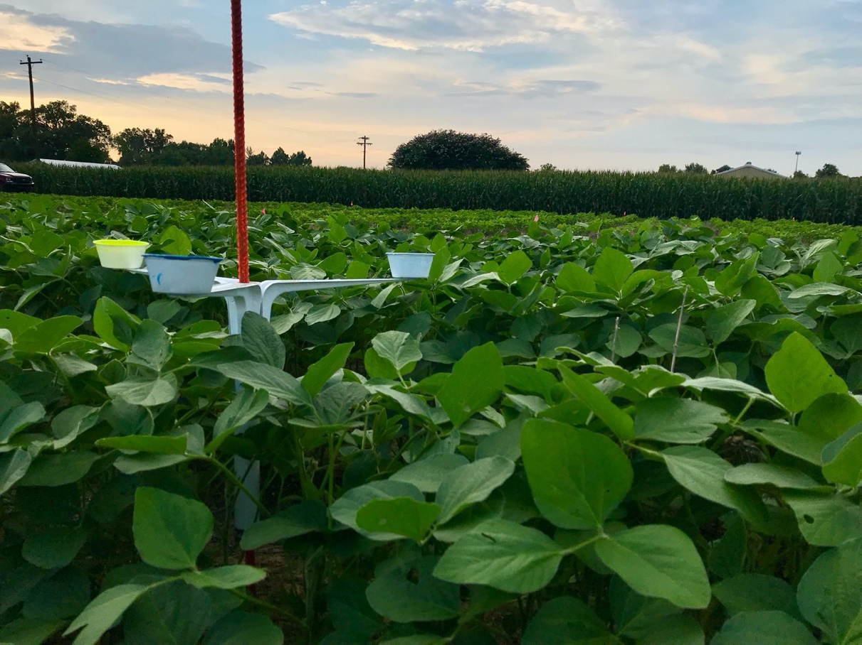
Figure 1. Blue, yellow, and white bee bowls deployed on elevated pan trapping system above soybean canopy.

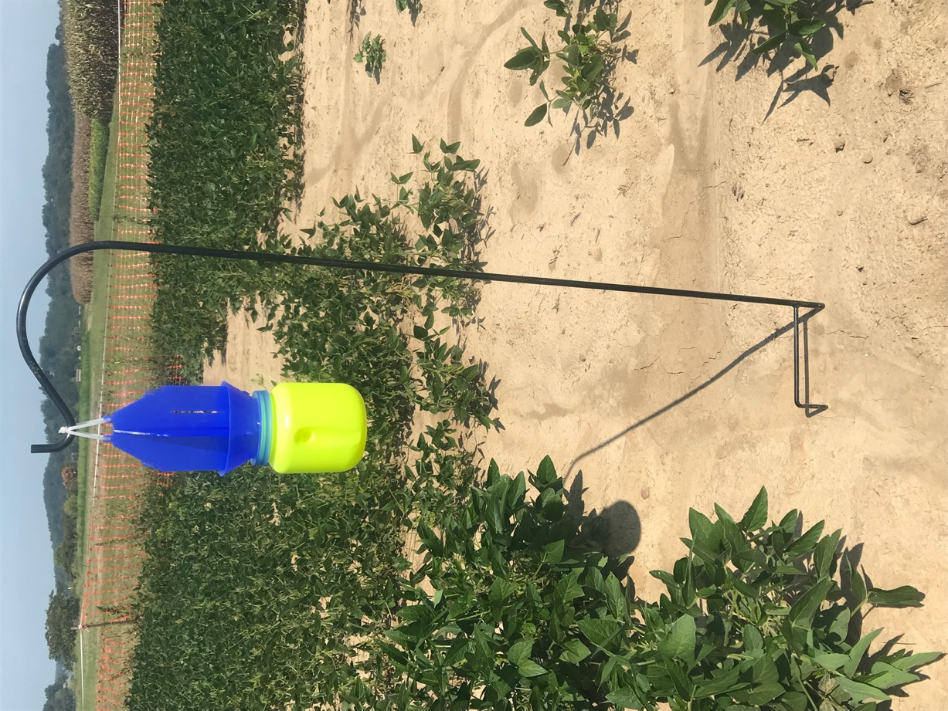
Figure 2. Blue vane trap placed in alleys of soybean plots during 2019.
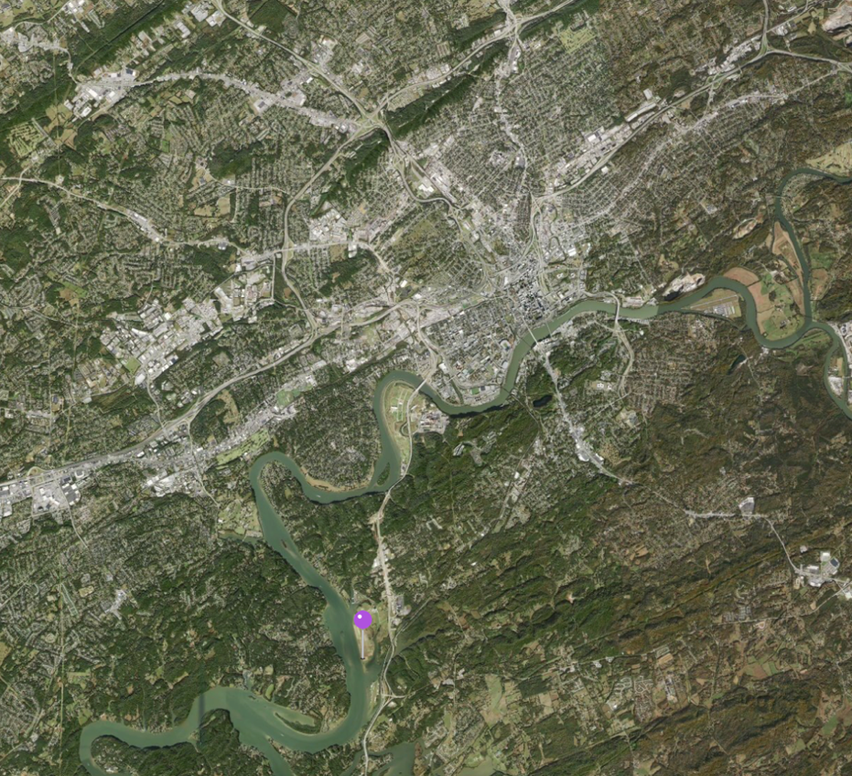
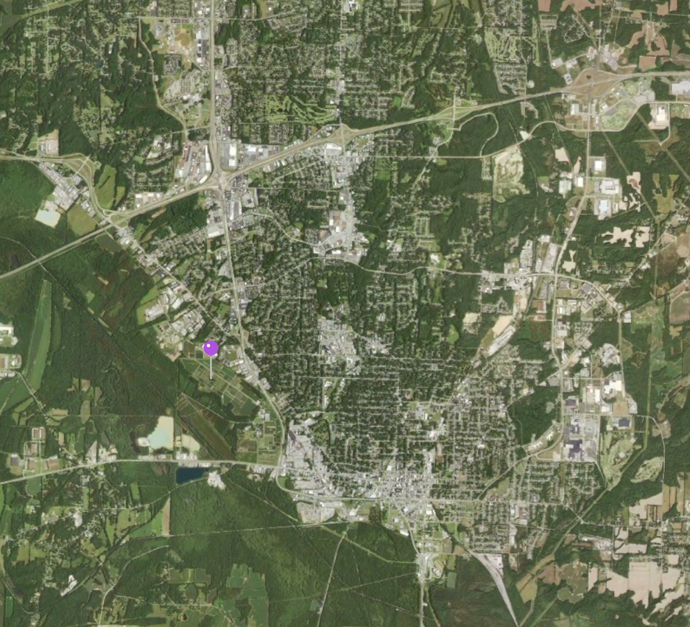
Figure 3. Satellite images of Knoxville (top) and Jackson, TN (bottom) test locations. Purple pin signifies locations of research plots during 2018-2019 growing season.

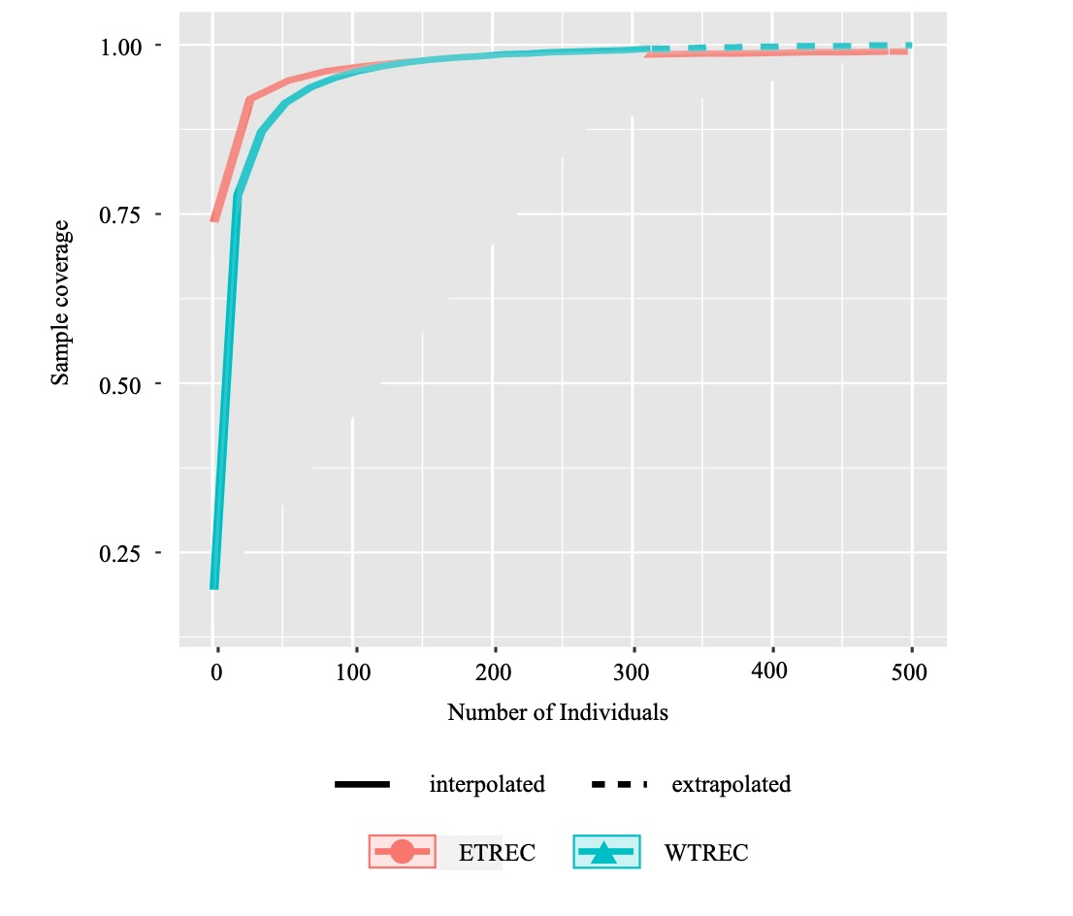
Figure 4. Rarefaction curves for bees caught in bee bowls placed in soybean at Knoxville (ETREC) and Jackson (WTREC) during 2018-2019.

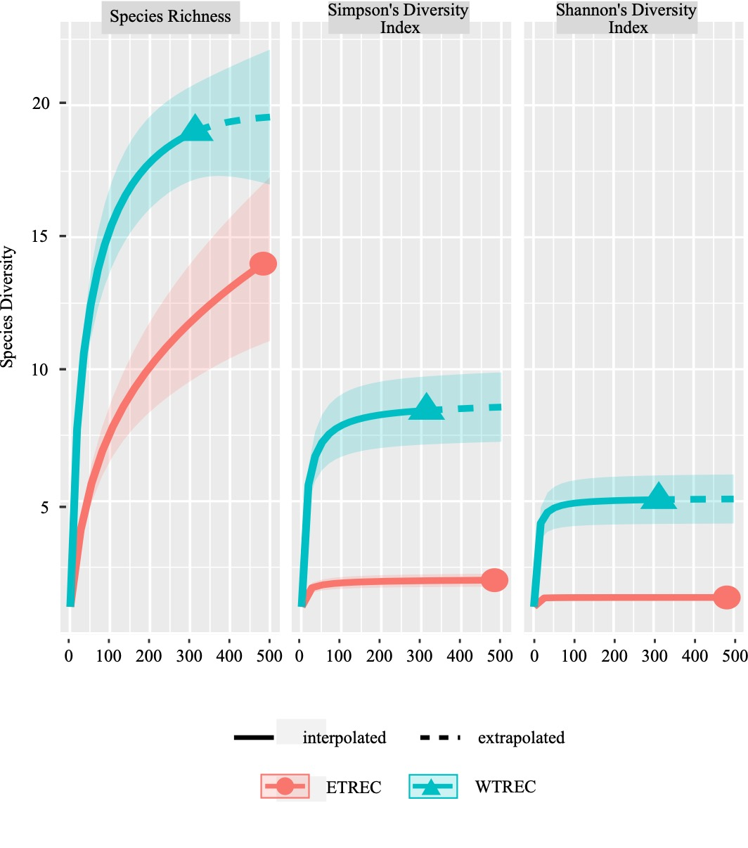
Figure 5. Generic richness curve (right), Simpson’s diversity index (middle), and Shannon’s diversity index (right) for bees caught with bee bowls placed in soybean at Knoxville (ETREC) and Jackson (WTREC) during 2018-2019.
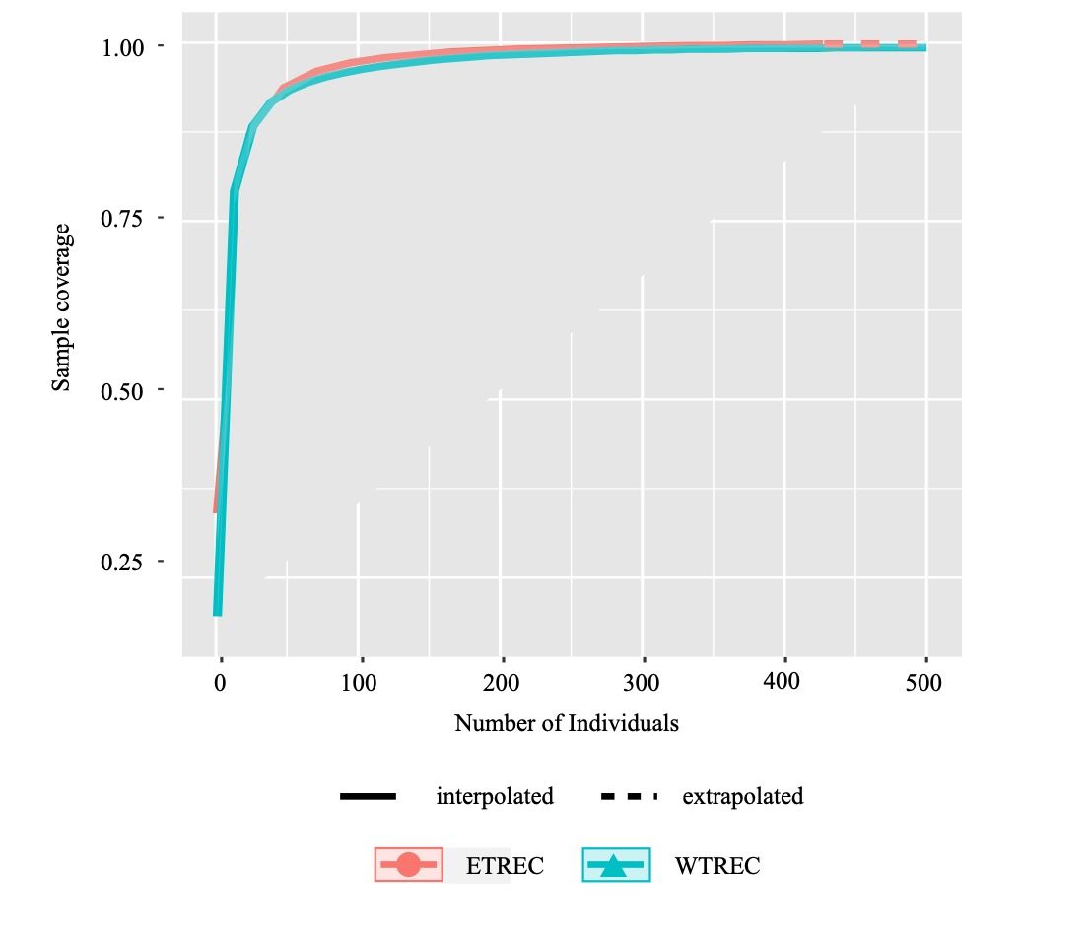
Figure 6. Rarefaction curves for bees caught with blue-vane traps (BVT) placed in soybean at Knoxville (ETREC) and Jackson (WTREC) during 2018-2019.
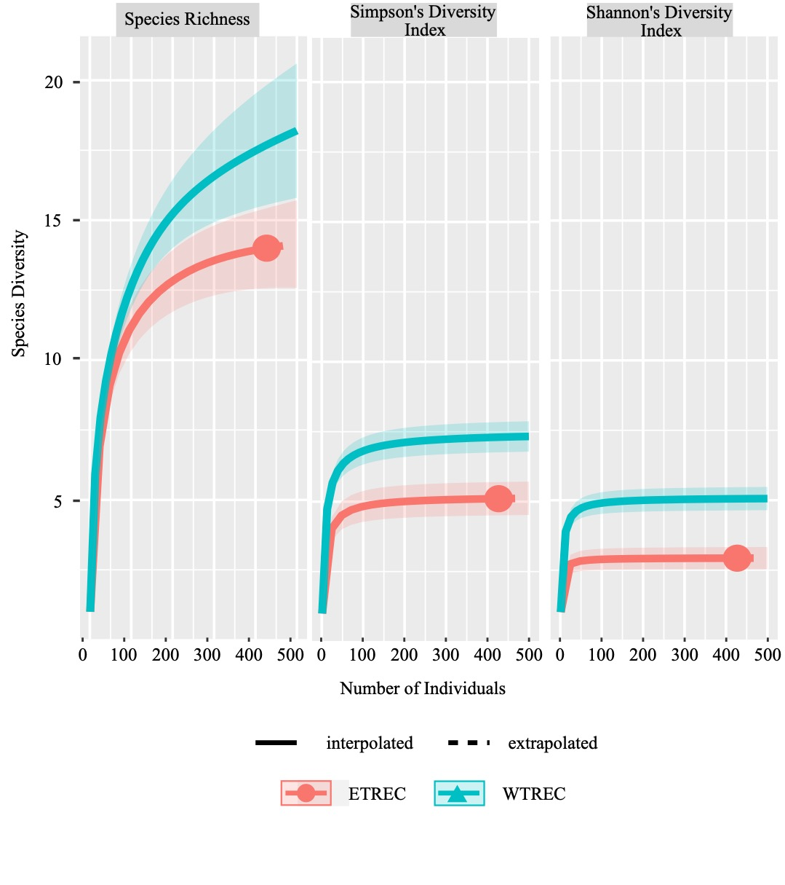
Figure 7. Generic richness curve (left), Simpson’s diversity index (middle), and Shannon’s diversity index (right) for bees caught with blue-vane traps (BVT) placed in soybean at Knoxville (ETREC) and Jackson (WTREC) during 2018-2019.
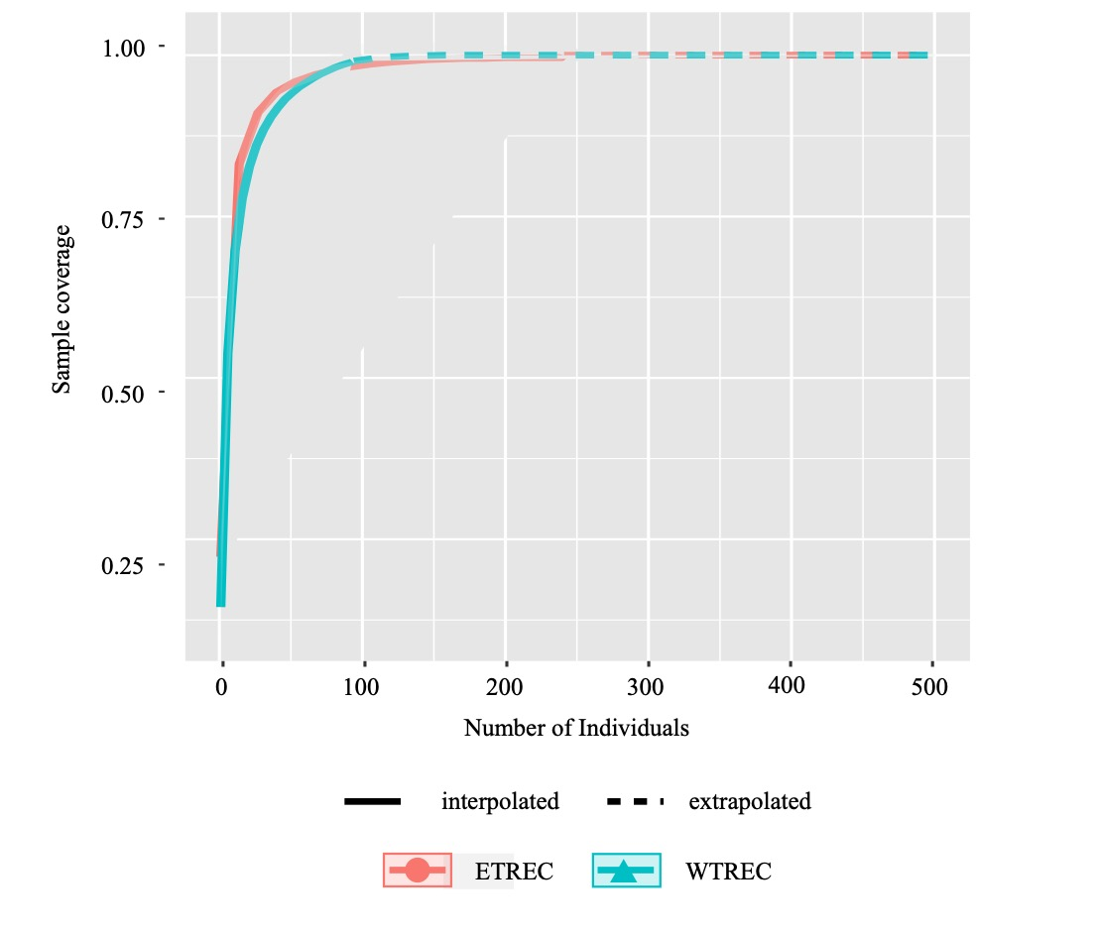
Figure 8. Rarefaction curve for bees caught in sweep-netting samples at Knoxville (ETREC) and Jackson (WTREC) during 2018-2019.
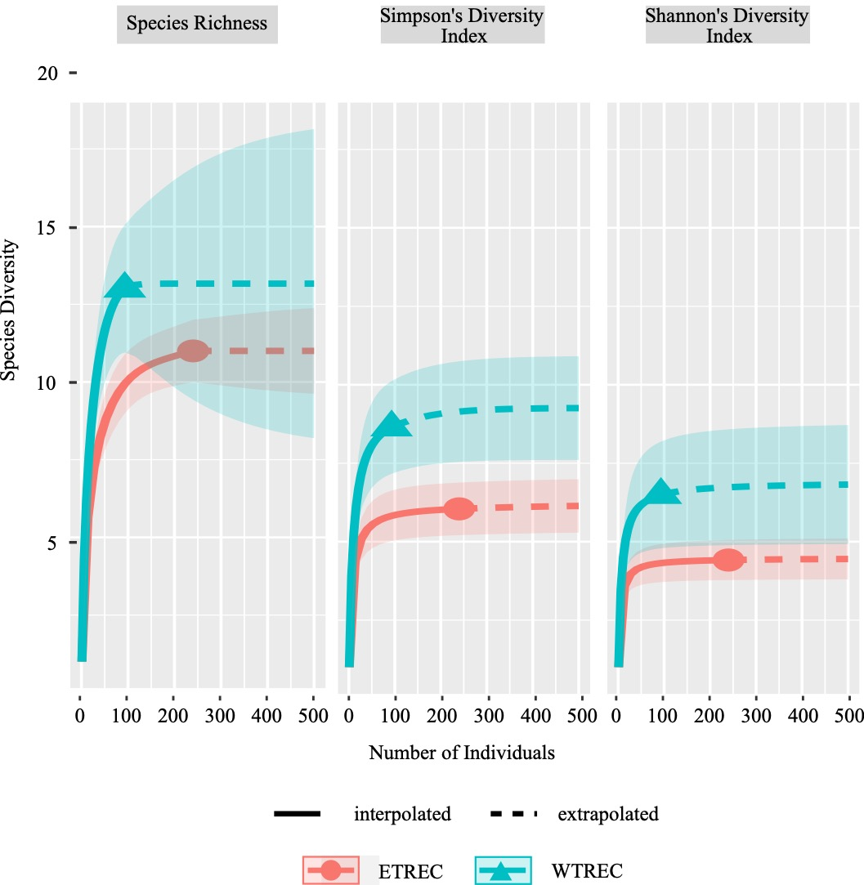
Figure 9. Generic richness curve (right), Simpson’s diversity index (middle), and Shannon’s diversity index (right) for bees caught in sweep-netting samples of soybean at Knoxville (ETREC) and Jackson (WTREC) during 2018-2019.

Figure 10. The total number of bees caught by genera across all sampling methods and both years at Knoxville and Jackson (2018-2019).

Figure 11. The total number of bees caught in July, August, and September with bee bowl, blue-vane traps and sweep-netting samples taken in soybean at Knoxville and Jackson during 2018-2019.

References
Ascher, J., & Pickering, J. (2020). Discover life bee species guide and world checklist (Hymenoptera: Apoidea: Anthophila). https://www.discoverlife.org/nh/cl/counts/Apoidea_species.html
Bartomeus, I., & Winfree, R. (2013). Pollinator declines: Reconciling scales and implications for ecosystem services. F1000Research, 2, 1–5. https://doi.org/10.12688/f1000research.2-146.v1
Breed, M. D. (2009). Honeybees. In Encyclopedia of Animal Behavior (pp. 89–96). Elsevier Inc. https://doi.org/10.1016/B978-0-08-045337-8.00044-9
Burger, H., Dötterl, S., Häberlein, C. M., Schulz, S., & Ayasse, M. (2012). An arthropod deterrent attracts specialised bees to their host plants. Oecologia, 168(3), 727–736. https://doi.org/10.1007/s00442-011-2136-4
Cane, J. H., Minckley, L., & Kervin, J. (2011). Sampling bees (Hymenoptera: Apiformes) for pollinator community studies: pitfalls of pan-trapping pans, 73(4), 225–231.
Chao, A. (1984). Non-parametric estimation of the classes in a population. Scandinavian Journal of Statistics, 11(4), 265–270. https://doi.org/10.2307/4615964
Chopra, S. S., Bakshi, B. R., & Khanna, V. (2015). Economic dependence of U.S. industrial sectors on animal-mediated pollination service. Environ. Sci. Technol., 49(24), 14441–14451. https://doi.org/10.1021/acs.est.5b03788
Danforth, B. N., Sipes, S., Fang, J., & Brady, S. G. (2006). The history of early bee diversification based on five genes plus morphology. Proceedings National Acad. Sci. United States Amer., 103(41), 15118–15123. https://doi.org/10.1073/pnas.0604033103
Di Pasquale, G., Alaux, C., Conte, Y. Le, Odoux, J. F., Pioz, M., Vaissière, B. E., Belzunces, L. P., & Decourtye, A. (2016). Variations in the availability of pollen resources affect honey bee health. PLoS ONE, 11(9), 1–15. https://doi.org/10.1371/journal.pone.0162818
Droege, S. (2005). Impact of color and size of bowl trap on numbers of bees captured. https://www.researchgate.net/publication/265563502
Erickson, E. (1984). Research notes: United States: soybean floral ecology and insect pollination. Soybean Genetics Newsletter, 11(1). https://lib.dr.iastate.edu/soybeangenetics/vol11/iss1/50
Erickson, E. H., Berger, G. A., Shannon, J. G., & Robins, J. M. (1978). Honey bee pollination increases soybean yields in the Mississippi delta region of Arkansas and Missouri. J. Econ. Entomol., 71(4), 601–603. https://doi.org/10.1093/jee/71.4.601
Esquivel, I. L., Coulson, R. N., & Brewer, M. J. (2020). A native bee, Melissodes tepaneca (Hymenoptera: Apidae), benefits cotton production. Insects, 11(8), 487. https://doi.org/10.3390/insects11080487
Frisch, K. (1967). The dance language and orientation of bees. Belknap Press of Harvard Univ. Press.
Fuentes, J. D., Chamecki, M., Roulston, T., Chen, B., & Pratt, K. R. (2016). Air pollutants degrade floral scents and increase insect foraging times. Atmospheric Environ., 141, 361–374. https://doi.org/10.1016/j.atmosenv.2016.07.002
Gill, K. A., & O’Neal, M. E. (2015). Survey of soybean insect pollinators: community identification and sampling method analysis. Environ. Entomol., 44(3), 488–498. https://doi.org/10.1093/ee/nvv001
Hodson, R. (n.d.). The world is in the midst of the largest wave of urban growth in history. Retrieved May 6, 2020, from https://go.gale.com/ps/i.do?&id=GALE%7CA446637895& v=2.1&u=tel_a_utl&it=r&p=AONE&sw=w
Kevan, P. G. (1999). Pollinators as bioindicators of the state of the environment: species, activity and diversity. Agricul., Ecosystems Environ., 74(1–3), 373–393. https://doi.org/10.1016/S0167-8809(99)00044-4
Kearns, C. A., Inouye, D. W., & Waser, N. M. (1998). Endangered mutualism: the conservation of plant pollinator interactions. Annu. Rev. Ecol. Syst., 29, 83-112. https://www-annualreviews-org.proxy.lib.utk.edu/doi/pdf/10.1146/annurev.ecolsys.29.1.83
Kimoto, C., DeBano, S. J., Thorp, R. W., Rao, S., & Stephen, W. P. (2012). Investigating temporal patterns of a native bee community in a remnant North American bunchgrass prairie using blue vane traps. J. Insect Sci., 12(108), 1–23. https://doi.org/10.1673/031.012.10801
Klein, A. M., Boreux, V., Fornoff, F., Mupepele, A. C., & Pufal, G. (2018). Relevance of wild and managed bees for human well-being. Curr. Opin. Insect Sci., 26, 82–88. https://doi.org/10.1016/j.cois.2018.02.011
Klein, S., Cabirol, A., Devaud, J. M., Barron, A. B., & Lihoreau, M. (2017). Why bees are so vulnerable to environmental stressors. Trends Ecol. Evol., 32(4), 268–278. https://doi.org/10.1016/j.tree.2016.12.009
Knuth, P. (1906). Handbook of flower pollination based upon Hermann Müller’s work “The fertilisation of flowers by insects”. Oxford. http://hdl.handle.net/2027/hvd.32044106322951
Kremen, C., Williams, N. M., & Thorp, R. W. (2002). Crop pollination from native bees at risk from agricultural intensification. Proceed. Nat. Acad. Sci. United States of Amer., 99(26), 16812–16816. https://doi.org/10.1073/pnas.262413599
Losey, J. E., & Vaughan, M. (2006). The economic value of ecological services provided by insects. BioScience, 56(4), 311–323. https://link.gale.com/apps/doc/A145065425/AONE?u=tel_a_utl&sid=AONE&xid=cc99ef18
Maldonado, M. B., Lomáscolo, S. B., & Vázquez, D. P. (2013). The importance of pollinator generalization and abundance for the reproductive success of a generalist plant. PLoS ONE, 8(10), e75482. https://doi.org/10.1371/journal.pone.0075482
Mallinger, R. E., Gibbs, J., & Gratton, C. (2016). Diverse landscapes have a higher abundance and species richness of spring wild bees by providing complementary floral resources over bees’ foraging periods. Landscape Ecol., 31(7), 1523–1535. https://doi.org/10.1007/s10980-015-0332-z
Michener, C. D. (2000). The bees of the world. Johns Hopkins University Press.
Neff, J. L., Simpson, B. B., & Vogel, S. (2017). Vogel’s great legacy: the oil flower and oil-collecting bee syndrome. Flora, 232, 104–116. https://doi.org/10.1016/j.flora.2017.01.003
Parys, K. A., Esquivel, I. L., Wright, K. W., Griswold, T., & Brewer, M. J. (2020). Native pollinators (Hymenoptera: Anthophila) in cotton grown in the gulf south, United States. Agronomy, 10(5), 698. https://doi.org/10.3390/agronomy10050698
Pemberton, R. W. (2010). Biotic resource needs of specialist orchid pollinators. Botanical Review, 76(2), 275–292. https://doi.org/10.1007/s12229-010-9047-7
Portman, Z. M., Bruninga-Socolar, B., & Cariveau, D. P. (2020). The state of bee monitoring in the United States: a call to refocus away from bowl traps and towards more effective methods. Annals Entomol. Soc. Amer. https://doi.org/10.1093/aesa/saaa010
Potts, S. G., Biesmeijer, J. C., Kremen, C., Neumann, P., Schweiger, O., & Kunin, W. E. (2010). Global pollinator declines: trends, impacts and drivers. Trends Ecol. Evol., 25(6), 345–353. https://doi.org/10.1016/j.tree.2010.01.007
Preliminary results: 2017-2018 Total and average honey bee colony losses by state and the District of Columbia – Bee Informed Partnership. (n.d.). Retrieved May 20, 2020, from https://beeinformed.org/2018/06/21/preliminary-results-2017-2018-total-and-average-honey-bee-colony-losses-by-state-and-the-district-of-columbia/
Ricigliano, V. A., Mott, B. M., Floyd, A. S., Copeland, D. C., Carroll, M. J., & Anderson, K. E. (2018). Honey bees overwintering in a southern climate: longitudinal effects of nutrition and queen age on colony-level molecular physiology and performance. Scientific Reports, 8(1), 1–11. https://doi.org/10.1038/s41598-018-28732-z
Ritchie, A. D., Ruppel, R., & Jha, S. (2016). Generalist behavior describes pollen foraging for perceived oligolectic and polylectic bees. Environ. Entomol., 45(4), 909–919. https://doi.org/10.1093/ee/nvw032
Roulston, T. H., Smith, S. A., & Brewster, A. L. (2007). A comparison of pan trap and intensive net sampling techniques for documenting a bee (Hymenoptera: Apiformes) fauna. J. Kansas Entomol. Soc. 80(2). https://www.jstor.org/stable/25086376
Russo, L., Nichol, C., & Shea, K. (2016). Pollinator floral provisioning by a plant invader: quantifying beneficial effects of detrimental species. Divers. Distrib., 22(2), 189–198. https://doi.org/10.1111/ddi.12397
Schmidt, N. P., O’Neal, M. E., & Dixon, P. M. (2008). Aphidophagous predators in Iowa soybean: a community comparison across multiple years and sampling methods. Annals Entomol. Soc. Amer., 101(2), 341–350. https://lib.dr.iastate.edu/cgi/viewcontent.cgi?article=1012&context=ent_pubs
Scofield, H. N., & Mattila, H. R. (2015). Honey bee workers that are pollen stressed as larvae become poor foragers and waggle dancers as adults. PLoS ONE, 10(4), 1–19. https://doi.org/10.1371/journal.pone.0121731
Simpson, E. H. (1949). Measurement of diversity [16]. In Nature 163(4148), 688. Nature Publishing Group. https://doi.org/10.1038/163688a0
Sircom, J., Arul Jothi, G., & Pinksen, J. (2018). Monitoring bee populations: are eusocial bees attracted to different colours of pan trap than other bees? J. Insect Conserv., 22(3–4), 433–441. https://doi.org/10.1007/s10841-018-0071-y
Spellerberg, I. F., & Fedor, P. J. (2003). A tribute to Claude-Shannon (1916-2001) and a plea for more rigorous use of species richness, species diversity and the “Shannon-Wiener” Index. Glob. Ecol. Biogeogr., 12(3), 177–179. https://doi.org/10.1046/j.1466-822X.2003.00015.x
Stephen, W. P., & Rao, S. (2014). Unscented color traps for non-Apis bees (Hymenoptera: Apiformes ) J. Kansas Entomol. Soc., 78(4), 373–380. https://bioone.org/journals/journal-of-the-kansas-entomological-society/volume-78/issue-4/0410.03.1/Unscented-Color-Traps-for-Non-Apis-Bees-Hymenoptera-Apiformes/10.2317/0410.03.1.short
Hsieh, T. C., Ma, K. H., & Chao, A. (2020). iNEXT: interpolation and extrapolation for species diversity. https://cran.r-project.org/web/packages/iNEXT/iNEXT.pdf
Team, R. C. (2018). R: A language and environment for statistical computing. R Foundation for Statistical Computing, Vienna, Austria. https://www.r-project.org/.%0A%0A
Tepedino, V. J. (1981). The pollination efficiency of the squash bee (Peponapis pruinosa) and the honey bee (Apis mellifera) on summer squash (Cucurbita pepo). J. Kansas Entomol. Soc., 54(2), 359-357. https://www.jstor.org/stable/25084168?seq=1
Tuell, J. K., & Isaacs, R. (2009). Elevated pan traps to monitor bees in flowering crop canopies. Entomol. Exper. et Applicata, 131(1), 93–98. https://doi.org/10.1111/j.1570-7458.2009.00826.x
Vaudo, A. D., Tooker, J. F., Grozinger, C. M., & Patch, H. M. (2015). Bee nutrition and floral resource restoration. Curr. Opin. Insect Sci., 10, 133–141. https://doi.org/10.1016/j.cois.2015.05.008
Wardhaugh, C. W. (2015). How many species of arthropods visit flowers? Arthropod Plant Interactions, 9(6), 547–565. https://doi.org/10.1007/s11829-015-9398-4
Wheelock, M. J., Rey, K. P., & O’Neal, M. E. (2016). Defining the insect pollinator community found in Iowa corn and soybean fields: implications for pollinator conservation. Environ. Entomol., 45(5), 1099–1106. https://doi.org/10.1093/ee/nvw087
Wickham, H. (2016). ggplot2 (2nd ed.). Springer International publishing. https://link-springer-com.proxy.lib.utk.edu/book/10.1007%2F978-3-319-24277-4
Wilson, J. S., & Carril, O. M. (2016). The bees in your backyard. Princeton Univ. Press.
Wilson, J.S.; Griswold, T.; Messinger, O.J. (2008). Sampling bee communities (Hymenoptera: Apiformes) in a desert landscape: Are pan traps sufficient? J. Kansas Entomol. Soc. 81, 288–300. https://www.jstor.org/stable/25086445
Woodard, S. H., & Jha, S. (2017). Wild bee nutritional ecology: predicting pollinator population dynamics, movement, and services from floral resources. Curr. Opin. Insect Sci., 21, 83–90. https://www.sciencedirect.com/science/article/pii/S2214574517300615
Ziska, L. H., Pettis, J. S., Edwards, J., Hancock, J. E., Tomecek, M. B., Clark, A., Dukes, J. S., Loladze, I., & Polley, H. W. (2016). Rising atmospheric CO2 is reducing the protein concentration of a floral pollen source essential for North American bees. Proceed. Royal Soc. Biol. Sci., 283(1828), 20160414. https://doi.org/10.1098/rspb.2016.0414

VITA

Andrew Lowell Lawson was born November 28th, 1990 in Knoxville, Tn. He attended elementary school at Berean Christian School as well as homeschool and graduated from Carter Highschool in the Knox County School District in 2009. He obtained his Associates of Science from Pellissippi State Community College in 2015 where he earned the Outstanding Student Award in the subject of Botany. He received the degree of Bachelor of Science in Plant Sciences from the University of Tennessee in 2017. In 2020 he completed the degree of Masters of Science in Entomology.

