A Study of Greek and Roman Stylistic Elements in the Portraiture of Livia Drusilla

Honors Thesis Project

Chloe Lovelace

Faculty Advisor: Dr. Stephen Collins-Elliott

Department of Classics

Introduction

For the past three-hundred years or so, the study of Roman art has been seen through the lens of the 18th century German elite; their writings have been translated, analyzed, debunked, praised, but we cannot remove ourselves from their original work, or their original prejudices. Though revolutionary, establishing the nascence of art history itself, they limited Roman art to a category of imitation, rather than viewing it as art on its own. Rome is punished eternally for the arbitration of time—its place later in history has given it a reputation as a state of cultural appropriation. Even today, the modern need for originality places the onus on Rome to produce something as new, as strikingly unique, as the art of the endlessly creative Greeks. One cannot deny that Roman art is a reflection of the cultures that Rome enveloped during the expansion of the empire. However, it is the incorporation of those foreign styles and the consolidation of the Roman tradition that resulted in art that is messy, complicated, indefinable, and purely Roman.
The inclusion of these foreign elements creates Roman sculpture, rather than take away its value as Roman art. This can be seen in the portraiture of Livia Drusilla, the first empress of Rome, whose portraits effectively use both Roman and Greek elements to create her own public image. Using her portraiture, I aim to show that foreign elements in sculpture do not diminish its intrinsic Roman qualities, but rather help to enhance a Roman message. I will explore the various stylistic categorical nuances of Livia’s portraiture, which range from almost unrecognizably veristic to semi-archaised, to near-classical, though Livia’s portraiture never fully reaches the utmost idealized state. The distinctions pressed by these variants of portrait types are representative of both changes in the life of Livia—the death of Augustus, her own death, her deification— and of contexts, both known and supposed, of the portraits, and are most represented by her changing hairstyles, from a traditional Roman nodus to a conventional Greek style.
Seneca describes Livia as “feminam opinionis suae custodem diligentissimam” (“woman who was the most diligent protector of her reputation”) (Cons.Marc. 4.4), which is one of the more specific descriptors of Livia as a woman in her own right, rather than the wife or mother of an empress. It is clear that her portraiture has been carefully curated to reflect specific values and traditions both emphasized by Augustan leadership and easily relatable to the Roman people. Her role, or simply her association with Octavian, placed her at the forefront of ending a terrible civil war and she sought to maintain, through her public image, the feminine virtues that became a part of her own narrative and were publicly championed by Octavian (pietas, iustitia, and clementia). She is never portrayed in a luxurious or obscenely beautiful fashion, as “the very ordinariness of Livia… was one of her strongest assets”. She promoted Roman virtues, and tied the imperial family back to Roman tradition with verism, instead of emphasizing divinity or idealness like her husband. Her normalcy is just as intentional as Augustus’ sculptural perfection, and she achieves this using the elements of veristic and classical sculptural styles.
Categorical Importance and Definitions
Ancient art is defined by and studied within the parameters of categorical definitions, sometimes applying modern opinions and art historical terms to ancient stylistic choices. This problematic use of categories traps ancient art in a constant competition between the Greeks and everyone else, especially the Romans, who are seen as their counterpart in the ancient world. Johann Joachim Winckelmann began this strict categorization and tied the noose for the Romans with his proverbial styles of art—ancient, grand or high style, beautiful style, and the style of the imitators, which persevered “until art gradually declined to its fall”. Winckelmann’s theory hinged on the belief that culture was cyclical, building up to an artistic acme and then experiencing a decline. The Romans, according to Winckelmann, facilitated this decline, following the Greeks who he thought had perfected an interpretation of the human condition. Further, his insistence on Greek art as “superior” has given those who study art history the opportunity to brush Roman art under the rug, aligning it with the myth of the copies. In order to discuss Roman portraiture, there must first be a brief analysis of what, exactly, Roman art styles entail, and how much of it is Greek, rather than Roman.
Verism, or hyper-realistic portraiture, has long been seen as the “most Roman” of Roman art, portraying a presumed extreme realism that was not seen in art before the Romans. It is, for many, the Romans’ saving grace in originality, since this specific portrait style is not seen in Greek art. However, this view of verism returns to the misconception that, in order for art to be considered “Roman” it must reject Greek artistic concepts, which excludes the other prevailing notion that in order for Roman art to be considered “good” it must be Greek.
Because of its specificity to Roman culture, verism is oft categorized as Roman art style. There is some debate, however, as to the origins of verism, as best illustrated by R.R.R. Smith’s article “Greeks, Foreigners, and Roman Republican Portraits”. Smith contends that verism was not invented by the Romans but was an artistic coping mechanism for Greek sculptors, who were conscious of the importance of a division between Greeks and non-Greeks. Hellenistic rulers, too, were depicted in a realistic manner. This realism was not as harsh as that of the Romans, whose portraits would have been sculpted by the then-conquered Greek artists who had been taken to Rome. Smith writes that the intensity of the realism was a result of the Greeks’ hatred towards their Roman conquerors, and the more realistically they portrayed the Romans, the more stark the contrast with their own idealized Greek forms. The results were wrinkled, frowning faces, with emphasized imperfections and a tone of seriousness rather than serenity. This style became popular with portraiture of the Late Republican period, as it reflected the gravitas craved by so many aristocrats of the time, whether or not it originated with the Romans. A wrinkled face and furrowed brows were desired qualities, giving the subject authority and self- importance. Instead of seeing it as an insult or a decline in artistic depiction from the classical period, it became something Roman unto itself, reflecting their own touted values and even further establishing the ideals of the period. The Romans admired old age, correlating it with a lifetime of hard work and wisdom, rather than associating it with undesirable physical features. While Smith may be correct about the Greek origins of the style, as a whole, it does not become any less Roman, nor does it cease to be one of the most impressive forms of ancient art, as it allows modern viewers to, more or less look at ancient people.
Verism can be seen not only in the Late Republic and Hellenistic periods, but in the Imperial period in Rome as well. This later verism is a reflection of republican stylistic features: hairstyles (e.g., nodus), wrinkles, and disproportionate features (especially in comparison to classicized portraits and sculpture). Later verism may not be as harsh as earlier portraits but it embodies a defining feature of lending a distinct emotional and physical impression to the sculpture, which classicism lacks. While classicized portraits are serene in their perfection, illustrating the ideal physical and moral Greek or Roman, veristic portraits create a sense of weariness and, naturally, reality, rather than an unachievable goal of excellence. This reality, as exemplified through flawed features, elevates the moral traits supported by the Romans by making them attainable. The essence of true humanity is portrayed through these portrait features, giving life to its subjects, rather than elevating them to something, which is unattainable. By adding characteristics of this style to later art, which is largely based on Greek works, Roman art is able to maintain, or create, its “Roman-ness” within the framework of classical style.
Classicism presents a similar problem in terms of categorization. Heralded by Winckelmann as the greatest form of art from antiquity, it established the modern-thought of Greek artistic supremacy over contemporary cultures. Traditionally, classicism is identified by its idealistic forms, proportionality and gracefulness, sought after by sculptors across the ancient world, but fully achieved only by the Greeks (and, first, by the Egyptians). Greek classicism also typically utilized the so-called “heroic nude” in idealization processes, usually in depictions of male heroes and deities. A lack of flaws and other defining physical characteristics also permeated the style of classicism.
Though conventional definitions imply a higher statusof the Greek sculptors to those in Rome, these standards were not abandoned by the classicizing styles of Augustus in the late first centuries BCE. Tonio Hölscher writes that the language of Roman art “has its primary framework in its typological borrowings from the Greek past, just as written or spoken language has its frame in its syntax or vocabulary”. Much like modern art historians defining ancient art in contemporary terms, the Romans applied their own terms to classicism, adapting it to fit their needs accordingly. The Romans appropriated the style to display a sense of dignitas and auctoritas, which were ideal characterizations of Roman leadership, but notably absent from Greek visual language. This distinction alone creates a separation between Roman and Greek classicism, if only in its contextual meaning. The use of Greek elements demonstrated also an admiration of Greece by the Romans, and allowed for wealthy Romans to link themselves to images of Greek gods, heroes, and the Golden Age of Pericles.
Romans used classicism with intention to build upon their own visual and national narrative, rather than just for the sake of copying or for aesthetic impressions. Certain aspects, such as the aforementioned heroic nude trope, were less frequent in Roman sculpture, excepting in certain workshops in Magna Graecia during the imperial period. The features of the Greek Classical period were used sparingly and with specific functions in Roman sculptural tradition, usually to emphasize peace and serenity within the empire, especially during the Augustan period. Perpetual youthfulness is an evident component of classicized works in Rome, adding to the allusion of perfection and the divine nature of the emperor and his (male) clan. Roman classicism utilizes proportionality, idealization of the face and body, and the inclusion of certain status symbols, used often as identifiers for portraits- most notably hairstyles. The intentionality of classicism, and of verism, in sculpture and portraiture is essential to understanding Roman art and its meaning.
Livia’s portraiture lay somewhere on the spectrum that exists between classicism and verism. While Augustan portraiture displays almost entirely classicized traits, Livia’s portraits are more nuanced, reflecting both aspects of classicizing features and tendencies towards verism. Her portraiture, from the mid-thirties BCE all the way through to the early first century CE runs the metaphorical gamut of Roman portraiture styles—beginning in strict classical style and wavering subsequently in and out of a combination of verism and classicism, without ever employing an entirely veristic depiction.
There is some difficulty in creating a making a failsafe identification of portraits of Livia, given the similarity in time and place of portraits of Octavia and Julia. We must base our identifications solely on historical and visual data. Literary accounts, unfortunately, are skewed both by a proclivity towards appeasement and by the absence of physical description of women in antiquity. Aside from descriptions of Livia as “beautiful” and Ovid’s flattering characterizations, little is known about Livia’s physical appearance outside of portraits. This lack of literary assemblage and epigraphic confirmation of historical accounts of Livia’s portraits further complicates the matter, along with the inconsistency of Livia’s features in variant areas of time and space. Her characteristically small mouth , almond shaped eyes, and her hairstyles are the only consistent features that allow art historians and archaeologists to identify her portraits. Because of the cultural and stylistic breadth of the empire and the difficulties in conceiving a cohesive concept of Roman art, many of Livia’s portraits look quite different from one another, varying in size, style, and technique, even in the presence of these conventional features. Despite these challenges, Livia’s portraiture has been divided into four types named after their modern locations: the Villa Albani-Bonn Type (late 30s BCE, wears a nodus hairstyle, extremely classicized), the Copenhagen Type 616 (ca. 30 BCE, broader nodus and long, loose curls), the Copenhagen Type 615 (depicts more specific facial features to Livia) and the Marbury Hall Type (20- 10 BCE, a depiction of the older empress). This list, while extensive, should not be considered as all-inclusive, given the variations and inconsistencies of Livia’s portraiture throughout the Roman empire, and throughout the reigns of her husband and her descendants. The categorical types are, however, useful in identifying portraits and their contexts, the latter of which are often lost due to poor excavation documentation and the antiquities black market.
Portraiture and Discussion
Roman sculptural tradition is entrenched in aesthetic nuances, developed with the styles popular in the period. Classicism’s obliteration of realistic human characteristics and verism’s emphasis on them are merged together in Livia’s portraits to share a specific aspect of her personal public image. A repeated and striking feature of Livia’s portraits over time is the hairstyle chosen for her sculptures. Traditionally, she is shown with the nodus, which is usually depicted as mainly a broad section of hair rolled over onto her forehead with curls framing her face, with the rest of the hair wrapped into a bun on the nape of the neck. Some portraits show her hair in distinct waves as it is pulled back into a bun, while others show a smooth, indistinguishable surface; some portraits also distinguish a braid leading from the nodus itself to the bun in the back.
Scholarly consensus has established that Livia (or Augustan women in general) popularized this nodus style, but this idea does not seem to match the evidence. Earlier Republican portraits of women, those which epitomize the veristic style, wear the nodus, long before Livia’s own portraits. Many sculptures of women from the late Republican period show the subject wearing variations of this style. They do not match entirely with Livia’s own style, as some of the nodus curls are very small, and almost look like a large, horizontal curl on the forehead, while others are large. Different portraits also show varying hair textures (wavy and straight) and occasionally include a braid, which ties the nodus to the bun. However, these variations do not change the fact that much of the female portraiture from the Late Republic displayed a hairstyle nearly identical to Livia’s, even if the execution of the style is different among portraits. Thus, to call Livia an innovator of style when it is evident throughout Republican portraiture ignores the decades of Republican portraiture that came before Livia’s own lifetime. The theory of innovation, of Livia as a trendsetter for this style, seems lacking in terms of why the style is kept in her portraiture up until the Tiberian period. If this were part of a trend, one would think that Livia’s sculptural portrayals would have departed from the hairstyle during the Augustan period, as the hairstyle reached its zenith during the Late Republican period. Livia’s distinguishing facial characteristics could have alone served as identification for her portraits, and her hairstyle could have easily changed from the older nodus style. The fact that it persisted throughout the entire Augustan period would indicate that it had meaning beyond Livia as a trendsetter. Modern accounts, in fact, note that the nodus would have been out of fashion even at the time that her portraits showed it. Further, the implication of Livia’s hairstyle in the Pentelic marble portrait (Fig. 1) creates a distinction between Roman pragmaticism and the luxuriousness of the Eastern Empire, as personified by Cleopatra, furthering the goals of Octavian’s visual propaganda. This is not due to Livia’s fashionability, rather her purpose as a vehicle of Roman tradition. Anthony Barrett writes that it was “Livia’s dull normalcy [that] was reassuring”, instead of any role as a trendsetter, which encourages this theory.
As the “first woman in the history of the West depicted systematically in portraits”, Livia’s portraiture was spread throughout the Roman empire, with many of today’s surviving portraits coming from outside of Rome. In the same light, her portraits were a part of the Augustan artistic program, promoting certain moral ideals in her portrayals (and those of her husband). These depictions began as classicized portraits and evolved to reflect both changing social mores and Livia’s own growth as an individual.
Livia’s portraiture retains the nodus hairstyle throughout her lifetime, only changing in portrait sculpture at the end of her life and after her death. It is also an aspect of her visual narrative that is purely Roman in style, and it is reminiscent of an older Rome, the Rome in which the deified Julius Caesar lived. This latter point is necessary to the discussion of Livia’s image because it associates her with the Republican period in a way that Augustus did not do to himself. Augustus used his visual program to emphasize his connection with the then deified Julius Caesar through allusions to Venus Genetrix and through building temples in his honor, but does not use his own physical features to accomplish this, nor does he specifically reference the Republican period. Instead, he prefers to use his affiliation with the divine Caesar to more intently focus and promote his own Golden Age, while referencing the Periclean Golden Age with his sculpture. However, Livia completes that gap in the narrative. By utilizing a traditionally Republican style, she reminds the viewer of the austere and severe visual tradition of the veristic Republican period and of the modesty, grace, and loyalty that was so important to being a woman of Rome. Contrast this style to the elegance of Livia’s classicized face and features in the Pentelic marble portrait, and an amalgamation of messages can be seen. On the one hand, the sculpture recalls the past, which is a concept that is revered by the Romans (and vehemently advocated for by Augustus), and on the other, it incorporates the pristineness of the peace to come with the Augustan period.
There is no identifiable Greek parallel to the nodus hairstyle, nor was it the only hair style available during the Augustan period, implicating it as an intentional choice on the part of Livia and Augustus. Ovid, in the Ars Amortia, writes on the topic, suggesting that those with more plump, rounder faces opt for a nodus style, despite the simplicity of other styles, which could partially explain the choice, as Livia is shown, early-on, with round cheeks and a chin that tapers to a sharp point. He also observed that the other popular style of the time, which was, in fact, the middle part style popularized by statues of Greek goddesses, would have connected the empress too readily with the divine, a blatant comment on the couple that Augustus did not wish to obviously bestow himself. Perhaps this was an effort not to overwhelm the Roman people with images of the divine, as Augustus’ own portraiture shows him with the Julio-Claudian locks so indicative of young male gods, and with allusion upon allusion to Apollo and to Venus Genetrix. Livia, in her simplicity and her decidedly non-divine nature at the beginning of her relationship with the Roman people, served to fulfill the need in the visual narrative of the modest, Roman woman.
The Pentelic marble portrait of Livia (Fig. 1), was made in the mid to late 30s BCE, shortly after her marriage to Octavian and right before his victory at Actium. Its archeological context is unknown, creating several issues in terms of imagining the viewer and the impact the portrait would have had in terms of the Augustan visual program. The lack of context does not diminish the importance of the portrait in terms of iconography. It has been identified by scholars as Livia, because its features are holistically consistent with conventional identification methods. Though it is now damaged, it is still a fairly good example of the classicized portraiture of Livia, which is reflective of Octavian’s portraiture of the time. Here she is shown with almond-shaped eyes, looking downwards, with a small, rounded mouth, somewhat curved upwards. Her nose, which would have been curved, is prominently featured on her serene face. She wears her hair in a nodus, which would have been popular among high-society women during the 30s BCE. The method of carving would have allowed for the bust to have been inserted into a full statue, but it is unclear if it ever was. This is one of the most classicized portraits of Livia, looking off into space, calm and serene, but lacking in any sort of expressivity. Kleiner and Matheson pose that she is styled in this way (especially regarding the simplicity of her hair style) to counter the “oriental excess” of Cleopatra’s portraiture at the time. Further, her conservative depiction and traditional hairstyle would have reminded the viewer of Roman social values that Octavian was championing in his civil war against Marc Antony, allowing Octavian to claim his victories as victories for Roman values. This would have paralleled Octavian’s own portraits, which emphasized his connections to Apollo and the importance of avenging the death of his adoptive father, as well as the depravity and excessiveness of Marc Antony’s lifestyle in the East.
The so-called Arsinoe Livia (Fig. 2), currently exhibited in Copenhagen’s Ny Carlsberg Glyptotek, is another marble portrait of the empress from after the time of Augustus’ death in 14 CE. She again wears her recognizable nodus and her face is nearly without surface imperfections, a traditionally classical attribute. This portrait is representative of the Copenhagen type 615 portraiture of Livia, and was the most widely distributed of all of the types of Livian portraiture. It was found as a part of a dynastic group in Arsinoe in Egypt, where she would have been displayed alongside portraits of her husband and son. The portrait type’s breadth of distribution and its high frequency of discovery in the art historical and archaeological record diminishes any importance of inconsistencies and variations among this particular portrait type. Further, its location outside of Rome itself would indicate that this is how a great deal of the empire would have seen the empress, highlighting the importance of this particular portrait type, especially after the death of Augustus, when it would have been popular.
The Arsinoe Livia presents several veristic characteristics absent from her Late Republican counterpart. Her cheeks are more defined, and her face is less oval-shaped, potentially indicative of age. Her eyes, while still the same almond-shape as before, are larger, and her eyebrows are more emphasized. She has stray curls framing her face, carefully carved along her cheekbones and forehead. She looks straight on, rather than downwards, and has wrinkles on her neck, which are not seen in the Late Republican portrait. Her stare is less of a blank serenity than it is expressive of a confident existence—while it is not emotionally expressive, this Livia shows fortitude, while the earlier one shows an almost bored quietness. These new features are representative of values much more substantial than a contrast between the practicality of the Romans and the ornateness of the East. These specific aspects are “not an arbitrary relativism that prevails, nor a pure preference, but a selection, which is geared towards best expressing the message”. Based on this portrait, there is a shift in the values emphasized by Livia’s image, moving away from the youthful purity of the Pentelic marble Livia and creating a new role for Livia as a matriarch. She shows tradition with her nodus, but also emphasizes the necessary qualities of the contemporary Roman woman. She is strong, conservative in appearance, and maternal, especially considering this portrait’s context next to her son and husband.
Staying true to the late Republican style of portrait, there exists an unexpected piece in the Livian catalogue of sculpture. A bust found in the remains of a Roman villa at Ampurias in 1947, identified as Livia, shows the empress at a shockingly mature age, resembling more a sculpture from the time of Livia’s birth than the time of her death (Fig. 3). Even more surprising is the proposed dating of this portrait to the Augustan period, which would imply that it would have been created before the time of Augustus’ death. While it is more common for more mature looking portraiture of Livia to have been created after her husband’s death, this portrait has been placed solidly in the Augustan period. The main identifying characteristic for Livia in this portrait, is her distinguished nodus hairstyle. This portrait to be identified as Livia for this reason, because, while the hairstyle would have been featured on many busts of women in the Republican period, the imperial portrait style allows Livia to distinguish herself with this nodus. However, the heaviness of her face, perhaps weighed down by unfamiliar old age, combined with an uncharacteristically wide mouth and thin lips, give reason to be at least a little skeptical of the identification. It is, however, similar to the Marbury Hall type, which depicts Livia at a more advanced age, so the identification will be presumed as accurate for the purposes of this paper. The Marbury Hall type, which is the fourth category of Livia’s portrait types, is utilized in Livia’s portraiture to show the transition of Livia as the wife of the first emperor, to her role as the mother of the second emperor, Tiberius. It shows her as older than she would have been at the time, rather than necessarily at a realistic age. This portrait, other than the projected age, is a traditional portrait of Livia, only enhanced by the harsh and realistic (though probably exaggerated) features of old age. The wrinkles around her nose and mouth are evident, and her hair is carved with distinctive waves all over her head, which is sometimes overlooked in her portraits. In combination with her aforementioned hair style, the portrait’s location in Hispania Tarraconensis seems to indicate that this portrait of Livia would have given the viewer a visual connection of the imperial family to the earlier traditions of the Republic, perhaps inspiring the virtues held dear by the emperor and his family.
Continuing the discussion of odd, seemingly displaced portraits of Livia, a portrait dated to 23 CE from Lepcis Magna in Africa shows Livia with what can best be described as archaizing features (Fig 4). It had been set up in the Forum of Augustus and Roma in Lepcis Magna in a Tiberian group, alongside the new emperor and other, lesser members of the imperial family. The Lepcis Magna Livia is the face of expected youth, with nary a blemish or wrinkle on her face or neck, though her chin is pulled in strangely close to her neck, which looks uncomfortable and stiff. She has oversized eyes, exaggeratingly almond-shaped, and her characteristically small mouth is turned slightly upwards. Her brow and eyes are reminiscent of archaic sculpture, which could be a result of a provincial workshop in the area, or an intentional stylistic choice. She stares outwards and directly at the viewer, rather than looking slightly down or to the side as many of her portraits are situated. She wears her hair in a nodus, as she has in all of the other discussed portraits, and it is surprisingly as realistic, if not more realistically portrayed, as the Ampurias portrait. Livia’s hair is carefully carved, revealing every lock and wave, which is not often seen in the portraiture of Livia. This portrait was created during the Tiberian period, a time that saw the vacillation of Livia’s portrait styles (between the “old-fashioned” nodus style and the newer styles), and was set in a Julio-Claudian group at Lepcis Magna. The inclusion of this particular style, it seems, would have been used to distinguish Livia as herself from the other figures in the group. Bartman proposes that this would have been a radical portrayal of Livia in this particular context among Tiberian portraits. Since the portrait was created around 23 CE, Livia would have been alive when it was sculpted, so the nodus, while maybe out-of-fashion for the younger generation, would have been expected of the empress, rather than used as a way of distinguishing herself among the other Tiberians—it was simply an anticipated depiciton. Thus, she would have been representative of a more traditional Rome, still sporting the Republican coiffure, as opposed to the slightly more modern era of Tiberius’ rule. Her usual connection to Republican Rome is enhanced by her presence among Tiberian familial portraits, which connects Tiberius to a more modest Rome, and by the inclusion of local stylistic elements that echo older sculptural traditions.
Another subset of Livian portraiture that needs to be incorporated into this discussion is the series of depictions of Livia as a religious or explicitly matronly figure. Much like Augustus’ attempts to link himself with the god Apollo, and Julius Caesar’s likewise efforts to associate himself with Venus, Livia’s portraiture creates a connection between herself and, often, Ceres. Livia was also associated with Venus Genetrix and with Cybele, both of whom were associated with motherhood, though the portraits of Livia as Ceres are far more common in portraiture. A good example is the sculpture of Livia housed in the Musée du Louvre, which depicts the empress as Ceres, holding wheat in one hand and a cornucopia in the other hand (hereafter referenced as the Ceres Livia) (Fig. 5). Livia is adorned with a floral crown and a veil, which covers the back of her head and drapes over her shoulders, and she poses in a similar fashion to Augustan portraiture of a similar character. This sculpture, even ignoring the body, as we have been discussing specifically portrait busts and not full body sculptures, is laden with iconographic meaning and is compressed with both Greek and Roman features. Again, Livia wears her traditional nodus, though its size makes the portrait seem understated and the waviness of the hair on the sides, rather than the individual curls of the Arsinoe portrait type, seems to elicit the Greek goddess style, which we can see in posthumous portraits of Livia. The inclusion of a wreath of flowers in her hair indicates her ties to Ceres as a goddess of fertility and the deity who brings springtime to the earth. It also refers to the visual ideology of the Augustan Golden Age, which is reflected most obviously on the Ara Pacis. Further the crown itself allowed Livia to identify with the deity and to set precedence for her own portraiture to be featured with a crown or diadem of some sort. The crown also obviated any need for excessive jewelry or elaborate clothing or hairstyles, thus separating Livia from the other wealthy women of Rome and giving her a moral high ground. The fact that her accouterments were flowers and natural elements furthers the distance created between Livia and the opulence of the upper class. This portrait with the inclusion of this crown, which was an unusual portrait feature, allowed Livia to create more language in this portraiture than many of the other portraits we have discussed. The veil attached with the crown implies that she is a matron, and further reminds the viewer of the veil of Augustus as pontifex maximus.
Regarding the Ceres sculpture’s facial features, it is clear that she was intended to be shown as a more mature Livia. She is classicized to an extent, with eyes proportionate to the size of her head and smooth, untarnished skin, but, again, she displays characteristics of verism. Her small mouth is carved with her lips parting in a straight line, and with creases on the outside of her mouth, replicating the wrinkles that one gets from a lifetime of smiles and frowns. This is also a basic physiognomic feature of Tiberius, which would date the sculpture to his rule, though it was created before Livia’s death. Her face is fuller than in many of her earlier portraits, again likely an indicator of age. This choice of portraiture is not only reflective of Livia’s own age, but perhaps provides an easier connection between Livia and Ceres, who would also have been depicted as a mother, rather than as an eternally youthful female. The inclusion of classical elements and Roman elements—both the verism and her resemblance to Tiberius— allows the depiction of Livia as something more than an empress, as a maternal figure ushering in moral standards.
The inclusion of the nodus in combination with Greek stylistic features is a great example of the synthesis of Roman and Greek elements in portrait sculpture. While her face changes throughout the catalog of her portraits, this style remains, constantly alluding to the Republican period, even in the beginning of the Tiberian period. The Ceres portrait of Livia is heavily classical, and based on the sculpture as a whole, it is almost shocking to find Livia’s hair not wavy and parted down the middle like most Greek classical sculpture, but still pulled tightly into her nodus, which, though subtle, is evident. This demonstrates the establishment of Roman characteristics in the syntax of art which is almost entirely a replication of a Greek idealized sculpture.
It is not until after Augustus’ death that Livia’s portraiture began to shift towards the Greek middle part, though this did not present a complete departure from her traditional nodus (this would come at her own death). There is some debate as to whether or not these newer portraits show Livia as a priestess of Augustus, but the lack of inscriptions and body make it nearly impossible to determine. The Ceres portrait, which was discussed earlier, shows her wearing the nodus while in the guise of the goddess Ceres. This can easily parallel the Fayum type in structure, exemplifying the same characteristic features as the Arsinoe portrait. Further, another portrait from the determined time (14-29 BCE) shows Livia in a Fayum portrait nearly identical to the Arsinoe portrait as a Priestess to the Deified Augustus (Fig. 6). Both of these portraits show Livia as veiled, and it is clear that the Fayum type expressed the strength and the care necessary of a grieving wife, priestess, and mother. The Fayum type echoes throughout Livia’s public images during this period, but it is at this time that we see adoptive portraits of Livia with the parted hairstyle. The portrait from Beziers, ca. 14-23 CE, reiterates the characteristics of the Fayum type, with the exception of the coiffure which has been simplified to two wavy sections coiled back into a bun at the nape of Livia’s neck (Fig. 7). Until this time, Livia’s portraiture had been consistent on the nodus almost exclusively, but the portraits shifted suddenly to include the adopted parted style. The abrupt inclusion of this style which had been so carefully omitted from Livia’s visual program makes one wonder why this change occurs and why it does not occur on a mass scale.
Because of the time that this change occurs, it is likely that it shows a shift in Livia’s social and political status. Her former role as the “first lady” of the Roman Empire defined her life and the way she was portrayed. Livia, as earlier mentioned, served as a sort of modest and somewhat ordinary foil to Augustus’ divine grandeur. After Augustus’ death in 14 CE, however, she was no longer just the wife of the first emperor, but the wife of a deified emperor, and the mother of the next emperor. She no longer needed to maintain her modesty, because, at this point, the Julio-Claudians were past the point of no return when it comes to imperial rule—a line of succession had been established and Augustus’ deification allowed the family some breathing room in terms of wariness regarding prestige. The concern for overt presentations of power was probably a driving force for a lot of imperial portraiture, and, once it was created, it set a course for future emperors to take. Livia, despite this, changes very little in terms of features, but the goddess-like hairstyle was enough to express her new status and the responsibilities associated with it. Though her association with Ceres permeates her imagery, it is this newer style that juxtaposes Livia with Venus Genetrix, filling her new role as matriarch for the imperial lineage. This Greek style forms an image of Livia that will become more refined after her death, showing her as the female leader of the Julio-Claudian clan, echoing her divine counterpart who, more or less, initiated the foundation of Rome with the birth of Aeneas.
After her death, this transformation to the Divine Julia Augusta (Livia having been given a new name at Augustus’ death, incorporating her officially into the Julian clan) becomes apparent and complete. Returning to the Eastern provinces at Lepcis Magna, there is, of course, evidence of her older, nodus-style portraiture in the region, but her death introduces this divine element into her image. Livia as Ceres Augusta at the temple in the theatre of Lepcis Magna, which is dated to 35-36 CE, is a larger than life depiction of the empress (Fig.8). This portrait shows Livia with this newer hairstyle, which is fuller than in the Beziers portrait and emphasized by a diadem placed on the crown of her head. Her face resembles that of the other portrait from Lepcis Magna, with larger, more bug-like eyes than the other portrait types, and with deeply carved strands of hair. Though this is specifically a cult statue to Ceres Augusta, with whom Livia is most commonly associated, her portrait still conveys the maternal grace of the imperial matriarch. Livia had yet to be deified at this time, reportedly due to disputes with Tiberius, but her presence in a divine context helped to solidify Tiberius’s own rule. The new features establish her place alongside the divine Augustus, whom imperial predecessors will seek to emulate in aesthetic and memory.
Conclusion
Livia’s portraiture is a veritable mix of Roman and foreign stylistic elements which are too often seen as classicizing portraits alone. The variations in her portraits, which coordinate with changes in the empire, are subtle, but intentional statements that define her public image. The inclusion of the nodus alone gives Livia the status of a respectful, modest Roman woman, upholding old Roman values; its absence leads her to divinity (or at least associates her with it). Her classicized portraits, her Greek hairstyle, and the incorporation of elements which are not originally Roman, work together in the visual language to produce a sculpture which is Roman in context and in intention. Livia relied on the originality of the Roman visual semantics to craft an image that could visibly change as her own status evolved, up until and after her death, and as she needed to be perceived by the Roman people. The implementation of foreign elements allowed her to appropriate old traditions and create a portrait that is entirely Roman in execution.

Images
Fig 1. Portrait of Livia, 37-31 BCE. Walters Art Gallery, Baltimore, Maryland.
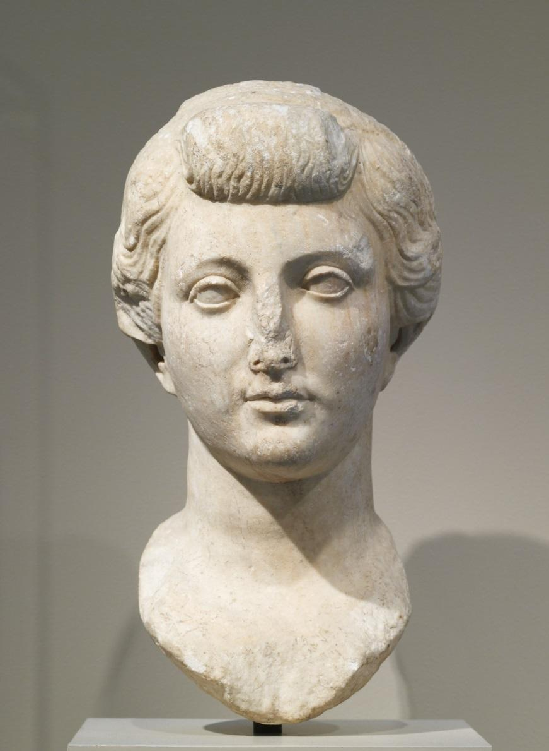

Fig. 2. Livia, Fayum type, 4-14 CE, from Arsinoe, Egypt. Ny Carlsberg Glyptotek, Copenhagen.
Wood, S. 1999. Imperial Women : A Study in Public Images. Pl. 22-23

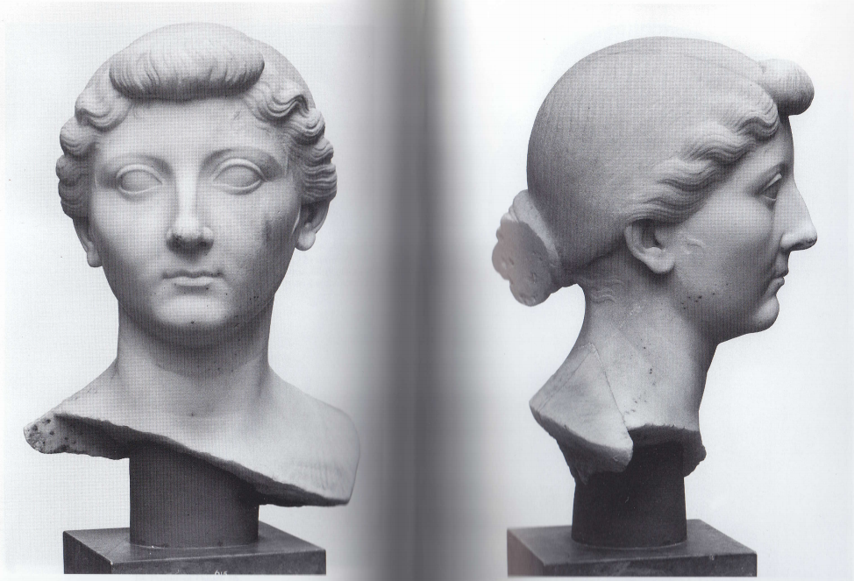

Fig. 3. Livia, from Ampurias. Museo Arquelogico, Barcelona.
Bartman, E. 2004. Portraits of Livia. Figure 151. 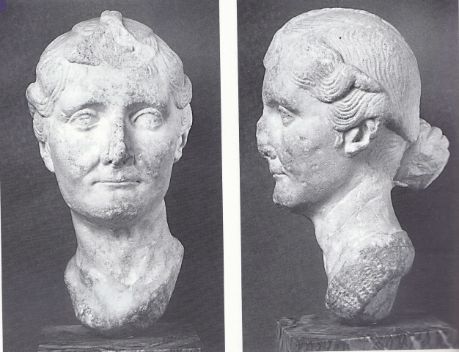

Fig. 4. Livia, ca. 23 CE, from Lepcis Magna. Tripoli Museum.
Wood, S. 1999. Imperial Women: A Study in Public Images. Pl. 35

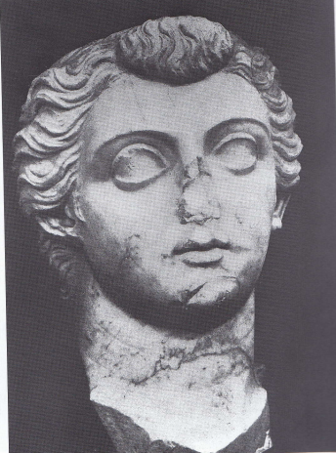

Fig. 5. Livia as Ceres- Fortuna, ca. 14-29 CE. Paris, Musee du Louvre.
Left: Wood, S. 1999. Imperial Women: A Study in Public Images. Pl. 38.
Right: Giroire, C. and Daniel Roger. 2007. Roman Art from the Louvre. 69.

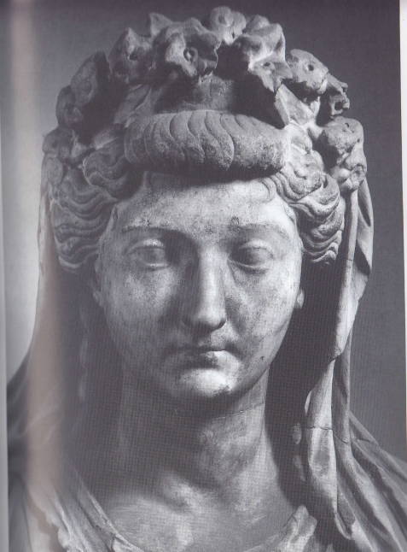
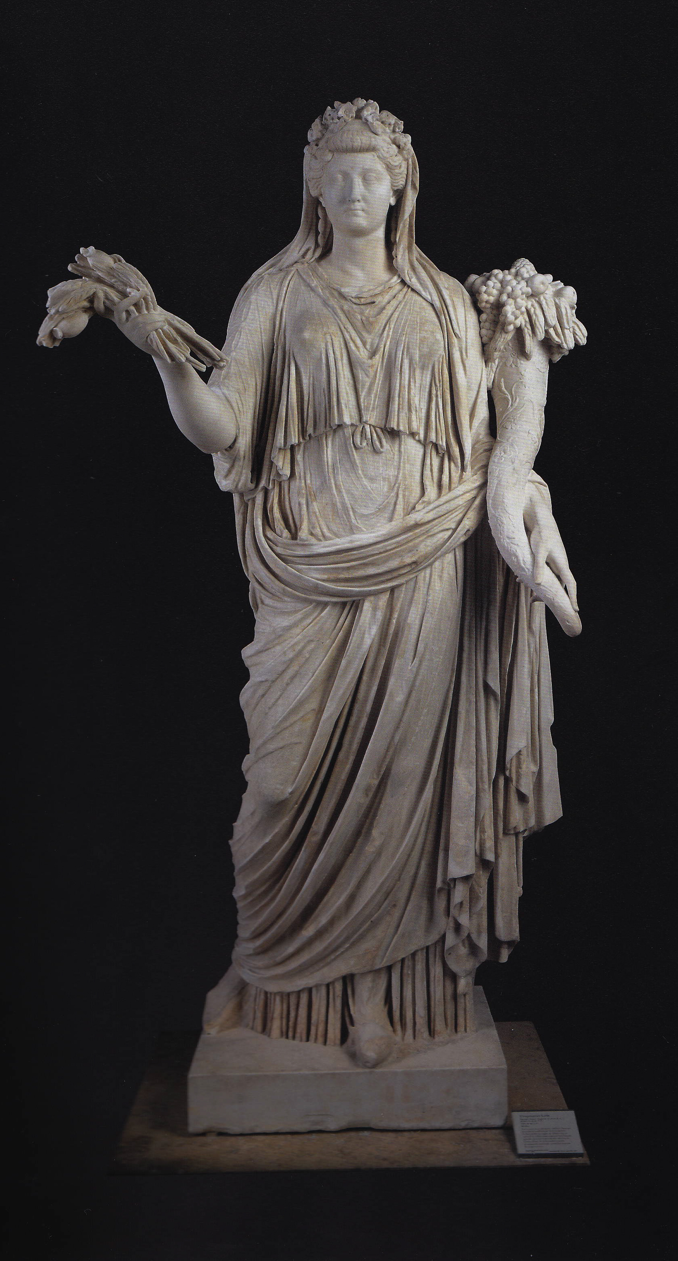

Fig. 6. Livia as Priestess of the Deified Augustus, 14-29 CE. Vatican.
Wood, S. 1999. Imperial Women: A Study in Public Images. Pl. 37.

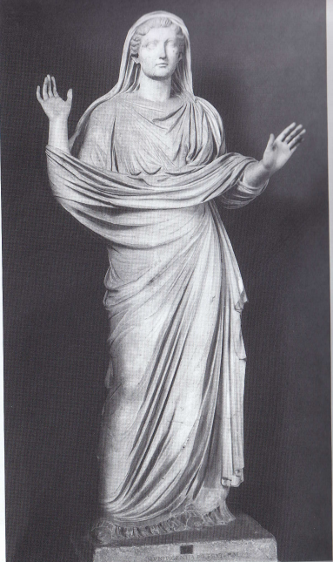

Fig. 7. Livia from Beziers. 14-23 CE. Musee Saint Raymond, Toulouse.
Wood, S. 1999. Imperial Women: A Study in Public Images. Pl.39-40

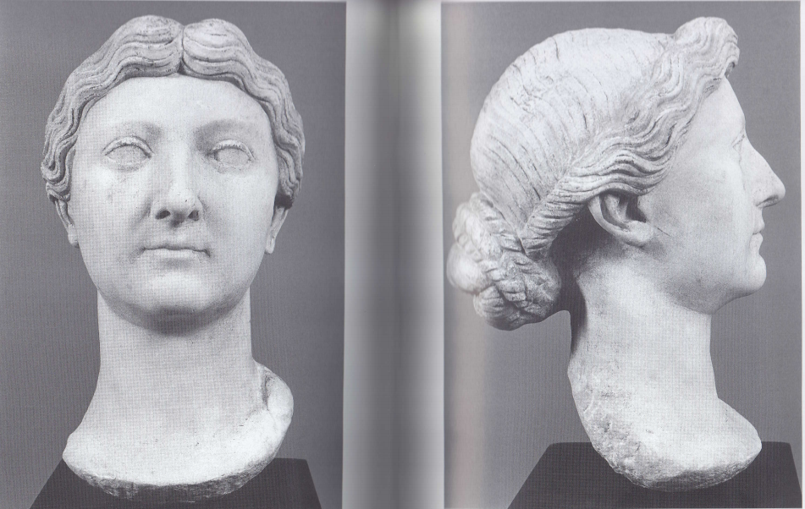

Fig. 8. Livia as Ceres Augusta, 35-36 CE, Lepcis Magna. Tripolis Museum.
Wood, S. 1999. Imperial Women: A Study in Public Images. Pl.43

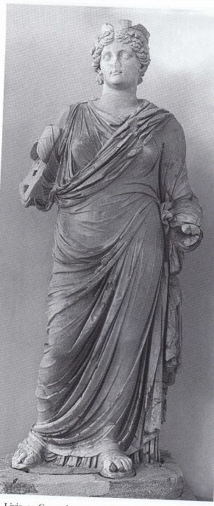

Bibliography

Primary Sources:
Ovid, Ars Amatoria. Translated by Barrett, Livia: The First Lady of Imperial Rome. 2002. New Haven: Yale University Press.

Seneca, De Consolatione ad Marciam. Translated by Barrett, Livia: The First Lady of Imperial Rome. 2002. New Haven: Yale University Press.

Suetonius, The Lives of the Twelve Caesars. Translated by Alexander Thomson.

Secondary Sources:
Barrett, A. 2002. Livia: First Lady of Imperial Rome. 2002. New Haven: Yale University Press.

Bartman, E. 1999. Portraits of Livia: Imagining the Imperial Woman in Augustan Rome. Cambridge: Cambridge University Press.

Bartman, E. 2001. “Hair and the Artifice of Roman Female Adornment.” AJA 105, 1: 1-25.

D’Ambra, E. 2013. “Mode and Model in the Flavian Female Portrait.” AJA 117, 4: 511-525.

Giroire, C. and D. Roger. 2007. Roman Art in the Louvre. New York: American Federation of the Arts.

Hölscher, T. 2004. The Language of Images in Roman Art. Translated by A. Snodgrass and A. Künzl-Snodgrass. Cambridge: Cambridge University Press.

Galinsky, K. 1996. Augustan Culture:An Interpretive Introduction. Princeton: Princeton University Press.

Kleiner, D. 1992. Roman Sculpture. New Haven: Yale University Press.

Kleiner, D. and S.B. Matheson. 1996. I Clavdia: Women in Ancient Rome. New Haven: Yale University Press.

Kleiner, F. 2010. A History of Roman Art. Boston: Wadsworth.

Marvin, M. 2008. The Language of the Muses: The Dialogue between Greek and Roman Sculpture. Los Angeles: J. Paul Getty Museum.

Smith, R.R.R. 1981. “Greeks, Foreigners, and Roman Republican Portraits.” JRS 71: 24-38.

Winckelmann, J.J. 2006. History of the Art of Antiquity. Translated by H.F. Mallgrave. Los Angeles: The Getty Research Institute.

Wood, S. 1999. Imperial Women: A Study in Public Images, 40 B.C.- A.D. 68. Leiden: Koninklijke Brill NV.

Zanker, P. 1988. The power of images in the Age of Augustus. Ann Arbor: The University of Michigan Press.

For the purposes of this study, I will be looking at free-standing sculptures, busts, and portrait heads. Minor arts, like cameos and relief sculpture, will not be considered because they tend to have a more private function than free-standing sculpture.
Cf. the Ampurias bust. Bartman 1999, 166; Archaic as defined by the Greek period of Archaic art, characterized by large, bug-like eyes, the “archaic smile” and otherwise stiff and unnatural posture. Cf. the Lepcis Magna Livia portrait; Barman 1999, 115.
Even in the most idealized portraits, Livia’s facial proportions are far from the ideal of the Greek classical style, which could either be a distinction in the portrait of Livia as non-classical or in the distinction between Greek and Roman classicism.
Barrett 2002, 103.
Wood 1999, 79.
Barrett 2002, 114.
Winkelmann 2006, 227.
Winkelmann 2006, 186; There seems to be a negative connotation associated with copies from the Roman period because they are deemed to be uncreative, although reproductions served as both a popular distribution and teaching method for many of the world’s most famous artists, including Titian and Michelangelo; Marvin 2008, 121-122.
Smith 1981, 33-4.
Smith 1981, 35.
It should be noted, however, that as realistic as verism is intended to be, because of its ability to purport Roman social and political values, things like age and physical wear (e.g., wrinkles, ear and nose size, etc.) may have been exaggerated in some cases, to give aristocrats a propagandistic advantage.
Again, this is a form of verism, but I believe that the style does not reach its height of hyper-realism until well into the Republican period in Rome.
Winckelmann 2006, 234; “Grace is formed and resides in the gestures and displays itself in the action and movement of the body; it is even expressed in the full od the clothing and the whole garb.”
In terms of modern application of status, rather than ancient social status, which would have placed sculptors in Rome low on the social scale
Who, ironically, were likely Greek, or trained by Greeks
Hölscher 2004, 11.
Verism itself is not an ancient concept, for example, but a term placed upon the style at a later date.
Hölscher 2004, 54.
Cf. The Shrine of the Augustales
Occasionally in Roman sculpture, the body of a sculpture is idealized, while the head is more veristic. Again, an emphasis on virility over realism.
Even with the use of these categories as our mainstays for the study of art from antiquity, it is necessary to approach them with caution, as there is danger in applying modern art historical terminology and ideas to decidedly non-modern works. Because of our inevitable separation from the artists, subjects, and viewers, it is difficult to detach modern sensibilities from ancient marble, which can only really be studied through the view of the original audience. The use of scant primary evidence and physical portraits is the best way of approaching the topic.
Bartman 1999, 3; Ovid describes Livia as having the body of Venus and the face of Juno (Barrett 2002, 103-4).
Bartman 1999, 4.
Kleiner 1992, 76-7.
Cf. The Lepcis Magna portrait
Cf. Head of an Old Woman, c.40-30 BCE. Kleiner 2010, 55 (Figure 4-9).
In the hairstyle popular in the Flavian period, these same variations were seen, in regard to hair height and the density of curls, which shows that Roman portraiture was reflective of styles popular at the time and that variation was likely due to a personal artistic or style choice, rather than indicative of anything else. D’Ambra 2013.
Zanker says that Octavian propaganda in the war against Marc Antony focused on the destruction of his morality in the eyes of the Romans, which mostly revolved around his relationship with the extravagant Cleopatra and his own association with Dionysus. Zanker 1988, “Rival Images: Octavian, Antony, and the Struggle for Sole Power”.
Barrett 2002, 114.
Bartman 1999, XXI.
Some scholars believe that Livia commissioned these portraits herself, rather than the portraits being arbitrated by Augustus. This says something about the increasing prominence of women in the Augustan period and about Livia’s own power.
Augustus’ face is represented as gaunt and serious, which can be seen as a nod to old Republican aesthetic values. However, the classicized nature of his face and body, and the divine locks of hair, downplay this particular feature.
The Prima Porta Augustus references the Greek heroism of the Periclean Golden Age by imitating the Doryphoros, a canon of Greek visual language.
Galinsky 1996, 63; Augustus’ efforts to revive the old mores and his focus on bringing back the values and attitudes of the past as a way to bolster the future.
Wood 1999, 97-98; Octavia, too, wore this hairstyle, further demonstrating the deliberate nature of the coiffure.
Wood 1999, 98; Ovid Ars Am. 3.138; Suet. Aug. 52.; Augustus refused sculptures erected to him in the city and rejected pleas to become dictator.
Cf. Augustus at Prima Porta
Kleiner and Matheson 1996, 53; Walters Gallery of Art.
Kleiner and Matheson 1996, 53.
Kleiner and Matheson 1996, 53.
Kleiner and Matheson 1996, 167 (Cat. 122).
Zanker 1988, 33-37, 44- 53, 57-65.
Kleiner 1992, 76; Bartman 1999, 61 (Figures 47, 49, 50).
Wood 1999, 95.
Holsher 2004, 86.
Bartman 1999, 166.
Kleiner 1992, 77.
Wood 1999, 95.
Cf. Glanum portrait, shows the styling of the hair disappear into a smooth surface, rather than a portrayal of the actual hair style.
Wood 1999, 110.
Figure 8 also comes from Lepcis Magna and features the same large eyes and hair depth as this portrait, so it is likely that the style is a part of the local sculptural tradition. Similarly, 3rd century portraits of Julia Domna from the region have the same exaggerated features that Livia has.
Bartman 1999, 114.
Bartman 1999, 114-115
Bartman 1999, 106. It should be noted that Ceres was not the only figure with whom Livia tried to associate herself- any female connected with prosperity or fertility would have also been a popular choice for her sculptures.
Wood 199, Fig. 41-42; Livia as Cybele and as Venus are both featured on minor arts, which create an entirely different portrait style than that of Livia’s sculptural depictions.
Bartman 1999, 45 and 146.
Though it is worth noting that many of the portraits discussed were carved for insertion and would have potentially been used in full sculptures.
Bartman 1999, 45.
Bartman 1999, 46.
It is necessary to note that due to the amount of restoration done on this particular statue, we can not be entirely sure that all of these flowers would have been present on the crown (Wood 1999, 115). Given the nature of the overall sculpture, a crown or diadem would have been present and that the exact dimensions or arrangement does not change the sculpture as a whole.
Bartman 1999, 147.
When Livia is depicted as an older women, she is hardly ever depicted in a way that is really seen as “old”, but certainly matronly. She does not keep her eternal youth, but she also does not age realistically, as can be seen with the Ceres statue.
We can safely assume that this occurs at this point based on approximate dating of many of these Diva Augusta style sculpture to the Tiberian period.
Wood notes that because none of the heads in question are veiled it is likely that they were not priestesses. Wood 1999, 119.
Wood 1999, 118.
Cf. Fig. 4
He used religion in the way that some used nationalism, to create an atmosphere for punishment. Wood 1999, 114.

