Effects of switchgrass related land-use changes on aquatic macroinvertebrates

A Dissertation Presented for the

Doctor of Philosophy

Degree

The University of Tennessee, Knoxville

Latha Malar Baskaran

May 2017

Copyright © 2017 by Latha Malar Baskaran.
All rights reserved.

DEDICATION

I dedicate this dissertation to my mother and mother-in-law, the strongest and most compassionate women in my life, whose endless support made this journey possible.

ACKNOWLEDGEMENTS

I have many people to thank in this journey. First and foremost, I would like to offer my greatest gratitude to my advisor Dr, Liem Tran who guided and supported my work. His advice helped me cross many roadblocks I faced in my research. In spite of my many delays and breaks, he always supported me when I came back to pick up the pieces and continue with my research. Without his support and understanding of my situation, I couldn’t have made this possible in the midst of all my other commitments.

I would like to sincerely thank Dr, Virginia Dale, my supervisor, mentor and advisor at work. She encouraged me to start my PhD, and she was always ready with support and advice when I needed it.

ABSTRACT

This research examines if switchgrass-based land management changes have the potential to influence aquatic macroinvertebrates through changes in stream flow and water quality in Tennessee. The number of taxa in Ephemeroptera, Plecoptera, and Tricoptera orders (EPT taxa richness) is analyzed in the context of regional environmental variations, and changes in stream flow and water quality, and the use of EPT taxa richness as a bioindicator with respect to bioenergy systems is evaluated. This dissertation is structured as three manuscripts that address factors at different scales operating on aquatic macroinvertebrates, that link together to address the overall research question.
The first manuscript focuses on identifying regional environmental variables that influence EPT taxa richness. The influence of temperature, precipitation, geology, soil, stream flow and velocity, on EPT taxa richness differs among ecoregion classes and also sets the context for understanding local-scale influences..
The second manuscript uses a multilevel regression model to quantify the influence of regional factors and evaluate the effects of stream flow and water quality on EPT taxa richness. The results indicate that stream flow is significant in affecting EPT taxa richness across ecoregions, nitrogen is significant within the southeastern plains and ridge and valley ecoregions, and phosphorus is significant in the Blue Ridge ecoregion. However, the magnitude of these effects is very small in the midst of other regional factors.By testing the significance of EPT taxa richness in explaining water quality, EPT taxa richness is not found to be a strong indicator of water-quality changes under the conditions of this study.
The third manuscript analyzes output from the hydrologic model, Soil and Water Assessment Tool (SWAT) to assess the relationship between EPT taxa richness and daily and monthly stream flow and water quality using regression models at the Nolichucky watershed in Tennessee. Simulating a future switchgrass scenario in SWAT indicates mean increase in stream flow and decrease in N and P in the switchgrass scenario, compared to the baseline scenario simulating pasture. Applying these results to the EPT taxa richness model, the mean EPT taxa richness is found to increase in the switchgrass scenario. However, these increases are within the monthly standard deviation of the estimates, and it is concluded that the influence of switchgrass-based land management on EPT taxa richness cannot be detected.
Overall, based on the results of the three pieces, it is found that EPT taxa are affected by processes that operate at different spatial and temporal scales, and impacts due to switchgrass-management related stream flow and water quality changes cannot be detected in the current spatial context. EPT taxa richness is not a suitable bioindicator of switchgrass-based land-management.
<needs to be cut down to 350 words>

TABLE OF CONTENTS

CHAPTER 1 - INTRODUCTION 10
Research Objective 11
Dissertation organization 12
References 13
CHAPTER 2 - Background 14
Aquatic Macroinvertebrates 15
Factors affecting aquatic macroinvertebrates 15
Switchgrass related land-use changes and effects on the stream 1
Models – Why SWAT? 2
Modeling Framework 3
References 5
CHAPTER 3 Analyzing Aquatic Macroinvertebrate Taxa Richness Indices across Ecoregions in Tennessee 6
Abstract 7
Introduction 8
Study Area and Methods 11
Study Area 11
Methods: Data and Analysis 12
Results 16
EPT taxa richness across Ecoregions 16
Regional factors among ecoregions 18
Discussion 18
Conclusion 29
References 31
CHAPTER 6 - CONCLUSION 37
Summary of results by objectives of study 37
Lessons learned and future research directions 39
References 42
VITA 44

LIST OF TABLES

Table 1: Table 1: Landscape and stream features affecting macroinvertebrates, their scales of influence, and the factors by which they affect macroinvertebrate health 18
Table 2: List of regional variables considered to be potentially important in affecting macroinvertebrate taxa richness, with sources of data and statistical tests. NHDplus refers to the hydrologic framework dataset developed by the US Environmental Protection Agency and the US Geological Survey (McKay et al., 2012).The PRISM Climate Group develops spatial climate datasets to reveal short- and long-term climate pattern (PRISM climate group 2013). The SSURGO database contains information about soil collected by the National Cooperative Soil Survey (Soil Survey Staff, 2013). 16
Table 3: Correlation of EPT taxa richness with regional variables by Omernik's ecoregion classification. The asterisks indicate significant correlation at the 0.05 level 25

LIST OF FIGURES

Figure 1: Linkages between agriculture-based land management and sources of stress to macroinvertebrates (roughly adapted from Nietch et al. 2005). 4
Figure 2: Hierarchical relationships between select landscape and stream features and habitat “filters” that affect macroinvertebrates (adapted from Poff, 1997). The colors from the diagram on the left correspond to various scales and the colors in the table. 9
Figure 3: Physical map of Tennessee illustrating elevation gradient, major land forms and rivers. 12
Figure 4: Ecoregion classification schemes for Tennessee. 14
Figure 5: Box plots of EPT taxa richness (using data collected by TDEC between 2007 and 2010) grouped by Omernik’s ecoregion classes of Tennessee (ordered from west to east) and separated by reference stream category (reference streams are light grey boxes). The boxes represent the interquartile (IQ) range, and the line across the boxes indicates the median values. The whiskers from the upper and lower edge of the box indicate the highest and lowest values within 1.5 times the IQ range. Outliers between 1.5 and 3 times the IQ range are indicated by the closed circles, and outliers with values more than 3 times the IQ range are indicated by the asterisk. Data from the Mississippi Alluvial Plain have been excluded due to insufficient data. 20
Figure 6: Box plots of EPT taxa richness (collected by TDEC between 2007 and 2010) grouped by Bailey’s ecoregion classes of Tennessee (ordered from west to east) and separated by reference stream category (reference streams are light grey boxes). The boxes represent the interquartile (IQ) range, and the line across the boxes indicates the median values. The whiskers from the upper and lower edge of the box indicate the highest and lowest values within 1.5 times the IQ range. Outliers between 1.5 and 3 times the IQ range are indicated by the closed circles. 21
Figure 7: Box plots of EPT taxa richness (collected by TDEC between 2007 and 2010) grouped by Freshwater ecosystem classes of Tennessee (ordered from west to east) and separated by reference stream category (reference streams are light grey boxes). The boxes represent the interquartile (IQ) range, and the line across the boxes indicates the median values. The whiskers from the upper and lower edge of the box indicate the highest and lowest values within 1.5 times the IQ range. Outliers between 1.5 and 3 times the IQ range are indicated by the closed circles. Data from the Mobile Bay ecoregion have been excluded due to insufficient data. 22
Figure 8: Silhouette plots for classification of EPT taxa richness using Omenik’s (A), Bailey’s (B), and Freshwater (C) ecoregion classification schemes. Classes on Omernik’s plot (A) are: 1- Blue Ridge, 2-Central Appalachian 3-Interior plateau, 4-Mississippi Valley Loess Plains, 5-Ridge and Valley, 6-Southeastern Plains, and 7-Southwestern Appalachians. Classes on Bailey’s plot (B) are 1-Blue ridge mountains, 2-Central ridge and valley, 3-Coastal plains middle section, 4-Interior low plateau, Highland rim section, 5-Mississippi alluvial basin section, 6-Northern Cumberland plateau section, 7-Northern ridge and valley section, 8-Southern Cumberland mountains section, and 9-Upper Gulf coastal plain section. Classes on Freshwater ecoregion plot (C) are: 1-Lower Mississippi, 2-Old Ohio, 3-Cumberland, and 4-Tennessee. 23
Figure 9: Soil (upper) and climate (lower) gradients across Tennessee based on soil composition and average annual precipitation (Source: SSURGO and PRISM data) 27
Figure 10: Distribution of EPT taxa richness by stream order for ecoregions found to have significant correlation between stream order and EPT taxa richness. The boxes represent the interquartile (IQ) range, and the line across the boxes indicates the median values. The whiskers from the upper and lower edge of the box indicate the highest and lowest values within 1.5 times the IQ range. Outliers between 1.5 and 3 times the IQ range are indicated by the closed circles. 28

CHAPTER 1 - INTRODUCTION
The need to identify alternative sources of energy has been given increased attention in the past few decades. The Energy Independence and Security Act (EISA) of 2007 was enacted “to move the United States toward greater energy independence and security, to increase the production of clean renewable fuels…” (EISA 2007). An assessment by the U. S. Department of Energy (2016) found that U.S. agriculture and forest resources have the capability to potentially produce at least one billion dry tons of biomass annually in a sustainable manner. Currently, grain based ethanol from corn is widely produced and is one of the major sources of biofuel in the United States. Though the environmental effects of intensive corn production for ethanol is well documented, grain-based biofuels are continue to remain a significant part of the bioenergy system due to their well-established infrastructure (Robertson et al. 2008). However the Renewable Fuels Standard (RFS2), mandated by EISA, calls for increased use of cellulosic ethanol derived from energy crops. These energy crops include switchgrass, miscanthus, short rotation woody crops, agricultural residues, and forestry materials and residues. Among these energy crops, the cellulosic feedstock switchgrass has gained more attention due to its growth and yield properties that makes it a better environmental choice rather than obtaining biofuels from crops such as corn. Switchgrass has been considered as a ‘model’ bioenergy crop owing to its wide range and adaptability (McLaughlin and Walsh 1998). Switchgrass is a perennial crop, and compared to corn, it has lower fertilizer requirements, improved soil conservation, improved energy gain and improved reductions in emissions of carbon dioxide (McLaughlin and Walsh 1998).
Based on various scenarios considered by the billion ton assessment, by 2040 energy crops can contribute between 34% and 48% of the billion ton goal, and up 27 million acres of cropland and 37 million acres of pasture land could be managed for energy crops to meet the biofuel demand (U. S. Department of Energy 2016). The consequent land-use and land-cover change associated with biofuel expansion would have environmental effects that need to be given forethought and consideration (Ramney and Mann 1994; McLaughlin and Walsh 1998; Tolbert and Wright 1998; Borjesson 1999). Given that existing agricultural activities in the form of crop production are one of the top sources of impairment in assessed rivers and streams in the United States (US EPA 2009), it is important to minimize negative consequences and to understand the effects of bioenergy systems due to the large-scale management of land for bioenergy production.
To address environmental sustainability of the bioenergy system, Robertson et al. (2008) identified urgent research needs, which include a systems approach to assess the full impact of bioenergy systems, focus on ecosystem services, and understanding the implication of policy and management. Biodiversity is a vital component of these research efforts, and there is a growing need to better our understanding of bioenergy crop production and the effects it may have on biodiversity (Dale et al. 2010). Bioenergy systems can affect the habitat of species that rely on the land used to grow bioenergy crops and the streams that drain from these lands. Effects on habitat may stem from changes in land management for bioenergy crops. Such habitat alterations directly affect biodiversity at different scales and are a function of the type of bioenergy crop being considered and how they are managed on the ground as well as prior management practices (Fletcher et al. 2011). For example, dependence on grain-based biofuels such as ethanol from corn can result in agricultural intensification and negatively impact stream habitat and biodiversity (Williams et al. 2009).
McBride et al. (2011) identified 19 indicators in six categories, including water quality and quantity, and biodiversity, for assessing environmental sustainability of bioenergy systems. ‘Taxa of special concern’ is one of the biodiversity indicators recommended by McBride et al. (2011). These taxa of special concern include “bioindicators”, which are used to monitor the condition of an environmental system (Hodkinson and Jackson 2005). Aquatic macroinvertebrates have been considered to be good bioindicators and are frequently used as environmental, ecological biodiversity indicators (Holt et al. 2010). Aquatic macroinvertebrates are sensitive to water quality changes and habitat changes, and have recognized responses to such changes (e.g., Johnson et al. 1993; Kerans and Karr 1994). They are affected by human-induced alterations through changes in their food source, habitat structure and biotic interactions. Mechanisms that cause these changes to the stream ecosystems include sedimentation, nutrient enrichment, contaminant pollution, hydrologic alteration, riparian clearing and loss of large woody debris (Allan 2004). Currently, all 50 states of the United States use aquatic macroinvertebrates to assess the biological health of streams and rivers (Holt et al. 2010). Bioindicators, such as aquatic macroinvertebrates, also have the ability to indicate indirect biotic effects of pollutants and nutrients in the stream without having to make chemical measurements in the stream. This property makes aquatic macroinvertebrates a potential indicator to assess both water quality/quantity and biodiversity in the categories identified by McBride et al. for assessing environmental sustainability of bioenergy systems (2011).
This research will evaluate the potential of an aquatic macroinvertebrate metric as a bioindicators to assess environmental effects of switchgrass-related land management. This study will also fill the gap in the current understanding of the effects of switchgrass related land-use changes on aquatic biodiversity by focusing on aquatic macroinvertebrates. We focus on the number of taxa in ephemeroptera, plecopter and tricoptera (EPT taxa richness) as the potential bioindicator. EPT richness is a standard community-level indicator since it includes insect orders that are very sensitive to environmental perturbations and can associate benthic assemblages to complex ecosystems and disturbance regimes (e.g., Feminella 1996; Maxted et al. 2000). Further, stream benthic macroinvertebrates such as EPT taxa richness are useful indicators of the impacts of disturbances on catchment and stream conditions because they integrate many catchment-scale ecological processes (Maloney and Feminella 2006).

Research Objective
The goal of this research is to understand if switchgrass-based land-management changes can affect aquatic macroinvertebrates. The potential of EPT taxa richness as a bioindicator to assess the effects of switchgrass related land-management changes will also be evaluated. Towards this goal, the role of spatially variable regional natural factors that influence aquatic macroinvertebrates will be identified. This study is conducted in Tennessee and focuses on changes to EPT taxa richness at streams draining lands that have the potential to grow switchgrass. The key hypothesis is that aquatic macroinvertebrates are affected by factors and processes at different spatial scales and switchgrass related land-management changes influence some of those factors and hence can potentially change EPT taxa richness. The specific objectives of this research are
- Determine the key natural factors at different scales that affect EPT taxa richness across ecoregions in Tennessee
- Quantify the influence of the regional environmental variables such as temperature, precipitation, soil, slope, stream flow and water quality on structuring the spatial distribution of EPT taxa richness
- Evaluate if switchgrass-based land-management changes influences EPT taxa richness

Dissertation organization
This dissertation is organized into 6 chapters. The next chapter (chapter 2) provides background information on switchgrass, EPT taxa richness and the models used by this study. This chapter will address how switchgrass is managed and how land-management changes to switchgrass is expected to affect water quality and aquatic habitat in the stream. Background information on factors affecting aquatic macroinvertebrates, and EPT taxa richness in specific, will also be presented in chapter 2. Since there are many models to address land-management changes and their impacts to the stream, chapter 2 will also address the specific model chosen for this study.
Chapters 4, 5 and 6 are based on three different manuscripts. Chapter 4 presents the manuscript titled “Analyzing aquatic macroinvertebrate taxa richness indices across ecoregions in Tennessee”. This chapter evaluates three different ecoregion classifications and identifies the better ecoregion classification that provides context for studying aquatic macroinvertebrates. This chapter addresses the first objective by evaluating regional variables and spatially variable stream-scale factors that are significant with respect to EPT taxa richness by ecoregion.

Chapter 5 presents the manuscript titled “Potential of aquatic macroinvertebrates as water quality indicators: An evaluation across Tennessee, USA”. This chapter evaluates the potential of EPT taxa richness as an effective indicator of stream flow and water quality variables in affecting EPT taxa richness using data collected across Tennessee. The ecoregion identified in Chapter 4 is used to separate regional effects using a multilevel model framework. This chapter directly addresses objective 2 by quantifying the influence of regional and stream-level variables using a multilevel regression model in structuring the spatial distribution of macroinvertebrates by ecoregion.

Chapter 6 is based on the manuscript titled “Potential impacts of switchgrass management on streamflow and aquatic macroinvertebrate diversity” and addresses the third objective by evaluating the potential impacts from land managed for switchgrass on EPT taxa richness through changes in streamflow and water quality within a watershed in the Tennessee River Basin. This chapter uses a modeling approach to generate stream flow and water quality variables that help quantify relationships between EPT taxa richness and stream flow/water quality, previously not captured by results in Chapter 5.

Chapter 7 provides conclusions to this study and summarizes the results from the three different manuscripts. The lessons learnt and future research questions are also addressed.

References

Abbaspour, K. C. 2011. SWAT-CUP4: SWAT Calibration and Uncertainty Programs - A User Manual. http://www.neprashtechnology.ca/Downloads/SwatCup/Manual/Usermanual_Swat_Cup.pdf. (Accessed: June 1, 2012).

Abbaspour, K.C., J. Yang, I. Maximov,R. Siber, K. Bogner, J. Mieleitner, J. Zobrist, and R. Srinivasan. 2007. Spatially distributed modelling of hydrology and water quality in the pre-alpine/alpine Thur watershed using SWAT. Journal of Hydrology 333: 413–430.

Al-Khudhairy, D., J.R. Thompson, H. Gavin, and N.A.S. Hamm. 1999. Hydrological modelling of a drained grazing marsh under agricultural land use and the simulation of restoration management scenarios. Hydrological Sciences Journal 44: 943 - 971.

Hodkinson, I. D., & Jackson, J. K. (2005). Terrestrial and aquatic invertebrates as bioindicators for environmental monitoring, with particular reference to mountain ecosystems. Environmental management, 35(5), 649-666.

Holt, E. A., & Miller, S. W. (2011). Bioindicators: using organisms to measure environmental impacts. Nature Education Knowledge, 3(10), 8.

CHAPTER 2 - Background

Aquatic Macroinvertebrates
Macroinvertebrates refer to animals without backbones such as insects, crustaceans, molluscs, arachnids and annelids that can be seen with naked eye and are found in streams, rivers, wetlands and lakes. This analysis focuses on immature insects that are found in freshwater habitats. They are an important source of food for fish and other higher order species. Macroinvertebrates also have an important influence on nutrient cycles, primary productivity, and translocation of material (Wallace and Webster 1996). Macroinvertebrates are considered to be a crucial intermediate link between primary producers and predators higher up in the trophic hierarchy. The majority of these insects spend most of their immature lives in the water, and the adults emerge from the aquatic environment to mate and disperse

Factors affecting aquatic macroinvertebrates
When using invertebrate communities as bioindicators, it is important to understand that such assemblages are subject to natural variation in addition to the independent deterministic changes resulting from pollution or disturbance, particularly over the long term (Hodkinson and Jackson 2005). In general, macroinvertebrate habitat is influenced by several factors ranging from local-scale physical habitat characteristics to regional-scale characteristics (Table 1). At the local scale, reach level properties such as channel dimensions, substrate characteristics, woody debris, and hydraulic characteristics can affect macroinvertebrate habitat (Lenat and Crawford 1994; Richards et al. 1997). At the regional and watershed scales, geomorphology and climate characteristics are important predictors of macroinvertebrate community impairment (Goldstein et al. 2007; Kennan 1999).
Suspended and deposited sediments can affect benthic invertebrates by changing the suitability of substrates for taxa (Wood and Armitage 1997). One of the biggest impacts of sedimentation is associated with the fines eroded from agricultural land (Walling et al. 1990). Sandy substrates are poor habitats because the shifting nature of the bed provides unsuitable attachment and poor food conditions (Merritt and Cummins 1996). Further, silt based substrates have low concentrations of oxygen and result in inefficient oxygen consumptions by some macroinvertebrate taxa. In general, taxa richness increases with increase in substrate size (Quinn and Hickey 1990). Courser substrates provide suitable habitat for invertebrates having high oxygen requirements, such as many taxa in the ephemeroptera, plecoptera and trichoptera orders (Quinn and Hickey 1990). Though macroinvertebrates can tolerate short term variations in suspended and benthic sediment, addition of fine particulate material due to long term disturbances, such as agriculture and surface mining activities, can change the natural faunal assembly in the streams (Wood and Armitage 1997). Elevated concentrations of suspended sediments can decrease light penetration in the water and reduce rates of primary production and visual foraging efficiency (Wood and Armitage 1997).
Increased input of nutrients can cause increased primary productivity and periphyton concentrations, which in turn can affect higher trophic levels that rely on them for habitat and food. Changes in the food web may cause changes in the ecosystem and further alter stream physical habitat and water chemistry, e.g., decreasing dissolved oxygen. In some ephemeroptera and plecoptera taxa, the rate of respiration (physiology) fails to compensate for falling oxygen levels within the water (Merritt and Cummins 1996). Wang et al. (2007) found that EPT taxa richness was strongly correlated with nutrient measures in Wisconsin streams. Overall, increased nutrient concentrations can cause macroinvertebrate community structure to shift from having sensitive species to more tolerant species. Nutrient enrichment can also alter other physical sources of ecological change that affect ecosystem properties such as resilience and resistance (Gafner and Robinson 2007). Lemly (1982) found that excess nitrates and phosphates, in association with sedimentation, resulted in growth of the filamentous bacterium Sphaerotilus natans on the body and respiratory surfaces of macroinvertebrates, as well as on the surface of stones in the stream. These bacteria resulted in a net-like formation due to the overlapping of filaments over the macroinvertebrates and greatly augmented the accumulation of sediments with the eventual blanketing and smothering of the insect (Lemly 1982). Nutrient concentrations also vary by season. They are generally higher in summer than in autumn. Johnson et al. (1997) found that influence of land use on water chemistry was lesser in autumn compared to spring.
Reductions of pH in stream water can result in low invertebrate diversity and density (Rosemond et al. 1992; Simpson et al. 1985). Low pH values in the streams (4 to 5.5) have been found to eliminate many ephemeroptera taxa, while some other species decline gradually (Courtney and Clements 1998). Ernst et al. (2008) found that acidic headwaters resulted in fewer numbers of ephemeroptera and plecoptera taxa in the Neversink River of the Catskill Mountains in south eastern New York. The toxic effects of acidic pH are associated with disruption of ion regulation, particularly NaC and Cl−, increased membrane permeability, and respiratory stress (Courtney and Clements 1998). In the Obey river in Tennessee, acid mine drainage has been known to cause drastic reductions in benthic macroinvertebrate abundance and diversity because of decreased pH, increased concentrations of dissolved metals, and a high amount of metal precipitation (Nichols and Bulow 1973).
Accumulation of metals in aquatic organisms can be toxic and is caused by the transport of dissolved metal species across external membranes, adsorption on body surfaces, and intake of particulate forms of metals (Hare 1992). For example, metal ions such as iron, can precipitate on gill surfaces under acidic conditions and affect respiration for some ephemeroptera taxa (Gerhardt 1992). Studies have found that bioaccumulation of heavy metals such as mercury, lead cadmium and aluminum is influenced by the water pH (Wren and Stephenson 1991). The pH of the water is strongly related to metal speciation because it affects the sorption process, remobilization, and solubility of metals (Gerhardt 1993). DeNicola and Stapleton (2002) found that acid mine drainage, in addition to affecting the water quality, also results in precipitation of metals in the substrate, which can affect macroinvertebrate habitat.
Flow is correlated with most important characteristics of stream systems (e.g., current, water depth, hydraulics, channel geomorphology, substratum stability) and is of critical importance to the range of potential microhabitats available to benthic macroinvertebrates (Statzner et al. 1988). Hydraulic stress associated with foraging, maintaining position, and organic matter retention in coarse substrata are some mechanisms through which the flow affects the spatial distribution of macroinvertebrates (Rempel et al. 2000). A reduction in flow velocity can lead to an increase in deposition of fines and decaying matter onto the riverbeds (Wood and Armitage 1997). This problem in prevalent during low flow conditions in summer, and it is acute in groundwater-fed streams (Wood and Armitage 1997). Flow changes can also affect taxa richness by causing changes in amount of nonpoint source runoff or the dilution of point source discharge (Lenat 1988).
Major floods can reduce the macroinvertebrate abundance and richness. Floods can wash away periphyton attached to the substrate material, and this can impact the periphyton-associated macroinvertebrates (Quinn and Hickey 1990).However, floods need to exceed a certain threshold relative to the median flow to have significant effects on invertebrate abundance and richness. Previous studies have found that this threshold ranges from 20X to 45X the median flow (Quinn and Hickey 1990).
Geomorphic parameters, such as surface geology and topographic heterogeneity influence the flow regimes and physical habitat of streams and can hence affect the structure and composition of macroinvertebrate assemblages (Richards et al 1996). Seasonal and monthly changes in precipitation and solar radiation result in within-year changes in flow and temperature in aquatic systems (Beche et al. 2005). Similarly, year-to-year changes in precipitation produce variation in stream discharge and habitat quality and quantity (McElravy rt al. 1989). These features influence the timing of emergence, reproduction, growth and development of macroinvertebrates, which in turn influences the seasonal recolonization of organisms after disturbances (Beche et al. 2005). Beche and Resh (2007) found that the stability and persistence of macroinvertebrate communities were correlated with climatic variation (precipitation and El Niño Southern Oscillation) and stream size. Seasonal habitat variability of macroinvertebrates was also found to be higher in intermittent streams than in perennial streams (Beche et al. 2005).
Processes such as land-use change can affect several of the stream and regional features thereby affecting aquatic macroinvertebrates. Aquatic macroinvertebrate systems that vary in space and time need to be addressed at multiple scales by considering appropriate relationships between environmental effects and species traits at each scale (Poff 1997). Gergel et al. (2002) found that water quality parameters are sensitive to changes in the riparian zone, and a spatial view of a watershed can help in understanding where aquatic ecosystems are more vulnerable to land-use changes. Further, the spatial scale of landscape influence on aquatic ecosystems may be similar across systems or spatially variable (Gergel et al. 2002). Comprehending this spatial variation of vulnerability can help identify scales at which changes occur, such as those caused by climate (Poff et al. 2010), and also bioenergy based regional land-use changes.

Table 1: Landscape and stream features affecting macroinvertebrates, their scales of influence, and the factors by which they affect macroinvertebrate health.
Landscape/stream features | Scale(s) of influence | Related factors that affect macroinvertebrates | Example References
Geomorphology | Regional | Flow regime, substrate, ion concentration | Richards et al. 1996
Climate | Regional | Stream flow, temperature | Beche et al. 2005
Sediments and Substrate | Reach | Turbidity, scouring and abrasion, substrate composition, in-filling interstitial habitat, stream depth heterogeneity | Woods and Armitage 1997
Nutrients | Reach | Nutrient enrichment, dissolved oxygen, changes to assemblage composition | Wang et al. 2006
pH | Reach | pH sensitivity, toxicity | Simpson et al. 1985
Stream flow | Reach | Flow volume, channel dynamics, erosion, floods and low flows | Statzner et al. 1988

Switchgrass related land-use changes and effects on the stream
Switchgrass is a perennial warm season grass with a range covering most of the eastern United States. It has been used as a forage crop for the past few decades and has also been investigated as a bioenergy crop (Parrish and Fike 1995). The extensive root system and dense canopy of switchgrass makes it suitable for erosion control, and hence switchgrass has been used as streamside buffers and vegetative strips for erosion control (Belden and Coats 2004; Blanco-Canqui et al. 2004). The perennial ground cover of switchgrass helps to dissipate the energy from direct impact of raindrops and reduce surface runoff and sediment transportation from the land (Nyakatawa et al. 2006). Surface runoff can remove large quantities of both dissolved and sediment bound nutrients from the soil, which can affect water quality.
Land planted with switchgrass has reduced nutrient input into the streams and reduced sediment loads (e.g., Lee et al. 2003). Switchgrass is also effective in its utilization of nitrogen, and the nitrogen removed in harvest is usually greater than the amount applied (Parrish and Fike 2005). Though switchgrass requires some nitrogen fertilizers for its growth, the requirements are lesser than that for corn, which requires almost twice as that required by switchgrass (McLaughlin and Walsh 1998). Miller et al (2007) suggest that compared to corn, switchgrass-based ethanol offers good climate change benefits as well as a low eutrophication impact due to high yields per acre. Randall and Mulla (2001) founds that perennial cropping systems have the potential to reduce nitrate losses.
Compared to annual agricultural crops such as corn, switchgrass has been found to have reduced sediments and erosion to streams. Brown et al (2000) evaluated the feasibility of a large-scale conversion of land to grow switchgrass in the place of corn, sorghum, soybeans or winter wheat in the Missouri–Iowa–Nebraska–Kansas region. Using the erosion productivity impact calculator (EPIC) model they found that under the baseline scenario, the surface runoff and erosion from switchgrass was lower than that under the traditional crops. Similarly, in a modified climate scenario, erosion under switchgrass cultivation decreased, and erosion tended to increase under corn. Switchgrass has increased growth and is able to reduce the erosion risk by providing continuous cover throughout the year (Brown et al 2000). Brown et al (2000) also concluded that a large-scale conversion of corn to switchgrass can affect water resources by the decreases in surface runoff. The higher level of runoff and water export from conventional crops by itself is not a critical issue; however, when the water also carries agricultural pollutants, it poses a significant risk to the streams and estuaries downstream (Schilling et al. 2008). The lower reduction of sediments into streams draining switchgrass fields indicates the potential to improve channel characteristics and suspended sediments in streams to recover or protect habitat of macroinvertebrates.

Models – Why SWAT?
To understand the potential effects of bioenergy-based land-use changes, the hydrologic foundation for the study region needs to be established using a hydrologic model that can capture the bioenergy land use-water relationships in the region and relate them to mechanisms influencing macroinvertebrates. Changes in sediment and nutrient in the stream are some of the important factors that are caused by bioenergy-based land-use changes and also directly impact macroinvertebrates. These changes are also driven by changes in stream flow, which was identified as a factor contributing to change in macroinvertebrate structure of Tennessee (Arnwine et al. 2011). The switchgrass management operations that are relevant to affecting water quality and that need to be represented in a model include perennial crop management, modified fertilizer routine, and a modified harvest schedule.

Several hydrologic models that can simulate land-use changes have been developed and implemented for small to large-scale applications (Breuer et al. 2009). These models range from complex distributed models such as DHSVM (e.g., Storck et al. 1998), MIKE-SHE (e.g., Al-Khudhairy et al. 1999) to lumped models such as IHACRES (e.g., Croke and Jakeman 2004). Hybrid mechanistic/empirical, basin scale models such as the SPARROW (SPAtially Referenced Regression On Watershed attributes) model use spatially distributed to estimate N and P delivery to streams (Smith et al. 1997). In between distributed and lumped hydrologic models are semi-distributed models that are spatially explicit to the extent of sub-watersheds and model hydrologic response units as their basic unit of analysis. The Soil and Water Assessment Tool (SWAT) is an example of such a model. SWAT is a physically based, semi-distributed model operating on a daily time scale and has been used extensively around the world for different applications ranging from TMDL analysis at the local scale to macro-scale analysis of the entire US (Gassman et al 2007). SWAT was developed as an integration of several models – EPIC, CREAMS, GLEAMS and a weather generator model (Krysanova and Arnold 2008). SWAT models overland processes and channel processes by a mass water balance equation within a watershed (Neitsch et al. 2005). The crop-growth component of SWAT, which helps model various crop properties and their effects on the hydrological cycle, is part of the overland component of the hydrologic cycle and was originally derived from the EPIC model. The crop growth component of SWAT simulates all crops with a single crop-growth model with the use of unique parameter values for each crop (Neitsch et al. 2005). The crop-growth model is also used to assess removal of water and nutrients from the root zone, transpiration, and biomass production (Neitsch et al. 2005). Switchgrass growth has been parameterized in SWAT and has been applied in several studies (e.g., Baskaran et al. 2010).

Models that can support detailed management and within-region water quality can help study water quality impacts in large regional studies. An evaluation of models to support efforts to study nutrient transport to the gulf of Mexico causing hypoxia found that SWAT, with its ability to target watersheds, placement of conservation practices and timing of nutrient flows, was an effective model (Dale et al. 2010).Given the detailed crop module in SWAT, the overland and in-stream nutrient and sediment transportation mechanisms modeled by SWAT, and since the focus of this study requires identifying temporal changes in stream flow, SWAT is selected as the appropriate model for this study.

Modeling Framework
The wide adaptation, tolerance to drought, reduced nutrient and sediment runoff, and good yield properties of switchgrass has also made it favorable bioenergy crop. Based on the land management of switchgrass and the various pathways it affects streams, the potential of switchgrass to affect aquatic macroinvertebrates is depicted in Figure 1. The influence of scale-based factors affecting aquatic macroinvertebrates is also depicted as boxes around the modeling framework.

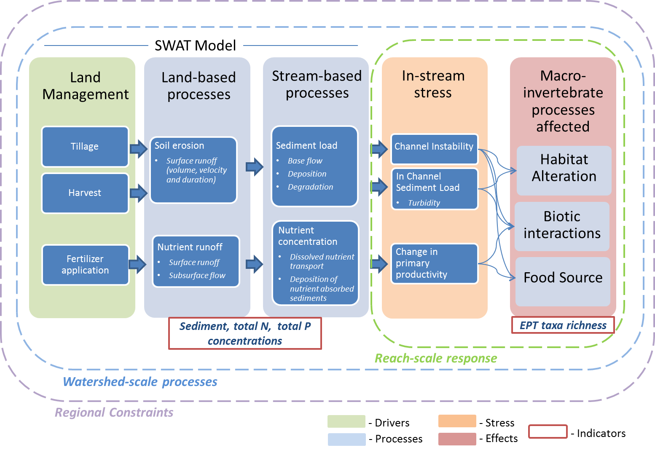
Figure 1: Linkages between agriculture-based land management and sources of stress to macroinvertebrates (roughly adapted from Nietch et al. 2005).

References

Dale, V.H., Armitage, T., Bianchi, T., Blumberg, A., Boynton, W., Conley, D.J., Crumpton, W., David, M., Gilbert, D., Howarth, R.W. and Kling, C.L., 2010. Hypoxia in the northern Gulf of Mexico. New York: Springer.

Smith, R. A., Schwarz, G. E., & Alexander, R. B. (1997). Regional interpretation of water‐quality monitoring data. Water resources research, 33(12), 2781-2798.

CHAPTER 3
Analyzing Aquatic Macroinvertebrate Taxa Richness Indices across Ecoregions in Tennessee

A version of this chapter was originally submitted to the American Midland Naturalist by Latha M. Baskaran, Virginia H. Dale and Liem Tran:
Latha M. Baskaran, Virginia H. Dale, and Liem Tran. “Analyzing Aquatic Macroinvertebrate Taxa Richness Indices across Ecoregions in Tennessee” American Midland Naturalist.

This article was prepared and written primarily by Latha Baskaran. Liem Tran and Virginia Dale advised on the work described here. They also reviewed early revisions of this manuscript.

Abstract
Aquatic macroinvertebrates are important components of stream ecosystems and are intimately linked to stream quality and land use and management in the regions that drain the streams. Understanding the factors that affect aquatic macroinvertebrate community structure can help develop predictive tools to assess landscape-level changes. The aquatic macroinvertebrate community structure is spatially variable and constrained by a hierarchy of factors ranging from regional climate, geology and soils, to local stream and substrate characteristics; so it is critical to establish a baseline against which changes are compared. This study analyzes the regional variation of EPT taxa richness (aquatic macroinvertebrate in the Ephemeroptera, Plecoptera and Tricoptera orders) across the state of Tennessee under different ecoregional classification schemes: Omernik’s, Bailey’s and Freshwater ecoregion classification. Of the three schemes considered, a silhouette analysis found the Omernik’s ecoregion classification scheme to be the better ecoregion classification for characterizing EPT taxa richness in Tennessee. The influence of regional factors, such as climate and soils, on EPT taxa richness varied by location and Omernik’s ecoregion class. EPT taxa richness was sensitive to bed rock and soil variables but not to climate variables in the interior plateau. EPT taxa in the ridge and valley ecoregion in the eastern end of the state were correlated to temperature and soil variables. However the ecoregion classification alone could not completely characterize EPT taxa richness. Other finer-scale factors such as stream discharge and velocity were also found to be significant in influencing the macroinvertebrate community. Ecoregions provide the context for studying aquatic macroinvertebrates, and this study found inclusion of spatially variable finer-scale factors is necessary for an effective understanding of the macroinvertebrate community response to changes in land use and management.

Introduction
Changes on the land affect many facets of the aquatic environment including habitat for aquatic species. Aquatic macroinvertebrates are often used as indicators of stream condition because they are abundant, short lived, and can be sensitive to ecosystem disturbances and water quality changes (Rosenberg and Resh, 1993; Sharma and Rawat, 2009). For this reason different metrics to describe aquatic macroinvertebrate community structure (abundance, taxa richness, structural, functional, and feeding assemblages) can be useful because they are easy to measure or calculate and are applicable to various systems (Roy et al., 2003;Carlisle and Clements, 1999). Among these metrics EPT richness (the number of taxa in Ephemeroptera , Plecoptera and Trichoptera orders) has become a standard indicator, for it includes insects that are very sensitive to environmental perturbations and can associate benthic assemblages with complex ecosystems and disturbance regimes (e.g., Feminella, 1996; Maxted et al., 2000). For example excessive sedimentation has been shown to cause a decrease in EPT taxa abundance and richness due to habitat alteration of these species (Richards et al., 1996; Yuan and Norton, 2003). Nutrient enrichment has also been found to decrease EPT taxa richness (Lenat, 1984).
In addition to the independent deterministic changes in macroinvertebrate assemblages that can result from pollution or disturbance, they are subject to natural variation, particularly over the long term (Hodkinson and Jackson, 2005). In general macroinvertebrate habitat is influenced by several factors, ranging from local-scale physical habitat characteristics to regional-scale land-use characteristics (Poff, 1997). At the local scale, reach-level properties such as channel dimensions, substrate characteristics, woody debris, water quality, water chemistry, and hydraulic characteristics can affect macroinvertebrate habitat (Lenat and Crawford, 1994; Richards et al., 1997). At the regional and watershed scales, geomorphology and land-use characteristics are important predictors of macroinvertebrate community (Goldstein et al., 2007; Kennan, 1999). For example geology influences the physical and chemical attributes of aquatic systems thus making stream habitat erosional or depositional, which in turn constrain the type of macroinvertebrate species that can occur based on their habit-trait group – climbers and burrowers in depositional habitat versus clingers in erosional habitat (Neff and Jackson, 2011).
Local richness and species turnover of benthic macroinvertebrates are controlled by both regional and local factors that influence how the assemblages respond to anthropogenic stressors (Maloney et al., 2011). The hierarchical-filtering model is a way to analyze such processes and is based on the assumption that an organism must pass through a series of biotic and abiotic filters before becoming part of a local community (Poff, 1997). Habitat filters may operate hierarchically so that processes at different scales constrain species traits from the regional scale to the microhabitat scale (Fig. 2) (Poff, 1997). These factors can influence macroinvertebrate habitat by affecting physiological constraints (e.g., oxygen acquisition), trophic considerations (e.g., food acquisition), physical habitat constraints (e.g., substrate), and biotic interactions (e.g., predation) (Merritt and Cummins, 1996).
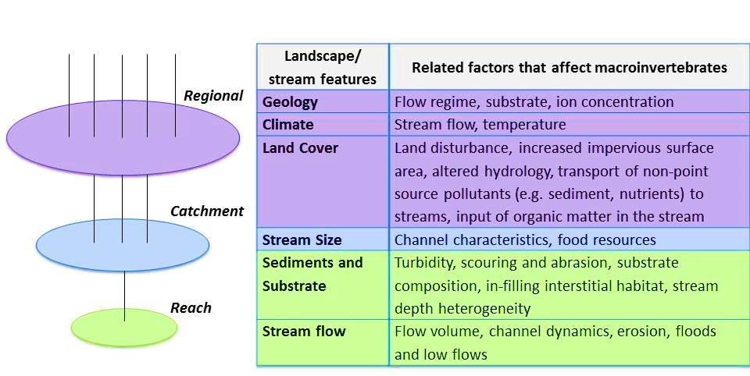
Figure 2: Hierarchical relationships between select landscape and stream features and habitat “filters” that affect macroinvertebrates (adapted from Poff, 1997). The colors from the diagram on the left correspond to various scales and the colors in the table.
In addition to hierarchical effects, the environmental factors that have the most influence on macroinvertebrates vary regionally and influence the response of aquatic systems to other changes (Wang et al., 2003; Johnson and Host, 2010). Stewart et al. (2001) found variation in how macroinvertebrate and fish species respond to watershed, riparian, and reach characteristics. The distribution of aquatic biota, scale dependencies in environmental features, size of the study region, background disturbance, and landscape heterogeneity influence the relative contribution of local, reach, and watershed variables (Johnson and Host, 2010). Hence the relative importance of each variable with respect to the habitat of macroinvertebrates varies by region. Further, the spatial scale of influences on aquatic ecosystems may be similar across riverine systems or may be spatially variable (Gergel et al., 2002). Analyzing this spatial variation across environmental gradients can help identify places and scales at which large environmental changes, such as those caused by climate (Poff et al., 2010), and also large-scale resource management changes are most prominent.
Ecoregions can be a useful basis for monitoring and management of streams. The underlying premise of this approach is that ecoregion classifications provide a first-level filter in assessing influence on the habitats of aquatic macroinvertebrates and, in turn, can help improve understanding about how the spatial variation in aquatic macroinvertebrates respond to other changes. Ecoregions are based on patterns of a combination of causal and integrative factors including land use, resource management, land-surface form, potential natural vegetation, and soils (Omernik, 1987). Ecoregions reflect the distribution of species and communities across a region and have been used to study biodiversity and aid in environmental conservation (Olson et al., 2001). Aquatic ecosystems are also influenced by ecoregion classifications since the characteristics of a stream depend on the characteristics of the land it drains (Larsen et al., 1986). Feminella (2000) found ecoregions were useful to classify benthic invertebrates and their habitats within catchment in the southeastern U.S. Ecoregions, therefore, can be very useful in management of watersheds by identifying areas within a watershed with similar aquatic ecosystems (Rohm et al., 1987, Bailey, 2004). Characterizing species by ecoregions limits the variability of natural regional-scale forces, which helps improve understanding about how differences between regions influence stressors effects on biota (Hawkins et al., 2000). For example knowing if a stream is in a catchment with highly erodible soils or one with low erosion potential provides insight regarding vulnerability of aquatic biota to otherwise similar disturbance (Hawkins et al., 2000).
Different ecoregion classifications have been developed based on the characteristic of interest, management need, and resource under consideration (McMahon et al., 2001). Of these classifications, Omernik’s, Bailey’s, and Freshwater Ecoregion Classification systems are among the most frequently used for resource analysis and environmental conservation. For example Omernik’s ecoregion classification incorporates the spatial correlation of both physical and biological factors and is based on the premise that relatively homogenous areas can be identified by simultaneously analyzing causal and integrative factors including land-surface form, soils, land use, and potential natural vegetation (Omernik, 1987). Omernik’s ecoregion classification scheme was created to assist managers in understanding aquatic and terrestrial resources and was found to be useful in classifying aquatic species in streams in Oregon (Van Sickle and Hughes, 2000). Climate plays a key role in Bailey’s ecoregion differentiation. For broad-scale subdivision of the continent, the large ecological climate-zones are useful in identifying categories called ‘Divisions’ since the formation of soils and vegetation types and, to a lesser degree, of fauna are determined primarily by the climate (Bailey, 1983). Beyond climate, the macrofeatures of vegetation, which usually coincide with major relief units, are used to identify more detailed ecoregion classifications called provinces, which are further divided into sections based on the terrain in Bailey’s scheme (Bailey, 1983). Benthic invertebrate and fish assemblages in Missouri were found to be coincident with Bailey’s sections and Omernik’s ecoregions (Rabeni and Doisy, 2000). The Freshwater ecoregions that depict a global biogeographic regionalization of Earth's freshwater system are based on the distributions and compositions of freshwater fish species and incorporate major ecological and evolutionary patterns (Abell et al., 2008). Freshwater ecoregions have been used for global and regional conservation efforts related to fish species (Abell et al., 2008).
The objective of the present study was: (1) to evaluate which ecoregional classification scheme (Omernik, Bailey, or Freshwater) provides a better framework for understanding the spatial distribution of aquatic macroinvertebrates in the EPT taxa in the state of Tennessee and (2) to analyze how EPT taxa respond to variations in regional environmental and stream-based factors. To address the objective of this study, the distribution of statewide benthic macroinvertebrate data were analyzed with three ecoregion classifications: those of Bailey, Omernik, and Freshwater ecoregion, and the differences in EPT taxa richness across ecoregions and the regional factors that could cause such differences were evaluated. The ecoregion classification schemes were used to partition naturally occurring variation in the aquatic biota and regional stressors effects on aquatic macroinvertebrates. Evaluating these classification schemes and understanding the factors affecting EPT taxa richness can help identify the baseline and context under which several other factors, such as those caused by land-use change, can affect EPT taxa.

Study Area and Methods

Study Area
This study focuses on the diversity and distribution of aquatic macroinvertebrates in Tennessee, which has great variation in topography, climate, and geography, and hence one of the highest freshwater species diversity of any inland state in the United States (Stein, 2002). Several distinct landforms exist in Tennessee – from the Appalachian Mountains in the east to the Mississippi plains in the west (Fig. 3) (US EPA, 2012). The unique geomorphological and geological structures of the ecoregions provide different stream characteristics and substrates that are expected to affect macroinvertebrate distribution. Since one of the goals of this research is to understand the spatial distribution of macroinvertebrates as a function of different environmental variables, the diverse geomorphological structure of Tennessee offers an ideal case study.
The Blue Ridge Mountains (part of the Appalachian range) of Tennessee, extending to parts of the Great Smoky Mountains, are characterized by forested slopes; high gradient, cool, clear streams with bedrock and boulder substrates; and rugged terrain on primarily metamorphic bedrock (Griffith, 2010). West of the Blue Ridge Mountains is the Ridge and Valley Province, which is characterized by parallel ridges and valleys comprising of a variety of widths, heights, and geologic materials, including limestone, dolomite, shale, siltstone, sandstone, chert, mudstone, and marble. Small streams drain the ridge slopes and join at right angles with largerlower-gradient stream courses that meander along the parallel valley floors (Griffith, 2010). The Southwestern Appalachian Mountains are low mountains to the west of the Ridge and Valley ecoregion that have moderate to high density of small perennial streams, mostly on moderate to high gradients. The Interior Plateau is a diverse ecoregion with Mississippian to Ordovician-age limestone, chert, sandstone, siltstone, and shale underlying the landforms of open hills, irregular plains, and tablelands. This region has perennial to intermittent streams on low to moderate gradients. Close to the west end of the state, the Gulf Coastal Plain has Cretaceous or Tertiary-age sands, silts, and clays that contrast geologically with the older limestone, chert, and shale found in the Interior Plateau. Streams in this area are relatively low-gradient with sandy substrates (Griffith, 2010). The Mississippi flood plains at the far west end of the state are flat broad floodplains with river terraces and levees. The soils here are generally fine textured and poorly drained.
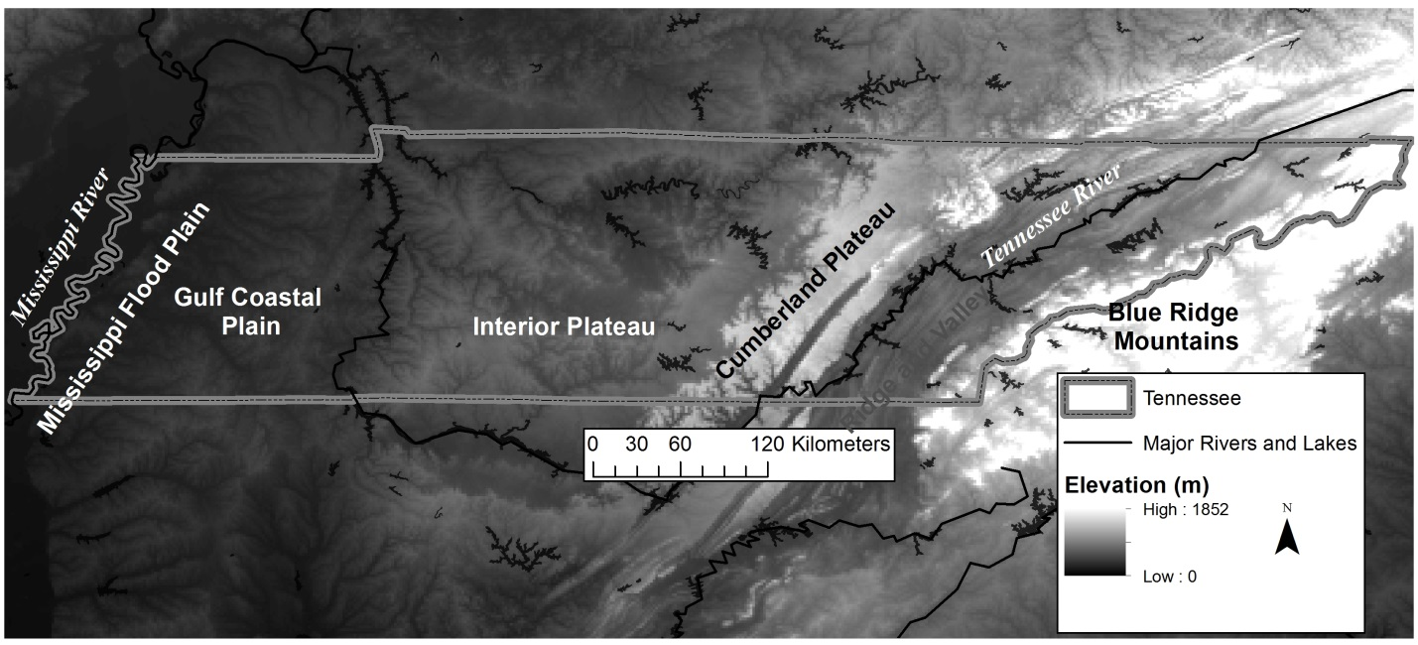
Figure 3: Physical map of Tennessee illustrating elevation gradient, major land forms and rivers.

Methods: Data and Analysis
As a first step towards the research goal, the EPT taxa richness values across streams in Tennessee were categorized by different ecoregion classification schemes, and the distribution of EPT taxa richness across different ecoregions in each classification were analyzed to evaluate if they were similar across the study region, or different based on ecoregion . EPT taxa richness measures were obtained from data collected by the Tennessee Department of Environmental Conservation (TDEC). TDEC surveys and monitors several streams in Tennessee to conduct benthic macroinvertebrate assessments (TDEC, 2008). These surveys are usually conducted in the months of July, August, and September using standard operating protocols. Based on semi-quantitative single habitat surveys (SQSH) in riffles or banks, taxa are identified to the genus level within a 200 organism subsample, and indices such as total taxa, EPT taxa richness, percentage of organisms in EPT order, and intolerant taxa are calculated (TDEC, 2011). The information from TDEC included data from the Wadeable Streams Assessment (WSA) (Arnwine et al., 2011); reference stream assessment; and biological, chemical, bacteriological, and physical data collected as part of the following programs: routine watershed monitoring, 303(d) monitoring, antidegradation monitoring, and permit compliance/complaint investigation (Denton et al., 2010). TDEC conducted a probabilistic monitoring of about 90 wadeable streams in 2007 and 2010 as part of the national monitoring effort (Arnwine et al., 2011). The wadeable stream assessment is based on one site visit per station and includes information on macroinvertebrates, habitat, nutrient, and metals. The reference stream assessment by TDEC evaluates habitat at reference sites using standardized numeric assessment approaches. These reference sites are the least-impacted, yet representative, streams in each of the ecoregions within the state. There are 162 reference stream sites in TN, and these sites are monitored on a 5 y rotation period. As part of the routine watershed monitoring program, 55 hydrologic watershed boundaries were identified within Tennessee, and each of these watersheds was classified into five groups that were monitored on 5 y cycles scheduled in different years. Macroinvertebrate sampling, habitat assessments, and field measurements of DO, conductivity, pH, and temperature were conducted by TDEC at these sites. Based on the above data from TDEC, 741 data samples between the years 2007 and 2010 were assembled for data analysis in this study. The EPT taxa richness values were between 0 and 25 and not normally distributed. Hence we used the Kruskal-Wallis test, a nonparametric statistical procedure, to evaluate if EPT taxa richness was different by ecoregions defined in each ecoregion classification scheme.
The EPT taxa richness values were evaluated based on Bailey’s, Omernik’s, and the freshwater ecoregion classification schemes (Fig. 4). The purpose of this study is to identify among common existing ecoregion classifications a classification which is better suited than others with respect to describing EPT taxa richness and their interactions with regional variables.
To select the classification that performed the best with respect to explaining EPT taxa richness patterns in Tennessee, the regional variables that influence macroinvertebrate habitat (climate, geology, soils) were also evaluated along with EPT taxa richness. Based on the factors affecting macroinvertebrate habitat at various scales (Fig. 2), climate, geomorphology, stream flow, and stream order were identified as important factors influencing macroinvertebrates at the regional scale. For the climate variables, average temperature and precipitation values were obtained from PRISM climate data (PRISM climate group 2013) (Table 1). Soil variables, geology, and slope were used to describe geomorphology. The Soil Survey Geographic (SSURGO) database was used to derive information on soil, silt, and clay texture composition of map units (Soil Survey Staff, 2013). Based on a weighted average of the soil texture fractions by component and map unit in ArcGIS, the soil texture values were mapped to SSURGO map units for Tennessee. Predominant lithology categories were obtained from the geology maps of Tennessee and used to identify primary and secondary rock types (USGS, 2005). Slope along streams was derived from the NHDPlus dataset, which uses the National Elevation Dataset (NED) to calculate terrain variables. The NHDPlus dataset, which is based on features of the National Hydrography Dataset (NHD), the National Elevation Dataset (NED), and the National Watershed Boundary Dataset (WBD) was used to obtain stream-based variables such as stream order, stream velocity, and stream flow.

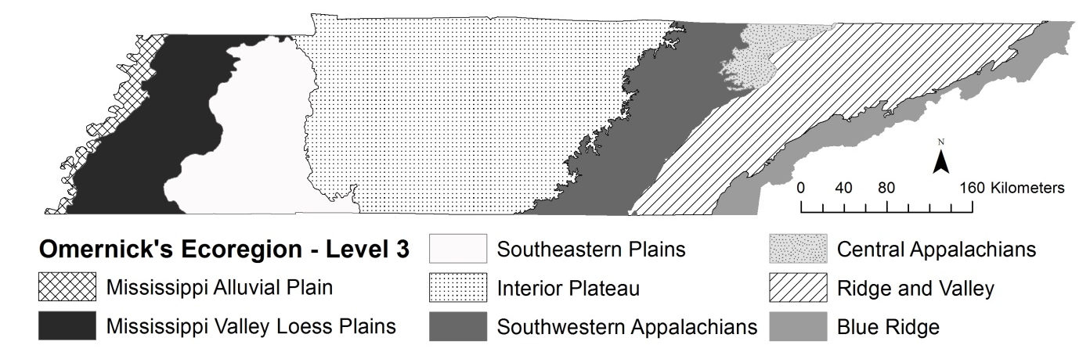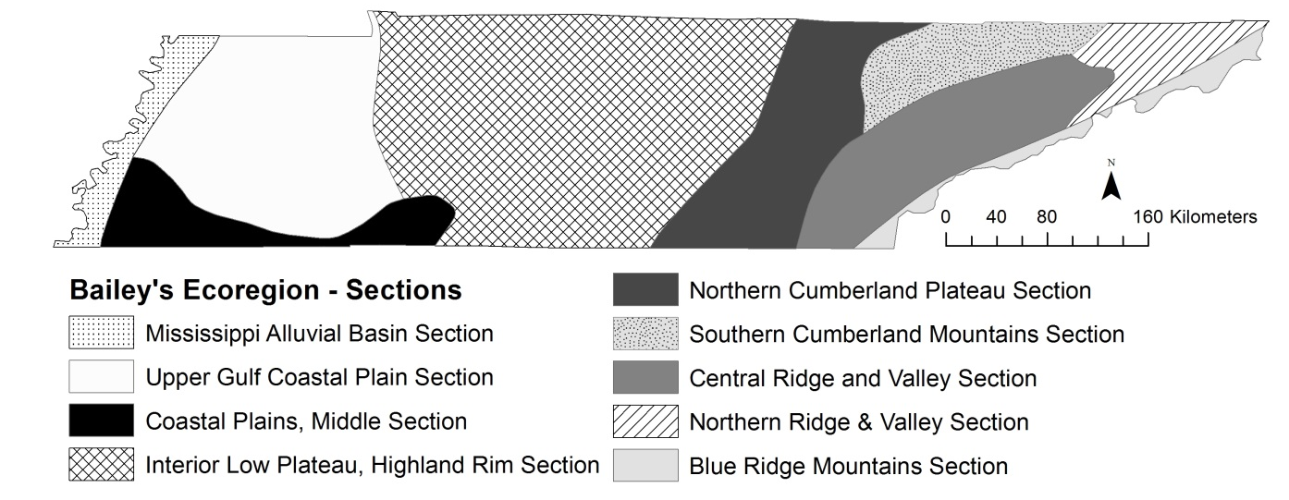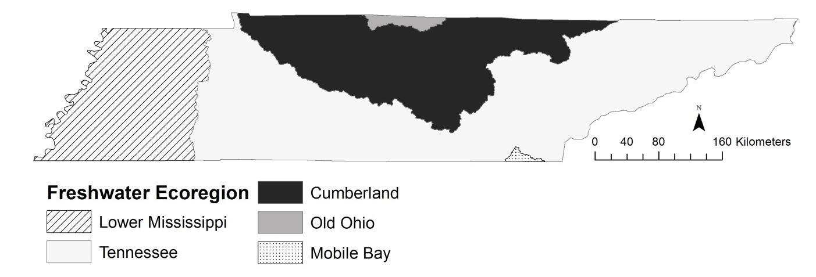
Figure 4: Ecoregion classification schemes for Tennessee.

In order to focus on the regional environmental influences on EPT taxa richness and to prevent masking of such influences by other anthropogenic factors, the data from the reference stream sites were used to determine which ecoregion classification is more appropriate for the purpose of this study (e.g., to differentiate the most EPT taxa richness from one ecoregion to others). We use a cluster evaluation technique called Silhouette analysis to identify the classification which captured the within-ecoregion class homogeneity of these variables as much as possible. Silhouette analysis was applied to data from the reference stream sites. Silhouette analysis computes the within cluster compactness and between cluster dissimilarity to obtain a silhouette value between -1 and 1. The silhouette value for the i^{th} point, $Si$, is defined as
$$Si=\frac{bi-ai}{\max\left(ai,bi\right)}$$
where $ai$ is the average distance from the i^{th} point to the other points in the same cluster as i, and $bi$ is the minimum average distance from the i^{th} point to points in a different cluster, minimized over clusters (Rouseeuw, 1987). High silhouette values above 0 indicate a tight cluster that is well-matched to its own cluster and well differentiated from its neighboring clusters. Low or negative silhouette values can be due to too many or too few clusters (Kaufman and Rouseeuw, 2009). A negative SV indicates that an object may have been placed in a cluster that is heterogeneous, since the average within cluster distance is large and/or the distance to the next closest cluster is small. As the SV gets closer to -1, it is more clear that the object has been misclassified and its placement will be more appropriate in a different cluster. However values closer to zero indicate that the within cluster distance and the distance to the next closest cluster is about the same and the object can belong to both clusters (Rousseeuw 1987). Such clusters are not considered wrong, but indicate additional heterogeneity in the clusters. Since the object of our study was to select the best among three ecoregions (for the purpose of our analysis), we choose the classification that had the lowest “misclassification” of objects for further analysis.
The second part of this research focused on the regional factors that influence aquatic macroinvertebrates and how their influence varied across ecoregions associated with the ecoregion classification scheme selected earlier. First we used the Kruskal-Wallis test on each regional variable (α =0.05) to examine if it varied across different ecoregions. Next we evaluated the association between regional factors and EPT taxa richness (Table 2). If a regional factor is a continuous variable, we utilized correlation analyses between EPT taxa richness and the regional factor for each ecoregion. Then we compared the strength of those associations to see if they varied by ecoregions. For a regional factor as a categorical variable, such as rock type and stream order, we used the Analysis Of Variance (ANOVA) test to determine if there were significant differences in EPT taxa richness across groups of each variable.

Results

EPT taxa richness across Ecoregions
Under all three ecoregion classification schemes considered in this study, the EPT taxa richness values were found to be significantly different across ecoregions at a 0.001 level based on the nonparametric Kruskal-Wallis test. A graphical representation of the EPT taxa distribution for Omernik’s and Bailey’s ecoregions illustrates that higher EPT taxa richness was found in the eastern regions – Blue Ridge, central and southwestern Appalachians, and the Ridge and Valley ecoregions (Figs. 5,6). The freshwater ecoregion classification had low EPT taxa richness in the Mississippi ecoregion and higher EPT taxa richness for reference streams in the Tennessee ecoregion (Fig. 7). In all ecoregion classifications, the EPT taxa richness values of reference streams were higher than those of other stream sites.
Statistical analysis of the regional variables indicated that temperature, rock depth, percentage of sand, silt and clay, slope, stream flow, stream velocity, and stream order were significantly different across ecoregions. Apart from the freshwater ecoregion classification, precipitation was significantly different across the ecoregion classifications.
Silhouette analysis of the EPT taxa richness and regional variables for the three different ecoregion classifications resulted in silhouette values of -0.0812 for Omernik’s classification, -0.1672 for Bailey’s classification, and -0.2953 for the freshwater ecoregion classification. Silhouette plots of the classification schemes (Fig. 8) identified individual classes that had high negative or positive values. In general values close to 0 indicate samples are close to boundaries between clusters, and negative values indicate heterogeneous classes that can be improved with further clustering. Overall, all classification schemes provided negative values indicating that the classification could be improved with better clusters. However since the goal of this analysis was to compare the relative performance of three pre-existing classifications schemes, the best among the three, Omernik’s classification, was chosen for further analysis.

Regional factors among ecoregions
The results from the analyses testing the significance of relationship between the regional variables and EPT taxa richness across the Omernik’s ecoregion indicated differences by ecoregion class (Table 2). For example correlation between temperature and EPT taxa richness was found to be significant only in the Mississippi Valley Loess Plains, the Central Appalachians, and the Ridge and Valley ecoregions. However, the
correlations between stream velocity and EPT taxa richness were significant in all ecoregions except the central Appalachians. Two precipitation variables were
Table 2: List of regional variables considered to be potentially important in affecting macroinvertebrate taxa richness, with sources of data and statistical tests. NHDplus refers to the hydrologic framework dataset developed by the US Environmental Protection Agency and the US Geological Survey (McKay et al., 2012).The PRISM Climate Group develops spatial climate datasets to reveal short- and long-term climate pattern (PRISM climate group 2013). The SSURGO database contains information about soil collected by the National Cooperative Soil Survey (Soil Survey Staff, 2013).
Category | Variable | Unit | Source | Statistical test used to test significance
Climate | Average temperature at the stream sampling site | C | NHDplus | Correlation
 | Average precipitation over several years at the stream sampling site | mm | NHDplus | Correlation
 | Mean annual precipitation during the year of data collection | mm | PRISM Climate group | Correlation
Geomorphology | Rock Type | Categorical | US Geological Survey Geology data | Kruskal-Wallis/ one-way ANOVA
 | Depth to bedrock | m | State Soil Geographic (STATSGO) dataset | Correlation
 | Soil (e.g. % clay) | % | SSURGO | Correlation
 | Slope | Degrees | NHDplus | Correlation
Stream flow | Stream Flow | cfs (cubic feet per second) | NHDplus | Correlation
 | Velocity | fps (feet per second) | NHDplus | Correlation
Stream Order | Stream order | Categorical (nominal) | NHDplus | Kruskal-Wallis/ one-way ANOVA

considered for the analysis – mean annual precipitation for the year of macroinvertebrate data collection and overall average precipitation over the macroinvertebrate stream site. Mean annual precipitation did not turn out to be significant for any of the ecoregion classes and hence has not been included in the results.

Discussion
Complex biological systems, such as aquatic ecosystems, vary in space and time need to be studied at multiple scales by considering appropriate relationships between environmental effects and species traits at each scale (Poff, 1997). Ecoregions help partition such effects and capture the environmental framework within which other factors may influence aquatic systems. In this study the variation of EPT taxa richness across ecoregions reflects the regional variation of macroinvertebrate community distribution as a response to different ecological, geological, and climatic conditions. All three ecoregion classifications had significant differences in EPT taxa richness among ecoregions (Figs. 5-7). However, there were differences in the significance of regional variables that influenced EPT taxa richness across the different classifications. The freshwater classification had the lowest silhouette scores of the three classification schemes.
This result could be because this scheme does not take into consideration climate and soil (Figs 4 & 9), which are important indicators of macroinvertebrate community structure ((Diaz et al., 2008). Bailey’s ecoregion, being based on climate, captures the precipitation gradient but does not align with the east-west soil gradient seen in Tennessee. The Omernik’s ecoregion aligns with the soil gradient and follows the general east-west gradient of precipitation. However the silhouette plots of the ecoregion classifications indicated that many regions had predominantly negative silhouette values. This observation could be attributed to the presence of other factors that influence the EPT taxa richness that are not captured by the ecoregion classification schemes. For example the silhouette values of the ridge and valley ecoregion were largely negative. The ridge and valley ecoregion is comprised of roughly parallel ridges and valleys in a variety of widths, heights, and geologic materials. The diversity within the landscape is not captured by the ecoregion classification and requires other sub-regional variables such as stream bank characteristics, substrate, and stream bed information for a more effective classification. However such a classification is beyond the scope of the current study, which is to assess if existing data could be used to differentiate macroinvertebrates by ecoregions.
Since the Omernik’s classification had the better classification scheme among three ecoregion classifications based on the silhouette analysis, it was chosen as the spatial framework for classifying aquatic macroinvertebrates and their naturally occurring regional variation in Tennessee.
In addition to setting the regional constraints, analyzing the spatial distribution of EPT taxa in relation to environmental gradients such as temperature, precipitation, and geomorphology, and stream–based factors is critical for predicting how species and communities are affected by other external changes. Based on the regional factors correlated with EPT taxa richness across Omernik’s ecoregions (Table 2), stream velocity was found to be a significant factor across most ecoregions. A reduction in flow velocity can lead to an increase in deposition of fines and decaying matter onto the riverbeds (Wood and Armitage, 1997). This problem is prevalent during low flow conditions in summer, and it is acute in groundwater-fed streams (Wood and Armitage, 1997).
Flow changes can also affect taxa richness by causing changes in amount of nonpoint source runoff or the dilution of point source discharge (Lenat, 1988). Further, a number of studies have found significant correlations between flow-related variables and macroinvertebrate habitat (e.g., Poff and Ward, 1989).
Stream order was significantly correlated with EPT taxa richness in three out of seven ecoregions. Previous studies have found taxa richness tends to increase with stream order till the 5th order streams (Lenat, 1988). A similar trend was observed for the ridge and valley streams (Fig. 10). The interior plateau streams also show a gradual increase from 2nd order streams and then a drop in taxa richness beyond 5th order streams.
This downstream shift in species richness conforms to the river continuum concept (Vannote et al., 1980), according to which the macroinvertebrate community structure changes along a continuum, from stream headwaters to mouths due to changes in stream flow, channel morphology, and temperature (Minshall et al., 1985). With increase in stream order, the physio-chemical fluctuations, mean annual turbidity, and water temperature decrease, while mean annual flow, alkalinity, and conductivity increase (Harrel and Dorris, 1968). These factors affect macroinvertebrate habitat and food resources. However the influence of stream order was different for Blue Ridge streams, which showed a decrease in taxa richness with increasing stream order. In the Blue Ridge, the highest EPT taxa richness values were observed in the first-order streams, which may be pristine mountainous headwater streams.
The percentage of sand in the first layer of soil was correlated with EPT taxa richness in four out of seven ecoregions. The type of soil influences the substrate type in streams and hence affects macroinvertebrate habitat. For example clay soils are less permeable to water than sandy soils. In sandy soils, larger proportions of sand are found in the stream reaches, and the streams are generally shallow (Richards et al., 1996). Ion concentration, which is also an important determinant of stream macroinvertebrate composition, can be attributed to geology and soil conditions (Hynes, 1975). Mean annual temperature was found to be significant in the eastern ecoregions. This significance could be a function of the rugged terrain in these regions, which influences
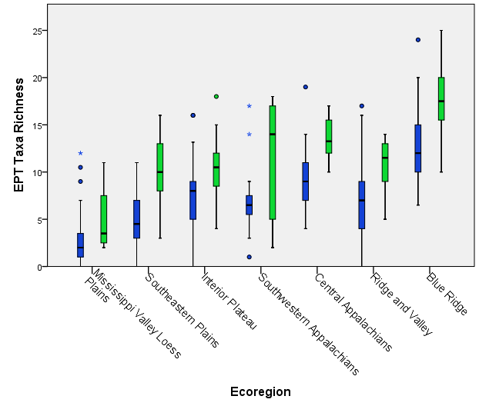
Figure 5: Box plots of EPT taxa richness (using data collected by TDEC between 2007 and 2010) grouped by Omernik’s ecoregion classes of Tennessee (ordered from west to east) and separated by reference stream category (reference streams are light grey boxes). The boxes represent the interquartile (IQ) range, and the line across the boxes indicates the median values. The whiskers from the upper and lower edge of the box indicate the highest and lowest values within 1.5 times the IQ range. Outliers between 1.5 and 3 times the IQ range are indicated by the closed circles, and outliers with values more than 3 times the IQ range are indicated by the asterisk. Data from the Mississippi Alluvial Plain have been excluded due to insufficient data.
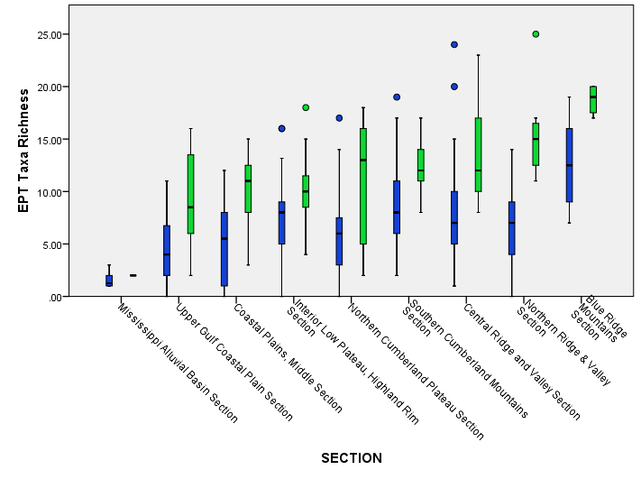
Figure 6: Box plots of EPT taxa richness (collected by TDEC between 2007 and 2010) grouped by Bailey’s ecoregion classes of Tennessee (ordered from west to east) and separated by reference stream category (reference streams are light grey boxes). The boxes represent the interquartile (IQ) range, and the line across the boxes indicates the median values. The whiskers from the upper and lower edge of the box indicate the highest and lowest values within 1.5 times the IQ range. Outliers between 1.5 and 3 times the IQ range are indicated by the closed circles.

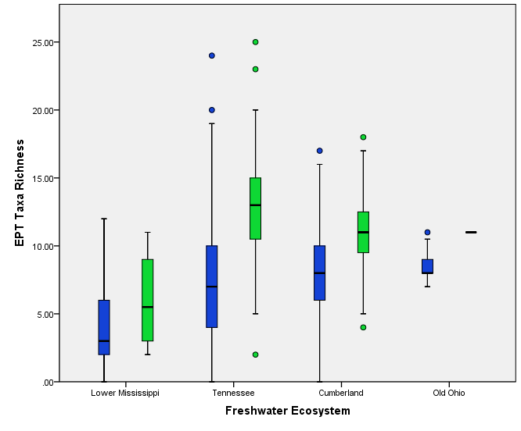
Figure 7: Box plots of EPT taxa richness (collected by TDEC between 2007 and 2010) grouped by Freshwater ecosystem classes of Tennessee (ordered from west to east) and separated by reference stream category (reference streams are light grey boxes). The boxes represent the interquartile (IQ) range, and the line across the boxes indicates the median values. The whiskers from the upper and lower edge of the box indicate the highest and lowest values within 1.5 times the IQ range. Outliers between 1.5 and 3 times the IQ range are indicated by the closed circles. Data from the Mobile Bay ecoregion have been excluded due to insufficient data.

Figure 8: Silhouette plots for classification of EPT taxa richness using Omenik’s (A), Bailey’s (B), and Freshwater (C) ecoregion classification schemes. Classes on Omernik’s plot (A) are: 1- Blue Ridge, 2-Central Appalachian 3-Interior plateau, 4-Mississippi Valley Loess Plains, 5-Ridge and Valley, 6-Southeastern Plains, and 7-Southwestern Appalachians. Classes on Bailey’s plot (B) are 1-Blue ridge mountains, 2-Central ridge and valley, 3-Coastal plains middle section, 4-Interior low plateau, Highland rim section, 5-Mississippi alluvial basin section, 6-Northern Cumberland plateau section, 7-Northern ridge and valley section, 8-Southern Cumberland mountains section, and 9-Upper Gulf coastal plain section. Classes on Freshwater ecoregion plot (C) are: 1-Lower Mississippi, 2-Old Ohio, 3-Cumberland, and 4-Tennessee.
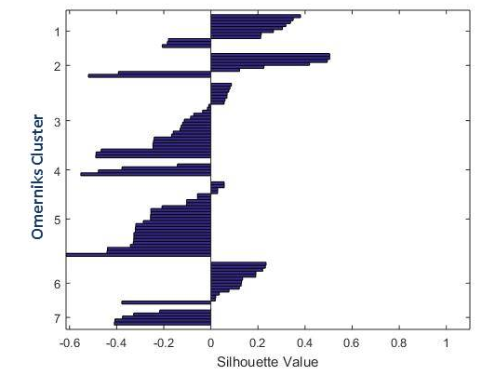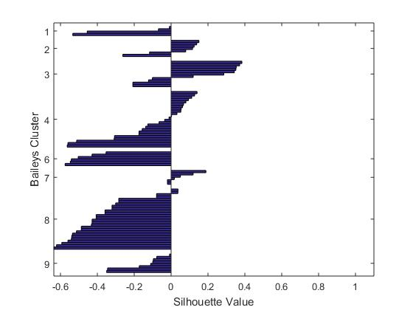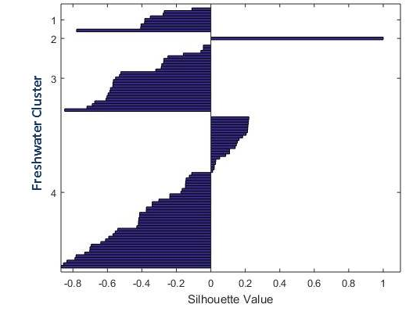
A
C
B
Figure 8. Continued
Table 3: Correlation of EPT taxa richness with regional variables by Omernik's ecoregion classification. The asterisks indicate significant correlation at the 0.05 level
Ecoregion | Temp-erature | Precip-itation | Rock depth | Rock type | % Sand | % Silt | % Clay | Slope | Stream Flow | Velocity | Stream order | Map
Mississippi Valley Loess Plains |  | * |  |  | * |  |  |  | * | * |  | 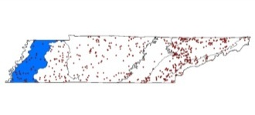
Southeastern Plains |  | * |  | * |  |  | * |  |  | * |  | 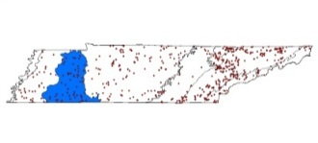
Interior Plateau |  |  | * | * | * |  |  | * | * | * | * | 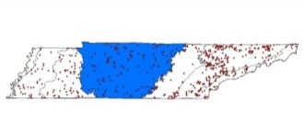
Southwestern Appalachians |  |  |  |  |  |  |  |  |  | * |  | 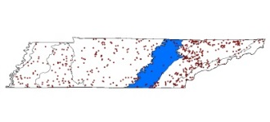
Central Appalachians | * | * |  |  |  |  | * |  |  |  |  | 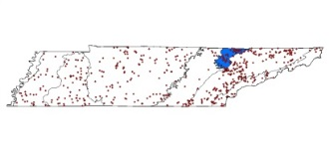
Ridge and Valley | * |  |  |  | * | * |  | * |  | * | * | 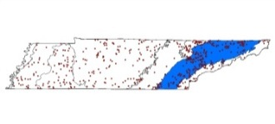
Blue Ridge | * |  |  |  | * |  |  | * | * |  | *

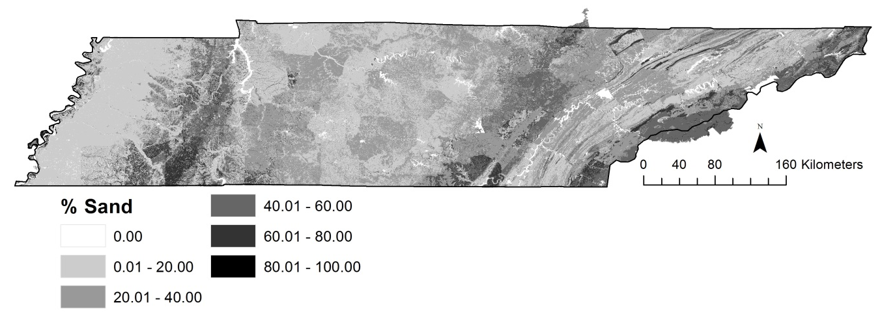
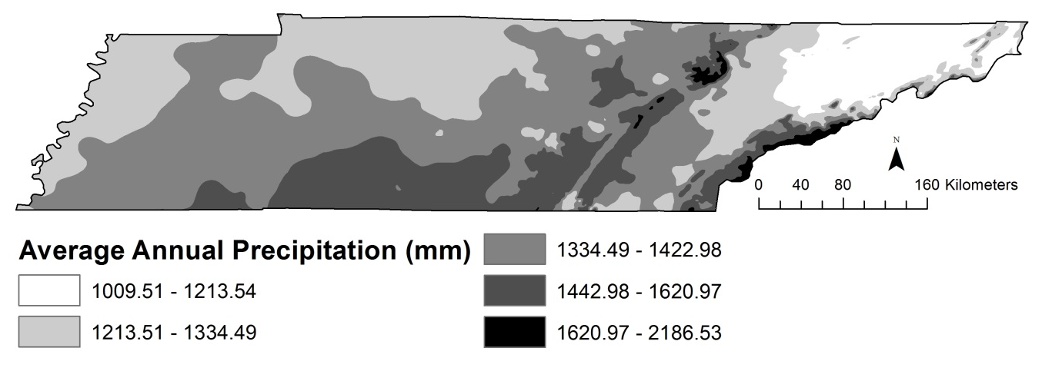
Figure 9: Soil (upper) and climate (lower) gradients across Tennessee based on soil composition and average annual precipitation (Source: SSURGO and PRISM data).

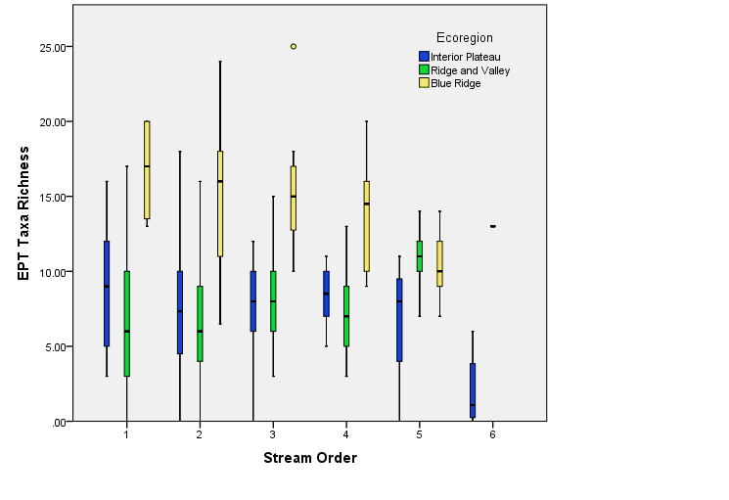
Figure 10: Distribution of EPT taxa richness by stream order for ecoregions found to have significant correlation between stream order and EPT taxa richness. The boxes represent the interquartile (IQ) range, and the line across the boxes indicates the median values. The whiskers from the upper and lower edge of the box indicate the highest and lowest values within 1.5 times the IQ range. Outliers between 1.5 and 3 times the IQ range are indicated by the closed circles.

temperature variations and also precipitation changes. The EPT taxa richness in the Ridge and Valley and Blue Ridge streams were also correlated with slope.

Conclusion
The local macroinvertebrate community structure in Tennessee is a result of continuous sorting process through various environmental filters, ranging from regional processes (geology, climate) to local processes (substratum porosity, channel velocity) (Fig. 2). These factors can influence macroinvertebrate habitat by affecting physiological constraints (e.g., oxygen acquisition), trophic considerations (e.g., food acquisition), physical habitat constraints (e.g., substrate), and biotic interactions (e.g., predation) (Merritt and Cummins, 1996). The above analysis across ecoregions indicates that EPT taxa richness in Tennessee varies by ecoregion, irrespective of the classification type used. Differences in the regional factors that influence EPT taxa richness across ecoregions have implications for how the macroinvertebrate community responds to other changes, such as land-use changes. The spatial scales with which land cover and macroinvertebrate variables are associated vary depending on the mechanisms that link land cover and ecological conditions (Strayer et al., 2003). For example in-stream habitat structure is determined by local conditions such as vegetative cover at a site, whereas nutrient supply, sediment delivery, hydrology, and channel characteristics are influenced by regional conditions, including landscape features (Allan et al., 1997). Waite et al. (2000) noted that, “the usefulness of macroinvertebrate assemblages for monitoring water quality and biological integrity depends in part on our ability to distinguish human impacts from natural variability.”
The processes that influence the structure and dynamics of communities occur on multiple spatial scales and, for many communities, focusing on processes at a single spatial scale does not provide understanding of the factors that shape communities (Swan and Brown, 2011). Understanding the relative influence of catchment, reach, and riparian-scale factors in structuring aquatic biota can help prioritize the scale at which to rehabilitate, manage and derive policies for stream ecosystem integrity (Weigel et al., 2003). In this study we found that various regional variables constrain EPT taxa richness and hence can influence the susceptibility of EPT taxa to further abiotic changes such as anthropogenic land-use change. For example EPT taxa richness in the ridge and valley streams was significantly correlated to soil, terrain, and stream velocity. Based on the silhouette analysis, the regional variables that define ecoregions are not sufficient to characterize the EPT taxa richness. In these streams the effect of land-use changes also depends on the location of the stream and its flow characteristics (also a function of the terrain). Identifying the regional factors and accounting for them can help characterize land-use and land-management change effects on aquatic macroinvertebrates. Though other studies have considered regional and local factors together in their analyses, such methods can cause the effect of a variable to overshadow the effect of other significant, but smaller variables. A multi-scale analysis, which takes into consideration regional effects across ecoregions before considering other local–scale variables such as stream water quality and sediment, can help assess the multiple processes operating on aquatic macroinvertebrates and also set the stage for analyzing anthropogenic influences in the context of defined regional/local variable influences.

References

Abell, R., M.L. Thieme, C. Revenga, M. Bryer, M. Kottelat, N. Bogutskaya, B. Coad, N. Mandrak, S. Contreras-Balderas, W. Bussing, M. L. J. Stiassny, P. Skelton, G. R. Allen, P. Unmack, A. Naseka, R. Ng, N. Sindorf, J. Robertson, E. Armijo, J. Higgins, T. J. Heibel, E. Wikramanayake, D. Olson, H. L. Lopez, R. E. d. Reis, J. G. Lundberg, M. H. Sabaj Perez, and P. Petry. 2008. Freshwater ecoregions of the world: a new map of biogeographic units for freshwater biodiversity conservation. BioScience, 58: 403-414.

Allan, D., D. Erickson, and J. Fay. 1997. The influence of catchment land use on stream integrity across multiple spatial scales. Freshwater Biol., 37: 149-161.

Arnwine, D. H., M. H. Graf, and A. L. Whitley. 2011. 2010 Probabilistic monitoring of wadeable streams in Tennessee. https://www.tn.gov/assets/entities/environment/attachments/wsa2010.pdf. Accessed: February 1st 2016.

Bailey, R. G. 1983. Delineation of Ecosystem Regions. Environ. Manage., 7: 365-373.

Bailey, R. G. 2004. Identifying ecoregion boundaries. Environ. Manage., 34: S14-S26.

Carlisle, D. and W. Clements. 1999. Sensitivity and variability of metrics used in biological assessments of running waters. Environ. Toxicol. and Chem., 18: 285-291.

Denton, G.M., M.H. Graf, D.H. Arnwine, and L.K. Cartwright. 2010. 2010 305(b) Report. The status of water quality in Tennessee. https://www.tn.gov/assets/entities/environment/attachments/2010_305b.pdf. Accessed: February 1st 2016.

Díaz, A. M., M. L. S Alonso, and M. R. V. A. Gutiérrez. 2008. Biological traits of stream macroinvertebrates from a semi‐arid catchment: patterns along complex environmental gradients. Freshwater Biol., 53: 1-21.

Feminella, J. 1996. Comparison of benthic macroinvertebrate assemblages in small streams along a gradient of flow permanence. J. N. Am. Benthol. Soc., 15: 651-669.

Feminella, J. W. 2000. Correspondence between stream macroinvertebrate assemblages and 4 ecoregions of the southeastern USA.J. N. Am. Benthol. Soc., 19: 442-461.

Gergel, S.E., M.G. Turner, J.R. Miller, J.M. Melack, and E.H. Stanley. 2002. Landscape indicators of human impacts to riverine systems. Aquat. Sci., 64: 118-128.

Goldstein, R.M., D.M. Carlisle, M.R. Meador, and T.M. Short. 2007. Can basin land use effects on physical characteristics of streams be determined broad geographic scales? Environ. Monit. Assess., 130: 495-510.

Griffith, G. 2010. Level III North American Terrestrial Ecoregions: United States Descriptions. ftp://ftp.epa.gov/wed/ecoregions/pubs/CEC_LEVEL_III_Descriptions_US_May2010.doc. Accessed: November 7, 2012.

Harrel, R. C. and T.C. Dorris. 1968. Stream order, morphometry, physico-chemical conditions, and community structure of benthic macroinvertebrates in an intermittent stream system. Am. Midl. Nat., 80: 220-251.

Hawkins C.P., R.H. Norris, J. Gerritsen, R.M. Hughes, S.K. Jackson, R.K. Johnson, and R. Jan Stevenson. 2000. Evaluation of the use of landscape classifications for the prediction of freshwater biota: synthesis and recommendations. J. N. Am. Benthol. Soc., 19: 541-556.

Hodkinson, I. D. and J. K. Jackson. 2005. Terrestrial and aquatic invertebrates as bioindicators for environmental monitoring, with particular reference to mountain ecosystems. Environ. Manage., 35: 649-666.

Hughes, R. M., E. Rexstad, and C. E. Bond. 1987. The relationship of aquatic ecoregions, river basins, and physiogeographic provinces to the ichthyogeographic regions of Oregon. Copeia, 1987:423–432.

Hynes, H. B. N. 1975. Edgardo Baldi memorial lecture. The stream and its valley. Ver. Int. Verein. theoret. angew. Limnol., 19: 1-15.

Johnson, L. B. and G. E. Host. 2010. Recent developments in landscape approaches for the study of aquatic ecosystems. J. N. Am. Benthol. Soc., 29: 41-66.

Kaufman, L. and P. J. Rousseeuw. 2009. Finding groups in data: an introduction to cluster analysis. John Wiley & Sons, Hoboken, NJ, USA.

Kennan, J. G. 1999. Relation of macroinvertebrate community impairment to catchment characteristics in New Jersey streams. JAWRA, 35: 939-955.

Larsen, D. P., J. M. Omernik , R. M. Hughes , C. M. Rohm, T. R. Whittier , A. J. Kinney , and D. R. Dudley. 1986. Correspondence between spatial patterns in fish assemblages in Ohio streams and aquatic ecoregions. Environ. Manage., 10: 815-828.

Lenat, D.R. 1984. Agriculture and stream water quality: a biological evaluation of erosion control procedures. Environ. Manage., 8: 333-334.

Lenat, D. R. 1988. Water quality assessment of streams using a qualitative collection method for benthic macroinvertebrates. J. N. Am. Benthol. Soc., 7: 222-233.

Lenat, D. R. and J. K. Crawford. 1994. Effects of Land-Use on Water-Quality and Aquatic Biota of 3 North-Carolina Piedmont Streams. Hydrobiologia, 294: 185-199.

Maloney, K. O., P. Munguia, and R. M. Mitchell. 2011. Anthropogenic disturbance and landscape patterns affect diversity patterns of aquatic benthic macroinvertebrates. J. N. Am. Benthol. Soc., 30: 284-295.

Maxted, J.R., M. T. Barbour, J. Gerritsen, V. Poretti, N. Primrose, A. Silvia, D. Penrose, and R. Renfrow. 2000. Assessment framework for mid-Atlantic coastal plain streams using benthic macroinvertebrates. J. N. Am. Benthol. Soc., 19: 128-144.

McKay, L., T. Bondelid, T. Dewald, J. Johnston, R. Moore, and A. Rea. 2012. NHDPlus Version 2: User Guide. ftp://ftp.horizon-systems.com/NHDPlus/NHDPlusV21/Documentation/NHDPlusV2_User_Guide.pdf. Accessed: January 29, 2016.

McMahon, G., S. M. Gregonis, S. W. Waltman, J. M. Omernik, T. D. Thorson , J. A. Freeouf, and J. E. Keys. 2001. Developing a spatial framework of common ecological regions for the conterminous United States. Environ. Manage., 28: 293-316.

Merritt, R. W. and K.W. Cummins. 1996. An introduction to the aquatic insects of North America. Kendall Hunt Publishing Company, Dubuque, IA, USA.

Minshall, G. W., R.C. Petersen Jr., and C.F. Nimz. 1985. Species richness in streams of different size from the same drainage basin. Am. Nat., 125: 16-38.

Neff, M. R. and D. A. Jackson. 2011. Effects of broad-scale geological changes on patterns in macroinvertebrate assemblages. J. N. Am. Benthol. Soc., 30: 459-473.

Olson, D.M., E. Dinerstein, E.D. Wikramanayake, N.D. Burgess, G.V. Powell, E.C. Underwood, J.A. D'amico, I. Itoua, H.E. Strand, J.C. Morrison, and C.J. Loucks. 2001. Terrestrial Ecoregions of the World: A New Map of Life on Earth A new global map of terrestrial ecoregions provides an innovative tool for conserving biodiversity. BioScience, 51: 933-938.

Omernik, J. M. 1987. Ecoregions of the conterminous United States. Ann. Assoc. Am. Geogr., 77: 118-125.

Poff, N. L. 1997. Landscape filters and species traits: towards mechanistic understanding and prediction in stream ecology. J. N. Am. Benthol. Soc., 16: 391–409.

Poff, N.L., M.I. Pyne, B.P. Bledsoe, C.C. Cuhaciyan, and D.M. Carlisle. 2010. Developing linkages between species traits and multiscaled environmental variation to explore vulnerability of stream benthic communities to climate change. J. N. Am. Benthol. Soc., 29: 1441-1458.

Poff, N. L. and J.V. Ward. 1989. Implications of streamflow variability and predictability for lotic community structure: a regional analysis of streamflow patterns. Can. J. Fish. and Aquat. Sci., 46: 1805-1818.

PRISM Climate Group. 2013. Average monthly and annual temperature and precipitation. http://prism.oregonstate.edu. Accessed: January 29, 2016.

Rabeni, C. F. and K. E. Doisy. 2000. Correspondence of stream benthic invertebrate assemblages to regional classification schemes in Missouri. J. N. Am. Benthol. Soc., 19: 419-428.

Richards, C., L. B. Johnson, and G. E. Host. 1996. Landscape-scale influences on stream habitats and biota. Can. J. Fish. Aquat. Sci., 53: 295-311.

Richards, D., R. J. Haro, L. B. Johnson, and G. E. Host. 1997. Catchment and reach-scale properties as indicators of macroinvertebrate species traits. Freshwater Biol., 37: 219-230.

Rohm, C. M., J. W. Giese, and C. C. Bennett. 1987. Evaluation of an aquatic ecoregion classification of streams in Arkansas. J. Freshwater Ecol., 4: 127-140.

Rosenberg, D. M. and V. H. Resh. 1993. Freshwater biomonitoring and benthic macroinvertebrates. Chapman & Hall, New York, USA.

Rousseeuw, P. J. 1987. Silhouettes: a graphical aid to the interpretation and validation of cluster analysis. J. Comput. Appl. Math., 20: 53-65.

Roy, A. H., A.D. Rosemond, M.J. Paul, D.S. Leigh, and J.B. Wallace. 2003. Stream macroinvertebrate response to catchment urbanisation (Georgia, USA). Freshwater Biol., 48: 329-346.

Sharma, R. C. and J. S. Rawat. 2009. Monitoring of aquatic macroinvertebrates as bioindicator for assessing the health of wetlands: A case study in the Central Himalayas, India. Ecol. Indic., 9: 118-128.

Soil Survey Staff. 2013. Soil Survey Geographic (SSURGO) Database for Tennessee. http://soildatamart.nrcs.usda.gov. Accessed: July 31, 2013.

Stein, B.A. 2002. States of the Union: Ranking America’s Biodiversity. Arlington, Virginia: NatureServe. http://www.natureserve.org/library/stateofunions.pdf. Accessed: February 1, 2016.

Strayer, D. L., R.E. Beighley, L.C. Thompson, S. Brooks, C. Nilsson, G. Pinay, and R.J. Naiman. 2003. Effects of land cover on stream ecosystems: roles of empirical models and scaling issues. Ecosystems, 6: 407-423.

Stewart, J. S., L. Wang, J. Lyons, J. A. Horwatich, and R. Bannerman. 2001. Influences of watershed, riparian-corridor, and reach scale characteristics on aquatic biota in agricultural watersheds. JAWRA, 37: 1475-1487.

Swan, C.M. and B.L. Brown. 2011. Advancing theory of community assembly in spatially structured environments: local vs regional processes in river networks. J. N. Am. Benthol. Soc., 30: 232-234.

TDEC. 2008. 2008 305(b) Report: The Status of Water Quality in Tennessee. http://tn.gov/assets/entities/environment/attachments/2008_305b.pdf. Accessed: February 1, 2016.

TDEC. 2011. Quality System Standard Operating Procedure for macroinvertebrate stream surveys. https://www.tn.gov/assets/entities/environment/attachments/bugsop11.pdf. Accessed: February 1, 2016.

US EPA. 2006. Wadeable stream assessment: A collaborative survey of the Nation’s streams. http://www.epa.gov/national-aquatic-resource-surveys/nrsa. Accessed: February 1st 2016.

USGS. 2004. USGS Open-File Report 2005-1324: Preliminary integrated geologic map databases for the United States : Kentucky, Ohio, Tennessee, and West Virginia. http://pubs.usgs.gov/of/2005/1324/ . Accessed: January 29, 2016.

USGS. 2005. USGS Open-File Report 2005-1324: Preliminary integrated geologic map databases for the United States : Kentucky, Ohio, Tennessee, and West Virginia. http://pubs.usgs.gov/of/2005/1324/ . Accessed: July 31, 2013.

Vannote, R. L., G.W. Minshall, K.W. Cummins, J.R. Sedell, and C.E. Cushing. 1980. The river continuum concept. Can. J. Fish. Aquat. Sci., 37: 130-137.

Van Sickle, J. and R. M. Hughes. 2000. Classification strengths of ecoregions, catchments, and geographic clusters for aquatic vertebrates in Oregon. J. N. Am. Benthol. Soc., 19: 370-384.

Waite, I. R., A. T. Herlihy, D. P. Larsen, and D. J. Klemm. 2000. Comparing strengths of geographic and nongeographic classifications of stream benthic macroinvertebrates in the Mid-Atlantic Highlands, USA. J. N. Am. Benthol. Soc., 19: 429-441.

Wang, L., J. Lyons, P Rasmussen, P. Seelbach, T. Simon, M. Wiley, P. Kanehl, E. Baker, S. Niemela, and P.M. Stewart. 2003. Watershed, reach, and riparian influences on stream fish assemblages in the Northern Lakes and forest ecoregion, U.S.A. Can. J. Fish. Aquat. Sci., 60: 491-505.

Weigel, B. M., L. Wang, P.W. Rasmussen, J.T. Butcher, P.M. Stewart, T.P. Simon, and M.J. Wiley. 2003. Relative influence of variables at multiple spatial scales on stream macroinvertebrates in the Northern Lakes and Forest ecoregion, USA. Freshwater Biol., 48: 1440-1461.

Wood, P. J. and P.D. Armitage. 1997. Biological effects of fine sediment in the lotic environment. Environ. Manage., 21: 203-217.

Yuan, L.L. and S.B. Norton. 2003. Comparing responses of macroinvertebrate metrics to increasing stress. J. N. Am. Benthol. Soc., 22: 308-322.

CHAPTER 6 - CONCLUSION
The environmental implications of bioenergy choices are extensive, complex, intertwined, and dependent on factors both endogenous and exogenous to a region and there is a strong need to understand how bioenergy crops can be grown sustainably (Dale et al. 2011). This research analyzed the effects of switchgrass-based land management on EPT taxa richness and assessed the potential of EPT taxa richness to be a potential bioindicator that can help evaluate the environmental sustainability of bioenergy systems. Based on the results of this study, and under the spatial context considered, it can be concluded that EPT taxa richness is not significantly affected by switchgrass-based land management on the short term (1-9 years). Further, EPT taxa richness is not an appropriate bioindicator in the context of switchgrass-based bioenergy systems.

Summary of results by objectives of study
In chapter 3, towards addressing first objective of the study to determine the key natural factors at different scales that affect EPT taxa richness, it was found that the regional factors and stream flow characteristics varied spatially by ecoregion classes. Three ecoregion classification schemes were evaluated to stratify the regional constraints, and the Omernik’s ecoregion classification, which captured the soil and precipitation spatial gradients, was found to be the better classification scheme for evaluating EPT taxa richness. For example, slope was correlated to EPT taxa richness in the interior plateau, ridge and valley and Blue Ridge ecoregions. Temperature was found to be significant in three of the eastern ecoregions (central Appalachians, ridge and valley and Blue Ridge ecoregions) where the undulating terrain has the potential to influence temperature and stream conditions. Stream flow was correlated to EPT taxa rich ness in the Mississippi Valley Loess plains, interior plateau and Blue Ridge ecoregions and stream velocity was correlated to EPT taxa richness all ecoregions other than central Appalachians and the Blue Ridge ecoregion. These results highlight the need to consider location and geomorphological context while studying aquatic macroinvertebrates. The results also bring to light the importance and need for a multi-scale analysis, which takes into consideration regional effects across ecoregions before considering other local–scale variables such as stream water quality and sediment.
Chapter 4 evaluated the potential of EPT taxa richness as indicators of water quality in Tennessee using a multilevel modeling approach. The use of the multilevel regression model helped quantify the influence of various variables in affecting EPT taxa richness by ecoregion (objective 2). It was found that temperature and average stream flows had the largest fixed effect regression coefficients, and were some of the strongest factors affecting EPT taxa richness across ecoregions (based on tables 5, 6 and 7). Daily stream flow was found to be significant as a random variable in some of the ecoregions. Total N, total P and sediment were found to be significant random variables in some ecoregions, but the magnitudes of their influence were small (<0.09 for N model, <0.05 for P model and <0.14 for sediment model). To evaluate if EPT taxa richness has the potential to be an indicator of water quality in the study area, multilevel regression models with water quality variables as dependent variables, and EPT taxa richness as the independent variable were assessed. The results from these models indicated that EPT taxa richness was significant as a random effect within some ecoregions, but the magnitude of these effects was small. Based on the results from the two different multilevel regression models (EPT taxa richness as dependent variable in the first set, and EPT taxa richness as the independent variable in the second set), the interaction between N and EPT-taxa richness as random factors can be confirmed in the southeastern plains and the ridge and valley ecoregions. The interaction between P and EPT taxa richness can be confirmed in the Blue Ridge ecoregion. However, owing to the low strength of the interactions and uneven responses across regions, EPT taxa richness was not found to be a useful indicator of water quality within the context of this study. Chapter 5 directly addressed the third objective of evaluating if switchgrass-based land-management changes influence EPT taxa richness. This study found that based on the study region and baseline conditions, the influence of switchgrass-based land management on EPT taxa richness was very small and within the standard deviations of monthly variations of the system. Hence it is concluded that the influence of switchgrass-based land-management changes on EPT taxa richness cannot be detected within the regional context and baseline conditions considered for this study.
Though the three manuscripts presented in this paper addressed different issues and used different approaches, the results of each manuscript was useful for the next and also share commonalities. Based on results from chapter 3 and chapter 4, stream velocity was found to be a significant variable in influencing aquatic macroinvertebrates. Slope was also significant in some ecoregions based on chapter 3, and based on chapter 4 slope was significant as a random variable in the same ecoregions when all three models (N, P and sediment) were considered.
Results from the multilevel models in chapter 4 indicate that stream flow is an important variable with respect aquatic macroinvertebrates. The same results were confirmed by the SWAT –regression model in chapter 5. The multilevel model in chapter 4 also found that N and P influence EPT taxa richness in the ridge and valley ecoregion and Blue Ridge ecoregion. This result was based on the significance of the random variable, and the overall influence on EPT taxa richness very small. In chapter 5 we found that N and P loads and P concentrations were significant in affecting EPT taxa richness. However the uncertainty associated with that result was large owing to the monthly variations exhibited by those variables over several years.

Lessons learned and future research directions
The lessons learnt from this study can help improve and address future research efforts. In the context of aquatic macroinvertebrates, among existing ecoregion classification schemes, the Omernik’s ecoregion was found to be the better ecoregion classification to structure the macroinvertebrate habitat in the context of large-scale regional variations. However, a different ecoregion classification derived from clustering the aquatic macroinvertebrate data and related environmental variables might partition the regional characteristics more effectively (Hargrove and Hoffman 2004). However, such statistically generated ecoregions, may not be appropriate from a management or conservation standpoint since it will be difficult to identify the spatial extent and range of clusters. .
The multilevel models described by chapter 4 of this research provide a method to account for regional effects at a large scale and then observe the effects at a smaller scale. This method can help quantify the relative influence of flow and physical habitat changes on aquatic species (Dunabar et al. 2010). Though multilevel models have been used in some aquatic studies (e.g., Wagner et al. 2006, Qian et al. 2011, Cheruveli et al. 2013), their potential applications are large since the issue of scale is a constant factor influencing aquatic species and aquatic phenomenon. The same multilevel modeling framework can be applied for other aquatic species such as fish and mussels to evaluate if they may be a better indicator of changes in water quality in Tennessee.
Efforts to design optimal landscapes of bioenergy cropping systems have been carried out using economic and environmental targets, including farmer profit, production goals, and water quality (Parish et al. 2012). The results from the SWAT model and EPT taxa richness regression models (chapter 5) indicated increase in magnitude of effects going downstream in a watershed, as a result of more land converted to switchgrass. This result has implications for designing bioenergy landscapes since changes were largest near the outlet of the watershed. In the case of improvements in environmental quality, such as seen with aquatic macroinvertebrates, this makes the strong case for designing landscapes where a larger part a watershed can be converted to maximize downstream benefits. In cases of worsening water quality or other negative environmental impacts, it would be better to design landscapes such that only parts of a larger watershed are converted to avoid cascading effects and amplifications of negative impacts.
The results of this study helps alleviate some of the environmental concerns related to bioenergy futures. Changes from pasture land may not have a marked impact on aquatic biodiversity, as found by this study. Based on BT16 estimates, such land-management conversions to energy crops from pasture (managed for hay) are expected to be about 2.5 million acres or about 4% of the total energy crops by 2040 (U. S. Department of Energy 2016).
In this study we found that it is unlikely that EPT taxa richness will be affected by switchgrass-based land management under the current conditions considered, which are defined by the regional context, the study area considered (watershed-scale), baseline assumptions. This result is also constrained by the assumptions of this study, which included assumptions on the temporal scale. The study was conducted over the years 2003 to 2011, and the aquatic macroinvertebrate changes in these 9 years were largely within the standard deviation of monthly estimates. Nieme et al. (1990) found that most aquatic systems recovered within 3 years following heavy chemical stresses and non –chemical stresses including logging, flooding, dredging and drought. The only conditions under which recovery was not seen was when the physical habitat was altered, pollutants remained in the system or cases where the stream was isolated (Nieme et al. 1990). Focused stream restoration on severely impacted stream in Finland showed recovery in 4-8 years (Muotka et al. 2002). The stressors considered in this current study are not such extreme cases that would cause such extensive changes. On the other hand, observing prolonged changes over a longer time period may have produced different results. For example, Durance and Ormerod (2007) found that over a 25 year period, climate change had to potential to impact macroinvertebrate composition and abundance.
In addition to nutrients and stream flow, aquatic macroinvertebrates are also impacted by chemical toxicity, changes in pH and changes in dissolved oxygen in the stream (e.g., Merritt and Cummins 1996; Connolly et al. 2004). These factors have not been directly addressed by the current study and may have been present as confounding factors not accounted for. Only a complete analysis of all stressors can help decisively address reasons for changes in aquatic macroinvertebrate structure.
We hypothesized EPT taxa richness as an aquatic macroinvertebrate index with potential to be a bioindicator since it is sensitive to environmental changes, widely used and easy to measure (e.g., Lenat 1993). However, this metric does not capture potential changes to individual organisms or species. It is usually very difficult to identify aquatic organisms at the species level. Recent advances in DNA bar coding techniques show promising ways to better identify macroinvertebrate species (Ball et al. 2005; Hajibabaei et al. 2011). These techniques have biomonitoring implications since the ability to distinguish larvae at the species level through barcoding puts biodiversity assessments for aquatic communities comparable to those used for terrestrial ecosystems where estimates of biodiversity for plants and animals are never quantified at the level of genus or family (Sweeney et al. 2011). Next-Generation Sequencing (NGS) technologies that are a non-destructive and inexpensive source of DNA for biodiversity analysis of benthic macroinvertebrates are rapidly changing the landscape of biodiversity analysis by targeting various habitats and a wide array of organisms (Hajibabaei et al.2012). The DNA barcodes of stream macroinvertebrates is expected to improve descriptions of community structure and water quality for both ecological and bioassessment purposes (Sweeney et al. 2011). With advances in better technology for DNA barcoding, it will be useful to revisit the current research question in the future to assess if better estimates of EPT taxa richness or specific species using NGS technologies can provide more insight into the potential effects of land-management changes on aquatic macroinvertebrates.

References

Ball, S.L., Hebert, P.D., Burian, S.K. and Webb, J.M., 2005. Biological identifications of mayflies (Ephemeroptera) using DNA barcodes. Journal of the North American Benthological Society, 24(3), pp.508-524.

Connolly, N. M., Crossland, M. R., & Pearson, R. G. (2004). Effect of low dissolved oxygen on survival, emergence, and drift of tropical stream macroinvertebrates. Journal of the North American Benthological Society, 23(2), 251-270.

Dale, V. H., K. L. Kline, L. L. Wright, R. D. Perlack, M. Downing, and R. L. Graham. 2011. Interactions among bioenergy feedstock choices, landscape dynamics, and land use. Ecological Applications 21: 1039–1054.

Death, R. G. and K. J. Collier. 2010. Measuring stream macroinvertebrate response to gradients of vegetation cover: when is enough enough? Freshwater Biology 55: 1447-1464.

Dunbar, M.J., Warren, M., Extence, C., Baker, L., Cadman, D., Mould, D.J., Hall, J. and Chadd, R., 2010. Interaction between macroinvertebrates, discharge and physical habitat in upland rivers. Aquatic Conservation: Marine and Freshwater Ecosystems, 20(S1), pp.S31-S44.

Cheruvelil, K. S., Soranno, P. A., Webster, K. E., & Bremigan, M. T. (2013). Multi‐scaled drivers of ecosystem state: quantifying the importance of the regional spatial scale. Ecological Applications, 23(7), 1603-1618.

Qian, S. S., Cuffney, T. F., Alameddine, I., McMahon, G., & Reckhow, K. H. (2010). On the application of multilevel modeling in environmental and ecological studies. Ecology, 91(2), 355-361.

Hajibabaei, M., Shokralla, S., Zhou, X., Singer, G.A. and Baird, D.J., 2011. Environmental barcoding: a next-generation sequencing approach for biomonitoring applications using river benthos. PLoS one, 6(4), p.e17497.

Hajibabaei, M., Spall, J.L., Shokralla, S. and van Konynenburg, S., 2012. Assessing biodiversity of a freshwater benthic macroinvertebrate community through non-destructive environmental barcoding of DNA from preservative ethanol. BMC ecology, 12(1), p.1.

Hargrove, W. W., & Hoffman, F. M. (2004). Potential of multivariate quantitative methods for delineation and visualization of ecoregions. Environmental management, 34(1), S39-S60.

Durance, I. and Ormerod, S.J., 2007. Climate change effects on upland stream macroinvertebrates over a 25‐year period. Global change biology, 13(5), pp.942-957.

Muotka, T., Paavola, R., Haapala, A., Novikmec, M. and Laasonen, P., 2002. Long-term recovery of stream habitat structure and benthic invertebrate communities from in-stream restoration. Biological Conservation, 105(2), pp.243-253.

Niemi, G.J., DeVore, P., Detenbeck, N., Taylor, D., Lima, A., Pastor, J., Yount, J.D. and Naiman, R.J., 1990. Overview of case studies on recovery of aquatic systems from disturbance. Environmental management, 14(5), pp.571-587.

Sweeney, B. W., Battle, J. M., Jackson, J. K., & Dapkey, T. (2011). Can DNA barcodes of stream macroinvertebrates improve descriptions of community structure and water quality?. Journal of the North American Benthological Society, 30(1), 195-216.

VITA

Latha Baskaran received her Master’s degree in Geography from the Pennsylvania State University and her Bachelor’s degree in GeoInformatics from Anna University, India. She currently works at the Oak Ridge National Laboratory and has had over 15 years of experience using GIS software and related products. Her work and research includes bioenergy sustainability, applications related to environmental indicators, hydrologic modeling, habitat modeling, and land-use and land-cover change. She has presented her research at a number of professional conferences and forums, including the American Association of Geographers (AAG) Annual Conference, the International ESRI Users Conference, the American Geophysical Union (AGU) Annual conference and the American Society for Photogrammetry and Remote Sensing (ASPRS) Annual Conference. While at Anna University, Ms. Baskaran was honored with the University Gold Medal for overall academic excellence in four years of undergraduate study as well as the University Gold Medal for obtaining the highest grade point average in the 2nd, 3rd and 4th years of undergraduate study.

