Name

Abstract

Acknowledgments

Table of Contents

List of Figures

Introduction

List of Tables

PV design
Boost converter:
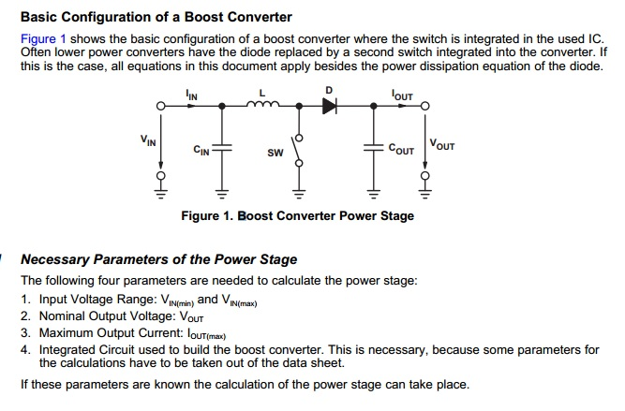
$$V_{in}=4*700=2800 V$$
Duty Cycle Calculation :
D = 1 - $\frac{V_{in}* ƞ}{V_{out}}$ = 1 - $\frac{2800*1}{5600}$ = 0.5
where $ƞ$ = 80 % which is the worst case converter efficiency = 1 as ideal case
Inductor Selection :
L = $\frac{D*( V_{out}- V_{in})}{2*∆I_{L}* f_{s}}$
$$∆I_{L}=Estimated inductor ripple current$$
$f_{s}=Minimum switching frquency of the converter$ = $\frac{1}{2*{10}^{-4}}=5k Hz$
$$∆I_{L}=\left(0.2 to 0.4\right)* I_{OUT}* \frac{V_{out}}{V_{in}}$$
$I_{OUT}=Maximum output current necessary in the application$= 10 A (assume)
$∆I_{L}=0.3* 10* \frac{5600}{2800}$ = 6
L = $\frac{0.5*\left(5600-2800\right) }{2*6*5000} =166 mH$
Capacitor selection :
C = $\frac{I_{out }* D}{f_{s} * ∆V_{out}}$
$∆V_{out}$ = ESR * $\left(\frac{I_{out}* ∆I_{L} }{\left(1-D\right)*2}\right)$
ESR = Equivalent series resistance of the capacitor
$$∆V_{out}= \frac{10*6}{\left(1-0.5\right)*2}=60$$
C = $\frac{10*0.5}{5000*60}$ = 0.166µF ~ 10 µF chosen for a smoother DC link voltage.
Power:
The total power supplied by PV panel = P = V*$I_{OUT}$ = 5600*10 = 56k W
IGBT Inverter :

 | Kundur’s Two Area System | Discrete Two Area System
Active Power in Grid Lines
Reactive Power in Grid Lines
Line voltage | 230kV | 120srt(2) = 170
No of machines | 4 generators( 2 in each) | 4 generators( 2 in each)
Rating of each generator | 700 MW | 15k
Total Generation | 2800 MW | 60k
Load Distribution | A1 is exporting 413MW to A2
Battery:
A lead acid battery is used to compensate the ups and downs in the grid-tied voltage during grid-connection mode. In islanding mode, the same battery is used to fulfill the load requirements.
Battery selection:
The simulation of charge and discharge of a battery model using parameters taken from a steady state curve is done. The approximate error between simulation results and experimental results varies between 5% to 10% [1]. The battery model block in Simulink is used to get the simulation results in [1].
The Battery block implements a generic dynamic model parameterized to represent most popular types of rechargeable batteries.
Lead-Acid Model
Discharge model (i* > 0)

Charge Model (i* < 0)

Lithium-Ion Model
Discharge Model (i* > 0)

Charge Model (i* < 0)

Nickel-Cadmium and Nickel-Metal-Hydride Model
Discharge Model (i* > 0)

Charge Model (i*< 0)

where,
EBatt = Nonlinear voltage (V)
E0 = Constant voltage (V)
Exp(s) = Exponential zone dynamics (V)
Sel(s) = Represents the battery mode. Sel(s) = 0 during battery discharge, Sel(s) = 1 during battery charging.
K = Polarization constant (Ah−1) or Polarization resistance (Ohms)
i* = Low frequency current dynamics (A)
i = Battery current (A)
it = Extracted capacity (Ah)
Q = Maximum battery capacity (Ah)
A = Exponential voltage (V)
B = Exponential capacity (Ah)−1
Step down transformer used…. 240 V selected because
Many areas such as the USA which use (nominally) 120 V make use of three-wire, single-phase 240 V systems to supply large appliances. In this system a 240 V supply comes with a centre-tap neutral to give two 120 V supplies which can also supply 240 V to loads connected between the two live wires. (source:wikepedia)
In [2], a 34 MW NAS Battery is used to stabilize the output of a 51 MW Wind Turbine farm in the Tahoku district of Japan. The fluctuations in the power supplied by the wind turbine are stabilized with a precision of +-2% using the battery.
There are two rectifers which can be used :
1. Boost rectifier
2. Buck Rectifier
They are also classified into two main categories, controlled and uncontrolled rectifiers.

Bi-directional converter:
Bidirectional converter is used in electric vehicles for efficient utilization of battery by providing a uniform voltage supply and re-charging the battery at some instances e.g down-slope motion of car [3, 4, 5].

[1] “Experimental Validation of a Battery Dynamic Model for EV Applications,”
[2] “Development and field experiences of NAS battery inverter for power stabilization of a 51 MW wind farm”
[3]”Battery Control” Yongli
[4] “Experimental Validation of a Battery Dynamic Model for EV Applications”,
[5]
[6] “Bidirectional DC-DC Power Converter Design Optimization, Modeling and Control”

