Abstract
Previous studies from Howell lab have found the addition of osmolytes weakens binding of folate/DHF to dihydrofolate reductase (DHFR). Three different proteins capable of catalyzing the DHFR reaction are R67 DHFR [1], EcDHFR [2] and FolM[3] and they all show this behavior. This result supports a preferential interaction between folate/DHF with the osmolytes. As the tetrahydrofolate structure resembles that of folate/DHF, we asked if other folate cycle enzymes would show weaker binding in the presence of osmolytes. In other words, can the depicted preferential interaction between osmolytes and folate/DHF be extended to other folate pathway enzymes? Therefore, in this thesis, we explored the in vivo effect of increasing concentration of osmolytes on the activity of selected essential folate enzymes. The general steps of this process were: first, essential folate enzymes were selected and cloned into the pKTS vector [4]. Second, the clone was transformed into its respective knockout strain of E. coli, rescuing the strain from folate end product auxotrophy. Third, the intracellular osmolyte concentration of the host cell was increased by adding sorbitol to a Bonner-Vogel (BV) minimal media. Finally, the ability of the clone to rescue the knockout strain from prototrophy was assessed.

1 General introduction 3
1.1 The effects of osmolyte addition on Folate/DHF binding to various dihydrofolate reductases R67 dihydrofolate reductase 4
1.2 Osmoprotectants: natural organic co-solutes generated to rescue cells from osmotic stress 8
1.3 Probing the activity of water on R67 DHFR binding in vivo 10
1.4 Rationale for a genetic approach 11
1.5 Decreasing the protein production and/or enzyme activity with a controllable plasmid. 12
1.6 Selection Criteria for Folate Enzymes 16
1.7 Selected Folate Cycle Enzymes 19
1.7.1 R67 Dihydrofolate Reductase (R67 DHFR) 21
1.7.2 Folylpolyglutamate Synthase (FPGS) 23
1.7.3 5,10-Methylenetetrahydrofolate Reductase (MTHFR) 26
1.7.4 Serine Hydroxymethyl Transferase (SHMT) 27
1.7.5 Dihydropteroate Synthase (DHPS) 29
1.7.6 Thymidylate Synthase (TS) 30

List of Tables

Table 1 Predicted µ₂₃/RT of betaine with various reduced forms of folate molecules with mono, di, and tri glutamate. 14
Table 2: List of folate enzymes and essential folate enzymes and their growth conditions 19
Table 3: List of selected folate pathway enzymes, 21

Table of figures

Figure 1-1 Folate contains pterin, pABA and glutamate moieties. 4
Figure 1-2 Models of preferential exclusion and B. preferential interaction 5
Figure 1-3 Plot of ln K_{a} versus osmolality 6
Figure 1-4 A plot of osmolality versus ln k_{cat}/K_{m (DHF)} for R67 DHFR. 7
Figure 1-5 Model showing the preferential interaction of osmolytes with free DHF. 8
Figure 1-6 Chemical structures of selected naturally occurring osmolytes. 10
Figure 1-7 Effects of total enzyme activity on cell growth rate. 15
Figure 1-8 Map of the pKTS vector. 16
Figure 1-9 Design of the pKTS plasmid. 17
Figure 1-10 Selected essential folate cycle enzymes. 21
Figure 1-11 R67 Dihydrofolate reductase activity. 22
Figure 1-12 R67 DHFR is a homotetramer. 23
Figure 1-13 A cartoon of monomeric Quad4 [56]. 24
Figure 1-14 The two reactions associated with FPGS. 25
Figure 1-15 FPGS is a monomer (PDB:1W78) [61]. 26
Figure 1-16 Methylene-tetrahydrofolate reductase (MTHFR). 27
Figure 1-17 MTHFR is a tetramer (PDB:1ZPT). 28
Figure 1-18 Serine hydroxymethyltransferase (SHMT) 29
Figure 1-19 Serine hydroxymethyltransferase (SHMT) 29
Figure 1-20 Dihydropteroate synthase (DHPS) 30
Figure 1-21 Dihydropteroate synthase (DHPS) is a monomer. 31
Figure 1-22 Thymidylate synthase (TS). 32
Figure 1-23 Thymidylate Synthase is a dimer. 33

General introduction
Folate is also known as vitamin B9 and its structure is composed of a pterin, p-aminobenzoate (pABA), and glutamate moieties (Figure 1). These molecules are essential for life. Human and higher animals cannot synthesize folate, thus they obtain folate from their diet. Plants and bacteria synthesize folate de novo. In all domains of life, folates are required for several cellular processes such as DNA, RNA, purine nucleotide, and amino acid synthesis. In the folate pathway, tetrahydrofolate (THF) is the active species as it can carry methyl or formyl groups on either its N5 and/or N10 position(s). These molecules are one carbon carriers that lead to synthesis of thymidylate, serine, methionine, etc . Figure 1-1 (below)[5].
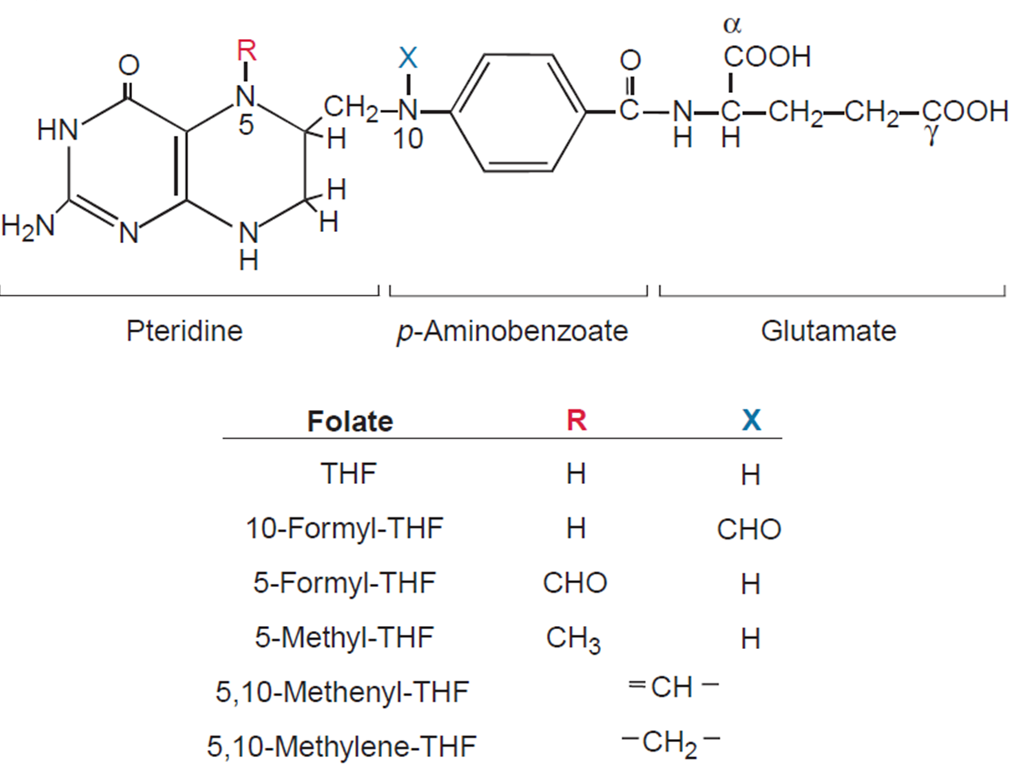
Figure 1-1 Folate contains pterin, pABA and glutamate moieties.
Tetrahydrofolate, shown above, plays a role in the folate pathway by adding carbons at the N5 (R) and/or N10 (X) position(s) [5]

The effects of osmolyte addition on Folate/DHF binding to various dihydrofolate reductases R67 dihydrofolate reductase

The Howell lab has studied the structure-function relationship in dihydrofolate reductase (DHFR). Recent studies have focused on examining the role of water on folate/DHF and/or cofactor binding. One way of examining the activity of water in binding is to perturb the water molecules in the hydration shell of the interacting molecules (for example, protein plus ligand) by the gradual increase of osmolyte (co-solvent) concentration and monitoring the change in catalytic efficiency and/or binding. A typical result is tighter binding of a ligand to protein as fewer water molecules need to be removed and the desolvation penalty is decreased. Another case is provided if the affinity of the protein surface is greater for osmolytes compared to the water molecules, then the osmolytes compete with water and weakly interact with the protein surface. A cartoon representation of preferential interaction and preferential exclusion of osmolytes from a protein surface is represented in Figure 1-2 (below) If osmolytes are more difficult to remove than water, then the binding equilibrium will be shifted towards free state, which will weaken binding. Thus, Chopra et al. studied the role of water on the primitive enzyme R67 DHFR binding [1].

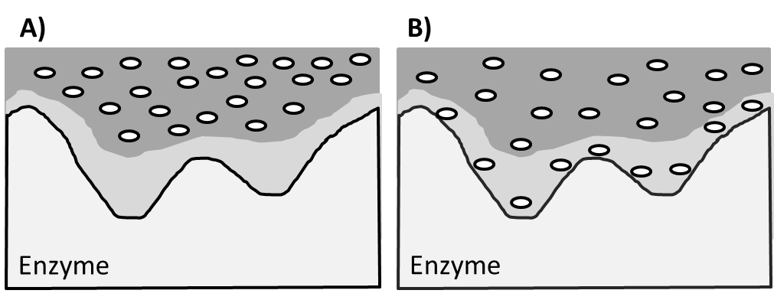
Figure 1-2 Models of preferential exclusion and B. preferential interaction
The solvation layer of the enzyme is shown in light grey, while the bulk solvent is dark grey. Osmolytes are represented by white ovals [6]

The binding of NADPH to apo R67 DHFR was investigated using isothermal titration calorimetry (ITC). Tighter binding was observed upon the addition of ethylene glycol, sucrose, Me₂SO, glycine betaine, or PEG400 Figure 1-3 (below/right) [1]. This result is the typical observation associated with osmotic stress studies as a lower water concentration leads to a decreased desolvation barrier associated with binding. All osmolytes tested have the same effect, consistent with exclusion of the osmolytes from the surfaces of NADPH and R67 DHFR [1].

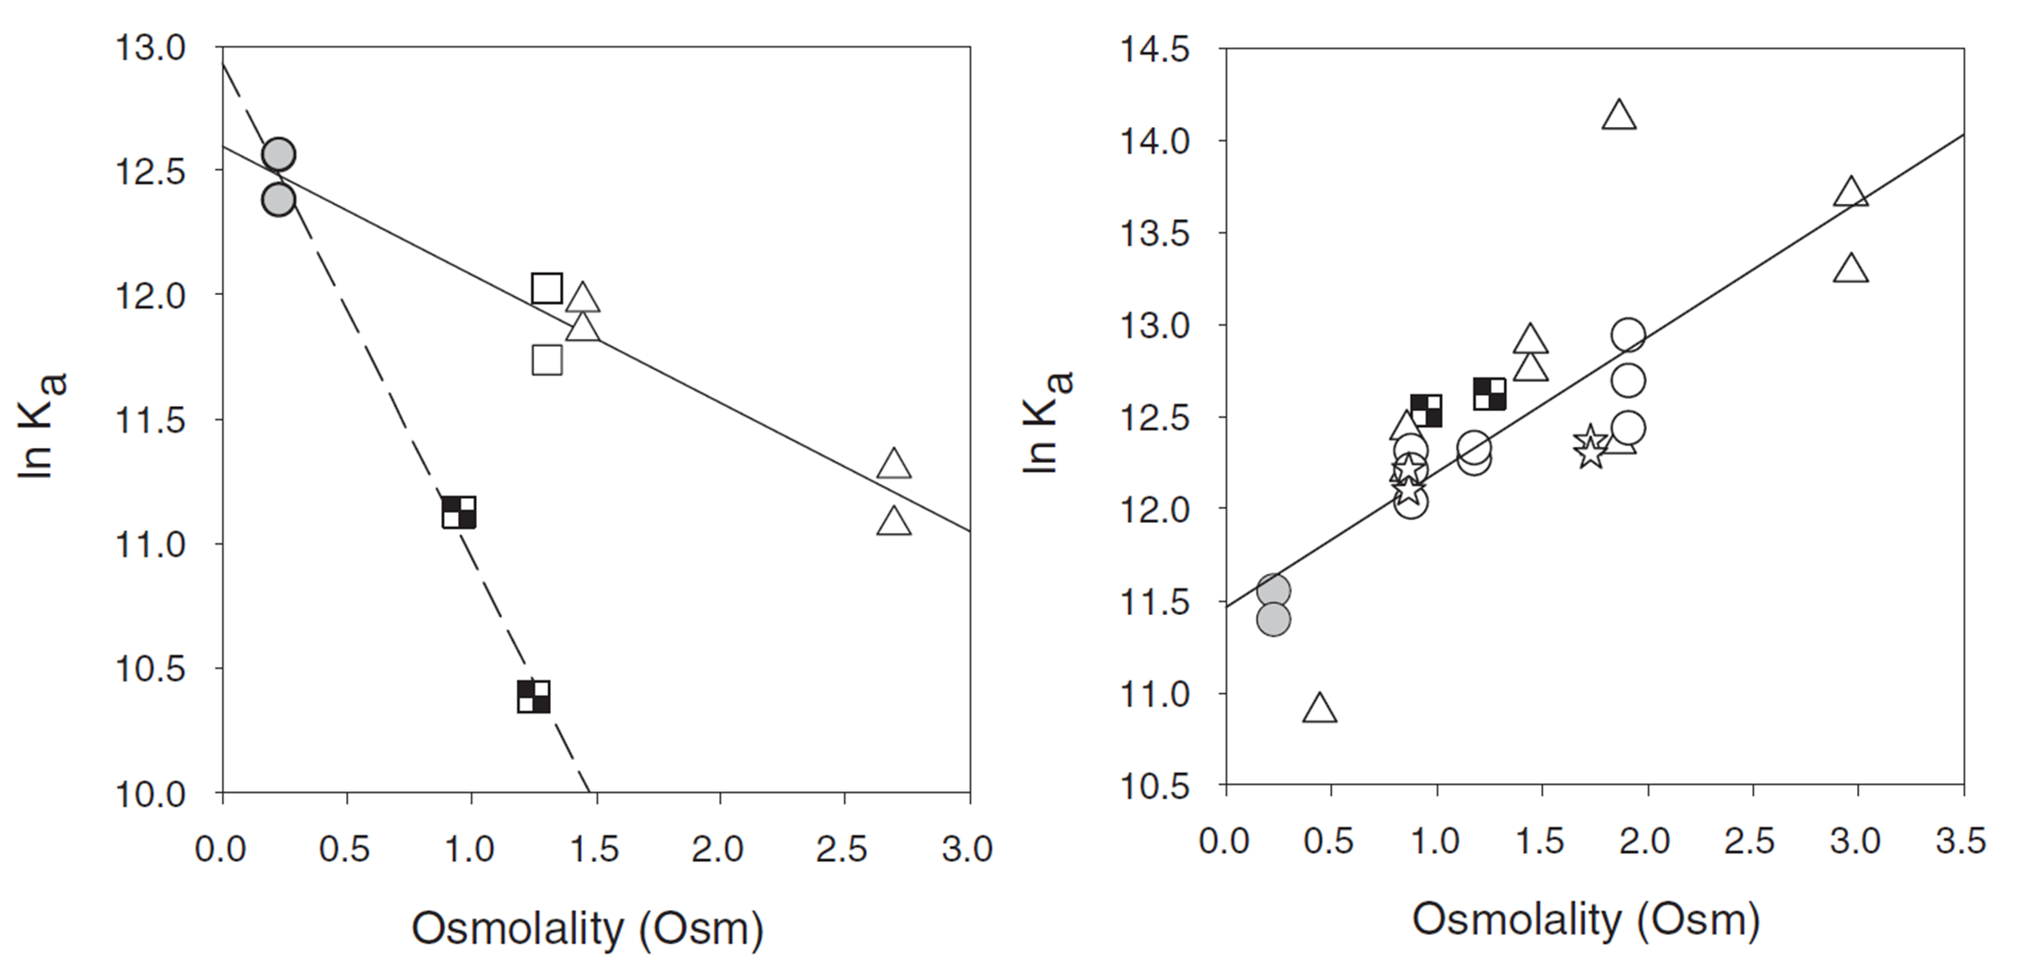
Figure 1-3 Plot of ln K_{a} versus osmolality
The K_{a} for DHF binding to R67 DHFR-NADP⁺ was determined by ITC. Weaker binding and a sensitivity to osmolyte identity was observed (left). In contrast, the K_{a} for NADPH binding to apo R67 DHFR showed a single positive slope. The K_{a} values for DHF and NADPH binding possess opposite slopes. The results for DHF are consistent with a preferential interaction model while the results for NADPH are consistent with a preferential exclusion model. Data for buffer (gray circle), ethylene glycol (open circle), sucrose (open square), Me₂SO(open circle), glycine betaine (open triangle), and PEG400 (checkerboard) are shown.

When binding of DHF was investigated using steady state kinetics, the catalytic rate constant, k_{cat}, showed minimal to no variation. However a significant increase in K_{M(DHF)} values was observed. This combined behavior results in a decrease in catalytic efficiency or k_{cat}/K_{M(DHF)}. If K_{M} equals K_{d}, this result suggests the drop in catalytic efficiency is due to weaker binding of DHF [1].

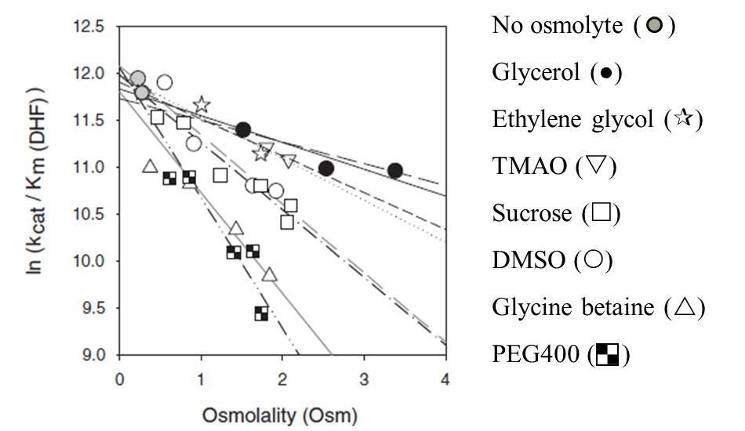
Figure 1-4 A plot of osmolality versus ln k_{cat}/K_{m (DHF)} for R67 DHFR.
Steady state kinetic data were obtained at saturating NADPH concentration and varied DHF concentrations in the presence of various osmolytes. Michaelis-Menten plots were used to calculate k_{cat} and K_{m (DHF)} values. The units for k_{cat}/K_{M} (DHF) are s⁻¹ M⁻¹. Adopted from [1].

Next, to directly monitor the K_{d} associated with DHF binding, Chopra et al. titrated DHF into R67 DHFR-NADP⁺ in the presence of increasing concentrations of sucrose, glycine betaine or PEG400. Their results showed a steady decline in ln K_{a} as the osmolyte concentration increased. The use of PEG400 showed a steeper negative slope in the plot Figure 1-3 above (left) which correlates with its acting as a crowding agent due to its larger volume [1].

As R67 DHFR possesses 222 symmetry and a single active site pore to bind its ligands, this results in the same site being able to accommodate either cofactor or DHF [7]. This unusual active site allows the Howell lab to use osmotic stress results for NADPH as an internal control which indicates no osmolyte interaction with either NADPH or R67 DHFR. If osmolytes don’t interact with R67 DHFR, the likely reason for weaker binding of DHF is a preferential interaction of osmolytes with DHF. This hypothesis led to the cartoon shown in (Figure 5).

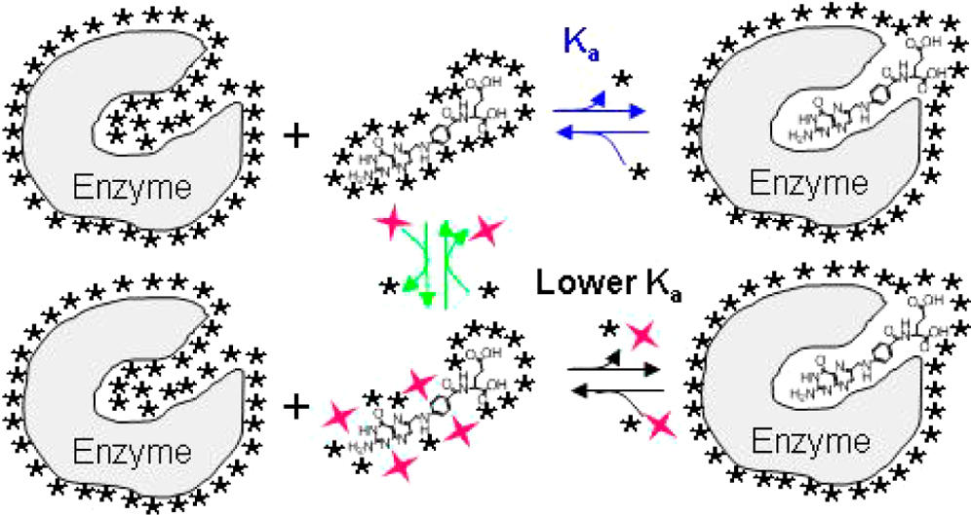
Figure 1-5 Model showing the preferential interaction of osmolytes with free DHF.
Removal of water (★) and/or osmolytes (red star) from the solvation shell of DHF is required for the ligand to bind to DHFR. If the DHF-osmolyte association is stronger than the DHF−water interaction, the binding equilibrium will be shifted to the left, favoring the unbound state. This results in a decreased binding affinity of DHF for DHFR. This model does not exclude interactions between osmolytes and the protein. Adopted from [3].

The model of folate/DHF interaction with osmolytes was tested using two additional folate enzymes, chromosomal DHFR from E. coli (EcDHFR) [2] and FolM [3]. These enzymes catalyze the DHFR reaction, but they have dissimilar sequence and oligomerization states [3]. For both enzymes studied by steady state kinetics and/or ITC, the K_{M} for DHF increased and/or the K_{a} decreased [2, 3]. These results are consistent with the model.

Osmoprotectants: natural organic co-solutes generated to rescue cells from osmotic stress

Osmolytes are low molecular mass compounds. These molecules are compatible or noncompatible with macromolecules. Compatible osmolytes destabilize both the native and unfolded states by its exclusion from the peptide backbone, however the unfolded state is more affected, resulting in a larger energy difference between the native and unfolded states. This leads to protein folding (see Figure 1-5 above in [8].Based on their chemical composition, osmolytes are divided into three classes: polyhydric alcohols and sugars (polyols), amino acids and their derivatives, and methyl ammonium compounds Figure 1-6 (below)[9]. Bacteria and plants generate small organic solutes (osmolytes) or transport them from the environment into the cell to maintain the osmolality of the cell due to external osmotic stress. The internal osmolytes help to compensate for cell volume changes, by stabilizing macromolecules [10] and/or by aiding protein folding [11];[9]
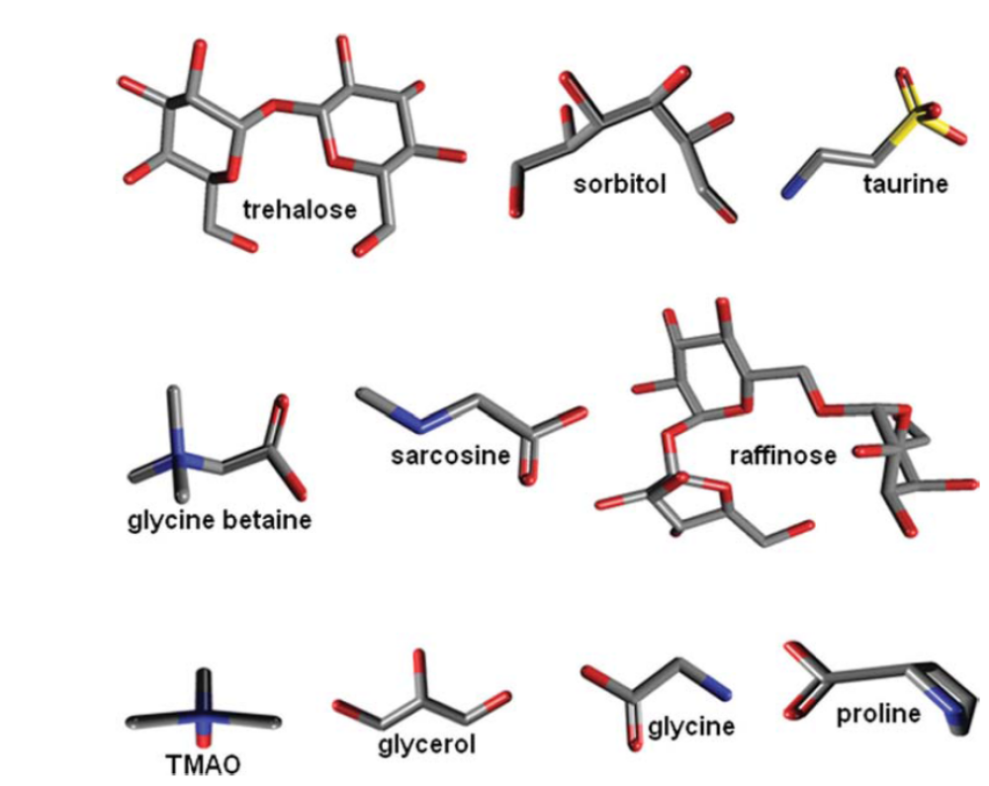
Figure 1-6 Chemical structures of selected naturally occurring osmolytes.
Adopted from [9].

The chemical properties and sizes of osmolytes can be correlated with the number of water molecules (∆n_{w}) excluded from the hydration shell of proteins [11]{Rosgen, 2007 #286}. The Record group has provided two excellent reviews of osmoprotectants in bacteria [12] [13].

In the intracellular compartment of bacteria, the total cytoplasmic water content is the sum of ‘bound’ and ‘free/bulk’ water. Typically the ‘bound’ water molecules are not affected by osmotic stress i.e. the organism does not lose bound water but rather ‘free’ water molecules [14]. In normal circumstance, ‘free’ water molecules move in and out of the cell. But, if there is difference in osmotic strength between the internal and external environments, the bacteria face sudden free water loss and can shrink. To overcome this situation, the bacteria produce intracellular osmolytes to balance the osmolality of the internal environment with that of the outside environment. Thus the intracellular osmolyte(s) concentration increases [14]. Common osmoprotectants in E. coli are glycine betaine, glutamate, proline and trehalose.

Probing the activity of water on R67 DHFR binding in vivo
As betaine is a common osmoprotectant in E. coli and as betaine decreases the catalytic efficiency of R67 DHFR Figure 1-4 (above), Chopra et al. examined the effect of osmotic stress on R67 DHFR function in vivo. Both EcDHFR and R67 DHFR reduce folate/DHF to THF, however the chromosomal DHFR is easily inhibited by addition of the antibacterial drug trimethoprim (TMP, K_{i} = 20 pM) [15]. In contrast, TMP does not inhibit R67 DHFR very well (K_{i} = 0.15 mM) [16]. Thus, the activity of chromosomal enzyme was inhibited by addition of 20 µg TMP/ml [17]. Then osmotic stress was applied to the host cell by adding sorbitol to a minimal growth media. The ability of E. coli DH5α carrying wild type or a mutant (Q69H, K32M, or Y69L) R67 DHFR clones cloned in pUC8 was then assessed [1].

The wild type and two mutant clones rescued the host cells from TMP pressure, but the Y69L mutant clone required an extended growth time [1]. These results correlated with the activity of the type of R67 DHFR enzyme. For example, the host cell carrying wildtype R67 DHFR clone has sufficient enzyme activity to reduce DHF to THF and can enable cell growth. However host cells carrying the Y69L mutant clone had a lower catalytic efficiency and took a longer time to allow host cell growth. On the other hand, the K32M R67 DHFR clone did not rescue its host cell, suggesting the mutant enzyme did not possess sufficient DHFR activity to rescue the cell from trimethoprim pressure [18].

In the next set of assays, increasing concentrations of sorbitol were added. E. coli DH5α and E. coli DH5α carrying the wt R67 DHFR-pUC8 clone allowed cell growth in the presence of TMP until the osmolality of the media became ≥ 1.95 Osm. As per the Record lab, this result suggests that the host cell stops growing due to loss of free water in the cytoplasm [14]. In contrast, E. coli DH5α carrying the mutant Y69L R67 DHFR-pUC8 clone grew very slowly and stopped growing under much less osmotic stresses (0.92 Osm). This result was interpreted as the lower activity associated with the Y69L R67 DHFR clone was less able to rescue the host cell; thus its activity could be titrated by osmotic stress. This titration follows the loss of enzyme activity upon osmolyte addition as seen in Figure 1-4 (above).

Titration of the activity of the wt R67 DHFR clone by sorbitol addition was not observed in the above experiments. Since the maximal activity (V_{max}) of an enzyme can be described as k_{cat}* [E_{total}], where [E_{total}] describes the total enzyme concentration, these two parameters need to be considered. The wt enzyme is reasonably active with a k_{cat}/K_{m} of 2.2 x 10⁵ M⁻¹ s⁻¹. In addition, the protein is overexpressed due to the high copy number of the pUC8 plasmid. A similar problem of in vivo assay for a metabolically essential enzyme with high protein production, but poor enzymatic activity was previously described by the Hilvert lab [19].

Rationale for a genetic approach

Vapor pressure osmometry studies by the Record group have monitored the interaction of betaine, proline and urea with various small molecules [20-22]. From these studies, they have derived atomistic preferential interaction coefficients (μ₂₃/RT) which allow prediction of whether water or betaine/proline/urea prefers to interact with larger molecules. The Howell lab has used this approach in predicting the interaction of betaine with folate and DHF. The predicted values are in the ballpark of the experimentally measured values, suggesting this approach is reasonable (predicted μ₂₃/RT values are shownTable 1(below). As tetrahydrofolate and its various derivatives possess very similar structures to folate, our prediction is that betaine will also interact with these redox states of folate [20-22] .

Table 1 Predicted µ₂₃/RT of betaine with various reduced forms of folate molecules with mono, di, and tri glutamate.
 | Betaine mu23/RT
Folate Molecule | (glu)₁ | (glu)₂ | (glu)₃
5-formylthf | 0.228 | 0.579 | 0.893
5-methylthf | 0.146 | 0.493 | 0.806
6-hydroxymethyldihydropterine | -0.024 | N/A | N/A
10-formylthf | 0.287 | 0.623 | 0.937
10-methylthf | 0.176 | 0.524 | 0.837
Dhpp | 0.907 | N/A | N/A
Dihydropteroate | -0.166 | N/A | N/A
Methenylthf | 0.167 | 0.512 | 0.829
Methylenethf | 0.163 | 0.509 | 0.826
Paba | -0.122 | N/A | N/A
Pabaglu | 0.168 | 0.470 | 0.718
Tetrahydropteroate | -0.162 | N/A | N/A
THF | 0.133 | 0.479 | 0.791
DHF | 0.128 | 0.523 | 0.766
Folate | -0.039 | 0.359 | 0.685
Glutamate | 0.451 | 0.744 | 1.095
citrate | 0.683 | N/A | N/A
phosphate | 0.986 | N/A | N/A
diphosphate | 1.294 | N/A | N/A

To test this prediction, we can purify the relevant enzymes and do in vitro osmotic pressure studies. As purifying enzymes and doing in vitro osmotic stress studies is quite time-consuming, our hope is that a genetic approach will be faster. This approach will also test whether our model in Figure 1-5 (above) continues to work in the crowded environment of the cell with many other molecules and macromolecules present.

As the growth of various E. coli strains is not titrated by increasing concentrations of sorbitol (except for the limit when no free water remains as per Cayley et al. [14]), we need a system that will decrease the total enzyme activity in the cell for folate pathway enzymes. Since a single gene exists per E. coli chromosome, a system is needed that will produce less active protein than normally exists per E. coli cell. For this type of system, we plan on transforming selected Keio deletant strains [23] with a plasmid with controls on gene expression and protein stability.

Decreasing the protein production and/or enzyme activity with a controllable plasmid.

As described by the Hilvert lab, the in vivo selection of a chorismate mutase clone with a high protein production, but poor enzymatic activity could be improved by minimizing the protein production level Figure 1-7 (below) [19]. To address this problem in our system, we will use the pKTS plasmid obtained from the Hilvert lab [4].

The pKTS vector has two ways to control protein production, use of the P_{tet} promoter and a protease degradation tag (SsrA) Figure 1-8 (below) and Figure 1-9(below) [4]. In this vector, the gene of interest is cloned between the tetracycline promoter (P_{tet}) and a SsrA tag. The P_{tet} promoter has a large regulatory window. At the lowest tetracycline concentration, it allows basal expression of a gene to the tune of one mRNA molecule per three cells [24]. In addition, use of a SsrA tag (AANDENYALA) on the C-terminus of the protein, directs the protein to the ClpXP protease for degradation [4]. This approach may sufficiently minimize the protein production as to allow titration of enzyme activity by a decreased water activity Figure 1-7 (below).

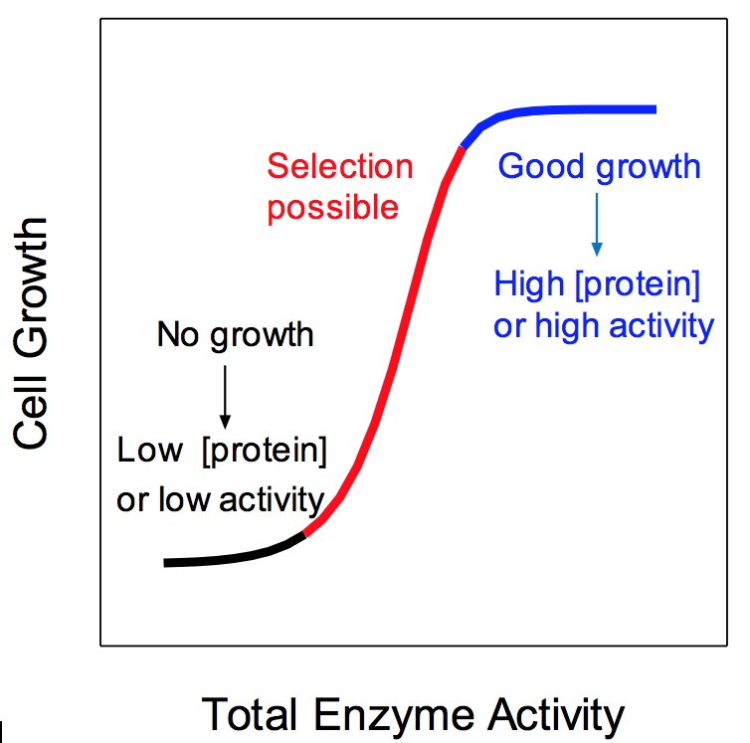
Figure 1-7 Effects of total enzyme activity on cell growth rate.
The best selection window is at the center of the graph. The left hand side of the graph describes conditions where the total enzyme activity is too low to enable growth. The right hand side of the graph describes conditions where selection is not possible due to high expression levels or high activity of the enzyme. Titration of enzyme activity is possible when either a low protein concentration or a low enzyme activity (due to mutation) occurs; the black curve color represent the low protein production or enzyme activity, the red carve color represent medium protein production where selection is possible, and the blue color represent high protein production where in vivo selection is problematic . Adapted from [19].

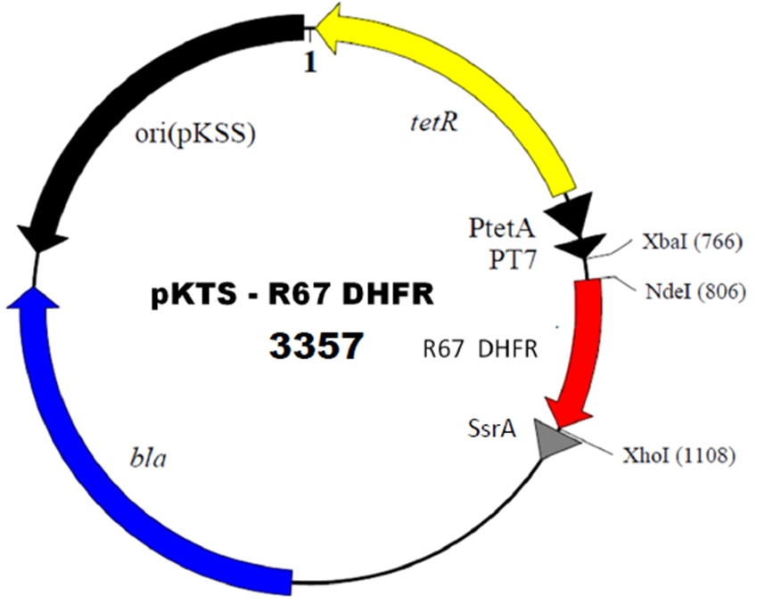
Figure 1-8 Map of the pKTS vector.
The gene of interest (for example, R67 DHFR) is cloned into the pKTS vector obtained from the Hilvert lab. In this vector, transcription of the R67 DHFR gene is controlled by tetracycline repressor (TetR) and tetracycline promoter (P_{tet}). Therefore, while Tc exerted its antibiotic activity in the system, transcription of TetR promotes Tc resistance [25]. As a result, only the basal level of the promoter activity that correlates with the Tc concentration would be allowed [26]. In addition to the TetR and P_{tet} system, the SsrA tag is at the C- terminal sequence, destabilizes the gene product and directs the protein to the ClpX protease for degradation. Adopted from [4].

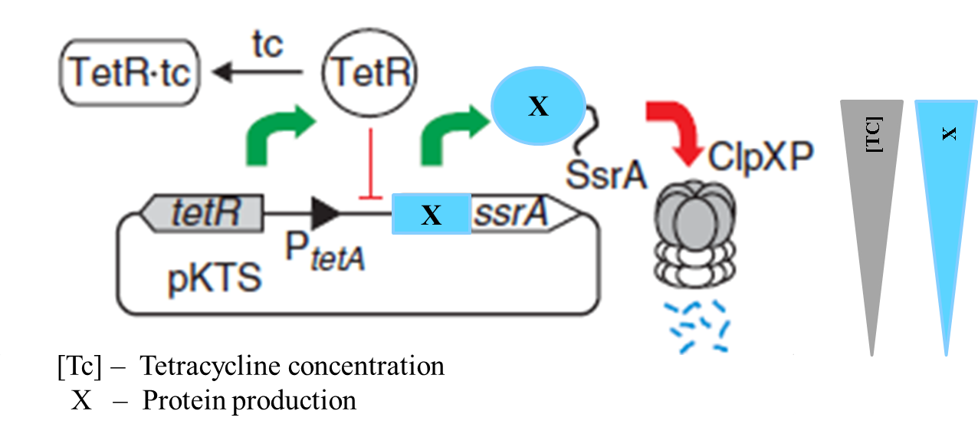
Figure 1-9 Design of the pKTS plasmid.
The gene of interest ‘X’ is cloned between the P_{tetA} promoter and a sequence encoding a SsrA tag. The pKTS plasmid permits transcriptional control and limits enzyme half-life. The SsrA sequence is fused to the C-terminus of the protein of interest. Minimizing protein production should allow an in vivo selection of folate pathway enzyme activity [4].

Selection Criteria for Folate Enzymes
To select candidate enzymes in the folate cycle for these studies, we used the following three criteria. First, the enzyme must be essential and/or selectable;Table 2 (below) lists various genes in the folate pathway and notes whether they are essential (Bold). Second, the C-terminus and/or N-terminus should not be in a close proximity to the active site as this would block our ability to use the pKTS vector or the pKTR vector (which puts a RepA degradation tag on the N-terminus) to control protein expression levels. And third, we prefer the K_{M} of the folate derived substrate to be higher than the respective substrate concentration in the cell. We discuss these issues below.

Table 2: List of folate enzymes and essential folate enzymes and their growth conditions
Gene | Enzyme  (Abbreviation) | Source of cloned gene? | Growth conditions?
FolA | Dihydrofolate reductase (EcDHFR)  (Type I DHFR);  (R67 DHFR)  (Type II DHFR) | Howell;[27]  Reece et al.[28] | •Requires thymidine, pantothenate, adenine, glycine, methionine  •Provides TMP resistance
FolB | Dihydroneopterin aldolase (DHNA) | - | -
FolC | Folylpolyglutamate Synthetase (FPGS) | Bognar[29, 30] | •Rescue by A309R FPGS requires glycine, methionine  •Rescue by A309E FPGS requires glycine, methionine, thymidine, adenosine
FolD | Bifunctional methylene tetrahydrofolate reductase/cyclohydrolase (MTHFDH/MTHF) | - | -
FolE | GTP cyclohydrolase I | - | •Slow growth on LB + 300 μM thymidine[31]
FolK | 2-amino-4-hydroxy-6-hydroxymethyl-dihydropteridine pyrophosphokinase  (HPPK) | Yan [32] [33] | •ΔFolK::tet shows very poor growth on rich media[34]
FolM | Pteridine Reductase (FolM) | Hansen[35]/  Mevarech [36] | •Double ΔFolM + ΔFolA  is synthetic lethal [37]
FolP | Dihydropteroate synthase (DHPS) | Swedberg  (E. coli)  Lee[38, 39] (Staphylococcus aureus) | •Sulfa drug resistance  •FolP::kan shows poor growth on rich media[40]
GlyA | Serine hydroxymethyl transferase SHMT | Contestabile[41-43] | •Requires glycine and serine [44] [45] [46]
MetF | Methylene-tetrahydrofolate reductase MTHFR | Trimmer/  Matthews[47] | •Requires methionine[48]
PurU | Formyl-tetrahydrofolate deformylase | -
ThyA | Thymidylate synthase TS | Kohen[49]/  Maley[50] | •Requires thymidine  •N-formyl-methionine at N-terminus in 1AYX.pdb which has 5 H-bonds with T46 and T47  •COO⁻ at the C-terminus in the active site and critical for activity.[51]
Bold: enzymes selected for in vivo osmolality study.
Essential enzymes are required for the survival of a cell. For example, DHFR is essential for biosynthesis of thymidylate, methionine, glycine, serine and purines in bacteria. Therefore, it was possible to assay the effect of increasing external osmotic stress via a gradual decline in cell growth. We aimed to use a similar approach with other enzymes in the folate mediated one carbon (1C) cycle. As noted in Table 2 (above), there are many essential folate cycle enzymes.
Secondly, since we aimed to use the pKTS plasmid, we were concerned whether the SsrA tag could have an effect on enzyme activity. Therefore, we measured the closest distance between the active site of the selected enzymes and their C-terminus using the Molecular Operating Environment computer program (MOE). If the C-terminus is very close to the active site, we could use an alternative vector, pKTR, that adds an N-terminal RepA degradation tag [19]. The distance range between the active site and the C-terminus is listed Table 3 (below). ()
Table 3: List of selected folate pathway enzymes,
PDB file names, oligomerization states, ligands bound in the crystal structure, approximate distances between the active site and the C-terminus and information on whether the protein has been expressed as a histag, GST tag or other fusion.
Protein | PDB code | Oligomer? | Bound ligands | Distance between active site and C-terminus | Histag or other fusion?
Methylene-tetrahydrofolate reductase (MTHFR) | 1ZPT | Tetramer | Sulfate ion, flavin-adenine dinucleuotide, 1,4-dihydronicotinamide adenine dinucleotide, NADH | ≥ 25 Å | E. coli enzyme expressed with a C-terminal histag[47]
Folyl-polyglutamate reductase (FPGS) | 1W78 | Monomer | Lysine NZ-carboxylic acid, magnesium ion, sulfate ion, phosphorylated dihydropteroate, adenosine-5’-diphosphate | ≥ 26Å | E. coli enzyme expressed with a histag, however not stated whether tag is at N- or C-terminus[52]
Serine hydroxymethyl  transferase (SHMT) | 1DFO | Dimer | N-Glycine-[3-hydroxy-2-methyl-5 phosphonooxymethyl-pyridin-4-yl-methane],  5-Formyl-tetrahydrofolate  N-pyridoxyl-glycine-5-monophosphate | ≥ 25Å | Strep tagged C-terminus for SHMT from Chlamydia pneumonia{De Benedetti, 2014 #2595}
Dihydropteroate synthase (DHPS) | 1AJO | Monomer | Sulfanilamide, sulfate ion, 2-amino-6-hydroxymethyl-7,8-dihydro-3H-pteridin- 4-one | ≥ 22Å | DHPS from Plasmodium falciparum tolerates a C-terminal GST tail[53]
6-hydroxy-methyl-7,8-dihydropterin pyrophospho-kinase (HPPK) | 3KUH | Monomer | Diphosphomethylphosphonic acid adenosyl ester, 2-amino-6-hydroxymethyl-7, 8-dihydro-3h-pteridin-4-one, magnesium ion, chloride ion, acetate ion | ≥ 9Å | HPPK and DHPS from Francisella tularensis exist as a bifunctional HPPK-DHPS fusion{Shaw, 2014 #2596}; HPPK from E. coli tolerates a C-terminal GST fusion{Li, 2003 #2597}

Lastly, if the substrate concentration of the folate metabolite in the cell is much higher than the K_{M,} the active site of the enzyme would be saturated. Thus, it could be difficult to observe measurable effects induced by osmotic stress. To avoid this potential problem, the concentrations of metabolites in vivo were identified based on previously published E. coli K12 metabolite concentrations [54] and compared to literature K_{M} values.

Selected Folate Cycle Enzymes

We considered the following enzymes: Dihydropteroate Synthase (DHPS encoded by the folP gene); Folylpolyglutamate Synthase (FPGS encoded by the folC gene); R67 dihydrofolate reductase (a type II DHFR that provides resistance to the antibacterial drug trimethoprim); Serine Hydroxymethyl Transferase (SHMT encoded by glyA); and Methylenetetrahydrofolate Reductase (MTHFR encoded by metF), Figure 1-10 (below).

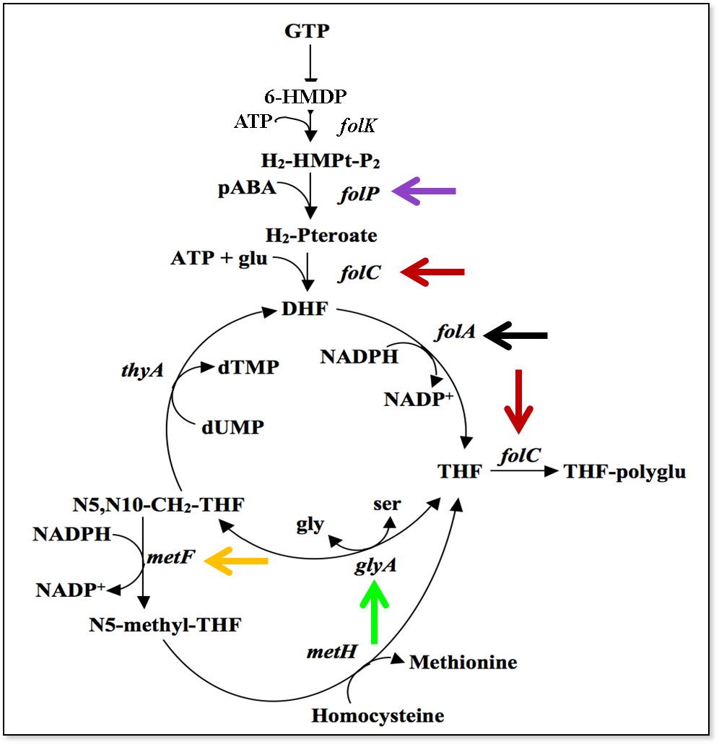
Figure 1-10 Selected essential folate cycle enzymes.
The folP gene (purple arrow) encodes dihydropteroate synthase or DHPS and this protein forms 7,8-dihydropteroate or H₂-pteroate from 7,8-dihydropterin-methyl diphosphate (H2MPt-P₂) and ρ-amino benzoic acid. The folC gene (red arrows) encodes folylpolyglutamate synthase or FPGS and this enzyme has two activities. The first activity adds L-glutamate to dihydropteroate and forms 7,8-dihydrofolate (DHF), while the second activity adds 2-5 glutamates to form polyglutamylated THF species. The folA gene (block arrow) encodes dihydrofolate reductase or DHFR; this enzyme catalyzes the NADPH-dependent reduction of 7,8-dihydrofolate (DHF) to 5,6,7,8-tetrahydrofolate (THF). The glyA gene (green arrow) encodes serine hydroxymethyl transferase or SHMT, which interconverts L-serine to glycine using THF or 5, 10-methylene-THF and pyridoxal phosphate as a cofactor. The metF gene (orange arrow) encodes methylene-tetrahydrofolate reductase or MTHFR, which reduces N-5, 10-methylene-THF to 5-methyl-THF using NADPH as a cofactor.

R67 Dihydrofolate Reductase (R67 DHFR)

R67 dihydrofolate reductase (DHFR), encoded by an R plasmid, provides resistance to the antibacterial drug trimethoprim (TMP) [17]. This enzyme reduces 7,8-dihydrofolate (DHF) to 5,6,7,8-tetrahydrofolate (THF)Figure 1-11 (below). While this is the same reaction catalyzed by EcDHFR, the protein scaffold is different [17]. In E. coli K12, the concentration of DHF (glutamate, and diglutamate forms) is ?? µM [52]. The K_{M} is only 5.8 µM [17]. Thus the active site is not expected to become saturated in vivo.

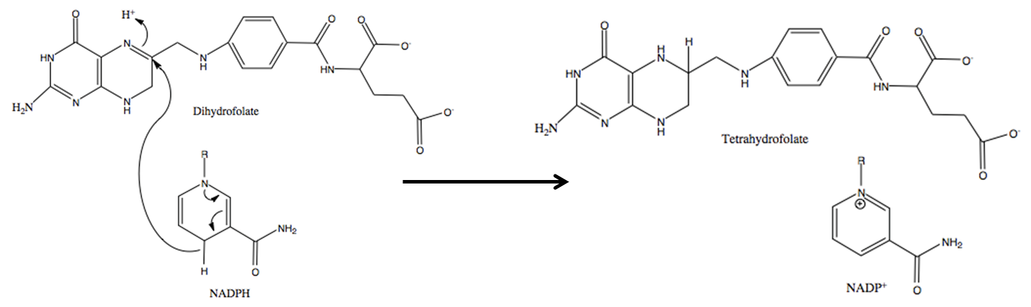
Figure 1-11 R67 Dihydrofolate reductase activity.
R67 Dihydrofolate reductase catalyzes the reduction of 7,8-dihydrofolate (DHF) to 5,6,7,8-tetrahydrofolate (THF) by a stereospecific hydride transfer from the NADPH cofactor to the C6 atom of the pterin ring with a simultaneous protonation at N5. http://en.wikipedia.org/wiki/Dihydrofolate_reductase

R67 DHFR is a homotetramer (PDB:2RK1) [7]; the active site and the C-terminus are labeled inFigure 1-12 (below). Both DHF (substrate) and NADPH bind in the central active site pore of the enzyme [55]. The distance between the active site and the C-terminus is ≥19 Ǻ.
A tandem array of four fused R67 DHFR genes was previously constructed and a functional enzyme named Quad4 resulted [56] see Quad4 structure in Figure 1-13 (below). In our in vivo study, we aim to study the effect of increasing osmolality on Quad4 in parallel to that of R67 DHFR. Quad4 should have a single SsrA tag while R67 DHFR should have four SsrA tags. The K_{M(DHF)} of Quad4 is 5.6 ± 0.3 [56], which is comparable to R67 DHFR.

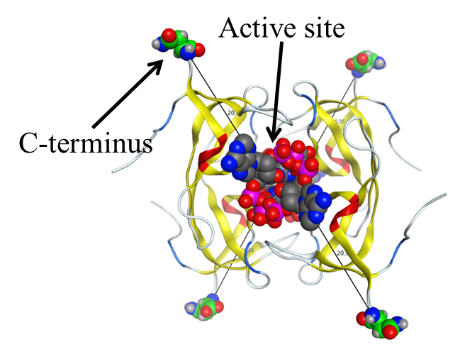
Figure 1-12 R67 DHFR is a homotetramer.
The crystal structure (PDB:2RK1) [7]of dimeric R67 DHFR shows 17-18 residues are disordered at the N-terminus [57]. When these residues are removed by chymotrypsin treatment, the truncated species crystallizes as the active tetramer [58]. The active site and the C-terminus are labeled above. Both DHF (substrate) and NADP⁺ are bound in the central active site pore [55]. The distance between the active site and the C-terminus is ≥19 Ǻ.

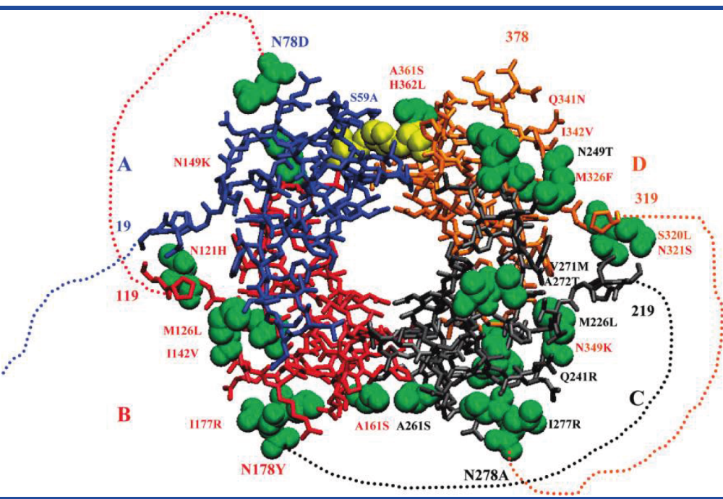
Figure 1-13 A cartoon of monomeric Quad4 [56].
The four different colors represent the four fused R67 DHFR domains. The dashed lines imagine the N-terminal 16 amino acids that would serve as the linker between domains. These disordered amino acids are cleaved off to yield a truncated species that crystals as the homotetramer [57, 58]. Similar to R67 DHFR, both the substrate and cofactor bind in the central active site pore of the enzyme. The C-terminus is a reasonable distance from the active site pore.

Folylpolyglutamate Synthase (FPGS)

Folylpolyglutamate Synthase (FPGS) is a product of the folC gene [59]. This enzyme (EC 6.3.2.17) catalyzes two distinct reactions: the dihydrofolate synthase reaction adds L-glutamate to dihydropteroate and forms dihydrofolate using ATP as an energy source and the folylpolyglutamate synthase reaction extends the glutamate tail of THF using a γ-linkage Figure 1-14 (below) [59, 60]. Both THF and 10-formyl-THF are FPGS substrates. These enzymes participate at two separate positions in the folate cycle [59, 61] Figure 1-10 (see red arrows/above).

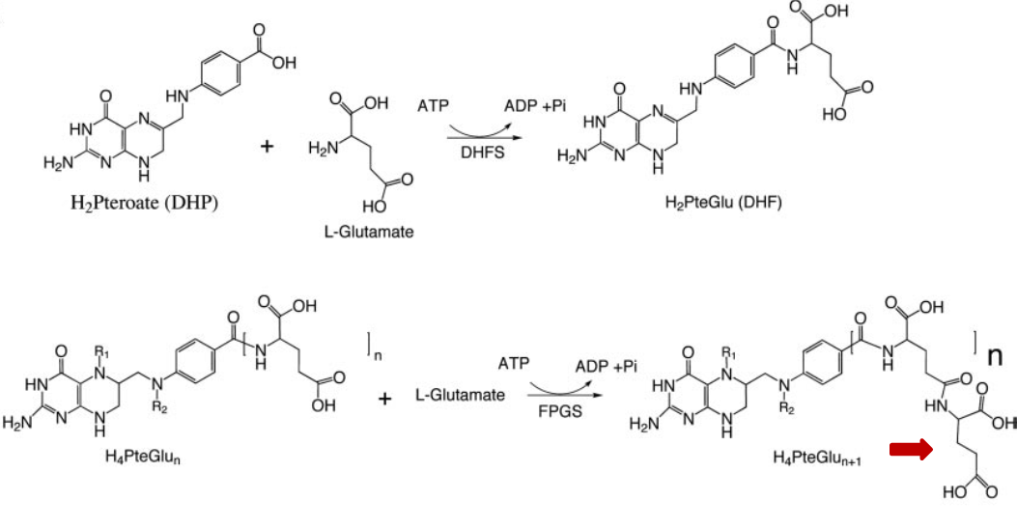
Figure 1-14 The two reactions associated with FPGS.
The first is a dihydrofolate synthase (DHFS) activity. DHFS adds L-glutamate to dihydropteroate to form dihydrofolate (DHF) (TOP). In the second reaction, FPGS extends the glutamate tail using a γ-linkage to form polyglutamylated folates (bottom) [61].

The concentrations of THF and 10-formyl-THF in E. coli K12 are 10.02 µM and 6.8 µM, respectively [52]. The K_{M} of THF for FPGS is 0.9 µM [59], and the K_{M} of 10-formyl-THF is 17.0 µM [59]. For the latter reaction, the K_{M} is higher than the concentration of 10-formyl-THF in vivo, suggesting the active site of the enzyme may not be saturated.
FPGS is a monomer (PDB: 1W78) [61]. The closest distance between the active site and C-terminus is 26 Ǻ. This great a distance suggests addition of a SsrA tag would be tolerated Figure 1-15 (below/left). We also note that a C-terminal histag version of the enzyme is available and active [52]. As an alternative to the pKTS cloning, we also obtained two E. coli K12 mutant strains SF2 (folC strA) and SF4 (folC strA recA Tn10::srlC) that carry an A309T mutation in the chromosomal folC gene [62] Figure 1-15 (below/right). This mutant enzyme displays a 30 fold increase in K_{m} for 10-CHO-THF, a 60 fold increase in the K_{m} for glutamate, a 10 fold increase in the K_{m} for ATP and a 200 fold increase in the K_{m} for dihydropteroate[29, 62]. Because of this drastic decrease in enzyme activity, we proposed it might be possible to titrate FPGS activity by osmotic stress in the E. coli SF2 (folC strA) strain.

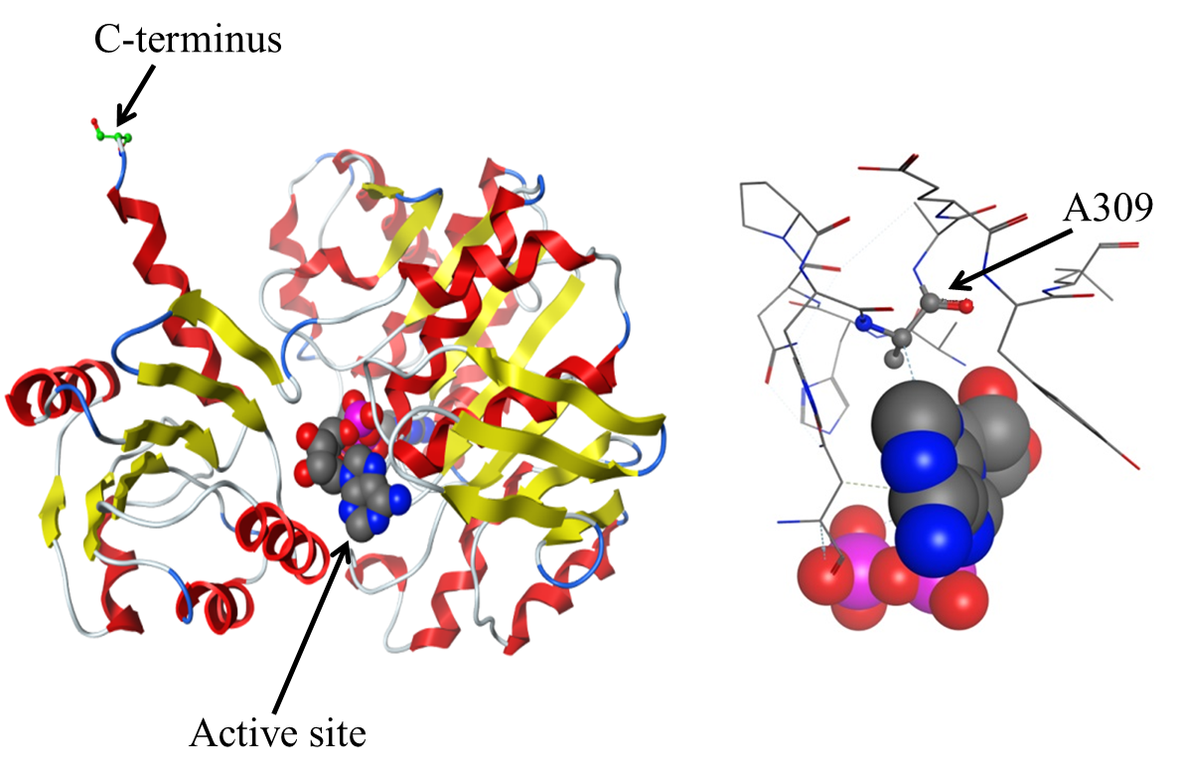
Figure 1-15 FPGS is a monomer (PDB:1W78) [61].
Left image: the active site and the C-terminus are labeled. The distance between the active site and the C-terminus is ≥26 Ǻ. Right image: The E. coli SF2 strain contains a G925A mutation in the FolC gene corresponding to an A309T mutation in FPGS. This mutant enzyme displays a 30 fold increase in K_{m} for 10-CHO-THF, a 60 fold increase in the K_{m} for glutamate, a 10 fold increase in the K_{m} for ATP and a 200 fold increase in the K_{m} for dihydropteroate[29, 62]. The figure was constructed using MOE version?

5,10-Methylenetetrahydrofolate Reductase (MTHFR)

Methylenetetrahydrofolate Reductase (E.C. 1.5.1.20 ) is encoded by the metF gene. This enzyme catalyzes the reduction of 5,10-methylene-THF to 5-methyl-THF using NAD(P)H as a cofactor Figure 1-16 (below) [47, 63]. The 5-methyl-THF product serves as a methyl group donor for the subsequent conversion of homocysteine to methionine by methionine synthase [47]. In E. coli K12, the concentration of 5,10-methylene-THF (diglutamate, triglutamate, tetraglutamate and pentaglutamate forms) is 22.24 µM [52]. The K_{M} is only 0.8 µM [47], suggesting the enzyme will be saturated in vivo.
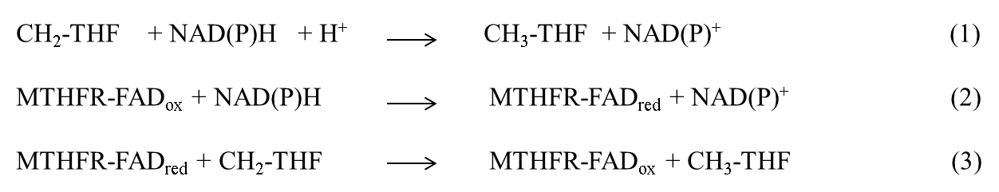
Figure 1-16 Methylene-tetrahydrofolate reductase (MTHFR).
MTHFR catalyzes the reduction of 5,10 methylene-tetrahydrofolate (CH₂-THF) to 5-methyl-tetrahydrofolate (CH₃-THF) using NADPH and flavin adenine dinucleotide (FAD) as coenzymes. MTHFR uses a ping-pong bi-bi mechanism in which NAD(P)⁺ release is followed by the binding of CH₂-THF and the subsequent release of CH₃-THF after reaction with the flavin. Equations from [63].

MTHFR is a tetramer (PDB: 1ZPT) Figure 1-17 (below) [64]; the closest distance between the active site and C-terminus is 25 Ǻ. Thus, addition of an SsrA tag should not interfere with the activity of the enzyme. Even though all of our criteria were not satisfied, the importance of this enzyme in the folate cycle and its association to heart disease [65 511] made this enzyme an attractive target for our study.
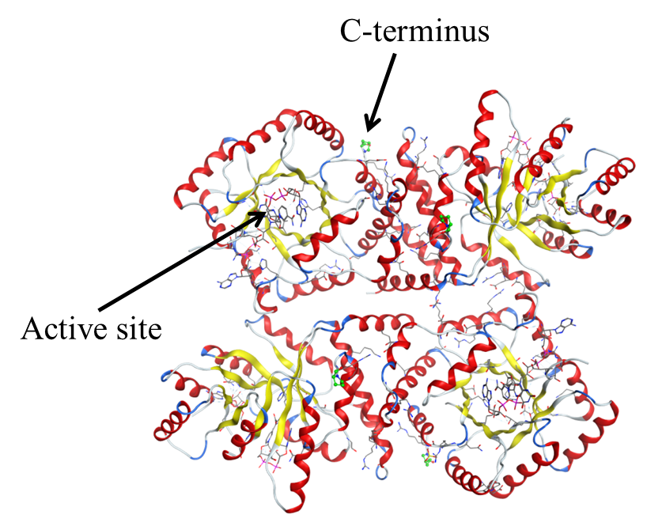
Figure 1-17 MTHFR is a tetramer (PDB:1ZPT).
The active site and C-terminus of one monomer are labeled. The distance between the active site and C-terminus is ≥ 25 Ǻ [66]. The figure was constructed using MOE

Serine Hydroxymethyl Transferase (SHMT)
Serine hydroxymethyl transferase (SHMT) (EC. 2.1.2.1) is the product of the GlyA gene. SHMT converts serine to glycine using pyridoxal phosphate (PLP) as a coenzyme. SHMT catalyzes two coordinated reactions, cleavage of PLP-serine to form PLP-glycine, and condensation of the formaldehyde with THF to form 5,10-methenyltetrahydrofolate [67]. A simplified reaction is shown in Figure 1-18 (below). SHMT is a dimer (PDB = IDFO) Figure 1-19 (below). In E. coli K12, the THF concentration (in all glutamylation states) is 10.02 µM [52]. The enzyme follows a sequential reaction mechanism; the K_{M} for THF is 25 µM [68]. The K_{M} is higher than the concentration of the metabolites in vivo [52], suggesting we may be able to titrate its activity. Finally, the distance between the active site and the C-terminus is ~25 Å, suggesting addition of a SsrA tag would not interfere with the catalytic site of the enzyme.

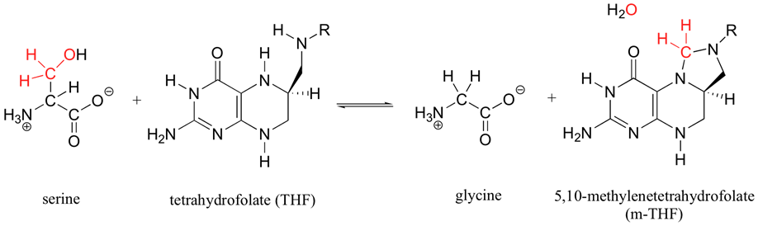
Figure 1-18 Serine hydroxymethyltransferase (SHMT)
SHMT catalyzes the THF dependent cleavage of serine to form 5, 10-THF and glycine. Adapted from: http://2012.igem.org/Team:Utah_ State/Project.

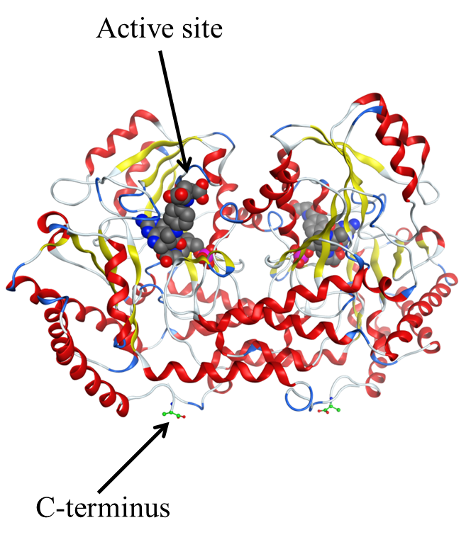
Figure 1-19 Serine hydroxymethyltransferase (SHMT)
SHMT is a dimer (PDB:1DFO). One active site and C-terminus (shown in green) are labeled. The distance between the active site and the C-terminus is ≥25 Ǻ. The figure was constructed using MOE version?

Dihydropteroate Synthase (DHPS)
DHPS (EC 2.5.1.15). catalyzes the formation of dihydropteroate from dihydropteroate-6-pyrophosphate (H₂PtPP) and p-aminobenzoic acid (pABA) Figure 1-20(below).The in vivo pABA concentration is 0.02 µM [52]. The K_{M}s for H₂PtPP and pABA are 1.2 ± 0.4 µM and 0.7 ± 0.2 µM, respectively [69]. Dihydropteroate synthase (PDB:1JAO) is a monomer Figure 1-21(below). The distance between the active site and C-terminus is ≥ 22 Å.

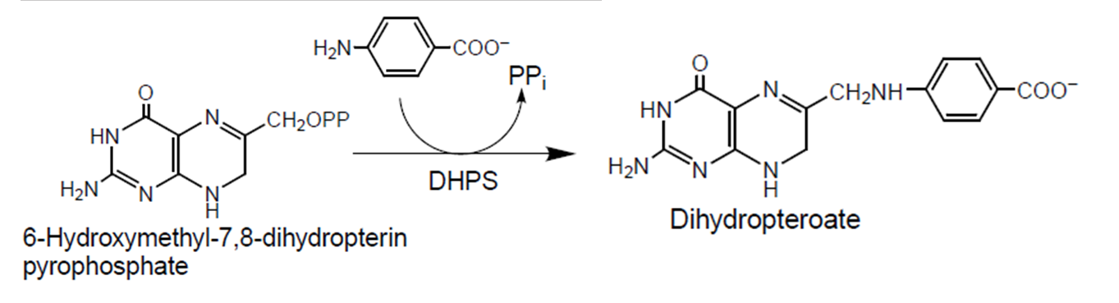
Figure 1-20 Dihydropteroate synthase (DHPS)
This enzyme joins the activated 6-hydroxymethyl-7,8-dihydropterin pyrophosphate (DHPPP) with para-amino benzoic acid (pABA) to produce 7, 8-dihydropteroate.

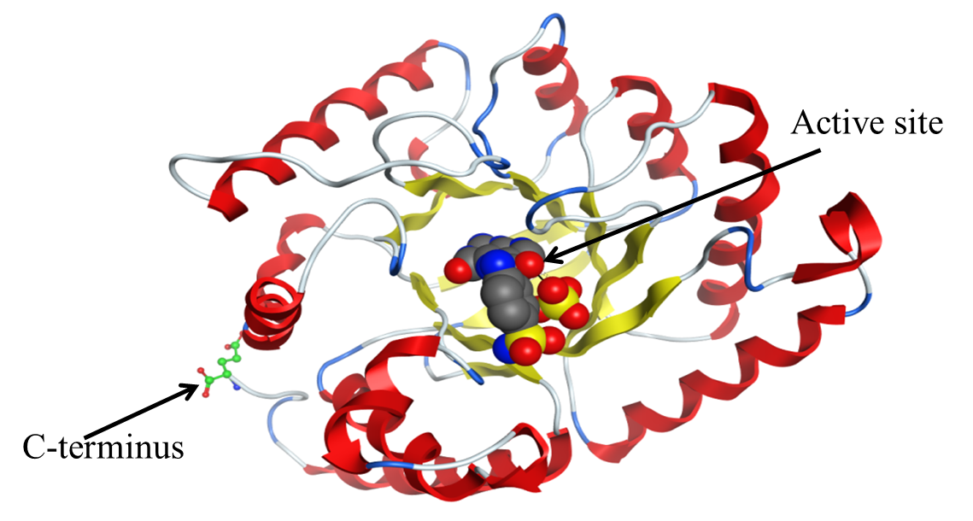
Figure 1-21 Dihydropteroate synthase (DHPS) is a monomer.
The active site and C-terminus are labeled (PDB: 3KUH). The distance between the active site and C-terminus is ≥22 Ǻ. DHPS is also of interest as it provides resistance to sulfa drugs. The figure was constructed using MOE version?

Thymidylate Synthase (TS)
Thymidylate synthase (E.C. 2.1.1.45) catalyzes the conversion of deoxyuridine monophosphate (dUMP) to deoxythymidine monophosphate (dTMP). During this process, the 5,10-CH₂-THF cofactor is converted to DHF. This enzyme is a product of the ThyA gene. TS plays a major role in pyrimidine biosynthesis and it is the only de novo source of dTMPFigure 1-22 (below) [60, 70]. In E.coli K12, the concentration of 5,10-CH₂-THF is 22.42 µM [60]. The K_{M} values for CH₂-THF and dUMP are 11 µM [52] and 1.2 µM [54], respectively. However, the enzyme active site is close to the C-terminus and the carboxyl group (-COO⁻), and is involved in positioning the ligands at the active site [71]. Any additions to the C-terminus inactivate the enzyme. In addition, the N-terminal methionine is formylated and the formyl group forms a hydrogen bond with Thr46 and Thr47 Figure 1-23 (below).Thus, attaching the protease degradation tag at either N-terminus or C-terminus is not possible. Thus this enzyme is not purified by the use of histags.

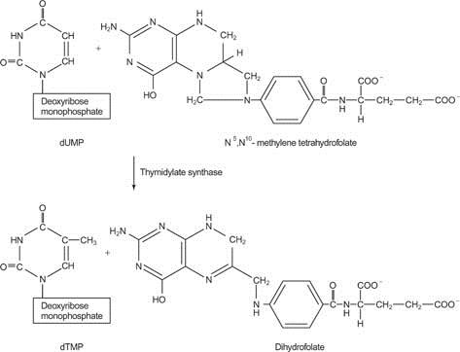
Figure 1-22 Thymidylate synthase (TS).
This enzyme catalyzes the conversion of deoxyuridine monophosphate (dUMP) to deoxythymidine monophosphate (dTMP) using 5,10-methylene tetrahydrofolate (CH₂THF) as a methyl group donor. From: http://www.cliffsnotes.com/sciences/biology/biochemistry-ii/purines-and-pyrimidines/deoxynucleotide-synthesis

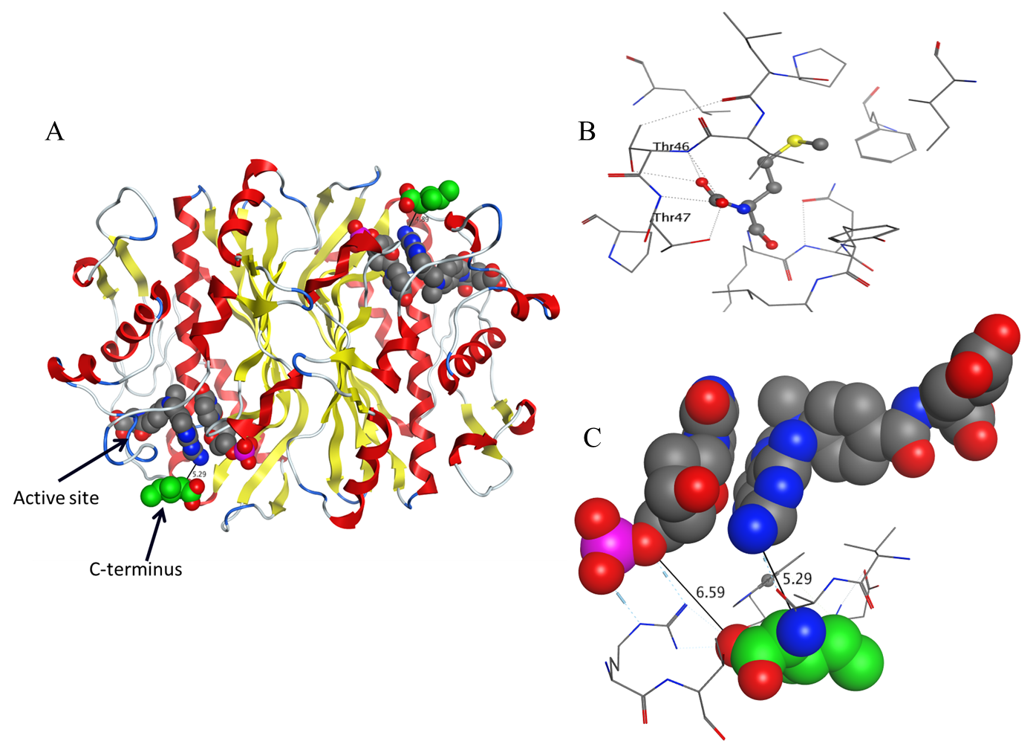
Figure 1-23 Thymidylate Synthase is a dimer.
A-The active site and C-terminus are labeled. B-The N-terminus is formlyated; this group forms a hydrogen bond with Thr46 and Thr47. C- The distance between the active site and C-terminus is ≤ 5 Ǻ and the C terminus carboxylate of the enzyme plays a role in adjusting the position of the ligands in the active site (PDB:1AXW).[71].

