Applying Modern Immunology to the Plague of Ancient Athens

by
Juhi Patel

Senior Honors Thesis
submitted in partial fulfillment
of the requirements for the degree of
Bachelors of Arts with
Honors in Classics with a concentration in Classical Civilization at
The University of Tennessee

Thesis advisor:
Dr. Aleydis Van de Moortel
May 2019

Table of Contents

List of Tables 3
List of Figures 3
Introduction 4
Chapter 1. Overview of primary and secondary sources. 7
Primary Written Sources. 7
Primary Archaeological Sources. 9
Chapter 2. The Plague of Athens. 11
Chapter 3. Population Densities in the Walled Areas of Athens and Piraeus. 21
Population Estimates of Ancient Athens, ca 431 BCE. 21
Area Calculation of Walled parts of Athens and Piraeus. 29
Chapter 4- Athens’ Strained Sanitation Systems during the Outbreak of the Plague. 34
Chapter 5- Using SIR Modeling to Study the Spread of Infection during the Athenian Plague. 39
Chapter 6. Advice from Modern Immunology: Measures to Prevent the Spread of the Athenian Plague. 47
Conclusion 53
Bibliography 55

List of Tables

Table 1. Hypotheses for the identification of the plague of Athens 16
Table 2. Estimated population sizes of the Athenian polis 25
Table 3. Area calculations of domestic and refugee settlements at Athens and Piraeus 31
Table 4. Domestic population density in the walled areas of Athens and Piraeus
before the war 31
Table 5. Refugee population density during plague years 31
Table 6. Secondary rate of infection caused by a single infected person 43

List of Figures

Figure 1. Three private houses from the 5th and 4th centuries BCE Athens
near the Athenian Agora 27
Figure 2. Evolution of house sizes in Athens 27
Figure 3. Map of Piraeus with the estimated area of habitation 29

INTRODUCTION

In 431-404 BC, the ancient Greeks experienced the Peloponnesian war, which involved the participation of the majority of the Greek world. After the Persian wars in the early fifth century BC, Athens and Sparta had become two of the most powerful city-states in Greece. At first, they were allies against the common threat of the Persians. However, in the aftermath of the Persian wars, political disagreements between the two leading powers led to the formation of two opposing groups: the Delian League and the Peloponnesian League. The Delian League led by Athens was a sea-based naval power, and the Peloponnesian League led by Sparta was a land-based power with a formidable army (Rhodes 1988, 23). Our main written source for the war between those two confederations is the late-5th-century-BCE Athenian historian and eye-witness Thucydides, who wrote the History of the Peloponnesian War. Thucydides tells us that in 431 BC, Pericles, then the leader of Athens, devised a strategy for dealing with the superior Spartan
land army by bringing a large part, if not all, of the rural population of Attica into the city walls of Athens and its harbor Piraeus. With this action, Pericles surrendered the Attic countryside to Spartan raiding, and Athens became de facto a besieged fortification. However, he maintained control of the harbor Piraeus to safely import food and other necessities by ship to supply the Athenian population within the city walls. Athens and Piraeus were connected by the Long Walls, which protected the road from the harbor to the main city and ensured the Athenians safe access to the port of Piraeus.
When the refugees from the Attic countryside came into the city, they had to find shelter within the walls of the city. The influx of so many refugees caused overcrowding, which contributed to poor sanitary conditions (Th. 2.17.1). Already in the second year of the war, in 430 BC, a devastating epidemic disease broke out in Athens, claiming the lives of a substantial part of the population. Although Thucydides provides a first-hand account of the symptoms of the plague, modern historians have not been able to definitively identify the pathogen that caused the deadly epidemic.
The present study will examine the different factors involved in the spread of the plague in ancient Athens at the beginning of the Peloponnesian war. I want to investigate how the refugee crisis caused by the military strategy of Pericles affected the rapid spread of the plague, and how this spread could have been slowed down or stopped through the adoption of protocols developed by modern immunologists. Nowadays, countries experiencing high rates of urbanization are also suffering high rates of epidemic diseases. Many of these regions have poor living conditions with overcrowding and insufficient sanitation systems. Now that we know more about the causes of epidemic diseases in overcrowded conditions, we can use this knowledge to understand the conditions in ancient Athens during the plague and devise simple protocols for slowing down or preventing the spread of the disease.
The main written primary source I am using in the present study is The History of the Peloponnesian War by Thucydides. Other important primary evidence is archaeological: skeletal remains claimed to be of plague victims, physical remains of houses, public buildings, water supply systems, sanitation systems, burial sites, etc. In addition I am consulting a variety of secondary sources that discuss population size and living conditions in Athens before and during the war, the factors that may have influenced the spread of the disease, and the potential identification of the disease. Using the most probable identifications of the Athenian plague, I will use a function derived from an SIR model (“S” representing the number of susceptible people, “I” the number of infections, and “R” the number of recovered or immune people) used in modern immunology to compare the conditions of the spread of these modern diseases to the conditions in Athens during the plague. In modern times, standard immunological protocols have been developed for a number of epidemic diseases that have been suggested as candidates for the Athenian plague, and I will apply these hypothetical protocols to data for ancient Athens to see how they could have slowed down or stopped the spread of the disease.

Chapter 1. Overview of primary and secondary sources.

Primary Written Sources.

The historian Thucydides was an Athenian citizen who may have traced his lineage to Thracian royalty via his father Olorus. He was born in 460 BC, but the date of his death is unknown. To judge by his writings, he survived until the end of the Peloponnesian war (Hornblower 2002: 632). Thucydides served as a strategos, a military general, in Thrace. In charge of defending the Athenian colony of Amphipolis in northern Greece, he failed to stall a surprise attack by Sparta and lost the city. As a result, he was banished from Athens. His exile turned into a benefit for him, as it liberated him to travel and move freely to finish his books and research. In his own words, his report of the war was not an attempt at redemption for his military failure, but a genuine desire to record history (Th. 1.22.4). Details of his personal life are unclear until he begins to write the history of the war in 431 BC.
As Thucydides himself stated, he formulated his arguments from facts, and investigated all details before delivering (Th. 1.22.2-3). Modern historians such as P.J. Rhodes are critical of Thucydides’ use of superlatives in his writing, but still agree that he intended his writing to be based on facts to the best of his ability (Rhodes 1988: 3, 5-9). However, certain parts, such as the Funerary Oration delivered by Pericles in the winter of 431 BC are so well written that they almost seem to be contrived following the rhetorical fashion of the day. Even Thucydides admitted that it was impossible for him to report the exact words spoken in such speeches, so instead he used wording to fit the sentiments of the occasion (Th. 1.22.1). Modern historians point out that the Funerary Oration (Th. 2.35-46) was composed to convey the grandeur of Athens, and is immediately followed by the outbreak of the plague (Th. 2.47.3), which broke down one by one the previously described splendors of Athens (Rhodes 1988: 10). Such contrived composition makes scholars hesitant to believe that everything occurred exactly as written, and it makes one wonder whether Thucydides exaggerated his writing at times to make a rhetorical point. This especially becomes an issue when one uses his account of the plague to identify the disease, as The History of the Peloponnesian War is the most important primary written source for the symptoms of the disease.
As said by his own writings (Th. 2.48.4-5), Thucydides caught the plague during its first outbreak in 430 BC but survived and made the decision to inform others of the potential danger of such devastating infectious disease. Modern scholars agree that his overall record of the plague is medically sound for the time period and conveys an understanding of infection and immunity as well as an overall better understanding of medicine than the average Ancient Greek historian had (Hornblower 2002: 633). However, no one has been able to identify the disease on the basis of Thucydides’ description of the symptoms. One physician and Classicist who is critical of Thucydides’ account of the plague is Thomas Morgan, who believes that Thucydides enhanced his description of the symptoms of the plague in order to fit his own agenda better, emphasizing the destruction of Athens as a counterpoint to the Funerary Oration (Morgan 1994, 199-201: 205). Like Rhodes (see above) Morgan suggests that the primary motive of Thucydides was not to spread information about the disease, but to show the downfall of Athens in a rhetorical fashion. Morgan concludes that it is difficult to use the symptoms described by Thucydides to define the identity of the plague, as the words are not precise (Morgan 1994: 208). In contrast, other historians like Donald Kagan believe that Thucydides was extremely precise in his account of the plague, in that he recorded every single observed symptom, no matter how low the rate of occurrence. In this way, Thucydides made it seem as though each of the approximately twenty symptoms was observed equally in all plague victims. The problem is that many of the symptoms he described, such as fever, vomiting, diarrhea, and fatigue, are shared by a large number of infectious diseases. In each of these diseases, some of the symptoms are major while others are minor. The fact that Thucydides does not provide details about the rate of occurrence, in my opinion, makes it difficult to use his written account for identifying the disease that caused the plague. However, it does allow us to point to a limited range of possible diseases.

Primary Archaeological Sources.

The primary archaeological evidence used in the present study involves the remains of a burial site discovered in 1994 at the Athenian cemetery of Kerameikos (Papagrigorakis et al. 2006: 207). The grave consisted of an irregularly shaped pit, 6.50 meters long and 1.60 meters deep. It contained at least 150 inhumations stacked in more than five layers. It appears as though the bodies were placed more carelessly towards the top of the pit. Several factors led the researchers to link the 150 discovered bodies to the outbreak of the plague. This interpretation is primarily based on pottery dates: various vessels found in the tomb were dated stylistically to around 430 BC, whereas others were dated within the decade of 430-420 BC, and a few could be placed in the last quarter of the fifth century BC. These pottery dates make it possible that the grave dates to one of the plague years. In addition, the researchers cite the “hasty and impious manner of burial” as a factor that led them to connect the bodies to the plague, because Thucydides states that because of the multitude of deaths, the bodies of the dead from the plague were buried without regard to regular burial customs (Th. 2.52.4-8; Papagrigorakis et al. 2006: 207-208). The researchers randomly selected three teeth and subjected these to molecular DNA analysis, which led them to identify Salmonella enterica serovar Typhi, the bacterium that causes typhoid fever, as the possible cause of the Athenian plague (see chapter 2). My main critique of their research is that it was performed on only three teeth, and that the microbial DNA was compared to only seven pathogens in order to identify the disease. The sample size of tested teeth is too small, and not enough information is given about the random selection. No details are given about the number of teeth available, or even about the location of the selected teeth in the tomb. It is possible that all three teeth came from one layer or area, and that the other bodies had other diseases. Since Thucydides listed so many symptoms, it is possible that different people had been killed by different infectious diseases, or that the same individuals had been plagued by more than one pathogen at the same time. The other problem with this study is that there are other diseases that have been proposed by historians as the cause of the plague, and these were not tested in the study, such as measles, ergot toxin, glanders, smallpox, leptospirosis, lassa fever, and alimentary toxic aleukia. In the future, more teeth should be analyzed and the results should be compared to a much broader database of pathogens in order to determine the identity of the plague with a greater degree of certainty.

Chapter 2. The Plague of Athens.

As Thucydides tells us, the Athenians obeyed their general Pericles and in 431 BCE moved from the rural countryside into the walls of the city (Th. 2.15.1-3). The Peloponnesians indeed entered the Attic countryside during this and most of the following years (431 BCE, 430 BCE, 429 BCE, 427 BCE, and 425 BCE), and they ravaged the crops. They invaded each year in the summer and left after a few months. Victor Hanson suggests that the second invasion, in 430 BCE, was the most destructive of the five invasions, because it was made worse by the outbreak of the plague (Hanson 1998: 134-135).
Thucydides tells us that this epidemic disease originated in Ethiopia (present-day Sudan), then descended into Egypt and Libya and traveled across to the Persian Empire and then into Athens. It first entered the harbor town of Piraeus, then hit the main city much harder. In addition, Thucydides reports that the highest populated regions of the Peloponnese were affected by the disease as well, but Athens suffered the worst. The disease affected anyone, no matter whether healthy or sick. Thucydides provides a thorough description of the disease’s symptoms to serve as guidance for others to recognize the symptoms (Th. 2.48.3). He reports:
“… men were seized first with intense heat of the head, and redness and inflammation of the eyes, and the parts inside the mouth, both the throat and the tongue, immediately became blood-red and exhaled an unnatural and fetid breath. In the next stage sneezing and hoarseness came on, and in a short time the disorder descended to the chest, attended by severe coughing. And when it settled in the stomach, that was upset, and vomits of bile of every kind named by physicians ensued, these also attended by great distress; and in most cases ineffectual retching followed producing violent convulsions, which sometimes abated directly, sometimes not until long afterwards. Eventually the body was not so very warm to the touch; it was not pale, but reddish, livid, and breaking out in small blisters and ulcers. But internally it was consumed by such a heat that the patients could not bear to have on them the lightest covering or linen sheets, but wanted to be quite uncovered and would like best to throw themselves into cold water- indeed many of those who were not looked after did throw themselves into cisterns- so tormented were they by thirsts which could not be quenched; and it was all the same whether they drank much or little. They were also beset by restlessness and sleeplessness which never abated. And the body was not wasted while the disease was at its height, but resisted surprisingly the ravages of the disease, so that when the patients died, as most of them did on the seventh or ninth day from the internal heat, they still had some strength left; or if they passed the crisis, the disease went down into the bowels, producing there a violent ulceration, and at the same time an acute diarrhea set in, so that in this later stage most of them perished through weakness caused by it. For the malady, starting from the head where it was first seated, passed down until it spread through the whole body, and if one got over the worst, it seized upon the extremities at least and left its marks there; for it attacked the privates and fingers and toes, and many escaped with the loss of these, though some lost their eyes also. In some cases the sufferer was attacked immediately after recovery by loss of memory, which extended to every object alike, so that they failed to recognize either themselves or their friends.” (Th. 2.49.2-13).
Based on the symptoms provided by Thucydides, modern historians have focused primarily on diseases such as typhus, smallpox, measles, and typhoid fever as potential identification of the Athenian plague. In 2006 researchers used a mass grave with 150 bodies discovered in the cemetery of Kerameikos to conduct molecular DNA testing on the dental pulp of three teeth selected randomly from the bodies in the tomb (Papagrigorakis et al. 2006; see chapter 1). Using suicide PCR, which stands for Polymerase Chain Reaction, and primers of seven different diseases, they amplified the genes of interest. The tested diseases were plague (Yersinia pestis), typhus (Rickettsia prowazekii), typhoid fever (Salmonella enterica serovar Typhi), anthrax (Bacillus anthracis), tuberculosis (Mycobacterium tuberculosis), cowpox (cowpox virus) and cat-scratch disease (Bartonella henselae). The process of PCR capitalizes on the complementary nature of DNA. By using a sample of microbial DNA from the teeth together with an enzyme that synthesizes DNA (DNA polymerase), and a primer that signals the enzyme where to begin synthesizing new DNA (specific for each microbial agent), they are able to amplify the genes of interest (NCBI 2017). In suicide PCR, the primer can be used only once before it is destroyed in order to minimize the risk of contamination. Once a single gene from the target DNA has been amplified, its genome is sequenced and inserted into the GenBank® sequence database. The database compares the isolated sequence to all known sequences available, and provides a list based on base pair similarity. In this study, the researchers found a 93% similarity in the narG gene to modern Salmonella enterica serovar Typhi, the bacterium that causes typhoid fever (Papagrigorakis et al. 2006: 207-208). They knew that it could not be the modern strain of this disease because there was not a 100% homology between the base pairs. They explain the 93% similarity by suggesting that there may have been a mutation of the strain over time. Indeed, such mutation was indicated by genetic sequencing of the ancient narG gene which showed the presence of 28 base pair changes, 25 of which were in the final codon. A codon is a sequence of three nucleotide base pairs that codes for an amino acid. The changes in the final codon do not change its identity, so there are no biological consequences. However, the three mutations that are not in the final codon likely resulted in more significant changes. In fact, genetic testing into the examination of S. typhi genome has shown the presence of pseudogenes, which are sequences that have been mutated by changes in single base pairs. Approximately 5% of the S. typhi genome had been inactivated by the presence of pseudogenes, which is indicative of significant biological changes. This led the researchers to hypothesize that the genome of the bacterium had mutated in order to better adapt its pathogenesis, which is the mechanism by which the organism infects other organisms with disease. Over time, genetic mutations may have allowed S. typhi to reduce its routes of invasion and focus on single human infection. (Wain et al. 2002: 165). The bacterium evolves to narrow its host ranges and increases its virulence by becoming a systemic pathogen, which causes an infection that spreads through the entire body (Lederberg, 2009). This may explain why modern typhoid fever does not affect animal reservoirs, whereas it may have done so in ancient Athens, where Thucydides recorded animal infection by the plague. A reservoir is a living organism that carries infectious agents and influences disease outbreak.
Cross-examination of the primary evidence provided by Thucydides and the primary archaeological evidence provided by Papagrigorakis et al. highlights a key discrepancy- the animal reservoir. The simple experiment performed by Papagrigorakis et al. makes it difficult to pinpoint the reason behind this difference. It is clear from their discussion that Papagrigorakis et al. did not compare the obtained DNA with more than seven pathogens. They simply stopped the study once they received a positive result, and they did not do further analyses, presumably because this type of study was very expensive at the time. However, since 2006, when this study was done, the available database of pathogens has expanded significantly, and it has become much cheaper and more efficient to run PCR. To test whether the new available data would strengthen or weaken the homology of the analysis, I used the provided narG sequence of the ancient DNA provided by Papagrigorakis et al. (2006) and inserted it into the GenBank® sequence database. I used a BLASTN search to compare the nucleotide sequence to modern strains in the database, and found a 91% nucleotide homology with the modern narG gene of S. enterica serovar Typhi. I then used a BLASTX search to compare the translated amino acid sequence to modern strains in the database, and found a 96% homology in the amino acid sequence. The fact that my results show a different homology from that obtained by Papagrigorakis et al. may be explained by the fact that the authors do not tell us the basis on which the homology was performed. However, the gene sequence is now known in more detail, and many more data are present in the database, so the expected homology is higher if the ancient DNA is indeed from S. enterica serovar Typhi. Any homology less than 100% indicates a change in the DNA from the ancient sample to modern samples.
Thus, although an old strain of typhoid fever was most likely the causative agent that killed the Athenians whose teeth were analyzed, the results of this research are not adequate to definitively identify the disease. As explained in chapter 1, the experiment should be repeated with a larger sample size, and the genome(s) should be compared to more than the seven tested pathogens. We should at least consider the other diseases discussed by historians based on the similarity of their symptoms to those described by Thucydides. The ideal way to do this would be to sequence the entire genome of the DNA extracted from the teeth, and not just one gene at a time as they have done. However, this would be a very expensive, multi-million dollar, project that is currently out of the reach of archaeological budgets.
Since the DNA evidence is somewhat inconclusive, we can use Thucydides’ list of symptoms and compare these with the symptoms of known diseases. Typhoid fever is likely present, but we cannot exclude other diseases that were not tested in the study. The following table lists other possible identifications of the plague considered by modern historians (Table 1). Some diseases such as the bubonic plague can be eliminated immediately, as we know that the reservoirs for the disease--rats--were most likely not present in ancient Greece during this time period (Vigne 1994). Other diseases, such as measles and smallpox, are difficult to eliminate as the virus may have evolved or mutated over time. In the following chapters, I will choose three diseases to conduct the SIR modeling. These diseases are typhoid fever, measles, and smallpox. These were selected on the basis of their greatest similarity to Thucydides’ description of the symptoms, as shown in Table 1.
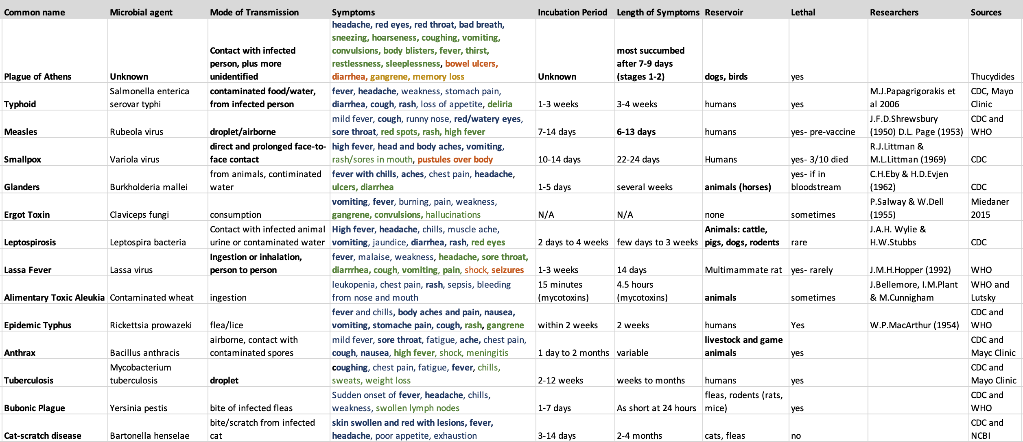
Table 1. Hypotheses for the identification of the plague of Athens. This table lists diseases discussed by various modern historians and scientists as the cause of the plague. The first row lists the symptoms provided by Thucydides. Symptoms in common with Thucydides’ description are in bold print. The stages of the symptoms are differentiated by a color change, i.e. the first stage is represented in blue, the second in green, the third in orange, and the fourth in yellow.

Typhoid fever is included because of the study by Papagrigorakis et al. (2006) that showed the presence of its bacterial DNA, be it in mutated form, in the dental remains from the mass grave in the Kerameikos cemetery. Symptoms of modern typhoid fever include fever, headache, weakness, stomach pain, diarrhea, cough, rash, loss of appetite, and deliria. As shown in Table 1, fever, headache, diarrhea, cough, rash, and deliria are all symptoms provided by Thucydides. The symptoms of modern typhoid fever last much longer (three to four weeks) than what Thucydides explained (seven to nine days), and the modern disease also does not affect non-human reservoirs. However, it is possible that an earlier form of typhoid fever could have acted more swiftly and infected animals as well (Wain et al. 2002).
Measles, smallpox, and glanders were not considered by the 2006 study, but have symptoms that correspond to parts of Thucydides’ account (Table 1). Measles, smallpox, and typhoid fever spread solely through person to person contact, and in their modern forms do not infect animals (http://www.who.int/ith/diseases/typhoidfever/en/), although it is always possible that they have mutated and their ancient forms did spread to animals as well. Symptoms for measles are, in chronological order, mild fever, cough, runny nose, red/watery eyes, sore throat, red spots, rash, and high fever. Symptoms for smallpox include high fever, head and body aches, vomiting, rash/sores in mouth, and pustules over the body. Those listed in bold print match the description provided by Thucydides. The duration of symptoms for modern measles is similar to that described by Thucydides for the plague, but those of smallpox last much longer, and this disease immediately causes a high fever, whereas Thucydides mentions that fever occurs at a later time (Table 1). Thus, it appears that measles are a somewhat more likely identification of the Athenian plague than smallpox.
Glanders cannot be ruled out because, unlike typhoid fever, measles, or smallpox, which only spread person-to-person, it must have animal reservoirs, and Thucydides describes how animals contracted the sickness as well as humans. Key symptoms include fever with chills, aches, chest pain, headache, eye sensitivity, and fatigue. Of those symptoms, only chills, aches, and headache, are shared with the symptoms of the Athenians plague (Table 1). Although animal to human transmission of glanders is rare in modern times, close occupational exposure to animals still provides a risk for modern groups such as soldiers, farmers, and veterinarians. Glanders is primarily transmitted by direct invasion of bacteria into scratched skin; by inhalation of bacteria into the lungs; and by bacterial infiltration of the nasal, oral, and conjunctival (part of the eye) membranes. Though information about the rate of infection is deficient, the mortality rate is reported as 90-95% without treatment (Van Zandt et al 2013: 2,5). Glanders is a possibly cause or one of the causes of the Athenian plague because both primary written records and archaeological evidence show that Athenians in the late 5th century BCE kept animals such as dogs and birds as pets. Aristophanes (Wasps 1.2.928-29) tells us that dogs were household pets in Athens, and a marble grave stele from Athens, dated to 450-440 BCE, which is now in the Metropolitan Museum, shows a little girl holding a pet bird (https://www.metmuseum.org/art/collection/search/252890 No. 27.45). Moreover, as a large part of the population was drawn within the walls of Athens at the beginning of the Peloponnesian war, one would imagine that the number of pet animals as well as horses for the cavalry would have increased. Thucydides tells us that farm livestock was not brought within the walls as the refugees sent the livestock to Euboea (Th. 2.14.1). Even though glanders is a likely identification of the Athenian plague, it will not be considered in my SIR model in chapter 5 because we lack information about the transmission of the disease in antiquity.
Some symptoms provided by Thucydides that are not covered by the four diseases above are bad breath, sneezing, convulsions, thirst, restlessness, sleeplessness, and gangrene. Bad breath, sneezing, and thirst are minor symptoms unlikely to be included in lists of symptoms for modern diseases. The presence of convulsions could be explained by a high fever. Similarly, gangrene can result from bacterial infections. Restlessness and sleeplessness are not listed symptoms for any of the proposed causes of the plague.
The frequency of person-to-person and person-to-animal contact must have increased enormously within the walls of Athens at the time of the outbreak of the war due to the increase of inhabitants as a result of Pericles’ strategy for fighting the Peloponnesian war. The following chapter will discuss the spike in population density and provide estimates for the size and density of Athens’ population after the influx of rural refugees within the walls.

Chapter 3. Population Densities in the Walled Areas of Athens and Piraeus.

Population Estimates of Ancient Athens, ca 431 BCE.

The polis of Athens encompassed the whole of Attica (around 2,527 km²), and was much larger than the walled areas of Athens and Piraeus (Morris 2005:15). In a speech at the outbreak of the Peloponnesian War in 431 BC, Pericles of Athens called for Athenians to abandon the Attic countryside and move within the walled area of Athens to evade the superior Spartan army. Thucydides tells us of an enormous population increase within the walled area of Athens due to the influx of refugees caused by the strategy of Pericles. However, modern historians disagree about how many refugees settled within the walls of Athens, ranging from estimates that would put the total population at 300,000 to 400,000 (Morens and Littman 1992: 276). Our primary source for the population size of the Athenian state is Thucydides, and modern historians disagree on how to interpret population data. This is why it has been difficult for modern historians to come to a consensus about the exact size of the population of the walled area of Athens and Piraeus after the refugee influx in 431 BCE.
In order to estimate the population size and density within the walled area of Athens and Piraeus when the plague broke out in 430 BCE, we must first estimate what the population was of the whole of the Athenian polis and then work with reasonable estimates for how much of the population would have withdrawn within the walls. Modern historians have used various methods to determine population size based on passages by Thucydides and other historians. In particular, Thucydides gives data about the numbers of land soldiers and triremes (ancient war ships) available to Athens at the beginning of the war in 431 BCE. In a speech to the Athenian assembly trying to bolster their morale as the war broke out, Pericles mentions that there were 13,000 hoplites of the active army and 16,000 hoplites on home duty to defend Athens. In addition, he mentions that there were 1200 members of the cavalry, 1600 archers on foot, and 300 seaworthy triremes (Th. 2.13.6-8; see Table 2 below).
A prominent modern historian, A. W. Gomme, used those military data as the foundation for his estimate. He assumed that these numbers included 25,000 citizens of hoplite (middle class heavily armed soldiers) and cavalry rank (upper class), aged 20-60, and 5,500 metics (resident aliens in the polis) of the hoplite census. To these numbers he added 18,000 citizen thetes (lower-class lightly armed troops and oarsmen). This is a minimum estimation by Gomme based on his estimated number of citizen oarsmen in the fleet- the rest of the oarsmen having been metics and foreign allies (Gomme 1933: 13-14). This sum of 25,000 citizen hoplites and 18,000 citizen thetes gave him an estimate of around 43,000 male citizens in the polis of Athens. He multiplied this value by four to account for the women and children of these men, arriving at a total of 172,000 citizens. In addition to 5,500 metics of the hoplite census, he estimated that 4,000 metics were classified as thetes, which gave him a total of 9,500 metics that served as hoplites and thetes. These thetes would have included the 1,600 archers mentioned by Thucydides. He multiplied this number by three to account for the women and children, assuming that a number of metics may have been new arrivals with no or smaller families, and arrived at a number of 28,500 metics. He also believes there were 115,000 slaves. He derives this number by assuming that each hoplite and cavalryman (ca. 33,000 in his estimate) had at least one male servant, and there were some 40,000 to 50,000 slaves engaged in heavy industry such as mining and quarrying. Included in his number of slaves is also an estimated 35,000 to 40,000 female slaves. Gomme does not mention slave children explicitly, but given the roughness of his estimates, we will assume that they are included. Adding together the number of male citizens, women, and children (172,000), metics (28,500), and slaves (115,000) gives a total of 315,500 people living in the Athenian polis in 431 BCE (Gomme 1933: 21, 26).
A higher estimate can be proposed on the basis of estimates by Hansen (1988). Hansen began by examining the number of hoplites as given by Thucydides (Th. 2.13.6-7) and Gomme (1933). Gomme estimated 43,000 citizens aged 18-59, to which Hansen added 4000 to account for those over age 60 (Hansen 1988: 60). He then offered an even higher estimate of citizens, 60,000, after conducting a demographic analysis of the age distribution of the Athenian male citizens (Hansen 1988). For his analysis, he used a population model called the “West” model. This model states that the year classes of 18-19 and 50-59 in a pre-industrial population would have made up 1/5 of the males aged 18-59 (Coale and Demeny 1966). In Hansen’s view, these ranges of 18-19 and 50-59 would have represented the oldest and youngest, or the home guard at Athens, which Gomme estimated as 10,500 (Gomme 1933: 5). Hansen rounded this value down to 10,000, and used it to approximate the population of citizens aged 18-59, which would correspond to 50,000. He then added 5,000 to this number, explaining that around 10% of the citizens of military age must have been unfit for military service. Now at 55,000, he then must account for those over the age of 59. According to the population model listed above, men over 60 make up 1/12 of the population. He added another 5,000 to account for this, arriving at a total of 60,000 male citizens living in Attica (Hansen 1988: 25). This number also would explain why in spite of the heavy losses suffered by Athens as the result of the Peloponnesian War and the plague, there would still have been about 25,000 citizens left ca. 400 BCE-- which would have been the minimum needed for the functioning of the democratic institutions (Hansen 1988: 14-27). Hansen ended here, and did not proceed to estimate the total population of the Athenian polis, including women, children, metics, and slaves. To arrive at a total estimate as Gomme did above, we can multiply Hansen’s number of 60,000 adult male citizens by 3.5 to account for women and children. This gives a total of 210,000 male citizens, women, and children. This value of 210,000 can be added to Gomme’s numbers of 115,000 slaves and 28,500 metics for a final estimate of 353,500 people living in Athens in 431 BCE.
In the above estimate, I chose a multiplication factor of 3.5, which is somewhat lower than Gomme’s factor of 4, on the assumption that Athenian families had on average 2 children and that among the 60,000 adult male citizens there would have been fathers and married sons, and among the women and children there would be daughters who also were mothers. If, however, one accepts a multiplication factor of 4, which would mean an average number of more than 2 children per family, the number of citizens would have been 240,000, and the total number of inhabitants in the Athenian polis 383,500. This number is only slightly less than if one estimates the Athenian population size on the basis of Thucydides' military numbers of 431 BCE, and accepts that of the 300 seaworthy triremes, 180 ships (or 60%) would have had a full crew of 200, and 120 ships (or 40%) would have been transport vessels with an average crew of 70-- figures taken from the Athenian expedition against Syracuse (Hansen 1988: 16). Adding these 44,400 crew (Athenian citizens, metics, and foreigners) to Thucydides' list of 29,000 hoplites, 1,200 cavalry, and 1,600 archers would give a total of 76,200 active servicemen (Th. 2.13.6). If one multiplies this by 3.5 to account for women, children, and the elderly--keeping in mind that these troops would have included fathers and sons as well as mothers and daughters—and possibly foreigners without their families--one reaches a total of 266,700 citizens, metics, and foreigners. Adding to that Gomme's 115,000 slaves yields a total of 381,700 inhabitants of the Athenian polis. On the other hand, if one multiplies the 76,200 active servicemen by 4, one reaches a total of 285,750 people in the citizen and metic class, and ca. 400,000 inhabitants in all.
The lowest reasonable estimate can be proposed on the basis of calculations by van Wees (2004: 241-243), who references Thucydides and Hansen in his analysis. He interprets Thucydides value of 29,000 hoplites differently, and breaks the number down into 13,000 citizens in the active army, 3,000 metics in the active army, and 13,000 (oldest and youngest) acting as the home guard. He includes an additional 1000 men in the cavalry as part of the active army. When looking at the 17,000 men in the active army, approximately 17.6% are metics. Using this same percentage, Hansen estimates that 10,700 out of the 13,000 in the home-guard are citizens, and the remaining 2,300 are metics. This gives a total of 24,700 citizen hoplites and cavalry, and 5,300 metics that are hoplites (van Wees 2004: 241). This number does not include the number of thetes, or women and children. If we add to this, for the sake of argument, Gomme’s low estimate of 18,000 thetes, and then multiply this number of 42,700 by 3.5 to account for women and children, this gives a total of 149,450 male citizens, women, and children. This value of 149,450 can be added to Gomme’s numbers of 115,000 slaves and 28,500 metics for a final minimum estimate of 292,950 people living in Athens in 431 BCE (van Wees 2004: 243). Having reviewed the various population estimates of the Athenian polis in 431 BCE, I believe that it is reasonable to work with simplified estimates of 300,000, 350,000, and 400,000 inhabitants.

 | Thucydides (2.13.6) | Gomme | Hansen | van Wees | Morris
Hoplites (both citizens and metics, old and young) | 29,000 (13,000 in active duty and 16,000 in the garrisons and home-guard) | 29,000  (subtracted 4000 to account for metics) | 60000 male Athenian citizens, including citizens unfit for military service and above military age | 23,700
Cavalry | 1200 |  |  | 1000
Bowmen | 1600
Trireme Crew | 44,400 (based on an estimate of 180 seaworthy fighting triremes and 120 transport triremes); moreover, there were other ships in the Athenian navy not mentions by Thucydides
Thetes |  | 18,000 |  | (18,000)
Women and children (and fighting men) | 76,200 x 3 = 228,600 (also includes metics) | (25000+18000) x 4=  172,000 | 60000 x 3.5 = 210000 | (24,700+ 18,000) x 3.5 = 149,450
Metic men | (included in above calculation) | 9,500 (hoplite soldiers and thetes)
Metic women and children (and men) | (included in above calculation) | (9500) x 3 = 28,500 | 28,500 adopted from Gomme | 28,500 adopted from Gomme
Slaves | 115,000 | 115,000 | 115,000 adopted from Gomme | 115,000 adopted from Gomme
Total | 343,600 | 315,500 | 383,500 | 292,950
Population in Athens & Piraeus |  | 155,000 |  |  | 60,000 to 65,000
Table 2. Estimated population sizes of the Athenian polis. The table lists population calculations based on data provided by various historians. The numbers listed in bold have been used in the calculation of the grand totals.
Another issue of importance to our inquiry is what percentage of this total population would have lived inside the walled areas of Athens and Piraeus before the refugee crisis of 431 BCE. Gomme hypothesized that a third of the population, or 155,000 people in his estimate, lived within those walled areas. Later ancient historians such as Ian Morris disagree, and argue that the small walled area (see below) would not have been able to support such a high population. Instead, they estimate the population of the walled city of Athens as between 35,000 to 40,000, and the population in Piraeus as 25,000 (Morris 2005: 15). If we accept an estimated total population size of Athens of 300,000, the urban population would have represented about 20% of that total. If we accept the maximum estimate of ca. 400,000, it would have made up roughly 15% of the total. This means that if the entire population of Attica would have moved within the walls, the urban population would have increased about five to seven times.
These population estimates are supported by scant published archaeological evidence of house sizes in Athens, which suggests that they may have been on average about 220 sq. m in area. In his study of the area of the Athenian Agora, John Camp includes plans of three private houses of Athens dated to the 5th and 4th centuries BC (Fig. 1; Camp 1986: 148). Their areas measured 150 sq. meters, 220 sq. meters, and 360 sq. meters. If we use the median value of 220 sq. m as the average size of an Athenian house, then approximately 5454 houses would have fitted in the 120 hectares estimated by Morris to have been used for domestic settlement in the city of Athens (Morris 2005: 15). If Morris’ estimated population size of 35,000-40,000 is correct, this means that 6.4 to 7.3 people would have lived in a house of 220 sq. m, which seems reasonable. The houses near the Agora may be larger than average, however, as the median 50% of houses in the mid-5th century BCE throughout Greece reported by Morris (2004) range from 110 sq. m to 180 sq. m. If we use the median of this range, 145 sq. m as the average house size, that means that up to 8275 houses could have fit in the domestic area of 120 hectares in Athens, with 4.2 to 4.8 people per household (Morris 2004: 772). John Travlos, on the other hand, must have envisioned an average house size in Athens that fell in-between the Agora houses and the average house size in mid-5th century Greece. He states that Athens held up to 6000 houses with around 36,000 occupants, resulting in 6 people per house (Travlos 1971: 72). A typical family of 6 would have included parents, an average of two children, and one or two slaves or an elderly family member.
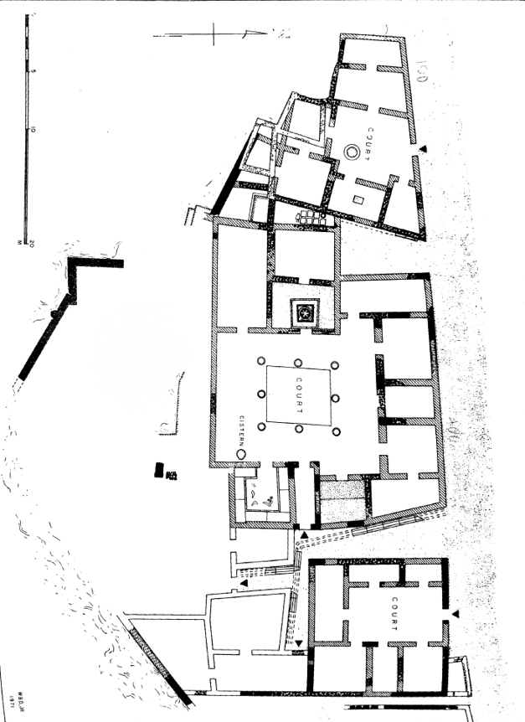
Figure 1. Three private houses from the 5th and 4th centuries BCE Athens near the Athenian Agora. The areas of the houses were measured using the provided scale (Camp 1986: 148).
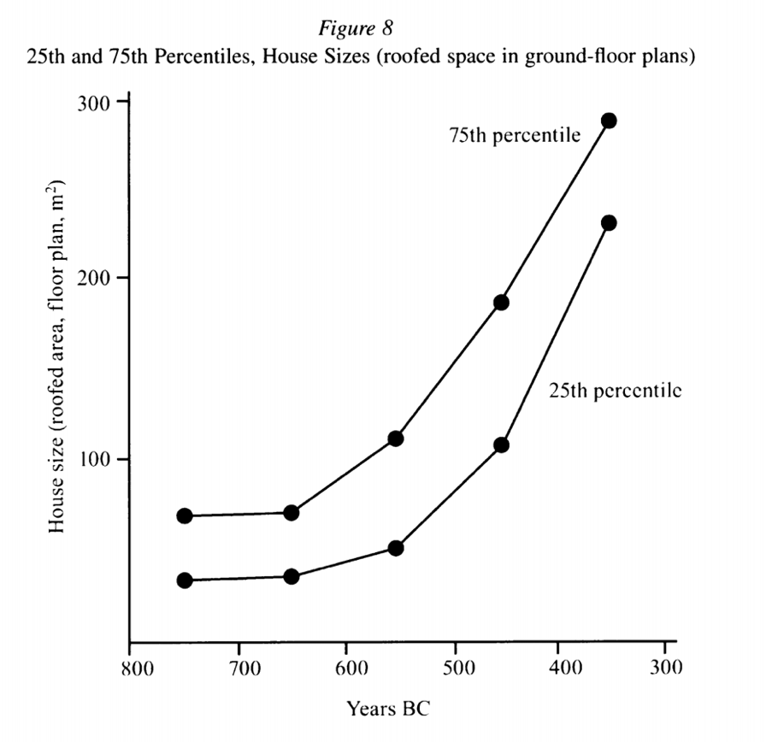
Figure 2. Evolution of house sizes in Athens. This figure shows the 25th and 75th percentiles of the average house sizes in Athens from ca. 750 to ca. 350 BCE. In the mid-5th century BCE the median 50% of houses ranged between 110 m2 and 180 m2 (Morris 2004: fig.8).

Area Calculation of Walled parts of Athens and Piraeus.

Now that we have accepted minimum and maximum population estimates for the urban and rural areas of the Athenian polis, we want to estimate population densities in the walled areas of Athens and Piraeus both before and during the outbreak of the war and the plague. The first step is to calculate the area inhabited by both residents and refugees within Athens and Piraeus. Morris stated that the walled area of Athens encompassed 215 hectares, of which only 120 hectares (or 56%) was used for domestic settlement (Morris 2005: 15). My measurements show that an additional 3 hectares were occupied by the Acropolis, and another 2 hectares can be estimated for the temple of the Eleusinian Demeter and any other enclosed sacred areas, which according to Thucydides were off-limit to the arriving refugees (Th. 2.17.1). This would have left approximately 90 hectares available for refugees in Athens itself. As for the other walled areas, Meera Patel calculated the total area of Piraeus as 473 hectares and the area between the Long Walls as 191 hectares (Patel 2017: 18). This calculation does not include the area between the Long Walls and the Phaleric Wall, which was not defended and thus unlikely to have been inhabited during the Peloponnesian War (Th. 2.13.7; Patel 2018: 13). Compared to Athens, a much smaller area of Piraeus, around 60 hectares in the middle of the town between Kantharos and Zea, would have been used for domestic settlement, as some evidence for roads and houses has been found there (Fig. 3; Wycherley 1978: 263). In addition, we can estimate that another 80 hectares were taken up by harbor installations at Kantharos, Zea, and Mounychia. Much of the remainder of the landscape was covered with uninhabited hills. These hills would have allowed Piraeus to have more land available for refugee settlement. The southern part of the Akte peninsula, ca. 150 ha, remained outside of the walls, however, and was therefore unguarded, so it is unlikely that refugees settles in this area. This would have left 150 hectares of open area for refugee settlement in the northern half of the Akte peninsula. In addition, refugees may have settled in other uninhabited areas to the north of Kantharos and Mounychia, which covered another 33 hectares. This means that there were in all approximately 183 hectares available for refugees in Piraeus.
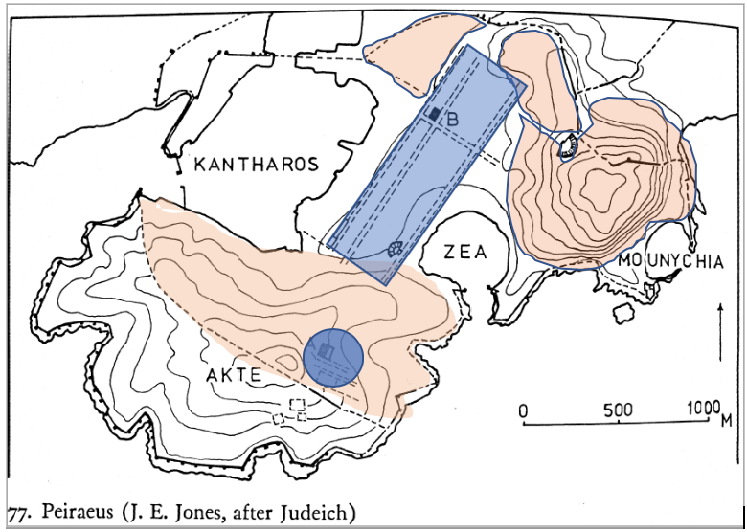
Figure 3. Map of Piraeus with the estimated area of habitation. The areas in orange represent those available for refugees, and the areas in blue represent those used for domestic settlement (after Wycherley 1978: 264).

The total area between the Long Walls that ran between Athens and Piraeus was measured as 191 hectares, but since there was a deme called Xypete located in this area, I roughly estimate that only 90%, or 172 hectares, were open for refugee settlement (Traill 1975: Map 1). These numbers (90+183+172) give a total of 445 hectares available for refugee settlement in Athens and Piraeus, and between the Long Walls. In all those areas, 199 hectares (120+60+19) would have been used for domestic settlement.
According to Morris’ estimate, before the refugee crisis, around 65,000 people occupied an area of 644 hectares in Athens and Piraeus (Table 2). This gives a population density of 101 people per hectare, or 10,100 people per square kilometer. In order to estimate the population densities of the walled areas during the refugee crisis we will use the minimum and maximum population estimates of 300,000 and 400,000 (see above), and we will make calculations for two scenarios: one that assumes that 50% of the Attic population entered the walled area and one that assumes that 75% of the population came into the urban areas. It is unlikely that 100% of the population fled within the walls because there were also other fortified settlements in Attica where some seem to have gone for shelter (Patel 2018: 21). If the Athenian population numbered 300,000 before the war, and 65,000 people lived within the walls that means 235,000 people would have dwelled in the rural countryside. If 50% of them entered the walled area of Athens-Piraeus, that means that 117,500 refugees settled in 445 hectares, giving a density of 264 people/ha, or 26,400 people/sq. km. This density of 264 people/ha is unlikely because this population density is less than half of the residential areas, whereas Thucydides reports that the refugee areas were more crowded than the residential areas (see chapter 5 for discussion). If 75% of the rural population entered the walled area, that means 176,250 refugees settled in 445 hectares, giving a density of 396 people/ha, or 39,600 people/sq. km. If, however, the Athenian population numbered 400,000, we obtain much higher density estimates. Subtracting the 65,000 people already within the walls from 400,000 gives 335,000 people in the rural countryside. If 50% of them entered the walled area, that means 167,500 refugees settled in 445 hectares, giving a density of 376 people/ha, or 37,600 people/sq.km. If 75% of the rural population entered the walled area, that means 251,250 refugees settled in 445 hectares, giving a density of 564 people/ha, or 56,400 people/sq. km.
 | Domestic Settlement | Refugee  Settlement | Other buildings | Total Area
Athens | 120 hectares | 90 hectares | 5 hectares | 215 hectares
Piraeus | 60 hectares | 183 hectares | 80 hectares- harbor  150- unoccupied | 473 hectares
Long walls | 19 hectares | 172 hectares |  | 191 hectares
Total Area | 199 hectares | 445 hectares | 235 hectares | 879 hectares
Table 3. Area calculations of domestic and refugee settlements at Athens and Piraeus (after Morris 2005: 15; Wycherley 1978: 264).
 | Area | Population | Density
Athens  Piraeus  Long Walls | 199 ha settlement | 65,000 | 326 people/ha
Athens  Piraeus  Long Walls | 644 ha total | 65,000 | 101 people/ha

Table 4. Domestic population density in the walled areas of Athens and Piraeus before the war.

Population increase | Area | Population | Density
50% increase of 300,000 | 445 ha | 117,500 people | 264 people/ha
75% increase of 300,000 | 445 ha | 176,250 people | 396 people/ha
50% increase of 400,000 | 445 ha | 167,500 people | 376 people/ha
75% increase of 400,000 | 445 ha | 251,250 people | 564 people/ha

Table 5. Refugee population density during plague years. The minimum population is based on an estimate that 50% of the Attic population of 300,000 entered the walled area of Athens-Piraeus. The maximum population is based on an estimate that 75% of the Attic population of 400,000 entered the walled area of Athens-Piraeus.

In this chapter, I have demonstrated the enormous population density increase in the walled areas Athens-Piraeus during the refugee influx. If we accept the maximum population estimate, the population density more than quadrupled during the war and plague. With such a large population density, it is likely that diseases with fast transmission rate (such as measles and smallpox) would have spread much too quickly. On top of the overcrowding, another potential factor involved in the spread of the disease is the fact that Athens was dependent on a simple sanitation system that was overtaxed during the population influx. In the next chapter, I will examine the sanitation infrastructure of Athens and Piraeus.

Chapter 4. Athens’ Strained Sanitation Systems during the Outbreak of the Plague.

Thucydides tells us that as the plague entered Attica, it first affected the residents of the port of Piraeus. The Athenians at first believed that the water reservoirs had been poisoned (Th. 2.48.2). It is clear from textual and archaeological evidence that the people of ancient Athens relied on structures such as wells, cisterns, and aqueducts to supply water, and they used cesspools for waste disposal (Wycherley 1977: 240, 248). Thucydides also tells us that on occasion, the sick jumped into cisterns, which collected rainwater to supply the wells used in Athens (Th. 2.49.5). Although simple, these systems worked well for the population of Athens before the war. However, these systems were strained under the influx of refugees at the beginning of the Peloponnesian war, as they had not been constructed to support such a large population. In the following we will examine how this enormous population increase, as estimated in chapter 3, would have stressed these systems and affected the spread of the disease.
Thucydides clearly states that the plague was the worst in the most populated areas (Th. 2.52.1). This indicates that the refugees from the rural countryside must have suffered more than the urban population as they sought shelter within the walls of Athens and Piraeus. This suffering can be attributed to poor living conditions and much closer contact with others than was the case in the established residential areas of the city. As my estimates in chapter 3 have shown, at minimum, the population inside the walled area tripled from around 65,000 to 247,500 people, but at a maximum, the population quintupled to 316,250 people. Population densities must have increased from about 101 people/ha to 376 - 564 people/ha. Thucydides tells us that unlike the citizens of the city, most refugees did not have access to houses and had to live in crowded huts and shacks (Th. 2.17.2-4).
These overcrowded conditions must have taxed the water supply systems which were vital for survival and hygiene. Athens relied mostly on wells for the private residential supply of water (Camp 1977: 106). These wells were lined with terracotta drums that prevented objects like dirt from entering the water. To supplement the wells, the Athenians also utilized rainwater gathered in cisterns. Lengthy aqueduct systems were expensive and were sponsored by the city. The Athenians used channels cut into rock to bring water from mountains in the northeast to the city. One major public structure that was supplied by this conduit system is the fountain house named Enneakrounos, or “Nine-spouted,” constructed in the late 6th century BCE by the Peisistratid tyrants (Wycherley 1978: 248). Camp identifies this structure with a fountain house of around 123 m² in the southeast area of the Agora (Camp 1986: 42-43). However, other scholars disagree about the exact location and identification of this structure (Wycherley 1978: 248). Terracotta pipes also were used to run water from the central aqueduct and fountains to public buildings and shrines (Wycherley 1978: 250). These water supply systems were sufficient for the pre-war population of the walled areas, but they were not excessive, and would have been strained by overcrowding.
Not only did the people have to bring water into homes, but they also needed a system to remove waste from their homes. Athens during this time had a crude sanitation system consisting of cesspools--both private cesspools in the courtyards of houses and public cesspools in street-- to dispose of liquid wastes (Wycherley 1978: 240-41). Athenians also tended to leave garbage behind in the streets, another factor that must have aggravated disease outbreak, as wastes are a breeding ground for disease-causing microbial organisms (Adorni and Giannelli 1970: 39). Since public latrines did not yet exist, it was not uncommon for people to use a garden or the street as a toilet, further risking the spread of disease through feces, which can harbor bacteria (Wycherley 1978: 251; Adorno and Giannelli 1970: 47). Also, the refugees from the rural countryside likely did not follow the same sanitation etiquette as those from the city. Moreover, Thucydides says that people became careless during the plague, and some patients even jumped into cisterns to seek relief from their hot fevers (Th. 2.49.5; 2.52.3).
Another factor that would have strained sanitary conditions during Athens’ refugee crisis was the burial of human bodies. In any city, proper disposal of dead bodies is important for sanitation purposes. By law, Athenians conducted all burials outside of the city walls, primarily in burial grounds near the roads that led away from the city gates (Wycherley 1978: 253). This rather sanitary system must have weakened during the war, as it was difficult or impossible for Athenians to travel outside of the walls to dispose of the dead bodies while under siege by the Spartans (Wycherley 1978: 253). Before the war and the plague, Hansen estimates that the yearly mortality rate in Athens was around 2.5% (Hansen 1988: 21). If we use an estimated population size of 65,000 in Athens and Piraeus before the war (see Chapter 3), a mortality rate of 2.5% would mean that 1,625 people died per year, or around 135 people died each month. This number increased enormously during the first three years of the plague, when the total estimated mortality was 25-33% of the population within the walls (Hansen 1988: 21, Sherman 2017: 55). If we estimate the total population within the walls during the refugee crisis as averaging 280,000 (see chapter 3) and the average mortality rate as 29%, that means that 81,200 people died in all, or around 27,066 people per year, and 2,255 people per month. This is an overwhelming increase from 135 people per month before the plague.
In normal circumstances, Athenian burial practices were elaborate and involved much contact with the dead. These customs would have increased the risk of infection, as both S. typhi (typhoid fever) and variola virus (smallpox)—two of the most likely identifications of the Athenian plague (cf. chapter 2)-- can still be carried and spread by a dead body (cf. chapter 6). First, the body was bathed, oiled, dressed, and decorated at the home of the deceased. This ceremony involved the immediately family, and the women especially would have come into heavy direct contact with the body. Then, on the third day the body was led away in a procession to the cemetery outside the walls (Kurtz and Boardman 1971: 144). During the time of the plague, such extensive contact with both the home of the deceased--in the case of civilian dead-- and the body of the deceased could easily have spread the pathogen causing the plague. On the other hand, proper burial would have removed the body from the area of living, limiting the exposure to the disease carried by the body. The problem was that during Spartan invasions, Athenians could not go outside the walls to bury the dead. This must have resulted in an accumulation of dead bodies within the areas of living. Moreover, Thucydides tells us that as the plague took its toll, people began to neglect burial practices because the number of dead was too high, and bodies of the plague victims were often left unburied in the buildings and streets (Th. 2.52.3). The decaying bodies would have attracted insects and vermin that likely carried the sickness even further.
As this brief overview has shown, the basic water supply and waste management systems as well as burial practices that existed in 5th-century-BCE Athens were sufficient during normal circumstances, but were insufficient to cope with the large numbers of refugees that flowed into the city at the beginning of the war. Once the plague took hold and the dead toll mounted, people began to abandon proper burial practices and left the dead in the street. All of this, together with the very high population density in the city, created an even more fertile ground for infection by the plague. The following chapters will examine the rates of infection of the Athenian plague, taking into account how infection rates were influenced by the sanitation factors mentioned above.

Chapter 5- Using SIR Modeling to Study the Spread of Infection during the Athenian Plague.

As shown by the previous chapters, two major factors that influenced the spread of the Athenian plague were overcrowding and strained sanitation systems. The population within the walled area of the city increased enormously during the first year of the Peloponnesian war, and most refugees were crammed together without access to adequate housing. My estimated minimum and maximum population sizes in the refugee quarters are 117,500 people and 251,250 people, respectively. These were in addition to the 65,000 permanent residents of the walled areas (cf. chapter 3). Clearly, the simple water, sanitation, and burial systems of ancient Athens must have been heavily strained by the overcrowding. Understanding the overcrowding and population density in an enclosed area such as Athens-Piraeus is key when studying and modeling the spread of the infection. In present-day immunology, a widely used method for studying and predicting the spread of infectious diseases is called SIR modeling (“S” representing the number of susceptible people, “I” the number of people infected and capable of causing infections, and “R” the number of people removed from the population, or those recovered and immune or those who have deceased). By applying various parameters, the model can be constructed to fit various epidemic disease outbreak situations, or even can be used to create simulations of hypothetical outbreaks and design measures to prevent or mitigate the spread of disease.
One of the first and most widely used SIR models for studying epidemic diseases is called the Kermack–McKendrick model after the two scientists who first proposed it in 1927 (Martcheva 2015). The model uses the following system of equation, and each equation specifically determines one of the three classes (Susceptible, Infectious, and Recovered individuals, respectively): $\frac{dS}{dt}=-λSI$; $\frac{dI}{dt}=λSI – σI$; $\frac{dR}{dt}= σI$. The constant $λ$ represents the infection rate, and $σ$ represents the removal, or recovery and death rate. Solving for each equation allows one to calculate the rate of the class (S, I, or R) with respect to time. This model simply proposes a principle for hypothesizing the number and distribution of people infected by a disease in a constant population over time. By using the system of equations that are established by the model, one is able to explain the rise and fall of an infectious disease. In order to use such a model, precise information such as the number of susceptible people, the number of infected people, the number of recovered people, the infection rate, and the removal rate are essential. Furthermore, this model relies on several key assumptions. The first is that any individual who is infected is also infectious (Martcheva 2015). This was certainly the case for the diseases that are under consideration in the present study as possible identifications of the Athenian plague (see below). The second assumption is that population size is constant. A constant population is one without immigration or emigration, and this applies to walled-in areas of Athens and Piraeus during the outbreak of the plague after the influx of refugees, since no one could leave because of the Spartan threat. Regarding the Athenian plague, exact data for the number of susceptible/infected/recovered people are not available. Since such data are lacking, the present study will use a model to calculate the hypothetical spread of the Athenian plague. The original Kermack-McKendrick model has led to the development of numerous specific SIR models with different formulas for calculating the spread of infectious diseases, and it is one of those that will be used in the present study.
SIR models can be built as complex or as simple as is needed for the situation. Although a more complex model could have been created to study the spread of the Athenian plague, because of time constraints I have elected to utilize a very specific and simple formula proposed by Rhodes and Anderson (2008) to calculate the basic reproductive number ($R_{0})$ for a disease, which is the maximum number of secondary infections that can be caused by a single infected individual in a constant population. The formula used is $R_{0}=\frac{8Rp\overline{v}ρ }{πα}$, where R= the radius (in km) of the area in which an infected person can transmit a disease to another person; $p$ = the transmission probability of infection given contact with an infected individual; $\overline{v}$ = velocity (in km/day) of the infected individual passing throughout the space inhabited by the population; ρ = the population density (in people/km²), and α = the infectious period (in days; Rhodes and Anderson 2008). This value of $R_{0}$ only gives the hypothetical number of infections that can be caused by one single individual; since the transmission of an infectious disease involved many complex parameters, $R_{0}$ does not accurately model the true exponential spread of the disease.
For the purposes of this paper, I will focus my SIR model on three of the most likely identifications of the Athenian plague: typhoid fever, measles, and smallpox. Glanders, which was previously included as a potential causative agent, will not be included in the SIR model because of our lack of information regarding the transmission of the disease (cf. chapter 2). For the other three diseases I will use as much as possible data from before the 20th-century worldwide vaccination campaigns, which considerably reduced infection rates. For typhoid fever, the transmission probability ($p$) was adopted from a report on the medical history of the South African Anglo-Boer War from 1899-1902. During this war, a typhoid fever outbreak occurred within a static camp during the war. Out of the 556,653 men who served in the British Forces, 57,684 were infected by typhoid fever, and 8,224 of these men died (Villiers 1981). Due to the variability in the length of typhoid fever symptoms and infectivity, for the purposes of the model, an infectious period of 7 days, or the average length of the first stage of symptoms, will be used (CDC 2017).
As for measles, the CDC states that the transmission rate for unvaccinated people is as high as 90%, which fits the high disease transmission rate reported by Thucydides. The mean infectious period for measles is reported as 8 days by the Mayo Clinic (https://www.mayoclinic.org/diseases-conditions/measles/symptoms-causes/syc-20374857). For smallpox, data are used that were collected during a smallpox eradication campaign during the 1960’s (Meltzer et al. 2001). The data are split into three parameters: the transmission rate in the case of a susceptible patient living in the house; the transmission rate in the case of non-susceptible individual living in the house; and the overall transmission rate. In ancient Athens, where there were no hospitals and the ill were treated in the home, we need to take the first transmission rate, which was 50% during an outbreak in rural Afghanistan in 1969. The data from Afghanistan are applicable to the Athenian plague because of the close contact between Athenians during those years (Meltzer et al. 2001). With respect to the infectious period of smallpox, the WHO reports that most infectious period is during the first week, which is why a period of seven days is used for the model (WHO 2016).
For the susceptible population (S), the numbers used are those calculated previously in chapter 3, but these are converted to people/km² (by multiplying by 100) to fit the model. The three densities used for this model are those arrived at in chapter 3; for the 199 ha estimated to have been used for residential housing, the estimated population density is 326 people/ha or 32,600 people/km², and for the 445 ha estimated to have been occupied by refugees, the minimum and maximum densities that will be used here are 396 people/ha and 564 people/ha, or 39,600 people/ km² and 56,400 people/ km². Although the absolute minimum estimate that was obtained in chapter 3 was 264 people/ha which represents an influx of only 50% of the rural population assuming a minimum population size for the entire polis of Athens, this was not included here because it is lower than the density of the residential area, and thus unlikely; for Thucydides explicitly mentions that the refugee areas were more crowded than the residential areas (Th. 2.17.1). The population density of 396 people/ha assumes a population size of 300,000 and that of 564 people/ha assumes a population size of 400,000; in both cases, it is assumed that 75% of the rural population moved into the walled areas.
A contact radius (R) of 2 m, or 0.002 km, and an average velocity of an infected person of 2 km/day are used for the SIR calculation; both have been adopted from Rhodes and Anderson (2008), who do not provide a specific rationale for those values. In my own experience of volunteering at a hospital in the U.S., a radius of 6 feet is considered as the radius for infectivity, which corresponds to 2 m. As for the average distance a 5th-century BCE Athenian may have walked in a day, 2 km/day seems to be a reasonable estimate. The diameter of the walled area of ancient Athens was only 2-3 km. It is difficult to be precise about the daily distance covered by individuals because ancient Athenian women would not have walked as much as men, as their culture dictated that a woman stayed mostly at home, nor would a sick individual have walked as much as a healthy person. The table below shows my calculations using the equation by Rhodes and Anderson, which gives a numerical value to represent the maximum number of secondary infections that can be caused by one infected individual. These calculations enable us to compare transmissions of the different proposed diseases at different population densities.
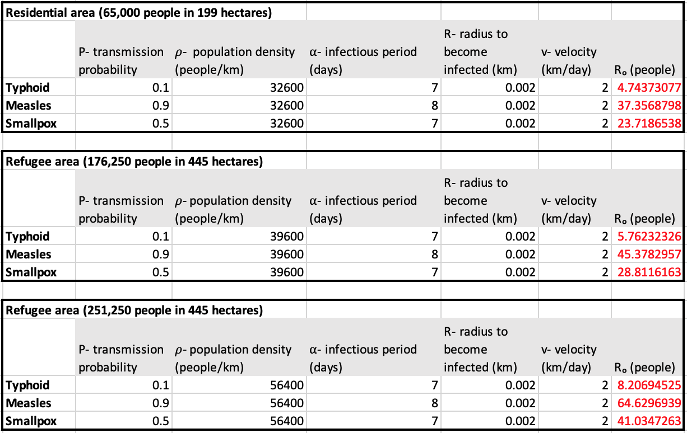
Table 6. Secondary rate of infection caused by a single infected person. Rhodes and Anderson’s (2008) proposed equation $R_{0}=\frac{8Rp\overline{v}ρ }{πα}$is used to model the transmission of typhoid, measles, and smallpox at various population estimates.
The resulting values can be used to analyze the transmission of the plague. The basic reproductive numbers are significantly higher when comparing the minimum and maximum population density estimates in the refugee areas. The model used above highlights the stark difference made by refugee influx in the disease transmission, as Thucydides described it (Th. 2.17.1).
The numbers for R₀ in the figure above only give the numbers of infectious cases produced by one infected person. To illustrate the devastation of the plague, whichever of the three proposed diseases it was, it is useful to construct a hypothetical scenario. Imagine a ship carrying ten men infected with typhoid fever. Once they landed in Piraeus, where Thucydides tells us the plague started, each infected man would have been capable of infecting on average 6 other people (R₀). Although R₀ is not a function of time, we can assume that these infections occurred over the total infectious period of seven days. This is known as a generation. After one generation, the original ten men have infected sixty others. After a second generation, these sixty men each have infected six more people, resulting in 360 new infections. This means that after two generations (roughly 2 weeks), there would have been a total of 430 infections (10+60+360). After 4 weeks, there would have been up to 15,550 total people infected, and after 6 weeks the infection would have reached 466,560 people if allowed to spread without impediment. These hypothetical calculations indicate that typhoid fever would have reached epidemic proportions in ancient Athens in a span of 4-6 weeks. In the case of measles, each of the 10 men in the ship would have infected 45 others within one generation. This would have resulted in 450 infections. After a second generation, there would have been already up to 20,250 new infections, for a total of 20,710 infections. In just one more week, the newly infected 20,250 people could have infected 911,250 people, if each came into contact with 45 susceptible people. In the case of smallpox, each of the 10 men in the ship were capable of infecting 29 others. This would have resulted in 290 infections. After a second generation, there would have been up to 8,410 new infections, for a total of 8,710 infections. After one more generation, there would have been up to 243,890 new infections, which would have been nearly the entire population within the walled areas of Athens-Piraeus.
The reproductive numbers of typhoid fever compare well to Thucydides' description of the long, large-scale devastation wreaked by the Athenian plague in the course of three years, with an interruption of one year (430/429, 429/428, and 427/426 BCE). On the other hand, the reproduction rates of measles and smallpox seem much too high to continue a three-year long epidemic. This issue was already noted by Morens and Littmann, who discovered in their epidemiological model that smallpox and measles epidemics would have lasted only a few months in Athens (Morens and Littman 1992, 290). Thus my SIR modeling shows that typhoid fever is a much more likely candidate than measles or smallpox as the cause of the Athenian plague, supporting the identification obtained through DNA analysis of a few teeth of possible plague victims (cf. chapter 2).
Whereas the significant increase in population density was a direct result of Pericles’ strategy to copy with the Spartan invasions, and could not be changed, it would have been possible for the ancient Athenians to slow down or control the transmission of the plague by adopting some protocols. The next chapter discusses measures prescribed by modern immunology that the Athenians could have taken with their existing technologies.

Chapter 6. Advice from Modern Immunology: Measures to Prevent the Spread of the Athenian Plague.

For millions of years, humans have practiced hunting and gathering for survival. They did not rely on agriculture or domestic animals for food. This lifestyle, and the fact that there were relatively few humans on the planet, limited both human exposure to sources of infection and also routes of transmission of infectious diseases. As humans developed agriculture, and became sedentary and more numerous, they began to experience infectious diseases and plagues. This must be due to the increase in inter-group contacts and to the fact that humans integrated sources and hosts of infections such as domestic animals into their lives (Sherman 2017: 43). When these epidemics occurred in antiquity, people did not fully understand the mechanics of bacteria and viruses, or how to prevent the disease. This was true also for the Athenians during the outbreak of the plague during the first years of the Peloponnesian War in the late 5th century BCE. Even though people with medical training, such as Thucydides, noticed increased infection rates in areas with the greatest population densities (Th. 2.52.1), ancient Athenians did not understand the principles of infection or the ways of controlling infection that we know today, and this led to an increased infection rate from person-to-person. Had the Athenians understood that infectious diseases spread through bacteria or viruses, they could have taken various measures to slow down or stop the spread of the disease.
As shown in the SIR model in chapter 5, population density had a large impact on disease transmission. However, limiting the refugee influx during the plague and war years would have been a two-sided sword. On the one hand, it would have resulted in a lower population density and therefore would have led to a slower disease transmission. On the other hand, not allowing such a large part of the rural population to enter the walled area would have left them susceptible to death by the invading Spartan army, and this would have been politically and humanly unacceptable.
As discussed in chapter 2, the modern diseases most similar to Thucydides’ description of the plague are typhoid fever (caused by the bacterium S. typhi), measles (rubeola virus), and smallpox (variola virus). Typhoid fever is the most likely candidate on the basis of the archaeological evidence, as it was actually found in the dental remains of potential plague victims excavated at Athens. Glanders was previously discussed as a potential disease, but was not included in the SIR model of the previous chapter because of our current lack of information regarding the infectiousness of the disease.. Typhoid fever, measles, and smallpox have different methods of transmission, therefore different factors must be considered when studying the spread of the disease. Thucydides tells us that the plague was the worst in the most densely populated areas and that those who nursed the sick experienced the highest level of mortality (Th. 2.51.4). These things are to be expected, as contact with the sick increases the risk of infection in each of the diseases that has been proposed as identifications of the Athenian plague (see below). Nowadays, organization like the WHO and the CDC highlight infection control protocols for disease outbreaks. In case of an incident of typhoid fever for example, a Rapid Response Team would investigate the patient’s history to find the source of infection, search for any other potential cases and carriers, and quarantine the patient until the fever has disappeared (WHO: 2011).
Considering that one third of the Athenian population perished from the plague, I believe that a comparable modern epidemic, in terms of its rapid spread, is the current Ebola virus crisis in central Africa (Littman: 2009; cf. chapter 3). For something as severe such as Ebola, the CDC recommends patient isolation in a hospital with a log of everyone who enters the room. This helps create a list of everyone who has established contact so that these people can be checked for infection. They also have a list of the Personal Protection Equipment (PPE) that each medical personnel must don for standardized protection while entering the room and they recommend posting someone outside of the room to ensure that all PPE guidelines are met (CDC: 2018). In the case of the ancient Athenian plague, whichever of the three suggested diseases it was, a quarantine of those who exhibited signs of disease as well as those who had been in contact with them would have helped prevent the spread. Although protective gear would have been helpful, the Athenians lacked adequate technology. They only had linen and wool for producing textiles, and with the limited technology, handmade gloves likely would have been too porous to prevent the spread of bacteria or viruses.
Another factor is patient waste disposal, as bacteria like S. typhi, the causative agent of typhoid fever, is excreted through feces. This contamination can occur both with patients who are alive and with dead bodies as well. This poses a problem when fecal matter is not proper disposed of and comes into contact with food and water. It can also lead to contamination of water sources when rainfall comes into contact with bodies and the runoff leads into water sources, or when water from washing dead bodies ends up in a water source. The measles virus, on the other hand, spreads via droplet transmission through sneezing and coughing. Although a dead body would not pose any significant risk, an infected individual is so contagious that the risk of infecting another is up to 90% (CDC: Measles 2018). One of the symptoms of smallpox is the development of sores and scabs, which actually contain the virus. The virus can spread through items such as bedding or clothing that has been contaminated by these scabs (CDC: Smallpox 2016).
Whereas dead bodies of people who died from natural causes do not pose a risk of spreading disease, the same cannot be said for those who died from the plague. People who interact with the bodies of such patients have the highest risk of contracting the disease. We know from literary evidence that Athenian burial customs involved heavy contact with the bodies of the dead (Kurtz and Boardman 1971: 144; see chapter 4). These people washed and touched the bodies, and likely ate food without washing their hands properly, as they lacked antibacterial soaps. For convenience purposes, the WHO recommends burial over cremation for the disposal of bodies as a last resort during mass casualties, although they caution against mass graves. This is because they caution against permanent disposing of dead bodies without proper identification of the victims. They also have safety protocols for those who handle the bodies of the dead, such as undergoing training and using protective equipment such as gloves and masks (WHO: 2016). In contrast, in ancient Athens, a large number of the bodies of people who had just died from the plague were not properly buried, in part because the Kerameikos cemetery was outside the walls and inaccessible during the Spartan invasions, and in part because the overwhelming number of dead caused people to abandon proper burial rites (Th. 2.52.4). If the dead had been buried in hygienic fashion, the disease would likely not have spread as quickly as it did. However, this is easier said than done. People had their customs, and may not have been willing to change their beliefs so easily. This is still true today, and this cultural factor is exacerbating the current spread of the Ebola virus in central Africa (Curran et al. 2016).
Another problem must have been difficulty of access to clean water for the many refugees who had poured into the walled areas of Athens and Piraeus (see chapter 4 above). Even in modern times, hundreds of millions of people lack access to clean water supply systems. According to the World Health Organization, improved water, sanitation, and hygiene can prevent 9.1% of global disease and 6.3% of deaths (Pruss-Üstün 2008: 10). Also, both groundwater and surface water may contain what are called “natural water pollutants”, which are elements, compounds, molecules, or organisms that are found in bodies of water and are pathogenic to humans. Examples include yeasts, inorganic chemicals such as fluoride, and algal toxins, just to name a few (Selendy 2011: 271-73). These sanitation weaknesses led the World Health Organization to outline various methods and strategies for low-income countries to improve water sanitation. Many of these techniques are simple and could have been used by Athenians during the plague if they had a better understanding of infectious diseases. The first method is to filter drinking water by means of media such as porous rock and sand. Another simple step that could have been taken is to boil water before use. This method is capable of killing most, if not all, waterborne pathogens. Other more efficient methods of water purification exist now, but they would not have been plausible in ancient Athens (Selendy 2011: 219-21). Nowadays we have large-scale water treatment facilities that did not exist in ancient Athens, and we even have technology such portable carbon-based water bottle filters to treat drinking water on the go. Although the Athenians utilized carbon, they lacked the technology and knowledge to use it to purify water. Even without these high-tech inventions, Athens still had resources to slow down or stop the spread of the plague.
Even with their limited technology, there are several protocols that the Athenians could have adopted to slow down the spread of the plague. A quarantine of any infected individuals and anyone who had been in contact with them would have slowed down the rate of person-to-person transmission, as infected individuals would have been able to spread the disease only during the incubation period, before they displayed any symptoms. In addition, the only people who should have been allowed near the sick should have been the ones with a demonstrated immunity to the plague. Furthermore, all water should have been boiled to kill any contaminants from the plague or waterborne pathogens. These simple methods would have decreases the number of dead significantly. In addition, the bodies of the victims should have been disposed of in a way that avoided any possible contamination. This included not washing the body, not touching the body with bare hands, and burying the body at least 30 m away from groundwater sources, as recommended by the World Health Organization. Alternatively, only the people immune should have been allowed to touch the dead bodies, but this would have been near impossible as burial rituals involved the immediate family, who may or may not have been immune. The Athenians should have designated plots for mass burial at least 30 meters away from all groundwater sources, and only the immune should have handled the bodies during the burial. By implementing these measures, the spread of the disease would have been slowed down enormously, or may even have been stopped entirely.

CONCLUSION

Political disagreements between Athens and Sparta in the course of the 5th century BCE led to the outbreak of the Peloponnesian war in 431 BCE. During the war, the primary strategy by the Athenian general Pericles was to withdraw the rural population within the walled areas of Athens and Piraeus, causing those areas to become a besieged fortification. The Athenian historian Thucydides, an eye-witness to the war, reports that as refugees crowded together inside of the previously uninhabited areas, they experienced a devasting epidemic disease which started in the harbor of Piraeus and, according to modern studies, destroyed nearly a third of the population over the course of its three years (430/429, 429/428, and 427/6 BCE; Hansen 1988, 21). In this thesis, I sought to better understand the circumstances in the overcrowded areas as well as the identification of the disease that was responsible for this epidemic, using Thucydides’ description of the symptoms as well as archaeological evidence. I then estimated possible population densities, which allowed me to apply a mathematical model to study the spread of the disease. Finally, I proposed some modern measures that could have been adopted by the ancient Athenians to contain the plague.
When comparing the plague symptoms to various potential infectious diseases, I found that four diseases- typhoid fever, measles, smallpox, and glanders- were the most similar to the descriptions provided by Thucydides, but none matched exactly. Typhoid fever is widely considered to be the most likely identification because scientific analysis of teeth from likely plague victims were found to contain DNA from the causative agent of this disease. By creating an SIR model and carrying out the calculations, I was able to compare the reproductive number of the different diseases at different population estimates. The SIR model showed that typhoid fever infection spread much more slowly than smallpox and measles. In fact, one person infected with measles was capable of infected over eight times as many people as one person infected with typhoid fever. However, calculations of the spread of typhoid fever over time showed that it would have reached epidemic proportions after only 4 to 6 weeks, if it had started with 10 infected individuals on a boat landing at Piraeus. While such rate of spread for typhoid fever compares well with Thucydides' description, the rate for smallpox and measles seems too high in order for the disease to last for three years. These calculations make it seem more likely that typhoid fever, and not measles or smallpox, was the identification of the Athenian plague. One thing is certain--a higher population density exacerbated the spread of the disease. In view of the available technology at the time, quarantine and some simple improved sanitation practices would have slowed down the spread of disease significantly, if the ancient Athenians had understood the mode of infection.
Much remains unknown about the exact identification of the Athenian plague. Although the scientific analysis of the teeth excavated from the Kerameikos cemetery have shown that those specific individuals had been infected by typhoid fever, this does not necessarily mean that this was the one and only cause of the epidemic. For a number of the symptoms described by Thucydides do not match known symptoms of typhoid fever. More analysis of the plague victim remains is necessary to determine all the likely causative agent(s) of this devasting disease. If repeating the DNA analysis of the teeth, scientists should extract and amplify the entire non-human DNA genome and insert this sequence into the database in order to analyze all possible agents instead of only a few, as has been done up to now. Such a comprehensive analysis, which is extremely expensive and out of the reach of archaeological budgets, would allow for a more definitive solution for the question of the identification of the plague of Athens, and this in turn would enable researchers to model the spread of the disease with greater accuracy.

Bibliography
Ancient Scholarship

Aristophanes, Wasps, ed. Transl. J. Henderson. Rev. ed. Loeb Classical Library. 1946.

Thucydides, The History of the Peloponnesian War, Books I and II, transl. C.F. Smith. Rev. ed. Loeb Classical Library. 1934.

Modern Scholarship

Adorno, F. and Giannelli, G., 1970. The World of Classical Athens, New York.

Andersen, K. et al., 2015. Clinical Sequencing Uncovers Origins and Evolution of Lassa Virus. Cell, 162(4), pp. 738–750.

Beloch, J., 1886. Die Bevölkerung der griechisch-römischen Welt, Leipzig.

Camp, J.M., 1977. The Water Supply of Ancient Athens from 3000 to 86 BC, Ph.D. dissertation,
Princeton University.

Camp, J.M., 1986. The Athenian Agora: Excavations in the Heart of Classical Athens, New York.

CDC. 2018. Ebola (Ebola Virus Disease). https://www.cdc.gov/vhf/ebola/index.html.

CDC. 2016. Glanders. https://www.cdc.gov/glanders/index.html.

CDC. 2018. Measles (Rubeola). https://www.cdc.gov/measles/about/index.html.

CDC. 2016. Smallpox. https://www.cdc.gov/smallpox/index.html.

CDC. 2018. Typhoid Fever and Paratyphoid Fever.
https://www.cdc.gov/typhoid-fever/index.html.

Curran, K.G. et al., 2016. Cluster of Ebola Virus Disease Linked to a Single Funeral—Moyamba District, Sierra Leone, 2014. Morbidity and Mortality Weekly Report, 65(8), pp. 202.

de Villiers, J.C., 1984. The Medical Aspect of the Anglo-Boer War, 1899-1902 Part II, Military History Journal, 6(3). http://samilitaryhistory.org/vol063jc.html

Demeny, P., and Coale, AJ., 1966. Regional Model Life Tables and Stable Populations, Princeton.

Dodge, P. and Dodge, H., 1998. The Ancient City: Life in Classical Athens & Rome, Oxford.

Garland, R., 2001. The Piraeus: From the Fifth to the First Century BC, Bristol.

Gomme, A.W., 1933. The Population of Athens in the Fifth and Fourth Centuries B.C., Oxford.

Hansen, M.H., 1988. Three Studies in Athenian Demography, Copenhagen.

Hanson, V.D., 1998. Warfare and Agriculture in Classical Greece. Rev. ed., Berkeley.

Hornblower, S., 2009. Thucydides of Athens, Brill’s Encyclopedia of the Ancient World New Pauly, Koninklijke Brill, Leiden, The Netherlands, pp. 632-637.

Kurtz, D.C. and Boardman, J., 1971. Greek burial customs, Ithaca.

Lederberg, J. et al., 2009. Microbial Evolution and Co-Adaptation: A Tribute to the Life and Scientific Legacies of Joshua Lederberg: Workshop Summary, Washington, DC.

Littman, R.J., 2009. The Plague of Athens: Epidemiology and Paleopathology, Mt Sinai J Med 76, pp. 456-467.

Martcheva, M., 2015. An Introduction to Mathematical Epidemiology, Boston.

Mayo Clinic. Measles.
https://www.mayoclinic.org/diseases-conditions/measles/symptoms-causes/syc-20374857

Mayo Clinic. Smallpox.
https://www.mayoclinic.org/diseases-conditions/smallpox/symptoms-causes/syc-20353027

Meltzer, M. et al., 2001. Modeling Potential Responses to Smallpox as a Bioterrorist Weapon. Emerging Infectious Diseases, 7(6), pp. 959–969.

Morens, D.M., Littman, R.J., 1992. Epidemiology of the Plague of Athens, Transactions of the American Philological Association 122, pp. 271-304.

Morgan, T.E., 1994. Plague or Poetry? Thucydides on the Epidemic at Athens, Transactions of the American Philological Association 124, pp. 197-209.

Morris, I., 2004. Economic Growth in Ancient Greece. Journal of Institutional and Theoretical Economics JITE, 160(4), pp. 709–742.

Morris, I., 2005. The Growth of Greek Cities in the First Millennium BC, Princeton/Stanford
Working Papers in Classics Paper No. 120509. https://ssrn.com/abstract=1426835

Papagrigorakis, M.J., Yapijakis, C., Synodinos, P.N., Baziotopoulou-Valavani, E., 2006. DNA examination of ancient dental pulp incriminates typhoid fever as a probable cause of the Plague of Athens, Int J Infect Dis 10, pp. 206-214.

Patel, M., 2018. The Athenian Plague and the Peloponnesian War Through Thucydides’ History of the Peloponnesian War, Honor's thesis Classics, The University of Tennessee.
National Center for Biotechnology Information. Polymerase Chain Reaction (PCR)., U.S. National Library of Medicine, www.ncbi.nlm.nih.gov/probe/docs/techpcr/.
Pruss-Üstün A., Bos R., Gore F., Bartram J. 2008. Safe Water, Better Health: Costs, Benefits and Sustainability of Interventions to Protect and Promote Health, Geneva.
Rhodes, C.J., Anderson, R.M., 2008. Contact Rate Calculation for a Basic Epidemic
Model. Mathematical Biosciences, 216(1), pp. 56–62.

Rhodes, P.J., 1988. Thucydides: History II, Warminster.

Riedel, S., 2005. Edward Jenner and the history of smallpox and vaccination, Proc (Bayl Univ Med Cent) 18, pp. 21-25.

Selendy, J.M.H., 2011. Water and Sanitation Related Diseases and the Environment : Challenges, Interventions and Preventive Measures, Somerset.

Sherman, I.W., 2017. The Power of Plagues, Second ed., Washington, DC.

Traill, J.S., 1975. The Political Organization of Attica; A Study of the Demes, Trittyes, and Phylai, and Their Representation in the Athenian Council, Princeton.

Trvlos, I.N., 1971. Pictorial Dictionary of Ancient Athens, New York.

Van Wees, H., 2004. Greek Warfare: Myth and Realities, London.

Van Zandt, K.E., Greer, M.T. & Gelhaus, H.C., 2013. Glanders: an Overview of Infection in Humans. Orphanet Journal Of Rare Diseases, 8(1), p.131.

Vigne, J., 1994. Rats, Mice, and Relatives III: Old World Rats and Mice (Murinae), in: Hutchins, M. (Ed.), Grzimek, 2 ed., pp. 249-262.

Wain, J., House, D., Parkhill, J., Parry, C., Dougan, G., 2002. Unlocking the Genome of the Human Typhoid Bacillus, Lancet Infect Dis 2, pp. 163-170.

WHO. 2016. Management of dead bodies: Frequently asked questions. https://www.who.int/hac/techguidance/management-of-dead-bodies-qanda/en/

WHO. Smallpox. https://www.who.int/biologicals/vaccines/smallpox/en/

WHO. Typhoid Fever. International travel and health. https://www.who.int/ith/diseases/typhoidfever/en/

Wycherley, R.E., 1977. The Stones of Athens, Princeton.

