Driving Simulator Transportation Safety: Proper Warm-up Testing Procedures, Distracted Rural Teens, and Gap Acceptance Intersection Sight Distance Design

A Dissertation Presented for

the Doctor of Philosophy

Degree

The University of Tennessee, Knoxville

Ryan Overton

August 2012
ACKNOWLEDGMENTS
First and foremost, I would like to thank my Lord and Savior Jesus Christ for my salvation and guidance.
Throughout my academic career, I have had the opportunity to meet and learn from wonderful educators and leaders. I would like to thank my advisor, Dr. Lee Han, for his profound knowledge and guidance. He has not only guided my research and education, but has taught me numerous life lessons. Next, I would like to thank Dr. Xuedong Yan for providing me the opportunity to work with the newly acquired driving simulator as my first steps in research. Dr. Cherry is a wonderful professor and I thank him for all the encouraging and motivational words over the years. Special thanks go out to Mrs. DeAnna Flinchum and Dr. Steve Richards for their efforts through the Southeastern Transportation Center in providing me funding to continue my education in graduate school. I am particular grateful for meeting Dr. William Seaver late in my graduate school career. Dr. Seaver has provided me with great statistical knowledge, but even better spiritual guidance through his book that he shared with me, “A Mosaic of Faith from The Gospels.” I am obliged to have had a wonderful dissertation committee and would like to thank Dr. Han, Dr. Cherry, Dr. Richards and Dr. Seaver for all of their guidance and hard work.
I would like to thank all of my friends at UTK for the great times working and playing. In particular, I would like to thank Qiang Yang for his direction working with the driving simulator and his efforts testing subjects in my absence.
I am sincerely thankful for the unconditional love and patience from my wife, Ashley. Without her loving support and encouragement, I am not sure I could have completed this journey alone. I am honored and proud to be married to such a wonderful, Godly woman.
The amount of support from my family is indescribable. I am truly blessed to have loving parents and I would like to thank dad and mom, Darryl and Angie Overton, for all of their care and provision. I would also like to thank my brother, Eric Overton, for all the encouraging words and spiritual guidance in the tough times. Finally, I would like to acknowledge my church family at Haynes Flat Missionary Baptist Church for all of their love, support, and prayers.
To all the people mentioned and countless others, I would like to thank each individual for their support, direction, and leadership in my life. As I continue to grow, I hope you are proud to have been an influential person who molded me into the man I am today.

ABSTRACT
Although the content of the abstract is determined by the student and committee, the following information is appropriate: [1] a short statement concerning the area of investigation, [2] a brief discussion of methods and procedures used in gathering the data, [3] a condensed summary of the findings, and/or [4] conclusions reached in the study.

The abstract will be used by the University of Tennessee Libraries in cataloguing the thesis or dissertation. Therefore, the abstract must NOT exceed 350 words in length.

TABLE OF CONTENTS
List of Tables 1
List of Figures 2
Introduction 3
1 CHAPTER I Warm-up Analysis 6
1.1 Introduction 7
1.2 Literature Review 8
1.3 Purpose 10
1.4 Methodology 11
1.4.1 Apparatus 11
1.4.2 Test Participants 12
1.4.3 Virtual Scenario & Section Comparisons 13
1.4.4 Testing Procedure 15
1.4.5 Independent and Dependent Variables 16
1.4.6 Statistical Analysis 17
1.4.7 Controlling Error Rate for Multiple Comparisons 18
1.5 Results 19
1.5.1 Hotelling’s Results: Intersection Turn Maneuvers – Variable Averages 19
1.5.2 Hotelling’s Results: Curve Maneuvers – Variable Averages 22
1.5.3 Hotelling’s Results: Age & Gender Comparisons 28
1.6 Conclusions 29
Appendix 30
Appendix A: Example of Two-Sample Hotelling's T2 Report 31
Appendix B: Section 2,5,8,11 Lateral Acceleration Differences 33
Appendix C:Section 3, 6, 9, 12 Left Turn Analysis of Steer 35
Appendix D: Section 4 vs. 14 Scaled Transformed Comparison 37
2 CHAPTER II Distracted Rural Teen Driver analysis 38
2.1 Introduction 39
2.2 Purpose 41
2.3 Methodology 42
2.3.1 Participants 42
2.3.2 Apparatus / Equipment 42
2.3.3 Design and Experimental Procedure 43
2.3.4 DATA ANALYSIS 45
2.5 Results 46
2.5.1 Multiple Variable Hotelling’s Analysis 46
2.5.2 Subject’s Lateral Velocity Analysis of Variance 51
2.6 Conclusions 55
3 CHAPTER III Intersection Sight Distance Design Supplement based on Driver Gap Acceptance Modeling 57
3.1 Introduction 58
3.2 Literature Review 60
3.3 Purpose 64
3.4 Methodology 65
3.4.1 Apparatus 65
3.4.2 Participants 65
3.4.3 Scenario Design & Research Approach 65
3.4.4 Data Analysis 68
3.5 Results 69
3.6 Conclusions 69
Conclusion 70
References 71
Vita 77

List of Tables

Table 1 Warm-Up Time Used In Previous Simulator Studies 10
Table 2 Summary of Right Turn Section Comparison Significance 21
Table 3 Right Turn Section Comparison Excluding ID #11 22
Table 4 Left Turn Section Comparison 23
Table 5 Curve Comparison 24
Table 6 Curve Comparison Without Steer or Lateral Acceleration 24
Table 7 Step-Wise Variable Selection - Section 4 vs. 14 27
Table 8 Step-Wise Variable Selection – Section 4 vs. 14 Scaled Data 28
Table 9 Subject’s Driving Task Progression 37
Table 10 Section A: Curve & Straight Section Hotelling’s Comparison 40
Table 11 Section B: Straight Section Hotelling’s Comparison 41
Table 12 Section C: Straight Section Hotelling’s Comparison 43
Table 13 Section A : Lateral Velocity Analysis of Variance 44
Table 14 Section B : Lateral Velocity Analysis of Variance 45
Table 15 Section C : Lateral Velocity Analysis of Variance 47
Table 16 Sight Distance Triangle Design Guidelines 60

List of Figures
Figure 1 DriveSafety DS-607c driving simulator system. 13
Figure 2 Warm-up map with color coordinated matching sections. 15
Figure 3 Lateral Acceleration Values for Individual Subjects 22
Figure 4 Status of the Highway Account of the Highway Trust Fund[48]. 53
Figure 5 Departure Sight Triangle for Traffic Approaching from the Left 60
Figure 6 Plan View of Intersection in Virtual Scenario 61

Introduction
In the summer of 1954 the National Society of Professional Engineers adopted the Engineers’ Creed, “As a professional engineer, I dedicate my professional knowledge and skill to the advancement and betterment of human welfare.” This creed accentuates the commitment of this engineering research effort to develop safer transportation systems through improved driving simulator research methods, understanding of our transportation user population, and design standards of intersections. National, state, and local agencies realize the dangers of our current transportation systems and have recently addressed the issue by emphasizing programs and philosophies targeted at a zero traffic fatality goal. Transportation safety engineers seek to achieve the same goal through quality, groundbreaking research as intended through this effort.

Driving Simulators have become invaluable tools for researchers through technological advancements of the twenty-first century. With increasing availability and affordability of these systems, the opportunity for flawed human behavior research methodology becomes more prevalent. Recognizing the importance of collecting quality data in a driving simulator to ensure the validity of each and every study, Chapter I discusses how previous research efforts reveal inconsistencies in acclimating test participants to driving simulators. Nearly all researchers using a simulator tool recognize the need for a practice session to allow the drivers to adjust to the vehicle handling and virtual environment. This proposal discusses testing procedures, data collection methodologies, and statistical analysis testing to establish guidelines for researchers to follow regarding warming-up subjects before collecting data in a simulator.
Understanding the user population of our transportation system is yet another important aspect of engineering to consider in safety designs. Teenage and novice drivers quickly became a population of interest to researchers given their inexperience operating an automobile and their tendencies towards risky and influential behavior. Additionally, drivers primarily traversing rural roads are of particular concern given their history of higher fatality rates. Combining these populaces with the disposition of adolescents to be technologically reliant and inseparable from their cell phones, we obtain the distracted, rural, teenage driver. Chapter II discusses a plan to examine the driving characteristics of rural, teen drivers and present data useful for future research regarding this special group.

Researchers have modest influence regarding direct impacts to transportation networks without consultants who implement innovations in creating and implementing the safest possible geometric designs. Although few if any aspects of design have been studied more than intersections, the inherent nature of at-grade intersections with multiple conflict points result in numerous crashes and traffic fatalities. Creating a safer traffic network requires iterations of updating existing infrastructure and rejuvenation of outdated, design standards for future projects. To better understand the requirements to optimize designs for safety, researchers much first recognize and integrate evolving driver behavior and modern vehicle performance into their design considerations. With safety being the top priority in all transportation projects, the acquisition of funding falls closely behind. In tough economic times and with limited resources, it is important to make every dollar count on improvement projects. Therefore, economical solutions to problematic intersections are needed to improve safety at the cheapest possible price. Chapter III examines a research effort to analyze driver behavior at intersections regarding their stopping behavior approaching intersections, stopped position relative to the travel way, and comfortable gap acceptance behavior. Ensuing results will provide information useful in revising and updating current intersection sight distance design standards to improve safety in the most cost-efficient manner.

1 CHAPTER I
Warm-up Analysis

1.1 Introduction
Although the concept of studying driving ability dates back to the 1920s [1], wide use of driving simulators in transportation research was not until last decade with the emergence of enabling technologies that made driving simulators affordable enough to own and authentic enough for research. Numerous validation studies examining various performance variables have proven driving simulator to be an appropriate research tool [2-5]. The main advantage of driving simulators is its provision of an inherently safe environment for testing driving scenarios that can be economically created, easily configured, and reliably replicated to investigate a variety of human factors research problems[6]. One of the crucial concerns when using driving simulators is Simulator Adaptation Syndrome (SAS) or Simulator Sickness (SS), which Mollenhauer claims to always be an issue when using an immersive driving simulator[7]. Although several researchers have hypothesized the cause of the syndrome[8], it is generally accepted that conflicting visual and bodily cues cause the uncomfortable feeling. Brooks describes multiple theories of motion sickness and presents a method for assessing and reacting to simulator sickness symptoms in a recent study[9]. However, no insight or suggestions are given regarding how long participants should practice to become comfortable in the virtual environment. Researchers typically combat the occurrence of simulator sickness with what is generally referred to as a warm-up or practice session in the simulator. These sessions are designed to familiarize the individuals with the feel and the controls of the vehicle and ensure that each subject is comfortable in the virtual environment.

1.2 Literature Review
Numerous studies have been conducted using a driving simulator as the data collection tool. This section will provide insight to select simulator studies and contrast the practice times provides to test participants to acclimate to the simulator vehicle. A rear-end collision simulator study adopted a “10 minute (or as long as required)” practice session with 60 minutes of experimental testing to follow[10]. Another recent study cited an introductory session, with no specified time frame, and reported 9% of participants feeling dizziness after the simulator assessment. It was not indicated whether the dizzy subjects’ data were disregarded or treated with special considerations in the study[11]. Researchers conducting a spot treatment simulator project allowed “two or three training sessions, depending on how quickly he learned the task.” They continued by adding the main subjective criterion for judging whether significant learning trends were evident was the “judgment of the experimenter that each subject had adequately learned to drive the simulator.” The training sessions were 15 to 20 minutes long, and one subject did not complete 2 of the 36 test segments due to illness[12]. The use of subjective data and reasoning is vulnerable to many fallacies and should be avoided unless independent data confirmation safeguards are performed. McGhee concluded that approximately three minutes of driving was all the time needed to become familiar with a driving simulator[13]. While a three-minute familiarization time frame may be appropriate for select individuals, individuals susceptible to motion sickness may require a slower and easier paced warm-up session to reduce the likelihood of sickness.

TABLE 1 summarizes diverse experimental designs for warm-up time frames and underscores the need for guidelines in the area of warming up subjects to driving simulators. One could argue that due to the reported ailment, the subject’s driving performance was not natural or normal. If the driving performance of individuals who suffered discomfort were significantly different from that of individuals without discomfort, the data should be treated with special care or even disregarded. One may thus pose questions such as: “How long should the warm-up time be?” “If everyone is different, shouldn’t everyone have a different warm-up time?” and “How does one decide the warm-up time for different individuals?” Review of previous driving simulator studies shows that few guidelines have been established regarding pretesting exposure lengths during the warm-up period to ensure drivers have acclimated to the system while keeping the subjects health and comfort as the top priority.
Table 1 Warm-Up Time Used In Previous Simulator Studies
Warm-Up Given | Warm-Up Time | Subject Sickness | Reference
Yes | Unspecified | No Report | [14]
Yes | User Defined¹ | No Report | [15]
Yes | User Defined¹ | No Report | [16]
Yes | 2-5 minutes | No Report | [17]
Yes | 10 minutes | Yes – 5 subjects² | [18]
Yes | 18 minutes | No Sick Subjects | [19]
Yes | 30 minutes | No Report | [20]
Yes | 60 minutes | No Report | [21]
No | - | Yes – 3 subjects³ | [22]
¹Subjects determined when they were comfortable with the simulator.
²Three subjects became ill before test completion; two reported ill after the test.
³Cited motion sickness / Data disregarded.

Few research efforts have been undertaken regarding warming up test subjects to a driving simulator. Sahami has built upon previous research to calculate cost functions utilizing accelerator and brake pedal depressions to categorize subjects as adapted, adapting, and nonadapting through a series of trials. The methodology to obtain results in this manner is labor intensive and too costly in terms of time for researchers to adopt into their testing procedures. Furthermore, Sahami provides a methodology for analyzing the concept of experience curve effect in the steering performance measure. This evaluation of adaptation is subjective and relies on the judgment of the researcher[23].

McGehee analyzed warming up test participants through a quantitative steering adaptation study on a straight roadway and determined that approximately 240 seconds (4 minutes) was all the time required for steering adaptation to occur[24]. This oversimplified approach does not represent real life driving maneuvers by excluding the more difficult talk of curve and turning negotiation. Sahami created a revised steering adaptation parttern study in 2010 and found that average adaptation time was 456 seconds (7.6 minutes.) Self-reported acclimation was noted to be significantly less (122 seconds) than the calculated steering adaptation[25]. Although a 7 minute adaption period seems reasonable, it is believed that additional variables beyond just steering need to be tested to determine a warm-up, practice period for subject acclimation.

1.3 Purpose
The purpose of this study is to identify key driving behavior indicators that will signify the driver has become acclimated to the driving simulator system. These indicators will be tested to show variations in driving behavior and signal an approximate time in which the subject has reached their normal driving state. This would ensure the collection of quality data instead of those when the subject is still trying to get accustomed to the difference between the subject’s personal vehicle and the apparatus that is the virtual driving simulator. Because of the vast difference in individuals and in the types of vehicles they usually operate, it is not readily clear how long this adjustment period may be for each subject. As such, indicators that can help determine when a test subject is ready in an objective fashion are desirable. Aiken identified that unreliability can stem from behavioral changes due to distracting or uncomfortable test conditions [26].To this end, this study seeks to determine a desired warm-up period so the test subjects can become comfortable with the driving simulator and the data collected subsequently can be of good quality. The hypothesis in this research is that: changes in driving behavior as subjects acclimate to the handling of the simulator vehicle will be evident from statistical differences in driving characteristics. As these differences are monitored and diminish, as acclimation progresses, an established warm-up time can be calculated to ensure the test subjects have reached their normal driving state.

1.4 Methodology

1.4.1 Apparatus
Tests for this study will be conducted using the DriveSafety DS-607c, which consists of 5 extreme angle projectors wrapping around a Ford Focus cab, where the test subject is to be seated. Data collection will monitor 20 variables at 10hz for this study. The screen projection has a resolution 1024 x 768 pixel each. A digital audio system is functional in the cab with four speakers to allow for audio commands and other sounds in the virtual environment. The interior of the vehicle is an exact replica of a Ford Focus featuring: windshield, driver and passenger seats, center console, radio/CD player, full functioning instrument panel. In addition, the driver has rear views through a LCD rear view mirror and two LCD side view mirrors.

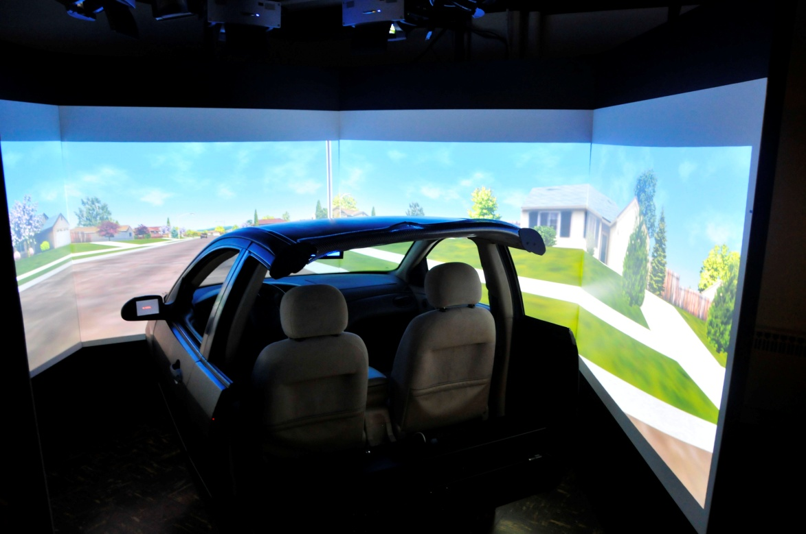
Figure 1 DriveSafety DS-607c driving simulator system.

1.4.2 Test Participants
Participation in this study is voluntary and consisted of men and women. Subjects were recruited randomly with the only requirements being a valid driver’s license holder and healthy to complete all tasks. An even gender split was found among the 30 test subjects (Age Mean = 32.4, STDV = 20.4). The reason for such a large standard deviation is due to 5 subjects being over the age of 67 and the remaining test subjects under the age of 35. Age and Gender split driving performance will be analyzed.

1.4.3 Virtual Scenario & Section Comparisons
Each participant was asked to drive a roadway course for the purpose of this experiment. The roadway was designed with a series of intersections and curves. Approaching an intersection the subjects were informed on which way to turn by a visual display of words on the center driving simulator screen and an audible voice indicating the direction to turn such as, “turn right” or “turn left.” The time exposure to the warm-up course is determined by the driving speed of the individual, because the test course is a predefined distance. Every subject was tested on the exact same driving course.

FIGURE XX shows the test course and the 16 different sections that were analyzed. Sections 1 and 13 are the long curves turning in the right direction. Sections 4 and 14 are the long curves turning in the left direction. Sections 7 and 15 are the short curves right and sections 10 and 16 are the short curves left. During the experimental design it was determined to only give one comparison between the 4 different curve types, because quick adaptation is expected on the relatively easy maneuvers. It is hypothesized that the subjects will show little to no adaptation while traversing the curve maneuvers.

The intersection sections of the experiment were given additional test sections, because an intersection maneuver is more strenuous and requires greater skill. Sections 2,5,8, and 11 are the intersections with stop signs and the subjects are instructed to turn right. Sections 3,6,9, and 12 are the intersections with traffic signals and the subjects are instructed to turn left. The traffic signals were timed in a manner to simulate a stop or “rolling stop”. When the subjects reached the stop bar of the traffic signal intersections, the traffic signal immediately changed from red to green. 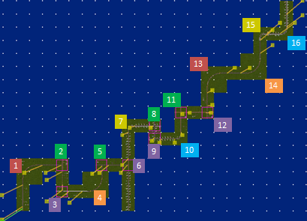
1 & 13 Long Curve Right
4 & 14 Long Curve Left
7 & 15 Short Curve Right
10 & 16 Short Curve Left
2,5,8,11 Stop Right Intersection
3,6,9,12 Light Left Intersection
Figure 2 Warm-up map with color coordinated matching sections.

1.4.4 Testing Procedure
Upon arrival to the University of Tennessee Driving Simulator Laboratory (UTDSL), each participant will be greeted and asked to sit down in the consultation area to review the outline of the testing procedures. Participants will be informed that this study is on a voluntary basis and if at any time they feel uncomfortable or uneasy taking part in this research effort they are free to stop immediately and all of the results from the testing will be disregarded. Confidentiality of each subject and the data collected is to remain confidential.. Each subject will be presented with an informed consent form approved by the Institutional Review Board (IRB) at the University of Tennessee. Immediately following agreement to the consent form, subjects will be introduced to the simulator. Each subject will be asked to sit in the driver seat of the car cab and familiarize themselves with the interior of the cab. Directions for the testing procedure are as follows: “Drive the vehicle and follow the on screen directions. Please drive in your usual driving behavior as if you were on a real roadway. Finally, if at any time you feel uncomfortable or sick stop immediately and I will assist you out of the vehicle. Do you have any additional questions?” After all questions are answered, the scenario is loaded and the participants will begin testing. At the conclusion of the testing procedures, each subject will be offered refreshments and thanked for their participation in the study. For this study, no warm up period or practice session is given to the subjects due to the nature of the data collection for such research. It is the goal of this research to use the initial driving behavior of each subject for data analysis. All of the voluntary subjects will have no previous acquaintance to the driving simulator to ensure that the data collected from the participants is of the same nature concerning exposure to such technology. Audible commands and text will be displayed on the center simulator screen, prior to each intersection, indicating which direction to turn.

1.4.5 Independent and Dependent Variables
The variable outputs from the driving simulator to be analyzed include:
- Velocity – The speed of the subject in m/s.
- Steer – Position of the steering wheel recorded in degrees. Clockwise is positive with +/-540 degrees, or one and half turns, being the maximum values.
- Accel – The normalized accelerator position value. Zero meaning no pushing of the accelerator pedal, while 1.00 reports that the gas pedal is fully depressed.
- Brake – The normalized brake position value. Zero meaning no pushing of the brake pedal, while 1.00 reports that the brake pedal is fully depressed.
- LatAccel – The latitudinal component of the total acceleration of the vehicle in the simulated environment in m/s2. This is not the actual force on the subject in the car cab.
-  LongAccel – The longitudinal component of the total acceleration of the vehicle in the simulated environment in m/s2. This is not the actual force on the subject in the car cab.
Independent variables such as age, gender, etc. will be coded accordingly for statistical testing.
Special interest will be given to the use of the lateral and longitudinal acceleration data collected on the fixed based simulator. Research has shown that the load transfer of the car during a turning maneuver, represented as lateral acceleration, felt by the vestibular system has direct correlation with the speed adopted by the driver. Reymond et al. established that stable or fixed based driving simulators, not capable of producing a lateral acceleration response to the driver, generally see higher speeds than their motion based counterparts. It was also determined that the acceptable threshold for lateral acceleration felt by the driver is a function of his or her driving experience, familiarity with the vehicle, and risk level [27]. Isabelle notes that the driver’s increase in the threshold of acceptable risk, indirectly affects the speed in a driving simulator [28].

1.4.6 Statistical Analysis
The Two-Sample Hotelling’s T² multivariate test will be performed to evaluate the driver performance inputs while traversing the simulator scenario. The main advantage and reason for performing the Hotelling’s test to discover differences between samples is the lack of needed normality and equal-variance assumptions in order to provide probability levels based on randomization tests. The driving behavior of each matching section will be hypothesis tested using Hotelling’s T² analysis to determine whether driving behaviors change as exposure to the driving simulator increases. The null hypothesis (H_{o}) is that no differences among the dependent variables can be determined between the two sections in question[29].
H_{o}: There are no differences between driving characteristics.
H_{a}: There are differences significant differences between driving characteristics.
If testing reveals a rejection the null hypothesis, we accept the alternative hypothesis (H_{a}) and conclude that significant differences in driving behavior has been determined and additional individual variable t-test significance levels will be used when the overall T² value is significant to determine which dependent variables differ.
Randomization Test results will be reported when discussing the overall significance of the sectional testing. The randomization test is conducted following a Monte Carlo approach by enumerating all possible data permutations of the sample data and counting the permutated results that produce T² values greater than or equal to the actual T² values. The randomized results are reported assuming equal variance-covariance matrices, unequal covariance cases, and all individual t-test. A portion of the following results failed to meet the assumption of equality of covariance matrices as a result of the Bartlett-Box Homogeneity of Variance Tests. Appendix A gives results for one of the Box’s M Chi² Probabilities for Section comparison 2 versus 8. The significance of the Chi² Probability leads us to use the unequal variance version of the randomization test. Throughout the testing the reported results were nearly identical for the equal and unequal covariance matrices. Therefore, the Hotelling’s Two-Sample comparison can be viewed with confidence.

1.4.7 Controlling Error Rate for Multiple Comparisons
The experimentation of the multiple comparisons of the individual driver behaviors requires controlling the overall experiments significance level or alpha (α_{E}). To accomplish controlling the experiment wide error the individual comparison Type 1 error rate (α_{I}) must be controlled for each comparison (M) of the driving sections. To determine the individual comparison significance level, α_{I}, for analysis the following equation will be used.
$$α_{E}=1-{(1-α_{I})}^{M}$$
Choosing to control the experiment wide error rate at .05 significance and obtaining a total of 28 comparisons for each testing procedure of the turning and approach data, the individual comparisons significance level is calculated.
$$α_{E}=1-{\left(1-α_{I}\right)}^{M}$$
$$.05=1-{\left(1-α_{I}\right)}^{28}$$
$$\sqrt[28]{.95}=\sqrt[28]{{\left(1-α_{I}\right)}^{28}}$$
$$1-α_{I}=\sqrt[28]{.95}$$
$$α_{I}= .002$$

Therefore, an individually controlled error rate α_{I} =.002 will ensure that the experiment wide error rate α_{E} ≤ 0.05.

1.5 Results

1.5.1 Hotelling’s Results: Intersection Turn Maneuvers – Variable Averages
The Hotelling’s results for the turning maneuvers where summarized into charts for analysis. The analysis was conducted on the averages of each variable throughout the movement. For instance, the data collected for the right turn maneuver at the stop sign was averaged from the time the vehicle passed across the stop bar to a distance 30 meters down the perpendicular roadway. Table XX is the summary for all of the right turning maneuvers at the stop signs and includes sections 2, 5,8,11. A full report of one comparison of the two sections in question can be viewed in Appendix A. A similar report was produced for every section comparison reported in the summary tables embedded.
Table 2 Summary of Right Turn Section Comparison Significance
α_{I28}=0.002 |  | Prob | Individual Variables Section Variable Omitted
StopRight |  | Level | X1V | X1S | X1A | X1B | X1LATA | X1LONGA
2 | 5 | 0.1565
2 | 8 | 0.0001 | 0.0017 | 0.0008 | 0 | 0 | 0.063 | 0
2 | 11 | 0.0543
5 | 8 | 0.0001 | 0.0002 | 0.0007 | 0 | 0 | 0.0674 | 0
5 | 11 | 0.019
8 | 11 | 0.0001 | 0.0024 | 0 | 0 | 0 | 0.0037 | 0

The results show significant differences among one of more variables between sections 2 vs. 8, 5 vs. 8, and 8 vs. 11. Further analyzing the variables that contribute to the differences between sections, an interesting trend can be seen with the lateral acceleration variable. For the significantly different sections above, the significance levels of the combined 6 variables minus the variable listed is reported. This shows a trend among all three different sections that lateral acceleration accounts for the majority of the difference among the combined variables. For example, comparing section 2 vs. 8 and removing the lateral acceleration variable from the Hotelling’s comparison analysis, the combined other variables do not prove to be significantly different because the significance level omitting lateral acceleration is only 0.063. This significance level does not meet our required significance for an individual comparison of 0.002.
Because differences have been found between the sections compared to section 8 and lateral acceleration is the most influential variable, a further analysis of section 8 lateral acceleration is needed. Appendix B highlights the finding of an unusually high standard deviation for the section 8 lateral acceleration. Using Figure XX, the Intraocular Traumatic Test reveals subject ID #11 grossly deviates from the norm.

Figure 3 Lateral Acceleration Values for Individual Subjects

Removing subject ID #11 from the analysis we obtain new significant findings for sections 2, 5, 8, 11. Table XX reveals the same significance findings with and without Subject ID #11.
Table 3 Right Turn Section Comparison Excluding ID #11
α_{I28}=0.002 |  | Prob | Individual Variables Section Variable Omitted
StopRight |  | Level | X1V | X1S | X1A | X1B | X1LATA | X1LONGA
2 | 5 | 0.0897
2 | 8 | 0.0001 | 0 | 0 | 0 | 0 | 0.0382 | 0
2 | 11 | 0.0306
5 | 8 | 0.0001 | 0 | 0 | 0 | 0 | 0.0009 | 0
5 | 11 | 0.0227
8 | 11 | 0.0001 | 0 | 0 | 0 | 0 | 0.0763 | 0

New differences in the mean lateral acceleration between the sections were calculated without subject ID #11. Section 2, 5, and 11 produced average lateral accelerations of 1.097m/s², 1.104 m/s², and 1.168 m/s² respectively, while section 8 produced an average lateral acceleration of 1.569 m/s².
The left turning movements at the traffic signal intersections were analyzed in the same fashion as the right turning movements at the stop signs. Table XX reveals a similar pattern of significance surrounding section 9.
Table 4 Left Turn Section Comparison
α_{I28}=0.002 |  | Prob | Individual Variables Section Variable Omitted
LightLeft |  | Level | X1V | X1S | X1A | X1B | X1LATA | X1LONGA
3 | 6 | 0.1582
3 | 9 | 0.0001 | 0 | 0.0007 | 0 | 0 | 0 | 0
3 | 12 | 0.0046
6 | 9 | 0.0002 | 0 | 0.0254 | 0.0001 | 0.0002 | 0.0002 | 0
6 | 12 | 0.0189
9 | 12 | 0.0001 | 0 | 0 | 0 | 0 | 0 | 0

Appendix C shows the mean differences and standard deviations for the six variables as well as the Student’s Individual Randomization Test Probability Levels for each variable. The Steer variable reveals itself to be significantly different between the three comparisons with section 9. Section 9 average steering wheel position is -49.70° while sections 3, 6, and 12 are -60.77°, -60.72°, and -56.63° respectively.

1.5.2 Hotelling’s Results: Curve Maneuvers – Variable Averages
The analysis for the curves was conducted on the averages of each variable throughout the movement, similar to the intersection turns. The data collected for the curve maneuvers was averaged from the time the vehicle entered the point of curve until the radius ended and the roadway straightened at the point of tangent. The long and short curve driver inputs were analyzed and Figure XX is the summary of these movement comparisons. The right curve comparison with left curve results are not shown, because all of the comparisons revealed significant differences due to the steering wheel turning in opposite directions.
Table 5 Curve Comparison
α_{I28}=0.002 |  | Prob | Individual Variables Section Variable Omitted
LongCurve |  | Level | X1V | X1S | X1A | X1B | X1LATA | X1LONGA
1 | 13 | 0.2616
R | R | 0.2616
4 | 14 | 0.0001 | 0.0001 | 0 | 0 | 0 | 0 | 0
L | L
ShortCurve
7 | 15 | 0.2584
R | R | 0.2584
10 | 16 | 0.0162
L | L | 0.0162

Expecting to find little or no significance among curve movements was expected, thus only four comparisons from the experiment design. However, removing the obvious conflicting variables, steering wheel position and lateral acceleration, new comparisons can be made across all possible combinations of long and short curves. Table XX summarizes the results of the comparisons without Steer(X1S) and Lateral Acceleration (X1LATA).
Table 6 Curve Comparison Without Steer or Lateral Acceleration
α_{I28}=0.002 |  | Prob | Individual Variables Section Variable Omitted
LongCurve-S-Lata |  | Level | X1V | X1A | X1B | X1LONGA
1 | 4 | 0.0203
R | L | 0.0203
1 | 13 | 0.1254
R | R | 0.1254
1 | 14 | 0.0003 | 0.0007 | 0.0014 | 0.0027 | 0.0347
R | L
4 | 13 | 0.2234
L | R | 0.2234
4 | 14 | 0.6262
L | L | 0.6262
13 | 14 | 0.1158
R | L | 0.1158
ShortCurve-S-Lata
7 | 10 | 0.0529
R | L | 0.0529
7 | 15 | 0.1443
R | R | 0.1443
7 | 16 | 0.0001 | 0.0008 | 0.006 | 0.0008 | 0.0001
R | L | 0.0001
10 | 15 | 0.0014 | 0.0044 | 0.0184 | 0.003 | 0.0291
L | R | 0.0014
10 | 16 | 0.0081
L | L | 0.0081
15 | 16 | 0.0106
R | L | 0.0106

A lack of trending significant differences creates a difficult argument attempting to reveal changes in driving behavior. It is interesting to note the change in significance between sections 4 and 14 when the steer and lateral acceleration variables where removed. Table XX shows a definite difference in the variables compared in sections 4 and 14, while the other long and short curve comparisons do not reveal differences. The differences contradict the experimental idea that the curve sections should be easy to traverse thus revealing little differences in driving behavior. Therefore, further analysis of this comparison revealed an interesting interaction effect among the variables.
Two-Sample Hotelling's T2 Report
Database E:\NCSS\Turn.S0
Filter SECTION=4,14
Group SECTION

Descriptive Statistics
Means Standard Deviations
Variable 4 14 4 14
X1V 22.4667 23.99101 5.603535 3.804164
X1S -18.06758 -16.41321 5.72372 3.320336
X1A 0.171668 0.176348 0.1067739 9.249188E-02
X1B 5.836442E-03 2.195708E-03 1.373084E-02 3.372263E-03
X1LATA -2.211786 -2.014411 0.9102678 0.6211334
X1LONGA 5.427115E-02 6.506392E-02 0.1973854 0.1338257
Count 30 30 30 30

Hotelling's T2 Test Section
Parametric Randomization
Test Test
Covariance Prob Prob
Assumption T2 DF1 DF2 Level Level
Equal 164.715 6 58.0 0.0000 0.0001
Unequal 164.715 6 48.8 0.0000 0.0001
The randomization test results are based on 10000 Monte Carlo samples.

Individual Variables Section
Variable T2 Prob T2 Prob T2 Prob
Omitted Others Level Change Level Alone Level
X1V 33.334 0.0001 131.381 0.0000 1.520 0.2227
X1S 133.726 0.0000 30.989 0.0050 1.875 0.1762
X1A 120.513 0.0000 44.203 0.0007 0.033 0.8566
X1B 139.209 0.0000 25.507 0.0115 1.989 0.1638
X1LATA 153.540 0.0000 11.176 0.1002 0.962 0.3307
X1LONGA 162.502 0.0000 2.213 0.4690 0.061 0.8051

Student's T-Test Section
Parametric Randomization
T2 Test Test
or Prob Prob
Variable |Student's T| Level Level
All (T2) 164.715 0.0000 0.0001
X1V 1.233 0.2227 0.2249
X1S 1.369 0.1762 0.1762
X1A 0.181 0.8566 0.8602
X1B 1.410 0.1638 0.1779
X1LATA 0.981 0.3307 0.3294
X1LONGA 0.248 0.8051 0.8069
The randomization test results are based on 10000 Monte Carlo samples.
These individual t-test significance levels should only be used when the overall T2 value is significant.

Immediate review of the standard deviations provides no evidence of gross outliers skewing the data. The Equal and Unequal Parametric and Randomization Tests produce virtually the same results. However, reviewing the individual variable Student’s T-Test shows that no individual variable is significantly different from the other variable across sections. Therefore, we know an interaction effect is occurring between the variables. We proceed to reveal the interaction by performing a step-up variable selection.
Table 7 Step-Wise Variable Selection - Section 4 vs. 14
Variables Entered |  |  |  |  |  | Randomization Test Prob.
X1V |  |  | X1B |  |  | 0.3144
 | X1S |  | X1B |  |  | 0.0359
 |  | X1A | X1B |  |  | 0.4004
 |  |  | X1B | X1LATA |  | 0.0956
 |  |  | X1B |  | X1LONGA | 0.3925
X1V | X1S |  |  |  |  | 0.0001
 | X1S | X1A |  |  |  | 0.0514
 | X1S |  | X1B |  |  | 0.0359
 | X1S |  |  | X1LATA |  | 0.0445
 | X1S |  |  |  | X1LONGA | 0.1435
X1V | X1S |  |  |  |  | 0.0001
X1V |  | X1A |  |  |  | 0.3174
X1V |  |  | X1B |  |  | 0.3045
X1V |  |  |  | X1LATA |  | 0.0001
X1V |  |  |  |  | X1LONGA | 0.4308
X1V | X1S | X1A |  |  |  | 0.0001
X1V | X1S |  | X1B |  |  | 0.0001
X1V | X1S |  |  | X1LATA |  | 0.0001
X1V | X1S |  |  |  | X1LONGA | 0.0001
X1V | X1S |  |  | X1LATA |  | 0.0001
X1V |  | X1A |  | X1LATA |  | 0.0001
X1V |  |  | X1B | X1LATA |  | 0.0001
X1V |  |  |  | X1LATA | X1LONGA | 0.0001

Viewing the individual probability levels in the section 4 vs. 14 analysis, we identify brake (X1B) prob. level = 0.1638, steer (X1S) prob. level = 0.1762, and velocity (X1V) = 0.2227. Therefore, we begin our step-up variable selection analyzing all other combinations with the three most significant individual variables. All combinations with brake do not reveal any significance even though the brake variable analyzed alone is the single most significant variable. Table XX shows the combination of velocity with steer and lateral acceleration identifies the unusual interaction effect found in the significant results.
In an attempt to reduce the significance of the interaction effect among the variables, a data transformation was completed. It is believed that the steer and lateral acceleration variables that bound zero with positive and negative results may be creating the interaction. Appendix D reveals that the scaling of the steer and lateral acceleration variables produced similar results as before with an overall significant difference without any individual variables proving significantly different. The steer variable raw data was scaled by adding the absolute value of the lowest reported individuals average steering wheel position plus 0.1 to everyone’s steer value. This created a steer data set with all positive values. The same theory was applied to the lateral acceleration data set to create all positive values. Yet another step-up variable analysis was completed to gauge any improvement in the interaction. Once again brake, steer, and velocity were the most significant individual variables. Table XX summarizes the scaled data step-up results.
Table 8 Step-Wise Variable Selection – Section 4 vs. 14 Scaled Data
Variables Entered |  |  |  |  |  | Randomization Test Prob.
X1V |  |  | X1B |  |  | 0.3017
 | X1S |  | X1B |  |  | 0.0372
 |  | X1A | X1B |  |  | 0.3964
 |  |  | X1B | X1LATA |  | 0.1003
 |  |  | X1B |  | X1LONGA | 0.3906
X1V | X1S |  |  |  |  | 0.0001
 | X1S | X1A |  |  |  | 0.0495
 | X1S |  | X1B |  |  | 0.0372
 | X1S |  |  | X1LATA |  | 0.0436
 | X1S |  |  |  | X1LONGA | 0.1429
X1V | X1S |  |  |  |  | 0.0001
X1V |  | X1A |  |  |  | 0.3275
X1V |  |  | X1B |  |  | 0.3017
X1V |  |  |  | X1LATA |  | 0.0001
X1V |  |  |  |  | X1LONGA | 0.4325

A final natural log transformation was performed on the data, but not changes occurred in the interaction effects between the variables. Further inquiry into data transformations exceeds the context of this research.

1.5.3 Hotelling’s Results: Age & Gender Comparisons

1.6 Conclusions
The right and left turns at the intersections computed using the averages of the variables revealed significant differences surrounding sections 8 and 9. During the experimental design, sections 8 and 9 were designed with a residential look as compared to the bare or rural look of the other compared intersections. No significance was placed on the appearance of the designed sections. The change of scenery was intended to give the driving experience a more natural feel and to reduce the probability of subjects becoming bored. The roadway sections were identical in terms of geometric design, but it is interesting to discover that the scenery of the road network affected the driving behavior of the subjects. It is significant to note that changing roadside features proves to be an important factor when warming up driving simulator subjects.
The curve section analysis revealed results on par with the anticipated results. With the exception of the unusual interaction effects in the comparison between sections 4 and 14, no significant differences were revealed using the mean data across the long and short curves.

Appendix

Appendix A: Example of Two-Sample Hotelling's T2 Report
Database E:\NCSS\Turn.S0
Filter SECTION=2,8
Group SECTION

Descriptive Statistics
Means Standard Deviations
Variable 2 8 2 8
X1V 10.17018 10.64031 2.152361 2.204844
X1S 66.76871 72.34553 9.602363 30.24709
X1A 0.2676792 0.2379712 0.1414675 0.1516117
X1B 1.621674E-02 2.675449E-03 3.212682E-02 6.541225E-03
X1LATA 1.114124 1.759387 0.4509365 1.273837
X1LONGA 1.044436 1.019001 0.4875915 0.507047
Count 30 30 30 30

Hotelling's T2 Test Section Parametric Randomization
Test Test
Covariance Prob Prob
Assumption T2 DF1 DF2 Level Level
Equal 43.504 6 58.0 0.0000 0.0001
Unequal 43.504 6 34.9 0.0003 0.0001
The randomization test results are based on 10000 Monte Carlo samples.

Individual Variables Section
Variable T2 Prob T2 Prob T2 Prob
Omitted Others Level Change Level Alone Level
X1V 30.627 0.0003 12.878 0.0076 0.698 0.4068
X1S 26.570 0.0008 16.935 0.0020 0.926 0.3398
X1A 42.721 0.0000 0.783 0.5237 0.616 0.4358
X1B 43.038 0.0000 0.466 0.6229 5.118 0.0274
X1LATA 11.784 0.0682 31.720 0.0000 6.841 0.0113
X1LONGA 43.032 0.0000 0.472 0.6207 0.039 0.8437

Student's T-Test Section
Parametric Randomization
T2 Test Test
or Prob Prob
Variable |Student's T| Level Level
All (T2) 43.504 0.0000 0.0001
X1V 0.836 0.4068 0.4106
X1S 0.963 0.3398 0.4019
X1A 0.785 0.4358 0.4457
X1B 2.262 0.0274 0.0126
X1LATA 2.615 0.0113 0.0027
X1LONGA 0.198 0.8437 0.8441
The randomization test results are based on 10000 Monte Carlo samples.
These individual t-test significance levels should only be used when the overall T2 value is significant.
Two-Sample Hotelling's T2 Report
Database E:\NCSS\Turn.S0
Filter SECTION=2,8
Group SECTION

Confidence Intervals for the Mean Differences Section
Lower 95.0% Upper 95.0% Lower 95.0% Upper 95.0%
Bonferroni Bonferroni Simultaneous Simultaneous
Variable Difference Conf. Limit Conf. Limit Conf. Limit Conf. Limit
X1V -0.4701286 -2.006894 1.066637 -2.644548 1.704291
X1S -5.57682 -21.40451 10.25087 -27.97194 16.8183
X1A 0.029708 -7.371404E-02 0.13313 -0.1166272 0.1760432
X1B 1.354129E-02 -2.81072E-03 2.989331E-02 -9.595701E-03 3.667829E-02
X1LATA -0.645263 -1.319223 2.869708E-02 -1.598871 0.3083449
X1LONGA 2.543525E-02 -0.3254107 0.3762812 -0.470988 0.5218585

Bartlett-Box Homogeneity of Variance Tests
Variable(s) Test F F Chi2 Chi2
Tested Value DF1 DF2 Approx Prob Approx Prob
Box's M Test
ALL 159.961 21 12373 6.769 0.0000 142.429 0.0000
Bartlett Individual Variable Tests
X1V 0.017 1 10092 0.017 0.8977 0.017 0.8977
X1S 31.915 1 10092 31.469 0.0000 31.365 0.0000
X1A 0.139 1 10092 0.137 0.7117 0.137 0.7117
X1B 54.464 1 10092 53.822 0.0000 53.525 0.0000
X1LATA 26.876 1 10092 26.487 0.0000 26.413 0.0000
X1LONGA 0.044 1 10092 0.044 0.8346 0.044 0.8346

Appendix B: Section 2,5,8,11 Lateral Acceleration Differences
Filter SECTION=2,8
Group SECTION

Descriptive Statistics
Means Standard Deviations
Variable 2 8 2 8
X1V 10.17018 10.64031 2.152361 2.204844
X1S 66.76871 72.34553 9.602363 30.24709
X1A 0.2676792 0.2379712 0.1414675 0.1516117
X1B 1.621674E-02 2.675449E-03 3.212682E-02 6.541225E-03
X1LATA 1.114124 1.759387 0.4509365 1.273837
X1LONGA 1.044436 1.019001 0.4875915 0.507047
Count 30 30 30 30
Student's T-Test Section
Parametric Randomization
T2 Test Test
or Prob Prob
Variable |Student's T| Level Level
All (T2) 43.504 0.0000 0.0001
X1V 0.836 0.4068 0.4106
X1S 0.963 0.3398 0.4019
X1A 0.785 0.4358 0.4457
X1B 2.262 0.0274 0.0126
X1LATA 2.615 0.0113 0.0027
X1LONGA 0.198 0.8437 0.8441

Filter SECTION=5,8
Group SECTION

Descriptive Statistics
Means Standard Deviations
Variable 5 8 5 8
X1V 10.52702 10.64031 1.972095 2.204844
X1S 66.60902 72.34553 8.47261 30.24709
X1A 0.3068768 0.2379712 0.1599834 0.1516117
X1B 3.163916E-03 2.675449E-03 1.067215E-02 6.541225E-03
X1LATA 1.124244 1.759387 0.392002 1.273837
X1LONGA 1.248158 1.019001 0.4110911 0.507047
Count 30 30 30 30
Student's T-Test Section
Parametric Randomization
T2 Test Test
or Prob Prob
Variable |Student's T| Level Level
All (T2) 58.039 0.0000 0.0001
X1V 0.210 0.8346 0.8309
X1S 1.000 0.3213 0.3722
X1A 1.712 0.0922 0.0870
X1B 0.214 0.8315 0.8480
X1LATA 2.610 0.0115 0.0020
X1LONGA 1.923 0.0594 0.0591

Filter SECTION=8,11
Group SECTION

Descriptive Statistics
Means Standard Deviations
Variable 8 11 8 11
X1V 10.64031 11.21145 2.204844 1.948658
X1S 72.34553 65.65321 30.24709 6.706572
X1A 0.2379712 0.2989304 0.1516117 0.1506472
X1B 2.675449E-03 2.548042E-03 6.541225E-03 1.021186E-02
X1LATA 1.759387 1.196112 1.273837 0.4277564
X1LONGA 1.019001 1.215071 0.507047 0.3896057
Count 30 30 30 30
Student's T-Test Section
Parametric Randomization
T2 Test Test
or Prob Prob
Variable |Student's T| Level Level
All (T2) 121.961 0.0000 0.0001
X1V 1.063 0.2921 0.2834
X1S 1.183 0.2416 0.2790
X1A 1.562 0.1237 0.1186
X1B 0.058 0.9543 0.9569
X1LATA 2.296 0.0253 0.0097
X1LONGA 1.679 0.0984 0.0960

Appendix C:Section 3, 6, 9, 12 Left Turn Analysis of Steer
Means Standard Deviations
Variable 3 9 3 9
X1V 10.97787 11.6007 2.209262 2.413592
X1S -60.76741 -49.70045 6.618906 4.596298
X1A 0.2765194 0.208227 0.1511936 8.855599E-02
X1B 8.229792E-03 8.246668E-03 1.610567E-02 1.836983E-02
X1LATA -1.257738 -1.422642 0.4979192 0.4959105
X1LONGA 0.9528053 0.6724786 0.3857599 0.3540724
Count 30 30 30 30

Hotelling's T2 Test Section
Parametric Randomization
Test Test
Covariance Prob Prob
Assumption T2 DF1 DF2 Level Level
Equal 93.113 6 58.0 0.0000 0.0001
Unequal 6 1.0000
The randomization test results are based on 10000 Monte Carlo samples.

Parametric Randomization
T2 Test Test
or Prob Prob
Variable |Student's T| Level Level
All (T2) 93.113 0.0000 0.0001
X1V 1.043 0.3015 0.3025
X1S 7.522 0.0000 0.0001
X1A 2.135 0.0370 0.0367
X1B 0.004 0.9970 0.9974
X1LATA 1.285 0.2038 0.2057
X1LONGA 2.932 0.0048 0.0055
The randomization test results are based on 10000 Monte Carlo samples.
These individual t-test significance levels should only be used when the overall T2 value is significant.

Means Standard Deviations
Variable 6 9 6 9
X1V 11.2833 11.6007 2.116888 2.413592
X1S -60.72381 -49.70045 15.71853 4.596298
X1A 0.2504038 0.208227 0.1167288 8.855599E-02
X1B 0.0170659 8.246668E-03 4.622032E-02 1.836983E-02
X1LATA -1.293948 -1.422642 0.4730972 0.4959105
X1LONGA 0.8045366 0.6724786 0.4418991 0.3540724
Count 30 30 30 30

Hotelling's T2 Test Section
Parametric Randomization
Test Test
Covariance Prob Prob
Assumption T2 DF1 DF2 Level Level
Equal 41.441 6 58.0 0.0000 0.0001
Unequal 6 1.0000
The randomization test results are based on 10000 Monte Carlo samples.

Student's T-Test Section
Parametric Randomization
T2 Test Test
or Prob Prob
Variable |Student's T| Level Level
All (T2) 41.441 0.0000 0.0001
X1V 0.542 0.5902 0.5931
X1S 3.687 0.0005 0.0001
X1A 1.577 0.1203 0.1201
X1B 0.971 0.3355 0.4220
X1LATA 1.028 0.3080 0.3058
X1LONGA 1.277 0.2066 0.2025
The randomization test results are based on 10000 Monte Carlo samples.
These individual t-test significance levels should only be used when the overall T2 value is significant.

Means Standard Deviations
Variable 9 12 9 12
X1V 11.6007 11.95745 2.413592 1.586658
X1S -49.70045 -56.62521 4.596298 4.613665
X1A 0.208227 0.3300488 8.855599E-02 0.146287
X1B 8.246668E-03 2.724984E-03 1.836983E-02 4.411732E-03
X1LATA -1.422642 -1.356111 0.4959105 0.3881786
X1LONGA 0.6724786 1.147025 0.3540724 0.2826653
Count 30 30 30 30

Hotelling's T2 Test Section
Parametric Randomization
Test Test
Covariance Prob Prob
Assumption T2 DF1 DF2 Level Level
Equal 70.313 6 58.0 0.0000 0.0001
Unequal 6 1.0000
The randomization test results are based on 10000 Monte Carlo samples.

Student's T-Test Section
Parametric Randomization
T2 Test Test
or Prob Prob
Variable |Student's T| Level Level
All (T2) 70.313 0.0000 0.0001
X1V 0.676 0.5014 0.5063
X1S 5.824 0.0000 0.0001
X1A 3.902 0.0003 0.0004
X1B 1.601 0.1148 0.1231
X1LATA 0.579 0.5651 0.5696
X1LONGA 5.737 0.0000 0.0001
The randomization test results are based on 10000 Monte Carlo samples.
These individual t-test significance levels should only be used when the overall T2 value is significant.

Appendix D: Section 4 vs. 14 Scaled Transformed Comparison
Two-Sample Hotelling's T2 Report
Database E:\NCSS\TurnTransform.S0
Filter SECTION=4,14

Descriptive Statistics
Means Standard Deviations
Variable 4 14 4 14
X1V 22.4667 23.99101 5.603535 3.804164
X1A 0.171668 0.176348 0.1067739 9.249188E-02
X1B 5.836442E-03 2.195708E-03 1.373084E-02 3.372263E-03
S 118.6479 120.3023 5.72372 3.320336
Lata 2.009753 2.207128 0.9102678 0.6211334
Longa 1.000897 1.01169 0.1973854 0.1338257
Count 30 30 30 30

Hotelling's T2 Test Section
Parametric Randomization
Test Test
Covariance Prob Prob
Assumption T2 DF1 DF2 Level Level
Equal 164.715 6 58.0 0.0000 0.0001
Unequal 164.715 6 48.8 0.0000 0.0001
The randomization test results are based on 10000 Monte Carlo samples.

Individual Variables Section
Variable T2 Prob T2 Prob T2 Prob
Omitted Others Level Change Level Alone Level
X1V 33.334 0.0001 131.381 0.0000 1.520 0.2227
X1A 120.513 0.0000 44.203 0.0007 0.033 0.8566
X1B 139.209 0.0000 25.507 0.0115 1.989 0.1638
S 133.726 0.0000 30.989 0.0050 1.875 0.1762
Lata 153.540 0.0000 11.176 0.1002 0.962 0.3307
Longa 162.502 0.0000 2.213 0.4690 0.061 0.8051

Student's T-Test Section
Parametric Randomization
T2 Test Test
or Prob Prob
Variable |Student's T| Level Level
All (T2) 164.715 0.0000 0.0001
X1V 1.233 0.2227 0.2239
X1A 0.181 0.8566 0.8614
X1B 1.410 0.1638 0.1809
S 1.369 0.1762 0.1729
Lata 0.981 0.3307 0.3368
Longa 0.248 0.8051 0.8085
The randomization test results are based on 10000 Monte Carlo samples.
These individual t-test significance levels should only be used when the overall T2 value is significant.

2 CHAPTER II
Distracted Rural Teen Driver analysis

2.1 Introduction
Distracted driving continues to plague the transportation community after several decades of research. With early distracted driving research efforts dating back to the mid-1900s, the transportation safety professionals around the world still struggle to alleviate the pandemic. Brown, Tickner, and Simmonds (1969) were potentially the first to study drivers’ performance on the task of engaging in a conversation over a mobile telephone while driving a car [30]. The 2009 Fatality Analysis Reporting System (FARS) and the National Automotive Sampling reported 33,808 fatalities on US roadways. It is also reported that 5,474 people killed (16% of the total fatalities) were involved in driver distraction crashes [31]. Distracted driving has been reported to interfere with judgment and recognition more than alcohol impairment [32]. The National Highway Traffic Safety Administration acknowledges yet another disturbing statistic, indicating that motor vehicle crashes are the leading cause of death for teens in the United States. Additionally, teens are 3 times more likely to be involved in a fatal traffic crash per mile driven than any other age group [33]. While distractions and inexperience on the roadways considerably compromise the safety of travel, the spatial location of vehicle miles traveled further complicates the argument for providing safe travel. 2008 FARS data indicated that while only 23 percent of the United States population lives in rural areas, rural fatalities account for 56 percent of all traffic fatalities [34]. Distractions, inexperience, and rural locations combine to identify rural teen drivers as a special population with a high vulnerability for highway fatalities. For this reason, we aim to identify key driving parameters that compromise the driving behavior among rural teen drivers utilizing a driving simulator.
Although the concept of driving simulators dates back to the 1960’s, wide use in transportation research was not until last decade with the emergence of enabling technologies that made driving simulators affordable enough to own and authentic enough for research. Numerous validation studies examining various performance variables have proven driving simulators to be an appropriate research tool [2-5]. The main advantage of driving simulators is its provision of an inherently safe environment for testing driving scenarios that can be economically created, easily configured, and reliably replicated to investigate a variety of human factors research problems [6]. Paul Green emphasized that all simulator users need to be vigilant with regard to the data they collect, and need to verify that the values reported are indeed reasonable for real driving, and not just that differences between test conditions of interest are statistically significant [35].
Numerous studies have been conducted researching distracted driving in recent years. Greenberg determined that teens are more prone to be distracted and choose unsafe following distances when operating a hand-held phone compared to their adult, experienced driving counterparts [36]. Lateral position deviation was used as the main driving performance measure in a study concluding that dialing a hands-free or handheld phone creates greater lateral deviation, but conversing actually reduced lateral deviations. This reduction is believed to be a compensatory effect of increased alertness [37]. An awareness of driving performance deterioration during cell phone use study attempted to reveal the hazards of distracted driving, even though the subjects expressed confidence in his/her abilities to multi-task while driving [38]. Significant differences in driving performance and incident detection have even been found between in-car passenger conversations and remote cellular conversations [39]. Numerous research efforts have concluded that distracted driving is dangerous; therefore, state and federal legislation continue to restrict or ban the use of distracting devices.

2.2 Purpose
The goal of this study is to analyze the intra-lane lateral velocity between teen drivers with a history of driving on predominately rural roads while conversing on a phone, texting, and undistracted. The need for lateral lane deviation information across all populations involving hand-held devices has been noted in previous meta-analysis research [40]. Driver control inputs and resulting lateral velocity parameters are evaluated for significant findings. Additional analysis of teens reacting to an emergency situation will be presented to evaluate and better educate teen drivers in the future. The results may provide researchers important information regarding driving behavior and ultimately, assist teens in learning lifesaving, experienced driving techniques. The hypothesis in this research is that: teen drivers partaking in distracted behavior behind the wheel pose a threat to all users of the roadway. Better understanding of distracted, rural, teen drivers will allow engineers to design safer roadways to accommodate risky behavior and governing bodies to formulate educational material targeted at increasing driver awareness and enhancing safe driving performance.

2.3 Methodology

2.3.1 Participants
Participation in this study was voluntary and consisted of 64 high school juniors. Subjects tested held a valid Tennessee driver’s license and reported healthy to complete all tasks. Gender differences were not reported in this effort, but an approximately even distribution was observed. All participants reported having corrected or normal vision, as well as normal hearing in both ears. Utilizing a cell phone device in this study, every subject reported being very familiar with operating a cell phone for conversation and texting.

2.3.2 Apparatus / Equipment
Tests for this study were conducted using the DriveSafety DS-607c, which consists of 5 aspheric mirror technology projectors wrapping 300° around a Ford Focus cab, where the test subject is to be seated. The screen projection has a resolution 1024 x 768 pixel each. A digital audio system is functional in the cab with four speakers to allow for audio commands and other sounds in the virtual environment. The interior of the vehicle is an exact replica of a Ford Focus featuring: windshield, driver and passenger seats, center console, radio/CD player, full functioning instrument panel. In addition, the driver has rear views through a LCD rear view mirror and two LCD side view mirrors.

2.3.3 Design and Experimental Procedure
A two lane rural driving course was specifically designed for testing four groups of teen subjects. The first test section consists of a sweeping right hand curve and a simple straight segment of roadway. The scenario is designed with continuously flowing oncoming ambient traffic with no vehicles in the subject’s lane to impede on the driver’s speed. The subsequent sections were straight segments of two lane roadway with the continuous oncoming ambient traffic. No access points or intersections were designed into the simulation to avoid external influence on the driving performance. The weather conditions were programmed as clear and daytime driving.
Arriving at the laboratory, each participant received a brief introduction to the lab and was given the opportunity to review and sign the informed consent form. While the participant familiarized himself/herself with the apparatus in the driver’s seat, instructions for the experiment were given. The instructions did not include any information about the purpose of the experiment, which could potentially influence driving behavior. The subjects were instructed to drive in their normal driving behavior. In order to acclimate the participants to the simulated driving environment to ensure accurate data collection, each participant was asked to drive a short practice session and drive until they felt comfortable operating the vehicle. On average the warm-up session lasted a couple of minutes for the teen drivers. McGhee concluded that approximately three minutes of driving was all the time needed to become familiar with a driving simulator [13]. If the participant did not exhibit any discomfort after the short session the testing commenced after another set of instructions. In order to eliminate the potential effect of the order in which various tasks were presented to the subject, the sequence of the requested tasks were randomized for each participant. The participant’s comfort level was assessed during the testing to ensure data quality.
The experimental design required the 64 subjects to be separated into four groups for randomized testing. Table 1 shows the progression of tasks each group of subjects was exposed: no distraction (normal driving), receive a phone call and conversing, or sending a text message. Each subject was given the cell phone before the study to familiarize themselves with the device. The cell phone was placed on the passenger seat at the onset of each test. Immediately before the testing procedure every subject was asked to drive normally, answer the phone if it rang and converse until the other party ended the conversation, or send a text message stating “I Love the University of Tennessee” as a reply to the only message in the phones inbox. The phone conversation consisted of simple questions such as name, school, hometown, etc. to avoid excess mental workload, as the intent of the phone conversation was to serve as a physical distraction and hindrance.
Table 9 Subject’s Driving Task Progression
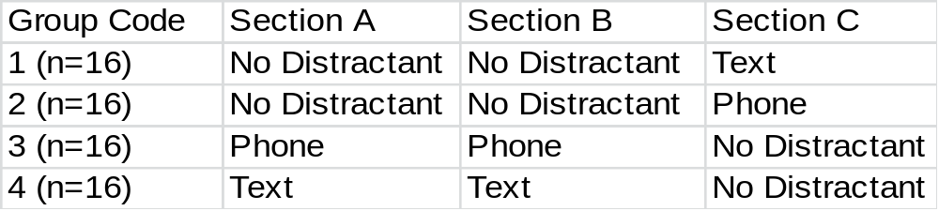
Three sections of data collection occurred during the two lane road driving scenario in which each participant drove through the progression of sections in order: A, B, and C. Section A consisted of a long sweeping curve and a 400 meter straight section of roadway. Sections B & C were straight roadways 600 meters in length. The virtual scenario was designed to simulate rural driving and the two-lane roadway contained eight foot shoulders.

2.3.4 DATA ANALYSIS
The variable outputs from the driving simulator performance that were analyzed in the Two-Sample Hotelling’s T² test of driver inputs include:
- Velocity – The speed of the subject in m/s.
- Steer – Position of the steering wheel recorded in degrees. Clockwise is positive with +/- 540 degrees, or one and half turns, being the maximum values.
- Accel – The normalized accelerator position value. Zero meaning no pushing of the accelerator pedal, while 1.00 reports that the gas pedal is fully depressed.
- Brake – The normalized brake position value. Zero meaning no pushing of the brake pedal, while 1.00 reports that the brake pedal is fully depressed.
Statistical testing of the collected data for this study was completed using the NCSS and SPSS statistical software package. The data collection parameter, lane position, was also obtained to calculate the lateral velocity of each subject’s vehicle movements. The lane position output is measured in meters and it is calculated from the center of the lane to the center of the subject’s vehicle with an accuracy of one millimeter. The data was sampled at a rate of 10 HZ for this experiment. The derivative of the lane position data was computed to obtain the lateral velocity of each subject’s vehicle throughout the testing procedure. This lateral velocity data was then compared across groups to analyze the swerving speed between the four groups.
The Two-Sample Hotelling’s T² multivariate test was performed to evaluate the driver performance inputs while traversing the simulator scenario. The main advantage and reason for performing the Hotelling’s test to discover differences between groups is the lack of needed normality and equal-variance assumptions in order to provide probability levels based on randomization tests. For each section of the driven course we test the null hypothesis that the group means for all the response variables are equal.
The different Sections were evaluated testing the performance variables: Velocity, Steer, Accel, and Brake. The Bartlett Individual Variable Tests was performed to satisfy equal variances across samples and outliers were identified and removed. The Hotelling’s T² Randomization Test Probability Level is reported assuming unequal covariance and the randomization test results are based on 1000 Monte Carlo samples. The individual variable t-test significance levels should only be viewed with confidence when the overall T² value is significant.

2.5 Results

2.5.1 Multiple Variable Hotelling’s Analysis
The collected driving parameters for Section A were evaluated and the results are summarized in Table XX. During this curve maneuver and straight driving section, the velocity of the texting group was slightly higher than the two control groups. However, no statistically significant differences could be deducted from the velocity results. The position of the steering wheel (steer), accelerator (accel), and brake pedal (brake) were not found to be different between groups and no trends could be established through the relationships.
Table 10 Section A: Curve & Straight Section Hotelling’s Comparison
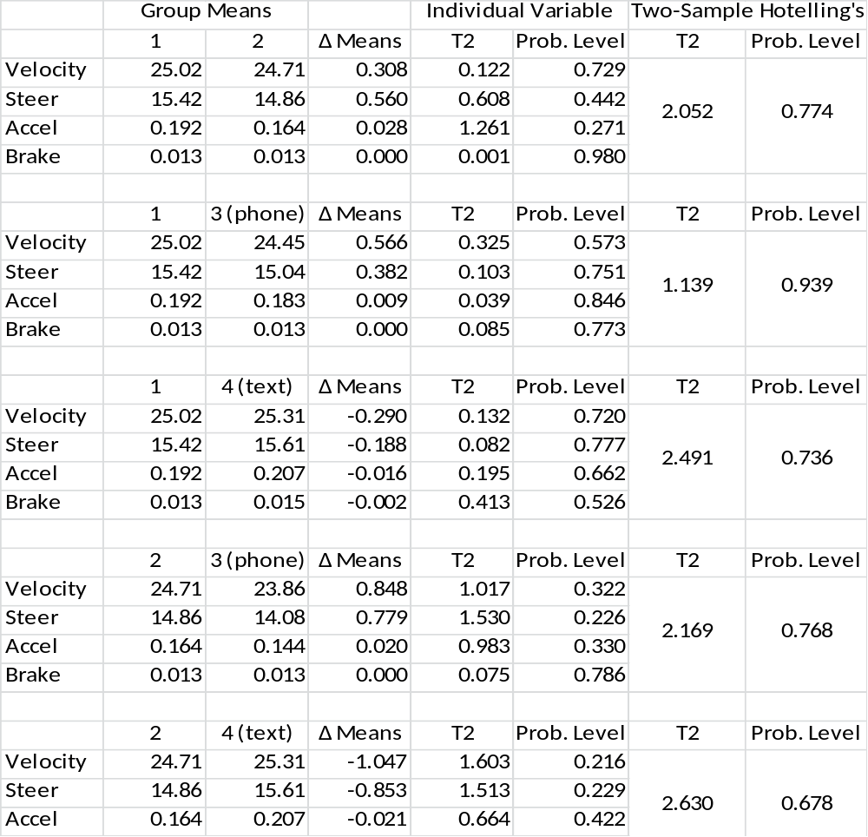
¹Group 1 in Section A: No Distractions
²Group 2 in Section A: No Distractions
³Group 3 in Section A: Phone Conversation
⁴Group 4 in Section A: Texting

The second data collection portion of the testing resulted in similar results of Section A. Although no multivariate between group distinctions could be classified as significant, it is interesting to note that the participants talking on the phone on average drove slower than the control groups in both Sections A and B. The Section B summarized results are presented in Table xx.
Table 11 Section B: Straight Section Hotelling’s Comparison
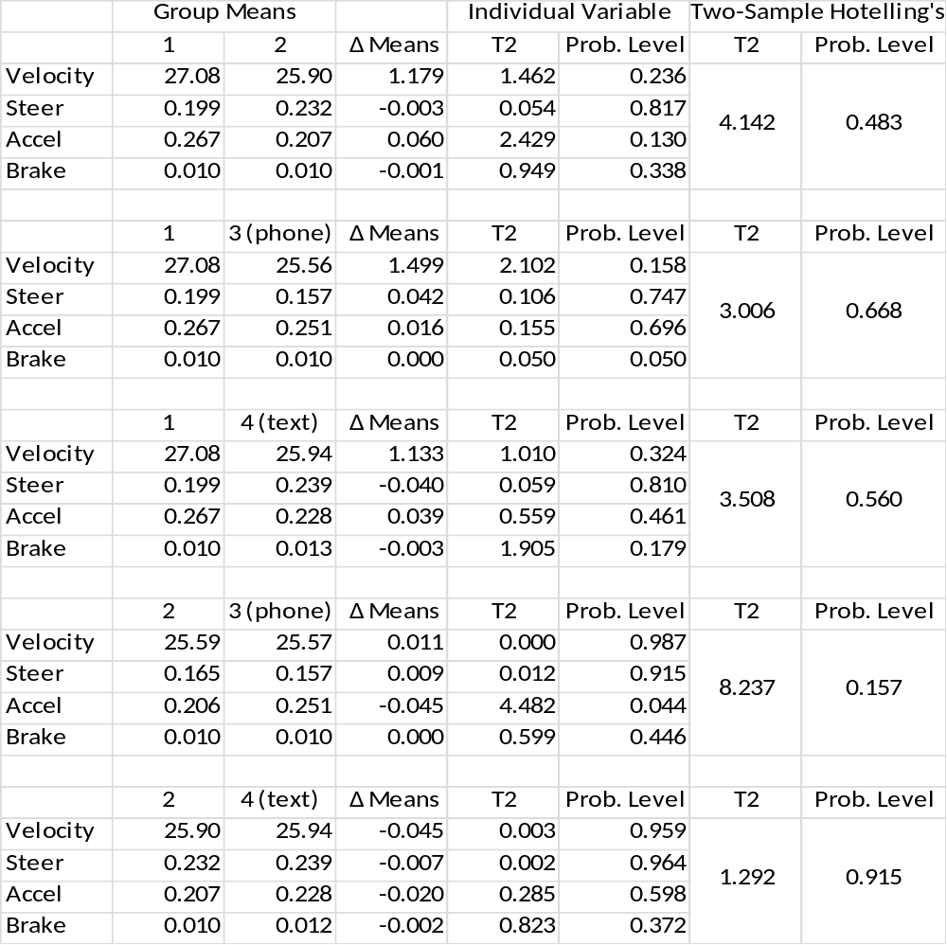
¹Group 1 in Section B: No Distractions
²Group 2 in Section B: No Distractions
³Group 3 in Section B: Phone Conversation
⁴Group 4 in Section B: Texting

The final test section Hotelling’s Comparisons once again did not result in significant multivariate differences between velocity, steer, accel, and brake. The velocity means regarding texting were still inconclusive, but the decreased velocity among the group carrying on a phone conversation is still trending true. It should be noted that the implication of rejecting the null hypothesis of equal means across variables is growing in significance in comparing the non-distracted and phone drivers against the texting group. Although our testing never reached an alpha=0.05. The trend of the Two-Sample Hotelling’s comparison seems to be approaching significant results the longer the subjects drove the simulator.
Table 12 Section C: Straight Section Hotelling’s Comparison
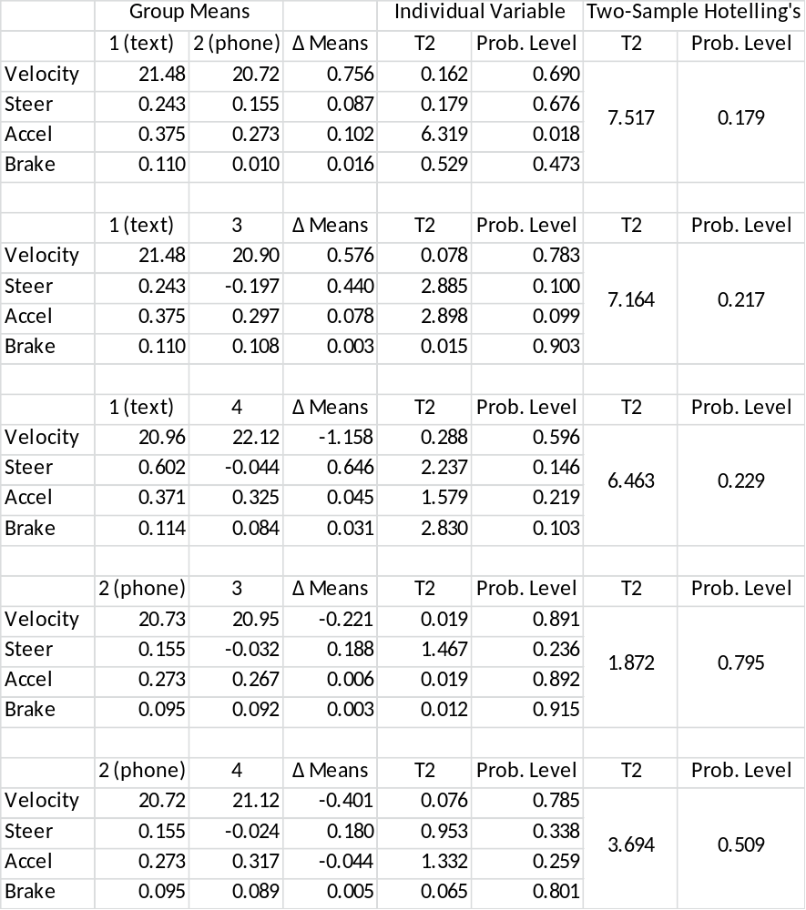
¹Group 1 in Section C: Texting
²Group 2 in Section C: Phone Conversation
³Group 3 in Section C: No Distractions
⁴Group 4 in Section C: No Distractions

2.5.2 Subject’s Lateral Velocity Analysis of Variance
The second analysis of this study involves the lateral position of the vehicle with respect to the center of the traveled lane. Using the lane position data and differentiating the data with respect to time, we obtained the lateral velocity of the simulated automobile to capture swerving movement intensity during the groups individual driving performances. The group lateral velocity mean values reported in the descriptives tables for each of the Sections below was computed as the absolute value summation of the incremental lateral velocity experienced during each section. The calculated lateral velocity data is independent and residuals were tested to ensure normality. Table XX displays the results of the Section A calculated lateral velocity mean differences between the control group, phone group, and texting group. We report significant differences between the groups with an F-test value = 7.918 (p-value=0.000). The Bonferroni Post-Hoc Test was used to determine which groups differed in average lateral velocity. The text messaging participants exhibited the most erratic lateral velocities averaging nearly 2.5 meters per second higher velocities compared to the non-distracted and phone groups.
Table 13 Section A : Lateral Velocity Analysis of Variance
Section A : Descriptives
 |  |  |  |  | N |  |  | Mean (m/s) |  |  | Std. Deviation |  |  | Std. Error
1.00 (No Distraction) |  |  |  |  | 16 |  |  | 1.584938 |  |  | .8681020 |  |  | .2170255
2.00 (No Distraction) |  |  |  |  | 16 |  |  | 1.372187 |  |  | .5777275 |  |  | .1444319
3.00 (Phone Conversation) |  |  |  |  | 16 |  |  | 1.816625 |  |  | 1.1893486 |  |  | .2973372
4.00 (Text Messaging) |  |  |  |  | 16 |  |  | 4.082687 |  |  | 3.2104095 |  |  | .8026024
Total |  |  |  |  | 64 |  |  | 2.214109 |  |  | 2.0632769 |  |  | .2579096
Model | Fixed Effects |  |  |  |  |  |  |  |  |  | 1.7894587 |  |  | .2236823
Model | Random Effects |  |  |  |  |  |  |  |  |  |  |  |  | .6294354
Section A : ANOVA
 |  |  | Sum of Squares |  |  |  | df |  |  | Mean Square |  |  | F |  |  | Sig.
Between Groups |  |  | 76.068 |  |  |  | 3 |  |  | 25.356 |  |  | 7.918 |  |  | .000
Within Groups |  |  | 192.130 |  |  |  | 60 |  |  | 3.202
Total |  |  | 268.198 |  |  |  | 63
Section A : Dependent Variable Bonferroni Multiple Comparisons
 |  | (I) V1 |  | (J) V1 |  | Mean Difference (I-J) |  |  | Std. Error |  |  | Sig. |  |  | 95% Confidence Interval
 |  |  |  |  |  |  |  |  |  |  |  |  |  |  | Lower Bound |  |  | Upper Bound
1 |  | dimension3 |  | 2 |  | .2127500 |  |  | .6326692 |  |  | 1.000 |  |  | -1.513521 |  |  | 1.939021
 |  |  |  | 3 |  | -.2316875 |  |  | .6326692 |  |  | 1.000 |  |  | -1.957958 |  |  | 1.494583
 |  |  |  | 4 |  | -2.4977500* |  |  | .6326692 |  |  | .001 |  |  | -4.224021 |  |  | -.771479
2 |  | dimension3 |  | 1 |  | -.2127500 |  |  | .6326692 |  |  | 1.000 |  |  | -1.939021 |  |  | 1.513521
 |  |  |  | 3 |  | -.4444375 |  |  | .6326692 |  |  | 1.000 |  |  | -2.170708 |  |  | 1.281833
 |  |  |  | 4 |  | -2.7105000* |  |  | .6326692 |  |  | .000 |  |  | -4.436771 |  |  | -.984229
3 |  | dimension3 |  | 1 |  | .2316875 |  |  | .6326692 |  |  | 1.000 |  |  | -1.494583 |  |  | 1.957958
 |  |  |  | 2 |  | .4444375 |  |  | .6326692 |  |  | 1.000 |  |  | -1.281833 |  |  | 2.170708
 |  |  |  | 4 |  | -2.2660625* |  |  | .6326692 |  |  | .004 |  |  | -3.992333 |  |  | -.539792
4 |  | dimension3 |  | 1 |  | 2.4977500* |  |  | .6326692 |  |  | .001 |  |  | .771479 |  |  | 4.224021
 |  |  |  | 2 |  | 2.7105000* |  |  | .6326692 |  |  | .000 |  |  | .984229 |  |  | 4.436771
 |  |  |  | 3 |  | 2.2660625* |  |  | .6326692 |  |  | .004 |  |  | .539792 |  |  | 3.992333
*. The mean difference is significant at the 0.05 level.

Table xx displays Section B analysis of variance that proved significant difference between the groups’ lateral velocities (F-Test = 4.062, p-value = 0.011). The results of the Bonferroni test prove once again that the text messaging group of drivers shows evidence of abnormal swerving behavior when traversing the straight stretch of roadway. Texting participants averaged a lateral velocity approximately 1 m/sec greater than their study counterparts.
Table 14 Section B : Lateral Velocity Analysis of Variance
Section B : Descriptives
 |  |  |  |  |  | N |  | Mean (m/s) |  |  | Std. Deviation |  |  |  | Std. Error
1.00 (No Distraction) |  |  |  |  |  | 16 |  | .883438 |  |  | .6684239 |  |  |  | .1671060
2.00 (No Distraction) |  |  |  |  |  | 16 |  | .884000 |  |  | .8454411 |  |  |  | .2113603
3.00 (Phone Conversation) |  |  |  |  |  | 16 |  | .795063 |  |  | .5053031 |  |  |  | .1263258
4.00 (Text Messaging) |  |  |  |  |  | 16 |  | 1.898312 |  |  | 1.7043559 |  |  |  | .4260890
Total |  |  |  |  |  | 64 |  | 1.115203 |  |  | 1.1126441 |  |  |  | .1390805
Model | Fixed Effects |  |  |  |  |  |  |  |  |  | 1.0394375 |  |  |  | .1299297
Model | Random Effects |  |  |  |  |  |  |  |  |  |  |  |  |  | .2618715
Section B : ANOVA
 |  |  |  | Sum of Squares |  |  | df |  |  | Mean Square |  |  | F |  |  | Sig.
Between Groups |  |  |  | 13.167 |  |  | 3 |  |  | 4.389 |  |  | 4.062 |  |  | .011
Within Groups |  |  |  | 64.826 |  |  | 60 |  |  | 1.080
Total |  |  |  | 77.993 |  |  | 63
Section B : Dependent Variable Bonferroni Multiple Comparisons
 |  | (I) V1 | (J) V1 |  | Mean Difference (I-J) |  |  |  | Std. Error |  |  | Sig. |  | 95% Confidence Interval
 |  |  |  |  |  |  |  |  |  |  |  |  |  | Lower Bound |  |  |  | Upper Bound
1 |  | dimension3 | 2 |  | -.0005625 |  |  |  | .3674967 |  |  | 1.000 |  | -1.003296 |  |  |  | 1.002171
 |  | dimension3 | 3 |  | .0883750 |  |  |  | .3674967 |  |  | 1.000 |  | -.914359 |  |  |  | 1.091109
 |  | dimension3 | 4 |  | -1.0148750* |  |  |  | .3674967 |  |  | .046 |  | -2.017609 |  |  |  | -.012141
2 |  | dimension3 | 1 |  | .0005625 |  |  |  | .3674967 |  |  | 1.000 |  | -1.002171 |  |  |  | 1.003296
 |  | dimension3 | 3 |  | .0889375 |  |  |  | .3674967 |  |  | 1.000 |  | -.913796 |  |  |  | 1.091671
 |  | dimension3 | 4 |  | -1.0143125* |  |  |  | .3674967 |  |  | .046 |  | -2.017046 |  |  |  | -.011579
3 |  | dimension3 | 1 |  | -.0883750 |  |  |  | .3674967 |  |  | 1.000 |  | -1.091109 |  |  |  | .914359
 |  | dimension3 | 2 |  | -.0889375 |  |  |  | .3674967 |  |  | 1.000 |  | -1.091671 |  |  |  | .913796
 |  | dimension3 | 4 |  | -1.1032500* |  |  |  | .3674967 |  |  | .023 |  | -2.105984 |  |  |  | -.100516
4 |  | dimension3 | 1 |  | 1.0148750* |  |  |  | .3674967 |  |  | .046 |  | .012141 |  |  |  | 2.017609
 |  | dimension3 | 2 |  | 1.0143125* |  |  |  | .3674967 |  |  | .046 |  | .011579 |  |  |  | 2.017046
 |  | dimension3 | 3 |  | 1.1032500* |  |  |  | .3674967 |  |  | .023 |  | .100516 |  |  |  | 2.105984
*. The mean difference is significant at the 0.05 level.

The final section of the testing procedure produced comparable results with the previous sections, but with less significant results. The analysis of variance proved differences among the lateral velocities between groups, however, the Bonferroni multiple comparisons only revealed one pair of differences. The text messaging subjects’ lateral velocity proved significantly higher than one of the undistracted, baseline groups. It should be noted that on average the text messaging subjects’ lateral velocity was calculated higher than the other non-distracted or phone groups insignificantly.
Table 15 Section C : Lateral Velocity Analysis of Variance
Section C : Descriptives
 |  |  |  |  |  | N |  | Mean (m/s) |  |  | Std. Deviation |  |  |  | Std. Error
1 (Text Messaging) |  |  |  |  |  | 16 |  | 2.012375 |  |  | 1.2078301 |  |  |  | .3019575
2 (Phone Conversation) |  |  |  |  |  | 16 |  | 1.163938 |  |  | .7760326 |  |  |  | .1940081
3 (No Distraction) |  |  |  |  |  | 16 |  | 1.233875 |  |  | .9630297 |  |  |  | .2407574
4 (No Distraction) |  |  |  |  |  | 16 |  | .748563 |  |  | .7522653 |  |  |  | .1880663
Total |  |  |  |  |  | 64 |  | 1.289688 |  |  | 1.0286413 |  |  |  | .1285802
Model | Fixed Effects |  |  |  |  |  |  |  |  |  | .9426571 |  |  |  | .1178321
Model | Random Effects |  |  |  |  |  |  |  |  |  |  |  |  |  | .2636319
Section C : ANOVA
 |  |  |  | Sum of Squares |  |  | df |  |  | Mean Square |  |  | F |  |  | Sig.
Between Groups |  |  |  | 13.344 |  |  | 3 |  |  | 4.448 |  |  | 5.006 |  |  | .004
Within Groups |  |  |  | 53.316 |  |  | 60 |  |  | .889
Total |  |  |  | 66.660 |  |  | 63
Section C : Dependent Variable Bonferroni Multiple Comparisons
 |  | (I) V1 | (J) V1 |  | Mean Difference (I-J) |  |  |  | Std. Error |  |  | Sig. |  | 95% Confidence Interval
 |  |  |  |  |  |  |  |  |  |  |  |  |  | Lower Bound |  |  |  | Upper Bound
1 |  | dimension3 | 2 |  | .8484375 |  |  |  | .3332796 |  |  | .081 |  | -.060933 |  |  |  | 1.757808
 |  | dimension3 | 3 |  | .7785000 |  |  |  | .3332796 |  |  | .137 |  | -.130871 |  |  |  | 1.687871
 |  | dimension3 | 4 |  | 1.2638125* |  |  |  | .3332796 |  |  | .002 |  | .354442 |  |  |  | 2.173183
2 |  | dimension3 | 1 |  | -.8484375 |  |  |  | .3332796 |  |  | .081 |  | -1.757808 |  |  |  | .060933
 |  | dimension3 | 3 |  | -.0699375 |  |  |  | .3332796 |  |  | 1.000 |  | -.979308 |  |  |  | .839433
 |  | dimension3 | 4 |  | .4153750 |  |  |  | .3332796 |  |  | 1.000 |  | -.493996 |  |  |  | 1.324746
3 |  | dimension3 | 1 |  | -.7785000 |  |  |  | .3332796 |  |  | .137 |  | -1.687871 |  |  |  | .130871
 |  | dimension3 | 2 |  | .0699375 |  |  |  | .3332796 |  |  | 1.000 |  | -.839433 |  |  |  | .979308
 |  | dimension3 | 4 |  | .4853125 |  |  |  | .3332796 |  |  | .903 |  | -.424058 |  |  |  | 1.394683
4 |  | dimension3 | 1 |  | -1.2638125* |  |  |  | .3332796 |  |  | .002 |  | -2.173183 |  |  |  | -.354442
 |  | dimension3 | 2 |  | -.4153750 |  |  |  | .3332796 |  |  | 1.000 |  | -1.324746 |  |  |  | .493996
 |  | dimension3 | 3 |  | -.4853125 |  |  |  | .3332796 |  |  | .903 |  | -1.394683 |  |  |  | .424058
*. The mean difference is significant at the 0.05 level.

2.6 Conclusions
The Hotelling’s mean comparisons among the independent variables: velocity, steer, accel, and brake across three separate test sections did not reveal significant differences between any of the four groups. Although it was reported that the driving task was more difficult when texting than talking on the phone or driving undistracted, no representative distinctions could be established among the groups when analyzing these inputs. When viewing the trends of the velocity data, it can be seen that the group tasked with talking on the phone while navigating the course drove slightly slower than the other groups: non distracted and texting. This finding coincides with other research claiming phone conversations have been linked with reduced driving speeds from excess mental workload [41, 42]. However, no significant velocity difference was detected between the non-distracted, phone conversation, and texting groups. It is believed that the amount of data collected was inconsequential to capture speed variations for extended phone conversations or texting. The lack of determining differences in driver inputs could also be resultant of insufficient warm-up exposure and relatively short periods of data collection. It is recommended for future research to ensure all subjects have fully acclimated to the simulator and that data collection sections are generous enough to capture substantial differences among populations of interest. It is the opinion of the researcher that poor driving performance among the general teen population could also be a factor in the lack of significant differences. This hypothesis agrees with previous research comparing driving tasks between novice teens and experienced adults[43, 44].
The results of the lateral velocity group comparisons agree with intuition when evaluating the texting drivers and conclude that the lateral velocity increases when attempting to send text messages. These results concur with other research claiming that dialing a phone, similar to sending a text message, biomechanically interferes with steering and affects lateral vehicle control[45, 46]. The apparent reduction in lateral velocity by the phone conversation group during Section B has also been observed in a similar study[37]. Through this research effort it is hoped that the scientific community can better understand and expound on the driver behavior knowledge needed to improve safety for the vulnerable rural teen driver population.

3 CHAPTER III
Intersection Sight Distance Design Supplement based on Driver Gap Acceptance Modeling

3.1 Introduction
The United States Department of Transportation recently reported a decrease of fatal crashes by 9.9 percent from 2008 to 2009. However, great efforts are still needed to further reduce the amount of crashes on our road networks. A point of interest that accounts for as much as 54 percent of all crashes is intersections. Intersection safety is recognized as a high-priority research area by multiple national research institutes and organizations including: AASHTO, FHWA, TRB, ITE, AAA, STC and many state DOTs. NHTSA’s Traffic Safety Facts 2009 compiles motor vehicle crash data from the Fatality Analysis Reporting System (FARS) and the General Estimates System (GES) and reported nearly 6,800 intersection traffic fatalities. It was also found that a staggering 2.2 million crashes occurred at intersections in the United States[47]. Numerous intersection safety factors contribute to the operation and safety of intersections, including the provision of intersection sight distance (ISD) that plays an integral part in ensuring users safe, yet efficient intersection operation. Adequate ISD should be provided at all intersections to minimize potential conflicts and reduce the likelihood of a crash occurring between vehicles vying to traverse the same facility. The problem with insufficient sight distance is it does not afford the driver ample time for reacting to potential conflicts or hazards. As a result, the likelihood of a crash at such an intersection can be elevated, sometimes significantly.
Improving the safety of our roadways require extensive funding from the design phase until construction is complete. With a sharp downturn in the national economy and failed policies to ensure future funding for transportation projects, each federally funded organization is financially impoverished and only provides funding for the highest priority projects. Figure 3 highlights projections shown that the Highway Trust Fund, the major source of income for transportation funding, will be nearly $100 billion in the red by 2021 [48] . Predicting less available funding for future project due to increased national debt and unpredictable political agendas, research should be focused on providing innovative solutions at economic prices while maintaining the betterment of human welfare. Previous design standards are full of safe-guards and factors of safety to ensure the highest possible protection for transportation users, however, stronger degrees of safety require higher price tags. With advancements in technology and changes in driving behavior, a reevaluation of the current standards is imperative to sustain sufficient infrastructure at the most economical price. Technology will allow researchers to accurately condense the standards on engineering factors of safety to economically optimize outdated intersection standards.
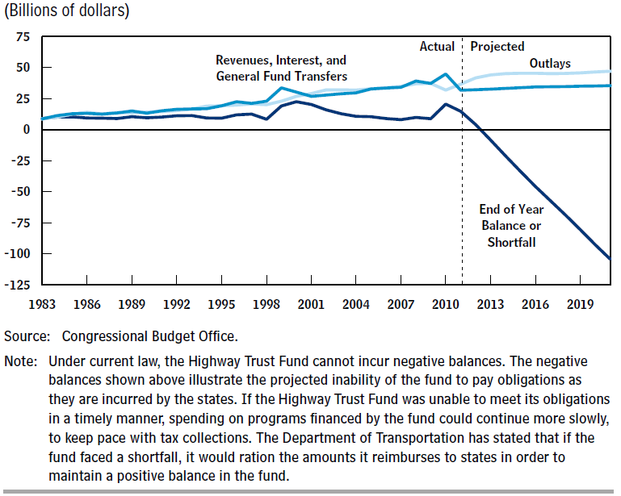
Figure 4 Status of the Highway Account of the Highway Trust Fund[48].

3.2 Literature Review
AASHTO’s monolith on A Policy of Geometric Design of Highways and Streets, often referred to as “AASHTO Green Book,” has long recognized the safety concerns of restricted intersection sight distance. It identified six scenarios; see below, corresponding to various intersection controls and maneuvers that may have ISD issues.
- Case A - Intersections with no control;
- Case B - Intersections with Stop control on the minor road;
  - B1 - Left turns from the minor road;
  - B2 - Right turns from the minor road;
  - B3 - Crossing maneuver from the minor road;
- Case C - Intersections with Yield control on the minor road;
  - C1 - Crossing maneuver from the minor road;
  - C2 - Left or right turns from the minor road;
- Case D - Intersections with traffic signal control;
- Case E - Intersections with all-way Stop control;
- Case F - Left turns from a major road.
Green Book’s procedures for determining required ISD are based on the time gap acceptances methodology; we will only consider passenger cars in this study[49].
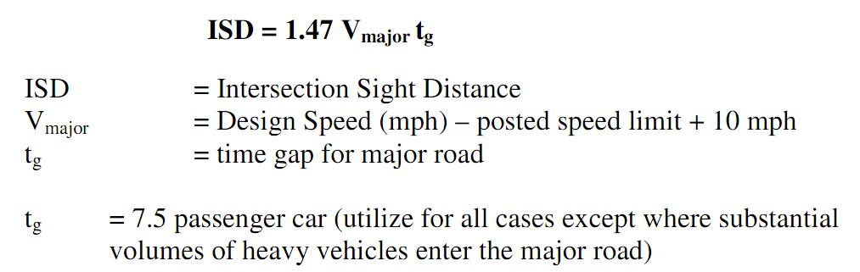
For this study, consideration of Case B – Intersections with Stop control on the minor road will be considered. The procedure used to formulate this equation is simplistic in comparison with the actual operation situations in the real world and have the following shortcomings:
- The gap acceptance data used for determining critical gaps assumes the stream of traffic will, in the most extreme condition, reduce their operating speed 15% to accommodate the vehicle entering the roadway. This assumption is based on early driving behavior and has not been updated to capture changes in driving behavior.
- The critical gap procedure per Green Book only reflects the behavior of 50% of the drivers. The other 50%, who do not consider the established critical gap acceptable, are likely to be conservative and/or older drivers. The population of the latter has been on the rise, which exasperates the ISD problem.
- The required ISD procedure is based on road design speed, which is generally correlated with the 85th percentile operation speed. Thus, the minimum ISD standard is unlikely to meet the actual required sight distance of 15% of the drivers. Furthermore, it is commonly observed that a significant portion of motorists tends to exceed the posted speed limits, which makes the ISD problem more serious.
In reality, it is not unusual to find intersections with inadequate sight distances due to complex geometric conditions or even overgrowth of vegetation. State and local governments continue to trim budgets and this reduces available funding for maintenance, mowing and cleaning the clear zones of roadways. Therefore, there is a research need to assess the adequacy of AASHTO ISD design standards through comprehensive and thorough analyses of changes in driving behaviors. AASHTO recognized the needs to allow engineers to exercise “engineering judgment” in regards to intersection sight distance with their publication of, “A Guide for Achieving Flexibility in Highway Design.” This allows designers flexibility in adjusting key parameters for context sensitive solutions in the ISD design, including approach design speed which has already been argued to be flawed[50].
With numerous safety shortfalls looming at nearly every intersection, intersection safety has been a heavily studied topic in the past. Albeit brief, the following literature review is a small sample of the full review that will be presented in the completed study to provide sufficient background supporting the need for such a study. Gap Acceptance Models have been formulated using observed traffic flows and driver behaviors at intersections that are subjectively considered safe to calculate accepted gaps by vehicles. Harwood concluded that observed subjects required a gap of 6 seconds to enter the mainstream traffic flow[51].
Gattis reviewed several methods for modeling critical gap acceptance for atypical intersections and found 7.8 second gap for the predominant traffic stream approaching from the right[43]. Moussa utilized an Augmented Reality Vehicle System to determine that most drivers will accept a gap in traffic between 4 and 9 seconds for left-turn maneuver at two-way stop-controlled “TWSC” intersection [44]. Yan et al. performed a left turn gap acceptance study simulator study and found that older drivers and female drivers are more conservative in accepting gaps in traffic streams than their counterparts[46]. Harwood arguably produced the most influential article of research regarding gap acceptance with his work that produced the currently accepted AASHTO intersection sight distance policy[29]. This research was considered exceptional following its publication in 1999; however, technological advancements have improved the capacity in which we can analyze driving behaviors over traditional observation studies such as Harwood’s. With the use of highly precise driving simulators, in depth analyze of driving characteristics can give researchers invaluable information regarding attitudes towards risky driving behavior. It is also of interest to investigate how improved performance of everyday vehicles has transformed driving behavior.

3.3 Purpose
The purpose of this research is to expound on the current ISD guidelines using driver behavior analysis as opposed to traditional design speed standards. A model will be developed from drivers’ gap acceptance behavior to better understand risk perception and safety threshold. Understanding driving perception and judgment through quantitative analysis will allow for scientific revisions to the current ISD standards. Special emphasis will be placed on maintaining safety, but formulating standards that are economically advantageous in context sensitive situations is ideal. These standards will be developed with the understanding that tradeoffs are required to balance the line of safety and frugality. The hypothesis in this research is that: current ISD standards are outdated and do not consider evolving driving behavior and technological advances. New sight distance standards will be developed using driver inputs and gap acceptance behavior to gauge risk thresholds and avoid fallacies of traditional design. It is desired that the new, economically optimized ISD recommendations be beneficial in providing pragmatic, context sensitive ISD solutions.

3.4 Methodology

3.4.1 Apparatus
Tests for this study will be conducted using the DriveSafety DS-607c, which consists of 5 aspheric mirror technology projectors wrapping 300° around a Ford Focus cab, where the test subject is to be seated. The screen projection has a resolution 1024 x 768 pixel each. Real-time data collection will be sampled at a rate of 20 Hz. A digital audio system is functional in the cab with four speakers to allow for audio commands and other sounds in the virtual environment. The interior of the vehicle is an exact replica of a Ford Focus featuring: windshield, driver and passenger seats, center console, radio/CD player, full functioning instrument panel. In addition, the driver has rear views through a LCD rear view mirror and two LCD side view mirrors.

3.4.2 Participants
Approximately 40 volunteers will be used for this effort. . Every subject should hold a valid driver’s license with at least 2 years of driving experience. A diverse range of individuals regarding sex, race, and age is preferred for comparisons between and within groups of interest. Every participant will be required to read, agree, and adhere to the consent form approved by the University of Tennessee’s Institutional Review Board.

3.4.3 Scenario Design & Research Approach
A series of intersections will be designed in a street network for subjects to drive during simulation. Ambient traffic will be provided on the streets, but selected intersections for gap accepted analysis will contain specifically designed traffic for monitoring. Approaching the select test sights, a series of cars will be approaching the intersection on the perpendicular street with predefined gaps between each vehicle. The gaps in the traffic will gradually increase from 1 second up to 12 seconds. At some point the participant will choose to accept a gap in the traffic stream and proceed left, right, or straight. Each turning movement will be analyzed separately, due to the perceived risk of crossing traffic. With the numerous types of intersections and available combinations of conflicting vehicles, this study will only analyze vehicles approaching the subject from the left side of the perpendicular street. Data will be collected on the gap accepted in the traffic along with the vehicle performance through the simulator output. The study parameters to be analyzed include speed, deceleration, acceleration, turn maneuvers, response time, vehicle stop position relative to stop bar and travel way, lane position, etc.
Through the gap acceptance procedure we hope to gain information valuable in testing assumptions regarding risk taking behavior among certain groups, including: novice drivers, elderly drivers, male/female drivers, etc. This effort will create a matrix of sight distances suitable to accommodate drivers so they feel comfortable accepting gaps in traffic. New sight distance recommendations will be calculated by revising the t_{g} value in equation (1). The short leg of the sight triangle, measurement a in Figure 4, is currently recommended to be 14 feet from the edge of traveled way. Analyzing the intersection approach behavior and relative distance to the edge of traveled way, results will be reported and new recommendations will be made regarding the final stopping location of drivers while making critical gap acceptance decisions. Determining the decision point of drivers is a crucial part in determining sight distance values in design.
Table 16 Sight Distance Triangle Design Guidelines
Type of Intersection/Driveways | Distance from Edge of Traveled Way (ft) | Major Street (Street Entered Upon)
Type of Intersection/Driveways | Distance from Edge of Traveled Way (ft) | Average Daily Traffic | Speed Limit (MPH) | Sight Distance Value (ft)ª  (B-C₁) and B-C₂)
 |  |  |  | Recommended (Desirable) | Minimum (Required)^{d}
B - Stop Control on Minor Street  (See Figure 2) | 14 | Any | 25 | 280 | 150
B - Stop Control on Minor Street  (See Figure 2) | 14 | Any | 30 | 335 | 200
B - Stop Control on Minor Street  (See Figure 2) | 14 | Any | 35 | 390 | 250

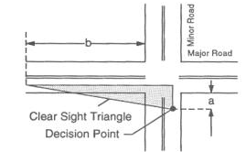
Figure 5 Departure Sight Triangle for Traffic Approaching from the Left

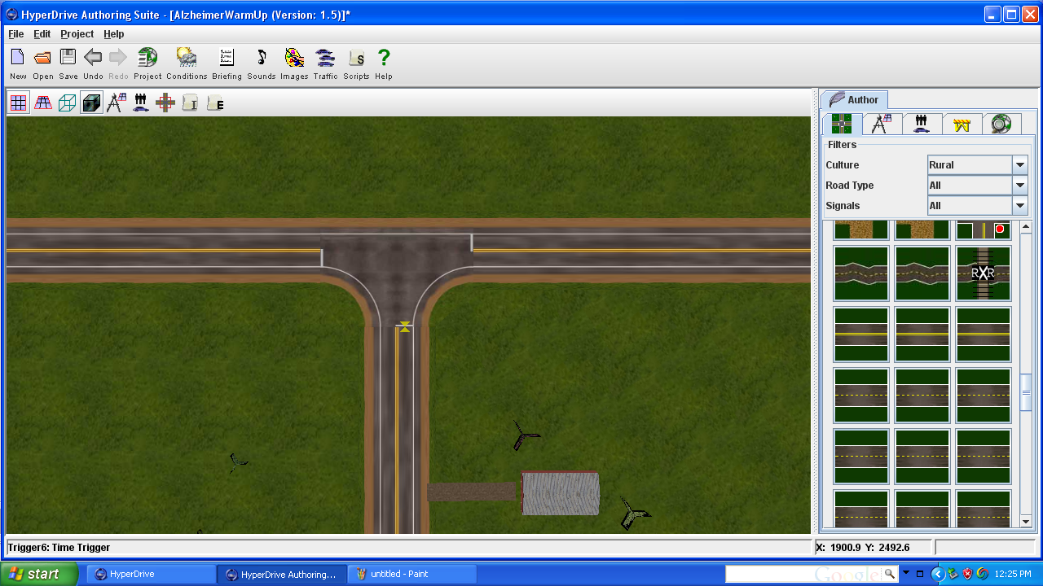
Figure 6 Plan View of Intersection in Virtual Scenario

3.4.4 Data Analysis
The analysis of variance (ANOVA) or multivariate analysis of variance (MANOVA) will be used to statistically test relationships of driving behaviors and individual gaps accepted in the traffic. The ANOVA and MANOVA testing is dependent on the condition of normality, homoscedasticity, and randomization of the data. Finding a non-normal distribution of residuals, the The Kruskal–Wallis test may be performed seeing it does not rely on an assumption of normality. If any combination of these assumptions cannot be met for statistical testing, the Hotelling’s T² multiple comparisons test will be performed to reveal differences between group means in question.

3.5 Results

3.6 Conclusions

Conclusion
The aforementioned research efforts will be completed with the upmost diligence and respect to all parties involved. Extensive care must and will be taken in each study to ensure all participating test subjects in the driving simulator are comfortable and in optimal condition to perform their tests naturally. Following all Institutional Review Board mandates and guidelines, it is anticipated that quality data be extracted and tested to obtain useful information.
Complying with the creed of all professional engineers to dedicate knowledge and skill to the betterment and preservation of human welfare, the following results are desired through this effort. With regards to the warm-up analysis study, we strive to establish an approximated time required for test subjects to acclimate to the driving simulator to ensure accurate data collection for all researchers using a driving simulator. Furthermore, we hope to better understand the driving behavior of rural teen drivers and utilize this understanding in future research endeavors. Finally, we anticipate improved intersection sight distance guidelines will improve intersection safety through economical design.

References
1. Wachtel, J., Brief History Of Driving Simulators. TR News, 1995(179): p. 26-27.
2. Bella, F. Driving simulation in virtual reality for work zone design on highway: a validation study. in Second International Congress. 2004. Florence, Italy: Infrastructure Viarie (SIIV).
3. Blaauw, G.J., Driving experience and task demands in simulator and instrumented car: a validation study. Human Factors: The Journal of the Human Factors and Ergonomics Society, 1982. 24(4): p. 473-486.
4. Reed, M. and P. Green, Comparison of driving performance on-road and in a low-cost simulator using concurrent telephone dialing task. Ergonomics, 1999. 42(8): p. 1015-1037.
5. Lee, H. The validity of driving simulator to measure on-road driving performance of older drivers. in 24th Conference of Australian Institutes of Transport Research (CAITR). 2002. Sydney, Australia.
6. Blana, E., Driving Simulator Validation Studies: A Literature Review. 1996, University of Leeds.
7. Mollenhauer, M., Simulator Adaptation Syndrome Literature Review. 2004, Realtime Technologies.
8. Reason, J. and J. Brand, Motion Sickness, in Academic Press. 1975: London, New York.
9. Brooks, J.O., et al., Simulator sickness during driving simulation studies. Accident Analysis &amp; Prevention, 2010. 42(3): p. 788-796.
10. Ho, C., N. Reed, and C. Spence, Assessing the effectiveness of "intuitive" vibrotactile warning signals in preventing front-to-rear collisions in a driving simulator. Accident Analysis & Prevention, 2006. 38: p. 988-996.
11. Lee, H.C., D. Cameron, and A.H. Lee, Assessing the driving performance of older adult drivers: on road versus simulated driving. Accident Analysis & Prevention, 2003. 35: p. 797-803.
12. Gawron, V.J. and T.A. Ranney, The Effects of Spot Treatments on Performance in a Driving Simulator Under Sober and Alcohol-Dosed Conditions. Accident Analysis & Prevention, 1990. 22: p. 263-279.
13. McGehee, D.V., et al. Examination of Older Driver Steering Adaptation on a High Performance Driving Simulator. in DSC North America. 2005. Orlando.
14. Broughton, K.L.M., F. Switzer, and D. Scott, Car following decisions under three visibility conditions and two speeds tested with a driving simulator. Accident Analysis & Prevention, 2007. 39: p. 106-116.
15. Fisher, D.L., et al., Empirical Evaluation of Hazard Anticipation Behaviors in the Field and on Driving Simulator using Eye Tracker. Transportation Research Record, 2007(2018): p. 80-86.
16. Pradhan, A., D. Fisher, and A. Pollatsek, Risk Perception Training for Novice Drivers: Evaluating Duration of Effects of Training on a Driving Simulator. Transportation Research Record: Journal of the Transportation Research Board, 2006. 1969(-1): p. 58-64.
17. Lee, C. and M. Adbel-Aty, Testing Effects of Warning Messages and Variable Speed Limits on Driver Behavior Using Driving Simulator. Transportation Research Record, 2008(2069): p. 55-64.
18. Bella, F., Parameters for evaluation of speed differential - Contribution using driving simulator. Transportation Research Record, 2007(2023): p. 37-43.
19. Beede, K.E. and S.J. Kass, Engrossed in conversation: The impact of cell phones on simulated driving performance. Accident Analysis & Prevention, 2006. 38: p. 415-421.
20. Nelson, T.M. and T.H. Nilsson, Comparing Headphone and Speaker Effects on Simulated Driving. Accident Analysis & Prevention, 1990. 22: p. 523-529.
21. Kelly, M.J., S. Lassacher, and Z. Shipstead, A High Fidelity Driving Simulator as a Tool for Design and Evaluation of Highway Infrastructure Upgrades., DOT, USDOT, and FHWA, Editors. 2007: Montana.
22. Muttart, J.W., et al., Driving Without a Clue: Evaluation of Driver Simulator Performance During Hands-Free Cell Phone Operation in a Work Zone. Transportation Research Record, 2007(2019): p. 9-14.
23. Sahami, S., J. Jenkins, and T. Sayed, Methodology to Analyze Adaptation in Driving Simulators. Transportation Research Record: Journal of the Transportation Research Board, 2009. 2138(-1): p. 94-101.
24. McGehee, D.V., et al., Quantitative analysis of steering adaptation on a high performance fixed-base driving simulator. Transportation Research Part F: Traffic Psychology and Behaviour, 2004. 7(3): p. 181-196.
25. Sahami, S. and T. Sayed, Insight into Steering Adaptation Patterns in a Driving Simulator. Transportation Research Record: Journal of the Transportation Research Board, 2010. 2185(-1): p. 33-39.
26. Aiken, L.R., ed. Psychological Testing and Assessment. 7th ed. 1971, Perpperdine University.
27. Reymond, G., et al., Role of lateral acceleration in curve driving: driver model and experiments on a real vehicle and driving simulator. Human Factors: The Journal of the Human Factors and Ergonomics Society, 2001. 43: p. 483-495.
28. Isabelle, M.-P., A visual sign of lateral acceleration for steering assistance. International Journal of Human-Computer Studies, 2008. 66(3): p. 145-157.
29. Edgington, E., Randomization Tests. Marcel Dekker. New York. A comprehensive discussion of randomization tests with many examples. 1987.
30. Brown, I.D., A.H. Tickner, and D.C. Simmonds, Interference between concurrent tasks of driving and telephoning. Journal Applied Physchology, 1969. 53(5): p. 419-424.
31. NHTSA, Statistics and Facts About Distracted Driving., U.D.o. Transportation., Editor. 2009: Washington, DC.
32. Burns, P., et al., How Dangerous Is Driving with a Mobile Phone? Benchmarking the Impairment to Alcohol., T.D. Report, Editor. 2002.
33. NHTSA, Saving Teenage Lives: The Case for Graduated Driver Licensing., U.D.o. Transportation, Editor. 1998.
34. NHTSA, Traffic Safety Facts., U.D.o. Transportation, Editor. 2008: Washington, DC.
35. Green, P., How Driving Simulator Data Quality Can Be Improved., in DSC North America. 2005: Orlando.
36. Jeff Greenberg, L.T., Reates Curry, Bruce Artz, Larry Cathey, Dev Kochhar, Ksenia Kozak, Mike Blommer, Peter Grant, Driver Distraction: Evaluation with Event Detection Paradigm Transportation Research Record: Journal of the Transportation Research Board, 2003. 1843: p. 1-9.
37. Törnros, J.E.B. and A.K. Bolling, Mobile phone use--Effects of handheld and handsfree phones on driving performance. Accident Analysis & Prevention, 2005. 37(5): p. 902-909.
38. Lesch, M.F. and P.A. Hancock, Driving performance during concurrent cell-phone use: are drivers aware of their performance decrements? Accident Analysis & Prevention, 2004. 36(3): p. 471-480.
39. Charlton, S.G., Driving while conversing: Cell phones that distract and passengers who react. Accident Analysis & Prevention, 2009. 41(1): p. 160-173.
40. Caird, J.K., et al., A meta-analysis of the effects of cell phones on driver performance. Accident Analysis & Prevention, 2008. 40(4): p. 1282-1293.
41. Haigney, D.E., R.G. Taylor, and S.J. Westerman, Concurrent mobile (cellular) phone use and driving performance: task demand characteristics and compensatory processes. Transportation Research Part F, 2000: p. 113-121.
42. Alm, H. and L. Nilsson, Changes in Driver Behavior as a Function of Handsfree Mobile Phones A Simulator Study. Accident Analysis & Prevention, 1994. 26(4): p. 441-451.
43. Olson, E.C.B., B.G. Simons-Morton, and S.E. Lee, Novice Teen and Experienced Adult Drivers on the Smart Road Intersection: Does Six Months of Experience Matter?, in Proc. Human Factors and Ergonomics Society 50th Annual Meeting. 2006: Santa Monica, CA. p. 2283-2287.
44. Olsen, E.C.B., et al. Intersection Behavior of Novice Teen Drivers and Experienced Adult Drivers. in 49th Meeting of the Human Factors and Ergonomics Society. 2005. Santa Monica, CA.
45. Brookhuis, K.A., G. de Vries, and D. de Waard, The effects of mobile telephoning on driving performance. Accident Analysis & Prevention, 1991. 23(4): p. 309-316.
46. Tijerina, L., et al., Heavy vehicle driver workload assessment, Task 7A: in-car text message system and cellular phone use by heavy vehicle drivers on the road, N.H.T.S. Administration, Editor. 1996: Washington DC.
47. NHTSA, Traffic Safety Facts 2009, USDOT, Editor. 2010, National Center for Statistics and Analysis: Washington, DC.
48. Office, C.B., Testimony: Statement of Joseph Kile, Assistant Director for Microeconomic Studies - The Highway Trust Fund and Paying for Highways, C.o.F.U.S. Senate, Editor. 2011: Washington, DC.
49. Officials, A.A.o.S.H.a.T., A policy on geometric design of highways and streets. 2004.
50. AASHTO, A Guide for Achieving Flexibility in Highway Design, USDOT, Editor. 2004: Washington, DC.
51. Harwood, D.W., et al., NCHRP Report 383: Intersection Sight Distance. 1996, Transportation Research Board: Washington , D C.

Vita
Ryan Overton was born on April 1, 1986 and grew up in Speedwell, TN. He graduated from the University of Tennessee in 2008 with a B.S. in Civil and Environmental Engineering. In 2009, he obtained a M.S. in Civil Engineering with a concentration in Transportation Engineering at the University of Tennessee. Throughout his undergraduate and master’s education, Ryan worked at Vaughn & Melton Consulting Engineers in Middlesboro, KY. He also worked on his family’s cattle farm in Speedwell, TN. Ryan has been awarded numerous scholarship and fellowship opportunities, including: Eisenhower Graduate Fellowship and East Asia and Pacific Summer Institutes-China. Ryan’s expertise involving human behavior and driver safety has allowed him to work on several research projects, including early onset Alzheimer driving and distracted teen driving projects. He is interested in continuing research related to traffic safety and reducing roadway fatalities.

