I, Too, Am Harvard:
A Black Higher Education Narrative

A Thesis Presented for the
Master of Arts
Degree
The University of Tennessee, Knoxville

Tara Nicole Rayers
July 2015

Copyright © 2015 by Tara Rayers
All rights reserved.

DEDICATION

To the students at Harvard who began this campaign and who welcomed me into it and into their homes.

To the students who joined the campaign, and all who will follow in their footsteps, continuing to prove Patricia Hill Collins’s claim that “Despite long-standing claims by elites that Blacks, women, Latinos, and other similarly derogated groups in the United States remain incapable of producing the type of interpretive, analytical thought that is labeled theory in the West . . . Members of these groups do in fact theorize, and our critical social theory has been central to our political empowerment and search for justice.”
Finally, to my parents, whose multiracial marriage (despite protest) taught me that there are some things worth tirelessly for, and who gave me both the burden and the infinite blessing of being biracial.

ACKNOWLEDGEMENTS

I wish to thank the following people who have helped shape both this thesis and me over the last year:

Dr. Lisa King—who introduced me to cultural rhetorics at the time I needed it the most, revitalizing my academic spirit and reminding me why I research and write—because knowledge can better the world if we let it.

Dr. Jeff Ringer—who, in calling me a rockstar, helped me not only believe that I could do this work, but also that I could do it with passion and authority.

Dr. Katy Chiles—who directed me to incredible rhetorical resources outside of her specialty as a literature professor, provided me with kind and useful feedback, and chose to do so despite not knowing me at all before this year.

My graduate sibling. Staci—for keeping both my work and myself alive, reading and editing paper drafts and feeding me more meals than I could ever count in the process (and for teaching me about m-dashes).

My best friend. Andre—I know the path I chose has been difficult for you. Thank you walking with me anyway.
ABSTRACT
On November 2nd, 2012 Sarah R. Siskind wrote an opinion editorial for Harvard’s student newspaper that initiated critical and frequently demeaning conversations on campus about the place of minorities in higher education. In this thesis, I examine a response to this editorial and the conversations that surrounded it, a response which began with 50 black students at Harvard, but expanded to include (as of November, 2014) students in at least 45 different universities in 9 different countries. I argue that this response, entitled the “I, Too” campaign, serves as an example of an empowering social justice movement. In particular, I assert that this campaign uses a (re)mix of virtual, discursive rhetoric; embodied, material rhetoric; minority histories, traditions, and values; contemporary technological resources; and activism on the ground, in order to challenge dominant and oppressive theories of ethos and structures of knowledge in the university. In using the remix, I argue that “I, Too” offers conceptions of ethos and knowledge-production that are rooted in the values and experiences of minorities, and thus that the campaign provides a way forward for both the field of Rhetoric and Composition as well as academia more broadly.

TABLE OF CONTENTS

TABLE OF CONTENTS vi
INTRODUCTION 1
Themes: Ethos, Knowledge-Structures, Remix, Authorship, and Technology 7
Ethos and Knowledge-Structures 7
The Remix, Authorship, and Technology 13
Chapter Outline 19
CHAPTER 1 22
Theoretical and Historical Context 24
Embodiment in I, Too Videos 28
The Remix of the Photograph Campaign 42
Chapter Summary 56
CHAPTER 2 58
Brief Description and Comparisons: Kony 2012 and “I, Too” 65
Comparison One: Mechanisms and Goals of Composition 66
Comparison Two: Bodies in Composition 71
Comparison Three: Choreography of Composition 76
Comparison Four: Bridging Discourse with Bodies and Physical Spaces 90
Comparison Five: Kairos 97
Chapter Summary 103
CHAPTER 3 105
Tumblr and the Digital Griot 106
Remix: Campaign to Campaign: 109
Summary 125
Continuation: Digital Griots Imani and Ian Bateman 125
Imani: 126
Ian Bateman: 134
CONCLUSION 145
REFERENCES 152
APPENDICIES 159
Appendix A 160
Appendix B 164
VITA 166

LIST OF FIGURES

Figure 1: I, Too, Am Harvard Tumblr Description 29
Figure 2: I, Too, Am Harvard Promotional Preview Video, Still 1 33
Figure 3: I, Too, Am Harvard Promotional Preview Video, Still 2 34
Figure 4: I, Too, Am Harvard Promotional Preview Video, Still 3 36
Figure 6: I, Too, Am Harvard Promotional Preview Video, Still 5 40
Figure 5: I, Too, Am Harvard Promotional Preview Video, Still 4 40
Figure 7: I, Too, Am Harvard Photograph 1 44
Figure 8: I, Too, Am Harvard Photograph 2 49
Figure 9: I, Too, Am Harvard Photograph 3 86
Figure 10: I, Too, Am Harvard Photograph 4 86
Figure 11: I, Too, Am Harvard Photograph 5 87
Figure 12: I, Too, Am Harvard Photograph 6 87
Figure 13: I, Too, Am Harvard Photograph 7 87
Figure 14: I, Too, Am Harvard Photograph 8 87
Figure 15: I, Too, Am Harvard Photograph 9 87
Figure 16: I, Too, Am Harvard Photograph 10 87
Figure 17: Drawing by I, Too participant during the Living Memorial at the 2014 I, Too, Am Harvard Blacktivism Conference as shown on YouTube in the conference recap video #ITooAmHarvard Blacktivism Conference 2014 96
Figure 18: I, Too, Am OSU Photograph 1 114
Figure 19: I, Too, Am OSU Photograph 2 114
Figure 20: I, Too, Am OSU Photograph 3 117
Figure 21: I, Too, Am Notre Dame Facebook Post 121

INTRODUCTION

“We go here to be taught to speak the language of power, but we also go here to teach [those in power] the language of social justice.” – Kimiko Matsuda-Lawrence, Founder of I, Too Am Harvard Campaign

On November 2nd, 2012, Sarah R. Siskind wrote an opinion editorial for Harvard’s Student Newspaper critiquing affirmative action policies. Questioning who “counts as a ‘minority’ in affirmative action,” Siskind offers that the red-haired population, women, Jews, people with lower centers of gravity, and ugly people are “overlooked in the affirmative action policies of most schools” (par. 2-5). After this claim, she makes the most quoted assertion of her piece:
Helping those with primarily low academic qualifications [ostensibly, minorities] into primarily academic institutions makes as much sense as helping the visually impaired become pilots. How would you feel if you were assured before going into surgery that your surgeon was the beneficiary of affirmative action in medical school? I do not see why higher academic institutions should lower their standards for admission. (Siskind par. 7).
Siskind’s apparent purpose is not to cast out minorities, but rather to rid American institutions of a policy which constitutes “discrimination on the basis of race” – ultimately, empowering minorities in the future (par. 9). For Siskind, and for the many supporters who voiced their accord in the coming months at Harvard, affirmative action is threatening to minorities: “employers will likely regard a minority candidate with greater skepticism if their alma mater engaged in affirmative action. This wouldn’t be racism – it would be simple logic – and that is what makes it all the more nefarious” (11).
Siskind’s article raises important questions about the issue of minority empowerment in the twenty-first century. When it comes to racism, what is “simple logic,” and how does “simple logic” change based on cultural context? To what extent is America truly transitioning out of Enlightenment epistemologies which assert the primacy of the mind over the body, and to what extent do the positions Americans hold on issues such as racism make room for embodied rhetorics and lived experience? Additionally, in an increasingly technological world where knowledge can be produced and circulated more easily and quickly, how do activists navigate virtual spaces, ensuring their voices are heard, their bodies are seen, and their lived experiences are considered legitimate? And finally, how can the media we use—from the words we say to the technology we use to produce them—create or inhibit agency depending on context?
This thesis examines a response to many of these questions by black students in higher education institutions (HEIs), a response that began with fifty black students at Harvard who created a play and photograph campaign entitled “I, Too, Am Harvard.”
As of November 2014, this response includes students in at least forty-five different universities in nine different countries who created similar campaigns. Since the collection of all the “I, Too” events and campaigns has no official name, I refer to each individual campaign in quotes—as “I, Too,” and to the larger movement in italics—as the I, Too campaign. When describing the I, Too campaign, I encompass the following:
- A play entitled I, Too, Am Harvard, based on interviews with 50 black students about their experiences at Harvard conducted shortly after (and partially because of) Siskind’s “Affirmative Dissatisfaction” op-ed.
- A Tumblr photograph campaign entitled “I, Too, Am Harvard,” originally intended as an advertisement for the play, but eventually operating as the first/foundational I, Too photograph campaign.
- Every subsequent campaign entitled “I, Too, Am [HEI Name] or “We, Too, Are [HEI Name]” that was explicitly modeled after the “I, Too, Am Harvard” photo campaign. These campaigns include, but are not limited to photo campaigns – some contain only photos and others include photos in varying degrees alongside discussions, dialogues, and advertisements/logistical coordination for social justice events (a full list of these campaigns is provided in Appendix B).
- A promotional video for the play I, Too, Am Harvard posted on YouTube by Ahsante Bean.
- An “I, Too, Am Harvard Blacktivism Conference,” an associated private Facebook page, and a conference video posted by The Sting Live on YouTube.
- A public Facebook page named “I, Too, Am Harvard” that includes posts about all of the above.
I examine this campaign as an example of a successful social justice movement, one that bridges virtual, discursive action with embodied activism in a powerful, effective manner attuned to both the communities it arose from and to available resources in the 21st century. In particular, I analyze the way the campaign works to shape or re-shape theories of authority and knowledge in the university. Due to space and intellectual property constraints, I focus on the following six portions of the campaign in this work (in this order for the most part, although there is some recursion): The “I, Too, Am Harvard” promotional video and Tumblr photograph campaign, the short documentary that the promo video developed into, selections form subsequent I, Too Tumblr and Facebook campaigns, the public “I, Too, Am Harvard” Facebook page, and two interviews that I conducted with participants at the I, Too Blacktivism Conference. I primarily examine the original Tumblr photo campaign since it was responsible for starting the spread of the campaign nationally and globally and, as such, acts a foundational text for the movement.
A description of Harvard’s Tumblr photograph campaign is thus necessary. In its original form, the campaign consisted of a page name/header (“I, Too, Am Harvard”), a project description (which I provide discuss later), a flyer promoting the I, Too, Am Harvard play, and a series of photographs with datelines. No contextual information is provided for the photographs and no comments are made. The photographs have some aspects in common, but are varied overall. Each photograph contains a self-identified black student at Harvard standing in front of a chalkboard, wall, or stairs and the hashtag #itooamharvard. Other elements of the photographs vary. The students diverge in appearance. Often the students hold a white board or chalkboard with a message written on it. Sometimes the message is one which appears to be aligned with the student holding it and sometimes the message appears to be a quote by another person (sometimes both). If a board is included, the message on that board always addresses race in some way. I include screenshots of this page in Appendix A for illustration. After its inception, the page coordinator Lydia Cantor added a promotional video as well as two posts about follow-up I, Too events.
In this thesis, I argue that the use of multiple remixed elements in these photographs, videos, and pages provides a vision for how academia might reconsider the concept of ethos as well as the structure of HEIs more broadly—a claim I address in more detail further in this introduction. This vision, I claim, is more attuned to minorities because it incorporates and values the ethos of bodies, materials, and contexts as legitimate forms of knowledge/sites of knowledge-production. Finally, I assert I, Too has the potential to create empowering change because it joins historical and current activism while allowing room for adoption and adaptation in future activism, maintaining ethical roots and using these for progress.
The arguments I make developed out of a long process of data analysis. I began with no goals or framework (theoretical or structural) in mind. I approached I, Too as a project rather because I was drawn to it both personally and professionally. As a mixed-race Indian-American bisexual female growing up in the South, I have often struggled to define my own identity amidst and against the identities people have imposed upon me. Until recently, I have viewed these battles as deeply personal, unique to me, and separate from my academic work. My recent explorations of new cultural methodologies for academic work have led me to question this self-imposed divide between my “personal” and “scholarly” selves, and this campaign made me question how unique these divides are to me. After spending weeks reviewing and reflecting on the I, Too campaigns online, I decided to finally do something about this identity crisis and make my scholarly life become personal.
Like most academics in beginning stages of projects, however, I soon realized that I needed to narrow my research. In narrowing, I decided to focus on the heart, where the campaign began. As such, this thesis is primarily about black students in HEIs, although in discussion about subsequent campaigns I do mention other minorities. In some ways then, I recognize that this is not my story. Yet in some ways it is; it is the story of my allyship. My guiding model of methodology for this thesis mirrors my model of allyship: listening and seeing, and then trying do justice to the words I hear and the people I see.
I began the process in June of 2014 by looking at Harvard’s Tumblr photograph campaign, seeking out as many subsequent Tumblr or Facebook photograph campaigns as possible. I tried to listen, look, and to find patterns in what I heard and saw. Instead, I found that the pictures resisted patterning, resisted unity, resisted reduction. I then instead observed the pictures in multiplicity, noticing the ways in which pictures called upon, emphasized, extended, or complicated one another. In finding multiple connections and yet differences, I came to realize that this campaign was a story told in relations and remixes, told in written, spoken, embodied, and contextualized language. As such, I wanted to hear the voices that made these stories, to see the bodies that lived the experiences that resonated so powerfully for me on screen. I knew that I would do an injustice to the campaign if I treated it as authorless, bodiless, acontextual data. In August 2014, a team of I, Too, Am Harvard participants announced that they would be holding a conference entitled “I, Too, Am Harvard’s 2014 Blacktivism Conference,” so I registered and went to Harvard where it all began. I stayed with the campaign creators, listened to their voices tell these stories, stood among their bodies, ate with them, and sang with them. I also interviewed four students who came to the conference (unfortunately, due to technological issues, the interviews and transcripts of two of these students were not fully recorded, so I only use two interviews here).
Finding that all of the participants in the campaign felt a strong sense of purpose in and commitment to their communities, I approached the campaign by looking at how the rhetorical construction is purposeful for minority communities. Since the campaign is focused on higher education, I specifically sought to find what the campaign changes or seeks to change about minority communities’ place in higher education. Intertwining themes emerged here: ethos, structures of knowledge, the remix, authorship, and technology. Before I explain how I address these themes, I will first address how I define these themes in my project and how I see the themes as intertwined. In addition, I will explain how my analysis uses these themes to respond to existing calls for non-dominant conceptions of ethos and intellectual inquiry by scholars such as Robert Con Davis, David Gross, and Gayatri Chakravorty Spivak as well as to calls for digital work with minority roots by scholars such as Adam Banks. In the process, I situate myself against work which is I consider overly critical of social media, showing how social media can and should be used for minority empowerment if used in a way that challenges Western hegemonic intellectual theories.

Themes: Ethos, Knowledge-Structures, Remix, Authorship, and Technology

Ethos and Knowledge-Structures
In their 1994 collection Ethos: New Essays in Rhetoric and Critical Theory, James S. Baumlin and Tita French Baumlin note how conceptions of ethos are complex and varied. In his introduction, James Baumlin locates ethos’s position in history, outlining how even the ancient Greek conception of ethos was not monolithic; rather at least two broad strains of ethos developed. Ethos as conceived by Aristotle, who coined the term, was “an active construction of character—or, rather, of an image, a representation of character.” As Baumlin shows, Aristotle was concerned with how a rhetor might represent himself or herself as credible. Contrary to this position, Baumlin outlines, is the Isocratean tradition of rhetoric, described in the Antidosis. Here, ethos is actual character, not mere representation. Rhetors who wish to utilize ethos in their persuasion must do so by actually becoming “better and worthier,” by “develop[ing] an upright character” (xv). From its origination then, ethos has never been clearly discursively-constructed nor extra-discursive; scholars have viewed the speaker as cultivating ethos before approaching a text, as an element of the text itself, or as some combination of these different models that continue to be written and debated (xvi).
At the heart of all continued forays into the concept of ethos, however, is the notion of authority. Baumlin notes that in the Phaedrus, Plato (though not explicitly) sees ethos as truth and language meeting together in an individual—as known by means of an embodied individual (xxiii). But what if that individual is not recognized? Or what if the body has been marginalized? Although Isocrates claimed that “an ambition to speak well” can make one “better and worthier,” he notably also asserted that there is no “art which can implant honesty and justice in depraved natures” (337? Iv). Ancient Romans, Baumlin describes, similarly conceived of ethos as dependent on the “right” status:
The Romans conceived of ethos, then, as inherited . . . quite literally. In Roman culture, one’s persona was itself bound legally to one’s family name, and Roman citizenship accorded one the rights of a ‘civil persona’ that the Roman slave, in contrast, was denied. By law, “servus non habet personam. He does not own his body, nor has he ancestors, name, cognomen, or personal belongings” (Mauss 17) (Baumlin xix).
As a Western construct, ethos, then has been reserved for those who are able to either attain (Isocrates) or to claim to attain (Aristotle) authority to speak or write.
Baumlin notes that recent work on ethos, recognizing “that language gives expression to human consciousness” and that “language is itself shaped by ideological forces within a culture,” takes up the challenge of acknowledging and analyzing ethos as an ideological construct (xxii). Specifically, new work on ethos begins to ask questions about how marginalized communities might gain ethos in the form of authority in the face of imperialism, colonialism, neocolonialism, economic exploitation, and other forms of hegemony that the West created. In their analysis of Gayatri Chakravorty Spivak’s 1988 “Can the Subaltern Speak?” Robert Con Davis and David S. Gross claim that Spivak contributes much to this challenge of conceiving or defining ethos outside of Western ideological constraints.
In her essay, Spivak addresses the complications of white men “allowing” the subaltern to speak for herself, noting how this allowance only serves to reinforce hegemonic power structures in place. This allowance, as Davis and Gross describe, is an ideology, or an “interpretive apparatus that surrounds the Western subject projected as a romantic source, or ‘origin,’ or autonomous and perennial power” (77). For Spivak, the allowance also lends the Western privileged subject a false objectivity, masking the always interested and political position that the empowered have. Spivak asks readers to consider if it is possible as well as how it might be possible for a marginalized group to speak outside of the ideologies and discourses of the empowered. Davis and Gross take up a similar question in their analysis of her work, asking “Is it ever possible for an intellectual to theorize struggle and simultaneously engage in that struggle?” (68).
The point of Spivak, Davis, and Gross’s articles, I argue, is not to find a “yes” or “no” answer to these questions. If it is impossible, as all authors are concerned it is, the point cannot be to quit. Rather than calling for an end to cultural work that challenges dominant paradigms, Davis and Gross see Spivak as giving an “itinerary” for cultural studies, one that calls for cultural studies to be subjective, to be “undertaken by interested participants . . . Never disinterested but always enacting an ethical and political relation,” and to be “ideologically oriented” (80-1). More important than asking if it is possible, then, is questioning how it is possible and analyzing how people attempt to do so.
This work responds to calls by scholars such as Spivak, Davis, and Gross in examining and analyzing how it is that marginalized communities, here specifically black communities at individual higher education institutions, attempt to speak “outside of the discourse of the oppressor,” and in doing so, how they try to formulate ethos outside of Western constructions of it (Davis and Gross 68). I refer to ethos throughout the thesis as authority—authority that legitimates a rhetor’s character and trustworthiness and allows a rhetor to gain the trust and respect of those he or she speaks to. In particular, I look at how the I, Too participants use rhetorics (verbal, discursive, embodied, material, and digital) to establish an extra-discursive ethos. I realize that the term “extra-discursive” is epistemologically complex, and raises questions about whether or not character, authority, or even a self might exist outside of discourse. My reason for using this term, however, is to clarify that I want to look not at how the I, Too participants work to write themselves into structures of authority that already exist, but how they instead work to challenge those structures, to show that these structures are exclusive, oppressive, and socially constructed. I do not see these participants are being interested in trying to gain ethos or present ethos in discourse, but instead as trying to show how they have always already had character as well as methods for presenting that character, and to argue for higher education institutions to make room for that non-Western ethos and those methods.
I apply ethos is multiple ways in my thesis, analyzing how I, Too participants conceptualize ethos both for themselves as individuals and for the particular race communities in which they belong. Debates regarding whether or not ethos is individual or social are prevalent, particularly in the form of questions about whether ethos is “an expression of individual psychology or an intersection of societal forces” (Baumlin xxiii), and whether an individual can even have “a singular stable self-image” to project (Baumlin xxvi). I do not take up to what extent individuals and their ethos are created by communities or social groups here—this question is far too large and additionally complicated by religion, a subject I do not take up. I do, however, note when and how individuals connect themselves to a community and how these references influence the authority of both individuals and their communities.
Earlier I claimed that I, Too provides a vision for how academia might reconsider not just ethos, but also the structure of higher education institutions. I see these concepts as inevitably intertwined. Davis and Gross also make this connection, claiming that Spivak’s “aim is to situate the very idea of ethos – even intellectual inquiry – ideologically” (77). Spivak’s essay is largely an analysis of the text “Intellectuals and power: a conversation between Michel Foucault and Gilles Deleuze” (Spivak 66). In this analysis, Spivak examines the “the question of ideology” and its “implication in intellectual and economic history” (Spivak 66). I make this same connection in my work. In redefining ethos, I argue, one is also always redefining intellectual inquiry. I believe, as Davis and Gross state, that “Intellectual scrutiny is political engagement” (81). As politics relies on power and authority, intellectual work must also. In the case of I, Too particularly, I claim that when the I, Too participants reconsider ethos in the academy, they thus are also reconsidering how the academy structures knowledge—who is allowed to create knowledge, what types of knowledge are studied, and what forms rhetors are allowed to use to express that knowledge. I argue that I, Too participants attempt to conceptualize ethos outside of Western constraints, and in doing so envision an academy more accustomed to minorities, where bodies, materials, contexts, and lived experiences are considered both authority-confirming and legitimate types of/sites of knowledge-production. As the next section explains, I also claim that participants offer one vision, rooted in minority traditions, of how both ethos and knowledge might be presented: the remix.

The Remix, Authorship, and Technology
As I mentioned in the section above, I claim that the I, Too participants offer conceptions of ethos and knowledge-production meant to challenge hegemonic structures. One way I argue that the participants take up this challenge is by using the form of the remix. A description of remix theory and its consequences for raced oppression will help explain this argument.
Remix theory arose from changing notions of authorship and intellectual property due to internet presence in the 21st century. While these changes have been gradual and contested in the fields of rhetoric and composition, scholars such as Rebecca Moore Howard have increasingly begun to contemplate ways in which the internet “chang[es] authorship by providing new models” or a new textuality, governed by “collaboration and mimesis” (4). In their 2007 article “Plagiarism, Originality, Assemblage, “ Johndan Johnson-Eilola and Stuart Selber give this new textuality a few names, including “remix.” They define this remix as a non-absolute unity of two or more disparate elements, elements which do not hold stable meanings and purposes, but are instead defined by the (con)texts which surround them (Johnson-Eilola and Selber 382-3). These remixes privilege use-value—or fulfilling a rhetorical purpose—over notions of authorial “originality.”
Although they do not explicitly make the connection—Johnson-Eilola and Selber’s remixes are fundamentally tied to notions of ethos. This tie is evidenced by their recognition that for remixes to be used and valued, communities must support increased open-sourcing of knowledge and Creative Commons licensing. Open-sourcing and Creative Commons practices change the nature of knowledge, moving knowledge from individually owned to communally shared; as such, the remix is tied to community. The remix practices also value practical and lived knowledge, or knowledge that can be used to solve real and immediate lived problems. In this way, the remix also legitimates lived experiences. Within the remix then, community principles and lived experiences count as credible sources of knowledge and ethos.
As I mentioned earlier, the ethos conceived in the I, Too campaign is not just tied to individuals’ and communities’ lived experience, but specifically black individual and community lived experience. In order to more accurately understand the influence of the remix in this campaign, then, Adam Banks’s application of Johnson-Eilola and Selber’s remix to African American rhetoric in a digital age is helpful. In his 2010 Digital Griots: African American Rhetoric in a Multimedia Age, Banks offers “what we might learn from the rhetorical practices and tradition of the [African American] culture that gave us the remix” (2). Banks’s point of entry into this culture is the figurehead of the DJ, who Banks argues is similar to “storytellers, preachers, poets, [and] standup comics” in that he or she acts as a griot – an African historian, archivist, and storyteller. Uniquely, though, the DJ is a “digital griot,” particularly characteristic of the DJ “before the separation of the DJ and the MC” who was “rooted in the oral tradition,” and who, “announced records and artists in slick raps on the radio, creating personae rooted in characters like Shine and Stagolee, speaking in code to tell listeners about mass meetings in the civil rights movement and initiating call and response chants in parties” (19). This DJ-digital-griot is defined as a “time-binder,” and “trickster” who works to create “freedom from fixed ways of seeing, feeling, thinking, acting; a revolt against a whole complex of ‘givens’ coded in a society” and who “uses an endless recontextualization as a core compositional strategy” to do so (Banks 23). This recontextualization is a remix, one which Banks himself says is akin to Johnson-Eilola and Selber’s remix, but specifically rooted in African culture.
The values and purposes of the remix are intimately tied into values and purposes of the DJ-digital griot—which include maintaining an “ethos of commitment to community” as well as five other major principles:
- knowledge of the traditions and cultures of his or her community (is grounded deeply in those traditions, and can ‘tell it’);
- the technological skills and abilities to produce in multiple modalities
- the ability to employ those skills for the purposes of building community and/or serving communities with which he or she is aligned;
- awareness of the layered ethical commitments and questions involved in serving any community;
- the ability to ‘move the crowd’ – that is, use of those traditions and practices and technologies for the purposes of persuasion (Banks 24-26, original format preserved)
Both the remix and the digital griot’s values and responsibilities can be seen in the I, Too movement. As such, much of my thesis considers the ways in which these values and responsibilities manifest themselves in the movement and the consequences of this manifestation.
While I examine the ways I, Too uses the remix throughout my work, I wish to note here that I also see the use of the remix in any way as of important political consequence. Remix theory is in part a pushback against more traditional theories of authorship and intellectual property. Rather than value originality and linearity above all in writing (as tradition would), remix theory asks that texts might value (like the Hip Hop DJ) a disruption of linearity as well as “ways the art form has places a focus on the recycling, reuse, and repurposing of language and tools old and new” (Banks 20). This shift in focus has deliberate ethical and political consequences. The remix is more than simply a tool for communication, it is a way of “mov[ing] beyond the . . . individual writer and into a cultural understanding of the networks they [writers] inhabit” (21). Against Enlightenment considerations of the autonomous, rational mind as writer (which I will outline in chapter one), this move is bold. The remix as such is, as Banks defines it, a “revolt against the codes,” codes which Banks defines as “the complex of givens in a society” (27).
The remix confronts more than just the codes of disembodied, dematerialized knowledge that stem from the Enlightenment (as I show in chapter one), however; it also challenges the codes of intellectual property that exclude or oppress minorities today. Banks calls these codes “the gaudy accoutrements of the middle-class strata sham,” contrasting them with compositional work such as those done by (primarily black) Hip Hop artists that “stand on the side of the wide range of different, everyday writing practices that emerged from vernacular traditions into public awareness and into our students’ conception of what it means to write” (137). Banks broadens the connection of black Hip Hop artists and remix to African Americans and the remix overall, claiming that:
When we consider the tensions and opposites that play out in the “tested and tried existential realities” around African American experience, it is easy to find that the mixtape and all of the assorted practices of the DJ are a part of a much larger tradition of attitudes toward textual borrowing that have far more in common with the copyleft, Creative Commons, and open source movements than in corporate-lobbied contemporary versions of copyright law and intellectual property conventions (139).
Banks turns to Lovalerie King to point out that theft is a traditional theme in black texts, such as the slave narratives of Frederick Douglass and Harriet Jacobs where crime is racialized and race criminalized. He argues that this concept of the “thievin negro” has continued throughout time as black people could not by law own property. Banks thus argues that Black people have become associated with theft, even when in black communities, as Br’er Rabbit tales where the rabbit acts as a trickster to get ahead will show, to steal is not always a bad thing, particularly when one steals for rights in “desperate and inhumane conditions of servitude and dehumanization” (141).
Banks claims that this concept of the “thievin negro” exists in terms of intellectual property today, as evidenced by intellectual property charges and the repercussions of those charges brought against Hip Hop DJs such as DJ Biz Markie but not on artists such as Bob Dylan, against journalists such as Jayson Blair but not Maureen Dowd, and the questioning of legacies of prominent people such as Martin Luther King but not Doris Kearns Goodwin (all of whom allegedly plagiarized parts of their works).
Banks asserts that all of these “thefts,” particularly “intellectual thefts,” committed by black people do not mean that black people are more criminal, but rather that black communities have a “different set of ethical principles in place with respect to ‘theft,’ borrowing, and reuse of both intellectual and material property” (142). This set of principles is based in the black community in traditions of sermonizing and storytelling. As such, Banks illustrates how claims against plagiarism are also claims against the traditions of black communities, and thus how plagiarism is raced. To accept and use the remix, then, means not only to communicate differently, but also to right a raced wrong within composition studies by re-conceiving what constitutes rhetorical ownership. In using the remix, DJ-as-digital griot is thus enacting social and political resistance.
Simply by remixing elements in photographs and campaigns (as I show in chapter one) and by using social media genres that encourage the remix (as I outline in chapter three), I claim that I, Too participants are committing social and political resistance. In other words, I argue that the campaign is an act of resistance in content, form, and genre (aspects which I see as all connected). I claim that this remix provides a way forward following the calls of Spivak, Gross, and Davis because it seeks to grapple with intellectual inquiry outside of the constraints of Western hegemonic constructions of ethos and knowledge (to the extent that this is possible). I thus also see I, Too as responding to Spivak, Gross, and Davis’s challenge to theorize how the oppressed might speak and Banks’s call for black, digital literacy work.

Chapter Outline
Using the themes outlined above, I argue that I, Too seeks to empower minorities through a mix of virtual, discursive rhetoric; embodied, material rhetoric; contemporary technological resources; and activism on the ground. In doing so, I argue that I, Too offers conceptions of ethos and knowledge-production within the university (who creates knowledge, what knowledge is studied, and how knowledge is expressed) that are inclusive of minorities values and experiences—treating bodies, materials, and contexts as productive of authority and knowledge.
In chapter one, I discuss how the campaign uses remix elements to join together discursive, embodied, and material rhetoric. In order to show the stakes of this remix, I outline Enlightenment epistemologies that prioritize the rational, autonomous, acontextual mind and note the implications of rhetoric that works against this model.
I argue that in using verbal, embodied, and material rhetorics in a remix fashion, I, Too participants challenge oppressive and hegemonic conceptions of ethos and knowledge formation in the university as well as provide a vision for ethos and knowledge that is inclusive of people of color. As outlined above, I see I, Too as theorizing and critiquing dominant paradigms in a manner attuned to challenges provided by Spivak, Davis, and Gross—showing the constructed nature of ethos and knowledge and offering a vision different from this construction.
In chapter two, I expand on the digital form of the campaign, contrastively reading the use of social media in the I, Too and Kony 2012 campaigns. I specifically look at five elements of both campaigns in relation to social media: mechanisms and goals of composition, bodies in composition, choreography of composition, bridging discourse with bodies and physical spaces, and kairos. I argue that each of these factors complicate overly generalized critiques of social media, illustrating how social media composition might (or might not be) be committed to community histories and principles. I claim that I, Too uses social media in ways that might not only help minority communities short-term, but also help to restructure more lasting oppressive systems of power. I argue that this project, which brings together black communities and technological literacy, provides an empowering way for “black people [to] . . . see themselves in a digital story” as Adam Banks argues they “must” (5).
In chapter three, I bring together and expand upon both chapters one and two, discussing how I, Too uses specific social media genres in ways aligned with principles of the digital griot and the remix. In this chapter, I illustrate how each campaign in itself uses the remix as well as how each campaign remixes the other campaigns in ways that are both committed to history and also adaptive for future goals. Here I also discuss how the remix helped the campaign move from an online-only movement to a movement also on the ground, one that effected real bodies in real spaces. Finally, I end this chapter by providing the voices of these real bodies from two interviews I did in these spaces.
In this work, I hope to elucidate how I, Too provides a vision for the future of Rhetoric and Composition, one in which academics incorporate practices and traditions of minorities, particularly the remix, and do so in a manner that acknowledges and legitimates minority ethos and knowledge. More broadly, also, I hope to show how I, Too’s challenges all of higher education to value minority bodies and lived experiences, upend hegemonic structures, and make room for people of color to be able to authentically say: I, Too, Am Academia.

CHAPTER 1

Embodiment, Materiality, and Ethos

“I always questioned knowledge, like not necessarily what we know, but how do we know that we actually know something in the first place – so this like meta-level questioning, and I think it’s like really really phenomenal that for hundreds of years people were convinced that I, had I been born back then, would not be human.” – “I, Too, Am Harvard” Participant (Bean; “Constructing Space | A Documentary,” 0:10-30).

Two years ago, I was discussing college admissions processes with a friend at a casual dinner and the topic of affirmative action came up. My friend expounded upon Affirmative Action’s negative influence on minorities (specifically African Americans). For him, the process reinforced discrimination by setting up the expectation that African Americans will perform at a lower standard than others. Using words like “obviously” and “of course,” my friend found this logic self-evident, and assumed that I agreed. Interested in how he came to his opinion, I asked him if he had ever spoken to an African American person about this issue, and he said no. As a minority, I found this perspective peculiar. Despite my consistent attempts, I know I have never been able to translate my lived experiences into words in a way that an audience could feel what it is like to be in my body experiencing my surroundings. My race and my sexuality, fundamental components of my body, have always influenced a large part of my identity, and perhaps because of this, I have always assumed there were other types of knowledge which must be embodied and experienced to be fully understood.
As I became a teacher and scholar in higher education, I found that there was little particularity about this conversation other than its explicit nature. Implicit in higher education all around to me were, and still are, theories of knowledge which hold contested views on the relationship between the mind, the body, and the body’s surroundings/contexts. These theories lead me to question: when do academics acknowledge their bodies in spaces, and how do they do so? What is at stake in this acknowledgement, and for whom?
In this chapter, I examine the question of the relationship between bodies, knowledge, and other (con)texts as specifically addressed in the I, Too campaign. I begin this examination by providing a brief overview of perspectives on mental versus embodied and contextual knowledge in higher education. In this overview, I hope to elucidate the difference between traditional Eurowestern epistemologies regarding the body, materials, spaces, and communities and contemporary responses to those perspectives by scholars who actively seek to challenge the current balance of power. I use this response as a guideline for reading the online “I, Too, Am Harvard” campaign, which relies on understandings similar to these contemporary responses, particularly responses by race theorists. Building on the insights of these theorists, I argue that the I, Too campaign both values the ethos of minority communities and minorities as well as offers alternative or adapted versions of the ethos concept, versions which allow embodied, community, material, and spatial experiences to contribute to a person’s ethos. The examples I provide argue for how the remix of voices with bodies in contexts (communities, materials, and spaces) illuminate minority authority, character, and legitimacy. In addition, I claim that in reconceiving and legitimizing their ethos, the I, Too participants build a valued place for minorities within the foundations of the university – incorporating content, methodologies, and epistemologies with African-American roots into the foundations of the traditionally Eurowestern university. Overall, I argue that what is at stake in acknowledging bodies in spaces is the constructs of ethos and the university itself.

Theoretical and Historical Context

Queries about the relationship between the material and the mind have defined much of Western epistemology. Much of this relationship has centered on, although is not reliant on, questions about the origin of feelings: How do feelings exist? Where do they come from? Can we control them? As Theresa Brennan acknowledges in The Transmission of Affect, people tend to be hesitant to admit the possibility that feelings (here she focuses on affects, but she also claims this of feelings, as they can be located within affects) can come from without a body. Brennan notes that this hesitancy, while powerful, “historically, is only recent”; the concept of the transmission of feelings “faded from the history of scientific explanation as the individual, especially the biologically determined individual, came to the fore” in the Enlightenment (2). Despite its clear historical and social construction, the notion of the self-contained, self-governing individual was not eradicated with counter-Enlightenment Romanticism. As Adela Pinch writes in Strange Fits of Passion: Epistemologies of Emotion, Hume to Austen, on into the 19th century, intellectuals continued to aggressively “seek after the origins and locations of feelings,” “to pin them down,” consistently resisting the idea that feelings could come from outside of the individual (3).
The need to root feelings within an individual was a part of a larger debate about authority and power reliant on the relationship between the mind, body, materials, spaces, and communities. If feelings could come from without, they had a material substance locatable in some place outside of the mind. In this model – Descartes is flawed: “to be,” thus, must not be simply “to think”; “to be” must be dependent on thoughts located in con(texts) or fleshed, material, and spatial realities. While seemingly innocuous, to acknowledge this model of materially-influenced existence has been and still is threatening to those in power because it deprioritizes the conscious mind, which has been used to justify not only species superiority, but also gender, sexuality, and race superiority. As Brennan argues, “the fact is that the taken-for-grantedness of the emotionally contained subject is a residual bastion of Eurocentrism in critical thinking, the last outpost of the subject's belief in the superiority of its own worldview over that of other cultures” (2). The treatment of the mind in this bastion of Enlightenment eurocentrism has much at stake. The model of the mind as the impenetrable, self-governing construct that defines an individual and defines reality defies contextualization. In this acontextual model, elit,e white, men are more likely to have ethos because only this demographic can get close to the privilege of abstract theorizing. The Enlightenment model thus disallows ethos for those who do not have the privilege of escaping the lived realities of race, class, gender, and/or sexuality. In this model, the body, materials, and contexts do not count as valuable for ethos or as legitimate forms of knowledge.
In contrast, a non-emotionally-contained anti-Enlightenment epistemology would treat embodied, material, spatial, and community contexts such as racism, poverty, housing acts, and segregated (de jure or de facto) spaces as relevant to a person’s ethos. These contexts would act as more than just sites for consumption of knowledge, but as sites of production of knowledge, authority, character, and legitimacy.
Contemporary gender, sexuality, affect, and minority theorists, concerned with re-examining power hierarchies, are thus concerned with examining the body and the body’s surroundings as sites for knowledge. This consideration of body and context in contemporary theory is both a re-privileging as well as a reconstructing. Each field’s theorists seek in their own way to lend significance to lived experiences (the body and its contexts), while also challenging the idea that the body and its contexts are entirely separate from the mind. In her deconstruction of what she terms “dominator culture,” black feminist theorist bell hooks not only re-prioritizes the body, but also challenges the entire Western portrait of the mind and the body as distinct binaries, alleging that this portrait is dependent on an overinvestment of dominator culture in “western metaphysical dualism” (8). As Catherine Squires notes in bell hooks: A Critical Introduction to Media and Communication Theory (2013), much of bell hooks’s work offers an alternative to this dualism – a “both/and approach” which can “offer alternative ways of envisioning society, interpersonal relations, and group identities” and “de-essentializ[e] identity” (Squires 17). In this approach, one need not consider either the mind or body as a source of knowledge, but both mind and body as sources, ones which are neither entirely distinct nor entirely subsumed within one another. The body, mind, and context are not separate, the same, or hierarchized, but rather fashioned and continually refashioned in a non-absolute form.
The concept of the “remix” becomes useful here as a way to understand the relationship between material and mental entities in contemporary non-traditional epistemologies. As I mentioned in the introduction, I pull from contemporary theorists Johndan Johnson-Eiola, Stuart Selber, and Adam Banks to define the remix as a non-absolute unity of two or more disparate elements that do not hold stable meanings and purposes, but are instead defined by the (con)texts which surround them. Epistemologically, the mind, body, material, spatial, and community function as elements with meanings dependent on their relationship with one another in a specific moment. Each element functions as both text and context, creating knowledge and producing meaning through its relationship to other elements.
The I, Too campaign uses the epistemology and methodology of the remix to challenge conceptions of both ethos and knowledge construction within higher education institutions. The campaign treats varied texts – bodies and contexts – in a remix fashion; the photographs and videos (and the campaign they represent) can only be understood by reading bodies as helping to produce a message dependent on or in relation to the (con)texts which surround them. In this treatment, the campaign uses remix theory to adapt perspectives on what counts as legitimate knowledge and authority. Here, ethos is not built by only mental and verbal elements, but also by material elements in lived realities. As the following sections will outline, the campaign’s remix offers a view of bodies, materials, spaces, and their relations as authoritative, as an integral part of both community and individual character, and as productive of and disruptive to knowledge in the traditional university. In other words, I argue that I, Too uses contemporary theoretical models to show that what is at stake in contemporary remix understandings is the construction of ethos and of the university overall. The campaign shows how ethos and the university might be reconceived by valuing felt, lived, individual and community experiences, and how minorities might become an active, valid, and legitimate part in and of this re-conception.

Embodiment in I, Too Videos

Central to the I, Too campaign are rhetorics of embodiment and space that legitimate and affirm the authority and character of minority students. These rhetorics can be found at the outset of the photograph campaign in the first public description Harvard provides of the I, Too underneath the title banner “I, Too, Am Harvard” on the original Tumblr page (reprinted below and showcased in Figure 1):
I, Too, Am Harvard
A photo campaign highlighting the faces and voices of black students at Harvard College. Our voices often go unheard on this campus, our experiences are devalued, our presence is questioned—this project is our way of speaking back, of claiming this campus, of standing up to say: We are here. This place is ours. We, TOO, are Harvard. The #itooamharvard photo campaign is inspired by I, Too, Am Harvard, a play based on interviews with members of the black community exploring and affirming our diverse experiences as black students at Harvard College. The original play premieres on Friday, March 7th, 2014 at 7 PM in Lowell Lecture Hall on the campus of Harvard College, facebook.com/itooamharvard @iTooAmHarvard #itooamharvard 481726 (banner description).
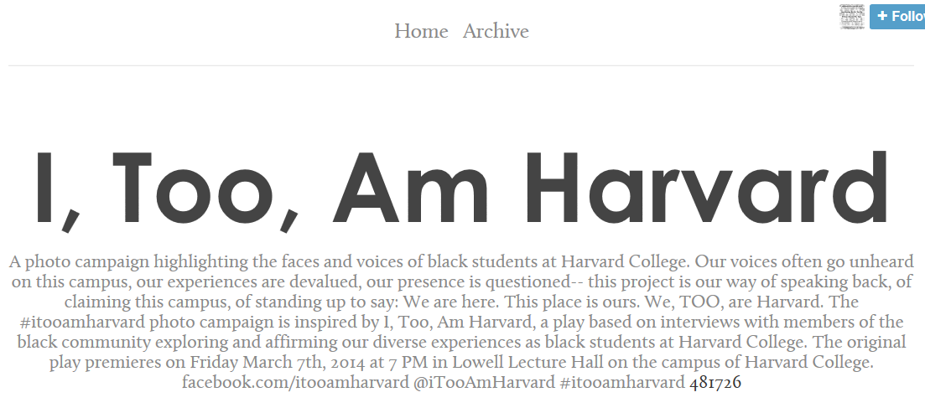
Figure 1: I, Too, Am Harvard Tumblr Description
This description – which is the only purely verbal portion of the entire campaign – is imbued with physical and spatial rhetoric. Notably, the author of this Tumblr might have written that “I, Too” was a photo campaign highlighting the opinion, or the words of black students, or just black students in general. Instead, however, the description reads as, “highlighting the faces and voices of black students,” asserting the primacy of bodies and physicality as meaning-makers in this campaign. These bodies also markedly possess (with possessives) or occupy (with physical verbs) spatial positions: “black students at Harvard college,” “our voices . . . on this campus,” “our presence” “standing up” “We are here,” “This place is ours.” In the one place without pictures, then, the students still remind us rhetorically that bodies can own—that they can have authority over and in spaces- that they can “explore” and “affirm.” With its authoritative tone, this description does more than simply preview the campaign – it acts as a statement of character for the people in the campaign. It suggests that the students are qualified to be where they are, that their experiences are legitimate and deserve to be affirmed. By describing these experiences as both physical and deserving of affirmation, I contend that the description asserts that bodies are an important part of character, complicating notions of ethos which rely more frequently on the words and actions of rhetors.
The video and photographs within the campaign continue to reconceive ethos by affirming minority ethos, this time using a more re-mixed version of verbal, physical, and spatial rhetoric. As I mentioned in the introduction, the methods and responsibilities of Banks’s remix are necessarily connected with those of the DJ-digital-griot figure—a connection which the I, Too participants make clear in both the campaign’s videos and photographs. The participants take on the role of DJ-digital griots in a number of ways I will discuss in a following example. Most notably, I argue, the participants act as the DJ-digital griot by affirming their ethos as unique individuals, while also maintaining an “ethos of commitment to a community” (Banks 24). In addition to using their roles as DJ-digital griots, the participants use disruptive production allowed by the format of the remix (production which defies easy coherence, traditional format, and/or reader expectations) to assert their qualification as students, to legitimize and affirm their identities and character as individuals and community-members, and to claim the ethos of their communities overall.
An extended example will help elucidate my argument. Directly underneath the description of the campaign during the month of its publication (now a few news items appear above it) is the promotional preview video for the campaign created by Harvard student and “I, Too” participant Ahsante Bean. This video can be viewed directly on Tumblr or can be accessed on YouTube (and a sharable link is provided for viewers who wish to pass the video on, in the process enacting the digital griots roles of passing down community stories). The video begins with a blank, black screen, and a voice which states “Blackness to me is faith.” Directly after this statement, the camera turns on, and the viewers sees a close-up image of the face of a black Harvard student – specifically the mouth, chin, and neck of this student. Similar to the earlier description of this campaign which did not reference “black students” but rather the “faces and voices of black students,” this image highlights the lower part of the student’s face, including the mouth from which he will later speak. The specific image of segments of his body (as shown in Figure 2 on the following page) highlights his physicality in a way that showing the whole image of him might not. Over the course of the following seconds, the video will pan out to show his entire body. Before viewers can grapple with him as a person, though, they must grapple more specifically with his body.
The audio in the video then follows up “Blackness to me is faith” with the statement “Having faith in what you don’t see” (0:03). At this point, viewers might suspect that the voice is the voice of the student shown; however, the student’s mouth does not move, disruption reader expectations. The words instead overlap or act as a voice-over to the body, forcing readers to look at his face – including his mouth – as an important and autonomous physical characteristic, rather than as merely a tool or a mouthpiece for a voice or story. The body acts as a form of rhetoric, not subordinate to words or language, but complementary to or complicating to it, producing based on this disruption.
The video then pans out to the student’s whole face, centered on his eyes (see Figure 3), calling to mind questions of visibility. This move parallels his statement, asking audiences to consider what is it that he—or black people—must have faith in? It also implicitly challenges audiences to ask: what is it that we “don’t see” here? What do we see?
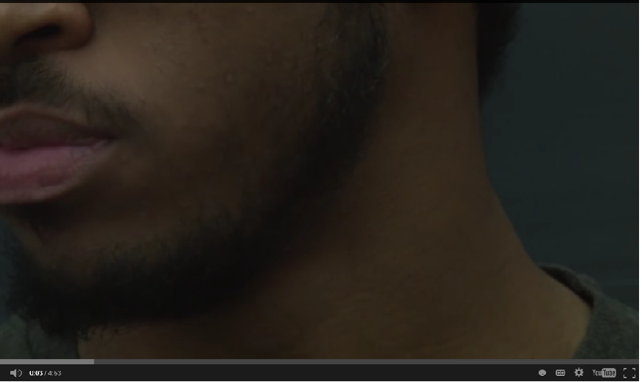
Figure 2: I, Too, Am Harvard Promotional Preview Video, Still 1
What assumptions do we or do we not make about black faces? What assumptions might we have already made based on the body of this student?
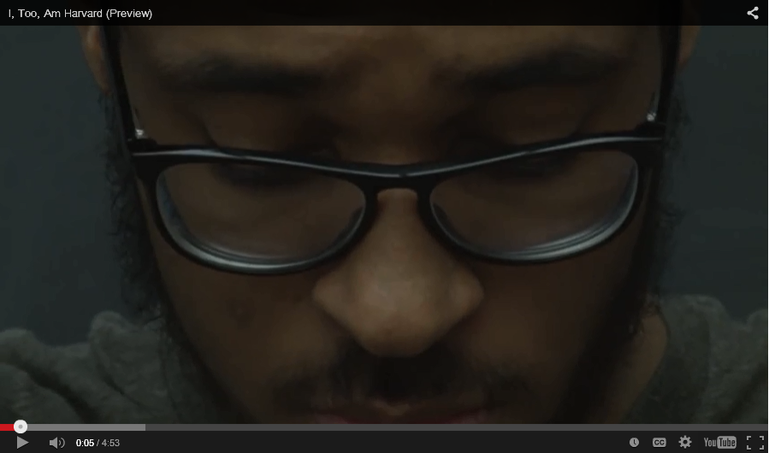
Figure 3: I, Too, Am Harvard Promotional Preview Video, Still 2

The voice in the background then says “because”—asking readers to consider the reasons why blackness might be faith—and then the view expands to the image of the student from the chest up (see Figure 4). The sentence continues, “Because we as a people often don’t see, validation, we don’t see uplifting in the context of mainstream America or even situations like Harvard. So for me it’s having faith that I am significant. I am valid. I am valuable, even though everything else is telling that I’m not (0:09-0:33). During this sentence, the student’s mouth moves, confirming that this student was speaking all along even though his mouth did not move originally. The first time the student’s voice and body work in tandem are when the student begins using the pronoun “I” and asserting his individual ethos.
As the decision to separate voice and body until this point is clearly intentional, I believe it warrants further investigation. The voice and body here form a non-absolute unity of two or more disparate elements. The “disparate” portion of this definition is critical; here, the body and voice/words of the rhetor are not the same, nor is one subsumed as part of another. They are related in as I would call a “non-absolute unity.” To clarify, when I say these elements form a non-absolute unity, I mean that they form a cohesive pair that changes depending on context. When the rhetor is first enacting Banks’s DJ-digital griot role of maintaining an “ethos of commitment to community,” the body signals black embodiment, while the voice places that body in the context of a larger community of “blackness.” The student’s individuality is not in focus here—and thus there is no need for his mouth to be moving. In other words, the voice and body form an implied unity in community here, acting as (autonomous) components that work together to signal a black body’s place in the larger community of “blackness”—or to point to “blackness” as a fleshed, material concept, rather than an abstract one.
The autonomous, or non-absolute, nature of the body and voice is signaled by the way they change based on context; in the next photograph, the voice/words in the video attach to the body as they had not before. This non-absolute unity then asserts the student’s individual ethos – his significance, validity, and value in the context of “mainstream America” and “Harvard.” Notably, however, the commitment to the black community comes before individuality, before America, and before Harvard. In this way,

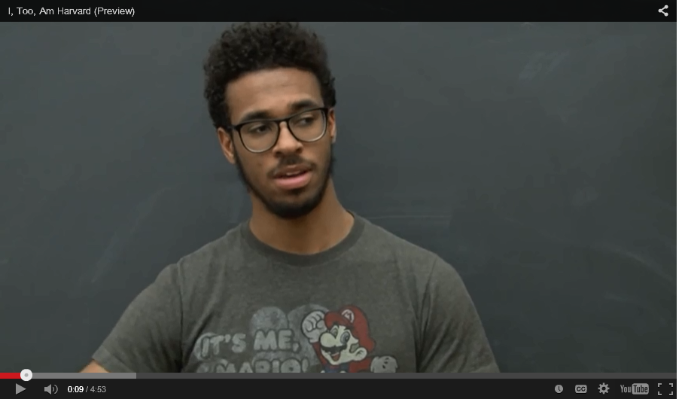
Figure 4: I, Too, Am Harvard Promotional Preview Video, Still 3

the beginning of the video also calls to mind Banks’s concept of the DJ-digital griot. In “digital” manner particularly attuned to the 21st century—a video posted in social media—the participant and Ahsante Bean (videographer) assert “technological skills and abilities” as well as “the ability to employ those skills for the purposes of building community and/or serving communities with which he or she is aligned.” Bean and the participant shown also pass down values in a manner similar to West African griots—particularly here the values of power of self-empowerment, of faith, and of maintaining confidence and asserting validity (not assimilating) in the face of another community (“mainstream America” or “Harvard”) which seeks to challenge it.
The video then expands on power and ethos of knowing and sharing history and faith within the black community. Bean pans away from the first participant to another participant who states, “For me being black means to be interwoven with an immense, difficult, and beautiful history. It means to wake up every day in this brown skin and walk out the door knowing that I am fearfully and wonderfully made” (emphasis mine, italics indicate a biblical reference, Psalm 139:14). While this participant asserts these values, the video cuts to close-up images of the bodies of other Harvard “I, Too” participants, highlighting that the values the participant is sharing are held by other black people, and are particularly attuned to black bodies.
One of the close-up images behind the voice is actually another student whose mouth is moving, but who is clearly speaking different words that we cannot hear. Throughout the video, Bean continues to complicate voice and body unity – disrupting unity by remixing them in several different ways, including:
- The next participant, who describes her experience of being asked “what are you?” The image in the background here is of a different student holding up a sign that states: “‘What are you?’ is NOT a cute introduction” (1:04). The voice heard overlaps the embodied experiences of both students, paralleling the written words on the screen.
- An image of arms – attached to an unseen and unknown student – holding up a poster which says “Nothing in all the world is more dangerous than sincere ignorance and conscientious stupidity” – words which, although they belong to Martin Luther King, Jr., are left unattributed. The only sound that can be heard is of the community of students distantly talking in the background about their classes.
- A message about the difficulty of being the only black student in the classroom, voiced by two participants who complete each other’s sentences, and who once speak in unison.
The remixed nature of the voice and body made possible by the video genre becomes more evidently integrally tied to concepts of community and individual ethos during the conclusion of the video. In the end, a number of students assertively claim authority to be at Harvard—claim stating repeatedly, “I, Too, Am Harvard.”
The students not only affirm their ethos by claiming this authority, but also by asserting a number of other attributes which contribute to their character. Overlapping images appear as different voices claim, “I, too, am innovative, beautiful, creative, fiery, passionate, excited, commanding, intelligent, philosophical, persistent, productive.” The adjective “productive” here – the last adjective in this list – is an intriguing choice to end with. I believe, however, this only emphasizes the messages the video promotes all along: that bodies – particularly black bodies – are not just materials for consuming or storing knowledge, but are producers of knowledge.
While many of the images and rhetoric throughout the video work to build this concluding belief that bodies are productive, one quote in particular grapples with this idea more directly. One participant claims her right to be at Harvard partially because Harvard was “built on the backs of slaves” (3:54-6). The word “backs” here and the connotations of heaviness and weight again emphasizes how materiality should be recognized. The video then closes with an image of a hand in front of a chalkboard in a classroom, on which is written the words “I, Too, am Harvard.” These moments again highlight that bodies and buildings contribute to knowledge – the two forming, again, a non-absolute unity.
In asking important questions about bodies, the quote above as well as the video as a whole also asks what it means to be a body in a context – specifically a body in a space. This promotional video, originally uploaded on March 3, 2014, was later uploaded as a longer (13 minute) documentary dedicated to asking questions about this space. Published on YouTube on June 9, 2014 by the same videographer Ahsante Bean . . . and now advertised in the original promotional video, this documentary is entitled “Constructing Space: A Documentary.” Similar to the beginning of the promotional video, this documentary begins with images of hands, and then the image of a girl writing on a hand (which appears to be the same hand which is shown in the end of the promotional video with the writing “I, Too, am Harvard”). Throughout the documentary, bodies are also emphasized. Unlike the promotional video, bodies are more emphasized as occupying spaces. The video frequently lingers on spaces of Harvard’s campus with bodies walking through them (see Figure 5 and Figure 6).
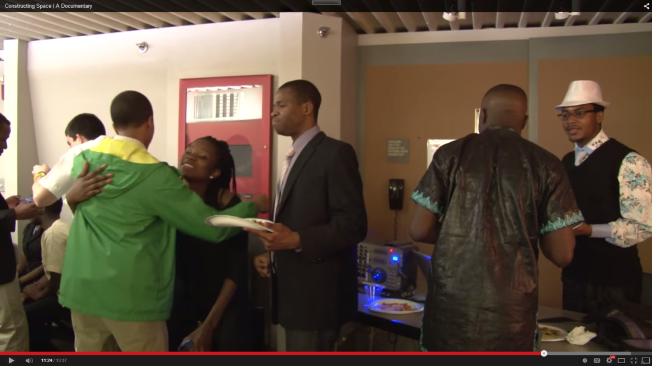
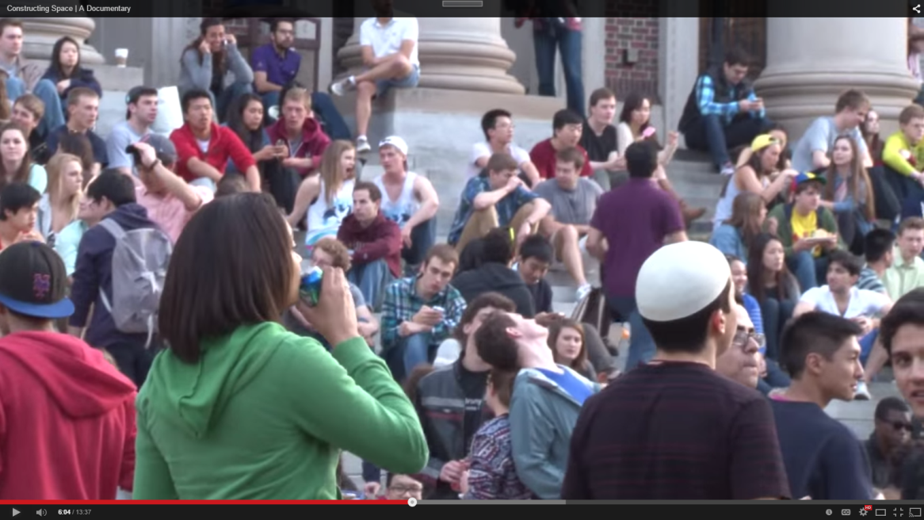
Figure 6: I, Too, Am Harvard Promotional Preview Video, Still 5
Figure 5: I, Too, Am Harvard Promotional Preview Video, Still 4
Many of these spaces are evidently raced, an issue which comes up multiple times within the documentary. One student, for example, who identifies herself as a queer black woman, describes her feelings navigating Harvard as:
I have felt unsafe a lot at this campus . . . I guess for that reason I have avoided a lot of spaces, intellectual spaces as well as cultural spaces, and even social spaces here. And so I have created my own safe space, but it’s very secluded – it’s oftentimes my own room” (~6 min).
Other participants follow, claiming that there are safe spaces for the black community on campus, but they are separate from “normal Harvard” (which the speaker identifies as “Harvard outside of the black community”) (6:21-6:24). This “normal Harvard” includes the classroom, where teachers have even called into question affirmative action policies in derogatory ways which make black students feel unwelcome.
This concept of space is integral to the campaign itself, which began as an idea at Kuumba, Harvard’s diasporic choir. Since its establishment in 1970, this choir has acted as a vital safe space for the black community at Harvard. Each year Kuumba tours across the nation, and concludes this tour with a conversation about race among its members. The year Siskind’s “Affirmative Dissatisfactions” was published, Kuumba members articulated the concerns that had been building inside them for the first time during this conversation. Noting that they had felt unsafe to express their feelings in other spaces, they shared feeling even more unwelcome on campus than before. Founder of “I, Too,” Kimiko Matsuda-Lawrence, admitted constantly wondering if her friends, her classmates, or her teachers were supporters of Siskind’s opinions, or if they too felt she had no “place” at Harvard. She also noted painful moments which arose since the article, such as a stranger on campus turning to her and asking her “Can you read?”. Many students discussed realizing for the first time in this discussion that they were not alone in their isolation or fear, noting the deep and important role Kuumba, as a safe space, had in this realization.
Matsuda-Lawrence developed the idea to conduct interviews with the black community at Harvard from this discussion. These interviews, which centered around the focal question “What is it like to be black in Harvard and in America?” became the basis for the I, Too, Am Harvard Play. Although, due to space and copyright constraints, I do not analyze the play here, it is noteworthy that the play appears to invert the oppressing nature of “normal” Harvard’s space. The backgrounds in the play are mostly bare; the students set the scene with their words and bodies. In other words, the students dictate their surroundings rather than having their surroundings dictate them. The significance of this visual, spatial rhetoric is even more evident within the photograph campaign (originally intended as an advertisement for the play). By nature of the remix, the spaces create meaning in relation to black bodies and black experiences in a context. The elements together expose and challenge raced spaces, asserting the right of black individuals and communities to both disrupt and claim authority within spaces.

The Remix of the Photograph Campaign

“I don’t believe in a biological basis to race, I believe it’s socially constructed, yada yada. That being said, doesn’t mean it’s not real. A building is constructed, it’s still real. Race is still real, it has an impact on people’s lives” – I, Too Participant (Bean; “Constructing Space | A Documentary,” 3:23-3:40).

Like the “I, Too videos,” the photograph campaign treats embodied experience as a legitimate form of knowledge; I would argue, however, that there is more at stake in this treatment in the photographs than in the videos. The photographs enact Banks’s notion of the remix in greater complexity, using remix in such a way that it becomes integral to understanding the campaign overall. The photographs create non-absolute (contextually-defined) unities of elements such as bodies (including skin color, hairstyle, body positions, and facial expressions), verbal (written and typed) rhetoric, chalkboards, white boards, and other material spaces such as walls, doors, and staircases. In some photographs the words contain the heart of the photograph’s message, while in others the words complement, contradict, or otherwise complicate surrounding elements and their meanings. In order to understand many of the photographs, the audience cannot ignore or relegate the importance of the bodies or the placement of bodies in space. The audience must read the students’ bodies and must read them in a particular verbal and material background. Whether or not readers ascribe to this anti-Enlightenment view (which does not subsume the importance of the body under the mind) in theory, they must do so in the practice of reading the text. The rhetors in this way do more than simply present a message to an audience, they force their readers to enact an entire methodological and epistemological viewpoint in reading. Take, for example, Figure 7. Each element of this picture must be read in conjunction with one another for viewers to get the message of the picture. In the process, each element in relation communicates ideas about ethos, offering alternative ideas for who should be seen as authoritative and legitimate and why. I provide a close reading over the following pages to help illustrate this claim.
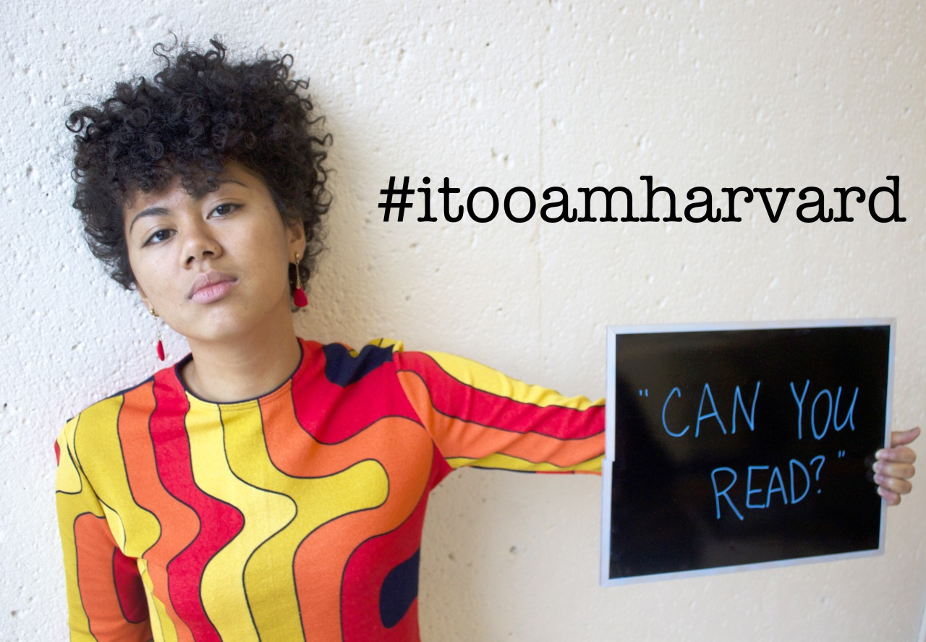
Figure 7: I, Too, Am Harvard Photograph 1`
It is evident upon first viewing this photograph, the words “can you read” do not belong to the participant pictured, Mastuda-Lawrence. The evidence used to create this understanding includes Matsuda-Lawrence’s body and the hashtag. Matsuda-Lawrence’s facial expression asserts that she takes offense at the quote, and thus that the quote was articulated to her not by her. Her skin color, coupled with histories of raced literacy laws and racist perspectives of black academic ability, forces readers to consider that the statement might have been made because of her race. The hashtag solidifies this reading, aligning Matsuda-Lawrence to the campaign that asserts her ethos as a qualified, learned student at Harvard who is treated different because of her race. In conjunction with the implied reference to race and literacy laws/perspectives, she also asserts the ethos of her black community. Blackness is represented in color here with the black hashtag and the black chalkboard disrupting the white background space.
The links between blackness and digital literacy and blackness and educational roles form a significant message in this remix. The disruption of the hashtag in particular points to the type of DJ-digital-griot role that Banks calls for in his work. Banks argues that blackness and digital literacy must go hand-in-hand if education wants to work toward a model of equality. To justify this call, he underscores that “technology and education collide with and exacerbate long-standing inequalities to such an extent that we must rethink old narratives to have any chance at addressing either our old problems or the new ones that will compound them” (5). As such, Banks claims that:
Any attempt to foster meaningful access to communication technologies or to a working education system must include theoretical frameworks or conceptual models that build from the traditions and truths of a people and assume their agency and ability. Black people must see themselves in the digital story (5).
Matsuda-Lawrence’s hashtag (and photograph on Tumblr) enacts Banks’s methodology, disrupting and moving past the non-digital white space in a digital way which builds from her black identity. Both the color of the hashtag and the meaning of the hashtag as explained before assert her “agency and ability” and her place with within “the digital story” as a black person. Her raced digital literacy and agency provide a direct contrast with the assumed raced illiteracy in the quote in the chalkboard – a chalkboard that is notably black but framed in a white frame which structures and contains it.
As is the nature of the remix that defies western metaphysical dualism, the elements do not form exact binaries, however. The black chalkboard still works to disrupt white space even when contained within a white framework. More notably, Matsuda-Lawrence’s clothing and the quote productively disrupt both the white space as well as the black-white binary operating in the rest of the picture. The colors of Matsuda-Lawrence’s clothing paint her as more complex than simply a black body in a white space. Interestingly, Matsuda-Lawrence is actually half-black and half-Japanese, although as she says, everyone always assumes she is black. Here Matsuda-Lawrence is both black and Japanese; both individual and community; black, yellow, orange, and red – a whole and multiplicity. She is also holding blue words which she has written onto the chalkboard, claiming agency over color, choosing to dictate the color of the picture rather than be dictated by color.
One more significant element works to portray Matsuda-Lawrence as both a part of her community (paired with the hashtag) and an individual (paired with her clothes to make an individual style)—her hair. Matsuda-Lawrence’s hair is free of chemical relaxers and, as such, is in defiance of the Euro-American female ideal of straight hair. The hair represents more than a mere aesthetic choice, it is a political statement asserting both the beauty and power of black hairstyle in the face of regulations on hair which have been placed in many institutions throughout time, such as the army, universities, private companies, and elsewhere. In styling her hair in this manner, Matsuda-Lawrence makes a statement that she will not allow her physicality to be regulated, and that her style contributes to and is a part of her authority in university spaces, rather than a detriment to it. Her style contributes to her legitimacy both as an individual and member of the black community, while validating and authorizing black style, and thus the black community overall.
Each of the messages articulated in this photograph communicate messages about ethos. The chalkboard and hashtag, combined with Matsuda-Lawrence’s skin color and facial expression and the colors of the photograph, challenge prejudiced ideas about black literate abilities and portray a future where black digital literacy is a legitimate part of the foundation of the university. The colors of Matsuda-Lawrence’s clothes and the quote she writes break down a binary structure, suggesting that authority need not be an either/or situation (both minorities and white students can have it) and challenging the essentialism that binaries can produce. Finally, Matsuda-Lawrence’s hair in conjunction with the other elements such as the hashtag suggest that black style is legitimate, and that acknowledging and embracing one’s race (specifically blackness here) is not a detriment to ethos but an integral component of it. All of these elements together depict black students and communities as agential and able, embodying ethos.
At the same time that the elements affirm the ethos of minorities, the elements in the photograph adapt what counts as ethos-building. Because the elements make meaning in relation, the photograph relies on the remix. In order to understand the photograph, viewers must enact an epistemology and methodology of reading where bodies, materials, spaces, and colors as legitimate sites for knowledge-production.
In addition, viewers must also place themselves at least temporarily in Matsuda-Lawrence’s situation. They must enact belief in her racist experiences in order to understand the messages she is trying to convey. In this process, viewers must believe the participant has ethos, they must read her as having the authority and legitimacy to make her claims in order to understand the claims. The epistemology and methodology of the remix in this way not only adapts ethos, but also forces readers to practice believing in this adapted ethos.
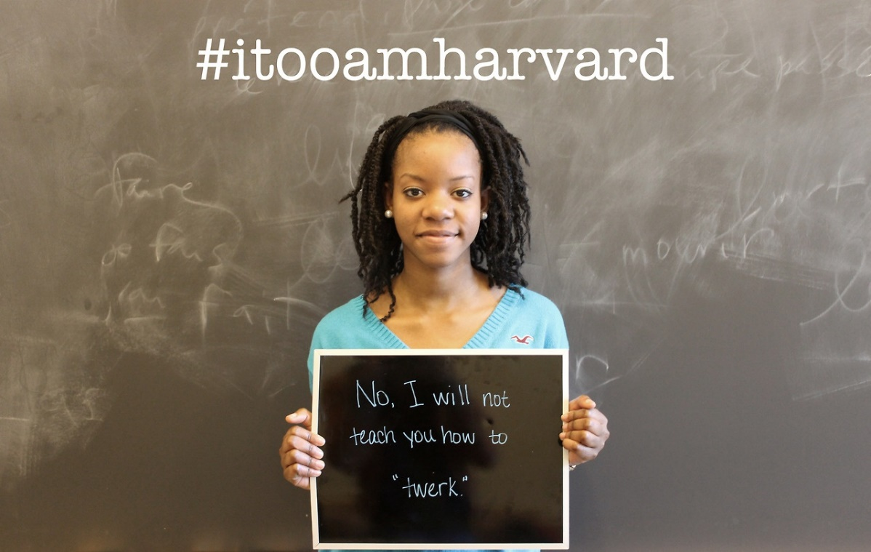
Each photograph within the campaign works to communicate similar, though distinct messages about ethos through the format of the remix, forming a unity in multiplicity just as Matsuda-Lawrence does in the photograph above. Take for example, Figure 8. Verbal (both written and digital), embodied, spatial, and material elements all create meanings-in-relation here as well. Like the other photograph, this one uses the remix to portray both individual and community authority and character and to break
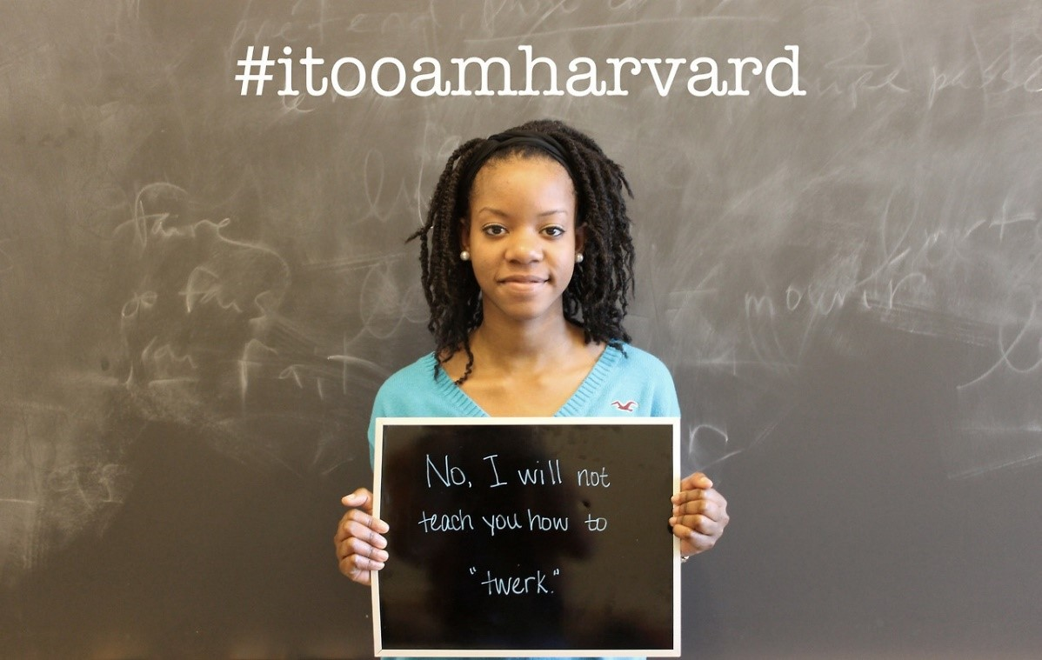
Figure 8: I, Too, Am Harvard Photograph 2
down simplistic binaries. This photograph also addresses raced perspectives on literacy and education. The photo highlights different aspects of structural racism, however, playing with spatial and verbal elements to both trouble expected roles of teacher and student as well as call into question the type of knowledge that the university privileges.
To begin with, the chalkboard functions in relation to the participant to question or challenge both the participant’s ethos and the way ethos overall is constructed. At first glance, the context and placement of quotations communicates that the phrase, “No, I will not teach you how to ‘twerk’” is this student’s response to someone (either directly or implicitly) asking her for this lesson. The elements at play in the photograph complicate this rhetorical situation, however, breaking down the simple questioning rhetor/answering rhetor binary. The student’s body does not contrast with the words as it did in Figure 7; whereas in Figure 7, Matsuda-Lawrence’s body formed an opposition against an implied rhetor’s words, this student’s body forms a different unity with the words in this context. Figure 8 showcases a body and words which both belong to the rhetor. Included in the words of the rhetor (the words on the chalkboard she is holding) is the quoted word “twerk.” The quotes function semi-ambiguously, calling attention to the concept of twerking perhaps to note that twerking is a concept which needs unpacking or perhaps to implicate the words of an implied questioner. I read the quote as functioning both ways, and claim that the ambiguity may be the point. In other words, I see the quote functioning as a unity in multiplicity. There is a productive tension happening here.
Culturally, twerk is considered to have been born out of a combination of the words “work” or “jerk” (with Caribbean associations) and “twist” or “twitch” (Lynch). Stemming from New Orleans bounce music in the 90s, the term twerk was popularized by femcee Cheeky Blakk and DJ Jubilee (talk about a connection with the DJ-digital griot!) and later attained additional significance among artists such as the Ying Yang Twins, Beyonce, and (among white audiences, many of whom are unfamiliar with its roots) Miley Cyrus (Graham; Lynch; Mbakwe; Wiggins). Popular arguments link this form of dance to more African or diasporic roots, such as Mapouka from Cote D’Ivoire or Carribean winding (Mbakwe; Monhanam).These popular arguments depict twerking with varying sexual associations – some focusing on the dance as simply a natural form of movement women enjoy doing regardless of audiences (Mbakwe) and some seeing the dance as intended to attract a partner (Wiggins). The sexual associations range from nonexistent (Mbakwe) to healthy to derogatory, and for some are considered political in nature, representing an embrace of black (generally female) bodies in resistance to regulation, assimilation, or hyper-sexualizing critics and audiences (Narayan).
In another reading, “twerk” also functions as a derogatory reduction of what black students, specifically female students, might offer or teach. It is reductive in reducing the participant to a teacher only of concepts such as the dance, in reducing the dance to its provocative or sexual aspects, and by extension in reducing the black woman’s identity to a sexual one.
“Twerk” functions as all of these things. The concept makes the participant a teacher, a student, a questioner, and a replier; it marks her as invalid because she is back and at the same time legitimates her identity as black. Most importantly, it asks readers to question what gives a person authority, or what cultivates ethos, suggesting that this ethos might be built on unjust or unexamined principles. In conjunction with the hashtag “I, Too, Am Harvard” (which asserts the participant’s legitimate role in the university and the digital future of the university) and with the body’s position in front of the classroom as a teacher, the picture also suggests that the student has ethos—viewers might just need to change their understanding of what can contribute to ethos in order to see this.
The quote in the chalkboard also points to the question of what gets taught in the university, a question which is further examined in the remix of the quote, the body, and the space of the French classroom. Viewers might assume that the French classroom in the background is one in which students learn European French, rather than the French of other francophone places, Cajun French, or other nonstandard dialects. I argue that viewers might assume this language because the hashtag indicates that the student goes to Harvard, an institution which prides itself on its culturally and academically elite status. European French holds the most social, symbolic, and cultural capital, and as such would represent the right “type” of knowledge to be taught in the Harvard environment. Because European French was a colonial/colonizing language, this French classroom would also be stereotypically considered a “white” space.
The rhetor works to redefine this space by standing as teacher would at the front of the classroom—also holding a chalkboard she has written on for her audience (who, if we imagine the image extending, would be students). The juxtaposition of this teacher of an esteemed language with the words “No I will not teach you how to twerk” emphasizes the politics of space. Her stance as a teacher and the words on the chalkboard she holds illuminate the idea that society places her in the role of teacher only stereotypically black concepts. She chooses to defy this role, however, by standing in the EuroWestern French classroom. Implicitly, the rhetor is then arguing for her right to exist not just as Harvard but in spaces which are traditionally considered white. As a teacher who does not deny her blackness—but instead embraces the comment (literally, in the photograph), this participant cannot be seen as simply wishing to have authority in a white space. In standing here, she also breaks down the association of white with this space.
This French is not necessarily European, however, which raises other questions about knowledge circulation in the university. Francophone countries are numerous and many are populated by people of color. In fact, the continent with the most French speakers is Africa. While this correlation is due to colonization, the fact that French arrived in many of these places as a colonial language does not discount the ability of persons of color to claim ownership of French—particularly the dialects of French specific to regions populated by people of color. If the curriculum of this class includes non-European French, particularly if it addresses French spoken in Africa or the Caribbean, the relationship between the message “No, I will not teach you how to ‘twerk,’” and the participant changes. In one sense the words and body align more closely since twerking has African and Carribbean roots. Yet they perhaps also contrast again, illustrating how the participant’s vast knowledge and the lessons that non-European classrooms can offer are reduced to a recently-popularized in mainstream media and largely misunderstood.
The photograph thus poses significant questions about ethos and knowledge in the university—what French is taught in this space and why? What is at stake—not simply for the institution, but for students who attend the institution—in the decision to teach certain types of French? Which subjects build one’s authority and which do not? Who is allowed to be an authority/teacher and in what context?
The specific French words on the large chalkboard board in contrast with the words on the smaller chalkboard extend these questions of knowledge and authority to include questions of character. Notably the French words on the chalkboard are imprints left over after erasure. In line with this idea, one of the erased words is “passé,” a French word which means “past.” French is by no means an erased language; the past here might associate with French through the link of tradition. French has a long past which aids its status at the university which privileges tradition. In contrast, “twerking”—what this rhetor is deemed worth teaching is clearly readable and newly written. Twerking might be adequately contrasted with tradition and past as its official beginning is attributed to New Orleans bounce in the 1990s. If so, the rhetor is writing modernity into the picture here—giving it a place within the university along with the past. Her story, the experience she has, and her body are a part of the university as much as the tradition is. This reading, however, would have to ignore the cultural histories from which twerking developed. Those histories destroy a solid binary, forcing readers to consider that tradition is EuroWestern only because we have made it that way. I argue that the binary is destroyed in this picture, not only because of cultural histories, but also because of the literal body of the I, Too participant. The rhetor destroys this binary by standing directly in the middle of it.
The words on the chalkboard also suggest that ethos is built by more than just knowledge and authority, that the concept involves character and ethics as well. The only other words which are legible on the chalkboard are forms of the word “to do” or “to make” (faire) on one side and “to die” (mourir) and “strong” (fort) on the other. Intriguingly, one of the forms of faire appears to be “de fait” which means “de facto.” “De facto” means “in reality” or “in actual existence,” and is used “frequently [in] oppos[ition] to de jure,” which means “according to law” (OED, de, 3a; OED, de, 5). As such, the phrase de facto calls into question what it is that people do in actual practice without force/duress of the law. In the context of a campaign about black students’ right to be at Harvard, the phrase conjures notions of school segregation. While Harvard is certainly integrated de jure, with law asserting the right of black students to attend, the photograph and campaign suggest that Harvard still contains de facto segregation, or segregation in actual practice. This tension between reality and law is ethically provocative. With the other words on the chalkboard, the photo asks readers what it is that we “make” or “do” (faire) perhaps even what we would have the strength (fort) to “die” (mort) to do. My relations between these words are, of course, only a hypothesis, but I do not believe it is a stretch to associate strength, practice, segregation, and even death. In continuing civil rights movements, in an era of The New Jim Crow as Michelle Alexander calls it in her book, progress depends as it always has on people having the strength to act on, resist, and fight segregation and the racism it stems from (to the death, if that’s what it takes). With or without these associations though, these words raise questions of character and ethics: What does one do in actual practice either against the law or irrelevant to it? For what is one strong? For what might one die? The teacher-participant is positioned at the front of the classroom to help teach her audience, to guide her audience through these ethical issues. She is positioned as Banks’s digital-griot, a figure with awareness of the ethical questions and commitments involved in being a member of a community. Her position as teacher establishes her ethos and her role as a teacher-digital-griot establishes her ethos within the black community. This position and role combined by extension also help to affirm the ethos of the black community.
The two photographs I outlined illustrate the campaign more broadly. Like the other photographs, these two remix written, digital, material, embodied, and contextual rhetorics, often placing multiple and contrasting elements side-by-side in order to push back on, question, and adapt conceptions of ethos. The photographs also represent the larger campaign in consistently affirming the ethos of the participants and their communities using these adapted notions. Finally, the photographs address repeated themes of “I, Too,” exhibiting the DJ-digital griot’s “awareness of the layered ethical commitments and questions involved in serving any community,” and challenging who has the right to attend the university, who has the authority or legitimacy to teach there, and what types of knowledge should be taught within the university (Banks 26).

Chapter Summary
In this chapter, I examined the way the I, Too campaign adapts the concept of ethos and asserts the ethos of black students and communities. I looked specifically at the way that the description, the promotional video, and two representative photographs in the campaign remixed elements in order to claim or reclaim spaces, to raise ethical questions, and to assert the legitimacy of bodies in contexts. I argued that these portions of the campaign relied on epistemologies and methodologies of the remix, a form attuned to and embraced by black theorists in the 21st century. In relying on these, I claimed that the campaign not only suggests new perspectives on ethos through its content, but also through form, forcing readers to practice these new perspectives by reading bodies and their (con)texts as legitimate sites for knowledge. In this chapter, I have thus shown the ways in which the I, Too campaign bridged virtual discursive rhetoric with embodied and material rhetoric in a manner particularly attuned to 21st century theory. I have shown what is at stake in choosing to embrace acknowledging bodies and spaces for black students.
In the following chapter, I explore the digital nature of the campaign further by analyzing the role of social media in the campaign. In this chapter, I make no argument about whether or not social media is effective overall. As Paulo Gerbaudo writes in Tweets and the Streets, “rather than being concerned merely with the efficiency or otherwise of different communication technologies, I pay attention to what activists actually do with them, to the concrete and local ‘media practices’ (Couldry, 2004) activists develop in their use” (9). Specifically, I contrast Tony Scott and Nancy Welch’s valid reading of the Kony 2012 campaign and my reading of I, Too to show how I, Too uses social media to empower by challenging dominant paradigms, committing to minority values, and working to make lasting change for minority groups. I argue that this analysis is work is important in light of contemporary calls for digital and inclusive work in the university.

CHAPTER 2

Social Media and I, Too: Principles of Continuity and Commitment

“Our project was inspired by the recent ‘I, too, am Harvard’ initiative. The Harvard project resonated with a sense of communal disaffection that students of colour at Oxford have with the University. The sharing of the Buzzfeed article ‘I, too, am Harvard’ on the online Oxford based race forum, ‘Skin Deep’ led to students quickly self organising a photoshoot within the same week. A message that was consistently reaffirmed throughout the day was that students in their daily encounters at Oxford are made to feel different and Othered from the Oxford community. Hopefully this project will demonstrate that despite there being a greater number of students of colour studying at Oxford now than there has ever been before, there are still issues that need to be discussed. In participating in ‘I, Too, Am Oxford,’ students of colour are demanding that a discussion on race be taken seriously and that real institutional change occur” (I, Too, Am Oxford Tumblr).

“Taken as inspiration from the #itooamharvard movement, #itooamOSU was and is a movement to raise awareness surrounding issues of racism on campus” (I, Too, Am OSU Facebook Page).
“Following the ‘I, Too, Am Harvard’ initiative, the “I, Too, Am Cambridge” campaign aims to highlight incidences of discrimination and stereotyping that occur within Cambridge University. We hope that this will provoke wider discussion and necessary change. The BME Committee decided to name the Tumblr “We, Too, Are Cambridge” to emphasise not only the collective experiences of BME students, but also to highlight the widespread support from the general student body. Change can only be accomplished if we work together. The CUSU Black and Ethnic Minority Campaign is an autonomous platform that exists to voice the concerns of students who feel they are discriminated against due to their culture or beliefs. The term “black” describes the colour of our politics, rather than skin” (We, Too, Are Cambridge Tumblr Page).
On March 3, 2014, just two days after I, Too, Am Harvard posted their photograph campaign, the Tumblr page with the photographs had been viewed over 19,000 times and multiple schools had contacted Harvard for advice on beginning their own campaign (Vingiano). In an interview with Buzzfeed about this widespread movement, “I, Too, Am Harvard” founder Matsuda-Lawrence stated, “‘We’re part of a nationwide movement of black student activism . . .We haven’t started this, but we’re hoping we can add to the movement and speak up against racism on college campuses’” (Vingiano, par. 11).
I find Matsuda-Lawrence’s claim, “We haven’t started this” particularly fitting as a description for why this campaign is effective. What Matsuda-Lawrence and the others of I, Too envisioned was not a photograph movement, nor the conference or other events that came from the photograph movement. As such, the quote captures how I, Too attained a life of its own outside of its inception as an advertisement for the play, one connected to other activist movements which have come before.
In chapter one, I examined the beginning of this photograph movement, detailing how the campaign operates on its own rather than as an advertisement. I underscored the stakes of the campaign, showing how the campaign restructured higher education’s theories of knowledge, particularly its theory of ethos. My argument for this thesis was that I, Too successfully bridged discursive action with embodied activism in an empowering manner particularly attuned to the available resources in the twenty-first century. In chapter one, I examined a part of this bridge by looking at how the twenty-first century theories, principles, and formats of the remix allowed I, Too participants to remix discourse, embodiment, and (con)text rhetorically on online media.
In this chapter, I further my claim that I, Too uses twenty-first century resources to empower minority populations. I argue here that I, Too participants use social media specifically to empower minorities by challenging dominant paradigms. I claim that the participants do this by asserting the ethos of past activists and community members and their values—maintaining ethical roots—while also building on these roots for progress. I claim that the campaign works outside of dominant paradigms by grounding itself in minority histories and communities, but does so using the contemporary resource of social media, thereby bringing minorities into the digital story. In addition to being ethically rooted, I argue that the campaign is flexible and adaptive enough to be picked up and continued by additional universities, and thus to gain the momentum it might need to make a lasting change.
Before describing how the campaign seeks to empower, critique, and form lasting change, however, however, I want to briefly reiterate the importance of the campaign using digital spaces to do so. As I noted in chapter one, Adam Banks argues throughout his book Digital Griots that differing access to technologies and technological literacies throughout history has helped to constitute a divide between the empowered and disempowered. As such, Banks claims that in order for higher education institutions to become inclusive, these institutions must allow “black people [to] . . . see themselves in the digital story” (5). In his 2015 Chair’s Address to the Conference of College Composition and Communication, Banks also argues that composition pedagogy needs to begin to utilize technology “as composing [in society overall] becomes more and more enmeshed in digital environments” (NCTE 23:35-23:38):
as we become more and more enmeshed in the matrix, into digital tools, environments, practices, and networks, we need to see this as a crossroads moment for our scholarship too. That crossroads, for me, is one where we see that we have to embrace technology issues not just as a part of what we do, but central to what we do. Technology needs to be what we do, not just because literacy has always been technologized, not just because of Computers AND Composition, but because of the big picture technological issues that are always brought to bear on all facets of our lives and work” (NCTE 23:39-24:23).
In the July, 2014 edition of College English, Steve Parks also makes a claim about the need for the university to utilize contemporary resources to effect change. Parks seeks a political turn in English studies, and asserts that one way the field of English as well as Rhetoric and Composition can achieve this shift is by using community resources that are already in place in our society to produce change. Parks suggests that scholars should think on a broader, national scale about how we might channel currently existing resources to shape the world as we desire to see it.
Although neither Banks nor Parks explicitly address social media, by calling for a channeling of existing resources, they both open the door for substantial work with and inquiry into the use of social media to effect change. As social media provides a space for social, cultural, or political minorities to gather in order to change the nature of minority discourse as well as plan collective action, social media might in fact be the best community resource available for political change. In addition, much of current composition takes place on social media. Analysis and use of social media is thus significant for the purposes of both activism and for the university, concepts that Banks, Parks, and the I, Too participants envision as going hand-in-hand.
Calls for the use of social media are, however, highly contested. Much of the scholarship that exists on social media emphasizes the concerns of social media rather than the potential of it. In their 2011 study in Communication Research, for example, Lim and Golan note the benefits of online media, but do so in passing and as a way to introduce the complications of online media production, claiming,
while the online user’s political engagement holds great potential for democratization of political content production and distribution, it also poses many challenges and risks affiliated with unethical practices and political misinformation . . . [and] while the incorporation of user-generated videos into public discourse may contribute to the democratization process, some scholars have pointed out issues related to the mass distribution of political disinformation (711-12).
Lim and Golan do note (referencing Youn, Faber, and Shah) that the effects of advertising media “might be built on ‘unconfirmed fears of media influence rather than the actual impact of media” (713). The authors do not apply this note to social media, however, perhaps because social media is not the primary focus of the research study or perhaps because they define “social media activism” in a limited way, as “an individual’s rectifying behaviors” or corrective activism (i.e. posting or commenting with a political intent in response to an already existing event). To their credit, they acknowledge this portrait as a “key limitation” of their study (724).
Many other works convey similar concerns ranging from the worry that “diffusion of digital media does not always have democratic consequences” (Pearce and Kendzior, 2012) to the assertion that social media activism is for slackers (“slacktivism”). Finally, in the 2014 edition of College English, Tony Scott and Nancy Welch argue that social media might detract focus from critical concerns, noting how Kony 2012 (a campaign which I describe in more detail later in the chapter) seemed to garner more attention due to its nature as an internet video than to its addressing significant, political concerns. Scott and Welch also describe the misinformation perpetuated by the Kony event due to the outdated nature of the videos broadcasted. The authors also note other issues, such as a lack of emphasis on bodies and materials, which arise with composition on social media.
While recognizing the concerns and critiques of each of these articles as legitimate, I offer that the critiques are more valid for the individual campaigns each scholar addresses than for social media campaigns overall. Each campaign studied is unique and contributes only a small (yet significant) amount to analyzing such a new and complex genre. In light of the prevalence of composition on social media sites, and Banks and Parks’s calls for higher education institutions to become more inclusive and more attuned to contemporary resources, I do not believe social media can or should be dismissed. Rather, I argue, writers and critics alike need to consider the ways in which social media might work to reinforce structures of oppression or to uproot them.
Part of my project in this chapter is to chart how social media work can only help empower minorities if it works against, rather than within dominant Western paradigms, and how I, Too takes on this challenging work. In doing so, I argue that social media activism cannot be determined to be successful or unsuccessful simply by virtue of being on social media. I do not argue that the effectiveness of the I, Too campaign or ineffectiveness of the Kony 2012 campaign that Scott and Welch point out is necessarily determined by its technology; I do not wish to be that techno-deterministic. To attribute the effects of these to social media would be to ignore that the issues of race are complex, rooted, and continuing—an attribution that would work against the main point I am trying to make in this chapter. Rather, I argue that writers and critics of social media alike must consider that for minorities to become a part of the digital story, the digital story must make room for minorities by building off of the histories and values of marginalized peoples as much as those of people in power.
In this chapter, I read the I, Too and Kony 2012 campaigns side-by-side, charting how Kony 2012 works within dominant frameworks and how I, Too works against these, and as such, how Kony does not accomplish the same level of empowerment as I, Too. In this reading, I underscore that I, Too works against paradigms primarily by valuing community roots. Notably, I do not see community commitment as the only necessary factor for social media campaigns to be empowering, however. In order for campaigns to last, I recognize they must also spread and gain momentum. As such, the other part of my project in this chapter is to note how I, Too takes on the work of minority empowerment by looking both forward and backward, by being flexible enough to be picked up and continued by others and also rooted enough in community to make lasting change. As such, I look at how the campaign writes itself into a narrative of continuity from the past and into the future, never claiming to “start” activism nor to end it, but rather only to “add to the movement,” as Matsuda-Lawrence so aptly describes.
I take on this reading using five categories of analysis that I created, categories which I believe are useful for illuminating how digital work may either reinforce or challenge oppression. I offer these categories as useful not just for scholars analyzing activist campaigns, but also for academics to consider when asking students and scholars to take on digital, inclusive work. These categories are mechanisms and goals of composition, bodies in composition, choreography of composition, how composition bridges discourse with bodies and physical spaces, and kairos. I argue that each of these five factors contribute to making I, Too a more empowering campaign, one that works for lasting change and is continuing yet rooted in community.
A clarification: I am not interested here in classifying Kony 2012 as a problematic campaign. Many authors, including Scott and Welch, have already done this work well. Rather, I examine Kony 2012 alongside I, Too because I believe that Kony exhibits the same issues that Spivak critiques (as I mentioned in my introduction) about intellectual pursuits—it seeks to empower minorities, but only within frameworks that ultimately disallow this empowerment. I seek to show the difference in consequence between digital work done within frameworks that do not allow for commitment to minority communities or lasting change within these communities and digital work that works against frameworks and thus allows for committed work and lasting change. I believe that a reading of Kony alongside I, Too illuminates the implications of this difference.

Brief Description and Comparisons: Kony 2012 and “I, Too”
For those unfamiliar with Kony 2012 or Scott and Welch’s analysis of it, I will first give a brief description of the campaign. Scott and Welch begin their analysis of Kony 2012 in “One Train Can Hide Another: Critical Materialism for Public Composition” by explaining the failure of the event which began the Kony 2012 campaign – a thirty-minute video. Created by a United States charity entitled Invisible Children, this video asked the U.S. to intervene in the affairs of Uganda and capture Uganda’s corrupt warlord, Joseph Kony. Kony. Because this video became the “most rapidly disseminated human rights video ever” (Gregory qtd. in Scott and Welch 562), many believed that Kony 2012 could provide a “‘gateway moment” for young activists” (Tufekci, qtd in Scott and Welch 564) which might prompt political transparency and “inquiry into the ‘bigger questions’” of activism and political responsibility (Scott and Welch (564).
As Scott and Welch point out, however, fraught with “gross factual distortions,” tropes of the “white man’s burden” and a focus on genre and style over political substance, this video never lived up to such hopes (563). In addition to this failure, and perhaps in part because of the discourse generated around the failure rather than the video itself, Scott and Welch argue that the video actually obscured more troubling realities, such as the United States’s potential desire to intervene in Africa for the region’s resources and the “well-heeled salaries and travel budgets” of the principals of Invisible Children who generated “the commodification of activism” by following up the video with “Stop Kony” action kits (564).

Comparison One: Mechanisms and Goals of Composition
While the Kony 2012 campaign had numerous problems, I posit that part of the of the issue with what many considered the failure of Kony 2012 stems from the way the mechanisms and goals of the campaign were formulated. Those such as Sam Gregory of “the global video advocacy organization Witness” who claimed that the video “enabl[ed] us now to have a conversation on some of the bigger issues” helped define Kony 2012’s activism as one based on the spread of information (Gregory qtd. in Scott and Welch 564). In other words, the main mechanism for spreading activism for the Kony campaign was information dissemination. This information was then supposed to lead to an increased amount of people engaging in “in-the-streets” action on April 20th 2012, when Invisible Children asked the public to “cover the night” with posters, stickers, and other texts that arguing for Joseph Kony to be stopped (Scott and Welch 565).
The issue with Kony’s attempt to empower minorities by spreading information and mobilizing for action, I argue, is that these mechanisms worked within a hegemonic framework. These mechanisms were not rooted in or committed to the principles of the community the campaign sought to help, nor were they conceived of in a way that would create a lasting effect. The primary information spread—the video—was written by white men with no experiential knowledge of the communities they wrote about. The mobilization was more in line with Western capitalism than attuned to the realities of problems in Uganda; Invisible Children asked people to mobilize through commodities, persuading people to help by buying stickers and/or an action kit. In addition, this mobilization had no built in continuity; the creators of the campaign it was always built to begin and end on one night—April 20th, 2012.
Additionally preventing the campaign from achieving continuity were the ill-defined goals which Invisible Children sought to attain through the mechanisms of information dissemination and mobilized action. Given the changes being made in American political policy on Ugandan intervention at the time and pledges made on YouTube by senators after the video, Invisible Children might have been successful at perhaps its original goal—“to secure audience allegiance for policy already being pursued” or gain “passive acceptance” (Scott and Welch 565). Part of the reason for the public-deemed failure of this campaign, then, stems from the fact that the “activism” sought by the Kony 2012 creators and “activism” sought by the public were defined differently, with the public deemed-definition already perhaps doomed to failure. Both the creators and public notably conceived of this activism as etic, masking another troubling reality of the Kony campaign – that had the Ugandan people spoken for themselves, they might have portrayed themselves differently and asked for a different outcome. With two different activist goals, both abstracted from any separate goals that people in Uganda with experiential knowledge might have, the campaign was formulated in a way that could not achieve substantive activist success, let alone define it.
Unlike Kony, I, Too was conceived from the ground-up rather than top-down; as such, I, Too was more able to use mechanisms to achieve goals that are rooted in community and lasting. Those who experience the struggles of the campaign firsthand are the ones who create mechanisms and set the goals for the I, Too campaign. Many of the goals for activism are clearly stated from the beginning; in the description on I, Too, Am Harvard’s Tumblr page, the students state that the campaign is meant for “highlighting the faces and voices of black students,” “speaking back,” “claiming this campus, “standing up to say: We are here. This place is ours,” and “exploring and affirming our diverse experiences as black students at Harvard,” as well as, of course, to garner awareness for the I, Too play. I claim that the campaign succeeds at these goals of activism partially because the creators make their goals explicit. Anyone wishing to participate in the campaign knows the goals of participation and how to contribute to them to help the campaign achieve continuity.
In addition, I, Too uses mechanisms which intertwine with its goals to work more successfully for the campaign. The goals of I, Too do not call for “passive acceptance” of spreading information, but rather a spreading and “exploring” and “affirming” of experiences, or a “speaking back” (itooamharvard). As such, I, Too retains an ethical commitment to the values and experiences of minority communities and the authority these minority students have. The pictures in I, Too assert and affirm the rights of and personal and political stances, as well as the voices and bodies of the disempowered people.
This assertion and affirmation of minority voices and bodies is built into the framework of the campaign in such a way that it allows others to pick up the campaign and continue it (although notably in limited ways by limited people, a significance of the genre that I address later). The posting of this campaign on Tumblr allows for reblogging of individual photographs by Tumblr users. This reblogging can take the form of identical duplication, which would express and affirm the lived experience of the person in the photograph/the photograph itself, and duplication with additional commentary, again allowing for this validation. As students at other universities began to create their own campaigns mirrored after the original campaign yet tailored to their university needs (which I will later show), the campaign also provides a framework that allowed students across the nation to continue the campaign in a way would make it lasting. Each individual as well as each university community could post the campaign according to its own principles, yet still had to use the framework of (and thus pay homage to) the original campaign. In addition to being rooted in an I, Too community, this original campaign by nature was also rooted in the minority communities as it was created by and for them.
The organization of the Harvard’s I, Too campaign also allowed for and promoted continuing activism. After attaining a viewership, I, Too, Am Harvard included additional posts on their Tumblr page not only promoting the I, Too play (as they had originally), but also asking for question submissions as the Harvard team was invited to a Q&A with President Obama and inviting viewers to attend a conference hosted by the group with additional detail on a website to which Tumblr links. Subsequent I, Too campaigns hosted by other universities often also ask members to join a cause, providing information about events in support of this cause. New Zealand’s University of Auckland, for instance, has a group entitled “I, Too, Am Auckland,” who hosts workshops, panels, and guest speaker lectures, and promotes them on their I, Too Facebook page alongside online readings and videos and their photograph campaign. The University of Southern California’s “I, Too, Am USC” Facebook page similarly promotes and mobilizes members for events they host regarding genre, sexuality, culture, religion, homelessness, labeling, and race. A host of other campaigns follow this same pattern, asking members not only to “post your story/experience!” (Carnegie Mellon’s “I, Too, Am CMU”) but also to join their cause and to actively attend events within it.
I argue because the I, Too campaign was formed and perpetuated by the people who experienced the issues described, the mechanisms and goals of this activism were more clearly formulated, unified, and attuned to the community that it served. Because the participants were able to determine both the goals of the campaign and the mechanisms to achieve these goals for themselves, the campaign also provided more lasting results. Rather than achieving “a brief diversion, just a bit of internet chatter” (Schomerus, Allen, and Vlssenroot qtd. in Scott and Welch 565), an obscuring of more complicated realities, or the more positive “passive acceptance” of policies already underway that Kony 2012 achieved, the I, Too campaign’s original mechanisms and goals resulted in dozens of other campaigns, hundreds of other events, breakaway groups which began their own campaigns regarding race, a national conference, a question and answer session with the president, the acceptance of new policies and reform at dozens of universities (tailored to the universities’ needs), and many continuing personal stories and gatherings that occur each day.

Comparison Two: Bodies in Composition

Another difference between Kony 2012 and I, Too is each campaign’s treatment of bodies. In this section, I illustrate how Kony 2012 masks embodiment, while I, Too embraces it. As chapter one addressed, the emphasis on bodies as productive of and significant to knowledge and authority is a major part of current race theory. As such, I believe that I, Too retains a stronger commitment to community in incorporating bodies into their campaign. I also claim that I, Too’s use of bodies renders the members of the campaign more human than Kony’s, thus also making the viewers more likely to contribute to the campaign and help the campaign last. I begin by looking at Scott and Welch’s treatment of embodiment in Kony and then contrast this treatment with I, Too’s in order to illustrate these distinctions.
In their analysis, Scott and Welch express concern with the fixation of the public on the Kony 2012 video as a text because of the way this fixation masked the potential “extratextual interests” of the campaign (566). Some of the significant “extratextual interests” they find obscured are “bodily impacts felt beyond” the campaign. Needed in this campaign, for Scott and Welch, is a type of “critical materialism” which would “allo[w] one to acknowledge that, yes, ‘[c]lass power is diffuse’ . . . without losing sight of the fact that the wielders of class power do have ‘names and addresses’” (566). Missing from this campaign then is an understanding of the bodies involved, the bodies of the creators and of the Ugandan people, and the “actual material consequence” that the campaign has on bodies.
Scott and Welch link this lack of embodied attention to a growing trend in composition. They argue that despite the field’s at least theoretical “recent emphases . . . on embodied, affective, and unbounded composing practices within diverse rhetorical ecologies,” and on materiality, pedagogies remain “textually fixated” (Scott and Welch 566). The consequences of this trend for Scott and Welch are nothing short of the fact that “banishing the body” has led composition to become “less, not more, attentive to human histories, relations, and experience” (566). As Scott and Welch suggest, provocatively, part of the reason for this banishing of the body might actually be composition’s focus on materiality – or at least a type of materiality. When objects are studied as having agentive powers (Bruno Latour’s actor-network theory), the relation of bodies to those materials becomes masked (like Karl Marx’s concerns, still relevant today). As Scott and Welch point out, the Kony 2012 campaign relies on the same narrative of “enthrallment with technological means, processes and styles” and as such, “abstract[s] Kony 2012 from its contentious context and emptie[s] it of human content” (569). Notably, much of the human content that is missing is the bodies of the people who Invisible Children are aiming to help. By abstracting their lived realities from the campaign, then, Invisible Children abstracts itself from the Ugandan community whose blackness is rendered irrelevant despite the fact it informs and constructs the community’s realities. In its abstraction of bodies, the Kony campaign becomes ineffective in the long-term by being ill-attuned to the lives and perspectives of the Ugandan people. The campaign might acquire resources or policy to temporarily help Ugandans, but it does not do the more lasting work of learning through and with culture, changing perspectives on race which might disrupt systems of economy and power allowing lasting change for Uganda or its people. Instead, it learns about the Ugandan culture and aims to change it from the outside, perpetuating a “white hero” narrative that continues to devalue and oppress black bodies.
Here again, I find that I, Too takes a different approach to bodies, incorporating both rhetoric of the body and photographs of bodies into their campaign. As outlined in chapter one, bodies become an integral component of the campaign, complicating the meaning of the words and backgrounds portrayed in each photograph, and thus helping to reconceive ethos outside of colonial, immaterial ideology where bodies hold no significance. In I, Too, bodies are as much a part of the message as other components.
The bodies in I, Too also function beyond the text, a point which I argue is crucial. Had the bodies only functioned as text, one might argue that the campaign still obscured embodied experience, this time by masking physical embodiment with virtual embodiment. Scott and Welch point out this problem as a problem of postmodernism – where “even as postmodernism abounds with desiring, performing, policed, or technologized bodies,” its “new idealism” represses regard for the physical body that labors within the global economy: the body that, among other things, “grows chaffed and swollen with the labor of scrubbing and cleaning” and “breaks down from repetitive motion at the keyboard” (567). Postmodernism instead treats the “‘body as text . . . free to invent itself,’” created by discourse and the human imagination (McNally qtd. in Scott and Welch 567). As such, technologized bodies, presented as discursive, are problematically “rendered nonhistorical, noncorporeal, independent of economic structures that fatigue, stoop, scar, and kill” (Scott and Welch 567).
While I acknowledge the limitation of technologized, discursive bodies, I believe that even if the campaign only contained these bodies, the joining of verbal and embodied rhetoric still would have been a step in a positive direction, filling the campaign with more needed human content that Kony lacked. As a part of this argument, I think it is worthwhile to take into account that the bodies in the campaign are presented as productive and constructive, but also realized more fully than the postmodern concern. The campaign showcases the struggles of people of color side-by-side with constraints and (con)texts such as opinions from the majority and material and spatial environments. The remixed rhetorical situation calls attention to the way the participant’s agency is influenced by context. As such, the campaign might not perpetuate such an idealistic myth of agency as most technological, discursive bodies might. Simply by presenting the body as text, though, I do concede there would be potential for the photographs to reinforce ideals of agency abstracted from the real conditions of bodies “in-the-streets.”
Because the campaign was always constructed to bridge technologized bodies with bodies in physical spaces (a play, gatherings, a conference, etc.), I believe that this potential for problematic notions of agency is nullified. The “digital transubstantiation” that Scott and Welch describe of most media does not occur as the bodies still hold a place in physical spaces. Unlike Kony, which banishes the body and as a consequence reinscribes the primacy of abstract idealism over lived experiences, I, Too foregrounds the body both virtually and in physical spaces, consistently reminding viewers of the way agency and materiality have material consequences. Part of the power of this campaign relies on this reminder; viewers cannot easily resort to abstracted theoretical grappling with these messages if they are consistently and perpetually reminded that real bodies in real spaces are at stake. Viewers are more likely to care about the people of I, Too, and as the people are integrally intertwined with the message, more likely to respond to the message. Unlike Kony then, the campaign is more likely to garner response which will help the campaign last.
I, Too also exhibits more lasting potential by acknowledging the importance of black bodies politically. As embodiment is significant within the black community, I, Too seeks to work through the principles of the culture it fights for rather than to work around or at that culture as Kony does. In this way, I, Too has the potential to be lasting because it challenges a broader status quo—the ignoring, devaluing, or oppressing black bodies which continues to perpetuate systems of injustice.

Comparison Three: Choreography of Composition

Scott and Welch are careful to note that an emphasis on materialism which erases and abstracts bodies “has not been carried out via a compelling fiction alone. Rather, the powerful fictions of self-propelling [materials] . . . belong to wider efforts to recognize economic relations, manage laboring bodies, and control political unrest” (569). These wider efforts that banish the body are, of course, constructed by people (people who I would argue remain largely unseen). Paolo Gerbaudo takes up this issue of unseen organizers in specific relation to social media in his book Tweets and the Streets: Social Media and Contemporary Activism. Gerbaudo argues that “In fact, despite their repeated claims to leaderlessness, contemporary social movements do have their own ‘choreographers’ and these choreographers are not identical with the ‘dancers’ or participants (159, italics his). Gerbaudo uses this term “choreography” to link people to social media, asserting that studying social media is neither useful nor unproductive itself—it is useful or not according to how choreographers use it.
Gerardo uses the term “choreography” rather than “organizers,” “leaders,” or another term in order to emphasize the “soft” nature of leadership in social media. Rather than having explicit leaders, he argues, social media often has behind-the-scenes narrators who choreograph or channel sentiment in particular directions. These choreographers often encourage others to be as much a part of the campaign as they are, “put[ting] a lot of emphasis on individual participants’ active contribution,” emphasizing democratization and “horizontalism” more than outright “leaders” or “organizers” would (Gerbaudo 163).
I believe that Gerbaudo’s term “choreography” serves as a useful mode of comparison between Kony 2012 and I, Too because it illustrates how each campaign is scripted in relation to power and community. I argue in this section that Kony’s choreographers might rhetorically construct the campaign to be committed to the community in Uganda that they serve, but this construction masks a more troubling and deeply rooted self-commitment. I claim that this masking occurs because Kony builds a pretense of democracy which hides both personal and American political self-interests, thus continuing to disempower the community it attempts to serve.
I then contrast this Kony reading with I, Too, showing how I, Too grounds itself in ethical commitments that are loyal to black communities, affirming the ethos of black communities. I expand on the relationship of the campaign to community here, showing how the campaign maintains loyalty to the black community by embracing the community without essentializing it, a key move which helps the I, Too campaign have lasting potential. Finally, I describe how Kony does the opposite, reinforcing divisions between minority and majority communities in a way that amplifies future racial issues rather than helping to alleviate them.
Before looking at the choreographies of the campaigns closely, I would like to begin with a disclaimer; I see neither Kony 2012 nor I, Too as being truly democratic. I do believe that both campaigns rhetorically construct themselves as democratic and horizontal in nature. The Kony video repeatedly emphasizes the power each individual can have in making a difference. For example, after the voice-over in the video asks for individuals to write, call, meet with, or otherwise capture the attention of important policy-makers, Sherpard Fairley appears on screen and states:
A lot of people feel powerless to communicate their ideas, they think that okay, you know I’m not a corporation, I don’t own my own magazine or news station, I just don’t have any say. But seeing what I’ve done, I think it’s empowered a lot of people to realize that one individual can make an impact, and I actually wanna demystify and say here are these really simple tools, go out and rock it (Invisible Children; “KONY 2012” 24:59-25:21).
After this explanation, the video zooms in on faces of average, every day, individuals, suggesting visually that each person contributes democratically to the campaign. The video ends by claiming they will “tur[n] the system upside down” (Invisible Children; “KONY 2012” 27:31-27:33) so that the people, not the “few with the money and power” will “dictat[e] the priorities of the government” (Invisible Children; “KONY 2012” 27:09-27:15). The system here is visually represented by a vertical hierarchy. This rhetoric of individual influence, then, can be seen to attempt to level power. The campaign thus constructs itself as both democratic and horizontal in nature. As Scott and Welch point out, however, “notwithstanding its do-it-yourself ‘go out and rock it’ discourse, viewers are exhorted to purchase a prefab action kit” (574). And despite this democratic nature, viewers are asked to go onto the choreographers’ website, use the choreographers’ tools and methods, and donate to the choreographers’ organization that claims it will help Ugandans in some nonspecific way.
The I, Too campaign is not marked by such explicit calls to democratization, but the rhetoric still fashions the campaign as horizontal. The descriptive banner in the original I, Too, Am Harvard Tumblr, for instance, describes the campaign as “a photo campaign highlighting the voices and faces of black students” generally, using the pronouns “our” and “we” to unify all participants in a non-hierarchical manner. Follow-up campaigns also ask for participants to share their stories, to post their experiences, and to submit their photos. These campaigns use the same unified rhetoric, which to a certain extent implies flattened hierarchies where all participants are equally a part of the campaign. Showcasing multiple photographs of participants all side by side—or one on top of the other (literally vertical, but constructed in what I would deem a “horizontal” or “democratic” way because it makes all photographs seem equal rather than some more important than others), the campaign lends equal space and time to each participant. As each participant is allowed to write their own message on a white board, chalk board, poster, or piece of paper in each campaign (or to refrain from doing so), each participant also seems to have an equal voice in the campaign. Beneath this horizontalism, however, are those choreographers who run the Tumblr or Facebook accounts, who choose which pictures to post, who moderate comments, and plan the events the group will support.
I would claim, though, that simply having hierarchies in a campaign does not make the campaign problematic. I believe as Gerbaudo does, that “activists do not need to change their communicative and organisational practices so as to make them more ‘horizontal’; they need not labour under the optimistic compulsion to achieve a utopian equality of involvement which will never be realised however hard we try” (165). Attempting to create horizontalism will always be an attempt.
I argue thus that the goal of a successful protest campaign which seeks to empower should not be to flatten or appear to flatten hierarchies as much as possible, but to be as transparent about the hierarchies as possible, ensuring that the stakes of what is left unsaid are as minimally harmful to the community it seeks to serve as possible. As such, I claim that part of what makes the I, Too campaign more effective than Kony 2012 as a protest-by-the-people movement is their level of transparency. I, Too never explicitly argues that each and every person can contribute equally to the campaign. Often the choreographers are even mentioned. I, Too, Am Harvard, for example, clearly articulates that it is run by a team; the conference website names each member of the team, describes their role, and provides a photograph for each. Follow-up campaigns often include a disclaimer that each post is moderated, often again with a name and description of the moderators.
Kony achieves some of the same level of transparency as I, Too, but with much more at stake for the community in what is left out. In March of 2012 (the month the video came out), Kony 2012’s website did include information about the organizers of the campaign, but this information was limited to the following contact data:
Contact
General questions:
info@invisiblechildren.com // 619.562.2799
Media inquiries:
pr@invisiblechildren.com
For more information about Invisible Children, visit our main website:
www.invisiblechildren.com (Invisible Children; “Kony 2012”)
That month the main website that the Kony website refers to (www.invisiblechildren.com) contained more but still limited information (Invisible Children; Invisiblechildren.com). The website had a page entitled “Who We Are,” containing the first names of the three filmmakers (Jason, Lauren, and Bobby), but otherwise only stating more general claims such as “We are storytellers. We are visionaries, humanitarians, artists and storytellers” and “our programs rely on talented staff, hundreds of committed volunteers” (Invisible Children; Invisiblechildren.com) Perhaps most transparent is the video itself, which showcases the main filmmaker and his family (him and his son extensively) throughout the film.
More important than what is included for transparency’s sake in Kony’s campaign, though, is what was left out. Drawing from other analyses of Kony 2012, Scott and Welch point out:
Although Kony was celebrated as an example of democracy in action, skeptics pointed out the campaign’s anti-democratic aims – including propping up Uganda’s repressive government – and obscured private interests – including not only such dubious funders as the religious-right Discover Institute but also the escalating US corporate grab for central Africa’s resource wealth (564).
Many scholars in addition to Scott and Welch note similar issues with the Kony campaign, reporting “the dramatic widening of the US military footprint in Africa since 2008” (Ryan; Whitlock) and a “rivalry between China and the United States over the region’s resources” (Schomerus, Allen, and Vlassenroot), both of which suggest that Invisible Children choreographers might have contributed to the best interests of the American economy at the expense of Uganda (Scott and Welch 564). Others also critique the “well-heeled salaries and travel budgets” of Invisible Children’s principals, likely provided by the oddly commodified nature of the campaign which asks every person to help Ugandans by buying a bracelet with a unique ID number to geotag posters with for awareness (and/or the larger action kit the bracelet comes in) (Scott and Welch 564). Regardless of a very real potential that Invisible Children did want to help Ugandans, Invisible Children exhibited a lack of transparency about the issues of Uganadan history, politics, and resources and America’s involvement in this context, allowing these issues to at least perpetuate, if not amplify.
While one could argue that issues with Kony were largely due to the American populace’s neglect to research the issues behind the video, I claim that no amount of “self-education” should excuse choreographers from accountability. For me, then, the lack of transparency is not just a problem of misinformation, but a problem of ethical responsibility to the communities at stake. Gerbaudo expresses a similar argument in Tweets and the Streets, claiming that the problem with “choreographic leadership” is “the categorical denial of the existence of leaders of any kind. What worries me about this denial is its capacity for encouraging a lack of responsibility among movement leaders . . . by refusing to admit to being leaders at all, they can then be let off the hook when they do something wrong” (164-5). By pretending to be democratic and transparent, then, the choreographers of Invisible Children excuse themselves from the responsibility not just of providing accurate information, but of articulating all of the problems that might be related to the goals they are trying to accomplish. As such, Invisible Children allows for its principals and for America to take economic and political advantage of the work they are attempting to accomplish.
The issues at stake in the level of transparency for I, Too are far less troubling. Posts removed, pictures unchosen, events unplanned, and perspectives untold certainly matter; I do not mean to argue they don’t. What makes the stakes different in I, Too are the goals of the campaign and how they are scripted. In 2012, Invisible Children was a mainly American, white organization seeking to speak for the needs of the people of Uganda. By failing to address this disconnect, Invisible Children allows for perpetuation of both the “white hero” narrative as well as America’s imperialistic economic desires. I, Too’s choreographers, however, are a part of the community which they seek to help. While the choreographers cannot seek to speak for all minority voices, their lived experiences as minorities allow them to craft goals for minorities more attuned to what will help minorities in the long run. The Kony 2012 video tries to replicate this attunement; the main filmmaker consistently tries to relate the emotions of the Ugandan people with the emotions he would feel if his son were forced into similar circumstances.
I would argue that not only does this link fail, but also it backfires, obscuring the real differences of race, class, and political status which are involved in trying to speak with or for someone with less power. In contrast, the I, Too choreographers are naturally attuned to the people who they speak with or for because their lived experiences are more similar racially and politically—or, more importantly, because they are a part of the group they seek to help, have ethos within this group, and acknowledge the ethos of this group. What is left out thus has less potential than Kony to significantly harm the group it seeks to help. It is in the choreographers’ best interest to hold themselves accountable, to make sure issues are hidden that might be significant.
The choreographers also never exploit this more natural and effective connection, and as such the choreography of the campaign portrays the diversity of the oppressed group rather than essentializing and othering the struggling group they seek to help. The I,Too photographs and statuses often do not explicitly seek to assert their similarity, but rather their multiplicity—or their multiple experiences, lives and identities—within their community. For example, in her photograph (Figure 7), Matsuda-Lawrence aligns herself with the Harvard black community through the hashtag. She never explicitly assumes or suggests, however, that any members of this community have had the same lived experience or interaction as she has. Instead, she presents an experience in the photograph as one that has happened to her individually because she is a member of the black community. Tumblr choreographer Lydia Burns posts this picture alongside various pictures that are multiple and diverse in expression (some containing quotes by those that the participants disagree with, some containing quotes by others the participants agree with, others containing arguments by the participants, hashtags only, and so forth) and background. These photographs in this campaign as well as subsequent ones express an individuality specific to participants. For example, Figure 9 and Figure 10 below assert a specific, individual experience. While the interactions implied above certainly may relate to other minorities, the participants do not explicitly assert that they are similar to others in any way. The choreographers’ choice to showcase this multiplicity of opinion expression helps prevent the idea that one minority can speak for all or the idea that being of a particular race means the same to every person of that race.
The choreographers achieve this level of diversity not only through showcasing different opinions and experiences, but also different bodies (these opinions and bodies, of course, are intertwined since the campaign tackles the issues of skin color, race, and ethnicity). Figures 11-16 illustrate this diversity. The choreographers thus use bodies to visually complicate and prevent essentialism. The I, Too choreographers also avoid essentializing the audience, which helps prevent an “us” and “them” binary or an othering of the minority group. The choreographers of the original campaign do not explicitly address their readers and the roles they expect their readers to fill. The result of this lack of explicit address to the audience is that the audience must determine for themselves how they fit into the narrative. For most viewers, this positioning will not be easy to find or understand. The remixed nature of the campaign complicates the viewer’s position in the racial narrative. When scrolling through the entire campaign, for instance, viewers are more likely to closely identify with some photographs than others. The photographs in Figure 11-16, for example, display students with a variety of body types, facial features, skin colors, and clothing styles. By nature some of these appearances will coincide more or less closely with each viewer, causing the viewer to consider where he or she fits into

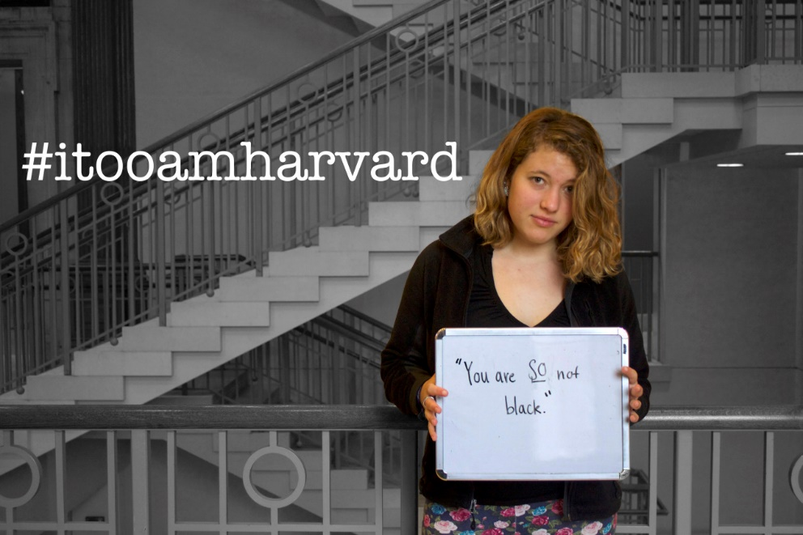
Figure 9: I, Too, Am Harvard Photograph 3
Figure 10: I, Too, Am Harvard Photograph 4
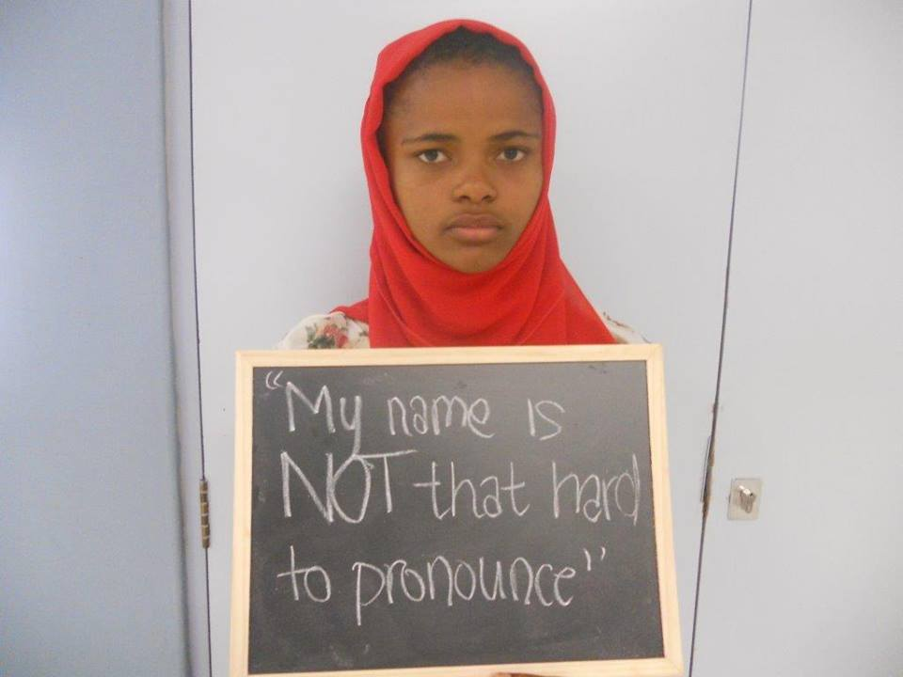
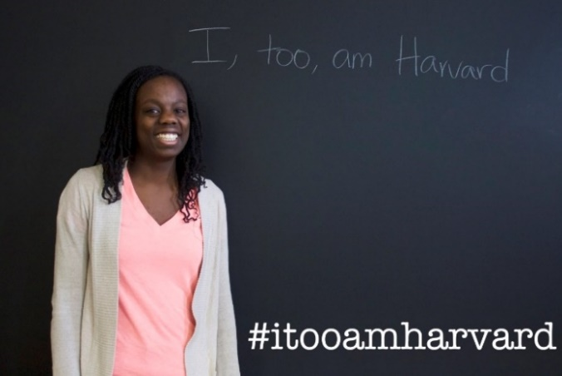  Figure 11: I, Too, Am Harvard Photograph 5 | 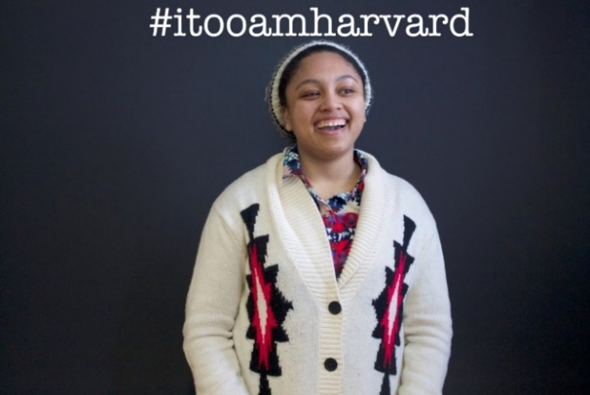  Figure 12: I, Too, Am Harvard Photograph 6
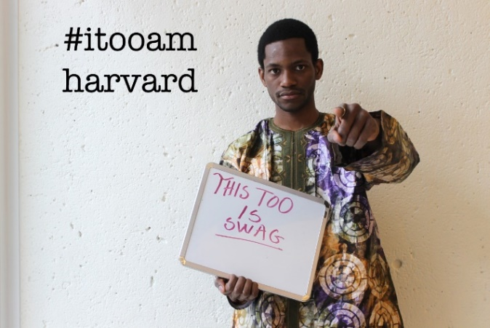  Figure 13: I, Too, Am Harvard Photograph 7 | 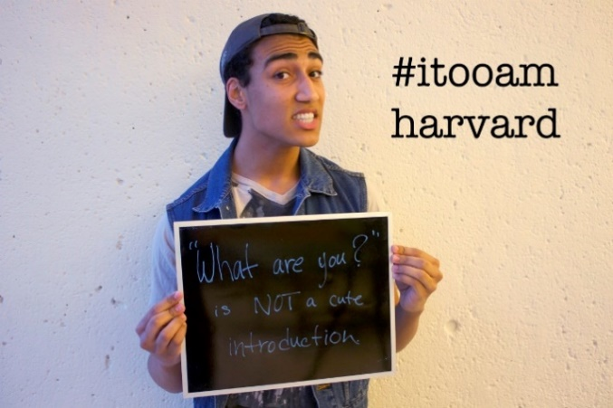  Figure 14: I, Too, Am Harvard Photograph 8
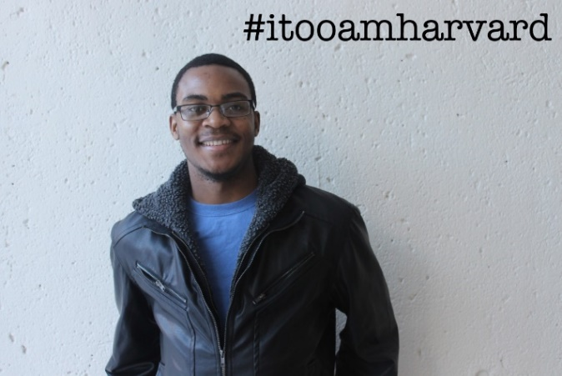  Figure 15: I, Too, Am Harvard Photograph 9 | 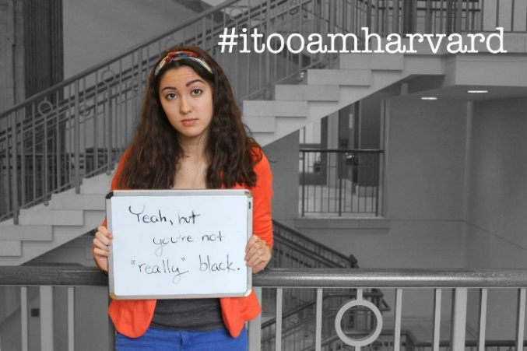  Figure 16: I, Too, Am Harvard Photograph 10
the racial narrative. The opinions in each photograph also ask the viewer to consider his or her place –is the viewer a minority who has experienced these issues? A member of a majority class who has articulated some of these issues? One who does so explicitly or implicitly? A minority who has also perpetuated these issues, or a white person who has not? Again, is the viewer making conscious decisions regarding these matters or are they unconscious? All of these audiences are potential. As such, the choreographers resist clearly dividing rhetors and the audience here, preventing an “us” and “them” dichotomy which might serve to only amplify or reinforce hierarchies of power.
In contrast, I argue that Kony 2012 repeatedly reminds viewers who the helpers are, who are the helped, and what roles each of these groups have. Despite reiterating the use of social media in “remind[ing] us what we all have in common” and consistently attempting to make connections between America and Uganda, the rhetoric implies a distinct separation between the Ugandan and American people. The video begins with the filmmaker showing his son’s everyday activities (ones which would be very distinct from those in Uganda). He transitions into his role in Uganda by claiming, “years before Gavin was born, the course of my life was changed entirely by another boy” (Jacob) (Invisible Children; “KONY 2012” 3:47-3:53). The film pans to Gavin saying “Jacob is our friend in Africa” (Invisible Children; “KONY 2012” 3:59-4:01).The film then cuts to a picture of the filmmaker’s Facebook page with a picture of Jacob on it and videos of Jacob in Uganda. The narrator then says, “but when my friends and I first met him in Uganda, in Central Africa it was in very different circumstances”; in the background at this point is a shot of a map of Africa posted on Facebook (Invisible Children; “KONY 2012” 4:17-4:24). The film zooms in on the map with intense sound effects until all of a sudden Jacob is on screen. The video consistently reiterates that Jacob is in a different and faraway place divorced from America except for in virtual spaces. The video focuses on Jacob’s roles as a student and victim, suggesting that his responsibilities now lie in studying, growing up, and being comforted and helped by Americans such as the speaker who console him and promise him they will help make his life better. In contrast, Americans have specific action roles in the campaign. The narrator states, “This year, 2012, is the year” that Americans will fulfill his promise – “but time is running out. I’m going to level with you. This video expires on December 31st, 2012, and its only purpose is to stop the rebel group the L.R.A and their leader Joseph Kony and I am about to tell you exactly how we’re going to do it” (Invisible Children; “KONY 2012” 8:22-8:50). Later in the video, the filmmaker calls for everyone to write to, call, or meet with 12 specific policymakers that they selected and deemed could help Uganda. They want “everyone to wear” Kony bracelets, to “input that number and . . . enter the mission to make Kony famous,” “track” and “geotag” their influence, and do it all with an action kit that contains “everything you need” (Invisible Children; “KONY 2012” 25:49-26:05). The choreographers clearly distinguish relationships and roles between those who help and those who are helped, thus reinforcing and perpetuating an “us” and “them” binary between Americans and Ugandans and othering the Ugandans through their rhetoric.
The differing choreography in the Kony 2012 and I, Too campaign showcases the roles of power and community at stake in the digital rhetoric of each of the campaigns. Specifically, the levels of democratic transparency and more general political transparency of each of the campaigns helps elucidate the ways in which activists can use digital rhetoric to empower (I, Too) or to attempt to empower, while actually disempowering (Kony 2012) oppressed groups. It is my hope that the distinctions between these ways helps better show how I, Too may not be entirely democratic, but maintains a firm commitment to community which is both individually and communally empowering.

Comparison Four: Bridging Discourse with Bodies and Physical Spaces

One of the significant reasons for social media composition is, of course, the potential for people who are minorities in their own public spaces to be able to gather in virtual, public spaces which facilitate a sense of community both emotionally and logistically. The utility of this cyberspace warrants further investigation, however. Based on his interviews with over 80 activists in Egypt, Greece, Spain, Tunisia, the UK, and the US, Paulo Gerbaudo notes that “there is no doubt that for almost all the activists I interviewed, the internet alone is not the solution to the crises of public space” (160). Gerbaudo highlights that the activists he interviewed with were reluctant to claim that they interacted in “simply internet-based publics,” articulating concerns such as “We are not the people of comment and like” and “We are not on Facebook, we are on the streets” (160). Even for compositions which originate online, then, the way social media interacts with physical spaces cannot be overlooked.
But why does it matter that a campaign bridge virtual, discursive realms with physical spaces? What makes this engagement on the ground significant? More particularly, why for I, Too does this bridge matter? Again, a distinction between how Kony 2012 approaches (or lacks in approach) this bridge between virtual and physical activism and how I, Too approaches it can help illustrate the significant and productive uses of social media I, Too holds for the black communities at each higher education institution which has a campaign. As such, I begin this section by describing the potential harm of virtual, discourse-only campaigns in the contexts of both Kony 2012 and I, Too. Asserting that Kony 2012 never moved past this virtual, discursive nature, I then describe how I, Too did and what is at stake in this move.
One of the limitations of virtual spaces, as Paolo Gerbaudo points out, is that even while these spaces “facilitat[e] interpersonal communication across a distance,” the maintained physical distance allows “contemporary societies . . . to deal with others while not having to fully engage with them” (12). I would argue that this limitation also applies to discourse-only spaces, where those who read or interact might deal with the abstracted words and ideas of minorities, but do not have to grapple with their lived realities or conditions. In his 2014 article “Sinners Welcome: The Limits of Rhetorical Agency,” Steve Parks expresses concern about the nature of discourse-only activism. Parks claims that dominant groups can use this type of rhetorical-agency-activism to appear progressive while not actually being so. Parks argues that rhetorical agency functions as a “‘disciplinary compromise,’ that allows us to invoke the political rhetoric of a West without having to engage in traditional forms of political organizing that his insights ultimately require” (511).
While Parks argues against empowering the oppressed with “rhetorical agency,” I believe his concerns also apply to how choreographers empower their activist participants. By asking participants only to increase awareness of an issue, I argue that choreographers empower participants with a limited rhetorical agency. This choreography invites participants to partake in an easy compromise – invoking political activist rhetoric “without having to engage in traditional forms of political organizing” that the issues necessitate. Aida Hurtado’s concept of “pendejo games” might usefully be applied to this phenomenon. As Catherine R. Squireso notes in her essay, “N-word v. F-word, Black v. Gay,” Hurtado’s pendejo games act as stories which “are told as “progressive stories” but are not, because all they do is “offer space to discuss difference and oppression, while employing dominant hegemonic frames of reference” (Squireso 3).
Notably, I do not mean to argue that discursive composition and activism is a problem (I’m not sure how one could move away from discourse entirely anyway). Rather, I mean to say that discourse that is not married to materialism is a problem, or that campaigns must rhetorically enable participants while also maintaining a commitment to the embodied, lived, everyday experiences of all of the people involved. Part of the need for this embodied, material attention stems from the nature of activist work in general. As Gerbaudo emphasizes, “the move ‘from the web to the streets’ is also a reflection of contemporary popular movements’ anti-authoritarian valuing of immediacy and face-to-face relationships” (162).
These potential limitations of genre are fully exemplified in the Kony campaign, where Americans are never asked to engage with anyone the campaign concerns. All Americans are asked to do is spend their money, “cover the night” with stickers and posters, and geotag them. Issues underlying history, colonialism, imperialism, and racism are ignored because the people are ignored. To engage in the campaign, people need not open their mind as much as their wallet; people need not interact as much as post information, or do what they are told.
The virtual spaces of Kony that restrict meaningful activism by preventing interaction also problematically confine activism to discourse. This discourse which “others,” creating a white hero narrative based off an “us” v. “them” binary, acts as Hurtado’s pendejo game, allowing activist participants to talk about the horror of Joseph Kony’s actions while maintaining a sense of transcendence above the messy political and ethical factors at play in postcolonial or neocolonial Africa. Since part of the point of activist work is to push back against the “bureaucratic, alienating, pyramidal, over-structured, and opaque” nature of authority, or colonial authority, Kony 2012’s ignoring of bodies and spaces at best does not engage meaningfully in political issues, and at worse amplifies and reifies oppressive hierarchical structures. An embodied and material approach to Kony would help push Americans past a simple “helper” mentality into a shift in perspective where they might see Ugandans as equally valuable humans who might help them as they are helped.
While I admit that I, Too’s photo campaigns might generate the same limited majority-minority engagement, I contend that this distanced interaction is less problematic in light of the overall movement. Unlike Kony, the I, Too movement does not call for allies to help the campaign succeed. Certainly, the racial tensions prominent in the photographs and videos would benefit from white audiences deeply considering the issues raised so as not to replicate them. I, Too does not call for this allyship in its main goals, though. For instance, Harvard’s photograph campaign asserts (similar to the others) “this project is our way of speaking back, of claiming this campus, of standing up to say: We are here. This place is ours” (itooamharvard). The target demographic of I, Too can thus be seen as minorities who will not need the same type of proximity-interaction in order to meaningfully engage with one another. Unlike Kony’s participants who would benefit from listening to Ugandans in order to understand their experiences, the I, Too participants live the experiences they aim to better. In its construction as minority-based and minority-driven, functioning regardless of allies, less is at stake in the virtual nature of the campaign.
Still, I, Too cannot afford to miss the point of embodied, material work (and it doesn’t). The campaign is about the importance of and rights of bodies in spaces, so to ignore those bodies in spaces would be to undercut the very goals the campaign puts forth. For I, Too, then the bridge of virtual, discursive activism and physical activism is crucial, requiring not just showing bodies in spaces online (as chapter one addresses), but communities of bodies in physical spaces.
I, Too does address these bodies in physical spaces, managing to move beyond the virtual into physical space. Unlike Kony, I, Too uses social media as an effective tool to make this move. The move is possible through social media for I, Too in a way that it was not for Kony 2012 because the creators of the campaign are committed to this move and to their communities from the start. Built into the description of the original photograph campaign is an invitation to a play on Harvard’s campus:
The #itooamharvard photo campaign is inspired by I, Too, Am Harvard, a play based on interviews with members of the black community exploring and affirming our diverse experiences as black students at Harvard College. The original play premieres on Friday March 7th, 2014 at 7 PM in Lowell Lecture Hall on the campus of Harvard College (itooamharvard).
While the text does not explicitly articulate it, founder Matsuda-Lawrence shared at the I, Too conference that the entire point of the original campaign was to attract students to the play on campus.
Once additional campaigns sprang up across the country (ones that also built on-the-ground campus events into their campaigns, again bridging the virtual and physical) the I, Too choreographers continued to channel the power and momentum of these movements on the ground. On August 7th, 2014 the I, Too, Am Harvard choreographers organized a conference for activists around the nation to gather together in Cambridge and promoted this conference online. Over 250 activists across the nation attended, and the conference resulted in a national Facebook page and e-mail listserv as well as fostered various connections between college activist groups across the nation.
The connections created by the campaign were more than logistical, however, additionally illustrating the power of on-the-ground activism for I, Too. All of the events in the conference were charged with a level of emotion I would argue can only take place in person. As illustrated in Figure 17, I, Too participants commonly reiterated feeling a sense of hope, freedom, community, and empowerment fueled by being surrounded with one another’s bodies. The conference leaders and organizers repeatedly reveled in the joy
of being with “beautiful black people” or “people who look like me” (Workshops). And after each day’s powerful events (often leading to tears of both joy and sorrow), going home or clicking off Facebook was not an option. With nothing else to do but experience the emotions and the hours together, strong ties formed in physical spaces out of the weak
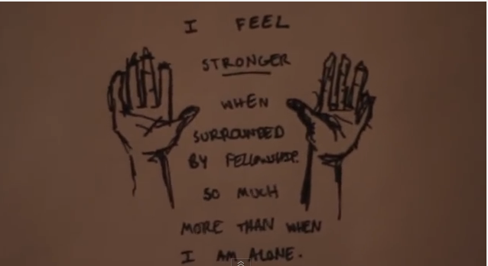
Figure 17: Drawing by I, Too participant during the Living Memorial at the 2014 I, Too, Am Harvard Blacktivism Conference as shown on YouTube in the conference recap video #ITooAmHarvard Blacktivism Conference 2014

ties which were created online.
I do not mean to suggest that the physical space created all of the emotion, while the social media space merely helped form weak ties (to change into strong ties in person), set dates, gather RSVPs, raise money, create carpools, and provide other such mobilizing information. To suggest this binary would be to ascribe a false democratization to the campaign. A level of “emotional scene-setting,” as Gerbaudo puts it, took place online before and around the campaign to foster the powerful environment that arose in the conference. Still, the physical activism allowed for not only a greater understanding and engagement with minorities than virtual, discursive activism would, but also an additional emotional resonance not available through the genre of social media alone.

Comparison Five: Kairos
The last significant distinction that I take up here between Kony 2012 and I, Too is the campaigns’ use of kairos; in this section, I argue that Kony 2012 rhetorically constructed itself as having an over-immediate beginning and end, a construction that prevented the campaign from achieving the same lasting success I, Too achieved.
The Kony 2012 video constructs itself as non-continuous, setting up the campaign from the start to become non-lasting. The video starts with the rhetoric of beginnings, claiming “nothing is more powerful than an idea whose time has come, whose time is now” and repeating the words “right now” and “now” as a clear marker of time when the campaign will start. The video then claims that the world “has new rules” and pans to a cut scene of the narrator’s wife bringing new life – their baby – into the world, cutting off the campaign from historical markers before it with rhetoric of new beginnings. Later in the video, an interviewee repeats these ideas, saying that:
now there is something bigger . . . The people of the world see each other and can protect each other. It’s turning the system upside down. And it changes everything. We’re living in a new world, Facebook world, in which 750 million people share ideas, not thinking in borders. It’s a global community, bigger than U.S. Joseph Kony was committing crimes for 20 years and no one cared. We care” (Invisible Children; “KONY 2012” 27:22-27:54).
In this rhetoric of beginnings, the video not only ignores, but also problematically erases the cares and efforts of people who came before Invisible Children. Invisible Children become rhetorically marked as the heroes, notably the “white heroes” (even though the video operates under the pretense of a globalized network) who will swoop in to save the Ugandans now, ending Joseph Kony’s reign and establishing a better world for all.
The rhetoric of endings neatly bookends these beginnings. After describing what audiences can do to help, the narrator states that “all of these efforts will culminate on one day—April 20th—when we cover the night” with stickers, posters, and geotags (Invisible Children; “KONY 2012” 26:22-26:29). He repeats in the video that “this is the day,” the one day that the campaign builds towards, never proposing what people might do after the one day they post paraphernalia all over America to help Uganda (Invisible Children; “KONY 2012” 26:28-26:29).Conceivably, policymakers might see the widespread coverage and be inspired to help with the campaign, leaving protestors with little to have to do, although they could of course still call in or write letters. Audiences are not asked to be a part of a continuing campaign, however. They are invited rhetorically to “culminate” their efforts on a specific day, and then, perhaps, to go back to whatever it was they did before they were side-tracked by caring about Uganda. The narrator echoes this rhetoric of ending:
at the end of my life, I want to say that the world we’ve left behind is one that Gavin [his son] can be proud of. A place that doesn’t allow Joseph Konys and child soldiers. A place where children, no matter where they live, have a childhood free from fear (Invisible Children “KONY 2012” 28:1-28:50).
In addition to erasing the toils of activists before, the campaign thus erases any need for activism in the future, ignoring the lasting issues and legacies that oppression, violence, and power can contain. By ascribing a clear beginning and end to the campaign, then, Invisible Children does not allow for their Kony 2012 campaign to achieve any lasting status. Granted, one might argue that Invisible Children never wanted lasting status, but a look at their website proves otherwise. Invisible Children continues to operate, although having downsized in December of 2014. The company claims that, despite their cutbacks and a plan to eventually hand over ownership which “hurt to let go,” they have been and still are on a “journey” that depends on the public’s “voice and work,” one which they “won’t stop until every captive man, woman, and child is out of the LRA” (invisiblechildren.com). The rhetorical construction of the kairos of this campaign as starting now and ending at a specific date thus can be seen to inhibit the campaign from achieving both the cover-the-night effect and the lasting effect it wanted.
The kairos of the campaign also prevented the campaign from being lasting by disallowing time and flexibility. Had the campaign been constructed over the course of a longer amount of time and allowed more flexible options for response, participants might have been able to adapt the campaign to their desires, needs, or particular way of contributing. For instance, participants might have been able to create their own videos or small campaigns to build upon the Kony campaign in way that played to participant strengths. Instead, however, Kony contained a “hyper-kairotic ‘TIME IS NOW’ urgency” that prevented adaptation and continuity by exploiting a “fast-approaching ‘expiration date’ for the video even though much of the footage was already almost a decade old” (575).
Scott and Welch suggest that this poor use of kairos might not be entirely attributable to Invisible Children, claiming that have that online spaces contain “speed, volume, and insistence of new media texts vying for attention” which invite amplification of kairos. They argue that this need for amplification is further intensified due to the overall urgent nature of “media consolidation and information control” which has allowed Americans “to march into wars against phantom weapons of mass destruction,” and “cut Social Security and Medicare against the threat of a fiscal cliff.”
Yet here again with kairos, I, Too takes a different approach. The photograph campaign maintains a framework tied to problems they implicitly acknowledge as stemming from complex histories that were created before the campaign began and that will continue to influence futures after the campaign may end. As the creator of the campaign said explicitly, the campaign is a “part of a nationwide movement of black student activism,” one which the participants “haven’t started” but are “hoping . . . can add to the movement and speak up against racism on college campuses” (Vingiano par. 11).
Throughout the campaign, “I, Too, Am Harvard” as well as other subsequent campaigns echo this narrative of continuity, writing themselves into larger, more complex issues of community, race and oppression. I, Too, Am Oxford’s campaign description, for example (as shown in the epigraph to the chapter) describes the campaign as “resonat[ing] with a sense of communal dissatisfaction that students of colour” have, aligning itself with community commitments in the first line. In the last line, Oxford then describes that this community is taking on the campaign to “deman[d] that a discussion on race be taken seriously and that real institutional change occur,” moving the campaign from the feelings of the community to the larger and more lasting problems of race from which they stem.
Additional campaigns also address this issue of race without specifically attributing a start and end date to where these problems occur. I, Too, Am OSU (also in the epigraph), for example, claims that theirs is a “movement to raise awareness surrounding issues of racism on campus.” While still focusing on campuses (as is the nature of the campaign), I, Too, Am Cambridge rhetorically extends further, addressing black politics more broadly. Joining with the Black and Ethnic Minority Campaign on their school, Cambridge’s Tumblr domain name is actually titled “Wetooarecambridge” in order to “emphasize not only the collective experiences of BME students, but also to highlight the widespread support from the general student body” (wetooarecambridge). As they claim, the purpose of this broader campaign is to “voice the concerns of students who feel they are discriminated against due to their culture or beliefs. The term ‘black’ describes the colour of our politics, rather than skin” (wetooarecambridge). These campaigns are a few examples of the genre of descriptions that govern all of the I, Too campaigns, which all assert both community authority and its place in helping to establish and voice and presence of people of color which will address larger issues of racism. By writing themselves into the more larger narrative of racism, I, Too ensures that their campaign aligns with issues which are ongoing. The I, Too campaigns do not purport to “end racism” as Kony 2012 might end the LRA or Joseph Kony. Rather, the campaigns seek to address and/or increase consciousness about prevailing issues.
The campaign also rhetorically constructs itself as continuous through its invocation of Langston Hughes. The titles of the campaign, “I, Too, Am ______” are a reference to Langston Hughes’s “I, Too, Sing America,” a canonical black activist text. Similar to the I, Too campaign, this poem, reprinted below, asserts the right of black people to be in spaces:
I, too, sing America.

I am the darker brother.
They send me to eat in the kitchen
When company comes,
But I laugh,
And eat well,
And grow strong.

Tomorrow,
I’ll be at the table
When company comes.
Nobody’ll dare
Say to me,
“Eat in the kitchen,"
Then.

Besides,
They’ll see how beautiful I am
And be ashamed—

I, too, am America.
In referencing this poem, the I, Too participants both pay homage to Hughes’s contribution and extend the application of Hughes’s metaphor of the table to university campuses. As such, the I, Too campaigns align themselves not just with prevailing issues of race as their descriptions show, but also with important community figures in prior black justice movements, specifically connecting their campaign with these past movements. As I will address in my next chapter, these past and present elements are then married to the future in the way that the digital elements, such as the Tumblr or Facebook pages the campaigns are posted on and the use of hashtags to align the campaign with Twitter, are used by participants.

Chapter Summary
In this chapter, I have outlined the ways in which I, Too choreographers use social media for minority empowerment. Specifically, I asserted that I, Too empowers by being committed to the community it seeks to help and that community’s principles and by writing itself into a continuous narrative of concerns (race and oppression) that stem from the past and into the future, and by I argued that the effects I, Too forms are lasting because they seek not only to temporarily help their community, but also to restructure systems of power that oppress their community.
I formed these arguments by reading I, Too contrastively with the Kony 2012 campaign, focusing specifically on five elements of comparison: mechanisms and goals of composition, bodies in composition, choreography of composition, bridging discourse with bodies and physical spaces, and kairos. I used these five categories to help illuminate how social media work might reinforce dominant, oppressive paradigms or work against them. I argued that this analysis is significant for the future of Rhetoric and Composition because it helps to underscore how, in an age when scholars increasingly call for universities to become more inclusive to both minorities and to contemporary technologies, this work can be done ineffectively or effectively. I attempted to show the consequences of both an ineffective and effective campaign. I hope that my categories provide useful themes for writers and scholars to consider when attempting digital, inclusive work.
In the last section of my chapter, I discussed how I, Too choreographers write their campaign into a narrative of continuity. There I focused specifically on continuity from the past. In the following chapter, I expand on the ways the I, Too choreographers join this past and present with the future to work for lasting change. To clarify, I do not argue that the campaign is necessarily continuous because it simply uses digital elements in an increasing digital age (although that certainly might be possible). Again, in this thesis I am not interested in what technology does by virtue of existing, but rather what technology enables in use and context. Instead, I explore the ways that I, Too uses particular digital elements in particular digital genres to restructure. Thus in this final chapter, I bring together chapters one and two, illustrating how subsequent I, Too campaigns use the specific genres of Tumblr and Facebook to remix the original campaign. I argue that the I, Too participants provide a vision for how particular social media genres might be used for committed and progressive minority activism.

CHAPTER 3

Contextual Analysis: Genre and African American Activism

In chapter one, I discussed theories of the remix, embodiment, and materialism, and how these theories work within and for black communities. I applied these theories to a reading of the I, Too campaign. In this reading, I argued that by aligning themselves with the principles of these theories, the I, Too participants challenge exclusivity within the university, arguing for a vision of both theoretical knowledge as well as ethos that is attuned to minority students. In chapter two, I explored ways the I, Too choreographers used social media successfully in a manner particularly rooted in community and community history. Contrasting the campaign with the Kony 2012 campaign, I argued that these roots help the I, Too campaign challenge dominant paradigms and thus work towards long-term empowerment.
In this chapter, I build upon the remix theory addressed in chapter one and the social media focus of chapter two in order to show how I, Too participants do, and thus how others might, use Tumblr and other social media sites in a manner both particularly aligned with minority commitments and also accommodating enough to bring minorities into the digital story in the long run (as Adam Banks argues for). I also show that this digital story inevitably points back to bodies, embodied experience, and lived realities.
As such, I begin the chapter by illustrating how Tumblr, where the first I, Too photograph campaign was posted, can be used according to Adam Banks’s remix. Here I argue that the I, Too, Am Harvard participants act as Digital Griots, remixing elements in order to help their community. I then chart how I, Too photograph campaigns are remixed in subsequent campaigns and how that remix allows the campaign to adapt and grow, both online and offline. Finally, I end with people and their lived experiences, specifically showing how the movement has impacted future generations of activists. Here, I include excerpts from two interviews I conducted with young black activists verbatim without analysis. I let these activists speak for themselves about their personal stories, their activist commitments, and their interactions with I, Too. I do so to remind myself and readers that this campaign began and continues (at least in part, although with adaptation for other minorities) as a black story about black ethos and black conceptions of knowledge. As such, the campaign, and any reading of it, I believe, must begin and continue with black people and their stories.

Tumblr and the Digital Griot
I, Too choreographer Lydia Burns’s choice to publish this photograph campaign as a multimedia project on Tumblr is particularly suited to notions of the digital griot and the remix. As mentioned in the introduction, the digital griot’s purpose is to use the remix in order to maintain an “ethos of commitment to community,” exhibiting:
- “knowledge of the traditions and cultures of his or her community” (26)
- “the technological skills and abilities to produce in multiple modalities” (26)
- “the ability to employ those skills for the purposes of building community and/or serving communities with which he or she is aligned” (26)
- “awareness of the layered ethical commitments and questions involved in serving any community” (26)
- “the ability to ‘move the crowd’ – that is, use of those traditions and practices and technologies for the purposes of persuasion” (26)
As I have shown in chapters one and two, the I, Too participants do all of these, particularly principles one through four, using both their campaign and the space of social media in ways committed to their community and to the ethics of their community, but with the skills needed in an increasingly remixed and digital age. In this chapter, I elaborate on these principles, showing how I, Too choreographers use technological skills and abilities to serve and move the communities they belong to.
To begin with, in using Tumblr, a blogging website which allows users to blog in six different modes (text, photos, quotes, links, chat conversations, audio, and video), Lydia Burns exhibits the digital griot’s ““technological skills and abilities to produce in multiple modalities” (Banks 26). More significantly, however, Burns sets up the campaign to allow the passing of stories through reblogs, a move which allows for her technological abilities to build and serve her community. Tumblr is a reblogging-based website, allowing only two options for interacting with other entries – liking (which is brief, and which ends in the like itself) and reblogging (which is foregrounded as it provides the basis for continued Tumblr activity).
The photographs passed down by Burns as digital griot might adapt in similar ways to stories passed down by griots. Users who reblog the photographs can add to them, and thus they can develop as they pass along. Unlike stories, however, in this digital space the photographs themselves cannot be changed. Users who reblog the photographs cannot edit them. Also, options for addition are limited. Users can only add text underneath the photograph and/or add hashtags. The ethos of the original rhetor is perhaps privileged more in this format. Unlike with other media, the reproduction and passing along of messages on Tumblr must always preserve the message itself in full, even if to later appropriate, complicate, or criticize it. In this way, Burns encourages sharing, extending the use of, or reproducing to challenge stories in a remix form.
Notably, reblogging is reserved for the Tumblr blogging community, a restriction that limits shallow interaction and promotes at least a minimal level of responsibility to the minority community that users interact with. Non-Tumblr users can only view posts, but cannot interact with them. Those wishing to insert themselves in the conversation about this campaign, then, must reproduce particular photographs in the campaign in order to interact with it. In doing so, users take on a role in the campaign, publishing portions of it that others can then interact with. Unlike many other blogs or social media sites, users cannot comment and move on, but instead must take more active ownership of their commentary by producing it on their own page. In this way, users who want to interact must remix the content, putting it in the new context of their own page or the (con)texts of commentary they produce about it. By posting the campaign on Tumblr rather than another site, then, Burns has performed the function of DJ-digital griot, using technological skill to serve her community – requiring an active engagement with the campaign by users who wish to comment on it.
As is the nature of this active reblog/remix community, the stories that the I, Too photographs tells were and are actively shared by many bloggers in the chain of reblogging. While a few Tumblr bloggers appropriate or criticize the photographs, this group is the least common. Most bloggers have preserved the message exactly as is in the context of their own page. Many others have only added additional reaffirming messages, such as, “tell em!” (cilove), “Yesssss!” (Unponamidnighdreamstate), and “THIS!” (jdchanel) (itooamharvard). By posting this campaign on Tumblr, then, Burns has not only acted as a digital griot, but also opened up the opportunity for many others to become digital griots as well. She has also exhibited the griot’s ability to move a crowd, a movement that is evident both logistically (since others re-post) and emotionally (since others add enthusiastic messages), using Tumblr to motivate others to invest in some way in this issue.
The fact that Tumblr provides a quick outlet for possible remixing brings about vital community implications that extend beyond the remix of each particular photograph in Harvard’s campaign, however. As I have shown in chapter One and here, the remix is a theory which reshapes conceptions of ethos and knowledge, including minority principles and perspectives in this reshaping. In discussing the implications, however, I have focused mainly on the implications of individual photographs and/or the Harvard campaign on Tumblr. I turn now to looking at the implications of the remix in the larger I, Too movement.

Remix: Campaign to Campaign:
Before discussing the manner in which I, Too campaigns remix preceding campaigns (making the whole movement overall a remix), I want to expand on the type of remix I evaluate here. I mentioned in my introduction that the remix is a form a social and political resistance. By using the remix at all, then, I claim that the participants seek to restructure concepts of ethos and structures of knowledge. I argue here that this restructuring takes on more significance in terms of the overall movement. In using social media sites such as Tumblr which actively encourage remix, the I, Too activists are perpetuating the ethical consequences of the remix, encouraging forms and sites for composition that make room for black histories and principles.
To be clear, I am arguing that the campaign overall acts as resistance by using the remix, not that every remixed form of the original Harvard campaign resists its original. Other ethical commitments and changes are at play in the specific remixes that happen from campaign to campaign. Banks actually outlines three different relationships that remixes might have with their original that are helpful in understanding this campaign:
- an extended version, which grows most directly from the Jamaican dub; (2) a selective version, which might choose to delete some elements of the original and add new sounds or elements while ‘keeping the essence of the song intact’; and (3) a reflexive remix, one that ‘allegorizes and extends the aesthetic of sampling, where the remixed version challenges the aura of the original, and claims autonomy, even when it carries the name of the original; material is added or deleted, but the original tracks are largely left intact to be recognizable’ (Banks 90, original format preserved).
A closer look at the way I, Too moved from campaign to campaign will show that it operated in the second way, both maintaining the essence of the original and selectively changing. I claimed previously that the campaign holds commitments to community histories and moves forward. One can see these moves from how each subsequent campaign reflects and pays tribute to the original campaign (which is rooted in community as I outlined in chapter two) and yet adapts the original campaign to fit its own needs. Although each campaign pays tribute to or reflects the Harvard campaign in differing degree, each campaign does ethically bind itself in some way to the original campaign and as such, perform the role of the DJ-digital-griot and challenge oppressive structures which exclude minorities. This binding also helps to inscribe the ethos of the original I, Too rhetors and their arguments about knowledge production and construction. In addition, it helps bring them campuses together, building a network of people within the community who work together to challenge hegemony.
The campaigns also adapt, adding “new sounds and elements” to make a community in multiplicity as each photograph campaign does on its own; I argue that this adaptation makes the I, Too movement lasting. If each campaign merely reproduced a replica of the campaign before it, the momentum of the campaign would likely die. As the campaigns spread and fewer and fewer gain national attention, the impact any campaign would have on the ethos of the overall movement or community would be limited. Simply being a part of a larger community might not be enough to continue to inspire campuses to gather and spend hours compiling, editing, and publishing their own photograph campaigns. The fact that subsequent movements also selectively remixed the original campaign then becomes critical for the passing down of this movement. In this selective remixing, each campaign has the chance to impact (in however limited a manner) not only the ethos of minorities communities, but also the ethos of the minorities at their particular school.
Now that I have described these moves and their consequences more generally, I would like to illustrate how I, Too, Am Harvard’s movement was rhetorically constructed so that it would enable others to both use a committed framework and to adapt the framework selectively. To clarify, I do not mean to say that I, Too, Am Harvard choreographers set these structures on purpose to maintain commitment yet progress. I believe that the structures do this work nonetheless, and as such, are important to examine.
The largely connecting factors of the I, Too photograph movement are a hashtag asserting belonging for a group that is not normally included (#itooam), a campaign description (which often refers back to I, Too, Am Harvard), and photographs with quotes, often derogatory comments made to minority students. All of these factors are present each time, but can be (and sometimes are) easily adapted to fit other communities who need inclusion. While these similarities bind the campaigns to a global race community, the “am Harvard” part of the campaign forces new campaigns to adapt, as they must change the name of the local community to which they belong. In addition, other campuses must change the description of their campaign and one of their purposes for it, since the other campuses do not have a play for which to advertise. Built into the original campaign, then, was both a way and a mandate for the movement to continue and adapt, allowing for it to be lasting and effective for many groups of people. Each campus then can and does adapt the campaign to the particular needs of their institution, helping to solve problems and raise awareness on a local level affirming the ethos of both the communities they choose to reflect and the school overall. Again, though, the adaptation stays within a particular framework. The #itoo and photograph media ensures that the campaign foregrounds those who are traditionally excluded in a way that asserts the legitimacy of their opinions, words, bodies, and bodies in spaces. It also suggests that the campaign be used for bringing people together in a physical space. In this way, the tools allow adaption within limits, not allowing an essence of minority activism to be lost, but allowing selective remixing of how that essence is continually constructed anew.
While part of the efficacy of the campaign relied on the original creation ensuring possible remixing within boundaries, part of the lasting effect came from the way in which the first campaigns chose to selectively remix. The first campaign to follow Harvard’s was Oregon State University, in a campaign called #itooamosu. The “about” section of this campaign states, “Taken as inspiration from the #itooamharvard movement, #itooamOSU was and is a movement to raise awareness surrounding issues of racism on campus.” Immediately in both the maintaining of the hashtag and the informative details, OSU maintains the essence of the original Harvard campaign. The campaign also maintains the essence of the original by keeping the photographs similar: each of the photographs contain a foregrounded picture of a person in the context of a space on campus holding up a sign which asserts something about race and belonging and a hashtag which begins with “itooam.” Many of these signs have similar patterns, such as descriptions of, answers to, or comments on offensive statements a minority has been told before. For a view of the similarity, see Figure 18 and Figure 19.
The campaign notably also selectively remixes in a few ways. Firstly, the campaign is published on Facebook, not Tumblr, a fact which changes the nature of the campaign by changing how people can interact with it. Similar to Tumblr, people can “like” these photographs or can scroll through them, but unlike Tumblr—people can comment on the photographs without reproducing them on their own pages. The campaign thus allows for engagement by parties who are not as actively invested—
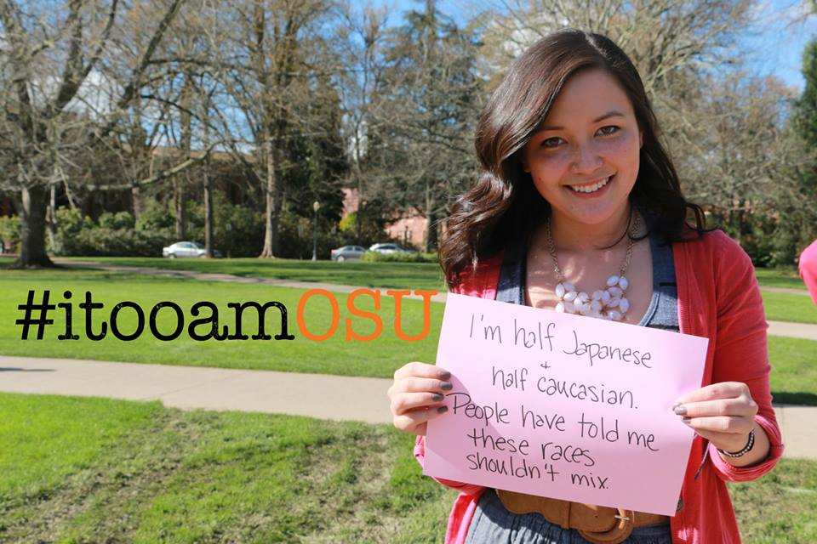
Figure 18: I, Too, Am OSU Photograph 1
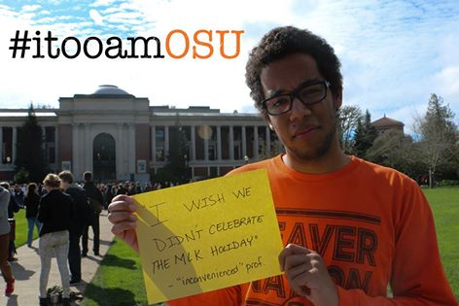
Figure 19: I, Too, Am OSU Photograph 2
lessening the ethical commitments of its audience—but broadening the audience for the campaign overall. The campaign does, however, still encourage active commitment in other ways, primarily through the space of the Facebook page. People may “like” the “I, Too, Am OSU” page overall, and therefore receive updates on the posts on the page. Posts on the page are numerous, appropriate to the genre of a Facebook page, which is meant to be continuously updated and interacted with. Through OSU’s remix—the campaign becomes more than simply a photograph campaign designated to end as an advertisement for a play, but rather a campaign designated to engage an audience for further discussion and action and then gathering in a different physical space. This use of space is clearly outlined in the first post on the page.
In order to further establish this photograph campaign space as a safe community-building space for the school, creators of the page repeat portions of this message in following posts, specifically that the campaign is a “safe space” to “validate, appreciate, and celebrate our diverse population.” The creators of the campaign also allowed for anyone to post pictures of the movement directly onto the page. These pictures, like the comments on the page, are moderated. Again, then, the campaign allows for organic growth and change via a social media space but within an approved framework.
The campaign not only allows further involvement, but also specifically asks for it in physical spaces (as Harvard’s did by advertising for the play). Two days after the first post, for example, the moderators of the page posted the notice:
TOMORROW at 10 AM: We will be posting the papers from the #‎itooamOSU ‬event up inside the MU across from the main lounge! We will need some help posting, so if you can come, that would be great! We also will provide more papers and writing utensils for those who may want to add to the collage. Hope to see you then! A big thank you to MUPC for helping coordinate this.
This message not only calls for volunteers to continue their engagement with the photograph campaign, but also links the campaign with OSU’s Memorial Union Program Council which sponsors events in the OSU union all year long. The event’s success then furthered these links, leading to the creation of an OSU Solidarity March that the President and Vice Provost of the school attended and that received attention on the local news. This attention then generated a school dialogue and further events. OSU’s campaign thus provided the vital role of continuing the purpose of the campaign in digital spaces, but expanding and adapting the campaign to become more interactive and to lead to further investment.
OSU also adapted the Harvard campaign by widening the pool of participants. Instead of limiting participation to black students, I, Too, Am OSU (a team at OSU) photographed all minority races as well as white allies. These white allies held up similar signs, but differing messages – messages asserting white support and inclusion (see Figure 20).
This decision to include all races, which some subsequent campaigns make and some do not, has become controversial among “I, Too” participants. Some participants embrace the photographing of allyship, and some (including the Harvard founders) express their desire for the space to be exclusively for minorities (conference). As such, OSU is pushing the boundaries of the accepted framework notably here. While this push could be harmful in its move away from focusing on minority voices and bodies, the
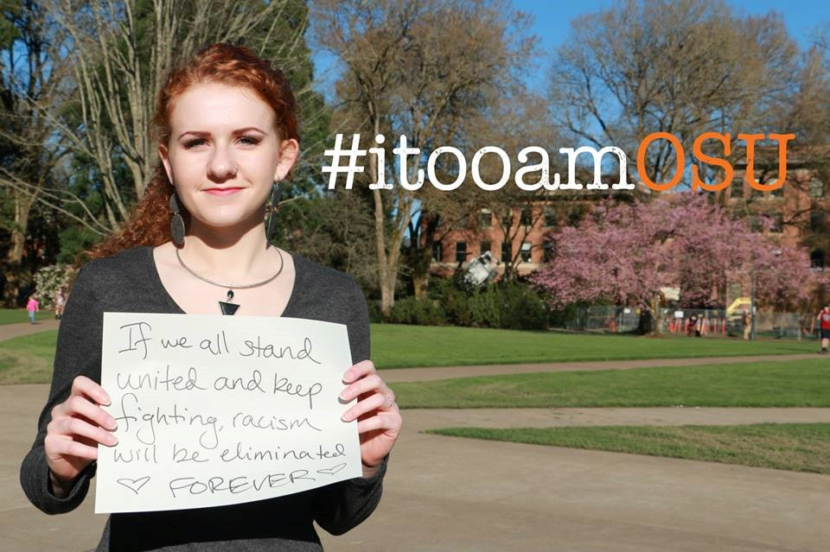
Figure 20: I, Too, Am OSU Photograph 3

campaign notably does still emphasize the minority voices and bodies; the cover photograph of the page is exclusively minority. Additionally, the decision to include white bodies might highlight the idea that white is a race, not a norm to be compared to (although the white students do not usually reference their whiteness explicitly). Regardless of the ethical tensions at play here, the decision does help contribute to the expansion of the campaign in that it involves more people and signals that the campaign can be reproduced by campuses which might be uncomfortable with, unready, or unwilling to limit the campaign to only minority students.
“I, Too, Am Oxford,” the next photograph campaign created (and the last I will analyze here due to space constraints) also notably maintains the essence of the original campaign through a dedication to Harvard, through similar photographs, and by using hashtags This dedication is similar to OSU’s in that it outlines is loyalty to the original campaign and to its purposes, but slightly different in that it links the project immediately with another Oxford-based program:
Our project was inspired by the recent ‘I, too, am Harvard’ initiative. The Harvard project resonated with a sense of communal disaffection that students of colour at Oxford have with the University. The sharing of the Buzzfeed article ‘I, too, am Harvard’ on the online Oxford based race forum, ‘Skin Deep’ led to students quickly self organising a photoshoot within the same week. A message that was consistently reaffirmed throughout the day was that students in their daily encounters at Oxford are made to feel different and Othered from the Oxford community. Hopefully this project will demonstrate that despite there being a greater number of students of colour studying at Oxford now than there has ever been before, there are still issues that need to be discussed. In participating in ‘I, Too, Am Oxford,’ students of colour are demanding that a discussion on race be taken seriously and that real institutional change occur.
Even though Oxford’s campaign is also on Tumblr, and thus does not allow for the kind of interaction that Facebook might, Oxford also extends the telos of this campaign by including a link to their race dialogue. Unlike OSU, Oxford brings the campaign back to the essence of the digital griot storytelling community using Tumblr and including only minorities in their campaign. Notably, though, Oxford does extend Harvard’s campaign by including all students of color. In addition, Oxford extends their participant pool by enabling a moderated “Submit Your Own Photo” option for those who could not participate in the photoshoot on campus.
Oxford also adapts Harvard’s campaign by approaching the hashtags in the photographs differently. Like OSU, the hashtags are not edited onto the photographs, but appear in the signs that students are holding up. Students write-in whichever hashtags, if any, they wish to appear. One of these hashtags (#50shadesofbrown) is repeated twice, but all the others are different. These varying hashtags allow for multiple levels of individuation within the minority activist essence – individuation to country (#VenezuelaLebanonAmerica), to individual race and life experience (#britishmusliumbrummy, #hijabismychoice) and to approach or attitude (#unimpressed v #tolerantbritain). As such, the campaign not only asserts the ethos and legitimacy of global race communities, but also the ethos of their local campus community and of each individual student’s lives and experiences. The campaign, just as OSU, then builds from a commitment to the original, but in an adaptive way that works for itself as well.
Many of the elements kept, deleted, and added in these first two subsequent campaigns are reflected in later campaigns, suggesting that the selective remix is integral to the lasting nature of the campaign. For example, following campaigns almost always have a dedication in the beginning and links which join the photograph campaign to other school activities. In addition, subsequent campaigns treat the photographs as a starting point for further activism that is specifically attuned to their particular needs and activities.
As the campaigns have grown and garnered additional attention, they have also become increasingly connected, adding to the remixed nature of the movement overall. Facebook and Tumblr pages began to link to one another, allowing the participants of each campaign to become a part of an engaged network or community of activists. These links often happen in remix form; participants of a campaign will include a photograph from and/or link to a fully-formed campaign, sometimes with comments made by the referenced campaign members and sometimes with comments they have added themselves. Just 29 days after the original I, Too, Am Harvard Tumblr page was posted, for instance, I, Too, Am Harvard’s Facebook page began to include connections to other I, Too movements, claiming:
We’re so amazed that I, Too, Am Harvard has become a national and global movement, so this week we’ll be featuring some of our favorite photos from other I, Too movements. Check out their Tumblr page for more photos. Http://itooamnotredame.Tumblr.com” (photograph included after, see Figure 21 for screenshot).
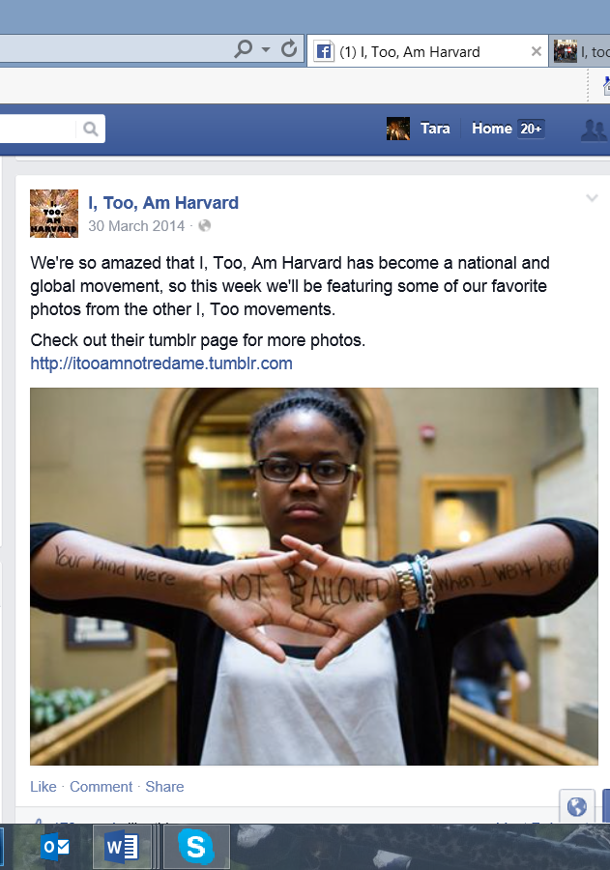
Figure 21: I, Too, Am Notre Dame Facebook Post

Over the following week, Harvard additionally featured I, Too campaigns at the Universities of Oxford (also with a link and feature photo), Iowa (with link, feature photo, and hashtags #itooamiowa #itooamharvard #solidarity), Cape Town in Southern Africa (link and photo), NYU (photo and twitter tag), and Cambridge (link and two photos). These references make their Facebook page a remix of multiple other distinct movements within the context of their own page, as the “#itooamiowa #itooamharvard #solidarity” hashtags side-by-side also show (Harvard also puts their itoo hashtag next to other campuses). As the original founders, Harvard also sets the stage for subsequent I, Too campaigns to do the same (again establishing a framework that is adaptable).
Harvard’s Facebook Page operates as a remix not only in referencing these campaigns, but also in linking community histories and historical activists with future activism, thus using the remix to maintain a commitment to the past, while marrying that past with future potential. In addition, the page works as a bridge from virtual to physical, on-the-ground activism. On August 8, 2014, for example, Harvard posted an advertisement for/link to a conference they organized for future activists across the nation. This post acts as an advertisement for a future gathering, but grounds the purpose of the gathering in historical roots:
Aug 8: “TODAY’S THE DAY TO JOIN THE MOVEMENT. Registration for the I, Too, Am Harvard Blacktivism Conference 2014 is now OPEN! Register at itooamharvard.com. On February 1, 1960 four freshman and North Carolina A&T, Ezell A. Blair Jr., Franklin E. McCain, Joseph A. McNeil, and David L. Richmond, sat down at a ‘whites only’ Woolworth’s lunch counter in Greensboro, North Carolina and ordered coffee. They were refused service and asked to leave. They stayed resolutely seated at the lunch counter until the store closed at 5 pm, returning the next day with more than 20 black students. By the fourth day, more than 300 black students had joined the protest. The Greensboro sit-ins continued over the next six months, spreading to many other southern cities, from Virginia to Tennessee, often to violent reactions from the segregationist mobs. Yet through these students’ commitment and resolve, on July 25th, 1960, the Greensboro Woolworth’s store abandoned is racist policies, and the lunch counter was desegregated. Their #blacktivism inspires ours today. Live the legacy. Register for the I, Too, Am Harvard Blacktivism Conference 2014. #greensborofour #knowyourhistory #blacktivism1960 #blacktivism 2014” (picture of the 4 men at a lunch counter)
Continuing throughout their Facebook page, the I, Too, Am Harvard choreographers reference other campaigns, “stand in solidarity” with movements on other campuses, and suggest places where people of color can meet on the ground to work together (e.g. October 15th: “Shoutout to one of the many amazing #FergusonOctober events. If you’re in the NYC area during the weekend of the 24th, you should DEFINITELY come out to this event. Black Lives Matter: #NYCforFerguson art showcase (with time, place, details, and link). These links help to start a network of varied race projects one can track all over the nation. As a result, schools across the nation have begun to contact one another on advice about events and dialogues to host at their schools (conference).
The network grew stronger, adding again to the rooted, yet lasting nature of the campaign, at the “I, Too, Am Harvard Blacktivism Conference,” where over 250 undergraduate black activists from across the nation joined in Cambridge, Massachusetts from October 10th – 12th. This conference hosted multiple events designed for the purpose of bringing black students together both socially and for the purposes of lasting activist networking. On the first day, for instance, the I, Too, Am Harvard conference organizers hosted a “Welcome Mixer” that took place during a “Living Memorial” session for lost black lives. This session included newsreels, songs, and spoken word poetry shown or performed by black activists in addition to portraits and names of black bodies and blank papered walls. Each participant received candles to put in front of portraits of their choice to pay homage to black loss as well as pens that they could use to write on the papered walls. The mixer and memorial joined black historical bodies with future black activists, again committing to the past and to the future at the same time.
Additionally joining these histories with futures was a panel the next day entitled “Activism Through the Ages,” where members of the NAACP sat alongside I, Too founder Kimiko Matsuda-Lawrence and shared their stories of fighting for justice. These panelists asked questions of and answered questions by younger activists, discussing both how activism has and has not changed through the ages as well as how future generations might continue to shape activism. In these events and workshops (all of which were led by activists who took down the name and information of attendees to be able to keep in contact) as well as the final networking brunch, small group reflections, and an event entitled “Final Goodbyes,” the conference organizers actively and consistently encouraged participants to connect with one another and build stronger connections. By the end of this conference, I, Too, Am Harvard created an e-mail listserv and private Facebook page which is used regularly. The connections formed by the campaign, particularly the private Facebook page, continue to build on the personal connections people made at the conference; members still regularly communicate about ideas or events they want to engage in on this page and campaigns continue.

Summary
In the process of charting the campaign’s remix, I have shown here that, subsequent I, Too campaigns accommodate the original to their needs while remaining to some degree faithful to the original campaign. I have depicted how that the campaigns work together to enact resistance against traditional viewpoints of minorities, asserting the ethos of a global race community. I have also illustrated that the campaigns work together in a multiplicity, one that allows each campus campaign to address their particular needs and the ethos of their localized communities. My argument here is that all of the features described help the campaign retain both a commitment to histories (building on chapter two) and forward momentum. I outlined the momentum from inception until the conference and the ensuing discussions the conference created. The stories do not end, here, however. They do not end with the conference, nor with any event which arises from logistical connections made at the conference. As is the nature of the remix, the stories are carried on in the lives of the digital griots who form the core of the movement and who continue to grow, change, adapt, and work for social justice every day. The movement is at heart their stories, so I end my analysis of the movement with them.

Continuation: Digital Griots Imani and Ian Bateman
The following are excerpts from interviews I conducted with two activists who attended the I, Too conference. Due to space constraints, I cannot include all of the interviews in full, so I have chosen to include excerpts here that I thought best represented these persons as a whole, their personal and professional struggles, and their interaction with the I, Too movement. My purpose here is not to make arguments of their words. My role in this last section is to act as a mouthpiece, an ally who can spread their words. As such, I reprint these words directly without comment or analysis. These are their stories. Although I did not choose them for this reason, these stories often address the themes of ethos, validity, legitimation, authority, and knowledge (the way knowledge is produced and structured as well as what types of knowledge are valued in academia). These stories are also ones about bodies and lived experiences. They are joined in community and yet provide a multiplicity of experiences of what it means to be a black body in a white space. They are, ultimately, what makes the movement committed and lasting.
I hope my readers will find themes and uses for these words as they will. You might. You might not. But as Thomas King writes in The Truth about Stories: A Native Narrative, I write this so that no one can “say in the years to come that you would have lived your life differently if only you had heard this story. You’ve heard it now” (29, 60, 89, 119, 151).
**My words are italicized and the interviewees’ words are in regular type.

Imani:

So you said you are from the University of Pennsylvania.
Yeah
. . . And you had spoken a little bit about why you came here. Can you tell me about that now that we started?
Just because, um, I heard about the movement and I thought that it was very important because movements like these are – and talks about – talks centered around this are mostly in the higher education realm and higher education is, like, a circle that is lots of times isolated from reality. So I feel like conference and talks need to be like, get, publicized, or attention so that outside of academia is talking about this … gets people talking.
Yea absolutely. So that’s one of the avenues that I’m interested in exploring is how academia and social media come together, because I think you’re so right, academia is a bubble that doesn’t really expand to the general public very often.. . .Do you feel like for you, you’ve had places where maybe your personal – or your public life – have come together in school, such as work that you have done that has been meaningful for you personally or on a community level?
Work that I have done
Like through classes.
Through classes. Well I did take a, Penn has this thing called ABCS courses, so it’s like, Academically Based Community Service. And so I went and worked in the West Philadelphia community with teens and we had a mentoring program them, and we just sat down and talked about problems that they face as teenagers and I guess things that they don’t really get to talk about with other people, and that was meaningful to me. I come from a town of – I guess it’s not that good – it’s not privileged – but it’s not impoverished, it’s like, I guess, middle low-class, working-class, and like, a lot of the time when it comes to higher education and minorities – I don’t know if this is straying off topic, but higher education and minorities – it’s all about your knowledge of it, and I feel like that’s a problem, how the knowledge is split, or how some people don’t get knowledge and other people have access to knowledge, and I feel like it’s a class issue, that is based on kind of like if you’re a minority or not also. But I feel like got off-topic of what you asked.
No no, that’s fantastic. You can go off topic as much as you please. So when you are saying that minorities have different access to certain types of knowledge than the majority students do – have you had an instance where you realized that personally?
Yea, so, I know for me, I would have not known about Penn had it not been like my scholarship program. So they take first generation college students, minorities, and just give them college access, and let them know about certain schools in certain places and certain things that I know I would not have been able to know on my own had it not been for them. And it’s just people willing to do it. And I know a lot of the time too, Penn students, or West Philadelphia high school students, when speaking to them, it’s like, they don’t know about Penn, but it’s right around Penn, but it’s like right in their community, but they know about other schools in their community but not Penn, and it’s all so – weird – I don’t understand – because it’s right in their backyard.
Did you have a college counselor in your high school?
I did, but my high school was so large that our counselors had such a large group of students, that you didn’t get the type of attention that you maybe should have gotten.
I know from some of my interviews that I did with students at LSU, that a lot of these students were automatically given materials for HBCUs, and nobody would ever talk to them about other options.
Yes.
As if they weren’t interested – or it wasn’t right there. Cause I had a few friends who lived 2 blocks away from LSU, but they were like here’s something information about Southern and Xavier and that would be it.
Yes.
So I know that they had to look elsewhere for these points of access. They had to be interested in finding these things on their own.
But I’m also very interested in spaces, I guess, or how spaces get colored, what spaces are considered “white,” what spaces are considered open access to minority. So I guess that would be my next question. Do you feel like your university is a safe space for you – or are there places on campus you feel are safe?
I feel like there are places on campus that are safe because they’re like catered to us, and I feel like a lot of the black community would agree, so there’s like Makuu, which is our cultural center, and then the women’s center is very welcoming and safe. The LGBT center is open and welcome, and I feel like – so there are safe spaces on campus – but, yea, there are safe spaces on campus. But…
You don’t feel like campus is safe overall.
Overall, I wouldn’t say that it’s not safe, but I just feel like, there’s a lot of – I have to censor myself.
Yea. Censor yourself.
Yea. I have to watch what I say because someone could be like upset or hurt by it, or, I am seen as like a “sassy black person” or an “angry black person” all the time. When you have those safe spaces, it’s like, everybody’s talking about it – and no one’s like – ah you shouldn’t feel that way. It’s like why do you feel this way? It like explains like we can help you, or maybe we’ve felt the same way too.
… So we talked a little bit about moving forward from these campaigns, but I want to make it a little more personal. Do you have any personal goals from being here? Some things you want to take back with you?
I want to be able to, be able to articulate what I want to get done and how I feel about certain things in a way that takes away anger and emotion, to be able to articulate it in a well, well a way that will be taken seriously, and not just like “oh she’s angry or something.” And I want to be able to figure out different forms of activism, and what I can do, because I feel like that’s also a hard thing when you’re a student , cause you can’t always go out and do the protest, or go out here, but to be able to be like taken seriously, and be a part of something that’s gonna get taken seriously, because it’s presented very well.
. . . In terms of how you were raised, both by your parents, but also in the education systems you were in, did you feel like you were taught more of knowledge is power, knowledge is something you get to do something with? Do you think it is easier for certain cultures, certain races to do rote memorization because that’s what they’re taught or do you think that doesn’t break down along race or culture lines?
Okay, two contrasts. The way I was raised, it was like, if you have this knowledge, you’re gonna do something with it – your mind is your greatest weapon. That’s what my mom says, she’s like, always think. You should never just go somewhere where you’re not thinking. She’s with the, I guess, memorization – because she’s like you should know the fact, but you should use those facts when it comes to your everyday life, whereas like, in my high school, or, hmm… that’s interesting… up until high school it was the same thing. But I was also put into, I tested for gifted and accelerated programs so they had different curriculums anyway, where it was like oh we’re gonna study all these like different topics, but you guys are gonna do something with them. So like every year, 3rd, 4th, and 5th grade, so 3rd grade it was arts, one year it was innovations/inventors years, but we always had to produce something from it or show that we had learned something from it. It was kind of the same thing in middle school, we had different themes each year, so one year it was space, one year it was like medieval, and they always like had fun incentives with it if you did things further than you were supposed to, but it was like you’re gonna study these things and learn something from it. But when we got to high school it was like how many people can we get through here and for this standardized testing and things like that even though I was in a college studies program.
Did you feel like standardized testing was white/catered to majority races?
Um, while taking it, I didn’t feel that way. But when getting scores back, it was prevalent. Telling people, so I remember one of my counselors from my college program, he came back and he was asking how everyone did, and we were like “oh like somebody got like a 26” and she was a white female, and he was like “mmm… she could have done better, but that’s okay.” And then somebody else got like a 30 and he’s like a Hispanic male, and he’s like okay that’s basically like a 36 for him. And we were like well what do you mean? He was like. . . well you guys are minorities so that 30 to college holds another place, and it was like that’s a 36, but like if a white male were to get a 30, we’d be like “mmm.. what is this? This is just . . . plain. Cuz like I’m from the Midwest, so we take the ACT, I don’t know how the SAT works. But, that was in regards to the ACT, and like that bothered me, and I was just like why are these not put on the same scale, like if I’m an African-American female who got a 30 that should be the same 30 that a white male got, like why is that factored in.
… I guess that’s another thing that’s like, why. I don’t understand. I guess it’s just this thing that hasn’t gone away from like the pseudoscience that African-Americans are just like not as smart or have lower IQs but then again what is an IQ test and how do you test that? And then also, if you’re trying to figure out if this person is book smart or street smart, I feel like that’s totally different. And it depends on where you come from, and in my experience, I’ve noticed that minorities can tend to be more street smart than they are book smart, but it doesn’t mean that they’re not book smart. And that’s another thing I’ve noticed, and like privileged students too, we, me and my friends always joke around that all the smartest kids lack the most common sense – and it’s just like, yes, because they’ve been trained to be book smart and it’s like “what do you do you when you have to come out here in the world.” And so I guess my parents were always “you’re gonna be both. You’re gonna be book smart and you’re gonna be street smart, so nothing can get past you, and you’re gonna always have to like, I guess it’s the thing too, you have to work twice as hard because you’re a black female, but it’s like you have to work twice as hard because the world already perceives you to be down here, so now you have to work twice as hard just to even be on the same recognition as these people.
I’m interested in that you said book smart and then street smart, do you, have you always felt those two parts of you have been very integrated? Do you feel it now?
Uh, no. I feel like my book smarts don’t even compare to some students at Penn, and I know it’s not because I’m not book smart, but it’s just because they just had more opportunity to be able to learn these certain things, and take these classes, where I didn’t. Like my school was basically like, if you’re taking this AP class, you’re not going to go any further than what is on this AP test, that is what you need to know, because that is my goal, to teach you.
When you say book smart – I wonder if you ever felt like book smart was racial, like was racially identifiable.
. . . Yea, I was just about to bring that up. I feel like it is racial, because of what you said, because of like “you talk white”
So you’ve gotten that before?
Oh my gosh, yes. Yes. Like – all throughout my elementary childhood, because I would travel back and forth between the suburb where I lived in Chicago, so I would like live in Chicago in the summers, and all my friends in Chicago would be like – oh my god you talk white – or you’re not black – “you’re a white girl” yadda yadda yadda. And I was always so frustrated with it, but being like 8, not understanding everything that goes with it, I just knew I was frustrated with it. But when I came, and this is what I’ve noticed now, being here, where I go to school now, people are always like “we can’t understand you,” “you don’t talk correctly” yea my friends are always like you mumble too much, we don’t hear you or like “what was that?” “how were you saying that word?”

Would you self-identify as African American, or how would you self-identify as a minority?
Oh gosh. This is a topic that gets brought up all the time now, because I just learned, from being at this talk last year, African American is now first generation students whose parents are from Africa and they are now American, and we’re “just black.” Like if you were born here, now you’re “just black.” And that frustrates me, because I’m like . . .
Where have you heard that concept coming from?
Black people. *laugher* It throws me off so much because I’m like, I have never heard of this before in my life – I was like what is “just black”? That makes it sound so bad. Like you are “just. black.” Like when people are like, oh did you do this? Na I’m just this. It’s always like less than what you’re comparing it to, so it’s like “na I’m just black” and I feel like that just puts a stigma on it, and when it’s like other black people, and it’s like why would you do that. I am African-American because I have descendants from Africa and this is what they classified me as for a long time. So yes you have descendants from Africa, and so you’re African-American but that doesn’t take away my African ancestry that’s there, it’s just you’re closer to yours than I am to mine. And so that frustrates me – so much. And the people I talk to, don’t understand why it frustrates me. And it’s like – you are taking away my ancestry but saying I’m “just black.”

Ian Bateman:

. . . I facilitate dialogues. So in, I guess, simple terms, I just pretty much, I have a co-facilitator and we create a dialogue topic that we discuss. We have 2 dialogue topics we discuss, one is socioeconomic status and how it affects students on a college campus, and then the other one is about race and how that affects us. So, um, the name of that one is, “I, Too, am Clemson.”
Oh wow.
Um, yea, so that is uh. . .
That’s for the race one?
Yea. So in that dialogue we discuss, uh, we briefly go over microaggressions and what they look like, so how that looks like on a college campus, how it looks in I guess in intentional terms and unintentional terms, and then we actually just delve fully into the concept of racism and actually accepting the fact that racism still exists in today’s society, and what that looks like. What that really looks like, discussing the fact of it being an “ism” as opposed to just saying someone is “racist,” um so really, kind of like speaking on the fact that’s its like a principle that we believe in too. So it’s understanding just like, um, we had a discussion the other day in our, cuz we actually, we teach, we facilitate the course, and we actually have a course, a dialogue, that as facilitators that we have to take as well. So in doing that, we um, get a chance to kind of like debrief and process how our dialogues went throughout the week and just get a chance to speak about it in a more, a looser sense, and in doing that one of the students in our class went more into depth about the “ism” part of it and how in today’s society – I can’t remember who it was – the professor that he actually heard this from – but he said that in today’s society racism is kind of like communism – and it’s not even like necessarily that we believe in it, or that we practice it, but it’s still a system that we kind of like fall subject to. Not just communism, but there are a lot of “isms,” like we might not necessarily believe in it or agree to it, but we still fall subject to it by indirectly or subconsciously, you know, adhering to it. . . so in 2008 there was a blackface party on campus.
Oh I heard about that.
Yea so the blackface party happened, and that was, that caused a huge uproar. It caused the creation of the Black Student Union, which I’m the president of now. So it caused that uproar, so a lot of people, a lot of diversity issues were brought to light, and Clemson realized, okay, we probably need to do something about this, so the peer dialogue facilitators came into play just trying to understand, and that process has been building since then.
What that something the Black Student Union pushed for or was that something the college did on its own?
Clemson itself created, it’s under the education program, but they created the New Student Dialogues, they made that a requirement based off of that issue. The black student union was formed, a group of black students decided that it’s important to actually come together, since that was directly, you know directed towards them. So they decided to come together and make that.
Does your university support them with their activities quite a lot?
They do. I feel like it’s starting to happen more, just because lately our interaction on campus, it hasn’t been as big . . . so now we discuss a lot more, before we would just discuss things, we would just come together and discuss things, try and make events here and there, try to do something in the community, but now what I decided to do is actually have certain months, every month dedicated to a certain subject. So, this month we had it dedicated towards police brutality . . . especially in the African American community . . .We discussed those, did a few video interviews, we played it at our general body meeting, and then we showed the other videos that had been occurring, the recent Hammond stopping, I’m not sure if you saw that. Well that one, and I’m from Columbia, South Carolina, and recently in Columbia a man was stopped at a gas station, was told to get out of his car, was told to get out his licensed, and he turned around to get his license, and a police officer shot at him because he thought he moved too fast . . . and he was really just going to get his license. . . But these things have just been occurring so much, so I figured we should really look into that. And then next month, I’m going to have us look into perception and how we’re perceived as African Americans. How we’re perceived in our society, how we’re perceived in our own personal communities, how we’re perceived in social media how that affects ourselves, our self-esteem, things like that. So that’s the goal and in doing that I’m hoping that that brings a lot more attention to the Black Student Union, gives us a lot more funding so we can do more things, you know be a bigger program.
What is, so your presence here, is that related to part of these goals?
Mhmm. Yea so, I got an email from the chief diversity officer, he sent an e-mail to myself and A.D. Carson, he should be here, I don’t know I haven’t seen him. He created, actually, the See the Stripes movement. So Clemson, I’m not sure if you, not many people know but some people do, Clemson was a slave plantation at one point in time.
I did not know that.
Yea a lot of people don’t know, and a lot of the buildings named after, um, like Thomas Green, and Ben Tillman, there were all slave owners, they were clearly for slavery. So a lot of their principles and ideas, obviously it was all based on that. So what A.D. Carson did is he created a movement called See the Stripes, where it actually, it doesn’t necessarily, it’s not trying to bring negativity to Clemson in saying that it’s a problem – it was the South, I mean it happened, you can’t erase that – but it’s actually trying to bring just awareness to the fact that this was a Slave plantation, this was here. And all the tours, never, not once has it ever been mentioned. . . It’s not normal at all – you are ignoring the history that was actually, you know, created here. In us talking in our peer dialogue class, and just in general, that’s one of our biggest issues is that we feel like by not acknowledging the fact that we were oppressed for so many years, but not acknowledging and acting as if it never occurred in its own way still oppresses because at the same time it’s all the things that are still happening are indirect causes of that same .. .
No one is asking for names to be changed, no one’s asking for anything to be done. It’s accepting the fact that this happened here and presenting that history.
. . . How does that matter to you personally?
To me personally.
And I think it should, I’m not trying to say it shouldn’t.
Right, no no no no no I understand . . .To me personally I think it’s important just because, being in the south and the fact that, like I said, people feel as if racism doesn’t exist, it’s really become, it’s just become very important to me lately as I’ve just become more educated in it. And I think education’s the biggest part of it, just because literally it’s taken 21 years for me to finally learn more about African American history.
. . . Can I ask you, like, what you define the difference between discussion and dialogue to be?
So discussion is more, discussion is simple more understanding, like the main topic that we really hone on in discussion is um… what’s the actual… I’m trying to remember what it actually says on the sheet, um, it says having a conversation, but not paying attention, having a conversation with little regard to power, identity, and status, so pretty much speaking as if you’re on an equal playing field. So if I was speaking to a white person, and we were having a conversation about race, and us just having a conversation, but them not acknowledging the fact that they have white privilege – that’s a discussion. A dialogue is breaking past all that – it’s breaking past, it’s literally coming to the point where you understand that racism is existent, and this is just in a race conversation, but understanding that racism is existent, understanding that white privilege is existent, understanding that it happens now in today’s society, that it looks different, microaggressions are prevalent, and those type of problems. But Clemson has just recently created a module for this entire year called the race and diversity module so um, its done a lot more understanding and breaking down race and diversity on our campus, how that looks, and its really been a major factor because of A.D. Carson and his movement.
. . . Do you get a lot of students who don’t see microaggressions?
Yea. Yea. And there are a lot of students who don’t really understand it. When we talk about it in our class, they say, oh well it’s not that big a deal because I have friends and we say this all the time and, you know, we’re just joking, like it’s not a problem – not understanding that that’s a problem. Like, by laughing at it or just thinking oh it’s not a big deal
Or wondering if those friends really find it funny
Right yea, or even if they laugh, or even if they laugh back at it, even if they don’t understand, like even if they do think it’s funny, it’s still a problem, because it’s still accepting the fact that you’re thinking this okay. Exactly.
. . . Do you identify yourself as an African-American in your class or in your personal life or in some other way?
Um, yea I identify as African-American. I wish I could more, like actually identify with like my true ethnicity, but I don’t really know.
What do you think your true ethnicity is?
I have no idea, honestly. And that’s something that has really become very important to me lately. That’s been very salient like, in me, understanding my own social identity. Like, I know my race, of course. It’s Black/African-American, but as far my true ethnicity, I don’t know. And it’s like – that’s just a natural resort of slavery, and the fact that family ties have been broken, and the fact that you are understanding where actually your roots lie from, it’s very difficult… I can take a good guess because I’m from Charleston, so a majority of people from Charleston are Gullah and most Gullah people are from the Ivory Coast, that’s the generalization, but it could be anything, so, yeah.
. . I don’t know black culture to be 100% honest. Does that mean I only listen to rap music? Does it mean I can only, you know, collaborate with people who are in the same, who like to wear Jordans like I like to wear Jordans, you know, who fit into that category. And if you don’t, does that mean you’re black? *
Have you struggled with that? Have people told you things like you act white or you’re not that black?
Yea well growing up, that’s honestly been something that’s like, cuz growing up I’ve always gotten you talk white or you’re not black, you’re white blah blah blah. And it’s just been like no, you’re like that’s not true, and that’s, at least that’s not how, you know, I’ve ever felt. Obviously, you grow up with your family, you do what you do. I live in a black family. I have a black sister, my mom and dad are black, grandparents are black. Yea we’re black. Everything’s normal, it’s not a big deal. You got to school and all of a sudden you’re like what? What does that mean? Why are you talking white? What does that mean? And it’s like you hear it from black people and you’re like – okay. And then you hear it from white people and you’re like, well, what does that mean? So it’s just a huge divide, and in between that you try to understand who you are, so I really do feel like I’ve been searching for who I am as well, even though it’s defined who I am or I can define it by how I’m perceived, or how I allow people to perceive me. But at the same time that doesn’t necessarily mean that’s who I am.
So it’s difficult. I’ve struggled I guess with that. . . It’s interesting because it’s like, in doing so, cause like growing up I didn’t necessarily listen to a lot of rap music, as a kid, um, and it was just like by being around more, I guess I had white friends and I had black friends, and I was just like, I guess just hearing, or in that divide of you’re not black you’re white blah blah blah, I thought, well if that’s the case, I thought, let me find out what being black means, and in the process I did what being black would.
And that’s interesting when people who are not black think can tell you what they think being black should be, is. And then it gets so internalized and you’re like – okay! You must be right. Where is it?
Right and it’s like you go look for it and you try to do the things that they perpetuate it to be, and it’s just like, well how do you know more about it than I do? Who taught you? So it’s a battle. It definitely is.
Do you have personal goals from being here too? With your own identity?
With my own identity, I guess really . . I always get asked what I want to do career wise. Psychology is my major and I love it, because it gives me an opportunity to think and understand people, but at the same time I really have no true idea. But my one true passion, well one of my one true passions, one of my two passions is changing the perception of African-Americans. So, in doing this I guess I just want to learn as much as possible about it, just about diversity. The one thing, I went to, Clemson has this thing called LeaderShape, a couple other colleges do it too. What you do is, you go there, it’s like a week-long leadership camp and you get a chance to learn about leadership principles, what that means in you and how you yourself can be a leader and change the world around you. In doing so, everybody had to make a vision. So you had to make a vision about what you thought was most important, what you really wanted to change, etc, etc. So I did this my sophomore year, the end of my sophomore year, and the vision I created was to destroy stereotypes . . . There won’t be problems if you accept the fact that we are all Americans, that’s what we believe in, that’s what we were founded on, that’s what we all accepted, that’s what we pledge our allegiance to all through elementary school.
When you pledge allegiance to America do you feel like you’re pledging it to an America that you belong in right now?
Not anymore. That’s the thing, I definitely don’t feel like that now. When I was a kid I felt like yea, pride, blah blah blah. And then actually understanding, like okay so this is how the world is, it’s like no. But after leaving that leadership camp, I kept trying to figure out ways, what they do is they keep trying to get you to continue to work on your vision, to try to think about it, try to continue to get you to actually implement change. But in doing so and being a peer dialogue facilitator and focusing more on race, um, I realize that we can’t accept the fact that we’re Americans until we accept the fact that we’re diverse, and that we are different cultures that make up this melting pot. So until we embrace those different cultures and really appreciate each individual culture, we can never appreciate the fact that we’re Americans, because . . . it it just doesn’t work. Plain and simple.

Ian and Imani, Too, Sing America.
Ian, Too, Is Clemson
Imani, Too Is UPenn
They, Too are multiplicities of stories, brought together by I, Too, Am Harvard, a campaign that will always be a part of them as their stories live on and are told. I began my thesis by discussing what is at stake, here, arguing that the ethos of minorities communities are at stake as well as the way we structure knowledge. I end it here by adding that what is at stake is people.
They, Too, Are the Future
They, Too, Are Academia
They, Too, Matter
#blacklivesmatters #itooamharvard #solidarity

CONCLUSION

The I, Too campaign is at its heart a project of inclusion. It is a demanding and bold project, one that does not seek to gain acceptance or legitimacy within the privileged discourse of higher education, but rather asserts a new language for academic institutions, reshaping structures of authority and legitimation in ways that include minorities authentically. In other words, this is not a story of narrative inclusion where participants write themselves into or against a story that already exists. It is a foundation tale, one that re-roots and reshapes the story that exists, using histories, bodies, materials, spaces, and lived experiences as a part of the story-telling language.
As I outlined in chapter one, I, Too is also a call for methodological and epistemological change. In line with current challenges to privileged, white, Enlightenment theories by theorists such as bell hooks and Adam Banks, it asks that readers value bodies and lives as legitimate sites for knowledge production and reproduction. I, Too not only relies on this methodology and epistemology, it is inextricably intertwined with it, forcing readers to grapple with the remix, and the changing conceptions of authorship, legitimacy, and ethos that the remix brings. In light of the increased attention in cultural studies and rhetorics (outlined in my introduction) to how minority populations might either have or speak with ethos and might be an integral part of larger constructions of knowledge in the university, I see this campaign as important in both form and content. In using the remix which brings together virtual, discursive, embodied, and material rhetoric, I claim that I, Too participants provide one theory for how minority communities might restructure ethos and knowledge outside of dominant Western hegemonic paradigms.
In chapter two, I further my claim that I, Too challenges structures of oppression, showing how the campaign uses social media to do so. I note that I, Too’s use of social media to do the work of minority empowerment is significant because it provides a model for how racially inclusive work and contemporary technologies can go together, thus taking on the work that Adam Banks and Steve Parks see as necessary for the future of Rhetoric and Composition—bridging contemporary resources and technology with political activism in the university. In particular, I show that I, Too helps accomplish what Banks wants for the future of Rhetoric and Composition: for “black people [to] . . . see themselves in the digital story” (5). In making this assertion, I argue that current concerns about social media by scholars are overgeneralized from specific problem cases and that social media should not be dismissed as a tool for activism or composition. Noting that Tony Scott and Nancy Welch’s critique of Kony 2012 is valid, however, I seek to show that social media work which seeks to empower minorities can only do so if it challenges dominant frameworks in the process. As such, I argue, writers and critics alike need to consider the ways in which social media might work to reinforce structures of oppression or to uproot them.
In this second chapter, I read Kony 2012 next to I, Too, outlining how Kony 2012 works within dominant frameworks and how I, Too works against them. I discuss the implications of these differences, namely that Kony 2012 at best temporarily aids minorities while also reinforcing structures of oppression. In contrast, I argue that I, Too works against dominant frameworks, grounding itself in minority histories and communities in a way that is ethically and historically committed, but also flexible and forward-looking enough to gain the momentum it might need to make a lasting change. I take on this contrastive reading using five categories of analysis that I believe are useful not just for scholars to consider when analyzing activist campaigns, but also for academics to consider when asking students and scholars to take on digital, racially inclusive work. The following are the five categories I use for analysis: mechanisms and goals of the social media composition, representation of bodies in the composition, the choreography of composition, how the composition bridges discourse with bodies and physical spaces, and how the composition uses kairos.
In chapter three, I bring together the remix from chapter one and the social media focus from chapter two, outlining how I, Too choreographers use Tumblr and Facebook to remix elements within their individual campaigns as well as the movement overall (each campaign remixes prior ones). I describe how these remixes are committed to broader minority communities and minority ethos, while also particularized according to the needs of each higher education institution. I also discuss how the remix helped move the campaign from online to offline environments, effecting real bodies in physical spaces. I claim that the campaign’s overall remix nature provides a framework for the campaign to adapt and continue. As such, I see I, Too as using a non-dominant intellectual framework (the remix) to challenge oppression and commit to working for lasting change for minorities.
The challenge of upending hegemonic conceptions of ethos and knowledge-production does not begin and end on social media, however; the digital story of I, Too invariably begins and ends with black stories, bodies, and lived experiences. As such I end with the third chapter with excerpts from interviews I conducted with two I, Too participants. I include these stories under the section labeled a “continuation,” to show that the way forward for the campaign lies not only in the theories that the participants illustrate, but also in the people themselves.
In his Chair’s Address for the 2015 Conference on College Composition and Communication, Adam Banks proposed a future for Rhetoric and Composition: “All I have is one person’s vision of what we do. And that vision, everything I think about who we are, the best of what we do, and who we can be comes down to three words. Funk. Flight. Freedom” (NCTE 2:35-2:54). Banks calls for Rhetoric and Composition to be, as the funk is, messy and playful, alive and unconstrained by traditional (disciplinary) expectations. Like “Bootsy Collins and his Parliament Funkadelic family” who “made flight and space travel central themes and images in their music,” he also asks for composition to invoke flight and freedom (NCTE 5:08-5:15). He asks scholars to “fly on, past any limits that our day to day lives might impose on us, past any constraints that might wear on us,” and, notably, to “joi[n] in a long line, to a long tradition of tales of flying Africans in which flight . . . has been an ongoing motif” (NCTE 5:30-5:55). One of the constraints Banks sees as holding Rhetoric and Composition back from this flight is the emphasis on the traditional academic essay, a form which Banks sees as having “particular affordances,” but ones that the field has “gotten too comfortable relying on . . . as our writing and communication universe goes through not only intense changes, but an ever increase tempo of change” (NCTE 21:00-21:20). In response, Banks argues that Rhetoric and Composition take up the call presented by “Jackie Royster . . . years ago to expand our vision of academic discourses in her classic ‘Small Boats in A Big Sea’” and to do more than simply talk about “multimodal, multimedia forms of composing” (NCTE 22:02-22:17).
As his motifs of funk, flight, and freedom show, Banks sees issues of technological advancement as critical and intertwined with issues of race, asking scholars to consider—
What happens to composing when laptop and desktop computers and mobile phones go the way of the typewriter? How will wearable and implantable technologies change our access to information and our ability to share with each other? . . . How will we respond when the dramatic changes in the pace of change exacerbate racial and gender divides that are already staggering? (NCTE 24:55-25:38, emphasis mine).
For Banks, Rhetoric and Composition is most valid and useful when attuned to the issues of technology, power, and inequality occurring today. As such, Banks ends his speech with explicit calls to rhetoric and composition scholars as they move forward in their work:
Let us be committed to creating free spaces for ourselves, and to standing with and learning from those who are engaged in freedom struggle, not in some sanitized moment in the past, but in the messy right here and now.
Let us use the freedom we take for those who do not have our protections or our privileges, inside and outside the academy.
Let us use it to become Deep Space Nine, a hub for intellectual life and critical dialogue on campus and off. And let us use it to serve our students, to serve the local communities in which we live, love, work and play, and to serve our broader society, which needs our attention to discourse and ability to enter messy public conversations maybe more now than at any point in our recent memory (NCTE 37:24-38:18).
What I, Too can offer rhetoric and composition then is how teachers might respond to these calls, bringing digital technologies and racially inclusive pedagogy into the classroom to move toward a funkier and freer discipline overall. These responses include:
- Asking students to study and engage in online composition.
- Challenging students to rethink notions of intellectual property and plagiarism and to construct texts that privilege use-value over authorial originality.
- Having students play with form, using forms such as the remix.
- Validating and recognizing the ethos of minority students, experiences, values, and histories.
- Valuing bodies, materials, contexts, and lived experiences as legitimate forms of and sites for knowledge production in the classroom.
- Ensuring that students engage with minority voices and bodies in real ways, rather than only at a distance or as the “other” of a hegemonic construct.
- Asking students to occasionally use online genres to move offline.
- Ensuring that any online work acknowledges the bodies, materials, and ideologies that make it up
- Analyzing how the goals, mechanisms, choreography, and kairos of compositional work either works to reinforce or upend oppression.
By doing this work, teachers of rhetoric and composition can both reconsider uses of technologies in the classroom and help ensure the classroom spaces and curricula are racially inclusive.
When claiming “I, Too,” the participants are not saying “I, Too, Am the Same” as the majority, nor “I, Too” can be similarly successful, but rather “I, Too” have a say in the construction of authority and knowledge. I, Too thus asks its readership to consider that higher education not simply build a room for them in the university, but rather radically restructure the house from the foundation up, acknowledging minority tradition as much as dominant Eurowestern tradition. The participants suggest that the table Langston Hughes might dine at “tomorrow” in his poem would be a table supported by/standing on legs that have been construction by minorities and the majority alike. They Too, Sing America. They Too, Are Academia.

REFERENCES

Alexander, Michelle. The New Jim Crow: Mass Incarceration in the Age of Colorblindness. New York: The New Press, 2012. Print.
Banks, Adam. Digital Griots: African American Rhetoric in a Multimedia Age. Carbondale, IL: Southern Illinois University Press, 2011. Print.
Bateman, Ian. Personal Interview. 10 Oct. 2014.
Baumlin, James S. “Introduction: Positioning Ethos in Historical and Contemporary Theory.” Ethos: New Essays in Rhetoric and Critical Theory. Ed. James S. Baumlin and Tita French Baumlin. Dallas: Southern Methodist University Press, 1994. xi-xxvii. Print.
Baumlin, James S., and Tita French Baumlin, eds. Ethos: New Essays in Rhetoric and Critical Theory. Dallas: Southern Methodist University Press, 1994. Print.
Bean, Ahsante. “Constructing Space | A Documentary.” YouTube. YouTube, 9 June, 2014. Web. 8 May 2015.
Bean, Ahsante. “I, Too, Am Harvard (Preview).” YouTube. YouTube, 3 Mar. 2014. Web. 8 May 2015.
bell hooks. Yearning: race, gender, and cultural politics. Boston: South End Press, 1990. Print.
Brennan, Theresa. The Transmission of Affect. Ithaca, NY: Cornell University Press, 2004. Print.
Cooper, Brittney. “The politics of black women’s hair: Why it’s seen with skepticism – and a need to discipline.” Salon.com. Salon Media Group, 22 Apr. 2014. Web. 8 May 2015.
Curtis, Polly, and Tom McCarthy. “Kony 2012: What’s the Real Story?” The Guardian. Guardian, 8 Mar. 2012. Web. 7 May 2015.
Davis, Robert Con, and David S. Gross. “Gayatri Chakravorty Spivak and the Ethos of the Subaltern.” Ethos: New Essays in Rhetoric and Critical Theory. Ed. James S. Baumlin and Tita French Baumlin. Dallas: Southern Methodist University Press, 1994. 65-89. Print.
“de, prep.” OED Online. Oxford University Press, March 2015. Web. 5 May 2015.
Dixon, Bruce A. “Social Media Scam Alert: Top Ten Ways to Tell Kony is Phony.” Black Agenda Report. Black Agenda Report, 14 Mar. 2012. Web. 7 May 2015.
Gerbaudo, Paulo. Tweets and the Streets: Social Media and Contemporary Activism. London: Pluto Press, 2012.
Graham, Mark. “A Complete History Of Twerking (1993-2013).” Vh1.com. VH1, 7 Aug 2013. Web. 15 Apr. 2015.
Howard, Rebecca Moore. “Understanding Internet Plagiarism.” Computers and Composition 24.4 (2007): 3-15. Web. 21 Oct. 2014.
Hughes, Langston. “I, Too, Sing America.” The Collected Poems of Langston Hughes. Eds. Arnold Rampersad and David Roessel. New York: Random House, 1994. 46. Print.
Hurtado, Aida. The Color of Privilege: Three Blasphemies on Race and Feminism. Ann Arbor: University of Michigan Press, 1996. Print.
Imani. Personal Interview. 10 Oct. 2014.
Invisible Children. “KONY 2012.” YouTube. YouTube, 5 Mar. 2012. Web. 7 May 2015.
Invisible Children. “Kony 2012.” Missions.kony2012.com. Invisible Children, 16 Mar. 2012. Wayback Machine Internet Archive. Web. 8 May 2015.
Invisible Children. Invisiblechildren.com. Invisible Children, 16 Mar. 2012. Wayback Machine Internet Archive. Web. 8 May 2015.
Invisible Children. Invisiblechildren.com. 2015. Invisible Children. Web. 15 Apr. 2015.
I, Too, Am Auckland. Facebook: I, Too, Am Auckland. Facebook, 7 May. 2014. Web. 8 May 2015.
I, Too, Am CMU. Facebook: I, Too, Am CMU. Facebook, 6 Feb. 2015. Web. 6 May 2015.
Itooamharvard. “I, Too, Am Harvard.” Tumblr. 7 Aug. 2014. Web. 8 May 2015.
I, Too, Am Harvard. By Kimiko Matsuda-Lawrence. Dir. Kimiko Matsuda-Lawrence. Harvard Hall, Cambridge, MA. 11 Oct. 2014. Performance.
I, Too, Am Harvard Blacktivism Conference. Harvard University, Cambridge, MA. 10-12 Oct. 2014.
I, Too, Am Harvard. Facebook: I, Too, Am Harvard. Facebook, 3 May 2014. Web. 6 May 2015.
Itooamiowa. “I, Too, Am Iowa.” Tumblr. 21 May 2014. Web. 8 May 2015.
Itooamnotredame. “I, Too, Am Notre Dame.” Tumblr. n.d. Web. 8 May 2015.
I, Too, Am NYU. Facebook: I, Too, Am NYU. Facebook, 7 May 2015. Web. 6 May 2015.
i-too-am-nyu. “I, Too, Am NYU Official.” Tumblr. n.d. Web. 8 May 2015.
I, Too, Am OSU. Facebook: I, Too, Am OSU. Facebook, 15 Apr. 2014. Web. 8 May 2015.
Itooamoxford. “I, too, am Oxford.” Tumblr. 11 June 2014. Web. 20 Apr. 2015.
I, Too, Am UCT. Facebook: I, Too, Am UCT. Facebook, 15 Mar. 2015. Web. 8 May 2015.
I, Too, Am USC. Facebook: I, Too, Am USC. Facebook, 6 May 2015. Web. 8 May 2015.
Johnson-Eilola, Johndan, and Stuart Selber. “Plagiarism, originality, assemblage.” Computers and Composition 24.4 (2007): 375-403. Web. 21 Oct. 2014.
Keating, Joshua. “Joseph Kony is not in Uganda (and other complicated things).” Foreign Policy. Foreign Policy, 7 Mar. 2012. Web. 6 May 2015.
King, Thomas. The Truth About Stories: A Native Narrative. Minneapolis: University of Minnesota Press, 2008. Print.
Lim, Joon Soo, and Guy Golan. “Social Media Activism in Response to the Influence of Political Parody Videos on YouTube.” Communication Research 38.5 (2011): 710-27. Web. 1 May 2015.
Lynch, Joe. “A Brief History of Twerking.” Fuse.tv. Fuse Networks, 28 Aug. 2013. Web. 20 Apr. 2015.
Matsuda-Lawrence, Kimiko. “The Making of I, Too, Am Harvard.” The Blacktivism Conference 2014. I, Too, Am Harvard, Cambridge, MA. 11 Oct. 2014. Conference Presentation.
Mbakwe, Christiana. “The Origins of Twerking: What It Is, What It Means, and How It Got Appropriated.” Xojane.com. SayMedia, 30 Aug. 2013. Web. 20 Apr. 2015.
McKay, Gail. “Using Indigenous Pedagogy to Study an Indigenous Text.” College Communication and Composition Conference. CCCC, Tampa. 20 Mar. 2015. Conference Presentation.
Moffit, Kimberly R. and Regina E. Spellers, eds. Blackberries and redbones: critical articulation of black hair/body politics in Africana communities. Creskill, NJ: Hampton Press, 2010. Print.
Monaham, Maureen. “What is the Origin of Twerking?” Mentalfloss.com. Mental Floss, 27 July 2013. Web. 15 Apr. 2015.
Narayan, Ravij. “If All You Know About Twerking Is Miley Cyrus, Do History A Favor And Watch These Women.” Upworthy.com. Cloud Tiger Media, 15 Apr. 2014. Web. 15 Apr. 2015.
National Council of Teachers of English (NCTE). “Funk, Flight, and Freedom’ [sic] – 2015 CCCC Chair Adam Banks’ Address.” YouTube. YouTube. 24 Mar. 2015. Web. 7 May 2015.
Parks, Steve. “Sinners Welcome: The Limits of Rhetorical Agency.” College English 76.6 (2014): 506-24. Web. 26 Sept. 2014.
Peace, Katy E., and Sarah Kendzior. “Networked Authoritarianism and Social Media in Azerbaijan.” Journal of Communication 62.2 (2012): 283-298. Web. 10 Feb. 2014.
Pinch, Adela. Strange Fits of Passion: Epistemologies of Emotion, Hume to Austen. Stanford: Stanford University Press, 1996. Print.
Rollins, Tom. “Kony 2012: Don’t Be Fooled.” New Statesmen. New Statesmen, 8 Mar. 2012. Web. 5 May 2015.
Scott, Tony and Nancy Welch. “One Train Can Hide Another: Critical Materialism for Public Composition.” College English 76.6 (2014): 562-79. Web. 26 Sept. 2014.
Siskind, Sarah R. “Affirmative Dissatisfaction.” Thecrimson.com. The Harvard Crimson, 2 Nov. 2012. Web. 8 May 2015.
Spivak, Gayatri Chakravorty. “Can the Subaltern Speak?” Marxism and the Interpretation of Culture. Eds. Cary Nelson and Lawrence Grossberg. Urbana: University of Illinois Press, 1988. 271-313. Print.
Squires, Catherine. bell hooks: a critical introduction to media and communication theory. New York: Peter Lang Publishing, 2013. Print.
Squireso, Catherine. “N-Word v. F-word, Black v. Gay: Uncovering Pendejo Games to Recover Intersections.” Critical Rhetorics of Race. Eds. Michael G. Lacy and Kent A. Ono. New York: NYU Press, 2011. 65-78. Print.
The Sting Live! SPSU. “#ITooAmHarvard Blacktivism Conference 2014.” YouTube. YouTube, 3 Nov. 2014. Web. 8 May 2015.
Wetooarecambridge. “I, Too, Am Cambridge.” Tumblr. 15 Mar. 2014. Web. 20 Apr. 2015.
Wiggins, Ebony. “African Origins of Twerking.” Progressive Pupil. Wordpress, 26 Oct. 2013. Web. 5 May 2015.
Wilson, Julee. “Hampton University’s Cornrows and Dreadlock Ban: Is It Right?” Huffingtonpost.com. The Huffington Post, 23 Aug. 2012. Web. 8 May 2015.
Van Sluytman, Laurens G. “Micro Aggressions.” Encyclopedia of Social Work (2013): 1-10. Web. 8 May 2015.
Vingiano, Alison. “63 Black Harvard Students Share Their Experiences in a Powerful Photo Project.” Buzzfeed.com. Buzzfeed, 3 Mar. 2014. Web. 10 Jan. 2015.

APPENDICIES

Appendix A
Screenshots of The I, Too, Am Harvard Tumblr Photograph Campaign as it appeared on the first day posted (March 1, 2014; Pictures scaled for visibility

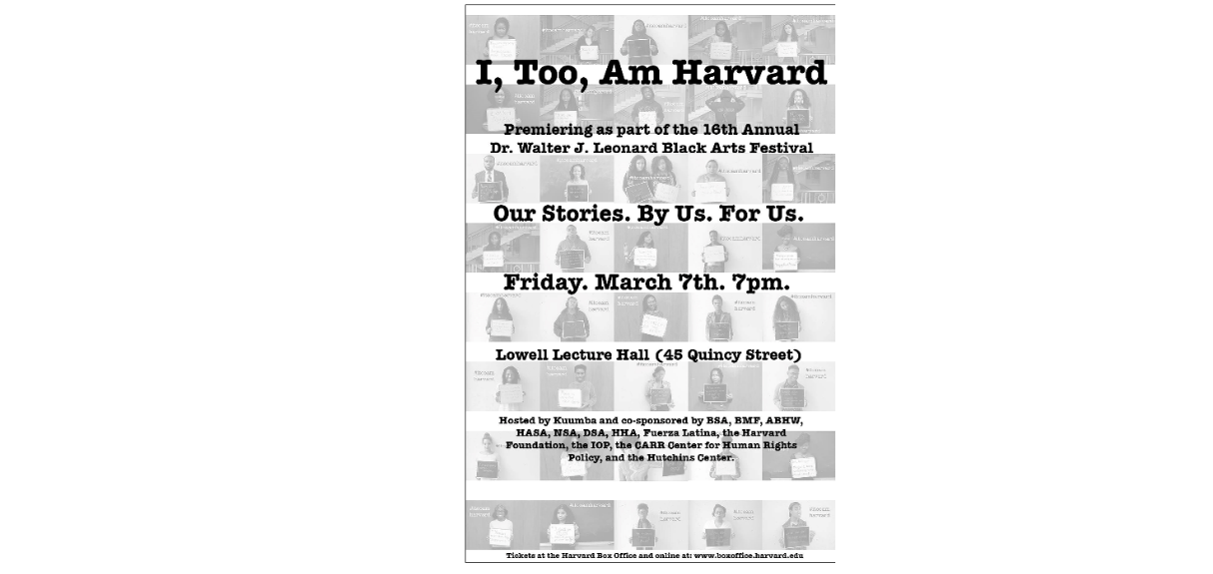
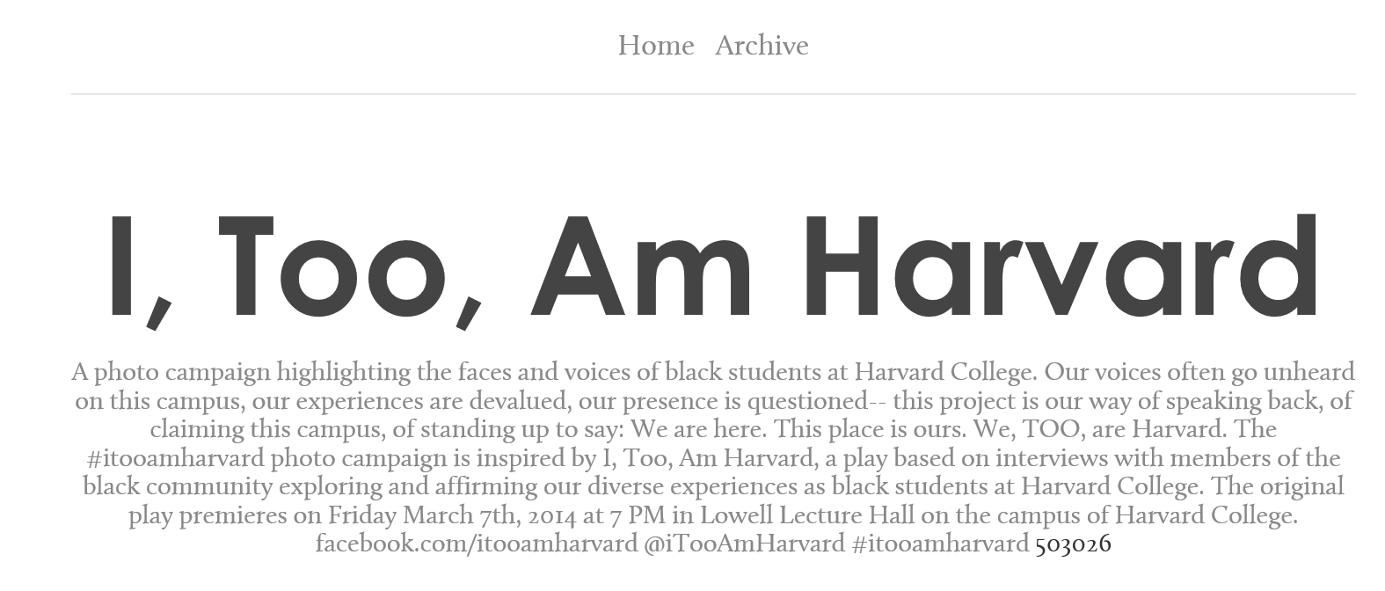
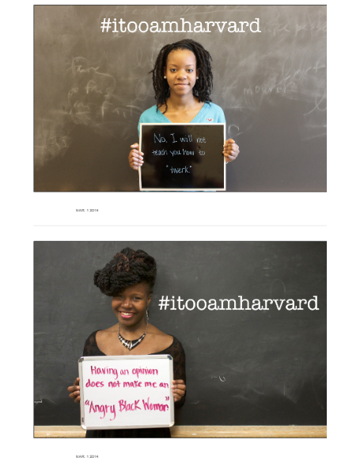

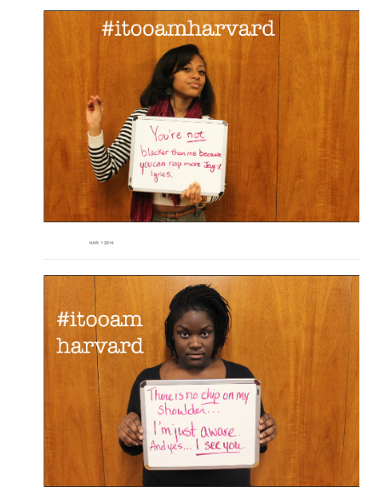
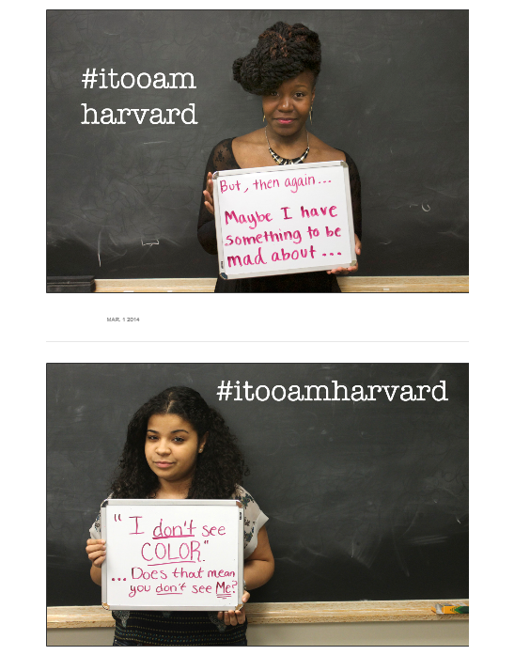

Appendix B

Index of I, Too campaign materials as of November, 2014.

Facebook
I, Too, Am Auckland
I, Too, Am Berkeley
I, TOO, AM CAMBRIDGE - Facebook
I Too Am CU campaign
I, Too, Am Exeter
I, Too, Am Harvard
I, Too, Am Harvard Blacktivism Conference 2014
I, Too, Am Lehigh
I, Too, Am NYU
I, Too, Am OSU
I Too Am Oxford
I, Too, Am Saginaw Valley
I, Too, Am, Sdstate
I, Too, Am St Andrews
I, Too, am Tuks
I, too, am UCT
I, Too, Am UNI
I, Too, Am USC
We Are Calvin Too
We Too Are Central
We Too Are Denison

Radio Broadcasts
NPR: 'I, Too, Am Harvard': A Mantra For Recognition Becomes An Anthem
Radio Boston: Microaggression: The Social Justice Word Du Jour On Campus

Tumblr
I, Too, Am Berkeley
I, too, am Bucknell. - Tumblr
I, Too, Am Cambridge - Tumblr
I, TOO, AM COFC
I, TOO, AM CU by itooamcu - Tumblr
I, Too, Am ENA - Tumblr
I, too, am Finland - Tumblr
I, Too, Am Harvard by itooamharvard - Tumblr
I, too, am IOWA - Tumblr
I, Too, am King's.
I, too, am McGill - I am McGill - Tumblr
I,Too, Am Notre Dame
I, Too, Am NYU Official
I, too, am Oxford.
I, Too, Am Princeton
I, Too, Am Sheffield ! - Tumblr
I too am SOAS by itooamsoas - Tumblr
I, too, am St Andrews - Tumblr
I Too Am Sydney - Tumblr
I, too, am UCT
I, Too, Am Uva - Tumblr
I, too, am UW-Madison by itooamuwmadison - Tumblr
I, Too, Am Wellesley - Tumblr
I, too, am Williams
We Are Calvin [too] by wearecalvintoo - Tumblr

Buzzfeed
“63 Black Harvard Students Share Their Experiences In A Powerful Photo Project”
“150 Students Of Color Share Their Experiences In The ‘I, Too, Am NYU’ Project”
29 Students Of Colour At Cambridge And SOAS Launch Their Own Campaigns To Share Their Experiences At University
Student Campaign Insists “Oxford Is An Inclusive Place” Following Diversity Row

Conference Web Page

Newspaper and Magazine Articles and Videos (This list excludes each college or university’s school newspaper, many of which have at least one article on the campaign)

AOL NowThisNews: “I, Too, Am Harvard” Campaign Gives Black Students a Voice”
BBC: Oxford University BME students speak out on prejudice
Boston Globe: “‘I, Too, Am Harvard’ campaign highlights black students’ frustrations”
“'I, too, am Harvard' campaign spreads across the pond”
City Journal: “The Microaggression Farce”
Elite Daily: “‘I, Too, Am Harvard': This Is What It’s Like To Be Black At Harvard”
The Independent: “Oxford's students of colour speak out in powerful 'I, too, am Oxford' campaign”
The Nation: ‘”I, Too, Am Harvard’ Rocks the Ivory Tower”
“White Noise, Black Politics”
The New York Times: “Students See Many Slights as Racial ‘Microaggressions’”
Times Video (Video also embedded in NYT article above): “Frustrating Black Hair Remark at Harvard”
Resource Magazine: “‘I, too, am Harvard’ Anthem for Black Students a Tumblr Photography Project”
StarTribune: “Microaggressions: Are they racism?”
The Stream: “'I, Too, Am Harvard'”
USA Today: “'I, Too, Am Harvard' photos tell black students' stories”
The Wall Street Journal: “‘I, Too, Am Harvard’ Explores Experience of Being Black and Crimson”
Washington Post: “‘I, Too, Am Harvard’: Black students show they belong”

*The extent of my crate-digging on the internet has produced this information, but it is entirely possible there were more online sources as of this date, and certainly likely that more will exist by the time this work is completed.

VITA

Tara Rayers was born in Baton Rouge, Louisiana. Prior to pursuing her M.A. in English Rhetoric, Writing, and Linguistics at the University of Tennessee, Knoxville, she attended Louisiana State University, where she graduated summa cum laude with a B.A. in English and a B.A. in Sociology. In her undergraduate majors, she concentrated in Literature, Secondary Education, and Criminology, and attained state certification to teach 6-12 grade English and History. She served as co-president of her undergraduate chapter of Sigma Tau Delta, worked in admissions and attendance at the University Laboratory School on LSU’s campus, and held a variety of writing, tutoring, and teaching positions for institutions such as Teach for America and the Institute of Reading Development. She is currently serving her second consecutive year as M.A./M.F.A Representative of the Graduate Students of English at UTK. She presented at the 2014 Cultural Rhetorics conference on the rhetorics of racism in Louisiana and the 2015 Conference of College Composition and Communication on using cultural research methodologies in the classroom.

Spivak does not actually use the term “ethos.” She does, however, discuss ideology, power, subjects and subjectivity. These concepts provide the basis for Davis and Gross’s argument that Spivak offers valuable arguments about ethos attuned to and critical of hegemonic constraints.
I am not arguing that such a project may even be possible. I am instead looking at how black communities in higher education now are trying to make this project possible.
In future work, I hope to complicate my readings by addressing the class and gender of individuals and the classed and gendered communities of the individuals. Although I mentioned gender briefly, these readings lie outside of the scope of this project.
For a consideration of these issues, see Baumlin and Baumlin’s 1994 collection Ethos: New Essays in Rhetorical and Critical Theory.
See Rebecca Moore Howard’s 2007 “Understanding ‘Internet Plagiarism’” for a description of these debates.
Banks does not define his use of the term ethos here, but rather states that he uses it “in all of the rich ways writers might understand that term” (24). Throughout Digital Griots, his use of ethos gestures towards an approximate definition of ethos as authority (either of an individual of a community) in a particular context.
Because nothing but black is visible on this screen, the video might be suggesting that faith is blind or, perhaps more provocatively, suggesting that faith is black. I will briefly mention the connection between faith and blackness later, but I do not focus on it in this project. A more religious reading of this campaign would complicate the remix of mind, body, material, and space, also adding room for spirit. A religious reading might also look specifically at the mind-body-soul-spirit remix at play within the campaign. This perspective would include a reading of the students as establishing their ethos as individuals, members of a race community, and members of a faith community/disciples. As such, an analysis might consider not just how participants relate to their environment (body) and mind (in religion, considered at times with the body, and at times with the soul), but also how participants relate to self-consciousness, self, internal purpose (soul) and to a religiously-imbued higher meaning or purpose (spirit). For the purposes of this reading, due to time and space constraints and the fact that not every participant is religious, I look at faith as an attribute of community. I justify this perspective since faith is a deeply important historical and cultural value for many African and African American communities.
For more information on the recent regulations, see Brittney Cooper’s 2014 “The Politics of black women’s hair: Why it’s seen with skepticism – and a need to discipline,” Julee Wilson’s 2012 “Hampton University’s Cornrows and Dreadlock Ban: Is It Right?” Regina E. Spellers and Kimberly R. Moffitt’s 2010 Blackberries and redbones: critical articulation of black hair/body politics in Africana communities also contains useful information regarding the politics of black hair more generally.
To help illustrate the importance of this element, Matsuda-Lawrence set this photograph as one of her Facebook profile pictures. Out of 17 comments, 3 explicitly praise her hair and many more compliment her style.
Why media attention did not emphasize the viral and technological nature of the I, Too campaign in the way that the public did with Kony remains uncertain. Perhaps people are simply accustomed now to constantly new technologies and to content going viral on them. If so, I would argue that Scott and Welch’s concerns about technological fetishizing may not hold for social media campaigns in general. Regardless, Scott and Welch’s concerns about the banishing of the body in online content remain relevant.
For Scott and Welch, this banishing of the body is mirrored in America’s current economic and political conditions—where “global capitalism depends on the story that human bodies are ancillary to and disposable within a system that can largely function without them” (568). This story is, of course, a myth; as the authors point out, despite the fact that power grids appear to operate on their own, and commodities seem to circulate through transportation technology, “when Hurricane Sandy takes out the lights of Manhattan, it is a human body that must slide into a manhole in search of the saltwater-corroded circuit breaker” and “when thirty-six warehouse workers in a tiny Illinois town refuse to load trucks bound for Walmart, they bring into view the necessity of human bodies” (568).
I thank Gail McKay for providing this distinction between learning about and learning through culture in her 2015 Conference on College Composition and Communication presentation “Using Indigenous Pedagogy to Study an Indigenous Text.”
This page no longer exists. I accessed the original page through an internet archive database called the Wayback Machine. The original page can be viewed at the following URL and is included in my references: http://web.archive.org/web/20120317052241/http://missions.kony2012.com/about-joseph-kony/.
The website has been updated over time, and now includes a page entitled “Our Team” with names, photographs, roles, and biographiess of each team member. At the time of Kony 2012’s big release, however, this transparency was not there. I accessed the original page through Wayback Machine. It can be viewed at the following URL and is included in my references: http://web.archive.org/web/20120313075815/http://www.invisiblechildren.com/
Curtis and McCarthy’s 2012 “Kony 2012: What’s the Real Story?” ; Bruce Dixon’s 2012 “Social Media Scam Alert: Top Ten Ways to Tell Kony is Phony”; Joshua Keating’s 2012 “Joseph Kony is not in Uganda (and other complicated things).”; Tom Rollins’s 2012 “Kony 2012: Don’t Be Fooled.”
These hidden concerns provide the basis for Scott and Welch’s argument that “one train can hide another.” Their claim here is not that the digital potential and democratic rhetoric of Kony was beneficial, but the hidden interests lessened it, but rather that the digital and democratic nature of the campaign actually harmed it because it masked the hidden interests. Unlike Scott and Welch, attribute the harm of the campaign to its digital nature. Rather, I believe it is the way the choreographers used the digital nature of the campaign which contributed to the problems of the campaign.
Parks explains the limiting nature of rhetorical-agency-activism by linking it to neoliberalism, a connection which I think is helpful for understanding the problems with discursive agency. He claims that current neoliberal thought brands political action as “old hat,” using privatization, free market trade, and other such “government-business” partnerships to (claim to) “empower” individuals without having to actually lend real power to anyone.
I include only excerpts for space concerns since the full transcriptions take up over 50 pages. I selected excerpts that I thought best captured the interviewees’ personal struggles, activist concerns, and interaction with the campaign. Notably, many of those excerpts do indirectly address ethos and structures or purposes of knowledge, although I did not specifically pick them because they did so.
See pages 16-19 for my argument about this.
Laurens G. Van Sluytman provides a useful definition and history of the term “microaggressions” in her 2013 article “Micro Aggressions” in the Encyclopedia of Social Work: Chester M. Pierce (1970) first used the term microaggression to described subtle communications of expectations and stereotypes associated with race in an article in Floyd Barbours’ The Black ’70s. Pierce, Carew, Pierce-Gonzalez, and Willis (1978) later referred to these communications as often automatic and nonverbal. Expanding on this definition, Solórzano, Ceja, & Yosso (2000) indicated that microaggressions are nonverbal and verbal as well as visual insults directed at people belonging to racial minority groups that are difficult to confront due to their subtle nature. Microaggressions allow the expression of biased opinions while freeing the perpetrator by means of a thin veil of doubt concerning the intentionality of the action, comment, or behavior. The victims feel doubt concerning their experience of the attack as well as if and how to responded (Essed, 1991; Harrell, 2000; Sue, 2010a, 2010b). Sue, et al. (2007) added that racial microaggressions are, at times, unconsciously delivered failures to acknowledge or trivializing expressions and signals, so pervasive in “everyday occurrences” that they are often easily justified or ignored” (1). Although many of the quotes on chalkboards and white boards in the photograph campaigns contain rhetoric that by this definition would be considered microagressions, I purposely avoid using this term in my thesis. As Sluytman shows, the word microaggression can be used to diminuate problematic and oppressive rhetoric, suggesting the innocence, ignorance, and/or good intention of a rhetor and thus freeing that rhetor from responsibility for his or her own words. I do not think the founders of I, Too attempt to make this type of trivialization. At the I, Too, Am Harvard Blacktivism Conference¸ the founders and participants rarely used the term microaggression; when participants used the term, they often did so with either hesitation or downright frustration, accompanied by an explanation that these “micro” aggressions are not “micro” at all.

