Thermal conditions in residential tents in Knoxville, Tennessee, during hot and cold nights

A Thesis Presented for the
Master of Science
Degree
The University of Tennessee, Knoxville

Seth Thompson
May 2025
Acknowledgments
I would like to take a moment to thank everyone who made this thesis possible. First, I want to offer a special thanks to the University of Tennessee for funding this project through a Student-Faculty Research Award. Thanks to my committee for supporting me along the way and seeing the project through. The VCM Street Outreach team was a vital piece to this project, and without them we would not have been able to recruit participants to participate in this study. Lastly, thanks to Dr. Courtney Cronley with the College of Social Work.

Abstract
Unhoused individuals are exposed to hazardous weather due to their lack of shelter and resources. Extreme temperatures are one hazard experienced frequently by those sleeping outside, including those who sleep in tents. Given the potential impacts of hot and cold nights on human health, and the scarcity of research on overnight temperature exposure of the unhoused population, the study aimed to fill gaps and contribute to our understanding of how unhoused individuals are exposed to heat and cold over the course of a day. This study uses data gathered during two periods in Knoxville, Tennessee, including once in the summer and once in the winter, with 10 study participants in each sample period. Participants who were living in a tent throughout the study period, which was one week long, were invited to participate. iButton Hygrochons were placed inside tents to observe temperature and humidity levels. After the data were collected, they were analyzed to discern patterns of temperature exposure within residential tents. The findings include elevated in-tent temperatures during summer nights, potentially hindering the body’s ability to recover from daytime heat exposure. On the other hand, colder nighttime temperatures during the winter led to dangerous cold exposure, though tents provided some warmth. The findings demonstrated how tents may not mitigate, and at times may worsen, exposure to dangerous thermal conditions, highlighting the vulnerability of unhoused individuals using them as overnight shelters.

Table of Contents
Chapter 1 – Introduction 1
1.1 Homelessness Across Knoxville 1
1.2 The Challenges of Homelessness 2
1.3 Objective of Research 3
1.4 Research Questions 3
Chapter 2 - Background 4
2.1 Residential Tents 4
2.2 Microclimates within an Urban Setting 5
2.3 Heat Exposure and Impacts 6
2.4 Cold Exposure and Impacts 8
Chapter 3 – Data and Methods 10
3.1 Study Area 10
3.2 Participant Recruitment and Characteristics 10
3.3 Temperature Observations 12
3.4 Analysis 15
3.5 Field Notes 16
Chapter 4 - Results and Discussion 20
4.1 In-Tent Temperatures vs. Ambient Temperature 20
4.2 Limitations 27
4.3 Future Research 28
Chapter 5 – Conclusion 30
List of References 33
Vita 44
List of Tables
Table 1. Winter Study Observations. 13
Table 2. Summer Study Observations 14
Table 3. Tent Conditions 17
Table 4. Summer vs. Winter Statistics Tent Statistics 26

List of Figures
Figure 1. Homelessness in Knoxville 1
Figure 2. Study Area 10
Figure 3. Instrumentation 15
Figure 4. Climatological Averages 16
Figure 5. Single Tent Comparison 21
Figure 6. Multiple Tents Comparison 23
Figure 7. Heating a Tent 26
Figure 8. Smoking in a Tent 27

Chapter 1 – Introduction

1.1 Homelessness Across Knoxville
Homelessness affects men, women, and children of all races and ethnicities. In the U.S., approximately 3 million people, 1% of the population, are unhoused in any given year (Maness & Khan, 2014). In 2020, 7,796 individuals across Knox County, Tennessee, were either unhoused or at risk of becoming homeless (Figure 1). During the Point-in-Time (PIT) Count––an annual survey of unhoused people in the U.S.––in January 2023, 30 volunteers counted 925 unhoused individuals in the city of Knoxville, 24% of which were unsheltered (City of Knoxville, 2023). However, the PIT count has been criticized for its lack of reliability, validity, and ability to capture an accurate numerical count of the unhoused population (Schneider et al., 2016). Specifically, the PIT count is known to undercount because unhoused individuals are mobile and attempt to stay hidden (School et al., 2021) in a perpetual game of hide-and-seek (Berghahn Books, 2020). Because living in tents is prohibited in Knoxville, it is impossible for encampments to stay in one location for an extended period; the local government uses abatements or “sweeps” to address the increasing number of encampments. Sweeps undermine and directly harm the health of unhoused individuals, leading to serious health consequences (Chang et al., 2022).
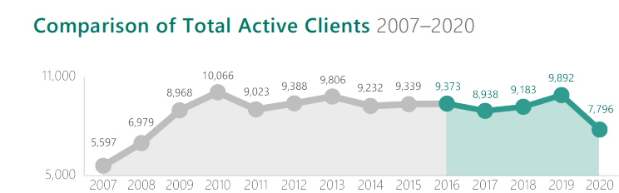
Figure 1. Homelessness in Knoxville: Total number of active unhoused clients in Knoxville who received service during a given year (Homeless Services in Knoxville / Knox County, Tennessee, 2021).

1.2 The Challenges of Homelessness
A combination of complex, advanced medical problems, and psychiatric illnesses, exacerbated by drug and alcohol abuse makes the unhoused population a unique challenge for the healthcare system (Maness & Khan, 2014). In 2017, the average age of death of an unhoused person was 53.5 years old, which was 17.5 years shorter than that recorded for the general population (Romaszko et al., 2017). Climate change exacerbates these healthcare challenges, in part because unhoused individuals are vulnerable to new and resurgent disease processes. The distribution of many different viruses such as West Nile Virus and Ebola virus have changed as a result of climate change (Ramin & Svoboda, 2009). One such example is a large shigellosis outbreak in Oregon in 2015, during which warm weather and heavy precipitation were associated with shigellosis transmission among unhoused individuals but not housed individuals (Hines et al., 2018). Additionally, extreme weather is amplified by climate change and has health consequences. Past research has demonstrated relationships between extreme hot and cold weather and morbidity and mortality (Gronlund et al., 2018). Heat waves exacerbate chronic conditions, cardiovascular and respiratory mortality, and morbidity (Basu, 2009), while cold weather conditions can cause hypothermia, frostbite, and non-freezing cold injuries. To better understand how individuals are impacted by extreme temperatures, recent studies have assessed how individuals are exposed to hot and cold weather and how it affects their health (Seltenrich, 2015; Masselot et al., 2023). Unhoused participants reported a higher perceived severity of excessive heat, which aligns with their heightened vulnerability due to living conditions and limited access to resources. This underscores the necessity for targeted interventions for unhoused individuals, emphasizing the heightened risks and promoting awareness campaigns tailored to their unique circumstances (Robertson et al. 2024). This study is the first to investigate how unhoused individuals are exposed to hot and cold weather when sleeping in tents.

1.3 Objective of Research
The objective of this project was to collect and analyze data from inside tents of unhoused individuals living in Knoxville, Tennessee, to understand their exposure to extreme heat and cold. Specifically, we wanted to determine the difference between the ambient temperature and the in-tent temperature during the overnight period. I attempted to answer two research questions:

1.4 Research Questions
- What overnight temperatures are observed inside tents during the hottest and coldest periods of the year?
- What factors may contribute to the temperatures experienced inside the tents?

Chapter 2 - Background

2.1 Residential Tents
Some unhoused individuals resort to living in tents and encampments, in part because of the sense of community, privacy, and autonomy these arrangements provide (Cohen et al., 2019). Unhoused individuals living in a tent city just outside the city of Victoria, British Columbia, said that a key contributor to a sense of community and safety was the level of stability felt by residents, who are able to avoid constant movement, displacement, and theft experienced when sleeping outside on the street (Olson et al., 2023). On the other hand, one study in Amsterdam also found that outside sleepers may steal from one another, resulting in violence towards each other to protect their interest (Steger & Brunt, 2003). In the city of Knoxville, living in tents is prohibited and abatements or sweeps are used to enforce this law, forcing tent-dwellers from their homes back into even more precarity (City of Knoxville, 2022.). In urban areas such as Knoxville, the city experiences warmer temperatures than the surrounding rural area due to heat-absorbing surfaces like asphalt or buildings. This phenomenon is known as an urban heat island (UHI).
Greenspaces and other hidden areas are places where unhoused individuals often build or erect tents, keeping them out of the public view where they feel unwelcome or discriminated against (Koprowska et al., 2020). Urban green spaces are attractive spaces to socialize and rest, where aspects of peacefulness, brought by nature, are highly valued. Here, unhoused individuals can feel at home, out of sight of the public, and less likely to be bothered and told to move. “Under the bridge, people can’t see me,” said an unhoused woman, interviewed in a different study, who described living unhoused as being an eyesore (Langegger & Koester, 2016). Unhoused people can encounter numerous problems while sleeping outside including exposure to harsh weather, safety threats, and health issues that stem from a combination of factors including sleep deprivation, heat stress, and cold exposure (Gonzalez & Tyminski, 2020; Romaszko et al., 2017). Those who sleep in tents may have some protection from inclement weather, but in some cases, tents can be damaged or flooded, resulting in the loss of a safe sleeping area (Every et al., 2019).

2.2 Microclimates within an Urban Setting
While cities are often warmer than rural areas overall, microclimates exist within a single urban area. Longwave and shortwave solar radiation exchange differences produce complex interactions of physical phenomena across short time and length scales (Allegrini et al., 2015). A feature that may lead to a microclimate is an elevation change, which may cause cold air drainage, meaning lower-lying areas are cooled by cold air advection (Sachsen et al., 2013). In Knoxville this is observed with the river valley created by the Tennessee river that runs through the center of Knoxville where cold air can pool causing a microclimate in the lower elevations of the river valley. Meanwhile other features such as building density and the thermal mass of urban areas all influence microclimates (Loibl et al., 2021).
Trees play a pivotal role in creating local urban microclimates that can mitigate urban heat and enhance thermal comfort (Rahman et al., 2020). Trees can modify the microclimate by providing shade, reducing wind speed, and cooling the air via evapotranspiration (Georgi & Zafiriadis, 2006). These effects together seem to raise the comfort of an individual strictly based on temperature alone (Cheng et al., 2012). This is why we see unhoused populations drawn to areas like parks with plentiful tree cover to provide shade and protection against the elements (Speer & Goldfischer, 2020). Tree species with dense and big canopies provide better shading and human thermal comfort (Helletsgruber et al., 2020). Park Cool Islands have a cooling effect within urban areas, but different densities and distribution of trees play a factor in cool island intensity (Spronken-Smith et al., 2000).
Because of their cooling properties and other characteristics, green spaces are one location of choice for unhoused residents to spend their time. There are other strategic locations where unhoused individuals set up their tents that can provide protection from the elements. For example, an encampment in California was at the bottom of a hill next to a canal and under an overpass (Speer, 2017). At locations such as these in low-lying areas, cold air drainage reduces night-time temperatures beginning right after sunset (McKendry et al., 2001). Overpasses also offer shading and protection from the elements, leading to overpasses being a place used for encampments in Knoxville as well. However, the overpass stores incoming solar irradiance to remit at night which, especially in locations without cold air drainage, may keep the area somewhat warmer than out in the open (Ellis et al., 2024). Data collected across 10 weather stations in the city of Knoxville found that downtown Knoxville was warmer than surrounding neighborhoods over the summer, especially at night (Ellis et al., 2017). A second study found that places where unhoused individuals often sleep outside in downtown Knoxville, including a downtown park area with plentiful trees that kept daytime temperatures down, maintained warmer temperatures than the suburbs overnight, showing a nocturnal UHI (Ellis et al., 2024).

2.3 Heat Exposure and Impacts
The increasing frequency, duration, and severity of heat waves along with the rapidly growing at-risk population around the world amplifies the health implications from weather events (Kenney et al., 2014). One of these implications is heat stress, which, under global warming, is becoming more frequent and intense (Kenney et al., 2014). Heat kills about 600 people per year in the U.S., more than any other extreme weather event in the country (US Department of Commerce, 2023), though that number is likely a considerable undercount (U.S. Global Change Research Program, 2018). Unhoused individuals are particularly vulnerable to heat events (Gabbe et al., 2023). This was recently demonstrated in Las Vegas, where heat is among the deadliest natural event in the region. In 2021, heat-related deaths totaled 245 people as temperatures hit 117 °F, doubling from 125 deaths in 2020. Among these deaths, the coroner office estimates that the unhoused population accounted for around half (Simonton, 2022).
The role of night-time warming in heat-related health effects is growing due to climate change. Daily minimum temperature has increased more than 1 °C in the past few decades (Wang et al., 2020). In addition, night-time heat exposure could be exacerbated by the UHI effect within urban areas, as the maximum UHI is often at night (Shi et al., 2021). By the 2100s, the population exposed to night-time heat is projected to increase four to eight times compared with the 2010s across the northern hemisphere (Wang et al., 2020). Therefore, it could be reasoned that the health effects due to hot nights worsen in a warming climate.
Mitigation efforts have been made to inhibit the impact heat has on unhoused individuals. For example, cities may use cooling shelters, which are air-conditioned public spaces open during abnormally hot days in summer. Usually, local community centers or churches serve as cooling shelters where an individual can seek refuge out of the heat, but for a variety of reasons unhoused individuals may seek refuge in other spaces. Often during heat waves, knowledge of cooling shelters is only spread by word of mouth or by having seen the cooling shelter’s location (Berisha et al., 2017). Additionally, heat alerts may not reach unhoused individuals (Bezgrebelna et al., 2021). Heat education and outreach activities should ensure that vulnerable populations have information made readily available to them along with the ability to access cooling shelters (VanderMolen et al., 2022), and must recognize that, without careful attention, technological advances in heat-health systems may not be beneficial to the unhoused community (Longo et al., 2017). When access to cooling shelters is not provided, unhoused individuals might seek refuge in a park under a shade tree, a library, or a shopping mall (Every et al., 2019); however, they risk being removed by security or law enforcement from these public spaces (Cusack et al., 2013). Tents provide shade and could offer some protection from heat until daytime sunshine warms up the inside of the tent higher than the ambient air temperature. Furthermore, adding a cover material such as a tarp to shade a tent has been found to cause an even higher air temperature inside the tent (Karanja et al., 2023), though thermal environments of tents in which people are living have not yet been observed.

2.4 Cold Exposure and Impacts
In many parts of North America, cold weather conditions persist during the cold months. Unhoused individuals spend most of their time in these conditions, resulting in prolonged cold exposure, and those who sleep outside are exposed to the coldest conditions of the day. Cold stress can quickly overwhelm human thermoregulation with consequences ranging from impaired performance to death (Stocks et al., 2004). Luckily, many climate models indicate cold extremes are becoming less severe and frequent. Areas like Knoxville usually only see one or two extreme cold events each winter. The duration of such events could be impacted too with the changing climate, with models pointing towards a shortening period of extreme cold events (Kodra et al., 2011).
An unhoused individual may attempt to combat the cold nights of the year with multiple methods to warm themselves or the spaces they live in. Drugs and alcohol may be used to provide relief, but they can dangerously dull the senses giving an individual the feeling of warmth even when they are not. Burning bits of trash and paper against bricks or rocks, which hold heat, can help warm structures (Batty, 2011). In a previous study, one unhoused woman described being cold at night and running to the nearest public restrooms for warmth, but unfortunately many times the public restrooms were closed (Alewett, 2014). These methods are not ideal for staying warm at night, but with the circumstances surrounding homelessness many do not have any other options.
The health implications of cold exposure can be severe. Hypothermia is the most common ailment, in which individuals staying outdoors in cold environmental conditions develop abnormally low body temperature, cardiovascular, central nervous system dysfunction, and potentially fatal outcomes. The odds of experiencing hypothermia increase 1.64-fold with every 5 °C of cooling (Zhang et al., 2019). Also common is frostbite, when a person’s exposed skin becomes white-colored due to lack of blood flow, the cells die, and the tissue freezes. This damage can be temporary or permanent depending on the severity (Frostbite on Jstor, 1952). Disability from amputation following frostbite affects at least 20 percent of patients and disproportionality affects the unhoused population (Endorf & Nygaard, 2021).

Chapter 3 – Data and Methods

3.1 Study Area
Data were collected from across the downtown district of Knoxville, Tennessee (Figure 2). Knoxville is considered a medium-sized city with an estimated population of 190,740 as of 2020 (Knoxville Census, 2022.). Knoxville exists in a valley, located east of the Cumberland Plateau and west of the Great Smoky Mountains. The Tennessee River separates South Knoxville from the rest of the city and downtown, where the data were collected. Knoxville is a humid subtropical climate, with hot, humid summers and mild winters, but not regular frosts.

3.2 Participant Recruitment and Characteristics
There were two data collection periods: one in winter 2024 and one in summer 2024. For each period, ten unhoused individuals who were living in a tent were recruited to participate in this study. The Volunteer Ministry Center of Knoxville (VMC) helped identify potential participants. Once a participant was chosen, they agreed to participate in the study by signing a
consent form. The form has 2 parts, a section on demographic information being collected for a separate study, and a section about participating in the in-tent observation portion of the study. Upon initial consent, a $20 gift card was given to the participant for completing the demographic
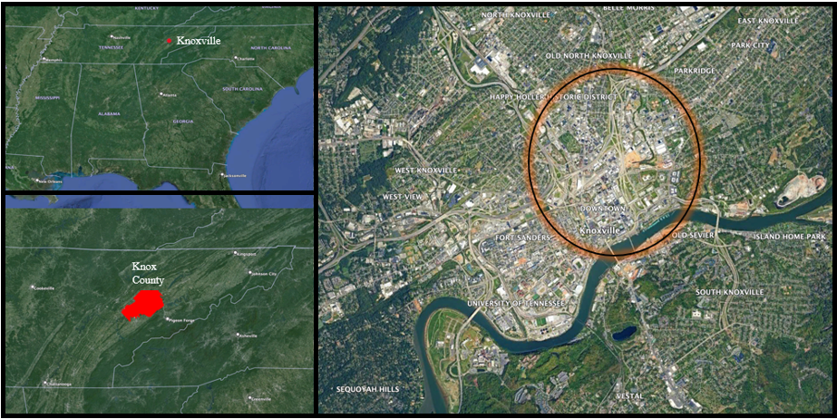
Figure 2. Study Area: Data were collected in tents located within the circle.
survey. The VCM Street Team led the research team around Knoxville to locate participants in the study and place equipment. When arriving at the tent, the street team loudly identified the group as “VMC and UT” and asked if they can access the tent. If no one answered, no sensors were placed in the tent. If someone answered, exited the tent, and allowed access, then the temperature sensors described in section 4.2 were placed in the participant’s tent. Notes were taken about the type of tent materials and any evident mitigation measures for extreme temperatures. During each of the two data-collection periods, participants were given a $20 Kroger gift card for every other day during the collection period that they participate. A total of $100 in gift cards were given to everyone participating in the study. This research was approved by the University of Tennessee Institutional Review Board (UTK IRB-24-07952-XP).
Some problems with recruitment occurred when completing the study. During each study period, 10 tents were initially accessed, but some tents could not be included in this study for reasons such as erroneous observation or the participant did not have a tent. For example, two participants volunteered but did not mention they do not live in a tent. Unfortunately, when the team arrived at the location where they lived, there was only a pavilion. Since these conditions are what so many of the unhoused community have to face the team went ahead and recorded observations at the location, but the data was not included in the study.
Participant demographic information was collected via a survey performed orally in a VMC office. The average age of a person who participated in the study was 46 years old, and ages ranged from 34–63. Participants had been unhoused for as few as 4 months to as long as 20 or more years. The length of time exposed to the elements matters because of the impacts of long-term exposure on health (Heaviside et al., 2017). Several participants shared with the team that this was not their first experience being unhoused. They explained that they had previously secured housing, but due to various circumstances, they once again found themselves without stable shelter.
When asked how they received information about impending weather events, participants gave two primary responses. About half reported obtaining inclement weather updates via cell phone alerts, while several others relied on family and friends for timely warnings. Participants were also asked which weather conditions most affected their health when sleeping in a tent. Common responses included extreme cold, intense heat, rain, snow, and high winds. Sixteen participants reported that cold weather negatively impacted their ability to sleep in a tent, while twelve indicated that hot weather influenced their decision on whether to use a tent for sleeping. These findings demonstrate that everyday weather patterns impact the study participants. Several participants noted only fair health, citing prolonged exposure to the elements as a contributing factor to their declining well-being. Individuals who reported being in very good health were those who had experienced long-term homelessness. This may be attributed to their developed expertise, resilience, and adaptability in navigating the challenges of life without stable housing.

3.3 Temperature Observations
The winter portion of the study took place from February 14–21 2024. The summer portion of the study took place from August 14–21 2024. These dates were chosen based on personnel availability, including partners at the VMC who were integral to ensuring the camps were not swept during the study. The weather during the collection periods is shown in Tables 1 and 2. For each collection period, sunny and cloudy weather was observed, accounting for a
multitude of conditions unhoused individuals face. Frontal systems were also observed during

Table 1. Winter Study Observations: Weather observations reported from the KCNI airport weather station during our winter study period from February 14–21, 2024.

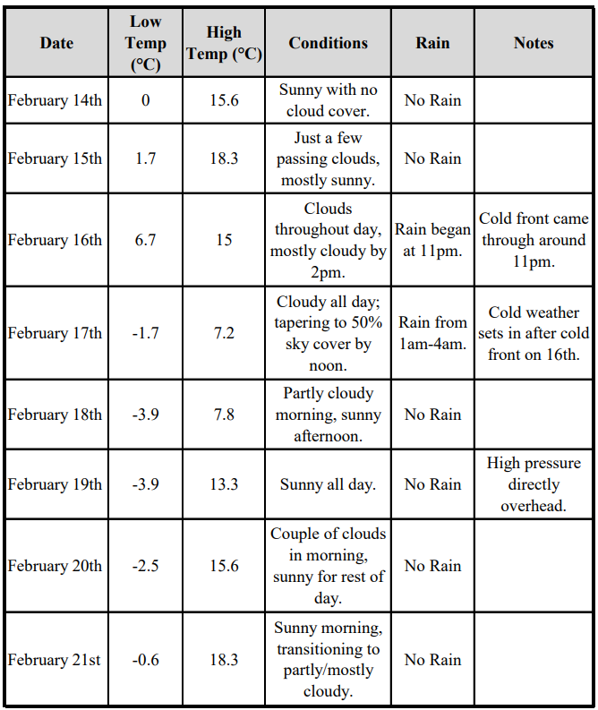

Table 2. Summer Study Observations: Weather observations reported from the KCNI airport weather station during our summer study period from August 14–21, 2024.
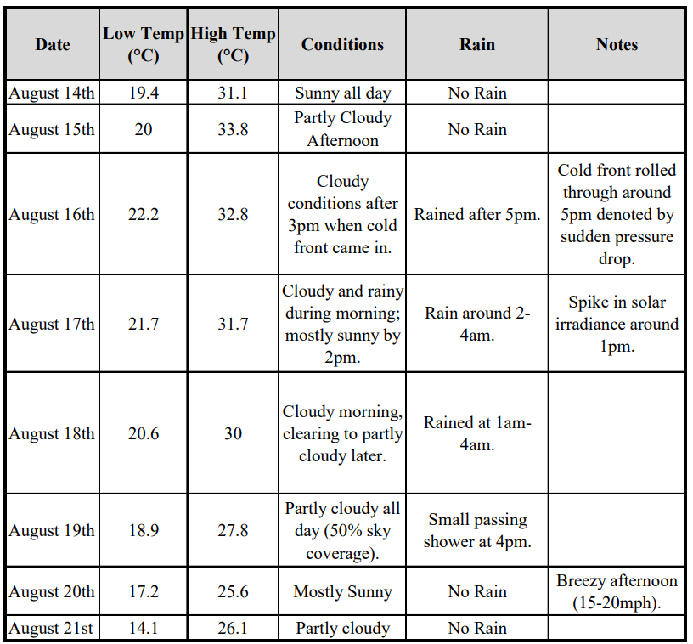
both collection periods allowing for drastic changes to temperatures throughout the collection period.
Data were collected using iButton Hydrochrons secured inside a radiation shield to ensure accurate data collection. The iButtons recorded temperature and relative humidity data at 15-minute time increments, which we downloaded from the device onto a local computer. The iButton Hygrochron has an accuracy of ± 0.5 °C and ± 5% relative humidity (Longo et al., 2017). Data were collected inside unhoused individuals’ tents where the devices holding the iButtons
were placed one foot from the center ceiling of the tent (Figure 3). This location within the tent has been used by other researchers and produced the best outcome with data collection (Karanja et al., 2023). A control iButton was placed outside of the tent to measure ambient air temperature so that it can be compared to the temperature inside the tents.
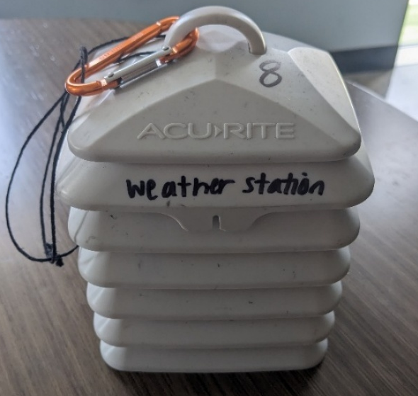
Figure 3. Instrumentation: Photo of instrumentation placed inside of participant’s tent. This instrument was placed one foot from the ceiling of the tent, and the two iButtons are on the inside of the radiation shield recording temperature and relative humidity observations.

3.4 Analysis
For the statistical portion of the study, we only used data from days that lied between 2 standard deviations from the climatological temperature averages (Figure 4) and exhibited no synoptic forcing, ensuring we focus on typical weather instead of extremes. This resulted in three (four) days for the winter (summer) portion of the study.
Because we were interested in overnight exposure when residents were most likely inside their tents, we analyzed the period from 12 am to 7 am. This specific period was chosen because
it is the time average adults are asleep for (Monk et al., 2000); though we recognize that the patterns of unhoused individuals may be different, this is likely a period where they do not have other places to go and will be in their tent.
The data collected from the iButton Hydrochrons were analyzed in R Studio using descriptive statistics to investigate relationships between in-tent temperature and ambient temperature. Graphical representations were created to highlight these patterns, plotting ambient

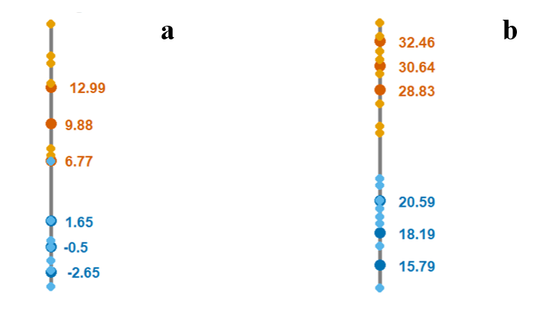
Figure 4. Climatological Averages: Climatological averages (°C) for winter (a) and summer (b) are depicted by the middle temperature in each set of numbers––winter and summer highs (orange) and winter and summer lows (blue). The surrounding numbers depict two standard deviations out from the climatological averages. The smaller dots are recorded highs and lows from a nearby airport, KCNI, during the study period to help determine what days fall within two standard deviations.
temperature alongside in-tent temperature for the study periods, which allows visual comparisons of the trends observed at both diurnal and sub-hourly scales. These graphs form the groundwork for the exploration of potential factors influencing the observed thermal behavior. A paired-samples t-test was used to compare ambient air temperature to the in-tent temperature using the Bonferroni correction to account for the error induced when conducting multiple t-tests. The Bonferroni correction adjusted alpha from 0.05 to 0.000357. The multitude of variables within the study made it challenging to isolate any single variable to discern its impact on temperature exposure. Such variables included smoking within a tent, which has been found to skew temperature observations, burning candles, and the wide variety of materials and tent types.

3.5 Field Notes
When each tent was visited for instrument implantation, physical observations were also taken of the tent. Table 3 provides an overview of the surrounding environment, structural descriptions, contents inside the tent, and other field notes including how many people were living in the tent. These descriptions provide powerful insights and connections that can be made
Table 3. Tent Conditions: Each row is the description of a tent with fourteen tents in total as a part of this study. Six tents were observed for the winter portion of the study. Eight tents were observed for the summer portion of the study.
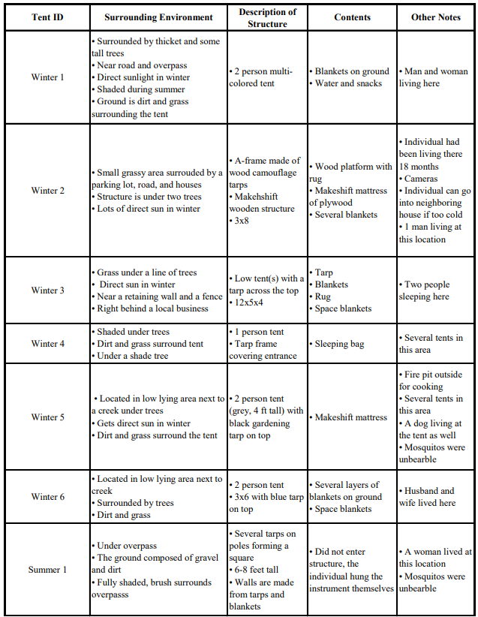

Table 3. Continued
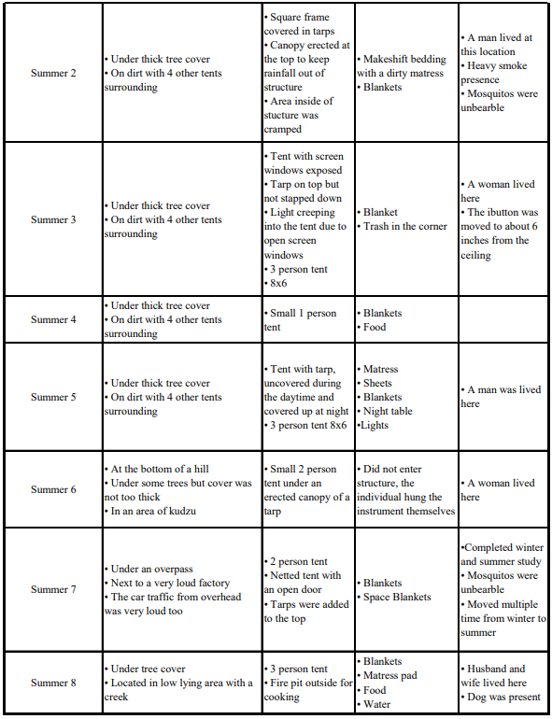

when comparing them to the graphical figures. Each row within Table 3 represents a unique tent, highlighting the differences within the individual’s set-up and living conditions. These tents vary in terms of their construction, from minimalistic structures that offer little to no insulation to more robust tent setups with materials that retain heat and improve the tent’s thermal comfort. Likewise, the contents range from basic bedding on the ground to more elaborate setups with a mattress, blankets, food, water, night table, lights, and drawers for belongings. The observations highlight the impact of both personal choices and environmental factors on the variability of tent conditions, providing valuable insights into currently employed and potential adaptive strategies.

Chapter 4 - Results and Discussion

4.1 In-Tent Temperatures vs. Ambient Temperature
The relationship between ambient and in-tent temperatures provides insight into microclimatic conditions within makeshift shelters such as tents, and the potential implications for occupant comfort and safety. This study examines the thermal characteristics of tents relative to the external environment by analyzing 15-minute temperature observations during a summer and winter period. The results provide a nuanced understanding of how tent structures respond to ambient temperature fluctuations and the extent to which they amplify or buffer external conditions.
In-tent temperatures tended to exceed ambient temperatures during daytime and nighttime periods in both summer and winter, as seen with tents Winter 3 and Summer 8 in Figure 5, for example. The differences were greater during the day, at times 7–8 °C, which can be attributed to incoming solar radiation being trapped inside the tent and limited ventilation within the structure increasing the temperature inside the tent. At night, in-tent temperatures remained slightly elevated (e.g., 3–4 °C) compared to ambient temperatures, suggesting that body heat, tarps, or supplemental heating sources keep the tent warmer as the ambient environment cools. Figure 5a highlights the importance of tents for the unhoused population by keeping them warmer in the winter and less exposed to cold and other extreme conditions, though the conditions they experience are still capable of severe health impacts. Meanwhile, Figure 5b demonstrates that during the summer, sleeping in a tent may result in increased nighttime heat exposure, at a time when the body would typically recover from daytime heat exposure.

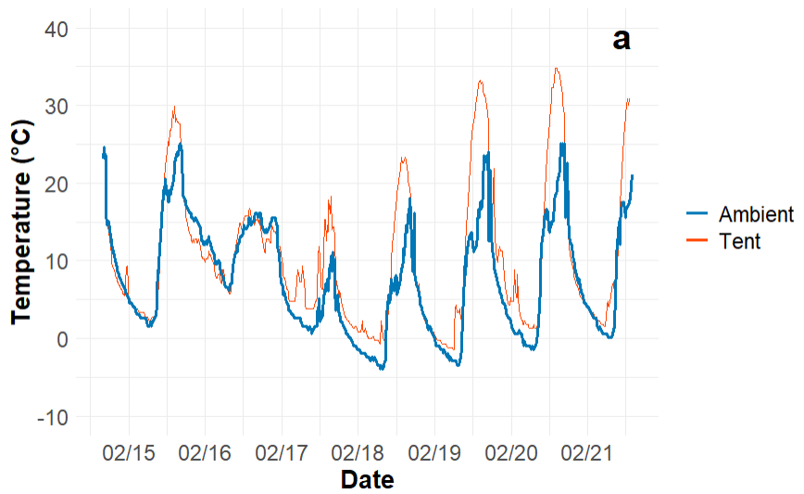
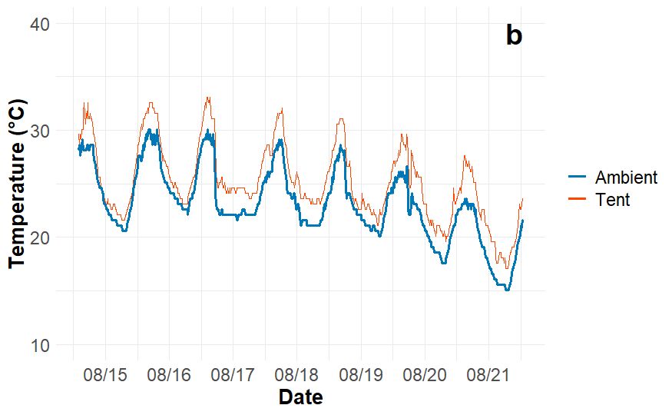
Figure 5. Single Tent Comparison: Example of one set of in-tent (solid red line) and ambient temperatures (bolded solid blue line) during the a) winter and b) summer. The tent ID for “a” is Winter 3. The tent ID for “b” is Summer 8 (Table 3).

Multiple tents located in a single location provided an opportunity to assess differences in
exposure between tents. In Figure 6a, we illustrate temperatures in a set of tents in a single encampment in the winter. Despite having nearly the same external conditions, the in-tent temperature profiles have notable variations, highlighting the impact of internal factors within the tents. Tent 1 had two people living inside the tent with a fire outside the tent they used to cook their food and stay warm at night, which resulted in warmer temperatures compared to the other tents during the overnight hours. The sharp increases during the overnight hours are indicative of supplemental heating sources such as burning candles, pieces of paper, or hand sanitizer to produce heat.
Even though some participants used methods to heat tents during the wintertime, most of the tents we studied did not show signs of heating up the tent overnight. This exposed participants to prolonged cold temperatures, which could lead to hypothermia or frostbite in
extreme cases. In a study on drug and alcohol abuse among unhoused individuals, researchers mentioned a number of participants said they drank alcohol to “warm up,” i.e., to better endure Montreal’s cold climate (Ochoa et al. 2023). The common feeling of warmth after drinking alcohol is because alcohol affects the thermoregulation of humans. When alcohol is consumed an immediate reaction of the body is the vasodilation seen in peripheral blood vessels, which causes warmth to be felt on the outside of the body (Yoda et al. 2005). Similar studies on alcohol clearly show that alcohol consumption dramatically affected the circadian core body temperature by inducing its nocturnal increase (average increase of 0.36°C; Danel et al. 2001). This is one potential reason alcohol and drug dependence is the most common mental disorder among the unhoused population (Fazel et al. 2008).
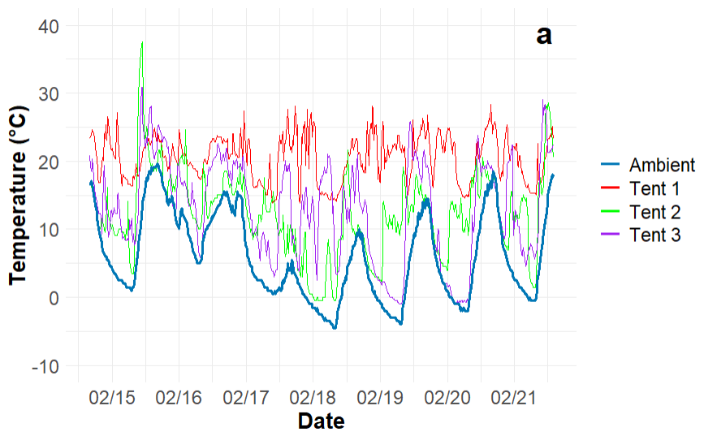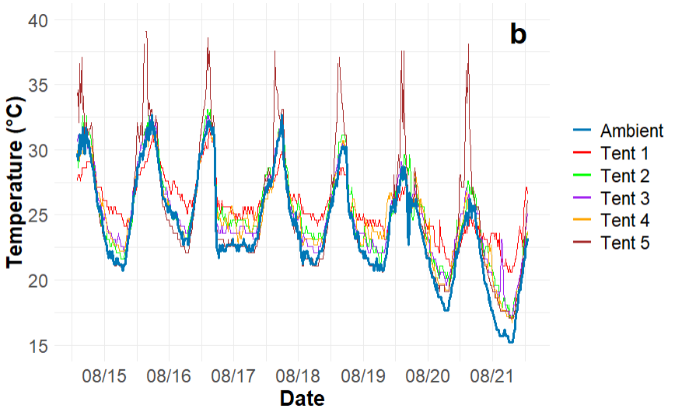
Figure 6. Multiple Tents Comparison: Temperature observations from within a set of tents located at a single encampment, as well as ambient encampment temperature, during a) the winter where Tent 1 ID is Winter 4, Tent 2 ID is Winter 5, and Tent 3 ID is Winter 6 and b) the summer where Tent 1 ID is Summer 1, Tent 2 ID is Summer 8, Tent 3 ID is Summer 2, Tent 4 ID is Summer 5, and Tent 5 ID is Summer 4.

During the summer study, the tents within the single encampment largely had a similar temperature profile to the ambient temperature. The exception was Summer 5, which was in the
direct sunlight causing warmer in-temp temperature during the daytime. During the nighttime, body heat and heat trapped inside the tent kept the tent warm and, in some cases, uncomfortably warm, upwards of 25 °C (77 °F). The ideal temperature for sleep is between 65–70 °C (Raj et al. 2020), which is not experienced on the average summer or winter night in a tent. While there is not yet a full understanding of the impact of overnight heat exposure on health, it is believed that being exposed to heat overnight prevents the body’s ability to recover from daytime heat exposure (Murage et al., 2017). Additionally, unhoused individuals lack of sleep can affect their cognition, resulting in reduced attention, psychomotor vigilance, and increased variability in behavioral responses (Killgore et al. 2010).
There are few to no options for cooling a tent down to optimal sleeping temperatures during summer months. One mitigation measure is the use of shade. An experiment in Arizona found that erecting a shade over a tent affects temperatures in tents significantly––enough to affect health outcomes. Specifically, tent covers can be used to reduce daytime heat but they should be removed at night or they will trap heat (Karanja et al., 2023). However, this experiment was performed in the desert and results could differ in a humid subtropical climate. In our study, many participants used trees to shade their tents, which means they have no structure to remove at night. It is doubtful that those who did erect shade structures remove them at night due to the complexity of the shade structures, many of which were built from scrap materials. Instead, we saw participants attempting to mitigate heat by increasing air flow in the summer months. They opened doors and windows and removed layers of blankets and tarps from the roof of the tent (Table 3). This shows that heat mitigation measures are going to vary geographically, and some measures may not be possible in these makeshift structures. A common spot tent dwellers were found throughout the study is underneath overpasses in attempt to provide shade and other protection from the elements. Overpasses are a commodity to the unhoused community, and some argue they should be allowed to take advantage of the existing infrastructure (Hall, 2011).
Mitigation strategies were more impactful in the winter. The in-tent temperature constantly exceeded the ambient temperature (Figure 7), with temperature spikes suggesting the use of supplemental heating methods such as candles, small fires, or other heating sources. Despite participant attempts at warming their tent, the average temperature of this particular tent during the coldest part of the morning was around 6 °C (42 °F), which is approximately 12 °C below recommended ambient sleep temperature, though warmer than the ambient temperature. Inside the tents used in our study, we observed temperatures below the -0.5 °C threshold where frostbite and other cold exposure sicknesses can occur (Fudge et al. 2015). In addition, burning
candles is a dangerous mitigation measure, as this practice can destroy a tent or an entire community (Murray et al. 2009). These results provide insights as to how effectively individuals attempt to adapt to outdoor living conditions and mitigate winter temperatures, and also demonstrate that these mitigation measures may not make a large enough difference to contribute to better health outcomes or may be inherently dangerous.
Table 4 illustrates 14 paired t-test results comparing the difference between ambient temperature and in-tent temperature for both summer and winter. The results show the majority tents from summer and winter periods experience significant differences from the ambient temperature. During the winter period, these differences were much greater than when compared to the summer data, demonstrating the impact of mitigation measures. Though tents only
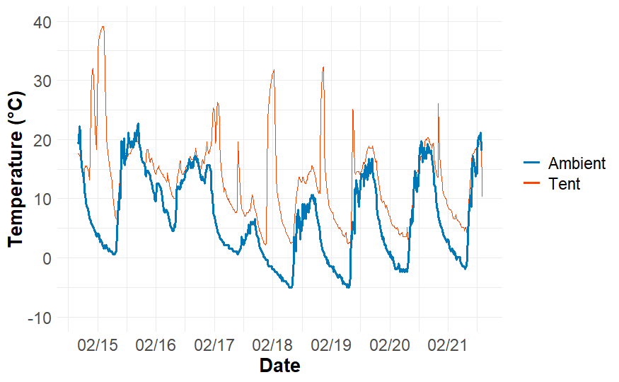
Figure 7. Heating a Tent: Ambient temperature and in-tent temperatures during the winter, showing how heating sources such as candles cause sharp peaks in the in-tent temperature. The tent ID for this tent is Winter 2.

Table 4. Summer vs. Winter Statistics Tent Statistics: Mean differences in 15-minute overnight temperature observations (°C) between tents and the ambient environment during the summer and winter. Positive values depict the in-tent temperature as warmer than the ambient temperature. Significance is reported based on a paired-samples t test (*p<0 .05, **p<.00357). Subscript values correspond with tent ID number.
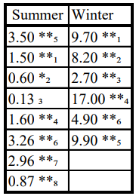

captured minimal additional warmth overnight in the summer, the overnight heat exposure may still have negative health consequences. Similarly, though tents remain significantly warmer overnight in the winter, residents are still being exposed to dangerously cold temperatures.

4.2 Limitations
This study was limited by sampling capabilities that affected the size and timing of the data collection. The timing of the study periods had to be planned weeks in advance and coincide with periods where all personnel were available and VMC could confirm with officials that they would pause camp sweeps. This resulted in data collection occurring in unseasonably mild temperature periods for summer and winter. This deviation from average conditions could have introduced bias, limiting the conclusive findings to other periods of the year.
Furthermore, many variables for this study area were not controlled for such as smoking (Figure 8), unknown heating sources (Figure 7), daily lives of unsheltered individuals, or tent
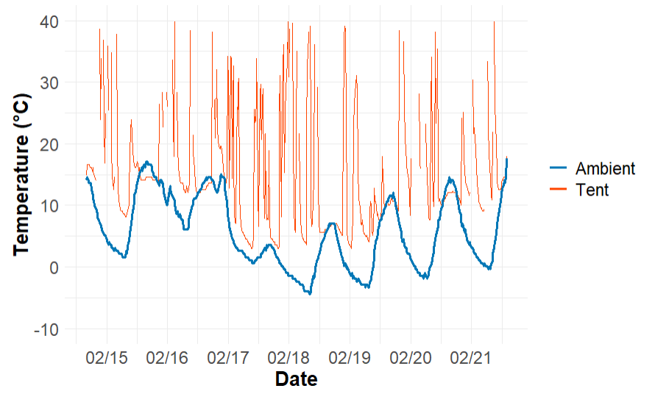
Figure 8. Smoking in a Tent: Ambient temperature and in-tent temperatures during the winter, showing how smoking in a tent can increase the temperature inside the tent drastically observed by the sharp spikes in the in-tent temperature data.

placement. This is what also made this study important, the fact that the research team was able
to go out into the field and work alongside the real unhoused population. Some of these complex variables are potentially impactful for unhoused individuals and would be interesting to study in isolation; for example, the comorbidity of smoking and thermal exposure among those sleeping in tents, or the effects of burning candles on core body temperature. Some data were also excluded because an ambient sensor was covered with a wet shirt so we could not use that data. This is a good example of the challenges associated with relying on volunteers to host equipment. Lastly, many participants lived in a semi-urban or low-lying forested environment, which limited this study’s ability to explore connections between the unhoused population and the UHI. These limitations all reflect the innate challenges of conducting field-based research on a vulnerable and highly mobile population.

4.3 Future Research
Future research should focus on addressing the limitations of this study while attempting to expand the scope of thermal dynamics surrounding the unhoused population. A necessary improvement would be to ensure data collection across climatological averages for the studied season based off of temperature, which has been proven hard to achieve. Another interesting component to investigate would be to repeat this study under climatologically extreme temperatures for winter and summer to see how the thermal dynamics within tents change. Incorporating additional variables, such as human activities, sky view factor, and health data like body temperature would be important to consider. Future studies could also investigate unhoused populations living in a denser urban setting to look at the direct effects of the UHI on the unhoused population. Finally, incorporating descriptive qualitative data, such as in-depth questionnaires for participants on their thermal comfort and coping strategies, could provide valuable context to support the quantitative findings and inform interventions that improve the living conditions of unhoused individuals.

Chapter 5 – Conclusion
This project is the first to assess thermal conditions of residential tents. The findings revealed that tents consistently maintain higher temperatures than their surroundings. During the wintertime this result is positive, with tents helping the unhoused stay warmer in the cold conditions. On average, tents in the winter were 8.73 °C warmer overnight than the ambient environment, though the temperatures still reached cold enough conditions to cause health concerns, even on average winter nights. One study participant who has been living in a tent long-term had a few frostbit toes and was likely going to have them removed. Alternatively, in the summer, the excess heat inside the tents, which were approximately 2.48 °C warmer than the ambient temperature on average overnight, increases individual heat exposure. Individuals could benefit from sleeping outside during the summer in the cooler ambient air, but as documented from this study the mosquitos were unbearable at some encampment locations. Originally this study aimed to use heat index as a variable to study, but during the summer study period the warmest temperature observed was 30 °C. The relative humidity during the entire period was also low, making the heat index negligible. However, multiple individuals told the team that even if it is not 38 °C, 29 °C is still hot and strains their body.
Shading effects on tents also emerged as a notable factor that influenced temperature regulation within the tent. Dense tree cover where tents were situated experienced cooler in-tent temperatures mainly during the daytime hours than those exposed to direct sunlight. While shade can mitigate heat in the summer months, it could reduce warming inside the tent during the wintertime. Luckily, during the winter months the team noticed that the trees were off the leaves creating more sunlight in dense tree covered areas. Unfortunately, as many unhoused individuals mentioned to the team that the limited leaves on the trees made it harder for them to stay hidden, increasing their chances of getting swept by the local officials. These findings suggest that the tent location with consideration of shading and sunlight could improve safety and comfort for unhoused individuals.
This study illustrates the variability in thermal performance between tents in proximity to each other. Differences in the surrounding environment, structure type, contents, and the amount of people living in the tent are all factors that impact the in-tent temperature. For example, tents with tarps or space blankets perform better at retaining heat. Alternatively, tents with thinner materials or in more exposed locations were less effective at retaining heat. As the team went around from encampment to encampment a pattern evolved of tents that were slashed, and we finally asked the VMC team members if they knew how this occurred. They told the researchers that the local officials come through and slash the tents of unhoused individuals to ward them away from the area and make their tent not suitable for living. Now the elements like wind and rain can infiltrate their tent making living conditions miserable for the inhabitant. Table 3 summarizes these descriptions demonstrating the wide variability within tents and belongings of unhoused individuals, which can significantly influence the effectiveness of the tent as a shelter.
Tents are a vital resource for the unhoused populations throughout the year, regardless of their limited ability to reduce thermal exposure. Unfortunately, encampment sweeps are conducted by local officials every couple of weeks creating a scarcity of tents within the community. This forces unhoused individuals to constantly move their camp and/or replace their items, increasing their precarity. If individuals could remain in one location, they could improve the livability of tents through simple interventions. Methods could involve decreasing cold exposure in the winter months by using blankets or safe external heat sources. Some reduced heat exposure could occur through appropriate removal of tarps and use of windows in locations where an individual is comfortable doing so. These findings also allude to broader systematic challenges as while tents do provide short-term protection against harsh elements, there is currently no long-term solution for housing insecurity.

List of References
Alewett, H. (2014). Homeless for One Winter Night: A Nursing Student’s Perspective. A with Honors Projects. https://spark.parkland.edu/ah/113
Allegrini, J., Dorer, V., & Carmeliet, J. (2015). Influence of morphologies on the microclimate
in urban neighborhoods. Journal of Wind Engineering and Industrial Aerodynamics, 144, 108–117. https://doi.org/10.1016/J.JWEIA.2015.03.024
City of Knoxville. (2022). Retrieved June 2, 2024, from https://www.knoxvilletn.gov/archived_news_stories/2023/annual_homeless_count_decreases_from_2022
Basu, R. (2009). High ambient temperature and mortality: A review of epidemiologic studies from 2001 to 2008. Environmental Health: A Global Access Science Source, 8(1), 1–13. https://doi.org/10.1186/1476-069X-8-40/TABLES/3
Batty, E. (2011). The hidden truth about homelessness Experiences of single homelessness in England Kesia Reeve. www.crisis.org.uk
Berisha, V., Hondula, D., Roach, M., White, J. R., McKinney, B., Bentz, D., Mohamed, A., Uebelherr, J., & Goodin, K. (2017). Assessing Adaptation Strategies for Extreme Heat: A Public Health Evaluation of Cooling Centers in Maricopa County, Arizona. Weather, Climate, and Society, 9(1), 71–80. https://doi.org/10.1175/WCAS-D-16-0033.1
Bezgrebelna, M., McKenzie, K., Wells, S., Ravindran, A., Kral, M., Christensen, J., Stergiopoulos, V., Gaetz, S., & Kidd, S. A. (2021). Climate Change, Weather, Housing Precarity, and Homelessness: A Systematic Review of Reviews. International Journal of Environmental Research and Public Health 2021, Vol. 18, Page 5812, 18(11), 5812. https://doi.org/10.3390/IJERPH18115812
Chang, J. S., Riley, P. B., Aguirre, R. J., Lin, K., Corwin, M., Nelson, N., & Rodriguez, M. (2022). Harms of encampment abatements on the health of unhoused people. SSM - Qualitative Research in Health, 2, 100064. https://doi.org/10.1016/J.SSMQR.2022.100064
Cheng, Y., Niu, J., & Gao, N. (2012). Thermal comfort models: A review and numerical investigation. Building and Environment, 47(1), 13–22. https://doi.org/10.1016/J.BUILDENV.2011.05.011
Cohen, R., Yetvin, W., Khadduri, J., & Associates, A. (2019.). Understanding Encampments of People Experiencing Homelessness and Community Responses, Emerging Evidence as of Late 2018. Retrieved June 16, 2024, from https://ssrn.com/abstract=3615828
Cusack, L., Van Loon, A., Kralik, D., Arbon, P., & Gilbert, S. (2013). Extreme weather-related health needs of people who are homeless. Australian Journal of Primary Health, 19(3), 250–255. https://doi.org/10.1071/PY12048
Danel, T., Libersa, C., & Touitou, Y. (2001). The effect of alcohol consumption on the circadian control of human core body temperature is time dependent. American Journal of Physiology-Regulatory, Integrative and Comparative Physiology, 281. https://doi.org/10.1152/ajpregu.2001.281.1.r52
Ellis, K. N., First, J. M., Kintziger, K. W., & Hunter, E. (2024). Overnight heat in sleep spaces
of housed and unhoused residents: results and recommendations from a Knoxville, Tennessee, case study. International Journal of Biometeorology, 68(4), 637–646. https://doi.org/10.1007/S00484-023-02611-3/FIGURES/6
Ellis, K. N., Hathaway, J. M., Mason, L. R., Howe, D. A., Epps, T. H., & Brown, V. M. (2017). Summer temperature variability across four urban neighborhoods in Knoxville, Tennessee, USA. Theoretical and Applied Climatology, 127(3–4), 701–710. https://doi.org/10.1007/S00704-015-1659-8/TABLES/10
Endorf, F. W., & Nygaard, R. M. (2021). Social Determinants of Poor Outcomes Following Frostbite Injury: A Study of the National Inpatient Sample. Journal of Burn Care & Research, 42(6), 1261–1265. https://doi.org/10.1093/JBCR/IRAB115
Every, D., Richardson, J., & Osborn, E. (2019). There’s nowhere to go: counting the costs of extreme weather to the homeless community. Disasters, 43(4), 799–817. https://doi.org/10.1111/DISA.12400
Fazel, S., Khosla, V., Doll, H., & Geddes, J. (2008). The prevalence of mental disorders among the homeless in western countries: Systematic review and meta-regression analysis. Plos Medicine, 5(12). https://doi.org/10.1371/journal.pmed.0050225
FROSTBITE on JSTOR. (1952.). Retrieved April 22, 2024, https://www.jstor.org/stable/24950594?casa_token=ioLN8JTsZ7UAAAAA%3AeocM3mx9MfhK_nmnKOZHbGtqBCeubipsfMrD4M8SJxbsuIBW6cPTLQKnGot95oXBjtsKlVGzKyEOHpRE5X2zjv0zdI3CuoLuxSDe3mbww8WRNvdmHUow&seq=1
Fudge, J. R., Bennett, B. L., Simanis, J. P., & Roberts, W. O. (2015). Medical evaluation for exposure extremes. Clinical Journal of Sport Medicine, 25(5), 432–436. https://doi.org/10.1097/jsm.0000000000000224
Harrell, K. N. (2019). Homelessness in Portland, Oregon: An Analysis of Homelessness in Portland, Oregon: An Analysis of Homeless Campsite Spatial Patterns and Spatial Homeless Campsite Spatial Patterns and Spatial Relationships. https://doi.org/10.15760/geogmaster.24
Gabbe, C. J., Chang, J. S., Kamson, M., & Seo, E. (2023). Reducing heat risk for people experiencing unsheltered homelessness. International Journal of Disaster Risk Reduction, 96, 103904. https://doi.org/10.1016/J.IJDRR.2023.103904
Georgi, N. J., & Zafiriadis, K. (2006). The impact of park trees on microclimate in urban areas. Urban Ecosystems, 9(3), 195–209. https://doi.org/10.1007/S11252-006-8590-9/METRICS
Gonzalez, A., & Tyminski, Q. (2020). Sleep deprivation in an American homeless population. Sleep Health, 6(4), 489–494. https://doi.org/10.1016/J.SLEH.2020.01.002
Gronlund, C. J., Sullivan, K. P., Kefelegn, Y., Cameron, L., & O’Neill, M. S. (2018). Climate change and temperature extremes: A review of heat- and cold-related morbidity and mortality concerns of municipalities. Maturitas, 114, 54–59. https://doi.org/10.1016/J.MATURITAS.2018.06.002
Hall, H. (2011). Under the overpass (thesis). Under The Overpass.
Heaviside, C., Macintyre, H., & Vardoulakis, S. (2017). The urban heat island: Implications for health in a changing environment. Current Environmental Health Reports, 4(3), 296–305. https://doi.org/10.1007/s40572-017-0150-3

Helletsgruber, C., Gillner, S., Gulyás, Á., Junker, R. R., Tanács, E., & Hof, A. (2020). Identifying Tree Traits for Cooling Urban Heat Islands—A Cross-City Empirical Analysis. Forests 2020, Vol. 11, Page 1064, 11(10), 1064. https://doi.org/10.3390/F11101064
Hines, J. Z., Jagger, M. A., Jeanne, T. L., West, N., Winquist, A., Robinson, B. F., Leman, R. F., & Hedberg, K. (2018). Heavy precipitation as a risk factor for shigellosis among homeless persons during an outbreak — Oregon, 2015–2016. Journal of Infection, 76(3), 280–285. https://doi.org/10.1016/J.JINF.2017.11.010
City of Knoxville. (2023) Retrieved June 16, 2024, from https://www.knoxvilletn.gov/government/city_departments_offices/housing_and_neighborhood_development/office_on_homelessness/homeless_faqs
Homeless Services in Knoxville, (2021). www.knoxhmis.org
Karanja, J., Vieira, J., & Vanos, J. (2023). Sheltered from the heat? How tents and shade covers may unintentionally increase air temperature exposures to unsheltered communities. Public Health in Practice, 6, 100450. https://doi.org/10.1016/J.PUHIP.2023.100450
Kenney, W. L., Craighead, D. H., & Alexander, L. M. (2014). Heat Waves, Aging, and Human Cadiovascular Health. Medicine and Science in Sports and Exercise, 46(10), 1891. https://doi.org/10.1249/MSS.0000000000000325
Killgore, W. D. S. (2010). Effects of sleep deprivation on cognition. Progress in Brain Research, 105–129. https://doi.org/10.1016/b978-0-444-53702-7.00007-5
Knoxville city, Tennessee - Census Bureau Profile. (2022). Retrieved June 17, 2024, from https://data.census.gov/profile/Knoxville_city,_Tennessee?g=160XX00US4740000
Kodra, E., Steinhaeuser, K., & Ganguly, A. R. (2011). Persisting cold extremes under 21st-century warming scenarios. Geophysical Research Letters, 38(8). https://doi.org/10.1029/2011GL047103
Koprowska, K., Kronenberg, J., Kuźma, I. B., & Łaszkiewicz, E. (2020). Condemned to green? Accessibility and attractiveness of urban green spaces to people experiencing
homelessness. Geoforum, 113, 1–13. https://doi.org/10.1016/J.GEOFORUM.2020.04.017
Langegger, S., & Koester, S. (2016). Invisible homelessness: anonymity, exposure, and the right to the city. Urban Geography, 37(7), 1030–1048. https://doi.org/10.1080/02723638.2016.1147755
Li, J., & Liu, N. (2020). The perception, optimization strategies and prospects of outdoor
thermal comfort in China: A review. Building and Environment, 170, 106614. https://doi.org/10.1016/J.BUILDENV.2019.106614
Loibl, W., Vuckovic, M., Etminan, G., Ratheiser, M., Tschannett, S., & Österreicher, D. (2021). Effects of Densification on Urban Microclimate—A Case Study for the City of Vienna. Atmosphere 2021, Vol. 12, Page 511, 12(4), 511. https://doi.org/10.3390/ATMOS1204051
Longo, J., Kuras, E., Smith, H., Hondula, D. M., & Johnston, E. (2017). Technology Use, Exposure to Natural Hazards, and Being Digitally Invisible: Implications for Policy Analytics. Policy & Internet, 9(1), 76–108. https://doi.org/10.1002/POI3.144
MANESS, D. L., & KHAN, M. (2014). Care of the Homeless: An Overview. American Family Physician, 89(8), 634–640. https://www.aafp.org/pubs/afp/issues/2014/0415/p634.html
Masselot, P., Mistry, M., Vanoli, J., Schneider, R., Iungman, T., Garcia-Leon, D., Ciscar, J. C., Feyen, L., Orru, H., Urban, A., Breitner, S., Huber, V., Schneider, A., Samoli, E.,
Stafoggia, M., de’Donato, F., Rao, S., Armstrong, B., Nieuwenhuijsen, M., … Aunan, K. (2023). Excess mortality attributed to heat and cold: a health impact assessment study in 854 cities in Europe. The Lancet Planetary Health, 7(4), e271–e281. https://doi.org/10.1016/S2542-5196(23)00023-2
McKendry, I. G., Sturman, A. P., & Johannes, V. (2001). Shallow drainage flows. Boundary-Layer Meteorology, 101(2), 243–260.
https://doi.org/10.1023/A:1019273314378/METRICS
Monk, T. H., Buysse, D. J., Rose, L. R., Hall, J. A., & Kupfer, D. J. (2000). The sleep of healthy people—a diary study. Chronobiology International, 17(1), 49–60. https://doi.org/10.1081/cbi-100101031
Motta-Ochoa, R., Incio-Serra, N., Brulotte, A., & Flores-Aranda, J. (2023). Motives for alcohol use, risky drinking patterns and harm reduction practices among people who experience homelessness and alcohol dependence in Montreal. Harm Reduction Journal, 20(1). https://doi.org/10.1186/s12954-023-00757-2
MURRAY, M. J. (2009). Fire and ice: Unnatural disasters and the disposable urban poor in post-apartheid Johannesburg. International Journal of Urban and Regional Research, 33(1), 165–192. https://doi.org/10.1111/j.1468-2427.2009.00835.x
Olson, N., Pauly, B., & Pauly, B. (2023). ‘Forced to Become a Community’: Encampment Residents’ Perspectives on Systemic Failures, Precarity, and Constrained Choice. International Journal on Homelessness, 3(2), 124–138. https://doi.org/10.5206/IJOH.2022.2.14431
Harrell, K. N. (2019). Homelessness in Portland, Oregon: An Analysis of Homelessness in Portland, Oregon: An Analysis of Homeless Campsite Spatial Patterns and Spatial Homeless Campsite Spatial Patterns and Spatial Relationships. https://doi.org/10.15760/geogmaster.24
Rahman, M. A., Stratopoulos, L. M. F., Moser-Reischl, A., Zölch, T., Häberle, K. H., Rötzer, T., Pretzsch, H., & Pauleit, S. (2020). Traits of trees for cooling urban heat islands: A meta-analysis. Building and Environment, 170, 106606. https://doi.org/10.1016/J.BUILDENV.2019.106606
Raj, A., Ruder, M., Rus, H. M., Gahan, L., O’Mullane, B., Danoff-Burg, S., & Raymann, R. (2020). 1214 higher bedroom temperature associated with poorer sleep: Data from over 3.7 million nights. Sleep, 43, https://doi.org/10.1093/sleep/zsaa056.1208
Ramin, B., & Svoboda, T. (2009). Health of the homeless and climate change. Journal of Urban Health, 86(4), 654–664. https://doi.org/10.1007/S11524-009-9354-7/TABLES/2
Robertson, B. W. (2024). Heat risk perceptions and coping strategies of the unhoused. International Journal of Environmental Research and Public Health, 21(6), 737. https://doi.org/10.3390/ijerph21060737
Romaszko, J., Cymes, I., Dragańska, E., Kuchta, R., & Glińska-Lewczuk, K. (2017). Mortality among the homeless: Causes and meteorological relationships. 12(12), e0189938. https://doi.org/10.1371/JOURNAL.PONE.0189938
Sachsen, T., Ketzler, G., Knörchen, A., & Schneider, C. (2013). Past and future evolution of nighttime urban cooling by suburban cold air drainage in Aachen. DIE ERDE – Journal of the Geographical Society of Berlin, 144(3–4), 274–289. https://doi.org/10.12854/ERDE-144-19
Schneider, M., Brisson, D., & Burnes, D. (2016). Do we really know how many are homeless?: An analysis of the point-in-time homelessness count. Families in Society, 97(4), 321–329. https://doi.org/10.1606/1044-3894.2016.97.39
School, H., Report, C., Bergmann, S., Hilty, R., Hirilall, A., & Kraft, L. (2021). Strategies to Improve Point-In-Time (PIT) Counts of Unsheltered Homelessness.
Seltenrich, N. (2015). Between extremes: Health effects of heat and cold. Environmental Health Perspectives, 123(11), 276–280. https://ehp.niehs.nih.gov/doi/10.1289/ehp.123-A275
Shi, Z., Xu, X., & Jia, G. (2021). Urbanization Magnified Nighttime Heat Waves in China. Geophysical Research Letters, 48(15), e2021GL093603. https://doi.org/10.1029/2021GL093603
Simonton, T., & Davidson, M. S. (2022). ‘Alarming’ trend continues as Vegas heat deaths hit decade peak in 2021. Las Vegas Review-Journal. https://www.reviewjournal.com/investigations%20/alarming-trend-continues-as-vegas-heat-deaths-hit-decade-peak-in-2021-2600806/
Speer, J. (2017). “It’s not like your home”: Homeless Encampments, Housing Projects, and the Struggle over Domestic Space. Antipode, 49(2), 517–535. https://doi.org/10.1111/ANTI.12275
Speer, J., & Goldfischer, E. (2020). The City Is not Innocent: Homelessness and the Value of Urban Parks. Capitalism Nature Socialism, 31(3), 24–41. https://doi.org/10.1080/10455752.2019.1640756
Spronken-Smith, R. A., Oke, T. R., & Lowry, W. P. (2000). Advection and the surface energy balance across an irrigated urban park. International Journal of Climatology, 20(9), 1033–1047. https://doi.org/10.1002/1097-0088(200007)20:9<1033::AID-JOC508>3.0.CO;2-U
Steger, B., & Brunt, L. (2003). Night-time and sleep in Asia and the West: Exploring the dark side of life. Night-Time and Sleep in Asia and the West: Exploring the Dark Side of Life, 1–224. https://doi.org/10.4324/9780203612439
Stocks, J. M., Taylor, N. A. S., Tipton, M. J., & Greenleaf, J. E. (2004). Human Physiological Responses to Cold Exposure.
Structures of Protection?: Rethinking Refugee Shelter - Google Books. (2020). Retrieved June 11, 2024, from https://books.google.com/books?hl=en&lr=&id=sEC9DwAAQBAJ&oi=fnd&pg=PA111&dq=hiding+tents+from+police&ots=tCTr_d-ehS&sig=JBBjaI7QLasvCfPqIfi2hPP1a1k#v=onepage&q=hiding%20tents%20from%20police&f=false
U.S. Department of Commerce, N. N. W. S. (2023.). Weather Related Fatality and Injury Statistics.
U.S. Global Change Research Program. (2018). Climate science special report: Fourth national climate assessment, volume I. U.S. Global Change Research Program, 1, 470. https://doi.org/10.7930/J0J964J6
Van Wicklin, S. A. (2023). Frostbite 101. Plastic and Aesthetic Nursing, 43(2), 64–67. https://doi.org/10.1097/psn.0000000000000499
VanderMolen, K., Kimutis, N., & Hatchett, B. J. (2022). Recommendations for increasing the reach and effectiveness of heat risk education and warning messaging. International Journal of Disaster Risk Reduction, 82, 103288. https://doi.org/10.1016/J.IJDRR.2022.103288
Wang, J., Chen, Y., Tett, S. F. B., Yan, Z., Zhai, P., Feng, J., & Xia, J. (2020). Anthropogenically-driven increases in the risks of summertime compound hot extremes. Nature Communications 2020 11:1, 11(1), 1–11. https://doi.org/10.1038/s41467-019-14233-8
Yoda, T., Crawshaw, L. I., Nakamura, M., Saito, K., Konishi, A., Nagashima, K., Uchida, S., & Kanosue, K. (2005). Effects of alcohol on thermoregulation during mild heat exposure in humans. Alcohol, 36(3), 195–200. https://doi.org/10.1016/j.alcohol.2005.09.002
Zhang, P., Wiens, K., Wang, R., Luong, L., Ansara, D., Gower, S., Bassil, K., & Hwang, S. W. (2019). Cold Weather Conditions and Risk of Hypothermia Among People Experiencing Homelessness: Implications for Prevention Strategies. International Journal of Environmental Research and Public Health 2019, Vol. 16, Page 3259, 16(18), 3259. https://doi.org/10.3390/IJERPH16183259
Zhao, G., Zheng, X., Yuan, Z., & Zhang, L. (2017.). Spatial and temporal characteristics and correlation analysis of road networks and urban sprawl.
Zhao, L., Lee, X., Smith, R. B., & Oleson, K. (2014). Strong contributions of local background climate to urban heat islands. Nature 2014 511:7508, 511(7508), 216–219. https://doi.org/10.1038/nature13462
Zhao, M., Cai, H., Qiao, Z., & Xu, X. (2016). Influence of urban expansion on the urban heat island effect in Shanghai. International Journal of Geographical Information Science, 30(12), 2421–2441. https://doi.org/10.1080/13658816.2016.1178389

Vita
Seth Thompson was born in raised in Cumming, Georgia. Growing up Seth was always fascinated with the weather and decided to pursue it in college. He attended the University of Georgia where he received a Bachelor of Science in Atmospheric Science, a Bachelor of Science in Geography, and a certificate in Geographic Information System in the spring of 2023. In Fall 2023, Seth began his Masters in Geography and Sustainability at the University of Tennessee - Knoxville. Seth plans on graduating with his Masters in the Spring of 2025.

