To the Graduate Council:

I am submitting herewith a dissertation written by Christopher J. Hurt entitled “Deterministic Neutron Transport and Multiphysics Experimental Safety Analyses at the High Flux Isotope Reactor.” I have examined the final electronic copy of this dissertation for form and content and recommend that it be accepted in partial fulfillment of the requirements for the degree of Doctor of Philosophy, with a major in Nuclear Engineering.

G. Ivan Maldonado, Major Professor

We have read this dissertation
and recommend its acceptance:
David H. Cook
James D. Freels
Ronald E. Pevey
Arthur E. Ruggles
David Chandler (Courtesy Member)

Accepted for the Council:
Carolyn R. Hodges
Vice Provost and Dean of the Graduate School

(Original signatures are on file with official student records.)
Deterministic Neutron Transport and Multiphysics Experimental Safety Analyses at the High Flux Isotope Reactor

A Dissertation Presented for the
Doctor of Philosophy
Degree
The University of Tennessee, Knoxville

C.J. Hurt
August 2016

Copyright © 2011 by Christopher J. Hurt
All rights reserved

Dedication

Acknowledgements

Abstract
The computational ability to accurately predict the conditions in an experiment under irradiation is a valuable tool in the operation of a research reactor whose key operating purposes include isotope production, materials irradiation and neutron activation analysis. Understanding of different governing physics is required in order to ascertain satisfactory conditions within the experiment: the neutron transport and reactivity behavior throughout the reactor and the tightly coupled behavior of heat transfer, structural mechanics and fluid flow in and around the experiment. Computational methods and tools were developed for flexible and robust numerical analysis of experiment behavior at the Oak Ridge National Laboratory (ORNL) High Flux Isotope Reactor (HFIR), including the fully-coupled thermo-mechanics in ²³⁸Pu production-style targets and neutronics analysis for nuclear heating and radionuclide inventories within a ⁹⁹Mo production capsule. In addition, a new computational tool was developed that solves neutron transport using the discrete ordinates method on a finite element mesh and is easily coupled to a variety of other physics. This methodology is extended to a reactor kinetics/time-dependent analysis of the HFIR transient behavior initiated by an experiment ejection in the high flux target region.
The thermo-mechanical model of the ²³⁸Pu target is solved using the COMSOL heat transfer and solid mechanics modules with irradiation behavior and thermophysical properties taken from measurements performed at ORNL and fully incorporated. The experimental targets, placed in the permanent beryllium reflector, consist of neptunium dioxide/aluminum (NpO₂/Al) cermet pellets in an Al-clad structure, the cylindrical geometry taking advantage of symmetry in two-dimensional (2-D) R-Z cylindrical geometry. At times, extended analysis was needed for incomplete data sets and time schedules; however, the thermal-structure model ensured progression through the three build-up phases to prototypical production. A molybdenum-99 (⁹⁹Mo) production low-enriched uranium (LEU) capsule was studied in the hydraulic tube facility, where MCNP was used for static neutron transport and the SCALE code package for depletion/activation.
The neutron transport equation was solved in COMSOL, using the weak form partial differential equation (PDE) interface and the discrete ordinates formulation. Validation studies were performed for the dimensions developed (one-, two- and three- dimensional Cartesian as well as two-dimensional cylindrical) and compared to outside deterministic and stochastic codes. The method was then applied to the beginning-of-cycle (BOC) HFIR core, before research was concluded with a transient analysis of the ejection of a hydraulic tube rabbit. The research presented in this dissertation is the continued progress towards creating a comprehensive multiphysics methodology for studying the dynamic behavior of the HFIR core.
The results of this study show the advantages of detailed space-time kinetics studies at the HFIR in regards to local flux effects and of multiphysics capabilities for experiment analysis at a research reactor.

Table of contents
Dedication iii
Acknowledgements iv
Abstract v
List of figures xi
List of Tables xii
1 Introduction 13
1.1 Organization of Dissertation 13
1.2 Motivation and Goal 15
1.3 Literature Review 17
1.3.1 Codes for Discrete Ordinates 17
1.3.2 Transient Reactor Models 18
1.3.3 Discrete Ordinates Studies at the HFIR 18
1.3.4 COMSOL Neutronics Modeling 19
1.3.5 HFIR Thermal-Structure Calculations 19
1.4 Brief Nuclear Background 19
1.4.1 Neutron Transport 19
1.4.2 Nuclear Reactors 20
2 Description of the High Flux Isotope Reactor 20
3 Description of Computer Codes 21
3.1 MCNP5 21
3.2 SCALE 21
3.2.1 CSAS 22
3.2.2 KENOV.a 22
3.2.3 COUPLE 22
3.2.4 OPUS 22
3.2.5 NEWT 23
3.2.6 XSDRN 23
3.3 COMSOL 23
4 Molybdenum-99 Production Studies 24
4.1 Background of Molybdenum-99 Experiments 24
4.1.1 ⁹⁹Mo Production at the HFIR 24
4.2 Methodology 25
4.3 Preliminary Studies 26
4.4 Safety and Production Calculations 26
4.4.1 Target Geometry and MCNP Model Input 26
4.4.2 Heating Mechanisms in a HFIR Target 31
4.4.3 Safety Calculation Methodology 34
4.5 Preliminary Production Results 43
4.5.1 Nuclide Inventory Results 43
4.5.2 Thermal Cooling Results 43
4.6 Final Target Design Results 43
4.6.1 Potential reactivity feedback 43
4.6.2 Thermal Heating Results 45
4.6.3 Nuclide Inventory Results 47
4.7 Molybendum-99 Production Summary 47
5 Plutonium-238 Multiphysics Studies 49
5.1 Pu-238 Supply Project 49
5.1.1 Experimental Safety Review 50
5.2 Computational Model Development 52
5.2.1 Model Inputs 52
5.2.2 Pellet Irradiation Behavior 53
5.2.3 Contact/Gas-Gap Conductance 54
5.3 Computational Results 56
5.3.1 Mesh Refinement Studies 59
5.4 Plutonium-238 Multiphysics Studies Summary 60
6 Developing Discrete Ordinates in COMSOL Multiphysics 61
6.1 Discrete Ordinates Methodology 61
6.1.1 Streaming operator 66
6.1.2 Scattering Source 68
6.1.3 Process Flow Methodology 70
6.2 Benchmark Problems 73
6.2.1 Kobayashi Benchmarks 73
6.2.2 Godiva-like sphere 78
6.2.3 Miscellaneous problems 79
6.2.4 Beginning-of-Cycle HFIR Model 79
6.3 Discrete Ordinates Development Summary 84
7 Time-Dependent Discrete Ordinates 85
7.1 Methodology/Theoretical Development 85
7.2 Short Benchmark Study 85
7.3 Gd Rabbit Ejection 85
8 Summary of Conclusions and Suggestions for Future Work 86
8.1 Summary of Conclusions 86
8.2 Suggestions for Future Work 86
References 88
Appendices 97
Appendix A – COMSOL PDE Discretization Method 97
Appendix B - Plutonium-238 Production Feasibility Study 97
Vita 98

List of figures
Figure 4.1. MCNP as-modeled x-y cross section of HT and LEU capsule at the core horizontal midplane. 29
Figure 4.2. MCNP as-modeled x-z cross section of LEU irradiation capsule at the core horizontal midplane. 30
Figure 4.3. MCNP as-modeled x-z cross section of HT rabbit stack for LEU irradiation capsule at position 5. 31
Figure 4.4. Target heat generation components. 34
Figure 4.5. Transient power fractions for the different heat sources from shutdown to 0.6 seconds decay. 46
Figure 4.6. Transient power fractions for the different heat sources from shutdown to 10 minutes decay. 47
Figure 4.7. Transient power fractions for the different heat sources from shutdown to 10 hours decay. 48
Figure 6.1. Eighth unit sphere with discrete ordinate directions sampled. 64
Figure 6.2. Simple flow diagram showing the process of building a discrete ordinates model 73
Figure 6.3. Windows of the COMSOL discrete ordinates physics-builder application. 73
Figure 6.4. Kobayashi benchmark geometry setups for all 3 problems. 74
Figure 6.5. Mesh with 2 cm intervals for Kobayashi problem 3 in COMSOL using a mapped swept mesh. 76
Figure 6.6. Kobayashi problem 3, case i, fluxes along indicated lines for analytical, COMSOL, and PARTISN solutions. 76
Figure 6.6. Kobayashi problem 3, case i, flux ratio to analytical solution along indicated lines for COMSOL and PARTISN solutions. 77
Figure 6.7. Kobayashi problem 3, case i, flux and flux ratio to analytical solution along indicated line for analytical, COMSOL and PARTISN solutions. 77
Figure 6.8. Kobayashi problem 3, case ii, flux along indicated lines for analytic, COMSOL and PARTISN solutions. 78
Figure 6.6. Kobayashi problem 3, case ii, flux ratio to analytical solution along indicated lines for COMSOL and PARTISN solutions. 78
Figure 6.11. Kobayashi problem 3, case ii, flux and flux ratio to analytical solution along indicated line for analytical, COMSOL and PARTISN solutions. 79
Figure 6.12. Flux surface/contour plots for the fast, epithermal and thermal energy groups from left to right. 81
Figure 6.13. Raised tube-contour plot of the fission rate for an eigenvalue calculation. 82
Figure 6.14. Scalar fluxes along reactor midplane for fast, epithermal and thermal fluxes. 83
Figure 6.15. Scalar fast fluxes along the reactor midplane for COMSOL discrete ordinates, KENOV.a, and COMSOL diffusion theory models. 83
Figure 6.16. Scalar epithermal fluxes along the reactor midplane for COMSOL discrete ordinates, KENOV.a, and COMSOL diffusion theory models. 84
Figure 6.17. Scalar thermal fluxes along the reactor midplane for COMSOL discrete ordinates, KENOV.a, and COMSOL diffusion theory models. 84

List of Tables
Table 4.1. Sorting of heating components into calculation methodology, transient curve, physical source and particle type. 36
Table 4.1. Q-values for selected isotopes. 40
Table 6.1. Neutron streaming operators for 1-, 2-, 3-D Cartesian and 2-D cylindrical coordinate systems. 68
Table 6.2. Required flux moments for 1-, 2-, and 3-D coordinate systems currently analyzed. 72
Table 6.3. Problem parameters for the Kobayashi benchmarks. 76
Table 6.4. Problem parameters for the Godiva-like sphere problem. 80
Table 6.5. K-eigenvalues for simple Godiva-like sphere. 80
Table 6.6. Three-group energy structure. 82

Introduction
Chapter 1 provides a background for the research performed and introduces the key concepts behind it. Its subsections are the organization of this proposal, the purpose behind this research, a literary review to establish the academic context of the research, and a short background on nuclear engineering concepts and nuclear energy.

Organization of Proposal
This proposal is divided into several chapters based on their subject matter, including this introductory chapter. Chapter 1 provides a background for the research performed and introduces the key concepts behind the research. Its subsections are the organization of this proposal, the purpose behind the research, a documentary review to establish the academic context of the research and a short background on nuclear engineering theory and nuclear energy. Chapter 2 introduces the HFIR and gives a detailed description of its design and scientific purpose, as well as a brief historical background. Chapter 3 describes the computational tools that have aided in the methodology behind the research.
Chapters 4 through 7 present the research that makes up this proposal and are organized in increasing scope of work. Chapters 4 and 5 analyze given target configurations irradiated at the HFIR for their safety with relation to target integrity as well as other items of interest. Chapters 6 and 7 present the development of discrete ordinates methodology in COMSOL and its uses, and are the primary focus of this research.
Chapter 4 presents neutronics analysis [1] of an LEU foil in nickel capsule irradiated in the hydraulic tube (HT) facility at 10-26 days for the purposes of producing ⁹⁹Mo. Nuclear heating rates at steady-state and transient conditions, as well as reactor feedback and nuclide inventories are analyzed using MCNP5 and SCALE6.1. MCNP5 is used for HFIR core eigenvalue and fixed source calculations, as well as target fixed source calculations for neutron, photon and electron transport. SCALE6.1’s ORIGEN-S and COUPLE tools are used to collapse cross sections from MCNP and calculate the depletion and activation of target materials, as well as target decay heat. Fabrication issues prevented the progress of this program and thus the targets were never irradiated.
Chapter 5 presents thermo-mechanical analysis [2]-[7] of ²³⁷NpO₂/Al cermet pellets in aluminum cladding, irradiated in the permanent beryllium reflector for the purposes of producing ²³⁸Pu. This project took place in three distinct phases of test target build-up towards prototypical production targets. The safe irradiation of the targets were often dependent on post-irradiation examination (PIE) data incoming from previous target designs or a lower number of irradiation operating cycles. Thus parameterized analysis was often needed for this complex problem in order to meet project schedules. The model itself was created using COMSOL Multiphysics, using solid mechanics and heat transfer in solids interfaces, with added equations for fission gases, gas gap conductance, contact conductance, and the input of pellet swelling/densification from current or projected data. The results presented are the sole work of this author; however the development of this methodology and modeling was done in conjunction with colleague J. D. Freels.
Chapter 6 walks through the development [8] of the discrete ordinates equations in COMSOL, beginning with the static neutron transport equation and deriving the appropriate approximations until a PDE is available for input to the weak form PDE interface. An application is built using graphical user interface features of the application builder and underlying Java API programming, which allows the construction of discrete ordinates physics equations, boundary conditions for high numbers of angular quadratures or energy groups in a reasonable amount of time. The code is then validating for static benchmark problems including Kobayashi benchmarks, a water-reflected sphere benchmark, arbitrary examples of high energy group problems with HFIR fuel material and finally a static clean HFIR reactor core model.
Chapter 7 continues from Chapter 6 and extends the methodology from static discrete ordinates to time-dependence of the neutron transport solution. Subsequently a sample benchmark, followed by reactor feedback transient in the HFIR reactor core is intended to be modelled in the final dissertation document.

Motivations and Goals
Under the sponsorship of the U. S. Department of Energy’s (DOE), staff members at the Oak Ridge National Laboratory (ORNL) have been conducting studies to assess the feasibility and then demonstrate the production of ²³⁸Pu using the existing domestic neptunium feedstock. Irradiations were performed at the High Flux Isotope Reactor (HFIR), however, the work is part of an multiple DOE facility effort to re-establish the domestic production of ²³⁸Pu in support of ²³⁸Pu-powered spacecraft utilized by the National Aeronautics and Space Administration (NASA).
The goals of the DOE ²³⁸Pu supply project [9],[3] here at HFIR include:
- Ensure that the ability of the reactor to perform its scientific missions is not significantly diminished.
- Demonstrate the successful irradiation of NpO₂ pellets and subsequent chemical extraction of ²³⁸Pu at the neighboring Research Engineering Development Center (REDC) on the ORNL site.
- Collect pre- and post-irradiation material data on the as-yet unstudied NpO₂/Al cermet used in pellet production in the course of demonstration.
- Ensure safe operation of the reactor as well as the structural integrity of the target cladding for different target designs and operating cycles.
Thus, in the course of this project, detailed experiment safety analyses are needed to assess the conditions in the target under irradiation, given the limited set of pre- and post-irradiation data on the target materials. The irradiation test program consists of four phases that provide an incremental approach intended to reduce the risk of target failure during testing, the examination data from each phase being used to validate the previous analysis and enable analysis of the subsequent phase. As the limiting conditions for these targets have been under steady-state overpower conditions, the development of a fully-coupled thermal-structure model of the target has been crucial to project continuation.
Concurrently, ORNL staff members have been conducting studies under the sponsorship of the DOE’s National Nuclear Security Administration (NNSA) to assess the safe conversion from high enriched uranium (HEU) fuel to low enriched uranium (LEU) fuel. The current HEU core was designed based on experiments, calculations, and expert opinions, while large-scale validation experiments are not a present option for re-design due to increased financial expenses in modern nuclear operations. Therefore more advanced computational methods will be needed to fill this gap, including studies of reactor transient behavior. The motivation behind more detailed spatially-dependent reactor transient studies is then to remove assumptions and conservatisms in current methodology, while validating against measured transients in the HEU design for subsequent use in LEU fuel environments.
The continuous development of and expertise in new methodologies and current computational tools is crucial in any scientific facility due to the common ailments of lack of maintenance, documentation, loss of expertise that often cause previous tools and methodologies to become incompatible with current standards. The deterministic studies presented here make use of finite element analysis codes, robust solvers and detailed 2-D R-Z or 3-D geometries. The stochastic studies presented here make use of Monte Carlo codes and detailed three-dimensional geometry. Discrete ordinates method-based physics are developed in this dissertation and are applied to some of the static and time-dependent analyses because discrete ordinates offers direct multiphysics coupling and detailed flux distributions over Monte Carlo codes as well as the elimination of theoretical limitations with respect to other theories (diffusion theory, point kinetics). All of these tools are built to aid in detailed, accurate and efficient analysis of experiment and reactor operations in the unique reactor design of the HFIR.
COMSOL, a flexible finite element analysis software platform, has been implemented recently at HFIR for performing thermal-hydraulic analyses of the LEU and HEU fuel plates as well as a diffusion model for reactor transients. Three-dimensional models of HFIR fuel plates have been developed such that heat transfer in all three dimensions (across the width, axial length and thickness of the plate) is modeled, which is an improvement over current 1-D models of the fuel plates [10]. The successful implementation of this tool is another motivation behind the use of COMSOL for thermal, mechanical, and neutronics-based studies of reactor experiments. The diffusion theory model [11], which utilized the COMSOL PDE coefficient interfaces, was successfully applied to spatially-dependent reactor kinetics and was thus the motivating principle behind Chapters 6 and 7 of this research.

Literature Review
The purpose of this section is to establish a satisfactory body of information and similar studies that serve to support and define the current work. In this section, the theoretical framework and methodology of previous related work will be discussed, as well as the new and original purpose of the current work within the context of the field. The following subsections are included with supporting documentation n the subjects: 1) HFIR reactor physics calculations, 2) HFIR Reactor Kinetics, 3) Discrete Ordinates Studies at HFIR, 4) Codes of Discrete Ordinates, 5) Neutronics Modeling using COMSOL Multiphysics, and 6) Pellet Thermal-Structure Calculations.

Codes for Discrete Ordinates
Existing computer codes that solve the neutron transport problem using discrete ordinates, [11]-[20] , are often limited with respect to one or more of the following characteristics: Cartesian mesh, static modeling only, limited number of dimensions, and no availability to multiphysics coupling. An exception to these limitations exists[21]-[25]; however it is used primarily for and developed for commercial power reactors with geometries, operating conditions, and purposes significantly different from the HFIR. HFIR is unique because of its compact core design (height = 2 ft, outer radius = 8.5 in), which is composed of 540 involute-shaped, HEU (93 % ²³⁵U) inner and outer fuel plates that operates at 85 MW_{th}. In comparison, a typical commercial light water reactor is composed of approximately 50,000 fuel rods in bundles about 4 meters long and filled with uranium dioxide pellets enriched to ~5 percent in ²³⁵U/U.

Transient Reactor Behavior Codes
The existing computer codes,[26]-[33], that are used for modeling reactivity-induced transients are, in general, developed for commercial power reactors with geometries and operating conditions significantly different from the HFIR, as described in the section above. The current HFIR reactor kinetics model employed in the safety analysis report (SAR) uses point kinetics methodology coupled to the RELAP5 thermal-hydraulic code [34]-[37]. The RELAP5 code is allowed to assume steady-state conditions and subsequently reactivity feedbacks inform transient power behavior via conservative temperature and void coefficients. The limitations of this implementation are the point kinetics code which has no spatial effects and the one-dimensional RELAP-5 calculations.

Discrete Ordinates Studies at the HFIR
Studies of the HFIR reactor have previously been completed, the following is a short summary of the most recent [38]-[42]:
- Radiation dose rate calculations in beam tube vessel walls using two- and three- dimensional discrete ordinates codes DORT and TORT.
- Pressure-vessel flux calculations in three-dimensional discrete ordinates code TORT
- A beam-tube flux calculation using the one- and two-dimensional code DOT4 and three-dimensional code TORT for discrete ordinates, with correction factors in final results.
- The 1-D ANISN discrete ordinates code is used to aid in MCNP shielding calculation in HB-3.
The above efforts were all studies of the HFIR core and its components for the primary purposes of shielding calculations in the HFIR beam tubes, using finite-difference codes in a limited mesh not easily coupled to codes using other physics equations and no transient capabilities.

COMSOL Neutronics Modeling
Previous neutronics work in COMSOL has consisted of two static studies and two transient studies. The first two static studies [44]-[45] consisted of two-group diffusion theory models of LEU-fuel geometries. The first transient study consisted of a 3-group diffusion theory model [11] of the HFIR core for both static and transient conditions and the discrete ordinates development in this research is the programmatic extension of that effort. The fourth study was a point-kinetics multiphysics study of an aqueous uranyl nitrate solution [46], done by the author. None of these studies utilized the more-detailed and rigorous discrete ordinates method to solve the neutron transport equation. However, each of these studies did aid in the establishing the framework for further neutron transport calculations in COMSOL.

HFIR Thermal-Structure Calculations
Modern thermo-mechanical analyses of experimental configurations at the HFIR primarily consist of a fully-coupled models in ANSYS that consider primarily the axial expansion and clearance of target materials under irradiation [47]-[50]. The irradiation of isotopes that undergo induced fission, as is observed in the ²³⁷Np in the ²³⁸Pu production target pellets, creates a variety of new and unique problem sets. Subsequently, the fully-coupled thermo-mechanical analysis of a fission NpO₂ material that includes: 1) 52 pellets under axial contact and a calculated clearance other target components, 2) strong contact occurring upon the cladding side wall for multiple pellets, and 2) burn-up dependent densification/swelling behavior included is entirely outside the normal realm of experiment target analyses at the HFIR.
This method is then best compared to reactor fuel-performance codes[51]-[55], most of which include a weak coupling between thermal and mechanical physics or alternatively, more detailed fully-coupled methodologies that have been released recently [56]-[59]. These codes however are designed and used primarily for commercial reactor UO₂ pellets in zircaloy cladding, which have a wealth of historical supporting material correlations and measured experimental data to validate against and base your simulations upon.

Brief Nuclear Background
To be added.

Neutron Transport
To be added.

Nuclear Reactors
To be added.

Description of the High Flux Isotope Reactor
To be added.

Description of Computer Codes
A variety of computational tools were used in the course of this research, the following subsections briefly describe these tools along with a short description of their utilization herein.

MCNP5
The Monte Carlo N-Particle code (MCNP) is a three-dimensional particle transport code that was developed and is currently maintained by Los Alamos National Laboratory (LANL) [60]. MCNP uses the Monte Carlo method to statistically sample the phenomena of neutron streaming and thus solve the neutron transport equation stochastically, as opposed to deterministic methods. MCNP is commonly used to simulate neutron, photon, or coupled neutron/photon transport, as well as electron transport, or coupled neutron/photon/electron transport in many applications. The variety of variance reduction techniques to reduce its flux “tallies” and its versatile geometry features makes it a powerful tool in neutron transport. The latest version of MCNP, MCNP5, is used to solve coupled neutron/photon transport, photon transport and electron transport in Chapter 4.

SCALE
The Standardized Computer Analyses for Licensing Evaluation (SCALE) [61] modular code system was developed and is maintained at the Oak Ridge National Laboratory under an ongoing joint sponsorship with the U. S. Nuclear Regulatory Commission and the Department of Energy. The SCALE system consists of a suite of established nuclear engineering computer codes (also referred to as functional modules) and methods run within control sequences. The SCALE code is commonly utilized for criticality safety, reactor physics, radiation shielding, radioactive source term characterization, and sensitivity and uncertainty analysis. With over 89 computational modules, SCALE uses control modules to build and execute input decks for its various functional modules. Some of the control modules and functional modules in the SCALE 6.1 system, which is the version of SCALE used in these studies, are described in the following subsections.

CSAS
CSAS5[62] CSAS6 [63]

TRITON
[64]

KENOV.a
KENO V.a [65] KENOVI [66]

ORIGEN-S
[67]

COUPLE
[68]

OPUS
[69]

NEWT
[12]

XSDRN
[13]

COMSOL
COMSOL Multiphysics is a general-purpose software platform, based on advanced numerical methods, for modeling and simulating physics-based problems. COMSOL Multiphysics is a flexible tool that typically uses finite element analysis in a variety of physics and engineering applications, especially coupled phenomena, or multiphysics. In addition to built-in physics-based interfaces, COMSOL also allows for entering coupled systems of partial differential equations (PDEs) using the weak formulation of finite element methods. The solid mechanics, heat transfer in solids built-in physics interfaces are utilized in Chapter 5 of this research. In Chapters 6 and 7 the weak form PDE interface and Global ODE interface are utilized. Versions 4.3[70], 5.0[71] and 5.1[72] are used in the course of this research.

Molybdenum-99 Production Studies
In this chapter, studies are made for the production of molybdenum-99 (⁹⁹Mo) through irradiation of high density low-enriched uranium (LEU) targets in the HFIR hydraulic tube (HT) facility, located in the HFIR flux trap region. These studies were performed in order to facilitate the design of a HT “rabbit” holder target, which was completed, and followed through to approved HFIR safety calculations to support the irradiation of these targets.

Background of Molybdenum-99 Experiments
⁹⁹Mo is a radioactive isotope of molybdenum with a half-life of 2.75 days that beta decays to Techneitum-99m (^{99m}Tc). ^{99m}Tc, a metastable nuclear isomer of ⁹⁹Tc, is used in 20 million diagnostic medical applications per year as a radioactive tracer and is the most widely used medical isotope constituting 85% usage in nuclear medical imaging. Its short half-life (6 hours) emitting 140.5 keV gamma rays makes it well-suited for medical imaging using scintillation cameras and its biological half-life (1 day) keeps patient exposure low. The radioisotope is used in a wide variety of imaging areas, including the brain, heart, lungs, liver, kidneys, tumors, bones, and blood.
Currently, the primary domestic supply of ⁹⁹Mo comes from HEU targets irradiated in research reactors. Recently, the usage of LEU targets has been studied and pursued, as the primary ⁹⁹Mo source at the National Research Universal reactor in Ontario, Canada has been scheduled for shutdown initially in late 2016 and now early 2018. Thus the interest in LEU targets presents both a non-proliferation avenue of approach as well as meeting a very necessary public health requirement.

⁹⁹Mo Production at the HFIR
This target is part of a two target campaign to produce ⁹⁹Mo at the HFIR using neutron irradiation of high-density uranium targets. The two parts involve 1) a lower-enriched, smaller LEU target to be irradiated in the HT facility, and 2) a higher enriched, larger LEU target to be irradiated in the permanent beryllium reflector. Other methods of ⁹⁹Mo production have been pursued at the HFIR, including irradiation of aqueous uranyl-based solutions in the Gamma Irradiation Facility (GIF), but this chapter focuses on the high density LEU campaign, specifically part 1, involving the irradiation of an LEU target in the HT facility.
HFIR was originally designed to produce transplutonium isotopes. The FTT region contains 37 experiment sites and is located at the center of the reactor with a the peak thermal neutron flux of approximately 2.2*10¹⁵ neutrons/cm²-s at full power of 85 MW_{th}. Target removal availability and the high thermal flux in the hydraulic tube makes it well-suited to accommodating a short half-life medical isotope production target that may be irradiated for a shorter time period than the typical 22-26 day HFIR fuel cycle then removed for subsequent separation, recovery, and purification at the Radiochemical Engineering Development Center (REDC). The higher enriched, larger LEU target may be irradiated for a full operating cycle in the permanent beryllium reflector, where lower fluxes and burnup will occur, before removal and chemical filtration.

Methodology
Version 1.5.1 of the MCNP5 code was utilized to solve neutral particle (neutron and photon) and electron transport for certain neutronics parameters such as reactivity insertion, neutron fluxes and heat generation rates in the targets. Version 6.1 of the SCALE code package is used, specifically the COUPLE and ORIGEN-S modules in order to calculate transmutation and decay of the nuclide inventory in the target. In addition, Mathematica and COMSOL were used for preliminary thermal cooling analysis.

Preliminary Studies
Preliminary studies use a middle-of-cycle (MOC) neutron flux to calculate the heat generation rates and fluxes for depletion. The methodology is similar to that explain in the following subsections

Safety and Production Calculations
The final target design and plan consisted of nickel component parts and an LEU coated foil of natural enrichment (~0.7 wt.% ²³⁵U) to be irradiated in the HT facility at a top position (position 8). In order to assure adequate target cooling, two cases were requested to be modeled: 1) A nominal case of normal target loading at position 8, and 2) A misloading of the target at the reactor centerline position (position 5).

Target Geometry and MCNP Model Input
The two HFIR core MCNP models, modified versions of HFIR fuel cycle 400[], occurr at beginning-of-cycle (BOC) and end-of-cycle (EOC) for a 26 day fuel cycle and were modified to reflect the current design drawings of the HFIR HT facility and its utilized rabbit components. The rabbit stack was modeled in flux trap position B-3 (HT facility) and the in-vessel drawings of the B-3 tube and surrounding target shrouds were used to update the geometry.
In addition to the LEU target, aluminum rabbits complete the remainder of the rabbit stack in the B-3 tube. HFIR rabbit pushers are placed at the top and bottom (positions 9 and 1, respectively) of rabbit stacks as large OD capsules that help push/pull the rabbit stack into/out of the hydraulic tube. In this case, since the irradiation capsule is heavy compared to dummy rabbits, only a bottom rabbit pusher is needed. HFIR dummy capsules serve as placeholders, in order to locate the irradiated target in its’ desired position.
The target material compositions are hardened 4N5 Nickel and high density LEU foil manufactured at the Y-12 National Security Complex using available natural uranium feedstock (0.7142 wt.% ²³⁵U), with a back-filled helium gas for the plenum regions of the target. The measured impurities are utilized in the MCNP data cards for these materials.
The target/rabbit assembly geometry is contained in a nickel housing with a maximum length of 2.625” inches, with a welded nickel end cap. A 125 micron thick LEU foil is coated with 7.5 micron thick nickel coating. With the LEU coated foil wrapped outside a nickel inner sleeve, the inner sleeve acts as a spring which pushes the LEU coated foil flush against the inner surface of the housing. The 17.6138 degree gap in the LEU foil is conservatively directed away from the core centerline since the thermal flux is greatest in the center of the core. Figure 4.1 and Figure 4.2 show the LEU rabbit geometry as modeled within the hydraulic tube in MCNP.
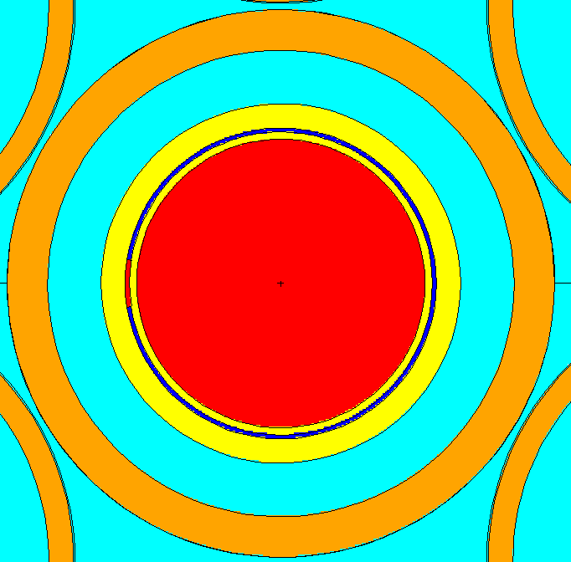
To reactor centerline
Water Coolant
(OD = 0.56”)
He plenum
(OR ~ 0.44 cm)
Outer Coating and Capsule Housing (nickel)
(7.5 µm thick & 0.4315” OD)
Inner Sleeve & Coating (nickel)
(8 mils & 7.5 µm thick)
Irradiation Foil (0.714 wt% ²³⁵U)
(125 µm thick)
Figure 4.1. MCNP as-modeled x-y cross section of HT and LEU capsule at the core horizontal midplane.
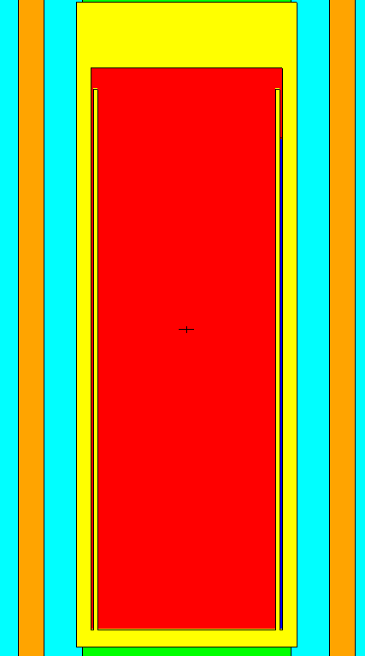
Figure 4.2. MCNP as-modeled x-z cross section of LEU irradiation capsule at the core horizontal midplane.

For the nominal case considered, the rabbit pusher is placed at position 1, HFIR dummy capsules at positions 2 thru 7, and the U foil irradiation capsule placed at position 8. For the loading error case, the rabbit pusher is placed at position 1, HFIR dummy capsules at positions 2 thru 4 and 6 thru 8, and the LEU foil irradiation capsule placed at position 5. In the position 5 case, the height of the rabbit pusher is increased to 2.93225” (7.447915 cm) in order to place the LEU foil at the reactor core horizontal midplane (the location of highest flux and thus highest heat generation). Figure 4.3 shows the MCNP as-modeled rabbit stack in the HT facility with the LEU rabbit at position 5.

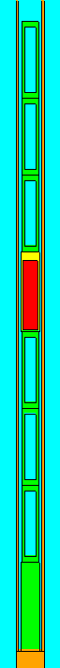
horizontal midplane
LEU Irradiation Capsule
LEU, nickel, He
Height = 2.625”
HFIR Rabbit Pusher
aluminum, Height = 2.5”
HFIR Dummy Capsules
aluminum, Height ~ 2.53”
Figure 4.3. MCNP as-modeled x-z cross section of HT rabbit stack for LEU irradiation capsule at position 5.

Heating Mechanisms in a HFIR Target
It is important to discuss and understand the mechanisms or components that contribute to heating of the target in HFIR. Components of nuclear heating are depicted in Figure 4.4 on the following page and include:
- Prompt gamma (or photon) radiation arising from the fission process in the reactor fuel components and then imparting energy through absorption or scattering in the target.
- Capture gamma rays (or photons) from (n,γ) reactions occurring in the surrounding structural materials and then imparting energy through absorption or scattering in the target.
- Prompt gamma (or photon) radiation arising from the fission process in the target fissionable material and then imparting energy through absorption or scattering in the target.
- Capture gamma rays (or photons) from (n,γ) reactions occurring in the target materials and then imparting energy through absorption or scattering in the target.
- Prompt neutrons arising from the fission process in the reactor fuel components and then imparting energy through absorption reactions, scattering or induced fission in the target.
- Prompt neutrons arising from the fission process in the target fissionable material and then imparting energy through absorption reactions, scattering or induced fission in the target.
- Fission fragments arising from the fission process in the target fissionable material and then imparting energy locally as ionized daughter nuclei.
- Decay gamma radiation (or delayed photons) produced from the decay of fission products in the core and imparting energy through absorption or scattering in the target.
- Decay gamma radiation (or delayed photons) produced from the decay of neutron-activated structural materials surrounding the target and imparting energy through absorption or scattering in the target.
- Beta and alpha particles produced from the decay of neutron-activated materials and fission products in the target and imparting energy locally as ionizing radiation.
- Decay gamma radiation (or delayed photons) produced from the decay of neutron-activated materials in the target and imparting energy through absorption or scattering in the target.
- Decay gamma radiation (or delayed photons) produced from the decay of fission products in the target and imparting energy through absorption or scattering in the target.
Table 4.1 below sorts the above components into the calculation methodology by which their solved, the transient power curve they are dictated by, their physical source location, and particle type.
Components 1 through 7 are “prompt” or “instantaneous” components in that that they are directly proportional to the fission rate in the reactor core. During steady state operation this is typically the largest single component of nuclear heating, however during a HFIR transient it falls off very quickly upon the reactor scram along the order of a 3rd of a second (along with the HFIR fuel fission rate).
Components 8 through 9 are core decay components, in that the radioactive decay of reactor materials outside the target (including fission products from the fuel and neutron-activated structural materials) contribute their delayed photons to the target heating. These follow the
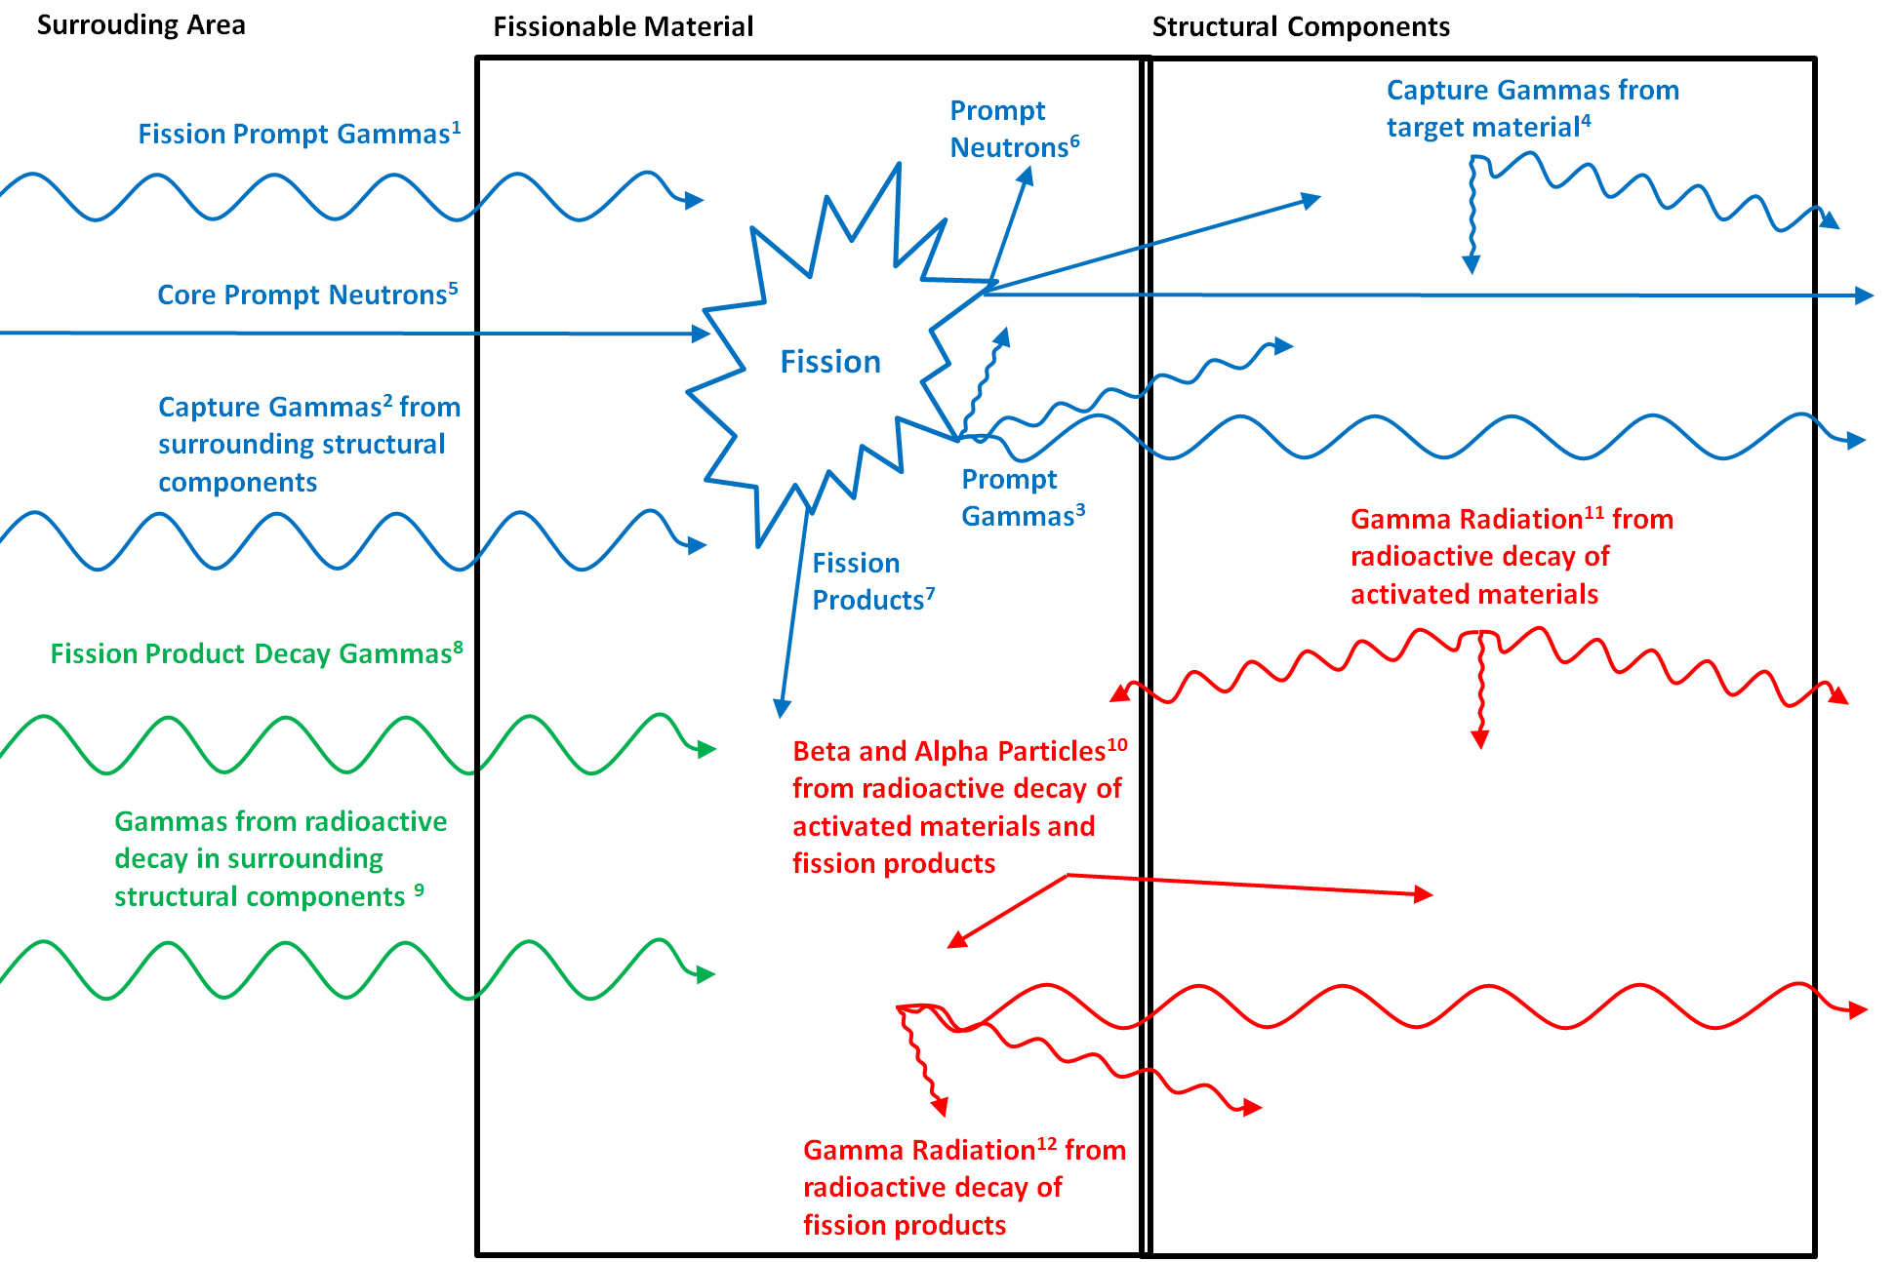
Figure 4.4. Target heat generation components.

Table 4.1. Sorting of heating components into calculation methodology, transient curve, physical source and particle type.
# | Description | Calculation | Transient | Source | Particle
1 | Core Prompt Gammas | F6:p | Prompt | External | Prompt Gammas
2 | Structural (n,gamma)
3 | Target Prompt Gammas | F6:p | Prompt | Target Fission | Prompt Gammas
4 | Target (n, gamma) | F6:p | Prompt | Target | Prompt Gammas
5 | Core Prompt Neutrons | F6:n | Prompt | External | Prompt Neutrons
6 | Target Prompt Neutrons | F6:n | Prompt | Target Fission | Prompt Neutrons
7 | Fission Fragments | F6:n | Prompt | Target Fission | F.P.'s
8 | Core Decay Gammas | EOC-Core | Core Decay | External | Delayed Photons
9 | Structural Decay Gammas
10 | Target Fission Gammas | EOC-LEU | Target Decay | Target Fission | Delayed Photons
11 | Target Activation Gammas | EOC-LEU,Ni | Target Decay | Target | Delayed Photons
12 | Target Beta+Alpha Decay | ORIGEN-S | Target Decay | Target | Beta+Alpha

Safety Calculation Methodology

Activation, depletion, and decay calculations using SCALE
The SCALE code including the COUPLE, ORIGEN-S, and OPUS modules were used to perform activation, depletion and decay calculations on the LEU foil material and nickel assembly component material including the housing capsule, the inner sleeve, the foil’s nickel coating, and the end cap. The COUPLE code, utilizing the BOC 238-group neutron flux spectrum as cross section weighting data, was used to collapse the 238-group AMPX neutron activation cross sections into one-group format as required by ORIGEN-S, unless user-supplied cross sections were made available. A Python script was generated and utilized to execute a Fortran program to extract the fluxes and actinide cross sections from the MCNP output, write an ORIGEN-S calculation, and execute it. COUPLE was provided actinide fission and radiative capture cross sections calculated in the BOC MCNP input, as described later, to account for self-shielding effects in the LEU foil material cross sections. Since self-shielding effects for the nickel components activation calculations are not expected to be significant, the infinite dilute cross sections are utilized. Then, the ORIGEN-S code was used to perform the activation and depletion calculations and OPUS was used to post-process the results into easy to read tables.
For the ORIGEN-S calculations, one 26 day fuel cycle was modeled for limiting safety calculations or a 10 day irradiation for nominal shipping calculations. Both cases utilized a constant total neutron flux to activate the foil and assembly components. Transport calculations were performed on day 0 (BOC) to calculate the materials’ spatially dependent neutron fluxes (among other parameters wanting to be studied, but not documented here). The BOC was chosen as it is representative of the neutron flux in the target region over the course of the cycle. The day 26 fluxes were calculated in the EOC transport calculations and it was shown that thermal neutron fluxes were within ±1 % of the BOC while fast neutron fluxes decreased from their BOC values.
ORIGEN calculations for a 10 day irradiation were performed on the LEU foil and nickel component materials to calculate their post-irradiation radionuclide inventories and decay heats for transportation and PIE requirements. Also, the ORIGEN calculations were utilized to determine the end-of-cycle delayed photon sources (photons/second) resolved in a 57-energy group structure for each of the LEU foil and nickel component materials. The same energy structure used in C-HFIR-2012-035 (Ref. 19) was used in these calculations. Fixed source MCNP photon type calculations were constructed based on these results to determine the photon heating rates due to delayed photons. As described in a later section, the LEU foil’s heat generation rates due to the core’s and LEU foil’s delayed photons can reach up to 47.6 and 2.1 watts/gram, respectively, whereas the nickel components’ delayed photons contribute considerably less (less than 0.01 watts/gram).

Neutron Flux
The neutron fluxes resolved in a 238-energy group structure were calculated for the irradiation capsule materials with track length estimate of flux tallies (F4:N) in MCNP. The fluxes are resolved into 238-group structures because, in this format, they can be used to define a source weighting spectrum for the SCALE activation calculations, which was described in more detail in 4.4.2.1. MCNP tallies are normalized per starting particle (i.e., per source fission neutron), and therefore, the tally results must be multiplied by the fission neutron source strength. The fission neutron source strength is defined by Equation 4.1.

$$Sn\left({fission neutrons}/{second}\right)= \frac{P\left(W\right)×\overline{υ}\left(n/fission\right)}{e\left(J/MeV\right)×Q\left(MeV/fission\right)×k_{eff}}$$
Equation 4.1

In Equation 4.1, P is the reactor power in watts (85 x 10⁶), $\overline{υ}$ is the average number of neutrons produced per fission reaction, e is a unit conversion factor (1.60218 x 10⁻¹³ J/MeV), Q is the average recoverable energy released per fission reaction, and k_{eff} is the effective multiplication factor. For these calculations, a fixed average recoverable energy of 200.7 MeV per fission was utilized, which is slightly less than the EOC Q-value of 201.3 MeV/fission and slightly greater than the BOC Q-value of 200.2 MeV/fission that were calculated in Ref. 23. The average number of neutrons produced per fission is given in the MCNP output and typically varies between 2.439 and 2.441 for HFIR calculations. MCNP also outputs the multiplication factor, which should be close to unity for these calculations. Thus, a total fission neutron source of approximately 6.4 to 6.5 x 10¹⁸ fission neutrons per second is used for the 85 MW calculations.

Neutron and Photon Heating
The most conservative heat generation rates in the LEU foil occur at the end of the cycle, however beginning of cycle heating rates are also calculated and included. Heating due to fission dominates other heating mechanisms in the LEU foil, and the greatest amounts of fissile material (primarily due to ²³⁹Pu, ²³⁵U, and ²⁴¹Pu) are present in the foil at the end of the cycle in comparison to any other point in time due to the build-up of ²³⁹Pu from the fertile isotope ²³⁸U through neutron absorption and subsequent β decays. Thus, the LEU foil’s greatest fission rates and heat generation rates occur at EOC. Also, at the end of a cycle, the delayed photon sources from the HFIR fuel and LEU foil are greatest due to the buildup of fission products, resulting in the peak delayed photon source heating at the end of the cycle.
Track length estimate of energy deposition tallies (type 6) were used to calculate heating due to neutrons and fission products (F6:N) and prompt and capture photons (F6:P). The units corresponding to the F6 tally are MeV/g-fission_neutron and the desired units are W/g, so the tally results are multiplied by the total fission neutron source (fission_neutrons/second) and the unit conversion factor (1.60218 x 10⁻¹³ W-s/MeV). The source and tally cards used for the EOC MCNP input are provided in Appendix 3. Refer to Refs. 13, 19, 23, 24, 25, 26, and 27 for other HFIR-related heat generation rate calculations.

Delayed Photon Heating
Delayed photons are not included in MCNP photon production cross sections, so the delayed photon sources were determined from ORIGEN calculations as previously described. Then, fixed source MCNP calculations in photon mode were run with the BOC and EOC inputs and the photon sources previously described. The delayed photon source heating at the BOC is conservatively determined using the EOC delayed photon source, where the delayed photon source is largest. The photon heating tallies previously described were used to calculate the photon heating rates due to the delayed photons. Multipliers equal to the product of the total source strength (photons/second) and 1.60218 x 10⁻¹³ W-s/MeV were used to convert the photon heating results in terms of MeV/g-source_photon to units of W/g. The EOC core delayed photon source cards generated in C-HFIR-2013-005 (Ref. 13) were utilized in this set of calculations. The EOC LEU foil delayed photon source cards are shown in Appendix 4 for position 5 and the EOC nickel capsule components delayed photon source cards are shown in Appendix 5 for position 8.

Beta Plus Alpha Heating
Beta plus alpha heating in the LEU foil material can be calculated with two separate methods. The ORIGEN-S calculations described previously can be used to determine the total heat (watts) due to photons, betas, and alphas and the heat due to photons only. Assuming the betas and alphas are locally deposited, the heat due to betas and alphas only can be calculated by subtracting the heat due to photons only from the total heat. Heating due to beta and alpha radiation is however dominated by the beta radiation.
The second method utilizes the track length estimate of fission energy deposition tally in MCNP (F7:N) (Refs. 23 and 28), which includes the kinetic energy of fission fragments, the kinetic energy of prompt neutrons, and the kinetic energy of prompt photons. Kinetic energy from fission fragments is locally deposited, but the prompt neutrons and photons need to be transported because their energy is deposited throughout the system. The corresponding Q-values for the dominant fissioning nuclides in the LEU foil, namely Pu-239 and Pu-241 at the EOC and U-235 at the BOC, are listed in Table 4.1 and were obtained from Ref. 29.

Table 4.1. Q-values for selected isotopes.
Description | ²³⁵U Q-values (MeV) | ²³⁹Pu Q-values (MeV) | ²⁴¹Pu Q-values (MeV)
Q_{f} = kinetic energy of the fission fragments | 169.130 | 175.550 | 175.360
Q_{np} = kinetic energy of the prompt neutrons | 4.838 | 6.128 | 5.990
Q_{γp} = kinetic energy of the prompt gammas | 6.600 | 6.741 | 7.640
Q_{F7} = sum of above | 180.568 | 188.419 | 188.990
Q_{β} = total energy released by delayed betas | 6.500 | 5.310 | 6.580
ratio of Q_{β} to Q_{F7} | 3.600% | 2.818% | 3.482%

The delayed beta Q-values are 6.500 and 5.310 MeV, respectively, for U-235 and Pu-239. If this energy is assumed to be deposited locally in the LEU foil, the heat deposition in the LEU foil due to delayed betas can be approximated by multiplying the result of the F7:N tally (MeV/g-fission_neutron) by the total fission source (fission_neutrons/second), the unit conversion factor of 1.60218 x 10⁻¹³ W-s/MeV, and the ratio of Q_{β} to Q_{F7} (Equation 4.2, Refs. 23 and 28).

$$H_{β}=H_{F7}\left(\frac{Q_{β}}{Q_{F7}}\right)$$
Equation 4.2

The total fission rates for each isotope were taken from the ORIGEN-S depletion calculation and used to find a fission-averaged beta heating ratio at the BOC and EOC. However, the conservatively larger beta heating contribution was generated by the former ORIGEN-based method calculating the difference between the total heat and photon heating in ORIGEN-S. These values, which include the alpha heating, were used for conservatism over those found using the fission deposition method. The ORIGEN-based method was also used to calculate the beta heat generation rates in the nickel capsule assembly components.

Actinide Capture and Fission Cross Sections
The radiative capture (MT=102) and fission (FM option -6) reaction rates for 30 important actinides were calculated in the LEU foil, in addition to the total neutron flux, in MCNP for use in the SCALE calculations as previously described. The 30 actinides include those nuclides with recoverable fission energy data in ORIGEN-S (except ²⁴⁵Cm and ²⁴³Pu) (Ref. 9) and are listed in Table 4.3 below.
The one-group cross sections (barns) were calculated for each actinide as defined by Equation 4.3.

$$\overline{σ_{x}}= \frac{\int{σ_{x}\left(E\right)φ\left(E\right)dE}}{\int{φ\left(E\right)dE}}$$
Equation 4.3

In Equation 4.3, $\overline{σ}$ is the one-group actinide cross section in barns, $σ_{x}$ is the energy-dependent microscopic cross section for reaction type x in barns, E is energy, and $φ$ is the energy-dependent neutron flux in neutrons/cm²-sec per fission neutron. The total neutron source is applied to both the denominator and numerator and thus cancels itself out. The resulting actinide cross sections are then utilized in the LEU foil’s ORIGEN depletion calculations previously described.

Transient Heat Generation
Three components contribute to the total transient decay heating of the irradiation capsule in this analysis: prompt particle heating, reactor delayed photon heating and target decay heating (Ref. 30). The first is due to “prompt” effects; the capsule heating due to reactions from prompt neutrons and photons in the reactor (primarily neutron-induced fission in the LEU foil). This includes all contributions from prompt neutrons and photons produced in the reactor, including those from the irradiation capsule itself. The initial prompt heat generation after reactor scram is determined from MCNP calculations as previously described. This effect is the primary contributor over short time periods (less than 1 second) due to its large value at time zero after reactor shutdown. However, its time-dependent power curve, developed by the HFIR point-kinetics reactivity model (Ref. 31), falls off rapidly due to the rapid insertion of the safety plates.
The second heating component is “core decay” due to the delayed photons emitted by the reactor fuel and structural materials after shutdown from fission and activation products. The initial heat generation at the start of shutdown is established in the core EOC fixed source MCNP calculation (see Section 4.5.3). The time-dependent power curve of the reactor core’s decay is originally described in Reference 32, using both ANSI/ANS 5.1 and ORIGEN2.
The third heating component is the local decay components from the irradiation capsule itself. The radioactive decay of the capsule produces beta (electron or positron), alpha (⁴He), and gamma (photon) particles due to its fission and activation products. All radiation released is conservatively assumed to deposit its energy locally (in the decay material). However, the fixed source calculations transport these delayed photons and most of the energy is deposited elsewhere in the system. To be conservative, delayed photon heating between the capsule materials (the LEU foil and the nickel assembly components) is counted twice according to the delayed photon EOC fixed source calculations (see Section 4.5.3). This additional heating contribution decays according to a conservative decay power fraction which bounds the local decay fraction of the contributing source (the LEU foil or nickel assembly components) as further described in the results.
The total steady-state heat generation rate is used as the initial total heat generation rate at reactor scram. The contributions from the core decay photons and local target decay at time zero are subtracted from this value to determine the initial prompt heat generation rate. Since the local target decay is conservatively overestimated to be locally deposited, this results in a corresponding underestimation of the prompt contribution. However, as the “prompt” power fraction is bounded by the local target decay power fractions (see Figure 8.4 through Figure 8.6) this represents a conservative total transient heat generation over all time steps. The time-dependent curves of HFIR prompt and delayed photon heating is that developed for the HFIR RELAP model (Ref. 33) – documented in Attachment 1 of Reference 34 – and the local target decay is determined by ORIGEN depletion and decay calculations as previously described.

Beta particle energy deposition
The beta particle energy spectra resulting from the thermal neutron fission of several fissile isotopes (239Pu, 235U, and 241Pu) is obtained from References A8.1, 2, 3 and 4 and confirmed in Reference A8.5. The spectra over the energy ranges 1 to 9 MeV are shown in Figure A8.1 below.

As can be seen, the spectra are very consistent between the four sets of measurements. However, the energy spectrum of 239Pu was used in this calculation as it is the primary fissioning isotope at the end-of-cycle, where the highest heat generation rates occur. An LEU irradiation capsule surrounded by water was modeled in MCNP for the electron transport mode. The energy deposition in three cells of the irradiation capsule was calculated using the *F8 card (pulse height tally using surface and source weight collections).

Preliminary Production Results

Nuclide Inventory Results

Thermal Cooling Results

Final Target Design Results

Potential reactivity feedback
To assess the potential impact of the insertion and removal of the two rabbit stack configurations, considered in terms of the rabbit stack reactivity worth, the steady-state effective multiplication factors, k_{eff}, were extracted from the BOC and EOC MCNP outputs, for each rabbit position, and compared to the water-filled hydraulic tube case. For the BOC and EOC cycle inputs, all configurations’ (rabbit stack with capsule at position 8, rabbit stack with capsule at position 5, water-filled HT) k_{eff} values compared well to those calculated in ORNL/TM-2010/318, Appendix B. The maximum reactivity worth of the rabbit stack configurations with respect to the water-filled hydraulic tube was calculated to be +2.38 ±0.56 cents (1 standard deviation provided) at BOC and 1.18 ±0.56 cents at EOC – both for the irradiation capsule in position 8. A value of 0.0076 was used for β_{eff}.
The water-filled HT introduces a neutron-absorbing material (the hydrogen-rich water) to the HT region, and thus is bounding in terms of a lower reactivity (or a minimal k_{eff} value) compared to the rabbit stack (which represents a positive reactivity addition by displacing the water with the 6 dummy capsules, 1 HFIR pusher rabbit, and the irradiation capsule). Reference 22 gave a 2.9 cent reactivity worth for 9 dummy rabbits, which is on the order of the calculated results. The placement of the LEU irradiation capsule, which has little fissile material, presents an overall negative reactivity addition in its placement closer to the reactor horizontal midplane (position 5) in the results. The negative reactivity impact of replacing a HFIR dummy rabbit with an LEU irradiation capsule at reactor midplane includes the displacement of relatively neutron-transparent aluminum with better neutron-absorbing materials in the hardened 4N5 nickel (large content of ⁵⁸Ni) and LEU foil (large content of the naturally abundant isotope ²³⁸U). The positive reactivity addition gained by the placement of the capsule, including the fissile content in the LEU foil (primarily ²³⁵U) and displacement of the water in the inner annular region of the dummy rabbit, is relatively less significant in the results. Therefore the greatest reactivity worth (and the least neutron-absorbing configuration) is that with the irradiation capsule placed at Position 8. The reactivity worth for the HT rabbit configurations and their associated uncertainties can be seen in Table 6.1. Thus the positive reactivity addition associated with the insertion and the subsequent negative reactivity addition associated with the ejection of the hydraulic tube rabbit configurations (containing 1 pusher rabbit, 6 dummy capsules and 1 LEU irradiation capsule) are considerably less than the 9 cent limit (Ref. 22).

: Multiplication factors and reactivity of rabbit stack configurations.
Case | keff | σ | ρ (¢)* | σ (¢) | ρ + 2σ (¢) | ρ - 2σ (¢)
BOC water-filled HT | 0.99811 | 0.00003 | - | - | - | -
EOC water-filled HT | 1.00209 | 0.00003 | - | - | - | -
BOC foil position 8 | 0.99829 | 0.00003 | 2.38 | 0.56 | 3.50 | 1.26
BOC foil position 5 | 0.99820 | 0.00003 | 1.19 | 0.56 | 2.31 | 0.07
EOC foil position 8 | 1.00218 | 0.00003 | 1.18 | 0.56 | 2.29 | 0.07
EOC foil position 5 | 1.00215 | 0.00003 | 0.79 | 0.56 | 1.90 | -0.33
* with respect to the water filled HT case and calculated as (k₂-k₁)/(k₂*k₁)*(100/β_{eff})

Thermal Heating Results
The three time-dependent heat generation rate results are expressed as a function of decay time after reactor scram for both irradiation capsule positions (5 and 8). Per Section 4.4.3.7, the delayed photon heating from the LEU foil to the nickel housing is conservatively added to the initial target decay heating and decays according to the nickel component local decay fraction, which conservatively bounds the decay of the LEU foil. The normalized transient heat generation results for the LEU foil out to 10 hours post-shutdown are shown in

Figure 4.5. Transient power fractions for the different heat sources from shutdown to 0.6 seconds decay.

Figure 4.6. Transient power fractions for the different heat sources from shutdown to 10 minutes decay.

Figure 4.7. Transient power fractions for the different heat sources from shutdown to 10 hours decay.

Nuclide Inventory Results

Molybendum-99 Production Summary
A set of neutronics calculations were performed to support the irradiation of a high-density LEU foil and nickel irradiation capsule in the HFIR HT for up to 1 full cycle or 10 days (for shipping requirements). The SCALE code including the COUPLE, ORIGEN-S, and OPUS sequence was used to perform depletion, activation, decay and source term calculations on the LEU foil and nickel capsule assembly components. MCNP, a Monte Carlo-based transport code, was utilized for neutron, photon, and coupled neutron-photon transport calculations to estimate energy-dependent neutron fluxes, actinide cross sections and heat generation rates. Nuclear heat generation rates, nuclide inventories, and decay heating rates for the LEU foil and its associated nickel capsule components. In addition, an alternative heating distribution using electron transport in MCNP was utilized.

Plutonium-238 Multiphysics Studies
In this chapter, safety studies are made for the irradiation neptunium-237 (²³⁷Np) in NpO₂/Al pellets in aluminum targets through throughout the HFIR permanent beryllium reflector in order to produce plutonium-238 (²³⁸Pu). These studies were performed in order to facilitate three phases of the ²³⁸Pu production supply project, which have been completed during the course of this research with design optimization a continual effort.

Pu-238 Supply Project
Plutonium-238 oxide pellets fuel the radioisotope thermoelectric generators (RTGs) that are the established power sources for deep space missions where solar power is not viable. The Department of Energy (DOE) has been tasked to re-establish the domestic production of ²³⁸Pu in support of ²³⁸Pu-powered spacecraft utilized by the National Aeronautics and Space Administration (NASA).
The technology demonstration activity supported by this reaserch is focused on supporting future production capability; specifically, the target design, qualification and irradiation studies that have taken place to date at the HFIR and supporting ORNL facilities. The intended infrastructure for full-scale production includes multiple DOE facilities and target irradiation at research reactors at both ORNL ( at the HFIR) and Idaho National Laboratory (at the Advanced Test Reactor) with chemical extraction taking place at REDC at ORNL. However, the focus of this research is on advanced multiphysics modeling to support target design, qualification and irradiation studies that have taken place at the HFIR that will enable and streamline full-scale activities throughout DOE facilities.
The neutron irradiation of ²³⁷Np in a nuclear reactor yields ²³⁸Pu via the absorption of a neutron to yield ²³⁸Np which subsequently beta decays to ²³⁸Pu. It is anticipated that the High Flux Isotope Reactor (HFIR) at ORNL and the Advanced Test Reactor (ATR) at INL, together will irradiate sufficient neptunium oxide (NpO₂) to produce an estimated 1.5 kg of plutonium product per year.
The irradiation test program consists of four phases (these four phases are to be added as a Figure in the final format) that provide an incremental approach intended to reduce the risk of target failure during testing. Additionally, PIE results from each phase serve as a hold point and are used to guide the course of the subsequent irradiations. Ideally safety calculations would only be performed at the start of each phase with PIE results from the previous phase informing the new set of models. However, scheduling efforts as well as unexpected pellet irradiation behavior observed in the PIE results has created the need for increasingly detailed revisions and creative approaches to the safety analysis models.

Experimental Safety Review
Target qualification requires an experiment authorization basis document supported by safety review references including calculations that assure target cooling in off-normal and nominal reactor operating conditions that do not result in either reactor fuel damage, or damage to the experiment target as defined in the HFIR safety analysis report. The process to generate a comprehensive experiment authorization basis document is shown in Figure below.
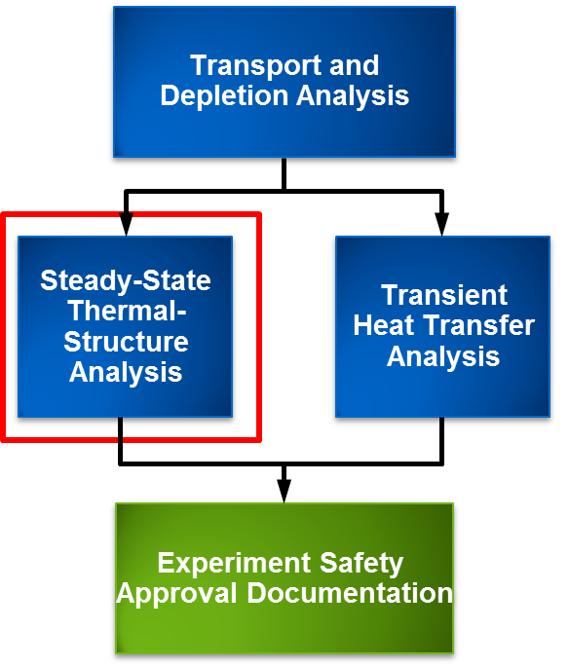
FIGURE 2. Simple diagram of the experiment safety review process.
The target cooling analyses are subdivided into bounding steady-state and transient conditions that are computed using the software-approved COMSOL Multiphysics and RELAP5 codes, respectively, as detailed below.
• Steady-State Analysis in COMSOL:
o 50% reduced coolant flow under normal reactor operating conditions,
o 130% overpower and raised inlet temperature.
• Transient Analysis in RELAP5:
o Small break loss of coolant (SBLOCA),
o Loss of offsite power (LOOP).
The safety analysis review ensures reactor safety with respect to the experiments, specifically 1) The target internal temperatures remain below component melting temperatures, 2) The structural integrity of the target housing is such that it safely contains the irradiated pellet materials, and 3) The target surface temperatures remain below coolant saturation temperatures. The 1st mode of failure under steady-state 130% overpower, analyzed using coupled heat transfer and structural mechanics equations in COMSOL, has been the limiting condition from a safety review perspective and is the topic of this chapter.
The third set of supporting safety calculations are performed to establish the target heating and nuclide inventories which provide a basis for the above described calculations as well as a comparison to future PIE results.

Computational Model Development
The models’ governing equations are briefly described below and in the following subsections the inputs, pellet dimensional behavior and gas gap/contact conductance is discussed in greater detail. The models takes advantage of the symmetry about the axial centerline of the targets to utilize 2-D R-Z or axisymmetric geometry, thus heat transfer and mechanical loads are invariant of the rotation angle.
The built-in Heat Transfer physics interface is added, which is governed by the domain equation given in Equation 5.1, where $ρ$, C_{p}, and k are the material density, heating capacity and thermal conductivity, respectively . T and u are the field variables temperature and velocity, while t is the time and Q is a volumetric heat source (to be added by the user). For this problem, the transient heat and convection terms are eliminated as the analysis is for steady-state conditions in a solid medium (excluding fission gas regions).
$$ρC_{p}\frac{∂T}{∂t}+ρC_{p}u∙\vec{∇}T+\vec{∇}∙(-k\vec{∇}T)=Q$$
Equation 5.1
The built-in Solid Mechanics physics interface is added as well, which is governed by the domain equation given in Equation 5.4 The strain tensor, $ε$, is given in terms of the gradient of displacement field variable, u, Equation 5.2. The stress tensor,$σ$, is related to the strain tensor via Hooke’s law (Equation 5.3) , where C is an elasticity tensor, 0 denotes initial stresses and strains, and $ε_{th}=α(T-T_{ref})$ is the thermal expansion. This last term is one of two locations where the Solid Mechanics and Heat Transfer interfaces are coupled to create a thermo-mechanical analysis. Finally, the linear momentum is conserved in the equilibrium equation for forces, F, and stresses in the target (Equation 5.4).
$$ε=\frac{1}{2}\left({\left(\vec{∇}u\right)}^{T}+\vec{∇}u+{\left(\vec{∇}u\right)}^{T}\vec{∇}u\right)$$
Equation 5.2
$$σ=σ_{0}+C\left(ε-ε_{0}-ε_{th}\right)$$
Equation 5.3
$$\vec{∇}σ=Fv$$
Equation 5.4
Appropriate constraints must be applied to the problem for solution. In this case, a prescribed displacement in the z direction of zero is given at the bottom of the target endcap. A thermal convection boundary is applied to the target external surface to the coolant, where the bulk temperature is given by a simple control volume energy balance of the coolant and the given heat transfer coefficients were found to be conservative with respect to Dittus-Boelter.

Model Inputs
There are several key model inputs to the target cooling safety analyses models, as listed below. These are separated into PIE data, pellet material property data, target design information, and supporting data from neutron transport calculations. The PIE data was updated as irradiated targets could be measured, with close attention at shifts in between project phases/designs. The pellet property data has been measured as needed for the safety calculations and conservative data assumed elsewhere, including temperature dependent stress-strain curves. Updating the target design is a continual process but is usually frozen before the safety calculations are performed for each irradiation. The supporting neutron transport calculations are performed at each phase and repeated as needed to provide input to the target heating calculations.
• Post-Irradiation Examination (PIE) results
o Shrinkage/Swelling vs. burn-up for radial and height dimensions
o Fission gas release fractions
• Temperature- and composition-dependent material property data for the NpO2/Al pellet (and other materials):
o Thermal expansion coefficient
o Thermal conductivity
o Temperature dependent Stress/strain curves (i.e. elastic modulus, yield strength)
o Density, Poisson’s ratio, etc.
• Target Design Drawings and Information
• Input heat generation rates, burnup and fission gas production from neutronics calculations

Pellet Irradiation Behavior
The possibility of significant densification and swelling in the neptunium oxide pellets was discussed prior to the Phase 1 irradiations, however the expectation was that for the production burn-up levels the observed densification of the pellets would be minor and swelling would be the more measurable factor. While swelling presents a safety consideration in possible breach or failure of the target housing, densification or negative swelling presents a safety consideration as it increases the gap between the pellets and target housing, hence, reducing radial heat transfer, and elevating pellet temperatures near melting.
The behavior of the irradiated fuel oxides (typically uranium) suspended in an aluminum mixture has been measured in previous experiments, however not for NpO₂ materials. The experiment results exhibit the general characteristics of densification and swelling as shown in Figure 5.1. Fabrication void volumes experience a radiation-enhanced sintering which reduces the overall volume of the pellets for the early irradiation periods. Subsequently, the swelling due to fission gas and fission product release dominate the irradiation behavior as the reduction in void volume falls off. The irradiation behavior, as measured by the pellet dimensional changes in the PIE results, has been observed in the time period after maximum densities and swelling due to fission products is recovering the negative volume change. Given input PIE data, this behavior may be modeled using burnup-dependent correlations for densification and swelling which both make up the total volumetric irradiation change (see Equation 5.5-Equation 5.7).
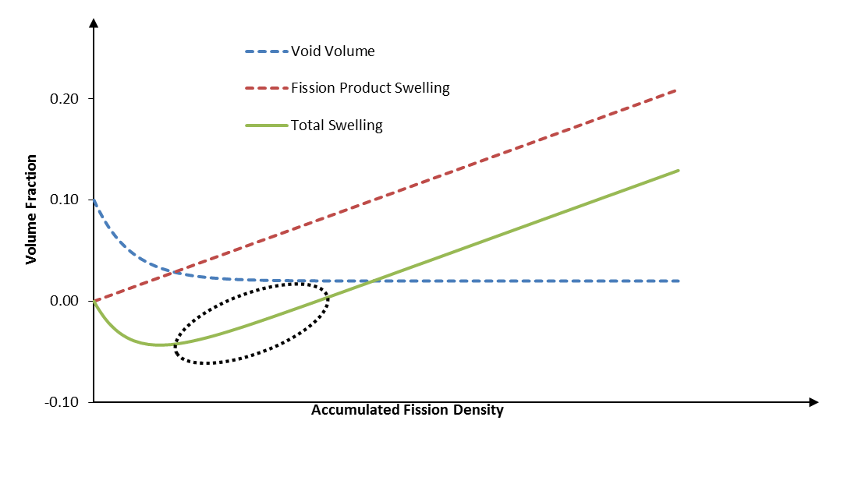
Figure 5.1. Pellet dimensional behavior as a function of burnup.
$${∆V}_{swell.}=α*BU$$
Equation 5.5
$${∆V}_{dens.}=P_{0}\left(e^{-β*BU}-1\right)$$
Equation 5.6
$${∆V}_{total}={∆V}_{dens.}+{∆V}_{swell.}$$
Equation 5.7

Contact/Gas-Gap Conductance
Contact is modeled in COMSOL by the interface between a contact “pair” feature of a destination surface and source surface, where destination may not penetrate the source domain. Contact problems are modeled either using a penalty method or augmented Lagrangian method, the latter of which is a recent addition that provides a more robust solution but with greater difficulty in convergence and is utilized in the models for which it was available.
Peak pellet temperatures in the target are driven by the heat transfer in the radial gap between the NpO2 pellets and target cladding. The gas gap between the neptunium oxide pellets and aluminum target housing is the location of the largest temperature gradient in the target and thus an important phenomenon to quantify when calculating the centerline (hottest) pellet temperatures. The densification or shrinkage of the pellets has made this effect more pronounced by enlarging the gap and increasing pellet temperatures, as can be seen Figure 5.2. Pellet dimensional behavior as a function of burnup..
The heat transfer between the two surfaces consists primarily of two effects: solid spot contact conductance and the gas gap conductance as well as a negligible radiation heat transfer term. The contact conductance is negligible when surfaces are not in contact, but nevertheless, is accounted for in the analysis in case some contact is made. The gas heat transfer is affected by the gas conductivity (which is strongly affected by the mixture of fission gases), the separation distance (which is strongly affected by the dimensional irradiation behavior), and gap jump terms that account for the inefficient heat transfer between gas particles and the solid surface. The equations for the gap heat transfer coefficients, h, are shown below [73]:
$$h_{f}=h_{c}+h_{g}+h_{r}$$
Equation 5.7
$$h_{g}= \frac{k_{g}}{δ+g_{1}+g_{2}}$$
Equation 5.7
$$g=\left[{\left(2-α\right)}/α\right]\left[2/{\left(γ+1\right)}\right]\left[{k_{g}}/{\left(μC_{v}\right)}\right]λ=\left[{\left(2-α\right)}/α\right]\left[{2γ}/{\left(γ+1\right)}\right]\left[k/{\left(μC_{p}\right)}\right]λ$$
Equation 5.7

where g = thermal gap jump,
α = accommodation coefficient,
γ = ratio of specific heats = ${C_{p}}/{C_{v}}$,
μ = viscosity, and
λ = mean free path of gas molecules
$$λ_{gas}=\left[m/{\sqrt{2}{πd^{2}p}_{gas}}\right]=\left[{k_{B}T}/{\sqrt{2}{πd^{2}p}_{gas}}\right]$$
Equation 5.7
where m = the mass of a molecule of the gas,
k_{B} = Boltzmann’s constant= 1.38060504x10⁻²³ J/K,
d = the diameter of the gas particle (m), and
p_{gas}= the pressure of the gas which is an input to the COMSOL model (Pa).

$$h_{c}=1.55\left({k_{m}m}/σ\right){\left({P\sqrt{2}}/{E^{'}m}\right)}^{0.94}$$
Equation 5.7
where h_{c} = the contact/constriction conductance,
m = mean slope of asperities,
P = contact pressure,
σ = mean surface roughness, and
E = Young’s modulus
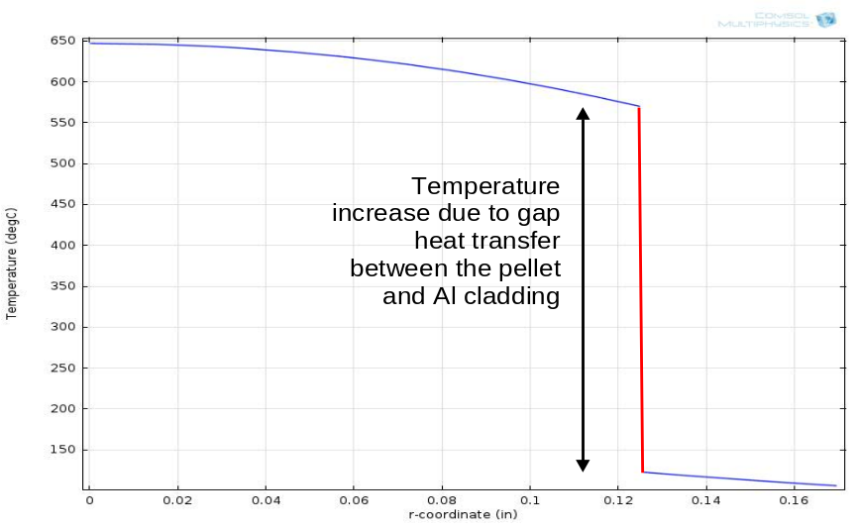
Figure 5.2. Temperature gradient between the pellet and cladding along the radial direction.

Computational Results
The more detailed analysis of each individual pins for the fully-loaded target design over the course of 3 operating cycles have not yet been approved and documented. However, previous analyses of fully-loaded targets are presented briefly here. The partially-loaded target analysis is not presented, but will be added to the final dissertation document.

Previous Thermo-mechanical Analyses
Presented below are results from fully-coupled thermo-mechanical analyses of the fully-loaded target. Calculations have been completed for all 2 cycles of operation for both partially-loaded and fully-loaded target designs, including several parametric studies given incomplete examination data. All computations are computed on the betty computational cluster, which is approved by software quality assurance, on single 128 GB nodes using the PARDISO direct linear solver. A mesh refinement study is documented in a later section.
Goals of the analysis were to ensure structural integrity of the target primarily by examining the target temperatures under 130% overpower to ascertain that the melting temperature of 650°C was not reached. However, structural integrity of the target via maintaining an axial clearance under measured target housing failures is also examined. The temperature profile along the axial centerline for the end-of-cycle (EOC) 2 for the fully-loaded target is shown in Figure 5.3.

Figure 5.3. The temperature profile shape at the end of the 2nd cycle for the fully-loaded target at 130% power.
. In addition, the changing temperature profile throughout the 2nd cycle is shown at several time steps in Figure 5.5 and the expected hourglass feature observed previously in uranium oxide pellets is shown in Figure 5.3. Fluxes at the HFIR are typically in a cosine shape with respect to axial position, peaking at the horizontal midplane. The temperature distribution at day 0 demonstrates that peak nuclear heating occurs in the axial center of the target where fluxes are highest. However, as the cycle progresses irradiation behavior in the target causes increasing volumetric swelling (or densification recovery) in the radial direction with greatest effect in the locations of highest burnup at the axial center. This closes the radial gap and cools down these sections of the target, meanwhile the “hot spot” of the target migrates to the opposing axial ends of the target where swelling is less pronounced by the EOC-2.
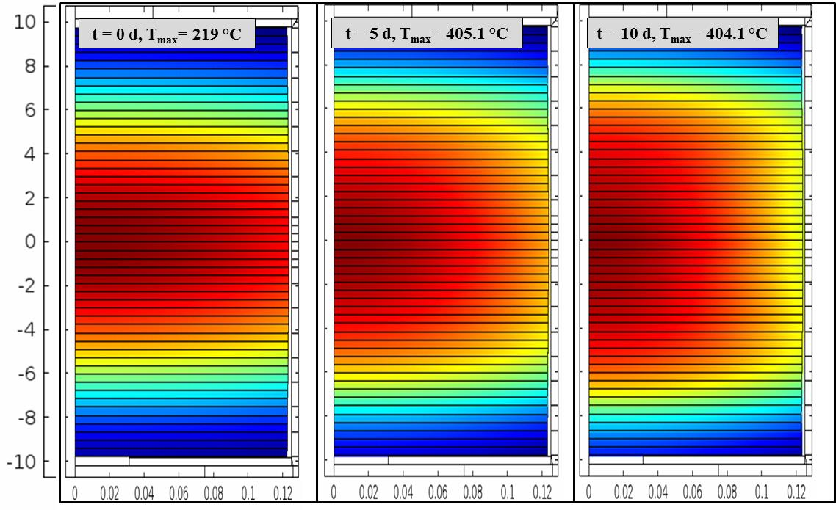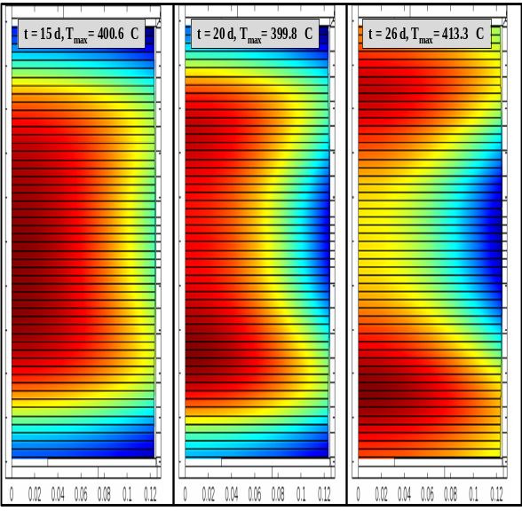

Figure 5.5. Temeprature profiles at 0, 5, 10, 15, 20, and 26 days at 100% power in a 52 pellet-stack for the 2nd cycle of irradiation of fully-loaded target.
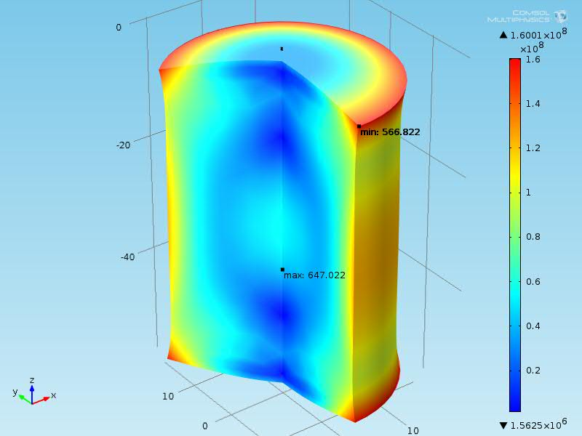
Figure 5.5. Rotated surface stress plot of individual pellet exhibiting “hourglass” shape.

Preliminary Current Results
In this section the current, undocumented and preliminary results of the fully-loaded ²³⁸Pu targets for 3 cycles are presented. Seven pins throughout a target holder are analyzed with Pin 1 (the closest to the reactor axial centerline) having the highest temperatures, as shown in . Pin 1 is examined more closely in and , where contact occurs in the 3rd cycle of irradiation and

Mesh Refinement Studies
A mesh refinement study was performed for the initial fully-loaded target analysis that is now briefly discussed. The study was performed at 130% power, EOC-2 for both the best estimate and “cold case” models to demonstrate the increased convergence for the latter model method (where structural mechanics equations are not included and the nonlinear coupling at the pellet/housing gap does not negatively impact convergence).
The number of mesh elements in the pellet/housing region was roughly doubled at each convergence step and an error estimate was made from two post-processing results: 1) pellet centerline average temperature, and 2) the maximum pellet centerline temperature. The individual error estimates were defined as:
$$e^{T}=\frac{∆T}{3}$$
And the square root of the product of the errors was used as a final error “norm”. The error norm is plotted against the reciprocal of the mesh number in the log-log plot in Figure 5.6. The increased rate of convergence and reduced error in the cold case model can be clearly seen. More specifically, the finite element order of convergence approximately doubles and approaches the expected value of 2 for smooth quadratic convergence.

Figure 5.6. Mesh refinement curve for the examined cases in the fully-loaded target.

Plutonium-238 Multiphysics Studies Summary
A detailed set of safety analysis models have been developed and reviewed to support the irradiation of NpO2 pellets at the HFIR. These models account for advanced and detailed physics phenomena and material behavior and their results can be used to qualify the current design of fully-loaded targets to produce ²³⁸Pu. Furthermore, improvements and studies with these models can be used to optimize the ²³⁷Np loading and configuration of the full-scale production targets in order to increase 238Pu throughput and better meet the customer needs of NASA.

Developing Discrete Ordinates in COMSOL Multiphysics
In this chapter, the development of a COMSOL multi-dimensional and angularly-dependent neutron transport physics using the discrete ordinates method is discussed. The development of this solution method was intended to serve a variety of potential purposes at the HFIR, in studying more detailed and accurate spatially-dependent flux/power distributions in the HFIR core for different conditions (both stationary and transient) as well as suited to studying other fixed source problems related to reactor operations, including deep-penetration problems in the HFIR beam tubes.

Discrete Ordinates Derivation and Methodology
The solution of neutral particle (neutron or photon) transport generally requires seven independent variables: 3 spatial coordinate variables specifying the particle position, 2 angular variables specifying the particle direction of travel, 1 variable for particle energy, and 1 variable for time. In this case, the spatial variables are solved using the finite element method, the angular variables using discrete ordinates, the energy variable using the multi-group method and the time variable with implicit time steps.
The static or time-independent neutron transport equation (Equation 6.1) may be solved in terms of the neutron angular flux, and includes source terms on the right hand side (RHS) of the equation (the fission source, scattering source and external fixed source, respectively) and the streaming/leakage and annihilation terms on the left hand side (LHS), respectively. The transient or time-dependent form includes time-dependence terms, kinetics parameters and precursor concentration equations, as well as an additional time derivative operator in the streaming term as described in section 6.1.1.
$$\left[\hat{Ω}∙\vec{∇}+Σ_{t}(\vec{r},E)\right]ψ\left(\vec{r},E,\hat{Ω}\right)=\frac{χ\left(E\right)}{k_{eff}}\int_{0}^{∞}{dE^{'}ν\left(E^{'}\right)Σ_{f}\left(\vec{r},E^{'}\right)\int_{4π}{dΩ^{'}}}ψ\left(\vec{r},E^{'},{\hat{Ω}}^{'}\right) +\int_{4π}{dΩ^{'}\int_{0}^{∞}{dE^{'}Σ_{s}\left(\vec{r},E^{'}→E,{\hat{Ω}}^{'}→\hat{Ω}\right)}ψ(\vec{r} ,E^{'},{\hat{Ω}}^{'})}{+q}_{ext}\left(\vec{r} ,E,\hat{Ω}\right)$$
Equation 6.1
where: $\hat{Ω}$ is the particle direction vector,
$\vec{∇}$ is the gradient operator $=\left(\frac{∂}{∂x}{\hat{e}}_{x}+\frac{∂}{∂y}{\hat{e}}_{y}+\frac{∂}{∂z}{\hat{e}}_{z}\right)$ in rectangular coordinates and
$=\left(\frac{∂}{∂r}{\hat{e}}_{r}+\frac{1}{r}\frac{∂}{∂θ}{\hat{e}}_{θ}+\frac{∂}{∂z}{\hat{e}}_{z}\right)$ in cylindrical coordinates,
$Σ_{t}, Σ_{f}, Σ_{s}$ are the total, fission and scattering macroscopic cross sections,
$\vec{r}$ is the particle position vector $=\vec{r}\left(x,y,z\right)$ in rectangular coordinates and
$=\vec{r}\left(ρ,θ,z\right)$ in cylindrical coordinates,
E is the particle energy,
$ψ$ is the angular particle flux,
$χ$ is the fission distribution,
k_{eff} is the k-eigenvalue or effective multiplication factor,
$ν$ is the average number of neutrons produced per fission, and
$q_{ext}$ is the external fixed source term.
To begin the application of the discrete ordinates to the directions, a first simplification can be made to Equation 6.1 by including the definition of the scalar flux, $ϕ$, as the integration of the angular flux over all directions, where w_{n} is a weighting factor:
$$ϕ\left(\vec{r},E\right)=\int_{4π}{ψ\left(\vec{r},E,{\hat{Ω}}^{'}\right)dΩ^{'}=\sum_{n=1}^{N}{w_{n}ψ\left(\vec{r},E,{\hat{Ω}}_{n}\right)}}$$
Equation 6.2
In Equation 6.2 the transport equation is solved for N distinct angles and quadrature approximation is utilized to numerically integrate over the angular domain using weighting factors at each discrete location. An example of the sampling of the unit sphere in discrete directions is shown in Figure 6.1 below:
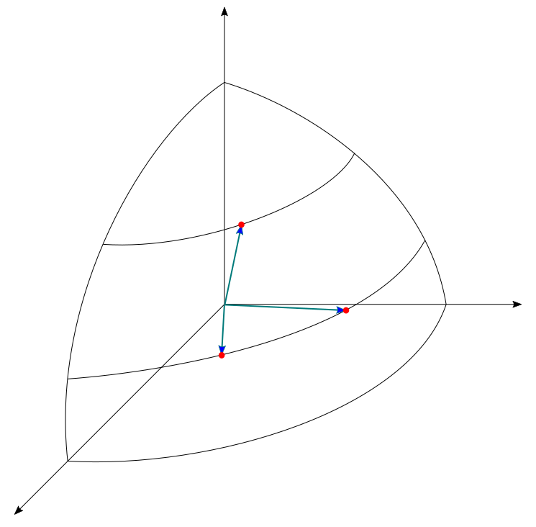
$$ξ$$
$$μ$$
$$η$$
$${\hat{Ω}}_{3}$$
$${\hat{Ω}}_{2}$$
$${\hat{Ω}}_{1}$$
Figure 6.1. Eighth unit sphere with discrete ordinate directions sampled.
where: $μ$ is the direction cosine along the x unit vector $=\hat{Ω}∙{\hat{e}}_{x}$ in rectangular coordinates, and
along the $ρ$ unit vector $=\hat{Ω}∙{\hat{e}}_{ρ}$ in cylindrical coordinates,
$η$ is the direction cosine along the y unit vector $=\hat{Ω}∙{\hat{e}}_{y}$ in rectangular coordinates, and
along the $θ$ unit vector $=\hat{Ω}∙{\hat{e}}_{θ}$ in cylindrical coordinates, and
$ξ$ is the direction cosine along the z unit vector $=\hat{Ω}∙{\hat{e}}_{z}$.
Furthermore, as later explained in section 6.1.2, it’s found to be advantageous to define scalar flux moments in terms of spherical harmonics as shown in Equation 6.3. See Equation 6.20 in section 6.1.2 which simplifies the scattering source term using the definitions of spherical harmonic moments of the angular flux, which uses the discrete ordinate form of the .
$$ϕ_{l}^{m}\left(\vec{r},E\right)=\int_{4π}{Y_{lm}\left({\hat{Ω}}^{'}\right)ψ\left(\vec{r},E,{\hat{Ω}}^{'}\right)dΩ^{'}=\sum_{n=1}^{N}{w_{n}Y_{lm}\left({\hat{Ω}}_{n}\right)ψ\left(\vec{r},E,{\hat{Ω}}_{n}\right)}}$$
Equation 6.3

Having dealt with angular discretization through discrete ordinates, and understanding that COMSOL Multiphysics handles the spatial and time discretization through the FEM and implicit steps, respectively, the remaining independent variable to be discretized is particle energy. Begin by defining a group flux for energy group g, where the particle energy is subdivided into G intervals called groups and the G^{th} group is the lowest energy group:
$$ψ^{g}\left(\vec{r},{\hat{Ω}}_{n}\right)=\int_{E_{g}}^{E_{g-1}}{ψ\left(\vec{r},E^{'},{\hat{Ω}}_{n}\right)dE^{'}}$$
Equation 6.4
If one takes the transport equation in Equation 6.1 and integrates over the group domain from E_{g} to E_{g-1}, the group definitions for other parameters must be defined in order to conserve reaction rates:
$$Σ_{t}^{g}\left(\vec{r}\right)=\frac{\int_{E_{g}}^{E_{g-1}}{Σ_{t}\left(\vec{r},E^{'}\right)ψ(\vec{r},E^{'},{\hat{Ω}}_{n})dE^{'}}}{ψ^{g}(\vec{r},{\hat{Ω}}_{n})}$$
Equation 6.5
$$χ^{g}=\int_{E_{g}}^{E_{g-1}}{χ\left(E^{'}\right)dE^{'}}$$
Equation 6.6
$${νΣ}_{f}^{g}\left(\vec{r}\right)=\frac{\int_{E_{g}}^{E_{g-1}}{Σ_{t}\left(\vec{r},E^{'}\right)ϕ(\vec{r},E^{'})dE^{'}}}{ϕ^{g}(\vec{r})}$$
Equation 6.7
$$q_{ext}^{g}\left(\vec{r},{\hat{Ω}}_{n} \right)=\int_{E_{g}}^{E_{g-1}}{q_{ext}\left(\vec{r} ,E^{'},{\hat{Ω}}_{n}\right)dE^{'}}$$
Equation 6.8
$$Σ_{sl}^{g^{'}→g}\left(\vec{r}\right)=\frac{\int_{E_{g}}^{E_{g-1}}{\int_{E_{g^{,}}}^{E_{g^{,}-1}}{Σ_{sl}\left(\vec{r},E^{'}→E\right)ϕ_{l}^{m}\left(\vec{r},E^{'}\right)dE^{'}dE}}}{ϕ_{lm}^{g^{'}}(\vec{r})}$$
Equation 6.9
The immediate difficulty here is that in order to derive these group constants, the energy dependent fluxes and nuclear data must be known in advance. Fortunately, nuclear data with detailed time dependence is calculated in various data libraries and there are other codes that may be utilized to pre-process these cross sections given expected localized flux curves – an accurate method for fine energy group selections. Start with simple problems for fine energy groups and use the scalar flux solutions to collapse to a lower number of energy groups, if broader group intervals are desired.
Applying the above discretizations in energy and angle to Equation 6.1 yields the multigroup neutron transport equation for discrete ordinates in Equation 6.10: ISCT represents the truncated number of scattering orders, or the P_{N} order, where isotropic scattering requires only the leading term (P₀). The number of discrete ordinates is represented by the S_{N} order, where for 3-D, there are N(N+2) distinct directions. So for a given problem, there are G*N(N+2) governing weak equations of starting form Equation 6.10.
$$\left[{\hat{Ω}}_{n}∙\vec{∇}+Σ_{t}^{g}(\vec{r})\right]ψ_{n}^{g}\left(\vec{r},{\hat{Ω}}_{n}\right)=χ^{g}\sum_{g^{'}=1}^{G}{νΣ_{f}^{g^{'}}(\vec{r})ϕ^{g^{'}}\left(\vec{r}\right)}+\sum_{l=0}^{ISCT}{\sum_{m=-l}^{l}{Y_{lm}^{*}({\hat{Ω}}_{n})\sum_{g^{'}=1}^{G}{Σ_{sl}^{g^{'}→g}{(\vec{r})ϕ}_{lm}^{g^{'}}(\vec{r})}}}+q_{ext}^{g}\left(\vec{r} \right)$$
Equation 6.10
In Equation 6.5, most of the terms have the same expansion for all coordinate systems and thus their formulation varies little and need no additional derivations. However, two terms, the “streaming” or “leakage” term and the scattering source vary significantly between each coordinate system and thus warrant further discussion in sections 6.1.1 and 6.1.2.

Streaming operator
The “streaming” term in the neutron transport equation is the projection or dot product of the neutron direction vector and the spatial gradient of the angular neutron flux. This term represents the movement or streaming of neutrons within the problem geometry and to the outside of its borders (thus it is also known as the “leakage” term) and its proper formulation is therefore very important to neutron transport. Table 6.1 below gives a summary of the different formulations for the coordinate systems utilized: 1-, 2-, 3-D Cartesian as well as 2-D cylindrical geometries, where ω is the angle between the unit vector ${\hat{e}}_{ρ}$ and the line made by the projection of the direction onto the plane of the unit vectors ${\hat{e}}_{ρ}$ and ${\hat{e}}_{θ}$.
Table 6.1. Neutron streaming operators for 1-, 2-, 3-D Cartesian and 2-D cylindrical coordinate systems.
Dimension | Spatial Variables | Angular Variables | $$\hat{Ω}∙\vec{∇}$$
1D Cartesian | x | $$μ$$ | $$μ\frac{∂}{∂x}$$
2D Cartesian | x,y | $$μ,η$$ | $$μ\frac{∂}{∂x}+η\frac{∂}{∂y}$$
3D Cartesian | x,y,z | $$μ,η,ξ$$ | $$μ\frac{∂}{∂x}+η\frac{∂}{∂y}+ξ\frac{∂}{∂z}$$
2D Cylindrical | $ρ$,z | $ω$, $ξ$ | $$\frac{μ}{ρ}\frac{∂}{∂ρ}ρ+ξ\frac{∂}{∂z}-\frac{1}{ρ}\frac{∂}{∂ω}η$$

As shown in the 3-D Cartesian example in Equation 6.11, the formulation for Cartesian coordinates can be done by expanding the derivative of the neutron flux with respect to the streaming direction, s, in terms of the partial derivatives of the seven independent variables. The angular and energy derivatives are eliminated as they do not change along the streaming direction in Cartesian coordinates. ph.d. qualif examFor lower coordinate systems, the spatial flux gradients $\frac{∂ψ}{∂z}$ and $\frac{∂ψ}{∂y}$ are eliminated progressively for 2- and 1-D Cartesian coordinates due to the infinite expansion of the problem along those axes. The time derivative is nonzero for time-dependent or transient studies, which are not considered in this work.
$$\frac{dψ}{ds}=\frac{∂x}{∂s}\frac{∂ψ}{∂x}+\frac{∂y}{∂s}\frac{∂ψ}{∂y}+\frac{∂z}{∂s}\frac{∂ψ}{∂z}+\frac{∂μ}{∂s}\frac{∂ψ}{∂μ}+\frac{∂η}{∂s}\frac{∂ψ}{∂η}+\frac{∂ξ}{∂s}\frac{∂ψ}{∂ξ}+\frac{∂E}{∂s}\frac{∂ψ}{∂E}+\frac{∂t}{∂s}\frac{∂ψ}{∂t}=μ\frac{∂ψ}{∂x}+η\frac{∂ψ}{∂y}+ξ\frac{∂ψ}{∂z}+\frac{1}{v}\frac{∂ψ}{∂t}$$
Equation 6.11
In cylindrical coordinate systems, two of the four angular variables can be used to describe the direction of the angular flux for all dimensions, as shown in and .The streaming term for 2D cylindrical coordinate systems can be seen in Equation 6.12, where the partial derivative with respect to angular variable $ω$ is utilized in place of $μ$. As opposed to the Cartesian geometries, there is an angular derivative term that cannot be eliminated as the angular flux varies with angular variable $ω$ and, as can be seen in , the angular variable $ω$ will vary as the particle moves along a straight line. The change in coordinate system is examined more closely in . There we can see the relation derived in , and arrive at the non-conservative form of the 2-D cylindrical static streaming operator in Equation 6.13.
$$\frac{dψ}{ds}=\frac{∂ρ}{∂s}\frac{∂ψ}{∂ρ}+\frac{∂θ}{∂s}\frac{∂ψ}{∂θ}+\frac{∂z}{∂s}\frac{∂ψ}{∂z}+\frac{∂ω}{∂s}\frac{∂ψ}{∂ω}+\frac{∂η}{∂s}\frac{∂ψ}{∂η}+\frac{∂ξ}{∂s}\frac{∂ψ}{∂ξ}+\frac{∂E}{∂s}\frac{∂ψ}{∂E}+\frac{∂t}{∂s}\frac{∂ψ}{∂t}=μ\frac{∂ψ}{∂ρ}+ξ\frac{∂ψ}{∂z}+\left[\frac{∂ω}{∂s}\right]\frac{∂ψ}{∂ω}+\frac{1}{v}\frac{∂ψ}{∂t}$$
Equation 6.12

$$μ\frac{∂ψ}{∂ρ}+ξ\frac{∂ψ}{∂z}-\frac{η}{ρ}\frac{∂ψ}{∂ω}$$
Equation 6.13
The conservative form of the static cylindrical streaming operator is shown in Equation 6.14, and is thus named as it conserves neutrons in the finite difference scheme. This property can be understood by integrating the Equation 6.15 uses the product differentiation rule to show the equivalence between the conservative and non-conservative forms – excluding the axial derivative term, which is identical in both.
$$\frac{μ}{ρ}\frac{∂}{∂ρ}ρψ+ξ\frac{∂ψ}{∂z}-\frac{1}{ρ}\frac{∂}{∂ω}ηψ$$
Equation 6.14
$$\frac{μ}{ρ}\frac{∂}{∂ρ}ρψ-\frac{1}{ρ}\frac{∂}{∂ω}ηψ=μ\frac{∂ψ}{∂ρ}+\frac{μ}{ρ}ψ-\frac{ψ}{ρ}\frac{∂η}{∂μ}-\frac{η}{ρ}\frac{∂ψ}{∂ω}=μ\frac{∂ψ}{∂ρ}-\frac{η}{ρ}\frac{∂ψ}{∂ω}$$
Equation 6.15
Integrating the conservative form of the streaming operator in Equation 6.14 and using integration by parts it can be shown that the angular terms cancel out, leaving only the gradient of the particle current as expected. A similar operation using the non-conservative form in Equation 6.13 yields leftover terms.

Scattering Source
Start with the scattering source from the neutron transport equation (Equation 6.1) as depicted in Equation 6.16, which is the integral over all energies and angles of the product of the differential scattering cross section and angular flux. The differential scattering cross section, as in Equation 6.16, is commonly expanded in terms of Legendre polynomials in order to separate the angular dependence of the scattering source.
$$q_{s}\left(\vec{r},E,\hat{Ω}\right)=\int_{4π}{dΩ^{'}\int_{0}^{∞}{dE^{'}Σ_{s}\left(\vec{r},E^{'}→E,{\hat{Ω}}^{'}→\hat{Ω}\right)}ψ(\vec{r} ,E^{'},{\hat{Ω}}^{'})}$$
Equation 6.16
$$Σ_{s}\left(\vec{r},E^{'}→E,Ω∙Ω^{'}\right)=\sum_{l=0}^{∞}{\left(2l+1\right)Σ_{sl}\left(\vec{r},E^{'}→E\right)P_{l}\left(Ω∙Ω^{'}\right)}$$
Equation 6.17
The scattering moments are subsequently defined using the orthogonality of the Legendre polynomials:
$$Σ_{sl}\left(\vec{r},E^{'}→E\right)=\int_{-1}^{1}{dμ_{0}Σ_{s}\left(\vec{r},E^{'}→E,Ω∙Ω^{'}\right)P_{l}\left(Ω∙Ω^{'}\right)}$$
Equation 6.18
Substituting the Legendre Addition Theorem (Equation 6.19) and Equation 6.17 into Equation 6.16, the scattering source can be simplified as shown in Equation 6.20 and then further simplified using the definition of the scalar flux moments in Equation 6.3. Application of the discrete ordinates method and multigroup methods, in addition to truncating the scattering source to some finite scattering order (P_{n} order) of ISCT will yield the scattering source in Equation 6.20 in the form depicted in Equation 6.10.
$$P_{l}\left(Ω∙Ω^{'}\right)=\frac{1}{2l+1}\sum_{m=-l}^{l}{Y_{lm}^{*}\left(Ω\right)Y_{lm}\left(Ω^{'}\right)}$$
Equation 6.19
$$q_{s}\left(\vec{r},E,\hat{Ω}\right)=\sum_{l=0}^{∞}{\sum_{m=-l}^{l}{Y_{lm}^{*}(\hat{Ω})\int_{0}^{∞}{Σ_{sl}(\vec{r} ,E^{'}→E)\int_{4π}{Y_{lm}\left(Ω^{'}\right)ψ(\vec{r} ,E^{'},{\hat{Ω}}^{'})dΩ^{'}}}dE^{'}}}=\sum_{l=0}^{∞}{\sum_{m=-l}^{l}{Y_{lm}^{*}(\hat{Ω})\int_{0}^{∞}{Σ_{sl}(\vec{r},E^{'}→E)ϕ_{lm}(\vec{r},E^{'})dE^{'}}}}$$
Equation 6.20
The Legendre Addition Theorem can be expanded using the definition of the spherical harmonics function (Equation 6.21) and this can be simplified, depending on which dimension the problem is solved in, as summarized in Table 6.2 through P₃ scattering. The P_{N} order denotes the truncation of the infinite Legendre expansion in Equation 6.20, where isotropic scattering problems require only the leading term.
$$P_{l}\left(Ω∙Ω^{'}\right)={P_{l}\left(μ\right)P}_{l}\left(μ^{'}\right)+2\sum_{m=1}^{l}{\frac{\left(l-m\right)!}{\left(l+m\right)!}}{{P^{m}}_{l}\left(μ\right)P_{}^{m}}_{l}\left(μ^{'}\right)\cos\left[m\left(ω-ω^{'}\right)\right]$$
Equation 6.21
Table 6.2. Required flux moments for 1-, 2-, and 3-D coordinate systems currently analyzed.
P_{N} | 1-D | 2-D | 3-D
0 | $$ϕ_{0}$$ | $$ϕ_{00}$$ | $$ϕ_{00}$$
1 | $$ϕ_{1}$$ | $$ϕ_{10},ϕ_{11}$$ | $$ϕ_{10},ϕ_{11}^{}, ϕ_{11}^{i}$$
2 | $$ϕ_{2}$$ | $$ϕ_{20},ϕ_{21},ϕ_{22}$$ | $$ϕ_{20},ϕ_{21},{ϕ_{21}^{i},ϕ}_{22},ϕ_{22}^{i}$$
3 | $$ϕ_{3}$$ | $$ϕ_{30},ϕ_{31},ϕ_{32},ϕ_{33}$$ | $$ϕ_{30},ϕ_{31},{ϕ_{31}^{i},ϕ}_{32},ϕ_{32}^{i},ϕ_{33},ϕ_{33}^{i}$$

Process Flow Methodology
Physics are built using the Java API programming of COMSOL, which provides the user java utilities to edit and create COMSOL features. The physics-builder application is built in the COMSOL Application Builder for its convenient graphical user interface features, however any java compiler would be sufficient. Figure 6.2 below shows the process for building a single discrete ordinates model:
- In the course of defining the problem, the user must choose the appropriate cross sections – whether they come from a utility or can be manually entered. In the case of this research, cross sections were processed in the SCALE 6.1 code package: the CSAS-MG or T-XSEC control sequences run BONAMI and CENTRM/PMC or NITAWL (for 1-D) and the AWL utility is used to save an AMPX working directory.
- Alternatively, a KENO problem may be run, using CSAS5 or CSAS6 (for V.a or VI, respectively) for an intended cross section collapse.
- In the application builder window (Figure 6.3), the user simply has to select the choices available: dimension, S_{N} order, P_{N} order, energy groups, type of sources (eigenvalue and/or fixed source).
  - Upon clicking cross section mixing or collapse one of two utilities will run that post-process an AMPX working directory or KENO output file, respectively, into a text file.
  - Upon clicking run, the model will be built with its given local model variables (flux moments, scattering sources, etc.), weak form interface with weak statements and BCs, global ODE for k-eff, and default solvers, mesh, and geometry.
  - Then simply save the model file.
- From the model file, set up the problem details and import cross sections. If there are any errors, one can edit them manually or using an editing utility.
- Run the model and get the results!

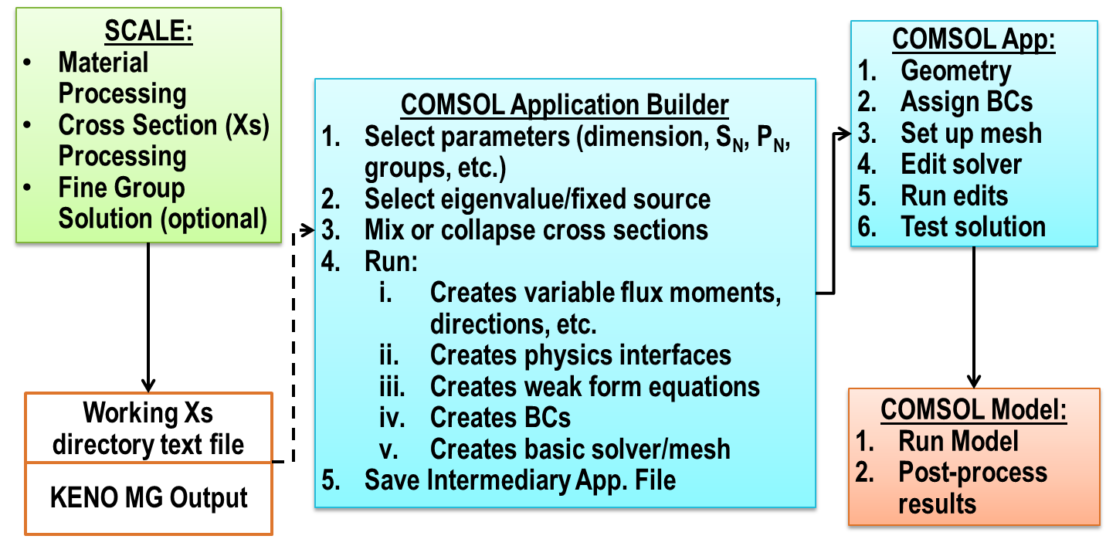
Figure 6.2. Simple flow diagram showing the process of building a discrete ordinates model
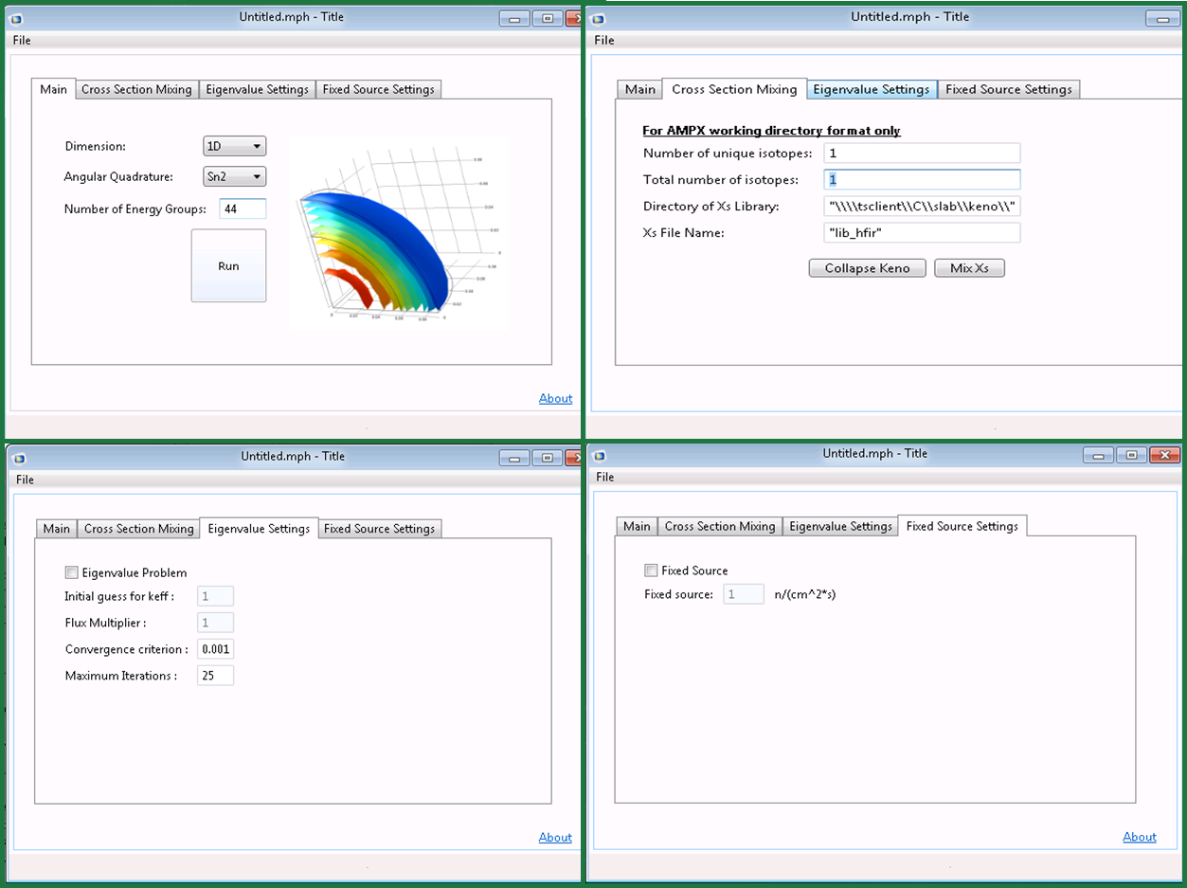
Figure 6.3. Windows of the COMSOL discrete ordinates physics-builder application.

Benchmark Problems and Results
There are currently three sets of benchmark problems that have been run: 1) Kobayashi benchmarks designed for difficult flux profiles that exhibit ray effects and compared to PARTISN, 2) Water-reflected sphere problem compared to Attila, 3) Example problems created for various dimensions and compared to SCALE code package transport solvers. In addition, the verification of a static clean core model of the HFIR is compared against available flux distributions and results presented.

Kobayashi Benchmarks
The Kobayashi benchmarks [83] are difficult problems that are designed to assess the accuracy of the flux distributions in highly absorbing medium systems with void regions. This is the ideal common condition for exhibiting ray effects [84][85], that of an isolated isotropic source in a purely absorbing medium. There are three set problem geometries and for each, there is a case without scattering and one with a 50% scattering cross section. Provided in the benchmark are analytical solutions – numerically integrated for no scattering and Monte Carlo for 50% scattering – of the flux distribution along straight lines that can be used for comparison. A short problem setup summary for the three cases is given in Figure 6.4 and Table 6.3

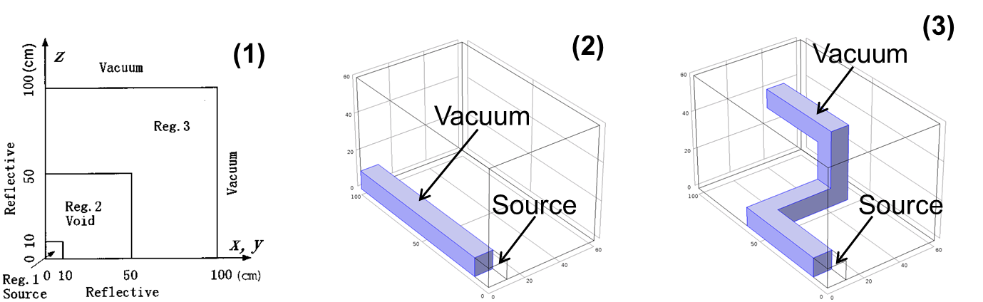
Figure 6.4. Kobayashi benchmark geometry setups for all 3 problems.
Table 6.3. Problem parameters for the Kobayashi benchmarks.
 |  |  | Case i | Case ii
Region | S (n/cm³-s) | $Σ_{t}$(1/cm) | $Σ_{s}$(1/cm)
1 | 1 | 0.1 | 0 | 0.05
2 | 0 | 10⁻⁴ | 0 | 5e-5
3 | 0 | 0.1 | 0 | 0.05

For each problem, analytical solutions are provided to point fluxes along three straight lines in the geometry in 5 cm intervals. To be concise, only results for the 3rd problem will be summarized for both cases here, the duct geometry with three 90° turns as shown on the right in Figure 6.4 which would be expected to be the most difficult solution for the discrete ordinates method.
No ray effect remedies, including first collision source methods[86], are used for two reasons: 1) In order to allow the ray effects to manifest and see how the code handles the resulting discrepancies from this expected limitation to discrete ordinates, and 2) ray effect remedies like the first collision source method are not practical for distributed sources including common eigenvalue calculations.
For this research, the PARTISN discrete ordinates code is used for comparison purposes by the author. S16 angular quadrature is utilized, P0 scattering, and a mesh width intervals of 2 cm using a mapped/swept mesh for 45 – 125,000 mesh elements (see Figure 6.5). In the COMSOL solver settings, the PARDISO linear solver was used with the segregated solver that utilizes a “lower limit” feature that simulates the negative flux fixup which is also in PARTISN. The flux comparison results for problem 3 along three individual lines are presented in Figure 6.6 – Figure 6.11. The solution time was 1-2 hours using 14-28 million DOF.
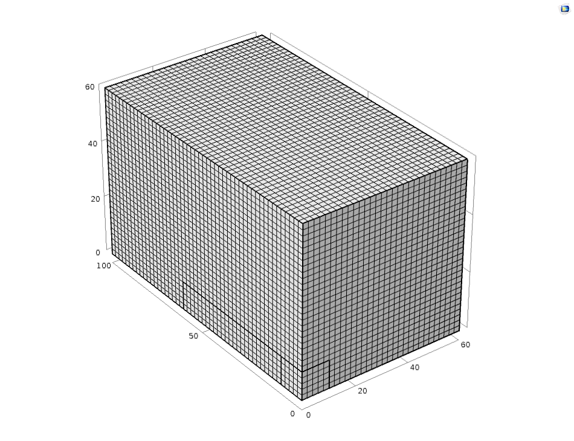
Figure 6.5. Mesh with 2 cm intervals for Kobayashi problem 3 in COMSOL using a mapped swept mesh.

Figure 6.6. Kobayashi problem 3, case i, fluxes along indicated lines for analytical, COMSOL, and PARTISN solutions.

Figure 6.6. Kobayashi problem 3, case i, flux ratio to analytical solution along indicated lines for COMSOL and PARTISN solutions.

Figure 6.7. Kobayashi problem 3, case i, flux and flux ratio to analytical solution along indicated line for analytical, COMSOL and PARTISN solutions.

Figure 6.8. Kobayashi problem 3, case ii, flux along indicated lines for analytic, COMSOL and PARTISN solutions.

Figure 6.6. Kobayashi problem 3, case ii, flux ratio to analytical solution along indicated lines for COMSOL and PARTISN solutions.

Figure 6.11. Kobayashi problem 3, case ii, flux and flux ratio to analytical solution along indicated line for analytical, COMSOL and PARTISN solutions.

Water-reflected sphere
A simple and straightforward water-reflected sphere problem is presented in this section. Table 6.4 that follows gives the short summary of the problem, including 1-group cross sections and the outer radius of the materials. The anticipated for this benchmark problem is k_{eff} is unity. Chosen problem parameters are S4 quadrature, with P0 scattering and a convergence criterion of 1e-4. The problem uses 39 thousand DOF, 1-2 GB of RAM and has a 1-2 minutes solution time for the MUMPS linear solver and fully-coupled Jacobian. The k-eigenvalue comparison is presented in Table 6.5.
Table 6.4. Problem parameters for the water-reflected sphere problem.
Material | $Σ_{t}$(1/cm) | $Σ_{f}$(1/cm) | $Σ_{s}$(1/cm) | R_{O}(cm)
²³⁵U | 0.326400 | 0.182595 | 0.248064 | 6.12745
Water | 0.326400 | 0.000000 | 0.293760 | 9.191176

Table 6.5. K-eigenvalues for simple water-reflected sphere.
Material | $$keff$$ | %Error
Analytical | 1.0000000 | --
COMSOL | 0.9994911 | 0.05%
Attila | 0.9990156 | 0.10%

Miscellaneous problems
In this section, HFIR HEU fuel material is assembled in several configurations that were arbitrarily chosen and the eigenvalues/fluxes compared to the available SCALE codes to ensure that the same nuclear data was being used as input. The SCALE 44 energy group cross section libraries are used and processed with the same functional modules and, where possible, similar solution methods were used. However, for the 3-D comparisons, it should be noted that the Monte Carlo code KENOV.a or KENOVI cannot give a direct comparison to the COMSOL solutions, due to the angular quadrature approximation of the discrete ordinates method.
First presented are two very simple one-region eigenvalue problems in 1-D and 2-D. Both are computed using Sn2 quadrature, however at the time the mesh intervals are different for each study so that control parameter isn’t available. The 1-D case uses simple uranyl fluoride solution of 93 wt.% enrichment ²³⁵U/U in a 16 cm slab with reflective BC on the left boundary and vacuum BC on the right. This case is compared to XSDRNPM and is presented in and.
The 2-D case uses the same uranyl fluoride solution as the 1-D case in a square 16-by-16 cm, with reflective BC on the left and bottom boundaries and vacuum BCs on the right and top boundaries. This case is compared against NEWT and is presented in and . Agreement is found between the results, although a return to these studies with closer control on input parameters should allow closer agreement.
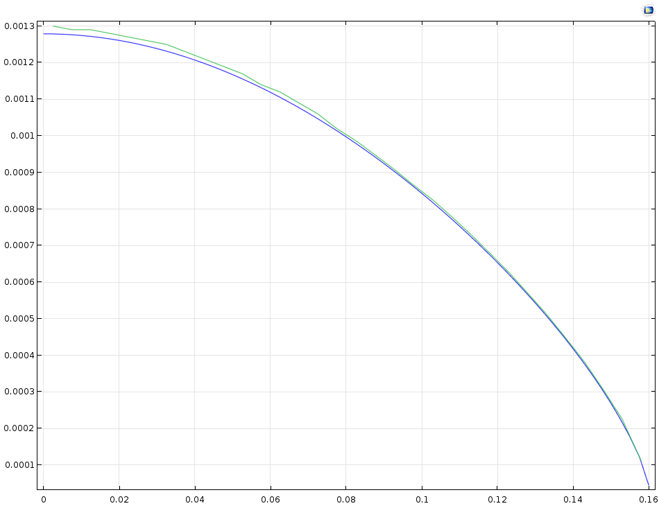
Figure 6.12. Neutron flux comparisons between XSDRNPM and COMSOL for energy groups 44 for uranyl fluoride solution.

Figure 6.13. Neutron flux comparisons between NEWT and COMSOL for energy groups 1 (left) and 44 (right) for uranyl fluoride solution.
Table 6.6. K-eigenvalue comparisons for COMSOL between SCALE codes NEWT and XSDRNPM.
Material | 1-D | %Diff | 2-D | %Diff
COMSOL | 1.527118 | 0.77% | 1.247174 | -0.44%
SCALE | 1.538999 | -- | 1.252748 | --

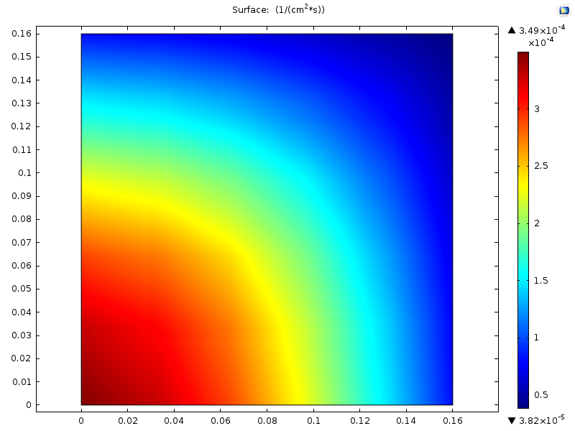
Figure 6.14. Neutron flux surface profile for group 1 in COMSOL 2-D discrete ordinates uranyl fluoride.

Beginning-of-Cycle HFIR Model
The static beginning-of-cycle (BOC) or clean core model for the HFIR core has been developed for the discrete ordinates formulation in COMSOL and has preliminary results. The geometry used is a simplified representation documented in previous calculations and the BOC material compositions are documented in Appendix C of []. Both 3 group and 44 group neutron cross sections have been input, although due to computation time 3 group is preferred.
The 3 group cross sections are generation by collapsing finer group calculations in KENOV.a (in the case of results exhibited here, a 44 group ENDF/B-V library) using the neutron flux spectrum and reaction rates calculated therein into the energy spectrum shown in (as used in and comparable to original HFIRCE-4 energy range results). The KENOV.a model is run using the CSAS5 control sequence BONAMI/CENTRM cross section processing modules for resonance shelf-shielding and production of multigroup cross sections.

Table 6.6. Three-group energy structure.
Group # | Group Name | Lower Neutron Energy | Upper Neutron Energy
1 | Fast | 100 keV | 20 MeV
2 | Epithermal | 0.625 eV | 100 keV
3 | Thermal | 10⁻⁵ eV | 0.625 eV

An unstructured, free triangular coarse mesh is used as shown in and the problem is solved using 42 GB of RAM and 5 million DOF. The MUMPS direct linear solver is used with the fully-coupled solver (note: no negative flux fixups). S₈ angular quadrature is used, with P₁ scattering order and a raised convergence criterion of 5e-2. The scalar flux contour/surface plots for the three groups are presented in Figure 6.12 and a raised tube-contour fission rate plot is presented in ..
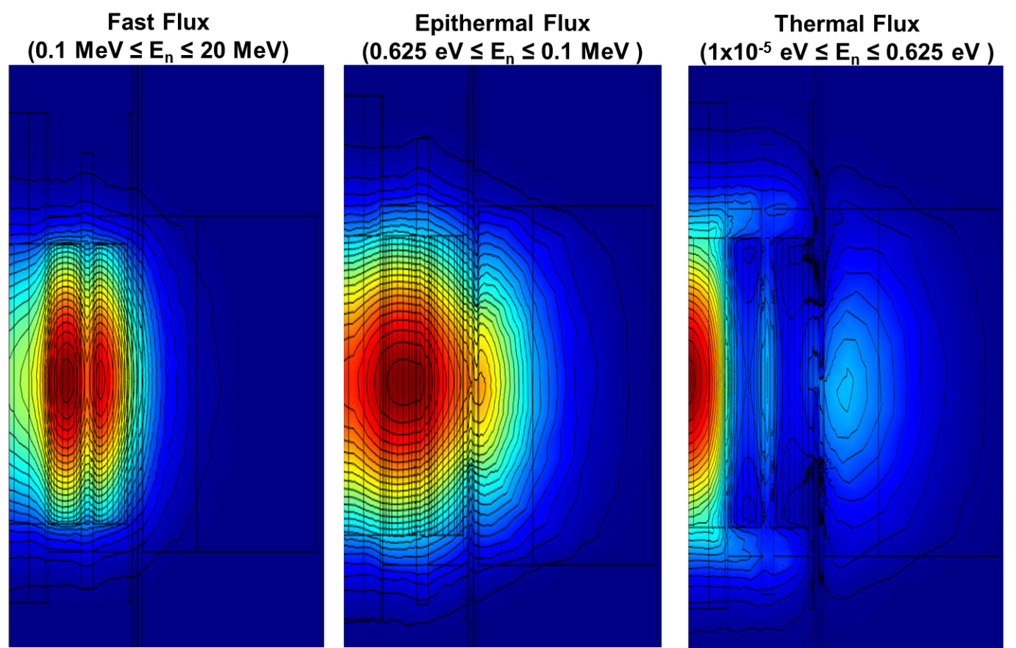
Figure 6.12. Flux surface/contour plots for the fast, epithermal and thermal energy groups from left to right.
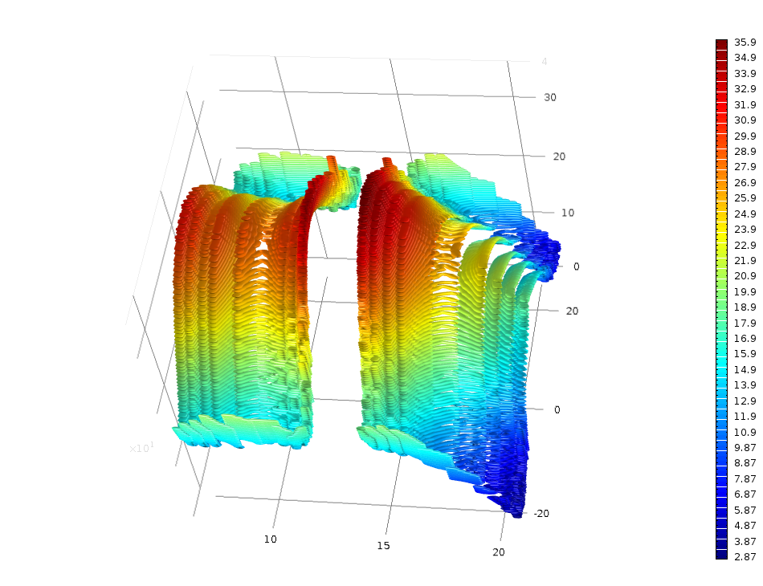
Figure 6.13. Raised tube-contour plot of the fission rate for an eigenvalue calculation.
The scalar fluxes for the three groups along the reactor midplane (z=0) to 60 cm is shown in Figure 6.14 and a comparison along the midplane for each group is made between the KENOV.a simulation (44 energy groups), the COMSOL discrete ordinates results and a 3-group diffusion theory simulation in COMSOL [] for the same mesh in Figure 6.15 - Figure 6.17.
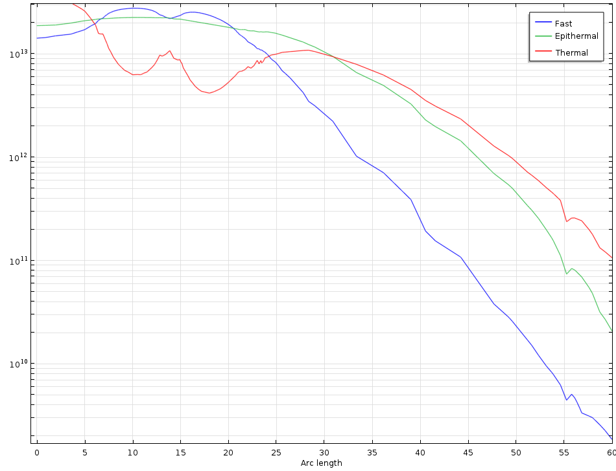
Figure 6.14. Scalar fluxes along reactor midplane for fast, epithermal and thermal fluxes.
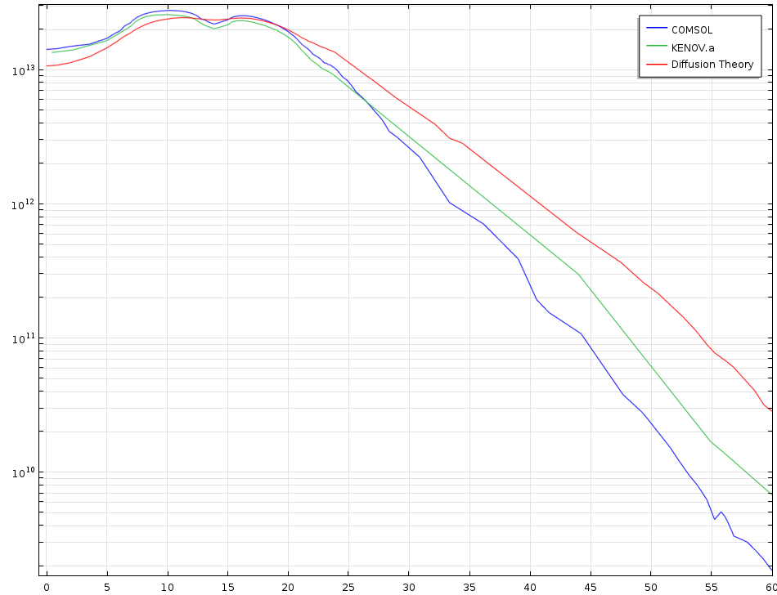
Figure 6.15. Scalar fast fluxes along the reactor midplane for COMSOL discrete ordinates, KENOV.a, and COMSOL diffusion theory models.
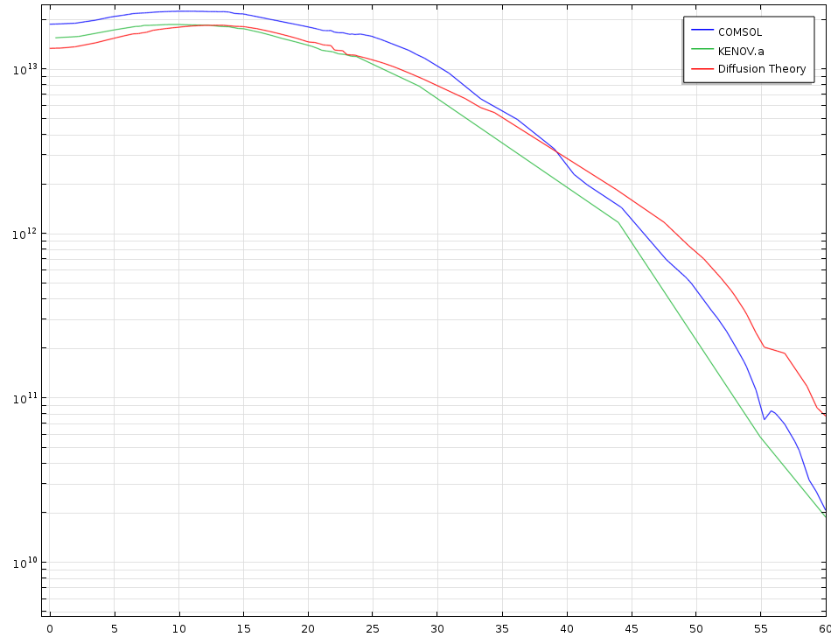
Figure 6.16. Scalar epithermal fluxes along the reactor midplane for COMSOL discrete ordinates, KENOV.a, and COMSOL diffusion theory models.
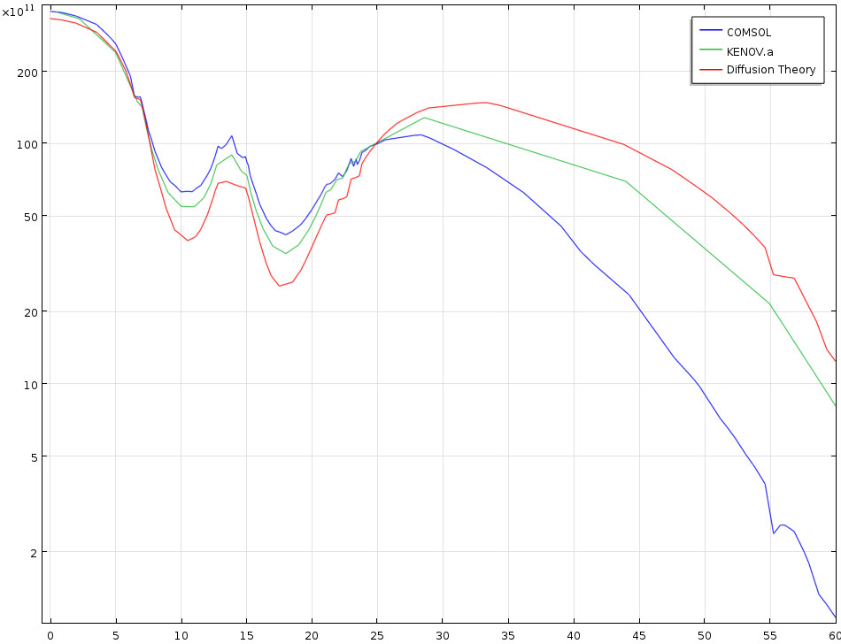
Figure 6.17. Scalar thermal fluxes along the reactor midplane for COMSOL discrete ordinates, KENOV.a, and COMSOL diffusion theory models.

Discrete Ordinates Development Summary
A physics-building application for the discrete ordinates method solution to the transport equation is created in COMSOL Multiphysics for all 3 Cartesian geometries and 2-D R-Z, making use of the Java API programming and Application Builder GUI. The method makes full use of finite element analysis and is readily applicable to multiphysics applications involving the over 30 physics modules built into COMSOL. The application is tested against several benchmark problems with modest success and comparison against other discrete ordinates (and Monte Carlo) codes. In addition, a static BOC HFIR core model is developed and verified to be made available for further use (see following sections).

Time-Dependent Discrete Ordinates
In this chapter, the extension of the COMSOL multi-dimensional and angularly-dependent neutron transport physics discussed in the previous chapter to include time-dependent capabilities is included. The development of this added capability is intended to serve a variety of potential purposes for reactor kinetics at the HFIR, including solutions to reactor kinetics problems in the HFIR SAR, comparison against documented kinetics results, and utilization of time-dependent flux data for multiphysics problems in COMSOL.

Methodology/Theoretical Development
Recalling the unpacking of the streaming operator term in section 6.1.1, there was derived a time derivative of the neutron angular flux divided by the neutron speed, v. This term was eliminated as the time derivative is zero for the stationary case however it is reintroduced to the transport equation for time-dependent solutions. Furthermore, the time-dependent behavior of delayed neutron precursor groups must be accounted for with kinetic equations for each delayed neutron precursor group, as seen below. This accounts for those precursors generated during fission that decay to release neutrons over a much longer time span (on the order of seconds) than prompt fission neutrons (~10⁻¹⁷ seconds to be considered instantaneous).
$$\frac{dC_{i}\left(\vec{r},t\right)}{dt}+λ_{i}C_{i}\left(\vec{r},t\right)=\frac{β_{i}}{k_{s}}\sum_{g^{'}=1}^{G}{νΣ_{f}^{g^{'}}(\vec{r})ϕ^{g^{'}}\left(\vec{r},t\right)}$$
Equation 7.1
where: t is the model time variable,
C_{i} is the concentration for precursor group i,
$λ_{i}$ is the decay constant for precursor group i,
$β_{i}$ is the delayed neutron fraction for precursor group i, and
k_{s} is the stationary solution for k_{eff}.
$$\frac{1}{v^{g}}\frac{dψ_{n}^{g}\left(\vec{r},{\hat{Ω}}_{n},t\right)}{dt}+\left[{\hat{Ω}}_{n}∙\vec{∇}+Σ_{t}^{g}(\vec{r})\right]ψ_{n}^{g}\left(\vec{r},{\hat{Ω}}_{n},t\right)=\frac{χ_{p}^{g}\left(1-β_{eff}\right)}{k_{s}}\sum_{g^{'}=1}^{G}{νΣ_{f}^{g^{'}}(\vec{r})ϕ^{g^{'}}\left(\vec{r},t\right)}+\sum_{l=0}^{ISCT}{\sum_{m=-l}^{l}{Y_{lm}^{*}({\hat{Ω}}_{n})\sum_{g^{'}=1}^{G}{Σ_{sl}^{g^{'}→g}{\left(\vec{r}\right)ϕ}_{lm}^{g^{'}}(\vec{r},t)}}}+\sum_{i=1}^{np}{{χ_{di}^{g}λ}_{i}C_{i}(\vec{r},t)}+q_{ext}^{g}\left(\vec{r} ,t\right)$$
Equation 7.2
where: v^{g} is the neutron speed for group g,
$χ_{p}^{g}$ is the prompt fission distribution for group g,
$β_{eff}$ is the total delayed neutron fraction for all precursors, $β_{eff}=\sum_{i=1}^{np}{β_{i}}$
np is the number of delayed neutron precursor groups, and
$χ_{di}^{g}$ is the delayed neutron fission distribution for precursor group i into energy group g,

Thus there is now the added inputs for the kinetics parameters, typically determined for a system or material region, neutron speed by group, and new probability density function for the production of neutrons by delayed neutron precursors. It can be seen that the decay of delayed neutrons will become a driving force for reactivity insertions less than the delayed neutron fraction (delayed-critical).

Short Benchmark Study

Gd Rabbit Ejection

Concluding Statements
The following two sections summarize the final thoughts of the author for this proposal and attempt to give a clear view of the potential path forward in this research.

Conclusions
The primary objective of this research is to develop new methodologies to ensure safe reactor operations and irradiations of experiments at the HFIR. In the course of that goal, a discrete ordinates methodology is developed in COMSOL that allows for versatile neutron transport calculations with easy access to multiphysics coupling. That method is verified for a variety of benchmark studies as well as the beginning-of-cycle 2-D HFIR core. In addition, two two safety analyses were performed: 1) A limited, but valuable neutronics study for ⁹⁹Mo production, and 2) A detailed, fully-coupled thermo-mechanical model of ²³⁸Pu production targets for a variety of scenarios and challenging physics.
It has been shown that there is a great potential to utilize discrete ordinates in COMSOL for a variety of applications to accurately model neutron transport. It is also established that there is a motivation and opportunity to analyze the unique problem of spatial-dependent reactor kinetics using a new and original computational tool.

Proposal for Future Work
Given the conclusions and the clear need for a problem to satisfactorily demonstrate the discrete ordinates COMSOL application, the following work is proposed as a final objective of this research:
- Implement the required developments for time-dependent discrete ordinates including:
  - Six precursor equations in PDE coefficient form.
  - The time derivative term to the LHS and delayed neutron source to the RHS of the neutron transport governing PDE.
- Utilize the geometry and calculated kinetic parameters from the previous diffusion theory development in COMSOL. If needed, pursue more accurate nuclear data through MCNP (kopts for kinetics parameters), KENO (238 group collapse), etc.
- Pursue those HFIR transient studies that have measured experimental data:
  - Ejection of a gadolinum rabbit, and/or
  - Scram of reactor control elements.
- Compare results to both experimental data and previous calculated results.

References

References
- C. J. Hurt, “Neutronics and Heat Generation Calculations to Support High Density LEU (Natural Uranium) Hydraulic Tube Rabbits for Mo-99 Production ,” C-HFIR-2013-014/R1, 2013.
- C. J. Hurt, J. D. Freels, et. al., “Safety Analysis Models for the Irradiation of 237Np Targets at the High Flux Isotope Reactor,” Proceedings of Nuclear & Emerging Technologies in Space (NETS) 2015, Albuquerque, NM, February 2015.
- C. J. Hurt, R. M. Wham, et. al., “Plutonium-238 Production Design Studies,” INMM 55th Annual Meeting, Atlanta, GA, July 2014.
- J. D. Freels, C. J. Hurt “COMSOL Thermal-Structure Interaction Simulations of NpO2 Bare-Pellet Test Capsules in HFIR,” C-HFIR-2012-017/R1, 2012.
- C. J. Hurt, J. D. Freels “COMSOL Thermal-Structure Interaction Simulations of NpO2 Partially-Loaded Targets in HFIR,” C-HFIR-2013-007/R0, 2013.
- C. J. Hurt, J. D. Freels “COMSOL Thermal-Structure Interaction Simulations of NpO2 Fully-Loaded Targets in HFIR ,” C-HFIR-2013-029/R4, 2013.
- C. J. Hurt, J. D. Freels, “Design and Nuclear Safety Analysis of a Pu-238 Fully-Loaded Target Assembly for up to Three Irradiation Cycles in HFIR using COMSOL Multiphysics v5.0,” C-HFIR-2015-033/R0, to-be-issued 2015.
- C. J. Hurt, J. D. Freels, “Using the Application Builder for Neutron Transport in Discrete Ordinates,” COMSOL Conference Boston 2015.
- R.M. Wham, L. K. Felker, et. al., “The Plutonium-238 Supply Project,” The 19th Pacific Basin Nuclear Conference, Vancouver, British Columbia, Canada, August 2014.
- L. Tschaepe, A. E. Ruggles, J. D. Freels, and R. T. Primm, III, “Evaluation of HFIR LEU Fuel Using the COMSOL Multiphysics Platform,” ORNL/TM-2008/188, Oak Ridge National Laboratory, March 2009.
- D. Chandler, “Spatially-Dependent Reactor Kinetics and Supporting Physics Validation Studies at the High Flux Isotope Reactor,” A Dissertation Presented for the Doctor of Philosophy Degree, University of Tennessee, August 2011.
- M. D. DeHart, “NEWT: A New Transport Algorithm for Two-Dimensional Discrete Ordinates Analysis in Non-Orthogonal Geometries,” ORNL/TM-2005/39, Version 6.1, Sect. F21, Oak Ridge National Laboratory, June 2011.
- N. M. Greene, L. M. Petrie, M. L. Williams, “XSDRNPM: A One-Dimensional Discrete-Ordinates Code for Transport Analysis,” ORNL/TM-2005/39, Version 6.1, Sect. F3, Oak Ridge National Laboratory, June 2011.
- R. E. Alcouffe, R. S. Baker, et. al., “PARTISN: A Time-Dependent, Parallel Neutral Particle Transport Code System,” LA-UR-08-07258 (Revised Nov. 2008).
- R. E. Alcouffe, R. S. Baker, et. al., “DANTSYS: A Diffusion Accelerated Neutral Particle Code System,” LA-12969-M, 1995.
- W. A. Rhoades, D. B. Simpson, “The TORT Three-Dimensional Discrete Ordinates Neutron/Photon Transport Code,” ORNL/TM-13221, October 1997.
- A. Seubert, K. Velkov, and S. Langenbuch, “The Time-Dependent 3-D Discrete Ordinates Code TORT-TD with Thermal-Hydraulic Feedback by ATHLET Models,” Proc. PHYSOR-2008, International Conference on the Physics of Reactors, Interlaken, Switzerland, September 2008.
- M. B. Emmett, W. A. Rhoades, et. al., the DORT section of “A User’s Manual for MASH 1.0 - A Monte Carlo Adjoint Shielding Code System,” ORNL/TM-11778, March 1992.
- W. W. Engle, Jr., “ANISN, A One-Dimensional Discrete Ordinates Transport Code with Anisotropic Scattering,” K-1693, March 1967.
- T. A. Wareing, J. M. McGhee, et. al., “Discontinuous Finite Element Sn Methods on Three-Dimensional Unstructured Grids”, Nucl. Sci. Engr., Vol. 138, Number 2, July 2001.
- S. T. Keller, T. S. Palmer, “Modeling a TRIGA Mark II Reactor Using the Attila Three-Dimensional Deterministic Transport Code”, M&C 2005: International Topical Meeting on Mathematics and Computation, Supercomputing, Reactor Physics, and Nuclear and Biological Applications, Avignon, France, 2005.
- F. N. Gleicher II, Y. Wang, et. al., "The Method of Manufactured Solutions for RattleSnake, A SN Radiation Transport Solver inside the MOOSE Framework,” Transactions of the American Nuclear Society, Vol. 106, 372-374, June 2012.
- F. N. Gleicher II , M. DeHart, et. al., " Development of Multi-Physics Methods to Support Restart of the Transient Test Reactor,” Transactions of the American Nuclear Society, Vol. 112, 358-362, June 2015.
- H. Zhang, Y. Wang, et. al., “Coupling of RELAP-7 with the Three-Dimensional Kinetics Code Rattlesnake,” Transactions of the American Nuclear Society, Vol. 108, 863-865, June 2013.
- J. R. Harter, P. A. Greaney, et. al., “Characterization of Thermal Conductivity using Deterministic Phonon Transport in Rattlesnake,” Transactions of the American Nuclear Society, Vol. 112, 863-865, June 2015.
- Yaqi Wang, “Nonlinear Diffusion acceleration for the Multigroup Transport Equation Discretized with Sn and Continuous FEM with Rattlesnake,” International Conference on Mathematics and Computational Methods Applied to Nuclear Science & Engineering, LaGrange Park, IL, May 2013.
- D. Gaston, C. Newman, “MOOSE: A parallel computational framework for coupled systems of nonlinear equations,” Nuclear Engineering and Design, Vol. 239, 1769-1778, 2009.
- D. P. Griggs, M. S. Kazimi, and A. F. Hendry, “TITAN: an advanced three-dimensional coupled neutronic/thermal-hydraulics code for light-water nuclear-reactor-core analysis,” PB-85-144251/XAB and MIT/EL-84/011, Massachusetts Institute of Technology, Cambridge, USA, June 1984.
- H. G. Joo, D. Barber, G. Jiang, and T. Downar, “PARCS: a multi-dimensional two-group reactor kinetics code based on the nonlinear analytic nodal method,” School of Nuclear Engineering, Purdue University, July 2002.
- NESTLE Version 5.2.1, “Few-Group Neutron Diffusion Equation Solver Utilizing The Nodal Expansion Method for Eigenvalue, Adjoint, Fixed-Source Steady-State and Transient Problems,” Electric Power Research Center, North Carolina State University, July 2003.
- H. G. Joo, J. Y. Cho, K. S. Kim, C. C. Lee, and S. Q. Zee, “Methods and Performance of a Three-Dimensional Whole-Core Transport Code DeCART,” Korea Atomic Energy Research Institute, Proc. PHYSOR-2004, The Physics of Fuel Cycles and Advanced Nuclear Systems: Global Developments, Chicago, IL, April 2004.
- U. Bredolt, “POLCA-T – Validation of Transient Bundle Flow Predictions During an All Recirculation Pump-trip in a BWR,” Proc. International Conference on Nuclear Engineering 14, Miami, FL, July 2006.
- C. Jönsson, G. Grandi, J. Judd, G. Dominicus, and H. Bergersen, “Severe Reactivity Initiated Accidents with SIMULATE-3K and SIMULATE-3K/RELAP5 in Forsmark-3 BWR, Studsvik Scandpower, Proc. 2010 LWR Fuel Performance/Top Fuel/WRFPM, Orlando, FL, September 2010.
- W.F. Lyon, N. Jahingir, et. al., “Capabilities of the FALCON steady state and transient fuel performance code,” 2004 International Meeting on LWR Fuel Performance, Orlando, FL, 2004.
- D. G. Morris and M. W. Wendel, “High Flux Isotope Reactor System RELAP5 Input Model,” ORNL/TM-11647, Oak Ridge National Laboratory, February 1993.
- J. D. Freels, “Reactor Point Kinetics Model for HFIR Analysis,” C-HFIR-92-024, September 1993.
- Internal Correspondence, D. G. Morris to B. L. Lepard, “HFIR Vessel/Core RELAP5 Model Input Calculation Notes,” February 28, 1998.
- F. P. Griffin, K. A. Smith, et. al., “RELAP5 Consolidated Model of High Flux Isotope Reactor System,” ORNL/RRD/INT-154 Rev. 0, April 2011.
- E. D. Blakeman, “Neutron and Gamma Fluxes and dpa Rates for HFIR Vessel Beltline Region (Present and Upgrade Designs),” ORNL/TM-13693, Oak Ridge National Laboratory, November 2000.
- J. Pace III, C.O. Slater, et. al., “Three-Dimensional Discrete Ordinates Radiation Transport Calculations for Beginning-Of-Cycle at Several Pressure Vessel Surveillance Positions in the High Flux Isotope Reactor”, The Eight ASTM-EURATOM Symposium on Reactor Dosimetry, Vail, Colorado, September 1993.
- S. T. Mahmood, S. Mirzadeh, et. al., “Neutron Dosimetry of the HFIR Hydraulic Facility,” ORNL/TM-12831, Oak Ridge National Laboratory, February 1995.
- J.A. Bucholz, “Source Terms for HFIR Beam Tube Shielding Analyses, and a Complete Shielding Analysis of the HB-3 Tube,” ORNL/TM-13720, Oak Ridge National Laboratory, July 2000.
- R. L. Childs, W. A. Rhoades, et. al., “Three-dimensional Calculations of Neutron Streaming the Beam Tubes of the ORNL HFIR Reactor,” The 7th International Conference on Radiation Shielding, Bournemouth, United Kington, September 1988.
- G. Gomes, “Comparison between COMSOL and RFSP-IST for a 2-D Benchmark Problem,” Atomic Energy of Canada Limited, Excerpt from the Proceedings of the COMSOL Conference 2008 Hannover, Hannover, Germany, November 2008.
- V. Memoli, A. Cammi, V. D. Marcello, and L. Luzzi, “A Preliminary Approach to the Neutronics of the Molten Salt Reactor by means of COMSOL Multiphysics,” Politecnico di Milano, Excerpt from the Proceedings of the COMSOL Conference 2009 Milan, Milan, Italy, October 2009.
- C. J. Hurt, R. E. Pevey, P. L. Angelo, “Simulation of Criticality Accident Transients in Uranyl Nitrate Solution with COMSOL Multiphysics,” Transactions of the American Nuclear Society, Vol. 107, 652-655, November 2012.
- J. L. McDuffee, T. D. Burchell, “Experimental plan and design of two experiments for graphite irradiation at temperatures up to 1500 °C in the target region of the high flux isotope reactor,” Journal of Nuclear Materials, Vol. 381, 114-118, 2008.
- J. L. McDuffee, “Axial Thermal Expansion Calculation for Graphite Foam Specimens in a Molybdenum Rabbit Holder,” RRD Calculation, C-HFIR-2015-027/R0, 2015.
- J. L. McDuffee, “Temperature Verification and Expansion Calculation for Nickel Specimens in a 3-Hole Housing,” RRD Calculation, C-HFIR-2014-013/R0, 2014.
- J. L. McDuffee, “Temperature Verification and Expansion Calculation for Standard Capsule Selenium Rabbits,” RRD Calculation, C-HFIR-2014-016/R0, 2014.
- K. J. Geelhood, W. G. Luscher, “FRAPCON 4.0: A Computer Code for the Calculation of Steady- State, Thermal- Mechanical Behavior of Oxide Fuel Rods for High Burnup,” PNNL-19418, Vol. 1 Rev. 2, September 2015.
- M. E. Cunningham, C. E. Beyer, “GT2R2: An Updated Version of GAPCON-THERMAL2,” NUREG/CR-3907, PNL-5178, September 1984.
- M. Suzuki, H. Saito, “Light Water Reactor Fuel Analysis Code FEMAXI-IV(Ver.2) – Detailed Structure and User’s Manual,” JAERI-Data/Code 97-043, 1993.
- J. Rest, “GRASS-SST: A Comprehensive, Mechanistic Model for the Prediction of Fission Gas Behaviour in UO₂-base Fuels during Steady-State and Transient Conditions,” NUREG/CR-0202, ANL-78-53, June 1978.
- F. Strizhov, M. Valach, “Description of PIN micro Innovation to the PIN99W code,” Nuclear Research Institute Rez, plc UJV-11321-TM, November 1999.
- K. T. Clairno, B. Phillip, “The AMP (Advanced MultiPhysics) Nuclear Fuel Performance code,” Nuclear Engineering and Design, Vol. 252, 108-120, November 2012.
- R. L. Williamson, D. A. Knoll, “Enhancing the ABAQUS Thermomechanics Code to Simulate Steady and Transient Fuel Rod Behavior,” Proceedings of Top Fuel 2009, Paris, France, September 2009.
- R. L. Williamson, J. D. Hales, et. al., “Multidimensional multiphysics simulation of nuclear fuel behavor,” Journal of Nuclear Materials, Vol. 423, 149-163, 2012.
- R. L. Williamson, J. D. Hales, et. al., “A feasibility study on the use of the MOOSE computational framework to simulate three-dimensional deformation of CANDU reactor fuel elements,” Nuclear Engineering and Design, Vol. 293, 385-394, 2015.
- X-5 Monte Carlo Team, “MCNP—A General Monte Carlo N-Particle Transport Code, Version 5, LA-CP-03-1987,” Los Alamos National Laboratory, April 24, 2003 (Revised February 1st, 2008).
- “Scale: A Comprehensive Modeling and Simulation Suite for Nuclear Safety Analysis and Design,” ORNL/TM-2005/39, Version 6.1, June 2011.
- S. Goluoglu, N. F. Landers, L. M. Petrie, and D. F. Hollenbach, “CSAS5: Control Module for Enhanced Criticality Safety Analysis Sequences with KENO V.A,” ORNL/TM-2005/39, Version 6.1, Sect. C5, Oak Ridge National Laboratory, June 2011.
- S. Goluoglu, D. F. Hollenbach, and L. M. Petrie, “CSAS6: Control Module for Enhanced Criticality Safety Analysis Sequences with KENO-VI,” ORNL/TM-2005/39, Version 6.1, Sect. C6, Oak Ridge National Laboratory, June 2011.
- M. D. DeHart, “TRITON: A Two Dimensional Transport and Depletion Module for Characterization of Spent Nuclear Fuel,” ORNL/TM-2005/39, Version 6.1, Sect. T1, Oak Ridge National Laboratory, June 2011.
- L. M. Petrie, N. F. Landers, D. F. Hollenbach, B. T. Rearden, M. E. Dunn, and S. Goluoglu, “KENO Va: An Improved Monte Carlo Criticality Program,” ORNL/TM-2005/39, Version 6.1, Sect. F11, Oak Ridge National Laboratory, June 2011.
- D. F. Hollenbach, L. M. Petrie, S. Goluoglu, N. F. Landers, and M. E. Dunn, “KENO-VI: A General Quadratic Version of the KENO Program,” ORNL/TM-2005/39, Version 6.1, Sect. F17, Oak Ridge National Laboratory, June 2011.
- I. C. Gauld, O. W. Hermann, and R. M. Westfall, “ORIGEN-S: SCALE System Module to Calculate Fuel Depletion, Actinide Transmutation, Fission Product Buildup and Decay, and Associated Radiation Source Terms,” ORNL/TM-2005/39, Version 6.1, Sect. F7, Oak Ridge National Laboratory, June 2011.
- I. Gauld, D. Wiarda, et. al., " COUPLE: A Nuclear Decay and Cross Section Data Processing Code for Creating ORIGEN-S Libraries," ORNL/TM-2005/39, Version 6.1, Sect. F6, June 2011.
- I. Gauld, D. L. Barnett, et. al., "OPUS/PlotOPUS: An ORIGEN-S Post-Processing Utility and Plotting Program for SCALE" NUREG/CR-0200, Revision 7, Volume 2, Section F15, ORNL/NUREG/CSD-2/R7 April 2002
- COMSOL: COMSOL, Inc., “COMSOL Multiphysics User’s Guide,” Version 4.3, Burlington, MA, May 2012.
- COMSOL: COMSOL, Inc., “COMSOL Multiphysics Reference Manual,” Version 5.0, Burlington, MA, October 2014.
- COMSOL: COMSOL, Inc., “COMSOL Multiphysics Reference Manual,” Version 5.1, Burlington, MA, 2015.
- C. V. Madhusudana, “Thermal Contact Conductance,” Springer-Verlag, New York, 1995.

- M. E. Dunn and N. M. Greene, “AMPX-2000: A Cross-Section Processing System for Generating Nuclear Data for Criticality Safety Applications,” Trans. Am. Nucl. Soc. 86, 118–119 2002.
- R. T. Primm, III and N. Xoubi, “Modeling of the High Flux Isotope Reactor Cycle 400,” ORNL/TM-2004/251, Oak Ridge National Laboratory, August 2005.
- G. Ilas and R. T. Primm, III, “Methodology for Simulating the Irradiation of the Control Elements in HFIR,” Transaction American Nuclear Society, Vol. 103, 696 – 698, ANS 2010 Winter Meeting, Las Vegas, NV, November 2010.
- G. Ilas, J. C. Gehin, and R. T. Primm, III, “New Cross Section Processing Methodology for HFIR Core Analysis,” Proc. PHYSOR-2008, International Conference on the Physics of Reactors, Interlaken, Switzerland, September 2008.

- E. E. Lewis, W. F. Miller, Jr. “Computational Methods of Neutron Transport,” American Nuclear Society, La Grange Park, IL, 1993
- W. M. Stacey, “Nuclear Reactor Physics,” John Wiley and Sons, Inc, New York, 2001.
- B. G. Carlson, K. D. Lathrop, “The Method of Discrete Ordinates,” in “Computing Methods in Reactor Physics,” Gordon and Breach, Science Publishers, Inc.., New York, 1968.
- K. D. Lathrop and B. G. Carlson, “Discrete-Ordinates Angular Quadrature of the Neutron Transport Equation,” LA-3186, February 1965.
- K. Kobayashi, N. Sugimura, Y. Nagaya, “3-D Radiation Transport Benchmark Problems and Results for Simple Geometries with Void Regions,” OECD Proceedings, Nuclear Energy Agency, November 2000.
- K. D. Lathrop, “Ray Effects in Discrete Ordinates Equations,” Nuclear Science and Engineering, Vol. 32, 255-268, January 1968.
- K. D. Lathrop, “Remedies for Ray Effects,” Nuclear Science and Engineering, Vol. 45, 357-369, April 1971.
- K. Kosako, C. Konno, “FNSUNCL3: First Collision Source Code for TORT,” Journal of Nucl. Sci. and Tech., Vol. 37, 475-478, 2000.
- d

- D. P. Griggs, M. S. Kazimi, and A. F. Hendry, “TITAN: an advanced three-dimensional coupled neutronic/thermal-hydraulics code for light-water nuclear-reactor-core analysis,” PB-85-144251/XAB and MIT/EL-84/011, Massachusetts Institute of Technology, Cambridge, USA, June 1984.
- H. G. Joo, D. Barber, G. Jiang, and T. Downar, “PARCS: a multi-dimensional two-group reactor kinetics code based on the nonlinear analytic nodal method,” School of Nuclear Engineering, Purdue University, July 2002.
- NESTLE Version 5.2.1, “Few-Group Neutron Diffusion Equation Solver Utilizing The Nodal Expansion Method for Eigenvalue, Adjoint, Fixed-Source Steady-State and Transient Problems,” Electric Power Research Center, North Carolina State University, July 2003.
- H. G. Joo, J. Y. Cho, K. S. Kim, C. C. Lee, and S. Q. Zee, “Methods and Performance of a Three-Dimensional Whole-Core Transport Code DeCART,” Korea Atomic Energy Research Institute, Proc. PHYSOR-2004, The Physics of Fuel Cycles and Advanced Nuclear Systems: Global Developments, Chicago, IL, April 2004.
- U. Bredolt, “POLCA-T – Validation of Transient Bundle Flow Predictions During an All Recirculation Pump-trip in a BWR,” Proc. International Conference on Nuclear Engineering 14, Miami, FL, July 2006.
- C. Jönsson, G. Grandi, J. Judd, G. Dominicus, and H. Bergersen, “Severe Reactivity Initiated Accidents with SIMULATE-3K and SIMULATE-3K/RELAP5 in Forsmark-3 BWR, Studsvik Scandpower, Proc. 2010 LWR Fuel Performance/Top Fuel/WRFPM, Orlando, FL, September 2010.

- D. Chandler, R. T. Primm, III, and G. I. Maldonado, “Power Distribution Analysis for the ORNL High Flux Isotope Reactor Critical Experiment 3,” Nuclear Science and Engineering, Vol. 164, January 2010.
- J. L. McDuffee, Heat Generation Rates for Various Rabbit Materials in the Flux Trap of HFIR, C-HFIR-2012-035, December 2012.
- SCALE Newsletter, Number 45, Spring 2013, http://scale.ornl.gov.
- ORNL/HFIR/SAR/2344, High Flux Isotope Reactor Safety Analysis Report, Chapter 4.3 Nuclear Design, Revision 11, May 2012.
- R. W. Hobbs, Reactivity Worth of Rabbits Containing Partial Length Gadolinium Rods or Sleeves, C-HFIR-2011-007/R1, March 2011.
- J. Peterson and G. Ilas, Calculation of Heating Values for the High Flux Isotope Reactor, PHYSOR 2012 – Advances in Reactor Physics, Knoxville, TN, April 2012.
- D. Chandler, Nuclear Heating and Radionuclide Inventory Calculations to Support NpO2 Single Pellet Irradiations in HFIR, C-HFIR-2012-005, May 2012.
- R. J. Ellis, Neutronics and Heat Generation Calculations in Support of the Thermal Neutron Fuel Irradiation Facility, C-HFIR-2009-011, November 2009.
- R. J. Ellis, Heat Generation and Neutronics Calculations in Support of TEM Disk Rabbit Irradiations Inside a Gadolinium Shield in the Hydraulic Tube, C-HFIR-2011-016, August 2011.
- C. O. Slater and R. T. Primm, III, Nuclear Heating Rates in and around the Cold Source and HB4 Beam Tube, C-HFIR-2005-113, March 2005.
- B. R. Betzler, E. E. Sunny, J. C. Lee, and W. R. Martin, Coupled Nuclear-Thermal-Hydraulic Calculations for Fort St. Vrain Reactor, NURETH14-421, The 14th International Topical Meeting on Nuclear Reactor Thermal Hydraulics, Toronto, Canada, September 2011.
- National Nuclear Data Center, Evaluated Nuclear Data File (ENDF) Retrieval & Plotting, Brookhaven National Laboratory, http://www.nndc.bnl.gov/sigma/.
- R. W. Hobbs, Tungsten Rabbit Irradiations in the HFIR B-3 Hydraulic Tube, C-HFIR-2001-039, January 2002.
- J. D. Freels, Reactor Point Kinetics Model for HFIR Analysis, C-HFIR-92-024, September 1993.
- Internal Correspondence, D. G. Morris to B. L. Lepard, HFIR Vessel/Core RELAP5 Model Input Calculation Notes, February 28, 1998.
- F. P. Griffin, K. A. Smith, and J. R. Valentine, RELAP5 Consolidated Model of High Flux Isotope Reactor System, ORNL/RRD/INT-154 Rev. 0, April 2011.
- K. A. Smith, RELAP5 WCLOCA and LOOP Analysis – Scram/Safety Plate Timing Sensitivity Study, C-HFIR-99-017, July 1999.

Appendices

Appendices

Appendix A – COMSOL PDE Discretization Method

Appendix B - Plutonium-238 Production Feasibility Study

Vita

