To the Graduate Council:

I am submitting herewith a dissertation written by Peng Zhu entitled “Durability and Fatigue Behavior of CIP Concrete Connections for Accelerated Bridge Construction.” I have examined the final electronic copy of this dissertation for form and content and recommend that it be accepted in partial fulfillment of the requirements for the degree of Doctor of Philosophy, with a major in Civil Engineering.

Zhongguo John Ma, Major Professor

We have read this dissertation
and recommend its acceptance:

Edwin G. Burdette

Baoshan Huang

John Stanley Rabun

Accepted for the Council:

Carolyn R. Hodges
Vice Provost and Dean of the Graduate School

(Original signatures are on file with official student records.)

Durability and Fatigue Behavior of CIP Concrete Connections for Accelerated Bridge Construction

A Dissertation
Presented for the
Doctor of Philosophy
Degree
The University of Tennessee, Knoxville

Peng Zhu
December 2010
Dedication

I dedicate this dissertation to my parents, Yunfu Zhu and Yufen Fu, for their unending love, and encouragement.

Acknowledgments
I wish to express my sincere gratitude to all those who contributed in the successful completion of this research. I gratefully acknowledge the financial support provided by the National Cooperative Highway Research Program, National Academy of Sciences.
My deepest appreciation goes to my advisor, Dr. Zhongguo John Ma, for offering me the chance to be a member of his excellent research team, encouraging me throughout my study by his wonderful ideas and invaluable knowledge.
My wholehearted thanks go to the members of my committee, Dr. Edwin G. Burdette, Dr. Baoshan Huang, and Dr. John Stanley Rabun for showing me the way in the course of the study and giving me a chance to have their valuable inputs in my dissertation.
I extend my sincere thanks to Ken Thomas, Larry Roberts, and Nancy Roberts for providing material support and the testing setup.
Many sincere thanks go to my beloved friends and colleagues, Sam Moss, Daiwen Chen, Josh Kerr, Wenchao Song, Qi Cao, Lungui Li, Xin Jiang, Anupont Thaicharoenporn, Jing Song, Aaron Hanks, Matt Goranson, Jayaprakash Vadivelu and Akawut Siriruk, for their help and friendship.
At last but not the least, my profound and heart-to-heart thanks go to Ross Prestressed Concrete, Inc. for donating the concrete materials and helping with the casting of the specimens. Gerdau Ameristeel, Engineered Wire products and Salit Specialty Rebar Inc. provided the reinforcement. Robert Gulyas of BASF Construction Chemicals, LLC provided valuable comments in regards to the material testing program. I gratefully acknowledge the support of BASF Construction Chemicals, LLC, CTS Cement Manufacturing Corporation, Dow Reichhold, Specialty Latex LLC, Enco Materials, Inc., Five Star Products, Inc., and Lafarge North America, Inc.
Abstract
Continuous longitudinal and transverse U-bar joint connections between flanges of the decked bulb-Ts (DBTs) or between precast panels for accelerated bridge construction are investigated.
The procedure for selecting durable closure pour (CP) materials for the connections is discussed firstly. The accelerated construction is quantified as two categories: overnight cure and 7-day cure of CP materials. Candidate materials are selected first based on literature review as well as tests of compressive strength and flow and workability. Then, performance criteria for selecting durable CP materials for both categories are developed based on durability tests of selected candidate materials. These durability tests include freezing-and-thawing durability, shrinkage, bond, and permeability tests. To investigate the longitudinal U-bar joint details, four pairs of full-scale slabs connected by a U-bar detail with one of the selected CP materials, overnight cure and 7-day cure, were tested. The loading demand necessary in the slab testing is determined based on the maximum forces in the longitudinal joint from an analytical parametric study. Static and fatigue tests under four-point flexural loading and three-point flexural-shear loading were conducted. Test results were evaluated based on flexural capacity, curvature behavior, cracking, deflection and steel strain. The transverse U-bar joint details are investigated to provide negative moment continuity in the multi-span bridges. Four full-scale specimens connected by a U-bar detail with one of the selected CP materials, overnight cure and 7-day cure, were tested. Static and fatigue tests under tension loading were conducted. The loading demand necessary in the beam testing is determined based on the maximum forces in the transverse joint from an analytical study. Test results were evaluated based on tension capacity, cracking, displacement and steel strain. Based on the test results, the developed longitudinal and transverse U-bar joint details are viable connection systems.
Table of Contents
Chapter Page
Chapter 1: Introduction 1
Appendix 3
Chapter 2: Selection of Durable Closure Pour Materials for Accelerated Bridge Construction 4
2.1 Introduction 6
2.2 Preliminary Performance Criteria 9
2.3 Selection of Candidate Materials for Long-Term Tests 13
2.3.1 Overnight Cure Materials and Their Preliminary Selection 13
2.3.2 7-Day Cure Materials and Their Preliminary Selection 15
2.4 Long-Term Tests 16
2.4.1 Bond Strength Test 16
2.4.2 Permeability Test 17
2.4.3 Freezing-and-Thawing Test 19
2.4.4 Shrinkage Test 20
2.5 Proposed Performance Criteria and Conclusions 20
Appendix 22
Chapter 3: Fatigue Evaluation of Longitudinal U-Bar Joint Details for Accelerated Bridge Construction 31
3.1 Introduction 33
3.2 Maximum Forces in the Longitudinal U-bar Joints 34
3.3 Experimental Program 35
3.3.1 Slab Dimension 35
3.3.2 Reinforcement Layout and Strain Gage Instrumentation 36
3.3.3 Panel Fabrication and Joint Surface Preparation 37
3.3.4 Closure-Pour Materials 38
3.3.5 Testing Plan and Setup 38
3.3.6 Fatigue Loading Determination 41
3.3.7 Moment Capacity and Curvature 43
3.3.8 Deflection Development 46
3.3.9 Crack Width Development 47
3.3.10 Strain Development 50
3.3.11 Failure of Specimen 51
3.4 Conclusions 52
Appendix 54
Chapter 4: Fatigue Evaluation of Transverse U-Bar Joint Details for Accelerated Bridge Construction 72
4.1 Introduction 74
4.2 Maximum Forces in the Transverse U-bar Joints 76
4.3 Experimental Program 80
4.3.1 Specimen Dimension 80
4.3.2 Reinforcement Layout and Strain Gage Instrumentation 80
4.3.3 Specimen Fabrication and Joint Surface Preparation 81
4.3.4 Closure-Pour Materials 82
4.3.5 Testing Plan and Setup 82
4.3.6 Fatigue Loading Determination 83
4.4 Test Result Analysis 85
4.4.1 Tensile Capacity 85
4.4.2 Load Deflection Relationships 86
4.4.3 Crack Width Development 86
4.4.4 Strain Development 89
4.5 Conclusions 90
Appendix 91
Chapter 5: Conclusions and Future Work 104
5.1 Conclusions 104
5.2 Future Work 106
References 107
Vita 111

List of Tables
Table Page
Table 2.1. Performance Characteristic Grades* by Russell and Ozyildirim (2006) 22
Table 2.2. Performance Characteristic Grades* by Tepke and Tikalsky (2007) 22
Table 2.3. Candidate Overnight Cure Materials 23
Table 2.4. Candidate HPC Mix Proportions 23
Table 2.5. 7-day Cure Mixture Proportions, kg/m³ 24
Table 2.6. Compressive Strengths (MPa) per ASTM C 39 Modified 24
Table 2.7. Slant Cylinder Bond Strength and Failure Mode 24
Table 2.8. Depths (mm) for 0.2% chloride content (by mass of cement) 25
Table 2.9. Proposed Performance Criteria of CP Materials 25
Table 2.10. Application of CP Material Grades for Freezing-and-thawing Durability 26
Table 3.1. Slab Specimen Loading Matrix 54
Table 3.2. Compressive Strength of Concrete Panel and Grouted Joint 54
Table 3.3. Moment Capacity 55
Table 4.1. Negative Moment over Piers in Bridge Models 91
Table 4.2. Moment over Piers in Bridge Models with DBT65 91
Table 4.3. Moment over Piers in Bridge Models with BT72 91
Table 4.4. Tension Test Specimen Loading Matrix 92
Table 4.5. Cylinder Compressive Strength of Concrete Panel and Grouted Joint 92
Table 4.6. Tensile Capacity 92

List of Figures
Figure Page
Fig. 1.1. Joint directions and representative specimen orientations 3
Fig. 2.1. Compressive strength development of the neat grouts per ASTM C 109 and extended grouts per ASTM C 39 (“h”=hour; “d”=day) 27
Fig. 2.2. Truncated flow cone spread values per ASTM C 1437 for neat gouts and extended gouts 27
Fig. 2.3. ASTM C882 test: (a) Test mold and dummy section (b) Completed slant shear cylinders (c) Test setup 28
Fig. 2.4. ASTM C882 test failure modes (a), (b) and (c) 28
Fig. 2.5. Specimen preparation per ASTM C 1543 28
Fig. 2.6. Chloride concentration determination with ISE 29
Fig. 2.7. Chloride content profile after 90-day ponding test 29
Fig. 2.8. ASTM C666 freezing-and-thawing durability test: (a) Freezing-and-thawing apparatus, (b) Fundamental transverse frequency test, (c) Failure of RSLP mix 2 specimens 30
Fig. 2.9. AASHTO PP34 test setup 30
Fig. 2.10. Steel ring strain versus specimen age for HPC mix 1 30
Fig. 3.1. FE model for parametric study 56
Fig. 3.2. Dimension of slab specimen 57
Fig. 3.3. Reinforcement layout in slab 57
Fig. 3.4. Strain gage layout 58
Fig. 3.5. Panel fabrication 58
Fig. 3.6. Slab specimen 59
Fig. 3.7. Testing setup 60
Fig. 3.8. FF test setup and apparatus for fatigue loading 61
Fig. 3.9. FE model for load determination 62
Fig. 3.10. First two cycles of fatigue shear (FS) loading applied 62
Fig. 3.11. C-N curves 63
Fig. 3.12.Moment-curvature curves 64
Fig. 3.13. Load-deflection curves 65
Fig. 3.14. RD-N curves 66
Fig. 3.15. Cracks at interface of the joint 66
Fig. 3.16. Moment-crack width curves for static flexure and static flexure-shear specimens 67
Fig. 3.17. CW-N curves 68
Fig. 3.18. Transverse crack in FF-7 test 68
Fig. 3.19. MS-N curves 69
Fig. 3.20. Moment-strain curve 70
Fig. 3.21. Specimen failures 71
Fig. 3.22. Cracks at the bottom of slabs 71
Fig. 4.1. A DBT concrete bridge being constructed 93
Fig. 4.2. A typical DBT bridge connected by longitudinal joints with welded steel connectors 93
Fig. 4.3. Dimension of transverse joint specimen 94
Fig. 4.4. Reinforcement layout in tension specimen 94
Fig. 4.5. Strain gage configuration for tension specimen 95
Fig.4.6. Panel fabrication 95
Fig.4.7. Profile of joint surface after sandblasting 96
Fig.4.8. Tension test specimen 96
Fig.4.9. Tension test set-up 97
Fig.4.10. Load-deflection curve 98
Fig.4.11. Cracks within the joint 99
Fig.4.12. Deformation of lacer bar 100
Fig.4.13. Load-crack width curves of static tension specimens 101
Fig.4.14. CW-N curves of fatigue tension specimens 102
Fig.4.15. MS-N curves of fatigue tension specimens 102
Fig.4.16. Load-microstrain curve 103

Chapter 1: Introduction
Speed of construction, particularly for bridge replacement and repair projects, has become a critical issue to minimize disruption of traffic and commerce. Promising systems for rapid construction include precast bridge systems fabricated using decked bulb-T (DBT) concrete girders or full-depth deck panels on girders. Because of the similarity in these systems, the discussion herein focuses primarily on DBTs which generally have greater constraints on deck thickness than precast panel systems.
The bridge deck in DBTs consists of the girder flange, which is precast and prestressed with the girder. DBTs are manufactured in the precast plant under closely monitored conditions, transported to the construction site, and erected such that the flanges of adjacent units abut. Load transfer between adjacent units is provided by longitudinal joints (parallel to traffic direction). The DBT bridge system eliminates the time necessary to form, place, and cure a concrete deck at the bridge site. In addition, the wide top flange provided by the deck improves construction safety due to ease of installations, enhances durability because the deck is fabricated with the girder in a controlled environment, and enhances structural performance with a more efficient contribution of the deck in stress distribution. Despite the major benefits of this type of bridge, use has been limited to isolated regions of the U.S. because of concerns about certain design and construction issues.
One issue that hampers widespread use of DBT system is the current joint detail, welded steel connector with shear key joint. Welded steel connectors are typically spaced at 4 ft. To make the connection, two steel angles are anchored into the top flange of the DBT and a steel plate is welded to steel angles in the field. Between two connectors, a shear key is provided at the vertical edge of the top flange. Grout is filled into the pocket of the connector and in the voids of the shear key to tie the adjacent girders together. A joint backer bar is placed at the bottom of the shear key to prevent leakage when grouting. Because the welded steel plates are located 4 ft from each other and at mid-depth of the flange, they cannot help to control flexural cracks along the longitudinal joint. Also, the welding cannot satisfy the fatigue loading requirements. Although the performance of this type of joint was reported as good to excellent in a survey of current users, problems with joint cracking in these systems have been reported in the literature (Stanton and Mattock 1986; Martin and Osborn 1983). To overcome this shortcoming,
Lewis (2009) and Chapman (2010) finished a study that assesses potential alternate joint details for both longitudinal and transverse joints of DBT and full depth decks based on constructability, followed by testing of selected details, and a U-bar detail with a 152 mm (6 in.) overlap length and 114 mm (4.5 in) spacing was selected for additional testing to further investigate replacing the current welded steel connector detail. This dissertation describes the test program and presents results of this additional testing to investigate the feasibility of the U-bar detail for the longitudinal and transverse joints. Figure 1.1 shows the two joint directions tested and the specimen orientations used to represent the joints. The research consists of three parts of studies: 1) selection of CP materials, 2) fatigue evaluation of longitudinal U-bar joint details, and 3) fatigue evaluation of transverse U-bar joint details.

Appendix
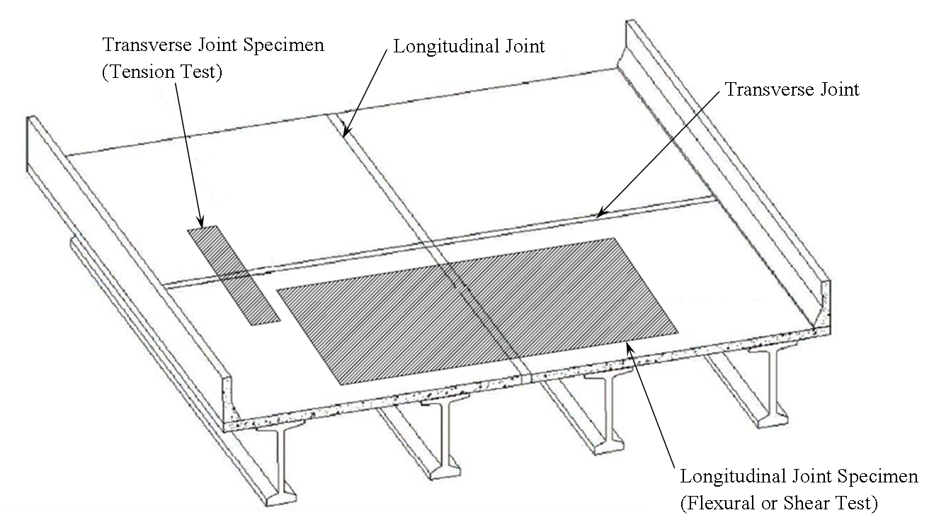
Fig. 1.1. Joint directions and representative specimen orientations

Chapter 2: Selection of Durable Closure Pour Materials for Accelerated Bridge Construction

This chapter is a slightly revised version of a paper with the same title published in the Journal of Bridge Engineering, ASCE by Peng Zhu, Zhongguo John Ma.
Abstract
With the public’s demands for reduced construction time and traveling delays, full-depth precast bridge decks or decked bulb tees (DBTs) are being more widely used. When these systems are used, precast elements are brought to the construction site ready to be set in place and quickly joined together. Then, a concrete closure pour completes the connection. The selection of closure pour materials is critical.
The procedure and methods for selecting durable closure pour (CP) materials are discussed in this paper. The accelerated construction is quantified as two categories: overnight cure of CP materials and 7-day cure of CP materials. For both categories, candidate materials are selected first based on literature review of published data as well as tests of compressive strength and flow and workability. Then, the performance criteria for selecting durable CP materials for both categories is developed based on durability tests of selected candidate materials. These durability tests include freezing-and-thawing durability, shrinkage, bond, and permeability tests.
Keywords: Closure pour materials, Grout, HPC, Chloride Penetration, Freezing-and-thawing durability, Shrinkage, Performance criteria

2.1 Introduction
The use of prefabricated bridge elements can minimize traffic disruption, improve work-zone safety, and increase quality. This technology is applicable and needed for both existing and new bridge construction. For the precast bridge deck system with cast-in-place (CIP) connection, precast elements are brought to the construction site ready to be set in place and quickly joined together. Then, a concrete closure pour (CP) completes the connection.
Traditionally, different types of grouts have been used as CP materials for the precast bridge deck system with CIP connections. Mrinmay (1986) documented a wide variety of materials used after 1973 to avoid joint failure in closure pours. These materials include sand-epoxy mortars, latex modified concrete, cement-based grout, non-shrink cement grout, epoxy mortar grout, calcium aluminate cement mortar and concrete, methylmethacrylate polymer concrete and mortar, and polymer mortar. Epoxy or polymer modified grouts can have significant advantages, such as a high strength of 41.4 MPa (6 ksi) in 6 hours, better bond, reduced chloride permeability, improved freezing-and-thawing durability, and lower creep. However, they are often significantly more expensive and less compatible with surrounding concrete. In addition, if the resin is used in too large a volume, the heat of reaction may cause it to boil, and thereby develop less strength and loose bond. Cementitious grouts have been used more in precast construction than epoxy or polymer-modified grouts (Matsumoto et al. 2001). A primary disadvantage of cementitious grouts is the shrinkage and cracking that result from the use of hydraulic cement. Non-shrink grout compensates for the shrinkage by incorporating expansive agents into the mix. With non-shrink grout, the effects of shrinkage cracks or entrapped air on the transfer of forces and bond are minimized, though not eliminated. ASTM C 1107 establishes strength, consistency, and expansion criteria for prepackaged, hydraulic-cement, non-shrink grout.
Nottingham (1996) reported that the very nature of portland cement grouts virtually assures some shrinkage cracks in grout joints, regardless of quality control. Prepackaged magnesium ammonium phosphate (MAP) based grout often extended with pea gravel can meet requirements, like high quality, low shrinkage, impermeable, high bond, high early strength, user friendly and low temperature curing ability (Nottingham 1996; Issa et al. 2003). Gulyas et al. (1995) undertook a laboratory study to compare composite grouted keyway specimens using two different grouting materials: non-shrink grouts and magnesium ammonium phosphate (MAP) mortars, in which MAP materials perform better than non-shrink grouts. Gulyas and Champa (1997) further examined inadequacies in the selection of a traditional non-shrink grout for use in shear key ways. The MAP grout outperformed the non-shrink grout in all areas tested, including direct vertical shear, direct tension, longitudinal shear, bond, shrinkage, etc. Menkulasi and Roberts-Wollmann (2005) presented a study of the horizontal shear resistance of the connection between full-depth precast concrete bridge deck panels and prestressed concrete girders. Two types of grout were evaluated: a latex modified grout and a MAP grout. For both types of grout, an angular pea gravel filler was added. The MAP grout developed slightly higher peak shear stresses than the latex modified grout.
Grout without coarse aggregate extension is usually referred to as neat grout, while grout with coarse aggregate extension, typically 12.7 mm (1/2 –in.) or 9.5 mm (3/8 in.) coarse aggregate, is extended grout. Comparing with neat grout, extended grout has the following potential benefits: (1) more compatible with concrete; (2) better interlock between connection components; (3) denser, less permeable; (4) less drying shrinkage and creep; and (5) larger grout volume per bag, hence less expensive. However, it was pointed out by Matsumoto et al. (2001) that the extended grout required more cement paste than available in prepackaged bags, leading to lower strengths and poor workability.
UHPC (Ultra High Performance Concrete) possesses superior properties including strength, ductility, durability and enhanced aesthetics. But the cost and the availability of materials from local suppliers are concerns. Also, the ultra-high performances of UHPC are not necessary for closure pours. Some of the HPC mixes can meet the mechanical and durability needs.
As discussed above, varieties of materials are available for the CP materials. However, research effort is still much needed to develop performance criteria for assisting engineers to select various CP materials, especially for accelerated bridge construction. Performance-based specifications focus on properties such as consistency, strength, durability, and aesthetics, rewarding quality, innovation, and technical knowledge, in addition to promoting better use of materials, and thus present an immense opportunity to optimize the design of materials. The industry is evolving specifications from prescriptive requirements to performance-based concepts.
To achieve this objective, it is important to point out that CP materials are needed to fill in the joints between adjacent precast decks or flanges of DBTs. As such, longitudinal and transverse joints must be able to resist shear and moment induced by vehicular loads. Shrinkage of CP materials and transverse shortening of precast members further subject the joints to direct tension. Freeze thaw resistance and low permeability of joints are also important. An ideal connection detail emulates monolithic behavior and results in a more durable and longer lasting structure. When selecting CP materials for accelerated bridge construction, performance based specifications for durability in the form of performance criteria need to be developed, which is the objective of this paper. In this paper, the accelerated bridge construction is qualified as two categories: overnight cure of CP materials and 7-day cure of CP materials. For the overnight cure, published performance data from different grout materials were collected through contacts with material suppliers and users. For the 7-day cure, standard or special concrete mixtures and their performance data were collected through contacts with HPC (High Performance Concrete) showcase states as well as with material suppliers. Based on these initial collected data, four grouts were first selected as candidate overnight cure materials, and four special concrete mixes as candidate 7-day cure materials. The preliminary selection was based on strength tests of selected materials or prediction model to narrow the candidate materials down to two materials in each of the two categories. Then long-term tests were performed on the four final selected materials, including freezing-and-thawing durability, shrinkage, bond, and permeability tests. The final performance criteria for selecting durable CP materials were developed based on results of these long-term tests.
2.2 Preliminary Performance Criteria
Performance characteristics, compressive strength, shrinkage, chloride penetration, freezing-and-thawing durability and bond strength, are investigated as performance criteria. As mentioned, for the closure pour/precast unit interface the focus must be on minimizing cracking in this location to reduce intrusion of water that may result in corrosion. And thus, shrinkage, chloride penetration, freezing-and-thawing durability and bond strength need be investigated to control cracking and corrosion. An extensive literature review has been performed to develop preliminary performance criteria of overnight and 7-day cure CP materials.
The FHWA defined a set of concrete performance characteristics for long-term concrete durability and strength of highway structures (Goodspeed et al 1996). Standard laboratory tests, specimen preparation procedures, and grades of performance were suggested for each characteristic. Because standard test methods sometimes offer different options, Russell and Ozyildirim (2006) modified the FHWA definition and the modified performance characteristic grades for high-performance structural concrete as shown in Table 2.1. Tepke and Tikalsky (2007) provided a working guide to the design and construction of concrete structures using attainable high standards rather than common practice. An engineering design tool for the development of performance specifications for reinforced concrete highway structures was developed and performance characteristic grades for HPC are shown in Table 2.2. As shown in Tables 2.1 and 2.2, the same or similar standard laboratory tests were recommended. Also three grades were suggested in both criteria. Performance criteria shown in Table 2.2 have lower requirements for compressive strength and chloride penetration, and higher requirements for shrinkage than the criteria in Table 2.1 in all three grades. They have similar grade limits for freezing-and-thawing durability. Both criteria were developed generally for bridges including girders and decks.
There exist some practical difficulties in implementing the above performance criteria. For example, MAP grouts like EUCO-SPEED MP and Set® 45 HW should be air cured for 8 hours, as overnight cure materials, while HPC will be cured for 7 days, as 7-day cure materials, by both the membrane-forming compound method and the water method with burlap. However, proposed test methods in Table 2.1 and 2.2 have a very different curing scheme. The test methods need also be modified, based on the following considerations. For the shrinkage, when shrinkage occurs after initial moist curing, concrete starts to develop stiffness as measured by the modulus of elasticity. High performance concretes often have low W/CM (water/cementitious materials) ratios and high stiffness as a result. If the shrinkage strains are high enough, they simply crack due to the restraint, the stiffness, and the drying shrinkage. For CP materials, the restraint is developed due to the internal reinforcing steel, especially the steel that runs through the construction joint in existing concrete member into the next cast adjacent concrete member or section. This is tremendous “racking restraint” that does not allow the second adjacent slab to shorten during cooling from hydration heat and also due to later developing drying shrinkage. The AASHTO PP34-99 (1998) Restrain Shrinkage Ring Test can test the crack potential, and should be used instead of ASTM C157 test. There are also issues with the ASTM C1202 rapid chloride permeability test (RCPT). The RCPT has some interference problems with materials such as nitrate corrosion inhibitors and even Set® 45. Part of the problem is the epoxy coating that must be bonded to the exterior side walls of the core. The coating must block the chloride from running through the specimen. To avoid this issue, ASTM C1543 ponding test is proposed to be used to determine the chloride gradient.
To aid selection of candidate CP materials for long-term durability tests, reasonable preliminary performance limits are specified first based on extensive literature reviews as well as the following considerations. To expedite construction and reduce cost, it would be desirable to minimize the width of the joint zone. The headed bar detail with a 152mm (6 in.) lap length was recommended as the improved longitudinal joint detail for DBT bridges by Li et al. (2009). And it has been found that a certain compressive strength is needed to develop headed bars within a short overlap length (Li et al. 2009). And a criterion of 41.4 MPa (6.0 ksi) is proposed for the compressive strength of the CP materials. Colorado Department of Transportation (CDOT) Specifications Committee (2005) specified Class H concrete used for bare concrete bridge decks must not exhibit a crack at or before 14 days in the cracking tendency test (AASHTO PP 34). For the chloride threshold level (CTL) for steel corrosion in concrete, Glass and Buenfeld (1995) summarized various research studies and found CTLs to vary from 0.17 to 2.5% (by mass of cement) with a value of 0.2% chosen as a good prediction of CTL for harsh environments. Also, a depth of 38-mm (1.5-in) is specified which is the minimum concrete cover for concrete exposed to earth or weather by ACI 318-08. And thus, the criterion for the chloride penetration is proposed as the depth for percent chloride of 0.2% by mass of cement after 90-day ponding is less than 38 mm. For the bond strength, Li (2009) conducted a parametric study on joints of DBT bridges and found that the maximum shear stress at joints due to live loads is 0.6 MPa (84 psi). Thus, a higher limit of 1.4-MPa (200-psi) was proposed for bond strength. For the freezing-and-thawing durability, performance characteristic grades by Russell and Ozyildirim (2006) were used: the relative dynamic modulus of elasticity after 300 cycles greater than 70% for Grade 1, greater than 80% for Grade 2, and greater than 90% for Grade 3, as shown in Table 2.1.
Additionally, for mixes with aggregates alkali-silica reactivity (ASR) and delayed ettringite formation (DEF) need be prevented. The reactive aggregates must not be used in the mixes to prevent ASR. To determine reactivity of aggregates, a 14-day expansion limit of 0.10 percent by the accelerated mortar bar test (ASTM C 1260) is recommended by Folliard(2006). Folliard(2006) found that preventing internal concrete temperatures from exceeding 158 °F is effective in preventing DEF, and no mixtures suffered from excessive expansion or cracking when temperatures were kept below this threshold value.
Based on these performance criteria, a preliminary selection was made to narrow the choices of CP materials down from the candidate materials to two different materials in each of the two joint material classifications. Further long-term tests, including freezing-and-thawing durability, shrinkage, bond, and permeability tests, were performed to evaluate these selected four joint materials (two for each cure) in order to validate or finalize the proposed preliminary performance criteria.
2.3 Selection of Candidate Materials for Long-Term Tests
2.3.1 Overnight Cure Materials and Their Preliminary Selection
For the overnight cure, different grout materials were considered as the candidate materials. As discussed earlier, published performance data from different grout materials were collected through contacts with material suppliers and users. Based on their potentials to meet the proposed preliminary performance criteria, candidate overnight cure materials were selected as shown in Table 2.3 with the mixing information. Five Star® Patch is cement-based, while EUCO-SPEED MP, Set® 45 and Set® 45 Hot Weather are all magnesium-phosphate based. Water and aggregate extension amounts used were based on manufacturer recommendations. 9.5 mm (3/8 in.) pea gravel is used as aggregate. And the aggregate was tested for fizzing with 10% HCL to avoid calcareous aggregate made from soft limestone.
The preliminary selection was based on strength tests of selected materials to narrow the choices down to two different materials in the overnight cure material classification. For neat grouts, the compressive strength is tested per ASTM C 109 modified. Both ASTM C 109 modified and ASTM C 39 modified were used to obtain the compressive strength for extended grouts to get both the cube strength and the cylinder strength. Both ASTM C 109 and ASTM C 39 require moist curing. However, the manufacturers for EUCO-SPEED MP, Set® 45 and Set® 45 HW do not recommend wet curing their products. And thus two normally used curing methods, air curing and moist curing, were investigated. The compressive strengths using these two curing methods are compared in Figure 2.1. The reported strength is the average of three specimens. As shown in Figure 2.1, the extended grouts gain strength slower than the corresponding neat grouts. Also, for the extended grouts, there is no significant difference between the strengths by the two curing methods, while for neat grouts, there is difference for the 4-hour strengths when comparing two curing methods except for Five Star® Patch.
Flow characteristics for each grout were measured in accordance with ASTM C 1437 modified. Specifications for the flow table and truncated flow cone were found in ASTM C 230. In the tests, the table was dropped 10 times within 15 seconds instead of 25 drops within 15 seconds according to the standard test method. The modification was needed to consider the fact that these particular types of grouts tend to flow better than the average mortars for which this test method is intended. Twenty-five drops would result in the grout spreading across the entire 254 mm (10 in.) diameter of the table and the purpose of the test would be lost. Flow results are presented in Figure 2.2. Observations were made regarding the workability of each grout based on the degree of effort required to mix each product as well as their work time and initial set time. Work time was measured from the start of mixing until workability began to decrease. Decreased workability is defined by the inability to move the grout with vibration, or easily finish a surface. Initial set time was measured from the start of mixing until the product showed resistance to the penetration of a thin rod or trowel edge.
Among the grout candidates, EUCO-SPEED MP and Set® 45 HW perform better than the remaining based on the flow and workability performance. All the extended grouts did not perform well in the flow cone spread testing. And for the workability, only Set® 45 HW extended has favorable workability results. And Five Star® Patch extended 80% and Set® 45 extended 60% were almost impossible to mix with such a high recommended aggregate extension. Their flow suffered because of this. The Five Star® Patch extended 80% exhibits lower strength than the neat grout, while Set® 45 extended 60% gains higher strength than the neat grout for 8-hour period. A lower aggregate extension ratio would be more suitable for use in a precast deck panel system. Based on a comparison of the compressive strength and flow and workability performance of both neat and extended grouts, EUCO-SPEED MP and Set® 45 HW are selected.
2.3.2 7-Day Cure Materials and Their Preliminary Selection
For the 7-day cure, standard or special concrete and mortar mixtures, including five HPC mixtures, Emaco® T430 mix with latex, LMC-VE and two RSLP mixes, were considered as the candidate materials. The candidate HPC mix designs are listed in Table 2.4. Mixes 1 to 3 were selected from Russell et al. (2006), and Mix 4 and 5 were developed by working with River Region Cement Division of Lafarge. Emaco® T430 mix with latex was developed by working with BASF Construction Chemicals, LLC, LMC-VE by working with Virginia DOT, and RSLP mixes by Virginia DOT and CTS Cement Manufacturing Corporation. The mix designs are shown in Table 2.5.
Three HPC mix proportions were first selected from five candidate HPC mixes in Table 2.4 using the worksheet developed by Lawler et al. (2007). A statistically based experimental methodology was used in the worksheet to identify the optimum concrete mixture proportions for a specific set of conditions, as well as to predict performances of hydraulic cement concrete mixtures incorporating supplementary cementitious materials. In the worksheet, “desirability” was introduced. Desirability is a function that converts any test result into a value between “0” and “1”, where “0” means the result is unacceptable, and “1” means the result needs no improvement. Intermediate values show the level of acceptability (desirability) of the result. The overall desirability for each mixture is the geometric mean of the individual desirability for that mixture for each test. “Response” is the measured value from a performance test. According to our criteria, the four responses are compressive strength at 7 day, shrinkage, chloride penetration and freezing-and-thawing durability. The corresponding desirability functions of the four “responses” were selected. Using the standard linear regression analysis to obtain the response of a given mix that best fits the testing data, a model was developed by Lawler et al. (2007), which can be used to predict the desirability functions of an untested mixture. And Mix 1, Mix 4 and Mix 5 were selected, comparing the predicted overall desirability and 7-day compressive strength desirability of the five HPC mixes based on the model.
And the compressive strength tests were performed on the remaining seven 7-day cure materials, HPC Mix 1, Mix 4 and Mix 5 and Emaco® T430 mix with latex, LMC-VE, RSLP Mix 1 and RSLP Mix 2, for further selection. The compressive strengths at 7 days and 28 days of the remaining seven 7-day cure materials are listed in Table 2.6. The reported strength is the average of three cylinders. Based on the compressive strengths, HPC Mix 1 and RSLP Mix 2 were selected as 7-day cure materials for the long-term tests.
2.4 Long-Term Tests
Long-term tests were performed on the four candidate materials selected, EUCO-SPEED MP and Set® 45 HW and HPC Mix 1 and RSLP Mix 2 for overnight cure and 7-day cure, respectively, including freezing-and-thawing durability, shrinkage, bond, and permeability tests.
2.4.1 Bond Strength Test
The bond strength test was conducted per ASTM C 882 modified. Scholz et al. (2007) investigated slant cylinder bond strength of eight grouts with varying concrete surface preparations: a) smooth, b) exposed aggregate, c) raked, and d) raked and sandblasted. There was not a particular preparation found that consistently provided the best bond strength for all the tested grouts. Scholz et al. (2007) concluded that the smooth interface performed better than anticipated, providing the worst or second worst bond strength for only half of the candidate grouts. For the cost involved with the other surface preparations (i.e., exposed aggregate, raked and sand blasting), the smooth interface was used for the study.
The concrete half-cylinders were made using the mold and dummy section shown in Figure 2.3a. After cured for at least 28 days, they were inserted into a whole 4 in. by 8 in. cylinder mold. Then for the overnight cure materials, the grout was poured into the mold to complete the cylinder (see Figure 2.3b). For the 7-day cure materials, a layer of cement paste was firstly applied onto the slanted face of the half-cylinder and then the test material was poured into the mold to complete the cylinder. Specimens for two overnight cure materials were air cured for 8 hours, while specimens for two 7-day cure materials were cured for 7 days by both the membrane-forming compound method and the water method with burlap, a typical practice for curing bridge decks.
After curing, cylinders were tested in compression in order to investigate the bond strength of each material. The test setup is shown in Figure 2.3c. Observations were made regarding whether the cylinder failed along the shear plane or if failure was due to significant cracking in the grout or concrete. The failure modes are shown in Figure 2.4 and described in Table 2.7. In each case, the maximum load was recorded and converted to stress by dividing by the elliptical area of the bonded interface, as suggested by Scholz et al, (2007). The maximum load was multiplied by the cosine of 30º to obtain the true shear stress component acting along the bonded interface. Results for the slant cylinder tests are presented in Table 2.7. The strength results represent the average of three cylinders. All the materials have the bond strength greater than 2.1 MPa (300 Psi), and the lower-bound of the criterion is increased to 2.1 MPa (300 Psi).
2.4.2 Permeability Test
As discussed earlier, the ponding test was prepared in accordance with ASTM C 1543 modified instead of ASTM C1202 tset. Three specimens (254×254×76.2 mm (10×10×3 in.)) for each of the selected overnight cure materials, EUCO-SPEED MP and Set® 45 HW, and 7-day cure materials, HPC Mix 1 and RSLP Mix 2, were cast. Specimens for two overnight cure materials were air cured for 8 hours, while specimens for two 7-day cure materials were cured for 7 days by both the membrane-forming compound method and the water method with burlap. After curing, the sides of the specimens were coated with the rubber coating material, 25 mm (1 in)-high closed-cell polystyrene foams were bonded to the specimens with silicone sealant, and then the specimen were subjected to continuous ponding with a 3% sodium chloride solution to a depth of approximate 20mm for 90 days, as shown in Figure 2.5a. The specimen surfaces were then brushed with a wire brush to remove the salt, and 102 mm (4 in.) cores were taken as shown in Figure 2.5b. The core cylinders were then cut into slices. Four slices were cut from different depths (Layer 1: 0-6mm; Layer 2: 6-19mm; Layer 3: 19-32mm and Layer 4: 32-44mm). The concrete slices obtained were then dried at 105 °C to constant mass and ground to pass an 850-μm sieve [No. 20] sieve, using a pulverizer. Powder samples for different depths of different samples were collected. The solution was made with each powder sample following the ASTM C 1152 modified procedure.
The titration test is introduced in the ASTM C 1152 to determine the chloride concentration. However, this method is very time-consuming. The tests by Ghanem et al. (2008) showed that the chloride ion selective electrode (ISE) matched titration readings, and suggested that the chloride concentration can be taken directly using the ISE. Consequently, the chloride ISE was used rather than the titration test. The ISE was calibrated using chloride solutions with five different concentrations. These solutions were obtained by diluting a 100 ppm solution two, five, ten, and 100 times to get solutions with concentrations ranging from 1 to 100 ppm. A calibration curve was constructed with the measured electrode potential in mV (linear axis) plotted against the concentration (log axis). The mV readings of the sample solution were taken, as shown in Figure 2.6, and the concentration was then determined from the calibration curve. The chloride concentrations were analyzed and are shown in Figure 2.7.
The depths for 0.2% chloride content (by mass of cement) for the four materials were calculated based on Figure 2.7, as listed in Table 2.8. For calculating the depths, the average depth of 3 mm (0.125 in), 13 mm (0.5 in), 25 mm (1.0 in) and 38 mm (1.5 in) was taken for Layer 1, 2, 3 and 4, respectively. The two overnight cure of CP materials have the depths for 0.2% chloride content less than 3 mm. For the 7-day cure of CP materials, HPC Mix 1 is less than 25 mm, and RSLP Mix 2 is greater than 38 mm. The two overnight cure and one of the 7-day cure, HPC Mix 1, meet the criterion.
2.4.3 Freezing-and-Thawing Test
The freezing-and-thawing test was prepared in accordance with ASTM C 666 Procedure A modified. Specimens for two overnight cure materials were air cured for 8 hours, while specimens for two 7-day cure materials were cured for 7 days by both the membrane-forming compound method and the water method with burlap. After curing, specimens were moisture-conditioned in saturated lime water at 23.0±2ºC (73.4±3ºF) for 48 hours prior to testing, as is used on specimens sawed from hardened concrete by the ASTM C 666. After curing and 48-hour moisture-conditioning, the test was started as shown in Figures 2.8a and 2.8b. After 76 cycles, the RSLP Mix 2 specimens failed as shown in Figure 2.8c. The relative dynamic modulus of elasticity after 300 cycles is 92% for EUCO-SPEED MP, 96% for Set® 45 HW, and 96% for HPC Mix 1. Each result is the average of three specimens. EUCO-SPEED MP, Set® 45 HW and HPC Mix 1 performed very well.
2.4.4 Shrinkage Test
For shrinkage, as discussed earlier, steel ring test was prepared in accordance with AASHTO PP34 (1998) modified as shown in Figure 2.9. Strain gages were bonded at four equidistant mid-height locations on the interior of the steel ring and were oriented to measure strain in the circumferential direction. Three ring specimens were fabricated for each material, and were immediately transferred to the cure room with a constant air temperature of 21º±1.7ºC (73.4±3ºF) and a relative humidity of 50±4 percent after completion of casting. The strain gages were connected to the data acquisition system to start monitoring the strain development in the steel ring. Specimens for two overnight cure materials were air cured, while specimens for two 7-day cure materials were cured by both the membrane-forming compound method and the water method with burlap till the age of 24 hours ± 1 hour. Then the outer ring was removed and the top surface was sealed. The strain development of one specimen is shown in Figure 2.10.
Cracks were found for specimens of the HPC Mix 1 at the age of 20.5 days. No crack was observed to occur for the EUCO-SPEED MP, Set® 45 HW and RSLP Mix 2 throughout the tests which were terminated at the ages of 58, 62 and 61 days, respectively.
2.5 Proposed Performance Criteria and Conclusions
For accelerated bridge construction, both transverse and longitudinal joints in decks are needed. Selection of CP materials for these deck-joints is critical for long-term durability considerations. Two categories of CP materials, overnight cure and 7-day cure, were proposed and studied. Candidate materials were compared by lab tests and software analysis, and CP materials were selected for each category, EUCO-SPEED MP and Set® 45 HW for overnight cure and HPC Mix 1 for 7-day cure. Based on extensive literature reviews and experimental investigation carried out in this paper, the performance criteria for selecting durable CP materials were developed based on durability tests of selected candidate materials, as listed in Tables 2.9 and 2.10. These durability tests included freezing-and-thawing durability, shrinkage, bond, and permeability tests. Additionally, the non-reactive aggregates should be used in the mixes to prevent ASR. To determine reactivity of aggregates, a 14-day expansion limit of 0.10 percent by the accelerated mortar bar test (ASTM C 1260) is recommended. And internal concrete temperatures need be kept under 158 °F to prevent DEF.
Appendix
Table 2.1. Performance Characteristic Grades* by Russell and Ozyildirim (2006)
Performance characteristic** | Test Method | Grade 1 | Grade 2 | Grade 3
Compressive Strength*** (CS), MPa | AASHTO T22  ASTM C 39 | 55≤CS<69 | 69≤CS<97 | 97≤CS
Shrinkage**** (S), με | AASHTO T160  ASTM C157 | 600≤S<800 | 400≤S<600 | S<400
Chloride Penetration (ChP),  coulombs | AASHTO T277  ASTM C1202 | 1500<ChP≤2500 | 500<ChP≤1500 | ChP≤500
Freezing-and-thawing Durability (F/T) (relative dynamic modulus of elasticity after 300 cycles) | AASHTO T161  ASTM C666  Procedure A | 70%≤ F/T<80% | 80%≤ F/T<90% | 90%≤ F/T
*Only performance characteristics investigated in this research are listed.
**All tests to be performed on concrete samples moist- or submersion-cured for 56 days until otherwise specified.
***The 56-day strength is recommended.
**** Shrinkage measurements are to start 28 days after moist curing and be taken for a drying period of 180 days.

Table 2.2. Performance Characteristic Grades* by Tepke and Tikalsky (2007)
Performance Characteristic | Test Method | Grade 1 | Grade 2 | Grade 3
Compressive Strength (CS), MPa | AASHTO T22 | 24≤CS<55  @ 28 days | 55≤CS  @ 28 days | 24≤CS  @ early ages
Shrinkage (S), με | ASTM C157 | S≤600  @ 56 days | S≤400  @ 56 days | S≤200  @ 56 days
Chloride Penetration (ChP), coulombs | AASHTO T277 | ChP≤4000  @ 56 days | ChP≤1500  @ 56 days | ChP≤800  @ 56 days
Freezing-and-thawing Durability (F/T) (relative modulus after 300 cycles) | AASHTO T161 Proc. A after 28 days moist curing and 7 days air drying | 60%≤F/T | 80%≤F/T | 90%≤F/T
*Only performance characteristics investigated in this research are listed.

Table 2.3. Candidate Overnight Cure Materials
Product Name |  | Mixing Quantities per 22.7-kg, Bag
 |  | Initial Water, ml | Additional  Water, ml | Aggregate  Extension,  % by weight | Aggregate  Extension, kg | Yield  Volume, m³
Neat  Grout | EUCO-SPEED MP | 1473 | 227 | 0 | 0 | 0.012
Neat  Grout | Five Star® Patch | 2366 | 473 | 0 | 0 | 0.011
Neat  Grout | Set® 45 | 1538 | 237 | 0 | 0 | 0.011
Neat  Grout | Set® 45 HW | 1538 | 237 | 0 | 0 | 0.011
Extended  Grout | EUCO-SPEED MP | 1473 | 227 | 60 | 13.6 | 0.016
Extended  Grout | Five Star® Patch | 2366 | 473 | 80 | 18.1 | 0.019
Extended  Grout | Set® 45 | 1538 | 237 | 60 | 13.6 | 0.016
Extended  Grout | Set® 45 HW | 1538 | 237 | 60 | 13.6 | 0.016

Table 2.4. Candidate HPC Mix Proportions
MIX NUMBER | MIX 1 | MIX 2 | MIX 3 | MIX 4 |  | MIX 5
W/CM Ratio | 0.31 | 0.35 | 0.31 | 0.32 |  | 0.35
Cement Type | I | I | II | I / II (Lafarge Sugar Creek SF) |  | I / II (Lafarge Sugar Creek SF)
Cement Quantity, kg/m³ | 445.0 | 281.2 | 290.7 | 334.0* |  | 255.7*
Fly Ash Type C Quantity, kg/m³ | 44.5 | 131.1 | 124.6 | 44.5 |  | 34.4
Slag Quantity, kg/m³ |  |  |  | 67.0 |  | 51.0
Fine Aggregate, kg/m³ | 830.6 | 773.0 | 809.8 | 688.8 |  | 776.0
Coarse Aggregate Maximum Size, mm | 12.5 | 25.0 | 32.0 | 37.5 | 12.5 | 37.5 | 12.5
Coarse Aggregate Quantity, kg/m³ | 830.6 | 1074.4 | 1127.2 | 907.7 | 160.2 | 901.8 | 225.4
Air Entrainment, ml/m³ | 193.5 |  | 120.0 | 116.1 |  | 89.0
Water reducer, ml/m³ | 1161.0
Retarder, ml/m³ |  | 851.4 | 1083.6
High-Range Water Reducer, ml/m³ | 5224.5 | 4721.4 | 6037.2 | 2322.0 |  | 1780.2
Shrinkage Reducing Admixture, ml/m³ |  |  |  | 1238.4 |  | 955.9
* 7% of silica fume is included in blended cement.

Table 2.5. 7-day Cure Mixture Proportions, kg/m³
Mixture | Emaco® T430 mix with latex | LMC-VE | RSLP Mix 1 | RSLP Mix 2
Cement/Mortar Type | Emaco® T430 | CTS Rapid Set® cement | CTS RSLP | CTS RSLP
Cement/Mortar Quantity | 1394 | 390 | 395 | 390
Fine Aggregate | --- | 949 | 712 | 1006
Coarse Aggregate* Quantity | 819 | 693 | 1068 | 863
Latex | 17.8 | 122 | --- | ---
Water | 101 | 81 | 166 | 156
* Coarse aggregate maximum size is 12.5 mm.

Table 2.6. Compressive Strengths (MPa) per ASTM C 39 Modified
 | HPC Mix 1 | HPC Mix 4 | HPC Mix 5 | Emaco T430 mix | LMC-VE | RSLP Mix 1 | RSLP Mix 2
7-day Compressive Strength | 44.8 | 28.4 | 34.9 | 10.1 | 30.4 | 26.3 | 72.8
28-day Compressive Strength | 61.3 | 36.3 | 50.4 | 15.9 | 30.3 | 29.2 | 77.6

Table 2.7. Slant Cylinder Bond Strength and Failure Mode
Material Type | Specimen Number | Test Age | Shear Stress (MPa) | Average Shear Stress (MPa) | Mode of Failure*
EUCO-SPEED MP | 1 | 8 hours | 3.1 | 2.7 | b
EUCO-SPEED MP | 2 | 8 hours | 1.1 | 2.7 | b
EUCO-SPEED MP | 3 | 8 hours | 4.0 | 2.7 | b
Set® 45 HW | 1 | 8 hours | 8.0 | 8.1 | b
Set® 45 HW | 2 | 8 hours | 7.7 | 8.1 | b
Set® 45 HW | 3 | 8 hours | 8.5 | 8.1 | b
HPC Mix 1 | 1 | 7 days | 11.1 | 12.5 | c
HPC Mix 1 | 2 | 7 days | 13.2 | 12.5 | a
HPC Mix 1 | 3 | 7 days | 13.3 | 12.5 | a
RSLP Mix 2 | 1 | 7 days | 4.5 | 4.9 | a
RSLP Mix 2 | 2 | 7 days | 4.4 | 4.9 | a
RSLP Mix 2 | 3 | 7 days | 5.7 | 4.9 | a
*a) clean shearing of bond along slanted interface (Figure 2.4a)
b) grout and/or concrete cracking before interface bond failure. However, it was possible to load the specimen until the bonded interface failed. (Figure 2.4b)
c) grout cracked and split in a vertical manner so that it was not possible to continue loading the specimen (Figure 2.4c)

Table 2.8. Depths (mm) for 0.2% chloride content (by mass of cement)
Materials | Sample
Materials | 1 | 2 | 3
EUCO-SPEED MP | <3 | <3 | <3
Set® 45 HW | <3 | <3 | <3
HPC Mix 1 | <25 | <25 | <25
RSLP Mix 2 | >38 | >38 | >38

Table 2.9. Proposed Performance Criteria of CP Materials
Performance Characteristic | Test Method | Performance Criteria
Compressive Strength (CS), MPa | ASTM C39 modified | 41.4≤CS  @ 8 hours (overnight cure)  @ 7 days (7-day cure)
Shrinkageª(S),  (Crack age, days) | AASHTO PP34 modified | 20<S
Bond Strength (BS), MPa | ASTM C882 modified | 2.5<BS
Chloride Penetration^{b}(ChP),  (Depth for Percent Chloride of 0.2% by mass of cement after 90-day ponding, mm) | ASTM C1543 modified | ChP<38
Freezing-and-thawing Durability (F/T), (relative modulus after 300 cycles) | ASTM C666  Procedure A modified | Grade^{c} 1 | Grade 2 | Grade 3
 | ASTM C666  Procedure A modified | 70%≤F/T | 80%≤F/T | 90%≤F/T
a: No S criterion need be specified if the CP material is not exposed to moisture, chloride salts or soluble sulfate environments.
b: No ChP criterion need be specified if the CP material is not exposed to chloride salts or soluble sulfate environments.
c: Grades are defined in Table 10.

Table 2.10. Application of CP Material Grades for Freezing-and-thawing Durability
Freezing-and-thawing Durability (F/T) | Is the concrete  exposed to  freezing-and-thawing  environments? | Yes | Is the  member  exposed to  deicing  salts? | Yes | Will the member  be saturated during  freezing? | Yes.  Specify F/T-Grade 3
No.
Specify F/T-Grade 2
 |  |  |  | No. Specify F/T- Grade 1
Freezing-and-thawing Durability (F/T) |  | No. F/T grade should not be specified.

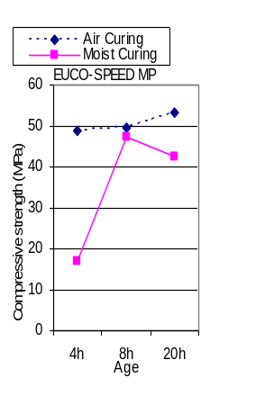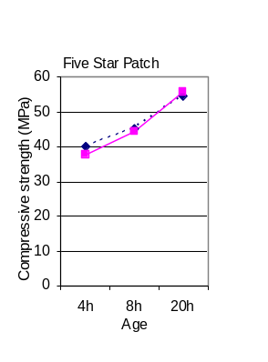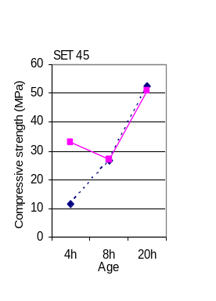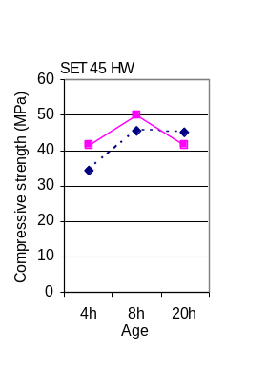
(a) (b) (c) (d)
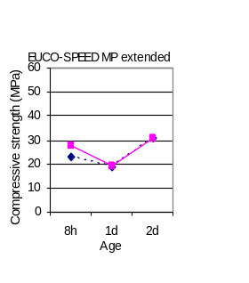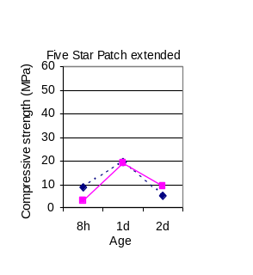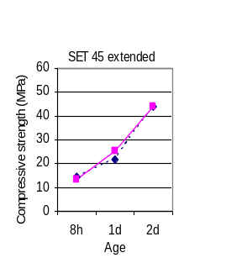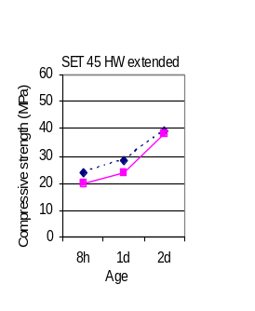
(e) (f) (g) (h)
Fig. 2.1. Compressive strength development of the neat grouts per ASTM C 109 and extended grouts per ASTM C 39 (“h”=hour; “d”=day)

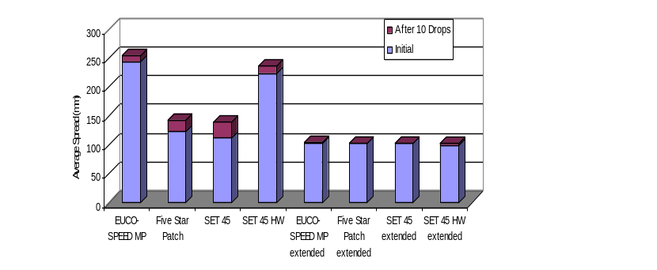
Fig. 2.2. Truncated flow cone spread values per ASTM C 1437 for neat gouts and extended gouts

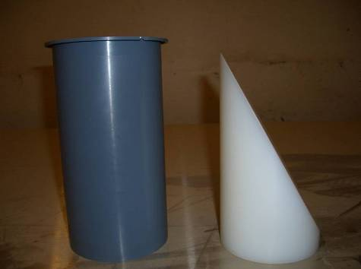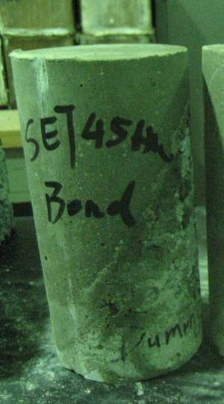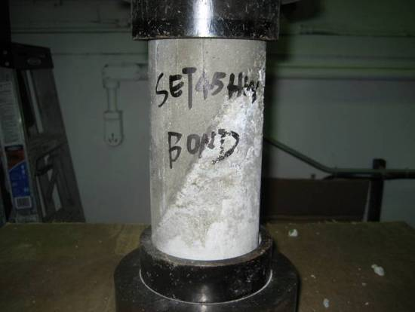
(a) (b) (c)
Fig. 2.3. ASTM C882 test: (a) Test mold and dummy section (b) Completed slant shear cylinders (c) Test setup

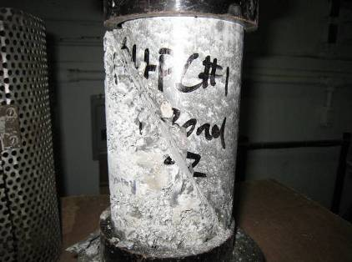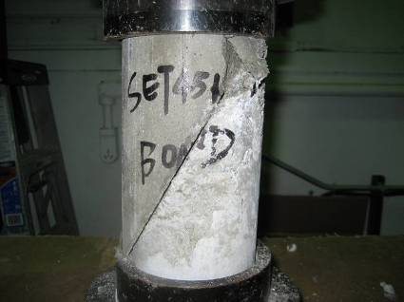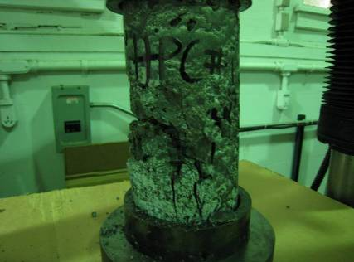
(a) (b) (c)
Fig. 2.4. ASTM C882 test failure modes (a), (b) and (c)

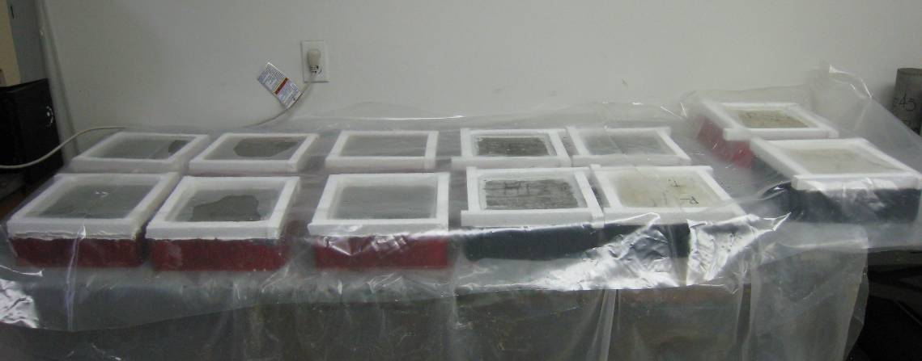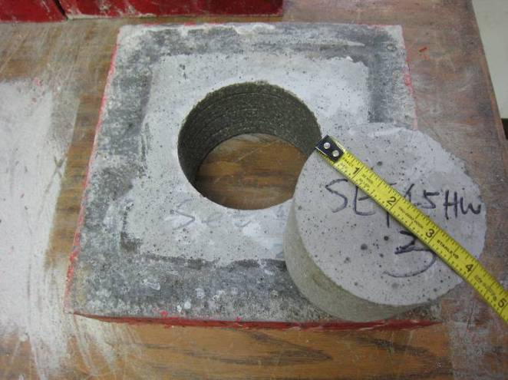
(a) Ponding of Specimens (b) Specimen Coring
Fig. 2.5. Specimen preparation per ASTM C 1543

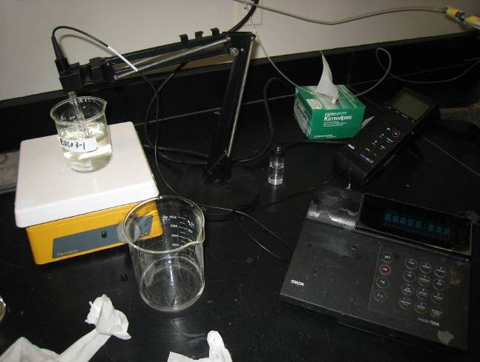
Fig. 2.6. Chloride concentration determination with ISE

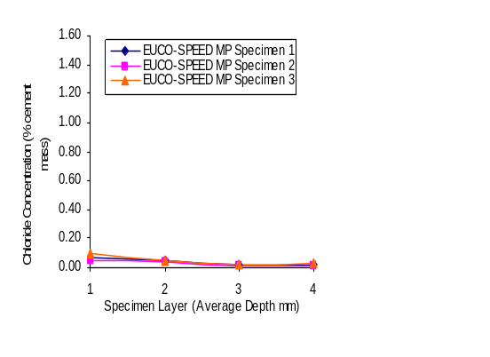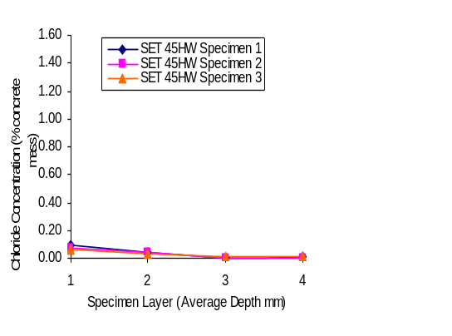
(38)
)
(25)
)
(13)
)
(3)
)
(38)
)
(25)
)
(13)
)
(3)
)

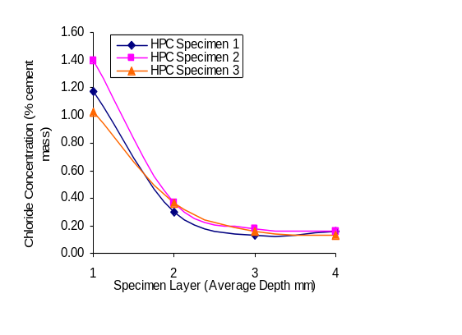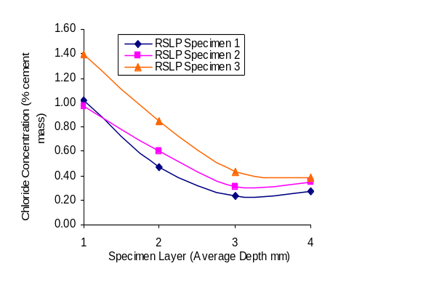
(38)
)
(38)
)
(25)
)
(25)
)
(13)
)
(3)
)
(13)
)
(3)
)
Fig. 2.7. Chloride content profile after 90-day ponding test
(Layer 1: 0-6mm; Layer 2: 6-19mm; Layer 3: 19-32mm and Layer 4: 32-44mm)

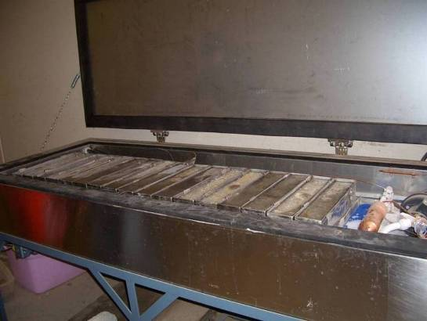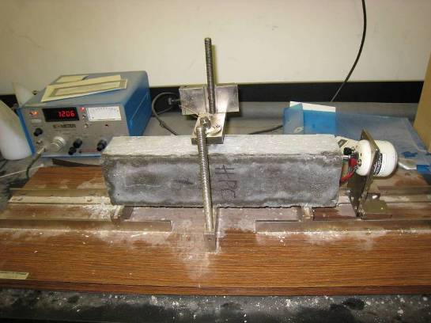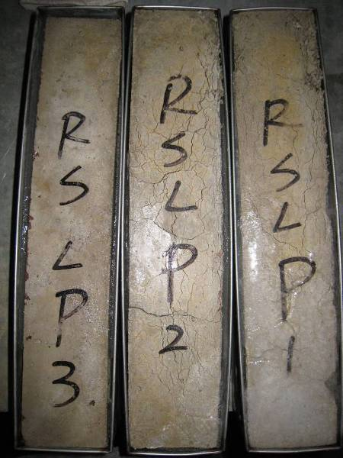
(a) (b) (c)
Fig. 2.8. ASTM C666 freezing-and-thawing durability test: (a) Freezing-and-thawing apparatus, (b) Fundamental transverse frequency test, (c) Failure of RSLP mix 2 specimens

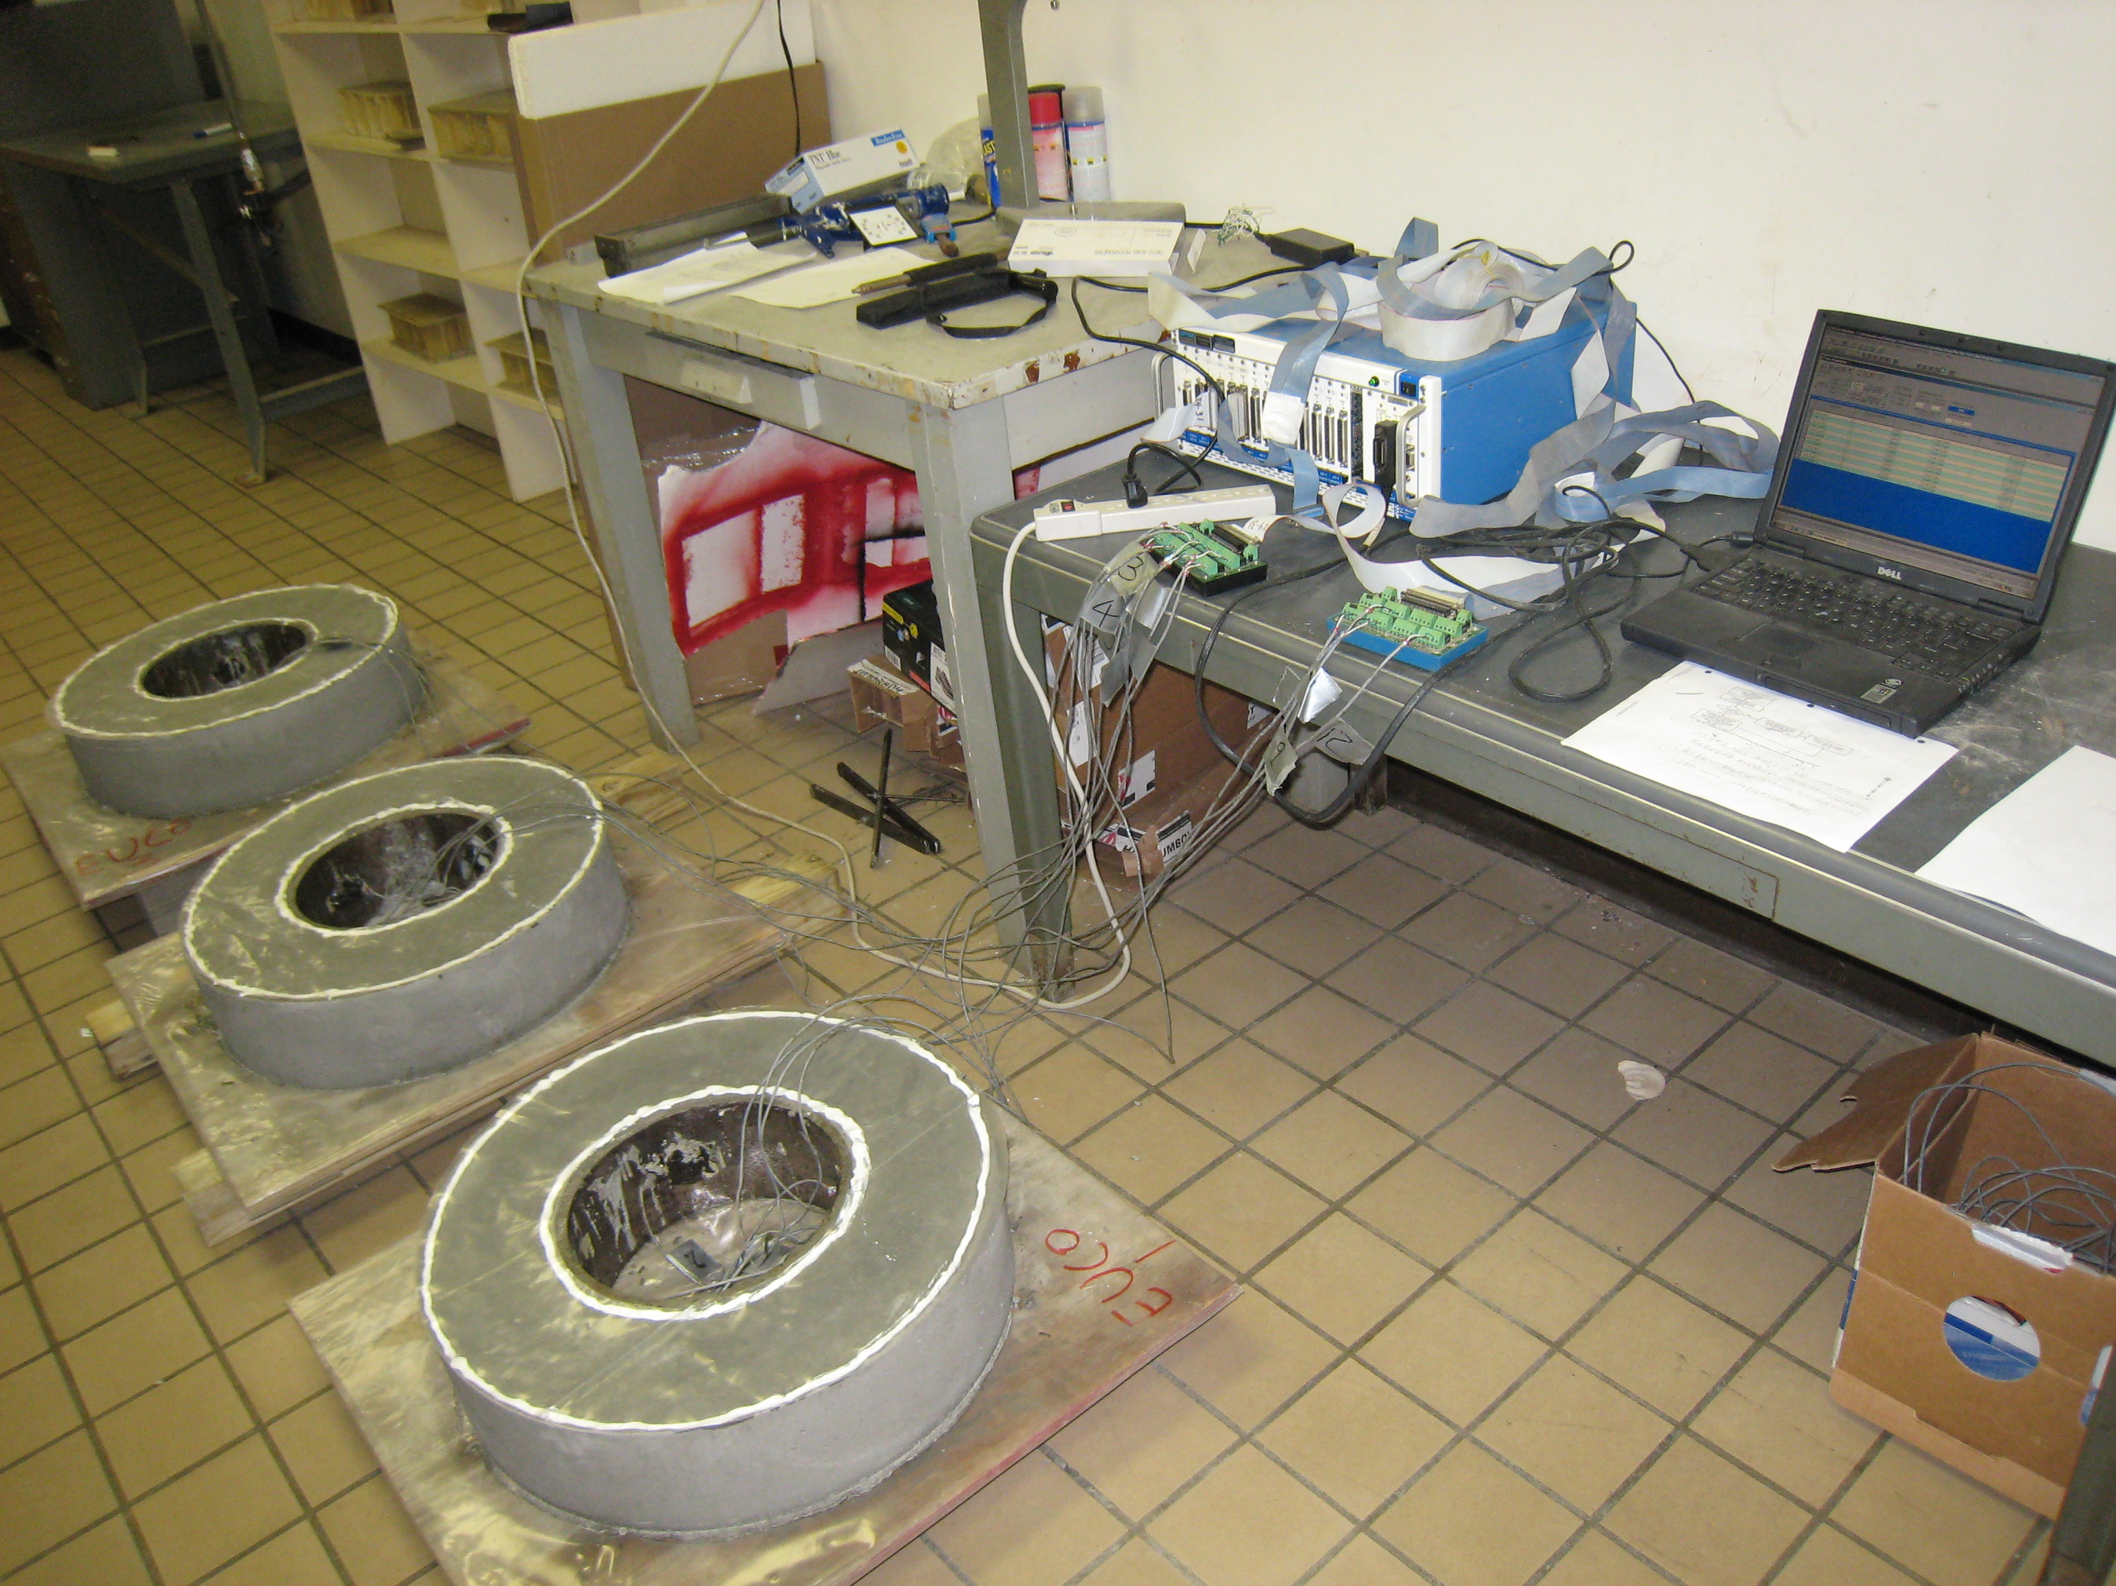
Fig. 2.9. AASHTO PP34 test setup

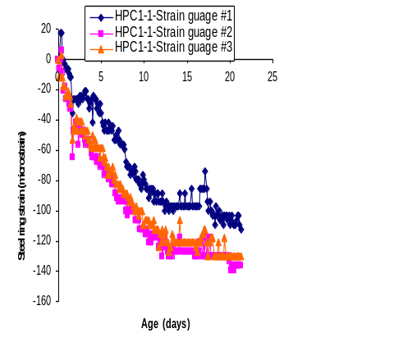
Fig. 2.10. Steel ring strain versus specimen age for HPC mix 1

Chapter 3: Fatigue Evaluation of Longitudinal U-Bar Joint Details for Accelerated Bridge Construction

This chapter is a slightly revised version of a paper with the same title under review for the Journal of Bridge Engineering, ASCE by Peng Zhu, Zhongguo John Ma and Catherine French.
Abstract
Continuous longitudinal U-bar joint details for accelerated bridge construction are investigated. Precast concrete girders with an integral deck (decked bulb-T), which are cast and prestressed with the girder, provide benefits of rapid construction along with improved structural performance and durability. However, use of this type of construction has been limited to isolated regions of the United States. One of the issues is the perceived problem with durability of longitudinal joints used to connect adjacent girders. Four pairs of full-scale slabs connected by a U-bar detail with one of the selected closure pour (CP) materials, overnight cure and 7-day cure, were tested. The loading demand necessary in the slab testing is determined based on the maximum forces in the longitudinal joint from an analytical parametric study. Static and fatigue tests under four-point flexural loading and three-point flexural-shear loading were conducted. Test results were evaluated based on flexural capacity, curvature behavior, cracking, deflection and steel strain. Based on these test results, the developed longitudinal U-bar joint detail is a viable connection system that transfers the forces between the adjacent decked bulb-T (DBT) girders.
Keywords: Fatigue, U-bar reinforcement, Longitudinal joint, Decked bulb-T (DBT), Full-scale tests, Accelerated bridge construction

3.1 Introduction
One issue that hampers widespread use of the decked bulb-T (DBT) girder system is that there exists fatigue concern for the current welded steel connector with shear key joint (Li et al. 2010). To overcome this shortcoming, Li et al. (2010) proposed a new headed bar joint detail for the longitudinal joint while still maintaining accelerated construction features. An experimental program was carried out by Li et al. (2010) to evaluate the proposed new joint detail. And the headed bar detail with a 152 mm (6 in.) lap length was recommended for replacing the current joint detail as the improved longitudinal joint detail for DBT bridges. The proposed joint detail by Li et al. (2010) does not require on-site welding of connectors. However, in order to keep the flange thickness of DBT girders the same, headed bars can only be placed near the mid-depth of the flange so that the head of headed bars has the required concrete cover. While the longitudinal joints are very common in single-span bridges, there exist transverse joints in the multi-span bridges. Li et al. (2010) did not address transverse joint issues in their study.
Lewis (2009) and Chapman (2010) completed studies that assessed potential alternate joint details for both longitudinal and transverse joints of DBT girders as well as full depth prefabricated concrete decks. Six reinforced concrete beam specimens connected with either lapped headed reinforcement or lapped U-bar reinforcement were tested in the first phase by Lewis (2009). Since U-bar reinforcement can be placed closer to the tensile side comparing with mid-depth located headed bars, the former can control flexural cracks better. The U-bar detail was tested utilizing two materials, deformed wire reinforcement (DWR) and stainless steel reinforcement. Based on that study, the DWR U-bar detail was recommended for further testing. In the second phase of experiments by Chapman (2010), six specimens with the DWR U-bar detail were tested, three in flexure and three in tension, to investigate effects of variables, such as overlap lengths, rebar spacings, and concrete strengths. A DWR U-bar detail with a 152 mm (6 in.) overlap length and 114 mm (4.5 in) spacing was selected for additional testing to further investigate replacing the current welded steel connector detail.
In this study, four pairs of full-scale slabs connected by a U-bar detail utilizing a 152 mm (6 in.) overlap length were fabricated and tested. The analytical parametric study was conducted to provide the database of maximum forces in the longitudinal joint. These maximum forces are used to determine the loading demand necessary in the slab testing due to the service live load. Static and fatigue tests under four-point pure-flexural loading, as well as three-point flexural-shear loading, were conducted. Test results were evaluated based on flexural capacity, curvature behavior, cracking, deflection and steel strain.
3.2 Maximum Forces in the Longitudinal U-bar Joints
The objective of the numerical study was to provide a database of maximum forces for determination of loading demand on the longitudinal U-bar joints for the static and fatigue tests. Effects of individual variables were researched by performing parametric studies using ABAQUS. A total of seven bridge models with different girder geometries were developed and subjected to the AASHTO LRFD (2010) HL-93 live load in the parametric study. One of the models is shown in Figure 3.1. The parametric studies were divided into two phases. In Phase I, the following parameters were considered: different loading locations, effect of bridge width, design truck and lane loading versus design tandem and lane loading, girder geometry (depth, spacing and span), bridge skew, and single-lane loading versus multi-lane loading. This phase of studies was the same as the one conducted by Li et al. (2010). Based on Li et al. (2010)’s study, the maximum positive moment is 35.2 kN-m/m (7.922 kips-ft/ft); the maximum negative moment is -11.2 kN-m/m (-2.152 kips-ft/ft); the maximum shear is 27.1 kN-m/m (6.091 kips/ft).
These results were obtained by using uncracked sections for the longitudinal joints (Li et al. (2010)). However, it is anticipated that the joints would be cracked under service loading. Therefore, the forces in the joint would be expected to be reduced compared with the forces calculated with uncracked sections. The difference of structural behaviors before and after crack is due to the change in the joint stiffness.
In the FE models where the largest maximum forces in the joint were found, the impact of cracking of the joint was studied in the second phase of parametric studies by changing the modulus of elasticity (E) while keeping the moment of inertia (I) the same. According to the theoretical calculation of the Specimen WB-1 by Lewis (2009), the EI reduction after cracking was 84%. Considering the force reduction due to the joint cracking, the maximum positive moment is 20.2 kN-m/m (4.546 kips-ft/ft); the maximum negative moment is -6.2 kN-m/m (-1.396 kips-ft/ft); the maximum shear is 77.9 kN/m (5.340 kips/ft). The corresponding moment (CM) occurring with the maximum shear is 15.0 kN-m/m (3.372 kips-ft/ft). The maximum forces before and after cracking will be used to determine the static loading demand for test specimens.
According to AASHTO LRFD (2010), using the Load Factor of 0.75 for Fatigue II and not including the Lane Load, i.e. 0.75 [1.15 (Fatigue Truck Load )], results in maximum positive moment, negative moment and shear in the longitudinal joint under fatigue live load HL-93 for finite life of 8.9 kN-m/m (1.992 kips-ft/ft), -1.6 kN-m/m (-0.352 kips-ft/ft) and 34.2 kN/m (2.344 kips/ft) respectively. These forces were used to determine the fatigue loading demand for test specimens.
3.3 Experimental Program
3.3.1 Slab Dimension
A total of eight slabs with the same dimensions were fabricated for the static and fatigue testing, with two different closure pour materials used in the longitudinal U-bar joint. Each specimen consisted of two panels connected by a longitudinal joint as shown in Figure 3.2. Each panel was 1829 mm (72 in.) wide, 1626 mm (64 in.) long and 159 mm (6.25 in.) deep. The female-to-female shear key was provided at the vertical edge of both ends in the specimen length direction. This allowed each slab to be used for two tests.
3.3.2 Reinforcement Layout and Strain Gage Instrumentation
Figure 3.3 displays the reinforcement layout used in the slab specimen. There are four layers of reinforcement in each panel’s depth direction with a 54 mm (2⅛ in.) cover at the top and 25 mm (1 in.) cover at the bottom. The straight bars simulate the longitudinal reinforcement while the U-bars simulate the transverse reinforcement in the bridge deck. The reinforcement details in the specimen are as follows: 16 mm diameter (#5) straight bar spaced at 152 mm (6 in.) at the bottom along the slab length direction; 13 mm diameter (#4) straight bar spaced at 305 mm (12 in.) at the top along the slab length direction. Note that the longitudinal reinforcement is located within the U-bars to enable the largest diameter bend possible for the U-bar while still meeting concrete cover requirements. The 16 mm diameter (#5) U bars project out of the panel to splice with the U-bars in the adjacent panel in the longitudinal joint. The spacing of the U bars is 114 mm (4.5 in.) and the overlap length, the distance between bearing surfaces of adjacent U-bars, is 152 mm (6 in.). The interior diameter of bend of the U-bar is 3d_{b} (Lewis 2009).
The U-bars around the joint zone were instrumented with strain gages to gain a better understanding of the behavior of the slab connected by the longitudinal joint. Figure 3.4 depicts the strain gage layout in the slab for the four-point pure-flexure test and the three-point flexure-shear test.
There are six U-bars with installed strain gages. The U-bars are numbered from the edge of the slab (number 1) to the middle (number 8) along the slab width direction in Figure 3.4(a). Strain gages are labeled in Figure 3.4(b)-(e). For example, strain gage “L1-7” means the strain gage on the U-bar #1 of the left slab, and it is 178mm (7’’) away from the outside bend of the bar. Two strain gages are also placed at the end, and the middle of the lacer bar, which are labeled as “a-1” and “a-2” respectively.
3.3.3 Panel Fabrication and Joint Surface Preparation
The concrete panels were fabricated locally at Ross Prestressed Concrete Inc. in Knoxville, TN. Two ends of the wood form, in the length direction, were slotted at a spacing of 152 mm (6 in.) to fix the U-bars in place (Figure 3.5(a)). Foam wedges were used to form the configuration of the shear key at the vertical edge of the panel and pipes were fixed in place to prepare holes for the connection to the loading cylinder in the Fatigue Flexure Tests (Figure 3.5(b)). The design concrete compressive strength at 28 days was 48 MPa (7000 psi). Concrete cylinders were made with the pouring of panels.
The surfaces of the shear key were sandblasted to prepare the joint for the closure pour. The purpose of the surface preparation is to remove all contaminants that can interfere with adhesion and to develop a surface roughness to promote a mechanical bond between the grout and base concrete. After removal of the deteriorated concrete, proper preparation should provide a dry, clean and sound surface offering a sufficient profile to achieve adequate adhesion. There are many methods of surface preparation such as chemical cleaning, mechanical cleaning and blasting cleaning. Sandblasting uses compressed air to eject the high speed stream of sand onto the surface which needs to be prepared. This method is very effective to process the surface of precast members under industrial conditions. Black Beauty 2050 sand was chosen for sandblasting to prepare the surface in this study.
3.3.4 Closure-Pour Materials
The longitudinal joint, which is filled with closure-pour materials connecting the top flange of the adjacent DBT girders, is considered to be the structural element of the bridge deck. It is important for the selected closure-pour material to reach its design compressive strength in a relatively short time for the purpose of accelerated bridge construction. In this study, it was decided to use two types of closure-pour materials, overnight cure and 7-day cure, recommended by Zhu and Ma (2010). In this study, the grout SET® 45 HW without extension and the grout with 60% extension were both used and compared as the overnight cure materials. The uniform-sized 6 mm (0.25 in.) – 13 mm (0.5 in.) round pea gravel was used to extend the grouts. The pea gravel was tested with 10% HCL to confirm that it was not calcareous. High performance concrete (HPC) “Mix 1”, developed in Zhu and Ma (2010), was used for the 7-day cure material.
3.3.5 Testing Plan and Setup
Eight slab specimens were made. Each slab specimen consisted of two concrete panels connected with an overlapping U-bar detail and one of the selected closure pour materials. During the test setup, each panel was placed on the steel I-beam, which was leveled to ensure that the two panels were on the same plane. At the joint zone, the two panels were positioned to satisfy the overlapped length and the spacing of the U-bar (Figure 3.6(a)). The wood form was provided at the bottom and at both ends of the joint to prevent leakage when grouting. After grouting, the slab specimen consisting of two panels connected by the joint was ready for testing (Figure 3.6(b)). Since each panel had U-bars and shear keys along two edges, each set of two panels was used to fabricate two test specimens. After completion of testing the first joint, the panels were separated, and then another joint was reassembled by the other two edges to create the second test specimen.
Eight slab specimens, four for each of two selected closure pour materials, were tested under different setups: 1) static flexure (SF) test; 2) static shear (SS) test; 3) fatigue flexure (FF) test, and 4) fatigue shear (FS) test. Table 3.1 presents the loading matrix for the eight specimens. Figure 3.7 shows the testing setup and the linear voltage displacement transducers (LVDT) instrumentation for each test. All slab specimens were simply supported with a 1829-mm (72-in.) span and the joint zone located in the center of the span. The neoprene pad, with two layers of plastic sheets placed between the pad and slab bottom, was used at one end; only the neoprene pad was used at the other end. The 254 mm (10 in.) by 508 mm (20 in.) neoprene pad and steel plate were used to simulate the truck tire contact area and the pressure loading. LVDTs were employed to measure the specimen deflection, settlement and curvature. Four LVDTs (Nos. “4”, “5”, “6” and “7” in Figure 3.7) were placed in the joint zone of the slab. LVDTs “4”, “6” and “7” were placed along the centerline of the joint while LVDT “5” was placed at the panel edge off the interface of the joint. In this way, the relative deflection between the side of the joint interface and joint center can be measured. LVDTs “1”, “2”, “3” and LVDTs “8”, “9”, “10” measured the settlements, if any, of two supports. Two LVDTs were used to measure the average curvature of the joint zone. The DEMEC points and the DEMEC mechanical strain gage and also the crack comparator were used to measure the width of crack opening at the joint interface.
The SF specimen was loaded with two equal loads spaced at 305 mm (12 in.) about the center of the span using Material Test System (MTS) rams until the specimen failed. The joint zone experienced the maximum constant moment without shear. The SS specimen was loaded with one load located at 305 mm (12 in.) about the center of the span until the specimen failed. The joint zone experienced the combination of moment and shear. The FF specimen was loaded with two equal loads spaced at 305 mm (12 in.) about the center of the span. Figure 3.8 shows the FF test setup and the apparatus to apply the fatigue forces to the joint zone of the specimen.
To achieve the fatigue flexure force in the joint, the apparatus shown in Figure 3.8(b) was designed. One side of the swivel rod end was screwed to the actuator tightly while the other side was bolted to the spread tube at midspan by four steel rods. The spread tube was soldered to two steel hinges, which were located 305 mm (12 in.) away from the middle of the spread tube. The other end of each steel hinge was soldered to the 254 mm (10 in.) by 508 mm (20 in.) steel plate. The use of steel hinges between the spread tube and the steel plates was to eliminate the extra moment applied on the slab specimen produced by the bending of the spread tube. The FF test setup is shown in Fig. 8(a). The steel plate and neoprene pad at the bottom of the slab were bolted to the corresponding top steel plate and neoprene pad through the slab by four steel rods, which apply the fatigue forces on the slab. The boundary condition was provided by the steel girder below the slab and by the steel girder above the slab. The two steel girders at each support-end, one below the slab and another one above the slab, were connected by bolts, and the steel girder below the slab was fixed to the strong floor.
The FS specimen was loaded with two loads spaced at 305 mm (12 in.) about the center of the span. Two loads (P1 and P2) were applied out-of-phase on each side of the joint during the fatigue test. For example, when “P1” reached the maximum force, “P2” was zero. The joint zone experienced the fatigue shear in reversing directions.
The compressive strength of concrete panel 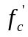 and the compressive strength of grouted joint 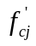 at the time of testing for each specimen are shown in Table 3.2. The panels for FS-O, FS-7, SS-O, and SS-7 were fabricated with the same batch of concrete and were tested or test was finished more than 120 days after the panels were fabricated. The 148-day strength of 79 MPa was tested and is presented. The test for FS-7 started five days after the joint was poured, and finished at 13 days. The strength here is 21-day joint strength. The FF-7 test started at the age of 22 days, and the joint strength reported in the table is the 8-day strength.
3.3.6 Fatigue Loading Determination
FE models of the test specimens (Figure 3.9) were developed to determine the loadings in fatigue tests and produce the maximum moment or the maximum shear in the joint zone corresponding to the results from previous parametric studies discussed earlier.
For the FF specimen, a static loading was applied in several increments up to 198 kN (44.6 kips) (99 kN (22.3 kips) on each pad) in order to produce the maximum positive moment of 35.2 kN-m per unit length (7.922 kips-ft/ft) in the joint and to crack the joint. After unloading to zero, a negative static load of -53 kN (-12.0 kips) (-27 kN (-6.0 kips) on each pad), corresponding to a negative moment of -9.6 kN-m per unit length (-2.152 kips-ft/ft), was applied and unloaded to zero.
During the fatigue test, the applied load is cycled between 51 kN (11.4 kips) (25 kN (5.7 kips) on each pad) corresponding to a positive moment of 8.5 kN-m per unit length (1.992 kips-ft/ft) and -9 kN (-2.0 kips) (-4 kN (-1.0 kips) on each pad) corresponding to a negative moment of -1.6 kN-m per unit length (-0.352 kips-ft/ft) for a total of 2 million cycles at a frequency of 4Hz. At the end of 0.5, 1.0, 1.5, and 2.0 million cycles, an interim static loading test was conducted. During each of these static tests, the static loading was applied in several increments up to 117 kN (26.2 kips) (58 kN (13.1 kips) on each pad) corresponding to a positive moment of 20.2 kN-m per unit length (4.546 kips-ft/ft) after cracking. After unloading to zero, a negative static load of -36 kN (-8.0 kips) (-18 kN (-4.0 kips) on each pad) corresponding to a negative moment of -6.2 kN-m per unit length (-1.396 kips-ft/ft) after cracking was applied and unloaded to zero. Finally, the slab specimen was loaded to failure.
For the FS test, fatigue loads “P1” and “P2” are applied by the two MTS rams having the same frequency but out-of-phase, as discussed earlier. Before the cyclical loading, a static loading P1 is applied in several increments up to 222 kN (49.9 kips) in order to produce the maximum shear of 88.9 kN per unit length (6.091 kips/ft) in the joint and to crack the joint. After unloading to zero, a static loading P2 of -222 kN (-49.9 kips), corresponding to a negative shear of -88.9 kN per unit length (-6.091 kips/ft), is applied and unloaded to zero.
Figure 3.10 shows the first few cycles of the fatigue loading history for the FS specimen. As discussed earlier, fatigue loads “P1” and “P2” were applied by the two MTS rams having the same frequency but out-of-phase. The slab was under the fatigue loading with the magnitude of “P1+P2” as shown in Figure 3.10.
The peak P1 is 111 kN (25.0 kips), corresponding to a positive shear of 41.5 kN per unit length (2.844 kips/ft), which is the combination of the fatigue shear of 34.2 kN/m (2.344 kips/ft) plus camber leveling shear of 7.3 kN/m (0.5 kips/ft). The “Average” value of “P1+P2” of 20 kN (4.4 kips) should be applied to attain the camber leveling shear of 7.3 kN/m (0.5 kips/ft) at the middle of the joint zone all the time. And thus, P2 equals 20 kN (4.4 kips) × 2 – P1= -72 kN (-16.2 kips). An interim static loading test (applying “P1” and “P2” separately) is conducted at the end of 0.5, 1.0, 1.5, and 2.0 million cycles. During each of these static tests, the static loading P1 is applied in several increments up to 209 kN (46.9 kips) corresponding to a positive shear of 77.9 kN per unit length (5.340 kips/ft) after cracking. After unloading to zero, a static load P2 of -209 kN (-46.9 kips) corresponding to a negative shear of -77.9 kN per unit length (-5.340 kips/ft) after cracking is applied and unloaded to zero. The specimen is loaded to failure after the fatigue cycles.
3.3.7 Moment Capacity and Curvature
Figure 3.11 shows the curvature-fatigue cycle curves (C-N) for the fatigue tests. The curvature represents the average curvature of the joint zone after a different number of fatigue cycles under a specific loading. For example, the curve labeled with “M=17.8 kN-m/m” (4.0 kips-ft/ft) in Figure 3.11(a) represents the change of the curvature of the joint zone with numbers of fatigue cycles, which was measured at the loading level corresponding to a moment of 17.8 kN-m/m (4.0 kips-ft/ft) of the joint for the FF-O specimen during each of the interim static load tests.
As shown in Figure 3.11, the curvature increased with the increasing of the joint moment for all specimens. The curvature data for the FS-7 Specimen under P1 before fatigue cycling is not good due to the malfunction of LVDTs and thus is not displayed. Comparing among different joint moment levels, the impact of fatigue on the curvature is about the same for all specimens. It appears that fatigue loading has little effect on the curvature for the FF-O and FS-O specimens while it increases the curvature for the FF-7 specimen and FS-7 Specimen under P2. For the FF-7 and FS-7 specimens, which are influenced by the fatigue loading, the first set of 0.5-million cycles increases the curvature and the rest 1.5-million cycles has no effect. Damage accumulations due to fatigue loading cycles cease after that point. In general, there is no significant influence of fatigue cycles on the curvature for joints with overnight CP material, and no significant influence after the first 0.5-million cycles for 7-day cure CP material.
The test results for the moment capacity are compared with the calculation in Table 3.3. The strengths for the fatigue tests, FS and FF, shown in the table are strengths at end of the tests, and Table 3.2 present detailed information about strengths. The service live load is the maximum positive calculated moment after cracking of 20.2 kN-m/m (4.546 kips-ft/ft) discussed earlier for the flexure tests and for the flexure-shear tests the service live load is the corresponding moment (CM) occurring with the maximum shear, which is 15.0 kN-m/m (3.372 kips-ft/ft) after cracking as discussed. Li et al. (2010) proposed and tested a new headed bar joint detail for the longitudinal joint. The slab dimensions, the joint grout (SET® 45 HW with 60% extension) and the test setups were the same as used in this study. The test results by Li et al. (2010) were also presented to compare with the U-bar detail and were referred as SS-O-headed bar for the static shear test with headed bar detail, FS-O-headed bar for the fatigue shear test with headed bar detail and etc.
All the specimens exceeded the calculated capacity. The joints with overnight cure material have lower capacity than 7-day cure, due to the lower strength of the joint material. The U-bar detail reached higher capacity than the headed bar detail under the same test conditions.
Figure 3.12 compares the moment-curvature curves between the specimens (FF and FS) subjected to fatigue loading after 2-million cycles with the specimens (SF and SS) subjected to static loading without fatigue cycles. The vertical axis labeling “Moment/Joint Length” represents the distribution moment along the joint, which the applied moment divided by the length of the joint. Both the SF and SS specimens were loaded with un-cracked section while the FF and FS specimens were loaded with cracked section after 2-million fatigue cycles. As a result, the slope of the curve (stiffness of the slab) for SF and SS is steeper (larger) than the FF and FS at the beginning of the load. After the applied moment exceeds the cracking moment level, the slopes of the two curves are about the same, indicating that the fatigue cycles had no significant effect on the curvature development, as discussed earlier.
In Figure 3.12(a), SF-7 and FF-7 specimens were beyond the MTS capacity (140 kN-m/m (31.5 kip-ft/ft)) and couldn’t be failed by MTS. The maximum curvature for FF-7 cannot be reported, because the LVDTs measuring curvature were removed during the tests. At service loading, the SF-O and FF-O specimens have about the same curvature, while FF-7 has more curvature than SF-7. FF-O has the similar failure load and curvature as the calculated, while SF-O, SF-7 and FF-7 have higher failure load and curvature than the calculated. When comparing overnight cure and 7-day cure CP materials, SF-7 has higher failure load and curvature than SF-O, and FF-7 performs better than FF-O. This is because 7-day cure material develops higher strength than overnight cure material in the tests, as shown in Table 3.2. The slopes of the curves (stiffness of the slabs) for the U bar detail are steeper (larger) than the headed bar detail.
In Figure 3.12(b), SS-7 has higher failure load and more curvature than FS-7, so fatigue cycles have some influence on the failure load of joint with 7-day cure CP material. The failure load for FS-O is higher than SS-O. The maximum curvature for SS-O and FS-O cannot be reported, because the LVDTs measuring curvature were removed during the tests. As shown in Figure 3.12(b), for the range of loading for which curvature was measured, SS-O and FS-O develop almost the same curves after the service load. The influence of fatigue cycles on the joint with overnight cure CP material is not significant. At service loading, the SS-O and FS-O specimens have essentially the same curvature, and it is the same to the SS-7 and FS-7 specimens. When comparing with the calculation, SS-7 and FS-7 have higher failure load and curvature than the calculated, while SS-O and FS-O have the similar failure load as the calculated. Comparing between different CP materials, the joints with 7-day cure CP material develop higher strength capacity and more curvature, due to the higher strength developed by 7-day cure material. After the service live load, the slopes of the curves (stiffness of the slabs) for the U bar detail become steeper (larger) than the headed bar detail.
3.3.8 Deflection Development
Figure 3.13 compares the load-deflection curves between the fatigue slab after 2-million cycles and the slab under static loading without fatigue cycles. The vertical axis labeling “Load/Joint Length” represents the nominal distributed load along the specimen, which is the applied load, P, divided by the length of the specimen. Note that the load P is the load applied to one loading pad as shown in Figure 3.7. Figure 3.13 only includes the load-deflection curves before the sensors are removed for safety. The deflection for FF-7 developed fast before the service load, because FF test setup is complicated and cracks developed during the setup.
The service live load shown in Figure 3.13(a) is the Load/Joint Length of 31.9 kN/m (2.183 kips/ft) which corresponds with the maximum positive calculated moment of 20.2 kN-m/m (4.546 kips-ft/ft) after cracking as discussed. The service live load shown in Figure 3.13(b) is the Load/Joint Length of 114.1 kN/m (7.817 kips/ft). This Service Live Load /Joint Length corresponds with the maximum calculated shear near the pad load of 77.9 kN/m (5.340 kips/ft) based on analyses using the finite element model shown in Figure 3.9.
The beam theory (labeled “Calculation” in Fig. 13) was utilized to predict a load-deflection curve consisting of three parts: before cracking, after cracking until yielding of the reinforcement, and the stage of plastic hinge development at midspan after reinforcement yielding. Similar to Figure 3.12, the slope of the curve for SF and SS is steeper than the slope of the curve for FF and FS from the initial loading until cracking load is reached. After cracking, the development of the deflection between static slab and the fatigue slab is similar, and the slopes of the two curves are about the same, except SS-O and FS-O. This indicates that the fatigue cycles have no significant effect on the deflection in this stage.
Under service live load, the deflection of the FF and FS specimens is larger than the SF and SS specimens. The deflection difference between the fatigue and static specimens is caused by the un-cracked section property and cracked section property for each slab at the initial loading.
For both flexure and flexure-shear tests shown in Figure 3.13, the slopes of the curves (stiffness of the slabs) for the U bar detail are steeper (larger) than the headed bar detail when the same joint materials (overnight cure) are used.
Figure 3.14 shows the relative displacement (RD) between the side of the joint interface and joint center versus fatigue-cycle (N) curves for FS under specific loading levels during interim static load tests. For the FF specimens, the relative displacement of the joint interface is zero under service live load and thus is not studied here.
From Figure 3.14, it can be seen that the relative displacement is dependent upon the applied load. The relative displacement increases with the increasing of the applied load. The change of the relative displacement after different fatigue cycles is not significant under the same load, so there is no significant influence of fatigue cycles on the relative displacement under service live load.
3.3.9 Crack Width Development
During the tests, the cracks at the interface between the grouted joint and the concrete panel were observed and crack widths were measured. The two cracks marked as “①” and “②” shown in Figure 3.15 are “Crack 1” and “Crack 2” respectively.
Figure 3.16 shows the moment-crack width relationship for the SF and SS specimens. The service live load shown in Figure 3.16(a) is the maximum positive calculated moment of 20.2 kN-m/m (4.546 kips-ft/ft) after cracking as discussed earlier. The service live load shown in Figure 3.16(b) is 15.0 kN-m/m (3.372 kips-ft/ft), which is the corresponding moment (CM) occurring with the maximum shear of 77.9 kN/m (5.340 kips/ft) after cracking based on analyses using the finite element model as discussed.
The crack width was measured by Crack Comparator. From Figure 3.16(a), it can be seen that the width of the two cracks of the same test, SF-O or SF-7, is developed at a different rate with the increasing of the loading. The width of “Crack 1” grows faster than the width of “Crack 2” due to the reinforcement yielding that is developed at the joint interface of the “Crack 1” location. The crack widths at the service live load level are relatively small comparing to the crack development after that. At the same load level, the crack widths of SF-O are greater than SF-7, but the difference is not significant. The crack widths of SF-7 at failure are bigger than SF-O, because SF-7 has higher failure load.
In Figure 3.16(b), the two cracks of the same test, SS-O or SS-7, are widened at the same rate with the increasing of the loading. The crack widths at the service live load level are relatively small comparing to the crack development after that. At the same load level, the crack widths of SS-O and SS-7 are similar. The crack widths of SS-7 at failure are bigger than SS-O, because SS-7 has higher failure load.
For both SF and SS tests shown in Figure 3.16 (a) and (b), the crack widths of specimens with the U bar detail is developed at a smaller rate with the increasing of the loading than those of the headed bar detail. At the failure loads, the U bar detail develops similar or even smaller cracks than the headed bar detail when the same joint materials (overnight cure) are used, although the former has much larger failure loads than the latter.
Figure 3.17 shows the crack width-fatigue cycle curve (CW-N) for the fatigue tests representing the maximum crack width within the joint after a various number of fatigue cycles under specified loadings. For the FF tests, 31.8 kN/m (2.18 kips /ft) corresponds to the maximum static loading of 117 kN (26.2 kips) (58 kN (13.1 kips) on each pad) during the interim static loading tests, as discussed earlier. And 18.2 kN/m (1.25 kips /ft) corresponds to the static loading of 67 kN (15 kips) (33 kN (7.5 kips) on each pad). For the FS tests, 85.1 kN/m (5.83 kips /ft) and 60.9 kN/m (4.17 kips /ft) correspond to the static loading of 156 kN (35 kips) and 111 kN (25 kips) respectively during the interim static loading tests.
From Figure 3.17, it can be seen that the width of the crack within the joint is dependent upon the applied load. The crack width increases with the increasing of the loading. Under the same loading, the change of crack widths is not significant, except FF-7. So the influence of fatigue cycles on the crack width within the joint is negligible under service live load for the joint with overnight cure materials, while fatigue cycles have influence on the joint with 7-day cure materials. For FF-7, a transverse crack developed at the middle of the joint length, as shown in Figure 3.18, is the biggest crack under service live load, 0.3 mm compared with 0.2 mm for Crack 1 and 2, and as the load was approaching the failure, this crack was getting smaller and Crack 1 and 2 kept increasing and had the largest crack widths. For FF-O, a transverse crack developed at the same location as the one in FF-7. It is small as the cracks along the joint interfaces under service live load. For FS-O and FS-7, the crack along the joint interface, Crack 1 or 2 as shown in Figure 3.15, has the maximum width through the fatigue. Under P1 loading, Crack 1 is the biggest crack, while Crack 2 has the maximum width under P2 loading. This is because P1 and Crack 1 are at the same side of the joint and P2 and Crack 2 are at the other side. In the Fatigue Flexure tests (FF), the joint with 7-day cure material develops bigger crack width than the overnight cure material, while in the Fatigue Shear tests (FS) the crack width of the joint with 7-day cure material is similar to the overnight cure material.
3.3.10 Strain Development
Figure 3.19 shows the microstrain-fatigue cycle curves (MS-N) for the fatigue tests representing the reinforcement strain in the joint after a various number of fatigue cycles under service live load. The strain gage number and the loading are shown in the figure. For example, “R1-7” means the strain gage on the U bar #1 of the right slab, and it is 7’’ away from the outside bend of the bar, as shown in Figure 3.4. “M=17.8 kN-m/m” (4.0 kips-ft/ft) means the joint of the slab is subjected to a joint moment of 17.8 kN-m per unit length (4 kips-ft/ft).
From Figure 3.19, it can be seen that the variation of the reinforcement strain after different fatigue cycles is not significant. The strain increases with the increase of the distance from the bend of the U bars, as shown in Figure 3.20. The R4-10 and L5-10 are exceptions, because they are outside of the joint.
Figure 3.20 shows the moment-microstrain curves representing the strain values in the joint zone for each slab, which also show the variation of the reinforcement strain after fatigue cycles is not significant. The slopes of the curves for the U bar detail are steeper than the headed bar detail, which means the U bar detail develops strain slower with the moment than the headed bar detail.
3.3.11 Failure of Specimen
As shown in Figure 3.21(a) and (b), the failure mode of the SF-O and FF-O specimens are typical flexure failures. After the U bar reinforcement yielded, the grout in the joint zone was crushed at top. There were two large cracks along two interfaces of the joint and two within the joint at the bottom of the slab, as shown in Figure 3.22(a). The widths of the two large cracks within the joint increased significantly when the load was large at approximately 80 kN-m/m (18 kips-ft/ft). The two cracks along the interfaces of the joint have the maximum width though the failure tests. The slab specimens experience a ductile failure. After failure, specimens can develop large displacement. SF-7 and FF-7 couldn’t be failed due to the MTS capacity limit. For SF-7 and FF-7, a horizontal crack was observed to develop at the bottom of the slab starting from the edges of the slab, as shown in Figure 3.22 (b), which increased significantly at the end of the test when the load was close to the MTS capacity.
Flexure-shear failure modes were observed in specimens SS-O, FS-O and SS-7, FS-7. A shear crack cross the joint zone was developed when the slab failed, as shown in Figure 3.21(c) and (f). For SS-O and FS-O specimens, a crack along the joint interface at the loading side developed though the slab thickness, and the grout is crushed at top along the joint interface when failed. For SS-7 and FS-7 specimens, a crack was widened from the lower part of the joint interface at the loading side and then developed vertically, not following the interface. The grout is also crushed at top along the joint interface when failed. For SS-O, FS-O and SS-7, FS-7 specimens, one horizontal crack within the joint, as shown in Figure 3.22(c), increased tremendously at the bottom when the slabs were close to failure.
For SF-O-headed bar, the grout under the reinforcement falls off along the joint due to the bending of the spliced headed bars, while the U bars hold the grout all through the test with only fine particles falling for SF-O with the U bar detail. For FF, SS and FS tests, the failure of the U bar detail is similar to that of the headed bar detail.
3.4 Conclusions
Based on the parametric study and the experimental program, the following conclusions are made:
- The fatigue loading has little influence on the structure behavior including average curvature of the joint, deflection at midspan, relative displacement of the joint interface and joint center as well as reinforcement strain under service live load.
- Fatigue loading was observed to have an effect on the loading capacity of the flexure specimens using the overnight cure material. After 2 million cycles, the specimens fabricated with the overnight cure material had less load capacity than the corresponding specimens subjected to the static load tests. For the specimens with 7-day cure material in the joint, fatigue loading had negligible effect on the results for the flexure-shear tests. In the case of the flexure tests, the failure load was not reached due to limitations of the MTS test equipment.
- Joints with the 7-day cure material performed better than those with the overnight cure material in some cases. Examples included the flexure-shear tests, SS and FS, where the joints with the 7-day cure material had larger failure loads and curvatures than those of the specimen with the overnight cure material. This was because the 7-day cure material used developed higher strengths than could be achieved with the overnight cure material in the tests.
- Based on these tests, the U-bar detail performs better than the headed bar detail by Li et al. (2010) in loading capacity, curvature of the joint, deflection at midspan, crack development, and failure mode. The U-bar detail is a viable connection system for the longitudinal joint.
Appendix
Table 3.1. Slab Specimen Loading Matrix
Joint Material Type | Overnight Cure |  |  |  | 7 Day Cure
Test | Flexure |  | Flexure-Shear |  | Flexure |  | Flexure-Shear
Test | Static | Fatigue | Static | Fatigue | Static | Fatigue | Static | Fatigue
Joint Material | SET® 45 HW extended | SET® 45 HW | SET® 45 HW | SET® 45 HW extended | HPC Mix 1 | HPC Mix 1 | HPC Mix 1 | HPC Mix 1
Test/Specimen Name | SF-O | FF-O | SS-O | FS-O | SF-7 | FF-7 | SS-7 | FS-7

Table 3.2. Compressive Strength of Concrete Panel and Grouted Joint
 | Panel (MPa) |  | Joint (MPa)
Specimen | Start of Test | End of Test | Start of Test | End of Test
SS-O | 79 |  | 52
SS-7 | 79 |  | 60
FS-O | 74 | 79 | 44 | 45
FS-7 | 79 | 79 | 54 | 65
SF-O | 86 |  | 41
SF-7 | 86 |  | 48
FF-O | 81 | 80 | 32 | 37
FF-7 | 76 | 81 | 74 | 85

Table 3.3. Moment Capacity
Specimen | Measured |  |  | Calculated
Specimen | Panel Strength (MPa) | Joint Strength (MPa) | Failure Load (kN-m/m) | Service Live Load (kN-m/m) | Ultimate Load (kN-m/m)
SS-O-headed bar | 52 | 51 | 50.6 | 30.2 | 53.8
FS-O-headed bar | 39 | 41 | 52.0 | 30.2 | 53.8
SS-O | 79 | 52 | 86.0 | 15.0 | 85.9
FS-O | 79 | 45 | 98.7 | 15.0 | 85.9
SS-7 | 79 | 60 | 113.2 | 15.0 | 85.9
FS-7 | 79 | 65 | 103.6 | 15.0 | 85.9
SF-O-headed bar | 52 | 38 | 54.2 | 18.0 | 53.8
FF-O-headed bar | 39 | 49 | 67.3 | 18.0 | 53.8
SF-O | 86 | 41 | 107.7 | 20.2 | 85.9
FF-O | 80 | 37 | 86.3 | 20.2 | 85.9
SF-7 | 86 | 48 | >140.1* | 20.2 | 85.9
FF-7 | 81 | 85 | >140.1* | 20.2 | 85.9
* SF-7 and FF-7 specimens were beyond the MTS capacity (140.1 kN-m/m) and couldn’t be failed by MTS.

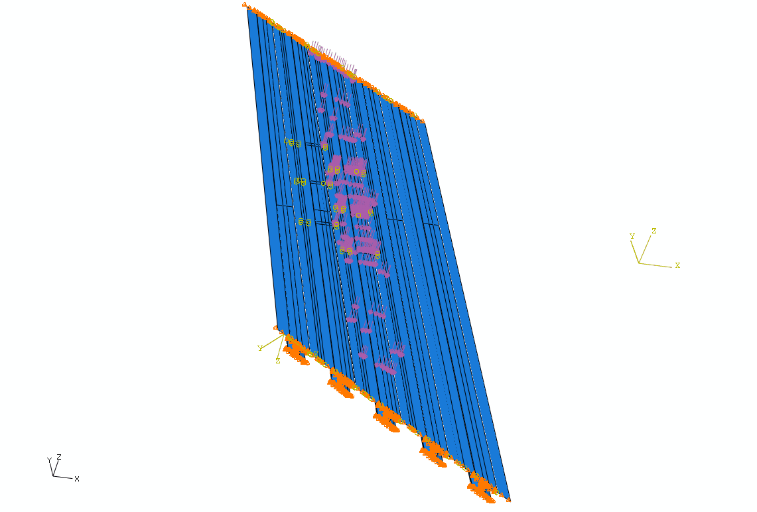
Fig. 3.1. FE model for parametric study

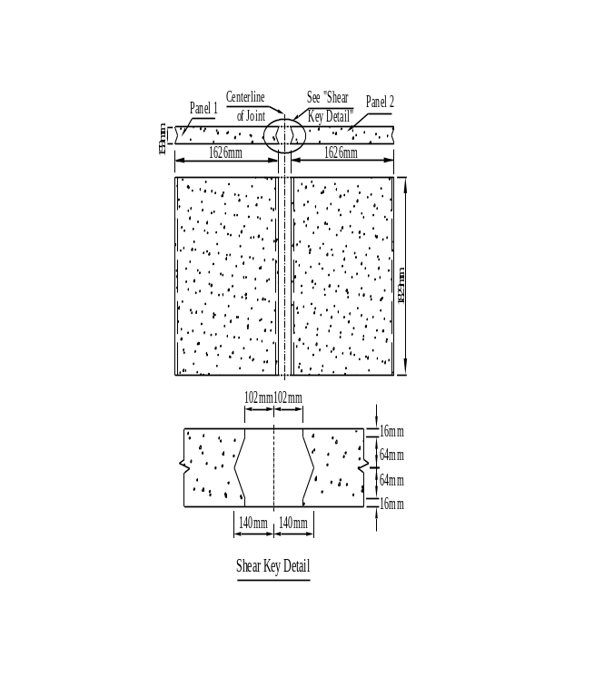
Fig. 3.2. Dimension of slab specimen

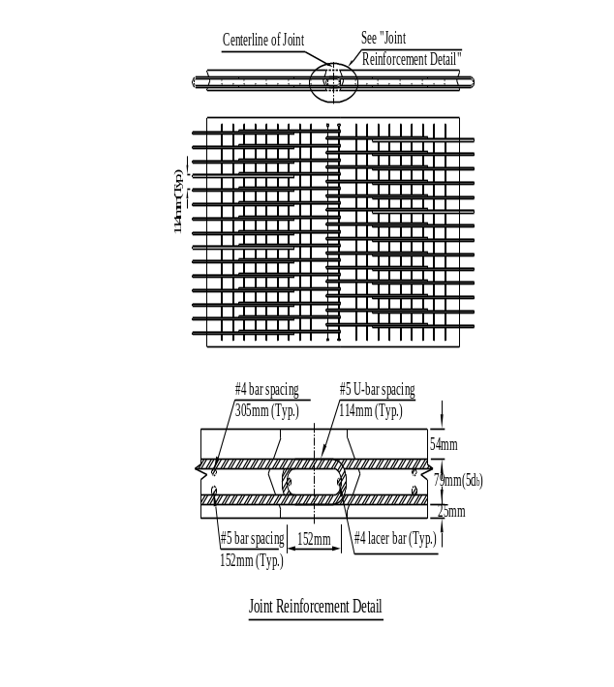
Fig. 3.3. Reinforcement layout in slab
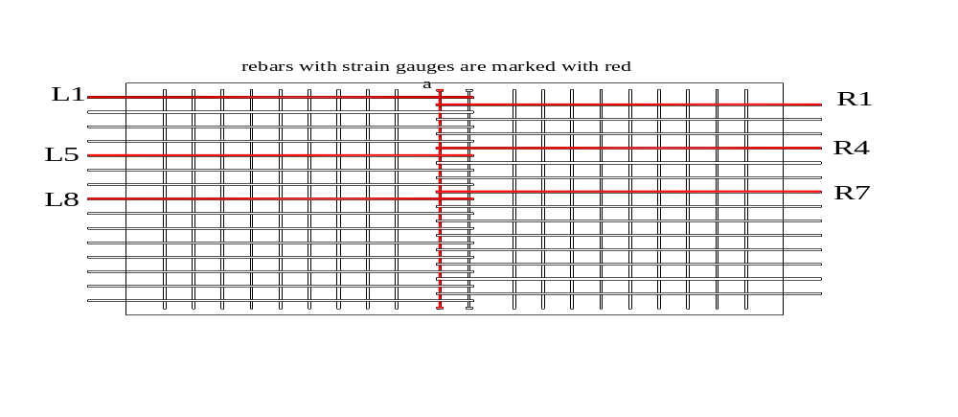
(a) Bars instrumented with strain gages (marked in dark)

(b) Strain gage locations for Bar L1 and R1 (c) Strain gage locations for Bar L5 and R4
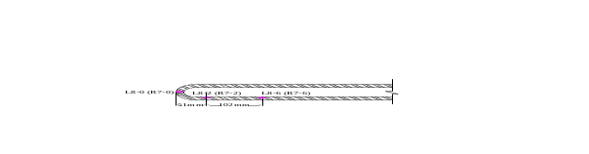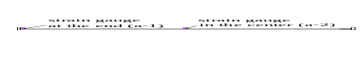
(d) Strain gage locations for Bar L8 and R7 (e) Strain gage locations for Lacer Bar a
Fig. 3.4. Strain gage layout

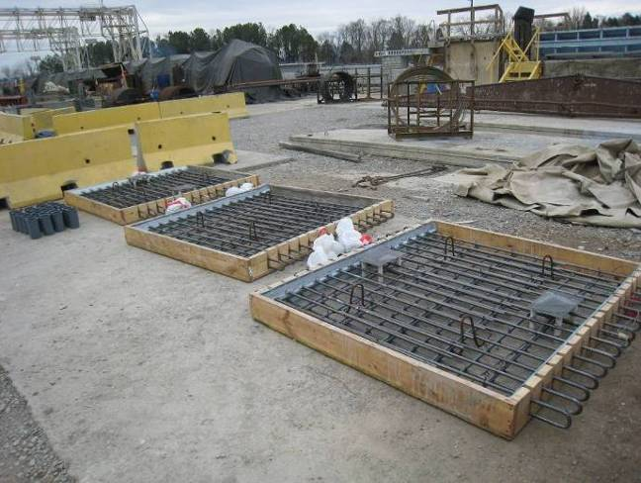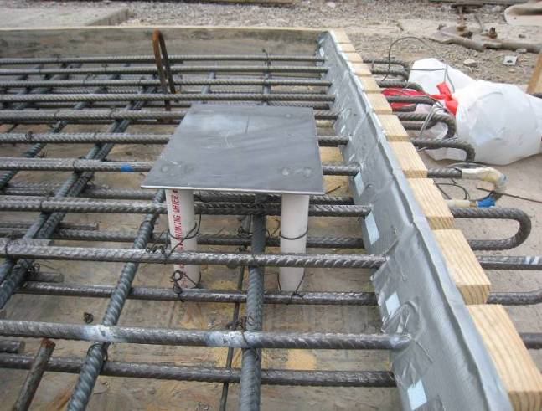
(a) Slotted wood form (b) Foam wedges and Pipes Fixed in Place
Fig. 3.5. Panel fabrication

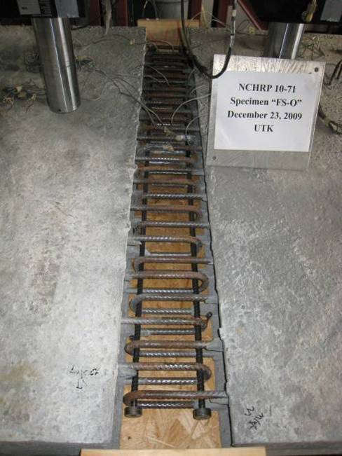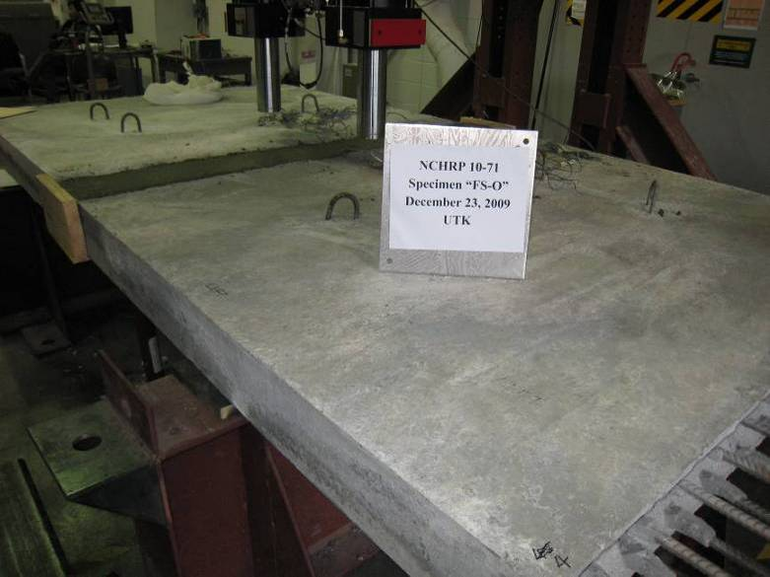
(a) Before grouting (b) After grouting
Fig. 3.6. Slab specimen

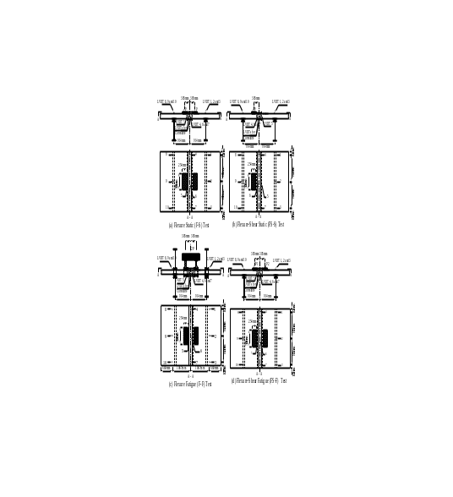
(a) Static flexure (SF) test (b) Static shear (SS) test
(c) Fatigue flexure (FF) test (d) Fatigue shear (FS) test
Fig. 3.7. Testing setup

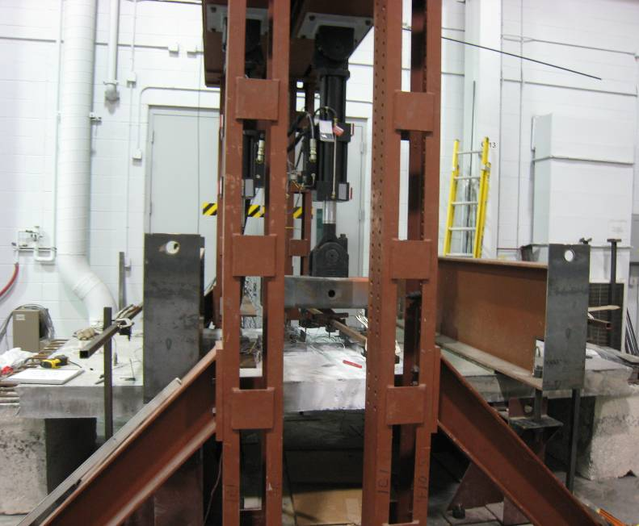
(a) FF test setup
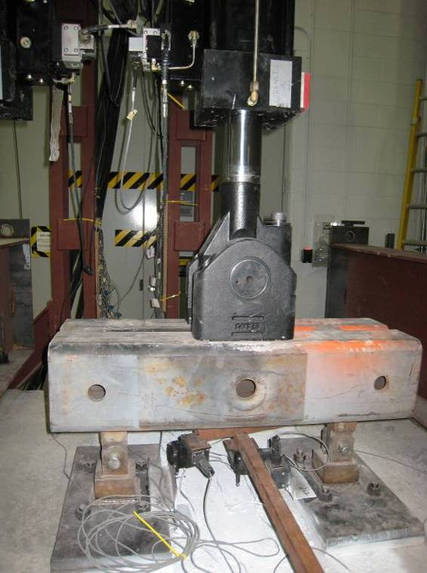
(b) Apparatus applying fatigue forces
Fig. 3.8. FF test setup and apparatus for fatigue loading

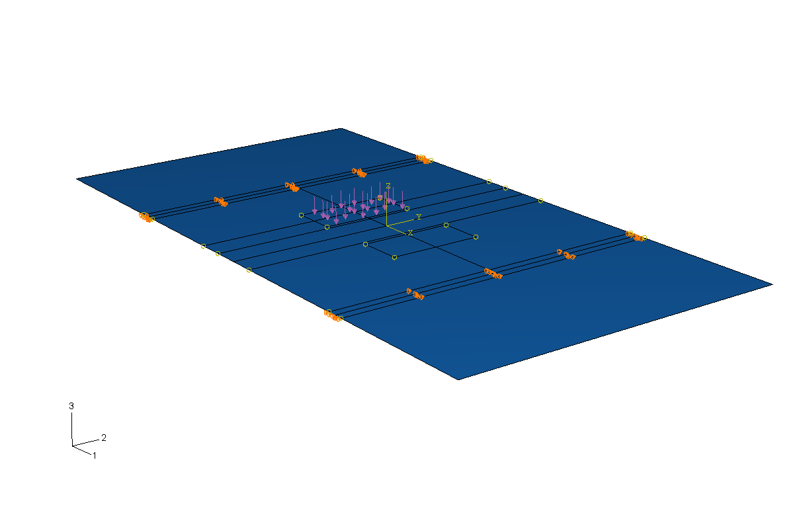
Fig. 3.9. FE model for load determination

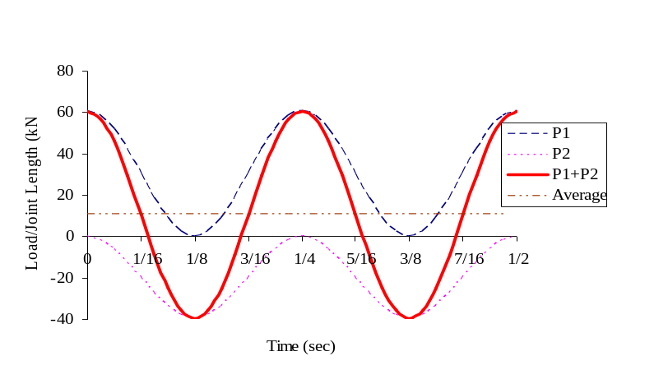
Fig. 3.10. First two cycles of fatigue shear (FS) loading applied

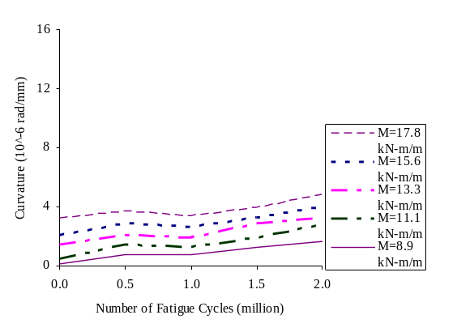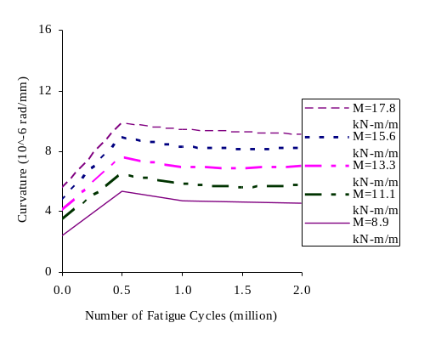
(a) FF-O specimen (b) FF-7 specimen
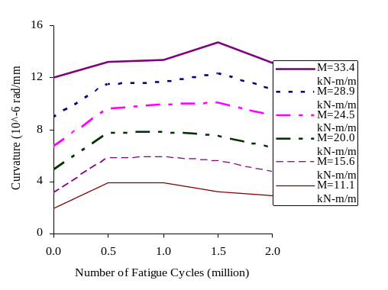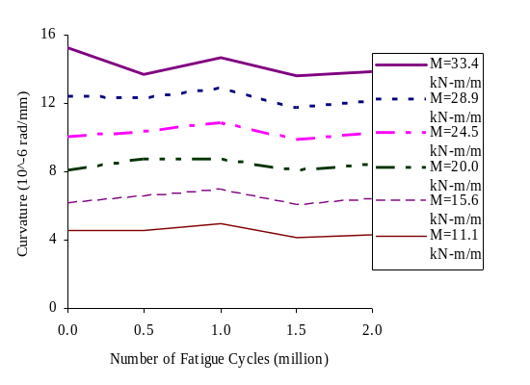
(c) FS-O specimen under P1 (d) FS-O specimen under P2
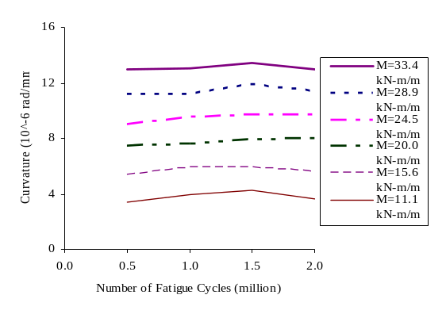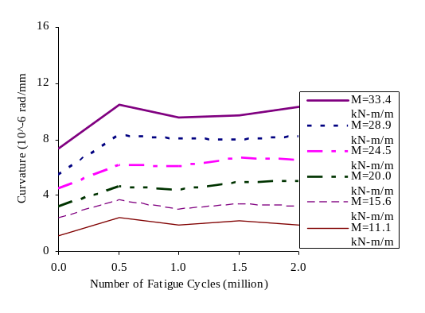
(e) FS-7 specimen under P1 (f) FS-7 specimen under P2
Fig. 3.11. C-N curves

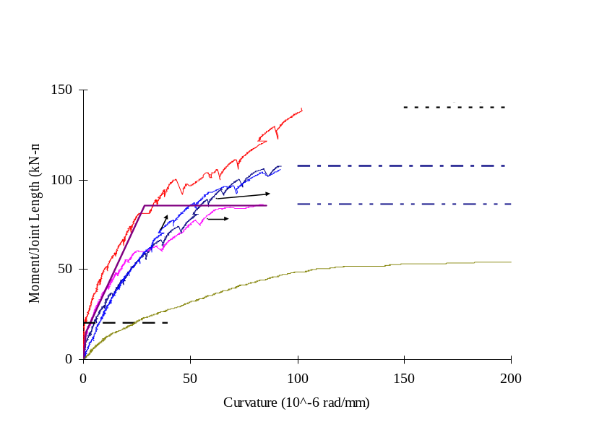
(a) Flexure tests
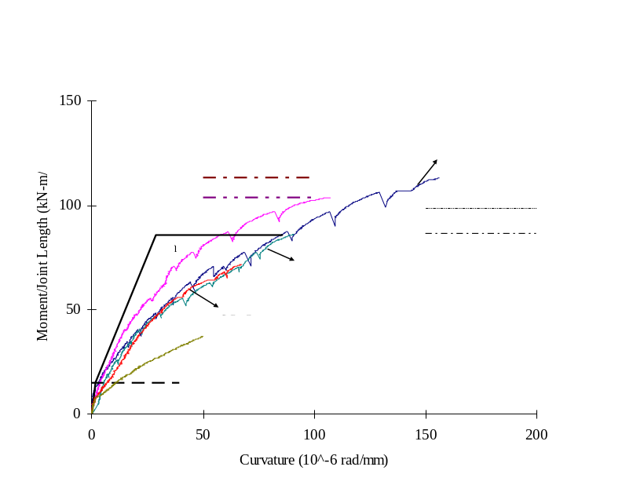
(b) Flexure-shear tests
Fig. 3.12.Moment-curvature curves

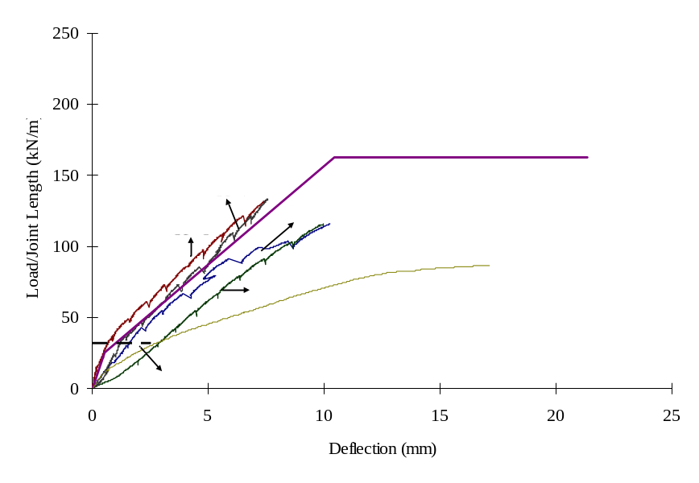
  - Flexure tests
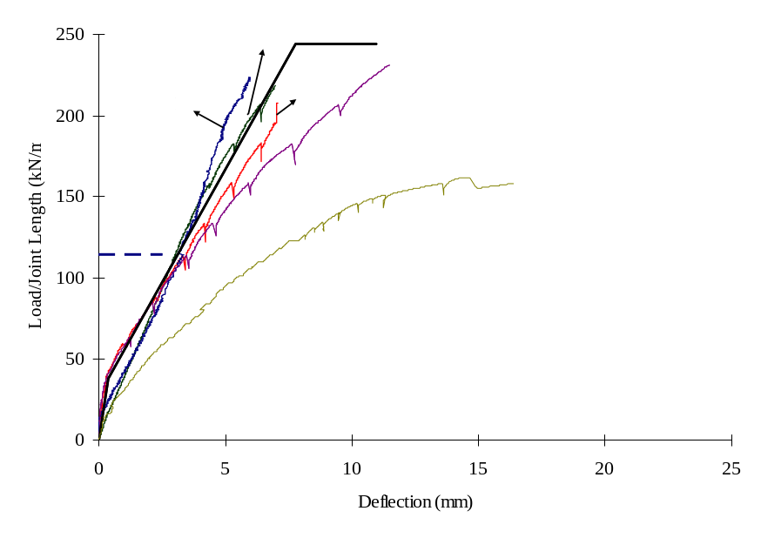
  - Flexure-shear tests
Fig. 3.13. Load-deflection curves

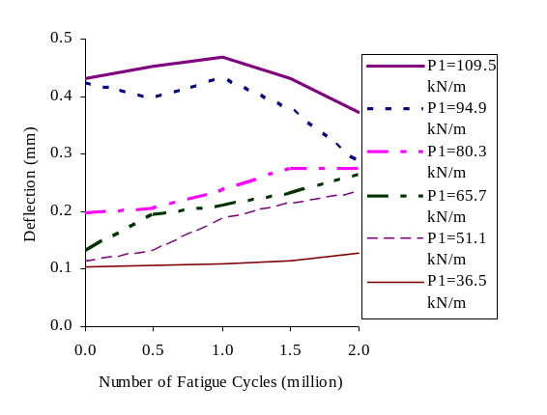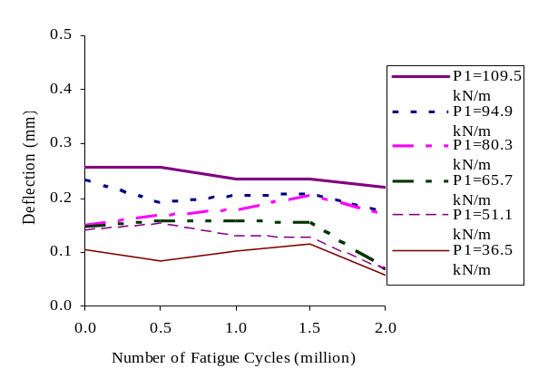
(a) FS-O specimen under P1 (b) FS-O specimen under P2
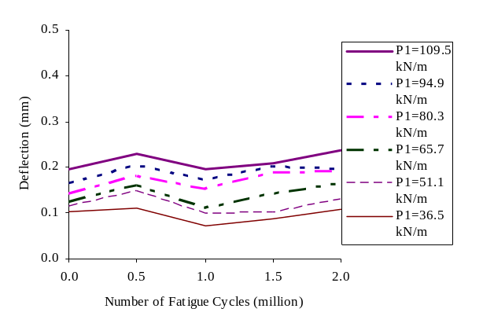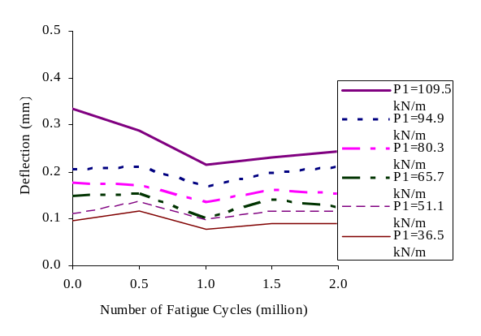
(c) FS-7 specimen under P1 (d) FS-7 specimen under P2
Fig. 3.14. RD-N curves

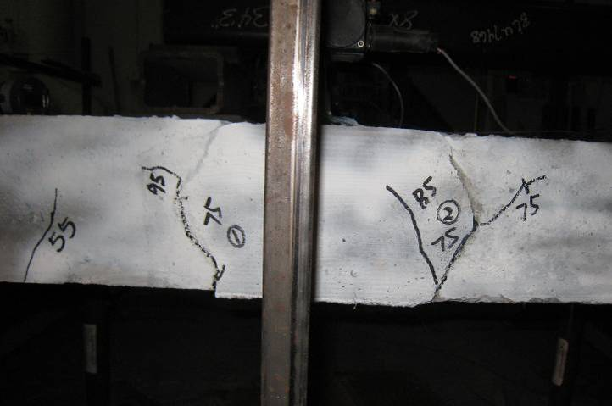
Fig. 3.15. Cracks at interface of the joint

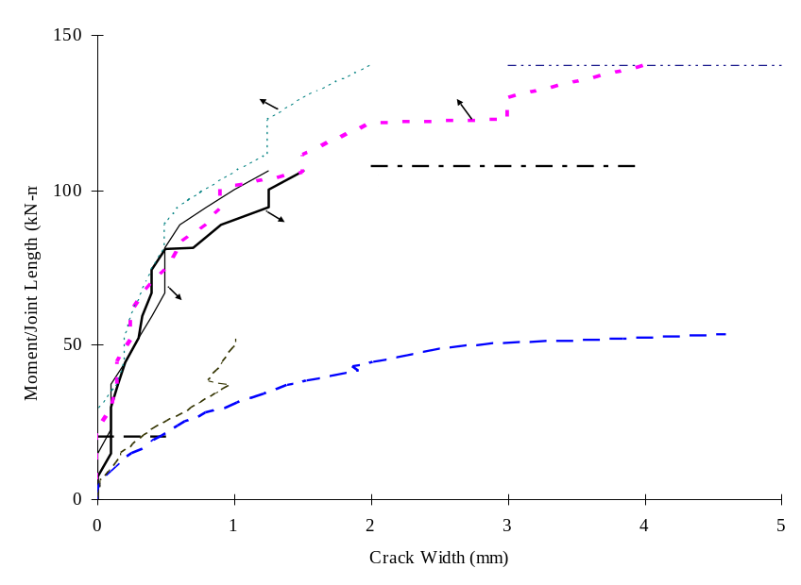
(a) SF specimens
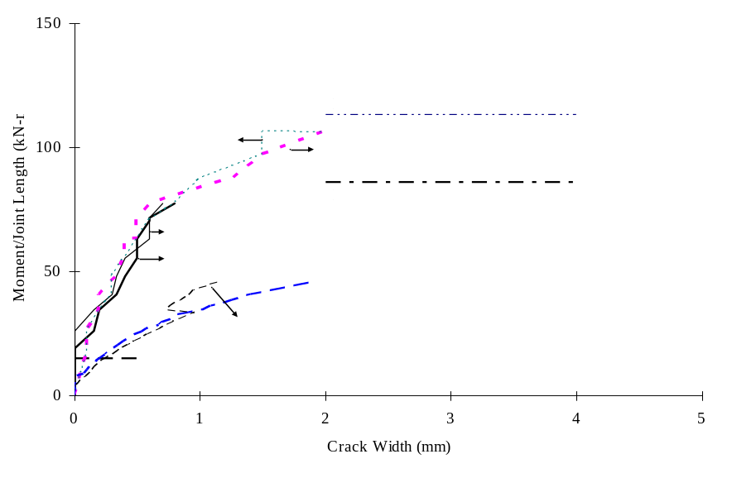
(b) SS specimens
Fig. 3.16. Moment-crack width curves for static flexure and static flexure-shear specimens

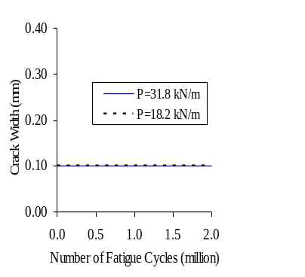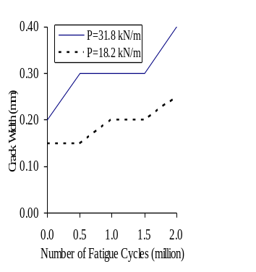
(a) FF-O (b) FF-7
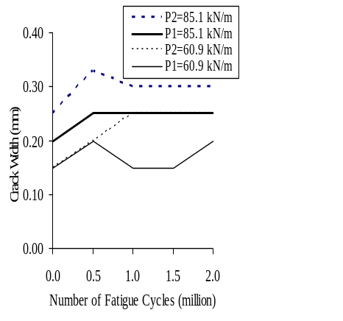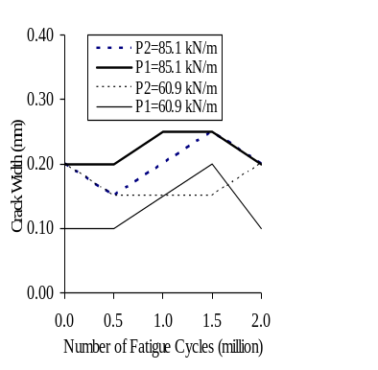
(c) FS-O (d) FS-7
Fig. 3.17. CW-N curves

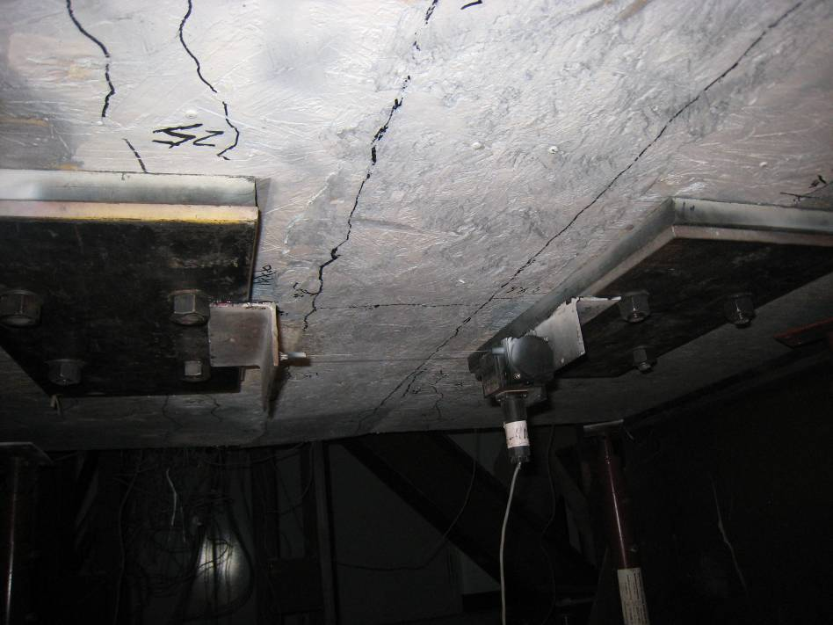
Fig. 3.18. Transverse crack in FF-7 test

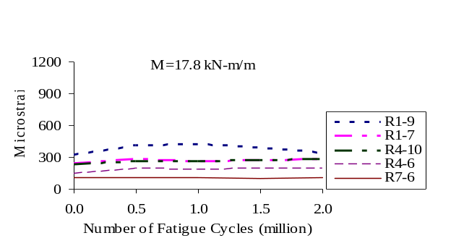
(a) FF-O
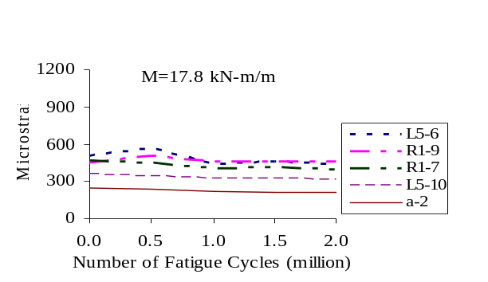
(b) FF-7
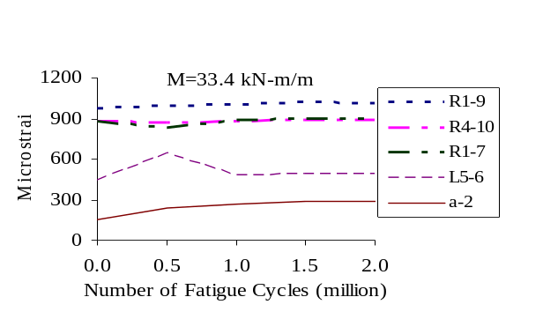
(c) FS-O
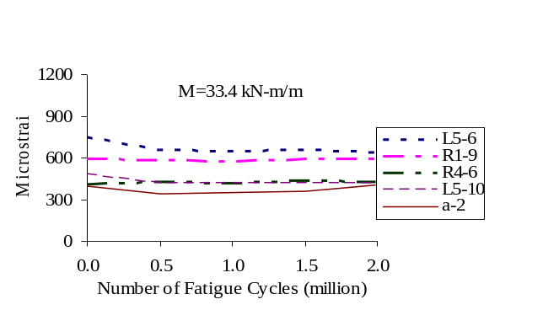
(d) FS-7
Fig. 3.19. MS-N curves
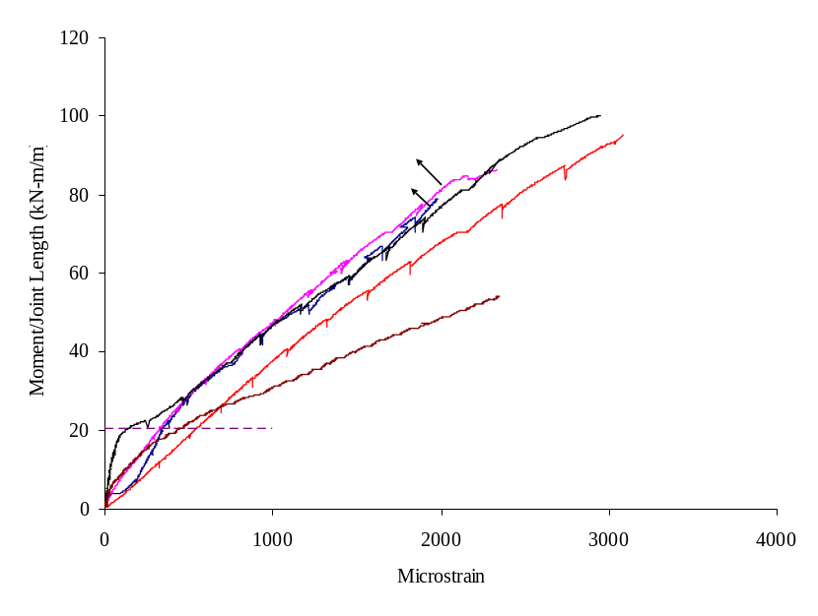
(a) Flexure tests
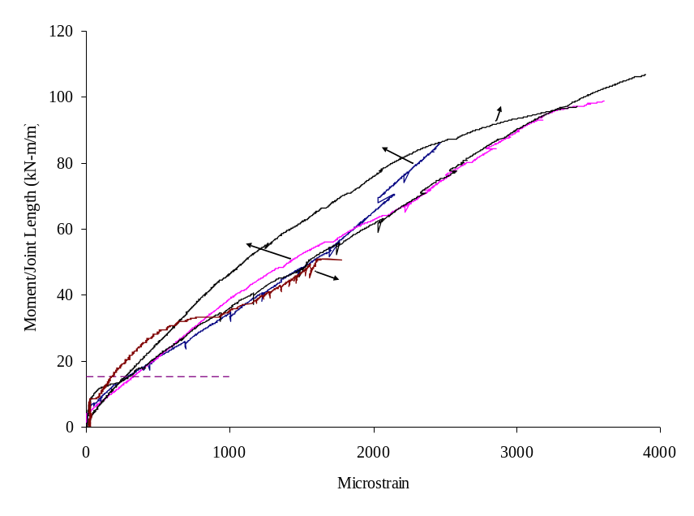
(b) Flexure-shear tests
Fig. 3.20. Moment-strain curve

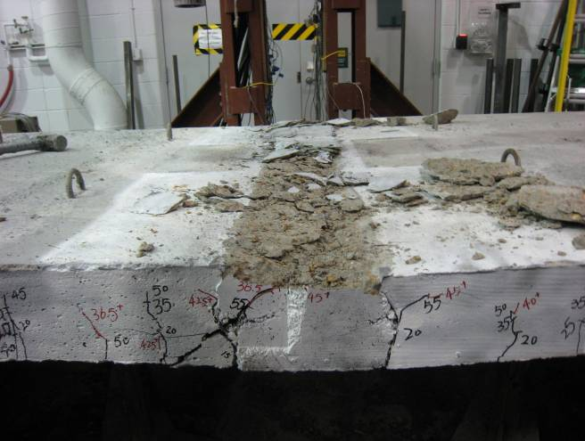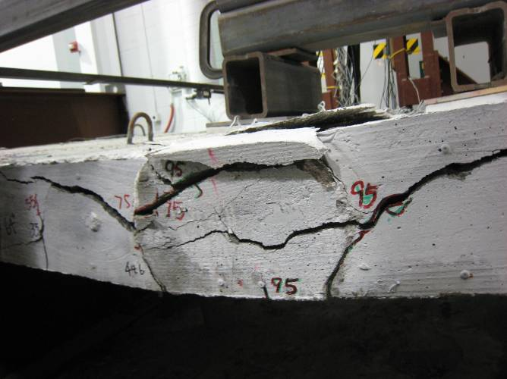
(a) SF-O (b) FF-O
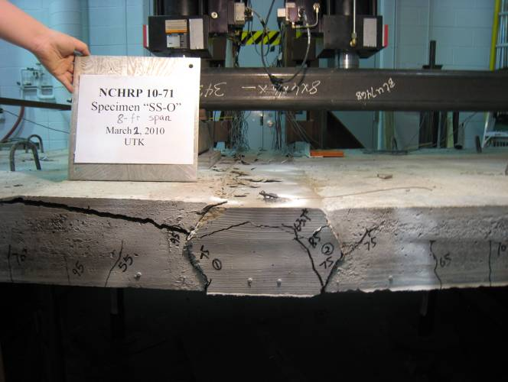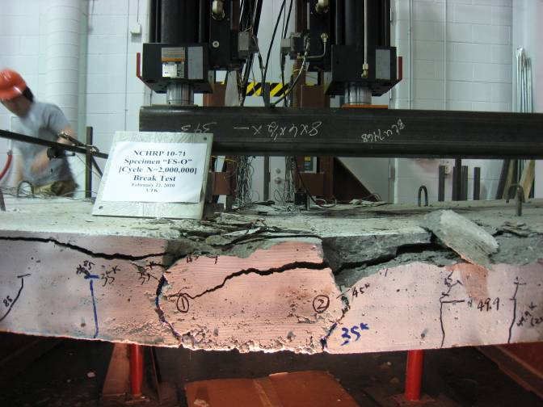
(c) SS-O (d) FS-O
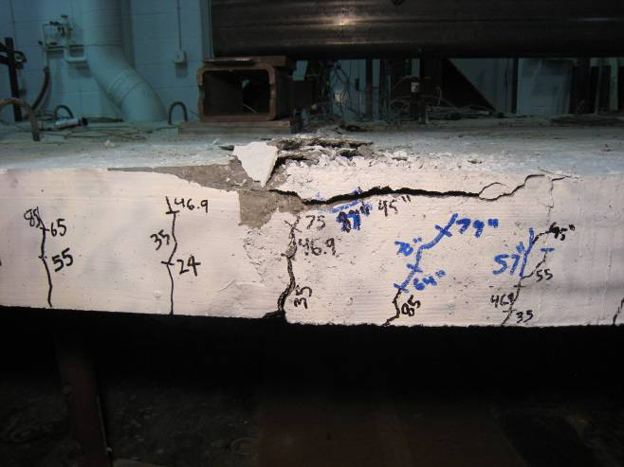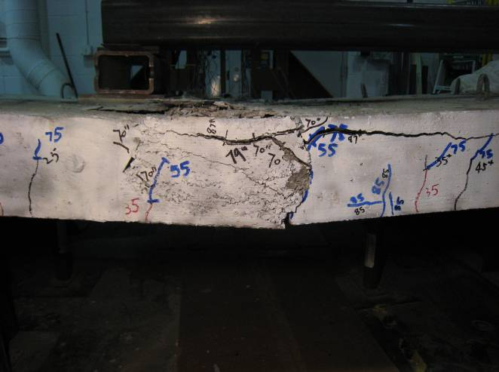
(e) SS-7 (f) FS-7
Fig. 3.21. Specimen failures

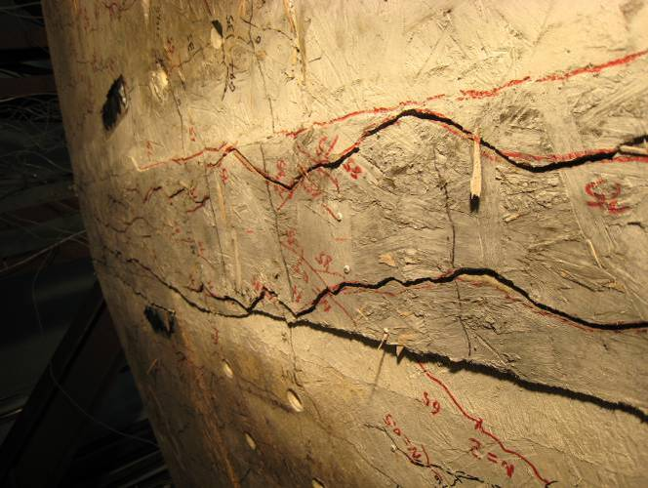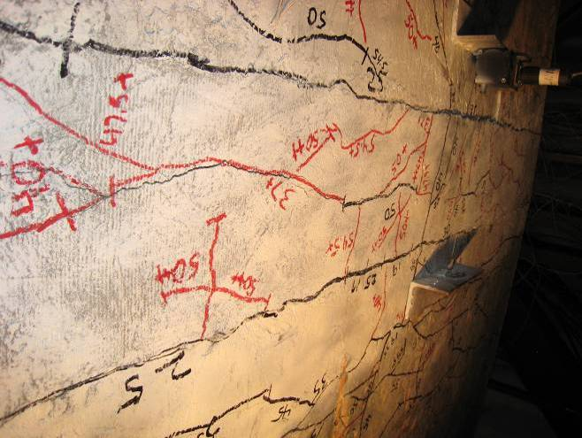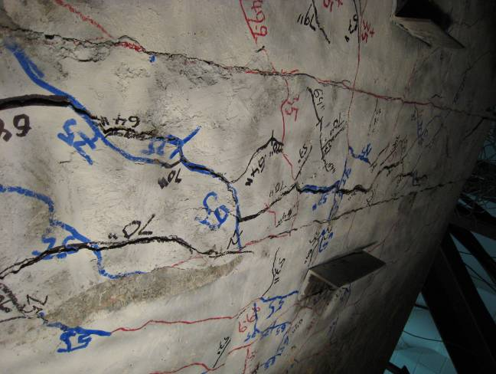
(a) FF-O (b) SF-7 (c) FS-7
Fig. 3.22. Cracks at the bottom of slabs

Chapter 4: Fatigue Evaluation of Transverse U-Bar Joint Details for Accelerated Bridge Construction

This chapter is a slightly revised version of a paper with the same title under review for the Journal of Bridge Engineering, ASCE by Peng Zhu, Zhongguo John Ma, Qi Cao and Catherine French.
Abstract
When precast deck panels and decked bulb-Ts (DBTs) are used for accelerated bridge construction, transverse joints exist. In this study, continuous transverse U-bar joint details which can provide negative moment continuity in the multi-span bridges have been investigated. Four full-scale specimens connected by the developed U-bar detail together with the selected closure pour (CP) materials, overnight cure and 7-day cure, were tested. Static and fatigue tests under tension loading were conducted. The loading demand necessary in the testing was determined based on the maximum forces in the transverse joint from an analytical study. Test results were evaluated based on tension capacity, cracking, displacement and steel strain. Based on these test results, the developed transverse U-bar joint detail is a viable connection system.
Keywords: Fatigue, U bar reinforcement, Transverse joint, Decked bulb-T (DBT), Precast deck panel, Accelerated bridge construction, Crack width

4.1 Introduction
Speed of construction, particularly for bridge replacement and repair projects, has become a critical issue to minimize disruption of traffic and commerce. Promising systems for rapid construction include precast bridge systems fabricated using decked bulb-T (DBT) concrete girders or full-depth deck panels on girders. When these systems are used, there exist both longitudinal (parallel to traffic direction) and transverse joints to connect deck panels and flanges of DBTs together. Development of longitudinal joint details has been reported elsewhere (Li et al. 2010 and 2010a). The objective of this study is to evaluate the developed continuous transverse joint details which can be used in the negative moment region of multi-span DBT bridge systems as well as in precast deck panel systems. In both cases, large tension forces in the transverse joints are expected, especially in the negative moment region. Because of the similarity in these systems, the discussion herein focuses primarily on DBTs which generally have greater constraints on the flange thickness of DBTs than the depth of precast deck panels.
The DBT bridge system eliminates the time necessary to form, place, and cure a concrete deck at the bridge site. In addition, the wide top flange (deck) of DBTs improves construction safety due to ease of installations, and enhances durability because the deck is fabricated with the girder in a controlled environment (Ma et al 2007). Despite the major benefits of this type of bridge, use has been limited to isolated regions of the U.S. because of concerns about certain design and construction issues. One issue that hampers widespread use of DBT system is about the current joint detail, welded steel connector with shear key joint. Because the welded steel plates are located 4 ft from each other and at mid-depth of the flange, they cannot help to control flexural cracks along the joints. Also, the welding causes a concern under the fatigue loading. To overcome these shortcomings, Li et al. (2010) proposed a new headed bar joint detail for the longitudinal joint. The proposed joint detail by Li et al. (2010) works well in the longitudinal direction. While the longitudinal joints are very common in single-span bridges, there exist transverse joints in the multi-span DBT bridges as well as in full-depth deck panel systems. Li et al. (2010) did not address transverse joint issues in that study.
For the transverse joint, suitable details need be developed to give continuity in negative moment regions. Gordon and May (2006) performed 18 tests carried out to develop in situ joints suitable for pre-cast bridge deck units in negative moment areas. The results of these tests, which contain both symmetric and non-symmetric arrangements of straight and looped bars, were given together with comparison to the theoretical strengths. The behavior of the joints at serviceability and ultimate loads were discussed. The tests showed that the failure loads of joints containing looped bars can be accurately predicted based on the ultimate strength of the reinforcement provided there are adequate transverse lacer bars. And crack widths would be unlikely to impose a limitation at the serviceability limit state. Please note that the loop bar details proposed by Gordon and May (2006) require a relative thick slab to accommodate the required bend diameter. To overcome this limitation, Lewis (2009) and Chapman (2010) completed studies that assess alternate U-bar joint details. To minimize deck (or slab) thickness, the U-bar detail was designed to utilize an extremely tight bend. The inside bend diameter was three times the diameter of the bar (3d_{b}). When 16 mm diameter (#5) bars are used, the inside diameter of the bend is 48 mm (1⅞ in). Since the proposed bend diameter violates the minimum allowable bend diameters established by ACI 318-08 (2008), Lewis (2009) and Chapman (2010) conducted a series of experimental studies to investigate the feasibility of the proposed U-bar joint detail. The U-bar detail was tested utilizing two materials, deformed wire reinforcement (DWR) and stainless steel reinforcement which have a relatively ductile behavior. Based on their studies, the DWR U-bar detail with a 152 mm (6 in.) overlap length and 114 mm (4.5 in) spacing was selected for additional fatigue evaluations to further investigate replacing the current welded steel connector detail. This paper describes the test program and presents results of this additional testing to investigate the feasibility of the U-bar detail for the transverse joint.
Four full-scale specimens connected by a U-bar detail with one of the selected closure pour (CP) materials by Zhu and Ma (2010), overnight cure and 7-day cure, were fabricated and tested. The analytical parametric study was conducted to provide the database of maximum forces in the transverse joint. These maximum forces are used to determine the loading demand necessary in the beam testing due to the service live load. Static and fatigue tests under tension loading were conducted. Test results were evaluated based on tensile capacity, cracking, displacement and steel strain.
4.2 Maximum Forces in the Transverse U-bar Joints
To determine the controlling load case for a transverse joint, the transverse joint should be positioned over an interior support in a continuous span bridge system. In this case, if the deck was compositely connected to the girder, the deck would have to resist large tensile forces that would be produced by the negative moment developed there. Conservatively it is assumed that all the tension force created by the negative moment would be resisted by the deck.
The transverse joints over the piers experience negative moment under service live load. The maximum negative moment in the transverse joint was studied using QConBridge™, which is a live load (AASHTO LRFD HL-93, 2010) analysis program for continuous bridge frames developed by WSDOT. Two types of bridge systems were developed: (1) two-span continuous bridge and (2) three-span continuous bridge.
According to AASHTO LRFD (2010), the HL-93 loading consists of the combination of the design vehicle load and the design lane load. The design vehicle load is either a truck or tandem with dynamic allowance of 1.33. The design truck is specified in Article 3.6.1.2.2 while the design tandem is specified in Article 3.6.1.2.3. The practical span ranges used in the study were much larger than those controlled by the tandem loading, so the truck loading controlled the vehicle load in the analyses. The design lane load was 9.34 kN/m (0.64 kip/ft) without dynamic allowance.
Based on Article 3.6.1.3.1, for negative moment between points of dead load contra-flexure, and reactions at interior piers only, 90% of the effect of two design trucks spaced at a minimum of 15 m (50 ft) between the lead axle of one truck and the rear axle of the other truck, combined with 90% of the effect of the design lane load should be considered. The distance between the 142 kN (32 kip) axles of each truck should be taken as 4 m (14 ft).
Considering the practical span range of the decked bulb-T girder family, Table 4.1 lists the bridge span length in each bridge model and shows the maximum negative moment in the transverse joint over the piers for each bridge model under service live load HL-93.
From the analysis results, it can be seen that the span length of the bridge had the largest effect on the maximum negative moment in the transverse joint. Generally speaking, the bridge model with the longer span length produced the larger maximum negative moment. For the bridge model with the same span length, the difference of the maximum negative moment between the two-span bridge systems and three-span bridge systems was negligible. In the case of the two-span bridge systems with the longer spans of the same length, the bridge model with different span lengths produced larger moments than bridge model with the same span length.
The decked bulb-T girder section (DBT65) and the bulb-T girder section (BT72) were chosen for the study of the maximum loads including the design loading and the fatigue loading in the transverse joints. Table 4.2 and Table 4.3 summarize the maximum moment in the transverse joint over the piers for girder sections DBT65 and BT72, respectively, under the HL-93 service live load. The calculated moments in Table 4.2 and Table 4.3 represent the loadings per lane. The calculated negative moment including the design moment and fatigue moment does not consider the 90% loading effect factor in Table 4.2 and Table 4.3.
The simplified distribution factor formulas (AASHTO 4.6.2.2) are used to determine the distribution factor for a typical interior girder.
Bridge Type (K) or Type (J) if sufficiently connected to act as a unit: BT72
The distribution factor for moment (DFM) for one design lane loaded and two or more design lanes loaded is 0.772 and 1.114 respectively. Thus, for the case of where two or more design lanes loaded control, DFM=1.114 lanes/beam.
The maximum moment in the transverse joint over the interior piers with girder section BT72 due to the AASHTO LRFD HL-93 service live load was determined by:
negative design load: M=-(0.9)(1.114)(3163.1)=-3171 kN-m(-2339 kip-ft) /beam
negative fatigue load: M=-(0.9)(1.114)(920.6)=-923 kN-m(-681 kip-ft) /beam
positive design load: M=(1.114)(469.1)=523 kN-m(385 kip-ft) /beam
positive fatigue load: M=(1.114)(199.3)=222.0 kN-m(164 kip-ft) /beam
Bridge Type (J) if connected only enough to prevent relative vertical displacement at the interface: DBT65
The distribution factor for moment is DFM=0.73. The maximum moment in the transverse joint over the interior piers with girder section DBT65 due to the AASHTO LRFD HL-93 service live load was determined by:
negative design load: M= -(0.9) (0.73) (6481)=-4258 kN-m(-3140 kip-ft) /beam
negative fatigue load: M=-(0.9)(0.73)(1878)=-1234 kN-m(-910 kips-ft) /beam
positive design load: M=(0.73)(934)=682 kN-m(503 kip-ft) /beam
positive fatigue load: M=(0.73)(363)=265 kN-m(196 kip-ft) /beam
In summary, the maximum moments in the transverse joint over the interior piers with girder section DBT65 were larger than the maximum moments in the girder section BT72 due to the AASHTO LRFD HL-93 service live load. For girder section DBT65, the negative design moment was -4258 kN-m (-3140 kip-ft)/beam; the negative fatigue moment was -1234 kN-m(-910 kips-ft)/beam; the positive design moment was 682 kN-m(503 kip-ft)/beam; and the positive fatigue moment was 265 kN-m(196 kip-ft)/beam.
Assuming uncracked sections, the resulting extreme fiber stresses at the top of the girder in the transverse joint associated with the maximum moments were -7.281MPa(-1.056 ksi), -2.110 MPa(-0.306 ksi), 1.165 MPa(0.169 ksi), and 0.455 MPa(0.066 ksi) under the negative design load, negative fatigue load, positive design load, and positive fatigue load, respectively. The negative design stress (-7.281MPa (-1.056 ksi)) under the design load (-4258 kN-m (-3140 kip-ft)) was greater than the modulus of rupture of concrete. Thus, the transverse joint was reanalyzed assuming cracked section properties. Based on the cracked section analysis, the stresses of the U-bar in girder DBT65 were determined to be 245.5 MPa (35.6 ksi) and 71.0 MPa (10.3 ksi) under the negative design load (-4258 kN-m (-3140 kip-ft)) and negative fatigue load (-1234 kN-m(-910 kips-ft)), respectively.
4.3 Experimental Program
4.3.1 Specimen Dimension
Four beams with the same dimensions were fabricated for the static and fatigue testing, with two different closure pour materials used in the transverse U-bar joint. Each specimen consisted of two panels (Part 1 and Part 2 in Figure 4.3) connected by one of the closure pour materials (overnight and 7-day cures) as shown in Figure 4.3. Each panel was 381 mm(15 in.) wide, 813 mm(32 in.) long and 184 mm (7.25 in.) deep. The female-to-female shear key was provided at the vertical edge of the end with the U-bar extended in the specimen length direction.
4.3.2 Reinforcement Layout and Strain Gage Instrumentation
Figure 4.4 displays the reinforcement layout used in the specimens. The reinforcement layout is the same as that used in WT-1 and WT-2 by Lewis (2009) and Chapman (2010) respectively. There are four layers of reinforcement in each panel’s depth direction with a 51 mm (2 in.) cover at the top and 25 mm (1 in.) cover at the bottom. The straight bars simulate the transverse reinforcement while the U bars simulate the longitudinal reinforcement in the bridge deck. The reinforcement details in the specimen are as follows: 16 mm diameter (#5) straight bar spaced at 152 mm (6 in.) at the bottom along the beam width direction; 13 mm diameter (#4) straight bar spaced at 305 mm (12 in.) at the top along the beam width direction. The 16 mm diameter (#5) U-bars project out of the panel to splice with the U-bars in the adjacent panel in the transverse joint. The spacing of the U-bars is 114 mm (4.5 in.) and the overlap length, the distance between bearing surfaces of adjacent U-bars, is 152 mm (6 in.). The interior diameter of bend of the U-bar is 3d_{b} (Lewis 2009).
Strain gages were used to measure the strain in the joint reinforcement. The strain gages allow for direct strain readings of the rebar in the joint. The strain gage configuration was modified based on the test results from Lewis (2009) and Chapman (2010). Figure 4.5 depicts the strain gage layout in the specimen for the tension test. Gages were placed at 51 mm (2 in.) and 152 mm (6 in.) away from the bend of the U-bar. The strain gage diagrams have notations indicating the U-bar identifier and the location on the bar. The U-bars are represented by “UB” and the lacer bars are indicated by “LB.” The distance from the bend of the U-bar to each gage is shown at the bottom of the diagram. All distances indicated on the diagrams are in inches and measured from center-to-center. A gage was placed at the midpoint of the lacer bar.
4.3.3 Specimen Fabrication and Joint Surface Preparation
The concrete specimens were fabricated locally at Ross Prestressed Concrete Inc. in Knoxville, TN. One end of the wood form, in the length direction, was slotted at a spacing of 152 mm (6 in.) to fix the U-bars in place (Figure 4.6(a)). Foam wedges were used to form the configuration of the shear key at the vertical edge of the panel (Figure 4.6(b)). Holes were drilled in the other end of the form, so that the threaded rods attached to the reinforcement could be extended out of the specimen. The design concrete compressive strength at 28 days was 48.3 MPa (7000 psi). Concrete cylinders were made with the pouring of panels.
The surfaces of the shear key were sandblasted to prepare the joint for the closure pour. The purpose of the surface preparation is to remove all contaminants that can interfere with adhesion and to develop a surface roughness to promote a mechanical bond between the grout and base concrete. After removal of the deteriorated concrete, proper preparation should provide a dry, clean and sound surface offering a sufficient profile to achieve adequate adhesion. There are many methods of surface preparation such as chemical cleaning, mechanical cleaning and blasting cleaning. Sandblasting uses compressed air to eject the high speed stream of sand onto the surface which needs to be prepared. This method is very effective to process the surface of precast members under industrial conditions. Black Beauty 2050 sand was chosen for sandblasting to prepare the surface in this study. The profile of the surface after sandblasting is shown in Figure 4.7.
4.3.4 Closure-Pour Materials
The joint, which is filled with closure-pour materials connecting the top flange of the adjacent DBT girders, is considered to be the structural element of the bridge deck. It is important for the selected closure-pour material to reach its design compressive strength in a relatively short time for the purpose of accelerated bridge construction. In this study, it was decided to use two types of closure-pour materials, overnight cure and 7-day cure, recommended in Zhu and Ma (2010). In this study, the grout SET® 45 HW without extension was used as the overnight cure materials. High performance concrete (HPC) “Mix 1”, developed in Zhu and Ma (2010), was used for the 7-day cure material.
4.3.5 Testing Plan and Setup
Four beam specimens were made. Each beam specimen consists of two concrete panels connected with an overlapping U-bar detail and one of the selected closure pour materials. When grouting, two panels were positioned to satisfy the overlapped length and the spacing of the U-bar at the joint zone (Figure 4.8 (a)). The wood form was provided at the bottom and at both ends of the joint to prevent leakage. After grouting, the beam specimen consisting of two panels connected by the joint was ready for testing (Figure 4.8(b)).
The specimens representing the transverse U-bar joint direction were tested in tension, because of the tensile forces created by negative moment regions. The longitudinal reinforcement in the transverse U-bar joint specimens was welded to 19 mm (¾”) threaded rods. These threaded rods were used to bolt the tension specimen to support and loading beams. The welding joints of the threaded rods and the U-bars were kept outside of the concrete specimen. This is designed to repair the welding easily in case the welding fails before the specimen does. The support beam was connected to the specimens and then placed on top of the load frame. The support beam was then braced and clamped into position, so it would remain stationary. The loading beam was then connected to the specimen and the actuators. The actuators pushed the loading beam down, which applied a tension force to the specimens. Figure 4.9 shows the tension test set-up.
Four beam specimens, two for each of two selected closure pour materials, were tested under static tension (ST) test, and fatigue tension (FT) test. Table 4.4 presents the loading matrix for the four specimens. The linear voltage displacement transducers (LVDT) were employed to measure the specimen deflection at various locations. LVDTs were installed on the top and the bottom of the joint to measure joint elongation and at the bottom of the specimen to measure the total deflection of the specimens. Figure 4.9 shows the test setup and the LVDT instrumentation for each test. The Crack Comparator was used to measure the crack width.
The compressive strength of concrete panel and the compressive strength of grouted joint at the time of testing for each specimen are shown in Table 4.5.
4.3.6 Fatigue Loading Determination
As discussed, the resulting extreme fiber stresses at the top of the girder in the transverse joint associated with the maximum moments were -7.281MPa(-1.056 ksi), -2.110 MPa(-0.306 ksi), 1.165 MPa(0.169 ksi), and 0.455 MPa(0.066 ksi) under the negative design load, negative fatigue load, positive design load, and positive fatigue load, respectively, assuming uncracked sections. The negative design stress (-7.281MPa (-1.056 ksi)) under the design load (-4258 kN-m (-3140 kip-ft)) was greater than the modulus of rupture of concrete. Thus, the transverse joint was reanalyzed assuming cracked section properties. Based on the cracked section analysis, the stresses of the U-bar in girder DBT65 were determined to be 245.5 MPa (35.6 ksi) and 71.0 MPa (10.3 ksi) under the negative design load (-4258 kN-m (-3140 kip-ft)) and negative fatigue load (-1234 kN-m(-910 kips-ft)), respectively.
The static and fatigue loadings during the test are determined as following:
Static Tension: P=2×2×200×245.5= 196 kN (44.1 kips)
Fatigue Tension: P=2×2×200×71.0=57 kN (12.8 kips)
Static Compression: P=184×381×1.165=82 kN (18.4 kips)
Fatigue Compression: P=184×381×0.455=32 kN (7.2 kips)
In the determination of the tension loads, on one side of the joint there were three sets of 16 mm diameter (#5) U-bars, on the other side of the joint, there were two sets of 16 mm diameter (#5) U-bars, as shown in Figure 4.4. The tension load was determined by multiplying the desired stress (i.e., 245.5 MPa (35.6 ksi) or 71.0 MPa (10.3 ksi), for the static and fatigue tests, respectively) by total cross-sectional area of the fewest number of bars crossing the joint (i.e., two sets of U-bars, which was two sets of two bars multiplied by the cross-sectional area of a 16 mm diameter (#5) bar of 200 mm² (0.31 in.²)). The compression load was found by multiplying the concrete cross-sectional area by the desired compressive stress.
In the tests, the compression load was not applied to be conservative. During the fatigue test, the applied tension load was cycled between 57 kN (12.8 kips) (28 kN (6.4 kips) on each actuator) corresponding to a negative fatigue load of -1234 kN-m (-910 kips-ft) and 0 kN-m (0 kips) for a total of 2 million cycles at a frequency of 4Hz.
Before the cycling and at the end of 0.5, 1.0, 1.5, and 2.0 million cycles, a static test was conducted. A static tension loading was applied in several increments up to 196 kN (44.1 kips) (98 kN (22.05 kips) on each actuator) in order to produce the negative design load of -4258 kN-m (-3140 kip-ft), and unloaded to zero. Finally, the beam specimen was loaded to failure.
4.4 Test Result Analysis
4.4.1 Tensile Capacity
The tensile capacity was calculated as the product of the lightly reinforced area of steel, As= 8.00 cm² (1.24 in²), and the U-bar nominal yield strength of 517 MPa (75 ksi). The service live load was also listed as discussed. The test results are compared with the calculation in Table 4.6. The strengths for the fatigue tests, FT-O and FT-7, shown in the table are strengths at end of the tests. The welds for fatigue tension tests, FT-O and FT-7, broke during the fatigue cycling. The specimens were rewelded and tests were finished.
WT-1 by Lewis (2009) and WT-2 by Chapman (2010) have the same reinforcement layout as specimens tested in this study. The difference is that WT-2 was poured in one whole piece, while ST-O, FT-O, ST-7 and FT-7 have two panels poured and then joined by one of the CP materials as shown in Figure 4.8. All the specimens exceeded the nominal service live load. However, only WT-1, ST-7 and FT-7 exceeded the calculated tensile capacity using 517-MPa (75-ksi) yield strength. It was concluded that tensile capacities were reduced by reducing the concrete strength (Chapman 2010). And one reason that ST-O and FT-O have lower capacity is the lower strength of joint material. Attention needs be paid to the moisture loss during the first 3 hours after placement, which may have caused the lower strengths in the tests.
4.4.2 Load Deflection Relationships
Figure 4.10 compares the load-deflection curves between the fatigue beam after 2 million cycles and the beam under static loading without fatigue cycles. The vertical axis labeling “Load” represents the total applied load, and the horizontal axis “Deflection” represents the relative displacement between the two joint interfaces.
The slopes for ST-7, FT-O and FT-7 were large, because the specimens deflected out of phase at the beginning of the load, and the FT-7 specimen had this out-of-phase problem through the test. ST-O developed more deflection than FT-O. After reaching the peak load, ST-7 exhibited more ductility than FT-7. The fatigue cycles had an effect on the deflection of joints. When the test was not influenced by the out-of-phase problem (i.e. ST-O), the slope of the curve is similar to those of WT-1 and WT-2.
4.4.3 Crack Width Development
During the tests, the cracks around the whole specimen were observed and crack widths were measured. Figure 4.11 shows the cracks patterns developed within the joint zone at tensile failure for WT-1, WT-2, ST-O, FT-O, ST-7 and FT-7. The numbers written by the cracks in Figure 4.11 represent the total force applied in kips when the crack was formed.
ST-O, FT-O, ST-7 and FT-7 developed similar cracks patterns as WT-1 and WT-2. For four specimens in this study, the first crack was developed along one of the joint interfaces with less U-bars (or the top interface in this particular set-up), Crack 1 as shown in the figures. As tension loading increased, transverse cracks would continue to appear in various locations within and outside the joint zone. The transverse cracks initially were found only in the surface of the concrete, and as the loading progressed the cracks propagated through the entire thickness of the specimens. Additional loading produced longitudinal cracks that appeared above the main longitudinal reinforcement in the specimens. When approaching the capacities of the specimens, diagonal cracks appeared close to the sides of the specimens. These diagonal cracks would usually propagate toward a transverse crack in the joint zone and cause the failure surface for the specimens.
For ST-O, the first transverse crack occurred at approximately 89 kN (20 kips), which is about 30% of the tensile capacity. For FT-O, the first transverse crack occurred at nearly 44 kN (10 kips), about 15% of the tensile capacity. For ST-7, the first transverse crack to develop was at 133 kN (30 kips), 32% of tensile capacity. For FT-7, the first transverse crack to develop was at 133 kN (30 kips).
Longitudinal cracks began forming inside the joint zone at the following loads: 178 kN (40 kips) for ST-O, 89 kN (20 kips) for FT-O before cycling, 178 kN (40 kips) for ST-7, and 196 kN (44.1 kips) for FT-7 after 0.5 million cycles.
Diagonal cracks appeared in the joint, alluding to shear cracks, as the specimens approached capacity. The diagonal cracks propagated toward the first transverse cracks that developed along the joint interface. The concrete could be easily removed from the specimen where the diagonal and transverse cracks met.
The lacer bars provided confinement of concrete within the joint and served as restraints for the U-bars. The lacer bars allowed ductile failure in all specimens. An example of the deformation of the lacer bars can be seen in Figure 4.12.
The crack width development within the joint zone for the static tension tests, ST-O and ST-7, is presented in Figure 4.13. And “Crack 1”, “Crack 2”, “Crack 3”, and “Crack 4” are shown in Figure 4.11, as marked as “①”, “②”, “③” and “④” respectively. Crack 1 and 2 are cracks along the upper and lower joint interfaces, respectively. Crack 3 is the longitudinal cracks within the joint. And Crack 4 is the diagonal or transverse cracks within the joint.
The crack development of ST-O and ST-7 is similar. From Figure 4.13, the width of “Crack 1” grows fastest among all the cracks due to the less reinforcement at the joint interface of the “Crack 1” location, two U bars at the joint interface of the “Crack 1” location and three at the “Crack 2” location. Crack 2 has small crack width through the tests.
Figure 4.14 shows the crack width-fatigue cycle curve (CW-N) for the fatigue tests representing the maximum crack width within the joint after a various number of fatigue cycles under specified loadings. For FT-7, Crack 1 and 2 along the joint interfaces developed before the fatigue cycling, and one longitudinal crack developed in the static test after 0.5 million cycles. The longitudinal crack width was less than 0.2 mm (0.008 in.) all through the cycling. For FT-O, seven cracks developed during the static test before the fatigue cycling, including two cracks along the joint interfaces, two transverse cracks and three longitudinal cracks in the joint. No new crack occurred in the interim static tests. Crack 1 along the joint interface with two U-bars had the largest width all through the fatigue cycling, while all the other cracks had the width less than 0.2 mm (0.008 in.).
From Figure 4.14, it can be seen that the width of the crack within the joint was dependent upon the applied load. The crack widths increased with the increased loads, as expected. Under the same loading, the crack widths were observed to increase with increasing numbers of fatigue cycles, particularly for the specimens with the overnight cure material. The joint with the 7-day cure material developed smaller crack widths than the overnight cure material, and the cracks in the joint with the 7-day cure material tended to stabilize under fatigue loads.
4.4.4 Strain Development
Figure 4.15 shows the microstrain-fatigue cycle curves (MS-N) for the fatigue tests representing the reinforcement strain in the joint after a various number of fatigue cycles under service live load. The strain gage number and the loading are shown in the figure. The strain gage layout is shown in Figure 4.5. “P = 196 kN” means the specimen is subjected to a tension load of 196 kN in total.
From Figure 4.15, it can be seen that the variation of the reinforcement strain after different fatigue cycles is not significant. The reinforcement in the side of two U-bars experience a higher strain compared with the reinforcement in the side of three U-bars. The strain increases with the increase of the distance from the bend of the U-bars. The lacer bar experiences a low strain.
Figure 4.16 shows the load-microstrain curves representing the strain values in the joint zone (Strain gage 3-1, shown in Figure 4.5) for each specimen, which also show the variation of the reinforcement strain after fatigue cycles is not significant. The strain for WT-1 develops differently from ST-O, FT-O, ST-7 and FT-7, because ST-O, FT-O, ST-7 and FT-7 develop cracks along the joint interfaces, while WT-1 has no joint and has similar transverse cracks developed at other locations.
4.5 Conclusions
Based on the parametric study and the experimental program, the following conclusions are made:
- The fatigue loading had no significant influence on tensile capacity and reinforcement strains.
- The fatigue loading was observed to have an effect on the deflection development, particularly for the joints with the 7-day cure material.
- The fatigue loading had some effect on the measured crack widths in the specimens with the overnight cure material. Under the same loading, the crack widths were observed to increase after the fatigue cycles.
- The tensile capacity of transverse joints with overnight cure material is lower than expected due to the lower strength of CP materials. It was found that attention needs be paid to the moisture loss during the first three hours after placement in order to develop the expected strength of 41.4 MPa (6.0 ksi) for overnight cure CP materials.
- Undesirable wider crack widths will be developed at service load levels in transverse joints designed with higher grades of steel (e.g., 517 MPa (75 ksi) compared to 414 MPa (60 ksi)) because smaller amounts of reinforcement can provide the required nominal strength. Under service loads, larger stresses would be expected in the smaller bars, which lead to wider cracks at service. It is recommended that 414 MPa (60 ksi) nominal yield strength be used in the design of transverse joints, or that stresses in the reinforcement are limited to 345 MPa (50 ksi) at service.
- Based on these tests and with the aforementioned caveats, the U-bar detail may be considered a viable connection system for transverse joints.
Appendix
Table 4.1. Negative Moment over Piers in Bridge Models
Bridge Model | Bridge System | Span (mm) |  |  | Moment (kN-m)
Bridge Model | Bridge System | First | Second | Third | Design Load | Fatigue Load
1 | Two-Span | 20 | 20 |  | -1563 | -438
2 | Two-Span | 55 | 55 |  | -6372 | -1421
3 | Two-Span | 55 | 29 |  | -6603 | -1867
4 | Two-Span | 54 | 26 |  | -6481 | -1878
5 | Three-Span | 20 | 20 | 20 | -1443 | -434
6 | Three-Span | 54 | 54 | 54 | -6132 | -1479
7 | Three-Span | 29 | 55 | 29 | -5133 | -1482
8 | Three-Span | 26 | 54 | 26 | -4977 | -1483

Table 4.2. Moment over Piers in Bridge Models with DBT65
Bridge System | DBT 65 Span (m) |  |  | Moment (kN-m)
Bridge System | First | Second | Third | Design (-) | Fatigue (-) | Design (+) | Fatigue (+)
Two-Span | 53.6 | 25.6 |  | -6481 | -1878
Three Span | 53.6 | 53.6 | 53.6 | -6132 | -1479 | 934 | 363

Table 4.3. Moment over Piers in Bridge Models with BT72
Bridge System | BT 72 Span (m) |  |  | Moment (kN-m)
Bridge System | First | Second | Third | Design (-) | Fatigue (-) | Design (+) | Fatigue (+)
Two-Span | 32.0 | 21.3 |  | -2802.5 | -920.6
Three Span | 32.0 | 32.0 | 32.0 | -3163.1 | -817.6 | 469.1 | 199.3

Table 4.4. Tension Test Specimen Loading Matrix
Test/Specimen Name | ST-O | FT-O | ST-7 | FT-7
Test Loading | Static Tension | Fatigue Tension | Static Tension | Fatigue Tension
Joint Material | Overnight Cure (SET® 45 HW) |  | 7-Day Cure (HPC Mix 1)

Table 4.5. Cylinder Compressive Strength of Concrete Panel and Grouted Joint
 | Panel (MPa) |  | Joint (MPa)
Specimen | Start of Test | End of Test | Start of Test | End of Test
ST-O | 58.3 |  | 32.1
ST-7 | 61.3 |  | 68.8
FT-O | 58.3 | 56.6 | 27.5 | 34.3
FT-7 | 58.3 | 63.2 | 65.3 | 65.5

Table 4.6. Tensile Capacity
Specimen | Measured |  |  | Calculated
Specimen | Panel Cylinder Strength (MPa) | Joint Cylinder Strength (MPa) | Failure Load (kN) | Service Live Load (kN) | Ultimate Load (kN)
 |  |  |  |  | 517 MPa (75 ksi) (U-Bar Nominal Yield Strength) | 414 MPa (60 ksi) (U-Bar Nominal Yield Strength)
WT-1 | 66.1 |  | 415 | 196 | 414 | 331
WT-2 | 53.2 |  | 395 | 196 | 414 | 331
ST-O | 58.3 | 32.1 | 302 | 196 | 414 | 331
FT-O | 56.6 | 34.3 | 290 | 196 | 414 | 331
ST-7 | 61.3 | 68.8 | 416 | 196 | 414 | 331
FT-7 | 63.2 | 65.5 | 450 | 196 | 414 | 331

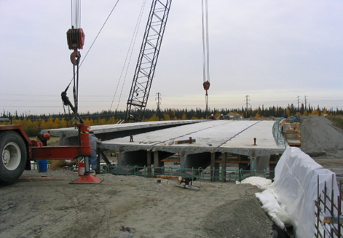
Fig. 4.1. A DBT concrete bridge being constructed

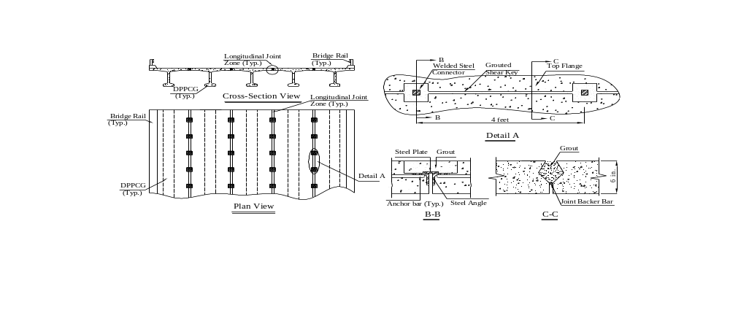
Fig. 4.2. A typical DBT bridge connected by longitudinal joints with welded steel connectors

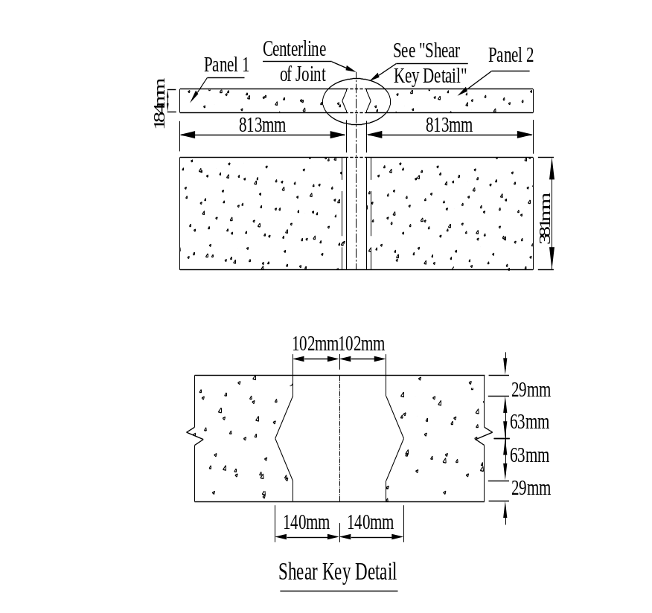
Fig. 4.3. Dimension of transverse joint specimen

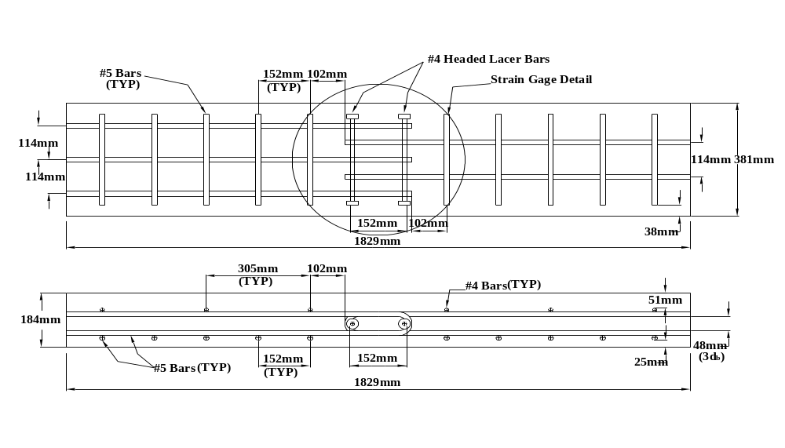
Fig. 4.4. Reinforcement layout in tension specimen
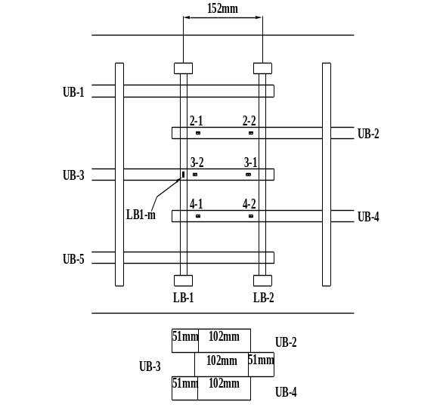
(a) Strain gage configuration for U-bars
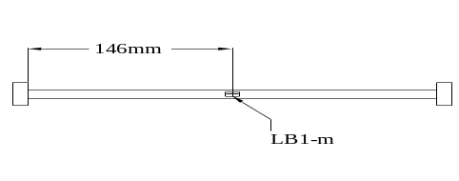
(b) Strain gage configuration for the lacer bar
Fig. 4.5. Strain gage configuration for tension specimen

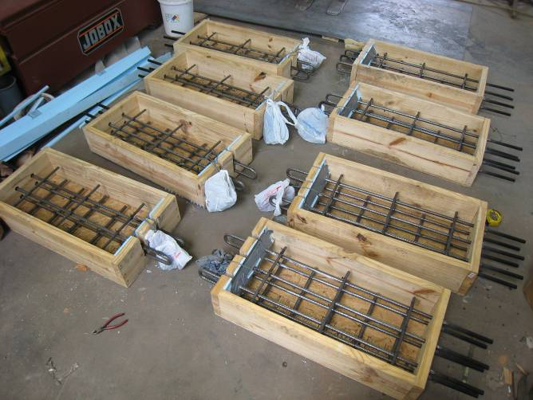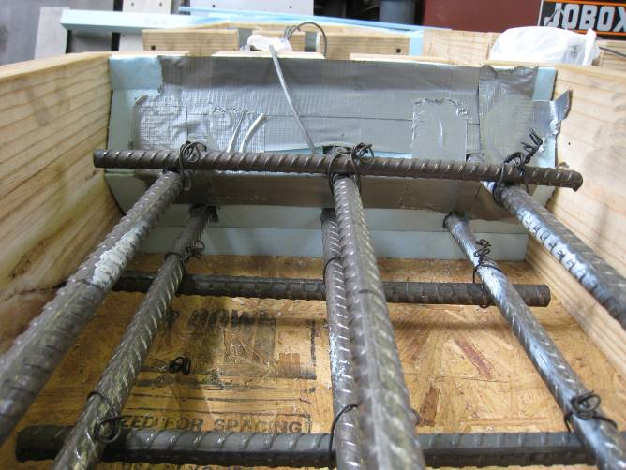
(a) Slotted wood form (b) Foam wedges
Fig.4.6. Panel fabrication

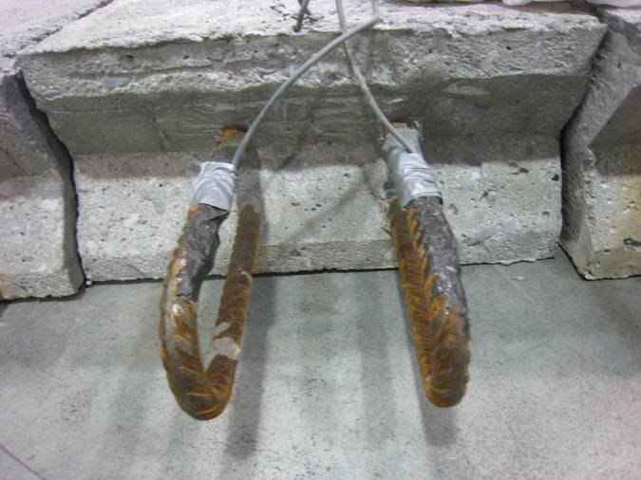
Fig.4.7. Profile of joint surface after sandblasting

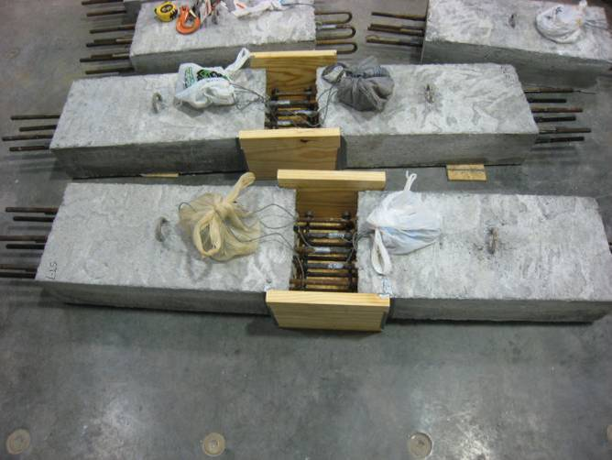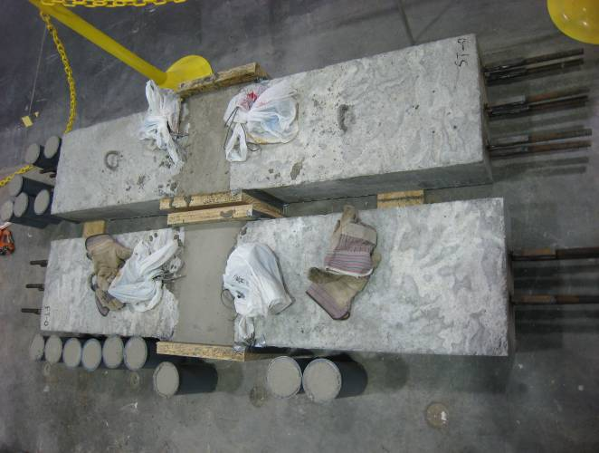
(a) Before grouting (b) After grouting
Fig.4.8. Tension test specimen
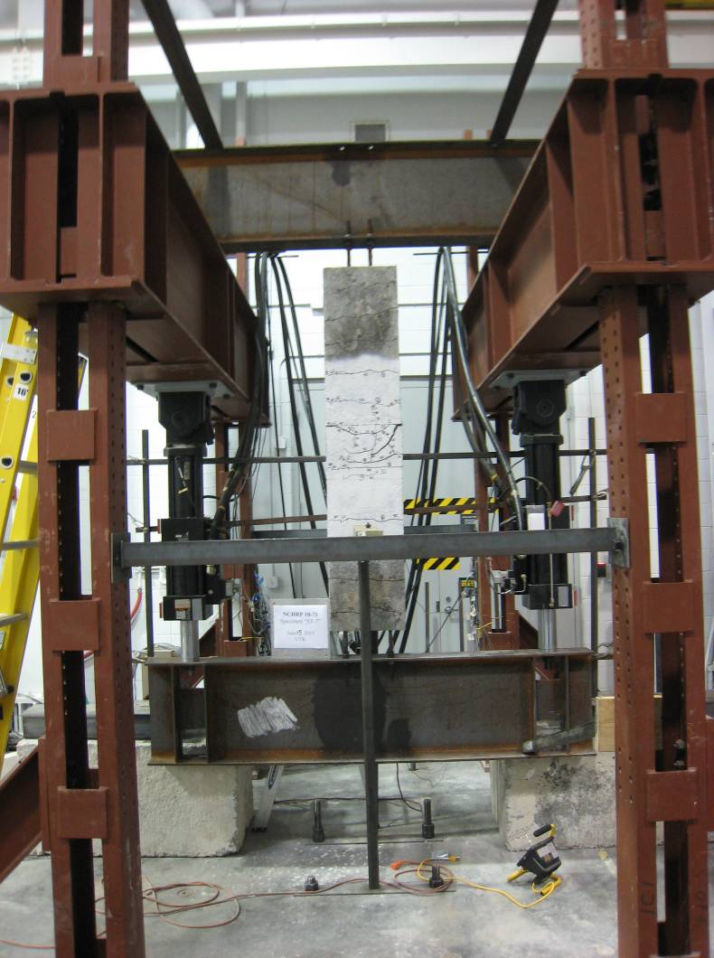
Fig.4.9. Tension test set-up

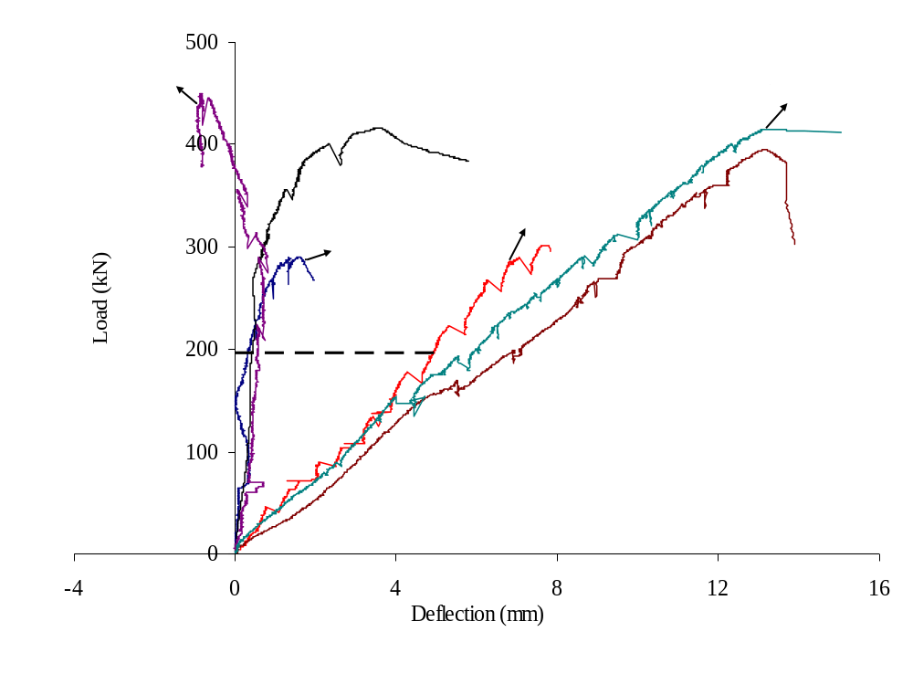
Fig.4.10. Load-deflection curve

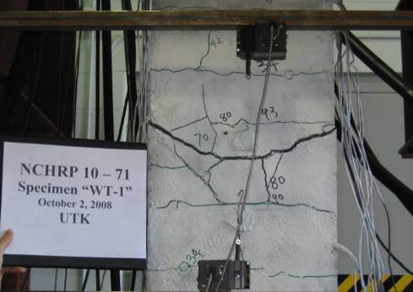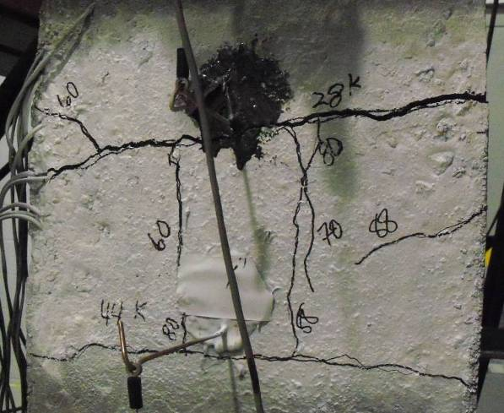
(a) WT-1 (b) WT-2
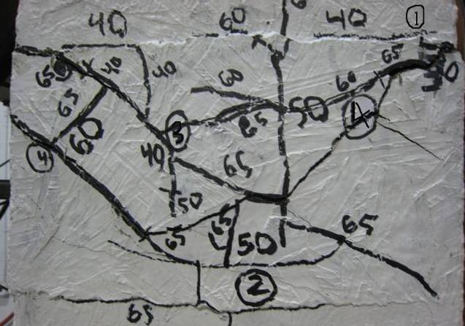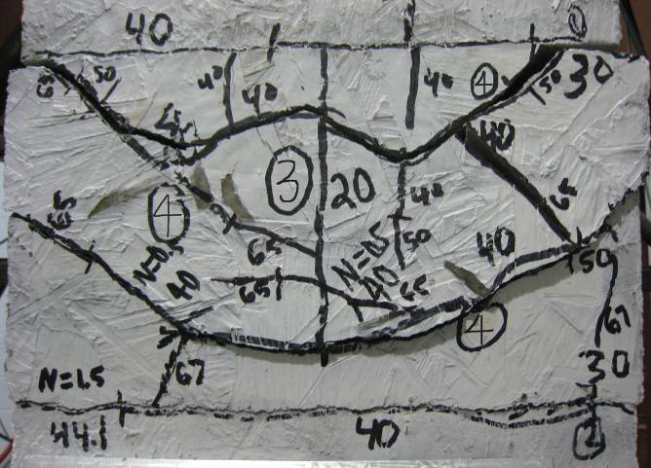
(c) ST-O (d) FT-O
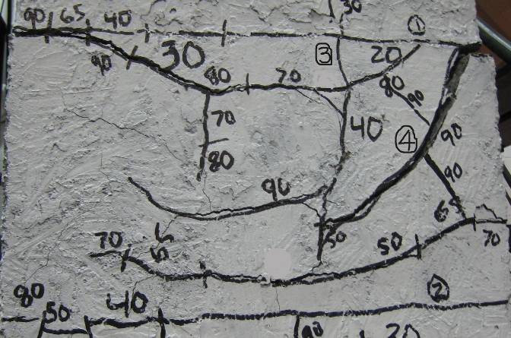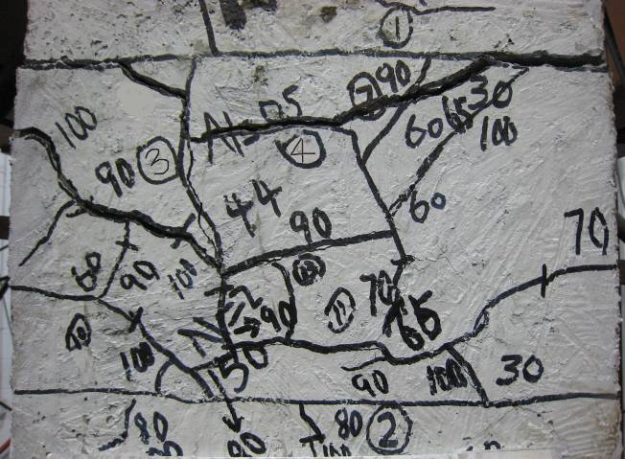
(e) ST-7 (f) FT-7
Fig.4.11. Cracks within the joint

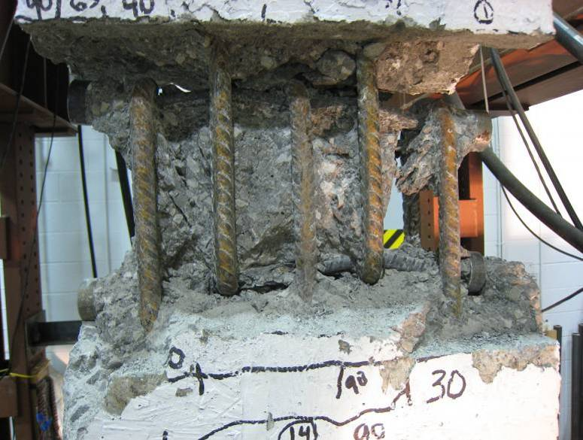
Fig.4.12. Deformation of lacer bar

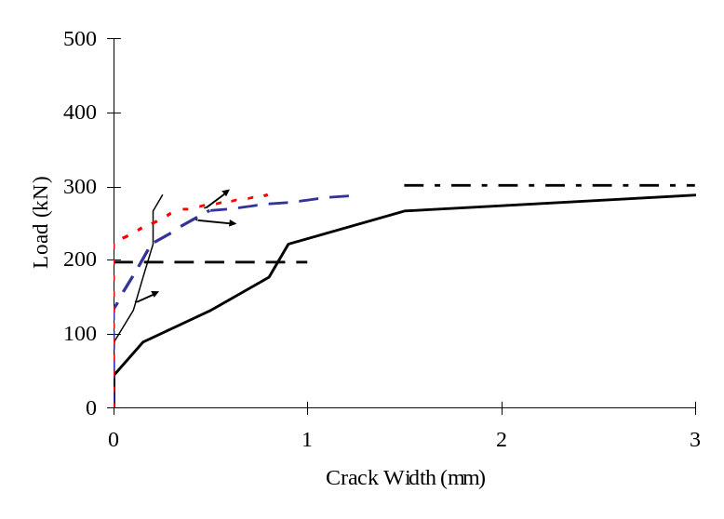
(a) ST-O
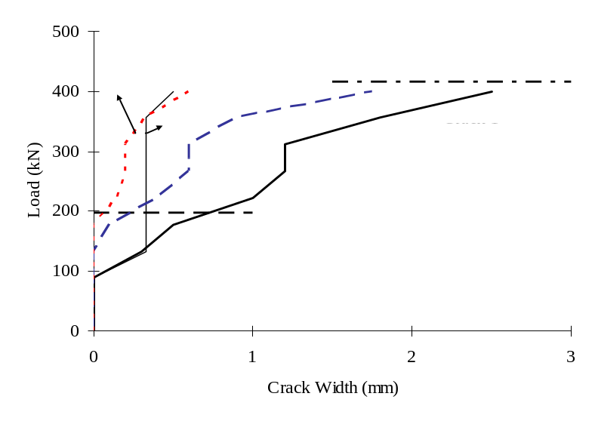
(b) ST-7
Fig.4.13. Load-crack width curves of static tension specimens

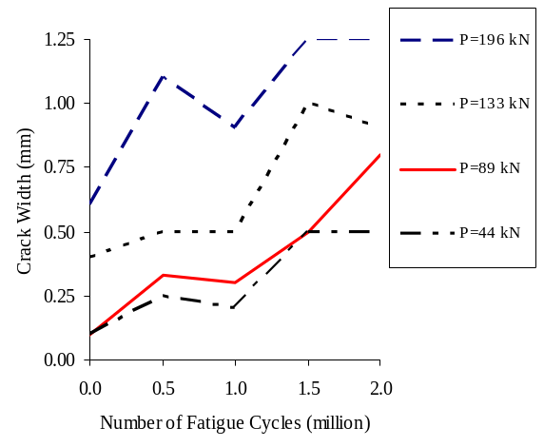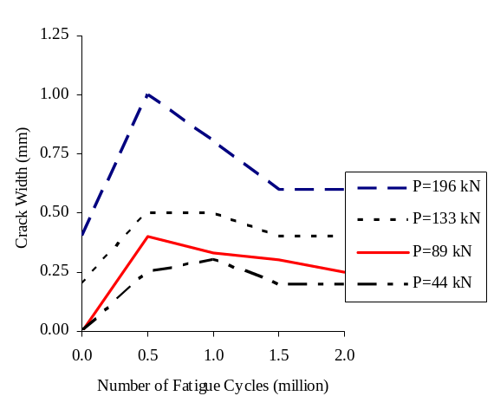
(a) FT-O (b) FT-7
Fig.4.14. CW-N curves of fatigue tension specimens

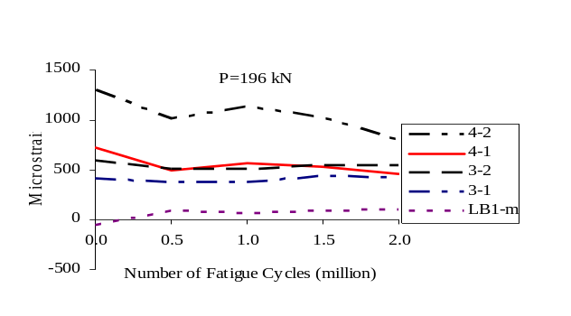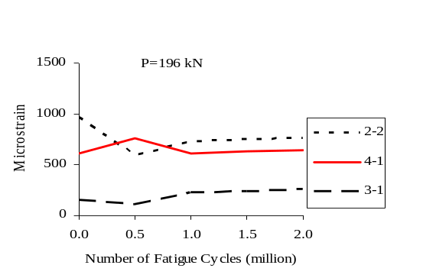
(a) FT-O (b) FT-7
Fig.4.15. MS-N curves of fatigue tension specimens
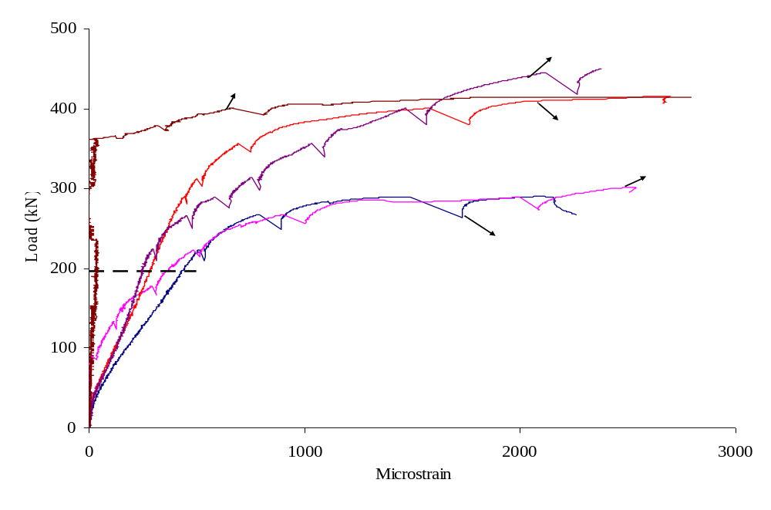
Fig.4.16. Load-microstrain curve

Chapter 5: Conclusions and Future Work
This chapter summarizes the accomplishments of this study along with conclusions and recommendations for the future research.
5.1 Conclusions
The longitudinal and transverse connection details between full-depth deck panels and decked bulb-T flanges including the durable closure pour materials for accelerated bridge construction were studied, and based on the material and structural experimental programs, the following conclusions were made:
- Set® 45 HW was selected for overnight cure and HPC Mix 1 for 7-day cure. The performance criteria for selecting durable CP (closure pour) materials were developed based on durability tests of selected candidate materials.
- For the longitudinal joints, the fatigue loading has little influence on the structure behavior including average curvature of the joint, deflection at midspan, relative displacement of the joint interface and joint center as well as reinforcement strain under service live load.
- Fatigue loading was observed to have an effect on the loading capacity of the flexure specimens using the overnight cure material. After 2 million cycles, the specimens fabricated with the overnight cure material had less load capacity than the corresponding specimens subjected to the static load tests. For the specimens with 7-day cure material in the joint, fatigue loading had negligible effect on the results for the flexure-shear tests. In the case of the flexure tests, the failure load was not reached due to limitations of the MTS test equipment.
- Longitudinal joints with the 7-day cure material performed better than those with the overnight cure material in some cases. Examples included the flexure-shear tests, SS (static shear) and FS (fatigue shear), where the joints with the 7-day cure material had larger failure loads and curvatures than those of the specimen with the overnight cure material. This was because the 7-day cure material used developed higher strengths than could be achieved with the overnight cure material in the tests.
- Based on these tests on the longitudinal joints, the U-bar detail performs better than the headed bar detail by Li et al. (2010) in loading capacity, curvature of the joint, deflection at midspan, crack development, and failure mode. The U-bar detail is a viable connection system for the longitudinal joint.
- For the transverse joints, the fatigue loading had no significant influence on tensile capacity and reinforcement strains.
- The fatigue loading was observed to have an effect on the deflection development of the tension specimens. The fatigue loading had some effect on the measured crack widths in the specimens with the overnight cure material. Under the same loading, the crack widths were observed to increase after the fatigue cycles.
- The tensile capacity of transverse joints with overnight cure material is lower than expected due to the lower strength of CP materials. It was found that attention needs be paid to the moisture loss during the first three hours after placement in order to develop the expected strength of 41.4 MPa (6.0 ksi) for overnight cure CP materials.
- Undesirable wider crack widths will be developed at service load levels in transverse joints designed with higher grades of steel (e.g., 517 MPa (75 ksi) compared to 414 MPa (60 ksi)) because smaller amounts of reinforcement can provide the required nominal strength. Under service loads, larger stresses would be expected in the smaller bars, which lead to wider cracks at service. It is recommended that 414 MPa (60 ksi) nominal yield strength be used in the design of transverse joints, or that stresses in the reinforcement are limited to 345 MPa (50 ksi) at service.
- Based on these tests and with the aforementioned caveats, the U-bar detail may be considered a viable connection system for transverse joints.
5.2 Future Work
The strut and tie model predicts the ultimate capacity of the longitudinal and transverse joint connections conservatively and should be studied as a design tool for the joints. Test results from different specimens in this dissertation can be used to calibrate and improve the strut and tie model.

References
AASHTO Designation: PP 34-99 (1998), “Standard Practice for Estimating the Cracking Tendency of Concrete,” American Association of State and Highway Transportation Officials, June 1998, pp199-202
AASHTO LRFD (2010). “Bridge Design Specifications.” Fifth Edition, American Association for State Highway and Transportation Officials, Washington, D.C.
American Concrete Institute. (2008). “Building Code Requirements for Structural Concrete and Commentary,” ACI Committee 318, Farmington Hills, Mich.
Chapman, C. E. (2010), “Behavior of Precast Bridge Deck Joints with Small Bend Diameter U-Bars,” MS Thesis, University of Tennessee, Knoxville.
Colorado DOT's 2005 Standard Specifications for Road and Bridge Construction, CDOT Specification Committee, Denver, Colorado.
Folliard, K., Barborak, R., Drimalas, T., Du, L., Garber, S., Ideker J., Ley, T., Williams, S., Juenger, M., Fournier, B., and Thomas, M.D.A. (2006), "Preventing ASR/DEF in New Concrete: Final Report,” Report No. FHWA/TX-06/0-4085-5, June.
Ghanem, H., Phelan, S., Senadheera, S., and Pruski, K. (2008), “Chloride Ion Transport in Bridge Deck Concrete Under Different Curing Durations”, ASCE Journal of Bridge Engineering, Vol. 13, No. 3, May 1, pp. 218-225
Glass, G.K. and Buenfeld, N.R. (1995), “Chloride threshold levels for corrosion induced deterioration of steel in concrete,” Chloride Penetration into Concrete, International RILEM Workshop, St. Remy-Les Chevreuse.
Goodspeed, C.H.; Vanikar, S.; and Cook, R.A. (1996), “High-Performance Concrete Defined for Highway Structures,” Concrete International, V. 18, No. 2, February, pp. 62-67.
Gordon, S. I., May, I. M. (2006), “Development of in Situ Joints for Pre-cast Bridge Deck Units,” Proceedings of the Institute of Civil Engineers: Bridge Engineering, 159 (1), 17-30.
Gulyas, R. J. and Champa, J. T. (1997), “Use of Composite Testing for Evaluation of Keyway Grout for Precast Prestresse Bridge Beams,” American Concrete Institute (ACI) Materials Journal, Technical Paper, V. 94, No. 3, May-June, pp. 244-250.
Gulyas, R. J., Wirthlin G. J. and Champa, J. T. (1995), “Evaluation of Keyway Grout Test Methods for Precast Concrete Bridges,” Precast/Prestressed Concrete Institute (PCI) Journal, V. 40, No. 1, January-February, pp. 44-57.
Issa, M. A., Cyro do V., Abdalla, H., Islam, M. S., and Issa, M. A. (2003), “Performance of Transverse Joint Grout Materials in Full-Depth Precast Concrete Bridge Deck Systems,” Precast/Prestressed Concrete Institute (PCI) Journal, V. 48, no. 4, July-August, pp. 92-103.
Lawler, J. S., Connolly, J. D., Krauss, P. D., Tracy, S. L., and Ankenman, B. E. (2007), “Guidelines for Concrete Mixtures Containing Supplementary Cementitious Materials to Enhance Durability of Bridge Decks,” NCHRP Project 18-08A Report 566, Transportation Research Board, Washington, DC.
Lewis, S. (2009), “Experimental Investigation of Precast Bridge Deck Joints with U-bar and Headed Bar Joint Details,” MS Thesis, University of Tennessee, Knoxville.
Li, L., Ma, Z., Griffey, M. E., and Oesterle, R. G. (2010), “Improved Longitudinal Joint Details in Decked Bulb Tees for Accelerated Bridge Construction: Concept Development,” ASCE Journal of Bridge Engineering, 15(3), 327-336.
Li, L., Ma, Z., and Oesterle, R. G. (2010), “Improved Longitudinal Joint Details in Decked Bulb Tees for Accelerated Bridge Construction: Fatigue Evaluation,” ASCE Journal of Bridge Engineering, 15(5), 511-522.
Martin, L.D., and Osborn, A.E.N. (1983), “Connections for Modular Precast Concrete Bridge Decks,” Report No. FHWA/RD-82/106, US DOT, Federal Highway Administration
Matsumoto, E., Waggoner, M. C., Sumen G., Kreger, M. E., and Breen, J. E. (2001), “Development of a Precast Bent Cap System,” University of Texas Austin, Project summary report 1748-S, March.
Ma, Z. et al (2007), “Field Test and 3D FE Modeling of Decked Bulb-Tee Bridges,” ASCE Journal of Bridge Engineering, 12(3), 306-314.
Menkulasi, F. and Roberts-Wollmann, C. L. (2005), “Behavior of Horizontal Shear Connections for Full-Depth Precast Concrete Bridge Decks on Prestressed I-Girders,” Precast/Prestressed Concrete Institute (PCI) Journal, V. 50, No. 3, May-June, pp. 60-73.
Mrinmay B. (1986), “Precast Bridge Deck Design System,” Prestressed/Precast Concrete Institute (PCI) Journal, V. 31, No. 2, March-April, pp. 40-86.
Nottingham, D. (1996), “Joints Grouting in Alaskan Bridges and Dock Decks,” Concrete International, V. 18, No. 2, February, pp.45-48
Russell, H. G., Miller, R. A., Ozyildirim, H. C., and Tadros, M. K. (2006), “Compilation and Evaluation of Results from HPC Bridge Projects, Volume 1: Final Report,” Report No. FHWA-HRT-05-056, Federal Highway Administration, October.
Russell, H. G. and Ozyildirim, H. C. (2006), “Revising high performance concrete classifications” Concrete International, August, pp.43-49.
Ryu, H. K., Chang, S. P., Kim, Y. J., Kim, B. S. (2005), “Crack control of a steel and concrete composite plate girder with prefabricated slabs under hogging moments,” Engineering Structures, 27(11), 1613-1624.
Scholz, D.P., Wallenfelsz, J. A., Lijeron, C., Roberts-Wollmann, C. L., and Davis, R. T. (2007), “Recommendations for the connection between full-depth precast bridge deck panel systems and precast I-beams”, Report No. FHWA/VTRC 07-CR17, June.
Stanton, J., and Mattock, A.H. (1986), “Load distribution and connection design for precast stemmed multibeam bridge superstructures,” NCHRP Rep. 287.
Tepke, D. G. and Tikalsky, P. J. (2007), “Best Engineering Practices Guide for Bridge Deck Durability Report” February 24.
Washington State Department of Transportation. (2005), Bridge Engineering Software: QConBridges. http://www.wsdot.wa.gov/eesc/bridge/software/index.cfm?fuseaction=software_detail&software_id=48.
Zhu, P. and Ma, Z. (2010a), “Selection of Durable Closure Pour Materials for Accelerated Bridge Construction,” ASCE Journal of Bridge Engineering, 15(6).

Vita

Peng Zhu was born in Xinxiang, Henan, China in November, 1981. He received a B.S. in Civil Engineering from Wuhan University of Technology, China in 2003 and a M.S. in Civil Engineering from Tongji University, China in 2006.
Peng is currently pursuing his doctorate in Civil Engineering at the University of
Tennessee, Knoxville.

