The Influence of Body Size on Sexual Dimorphism

A Thesis Presented for the

Master of Arts

Degree

The University of Tennessee, Knoxville

Haley Elizabeth Horbaly

December 2017

Copyright © 2017 by Haley Elizabeth Horbaly
All rights reserved.

DEDICATION

This thesis is dedicated to the individuals who have selflessly donated their bodies to science. I am beyond honored to work with you every day.

ACKNOWLEDGEMENTS

Thank you to my knowledgeable and supportive committee for helping me polish a rough idea into a rewarding start to my career. Thanks to my committee chair, Dr. Dawnie Steadman, for always asking the tough questions, reminding me to contextualize when I was taking too narrow a view, and for having the stamina to correct every “which” to “that.” To Drs. Benjamin Auerbach and Michael Kenyhercz: thank you for your guidance and patience as I worked to grasp two new languages in which both of you are so fluent—statistics, and R. Your valuable feedback and input on research design and analytical approaches truly made this research more thorough and meaningful.
Additional thanks go to Drs. Richard Jantz and Lee Meadows Jantz for helping me define and refine the metrics selected for this study. And to Dr. Mark Hubbe: there aren’t enough words in the world to convey what your boundless mentorship, energy, inspiration, and support mean to me. I wouldn’t be here without you.
To my dear friends, both near and far: thank you for the laughs, distractions, motivation, support, editing, commiseration, and celebration. This experience would not be nearly as exciting or rewarding without each of you in my life. Special thanks to those of you who read and gave feedback on early drafts or isolated chapters—I owe you!
And finally, huge thanks to my family, who support me unconditionally. Mom and Dad: from the time I was young, you both instilled in me amazing work ethic and values that have helped me reach this point, and will surely drive me farther. The completion of this thesis is as much a testament to your hard work as it is mine. Thank you so much for always being my sounding board and cheering section. Andrew, you inspire me every day through your fearless pursuit of your own dreams. The only thing more exciting than achieving my goals is watching you achieve yours. I’m infinitely proud to be your sister.

ABSTRACT

Accurate sex estimation of human skeletal remains is imperative for skeletal biologists, and relies upon the sexual dimorphism between males and females in a population. The degree of dimorphism, and hence the accuracy of sex estimation methods, are known to vary among populations, and while such global patterns have been well studied, the underlying causes of this variation are relatively unclear. Body size—a sexually dimorphic trait that also varies among populations—has previously been shown to affect skeletal morphology, yet whether specific body size parameters, such as stature and body mass, influence the expression of traits used for nonmetric sex estimation has not been previously tested.
To address this problem, this study tests three hypotheses: (1) variation in expression of sexually dimorphic traits will co-vary with body size, (2) stature will be a greater contributor to the sexual dimorphism of specific skeletal traits than body mass, and (3) sexual dimorphism will increase as stature increases.
Over 200 skeletons of varying body size were scored according to three widely-used sex estimation methods for the cranium, pelvis, and humerus. Existing and novel metrics provide more nuanced measures of dimorphism in the same skeletal regions. A suite of parametric and nonparametric statistical tests were conducted to determine the degree of covariation among the skeletal traits, method performance, and body size.
Results show significant correlations do exist between dimorphic traits and both body size parameters, with stature exhibiting stronger correlations than body mass. However, the effects of stature on individual traits become diluted when analyzing overall method performance, which remains unaffected by body size. The exception is the pelvic method, which exhibits high classification accuracy for the tallest and shortest individuals in the sample, with individuals around the mean at the highest risk of misclassification.
Despite the results of the pelvic method, overall there is little effect of body size on morphological sex estimation performance. However, body size does influence individual metric traits, with stature exerting more influence than body mass. This suggests that body size, particularly stature, has the potential to affect both intra- and interpopulational application of metric sex estimation methods.

TABLE OF CONTENTS

Chapter 1: Introduction 1
Chapter 2: Background 8
2.1 Sexual Dimorphism 8
2.2 Sexual Size Dimorphism (SSD) and Rensch’s Rule 11
2.3 Stature and Body Mass 17
2.4 Adult Skeletal Sex Estimation 20
2.4.1 Sex Estimation Using Morphological Features 23
2.4.2 Adult Skeletal Sex Estimation Using Skull Morphology 24
2.4.3 Adult Skeletal Sex Estimation Using Pelvic Morphology 25
2.4.4 Adult Skeletal Sex Estimation Using Distal Humerus Morphology 27
2.4.5 Metric Compliments to Morphological Sex Estimation 27
2.5 Hypotheses 31
Chapter 3: Materials and Methods 32
3.1 Materials 33
3.1.1 Random Sample Composition 33
3.1.2 Uniform Distribution Subsample Composition 34
3.2 Methods 34
3.2.1 Stature Analytical Methods 37
3.2.2 Body Mass Analytical Methods 41
Chapter 4: Results 43
4.1 Intraobserver Agreement 43
4.2 Random Sample Summary 44
4.3 Stature Results 53
4.5 Body Mass Results 69
4.6 Results Summary 73
Chapter 5: Discussion 75
5.1 Influence of Stature on Sexual Dimorphism 76
5.1.1 Hypothesis 1 76
5.1.2 Hypothesis 3 78
5.2 Influence of Body Mass on Sexual Dimorphism 83
5.2.1 Hypothesis 1 83
5.2.2 Hypothesis 2 84
5.3 Revisiting Rensch’s Rule 87
5.4 Additional Findings 92
5.5 Summary 94
5.6 Study Limitations 95
Chapter 6: Conclusion 97
References 100
Appendix 109
Metric definitions 110
A. Cranial metrics 110
B. Pubic metrics 111
C. Humeral metrics 114
D. Minimally dimorphic metrics 115
Vita 118

LIST OF TABLES

Table 1: Stature summary statistics (cm) 45
Table 2: Body mass summary statistics (lbs) 45
Table 3: Summary of female sexually dimorphic metrics 52
Table 4: Summary of male sexually dimorphic metrics 52
Table 5: Summary of female minimally dimorphic metrics 52
Table 6: Summary of male minimally dimorphic metrics 53
Table 7: Sex estimation method accuracy 54
Table 8: Female trait score frequency for Walker (2008) cranial traits 55
Table 9: Female trait score frequency for Klales et al. (2012) pelvic traits 55
Table 10: Female trait score frequencies for Rogers (1999) distal humerus traits 55
Table 11: Male trait score frequency for Walker (2008) cranial traits 55
Table 12: Male trait score frequencies for Klales et al. (2012) pelvic traits 55
Table 13: Male trait score frequencies for Rogers (1999) distal humerus traits 56
Table 14: Spearman correlation values of method accuracy vs. stature 56
Table 15: Spearman correlation values of method accuracy vs. uniform stature distribution 58
Table 16: Calibration results vs. Klales et al. (2012) values 60
Table 17: Klales et al. (2012) classification rates from calibrated formula 60
Table 18: Calibration results vs. Walker (2008) values 61
Table 19: Walker (2008) classification rates from calibrated formula 61
Table 20: Polyserial correlation values for morphological traits vs. stature 66
Table 21: Pearson correlation values for sexually dimorphic metrics vs. stature 68
Table 22: Pearson correlation values for minimally dimorphic metrics vs. stature 68
Table 23: Isometry analysis results for stature and sexually dimorphic metrics 69
Table 24: Isometry analysis results for stature and minimally dimorphic metrics 69
Table 25: Spearman correlation values of method accuracy vs. body mass 70
Table 26: Polyserial correlation values for morphological traits vs. body mass 70
Table 27: Pearson correlation values for sexually dimorphic metrics vs. body mass 72
Table 28: Pearson correlation values for minimally dimorphic metrics vs. body mass 72
Table 29: Isometry analysis results for body mass and sexually dimorphic metrics 72
Table 30: Isometry analysis results for body mass and minimally dimorphic metrics 73

LIST OF FIGURES

Figure 1: Histogram of pooled male and female stature 45
Figure 2: Binary logistic regression of estimated sex vs. pooled stature 46
Figure 3: Histogram of female stature 47
Figure 4: Q-Q plot for female stature 48
Figure 5: Histogram of male stature 48
Figure 6: Q-Q plot for male stature 49
Figure 7: Histogram of pooled body mass 49
Figure 8: Histogram of female body mass 50
Figure 9: Q-Q plot for female body mass 50
Figure 10: Histogram of male body mass 51
Figure 11: Q-Q plot for male body mass 51
Figure 12: Stature distribution of males (n = 30) misclassified by Klales et al. (2012) 57
Figure 13: Males misclassified by the Klales et al. (2012) method across a uniform stature distribution 58
Figure 14: Binary logistic regression of Klales et al. (2012) estimation vs. male stature 63
Figure 15: Binary logistic regression of Klales et al. (2012) estimation vs. female stature 63
Figure 16: Binary logistic regression of Walker (2008) estimation vs. female stature 64
Figure 17: Binary logistic regression of Walker (2008) estimation vs. male stature 64
Figure 18: Binary logistic regression of Rogers (1999) estimation vs. female stature 65
Figure 19: Binary logistic regression of Rogers (1999) estimation vs. male stature 65
Figure 20: Correlation between male stature and MP trait score 66
Figure 21: GP (i) and MP (ii) measurements 111
Figure 22: WPL measurement 112
Figure 23: MinPW (iv) and MinWPR (v) measurements 113
Figure 24: MinWBS measurement 113
Figure 25: MMaxHT (vii) and LMaxHT (viii) measurements 114
Figure 26: MinTC measurement 115
Figure 27: OBH (x), DKB (xi), and NLB (xii) measurements 116
Figure 28: FOL measurement 117
Figure 29: FMD measurement 117

Chapter 1: Introduction

Accurate sex estimation of human skeletal remains is imperative for skeletal biologists. In bioarchaeology and paleopathology, sex estimation is relied upon to determine the demographic composition of a sample and to understand patterns of disease; in forensic anthropology, accurate sex estimation can contribute to positive victim identification, or eliminate half of the missing persons pool to narrow the search for the unknown victim. Sex estimation is dually important because other aspects of the biological profile rely on sex to be determined first. For example, stature is estimated by entering post-cranial measurements into sex-based linear regression formulae with the assumption that sex influences the body proportions used to determine stature (Ousley 1995). The reverse—that body size might influence the expression of sexually dimorphic traits—has not been considered. The degree of sexual dimorphism is known to vary between populations, and while such global patterns have been well-studied, the underlying causes of this variation are relatively unclear. Body size has been previously shown to affect morphological trait expression used in age estimation (Merritt 2015), though no study has explored the effect, if any, on traits associated with sex estimation. This thesis aims to establish whether body size also influences expression of sexually dimorphic skeletal traits.
Sexual dimorphism has been researched from a variety of perspectives, but its importance for forensic anthropology has resulted in many studies that seek to establish new or improve upon existing biological profiling methods (Klales et al. 2012; Rogers 1999; Rogers 2006; Walker 2008). Though forensic method development is inherently more concerned with the discriminatory value of specific skeletal elements rather than the degree of dimorphism, this effort has nevertheless resulted in a well-established understanding of global patterns of sexual dimorphism (Frayer and Wolpoff 1985). However, the academic pursuit of new methods and validation studies has also revealed limitations for the application of forensic methods, such as the inability to accurately capture sexual dimorphism consistently in different populations.
For example, Vance et al. (2011) found limited success when applying a distal humeral sex estimation method developed on North American populations to black and white South Africans. Their study employed the Rogers (1999) method, which involves a morphological assessment of four characteristics of the distal humerus—trochlear symmetry, trochlear constriction, olecranon fossa shape and depth, and angle of the medial epicondyle. Vance et al. (2011) only achieved a 75.5% average accuracy with this method on a South African population, whereas Rogers (1999) achieved 94% accuracy for the North American population on which the method was developed. Vance et al. (2011) postulate that the anatomical region of the distal humerus may truly be less sexually dimorphic, or alternatively, simply less consistent in the South African population due to other factors such as “general body build,” alluding to potential implications of body size on forensic traits. A similar instance of reduced method accuracy was echoed by Kruger et al. (2015) in a study that concluded that the Walker (2008) cranial morphological traits do not perform as well on South African populations. A high frequency of indeterminate trait rankings were observed, which Kruger et al. (2015) explained was an indication of less cranial sexual dimorphism in South Africans than in North Americans. Furthermore, a study analyzing metric data from South African whites and South African blacks show that the former tend to exhibit greater cranial sexual dimorphism than the latter (L'Abbe et al. 2013; Ousley and L'Abbe 2010). Such variation in degree of sexual dimorphism both within and among populations largely contributes to the reduced success rate observed when applying forensic sex estimation methods to a population other than the one on which the method was developed. The fluctuating accuracy of biological profile methods is problematic, and understanding what factors may contribute to this issue is essential toward improving demographic profile methods.
Sexual dimorphism can also manifest as a disparity in overall body size between the sexes, a phenomenon called sexual size dimorphism, or SSD (Fairbairn 1997). SSD is defined as the difference in height between males and females in a population (Gustafsson and Lindenfors 2004), and has primarily been studied from an evolutionary perspective (Fairbairn 1997; Herczeg et al. 2010; Stephens and Wiens 2009; Szekely et al. 2004)(See Section 2.2 for more discussion of the study of SSD). However, SSD is largely neglected by the forensic literature. In forensic analysis, stature is often assessed as part of the biological profile. Current stature estimation standards inherently assume that an individual’s sex dictates height, and skeletal measurements are input into sex-based linear regression formulae to produce a final stature estimate (Ousley 1995). While the assumption is not unfounded—adult males are on average 15% heavier and 9% taller than adult females (Stulp and Barrett 2014)—there has been no research into whether an individual’s body size influences the expression of traits used to estimate sex. Should such a relationship exist, it may reverse current assumptions inherent in demographic methods. Furthermore, body mass is typically not a demographic parameter assessed in forensic analysis though methods for estimating weight from the skeleton do exist (Auerbach and Ruff 2004; Moore and Schaefer 2011; Ruff 2000a; Ruff 2000b). Should this study find that body mass contributes to expression of sexually dimorphic traits, it could encourage the inclusion of body mass estimation in a demographic analysis.
A recent study (Merritt 2015) was the first to determine that body size affected the morphological features used in age estimation, another facet of the forensic biological profile. To estimate body size, Merritt (2015) used stature, body mass, and body mass index, which is defined as an individual’s weight (kg) divided by their stature (m²). She conducted four morphological age estimation methods on over 700 skeletons that ranged in body size. The results showed that lightweight and short individuals experience a reduced rate of skeletal aging, thus putting them at risk of being under-aged by osteological methods; likewise, their heavy/tall counterparts tend to experience an increased rate of skeletal aging, meaning obese individuals are at risk of being over-aged. She cited multiple explanations for what may cause differential skeletal morphologies between individuals of varying height and weight, including bone remodeling rates (which are slower in lightweight individuals than overweight individuals), occupation or activity level, and/or hormone levels—all factors that can affect body mass and skeletal development.
Sexual dimorphism and body size have also been studied from the perspective of secular change. Using the Klales et al. (2012) pubic method to estimate sex on both historic and modern skeletal samples, Klales (2016) compared the resulting trait score distributions from the three pubic traits most commonly used for sex assessment: the subpubic contour, the medial aspect of the ischiopubic ramus, and the ventral arc . She noted a reduction in trait scores in modern females compared to historic females, indicating a gracilization of the female pubic bone over time. Male innominates showed no significant change in trait scores, but rather retained comparable levels of robusticity in both samples. The increasingly gracile appearance in females and maintenance of robusticity in males reveals that, with respect to morphological trait expression, secular change has not impacted the sexes equally. With secular change in trait expression contributing to greater disparity between the sexes, there is an increased accuracy in sex assessment for modern populations (Klales 2016).
In addition to the identification of increasing sexual dimorphism over time, secular change studies have also separately established that humans have become taller (Hermanussen et al. 2009; Jantz et al. 2008; Maat 2005; Staub et al. 2011). On average, most European populations have experienced a 15-19 cm increase in final adult height in the past 150 years (Hermanussen et al. 2009). This trend has also been validated with measurements on living populations (Meredith 1976). Taken together, the concomitant patterns of increasing stature and sexual dimorphism lead to new questions about the potential relationship between these trends. With height and skeletal sexual dimorphism increasing alongside one another over time, this thesis seeks to explore whether a covariation between these features have a detectable impact on current forensic sex estimation methods that are indiscriminately applied to individuals of varying stature.
While there are significant bodies of literature on patterns of human body size variation and sexual dimorphism among populations and across time, relatively few studies investigate the relationship between these phenomena within a forensic framework. Merritt (2015)’s study was the first to illustrate the effects of body size dimensions on morphological traits explicitly used in forensic and paleoanthropological applications, and her findings incite new questions about how other components of current demographic methods may be involved. The purpose of this study will be to lay similar groundwork by considering sexual dimorphism in conjunction with body size through both a morphological and metric analysis of the expression of sexually dimorphic traits. Stature and weight will be considered separately to allow a definitive statement to be made regarding each component’s contribution to expression of skeletal traits and sex estimation method performance.
The three hypotheses for this study are successive, with each part being contingent upon the previous:
(1) Variation in expression of sexually dimorphic traits will co-vary with body size,
(2) If Hypothesis 1 holds true, stature will be a greater contributor to the sexual dimorphism of specific skeletal traits than weight, and
(3) If Hypotheses 1 and 2 hold true, stature and sexual dimorphism do co-vary, and sexual dimorphism will increase as stature increases.
The emphasis on stature is based on the height-based definitions of SSD that are commonly used in the human variation literature (Gustafsson and Lindenfors 2004) and the evidence that humans exhibit a well-documented secular pattern of increasing stature over time (Hermanussen et al. 2009; Jantz et al. 2008; Maat 2005; Staub et al. 2011) alongside increased dimorphism in pubic traits (Klales 2016). To address the hypotheses, this thesis tests three widely-used morphological sex estimation methods on a sample of North American individuals representing a range in stature. Each method is applied to a different skeletal region: the skull (Walker 2008), the pubic bone of the os coxa (Klales et al. 2012), and the distal humerus (Rogers 1999). The performance of each method, as well as the distribution of associated ordinal or binary trait scores, will establish whether sexual dimorphism is expressed differentially across a stature spectrum. Additionally, metrics that correspond to the same skeletal regions will be recorded in attempts to identify any covariation between body size and sexual dimorphism that may be too minute for forensic sex estimation methods to detect. For the hypotheses to be supported, stature and sexual dimorphism, as measured by morphological and metric trait assessment, will be positively correlated. Should body mass also be correlated, the strength of the correlations should be weaker than those observed with stature in order to support the primary hypothesis. The second hypothesis will be supported if forensic sex estimation methods have higher classification accuracies for individuals of taller stature.
By testing for covariation between expression of dimorphic traits and body size, this thesis will address a gap in the literature that exists at the intersection of human variation and forensic application, and contribute to a greater understanding of variation in human skeletal sexual dimorphism. Furthermore, it has the potential to explain some of the current discrepancies in sex estimation accuracy between populations which may lead to future refinement of forensic and paleodemographic biological profile methods, and help anthropologists make more informed decisions regarding method application.

Chapter 2: Background

Anatomical differences between males and females are evident in soft tissue regions, but forensic and archaeological contexts often leave the anthropologist with partially or fully skeletonized remains with which to conduct analysis. Sex estimation is typically the primary step in creating the biological profile which also involves assessing age, stature, ancestry, pathology, and trauma. The biological profile then becomes the main tool for the forensic anthropologist to gain individualizing information on an unidentified skeleton, and for the bioarchaeologist or paleopathologist to understand social, cultural, or biological trends in past populations. Because sex is an integral part of the biological profile, method accuracy is imperative and relies on the well-established patterns of sexual dimorphism in male and female skeletons.

2.1 Sexual Dimorphism
Sexual dimorphism is defined as the difference in morphological features between adult males and females in a species (Fairbairn 1997; Leonard and Robertson 1994), and is one of the most conspicuous sources of biological variation. Much of a species’ sexual dimorphism can be attributed to obvious functional differences between the sexes, such as their reproductive roles. The uniquely female ability to give birth is associated with necessary skeletal morphology allowing for this function. Males and females in most species also exhibit differing degrees of parental investment, mating frequencies, and rates of reproductive success. These biological and behavioral disparities between the roles of each sex can manifest morphologically as structures that aid in sexual display or combat in males (Fairbairn 1997; Gould 1966; Stephens and Wiens 2009; Szekely et al. 2004) or features that aid in reproductive success for females (Herczeg et al. 2010; Prenter et al. 1999; Stephens and Wiens 2009), all of which are examples are sexual dimorphism.
Sexual dimorphism in primates has been studied from a variety of perspectives: geometric morphometric quantification of dimorphism in extant and extinct species, typology of discrete traits for forensic anthropology and paleodemography (Rosas and Bastir 2002), and establishing more general trends of sexual dimorphism that are identified throughout the human lineage (Frayer and Wolpoff 1985; Plavcan 2003; Plavcan 2012). Early Pleistocene hominids exhibit high levels of dental and cranial dimorphism, and diverged in their overall skeletal dimensions more than any later hominids. Middle and Upper Pleistocene, as well as early Homo groups, display sexual dimorphism intermediate to that of Australopithecines and extant groups (Wolpoff 1980). Overarching trends in the hominin line show a decrease in sexual dimorphism over time from the European Upper Paleolithic groups to later descendants (Plavcan 2012), a trend that is argued to be as drastic as the increase in hominin brain size (Frayer and Wolpoff 1985).
Despite a reduction in sexual dimorphism relative to the Early Pleistocene hominids and even some extant primates, modern humans retain enough sexual dimorphism to be useful in anthropological contexts. As was previously mentioned, sexual dimorphism in humans is most evident in soft tissues that are differentially distributed on the body. Males have more muscle fiber, females store more subcutaneous fat, and primary sex characteristics between the sexes differ (Frayer and Wolpoff 1985; Wells 2007). Sex-specific differentiation of most of these features is absent in subadults, indicating that the initiation of hormonal changes at puberty is largely responsible for the dimorphism (Wells 2007). Females begin puberty at a younger age and follow a quicker progression than males, who experience a later, extended growth period (Ruff 2007; Wells 2007). Though sex hormones responsible for pubertal transition are found in both males and females, estrogen naturally occurs in higher levels in females, and testosterone in males.
Estrogen and testosterone facilitate different rates and trajectories of skeletal growth for males and females. They dictate the maintenance of skeletal muscle mass and bone health, deposition, and resorption, and ultimately influence body size differences between the sexes. At birth, male and female bone mineral mass and body length are comparable, with neonate males being only 1% longer than females (Rodriguez et al. 2005; Wells 2007). Over time, high levels of estrogen in females work to conserve bone mass and turnover rates, and the testosterone in males inhibits bone resorption. These contrasting hormone functions result in heavier bones and larger ultimate adult skeletal size for males (Wells 2007).
That female bones tend to be smaller and lighter is a pattern that also holds true for specific skeletal morphologies. To illustrate, if a collection of 100 skeletal elements were seriated from smallest and most gracile to largest and most robust, individuals on the smaller extreme are most likely to be female, with the latter extreme representing males (White et al. 2012). Though the range of expression is a continuum and there can be normal variation producing gracile males and robust females, forensic sex estimation methods are designed to discriminate between the relative robusticity of the sexes, often using a suite of traits from regions identified as being most diagnostic of sex, such as the cranium and pelvis. A more thorough discussion of sex estimation methodology is offered in section 2.4.

2.2 Sexual Size Dimorphism (SSD) and Rensch’s Rule
In addition to differential hormones, coloration, or reproductive roles (all examples of sexual dimorphism), most males and females in a species exhibit a disparity in overall body size called sexual size dimorphism, which can vary in degree of expression (Fairbairn 1997). In a study of arthropod and avian taxa, Rensch (1950) identified a correlation between body size and sexual dimorphism, a relationship that has since been proven true for much of the animal kingdom. This typically presents as a positive correlation for most species, meaning higher degrees of dimorphism typically co-occurs with an increase in body size (Frayer and Wolpoff 1985). Species can also vary in whether SSD is male-biased (males are the larger sex) or female-biased (females are the larger sex). Historically, it has been noted that invertebrates and ectothermic vertebrates such as spiders, fish, and frogs, tend to exhibit female-biased SSD, whereas endothermic species, like primates and other mammals, tend to display male-biased SSD (Andersson 1994; Fairbairn 1997; Head 1995; Herczeg et al. 2010; Prenter et al. 1999). Building on his earlier observations, Rensch (1960) hypothesized that the degree of sexual size dimorphism is dependent upon this male or female bias. Rensch’s rule states that in species with male-biased SSD, dimorphism will be more pronounced, whereas in female-biased species, the dimorphism will be less pronounced (Rensch 1960). Patterns of Renschian allometry have been widely observed in most taxa, offering much support for this biological rule (Abouheif and Fairbairn 1997; Colwell 2000; Cullum 1998; Fairbairn 1997; Herczeg et al. 2010; Stephens and Wiens 2009; Szekely et al. 2004).
Since the development of Rensch’s rule, multiple hypotheses have been introduced to explain the evolution of SSD patterns. Three of the most prominent hypotheses are selection for male body size (Fairbairn 1997; Stephens and Wiens 2009; Szekely et al. 2004), female fecundity selection (Herczeg et al. 2010; Prenter et al. 1999; Stephens and Wiens 2009), and ecological niche selection (Fairbairn 1997; Shine 1989; Stephens and Wiens 2009; Szekely et al. 2004). Sexual selection is the most common explanation for SSD, because in species where male-male competition is required to attract potential mates, large male body size tends to be favored for a number of reasons (Berry and Shine 1980). Primarily, larger-bodied males will fare better in combat situations with others, and their large size will deter smaller males from engaging, acting as a proactive deterrent (Setchell and Wickings 2005). In these instances, body size is working to increase access to females and ensure high reproductive success, and selection for this trait results in male-biased SSD. In species where access to females is not associated with male-male physical contact but rather displays of agility that cannot be easily achieved by a large-bodied individual, sexual selection will favor reduced male body size, resulting in female-biased SSD, (Szekely et al. 2004).
For some species, selection on female fecundity, rather than sexual selection, results in SSD (Hughes and Hughes 1986; Williams 1966). Fecundity selection typically yields female-biased SSD, as maximizing fecundity traits favors an increase in female body size. Larger females have a greater potential for increasing their reproductive fitness, either by producing larger offspring, a greater number of offspring per reproductive event, or reproducing more frequently than smaller females (Stephens and Wiens 2009). Previous studies have identified the presence of fecundity selection in certain species by showing a positive correlation between maximization of clutch size and female body size, and by illustrating the resulting fitness advantage for larger-bodied females (Marshall and Gittleman 1994).
Ecological niche selection has also been proposed as a potential evolutionary cause of the SSD patterns exhibited by Rensch’s rule (Fairbairn 1997; Stephens and Wiens 2009). The importance of ecological niche divergence was established by Gause (1934) in his early identification of the competitive exclusion principle, which posits that species that are too similar will be in direct competition with one another due to attempts to occupy the same ecological niche (Gause 1934; Hardin 1960). An evolutionary solution to this niche competition is differentiation of body size between species, resulting in differing exploitation of resources and allowing for coexistence (Wilson 1975). The trophic dimorphism hypothesis for Rensch’s rule applies Gause’s competitive exclusion principle on an intraspecific level, and suggests that sexual dimorphism is a direct result of intraspecific competition reduction through selection for size differences between the sexes, rather than selection for reproductive features (Longland 1989; Fairbairn 1997; but see Brana 1996; Clutton-Brock et al. 1997).
This hypothesis of selection for different ecological niches is often overlooked in favor of the sexual selection model, typically because explanations invoking sexual selection seem more parsimonious (Shine 1989). But trophic dimorphism is not unfounded; there are many species that exhibit sexual dimorphism and also show significant ecological differences between the sexes (Clutton-Brock et al. 1982; Schoener 1967; Selander 1966). However trophic dimorphism does not seem to account for all instances of the evolution of SSD, since there are some taxa that exhibit high SSD but have no ecological disparity (Carothers 1984; Crook 1972). Because of this, it seems that ecological niche divergence may have contributed to SSD in some species, but that it most likely arose as a product of pre-existing sexual dimorphism arising as a result of sexual selection (Fairbairn 1997; Shine 1989; Stephens and Wiens 2009). This view is driven by the inability of the trophic dimorphism hypothesis to also account for the evolution of differences in male and female reproductive features.
Sexual size dimorphism in extant primates has been well-studied due to the vast variation exhibited by different primate species (Jungers 1985). Most exhibit positive allometry between body size and SSD, however the relationship between these two traits are weak to nonexistent for prosimians and platyrrhines (Smith and Cheverud 2002). A study by Leutenegger (1978) illustrates the variation in degree of SSD among species of polygynous and monogamous primates, and attributes the degree of SSD to differences in sexual selection for each mating system. He collected data from 42 polygynous species and 11 monogamous species, with eight males and eight females representing each species. Size dimorphism was assessed by body weight. Leutenegger (1978) found that in his pooled sample of all 53 species, SSD increases exponentially as body weight increases (positive allometry). However, when species were analyzed separately by breeding system, the results showed that males and females of polygynous species experience positive allometry, while males and females of monogamous species scale isometrically. This differential SSD patterning reflects the imbalanced sex ratios and increased male competition present in polygynous mating systems, resulting in larger males and greater body size disparity between the sexes (Clutton-Brock and Harvey 1977; Leutenegger 1978). Monogamous species experience reduced mating competition, and therefore smaller overall body size and reduced SSD. These findings illustrate a primate model where overall body size for a species and degree of dimorphism between the sexes appears to be linked, and indicate the vast range of SSD different populations can exhibit.
In addition to discovering differential scaling patterns of SSD between species, Leutenegger’s (1978) study found that an increased degree of SSD was positively correlated with increased sexual dimorphism in morphological traits, such as canine tooth size. This was reinforced by Plavcan (2003) in a study which assessed the scaling relationships between craniofacial and body mass dimorphism, and found the magnitude of craniofacial sexual dimorphism is proportional to the magnitude of body mass dimorphism (Plavcan 2003). The finding of morphological correlation with SSD gives support to the present study, which predicts the same correlation for human skeletal morphologies.
Research has shown that Renschian patterns of SSD are supported in humans (Abouheif and Fairbairn 1997; Colwell 2000; Cullum 1998; Fairbairn 1997; but see Gustafsson and Lindenfors 2004). On average, human males are about 15% heavier and 9% taller than females, and though every human group exhibits male-biased SSD (Eveleth 1975), the ratio is variable across populations (Stulp and Barrett 2014). The theoretical basis of the current study is an intraspecific derivative of Rensch’s rule given the proven interspecific variation in SSD. Whereas Rensch’s rule attributes the degree of SSD to the direction of bias, this study predicts that the degree of sexual dimorphism of morphological skeletal traits within a population is associated with body size; in other words, could “small-bodied” populations have lesser degrees of morphological trait dimorphism (and subsequently prove harder to estimate sex) than “large-bodied” populations? Frayer and Wolpoff (1985) extrapolate such a conclusion from the aforementioned study by Leutenegger (1978). They posit that due to the positive correlation between body size and sexual dimorphism, there will logically be a reduction in sexual dimorphism alongside selection for reduced body size. Their study cites populations in North America, Mexico, Europe, India, China, and Southeast Asia which appear to support this model of small body size and low sexual dimorphism (Brace and Ryan 1980; Bridges 1985; Frayer 1981; Kennedy 1984; Nickens 1976).
While an interpopulational analysis is outside the scope of this study, the present aim is to establish whether predictable patterning between body size and expression of sexually dimorphic traits exists. The relationship between body size and sexual dimorphism in humans has been studied from a variety of perspectives, such as the association between SSD and body size (Smith and Cheverud 2002) and sexual dimorphism of obstetric dimensions (Kurki 2006; 2011; Tague 2005), but the potential bias that body size might exert on skeletal morphologies used to estimate sex has not been considered. The covariation between body size and sex estimation from morphological skeletal traits is investigated to directly test for a relationship. Should such a relationship be found, this study could imply that populations of varying body size might also exhibit differential expression of sexually dimorphic traits.

2.3 Stature and Body Mass
Before a relationship between body size and skeletal dimorphism can be explored, certain variables included in this study need to be addressed. Most studies recognize human SSD as the ratio of male height to female height (Eveleth 1975; Frayer and Wolpoff 1985; Gray and Wolfe 1980; Gustafsson and Lindenfors 2004; Stulp and Barrett 2014). This is largely due to the high heritability of stature, and the fact that skeletal growth (height) is more tightly canalized than storage of fat, a trait that can fluctuate significantly over the course of an individual’s lifetime (Bogin 1999; Gray and Wolfe 1980; Stulp and Barrett 2014). Indeed, stature is an important body size dimension to consider, as it tends to be influenced by environmental differences, nutrition, genetics, and climate. For example, impaired nutrition can hinder an individual’s ability to reach their full genetic growth potential, and if reduced nutrition affects an entire population, overall SSD between males and females tends to be reduced as well (Gray and Wolfe 1980). Because stature is related to sexual dimorphism (as SSD), determining whether there is also a relationship between morphological skeletal traits and stature will begin to provide insight as to why sex estimation methods perform differently on different populations. If there is a link between traits and stature, and stature is known to have a relationship with the aforementioned environmental differences, nutrition, and genetics, it could spark future questions regarding the biological differences inherent in a population that may lead to varying levels in both SSD and morphological dimorphism.
However, body mass has been previously proven to be a contributing factor to morphological skeletal change in humans (Agostini and Ross 2011; Merritt 2015; Ruff 2005; Ruff 2008; Ruff et al. 2006), and understanding these effects is extremely important given modern rates of overweight and obese individuals. Obesity, especially in America, is a growing problem that has serious health implications, as well as the ability to affect biological functions such as bone growth and development. The National Center for Health Statistics data on obesity prevalence in the United States reports that 36% of the nation’s adults were obese in 2011-2014 (Ogden et al. 2015). Due to the inevitability that the current living population in the United States will eventually contribute to the deceased population, this rapidly changing health demographic should be well-understood by anthropologists in the event that it may change our biological profile standards. Obesity has been linked to many health issues, such as osteoarthritis (OA) of the knee, hip, and hand, diffuse idiopathic skeletal hyperostosis (DISH) of the spine, and osteoporosis, all of which directly affect bone morphology and quality (Anandacoomarasamy et al. 2007).
Merritt (2015) explored the relationship between body size and the morphology associated with age estimation. Results suggest that body mass can affect bone morphology enough to hinder accurate estimation of age, with obese individuals exhibiting older looking bone than individuals of a healthy body mass. A study by Agostini and Ross (2011) tested the skeletal effects of body mass from a biomechanical perspective by analyzing the femora of 121 individuals, 57 of whom were of normal body mass and 64 overweight. Cross-sectional geometry of the femoral shafts was approximated using anteroposterior (AP) and mediolateral (ML) measurements. After controlling for height, results showed that the ML femoral dimension displayed significant lengthening due to the increased biomechanical strain and altered stress distribution on the bones of an individual carrying extra body mass (Agostini and Ross 2011). Under such conditions of sustained stress, bone cells resorb and deposit in a synchronized fashion, changing the bone morphology so that the skeleton can carry the weight most efficiently (Agostini and Ross 2011; Ruff et al. 2006). That body mass can affect bone morphology has been also been established by Ruff (2005, 2008) who showed that pregnant women display increased ML dimensions, likely as a response to additional body mass and subsequent altered gait during pregnancy, and the associated change in biomechanical pressures on the skeleton.
The work conducted by Ruff (2005, 2008), Agostini and Ross (2011), and Merritt (2015) show that body mass can affect bone morphology. However, it has been established that most of the body mass-induced morphological changes in bone are related to cross-sectional geometric properties, pathological responses, or changes in bone quality such as bone mineral density (Moore 2008; Reeves 2014). For example, Moore (2008) found that light and/or underweight individuals exhibited low levels of bone density and no hypertrophic bone changes. Alternatively, heavy and/or obese individuals displayed increased bone density and high rates of diffuse idiopathic skeletal hyperostosis (DISH) and osteoarthritis. Reeves (2014) conducted complimentary research that revealed obese individuals had larger long bone cross-sectional geometric dimensions than did individuals of normal weight; long bones that fulfill load-bearing functions in the skeleton displayed the greatest increases in cross-sectional measurements (Reeves 2014). The findings presented by Moore (2008) and Reeves (2014) largely parallel those of Ruff (2005, 2008), Agostini and Ross (2011), and Merritt (2015), and indicate that body-mass related differences in the skeleton are most likely going to manifest as bone quality changes, or changes to the morphology of weight bearing bones or joints. Considering the present study’s focus on non-weight-bearing regions, it is logical to predict there will be a limited relationship between body mass and the skeletal traits analyzed here. However, while a relationship is not expected, it is still important to understand the relative contributions to morphological variation from both body size parameters, and therefore this study will include body mass as a variable in order to assess if/how it affects specific morphological traits used to estimate sex.

2.4 Adult Skeletal Sex Estimation
It is imperative to understand the factors that may influence skeletal sex estimation given the influence of sex estimation on other components of the biological profile. For example, age estimation employs methods that distinguish between male and female patterns of growth and deterioration (Brooks and Suchey 1990; Hartnett 2010). Brooks and Suchey (1990) observed that females exhibit more dorsal changes in the pubis than males, a phenomenon they suspect may be the result of pregnancy. Similarly, around early to middle adulthood (Phase 3), males may exhibit an “epiphyseal line” at the formation site of the ventral rampart (Brooks and Suchey 1990). Accurate sex estimation provides the anthropologist with the proper context for interpretation of age, stature, and ancestry, placing additional importance on the development and proper use of sex estimation methods that adequately capture skeletal sexual dimorphism.
Sex estimation from the skeleton relies on the presence of sexual dimorphism, the size- and shape-based skeletal differences induced by the timing and duration of growth and hormone activation in puberty. Due to the commencement of these changes at puberty, juveniles who have not yet reached adolescence will not display dimorphic skeletal changes reflective of sex, and therefore juvenile remains cannot be accurately assessed by current sex estimation methods (Buikstra and Ubelaker 1994; Iscan and Steyn 2013). The areas of the adult skeleton that display high degrees of sexual dimorphism and are therefore commonly used to estimate sex, are the pelvis and cranium. The dimorphism in these regions is due to their involvement in functional differences between the male and female adult skeleton (Fairbairn 1997). For example, because females possess the ability to give birth, their overall pelvic morphology tends to be wider to accommodate this function (Coleman 1969; Tague 2005). As a result, the bones of the pelvis are some of the most diagnostic of sex, which has led to the development of widely used sex estimation methods for this region (Klales et al. 2012; Phenice 1969; Volk and Ubelaker 2002).
Additionally, studies have shown that males have larger muscle mass than females (Laubach 1976; Miller et al. 1993). This is due to the tendency for males to have larger cross-sectional areas of their muscle fibers, resulting in higher muscle tensions (Young et al. 1985), and subsequently, more biomechanical forces acting on the bone. It has previously been shown that the force applied by muscles to bone is stronger than the gravitational pull on body mass (Burr 1997; Lu et al. 1997; Pauwels 1965). Such forces shape bone morphology (Ruff 2005; Wolff 1986) and cause more rugose muscle attachment sites in males than in females. The skull has muscle attachment sites that exhibit size and shape differences between the sexes, and are therefore useful in sex estimation (Walker 2008). The mastoid process, for example, is a projection of the temporal bone located just posterior to the external auditory meatus. This feature serves as the site of attachment for the sternocleidomastoid, the splenius capitis, and the longissimus capitis muscles, which facilitate extension, flexion, and rotation of the skull (White et al. 2012). Likewise, the nuchal region on the posteroinferior occipital bone supports nuchal musculature, fascia, and the nuchal ligament. Both the mastoid process and the nuchal crest are traits considered to be diagnostic of sex in the Walker (2008) method.
In the absence of the pelvis, many anthropologists regard the skull to be the second best morphological indicator of sex (Bass 2005; Byers 2002; Pickering and Bachman 1997). The same is true for measurement-based approaches, which historically place primary emphasis on the pelvis and skull, despite the fact that the skull’s inferiority to postcranial elements when determining sex has been established (Berrizbeitia 1989; France 1998; Robling and Ubelaker 1997). A study by Spradley and Jantz (2011) addressed this common reliance upon the skull for metric sex estimation when the pelvis is missing or compromised. The aim of their research was to assess whether the skull was truly a better metric indicator of sex than postcranial elements. Both univariate and multivariate metric methods of sex estimation were considered, and bones were ranked hierarchically by their level of success in discriminating sex. For both American whites and American blacks, the cranium, which had an overall classification accuracy of ~90% for both groups, was out-performed by multiple postcranial elements, including the humerus, which discriminated between males and females ~93% of the time (Spradley and Jantz 2011). The results do not negate the cranium as a viable estimator of sex, but they do dispel the fallacy that it should be wholly relied upon in the absence of the pelvis. These findings are integral to the interpretation of the biological profile in forensic anthropology, as sex estimation from any postcranial element prior to their study was popularly considered to be tentative at best (Pickering and Bachman 1997).

2.4.1 Sex Estimation Using Morphological Features
Sex can be estimated by either metric or morphological methods, and both types of assessment tend to produce comparable levels of accuracy (Acsadi and Nemeskeri 1970; Iscan and Steyn 2013; Stewart 1979). Sex estimation has been known to achieve 90-95% accuracy when a complete set of skeletal remains is present (Iscan and Steyn 2013; White et al. 2012), though forensic and archaeological contexts—such as dismemberment or a taphonomically compromised skeleton—will often require that the anthropologist make estimations based on incomplete remains. Therefore, each of the three methods selected for this study only rely on the preservation of a single region of the skeleton. The methods require skeletal features be scored by the observer based on accompanying drawings and descriptions. Though human skeletal morphology constitutes a continuum and overlap between the sexes can occur (Iscan and Steyn 2013), using visual representations of discrete trait expression expedites the speed with which morphological methods can assess sex, making them popular tools in the field. It is because of their widespread use that the following methods are most appropriate for the present study.

2.4.2 Adult Skeletal Sex Estimation Using Skull Morphology
The cranial sex estimation method used in this study is the morphological method described by Walker (2008). This method was originally developed by Acsadi and Nemeskeri (1970), which required that five cranial traits (nuchal crest, mastoid process, supraorbital margin, glabella, and mental eminence) be ranked on a scale from –2 (hyperfeminine) to +2 (hypermasculine) with 0 being indeterminate. Walker improves upon this method by using the same cranial traits, but adjusts the scale to range from 1 (hyperfeminine) to 5 (hypermasculine) with 3 being indeterminate (Kruger et al. 2015). This adjustment eliminates the implicit suggestion of a strict cut-off point between the sexes (Walker 2008). Drawings were prepared by Walker to illustrate the expression of each trait at the respective ordinal points on the new scale (Buikstra and Ubelaker 1994). Additionally, Walker (2008) was the first to incorporate functions to be used with ordinal trait scores to minimize misclassifications and sexing biases. He determined that logistic regressions performed the best, and furthermore, that discriminant functions including ordinal trait scores achieved levels of accuracy comparable to those achieved with discriminant functions based on craniometrics. Walker (2008) developed six discriminant equations for American/English individuals. Of the six equations developed by Walker (2008), the following has the greatest classification accuracy for both males (88.4%) and females (86.4%) and subsequently was selected for use in the present study:

Y = GP x –1.375 + MP x –1.185 + ME x –1.151 + 9.128
where GP is glabellar projection score, MP is mastoid process score, and ME and mental eminence score. When this calculation produces a value greater than 0, the individual is likely female, while a score of less than 0 indicates male. The resulting value can be used to determine the probability that an individual is female or male with the following equations:

p_{f} = 1/(1 + e ^{–y})
p_{m} = 1 – p_{f}

where p_{f} and p_{m} are probability the individual with the resulting score is female or male, respectively, and e ^{–y} is the negative exponential function of the value produced by the above function. Walker (2008) achieved 88% classification accuracy when applying this method to modern crania.

2.4.3 Adult Skeletal Sex Estimation Using Pelvic Morphology
As was previously mentioned, the pelvis is arguably the most dimorphic region in the human skeleton due to its involvement with gestation. The classic pubic bone method that is commonly employed by anthropologists today was first developed by Phenice (1969) and more recently revised by Klales et al. (2012). The original method relies on the presence or absence of three traits—the ventral arc, the subpubic concavity, and the ischiopubic ramus ridge—with presence indicating the female condition and absence indicating the male condition (Phenice 1969). The revision of this method by Klales et al. (2012) maintains the three traits originally described by Phenice (1969), but attempts to more thoroughly account for the range of variation that may be present, rather than ranking the traits as simply present or absent. Additionally, Klales et al. (2012) modifies the trait terminology of subpubic “concavity” to subpubic “contour” to more appropriately describe the variation observed in this trait, which ranges from concave to convex. Illustrations and descriptions of five character states with associated ordinal scores were developed by Klales et al. (2012) for each trait. The method also uses the following logistic regression equation:

2.726(VA) + 1.214(MA) + 1.073(SPC) – 16.312

where VA is the score assigned to the ventral arc, MA is the score assigned to the medial aspect, and SPC the score assigned to the subpubic contour (Klales et al. 2012). An individual scoring less than 0 is considered female, while a score greater than 0 indicates male. Once a value is calculated with the equation, the probability that an individual is female can be determined by:

p_{f} = 1/(1 + e^{score})

where e^{score} is the exponential function of the score produced by the above formula. The probability that an individual is male can be calculated by:

p_{m} = 1 - p_{f}
After calculating the probabilities, the individual is classified into the sex group with the higher probability (Klales et al. 2012). Klales et al. achieved an overall accuracy of 86.2%.

2.4.4 Adult Skeletal Sex Estimation Using Distal Humerus Morphology
The Rogers (1999) distal humerus method derives from the functional difference between the male and female elbow. The carrying angle of the arm—the degree to which the forearm deviates from the vertical axis of the humerus—is found to be approximately 10 to 15 degrees in males and 20 to 25 degrees in females (Grabiner 1989). This has led anthropologists to research potential sexual dimorphism of the trochlea and olecranon fossa of the distal humerus under the assumption that these skeletal features contribute to the differential carrying angle (Rogers 1999). The distal humeral features considered in this method are the trochlear constriction and symmetry, olecranon fossa shape and depth, and the angle of the medial epicondyle. Each trait is categorized by the observer as presenting with either male expression or female expression. Rogers’ method has achieved 91% accuracy for individuals from the William M. Bass Donated Skeletal Collection (Rogers 1999). Later studies utilizing this method on a variety of global populations achieved success rates between 75.5% (Vance et al. 2011) and 84% (Wanek 2002).

2.4.5 Metric Compliments to Morphological Sex Estimation
It is common practice for behavioral, social, and medical sciences to create ordinal or binary categories for variables that are, in reality, continuous (Cohen 1983). As was described above, none of the sex estimation methods chosen for the present study depict morphological variation between the sexes as continuous, but rather use ordinal (Klales et al. 2012; Walker 2008) or binary (Rogers 1999) scores. This technique makes these methods relatively easy to employ and tend to produce easily interpretable results—both common justifications for implementing categorical approaches (Altman 2006). However, breaking down a continuous variable, such as the expression of a sexually dimorphic skeletal trait, inherently eliminates much information and underestimates the full range of variation (Altman 2006; Cohen 1983). While the simplification of trait expression makes sex assessment more straightforward to the forensic anthropologist, it also indicates that our morphological methods may not detect more nuanced variation in the skeleton.
To account for this, the present study will incorporate both established and novel metrics which are meant to approximate the morphological features, and will treat each measurement as a continuous variable of expression. A study by Decker et al. (2011) illustrates how novel metric methods can be developed by “metricizing” skeletal features that are traditionally assessed visually. Using computed tomography (CT) scans, Decker et al. (2011) were able to landmark virtual pelvic models. Measurements were taken between landmarks, and measurement averages were calculated to determine which dimensions were most diagnostic of sex. Four measurements were determined to be significantly dimorphic: innominate height and transverse pelvic outlet (previously established measurements), and subpubic angle and greater sciatic notch angle (morphological traits “metricized” by the authors). These measurements were used to create a novel sex estimation formula that achieved 100% classification accuracy on other CT scans. While the primary goal of the Decker et al. (2011) study was to explore the utility in estimating sex from a 3D image, it also illustrated the effectiveness of converting traditionally morphological traits into quantifiable measurements. Both subpubic angle and greater sciatic notch angle are morphologies often assessed visually, and hence are highly subjective traits (Decker et al. 2011). By developing novel metrics to quantify these morphologies, subjectivity is decreased while simultaneously enhancing the anthropologist’s ability to detect variation.
The present study will therefore “metricize” morphological traits associated with the cranial, pelvic, and humeral sex estimation methods used here. For example, mastoid height (MDH) is used to approximate Walker’s (2008) mastoid process. However, in areas where direct metric assessment of a trait is more difficult, measurements emphasize other sexually dimorphic features of that region. For example, subpubic concavity and ventral arc cannot be evaluated with calipers, but the depth of the pubis and width of the ischiopubic ramus are supplemented here to metrically capture sexual dimorphism of this region. These metrics can be statistically tested against stature independently of the morphological traits. In the event that there is no correlation between the morphological traits and body size, yet there is a relationship between metrics and stature, this could indicate that body size is influencing the expression of skeletal sexual dimorphism, yet our visual methods are not stringent enough to detect them.
An important distinction should be made between this study’s application of supplemental metrics and formal metrics-based sex estimation methods. The 1993 ruling of the Daubert v. Merrell Dow Pharmaceuticals set new standards for compliance for forensic evidence. One of the many implications of this decision was that a testifying expert’s technique or method must have a known error rate, and this new standard encouraged forensic anthropologists to develop biological profile methods that adhere to this precedent. Metric sex estimation involves using classification functions comprised of single or multiple bone measurements that have been identified as statistically reliable indicators of sex (Spradley and Jantz 2011). The number resulting from either a univariate or multivariate classification function is then compared to an established sectioning point, with the expectation that males and females fall on opposite sides of this point. Though metric sex estimation contains inherent biases of its own, it satisfies the requirements of the Daubert (1993) ruling by eliminating a more subjective visual assessment, and instead reports an estimate based on discretely quantifiable measurements accompanied by a known error rate.
The measurements commonly required by classification functions are not direct measurements of the traits analyzed in this thesis, however. For example, the Spradley and Jantz (2011) function utilizing humeral metrics includes measurements for maximum length, epicondylar breadth, maximum vertical head diameter, and maximum diameter at the midshaft, while the present study is assessing morphological features such as trochlear constriction and symmetry. Because the focus here is on the expression of traits used in common morphology-based sex estimation methods, the metrics collected are not dimensions to be used with a classification function, but rather attempts at quantifying morphological trait and/or dimorphic region expression.

2.5 Hypotheses
The objective of this study is to discern if variation in body size and associated skeletal scaling affects the expression of sexually dimorphic traits or biases the application of widely-used sex estimation methods. The literature review establishes that body size affects bone morphology (Ruff 2005; Ruff et al. 2006) and the accuracy of one facet of the biological profile (Merritt 2015), and specific trends must occur for each of the three successive hypotheses to be supported. Hypothesis 1 for this study is that variation in expression of sexually dimorphic traits will co-vary with body size. This suggests there will be a statistical correlation between stature and/or body mass and the ordinal or binary trait scores of the sex estimation methods and/or the metrics collected to record more nuanced variation. In other words, Hypothesis 1 is upheld if morphological or metric sex estimation traits correlate with stature, body mass, or both.
If Hypothesis 1 is upheld, Hypothesis 2 then states that stature will be a greater contributor to the variation of skeletal traits than body mass. This hypothesis was developed given the apparent simultaneous secular trends of increasing stature (Hermanussen et al. 2009; Staub et al. 2011) and increasing morphological sexual dimorphism (Klales 2016), as well as the literature illustrating that body mass effects on bone primarily manifest as cross-sectional, pathological, and bone density changes. Support for Hypothesis 2 requires that there will be stronger covariation between traits and stature, rather than body mass. And finally, if stature does have a significant relationship with sexual dimorphism, Hypothesis 3 posits that the sex of taller individuals will be more accurately determined due to a greater expression of sexually dimorphic traits. For this hypothesis to hold true, an increase in method accuracy with increasing stature would require greater sexual dimorphism (i.e. more robust males and more gracile females) at the taller end of the spectrum. This would be supported by taller males and females being more accurately classified by the sex estimation methods than shorter individuals, indicating a greater disparity in trait expression between the sexes at taller statures. The third hypothesis inherently expects a decrease in method accuracy for shorter individuals.

Chapter 3: Materials and Methods

3.1 Materials

To address the hypotheses that expression of sexually dimorphic traits will covary with body size, be more influenced by stature than body mass, and exhibit more dimorphic expression in taller individuals, a combination of samples and statistical tests will be used. Together, this will allow for a multifaceted analysis. This chapter will outline the composition of the samples used and the accompanying analytical methods selected to address the hypotheses.

3.1.1 Random Sample Composition

Assessing the accuracy of sex estimation methods on individuals of varying body size requires that the skeletal sample (1) represents a range in body size (approximated here by stature and body mass), and (2) contains individuals that are of known sex, age, stature, and weight. The William M. Bass Donated Skeletal Collection (WMB) curated at the University of Tennessee, Knoxville is one of the most comprehensive modern skeletal collections, as it contains over 1,700 individuals, most with known demographic and biometric data. By using this collection to create a random sample of white adult males and females, the potential effects of age and ancestry are minimized. Individuals with unknown stature or with missing, damaged, or pathological crania, pelves, or humerii were excluded from the sample. Both stature and donor weight data were collected from the WMB database, and are self-reported values provided by donors upon completion of the pre-donation paperwork. The sample consisted of 209 adult individuals (females: n = 100; males: n = 109) to attempt to sufficiently capture body size variation in the WMB.

3.1.2 Uniform Distribution Subsample Composition

To more thoroughly address the hypothesis that stature is a more influential body size proportion than weight, nonparametric statistical analyses were also conducted on a subsample of individuals selected to represent a uniform stature distribution. Thirty new individuals who met the previously stated sample requirements were pre-selected to increase the sample size at the extremes of the normal distribution. From this new sample of 239 individuals, skeletons were randomly resampled into select stature groups. Ten females represented each of six stature groups of five centimeter increments ranging from 150 cm to 180 cm. Five stature groups for males ranged from 165 cm to 190 cm, also with ten individuals representing each five centimeter group. Incorporating the uniform stature distributions will ensure that the results are not biased by overrepresentation of mean statures and/or underrepresentation of extreme statures, as may be the case with the normal distribution and associated parametric tests. Analytical methods applied to this distribution are discussed later in this chapter. Because the WMB largely consists of older individuals, many of whom are overweight or obese, selection for a uniform stature distribution does not also result in a uniform distribution of body mass. Therefore, a uniform distribution of body mass was not possible due to the constraints of the sample.

3.2 Methods

The three morphological methods selected for this study each rely on a different region of the skeleton: the cranium (Walker 2008), the pelvis (Klales et al. 2012), and the humerus (Rogers 1999). Should differences in sexual trait expression of individuals of varying stature and weight be observed, the use of three different sex estimation methods should illustrate whether this pattern is observable in multiple regions of the skeleton. Sex estimation methods were performed on each skeleton without prior knowledge of the sex, age, stature, weight, or cause of death of the individual. When possible, bones or features from the left side were scored. In the case that a left-side feature was missing or compromised, right-side elements were observed instead. After all methods were performed the author assigned a method performance score for each individual, with 0 indicating correct sex estimation, and 1 indicating incorrect sex estimation. This assignment facilitates statistical testing of method accuracy.
Though measurements cannot always be taken in a forensic context due to a potentially incomplete skeleton, metric data were collected here to determine if there are more nuanced differences between sexually dimorphic traits than traditional sexing methods are able to detect. Measurements were collected from each of the skeletal regions associated with the morphological methods (cranium, pelvis, distal humerus). Metrics used to detect cranial sexual dimorphism are mastoid height (MDH) and glabellar projection (GP). Pelvic dimorphism was captured by minimum pubic length (WPL), minimum pubic width (MinPW), minimum width below the symphysis (MinWBS), and minimum width of the pubic ramus (MinWPR). Distal humeral metrics were medial maximum height of the trochlea (MMaxHT), lateral maximum height of the trochlea (LMaxHT), and minimum trochlear constriction (MinTC). MDH, GP, and WPL measurements adhered to definitions previously established by Howells (1973) and Langley et al. (2016). Novel metrics were developed for the remaining measurements, and were designed to either directly correspond to a morphological trait included in the sex estimation methods, or to capture a more general approximation of regional dimorphism (for example, MMaxHT, LMaxHT, and MinTC approximate the dimensions of the humeral trochlea, and subsequently quantify trochlear symmetry and constriction). Definitions and photographs for each measurement can be found in Appendix sections A–C.
Metric data from minimally dimorphic regions of the skeleton were collected for each individual to act as a control. Should the results of this study reveal a correlation between stature and/or body mass and changes in the metrics of minimally dimorphic traits, then it might suggest that there is true underlying covariation between body size and the sexually dimorphic changes we see in male and female skeletons. However, if there is no such correlation between minimally dimorphic traits and body size, then any potential correlation between body size and expression of sexually dimorphic traits may be the result of some latent factor. This pattern would uphold Hypothesis 1—that body size co-varies with sexually dimorphic traits—but could indicate that body size is not the main driver of the differences in the dimorphic traits due to its lack of effect on other, minimally dimorphic regions of the skeleton.
The minimally dimorphic traits used in this study are orbital height (OBH), interorbital breadth (DKB), nasal aperture breadth (NLB), the maximum diameter at fibular midshaft (FMD), and foramen magnum length (FOL). These measurements were selected for their small cross-validated classification accuracies calculated by Fordisc 3.1 for white adult males and females (Ousley and Jantz 2015). Classification accuracies for each trait are as follows: orbital height (57.2%), interorbital breadth (61.5%), foramen magnum length (62.9%), nasal breadth (63.9%), and maximum diameter at fibular midshaft (64.1%). The orbital height classification accuracy of 57.2%, for example, implies that orbital height alone accurately discriminates between male and female about 57% of the time, which is only slightly better than guessing. The control metrics were retrieved from the William M. Bass Donated Skeletal Collection database. Definitions and photographs for each measurement can be found in Appendix section D.
Intraobserver agreement for metrics and ordinal trait scoring was established prior to conducting methods on the research sample. The author scored all morphological traits and collected all metrics on ten skeletons per trial, and repeated the process on the same ten individuals three to four days later. There were four calibration trials total, with trial samples 3 and 4 consisting of different skeletons than trials 1 and 2. None of the individuals used for the calibration samples were included in the final research sample described in section 3.1.
Cohen’s kappa test was used to determine intraobserver agreement for categorical trait assignments between trials. Cohen’s kappa was selected over a simple percent agreement calculation due to its ability to account for any agreement between trials occurring by chance. Intraclass correlation coefficient (ICC) tests are designed to assess the strength of the resemblance shared by two groups of continuous data, and were therefore selected to test intraobserver agreement for the present study’s metric variables.

3.2.1 Stature Analytical Methods

A suite of parametric and nonparametric statistical tests were performed on the WMB sample. All statistical analyses for this thesis were conducted using R, a computational software developed by R Core Team (2016). Prior to conducting advanced statistical analyses, the randomly sampled male and female stature distributions were tested for normality. Due to the continuous nature of the stature data, a Shapiro-Wilk normality test was used, which compares the sample data to normally distributed theoretical data with the same mean and variance. A significant p-value implies that the sample data are non-normal. Quantile-quantile plots, or Q-Q plots, were used in conjunction with the Shapiro-Wilk test to confirm whether sex-specific stature data were normally distributed. In Q-Q plot analysis, the sample quantiles for stature are compared to theoretical quantiles representing a normal distribution. If the sample quantiles are significantly different from the theoretical quantiles, the sample is determined to depart significantly from normality, indicating that nonparametric statistical tests should be used for further analysis. If the sample quantiles do not differ significantly from the theoretical quantiles, the data is assumed to be normally distributed and parametric analysis may be used. Additionally, Q-Q plots can also reveal any skew or kurtosis present in the sample.
Stature histograms were created to better visualize the shape of the sex-specific data before proceeding. If stature distributions are identified as non-normal by the Q-Q plots, histograms will show whether the data exhibit positive or negative skew. To illustrate that stature is a reliable predictor of sex when the sexes are pooled, a logistic regression was conducted with stature as the predictor variable and sex (female or male) as the binary response variable. This provides justification for all further analysis to be conducted on sex-specific groups to eliminate influence of inherent bimodal stature substructure that is present in the pooled sample.
Spearman correlations were conducted to analyze covariation between stature, a continuous variable, and method accuracy, a binary variable determined by the assigned scores of 0 (correct classification) or 1 (incorrect classification). This will address the hypothesis that method accuracy should increase with stature. If stature appears to be significantly tied to method accuracy or experiences accuracy rates that are lower than previously reported, the author will use regressions to calibrate both the Walker (2008) and Klales et al. (2012) classification functions to the present study sample. If the coefficients for each morphological trait follow the same trends as those provided in the original sex estimation studies, then any stature patterns associated with method success will be reinforced as a true biological or methodological phenomenon, rather than malperformance of the method on a new sample.
Binary method performance scores were also used in logistic regressions to determine the probability that stature could predict whether an individual would be correctly or incorrectly classified by a sex estimation method. With stature as the continuous predictor variable, and method performance as the binary response variable, the logistic regressions will show the character state of method performance given stature; if stature is a strong predictor of method performance, the fitted regression line will have a clear sigmoid shape illustrating that one character state occurs more frequently for shorter statures than taller statures, and vice versa.
Nonparametric tests were conducted on subsets of the sample that were manufactured to represent uniform stature distributions for each sex. Nonparametric testing will determine how ordinal trait scores are distributed across statures, as well as ensure that method accuracy results from the previous section are not being influenced by the normal distribution. Statistical analyses on separate male and female uniform distributions allow for a more thorough understanding of how stature relates to method success and trait expression, and eliminates any potential bias that overrepresentation of the averages and underrepresentation of the extremes might exert on a normal distribution. Polyserial correlations were conducted on the uniform stature distribution, and are designed to test the relationship between a continuous variable and ordered categorical variables. Here, polyserial correlations will determine if stature is correlated with trait scores.
Kruskal-Wallis tests were also applied to the uniform data to determine whether morphological sex estimation traits for the Walker (2008) and Klales et al. (2012) methods are significantly different among ordinal trait scores. If significant differences in stature are found between trait scores, the Kruskal-Wallis test will not identify which pairs of trait scores exhibit differences. Because the Rogers (1999) method utilizes a binary scoring system (M/F), Mann-Whitney U tests were conducted on the traits for this method. Both the Kruskal-Wallis and Mann-Whitney U tests were bootstrapped to accommodate for small sample sizes in each stature group. Bootstrapping mitigates the effects of small sample size by approximating larger population values via resampling with replacement. Here, bootstrap functions were set to replicate the statistic 1,000 times, allowing for average p-values and test statistics to then be calculated.
The relationship between metric traits and stature were assessed via Pearson correlations, which test for covariation between two continuous variables. This test was accomplished using separate correlation matrices for the known sexually dimorphic and minimally-sexually dimorphic traits described above. Metric traits were also tested for isometric scaling with stature. With both stature and metric trait expression being linear dimensions, we would expect them to share a 1:1 scaling relationship, or a slope of 1. In order to perform linear regressions for each trait, natural logs of stature and traits were calculated. This will allow for better interpretation of the relationship between the variables, and will ensure a slope can be calculated with a linear model. Linear models were conducted on the log-transformed data, and resulting slopes were compared against the expected slope of 1 using t-tests.

3.2.2 Body Mass Analytical Methods

As with stature, initial statistical testing involved Shapiro-Wilk tests, Q-Q plots, and stature histograms to determine whether data were normally distributed, and to visualize the shape of both the male and female body mass distributions.
Spearman correlations were conducted here to determine if binary method performance (0 or 1) co-varies with the continuous variable body mass. Polyserial correlations evaluated whether ordinal trait scores for morphological traits are correlated with body mass, and Kruskal-Wallis and Mann-Whitney U tests complemented these correlations by determining whether body mass is significantly different among ordinal scores. As with stature, the Kruskal-Wallis tests are used for the Walker (2008) and Klales et al. (2012) methods which operate on an ordinal scoring system with five trait expressions, while the Rogers (1999) method uses binary (M/F) scoring and requires the Mann-Whitney U analysis. Kruskal-Wallis and Mann-Whitney U tests were not bootstrapped for the body mass data, as body mass analyses were conducted on the full sample rather than a subsample.
Pearson correlations tested for covariation between body mass and both sexually dimorphic and minimally-dimorphic trait size. As with stature, metric traits were also tested for isometric scaling with body mass. While metric traits are linear dimensions, body mass is a cubic dimension, so the expected scaling relationship between the variables is 1:3 (slope of 0.333). Metric traits and body mass were log-transformed prior to conducting linear models. The resulting slopes were compared to the expected slope using t-tests.
The findings of this thesis have the potential to determine whether body size and sexual dimorphism trends are related, and whether they may have implications for the application of sex estimation methods. It is hypothesized that such implications will be reduced sex estimation method accuracy in shorter individuals and increased method accuracy in taller individuals due to greater expression of dimorphic traits. Additionally, observation of similar correlations between dimorphic and minimally-dimorphic traits and stature/body mass would bolster the hypothesis that body size is driving these relationships.

Chapter 4: Results

This study aims to address the covariation between body size and expression of morphological and metric skeletal traits. It was hypothesized that body size and sexual dimorphism will co-vary, that stature will be a greater contributor to dimorphism than body mass, and that sexual dimorphism will increase as body size increases. The hypotheses were derived from the strong evidence that the human skeleton has undergone secular patterns of increasing stature (Hermanussen et al. 2009; Jantz et al. 2008; Staub et al. 2011) alongside increasing sexual dimorphism of morphological traits used for sex estimation (Klales 2016).
Statistical tests were selected to determine whether method performance and the expression of sexually dimorphic traits co-vary with body size, approximated here by stature and body mass. Should trait expression be influenced by body size, statistical analysis should also determine whether this variation creates biases in the success of widely used sex estimation methods, which could prove important for forensic application.

4.1 Intraobserver Agreement
Cohen’s kappa was conducted to test intraobserver agreement for scoring morphological traits between trials. The results of the final calibration trial prior to data collection show perfect intraobserver agreement on 120 trait scores (twelve morphological traits on each of ten individuals). This indicates that all Walker (2008) and Klales et al. (2012) traits were assigned the same ordinal scores, and all Rogers (1999) traits were consistently assigned the same M/F scores for ten individuals (K = 1, p < 0.01).
ICC tests assessed the level of agreement between metric traits. A high degree of reliability is found between 80 pairs of measurements (eight measurements on each of ten individuals). A single measure ICC test conducted on the final calibration trial prior to data collection results in a 95% confidence interval from 0.999 to 1 (F(79, 79.1) = 5785, p < 0.001). No measurements differ by more than 1 mm between trials.

4.2 Random Sample Summary
The random sample for parametric testing is comprised of 100 females and 109 males. Tables 1 and 2 contain stature and body mass summary statistics for the sample.
A Shapiro-Wilk normality test was applied to the pooled stature distribution for this sample to demonstrate that an inherent substructure exists when male and female statures are analyzed together due to sexual size dimorphism. As expected, the results show the distribution departs significantly from normality (p = 0.029). A histogram of the pooled statures (Figure 1) provides a visualization of this substructure, showing a bimodal distribution. To further illustrate that males and females should be analyzed separately, a binary logistic regression was applied to the pooled stature sample (Figure 2). Regression results show statistical significance, meaning that stature can explain much of the probability that an individual is male or female. The line overlaid onto the regression plot in Figure 2 predicts the probability that an individual belongs to the female group (0) or male group (1). The clear sigmoidal shape of the line illustrates that stature is good predictor of an individual’s sex.

Table 1: Stature summary statistics (cm)
 | Min. | 1st Qu. | Median | Mean | 3rd Qu. | Max.
Female | 142.2 | 157.5 | 160.7 | 162.2 | 166.7 | 182.9
Male | 154.9 | 172.7 | 177.8 | 176.6 | 182.9 | 198.0

Table 2: Body mass summary statistics (lbs)
 | Min. | 1st Qu. | Median | Mean | 3rd Qu. | Max.
Female | 90.0 | 120.0 | 150.0 | 170.7 | 200.0 | 389.0
Male | 84.0 | 142.0 | 167.0 | 171.9 | 195.0 | 300.0

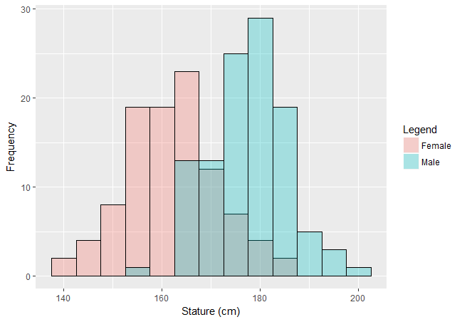
Figure 1: Histogram of pooled male and female stature
*Note darker shaded area represents region of overlap between the sexes
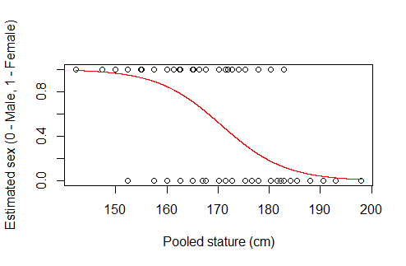
Figure 2: Binary logistic regression of estimated sex vs. pooled stature

After analyzing the pooled stature data, male and female stature distributions were tested separately for normality to determine whether parametric statistical tests were appropriate. Shapiro-Wilk tests showed that neither group departs significantly from normality; Q-Q plots and stature histograms confirm normality for both stature groups (Figures 3-6). These tests provide confirmation that parametric tests, which assume data are normally distributed, can be appropriately applied.
Preliminary tests for normality were also conducted on pooled body mass data. A Shapiro-Wilk test shows the combined data of male and female body mass departs significantly from normality (p = <0.01). A histogram shows the sample is positively skewed (Figure 7), however it does not exhibit a bimodal distribution as did the histogram for pooled stature. The body mass data were then separated by sex (Figures 8 and 10), and again tested for normality using a Shapiro-Wilk test. Both female and male body mass distributions depart significantly from normality (p = <0.01 and p = 0.01, respectively). This is confirmed by corresponding Q-Q plots (Figures 9 and 11), in which the plotted body mass points diverge from the plotline at the heavier end of the weight spectrum, meaning there are more individuals at this extreme than would be expected for a normal distribution. This is caused by the overweight and obese individuals in the sample that have created a positive skew.
Metric data were collected in the form of nine measurements which quantify sexually dimorphic skeletal traits, and an additional five minimally dimorphic control measurements. Summary statistics for all metrics are reported in Tables 3-6.
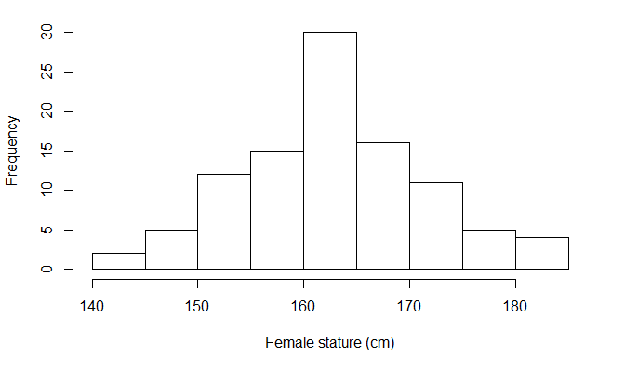
Figure 3: Histogram of female stature

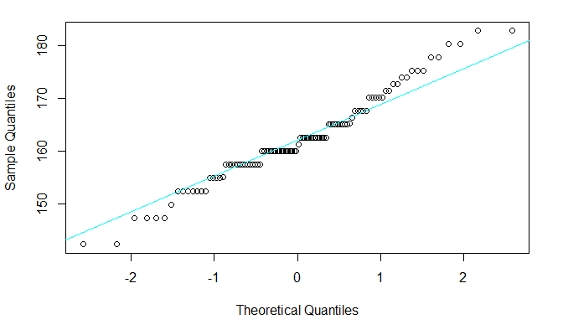

Figure 4: Q-Q plot for female stature

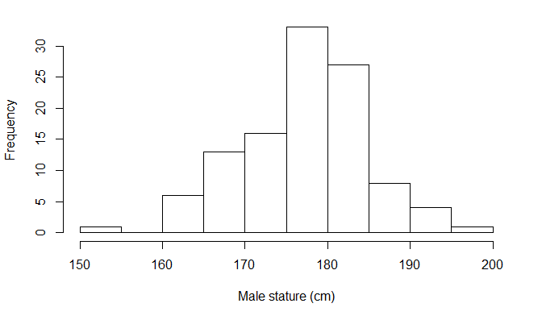
Figure 5: Histogram of male stature
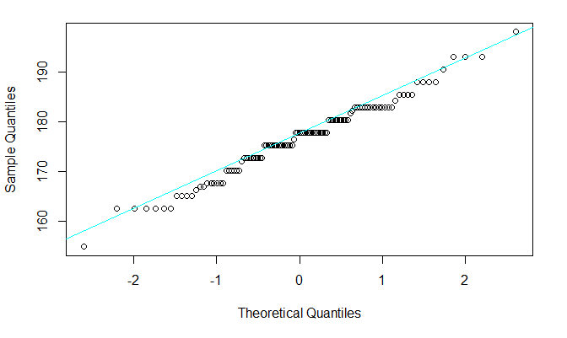
Figure 6: Q-Q plot for male stature

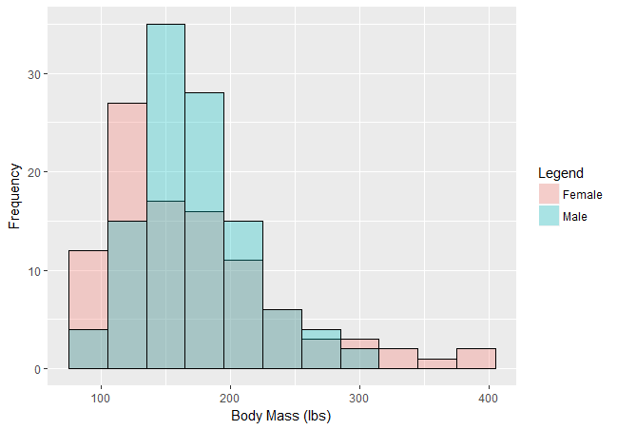
Figure 7: Histogram of pooled body mass
*Note darker shaded area represents region of overlap between the sexes
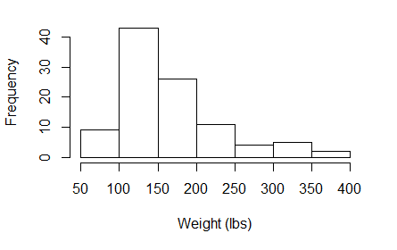
Figure 8: Histogram of female body mass

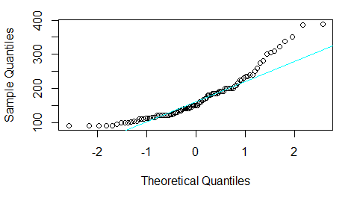
Figure 9: Q-Q plot for female body mass

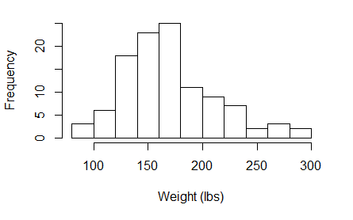
Figure 10: Histogram of male body mass

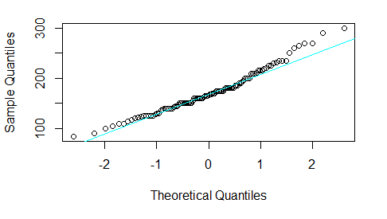
Figure 11: Q-Q plot for male body mass
Table 3: Summary of female sexually dimorphic metrics
Measurement (mm) | Min. | 1st Qu. | Median | Mean | 3rd Qu. | Max.
GP | -5 | -3 | -2 | -2.31 | -2 | -1
MDH | 19 | 26 | 28 | 27.33 | 29 | 36
WPL | 59 | 70 | 74 | 74.17 | 78 | 84
MinPW | 19 | 26 | 28 | 27.9 | 30 | 34
MinWBS | 5 | 6.75 | 7 | 7.52 | 8.25 | 12
MinWPR | 7 | 11 | 12 | 12.11 | 14 | 17
MMaxHT | 18 | 21 | 22 | 21.57 | 22 | 26
LMaxHT | 16 | 18 | 19 | 19.36 | 20 | 78
MinTC | 11 | 14 | 15 | 14.56 | 15 | 24

Table 4: Summary of male sexually dimorphic metrics
Measurement (mm) | Min. | 1st Qu. | Median | Mean | 3rd Qu. | Max.
GP | -8 | -5 | -4 | -4.21 | -3 | -1
MDH | 19 | 30 | 31 | 31.42 | 33 | 42
WPL | 62 | 69 | 72 | 71.83 | 75 | 87
MinPW | 18 | 21 | 23 | 23.13 | 25 | 29
MinWBS | 4 | 9 | 10 | 9.94 | 11 | 19
MinWPR | 6 | 14 | 16 | 15.5 | 17 | 21
MMaxHT | 22 | 24 | 25 | 25.4 | 27 | 32
LMaxHT | 19 | 21 | 22 | 21.59 | 22 | 26
MinTC | 13 | 16 | 17 | 16.88 | 18 | 25

Table 5: Summary of female minimally dimorphic metrics
Measurement (mm) | Min. | 1st Qu. | Median | Mean | 3rd Qu. | Max.
NLB | 18 | 21 | 23 | 22.63 | 24 | 28
OBH | 28 | 32 | 34 | 33.88 | 35.25 | 39
DKB | 16 | 19 | 19.5 | 19.7 | 21 | 26
FOL | 29 | 35 | 36 | 35.95 | 37 | 41
FMD | 11 | 13 | 14 | 14.21 | 15 | 19

Table 6: Summary of male minimally dimorphic metrics
Measurement (mm) | Min. | 1st Qu. | Median | Mean | 3rd Qu. | Max.
NLB | 19 | 23 | 24 | 23.94 | 25 | 29
OBH | 30 | 33 | 34 | 34.31 | 35 | 40
DKB | 18 | 20 | 21 | 21.23 | 22 | 27
FOL | 32 | 36 | 38 | 37.76 | 39 | 43
FMD | 11 | 14 | 15 | 14.95 | 16 | 17

4.3 Stature Results

After establishing that the stature data are normally distributed, parametric tests were conducted to determine the influence body size had on method classification accuracy and the expression of metric traits.
Individual method performance was determined by calculating the pooled ratios of properly classified individuals over total number of individuals for the Walker (2008), Klales et al. (2012), and Rogers (1999) methods. Overall, the sex estimation methods show higher misclassification rates than have been previously reported for reference collections (Walker: 20% misclassified; Klales: 18% misclassified; Rogers: 27% misclassified). Classification accuracies for each method are detailed in Table 7. Individual trait score frequencies for each method are detailed in Tables 8-13.
Trait score frequencies were compared to those provided by Walker (2008), Klales et al. (2012), and Rogers (1999). Female cranial traits exhibit similar trends to those outlined by Walker (2008), yet females in the present sample have a much greater number of indeterminate cranial traits (score 3). Conversely, the males in the Walker (2008) sample appear to exhibit more intermediate trait expression than the males in the current sample. For the pubic traits, the Klales et al. (2012) females appear to have more gracile SPC expression, with the majority scoring a 1 on this trait, while the current sample showed more gracilization for the MA. Ventral arc score frequencies are comparable between the two studies. Male pelvic trait frequencies are also comparable between the samples. Finally, the Rogers (1999) distal humerus trait scores show similar frequencies for females, however the males in the present sample have greater ambiguity in trait expression. Male TC, OFSD, and AME traits all exhibit female expression roughly half the time, whereas the same traits exhibit the male expression over 83% of the time in the Rogers (1999) male sample.
Sex-specific Spearman’s rho correlations tested the relationship between stature and method accuracy (Table 14). For females, none of the sex estimation methods display a statistically significant correlation with stature. Klales et al. (2012) and Walker (2008) both show statistically significant relationships with stature for males. The rho value for both methods is negative, indicating a pattern in which method performance more often scores a 1 (misclassification) on shorter males, and 0 (correct classification) on taller males. Both the male and female rho values for the Rogers (1999) method are also negative, yet neither of these correlations reached statistical significance.
Table 7: Sex estimation method accuracy
Method | % Females correctly classified | % Males correctly classified | Total % correctly classified
Walker | 66% | 93% | 80%
Klales | 100% | 66% | 82%
Rogers | 83% | 63% | 73%
Table 8: Female trait score frequency for Walker (2008) cranial traits
Trait | 1 | 2 | 3 | 4 | 5
G | .59 | .29 | .10 | .02 | .00
MP | .12 | .29 | .39 | .16 | .04
ME | .09 | .43 | .22 | .26 | .00
SM | .14 | .37 | .32 | .15 | .02
NC | .07 | .28 | .31 | .26 | .08

Table 9: Female trait score frequency for Klales et al. (2012) pelvic traits
Trait | 1 | 2 | 3 | 4 | 5
VA | .55 | .36 | .09 | .00 | .00
MA | .25 | .51 | .20 | .03 | .01
SPC | .36 | .43 | .13 | .04 | .04

Table 10: Female trait score frequencies for Rogers (1999) distal humerus traits
Trait | F | M
TC | .62 | .38
TS | .70 | .30
OFSD | .73 | .27
AME | .86 | .14

Table 11: Male trait score frequency for Walker (2008) cranial traits
 | 1 | 2 | 3 | 4 | 5
G | .03 | .15 | .23 | .34 | .25
MP | .02 | .04 | .18 | .38 | .36
ME | .06 | .25 | .31 | .29 | .09
SM | .01 | .17 | .40 | .28 | .14
NC | .01 | .04 | .27 | .47 | .20

Table 12: Male trait score frequencies for Klales et al. (2012) pelvic traits
 | 1 | 2 | 3 | 4 | 5
VA | .00 | .11 | .34 | .31 | .24
MA | .03 | .15 | .28 | .39 | .15
SPC | .02 | .04 | .35 | .35 | .24

Table 13: Male trait score frequencies for Rogers (1999) distal humerus traits
 | F | M
TC | .47 | .53
TS | .28 | .72
OFSD | .45 | .55
AME | .45 | .55

Table 14: Spearman correlation values of method accuracy vs. stature
*Note no females were misclassified by the Klales et al. (2012) method
Method | Females:  rho | p-value | Males:  rho | p-value
Walker | 0.10 | 0.34 | - 0.19 | 0.05
Klales | N/A | N/A | - 0.30 | 0.01
Rogers | - 0.05 | 0.65 | - 0.11 | 0.25

A further analysis of the males misclassified by the Klales et al. (2012) method show that 68% of these individuals are between 165 and 185 cm in stature (Figure 12), suggesting that males who fall closer to the middle of the male stature spectrum exhibit more indeterminate or gracile pubic trait scores than the individuals at the extremes of the distribution. It is important to note that in the pooled stature distribution illustrated by Figure 1, there is considerable overlap in stature between the sexes from approximately 165 to 185 cm. Females who fall into this region of overlap are not also being misclassified, suggesting that if there is ambiguity in trait expression in this stature range, it does not manifest equally for both males and females. To determine whether this trend is being influenced by the overrepresentation of mean statures that is inherent in the normal distribution, Spearman’s rho correlations were also conducted on the uniform distribution (Table 15). Again, all methods exhibit weak negative correlations with male stature with only the Klales et al. (2012) relationship reaching statistical significance. A visualization of the males from the uniform stature distribution who were misclassified by the pelvic method indeed confirms that individuals around the mean appear to be misclassified more often (Figure 13), while the method performs better on the tallest and shortest individuals. No correlations between female stature and method success reach statistical significance for the uniform distribution.
The Walker (2008) and Rogers (1999) methods exhibit a slight increase in method accuracy as stature increases, however neither of these relationships reach statistical significance.

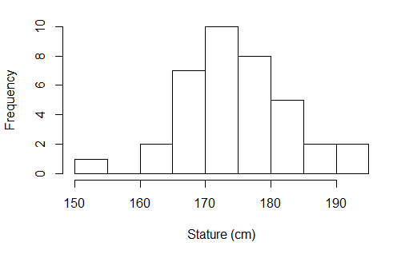
Figure 12: Stature distribution of males (n = 30) misclassified by Klales et al. (2012)

Table 15: Spearman correlation values of method accuracy vs. uniform stature distribution
*Note no females were misclassified by the Klales et al. (2012) method
Method | Females:  rho | p-value | Males:  rho | p-value
Walker | - 0.16 | 0.21 | - 0.27 | 0.06
Klales | N/A | N/A | - 0.28 | 0.05
Rogers | 0.14 | 0.30 | - 0.13 | 0.37

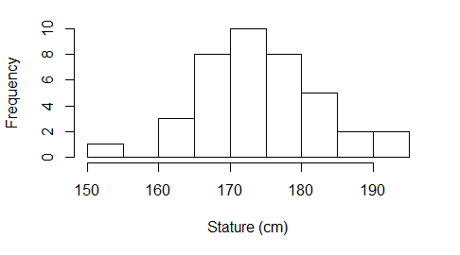
Figure 13: Males misclassified by the Klales et al. (2012) method across a uniform stature distribution

Both the Walker (2008) and Klales et al. (2012) methods rely on classification formulae that are derived from the samples on which the methods were developed. Due to the high rates of misclassification for females and males, respectively, calibration tests were conducted to reconfigure the classification formula for the present research sample. Table 16 shows the calibrated coefficient and intercept values for the reconfigured pelvic trait classification formula and how these values compare to the original formula produced by Klales et al. (2012). All trait coefficients, as well as the intercept, significantly contribute to the model. The calibrated pelvic trait formula for the current sample is:

2.686(VA) + 1.152(MA) + 0.962(SPC) – 12.652

Given the reconfigured formula, a classification matrix was conducted to determine how many individuals would be misclassified given the new formula. Table 17 exhibits the new classification rates, and shows that a calibrated Klales et al. (2012) formula results in a higher rate of overall classification for the method, increasing from 82% to 93%.
Though the Walker (2008) classification formula selected for this study uses only morphological traits GP, MP, and ME, all cranial traits were included in the calibration statistics to determine if there are different relative contributions on the present sample than there are on the sample used by Walker (2008). Results of the cranial trait calibration shows coefficient and intercept values that differ from those included in the original Walker (2008) formula (Table 18). Traits G, MP and NC, as well as the intercept, contribute significantly to the calibrated model, while ME and SM do not, and as a result are excluded from the new formula. The resulting calibrated formula for the current sample is:

1.770(G) + 0.886(MP) + 0.524(NC) – 9.723

As with the Klales et al. (2012) calibration, the new classification matrix based on the calibrated formula shows that overall method success increases when the new formula is used on the present sample, increasing from 80% to 88% (Table 19).

Table 16: Calibration results vs. Klales et al. (2012) values
 | Calibration results  Estimate | p-value | Klales et al. (2012)  Estimate
Intercept | -12.652 | <0.001 | -16.312
VA | 2.686 | <0.001 | 2.726
MA | 1.152 | <0.001 | 1.214
SPC | 0.962 | <0.001 | 1.073

Table 17: Klales et al. (2012) classification rates from calibrated formula
 | F | M | Total
Female | 92 | 8 | 100
Male | 6 | 103 | 109
Total | 98 | 111 | 209

Table 18: Calibration results vs. Walker (2008) values
*Note that the Walker (2008) classification formula does not use traits NC and SM
 | Calibration results  Estimate | p-value | Walker (2008)  Estimate
Intercept | -9.723 | <0.001 | 9.128
G | 1.770 | <0.001 | -1.375
MP | 0.886 | <0.001 | -1.185
ME | -0.207 | 0.416 | -1.151
NC | 0.524 | 0.039 | N/A
SM | 0.412 | 0.138 | N/A

Table 19: Walker (2008) classification rates from calibrated formula
 | F | M | Total
Female | 87 | 13 | 100
Male | 11 | 98 | 109
Total | 98 | 111 | 209

While correlations speak to the strength of the relationship between stature and method accuracy, binary logistic regressions determine how well stature can predict method success. Stature represents the predictor variable, and the binary response variable is correct (0) or incorrect (1) sex estimation produced by each method. Despite the fact that methods exhibited higher misclassification rates than have been observed in previous studies, regression results reveal that only males who were misclassified by the Klales et al. (2012) method were misclassified in part due to body size (p = 0.023; Figure 14). The regression line in Figure 14 predicts the probability that an individual will be in the correctly classified group (0) or the misclassified group (1). The hypothesis that taller individuals will be more accurately classified means we would expect a sigmoidal line (much like the regression line in Figure 2) to illustrate that individuals at the shorter end of the stature spectrum are predicted to be in the incorrectly classified group. The regression line does trend closer to 1 (incorrect classification) at the shorter end of the stature spectrum, and closer to 0 (correct classification) at the taller end of the spectrum, which supports the predicted pattern. However, the weak curve of the regression line in Figure 14 suggests that, though males may have been misclassified by the Klales et al. (2012) method in part due to stature, stature alone is not a strong predictor of an individual’s membership to the correct or incorrect group. The remaining regressions (Figures 15-19) show similarly weak regression lines, indicating stature cannot predict method success.
Results of the polyserial correlations show that no sex estimation trait for either sex is more than moderately correlated with stature (Table 20). The highest correlation was between male mastoid process (MP) and stature (r = 0.45; Figure 20). Additionally, p-values for the Kruskal-Wallis (p ranging from 0.47 – 0.50) and Mann-Whitney U tests (p ranging from 0.49 – 0.52) showed no significant results, meaning no sex estimation scores were significantly clustered, but rather were relatively evenly distributed across statures.
Similarly, the trait most strongly correlated with male stature is the MP (r = 0.45). Figure 20 provides a visualization of MP correlation with stature. Even as the single most strongly-correlated trait between the sexes, this visualization shows that most males fall between a rank 3 and rank 5 MP score. Additionally, individuals at the shorter end of the stature continuum can still exhibit a rank 5 MP, and taller individuals can still display a rank 3 MP.

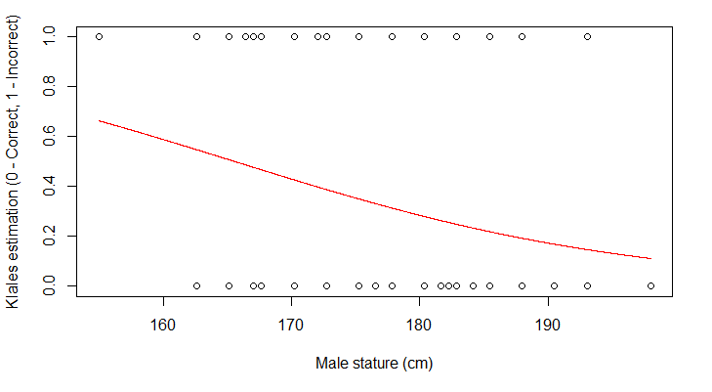
Figure 14: Binary logistic regression of Klales et al. (2012) estimation vs. male stature

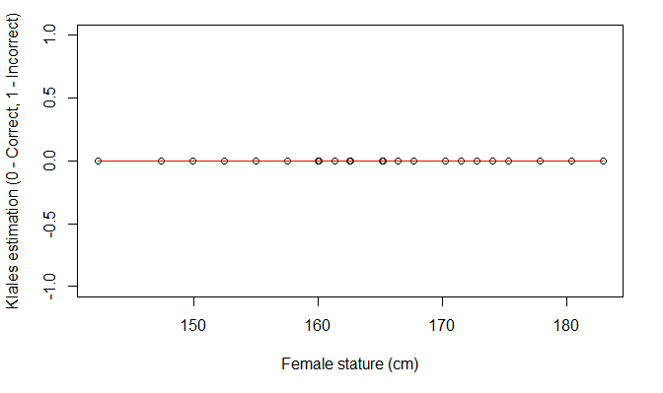
Figure 15: Binary logistic regression of Klales et al. (2012) estimation vs. female stature
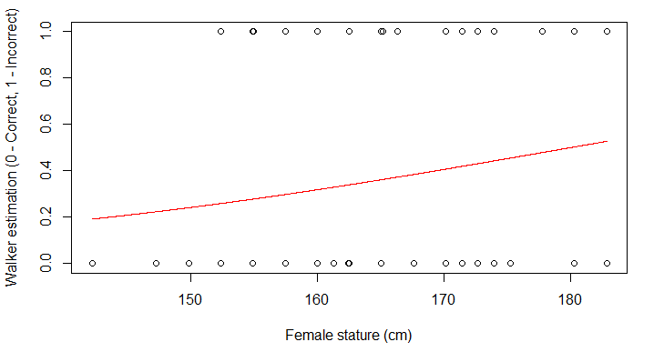
Figure 16: Binary logistic regression of Walker (2008) estimation vs. female stature

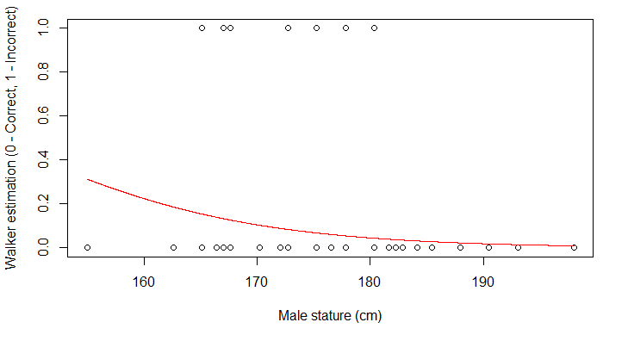
Figure 17: Binary logistic regression of Walker (2008) estimation vs. male stature
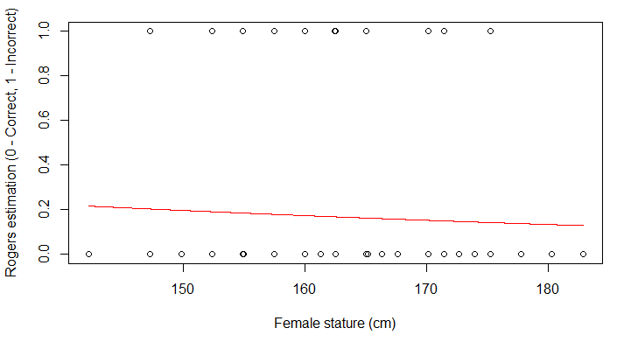
Figure 18: Binary logistic regression of Rogers (1999) estimation vs. female stature

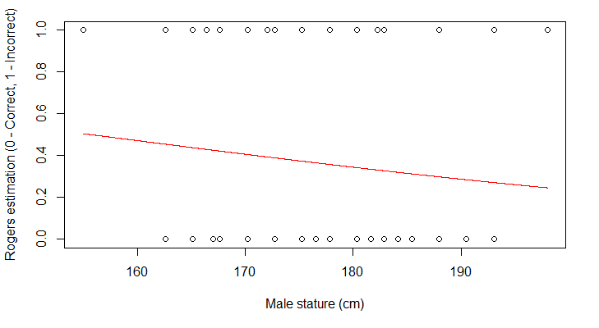
Figure 19: Binary logistic regression of Rogers (1999) estimation vs. male stature

Table 20: Polyserial correlation values for morphological traits vs. stature
Trait | Female Stature  r-values | Male Stature  r-values | Trait | Female Stature  r-values | Male Stature  r-values
G | 0.10 | 0.07 | MA | 0.10 | 0.29
MP | -0.16 | 0.45 | SPC | 0.04 | 0.02
ME | -0.05 | 0.28 | TC | -0.30 | -0.22
SM | 0.08 | 0.16 | TS | 0.23 | -0.14
NC | 0.16 | 0.40 | OFSD | 0.01 | 0.40
VA | 0.05 | 0.41 | AME | -0.20 | -0.07

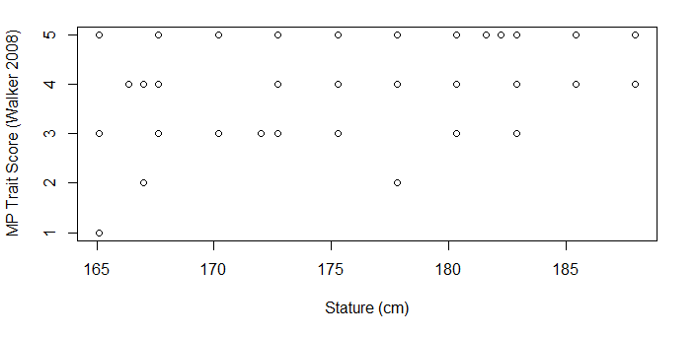
Figure 20: Correlation between male stature and MP trait score

Correlation matrices also tested the relationship between stature and sexually dimorphic measurements (Table 21). For females, minimum pubic length (WPL), minimum pubic width (MinPW), minimum width of the pubic ramus (MinWPR), medial maximum height of the trochlea (MMaxHT), and minimum trochlear constriction (MinTC) all exhibit statistically significant relationships with stature (p < 0.05; r ranging from 0.20 to 0.54). For males, mastoid height (MDH), WPL, MinPW, MinWPR, lateral maximum height of the trochlea (LMaxHT), and MinTC show statistically significant correlations with stature (p < 0.05; r ranging from -0.07 to 0.46). While p-values suggest there is a relationship between select cranial, pubic, and humeral traits and stature for both males and females, the low correlation coefficients show that stature cannot explain the majority of the variance.
Minimally sexually dimorphic metrics were then examined in separate Pearson correlation matrices with stature (Table 22). In females, orbital height (OBH), foramen magnum length (FOL), and diameter of the fibular midshaft (FMD) all show significant correlation with stature (p < 0.05; r ranging from 0.21 to 0.24). For males, only OBH and FOL show significant relationships (p < 0.05; r = 0.19 for both traits). Similar to the sexually dimorphic correlations, the p-values for minimally dimorphic measurements suggest a relationship with stature, however the r-values reveal the associations are even weaker than those exhibited by the dimorphic correlations..

Table 21: Pearson correlation values for sexually dimorphic metrics vs. stature
Measurement | Females:  r-value | p-value | Males:  r-value | p-value
GP | 0.03 | 0.79 | - 0.07 | 0.49
MDH | 0.18 | 0.07 | 0.46 | <0.01
WPL | 0.54 | <0.01 | 0.46 | <0.01
MinPW | 0.34 | <0.01 | 0.35 | <0.01
MinWBS | 0.05 | 0.65 | - 0.09 | 0.33
MinWPR | 0.20 | 0.04 | 0.22 | 0.24
MMaxHT | 0.46 | <0.01 | 0.08 | 0.39
LMaxHT | 0.25 | 0.11 | 0.30 | <0.01
MinTC | 0.25 | 0.01 | 0.25 | 0.01

Table 22: Pearson correlation values for minimally dimorphic metrics vs. stature
Measurement | Females:  r-value | p-value | Males:  r-value | p-value
NLB | 0.05 | 0.61 | <0.01 | 0.97
OBH | 0.22 | 0.03 | 0.19 | 0.04
DKB | 0.02 | 0.81 | 0.13 | 0.19
FOL | 0.24 | 0.01 | 0.19 | 0.05
FMD | 0.21 | 0.04 | 0.17 | 0.07

Each measurement was also tested for isometric scaling with stature. Given the linear nature of both variables, a slope of 1 was expected. Table 23 shows the resulting slopes, standard errors, and p-values for each sexually dimorphic metric. For females, MDH, WPL, MinWBS, MMaxHT, and MinTC all exhibit slopes that are significantly different than the expected slope of 1. This suggests that these traits are not scaling isometrically with stature. The remaining traits do not have significant p-values, meaning isometry cannot be ruled out. For males, dimorphic metrics WPL, MinWBS, MMaxHT, and LMaxHT exhibit statistically different slopes than would be expected for isometric scaling. Linear regressions for minimally dimorphic metrics exhibit relationships with stature that do not differ significantly from isometry. Linear model results and p-values for minimally dimorphic metrics are detailed in Table 24.
Table 23: Isometry analysis results for stature and sexually dimorphic metrics
Measurement | Females:  Slope | Std. error | p-value | Males:  Slope | Std. error | p-value
GP | -0.387 | 0.755 | 0.350 | 0.243 | 0.697 | < 0.001
MDH | 0.389 | 0.210 | 0.002 | 1.080 | 0.207 | < 0.001
WPL | 0.701 | 0.108 | 0.003 | 0.715 | 0.129 | < 0.001
MinPW | 0.699 | 0.188 | 0.056 | 0.851 | 0.216 | < 0.001
MinWBS | 0.099 | 0.382 | 0.010 | -0.387 | 0.446 | < 0.001
MinWPR | 0.684 | 0.333 | 0.172 | 0.739 | 0.368 | < 0.001
MMaxHT | 0.578 | 0.114 | < 0.001 | 0.152 | 0.172 | < 0.001
LMaxHT | 0.672 | 0.298 | 0.137 | 0.464 | 0.141 | < 0.001
MinTC | 0.545 | 0.181 | 0.007 | 0.614 | 0.236 | < 0.001

Table 24: Isometry analysis results for stature and minimally dimorphic metrics
Measurement | Females:  Slope | Std. error | p-value | Males:  Slope | Std. error | p-value
NLB | 0.078 | 0.166 | 0.531 | -0.011 | 0.178 | 0.496
OBH | 0.302 | 0.131 | 0.618 | 0.252 | 0.128 | 0.599
DKB | 0.042 | 0.184 | 0.517 | 0.270 | 0.194 | 0.606
FOL | 0.315 | 0.132 | 0.623 | 0.274 | 0.140 | 0.607
FMD | 0.416 | 0.202 | 0.661 | 0.374 | 0.197 | 0.645

4.5 Body Mass Results

Nonparametric statistical tests were required for body mass data, which were not normally distributed. The relationship between sex estimation method accuracy and body mass was determined by Spearman’s rho correlations. For both males and females, none of the sex estimation methods display statistically significant correlations with body mass, indicating body mass is not influencing method accuracy (Table 25).
Polyserial correlations were conducted to determine whether body mass and specific morphological traits used by sex estimation methods were correlated. The tests produce correlation values even weaker than those exhibited by stature (Table 26). The strongest correlation is between body mass and the female nuchal crest (r = 0.25). Results of the Kruskal-Wallis (p-values ranging from 0.08 to 0.98) and Mann-Whitney U (p-values ranging from 0.36 to 0.78) tests show that ordinal trait scores are not significantly different at different weights.

Table 25: Spearman correlation values of method accuracy vs. body mass
Method | Females:  rho | p-value | Males:  rho | p-value
Walker | 0.18 | 0.07 | 0.12 | 0.19
Klales | N/A* | N/A* | - 0.04 | 0.65
Rogers | 0.01 | 0.95 | - 0.04 | 0.71
*Note no females were misclassified by the Klales et al. (2012) method

Table 26: Polyserial correlation values for morphological traits vs. body mass
Trait | Female body mass  r-values | Male body mass  r-values | Trait | Female body mass  r-values | Male body mass  r-values
G | 0.05 | <0.01 | MA | 0.04 | 0.14
MP | 0.02 | -0.01 | SPC | -0.06 | -0.03
ME | 0.16 | 0.08 | TC | -0.09 | 0.12
SM | 0.08 | -0.09 | TS | 0.18 | 0.10
NC | 0.25 | 0.17 | OFSD | 0.14 | -0.01
VA | -0.23 | -0.05 | AME | -0.10 | 0.06

Relationships between dimorphic measurements and body mass were analyzed with Pearson correlation matrices. Three pubic measurements (WPL, MinPW, and MinWPR) and one distal humeral measurement (MMaxHT) exhibit statistically significant relationships with body mass for females. For males, all pubic measurements show significant relationships with body mass, along with one humeral measurement (MMaxHT). Overall, fewer measurements were correlate with body mass than with stature and the resulting relationships were also weaker than those with stature (Table 27). Neither of the cranial metrics, glabellar projection (GP) and MDH, showed a relationship with body mass. Results of the Pearson correlations for minimally dimorphic metrics show that only the measurement FMD has a significant relationship with body mass (Table 28).
Dimorphic metrics were tested for isometric scaling with body mass. Because the metrics are linear in nature, and body mass is cubic in nature, a slope of 0.333 was expected to illustrate an isometric 1:3 scaling relationship. For both males and females, all traits except GP exhibited slopes that were significantly different than expected for isometric scaling (p < 0.03 for all traits; Table 29). As with stature, all minimally dimorphic metrics for both sexes display scaling relationships with body mass that are not significantly different from isometry (Table 30).

Table 27: Pearson correlation values for sexually dimorphic metrics vs. body mass
Measurement | Females:  r-value | p-value | Males:  r-value | p-value
GP | 0.07 | 0.51 | 0.06 | 0.53
MDH | -0.02 | 0.86 | 0.08 | 0.38
WPL | 0.21 | 0.04 | 0.23 | 0.02
MinPW | 0.38 | <0.01 | 0.27 | <0.01
MinWBS | 0.04 | 0.71 | 0.18 | 0.05
MinWPR | 0.25 | 0.01 | 0.22 | 0.02
MMaxHT | 0.21 | 0.04 | 0.22 | 0.02
LMaxHT | 0.03 | 0.78 | -0.05 | 0.60
MinTC | 0.05 | 0.64 | 0.02 | 0.80

Table 28: Pearson correlation values for minimally dimorphic metrics vs. body mass
Measurement | Female:  r-value | p-value | Male:  r-value | p-value
NLB | 0.02 | 0.86 | <0.01 | 0.97
OBH | - 0.12 | 0.24 | 0.04 | 0.71
DKB | - 0.07 | 0.47 | - 0.08 | 0.42
FOL | 0.13 | 0.21 | 0.08 | 0.38
FMD | 0.40 | <0.01 | 0.19 | 0.04

Table 29: Isometry analysis results for body mass and sexually dimorphic metrics
Measurement | Females:  Slope | Std. error | p-value | Males:  Slope | Std. error | p-value
GP | -0.010 | 0.107 | <0.001 | -0.016 | 0.124 | 0.494
MDH | 0.001 | 0.030 | <0.001 | 0.033 | 0.041 | <0.001
WPL | 0.036 | 0.018 | <0.001 | 0.068 | 0.025 | <0.001
MinPW | 0.098 | 0.027 | <0.001 | 0.125 | 0.039 | <0.001
MinWBS | 0.010 | 0.054 | <0.001 | 0.178 | 0.078 | 0.024
MinWPR | 0.124 | 0.047 | <0.001 | 0.169 | 0.065 | 0.006
MMaxHT | 0.032 | 0.018 | <0.001 | 0.074 | 0.030 | <0.001
LMaxHT | 0.022 | 0.043 | <0.001 | <0.001 | 0.026 | <0.001
MinTC | 0.010 | 0.027 | <0.001 | 0.011 | 0.043 | <0.001

Table 30: Isometry analysis results for body mass and minimally dimorphic metrics
Measurement | Females:  Slope | Std. error | p-value | Males:  Slope | Std. error | p-value
NLB | 0.015 | 0.023 | 0.506 | 0.00 | 0.031 | 0.500
OBH | -0.027 | 0.019 | 0.489 | 0.01 | 0.023 | 0.503
DKB | -0.019 | 0.026 | 0.492 | -0.039 | 0.035 | 0.484
FOL | 0.024 | 0.019 | 0.509 | 0.026 | 0.025 | 0.510
FMD | 0.112 | 0.027 | 0.544 | 0.071 | 0.035 | 0.528

4.6 Results Summary

Overall, the Walker (2008), Klales et al. (2012), and Rogers (1999) morphological sex estimation methods experienced higher misclassification rates than previously reported for other samples. Despite performing the best overall and classifying 100% of the sample females correctly, the Klales et al. (2012) pubic method misclassifies one third of males in the present sample, and appears to be the only method with some relationship to stature. Visual representation of the males misclassified by the Klales et al. (2012) method clearly shows individuals between 165 and 185 cm in stature are more often misclassified; this same pattern is detected in the uniform distribution, confirming the phenomenon is not just the result of oversampling of the mean. Fitting a calibrated classification function to the sample results in higher classification accuracy, suggesting that some of the seemingly stature-related misclassifications may result from using an uncalibrated function. A closer look at the ordinal trait scores assigned to each individual show that the scores are not distributed differently for different stature groups, and therefore there is no predictable score patterning based on stature.
Most metric traits correlated positively with both male and female stature, but correlation coefficients are low, suggesting that any relationship between these variables is weak. The relationship between stature and metric traits is stronger on the uniform stature distribution, however it is possible this is the result of the low sample size for each stature group (n = 10) in this derived sample.
The non-normally distributed body mass data were analyzed with nonparametric tests. Neither sex show significant correlations between method performance and body mass, suggesting that an individual’s weight does not indicate whether they are susceptible to misclassification. Both morphological and metric traits showed some significant correlations with body mass, but all associations are weaker than those with stature. Ordinal trait scores used in the sex estimation methods also did not distribute significantly across the body mass distribution, suggesting there is no predictable relationship between donor weight and trait expression.

Chapter 5: Discussion

The hypotheses for this thesis were (1) variation in expression of sexually dimorphic traits will co-vary with body size, (2) stature will be a greater contributor to the sexual dimorphism of specific skeletal traits than weight, and (3) if stature and sexual dimorphism do co-vary, sexual dimorphism will increase as stature increases.
Results suggest that body size does co-vary with sexual dimorphism as indicated by performance of some sex estimation methods, and correlations between ordinal and metric traits. However, stature and body mass display different relationships with these variables, with stature exhibiting more influence on sexually dimorphic traits than body mass. To understand the effect of body size parameters on sexual dimorphism and the accuracy of forensic methods, the results must be contextualized within the theoretical framework of this thesis, as well as the realm of practical application. As with the Methods and Results chapters of this thesis, discussion will be divided into sections for stature (5.1) and body mass (5.2), and the hypotheses relevant to each body size parameter will be addressed in the appropriate sections. Specifically, Hypothesis 1 will be addressed in both sections because it relates to both body size parameters; Hypothesis 2 will be addressed with body mass (5.2) because it refers to the contribution of body mass to trait variation relative to that of stature; finally, Hypothesis 3 will be addressed with stature (5.1), as it directly predicts an increase in sex estimation method accuracy when applied to individuals of taller statures.

5.1 Influence of Stature on Sexual Dimorphism

5.1.1 Hypothesis 1

An analysis of the morphological traits used in the method scoring systems tested whether human variation in body size might bias method accuracies. Correlations between morphological traits used in forensic sex estimation methods, and metric approximations of these traits, show significant associations with stature, supporting Hypothesis 1. The male ordinal trait scores with the strongest relationship to stature are the MP and NC of the cranium (Walker 2008), the VA of the pubis (Klales et al. 2012), and the OFSD of the distal humerus (Rogers 1999). However, the strongest correlation, which belonged to the MP, is still considered weak (r = 0.45). This was made evident by the mixture of gracile and robust MP scores among the males at both extremes of the stature spectrum. For females, all sex estimation method traits produced correlations with stature that were significantly weaker than those exhibited by males. When score frequency was analyzed across a uniform stature distribution, no significant results were found, indicating there is likely little to no influence of stature on method performance. The relationship between stature and performance of methods will be discussed later in section 5.1.2.
Metric analyses provided a more nuanced look at sexual dimorphism by treating trait expression as continuous rather than discrete. Additional support for Hypothesis 1 is provided by the correlations between select pelvic measurements and stature for both sexes. Overall, the metric correlations are stronger than trait score correlations, which is likely due to the treatment of traits as continuous measurements rather than ordinal scores, which inherently result in a loss of information (Altman 2006; Cohen 1983). Minimum pubic length (WPL) has the strongest positive association with stature in both sexes. WPL is a pelvic dimension that is crucial to childbirth (Kurki 2011). The slightly stronger correlation in females may be due to obstetric pressures, with male WPL exhibiting an associated correlation made marginally weaker by the fact that their pelves are not also being selected on for obstetric purposes (Grabowski et al. 2011).
Females also exhibited a significant correlation between stature and the humeral measurement, maximum height of the medial trochlea (MMaxHT). This feature is thought to contribute to carrying angle of the elbow (William et al. 1989). It has also been previously hypothesized by Hooton (1946) that the carrying angle is related to hip dimensions—females have broader hips for obstetric purposes, and therefore physiologically require their forearms to diverge from the humerus at an angle so the hips can be cleared while walking. The narrower hip composition of males allows their arms to hang straight down. This is a potential explanation for why we see an increase in female WPL, and subsequently MMaxHT, as female stature increases. However, male WPL is also increasing with stature (though not as much as in females), and yet males do not also show the same significant increase of the MMaxHT.
Finally, both males and females showed some correlations between the minimally-dimorphic metrics and stature. For both sexes, cranial traits orbital height (OBH) and foramen magnum length (FOL) both showed significant relationships with stature, and females exhibited an additional correlation for the postcranial measurement diameter of the fibular midshaft (FMD). However, correlation coefficients for these metrics were weak (r collectively ranged from 0.19 to 0.24). As was stated with regard to the sexually dimorphic traits, these correlation coefficients suggest that stature does partly contribute to variation in these traits, but it appears that most of the variation is determined by other factors.
The significant correlations between both the dimorphic and minimally dimorphic measurements and stature does suggest that height is driving at least some of the differences we see in male and female skeletal traits, providing support for Hypothesis 1.

5.1.2 Hypothesis 3

By predicting an increase in sexual dimorphism at taller statures, the third hypothesis implies that method accuracy should increase across the stature spectrum. Sex estimation method success rates in this study were lower than previously reported (Klales et al. 2012; Rogers 1999; Walker 2008), yet it does not appear that the misclassifications are due solely to differences in stature. The Klales et al. (2012) method was unique in that stature did appear to contribute to male misclassifications; however, the weak slope of the regression line likely indicates the non-linear relationship between stature and method success, as well as potential influence from other latent factors. Interestingly, no females were misclassified as males by this method, so perhaps these results are due to difficulty in determining male sex using the pubis, or alternatively, an inherent bias toward classifying females using the Klales et al. (2012) method. The high rate of male misclassification that occurred between 165 and 185 cm also suggests that method accuracy is not consistently increasing with stature as the negative Spearman correlation implied, but rather that those individuals around the mean experience higher misclassifications than the extremes. This pattern held true for both the normal and uniform stature distributions.
The correlation between stature and Klales et al. (2012) method success would seem to suggest a steady, slight increase in method accuracy from the shortest to the tallest individuals. In reality, there is a dip in method accuracy from the shortest individuals to the mean, and a subsequent increase in accuracy again from the mean to the tallest individuals. This non-linear pattern of method performance may explain the weak nature of the relationship. Whereas the correlation value alone seemed to support Hypothesis 3 (that method accuracy would increase with stature), a better understanding of who was misclassified shows this hypothesis is only partially supported for the pubic method. For males, we do in fact see an increase in accuracy of the Klales et al. (2012) method when moving from individuals of average height to the tallest individuals in the sample. However, the shortest individuals share method success rates similar to the tallest individuals, with the individuals at the mean experiencing the lowest classification accuracy for this method.
The pelvic trait classification function was calibrated to fit the current sample. The calibrated formula provides information on the relative importance of each pelvic trait when determining sex. The model shows that VA contributes the most to sample variability (coefficient of 2.686), while SPC is not of great relative importance (coefficient of 0.962). Nevertheless, all three traits contributed significantly to the calibrated model, along with a significant intercept value indicating that the new formula can significantly estimate sex when trait scores are applied. This was supported by a classification matrix based on the calibrated model, which resulted in a higher overall classification accuracy. Male classification alone jumped from 66% to 94%. Female classification accuracy fell from 100% to 92% with the new function, however, the increase in male accuracy outweighs the decrease in female method accuracy, as the overall method accuracy increases to 93%.
Though the Klales et al. (2012) method achieved higher classification accuracy with the calibrated formula, calibration statistics can only be conducted based on populational data, and therefore are not a practical solution for forensic anthropologists who often deal with a single set of human remains. Therefore, many practicing forensic anthropologists will rely on the original formula provided by Klales et al. (2012), putting male skeletons at risk of being misclassified. A recent validation study conducted by Lesciotto and Doershuk (2017) found similarly low success when classifying American males using this method, with accuracy rates only marginally better than chance. The rate at which males are misclassified by this pelvic method warrants caution during application, especially considering males account for approximately 80% of violent crime victims (Federal Bureau of Investigation 2015). According to the National Center for Health Statistics (2016), the average height for males in the United States is 175.7 cm. Because this falls within the height range of the individuals most susceptible to misclassification by the Klales et al. (2012) method, certain recommendations should accompany the method’s use on other American white samples. The results of the present study showed that every time this pubic method returned trait rankings consistent with a male, the individual was always a male. However, when an individual was scored as a female, they were truly female only 73% of the time. With this in mind, if an individual is scored as a male using the Klales et al. (2012) method, researchers can be confident in assigning a final sex estimation of male. If the individual is scored as female with this method, then other methods should be used to make a more concrete conclusion, as individuals considered females by the Klales et al. (2012) method are males about one third of the time in this sample.
Because the results of this study implicate stature as contributing to the misclassification of males by the original Klales et al. (2012) classification formula, it may be prudent to determine stature prior to sex estimation, though this is atypical when constructing the biological profile. However, if an individual is classified as female by the pubic method and is known to fall within the stature range of the most commonly misclassified individuals (165 to 185 cm), then researchers can expect a reduction in method accuracy and supplement their estimation accordingly. It is unclear whether males within this stature range are being misclassified due to biological or methodological reasons. Future research should explore further the tendency for the Klales et al. (2012) method to perform best on the tallest and shortest individuals in a sample, yet misclassify a significant portion of the individuals of average height. A better understanding of this pattern could enhance the anthropologist’s ability to choose how and when to employ this method.
Though the results do not suggest the Walker (2008) misclassifications were due to stature, it is important to acknowledge that this method experienced similar misclassification rates as the Klales et al. (2012) method. The cranial traits, however, appeared to be biased in the opposite direction, and were more successful at correctly classifying males, but misclassified approximately 33% of females. While the calibrated classification formula also resulted in a better overall classification rate of 88%, forensic contexts will still require anthropologists to rely on the original formula provided by Walker (2008), and caveats should accompany the use of this method as well. Of all the individuals classified as females by the original Walker (2008) cranial trait formula, approximately 88% of the time these individuals were truly female. Due to the method’s tendency to overclassify males, 26% of the male classifications were females. Therefore, as with the Klales et al. (2012) method, caveats should be considered when applying Walker (2008). When an individual is classified as female based on their cranial scores, researchers can be more certain the estimation is right than when an individual is classified as male, as 88% of female classifications are true females, while only 74% of male classifications are true males.
Finally, the Rogers (1999) distal humerus method exhibited no relationship with stature, and resulted in the lowest classification accuracy of the three methods. Because Rogers (1999) does not use a classification function, it was not possible to calibrate the method for use on this research sample. However, Rogers herself has previously achieved a 94% classification accuracy on a sample from the WMB prior to her 1999 publication of the method. The discrepancy in method performance indicates that there may be some methodological shortcoming causing variability in interpretation of trait expression. The four traits used in this method were originally selected by Rogers based on her analysis of just ten male and ten female humerii from the University of Toronto’s Grant Skeletal Collection, which is comprised of unclaimed skeletons sent to the university between 1928 and the early 1950s. Only a single individual from the present sample could have possibly been analyzed by Rogers when she visited the WMB, as all other skeletons used for this thesis were donated to the WMB in the year 2000 or later. It is possible that the original method developed on the Grant Skeletal Collection individuals born in the late 19th and early 20th centuries described male and female trait expressions that are not consistent with the variation in the contemporary WMB.
Regardless, the Rogers (1999) distal humerus method does not perform well enough on the present sample for the author to recommend its use in a forensic context. While both the cranial and pelvic methods can be improved upon and refitted for a specific population, the lack of flexibility provided by the distal humerus method makes it impractical for widespread use. If an anthropologist is faced with estimating sex from just the humerus in a forensic context, they should, if possible, use the metric classification function provided by Spradley and Jantz (2011), which uses three to four measurements and achieves between 93-94% classification accuracy for American whites and blacks. If the anthropologist is assessing sex morphologically with a more complete set of remains, it is suggested that they use more reliable morphological indicators of sex, such as the pelvis or cranium.

5.2 Influence of Body Mass on Sexual Dimorphism

5.2.1 Hypothesis 1

While individual trait correlations with weight did exist, they were weak, suggesting that body mass is largely not a contributing factor to sexual dimorphism in skeletal traits, and therefore has no implications for how the present sex estimation methods are applied. However, the existence of significant correlations between dimorphic traits and body mass, though weak, do provide support for Hypothesis 1. However, correlations between method accuracy and body mass show no indication that there is predictable fluctuation in method success at different weights.
Estimating an individual’s weight is not part of current protocol for the biological profile, and this study validates the negligible effect weight has on sex estimation. While weight estimation methods do exist (Moore and Schaefer 2011; Ruff 2000a; Ruff 2000b) and could provide individualizing information within a specific forensic context, the estimation will not indicate whether the individual is at risk of being misclassified by the Walker (2008), Klales et al. (2012), or Rogers (1999) sex estimation methods; therefore, unless weight is pertinent to a specific case, it remains an unnecessary estimation. Additionally, these results indicate that the morphological sex estimation methods used here can be applied regardless of the weight of the individual, and furthermore, that modern trends toward obesity (Ogden et al. 2015) are not affecting our accuracy in estimating sex.

5.2.2 Hypothesis 2

Body mass exhibited fewer significant correlations with both the morphological and metric traits, and the significant relationships that did exist were weaker than those exhibited by stature, supporting Hypothesis 2. It is important to note that even the correlations between traits and stature are only weak to moderate in strength, and that the majority of the variance in trait expression is not explained by stature. Though significant relationships exist, it is likely they are not biologically meaningful, however it is still important to discuss why significant relationships were found with specific traits.
Sexually dimorphic metrics that correlated with body mass were primarily pelvic and distal humeral measurements; neither of the cranial metrics (GP, MDH) had significant correlations with body mass for either sex. Though the cranium does not exhibit fat deposits comparable to those that occur in the abdomen and limbs, both the GP and MDH are muscle attachment sites that are theoretically susceptible to loading forces stronger than those exerted by weight (Burr 1997; Lu et al. 1997; Pauwels 1965). However, it appears that biomechanical forces, whether from body mass or muscle attachments, had little effect on the cranial measurements. This pattern holds true for the minimally dimorphic metrics—four of the five measurements are cranial and exhibit no statistical correlation with weight. However FMD, a fibular measurement, exhibited stronger correlations with body mass than the other minimally dimorphic measurements (Table 22). Though the fibula is located in the lower leg, it is only responsible for between five and nineteen percent of the total weight-bearing experienced by the leg, with the majority of the load being placed on the tibia (Auerbach et al. 2017). However, the fibula does provide essential support and stabilization for the tibia, and hence is the site of many lower leg muscle attachments which facilitate load-sharing. It is possible that the correlation between FMD and body mass is due indirectly to the increased biomechanical strain on the tibia which transmits to the fibula via associated muscles and ligaments that assist the fibula in load-sharing between the two bones (Auerbach et al. 2017).
Overall, the influence of body mass on skeletal traits is minute, providing support for the second hypothesis of this study, which predicted stature to have greater influence on these variables. Interestingly, the lack of influence that weight has on skeletal morphology runs counter to what Merritt (2015) discovered in her analysis of age estimation. She found that body mass has a stronger influence on bone morphology than does stature, and that individuals at the extremes of the weight spectrum are at risk of a biased age estimation. According to her results, overweight and obese individuals experience increased rates of skeletal aging and therefore are over-aged by common age estimation methods; conversely, underweight individuals are aged younger by the same methods (Merritt 2015).
The discrepancy between Merritt’s (2015) findings and the findings of this thesis may be due to inherent differences in the skeletal regions anthropologists use to estimate sex and age. Age estimation methods primarily focus on joints, which exhibit varying levels of degradation as individuals grow older. Consequently, Merritt’s (2015) study utilized methods associated with the sternal joint surfaces of the ribs (Iscan et al. 1984; Iscan et al. 1985) and the pubic symphysis and auricular surface of the pelvis (Brooks and Suchey 1990; Buckberry and Chamberlain 2002; Lovejoy et al. 1985). The joint sites involved in Merritt’s (2015) age estimation methods are sites of biomechanical loading, which can be altered by weight and subsequently affect bone morphology (Anandacoomarasamy et al. 2007; Ruff 2005; Ruff 2008).
In the present study, neither the Walker (2008) nor Klales et al. (2012) methods involve joints, and therefore may be less affected by the biomechanics that weight might induce. The Rogers (1999) distal humeral sex estimation method does involve a joint, yet neither the morphological nor metric traits from this region show any increased association with body mass. This may be due to the fact that the distal humerus is a non-load-bearing synovial joint with mechanisms that reduce friction, and therefore will not exhibit the same morphological changes as are seen in cartilaginous joints such as the pubic symphysis and sternal rib ends. The auricular surface, used by two of the aging methods in Merritt’s (2015) study (Buckberry and Chamberlain 2002; Lovejoy et al. 1985), is also a synovial joint like the elbow, however it bears more weight than the distal humerus, resulting in the auricular surface being more subject to influence by body mass. Additionally, the age- and weight-related changes most often seen in the distal humerus are diseases such as osteoarthritis (Anandacoomarasamy et al. 2007), and any individuals who clearly exhibited arthropathies inhibiting the author’s ability to visually assess and/or measure traits were excluded from the present sample. The inherent differences in the types of skeletal regions used for age estimation versus sex estimation likely account for the contrasting conclusions regarding the influence of body weight on bone morphology.

5.3 Revisiting Rensch’s Rule

In addition to understanding how the results of the present study relate to the practical application of sex estimation methods, the findings must also be contextualized within a biological framework. Rensch’s rule provides much of the theoretical background for this thesis and aided in the formation of hypotheses that predicted a relationship between body size and sexual dimorphism. Rensch’s rule states that in species where males are the larger sex, there is greater sexual dimorphism than in species where females are the larger sex (Rensch 1960). As a species, it has been shown that human sexual dimorphism is largely male-biased, though the ratios between male and female size do vary across populations (Eveleth 1975; Stulp and Barrett 2014). Additionally, secular change studies show that, over time, humans have experienced simultaneous trends of increasing stature Hermanussen et al. 2009; Jantz et al. 2008; Maat 2005; Staub et al. 2011) and greater sexual dimorphism of skeletal traits (Klales 2016). This thesis took an intraspecific perspective on Renschian size patterns in order to explore whether the potential connection between size and sexual dimorphism affects the discrepancies observed when applying current sex estimation methods to various populations. While a full interpopulational analysis was outside the scope of this research, the study aimed to establish whether a relationship between size and sexual dimorphism of skeletal traits exists—an important preliminary step in understanding global patterns.
The results suggest there is, in fact, within-population covariation which may have implications on an interpopulational level. Select morphological traits have weak to moderate correlations with stature, and weak correlations with body mass. However, though there are significant correlations on an individual trait level, the effects of body size are diluted when looking at overall method performance. In other words, the effect caused by body size, while detectable on a smaller ordinal or binary trait scale, does not have the same cumulative influence on method application. The exception is the Klales et al. (2012) pelvic method which does appear to have a predictable association between stature and misclassification. However it is unclear why males between 165 and 185 cm in stature are at greater risk of being misclassified. This pattern indicates either a biological phenomenon occurring in men within this stature range, or inherent methodological shortcomings with the Klales et al. (2012) method. Future application of this method to additional populations ranging in body size would provide more context for the universality of the method and associated trends.
The reality of sex estimation is that there are varying degrees of method success when applied to different populations (Kruger et al. 2015; Lesciotto and Doershuk 2017; Toon and deGarcia 2014; Vance et al. 2011). The findings of this thesis rule out body size as a potential contributor to discrepancies in morphological method performance for a modern population of American white adults. Because current morphological methods rely on ordinal scoring systems, they are resistant to small biological variations, making them appropriate for use on individuals of varying body size. From an interpopulational perspective, any morphological method applied to groups with varying mean statures and/or degrees of body size dimorphism between the sexes could, and likely will, result in varying success rates. However, this is likely the result of influence from latent factors such as genetics, environment, or nutrition (Gray and Wolfe 1980; Liu et al. 2004; Stinson 1985), as body size shows no significant ties to method performance.
The metrics used in this thesis showed a greater number of trait relationships with body size than did morphological traits. This reinforces the fact that the information loss inherent in ordinal variables removes the effect of stature. The degree to which metric method performance co-varies with body size is unknown considering the methods analyzed here are strictly morphological. However, if measurements used in metric sex estimation methods exhibit a similar association with body size, it may affect final sex estimation. For example, metric methods that depend on multiple skeletal measurements typically assign a relative weight to each measurement in the classification formula. Spradley and Jantz (2011) provide classification formulae derived from postcranial metrics. If a researcher were to use the femur to estimate the sex of a white American, the formula would be:

(0.3644*epicondylar breadth) + (0.52629*maximum diameter of head) + (0.02826*bicondylar length) + (-65.70614)
From Spradley and Jantz (2011)
If the formula produces a negative number, then the individual is classified as female, and the individual is classified as male if the resulting value is positive. If the maximum diameter of the femoral head is heavily influenced by body size, then it could plausibly have an effect on the overall sex estimation due to the relatively high weight that measurement is given in the formula (a coefficient of about 0.526). On the other hand, if bicondylar length is a measurement influenced by body size, then it is likely to have far less influence on the final sex estimation, considering its low coefficient of about 0.028. Other formulae established by Spradley and Jantz (2011) have coefficients as high as 0.986.
The correlations between metrics and body size observed in the present study, along with the potentially high multiplicative values attached to metrics in current classification formulae (Spradley and Jantz 2011), suggest that body size could feasibly influence metric sex estimation. Metric methods are known to achieve high levels of precision, especially considering recent incorporation of geometric morphometrics, inter-landmark distances, and discriminant function analysis (Iscan and Steyn 2013; Klales et al. 2009; Vollner 2009). But as the field of anthropology strives toward increasingly precise and objective methodology, such as that offered by metrics, a better understanding of what causes variation in skeletal measurements must be pursued.
MacLaughlin and Bruce (1986) conducted a metric analysis of the sexual dimorphism among innominates from two distinct European populations (English and Dutch). They discovered highly complex differences between the groups, leading them to discourage the use of metric methods on populations other than the one for which the method was developed (MacLaughlin and Bruce 1986). More recent cross-populational studies of metric methods echo this caution (Holman and Bennett 1991; Spradley and Jantz 2011; Spradley et al. 2008). While the present study cannot attest to the interpopulational performance of metric sex estimation methods, it does provide valuable information regarding the role body size might play in method performance. Unlike morphological methods which are resistant to bias from body size, metric methods will likely be more vulnerable to the intrinsic properties of a population, given the results observed in the present study. This sensitivity to differences in body size makes metric methods less appropriate for interpopulational application.
The results of this thesis show that body size, namely stature, affects skeletal sexual dimorphism. Degree of dimorphism is known to vary across populations, resulting in associated variation in accuracy of methods designed to detect it. Morphological methods exhibit a more robust resistance to body size variation between individuals in a population, a pattern that presumably holds true for global groups. Therefore the well-documented failure of many morphological methods to adequately estimate sex across populations is likely not due body size, but rather to other biological factors that cause trait variation extreme enough to be detected by ordinal trait scores. Metrics are inherently more stringent detectors of minute trait variation; therefore body size cannot be ruled out as a contributor to the interpopulational variation in metric method performance.

5.4 Additional Findings

An interesting finding that is incidental to the original goal of this thesis is that the cranial sex estimation method set forth by Walker (2008) tends to overclassify individuals as males, while the Klales et al. (2012) pelvic method overclassifies individuals as females, both at an approximate rate of one in three individuals. This pattern was discussed earlier in this chapter with respect to method success and recommendations for application, however it also has implications regarding secular change. The misclassification biases suggest that the modern American crania used in this sample are more robust than the sample on which the Walker (2008) method was developed. Interestingly, the classification accuracy of the Klales et al. (2012) method suggests the exact opposite trend is occurring for the traits of the pubic bone. Both Klales and Walker use the Hamann-Todd collection as a calibration sample for their methods, with Walker additionally including the Terry collection and a skeletal sample from Saint Bride’s Church in London (Klales et al. 2012; Walker 2008). Individuals in the Hamann-Todd and Terry collections are American, and largely from the latter half of the 19th century; Saint Bride’s Church skeletons are a late 18th century English sample. The classification accuracy results observed here show how the same methods perform on a modern American collection, and suggest that opposite secular trends have occurred in the cranium and pelvis since the late 18th and 19th centuries. The tendency of the Walker (2008) method to classify females as males implies that some of the female crania from the William M. Bass Donated Skeletal Collection (WMB) display more robust features than their 18th and 19th century counterparts. Similarly, the WMB males appear to have more gracile trait appearance of the pubic bone, causing them to be classified as females by the Klales et al. (2012) method. This trend differs from that observed by Klales (2016) in a study which showed that modern males from the WMB did not show significant changes in pelvic trait scores compared to the Hamann-Todd historic sample. Klales observed that modern females, however, showed a gracilization of traits, suggesting a secular trend of increasing pelvic trait dimorphism and thereby indicating that the pubic method should experience higher classification accuracies when applied to a modern sample.
To address the tendency for the Walker (2008) cranial method to overclassify individuals as males, a future age analysis of the misclassified individuals may prove illuminating, as it has long been suggested that as males and females age, the morphology of the skull grows increasingly masculine (Buikstra and Ubelaker 1994; Meindl et al. 1985; White and Folkens 1991). Should the females who are being misclassified as males by the Walker (2008) method be advanced in age, it is possible that this associated increase in robusticity is responsible for the bias in method performance.

5.5 Summary
Hypothesis 1 is supported. Both body size parameters exhibit significant correlations with the expression of morphological and metric traits, though most of these correlations are weak.
Hypothesis 2 is supported by the fact that both morphological and metric traits exhibited stronger correlations with stature than with body mass. Body mass also had fewer total significant correlations with traits and method performance.
And finally, Hypothesis 3 is partly supported. For this hypothesis to be fully supported, there would need to be a clear increase in method success on taller individuals, a trend that was largely not observed for the methods used here. Most sex estimation methods displayed correlations with stature which suggested a slight increase in method accuracy as stature increases (though many correlations did not reach statistical significance). However, this hypothesis is both supported and challenged by the Klales et al. (2012) method which exhibits a nonlinear pattern of performance—low classification accuracy at the average male stature yet an increase in accuracy at the extremes. While the method performs well on the tallest individuals in the sample, seemingly supporting the hypothesis, it also performs well on the shortest individuals. This dip in method accuracy for males around the stature mean should be analyzed in future research. Morphological and metric skeletal traits lend more support to Hypothesis 3, as many traits showed significant, yet weak, correlations with stature.

5.6 Study Limitations

While important conclusions can be drawn from this study, limitations do exist and should be acknowledged. Sample composition creates an inherent bias, and the sample for this thesis was composed solely of white males and females. As was made evident by the literature review, much of the variation in both sexual dimorphism and sex estimation method application has been recognized through interpopulational studies. The results presented here can only speak to the covariation between bone morphology/metrics and body size for the population on which it was tested. Future studies should consider establishing whether a relationship exists between these variables in other human groups, and if it does, how it compares to the patterns presented in this study.
The stature and body mass measurements used for the study impose their own set of limitations as well. Both are self-reported values provided by the donor at the time of pre-registration for the body donation program. It has been shown that self-reported values, such as those recorded on a driver’s license, are often approximations that do not precisely reflect the individual’s true height and weight, and biases in reporting of these values has been directly linked to age (Giles and Hutchinson 1991), sex (Spencer et al. 2001), and obesity status (Rowland 1990). Additionally, while stature remains rather consistent once an individual’s full growth potential is reached, body mass can fluctuate drastically during life, and even an accurate measure at the time of pre-donation will not reflect such changes.
The random sample selection also did not allow the author to manufacture the same uniform distribution for body mass as was created for stature. This is due to the positive skew and the small number of individuals at higher body weights. Additional data collection that targets donors from under-represented weight categories could achieve the desired uniform distribution, and would allow for an additional level of analysis.

Chapter 6: Conclusion

This thesis was designed to address an under-studied facet of human variation literature: whether body size influences specific morphological and metric indicators of sex in the human skeleton. Results showed that stature appears to have a stronger relationship with the expression of skeletal traits than does body mass. Stature, while influenced by factors such as environment and nutrition, is tightly controlled by genetics and exhibits its own involvement in, and covariation with, sexual dimorphism. As was previously illustrated in this thesis, when males and females are pooled together, stature is a successful indicator of sex (Figure 1). But what was previously unknown was the relationship between body size parameters, skeletal trait morphology, and overall degree of sexual dimorphism. This thesis establishes an important pattern—that skeletal morphology does co-vary with stature, a trait which itself co-varies with sexual dimorphism.
The correlations observed between traits and body size are only moderate at best and do not have implications for the application of the sex estimation methods used here; however, further research should be conducted regarding the underlying causes of male misclassification by the Klales et al. (2012) method. But the apparent dilution of body size effects on the morphological methods establishes that modern body size trends such as obesity are not currently altering our ability to estimate sex.
Additionally, the correlation between metrics and stature encourages future research to focus on the measurements in widely used metric methods. While the metrics used in this study are not measurements traditionally used in classification functions designed to directly estimate sex, the results suggest there might be similar associations for other measurements used in the biological profile. For example, pubic length, which exhibited a moderate correlation with stature, contributes to a method of metric sex estimation based on the ischiopubic index established by Washburn (1948). The correlation between pubic length and stature observed in this thesis warrants an evaluation of potential implications for Washburn’s (1948) method. Similarly, a future study might look at metrics used by Spradley and Jantz (2011) for classification functions to determine whether univariate or multivariate formulae are affected by body size, and whether this results in more misclassification biases for final sex estimations. More generally, such studies would explain potential variation in metrics between individuals and across populations.
Despite the fact that metric traits showed only weak to moderate correlations with stature, and weak correlations with body mass, this research does provide valuable information for interpopulational sex estimation using morphological methods. While current methods are not stringent enough to detect some of the variation that metrics are capable of capturing, they are superior in their resistance to bias imposed by stature on individual traits. Therefore, though fluctuating method success may, and likely will, occur when applying the Walker (2008), Klales et al. (2012), and Rogers (1999) methods to different groups, researchers can be confident that this is not due to variation in body size. This thesis rules out body size as a source of influence on morphological method performance, and future studies should pursue alternative sources of variation as the drivers of morphological method inaccuracy. Alternatively, any method employing the metrics used here, and presumably alternative measurements, may be influenced by body size due to their inherent sensitivity to intrinsic properties of a population. While body size only accounts for a portion of the variation that may cause inaccuracy in metric methods across global populations, anthropologists should exercise caution when applying metric methods to individuals and groups of varying body size.
The work conducted in this thesis only reflects how body size and sexual dimorphism interact within a white North American population, but future interpopulational studies would enhance our understanding of the universality of this relationship. Populations with average heights and weights different from the sample used here will serve as a point of comparison, and may shed light on why certain sex estimation methods perform better or worse in different regions of the world. Additionally, this thesis incites new questions regarding variation in sex estimation performance within a single population and between the sexes, and establishes that individuals within specific stature ranges can be at higher risk for misclassification by certain methods. Future research concerning why some methods show biases and whether these biases are consistent across populations could lead to our ability to predict how a method will perform on an individual based on their body size.

.

References

1993. Daubert v. Merrell Dow Pharmaceuticals, Inc. In: Circuit USCoAftN, editor. 509 US 579. p 579-601.
Abouheif E, and Fairbairn DJ. 1997. Comparative analysis of allometry for sexual size dimorphism: Assessing Rench's rule. The American Naturalist 149(3):540-562.
Acsadi G, and Nemeskeri J. 1970. History of Human Life Span and Mortality. Budapest: Akademiai Kiado.
Agostini G, and Ross A. 2011. The effect of weight on the femur: a cross-sectional analysis. Journal of Forensic Sciences 56(2):339-343.
Altman D. 2006. The cost of dichotomising continuous variables. BMJ: British Medical Journal 332(7549).
Anandacoomarasamy A, Caterson I, Sambrook P, Fransen M, and March L. 2007. The impact of obesity on the musculoskeletal system. International Journal of Obesity 32:211-222.
Andersson M. 1994. Sexual Selection. Princeton, NJ: Princeton University Press. 599 p.
Auerbach BM, Gooding A, Shaw C, and Sylvester AD. 2017. The relative position of the human fibula to the tibia influences cross-sectional properties of the tibia. American Journal of Physical Anthropology 163(1):148-157.
Auerbach BM, and Ruff CB. 2004. Human body mass estimation: A comparison of "morphometric" and "mechanical" methods. American Journal of Physical Anthropology 125(4):331-342.
Bass W. 2005. Human osteology: a laboratory and field manual. Columbia, MO: Missouri Archaeological Society.
Berrizbeitia E. 1989. Sex determination with the head of the radius. Journal of Forensic Sciences 34(5):1206-1213.
Berry J, and Shine R. 1980. Sexual dimorphism and sexual selection in turtles (order Testudines). Oecologia 44:185-191.
Bogin B. 1999. Patterns of Human Growth. Cambridge: Cambridge University Press.
Brace C, and Ryan A. 1980. Sexual dimorphism and human tooth size differences. Journal of Human Evolution 9:417-435.
Bridges P. 1985. A biomechanical analysis of two prehistoric Amerind groups: changes in habitual activities and the division of labor with the transition from hunting-and-gathering to agriculture. Ann Arbor, MI: University of Michigan.
Brooks S, and Suchey JM. 1990. Skeletal age determination based on the os pubis: a comparison of the Acsadi-Nemeskeri and Suchey-Brooks methods. Human Evolution 5(3):227-238.
Buckberry J, and Chamberlain A. 2002. Age estimation from the auricular surface of the ilium: a revised method. American Journal of Physical Anthropology 119:231-239.
Buikstra J, and Ubelaker DH. 1994. Standards for data collection from human skeletal remains. Arkansas: Library of Congress Cataloging in Publications Data.
Burr D. 1997. Muscle strength, bone mass, and age-related bone loss. Journal of Bone and Mineral Research 12(10):1547-1551.
Byers S. 2002. Introduction to forensic anthropology: a textbook. Boston, MA: Allyn and Bacon Publishers.
Carothers J. 1984. Sexual selection and sexual dimorphism in some herbivorous lizards. The American Naturalist 124:244-254.
Clutton-Brock TH, Guinness F, and Albon S. 1982. Red Deer: Behavior and Ecology of Two Sexes. Chicago, IL: University of Chicago Press.
Clutton-Brock TH, and Harvey PH. 1977. Primate ecology and social organization. Journal of Zoology, London 183:1-39.
Clutton-Brock TH, Harvey PH, and Rudder B. 1977. Sexual dimorphism, socioeconomic sex ratio and body weight in primates. Nature 269:797-800.
Cohen J. 1983. The cost of dichotomization. Applied Psychological Measurement 7(3):249-253.
Coleman W. 1969. Sex differences in the growth of the human bony pelvis. American Journal of Physical Anthropology 31:125-151.
Colwell R. 2000. Rensch's Rule crosses the line: convergent allometry of sexual size dimorphism in hummingbirds and flower mites. The American Naturalist 156(5):495-510.
Crook J. 1972. Sexual selection, dimorphism, and social organization in the primates. In: Campell B, editor. Sexual Selection and the Descent of Man, 1871-1971. Chicago, IL: Aldine Publishing Co. p 231-281.
Cullum A. 1998. Sexual dimorphism in physiological performance of whiptail lizards (genus Cnemidophorus). Physiological Zoology 71:541-552.
Decker SJ, Davy-Jow SL, Ford JM, and Hilbelink D. 2011. Virtual determination of sex: metric and nonmetric traits of the adult pelvis from 3D computed tomography models. Journal of Forensic Sciences 56(5):1107-1114.
Eveleth P. 1975. Differences between ethnic groups in sex dimorphism of adult height. Annals of Human Biology 2:35-39.
Fairbairn DJ. 1997. Allometry for sexual size dimorphism: pattern and process in the coevolution of body size in males and females. Annual Review of Ecology and Systematics 28:659-687.
Federal Bureau of Investigation UCR. 2015. Murder Victims by Race, Ethnicity, and Sex, 2015. Crime in the United States: Department of Justice.
France D. 1998. Observation and metric analysis of sex in the skeleton. In: Reichs K, editor. Forensic osteology: advances in the identification of human remains. Springfield, IL: Charles C. Thomas. p 163-186.
Frayer DW. 1981. Body size, weapon use, and natural selection in the European Upper Paleolithic and Mesolithic. American Anthropologist 83:57-73.
Frayer DW, and Wolpoff MH. 1985. Sexual dimorphism. Annual Review of Anthropology 14:429-473.
Fryer C, Gu Q, Ogden C, and Flegal K. 2016. Anthropometric reference data for children and adults: United States 2011-2014. In: Statistics NCfHa, editor.
Gause G. 1934. The Struggle for Existence. Baltimore, MD: Williams and Wilkins.
Giles E, and Hutchinson D. 1991. Stature- and age-related bias in self-reported stature. Journal of Forensic Sciences 36(3):765-780.
Gould S. 1966. Allometry and size in ontogeny and phylogeny. Biological Reviews 41:587-640.
Grabiner M. 1989. The elbow and radioulnar joints. In: Rasch P, editor. Kinesiology and Applied Anatomy. London: Lea and Febiger. p 136-150.
Grabowski M, Polk J, and Roseman C. 2011. Divergent patterns of integration and reduced constraint in the human hip and the origins of bipedalism. Evolution 65(5):1336-1356.
Gray JP, and Wolfe LD. 1980. Height and sexual dimorphism of stature among human societies. American Journal of Physical Anthropology 53:441-456.
Gustafsson A, and Lindenfors P. 2004. Human size evolution: no evolutionary allometric relationship between male and female stature. J Hum Evol 47(4):253-266.
Hardin G. 1960. The competitive exclusion principle. Science 131(3409):1292-1297.
Hartnett KM. 2010. Analysis of age-at-death estimation using data from a new, modern autopsy sample--part II: sternal end of the fourth rib. J Forensic Sci 55(5):1152-1156.
Head G. 1995. Selection on fecundity and variation in the degree of sexual size dimorphism among spider species (class Araneae). Evolution 49(4):776-781.
Herczeg G, Gonda A, and Merila J. 2010. Rensch's rule inverted--female-driven gigantism in nine-spined stickleback Pungitius pungitius. Journal of Animal Ecology 79:581-588.
Hermanussen M, Godina E, Ruhli FJ, Blaha P, Boldsen JL, van Buuren S, Macintyre M, Abmann C, Ghosh A, de Stegano GF et al. . 2009. Growth variation, final height, and secular trend. Proceedings of the 17th Aschauer Soiree. p 277-284.
Holman D, and Bennett K. 1991. Determination of sex from arm bone measurements. American Journal of Physical Anthropology 84:421-426.
Hooton E. 1946. Up From the Ape. New York: Macmilian Company.
Howells W. 1973. Cranial Variation in Man: A Study by Multivariate Analysis of Patterns of Difference Among Recent Human Populations. Peabody Museum of Archaeology and Ethnology: Harvard University, Cambridge, Massachusetts.
Hughes A, and Hughes M. 1986. Paternal investment and sexual size dimorphism in North American passerines. Oikos 46:171-175.
Iscan MY, Loth S, and Wright R. 1984. Age estimation from the rib by phase analysis: white males. Journal of Forensic Sciences 29:1094-1104.
Iscan MY, Loth S, and Wright R. 1985. Age estimation from the rib by phase analysis: white females. Journal of Forensic Sciences 30:853-863.
Iscan MY, and Steyn M. 2013. The Human Skeleton in Forensic Medicine. Springfield, IL: Thomas Books.
Jantz RL, Kimmerle EH, and Baraybar JP. 2008. Sexing and stature estimation criteria for Balkan populations. Journal of Forensic Sciences 55:601-605.
Jungers WL. 1985. Body size and scaling of limb proportions in primates. In: Jungers WL, editor. Size and Scaling in Primate Biology. p 345-381.
Kennedy K. 1984. Growth, nutrition, and pathology in changing paleodemographic settings in South Asia. In: Cohen M, and Armelagos G, editors. Paleopathology at the Origins of Agriculture. Orlando, FL: Academic Press. p 169-192.
Klales AR. 2016. Secular Change in Morphological Pelvic Traits used for Sex Estimation. J Forensic Sci 61(2):295-301.
Klales AR, Ousley SD, and Vollner JM. 2012. A revised method of sexing the human innominate using Phenice's nonmetric traits and statistical methods. Am J Phys Anthropol 149(1):104-114.
Klales AR, Vollner JM, and Ousley SD. 2009. A new metric procedure for the estimation of sex and ancestry from the human innominate. Proceedings of the American Academy of Forensic Sciences. p 311.
Kruger GC, L'Abbe EN, Stull KE, and Kenyhercz MW. 2015. Sexual dimorphism in cranial morphology among modern South Africans. Int J Legal Med 129(4):869-875.
Kurki HK. 2006. Adaptive allometric modeling of the pelvis in small-bodied Later Stone Age (Holocene) foragers from southern Africa: University of Toronto.
Kurki HK. 2011. Pelvic dimorphism in relation to body size and body size dimorphism in humans. J Hum Evol 61(6):631-643.
L'Abbe EN, Kenyhercz M, Stull KE, Keough N, and Nawrocki S. 2013. Application of FORDISC 3.0 to explore differences among crania of North American and South African blacks and whites. J Forensic Sci 58(6):1579-1583.
Langley N, Jantz LM, Ousley SD, Jantz RL, and Milner G. 2016. Data Collection Procedures for Forensic Skeletal Materials 2.0. In: Forensic Anthropology Center TUoT, Knoxville, editor.
Laubach L. 1976. Comparative muscular strenght of men and women: a review of the literature. Aviation, Space, and Environmental Medicine 47:534-542.
Leonard W, and Robertson M. 1994. Evolutionary perspectives on human nutrition: the influence of brain and body size on diet and metabolism. American Journal of Human Biology 6:77-88.
Lesciotto K, and Doershuk L. 2017. Accuracy and reliability of the Klales et al. (2012) morphoscopic pelvic sexing method. Journal of Forensic Sciences Early view.
Leutenegger W. 1978. Scaling of sexual dimorphism in body size and breeding system in primates. Nature 272:610-611.
Liu P, Qin Y, Recker R, and Deng H. 2004. Evidence for a major gene underlying bone size variation in the Chinese. American Journal of Human Biology 16:68-77.
Lovejoy C, Meindl R, Pryzbeck T, and Mensforth R. 1985. Chronological metamorphosis of the auricular surface of the ilium: a new method for the determination of adult skeletal age at death. American Journal of Physical Anthropology 68:15-28.
Lu T-W, O'Connor J, Taylor S, and Walker P. 1997. Influence of muscle activity on the forces in the femur: Comparison between in vivo measurement and calculation. Transactions of the annual meeting of the Orthopedic Research Society 22.
Maat GJR. 2005. Two millennia of male stature development and population health and wealth in the Low Countries. International Journal of Osteoarchaeology 15:276-290.
MacLaughlin S, and Bruce M. 1986. Population variation in sexual dimorphism in the human innominate. Human Evolution 1(3):221-231.
Marshall S, and Gittleman J. 1994. Clutch size in spinders: is more better? Functional Ecology 8:118-124.
Meindl R, Lovejoy C, Mensforth R, and Carlos L. 1985. Accuracy and direction of error in sexing of the skeleton: implications for paleodemography. American Journal of Physical Anthropology 68:29-45.
Meredith H. 1976. Findings from Asia, Australia, Europe and North American on Secular Change in Mean Height of Children, Youths and Adults. American Journal of Physical Anthropology 44:315-326.
Merritt CE. 2015. The influence of body size on adult skeletal age estimation methods. Am J Phys Anthropol 156(1):35-57.
Miller A, MacDougall J, Tarnopolsky M, and Sale D. 1993. Gender differences in strength and muscle fiber characteristics. European Journal of Applied Physiology and Occupational Physiology 66(3):254-262.
Moore MK. 2008. Body Mass Estimation from the Human Skeleton: University of Tennessee, Knoxville. 153 p.
Moore MK, and Schaefer E. 2011. A comprehensive regression tree to estimate body weight from the skeleton. Journal of Forensic Sciences 56(5):1115-1122.
Nickens P. 1976. Stature reduction as an adaptive response to food production in Mesoamerica. Journal of Archaeological Science 3:31-41.
Ogden C, Carroll M, CD F, and Flegal K. 2015. Prevalence of Obesity Among Adults and Youth: United States. 2011-2014. In: Services USDoHaH, editor. National Center of Health Statistics: Centers for Disease Control and Prevention.
Ousley SD. 1995. Should We Estimate Biological or Forensic Stature? Journal of Forensic Sciences 40(5):768-773.
Ousley SD, and L'Abbe EN. 2010. Craniometric variation in South African and American blacks. American Academy of Forensic Sciences. Seattle, WA. p 377-378.
Pauwels F. 1965. Gesammelte Abhandlungen zur Funktionellen Anatomie des Bewegungsapparates. Berlin, Germany: Springer.
Phenice T. 1969. A newly developed visual method of sexing in the os pubis. American Journal of Physical Anthropology 82:319-340.
Pickering R, and Bachman D. 1997. The use of forensic anthropology. Boca Raton, FL: CRC Press.
Plavcan JM. 2003. Scaling relationships between craniofacial sexual dimorphism and body mass dimorphism in primates: implications for the fossil record. Am J Phys Anthropol 120(1):38-60.
Plavcan JM. 2012. Body Size, Size Variation, and Sexual Size Dimorphism in Early Homo. Current Anthropology 53(S6):S409-S423.
Prenter J, Elwood R, and Montgomery W. 1999. Sexual size dimorphism and reproductive investment by female spiders: a comparative analysis. Evolution 53(6):143-150.
Reeves NM. 2014. Augmenting Functional Adaptation: Does Obesity have a Systemic Effect on Bone Strength Properties in Humans?: University of Tennessee, Knoxville. 206 p.
Rensch B. 1950. Die abjangigkeit der relative sexualdifferenzvon der korpergrosse. Bonner Zoologishe Beitrage 1:58-69.
Rensch B. 1960. Evolution above the species level. New York: Columbia University Press.
Robling AG, and Ubelaker DH. 1997. Sex estimation from the metatarsals. Journal of Forensic Sciences 1997(42):6.
Rodriguez G, Samper M, and Olivares J. 2005. Skin-fold measurements at birth: sex and anthropometric influence. Archives of Disease in Childhood 90:F273-F275.
Rogers TL. 1999. A visual method of determining the sex of skeletal remains using the distal humerus. Journal of Forensic Sciences 44(1):57-60.
Rogers TL. 2006. A test of the Rogers' Method of skeletal sex determination using the distal humerus. In: University SF, and Mississauga UoTa, editors. Spitalfields Collection at the Natural History Museum of the University of Lisbon. p 17.
Rosas A, and Bastir M. 2002. Thin-plate spline analysis of allometry and sexual dimorphism in the human craniofacial complex. Am J Phys Anthropol 117(3):236-245.
Rowland M. 1990. Self-reported weight and height. The American Journal of Clinical Nutrition 52(6):1125-1133.
Ruff CB. 2000a. Body mass prediction from skeletal frame size in elite athletes. American Journal of Physical Anthropology 113:507-517.
Ruff CB. 2000b. Body size, body shape, and long bone strength in modern humans. Journal of Human Evolution 38:269-290.
Ruff CB. 2005. Mechanical determinants of bone form: insights from skeletal remains. Journal of Musculoskeletal and Neuronal Interactions 5(3):202-212.
Ruff CB. 2007. Body size prediction from juvenile skeletal remains. American Journal of Physical Anthropology 133(1):698-716.
Ruff CB. 2008. Biomechanical analyses of archaeological human skeletons. In: Katzenberg M, and Saunders S, editors. Biological anthropology of the human skeleton. 2nd ed. New Jersey: John Wiley and Sons. p 183-206.
Ruff CB, Holt B, and Trinkaus E. 2006. Who's afraid of the big bad Wolff?: "Wolff's Law" and bone functional adaptation. American Journal of Physical Anthropology 129:484-498.
Schoener T. 1967. The ecological significance of sexual dimorphism in size in the lizard Anolis conspersus. Science 64:1456-1462.
Selander R. 1966. Sexual dimorphism and differential niche utilization in birds. Condor 68:113-151.
Setchell J, and Wickings E. 2005. Dominance, status, and coloration in male mandrills. Ethology 111:25-50.
Shine R. 1989. Ecological causes for the evolution of sexual dimorphism: a review of the evidence. The Quarterly Review of Biology 64:419-461.
Smith RJ, and Cheverud JM. 2002. Scaling of sexual dimorphism in body mass: A phylogenetic analysis of Rensch's rule in primates. International Journal of Primatology 23(5):1095-1135.
Spencer EA, Appleby PN, Davey G, and Key T. 2001. Validity of self-reported height and weight in 4808 EPIC-Oxford participants. Public Health Nutrition 5(4):561-565.
Spradley MK, and Jantz RL. 2011. Sex estimation in forensic anthropology: skull versus postcranial elements. Journal of Forensic Sciences 56(2):289-296.
Spradley MK, Jantz RL, Robinson A, and Peccerelli F. 2008. Demographic change and forensic identification: problems in metric identification of Hispanic skeletons. Journal of Forensic Sciences 53(1):21-28.
Staub K, Ruhli FJ, Woitek U, and Pfister C. 2011. The average height of 18- and 19-year-old conscripts (N=458,322) in Switzerland from 1992 to 2009, and the secular height trend since 1878. Swiss Medical Weekly 141(w13238):1-7.
Stephens P, and Wiens J. 2009. Evolution of sexual size dimorphism in emydid turtles: ecological dimorphism, Rensch's rule, and sympatric divergence. Evolution 63(4):910-925.
Stewart T. 1979. Essentials of Forensic Anthropology. Springfield: Charles C. Thomas.
Stinson S. 1985. Sex differences in environmental sensitivity during growth and development. Yearbook of Physical Anthropology 28:123-147.
Stulp G, and Barrett L. 2014. Evolutionary perspectives on human height variation. Biol Rev Camb Philos Soc 91(1):206-234.
Szekely T, Freckleton R, and Reynolds J. 2004. Sexual selection explains Rensch's rule of size dimorphism in shorebirds. Proceedings of the National Academy of Sciences. p 12224-12227.
Tague RG. 2005. Big-bodied males help us recognize that females have big pelves. Am J Phys Anthropol 127(4):392-405.
Team RC. 2016. R: A language and environment for statistical computing. R Foundation for Statistical Computing. Vienna, Austria.
Toon C, and deGarcia L. 2014. A comparison of the Klales et al. (2012) and Phenice (1969) methods of sex estimation on a modern Colombian sample. Proceedings of the 64th Annual Scientific Meeting of the American Academy of Forensic Sciences. Seattle, WA.
Vance VL, Steyn M, and L'Abbe EN. 2011. Nonmetric sex determination from the distal and posterior humerus in black and white South Africans. J Forensic Sci 56(3):710-714.
Volk C, and Ubelaker DH. 2002. A test of the Phenice method for the estimation of sex. Journal of Forensic Sciences 47(1):19-24.
Vollner JM. 2009. Metric assessment of sex and ancestry in the human innominate. Erie, PA: Mercyhurst College.
Walker PL. 2008. Sexing skulls using discriminant function analysis of visually assessed traits. Am J Phys Anthropol 136(1):39-50.
Wanek V. 2002. A qualitative analysis for sex determination in humans utilizing posterior and medial aspects of the distal humerus. Portland, OR: Portland State University.
Washburn S. 1948. Sex Differences in the Pubic Bone. American Journal of Physical Anthropology 6(2):199-208.
Wells J. 2007. Sexual dimorphism of body composition. Clinical Endocrinology & Metabolism 21(3):415-430.
White T, Black M, and Folkens P. 2012. Human Osteology: Elsevier Academic Press.
White T, and Folkens P. 1991. Human Osteology. San Francisco: Academic Press.
William P, Warwick R, Dyson M, and Bannister L. 1989. Gray's Anatomy. Edinburg: Churchill Livingstone.
Williams G. 1966. Adaptation and natural selection. Princeton, NJ: Princeton University Press.
Wilson D. 1975. The adequacy of body size as a niche difference. The American Naturalist 109(970):769-784.
Wolff J. 1986. The Law of Bone Remodeling. Berlin: Springer-Verlag.
Wolpoff MH. 1980. Paleoanthropology. New York: Knopf. 329 p.
Young A, Stokes M, and Crowe M. 1985. The size and strength of the quadricepts muscles of old and young men. Clinical Physiology 5:145-154.

Appendix

Metric definitions
Asterisked (*) measurements were collected from the Forensic Database at University of Tennessee, Knoxville.
All measurement photographs were produced by the author.

A. Cranial metrics
i. Glabellar projection (GP; Figure 21)
Tool: Subtense caliper
Orientation: Rest the skull on the right occiput, left side to the observer so that the lower frontal region is in full profile (Howells 1973).
Definition: The maximum projection of the midline profile between nasion and supraglabellare (or the point at which the convex profile of the frontal bone changes to join the prominence of the glabellar region), measured as a subtense (Howells 1973).

ii. Mastoid height (MDH; Figure 21)*
Tool: Sliding caliper
Orientation: With the skull lying on its right side and facing the observer, place the calibrated bar of the caliper just behind the process on the left side, so that the fixed arm is tangent to the upper border of the auditory meatus and pointing to the lowest point on the border of the orbit. The calibrated bar should be perpendicular to the eye-ear plane of the skull (i.e., approximately level in the position given), not following the axis of the process itself, in either plane; sighting across the flat measuring surface of the fixed arm should indicate whether it is in fact level with the upper edge of the meatus. Move the measuring arm until it is level with the tip of the process, using the flat surface of the arm once more as control to sight across the tip of the process and, where possible, to the tip of the opposite process as well. This entails a slight shift of eye position for sighting while holding the caliper firm. (Howells 1973)
Definition: The direct distance between porion and mastoidale (Langley et al. 2016)

Figure 21: GP (i) and MP (ii) measurements

B. Pubic metrics
iii. Minimum Pubic length (WPL; Figure 22)
Tool: Sliding caliper
Orientation: The measurement is taken to the rim itself (not inside or outside of the rim) (Langley et al. 2016)
Definition: Distance from symphyseon to the closest point on the acetabular rim (Langley et al. 2016)

iv. Minimum width of the pubis (MinPW; Figure 23)
Tool: Sliding caliper
Orientation: Orient the pubis so it is viewed from the dorsal side. The measurement should be taken with the caliper needles perpendicular to the long axis of the pubis, with the medial caliper needle as flush as possible against the symphyseal face.
Definition: Width of pubis from obturator foramen to symphyseal face.

v. Minimum width of ischiopubic ramus (MinWPR; Figure 23)
Tool: Sliding caliper
Orientation: Orient the ischiopubic ramus so it is viewed from the dorsal side. The measurement should be taken so that the caliper needles are resting on the superior and inferior edges of the ischiopubic ramus. The handle of the caliper should be perpendicular to the long axis of the ramus, and the caliper needles should be perpendicular to the short axis of the ramus.
Definition: The minimum width of the ischiopubic ramus from obturator foramen to the external edge.

vi. Minimum width below the symphysis (MinWBS; Figure 24)
Tool: Sliding caliper
Orientation: Lay the posterior os coxa on a flat surface with the ischiopubic ramus toward you, as if viewing the os coxae from an inferior direction.
Definition: With the caliper needles on the anterior and posterior surfaces, slowly move the caliper up and down the ramus to find the minimum width.

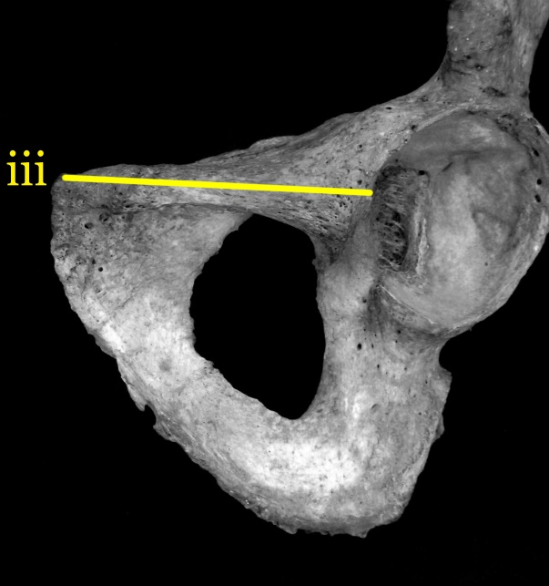
Figure 22: WPL measurement

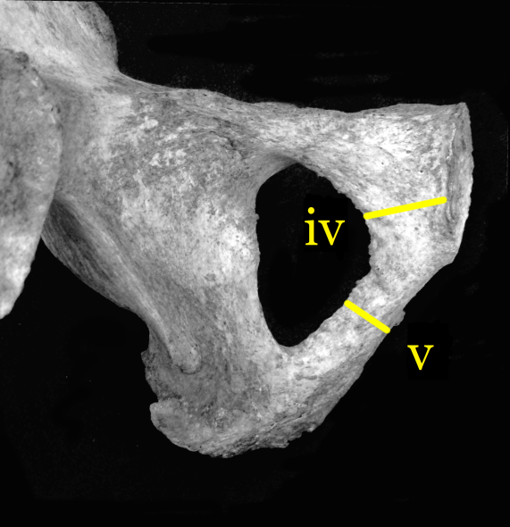
Figure 23: MinPW (iv) and MinWPR (v) measurements

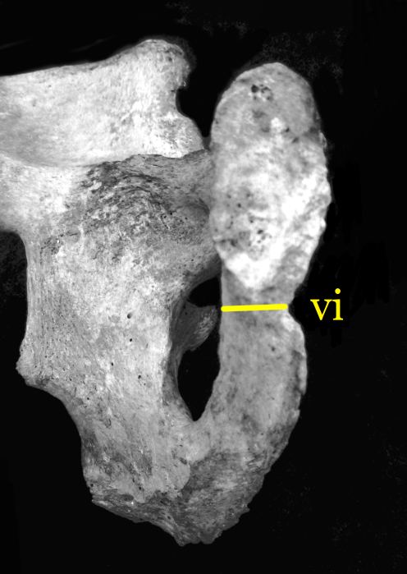
Figure 24: MinWBS measurement

C. Humeral metrics
vii. Maximum height of medial trochlear edge (MMaxHT; Figure 25)
Tool: Sliding caliper, flat end
Orientation: Lay humerus on a flat surface with the anterior side facing up. The measurement should be taken while looking straight down at the distal humerus. The flat caliper needles should be perpendicular to the long axis of the trochlea.
Definition: The maximum measurement from proximal edge to distal edge on the medial trochlea.

viii. Maximum height of lateral trochlear edge (LMaxHT; Figure 25)
Tool: Sliding caliper, flat end
Orientation: Lay humerus on a flat surface with the anterior side facing up. The measurement should be taken while looking straight down at the distal humerus. The flat caliper needles should be perpendicular to the long axis of the trochlea.
Definition: The maximum measurement from proximal edge to distal edge on the lateral trochlea.

ix. Minimum trochlear constriction (MinTC; Figure 26)
Tool: Sliding caliper, tapered end
Orientation: Lay humerus on a flat surface with the posterior side facing up. The measurement should be taken while looking straight down at the distal humerus. The flat caliper needles should be perpendicular to the long axis of the trochlea.
Definition: The minimum measurement of the trochlea, from the proximal surface (which borders the olecranon fossa) to the distal surface.

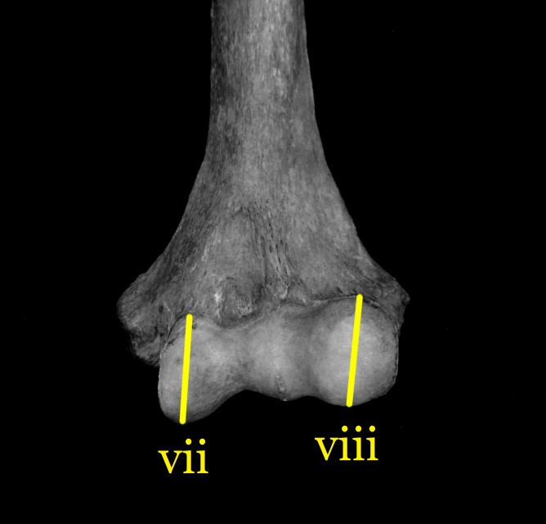
Figure 25: MMaxHT (vii) and LMaxHT (viii) measurements

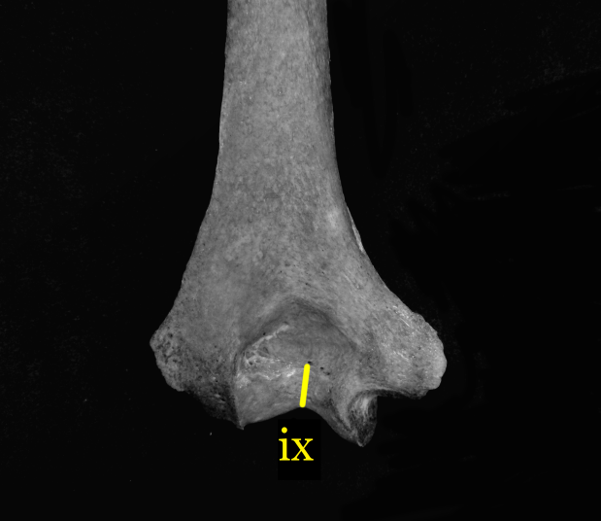
Figure 26: MinTC measurement

D. Minimally dimorphic metrics
x. Orbital height (OBH; Figure 27)*
Tool: Sliding caliper
Orientation: With the skull upside down and facing the observer, use the inside calipers to measure between the borders; this is an inside measurement. Bisect the orbit visually, referring to its own axes, not the planes of the skull (Howells 1973).
Definition: The height between the upper and lower borders of the orbit, perpendicular to the long axis of the orbit and bisecting it (Howells 1973).

xi. Interorbital breadth (DKB; Figure 27)*
Tool: Sliding caliper
Orientation: With the skull face up, place the lateral points on the dacryon, with particular attention to their antero-posterior location (Howells 1973).
Definition: The breadth across the nasal space from dacryon to dacryon (Howells 1973).

xii. Nasal aperture breadth (NLB; Figure 27)*
Tool: Sliding caliper
Orientation: Place the points of the instrument on the sharp lateral margins of the nasal aperture. This is not an inside measurement (Howells 1973; Langley et al. 2016)
Definition: The maximum breadth of the nasal aperture (Langley et al. 2016)

xiii. Foramen magnum length (FOL; Figure 28)*
Tool: Sliding caliper
Orientation: Measure with the skull base up, using the inside calipers for simplicity, not in order to take an inside measurement (Howells 1973).
Definition: The midsagittal distance from basion to opisthion (Howells 1973).

xiv. Maximum diameter at fibular midshaft (FMD; Figure 29)*
Tool: Sliding caliper
Orientation: Find the midpoint on the osteometric board and mark with a pencil. Place the diaphysis of the fibula between the two arms of the caliper while turning the bone to obtain the maximum diameter (Langley et al. 2016)
Definition: Maximum diameter at midshaft

Figure 27: OBH (x), DKB (xi), and NLB (xii) measurements

Figure 28: FOL measurement

Figure 29: FMD measurement

Vita

Haley Elizabeth Horbaly was born in Columbus, Ohio in 1992 to parents William and Denise Horbaly. After the birth of her brother in 1995, her family moved to Charlottesville, Virginia where Haley spent most of her childhood, only to later return to Columbus to begin her undergraduate career at The Ohio State University. She graduated from OSU in 2015 with a B.S. in Anthropological Sciences. Following graduation, Haley moved to Knoxville to pursue her Master’s in Biological Anthropology at the University of Tennessee. There, she worked as a graduate assistant for the Forensic Anthropology Center, eventually becoming the manager for the William M. Bass Donated Skeletal Collection. In spring of 2017, Haley was accepted to remain at the University of Tennessee to pursue her doctoral degree in Biological Anthropology.

