CHARACTERIZATION OF WATER QUALITY AND PERIPHYTON ASSEMBLAGES IN AN URBAN STREAM, KNOXVILLE, TENNESSEE

A Thesis Presented for the
Master of Science
Degree
The University of Tennessee, Knoxville

Allison Reed Rogers
December 2022

ACKNOWLEDGEMENTS
I have had so much support throughout my time here at UT in completing my research and am beyond grateful for the opportunity this department has given me. Thanks to Dr. Annette Engel for taking me on as her graduate student. Funding for this thesis research was provided to Dr. Engel through the Donald H. and Florence Jones Endowment for Aqueous Geochemistry. I cannot thank her enough for her patience, guidance, and honest feedback throughout the entire process of my research, from the planning stages to the finishing touches. Thanks also to Audrey Paterson for her assistance, giving me the opportunity to learn the proper techniques and instrumentation in the lab and apply it to my research. My committee members, Ania Szynkiewicz and Drew Steen, provided useful advice and expertise for my research. I am very appreciative of their time, effort, and flexibility to the adverse changes that were presented. I couldn’t have completed my research without the willingness of my lab mates, Hannah Rigoni, John Fulginiti, and Ethan Sweet, who assisted me in completing my sample collection. Of course, thank you to those who made grad school bearable: Aidan Sweeney, Kristen Butler, Jake Perez, Micki Recchuiti, Carsen Adams, Ivy Ettenborough, Morgan Lewis, and Jesse Scholpp. I do not think I would have made it without you all and will cherish our experiences we have shared together. And finally, thank you to my parents who have always been the most supportive throughout each step in my life.

ABSTRACT
Periphyton consists of assemblages of algae, diatoms, organic matter, and other microorganisms that grow on rock, sediment, and plant surfaces in aquatic systems. Periphyton growth and diversity can be affected by a range of environmental factors, but there have been few studies to understand periphyton diversity in nutrient-impaired waterways, such as in Tennessee. This study investigated whether stream periphyton communities could be used to indicate different levels of potential impairment. The study took place along a 4.8-kilometer-long segment of Third Creek in Knoxville, Tennessee. Twelve sites were selected and samples were collected at base-flow conditions in July, September, and October 2021, and in January 2022. Physical stream assessments indicated that bank stability and bank erosion conditions were poor, and 10 of 12 sites had at least one anthropogenic input (e.g., drainpipe) into the stream. More than half of the sites had land use / land cover (LULC) classified as 50% or more developed (i.e. urban). Although some water quality parameters did not indicate impairment, such as oxygen concentrations or chlorophyll a concentrations, others parameters did, including total nitrogen, which exceeded minimum recommended levels at all sites, and E. coli counts at almost all locations that exceeded recommended thresholds for recreational streams. The 16S rRNA and 18S rRNA gene sequence diversity of water and periphyton samples revealed differences in dominant taxonomic groups along the stream. Among the Bacteria, the phyla Proteobacteria, Actinobacteria, Bacteroidota, Firmicutes, Campilobacterota, Nitrospira, Verrucomicrobiota, Planctomycetota, and Myxococcota had high relative abundances in the water, and eukaryotic phyla Cilophora, Diatomea, and Cryptophycae were abundant. Periphyton communities were dominated by Proteobacteria, Cyanobacteria, Planctomycetota, Chloroflexi, Actinobacteriota, Acidobacteriota, and Bacteroidota, with prevalent eukaryotic phyla being Florideophycidae, Diatomea, Phragmoplastophyta, Chlorophyta, Arthropoda, Rotifera, Nematozoa, and Ascomycota. Bioconcentration factors of trace metals from periphyton biomass revealed that periphyton was significantly enriched in As, Cd, Pb, and Zn compared to concentrations in the water. These periphyton-associated metals could be a source of contamination into the stream and aquatic fauna.

Table of contents
SECTION 1. INTRODUCTION 1
1.1 Background 1
1.2 Thesis Goals 5
1.3 Thesis Questions, Objectives, and Hypotheses 8
SECTION 2. MATERIALS AND METHODS 12
2.1 Site Selection and Mapping 12
2.2 Land-use / Land-cover Assessment 19
2.2 Field Sampling 22
2.4 Colony Counts of Aerobic Bacteria, Total Coliforms, and E. coli 25
2.5 Water Chlorophyll Concentrations 28
2.6 Periphyton Biomass, Chlorophyll, and Trace Metal Concentrations 29
2.7 DNA Extractions, Gene Sequencing, and Sequence Processing and Analyses 34
2.8 Sequence Data Submission 36
2.9 Statistical Data Treatment and Analysis 36
SECTION 3. RESULTS 37
3.1 Characterization and Health Assessment of Third Creek 37
3.2 Seasonal Geochemical Analysis of Water Samples 41
3.3 Seasonal Changes in Aerobic Bacteria, Total Coliforms, and E. coli Counts 43
3.4 Seasonal Changes in Chlorophyll Concentrations of Water Samples 52
3.5 Microbial Diversity of Water from rRNA Genes 52
3.5.1 Bacteria and Archaea 52
3.5.2 Eukaryotes 58
3.6 Periphyton Geochemistry, Autotrophic Index, and Bioconcentration Factors 62
3.7 Microbial Diversity of Periphyton from rRNA Genes 67
3.7.1 Archaea and Bacteria 67
3.7.2 Eukaryotes 72
3.8 Correlations among Environmental Variables and Taxonomic Groups 80
SECTION 4. DISCUSSION 84
4.1 Determining Stream Health from Traditional Water Quality Indicators 84
4.2 Periphytic Responses to the Environment and Use as a Water Quality Indicator 87
REFERENCES 90
APPENDICES 100
Appendix A 100
VITA 109

List of Tables
Table 1.1. Summary of structural compositions for periphyton communities growing on various types of substrates and sediment, based on Wu (2016). 2
Table 1.2. Known locations for historical and current industrialization and potential sources for anthropogenic input along Third Creek near sample sites for this study and based on distance from confluence with the Tennessee River. 9
Table 2.1. Stream site assessment to determine the health of the system, adopted from Wolfe (2019). 17
Table 2.2. History of rainfall of Tyson Park monitoring station of Third Creek watershed in Knoxville, Tennessee, derived from city of Knoxville rainfall data, available from https://www.knoxvilletn.gov/government/city_departments_offices/engineering/stormwater_engineering_division/rainfall_data. Data were converted from inches to centimeters. 18
Table 2.3. ICP-OES analytical standards, selected spectral wavelengths, instrument detection limits (LOD) according to the ICP-OES and software specifications, and calibration ranges used in this study. 26
Table 2.4. Classification of periphyton according to different parameters, such as dry mass, ash content, and chlorophyll a content, as implemented by Romanów and Witek (2011) and adopted from Lakatos et al. (1998). 33
Table 3.1. Stream characteristics at sample sites and descriptions of periphyton and stream microhabitat according to Table 1.1. Distance (km) is with respect to confluence with the Tennessee River. Substrate at sites 011 and 012 could not identified (i.e., NA) due to water depth and turbidity occluding the bottom. 39
Table 3.2. Health assessment of sites along Third Creek in Knoxville, Tennessee, as categorized in Table 2.1 and according to Wolfe (2019). Distance (km) is with respect to confluence with the Tennessee River. Embeddedness at sites 011 and 012 could not identified (i.e., NA) due to water depth and turbidity occluding the bottom. 40
Table 3.3. Estimated land use / land cover percentages for major classification types for each sample site along Third Creek in Knoxville, Tennessee. 41
Table 3.4. Field-collected water quality parameters along Third Creek in Knoxville, Tennessee, from July 2021 (site names labelled JY), to September 2021 (labelled S), October 2021 (labelled O), and January 2022 (labelled JN). Units for conductivity are in µS/cm, and dissolved oxygen (DO), alkalinity, TN and NPOC are in mg/L. * = single injection value 43
Table 3.5. Major anions from water samples along Third Creek in Knoxville, Tennessee, from July 2021 (site names labelled JY), to September 2021 (labelled S), October 2021 (labelled O), and January 2022 (labelled JN). Distance (km) is with respect to confluence with the Tennessee River. MRL = Minimum reporting limit in mg/L. 45
Table 3.6. Major cations and charge balance from water samples along Third Creek in Knoxville, Tennessee, from July 2021 (site names labelled JY), to September 2021 (labelled S), October 2021 (labelled O), and January 2022 (labelled JN). Distance (km) is with respect to confluence with Tennessee River. MRL = Minimum reporting limit in mg/L. 46
Table 3.7. Fluorescence indices of water samples along Third Creek in Knoxville, Tennessee from July 2021 (site names labelled JY), to September 2021 (labelled S), October 2021 (labelled O), and January 2022 (labelled JN). 47
Table 3.8. Average (n = 4) values for aerobic microbial counts (Figure 3.1), total coliform (Figure 3.2), and E. coli (Figure 3.3) as colony forming units (CFU) along Third Creek in Knoxville, Tennessee, from July 2021 (site names labelled JY), to September 2021 (labelled S), October 2021 (labelled O), and January 2022 (labelled JN). 48
Table 3.9. Chlorophyll a and b concentrations from water samples along Third Creek in Knoxville, Tennessee, from July 2021 (site names labelled JY), to September 2021 (labelled S), October 2021 (labelled O), and January 2022 (labelled JN). MDL= Method detection limit (μg/L). Distance (km) is with respect to confluence with the Tennessee River. 54
Table 3.10. Summary of 16S rRNA gene sequence data for each watr sample. The number of OTUs were assigned at the 97% sequence identity cutoff for each sample. Alpha diversity indices at the genus level of water samples across sites sampled along Third Creek, Knoxville, Tennessee, in July 2021. Distance (km) is with respect to confluence with the Tennessee River. 55
Table 3.11. Summary of 18S rRNA gene sequence data for each water sample. The number of OTUs were assigned at the 97% sequence identity cutoff for each sample. Alpha diversity indices at the genus level of water samples across sites sampled along Third Creek, Knoxville, Tennessee, in July 2021. Distance (km) is with respect to confluence with the Tennessee River. 60
Table 3.12. Biomass, loss on ignitions (LOI), and chlorophyll content from AFDM periphyton samples from Third Creek, Knoxville, Tennessee, during July 2021. 64
Table 3.13. Classification of periphyton based on dry mass, ash-free dry mass, and chlorophyll content, based on Romanów and Witek (2011). 65
Table 3.14. Trace metal and magnesium concentrations from AFDM periphyton samples from periphyton samples from Third Creek, Knoxville, Tennessee, during July 2021. All concentrations are in mg/kg. 69
Table 3.15. Bioconcentration factors (BCF) for each trace metal (and magnesium) from the periphyton samples in Third Creek, Knoxville, Tennessee, during July 2021. Concentrations in the water that were below detectable limits (BDL) could not be used for BCF calculations. 70
Table 3.16. Summary of 16S rRNA gene sequence data for each sample. The number of OTUs were assigned at the 97% sequence identity cutoff for each sample. Alpha diversity indices at the genus level of periphyton samples across sites sampled along Third Creek, Knoxville, Tennessee, in July 2021. Distance (km) is with respect to confluence with the Tennessee River. 71
Table 3.17. Summary of 18S rRNA gene sequence data for each sample. The number of OTUs were assigned at the 97% sequence identity cutoff for each sample. Alpha diversity indices at the genus level of periphyton samples across sites sampled along Third Creek, Knoxville, Tennessee, in July 2021. Distance (km) is with respect to confluence with the Tennessee River. 75
Table 3.18. Correlations among phototrophic taxonomic groups using Spearman’s rho determination. The bottom triangle includes the Spearman’s rho values for each relationship and the top triangle contains the p-values for the relationship. The colored cells represent varying relationships as follows: green is an indication of the strongest positive or negative relationship; blue represents moderately significant relationships; yellow corresponds to p-values > 0.05 (i.e., significant), whereas orange is related to p-values > 0.05 but < 0.07 (i.e., moderately significant). 82
Table 3.19. Correlations among environmental variables using Spearman’s rho determination and significant (p-value <0.5) and moderately significant (p-values >0.05 but <0.07) relationships to environmental variables. 83
Table 3.20. Correlations among phototrophic taxonomic groups using Spearman’s rho determination and significant (p-value <0.5) and moderately significant (p-values >0.05 but <0.07) relationships to environmental variables. 84
Table 4.1. Chosen physical stream characteristics (Erosion/Bank Stability) and environmental variables (E. coli, TN, DO, chlorophyll a) that reflect the influence of urban development. The percent developed LULC includes low, medium, and high intensity development. The E. coli counts are in CFUs. DO and TN concentrations are in mg/L and chlorophyll a concentrations are in μg/L. Red shading for LULC >50%, and for parameters values that exceeded what is deemed as acceptable water quality (i.e., “good”). For reference, DO levels should be >5–6 mg/L for Fish and Aquatic Life Streams, TN should not exceed 0.591 mg/L, and E. coli counts should not exceed 1.26 CFU/1 mL in Recreation Streams (Dein et al., 2019). 87

List of Figures
Figure 1.1. Sample sites (labelled as 3-digit numbers 001 through 012) along Third Creek, Knoxville, Tennessee. Numbers increase downstream. Based on land-use / land-cover data, different development levels exist near the stream, from open space upstream, along the Third Creek Greenbelt, to high intensity development due to urbanization and industrialization downstream and near the confluence with the Tennessee River. The base map and urbanization gradient coloration are from Esri, OpenStreetMap and was plotted in ArcMap (v10.8). 7
Figure 2.1. Sample sites (only showing site labels 001 through 012) along Third Creek in Knoxville, Tennessee. The base topographic map uses Esri, HERE data, © OpenStreetMap, plotted in ArcPro (v10.8). 13
Figure 2.2. Geologic units surrounding sample sites (only showing the site labels 001 through 012) of Knoxville, Tennessee. The base topographic map uses Esri, HERE data, © OpenStreetMap, plotted in ArcPro (v10.8). 14
Figure 2.3. Representative photographs of sample sites (labelled 001 through 006) along Third Creek in Knoxville, Tennessee. 15
Figure 2.4. Representative photographs of sample sites (labelled 007 through 012) along Third Creek in Knoxville, Tennessee. 16
Figure 2.5. Potential urban or anthropogenic input point sources (blue triangle) and potential non-point sources (yellow triangle) along Third Creek in Knoxville, Tennessee. The base topographic map uses Esri, HERE data, © OpenStreetMap, plotted in ArcPro (v10.8). 20
Figure 2.6. Land-use / land-cover assessment for each sample site (labelled 001 through 012) along Third Creek in Knoxville, Tennessee. The maps use Esri, NLCD 2019, plotted in ArcPro (v10.8). Potential point and non-points sources are included, from mapped data on Figure 2.5. 21
Figure 2.7. Examples of the types of sampled periphyton from different microhabitats in Third Creek, Knoxville, Tennessee. Top, site 009, with 0.5-m² quadrat. Bottom, site 010. 23
Figure 2.8. Examples of 3M Petrifilm plates for counting E. coli/coliform colony forming units (top) and aerobic microbial counts (bottom) for 012 and 008, respectively. The yellow grid lines are 1 cm x 1 cm. 27
Figure 3.1. Changes in trace metal concentrations from water samples along Third Creek in Knoxville, Tennessee, from July 2021. All trace metals except Mn and Mg are plotted on the primary y-axis; Mn and Mg are plotted on the secondary y-axis. 49
Figure 3.2. Aerobic microbial counts (CFU = colony forming units) in Knoxville, Tennessee, from July 2021 (sites 001 through 012) to September 2021, October 2021, and January 2022. Sites that were sampled seasonally (i.e., Sept. 2021, Oct.2021, Jan. 2022) were 001, 003, 008, 010, 012. 50
Figure 3.3. Total coliform counts (CFU = colony forming units) in Knoxville, Tennessee, from July 2021 (sites 001 through 012) to September 2021, October 2021, and January 2022. Sites that were sampled seasonally (i.e., Sept. 2021, Oct.2021, Jan. 2022) were 001, 003, 008, 010, 012. 51
Figure 3.4. E. coli counts (CFU = colony forming units) in Knoxville, Tennessee, from July 2021 (sites 001 through 012) to September 2021, October 2021, and January 2022. Sites that were sampled seasonally (i.e., Sept. 2021, Oct.2021, Jan. 2022) were 001, 003, 008, 010, 012. The Fish and Aquatic Life Streams Threshold for E. coli counts is 6.3 CFU/1-mL (red dashed line) (Dein et al., 2019) and the Recreation Streams Threshold is 1.26 CFU/1-mL (turquoise dashed line) (Dein et al., 2019). 52
Figure 3.5. Chlorophyll a (top) and b (bottom) concentrations (µg/L) from water sampled along Third Creek, Knoxville, Tennessee, from July 2021 (site names labelled JY), to September 2021 (labelled S), October 2021 (labelled O), and January 2022 (labelled JN). according to Fondriest Environmental, Inc. (2014). Values < 7 µg/L are considered desirable (good), 7-15 µg/L are less desirable, and >15µg/L are considered problematic (poor water quality). 56
Figure 3.6. Number of sequences in the top 20 most abundant and shared 16S rRNA gene sequence OTUs from water sampled along Third Creek, Knoxville, Tennessee, from July 2021. 58
Figure 3.7. Number of sequences in only the top 20 most abundant and shared 18S rRNA gene sequence OTUs from water sampled along Third Creek, Knoxville, Tennessee, from July 2021. Samples from 1.93 and 1.45 km did not comprise some of the most prevalent OTUs detected in the whole dataset. 62
Figure 3.8. Chlorophyll a and b concentrations from AFDM periphyton sampled along Third Creek, Knoxville, TN, in July 2021. 66
Figure 3.9. Autotrophic Index (AI) calculations from chlorophyll a and AFDM data collected from periphyton samples along Third Creek, Knoxville Tennessee, during the July 2021 sampling period, shown against AI ranges of low to high, according to O’Brien and Wehr (2010) and APHA (2016). Values >400 could be considered indicators of potential organic pollution. 67
Figure 3.10. Trace metal concentrations from AFDM periphyton samples from Third Creek, Knoxville, Tennessee, during July 2021. All metals except for As and Cd are plotted on the secondary y-axis; As and Cd are plotted on the primary y-axis. 72
Figure 3.11. Number of sequences in the top 20 most abundant and shared 16S rRNA gene sequence OTUs from periphyton sampled along Third Creek, Knoxville, Tennessee, from July 2021. 74
Figure 3.12. Number of sequences in the top 20 most abundant and shared 18S rRNA gene sequence OTUs from periphyton sampled along Third Creek, Knoxville, Tennessee, from July 2021. 78
Figure 3.13. From the top 20 most abundant and shared 18S rRNA gene sequence OTUs from periphyton samples shown in Figure 3.12, but with the unclassified and heterotrophic taxa removed. Samples were collected along Third Creek, Knoxville, Tennessee, from July 2021. 79
Figure 3.14. (A) Functional proportions of 18S rRNA gene sequences from taxonomic classifications of binned OTUs from periphyton. (B) Phylum-level diversity of all 18S rRNA sequences assigned to autotrophic function based on OTUs from periphyton. 80

SECTION 1. INTRODUCTION

1.1 Background
Freshwater ecosystems, like streams and rivers, provide food, housing, and other essential socioeconomic and cultural resources (Smucker et al., 2020). However, due to rapid global population growth and changes in land use, the structure and ecological functions of aquatic ecosystems are being modified (McCormick et al., 1996; Aronson et al., 2014; Granitto et al., 2021). The shift in land use from unoccupied, rural, and wild natural areas into urban landscapes with impervious cover, rather than open soil or vegetation, is referred to as urbanization. Urbanization has the potential to change the morphology and hydrology of streams, lakes, and waterways, as well as alter substrate (i.e., soil) permeability. Urban runoff, which often includes fertilizers, pesticides, sediment, and animal waste, can cause nutrient loading that could trigger eutrophication and excessive periphyton growth (Matlock et al., 1998; Blanton, 2014). High periphyton biomass can decrease the overall quality of a habitat and its water due to unacceptably high or low levels of dissolved oxygen, aesthetically displeasing odors, and toxins (APHA, 2018; Wu, 2016).
Periphyton is the general term used to describe a biofilm of autotrophic and heterotrophic microorganisms growing in lakes, ponds, rivers, streams, wetlands, marshes, and estuaries within a mucopolymeric matrix of debris and sediment on submerged aquatic surfaces and substrates, such as rocks, vegetation, inorganic and organic particles, and/or sediment (Guckert et al., 1992). Periphyton classification is based on the type of substrate, including epipelon, epipsammon, epiphyton, epilithon, and meta-phyton (Table 1.1). Epipelon and epipsammon periphyton organisms move throughout the water column, usually live on or within sandy or muddy sediment, colonize surfaces quickly due to their motility, and are important for their intake and cycling of nutrients (e.g., carbon, nitrogen, phosphorus) (Wu, 2016). Epiphyton and epilithon periphyton commonly attach to solid surfaces, such rocks, plants, and macrophytes.

Type of Substrate | Classification | Description
Living on and/or within sediment | Epipelon | Living on organic (and muddy) sediment surface
Living on and/or within sediment | Endopelon | Moving within organic (muddy) sediment
Living on and/or within sediment | Endopsammon | Living on/with sandy sediment
Living on and/or within sediment | Metaphyton | Living within sediment; clouds of filamentous or coenobial algae (i.e., loosely associated colonies)
Living on and/or within solid surfaces | Epilithon | Growing on hard substrate (e.g., rock)
Living on and/or within solid surfaces | Epixylon | Growing on wood (similar to epiphyton)
Living on and/or within solid surfaces | Endolithon | Growing within rock
Living on and/or within solid surfaces | Epipsammon | Growing on sand grains
Living on and/or within solid surfaces | Endozoon | Growing within animals
Living on and/or within solid surfaces | Epizoon | Growing on animals
Living on and/or within solid surfaces | Endophyton | Growing within plants or plant-derived mucilage
Living on and/or within solid surfaces | Epiphyton | Growing on submerged plants, marcophytes, and/or large macroalgae
Table 1.1. Summary of structural compositions for periphyton communities growing on various types of substrates and sediment, based on Wu (2016).
Periphyton communities play an essential part in nutrient cycling, aquatic food chains and webs, and invertebrate community structure (Boston & Hill, 1991). The structural composition, as well as growth and photosynthesis rate, are influenced by submersion time, water velocity and depth, substrate type, nutrient concentrations, light availability/intensity, and water and air temperature (Wu, 2016). In shallow water, periphyton must endure variability in water depth and potential desiccation. On the contrary, the growth environment at greater water depths can be more stable but could be affected by light attenuation (Wu, 2016).
Studying the environmental and conservation consequences of urbanization on aquatic systems, such as habitat loss, habitat deterioration, and native species migration and replacement with invasive species (Lebkurcher et al., 2015), can be done by monitoring biological and water quality indicators for overall stream health (Smucker et al., 2020). Periphyton community compositions have been used as biological indicators for aquatic health based on community structure and function, and algal and microbial diversity and abundances (Vis et al., 1998; Lebkuecher et al., 2015; Wu, 2016). This is because excessive periphyton growth would indicate potentially poor water quality. Periphyton is generally compositionally diverse and includes, but is not limited to, algae, diatoms, fungi, protozoans, bacteria, and archaea that typically live in symbiotic associations with each other (Krenz et al., 2018; Carrell et al., 2021). Diatoms, in particular, are exceptional water quality bioindicators due to their ability to persist and thrive in minimal environmental conditions (e.g., pH, conductivity, light intensity).
Periphyton biomass is typically measured as chlorophyll a and b content (Cyr, 1998), which originates from chloroplasts that absorb energy from light during photosynthesis (Lebkurcher et al., 2015), but periphyton can also be described from phospholipid fatty acid profiles (Pfiffner et al., 2006). Periphyton composition can also be compared to environmental parameters (e.g., pH, temperature, anions, cations, and nitrogen and phosphorus concentrations) (Hoyle et al., 2014; Hill et al., 2000). The autotrophic index (AI) measures periphyton primary productivity from the ratio of periphyton ash-free dry mass (AFDM) to chlorophyll a concentration (O’Brien and Wehr, 2010). The AI can be used to interpret the heterotrophic and autotrophic composition of periphyton communities, growth location, growth tendencies, and incorporation of nonliving organic material can also influence AI values. A ratio ranging from 50 to 200 represents a “low” AI score and would indicate predominantly phototrophic algae. A “moderate” AI score ranges from 200 to 400 because of mixed phototrophs and heterotrophs. Values ranging at or above 400 have an overabundance of heterotrophic, non-chlorophyllous organisms or detritus and can be associated with poor water quality (O’Brien and Wehr, 2010; APHA, 2016).
Periphyton may improve water quality through the accumulation of contaminants into the physical biofilm and matrix material (e.g., Tang et al., 2014). The bioconcentration factor (BCF) compares the concentration of biota (i.e., periphyton) with the concentration of a trace metal within the medium (i.e., surface water) to evaluate accumulation proficiency. A BCF greater than 1 suggests that the trace metal concentration in the biota is greater than that of the medium (Tang et al., 2014). As such, the AI and BCF can be used as valuable ways to quantify the productivity of an aquatic system and understand potential stream health and water quality related specifically to periphyton.
Periphyton studies have been conducted in (but not limited to) Canada, Poland, South Africa, and the United States, including Tennessee, Florida, and Idaho (McCormick et al., 1996; Cyr, 1998; Vis et al., 1998; Hill et al., 2000; Winter & Duthie, 2000; Pfiffner et al., 2006; Middleton, 2010; Schneider et al., 2012; Hoyle, 2014; Lebkuecher et al., 2015; Grimmett & Lebkuecher, 2017). Diatom assemblages frequently include Achnanthes, Achnanthidium, Amphora, Gomphonema, Navicula, Nitzschia, and Fragilaria. Non-diatom benthic algae commonly found in aquatic communities include Cladophora, Phormidium, Protoderma, Cosmarium, Oedogonium, Scenedesmus, and Spirogrya (McCormick et al., 1996; Vis et al., 1998; Hill et al., 2000; Winter & Duthie, 2000; Lebkuecher et al., 2015; Grimmett & Lebkuecher, 2017). Macrophyte community structures exhibit strong compositional correlations with diatoms compared to non-diatom communities (Schneider et al., 2012).
Despite the demonstrated usefulness of periphyton as an aquatic bioindicator, and the fact that some members of a periphyton community can respond to levels of environmental stress caused by contamination and can flourish in polluted environments and even contribute to removing and bioconcentrating metals from the water, periphyton data have minimally been used in water quality assessments (Cyr, 1998). One of the reasons for this is because past studies have not thoroughly evaluated periphyton community diversity, and specifically relied on microscopic identifications of large, morphologically conspicuous organisms that can be non-specific taxonomically, rather than the use of molecular genetics to get a more detailed picture of microbial diversity. Additionally, past studies tended to investigate periphyton communities from either pristine habitats or heavily contaminated systems, rather than within an area and across gradients in land cover and use or water quality conditions. Without studies from pristine or less impacted locations, as reference sites, it is difficult to know what changes may occur to periphyton communities due to potential contamination. Moreover, without knowing how periphyton communities respond to changing environmental conditions, it has been difficult to know if periphyton assemblages are beneficial to the ecosystem or not, such as relationships among specific taxa to bioaccumulation potential. Fundamental questions in periphyton research can be asked, such as: How do physiochemical and aqueous geochemical conditions influence periphyton community compositions? Do point and/or nonpoint sources correlate to distinct periphyton communities, such that changes in periphyton communities would indicate different levels or types of identifiable contamination? What environmental changes correlate to shifts in periphyton compositions that could indicate potential impacts to the communities from contamination? How do periphyton communities change along a stream that receives different levels of contamination? How far downstream, and away from point or nonpoint sources of contamination, are changes in periphyton communities detected?

1.2 Thesis Goals
The goals of this thesis research were to assess periphyton assemblage diversity across an urbanization gradient by pairing periphyton biomass and water quality assessments with molecular genetics methods to describe the periphyton communities. The research was conducted along Third Creek in Knoxville, Tennessee, because of its ease of access, proximity to the city center, constant hydrologic flow, proximity to a range of differing urbanization levels and potential natural and anthropogenic, point- and non-point contamination sources. To my knowledge, this study is one of the first molecular genetics assessments of periphyton diversity from an urbanized stream reach within Knoxville and one of only a few studies from the state of Tennessee (Middleton, 2010; Carrell et al., 2021). Consequently, the findings should be of interest to city planners and water resource managers in the state.
The statewide population of Tennessee is 6.8 million, with over 180,000 residents in the city of Knoxville (Bureau, 2019). According to the Tennessee Department of Environment and Conservation (TDEC), aquatic contamination in Knoxville is predominantly due to urban runoff (Laster et al., 2014). Throughout the state’s waterways, bacteria, such as fecal coliforms, including E. coli, are the leading water-borne pathogen. High levels are caused by runoff from waste treatment plants, agricultural lands, and failed septic tanks in urban and rural areas (Laster et al., 2014). Advisory signage at stream locations was implemented by the State, beginning in 1985, due to public health concerns. A total maximum daily load (TMDL) was assigned to urban creeks to try and reduce the levels of bacteria in the streams (Duncan, 2015). Nitrate and/or nitrite sourced from agricultural inputs (i.e., fertilizer, pesticides) also require a TMDL due to exceedingly high levels (Duncan, 2015). However, from these investigations, it has been unclear what relationships there are, if any, among fecal coliform load and periphyton assemblages in the urban streams.
Although portions of Third Creek form a wooded riparian corridor, and is part of the Third Creek Greenway, which includes Third Creek Greenway Park, Safety City Park, Tyson Park, and the UT Gardens (Duncan, 2015; Colquit, 2021), the surrounding area near the Knoxville city center is excessively developed, with a densely and highly populated university campus, businesses, apartment complexes, and active and historical industrial and manufacturing activities (Figure 1.1). Third Creek’s and Knoxville’s contamination history dates back before the passing of the Clean Water Act in 1972 (Hampson et al., 2000). During the 1800s and after the Civil War, Knoxville used its access to waterways, railroads, and geographical location to be a profitable goods

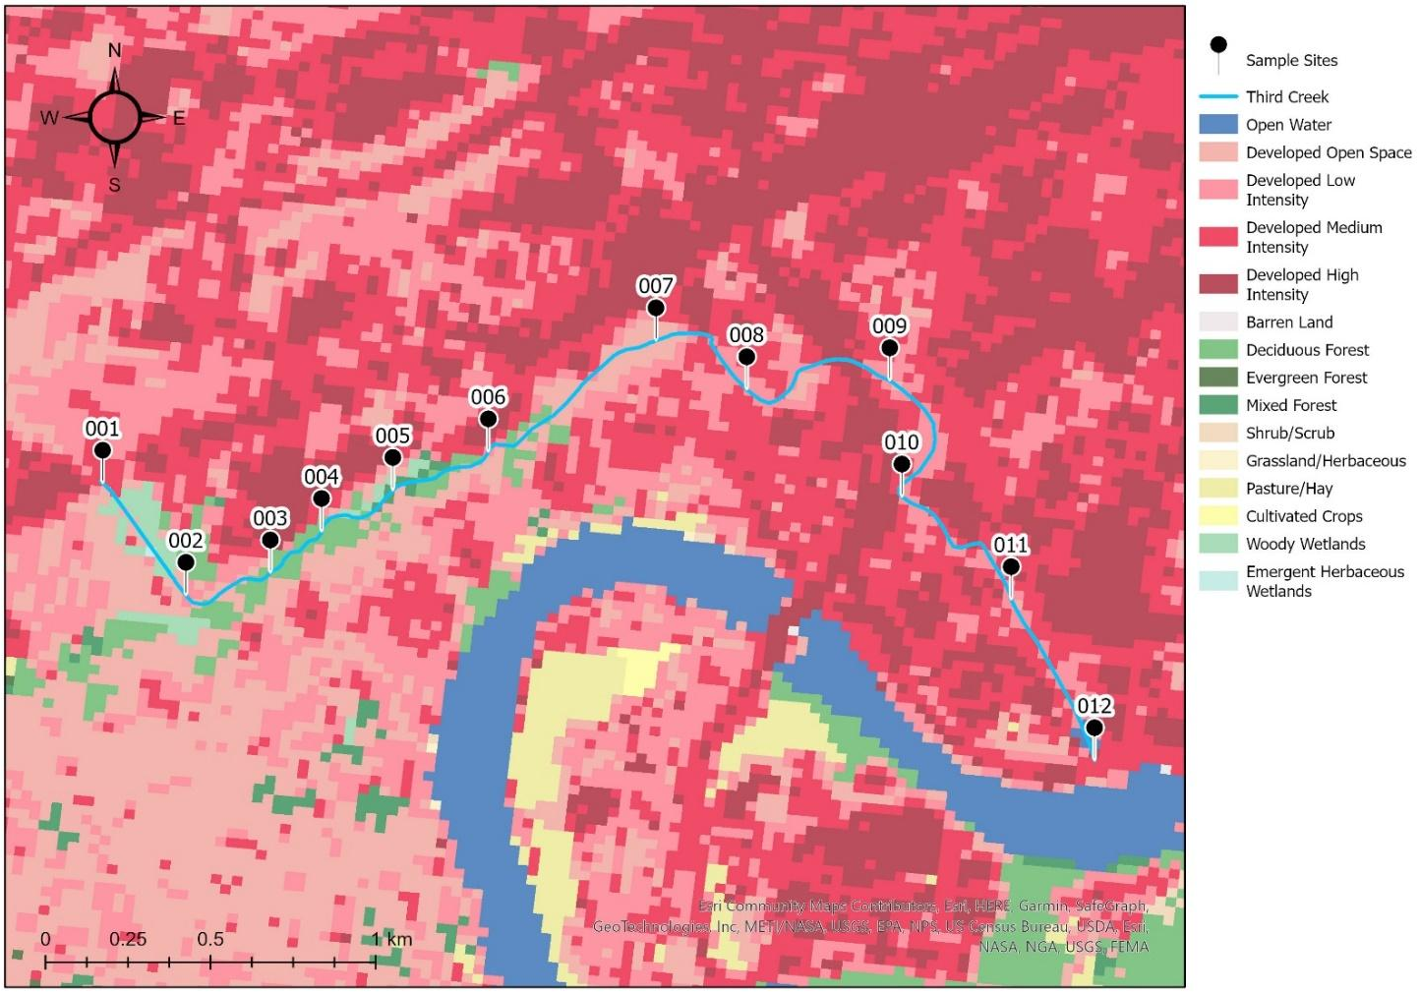

Figure 1.1. Sample sites (labelled as 3-digit numbers 001 through 012) along Third Creek, Knoxville, Tennessee. Numbers increase downstream. Based on land-use / land-cover data, different development levels exist near the stream, from open space upstream, along the Third Creek Greenbelt, to high intensity development due to urbanization and industrialization downstream and near the confluence with the Tennessee River. The base map and urbanization gradient coloration are from Esri, OpenStreetMap and was plotted in ArcMap (v10.8).
distributor (Hampson et al., 2000). Following the decline in agricultural prices between 1865-1870 (Belissary, 1953), efforts shifted to iron manufacturing. By 1890, the value of manufactured products surpassed agricultural products by over $15,000,000 (Belissary, 1953). Several companies along Third Creek could have potentially impacted sediment and overall water quality (Table 1.2). Waterway contamination over the past century, including of Third Creek, has cost the city more than $2,000,000 in attempts at remediation (Duncan, 2015). Previous studies from near Third Creek have characterized tree species diversity and soil characteristics (Reichert, 2014), and the effects of urbanization and industrialization on in-stream pollutants, including fecal coliform counts, during flood events (Christian & Hathaway, 2016; Christian et al., 2020). Third Creek has also been used to define a chemical perturbation index for examining water quality (Jolly, 2004) and to assess industrial contaminants in sediment (Wenhold, 2019).
Although the TDEC and other state policies and laws have been implemented to protect and restore the health of streams, urbanization will continue to be problematic for assessing water quality and biota within aquatic systems. Identifying and understanding how urbanization negatively impacts streams is vital to instilling updated conservation and remedial strategies to preserve aquatic life in urbanized areas. One way to begin to address these gaps is to learn more about the naturally occurring, undisturbed periphyton assemblages in Third Creek (i.e., not during or after storm events) that would result from growth under ambient, localized watershed conditions and potential contamination levels. Periphyton from urban streams in Tennessee have not been well studied (Middleton, 2010; Carrell et al., 2021) and research has not been directed at understanding periphyton diversity using molecular genetics or as a potential bioindicator for water quality.

1.3 Thesis Questions, Objectives, and Hypotheses
This thesis research intended to answer the following questions:
- What periphyton communities are present in Third Creek during stream baseflow conditions? Are the communities comparable to other streams within Tennessee?
- How do physiochemical and aqueous geochemical conditions correlate with fecal coliform and periphyton community compositions from Third Creek?
Site ID | Distance from Confluence (km) | Companies
007 | 2.90 | Sequatchie Concrete Services
010 | 1.45 | University Commons (previously known as Fulton Bellows manufacturing plant)
012 | 0.48 | Wastewater Treatment Plant and
 |  | Buzzi Unicem USA – General Contractor
Table 1.2. Known locations for historical and current industrialization and potential sources for anthropogenic input along Third Creek near sample sites for this study and based on distance from confluence with the Tennessee River.

- How do periphyton communities change along a gradient from the Greenbelt upstream (i.e., less developed) to the confluence with the Tennessee River downstream, which is densely populated and developed?
- Is there a periphyton community in less developed areas that is distinct from communities in areas with quantitatively more intense development?
- Can periphyton communities in more developed stream reaches indicate poor (or poorer) water quality based on their taxonomic diversity, and from the autotrophic index and bioconcentration factor calculations?
To answer these questions, the main research objectives were to:
- Examine the water chemistry from Third Creek during baseflow stream conditions, which differed from previous research that investigated Third Creek urban stream runoff geochemistry only during flush stages after major storm events (Christian et al., 2020); parameters measured would be physicochemistry, major ions, total and dissolved organic carbon content (TOC, DOC), chromophoric dissolved organic matter (CDOM) fluorescence, total nitrogen content (TN), and trace metals and chlorophyll a and b concentrations from the water and periphyton.
- Quantify aerobic bacteria and fecal coliforms, including E. coli, from the stream.
- Evaluate land-use / land-cover (LULC) along the stream reach using GIS.
- Assess water column microbial communities and undisturbed, natural periphyton assemblages using molecular genetics and compare the periphyton diatom and other eukaryotic diversity to other microbial communities, including cyanobacteria.
- Statistically examine periphyton diversity in the context of local stream geochemistry, including chlorophyll content and trace metals.
- Calculate AI and BCF to assess whether changes in periphyton communities correlate to potential water quality indicators along the stream.

The hypotheses tested were:
H1) Some parameters in the water (e.g., nitrate concentration, chloride concentration, chlorophyll content) and microbial counts (e.g., E. coli, total coliform, and aerobic) will be elevated at sites located in more developed areas and near point sources; nutrient concentrations and coliform counts will be lower in less developed areas away from point sources.
H2) Sample sites with comparable geochemical properties will have similar periphyton assemblages, such that upstream (and less developed) sites will have communities that differ from downstream communities where there is more development.
H3) Periphyton communities will be primarily composed of diatoms in areas with less potential contamination (i.e., E. coli, trace metals, N) and areas with more contamination will be composed of non-diatoms, as well as more heterotrophic, non-chlorophyllous organisms.
H4) The BCF calculations from periphyton will differ from upstream to downstream, and near stream input, and correlate to changing trace metal levels in the water, as well as periphyton autotrophic vs heterotrophic composition.

SECTION 2. MATERIALS AND METHODS

2.1 Site Selection and Mapping
Third Creek is a second-order stream that flows into the Tennessee River in the Appalachian Valley and Ridge Province. Twelve sampling locations were identified about 0.16 km apart from one another along the ~4.8 km stream reach and before the confluence with the Tennessee River (Figure 2.1). Using Geographic Information Systems (GIS) incorporated into the computer program ArcMap (v 10.8), each sample site’s XY coordinates were uploaded into ArcPro as a .csv file and plotted on a base map using the tool Add XY Coordinates. Layers of orthoimagery were downloaded from ArcPro Living Atlas, including streams (TNGIC, 2022) and the U.S. National Land Cover Database (NLCD) (Esri, 2019) for LULC using the 2019 layer. LULC units were modified from the Anderson Level II classification system (Anderson et al., 1976) and included ranges of vegetation type, agricultural use, and low to high development intensity. All layers were trimmed to a polygon feature representing Knox County using the Clip tool for vector data and the Extract by Mask tool for raster data. Geological units were downloaded from the U.S. Geological Survey (USGS) (Nicholson et al., 2005). Local bedrock is primarily limestone and dolomite, with shale, siltstone, and sandstone, that are Middle Proterozoic to late Paleozoic in age (Robinson Jr et al., 1992; Luther, 2017) (Figure 2.2).
For each sampling site, stream parameters (i.e., width, depth, discharge) were measured and images were taken (Figures 2.3 & 2.4). A stream assessment, adopted from Wolfe (2019), was also done during the initial sampling periods from 21 – 28 July 2021 to provide a ranked score for different characteristics (i.e., floodplain vegetation, embeddedness, erosion, bank stability) (Table 2.1).
Samples was taken at base-flow conditions and after periods of no rainfall for several days (Table 2.2). Some sites (001, 003, 008, 010, 012) were sampled seasonally, also at baseflow conditions, throughout the remainder of 2021 and through January 2022. This sampling strategy differed from previous research that investigated Third Creek geochemistry during flood events (e.g., Christian et al., 2020).
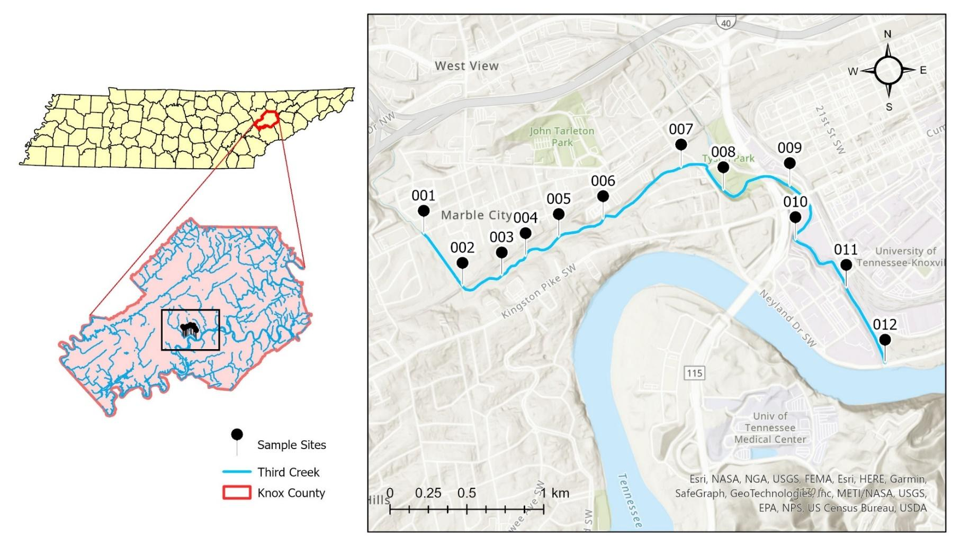

Figure 2.1. Sample sites (only showing site labels 001 through 012) along Third Creek in Knoxville, Tennessee. The base topographic map uses Esri, HERE data, © OpenStreetMap, plotted in ArcPro (v10.8).

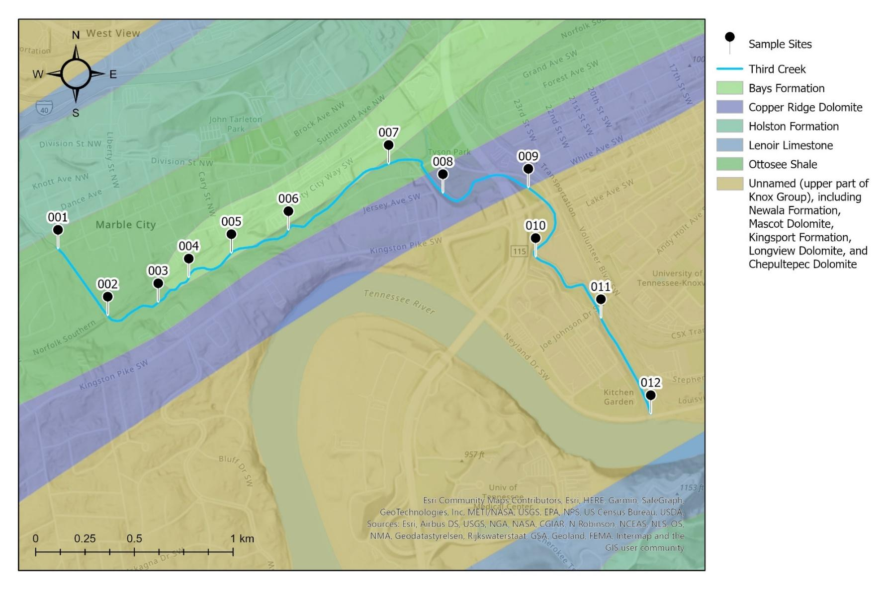

Figure 2.2. Geologic units surrounding sample sites (only showing the site labels 001 through 012) of Knoxville, Tennessee. The base topographic map uses Esri, HERE data, © OpenStreetMap, plotted in ArcPro (v10.8).
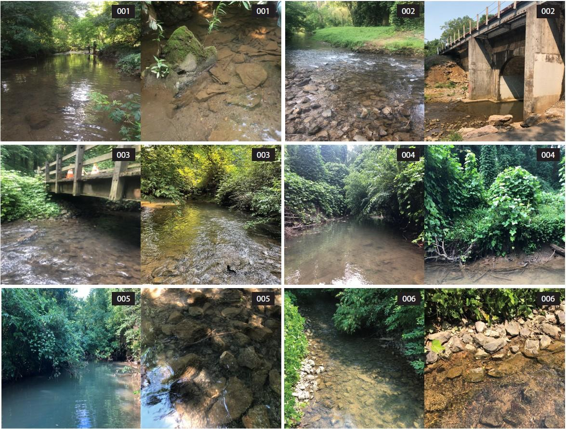

Figure 2.3. Representative photographs of sample sites (labelled 001 through 006) along Third Creek in Knoxville, Tennessee.
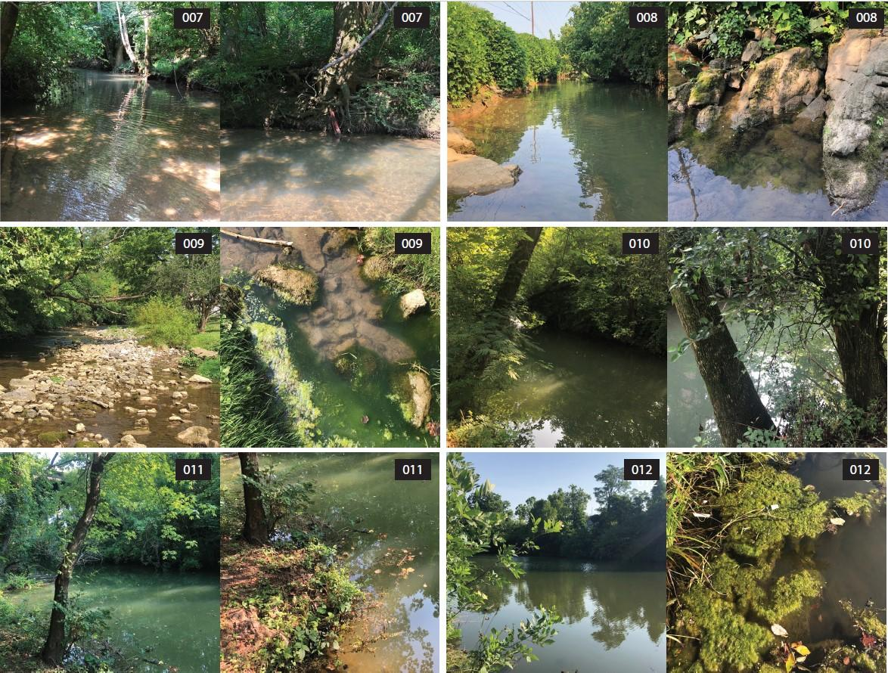

Figure 2.4. Representative photographs of sample sites (labelled 007 through 012) along Third Creek in Knoxville, Tennessee.
Table 2.1. Stream site assessment to determine the health of the system, adopted from Wolfe (2019).

Characteristic | Floodplain Vegetation | Embeddedness | Erosion | Bank Stability
Good | Lots of plants, bushes, and trees along banks and floodplain | Rocks and cobbles cover almost all the stream bed. Very little sand or silt between rocks | Banks only slightly above the surface of the water | Lots of roots and vegetation or large rocks on the vertical portion of the bank all the way down to the surface of the water
Fair | Some plants, bushes, and trees along banks and floodplain | Rocks and cobbles cover most of the stream bed. Some sand/silt between and on rocks | Banks somewhat higher above the surface of the water | Roots and vegetation or large rocks/boulders covering the vertical part of the bank 2/3 of the way down to the surface of the water
Marginal | Most trees and bushes are gone | Rocks and cobbles more than halfway buried (embedded) into sand/silt | Banks significantly above the surface of the water | Roots, vegetation and/or large rocks/boulders going only 1/3 of the way down vertical part of bank to surface of the water
Poor | Very little plant life at all along banks and floodplain | Rocks and cobbles entirely buried by sand and silt | Banks extremely high compared to water surface | Steep banks of bare soil with no plants or roots or large rocks

Table 2.2. History of rainfall of Tyson Park monitoring station of Third Creek watershed in Knoxville, Tennessee, derived from city of Knoxville rainfall data, available from https://www.knoxvilletn.gov/government/city_departments_offices/engineering/stormwater_engineering_division/rainfall_data. Data were converted from inches to centimeters.

Site ID | Dates Sampled |  | Rainfall (cm)
July 2021
― | Monday | 19 | 0.00
― | Tuesday | 20 | 0.00
001 | Wednesday | 21 | 0.00
002 | Thursday | 22 | 0.00
007, 008 | Friday | 23 | 0.00
― | Saturday | 24 | 0.00
― | Sunday | 25 | 0.00
009, 010 | Monday | 26 | 0.36
004, 005 | Tuesday | 27 | 0.00
011, 012 | Wednesday | 28 | 0.00
September 2021
― | Friday | 24 | 0.00
― | Saturday | 25 | 0.00
― | Sunday | 26 | 0.00
001, 003, 008, 010, 012 | Monday | 27 | 0.00
October 2021
― | Friday | 22 | 0.03
― | Saturday | 23 | 0.00
― | Sunday | 24 | 0.00
001, 003, 008, 010, 012 | Monday | 25 | 0.61
January 2022
― | Saturday | 15 | 0.00
― | Sunday | 16 | 1.32
― | Monday | 17 | 0.00
001, 003, 008, 010, 012 | Tuesday | 18 | 0.46

During these flooding periods, the periphyton assemblages would likely become disturbed, and be potentially scoured from substrate, buried by sediment, or otherwise impacted. Consequently, for this study, it was critical to sample periphyton during periods with no rainfall or low and intermittent rainfall. These baseflow periods in Third Creek would represent background and localized hydrological conditions for undisturbed periphyton growth. Moreover, although there is potential for contaminant levels to increase during and shortly after storm events (Christian & Hathaway, 2016; Christian et al., 2020), potential contaminant concentrations could also be higher between rainfall events, during baseflow, because concentrations would not be diluted by runoff and flood water.
A physical, on-site GPS survey was completed for the stream sampling reach to record potential point and non-point source inputs into the stream, including (but not limited to) storm water drains or pipes, conduits, and channels (Figure 2.5). Maps were created in the program ArcPro (v10.8).

2.2 Land-use / Land-cover Assessment
To analyze LULC classifications at each site, a polygon was selected 200-ft (60.96-m) from the stream centerline at each site XY coordinate using the Buffer tool. Buffers with set distances along a channel are often used to protect the riparian ecosystem functions (i.e., hydrologic, biological, ecological, aesthetic, and recreational) from development and are based on the local surroundings. For this research, the buffer distance applied was typical for other types of stream assessments and provides a way to categorize the land surrounding the stream channel that could impact stream function, whether natural or developed. From the NLCD 2019 imagery, the LULC layer was trimmed using the extract by mask tool for each site (Figure 2.6).
To calculate the percentage of each LULC classification type within the buffered area, the Calculate Field tool was used:
Equation 2.1 $Land Cover Type (\%)= \frac{C_{n}}{C_{total}}×100$
where C_{n} is the pixel count of the individual LULC type and C_{total} is the sum of all pixel counts for all LULC types within the buffered area.

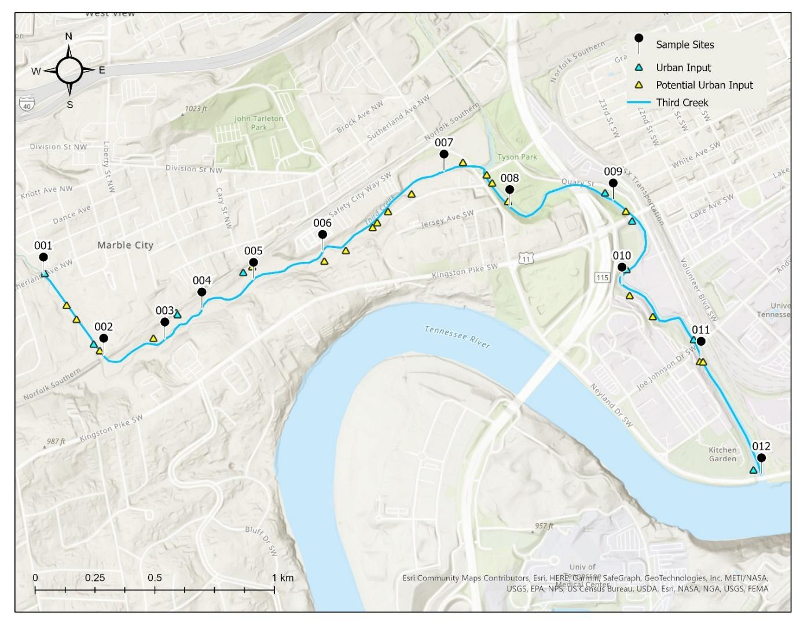

Figure 2.5. Potential urban or anthropogenic input point sources (blue triangle) and potential non-point sources (yellow triangle) along Third Creek in Knoxville, Tennessee. The base topographic map uses Esri, HERE data, © OpenStreetMap, plotted in ArcPro (v10.8).
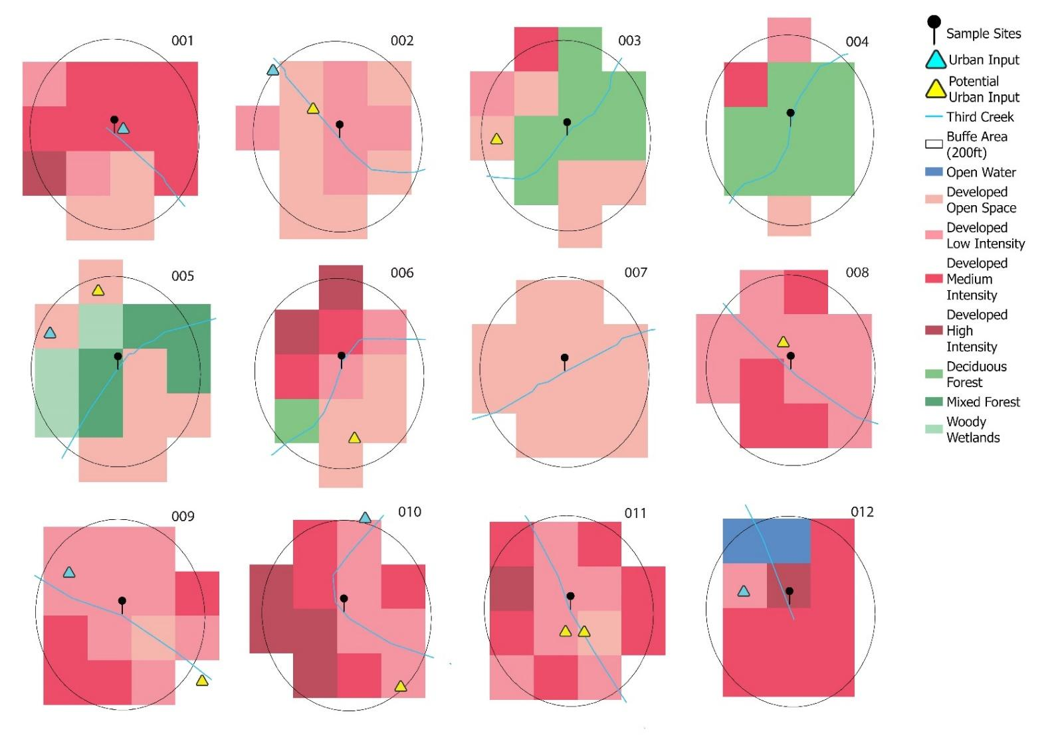

Figure 2.6. Land-use / land-cover assessment for each sample site (labelled 001 through 012) along Third Creek in Knoxville, Tennessee. The maps use Esri, NLCD 2019, plotted in ArcPro (v10.8). Potential point and non-points sources are included, from mapped data on Figure 2.5.

2.2 Field Sampling
During July 2021 sampling, water depth was measured at each site at evenly spaced intervals across the stream channel and flow was measured at each interval across the stream using a basic flow meter (MFP51 Impeller Stick). Field pH and temperature were measured using an Accumet AP110 meter and double-junction electrode. Dissolved oxygen (DO) and conductivity were measured using a YSI 2030 meter. Up to 2-L of water was filtered at each sample site through a 0.2-µm Sterivex (Millipore Sigma) PES filter into separate HDPE to analyze for major ions, alkalinity, TN, non-purgeable organic carbon (NPOC) from TOC and DOC, and CDOM fluorescence. Filtered water was also collected into acid-washed HDPE bottles and preserved with trace metal grade nitric acid for major cations and trace metal analyses. Raw (i.e., unfiltered) water was collected into a 250-mL amber bottles to analyze for aerobic bacteria, total coliforms, and E. coli.
To analyze for chlorophyll content, 1.2-µm Whatman GF/C filters (Millipore Sigma) were used to filter 250-mL of water. At least two Whatman GF/C and Sterivex filters were obtained per site and stored at -20˚C until further analysis. The Whatman GF/C filters were specifically stored in the dark until analysis to prevent the degradation of chlorophyll. All water samples (filtered/unfiltered) were kept on ice until returned to the laboratory where they were stored at 4˚C until analysis.
For the seasonal September 2021 – January 2022 water sampling events, field pH, temperature, conductivity, and DO were measured as described above for the July 2021 sampling. Water was filtered at each site (001, 003, 008, 010, 012) through a 0.2-µm Sterivex filter into separate HDPE bottles to analyze for major ions, alkalinity, and CDOM fluorescence. Raw water was also collected for chlorophyll content, and for aerobic bacteria and fecal coliform, including E. coli, counts.
At each sampling site, the different types of periphyton microhabitats were noted (e.g., on rocks, sediment, organic material like wood, artificial materials like tires and garbage), as well as the color of the periphyton. Up to 50-mL of wet periphyton was collected within a 0.5-m² quadrat using a metal spatula at each site (Figure 2.7). The
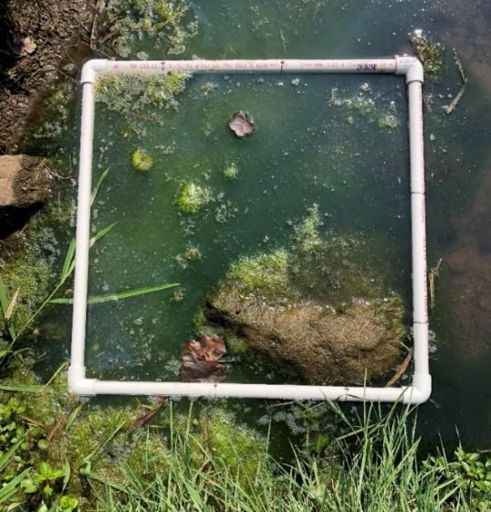

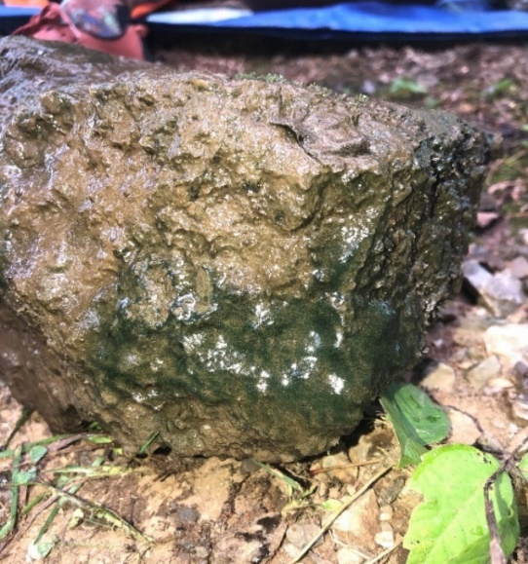

10 cm

Figure 2.7. Examples of the types of sampled periphyton from different microhabitats in Third Creek, Knoxville, Tennessee. Top, site 009, with 0.5-m² quadrat. Bottom, site 010.

quadrat and metal spatula were thoroughly rinsed with stream water at each sampling site before sampling the next site to prevent carry over. The number of quadrats needed to collect sufficient material was recorded. In the laboratory, the periphyton material was aseptically subsampled into separate amounts for ash-free dry mass (AFDM) measurements, loss on ignitions (LOI), chlorophyll a and b concentrations, trace metal content, autotrophic index, bioconcentration factor, and DNA sequencing (described below).
2.3 Geochemical Analyses
All geochemical analyses were done in accordance with analyte hold times at the University of Tennessee, Knoxville, in the Department of Earth and Planetary Sciences (EPA, 2016). Alkalinity was measured from the filtered water by manual titration with 0.1N H₂SO₄ to pH 4.3 to calculate bicarbonate and carbonate alkalinity. NPOC and TN concentrations were analyzed from filtered water samples (as duplicates) collected into 8-mL baked (to 550 ºC) glass tubes on a Shimadzu TOC-L series analyzer with a sparging kit to remove inorganic carbon and chemiluminescent TNM-L detector, following manufacturer instructions.
Major anions and cations were measured by ion chromatography using an ICS-2000 system (ThermoFisher Scientific, Dionex) by using standards for the chosen analytes. Instrument-based detection limits (LOD) and calibration ranges were identified and recorded. Charge balance was calculated using the major ion data and values less than or equal to 5% were considered complete.
Fluorescence of CDOM was measured from filtered water using a quartz cuvette on a Horiba Scientific FluoroMax-4 Spectrofluorometer and UV-Vis absorbance was measured with a Thermo Scientific UV-Visible Spectrophotometer. Both instruments were blanked with ultrapure Millipore deionized (DI) water. Slits were set to 5-nm and a 0.1 second integration time (Birdwell & Engel, 2009, 2010). Excitation-emission matrix (EEM) spectra from the fluorescence data were measured according to methods described by Birdwell & Engel (2009, 2010). UV-Vis absorbance was measured between the wavelengths of 200 to 600-nm in 0.5-nm increments. Inner-filter effects were corrected by using absorbance spectra. Rayleigh and Raman scattering corrections were made by subtracting the spectrum of the DI blank from each corrected EEM (Birdwell & Engel, 2009, 2010). Fluorescence indices, including the biological/autochthonous index (BIX), fluorescence index (FI), and the humification index (HIX), were used to compare the nature and type of CDOM. BIX values that range from 0.8 to 1.0 resemble CDOM from biological or microbial sources. FI values less than or equal to 1.4 indicate CDOM derived from terrestrial sources, and values greater than or equal to 1.9 suggest microbial sources. HIX values below 5 indicate CDOM that is obtained from fresh organic matter, such as animal manure and plant biomass. Values ranging between 10 and 30 represent more humified CDOM, such as extracted from soil porewater. Given that CDOM degradation is prevalent in surface waters due to photooxidation, fluorescence indices were interpreted as estimates (Birdwell & Engel, 2009, 2010). All corrections and calculations were completed using the StaRdom package (v1.1.21) (Pucher et al., 2019) in RStudio (v1.4) (R Core Team, 2021).
Trace metals (As, Cd, Fe, Mg, Mn, Pb, Zn) were measured from filtered and acidified water samples by inductively coupled plasma-optical emission spectroscopy (ICP-OES), following a modified version of the EPA method 200.7 (EPA, 1994). Reagent (2% nitric acid) and a set of standards and dilutions were prepared for calibrations and blanks before sample analysis. Sources of standards, wavelengths selected for each metal, as well as calibration ranges and instrument detection limits, are reported on Table 2.3.

2.4 Colony Counts of Aerobic Bacteria, Total Coliforms, and E. coli
Unfiltered (i.e., raw) water was collected for aerobic bacteria, total coliforms, and E. coli counts, calculated using 3M™ Petrifilm™ E. coli/Coliform and Aerobic Count Plates (3M™, 2017a, 2017b). Two replicates per plate type per site were quantified and averaged for the reported value. An example of each plate is shown in Figure 2.8. For aerobic count, 1-mL of unfiltered water was pipetted onto each plate and incubated for a total of 48 hours at 30˚C. For E. coli/coliform counts, 1-mL of unfiltered water was pipetted onto each plate and incubated at 35˚C and incubated for a total of 48 hours. For aerobic bacterial colonies, the total number of colonies for two squares (1 cm²) was averaged and then multiplied by 20 to obtain the total count per plate (3M™, 2017a,

Analyte | Standards Used | Wavelength (nm) | Calibration Range for Water Samples (mg/L) | Instrument LOD of Water Samples (mg/L) | Calibration Range of Periphyton Samples (mg/L) | Instrument LOD of Periphyton Samples (mg/L)
As | Agilent Technologies | 189.042 | 0.001 – 1 | 0.023 ± 0.00058 | 0.01 – 1 | 0.004 ± 0.0017
Cd | Sigma-Aldrich | 214.438 | 0.0001 – 1 | 0 | 0.001 – 1 | 0
Fe | Agilent Technologies | 238.204 | 0.001 – 1.5 | 0.0017 ± 0.00058 | 0.01 – 10 | 0.00067 ± 0.00058
Mg | Agilent Technologies | 279.553 | 0.002 – 20 | 0.001 ± 0.0017 | 0.02 – 20 | 0.00033 ± 0.00058
Mn | Sigma-Aldrich | 260.569 | 0.001 – 1 | 0 | 0.001 – 10 | 0
Pb | Agilent Technologies | 220.353 | 0.001 – 1 | 0.002 ± 0 | 0.001 – 1 | 0.015 ± 0.024
Zn | Agilent Technologies | 213.856 | 0.01 – 1 | 0 | 0.05 – 5 | 0
Table 2.3. ICP-OES analytical standards, selected spectral wavelengths, instrument detection limits (LOD) according to the ICP-OES and software specifications, and calibration ranges used in this study.

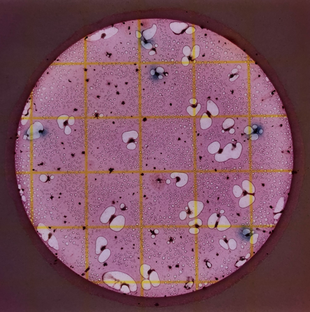

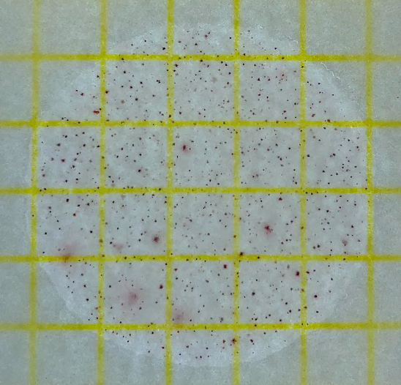

Figure 2.8. Examples of 3M Petrifilm plates for counting E. coli/coliform colony forming units (top) and aerobic microbial counts (bottom) for 012 and 008, respectively. The yellow grid lines are 1 cm x 1 cm.
2017b). Total coliform count was determined by quantifying the E. coli colonies, as any blue colony (or blue to red-blue or purple), and the number of any red colonies with associated gas bubbles (3M™, 2017a, 2017b). The number of blue colonies associated with entrapped gas bubbles was recorded as the number of E. coli colonies. Images for all plates can be found in Appendix A.

2.5 Water Chlorophyll Concentrations
All procedural steps for measuring chlorophyll a and b concentrations in the water followed standard methods (Arar, 1997) with the following modifications: filtering 250-mL of water, using Whatman GF/C filters, and homogenizing filters (in duplicate) with 10- mL of 90% acetone in an amber glass tube with a glass stirring rod to produce a slurry. Dilutions of chlorophyll a and b analytical standards (Millipore Sigma) were prepared. A Thermo Scientific Evolution 201 UV-Visible Spectrophotometer was baselined with 90% acetone to measure chlorophyll a and b concentrations at wavelengths 750, 691, 665, 664, 647, 630 nm. Samples were centrifuged for 15 minutes at 675 g, then 3-mL of the supernatant was filtered (EZ Flow Syringe Filter, 0.22-µm) into a 1-cm cuvette and wavelengths were measured from 400 – 755 nm. To correct for pheopigments (Arar, 1997), after filtration, samples were mixed with 0.1 N HCl and then rescanned. Absorbance (Abs) values at 750 nm were subtracted from absorbance values at 630, 647, 664, and 665 nm to correct for turbidity.
To calculate concentrations (mg/L) of chlorophyll a, Lorenzen’s Pheopigment-corrected Chl a and Pheo a equation was used (APHA, 2018b):

Equation 2.2
$$C_{a}=11.85\left(Abs 664\right)-1.54\left(Abs 647\right)-0.08\left(Abs 630\right)$$
where C_{a} is chlorophyll a.
To calculate concentrations (mg/L) of chlorophyll b, the Jeffrey and Humphrey’s Trichromatic Equation was used (Arar, 1997):

Equation 2.3
$$C_{E,b}=21.03\left(Abs 647\right)-5.43\left(Abs 664\right)-2.66\left(Abs 630\right)$$
where C_{E,b} is the concentration (mg/L) of chlorophyll b in the extract solution measured.
To calculate concentrations (mg/L) of chlorophyll a and b in the whole water sample, the following equation was used according to Arar (1997):

Equation 2.4 $C_{s}=\frac{C_{E}\left(a, b, or c\right)×extract volume (L)}{sample volume \left(L\right)×cell length (cm)}$
where C_{S} is the concentration (mg/L) of chlorophyll, C_{E} is the concentration (mg/L) of chlorophyll a and b (c was not measured) in the extract solution, and cell length refers to the size of the cuvette (cm) used to measure the chlorophyll concentrations.

2.6 Periphyton Biomass, Chlorophyll, and Trace Metal Concentrations
For periphyton AFDM, 2 grams of raw material from each site (in triplicate) was weighed on an aluminum tin and dried at 105˚C for 16 hours. After cooling to room temperature in a desiccator, the dried material was reweighed and then ashed in a muffle furnace for 6 hours at 500˚C. The ash was re-wet with distilled water and dried again at 105˚C for 16 hours. This last step rehydrates clay and other minerals that do not precipitate out initially.
To calculate dry weight (mg), ash weight (mg), and AFDM (mg/m²) per sample area (assuming proper taring of dish weight originally), the following equations were used according to APHA (2018b):

Equation 2.5
$$dry weight=[\left(original wet weight of sample+sample weight at 105℃\right)-\left(original wet weight of sample\right)]$$
This calculation provided the amount of dried material remaining after water was lost during drying.
Equation 2.6
$$ash weight=[\left(sample weight at 105℃+sample weight at 500℃\right)-\left(sample weight at 105℃\right)]$$
This calculation provided the weight of inorganic material remaining after the organic material was lost during ashing.
Equation 2.7 $AFDM= \frac{(dry weight-ash weight)}{(A_{Q}×n_{Q})}$
where A_{Q} is the quadrat area (0.25 m²), and n_{Q} is number of quadrats used at each sampling site to fill up a 50-mL conical tube with periphyton. This calculation accounts for the area and amount of material originally collected.
There are two ways to evaluate the percentage of organic matter of the original samples. One way (Equation 2.8) is based on AFDM, according to Biggs and Kilroy (2000), and the other is based on loss on ignition (LOI) following the modified approach of Heiri et al. (2001) (Equations 2.9 – 2.11):

Equation 2.8 $\% organic matter=\left[\frac{(AFDM)}{sample weight at 105℃ }\right]×100$

Equation 2.9
%Water Content (from LOI) =
$$\left[\frac{(original wet weight of sample-sample weight at 105℃)}{original wet weight of sample}\right]×100$$

Equation 2.10
%Organic Carbon Content (from LOI) =
$$\left[\frac{\left(sample weight at 105℃ -sample weight at 475℃\right)}{sample weight at 105℃}\right]×100$$

Equation 2.11
%DI-Rinsed Organic Carbon Content (from LOI) =
$$\left[\frac{\left(sample weight 105℃-\left(sample weight at 475℃ after rinsing\right)\right)}{sample weight at 105℃}\right]×100$$

Periphyton chlorophyll a and b content was determined following Arar (1997), with the following modifications: 10-mL of 90% acetone was added to 1 gram of raw periphyton (in duplicate) in an amber tube and homogenized until a slurry formed. The extraction mixture steeped for a minimum of 2 hours and a maximum of 24 hours at 4˚C. The tubes were then centrifuged for 15 minutes at 675 g. UV-Visible spectrophotometry measurements were the same as for the water chlorophyll concentrations (see above) at wavelengths at 750, 691, 665, 664, 662, 647, 645, 630 nm. Dilutions of chlorophyll a and b analytical standards (Millipore Sigma) were used to generate standard concentration curves. To measure the yield for each sample, 1.5-mL of supernatant and 1.5-mL of 90% acetone were added to a 1-cm cuvette after filtration (EZ Flow Syringe Filter, 0.22-µm) for samples whose absorbance at 750 nm exceeded 0.005 AU. To correct for pheopigments, the sample was measured after filtration, then acidified by adding 90-µL of 0.1 N HCl to the cuvette, mixing thoroughly, and waiting 90 seconds before remeasuring the sample. Absorbance values (Abs) at 750 nm were subtracted from the specified absorbance values (630, 647, 664, and 665 nm) to correct for turbidity.
To calculate the concentrations (mg/L) of chlorophyll a and b in the extraction solutions, absorbance values from two equations by Lichtenthaler and Buschmann (2001) were adjusted to represent the use of 90% acetone:

Equation 2.12
$$C_{a}=11.74\left({Abs}_{662}\right)-2.41({Abs}_{645})$$
Equation 2.13
$$C_{b}=20.81\left({Abs}_{645}\right)-4.64({Abs}_{662})$$
where C_{a} is chlorophyll a and C_{b} is chlorophyll b. These values were then used to calculate the concentrations (mg/L) of chlorophyll a and b of the periphyton per sample area using a modified equation according to Lichtenthaler and Buschmann (2001):

Equation 2.14
$$C_{a,b} per sample area=\frac{C_{E}\left(a, b, or c\right)×exctract volume\left(L\right)×DF}{(A_{Q}×n_{Q})}$$
where C_{E} corresponds to the concentration (mg/L) of chlorophyll a and/or b in the extract solution measured, DF refers to the dilution factor of the sample, A_{Q} is the quadrat area (0.25 m²), and n_{Q} is number of quadrats used at each sampling site to fill up a 50-mL conical tube with periphyton.
The Autotrophic Index (AI) was calculated using the following equation from APHA (2018a):

Equation 2.15 $AI=\frac{AFDM }{[Chl a]}$
where AFDM is in mg/m², and [Chl a] is the concentration of chlorophyll a, also in mg/m², measured from the AFDM.
For the classification of periphyton type at each site on its natural substrate and to provide an indication of the amount of organic versus inorganic material, as well as autotrophic versus heterotrophic composition, three indices were used (i.e., dry mass, AFDM, chlorophyll content) according to Romanów and Witek (2011) and adopted by Lakatos et al. (1998) (Table 2.4).
Trace metal (As, Cd, Fe, Mg, Mn, Pb, Zn) concentrations from the periphyton were measured following a modified version of the EPA method 200.7 to extract potentially sorbed and interacting metals associated with the periphyton biomass (EPA, 1994). Magnesium was also measured to compare yields from the ion chromatography results and provide a method check. AFDM material from each site location was homogenized and ground to a powder using a pestle and mortar. Each sample was processed in triplicate. From the homogenized powder, 0.5 g ± 0.01 were placed into a baked glass vial, where 2-mL of (1+1) 15 M HNO₃ and 5-mL of (1+4) 12 M HCl were added. The HNO₃ dilution involved adding 500-mL of HNO₃ to 400-mL of distilled water, and then further diluting to a volume of 1-L with distilled water. The HCl dilution involved adding 200-mL of HCl to 400-mL of distilled water, and then diluting to a volume of 1-L with distilled water again. An acid rinse was also prepared using a ratio of 2-mL of diluted (1+) HNO₃ to 5-mL of diluted (1+4) HCl. The suspended samples were heated in a hot bath at 95˚C for 30 minutes. The solutions were left to cool to room temperature and settle overnight prior to transferring 5-mL of supernatant to a HDPE 50-mL conical tube. The supernatant was then diluted with 45-mL of distilled water, mixing thoroughly before filtering (EZ Flow Syringe Filter, 0.22-µm) into a HDPE 15-mL conical tube. Dilutions (1:10) of each supernatant sample were also prepared into a separate 15-mL conical tube, transferring 1-mL of supernatant stock, and adding it to 9-mL of acid rinse (2-mL diluted HNO₃ to 5-mL of diluted HCl). A set of standards and dilutions were prepared to generate standard concentration curves (Table 2.3).
Table 2.4. Classification of periphyton according to different parameters, such as dry mass, ash content, and chlorophyll a content, as implemented by Romanów and Witek (2011) and adopted from Lakatos et al. (1998).

Type | Dry Mass | g/m²
I | High | > 40
II | Average | 20 – 40
III | Low | < 20
 | Ash Content | (%)
I | Inorganic | >75
II | Inorganic-organic | 50 – 75
III | Organic-inorganic | 25 – 50
IV | Organic | < 25
 | Chlorophyll a Content | (%)
I | Autotrophic | > 0.60
II | Auto-heterotrophic | 0.25 – 0.60
III | Hetero-autotrophic | 0.10 – 0.25
IV | Heterotrophic | < 0.10

To calculate the concentrations (mg/kg) of trace metals per AFDM, the following equation was used according to EPA method 200.7 (EPA, 1994):
Equation 2.16
$$Sample Concentration \left(\frac{mg}{kg}\right)=\frac{C×V×D}{W}$$
where C corresponds to the concentration of the extract (mg/L), V is the volume of the digestion extract (L), D corresponds to any dilution of the samples, and W is the weight of the AFDM sample (kg).
To calculate the bioconcentration factor (BCF) the following calculation was used according to Tang et al. (2014):
Equation 2.17 $BCF=\frac{C_{P}(\frac{mg}{kg})}{C_{W}(\frac{µg}{L})}$
where C_{P} corresponds to the concentration of metals in the biota (mg/kg) and C_{W} equates to the concentration of metals in the medium (µg/L). Values greater than 1 mean that there is more metal in the periphyton (i.e., it is enriched in a metal) compared to the water.

2.7 DNA Extractions, Gene Sequencing, and Sequence Processing and Analyses
For the water samples, total environmental DNA was extracted from the Sterivex filters collected during the July 2021 sampling event using DNeasy Blood and Tissue kits (Qiagen, Germany), with the following modifications according to Spens et al. (2016). Briefly, prior to extraction, 720-µL ATL and 80-µL Proteinase K were added directly to the Sterivex filters, which were then capped and sealed with perifilm on both ends. Sterivex filters were incubated at 56˚C for 24 hours and agitated throughout the incubation process using a rotor; recoverable liquid was transferred from the filter into a 15-mL conical tube, which received 720-µL AL and 80-µL of molecular grade ethanol. The mixture was added to the spin column then centrifuged at 8,000-rpm for 1 minute. The spin column was transferred to a new tube where 500-µL of Buffer AW1 was added and then centrifuged at 8000-rpm for 1 minute; this step was repeated with a new tube and 500-µL of Buffer AW2 was added, followed by centrifugation at 14,000-rpm for 3 minutes. Lastly, the spin column was transferred to a new 1.5-mL microcentrifuge tube and DNA was eluted from the membrane by adding 200-µL of Buffer AE, incubating for 1 minute at room temperature, and then centrifugation at 8,000-rpm for 1 minute.
DNA from periphyton was extracted using 0.25 grams of wet material collected during July 2021, in duplicate, using DNeasy PowerSoil DNA Isolation kits (Qiagen, Germany), following manufacturer instructions. This homogenized material was also used for the chlorophyll and trace metal concentration measurements (see Section 2.6).
A NanoDrop 2000c UV/Vis spectrophotometer was used to estimate concentrations of DNA from absorbance ratios (260/230nm and 260/280nm). Extracted DNA from all samples and controls (consisting of distilled water and extraction buffers only), were cleaned using Qiagen DNA purification kits, following modifications of manufacturer instructions. Duplicate extractions for each site were homogenized and sent for gene sequencing of the V4 region of the 16S rRNA gene (using 515F and 806RB primers for Bacteria and Archaea) and a section of the 18S rRNA gene (Euk1391 and EukBr primers for eukaryotes) using Illumina MiSeq sequencing technology at Molecular Research LP (Shallowater, Texas).
The taxonomical diversity, operational taxonomic units (OTUs), and relative abundances from the gene sequences were done using the computer program MOTHUR (Schloss et al., 2009) and Excel. Raw FASTQ files were demultiplexed to obtain separate R1 and R2 FASTQ files, along with index file for each sample, using MRDNA FASTQ Splitter (MRDNA, Shallowater, TX). Barcodes and primers were removed using MRDNA FASTQ Processor. Sequence processing and identification of taxa were executed using MOTHUR v.1.44.3, following the MiSeq standard operating procedure (Schloss et al., 2009). Briefly, sequences were aligned and combined using the make.contigs command, followed by the removal of overlapping regions and ambiguous reads with the command screen.seqs. The remaining sequences were aligned to the SILVA v.138 database (Quast et al., 2013; Yilmaz et al., 2014) and sequences that did not align properly were removed. The alignment was refined using the unique.seqs command that returned only unique sequences identical to the reference sequences and the filter.seqs command that removed overhang at both ends of the sequences. The command chimera.vsearch removed potential chimeric sequences. Sequences were assigned taxonomy using the command classify.seqs. When classifying the sequences for prokaryotes (i.e., 16S rRNA genes), sequences identified as unknown and/or Eukaryota were removed using the command remove.lineage; sequences identified as chloroplasts were removed manually in Excel. The dist.seqs command calculated uncorrected pairwise distances among the aligned sequences, which were then clustered using a cutoff of 0.03 (97% sequence identity) into operational taxonomic units (OTUs) based on the SILVA v.138 reference database. A taxonomy literature review was completed to identify what taxonomic groups were commonly found in stream water and periphyton samples. Diversity indices, including Shannon, Shannon Equitability, and Simpson, were used to quantify the alpha diversity at the genus level across all samples and between each site location.

2.8 Sequence Data Submission
Raw sequence files for each sample were submitted to the NCBI Sequence Read Archive under the BioProject PRJNA867322 (http://www.ncbi.nlm.nih.gov/bioproject/ PRJNA867322).

2.9 Statistical Data Treatment and Analysis

Relative abundances of the different taxa and the environmental data, including stream parameters (e.g., width, discharge), for each site were transformed using log(n+1) where n was the value being converted. Data were imported into PAST v. 4.03 for Windows (Hammer et al., 2001) to calculate Spearman’s rho (ρ) values, which are non-parametric correlation coefficients that evaluate the strength of association between two variables. The relationships can be positive or negative, and values from +/- 0.6 to +/- 1.0 were considered strong (with +/- 1.0 being the strongest) and values +/- 0.5 to +/- 0.7 were considered weaker but still of potential significance. Significance for any relationship was based on the p-value, whereby alpha lower than 0.05 was considered significant and alpha between 0.05 and 0.07 were considered weakly significant. Strongly significant relationships were used to evaluate the taxonomic data from the water and periphyton communities in relation to the environmental data and site characteristics, such as LULC assessment. Taxonomic groups were also binned into specific functional categories, such as photoautotrophic and heterotrophic, and compared to the stream and environmental data.

SECTION 3. RESULTS

3.1 Characterization and Health Assessment of Third Creek
Stream characteristics and periphyton attributes associated with color, habitat type, and sample locations, which were recorded the first sampling date, are listed in Table 3.1. Stream width was generally narrower upstream compared to downstream sites, although the width of the middle reach was narrower than upstream. These sites were in a channelized section near the Greenbelt entrance. Samples collected in riffles (003, 005, 006, 009) had generally shallower stream depths compared to pool-collected samples (010, 011, 012). Rocks of varying sizes were the most favorable microhabitat for periphyton compared to other microhabitats (i.e., organic material). There did not appear to be a correlation among microhabitat properties, substrate types, and periphyton color.
Based on the stream health assessment (Table 2.1) (Wolfe, 2019), most of the sites had similar health conditions (Table 3.2). Floodplain vegetation for approximately half of the sites was rated good, signifying abundant plants, bushes, and trees along the banks and floodplain. Sites where vegetation levels were moderate (008, 009, 010) to low (002, 011, 012) adjacent to the stream channel were also located near extensive impervious cover and infrastructures (i.e., bridges, tunnels). Embeddedness depended on the stream habitat (i.e., pool, riffle, run). Sites located within a riffle (003, 005, 006, 009) were rated good for embeddedness because streambed cobbles extended above the smaller substrate (i.e., sand, silt). Pool habitats tended to have poor embeddedness ratings because larger rocks were generally covered by finer sediment. However, despite higher embeddedness values, nearly all of the sites had poor and/or marginal ratings for bank erosion and stability (Table 3.2). Susceptibility to erosion could impact water quality and periphyton habitats.
The LULC characterization for each site was done using a 200-foot (i.e., 60.96 m) buffer (Table 3.3). In addition to the history of industrialization and anthropogenic impact to the stream (Table 1.2), 10 of 12 sites along the stream had at least one input within the buffer area (Figure 2.6). Nearly all sample sites, except for sites 005, 006, and 012, were

Table 3.1. Stream characteristics at sample sites and descriptions of periphyton and stream microhabitat according to Table 1.1. Distance (km) is with respect to confluence with the Tennessee River. Substrate at sites 011 and 012 could not identified (i.e., NA) due to water depth and turbidity occluding the bottom.
Site ID | Distance (km) | Stream Width (m) | Stream Depth (m) | Stream Discharge (m³/s) | Substrate Type | Stream Habitat | Periphyton Color | Periphyton Microhabitat
001 | 5.07 | 7.85 | 0.34 ± 0.1 | 0.65 | Gravel/silt | Pool | Dark green | Epilithon
002 | 4.59 | 6.6 | 0.34 ± 0.8 | 0.16 | Cobbles | Main channel | Light green | Epilithon
003 | 4.10 | 6.1 | 0.15 ± 0.1 | 0.43 | Cobbles | Riffle | Light green | Epilithon
004 | 3.86 | 9 | 0.41 ± 0.2 | 0.20 | Cobbles/silt | Pool | Light & dark green | Epixylon/Epilithon
005 | 3.62 | 8.3 | 0.04 ± 0.02 | 0.18 | Cobbles | Riffle | Dark green | Epilithon
006 | 3.38 | 4.3 | 0.19 ± 0.1 | 0.72 | Cobbles | Riffle | Light green | Epilithon
007 | 2.90 | 6.4 | 0.31 ± 0.02 | 0.16 | Gravel/silt | Pool | Dark green | Epilithon
008 | 2.41 | 10 | 0.26 ± 0.1 | 0.28 | Gravel/silt | Pool | Light green | Epilithon
009 | 1.93 | 12 | 0.88 ± 0.7 | 2.06 | Cobbles | Riffle | Light green | Epiphyton
010 | 1.45 | 10 | 0.73 ± 0.3 | 0.37 | Gravel/silt | Pool | Dark green | Epilithon
011 | 0.97 | 20 | 1.93 ± 1.1 | 1.93 | NA | Pool | Light & dark green | Epixylon
012 | 0.48 | 38 | 2.38 ± 0.7 | 4.51 | NA | Pool | Light green | Epiphyton

Table 3.2. Health assessment of sites along Third Creek in Knoxville, Tennessee, as categorized in Table 2.1 and according to Wolfe (2019). Distance (km) is with respect to confluence with the Tennessee River. Embeddedness at sites 011 and 012 could not identified (i.e., NA) due to water depth and turbidity occluding the bottom.
Site ID | Distance (km) | Floodplain Vegetation | Embeddedness | Erosion | Bank Stability
001 | 5.07 | GOOD | POOR | FAIR | FAIR
002 | 4.59 | MARGINAL | FAIR | FAIR | MARGINAL
003 | 4.10 | GOOD | GOOD | FAIR | FAIR
004 | 3.86 | GOOD | MARGINAL | POOR | FAIR
005 | 3.62 | GOOD | GOOD | MARGINAL | MARGINAL
006 | 3.38 | GOOD | GOOD | MARGINAL | GOOD
007 | 2.90 | GOOD | POOR | FAIR | MARGINAL
008 | 2.41 | FAIR | POOR | FAIR | FAIR
009 | 1.93 | FAIR | GOOD | GOOD | MARGINAL
010 | 1.45 | FAIR | POOR | POOR | MARGINAL
011 | 0.97 | MARGINAL | NA | MARGINAL | MARGINAL
012 | 0.48 | POOR | NA | MARGINAL | MARGINAL

Table 3.3. Estimated land use / land cover percentages for major classification types for each sample site along Third Creek in Knoxville, Tennessee.
Site ID | Distance (km) | Open Water | Developed Open Space | Developed Low Intensity | Developed Medium Intensity | Developed High Intensity | Deciduous Forest | Mixed Forest | Woody Wetlands
001 | 5.07 | 0 | 21.43 | 14.29 | 57.14 | 7.14 | 0 | 0 | 0
002 | 4.59 | 0 | 58.33 | 41.67 | 0 | 0 | 0 | 0 | 0
003 | 4.10 | 0 | 35.71 | 7.14 | 7.14 | 50 | 0 | 0 | 0
004 | 3.86 | 0 | 9.09 | 9.09 | 9.09 | 72.73 | 0 | 0 | 0
005 | 3.62 | 0 | 46.67 | 0 | 0 | 0 | 0 | 33.33 | 20
006 | 3.38 | 0 | 36.36 | 18.18 | 18.18 | 18.18 | 9.1 | 0 | 0
007 | 2.90 | 0 | 100 | 0 | 0 | 0 | 0 | 0 | 0
008 | 2.41 | 0 | 0 | 69.23 | 30.77 | 0 | 0 | 0 | 0
009 | 1.93 | 0 | 7.14 | 64.29 | 28.57 | 0 | 0 | 0 | 0
010 | 1.45 | 0 | 38.46 | 30.77 | 30.77 | 0 | 0 | 0 | 0
011 | 0.97 | 0 | 7.14 | 42.86 | 42.86 | 7.14 | 0 | 0 | 0
012 | 0.48 | 16.67 | 0 | 8.33 | 66.67 | 8.33 | 0 | 0 | 0

classified as primarily developed land of varying intensities (i.e., low, medium, high) and did not include vegetative cover (i.e., forests, wetlands) despite bushes and shrubs along the channels. The LCLU type developed open space had the highest percentages for almost half of the sample sites, where developed low- and medium- intensity dominated some sites and made up over 50% of the total LULC classification at some sites (001, 008, 009, 012) (Table 3.3), indicating that most of the Third Creek stream reach sampled experienced more developed and urbanized conditions. These results matched the stream health assessments of poor to marginal conditions based on impervious cover and poor bank stability.

3.2 Seasonal Geochemical Analysis of Water Samples
Most of the physical water quality parameters varied seasonally, like temperature and dissolved oxygen (DO) levels, as expected for hotter summer months compared to colder winter months (Table 3.4). The lowest DO was measured during September 2021, at <5 mg/L, and the highest was measured during January 2022. None of the sites had DO values below 3 mg/L. pH ranged from 6.77 to 8.65, and conductivity generally ranged between 350 and 420 µS/cm during all sampling months, except for site 012 (which was closest to the Tennessee River) that consistently had the lowest values, below 270 µS/cm. Alkalinity (as HCO₃⁻) ranged from 270.0 ─ 306.0 mg/L, with the lowest measured during September 2021 and the highest during October 2021.
In July 2021, the furthest upstream and downstream sites had the highest NPOC values, and this trend was consistent seasonally. Lowest NPOC values were measured in the winter in the middle stream reach. In July 2021, TN averaged about 1 mg/L and varied slightly seasonally. The maximum recommended concentration for TN should be < 0.591 mg/L (Dien et al., 2019), and all sites except for one (009 in July 2021) surpassed this limit. All major dissolved anion and cation concentrations increased downstream until site 010 where concentrations decreased. Seasonally, concentrations generally increased from July 2021 to January 2022 for anions but most cation concentrations decreased. Charge balance for all sites, except for 008 and 010, was below ±5% charge balance; values for sites 008 and 010 were only slightly above ±5%, which means
Table 3.4. Field-collected water quality parameters along Third Creek in Knoxville, Tennessee, from July 2021 (site names labelled JY), to September 2021 (labelled S), October 2021 (labelled O), and January 2022 (labelled JN). Units for conductivity are in µS/cm, and dissolved oxygen (DO), alkalinity, TN and NPOC are in mg/L. * = single injection value
Site ID | Distance (km) | Temp Water (˚C) | pH | DO | Conductivity | Alkalinity | TN | NPOC
001.JY | 5.07 | 18.2 | 7.84 | 8.63 | 401.7 | 275.7 | 1.05 ± 0.01 | 2.18 ± 0.40
001.S | 5.07 | 16.9 | 8.06 | 8.68 | 401.1 | 310.1 | 1.03 ± 0.01 | 0.79 ± 0.07
001.O | 5.07 | 15.6 | 7.88 | 6.35 | 390.2 | 305.5 | 1.26 ± 0.03 | 1.04 ± 0.04
001.JN | 5.07 | 11.0 | 8.57 | 11.45 | 353.3 | 290.8 | 1.37 ± 0.06 | 0.93 ± 0.02
002.JY | 4.59 | 18.6 | 7.71 | 7.08 | 409.0 | 300.4 | 1.10 * | 1.13 ± 0.62
003.JY | 4.10 | 18.7 | 7.93 | 7.40 | 410.6 | 305.7 | 1.00 ± 0.05 | 1.22 ± 0.48
003.S | 4.10 | 16.1 | 8.03 | 8.42 | 395.8 | 305.7 | 1.10 ± 0.06 | 0.82 ± 0.03
003.O | 4.10 | 15.3 | 7.93 | 6.33 | 386.6 | 313.1 | 1.28 ± 0.05 | 1.07 ± 0.08
003.JN | 4.10 | 10.8 | 8.59 | 11.46 | 356.3 | 292.8 | 1.29 ± 0.02 | 0.87 ± 0.07
004.JY | 3.86 | 19.4 | 7.89 | 6.73 | 414.3 | 298.2 | 1.37 * | 1.03 ± 0.22
005.JY | 3.62 | 19.4 | 7.86 | 7.63 | 410.2 | 297.8 | 1.16 * | 0.99 ± 0.27
006.JY | 3.38 | 19.5 | 7.97 | 9.53 | 417.1 | 305.7 | 1.15 * | 1.23 ± 0.75
007.JY | 2.90 | 19.4 | 7.98 | 8.41 | 416.1 | 295.2 | 1.03 * | 0.99 ± 0.03
008.JY | 2.41 | 19.6 | 8.03 | 6.86 | 438.4 | 305.5 | 1.22 * | 1.38 ± 0.65
008.S | 2.41 | 16.3 | 8.09 | 7.82 | 414.7 | 312.6 | 1.18 ± 0.02 | 1.01 ± 0.02
008.O | 2.41 | 15.1 | 8.05 | 6.68 | 405.5 | 312.6 | 1.22 ± 0.03 | 0.97 ± 0.06
008.JN | 2.41 | 9.3 | 8.57 | 9.31 | 359.0 | 295.2 | 1.52 ± 0.05 | 1.23 ± 0.08
009.JY | 1.93 | 25.9 | 7.87 | 9.01 | 428.2 | 270.8 | 0.47 * | 1.94 ± 0.12
010.JY | 1.45 | 20.8 | 7.95 | 5.57 | 454.7 | 300.6 | 1.15 * | 1.27 ± 0.51
010.S | 1.45 | 16.3 | 7.95 | 7.80 | 417.9 | 312.8 | 1.10 ± 0.02 | 0.95 ± 0.06
010.O | 1.45 | 14.4 | 7.98 | 7.17 | 407.1 | 314.8 | 1.24 ± 0.04 | 1.07 ± 0.02
010.JN | 1.45 | 9.4 | 8.65 | 11.19 | 365.6 | 291.1 | 1.41 ± 0.02 | 0.92 ± 0.05
011.JY | 0.97 | 23.8 | 7.68 | 5.53 | 418.4 | 218.1 | 1.07 * | 2.94 ± 0.69
012.JY | 0.48 | 23.6 | 7.57 | 6.35 | 265.4 | 129.8 | 0.59 * | 2.66 ± 0.61
012.S | 0.48 | 22.6 | 7.49 | 4.58 | 173.2 | 81.3 | 0.70 ± 0.03 | 2.16 ± 0.05
012.O | 0.48 | 20.5 | 6.77 | 5.63 | 168.1 | 83.4 | 0.80 ± 0.01 | 2.52 ± 0.03
012.JN | 0.48 | 9.7 | 8.48 | 12.00 | 160.3 | 293.5 | 2.50 ± 0.07 | 1.35 ± 0.03

the analyses could be considered incomplete but were not removed from the study (Table 3.5 and 3.6). CDOM fluorescence indices provided a way of investigating the nature and type dissolved organic carbon in the stream. The biological/autochthonous index (BIX) ranged between 0.68 ─ 0.86 and did not vary seasonally at different sites (Table 3.7). Site 012, located closest to the confluence had the lowest BIX values. Values below 0.8 suggested CDOM derived from sources other than biological and/or microbial. The fluorescence index (FI) ranged between 1.5 ─ 1.73, and seasonally the FI values decreased from July 2021 and September 2021, then increased in October 2021, and decreased in January 2022. Sample sites downstream, proximal to the confluence, had the lowest FI values. All FI values were below 1.9, suggesting that the DOM was derived from other sources (i.e., terrestrial) and not microbial or photosynthetic sources in situ. The humification index (HIX) ranged between 0.73 ─ 0.9, indicating that CDOM was terrestrial from plant biomass, animal manure, etc.
All metals except for Mg and Mn had minimal variation (<1%) in concentrations across the sampled stream reach (Figure 3.1). At the downstream sites closer to the confluence (sites 009, 010, 011), concentrations in some metals (As, Fe, Mn, Zn) increased between sites and then decreased in concentration following.

3.3 Seasonal Changes in Aerobic Bacteria, Total Coliforms, and E. coli Counts
Aerobic bacteria counts ranged from 400 – 2210 CFUs (Table 3.8). Although there was variability among sites, higher counts were from the middle of the reach. Aerobic counts were lowest in January 2022 and highest in October 2021 (Figure 3.2). Total coliform counts ranged from 10.5 – 130.5 CFUs (Table 3.8). Counts in July 2021 fluctuated across the reach, with a pronounced increase at the downstream sites. Coliform counts upstream were lowest in January 2022 and highest in July 2021. Sites downstream had lower counts in January 2022 (Figure 3.3). E. coli counts ranged from 0 – 6.0 CFUs (Table 3.8). E. coli counts were higher mid-reach and lower near the confluence, and counts were lowest during January 2022 and higher during July and September 2021 (Figure 3.4). Most sites during all sampling months except for January 2022, exceeded

Table 3.5. Major anions from water samples along Third Creek in Knoxville, Tennessee, from July 2021 (site names labelled JY), to September 2021 (labelled S), October 2021 (labelled O), and January 2022 (labelled JN). Distance (km) is with respect to confluence with the Tennessee River. MRL = Minimum reporting limit in mg/L.

Site ID | Distance (km) | SO₄²⁻ (mg/L) | Cl⁻ (mg/L) | NO₃⁻ (mg/L) | Br⁻ (mg/L) | PO₄³⁻ (mg/L)
Site ID | Distance (km) | MRL = 1 | MRL= 1 | MRL= 1 | MRL = 1 | MRL = 0.1
001.JY | 5.07 | 7.51 | 8.49 | 5 .11 | <MRL | <MRL
001.S | 5.07 | 7.82 | 8.93 | 5.22 | <MRL | <MRL
001.O | 5.07 | 8.26 | 10.03 | 5.85 | <MRL | <MRL
001.JN | 5.07 | 8.79 | 20.07 | 6.14 | 14.78 | <MRL
002.JY | 4.59 | 7.70 | 8.53 | 5.00 | <MRL | <MRL
003.JY | 4.10 | 7.60 | 8.55 | 4.93 | <MRL | <MRL
003.S | 4.10 | 8.12 | 9.19 | 5.14 | <MRL | <MRL
003.O | 4.10 | 8.27 | 9.37 | 5.78 | <MRL | <MRL
003.JN | 4.10 | 8.75 | 21.18 | 5.50 | 13.44 | <MRL
004.JY | 3.86 | 7.96 | 8.81 | 4.97 | <MRL | <MRL
005.JY | 3.62 | 7.73 | 8.43 | 4.78 | <MRL | <MRL
006.JY | 3.38 | 7.64 | 8.71 | 4.83 | <MRL | <MRL
007.JY | 2.90 | 7.74 | 8.44 | 4.73 | <MRL | <MRL
008.JY | 2.41 | 10.39 | 11.55 | 5.28 | <MRL | <MRL
008.S | 2.41 | 11.41 | 12.19 | 5.78 | <MRL | <MRL
008.O | 2.41 | 11.39 | 11.58 | 6.12 | <MRL | <MRL
008.JN | 2.41 | 12.73 | 26.49 | 6.06 | 14.59 | <MRL
009.JY | 1.93 | 12.94 | 18.12 | 1.70 | <MRL | <MRL
010.JY | 1.45 | 10.57 | 12.16 | 5.40 | <MRL | <MRL
010.S | 1.45 | 11.39 | 12.90 | 5.58 | <MRL | <MRL
010.O | 1.45 | 11.46 | 12.16 | 6.11 | <MRL | <MRL
010.JN | 1.45 | 12.61 | 26.18 | 6.68 | 15.58 | <MRL
011.JY | 0.97 | 10.32 | 11.38 | 3.95 | <MRL | <MRL
012.JY | 0.48 | 9.11 | 7.28 | 2.16 | <MRL | <MRL
012.S | 0.48 | 9.86 | 8.09 | 2.98 | <MRL | 1.95
012.O | 0.48 | 10.93 | 9.12 | 3.42 | <MRL | 1.76
012.JN | 0.48 | 12.66 | 28.77 | 5.79 | 15.61 | <MRL

Table 3.6. Major cations and charge balance from water samples along Third Creek in Knoxville, Tennessee, from July 2021 (site names labelled JY), to September 2021 (labelled S), October 2021 (labelled O), and January 2022 (labelled JN). Distance (km) is with respect to confluence with Tennessee River. MRL = Minimum reporting limit in mg/L.

Site ID | Distance (km) | K⁺ (mg/L) | Ca²⁺ (mg/L) | Mg²⁺ (mg/L) | Na⁺ (mg/L) | NH₄⁺ (mg/L) | Charge Balance
Site ID | Distance (km) | MRL = 0.1 | MRL = 0.5 | MRL = 0.25 | MRL = 2 | MRL = 0.05 | (%)
001.JY | 5.07 | 1.40 | 60.09 | 16.79 | 9.71 | <MRL | 4.83
001.S | 5.07 | 5.72 | 11.22 | 9.15 | 4.10 | 4.66 | 4.81
001.O | 5.07 | 5.73 | 11.25 | 9.20 | 4.12 | 4.66 | 4.81
001.JN | 5.07 | 5.76 | 11.34 | 9.31 | 4.22 | 4.74 | 4.81
002.JY | 4.59 | 1.39 | 60.58 | 16.76 | 9.54 | <MRL | 4.84
003.JY | 4.10 | 1.41 | 60.35 | 16.77 | 9.48 | <MRL | 4.83
003.S | 4.10 | 5.73 | 11.25 | 9.19 | 4.12 | 4.66 | 4.83
003.O | 4.10 | 5.73 | 11.25 | 9.20 | 4.12 | 4.66 | 4.83
003.JN | 4.10 | 5.75 | 11.32 | 9.28 | 4.20 | 4.72 | 4.83
004.JY | 3.86 | 1.46 | 61.74 | 15.99 | 9.00 | <MRL | 4.82
005.JY | 3.62 | 1.52 | 59.42 | 16.43 | 10.02 | <MRL | 4.78
006.JY | 3.38 | 1.40 | 60.78 | 16.91 | 9.04 | <MRL | 4.84
007.JY | 2.90 | 1.39 | 60.79 | 16.86 | 9.76 | <MRL | 4.87
008.JY | 2.41 | 1.57 | 64.14 | 16.16 | 10.6 | 0.06 | 5.02
008.S | 2.41 | 5.72 | 11.23 | 9.17 | 4.11 | 4.66 | 5.01
008.O | 2.41 | 5.72 | 11.2 | 9.12 | 4.09 | 4.65 | 5.01
008.JN | 2.41 | 5.76 | 11.32 | 9.30 | 4.21 | 4.73 | 5.01
009.JY | 1.93 | 1.93 | 54.23 | 15.76 | 12.65 | <MRL | 4.59
010.JY | 1.45 | 1.59 | 64.21 | 16.85 | 11.00 | <MRL | 5.10
010.S | 1.45 | 5.72 | 11.21 | 9.12 | 4.09 | 4.65 | 5.08
010.O | 1.45 | 5.72 | 11.24 | 9.18 | 4.11 | 4.66 | 5.08
010.JN | 1.45 | 5.75 | 11.32 | 9.30 | 4.21 | 4.73 | 5.08
011.JY | 0.97 | 1.79 | 52.82 | 13.05 | 10.93 | 0.11 | 4.23
012.JY | 0.48 | 1.44 | 26.97 | 6.13 | 9.16 | 0.06 | 2.28
012.S | 0.48 | 5.73 | 11.33 | 9.22 | 4.13 | 4.66 | 2.27
012.O | 0.48 | 5.72 | 11.29 | 9.15 | 4.10 | 4.65 | 2.27
012.JN | 0.48 | 5.75 | 11.3 | 9.27 | 4.19 | 4.72 | 2.27

Table 3.7. Fluorescence indices of water samples along Third Creek in Knoxville, Tennessee from July 2021 (site names labelled JY), to September 2021 (labelled S), October 2021 (labelled O), and January 2022 (labelled JN).

Site ID | BIX | FI | HIX
001.JY | 0.74 | 1.69 | 0.83
001.S | 0.74 | 1.68 | 0.79
001.O | 0.74 | 1.71 | 0.85
001.JN | 0.77 | 1.64 | 0.82
002.JY | 0.73 | 1.73 | 0.83
003.JY | 0.74 | 1.69 | 0.87
003.S | 0.73 | 1.7 | 0.73
003.O | 0.74 | 1.7 | 0.85
003.JN | 0.77 | 1.64 | 0.85
004.JY | 0.69 | 1.63 | 0.86
005.JY | 0.7 | 1.63 | 0.9
006.JY | 0.74 | 1.66 | 0.87
007.JY | 0.72 | 1.7 | 0.86
008.JY | 0.74 | 1.68 | 0.86
008.S | 0.74 | 1.67 | 0.84
008.O | 0.76 | 1.72 | 0.83
008.JN | 0.78 | 1.59 | 0.83
009.JY | 0.72 | 1.61 | 0.86
010.JY | 0.86 | 1.66 | 0.74
010.S | 0.75 | 1.69 | 0.84
010.O | 0.73 | 1.71 | 0.86
010.JN | 0.78 | 1.59 | 0.88
011.JY | 0.71 | 1.52 | 0.9
012.JY | 0.68 | 1.5 | 0.88
012.S | 0.64 | 1.52 | 0.89
012.O | 0.66 | 1.55 | 0.87
012.JN | 0.78 | 1.6 | 0.88

Table 3.8. Average (n = 4) values for aerobic microbial counts (Figure 3.1), total coliform (Figure 3.2), and E. coli (Figure 3.3) as colony forming units (CFU) along Third Creek in Knoxville, Tennessee, from July 2021 (site names labelled JY), to September 2021 (labelled S), October 2021 (labelled O), and January 2022 (labelled JN).

Site ID | Aerobic (CFU) | Total coliform (CFU) | E. coli (CFU)
001.JY | 635 ± 7.01 | 49 ± 27 | 5.5 ± 0.7
001.S | 650 ± 70.7 | 41.5 ± 27.2 | 1.5 ± 2.1
001.O | 600 ± 84.9 | 31.5 ± 20.8 | 1 ± 1
001.JN | 455 ± 21.2 | 18.5 ± 12.4 | 0.5 ± 0.7
002.JY | 650 ± 42.4 | 30.5 ± 19.4 | 1.5 ± 2.1
003.JY | 775 ± 120 | 45.5 ± 30.7 | 1 ± 0
003.S | 585 ± 7.07 | 29 ± 17 | 2 ± 1
003.O | 880 ± 28.3 | 37.5 ± 24.4 | 1.5 ± 2.1
003.JN | 445 ± 35.4 | 18 ± 12 | 0.5 ± 0.7
004.JY | 965 ± 49.5 | 52.5 ± 32.9 | 2.5 ± 2.8
005.JY | 1225 ± 148.5 | 63 ± 41 | 1.5 ± 0.71
006.JY | 1185 ± 106.1 | 39.5 ± 24.4 | 2.5 ± 2.1
007.JY | 735 ± 35.3 | 47 ± 31 | 3 ± 0.7
008.JY | 1015 ± 134.3 | 42 ± 26 | 5 ± 2
008.S | 1590 ± 21.21 | 59.5 ± 37.8 | 1.5 ± 0.0
008.O | 2060 ± 63.64 | 51.5 ± 29.3 | 1.5 ± 2.8
008.JN | 400 ± 42.4 | 12 ± 6 | 1.5 ± 0.7
009.JY | 955 ± 410 | 39.5 ± 25.8 | 3.5 ± 0.7
010.JY | 905 ± 70.7 | 49.5 ± 32.9 | 1 ± 0.7
010.S | 1940 ± 148.5 | 64 ± 40 | 6 ± 0.7
010.O | 2210 ± 91.92 | 37 ± 24 | 6 ± 1
010.JN | 555 ± 49.5 | 11 ± 7.1 | 0.5 ± 0.7
011.JY | 665 ± 113 | 103 ± 64.3 | 0 ± 0
012.JY | 715 ± 84.8 | 130.5 ± 83.8 | 0 ± 0
012.S | 1805 ± 49.50 | 19.5 ± 13.8 | 3 ± 0.2
012.O | 1545 ± 21.21 | 32 ± 22 | 2.5 ± 0.3
012.JN | 610 ± 70.7 | 10.5 ± 6.72 | 0.5 ± 0.1

Figure 3.1. Changes in trace metal concentrations from water samples along Third Creek in Knoxville, Tennessee, from July 2021. All trace metals except Mn and Mg are plotted on the primary y-axis; Mn and Mg are plotted on the secondary y-axis.

Figure 3.2. Aerobic microbial counts (CFU = colony forming units) in Knoxville, Tennessee, from July 2021 (sites 001 through 012) to September 2021, October 2021, and January 2022. Sites that were sampled seasonally (i.e., Sept. 2021, Oct.2021, Jan. 2022) were 001, 003, 008, 010, 012.

Figure 3.3. Total coliform counts (CFU = colony forming units) in Knoxville, Tennessee, from July 2021 (sites 001 through 012) to September 2021, October 2021, and January 2022. Sites that were sampled seasonally (i.e., Sept. 2021, Oct.2021, Jan. 2022) were 001, 003, 008, 010, 012.
Figure 3.4. E. coli counts (CFU = colony forming units) in Knoxville, Tennessee, from July 2021 (sites 001 through 012) to September 2021, October 2021, and January 2022. Sites that were sampled seasonally (i.e., Sept. 2021, Oct.2021, Jan. 2022) were 001, 003, 008, 010, 012. The Fish and Aquatic Life Streams Threshold for E. coli counts is 6.3 CFU/1-mL (red dashed line) (Dein et al., 2019) and the Recreation Streams Threshold is 1.26 CFU/1-mL (turquoise dashed line) (Dein et al., 2019).
TDEC’s threshold for Recreational Streams, at 1.26 CFU/1-mL (Dein et al., 2019), but none of the sites exceeded TDEC’s Fish and Aquatic Life Streams Threshold at 6.3 CFU/1-mL (Dein et al., 2019) (Figure 3.4).

3.4 Seasonal Changes in Chlorophyll Concentrations of Water Samples
Chlorophyll a is the primary molecule for photosynthesis and can be found in bacteria, algae, cyanobacteria, phototrophs, and all plants. Chlorophyll b is a pigment that aids in the processes of photosynthesis, as it captures sunlight and transports it to chlorophyll a. Chlorophyll b is primarily only found in plants and algae (Fondriest Environmental, Inc., 2014). According to Fondriest Environmental Inc. (2014), chlorophyll measurements below 7 µg/L are within a desirable range, 7 – 15 µg/L are less than desirable, and over 15 µg/L are considered problematic. In Third Creek, chlorophyll a concentrations ranged from 0.27 – 3.15 µg/L in July 2021 (Table 3.9, Figure 3.5).
Concentration differences over time and between sites might have been influenced by local environmental conditions (i.e., water depth and temperature, sunlight exposure), and lower chlorophyll a concentrations in January 2022 may be related to colder temperatures, lower light exposure, and lower photosynthesis rates, among other factors. Concentrations of chlorophyll b in the across all sampling months ranged from 0.05 – 0.30 µg/L, but the highest concentrations were from January 2022 (Table 3.9, Figure 3.5), and indicate a shift in chlorophyll, and subsequently organic carbon, contributions from photosynthesizing organisms seasonally. Overall, despite the spikes in chlorophyll a and b concentrations in the hottest months, concentrations were below 7 µg/L and within an acceptable range for chlorophyll in streams and surface waters (Fondriest Environmental, Inc., 2014).

3.5 Microbial Diversity of Water from rRNA Genes

3.5.1 Bacteria and Archaea
From all 12 water samples, after preprocessing, filtering, and screening the raw reads in mothur, there were 7,215,890 qualified 16S rRNA gene sequences (excluding controls) used for taxonomic assignments (Table 3.10). Reads were assigned to 12
Table 3.9. Chlorophyll a and b concentrations from water samples along Third Creek in Knoxville, Tennessee, from July 2021 (site names labelled JY), to September 2021 (labelled S), October 2021 (labelled O), and January 2022 (labelled JN). MDL= Method detection limit (μg/L). Distance (km) is with respect to confluence with the Tennessee River.

Site ID | Distance (km) | Chl a (μg/L) | Chl b (μg/L)
001.JY | 5.07 | 0.88 ± 0.566 | < MDL
001.S | 5.07 | < MDL | < MDL
001.O | 5.07 | 0.04 ± 0.289 | < MDL
001.JN | 5.07 | < MDL | 0. 30 ± 0.031
002.JY | 4.59 | 1.05 ± 0.187 | < MDL
003.JY | 4.10 | 1.76 ± 1.613 | < MDL
003.S | 4.10 | 0.80 ± 1.403 | < MDL
003.O | 4.10 | < MDL | < MDL
003.JN | 4.10 | < MDL | 0.07 ± 0.290
004.JY | 3.86 | 0.42 ± 0.345 | < MDL
005.JY | 3.62 | 0.87 ± 0.421 | < MDL
006.JY | 3.38 | 0.27 ± 0.237 | < MDL
007.JY | 2.90 | 0.45 ± 0.040 | < MDL
008.JY | 2.41 | 1.89 ± 1.958 | < MDL
008.S | 2.41 | < MDL | < MDL
008.O | 2.41 | 0.51 ± 0.130 | 0.05 ± 0.059
008.JN | 2.41 | 0.03 ± 0.229 | < MDL
009.JY | 1.93 | 3.15 ± 0.487 | 0.13 ± 0.298
010.JY | 1.45 | 0.88 ± 0.008 | < MDL
010.S | 1.45 | 0.21 ± 0.226 | < MDL
010.O | 1.45 | 0.51 ± 0.083 | < MDL
010.JN | 1.45 | < MDL | < MDL
011.JY | 0.97 | 0.88 ± 0.022 | < MDL
012.JY | 0.48 | 3.09 ± 0.093 | < MDL
012.S | 0.48 | 0.87 ± 0.349 | < MDL
012.O | 0.48 | 2.76 ± 0.164 | 0.30 ± 0.223
012.JN | 0.48 | 0.47 ± 0.163 | < MDL

Table 3.10. Summary of 16S rRNA gene sequence data for each watr sample. The number of OTUs were assigned at the 97% sequence identity cutoff for each sample. Alpha diversity indices at the genus level of water samples across sites sampled along Third Creek, Knoxville, Tennessee, in July 2021. Distance (km) is with respect to confluence with the Tennessee River.

Site ID | Distance (km) | Number of 16S rRNA Seqs. After Processing | Simpsons (D') | Shannon (H')
001 | 5.07 | 333,330 | 0.01 | 6.84
002 | 4.59 | 368,381 | 0.01 | 7.11
003 | 4.10 | 624,840 | 0.02 | 6.61
004 | 3.86 | 709,230 | 0.02 | 5.95
005 | 3.62 | 597,190 | 0.02 | 6.04
006 | 3.38 | 351,144 | 0.02 | 6.34
007 | 2.90 | 620,443 | 0.02 | 6.52
008 | 2.41 | 632,209 | 0.01 | 6.70
009 | 1.93 | 868,909 | 0.01 | 6.69
010 | 1.45 | 701,223 | 0.03 | 5.74
011 | 0.97 | 655,861 | 0.03 | 4.75
012 | 0.48 | 753,130 | 0.02 | 5.48

Figure 3.5. Chlorophyll a (top) and b (bottom) concentrations (µg/L) from water sampled along Third Creek, Knoxville, Tennessee, from July 2021 (site names labelled JY), to September 2021 (labelled S), October 2021 (labelled O), and January 2022 (labelled JN). according to Fondriest Environmental, Inc. (2014). Values < 7 µg/L are considered desirable (good), 7-15 µg/L are less desirable, and >15µg/L are considered problematic (poor water quality).
recognized archaeal phyla and 71 recognized bacterial phyla. Crenarchaeota was the most abundant archaeal phylum, although altogether, all sequence reads assigned to Archaea from all samples amounted to less than 0.2% of the total sequences in the water samples. Among the bacterial sequences, 10 phyla represented about 84% of all sequence reads with relative abundances above 1%. The most abundant bacterial phylum, on average, were Proteobacteria (42% relative abundance), Bacteroidota (20.1%), and Actinobacteria (6.3%).
At the OTU-level (classified to 97% sequence similarity), the 16S rRNA gene reads formed 94,316 OTUs from all the water samples. However, 37,999 OTUs were represented by a single sequence from a single location. Another 10,371 OTUs were comprised of sequences found from only a single location. Removing these, 45,946 OTUs consisted of at least one sequence in more than a single sample and represented the shared community. Among these shared OTUs, there were 3,520 OTUs found in every water sample, representing over 78.7% of all the 16S rRNA gene sequences. This suggests that the water microbial communities were dominated by similar taxonomic and functional groups. More than half of the sequences in all the 12 samples were represented by about only 80 OTUs. These shared OTUs belonged to the Proteobacteria, Actinobacteria, Bacteroidota, Firmicutes, Campilobacterota, Nitrospira, Verrucomicrobiota, Planctomycetota, and Myxococcota phyla.
The top 20 most abundant phyla represented 37.7% of all sequence reads and were dominated by only a few lineages. Specifically, eight different taxonomic lineages within the Proteobacteria, class Gammaproteobacteria, order Burkolderiales, comprised nearly 50,000 sequence reads or more from each sample along the stream (Figure 3.6).
The most abundant OTU overall, from all water samples, was affiliated with the genus Pseudarcicella (Bacteroidota, class Bacteroidia, order Cytophagales). Despite the shared microbial communities in all the water samples, the relative abundances of Pseudarcicella increased downstream (Figure 3.6). Increases in different microbial groups could be influenced by stream flow. Organisms could potentially travel slower than the main channel, therefore allowing more time for microbial growth and
Figure 3.6. Number of sequences in the top 20 most abundant and shared 16S rRNA gene sequence OTUs from water sampled along Third Creek, Knoxville, Tennessee, from July 2021.

accumulation to occur. Pseudarcicella can also be present in environments where there are low abundances of Cyanobacteria (Cruaud et al., 2020).
Alpha diversity measurements from 16S rRNA gene sequence data for each site were determined at the genus level using Simpson Diversity and Shannon Diversity indices (Table 3.10). Simpson’s Diversity Index is a measurement of diversity where D’ ranges between 0 (no diversity) and 1 (infinite diversity), which is often interpreted as dominance. Shannon’s Diversity Index examines both richness and evenness, where richness is the number of different genera and evenness is the relative abundance of each individual genera. From the 16S rRNA genes retrieved from water, Simpson’s Diversity across all sites ranged from 0.01 to 0.03, which suggests that the communities where diverse, relatively similar in the amount of diversity, and that there was no clear taxonomic group that dominated a sample. Shannon’s Diversity Index ranged from 4.75 to 7.11 across all sites. Sample richness and evenness was higher upstream compared to downstream, indicating a slight decrease in diversity, which was matched by a slight change in D’, as well.

3.5.2 Eukaryotes
There were 4,983,389 qualified 18S rRNA gene sequence reads obtained (excluding controls) (Table 3.11). Because of non-specific primer amplification, about 78.9% of all 18S rRNA genes belonged to Eukaryota; the other sequence reads were removed from later analyses. Among the Eukaryota, sequences were assigned to 53 recognized phyla, but for the whole dataset (excluding controls), about 96% of the sequences belonged to only 11 phyla with relative abundances above 1%. Most represented were Chilophora, representing 24.6% relative abundances of all 18S rRNA genes recovered from water, Diatomea (22.3%), Chlorophyta (6.1%), and Cryptophycae (3.0%); remaining groups had relative abundances around 1 to 2% overall. There was a high percentage of unclassified Eukaryota (22.7%), which may suggest novel or unresolved diversity for some of the samples. Alpha diversity measurements for the water samples revealed high diversity at all sites except 010 (0.97 km), which was matched by relatively high and stable Shannon’s Diversity values for all the sites (Table 3.11).

Table 3.11. Summary of 18S rRNA gene sequence data for each water sample. The number of OTUs were assigned at the 97% sequence identity cutoff for each sample. Alpha diversity indices at the genus level of water samples across sites sampled along Third Creek, Knoxville, Tennessee, in July 2021. Distance (km) is with respect to confluence with the Tennessee River.

Site ID | Distance (km) | Number of 18S rRNA Seqs. After Processing | Simpsons (D') | Shannon (H')
001 | 5.07 | 312,789 | 0.01 | 6.27
002 | 4.59 | 406,173 | 0.01 | 6.29
003 | 4.10 | 309,231 | 0.02 | 6.17
004 | 3.86 | 417,136 | 0.01 | 6.64
005 | 3.62 | 356,809 | 0.02 | 6.30
006 | 3.38 | 407,235 | 0.01 | 6.36
007 | 2.9 | 346,623 | 0.01 | 6.56
008 | 2.41 | 366,272 | 0.06 | 5.53
009 | 1.93 | 477,392 | 0.04 | 5.38
010 | 1.45 | 406,729 | 0.01 | 6.37
011 | 0.97 | 692,203 | 0.46 | 2.19
012 | 0.48 | 484,797 | 0.03 | 5.60

The controls were dominated by sequences assigned to Arthropoda (80.1% relative abundance), Ciliophora (7.5%), and unclassified eukaryotes (6.7%). Consequently, these phyla were considered a potential source of contaminating sequence
reads in the samples, particularly for sample 011 that had over 81% Arthropods reads. The sample could have been overwhelmed by arthropods that went undetected during the DNA extraction step, or this sample could represent contamination. Conducting OTU-based analyses to compare OTUs from the controls to the samples allowed for a clearer way of assessing the potential for contamination.
After removing sequences that were taxonomically assigned to non-eukaryotic groups or not assigned to a domain, OTU-based analyses of the 18S rRNA gene sequences included 4,147,372 reads (excluding controls), which formed 43,331 OTUs at 97% sequence identity. Among the OTUs, binned to major taxonomic phyla, Chiliophora (24.7%) had the highest relative abundances, followed by Diatomea (23.7%), and unclassified Eukaryota (22.6%). The most abundant OTU (with 277,686 total reads and representing 6.7% of all the sequences in the dataset) was retrieved from all 12 water samples and was assigned to the genus Bromeliophrya (phylum Chilophora, class Intramacronucleata, order Conthreep, family Oligohymenophorea). The top five OTUs were all retrieved from all the water samples and represented 21.4% of all the sequence reads. In addition to the Bromeliophrya, four of the OTUs were assigned to the Bacillariophyceae family, and two to the genera Surirella (149,312 reads) and Navicula (128,478 reads)., and one unclassified genus (235,231 reads). There were 342 OTUs, in total, that were retrieved from all 12 water samples, representing about 45.8% of all the sequences. The top 20 most abundant shared OTUs among the 18S rRNA genes comprised 31.9% of all the sequence reads (Figure 3.7). OTUs assigned to Diatomea had the highest proportion of reads, followed by Ciliophora. Site 006 (3.38 km) had the highest number of reads for the Bromeliophrya OTU. However, after site 006, the number of OTUs assigned to this or other Ciliophora OTUs decreased.

Figure 3.7. Number of sequences in only the top 20 most abundant and shared 18S rRNA gene sequence OTUs from water sampled along Third Creek, Knoxville, Tennessee, from July 2021. Samples from 1.93 and 1.45 km did not comprise some of the most prevalent OTUs detected in the whole dataset.

3.6 Periphyton Geochemistry, Autotrophic Index, and Bioconcentration Factors
Ash-free dry mass (AFDM) from periphyton ranged from 140.60 – 393.33 mg/m² (Table 3.12). AFDM was lower at mid-stream sites compared to upstream and downstream sites. By calculating the amount of organic matter in the periphyton samples for each site, values were lower from upstream sites (001 – 006) compared to mid-stream
sites (007, 008, 009). Loss on ignitions (LOI) of water content ranged from about 5.94 – 56.91%, with the lowest percentage being from site 006 and the highest being site 009 (Table 3.12). Values of organic carbon ranged from 10.91 – 80.27%. Differences in values were generally correlated with the type of microhabitat (i.e., sediment, organic matter, surface water).
Concentrations of chlorophyll a from AFDM periphyton samples ranged from 63.93 – 761.42 mg/m² and chlorophyll b concentrations ranged from 16.19 – 463.28 mg/m² (Table 3.12, Figure 3.8).
The autotrophic index (AI) was calculated using AFDM values and chlorophyll a concentrations. AI values ranged from 84.23 – 1585.18 (Figure 3.9). Seven out of the twelve sample sites exceeded a score of 400 (considered to be “High AI”), and the remainder fell below a score of 200 (considered to be “Low AI”). Sites with AI values >400 could potentially signify poor water quality due to organic pollution, even if the chlorophyll concentrations in the water (Figure 3.5) were considered acceptable.
Because periphyton can consist of inorganic material, heterotrophy, and autotrophs, classification measures were used to summarize the contents (Romanów and Witek, 2011). All sites had low dry mass that fit the Type III category and this ash content was below 75% and fit the Type I category (Table 3.13), indicating that the periphyton contained inorganic material, likely stemming from suspended and entrapped mineral particles, particularly where flow rates were lowest (Romanów and Witek, 2011). Over half of the sites consisted of organic-inorganic composition (Type III); however, sites downstream had inorganic-organic ash content (Type II). Specifically, sites 004 and 006 were different from the sites where ash content was predominantly organic (Type IV). These differences likely correspond to the types of organisms producing the
Table 3.12. Biomass, loss on ignitions (LOI), and chlorophyll content from AFDM periphyton samples from Third Creek, Knoxville, Tennessee, during July 2021.

Site ID | AFDM (mg/m²) | Organic Matter (%) | Water from LOI (%) | Organic Carbon from LOI (%) | LOI of Rinsed Organic Carbon (%) | Chl a (mg/m²) | Chl b (mg/m²)
001 | 140.60 ± 2.82 | 5.06 ± 0.18 | 30.70 ± 1.01 | 11.83 ± 0.55 | 11.50 ± 0.36 | 146.13 | 30.78
002 | 359.87 ± 94.58 | 6.12 ± 0.94 | 27.51 ± 9.08 | 13.94 ± 0.30 | 13.74 ± 0.23 | 553.33 | 192.53
003 | 339.20 ± 101.15 | 6.34 ± 1.20 | 36.51 ± 7.94 | 16.67 ± 0.86 | 16.61 ± 0.90 | 494.2 | 243.63
004 | 205.27 ± 3.82 | 5.90 ± 0.34 | 15.62 ± 3.15 | 11.05 ± 1.08 | 10.91 ± 1.00 | 63.93 | 16.19
005 | 230.13 ± 17.92 | 7.77 ± 0.79 | 29.61 ± 2.37 | 16.98 ± 2.54 | 16.88 ± 2.56 | 178.17 | 69.60
006 | 265.87 ± 1.67 | 9.05 ± 0.08 | 5.94 ± 72.39 | 20.30 ± 0.38 | 20.08 ± 0.38 | 306.26 | 118.91
007 | 236.53 ± 38.34 | 11.61 ± 1.54 | 49.14 ± 1.66 | 60.17 ± 1.48 | 59.82 ± 1.53 | 141.02 | 106.49
008 | 182.93 ± 17.19 | 8.77 ± 0.61 | 48.72 ± 2.36 | 36.96 ± 2.30 | 36.80 ± 2.18 | 191.04 | 114.30
009 | 211.67 ± 54.89 | 7.42 ± 0.93 | 56.91 ± 1.12 | 80.27 ± 3.93 | 78.79 ± 3.81 | 761.42 | 386.16
010 | 320.80 ± 12.20 | 5.40 ± 0.23 | 28.17 ± 2.21 | 11.71 ± 0.63 | 11.53 ± 0.72 | 165.42 | 59.91
011 | 268.53 ± 27.52 | 6.90 ± 0.62 | 53.72 ± 2.36 | 36.86 ± 1.60 | 36.66 ± 1.61 | 651.38 | 463.28
012 | 393.33 ± 56.01 | 9.98 ± 1.29 | 52.55 ± 1.53 | 51.92 ± 8.93 | 51.79 ± 8.78 | 579.01 | 199.11

Table 3.13. Classification of periphyton based on dry mass, ash-free dry mass, and chlorophyll content, based on Romanów and Witek (2011).

Site ID | Dry Mass |  | AFDM | Ash |  | Chlorophyll a
Site ID | g/m² | Type | g/m² | % (DM) | Type | Chl a (mg/m²) | (%AFDM) | Type
001 | 1.39 | III | 0.14 | 30.70 | III | 146.13 | 5.06 | I
002 | 1.45 | III | 0.36 | 27.51 | III | 553.33 | 6.12 | I
003 | 1.32 | III | 0.34 | 36.51 | III | 494.2 | 6.34 | I
004 | 1.74 | III | 0.21 | 15.62 | IV | 63.93 | 5.90 | I
005 | 1.48 | III | 0.23 | 29.61 | III | 178.17 | 7.77 | I
006 | 1.47 | III | 0.27 | 5.94 | IV | 306.26 | 9.05 | I
007 | 1.02 | III | 0.24 | 49.14 | III | 141.02 | 11.61 | I
008 | 1.04 | III | 0.18 | 48.72 | III | 191.04 | 8.77 | I
009 | 0.88 | III | 0.21 | 56.91 | II | 761.42 | 7.42 | I
010 | 1.48 | III | 0.32 | 28.17 | III | 165.42 | 5.40 | I
011 | 0.97 | III | 0.27 | 53.72 | II | 651.38 | 6.90 | I
012 | 0.98 | III | 0.39 | 52.55 | II | 579.01 | 9.98 | I

Figure 3.8. Chlorophyll a and b concentrations from AFDM periphyton sampled along Third Creek, Knoxville, TN, in July 2021.

Figure 3.9. Autotrophic Index (AI) calculations from chlorophyll a and AFDM data collected from periphyton samples along Third Creek, Knoxville Tennessee, during the July 2021 sampling period, shown against AI ranges of low to high, according to O’Brien and Wehr (2010) and APHA (2016). Values >400 could be considered indicators of potential organic pollution.
periphyton. Despite shifts in periphyton chlorophyll a content, which could indicate changes in the structure of periphyton communities, all sites had autotrophic status (Type I), and should reflect the genetic composition of the periphyton community.
Trace metal concentrations from AFDM periphyton samples varied. As and Cd had the lowest concentrations, overall, but Fe had the highest concentrations (Table 3.14). At sites 004 and 010, As and Fe increased significantly and then decreased thereafter (Figure 3.10). Mn, and Pb displayed similar patterns, increasing from site 008 to site 009 and then decreasing in concentrations at site 010. Cd increased in concentrations at sites closer to the confluence (008, 010). Concentrations of Zn decreased towards the middle of the stream reach and increased from site 006 to site 009 before decreasing again (Table 3.14). The bioconcentration factor (BCF) reflects how contaminants (i.e., metals) can concentrate and accumulate in biota (i.e., periphyton) in a given environment. The BCFs for all trace metals was above 1, whereas BCF for Mg was below 1, indicating that Mg concentrations were not associated with periphyton, including in clays or sediment trapped within the periphyton (Table 3.15). Of the trace metals considered to be potential contaminants, the BCF values for As ranged up to over 5, Pb and Cd (where measured) by over 300, and Zn by over 3000 (Table 3.15). These results indicate that the periphyton has the potential to be an enriched source of these trace metals for organisms that consume the contents, as well as if stream conditions result in the desorption of the metals from the organic matter.

3.7 Microbial Diversity of Periphyton from rRNA Genes

3.7.1 Archaea and Bacteria
Periphyton samples from July 2021 were used to assess microbial diversity during base-flow conditions. There were 6,680,883 qualified 16S rRNA gene sequences obtained from 12 periphyton samples (excluding controls) (Table 3.16). Archaeal sequences accounted for about 0.1% of all periphyton 16S rRNA gene sequences, although Crenarchaeota was the most prevalent phylum, similar to the water. Among the bacterial sequences, Proteobacteria, followed by Cyanobacteria, Planctomycetota, Chloroflexi, Actinobacteriota, Acidobacteriota, and Bacteroidota were the most abundant

Table 3.14. Trace metal and magnesium concentrations from AFDM periphyton samples from periphyton samples from Third Creek, Knoxville, Tennessee, during July 2021. All concentrations are in mg/kg.
Site ID | As | Cd | Fe | Mg | Mn | Pb | Zn
001 | 8.67 ± 0.42 | 1.34 ± 0.01 | 13726.71 ± 2541.16 | 4834.47 ± 1418.26 | 2540.29 ± 405.20 | 29.52 ± 10.00 | 368.26 ± 4.18
002 | 6.45 ± 0.57 | 0.79 ± 0.02 | 9093.07 ± 1844.61 | 3343.70 ± 381.98 | 1762.39 ± 305.65 | 18.16 ± 0.11 | 209.07 ± 7.12
003 | 6.99 ± 0.46 | 1.01 ± 0.24 | 11205.01 ± 2292.94 | 3411.55 ± 1244.65 | 3299.80 ± 855.76 | 18.82 ± 0.13 | 227.13 ± 37.71
004 | 10.12 ± 0.83 | 1.00 ± 0.10 | 18453.80 ± 2756.29 | 2663.70 ± 523.33 | 2012.45 ± 255.35 | 36.17 ± 3.02 | 182.56 ± 18.60
005 | 4.02 ± 0.44 | 0.85 ± 0.01 | 5708.27 ± 775.69 | 3421.49 ± 730.68 | 4843.95 ± 894.16 | 9.80 ± 0.27 | 264.73 ± 7.99
006 | 2.34 ± 0.38 | 0.38 ± 0.01 | 3748.73 ± 543.99 | 5184.22 ± 949.74 | 1601.39 ± 259.88 | 5.86 ± 0.32 | 111.73 ± 4.49
007 | 6.91 ± 0.88 | 1.24 ± 0.16 | 9865.87 ± 732.42 | 4113.53 ± 754.19 | 5310.49 ± 697.70 | 24.75 ± 7.35 | 366.34 ± 55.90
008 | 8.21 ± 0.89 | 1.85 ± 0.12 | 12545.91 ± 3034.79 | 4551.51 ± 1332.87 | 4176.27 ± 860.52 | 37.19 ± 2.61 | 542.49 ± 14.21
009 | 9.33* | 1.09* | 10985.69* | 13677.32* | 12358.68* | 19.41* | 591.28*
010 | 10.29 ± 0.64 | 2.03 ± 0.08 | 17445.44 ± 5328.48 | 5554.11 ± 1941.80 | 1648.54 ± 472.63 | 84.01 ± 12.30 | 492.69 ± 4.23
011 | 7.85 ± 0.91 | 1.47 ± 0.19 | 13361.85 ± 3979.44 | 4941.84 ± 1904.54 | 3081.82 ± 736.19 | 37.39 ± 4.92 | 470.16 ± 51.90
012 | 6.64 ± 0.95 | 1.10 ± 0.10 | 11964.14 ± 2800.42 | 4164.67 ± 606.48 | 2877.77 ± 569.13 | 27.97 ± 1.98 | 292.59 ± 12.56

* = Results at site 009 were determined by a single analysis.

Table 3.15. Bioconcentration factors (BCF) for each trace metal (and magnesium) from the periphyton samples in Third Creek, Knoxville, Tennessee, during July 2021. Concentrations in the water that were below detectable limits (BDL) could not be used for BCF calculations.

Site ID | As | Cd | Fe | Mg | Mn | Pb | Zn
001 | 2.7 | BDL | 24699.2 | 0.28 | 58080.7 | 84.97 | BDL
002 | 3.6 | BDL | 81959.6 | 0.19 | 4473.21 | 22.04 | 318.82
003 | 3.76 | BDL | BDL | 0.19 | 14131.9 | 15.73 | 903.53
004 | 5.24 | BDL | 87457.8 | 0.16 | 1129.97 | 74.17 | 685.28
005 | 1.28 | 330.13 | 5023.24 | 0.20 | 621.17 | 13.6 | 1135.42
006 | 1.19 | BDL | BDL | 0.30 | 15506.6 | 4.55 | BDL
007 | 2.63 | BDL | BDL | 0.23 | 46870.4 | 34.05 | 3094.03
008 | 2.68 | BDL | 1969.08 | 0.27 | 214.35 | 56.1 | 753.74
009 | 2.59 | BDL | 503.14 | 0.84 | 14.53 | 16.28 | 568.45
010 | 4.67 | 306.54 | 49626.7 | 0.31 | 2686.26 | 71.5 | 668.47
011 | 3.89 | BDL | 1513.45 | 0.36 | 6931.9 | 312.72 | 265.29
012 | 2.35 | BDL | 1576.28 | 0.67 | 1755.76 | 51.47 | 446.58

Table 3.16. Summary of 16S rRNA gene sequence data for each sample. The number of OTUs were assigned at the 97% sequence identity cutoff for each sample. Alpha diversity indices at the genus level of periphyton samples across sites sampled along Third Creek, Knoxville, Tennessee, in July 2021. Distance (km) is with respect to confluence with the Tennessee River.

Site ID | Distance (km) | Number of 16S rRNA Seqs. After Processing | Simpsons (D') | Shannon (H')
001 | 5.07 | 691,504 | 0.01 | 6.61
002 | 4.59 | 537,837 | 0.01 | 6.40
003 | 4.10 | 806,342 | 0.01 | 6.36
004 | 3.86 | 815,380 | 0.00 | 7.30
005 | 3.62 | 715,049 | 0.01 | 6.20
006 | 3.38 | 634,397 | 0.02 | 5.49
007 | 2.90 | 689,092 | 0.01 | 6.33
008 | 2.41 | 526,534 | 0.03 | 5.40
009 | 1.93 | 656,278 | 0.32 | 2.18
010 | 1.45 | 442,785 | 0.01 | 6.92
011 | 0.97 | 431,337 | 0.02 | 6.22
012 | 0.48 | 425,160 | 0.05 | 4.96

Figure 3.10. Trace metal concentrations from AFDM periphyton samples from Third Creek, Knoxville, Tennessee, during July 2021. All metals except for As and Cd are plotted on the secondary y-axis; As and Cd are plotted on the primary y-axis.
phyla.
Among the 12 periphyton samples, there were 58,156 16S rRNA OTUs, of which 25,452 OTUs were represented by a single sequence and 6,117 OTUs were comprised of more than one sequence but found only in a single location. Consequently, there were 26,587 remaining shared OTUs among all the samples, but 1,625 OTUs were shared
among all 12 periphyton samples. The top most abundant 180 OTUs comprised 50% of the total sequence diversity for all the samples. The top 20 most abundant OTUs shared among all 12 sites were represented by predominately Proteobacteria, Cyanobacteria, Chloroflexi, and unclassified bacteria (Figure 3.11). The periphyton from sample 007 had an unusually high relative abundance of unclassified bacteria; the significance of this is unknown. It could represent contamination, although potential contaminating sequences and OTUs were removed. Based on the alpha diversity indices (Table 3.16), similar to the water, there was high relative diversity and evenness among the periphyton samples, although site 009 had lower diversity.
The most abundant OTU in all samples, on average, was unclassified Rhodobacteraceae (class Alphaproteobacteria, order Rhodobacterales, family Rhodobacteraceae). Being unclassified, there could be a chance that these sequences represented a novel genus within this family because other OTUs with high relative abundances were assigned to specific genera, including Pseudorhodobacter and Rhodobacter (Figure 3.11).

3.7.2 Eukaryotes
Similar to the water analyses, because of non-specific amplification using the 18S rRNA primers, some 18S rRNA gene sequences were also assigned to Archaea and Bacteria and needed to be removed. Of the raw 8,713,840 reads obtained from the periphyton, and removal of non-eukaryotic reads, 6,972,925 (excluding controls) qualified 18S rRNA gene sequences (or roughly 86% of the data) were used for taxonomic analyses (Table 3.17). Overall, 48 phyla were retrieved from all the periphyton samples, although their relative abundances differed. Only 8 phyla had relative abundances above 1%, including Florideophycidae (15.5% relative abundances of all samples), Diatomea (14.8%), Phragmoplastophyta (11.1%), Chlorophyta (9.1%),

Figure 3.11. Number of sequences in the top 20 most abundant and shared 16S rRNA gene sequence OTUs from periphyton sampled along Third Creek, Knoxville, Tennessee, from July 2021.

Table 3.17. Summary of 18S rRNA gene sequence data for each sample. The number of OTUs were assigned at the 97% sequence identity cutoff for each sample. Alpha diversity indices at the genus level of periphyton samples across sites sampled along Third Creek, Knoxville, Tennessee, in July 2021. Distance (km) is with respect to confluence with the Tennessee River.

Site ID | Distance (km) | Number of 18S rRNA Seqs. After Processing | Simpsons (D') | Shannon (H')
001 | 5.07 | 415,367 | 0.01 | 6.11
002 | 4.59 | 318,879 | 0.03 | 5.32
003 | 4.10 | 353,381 | 0.07 | 4.58
004 | 3.86 | 390,511 | 0.01 | 6.32
005 | 3.62 | 575,596 | 0.23 | 3.41
006 | 3.38 | 436,510 | 0.11 | 3.77
007 | 2.90 | 762,602 | 0.47 | 2.15
008 | 2.41 | 481,476 | 0.30 | 2.61
009 | 1.93 | 829,769 | 0.70 | 1.15
010 | 1.45 | 668,087 | 0.02 | 6.17
011 | 0.97 | 932,524 | 0.23 | 3.03
012 | 0.48 | 808,223 | 0.24 | 2.61

Arthropoda (9.0%), Rotifera (2.1%), Nematozoa (2.1%), and Ascomycota (1.9%). Florideophycidae are red algae, and although most are marine, there are some
freshwater varieties that have been described in Australia and New Zealand (Enteistle and Kraft, 1984). Phragmoplastophyta are freshwater green algae that are ancestral to land plants and distinct phylogenetically from another large clade of green algae, Chlorophyta. Ascomycota are a group of fungi, and Arthropoda (invertebrates), Rotifera (wheel animals), and Nematozoa (words) are all groups of animals. Roughly 29% of all sequences, on average, were unclassified Eukaryota, which suggests potential novel, undescribed diversity, similar to the water samples.
From the OTU-based analyses, only 6,969,574 reads were used after removing Archaea and Bacteria, as well as reads with no domain-level classification (i.e., unknown). A total of 32,129 OTUs were assigned at 97% sequence identity. The most abundant OTU that was retrieved from 10 of 12 samples (i.e., not 007 or 010), with 747,770 reads in the full dataset (or roughly 10.1% of all reads), was classified to the genus Bryophyta (phylum Phradmoplastophyta, class Embryophyta, order Bryophyta). The next most abundant OTUs, which added to the Bryophyta OTU represented 32% of all the sample reads, were also retrieved from 10 or 11 sites. These other OTUs included an undescribed genus within the Nemaliophycidae family (phylum Florideophcidae, class Nemaliophycidae), with 741,476 reads (from all sites except 010), an unclassified arthropod (494,193 from all sites except 003), and the genus Sellaphora (phylum Diatomea, class Bacillariophyceae) (250,494 reads from all sites but 009). Overall, the most abundant OTUs based on the total number of reads were not present in all of the samples. There were 94 OTUs found in all 12 periphyton samples, and collectively these represented 36% of all the reads for all samples in the dataset. Three of the most abundant OTUs found in all samples belonged to the genera Navicula (75,565 reads), Cocconeis (56,566 reads in one OTU and 28,640 reads in another OTU). Navicula have been reported from periphyton studies in the United States and elsewhere in the world (McCormick et al., 1996; Cyr, 1998; Vis et al., 1998; Hill et al., 2000; Winter & Duthie, 2000; Pfiffner et al., 2006; Middleton, 2010; Schneider et al., 2012; Hoyle, 2014; Lebkuecher et al., 2015; Grimmett & Lebkuecher, 2017).
The top 20 most abundant shared OTUs, which were not retrieved from all locations, represented 68% of the total 18S rRNA periphyton reads in the dataset (Figure 3.11). Some sites had distinct compositions, with high read counts for unclassified Eukaryota (e.g., sites 007 at 2.9 km from the confluence). Other samples had high read counts for only a few taxa. For example, site 010 (1.45 km) had high read counts for unclassified Chlorophyta and several OTUs assigned to unclassified Arthropoda, but other groups were absent. Also, sites 008 (2.341 km) and 011 (0.97 km) had higher read counts for Bryophyta. Sites 001 – 006 had generally increasing counts for the same OTU assigned to an unclassified red algae genus within the family Nemaliophcidae (phylum Florideophycidae). This OTU was retrieved at abundances an order of magnitude lower from sites 005 and 006 and at very low counts from the other sites, which suggested that the conditions upstream and at the confluence were more conducive for this taxon compared to the middle or downstream sections. But, where this taxon was lowest, the OTU assigned to the green algae Bryophyta was higher (Figure 3.11). This pattern emerged more explicitly after removing the unclassified and arthropod (i.e., heterotrophs) from the graph, and only considering the photosynthetic (i.e., autotrophic) proportion (Figure 3.12). The relative proportions of OTUs assigned to Diatomea remained relatively similar, if they were present in the periphyton. Specifically, samples from 009, 011, and 012 did not have diatoms within the top 20 most abundant OTUs.
The taxonomic classifications for the OTUs of 18S rRNA gene sequences from periphyton were binned into the two main functional groups, autotrophs and heterotrophs
(Figure 3.14A). Overall, the autotrophic proportion of the periphyton was >50% of the total community at all sites except for 009 (1.93 km) and 011 (0.9 km). The dominance of site 007 by Phragmoplastophyta (green algae) was reflected in its alpha diversity values compared to the other locations (Table 3.17) The diversity of autotrophic groups shifted along the stream (Figure 3.14B), which mirrored the top 20 OTU observations (Figure 3.13). Diatoms were generally more abundant from upstream periphyton samples, and decreased in and were replaced by Florideophycidae (red algae). Site 004 (3.86 km) had the highest AI value, but this did not correspond to more autotrophic reads or a specific taxonomic group. By site 007 (2.9km), autotrophs were still more abundant in the

Figure 3.12. Number of sequences in the top 20 most abundant and shared 18S rRNA gene sequence OTUs from periphyton sampled along Third Creek, Knoxville, Tennessee, from July 2021.

Figure 3.13. From the top 20 most abundant and shared 18S rRNA gene sequence OTUs from periphyton samples shown in Figure 3.12, but with the unclassified and heterotrophic taxa removed. Samples were collected along Third Creek, Knoxville, Tennessee, from July 2021.

A
B
Figure 3.14. (A) Functional proportions of 18S rRNA gene sequences from taxonomic classifications of binned OTUs from periphyton. (B) Phylum-level diversity of all 18S rRNA sequences assigned to autotrophic function based on OTUs from periphyton.
periphyton (Figure 3.14A), but there was a shift in the autotrophic groups from Florideophycidae to Phragmoplastophyta. By site 009 (1.93 km), the proportion of heterotrophs was higher than autotrophs, and the diversity of autotrophs shifted to more Chlorophyta (green algae). The relative proportions of Chlorophyta and diatoms switched within the middle reach where periphyton had more heterotrophs than autotroph. At site 010 (1.45 km), the autotrophic proportion increased due to an increase in diatoms that replaced Chlorophyta and Phragmoplastophyta, but the periphyton near the confluence with the Tennessee River was dominated by Chlorophyta, and specifically the same OTU that was retrieved from upstream sites but in lower relative abundances (Figures 3.12 and 3.13).

3.8 Correlations among Environmental Variables and Taxonomic Groups
Spearman’s correlation was used to determine how phototrophic taxa, grouped into major categories (e.g., Chlorophyta, Diatomea), correlated to each other (Table 3.18), whether there were any specific environmental variables (e.g., NPOC, E. coli, As, Pb) and LULC levels (i.e., low, medium, high) that correlated (Table 3.19), and then what environmental variables may have influenced phototrophic taxa (Table 3.20). Although there were not many strong correlations among phototrophic taxa, Chlorophyta positively correlated to unclassified green algae and Ochrophyta, and unclassified green algae positively correlated to Pavlovophyceae and negatively correlated to Florideophycidae. Stream depth and width positively correlated to several environmental variables, such as temperature, DO, NPOC, and TN. LULC categories of low and medium intensity correlated to NPOC and trace metal concentrations, like Pb and As. There were strong positive correlations among taxa, such as Chlorophyta, and Ochrophyta, and environmental variables and low LULC intensity and negative correlations to medium LULC intensity for most groups. Florideophycida strongly and positively correlated to high intensity LULC. All taxonomic groups, including Phragmoplastophyta, strongly and negatively correlated to trace metals like Zn, As, and Pb.
Table 3.18. Correlations among phototrophic taxonomic groups using Spearman’s rho determination. The bottom triangle includes the Spearman’s rho values for each relationship and the top triangle contains the p-values for the relationship. The colored cells represent varying relationships as follows: green is an indication of the strongest positive or negative relationship; blue represents moderately significant relationships; yellow corresponds to p-values > 0.05 (i.e., significant), whereas orange is related to p-values > 0.05 but < 0.07 (i.e., moderately significant).

p-value/rho | Chlorophyta (green algae) | Cryptophyceae (unclassified algae) | Diatomea | Dinoflagellata | Florideophycidae (red algae) | Klebsormidio-phyceae  (green algae) | Ochrophyta (photosynthetic heterokonts) | Pavlovo-phyceae (algae) | Phragmo-plastophyta (green algae)
Chlorophyta  (green algae) | 0 | 0.033 | 0.25 | 0.35 | 0.08 | 0.16 | 0.02 | 0.88 | 0.42
Cryptophyceae (unclassified algae) | 0.61404 | 0 | 0.21 | 0.17 | 0.001 | 0.1 | 0.1 | 0.01 | 0.88
Diatomea | 0.35664 | 0.38597 | 0 | 0.85 | 0.5 | 0.05 | 0.15 | 0.42 | 0.81
Dinoflagellata | 0.29825 | 0.42077 | 0.059649 | 0 | 0.17 | 0.08 | 0.06 | 0.8 | 1
Florideophycidae (red algae) | -0.52448 | -0.70878 | 0.25175 | -0.42456 | 0 | 0.36 | 0.54 | 0.16 | 0.62
Klebsormidiophyceae  (green algae) | 0.42922 | 0.50002 | 0.57478 | 0.52998 | -0.28739 | 0 | 0.01 | 0.30 | 0.19
Ochrophyta (photosynthetic heterokonts) | 0.65734 | 0.4 | 0.44056 | 0.55088 | -0.1958 | 0.70541 | 0 | 0.82 | 0.40
Pavlovophyceae (algae) | 0.045895 | 0.70005 | 0.25701 | 0.07369 | -0.43141 | 0.32334 | 0.073432 | 0 | 0.69
Phragmoplastophyta (green algae) | -0.25874 | -0.049123 | -0.076923 | 0 | -0.16084 | 0.40682 | -0.26573 | 0.12851 | 0

Table 3.19. Correlations among environmental variables using Spearman’s rho determination and significant (p-value <0.5) and moderately significant (p-values >0.05 but <0.07) relationships to environmental variables.

Environmental Variable | Environmental Variable | Spearman's rho | p-value
Temp | Width | 0.73722 | 0.006
Temp | Depth | 0.58907 | 0.04
Temp | Discharge | 0.61024 | 0.03
Temp | Open Space | -0.55477 | 0.06
TN | Temp | 0.9296 | 0.00001
TN | Width | 0.73555 | 0.006
TN | Depth | 0.59895 | 0.04
E. coli | AFDM | -0.84157 | 0.0006
E. coli | DO | 0.65847 | 0.01
Chl a water | Chl a periphyton | 0.66199 | 0.02
DO | As | -0.62937 | 0.03
DO | Pb | -0.62238 | 0.03
DO | Width | -0.61296 | 0.03
NPOC | Zn | -0.64912 | 0.02
NPOC | Width | 0.6386 | 0.02
NPOC | Depth | 0.65965 | 0.02
NPOC | Discharge | 0.84035 | 0.0006
NPOC | Open Space | -0.7522 | 0.005
NPOC | Low Intensity | 0.56491 | 0.06
NPOC | Medium Intensity | 0.92228 | 0.00002
NPOC | Chl a periphyton | 0.56392 | 0.06
Mn | Width | -0.60245 | 0.04
Pb | As | 0.67133 | 0.02
Pb | Depth | 0.60946 | 0.03
Pb | Medium Intensity | 0.59614 | 0.04
Zn | Discharge | -0.55789 | 0.06
Zn | Medium Intensity | -0.56185 | 0.06
Width | Depth | 0.77895 | 0.003
Width | Open Space | -0.69772 | 0.01
Width | Medium Intensity | 0.64666 | 0.02

Table 3.20. Correlations among phototrophic taxonomic groups using Spearman’s rho determination and significant (p-value <0.5) and moderately significant (p-values >0.05 but <0.07) relationships to environmental variables.

Phototrophic Taxa | Environmental Variable | Spearman's rho | p-value
Chlorophyta (green algae) | Zn | -0.62697 | 0.029
Chlorophyta (green algae) | Low Intensity | 0.63047 | 0.028
Diatomea | Zn | -0.59194 | 0.043
Dinoflagellata | Chl a water | 0.60424 | 0.037
Dinoflagellata | Low Intensity | 0.62917 | 0.028
Dinoflagellata | High Intensity | -0.59109 | 0.043
Florideophycidae (red algae) | pH | -0.59441 | 0.041
Florideophycidae (red algae) | High Intensity | 0.66568 | 0.018
Klebsormidiophyceae (green algae) | E. coli | 0.55441 | 0.061
Klebsormidiophyceae (green algae) | NPOC | 0.54961 | 0.064
Klebsormidiophyceae (green algae) | Low Intensity | 0.80386 | 0.001
Ochrophyta (photosynthetic heterokonts) | Zn | -0.56042 | 0.06
Ochrophyta (photosynthetic heterokonts) | Low Intensity | 0.76007 | 0.004
Phragmoplastophyta (green algae) | DO | 0.55245 | 0.06
Phragmoplastophyta (green algae) | As | -0.81119 | 0.001
Phragmoplastophyta (green algae) | Fe | -0.65495 | 0.02
Phragmoplastophyta (green algae) | Pb | -0.62238 | 0.03

SECTION 4. DISCUSSION
Urban sprawl continues to be a global concern, as it impacts biogeochemical cycling of natural aquatic systems like streams. Anthropogenic activities, such as the expansion of roadways, construction, and industrial waste, as well as chemical fertilizers, wastewater treatment plants, and failed septic tanks, can lead to the excess nutrients in streams and impair water quality. In this study, water geochemistry and periphyton assemblages were analyzed from a section of Third Creek that is located along an urban development gradient. The potential effects of urbanization on water quality indicators have been examined previously, but urbanization effects on periphyton diversity and characteristics, like chlorophyll a content and AFDM, are not well understood. This study sought to answer basic questions, such as what periphyton communities grow in Third Creek, how do the communities change along the stream and according to LULC classification, and what physical and water quality conditions influence periphyton community composition? Determining if and how periphyton communities respond to changes in stream configuration and water quality will improve our understanding of how periphyton assemblages might be used as a water quality indicator. This could help to mitigate potential stream pollution associated with urbanization in the future.

4.1 Determining Stream Health from Traditional Water Quality Indicators
Streams are dynamic systems influenced by natural fluctuations in temperature, sunlight, rainfall, and stream depth, as well as geological processes. Stream health is usually determined from the physical and geochemical characteristics of the stream and specifically from water quality indicators, although determining whether a contaminant is natural, such as due to surrounding geology, or unnatural from anthropogenic activity, can be challenging. At Third Creek, the LULC classifications of all but three sites were more than 50% developed. Sites that were more developed had poor bank stability and evidence of erosion, and most sites had at least one anthropogenic input (e.g., drainpipes) into the stream. One of the research hypotheses stated that sites located in more developed areas would have stream geochemistry (e.g., nitrate concentration, chlorophyll content) and microbial counts (e.g., E. coli, total coliforms) that would indicate poorer

stream health. This hypothesis was supported overall, but not for every water quality indicator (Table 4.1). In particular, almost all sites had TN and E. coli levels above water quality standards for a healthy stream, but other parameters commonly used, such as DO or chlorophyll a content in the water, did not indicate impairment (Table 4.1). Dissolved oxygen should be present at or above 3 mg/L, and the minimum DO concentration to maintain fish health is between 5 and 6 mg/L (EPA, 1986). The majority of Third Creek sites had DO concentrations above 6 mg/L, except for 010 and 011 that had DO below 6 mg/L but still above 5 mg/L (Table 4.1). Accordingly, using DO as a water quality indicator suggests that stream health was not impaired. Moreover, the chlorophyll a concentration in the water should be <25 ug/L, and all sites had much lower levels (Table 4.1), thereby suggesting no impairment. Chlorophyll content in Third Creek had similar concentrations to those in earlier studies (O’Brien, 2010; Vadeboncouer et al., 2014), but exceeded concentrations reported by others (Guckert et al., 1992; Cyr, 1998; Matlock et al., 1998; Greenfield, 2016; Carrell et al., 2021).
Other potential indicators could include the concentrations of major analytes, such as HCO₃⁻, Cl⁻, Mg²⁺, Ca²⁺, but their concentrations also reflect water-rock interactions. Chloride concentrations around 20 mg/L are typical for unpolluted streams (Thomas et al., 2007). The chloride concentrations at Third Creek, including seasonally, generally did not exceed 20 mg/L, again suggesting no or limited impairment. Lastly, trace metal concentrations could provide evidence for poor stream health. Several industrial facilities and old manufacturing companies existed along Third Creek (Table 1.2), and residues could be leaching into the surface waters. However, trace metal concentrations in the water were low. The combination of water quality results emphasizes the importance of evaluating different types of indicators to understand stream health, and points to the need for other indicators. One indicator that has not been widely used is based on stream periphyton characteristics and diversity.
Table 4.1. Chosen physical stream characteristics (Erosion/Bank Stability) and environmental variables (E. coli, TN, DO, chlorophyll a) that reflect the influence of urban development. The percent developed LULC includes low, medium, and high intensity development. The E. coli counts are in CFUs. DO and TN concentrations are in mg/L and chlorophyll a concentrations are in μg/L. Red shading for LULC >50%, and for parameters values that exceeded what is deemed as acceptable water quality (i.e., “good”). For reference, DO levels should be >5–6 mg/L for Fish and Aquatic Life Streams, TN should not exceed 0.591 mg/L, and E. coli counts should not exceed 1.26 CFU/1 mL in Recreation Streams (Dein et al., 2019).
Site ID | Distance (km) | Developed LULC (%) | Erosion | Bank Stability | E. coli | TN | DO | Chlorophyll a
001 | 5.07 | 78.57 | FAIR | FAIR | 5.50 | 1.05 | 8.63 | 0.88 ± 0.566
002 | 4.59 | 41.67 | FAIR | MARGINAL | 1.50 | 1.10 | 7.08 | 1.05 ± 0.187
003 | 4.10 | 64.28 | FAIR | FAIR | 1.00 | 1.00 | 7.40 | 1.76 ± 1.613
004 | 3.86 | 90.91 | POOR | FAIR | 2.50 | 1.37 | 6.73 | 0.42 ± 0.345
005 | 3.62 | 0 | MARGINAL | MARGINAL | 1.50 | 1.16 | 7.63 | 0.87 ± 0.421
006 | 3.38 | 54.54 | MARGINAL | GOOD | 2.50 | 1.15 | 9.53 | 0.27 ± 0.237
007 | 2.90 | 0 | FAIR | MARGINAL | 3.00 | 1.03 | 8.41 | 0.45 ± 0.040
008 | 2.41 | 100 | FAIR | FAIR | 5.00 | 1.22 | 6.86 | 1.89 ± 1.958
009 | 1.93 | 92.86 | GOOD | MARGINAL | 3.50 | 0.47 | 9.01 | 3.15 ± 0.487
010 | 1.45 | 61.54 | POOR | MARGINAL | 1.00 | 1.15 | 5.57 | 0.88 ± 0.008
011 | 0.97 | 92.86 | MARGINAL | MARGINAL | 0.00 | 1.07 | 5.53 | 0.88 ± 0.022
012 | 0.48 | 83.33 | MARGINAL | MARGINAL | 0.00 | 0.59 | 6.35 | 3.09 ± 0.093

4.2 Periphytic Responses to the Environment and Use as a Water Quality Indicator
Microbial community compositions in streams are controlled by local geochemical conditions (i.e., light, temperature), water flow, and grazing from heterotrophs, like arthropods. Moreover, LULC and urban development may also influence stream biota, including periphyton. Periphyton compositions can be used to indicate stream health (Vis et al., 1998; Lebkuecher et al., 2015; Wu, 2016) because excessive growth would indicate potentially poor water quality and periphyton has an ability to improve water quality through the accumulation of contaminants (e.g., Tang et al., 2014). However, periphyton data have not been widely used in water quality assessments (Cyr, 1998). This study assessed the microbial diversity of periphyton from rRNA gene sequences, which provided an unprecedented and detailed look into periphyton assemblages from different LULC types along Third Creek’s urbanization gradient. This was done to evaluate how stream conditions and water quality parameters may influence periphyton diversity and to assess the potential use of periphyton as a water quality indicator. No studies, to my knowledge, have observed the impacts of urban development on periphyton communities in Tennessee streams in Knox County.
One hypothesis tested in this study was that periphyton communities along Third Creek would be primarily composed of diatoms in areas with less potential contamination (i.e., E. coli, trace metals, TN) but areas with more contamination would be composed of non-diatoms, as well as more heterotrophic, non-chlorophyllous organisms. Overall, the amount of periphyton from Third Creek was greater than periphyton recovered by Boston and Hill (1991) but less than other studies (e.g., O’Brien, 2010; Lebkuecher et al., 2015; Krenz et al., 2018). Periphyton bacterial communities were dominated by Proteobacteria, Cyanobacteria, Planctomycetota, Chloroflexi, Actinobacteriota, Acidobacteriota, and Bacteroidota, with prevalent eukaryotic phyla being Florideophycidae, Diatomea, Phragmoplastophyta, Chlorophyta, Arthropoda, Rotifera, Nematozoa, and Ascomycota. Diatoms were more abundant from upstream periphyton samples. Consequently, the hypothesis was supported because less developed areas, mostly upstream, had higher relative abundances of diatoms. Moreover, almost all sites were comprised of more autotrophs than heterotrophs (except for sites 009 and 011), but the diversity of autotrophs shifted from upstream to downstream, specifically from diatoms to green algae, then to red algae downstream.
The diversity of autotrophs in the periphyton was also compared to stream physical and geochemical conditions to evaluate what environmental conditions may influence diversity. This was done to test the hypothesis that sites with comparable geochemical properties would have similar periphyton assemblages, such that upstream (and potentially less developed) sites will have communities that differ from downstream communities where there is more development. This hypothesis was also supported, but evidence to support this hypothesis came with mixed results depending on which taxonomic and functional groups in the periphyton were being considered. From the Third Creek data, there was no significant correlations among autotrophic groups and TN concentrations, even though most sites had elevated TN concentrations. Carrell et al. (2021) suggest that algal communities may be nitrogen limited, and although high TN levels can promote rapid algae growth, it can also be detrimental to some taxa, such as diatoms (Middleton, 2010). Diatoms were more abundant upstream, but TN levels were as high upstream as downstream. Moreover, most sites also had high AI scores, linked to high biomass and chlorophyll a concentrations, which corresponded to greater relative abundances of heterotrophs downstream. There were strong positive correlations among taxa, such as Chlorophyta, and Ochrophyta, and low LULC intensity and negative correlations to medium LULC intensity. Florideophycida strongly and positively correlated to high intensity LULC, which matched that their relative abundance increased downstream where there was more urban development.
The last hypothesis tested in this study was that BCF calculations from periphyton will differ from upstream to downstream and will correlate to changing trace metal levels in the water, as well as periphyton autotrophic vs heterotrophic composition. Stressors that cause poor water quality have greater impacts on algal composition and result in fewer species that are tolerant of the poor conditions (Guckert et al., 1992; Middleton, 2010). Periphyton can tolerate and absorb high metal concentrations (Mehta and Gaur, 2005; Tang et al., 2014). Trace metal content in periphyton was significantly higher than that of the water column along Third Creek, which resulted in BCF values greater than 1 and being more enriched in the periphyton than the water. This could be because the periphyton are efficient at removing metals from the water, or that the composition of periphyton is conducive for sorption and binding of the metals. Metal accumulation may differ based on the periphytic assemblages, as past studies suggest that specific metals can be associated with specific taxonomic groups (Tang et al., 2014).
From Third Creek, all periphyton autotrophic taxonomic groups strongly and negatively correlated to Zn, As, and Pb, suggesting that higher metal concentrations may limit the relative abundances of different autotrophic taxa but the reasons why are unclear. Consequently, the last hypothesis was supported because BCF values did change from upstream to downstream, but patterns for each metal differed, as well as shifted depending on which autotrophic groups were present in the periphyton. The periphyton-bioconcentrated metals could be a serious problem to the stream because the concentrations of trace metals in the periphyton, if released back into the stream water under different pH and redox conditions, could exceed toxic levels.
In conclusion, it is possible that the BCF values, when used in combination with specific periphyton assemblages, may be used as a poor water quality indicator similar to AI, and validation should be an area of future research. Moreover, future research could focus on other trace metals known from the historical industrial and developed areas near the stream. Lastly, to evaluate periphyton more effectively, future studies should attempt to incorporate artificial substrates and allow periphyton to colonize and grow on those surfaces naturally. Using artificial substrates would eliminate the potential influence of different substrates (e.g., cobble, vegetation) that may also be affecting periphyton structure and diversity.

REFERENCES
3M™ (2017a). Aerobic Count Plate. In Petrifilm Interpretation Guide.
3M™ (2017b). E. coli/ Coliform Count Plate In Petrifilm Interpretation Guide.
Anderson, J.R., Hardy, E.E., Roach, J.T., and Witmer, R.E. (1976) A land use and land cover classification system for use with remote sensor data: U.S. Geological Survey Professional Paper 964, 28 p.
APHA (2018a). 10200 PLANKTON: In Standard Methods for the Examination of Water and Wastewater: American Public Health Association.
APHA (2018b). 10300 PERIPHYTON: In Standard Methods for the Examination of Water and Wastewater: American Public Health Association.
Arar, E. J. (1997). Method 446.0: In Vitro Determination of Chlorophylls a, b, c + c and Pheopigments in Marine And Freshwater Algae by Visible Spectrophotometry: U.S. Environmental Protection Agency.
Aronson, M. F. J., La Sorte, F. A., Nilon, C. H., Katti, M., Goddard, M. A., Lepczyk, C. A., Warren, P. S., Williams, N. S. G., Cilliers, S., Clarkson, B., Dobbs, C., Dolan, R., Hedblom, M., Klotz, S., Kooijmans, J. L., Kühn, I., Macgregor-Fors, I., McDonnell, M., Mörtberg, U., Pysek, P., Siebert, S., Sushinsky, J., Werner, P., and Winter, M. (2014). A global analysis of the impacts of urbanization on bird and plant diversity reveals key anthropogenic drivers: Proceedings of the Royal Society. B, Biological Sciences, v. 281, no. 1780, p. 20133330– 20133330.
Atkins, K. S., Hackley, S. H., Allen, B. C., Watanabe, S., Reuter, J. E., and Schladow, S. G. (2021). Variability in periphyton community and biomass over 37 years in Lake Tahoe (CA-NV): Hydrobiologia, v. 848, no. 8, p. 1755–1772.
Belissary, C. G. (1953). The rise of industry and the industrial spirit in Tennessee, 1865-1885: The Journal of southern history, v. 19, no. 2, p. 193–215.
Biggs, B.J.F. and Kilroy, C. (2000). Stream Periphyton Monitoring Manual. New Zealand Institute Water and Atmosphere report for Ministry for the Environment, Christchurch, New Zealand, available from:
http://www.niwa.co.nz/sites/default/files/import/attachments/peri_complete.pdf
Birdwell, J. E., and Engel, A. S. (2009). Variability in terrestrial and microbial contributions to dissolved organic matter fluorescence in the Edwards Aquifer, Central Texas. Journal of Cave and Karst Studies, v. 71, no. 2, p. 144–156.
Birdwell, J. E., and Engel, A. S. (2010). Characterization of dissolved organic matter in cave and spring waters using UV–Vis absorbance and fluorescence spectroscopy: Organic Geochemistry, v. 41, no. 3, p. 270–280.
Blanton, B. N. (2014). Effect of Urbanization on Base Flow Hydrology Among Ecoregion II Catchments in Eastern United States. Master's Thesis, University of Tennessee, 70 pp. https://trace.tennessee.edu/utk_gradthes/3140
Blatterer, H., and Oberndorfer, H. (2006). Ciliates (Protozoa, Ciliophora) – Indicators of water quality: Verh. Int. Verein. Limnol., v. 29, p. 1372, DOI:10.1080/03680770.2005.11902906
Boston, H. L., and Hill, W. R. (1991). Photosynthesis-light relations of stream periphyton communities: Limnology and Oceanography, v. 36, no. 4, p. 644–656.
Bureau, U. S. Census Bureau. (2019). QuickFacts: Knoxville city, Tennessee; Tennessee, available from: https://www.census.gov/quickfacts/knoxvillecitytennessee
Carrell, A. A., Schwartz, G. E., Cregger, M. A., Gionfriddo, C. M., Elias, D. A., Wilpiszeski, R. L., Klingeman, D. M., Wymore, A. M., Muller, K. A., and Brooks, S. C. (2021). Nutrient exposure alters microbial composition, structure, and mercury methylating activity in periphyton in a contaminated watershed: Front Microbiol, v. 12, p. 647861.
Christian, L. E., and Hathaway, J. M. (2016). Exploring the influence of urban watershed characteristics and antecedent climate on in-stream pollutant dynamics: Master's Thesis, University of Tennessee, 86 pp., https://trace.tennessee.edu/
utk_gradthes/4279
Christian, L., Epps, T., Diab, G., and Hathaway, J. (2020). Pollutant concentration patterns of in-stream urban stormwater runoff: Water, v. 12, no. 9., 2534; https://doi.org/10.3390/w12092534
Colquit, E. (2021). Third Creek Greenway - Outdoor Knoxville. Available from: https://outdoorknoxville.com/places/greenways/west/third-creek-greenway/
Cruaud, P., Vigneron, A., Dorea, C., Rodriguez, M., & Charette, S. (2020). Rapid Changes in Microbial Community Structures along a Meandering River. Microorganisms, 8(11), 1631. Available from: https://doi.org/10.3390/microorganisms8111631
Cyr, H. (1998). How does the vertical distribution of chlorophyll vary in littoral sediments of small lakes?: Freshwater Biology, v. 40, no. 1, p. 25–40.
Dein, J., Gilmer, D., Ray, H., Sasthav, C., and Armsworth, P. (2019). The State of Surface Water Quality in Knox County University of Tennessee, Knoxville. Available from: https://consci.utk.edu/wp-content/uploads/2019/08/State-of-the-Watershed.pdf
Duncan, S. H. (2015). Knoxville's creeks are a polluted mess. Will they ever be clean enough to enjoy? Knoxville Mercury, reported on September 2, 2015; available from: https://www.knoxmercury.com/2015/09/02/knoxvilles-creeks-are-a-polluted-mess-will-they-ever-be-clean-enough-to-enjoy/
Entwistle, T.J., Kraft, G.T. (1984) Survey of freshwater red algae (Rhodophyta) of south-eastern Australia: Australian Journal of Marine and Freshwater Research, v. 35, p. 213–259.
EPA, U.S. (1986) Ambient Water Quality Criteria for Dissolved Oxygen. U.S. Environmental Protection Agency, Office of Water, Washington DC. EPA/PB86-208253.
EPA., U. S. (1994). Method 200.7: Determination of Metals and Trace Elements in Water and Wastes by Inductively Coupled Plasma-Atomic Emission Spectrometry. Revision 4.4. Cincinnati, OH.
EPA., U. S. (2016). Quick Guide To Drinking Water Sample Collection. 2nd edition. U.S. EPA, Region 8 Laboratory, Golden, CO, 20 pp.
Esri (2019) USA NLCD Land Cover [downloaded file]. Esri on ArcGIS Living Atlas. https://landscape10.arcgis.com/arcgis/rest/services/USA_NLCD_Land_Cover/Im ageServer
Fondriest Environmental, Inc. (2014). Algae, Phytoplankton and Chlorophyll: Fundamentals of Environmental Measurements. Available from: https://www.fondriest.com/environmental-measurements/parameters/water-quality/algae-phytoplankton-and-chlorophyll.
Grimmett, M. R., and Lebkuecher, J. G. (2017). Composition of algae assemblages in middle Tennessee streams and correlations of composition to trophic state: Journal of freshwater Ecology, v. 32, no. 1, p. 363–389.
Granitto, M., Diodato, S., and Rodríguez, P. (2021). Water quality index including periphyton chlorophyll-a in forested urban watersheds from Tierra del Fuego (Argentina): Ecological Indicators, v. 126, p. 107614.
Guckert, J. B., Nold, S. C., Boston, H. L., and White, D. C. (1992). Periphyton response in an industrial receiving stream: lipid-based physiological stress analysis and pattern recognition of microbial community structure: Canadian Journal of Fisheries and Aquatic Sciences, v. 49, no. 12, p. 2579–2587.
Gupta, R. K., Chaudhary, K. K., Kumar, M., Negi, A., and Rai, H. (2012). Bioremediation and cyanobacteria: an overview: Bionano Frontier, v. 9, p. 190–196.
Hammer, Ø., Harper, D.A.T., and Ryan, P.D. (2001). PAST: Paleontological statistics software package for education and data analysis. Palaeontologia Electronica 4(1): 9pp. http://palaeo-electronica.org/2001_1/past/issue1_01.htm.
Heiri, O., Lotter, A., and Lemcke, G. (2001). Loss on ignition as a method for estimating organic and carbonate content in sediments: Reproducibility and Comparability of Results, v. 25, p. 101–110.
Hampson, P. S., Treece, M.W. Jr., Johnson, G.C., Ahlstedt, S.A., and Connell, J.F. (2000). Water Quality in the Upper Tennessee River Basin, Tennessee, North Carolina, Virginia, and Georgia 1994–98: U.S. Geological Survey Circular 1205.
Hill, B., Herlihy, A., Kaufmann, P., Stevenson, R., McCormick, F., and Johnson, C. (2000). Use of periphyton assemblage data as an index of biotic integrity: Journal of the North American Benthological Society, v. 19, p. 50–67.
Hoyle, G. M., Holderman, C., Anders, P. J., Shafii, B., and Ashley, K. I. (2014). Water quality, chlorophyll, and periphyton responses to nutrient addition in the Kootenai River, Idaho: Freshwater Science, v. 33, no. 4, p. 1024–1029.
Jolly, B. A. (2004). The Effectiveness of the Chemical Perturbation Index for Monitoring Water Quality in Three Mixed-use Urban Watersheds, Knoxville, Tennessee. Master's Thesis, University of Tennessee, 176 p., https://trace.tennessee.edu/utk_gradthes/4638
Krenz, R. J., Zipper, C. E., and Schoenholtz, S. H. (2018). Periphyton structure and function in constructed headwater streams of the Appalachian coalfield: Freshwater Science, v. 37, no. 4, p. 780–794.
Lakatos G., Grigorszky I., Biró P. (1998). Reed-periphyton complex in the littoral of shallow lakes: Internationale Vereinigung für Theoretische und Angewandte Limnologie: Verhandlungen, v. 26, p. 1852–1856.
Laster, K., Arnwine, D., Denton, G., & Cartwright, L. (2014). The Status of Water Quality in Tennessee Report 305(b).
Lichtenthaler, H. K., and Buschmann, C. (2001). Chlorophylls and Carotenoids: Measurement and Characterization by UV‐VIS Spectroscopy: Current Protocols in Food Analytical Chemistry, v. 1, no. 1, p. F4.3.1-F4.3.8.
Lebkuecher, J., Baker, K., Butts, M., Downey, K., Grimmett, M., Lingerfelt, M., Rickard, R., Rongholt, J., Schnorr, Shelton, J., Smith, J., and Winters, D. (2015). Evaluation of the ecological status of a stream in middle Tennessee using periphyton characteristics: Phytoneuron, v. 65: p. 1–7.
Lebkuecher, J., Tuttle, E., Johnson, J., and Willis, N. (2015). Use of algae to assess the trophic state of a stream in Middle Tennessee: Journal of Freshwater Ecology, v. 30, no. 3, p. 349–376.
Luther, E. (2017) Geologic Zones, Tennessee Encyclopedia Tennessee Historical Society.
Mehta, S. and Gaur, P. (2005) Use of algae for removing heavy metal ions from wastewater: Progress and prospects, Critical Reviews in Biotechnology, v. 25, no. 3, p. 113–152, DOI: 10.1080/07388550500248571
Matlock, M. D., Matlock, M. E., Storm, D. E., Smolen, M., and Henley, W. (1998). Limiting nutrient determination in lotic ecosystem using a quantitative nutrient enrichment periphytometer: Journal of the American Water Resources Association, v. 34, no. 5, p. 1141–1147.
McCormick, P., Rawlik, P., Lurding, K., Smith, E., and Sklar, F. (1996). Periphyton- water quality relationships along a nutrient gradient in the Northern Florida Everglades: Journal of the North American Benthological Society, v. 15, no. 4, p. 433–449.
Middleton, R. G. (2010). Cattle access affects periphyton community structure in Tennessee farm ponds. Master's Thesis, University of Tennessee, 103 p., https://trace.tennessee.edu/utk_gradthes/732
Nicholson, S., Dicken, C., Horton, J., Labay, K., Foose, M., Mueller, J. (2005). [downloaded file] Tennessee geologic map data. USGS. https://mrdata.usgs.gov/geology/state/state.php?state=TN
O’Brien, P. J., and Wehr, J. D. (2009). Periphyton biomass and ecological stoichiometry in streams within an urban to rural land-use gradient: Hydrobiologia, v. 657, no. 1, p. 89–105.
Pfiffner, S., Cantu, J., Smithgall, A., Peacock, A., White, D., Moser, D., Onstott, T., and van Heerden, E. (2006). Deep subsurface microbial biomass and community structure in Witwatersrand Basin mines: Geomicrobiology Journal, v. 23, no. 6, p. 431–442.
Pucher, M., Wünsch, U., Weigelhofer, G., Murphy, K., Hein, T., and Graeber, D. (2019). staRdom: Versatile software for analyzing spectroscopic data of dissolved organic matter in R: Water, v. 11, no. 11, p. 2366.
Quast, C., Pruesse, E., Yilmaz, P., Gerken, J., Schweer, T., Yarza, P., Peplies, J., Glöckner, FO. (2013). The SILVA ribosomal RNA gene database project: improved data processing and web-based tools: Nucleic Acids Research, v. 41, p. D590–D596.
R Development Core Team (2019). R: A Language and Environment for Statistical Computing. R foundation for statistical computing Vienna, Austria.
Reichert, B. L., and Jean-Philippe, S. (2014). Investigating the effects of urbanization on residual forest soils in Knox Co., Tennessee: The University of Tennessee, Knoxville.
Robinson Jr, G. R., Lesure, F. G., Marlowe, J. I., Foley, N. K., & Clark, S. H. (1992) Bedrock geology and mineral resources of the Knoxville 1°x2° quadrangle, Tennessee, North Carolina, and South Carolina (1979).
Romanów, M., Witek, Z. (2011). Periphyton dry mass, ash content, and chlorophyll content on natural substrata in three water bodies of different trophy: Oceanological and Hydrobiological Studies, v. 40, p. 64–70, https://doi.org/10.2478/s13545-011-0042-3
Schloss, P., Westcott, S., Ryabin, T., Hall, J., Hartmann, M., Hollister, E., Lesniewski, R., Oakley, B., Parks, D., Robinson, C., Sahl, J., Stres, B., Thallinger, G., Van Horn, D., and Weber, C. (2009). Introducing mothur: open-source, platform-independent, community-supported software for describing and comparing microbial communities: Appl Environ Microbiol, v. 75, no. 23, p. 7537-7541.Schneider, S. C., Lawniczak, A. E., Picińska-Faltynowicz, J., and Szoszkiewicz, K. (2012). Do macrophytes, diatoms and non-diatom benthic algae give redundant information? Results from a case study in Poland: Limnologica, v. 42, no. 3, p. 204–211.
Smucker, N., Pilgrim, E., Nietch, C., Darling, J., and Johnson, B. (2020). DNA metabarcoding effectively quantifies diatom responses to nutrients in streams: Ecological Applications, v. 30, no. 8, p. e02205-n/a.
Spens, J., Evans, A., Halfmaerten, D., Knudsen, S., Sengupta, M., Mak, S. S. T., Sigsgaard, E., and Hellström, M. (2016). Comparison of capture and storage methods for aqueous macrobial eDNA using an optimized extraction protocol: Advantage of enclosed filter: Methods in Ecology and Evolution, v. 8, p. 635–645.
Tang, W., Cui, J., Shan, B., Wang, C, Zhang, W. (2014). Heavy metal accumulation by periphyton is related to eutrophication in the Hai River Basin, Northern China: PLoS ONE, v. 9, no. 1, p. e86458, https://doi.org/10.1371/journal.pone.0086458
TNGIC (2022). Statewide watershed coverage (12 digit HUC) ArcView shapefile for detailed streams (1:100,000), as provided by the Natural Resources Conservation Service (NRCS), Available from: http://www.tngis.org/water.htm
Thomas, J., Lutz, M., Bruce, J., Graczyk, D., Richards, K., Krabbenhoft, D., Westenbroek, S., Scudder, B., Sullivan, D., and Bell., A. (2007). Water-Quality Characteristics for Selected Sites within the Milwaukee Metropolitan Sewerage District Planning Area, Wisconsin, February 2004–September 2005. U.S. Geological Survey Scientific Investigations Report 2007-5084, 187 p.
Vis, C., Hudon, C., Cattaneo, A., and Pinel-Alloul, B. (1998). Periphyton as an indicator of water quality in the St Lawrence River (Québec, Canada): Environmental Pollution, v. 101, no. 1, p. 13–24.
Wenhold, L. H. (2019). Urban and Industrial Contaminants in Floodplain Sediments in Knoxville, Tennessee. Master's Thesis, University of Tennessee, 150 p., https://trace.tennessee.edu/utk_gradthes/5488
Winter, J. G., and Duthie, H. C. (2000). Stream epilithic, epipelic and epiphytic diatoms: habitat fidelity and use in biomonitoring: Aquatic Ecology, v. 34, no. 4, p. 345– 353.
Wolfe, J. (2019). Explore and Restore Maryland Streams, Maryland Department of Natural Resources, circa 2016. Modifications from A. Sullivan original publication for “Stream Health Data Sheet.” Available from: https://dnr.maryland.gov/education/Documents/StudentDataSheet.pdf
Wu, Y. (2016). Periphyton: Functions and Application in Environmental Remediation: Elsevier, Amsterdam, Netherlands, 434 p.
Yilmaz, P., Parfrey, L, Yarza, P., Gerken, J., Pruesse, E., Quast, C., Schweer, T., Peplies, J., Ludwig, W., Glöckner, F. O. (2014). The SILVA and "All-species Living Tree Project (LTP)" taxonomic frameworks: Nucleic Acids Research, v. 42, p. D643–D648.

APPENDICES

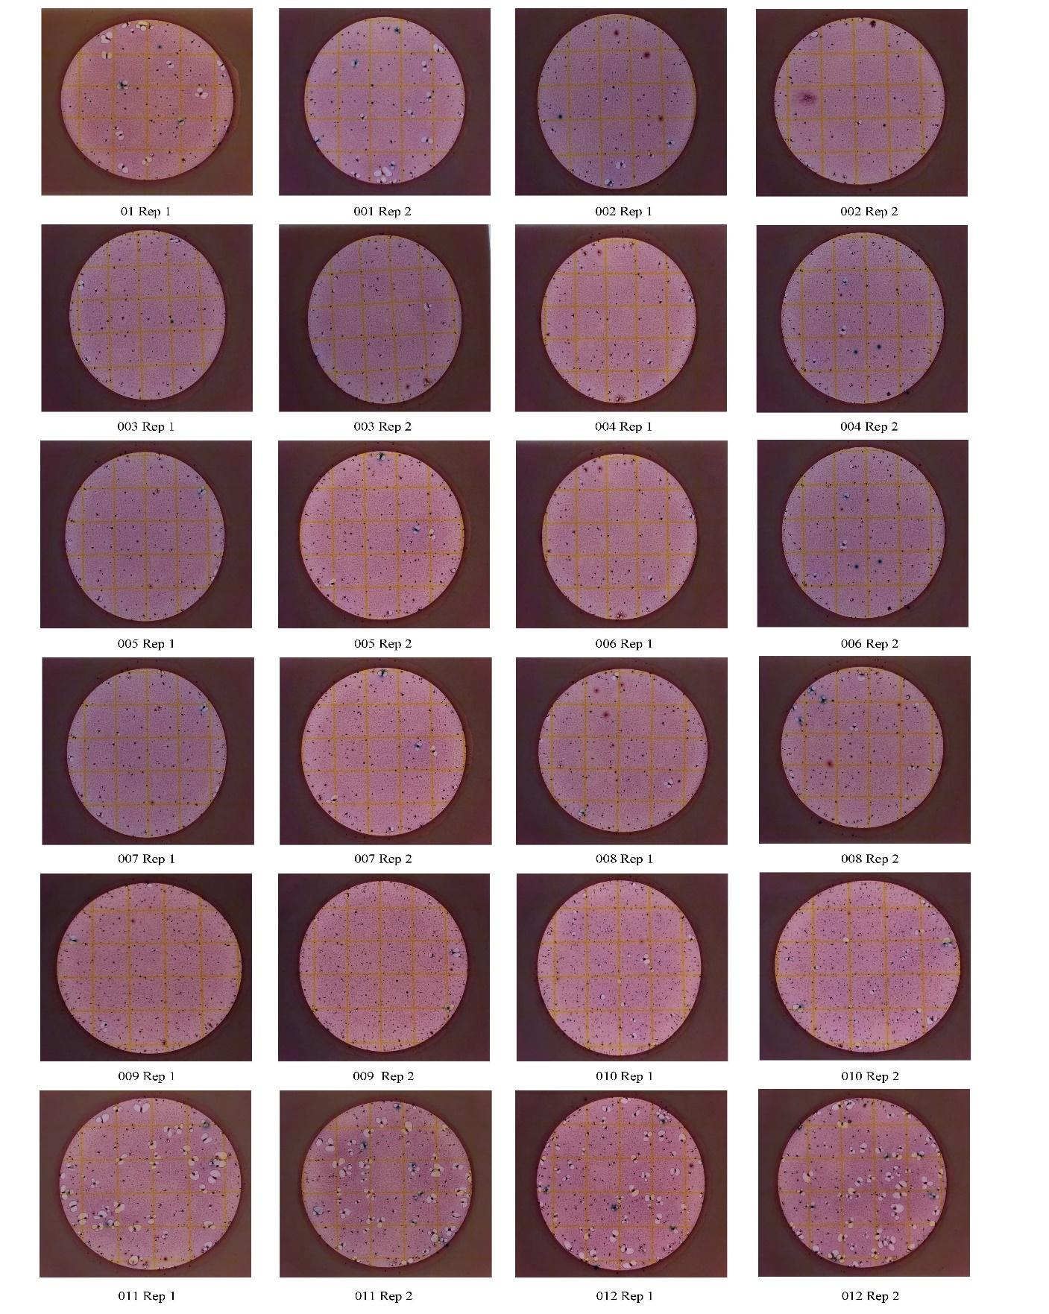
Appendix A
Figure A.1 in Appendix A. Total coliform Petrifilm plates, July 2021.
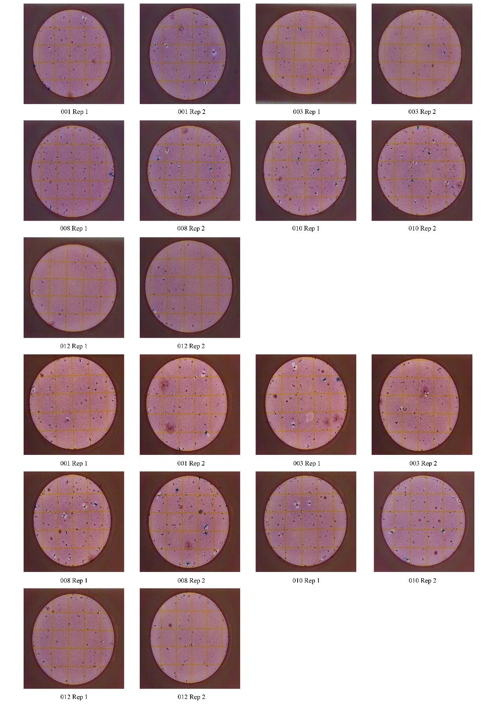
Figure A.2 in Appendix A. Total coliform Petrifilm plates, September and October 2021.
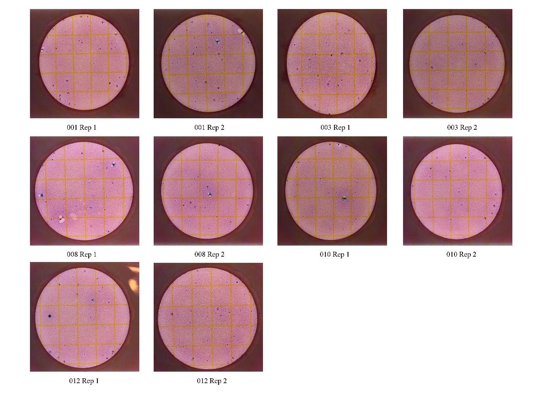
Figure A.3 in Appendix A. Total coliform Petrifilm plates, January 2022

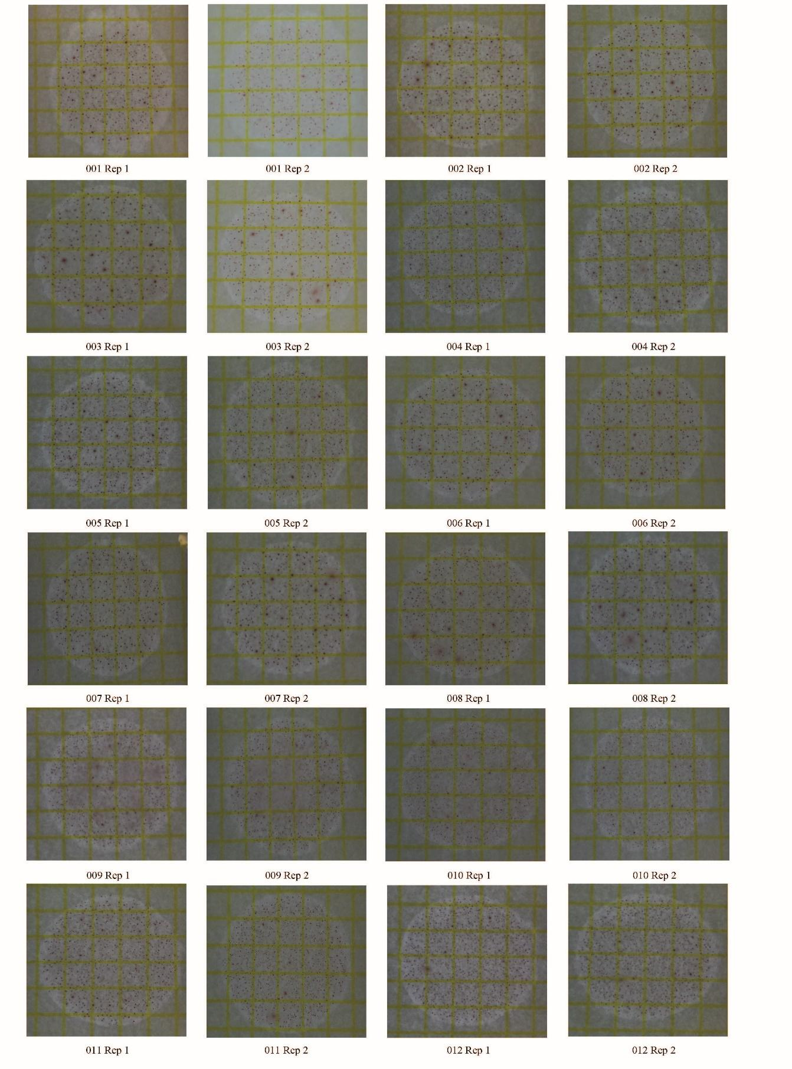
Figure A.4 in Appendix A. Aerobic Petrifilm plates, July 2021.

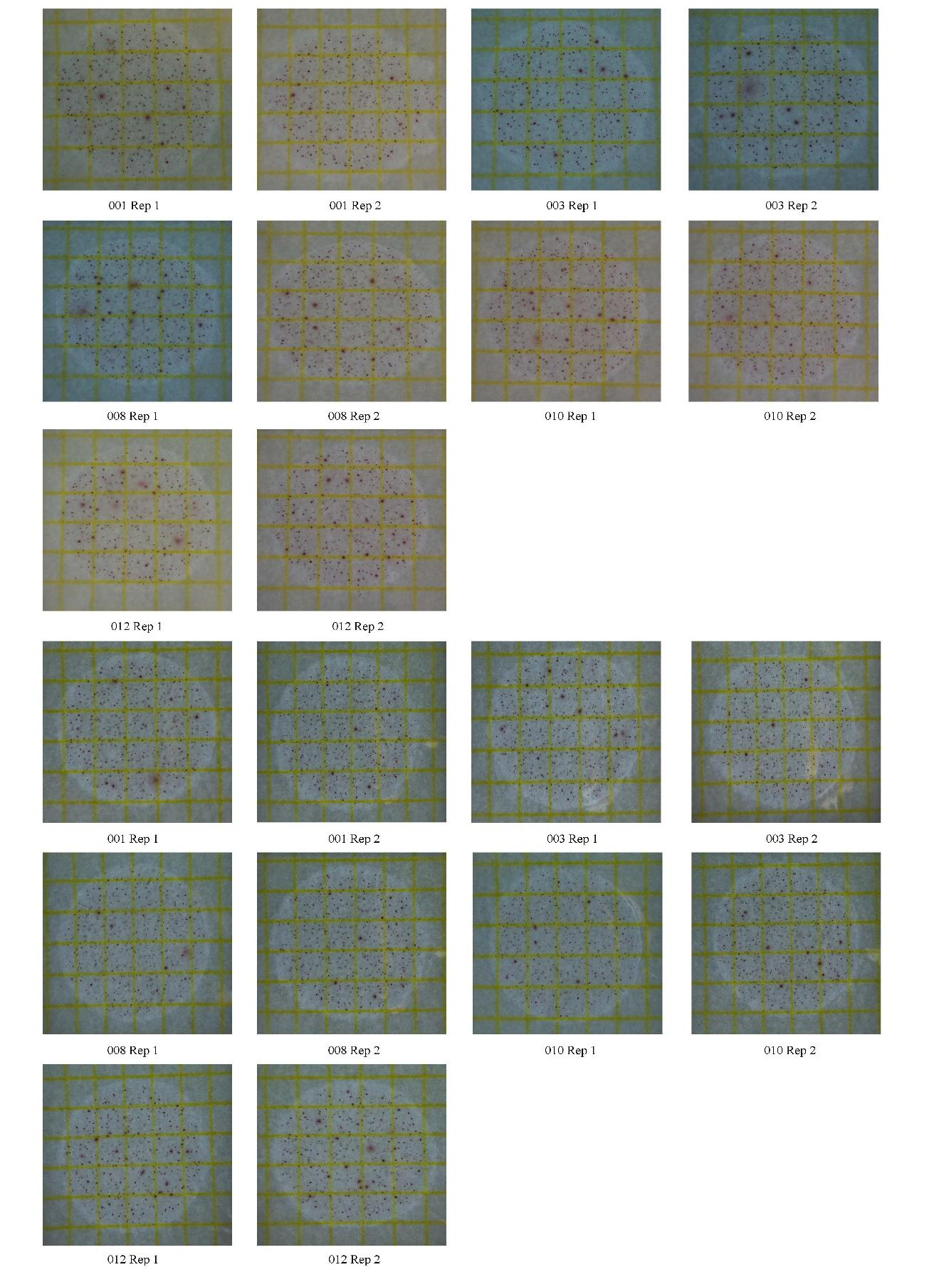
Figure A.5 in Appendix A. Aerobic Petrifilm plates, September and October 2021.
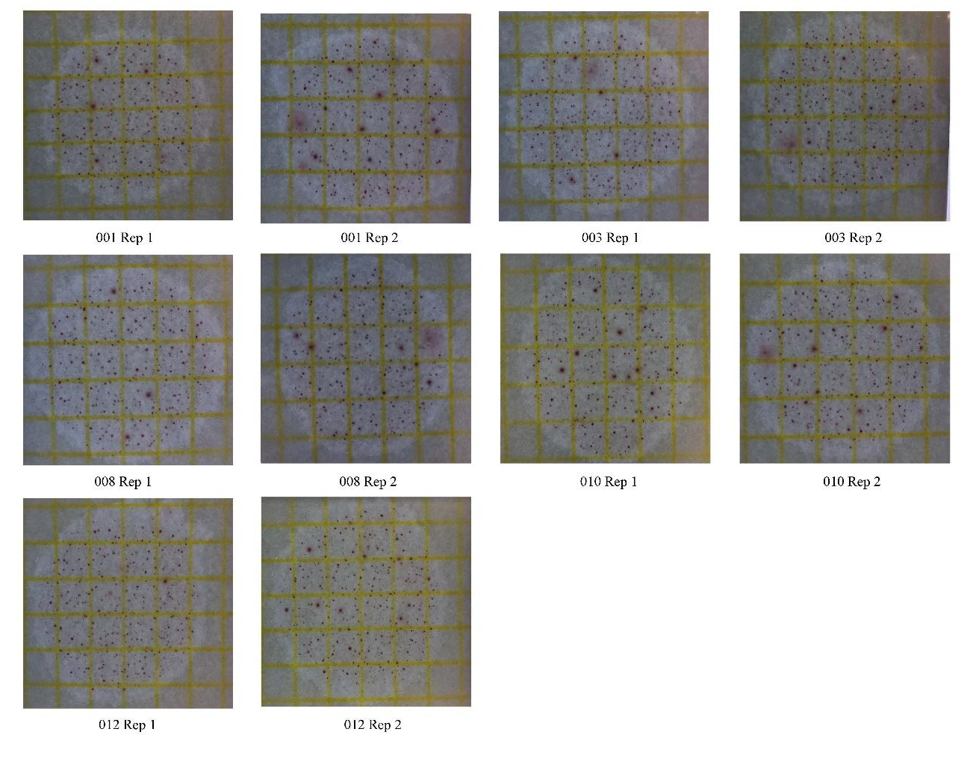
Figure A.6 in Appendix A. Aerobic Petrifilm plates, January 2022.

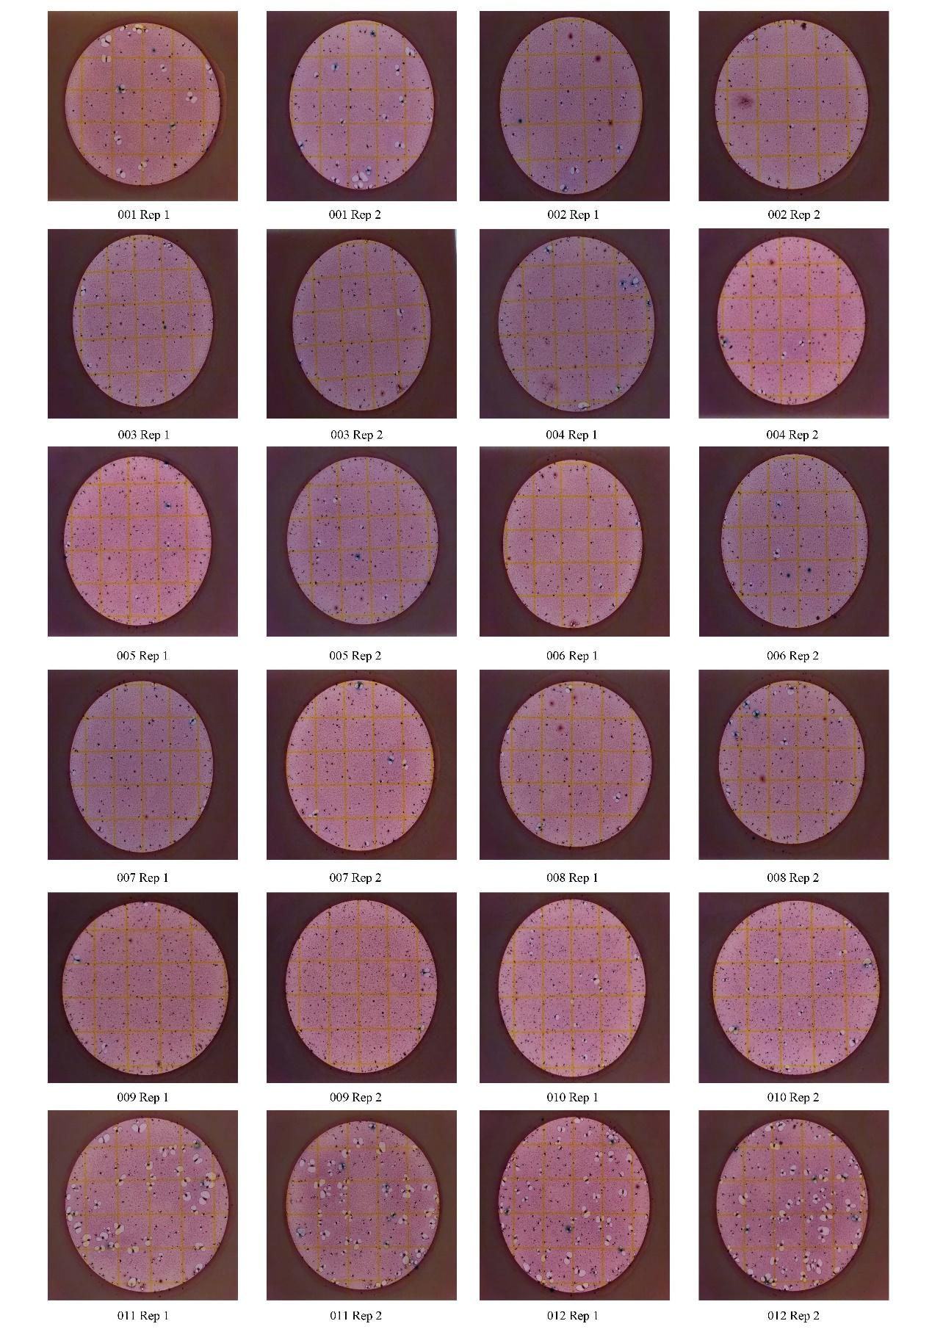
Figure A.7 in Appendix A. E. coli Petrifilm plates, July 2021.
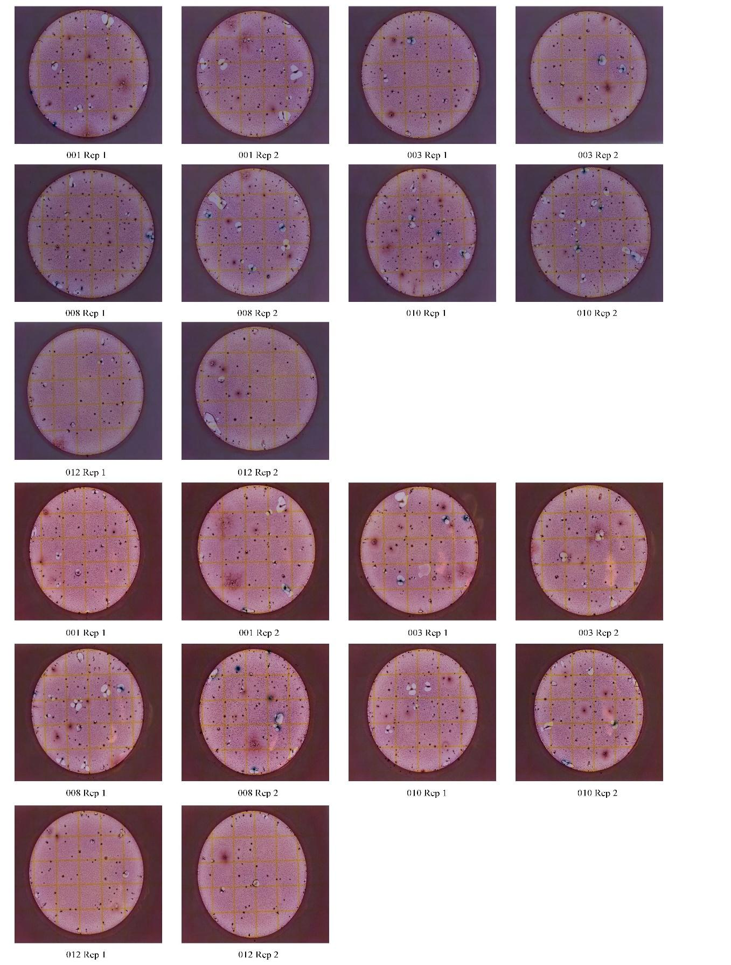
Figure A.8 in Appendix A. E. coli Petrifilm plates, September and October 2021.
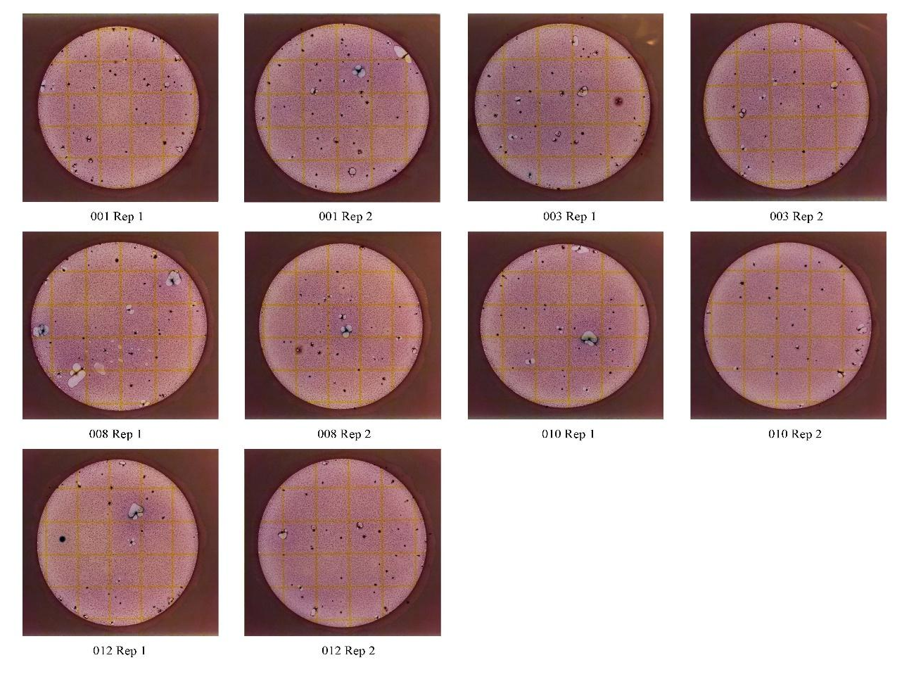
Figure A.9 in Appendix A. E. coli Petrifilm plates, January 2022.

VITA
Allison Rogers was born in Plymouth, Massachusetts, where she stayed throughout her adolescence. Driven by the desire to play sports, she went on to play DII lacrosse in Philippi, West Virginia. She received her Bachelor of Science degrees in Biology and Environmental Science with minors in chemistry and geographic information systems in Spring 2019 from Alderson Broaddus University. After receiving her degrees, Allison began her Master of Science degree in geology at the University of Tennessee, Knoxville, in the Department of Earth and Planetary Sciences. Her advisor, Dr. Annette Engel, supervised her studies on the changes in stream health influenced by urbanization (i.e., water quality, periphytic communities) via geochemistry. Allison received an honorable mentioned for the Colloquium Presentation Award in Spring 2021 and was awarded the Excellence in Teaching by a Graduate Teaching Assistant in Spring 2022. Through this lab, she learned about geochemistry and how we can use quantitative data and measurements to determine how anthropogenic sources impact the environment. Her experience as a graduate student, and her involvement and passion for her research, has led her to further her career as an environmental consultant within the Knoxville area.

