We Have Come to Turn It: Merging Archaeological Practice with the Cherokee Concept of Duyudvi

A Dissertation Presented for the
Doctor of Philosophy
Degree
The University of Tennessee, Knoxville

Beau Duke Carroll
August 2025

Copyright © 2025 by Beau Duke Carroll
All rights reserved.

To ᎤᎳᏏᎩ and ᎤᏅᏧᎲ —though you have journeyed on, your presence still stirs my curiosity and gently guides me forward when the path feels heavy. Your quiet encouragement remains with me.
This work is also for the Cherokee—past, present, and future. It is because of you that we endure, that we remember, and that we continue.

ACKNOWLEDGEMENTS
I would like to extend my deepest thanks to everyone who supported me throughout this journey—this work would not have been possible without you.
To my family: ᏩᏙ for your endless love, patience, and encouragement. You carried me when I couldn’t carry myself. To my sister, ᏓᏰᏂ, thank you for all your love, support, and encouragement; this wouldn’t have been possible without your help. The physical and mental space that you provided me was crucial in the completion of this project. To my mother, ᏰᎩᏂ, your presence, no matter the circumstance, gave me strength when things seemed impossible. To my brother, ᏗᏓᏂᏏᏍᎩ, you’ve never led me into something you couldn’t also lead me out of—ᏩᏙ for the laughter, the wisdom, and the unwavering support. I can’t go without mentioning ᎠᏳᎩᏓ—thank you for putting up with me, the endless productive debates, and all the constructive criticisms. Your honesty and insight have pushed me to be better, even when I acted like I didn’t want to hear it.
To ᏕᏂᎵ, ᏩᏙᏏ for the cultural knowledge, early morning debates, and gentle guidance through the many conversations about language and tradition. I wouldn’t have wanted to be anywhere else on those Saturdays.
To my brothers and sisters at ᎣᎦᎾᏱ ᎩᏚᏩᎩ ᎦᏘᏲ — ᏍᎩ for the smoke you raised and the prayers you offered. Your belief in what we do sustained me.
To everyone at the Tribal Historic Preservation Office, your commitment to the Cherokee people and our shared responsibilities made this work possible. Thank you for always having my back and showing what collective dedication looks like.
To my professors—your guidance helped protect and preserve cultural knowledge that might have otherwise been lost. Wado for showing me how to carry these teachings forward. The work we’ve done together ensures that future generations of Cherokee people will have access to our stories, our practices, and our truths.
To my dissertation committee:
Dr. Kandace Hollenbach—your genuine respect for Indigenous people and Indigenous work gave me the hope that my scholarship mattered.
Dr. David Anderson—you welcomed me on my first day at UTK and have continued to do so ever since. Thank you for seeing me, not just as a student, but as a person.
Dr. Julie Reed—your example showed me that Cherokee people belong in academic spaces. You helped me believe that this path was possible.
Dr. Jan Simek—none of this would exist without you. From research and writing to surviving the hardest parts of life, your mentorship and friendship shaped who I’ve become. Thank you for talking me off the ledge and never letting me ease up, even when I wanted to.
Finally, I give thanks to ᏌᏌ, Mr. RG, and to ᎫᎦᎫᎦᏑᏍᎪ, for leaving me those messages so long ago. I heard you and I am still listening.

ABSTRACT
This dissertation provides a framework for using Indigenous archaeology through the experiences of a professional archaeologist who is also a traditional Cherokee cultural practitioner. The new methods presented highlight the need to incorporate Indigenous values and knowledge while recognizing tribal sovereignty within research methods for the future. As the lead archaeologist for the Eastern Band of Cherokee Indians (EBCI), I examine colonial legacies within the field and propose ways to allow for meaningful change through Indigenous-led collaborative work that incorporates community-based research and culturally grounded interpretations. This work is structured using three papers tailored to meet formatting guidelines to be published by different journals at a future date. The first utilizes an autobiographical account of the experiences of becoming an Indigenous archaeologist and the cultural issues this introduces. The second is a successful collaborative study analyzing Cherokee Syllabary inscriptions within Howard’s Waterfall Cave, providing an example for future work. The last is a critical reflection on NAGPRA (The Native American Graves Protection and Repatriation Act, Pub. L. 101-601, 25 U.S.C. 3001 et seq., 104 Stat. 3048 of 1990 with revisions) and federal resource laws and their implications in Native communities. The study presents challenging methodologies that remain extractive and proposes future practices formed through accountability, partnerships, and cultural respect. When Cherokee language expertise, traditional knowledge, and firsthand accounts are combined within cultural resource management, a more meaningful way to practice Indigenous studies emerges. As shown in this dissertation, Indigenous archaeology can reshape academic research and allow for protection, healing, and cultural revitalization for everyone involved in studying Indigenous people. Ultimately, it asserts that Indigenous archaeology is not a theory to be selectively applied but a necessary evolution of the field—one that recognizes Native peoples not as subjects of research but as sovereign stewards of their histories.

TABLE OF CONTENTS
Introduction to the Dissertation: Attempting to Familiarize the Unfamiliar 1

Genesis 1:1 2.0: The Development of Indigenous Archaeology 3

The Structure of the Dissertation 12
CHAPTER I: Archaeological Double Agency 16

Abstract 17

My Background 17

Realizing My Interests 20

Traditional Beliefs and Archaeology 23

Hopes for the Future 28

Summary of Paper I and Introduction to Paper II 29
CHAPTER II: Howard’s Waterfall Cave: What Can Be Learned from Sequoyan Syllabary in Cave Contexts 31

Abstract 32

Introduction 33

Cherokee People and Howard’s Waterfall Cave 34

Regional History 36

Cherokee Cultural Concepts 37
Cherokee Human Relationships 38
The Meaning of Caves 39
Cherokee States of Being 40

Sequoyah’s Syllabary 40

Howard’s Waterfall Cave: The Analytic Process 42

Howard’s Waterfall Cave Inscriptions 43

Translation Discussion 44

Conclusion 50

References 53

Appendix 56

Summary of Paper II and Introduction to Paper III 63
CHAPTER III: Protecting “Our” Past for Future Generations 64

Abstract 65

Introduction 65
What the NAGPRA Law Says vs. What It Means 68

Cherokee Perspectives on Death and the Ancestors 72

Repatriation from a Traditionalist Cherokee View 75

Navigating Life as a Living Object 83

Cultural Beliefs and Problems 87

Looking Towards the Future 90

References 93
Concluding the Dissertation: The Way Forward by Reclaiming Sovereignty Through Practice 96
References for Introduction, Indigenous Archaeology and Conclusion 100
VITA 102

LIST OF FIGURES
Figure 1. Howard’s Waterfall Cave Map Showing Location of Inscriptions 56
Figure 2. Cherokee Syllabary Chart 57
Figure 3. SaSa with Syllabary Example 58
Figure 4. Atadvsvi with Syllabary Example 59
Figure 5. Osawatv with Syllabary Example 60
Figure 6. Tsoinitsidv with Syllabary Example 61
Figure 7. Ogatseliga with Syllabary Example 62

Introduction to the Dissertation: Attempting to Familiarize the Unfamiliar
In this dissertation, I attempt to illustrate the current state of Indigenous archaeology from the point of view of a Native practitioner. In order to do this, I take a very personal view, because there is yet to be a formal structure to an Indigenous practice. The actions I undertake in my day-to-day work are often ad hoc and represent responses to challenges that arise on a day-to-day basis. A few words about myself are in order if the dissertation I present here is to be comprehended by non-Native archaeologists. I am an enrolled member of the Eastern Band of Cherokee Indians, a federally recognized Indian tribe residing in North Carolina. I am also a practicing Cherokee traditionalist, carrying on my tribe’s thousands of years of cultural beliefs and practices. I have been the Lead Archaeologist working for the Tribal Historic Preservation Office (THPO) for ten-plus years. Through work experiences as the Lead Archaeologist, where I focus primarily on repatriation, I have witnessed concerns that need to be addressed within the process. I have identified problems that exist with how cultural resources laws are interpreted and utilized and how these processes contribute to some of the issues Native people face presently.
My unique traditional knowledge provides me with a different perspective that academia has largely resisted or ignored regarding archaeology. My educational background has given me the theoretical and analytical tools every archaeologist should possess. With this “bicameral” knowledge, I can process and interpret information closely resembling the mindset of the Indigenous people under study, often producing research unique to the field. My background as an Indigenous archaeologist qualifies me to speak on topics related to Native tribes within archaeology, which is crucial to future work. My experience with NAGPRA and the successful reburial of thousands of sets of my ancestors’ remains and grave property allows me to speak confidently on the issues discussed in detail throughout these papers.
Throughout this work, the term Cherokee appears frequently, and for clarity, I want to explain what I mean when I use it. When I say Cherokee people, I am speaking about all of us—those who came before, those here now, and those still to come. Before the forced removal from our homelands, we were one people. Each town had its own leadership, but we were all part of a single Nation. Think of it like different states within the same country—governed locally, but united. The removal and historical trauma that followed created political separation, leading to the formation of three federally recognized tribes: the Eastern Band of Cherokee Indians, the Cherokee Nation, and the United Keetoowah Band. But to me, and for the purposes of this dissertation, we are still one people. The only division is the space between us.
To understand this dissertation and the way I interpret the world, it’s also important to understand what it means when I say I’m a traditional Cherokee person. More precisely, I am Anigiduwagi, a person of Kituwah—the Cherokee Mother Town. Kituwah is more than a place. It’s our origin, our law, and our responsibility. It is the foundation of our identity as Cherokee people. We were placed there by the Creator and given a way to live, one that includes Duyudvi—the right path. This is a guiding principle for Kituwah people, a commitment to walk in balance, with respect for the world and each other. This isn’t just a philosophy. It’s a way of life that we call the Old Ways, and it shapes how we live, how we pray, and how we act.
When I refer to being Anigiduwagi, I am referring to a way of life rooted in practice, belief, and cultural responsibility. That doesn’t change whether I am writing from the Qualla Boundary or speaking to Cherokee people a thousand miles away in Oklahoma. We were given the same teachings, and those teachings connect us through time and place. Colonization has changed how we see the world and how we see each other, but those views are not ours. Our ancestors believed that community came first, and that each person was part of a larger whole, with responsibilities to care for one another. If we lose that, we risk becoming like the people who tried to destroy us—driven by greed instead of kinship.
Losing this way of life would not just be sad—it would be the end of us as Anigiduwagi. It would sever our connection to the Creator, and we would fade until we disappear. This dissertation, and the work I do every day, is about preventing that. It’s about protecting what remains. Every part of our traditional belief system—language, worldview, ethics, and spirituality—holds up the whole. That’s what makes us who we are, and what we must continue to be. I am sharing parts of this life here so that others might better understand us, but this is not an invitation for extraction. Too much has been stolen already. I will not contribute to that.
Still, I believe in honest dialogue and the possibility of real relationships. There are people outside our communities who want to understand and work in a good way. This writing is for them too. But I hold my boundaries, and I protect what should remain ours. So, let this be clear: We are still Cherokee, we are still Anigiduwagi, and we still walk the path of Duyudvi.

Genesis 1:1 2.0: The Development of Indigenous Archaeology
The theory of Indigenous archaeology is not new, but like all theories, it requires development, understanding, and trial-and-error testing to be effective. American archaeology began as a tool for eugenics, colonialism, and a way to discount the minority groups that it attempted to study. The field slowly shifted its focus onto recording cultures believed to be disappearing to “save” them for the future of America, where this approach continues today. Throughout this progression, Indigenous people have slowly begun to realize how archaeology can assist them in reconstructing and recording aspects of their culture. Indigenous people also realized the need to participate and have a say in how their material culture is studied, interpreted, and analyzed. This is the crux of Indigenous archaeology, a collaborative way to study the past that is based on a concern for and inclusion of Native peoples actively participating in identifying important problems to address, the design of research, and the interpretation and use of research findings concerning their own past. Slowly, the number of Indigenous archaeologists continues to grow and impact the field in new ways.
Anthropology and archaeology are not new and have been utilized to record and interpret cultures worldwide. What we know as American archaeology today is more recently developed in comparison to the history of anthropology in general. The interest in and study of Native American cultures has been present since European settlers made first contact with the Indigenous populations that inhabited North America. We were initially viewed as uncivilized and incapable of capitalizing on the land we controlled, and this was the justification for the political process designed to strip us of it. We managed to progress but were either romanticized as noble savages or portrayed as murderous people without the ability to progress in civilization. Due to the Native’s perceived low mental status and to aid in the country’s progression, Native people were intentionally exterminated or allowed to pass into extinction to make room for progress (Bray et al. 2001). The history of archaeology within America is broad and will not be discussed at length. For this discussion, it is important to remember where influences within the field began and the stereotypes it continues to place on Native people.
The theory of Indigenous archaeology is relatively new, and the history of its inception is difficult to summarize in depth because it has not been clearly defined. When you compare the damage that the field of anthropology has caused to Native communities with the benefits they have gained, the need for Indigenous archaeology becomes apparent. For Indian people, there is no need to study the past as if it were a separate moment in time. The Native American concept of time is not linear, and Native people carry it with them, where it can be visited fluidly without a distinctive separation. The past is the present because we carry it in our stories, memories, life experiences, and DNA. We know who we are and where we are from and do not need to discover and record the past. Anthropologists have been present in Indian communities for generations and have been recording aspects of Native culture to have a record. Archaeologists have been excavating our sacred places to write a history we already knew (Bray et al. 2001). Archaeologists have been robbing our ancestors from their graves so that they can display their remains and funerary objects, referring to it as shared American history. The main factor for me involving Indigenous archaeology is that Native people realized that they would not be able to stop this from happening, so they needed to be involved in order to mitigate the damage and use it to salvage what was left of their culture.
Native people, such as Arthur Parker, have attempted to engage with archaeology since the 1900s, and a few tribal members have become archaeologists. Widespread engagement with the field only happened when a few tribal nations realized the impact it could have on preserving what was left of their cultural past (Colwell-Chanthaphonh et al. 2010; Smith and Wobst 2005; Colwell 2009). Parker became an archaeologist in 1903 to honor his Seneca past but ultimately ended up practicing the same archaeology that had harmed his people. He could not practice archaeology applying the Indigenous values needed to assist his community because that was not an academic alternative (Watkins 2000). This example shows that the inclusion of Native people within archaeology is not the only factor needed to form Indigenous archaeology. Many factors influenced this theoretical approach’s creation, including the need to protect and record aspects of the tribal community’s historical pasts.
Indigenous archaeology began with the need for historic preservation and an approach for American Indian groups to apply it to their cultures. In 1972, the Navajo Tribal Council passed a resolution to enact an antiquities preservation law for their reservation. The Navajo realized the importance of the archaeological evidence within their lands and the need to preserve it for their continuing culture and history. This resolution is believed to be the first instance of tribal nations attempting to extend protection for cultural resources within tribal lands. This engagement contrasted with what had happened a year previous when members of the American Indian Movement (AIM) protested the excavation of an archaeological site in Minnesota and orchestrated the takeover of an archaeological laboratory in Colorado. Largely, archaeology was seen as damaging to the Native American community but had begun to be viewed as a tool to help protect aspects of their cultural past (Watkins 2000).
In the same year, Thomas King, a member of the Advisory Council on Historic Preservation, wrote Archeology and the American Indian, where he discussed laws that applied to American Indians and the protection of their cultural resources. He pointed to the fact that with every excavated burial that has been stored in a secure storage room, countless others were bulldozed away or looted for decoration (King 1972). This statement reinforced the need to save these specimens while mentioning the safety and security of an institution’s storage facility.
In 1974, there was a discussion of how historic preservation needed to be altered to allow Native people to focus their attention on the natural lands they inhabited and their ancestors’ remains (Wilson and Zingg 1974). The intention was for other Americans to recognize and respect Native people as Indians and Americans. Very few archaeologists acknowledged or attempted to solve any societal or economic issues regarding Native Americans during this time. It was often individuals from outside the field that weighed in. In 1982, following similar views by two lawyers named Wilson and Zingg, it was believed that Native Americans were incapable of separating their natural resources from their cultural ones (King 2013a; Watkins 2000). Archaeology would continue unabated as it had in the past, and the only hope for Indigenous people was to make their religious beliefs known at the beginning of the projected project, or they would not be considered.
During this time, it seems archaeologists at large were unaware of how Native people viewed them, and it was not until 1988 that those thoughts became clear. Vine Deloria Jr., a member of the Standing Rock Sioux Nation and a professor of history at the University of Colorado, wrote the book Custer Died for Your Sins. In this seminal work, Deloria discussed the Native American views of anthropologists and the problems they continue to cause tribal communities. Deloria said that even though these feelings are not indicative of all Indians today, it will be tomorrow, and it would be wise for anthropologists to descend from their research thrones of authority and start helping Indian tribes as opposed to preying on them (Deloria 1988). Ten years later, a group of anthropologists co-authored a book titled Indians and Anthropologist: Vine Deloria Jr. and the Critique of Anthropology, where they examined how Deloria’s book shaped their views as anthropologists and the personal impact it had on them (Biolsi and Zimmerman 1998). I agree; when I first stumbled onto Deloria’s book as an undergraduate, it changed my perception of the field I was attempting to study. As a university-trained anthropologist, I was on my way to being another cookie-cutter academic where Western theory dictated my thoughts and actions. This perspective was not part of any curriculum or acknowledged; but it profoundly influenced my career, and I am a better anthropologist because of it. This book allowed me to realize my passion and instilled in me the need for my community to have a voice regarding the study and interpretation of our culture.
In 1990, the Native American Graves and Repatriation Act was passed, allowing Native tribes to reclaim some of their stolen ancestors and belongings. In 1992, Amendments to the National Historic Preservation Act of 1966 allowed Native American tribes to take over State Historic Preservation duties, giving them authority to provide protection through the creation of Tribal Historic Preservation Offices (Watkins 2000). With the majority of funding for archaeological sites put in place to protect cultural resources, public archaeology was beginning to take shape and provide alternate methods through community-based participation. Sonya Atalay defined community-based participation as community-based archaeology that foregrounds the knowledge and experiences of community partners to guide the archaeological research process, ensuring it is grassroots and ground-up, with communities as partners rather than as people whose heritage is simply the object of study (Atalay 2006; Atalay 2012). She advocates for what she refers to as the decolonization of archaeology, where colonist-based practices of the past are identified within the field and eliminated. This archaeology also focuses on recording and investigating Native-based knowledge systems, cultural-traditional knowledge, and practices. Above all, it states that all research should be inclusive and beneficial to the communities that are being studied.
In short, Indigenous archaeology is an expression of archaeological theory and practice in which the discipline intersects with Indigenous values, knowledge, practice ethics, and sensibilities through collaborative and community-originated or -directed projects and related critical perspectives (Colwell-Chanthaphonh et al. 2010; Smith and Wobst 2005). Archaeology has always been harmful to Indigenous people for many reasons, and the theory of Indigenous archaeology attempts to acknowledge and remediate the damage for future work. Recognizing that archaeology is embedded with inequalities and has up to now been imposed on Native people is the only way to begin to repair the inequity. Much like any other archaeological theory, Indigenous archaeology includes rigorous scientific study and testing, and the results are published in peer-reviewed journals to add to the archaeological record (McNiven and Russell 2005). It is science as usual but with more inclusivity and respect for the people being studied. Indigenous archaeology is still in its beginning stages and, through trial and error, has been applied in different scenarios. Research exists that benefits from this theory and has shown positive results. The fact that there is a willingness to understand and apply it to research is a step in the right direction (Allen et al. 2016). With the continued inclusion of tribal people, it will yield exceptional results for everyone.
Throughout this dissertation, I explore different aspects of Cherokee cultural beliefs in the context of performing archaeological research and how those beliefs affect the archaeologists and the Indigenous people involved. What archaeologists need to remember is that all Native American tribes do not have the same cultural practices or beliefs and sometimes can be vastly different. It is imperative that the researcher possess, at the very least, a general understanding of tribal history and cultural beliefs to protect the people involved. Indigenous archaeological theory does not include performing the bare minimum tribal consultation to satisfy federal law requirements (Silliman 2008). However, if these laws had not been put into place, this theory might not have progressed as quickly, and there would have been far fewer conversations with tribal people.
Since first contact, Euro-Americans have been stealing from the Native population that existed here for tens of thousands of years. The first action when they stepped off the ship was to dig up and rob Native American graves, and that was a continued practice for many years (Bray et al. 2001). We have dealt with the theft of our lands, children, human rights, religion, ways of life, and other aspects of our culture, from which we will never recover. Anthropologists have been present in Native American communities for hundreds of years, unethically extracting what cultural information we managed to maintain. Countless anthropologists have taken advantage of the economic hardships of Native communities in order to further their careers, often never giving back to the community. For Indigenous archaeology to be beneficial, it must include exchanging information with people who represent that past. Why should Indigenous people share anything with anthropology? There will be a time when Native communities realize this and will shut their reservations off from any attempt at cultural extraction. “Thus the pendulum will swing radically from one extreme to another, whereas with understanding between the two groups, it would not have to swing at all” (Deloria 1988). An understanding of the theory of Indigenous archaeology and the ability to apply it successfully within research will be needed when attempting to work with Native American communities.
Indigenous archaeological theory that has been correctly implemented benefits the researcher and the tribal people who are the focus of the study. It begins with the researcher making contacts within the tribal community that is the focus of the research. Not all tribes will be the same; some may have requirements to be met to conduct research within their communities. Researchers should have a general understanding of the cultural beliefs and practices of the tribal people they are attempting to work with. Tribal members must assist in research design from the beginning in a collaborative engagement. One of the main questions will be how this study will benefit the tribe in the present and who will control how the data are used.
In practice, this theory is simply archaeology; the only difference is that Native people are finally afforded some respect and are included in the conversation. Indigenous archaeology is working with other Native archaeologists to interpret cave art and present the findings as equal partners. When the United States Forest Service is working in collaboration with a THPO and following the recommendations to hire a tribal person to monitor a project is another example. It is a field school offered to tribal people, allowing them to be included in a field of study that was never welcoming. It is a university that takes an honest assessment of its history and identifies the colonial practices within it to allow for change in the future. Higher education should strive for inclusivity for all demographics, especially Native American students interested in archaeology. Considering the university was built on their ancestors’ stolen land, it is concerning to have to point this out. Indigenous archaeology includes Indigenous and non-Indigenous archaeologists, allowing for their rights, interests, and responsibilities to be equal and, finally, it is the way archaeology should have always been practiced.
Indigenous archaeology continues to be considered a theory that a researcher can choose to utilize within their work if applicable. As an Indigenous person who is a practicing archaeologist, it is obvious to me that this theory is how archaeology should have been practiced since the field’s inception. Native people have been stripped of large parts of their cultural practices, and what wasn’t lost is stolen and used without their input or consent. What little information they still retain is often ignored or discounted as mythology or superstition. Instead, non-Indigenous researchers’ imaginations are used to create false narratives based on their interpretation of a culture they had no hand in creating. This results in often mistaken or outright misinterpreted evidence of an Indigenous group’s cultural past without including them, only to have the next researcher regurgitate the same misinformation and so on.
The theory of Indigenous archaeology through the eyes of a member of the Indigenous group who created the materials being studied is often a more complete interpretation of the evidence. By inclusion, one can develop a more accurate picture to add to the archaeological record (Allen et al. 2016). Indigenous archaeology is not a non-Native researcher who has consulted with an Indigenous group or tribe and then has free reign to take aspects of their culture to use for academic gain. To an Indigenous person, archaeology has mainly been etic and, by its nature, contains known and unknown biases that often harm Indigenous people in indirect ways.
Indigenous archaeology is normalizing the inclusion of the people you are researching from the beginning and collaborating on research designs. For Indigenous groups to feel comfortable enough to participate, it is critical to understand the field’s mistreatment and avoid the same mistakes that our predecessors made. When researchers consider the cultural beliefs of the Indigenous tribe regarding aspects of their history, they can start to recognize how they may be impacted in the present. Indigenous archaeology requires inclusion, understanding, patience, and collaboration, with a conscious effort to keep research free from the biased practices of the past. Indigenous archaeology is just a good and sound way to practice archaeological research.

The Structure of the Dissertation
I have taken the option to produce three publication-ready papers for this dissertation; this option requires three papers that must be entirely prepared for submission to academic books or peer-reviewed journals. I must be the sole author on two of the three papers, with the third possibly being co-authored, and my dissertation committee must agree upon the topics. The papers must be formatted according to the proposed journal procedures and must meet paper size, extent, and word count to meet publishing requirements. Through these three articles, I am able to introduce the Native perspectives on issues within archaeology to a broader audience. My hope is to provide information to a larger audience that may not otherwise be exposed to it while also addressing Indigenous perspectives, allowing for a better understanding for everyone involved.
The first paper is an in-depth account of how I, an Indigenous Cherokee person, became the first member of my tribe to become an archaeologist and the influences that molded my personal outlook through this journey. Utilizing traditional Cherokee knowledge and applying it to different aspects of my research have allowed for the development of some unique perspectives, and this paper explains those in detail. This topic was solicited by the editors of a book entitled Working as Indigenous Archaeologists: Reckoning New Paths Between Past and Present Lives, edited by George Nicholas and Joe Watkins. This book contains autobiographical chapters from over seventy Indigenous archaeologists worldwide, and few requirements were placed on the paper’s content. The editors requested that the authors speak on themselves in a non-academic, conversational tone of 3500–4000 words. This project used a formatting program called Code Mantra and processed the formatting for the authors. The goal of the book, as stated by the editors, was a broad representation in terms of gender, age, and geography for individuals who self-identify as Indigenous and are involved in archaeology. I used this opportunity to explain in detail the successes and hardships I experienced in my journey to becoming an Indigenous archaeologist. It is a contributed chapter, and that book has already been published by Routledge Publishing. The reference for the book is Nicholas, George P., and Joe Watkins (editors). 2024. Working as Indigenous Archaeologists: Reckoning New Paths between Past and Present Lives. Archaeology and Indigenous Peoples Series. Routledge, Abingdon, Oxon, UK.
The second paper focuses on the culmination of past experiences and how they were utilized in the understanding and practice of archaeology. This project at Howard’s Waterfall Cave in Alabama was successfully designed, researched, and interpreted through a collaboration between non-Native archaeologists and tribal communities and is used as an example of how archaeology can and should be practiced. This study highlights the much richer and complete study and understanding of archaeological evidence that is possible when archaeologists and Native communities work closely together. I hope this study provides a blueprint for collaborative work and influences future researchers to do the same. The study of the Cherokee Syllabary in Howard’s Waterfall Cave and the methods used in its successful interpretation will be submitted to American Antiquity, the Journal of the Society of American Archaeology, for publication.
The third and final paper focuses on how becoming an Indigenous archaeologist has influenced my outlooks on the field and identified problems within it. Drawing on personal experiences as a Tribal Cultural Resources Specialist working for a Tribal Historic Preservation Office, I share a view that has not often been articulated and thus is not well understood. For the people who work with Indigenous groups within federal cultural resources law, this paper shows how damaging the current process is and why. A highly personal account gives the reader a better understanding of my Indigenous perspectives on NAGPRA work and the difficulties that come when engaging with it. This paper provides a much-needed perspective currently missing from non-Native academia and institutional understanding. The plan is to submit this paper for publication in the journal Southeastern Archaeology at some point in the future.
These three proposed research papers will allow the reader to understand better how a particular Indigenous person who grew up in a tribal community was influenced in their journey of becoming an archaeologist. Of particular practical interest is how traditional tribal knowledge was utilized while practicing successful Indigenous archaeological theories to develop unique research methods for the future. These influences are explained using personal accounts, providing a better understanding of Indigenous concerns within archaeology and focusing light on some pervasive issues and how to alleviate them. This collection of papers comes straight from the heart and contains many thoughts that occupy my mind a great deal of the time. My presentation might be passionate and unsettling at times, but I do not want to censor anything so that the reader will have the best understanding of the emotions involved in each of these experiences. It seems like the only way to attempt to repair some of the problems Native people face is through an honest understanding of all viewpoints held by everyone involved. These papers will, I hope, show the viewpoint of one practicing tribal archaeologist and Cherokee cultural traditionalist, a perspective rarely heard in the archaeological literature. As with every story, it helps to start at the beginning, and this one will not be any different.

CHAPTER I: Archaeological Double Agency

Abstract
There are very few Indigenous archaeologists and even fewer are Indigenous and possess that cultural background. This paper uses an autobiographical account to explain the progression of life experiences that led to becoming a traditional Cherokee person involved in this field. It also examines specific examples of what a Native student experienced in pursuing higher education within colonial-built institutions and how they influenced current perspectives. All these experiences provide a better understanding of what is involved for a Native person regarding their involvement and navigation of work in historic preservation. The problems that Native people face regarding protecting what remains of their cultural past are addressed in this paper in hopes of future inclusivity. By providing a more in-depth background than the usual academic journal entry allows, this paper shares a point of view that academia rarely sees and isn’t widely expressed. The hope is that non-Native researchers and cultural resource workers will better understand what it means to be a Cherokee archaeologist and implement changes to the current process.

My Background
I grew up on the Qualla Boundary, also known as the Cherokee Indian Reservation, in Cherokee, North Carolina. I have lived in Western North Carolina all my life and have never been away from Cherokee for very long. I am currently writing this paper a few hundred meters from Kituwah, the mound site where Cherokee people originated.
While I was growing up, there never was a separation of traditional life from nontraditional. Things were done a certain way, and it was never explained how it was different from a non-Cherokee household. I never enjoyed the structure of school; it seemed like a waste of time. I received my GED from a local community college and never thought I would be attending school again. I fought wildland fire for about six seasons and worked as a sawyer on different crews. That job required travel, and I was at a point in my life where I did not enjoy it anymore. I started working for a tree company climbing and trimming trees. I worked there until I was injured and decided to go back to school. I went back to the same community college where I received my GED and got a General Education Transfer degree. I transferred to Western Carolina University, where I received a BA in Anthropology with a minor in Cherokee Studies. I enrolled in the University of Tennessee/Knoxville (UTK) Master’s Program, and I received an MA in Anthropology. I am currently in my first year of Ph.D. study at UTK, and I plan on completing the program by 2023.
To give the reader a better understanding of my perspective on being an Indigenous archaeologist, it is important that I explain what this title and field mean to me. Simply put, an archaeologist is a person who studies history through material culture. To Indigenous peoples, archaeology is a destructive science that ruins irreplaceable sites and artifacts to serve someone’s curiosity. The very act of doing archaeology harms the direct ancestors of the people who are being studied, often without their consent. Archaeologists are academically educated looters who pretend that Indigenous peoples’ pasts belong to everyone except those who created and lived them. For this reason and others explained below, there are not that many Indigenous archaeologists. For me, as an enrolled member of the Eastern Band of Cherokee Indians (EBCI), being an archaeologist goes against fundamental aspects of my cultural and traditional upbringing.
Considering my tribe’s beliefs about archaeology, most would wonder why I even pursued being an archaeologist as a career, and honestly, I still wonder about this myself. However, I believe that everything I was taught, experienced, and learned growing up has prepared me and led me to this profession. To me, being an archaeologist is more of a responsibility that I was given instead of the occupation of my choosing. For example, I realized early in my career that I cannot stand in the way of progress, especially if money is involved.
I have worked on sites across the southeastern United States where I knew archaeological resources would be affected, and I knew the potential for encountering burials was extremely high. It was decided by EBCI Tribal leadership that development should continue despite my objections. In the end, so many burials were disturbed that it ultimately killed the project. It is sad to say that in my experience, capitalism supersedes traditions. Economic and residential development will continue to destroy archaeological sites. It is inevitable. The field of archaeology will continue to destroy what remains of my ancestral past. My mother once told me, “If you do not vote, you can’t complain.” Taking that lesson and applying it to what I do for a living, if I want the field of archaeology to change, I must actively participate in its progress to help advocate for the changes that would benefit my tribe and other Indigenous groups. I can’t stand on the outside complaining to people who aren’t listening in the first place. Cherokee peoples’ past, my past, will be studied regardless of whether we participate or not. For Cherokee people to have a voice, we must actively participate.
Archaeology is primarily controlled by academia, and for tribes to be taken seriously, the person or group speaking must possess the same educational background. If we want it to change, then we must facilitate that change. If we want our ancestors to remain in the earth where they belong, we must use the system afforded to us and push on. There are many problems facing Indian communities today, and I can’t fix them all; but I found one that is important to me, and so that’s the one that I fight in to make a difference. I feel like when you have an ancestral past that you can trace right back to where I am writing this chapter from, then it is easy to view all prehistoric remains as family. They are my grandmothers and grandfathers, regardless of how many times removed. As a Cherokee person, it is my job to protect these people, my family, my ancestors. If you sever that tie to the past or lose connection, then you start to view people as only objects. If you didn’t know them personally, does that allow you to treat them as such? This mindset will enable you to desecrate people’s remains to satisfy your curiosity. These actions are what the field of archaeology has been doing since its inception.

Realizing My Interests
I once attended a field school in Alabama, and on the way to the site, we passed a coon dog cemetery, and it got me thinking. If I were to go and dig up a dog and run an analysis on it, I am sure I would be met with solid objection, at the least from the local community and the dog owners. But when people desecrate my grandmother’s remains in the name of science, it is forgivable and even accepted. This makes me feel, as a person, like I am less than a dog. Indian people have held this same sentiment for years—but no one seems to care.
After reading thus far, I am sure some are wondering how I became involved in archaeology in the first place. Many assume that because of where I live, I started out picking up arrowheads, and that sparked an interest in archaeology for me; but that’s not the case. When I was in community college, I had an anthropology teacher who was a self-described “amateur” archaeologist. I came to find out he was actually looting archaeological sites, the same sites I now work to protect. He would talk about things that he had found while we were in class, and that was my first exposure to the field. At the time, I loved history, especially Cherokee history, and that was going to be my focus while in school, but I don’t like to be indoors.
Another problem with being a historian was while reading the history of my people, I realized that it is the “victors” who write history, and there aren’t many Cherokee authors because we didn’t “win.” How much of this “history” can I believe? How much are the accounts muddled with ethnocentric bias? I found this to be a big problem for a field in which I was interested. While attending Western Carolina University, I would register for classes by my level of interest and realized that all my classes were anthropology classes. So, I looked up what anthropology was, and I found it to be the broad study of humankind—for an undergraduate who hadn’t declared a major, this was perfect. The definition of anthropology is so vague that I literally could do anything anthropologically, including digging through people’s trash. I gravitated to archaeology unintentionally. This was a field where I could take flawed data sets such as ethnocentric historical accounts and mesh them with my tribe’s oral traditions. I could take geology and artifact assemblages and determine dates of when sites were occupied.
To meet the anthropology program’s requirements, I was required to attend a field school located near a Cherokee mound known as Spike Buck in Clay County, North Carolina. A field school was a requirement for a degree in anthropology at Western Carolina University, and it is essentially a practice archaeological dig. The field school was a Cherokee mound site and village and was in an area that was going to be developed. As far as incredible artifacts, we didn’t find much that season. When I did find my first potsherd, I went through a wide range of emotions, starting with excitement. I would equate this feeling to a gold prospector finding gold for the first time. My excitement quickly changed to curiosity and the need to find more, only for that feeling to change. I was amazed at how old the potsherd was and who could have possibly made it. It was a Cherokee person for sure, and it could have been one of my clan members. Then, an extreme sadness washed over me because I knew the history of this site, and even with the historical biases, it was still apparent. This Cherokee town had been burned to the ground, and all the food that would have carried my people through winter was destroyed. Men, women, and children were killed, and this artifact that I held in my hand—that I was so excited to find—also carried death and sickness for my community. Was this a job that I wanted to be involved with?
These sites are going to continue to be developed, and archaeology is still going to be studied. I want my people to be able to control how that is done. I want archaeology to be practiced on our terms because the sites and artifacts archaeologists are finding belong to us. Non-Indigenous people can tell themselves that it belongs to every American and they have a right to study it, but this isn’t true. It is perceived that Native Americans are the only group of people whose ancestral past belongs to everyone. This could be to make the descendants of European colonizers feel better about destroying a race of people and stealing their land; it makes it easier if the descendants think of them as extinct. An example of this way of thinking is the Mound Builder myth in which Natives conquered the groups of people that were here before them. Theft and genocide are easier to justify when it is happening to a group that has already done those things to someone else. When everyone claims to be Native American, then that past ultimately belongs to everyone. It is easier to have a shared violent and sad past than it is to admit that your ancestors had a hand in almost wiping out an entire population of people.
Not long after my field school experience at the Cherokee mound site, I was watching the news and saw a story in which a Cherokee town had been found. The archaeologist for the tribe was being interviewed, and it was then that I knew that was what I wanted to do. I found out that there was a Tribal Historic Preservation Office, and I went over and introduced myself. I explained to them that I was interested in archaeology. The historic preservation officer, Russ Townsend, got me my first contract job working on a Cherokee Trail of Tears Removal Site, Fort Armistead in Cherokee National Forest.
The Trail of Tears is a product of the United States government’s Indian Removal Act of 1830 where Cherokees among other southeastern Indian nations were forcibly removed from their ancestral homeland to Indian Territory, present day Oklahoma. This was another site where I realized that archaeology was what I was meant to do—knowing the history of the Trail of Tears, the United States government’s Removal Policy, and the history of this internment camp that was used as a stopping point for groups of Cherokees moving west. The feeling of working on an intact removal site was a powerful experience for me, and I was able to understand the need for protecting sites like this one. While I was there, a group of Cherokee Nation schoolteachers from Oklahoma came to visit the site. It was a very emotional visit, and I felt a sadness that I had never felt before. When they were leaving the site, one of the teachers pulled me to the side and told me that they were happy to see another Cherokee working on a site that had strong meanings for our people. This was another indication that I was doing a job that was needed, and I felt I was making a difference. I continued doing contract archaeology for my tribe until I was hired on full time as the lead archaeologist for the Eastern Band of Cherokee Indians’ Tribal Historic Preservation Office.

Traditional Beliefs and Archaeology
Cherokees have a belief called Tohi. This refers to a state of existing for oneself and the world, like a river flowing or a steady breeze. Tohi is the act of remaining calm and steady, and moving around or through obstacles unencumbered. It is what every traditional person tries to maintain. When you don’t maintain a certain balance, or you begin to rush, this throws off your Tohi. In turn, you can throw off the Tohi of the people that are around you. Both physical and mental ailments arise when Tohi is disturbed, and certain ceremonies are needed to regain this balance. Tohi is the basis of the belief that pollution can be picked up from the dead and can affect the community.
For readers to understand what encouragement and challenges I have faced and continue to experience, I must mention the Cherokees’ beliefs about pollution that arises from anything to do with the deceased. There are different levels of contamination that you can pick up. Going to a funeral and being in close contact with a dead body can result in very strong contamination. Even looking at pictures of human remains or open graves, while not as risky, is still dangerous. The belief in becoming contaminated is so strong that it goes down to even touching things that a deceased person has made, like pottery and other artifacts at archaeological sites. Each one of these things pollutes you like a sickness, and you can spread this sickness to others. It takes a particular cleansing process to rid yourself of this pollution. You are required to abstain from traditional ceremonies and other traditional activities for a certain number of days while the pollution wears off. As an archaeologist, this is a huge problem for me but also for the people that I am around. Simply being around me could affect them negatively. This pollution can cause bad luck, ill health, and even death.
As an undergraduate student at Western Carolina University, I enrolled in an archaeology class called death and burial, and it was precisely what it sounds like. My professor, having worked with Cherokee people during her career as an archaeologist, thankfully was aware of the Cherokee belief in pollution from the dead, and she asked me if I wanted to work on something else during her class. She was going to give me a special assignment so that I wouldn’t be subjected to the pollution that was in the class. After careful consideration, I decided that for me to work in this field and to protect my ancestors’ graves, I needed to know as much as I possibly could about death and burial. I wanted to know how to identify a grave before it was excavated so I could avoid it. I needed to understand burial practices to protect my people from this same pollution that I was subjecting myself to every day. I ended up taking the class and acing it. It took extra work for me as a traditional Cherokee person. While all the other students were going home after class and enjoying their evenings, I was going to the river, hoping to wash off the sickness I had picked up while in the class and hoping that I wouldn’t take it home to my family. Out of all my professors, she was the only one who acknowledged that I had a different belief system than everyone else’s and understood what that meant.
The next problem I experienced was with my traditional family and community because they have the same beliefs that I have. I ran the risk of my traditional family shunning me because they didn’t want to be around me for fear of my passing something on to them. I was talking to a Cherokee elder, and I mentioned that I wanted to become an archaeologist. He responded that Cherokee people did not do that job, and he knew I understood why. He said that the field of anthropology had not been kind to Native Americans and to Cherokees especially; anthropologists come into Cherokee communities and build careers on the backs of the Cherokee people, and then they leave and never return. They do not contribute to the Cherokee community whatsoever. He added that anything associated with death should be avoided at all costs. I can’t lie; his words stung a little, and I couldn't think of a way to explain that I wanted something different. Rather than dig up my ancestors, I wanted to protect them. I wanted to participate in and conduct studies to serve my people. When they had questions like how prehistoric people waterproofed the pottery, I wanted to be able to give them an answer. I wanted to work in a field that had caused a great deal of damage and hurt many people for many years—and use my work to protect those same people.
As time went on, I had conversations with the Cherokee people around me, and I explained the work that I was doing and how I thought it could help us. I fully understand that at any moment those people could ask me to leave and not come back. If that ever happens, I will respect their wishes. Fortunately, they seem to understand what I am trying to do and why, and they seem to accept it. Even the elder Cherokee man who had voiced his concerns so bluntly came up to me with a group of people and introduced me as the only enrolled Eastern Cherokee member who is an archaeologist. He said that historically Cherokee people have used the systems they are given to protect what is sacred. He said that, for example, when the court system became a presence in Cherokees’ lives, they sent their children to law school, and when medical school became an option, they enrolled their children so that they could care for tribal members who were sick. He explained that we are still doing the same thing now: if we want to change the face of archaeology for the Cherokee people, then we need Cherokee archaeologists. This was another time that I felt like what I was doing was right, and I was helping the best way I knew how.
Historically, Cherokee people have always worked and sacrificed to protect sacred Cherokee sites, and I try to carry that on today. Even when the land was taken from the Cherokee leaders and given back through reserves, the most important sites were chosen first. I hope to continue to protect Cherokee sites by using the field of archaeology. My job is difficult, and sometimes I want to give up; but will anyone be there to pick up where I leave off? I work with many different agencies, and I’ve heard it all. Fellow tribal members have called me “bone picker”— “Hey, you find any bones today?” People have been upset with me because the parcel of land for the house they wanted to build was too close to a mound, and I had to deny them. I routinely find people doing ground disturbance activities without the proper clearance. I’ve had people call me and say they were digging in a known site without permission, and they dug someone up; and when I arrived, they had the backbones laid across the back of their truck. When this happens, they always want me to fix it, and I’m not sure if they understand the gravity of this request. Once I had to drive all night across four states to a site that had storm damage because burials were exposed, and the area was highly looted. I excavated those remains and moved them to a secure undisclosed location for them to be protected. I was called to a different site where I witnessed multiple pool-sized looter holes where the site had been systematically looted for months. It was overwhelming when the non-Native archaeologists were handing me different sets of bones every time I turned around. The looters dug up multiple burials, took the artifacts, and left the bones lying for me to fix. This brings me to the most dangerous and most rewarding part of my job—repatriation.
I have seen the effects of the Native American Graves Protection and Repatriation Act (NAGPRA) on different tribes. While from the outside the law makes everyone feel warm and fuzzy, it’s just another patronizing pat on the back. Following the introduction of NAGPRA, tribes were bombarded with lists of hundreds of thousands of sets of burials and associated funerary objects from across the United States—lists that were often incomprehensible and hard to follow. The Tribal Historic Preservation Offices that receive these lists are often underfunded and short-staffed. If tribes do manage to sort through the vast amounts of data to find a collection of remains that they can prove are direct descendants, often it takes ten to fifteen years to obtain the collection. If the collection happens to be in an exhibit, then the agency or museum that has control makes it even more difficult to obtain. As soon as a NAGPRA request is about to be fulfilled and the remains returned, often tests suddenly need to be administered, which are destructive and damaging to the remains. While agencies are required to consult with the tribes before performing tests on descendants, sometimes the remains are returned with the tests already completed. Many times, I have noticed that a set of remains is missing the associated funerary objects that were recorded with the burial. I always assume they were stolen and are in a private collection somewhere. This used to upset me until I realized that the most important thing to get back in the ground are the people, even though I would prefer to have both.
Once I have repatriated my ancestors, I must deal with the pollution of being around the actual remains. Often these remains were excavated and stolen and have been sitting on a shelf for 50-plus years; often the teeth have been pulled from the skull or a set of remains has been jumbled up with other sets of remains. Sometimes, after I somehow manage to deal with all these factors to rebury someone, their graves are looted a second time.

Hopes for the Future
Recently I was asked where I would like to see archaeology go in the future. I would like to see a couple of things. First, I would rather not have to write papers with the same content as this one. I have shown the negative aspects of what it means to be an Indigenous archaeologist, and it is hard to see the positive side. Second, I would like to tell other people I am an archaeologist without feelings of apprehension because of the field’s treatment of Indigenous people. Third, I would like to see archaeology being more inclusive to Indigenous people and involving them within their research. Finally, I would like for professors to include tribal consultations and how to normalize that within their class curriculums. Indigenous archaeology should just be archaeology and this way of practicing it shouldn’t be an outlier. The field of archaeology is slowly changing for the better, and those closest to it should help direct it towards the future.
As a Cherokee archaeologist, this job is spiritually, mentally, and physically taxing, and it takes its toll on me. There are few accolades, and often most people have no idea that these things are going on or what the job entails. It’s easy to look at the bad things that happen in my life and chalk it up to doing a job that is dangerous for me. I was told once that bad things happen, and if there is a price to pay, I have already paid it. I am in it now, and there is no turning back. The job that I do is dangerous, but it is also one of the most rewarding jobs that I have ever done. I have always felt that as a Cherokee I will truly know when what I am doing is right or wrong. I’ve always felt like I am exactly where I need to be, doing the job I am meant to do. I didn’t choose this job. The job chose me, and if I could do it over again, I would do it the same way.

Summary of Paper I and Introduction to Paper II
Through an autobiographical account, the previous paper discussed the journey to becoming a traditional Cherokee archaeologist, emphasizing the challenges faced by Indigenous people in a field where they are largely unrepresented. It explores the impact of how higher education systems and work with institutions shaped my perspectives on cultural preservation through different experiences. By addressing the difficulties Native people encounter in protecting their cultural heritage, this paper advocates for greater understanding and implementation of collaborative work. The profoundly personal narrative provided insights rarely seen in academia to assist institutional and cultural resource professionals in recognizing the significance of Indigenous perspectives and how to apply them to future research.
Indigenous archaeology requires close collaboration with and inclusion of Native people in all aspects of research. The next paper is an example of a successful collaborative study between non-Native researchers and Indigenous people that would not have been as complete without that close collaboration. The study of the Cherokee Syllabary in Howard’s Waterfall Cave would not have been as significant without Indigenous researchers providing key cultural insights into the background of traditional Cherokee culture. By translating the writing through a Cherokee cultural lens using first-language Cherokee speakers, information was exchanged that would otherwise have been missed. Without non-Native researchers’ discovery of this cave art, this important piece of Cherokee history would have remained unknown. This paper provides a concrete example of how collaborative research should be designed and implemented from beginning to end, and the results will show how this method should be utilized in the future.

CHAPTER II: Howard’s Waterfall Cave: What Can Be Learned from Sequoyan Syllabary in Cave Contexts

Beau D. Carroll: Tribal Historic Preservation Office, Eastern Band of Cherokee Indians, Cherokee NC, USA, and Eastern Band of Cherokee Indians, Cherokee, NC, USA (beaucarr@ebci-nsn.gov, corresponding author)
Thomas Belt: Cherokee Language Program, Western Carolina University, Cullowhee, NC, USA, and Cherokee Nation in Oklahoma, Tahlequah, OK, USA
Alan Cressler: Atlanta, GA, USA
Jan F. Simek: Department of Anthropology, University of Tennessee, 502 Strong Hall, Knoxville, TN 37996, USA

Abstract
To understand the archaeological significance of Howard’s Waterfall Cave in Trenton, Georgia, it is crucial that researchers develop a better understanding of traditional Cherokee culture. The research presented here focuses on utilizing Sequoyah’s Syllabary writing system and how it relates to the cultural significance of cave writing. It also demonstrates how aspects of traditional Cherokee beliefs and governance were recorded by utilizing this system. The Syllabary discovered within the cave provides important insights through new collaborative research designs about Cherokee societal structures and cultural beliefs. By looking at traditional Cherokee laws, healing practices, and social systems, we can incorporate a traditional knowledge-based system within current and future archaeological research designs. The need for collaboration between archaeologists and Indigenous people to comprehend material culture as it relates to archaeological interpretations is apparent. It should be included when studying living people’s ancestral past. In the end, this study hopes to highlight the need for knowledge-based interpretations that incorporate traditional wisdom through Indigenous collaboration to better understand the Cherokee people in the past and present.

Introduction
The Howard’s Waterfall Cave, located in present-day Trenton, Georgia, has been utilized by the Cherokee for thousands of years. The evidence for this can be seen both in the cave itself and through the numerous archaeological sites surrounding it, many of which were among the “Chickamauga Settlements” occupied by Cherokee people before their removal. It is also apparent in the historical records and firsthand accounts of people who visited this area. And it is included within Cherokee oral traditions and mythology, handed down through thousands of years of shared tribal knowledge. The Cherokee written language, known as Sequoyah’s Syllabary, recorded on Howard’s Waterfall Cave walls, provides another line of evidence of a continuity of cave use, both prehistoric and historic, and adds to the archaeological record in new progressive ways by (1) providing insight into overall cave use by the past Cherokee inhabitants and (2) providing collaboration opportunities to Cherokee scholars and non-Cherokee archaeologists in the present to obtain a better understanding of how Cherokees view the world around them in the past and present and how they interact with it. This understanding will allow researchers a more complete background when interpreting the earlier cave art found in the Southeast. The meaning of caves to the Cherokee and how they chose to utilize them within the broader framework of cave art will open potential research questions that may have never been thought of by past and current researchers.
Sequoyah’s Syllabary was an invention of genius at a moment when the Cherokee people struggled to hold on to everything they considered important. The use of this system and the numerous ways that Cherokees employed it within their struggle to survive is critical in interpreting how Cherokee people were coping within an increasingly foreign way of life. The methods we have developed for the translations that will be used in this paper seem simplistic but are rooted in thousands of years of traditional knowledge that has been passed down through generations. Researchers will benefit from having relationships where these interactions can occur more frequently within future collaborations, and this paper makes this apparent. The several Syllabary panels within this cave open rich and textured ways of looking at this archaeological data, emphasizing how the Cherokees governed their societies. The idea of law and healing being closely intertwined and supporting each other, a central feature of the Howard’s Waterfall Cave inscriptions, has yet to be considered in past archaeological interpretations. Again, the use of traditional cultural knowledge in archaeology, which is vital to understanding and interpreting the archaeological record, is foregrounded.
Different states of being for the Cherokee directly influenced the way they acted and reacted to everything that they experienced, and by understanding what those are, researchers have the opportunity to include that mindset while interpreting all aspects of the archaeological and historical records. Overall, this discussion will strengthen the need for Indigenous collaboration related to interpreting the material culture that ancestors created. It will also allow researchers to step out of the academic corners that they have continuously painted themselves into and provide a framework of traditional knowledge-based interpretation.

Cherokee People and Howard’s Waterfall Cave
The Cherokee Tribe is one of the most written about Native American peoples of North America. When Europeans first arrived in the Appalachian Mountains, they found an extensive farming and hunting tribe that belonged to the Iroquois linguistic family. The Cherokee called the Southern Appalachians home, including the modern-day states of Georgia, South Carolina, North Carolina, and Tennessee. During the 18th and 19th centuries, the Cherokee were displaced by European settlers west to Indian territory on what is known as the Trail of Tears. Total removal was completed by 1838, but before this, Cherokee people interacted politically, socially, and economically with their white neighbors, often adopting European practices. Most of these interactions were one-sided and almost never favored the Cherokees. Cherokee people remained culturally and intellectually vibrant throughout the contact period and after displacement to Indian territory in the west. Early in the 19th century, a Cherokee scholar named Sequoyah introduced a Syllabary system that allowed the Cherokee to communicate in their own language through writing (Foreman 1996; Mooney 2012; Carroll 2017). There are many stories about how this Syllabary writing system was created and officially adopted by the Nation in 1825. This invention occurred around the Cherokee town known as Willstown, located at present-day Fort Payne, Alabama, where Sequoyah lived after the turn of the 19th century. After Sequoyah introduced the Syllabary, many of the Nation put it to use.
Howard’s Waterfall Cave is located in modern northwest Georgia. In the 19th century, this area was known as Lookout Mountain Town and was a substantial Cherokee community located near present-day Lookout Mountain Creek. It is said to have contained eighty houses in a three-mile-wide valley next to Lookout Mountain (Thornton et al. 2010). The cave is located today right off a residential drive, and the opening to the cave can be seen from the road. It is owned and protected by the Southeast Cave Conservancy, which provides site monitoring and manages access. The entrance to the cave is wide but only about three feet high. To get through the entrance, one must crawl through this narrow space for about fifteen to twenty meters until it opens enough to stand. There are numerous paths to take from here, but we stay to the left for our purposes, and the cave starts to narrow again. The Syllabary panel is located on the left side of the passage about four feet up and on a vertical section of the cave wall. Modern graffiti with names and dates is littered around and over top of the Syllabary. The charcoal used to write this Syllabary is faded but surprisingly readable, considering how long it has been there. We are still in the process of digitally enhancing some syllables with different experimental software to make them legible. Today, this area of the cave is protected by a large, bat-friendly locked steel gate.

Regional History
Lookout Mountain Town was an important Cherokee town and was one of the five lower towns of the Chickamauga Chief Dragging Canoe (Cox 1999). Another Chickamauga town, Running Water Town, was located 25 km to the north (Walker and Sarbaugh 1993). Lookout Mountain Town was located on the east side of Lookout Mountain, 55 km north of present-day Fort Payne, Alabama. Howard’s Waterfall Cave comes up briefly in North Georgia history. This part of the Tennessee River Valley was isolated from the rest of Georgia, and road access was limited. To access the area, one had to leave Georgia, pass through Alabama or Tennessee, and re-enter Georgia. Cherokees would have traveled this route often for hundreds of years to trade. One of the Civil War’s bloodiest battles, the Battle of Chickamauga, was fought nearby. A cave believed to be Howard’s Waterfall Cave was used periodically throughout the Civil War by Native Americans and a group called Trenton Cave Works (Fort Payne Coal and Iron Company 2022). In the late 19th century, long after Cherokees had been removed, coal interests from Trenton, New Jersey, began large-scale mining operations in the area, exploiting coal and saltpeter. In 1960, the first map of the cave was produced, and it contained 2,346 meters of passage (Figure 1, all figures are in the chapter appendix). A complete map of the cave is included in the figure list at the end of the chapter. The cave was made infamous on April 16, 1966, when a group of visiting Boy Scouts were killed when vapors from a nearby gas station filled the cave with fumes and ignited. Guided trips began in the early 1900s and are open to the public under permit presently, but the passage with Syllabary inscriptions lies beyond the protective gate and is not accessible to the public.
We turn now to some important concepts based in aspects of Cherokee culture that will be fundamental to the analyses and interpretations that follow. These are concepts rooted in Cherokee ideas about the universe they live in, how people are to conduct themselves, and how order and justice are maintained. The importance of the Cherokee Syllabary in both the past and present is also discussed. These concepts are a prelude to examination of the Syllabary inscriptions found in Howard’s Waterfall Cave.

Cherokee Cultural Concepts
It is not a coincidence that this cave and many others were used by Cherokees in the past, and to comprehend why that is the case, the place of caves in Cherokee beliefs must be understood. The Cherokee belief system centers around the notion that humans, through their religious practices, maintain a balance among three distinct worlds: the Above World (in the sky), the Below World (beneath the earth’s surface), and the Middle World, where people reside (at the boundary between the earth and the sky). These three worlds are intertwined. The earth’s surface is flat and suspended from the dome of heaven, connected at the four cardinal points, and floats within a vast body of water (Mooney 2012). This water covers the Below (or Lower) World and is much like the earth’s surface, but some aspects of the Lower World are reversed, a mirror reflection of the human world. Each realm—the celestial, the visible, and the Lower World—has its landscapes and inhabitants. The sky is home to weather, Thunderers, and the Milky Way’s final resting place of souls. The earth is the realm of plants, animals, and humans, where people live, grow, and maintain the universe’s equilibrium through their religious practices (McLoughlin 1995). The Lower World is a realm of darkness, where supernatural serpents, fish, birds, and monsters guard the pathways human souls take after death before they ascend into the sky to become stars.
The cultural landscape defined by this geography makes it impossible to separate the spiritual and empirical in human experience. The spirit world is omnipresent, and the world of people and the Lower World are typically connected through water and caves. Throughout each of these worlds, spirits that are often unpredictable exist alongside people.

Cherokee Human Relationships
For the Cherokee to exist safely within these worlds, they must follow a variety of laws to remain neutral. Free will is essential within these natural laws, and each Cherokee has the option to choose right or wrong; and each choice has consequences. The world is harmonious when one chooses the right action because balance is maintained. However, when one chooses the wrong action, the consequences manifest themselves at an unpredictable time in the future (Thomas Belt, personal communication 2024). The idea of balance plays a crucial role within Cherokee beliefs and is an essential aspect of the clan system.
The Cherokee clan system is a matrilineal system that has a total of seven clans. Those clans are the Anigatagewi–Wild Potato, Aniwaya–Wolf, Anisahoni–Blue, Anigilohi–Long Hair, Aniwodi–Paint, Anitsisqua–Bird, and the Anikawi–Deer. These clans were considered the most important aspect of Cherokee constitutional law (Reid 2006). Judges and lawyers did not exist within Cherokee culture, and finding justice in the event of transgressions required the clan of an offender and the victim’s clan to come to a consensus about guilt and punishments. When the agreed punishments were decided, it was up to the victim’s clan to carry them out, and often, it was the duty of the clan’s men. This natural law within this familial system is known as clan or blood law and is appropriately named. If and when a member of a clan is killed, this upsets the natural balance of the world and can only be remedied by replacing that victim’s life with another. Often, the balance was maintained by executing the offender to maintain the natural balance of the world. If they try to escape their fate, it is up to their brother or sister to forfeit their lives to fulfill this balance (Reid 2006). Regarding non-Cherokee or unknown offenders, the people believed to be associated with the person could be used as a substitute. The Cherokees must always maintain balance to fulfill their requirements of maintaining the natural laws the Creator gave them.

The Meaning of Caves
To understand the significance of caves and cave art in ancient ceremonial practices, it is important to examine the way Indigenous southeasterners perceived caves. Caves were viewed as pathways to the Lower World and were often seen as places of emergence in origin times for natural elements like animals and human beings. Caves were also considered the abodes of powerful spirits linked to the Lower World. For many Native peoples, encounters with the spirits of the Lower World involved crossing the interface of the visible world inhabited by humans and the invisible realm of the spirits. Caves were regarded as powerful places where this boundary could be approached from both sides, making them portals between realms. The Lower World is a realm of darkness and is like the earth’s surface in many ways, but aspects of it are reversed, a mirror of the human world. The Lower World is guarded by supernatural serpents, fish, birds, and monsters, and is where human souls go after death before they ascend into the sky to become stars. According to James Mooney’s Cherokee consultant, Swimmer, “the streams that come down from the mountains are the trails by which humans reach the Lower World, and the springs at their heads are the doorways by which they enter it. To do this, one must fast and go to water and have one of the underground people as a guide” (Mooney 2012: 240). The Lower World is accessed through water and caves, which are considered doorways into the realm. The seasons are reversed in the Lower World, with water and caves being cooler than the outside in the summer months and warmer than the cold air outside in winter. Again, this cultural geography makes it impossible to separate the spiritual and empirical in human experience.

Cherokee States of Being
Two states of being exist within traditional Cherokee culture: the red and the white state. The red state is a state of war and can only be achieved by going through the proper preparation rituals. The white state is where you are most of the time and is a peaceful and calm state of being. The red state is a preparation for potentially violent situations. Certain rituals are needed to prepare and put you into a red state, and this would be utilized when preparing for and during battles (Zogry 2014). You are being prepared to take a life or to have your life taken and would be ritually assumed in preparation for war. The red and white states cannot mix, and when a person of the opposite state is near anyone or anything that contains the red state, the red state will transfer to the person in the white state. The concept of burial, placing people into the ground after they have moved on to the other worlds, is to contain the pollution of death (a red condition) and keep it from affecting those within the Middle World. Caves were spiritual places within another realm where you could safely move between the two states of being without fear of pollution being passed to another person.

Sequoyah’s Syllabary
The Cherokee Syllabary was invented by a single man, Sequoyah. It is likely that Sequoyah started creating the Cherokee Syllabary in the early 19th century, and it took him around twelve years to complete (Hoig 1995; Parins 2013). After several failed attempts at creating a writing system from scratch, he finally assigned a unique character to each syllable in the Cherokee language. Today, the Cherokee Syllabary consists of eighty-five characters, with a symbol for each syllable used in the Cherokee language. These characters are combined as in the spoken language to form words (Bender 2010). For instance, the Cherokee word for “bird” is written “ᏥᏍᏆ” and pronounced “tsisgwa” (with three syllables). All Cherokee words can be written using these syllable symbols.
The Syllabary has fixed structure as illustrated in Figure 2. The top row has the six vowels used in the language, and each column includes the syllables for the sounds that end with that vowel sound. Today’s charts include the syllable and the phonetic sound, or how it is pronounced in English. When first introduced, Sequoyah’s written language spread rapidly among the Cherokee because of its ease to learn and efficiency of use for Cherokee speakers. Many Cherokees became literate in their language in days. The use of Sequoyah’s Syllabary was widespread and tracked informally; therefore, there are many estimates of the number of Cherokees at the time who could read and write in their language, ranging from fifty percent to ninety percent of the adult population (G.C. 1828; Parins 2013:36–37). The Syllabary quickly gained popularity among the Cherokee people and was widely used very soon after its development (Perdue 1999). The Cherokee Nation officially recognized it in 1825, and two years later, it became the basis for the first printing of a bilingual newspaper, called the Tsalagi Tsulehisanvhi or Cherokee Phoenix, in New Echota, Georgia (McLoughlin 1995). The Cherokee Constitution, signed in New Echota in July 1827, was also printed in Syllabary by the Cherokee Phoenix on March 6, 1828. The Cherokee Syllabary is still used for signage, personal communication, and curriculum in the Cherokee school system (Bender 2010). It continues to be the ingenious invention that it has been since its inception and aids the Cherokee people in their cultural revitalization efforts.

Howard’s Waterfall Cave: The Analytic Process
There are two panels of Syllabary in Howard’s Waterfall Cave. For this research, we sought to translate the inscriptions in order to understand how they related to their context. The process of translation was relatively simple, but interpretations could constantly change depending on different ways of viewing it, including, for example, regional dialectical differences. We started by locating the Syllabary. Photographer Alan Cressler made high-resolution photos. We then uploaded the images to a photo enhancement application known as Decoloration Stretch (https://www.dstretch.com/). By emphasizing certain color ranges on the image, this program can highlight and contrast designs and patterns invisible to the naked eye.
We then took the pictures to Professor Tom Belt (a fluent Cherokee speaker and then professor of the Cherokee Language at Western Carolina University) to be translated. Under Belt’s direction, we attempted to form a phrase for each set of syllables that made sense when spoken out loud. When a syllable didn’t fit or was not clearly defined from the writing, we replaced it with one similar in appearance. The partially legible syllable could be due to stylistic differences between the person writing the message or the overall physical degradation of the writing over time. In the Cherokee language, one syllable could make a word mean something completely different than what was intended. Changing a phrase’s beginning, root, middle, or end could change the location or subject involved. The messages make sense to the interpreter by interchanging different syllables and fitting them into the overall phrase.
Once the words fit into proper Cherokee sentence structure, we began to discuss the subject and meaning of the writing. Drawing on tens of thousands of years of traditional knowledge, the background of the phrases took shape and allowed us to investigate the panel further. In 2022, the Public Broadcasting Service (PBS) broadcast a segment on Native America, Season 2, Episode 4, “Language is Life,” where Tom Belt, Dr. Julie Reed, and Beau Carroll demonstrate how we utilized this method of translation (https://www.pbs.org/video/episode-4-preview-qxhewx/).

Howard’s Waterfall Cave Inscriptions
Howard’s Waterfall Cave contains at least two panels of Cherokee Syllabary. Our focus here will be on the main panel in the cave, the most extensive one. On the far upper left of this panel are the syllables “ᏌᏌ.” This translates as sa sa, meaning “Goose,” here a proper name (Figure 3a-b). This is, therefore, a signature; it is the same name written in the same way as seen on the ceiling in Manitou Cave (Carroll et al. 2019). Manitou Cave is 35 miles west of Howard’s Waterfall Cave and would be accessed easily by the author. As in that cave, we believe this is the name of the person creating the inscription. We believe the Goose was possibly an important religious figure within the Cherokee Tribe and would have been able to access spiritual places. A person named the Goose is listed in the 1835 Cherokee Census, and his residence is located on the Coosawattee River in Georgia, just east of both Howard’s Waterfall and Manitou Caves. This may be the person whose name is written in these sites. Continuing with the main panel, to the right of Goose’s name is written “Ꭰ Ꮤ Ꮫ Ꮢ Ꭲ,” which translates to a-ta-dv-sv-i—“this that has been asked about” (Figure 4a-b). The line directly below reads “Ꭳ Ꮵ Ꮹ Ꮫ,” which means o-tsi-wa-dv—“we found it or them” (Figure 5a-b). The third line reads “Ꮶ Ꭲ Ꮒ Ꮵ Ꮫ,” translated as tso-i-ni-tsi-dv—“divided equally, we divided equally between the three of us” (Figure 6a-b). Finally, the fourth line on this panel reads “Ꭶ Ꮮ Ꭿ Ꮅ ᏛᎩ” or ga-tle-hi-li-dv-gi—“taking hold of or taking back,” then, “Ꭳ Ꭶ Ꮴ Ꮅ Ꭶ,” or o-ga-tse-li-ga—“what is or that is ours” (Figure 7a-b). Included in Figures 3a–5b and 7a–7b, what look like squiggly lines are what we believe to be word breaks that would be used to separate words from other words that may have been written at a different time.

Translation Discussion
This panel in Howard’s Waterfall Cave gives us great insight into Cherokee life and how long they continued with the traditional Cherokee laws. Taken together, the inscription reads, “The three things that were taken, we found them, divided them equally between the three of us, taking back what is ours.” This inscription reflects a certain aspect of Cherokee Clan Law, and by looking at clan structure among the Cherokee, a better understanding of the meaning behind this text becomes clear and offers a rare glimpse into the past.
By looking at the root word as it is known in the Cherokee language, we can see how the emergence of the wording of the panel explains the meaning. The phrase Ga Tle Hi Li Dvgi is a term not used in the present day and goes along with other known Syllabary panels within the region as a way of speaking that is not used anymore or a way of speaking that was never used in everyday language. For example, words and phrases would be different within medicinal formulas and would not be used in the same way in speaking. In order to remember particular phrases only used on certain occasions, one might need to write them down. Often, personal notebooks were used by Cherokee medicine men in order to record and recall specific aspects of the formulas needed in the treatment of a particular illness (Mooney 2012). By writing them down in these books using the Cherokee Syllabary they wouldn’t need to remember exact details but could use the books as reference.
Similarly, the Syllabary inscriptions in caves might represent a way that these phrases were used and recorded. Ga Tle translated means “other,” and Hi Li Ga means “I have come to turn it,” so whichever way it was going, I have come to turn it. Li Dvgi means “we have come to this place to do it.” Ga Tle Hi Li Dvgi translates as “I have come to this place and turned it.” This phrase means that the author was going to switch the direction of the main recorded action. The actions were done before the writing, and it is impossible to reverse them. Professor Tom Belt has helped to translate this panel periodically since 2015 to understand the true meaning of the cave inscriptions at Howard’s Waterfall Cave. For Belt, “The three that were taken” could be interpreted as three Cherokee lives that were taken. This would create an imbalance within the clan structure and invoke clan blood law as discussed earlier. “We found them and divided them equally between the three of us.” Cherokee followed blood-for-blood laws, which are not settled until the balance is restored. As Reid notes, “the Cherokees felt that retaliatory killings were justified, for the records tell of headmen who sent the enemy word they had taken only as many lives as were owed” (Reid 2006:169). Cherokees would not enter such a sacred and powerful place as a cave simply to place anecdotal graffiti about losing and finding physical things. It seems most likely that three Cherokees were killed or captured. In response, three individuals that fit the Cherokee versions of blood law or clan ties were found and executed. This inscription would serve as a permanent reminder to both the authors and those who chose to explore Howard’s Waterfall Cave. “If the crime of murder was committed, whether accidental or deliberate, the family or clan against whom the homicide had been perpetrated was required under the primitive law of their ancestors to retaliate in kind against the offender” (Dickson 1964:189). That they recorded this inside a cosmic place emphasized its importance.
As previously stated, caves are doorways to the underworld, and Cherokees used these portals to do things that were impossible outside. Anything that is done inside would contain great power when brought back out. Only the most powerful individuals would have dared to enter places like Howard’s Waterfall Cave. The Goose wrote his name for others to know he had been there. It is comparable to modern graffiti that already fills this cave, but the story behind the name is what is so interesting. In the panel in Howard’s Waterfall Cave, the three that were taken had a clan, and that clan had a set of rules that must be obeyed. To maintain balance in the Cherokee world, these lives had to be replaced by that clan. Clan law was still practiced well into the 19th century, and a balance had to always be maintained. Because of the gravity of the events, these Cherokees were forced to seclude their record. Caves offered places for concealment to practice these traditions away from the watchful eye of white military and Christian missionaries (Carroll 2017). This panel also lets us reaffirm how Cherokee life was structured and maintained. Often, Native people are portrayed by white chroniclers as murderous savages, and the focus is on a particular instance where they killed or terrorized white settlers. These accounts hardly ever explain the reason for the attack, but such events were usually in retaliation for some Cherokee family members being attacked and murdered. The idea of cosmic balance requires a clan member to restore the imbalance created by their clan member’s killing. This is not a suggestion but a law, and the penalty for not fulfilling their duties means death for them. When there is homicide, someone’s life must be taken to restore balance within the Cherokee world.
These laws worked surprisingly well, and we seldom had problems within traditional Cherokee life involving someone being wronged. So, when a clan member’s life was taken, and the offenders could not be located, the restoration of balance was still required. Often, revenge was on someone suspected or a relation within the general vicinity. Now, it seems that it is barbaric and savage to kill an “innocent person” in order to keep the balance needed with Cherokee life. However, most of the time, the European people in the general vicinity were squatting on Cherokee lands and were not considered innocent. They were not supposed to be there in the first place and were often given numerous warnings about staying in that particular area. We can also look at the numerous historical signs that the states put up around ancestral Cherokee lands. When the Cherokee were defeated, it is always worded as the Cherokee suffered a defeat while at war. When it was the other way around, it was always a massacre of innocent people.
Cultural interplay can be seen when breaking down different Cherokee words linguistically and separating the root of particular words. A word that is crucial for this translation is the root for both medicine and law:
{Nv Wo Ti} – Medicine
Di Ka {Nv Wa Dv} S Di – Law
Linguistically, both words’ stems are Nvwoti because the differences between the first sounding D can be interchanged with the T. For example, the word for “he is smoking” is Go S Ga. When you want to refer to yourself as smoking, you replace the K sound with an I, and in order for it to be proper, you must include the G sound, “I am smoking” or Go G(I) S Ga.
{Go G(I) S Ga}
{Go K S Ga}
By looking at the root word for medicine, we can see how the Cherokees viewed this law and life itself. The Cherokee word for medicine is Nv Wo Ti, and if you look at our word for law, it is Di KA Nv Wa Dv S Di. In the traditional Cherokee way of understanding and belief, the idea of law is to undo hurt. When someone is wronged, then they are hurt and suffer. The only way to ease or remedy the suffering is by using medicine.
Medicine to the Cherokee can be many things, and it is not limited to physical medicine. Cherokee medicine is made not only to fix physical ailments but also to improve the overall spiritual health of the person affected. It does this by fixing the heart of the person in need. For example, Cherokees had a law that said that you could not abuse children, and to be found guilty of this would bring death from the victim’s clan members. This law was applied to protect children. While this law does not fix the hurt that the child had suffered, it does prevent that child and any other children in the future from suffering the same hurt by the offender. What you have done by abusing that child will carry with them for the rest of their lives, and this plays into the idea of generational trauma that continues to plague Native American people today. If this law is not followed and the balance is not restored, then it will come out again in the future, whether it be from the abuser or the abused. One example of this intergenerational trauma is the physical, mental, and sexual abuse suffered by Native American children when they were put into governmental boarding schools. There was no possible way to restore the balance that was taken from hundreds of thousands of innocent children, so it has continued to carry on over many generations, often manifesting itself through the victims. The abused become abusers, and it is passed on to another generation of children. Thus, law, balance, and medicine directly play into each other and show us how everything is connected within the Cherokee world. It is a way to prevent unwanted actions and undue hurt, to maintain a delicate balance within society.
One of the main characteristics of the underworld is the idea of mirror opposite relation to the visible world, so naturally, everything that enters this world would be reversed. When you stepped into the cave entrance, the need to change back into a particular state would be reversed. The rituals performed inside the cave would remove the actual pollution you were carrying, hold it in the underworld, and allow the members to return to the white state after exiting. If anyone ventures into this cave in the future and wants to utilize it for traditional purposes, the inscriptions would be a warning that this place is used as a red state and contains that imbalance. In traditional beliefs, this place would not be used for purposes other than those associated with this red state of being (Carroll 2017). If you want to utilize the cave to help someone, then that pollution would interfere with the white state you are trying to maintain and contaminate whatever healing the person in need would require. You would also become contaminated by entering the cave and could pick up and pass on this state of being. If another Cherokee were to enter and read this message, they would know that this place was used only for specific purposes and was inappropriate for practicing certain rituals.
The subject of the main panel leads us to believe that the authors existed in a red state of being and would require specific traditional actions to return to the white state needed to be allowed back into the general community. They are talking about returning not just the three that were taken. They also refer to returning from the red state, which was needed to counteract the previous action that created an imbalance within their clans and community. The authors had left the community and had set their minds on the actions of death, and they would exist in this mindset until they had completed their mission and been cleansed of that state of being. Ga Tle Hi Li Dvgi—“we have come to turn it”—means they are back on the right path and balance is restored. The fact that caves were being utilized for segregation from the community and a variety of rituals in the same geographical region shows that caves continued to be utilized traditionally in the same ways and have been for thousands of years.
Thus, the Cherokee Syllabary within this cave shows a continuity of occupation and traditional use for thousands of years. Even after the Cherokee had become “civilized” in the eyes of their white counterparts, they continued to struggle to maintain the balance needed for the traditional world. They understood what the laws were and lived peacefully among themselves by implementing them. They understood the need to heal both physically and spiritually well before the introduction of Western medicine and psychology. They understood the need to protect the people they cared about and had ways to heal the sick and injured. These cave writings are not just art; they hold aspects of Cherokee beliefs that we have only scratched the surface of as researchers. These aspects in fact constitute the “meaning” of the archaeological record in the cave and, indeed, the context itself.
By emphasizing Indigenous researchers in this study, we have shown a clearer picture than would have been produced in the past. This has allowed us to have a better understanding of the authors of the Howard’s Waterfall Cave inscriptions and the roles that they played at the time they recorded it. We have a better understanding of the situations that caused them to want to record this message in the first place. We also have a more in-depth understanding of how society was governed and how it all connects within traditional Cherokee lifeways. This message continues to inform and teach both Cherokees and non-Cherokees in the present; it is still doing its job. Despite the attempted genocide that continues today and the modern problems Native tribes face, we can still venture into this cave and be reminded of our ancestral laws and the punishments that followed if we violated them. The Cherokees have struggled to maintain a language that was often physically beaten out of them but still exists. They can read the messages their ancestors left them and understand the proper rituals they need to follow. Despite facing physical and cultural genocide as well as the abduction of their children, the Cherokee people have managed to survive and remain vital today. “Kill the Indian and save the man” rhetoric leaves one question: who were the actual savages?

Conclusion
The Howard’s Waterfall Cave, situated on the ancestral lands of the Cherokee, holds significant traditional value. The area surrounding the cave has seen thousands of years of occupation by the ancestors of those who left inscriptions on its walls, showcasing a continued religious use. The Syllabary inscriptions found in the cave, translated by Cherokee people with the assistance of academics, reveal how caves were utilized through the 19th century and continue to be used today. This collaborative research has brought a deeper understanding of traditional Cherokee life to light, which will be invaluable in interpreting future aspects of the tribe’s material culture. Understanding the structure and interconnectedness of Cherokee life and law with other aspects of their culture will provide a clearer picture when researching various aspects of Cherokee life.
A Cherokee worldview was essential in explaining the findings of this paper, and incorporating ideas of the cosmos and how people interact within it further enriches the interpretation. Caves have always been powerful spaces for the Cherokee, and armed with this knowledge, researchers can continue to contribute to the archaeological record. Understanding the significance of Sequoyah and the utilization of his invention in conveying messages is crucial when researching cave art in the Southeast. The new translation process introduced in this paper will be utilized in future work as well. This process necessitates engagement and strong relationships between researchers and tribal members. Continued efforts are being made to perfect this translation research method, which will aid in translating other instances of the Cherokee Syllabary as they are discovered (and more examples have been found). The most valuable aspect of this study lies not only in the literal translations themselves but also in the discussions among Cherokee and non-Indigenous researchers and the traditional Cherokee community. By translating and interpreting from a unique Cherokee viewpoint, aspects of an endangered language are being preserved for future generations. Unfamiliar ways of speaking and writing the Cherokee language, lost due to external pressures and displacement, are being acknowledged and examined in new ways, contributing to the revitalization of Cherokee culture.
While many of the old laws that once governed our tranquil way of life are not used anymore, by understanding these concepts, we can reintegrate them into our culture in the present. Through discussions like these, ideas are shared and recorded. The term used to describe this idea by modern Natives today is “decolonize” when deconstructing the forced aspects of “civilization.” Through works such as this one, Cherokee people are re-indigenizing a way of life that was almost completely stolen from them. Aspects of the two states of being still exist today, and we continue to fight for our survival and struggle to salvage what’s left of our culture. All modern Native communities are in the same predicament, but with the number of social problems brought on by our oppressors, most times, it is hard to make it a priority. Ga Tle Hi Li Dvgi–we have come to turn it, and we continue on the path that our ancestors within these caves were so adamant that we follow. The resilience of the Cherokee people continues to be apparent today despite insurmountable odds.

References
(required American Antiquity format)
Belt, Thomas. 2024. Cherokee Nation of Oklahoma. Lives in Birdtown Community, Cherokee North Carolina, Oral Teaching, personal communication. June,1, 2017.
Bender, Margaret (editor). 2010. Signs of Cherokee Culture: Sequoyah’s Syllabary in Eastern Cherokee Life. University of North Carolina Press, Chapel Hill.
Carroll, Beau. 2017. Talking Stone: Cherokee Syllabary Inscriptions in Dark Zone Caves. Master’s Thesis, University of Tennessee, Knoxville.
Carroll, Beau Duke, Alan Cressler, Tom Belt, Julie Reed, and Jan F. Simek. 2019. Talking Stones: Cherokee Syllabary in Manitou Cave, Alabama. Antiquity 93(368):519–536. https://doi.org/10.15184/aqy.2019.15.
Cox, Brent Alan. 1999. Heart of the Eagle: Dragging Canoe and the Emergence of the Chickamauga Confederacy. Chenanee Publ, Milan, Tennessee.
Dickson, John L. 1964. The Judicial History of the Cherokee Nation from 1721 to 1835. Dissertation, University of Oklahoma, Norman.
Foreman, Grant. 1996. Sequoyah. 10. print. University of Oklahoma Press, Norman.
Fort Payne Coal and Iron Company. 2022. Fort Payne, Alabama, Illustrated: February 1889 August 1890 (Classic Reprint). Forgotten Books, London, UK.
G.C. 1828. Cherokee Phoenix: Communications. August 13, 1828, p. 2, Column 1a-2a. http://www.wcu.edu/library/DigitalCollections/CherokeePhoneix/Vol1/no24/communication. Accessed September 25, 2017.
Golding, Daniel (director). 2023. Native America: Language is Life. Season 2, Episode 4. Providence Pictures and Public Broadcasting Service (PBS), (https://www.pbs.org/video/episode-4-preview-qxhewx/). Accessed September 9, 2024.
Harman, Jon. 2024. DStretch: Rock Art Digital Enhancement. (https://www.dstretch.com/). Accessed September 17, 2024.
Hoig, Stan. 1995. Sequoyah: The Cherokee Genius. Oklahoma Historical Society, Oklahoma City, Okla.
McLoughlin, William Gerald. 1995. Cherokees and Missionaries, 1789–1839. Oklahoma paperbacks ed. University of Oklahoma Press, Norman.
Mooney, James. 2012. The Swimmer Manuscript: Cherokee Sacred Formulas And Medicinal Prescriptions. United States Government Printing Office, Washington.
Parins, James W. 2013. Literacy and Intellectual Life in the Cherokee Nation, 1820–1906. American Indian Literature and Critical Studies Series. University of Oklahoma Press, Norman.
Perdue, Theda. 1999. Cherokee Women: Gender and Culture Change, 1700–1835. 1st Bison books printing. Indians of the Southeast. University of Nebraska Press, Lincoln.
Reid, John Phillip. 2006. A Law of Blood: The Primitive Law of the Cherokee Nation. Northern Illinois University Press, Dekalb.
Thornton, Russell, C. Matthew Snipp, and Nancy Breen (editors). 2010. The Cherokees: A Population History. Indians of the Southeast. University of Nebraska Press, Lincoln.
The Trail of Tears Association Oklahoma Chapter. 2002. 1835 Cherokee Census. The Trail of Tears Association Oklahoma Chapter, Parkhill, Oklahoma.
Walker, Willard, and James Sarbaugh. 1993. The Early History of the Cherokee Syllabary. Ethnohistory 40(1):70–94. https://doi.org/10.2307/482159.
Zogry, Michael J. 2014. Anetso. University of North Carolina Press, Chapel Hill.

Appendix
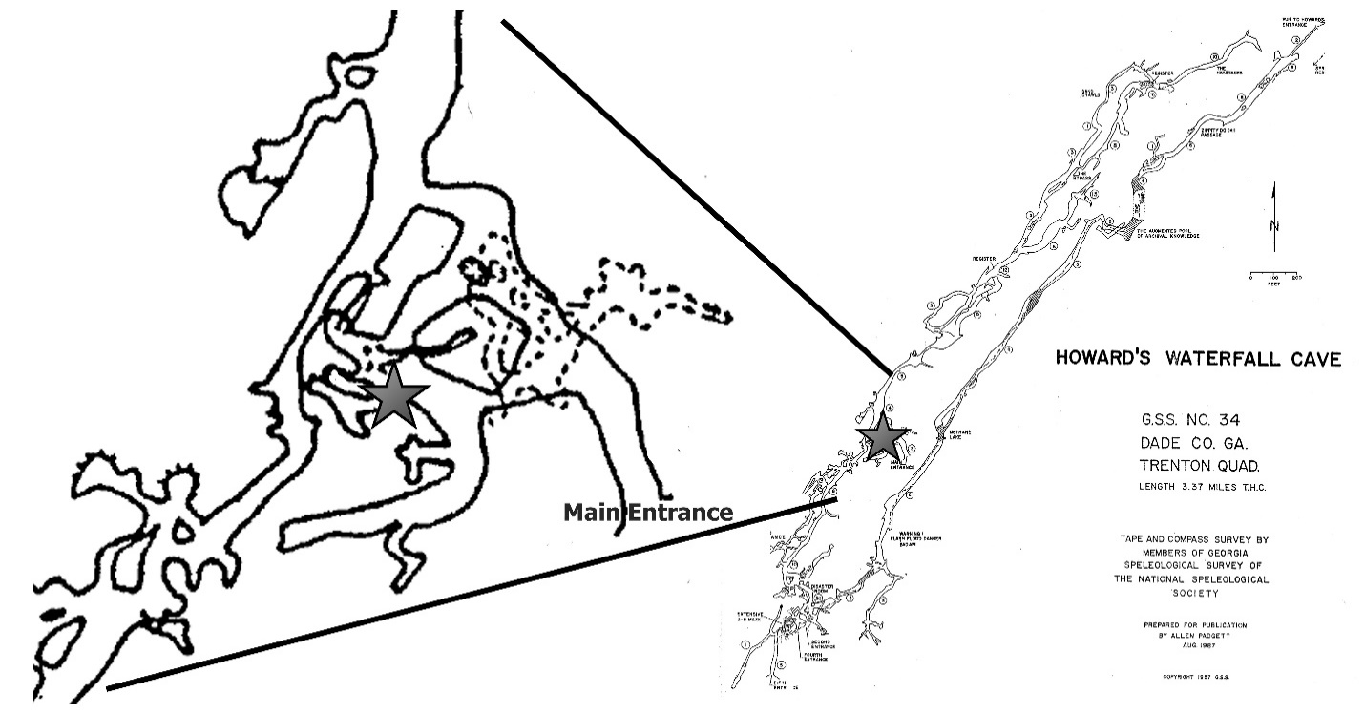
Figure 1. Howard’s Waterfall Cave map. The star denotes the location of pictographs.
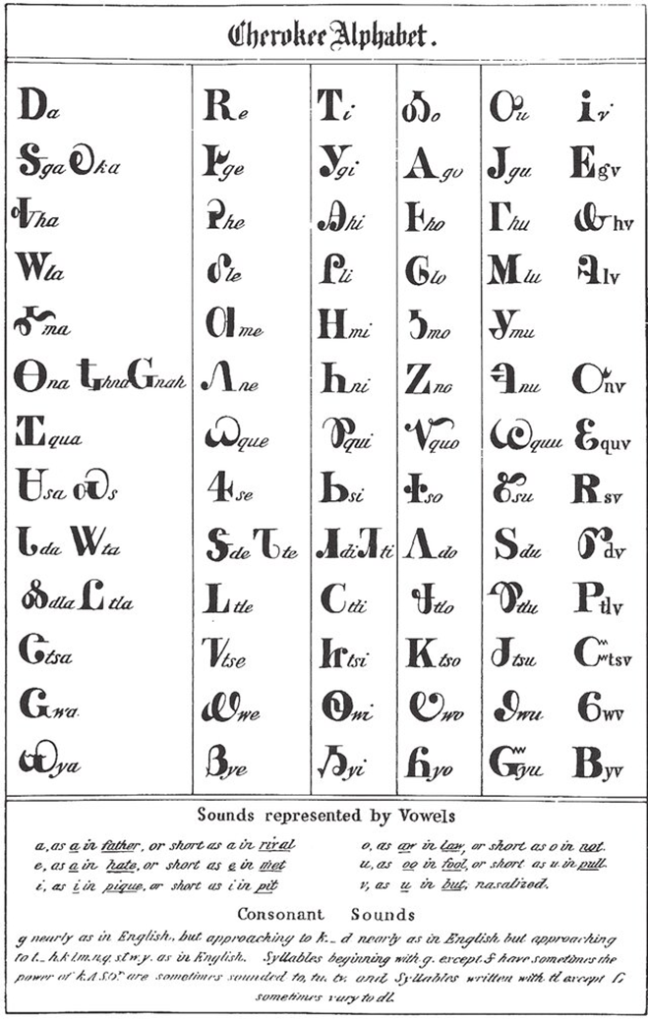
Figure 2. Cherokee Syllabary chart.

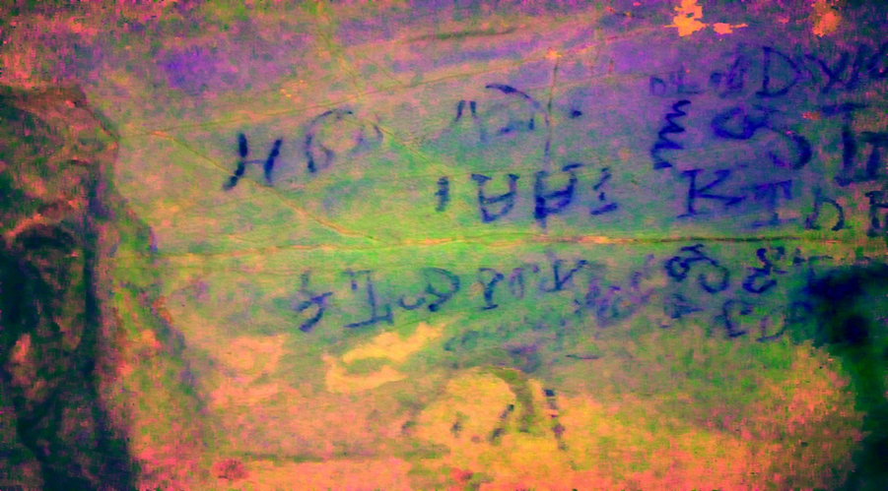
A. Sasa panel.
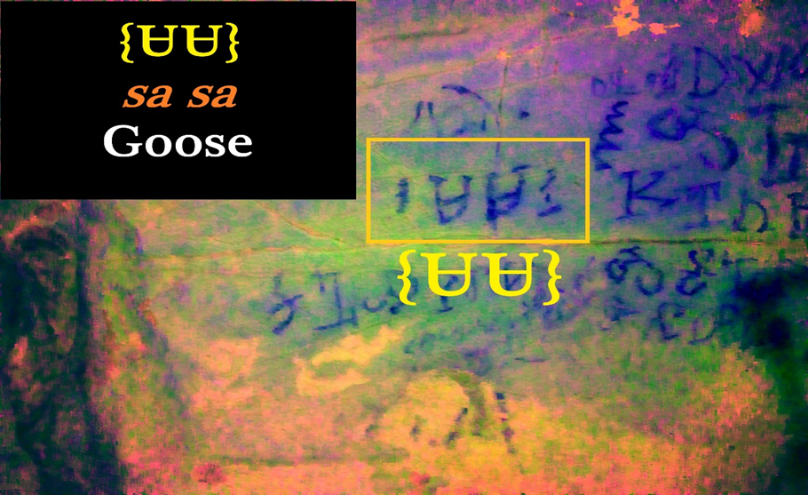
B. Sasa panel with Syllabary interpretation.
Figure 3. SaSa with Syllabary Example
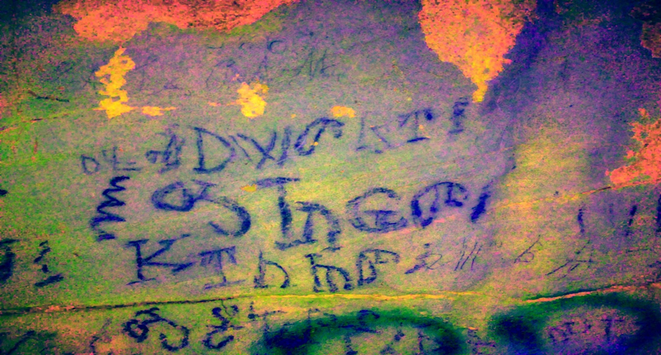
A. a ta dv sv i.
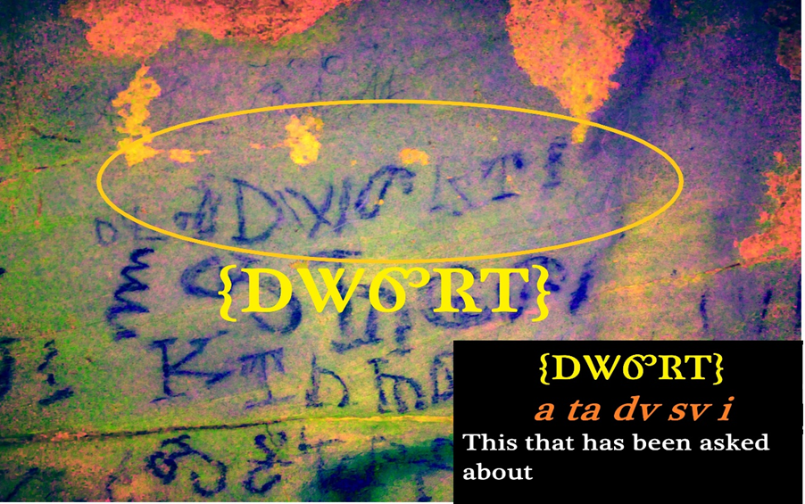
B. a ta dv sv i with Syllabary interpretations.
Figure 4. Atadvsvi with Syllabary Example

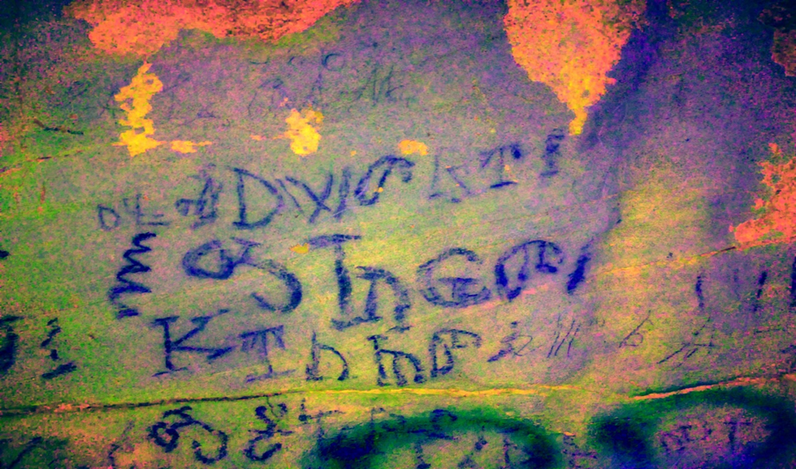
A. o sa wa tv.
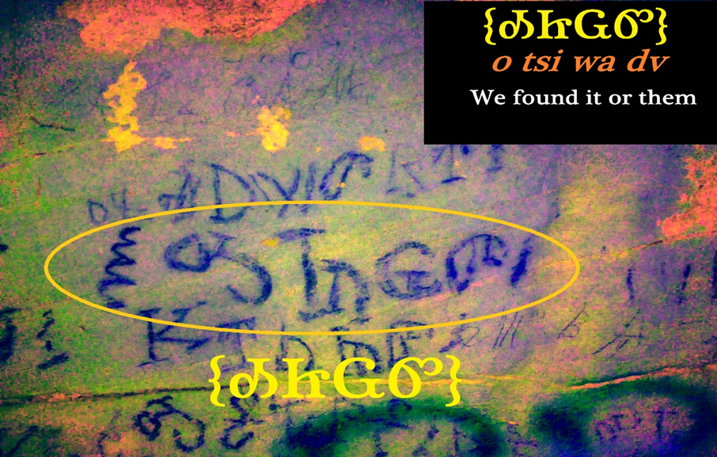
B. o sa wa tv with Syllabary interpretations.
Figure 5. Osawatv with Syllabary Example
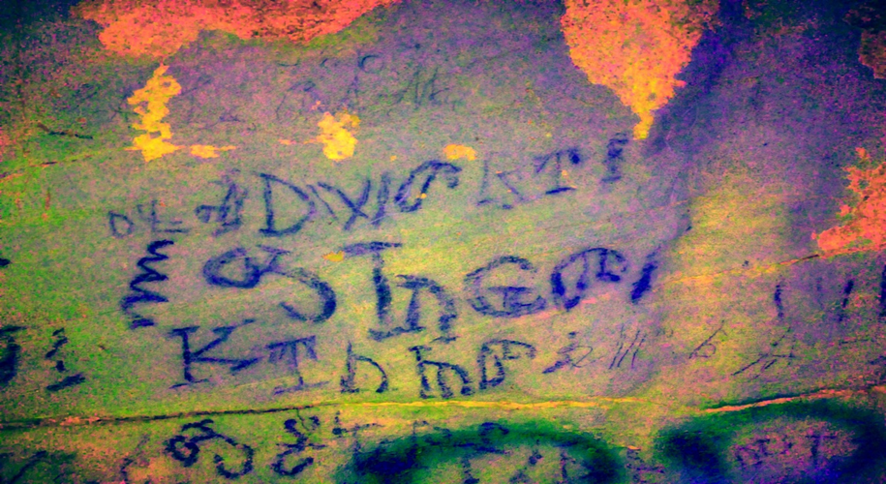
A. tso i ni tsi dv.
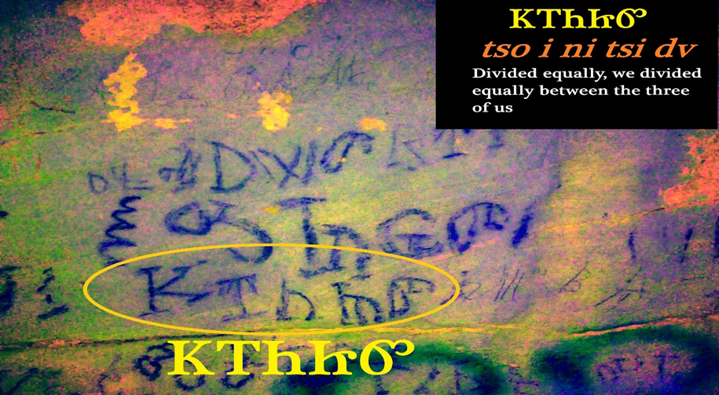
B. tso i ni tsi dv with Syllabary interpretations.
Figure 6. Tsoinitsidv with Syllabary Example

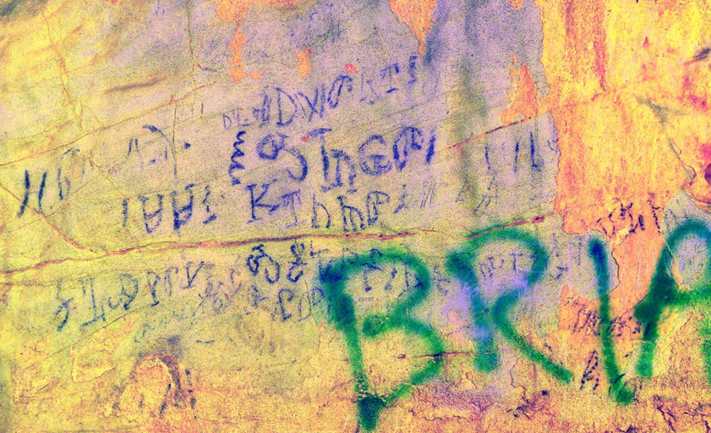
A. o ga tse li ga.
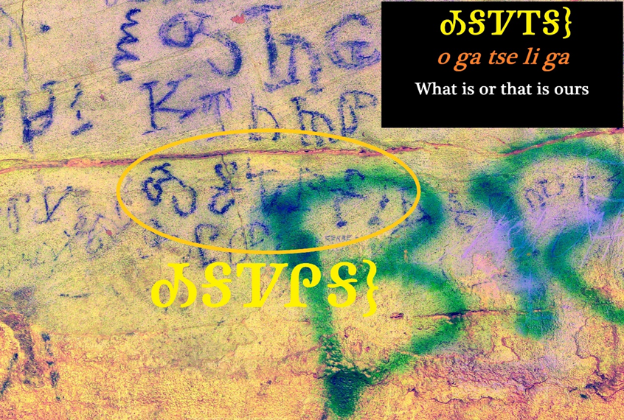
B. o ga tse li ga with Syllabary interpretations.
Figure 7. Ogatseliga with Syllabary Example

Summary of Paper II and Introduction to Paper III
My second paper explored elements of traditional Cherokee culture, history, and spiritual aspects of Howard’s Waterfall Cave, focusing on its Cherokee Syllabary inscriptions. A general overview of Cherokee history, clan structure, justice, and belief systems was explained regarding the belief in maintaining balance within different worlds. The Cherokee interacted with caves for many purposes; they were considered spiritual places used for healing, ritual, and seclusion to maintain spiritual balance. This paper highlighted research methods that can be used in the future when working with Indigenous people to produce the best study possible. This collaborative study aided in the cultural preservation and language revitalization that is the focal point for many different tribal nations, including the Cherokee, and shows the importance of Indigenous knowledge being included.
The final paper examines the challenges of repatriation under the Native American Graves Protection and Repatriation Act (NAGPRA), focusing on the emotional toll it takes on Indigenous communities. As a tribal member and cultural resource specialist for the Eastern Band of Cherokee Indians, this paper shares personal experiences highlighting the divide between Indigenous peoples’ cultural responsibilities and legal requirements when reclaiming ancestral remains. The paper underscores the burdens of reburial, institutional resistance, and the lack of recognition of Indigenous perspectives making progressive dialogue difficult. By acknowledging repatriation’s spiritual and emotional impact, institutions can work toward a more respectful and culturally informed implementation of NAGPRA.

CHAPTER III: Protecting “Our” Past for Future Generations

Abstract
The Native American Graves Protection and Repatriation Act (NAGPRA) was introduced in 1990 to allow the return of ancestral remains, funerary objects, and sacred items back to Native American tribes. While the law provided a framework for repatriation, it also introduced issues with the institutions holding the items and the Native American tribes’ interpretations of the law’s intent. I am a tribal member and a cultural resource specialist for the Eastern Band of Cherokee Indians Tribal Historic Preservation Office. This paper explores the emotional effects of my participating in the repatriation process using deeply personal accounts. These experiences highlight the divide that exists between the legal requirements of NAGPRA and the cultural responsibilities Indigenous people navigate when attempting to reclaim their stolen ancestors. These accounts use firsthand experiences to illustrate the burdens of reburial placed on Native people, highlighting the need for change. The ongoing struggles Indigenous people have with institutions regarding continued cultural disruptions and the unwillingness to recognize Indigenous perspectives prevent meaningful dialogue. By understanding the spiritual and emotional toll of repatriation, institutions can begin to work towards implementing a more respectful and effective version of NAGPRA guided by the spirit of the law rather than literal interpretation of the text.

Introduction
In 1990, Congress passed the Native American Graves Protection and Repatriation Act (NAGPRA), Pub. L. 101-601, 25 U.S.C. 3001 et seq., 104 Stat. 3048. The intent of that legislation was to ensure that all human remains held by agencies, museums, and universities receiving federal funding be treated with dignity and that a process be put in place whereby those remains, along with accompanying grave goods, sacred objects, and other objects of cultural importance, would be returned to lineal descendants, Native American tribes, and/or Native Hawaiian groups for disposition according to their laws and beliefs. NAGPRA did, indeed, lead to the development of a process for accomplishing this repatriation, which typically involved the establishment of official tribal authorities, usually Tribal Historic Preservation Offices (THPO), to represent Indigenous groups in the NAGPRA process. I am a cultural resource specialist with the Eastern Band of Cherokee Indians THPO, one of three federally recognized tribes of the Cherokee people, and for twelve years, I have been directly engaged in the repatriation and reburial of Cherokee ancestors and culturally sensitive items. This has been a difficult and emotionally challenging task in a way that the individuals, agencies, and institutions holding “collections” including my ancestors and their possessions cannot comprehend. There is frequent lack of understanding and failure to listen to the sensibilities of Native people. Consultation as mandated occurs, but talking at cross-purposes is common. It is clear to me that those agencies and institutions holding NAGPRA collections need to understand how the NAGPRA process affects Native people in a very personal way if the process is to move forward expediently, as mandated in the law itself. This paper uses personal experiences working through aspects of cultural preservation and the problems Indigenous people face within this field. By understanding what problems exist through these experiences, it is my hope that people who work within NAGPRA will be able to utilize these understandings when working with tribal nations.
As noted, I speak here from the perspective of a cultural resources specialist who works for the Eastern Band of Cherokee Indians THPO. I am also a practicing Cherokee traditionalist who is attempting to live life with a traditionalist perspective. As a cultural specialist within the THPO, I am required to be one of the primary individuals dealing with the Tribe’s repatriations by taking possession of ancestor remains and other results of repatriation. As a practicing traditionalist performing these duties, this job is exceptionally burdensome, physically and emotionally, and a better understanding of how these burdens affect a Native person will, I hope, help the institutions and individuals with whom we consult comprehend our perspectives on this process in future repatriation work.
This presentation is a very personal account and may lack the academic structure of the usual archaeological paper that most journals have published in the past. The process itself is profoundly personal for Native people, however, and the personal aspect is the most effective way to explain problems with interpreting and applying NAGPRA. Repatriation and the overall NAGPRA process are interactive and constantly evolving, and not all participants understand the emotional difficulties that tribal people face. Indigenous worldviews and concepts are the foundational beliefs at the core of NAGPRA and influence how tribal people interact with the law and how it is performed and interpreted. By looking at these difficulties and applying this Indigenous worldview concept, we can identify and rectify many current and future problems.
In my view, NAGPRA was designed to define an interactive and collaborative process with repatriation as its primary goal. Discrepancies in how the law is interpreted and practiced lead to a lack of understanding and sensitivity when working with tribal nations. The NAGPRA process presents complex problems, often due to a lack of willingness to understand the Indigenous point of view where it can be used as a framework for future consultation. The letter of the NAGPRA law fails to account for the emotional toll that it inflicts on the participants and interferes with what the spirit of the law requires. Institutions often focus on how the law is written and attempt to interpret it for their benefit to maintain ownership over collections. Indigenous people focus heavily on the law’s spirit and true intentions as they see it, and they live within an understanding of what the law truly means. A few institutions lack the willingness and understanding of what the law states should happen and what it means to facilitate that interaction, allowing for more distrust and skepticism for tribal nations.

What the NAGPRA Law Says vs. What It Means
How I understand what NAGPRA says and means is sometimes vastly different than how institutions and agencies holding ancestor remains may interpret it, which has frequently caused conflicts. The purpose of the law, as stated in the Code of Federal Regulations (US CFR), is that the law is intended to recognize the rights of Indian tribes regarding ancestral remains, funerary objects, sacred objects, and items of cultural patrimony. The act provides systematic processes to protect and return these objects through consultation with Indian tribes, and it must defer to Native traditional knowledge when examining these items (US 43 CFR Part 10, 2025). Any institution that receives federal funding must safeguard and protect cultural items within its possession and consult with tribal nations on how these items are cared for. They must also make a “good faith effort” to include Native traditional cultural knowledge in treating and caring for these items. NAGPRA also requires anyone who has collections and receives federal funding to complete an inventory of Native American materials for Native nations to review and potentially request (Watkins 2000). This legislation was intended to address the struggles Native nations have had for decades addressing past and current grave desecration, the archiving of thousands of ancestral remains, and the reacquisition of improperly acquired religious and cultural property.
The meaning of NAGPRA is open to interpretation, which is one of the key problems with this act. When a Native nation receives one of these inventories, there are thousands of sets of artifacts, often poorly curated and/or lacking documentation. When the tribe finally deciphers an inventory enough to make a request, they must meet specific criteria to get the items or remains returned. We have lines of evidence that we can use to prove the collection descends from the tribe that has made the request, each one with its own set of problems. These include Anthropological, Archaeological, Biological, Folkloric, Geographical, Historical, Kinship, Linguistics, Oral Tradition, and/or relevant expert opinion; lacking these does not preclude determining cultural affiliation (US 43 CFR Part 10, 2025). Unfortunately, institutional purpose is not always aligned with Native understanding regarding the law’s intention and how it should be interpreted. “The way NAGPRA is structured, institutions have the power to make all determinations of cultural affiliation and whether they repatriate” (Chari and Lavallee 2013:30). By leaving the decision-making to the institution, NAGPRA has allowed those institutions to delay and sometimes refuse to repatriate ancestors and their objects. Retaining remains and objects can be beneficial to the institution when seen as important display items or potential research materials, making it difficult and sometimes impossible for Indian tribes to meet institutionally defined acceptable criteria, especially when institutions are the deciding entity. Tribal nations often have limited resources and can only afford to pursue a legal claim in court for a short time, often having to give up on a claim to focus resources elsewhere. The burden is on the tribe to prove through a preponderance of evidence that the collection came from one of their ancestors (Chari and Lavallee 2013).
Other problems exist with meeting the criteria listed above and delaying or denying tribal nations the ability to repatriate ancestral remains and cultural items. Even though NAGPRA has been in effect for over thirty years, many institutions have never worked with a tribe and lack the preparation for meaningful consultation. It is often the case that someone from an institution believes that they know more about a tribe’s traditions than the descendants of the ancestors who created them. This condescending approach can make the implementation of NAGPRA difficult.
Native people are concerned with the spirit of the law; this is evident in how we consult on these issues. We did not write this law, and it is still difficult for us to imagine that this would be a problem we would face. Tribes agree with the spirit of the law, where they have the right of protection when it comes to ancestral remains, items of cultural patrimony, and sacred objects. We are continually surprised when we are met with friction. NAGPRA includes the criteria to label these items and places stipulations on these “objects,” not accounting for fundamental human rights that everyone else seems to possess. “From the viewpoint of Tribes and descendants, NAGPRA could only be about civil rights, religious freedom, human rights” (Colwell 2017: 257). To Native people, this is not just a legal matter that should be argued and examined but a profoundly religious right that everyone should be afforded. The spirit of the law was meant to repair hundreds of years of discrimination, objectification, colonialism, genocide, theft, and desecration, not to mention a violation of treaty laws with sovereign nations through the return of cultural items and the protection of ancestral graves. “As Congress stated, NAGPRA was intended to ‘establish a process that provides the dignity and respect that our nation’s first citizens deserve’” (Chari and Lavallee 2013:8). In my opinion, the spirit of the law does not need any interpretation and is clearly defined when applied; it becomes problematic when focusing on the letter of the law above all else.
To Native people, laws are not meant to be argued and debated in front of a man with a wooden hammer and a black dress. They are laws, and just like the laws of nature, they do not fluctuate much. The word for law in the Cherokee language is rooted in the word for medicine and is intended to heal the victim and their families (Thomas Belt, personal communication 2024). While American law is also meant for protection and order, it is open for interpretation, and many lawyers devote years of their lives to finding ways to bend these laws to their client’s benefit. NAGPRA was not a law accepted collectively out of the goodness of everyone’s heart; it was a legal requirement placed on institutions by the federal government. The more I think about the letter of the NAGPRA law, the more I cannot see a connection with the retentionists who attempt to break it. The letter of the law requires the protection of Native American human remains, funerary objects, sacred objects, and objects of cultural patrimony, and it also requires the restoration of those same objects to descendants or their present-day communities. Institutions continue to hoard these items even though they violate federal law because of their sense of ownership, making it difficult for tribes to complete NAGPRA claims.
The NAGPRA process includes several major components, each one a potential source of misunderstanding and conflict between the parties engaged in consultation. First, tribes consider inventory documents presented by agencies and institutions holding collections subject to NAGPRA to inform decisions about potential claims for repatriation. As already noted, the documents can obscure this initial phase of the process, which is why consultation between the parties is important. A claim may then be filed, essentially a negotiation as to whether the claimant Native tribe has just cause to make the claim. We have touched on problems with unequal authority in this phase of the process. When a claim is recognized, the tribe must recover the items from the holding institution, physically taking possession of the remains and artifacts (Watkins 2000). They are then transported to tribal custody for disposition. Each of these phases in the process can create difficulties depending on how they are perceived and the level of cooperation. Because of this, the difficulties I have experienced in carrying out the Eastern Band’s NAGPRA repatriation actions are best illustrated in their details by example. Before talking about my experiences, however, a few words about Cherokee cultural perspectives on death and the ancestors are warranted, as these determine my responses to the experiences themselves.

Cherokee Perspectives on Death and the Ancestors
Cherokee beliefs state that for a person to be at rest and move on after death, specific actions need to be performed to facilitate this transition. By disturbing the grave of an ancestor, you interrupt that transition and call that person back, where they remain in limbo until they are reinterred (Carroll 2017). Only a few people within my tribe have the knowledge that someone must possess to navigate this safely. In the past and today, certain people care for the dead and are trained in mortuary practices that are not general knowledge. It is believed that there are supernatural creatures that are drawn to death like a beacon who spread illnesses and conflict, and this is why being in close contact with human remains is associated with disease and illness. “It is held by traditional Cherokees that research by anthropologists on the bones of the dead is a dire danger to the living community of modern Cherokees” (Lefler et al. 2009:38). Anyone not adhering to the proper cleansing rituals is viewed as someone who is purposely spreading sickness within the community. Many Cherokee people believe that the disturbance of their ancestors is a direct cause of the problems that exist today.
Aspects of doing NAGPRA work are dangerous not just for tribal people but for all the people involved and have real repercussions. The anthropologist in me would like to attribute this to cultural superstition, which lacks a basis within scientific facts. Still, I have experienced things that cannot be explained using the scientific method, and that does not mean they are any less real. I watched a video of the Yanomami people (Asch and Chagnon 1975). These Native people lived in the Amazon and were one of the last Native groups untouched by colonization. They would not go out at night because they believed ghosts were waiting for them in the dark and would cause them harm. This cultural belief was referred to anthropologically as a “superstition” and was framed as being uncivilized or ignorant. Native people have lived interconnected with the land for tens of thousands of years, and to dismiss this accumulated knowledge was and continues to be a mistake for modern-day science. There was a good reason the Yanomami would not go out at night. By viewing Native people and their beliefs in a condescending fashion, we will continue to cause them harm when attempting to work with them.
There are two aspects to the dangers of dealing with the dead, and both have negative impacts on the people who have passed and the person who is exposed. First are specific characteristics associated with ancestral remains and a person’s soul. Cherokees believe that the crown of the head is one of these parts, which makes reburying skulls especially difficult. When a Cherokee dies, his soul makes a seven-day journey to the West, sometimes called the Night Land or Ghost Country, where they continue to the next life (Mooney 2012). Cherokee people will not visit the grave of a deceased person due to the belief that by thinking of them, you have the potential to interrupt their journey and call them back to this world. Also, by thinking or dreaming of them, you can cause yourself bad luck, sicknesses, and, ultimately, death. By visiting the graveyard, you are believed to be in a rush for someone else to pass, or you would not be there. With this understanding, we often rebury hundreds of ancestral remains at a time, and each of those individuals has been called back and is waiting for us to return them so they can continue their journey.
Regarding myself and my community, traditional Cherokee beliefs see contamination from coming into contact with anything associated with the dead, and only the proper rituals will cleanse you of this contamination (Witthoft 1983). This contact can be from direct contact with the deceased or from being in the same room with them, like a visitation. The contamination is so strong that you can contract it through the dirt from the grave or by looking at photos of the remains. This contamination can be thought of as an infectious disease that can be spread by coming into contact with others, and in my experience, the people you pass it to suffer the consequences more than you. “Contact with the dead through preparation of the dead for burial or attending a funeral can cause spiritual contamination, which is both harmful and contagious” (Lefler et al. 2009:37). These beliefs are so strong that the idea of being involved with NAGPRA and reburial of our ancestors is unthinkable for most Cherokees.
Many different rituals need to be followed to cleanse yourself, and you must follow them exactly. Following them incorrectly or missing something could cause certain aspects of your life to change on top of the contamination you were initially exposed to. A person will carry this contagion with them for seven days if left untreated but four days if they follow the proper rituals. During this period, you must not do anything other than what is necessary, believing that whatever you do within these four days will determine how the rest of your life will be. If you only tend to the necessities, you will be reliable and able to survive relatively easily (Mooney 2012). Due to this belief, there is no visiting with neighbors, socializing, or attending ceremonies. Not following this jeopardizes both personal health and the health of others, and it can have lifelong repercussions.
Many different rituals are associated with death and burial, but I will keep them private due to their sensitive nature. I will share that after you return home from a funeral, the fire in your house must be extinguished and the ashes removed. Every person in the family must “go to water.” This cleansing ritual is believed to wash the contamination off, often in a moving body of water for it to wash downstream away from the community (Lefler et al. 2009). Everyone who has come into contact must relight their fires and cleanse the house with smoke from burning certain trees. Relighting the fires signifies that you are starting over and making sure your fire has not been affected, and the smoke you are cleansing with will push the sickness out of your house. These rituals go on for four days when followed correctly and up to seven days if needed or done incorrectly (Cherokee Elder, personal communication 2015).
Understanding the beliefs and practices the Cherokee have associated with death clarifies the predicament faced by people who do reburials. There are no rituals for the reburial of our ancestors and no certain cleansing practices to rid yourself of sickness. No one could ever have imagined a situation where we would need them because dealing with the dead is such a serious issue that no one thought of disturbing them and having to do it a second time. People die as a part of life, and all Cherokees have an exceptional understanding of this and act accordingly. When ancestors were dug up, sifted through, subjected to testing, and robbed of their belongings, it had serious adverse effects on the living people involved. No one knows if our rituals will protect us from injury caused by performing this duty, and we struggle to do our best.

Repatriation from a Traditionalist Cherokee View
One of the most significant and disturbing NAGPRA actions I have experienced involved the reburial of human remains and grave goods taken through archaeology from Dust Cave, located in Lauderdale County, Alabama. “Dust Cave was occupied for ca. 7000 yrs. from the late Paleo Indian to the Middle Archaic period. Rediscovered in 1984 by Dr. Richard Cobb, the cave was excavated between 1984 to 2002” (Carmody 2009:1). This repatriation experience had elements that were both degrading and terrifying to me as a traditionalist Cherokee. The primary agency involved was the Tennessee Valley Authority (TVA). This quasi-federal agency manages the Tennessee River entirely, including where Dust Cave is located.
Here is how the reburial at Dust Cave played out for Johi Griffin, my colleague from the Eastern Band of Cherokee THPO, and me in the field. When Johi and I arrived by boat, TVA staff had already moved in the remains and associated artifacts by barge. The remains were set in the mouth of the cave where they could fit two large pallets of banker boxes. To the right of the mouth of the cave and up a steep incline was a small hole about 120 cm x 120 cm that led into the back of the cave. This narrow crawl space was about 6 m long and opened into a larger room at the back of the cave. The team reviewed different ways to move the large number of boxes efficiently. It was decided that I would be in the back of the cave where the reinterment would occur. Johi would be midway through the entrance, and the TVA staff would be on the outside, passing us boxes of our ancestors. The only way we could move these boxes was to chain them through by sliding them across the bottom of the cave. When they got to the back room, I started to open the boxes. Standing inside the room was impossible, so most of the work was done crawling and kneeling.
Some boxes were filled with dirt and shell with tiny bits of bone. Other boxes contained the skulls of my ancestors, along with whatever bones were lost from the multiple looting episodes. When we do reburials, the site is cleared of archaeology beforehand to avoid digging anyone else up in the reinterment process. The cave still contained cultural resources, and digging to rebury would risk disturbing someone else. It felt disrespectful for me to dump the bags out and leave my ancestors’ remains in a pile on the floor. There was a ledge about 60 cm off of the floor that looked like a shelf and was big enough to set items on. The first skull of my ancestors was placed on the shelf, and the remaining parts of their bodies were laid out under them.
The next box pushed through was one of the large bags of mixed dirt and bone, and the only way to get it out was to dump it. A large cloud of dust filled the tiny cave room, and the light from my flashlight was drowned out. When the dust finally settled, another skull was placed on the ledge beside the other. This process continued for hours, creating an experience I will never forget or forgive. The dust would fill up the tiny room, and I would have to wait to be able to see. I would have to wash my eyes out with water because the dust from the bones of my ancestors had been caked to my eyelids. I could feel myself breathing in the dust from the bags with every breath. Johi stated that the ancestors we help move on will always be with us. These ancestors are inside our bodies because we inhaled them through dust from the bags. The stolen skulls of our people lined the ledge in Dust Cave, and I had to carefully crawl across the floor to not step on the rest of the bodies. Nine hours later, the last box was opened and emptied, and when the dust settled, and my light illuminated the cave room, it was an image that I will carry with me until the day I die. Twenty skulls of my ancestors with accession numbers written on their heads and the teeth removed from their skulls for analysis. I could feel them staring at me, and the question each one of them asked was, “How could you let this happen?”
Each reburial I participate in affects me consciously and subconsciously, and I have tried to figure out how to explain it to people unfamiliar with the process. It always starts with a gearing up of emotions, and I feel like I am preparing myself for what has to come. Sadness is mixed with anger and comes with a heightened sense of awareness. I witness abnormal things, such as seeing nocturnal animals in the daytime, among other things that I should not discuss due to the cultural sensitivity I struggle to maintain within my explanations. Everything just feels off, as if the world around me is confused. Family members must be informed that I will not be around and that they should only try to visit me after I had completed the job and four days had passed. Following certain traditional practices, I can be around other people after four days of isolation. As noted, these practices are due to the contamination that a person picks up from handling the deceased. We start to worry about our balance days before we leave for our trip, and concern often occupies most of my time despite my attempts to stop. We often have no idea who or what we are reburying. Some instances are more dangerous than others.
The idea that our ancestors would be dug up and stolen only to end up in a cardboard box or on a looter’s mantelpiece is entirely alien to us as Native people. Traditionally, we have many different ceremonies that prepare us for potentially dangerous things. For example, if you are going to battle, the process protects you from harm but also prepares you to take a life. The process also aids you mentally regarding what you may see and experience while in combat. Even burying our dead at death has certain rituals that a traditional person adheres to when involved. Reburying our ancestors after they have been desecrated is a foreign concept, and no one ever thought we would need protection from that. Through numerous talks with our spiritual leaders, we have managed to piece together a new practice in the hopes that we can prepare ourselves for the dangerous situations we now must engage in.
I was on edge days before the trip to Dust Cave, and I had this underlying anger that I never picked up on until someone pointed out that I was overly angry and agitated. It feels like I am gearing up physically, mentally, and spiritually to protect myself from whatever may happen. The actual reburial in itself is very somber, and I continue to feel a great deal of anxiousness, anger, and sadness while completing it. I need a positive mindset throughout this process and cannot bring negative feelings into the situation. It is difficult to regulate my emotions when I am placed into a situation that would naturally anger someone, but it is crucial to maintain my composure. It is also important that I do not take the blame for what happened to the person that I am sending on. I remind myself that, in all actuality, this is not my fault, and to take on blame would open me up to anything negative that may be released when we place the person back to rest. We place them back in the ground or, in this instance, the cave as respectfully as possible, being careful to be gentle and not cause any damage. We perform the necessary rituals when we place someone in the ground, so hopefully, they understand the change they are experiencing. I think the person has been unfamiliar with people not their own for a considerable amount of time, hearing those around speaking a language they do not understand. During reburial, our words are in the Cherokee language; hopefully, our ancestors know they are back with their people. The things we bury with them are used to assist them on their journey but are also familiar to them because they were prepared with the same rituals and carried the same meaning they have for thousands of years. There is no word in the Cherokee language for goodbye, and the thought is that we will always see each other again, either in this life or the next; so I give a quick donadagohvi loosely translated to “until we meet again” in English. This simple but crucial step holds much meaning and is something I have thought about extensively. I will meet these people again one day, and I want to stand face to face with them and look them in the eye, knowing that I did everything in my power to help them. They are Kituwah people, my people, and my family, and hopefully, they will be at peace again.
Even though I have done the proper rituals to cleanse myself of the pollution and protect myself, we still carry it. We have put ourselves in a dangerous situation, and the return trip home is where we are in immediate danger. Dust Cave is in Alabama, about a six-hour drive from where we live, and it is late at night when Johi and I have completed our work. To limit our exposure to everyone else, we head home immediately and often do not return home until early morning. It strikes me as strange that we care so much about people that we risk our safety for the safety of others who are often unaware of the danger around them. It seems strange because I try to explain this concept of exposure to others who work within fields that have contamination, and some do not understand or care, although I have noticed that it is slowly changing. One example would be tribes requesting that a publication not include photographs of grave goods without consulting with the appropriate tribal nations first. The image policy was not a popular request among members of the Southeastern Archaeological Conference, and some objections were raised, such as infringing on academic freedoms (Rooney 2023). I was told by the people in opposition that I knew that archaeologists research grave goods, and I should have never gone into archaeology if I was afraid of the dangers. This issue was somehow my fault.
The fact is that for me to see those photographs and not be prepared to cleanse myself means I pick up pollution and am contagious without my consent. Yes, from a photograph. Ultimately, I place myself in harm’s way by fixing a problem that I did not create to protect people who do not seem to care and have no concern for my health or safety. When I returned home, no one was there to greet me because they had left so that I could quarantine. The time right after is when I need them the most, but also when they do not need to be near me. The required time for us to self-isolate is four days, and until Dust Cave, I was not fully aware of why that was a traditional requirement for me personally. I understand the need for pollution to wear off, and it takes a certain amount of time to dissipate in order to protect the community. What I was not aware of was the mental decompressing that was needed after this trip. Anger consumed me, and I struggled to understand where it originated. Sometimes, it was directed towards society’s treatment of my people historically. Often, it was directed at an unknown actor that caused me to be placed in the situation I found myself in. But most of the time, it was just there. There was anger with the world, anger with myself for allowing it, and anger with people who view me as an object they can measure and test. It took me more than four days to get that image out of my head and for me to be able to regulate my emotions again. It took a while to start feeling like myself again, and where the world began to feel right. Johi was correct when he said I will always carry those ancestors with me, including the tens of thousands of people I have helped rebury. The next question would be, if it is so taxing and dangerous, why would you do it in the first place?
For weeks, every time I would close my eyes, I would see those skulls of my ancestors staring back at me with the same question. I would dream about that image and the people put there, often waking up in a panic. I have trouble labeling it PTSD, and I also struggle with saying that my experiences warrant that diagnosis. By saying that, I feel I am less of a man because I am affected as much as I was. I have been through many difficult things, but nothing like what I took away from this. My duty as a Cherokee person is to protect my ancestors who have come before me. If it were not for their sacrifices and sheer will to survive in the face of an actual genocide, then I would not be here. Not only had I failed to protect them, but the Cherokee people had also failed to protect them, and morally, as human beings, we have all failed to protect them. Few people know these things occur, but I cannot help feeling like it is somehow my fault for allowing this to happen, even as I write this paper. In my culture, death and anything associated is highly dangerous to both the individual and the community and can cause actual harm. Death carries pollution comparable to a contagious disease and can be passed on to others you may come into contact with. Many other Indian tribes have the same beliefs about death, and many choose not to participate in the NAGPRA process for fear of causing harm.
My experience with the Tennessee Valley Authority has been primarily negative regarding looting and repatriation, and wins are difficult. There has always been a vast looting problem within TVA lands in the state of Alabama, including at Dust Cave, and I have been to this cave numerous times to assess and repair damage resulting from repeated bouts of looting. Acknowledging that stopping looting is difficult, I believe the TVA has not always done everything it could or that was mandated by law to inhibit this activity. Historically, there has been an overwhelming problem in obtaining looting convictions by TVA police. In this particular area of TVA property, the central Tennessee River Valley, there is a sizeable, organized network of looters that receive money for burial goods or human remains. One TVA archaeologist said, “A lot of them [looters] have a source they know where they can sell the stuff. That is where you run into the almost-industrial scale looting” (The Associated Press 2022). The black market for these artifacts is a closed network group and is nearly impossible to infiltrate, making combating this problem very difficult. If there were no market for these materials, looting would not be so prevalent, and mitigation of damage to cultural resources would be more manageable. At the heart of this problem is the involvement of important people with means—collectors and marketers—who can avoid direct connections to the looters on the ground. We know that Archaeological Resources Protection Act (ARPA) arrests have been made, and trafficker names have been mentioned to law enforcement, but the investigation has never been followed up. The courts have dismissed cases even though law enforcement caught looters red-handed violating federal and state laws. If TVA law enforcement manages to catch an individual desecrating a grave, then it is a Class C felony, which usually involves a fine if convicted (Urquhart 2004). This punishment is not a deterrent; the offender is usually set free in court and goes back to looting in a different area.
At the very outset, Native people are faced with terminology that is degrading and insulting. Many protection laws are written with my ancestors and their belongings referred to as resources, not as people. “They have all along been treated as scientific ‘cultural items,’ that is, as laboratory specimens, as data, as property, as ‘Exhibit, A’ and everything but what the original spirits that animated those remains would have considered them to be” (Fine-Dare 2002:148). Euro-American graves are often perceived differently, with “cemetery laws” that accord more humanity and dignity than the “cultural resources” laws that guide the protection of Native American burial sites. Continuing to view Native American graves as different than non-Indian ones reinforces the sense that we are somehow less than people. When courts take this view and do not prosecute offenders in a serious fashion, it is like a warrant for situations like this to occur. A district attorney only has to pursue a conviction in these circumstances a few times before realizing that most cases will end up in acquittal or dismissals and, in the future, they will no longer pursue them.

Navigating Life as a Living Object
The system that Indian people are forced to work in has always been difficult to understand and is designed for tribes to fail. The fact is that TVA has destroyed a large number of Cherokee sites, and many others are inundated with water that makes them difficult for Cherokee people to access. The looting problem for TVA is only a problem when attention is called to it or when the tribes manage to get someone with actual authority to pay attention. Looting destroys sites and erases tribal nations’ cultural heritage and, with that, any evidence that they were ever here. As Indian people, we are continuously being manipulated to cost these institutions and the federal government as little money as possible. We have entered into treaties that afford us certain protections and rights under treaty law, which is not a right that colonists just gifted Indian nations. “The United States did not give anything to Indian Tribes. American Indian leaders guaranteed their nations’ sovereign status through the treaty process with the United States” (Harjo 2014:34). We managed to maintain our rights through our continued fight for sovereignty under the agreed treaties that were signed. The government took away many of our rights when we were forced to sign treaties with the United States, such as land and water rights. The rights that Indian people have today are what they managed to retain through being forced into land sales. It would benefit everyone who was not Indian if we had vanished as was intended, and you can see this by the continuous attempts of erasure throughout history.
What is interesting to me is that Indian people were forced into these deals where they were stripped of power and any capital they possessed. The United States government painted us into corners on reservations far from our original homelands. We were made wards of the government and stripped of everything that gave us agency. When a tribal nation’s rights as wards of the United States are violated, the Supreme Court tells us we are Dependent Domestic Nations. “And when other Tribes have sought relief claiming that they are dependent nations, they have been told they are ‘wards of the government’” (Deloria 1988:50).
Our sites are desecrated, and our ancestors were stolen and studied in the name of science, where they are treated as objects of curiosity, as “data.” Indian tribes are continuously assaulted, even in the present, and we have struggled to retain the small amount of status we were allowed to keep. My ancestors went from calling almost a quarter of North America home and living the way the Creator intended to losing everything multiple times and being forced to eat roots so they would not starve. Slowly, we have worked in the system we were given so that our people can survive and hopefully flourish (Carroll 2017). We have lobbied, protested, fought, and pleaded to maintain what few rights we held onto so that our children would have a better life than we had.
Over time, we have educated ourselves on the white man’s systems and learned how to use them to aid in our survival, all while facing human eradication and land and property thefts for hundreds of years. We survived a one-thousand-mile death march through one of the worst winters on record with just the clothes on our backs and the rotten meat that was not stolen from us by the Bureau of Indian Affairs agents (Wilkins 1986). We persevered through the theft of our children when they were kidnapped and forced into boarding schools where sexual and physical violence was rampant (King 2013b). We made it through the Indian relocation program that was intended to dilute our blood even more and remove us from our traditional communities (Deloria 1988). We survived the “free” health care given to us by the Indian Health Service, where, up until 1980, Indian women were forced to be sterilized to prevent them from having more Indian babies (Lawrence 2000). Through all this, we learned how to work in a system created to suppress our advancement and wipe us out as a people. Through this system, we have managed to maintain our sovereign status and worked that status to where we could support ourselves. All tribes have been doing this to some degree, and now some are in a position where they can be vocal about how they want to be treated.
No colonial invaders intended for Indian people to survive, much less make it to a point where we could work to have these laws and treaty rights enforced. We have managed to progress, and we can send our children to universities so they can learn how to fight within a system designed for us to fail (Carroll 2017). We have fought for the right to protect our cultural sites and have seen laws passed to help with that protection. Tribes were able to insist that these laws were passed that protect their ancestors’ remains and burial goods from desecration. However, until the introduction of NAGPRA, the remains of our ancestors and culture were viewed only as resources. “NAGPRA is a unique legislation because it is the first time the federal government and non-Indian institutions must consider what is sacred from an Indian perspective” (Bray et al. 2001:32). While these laws are imperfect and many problems exist, they are a step in the right direction. The implementation of these laws allows us to slow down the continued assault aimed at tribal nations and their cultural heritage.
If Indian people lose the evidence of the past, that is one more step in the government’s attempt to do away with the Indian problem. We are currently in a situation where we are less in survival mode and have more resources to focus on the issues we face. The Indian tribes that continue to resist colonization put themselves in real danger. As sovereign nations, we are under constant attack, and to survive, we must continue to resist the dominant forces that attempt to erase us. In this, we are carrying on what our ancestors started and continue to press on for our tribe’s survival. Today, dangers are nothing new to us and do not compare with what we have already been subjected to. The fact that we are physically and financially able to stand up and fight for the protections we were allowed by law angers the people trying to take those protective measures away.
Following preservation laws costs corporations, institutions, and governmental organizations money and prestige and slows their progress. Ultimately, it is up to the tribes to police these entities and sound the alarm when laws are being violated, even though the alarm is mostly ignored. Sometimes, you find allies that will partner with you and try to do the right thing, but they have limited influence. These people are always lower-level institutional staff who do not sit on the boards or in positions that can initiate change. Their job is to appease and keep us as quiet as possible while the organization does the bare minimum, often less action than the law requires. Who is going to enforce these laws? The district attorney that would not prosecute for fear of taking a loss and did not care to begin with? The organization that wrote and then broke the law? For a hypothetical example, the United States Forest Service violates ARPA and NAGPRA laws by logging timber to sell without doing the proper tribal consultations or archaeological testing. They are an entity of the same U.S. government that wrote the laws they are violating and who should enforce them. When a complaint is made regarding a violation, it is handled by an internal “unbiased” review board of the same people under investigation. This situation may not sound unethical to some, and people seem to have difficulty grasping why this is an issue in the first place. If you were investigating a doctor for malpractice, would you trust the doctor enough to conduct their own investigation, and what would the ultimate consequence be for violating medical codes of ethics if they found themselves guilty? Would that doctor convict themselves and impose the adequate fines that the violation deserved? If they were ethical enough to do this fairly, then I doubt they would be in the situation to begin with.

Cultural Beliefs and Problems
Cherokee people have a belief known as Tohi, which involves balance within oneself, the community, nature, and the outside world. “The normal state of the Cherokee universe is described as tohi:—smoothly flowing, evenly and moderately paced, fluid, and peaceful. This is thought of as the way in which grass grows, and clouds move on a spring day, and the way in which things are done when they are done properly” (Lefler et al. 2009:14; Carroll 2017). When you come into contact with pollution or disturb a grave, it creates an imbalance in the mundane and spiritual world. If this imbalance is not corrected, then it can cause bad luck, health problems, and even death to anyone who comes into contact with it. This pollution is not just limited to the Native people who share this view but also the non-Native people who are continuously in contact with it. Bioanthropologists, museum staff, archaeologists, and countless others working within this cultural resource realm also carry this pollution. This pollution could be problematic when these researchers attempt to enter into Native communities and work with Native people. This idea does not seem to be considered when researchers try to work with Indigenous communities, but it is a crucial aspect of initially developing a collaborative relationship with the community.
Indian tribes have had to and continue to endure systematic acts of genocide and violence throughout history. We have the highest rates of suicide, domestic violence, alcoholism, and drug abuse per capita compared with the rest of America (Ehlers et al. 2022). Family members, especially women, disappear or are found murdered, often without investigation or any news coverage. Some tribes live on reservations comparable to a third-world country, often lacking running water or electricity. Generational trauma from years of enduring these conditions is said to be the cause of some of these problems. Ethnic cleansing and genocidal actions against them are other contributing factors when looking at problems Indian tribes face presently (Morton 2018). Basically, the system strips us of our resources and puts us in an almost impossible position to survive.
While these are the usual explanations of what causes the problems that Indian tribes face today, there is one that is not mentioned much and is often overlooked. This is the Indian tribe’s own failure to stop the desecration of the graves of their ancestors and the pollution that has been released into the world. This pollution has created an imbalance and could be part of the explanation for these problems; until non-Indians recognize the cause, there is, however, no hope for a cure. Proper rituals exist that allow a person to restore balance and rid themselves of pollution, but it is a lengthy process. The sheer scale of desecration that has been committed continuously for hundreds of years, coupled with the hardships that were forced onto Indian people, has made it impossible for Native people to maintain balance. These actions have thrown off the equilibrium for the tribes without the ability to restore it and caused dire problems that have affected our communities in negative ways. Some tribes also look at the state of the world we live in today and place the lack of stability as one of the causes of everyone’s troubles.
Cherokee people believe that humans were an afterthought and were created without purpose. Plants and animals were the intended inhabitants of the world we exist in today. Humans were a nuisance by being stuck in the middle of the complex world of plants, animals, and spirits. “Cherokee people asked the Creator to be given a purpose, and we were told to protect these things and maintain the balance within the world. In order to manage and maintain their position in this system, which is also populated by other spirit beings that hold unpredictable attitudes toward them, humans must observe a system of natural laws instilled through oral tradition, balance themselves among their antagonists and protagonists, and preserve a neutral position” (Lefler et al. 2009:14). We are said to achieve this by respecting the natural world, limiting our environmental impact, and allowing it to continue to be a renewable resource. We also maintain that balance through our ceremonies, where we acknowledge our roles and give thanks for being allowed to continue to be a part of it.
Historically, the treatment of Indian people has made it impossible for us to continue to uphold our agreement with the Creator. We lost the ability to maintain the balance needed to make the world right, and it has caused us a large amount of suffering. Through the attempt to erase our culture, we have lost many of the ceremonies and knowledge that was given to us to remedy these problems. We have failed to protect our ancestors’ graves and sacred sites, and we have failed in our role of maintaining balance, in turn creating problems within our society today.

Looking Towards the Future
It was never my plan to work within NAGPRA, and I had no personal feelings about it either way. My outlook has been shaped by what I have seen and the experiences I continue to have. The dangers are real for me and anyone who participates in this work, and I have the past to prove it. Some Cherokee elders warned me that what I was doing was dangerous and could affect me and my family in negative ways, but the need was clear for me to put these ancestors back to rest and fix some of the problems that continue to plague the world. My thoughts and feelings are much more profound than I could touch on here, and everything I have discussed in this paper has a deeper meaning and needs further expansion. The traditionalist views and beliefs deserve more explanation because they are much richer than I could convey in so short of a space. These conversations will always be in keeping with the beliefs of my people, only disclosing what I feel is intended to be public knowledge. Indian peoples’ culture has been continually extracted and stolen to be used as an academic commodity for far too long. Careers have been made on the backs of the Cherokee people and literally on the bones of my ancestors, and I refuse to give away what little we have left. The weight of what I have done and experienced is quite heavy, and I struggle to shoulder it most days.
Academia does not deserve to see what is in my soul at this point, and I will continue to carry the secrets of my ancestors until I feel it is the appropriate time and place to unburden myself. Most people would ask me why I do it in the first place if it is so taxing and dangerous. I never set out to do NAGPRA work, but my initial experiences left me with a feeling of duty for my people. Kituwah people have a set of laws given to them by the Creator, which are the basis of how we strive to live. Gadugi is the idea that you give yourself over for the good of the community, and you desire to be a selfless person. If someone needs help, it is your job to help them because we are all one people. I believe there is no better way to be selfless than to help people who cannot help themselves. My introduction to NAGPRA started because I saw my brother struggling to do a job alone, and as a Cherokee person, I could not sit by while he did all the work. Suddenly, I was in the middle of it, and it felt like it was what I was supposed to do despite the dangers. I am doing the job I was always intended to do, one that is sorely is needed.
The years have begun to add up faster than I would have liked, and I am not getting any younger. I have had the privilege to help rebury tens of thousands of my ancestors, and the lists seem to grow yearly. I am currently at an age where I need to think about what will happen when I can no longer physically do this job. The goal is to rebury my ancestors from every institution and end all this hurt. I was asked if I would ever teach another Cherokee person how to do this work when I cannot do it anymore. Both Johi and I have experienced personal losses that no one should ever have to experience, and I often catch myself wondering if it is my fault due to the job I was warned not to do. I have frequently thought that this was something that I might not want to be a part of anymore, and when I first started, it was a question I had quite often. If it is true, I am the reason for the pain and the loss inflicted on the people around me. If I quit before the job was done, all the sacrifices that were made would be for nothing, and to me, that is a disservice to the people who were made to make those sacrifices. I don’t want any other Cherokee person to have to experience what I have been made to experience. I don’t want another Cherokee to have to close their eyes and see the images of babies that have been set into casts and labeled specimens. No one should have to dig individual bags of their ancestor’s teeth out of the spinal hole in their ancestor’s skull to rebury them in something other than plastic. I would rather not subject another Cherokee to the looks of disapproval and hatred because they are taking away a “specimen” from a person, even though that is what the law requires. I do not wish this on anyone, and we will continue fixing the problems we had no hand in creating.

References
(required Southeastern Archaeology format)
Asch, Tim, and Napoleon Chagnon. 1975. The Ax Fight. Film.
The Associated Press. 2022. Archaeological Looters in Tennessee Violating Protection Act, Challenging TVA Cultural Team, September 5. https://www.localmemphis.com/article/news/crime/archaeological-looters-in-tennessee-violating-protection-act-challenging-tva-cultural-team/522-76bca494-4b8e-405d-b02c-ff3c15f08b21.
Belt, Thomas. 2024. Cherokee Nation of Oklahoma. Lives in Birdtown Community, Cherokee North Carolina, Oral Teaching, personal communication. June,1, 2017.
Bray, Tamara L. (editor). 2001. The Future of the Past: Archaeologists, Native Americans and Repatriation. Garland, New York.
Carmody, Stephen. 2009. Hunter/Gatherer Foraging Adaptations During the Middle Archaic Period at Dust Cave, Alabama. Master’s Thesis, University of Tennessee, Knoxville.
Carroll, Beau. 2017. Talking Stone: Cherokee Syllabary Inscriptions in Dark Zone Caves. Master’s Thesis, University of Tennessee, Knoxville.
Chari, Sangita, and Jaime M. N. Lavallee (editors). 2013. Accomplishing NAGPRA: Perspectives on the Intent, Impact, and Future of the Native American Graves Protection and Repatriation Act. First Peoples Series. Oregon State University Press, Corvallis.
Code of Federal Regulations Title 43. 2025.
Colwell, Chip. 2017. Plundered Skulls and Stolen Spirits: Inside the Fight to Reclaim Native America’s Culture. University of Chicago press.
Deloria, Vine, Jr. 1988. Custer Died for Your Sins: An Indian Manifesto. University of Oklahoma Press, Norman.
Ehlers, Cindy L., Rachel Yehuda, David A. Gilder, Rebecca Bernert, and Katherine J. Karriker-Jaffe. 2022. Trauma, Historical Trauma, PTSD and Suicide in an American Indian Community Sample. Journal of Psychiatric Research 156(2): 214–220. https://doi.org/10.1016/j.jpsychires.2022.10.012.
Fine-Dare, Kathleen Sue. 2002. Grave Injustice: The American Indian Repatriation Movement and NAGPRA. Fourth World Rising Series. University of Nebraska Press, Lincoln.
Harjo, Suzan Shown (editor). 2014. Nation to Nation: Treaties between the United States & American Indian Nations. First Edition. Published by the National Museum of the American Indian in association with Smithsonian Books, Washington, DC.
King, Thomas. 1972. Archaeological Law and the American Indian. Indian Historian 5(3):31–35.
King, Thomas. 2013a. The Inconvenient Indian: A Curious Account of Native People in North America. University of Minnesota Press, Minneapolis.
King, Thomas F. 2013b. Cultural Resource Laws and Practice. Fourth edition. Heritage Resources Management Series. AltaMira Press, Lanham, Maryland.
Lawrence, J. 2000. The Indian Health Service and the Sterilization of Native American Women. The American Indian Quarterly 24(3):400–419. https://doi.org/doi:10.1353/aiq.2000.0008.
Lefler, Lisa J. 2009. Under the Rattlesnake: Cherokee Health and Resiliency. Contemporary American Indian Studies Series. University of Alabama Press, Tuscaloosa.
Mooney, James. 2012. The Swimmer Manuscript: Cherokee Sacred Formulas And Medicinal Prescriptions. Originally published 1932, Bulletin 99, Bureau of Ethnology, Smithsonian Institution, Washington, DC.
Morton, Katherine. 2018. Ugliness as Colonial Violence: Mediations of Murdered and Missing Indigenous Women. In On the Politics of Ugliness, edited by Sara Rodrigues and Ela Przybylo, pp. 259–289. Palgrave MacMillan, Cham. https://doi.org/10.1007/978-3-319-76783-3_13.
Rooney, Matthew. 2023. Horizon and Tradition. The Newsletter of the Southeastern Archaeological Conference 65(2).
Urquhart, H. T. 2004. Alabama Cemetery Legislation/Laws. Alabama Cemetery Preservation Alliance.
Watkins, Joe. 2000. Indigenous Archaeology: American Indian Values and Scientific Practice. Indigenous Archaeologies Series No. 1. AltaMira Press, Walnut Creek, California.
Wilkins, Thurman. 1986. Cherokee Tragedy: The Ridge Family and the Decimation of a People. The Civilization of the American Indian Series No. 169. University of Oklahoma Press, Norman.
Witthoft, J. 1983. Cherokee Beliefs Concerning Death. Journal of Cherokee Studies. 8(2):68–72.

Concluding the Dissertation: The Way Forward by Reclaiming Sovereignty Through Practice
Throughout these three papers, I have tried to reflect on my journey within archaeology, and this reflection has led to the realization that it is more than a chosen profession, it is my responsibility. These experiences have brought to light hard truths about colonial legacies, flawed institutional practices, and the emotional toll inflicted when working within a field that historically has marginalized Native voices. One realization becomes clear above all others: the field of archaeology must change. Using deeply personal narratives, successful collaboration, and the need to incorporate traditional knowledge, I have advocated for an approach that brings Indigenous perspectives to the center. This approach not only includes Native voices but amplifies them through respect.
Despite the mental weight, spiritual danger, and emotional harm this work inflicts on me, I remain committed to continuing. To call myself a Cherokee, I carry this responsibility for my ancestors, community, and future generations. Their history, my history, deserves to be grounded in respect and accuracy and not a reflection of the external frameworks of the past. This work will serve as both a testimony and a challenge for those studying Indigenous cultures. The challenge is for future researchers to provide recognition and critical assessments of existing colonial structures within institutional practices, legal frameworks, and the methods we continue to use.
More importantly, this work invites present and future Indigenous scholars to occupy these spaces not created or intended for us and reshape them so that our traditional ways and knowledge can be honored and protected. Our Indigenous knowledge, developed from tens of thousands of years of cultural continuity and empirical observation, must be recognized as vital in our understanding of the past and present. If we all agree that archaeology should serve a meaningful purpose, it should also be inclusive, ethical, and open to collaborative research designs.
Looking ahead towards the future of the field and the role I play within it, some questions remain unanswered. Even though collaborative projects such as Howard’s Waterfall Cave demonstrate promise, this is only a fraction of the more significant issues that persist. These problems include the recurring misalignment between NAGPRA legislation’s intent and institutional implementation. In many cases, the people who practice consultation interact with tribal nations and develop genuine understanding and empathy. However, institutional boards and administrators that are disconnected from Indigenous peoples’ realities possess the decision-making authority. The future requires that these board seats be held by individuals who understand and respect Indigenous cultural beliefs and who view repatriation as more than a legal obligation but as a human and spiritual right that has been continuously denied.
There are critics within the field who claim that Indigenous archaeology introduces biases and does not allow for the neutrality needed for scientific research. When we begin to recognize that Western science has never been neutral because it was created within a colonial framework these arguments lose validity. The argument is that Indigenous people have no inherent rights or privileges in the scientific interpretation of their past. It is stated that the only way to be truly scientific is to treat everyone as humans, where we are all the same (McGhee 2008). Classifying people on evolutionary scales when attempting to interpret micro-characteristics of their past only perpetuates systematic objectification. Doing this strips tribal people of their agency, and by misrepresenting their culture, archaeology continues to inflict harm on living Native populations. The only people who can truly understand and explain the nuances of a culture are the individuals who are embedded within the culture itself. When archaeological research is conducted in true partnership with Indigenous communities, it becomes more ethical and richer in meaning and interpretation. As a practicing traditionalist entrusted with sensitive cultural knowledge that may never be shared, I can offer collaborative insight that bridges gaps in understanding. Respecting these boundaries and incorporating Indigenous perspectives enhances the archaeological record, offering a more complete interpretation.
In the future, I plan to advocate for better interpretations and implementations of NAGPRA. I would like to see every one of my ancestors returned and reburied with the dignity stolen from them. Currently, my tribe faces two urgent priorities: the protection of our cultural heritage and the survival of the Cherokee language. Our language is on the brink of extinction, and saving what is left is especially critical. Its revitalization is essential because no aspect of Cherokee culture exists in isolation. I plan to enroll in as many language programs as possible, a commitment that began during my graduate studies, so that I can contribute to the effort of ensuring our words do not disappear along with everything else that we were made to forget. Knowing our ancestral language gives us a unique perception of the world and is vital in continuing our cultural practices.
Additionally, these experiences have shown the need for a deeper legal understanding. I intend to pursue a master’s degree in Federal Indigenous Law, focusing on Section 106 compliance and NAGPRA, through the University of Oklahoma. My goal is to increase my knowledge with the hopes of navigating the legal system and the credentials to hold institutions accountable. Often, vague language and a misunderstanding of the procedures are used to subvert the intent of the laws put into place to protect Native rights. In the future, I will assure that I am the most educated individual involved in the intricacies of federal law and the person who can wield that knowledge effectively.
The framework I have proposed with these papers has implications beyond archaeology. This research method can be applied to any field engaged in Indigenous studies, from ethnohistory to museum studies and law. Regardless of the area, we must focus on empathy, historical accountability, and Indigenous sovereignty and bring them to the forefront. This paper challenges institutions to acknowledge traditional knowledge, recognize historical harm, and create more inclusive structures moving forward.
In closing, I demand the return of my ancestors and their sacred belongings, the restoration of cultural authority, and the recognition of our spiritual autonomy. The knowledge, stories, and spirits of our ancestors are still here. We are still here.

References for Introduction, Indigenous Archaeology and Conclusion
Allen, Harry, Caroline Phillips, and World Archaeological Congress (Organization) (editors). 2016. Bridging the Divide: Indigenous Communities and Archaeology into the 21st Century. One World Archaeology Series No. 60. Routledge, London.
Atalay, Sonya. 2006. Indigenous Archaeology as Decolonizing Practice. American Indian Quarterly 30(3/4):280–310.
Atalay, Sonya. 2012. Community-Based Archaeology: Research with, by, and for Indigenous and Local Communities. University of California Press, Berkeley.
Biolsi, Thomas, and Larry J. Zimmerman. 1998. Indians and Anthropologists: Vine Deloria, Jr., and the Critique of Anthropology. University of Arizona Press, Tucson.
Bray, Tamara L. (editor). 2001. The Future of the Past: Archaeologists, Native Americans and Repatriation. Garland, New York.
Colwell, Chip. 2009. Inheriting the Past: The Making of Arthur C. Parker and Indigenous Archaeology. University of Arizona Press, Tucson.
Colwell-Chanthaphonh, Chip, T. J. Ferguson, Dorothy Lippert, Randall H. McGuire, George P. Nicholas, Joe E. Watkins, and Larry J. Zimmerman. 2010. The Premise and Promise of Indigenous Archaeology. American Antiquity 75(2):228–238. https://doi.org/10.7183/0002-7316.75.2.228.
Deloria, Vine, Jr. 1988. Custer Died for Your Sins: An Indian Manifesto. University of Oklahoma Press, Norman.
King, Thomas. 1972. Archaeological Law and the American Indian. Indian Historian 5(3):31–35.
King, Thomas F. 2013. Cultural Resource Laws and Practice. Fourth edition. Heritage Resources Management Series. AltaMira Press, Lanham, Maryland.
McGhee, Robert. 2008. Aboriginalism and the Problems of Indigenous Archaeology. American Antiquity 73(4):579–597.
McNiven, Ian J., and Lynette Russell. 2005. Appropriated Pasts: Indigenous Peoples and the Colonial Culture of Archaeology. Archaeology in Society Series. AltaMira Press, Lanham, Maryland.
Silliman, Stephen W. (editor). 2008. Collaborating at the Trowel’s Edge: Teaching and Learning in Indigenous Archaeology. Amerind Studies in Archaeology. University of Arizona Press, Tucson.
Smith, Claire, and Hans Martin Wobst (editors). 2005. Indigenous Archaeologies: Decolonizing Theory and Practice. One World Archaeology No. 47. Routledge, London.
Watkins, Joe. 2000. Indigenous Archaeology: American Indian Values and Scientific Practice. Indigenous Archaeologies Series No. 1. AltaMira Press, Walnut Creek, California.
Wilson, E. Paul, and Oser Elaine Zingg. 1974. What Is American Heritage: Historic Preservation and American Indian Culture. Kansas Law Review 22(3):413–53.

VITA
Beau D. Carroll is a citizen of the Eastern Band of Cherokee Indians and lives on the Qualla Boundary, also known as the Cherokee Indian Reservation, in Cherokee, North Carolina. As the Lead Archaeologist for the Tribal Historic Preservation Office, he draws upon traditional Cherokee knowledge passed down through generations to guide his work in protecting and interpreting ancestral sites and aspects of culture.

