Small-Signal Stability and Black-Box Modeling of Large-Scale Power-Electronic Converter Rich Power Systems

A Dissertation Presented for the
Doctor of Philosophy
Degree
The University of Tennessee, Knoxville

Liang Qiao
May 2024

Copyright © 2024 by Liang Qiao
All rights reserved.

Acknowledgements
Doctoral study is a challenging journey but with moments of joy. I would like to express my deepest gratitude to my advisor, Dr. Fred Wang, for his unwavering support, guidance, and mentorship during my PhD study. Dr. Wang’s profound expertise, constructive feedback, and consistent encouragement were instrumental throughout this long journey. Beyond the technical insights, he also generously shared his life experiences, offering invaluable perspectives that have significantly influenced both my personal life and my future career.
I would also like to extend my sincere appreciation to my committee members, Dr. Leon M. Tolbert, Dr. Hua Bai, and Dr. Zheyu Zhang, for their valuable insights, critical feedback, and commitment to excellence. Their expertise has significantly enriched the quality of this dissertation.
A special acknowledgment goes to Mr. Yaosuo Xue from Oak Ridge National Laboratory, for his generous and continuous support for my research projects.
I am also grateful to my colleagues and collaborators, Dr. Le Kong, Mr. Jacob Dyer, and Mr. Craig Timms, who shared their expertise and resources, contributing to enriching the scope and depth of my research projects.
To my parents, thank you for your love, patience, and understanding throughout this journey. Your unwavering support provided the emotional strength needed to face the challenges in these years.

Abstract
Modern electric power systems are undergoing a transformation driven by the integration of power electronics converters (PECs), such as inverter-based resources (IBRs) and power electronics interfaced loads, aimed at promoting sustainability and addressing global energy challenges. However, this rapid proliferation of PECs, leading to large-scale PEC-rich power systems, introduces significant challenges, including small-signal stability analysis and the development of accurate, computationally efficient transient simulation models.
The first major challenge is the development of a practical and computationally efficient small-signal stability approach for large-scale PEC-rich power systems. To address this, a partition-based method utilizing the nodal admittance matrix (NAM)-based stability criterion has been proposed. This technique divides the large-scale PEC-rich systems into manageable sub-areas and their interconnected networks, facilitating the assessment of small-signal stability at both sub-system and interconnection levels. Additionally, an issue related to the applicability of the NAM-based stability criterion in power systems with pure inductance models is identified. The dissertation not only highlights this problem through practical examples and mathematical demonstrations but also provides solutions to ensure the accuracy of stability analysis.
The second major challenge is the development of precise and computationally efficient models for transient simulations in large-scale PEC-rich systems. To this end, the study explores the utilization of black-box modeling as a promising approach. A comparative study method is introduced to evaluate the performance of three popular nonlinear black-box modeling approaches for modeling the transient behaviors of PECs. Based on the comparative study's findings, three deep learning (DL)-based black-box models (BBMs) are developed for three-phase inverters. The dissertation delves into the model architecture, data acquisition, and data preprocessing necessary to create accurate and reliable models. A switching model and another hardware-in-loop model of three-phase inverters are constructed to generate training and testing data. The performance of the developed DL-based BBMs is evaluated under a variety of transient conditions. Furthermore, the proposed DL-based BBM modeling approach has been extended to three-phase inverters under unbalanced grid conditions.

Table of Contents
Chapter 1. Introduction 1
1.1 Background and Motivation 1
1.2 Dissertation Organization 7
Chapter 2. Literature Review and Challenges 10
2.1 Small-Signal Stability Analysis for PEC-Rich Systems 10
2.1.1 Review of Small-Signal Stability Analysis Approaches 10
2.1.2 Review of the Impedance-Based Criterion 13
2.2 Black-Box Modeling Approaches for PECs 20
2.2.1 Review of Linear Black-Box Modeling Approaches 23
2.2.2 Review of Nonlinear Black-Box Modeling Approaches 28
2.3 Research Objectives 41
Chapter 3. Proposed Small-Signal Stability Analysis Method for Large-scale Power Electronics-Rich Power Systems via System Partition 44
3.1 Introduction 44
3.2 Fundamental Concept and Procedure of the Partition-based NAM Method 44
3.3 Mathematical Derivation of the Proposed Method 49
3.3.1 Partition Principles 49
3.3.2 Rationality of System Partition in Step 3 50
3.3.3 Stability Analysis at the Sub-Area Level in Step 4 56
3.3.4 Equivalent Impedance Matrix of Sub-Areas in Step 5 57
3.3.5 Stability Analysis at the Interconnection Level in Step 6 59
3.4 Case Studies 1: The Six-Converter System 60
3.4.1 Six-Converter Test System 60
3.4.2 Stability Analysis Results 63
3.4.3 Experimental Results 72
3.5 Case Studies 2: The Modified NPCC System 72
3.5.1 Modified NPCC Test System 72
3.5.2 Impedance Models of System Components 76
3.5.3 Stability Analysis Results 78
3.5.4 Simulation Results 86
3.6 Conclusions 86
Chapter 4. A Potential Issue of Using the NAM-based MIMO Nyquist Criterion in Impedance-based Stability Analysis 91
4.1 Introduction 91
4.2 Potential Issue of the Determinant-based GNC 91
4.2.1 The Equivalence of Eigenvalue- and the Determinant-based GNC 91
4.2.2 The Issue with Pure Inductance Models 92
4.3 Case Study: A Five-Bus System with Pure Inductance 98
4.4 Proposed Method to Eliminate the Pure-Inductance Impact 107
4.4.1 Solution 1: Shifting Imaginary Axis Poles 107
4.4.2 Solution 2: Modification of Phase Angles 110
4.5 Conclusions 113
Chapter 5. Comparative Study of Nonlinear Black-Box Modeling Approaches for Power Electronics Converters 114
5.1 Introduction and Background 114
5.2 Single-Phase PV Inverters under Simulation 114
5.2.1 System Model 114
5.2.2 Transients under Study 116
5.3 Detailed Nonlinear Black-Box Model Architectures 120
5.4 Comparisons of Model Quality 121
5.4.1 Proposed Comparison Method 121
5.4.2 Comparison Results 124
5.5 Conclusions 128
Chapter 6. Development of Deep Learning-Based Black-Box Models for Three-Phase Inverters in Balanced Grids 131
6.1 Introduction 131
6.2 Benchmarking Models of Three-Phase Solar PV Inverters 131
6.2.1 Simulation Model of the Three-Phase Solar PV Inverter 131
6.2.2 Three-Phase Inverter Model in HIL Tests 136
6.3 Development of the DL-Based BBMs for Three-Phase Inverters 141
6.3.1 Data Acquisition 141
6.3.2 Data Preprocessing 143
6.3.3 BBM Architecture 146
6.3.4 DL-Based BBMs for Three-Phase Inverters 148
6.4 Performance Analysis of DL-Based BBMs for Three-Phase Inverters 155
6.4.1 Results of the Three-Phase Solar PV Inverter from Simulation 155
6.4.2 Results of the Three-Phase Inverter from HIL Tests 162
6.5 Discussions on Utilization of Black-Box Models 170
6.6 Conclusions 171
Chapter 7. Development of Deep Learning-Based Black-Box Models for Three-Phase Inverters in Unbalanced Grids 172
7.1 Introduction 172
7.2 Three-Phase Inverter Model with Unbalanced Loads 172
7.3 Development of DL-Based BBMs for Three-Phase Inverters in Unbalanced Grids 174
7.3.1 Data Acquisition and Preprocessing 174
7.3.2 BBM Architecture and DL-Based Model Structures 176
7.4 Performance Analysis of DL-Based BBMs in Unbalanced Grids 178
7.5 Conclusions 189
Chapter 8. Conclusions and Future Work 190
8.1 Conclusions 190
8.2 Future Work 192
Bibliography 195
Vita 210

List of Tables
Table 3-1 Electrical Parameters of the six-converter system 62
Table 3-2 Parameters of converters 62
Table 3-3 Absolute values of participation factors in Case III 68
Table 3-4 Comparison of Matrix Order Using Original Method vs. Proposed Method 77
Table 3-5 Absolute values of PF of interconnection in Case II 87
Table 4-1 Parameters of lines represented by $R$ and $L$ 99
Table 4-2 Parameters of constant impedance loads 99
Table 5-1 Parameters of the single-phase PV system 115
Table 5-2 Performance comparison of three black-box models for single-phase inverter 129
Table 6-1 Parameters of the three-phase PV inverter system in simulation 132
Table 6-2 Performance comparison of DL-based BBMs for the simulation inverter model 161
Table 6-3 Performance comparison of DL-based BBMs for the HIL inverter model 169
Table 7-1 Parameters of the inverter system with unbalanced loads 173
Table 7-2 Performance comparison of DL-based BBMs for the GFM inverter model under unbalanced conditions 188

List of Figures
Figure 1-1. Planned U.S. utility-scale electric generator additions, 2022 [10]. 2
Figure 1-2. Stability problems in PEC-rich power systems [9]. 2
Figure 1-3. Oscilloscope record of a sub-synchronous event [11]. 3
Figure 2-1 Cascaded source and load subsystems. 12
Figure 2-2 Source and load model for the Nyquist-based criterion. 15
Figure 2-3 Closed-loop circuit for the LIM-based criterion. 15
Figure 2-4 The closed-loop MIMO model for the NAM-based criterion. 17
Figure 2-5 Categories of data-driven models. 22
Figure 2-6 System identification of an unknown system. 22
Figure 2-7 Different types of system identification methods. 24
Figure 2-8 Model structure of the polytopic model. 27
Figure 2-9 Model structure of NARX model. 29
Figure 2-10 Model Structure of HW Model. 31
Figure 2-11 NN model structures: (a) FFNN and (b) NARX NN. 34
Figure 2-12 LSTM: (a) cell structure and (b) connections. 36
Figure 2-13 GRU: (a) cell structure and (b) connections. 38
Figure 2-14 CNN structure. 39
Figure 3-1. Flow chart of the partition-based analysis method. 46
Figure 3-2. (a) Partition of a large-scale PEC-rich system, and (b) equivalent MIMO feedback system of sub-area 1. 51
Figure 3-3. (a) Equivalent interconnected system and (b) equivalent MIMO feedback system of the interconnected system. 54
Figure 3-4. Equivalent impedance matrix of the $ith$ sub-area. 58
Figure 3-5 (a) the example six-converter system; (b) area partition under case I, case II, case III, and case IV. 61
Figure 3-6 Bode plots of $det(F)$ in Case I: (a) area 1, (b) area 2, and (c) interconnection. 64
Figure 3-7 Bode plots of $det(F)$ in Case II: (a) area 1, (b) area 2, and (c) interconnection. 65
Figure 3-8 Bode plots of $det(F)$ in Case III: (a) area 1, (b) area 2, and (c) interconnection. 68
Figure 3-9 Bode plots of $det(F)$ in Case IV: (a) area 1, (b) area 2, and (c) interconnection. 70
Figure 3-10 6-converter system based on HTB: converter cabinets (left) and 73
Figure 3-11 Experimental results of the 6-converter system: (a) case I (case II); (b) case III; (c) case IV. 73
Figure 3-12 The modified 140-bus NPCC system. 75
Figure 3-13 The impedance comparison for GFM models. 79
Figure 3-14 The impedance comparison for GFL models. 80
Figure 3-15 Bode plots of det(F) for 4 sub-areas in Case I: (a) sub-area 1; (b) sub-area 2; 82
Figure 3-16 Bode plots of $detFint$ for the interconnection in Case I. 84
Figure 3-17 Bode plots of $detFint$ for the interconnection in Case II. 84
Figure 3-18 Characteristic loci of $Lint(s)$ for the interconnection in Case II: (a) full view; and (b) zoom-in view of $λ2$. 85
Figure 3-19 (a) voltage and (b) current waveforms at Bus 134 in Case I. 88
Figure 3-20 (a) voltage and (b) current waveforms on transmission line 66-134 in Case II. 89
Figure 4-1 The closed contour with indentations to avoid open-loop modes on the imaginary axis. 94
Figure 4-2 Characteristic locus of $Ls$ with imaginary axis poles at $60 Hz$. 96
Figure 4-3 $detF$ with imaginary axis poles at $60 Hz$: (a) Nyquist and (b) Bode plots. 96
Figure 4-4 The example five-bus system. 99
Figure 4-5 Waveforms at bus 3 in Case I: (a) voltage and (b) current. 100
Figure 4-6 Waveforms at bus 3 in Case II: (a) voltage and (b) current. 101
Figure 4-7 Nyquist plot of $detF$ in Case I. 103
Figure 4-8 Bode plot of $detF$ in Case I. 103
Figure 4-9 Characteristic loci of $Ls$ in Case I. 105
Figure 4-10 Nyquist plot of $detF$ in Case II. 105
Figure 4-11 Bode plot of $detF$ in Case II. 106
Figure 4-12 Characteristic loci of $Ls$ in Case II. 106
Figure 4-13 $detF$ with model modification in Case I: (a) Nyquist plot and (b) Bode plot. 108
Figure 4-14 $detF$ with model modification in Case II: (a) Nyquist plot and (b) Bode plot. 109
Figure 4-15 $detF$ with phase compensation in Case I: (a) Nyquist plot and (b) Bode plot. 111
Figure 4-16 $detF$ with phase compensation in Case II: (a) Nyquist plot and (b) Bode plot. 112
Figure 5-1 Single-phase grid-connected PV array. 115
Figure 5-2 Architectures of BBM for the single-phase solar PV inverter. 117
Figure 5-3 Datasets for (a) training and (b) validation. 119
Figure 5-4 Architectures of NARX NN: (a) open-loop and (b) closed-loop. 122
Figure 5-5 Comparison of three nonlinear black-box models (NARX, HW, NN) vs. the simulation results. 125
Figure 5-6 Zoomed-in view of: (a) magnitude of $I$ during voltage perturbation, (b) magnitude of $I$ during temperature variation, (c) phase angle of $I$ during voltage perturbation. 126
Figure 6-1 Simulation model of the three-phase solar PV inverter system. 132
Figure 6-2 Voltage-reactive power mode of the three-phase inverter: (a) Volt-Var curve characteristic of Category A IBR; (b) Voltage-reactive power mode operation. 134
Figure 6-3 Irradiance change tests: (a) I-V and P-V characteristics of the PV array; (b) $Iabc$ change with irradiance variation. 135
Figure 6-4 Temperature variation tests: (a) I-V and P-V characteristics of the PV array; (b) $Iabc$ change with temperature. 137
Figure 6-5 Example waveforms of voltage ride-through tests: (a) dc input; (b) grid-side voltage; (c) grid-side current. 138
Figure 6-6 Example waveforms of dc change tests: (a) dc input; (b) grid-side voltage; (c) grid-side current. 139
Figure 6-7 Flowchart of DL-based BBM development. 142
Figure 6-8 “Bad data” due to the measurement: (a) original data and (b) corrected data. 144
Figure 6-9 Split the dataset to training, validation, and test data. 145
Figure 6-10 Architectures of BBMs: (a) simulation model and (b) HIL model. 147
Figure 6-11 Input data reshaping for LSTM and GRU. 149
Figure 6-12 Selection of the window size: (a) minimum window size to capture transients and (b) comparative result of LSTM using a window size of 50 vs. 5. 151
Figure 6-13 Strides of CNN kernel. 154
Figure 6-14 (a) Training loss and (b) zoomed-in view. 156
Figure 6-15 Results of Simulation test data: (a) magnitude and (b) phase angle of $Ia$. 157
Figure 6-16 Zoomed-in view of volt-var droop: (a) magnitude and (b) phase angle of $Ia$. 159
Figure 6-17 Zoomed-in view of irradiance and temperature change: (a) magnitude and 160
Figure 6-18 (a) Training loss and (b) zoomed-in view. 163
Figure 6-19 Results of HIL test data: (a) $Idc$, (b) magnitude and (c) phase angle of $Ia$. 164
Figure 6-20 Zoomed-in view of voltage ride-through: (a) $Idc$, (b) magnitude and (c) phase angle of $Ia$. 165
Figure 6-21 Zoomed-in view of dc change: (a) $Idc$, (b) magnitude and (c) phase angle of $Ia$. 167
Figure 7-1 Three-phase inverter with unbalanced loads. 173
Figure 7-2 Test waveforms example under unbalanced conditions: (a) $Vdc$ and $Idc$and (b) $Vabc$ and $Iabc$. 175
Figure 7-3 Architectures of BBM for the GFM inverter in the unbalanced grid. 177
Figure 7-4 (a) Training loss and (b) zoomed-in view. 179
Figure 7-5 Results of unbalanced test data: (a) $Idc$, (b) magnitude of $Va$, (c) magnitude of $Vb$, (d) magnitude of $Vc$, (e) phase angle of $Va$, (f) phase angle of $Vb$, and (g) phase angle of $Vc$. 181
Figure 7-6 Zoomed-in view of test data: (a) $Idc$, (b) magnitude of $Va$, (c) magnitude of $Vb$, (d) magnitude of $Vc$, (e) phase angle of $Va$, (f) phase angle of $Vb$, and (g) phase angle of $Vc$. 184

Introduction

Background and Motivation
Driven by eco-friendly initiatives and the ongoing global energy crisis, modern electric power systems are integrating more power electronics converters (PECs) including inverter-based resources (IBRs) and power electronics (PE) interfaced loads [1-4]. In the U.S., renewable energy sources currently account for approximately 20% of all electricity generated, and this percentage is steadily growing [5]. Figure 1-1 shows the planned U.S. utility-scale electric generator additions in 2022. It is expected that renewable sources will surpass coal and become the largest source of global electricity generation by early 2025 [6].
Although integrating PECs offers numerous benefits to modern power systems, the rapid growth of PEC penetrations presents new and complex challenges. Accordingly, this dissertation will primarily address two major challenges in large-scale PEC-rich systems: 1) analyzing the small-signal stability of large-scale PEC-rich systems, and 2) developing accurate and computationally efficient models for the transient modeling of PECs.
Challenge 1: small-signal stability analysis of large-scale PEC-rich power systems
While improved efficiency and controllability can be achieved, the increasing penetration level of power electronics-based components could also bring new issues, including instances of converter-driven instability [7, 8]. Figure 1-2 shows some small-signal stability problems in PEC-rich power systems [9]. Figure 1-3 shows a sub-synchronous control interactive event that occurred in the ERCOT region in 2009, which is caused by the interaction between a type 3 wind turbine and the series compensated transmission line. Analyzing the small-signal stability of the system is important for system operators to ensure stable system operation.
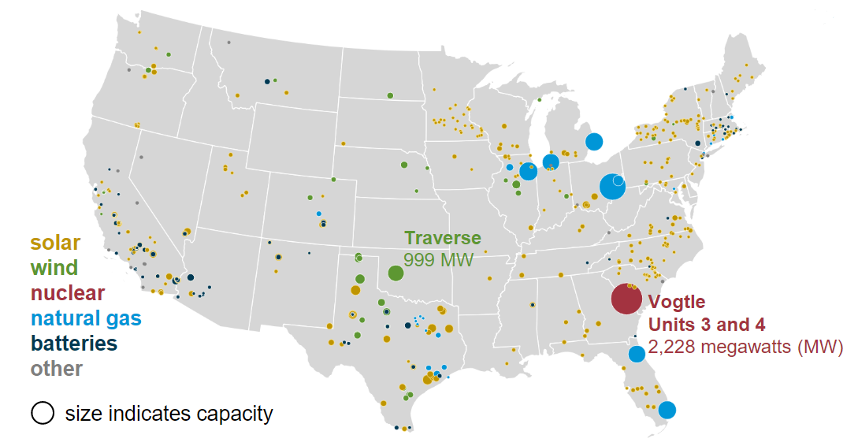
Figure 1-1. Planned U.S. utility-scale electric generator additions, 2022 [10].
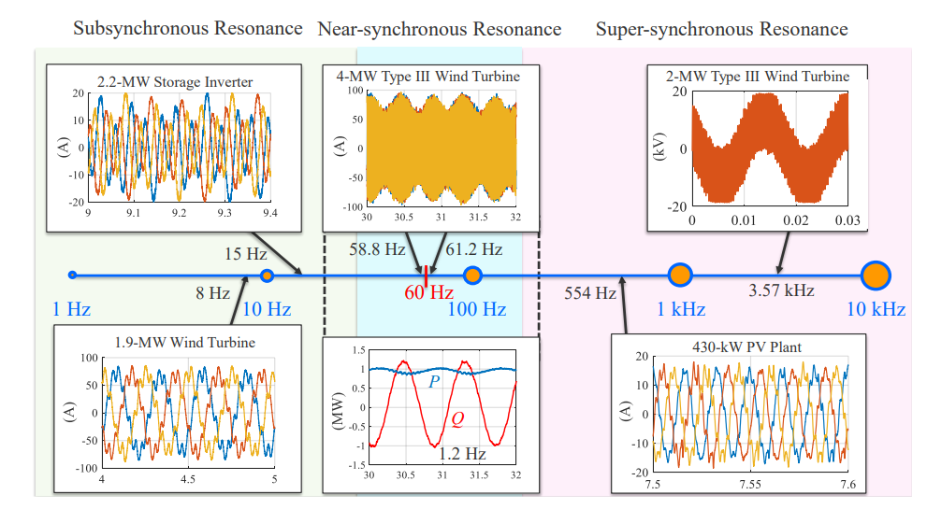
Figure 1-2. Stability problems in PEC-rich power systems [9].
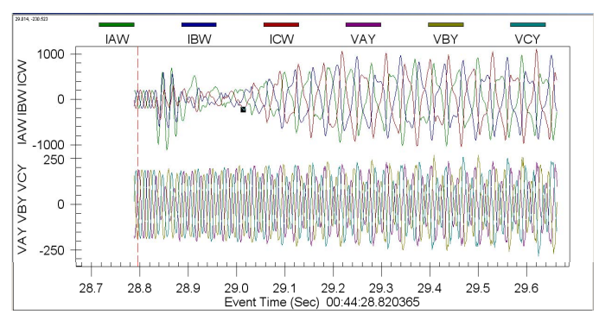
Figure 1-3. Oscilloscope record of a sub-synchronous event [11].

To analyze and understand the small-signal stability of PE-based power systems, two types of prevalent approaches are employed: 1) the state-space model-based approach and 2) the impedance model-based approach. The state-space model-based approach, which is commonly used in conventional power grids, can also be used for PEC-rich power systems. It can provide an in-depth understanding of the underlying causes of system dynamics. However, its effectiveness depends on the availability of detailed system information for constructing accurate state-space models, including the detailed converter control system, which manufacturers often regard as proprietary and confidential. This renders the state-space approach impractical in field applications, particularly when dealing with expansive PEC-rich power systems. Conversely, the impedance-based approach leverages terminal characteristics for stability analysis, avoiding the need for detailed internal information of the converters. Therefore, the impedance-based approach is preferred for small-signal stability analysis for PEC-rich power systems.
Although the impedance-based approach is preferred, the existing research work mainly uses this approach for either grid-connected systems with only a single IBR, or small-scale systems with a very limited number of PECs. The impedance-based approaches have not been applied to large-scale PEC-rich power systems, which is mainly due to the inaccurate analysis results and the computation burden regarding large-scale systems. Therefore, it is important to develop accurate and effective impedance-based methods aimed at small-signal stability analysis of large-scale PEC-rich systems.
Challenge 2: accurate and computationally efficient PEC models for transient analysis of large-scale PEC-rich power systems
With the rapid growth of IBRs and PE interfaced loads in modern PEC-rich power systems, models that can accurately represent the inverter dynamic behaviors are essential for system design, operation, and analysis. Moreover, in a three-phase electric distribution grid, it is common to serve both single-phase and three-phase loads simultaneously. This can result in load unbalance, which can cause unbalanced currents. These unbalanced currents can generate unbalanced voltages, which can be decomposed into the positive sequence (PS), negative sequence (NS), and zero sequence (ZS) components. Voltage unbalance must be strictly regulated in a distribution grid since it is harmful to system components and personnel. It has been found that the NS voltage can lead to overheating of the three-phase loads like motors [12], and the ZS voltage can result in dangerous phase-to-ground overvoltage [13]. Developing PEC models under balanced and unbalanced conditions is useful to ensure robust and secure operation of PEC-rich power systems.
Modeling challenges arise with such transitions in large-scale power systems, which include the requirement for electro-magnetic transient (EMT) simulations and accurate PEC models that are suitable for the application of interest [14]. Numerous efforts have been made to develop models that can represent PECs in various contexts. Most of these models require prior knowledge of these PECs, which are called first-principle or knowledge-based models, also known as white-box models. However, in large-scale PEC-rich systems, PECs are typically provided by different vendors and manufacturers, and detailed internal information is often confidential to system operators or users. Therefore, it is impractical to acquire accurate white-box models for all PECs in a large-scale system.
Another issue of detailed white-box models is that they could result in a huge computation burden, especially when they are used for large-scale PEC-rich systems. Accurate white-box models need to incorporate detailed and complex inverter controls, protections, switching actions, hardware characteristics, etc., which could severely slow down the planning and simulation of these large-scale systems. Simulating systems with tens, hundreds, or even more accurate white-box PEC models using commercially available software can be extremely challenging. Although efforts have been made to develop more computationally efficient white-box models using techniques like linearization and simplification, the application of these models is often limited, and they become inaccurate when large transients are involved.
Unlike white-box models, gray-box models provide a partial representation of system structures and/or parameters, leaving some aspects unknown. It still relies on partial system information for model construction.
The black-box models (BBMs), on the other hand, are developed based on empirical data, which means that internal information is not needed to acquire such models. When internal information about the system is unknown, black-box modeling techniques become the only approach to characterizing the system's behaviors. Moreover, they can be computationally efficient once the models are trained. Therefore, such BBMs can be a useful method to solve the aforementioned issues. In recent years, while certain black-box modeling approaches have been applied to power electronics converters like dc-dc converters and single-phase inverters, there has been a noticeable lack of comprehensive research focused on three-phase inverters. A critical gap exists in understanding the differences among various black-box modeling approaches. There is a pressing need to delve into these differences and undertake dedicated research efforts to develop appropriate black-box models tailored for grid-connected three-phase inverters, considering their transient behaviors inherent in grid applications.
This research aims to achieve two main objectives:
1) To address the challenges that arise when applying the multi-input multi-output (MIMO) criterion to large-scale PEC-rich systems and to develop a small-signal stability analysis method that can accurately and effectively analyze such large-scale systems.
2) To develop data-driven black-box modeling and system identification approaches for unknown or proprietary PEC technologies, with the goal of using these models to simulate system transients and conduct phasor dynamic analysis efficiently and effectively.

Dissertation Organization
The chapters of this dissertation are organized as follows.
In Chapter 2, a review and summary of existing research activities in small-signal stability analysis for PEC-rich power systems and black-box modeling for PECs are presented, respectively. Specifically, for the first issue regarding the small-signal stability analysis, existing approaches, with a focus on impedance-based methods, are examined, while identifying the challenges and gaps in applying these approaches to large-scale PEC-rich power systems. Additionally, for the second issue regarding the black-box models, the existing linear and nonlinear approaches for dc-dc converters, single-phase inverters, and three-phase inverters are reviewed. The research challenges in these areas and the objectives of this dissertation are also outlined.
Chapter 3 proposes a novel partition-based small-signal stability analysis method aimed at large-scale PEC-rich power systems. The proposed method decomposes the system into several sub-areas and their interconnection network, enabling the application of the Nodal Admittance Matrix (NAM)-based stability criterion at both the sub-area and interconnection levels. Then, the instability-issue-related converters or nodes are identified using the concept of participation factors (PFs).
In Chapter 4, a potential issue which arises when applying the NAM-based stability criterion to power systems with pure inductance models is identified. This issue is further illustrated through mathematical derivations and examples. Additionally, corresponding solutions to this problem are provided.
In Chapter 5, a comparative method is proposed to evaluate three widely-used nonlinear modeling approaches for BBMs, including the Nonlinear autoregressive exogenous (NARX) approach, the Hammerstein-Wiener (HW) approach, and the Neural Network (NN) approach, with a specific focus on capturing the transient behaviors of PECs. To identify the optimal BBM approach for transient modeling of PECs, the performance of these models is evaluated across diverse transients exhibited by a single-phase PV inverter. Then, the most suitable approach is selected for further investigation and analysis.
Chapter 6 explores the feasibility of employing the BBM approaches to effectively capture transient events in three-phase power systems. In this chapter, two different types of platforms are used to obtain the data related to a three-phase converter: one is the switching-based simulation model in MATLAB/Simulink; and the other is a three-phase converter in the hardware-in-the-loop (HIL) testing system. On both platforms, the three-phase converters are implemented with grid-following (GFL) control. Through proper data acquisition and preprocessing, training, validation, and test datasets are generated from each platform. Then, three different deep learning (DL)-based BBMs are developed, including the Long-Short Term Memory (LSTM) networks, the Gated Recurrent Unit (GRU) approach, and the Convolutional Neural Network (CNN) approach. Subsequently, a comprehensive examination of the proposed three DL-based BBMs is conducted by assessing their performance across various transient scenarios.
Chapter 7 extends the proposed three DL-based BBMs to the three-phase inverters in unbalanced grids. A simulation model of a three-phase inverter with grid-forming (GFM) control is built to generate the training, validation, and test datasets under unbalanced conditions. Development of these proposed DL models is illustrated, and the feasibility and performance of these BBMs are then examined under various transients with unbalanced loads.
In Chapter 8, the work in this dissertation is summarized, followed by suggested future work.

Literature Review and Challenges
This chapter reviews the research endeavors related to small-signal stability analysis for PEC-rich systems and black-box modeling approaches for PECs. The research challenges and objectives are subsequently presented to highlight the originality of the work.

Small-Signal Stability Analysis for PEC-Rich Systems
With the increasing penetration of renewables in power systems, the small-signal stability issue across a wide frequency range becomes a concern [8, 15]. In recent years, a growing number of unstable oscillations caused by grid-connected converters have been reported, with distinctly different characteristics compared to conventional power grids [16, 17]. However, the mechanism of such converter-driven instability is not straightforward and fully understood.

Review of Small-Signal Stability Analysis Approaches
Small-signal stability refers to the property of a dynamic system to maintain its steady-state operating conditions under small disturbances. In PEC-rich power systems such as an all-power electronics grid, the small-signal stability issue is a concern due to interactions among the converters across a wide frequency range [15]. To analyze the small-signal stability of such systems, two types of approaches are widely used [18]: 1) the state-space model-based approach, and 2) the impedance model-based approach.
- State-space model-based approach
The state-space model-based approach, which is commonly used in conventional power grids [19], can also be used for the small-signal analysis of PEC-rich systems and microgrids [20-23]. A small-signal state-space form of a system can be given by (2.1) and (2.2), where $A$ is the state matrix, $B$ is the input matrix, $C$ is the output matrix, and $D$ is the feed-forward matrix. The eigenvalues obtained by state matrix $A$ can then be utilized to determine the small-signal stability of a system.
$$∆\dot{x}=A∆x+B∆u$$ | (2.1)
$$∆y=C∆x+D∆u$$ | (2.2)
The state-space approach can provide a comprehensive overview of the root causes of system dynamics in detail. However, the state-space model-based approach requires detailed system information on all system components to form accurate state-space models, including the detailed converter control systems that many manufacturers often treated as proprietary and confidential. This makes the state-space approach not applicable in field applications, especially for large-scale PEC-rich systems.
- Impedance-based approach
The impedance-based approach was first introduced in [24]. Much research work has analyzed grid-connected inverters using the impedance-based approach, with different impedance models including the $dq$ impedance model [25-28], sequence impedance model [29-31], and dc impedance model [32, 33]. Figure 2-1 shows a system that is viewed as series-connected source and load subsystems [34]. The input-to-output transfer function of this system can be derived as (2.3).
$$F_{AB}=\frac{V_{out_B}}{V_{in_A}}=\frac{F_{A}F_{B}}{1+T_{m}} where T_{m}={Z_{o}}/{Z_{in}}$$ | (2.3)

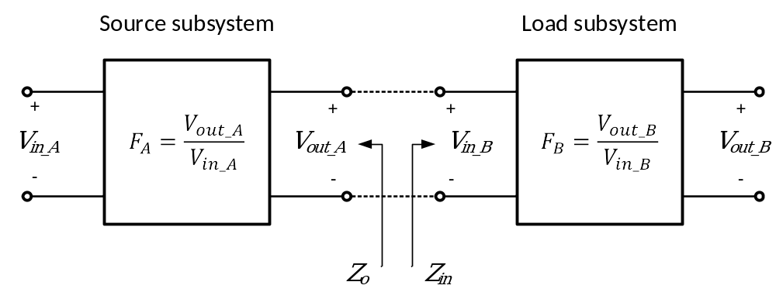
Figure 2-1 Cascaded source and load subsystems.

In (2.3), $Z_{o}$ is the output impedance of the source subsystem, and $Z_{in}$ is the input impedance of the load subsystem. The system's small-signal stability can be analyzed by examining the loop gain $T_{m}$. Other than $T_{m}$, the system stability can also be determined by analyzing the equivalent impedance $Z_{eq}=Z_{o}∥Z_{in}$ or the impedance-sum model [35, 36]. Different small-signal stability criteria can be applied to these impedance models when analyzing the system stability, and details of these stability criteria are reviewed in Section 2.1.2.
Unlike the state-space model-based approach, the impedance-based approach uses terminal characteristics for stability analysis without the need for detailed internal control and system information for the converters. The terminal characteristics can either be derived using an analytical model or measured directly from the terminals. Thus, the impedance-based criteria are preferred, and many efforts have been made to apply the impedance-based criteria to the system-level stability analysis for small-scale PEC-rich grids. The existing works for the system-level small-signal stability analysis of small-scale systems can be categorized into closed-loop [37-39] and open-loop approaches [27, 31, 40].

Review of the Impedance-Based Criterion
Although the impedance-based approach is preferred, it has not been applied to large-scale PEC-rich systems so far, mainly due to the inaccurate analysis results and the computation burden regarding large-scale systems.
For three-phase ac systems, the impedance-based approach deals with MIMO systems, and hence the generalized Nyquist stability criterion (GNC) is used to determine the stability of the system [41]. When applying the impedance-based approach for the small-signal analysis, three criteria are often used [42]: 1) the Nyquist-based criterion; 2) the loop impedance model (LIM)-based criterion; and 3) the nodal admittance matrix (NAM)-based criterion.
- Nyquist-based criterion
In this criterion, a system is partitioned at the Point of Common Coupling (PCC) to form source and load subsystems, as shown in Figure 2-2. The equivalent source impedance $Z_{source}(s)$ and the equivalent load admittance $Y_{load}(s)$ are derived to calculate the impedance ration $L$ as (2.4).
$$L(s)=Z_{source}(s)Y_{load}(s)$$ | (2.4)
Then, the system's small-signal stability can be analyzed with the following criterion:
Nyquist-based criterion: if the impedance ratio $L$ does not contain any RHP poles, then the closed-loop system is stable if and only if the eigen-loci of $L$ do not encircle the critical point $(-1, j0)$. If $L$ has RHP poles, the system is stable if and only if the number of counterclockwise encirclements of the $(-1,j0)$ equals the number of the RHP poles of $L$, otherwise, it is unstable.
When performing the derivation for the source and load equivalents, the Nyquist-based criteria may result in the pole-zero cancellation issue when performing the impedance aggregation [43] and therefore could lead to inaccurate analysis results. Moreover, the Nyquist-based criterion is sensitive to partition points, which could lead to contradictory prediction results [44, 45].
- LIM-based criterion
This criterion uses loop impedance as a closed-loop model for the small-signal analysis. The loop impedance, as shown in Figure 2-3, can be derived as (2.5).
$$Z_{Loop}\left(s\right)=Y_{load}^{-1}\left(s\right)+Z_{source}(s)$$ | (2.5)
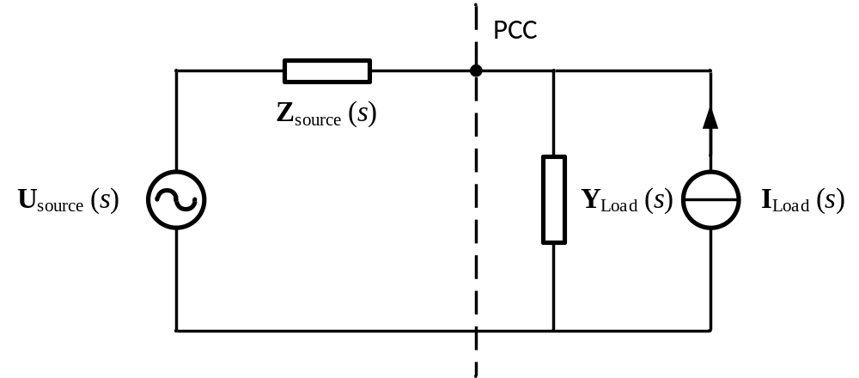
Figure 2-2 Source and load model for the Nyquist-based criterion.
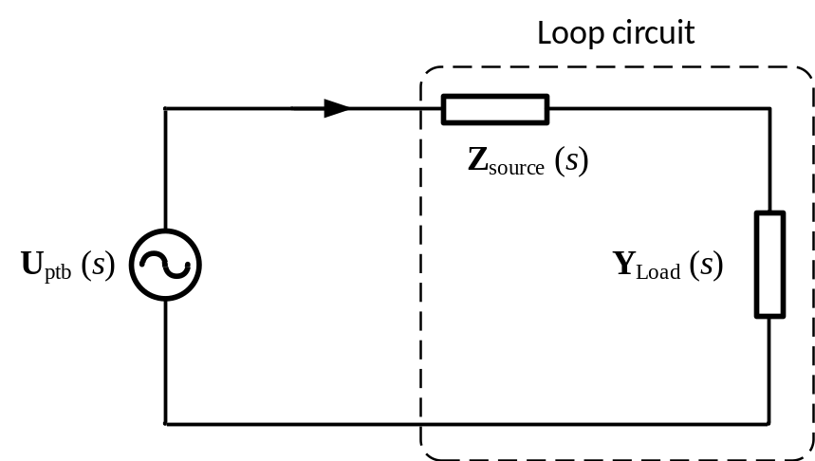
Figure 2-3 Closed-loop circuit for the LIM-based criterion.

The loop admittance $Y_{Loop}$ can then be calculated as (2.6).
$$Y_{Loop}\left(s\right)=Z_{Loop}^{-1}\left(s\right)=\frac{adj(Z_{loop}(s))}{det(Z_{loop}(s))}$$ | (2.6)
The system is stable if $Y_{Loop}$ doesn’t have any RHP poles. Considering (2.6), the LIM-based criterion can be illustrated as:
LIM-based criterion: The closed-loop system is stable if and only if there are no RHP poles of $Y_{Loop}$, or equivalently there are no RHP zeros of $det⁡(Z_{Loop})$.
Compared to the Nyquist-based criterion, the LIM-based criterion uses the impedance-sum model for the small-signal stability analysis. However, the LIM-based criteria may also result in the pole-zero cancellation issue when performing the impedance aggregation [43], which makes this criterion not suitable for small-signal stability analysis of large-scale systems.
- NAM-based criterion
Unlike the previous two criteria, the NAM-based criterion directly analyzes the small-signal stability using the NAM of the system, without deriving the equivalent model for either source or load. In this criterion, the system is decomposed into individual PEC components and the connection network based on the component connection method (CCM) [44]. Then, the equivalent MIMO feedback system of a power system can be derived, as shown in Figure 2-4 [27], where $G_{cl}\left(s\right)$ is the closed-loop reference-to-output matrix, $G_{cd}\left(s\right)$ is the closed-loop disturbance-to-output matrix, and $G_{nw}\left(s\right)$ is the MIMO impedance matrix model of the connection network.
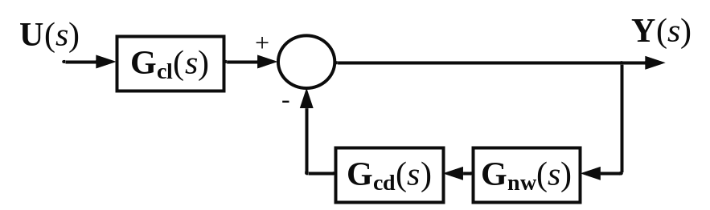
Figure 2-4 The closed-loop MIMO model for the NAM-based criterion.

The open-loop transfer function $L\left(s\right)$ and the return-difference matrix $F\left(s\right)$ can be expressed as (2.7) and (2.8).
$$L\left(s\right)=G_{cd}\left(s\right)G_{nw}\left(s\right)$$ | (2.7)
$$F\left(s\right)=I+L\left(s\right)=I+G_{cd}\left(s\right)G_{nw}\left(s\right)$$ | (2.8)
$G_{cl}\left(s\right)$ should be stable since all the converters are designed to be stable individually with ideal external conditions. Thus, the stability can be analyzed by applying the eigenvalue- or the determinant-based GNC to $L\left(s\right)$ or $F\left(s\right)$, respectively.
The NAM-based criterion can be stated as [27]:
NAM-based criterion: The closed-loop system is stable if and only if the eigen-loci of the open-loop transfer function $L(s)$ do not encircle the critical point $(-1,j0)$, or equivalently $N_{(0,j0)}\left(det⁡(F)\right)$ is 0.
As mentioned above, the issues of the Nyquist- and LIM-based criterion including pole-zero cancellation and being sensitive to partition points become more severe when analyzing large-scale systems involving many branches and converters. Therefore, these two impedance-based criteria are not suitable for the small-signal stability analysis of large-scale power electronics-based power systems. The NAM-based criterion, on the other hand, preserves the system structure by using the admittance matrix. Thus, this criterion is more capable of systems with complex structures, and it has fewer restrictions compared to the previous two criteria.
Two main approaches, the eigenvalue-based GNC and the determinant-based GNC, have been used for the NAM-based stability analysis. For the eigenvalue-based GNC, the stability of the system can be analyzed by examining the characteristic loci of $L\left(s\right)$ according to (2.9), where $Z()$ and $P()$ represent the number of RHP zeros and RHP poles, respectively. Theoretically, $L\left(s\right)$ should not have RHP poles.
$$Z\left(F\right)=P\left(L\right)-N_{\left(-1,j0\right)}\left(L\right)=-N_{\left(-1,j0\right)}\left(L\right)$$ | (2.9)
Similarly, for the determinant-based GNC, the stability of the system can be analyzed by examining the Nyquist or Bode plot of the determinant of $F\left(s\right)$ according to (2.10).
$$Z\left(F\right)=P\left(L\right)-N_{\left(0,j0\right)}\left(det\left(F\right)\right)=-N_{\left(0,j0\right)}\left(det\left(F\right)\right)$$ | (2.10)
Although the eigenvalue-based GNC could provide more insight like gain margin, phase margin, and the approximate resonance frequency, it could be tedious to examine each characteristic locus when using the eigenvalue-based GNC for large-scale systems [27].
For the determinant-based GNC, only one Nyquist plot needs to be checked to determine the stability of the whole system. Thus, the determinant-based GNC is often preferred in large-scale systems [27, 46, 47]. However, in the existing literature which applies the NAM-based criterion for small-signal stability analysis [27, 42, 48], the small-signal stability analysis and the derivation of the admittance matrix are normally conducted for the entire networks of relatively small systems. Since the orders of the matrices are twice the number of converters in the system, the larger the system is, and the more the converters are involved, the larger the matrices and the more complex the analysis will be. Moreover, if the contingencies are considered, e.g., disconnection of some converters, the whole admittance matrix will need to be derived again for each different case from the beginning. Although efforts have been done in recent years to use aggregated models to analyze the small-signal stability of subsystems [49, 50], there is still a lack of systematic and effective ways to the analysis of large-scale systems. Therefore, the development of accurate analytical methods with less computation burden for system-level stability prediction is desirable, especially for the large-scale PEC-rich systems, expected of the future power grids.

Black-Box Modeling Approaches for PECs
A literature survey has been conducted in this section to understand the state-of-the-art power electronics domain using BBM approaches. The BBM approach was initially applied to small-signal modeling of dc-dc converters in a publication for spacecraft power systems by Cho starting from the 1980s [51-53]. Although the BBM approaches have been gradually extended to single-phase and three-phase inverters, not very extensive research efforts have been done for power electronics BBM so far.
Depending on prior knowledge, there are two different approaches to modeling any dynamic systems, first-principle or knowledge-based modeling and data-driven modeling using empirical data. The former approach relies on the physics and internal details of a system to mathematically derive the equations for system models. If the system is too complex, derivation of its accurate system model could be complicated. Such knowledge-based models could lead to a huge computation burden for computers. Besides, the internal information of some systems might be confidential or unknown, which makes it impossible to acquire an accurate system model using knowledge-based modeling techniques. Unlike knowledge-based modeling, data-driven modeling uses available data to derive the model that describes the targeted system. This approach assumes that the data contains sufficient information to represent the physics of the targeted systems [54]. Data-driven models are categorized into three types based on the level of information available about the system's parameters and the degree of transparency of the model structure.
These categories include white-box, grey-box, and black-box models [55] as shown in Figure 2-5, which are classified based on the knowledge of the structures and parameters of the system [56].
For white-box models, both the system structure and its parameters are fully specified. When the structures and parameters are all known, these white-box models can be derived with good accuracy. To reduce the effort required for studying multiple inverters, a modular modeling approach is used [57]. However, white-box approaches have limitations in terms of the required computational burden and convergence constraints, which make them suitable only for studies of smaller systems. They are not appropriate for large-scale system studies due to this limitation.
The gray-box models only partially represent the system structures and/or parameters, with the remainder being unknown or uncertain. This modeling approach has not gained much attention since it still requires part of the system information. It has primarily been utilized for parameter estimation of known topologies [58].
Black-box models, on the other hand, do not provide any insight into the model structure or parameters and rely entirely on data-driven techniques to generate predictions. A black-box model is an abstraction of the model of real-world physics, simply representing the functional relationships between system inputs and outputs without preserving internal physical structure. When a dynamic system is difficult to or cannot be modeled using knowledge-based modeling techniques, system identification methods can be applied to derive its model using the measured system’s input and output data. Research of system identification was pioneered by Pieter Eykhoff in the 1960-70s [59], and it is further established with a theoretical framework and practical methodology by Ljung, Soderstrom, and Stoica in the 1980s [60-62]. Figure 2-6 illustrates a typical regression-based system identification block diagram.
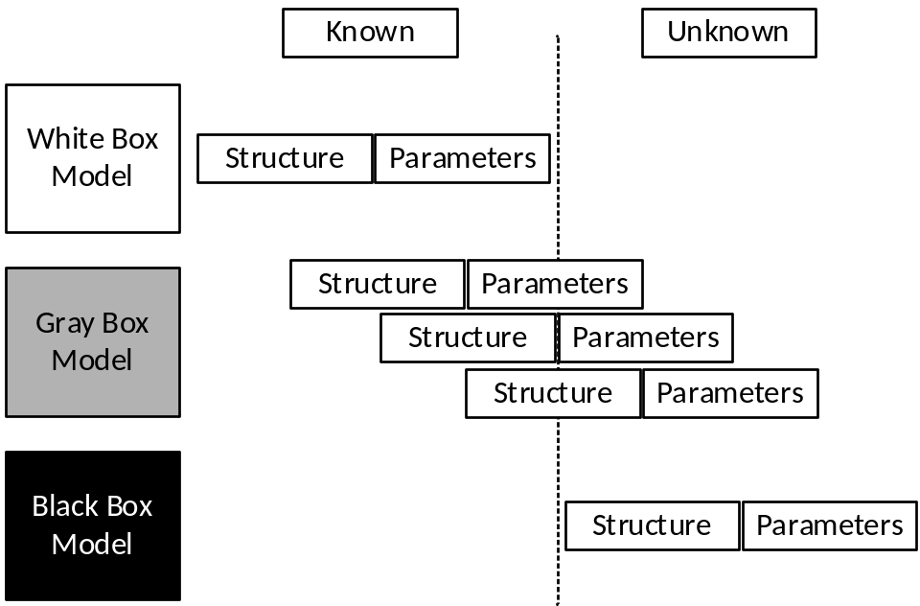
Figure 2-5 Categories of data-driven models.
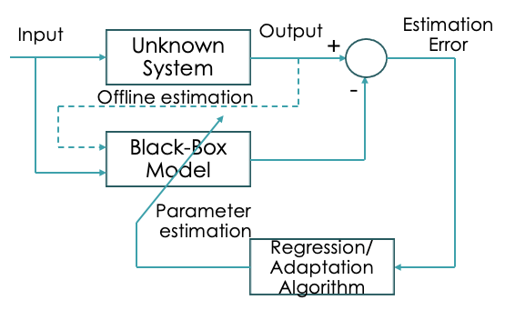
Figure 2-6 System identification of an unknown system.

System identification methods can be parametric or non-parametric. Parametric system identification methods involve making assumptions about the functional form of the system's model and estimating the parameters of that model using data. Non-parametric system identification methods, on the other hand, do not require assumptions about the functional form of the system's model, but instead, rely on techniques such as frequency response analysis or spectral analysis to identify the system's characteristics. The parametric model is usually preferred due to its simplicity, less required training data, and relatively fast training speed compared to non-parametric models. Figure 2-7 shows the classification of parametric model types.

Review of Linear Black-Box Modeling Approaches
Parametric black-box models take the forms of some established or standardized structures, linear or nonlinear, continuous or discrete-time, and time or frequency-domain.
The linear models offer a good solution to capture system dynamics at one operating point under small disturbances. Transfer functions (TF), state-space (SS) equations, and autoregressive with exogenous (ARX) are commonly used linear models for PECs [63-66]. However, these models can only represent a system in a small range of a single operating point. For systems with multiple operating points, a polytopic model structure can be utilized [67-70], which combines multiple small-signal linearized models with weighting factors to achieve a better and compromised solution.
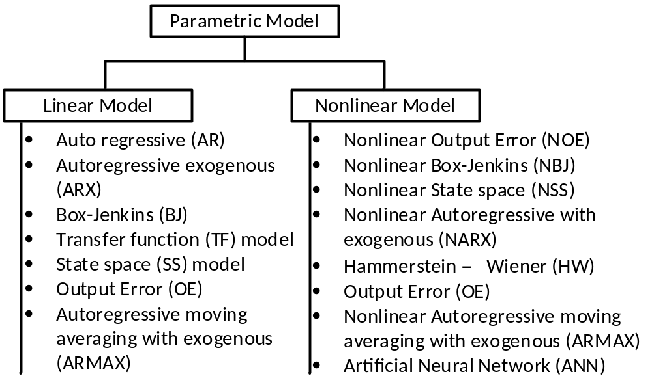
Figure 2-7 Different types of system identification methods.

- TF model
The general transfer function model structure can be mathematically described as (2.11) [66], where $U(s)$, $Y(s)$, and $E(s)$ are the system input, output, and error by the Laplace transforms, respectively.
$$Y\left(s\right)=\frac{num\left(s\right)}{den\left(s\right)}U\left(s\right)+E(s)$$ | (2.11)
The zeros of the TF model are the roots of the numerator polynomial $num(s)$, while the poles of the TF model are the roots of the denominator polynomial $den(s)$. When using the transfer function model for system identification, the number of poles and zeros are specified, and the numerator and denominator polynomials are calculated from the data.
- SS model
The general state-space model structure can be mathematically described as (2.12) [66], where $y(t)$ is the system output at time $t$, $u(t)$ is the system input at time $t$, and $e(t)$ is the white-noise disturbance.
$$\frac{dx}{dy}=Ax\left(t\right)+Bu\left(t\right)+Ke(t)$$  $$y\left(t\right)=Cx\left(t\right)+Du\left(t\right)+e(t)$$ | (2.12)
When using the state-space model for system identification, the model order, i.e., the dimension of the state vector, should be specified. The state-space matrices $A$, $B$, $C$, $D$, and $K$ are estimated from the data.
- Linear ARX model
For a single input/single output (SISO) system, the linear ARX model structure can be mathematically described as (2.13) [66], where $y(t)$ is the system output at time $t$, $u(t)$ is the system input at time $t$, and $e(t)$ is the white-noise disturbance; $n_{a}$ represents the number of poles, $n_{b}$ represents the number of zeros plus 1, and $n_{k}$ represents the input delay, i.e., the number of samples before the input affects the system output.
$$y\left(t\right)+a_{1}y\left(t-1\right)+…+a_{na}y\left(t-n_{a}\right)=b_{1}u\left(t-n_{k}\right)+…+b_{nb}u\left(t-n_{k}-n_{b}+1\right)+e(t)$$ | (2.13)
When using the linear ARX model for system identification, the model orders $n_{a}$, $n_{b}$, and $n_{k}$ are specified to identify the ARX model and the parameters $a_{1}$, …, $a_{na}$ and $b_{1}$, …, $b_{nb}$ are calculated from the data.
- Polytopic model
The polytopic model structure is a combination of small-signal linearized models that are parameterized and weighted [71]. Figure 2-8 illustrates the polytopic model structure [69]. The general mathematical representation of the polytopic model is expressed as (2.14) and (2.15)[68], where $ω_{i}(u)$ is the weighting function of the $i^{th}$ local model.
$$\dot{x}=\sum_{i=1}^{n}{ω_{i}(u)(A_{i}x+B_{i}u)}$$ | (2.14)
$$y=\sum_{i=1}^{n}{ω_{i}(u)(C_{i}x+D_{i}u)}$$ | (2.15)
It can be described as (2.16), where $u_{i}$ is the operating point at which the local model is identified.
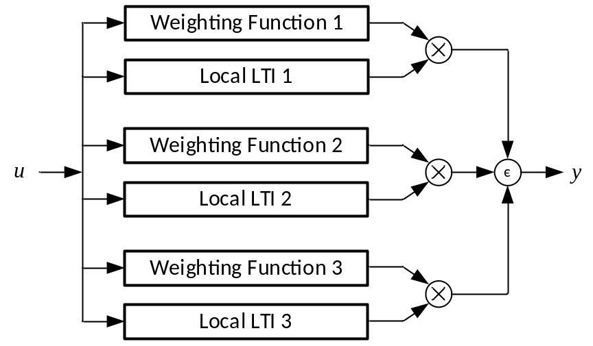
Figure 2-8 Model structure of the polytopic model.

$$ω_{i}(u)≈\left\{\begin{matrix}1 & if u∈u_{i} \\ (0,1) & if u∉u_{i}\end{matrix}\right.$$ | (2.16)
Besides, for the model integrity, the weighting functions should comply (2.17).
$$\sum_{i=0}^{i=n}{ω_{i}\left(u\right)=1 ∀t}$$ | (2.17)

Review of Nonlinear Black-Box Modeling Approaches
For the systems with nonlinearities and subject to large disturbances like PECs-rich power systems, a nonlinear large-signal model structure shall be adopted. Commonly known nonlinear models used for power electronics applications include:
- Nonlinear ARX (NARX) model
- Hammerstein-Wiener (HW) model
- Neural network (NN) model
- NARX model
The NARX model, as shown in Figure 2-9, consists of model regressors and one or more mapping objects as the output function. It defines the predicted output $y(t)$ as a function of linear and nonlinear functions of model regressors, together with a fixed offset. The regressors are calculated with the current input $u\left(t\right)$ and past input and output data. The regressors in the model can be either linear regressors with delayed inputs and outputs, or they could be nonlinear regressors that incorporate nonlinear functions of delayed inputs and outputs.
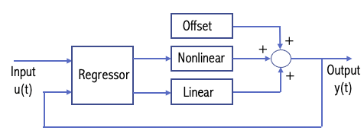
Figure 2-9 Model structure of NARX model.

The nonlinear estimator, as mentioned above, is a sum of linear and nonlinear functions with a fixed offset. The estimator can be described by equation (2.18) [72], where $x$ represents the vector of the regressors, and $r$ represents the mean of the regressors. $L^{T}\left(x-r\right)$ represents the linear function, $g\left(Q\left(x-r\right)\right)$ represents the nonlinear function, $Q$ is the projection matrix that makes the calculation well-conditioned, and $d$ is a scalar offset.
$$y\left(t\right)=L^{T}\left(x-r\right)+g\left(Q\left(x-r\right)\right)+d$$ | (2.18)
In the nonlinear estimator, either the linear or the nonlinear function can be excluded. Possible nonlinear estimators include Sigmoid Network, Wavelet Network, dead-zone, single variable polynomial, saturation, piecewise linear function, tree-partition networks, and multilayer neural networks [73]. Note that in the NARX model, the nonlinear data do not directly impact the linear model, so the nonlinear response cannot be easily tuned in the NARX structure.
- HW model
The HW model is a popular approach for the black-box modeling of PECs [74, 75]. In [76], the solar PV inverter is treated as a one-port network and the black-box model takes the form of a voltage-controlled current source implemented in the OpenDSS. It is recognized that the transfer function model cannot capture harmonics, while the HW model can identify up to the 13th-order harmonics [77, 78]. The comparisons between the HW and the NARX model structures have shown that the HW model demonstrates better performance in terms of quality metrics and fit percent [72].
The HW model, as shown in Figure 2-10, consists of input nonlinear block $H(∙)$ and output nonlinear block $W(∙)$ in series with a linear block $G(∙)$ in the middle. The input and output nonlinear blocks represent the nonlinearities of the input and output, respectively. $H(∙)$ is the
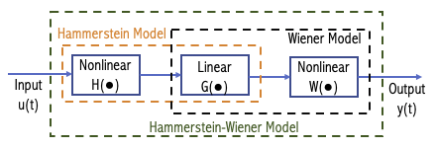
Figure 2-10 Model Structure of HW Model.

nonlinear function that transforms the input data $u(t)$, $W(∙)$ is the nonlinear function that maps the output of linear block $G(∙)$ to the system output $y(t)$. The middle linear block represents the linear transfer function of the system. Similar to the nonlinear estimators in the NARX model, the input and output nonlinearities can also be described as Sigmoid Network, wavelet network, saturation, polynomial, dead zone, piecewise linear function, etc. Note that when the output nonlinear block is not included, the model is called the Hammerstein Model; when the input nonlinear block is not included, the model is then called the Weiner model.
Unlike the NARX model, the linear and nonlinear model responses can be manipulated separately in the HW model, which makes it an effective structure for modeling nonlinear systems like PECs. However, it still faces some challenges to model some complex behaviors as reported in some literature, like the frequency coupling effects [79].
- NN model
The NN model, which offers desirable solutions in terms of accuracy, has been widely used for system identification as a powerful tool in power electronics applications [80]. The NN approaches have been attempted to demonstrate their potential for the black-box modeling of PECs in recent years [79, 81, 82]. Neural networks behave similarly to the neural network of the human brain. The basic neural network contains neurons, layers, weights, and activation functions. In a neural network, a "neuron" is a mathematical function that collects and organizes information according to a specific architecture. These neurons can form layers, and the data will be passed through different layers. The input layer will process the input data, while the output layer will provide the output data of the network. Layers between the input layer and the output layer are called hidden layers. The structure of neural networks, the number of neurons and layers, and the activation function can be very different according to different applications. Although neural networks resemble statistical methods such as curve fitting and regression analysis, neural networks are more powerful and can handle more complex tasks due to their ability to learn and adapt from data.
Figure 2-11(a) shows the topology of simple feedforward neural networks (FFNNs). However, as reported in [79], simple FFNNs shown in Figure 2-11(a) do not provide the required degree of accuracy when modeling IBRs. Some more advanced topologies, like the nonlinear autoregressive model with exogenous inputs (NARX) neural networks shown in Figure 2-11(b) [83], can provide more accurate predictions in such applications. A general mathematical representation of a NARX NN can be expressed as (2.19) [79].
$$y\left(t+1\right)=f(u_{1}\left(t\right), u_{2}\left(t\right), …,u_{n}\left(t\right),y\left(t\right), y\left(t-D\right), …,y\left(t-mD\right))$$ | (2.19)
It can be seen from equation (2.19) that the next output value $y\left(t+1\right)$ is a function of $n$ momentary input data $u$ and $m+1$ past output data $y$ at each time instance $t$. The discrete time step D represents the delayed time step, and it depends on the sampling rate $f_{sample}$ of the data. D is described as (2.20).
$$D=\frac{1}{f_{sample}}$$ | (2.20)
In addition to the NARX NN model, other types of Recurrent Neural Networks (RNNs) including Long-Short Term Memory (LSTM) networks and Gated Recurrent Unit (GRU), as well as Convolutional Neural Network (CNN), have been used for black-box modeling of dc-dc converters [84-86].

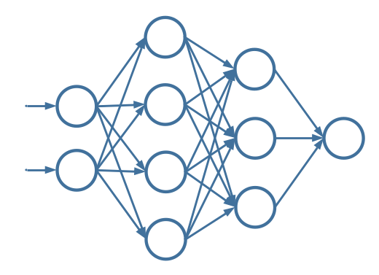
(a)

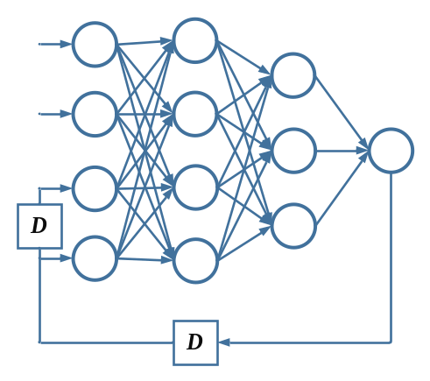
(b)
Figure 2-11 NN model structures: (a) FFNN and (b) NARX NN.

The LSTM model is a type of RNN that is widely utilized in research areas concerned with sequential data [87]. The LSTM NN was initially introduced to address the long-term dependency problem inherent in traditional RNNs in 1997 [88]. It is capable of learning and predicting data based on time series, which makes it suitable for system identification of PECs as the outputs of the converter are affected by its status during previous time steps. Figure 2-12 (a) and (b) show the cell structure and connections of the LSTM NN. An LSTM cell contains an input gate, an output gate, and a forget gate. The LSTM architecture enables it to forget the irrelevant history, perform the computations and store the relevant new information, update its internal state, and regulate which pieces of information to output from the current state. Such a structure gives LSTM the ability to remember information from the input data across arbitrary time intervals. The forward pass of an LSTM cell can be expressed as (2.21) - (2.26).
$$f_{t}=σ\left(W_{f}x_{t}+U_{f}h_{t-1}+b_{f}\right)$$ | (2.21)
$$i_{t}=σ\left(W_{i}x_{t}+U_{i}h_{t-1}+b_{i}\right)$$ | (2.22)
$$o_{t}=σ\left(W_{o}x_{t}+U_{o}h_{t-1}+b_{o}\right)$$ | (2.23)
$${\hat{c}}_{t}=tanh\left(W_{c}x_{t}+U_{c}h_{t-1}+b_{c}\right)$$ | (2.24)
$$C_{t}=f_{t}∙C_{t-1}+i_{t}∙{\hat{c}}_{t}$$ | (2.25)
$$h_{t}=o_{t}∙tanh\left(C_{t}\right)$$ | (2.26)
where $x_{t}$ is the input vector; $f_{t}$, $i_{t}$, and $o_{t}$ are activation vectors of forget, input, and output gates, respectively; ${\hat{c}}_{t}$ is the cell input activation vector; $C_{t}$ is the cell state vector; and $h_{t}$ is the hidden state vector; $W$ is the input weights, $U$ is the recurrent connections, and $b$ is the bias.
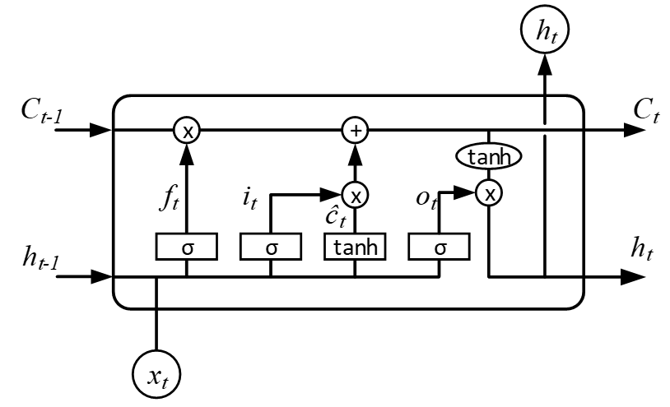
(a)
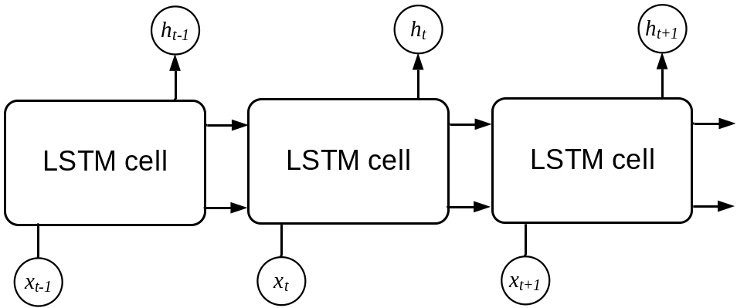
(b)
Figure 2-12 LSTM: (a) cell structure and (b) connections.

The GRU, introduced in 2014 [89], is another type of RNN that similar to LSTM but with fewer parameters. The GRU cell structures and its connections are shown in Figure 2-13. Although without an output gate, the GRU can provide similar performance as LSTM in certain tasks. The equations of a GRU cell can be expressed as (2.27) - (2.30):
$$z_{t}=σ\left(W_{z}x_{t}+U_{z}h_{t-1}+b_{z}\right)$$ | (2.27)
$$r_{t}=σ\left(W_{r}x_{t}+U_{r}h_{t-1}+b_{r}\right)$$ | (2.28)
$${\hat{h}}_{t}=tanh\left(W_{h}x_{t}+U_{h}\left({r_{t}∙h}_{t-1}\right)+b_{h}\right)$$ | (2.29)
$$h_{t}=\left(1-z_{t}\right)∙h_{t-1}+z_{t}∙{\hat{h}}_{t}$$ | (2.30)
where $z_{t}$ is the update gate vector; $r_{t}$ is the reset gate vector; ${\hat{h}}_{t}$ is the candidate activation vector. The definitions of $x_{t}$, $h_{t}$, $W$, $U$, and $b$ are the same as those for LSTM.
The CNN model, which its modern framework is first established around the 1990s [90] [91, 92], is one of the most influential and effective deep learning architectures [93]. CNN is capable of efficiently reducing the size of large datasets while preserving important features, making it well-suited for image processing tasks. Unlike previously introduced RNNs such as NARX NN, LSTM, and GRU, the CNN does not have any feedback connections, featuring only a forward path from inputs to outputs [94]. It reduces the number of parameters and enhances the feed-forward backpropagation training [95]. Figure 2-14 shows the structure of a basic CNN. It consists of an input layer, hidden layers, and an output layer. The typical structure of hidden layers includes a set of convolutional and pooling layers, together with a fully-connected layer that connects to the output layer.
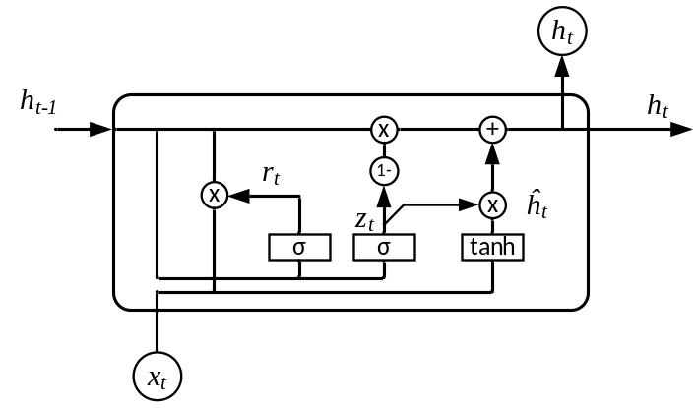
(a)
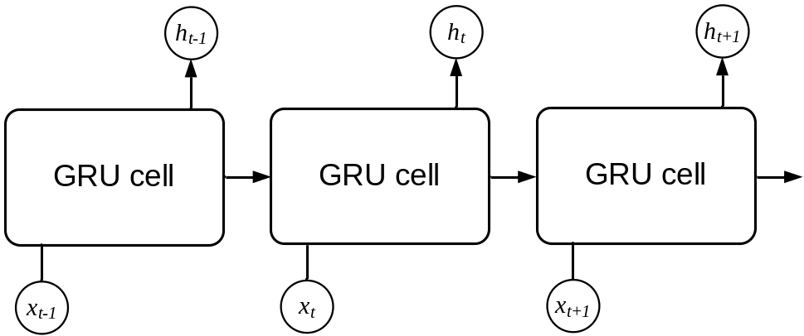
(b)
Figure 2-13 GRU: (a) cell structure and (b) connections.

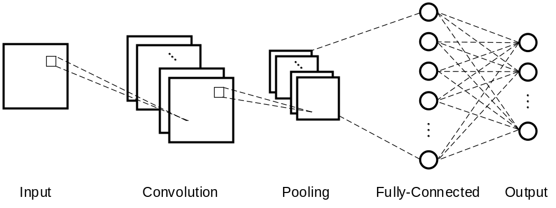
Figure 2-14 CNN structure.

Functions of each layer are introduced as follows:
- Convolutional layer: It extracts features from inputs to generate a feature map (also called activation map). In this layer, inputs are convolved with the weights (kernels or filters), and results are passed to the next layer. Equation (2.31) is used to calculate the $k$th output feature map $Y_{k}$ [94]:
$$Y_{k}=f\left(W_{k}*x\right)$$ | (2.31)
where $x$ is the input image; $W_{k}$ is the convolutional filter; $f(∙)$ represents the nonlinear activation function; the multiplication sign $*$ is the convolutional operator.
- Pooling layer: Also known as downsampling, as it reduces the computational burden by subsampling the spatial dimensions of the feature maps. There are two types of pooling schemes: max pooling and average pooling. The max pooling selects the maximum value within the receptive field, while the average pooling calculates the average value. By neglecting the irrelevant data, the pooling layer helps to reduce the complexity, enhance the efficiency, and limit the risk of overfitting.
- Fully-connected layer: It connects every neuron in the layer to every neuron in the next layer. The fully-connected layer utilizes extracted features from previous layers to generate output values for image classification.
The training of these NN models may require lots of data and longtime effort. A large amount of data sets is required and the significant size of neurons at several hundred will likely increase the model complexity and training time. However, once the NN model is trained, the implemented NN model will have a reduced computation effort and thus shorter simulation durations compared to the white-box models.

Research Objectives
The literature review above indicates that there are still many challenges and limitations associated with past research activities for small-signal stability analysis and black-box modeling based transient analysis for large-scale PEC-rich power systems. The main challenges and limitations can be summarized as follows:
- Large-scale power systems with high levels of PEC require small-signal stability analysis methods that are both effective and practical. The accuracy of the analysis is crucial in ensuring the stability of the power system under different operating conditions. At the same time, the computation burden should be kept as low as possible to avoid excessive processing times. Therefore, there is a need for new small-signal stability analysis methods that are specifically designed for large-scale PEC-rich power systems.
- The two existing impedance-based small-signal stability criteria, including the Nyquist- and LIM-based criterion, are not suitable for the analysis of large-scale systems, while the NAM-based criterion, although looks promising in such applications, has not been applied to large-scale systems yet. It should be noted that potential issues when using the NAM-based criterion for large-scale PEC-rich systems may have not been identified or reported in the literature. Therefore, further research is needed to thoroughly evaluate the performance and identify potential issues of the NAM-based criterion on large-scale systems.
- To simulate and analyze the large-scale PEC-rich system, the data-driven BBM approach is needed. Although some nonlinear black-box modeling approaches have been extended to dc-dc converters and single-phase inverters, the performance of different nonlinear BBMs under different inverter transient behaviors remains unclear.
- Current studies on black-box modeling (BBM) of three-phase PECs are still limited and focused mainly on the inverter behavior during steady-state operation, lacking research of their performance on multiple transient behaviors. Future research is needed to explore and evaluate the effectiveness of BBMs for three-phase grid-connected inverters, considering various control strategies such as GFM and GFL. Additionally, the scope of the models should be expanded to include different transient behaviors in both balanced and unbalanced grids.
Corresponding to the challenges and limitations listed above, the objectives of this dissertation include:
- Propose a partition-based small-signal stability analysis method using NAM-based criterion that aims at the analysis of large-scale PEC-rich power systems.
- Identify the potential issue when applying the NAM-based criterion to large-scale PEC-rich power systems. The cause of the issue should be illustrated, and corresponding solutions should be provided.
- Propose a comparative method to evaluate three commonly used nonlinear BBM approaches in the application of PEC modeling under different transient events and identify the most suitable BBM for such applications for further investigation.
- Develop DL-based black-box models for three-phase inverters with GFL control, utilizing data from different models obtained through both simulations and hardware-in-the-loop (HIL) tests. With proper data acquisition and preprocessing, the feasibility of employing these DL-based BBMs will be investigated, and their performance will be evaluated under different transients.
- Extend DL-based black-box models for three-phase inverters with GFM control under unbalanced conditions. Investigate the feasibility and assess the performance of these DL-based models under various transients in unbalanced grids.

Proposed Small-Signal Stability Analysis Method for Large-scale Power Electronics-Rich Power Systems via System Partition

Introduction
This chapter aims to accurately and efficiently use the impedance-based criteria to analyze the small-signal stability for large-scale PEC-rich systems. To accomplish this objective, a novel impedance-based analysis method by system partition is proposed. The proposed approach involves decomposing the system into multiple sub-areas and their interconnection network and using the NAM-based criterion to evaluate small-signal stability. Detailed information on how to partition the system using the proposed method and how to conduct stability analysis with this partition is provided. To demonstrate the effectiveness of the proposed method, a six-converter system and a modified 140-bus U.S. Northeast Power Coordinating Council (NPCC) system with 46 converters are studied, respectively. Both the experimental results of the six-converter system and the simulation results of the modified NPCC system are used to validate the analytical results of the proposed method. To the best of the authors’ knowledge, it is the first time such a large-size system is analyzed using the impedance-based criterion for small-signal stability analysis in the literature.

Fundamental Concept and Procedure of the Partition-based NAM Method
When employing the original NAM-based approach to a large-scale PEC-rich system, the methodology involves categorizing the system into active components (e.g., converters, synchronous generators, active loads) and passive connection network, depending on the theory of CCM. The holistic system model is then regarded as a multi-input multi-output (MIMO) system. In this method, due to the direct derivation of admittance matrix for the entire system, the orders of the system matrix will be twice the number of converters in the system. As the system expands in scale with increasing number of converters, the resultant system matrix becomes notably large, making it computationally unsolvable. Additionally, it becomes complicated to identify the cause of the instability issues in the system since the analysis relies solely on a high-order admittance matrix for the entire system.
To tackle this challenge, the proposed method is developed based on the original NAM theory, with a preliminary step of system portioning. Therefore, a large-scale system is initially dissected into several sub-areas, along with the corresponding interconnections linking these sub-areas. Each designated sub-area contains the converters and the remaining network connections confined to that sub-area. Figure 3-1 shows the flow chart of the proposed partition-based small-signal stability analysis method for large-scale PEC-rich systems. The procedure of the proposed partition-based method is summarized as follows (detailed derivation and the mathematical proof will be introduced in Section 3.3).
Step 1: Collect the available data, including components and system topology, of the target system. The corresponding operating points of the system should also be calculated accordingly.
Step 2: Derive or measure the impedance or admittance models of all system components (e.g., converters, synchronous generators, transmission lines, transformers, loads, shunts, etc.). Alternatively, gather impedance/admittance data from vendors.
Step 3: Partition the target system into several sub-areas and the interconnection network. Note that the proposed approach allows flexibility in terms of partitioning strategies, which can be executed based on the consideration of the system’s geographical layout or the control areas. To alleviate computation demands, the suggested partitioning process is to strategically select a
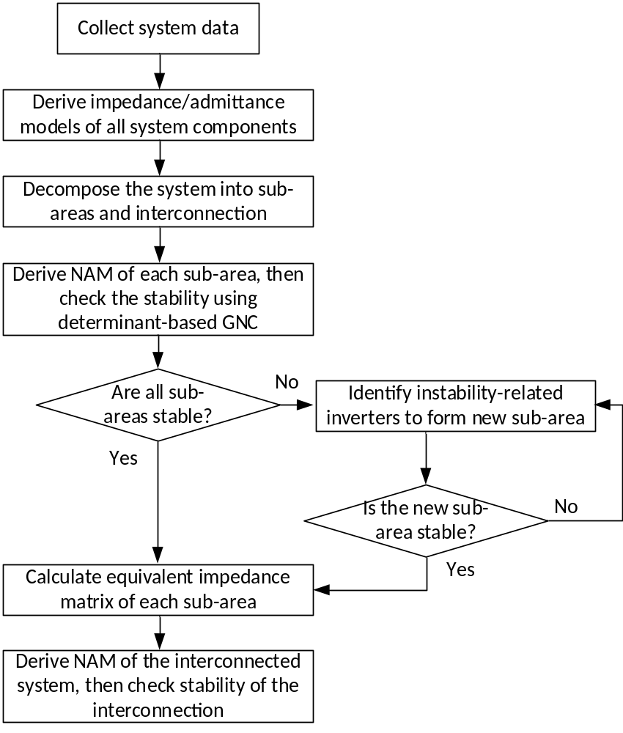
Figure 3-1. Flow chart of the partition-based analysis method.

modest number of interconnection nodes at the interconnection level and to accommodate approximately 10 – 20 converters in each sub-area. This can ensure that the matrix order of each sub-area and interconnections remain manageable. For example, matrix multiplication has a computational complexity of $O(n^{3})$ [96]. So, if the matrix order is reduced by 10 times, the computation time could be reduced by ${10}^{3}$ times. Moreover, with the help of parallel computing enabled by such partition at the subarea level analysis, the computation time could be further reduced. For systems of extremely large size, it can be extended to multi-level partitioning, involving further subdivisions of each sub-area.
Step 4: Derive the NAM of each sub-area based on the sub-area structure and analyze the small-signal stability of each sub-area using determinant-based GNC. This is achieved by checking the return-difference matrix $F_{i}(s)$ [27], yielding two possible results: 1) all sub-areas are stable; 2) some sub-areas are unstable. For the possible result 1), i.e., all sub-areas determined to be stable, the process advances to the subsequent step, which is to calculate the equivalent impedance or admittance matrix of each sub-area. For the possible result 2), i.e., one or more sub-areas are identified to be unstable, converters that are related to the instability within the unstable areas can be located using the characteristic loci of the open-loop transfer function $L_{i}(s)$ and the participation factor (PF) matrix [97]. These converters, which are related to the instability within the unstable sub-areas, can then be separated to form a new stable “sub-area” since each converter is designed to be stable in the first place. Mathematically, this can be achieved by directly modifying the original matrices of the corresponding sub-areas. After removing the rows and columns related to the instability-contributing converters, the newly regrouped sub-area can undergo analysis. With these reconfigured single-converter sub-areas, the possible result 2) can be transformed into the possible result 1) and the analysis can move forward to the subsequent step.
Step 5: Derive the equivalent impedance or admittance matrix of each sub-area seen from interconnection nodes after the stability is confirmed across all sub-areas. The NAM of each sub-area derived in Step 4 can be utilized to calculate the corresponding equivalent impedance or admittance matrix. A comprehensive derivation and mathematical proof of this equivalent impedance or admittance matrix can be found in Section 3.3.4.
Step 6: Construct the diagonal matrix of the closed-loop disturbance-to-output matrix $G_{cd_int}(s)$ of the interconnected system with the equivalent impedance or admittance matrices. Simultaneously, the admittance matrix of the interconnection network $G_{nw_int}(s)$ can be derived based on the interconnection structure. The overall stability of the interconnected system can then be analyzed using the Nyquist diagrams or the bode plots of the determinant of the return-difference matrix $F_{int}(s)$. If the interconnection is stable, then the entire interconnected system will be stable. Conversely, if the interconnection proves unstable, the characteristic loci of the open-loop transfer function $L_{int}(s)$ and the PF matrix can be calculated and used to locate the sub-areas associated with instability, and a corresponding stability enhancement approach can be developed. This marks the final step of the procedure in the proposed stability analysis approach. Note that within both sub-areas and the interconnection network, buses without connected converters can be eliminated using Kron reduction [98].
Unlike the original NAM-based method that analyzes the entire system as a single entity, the proposed partition-based approach is more suitable for large-scale systems. This is because the original method's matrix orders, which are two times the number of converters and generators, make it nearly impossible to analyze systems with thousands of converters and generators. The proposed partition-based method employs the aggregation model for sub-areas, which reduces the computation burden and makes it suitable for large-scale system analysis. While the partition concept has been used for other types of analysis in large-scale systems, it has not been applied to impedance-based small-signal stability analysis before. The proposed method provides several advantages compared to the existing impedance-based methods:
1) The proposed method features lower-order matrices of sub-areas and interconnections, instead of high-order matrix of entire system. This can yield several advantages. Frist, it can alleviate computational burden and offer a solution for large-scale systems. Second, it can accelerate analysis through parallel computation of sub-area matrices. Lastly, it can simplify the identification of the instability-related converters or sub-areas through the lower-order matrices.
2) The proposed method has enhanced flexibility and scalability. In response to changes in system configuration due to contingencies, only matrices corresponding to relevant sub-areas require updating, avoiding the re-derivation of entire system matrix. Furthermore, for extremely large-scale systems, the proposed approach can be extended to multi-level structures by expanding the sub-areas with sub-sub-areas when necessary.

Mathematical Derivation of the Proposed Method
In this section, the system partition principles, together with detailed derivation and mathematical proof of the proposed approach, including the rationality of system partitioning, derivation of the equivalent impedance/admittance matrices, and the stability analysis of sub-areas and interconnected systems, are introduced.

Partition Principles
As mentioned in Section 3.1, the purpose of the system partition for the small-signal analysis is to solve the issues when directly applying the NAM-based criterion to large-scale systems. Doing the partition could decompose the system into several smaller sub-areas and their interconnection, and thus make the analysis viable and simpler. As the computation burden with different partition strategies is highly dependent on the network structure of different large-scale systems and even different operating conditions of each system, extra effort will be needed for the “best partition” of these systems, which is not the focus of this dissertation. However, there are some general principles to do the partition for the large system analysis purpose. First, the sub-areas and the interconnection network after the partition should be small enough to do the computation. The number of converters in each subarea could be determined based on the computing power of the computer, which comprises the quantity of memory, the speed of the processors, and the number of processors that could be utilized for parallel computation for the sub-area level analysis in Step 4. Multi-level partitioning could be applied when necessary. Moreover, when selecting the interconnection nodes for the partition, it is better to decompose the system with fewer interconnection nodes, as fewer interconnection nodes mean lower matric order for the interconnection-level analysis, which could further reduce the computation burden in Step 5 and Step 6.

Rationality of System Partition in Step 3
In the proposed method, a large-scale PEC-rich system will be partitioned into $n$ sub-areas and their interconnection network, as shown in Figure 3-2 (a). Each sub-area is assumed to be connected to ideal sources at the interconnection nodes, presuming to be operated under the same operating conditions in the real system. The stability of each sub-area at the desired operating points will then be checked based on the CCM [99].
Sub-area 1 is used here as an example to explain the analysis at the sub-area level. Figure 3-2 (b) shows the equivalent MIMO feedback system of sub-area 1.
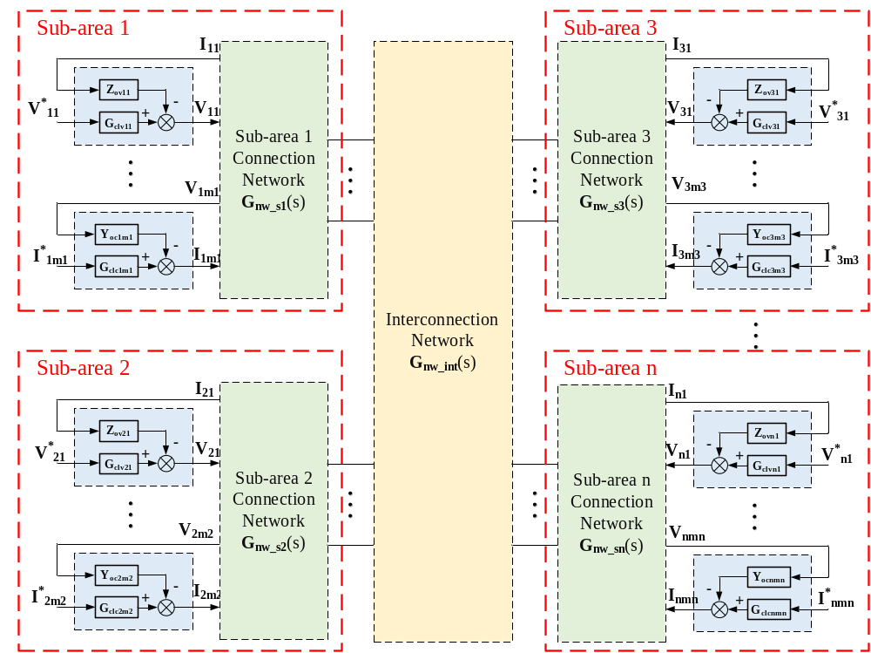
(a)

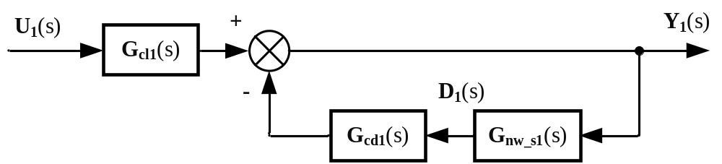
(b)
Figure 3-2. (a) Partition of a large-scale PEC-rich system, and (b) equivalent MIMO feedback system of sub-area 1.

The model for sub-area 1 can be derived as ( 3.1 ) and ( 3.2 ), where $Y_{1}(s)$, $U_{1}(s)$, and $D_{1}(s)$ are the output vector, reference vector, and disturbance vector of sub-area 1, respectively; $G_{cl1}(s)$ and $G_{cd1}(s)$ are the closed-loop reference-to-output transfer function matrix and closed-loop disturbance-to-output transfer function of sub-area 1, respectively.
$$Y_{1}\left(s\right)=G_{cl1}\left(s\right)U_{1}\left(s\right)-G_{cd1}(s)D_{1}(s)$$ | ( 3.1 )
$$D_{1}(s)=G_{nw_s1}(s)Y_{1}\left(s\right)$$ | ( 3.2 )
They can be expressed as ( 3.3 ) - ( 3.7 ).
$$Y_{1}\left(s\right)={\left[V_{11}\left(s\right),V_{12}\left(s\right), …,I_{1m1}\left(s\right) \right]}^{T}$$ | ( 3.3 )
$$U_{1}(s)={\left[V_{11}^{*}\left(s\right), V_{12}^{*}\left(s\right), …, I_{1m1}^{*}\left(s\right)\right]}^{T}$$ | ( 3.4 )
$$D_{1}(s)={\left[I_{11}\left(s\right),I_{12}\left(s\right), …,V_{1m1}\left(s\right)\right]}^{T}$$ | ( 3.5 )
$$G_{cl1}(s)=diag\left[G_{clv11}\left(s\right),G_{clv12}\left(s\right), …,G_{clc1m1}\left(s\right)\right]$$ | ( 3.6 )
$$G_{cd1}(s)=diag\left[Z_{ov11}\left(s\right),Z_{ov12}\left(s\right), …,Y_{oc1m1}\left(s\right)\right]$$ | ( 3.7 )
In ( 3.2 ), $G_{nw_s1}(s)$ is the admittance matrix of the connection network in sub-area 1. Detailed derivation of $G_{nw_s1}(s)$ based on the system topology will be introduced in Section 3.3.3.
With equations ( 3.1 ) and ( 3.2 ), the output vector $Y_{1}(s)$ of sub-area 1 can be derived as ( 3.8 ).
$$Y_{1}\left(s\right)={\left[I+G_{cd1}(s)G_{nw_s1}(s)\right]}^{-1}G_{cl1}(s)U_{1}(s)$$ | ( 3.8 )

The return-ratio matrix $L_{1}(s)$ and the return-difference matrix $F_{1}(s)$ of sub-area 1 are defined as ( 3.9 ) and ( 3.10 ).
$$L_{1}\left(s\right)=G_{cd1}(s)G_{nw_s1}(s)$$ | ( 3.9 )
$$F_{1}\left(s\right)=I+L_{1}\left(s\right)=I+G_{cd1}(s)G_{nw_s1}(s)$$ | ( 3.10 )
Given that each converter is inherently designed to be stable with ideal external conditions, $G_{cl1}$ is established stable. Consequently, the small-signal stability of the sub-area 1 relies only on the matrix ${\left[I+G_{cd1}(s)G_{nw_s1}(s)\right]}^{-1}$, which means the stability of sub-area 1 can be predicted by checking $L_{1}(s)$ or $F_{1}\left(s\right)$. The determinant-based criterion presented in [27] will be used here for$det\left(F_{1}\right)$ to judge the stability at the sub-area level.
After each sub-area is confirmed stable, its equivalent impedance/admittance matrix will be derived first. Then, the equivalent interconnected system can be formed as shown in Figure 3-3(a). The interconnected system can be decomposed into equivalent impedance models for individual sub-areas and the interconnection network. The derivation of equivalent impedances of the subareas will be discussed in Section 3.3.3 in detail. Figure 3-3 (b) shows the equivalent MIMO feedback system of the interconnected system.
Similar to the sub-area analysis, the model for the interconnected system can be derived as ( 3.11 ) and ( 3.12 ), where $G_{nw_int}(s)$ is the admittance matrix of the interconnection network. $Y_{int}(s)$, $U_{eq}(s)$, $D_{int}(s)$, $G_{cl_eq}(s)$; $G_{cd_eq}(s)$ are the corresponding vectors and matrices of the equivalent interconnected system.
$$Y_{int}\left(s\right)=G_{cl_eq}\left(s\right)U_{eq}\left(s\right)-G_{cd_eq}(s)D_{int}(s)$$ | ( 3.11 )
$$D_{int}(s)=G_{nw_int}(s)Y_{int}\left(s\right)$$ | ( 3.12 )
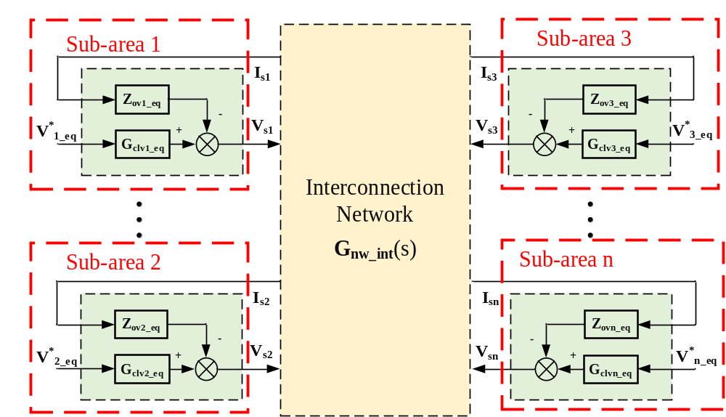
(a)

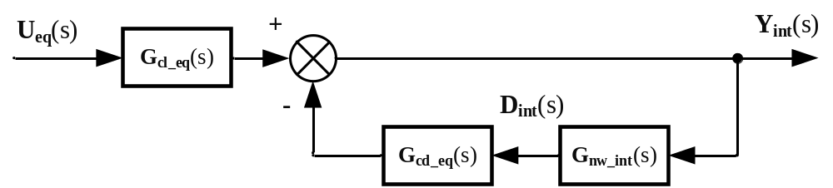
(b)
Figure 3-3. (a) Equivalent interconnected system and (b) equivalent MIMO feedback system of the interconnected system.

They can be expressed as ( 3.13 ) - ( 3.17 ).
$$Y_{int}\left(s\right)={\left[I_{s1}\left(s\right),I_{S2}\left(s\right), …,I_{sn}\left(s\right) \right]}^{T}$$ | ( 3.13 )
$$U_{eq}(s)={\left[I_{s1}^{*}\left(s\right), I_{s2}^{*}\left(s\right), …, I_{sn}^{*}\left(s\right)\right]}^{T}$$ | ( 3.14 )
$$D_{int}(s)={\left[V_{s1}\left(s\right),V_{s2}\left(s\right), …,V_{sn}\left(s\right)\right]}^{T}$$ | ( 3.15 )
$$G_{cl_eq}(s)=diag\left[G_{clv1_eq}\left(s\right),…,G_{clvn_eq}\left(s\right)\right]$$ | ( 3.16 )
$$G_{cd_eq}(s)=diag\left[Z_{ov1_eq}\left(s\right), …,Z_{ovn_eq}\left(s\right)\right]$$ | ( 3.17 )
With ( 3.11 ) and ( 3.12 ), the output vector $Y_{int}(s)$ of the equivalent interconnected system can be derived as ( 3.18 ).
$$Y_{int}\left(s\right)={\left[I+G_{cd_eq}(s)G_{nw_int}(s)\right]}^{-1}G_{cl_eq}(s)U_{eq}(s)$$ | ( 3.18 )
The return-ratio matrix $L_{int}(s)$ and the return-difference matrix $F_{int}(s)$ of the interconnected system are defined as ( 3.19 ) and ( 3.20 ).
$$L_{int}\left(s\right)=G_{cd_eq}(s)G_{nw_int}(s)$$ | ( 3.19 )
$$F_{int}\left(s\right)=I+L_{int}\left(s\right)=I+G_{cd_eq}(s)G_{nw_int}(s)$$ | ( 3.20 )
Given that all sub-areas are confirmed stable with ideal external conditions before connecting to the interconnection network, $G_{cl_eq}$ is established stable. Consequently, the small-signal stability of the interconnected system can be predicted by checking $L_{int}(s)$ or $F_{int}\left(s\right)$. The determinant-based criterion for$det\left(F_{int}\right)$ will be used here to analyze the small-signal stability at the interconnection level.

Stability Analysis at the Sub-Area Level in Step 4
As introduced in Section 3.3.2, the determinant-based criterion is used to analyze the small-signal stability at the sub-area level. The $i^{th}$ sub-area is stable if and only if $N_{(0, j0)}\left(det\left(F_{i}\right)\right)$ is 0. To analyze each sub-area with this stability criterion, the Nyquist diagram or the Bode plot of $det\left(F_{i}\right)$ can be used.
Upon confirming the stability of each sub-area, the subsequent step involves the computation of the equivalent impedance/admittance matrix for that specific sub-area.
Conversely, if the sub-area is found to be unstable, the converters contributing to the instability needs to be identified. To identify the converters responsible for the $i^{th}$ sub-areas instability, characteristic loci and PF matrix of $L_{i}(s)$ will be examined as follows. Let $Φ_{i_j}={\left[Φ_{i_j1},Φ_{i_j2},…,Φ_{i_jmi} \right]}^{T}$ and $Ψ_{i_k}={\left[Ψ_{i_j1},Ψ_{i_j2},…,Ψ_{i_jmi} \right]}^{T}$to be the right and left eigenvectors of the eigenvalue $λ_{k}$ of $L_{i}(s)$, where $m_{i}$ is the number of converters in the $i^{th}$ sub-area.
Then the PF matrix can then be calculated as ( 3.21 ), where the PF matrix element ${PF}_{i_jk}=Ψ_{i_jk}Φ_{i_jk}$.
$${PF}_{i}=\left[\begin{matrix}{PF}_{i_11} & {PF}_{i_12} & ⋯ & {PF}_{i_1 2m_{i}} \\ {PF}_{i_21} & {PF}_{i_22} & ⋯ & {PF}_{i_2 2m_{i}} \\ ⋮ & ⋮ & ⋱ & ⋮ \\ {PF}_{i_ 2m_{i} 1} & {PF}_{i_ 2m_{i} 2} & ⋯ & {PF}_{i_ 2m_{i} 2m_{i}}\end{matrix}\right]$$ | ( 3.21 )
The participation factors represent the interaction degree between the converters and the corresponding eigenvalues [100]. They can help to reveal which converters or nodes are mostly related to the instability. The larger the participation factor, the more relevant the converter is to the state. To identify the instability-related converters, only the eigenvalues that encircle the critical point $\left(-1,j0\right)$ needs to be considered, and the PF matrix will be calculated at the unstable frequency [24]. The most instability-involved converters can then be identified. The identified unstable converters will be then isolated from their original sub-area, creating new individual "sub-areas". As these converters are inherently stable under ideal external conditions, these single-converter sub-areas require no further sub-area level analysis. The analysis process will be iterated until all sub-areas are stable with ideal external conditions. Subsequently, equivalent impedance/admittance models of these stable sub-areas will be derived and integrated into the interconnection network. Note that when unstable sub-areas are regrouped, the interconnection matrix should be updated accordingly.

Equivalent Impedance Matrix of Sub-Areas in Step 5
Following the completion of sub-area level analysis, the subsequent step involves the calculation of the equivalent impedance matrix pertaining to all sub-areas, as observed from the interconnection nodes.
To calculate the equivalent impedance matrix of the $i^{th}$ sub-area showed in Figure 3-4, the closed-loop disturbance-to-output transfer function matrix $G_{cdi}(s)$ and the connection network admittance matrix $Y_{bus_i}(s)$ are needed with some modifications. Assuming that the $i^{th}$ sub-area contains $m$ converters, $G_{cdi}(s)$ can be expressed as ( 3.22 ).
$$G_{cdi}(s)=diag\left[Y_{oc1}\left(s\right), Y_{oc2}\left(s\right),…,Y_{ocm}\left(s\right)\right]$$ | ( 3.22 )
Also, assume that the $i^{th}$ sub-area has k buses connected to the interconnection network and n buses not connected to the interconnection network nor the grid-connected converters. To calculate the connection network admittance matrix, the admittance matrix of the sub-area network can be derived as ( 3.23 ).
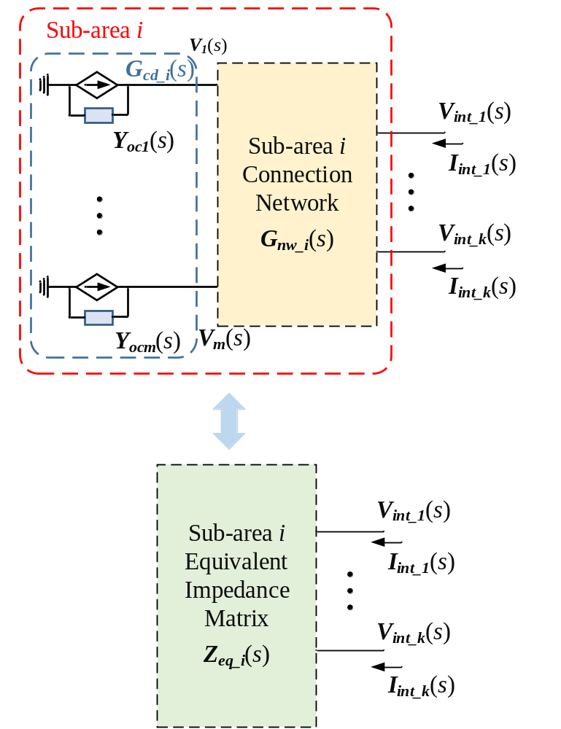
Figure 3-4. Equivalent impedance matrix of the $i^{th}$ sub-area.

$$\left[\begin{matrix}I_{k+m} \\ I_{n}\end{matrix}\right]=Y_{subi}\left[\begin{matrix}V_{k+m} \\ V_{n}\end{matrix}\right]=\left[\begin{matrix}Y_{k+m,k+m} & Y_{k+m,n} \\ Y_{n,k+m} & Y_{nn}\end{matrix}\right]\left[\begin{matrix}V_{k+m} \\ V_{n}\end{matrix}\right]$$ | ( 3.23 )
Since $I_{n}={\left[0,…,0\right]}^{T}$, the connection network admittance matrix $Y_{bus_i}(s)$ can be derived using the Kron reduction given in ( 3.24 ).
$$I_{k+m}=Y_{bus_{i}}V_{k+m}=\left(Y_{k+m,k+m}-Y_{k+m,n}Y_{nn}^{-1}Y_{n,k+m}\right)V_{k+m}$$ | ( 3.24 )
Let
$$Y_{bus_{i}}=\left(Y_{k+m,k+m}-Y_{k+m,n}Y_{nn}^{-1}Y_{n,k+m}\right)=\left[\begin{matrix}Y_{kk} & Y_{km} \\ Y_{mk} & Y_{mm}\end{matrix}\right]$$ | ( 3.25 )
Then, the I-V relationship of the sub-area $i$ can be expressed as ( 3.26 ).
$$\left[\begin{matrix}I_{int} \\ 0\end{matrix}\right]=\left[\begin{matrix}Y_{kk} & Y_{km} \\ Y_{mk} & Y_{mm}+G_{cdi}\end{matrix}\right]\left[\begin{matrix}V_{int} \\ V_{m}\end{matrix}\right]$$ | ( 3.26 )
By applying the Kron reduction to equation ( 3.26 ), the equivalent admittance matrix and equivalent impedance matrix of the sub-area $i$ can be derived as ( 3.27 ) and ( 3.28 ).
$$Y_{eq_i}=Y_{kk}-Y_{km}{\left(Y_{mm}+G_{cdi}\right)}^{-1}Y_{mk}$$ | ( 3.27 )
$$Z_{eq_i}=Y_{eq_i}^{-1}$$ | ( 3.28 )
With the calculated equivalent impedance/admittance matrix of all sub-areas, the small-signal stability of the interconnected system can then be analyzed as the next step.

Stability Analysis at the Interconnection Level in Step 6
The determinant-based criterion is also used for the small-signal stability as the interconnection level. By employing either the Nyquist diagram or Bode plot of $det\left(F_{int}\right)$ , the small-signal stability analysis can be carried out.
If $N_{(0, j0)}\left(det\left(F_{int}\right)\right)$ is 0, then the entire system is stable. Conversely, if $N_{(0, j0)}\left(det\left(F_{int}\right)\right)$ is not 0, it means the interconnected system is unstable. Similar to the analysis approach undertaken at the sub-area level in Section 3.3.3, the characteristic loci of $L_{int}(s)$ and the PF matrix can be used to identify the instability-related sub-areas/converters when the interconnection is determined to be unstable.

Case Studies 1: The Six-Converter System
To verify the effectiveness of the proposed system partitioning-based NAM method, an illustrative example involving a six-converter system is investigated. Despite its small scale, this six-converter system can illustrate the proposed approach more clearly with different working conditions, and it can also be more easily experimentally verified.

Six-Converter Test System
Figure 3-5 (a) shows the example six-converter system. Detailed parameters of the example system are listed in Table 3-1 and Table 3-2.
$G_{11}$, $G_{12}$, $G_{21}$, and $G_{22}$ are four voltage-controlled converters with current feedforward control, while $G_{13}$ and $G_{23}$ are two current-controlled converters with voltage feed-forward control. To verify the proposed method, four cases are tested within this six-converter system. To compare the results of different partition strategies, case I and case II are conducted under the same reference operating condition. The system is stable with a reference design shown in Table 3-1 and Table 3-2 in case I and case II. In both case III and case IV, the cutoff frequency of the voltage feedforward control in the current-type converter $G_{23}$ is increased from $2π×200 rad/s$ to $2π×1000 rad/s$. Additionally, the interconnection line in case IV is changed to connect Bus 12 and Bus 23, as shown in Figure 3-5 (b).
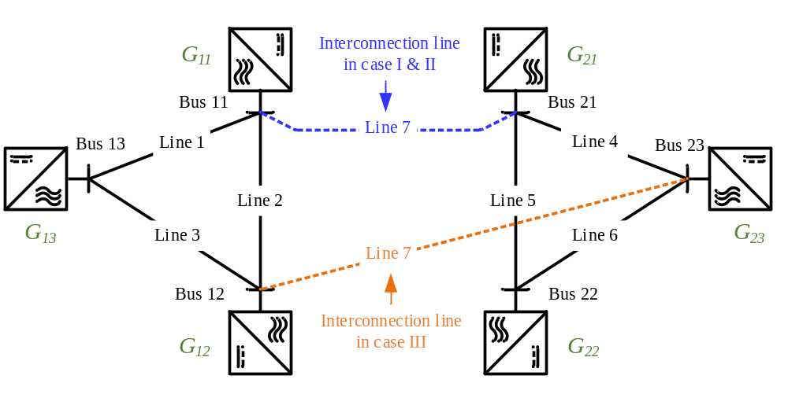
(a)

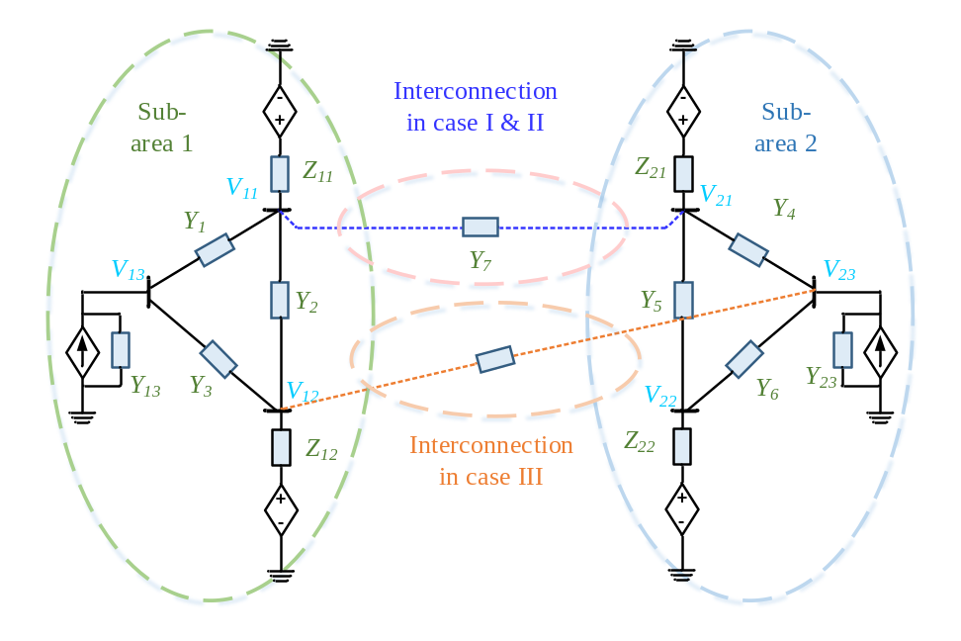
(b)
Figure 3-5 (a) the example six-converter system; (b) area partition under case I, case II, case III, and case IV.

Table 3-1 Electrical Parameters of the six-converter system
Electrical Parameters |  | Values
Ac voltage base | $$V_{base}$$ | 50 V
Ac power base | $$S_{base}$$ | 1302 VA
Fundamental frequency | $$ω_{f}$$ | $$2π×60 rad/s$$
Line impedances | $$L_{1}, R_{1}$$ | 2.45 mH, 0.12 Ω
Line impedances | $$L_{2}, R_{2}$$ | 1.2 mH, 0.04 Ω
Line impedances | $$L_{3}, R_{3}$$ | 0.7 mH, 0.035 Ω
Line impedances | $$L_{4}, R_{4}$$ | 10.7 mH, 0.65 Ω
Line impedances | $$L_{5}, R_{5}$$ | 2.5 mH, 0.12 Ω
Line impedances | $$L_{6}, R_{6}$$ | 0.7 mH, 0.04 Ω
Line impedances | $$L_{7}, R_{7}$$ | 0.7 mH, 0.035 Ω

Table 3-2 Parameters of converters
Electrical Parameters |  | Values
$L$ filter | $$L_{f}, R_{f}$$ |  | 0.575 mH, 0.2 Ω
Dc voltage | $$V_{dc}$$ |  | 200 V
Switching frequency | $$f_{sw}$$ |  | 10 kHz
Voltage-Controlled Converters |  |  | Values
PI voltage controller | $$K_{vp}, K_{vi}$$ |  | 1.04, 325
Voltage measurement filter | $$ω_{fv}$$ |  | $$2π×300 rad/s$$
Current measurement filter | $$ω_{fc}$$ |  | $$2π×1000 rad/s$$
Current-Controlled Converters |  |  | Values
PLL PI parameters | $$K_{pllp}, K_{plli}$$ |  | 1.06, 18
PI current controller | $$K_{ip}, K_{ii}$$ |  | 2.6, 2275
Voltage feed-forward gain | $$ω_{ffv}$$ |  | $$2π×200 rad/s$$

Stability Analysis Results
To analyze the small-signal stability of the six-converter system using the proposed method, the $dq$ impedance and admittance models of all system components should be derived first. This six-converter system contains voltage-controlled and current-controlled converters, together with RL transmission line models. The $dq$ impedance and admittance models derived for these components can be found in [32].
As stated in Section 3.3, when analyzing the small-signal stability at the sub-area level and the interconnection level, the determinant-based GNC is adopted, and the Nyquist diagram or Bode plot can be applied for the $det\left(F_{int}\right)$ analysis. Considering the large magnitude variation in the Nyquist diagram, the Bode plot is a better choice when analyzing the system’s small-signal stability. ${180}^{°}$ decrease of phase angle in the Bode plots means the one encirclement of the origin point $\left(0,j0\right)$ in the clockwise direction.
Figure 3-6 and Figure 3-7 show the bode plots for $det\left(F_{int}\right)$ of the six-converter system, respectively. To compare the results of different partition strategies, case I and case II are conducted under the same reference operating condition. In case I, the system is decomposed into 2 sub-areas, as shown in Figure 3-5 (b). In case II, the system is decomposed into 3 sub-areas, as $G_{21}$ and $G_{22}$ forms sub-area 2, and $G_{23}$ forms sub-area 3. With the 2 sub-areas partition in case I, by applying the proposed method, both sub-area 1 and 2 are predicted to be stable, and the interconnection of the two sub-areas is also predicted to be stable, as shown in Figure 3-6, where the phase variation in the full positive frequency range $\left(0, +∞\right)$ is $0^{°}$. Similarly, in case II, with the different 3 sub-areas partition, all 3 sub-areas are stable, and the interconnection of these 3 sub-areas is also predicted to be stable, as shown in Figure 3-7. The results show that the analysis results are the same regardless of partition strategies.
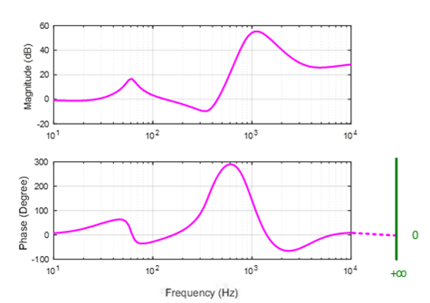
(a)
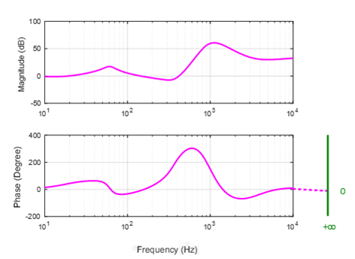
(b)
Figure 3-6 Bode plots of $det(F)$ in Case I: (a) area 1, (b) area 2, and (c) interconnection.

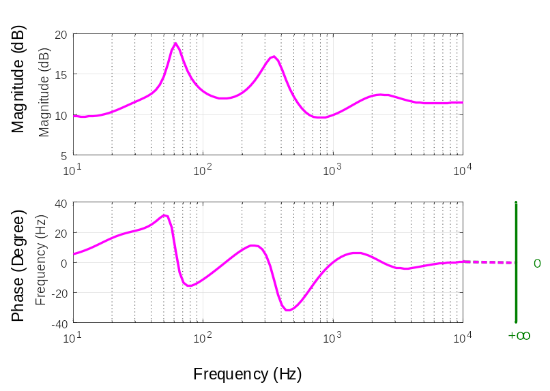
(c)
Figure 3-6 (continued)
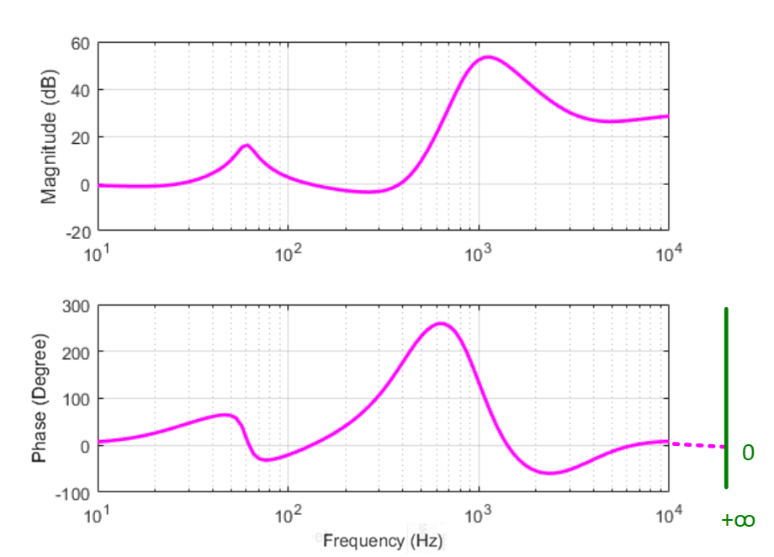
(a)
Figure 3-7 Bode plots of $det(F)$ in Case II: (a) area 1, (b) area 2, and (c) interconnection.

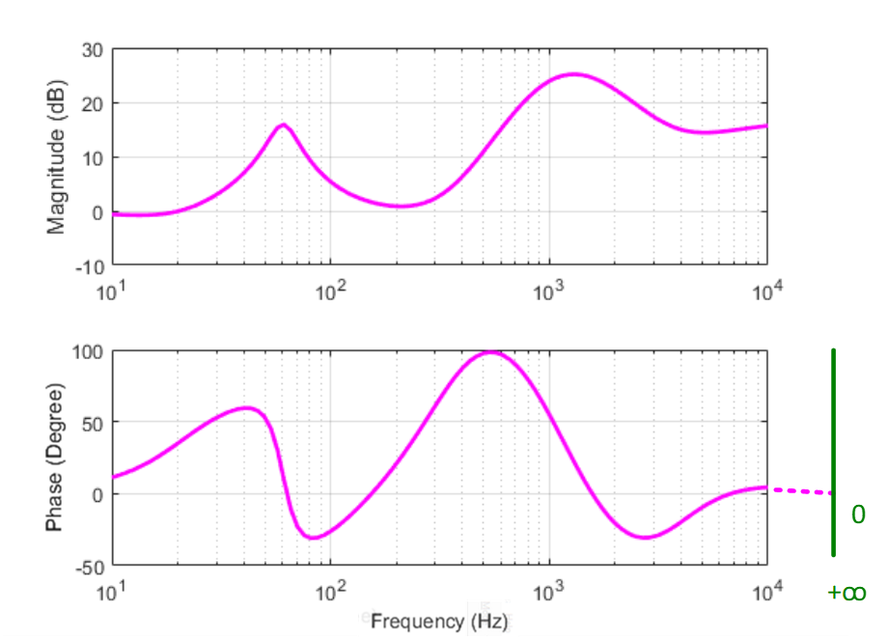
(b)
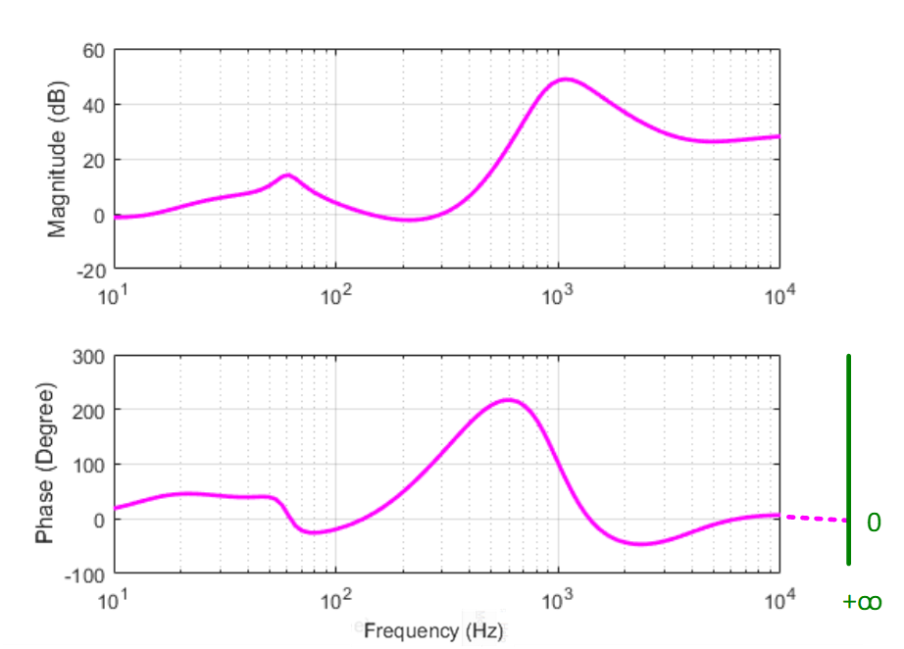
(c)
Figure 3-7 (continued)

In case III, with the change of the control parameters of $G_{23}$, the sub-area 2 is predicted to be unstable. In this case, the characteristic loci and the PF matrix are calculated for sub-area 2 to identify the instability-related converters. One should be noted that only the eigenvalues encircling the critical point need to be considered, which is $λ_{3}$ in this case. Absolute PF values of $λ_{3}$ are calculated at the unstable frequency and are shown in Table 3-3. When the PF value of one converter is larger, it means the corresponding converter is more relevant to the system's instability. As shown in Table 3-3, the current-type converter $G_{23}$ is identified to be the instability-related converter in sub-area 2. Then, as explained in Section II, sub-area 2 will be regrouped. Converter $G_{23}$ will form a new sub-area and the converter $G_{21}$ and $G_{22}$ will form another new sub-area. By checking that the new sub-area formed by the converter $G_{21}$ and $G_{22}$ is stable, the small-signal stability of the interconnected system can then be analyzed. As shown in Figure 3-8, the interconnection of these sub-areas is predicted to be unstable, and the phase variation in the full positive frequency range $\left(0, +∞\right)$ is ${-360}^{°}$, which represents 2 RHP poles in the six-converters system under case III.
In case IV, when analyzing the small-signal stability at the sub-area level, a similar analysis is done by applying the proposed method. With the changed interconnection line in case III, the interconnection of the sub-areas is predicted to be stable, as shown in Figure 3-9 with $0^{°}$ phase variation in the full positive range.
Table 3-3 Absolute values of participation factors in Case III
Converters | PF of $λ_{3}$
$$G_{21}$$ | 0.0361 | 0.0398
$$G_{22}$$ | 0.0770 | 0.0856
$$G_{23}$$ | 0.3283 | 0.3641

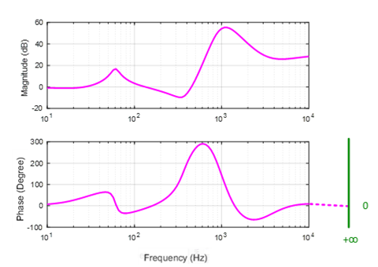
(a)
Figure 3-8 Bode plots of $det(F)$ in Case III: (a) area 1, (b) area 2, and (c) interconnection.

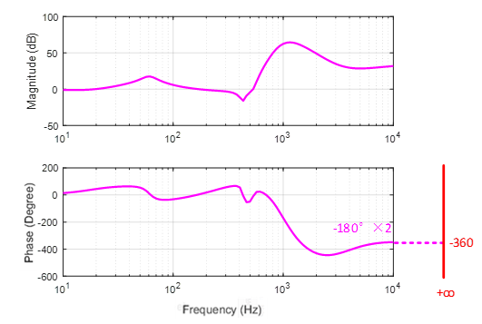
(b)

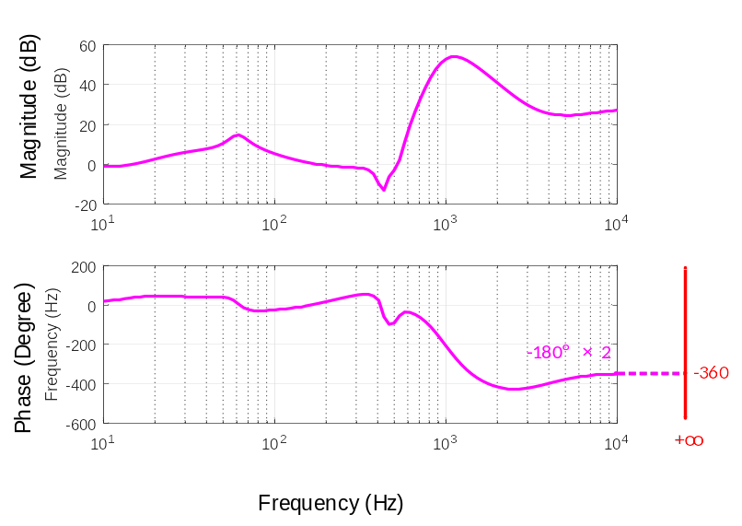
(c)
Figure 3-8 (continued)

(a)

(b)
Figure 3-9 Bode plots of $det(F)$ in Case IV: (a) area 1, (b) area 2, and (c) interconnection.
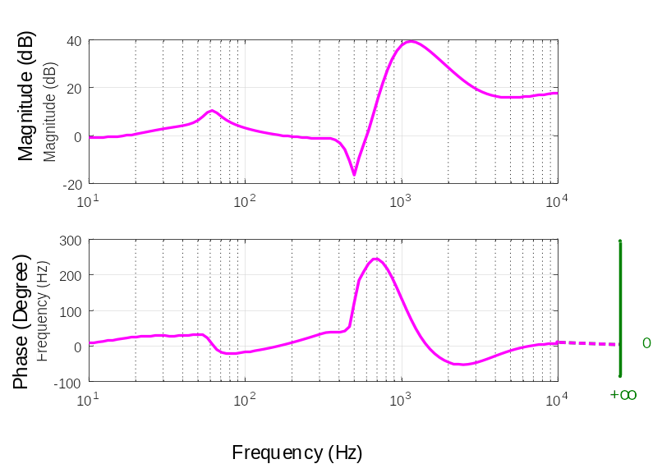
(c)
Figure 3-9 (continued)

Experimental Results
To verify the analytical results under the three cases, an experimental platform of the six-converter system based on the hardware testbed (HTB) [33, 34] is established, as shown in Figure 3-10. Six converters in the converter cabinets shown in Figure 3-10 (a) are used as the voltage- and current-type converters, while the variable inductor cabinets shown in Figure 3-10 (b) are used to emulate the transmission lines in the 6-converter system. The same parameters in Table 3-1 and Table 3-2 are used in the HTB setup.
Figure 3-11 shows the experimental waveforms of the six-converter system under the above three cases. It can be seen that the experimental results are the same as the analytical results, where the six-converter system is stable in both case I (case II) and case IV, and it’s unstable in case III with harmonics around 420 Hz.

Case Studies 2: The Modified NPCC System

Modified NPCC Test System
To further verify the proposed method in large-scale systems, a modified system based on the 140-bus simplified Northeast Power Coordinating Council (NPCC) system [101] with all PECs is built in PSCAD/EMTDC. Figure 3-12 shows the one-line diagram of the modified 140-bus NPCC system. Models of all system components are automatically imported into PSCAD models from PSS/E using the E-TRAN program first. Then, to analyze the small-signal stability of power-electronics-based grids, all 46 generators in the original NPCC system are replaced by grid-connected inverters. These inverters include 4 inverters with grid-forming (GFM) control and 42 inverters with grid-following (GFL) control. Considering the simulation time with a large number of inverters involved, the average converter models are used in the PSCAD simulation.
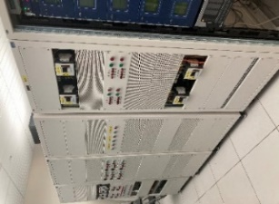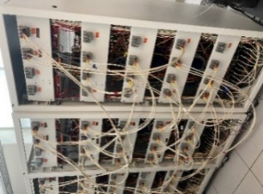
Figure 3-10 6-converter system based on HTB: converter cabinets (left) and
variable inductor cabinets(right)
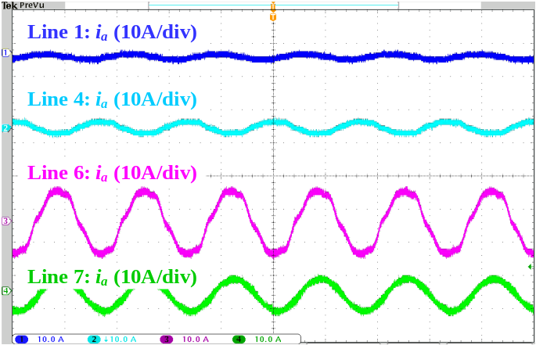
(a)
Figure 3-11 Experimental results of the 6-converter system: (a) case I (case II); (b) case III; (c) case IV.
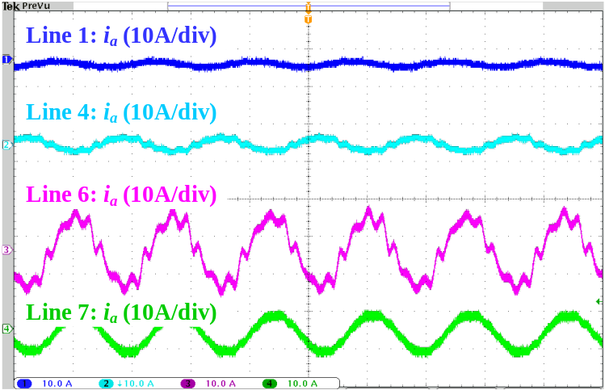
(b)

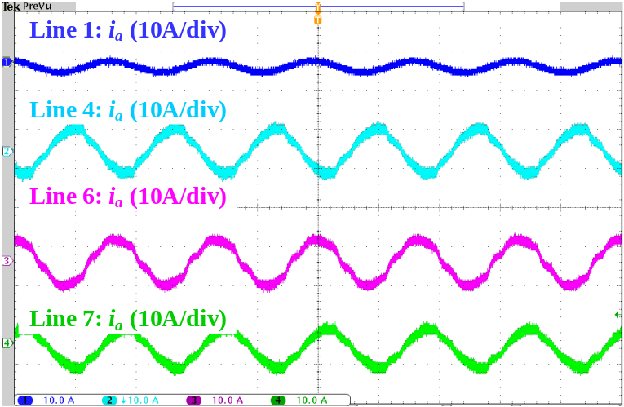
(c)
Figure 3-11 (continued)

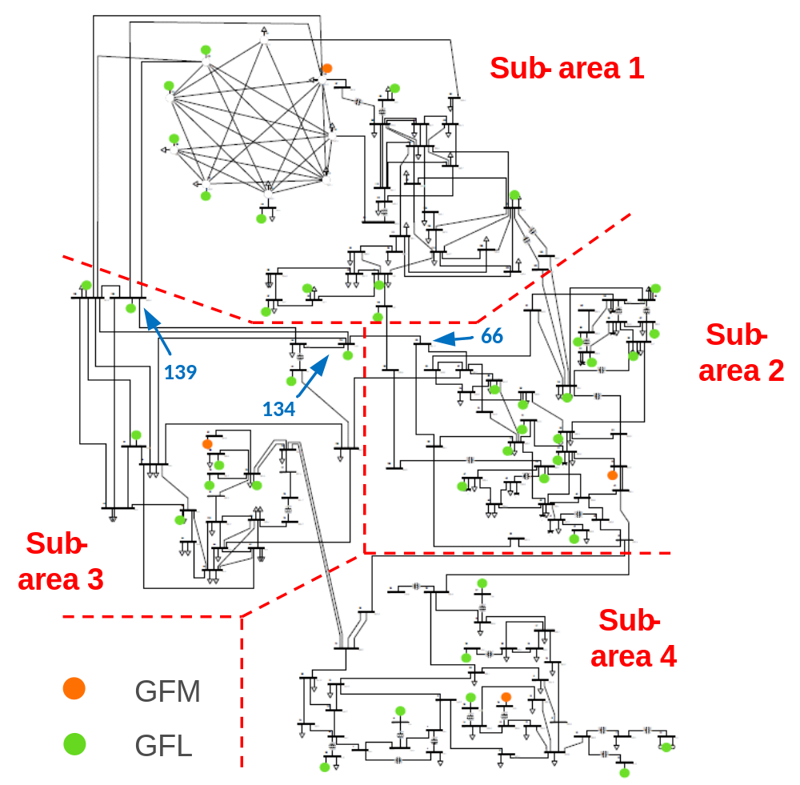
Figure 3-12 The modified 140-bus NPCC system.

Table 3-4 shows the comparison of matrix orders using the original method (which directly applies the NAM-based criterion to the entire system) versus the proposed partition-based method. It can be seen that the proposed partition-based method greatly reduced the matrix order for further computation. Note that each component in these matrices here is a series of frequency-dependent data, so a larger matrix order could greatly increase the computation burden. Thus, if the system is too large (with too many active sources/loads), the matrix order using the original method will also become so large and eventually make it unsolvable. The proposed method can solve this problem by computing lower-order matrices with such a system partition concept.

Impedance Models of System Components
To use the proposed method, the $dq$ impedance models of all system components need to be derived or measured first. In this case, the analytical method is used to derive the impedance models of GFMs, GFLs, transmission lines, transformers, loads, and shunts. The $dq$ impedance models of GFMs and GFLs are derived using the similar methods described in [102].
To ensure the accuracy of large-scale system analysis, the analytical impedance models of all system components are compared with the measured response. To conduct the impedance/admittance scanning for these system components, a scanning unit has been built in PSCAD. The scanning unit uses controlled voltage sources for injecting perturbation signals. It will also measure the response and generate output files from PSCAD. Then, these output files are collected and loaded into MATLAB for further data processing. The impedance/admittance is measured in $dq$ frame. Two independent perturbations are injected into the $d$- and $q$-axis, respectively. The perturbation frequency and switch status can be changed to measure the
Table 3-4 Comparison of Matrix Order Using Original Method vs. Proposed Method
Original Method | Proposed Partition-Based Method
Original Method | Area 1 | Area 2 | Area 3 | Area 4 | Inter-connection
92 | 24 | 32 | 20 | 16 | 32

response at different frequencies. Figure 3-13 and Figure 3-14 show the comparison results of GFM impedance models and GFL impedance models, respectively. It can be seen that for both models, the results of analytical impedance models match well with the measured response.
Note that in Figure 3-14, a small error can be observed in $Y_{dq}$, $Y_{qd}$, and $Y_{qq}$ in the very-low-frequency range. This is because that the magnitudes of these models in the very-low-frequency range are very small, and that makes the frequency sweeping measurements in this range become more sensitive to numerical issues [103]. Such small errors will not cause issues when determining the small-signal stability of the system due to its extremely small magnitude in this range. Impedance/admittance models of other passive system components are also measured and compared with the measurement results.

Stability Analysis Results
To analyze the small-signal stability of the modified NPCC system using the proposed method, the analysis code is developed in MATLAB. The available parameters of all system components in the targeted system are collected first as the code input. Then, the $dq$ impedance models of all components, including grid-connected inverters (GFM & GFL), transmission lines, transformers, loads, and fixed shunts, are derived.
The modified NPCC system is decomposed into four sub-areas and the interconnection network, as shown in Figure 3-12, and the nodal admittance matrices of each sub-area are derived accordingly. Small-signal stability analysis is applied to each sub-area first using the determinant-based GNC. Based on the interconnection of these sub-areas, the small-signal stability of the overall system can be determined by checking the stability of the interconnected system, and the instability-related converters/sub-areas can also be identified by applying the
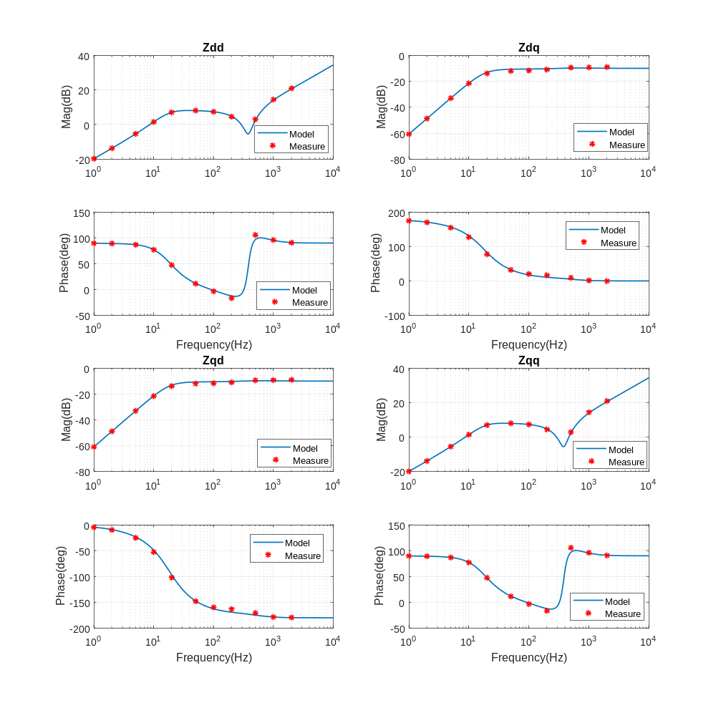
Figure 3-13 The impedance comparison for GFM models.

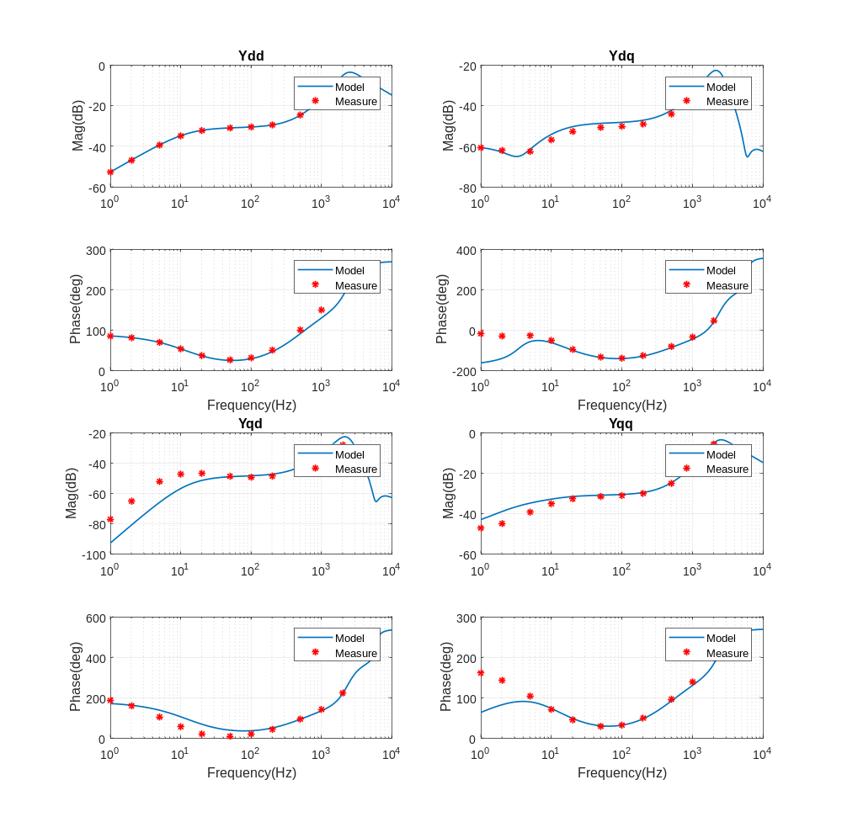
Figure 3-14 The impedance comparison for GFL models.

proposed method. Two cases, including a stable case (Case I) and an unstable case (Case II), are analyzed as follows.
- Case I
With the base design, the small-signal stability at the sub-area level is analyzed first. Figure 3-15 shows the Bode plots of 4 sub-areas. With $0^{°}$ phase change in the full positive frequency range in all 4 sub-areas, these sub-areas are determined to be stable in Case I. Figure 3-16 shows the bode plot of the interconnection of 4 sub-areas. It is shown that the interconnection is also stable with $0^{°}$ phase change. Therefore, the modified NPCC system is determined to be stable in this Case.
- Case II
In Case II, the resistance of the transmission line that connected Bus 66 and Bus 134 is reduced to 10% of the original value. No other parameters are changed in this case. Note that this transmission line 66-134 is one of the interconnection lines which connects sub-area 2 and sub-area 3, as shown in Figure 3-12. By applying the proposed partition-based method to the system, the analysis results at the sub-area level are similar to the results shown in Figure 3-15, so the sub-areas are also determined to be stable in Case II.
However, after deriving the equivalent impedance matrices of these sub-areas and analyzing the small-signal stability of the interconnected system, a ${-360}^{°}$ phase change is observed in the bode plot of the interconnected system, as shown in Figure 3-17. Therefore, the interconnected system is determined to be unstable in Case II. To further analyze the unstable frequency, the characteristic loci of the interconnected system are plotted in Figure 3-18.

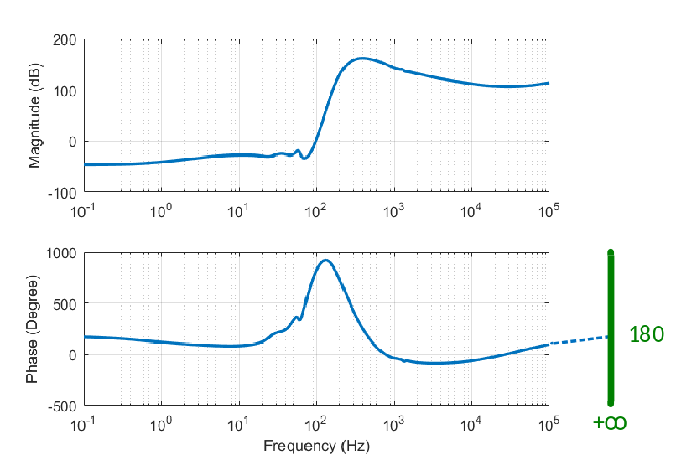
(a)

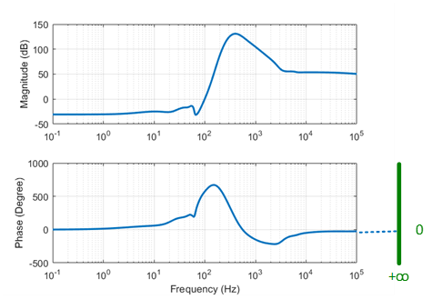
(b)
Figure 3-15 Bode plots of det(F) for 4 sub-areas in Case I: (a) sub-area 1; (b) sub-area 2;
(c) sub-area 3; and (d) sub-area 4.
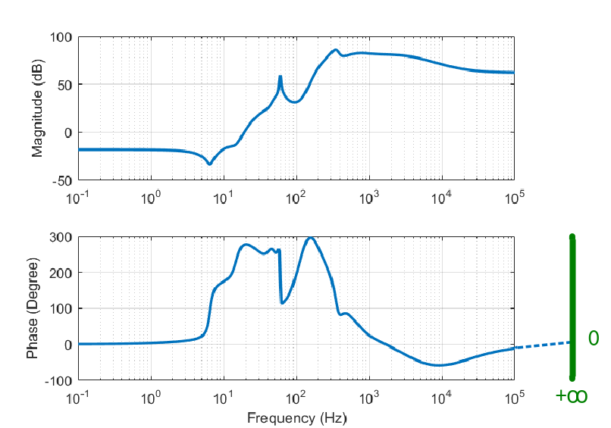
(c)

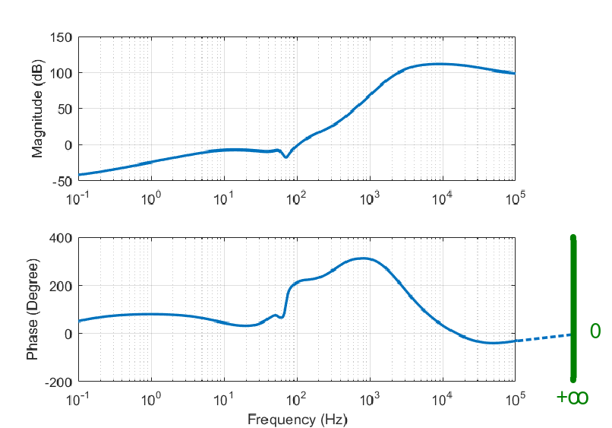
(d)
Figure 3-15 (continued)

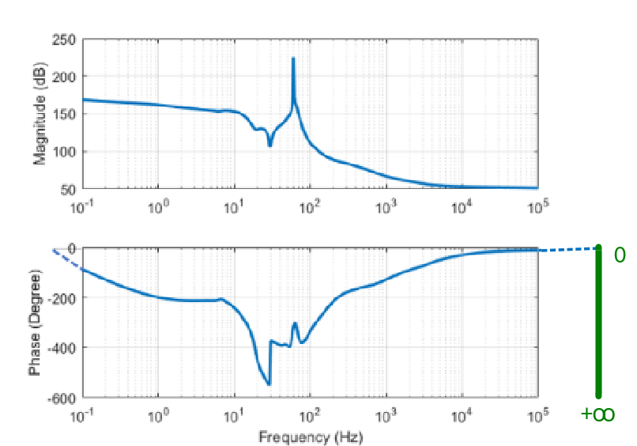
Figure 3-16 Bode plots of $det\left(F_{int}\right)$ for the interconnection in Case I.
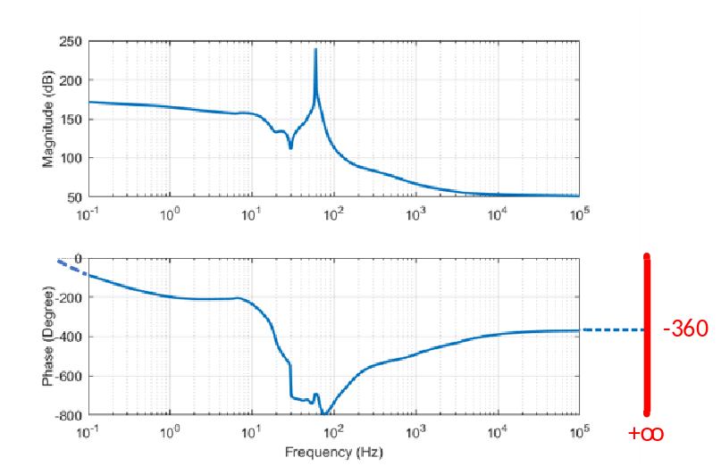
Figure 3-17 Bode plots of $det\left(F_{int}\right)$ for the interconnection in Case II.

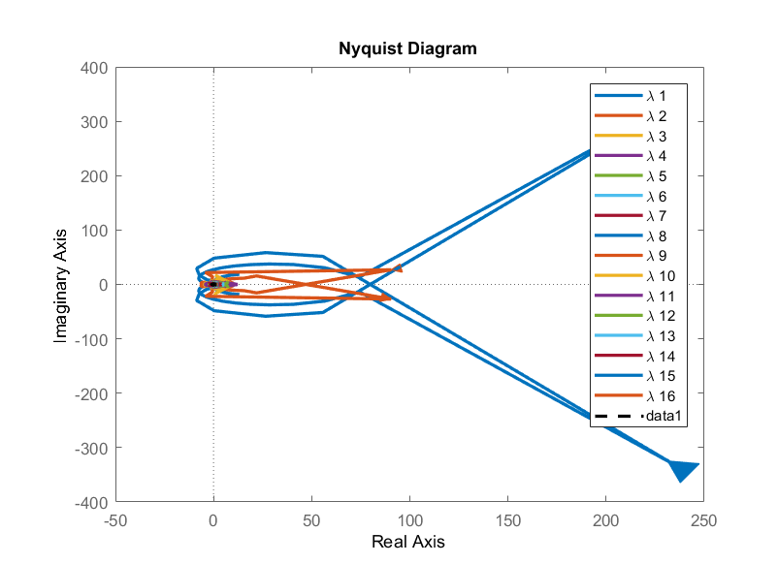
(a)
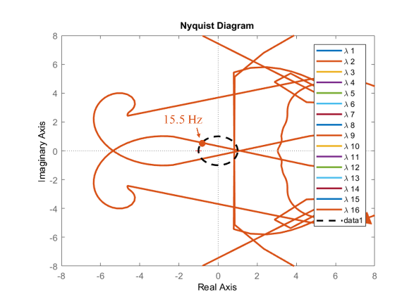
(b)
Figure 3-18 Characteristic loci of $L_{int}(s)$ for the interconnection in Case II: (a) full view; and (b) zoom-in view of $λ_{2}$.
Note that for the conciseness of the figure, only 16 of the total 32 eigenvalues are shown in Figure 3-18, as the rest are smaller and will not encircle the critical point in this case. It is observed that, among the 32 eigenvalues of 16 interconnection nodes, the eigenvalue $λ_{2}$ encircles the critical point $(-1, j0)$, and the unstable frequency is predicted to be 15.5 Hz in $dq$ frame (75.5 Hz in $abc$ frame). To identify instability-related nodes in the interconnected system, the absolute PF values of $λ_{2}$ at the unstable frequency are calculated in Table 3-5. It can be observed that the most related interconnection nodes are Bus 134, Bus 139, and Bus 66, which are close to the transmission line 66-134 with resistance change in this case, as shown in Figure 3-12.

Simulation Results
To verify the above analytical results of the modified NPCC system, a simulation model is built in PSCAD. The same parameters are used in the simulation under Case I and Case II as in the previous analysis. Figure 3-19 shows the voltage and current waveforms at Bus 134 in Case I, which shows the system is stable in this case. Figure 3-20 shows the voltage and current waveforms on transmission line 66-134 in Case II. The system is unstable in this case, with a 75 Hz instability frequency in $abc$ frame (15 Hz in $dq$ frame). Both simulation results match with the analysis results in the previous subsection in different cases using the proposed method.

Conclusions
This chapter proposes a system partitioning-based NAM approach for the small-signal stability analysis of large-scale PEC-rich systems. The simulation and experimental results show:
1) The small-signal stability analysis of the six-converter system and the modified NPCC system under multiple scenarios demonstrate that the proposed partition-based method can predict the small-signal stability of PEC-rich systems accurately and effectively.
Table 3-5 Absolute values of PF of interconnection in Case II
Interconnection Nodes | PF of $λ_{3}$
115 | 0.0020 | 0.0003
98 | 0.0000 | 0.0000
101 | 0.0011 | 0.0009
122 | 0.0046 | 0.0044
48 | 0.0001 | 0.0002
54 | 0.0025 | 0.0024
37 | 0.0036 | 0.0032
66 | 0.0493 | 0.0691
67 | 0.0067 | 0.0053
135 | 0.0098 | 0.0106
134 | 0.0833 | 0.1066
139 | 0.0755 | 0.0512
74 | 0.0123 | 0.0087
138 | 0.0093 | 0.0083
29 | 0.0004 | 0.0006
35 | 0.0001 | 0.0001

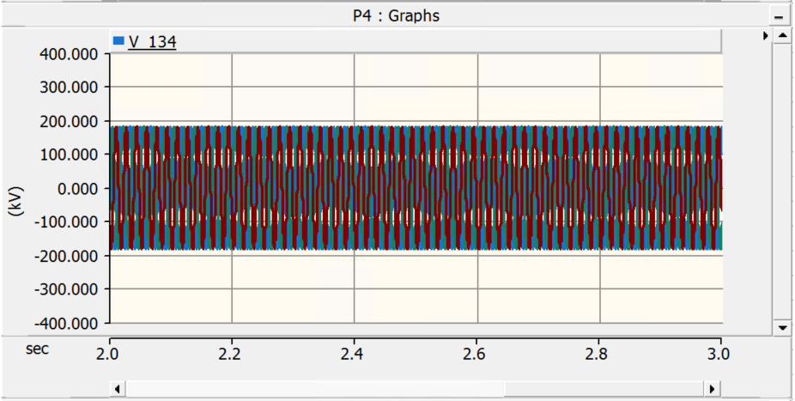
(a)

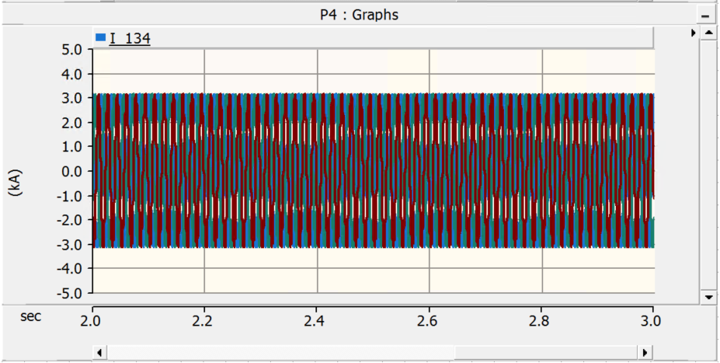
(b)
Figure 3-19 (a) voltage and (b) current waveforms at Bus 134 in Case I.

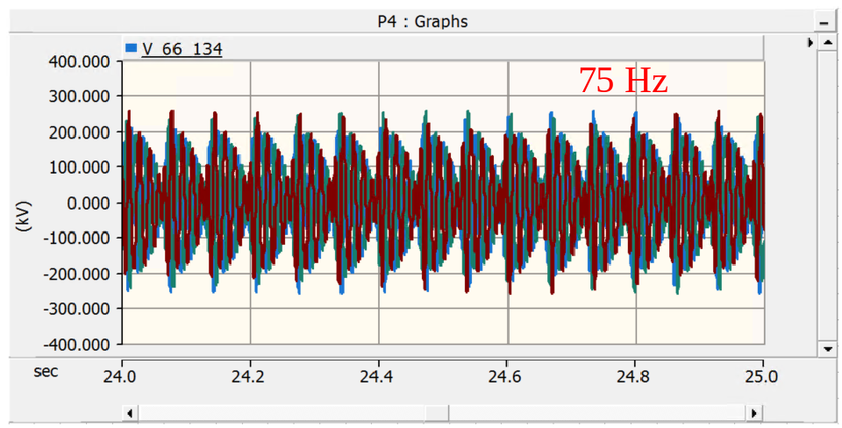
(a)

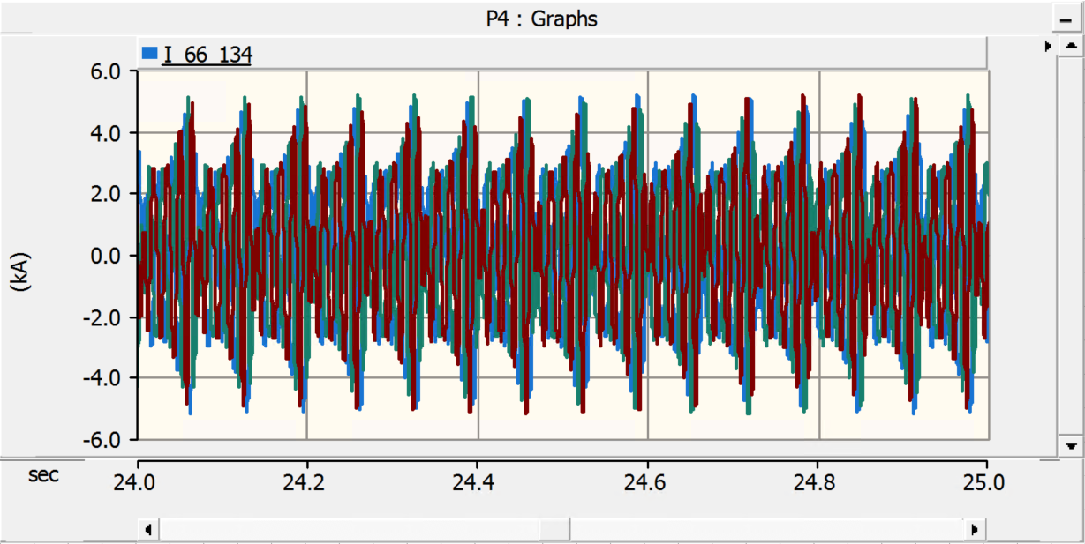
(b)
Figure 3-20 (a) voltage and (b) current waveforms on transmission line 66-134 in Case II.

2) By employing system partition, the proposed method reduces the orders of system matrices, which consequently helps to reduce the computation burden and simplifies the identification process of instability-related converters or nodes. Thus, this method renders the analysis of small-signal stability of large-scale systems feasible.
3) The partitioning concept proposed in this method enhances its scalability and flexibility by allowing for easy modifications to be made solely to the corresponding sub-areas or interconnections, whenever there are changes in the system structure, such as contingencies. This characteristic significantly reduces the time and effort required to adapt the stability analysis to system changes, thereby increasing the method's practicality and effectiveness.
The future work includes designing automated partition strategy, implementing parallel computing with subarea-level analysis, and extending to multi-level partitioning for extremely large systems.

A Potential Issue of Using the NAM-based MIMO Nyquist Criterion in Impedance-based Stability Analysis

Introduction
In this chapter, it is found that when applying the determinant-based GNC for small-signal stability analysis of power systems, pure inductance models in MIMO system models may lead to wrong prediction results for the system’s stability in some cases. The pure inductance models in system models can induce imaginary axis poles at 60 Hz and thus lead to incorrect results in both stable and unstable cases when using the determinant based GNC. This issue has not been reported in the literature so far, and therefore, this chapter intends to 1) identify the issue induced by pure inductance models when applying the determinant-based GNC in practical applications; 2) illustrate the issue based on the equivalence of eigenvalue-based and determinant-based GNC; and 3) provide solutions for this issue.

Potential Issue of the Determinant-based GNC

The Equivalence of Eigenvalue- and the Determinant-based GNC
As stated in Section 2.1.2-C, when using the NAM-based criterion, the system is stable if and only if the characteristic loci of $L\left(s\right)$ open-loop transfer function do not encircle $\left(-1, j0\right)$. Equivalently, the system is stable if and only if the Nyquist plot of $det\left(F\right)$ do not encircle $\left(0, j0\right)$, or the phase angle change of the full frequency range is $0$ in the Bode plot of $det\left(F\right)$.
The equivalence of these two GNCs is due to ( 4.1 ) [104], where $λ_{n}$ is the eigenvalue of $L\left(s\right)$.
$$det\left(F\right)=det\left(I+L\right)=\prod_{n}{\left(1+λ_{n}\right)}$$ | ( 4.1 )

The Issue with Pure Inductance Models
The determinant-based GNC, however, can have issues when applied to systems with pure inductance models. Although there is no pure inductance in real systems, an inductor or a reactor is often simplified as a pure inductance when modeling the systems in many cases. The $dq$ impedance model of a pure inductance $L$ considering the coupling terms is given in ( 4.2 ), where $ω_{60}$ denotes angular frequency corresponding to the system frequency, i.e., 60 Hz.
$$Z_{L}= \left[\begin{matrix}sL & -ω_{60}L \\ ω_{60}L & sL\end{matrix}\right]$$ | ( 4.2 )
The $dq$ admittance model of $L$ can be derived as ( 4.3 ).
$$Y_{L}=Z_{L}^{-1}= \frac{1}{s^{2}L^{2}+ω_{60}^{2}L^{2}}\left[\begin{matrix}sL & ω_{60}L \\ -ω_{60}L & sL\end{matrix}\right]$$ | ( 4.3 )
As seen from ( 4.3 ), the $dq$ admittance model of pure inductance $L$ has imaginary axis poles at $±60 Hz$. The MIMO network impedance matrix $G_{nw}\left(s\right)$, which is derived based on admittance models of passive components in the connection network and its network topology, can thus have such imaginary axis poles that are induced by these pure inductance components in corresponding matrix elements. Note that the Kron reduction and $G_{nw}\left(s\right)$ reformation when deriving $G_{nw}\left(s\right)$ [27] can still preserve such imaginary axis poles in many cases. Thus, when calculating the return-ratio matrix $L\left(s\right)$ as the multiplication of diagonal matrix $G_{cd}\left(s\right)$ and network impedance matrix $G_{nw}\left(s\right)$ as in (2.7), the imaginary axis poles could be induced in $L\left(s\right)$ because of these pure inductance components in the system, as will be shown in an example.
In the GNC, the “Nyquist plot” means “the image as $s$ goes clockwise around the Nyquist D-contour”. When there are imaginary axis poles in the system, D-contour must avoid locations where $L\left(s\right)$ has imaginary axis poles by making small indentations (semi-circles) around these points [105]. As pure inductances induce imaginary axis poles at $±60 Hz$, the D-contour of the system should be like in Figure 4-1. Finding of all eigenvalues of $L\left(s\right)$ with frequency $s$ varying along Nyquist D-contour in the complex plane becomes a major interest in coping with the stability problem for multi-variable systems.
To apply the MIMO Nyquist criterion, the eigenvalue loci should be calculated as a function of frequency. The eigenvalues can be computed by conventional techniques for a given frequency, and theoretically, one would have to repeat the entire computational procedure for all frequencies. However, it is impractical for such repetition in the actual stability analysis. For both eigenvalue- and determinant-based GNC, a more practical way of using software (e.g., MATLAB) is to calculate the eigenvalues at discrete frequencies in a wide frequency range, and then these points are connected in the software. An example case is used here to illustrate the impact of having imaginary axis poles when applying the MIMO Nyquist criterion, without loss of generality.
- The eigenvalue-based GNC with imaginary axis poles
When applying the eigenvalue-based GNC, assume there are two eigenvalues $λ_{1}\left(s\right)$ and $λ_{2}\left(s\right)$ for $L\left(s\right)$, as given in ( 4.4 ) and ( 4.5 ).
$$λ_{1}\left(s\right)=a_{1}\left(s\right)+jb_{1}\left(s\right)$$ |  | ( 4.4 )
$$λ_{2}\left(s\right)=a_{2}\left(s\right)+jb_{2}\left(s\right)$$ |  | ( 4.5 )
 | 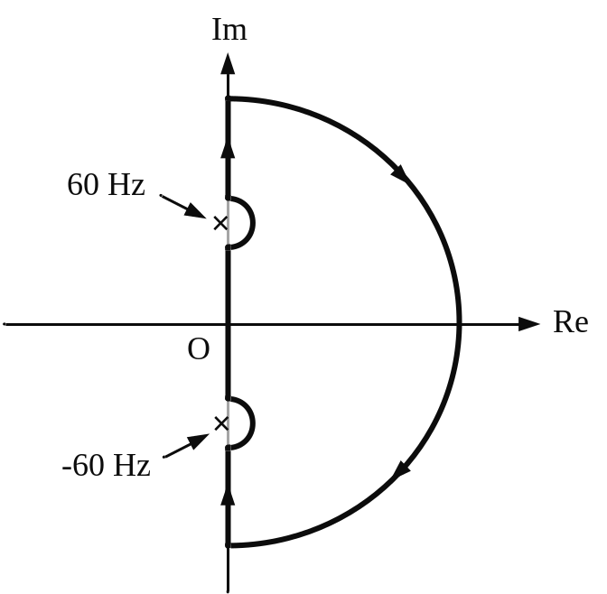
 | Figure 4-1 The closed contour with indentations to avoid open-loop modes on the imaginary axis.

When $L\left(s\right)$ has imaginary axis poles at $60 Hz$ due to pure inductance components, these eigenvalues become very large near $60 Hz$ in practical implementation when using software like MATLAB. Without loss of generality, assume the polarities of these eigenvalues are that the real part $a_{1}\left(s\right)$ and $a_{2}\left(s\right)$ of the eigenvalues are positive; the imaginary parts $b_{1}\left(s\right)$ and $b_{2}\left(s\right)$, quickly change from $+∞$ to $-∞$ at ${60}^{-} Hz$ and ${60}^{+} Hz$. The characteristic loci of $L\left(s\right)$ look like Figure 4-2. Note that only the characteristic loci of the positive frequency range are shown in this figure. The characteristic loci of the negative frequency should be symmetrical to the positive frequency.
- The determinant-based GNC with imaginary axis poles
According to equation ( 4.1 ), for the determinant-based GNC, the determinant of $F$ should be given as ( 4.6 ).
$$det\left(F\right)=\left(1+λ_{1}\right)\left(1+λ_{2}\right)=\left(1+a_{1}a_{2}-b_{1}b_{2}\right)+j\left(a_{1}b_{2}+a_{2}b_{1}\right)$$ | ( 4.6 )
Then, at ${60}^{-} Hz$, the real part of the determinant is negative, and the imaginary part of the determinant is positive; at ${60}^{+} Hz$, the real part is negative, and the imaginary part is also negative. When the points at ${60}^{-} Hz$ and ${60}^{+} Hz$ are connected in MATLAB, and the Nyquist plot of the determinant will look like Figure 4-3. Similar to Figure 4-2, only the positive frequency range of the Nyquist plot is shown here. Corresponding Bode plot of $det\left(F\right)$ will have a ${360}^{°}$ phase change in Bode plot since the Nyquist plot encircles the origin point, as shown in Figure 4-3.

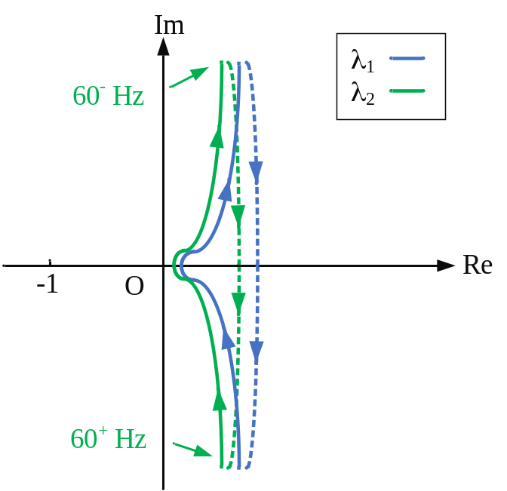
Figure 4-2 Characteristic locus of $L\left(s\right)$ with imaginary axis poles at $60 Hz$.
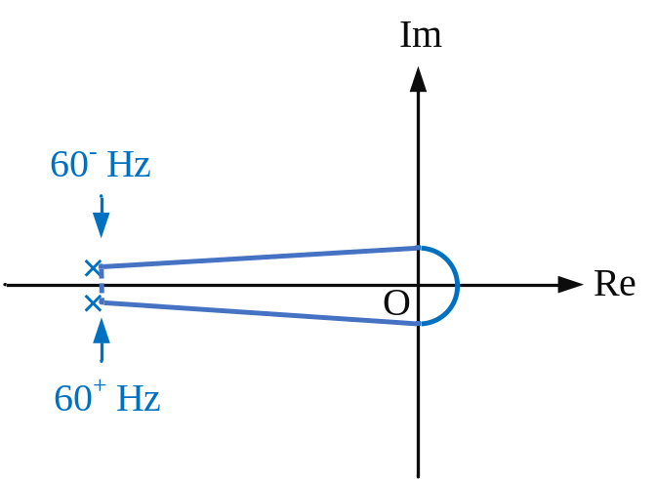
(a)
Figure 4-3 $det\left(F\right)$ with imaginary axis poles at $60 Hz$: (a) Nyquist and (b) Bode plots.
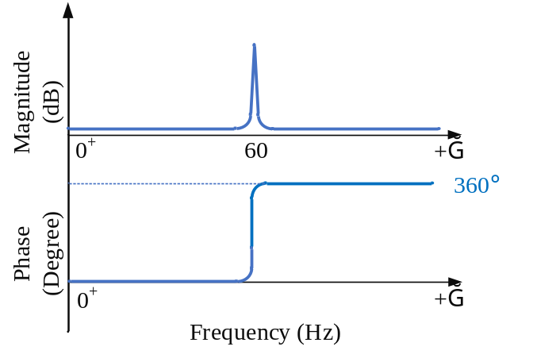
(b)
Figure 4-3 (continued)

When applying the determinant-based GNC to the Nyquist or the Bode plots shown in Figure 4-3, it shows that the system is unstable since the Nyquist plots encircle the origin point twice (considering the full frequency range from $-∞$ to $+∞$), and the phase angle change of the Bode plot in the full positive frequency range is ${360}^{°}$. However, the eigenvalue based GNC shows that the system is stable since $\left(-1, j0\right)$ is not encircled. Similarly, when in an unstable case, the analysis result predicted by the determinant based GNC could be stable because of the wrong ${360}^{°}$ phase change, as shown in Case II of an example system in Section 4.3. Thus, the stability prediction using the determinant-based GNC is in contradiction to the eigenvalue-based GNC in such cases which could provide wrong analytical results, and it is due to the imaginary axis poles induced by the pure inductances in the system.

Case Study: A Five-Bus System with Pure Inductance
To validate the above analysis, a simple case study is built in PSCAD simulation, and the analysis code using determinant- and eigenvalue-based GNC is developed in MATLAB. Moreover, solutions for the issue when using the determinant-based GNC are provided in this section. A five-bus system shown in Figure 4-4 is built in PSCAD as an example for the analysis of general multi-bus systems using the MIMO Nyquist criterion. For simplicity, bus 3 is connected with a grid-following (GFL) converter, while bus 1 and bus 2 are connected to ideal voltage sources. Parameters of the passive components are shown in Table 4-1 and Table 4-2. The example system is stable in Case I, as can be seen from the steady-state voltage and current waveforms shown in Figure 4-5. In Case II, the real power of the load at bus 3 is reduced to 200 MW, which leads to the unstable phenomenon in Case II, as the voltage and current waveforms at bus 3 are shown in Figure 4-6.
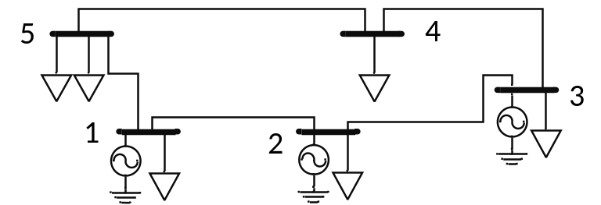
Figure 4-4 The example five-bus system.

Table 4-1 Parameters of lines represented by $R$ and $L$
Bus  # | Rated Voltage  (kV, L-L, RMS) | Rated MVA  (3-Phase) | Resistance  (pu) | Inductive  Resistance (pu)
1-2 | 220 | 100 | 0.0421 | 0.2932
2-3 | 220 | 100 | 0.0049 | 0.0036
3-4 | 220 | 100 | 0.0042 | 0.0283
4-5 | 220 | 100 | 0.0187 | 0.1284
5-1 | 220 | 100 | 0.0261 | 0.1844

Table 4-2 Parameters of constant impedance loads
Bus  # |  | Rated Voltage  (kV, L-L, RMS) | 3 Phase Real Power  (MW) | 3 Phase Reactive  Power (MVAR)
1 | 220 |  | 1650 | 500
2 | 220 |  | 10 | 320
3 | 220 |  | 910 (Case I); 200 (Case II) | 50
4 | 220 |  | 20 | 0
5_1 | 220 |  | 0 | 100
5_2 | 220 |  | 25 | 100

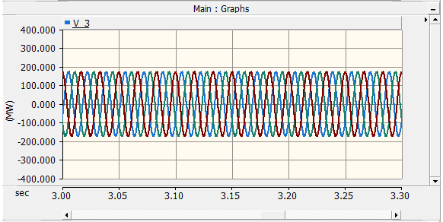
(a)

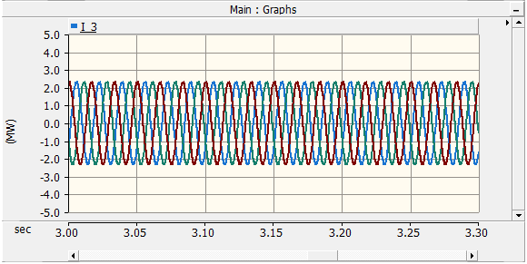
(b)
Figure 4-5 Waveforms at bus 3 in Case I: (a) voltage and (b) current.
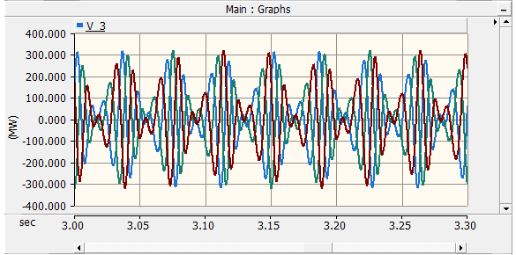
(a)

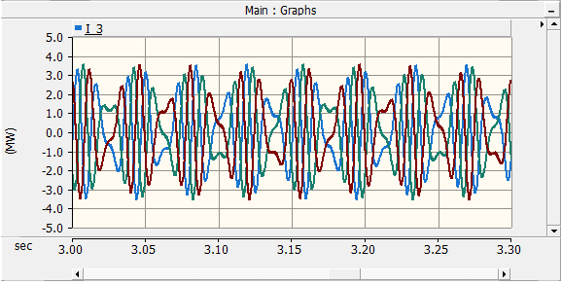
(b)
Figure 4-6 Waveforms at bus 3 in Case II: (a) voltage and (b) current.

To apply the impedance-based stability analysis, the impedance or admittance models of all system components should be derived first. The admittance models of the constant impedance loads, which are necessary to derive the connection network matrix $G_{nw}\left(s\right)$ in Figure 2-4, are modeled as single $L$ loads or $RL$ loads in parallel connection depending on the parameters in Table 4-1. Note that when a load is modeled as $RL$ in parallel connection, the admittance model of the load is calculated as the admittance of a pure resistance plus the admittance of a pure inductance. Therefore, the loads modeled as $RL$ in parallel could also cause the imaginary-axis poles problem, and it can potentially lead to incorrect stability analysis results when applying the determinant-based GNC. To analyze the small-signal stability of the five-bus system, the closed-loop disturbance-to-output transfer function matrix and the impedance matrix model of the connection network are developed based on the system topology. The determinant-based GNC and the eigenvalue-based GNC are then applied to the return-difference matrix $F\left(s\right)$ and the open-loop transfer function $L\left(s\right)$, respectively. 1000 data points are calculated in the frequency range of $0.1 Hz$ to ${10}^{5} Hz$.
- Case I
Figure 4-7 shows the Nyquist plot of $det\left(F\right)$ in Case I, and Figure 4-8 shows its Bode plot. Figure 4-9 shows the characteristics loci of $L\left(s\right)$. As shown in Figure 4-8, when plotting the Nyquist plot, MATLAB solver will connect the two points at $59.8 Hz$ and $60.2 Hz$ since there are no other data points between the two frequencies. This leads to the encirclement of the origin point $\left(0,j0\right)$ in the Nyquist plot. Note that such encirclement is not due to the number of data points that were taken for this analysis. Even with more data points, due to the imaginary axis poles induced by pure inductance, the connection of the two frequency points that are closest to $60 Hz$ in the software will still encircle the origin point $\left(0,j0\right)$ as analyzed above.
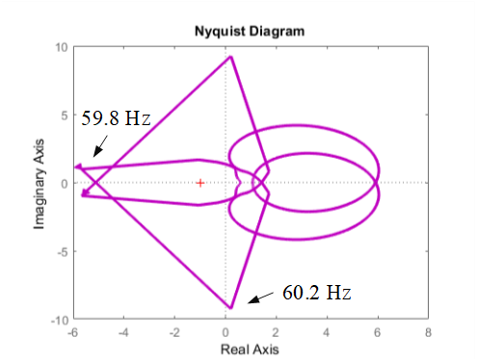
Figure 4-7 Nyquist plot of $det\left(F\right)$ in Case I.

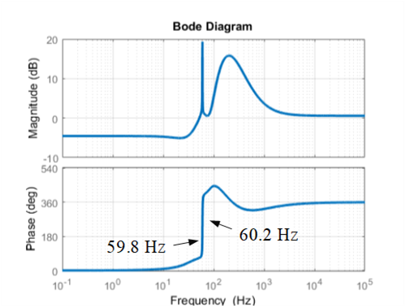
Figure 4-8 Bode plot of $det\left(F\right)$ in Case I.

Correspondingly, the Bode plot in Figure 4-8 shows a ${360}^{°}$ increment in the positive frequency range. Both the Nyquist plot and Bode plot of $det\left(F\right)$ predict that the system should be unstable, which contradicts the stable simulation results shown in Figure 4-5. As analyzed earlier, the mismatch between the analysis results and the simulation is due to the imaginary axis poles induced by the pure inductance models in the constant impedance loads. On the other hand, when judging the system’s small-signal stability with eigenvalue-based GNC from Figure 4-9, it appears that the system is stable in this case. The connection of two points at $59.8 Hz$ and $60.2 Hz$ do not encircle the critical point $\left(-1,j0\right)$. Therefore, the issue of the imaginary axis poles does not affect the results using the eigenvalue based GNC in this case.
- Case II
Figure 4-10 and Figure 4-11 show the Nyquist plot and Bode plot of $det\left(F\right)$ in Case II, respectively, while Figure 4-12 shows the characteristics loci of $L\left(s\right)$ in this case. Just like in Case I, MATLAB directly connects the two points at $59.8 Hz$ and $60.2 Hz$, which results in no encirclement of the origin point $\left(0,j0\right)$ in the Nyquist plot and zero phase change in the corresponding Bode plot. So, both the Nyquist and Bode plots using the determinant based GNC predict that the system should be stable in this case, which contradicts the unstable simulation results shown in Figure 4-6. In this case, the determinant based GNC provides wrong analytical results when the system is unstable, and that is also due to the pure inductance models. When looking at the characteristic loci of $L\left(s\right)$ using the eigenvalue-based GNC shown in Figure 4-12, the system is predicted to be unstable, as the critical point $\left(-1,j0\right)$ is encircled in this case. This is caused by the similar reason as in Case I, that the connection of the two points at $59.8 Hz$ and $60.2 Hz$ in the characteristic loci does not affect the encirclement of $\left(-1,j0\right)$.
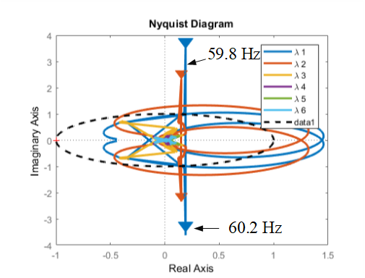
Figure 4-9 Characteristic loci of $L\left(s\right)$ in Case I.

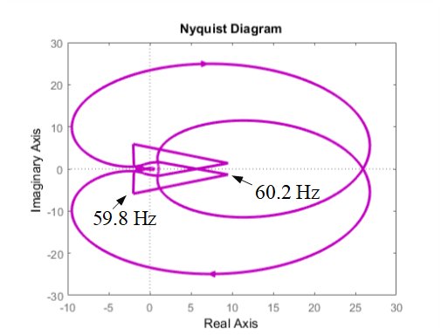
Figure 4-10 Nyquist plot of $det\left(F\right)$ in Case II.
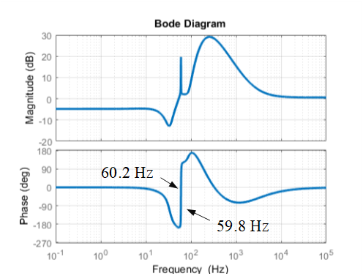
Figure 4-11 Bode plot of $det\left(F\right)$ in Case II.

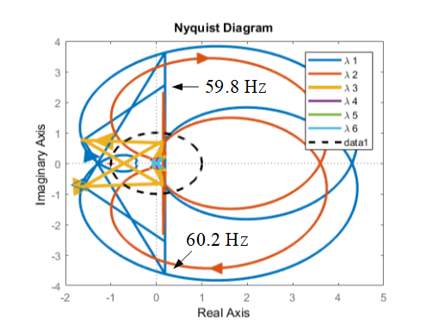
Figure 4-12 Characteristic loci of $L\left(s\right)$ in Case II.

Proposed Method to Eliminate the Pure-Inductance Impact
In some system models, there are components (e.g., transmission lines, transformers, or loads) that have only $L$ parameters in their models (as in Table 4-2).

Solution 1: Shifting Imaginary Axis Poles
To solve the abovementioned issue, one practical way is to shift all imaginary axis poles into the LHP, for example, by replacing the $1/s$ with $1/{\left(s+ϵ\right)}$, where $ϵ$ is a small positive number [105]. To correct the small-signal stability analysis results of the example 5-bus system using the determinant-based GNC, a small $ϵ$ is added for all pure inductance components.
The updated stability analytical results of this example system with such modifications are shown in Figure 4-13 and Figure 4-14 for Case I and Case II, respectively. Analytical results are now the same as the simulations with this change. For Bode plots in both Figure 4-13 and Figure 4-14, the blue curves are the original results using the determinant-based GNC, while the orange curves are the results with such modifications using this solution.
One can see from the Bode plots in both cases that the magnitude and phase plots show that such modifications almost don’t change the characteristics of the system at other frequencies except around 60 Hz (where the pure inductance models cause the problem); moreover, such small modifications correct the error to provide the same analytical results as in simulations.

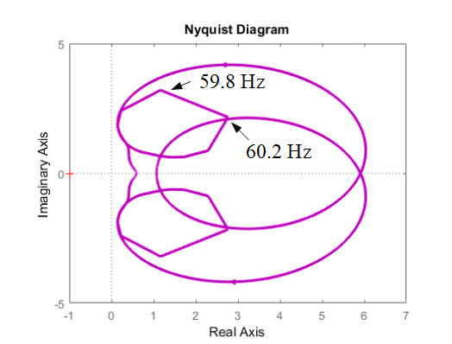
(a)

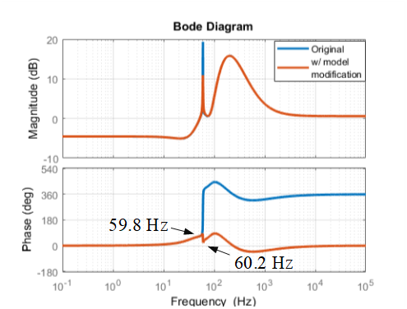
(b)
Figure 4-13 $det\left(F\right)$ with model modification in Case I: (a) Nyquist plot and (b) Bode plot.
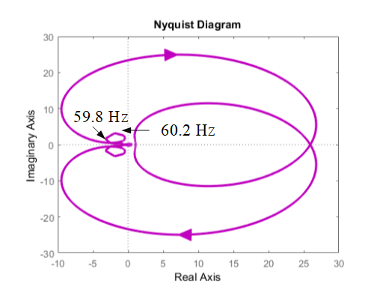
(a)

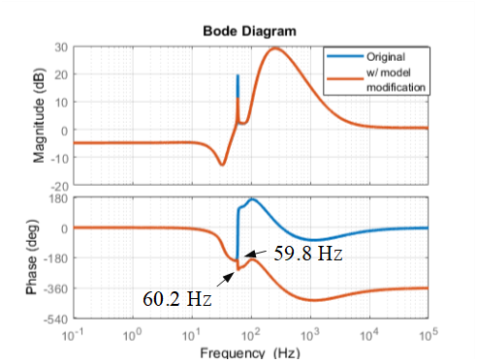
(b)
Figure 4-14 $det\left(F\right)$ with model modification in Case II: (a) Nyquist plot and (b) Bode plot.

Solution 2: Modification of Phase Angles
The second solution that does not change the original model is to modify the determinant based GNC by compensating the Nyquist and Bode plots of $det\left(F\right)$ with phase compensation.
From the above analysis in Section 4.2 and Section 4.3, it can be concluded that the incorrect analytical results are due to the wrong phase change induced by the imaginary axis poles at 60 Hz. So, when such imaginary axis poles are found in systems, the Nyquist plot and the Bode plot should add a corresponding phase compensation by following the D-contour in Figure 4-1 to get correct analytical results.
In the example system, for Case I showed in Figure 4-15, $det\left(F\right)$ should go to infinity from $59.8 Hz$ and then goes back to $60.2 Hz$ in the clockwise direction. With such compensation, in Case I, the Nyquist plot of $det\left(F\right)$ should not encircle $\left(0,j0\right)$, which represents the system is stable in Case I. And correspondingly, the Bode plot of $det\left(F\right)$ should also have a ${360}^{°}$ phase compensation after 60 Hz, as shown in Figure 4-15. The $0^{°}$ phase change in the Bode plot after the compensation is also showing that the system is stable in this Case. Similarly, in Case II, the $det\left(F\right)$ also goes to infinity from $59.8 Hz$ and then back to $60.2 Hz$ in the clockwise direction, as shown in the Nyquist plot in Figure 4-16. One can see that the $det\left(F\right)$ encircles $\left(0,j0\right)$ twice in the Nyquist plot, which means the system is unstable in Case II. Correspondingly, the phase change in the Bode plot in Figure 4-16 also decreases ${360}^{°}$. It also represents that the system is unstable in this case, making it the same as the simulation results.

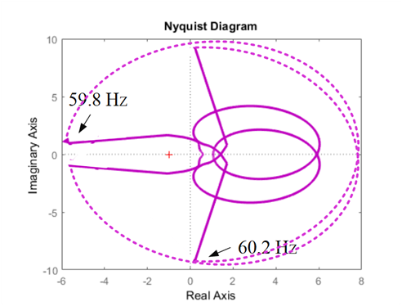
(a)

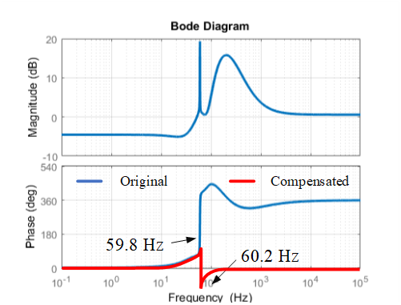
(b)
Figure 4-15 $det\left(F\right)$ with phase compensation in Case I: (a) Nyquist plot and (b) Bode plot.
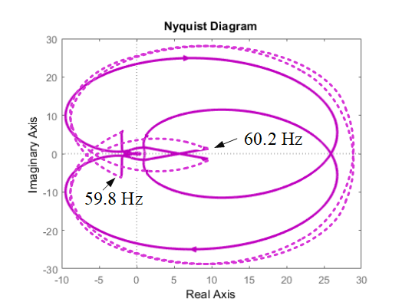
(a)

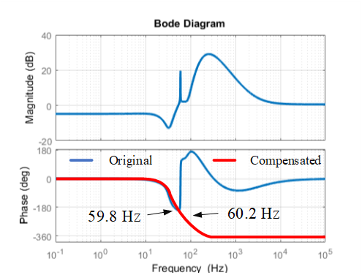
(b)
Figure 4-16 $det\left(F\right)$ with phase compensation in Case II: (a) Nyquist plot and (b) Bode plot.

Conclusions
This chapter identifies the issue caused by pure inductance models when applying the determinant-based GNC for small-signal stability analysis. It is found that the pure inductance models in the system can induce the imaginary axis poles to the MIMO system model, and such an issue can potentially result in incorrect stability analysis results. A case study of an example system validates the analysis. Solutions to this issue include shifting the imaginary axis poles into the LHP or providing phase compensation for the determinant based GNC when the imaginary axis poles are involved due to pure inductance models.

Comparative Study of Nonlinear Black-Box Modeling Approaches for Power Electronics Converters

Introduction and Background
It is known that PECs exhibit highly nonlinear phenomena and a small-signal linear modeling approach cannot capture system dynamics accurately during large disturbances. For better transient modeling of large-scale penetration of IBRs, nonlinear black-box modeling approaches are preferred. For black-box modeling of IBRs, based on the previous literature survey in Section 2.2, three different nonlinear black-box modeling approaches are investigated in more detail, and they are evaluated with the proposed comparison method under different transients. The three nonlinear black-box modeling approaches include:
- Nonlinear AutoRegressive-eXogenous (NARX) approach
- Hammerstein-Wiener (HW) approach
- Neural Network (NN) approach

Single-Phase PV Inverters under Simulation

System Model
To evaluate the different nonlinear black-box models and determine the most appropriate modeling approach for large distribution-connected IBRs, a single-phase 240 Vrms, 3500 W grid-connected PV system in MATLAB/Simulink is used for the simulation investigation. The system setup is shown in Figure 5-1. Table 5-1 shows the system parameters of this single-phase PV array. The simulation model includes a PV array, a single-phase dc/ac converter with an LCL filter, inverter control, and loads and utility grid. The inverter control has basic functions
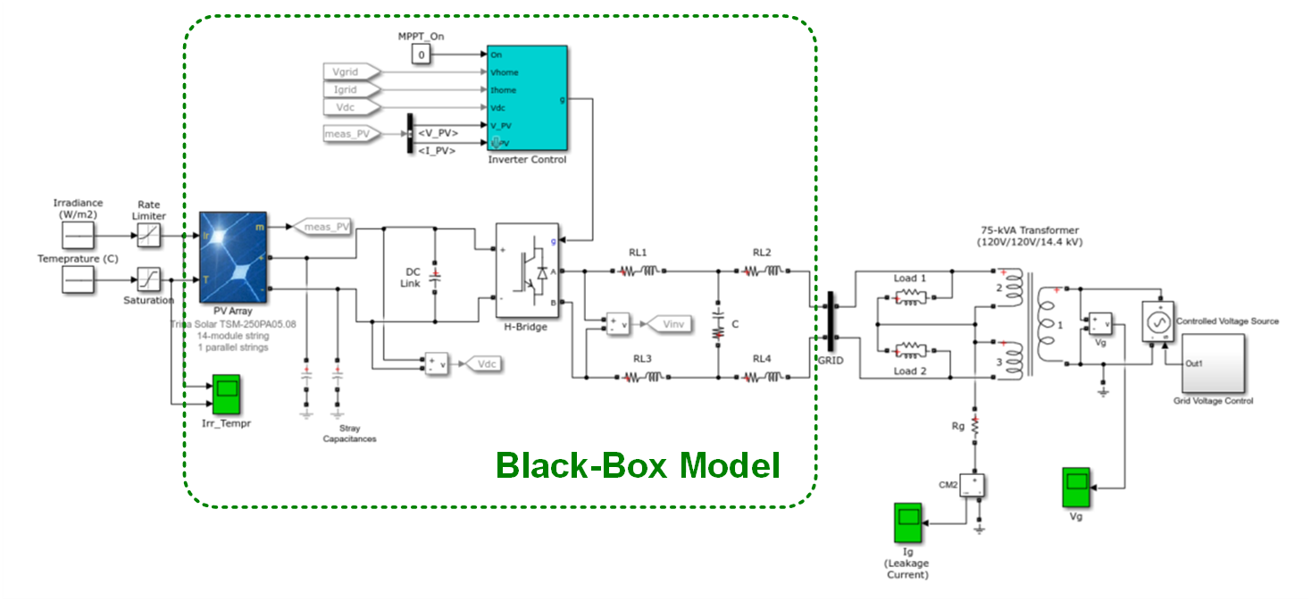
Figure 5-1 Single-phase grid-connected PV array.

Table 5-1 Parameters of the single-phase PV system
Electrical Parameters of the Inverter |  | Values
Nominal Voltage | $$V_{n}$$ | 240 Vrms
Nominal Power | $$P_{n}$$ | 3500 W
Frequency | $$f$$ | 60 Hz
Parameters of PV Array |  | Values
Module |  | Trina Solar TSM-250PA05.08
Parallel Strings |  | 1
Series-connected modules per string |  | $$14$$
Parameters of Loads |  | Values
Nominal Voltage | $$V_{nl}$$ | 120 Vrms
Active Power | $$P_{nl}$$ | 5000 W
Inductive Reactive Power | $${QL}_{nl}$$ | $$5000 var$$

including an Maximum Power Point Tracking (MPPT) controller, Vdc regulator, PLL, PWM generator, and voltage/current measurements. The irradiance, Temperature, and grid-side voltages and currents of the inverter are measured and collected to generate the training and validation data set for the system identifications using three black-box models.

Transients under Study
The two-port black-box model is adopted here to evaluate the performance of different modeling approaches. This model has two ports that include both the grid side and the inputs of the PV array. The dynamics of the PV array, the single-phase inverter, and the inverter control will be included in this black-box model, as shown in Figure 5-1. The irradiance, temperature, and inverter grid-side voltage are selected as the inputs of the model, while the inverter grid-side current is selected as the output of the model. Note that the ac signals are transformed into their RMS values and phase angles. Eventually, the black-box model is a four-input, two-output model, with the irradiance, temperature, and the grid voltage RMS value and its phase angle as the model inputs, while the grid current RMS value and the phase angle between voltage and current are the model outputs, as depicted in Figure 5-2.
- Data preprocessing
The voltage and current waveforms generated by the simulation need to be preprocessed before using as training and validation data for black-box models. The procedure of the data preprocessing includes:
- Remove start-up data: the data during the start-up process is not needed for the black-box modeling here.
- Correct “bad data”: some of the error data may be generated due to the measurement.

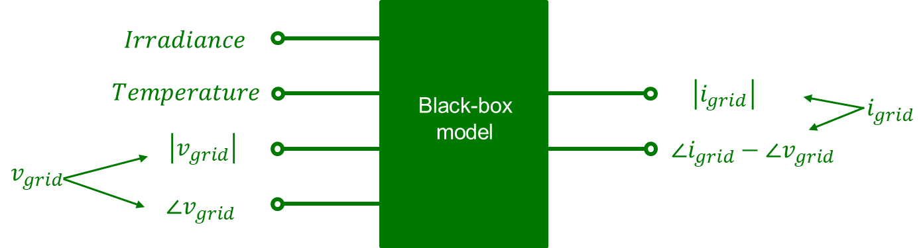
Figure 5-2 Architectures of BBM for the single-phase solar PV inverter.

These error data need to be correct before the training of black-box models.
- Down sample: the original data set should be down-sampled to the lowest acceptable data resolution to reduce the data size and speed up the training and simulation process.
- Rescale: data from different channels should be rescaled between 0 and 1 before the training and validation process.
- Reshape: the format of the original data needs to be reshaped to meet the requirements of different black-box models
- Training and validation datasets
For the black-box system identification of this system, the irradiance, temperature, and grid-side voltage and current waveforms are measured, and their RMS values and phase angles are calculated and collected for the training and validation data set. Three transients are considered in the training and validation tests: 1) grid voltage perturbation, 2) irradiance change, and 3) temperature variation. Figure 5-3 (a) and (b) show the input and output data for model training and validation, respectively. Note that the shown data has been normalized (rescaled within the range of 0 to 1). The bottom four figures are the model input signals, while the top two figures are the model output signals. The validation tests are chosen to be different from all training tests. In the training test, the grid voltage changed between 0.9 p.u and 1.1 p.u, the irradiance changed within the range of 100 – 1000 W/m², and the temperature variation is between 59 $℉$ to 139 $℉$. To evaluate the performance of the different black-box models, three aspects are considered for the validation results, including 1) model accuracy; 2) model behaviors (nonlinear behavior characteristics); and 3) model complexity (time).
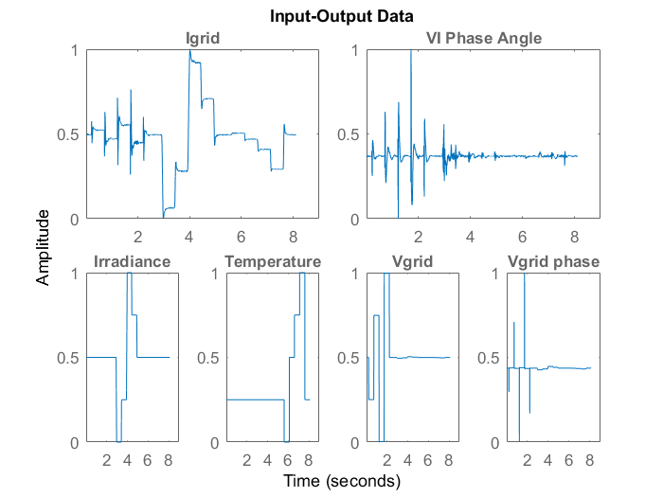
(a)

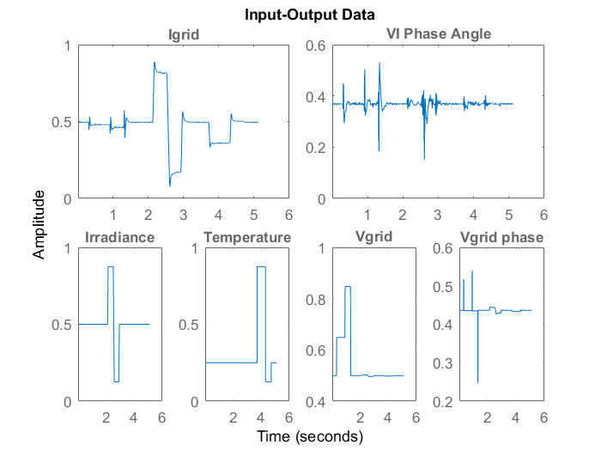
(b)
Figure 5-3 Datasets for (a) training and (b) validation.

Detailed Nonlinear Black-Box Model Architectures
In the evaluation section, three nonlinear black-box modeling approaches are considered: 1) the NARX model; 2) the HW model; and 3) the NN model. The NARX model and the HW model are built using the System Identification Toolbox in MATLAB [106]. The NARX NN model is developed using MATLAB Neural Network Training Tool. Detailed structures and parameters of the three nonlinear models are introduced as follows.
- The NARX model
The structure of the NARX model is shown in Figure 2-9. For the NARX model, after the model optimization, the regressors are selected as: the past output terms na = [2 0; 0 2]; the past input terms nb = [2 2 2 2; 2 2 2 2]; and the input delay nk = [1 1 1 1; 1 1 1 1]. The nonlinear estimator of output 1 (i.e., RMS of grid-side current) is the wavelet network with 9 units, while the nonlinear estimator of output 2 (i.e., the phase angle of grid-sed current) is the wavelet network with 7 units.
- The HW model
The structure of the HW model is shown in Figure 2-10. For the HW model, after the model optimization, the model parameters of the linear block are selected as: the number of zeros (plus one) nb = [3 3 3 3; 3 3 3 3]; nf = [4 4 4 4; 4 4 4 4]; and the input-output delay nk = [1 1 2 1; 1 1 2 1]. The nonlinear estimators of the four inputs are piecewise linear functions with 10 units, while the nonlinear estimators of the two outputs are also piecewise linear functions with 10 units.
- The NN model
For the NN model, the NARX neural network structure, as in Figure 2-11 (b), is selected. Note that the NARX NN has two architectures: the open-loop architecture (also referred to as the series-parallel architecture) and the closed-loop architecture (also referred to as the parallel architecture), as illustrated in Figure 5-4. In Figure 5-4, $y\left(t\right)$ represents the actual outputs (target outputs) of the system, $\hat{y}\left(t\right)$ represents the predicted outputs, and TD refers to the time delay. In the open-loop architecture, the actual past output data is used as part of the inputs to predict subsequent output values. Therefore, it is used in scenarios when the actual output data is accessible, such as during the training of NARX NN models using recorded data, or in applications like monitoring and fault detection. In the closed-loop architecture, the predicted past output data is fed back to model inputs to predict future output values. Following training, the open-loop architecture can be converted into the closed-loop architecture, which can then be employed in applications like making predictions in the simulation.
After the model optimization, three layers are designed for the NARX NN model, including an input layer, a hidden layer, and an output layer. The input layer has two sets of past input data and one set of past output data, the hidden layer has five neurons, and the output layer has two neurons that correspond to the two signals of the model output. For the NARX NN model, the training function is the Levenberg-Marquardt (trainlm), while the mean squared error (MSE) is used for the loss function.

Comparisons of Model Quality

Proposed Comparison Method
To evaluate the performance of the three black-box modeling approaches, the same training and validation datasets, as shown in Figure 5-3, is used for the system identification of the single-phase solar PV inverter. When comparing the performance of these models, three aspects are considered, which include:
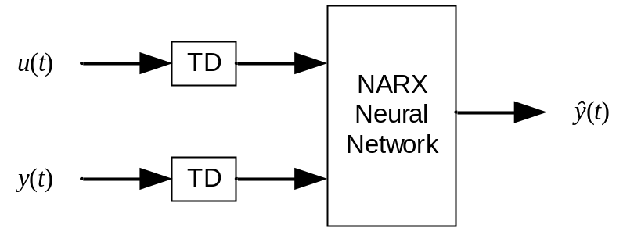
(a)

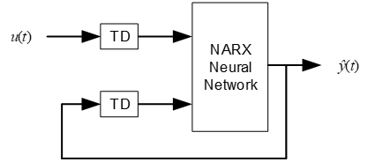
(b)
Figure 5-4 Architectures of NARX NN: (a) open-loop and (b) closed-loop.

1) Model accuracy
2) Model behaviors (nonlinear behavior characterization)
3) Model complexity (time)
- Model accuracy
When evaluating the accuracy of different black-box models, the root-mean-square error (RMSE) is used as the model quality metric. RMSE is a frequently used metric when measuring the differences between the true values and the predicted values. A smaller RMSE indicates a higher level of proximity between the predicted values and the actual values, and RMSE value with 0 represents that the model has a perfect fit. The expression of RMSE is described as ( 5.1 ), where $n$ is the total number of data points, $x_{i}$ is the true value of the $i^{th}$ data point, and ${\hat{x}}_{i}$ is the predicted value of the corresponding data point.
$$RMSE=\sqrt{\frac{1}{n}\sum_{i=1}^{n}{{\left|x_{i}-{\hat{x}}_{i}\right|}^{2}}}$$ | ( 5.1 )
- Model behaviors (nonlinear behavior characterization)
In addition to employing RMSE for evaluating the overall accuracy of various BBMs, it is essential to assess model effectiveness by examining their responses under various transient conditions. To compare the model behaviors of different BBMs, the nonlinear behavior characterization is used to evaluate if the model can “learn” the nonlinear behaviors of inverters. When designing the training and validation tests, different patterns are designed under multiple inverter transients. These patterns will be used to examine whether the model is suitable for transient modeling applications of PECs.
- Model complexity (time)
Given the different structures of the three nonlinear BBMs, direct comparison of their complexity is challenging solely based on their architectural differences. To assess model complexity of different nonlinear models, the total time, including both the training and validation process, will be considered. The training process involves using an optimization algorithm to find an optimal set of model parameters to map inputs to outputs using the training dataset, while the validation process includes using the trained model to predict outputs based on the inputs from the validation dataset. A shorter duration time indicates a lower computation burden for the model.

Comparison Results
The performance of the three nonlinear BBMs is assessed using simulation-generated training and validation datasets. Figure 5-5 shows the predicted waveforms of the three nonlinear BBMs in comparison to the simulation results using the validation data. In Figure 5-6, a closer examination is provided, offering a zoomed-in view of their comparisons across various transients. The calculated RMSE indicates that the HW model exhibits the lowest error for both outputs. The NN model demonstrates a comparable overall accuracy to the HW model, whereas the NARX model displays the highest error among the three.
Regarding the nonlinear behavior characteristics, while the HW model exhibits good overall accuracy for both outputs, a noticeable error can be observed in the current magnitude during the transient of temperature variation, as illustrated in Figure 5-6 (b). Discrepancies are also evident in the NARX model, particularly in both the magnitude and phase angle of grid-side current under transient conditions involving voltage perturbation and temperature variation, as depicted
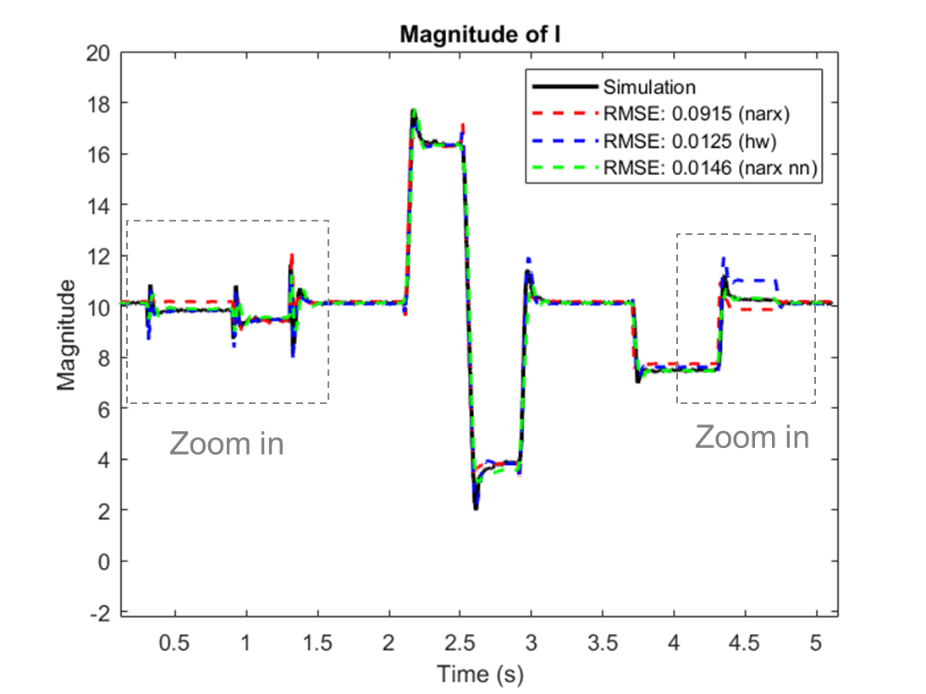
(a)

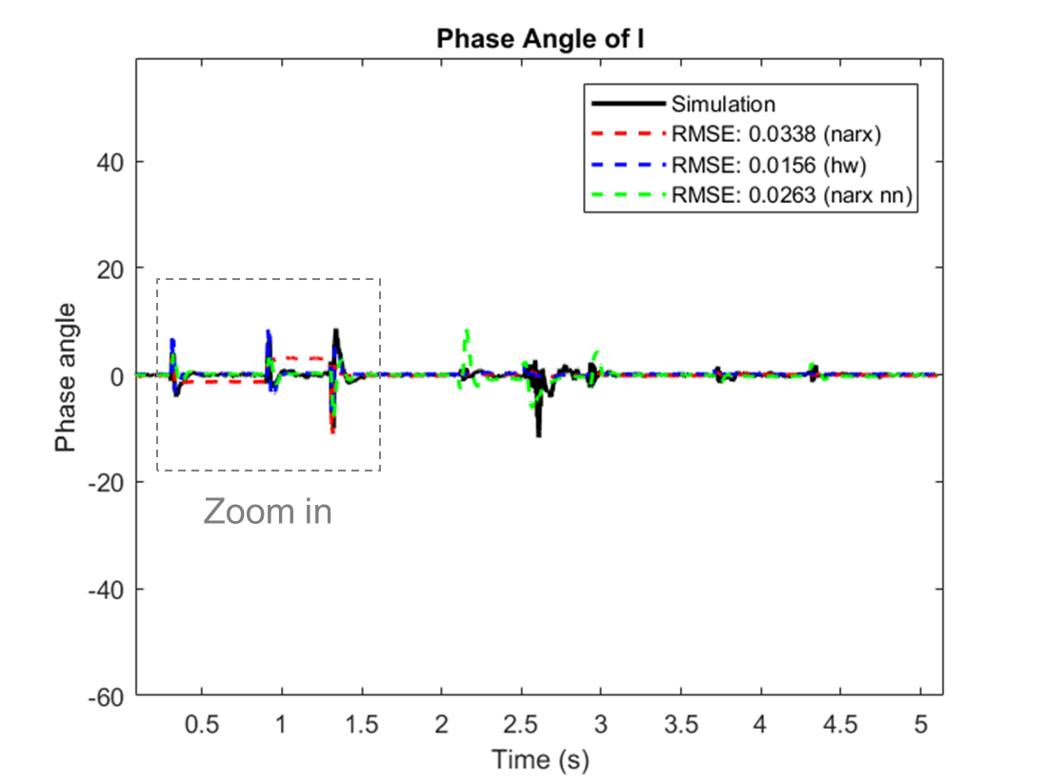
(b)
Figure 5-5 Comparison of three nonlinear black-box models (NARX, HW, NN) vs. the simulation results.

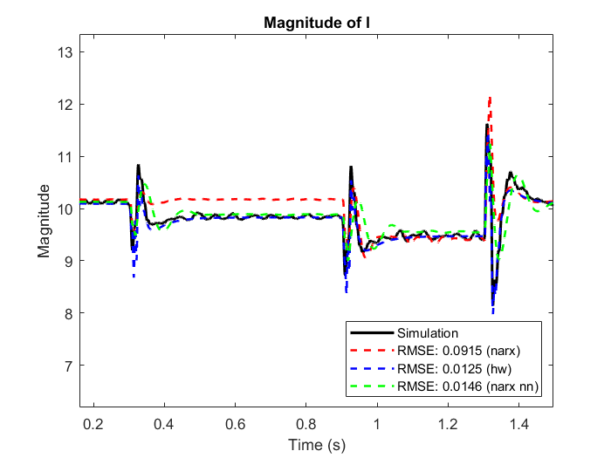
(a)

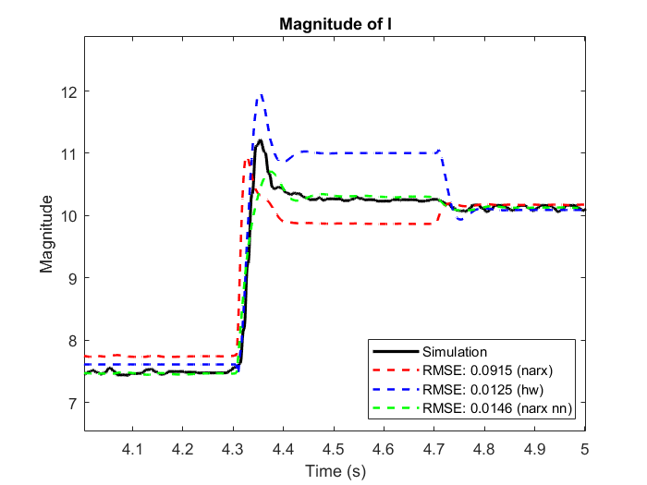
(b)
Figure 5-6 Zoomed-in view of: (a) magnitude of $I$ during voltage perturbation, (b) magnitude of $I$ during temperature variation, (c) phase angle of $I$ during voltage perturbation.
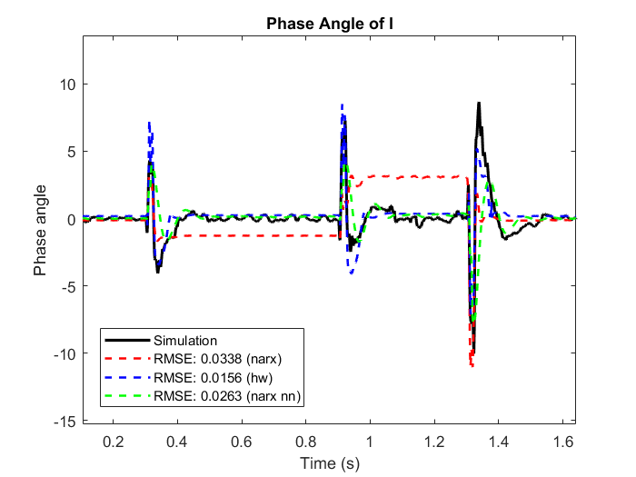
(c)
Figure 5-6 (continued)

in Figure 5-6 (a), (b), and (c). In contrast, the NN model demonstrates strong performance for both outputs across all transient conditions, distinguishing it from the other two models.
Table 5-2 provides a summary of the comparison among three different BBMs, considering both model accuracy and the total time consumed. The training and execution time tests were carried out on a Windows 10 64-bit platform equipped with an Intel(R) Core(TM) i7-10510U CPU @ 1.80 GHz. Note that the recorded total time in Table 5-2 includes both the training and validation process. Utilizing the same training data set and training for the same number of epochs, the NN model stands out with the shortest training and execution time among the three models, owing to its simple structure. In contrast, both the NARX and HW models require significantly more time for the training and execution processes.
Based on the simulation results and comparisons for the single-phase inverter, the NN-based model structure proves to be a promising solution. It was chosen for IBR black-box modeling in further studies, given its good performance across all transients and manageable efforts required for model training and implementation.

Conclusions
In this chapter, three major nonlinear black-box modeling approaches – namely, the NARX model, the HW model, and the NN model, were explored in detail for the modeling of PEC transients. These modeling approaches were applied to a single-phase solar PV inverter with maximum power-point tracking and standardized control functionalities, modeled as switching systems in Matlab/Simulink to generate training and validating datasets.
To evaluate the performance of these models, three transient scenarios were examined, including grid voltage disturbance, irradiance change, and temperature variation. The proposed
Table 5-2 Performance comparison of three black-box models for single-phase inverter
Model | NARX | HW | NN
RMSE($I_{grid_mag}$) | 0.0915 | 0.0125 | 0.0146
RMSE($I_{grid_pha}$) | 0.0338 | 0.0156 | 0.0263
Total Time (s) | 49.15 | 41.43 | 3.86

comparison method was applied to evaluate the model accuracy, nonlinear behavior characterization, and model complexity of the three nonlinear models. The results indicate that the NN-based model exhibits good model quality with manageable implementation effort, and thus can be considered for future investigation for large-scale distribution-connected IBRs modeling.

Development of Deep Learning-Based Black-Box Models for Three-Phase Inverters in Balanced Grids

Introduction
In this chapter, two benchmarking models of three-phase PV inverters with GFL control are built: one is in MATLAB/Simulink and the other is in HIL platform. These two benchmarking models are used to generate training, validation, and testing data for BBMs investigation. Multiple transients of these two models, including voltage ride-through, voltage-reactive power droop, dc change, and irradiance and temperature change, are recorded. With data acquisition and data preprocessing, three deep learning (DL)-based BBMs are developed for these three-phase inverters. The feasibility of utilizing these DL-based BBMs is investigated, and their performances are evaluated under different transients.
Note that the proposed method is applicable across various types of targeted systems, whether they are switching models, average models, or real converters. The data generated from the targeted systems will be used to train and test the proposed BBMs, ultimately influencing and defining the behavior of the developed BBMs. The selection of such systems for data generation depends on resource availability and the purpose of BBM development.

Benchmarking Models of Three-Phase Solar PV Inverters

Simulation Model of the Three-Phase Solar PV Inverter
A switching model of a three-phase 250 kW solar PV inverter connected to a 25-kV grid has been built in MATLAB/Simulink. As shown in Figure 6-1, this system includes a PV array, a three-phase dc/ac inverter with its filters, and a utility distribution grid. Table 6-1 shows the
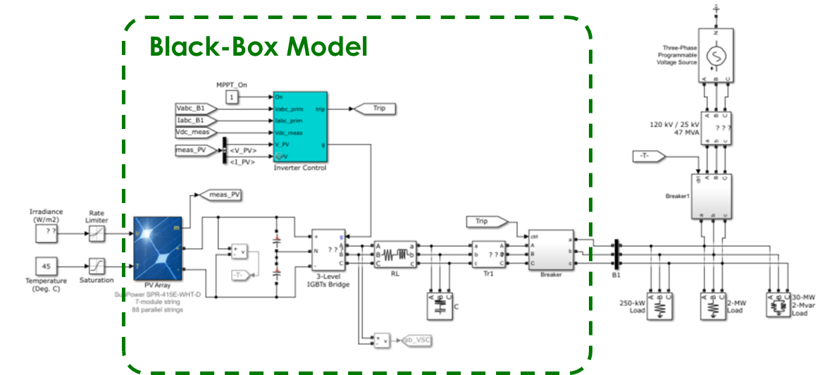
Figure 6-1 Simulation model of the three-phase solar PV inverter system.

Table 6-1 Parameters of the three-phase PV inverter system in simulation
Electrical Parameters of the Inverter |  | Values
Grid Voltage | $$V_{grid}$$ | 25 kV
Nominal Power | $$P_{n}$$ | 250 kW
Frequency | $$f$$ | 60 Hz
Parameters of PV Array |  | Values
Module |  | SunPower SPR-415E-WHT-D
Parallel Strings |  | 88
Series-connected modules per string |  | $$7$$
Parameters of Loads |  | Values
Active/Reactive Power of Load 1 | $P_{l1}$, ${QL}_{l1}$ | 250 kW, 0
Active/Reactive Power of Load 2 | $P_{l2}$, ${QL}_{l2}$ | 2 MW, 0
Active/Reactive Power of Load 3 | $P_{l3}$, ${QL}_{l3}$ | 30 MW, 2 Mvar

parameters of the three-phase solar PV inverter system. The inverter control has basic functions including an MPPT controller, Vdc regulator, current regulator, PLL, PWM generator, and voltage/current measurements. To assess the feasibility and performance of DL-based BBMs, data from three transient conditions, including the voltage-reactive power control, irradiance change, and temperature variation, are collected.
- Voltage and reactive power control
The IEEE Std 1547-2018 requires IBR to provide voltage regulation capability by supplying or absorbing reactive power. When in the voltage-reactive power mode, the IBR actively controls its reactive power output as a function of voltage following a Volt-Var curve characteristic. In this system, the standard for Category A IBR is selected. The operating points versus the Volt-Var curve characteristic of Category A IBR are shown in Figure 6-2 (a). The inverter operation under voltage-reactive mode at different steady-state operating points is shown in Figure 6-2 (b).
- Irradiance change
With the variation of the Sun irradiance, the maximum power of the PV array will be changed accordingly, thus affecting the output current of the inverter. Figure 6-3 (a) shows the relationship between the PV array voltage and current or power at different solar irradiance levels. The irradiance variation tests are conducted within the range of 100 – 1000 W/m². Additionally, Figure 6-3 (b) shows the magnitude and phase angle change of inverter output currents versus the irradiance variation.
- Temperature variation
The fluctuation of the cell temperature leads to the corresponding changes of the maximum
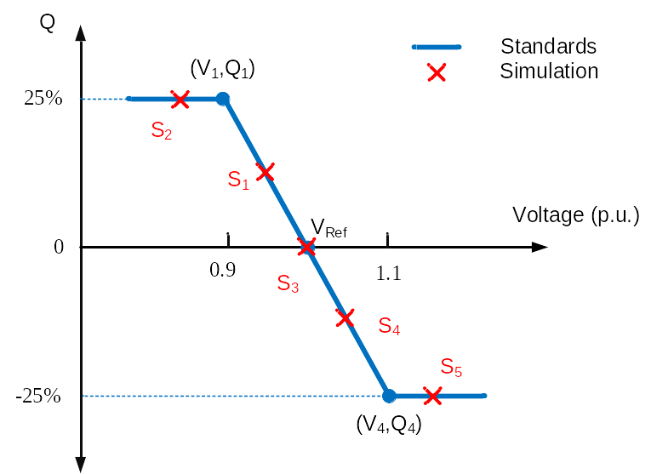
(a)

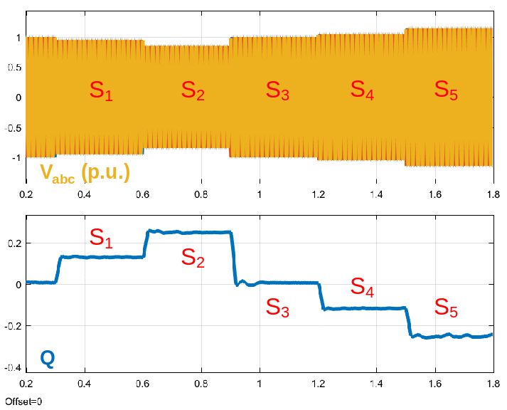
(b)
Figure 6-2 Voltage-reactive power mode of the three-phase inverter: (a) Volt-Var curve characteristic of Category A IBR; (b) Voltage-reactive power mode operation.

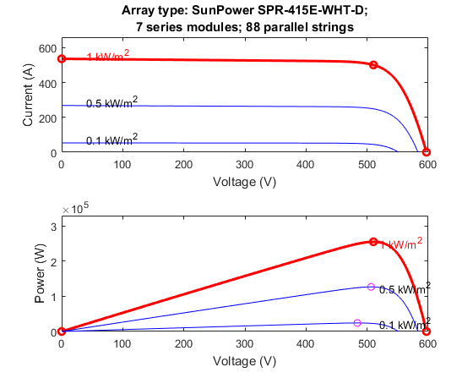
(a)

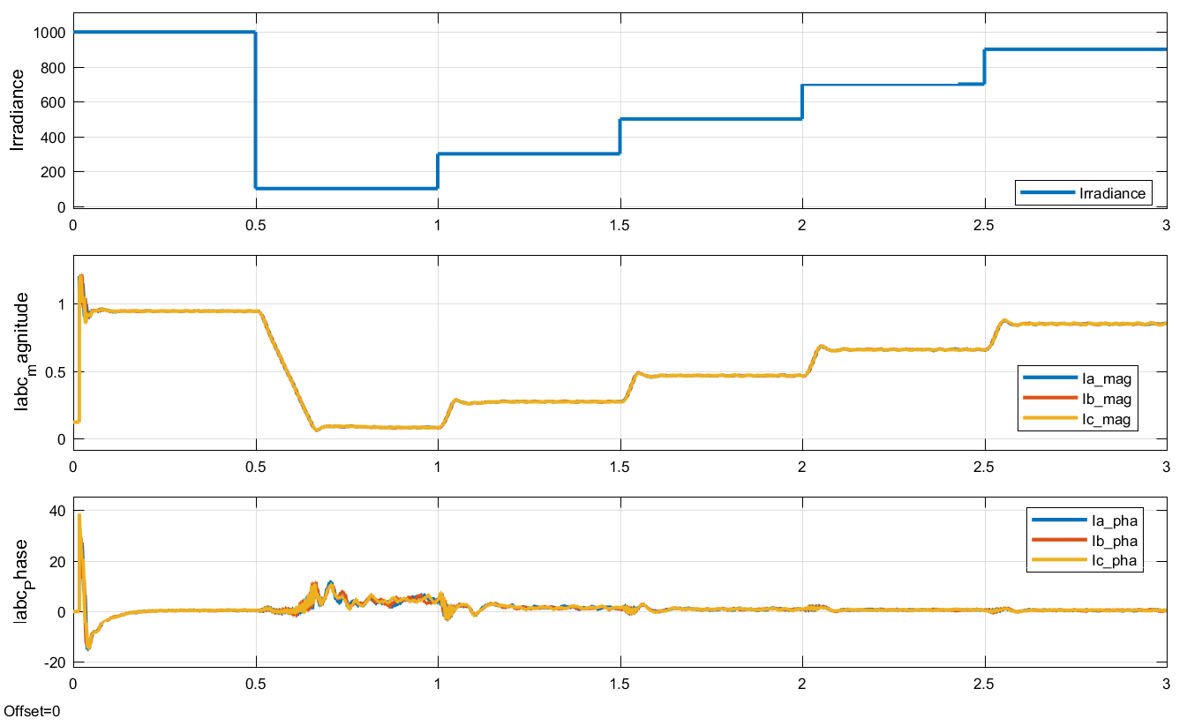
(b)
Figure 6-3 Irradiance change tests: (a) I-V and P-V characteristics of the PV array; (b) $I_{abc}$ change with irradiance variation.

power of the PV array, thus impacting the output current of the inverter. Figure 6-4 (a) depicts the relationship between the PV array voltage and current or power at different temperature levels. The temperature variation tests are conducted within the range of 59 – 139 °F. Figure 6-4 (b) shows the magnitude and phase angle change of inverter output currents versus the temperature fluctuation.

Three-Phase Inverter Model in HIL Tests
To further examine the performance of the proposed DL-based BBMs in such applications, a different three-phase inverter model within the HIL system is tested. Unlike the above three-phase solar PV inverter model developed in MATLAB/Simulink, the details of this HIL inverter model remain unknown. The only available information regarding this inverter model is that it uses a dc voltage input and a grid-following control strategy. This knowledge will help to determine the inputs and outputs of the BBM when modeling this inverter.
For the purpose of training and validation of the DL-based BBMs for this inverter model, numerous experiments were conducted through HIL tests under different transients. These experiments encompassed different conditions, including voltage changes on both the dc and ac sides. The available data obtained from these experiments are the only resources here to generate and validate the DL-based BBMs. In Figure 6-5, example test waveforms are illustrated, including input and output voltages and currents recorded during a voltage ride-through test. Figure 6-6 shows another set of example waveforms, including dc and ac voltages and currents tested from a dc change test. Note that the tested waveforms of grid-side voltages and currents shown here are in the $abc$ frame. When developing the DL-based BBMs, these waveform data will be converted into the phasor domain, which includes both magnitude and phase angle information.
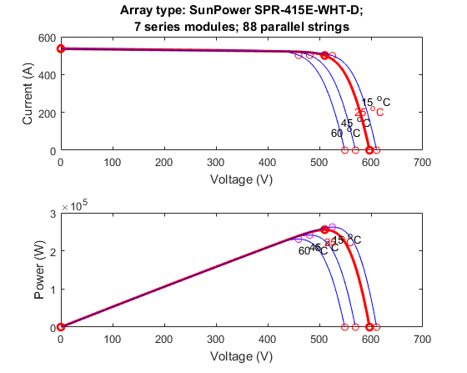
(a)

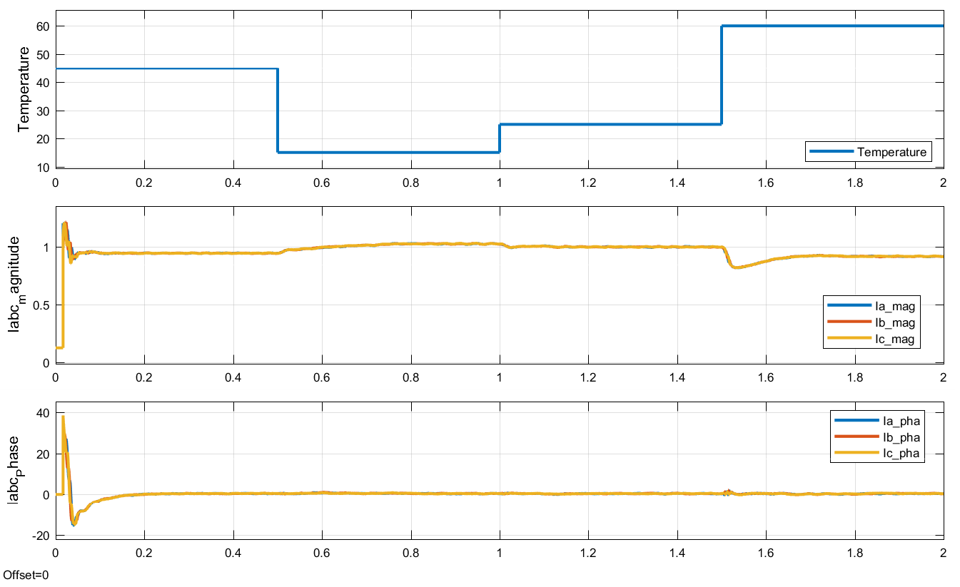
(b)
Figure 6-4 Temperature variation tests: (a) I-V and P-V characteristics of the PV array; (b) $I_{abc}$ change with temperature.

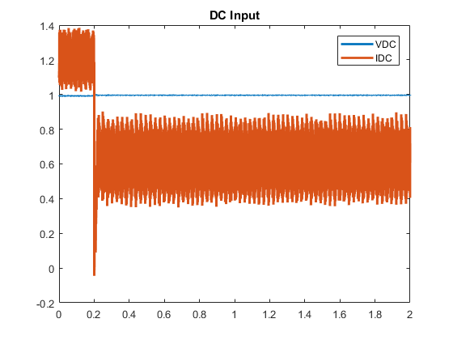
(a)

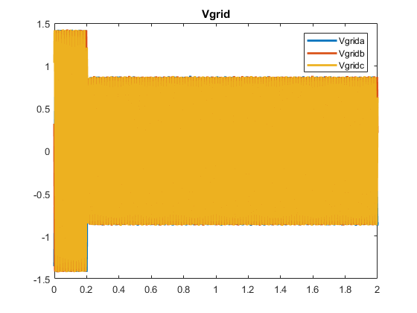
(b)
Figure 6-5 Example waveforms of voltage ride-through tests: (a) dc input; (b) grid-side voltage; (c) grid-side current.
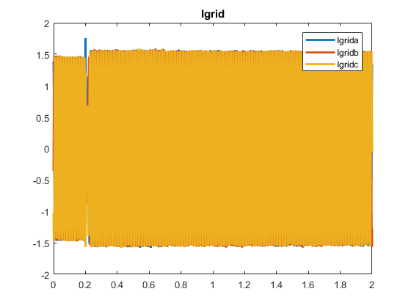
(c)
Figure 6-5 (continued)
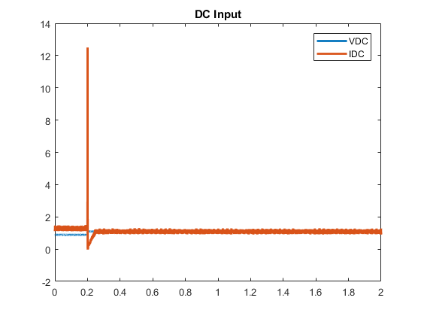
(a)
Figure 6-6 Example waveforms of dc change tests: (a) dc input; (b) grid-side voltage; (c) grid-side current.
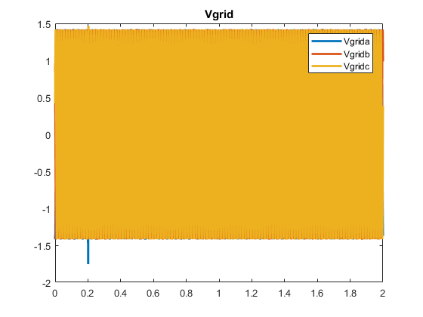
(b)

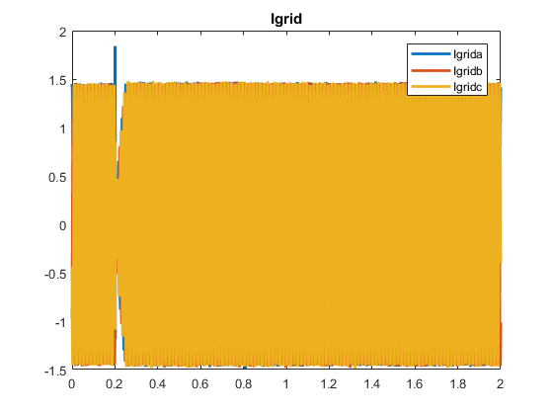
(c)
Figure 6-6 (continued)

Development of the DL-Based BBMs for Three-Phase Inverters
This section proposes a systematic approach for system identification to develop DL-based BBMs for the aforementioned two three-phase inverter benchmarking models. Figure 6-7 depicts the flowchart outlining the proposed model development strategy. To generate datasets for BBM training and validation, data acquisition is conducted to the test system to measure all input and output terminals to collect the raw data. Subsequently, data preprocessing is needed to remove redundant data and ensure data quality and integrity. All test data will then be combined and split into training, validation, and test datasets, and they will be reshaped to proper input and out format for subsequent BBM investigations. Moreover, the input and output terminals of the BBM should be defined according to the characteristics of the targeted system. Once all the inputs and outputs are defined, the appropriate DL algorithms can be selected, and the BBM architecture formulated. By fine-tunning the hyperparameters of the DL models, the DL-based BBMs can be trained and tested using the preprocessed datasets.

Data Acquisition
The raw data to be recorded depends on the target of the BBM being developed. For the simulation model of the three-phase solar PV inverter, the BBM will include both the PV array and the three-phase inverter. Therefore, the recorded data includes irradiance, temperature, magnitude and phase angle of grid-side three-phase voltages, and magnitude and phase angle of grid-side three-phase currents. For the HIL model of the three-phase inverter, the BBM will only model the three-phase inverter itself. So, the recorded raw data includes dc input voltage, dc input current, magnitude and phase angle of grid-side three-phase voltages, and magnitude and phase angle of grid-side three-phase currents.

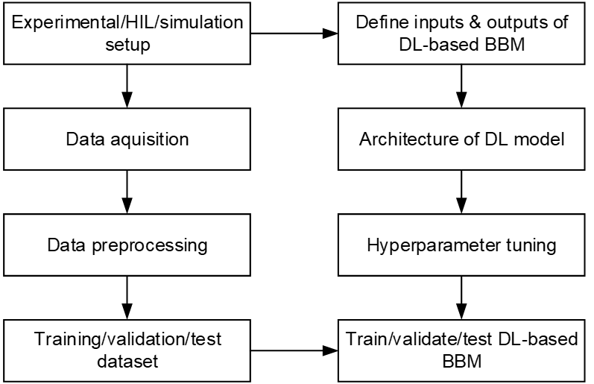
Figure 6-7 Flowchart of DL-based BBM development.

Data Preprocessing
The raw data collected from simulation and HIL tests need to be preprocessed for further investigation. As mentioned in Section 5.2.2-A, proper data preprocessing, including removing the start-up data, removing the “bad data”, down sampling, rescaling, and dataset splitting, should be performed before the BBM training and validation.
Note that “bad data” may be introduced due to the simulation measurements, and these data should be replaced with correct values. For example, when employing the Fourier block in Simulink to measure the phase angle, rapid shifts in the measured phase angle may occur, transitioning from close to 0° to approximately ${±360}^{°}$, resulting in “spikes” in the phase angle data, as depicted in Figure 6-8 (a). To correct these instances of “bad data”, the values at the “spikes” should be compensated by adding or subtracting ${360}^{°}$ accordingly, to return to the normal values, as shown in Figure 6-8 (b).
After eliminating the start-up data and rectifying any "bad data" within the raw dataset, all data from different transient tests will be combined. To reduce the computation burden, the dataset needs to be down sampled to the lowest acceptable data resolution in order to reduce the overall data size and expedite the training and validation process. Subsequent to down sampling, normalization of the data from different channels to a range between 0 and 1 is necessary. Following these preprocessing steps, the amalgamated dataset will be divided into training, validation, and test subsets, as depicted in Figure 6-9. Each block within the dataset corresponds to the recorded waveforms of a specific simulation or HIL test during different transient scenarios.

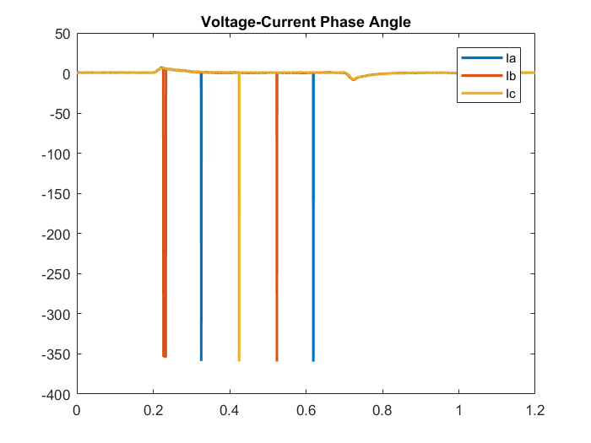
(a)

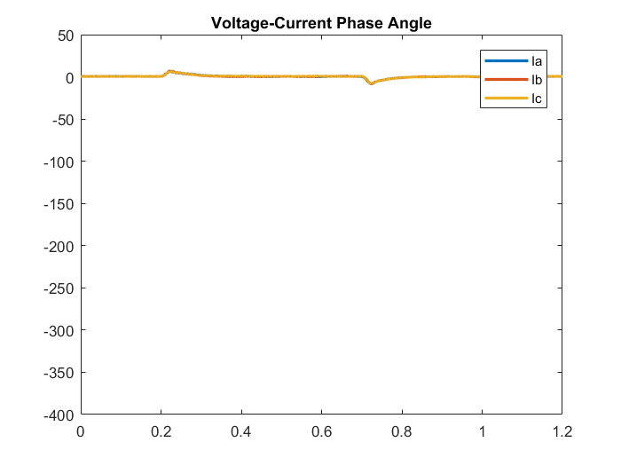
(b)
Figure 6-8 “Bad data” due to the measurement: (a) original data and (b) corrected data.

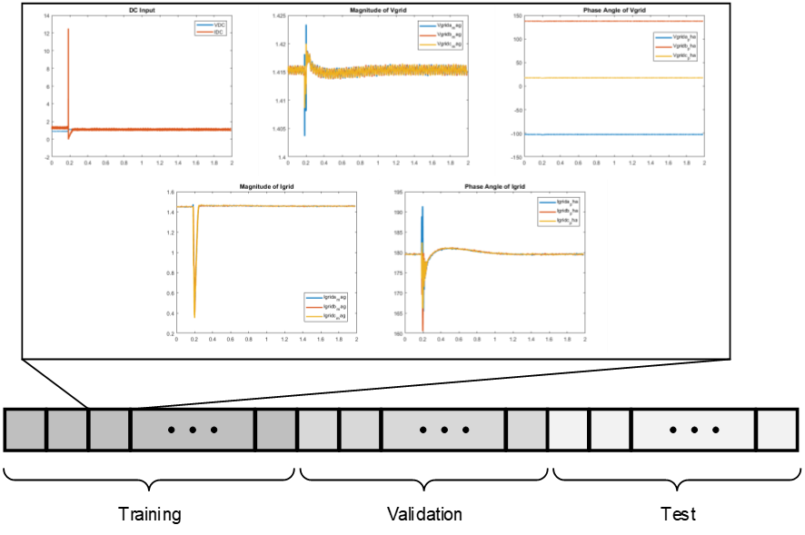
Figure 6-9 Split the dataset to training, validation, and test data.

BBM Architecture
The design of the BBM's architecture should be determined to align with its intended purpose. The selection of inputs and outputs for the BBM should be made considering the characteristics and requirements of the targeted system.
For the simulation model of the three-phase solar PV inverter, the BBM will characterize three main components: the PV array, the three-phase inverter, and the inverter control algorithm. In this model, the irradiance ($Ir$) and temperature ($T$) of the PV array are chosen as the BBM inputs. Additionally, given that this inverter uses GFL control, the magnitudes and phase angles of the three-phase grid-side voltages are included as the other inputs for the BBM, while the magnitude of the three-phase grid-side currents and the phase angles between grid-side voltages and currents are designated as the outputs. Consequently, the BBM for this simulation inverter model is structured as a model with 8 inputs and 6 outputs, as depicted in Figure 6-10 (a).
For the HIL model of the three-phase inverter, the BBM will only represent the inverter itself and its control. Since the model is using a dc voltage source for the dc input, the input voltage $V_{dc}$ is chosen as one of the BBM inputs, and the input current $I_{dc}$ becomes one of the BBM outputs. Meanwhile, considering that the HIL inverter model also uses GFL control, the magnitudes and phase angles of the three-phase grid-side voltages are incorporated as the other inputs for the BBM, while the magnitude of the three-phase grid-side currents and the phase angles between voltages and currents are designated as the other BBM outputs. As a result, the BBM for this simulation inverter model is configured with 7 inputs and 7 outputs, as illustrated in Figure 6.10 (b).

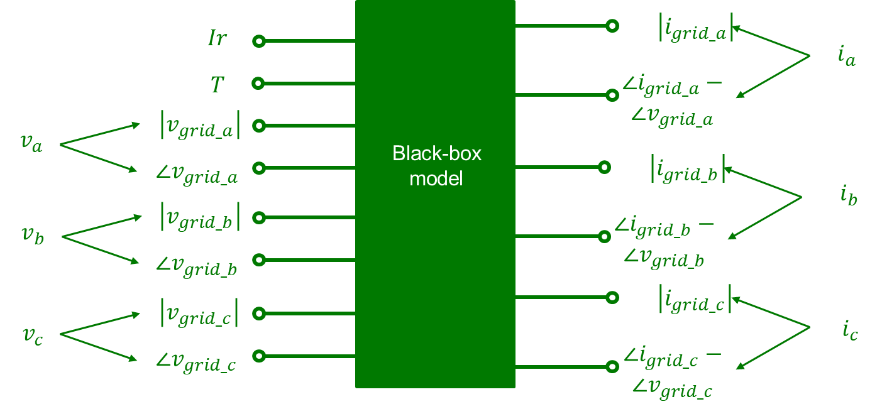
(a)

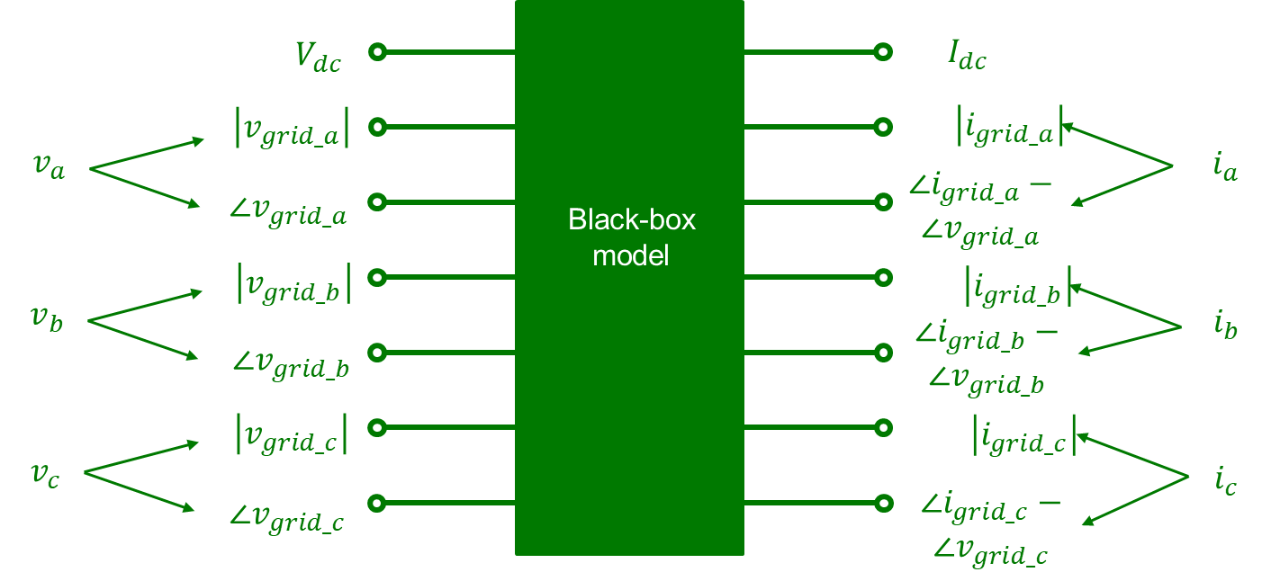
(b)
Figure 6-10 Architectures of BBMs: (a) simulation model and (b) HIL model.

DL-Based BBMs for Three-Phase Inverters
With the specified inputs and outputs outlined above for the BBMs, this section proposes the DL-based BBMs. Considering the characteristics of the power converters, three DL algorithms, including LSTM, GRU, and CNN, are investigated here. The LSTM and GRU networks are two types of RNNs, which are good at learning and predicting data based on time series, while the CNN is capable of extracting features from complex input dataset with reduced network parameters. Note that the NARX NN is not considered here for the modeling of three-phase inverters. This is because the NARX NN incorporates past output data as part of the model input, as illustrated in Figure 5-4. In tasks for multistep predictions (like models for simulation purposes), where the real output data is unknown and only the predicted output data is available, using the predicted output data as input for the NARX NN can lead to errors which will accumulate over time, affecting the accuracy of the model. This becomes particularly challenging for complex systems like the BBMs of three-phase inverters with 6 or 7 output channels. Models such as LSTM, GRU, and CNN, which rely solely on past input data, do not face this issue and are therefore the DL algorithms considered here.
- LSTM
The structure of the LSTM network has been illustrated in Figure 2-12. The LSTM networks take time series data as the input. Therefore, the preprocessed data from Section 6.3.2 needs to be transformed to match the LSTM expectations. Figure 6-11 depicts the reshaping of the input data for LSTM networks. The original input datasets are represented as large matrices, where each input channel (feature) forms a column and sequential timesteps are arranged as rows. To transform the input dataset, a window size of $n$ is chosen first. Then, the input data is reshaped

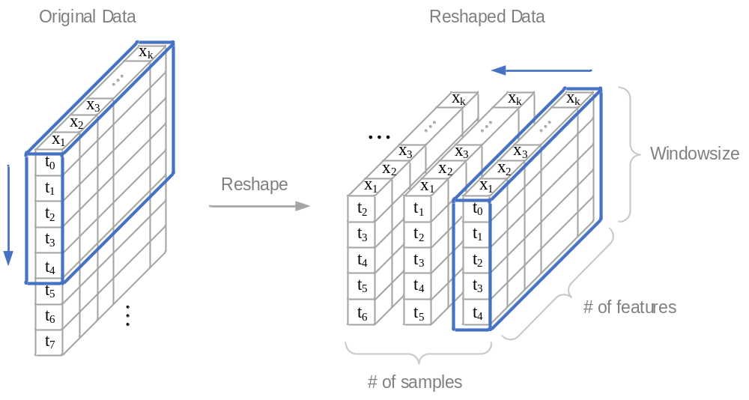
Figure 6-11 Input data reshaping for LSTM and GRU.

by moving the window one step down each time. In this example, the window size is chosen to be 5, then each batch of the reshaped input data can be depicted as ( 6.1 ):
$$X_{t}=\left[\begin{matrix}\begin{matrix}x_{1, t-4} & x_{2, t-4} \\ x_{1, t-3} & x_{2, t-3}\end{matrix} & \begin{matrix}⋯ & x_{k, t-4} \\ ⋯ & x_{k, t-3}\end{matrix} \\ \begin{matrix}⋮ & ⋮ \\ x_{1, t} & x_{2, t}\end{matrix} & \begin{matrix}⋱ & ⋮ \\ ⋯ & x_{k, t}\end{matrix}\end{matrix}\right]$$ | ( 6.1 )
where $t$ is the number of the batch, and $k$ is the number of features. Note that when $t≤3$, zeros could be added for the initialization purposes.
The output data of batch $t$ (also use the window size of 5 as an example) is chosen as ( 6.2 ):
$$Y_{t}=\left[\begin{matrix}y_{1, t} & y_{2, t} & ⋯ & y_{j, t}\end{matrix}\right]$$ | ( 6.2 )
where $j$ is the number of the output channels.
The window size serves as an important parameter influencing both the accuracy and complexity of the model. Opting for a larger window size enhances the model's capability for longer-term memory, thereby improving accuracy. However, this advantage comes at the cost of potentially slowing down both the training and execution processes of the model. Therefore, selecting an appropriate window size involves a trade-off between memory capability and computational efficiency. Chosen of the window size depends on the characteristics of the targeted system, as manifested in the recorded data, and should also take into account the requirements of the BBM. Figure 6-12 (a) depicts a typical response in PEC systems, wherein the input is subjected to a step change, resulting in a transient response in the corresponding output. If the to-be-designed BBM aims to capture such transients, the window size should not be shorter than the duration of these transient, as illustrated in Figure 6-12 (a). On the other hand,
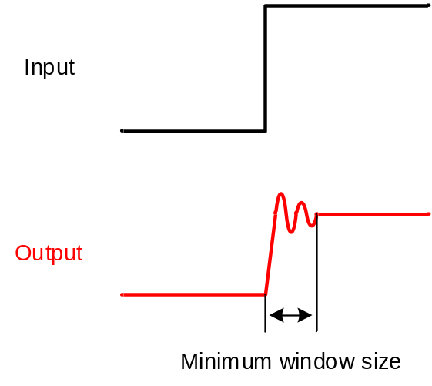
(a)

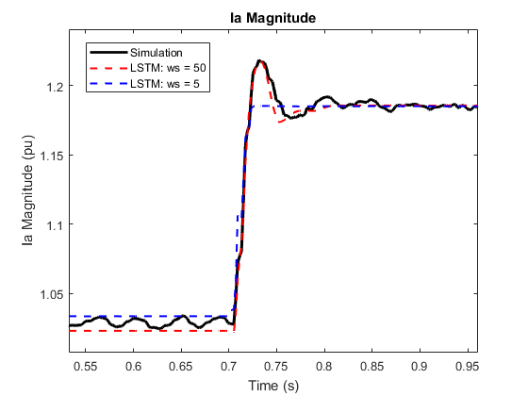
(b)
Figure 6-12 Selection of the window size: (a) minimum window size to capture transients and (b) comparative result of LSTM using a window size of 50 vs. 5.
if the primary goal of the BBM is only to estimate steady-state values, a smaller window size is recommended since it helps to minimize computational effort during both the training and execution processes. Figure 6-12 (b) shows a comparative result of the transient behavior in the magnitude of current $I_{a}$ between two LSTM-based BBMs, using window sizes of 50 and 5. The hyperparameters for the two BBMs are identical, with the only difference being their respective window sizes. While both models effectively predict the steady-state values for two operating points, the model with a larger window size precisely captures the overshoot occurring between 0.7 to 0.8 s.
With the transformed input and output data, the training, validation, and testing datasets can be used to train and evaluate the LSTM-based BBM. The architecture of the LSTM-based BBM can be designed after the tunning of the neural network hyperparameters. For the target three-phase inverters in both the simulation and HIL test scenarios, the LSTM-based BBM architectures are designed with the first layer as the input layer, succeeded by an LSTM layer, followed by a hidden layer consisting of a fully-connected layer, and another fully-connected layer serving as the final output layer.
- GRU
The structure of the GRU network has been illustrated in Figure 2-13. The GRU takes the same time series data as the input like LSTM. Therefore, the data reshaping depicted in Figure 6-11 and equations ( 6.1 ) and ( 6.2 ) are also used to transform the input and output dataset for GRU. Note that the choice of the window size for GRU follows the same principles outlined for LSTM, which depends on the nature of the target system and the purpose of the BBM. By tunning the hyperparameters of the GRU network, the architectures of the GRU-based BBMs are also chosen for the simulation model and the HIL model of the three-phase inverters. The architectures of GRU-based BBMs for both inverters are composed of an input layer, a GRU layer, followed by a fully-connected layer as a hidden layer, and another fully-connected layer serving as the output layer.
- CNN
The structure of the CNN has been illustrated in Figure 2-14. For the CNN input, the original sequential data needs to be transformed to a 2D-object using the historical input data. The historical input data length should be sufficiently extended to include important transients for three-phase inverters for CNN to learn. As mentioned in Section 2.2.2, the CNN use convolutional kernels to extract features from the input. When performing cross-correlation computations, the process starts by placing the convolution window at the upper-left corner of the input tensor. From there, it slides over all positions, progressing both downward and to the right, as illustrated in Figure 6-13. The number of rows and columns traversed per slide is referred to “stride”. In the example shown in Figure 6-13, stride $=(1, 1)$.
After the tunning of the hyper parameters, architectures of the CNN-based BBMs for the two inverters models are chosen. The input is succeeded by a CNN layer using a $3×3$ kernel and stride $=(1, 1)$. The next layer is a max-pooling layer, since the max-pooling provides better performance compared to the average pooling. The max-pooling layer is followed by a flatten layer and a fully-connected hidden layer. Another fully-connected layer is added as the final output.

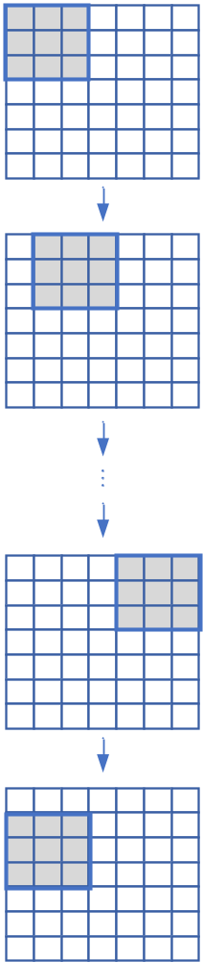
Figure 6-13 Strides of CNN kernel.

Performance Analysis of DL-Based BBMs for Three-Phase Inverters
To systematically evaluate the feasibility and efficacy of the DL-based BBMs for three-phase inverters, a comprehensive set of tests is performed. These tests encompass various transient scenarios, such as voltage-reactive power droop, voltage ride-through, dc input fluctuation, changes in irradiance, and variations in temperature. The resulting datasets, comprising data generated from these tests, are utilized for training purposes.
Furthermore, distinct tests conducted under these transient conditions form the validation and test datasets. The same datasets, whether collected from simulations or HIL tests, are employed for a comparative analysis of the performance of the three DL-based BBMs. The DL-based BBMs are developed using Python/Keras. To evaluate the overall accuracy of these models the Root Mean Square Error (RMSE) metric is employed. The time taken for the training and execution phases is recorded as an indicator of the computational complexity of the DL models.

Results of the Three-Phase Solar PV Inverter from Simulation
To assess the performance of DL-based BBMs for the simulation model of the three-phase solar PV inverter, transients under voltage-reactive power droop, irradiance change, and temperature variation are investigated. The validation and test datasets are selected to be distinct from the training dataset.
Figure 6-14 shows the model loss of three DL models over the course of 500 epochs with its zoomed-in view. It reveals that all three models achieve comparable levels of fitting on the training dataset after 500 epochs.
Figure 6-15 shows the predicted outputs generated by three DL-based BBMs under different
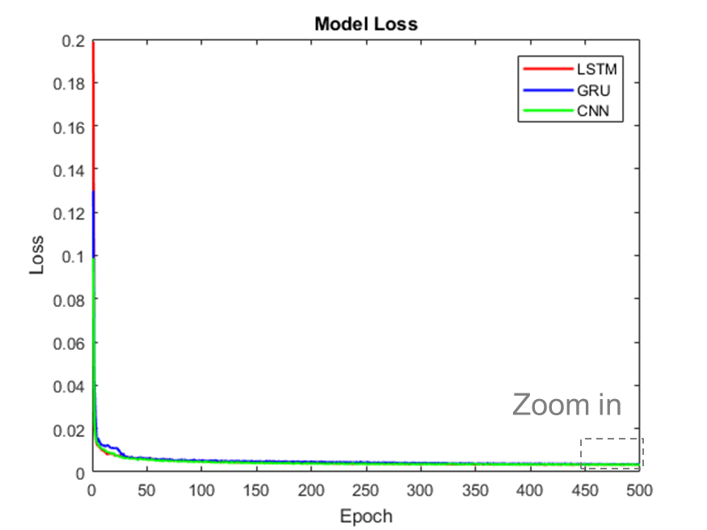
(a)

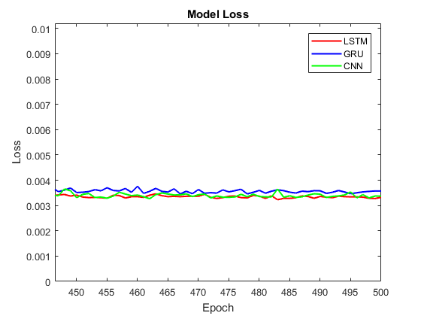
(b)
Figure 6-14 (a) Training loss and (b) zoomed-in view.

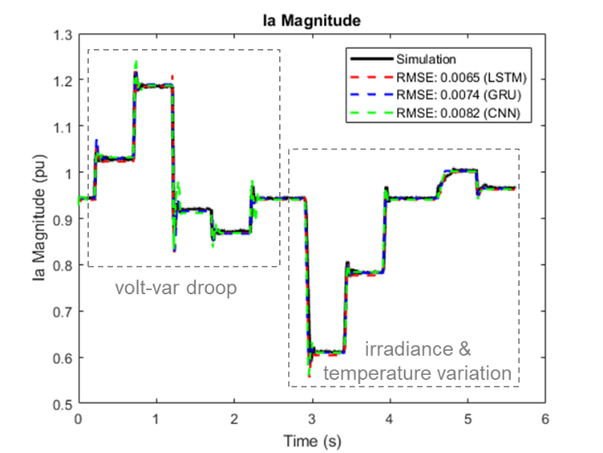
(a)

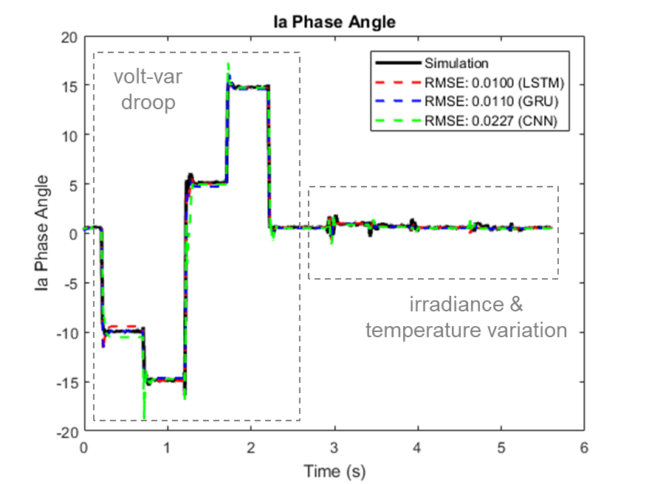
(b)
Figure 6-15 Results of Simulation test data: (a) magnitude and (b) phase angle of $I_{a}$.
transient scenarios, which are compared with the simulation results. Note that the initial rise in these signals is the initialization of these BMMs, as mentioned in Section 6.3.4-A. These results demonstrate that all three DL-based models can learn and predict the behaviors of three-phase PV inverter model from the simulation. Note that in the simulation of this balanced system, the magnitudes and phase angles of currents $I_{b}$ and $I_{c}$ looks very similar to the current $I_{a}$. Thus, only the results of $I_{a}$ are illustrated here.
Figure 6-16 depicts the zoomed-in view of the comparison under voltage-reactive power droop transients. In the test datasets, the grid-side voltage changed from 1 p.u. to 0.93 p.u., 0.82 p.u., 1.03 p.u., 1.12 p.u., and back to 1 p.u.. Figure 6-17 shows the zoomed-in view of the comparison under irradiance and temperature variation. The irradiance changed from $1000 W/{m^{2}}$ to $650 W/{m^{2}}$, $830 W/{m^{2}}$, and back to $1000 W/{m^{2}}$. The temperature varied from $45 ℃$ to $23 ℃$, and then to $37 ℃$.
Table 6-2 summarizes the comparison results of the three DL-based models, including both model accuracy and complexity. The complexity tests were carried out on a Windows 10 64-bit platform equipped with an Intel(R) Core(TM) i7-10510U CPU @ 1.80 GHz. The results reveal that all three models demonstrate comparable performance in predicting current magnitudes and phase angles, while both the LSTM and GRU models exhibit a slightly higher level of accuracy when compared to the CNN model. Additionally, the GRU model, delivering accuracy very close to that of LSTM, requires less time for training and execution due to its less complex structure over the LSTM model. The CNN model, on the other hand, while providing comparable overall accuracy, takes only 26% of training time and 32% of execution time compared to the LSTM model, featuring a simpler model structure with good accuracy in such an application.
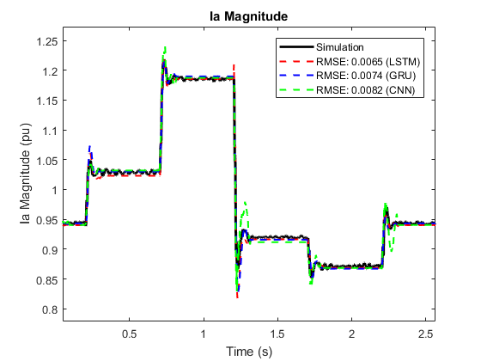
(a)

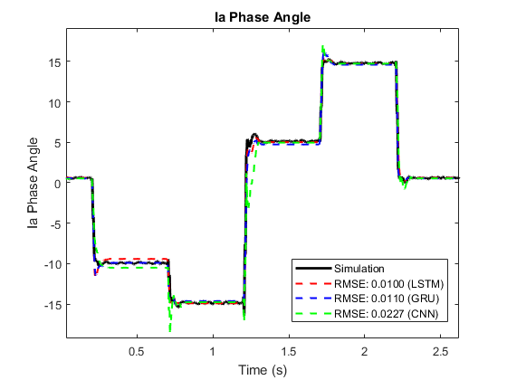
(b)
Figure 6-16 Zoomed-in view of volt-var droop: (a) magnitude and (b) phase angle of $I_{a}$.

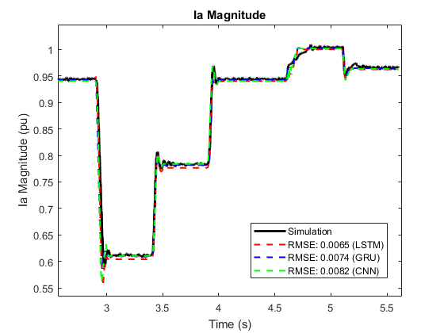
(a)

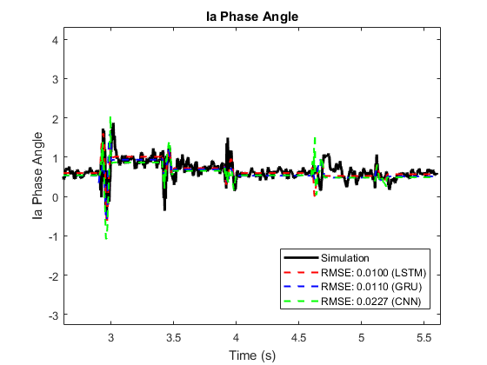
(b)
Figure 6-17 Zoomed-in view of irradiance and temperature change: (a) magnitude and
(b) phase angle of $I_{a}$.
Table 6-2 Performance comparison of DL-based BBMs for the simulation inverter model
Model | LSTM | GRU | CNN
RMSE ($I_{a_mag}$) | 0.0065 | 0.0074 | 0.0082
RMSE ($I_{b_mag}$) | 0.0065 | 0.0076 | 0.0083
RMSE ($I_{c_mag}$) | 0.0062 | 0.0076 | 0.0083
RMSE ($I_{a_pha}$) | 0.0100 | 0.0110 | 0.0227
RMSE ($I_{b_pha}$) | 0.0099 | 0.0112 | 0.0239
RMSE ($I_{c_pha}$) | 0.0106 | 0.0116 | 0.0228
Training Time (s) | 3388.354 | 2617.495 | 880.914
Execution Time (s) | 0.690 | 0.484 | 0.222

Results of the Three-Phase Inverter from HIL Tests
To investigate performance of DL-based BBMs for three-phase inverter model from HIL tests, transient scenarios under voltage ride-through and dc input voltage change are studied. The training process utilizes multiple sets of test data generated from these transient scenarios, while separate sets are reserved for validation and testing purposes. Figure 6-18 depicts the training losses of three DL-based BBMs over the course of 500 epochs, together with its zoomed-in view with more details. Figure 6-19 shows the predicted outputs (including $I_{dc}$ and magnitude and phase angle of $I_{a}$) of three DL-based BBMs compared with the HIL test results. As mentioned in the previous section, the initial rise in these signals represents the initialization of these BBMs. Figure 6-20 and Figure 6-21 depicts the zoomed-in perspective of the voltage ride-through and dc input change transients with more details. Note that in this balanced grid, the magnitudes and phase angles of currents $I_{b}$ and $I_{c}$ are very similar to that of current $I_{a}$. Therefore, only the results for $I_{a}$ are presented here. These results show that all three DL models are capable of black-box modeling for the three-phase inverter in the HIL tests.
Table 6-3 provides a comparison of the performance of three DL-based BBMs developed for the HIL inverter model. The comparison includes both model accuracy and complexity. The tests were carried out on a Windows 10 64-bit platform equipped with an Intel(R) Core(TM) i7-10510U CPU @ 1.80 GHz. The results indicate that the LSTM model achieves the highest accuracy; however, it also exhibits the highest complexity, requiring the longest training time. On the other hand, the GRU model offers comparable accuracy to the LSTM model, but with a slightly shorter training time. Lastly, the CNN model, while maintaining similar accuracy levels to the LSTM and GRU models, requires the shortest training and execution times, representing its lowest level of model complexity among the three DL-based BBMs.
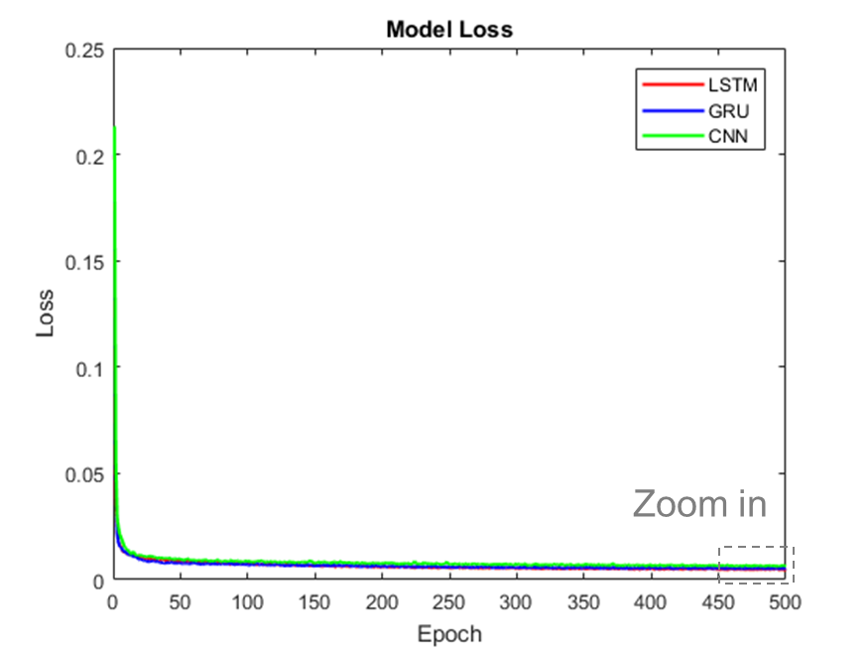
(a)

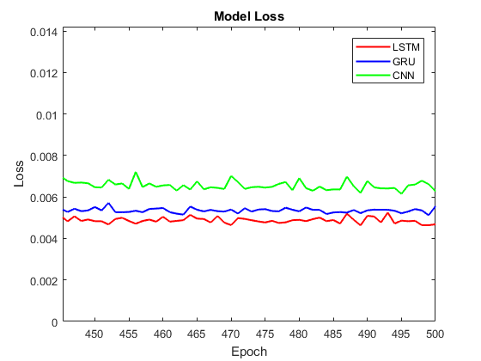
(b)
Figure 6-18 (a) Training loss and (b) zoomed-in view.
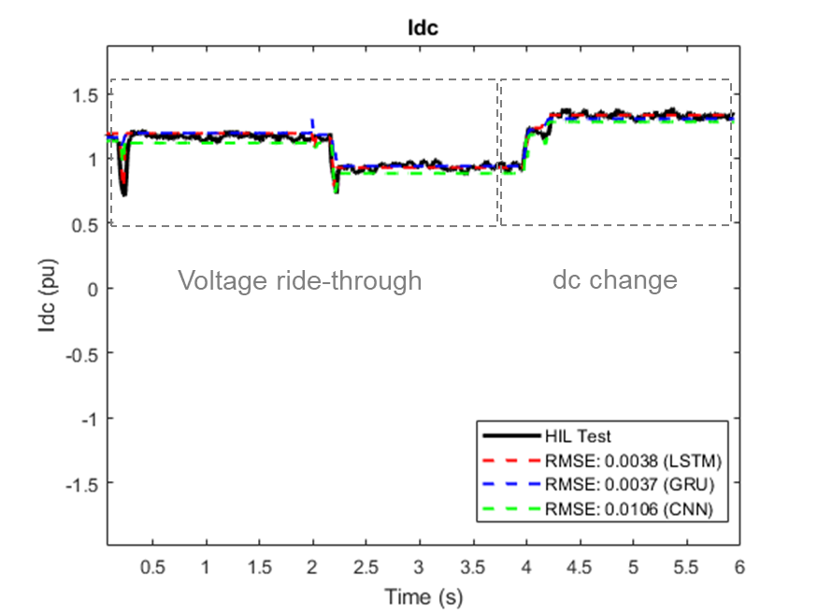
(a)

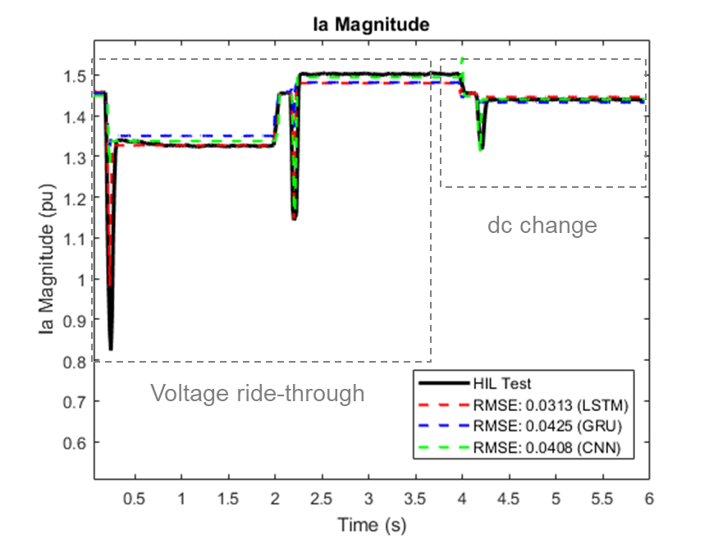
(b)
Figure 6-19 Results of HIL test data: (a) $I_{dc}$, (b) magnitude and (c) phase angle of $I_{a}$.
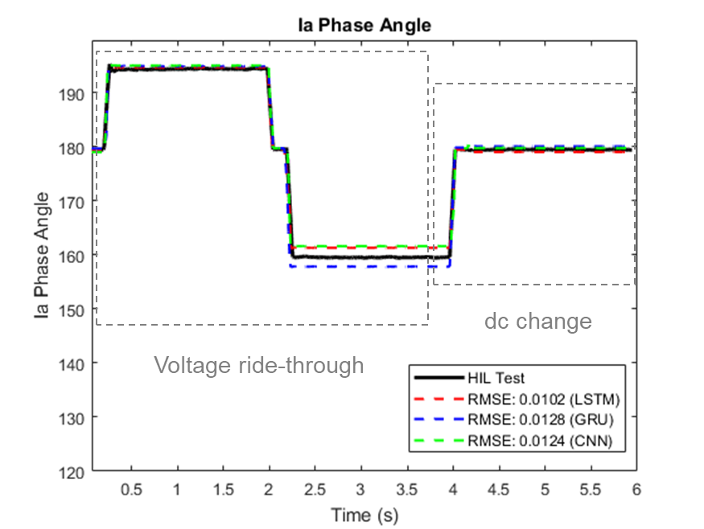
(b)
Figure 6-19 (continued)
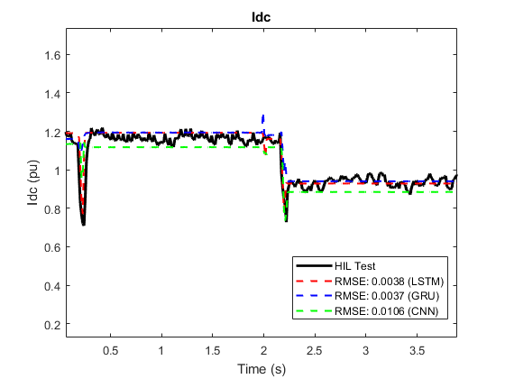
(a)
Figure 6-20 Zoomed-in view of voltage ride-through: (a) $I_{dc}$, (b) magnitude and (c) phase angle of $I_{a}$.
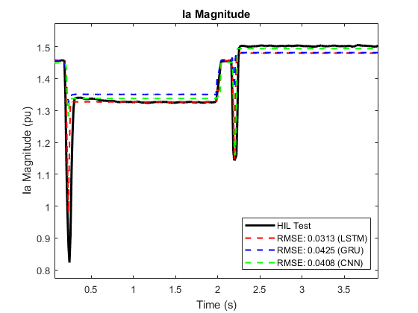
(b)
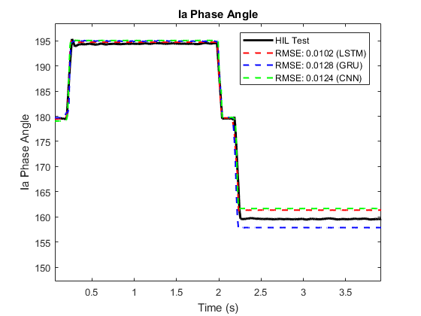
(c)
Figure 6-20 (continued)

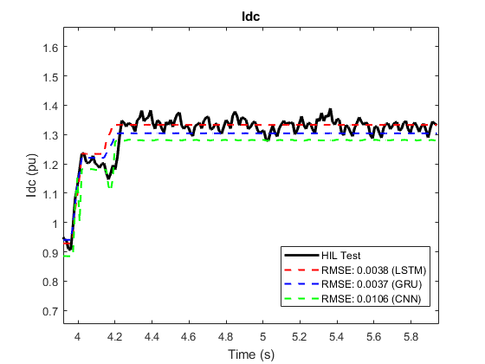
(a)

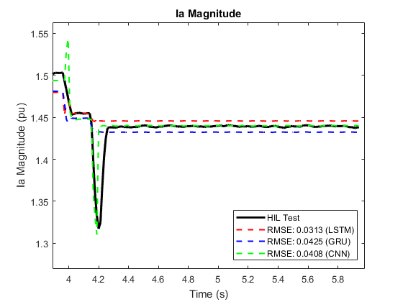
(b)
Figure 6-21 Zoomed-in view of dc change: (a) $I_{dc}$, (b) magnitude and (c) phase angle of $I_{a}$.
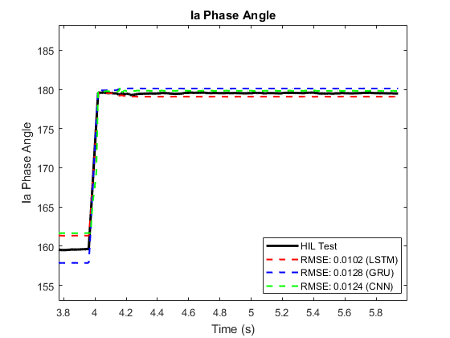
(c)
Figure 6-21 (continued)

Table 6-3 Performance comparison of DL-based BBMs for the HIL inverter model
Model | LSTM | GRU | CNN
RMSE ($I_{dc}$) | 0.0038 | 0.0037 | 0.0106
RMSE ($I_{a_mag}$) | 0.0313 | 0.0425 | 0.0408
RMSE ($I_{b_mag}$) | 0.0281 | 0.0373 | 0.0360
RMSE ($I_{c_mag}$) | 0.0301 | 0.0398 | 0.0406
RMSE ($I_{a_pha}$) | 0.0102 | 0.0128 | 0.0124
RMSE ($I_{b_pha}$) | 0.0102 | 0.0120 | 0.0123
RMSE ($I_{c_pha}$) | 0.0109 | 0.0114 | 0.0147
Training Time (s) | 600.729 | 528.264 | 188.173
Execution Time (s) | 0.072 | 0.077 | 0.045

Discussions on Utilization of Black-Box Models
Once the BBMs are trained and tested, they can be used for various applications, such as simulation, monitoring, protection, etc. More specifically, for power system simulation and analysis with numerous types of grid-connected inverters, the proposed BBMs can be employed with some grid simulation software, e.g., GridLAB-D [107], following the steps below. First, the test data of the inverter are collected for the purpose of training, validation, and testing for the development of BBMs. Second, the proposed BBMs are trained and tested in Python using the test data. Once the BBMs are trained and validated, the structures and parameters of the models will be saved. Third, the BBMs are coupled into GridLAB-D by converting the saved Python-based BBMs into the C++ simulation models since the simulation environment of GridLAB-D is based on C++. Fourth, the BBMs of inverters can now simulate with the rest of the systems in GridLAB-D. During the simulation, at each time step, historical input data from the system will be collected and transformed into correct format, which depends on the DL algorithms employed by the BBMs. Then, the BBMs calculate the output data, which will be sent back to the system. And, at the subsequent time step, the input data will be updated accordingly, and the new output data will be calculated. This process repeats until the end of the simulation period. Note that when the simulation starts, the historical input data is not available, so the model initialization should be considered during the training and validation phases, as mentioned in Section 6.3.4-A.
Similarly, in applications like monitoring and protection purposes, the proposed BBMs could serve to predict the output data of targeted systems, enabling comparison with the measured outputs. This facilitates the identification of degradation or fault conditions, prompting timely corrective actions to protect the systems.

Conclusions
This chapter presents a feasibility study on the use of DL-based BBMs for three-phase inverters, including LSTM, GRU, and CNN. The model architecture design, data preprocessing, and data reshaping are investigated to ensure that the BBM produces accurate and reliable results. To generate the data for the BBMs, a detailed switching model of the three-phase solar PV inverter is developed in simulation, alongside another three-phase inverter model from HIL tests. Various transient conditions of these two inverter models are investigated, including voltage and reactive power control, voltage ride-through, dc input change, irradiance change, and temperature variation.
The results from both tests affirm that all three DL-based BBMs are capable of providing good results when simulating these transients. The LSTM and GRU-based models provide a slightly superior performance compared to the CNN model, with the trade-off of longer training and execution times due to their higher complexity. The GRU-based model delivers results very close to those of LSTM, but with shorter training times. The CNN-based model requires the least amount of time for both training and execution among the three models, while still exhibiting overall accuracy that is comparable to the others.

Development of Deep Learning-Based Black-Box Models for Three-Phase Inverters in Unbalanced Grids

Introduction
In this chapter, the feasibility and performance of using DL-based BMMs (LSTM, GRU, and CNN) for three-phase GFM inverters under unbalanced conditions are investigated. To generate the training, validation, and testing data for such BBMs, a three-phase inverter using GFM control is developed in MATLAB/Simulink with unbalanced loads. Without detailed internal information, the BBMs can be directly generated using data-driven techniques. Additionally, using BBMs can significantly expedite analysis for unbalanced grids and facilitate prompt measures to prevent hazardous outcomes caused by unbalanced voltage. The proposed DL-based BBMs are evaluated under unbalanced conditions with different transient behaviors.

Three-Phase Inverter Model with Unbalanced Loads
A switching model of a three-phase inverter in MATLAB/Simulink is utilized to study the feasibility of DL-based BBMs for unbalanced grids. Considering more GFM inverters are adopted to enhance grid stability and resilience [108, 109], the GFM control is implemented. The circuit diagram of the inverter with a boost converter is shown in Figure 7-1, with its parameters summarized in Table 7-1 [110]. The dual-loop voltage control in $dq$ coordinates is implemented, and the 2nd-order current control is used for the dc/dc converter to prevent dc current from flowing into the distributed energy resources (DER) [111]. The developed BBMs will include the voltage source inverter, its output filter, and the inverter control. The voltage and current data from both the dc and ac sides are measured to train and validate the BBMs.

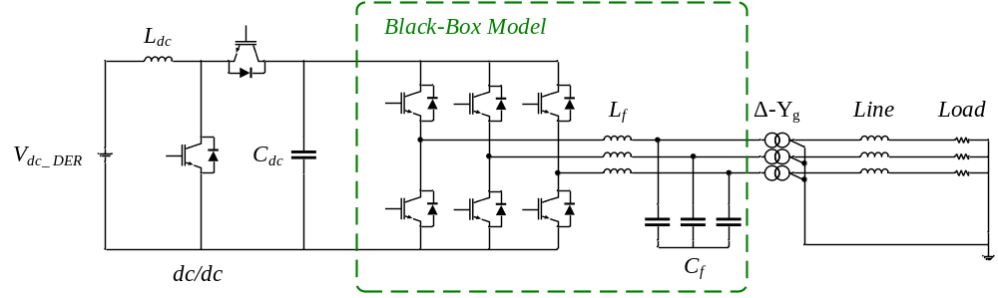
Figure 7-1 Three-phase inverter with unbalanced loads.

Table 7-1 Parameters of the inverter system with unbalanced loads
Parameters |  | Values
System parameters | $$S_{base}$$ | 4 MW
System parameters | $$V_{ac}$$ | 480 V
System parameters | $$V_{dc_DEr}$$ | 425 V
System parameters | $$V_{dc}$$ | 1020 V
Converter parameters | $L_{f}$, $R_{Lf}$ | 6.11 μH, 1.44 μΩ
Converter parameters | $C_{f}$, $R_{Cf}$ | 4.6 mF, 12.5 mΩ
Converter parameters | $L_{dc}$, $C_{dc}$ | 22.5 μH, 12.7 mF
Control parameters | $$f_{s}$$ | 10 kHz
Control parameters | $k_{pv}$, $k_{iv}$ | 0.25, 1250
Control parameters | $k_{pi}$, $k_{ii}$ | 0.6, 52.2
Line parameters | $L_{line}$, $R_{line}$ | 0.1 mH, 1 mΩ

Development of DL-Based BBMs for Three-Phase Inverters in Unbalanced Grids
A system identification strategy similar to Figure 6-7 is used to develop the DL-based BBMs for three-phase inverters under unbalanced conditions. The structures of such BBMs, including data acquisition, data preprocessing, design of model architectures, and developed DL structures, are introduced in this section.

Data Acquisition and Preprocessing
Since the target BBM features ports on both the dc and ac sides, the raw data of dc input voltage and current ($V_{dc}$ and $I_{dc}$) and ac output voltages and currents ($V_{abc}$ and $I_{abc}$) are recorded. Note that the ac voltages and currents in $abc$ frame will be converted to phasor domain as magnitudes and phase angles. To generate the training data set, numerous simulation tests are conducted under conditions of unbalanced loads. These tests involve varying combinations of loads with various active and reactive power levels across different phases. Figure 7-2 shows example waveforms captured during a test conducted for the training dataset, featuring a single-phase load with an active power of 1.33 MW connected to phase $a$ at 0.35 s. For validation and testing datasets, distinct tests are conducted, including transient behaviors that are not involved in the training dataset.
After all test data has been collected, the similar data preprocessing steps as outlined in Section 6.3.2 are applied, including removing the start-up data, removing the “bad data”, down sampling, rescaling, and dataset splitting. Following preprocessing, these datasets still need to be reshaped into appropriate formats to align with the input requirements of different DL algorithms, as detailed in Section 6.3.4.

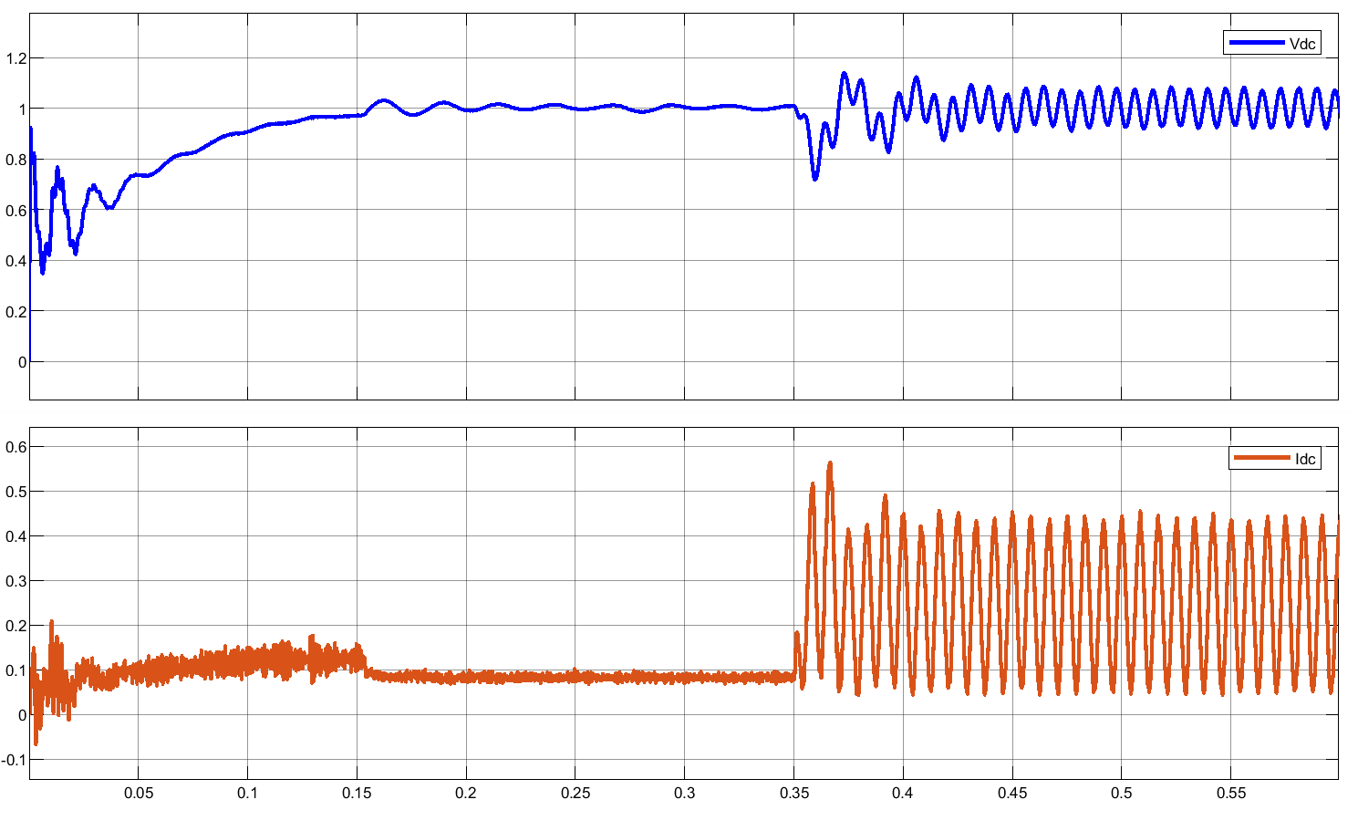
(a)

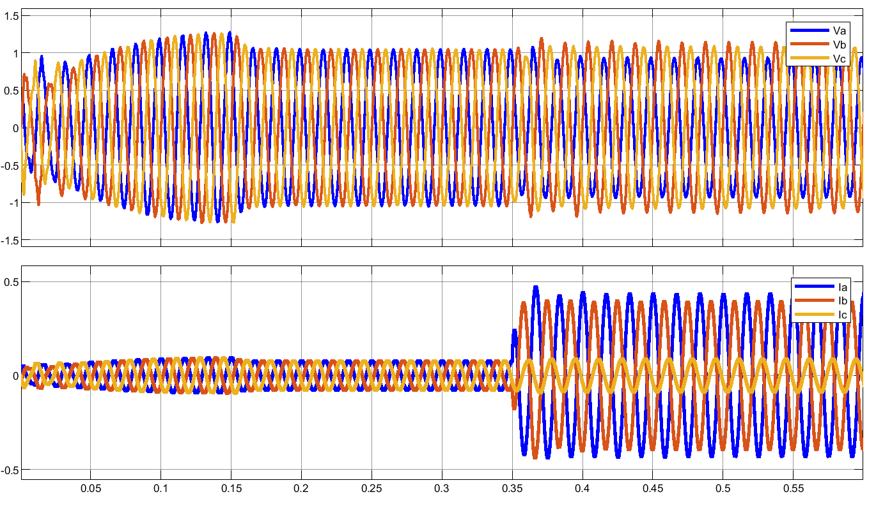
(b)
Figure 7-2 Test waveforms example under unbalanced conditions: (a) $V_{dc}$ and $I_{dc}$and (b) $V_{abc}$ and $I_{abc}$.

BBM Architecture and DL-Based Model Structures
The architecture of the BBM is designed based on the characteristics of the targeted three-phase inverter. On the dc input side, the dc input voltage $V_{dc}$ is selected as one of the BBM inputs, and the dc input current is selected as one of the BBM outputs. On the grid side, considering the three-phase inverter uses GFM control, the magnitudes and phase angles of grid-side currents are designated to be the rest of the BBM inputs, while the magnitudes and phase angles of grid-side voltages are chosen to be the rest of the BBM outputs, as depicted in Figure 7-3. Consequently, the BBM for this three-phase inverter model is configured with 7 inputs and 7 outputs.
With the designed inputs and outputs described above for the BBMs, three DL-based BBMs are developed for the three-phase GFM inverter with unbalanced loads, using the LSTM, GRU, and CNN algorithms. The preprocessed input and output data needs to be reshaped to meet the requirements of these DL models, as described in Section 6.3.4. The optimized structures of these three DL-based BBMs are illustrated below.
- LSTM
The architecture of the LSTM-based BBM is determined following the fine-tuning of neural network hyperparameters. For the targeted three-phase GFM inverters with unbalanced loads, the LSTM-based BBM is structured with the first layer as the input layer, followed by an LSTM layer. Subsequently, there is a hidden layer comprising a fully-connected layer, followed by another fully-connected layer that serves as the final output layer.
- GRU
After fine-tuning the hyperparameters of the GRU network, the architectures of the GRU-

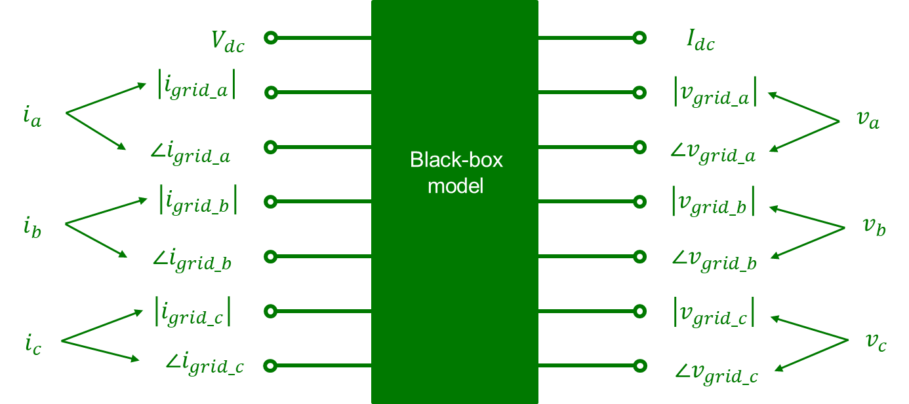
Figure 7-3 Architectures of BBM for the GFM inverter in the unbalanced grid.

based BBMs are selected for the targeted three-phase GFM inverters. These architectures comprise an input layer, followed by a GRU layer, a fully-connected layer as a hidden layer, and another fully-connected layer serving as the output layer.
- CNN
Following the fine-tuning of hyperparameters, the architectures of the CNN-based BBMs are selected for both inverter models. The input is followed by a CNN layer using a 3×3 kernel with a stride of $(1, 1)$. Subsequently, a max-pooling layer is introduced, as it shows superior performance than average pooling. This is followed by a flatten layer and a fully-connected hidden layer, with another fully-connected layer added as the output layer.

Performance Analysis of DL-Based BBMs in Unbalanced Grids
To examine the feasibility and performance of DL-based BBMs for three-phase inverters under unbalanced conditions, a comprehensive set of tests is conducted, encompassing a wide range of unbalanced scenarios. This forms the datasets for training, validation, and testing of the DL-based BBMs. Note that in addition to the power levels of unbalanced loads, certain transient behaviors that are not included in the training dataset are introduced in the testing dataset, which serves to evaluate the performances of different DL models.
For comparing the performance of three DL models, the RMSE metric is applied to compare the accuracy of each model, and the time related to model training and execution are monitored to assess the complexity of these models.
Figure 7-4 presents both the results of model training loss and a zoomed-in view over 500 epochs. It indicates that LSTM and GRU models achieve similar levels of fitting on the training dataset after 500 epochs, outperforming the CNN model.
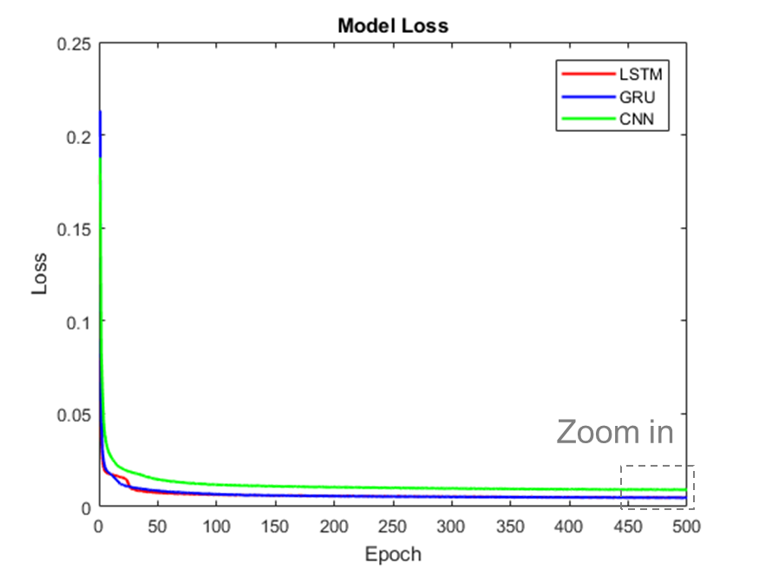
(a)

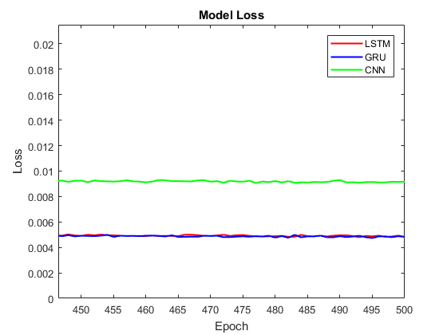
(b)
Figure 7-4 (a) Training loss and (b) zoomed-in view.

Figure 7-5 shows the predicted outputs of three DL-based BBMs compared to the simulation waveforms under unbalanced conditions, including the dc input current $i_{dc}$ and magnitudes and phase angles of the three-phase voltages $V_{a}$, $V_{b}$, and $V_{c}$. Unlike the results shown in Chapter 6 under balanced conditions, the magnitudes and phase angles of three-phase voltages are all different with unbalanced loads. Thus, results of all output channels are depicted here. These results demonstrate that all three DL-based BBMs are capable of modeling the three-phase inverter in unbalanced grids.
Figure 7-6 provides detailed views of testing transient scenarios that were not included in the training dataset. The zoomed-in results indicate that the LSTM and GRU-based models can accurately predict both the transient and steady-state behaviors, while the CNN-based model exhibits some errors in certain signals during these transients.
Table 7-2 summarizes the comparisons of model accuracy and complexity of three DL-based BBMs for the three-phase GFM inverter under unbalanced conditions. The training and execution time tests were carried out on a Windows 10 64-bit platform equipped with an Intel(R) Core(TM) i7-10510U CPU @ 1.80 GHz. It reveals that both the LSTM and GRU-based models, which are good at learning and predicting time-series data, outperform the CNN-based model in such unbalanced conditions. Additionally, the GRU model, while offering slightly improved accuracy over the LSTM model in most output signals, requires slightly less training time and executes more quickly. On the other hand, the CNN-based model, although faster due to its simpler architecture, exhibits lower performance compared to the other two models.

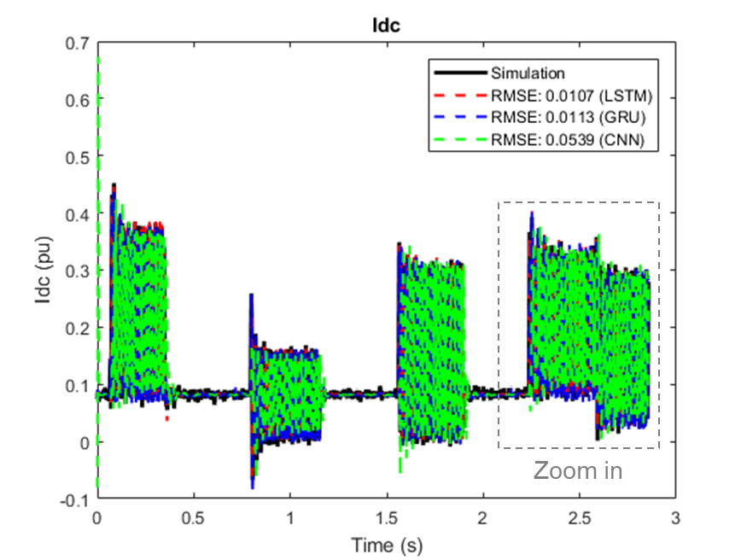
(a)

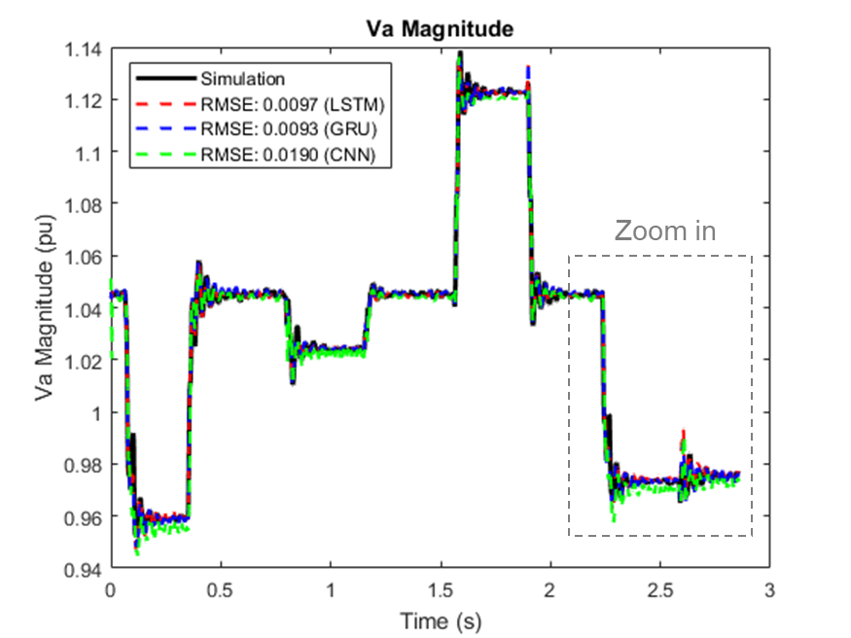
(b)
Figure 7-5 Results of unbalanced test data: (a) $I_{dc}$, (b) magnitude of $V_{a}$, (c) magnitude of $V_{b}$, (d) magnitude of $V_{c}$, (e) phase angle of $V_{a}$, (f) phase angle of $V_{b}$, and (g) phase angle of $V_{c}$.
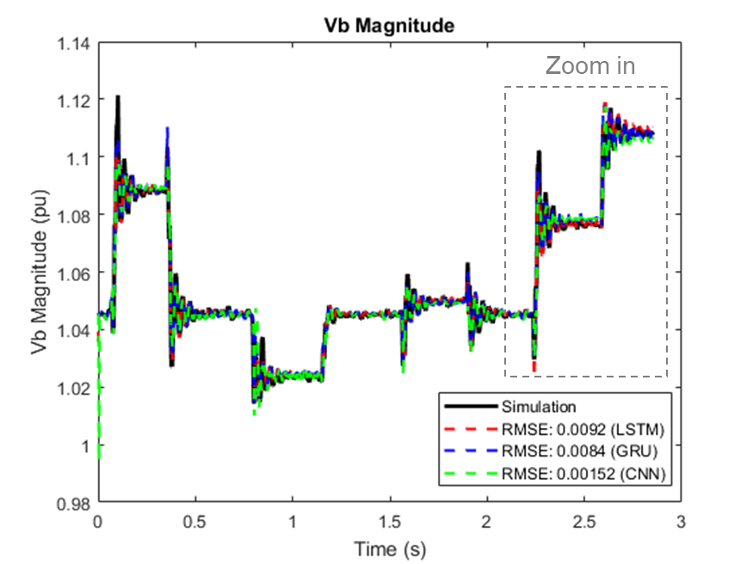
(c)

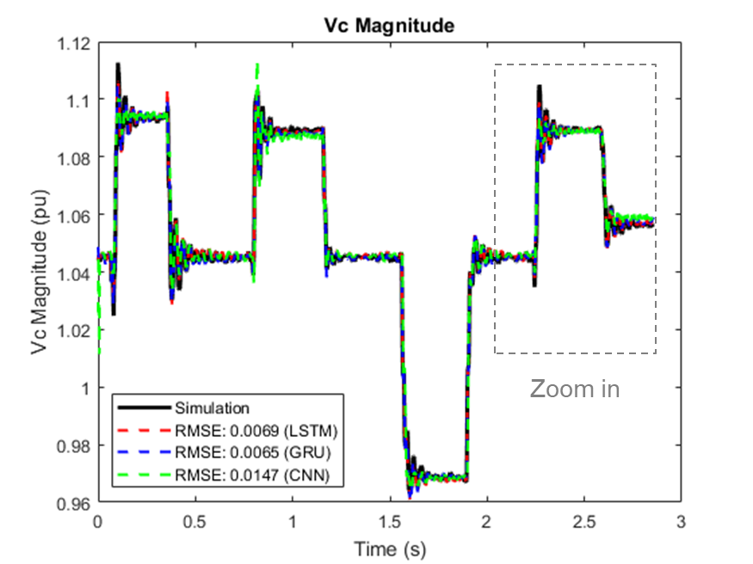
(d)
Figure 7-5 (continued)
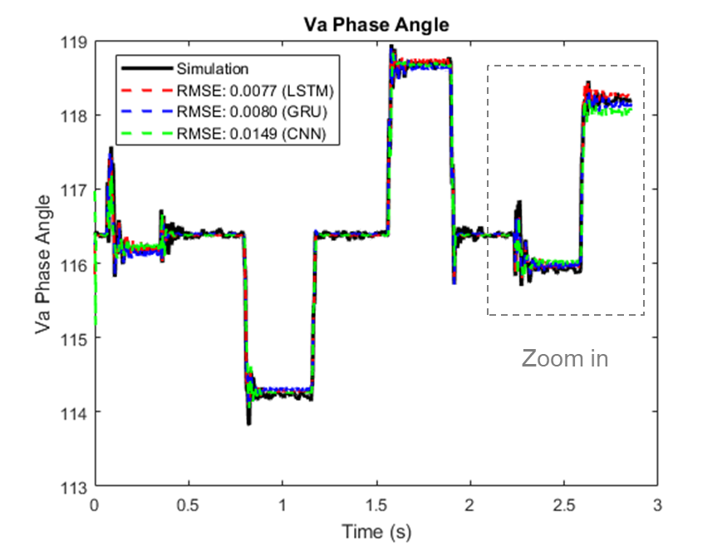
(e)

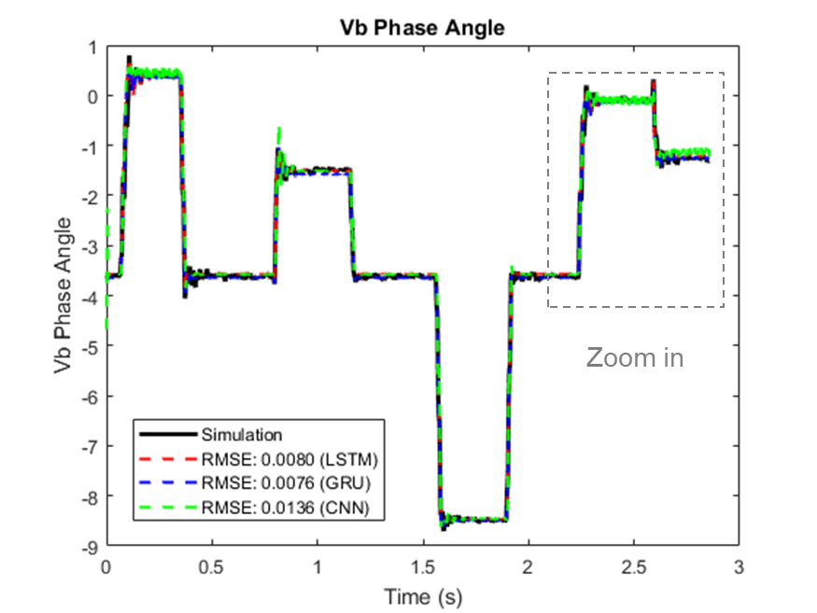
(f)
Figure 7-5 (continued)
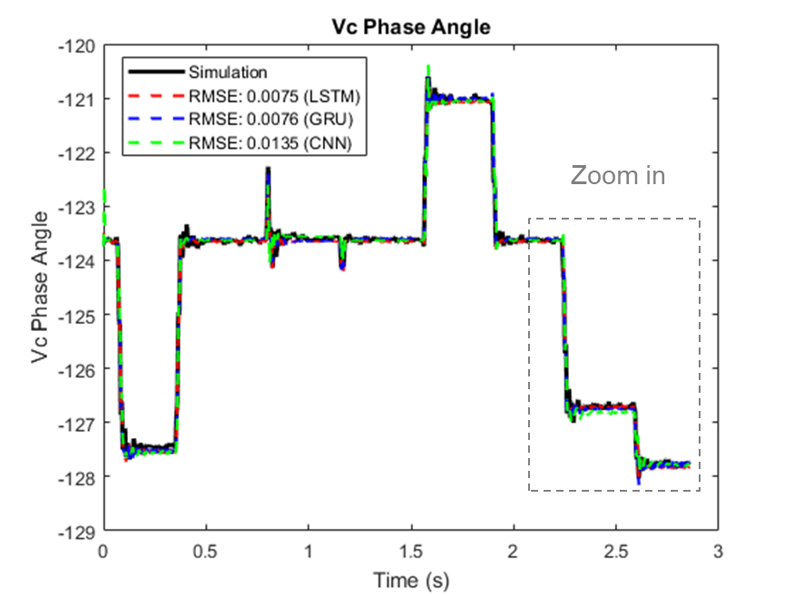
(g)
Figure 7-5 (continued)
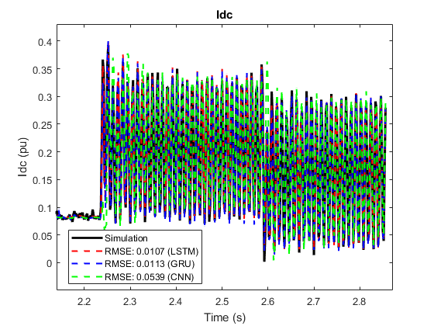
(a)
Figure 7-6 Zoomed-in view of test data: (a) $I_{dc}$, (b) magnitude of $V_{a}$, (c) magnitude of $V_{b}$, (d) magnitude of $V_{c}$, (e) phase angle of $V_{a}$, (f) phase angle of $V_{b}$, and (g) phase angle of $V_{c}$.
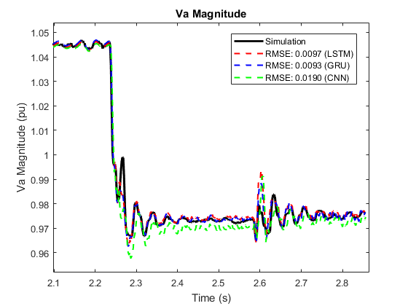
(b)

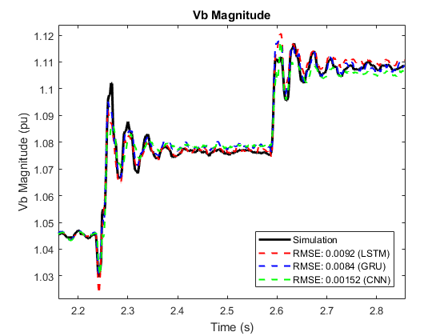
(c)
Figure 7-6 (continued)
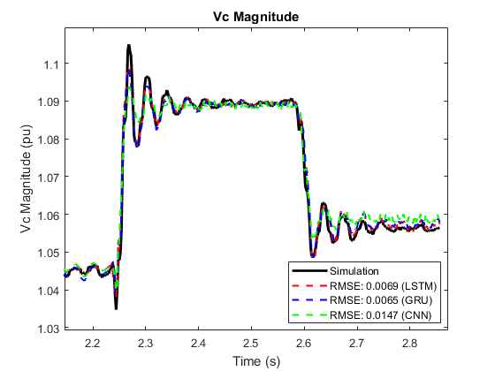
(d)

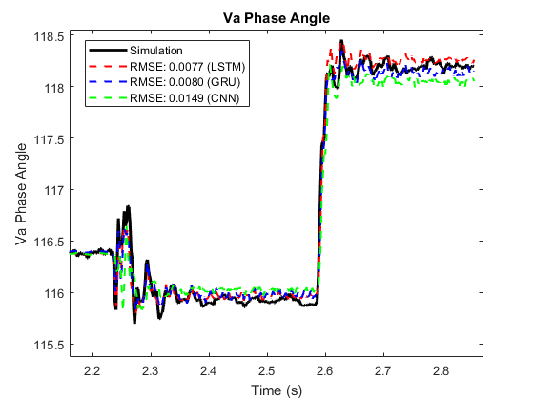
(e)
Figure 7-6 (continued)
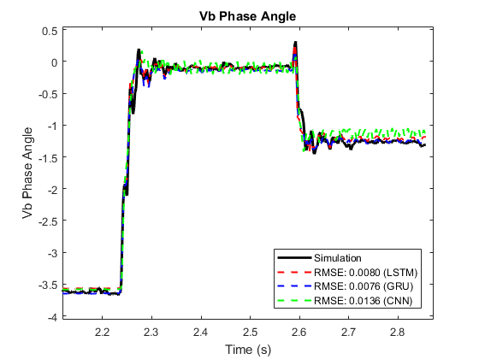
(f)

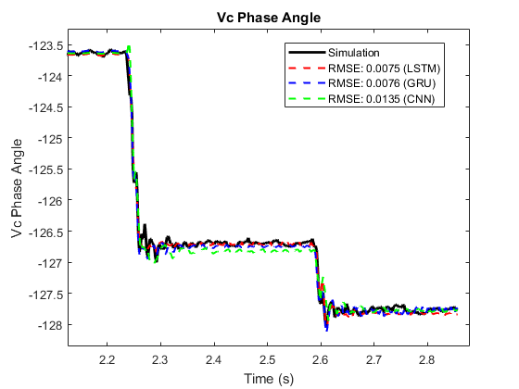
(g)
Figure 7-6 (continued)

Table 7-2 Performance comparison of DL-based BBMs for the GFM inverter model under unbalanced conditions
Model | LSTM | GRU | CNN
RMSE ($I_{dc}$) | 0.0107 | 0.0113 | 0.0539
RMSE ($V_{a_mag}$) | 0.0097 | 0.0093 | 0.0190
RMSE ($V_{b_mag}$) | 0.0092 | 0.0084 | 0.0152
RMSE ($V_{c_mag}$) | 0.0069 | 0.0065 | 0.0147
RMSE ($V_{a_pha}$) | 0.0077 | 0.0080 | 0.0149
RMSE ($V_{b_pha}$) | 0.0080 | 0.0076 | 0.0136
RMSE ($V_{c_pha}$) | 0.0075 | 0.0076 | 0.0135
Training Time (s) | 589.739 | 494.472 | 266.273
Execution Time (s) | 0.086 | 0.092 | 0.073

Conclusions
This chapter explores the feasibility and effectiveness of employing DL-based BBMs for three-phase inverters operating under unbalanced conditions. The datasets are collected from numerous tests using a simulation model of a three-phase GFM inverter with unbalanced loads, applying appropriate data acquisition and preprocessing techniques. The results indicate that all three DL-based BBMs – namely the LSTM, GRU, and CNN models – show good capabilities for such tasks. While the CNN-based BBM has the shortest training and execution time, its performance falls short of that exhibited by the LSTM and GRU-based BBMs. The GRU-based BBM, with a slightly superior performance, also requires less time for training when compared to the LSTM.

Conclusions and Future Work
This chapter provides a summary of the work in this dissertation and outlines the possible future work.

Conclusions
Both the small-signal stability analysis method and black-box transient modeling approaches for large-scale PEC-rich power systems are investigated in this dissertation. The conclusions can be summarized as follows:
- A partition-based small-signal stability analysis method that employs the NAM-based criterion to analyze large-scale PEC-rich systems is proposed. The results show that the proposed method reduces the computation burden by using lower-order matrices with system partition, while maintaining the accuracy of the original matrix-based analysis, thus making the small-signal stability analysis of large-scale systems solvable. Additionally, the partition concept enhances the scalability and flexibility of the method, allowing for easy modification of only the corresponding sub-areas or interconnections when considering contingencies. Using lower-order matrices with the proposed method also makes it simpler to identify instability-related converters or sub-areas. Simulation and experimentation on a six-converter test system and a modified 140-bus NPCC test system with 100% PE penetration confirm the effectiveness of the proposed analysis method.
- An issue caused by pure inductance models when applying the determinant-based GNC for small-signal stability analysis is identified. It is found that the pure inductance models in the system can induce the imaginary axis poles to the MIMO system model, and such an issue can potentially result in incorrect stability analysis results. A case study of an example system validates the analysis. Solutions to this issue include shifting the imaginary axis poles into the LHP or providing phase compensation for the determinant based GNC when the imaginary axis poles are involved due to pure inductance models.
- A comparative analysis is conducted on three popular nonlinear black-box modeling approaches, including NARX, HW, and NN approaches, in power electronics applications. The performance of these approaches is compared under different transients of a single-phase PV inverter. By analyzing the model accuracy, model behaviors, and model complexity using the proposed comparison method, it is concluded that the transient behaviors of the inverter are more effectively characterized by the NN-based BBMs. Notably, this model exhibits advantages such as shorter training and execution times. Based on these findings, the NN-based modeling approach is selected for further investigation of three-phase PV inverters.
- Three types of DL-based BBMs are developed to capture transient behaviors of three-phase inverters. To ensure accurate and reliable results, the data acquisition and preprocessing, model architecture design, and training, validation, and tests dataset selection are investigated. A detailed switching model of the three-phase solar PV inverter and another three-phase GFL inverter model in HIL tests are created to generate the data for these BBMs. The results demonstrate that the three considered DL algorithms, including LSTM, GRU, and CNN, are capable of providing good results when simulating transient behaviors for the three-phase PECs. Additionally, the study reveals that the LSTM and GRU-based BBMs yield better results, with the GRU model demonstrating faster training compared to the LSTM model. The CNN model, on the other hand, requires the least time for both training and execution while delivering performance comparable to the other two models.
- The proposed three DL-based BBMs are extended to study their applications for three-phase inverters in unbalanced grids. A three-phase GFM inverter with unbalanced loads is developed to generate data to train and validate the proposed DL-based models. It is found that these DL-based BBMs can also offer good performance for the GFM inverter under unbalanced conditions. The analysis indicates that both the LSTM and GRU models exhibit superior performance compared to the CNN model in this study. Notably, the GRU model, while delivering slightly better performance, also demands less time for both training and execution in comparison to the LSTM model.

Future Work
While the contributions address the relevant issues, some interesting topics and recommended future work are listed here:
- Automated partition strategy
The proposed small-signal stability analysis method in Chapter 3 relies on the partitioning of large-scale power systems. In this work, the partitioning process involves a manual selection of subsystems characterized by fewer interconnection lines, which aims to reduce the computational burden to facilitate further analysis. However, when dealing with larger systems featuring an increased number of buses and transmission lines, manual partitioning becomes a challenging task. To address this challenge, automated partitioning strategies can be implemented, aiming to enhance the applicability of the proposed method. Leveraging algorithms from graph theory offers a promising way for the development of an efficient automated partitioning strategy.
- Online estimation for small-signal stability analysis
The proposed stability analysis method is implemented offline for assessing the system’s small-signal stability at given operating points. While the method is valuable in design, planning, and debugging stage, it could be useful for an online estimation approach to perform small-signal stability analysis during active system operation. This real-time capability is crucial for providing timely advice and facilitating prompt corrective actions. The impedance models which depend on operating points (like GFM and GFL inverters) could be measured online for such online stability assessment. This shift towards online estimation not only enhances the responsiveness of the stability analysis but also supports proactive decision-making during system operation.
- Implementation of DL-based BBMs in simulation software
The data driven BBMs offer a distinct advantage by not requiring intricate internal information about PECs. Additionally, they exhibit a noteworthy reduction in computational burden, making them particularly well-suited for applications involving the simulation of large-scale PEC-based power systems. Once these BBMs are trained, they can be converted into simulation models. To comprehensively assess the benefits and limitations of incorporating data driven BBMs into such applications, further investigations should be directed towards integrating these BBMs into simulation software. This will provide valuable insights into the practical advantages and potential constraints associated with the implementation of data driven BBMs in simulation scenarios.
- Online black-box modeling
The developed DL-based BBMs are trained and validated offline, necessitating a large volume of test data under various transient conditions. A noteworthy future work would be to transition the training of black-box modeling to an online framework. This adaptation would enable these BBMs to seamlessly serve as digital twins, particularly beneficial for real-time monitoring and fault protection applications. The ability to continuously update and refine the models in response to dynamic conditions would enhance their accuracy and utility in ensuring system resilience and reliability.

Bibliography
[1] J. M. Guerrero et al., "Distributed generation: Toward a new energy paradigm," IEEE Industrial Electronics Magazine, vol. 4, no. 1, pp. 52-64, 2010.
[2] N. G. Hingorani, "Power electronics in electric utilities: role of power electronics in future power systems," Proceedings of the IEEE, vol. 76, no. 4, pp. 481-482, 1988.
[3] L. Kristov, "The bottom-up (R) Evolution of the electric power system: The pathway to the integrated-decentralized system," IEEE Power and Energy Magazine, vol. 17, no. 2, pp. 42-49, 2019.
[4] J. Rocabert, A. Luna, F. Blaabjerg, and P. Rodriguez, "Control of power converters in AC microgrids," IEEE transactions on power electronics, vol. 27, no. 11, pp. 4734-4749, 2012.
[5] DOE. "Renewable Energy." https://www.energy.gov/eere/renewable-energy (accessed 03/27/2023).
[6] IEA. "Renewable Energy Market Update - May 2022." https://www.iea.org/reports/renewable-energy-market-update-may-2022 (accessed 03/27/2023).
[7] N. Hatziargyriou et al., "Definition and classification of power system stability revisited & extended," IEEE Transactions on Power Systems, 2020.
[8] L. Kong, Y. Xue, L. Qiao, and F. Wang, "Review of Small-Signal Converter-Driven Stability Issues in Power Systems," IEEE Open Access Journal of Power and Energy, vol. 9, pp. 29-41, 2022, doi: 10.1109/OAJPE.2021.3137468.
[9] S. Shah, P. Koralewicz, V. Gevorgian, H. Liu, and J. Fu, "Impedance Methods for Analyzing Stability Impacts of Inverter-Based Resources: Stability Analysis Tools for Modern Power Systems," IEEE Electrification Magazine, vol. 9, no. 1, pp. 53-65, 2021, doi: 10.1109/MELE.2020.3047166.
[10] EIA. "Solar power will account for nearly half of new U.S. electric generating capacity in 2022." https://www.eia.gov/todayinenergy/detail.php?id=50818 (accessed 03/27/2023).
[11] J. Adams, C. Carter, and S. H. Huang, "ERCOT experience with Sub-synchronous Control Interaction and proposed remediation," in PES T&D, 7-10 May 2012 2012, pp. 1-5, doi: 10.1109/TDC.2012.6281678.
[12] "IEEE Recommended Practice for Electric Power Distribution for Industrial Plants," IEEE Std 141-1993, pp. 1-768, 1994, doi: 10.1109/IEEESTD.1994.121642.
[13] C. Heising, "IEEE recommended practice for the design of reliable industrial and commercial power systems," IEEE Inc., New York, 2007.
[14] C. Shah et al., "Review of dynamic and transient modeling of power electronic converters for converter dominated power systems," IEEE Access, vol. 9, pp. 82094-82117, 2021.
[15] X. Wang and F. Blaabjerg, "Harmonic Stability in Power Electronic-Based Power Systems: Concept, Modeling, and Analysis," IEEE Transactions on Smart Grid, vol. 10, no. 3, pp. 2858-2870, 2019, doi: 10.1109/TSG.2018.2812712.
[16] Y. Gu, J. Liu, T. C. Green, W. Li, and X. He, "Motion-induction compensation to mitigate sub-synchronous oscillation in wind farms," IEEE Transactions on Sustainable Energy, vol. 11, no. 3, pp. 1247-1256, 2019.
[17] J. Bialek, "What does the GB power outage on 9 August 2019 tell us about the current state of decarbonised power systems?," Energy Policy, vol. 146, p. 111821, 2020.
[18] M. Amin and M. Molinas, "Small-Signal Stability Assessment of Power Electronics Based Power Systems: A Discussion of Impedance- and Eigenvalue-Based Methods," IEEE Transactions on Industry Applications, vol. 53, no. 5, pp. 5014-5030, 2017, doi: 10.1109/TIA.2017.2712692.
[19] P. Kundur, "Power system stability," Power system stability and control, pp. 7-1, 2007.
[20] N. Pogaku, M. Prodanovic, and T. C. Green, "Modeling, analysis and testing of autonomous operation of an inverter-based microgrid," IEEE Transactions on power electronics, vol. 22, no. 2, pp. 613-625, 2007.
[21] S. D'Arco, J. A. Suul, and O. B. Fosso, "Automatic tuning of cascaded controllers for power converters using eigenvalue parametric sensitivities," IEEE Transactions on Industry Applications, vol. 51, no. 2, pp. 1743-1753, 2014.
[22] Y. Wang, X. Wang, F. Blaabjerg, and Z. Chen, "Harmonic instability assessment using state-space modeling and participation analysis in inverter-fed power systems," IEEE Transactions on Industrial Electronics, vol. 64, no. 1, pp. 806-816, 2016.
[23] Y. Mishra, S. Mishra, F. Li, Z. Y. Dong, and R. C. Bansal, "Small-signal stability analysis of a DFIG-based wind power system under different modes of operation," IEEE Transactions on energy conversion, vol. 24, no. 4, pp. 972-982, 2009.
[24] R. D. Middlebrook, "Input filter considerations in design and application of switching regulators," IAS'76, 1976.
[25] B. Wen, D. Dong, D. Boroyevich, R. Burgos, P. Mattavelli, and Z. Shen, "Impedance-based analysis of grid-synchronization stability for three-phase paralleled converters," IEEE Transactions on Power Electronics, vol. 31, no. 1, pp. 26-38, 2015.
[26] B. Wen, D. Boroyevich, R. Burgos, P. Mattavelli, and Z. Shen, "Small-signal stability analysis of three-phase AC systems in the presence of constant power loads based on measured dq frame impedances," IEEE Transactions on Power Electronics, vol. 30, no. 10, pp. 5952-5963, 2014.
[27] W. Cao, Y. Ma, L. Yang, F. Wang, and L. M. Tolbert, "D–Q Impedance Based Stability Analysis and Parameter Design of Three-Phase Inverter-Based AC Power Systems," IEEE Transactions on Industrial Electronics, vol. 64, no. 7, pp. 6017-6028, 2017, doi: 10.1109/TIE.2017.2682027.
[28] M. Amin and M. Molinas, "Understanding the origin of oscillatory phenomena observed between wind farms and HVDC systems," IEEE Journal of Emerging and Selected Topics in Power Electronics, vol. 5, no. 1, pp. 378-392, 2016.
[29] H. Liu and J. Sun, "Voltage stability and control of offshore wind farms with AC collection and HVDC transmission," IEEE Journal of Emerging and selected topics in Power Electronics, vol. 2, no. 4, pp. 1181-1189, 2014.
[30] M. Cespedes and J. Sun, "Impedance modeling and analysis of grid-connected voltage-source converters," IEEE Transactions on Power Electronics, vol. 29, no. 3, pp. 1254-1261, 2013.
[31] W. Cao, Y. Ma, and F. Wang, "Sequence-Impedance-Based Harmonic Stability Analysis and Controller Parameter Design of Three-Phase Inverter-Based Multibus AC Power Systems," IEEE Transactions on Power Electronics, vol. 32, no. 10, pp. 7674-7693, 2017, doi: 10.1109/TPEL.2016.2637883.
[32] M. Amin and M. Molinas, "Impedance based stability analysis of VSC-based HVDC system," in IEEE Eindhoven PowerTech, 2015: IEEE, pp. 1-6.
[33] L. Xu, L. Fan, and Z. Miao, "DC impedance-model-based resonance analysis of a VSC–HVDC system," IEEE Transactions on Power Delivery, vol. 30, no. 3, pp. 1221-1230, 2014.
[34] C. M. Wildrick, F. C. Lee, B. H. Cho, and B. Choi, "A method of defining the load impedance specification for a stable distributed power system," IEEE Transactions on power Electronics, vol. 10, no. 3, pp. 280-285, 1995.
[35] J. Siegers, S. Arrua, and E. Santi, "Allowable bus impedance region for MVDC distribution systems and stabilizing controller design using positive feed-forward control," in IEEE Energy Conversion Congress and Exposition (ECCE), 2016: IEEE, pp. 1-8.
[36] Q.-C. Zhong and X. Zhang, "Impedance-sum stability criterion for power electronic systems with two converters/sources," IEEE Access, vol. 7, pp. 21254-21265, 2019.
[37] E. Ebrahimzadeh, F. Blaabjerg, X. Wang, and C. L. Bak, "Harmonic stability and resonance analysis in large PMSG-based wind power plants," IEEE Transactions on Sustainable Energy, vol. 9, no. 1, pp. 12-23, 2017.
[38] Y. Zhan, X. Xie, H. Liu, H. Liu, and Y. Li, "Frequency-domain modal analysis of the oscillatory stability of power systems with high-penetration renewables," IEEE Transactions on Sustainable Energy, vol. 10, no. 3, pp. 1534-1543, 2019.
[39] S.-F. Chou, X. Wang, and F. Blaabjerg, "Frequency-Domain Modal Analysis for Power-Electronic-Based Power Systems," IEEE Transactions on Power Electronics, vol. 36, no. 5, pp. 4910-4914, 2020.
[40] B. Wen, D. Dong, D. Boroyevich, R. Burgos, P. Mattavelli, and Z. Shen, "Impedance-Based Analysis of Grid-Synchronization Stability for Three-Phase Paralleled Converters," IEEE Transactions on Power Electronics, vol. 31, no. 1, pp. 26-38, 2016, doi: 10.1109/TPEL.2015.2419712.
[41] B. Wen, D. Boroyevich, R. Burgos, P. Mattavelli, and Z. Shen, "Inverse Nyquist stability criterion for grid-tied inverters," IEEE Transactions on Power Electronics, vol. 32, no. 2, pp. 1548-1556, 2016.
[42] C. Zhang, M. Molinas, A. Rygg, and X. Cai, "Impedance-based analysis of interconnected power electronics systems: Impedance network modeling and comparative studies of stability criteria," IEEE Journal of Emerging and Selected Topics in Power Electronics, 2019.
[43] W. Zhou, R. E. Torres-Olguin, Y. Wang, and Z. Chen, "A Gray-Box Hierarchical Oscillatory Instability Source Identification Method of Multiple-Inverter-Fed Power Systems," IEEE Journal of Emerging and Selected Topics in Power Electronics, pp. 1-1, 2020, doi: 10.1109/JESTPE.2020.2992225.
[44] X. Wang, F. Blaabjerg, and W. Wu, "Modeling and analysis of harmonic stability in an AC power-electronics-based power system," IEEE transactions on power electronics, vol. 29, no. 12, pp. 6421-6432, 2014.
[45] Q. Ye, R. Mo, Y. Shi, and H. Li, "A unified impedance-based stability criterion (UIBSC) for paralleled grid-tied inverters using global minor loop gain (GMLG)," in IEEE Energy Conversion Congress and Exposition (ECCE), 2015: IEEE, pp. 5816-5821.
[46] W. Cao, Y. Ma, F. Wang, L. M. Tolbert, and Y. Xue, "Low-Frequency Stability Analysis of Inverter-Based Islanded Multiple-Bus AC Microgrids Based on Terminal Characteristics," IEEE Transactions on Smart Grid, vol. 11, no. 5, pp. 3662-3676, 2020, doi: 10.1109/TSG.2020.2978250.
[47] L. Qiao, Y. Xue, L. Kong, and F. Wang, "Nodal Admittance Matrix Based Area Partition Method for Small-Signal Stability Analysis of Large-Scale Power Electronics Based Power Systems," in IEEE Applied Power Electronics Conference and Exposition (APEC), 14-17 June 2021 2021, pp. 687-693, doi: 10.1109/APEC42165.2021.9487354.
[48] Y. Li et al., "Stability Analysis and Location Optimization Method for Multi-converter Power Systems Based on Nodal Admittance Matrix," IEEE Journal of Emerging and Selected Topics in Power Electronics, 2019.
[49] S.-F. Chou, X. Wang, and F. Blaabjerg, "An Aggregated Model for Power Electronic System Based on Multi-Port Network Reduction Method," in IEEE Workshop on Control and Modeling for Power Electronics (COMPEL), 2020: IEEE, pp. 1-6.
[50] J. Sun, "Frequency-Domain Stability Criteria for Converter-Based Power Systems," IEEE Open Journal of Power Electronics, vol. 3, pp. 222-254, 2022, doi: 10.1109/OJPEL.2022.3155568.
[51] B. H. Cho, Modeling and Analysis of Spacecraft Power Systems (Solar, Shunt, Switching, Stability). Virginia Polytechnic Institute and State University, 1985.
[52] B. H. Cho and F. C. Y. Lee, "Modeling and analysis of spacecraft power systems," IEEE Transactions on Power Electronics, vol. 3, no. 1, pp. 44-54, 1988, doi: 10.1109/63.4330.
[53] J.-Y. Choi, B. H. Cho, H. F. VanLandingham, H.-s. Mok, and J.-H. Song, "System identification of power converters based on a black-box approach," IEEE Transactions on Circuits and Systems I: Fundamental Theory and Applications, vol. 45, no. 11, pp. 1148-1158, 1998.
[54] D. P. Solomatine and A. Ostfeld, "Data-driven modelling: some past experiences and new approaches," Journal of hydroinformatics, vol. 10, no. 1, pp. 3-22, 2008.
[55] J. Sjöberg et al., "Nonlinear black-box modeling in system identification: a unified overview," Automatica, vol. 31, no. 12, pp. 1691-1724, 1995.
[56] A. Alqahtani, M. Alsaffar, M. El-Sayed, and B. Alajmi, "Data-driven photovoltaic system modeling based on nonlinear system identification," International Journal of Photoenergy, vol. 2016, 2016.
[57] E. Kaufhold, J. Meyer, and P. Schegner, "Modular white-box model of single-phase photovoltaic systems for harmonic studies," in IEEE Milan PowerTech, 2019: IEEE, pp. 1-6.
[58] B. H. Lin, J. T. Tsai, and K. L. Lian, "A non-invasive method for estimating circuit and control parameters of voltage source converters," IEEE Transactions on Circuits and Systems I: Regular Papers, vol. 66, no. 12, pp. 4911-4921, 2019.
[59] P. Eykhoff, System identification. Wiley London, 1974.
[60] L. Ljung, System identification. Springer, 1998.
[61] L. Ljung and T. Söderström, Theory and practice of recursive identification. MIT press, 1983.
[62] T. Söderström and P. Stoica, System identification. Prentice-Hall International, 1989.
[63] N. Guruwacharya et al., "Data-driven power electronic converter modeling for low inertia power system dynamic studies," in IEEE Power & Energy Society General Meeting (PESGM), 2020: IEEE, pp. 1-5.
[64] I. Cvetkovic, D. Boroyevich, R. Burgos, and Z. Liu, "Generalized Behavioral Models of Three-Phase Converters and Electric Machines for System-Level Study and Stability Assessment," in IEEE International Symposium on Power Electronics for Distributed Generation Systems (PEDG): IEEE, pp. 291-296.
[65] A. Naziris, A. Frances, R. Asensi, and J. Uceda, "Black-box small-signal structure for single-phase and three-phase electric vehicle battery chargers," IEEE Access, vol. 8, pp. 170496-170506, 2020.
[66] L. Ljung, "MATLAB system identification toolbox-getting started guide R2021b," Mathworks, Ed., Mathworks, 2021.
[67] G. Guarderas, A. Francés, R. Asensi, and J. Uceda, "Large-signal black-box behavioral modeling of grid-supporting power converters in AC microgrids," in IEEE International Conference on Renewable Energy Research and Applications (ICRERA), 2017: IEEE, pp. 153-158.
[68] G. Guarderas, A. Frances, D. Ramirez, R. Asensi, and J. Uceda, "Blackbox large-signal modeling of grid-connected DC-AC electronic power converters," Energies, vol. 12, no. 6, p. 989, 2019.
[69] V. Valdivia, A. Lazaro, A. Barrado, P. Zumel, C. Fernandez, and M. Sanz, "Black-box modeling of three phase voltage source inverters based on transient response analysis," in Twenty-Fifth Annual IEEE Applied Power Electronics Conference and Exposition (APEC), 2010: IEEE, pp. 1279-1286.
[70] V. Valdivia, A. Lazaro, A. Barrado, P. Zumel, C. Fernandez, and M. Sanz, "Black-box modeling of three-phase voltage source inverters for system-level analysis," IEEE Transactions on Industrial Electronics, vol. 59, no. 9, pp. 3648-3662, 2011.
[71] L. Arnedo, D. Boroyevich, R. Burgos, and F. Wang, "Polytopic black-box modeling of dc-dc converters," in IEEE Power Electronics Specialists Conference, 15-19 June 2008 2008, pp. 1015-1021, doi: 10.1109/PESC.2008.4592063.
[72] N. Patcharaprakiti, K. Kirtikara, D. Chenvidhya, V. Monyakul, and B. Muenpinij, "Modeling of single phase inverter of photovoltaic system using system identification," in Second International Conference on Computer and Network Technology, 2010: IEEE, pp. 462-466.
[73] L. Wieserman, "Developing a Transient Photovoltaic Inverter Model in OpenDSS Using the Hammerstein-Wiener Mathematical Structure," University of Pittsburgh, 2017.
[74] N. Patcharaprakiti et al., "Modeling of photovoltaic grid connected inverters based on nonlinear system identification for power quality analysis," Electrical Generation and Distribution Systems and Power Quality Disturbances, pp. 53-82, 2011.
[75] N. Patcharaprakiti et al., "Modeling of single phase inverter of photovoltaic system using Hammerstein–Wiener nonlinear system identification," Current Applied Physics, vol. 10, no. 3, pp. S532-S536, 2010.
[76] L. M. Wieserman, S. Graziani, T. E. McDermott, R. C. Dugan, and Z.-H. Mao, "Test-Based Modeling of Photovoltaic Inverter Impact on Distribution Systems," in IEEE Photovoltaic Specialists Conference (PVSC), 2019: IEEE, pp. 2977-2983.
[77] A. S. Abdelsamad, J. M. A. Myrzik, E. Kaufhold, J. Meyer, and P. Schegner, "Voltage-Source Converter Harmonic Characteristic Modeling Using Hammerstein–Wiener Approach," IEEE Canadian Journal of Electrical and Computer Engineering, vol. 44, no. 4, pp. 402-410, 2021, doi: 10.1109/ICJECE.2021.3088325.
[78] A. S. Abdelsamad, M. J. Myrzik, E. Kaufhold, J. Meyer, and P. Schegner, "Nonlinear identification approach for black-box modeling of voltage source converter harmonic characteristics," in IEEE Electric Power and Energy Conference (EPEC), 2020: IEEE, pp. 1-5.
[79] E. Kaufhold, S. Grandl, J. Meyer, and P. Schegner, "Feasibility of black-box time domain modeling of single-phase photovoltaic inverters using artificial neural networks," Energies, vol. 14, no. 8, p. 2118, 2021.
[80] S. Zhao, F. Blaabjerg, and H. Wang, "An overview of artificial intelligence applications for power electronics," IEEE Transactions on Power Electronics, vol. 36, no. 4, pp. 4633-4658, 2020.
[81] H. D. Abbood and A. Benigni, "Data-driven modeling of a commercial photovoltaic microinverter," Modelling and Simulation in Engineering, vol. 2018, 2018.
[82] M. Stender, O. Wallscheid, and J. Böcker, "Comparison of Gray-Box and Black-Box Two-Level Three-Phase Inverter Models for Electrical Drives," IEEE Transactions on Industrial Electronics, vol. 68, no. 9, pp. 8646-8656, 2021, doi: 10.1109/TIE.2020.3018060.
[83] T. Lin, B. G. Horne, P. Tino, and C. L. Giles, "Learning long-term dependencies in NARX recurrent neural networks," IEEE transactions on neural networks, vol. 7, no. 6, pp. 1329-1338, 1996.
[84] P. Qashqai, R. Zgheib, and K. Al-Haddad, "GRU and LSTM Comparison for Black-Box Modeling of Power Electronic Converters," in IECON 2021 – 47th Annual Conference of the IEEE Industrial Electronics Society, 13-16 Oct. 2021 2021, pp. 1-5, doi: 10.1109/IECON48115.2021.9589609.
[85] G. Rojas-Dueñas, J.-R. Riba, and M. Moreno-Eguilaz, "A Deep Learning-Based Modeling of a 270 V-to-28 V DC-DC Converter Used in More Electric Aircrafts," IEEE Transactions on Power Electronics, vol. 37, no. 1, pp. 509-518, 2021.
[86] G. Rojas-Dueñas, J.-R. Riba, and M. Moreno-Eguilaz, "Black-Box Modeling of DC–DC Converters Based on Wavelet Convolutional Neural Networks," IEEE Transactions on Instrumentation and Measurement, vol. 70, pp. 1-9, 2021.
[87] Y. Yu, X. Si, C. Hu, and J. Zhang, "A review of recurrent neural networks: LSTM cells and network architectures," Neural computation, vol. 31, no. 7, pp. 1235-1270, 2019.
[88] S. Hochreiter and J. Schmidhuber, "Long Short-Term Memory," Neural Computation, vol. 9, no. 8, pp. 1735-1780, 1997, doi: 10.1162/neco.1997.9.8.1735.
[89] K. Cho et al., "Learning phrase representations using RNN encoder-decoder for statistical machine translation," arXiv preprint arXiv:1406.1078, 2014.
[90] Y. LeCun et al., "Backpropagation applied to handwritten zip code recognition," Neural computation, vol. 1, no. 4, pp. 541-551, 1989.
[91] Y. LeCun et al., "Handwritten digit recognition with a back-propagation network," Advances in neural information processing systems, vol. 2, 1989.
[92] Y. LeCun, L. Bottou, Y. Bengio, and P. Haffner, "Gradient-based learning applied to document recognition," Proceedings of the IEEE, vol. 86, no. 11, pp. 2278-2324, 1998.
[93] Z. Li, F. Liu, W. Yang, S. Peng, and J. Zhou, "A survey of convolutional neural networks: analysis, applications, and prospects," IEEE transactions on neural networks and learning systems, 2021.
[94] W. Rawat and Z. Wang, "Deep convolutional neural networks for image classification: A comprehensive review," Neural computation, vol. 29, no. 9, pp. 2352-2449, 2017.
[95] I. Arel, D. C. Rose, and T. P. Karnowski, "Deep machine learning-a new frontier in artificial intelligence research [research frontier]," IEEE computational intelligence magazine, vol. 5, no. 4, pp. 13-18, 2010.
[96] T. H. Cormen, C. E. Leiserson, R. L. Rivest, and C. Stein, Introduction to algorithms. MIT press, 2022.
[97] X. Wilsun, H. Zhenyu, C. Yu, and W. Haizhen, "Harmonic resonance mode analysis," in IEEE Power Engineering Society General Meeting, 2005, 16-16 June 2005 2005, p. 2236 Vol. 3, doi: 10.1109/PES.2005.1489238.
[98] L. Luo and S. V. Dhople, "Spatiotemporal model reduction of inverter-based islanded microgrids," IEEE Transactions on Energy Conversion, vol. 29, no. 4, pp. 823-832, 2014.
[99] Y. Wang, X. Wang, F. Blaabjerg, and Z. Chen, "Harmonic stability analysis of inverter-fed power systems using component connection method," in IEEE International Power Electronics and Motion Control Conference (IPEMC-ECCE Asia), 2016: IEEE, pp. 2667-2674.
[100] Y. Liao, X. Wang, and X. Wang, "Frequency-Domain Participation Analysis for Electronic Power Systems," IEEE Transactions on Power Electronics, vol. 37, no. 3, pp. 2531-2537, 2022, doi: 10.1109/TPEL.2021.3118439.
[101] K. Cheung, J. Chow, and G. Rogers, "Power system toolbox, v 3.0," Rensselaer Polytechnic Institute and Cherry Tree Scientific Software, 2009.
[102] W. Cao, "Impedance-based stability analysis and controller design of three-phase inverter-based ac systems," 2017.
[103] S. Golestan, E. Ebrahimzadeh, B. Wen, J. M. Guerrero, and J. C. Vasquez, "dq-frame impedance modeling of three-phase grid-tied voltage source converters equipped with advanced PLLs," IEEE Transactions on Power Electronics, vol. 36, no. 3, pp. 3524-3539, 2020.
[104] M. Fardad and B. Bamieh, "The Nyquist Stability Criterion For A Class Of Spatially Periodic Systems," in Proceedings of the IEEE Conference on Decision and Control, 15-15 Dec. 2005 2005, pp. 5275-5280, doi: 10.1109/CDC.2005.1583000.
[105] S. Skogestad and I. Postlethwaite, Multivariable feedback control: analysis and design. Hoboken, NJ, USA: john Wiley & sons, 2005.
[106] MathWorks. "System Identification Toolbox." https://www.mathworks.com/products/sysid.html (accessed 03/27/2023).
[107] D. P. Chassin, K. Schneider, and C. Gerkensmeyer, "GridLAB-D: An open-source power systems modeling and simulation environment," in 2008 IEEE/PES Transmission and Distribution Conference and Exposition, 2008: IEEE, pp. 1-5.
[108] L. Kong, Y. Xue, L. Qiao, and F. Wang, "Enhanced Synchronization Stability of Grid-Forming Inverters With Passivity-Based Virtual Oscillator Control," IEEE Transactions on Power Electronics, vol. 37, no. 12, pp. 14141-14156, 2022, doi: 10.1109/TPEL.2022.3187402.
[109] L. Kong, Y. Xue, L. Qiao, and F. F. Wang, "Angle Droop Design for Grid-Forming Inverters Considering Impacts of Virtual Impedance Control," in 2021 IEEE Energy Conversion Congress and Exposition (ECCE), 10-14 Oct. 2021 2021, pp. 1006-1013, doi: 10.1109/ECCE47101.2021.9595604.
[110] D. Li, Y. Su, F. Wang, M. Olama, B. Ollis, and M. Ferrari, "Power Flow Models of Grid-Forming Inverters in Unbalanced Distribution Grids," IEEE Transactions on Power Systems, pp. 1-12, 2023, doi: 10.1109/TPWRS.2023.3290611.
[111] G. Zhu, X. Ruan, L. Zhang, and X. Wang, "On the Reduction of Second Harmonic Current and Improvement of Dynamic Response for Two-Stage Single-Phase Inverter," IEEE Transactions on Power Electronics, vol. 30, no. 2, pp. 1028-1041, 2015, doi: 10.1109/TPEL.2014.2307092.

Vita
Mr. Liang Qiao was born in Taiyuan, Shanxi Province, China in January 1994. He received his Bachelor of Science degree and Master of Science degree from the Xi’an Jiaotong University, in 2015 and 2018, both in electrical engineering. He started his Ph.D. study in 2017 at the Center for Ultra-wide-area Resilient Electric Energy Transmission Networks (CURENT), the University of Tennessee, Knoxville. His research interests include power electronic devices, modeling of power electronics converters, analysis of power system stability, etc.

