TITLE TBD

A Thesis Presented for the
Master of Science
Degree
The University of Tennessee, Knoxville

Tyler Matthew Sundstrom
May 2024

Copyright © by Tyler Matthew Sundstrom
All rights reserved.

ABSTRACT

TABLE OF CONTENTS
ABSTRACT ii
TABLE OF CONTENTS iii
LIST OF TABLES v
LIST OF FIGURES vi
NOMENCLATURE vii
Chapter 1: Introduction 1
1.1 Electrospray Thruster Overview 1
1.2 Modern Electrospray Thruster Technologies 1
1.3 Micro Scalable Thrusters for Adaptive Mission Profiles in Space (µSTAMPS) 1
1.4 Conceptual Propellant Feed System for µSTAMPS 1
Chapter 2: Background 2
2.1 Propellant Management Devices 2
2.1.1 Overview 2
2.1.2 Noncapillary-Type Propellant Management Devices 2
2.1.3 Capillary-Type Propellant Management Devices 5
2.2 Microfluidic Devices and Their Applications in Space 8
2.3 MSLA Additive Manufacturing 8
2.4 Additively Manufactured Microfluidic Devices 8
Chapter 3: Conceptual Designs of Propellant Feed Systems for µSTAMPS 10
3.1 FEP Bladder Tank 10
3.2 Piston Injector Tank 10
Chapter 4: Test Methods 11
4.1 Seal Strength Testing 11
4.1.1 Overview 11
4.1.2 Sample Preparation 11
4.1.3 Test Setup and Procedure 11
4.1.4 Data Analysis 14
4.1.5 Challenges and Limitations 16
4.2 Elegoo Mars 2 Pro vs. Elegoo Mars 4 Ultra Dimensional Accuracy and Support Testing 16
4.2.1 Overview 16
4.2.2 Print Material, Setup, and Post-Processing 18
4.2.3 Test Procedure and Analysis 18
4.2.4 Challenges and Limitations 22
4.3 Flow Rate and Channel Volume Testing 22
4.3.1 Overview 22
4.3.2 Propellant Routing Manifold Designs, Print Setup, and Post-Processing 22
4.3.3 Test Setups and Procedures 24
4.3.4 Data Analysis 26
4.3.5 Challenges and Limitations 28
Chapter 5: Results and Discussion 30
5.1 FEP Seal Strength and FEP Bladder Prototype 30
5.2 3D Print Test Results 30
5.3 Flow Rate and Channel Volume Test Results 30
Chapter 6: Conclusions and Future Work 31

LIST OF TABLES
Table 4.1 – Differences Between the M2P and M4U [CITE] 17
Table 4.2 – Cube test print settings 21
Table 4.3 – PRM designs and print orientations 23
Table 4.4 – PRM print settings 25

LIST OF FIGURES
Figure 2.1 – Behavior of liquid during various launch stages [A] 3
Figure 2.2 – Busek's CMNT's bellows tank [F] 3
Figure 2.3 – Busek and NASA JPL's new feed system [C] 3
Figure 2.4 – NASA JPL’s diaphragm tank for Busek’s CMNTs [C] 4
Figure 2.5 – Schematic of a piston tank feed system for a 1U CubeSat Hydrazine Adaptable Monopropellant Propulsion System (CHAMPS) [E] 4
Figure 2.6 – Trough PMD [A] 6
Figure 2.7 – Circular baffle welded to the interior of a tank [A] 6
Figure 2.8 – 3D model of a vortex suppressor [A] 6
Figure 2.9 – Total communication vane PMD [A] 7
Figure 2.10 – Conceptual design of a cryogenic propellant tank for Hall-Effect thrusters [G] 7
Figure 2.11 – Total communication sponge PMD [A] 7
Figure 2.12 – Sponge PMD for a cesium propellant ion engine [A] 9
Figure 2.13 – 3D model of a start basket [A] 9
Figure 2.14 – 3D model of a screen channel LAD used in the space shuttle’s reaction control system [A] 9
Figure 4.1 – Midwest Pacific MP-8C impulse heat sealer 12
Figure 4.2 – MTS testing setup 12
Figure 4.3 – ASTM F88 recommended specimen dimensions [ASTM F88] 13
Figure 4.4 – 3D model of the MTS grip attachment 15
Figure 4.5 – Example seal strength test result [ASTM F88] 15
Figure 4.6 – Elegoo Mars 2 Pro [CITE] 17
Figure 4.7 – Elegoo Mars 4 Ultra [CITE] 17
Figure 4.8 – Print orientation of 20 mm³ cubes flat on build plate 19
Figure 4.9 – Print orientation of 20 mm³ cubes with sparsely packed (50%), heavy supports 19
Figure 4.10 – Print orientation of 20 mm³ cubes with densely packed, lightweight supports 20
Figure 4.11 – 20 mm³ cubes with densely packed, lightweight supports (bottom view) 20
Figure 4.12 – Elegoo Mercury Plus Washing and Curing Station [CITE] 21
Figure 4.13 – Overall flow test setup 27
Figure 4.14 – Individual flow rate test setup 27
Figure 4.15 – Meniscus at inlet before beginning channel volume test 27
Figure 4.16 – Inlet partial delamination 29
Figure 4.17 – PRM with fillets 29

NOMENCLATURE

Chapter 1: Introduction

1.1 Electrospray Thruster Overview

1.2 Modern Electrospray Thruster Technologies

1.3 Micro Scalable Thrusters for Adaptive Mission Profiles in Space (µSTAMPS)

1.4 Conceptual Propellant Feed System for µSTAMPS

Chapter 2: Background

2.1 Propellant Management Devices

2.1.1 Overview
For most electric propulsion systems, various types of fluid propellants are required. This spans from critically stored gases to cryogenically stored liquids to ionic liquids. On Earth, gravitational forces pull liquid propellants down (towards the Earth) to have constant contact with tank outlets, but in a microgravitational environment, the liquids tend to float around and stick to the walls of tanks. In other words, fluid density determines the location of a liquid in a tank on Earth, whereas in orbit, surface tension becomes the controlling mechanism for phase separation [A]. This is problematic, because unless the craft is constantly undergoing a large acceleration that forces the liquid to make contact with the tank outlet, a void develops in the center of the tank. Figure 2.1 illustrates how liquids behave at various stages of launch, with and without the use of a PMD. After engine cutoff, the engines may need to be re-engaged for certain mission-specific maneuvers. Propellant management devices/liquid acquisition devices (PMDs/LADs) are essential in the successful restart of spacecraft engines and are designed to maintain a connection between the PMD, the liquid, and the tank outlet during any phase of the mission [A].
Several types of PMDs exist and may be used in combination with one another for redundancy and to ensure complete communication of the propellant with the tank outlet. These include noncapillary-type PMDs, partial communication capillary PMDs, and total communication capillary PMDs [A]. Noncapillary-type PMDs employ the use of positive expulsion devices, such as bellows, diaphragms, and pistons [A]. Partial communication capillary PMDs include traps, troughs, baffles, and vortex suppressors [A]. Total communication capillary PMDs consist of vanes, sponges, and screen channels [A]. These PMDs serve different functions and contain some advantages and disadvantages associated with each.

2.1.2 Noncapillary-Type Propellant Management Devices
Noncapillary devices strive to eliminate reactions between pressurant gases and liquid propellant and can be utilized in a wide range of orbital maneuvers [A]. As a thruster fires and the tank depletes, the expulsion mechanism effectively shrinks the tank volume, resulting in total communication throughout the process. For example, bellows can fold in on themselves and retract, maintaining a constant connection between the liquid propellant, tank walls, and outlet. A stainless-steel bellows system was utilized by Busek in their CMNT thrusters for the NASA ST7 mission, which can be seen in Figure 2.2 [B,C,F]. Similarly, elastomeric bladders shrink to expel the propellant. Diaphragms, typically hemispherical, are designed to invert on themselves as the tank depletes, maintaining constant communication. Busek was later contracted to employ their thrusters for Gravity Wave Observation Missions, which required larger propellant loads. To solve this problem, Busek teamed up with NASA JPL to design a stainless-steel diaphragm tank, shown in Figures 2.3 and 2.4 [C]. Piston devices behave similar to plungers in syringes, where the piston moves in the direction of the outlet as the tank expels propellant; some schematics of a piston PMD can be seen in Figure 2.5 [E].
Advantages of these systems include total communication of the propellant at all times, and in rare cases, do not require a pressurant gas. The NASA ST7 mission’s propellant feed system employed the use of four constant-force springs in their design to pressurize the system [B]. However, these systems require a rigorous propellant conditioning and cleaning process, especially when being utilized for electrospray propulsion. Any water content remaining in the ionic liquid propellant will lead to the formation of outgassing bubbles, which will adversely affect thruster startup and performance; the same can be said for other contaminants imposed through the manufacturing and assembly of these devices [C]. These PMDs
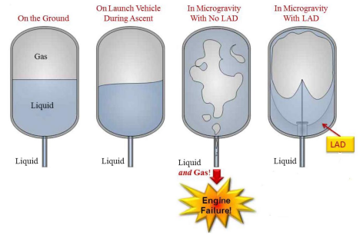
Figure 2.1 – Behavior of liquid during various launch stages [A]

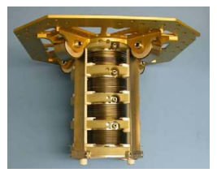
Figure 2.2 – Busek's CMNT's bellows tank [F]

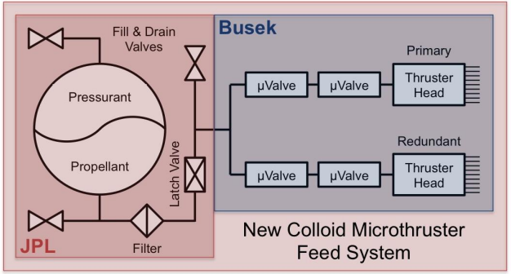
Figure 2.3 – Busek and NASA JPL's new feed system [C]
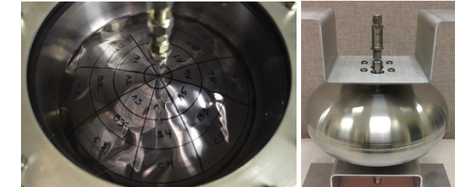
Figure 2.4 – NASA JPL’s diaphragm tank for Busek’s CMNTs [C]

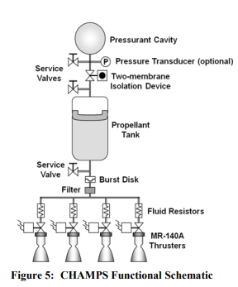
Figure 2.5 – Schematic of a piston tank feed system for a 1U CubeSat Hydrazine Adaptable Monopropellant Propulsion System (CHAMPS) [E]
may also require precise flow control, especially in the case of electrospray thrusters where flow rates are exceptionally low. Custom valves must be designed, which adds to the complexity of the system [B,C,F]. Noncapillary-type PMDs may also be heavy compared to other options, especially with the use of metallic components. Diaphragms experience mechanical fatigue and should be designed to undergo several cycles even if the mission does not include plans for in-orbit refueling. This is a challenge outlined by Busek, where their diaphragm design could only undergo two cycles when they needed a factor of safety of five [C]. Diaphragms and elastomeric bladders typically span the entire tank, which can make them impractical for large-scale use [A]. Elastomers are also not well-suited for long life missions, and may be incompatible with some propellants, such as the EMI-Im propellant used in Busek’s CMNTs [A,C].

2.1.3 Capillary-Type Propellant Management Devices
Due to the potential complexity of non-capillary PMDs, newer missions tend to employ surface tension, or capillary, PMDs [A]. Capillary PMDs make use of capillary action to effectively deliver propellant within a tank in a microgravitational environment. These PMDs fall in one of two categories: partial communication and total communication. Partial communication devices are typically used as simple control devices designed to ensure only liquid propellant is being extracted from the tank [A]. In contrast, total communication devices maintain a constant connection between the propellant load and the tank outlet. In many cases, these devices are used in conjunction with one another [A]. Capillary devices vary in both function and complexity, and the type of device (or devices) to be used depends on the orbital maneuvers a spacecraft will perform.
Traps, troughs, baffles, and vortex suppressors are examples of partial communication capillary PMDs [A]. Traps are designed to trap gas outside of the structure but allow liquid propellant to flow through and out of the tank [A]. These are reliable and can be lightweight, but they cannot passively reacquire propellant in microgravity [A]. Based on this, these devices are typically used for high-acceleration, one-time maneuvers such as station-keeping and launches [A]. Troughs are very similar to traps, their key difference being that troughs can be passively refilled via capillary action [A]. However, this extra functionality means that these devices are slightly more complex and add more mass to a system than traps [A]. An example of a trough can be seen in Figure 2.6 [A]. Baffles, on the other hand, serve an entirely different purpose. These devices are welded in tanks to reduce sloshing of the propellant during maneuvers and can take many different shapes [A]. Figure 2.7 provides an example of a circular baffle welded within a propellant tank [A]. Finally, vortex suppressors are important controlling devices for systems with high mass flow rates [A]. As a tank rapidly depletes of propellant, a vortex will develop, and gas may enter the system resulting in engine failure. Vortex suppressors are designed to reduce or eliminate vortices at the tank outlet [A]. A model of a vortex suppressor is shown in Figure 2.8 [A].
The final category of PMDs are total communication capillary devices, which include vanes, sponges, and screen channel LADs. Of all the PMDs described, vanes have the simplest design; these devices are manufactured from thin metal plates and are mounted perpendicular to tank walls [A]. Vanes are sized so that they maintain constant communication between the propellant, tank walls, and vane [A]. Due to their simple design, however, vanes cannot supply propellant to systems that require medium to large flow rates [A]. In addition to this, vanes cannot maintain liquid-only flow during high acceleration maneuvers due to their weak capillary forces [A]. To mitigate these issues, vanes are often used in combination with other PMDs, and they are selected for use with high surface tension propellants [A]. Figure 2.9 provides an example of a total communication vane PMD. A cryogenic propellant storage system for use in a Hall-effect thruster can be seen in Figure 2.10; this device intends to employ the use of a cooled vane PMD [G].
Sponges are PMDs composed of an array of thin, lightweight metal fins which emanate from the center of the tank over the tank outlet, shown in Figure 2.11 [A]. These devices have the ability to maintain and
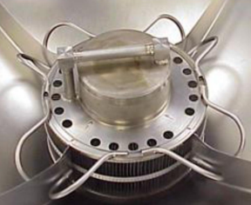
Figure 2.6 – Trough PMD [A]

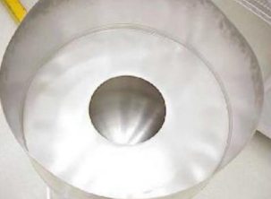
Figure 2.7 – Circular baffle welded to the interior of a tank [A]

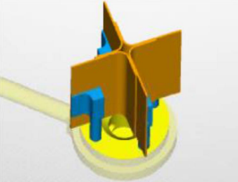
Figure 2.8 – 3D model of a vortex suppressor [A]
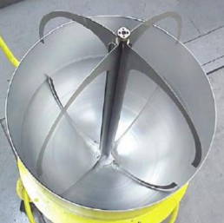
Figure 2.9 – Total communication vane PMD [A]

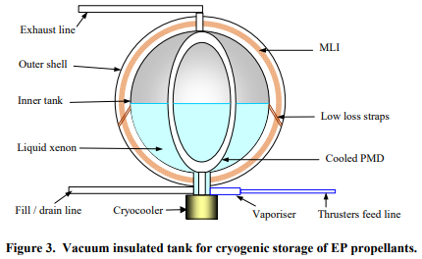
Figure 2.10 – Conceptual design of a cryogenic propellant tank for Hall-Effect thrusters [G]

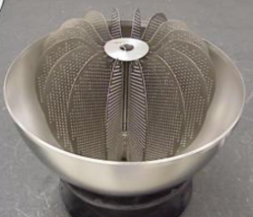
Figure 2.11 – Total communication sponge PMD [A]
refill propellant at the tank outlet [A]. Similar to vanes, sponges cannot support systems that undergo high-acceleration maneuvers, and its performance cannot be validated through ground testing [A]. These devices can also be much heavier than vanes [A]. Despite these disadvantages, sponges have the most flight heritage in comparison to the other PMD options and can be used in a wide array of non-cryogenic propulsion systems [A]. A sponge PMD used in a cesium propellant ion propulsion engine can be seen in Figure 2.12 [A].
Finally, screen channel LADs are some of the more complex and difficult to manufacture PMDs. These devices are defined as a closed channel with three solid walls and one porous wall [A]. The complexity of these designs’ stems from the manufacturing of the porous media. Screen meshes are woven, and the type of weave used is the most important parameter in these devices [A]. These weaves must then be extensively tested to ensure no bubbles form, resulting in failure of the thruster [A]. Compared to vanes and sponges, screen LADs can be a more robust solution that provides liquid acquisition to a broader range of thermal and gravitational environments [A]. Screen LADs are classified in two categories: start baskets and total communication devices [A]. Start baskets are small devices that confine liquid directly above the tank outlet; an example of a start basket is shown in Figure 2.13 [A]. Total communication screen LADs are much more complex and must be carefully designed to maintain communication during every phase of a mission; Figure 2.14 provides the screen LAD used inside the propellant tanks of the space shuttle’s reaction control system [A].

2.2 Microfluidic Devices and Their Applications in Space
In this section, I am going to discuss some basics of microfluidics, their traditional applications, and some potential applications for space. I will make note that these are primarily used for biological research, however I am exploring the use of these devices for electrospray propellant routing.

2.3 MSLA Additive Manufacturing

2.4 Additively Manufactured Microfluidic Devices
In this section, I want to review the additive manufacturing of microfluidic devices. Perhaps note what techniques are typically employed.

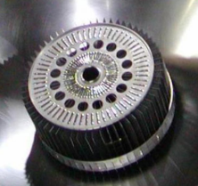
Figure 2.12 – Sponge PMD for a cesium propellant ion engine [A]

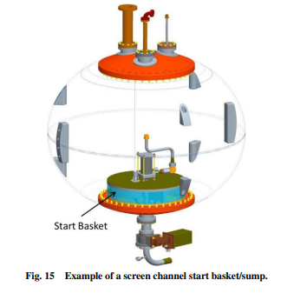
Figure 2.13 – 3D model of a start basket [A]

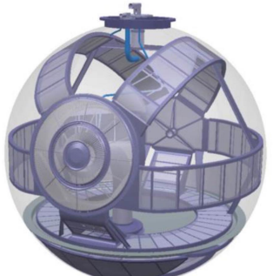
Figure 2.14 – 3D model of a screen channel LAD used in the space shuttle’s reaction control system [A]

Chapter 3: Conceptual Designs of Propellant Feed Systems for µSTAMPS

3.1 FEP Bladder Tank

3.2 Piston Injector Tank

Chapter 4: Test Methods

4.1 Seal Strength Testing

4.1.1 Overview
Before prototyping the bladder tank, it is important to know the strength of the seal. For this, the ASTM F88 standard was employed, which is designed specifically to measure the seal strength of flexible barrier materials, in this case, FEP film [ASTM F88]. A roll of both 0.003 inch and 0.005 inch (3 mil and 5 mil) thick FEP was supplied by American Durafilm. Five batches of five samples were prepared and tested; each batch consisted of a different sample fin thickness. Fins are the area of the sample that was gripped by the testing machine, and will be discussed further in Section 4.1.2. The first two batches were prepared from 3 mil thick and 5 mil thick films and had only one layer of film per fin. The fins were double-layered on the next three batches. This was done to effectively increase the thickness of the samples to 6 mil, 8 mil, and 10 mil. To seal the samples, a Midwest Pacific MP-8C impulse heat sealer was employed, shown in Figure 4.1. An MTS Systems Corporation tensile testing machine with a 5 kip (5000 lbf) load cell was used to test these samples. The system was connected to a TestStar IIs data acquisition device, and is outlined in Figure 4.2.

4.1.2 Sample Preparation
To begin the sample preparation, a seal configuration must be chosen. These configurations, whose dimensions are outlined in Figure 4.3, consist of a fin seal, a hot wire seal, or a lap seal. The fin seal configuration was chosen because it matches the configuration of an inflated bladder tank. From here, 3.0625 in long and 1 in wide strips of FEP were carefully cut and layered onto one another. The single-layered fin samples required two strips of film each (one strip per fin), and the double-layered fin samples required four strips (two per fin). These samples were then set aside for sealing.
The MP-8C impulse heat sealer functions by pressing two films together on a heated 0.0625 in diameter wire protected by fiberglass tape. To begin sealing, the MP-8C’s lever must be pushed down; this action turns the machine on and begins heating up the wire. After a few seconds, the sealer will turn off and the lever can be raised. The length of sealing time can be controlled by a dial on the front of the machine. For a proper seal, five consecutive lever pushes, or “stamps,” must be performed at the maximum dial setting. This is because the FEP film has a relatively high melting point of 550°F, and a single stamp was unable to develop a complete seal [FEP DATA SHEET]. Before beginning to seal each sample, the MP-8C was treated with mold release to limit how much the FEP sticks to the tool. When stamping, a constant pressure was applied and held until the LED power indicator near the dial turned off. The samples were cleaned with isopropanol before this procedure was performed to ensure no dust or other contaminants were present. This step is important because any contaminants in the seal area may weaken the seal and adversely affect the results of the experiment.

4.1.3 Test Setup and Procedure
The tests that were conducted are like standard tensile tests. A machine grips two ends of the samples, the fins in this case, and slowly pulls the samples apart. The DAQ recorded load versus grip displacement with a sampling frequency of around 1250 Hz and stored the data in Excel format to be analyzed. According to ASTM F88, the grip displacement rate should be 8 in/min [ASTM F88]. Many tensile testing machines can detect when a sample fails and stop automatically, however the MTS machine stops the test at an absolute grip displacement end level. This end level was set to 3.5 in; however, each sample failed before this limit and the tests were manually concluded.
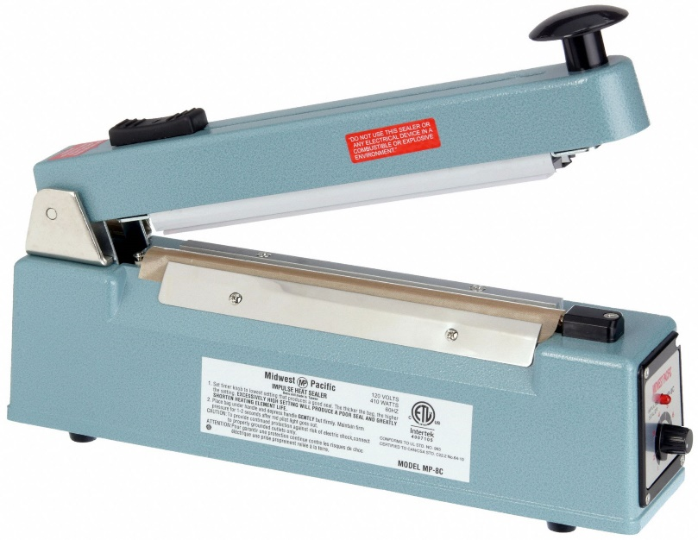
Figure 4.1 – Midwest Pacific MP-8C impulse heat sealer

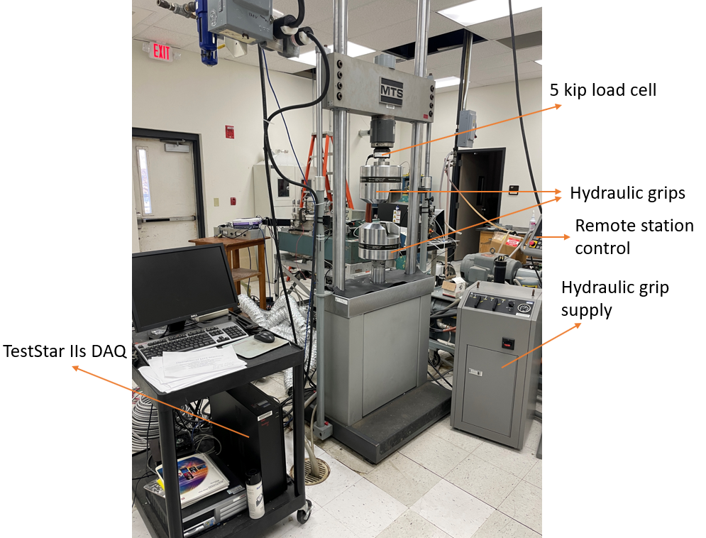
Figure 4.2 – MTS testing setup

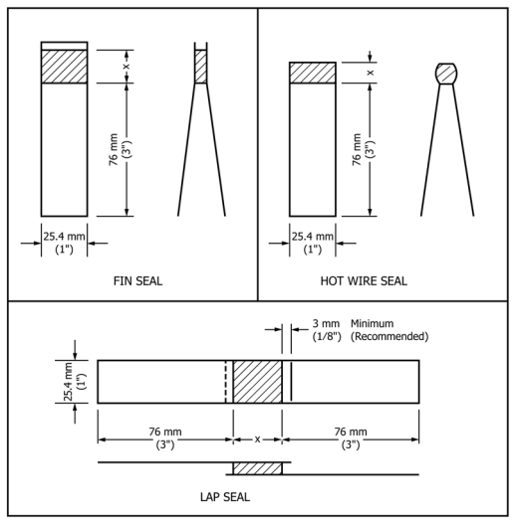
Figure 4.3 – ASTM F88 recommended specimen dimensions [ASTM F88]

To properly accommodate the minute thickness of the samples and to prevent the grips from damaging the fins, inserts were designed and 3D printed from polylactic acid (PLA) filament. These inserts span the length and width of the grips, and are 0.125 in thick, Figure 4.4 shows a model of the inserts. One fin was taped to the insert to easily mount in the grips, and to properly align the sample. About 0.5 in of space was left between the top of the insert and the fin. This is because when fully mounted in the grips, the standard called for 1 in of space between the grips. Once the sample was taped to one insert, the other insert could then sandwich the sample and be placed in the top grip. The grip was then tightened to about 290 psi. After the sample was secured in the top grip, the remaining inserts were placed into the bottom grip, and this grip was raised until there was 1 in of space between them. This grip was also tightened to approximately 290 psi. From here, the test was performed, and the process could be repeated.

4.1.4 Data Analysis
To analyze these data, the raw force versus displacement files were imported into MATLAB. At this point, the data is noisy due to the small force levels being recorded from a 5 kip load cell. Fortunately, a trend was present, so a smoothing function was employed. MATLAB’s “movmean” function was utilized to smooth the data. The formula for the moving average is shown by Equation 4.1, where k is the period selected for the moving average, n is the number of data points in the set, and p_{i} is the data point in the i^{th} position [SMA]. For the single-layered fins, a 5-point moving average was sufficient; however, for the double-layered fins, a 25-point moving average was performed. Both the raw and smoothed data could then be plotted.
$$SMA=\frac{1}{k}\sum_{i=n-k+1}^{n}{p_{i}}$$ | (4.1)
Once the data was plotted, the maximum load could be found. The standard (ASTM F88) provides an example of what the result of a test may look like, Figure 4.5 [ASTM F88]. It recommends that the average should be taken of the maximum range in the plot. However, these tests resulted in one local maximum, rather than the plateau shape shown in the figure. Based on this, a simple maximum could be taken from the smoothed data using MATLAB’s “max” function. From here, the averages (µ) and standard deviations (σ_{STD}) of the maximum loads between each sample could be found using Equations 4.2 and 4.3, where x_{i} is each value from the population and N is the size of the population [AVG, STD].
$$μ=\frac{1}{n}\sum_{i=1}^{n}{p_{i}}$$ | (4.2)
$$σ_{STD}=\sqrt{\frac{\sum{{(x_{i}-μ)}^{2}}}{N}}$$ | (4.3)
After these values were computed, the theoretical stress experienced within the bladder tank was calculated. Two assumptions were used to approximate the stress: 1) the tank will be spherical; 2) the pressure inside the tank will be 14.7 psig in a vacuum. A pressure of 14.7 psig was determined because the tank will not be pressurized on Earth, thus having a near zero gauge pressure in atmosphere. In a vacuum, the gauge pressure will, in theory, increase from 0 to 14.7 psig, due to the lack of atmospheric pressure. These are not perfect approximations, because the tank will not be perfectly spherical when inflated; rather, the tank will be an oblate sphere. Also, the ionic liquid propellant has a negligible vapor pressure. This means that in LEO, if perfectly conditioned to have no water content, the propellant should not outgas, and there will be a negligible gauge pressure. Despite this, a comparison must be made based on the worst-case
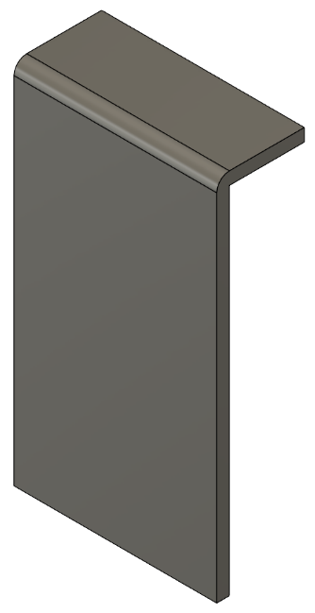
Figure 4.4 – 3D model of the MTS grip attachment

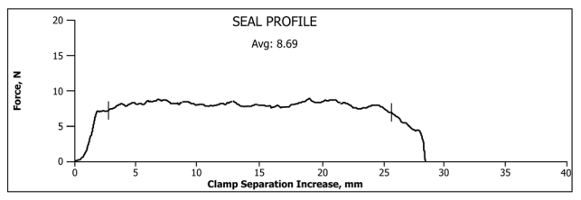
Figure 4.5 – Example seal strength test result [ASTM F88]
scenario. Equation 4.4 describes the theoretical stress experienced inside of a thin-walled spherical pressure vessel, where P is the tank pressure, r is the tank radius, and t is the thickness of the tank wall [TS].
$$σ_{tank}=\frac{Pr}{2t}$$ | (4.4)
Finally, the stresses experienced by each sample could be calculated. The standard (ASTM F88) states that any applicable algorithm can be applied to calculate the seal strength [ASTM F88]. As will be seen in Chapter 5, nearly every sample failed just before the sealed area on the fin, rather than the seal itself pulling apart. Based on this, the stresses experienced by the samples were calculated via a simple relation (Eq. 4.5), where F is the average maximum load experienced by each sample, and A is the cross-sectional area of the fin.
$$σ_{seal}=\frac{F}{A}$$ | (4.5)

4.1.5 Challenges and Limitations
The first challenge came from the sample preparation. The samples must be cut as cleanly and evenly as possible. Any uneven or jagged cuts could negatively affect the flow path of the forces and create unwanted stress concentrations and moments. This could result in premature failure of parts, leading to greater errors and standard deviation between the samples. Next, the impulse heat sealer did not heat up enough to seal the samples completely with one application, so multiple consecutive stamps were employed. Once the FEP melted and a seal formed, the next challenge was safely removing the sample from the sealer. The FEP tended to melt into the weave of the protective fiberglass tape. This made the samples difficult to remove without damage. To mitigate this the MP-8C’s working area was treated with mold release, and after sealing, the samples were removed slowly and steadily.
Other challenges stemmed from the test setup procedure. First, the test machine employed is typically used for testing high-strength, aerospace-grade metals. To establish a strong grip between these parts requires the grips to have small, jagged teeth. These teeth could damage the samples’ fins and potentially result in them failing at the grips. In addition to this, the manual recommends testing samples no thinner than 0.25 in. To mitigate these problems, four 0.125 in thick inserts (two for the top and bottom grips) were 3D printed from PLA, designed to protect the sample and meet the 0.25 in thickness requirement. Mounting and aligning the samples in the grips proved to be a challenge due to them being thin and flexible. Improper alignment could result in an extra torsional force which would cause the seal to fail prematurely. Taping one fin to an insert beforehand allowed for the sample to be aligned before being placed in the grips. It also prevented the sample from shifting while the grips applied pressure. Finally, the load cell was rated for loads much higher than the loads experienced during these tests. Testing with this load cell was deemed possible, however, because the standard was verified through a variety of different load cells, one of which being a 5-kip cell [ASTM F88]. This resulted in noisy output data, which was filtered by using a moving average function within MATLAB.

4.2 Elegoo Mars 2 Pro vs. Elegoo Mars 4 Ultra Dimensional Accuracy and Support Testing

4.2.1 Overview
Before printing any of the microfluidic devices, a printer must be chosen. The printers in question were the Elegoo Mars 2 Pro (M2P) and Elegoo Mars 4 Ultra (M4U), as shown in Figures 4.6 and 4.7 [ES]. Both printers employ the use of masked stereolithography (MSLA), however there are a few key differences between each printer as shown in Table 4.1 [M2P MANUAL, M4U MANUAL]. To help determine which printer to use, eight 20 mm³ cubes were printed without supports directly on the bed of each. Afterwards,
[INSERT FIGURE]
Figure 4.6 – Elegoo Mars 2 Pro [CITE]

[INSERT FIGURE]
Figure 4.7 – Elegoo Mars 4 Ultra [CITE]

Table 4.1 – Differences Between the M2P and M4U [CITE]
[INSERT TABLE]

eight more cubes of the same dimension were printed with sparsely packed, heavy supports. These print orientations can be seen in Figures 4.8 and 4.9. The qualitative results of the prints were noted, as well as the actual dimensions of the cubes. These final dimensions could then be compared to their theoretical size. As will be seen in Chapter 5, the results from the cubes printed with this support strategy prompted another batch of testing.
Chapter 5 will show that sparsely packed, heavy supports are not ideal for the print orientations required, so instead, the use of densely packed, lightweight supports was explored. Based on these results, the next round of testing was designed to determine what support density to use on both printers. To determine the ideal support density, four 20 mm³ cubes were printed on both the M2P and M4U, each with a different density—75%, 80%, 90%, and 95%—which are outlined in Figure 4.10 and 4.11. To determine which printer and support strategy to employ, the print success rate, ease of support removal, and final dimensions were noted.

4.2.2 Print Material, Setup, and Post-Processing
Elegoo’s Standard 2.0 Photopolymer Resin was selected for use. The 2.0 formulation, according to Elegoo, has reduced odor and volume shrinkage compared to its predecessor. The volume shrinkage is important because it may cause additional warping and deformations that will negatively affect certain parts. The Chitubox slicing software was utilized, and the print settings employed can be seen in Table 4.2, which were provided by Elegoo. The “lift speed” (the rate at which the print bed lifts from the vat’s film) and “rest time after retract” (the amount of time between print bed lowering to the bottom of the vat and projection of the UV light), however, were changed. The lift speed was decreased from Elegoo’s recommendation to ensure smooth separation of part and vat film. Preliminary print tests with higher retract speeds occasionally resulted in total print failure. The rest time after retract was included because preliminary prints experienced a defect known as “blooming,” where partially cured resin is left over on the edges of parts. This typically occurs when the resin is still moving upon curing of the layer, so adding this delay allows the fluid to settle and cure properly [BL]. Finally, in the Chitubox slicing software, the light support preset was used; the only support settings that were changed was the support density for each cube (75%, 80%, 85%, 90%), and the Z-height of the supports (10 mm). The Z-height of the supports was changed from the default 5 mm simply because the taller Z-height made the samples easier to remove from the supports (more grip and leverage).
Once each cube was printed, they were removed from the print bed, supports were removed from the respective parts, and a two-stage washing process with 99% isopropyl alcohol (IPA) was employed. The first stage involved an initial “dirty” clean, where the bulk of the resin can be washed off. The reason this stage is being called a “dirty” clean is because the tub of IPA gets dirty quickly, since the parts are typically coated in uncured resin. The second stage of cleaning involves a second tub of IPA, which is kept relatively clean and clear because of the first stage of cleaning. This tub contains a magnetic stirring device which is controlled by the Elegoo Mercury Plus washing and curing station (Figure 4.12) [ES]. The parts were then submerged in this tub of IPA, and the washing station was set to run for 5 minutes. Afterwards, the parts were removed, air dried, and post-cured for two minutes in the Mercury Plus.

4.2.3 Test Procedure and Analysis
After the parts were cleaned up and post-cured, the X-, Y-, and Z-dimensions could be measured, the X- and Y-axes being the surface parallel to the print bed, and the Z-dimension being the height of the cube. Three measurements were taken along each axis, averaged, and the standard deviations were taken (Eq. 4.2 & 4.3). In addition to this, the percentage error between the theoretical and actual cube dimensions were noted (Eq. 4.6). The actual dimensions of the printed parts are represented by v_{A}, and the expected values are represented by v_{E}. The errors and standard deviations were useful in showing the accuracy of each print,

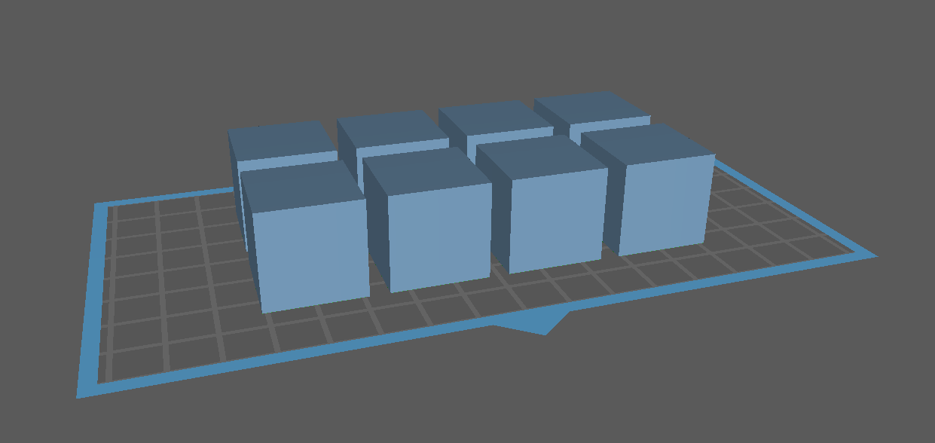
Figure 4.8 – Print orientation of 20 mm³ cubes flat on build plate

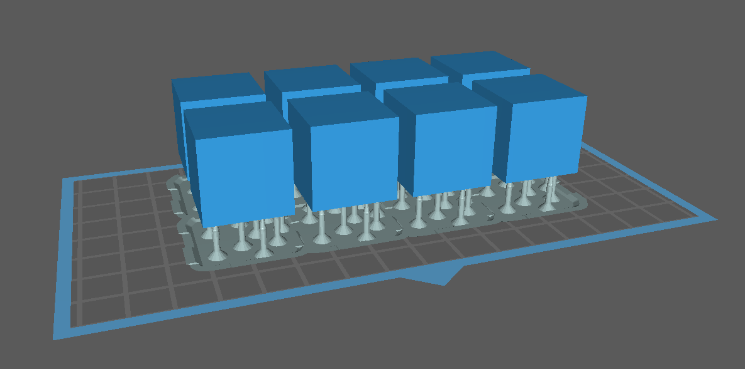
Figure 4.9 – Print orientation of 20 mm³ cubes with sparsely packed (50%), heavy supports

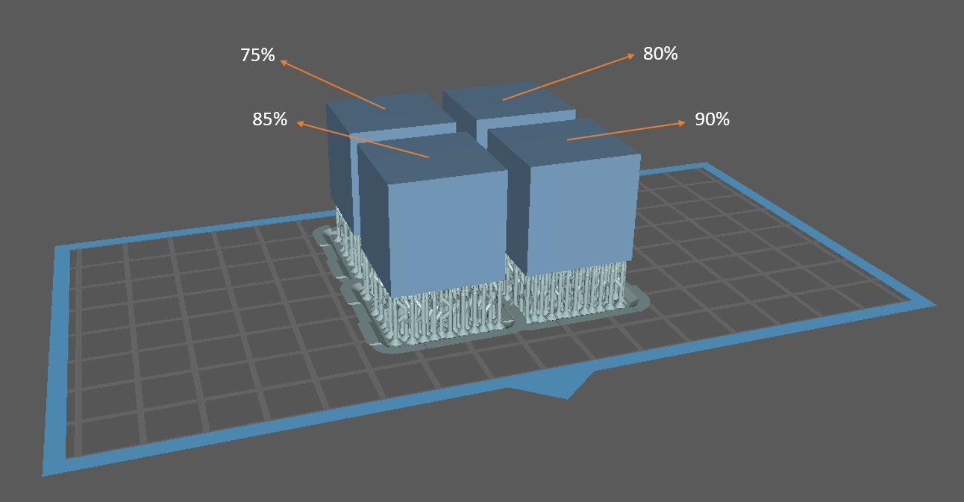
Figure 4.10 – Print orientation of 20 mm³ cubes with densely packed, lightweight supports

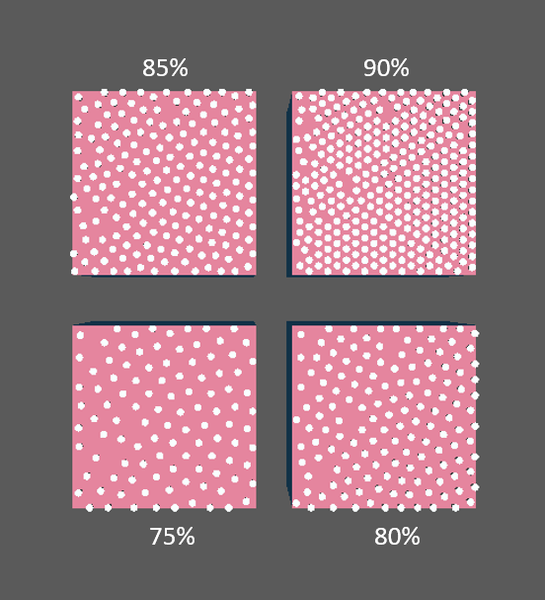
Figure 4.11 – 20 mm³ cubes with densely packed, lightweight supports (bottom view)
Table 4.2 – Cube test print settings
[INSERT TABLE]

[INSERT FIGURE]
Figure 4.12 – Elegoo Mercury Plus Washing and Curing Station [CITE]

as well as how the deformations in each part changed with respect to the varying print strategies. Qualitative results were noted as well, primarily noting which parts failed during printing (if any) and ease of support removal. It was imperative that the printer and print settings which were selected minimize warping effects, successfully print every time, and have quick post-processing times.
$$δ=\left|\frac{v_{A}-v_{E}}{v_{E}}\right|*100$$ | (4.6)

4.2.4 Challenges and Limitations
The primary challenges and limitations of this phase of testing are simply the standard challenges and limitations of MSLA printing. First, the print bed must be perfectly clean and level. Any contaminants or misaligned print beds will result in failed prints. By remaining consistent with a leveling and cleaning strategy, these problems should be easily mitigated. It may also be challenging deciding what print settings to use; fortunately, Elegoo has tested the ideal print settings for their products, and they have provided an open-source datasheet on their website [ES]. In the case of parts coming out with other defects, such as the blooming defect or delamination from the print beds as previously discussed, there are many sources (both scholarly and sources from 3D printing hobbyists) that provide insight on mitigation techniques for these commercial printers. In the case of industrial grade printers, it may be more difficult to find certain information. Finally, MSLA printing is a messy process, and the resin is an irritant (skin, eye, and lung). By utilizing the proper tools, methods, and PPE, such as lunch trays for transferring parts and cleaning, working in a well-ventilated environment, and wearing gloves, a mask/respirator, and eye protection, the printing process becomes much cleaner and safer.

4.3 Flow Rate and Channel Volume Testing

4.3.1 Overview
The final phase of testing served to determine the ideal design and print orientation of the 3D printed Propellant Routing Manifold (PRM). Every PRM iteration consisted of an inlet that separated into four different internal channels, each of which connected to its own outlet. Section 4.3.2 will discuss the designs and print orientations in more detail. Several iterations of the manifold were printed on both the M2P and M4U, and were subjected to two different flow rate tests. The first test involved pumping deionized (DI) water stored in a 60 mL syringe with the Dolomite Peristaltic Pump through the manifold. The purpose was to see whether or not flow was present in all four channels; this will be referred to as the “overall flow test.” The results of this test served to eliminate samples that did not experience flow through each channel. The samples that did experience flow did not evenly output water; therefore, those samples were subjected to further testing. The second round of testing was designed to determine the mass/volume flow rates of each channel individually, as well as predict the actual internal channel volumes; this will be referred to as the “individual flow rate test.” The individual flow rate test utilized the same syringe and pump setup, but with valves blocking all but one outlet. These data could then be compared, and a second round of elimination commenced. The results from this round served to decide the ideal print orientation of the PRM, as well as the ideal location of the inlet. Once the ideal print orientation and inlet location were established, further iterations of the internal channel geometry of the PRM were designed and tested in the same manner as the previous two rounds. The goal of these tests is to develop a solution which results in uniform flow (or as close to uniform as possible) through each outlet.

4.3.2 Propellant Routing Manifold Designs, Print Setup, and Post-Processing
Several different PRM designs and print orientations were explored. To keep track of these iterations, a naming convention was established. The part designs were labeled V1-V5, and the print orientations were labeled as a-d. Table 4.3 showcases the various PRM designs and print orientations that were evaluated.
Table 4.3 – PRM designs and print orientations
[INSERT TABLE]

Orientations a, b, c, and d represent the following: a) 45° angle with supports; b) printing parallel to the bed with supports; c) printing directly on the bed without supports; and d) printing perpendicular to the bed with supports. Every PRM design was a 6.2 cm² square and features four outlets on the bottom of the part, each of which is 3.5 cm from the center and aligned with the corners of the PRM. Parts V1, V2, V4, and V5 had a thickness of 0.5 cm, whereas V3 had a thickness of 1 cm. Starting from the top, V1 represents the first PRM design; the key features of this design include an inlet on the top of the PRM and internal channels of 1.5 mm in diameter. Part V2’s geometry is identical to V1; however, the inlet has been relocated to the side of the part. Manifold V3 also had an inlet on the side, but the thickness of the part was increased to allow room for supports on the inlet when printing flat on the print bed. These supports were required, because without them the inlet would not successfully print. Manifold V4 is nearly identical to V1; however, the internal channel diameters were reduced from 1.5 cm to 0.75 cm. Finally, part V5 was also similar in design to V1; however, the inlet was divided into four channels, each of which were connected to their respective outlets.
Printing began on the M2P, starting with parts V1a-d, V2a-d, and V3c. The parts that required supports were printed with heavy supports at first, however those printed at orientation b prompted the support density tests explained in Section 4.2. After performing the overall flow test to see which PRM designs experience flow through each channel, parts V1a, V2a, and V3c were eliminated. At this point, parts V1b,d and V2b,d were printed again, however this time on the M4U. The V1b,d and V2b,d manifolds printed by both the M2P and M4U were then subjected to the individual flow rate tests. This, in turn, eliminated V1b and V2b, which meant V1d had the ideal inlet location and print orientation. From here, iterations V4 and V5 were created and printed at orientation d. These parts were finally subjected to both of the flow rate tests discussed in this section. The print settings of these parts are reflected in Table 4.4.
Each manifold was cleaned and post-cured in a similar manner to the methods described in Section 4.2.2. A part was first washed in a dirty container of 99% IPA to remove most of the remaining resin. From here, the supports were carefully removed, and the part was washed again in the Mercury Plus washing and curing station for five minutes. Afterwards, a syringe with a Luer Lock barb adapter for 1.5 mm tubing was filled with 50 mL of clean IPA. Silicone tubing was then attached to the syringe and the inlet of the part, and the internal channels were washed to remove resin remaining within the channels. Any resin remaining within the part will result in a clogged channel upon post-curing. Air was then pumped via the syringe through the channels at least three times to dry residual IPA. Attempting to post-cure wet parts will result in sticky, partially cured surfaces, which may negatively affect flow rate tests. Finally, each part was post-cured in the Mercury Plus for 2.5 minutes. At this point, the parts were labeled and ready for testing.

4.3.3 Test Setups and Procedures
Both test setups consisted of a 60 mL syringe, deionized water, a Dolomite Peristaltic Pump, Luer Lock 1.5 mm barb adapters, 1.5 mm internal diameter silicone tubing, a 150 mL beaker, a 50 mL beaker, a laboratory stand, laboratory stand clamps, a stopwatch, small plastic cups, a [INSERT NAME HERE] scale with 0.001 gram precision, and a BK Precision DC power supply. For the individual flow rate tests, additional Luer Lock valves were required. The pump was operated at 3 V DC and 40 mA; under these conditions, the pump has a volumetric flow rate of about 0.45 mL/min [PUMP DATASHEET]. The setup began by labelling the channels of the PRM 1-4. Once that was completed, the laboratory stand was set up with the proper clamps. One clamp was used to hold the syringe, and the other clamp was for holding the pump. The syringe, which has the Luer Lock barb adapter attached to it, was then filled with DI water and placed in the clamp. The inlet of the pump could then be attached to the outlet of the syringe. From here, about 3 cm of tubing was attached to each of the outlets of the PRM. For the overall flow test, the PRM was ready to attach to the pump. For the individual flow rate test, three valves with Luer Lock barb adapters

Table 4.4 – PRM print settings
[INSERT TABLE]

were attached to three of the outlets to prevent flow, while one outlet remained open without a valve. At this point, the inlet of the PRM was connected to the pump and the PRM was placed atop the 50 mL beaker. The reason for not clamping the PRM as well was to keep the device as level as possible; when angled, the outlets angled down tended to experience flow more often. Finally, the power supply was ready to be turned on, set to the proper current and voltage (40 mA/3 V DC), and connected to the pump. Both test setups can be seen in Figures 4.13 and 4.14.
The overall flow test consisted of two stages. The first stage began by engaging the pump and observing the PRMs’ behaviors. To begin, each channel was primed with water. This was done by plugging three out of the four outlets and engaging the pump until the channel was full. The channels were primed by repeating this process for each outlet. Once primed, the pump ran for five minutes, and qualitative observations were noted. The primary focus was to observe which PRMs experienced flow through each channel. The devices which experienced flow in each channel were noted and moved on to the second stage. The second stage involved the same process as before, priming the channels and engaging the pump for five minutes. While the pump ran, the number of droplets outputted through each channel were noted. These tests assisted in providing initial insight on how the PRMs would function, as well as eliminating samples not worth testing further.
The PRM samples that passed the second stage of overall flow test could now have their channels tested individually to determine flow rates and channel volumes. Once set up, the channel being tested was primed with water. The small plastic cups were labeled 1-4 (corresponding to outlets 1-4); their dry masses were measured five times and averaged. Following this, the first cup could be placed underneath the first outlet to collect the water output by the PRM. The pump was engaged for two minutes, and the wet mass of the cup was measured. To test the volume of the channels within the PRM, the methods were similar. However, an additional step was taken when priming the channels. Once the channels were fully primed, the inlet of the pump was disconnected from the syringe, and the water remaining in the pump line was removed. To do this, the pump was simply reengaged and ran until the meniscus of the water in the pump lines was at the same level as the inlet of the PRM (Figure 4.15). After this additional water was removed, the volume of water remaining in the PRM should be the volume of the individual channel, plus the short length of tubing attached to the outlet in question. This water was finally pumped out into the channel’s respective cup, and the cup’s wet mass was measured. Both the flow rate and channel volume tests were repeated five times per channel.

4.3.4 Data Analysis
The methods employed to analyze these data are relatively simple. First, the dry masses of the cups were subtracted from the wet masses to obtain the masses of the water. These masses include the mass of water pumped in two minutes, and the mass of the water remaining in the channel (Eq. 4.7 & 4.8). The subscript “i” in these equations represent the PRM channel number. From here, the mass of the water pumped (in grams) was divided by the amount of time pumped (in seconds) to obtain the mass flow rate (Eq. 4.9). Since one gram of water equals one milliliter of water, the conversion from mass/mass flow rate to volume/volumetric flow rate was simple, as they are equivalent in this case. To match the flow rates to the flow rate of the pump (mL/min), simply multiply the mass flow rate by 60 (Eq. 4.10). Despite the mass (in grams) equating to the volume (in mL), an extra term can be seen in the volume calculations (Eq. 4.11). This was to account for the volume of water remaining in the outlet tubing. These values were finally averaged, and their standard deviations were taken. The samples with the lowest standard deviations were selected for further design iterations.

[INSERT FIGURE]
Figure 4.13 – Overall flow test setup

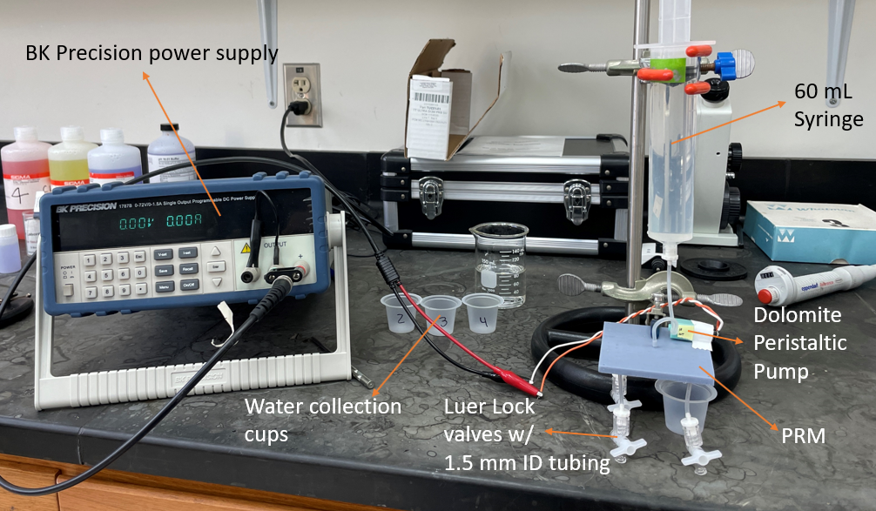Figure 4.14 – Individual flow rate test setup

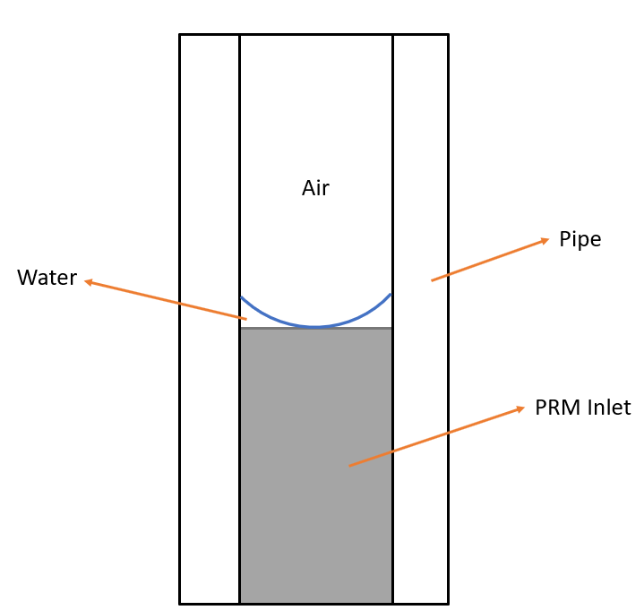
Figure 4.15 – Meniscus at inlet before beginning channel volume test
$$m_{i,r}=m_{i,wet,r}-m_{dry}$$ | (4.8)
$${\dot{m}}_{i}=\frac{m_{i,p}}{t_{p}}$$ | (4.9)
$$Q_{i}={\dot{m}}_{i}*60$$ | (4.10)
$$V_{i}=V_{i,r}-V_{outlet tube}$$ | (4.11)

4.3.5 Challenges and Limitations
Once again, most of the challenges stem from the typical challenges and limitations of MSLA printing. To begin, preliminary test prints did not experience uniform flow through each channel at one time. The non-uniform flow prompted further iterations and testing. This was likely due to a few reasons, such as a low pump flow rate, designed channel geometry, and non-uniformly printed channel dimensions caused by deformations induced by the printing process. Next, orientation b proved difficult to print. Initial attempts failed, which prompted the orientations tests described in section 4.2. Once the new support strategy was established, they became more difficult to remove. Extreme care was taken to not damage the inlets and outlets when removing these supports. Finally, the inlets and outlets proved to be fragile, and occasionally printed partially delaminated from the PRM (Figure 4.16), adding to the fragility. This defect would also induce air bubbles within the system, which would affect the test results. To mitigate this issue, 0.15 cm radius fillets were added to the base of each outlet (Figure 4.17), increasing their strength and print success rate.

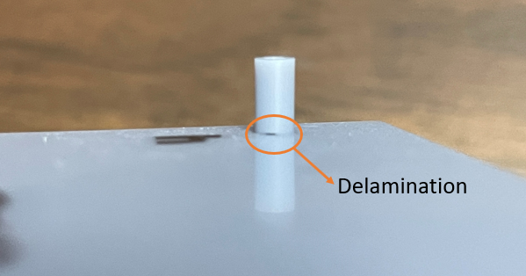
Figure 4.16 – Inlet partial delamination

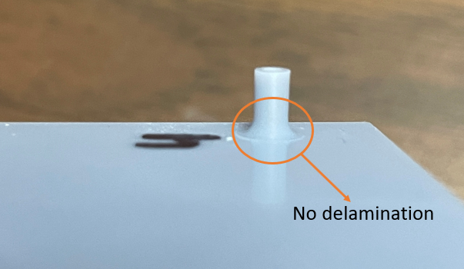
Figure 4.17 – PRM with fillets

Chapter 5: Results and Discussion

5.1 FEP Seal Strength and FEP Bladder Prototype
The data acquired from these tests were utilized to understand the performance of the bladder tank. In addition, the yield stress of the ASTM F88 samples were calculated and compared to the theoretical stresses experienced within the pillow tank.

5.2 3D Print Test Results
When printing a square part parallel to the bed with sparsely packed, heavy supports, the part tended to fail. It was found that for this project’s purposes, densely packed, lightweight supports are ideal. Sparse, thick supports have large gaps between supports, these gaps tend to bend the part surface, which leads to further warping.

5.3 Flow Rate and Channel Volume Test Results

Chapter 6: Conclusions and Future Work

Works Cited
Note to reviewer: I will remove this sentence as well as renumber all of these citations once I have them all. Done in AIAA format.
[A] Hartwig, J. W., “Propellant management devices for low-gravity fluid management: Past, present, and future applications,” Journal of Spacecraft and Rockets, vol. 54, Jul. 2017, pp. 808–824.
[B] Spence, D., Zwahlen, J., Hruby, V., Demmons, N., Roy, T., Martin, R., Ehrbar, E., Connolly, W., Ziemer, J., and Randolph, T., “Colloid thruster propellant conditioning and storage for the NASA ST7 mission,” 44th AIAA/ASME/SAE/ASEE Joint Propulsion Conference & Exhibit, Jul. 2008.
[C] Demmons, N. R., Lamarre, N., Ziemer, J. K., Parker, M., and Spence, D., “Electrospray thruster propellant feedsystem for a gravity wave observatory mission,” 52nd AIAA/SAE/ASEE Joint Propulsion Conference, Jul. 2016.
[F] Hruby, V., Spence, D., Demmons, N., Roy, T., Ehrbar, E., Zwahlen, J., Martin, R., Ziemer, J., Connolly, W., Rhodes, S., and Tolman, W., “St7-DRS colloid thruster system development and performance summary,” 44th AIAA/ASME/SAE/ASEE Joint Propulsion Conference & Exhibit, Jul. 2008.
[E] Schmuland, D., Masse, R., and Sota, C., “Hydrazine Propulsion Module for CubeSats,” DigitalCommons@USU Available: https://digitalcommons.usu.edu/smallsat/2011/all2011/69/.
[G] Duchemin, O., Valentian, D., and Cornu, N., “Cryostorage of propellants for electric propulsion,” 45th AIAA/ASME/SAE/ASEE Joint Propulsion Conference & Exhibit, Aug. 2009.

Appendix

Vita

