Assessing Global Meat Trade & Local Infrastructure Upgrades

A Thesis Presented for the
Master of Science
Degree
The University of Tennessee, Knoxville

Mary Lynn Marks
May 2022

ABSTRACT
This thesis is a combination of two distinct chapters. Chapter 1 focuses on human pandemics impacts on global meat trade. An increase in future mass global pandemics is expected as zoonotic diseases, globalization, and trade escalate. These pandemics affect nearly every industrial sector, with animal protein no exception. The COVID-19 pandemic continues to be the largest, most expansive, and unprecedented pandemic in a century. Labor shortages and supply chain defragmentation are only a portion the production process affected. Studies have analyzed species specific disease events’ effects on animal trade, such as those caused by the African Swine Fever amongst Chinese herds. Few studies have identified and analyzed the effects on the animal protein trade in relation to global human pandemics, however. This study uses public trade data and recent pandemics (i.e. MERS-Cov, COVID-19, Ebola, and Zika virus) to estimate the effects to global animal protein trade. The study results will improve preparedness and recognize implications to a potential future pandemic on the meat industry. Chapter 2 focuses on water infrastructure investment methodologies in communities in distress. Many communities in Tennessee face water infrastructure needs. By 2040, these needs are estimated near $15.6 billion. The Tennessee Department of Environment & Conservation (TDEC) Clean Water State Revolving Fund (CWSRF) seeks to ease the burden of these costs on distressed communities through low-interest loans and subsidies. Traditionally, this assistance has been distributed by a single economic metric (e.g., median household income). This study seeks to determine water infrastructure affordability through Ability-to-Pay indices composed of several socioeconomic and financial factors. The ATP indices will more accurately determine community affordability and will be a method able to be replicated for future fund distribution.
Table of Contents
Introduction 1
Chapter 1: Human Health Event Effects on Global Meat Trade 2
1.1 Introduction 4
1.2 Literature Review 5
1.2.1 Animal Diseases 5
1.2.2 Human Health Diseases 7
1.3 Methodology 8
1.3.1 Conceptual Framework 8
1.3.2 Modelling Framework 10
1.4 Data 11
1.5 Results 13
1.5.1 Human Health Event Impact Estimates 14
1.5.2 Various Factor Impact Estimates 15
1.6 Conclusion 18
Chapter 2: Factors Determining Affordability of Water Infrastructure Upgrades in Tennessee 19
2.1 Introduction 21
2.2 Literature Review 22
2.2.1 Water Infrastructure 22
2.2.2 Indices 23
2.2.3 Input-Output Models 24
2.2.4 IMPLAN Software 26
2.3 Methodology 26
2.3.1 Conceptual Framework 26
2.3.2 Method 1: Median Household Income 27
2.3.3 Method 2: Simple Average 27
2.3.4 Method 3: Negative Scaling 28
2.3.5 Ranking Community Scores 29
2.4 Data 30
2.5 Results 31
2.5.1 ATPI Method Results 31
2.5.2 IMPLAN Impact Results 33
2.6 Conclusion 35
Conclusion 37
References 38
Appendix 46
Vita 72

LIST OF TABLES

Table 1.1: Harmonized System Product Codes and Description Used in the Analysis
……………………………………………………………………………... 47

Table 1.2: Top Mean Global Meat Exporters from 2000-2019………………........ 51

Table 1.3: Analyzed Pandemic Details ………………………………………........ 51
Table 1.4: Estimated and Transformed Elasticities for the Effects of Human Health Events on

Meat Trade by Protein, 2010-2020………………....................................... 52

Table 2.1: 2019 County Affordability Scores and Bins for MHI, Simple Average, and Negative Scaled Average Methods ………………………………….……………… 53
Table 2.2: 2019 Tennessee Governor’s Distressed Counties ……………...……… 55

Table 2.3: 2019 Tennessee Regional Multipliers ……………...………………… 56

Table 2.4: 2019 Tennessee Employment Impacts by ATPI Method Allocation (in

Jobs)……………...………………… …………………………………….... 57

Table 2.5 2019 Tennessee Labor Income Impacts by ATPI Method Allocation (in Dollars)
...………………………………………………………................................. 58
Table 2.6 2019 Tennessee Value Added Impacts by ATPI Method Allocation (in Dollars)

...………………………………………………………................................. 59

Table 2.7 2019 Tennessee Output Impacts by ATPI Method Allocation (in Dollars)

...………………………………………………………................................. 60

Table 2.8 2019 Top Industry Impacts by ATPI Methods (in Dollars)………........... 61

LIST OF FIGURES
Figure 1.1: Data and Disease Timeline ……………………………………………. 62

Figure 2.1: Economic Impact and Multiplier Effect Relationships ………………… 62

Figure 2.2: Tennessee Economic and Community Development Regions, 2018…… 63

Figure 2.3: 2019 MHI Frequency of Affordability Bin Score………………………. 63

Figure 2.4: 2019 Simple Average Frequency of Affordability Bin Score………….. 64

Figure 2.5: 2019 Negative Scaled Average Frequency of Affordability Bin Score…. 64

Figure 2.6: Tennessee County ATPI Indices based on MHI Method……………...…. 65

Figure 2.7: Tennessee County ATPI Indices based on Simple Average Method…..…. 65

Figure 2.8: Tennessee County ATPI Indices based on Negative Scaled Average Method
…………………………………………………………………………………. 65

Figure 2.9: 2019 Tennessee Aggregated Employment Effects by ATPI Method…… 66

Figure 2.10: 2019 Tennessee Aggregated Labor Income Effects by ATPI Method…… 66

Figure 2.11: 2019 Tennessee Aggregated Value-Added Effects by ATPI Method….… 67

Figure 2.12: 2019 Tennessee Aggregated Output Effects by ATPI Method………....… 67

Figure 2.13: 2019 Tennessee Employment Effects by Region from the MHI ATPI …… 68

Figure 2.14: 2019 Tennessee Employment Effects by Region from the Simple Average ATPI
…………………………………………………………………………………. 68

Figure 2.15: 2019 Tennessee Employment Effects by Region from the Negative Scaled Average ATPI
………………………………………………………………………………….. 68

Figure 2.16: 2019 Tennessee Labor Income Effects by Region from the MHI ATPI…… 69

Figure 2.17: 2019 Tennessee Labor Income Effects by Region from the Simple Average ATPI
…………………………………………………………………………………. 69

Figure 2.18: 2019 Tennessee Labor Income Effects by Region from the Negative Scaled Average ATPI……………………………………………………………………………………. 69

Figure 2.19: 2019 Tennessee Value Added Effects by Region from the MHI ATPI.…. 70

Figure 2.20: 2019 Tennessee Value Added Effects by Region from the Simple Average ATPI
…………………………………………………………………………………. 70

Figure 2.21: 2019 Tennessee Value Added Effects by Region from the Negative Scaled Average ATPI……………………………………………………………………………………. 70

Figure 2.22: 2019 Tennessee Output Effects by Region from the MHI ATPI …..……. 71

Figure 2.23: 2019 Tennessee Output Effects by Region from the Simple Average ATPI
…………………………………………………………………………………. 71

Figure 2.24: 2019 Tennessee Output Effects by Region from the Negative Scaled Average ATPI
……………………………………………………………………………………. 71

Introduction
Human health is affected by various sectors at the local and global levels. A large human health event (such as a pandemic) may impact how trade partners, producers, and consumers participate in the market and may potentially cause a breadth of supply chain disruptions in addition to the impacts on human health. Two vital sectors involved in human health are meat trade and water infrastructure, both substantial and wide-reaching with critical roles in basic human needs. The substantial international meat trade may be affected by large scale and wide-ranging human health events. Local water infrastructure may not be adequate due to community distress and lack of affordability which limit investments for needed improvements. Potential impacts from these human health events as well as solutions to human health needs are important to study and analyze to assist policy makers, governments, and market participants in decision-making.
This study is a multiple-part analysis designed to explore these varied topics. The first chapter will estimate the effects of recent pandemics on global export trade values, assessing the impact on the value of global protein movements related to disease disruptions. The second chapter will form several ability-to-pay indexes for water infrastructure subsidies and use IMPLAN input-output software to estimate the economic effects of the distressed subsidies to Tennessee counties, providing an evaluation of current and proposed methodologies. The study implications will identify how human health events may impact existing industry and potential implications from future events, as well as analyzes and proposes a new way to identify distress to distribute needed funds more accurately to communities seeking to prioritize human health through clean water.

Chapter 1: Human Health Event Effects on Global Meat Trade

ABSTRACT CHAPTER 1
An increase in future mass global pandemics is expected as zoonotic diseases, globalization, and trade escalate. These pandemics affect nearly every industrial sector, with animal protein no exception. The COVID-19 pandemic continues to be the largest, most expansive, and unprecedented pandemic in a century. Labor shortages and supply chain defragmentation are only a portion the production process affected. Studies have analyzed species specific disease events’ effects on animal trade, such as those caused by the African Swine Fever amongst Chinese herds. Few studies have identified and analyzed the effects on the animal protein trade in relation to global human pandemics, however. This study uses public trade data and recent pandemics (i.e., MERS-Cov, COVID-19, Ebola, and Zika virus) to estimate the effects to global animal protein trade. The study results will improve preparedness and recognize implications to a potential future pandemic on the meat industry.

1.1 Introduction
Pathogenic disease outbreaks and infection rates have been increasing internationally for the past fifty years (Christiansen, 2018). Global disease outbreaks can have devastating effects on human mortality and morbidity, global economies, and trade. The impact of zoonotic disease disruptions on animal protein industries, such as the African Swine Fever (ASF) outbreak in 2019 that severely affected European and Asian swine herds have been studied (USDA APHIS, 2019). However, it is an emerging body of research concerning human health event effects on the animal protein trade which relates to the willingness to move products between countries in the face of disease risk. In 2020, COVID-19 became the most substantial and widespread pandemic in a century, causing high infection and death rates, affecting industry supply and demand, and creating the need for critical safety regulations. Global COVID-19 cases reached an estimated 211.7 million cases and 4.4 million deaths by the last week of August 2021 (WHO 2021a). Similar human health events have occurred in the past twenty years, such as the 2009 H1N1 (“Swine Flu”) pandemic which had an estimated 575,000 fatalities (CNN, 2021). However, with the emergence of COVID-19, there is an amplified need to understand the implications of human health events of varying magnitude on trade and markets to better prepare for future emerging diseases.
Global meat trade is a crucial segment of the agricultural industry. Increased globalization, zoonotic diseases affecting specific regions, and diversity in protein demand have created expansive and competitive global meat commerce. The value of total world protein exports in 2019 were approximately $134 billion, led by the United States, Brazil, and Australia (United Nations, 2021). Beef, pork, and poultry represented the majority of protein traded with a combined $111 billion value (United Nations, 2021). This trade is expected to increase over the next decade, potentially incurring substantial effects when considering trade disruptions (Ahmed et al., 2018). Human health events may relate to changes in willingness to accept products that may spread a disease, whether in truth or perception. While trade is an integral part of food acquisition worldwide, countries may be willing to accept the risks and uncertainties of international trade, which may be too high during a global pandemic. While COVID is the most recent, the rise and increase in global health events and their effects on protein markets can be understood. To estimate these effects, this study uses UN Comtrade data (United Nations, 2021), a publicly available international trade repository, coupled with Google Trend search engine and news data on recent (2000-2021) major human health events with global effects—COVID-19, Ebola, Middle Eastern Respiratory Syndrome (MERS-Cov), and Zika—to analyze human disease disruptions on the value of global protein trade. The study hypothesis is that there will be decreased trade value estimates during pandemic periods compared to non-pandemic periods across protein and type of product. The results will help animal protein and allied industries better understand the economic implications of a potential human health event on trade so that they can prepare business continuity plans for future emerging disease events.

1.2 Literature Review

1.2.1 Animal Diseases
There are studies in the literature analyzing the effects of animal disease outbreaks and their effects on domestic and international meat trade (Henson & Mazzocchi, 2002; Peterson & Chen, 2005; Thompson, 2018). While many emerging animal diseases are non-zoonotic—without threat to human infection—and only spread through livestock herds, the effects to livestock populations, prices, and production remain substantial. These diseases may occur in a single species (e.g., bovine, swine, or poultry), industry (such as African Swine Fever or Bovine Viral Diarrhea), or affect multiple species simultaneously (e.g., Leptospirosis). Foreign trade partners may suspend trade until the country is disease-free using the World Organization for Animal Health (OIE) standards, which have lasting effects on exporters dependent on those transactions. A U.S. outbreak of highly pathogenic avian influenza (HPAI) from 2014 to 2015 decimated 48 million American birds and caused 45 foreign partners to levy import restrictions (Thompson et al., 2020). Foot-and-Mouth Disease (FMD), a virus infecting cloven-hoofed livestock (e.g., bovine and swine), caused similar effects to Brazil’s meat market in 2005. Costa et al. (2015) determined Brazilian meat protein import bans by Russia in response to the FMD outbreak caused increased Brazilian domestic supply and depressed prices on meat products. The study concluded Brazil’s export beef prices did not fully recover until a year after the ban’s removal, with chicken and pork export prices not recovering as of 2015.
Animal disease implications are also compounded when the disease is zoonotic and transboundary. In 1996, the U.K. Government reported a link between the degenerative cattle disease Bovine Spongiform Encephalopathy (BSE) and a new variant of the related human equivalent Creutzfeldt-Jacob disease (Henson & Mazzocchi, 2002). The announcement affected national beef, dairy, animal feed, and pet food processor demand and alarmed other countries of potential transmission. Even perception of transmission is impactful. The same year American TV-personality Oprah Winfrey broadcast the news with promises to stop eating burgers; cattle future prices immediately dropped (Schlenker & Villas-Boas, 2009). A 2001 confirmed BSE case in Japan generated similar beef industry impacts, with a reduction in wagyu and dairy domestic beef production as well as imported beef from the U.S. and Australia (Peterson & Chen, 2005). When the U.S. reported the first single BSE-confirmed case in 2003, 53 countries retroactively banned American cattle and beef exports (Pendell et al., 2010). The estimated loss from BSE in the US was over $3 billion. BSE’s severity effects identify the risk averse policies countries adopt to preserve herd quality and consumer food safety.

1.2.2 Human Health Diseases
As widespread and impactful as animal health events are, major communicable human health events can also cause changes in risk perception and quick response to reduce global spread. Human health events are considered pandemics when spread over the globe and defined by high human morbidity and mortality rates over large geographical areas (Madhav et al., 2017). This study will not include endemic diseases—those already present, common, and re-occurring in the area—as these are essentially contained and no longer affecting world trade. Most emerging diseases with the potential for widespread contagion have and are expected to originate from domestic or wild animals, aligning the ideals of health safety with livestock international trade (Madhav et al., 2017). The current SARS-CoV2 (COVID-19) pandemic, occurring three years after the Madhav et al. (2017) book was published, supports this hypothesis. The World Health Organization (WHO) states the COVID-19 virus likely originated in wild bats and transferred into a zoonotic disease through an intermediate domesticated animal (2020). Therefore, the threat to food safety will likely cause a similar reaction in international meat trade as those non-infectious and directly related to the herd population.
While several studies have analyzed animal disease effects on protein trade and mass human health events respectively, few have analyzed human health events’ impacts on international meat exports. Those that have focused predominantly on the meat industry and trade in relation to the current COVID-19 global pandemic due to its size and sprawling effects on near total societal sectors. Some of these studies focused on COVID-19’s supply disruption (Maples et al., 2021; Weersink et al., 2021) while others analyzed trade issues (Mallory, 2021; Zhang, 2020). This study seeks to expand this existing knowledge to other global human health events potentially trade disruptive.
Hayes et al. (2021) analyzed the COVID-19 outbreak’s effects on the U.S. pork, turkey, and egg markets and determined both supply and demand were highly impacted in each agribusiness industry. While prices associated with restaurant and school consumption (e.g. turkey and breaker eggs) dropped, products associated with at-home use price surged (e.g. pork and shell eggs) (Hayes et al., 2021). Processing, often undercut by labor, storage, and transportation issues, only compounded these effects. The current study focuses on the domestic meat industry, but such an impact will likely reflect in trade exports as well. McEwan et al. (2020) notes this in a similar analysis of the Canadian pork trade’s relationship with the COVID-19 pandemic. Volatile post-initial outbreak demand made hog prices surge, but were expected to fall after stabilization and demand issues were solved (McEwan et al., 2020). The Canadian hog industry heavily relies on exports, and COVID-19’s impacts on the market (especially in foreign border policies addressing transmission prevention) were expected to be sizable. This study will attempt to analyze these impacts and compare other major health events’ impacts.

1.3 Methodology

1.3.1 Conceptual Framework
International trade extends from basic economic principles with the utility maximization concept. Utility is incurred by consumers interacting in the market as benefit from the product consumed (Greenlaw & Shapiro, 2017). Consumers have limited resources and must allocate their consumption to those goods that provide the most benefit. Countries participating in trade incorporate this concept into decisions on whether to generate goods domestically or import them, potentially at a lower price. These lower prices may arise from comparative advantage. In comparative advantage, countries trade goods they are able to produce at a lower opportunity cost while receiving goods they are not relatively better at producing than their trading partners (thus, the exporting country has the comparative advantage in the traded good to the imported country) (Greenlaw & Shapiro, 2017). In this scenario, both countries benefit from the trade and therefore have incentive to participate. Trade does not occur, however, if a country is in a state of autarky. Autarky occurs when a country chooses not to participate in trade and incorporate a self-reliant economy (Krugman & Wells, 2012). This may occur for various reasons, including national security and political motives.
In addition to relative comparative production efficiencies, international trade is also dependent on trust related to outcomes of the transactions as well as acknowledging potential trade disruptions. These trade disruptions may not be captured fully by price and may include supply chain issues, geopolitical impacts, and risk perceptions. Risk exists on the importer and exporter side of international trade, whether in political, financial, or unforeseen risk (Bhogal & Trivedi, 2008). This risk is especially present in agricultural products when considering disease spread possibilities. Threats exist at both the importer and exporter level, with countries considered to be disease-free due to biosecurity practices and standards affecting international trade levels (Shanafelt & Perrings, 2017). This concept includes the threat and perception of spread as well as the event. To conceptualize the incorporation of perceived trade disruptions (including risk) in trade, a formal definition of trade can be described by Equation 1:
$U_{t}^{R}\left(P, X_{i},Z_{j},d\right)>U_{t}^{A}\left(P, X_{i},Z_{j},d\right)$ (1)
where trade will only occur when the utility of trade (R) in time t, dependent on price (P), importer characteristics (Xi), exporter characteristic (Zj), and any market disruptions ($d$) are greater than the utility derived from autarky (A). In this analysis, the disruptions captured would be associated with potential disease spread during a global pandemic and their supply chain impacts.

1.3.2 Modelling Framework
To determine the effect of a human health event on the value exported, a multiple regression on the naturally logged value of trade will be modelled using Equation 2:
${lnTrade}_{i,t}^{k}=β_{1}+β_{n|n≠1}\left({Disease}_{i,t}×{Type}_{i,t}\right)+λln{Share}_{k,i,t-1}+θ{Reporter}_{i,t}+δ{Type}_{i,t}+ ψMonths_{t}+γYear_{t}+ε_{i,t}$ (2)
Where the transformed value of trade exported from exporter i in time t for commodity k is a function of the individual human health events (Disease) and meat product state (Type), the natural logarithm of exporters’ share of the total commodity trade of protein k (Share) in year t-1, the meat exporting nation (Reporter), and time fixed effects for month and year of trade. $ε_{i,t}$ represents the error term, $β ,λ,θ,γ,ψ,$and $δ$ represent estimated coefficients. Share represents the market power of the exporting Reporter for a given protein k which may impact the volume and value of products traded in a given period. Share is lagged in the model to prevent endogeneity in the same time period. The Type variable characterizes the commodity’s export state (Fresh, Frozen, Other). The disease and time variables are binary and equal one if true and zero, otherwise. The regression will be estimated for each k protein– Beef, Poultry, Swine, Other. These models will generate the estimate of each human health event’s respective impact on global meat product export sales. The models will be estimated with robust standard errors to account and correct for any heterogeneity issues that may be present.
The data used in the study is time series panel data and will be estimated using Stata software (StataCorp, 2019) time series panel regression estimator. This time series estimator accounts for serial correlation as well as effects over time. In comparison, standard pooled data in regression analysis (Ordinary Least Squares regression) would not account for these effects, requiring panel data analysis (Allison, 1994).

1.4 Data
Monthly value of trade was collected from the UN Comtrade database from 2010 to 2020 and used to build a time series panel dataset to estimate a multiple regression model analyzing the effect on various modern human health events on global meat exports. The data include monthly countries’ export values (in US dollars) of six-digit United Nations Harmonized System (HS) commodity codes (United Nations, 2017). The included commodities cover various products of fresh or chilled beef, frozen beef, swine, sheep and goats, and poultry meat. In total forty-nine codes are analyzed, detailed in Table 1.1. The six digit is used to provide the most granular data, while remaining consistent across trading partners.
While there are many countries that export given excess supply or high international demand, this analysis focuses on consistent meat exporting countries. To limit this study to countries that consistently export meat products, the exporters were limited to those that accounted for more than 1% of global protein trade at the two-digit HS level from 2000-2020 (all products at the general meat level). There are 23 exporters included in the analysis based on the trading criteria set. The data period for the analysis covers 2010 to 2020 dependent on available trade data. Table 1.2 displays the selected exporters and their meat protein export shares from 2000-2019.
The criteria for the diseases studied were related to their geographical spread, WHO classification, and timeframe. Non-endemic diseases were selected based on criteria which included the event covering multiple months with cases on at least two continents (Table 1.3). These were considered global pandemics and occurred in the study period. The selected human events are the Ebola, MERS-Cov, Zika, and COVID-19 pandemics. A summary of the analyzed pandemics’ infection rates and continents affected are listed in Table 1.3. As the infection rates temporal effects on the analysis are not known, these are provided for context. While the H1N1 event was an important global disease, data from the pandemic period are not available for the selected exporters. Expanded data would solve this omission and improve future studies. The official dates for these diseases can span years depending on disease and control measures. Rather than use the blanket event dates as reported by WHO or Center for Disease Control (CDC), the dates these diseases may have impacted trade were recorded based on a measure of the global importance of the disease. The human health event periods were estimated using Google Trend data to account for news and searches for the disease name. Google Trend data indexes the importance of a search or news item over a specified time. This allows a refinement of the recorded affected months where the disease had its highest relevance in the general population globally. Using WHO and CDC dates as general guidelines to set date parameters, diseases were recorded as a binary variable if the Google Trend index was higher than 40, which indicates the global importance of the disease in that period (Equation 2).
$Disease_{j,t}=\left\{\begin{aligned}1 if GTrend_{t}>40 \\ 0 otherwise\end{aligned}\right.$ (2)
To maintain contiguous disease periods where appropriate, an exception to this rule was created where a low index rate occurring between months that meet the criteria was recorded as a one. In other words, index rates below 40 but between event-level months were considered a low segment of a disease event and therefore recorded as a disease period. For example, the index for MERS-Cov was 65 in July 2013, 29 in August, 19 in September, and 42 in October. All months were recorded as a MERS-Cov disease period in the data (and part of the same event). A timeline of the data and disease is presented in Figure 1.1.
To account for heterogeneity between meat proteins, individual binary variables were created for the four overarching protein commodity categories. These allow for trade impacts to be protein specific. To account for an exporter’s contribution to the global market in a specified period, indicators for exporters share of the market is calculated for each commodity annually at the 4-digit HS level (e.g., Share 201). This can be expressed in Equation 3 as:
${lnShareP}_{i,year}=ln(\frac{{Trade}_{i,year}^{P}}{\sum_{i}^{n}{{Trade}_{i,year}^{P}}})$ (3)
where P represents the 4-digit commodity codes (i.e., 0201 for beef products, 0202 and 0203 for swine products, 0204 for other meat products, and 0207 for poultry products) and other variables as previously defined. These shares represent the exporters importance in that protein market and may capture some effects related to trade persistence based on habit formation that may influence trade restriction decisions. Variables accounting for general seasonal effects and time (month and year) are included in the model.

1.5 Results
Results for all four models are presented in Table 1.4. The four-commodity model estimates cover Disease and Type, Reporter, Share, Type, Months, and Year. The coefficients are included with respective standard deviation and significance. As this is an overall global trade analysis, substitutionary effects are present as some exporters’ reduction in trade is compensated by others’ increased trade. These regression estimates analyzed the overall effect of global trade (whether increasing, decreasing, or not statically significantly different).

1.5.1 Human Health Event Impact Estimates
As the COVID-19 pandemic emerged at an unprecedented level, commodity protein trade was impacted distinctly compared to other disease outbreaks driven by their infection rate in comparison to the other analyzed events as well as disruption on supply chains unparalleled in recent history. Every commodity product and type (excluding Frozen Beef, Fresh Swine, and some Other products) displayed a significant estimated change in trade percentage during the COVID-19 period compared to non-disease event trade. Most of these impacts were reductions in trade as expected (i.e., a 28.82% decrease in Fresh Beef, 26.66% decrease in Fresh Poultry, 38.12% decrease in Frozen Poultry, and 14.79% decrease in Frozen Other) while Frozen Swine trade alone increased trade during the period (by an estimated 44.77%). Frozen products feature longer shelf lives and perceived safer long distance trade abilities than fresh products, and therefore may explain the increase in this particular good during the pandemic. The exporting countries that increased trade may not have been affected or perceived as affected by the respective importers, and therefore may have been thought of as safer to import, thus increasing trade. Additionally, the current African Swine Fever disease event in several importing countries can relate to increased demand despite COVID-19. It may also reflect the changing global price for the products, such that an exporter able to move product would have done so at a premium price. These factors can be further analyzed in a more granular bilateral trade analysis, but it is beyond the scope of the current analysis.
The Zika virus pandemic identified statistical differences in Fresh Beef, Fresh Poultry, and Frozen Other products from non-disease trade. The significant estimated Zika effects were all decreased trade, with Fresh Beef decreasing by 5.82%, Fresh Poultry 12.19%, and Frozen Other 20.55% comparatively. These trade disruptions are more specific than COVID-19’s impacts, with the disease outbreak affecting Brazil and the US, two large bovine, sheep, and goat exporters (Waggoner and Pinsky 2016; United Nations 2021). The outbreak may have disrupted supply chain as in the COVID-19 pandemic or it may have affected trade market perceptions as the products came from perceivably “infected” origins. The heterogeneity across the products show that Zika didn’t have the same impact across proteins.
Both the MERS-Cov and Ebola outbreaks had minimal impact on trade values compared to the other events. The Ebola pandemic’s Frozen Poultry and Frozen Other products were impacted, with significantly increased trade compared to non-disease trade (13.88% and 23.37%, respectively) while MERS-Cov showed no significant differences in disease to non-disease trade periods. Both of these pandemic results are contrary to the a priori expectations that trade values would decrease across all proteins, and therefore we must reject the overall analysis hypothesis, but conclude that there were diseases where it held. These events may have had the least impact on notable meat exporting countries, and therefore potentially affected the value of trade by adjusting for quantity of trade losses to those impacted with compensating higher value quantities trading.

1.5.2 Various Factor Impact Estimates
While there were significant effects indicating human health events do have a relationship with animal protein trade, there were also factors contributing to trade values that varied across the panel. Poultry trade showed the most heterogeneity between Reporters. All significant reporters (the vast majority of those analyzed) showed a lower level of trade values in comparison to the baseline Argentina, ceteris paribus. For example, Brazil’s poultry trade value decreased 99.32%. This may indicate Poultry is more variable across reporters in trade values. Swine and Other traded products presented less significant differences from Argentina across Reporters, with Other products displaying estimated increased trade in Australia and New Zealand comparatively. Beef was the only commodity with no significantly different impacts across top meat exporters in non-health event trade. These results identify a concentration in the Poultry market amongst certain countries, while Beef is more equal in trade across exporters.
The exporter trade Share variable is significant in the product assigned per meat category (i.e., 0201 and 0202 for Beef products, 0203 for Swine products, 0204 for Other products, and 0207 for Poultry products). Each product’s estimated global market share was impacted by additional shares of respective global trade, with Swine and Other products affecting other product shares as well. Poultry products had the largest estimated impact of the four commodities, with an 109% increase in Poultry trade per additional Poultry global share. This may be reflective of how little these shares change between exporters or the value of their market. Beef trade showed an estimated increase of 65% per additional Beef global share. While countries don’t often change shares of the global market, this does speak to the value of trade related to a share of the global export market. Additionally, there were some cross market effects such as the relationship between Swine and Other. While Swine trade was estimated to increase by 67% with an additional share of the Swine market, it was expected to decrease by 7% with an additional share of the Other share. This may indicate that Other (sheep and goats) are substitutes for Swine in production so that as a country intensifies swine or sheep production, they reduce their production and trade of the substitute. Inversely, Other trade value was positively affected (31%) by Poultry trade shares in the exporting country. The cross-market effects are explained by between-country variation in the panel data, showing the substitution and complementarity in production and trade between the animal protein products.
The type of product (i.e., Fresh/Frozen/Other) is significant in all but the Swine model. Most notably, Frozen Poultry trade was estimated to be 820.73% higher trade value than the Fresh Poultry baseline. Frozen perishable products have longer shelf lives than fresh alternatives, making trade more affordable and accessible, especially considering the transportation distance between the larger poultry exporters (e.g., USA and Brazil) and the larger markets for poultry (e.g., China and Japan). However, some products in the model showed a deference to Fresh goods. For example, Frozen Beef trade was estimated to be 80.99% lower valued than Fresh Beef in the model. These results may also reflect country proximity (as closer countries may prefer to trade Fresh Beef) or importer demand preferences. In addition to proximity there are also preferential trade agreements such as within the European Union which would allow for more flows of fresh products.
The Monthly variables were significant across all four models showing seasonal effects in protein trade. Both the Poultry and Other estimations show significantly higher trade flows in every month compared to January trade and varies across months, suggesting a seasonal trade demand.
Trade in Beef and Swine products had an estimated increase in trade from January in all months excluding February, with Swine also having significant increases in all but March and December. These products present more seasonality behavior than Poultry and Other, identifying decreased demand in the winter months. The Year trend variable is significant in the Beef and Other products but not the Swine and Poultry models. This suggests Beef and Other may be annually increasing steadily while Swine and Poultry remain relatively stagnant.

1.6 Conclusion
Future pandemics and other large-scale human health events are inevitable. The technology and resources that have encouraged global trade growth have enabled quick disease transmission. Preparing for these events through safety precautions and traceability may help but will not fully eliminate disease emergence and spread. Therefore, analyses like the current study are valuable in understanding the impacts these events may produce. However, as demonstrated by the results, these impacts may not be heterogeneous across large-scale human health events. The literature on agricultural impacts pandemics has focused on COVID-19 (Hayes et al., 2021; Maples et al., 2021; Weersink et al., 2021), but are consistent with the supply chain outcomes from this study. Overall, trade is impacted from pandemics, with some emphasis on larger scale events.
While particular meat product trade was affected by the pandemics analyzed, the results are not unilaterally decreasing as hypothesized. In fact, some products show no significant difference from human health events and non-event trade, and one pandemic displayed no significant difference in trade whatsoever. This indicates that while pandemics may impact international meat trade, additional disease and trade factors should be analyzed. A protein trade impact analysis related to human health events aligns entirely with modern events and will continue to be applicable to the future. Understanding these effects is essential in keeping trade degenerative effects to a minimum, especially amongst substantial foreign export markets.

Chapter 2: Factors Determining Affordability of Water Infrastructure Upgrades in Tennessee

ABSTRACT CHAPTER 2
Many communities in Tennessee face water infrastructure needs. By 2040, these needs are estimated near $15.6 billion. The Tennessee Department of Environment & Conservation (TDEC) Clean Water State Revolving Fund (CWSRF) seeks to ease the burden of these costs on distressed communities through low-interest loans and subsidies. Traditionally, this assistance has been distributed by a single economic metric (e.g., median household income). This study seeks to determine water infrastructure affordability through Ability-to-Pay indices composed of several socioeconomic and financial factors. The ATP indices will more accurately determine community affordability and will be a method able to be replicated for future fund distribution.

2.1 Introduction
Water infrastructure upgrades to comply with federal and state regulations pose an economic burden directly on local governments and indirectly on communities. Regardless of a community’s overall wellbeing, these upgrades are often critical, expensive, and may cause environmental degradation and poor health outcomes if neglected. At the federal level, infrastructure improvements have been recognized as a national priority. The Biden administration has introduced several infrastructure plans to improve road, electric, and water infrastructure systems in need of repair (The White House, 2021). While a sizable investment, these upgrades have been prioritized to improve communities while providing jobs.
Tennessee infrastructural needs are estimated to be $61.9 billion for the 2020-2025 period (TACIR 2022). Up to $5 billion of these funds are needed for water and wastewater improvements. Unfortunately, an estimated $3.31 billion in funds are to be directed toward water infrastructure in this period (TACIR 2022). To help communities in economically distressed areas in need of water and wastewater upgrades, the Tennessee Department of Environment and Conservation (TDEC) distributes low-interest loans and subsidies through the Clean Water State Revolving Fund (CWSRF) to encourage infrastructure upgrades (TDEC 2021).
Because of limited funds and substantial community investment demand, decision makers must evaluate community financial situations to prioritize and determine where to allocate subsidized funds. A standard practice for this is to create an ability-to-pay index (ATPI) using median household income (MHI), a basic socioeconomic factor to estimate affordability (US EPA 2014). An ATPI threshold is then established, with communities scoring at or below receiving aid for water infrastructure investments. However, the MHI ATPI does not fully capture trends in socio-economic conditions and community distress. Using publicly available community data, this study calculates and analyzes two alternative ATPI calculations accounting for socioeconomic and financial variables to better estimate economic viability and community ability-to-pay (ATP) in determining individual community water infrastructure affordability at the county level. These alternative ATPIs (Simple Average and Negative Scaled Average methods) will be compared to the traditional MHI ATPI to evaluate the differences in community distress as well as comparing the previously established distressed counties for accuracy. An Input-Output (I-O) model will then be used to quantify the economic impact of investing in water and wastewater systems at the regional level based on the ATPI and compare the ATPI methods.
This study’s objective is to compare the ATPI methods between each other and already determined distressed counties to determine which is the most appropriate and sustainable in identifying and prioritizing distressed communities regarding water infrastructure funds. The varying fund allocations per ATPI method will also be analyzed using the I-O analysis. The Negative Scaled Average method is expected to improve the MHI method by including more factors and continuing to identify distressed communities and capture the socio-economic trends among the three methods. These results will provide decision makers with alternative metrics for measuring community ATP to ensure an equitable distribution across low-income and disadvantaged communities while protecting public health, improving water quality, and meeting environmental standards benefitting Tennessee residents.

2.2 Literature Review

2.2.1 Water Infrastructure
Water infrastructure is foundational to American communities. An estimated 99% of the US population are provided piped water to their homes, a system reliant on shared community infrastructure (VanDerslice, 2011). This infrastructure implementation and maintenance is regulated at the federal level by the Environmental Protection Agency (EPA) under the Clean Water Act while supplementing state-level funds with the CWSRF. Created in 1987, the CWSRF assists various qualifying water projects including water treatment systems construction and maintenance, stormwater, watershed, energy, and conservation (US EPA 2015). The program’s $145 billion dollar support (and counting) impacts thousands of American communities struggling with water infrastructure inadequacies. These funds are distributed by state agencies (e.g., TDEC in Tennessee) following EPA guidelines at their respective discretion. Without a standard practice in place, many states default to ranking community affordability by MHI or other inconsistent factors (US EPA 2014). Forming a reliable, standard, and replicable affordability indexing method would benefit community ranking at a regional level that indirectly benefits TDEC in allocating resources to communities in need.

2.2.2 Indices
To most effectively estimate community water infrastructure affordability, the ATPI factors and formation must be as accurate as possible in analysis. While few studies in the literature focus on community water infrastructure directly, many incorporate indices for similar affordability purposes.
An index's factor selection must be considered first and foremost. A 2003 study comprehensively examined multiple methods used in various well-being indices and emphasized the importance of choosing factors both relevant and high in correlation with the desired index measure (both increasing or decreasing simultaneously when one is affected) (Salzman, 2003). In this study, the factors chosen were to identify socio-economic and financial extent in each community. This intent is comparable to a 2012 study analyzing various methodologies to create an Index of Economic Well-Being (IEWB) amongst fourteen countries (Sharpe et al., 2012). The national factors chosen represented four wellness measures: consumption, wealth, economic equality, and economic security. While many factors specifically reflect national measures and therefore do not apply to this study (e.g. GDP growth and greenhouse gas (GHG) emissions), some were applicable, similarly used, and could be applied to the ATPI methodology (Sharpe et al., 2012). The Sharpe and Andrews (2012) study use of poverty, unemployment, and expenditures in its analysis is replicated in the ATPI method discussed in this paper. While the various weighing methods in this study will not be analyzed (but could potentially be in future studies), the variety of wellness factors supports the ATPI implementation regardless of average method.
After factor selection, the averaging for each method must be considered. The Simple Average method aggregates the factor scores (in relation to Tennessee, as outlined in the methodology) and averages the total. While non-robust, this method is straightforward and will serve as comparison to improve the Negative Scaled method. Salzman emphasizes the importance of standardizing an index, especially if the factor scores are not consistent (e.g. not in ratios or percentages) (2003). Utilizing a normalization method will represent each factor equally in the final aggregation, as preventing bias toward any one affordability measure. The Linear Scaling Technique (LST) as mentioned by Salzman, has been used in various indices to estimate each factor’s value in relation to the data range and create unilateral ranges easy to compare between (2003). LST will also be utilized in the analysis’s Negative Scaled Average method.

2.2.3 Input-Output Models
Each ATPI method’s fund allocation impact is estimated using Input-Output (I-O) analysis. I-O predicts economic impacts of specified monetary shocks (inputs) to certain industry sectors and the subsequent effects (outputs) at a regional level (Miller & Blair, 2009). These effects are estimated using interindustry flow data to assemble a transactions table and calculate the specific outputs of the economic impact relative to the specific industry targeted, interacting industries, governments, and households (Leontief & Strout, 1963). I-O analysis is foremost a decision tool used to form quantitative estimations but is also useful when comparing various monetary impacts to diverse sectors.
The I-O analysis impact can be isolated by effect type as well as sectors. Each economic shock will create Direct, Indirect, and Induced Effects (aggregated as Total Effects) in the selected region. These effects and their relationships are detailed in Figure 2.1. Direct Effects occur in the same sector the economic shock is imposed: in this analysis, the water and wastewater sector. Indirect Effects stem from those sectors providing raw materials, goods, and services to the targeted sector. Induced Effects then result from household expenditures from those employed by the direct and indirect sectors, spreading the impact throughout the county (Miller & Blair, 2009). To estimate each (and the aggregated total impacts), the Leontief inverse matrix estimates the final demand resulting from the inter-sector relationships and computes a region’s Direct, Indirect, and Induced Effect multipliers for various economic activity (W. Miernyk, 2020). The multipliers provide simple estimates for an economic shock. For example: if an indirect multiplier is 0.50, $0.50 of a $1 direct economic shock goes to indirect sectors. These multipliers can be easily misinterpreted, however. Multipliers are dependent on the I-O’s analyzed region and time period and therefore change when the data’s region expands or contracts (e.g., shifting from city to county impacts). Therefore, it’s essential to fully comprehend the economic impact’s targeted areas when forming the I-O analysis.

2.2.4 IMPLAN Software
Three I-O model applications are utilized to conduct economic impact analyses: IMPLAN, REMI, and RIMS II. This study will use IMPLAN software to estimate the economic impacts of the various ATPI method allocations on Tennessee communities. The software uses publicly available data to estimate economic impacts across multiple regions and industrial sectors (IMPLAN, 2019a). The database consists of 546 industry sectors defined by the North American Industry Classification System (NAICS) codes (IMPLAN, 2019a). National, federal, state, and county data from multiple sources is updated annually in the software (IMPLAN, 2019a).
IMPLAN has been used to estimate economic impact to industrial sectors in several studies in the literature. The University of Arkansas Extension implemented IMPLAN application in a 2002 study estimating the economic impact of the state’s agricultural industries (Goodwin et al., 2002). Hodges et al. estimated the economic impact of Florida’s 1999-2000 citrus industry; Steinback analyzed the recreational fisheries industry’s impact in Maine (2001; 1999). An impacted sector is isolated and the economic impacts are analyzed by effect in each of these studies, as the sector 49 (“Water, sewage, and other industries”) will be in this analysis.

2.3 Methodology

2.3.1 Conceptual Framework
Evaluating and ranking community affordability regarding water infrastructure subsidies is necessary due to scarcity. Scarcity occurs as a set and limited amount of resources must be distributed amongst a higher volume demand. In this case, a state agency (TDEC) must decide the community allocation of federal funds (EPA CWSRF funds) based on the most accurate affordability evaluation. Three ATPI methods are formed and compared to determine this ideal allocation using socio-economic and financial factors. Each method’s fund distribution will be compared, as well as how each aligns with communities already determined distressed by the state. The method found to be the most suitable in identifying economic distress will be used as an objective, replicable, and robust decision-making tool in comparison to a widely used subjective approach to funds distribution.
Community socio-economic and financial factors for each Tennessee county will be used to form the three respective ATPIs for water infrastructure upgrades. Each index will then identify those communities’ abilities to afford water infrastructure improvements based on a specified threshold. This affordability scoring is conducted using the following three methods, each developing from the former.

2.3.2 Method 1: Median Household Income
First, the median household income (MHI) of the studied counties are identified and sorted in ascending order. This order creates the scoring and affordability rankings for the 95 counties in Tennessee. This method demonstrates the current default method of community affordability (MHI, as reported by the EPA), and will be used as a comparison for Method 2 and 3 (US EPA 2014).

2.3.3 Method 2: Simple Average
In the second method, additional community factors are incorporated into the affordability scoring: Population Change, Unemployment Rate, Food Stamp Rate, Poverty Rate, Assets, Debt, Revenue, and Expenditures. The community factors are calculated in comparison to the state average, as displayed by Equation 1:
${Factor Score}_{f}=\frac{{Community Rate }_{f}}{{State Rate}_{f}}$ (1)
where f is the factor score being calculated. The Population Change community and state rates are calculated using Equation 2, estimating the change from 2010 to 2019.
$Pop Change=\frac{Current Year Pop-Previous Year Pop}{Previous Year Pop}$ (2)
The community factor scores for each county are then averaged for an ultimate affordability score. These additional factors represent other aspects of community affordability.

2.3.4 Method 3: Negative Scaling
In the third and final method, the factor scoring becomes more complex to demonstrate the varying factors more accurately while accounting for the direction of their relationship. The factors considered detrimental to a society are negatively scaled (i.e., Unemployment Rate, Food Stamp Rate, Poverty Rate, Debt, and Expenditures), before all the factors undergo normalization. Negative scaling accounts for the detriment certain socio-economic and financial factors present to community affordability (Salzman, 2003). Normalization sets each factor score range as 0-1 to make the index accessible and comparable (Salzman, 2003). These factors’ scores (calculated in Equation 1) are multiplied by -1 to represent the negative effect of these factors on affordability for the specific factors identified in the community.
After the negative scaling, the scores are normalized using Equation 3:
$Normalization=\frac{Factor Value-Minimum}{Maximum-Minimum}$ (3)
for the variables Population Change, MHI, Unemployment Rate, Food Stamps Rate, Poverty Rate, and the Financial Indicator. Scaling normalization furthers the state comparison already calculated, as the community’s score is also affected based on its rank amongst the other communities. In addition, the normalized factors considered to be Financial Indicators (i.e., Assets, Debt, Revenue, and Expenditures) are simply averaged together to form a new unique factor: the Financial Indicator. These factors will have less overall weight in the model while still being present, with the negatively scaled Debt and Expenditures factors also in effect.

2.3.5 Ranking Community Scores
The calculated community affordability scores are indexed using the Jenks Natural Breaks method, an algorithm designed to sort data into classes set by minimizing the total sum of squared deviations (Campbell & Shin, 2011). The three factor scoring methods will utilize this algorithm to sort the affordability scores into 11 ATPI bins (i.e., 0, 10, 20, 30, 40, 50, 60, 70, 80, 90, 100). The 0-100 scores are then comparable across ATPI methods, will identify how the community rankings shift in each, and allow threshold to be set determining which communities receive assistance. For this analysis, the threshold will be 50. Counties in the 50 ATPI bin and below will be considered distressed and will qualify for subsidies such as principal forgiveness, low interest loans, and technical assistance.
2.3.6 IMPLAN Application
IMPLAN software is used to estimate the economic impact of the various method’s ranking of distressed counties and resulting fund distributions (IMPLAN, 2019b). This study will use IMPLAN to analyze the effects of three ATPI scenarios on water infrastructure investments across Tennessee (one for each method). The investments in water infrastructure will be attributed to the “Water, sewage, and other systems” sector, sector 49 in IMPLAN. Supporting sectors will be impacted by indirect and induced effects for the total impact to the analysis region.
IMPLAN estimates I-O analysis multipliers for a region’s Direct, Indirect, and Induced Effects after a modelled economic shock to a specific sector. These allocations are made by TDEC at the water system level. However, IMPLAN software models county economic impacts. In addition, because IMPLAN lacks water and sewage industry data for every county in Tennessee (many water infrastructure systems span multiple counties), this study will perform IMPLAN analyses on the regional level. Nine Tennessee regions (determined by the Tennessee Department of Economic and Community Development) will be used as the next smallest economic analysis area to fully include the water sector data in the analysis. These regions are: Northwest, Northern Middle, Upper Cumberland, East, Northeast, Southeast, Southern Middle, Southwest, and Greater Memphis and are displayed in Figure 2.2 (TDECD 2018). In total, twenty-seven economic impacts will be analyzed in IMPLAN. These impacts will be compared at the regional level and aggregated for method allocation comparison. Not analyzing the economic impacts at the water system level may be addressed in similar future studies with additional data, but the consistent analysis methodology is sufficient for this analysis’s purpose.

2.4 Data
The data used in this study were collected from several publicly available databases. Data from 2019 5-year American Community Survey estimates from the U.S. Census Bureau were used to obtain population, median household income, food stamp, and poverty rates (US Census 2020). Community assets, debt, revenue, and expenditure information as reported in audit reports was collected from the Tennessee Comptroller of Treasury (2020). Unemployment rates were retrieved from the Tennessee Labor Market Report (TDLWD 2020). The data for each of the above factors were collected for the 95 Tennessee counties and at the state level when available, or otherwise averaged for state-county comparisons. As mentioned above, the population averages for 2010 were also used to estimate the population change from 2019.
IMPLAN software contains the regional economic data for I-O analysis. This data comes from national government databases and agencies including the U.S. Bureau of Economic Analysis, U.S. Department of Agriculture, U.S. Bureau of Labor Statistics, and the U.S. Census Bureau (IMPLAN, 2019a).

2.5 Results

2.5.1 ATPI Method Results
The ATPI results for each method are reported in Table 2.1. As expected, each method produced a unique frequency of distressed counties. The Simple Average method calculated the most distressed communities at 65, followed by Negative Scaled at 57, and MHI at 52. While the ATPI calculated some counties as distressed or not distressed across methods (e.g., in Carroll, Davidson, and Henry counties), the Simple Average method often over or underestimated county distress compared to the others (e.g., in Bledsoe, Fayette, and Hancock counties). This identifies the Simple Average method as potentially misleading despite including the factors used in the other ATPI calculation methods.
The ATPI method distributions also vary, as displayed by Figures 2.3-2.5. The MHI method frequency of ATPI bin scores greatly increases from 0 to 10 (from 2 to 12 counties), slowly decreases to the 60 ATPI bin level, and greatly increases again to 70 at peak 17 counties. The frequency follows close at 14 counties for the 80 ATPI bin, followed by only 4 total counties in the 90 and 100 ATPI. The Simple Average frequency looks similar to MHI at first, sharply inclining after the first bin (2 counties at 0 ATPI) to a frequency of 15 counties at 10 and 16 counties at 20 ATPI. The Simple Average, however, gradually declines instead of sharply increasing in the higher ATPI bins: the county frequency is skewed toward the lower ATPI. The Negative Scaled method is less skewed than the others, with the ATPI bin levels increasing to a peak of 60 before decreasing to the end of the range. The county frequency increases sharply from the 10 to 20 bin, stays at 10 counties or above to the 60 bin level, and gradually declines to the end of the distribution. This shows the Simple Average method overestimates county distress level while MHI slightly underestimates it, supported by the methods calculating the most and least distressed counties, respectively. The frequency and distribution identify the Negative Scaled method as the most moderate and balanced of the three ATPI methods.
Figures 2.6-2.8 display the analyzed Tennessee counties and their respective ATPI level for each method. The MHI method calculates the most counties of any method as above the distress threshold (those colored yellow into green), encompassing the majority of the Memphis, central, and eastern areas of the state. Simple Average calculates more counties as distressed, with many counties being much lower in ATPI bin level. The Negative Scaling Average method is similar to the MHI but does not characterize counties as affluently.
The distressed counties in each method can also be compared to those already considered distressed by the state. Each year the state of Tennessee analyzes socio-economic factors to determine distressed counties using the Appalachian Regional Commission Index (Transparent Tennessee, 2022). Fifteen Tennessee counties were considered distressed by Tennessee in 2019, as presented in Table 2.2. All of the Governor’s distressed counties were also calculated as distressed by the MHI and Negative Scaled Average Methods. However, the Simple Average method evaluated seven of the distressed counties as non-distressed, often by a score substantially higher than those the other methods found. The Governor’s distressed counties provide an existing conception of Tennessee distressed counties, demonstrating the Simple Average method the least accurate and reliable of the three methods for determining county affordability.

2.5.2 IMPLAN Impact Results
The IMPLAN-generated Direct, Indirect, Induced, and Total multipliers varied across regions as expected. These are displayed in Table 2.3 for Employment, Labor Income, Value Added, and Output. The Employment impact represents the amount of jobs supported in the region (IMPLAN, 2004). Labor Income is the amount of salaries and wages paid to employees working in a sector (IMPLAN 2004). Value Added is employee compensation (e.g., benefits), varying forms of community income (e.g., interest and rents on properties), and indirect business taxes (IMPLAN, 2004). Output is a region’s industrial value generated (IMPLAN, 2004). These interpretations are simple estimates, and the results will predominantly be used as comparisons between the models.
Each multiplier represents the impact from an additional $1 (or 1 job for Employment) of investment in a particular sector. The multipliers for each region and method allocation are presented in Table 2.3. The Employment, Labor Income, Value Added, and Output Impacts are also generated by region and aggregated to the state level for method comparison purposes. These impacts are presented in Tables 2.4-2.7, respectively. The Simple Average method leads these impacts in all but Employment (led by MHI), logical as the method allocates the funds to the most counties. The Negative Scale method, however, provides the second-most impact in every economic category. As the Simple Average has already been deemed unreliable based on the ATPI method results, the impacts support the Negative Scale method as the overall best ATPI method to use for allocation as well as distribution. This is supported by both MHI and Negative Scaled ATPI methods indexing the Governor’s Distressed counties as distressed while the Simple Average method does not. Figures 2.9-2.12 further compares the aggregated impacts by method. The aggregated impacts do not account for the regional economies interacting, but simply used for comparison purposes between methods in this study.
The investment impacts are also analyzed at the regional level in Figures 2.13-2.24. The concentration effects shift between the method of calculation. In terms of Employment (Figures 2.13-2.15), due to investment in water infrastructure, Eastern and Upper Cumberland regions supported the most jobs (greater than 1,500) while Norther Middle and Greater Memphis regions supported the least jobs (less than 350). Using negative scaled ATPI drives a higher impact in the Southeast in comparison to the MHI ATPI.
In terms of Labor Income (Figures 2.16-2.18), Eastern, Southeast, and Northwest regions paid the highest wages (greater than $75 million) to workers while rest of the regions paid salaries below $50 million. The spatial differences are consistent across the state between MHI and Negative Scaled Average ATPI, with the exception of the Southeast, which is not as impacted when not accounting for the expanded set of financial and socioeconomic indicators of distress. In comparison, value-added impacts (Figures 2.19-2.21), the spatial effect varied. In absolute terms, the Eastern region, Southeast, Upper Cumberland, Northwest and Northeast regions contributed the most (greater than $150 million) but Greater Memphis and Northern Middle regions contributed less than $50 million. Spatially, the was more emphasis on regions with more economic distressing signals. While the absolute values may not indicate the differences, the spatial effects indicate that the impacts of the different methods can be substantial on distressed communities and how we measure that distress.
For Output (Figures 2.22-2.4), Eastern, Upper Cumberland and Northwest regions contributed the most (greater than $230 million) to the regional economy whereas Northern Middle and Greater Memphis regions contributed the least (less than $100 million).
Regional level impacts identify how the three allocation amounts (derived from method) affect the state differently. The Simple Average method nearly consistently provides more impact by region than the MHI and Negative Scaled Average method, as assumed with the highest allocation, but also allocates to areas that are known to be in less distress. The MHI and Negative Scaled Average method are similar in impact, with some regions generating slightly higher or lower regional impact between the methods. The MHI method visually exceeds Negative Scaled Average in Employment and Labor Income but see fewer Value-Added impacts. In Output, higher outputs depend on region: Northwest, Northern Middle, Upper Cumberland, East, and Southern Middle in the MHI method, and Greater Memphis, Southeast, Northeast, and Southwest in the Negative Scaled Average Method. The spatial effects show there are differences in how these impacts are allocated, with Negative Scaled Average Method driving a more diverse impact across the state.
To understand where in the community fund allocations reach, the top fifteen impacted industries by total effects are listed for each method in Table 2.8. Sector 49 receives the most impact by default as the sector directly receiving the economic shock. Resources and services used for the infrastructure projects and maintenance, government-services, and healthcare operations are also ranked highly. As these effects stem from the sector impacted, the differences between the models are negligible.

2.6 Conclusion
Establishing a standard community ATPI calculation method would serve as an objective and replicable decision-making tool for fund-allocating agencies at a regional level. Including a wide range of affordability factors in addition to MHI may create a more accurate analysis of community distress but should not be done so without adequately offsetting the factor scales or beneficence (or lack thereof). The Negative Scaling method includes the factors while correctly evaluating how each translates into community affordability the way the Simple Average does not.
The MHI method is not a perfect indicator of poverty, does not capture income disparity among diverse populations, and does not consider the socio-economic and demographic changes occurring across communities over time. Since the Negative Scaling Average method includes several socio-economic factors, it is relatively a better method that captures economic distress when compared to the MHI method. Further, the Negative Scaling Average method captures the financial burden on rural communities to comply with regulations.
While this study considers several factors, it does contain limitations. TDEC and other state agencies distributing CWSRF funds by water infrastructure system rather than county. While this analysis used county data for simplicity, water system analysis would be more accurate. In addition, the study incorporates I-O analysis using IMPLAN software as comparison between methods. IMPLAN is adequate for no more than estimates for a specific time period, region, and targeted sector. I-O analysis does not consider industry changes and can only be used for short term forecasting, requiring data analyzed to be frequently updated (W. H. Miernyk, 1966). Therefore, the IMPLAN results from this study cannot be applied to other regions and require the IMPLAN analysis to be re-estimated.
This study and similar studies provide valuable information on creating an adaptable and replicable tool for regional agencies like TDEC and would allow communities to estimate their own affordability rankings. Implications could also extend into other rural development support in similar loan and subsidy programs.

Conclusion
Human health concerns are varied and complex. While the estimated impacts of many pandemics result in reduced estimated overall global trade in protein as expected, some have no, or even positive effects compared to non-event periods. This could be driven by relative size and scope of the event, but limitations in data did not allow for this to be estimated. These effects vary across protein and exporter, making the impacts even more susceptible to the given pandemic. Therefore, these large-scale human health events will impact global protein trade dependent on the period, product, and region rather than strict comparison to non-pandemic periods. Additional data and analyses would be useful to further understand the effects pandemic have on global protein trade.
In terms of water infrastructure, additional socioeconomic and financial factors should be used in determining community ability-to-pay index calculations to provide replicable, objective, and comprehensive distress determination method to ensure human health remains a priority at the local level with positive spatial outcomes compared to current methods. Anticipating and understanding potential implications from human health events at the global scale is vital but attending to local demands for basic needs must also be a prerogative. Without the consideration of both, the human health concern cannot be fully addressed.

References
Ahmed, J., Lorch, J., Ong, L., & Wolfgram, J. (2018). How the global supply landscape for global meat consumption will evolve | McKinsey. https://www.mckinsey.com/industries/agriculture/our-insights/how-the-global-supply-landscape-for-meat-protein-will-evolve#
Allison, P. D. (1994). Using Panel Data to Estimate the Effects of Events. Sociological Methods & Research, 23(2), 174–199. https://doi.org/10/b9tpr3
Bhogal, T. S., & Trivedi, A. K. (2008). International Trade and Inherent Risks. Palgrave Macmillan. https://link.springer.com/chapter/10.1057/9780230594326_1
Campbell, J., & Shin, M. E. (2011). Essentials of Geographic Information Systems. https://saylordotorg.github.io/text_essentials-of-geographic-information-systems/s10-03-data-classification.html
Center for Disease Control. (2020, March 17). 2014-2016 Ebola Outbreak in West Africa. https://www.cdc.gov/vhf/ebola/history/2014-2016-outbreak/index.html
Christiansen, J. (2018, May 1). Global Infections by the Numbers. Scientific American. https://doi.org/10.1038/scientificamerican0518-48
CNN. (2021, June 6). H1N1 United States Fast Facts—CNN. Cable News Network. https://www.cnn.com/2013/08/23/health/h1n1-u-s-fast-facts/index.html
Costa, R., Bessler, D., & Rosson, C. P. (2015). The Impacts of Foot and Mouth Disease Outbreaks on the Brazilian Meat Market. Journal of Food Distribution Research, 46(3), 1–19.
da Costa, V. G., Moreli, M. L., & Saivish, M. V. (2020). The emergence of SARS, MERS and novel SARS-2 coronaviruses in the 21st century. Archives of Virology, 165(7), 1517–1526. https://doi.org/10.1007/s00705-020-04628-0
Goodwin, H., Popp, J., Miller, W., Vickery, G., & Clayton-Niederman, Z. (2002). Impact of the Agricultural Sector on the Arkansas Economy. Research Reports and Research Bulletins. https://scholarworks.uark.edu/aaesrb/28
Greenlaw, S. A., & Shapiro, D. (2017). Principles of Microeconomics 2e. OpenStax. https://openstax.org/books/principles-microeconomics-2e/pages/1-introduction
Hayes, D. J., Schulz, L. L., Hart, C. E., & Jacobs, K. L. (2021). A descriptive analysis of the COVID‐19 impacts on U.S. pork, turkey, and egg markets. Agribusiness, 37(1), 122–141. https://doi.org/10/gjgqd4
Henson, S., & Mazzocchi, M. (2002). Impact of Bovine Spongiform Encephalopathy on agribusiness in the United Kingdom: Results of an event study of equity prices. American Journal of Agricultural Economics, 84(2), 370–386. https://doi.org/10/cjqjtq
Hodges, A., Philippakos, E., Mulkey, D., Spreen, T., & Muraro, R. (2001). Economic Impact of Florida’s Citrus Industry, 1999-2000 (Economic Information Report No. 01–2; p. 14).
Ikejezie, J. (2017). Zika Virus Transmission—Region of the Americas, May 15, 2015–December 15, 2016. MMWR. Morbidity and Mortality Weekly Report, 66. https://doi.org/10.15585/mmwr.mm6612a4
IMPLAN. (2004). Implan Pro Manual (3rd ed.).
IMPLAN. (2019a, October 16). IMPLAN Data Sources. https://implan.com/data-sources/
IMPLAN. (2019b). IMPLAN. https://implan.com/
Krugman, P., & Wells, R. (2012). Economics and Microeconomics (Third). Worth Publishers. https://www.uni-giessen.de/fbz/fb02/fb/professuren/vwl/goetz/lehre/downloadsordner/mikrooekonomie-i/foliensaetze/chapter-8
Leontief, W., & Strout, A. (1963). Multiregional Input-Output Analysis. In T. Barna (Ed.), Structural Interdependence and Economic Development: Proceedings of an International Conference on Input-Output Techniques, Geneva, September 1961 (pp. 119–150). Palgrave Macmillan UK. https://doi.org/10.1007/978-1-349-81634-7_8
Madhav, N., Oppenheim, B., Gallivan, M., Mulembakani, P., Rubin, E., & Wolfe, N. (2017). Pandemics: Risks, Impacts, and Mitigation. In D. T. Jamison, H. Gelband, S. Horton, P. Jha, R. Laxminarayan, C. N. Mock, & R. Nugent (Eds.), Disease Control Priorities: Improving Health and Reducing Poverty (3rd ed.). The International Bank for Reconstruction and Development / The World Bank. http://www.ncbi.nlm.nih.gov/books/NBK525302/
Mallory, M. L. (2021). Impact of COVID-19 on Medium-Term Export Prospects for Soybeans, Corn, Beef, Pork, and Poultry. Applied Economic Perspectives and Policy, 43(1), 292–303. https://doi.org/10/gj9p6b
Maples, J. G., Thompson, J. M., Anderson, J. D., & Anderson, D. P. (2021). Estimating COVID-19 Impacts on the Broiler Industry. Applied Economic Perspectives and Policy, 43(1), 315–328. https://doi.org/10/ghdrd6
McEwan, K., Marchand, L., Shang, M., & Bucknell, D. (2020). Potential implications of COVID‐19 on the Canadian pork industry. Canadian Journal of Agricultural Economics/Revue Canadienne d’agroeconomie, 68(2), 201–206. https://doi.org/10/gjgqd5
Miernyk, W. (2020). The Elements of Input-Output Analysis. 1965. https://researchrepository.wvu.edu/rri-web-book/6
Miernyk, W. H. (1966). The Elements of Input-Output Analysis. Economica, 33(132), 501. https://doi.org/10.2307/2552761
Miller, R. E., & Blair, P. D. (2009). Input-Output Analysis: Foundations and Extensions (2nd ed.). Cambridge University Press. https://doi.org/10.1017/CBO9780511626982
Pendell, D. L., Brester, G. W., Schroeder, T. C., Dhuyvetter, K. C., & Tonsor, G. T. (2010). Animal Identification and Tracing in the United States. American Journal of Agricultural Economics, 92(4), 927–940. https://doi.org/10/fwjvtm
Peterson, H. H., & Chen, Y.-J. (Kelly). (2005). The Impact of BSE on Japanese Retail Meat Demand. Agribusiness, 21(3), 313–327. https://doi.org/10/c3hjcz
Salzman, J. (2003). Methodological Choices Encountered in the Construction of Composite Indices of Economic and Social Well-Being. 33.
Schlenker, W., & Villas-Boas, S. B. (2009). Consumer and Market Responses to Mad Cow Disease. American Journal of Agricultural Economics, 91(4), 1140–1152. https://doi.org/10/dmbqpk
Shanafelt, D. W., & Perrings, C. A. (2017). Foot and mouth disease: The risks of the international trade in live animals: -EN- -FR- Fièvre aphteuse : les risques liés aux échanges internationaux d’animaux vivants -ES- Fiebre aftosa y riesgos del comercio internacional de animales vivos. Revue Scientifique et Technique de l’OIE, 36(3), 839–865. https://doi.org/10.20506/rst.36.3.2719
Sharpe, A., Andrews, B., & Well-being, E. (2012). An Assessment of Weighting Methodologies for Composite Indicators: The Case of the Index of Economic Well-being.
StataCorp. (2019). Stata Statistical Software (Version 16) [Computer software]. StataCrop LLC.
Steinback, S. R. (1999). Regional Economic Impact Assessments of Recreational Fisheries: An Application of the IMPLAN Modeling System to Marine Party and Charter Boat Fishing in Maine. North American Journal of Fisheries Management, 19(3), 724–736. https://doi.org/10.1577/1548-8675(1999)019<0724:REIAOR>2.0.CO;2
Tennessee Advisory Commission on Intergovernmental Relations. (2022). Building Tennessee’s Tomorrow: Anticipating the State’s Infrastructure Needs (p. 269). https://www.tn.gov/content/dam/tn/tacir/infrastructure/2022infra2020-2025/2022_Infrastructure.pdf
Tennessee Comptroller of the Treasury. (2020). County Audit Reports. https://comptroller.tn.gov/office-functions/la/reports/audit-reports.html
Tennessee Department of Economic and Community Development. (2018). Regional Directors.
Tennessee Department of Environment & Conservation. (2021). Clean Water State Revolving Fund. https://www.tn.gov/environment/program-areas/wr-water-resources/srfp/srf-home/clean-water-state-revolving-fund.html
Tennessee Department of Labor & Workforce Development. (2020). Tennessee Labor Market Report. https://www.tn.gov/content/dam/tn/workforce/documents/LMR/LMRDecember2020.pdf
The White House. (2021, March 31). FACT SHEET: The American Jobs Plan. The White House. https://www.whitehouse.gov/briefing-room/statements-releases/2021/03/31/fact-sheet-the-american-jobs-plan/
Thompson, J. M. (2018). Effects of Regionalized Trade Restrictions on Quantity Exported During a Highly Pathogenic Avian Influenza Event. Journal of Agricultural and Applied Economics, 50(2), 270–289. https://doi.org/10.1017/aae.2017.29
Thompson, J. M., Pendell, D. L., Hagerman, A. D., & Johnson, K. K. (2020). International Trade Implications of Highly Pathogenic Poultry Disease Events. Agricultural and Resource Economics Review, 49(3), 517–537. https://doi.org/10/ggcmdn
Transparent Tennessee. (2022). Distressed Counties. Tennessee State Government. https://www.tn.gov/transparenttn/state-financial-overview/open-ecd/openecd/tnecd-performance-metrics/openecd-long-term-objectives-quick-stats/distressed-counties.html
United Nations. (2017). Harmonized Commodity Description and Coding Systems (HS). United Nations International Trade Statistics Knowledgebase. https://unstats.un.org/unsd/tradekb/Knowledgebase/Harmonized-Commodity-Description-and-Coding-Systems-HS
United Nations. (2021). UN Comtrade Database. United Nations. http://comtrade.un.org/data/
United States Census Bureau. (2020). Census Data. https://data.census.gov/cedsci/
United States Environmental Protection Agency. (2014). Utilization of Additional Subsidization Authority in the Clean Water and Drinking Water State Revolving Fund Program [Report to Congress].
United States Environmental Protection Agency. (2015, April 16). Learn about the Clean Water State Revolving Fund (CWSRF) [Overviews and Factsheets]. https://www.epa.gov/cwsrf/learn-about-clean-water-state-revolving-fund-cwsrf
USDA APHIS. (2019). Joint Statement on the International African Swine Fever Forum. https://www.aphis.usda.gov/aphis/newsroom/news/sa_by_date/sa-2019/asf-forum
VanDerslice, J. (2011). Drinking Water Infrastructure and Environmental Disparities: Evidence and Methodological Considerations. American Journal of Public Health, 101(S1), S109–S114. https://doi.org/10/c4ffmx
Weersink, A., von Massow, M., Bannon, N., Ifft, J., Maples, J., McEwen, K., McKendree, M., Nicholson, C., Novakovic, A., Rangarajan, A., Richards, T., Rickard, B., Rude, J., Schipanski, M., Schnitkey, G., Schulz, L., Schuurman, D., Schwartzkopf-Genswein, K., Stephenson, M., … Wood, K. (2021). COVID-19 and the agri-food system in the United States and Canada. Agricultural Systems, 188. https://doi.org/10.1016/j.agsy.2020.103039
World Health Organization. (2020, March 26). WHO recommendations to reduce risk of transmission of emerging pathogens from animals to humans in live animal markets or animal product markets. https://www.who.int/publications-detail-redirect/10665332217
World Health Organization. (2021a). Disease Outbreaks. WHO; World Health Organization.
World Health Organization. (2021b, August 23). Coronavirus disease (COVID-19) pandemic. https://www.who.int/emergencies/diseases/novel-coronavirus-2019
Zhang, W. (2020). The Case for Healthy U.S.‐China Agricultural Trade Relations despite Deglobalization Pressures. https://doi.org/10/gktgbb

                - Appendix

Table 1.1: Harmonized System Product Codes and Description Used in the Analysis
HS Code | Description | Short Name | Fresh/Frozen | Meat Type
020110 | Meat; of bovine animals, carcasses and half-carcasses, fresh or chilled | Beef Fresh/Chilled Carcasses | Fresh | Beef
020120 | Meat; of bovine animals, cuts with bone in (excluding carcasses and half-carcasses), fresh or chilled | Beef Fresh/Chilled Bone-In Cuts | Fresh | Beef
020130 | Meat; of bovine animals, boneless cuts, fresh or chilled | Beef Fresh/Chilled Boneless Cuts | Fresh | Beef
020210 | Meat; of bovine animals, carcasses and half-carcasses, frozen | Beef Frozen Carcasses | Frozen | Beef
020220 | Meat; of bovine animals, cuts with bone in (excluding carcasses and half-carcasses), frozen | Beef Frozen Bone-In Cuts | Frozen | Beef
020230 | Meat; of bovine animals, boneless cuts, frozen | Beef Frozen Boneless Cuts | Frozen | Beef
020311 | Meat; of swine, carcasses and half-carcasses, fresh or chilled | Swine Fresh/Chilled Carcasses | Fresh | Swine
020312 | Meat; of swine, hams, shoulders and cuts thereof, with bone in, fresh or chilled | Swine Fresh/Chilled Bone-In Cuts | Fresh | Swine
020319 | Meat; of swine, n.e.s. in item no. 0203.1, fresh or chilled | Swine Fresh/Chilled Meat | Fresh | Swine
020321 | Meat; of swine, carcasses and half-carcasses, frozen | Swine Frozen Carcasses | Frozen | Swine
020322 | Meat; of swine, hams, shoulders and cuts thereof, with bone in, frozen | Swine Frozen Bone-In Cuts | Frozen | Swine
020329 | Meat; of swine, n.e.s. in item no. 0203.2, frozen | Swine Frozen Meat | Frozen | Swine
020410 | Meat; of sheep, lamb carcasses and half-carcasses, fresh or chilled | Sheep Fresh/Chilled Lamb Carcasses | Fresh | Other
020421 | Meat; of sheep, carcasses and half-carcasses (excluding carcasses and half-carcasses of lamb), fresh or chilled | Sheep Fresh/Chilled Carcasses | Fresh | Other
020422 | Meat; of sheep (including lamb), cuts with bone in (excluding carcasses and half-carcasses), fresh or chilled | Sheep Fresh/Chilled Bone-In Cuts | Fresh | Other
Table 1.1: Continued
020423 | Meat; of sheep (including lamb), boneless cuts, fresh or chilled | Sheep Fresh/Chilled Boneless Cuts | Fresh | Other
020430 | Meat; of sheep, lamb carcasses and half-carcasses, frozen | Sheep Frozen Lamb Carcasses | Frozen | Other
020441 | Meat; of sheep, carcasses and half-carcasses (excluding carcasses and half-carcasses of lamb), frozen | Sheep Frozen Carcasses | Frozen | Other
020442 | Meat; of sheep (including lamb), cuts with bone in (excluding carcasses and half-carcasses), frozen | Sheep Frozen Bone-In Cuts | Frozen | Other
020443 | Meat; of sheep (including lamb), boneless cuts, frozen | Sheep Frozen Boneless Cuts | Frozen | Other
020450 | Meat; of goats, fresh, chilled or frozen | Goats Fresh/Chilled Frozen Meat | Other | Other
020710 | Meat and edible offal; poultry, not cut in pieces, fresh or chilled | Poultry Fresh/Chilled Meat | Fresh | Poultry
020711 | Meat and edible offal; of the poultry of heading no. 0105, of fowls of the species gallus domesticus, (not cut in pieces), fresh or chilled | Poultry Fresh/Chilled Broiler | Fresh | Poultry
020712 | Meat and edible offal; of the poultry of heading no. 0105, of fowls of the species gallus domesticus, (not cut in pieces), frozen | Poultry Frozen Broilers | Frozen | Poultry
020713 | Meat and edible offal; of the poultry of heading no. 0105, of fowls of the species gallus domesticus, cuts and offal, fresh or chilled | Poultry Fresh/Chilled Broiler Cuts | Fresh | Poultry
020714 | Meat and edible offal; of the poultry of heading no. 0105, of fowls of the species gallus domesticus, cuts and offal, frozen | Poultry Frozen Broiler Cuts | Frozen | Poultry
020723 | Meat and edible offal; of the poultry of heading no. 0105, of ducks, geese or guinea fowls, (not cut in pieces), frozen | Poultry Frozen Other | Frozen | Poultry

Table 1.1: Continued
020724 | Meat and edible offal; of the poultry of heading no. 0105, of turkeys, (not cut in pieces), fresh or chilled | Poultry Fresh/Chilled Turkeys | Fresh | Poultry
020725 | Meat and edible offal; of the poultry of heading no. 0105, of turkeys, (not cut in pieces), frozen | Poultry Frozen Turkeys | Frozen | Poultry
020727 | Meat and edible offal; of the poultry of heading no. 0105, of turkeys, cuts and offal, frozen | Poultry Frozen Turkey Cuts | Frozen | Poultry
020732 | Meat and edible offal; of the poultry of heading no. 0105, of ducks, geese or guinea fowls, (not cut in pieces), fresh or chilled | Poultry Fresh/Chilled Other | Fresh | Poultry
020733 | Meat and edible offal; of the poultry of heading no. 0105, of ducks, geese or guinea fowls, (not cut in pieces), frozen | Poultry Frozen Other | Frozen | Poultry
020734 | Meat and edible offal; of the poultry of heading no. 0105, of ducks, geese or guinea fowls, fatty livers, fresh or chilled (foie gras from ducks or geese only) | Poultry Fresh/Chilled Other Fatty Livers | Fresh | Poultry
020735 | Meat and edible offal; of the poultry of heading no. 0105, of ducks, geese or guinea fowls, fresh or chilled, poultry cuts or offal (excluding fatty livers) | Poultry Fresh/Chilled Other Cuts | Fresh | Poultry
020736 | Meat and edible offal; of the poultry of heading no. 0105, of ducks, geese or guinea fowls, frozen | Poultry Frozen Other Cuts | Frozen | Poultry
020739 | Meat and edible offal; poultry cuts and offal (including livers but excluding the fatty livers of geese or ducks), fresh or chilled | Poultry Fresh/Chilled Other Cuts | Fresh | Poultry
020741 | Meat and edible offal; of ducks, not cut in pieces, fresh or chilled | Poultry Fresh/Chilled Other | Fresh | Poultry
020742 | Meat and edible offal; of ducks, not cut in pieces, frozen | Poultry Frozen Other | Frozen | Poultry
020743 | Meat and edible offal; of ducks, fatty livers (foie gras), fresh or chilled | Poultry Fresh/Chilled Other Fatty Livers | Fresh | Poultry
Table 1.1: Continued
020744 | Meat and edible offal; of ducks, cuts and offal, excluding fatty livers, fresh or chilled | Poultry Fresh/Chilled Other Cuts | Fresh | Poultry
020745 | Meat and edible offal; of ducks, cuts and offal, excluding fatty livers, frozen | Poultry Frozen Other Cuts | Frozen | Poultry
020751 | Meat and edible offal; of geese, not cut in pieces, fresh or chilled | Poultry Fresh/Chilled Other | Fresh | Poultry
020752 | Meat and edible offal; of geese, not cut in pieces, frozen | Poultry Frozen Other | Frozen | Poultry
020753 | Meat and edible offal; of geese, fatty livers (foie gras), fresh or chilled | Poultry Fresh/Chilled Other Fatty Livers | Fresh | Poultry
020754 | Meat and edible offal; of geese, cuts and offal, excluding fatty livers, fresh or chilled | Poultry Fresh/Chilled Other Cuts | Fresh | Poultry
020755 | Meat and edible offal; of geese, cuts and offal, excluding fatty livers, frozen | Poultry Frozen Other Cuts | Frozen | Poultry
020760 | Meat and edible offal; of guinea fowls, fresh, chilled or frozen | Poultry Fresh/Chilled Frozen Other | Fresh | Poultry
Source: (UN Comtrade 2021)

Table 1.2: Top Mean Global Meat Exporters from 2000-2019
Country | Total Trade Value (US $) | % of World Trade
USA | $231,913,177,113 | 14.60%
Brazil | $200,208,608,857 | 12.60%
Netherlands | $149,058,295,926 | 9.38%
Germany | $140,325,552,043 | 8.83%
Australia | $132,367,722,962 | 8.33%
Denmark | $82,362,079,322 | 5.19%
Canada | $81,564,368,024 | 5.14%
Spain | $79,526,910,644 | 5.01%
France | $74,160,817,259 | 4.67%
New Zealand | $74,041,685,052 | 4.66%
Belgium | $68,314,870,874 | 4.30%
Poland | $56,286,544,108 | 3.54%
Ireland | $52,220,003,080 | 3.29%
India | $43,313,138,310 | 2.73%
Italy | $38,196,052,609 | 2.40%
United Kingdom | $32,530,448,511 | 2.05%
Argentina | $31,510,773,054 | 1.98%
Uruguay | $23,424,429,775 | 1.47%
Austria | $20,948,711,089 | 1.32%
Hungary | $19,033,579,887 | 1.20%
Mexico | $17,595,666,547 | 1.11%
China | $17,199,552,600 | 1.08%
Source: (UN Comtrade 2021)

Table 1.3: Analyzed Pandemic Details
Pandemic | Continents Affected | Estimated Infection Rates
COVID-19 | Asia, Africa, North America, South America, Europe, Australia | 460,280,168 (as of March 2022)
Ebola | Africa, North America, Europe | 28,652
MERS-Cov | Asia, Africa, North America, Europe | 2,519
Zika | North America, South America | 707,133
Source: (CDC 2020; V. G. da Costa et al., 2020; Ikejezie, 2017; WHO 2021b)

Table 1.4: Estimated and Transformed Elasticities for the Effects of Human Health Events on Meat Trade by Protein, 2010-2020
 | Beef | Swine | Poultry | Other
COVID-19  Fresh  Frozen  Other | -28.82***(0.07)  -2.96 (0.13) | -5.82 (0.09)  44.77**(0.15) | -26.66***(0.08)  -38.12***(0.07) | -12.19 (0.12)  -22.12*(0.13)  -14.79 (0.32)
MERS-Cov  Fresh  Frozen  Other | 0.00 (0.03)  4.08 (0.07) | 2.02 (0.06)  -10.42 (0.08) | -4.88 (0.06)  3.05 (0.06) | 4.08 (0.08)  1.01 (0.09)  -25.17 (0.27)
Ebola  Fresh  Frozen  Other | 2.02 (0.06)  7.25 (0.11) | 2.02 (0.06)  -1.00 (0.08) | -3.92 (0.07)  13.88*(0.07) | 5.13 (0.10)  23.37**(0.10)  11.63 (0.20)
Zika  Fresh  Frozen  Other | -5.82*(0.03)  -6.76 (0.10) | 1.01 (0.07)  -2.96 (0.08) | -12.19* (0.07)  -6.76 (0.05) | -10.42(0.10)  -20.55***(0.08)  -11.31(0.12)
Reporter  Australia  Austria  Belgium  Brazil  Canada  China  Denmark  France  Germany  Hungary | -18.94 (2.40)  -47.27(2.21)  -100.00 (2.22)  -98.33 (3.01)  -4.88 (2.15)  -87.00 (2.19)  -59.34 (2.20)  -47.80 (2.14)  -71.92 (2.50)  -78.55 (2.21) | -86.67**(0.80)  -84.28 (1.16)  -73.02 (1.28)  -98.56***(1.59)  -88.81 (1.46)  -84.12 (1.28)  -81.18 (1.74)  -59.75 (0.99)  -36.24 (1.12)  -72.47 (1.26) | -91.63*(1.36)  -97.89***(1.33)  -93.48*(1.43)  -99.32***(1.60)  -82.45 (1.32)  -91.87*(1.45)  -97.74***(1.38)  -62.09 (1.34)  -94.55**(1.37)  -70.18(1.33) | 2164.64***(.99)  -89.87***(0.75)  -62.47 (1.09)  -97.07***(1.11)  -84.89***(0.67)  263.28 (1.28)  -75.59*(0.74)  -29.53 (0.93)  -63.35 (1.10)  -95.58***(0.90)
India  Ireland  Italy  Mexico  Netherlands  New Zealand  Poland  Spain  USA  United Kingdom  Uruguay | -92.72 (3.21)  -18.94 (2.14)  10.52 (2.07)  206.49 (2.11)  -64.30 (2.42)  122.55 (2.36)  43.33 (2.07)  -10.42 (2.06)  -36.24 (2.36)  -8.61 (2.04)  661.41 (2.31) | -99.18***(1.28)  -76.07 (0.91)  -73.02 (0.77)  -95.45*(1.86)  -53.23 (1.09)  -98.36**(0.85)  -66.04 (0.86)  -28.11 (1.13)  -63.58 (1.19)  -72.20 (1.02) | -54.62 (1.46)  -92.19*(1.34)  -98.59***(1.39)  -61.71 (1.69)  -98.11**(1.55)  -96.83**(1.36)  -91.95*(1.32)  -94.61**(1.43)  -97.45**(1.46)  -92.79**(1.31)  93.48 (1.63) | -53.70 (1.10)  206.49 (0.95)  -79.20**(0.75)  87.76 (1.64)  -32.97 (1.08)  661.41*(1.12)  -94.33***(0.96)  101.38(0.89)  -76.07 (0.92)  76.83 (1.12)  278.10 (0.95)
Meat Commodity Shares
201-202 Share  203 Share  204 Share  207 Share | 58.00***(0.18)  13.00 (0.07)  3.00 (0.04)  12.00 (0.09) | 18.00 (0.15)  58.00***(0.11)  -7.00(0.04)  -4.00 (0.09) | -4.00 (.08)  4.00 (.08)  -2.00 (.03)  77.00***(0.16) | 6.00 (0.11)  0.00 (0.05)  37.00***(0.13)  32.00*(0.18)
Fresh/Frozen  Frozen  Other | -83.80***(0.51) | -53.70*(0.40) | 716.62***(0.40) | 8.33 (0.32)  -58.52**(0.40)

Table 1.4: Continued
Month  February  March  April  May  June  July  August  September  October  November  December | 2.02 (0.03)  13.88***(0.04)  11.63***(0.03)  16.18***(0.03)  16.18***(0.03)  16.18***(0.03)  15.03***(0.05)  23.37***(0.05)  24.61***(0.04)  18.53***(0.04)  15.03***(0.03) | -1.98 (0.03)  6.18*(0.03)  7.25**(0.03)  7.25***(0.03)  10.52***(0.04)  8.33**(0.03)  12.75***(0.03)  16.18***(0.03)  18.53***(0.04)  17.35***(0.04)  8.33**(0.03) | 6.18**(0.03)  22.14***(0.03)  6.18*(0.03)  9.42***(0.03)  8.33**(0.04)  8.33**(0.03)  22.14***(0.04)  55.20***(0.04)  85.89***(0.06)  95.42***(0.06)  103.40***(0.07) | 10.52**(0.04)  44.77***(0.06)  41.91***(0.06)  34.99***(0.06)  27.12***(0.06)  22.14***(0.06)  12.75**(0.06)  13.88**(0.06)  11.63**(0.05)  18.53***(0.04)  33.64***(0.05)
Year | 3.05***(0.01) | -1.00 (0.01) | 0.00 (0.01) | 2.02(0.01)
Observations | 13,453 | 13,236 | 30,563 | 17,016
Notes: Standard errors in parentheses; * p<0.1; ** p<0.05; *** p<0.01

Table 2.1: 2019 County Affordability Scores and Bins for MHI, Simple Average, and Negative Scaled Average Methods
County | MHI | Bin | Simple Avg Score | Bin | Neg Scaled Avg Score | Bin
Anderson | 52,368 | 70 | 0.7 | 10 | 45.2 | 50
Bedford | 52,392 | 70 | 0.94 | 70 | 49.2 | 60
Benton | 38,983 | 10 | 0.91 | 60 | 39.1 | 30
Bledsoe | 45,852 | 50 | 1.16 | 80 | 33.1 | 20
Blount | 58,889 | 80 | 0.8 | 30 | 56.1 | 80
Bradley | 53,344 | 70 | 0.81 | 30 | 48.7 | 60
Campbell | 41,364 | 20 | 0.86 | 50 | 35.1 | 20
Cannon | 57,500 | 80 | 0.8 | 30 | 50.9 | 70
Carroll | 44,309 | 40 | 0.69 | 10 | 40.9 | 40
Carter | 39,586 | 10 | 0.66 | 10 | 37.1 | 30
Cheatham | 64,341 | 80 | 0.69 | 10 | 59 | 80
Chester | 53,983 | 70 | 0.69 | 10 | 52.2 | 70
Claiborne | 38,279 | 10 | 0.77 | 20 | 36.7 | 30
Clay | 33,428 | 0 | 0.88 | 50 | 32.8 | 20
Cocke | 38,156 | 10 | 0.79 | 30 | 34 | 20
Coffee | 52,325 | 70 | 0.78 | 20 | 50.2 | 60
Crockett | 46,470 | 50 | 0.75 | 20 | 43.8 | 50
Cumberland | 47,760 | 60 | 0.83 | 40 | 44.4 | 50
Davidson | 62,756 | 80 | 1.99 | 100 | 62.4 | 90
Decatur | 43,679 | 30 | 0.97 | 70 | 36.8 | 30
DeKalb | 47,296 | 60 | 0.87 | 50 | 41.7 | 40
Dickson | 55,157 | 70 | 0.96 | 70 | 54.9 | 70
Dyer | 45,918 | 50 | 0.71 | 10 | 40.9 | 40

Table 2.1: Continued
Fayette | 63,092 | 80 | 0.81 | 30 | 52.8 | 70
Fentress | 37,952 | 10 | 0.94 | 70 | 35.6 | 20
Franklin | 53,608 | 70 | 0.84 | 40 | 51.8 | 70
Gibson | 44,864 | 40 | 0.67 | 10 | 42.9 | 50
Giles | 51,559 | 70 | 0.75 | 20 | 49.1 | 60
Grainger | 45,792 | 50 | 0.8 | 30 | 40.6 | 40
Greene | 44,265 | 40 | 0.69 | 10 | 41.7 | 40
Grundy | 42,105 | 20 | 0.82 | 40 | 31.8 | 20
Hamblen | 45,329 | 50 | 0.71 | 10 | 46 | 50
Hamilton | 57,229 | 80 | 0.82 | 40 | 54.1 | 70
Hancock | 31,318 | 0 | 1.19 | 80 | 23.2 | 10
Hardeman | 41,884 | 20 | 0.65 | 10 | 36.6 | 30
Hardin | 42,277 | 20 | 0.85 | 50 | 37.7 | 30
Hawkins | 43,568 | 30 | 0.75 | 20 | 39.7 | 40
Haywood | 39,391 | 10 | 0.9 | 60 | 32.8 | 20
Henderson | 45,003 | 40 | 0.76 | 20 | 40.6 | 40
Henry | 42,090 | 20 | 0.75 | 20 | 38.3 | 30
Hickman | 45,305 | 50 | 0.78 | 20 | 46.9 | 60
Houston | 44,386 | 40 | 0.76 | 20 | 43.9 | 50
Humphreys | 47,458 | 60 | 0.58 | 0 | 50.4 | 60
Jackson | 36,588 | 10 | 0.88 | 50 | 37.8 | 30
Jefferson | 51,066 | 70 | 0.87 | 50 | 49.5 | 60
Johnson | 37,416 | 10 | 0.77 | 20 | 35.1 | 20
Knox | 59,723 | 80 | 0.86 | 50 | 56.1 | 80
Lake | 36,571 | 10 | 1.09 | 80 | 10.6 | 0
Lauderdale | 41,460 | 20 | 0.77 | 20 | 29 | 10
Lawrence | 45,324 | 50 | 0.91 | 60 | 44.3 | 50
Lewis | 38,739 | 10 | 0.77 | 20 | 38.6 | 30
Lincoln | 51,425 | 70 | 0.9 | 60 | 48.4 | 60
Loudon | 60,342 | 80 | 0.83 | 40 | 57.5 | 80
Macon | 38,898 | 10 | 0.71 | 10 | 44.2 | 50
Madison | 50,049 | 60 | 0.83 | 40 | 42.7 | 50
Marion | 51,370 | 70 | 0.76 | 20 | 46.8 | 60
Marshall | 55,283 | 70 | 0.87 | 50 | 53.9 | 70
Maury | 59,412 | 80 | 1.13 | 80 | 58.2 | 80
McMinn | 44,982 | 40 | 0.82 | 40 | 42.8 | 50
McNairy | 40,697 | 20 | 0.81 | 30 | 34.3 | 20
Meigs | 51,095 | 70 | 0.83 | 40 | 42.2 | 40
Monroe | 44,093 | 40 | 0.95 | 70 | 45.3 | 50
Montgomery | 59,797 | 80 | 1.14 | 80 | 53.1 | 70
Moore | 59,971 | 80 | 1.11 | 80 | 60.4 | 80
Morgan | 42,954 | 30 | 0.82 | 40 | 34.6 | 20
Obion | 41,168 | 20 | 0.63 | 10 | 36.8 | 30
Table 2.1: Continued
Overton | 38,656 | 10 | 0.75 | 20 | 47.7 | 60
Perry | 42,643 | 30 | 1.16 | 80 | 34.1 | 20
Pickett | 41,105 | 20 | 1.13 | 80 | 35.8 | 20
Polk | 45,004 | 40 | 0.77 | 20 | 44.9 | 50
Putnam | 45,994 | 50 | 0.92 | 60 | 49.8 | 60
Rhea | 43,861 | 30 | 0.84 | 40 | 37.6 | 30
Roane | 55,460 | 70 | 0.51 | 0 | 47.4 | 60
Robertson | 65,789 | 80 | 0.91 | 60 | 57.5 | 80
Rutherford | 70,073 | 90 | 1.05 | 80 | 64.7 | 90
Scott | 40,388 | 20 | 0.91 | 60 | 28.1 | 10
Sequatchie | 51,306 | 70 | 0.89 | 60 | 40.1 | 40
Sevier | 51,555 | 70 | 0.93 | 60 | 53.1 | 70
Shelby | 53,683 | 70 | 0.99 | 70 | 38.5 | 30
Smith | 49,953 | 60 | 0.93 | 60 | 50.1 | 60
Stewart | 47,605 | 60 | 0.88 | 50 | 47.4 | 60
Sullivan | 48,515 | 60 | 0.7 | 10 | 44.1 | 50
Sumner | 69,839 | 90 | 0.88 | 50 | 63 | 90
Tipton | 63,694 | 80 | 0.7 | 10 | 49 | 60
Trousdale | 58,529 | 80 | 2.82 | 100 | 62.5 | 90
Unicoi | 43,533 | 30 | 0.81 | 30 | 35.5 | 20
Union | 46,423 | 50 | 0.85 | 50 | 36.5 | 30
Van Buren | 44,399 | 40 | 1.22 | 90 | 43.9 | 50
Warren | 42,738 | 30 | 0.86 | 50 | 38.4 | 30
Washington | 50,229 | 60 | 0.75 | 20 | 49.6 | 60
Wayne | 43,051 | 30 | 0.86 | 50 | 37.5 | 30
Weakley | 41,503 | 20 | 0.67 | 10 | 42.4 | 40
White | 43,645 | 30 | 0.79 | 30 | 46.3 | 50
Williamson | 117,391 | 100 | 1.37 | 90 | 82.9 | 100
Wilson | 78,971 | 90 | 1.24 | 90 | 67.6 | 90
Total Distressed Counties |  | 52 |  | 65 |  | 57

Table 2.2: 2019 Tennessee Governor’s Distressed Counties
Distressed County | MHI | Simple Avg | Neg Scale Avg
Bledsoe | 50 | 80 | 20
Clay | 0 | 50 | 20
Cocke | 10 | 30 | 20
Fentress | 10 | 70 | 20
Grundy | 20 | 40 | 20
Hancock | 0 | 80 | 10
Hardeman | 20 | 10 | 30
Table 2.2: Continued
Jackson | 10 | 50 | 30
Lake | 10 | 80 | 0
Lauderdale | 20 | 20 | 10
McNairy | 20 | 30 | 20
Morgan | 30 | 40 | 20
Perry | 30 | 80 | 20
Scott | 20 | 60 | 10
Van Buren | 40 | 90 | 50

Table 2.3: 2019 Tennessee Regional Multipliers
Region | Direct | Indirect | Induced | Total
Employment
Northwest | 1.00 | 0.73 | 0.35 | 2.08
Northern Middle | 1.00 | 0.89 | 0.67 | 2.56
Upper Cumberland | 1.00 | 0.75 | 0.17 | 1.92
East | 1.00 | 0.82 | 0.58 | 2.40
Northeast | 1.00 | 0.76 | 0.50 | 2.26
Southeast | 1.00 | 0.81 | 0.67 | 2.47
Southern Middle | 1.00 | 0.64 | 0.36 | 2.00
Southwest | 1.00 | 0.70 | 0.25 | 1.95
Greater Memphis | 1.00 | 0.85 | 1.18 | 3.03
Labor Income
Northwest | 1.00 | 0.47 | 0.19 | 1.66
Northern Middle | 1.00 | 0.79 | 0.53 | 2.33
Upper Cumberland | 1.00 | 4.22 | 0.80 | 6.02
East | 1.00 | 0.97 | 0.52 | 2.50
Northeast | 1.00 | 0.68 | 0.35 | 2.03
Southeast | 1.00 | 0.45 | 0.29 | 1.74
Southern Middle | 1.00 | 0.46 | 0.20 | 1.66
Southwest | 1.00 | 1.03 | 0.30 | 2.33
Greater Memphis | 1.00 | 0.28 | 0.33 | 1.61
Value Added
Northwest | 1.00 | 0.27 | 0.13 | 1.40
Northern Middle | 1.00 | 0.44 | 0.33 | 1.77
Upper Cumberland | 1.00 | 0.75 | 0.18 | 1.93
East | 1.00 | 0.50 | 0.32 | 1.81
Northeast | 1.00 | 0.35 | 0.22 | 1.57
Southeast | 1.00 | 0.25 | 0.20 | 1.45
Southern Middle | 1.00 | 0.26 | 0.14 | 1.40
Southwest | 1.00 | 0.51 | 0.18 | 1.69
Greater Memphis | 1.00 | 0.28 | 0.37 | 1.65
Table 2.3: Continued
Output
Northwest | 1.00 | 0.33 | 0.14 | 1.47
Northern Middle | 1.00 | 0.47 | 0.32 | 1.78
Upper Cumberland | 1.00 | 0.52 | 0.10 | 1.62
East | 1.00 | 0.48 | 0.28 | 1.77
Northeast | 1.00 | 0.40 | 0.21 | 1.60
Southeast | 1.00 | 0.32 | 0.22 | 1.54
Southern Middle | 1.00 | 0.30 | 0.15 | 1.44
Southwest | 1.00 | 0.45 | 0.13 | 1.58
Greater Memphis | 1.00 | 0.36 | 0.42 | 1.77

Table 2.4: 2019 Tennessee Employment Impacts by ATPI Method Allocation (in Jobs)
Regions | Direct | Indirect | Induced | Total
MHI
Northwest | 510.12 | 374.19 | 177.70 | 1,062.00
Northern Middle | 52.99 | 46.99 | 35.49 | 135.47
Upper Cumberland | 885.28 | 665.73 | 150.12 | 1,701.13
East | 572.26 | 467.89 | 331.90 | 1,372.05
Northeast | 364.35 | 276.63 | 181.23 | 822.20
Southeast | 225.87 | 182.07 | 150.40 | 558.34
Southern Middle | 283.87 | 181.00 | 102.47 | 567.34
Southwest | 457.81 | 320.65 | 115.54 | 894.00
Greater Memphis | 44.90 | 38.30 | 53.02 | 136.21
Aggregate | 3,397.45 | 2,553.45 | 1,297.87 | 7,248.74
Simple Avg
Northwest | 317.41 | 232.83 | 110.57 | 660.8
Northern Middle | 211.97 | 187.95 | 141.97 | 541.89
Upper Cumberland | 637.4 | 479.33 | 108.09 | 1,224.81
East | 661.28 | 540.67 | 383.53 | 1,585.48
Northeast | 340.06 | 258.19 | 169.15 | 767.39
Southeast | 289.12 | 233.05 | 192.51 | 714.68
Southern Middle | 317.94 | 202.72 | 114.76 | 635.42
Southwest | 366.25 | 256.52 | 92.44 | 715.2
Greater Memphis | 107.76 | 91.91 | 127.24 | 326.92
Aggregate | 3,249.19 | 2,483.17 | 1,440.26 | 7,172.59
Neg Scaled Avg
Northwest | 465.37 | 341.36 | 162.11 | 968.84
Northern Middle | 48.34 | 42.87 | 32.38 | 123.59
Upper Cumberland | 807.62 | 607.33 | 136.95 | 1,551.91
East | 580.07 | 474.28 | 336.43 | 1,390.78
Table 2.4: Continued
Northeast | 387.79 | 294.42 | 192.89 | 875.09
Southeast | 288.48 | 232.54 | 192.09 | 713.11
Southern Middle | 207.18 | 132.1 | 74.78 | 414.06
Southwest | 487.26 | 341.27 | 122.98 | 951.51
Greater Memphis | 81.92 | 69.87 | 96.74 | 248.53
Aggregate | 3,354.03 | 2,536.04 | 1,347.35 | 7,237.42

Table 2.5: 2019 Tennessee Labor Income Impacts by ATPI Method Allocation (in Dollars)
Regions | Direct | Indirect | Induced | Total
MHI
Northwest | 34,750,658 | 16,454,417 | 6,633,933 | 57,839,008
Northern Middle | 4,206,419 | 3,339,969 | 2,242,728 | 9,789,116
Upper Cumberland | 7,091,213 | 29,927,583 | 5,668,756 | 42,687,552
East | 30,033,635 | 29,212,927 | 15,755,088 | 75,001,650
Northeast | 21,489,193 | 14,542,227 | 7,586,348 | 43,617,768
Southeast | 24,186,402 | 10,884,641 | 7,026,645 | 42,097,688
Southern Middle | 19,853,177 | 9,205,770 | 3,932,135 | 32,991,082
Southwest | 15,070,164 | 15,586,114 | 4,455,545 | 35,111,823
Greater Memphis | 8,256,195 | 2,329,193 | 2,696,934 | 13,282,322
Aggregate | 164,937,055 | 131,482,841 | 55,998,111 | 352,418,007
Simple Avg
Northwest | 21,622,632 | 10,238,304 | 4,127,780 | 35,988,716
Northern Middle | 16,825,677 | 13,359,878 | 8,970,911 | 39,156,465
Upper Cumberland | 5,105,673 | 21,547,860 | 4,081,504 | 30,735,037
East | 34,705,534 | 33,757,160 | 18,205,879 | 86,668,573
Northeast | 20,056,580 | 13,572,745 | 7,080,591 | 40,709,917
Southeast | 30,958,594 | 13,932,341 | 8,994,106 | 53,885,040
Southern Middle | 22,235,558 | 10,310,462 | 4,403,991 | 36,950,012
Southwest | 12,056,131 | 12,468,891 | 3,564,436 | 28,089,458
Greater Memphis | 19,814,867 | 5,590,062 | 6,472,643 | 31,877,572
Aggregate | 183,381,246 | 134,777,704 | 65,901,841 | 384,060,791
Neg Scaled Avg
Northwest | 31,702,355 | 15,011,047 | 6,052,009 | 52,765,411
Northern Middle | 3,837,435 | 3,046,990 | 2,045,997 | 8,930,422
Upper Cumberland | 6,469,177 | 27,302,356 | 5,171,497 | 38,943,030
East | 30,443,450 | 29,611,544 | 15,970,070 | 76,025,064
Northeast | 22,871,539 | 15,477,692 | 8,074,359 | 46,423,590
Southeast | 30,890,702 | 13,901,787 | 8,974,382 | 53,766,872
Southern Middle | 14,489,336 | 6,718,597 | 2,869,769 | 24,077,702
Southwest | 16,039,590 | 16,588,730 | 4,742,159 | 37,370,478
Table 2.5: Continued
Greater Memphis | 15,063,934 | 4,249,755 | 4,920,722 | 24,234,411
Aggregate | 171,807,518 | 131,908,498 | 58,820,963 | 362,536,979

Table 2.6: 2019 Tennessee Value Added Impacts by ATPI Method Allocation (in Dollars)
Regions | Direct | Indirect | Induced | Total
MHI
Northwest | 96,523,523 | 25,683,819 | 12,928,402 | 135,135,744
Northern Middle | 11,278,110 | 4,938,634 | 3,702,478 | 19,919,223
Upper Cumberland | 59,454,431 | 44,775,601 | 10,733,308 | 114,963,340
East | 87,198,607 | 43,165,602 | 27,575,942 | 157,940,151
Northeast | 60,707,174 | 21,505,169 | 13,117,269 | 95,329,613
Southeast | 62,257,448 | 15,690,132 | 12,339,221 | 90,286,801
Southern Middle | 53,553,432 | 13,714,919 | 7,689,529 | 74,957,880
Southwest | 46,680,787 | 23,580,839 | 8,457,439 | 78,719,064
Greater Memphis | 12,492,672 | 3,515,704 | 4,625,356 | 20,633,732
Aggregate | 490,146,184 | 196,570,419 | 101,168,944 | 787,885,547
Simple Avg
Northwest | 60,059,081 | 15,981,043 | 8,044,339 | 84,084,463
Northern Middle | 45,112,443 | 19,754,537 | 14,809,912 | 79,676,892
Upper Cumberland | 42,807,190 | 32,238,432 | 7,727,982 | 82,773,604
East | 100,762,835 | 49,880,251 | 31,865,532 | 182,508,619
Northeast | 56,660,030 | 20,071,491 | 12,242,785 | 88,974,306
Southeast | 79,689,534 | 20,083,369 | 15,794,203 | 115,567,105
Southern Middle | 59,979,844 | 15,360,710 | 8,612,273 | 83,952,826
Southwest | 37,344,629 | 18,864,671 | 6,765,951 | 62,975,251
Greater Memphis | 29,982,413 | 8,437,690 | 11,100,854 | 49,520,957
Aggregate | 512,397,998 | 200,672,195 | 116,963,831 | 830,034,024
Neg Scaled Avg
Northwest | 175,438,596 | 23,430,852 | 11,794,332 | 123,281,732
Northern Middle | 90,692,454 | 4,505,421 | 3,377,699 | 18,171,923
Upper Cumberland | 18,252,440 | 40,847,916 | 9,791,790 | 104,878,836
East | 284,383,490 | 43,754,606 | 27,952,221 | 160,095,279
Northeast | 64,612,315 | 22,888,542 | 13,961,071 | 101,461,928
Southeast | 79,514,776 | 20,039,326 | 15,759,567 | 115,313,669
Southern Middle | 39,084,610 | 10,009,485 | 5,612,007 | 54,706,102
Southwest | 49,683,644 | 25,097,735 | 9,001,484 | 83,782,864
Greater Memphis | 22,793,647 | 6,414,618 | 8,439,245 | 37,647,511
Aggregate | 824,455,973 | 196,988,503 | 105,689,417 | 799,339,845

Table 2.7: 2019 Tennessee Output Impacts by ATPI Method Allocation (in Dollars)
Regions | Direct | Indirect | Induced | Total
MHI
Northwest | 173,076,923 | 57,118,060 | 23,804,408 | 253,999,392
Northern Middle | 19,230,769 | 8,948,951 | 6,074,399 | 34,254,119
Upper Cumberland | 192,307,692 | 99,412,883 | 20,007,482 | 311,728,057
East | 173,076,923 | 83,866,533 | 48,741,286 | 305,684,742
Northeast | 115,384,615 | 45,647,086 | 24,022,761 | 185,054,462
Southeast | 96,153,846 | 30,393,422 | 21,473,550 | 148,020,818
Southern Middle | 96,153,846 | 28,447,918 | 13,959,372 | 138,561,135
Southwest | 115,384,615 | 51,954,587 | 15,310,868 | 182,650,070
Greater Memphis | 19,230,769 | 6,829,345 | 7,991,507 | 34,051,622
Aggregate | 1,000,000,000 | 412,618,785 | 181,385,633 | 1,594,004,416
Simple Avg
Northwest | 107,692,308 | 35,540,127 | 14,811,632 | 158,044,067
Northern Middle | 76,923,077 | 35,795,805 | 24,297,597 | 137,016,480
Upper Cumberland | 138,461,538 | 71,577,275 | 14,405,387 | 224,444,201
East | 200,000,000 | 96,912,438 | 56,323,264 | 353,235,702
Northeast | 107,692,308 | 42,603,947 | 22,421,244 | 172,717,499
Southeast | 123,076,923 | 38,903,580 | 27,486,144 | 189,466,647
Southern Middle | 107,692,308 | 31,861,668 | 15,634,496 | 155,188,472
Southwest | 92,307,692 | 41,563,670 | 12,248,694 | 146,120,056
Greater Memphis | 46,153,846 | 16,390,429 | 19,179,618 | 81,723,892
Aggregate | 1,000,000,000 | 411,148,939 | 206,808,076 | 1,617,957,014
Neg Scaled Avg
Northwest | 157,894,737 | 52,107,704 | 21,716,302 | 231,718,744
Northern Middle | 17,543,860 | 8,163,956 | 5,541,557 | 31,249,373
Upper Cumberland | 175,438,596 | 90,692,454 | 18,252,440 | 284,383,490
East | 175,438,596 | 85,010,910 | 49,406,372 | 309,855,878
Northeast | 122,807,018 | 48,583,448 | 25,568,085 | 196,958,551
Southeast | 122,807,018 | 38,818,265 | 27,425,867 | 189,051,150
Southern Middle | 70,175,439 | 20,761,989 | 10,187,892 | 101,125,321
Southwest | 122,807,018 | 55,296,696 | 16,295,777 | 194,399,491
Greater Memphis | 35,087,719 | 12,460,560 | 14,580,996 | 62,129,275
Aggregate | 1,000,000,001 | 411,895,983 | 188,975,289 | 1,600,871,273

Table 2.8: 2019 Top Industry Impacts by ATPI Methods (in Dollars)
Industry | MHI | Simple Avg | Neg Scale Avg
49 - Water, sewage and other systems | 1,001,231,404 | 1,001,220,941 | 1,001,272,954
417 - Truck transportation | 40,306,045 | 39,180,936 | 40,120,966
449 - Owner-occupied dwellings | 25,589,092 | 27,503,662 | 26,184,725
447 - Other real estate | 23,287,439 | 25,556,815 | 23,839,255
422 - Warehousing and storage | 27,388,981 | 27,269,859 | 27,573,201
441 - Monetary authorities and depository credit intermediation | 35,760,380 | 34,011,285 | 35,486,446
457 - Architectural, engineering, and related services | 25,803,328 | 27,473,767 | 26,164,472
534 - Other local government enterprises | 31,250,087 | 29,884,096 | 30,566,116
456 - Accounting, tax preparation, bookkeeping, and payroll services | 15,780,174 | 15,666,230 | 15,559,325
490 - Hospitals | 7,986,233 | 10,937,173 | 9,019,994
445 - Insurance agencies, brokerages, and related activities | 19,741,121 | 18,783,614 | 19,386,509
472 - Employment services | 16,188,565 | 16,342,769 | 16,207,932
60 - Maintenance and repair construction of nonresidential structures | 17,487,406 | 16,658,905 | 17,062,441
395 - Wholesale - Machinery, equipment, and supplies | 14,800,668 | 14,692,232 | 15,163,107
444 - Insurance carriers, except direct life | 2,932,124 | 4,955,851 | 3,370,476

                - 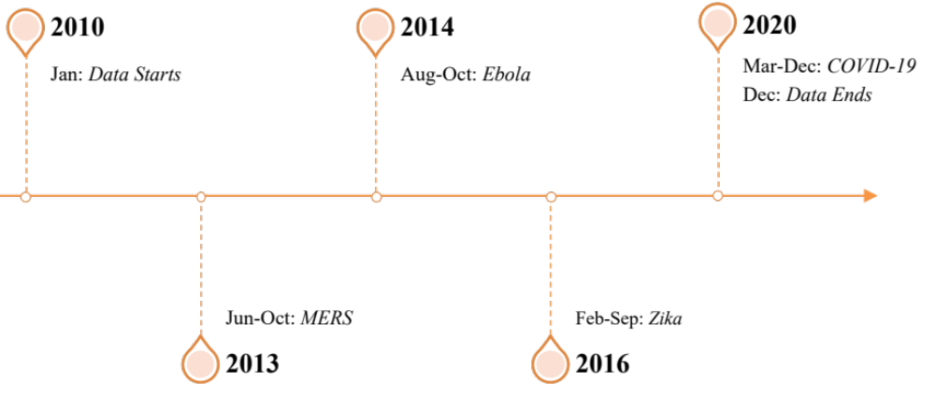
Figure 1.1: Data and Disease Timeline

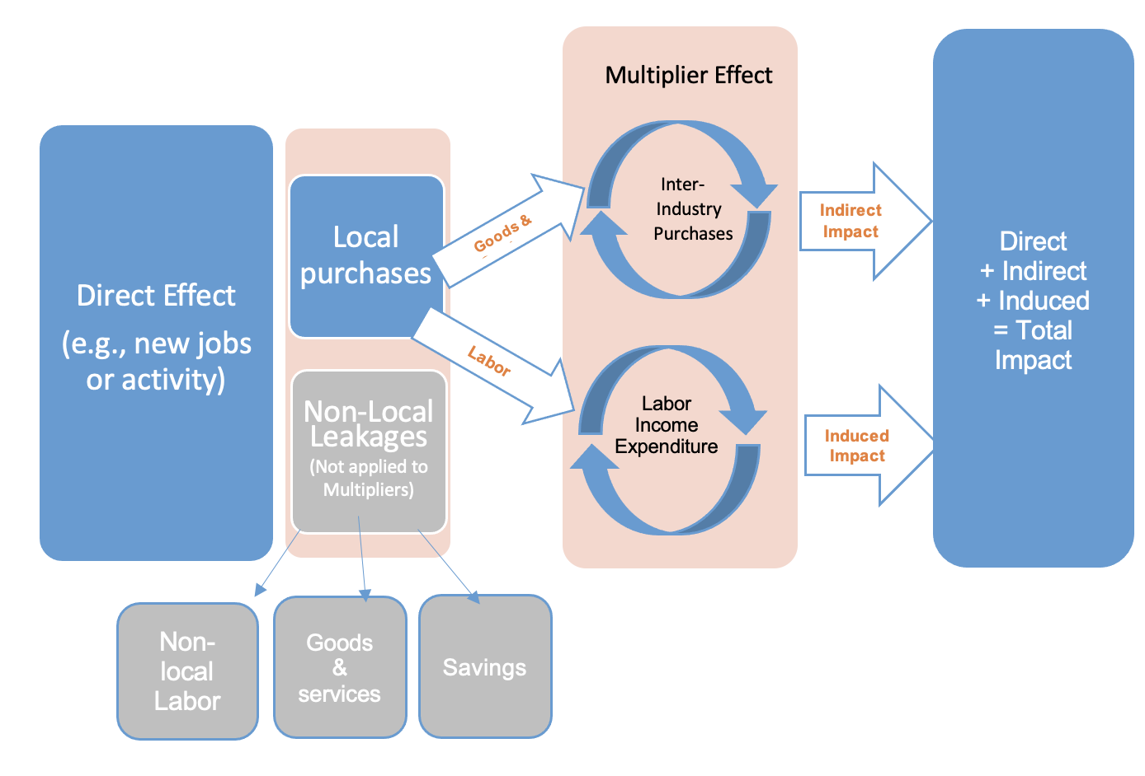

Figure 2.1: Economic Impact and Multiplier Effect Relationships
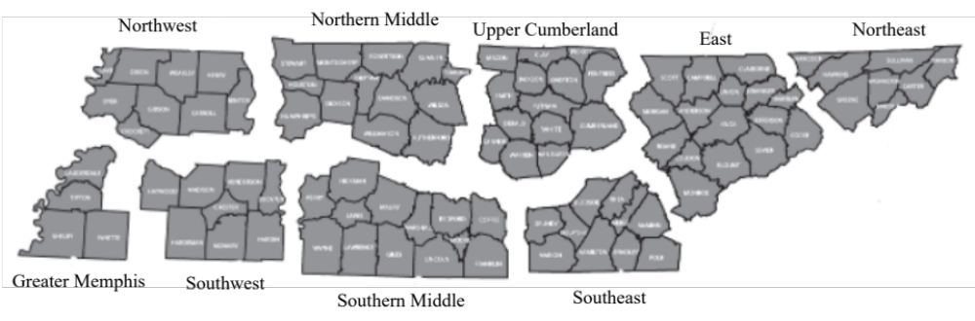
Source: Tennessee Department of Economic and Community Development. (2018)

Figure 2.2: Tennessee Economic and Community Development Regions, 2018

Figure 2.3: 2019 MHI Frequency of Affordability Bin Score

Figure 2.4: 2019 Simple Average Frequency of Affordability Bin Score

Figure 2.5: 2019 Negative Scaled Average Frequency of Affordability Bin Score

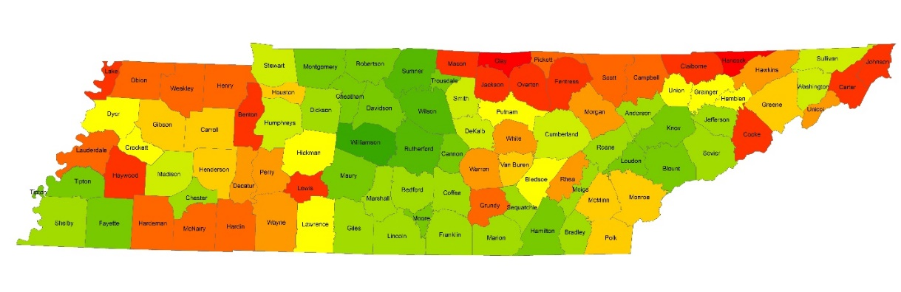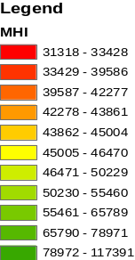
Figure 2.6: Tennessee County ATPI Indices based on MHI Method

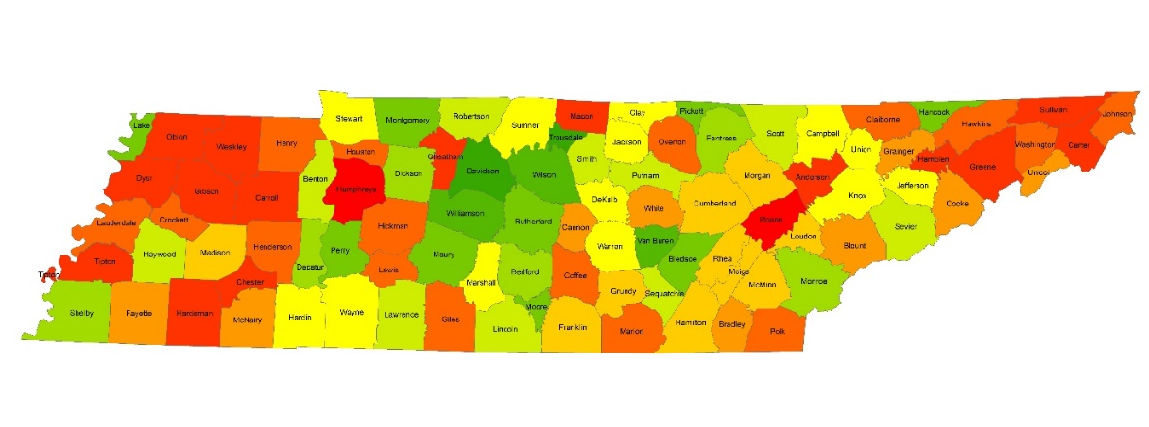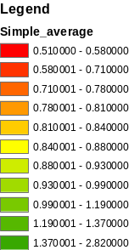
Figure 2.7: Tennessee County ATPI Indices based on Simple Average Method

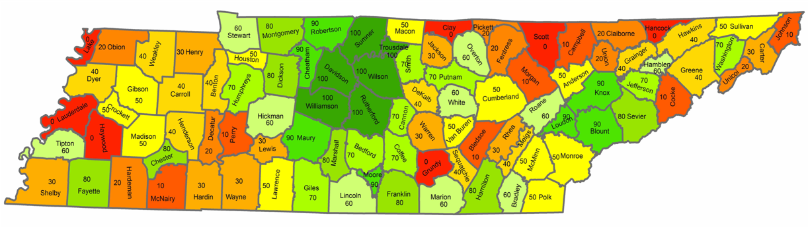
Figure 2.8: Tennessee County ATPI Indices based on Negative Scaled Average Method

Figure 2.9: 2019 Tennessee Aggregated Employment Effects by ATPI Method

Figure 2.10: 2019 Tennessee Aggregated Labor Income Effects by ATPI Method

Figure 2.11: 2019 Tennessee Aggregated Value-Added Effects by ATPI Method

Figure 2.12: 2019 Tennessee Aggregated Output Effects by ATPI Method
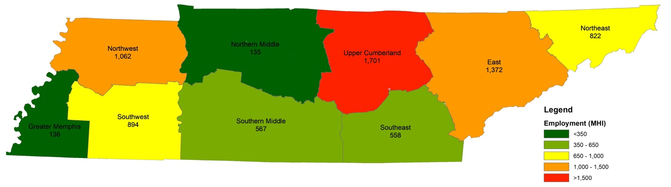
Figure 2.13: 2019 Tennessee Employment Effects by Region from the MHI ATPI

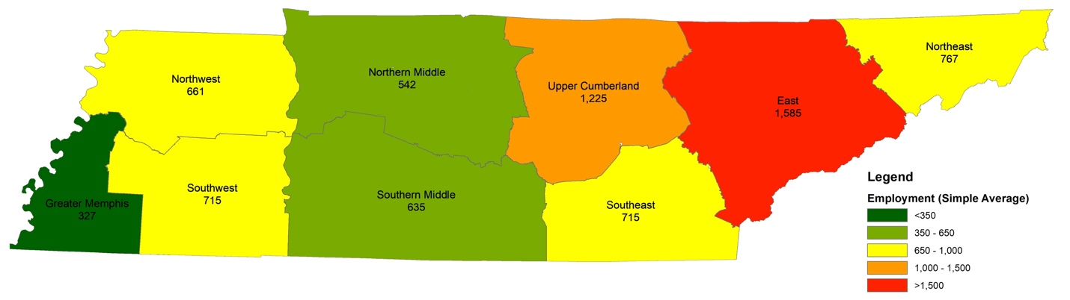
Figure 2.14: 2019 Tennessee Employment Effects by Region from the Simple Average ATPI

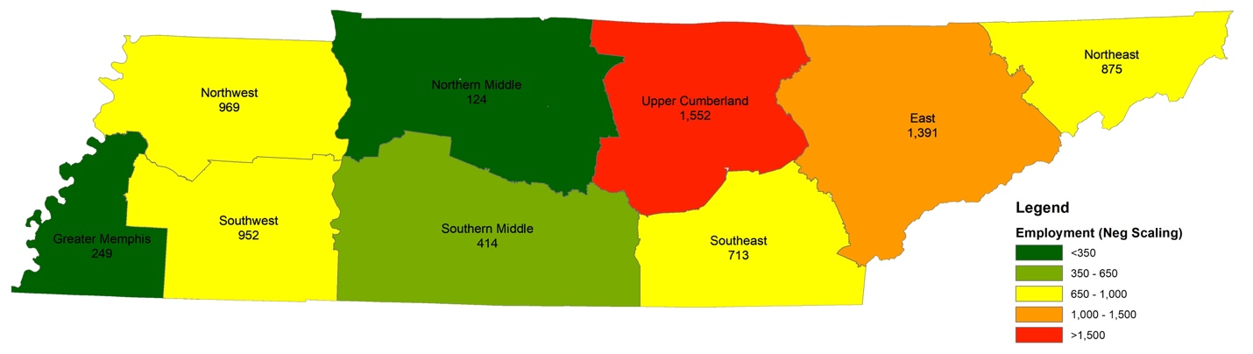
Figure 2.15: 2019 Tennessee Employment Effects by Region from the Negative Scaled Average ATPI

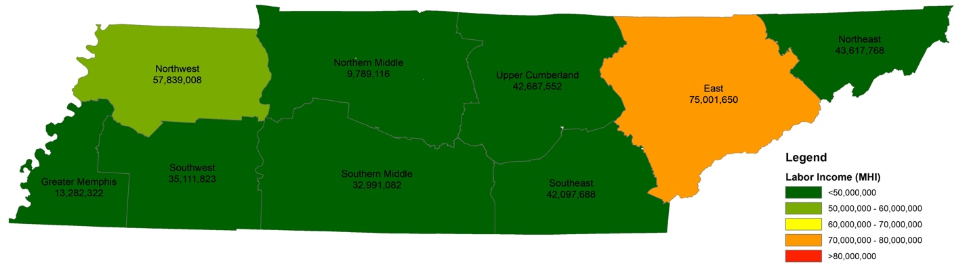
Figure 2.16: 2019 Tennessee Labor Income Effects by Region from the MHI ATPI

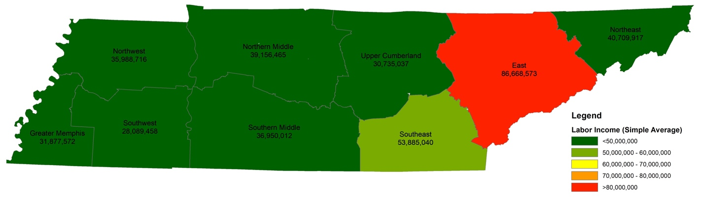
Figure 2.17: 2019 Tennessee Labor Income Effects by Region from the Simple Average ATPI

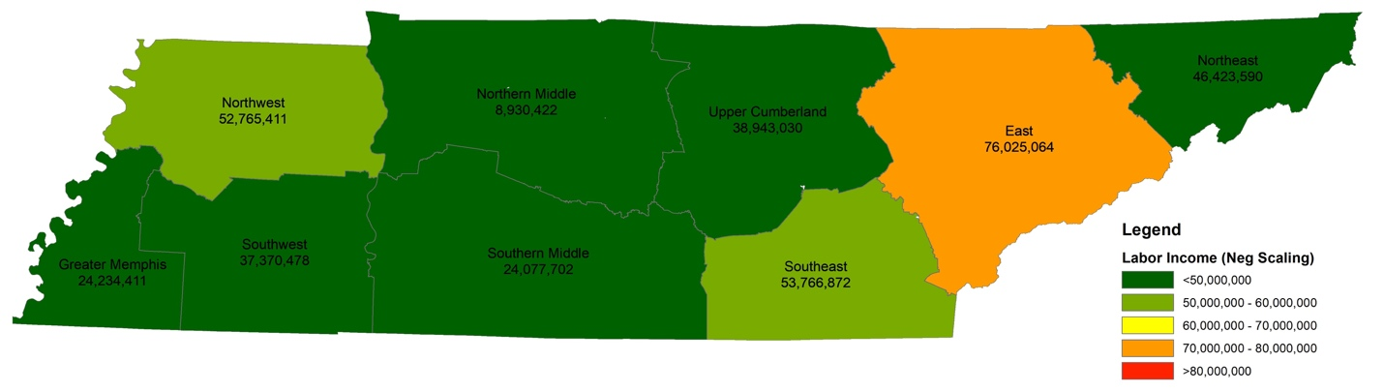
Figure 2.18: 2019 Tennessee Labor Income Effects by Region from the Negative Scaled Average ATPI

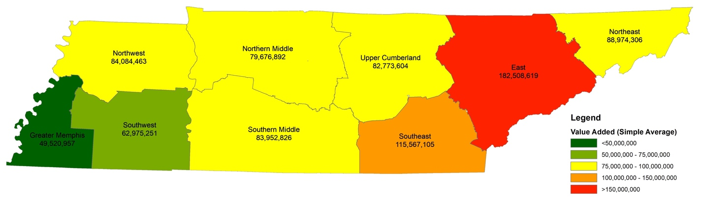
Figure 2.19: 2019 Tennessee Value Added Effects by Region from the MHI ATPI

Figure 2.20: 2019 Tennessee Value Added Effects by Region from the Simple Average ATPI

                - 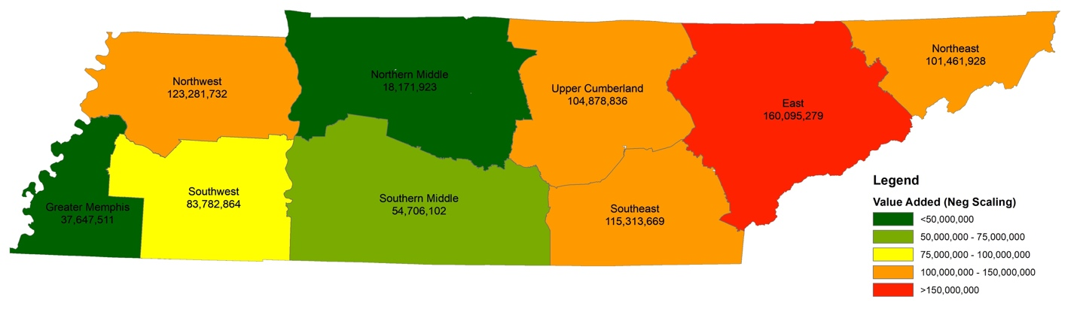
Figure 2.21: 2019 Tennessee Value Added Effects by Region from the Negative Scaled Average ATPI
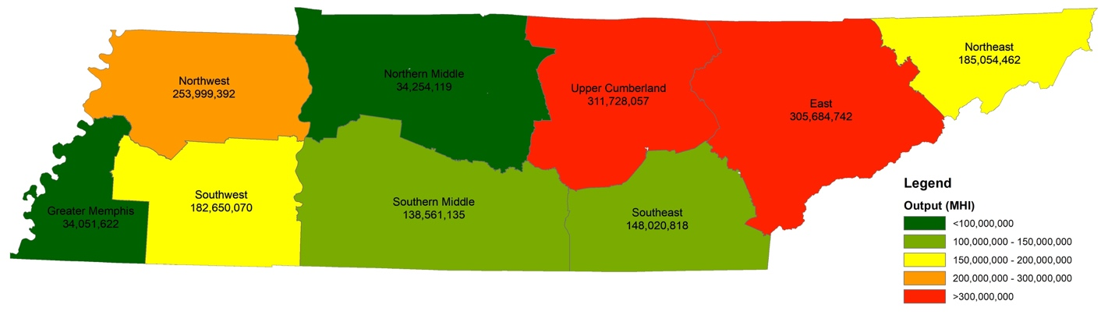
Figure 2.22: 2019 Tennessee Output Effects by Region from the MHI ATPI

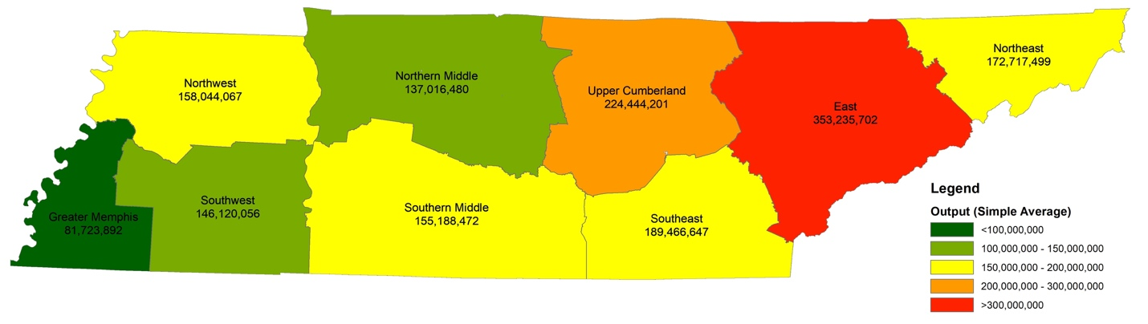
Figure 2.23: 2019 Tennessee Output Effects by Region from the Simple Average ATPI

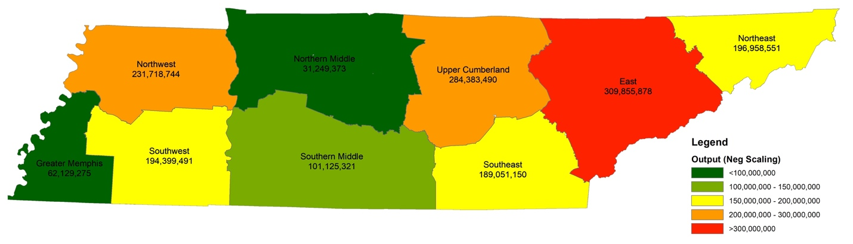
Figure 2.24: 2019 Tennessee Output Effects by Region from the Negative Scaled Average ATPI
                - Vita
Mary Lynn Marks was born in Nashville, Tennessee and grew up in Hendersonville, North Carolina. She attended the University of Tennessee, Knoxville and received her Bachelor of Science degree in Food and Agricultural Business, as well as a minor in English. She decided to continue her education at the University of Tennessee, Knoxville and pursue a Master of Science degree in Agricultural Economics with a minor in Statistics. Her research focuses and interests are in international agricultural trade and rural development. Upon graduation, Ms. Marks will begin an Agricultural Economist position with the United States Department of Agriculture Natural Resources Conservation Service in Harrisburg, Pennsylvania. She would like to thank her advisors, Dr. Jada Thompson and Dr. Sreedhar Upendram, for their contributions and patience in this endeavor. She thanks her family for their continued support and love through all of life’s challenges. And finally, Ms. Marks thanks her close friends for creating wonderful memories and relationships during her time in Knoxville.

The type Other indicates the six-digit HS code not specifying between Fresh or Frozen. This occurs in only one commodity product in the data (020450-Meat; of goats, fresh, chilled or frozen) and is characterized as Other Other
The protein commodity Other represents the meat proteins analyzed not including beef, swine, or poultry. In this study, this is sheep and goat meat products.

