ELECTRON MICROPROBE IN SITU MONAZITE DATING OF THE SLIDE LAKE SHEAR ZONE

A Thesis Presented for the
Master of Science
Degree
The University of Tennessee, Knoxville

Jeremy Leierzapf
December 2020

ACKNOWLEDGEMENTS
I would like to express my deepest gratitude towards all who assisted me in this journey, from beginning to end. Thanks to my advisor Micah Jessup, and committee members Robert Hatcher and Molly McCanta for guiding me through this process, and being patient with me as I progressed as a student. Also, thanks to the Department of Earth and Planetary Sciences at the University of Tennessee, Knoxville (UTK) for providing me with funding through the Swingle Award, the Geological Society of America for awarding me with the 2019 graduate student research grant, and my advisor Micah Jessup for providing additional funds. Many thanks to Joseph Allen, Colin Shaw, and Micah Jessup for their guidance, insight, and fellowship during our field work in Slide Lake, and special thanks to Joe for providing his hospitality while staying in Leadville, CO. Thanks to Tyler Grambling for being a consistent, vast source of tectonic, structural, and petrological information that saved me many trips through my personal textbooks. Many thanks to Allan Patchen for assisting me with Electron Microprobe mapping and interpretation at UTK. A big thanks to Michael Williams at the University of Massachusetts, Amherst for mapping and analyzing my samples for me, and for his substantial counseling during my data collection and interpretation. I would like to offer a final thanks to my professors, administrators, classmates, and officemates at UTK for their aid, support, and amity during my time at UTK.

ABSTRACT
The Colorado mineral belt (CMB) shear zone system records Proterozoic deformation episodes documenting the progressive tectonic accretion of Laurentia. Regional fold formation (D₁ & D₂) is coeval with the ~1.7 – 1.6 Ga Yavapai and Mazatzal orogenies, while Mesoproterozoic sub-vertical shear zones (D₃ & D₄) are a response to ~1.45 – 1.3 Ga intracontinental deformation. The Slide Lake shear zone (SLSZ) is a sub-horizontal shear zone located in the Northern Sawatch Range, central Colorado. Aside from its orientation, the SLSZ records similar deformational structures to other shear zones in the CMB, but there is no timing constraint to test this relationship. Monazite is used as a geochronometer for poly-deformed metamorphic assemblages that record phases of growth through compositional zoning related to deformation and fluid-alteration. This thesis implements microstructural observations, electron microprobe in-situ monazite U-Th-Pb dating, and trace element analysis to place a timing constraint on SLSZ activity. Monazite dates from this research dominantly range from ~1.71 – 1.6 Ga and ~1.54 – 1.41 Ga, the latter of which coincides with dates from the CMB shear zones. Monazite domain-age relationships in some grains suggest that U-Th-Pb monazite system was incompletely reset, commonly leading to younger inner-cores and older outer-cores. Core domains from HS09-42a record older ages (avg: 1700 +/- 6.9 Ma) than is expected from a mylonitic sample, which may imply that monazite grains from Paleoproterozoic deformation (D₁ & D₂) were not reset by fluid alteration during shear zone activity (D₃ & D₄). The ranges of monazite sample dates shows a progression of younger average ages in samples with more advanced grain-size reduction (HS09-36: 1640 +/- 23 Ma → HS09-35: 1502 +/- 39 Ma → SL08-07: 1421 +/- 7.6 Ma), paralleling the structural evolution of the CMB shear zones. Low-Y domains from HS09-35 (1423 and 1420 Ma) and SL08-07 (avg: 1421 +/- 7.6 Ma) support a fluid-alteration event in the shear zone at ⁓1.42 Ga, possibly corresponding with Mesoproterozoic deformation (D₃ & D₄) in the CMB. Monazite dates from mylonitic samples in the SLSZ are coeval with ages of the neighboring Homestake shear zone (HSZ), suggesting that the shear zones were active at similar times.

TABLE OF Contents
CHAPTER 1: INTRODUCTION 1
CHAPTER 2: BACKGROUND 6
2.1. Geologic Setting 7
2.2. The Colorado mineral belt shear zone system 9
2.3. The Slide Lake shear zone 14
2.4. Introduction to Monazite 23
CHAPTER 3: METHODS 27
3.1. Field work and structural analysis 27
3.2. Microscale analysis 28
3.3. In situ monazite dating 29
CHAPTER 4: SAMPLE DESCRIPTIONS 31
4.1. Microstructural framework 33
4.2. Monazite 40
CHAPTER 5: MONAZITE ANALYSIS 47
5.1. Monazite age-composition relationships 47
5.2. Sample comparisons 66
CHAPTER 6: DISCUSSION 68
6.1. General age trends 68
6.2. Microstructural significance of monazite dates 69
6.2. Core to rim relationships 72
6.3. Trace element trends 73
6.4 Timing of shear zone activity 74
6.5. Relationship to Northern Sawatch range 74
CHAPTER 7: CONCLUSION 76
REFERENCES 77
APPENDIX I 87
APPENDIX II 91
APPENDIX III 93
VITA 98

LIST OF FIGURES
Figure 1: Regional tectonic map of Proterozoic terranes with shear zones 2
Figure 2: Geological map and cross section of Slide Lake and Homestake shear zones 4
Figure 3: Generalized geologic map of Colorado mineral belt shear zones 9
Figure 4: Model assembly for Colorado mineral belt structures 11
Figure 5: Electron microprobe monazite data from Colorado mineral belt shear zones 13
Figure 6: Overview of Slide Lake field area 15
Figure 7: Paleoproterozoic structures from Slide Lake 16
Figure 8: Mesoproterozoic structures from Slide Lake 18
Figure 9: Stereograms of Slide Lake shear zone structures 19
Figure 10: Mylonite microstructures from Slide Lake 21
Figure 11: Kinematic model of Homstake and Slide Lake shear zones 22
Figure 12: Generalized geologic map of Slide Lake area 32
Figure 13: Full thin section map HS09-36 33
Figure 14: Microstructures from HS09-36 and HS09-35 34
Figure 15: Full thin section map HS09-35 36
Figure 16: Full thin section map HS09-42a 37
Figure 17: Microstructures from HS09-42a and SL08-07 38
Figure 18: Full thin section map SL08-07 39
Figure 19: Monazite photomicrographs 41
Figure 20: General SEM backscatter monazite images 42
Figure 21: Backscatter monazite images from HS09-36 and HS09-35 44
Figure 22: Backscatter monazite images from HS09-42a and SL08-07 46
Figure 23: HS09-36 Monazite maps with grain locations 49
Figure 24: HS09-36 domain interpretations 50
Figure 25: HS09-36 normal distributution monazite ages 51
Figure 26: HS09-36 age-compsitional relationships 52
Figure 27: HS09-35 Monazite maps with grain locations 53
Figure 28: HS09-35 domain interpretations 54
Figure 29: HS09-35 normal distributution monazite ages. 55
Figure 30: HS09-35 age-compsitional relationships. 56
Figure 31: HS09-42 aMonazite maps with grain locations. 58
Figure 32: HS09-42a domain interpretations 59
Figure 33: HS09-42a normal distributution monazite ages 60
Figure 34: HS09-42a age-compsitional relationships. 61
Figure 35: SL08-07 Monazite maps with grain locations. 62
Figure 36: SL08-07 domain interpretations. 63
Figure 37: SL08-07 normal distributution monazite ages 63
Figure 38: SL08-07 age-compsitional relationships 64
Figure 39: Sample comparison normal distribution. 65
Figure 40: Sample comparison age-compositional relationships. 66
Figure 41: Microstructural – monazite age relationships 71

CHAPTER 1:
INTRODUCTION
Monazite is a popular geochronometer for dating poly-metamorphosed assemblages (Williams et al., 1999; Shaw et al., 2001; Williams et al., 2006). Electron microprobe (EMP) in-situ monazite U-Th-total Pb dating can potentially allow the user to relate metamorphic microstructures to monazite genesis, providing the framework for dating reactions and deformation conditions (Williams et al., 2017). Due to its wide stability range and incorporation of a number of trace and major elements, monazite is appropriate for studying silicate metamorphic reactions that operate during deformation events (Williams et al., 2006). Monazite stability ranges from granulite (T > 700⁰ C) through lower greenschist facies (T = 300 – 450⁰ C) conditions, bridging the gap between higher (ex: U/Pb, zircon; T > 900⁰ C; Lee et al., 1997) and lower (ex: K-Ar, muscovite; T = 300 - 400⁰ C; Jäger, 1979) closure temperature geochronometers. In some examples of mylonitic shear zones monazite acts as a rigid grain, dissolving and reprecipitating as metamorphism persists (Mahan et al., 2006; Sindern et al., 2012; Wawrenitz et al., 2012).My thesis focuses on using monazite as an indicator of shear zone activity.
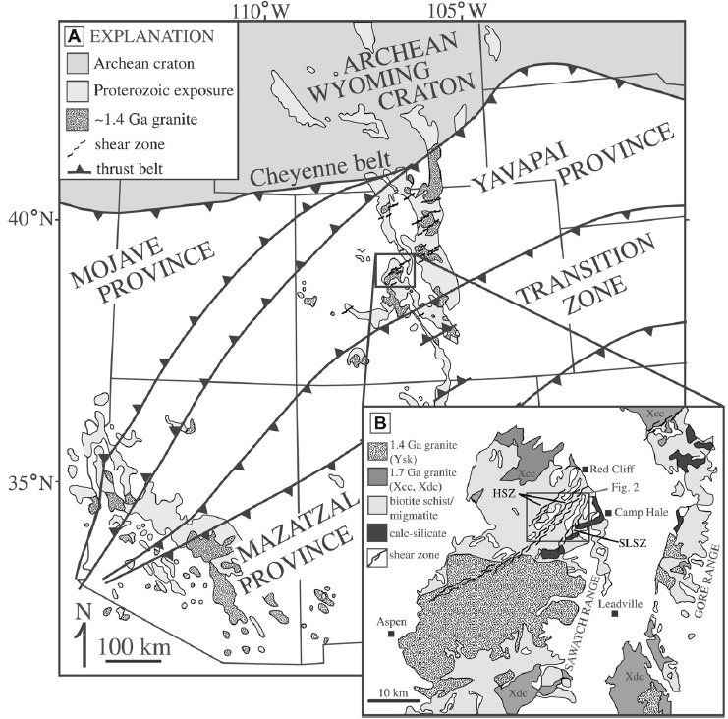
Figure 1: (A) Regional tectonic map of Proterozoic assembly in the southwestern U.S. with Proterozoic boundaries (Condie, 1986; Bennett and DePaolo, 1987; Karlstrom and Bowring, 1988; Wooden et al., 1988; Wooden and DeWitt, 1991; Jones et al., 2010). (B) Inset generalized geologic map of the study area (modified from Shaw and Allen, 2007; Tweto, 1979) with the location of Figure 2. From Lee et al. (2012).

The Colorado mineral belt (CMB) exhibits a complex system of poly-deformed Proterozoic rocks that developed during the multistage accretion of Laurentia (Figure 1) (Tweto and Sims, 1963; Karlstrom and Humphreys, 1998; Shaw et al., 2001; McCoy et al., 2005; Shaw and Allen, 2007). These rocks record the tectonic evolution of Laurentia into successively narrower zones of deformation, from regional scale folding, to localized northeast-striking shear zones that represent an intracratonic response to mid-crustal shortening (Bickford et al., 1989; Bowring and Karlstrom, 1990; Shaw and Karlstrom, 1999; Shaw et al., 2001; Jessup et al., 2005; McCoy et al., 2005; Shaw et al., 2005; Jessup et al., 2006; Allen and Shaw, 2011).
Application of in situ monazite dating to the sub-vertical Homestake shear zone (HSZ) (Figure 2), located in the Northern Sawatch Range (Figure 1), related monazite growth to fabric development and deformation episodes (Shaw et al., 2001). The same technique was implemented on three other shear zones in the CMB (The Gore Range shear zone, St. Louis Lake shear zone, Idaho-Springs Rhalston shear zone), resulting in the recognition of four deformation events in the Proterozoic core of Colorado. The oldest monazite dates in the CMB are linked to Yavapai tectonism (~1.7 Ga; D₁), followed by Mazatzal tectonism (1.65 – 1.6 Ga; D₂), each involving regional high temperature metamorphism, open to isoclinal folding, and plutonism. Proterozoic deformation resumed around ⁓1.45 – 1.37 Ga (D₃ & D₄) with rampant magmatism and shear zone development along Paleoproterozoic high strain zones as a response to deformation along the former southern margin of Laurentia (Shaw et al., 2001). More recent studies from metasedimentary units in the Picuris Mountains of northern New Mexico, detailing sedimentation and crustal thickening during the tectonic event termed the Picuris orogeny (1.5 – 1.4 Ga; Daniel et al., 2013; Aronoff, 2016), may serve as a mechanism for the shear zone activity in central Colorado, far inboard from the former active margin in northern New Mexico.
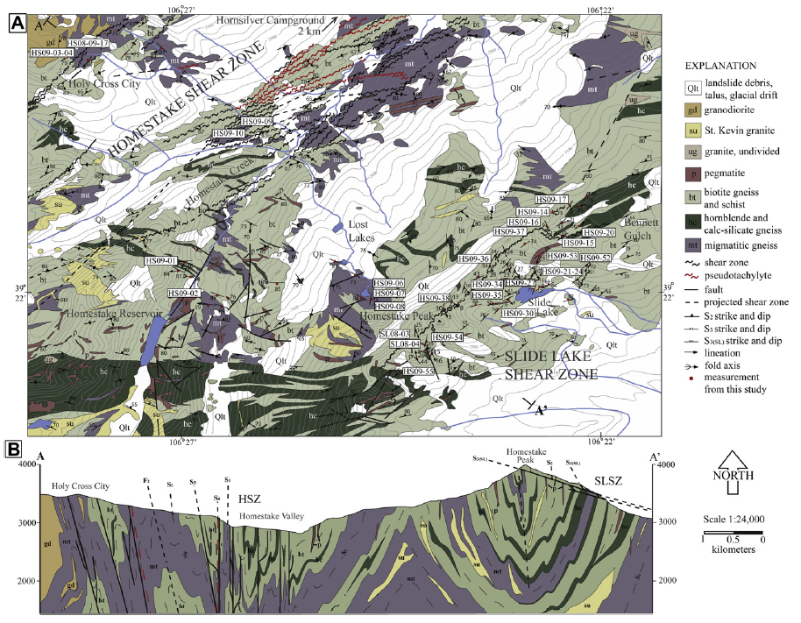
Figure 2: (A) Generalized geologic map of the northern Sawatch Range in the vicinity of Homestake and Slide Lake shear zones. (B) Geologic cross section of the field area (A-A’). From Lee et al. (2012).

The Slide Lake shear zone (SLSZ) is a southeast-dipping sub-horizontal mylonite to ultramylonite zone located 4 km’s southwest of the HSZ (Figure 2). Lee et al. (2012) performed the first kinematic analysis of the SLSZ, using the HSZ as a reference. The shear zones record similar metamorphic signatures (amphibolite to greenschist facies), kinematic shear sense (dominant top-to-the-southeast, and top-to-the-northwest shear sense), and deformation textures, suggesting that they were active at relatively equal crustal positions. A timing constraint for the activity of the SLSZ will give insight into how neighboring sub-vertical and sub-horizontal shear zones work to accommodate strain in the mid-crust during tectonic events. Additionally, advancements of the in-situ monazite dating technique (Williams et al., 2006; Williams et al., 2017) since the original application (Shaw et al., 2001; McCoy et al., 2005) presents an excellent opportunity to revisit the CMB shear zone system with a refined methodology.
This study combines in-situ monazite dating with new field and microstructural observations, and aims to 1) re-examine the timing of the CMB shear zones, 2) better understand the link between monazite microstructures and strain, and 3) place the first ever timing constraint on the activity of the SLSZ.

CHAPTER 2:
BACKGROUND
Tectonic convergence adds newer terranes onto preexisting lithosphere, as the continental interior grows outward with progressively younger crust. Upon assembly, these terranes are subjected to crustal shortening, extension, and transpression as blocks of crust with varying rheological properties move relative to one another (Molnar, 1988; Bowring and Karlstrom, 1990). The resulting structures are weakened upon repeated activation, producing lasting tectonic discontinuities that persist into an intracontinental setting (Burchfiel et al., 1989). Continued shortening along these tectonic boundaries results in concentrated strain, forming penetrative structures where stress is localized into shear zones (Sibson, 1977). At mid to lower crustal depths these structures are represented by ductile shear zones, which terminate into brittle faults in the upper crust (Passchier and Trouw, 2005). The recognition and study of these shear zones helps to better understand how deformation is accommodated in the middle-crust during convergence.
Shear zones that are recorded by Proterozoic rocks in the southwestern United States have been thoroughly researched, believed to correspond to the reactivation of structures formed during 1.8 to 1.6 Ga convergent events (Tweto and Sims, 1963; Bowring and Karlstrom, 1990; Karlstrom and Humphreys, 1998; Shaw et al., 2001; McCoy et al., 2005). These shear zones cross-cut Proterozoic crust that extends from the Cheyenne belt suture (Karlstrom and Houston, 1984) southwards into Colorado and New Mexico, constituting juvenile lithosphere and volcanic arcs that accreted to the Wyoming Craton in a series of northwest- directed shortening events (Whitmeyer and Karlstrom, 2007). Sub-vertical shear zones in the CMB specifically record the deformation associated with mylonitic shearing (⁓1.4 Ga) chronologically and spatially related to localized pluton emplacement (Shaw et al., 2001; McCoy et al., 2005). The presence of sub-horizontal shear zones in the CMB raises the question as to whether these are linked to the steeply dipping shear zones, or whether they correspond to a different intracontinental mechanism related to crustal shortening or extension (Lee et al., 2012).

2.1. Geologic Setting
The collision of the Archean cratons during the Trans-Hudson Orogeny (1.9 – 1.8 Ga) provided the tectonic foundation for the subsequent allochthonous terrane accretion that would persist throughout the Proterozoic (Hoffman, 1988; Ross and Villeneuve, 2003; Whitmeyer and Karlstrom, 2007). Following the assembly of the Laurentian core, juvenile island arcs accreted onto the southern margin of the Archean craton (1.8 – 1.7 Ga), making up the Yavapai Province (Whitmeyer and Karlstrom, 2007). A series of northeast-trending subduction zones delivered arc material with fragments of older crust (Hill and Bickford, 2001), culminating in the Yavapai orogeny ca. 1.71 – 1.68 Ga (Whitmeyer and Karlstrom, 2007). The Yavapai Province extends from Arizona and New Mexico to the Cheyenne belt suture in northern Colorado (Bowring and Karlstrom, 1990; Karlstrom and Bowring, 1993; Karlstrom and Humphreys, 1998).
The Mazatzal province consists of 1.7 – 1.6 Ga volcanic arc material that formed on southern Laurentia following the Yavapai orogeny (Karlstrom and Bowring, 1988; Karlstrom and Bowring, 1993; Whitmeyer and Karlstrom, 2007). 1.68 – 1.65 Ga plutons range as far north as the Cheyenne Belt, and as far northwest as the Mojave Province (Premo and van Schmus, 1989), recording magmatism over an extensive area of Laurentia during the construction of the Mazatzal Province (Whitmeyer and Karlstrom, 2007). The Mazatzal orogeny (1.65-1.60 Ga) comprised the metamorphism, thrusting, and shortening of the Mazatzal crust that accreted following the Yavapai orogeny (Whitmeyer and Karlstrom, 2007).
Mesoproterozoic tectonism in the Yavapai Province (Tweto and Sims, 1963; McCoy et al., 2005) is interpreted to be a response to far afield tectonic forces in southern Laurentia coeval with the assembly of the Granite-Rhyolite Province (1.5 – 1.3 Ga) (Bickford and Van Schmus, 1985; Lidiak et al., 1966) a as part of A-Type intracratonic magmatism (Whitmeyer and Karlstrom, 2007). Evidence for this Mesoproterozoic deformation event comes from widespread shear zone development and plutonism (Bowring and Karlstrom, 1990). Originally thought to be anorogenic (Anderson, 1983; Hoffman, 1989; Frost et al., 2001), many of these granitic intrusions are locally associated with mylonitic shear zones (McCoy et al., 2005). This correlation may be caused by the relationship between magmatism and thermally weakened crust, where reactivated tectonic fabrics assist pluton emplacement. For example, shear zones in the CMB record 1.45 – 1.3 Ga high strain deformation, coeval with adjacent plutonism (McCoy et al., 2005).
More recent studies have alternatively suggested that the 1.5 – 1.3 Ga deformation event is related to the final accretion of the Mazatzal Province (Aronoff et al., 2016; Daniel et al., 2013; Jones et al., 2015) after a period of tectonic quiescence following the Yavapai orogeny. Detrital zircon grains (1490 – 1450 Ma) deposited in the Trampas/Picuris basin of northern New Mexico, which preceded regional triple point metamorphism and 1.46 – 1.40 Ga amphibolite facies metamorphism, detail sedimentation and crustal thickening during the contractional Picuris Orogeny (Daniel et al., 2013; Jones et al., 2015; Aronoff et al., 2016).

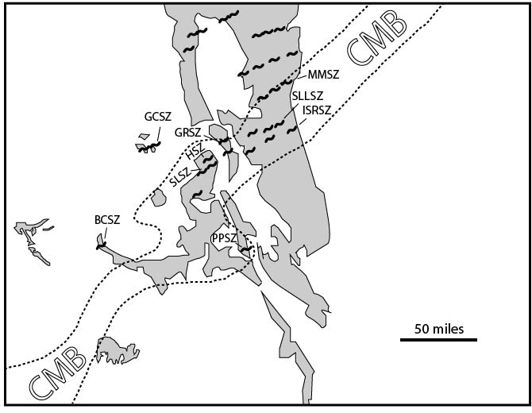
Figure 3: Geologic map of Colorado with highlighted Precambrian outcrops (Clarey et al., 2004; Allen and Shaw, 2011) and shear zones in the Colorado mineral belt (CMB). Shear zone locations from Allen and Shaw, 2011; Lee et al., 2012. BCSZ = Black Canyon shear zone, GCSZ = Grizzly Creek shear zone, SLSZ = Slide Lake shear zone, HSZ = Homestake shear zone, GRSZ = Gore Range shear zone, PPSZ = Poncha Pass shear zone, MMSZ = Moose Mountain shear zone, SLLSZ = St. Louis Lake shear zone, ISRSZ = Idaho Springs-Ralston shear zone.

2.2. The Colorado mineral belt shear zone system
The CMB shear zone system consists of northeast striking (028° – 090°; McCoy et al., 2005) mylonite and ultramylonite zones that record the Proterozoic deformation of Laurentia (Tweto and Sims, 1963; Selverstone et al., 2000; Shaw et al., 2001; McCoy et al., 2005 Allen and Shaw, 2011; Lee et al., 2012). Each main shear zone is ~ 1-km wide, with individual mylonite zones and ultramylonite zones that are meter- to decimeter-scale, and millimeter- to centimeter-scale, respectively. These shear zones are mostly sub-vertical (dips range from 74° NW to 66° SE; McCoy et al., 2005), have steeply plunging stretching lineations, and record dip-slip motion (McCoy et al., 2005; Lee et al., 2012). Individual shear zones may represent discontinuous branches of one shear zone splay that was offset by dextral faulting (McCoy et al., 2005). Shear zones are subparallel to high strain axial planar cleavage found in Paleoproterozoic folds (Shaw et al., 2001; McCoy et al., 2005).
Combining field relationships, geometry, and kinematics of different shear zone segments yields four distinct deformation events that record the evolution of the intracontinental Proterozoic core of Laurentia into progressively narrower zones of deformation (Figure 4) (Shaw et al., 2001; McCoy et al., 2005). D₁ is defined by regional S₁ sub-horizontal fabrics with isoclinal, recumbent F₁ folds with migmatites that were synchronous with high-grade metamorphism (McCoy et al., 2005). D₂ is recorded by the folding of S₁ into open to isoclinal F₂ folds with shallowly plunging fold axes (S₂), which are locally rotated into the S₂ sub-vertical high-strain zones. F₂ folds steepen with proximity to the high-strain domains, such that the F₂ fold axes become parallel to the vertical stretching lineations, indicating the both the folds and high strain were parts of D₂ (McCoy et al., 2005). Zones of mylonitic deformation overprint older high-strain D₂ domains with sub-vertical S₂ fabrics, recording lower temperature microstructures with southeast-side-down displacement (Shaw et al., 2001). Ultramylonite formation (D₄) features grain size reduction with a strong stretching lineation, lower deformation temperatures, and southeast-side-up with minor dextral component
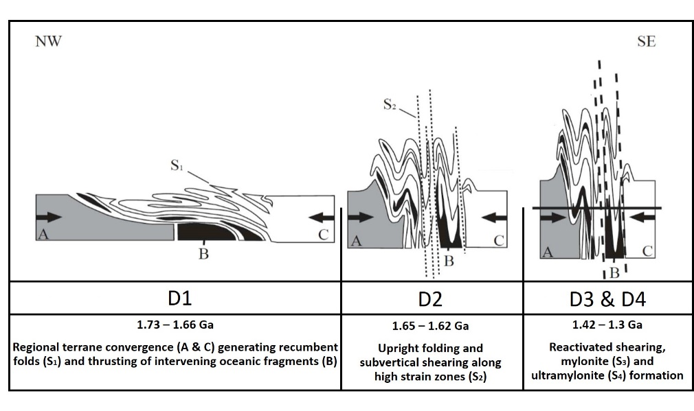
Figure 4: Model assembly for Proterozoic terrane accretion and the resulting structures. Modified from McCoy et al. (2005).

Electron microprobe (EMP) in-situ monazite dating applied to the sub-vertical Homestake shear zone (HSZ) related monazite growth to fabric development, deformation episodes, and metamorphism (Shaw et al., 2001; McCoy et al., 2005). Results from the HSZ indicated that the first phase of Paleoproterozoic deformation (D₁) is recognized by high-temperature, flow near the sillimanite stability field at which generated partial melting and the formation of magmatic leucosomes and melanosomes, defining the subhorizontal S₁ at >1708 ± 6 Ma (Shaw et al., 2001). This sub-horizontal flow progressed into northwest-southeast- shortening that transposed S₁ into a sub-vertical, northeast striking shear zone S₂ with steeply plunging stretching lineation’s by 1637 ± 13 Ma (Shaw et al., 2001). Mesoproterozoic deformation is characterized by localized, moderate temperature shear zone development that overprinted steep S₂ fabrics with mylonitic foliation (1.45 – 1.37 Ga). A weighed average of 1.372 ± 19 was interpreted to represent the age of D₃ top-down-to-the-southeast sense of shear. The final phase of Proterozoic deformation overprinted earlier fabrics with straight, narrow shear splays of ultramylonite, recording top-up-to-the- northwest sense of shear at 1375 ± 14 Ma (Shaw et al., 2001). The timing of structure formation in the HSZ field area inferred from Shaw et al. (2001) overlaps with the emplacement of the neighboring Cross Creek (ca. 1675 Ma [Rb-Sr]; Tweto and Lovering, 1977) and the St. Kevin Batholiths (1396 +/- 40 Ma [U-Th-Pb zircon]; Doe and Pearson, 1969); hornblende and muscovite ⁴⁰Ar/³⁹Ar data from a transect across the HSZ range from 1650 to 1400 Ma (Shaw et al., 2005).
In situ monazite dating was applied to three other sub-vertical shear zones in the CMB, roughly on strike with the HSZ: Gore Range shear zone (GRSZ), Idaho-Springs Rhalston shear zone (ISRSZ), St. Louis Lake shear zone (SLLSZ) (Figure 5) (McCoy et al., 2005). Monazite ages from the three shear zone segments cluster at around ⁓1.7 – 1.6 Ga, and ⁓1.45 – 1.3 Ga, with little activity recorded between the major events. In relation to structural fabrics and regional tectonic events, this research infers monazite growth in the CMB approximately parallels with Yavapai (D₁: ⁓1.7) and Mazatzal (D₂: ⁓1.65) orogenesis followed by Mesoproterozoic shear zone activity associated with intracontinental deformation (D₃ & D₄: 1.45 – 1.3 Ga). All told, these four Proterozoic deformation events recorded in the CMB have served as a crucial reference for the continental assembly and subsequent intracontinental deformation of the Yavapai Province.

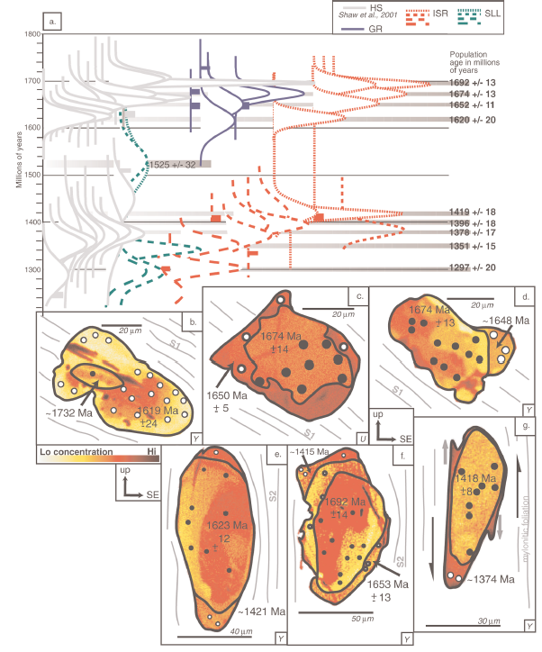
Figure 5: A.) Distribution curves of microprobe monazite dates based on 4–17 spot analyses from the Homestake (HS), Gore Range (GR), Idaho-Springs Rhalston (ISR), and St. Louis Lake (SLL) shear zones. B – G.) Examples of electron microprobe elemental concentration maps showing uranium (U) and yttrium (Y) zoning and average microprobe U-Th-Pb date for monazite. From McCoy et al. (2005).

2.3. The Slide Lake shear zone
Lee et al., (2012) completed the first detailed structural study of the Slide Lake shear zone (SLSZ). The SLSZ is located at the juncture between Lake and Eagle counties, CO, adjacent to Homestake Peak (Figure 2). The shear zone is defined by mylonite, ultramylonite, and pseudotachylyte zones that cut across a mélange of variably folded and partially melted metasedimentary rock, consisting of migmatite, schist, gneiss, amphibolite, and calc-silicate gneiss (Figure 2) (Lee et al., 2012). The northeast trending shear zone is exposed southeast of Homestake Valley along the Homestake and Bennett ridgelines, and down into Slide Lake Cirque and Bennett Gulch (Figure 6). The three main splays of the SLSZ as defined by Lee et al. (2012) include the Homestake Ridgeline, Bennett Ridgeline, and Slide Lake Pavement.
'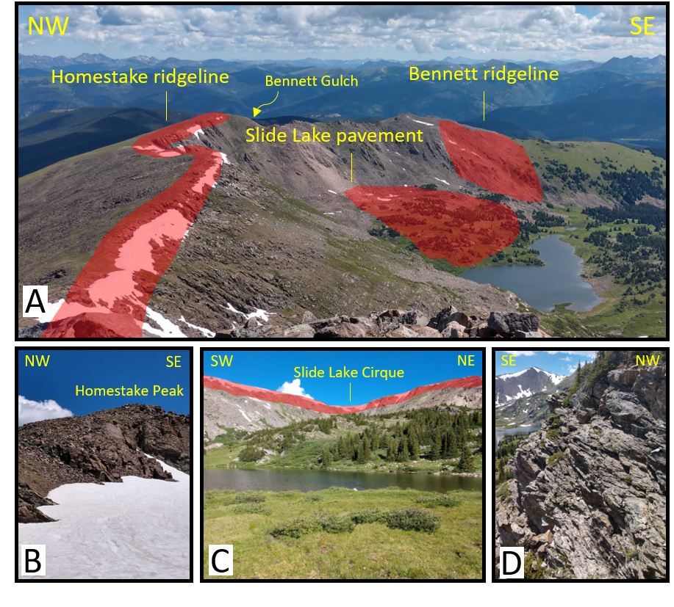
Figure 6: Field images, taken during field work for this thesis, that are representative of the various features of Lee et al., 2012). Overview of Slide Lake field area with reference to geographic markers A.) Picture taken from Homestake Peak showing the locations of the three main mylonite exposures inspired by Lee et al., 2012 (Homestake ridgeline, Slide Lake pavement, Bennett ridgeline). B.) View of mylonite splays just below Homestake Peak. C.) View of Slide Lake pavement and Slide Lake Cirque. D.) View of Homestake Peak from Slide Lake pavement.

Mesoscale framework
Lee et al. (2012) found the majority of the Proterozoic basement featured in the SLSZ field area consists of Paleoproterozoic biotite gneiss and migmatite (bt+grt+sil+qtz+fsp+ms), (qtz+fsp+ms+bt), calc-silicate gneiss (hbl+cal+qtz+chl), and granitoids (Figure 7). Lee et al., (2012) suggested Paleoproterozoic deformation events D₁ and D₂ are represented by high temperature metamorphism and open to isoclinal folding (Figure 7A & C). Leucosomes and melanosomes in migmatite define S₁ sub-horizontal flow, corresponding to regional nappe formation (Figure 7B). This early fabric was displaced into moderately to steeply dipping S₂ gneissic fabric coeval with amphibolite facies metamorphism, with open to isoclinal F₂ folds.

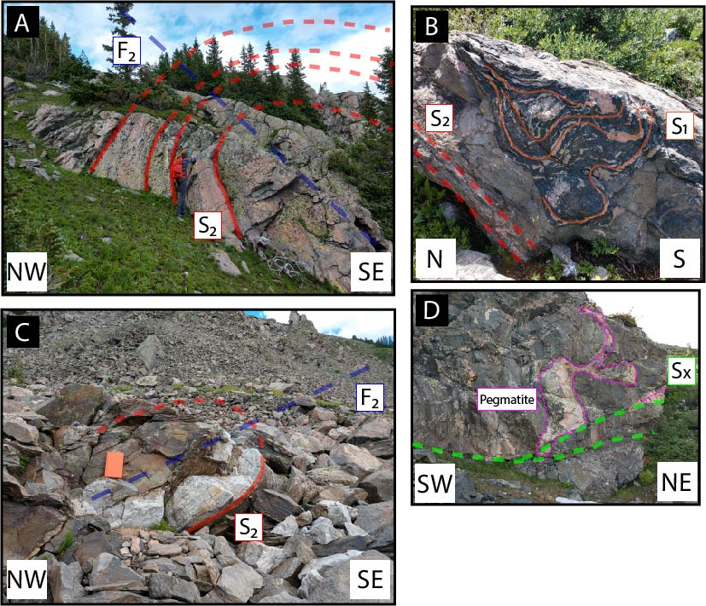
Figure 7: A.) Open gneissic fold with SE-dipping axial plane. B.) S₁ migmatite fabric overprinted by S₂ gneissic foliation. C.) NW-dipping axial plane of F₂ fold. D.) Pegmatite intrusion adjacent to sub-horizontal mylonite zone (S_{x}).

Lee et al., (2012) proposed the higher strain Mesoproterozoic deformation events (D_{x}) are recorded by grain-size-reduced mylonite and ultramylonite zones that can in places truncate the older Paleoproterozoic fabric (Figure 8A). The greenschist facies mylonite zones (qtz+fld+bt ± chl+ms) dip gently to the northeast and southeast (Figure 8B, C, D), with north- and south-plunging stretching lineations. S_{x} is defined by the alignment of elongate micaceous layers and quartzose shear bands, with a larger proportion of mica in ultramylonite layers (Figure 8D). Asymmetric shear bands, rotated feldspar porphyroclasts, and S-C foliation are used to recognize top-to-the-southeast, and minor top-to-the-northwest, shear sense (ex: Figure 8C). Exposures of mylonite zones are cm- to m- scale, while ultramylonite zones are usually ~ 1 cm in width (Figure 8D).
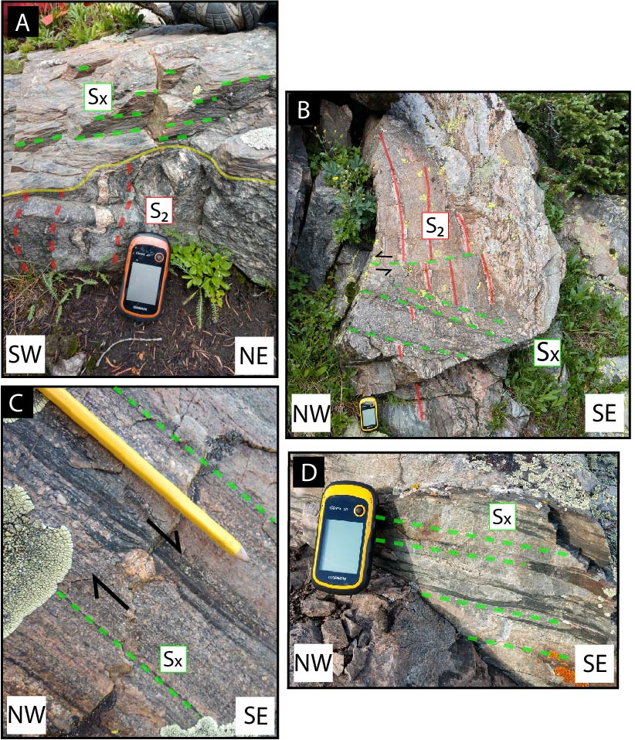
Figure 8: Field images, taken during field work for this thesis, that are representative of the various features of Lee et al., 2012) A.) Gneissic fabric (S₂) crosscut by high strain mylonite zone (S_{X}). B.) S₂ fabric sheared by mylonitic high strain domain. C.) δ-clast showing t-SE shear sense in mylonite. D.) Sub-horizontal mylonite (light) and ultramylonite (dark) zone.

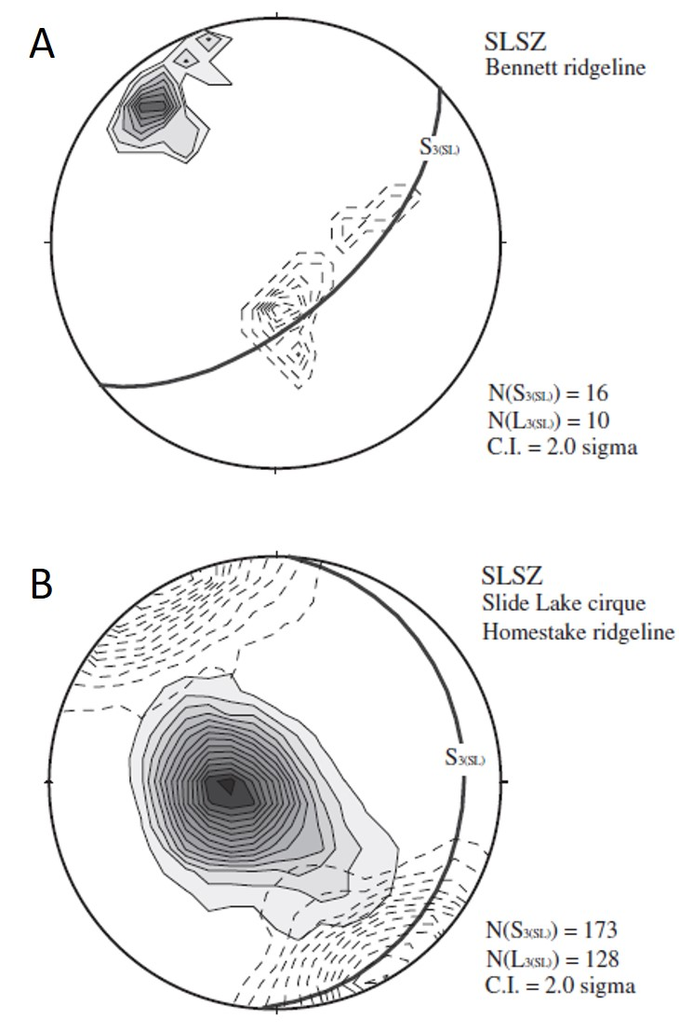
Figure 9: Lower hemisphere equal area stereograms showing foliation and lineation relationships in the field area from Lee et al., (2012). Black planes represent average foliation plane, shaded contours represent poles to foliation for all measured planes, and dashed contours are stretching lineations. (A) SLSZ Bennett ridgeline moderately dipping splay, S₃ (048, 60°SE), L_{3(SL)} (59°→ 121). (B) SLSZ low-angle splays, S₃ (007, 24°SE), L_{3 (SL)} (9°→ 165)

Figure 9 shows structural orientations of the SLSZ from Lee et al. (2012). The Slide Lake Pavement and Homestake ridgeline mylonite splays are characterized as dominantly east dipping and sub-horizontal (average: 007, 24°), with stretching lineation’s plunging to the northwest and southeast (average: L_{3 (SL)} 9°→ 165). The Bennett ridgeline mylonite is more moderately dipping to the southeast (average: 048, 60°), with southeast-plunging stretching lineations (average: L_{3(SL)} 59°→ 121)


Figure 10: Examples of photomicrographs from SLSZ, from Lee et al. (2012). A.) Mylonite with S-C fabric recording top-to-the-southeast shear sense. (B) Rigid feldspar porphyroclasts showing top-to-the-southeast shear sense. C.) Mylonite with elongate quartz domains (GBM) pinned by phyllosilicates. D.) Oblique grain-shape fabric in quartz grains, showing top-to-the-northwest sense of shear. E.) Quartz grains (GBM) surrounding feldspar porphyroclast displaying display core and mantle structures (BLG). F.) Quartz grains exhibiting Grain Boundary Area Reduction (GBAR).

Microscale framework
Mylonitic rocks from the SLSZ (qtz+fsp+bt+ms±cal) are dominantly characterized by a foliated matrix of grain-size reduced quartz and aligned mica grains (Lee et al 2012; Figure 10A). Quartz deformation textures show GBM (> 500°C) and GBAR textures (Lee et al., 2012; Figure 10F), sometimes pinned by phyllosilicates and restricted to narrow bands (Lee et al., 2012; Figure 10C). Feldspar porphyroclasts mostly exhibit microfracturing (< 450°C), with minor core and mantle structures exhibiting BLG recrystallization (450-600°C) (Lee et al., 2012; Figure 10E). Both top-to-the-northwest and top-to-the-southeast shear sense is exampled by asymmetric tails on rigid porphyroclasts (Lee et al., 2012; Figure 10B), oblique grain-shape fabric (Lee et al., 2012; Figure 10D), and S-C fabric (Lee et al., 2012; Figure 10A).

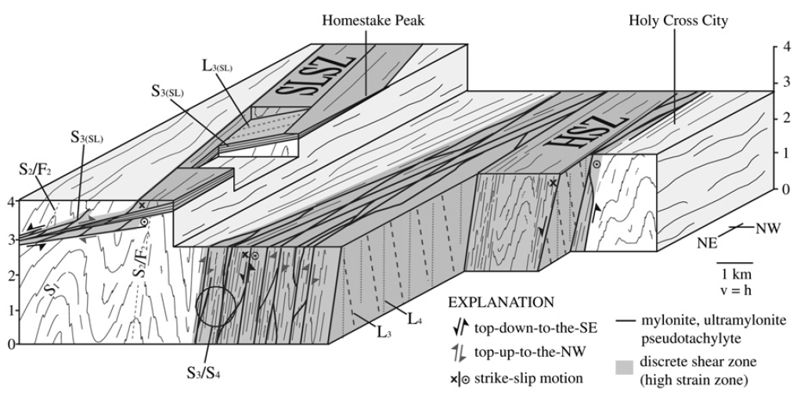
Figure 11: Block diagram of the Slide Lake and Homestake shear zones viewed to the south. From Lee et al. (2012).

Kinematic model
Figure 11 shows a block diagram that illustrates the kinematic relationship between the HSZ and SLSZ. Despite the lack of relative or absolute timing constraints between the HSZ and SLSZ, similarities in structural domains, shear sense, and microstructures suggest that the two shear zones were active at equivalent crustal levels (Lee et al., 2012).

2.4. Introduction to Monazite
Electron Microprobe (EMP) dating of monazite has become popular for constraining the timing of deformation in metamorphic assemblages (Suzuki and Adachi, 1991; Suzuki and Adachi, 1998; Montel et al., 2000; Terry et al., 2000; Simpson et al., 2000; Shaw et al., 2001; Williams and Jercinovic, 2002; Asami et al., 2002; Cheong et al., 2002; Pyle and Spear, 2003; Hibbard et al., 2003; Tickyj et al., 2004; Foster et al., 2004; Goncalves et al., 2004). Constraining the ages of deformation events involves choosing monazite crystals in relationship with structural fabric elements in a rock and obtaining EMP U-Th-Pb dates that can be tied to growth events (Williams et al., 1999). This technique is made possible by the high closure temperature of monazite (> 900°C; Cherniak et al., 2004) and the slow diffusion of Pb in monazite (Crowley and Ghent, 1999; Cherniak et al., 2004). Metamorphic monazite typically displays compositional zoning corresponding to growth and dissolution events during deformation and metamorphism, creating a link between structural kinematics and geochronology (Williams et al., 2006). In some cases, these compositional domains can be related to specific points along the P-T path of a metamorphic assemblage (Williams et al., 2006). The small spatial resolution of the EMP (< 5 µm) permits the user to examine several distinct compositional domains in a single monazite crystal (Williams et al., 2006). The goal of this method is to obtain geologically meaningful ages using in-situ electron microprobe compositional mapping and chemical dating.

Monazite stability
The stability of monazite precipitating in metapelitic rocks along a prograde metamorphic path reportedly depends on bulk CaO, assuming moderate LREE concentrations: rocks deficient in CaO can precipitate monazite from low greenschist facies through granulite facies conditions (Overstreet, 1967; Spear and Pyle, 2002), whereas rocks with sufficient CaO concentrations see the replacement of monazite by allanite at ⁓ 450 ⁰C until monazite reappears around the aluminosilicate-in isograd (e.g., Smith and Barreiro, 1990; Kingsbury et al., 1993; Wing et al., 2003; Kohn and Malloy, 2004; Fitzsimons et al.,2005; Rasmussen et al., 2006; Janots et al., 2006, 2008; Tomkins and Pattison, 2007; Corrie and Kohn, 2008; Spear, 2010). Monazite found in greenschist rocks are believed to be detrital relics, as it is not stable during diagenesis (Overstreet, 1967), and is mostly absent from samples in the chlorite + biotite zone (Kingsbury et al., 1993). Significant growth of monazite does not occur until the aluminosilicate-in isograd, above which monazite continues to grow with increasing metamorphic grade (Franz et al., 1996; Rubatto et al., 2001). In granulite facies conditions, monazite crystals are large and commonly have more complex internal zoning, suggesting melt assisted dissolution and reprecipitation (Rubatto et al., 2001).
Monazite stability additionally relies on the presence of additional P and REE-bearing phases (Spear and Pyle, 2002; Kohn and Malloy, 2004). Although monazite occurrence is often related to allanite breakdown, other studies have documented that major silicate phases have sufficient LREE and P concentrations to produce secondary monazite (ex: Kohn and Malloy, 2004). Apatite [Ca₅(PO₄)₃(OH,F,Cl)] and xenotime [YPO₄] also control monazite stability, serving as a major sink for Y, P, and REE’s (Spear and Pyle, 2002). ). Like monazite, apatite and xenotime (if garnet is absent: Pyle and Spear, 1999) are stable across all metamorphic grades (Spear and Pyle, 2002). Monazite coexisting with xenotime has higher Y and HREE’s concentrations with increasing temperature, as these elements favorably partition into xenotime at lower grades (Pyle et al., 2001). Apatite often replaces monazite during hydrothermal alteration where trace and REE’s are removed from the host-monazite, sometime resulting in discordant U-Pb ages (ex: Lanzirotti and Hanson, 1996).

Monazite deformation
The U-Th-Pb monazite system operates according to fluid composition and inter-grain transport during active deformation and metamorphism (Harlov and Hetherington, 2010; Seydoux-Guillaume et al., 2002). Metamorphic reactions release fluids that accelerate the resetting of the U-Th-Pb system in monazite, effectively producing datable monazite domains. Wawrenitz et al. (2012) describes two deformation mechanisms from which monazite recrystallizes: dislocation creep and dissolution-precipitation creep (DPC). The dissolution of major mineral phases (specifically feldspar and apatite) will produce an alkali-rich fluid that enhances DPC to dissolve older pre-deformative monazite, and precipitate younger syn-deformative monazite. Monazite solubility is higher at grain contacts normal to the principal compressive direction, and new grains exhibit shape elongation parallel to the principal extension axis. Rocks primarily deformed by dislocation creep involve intra-grain transport of U, Th, and Pb into anomalous patches within monazite grains, yielding too low or too high ages (Goncalves et al., 2005; Williams et al., 2011). Accordingly, rocks exhibiting DPC are more suitable for constraining the deformational history of a rock with in-situ monazite dating.
In ductile shear zones, syn-kinematic geochronometer minerals are typically present as small (< 100 µm) grains orientated parallel to the mylonitic fabric (Rolland et al., 2009). Shear zones localize fluid flow through grain-size reduction processes (Kerrich, 1986; McCaig et al., 1990; Barnes et al., 2004), affecting the porosity and permeability of rocks that can drive metasomatic reactions (ex: Putnis and Austrheim, 2010). These reactions can alter U, Th, and or Pb in monazite, effectively resetting ages (Williams et al., 2011). As monazite is reset during metamorphic / fluid infiltration events, a record of these events can be preserved in monazite grains, with the youngest shear zone deformation preserved as rims (ex: Mahan et al., 2006). Monazite susceptibility to these metamorphic fluids depends on its location in the grain, as when it is enclosed in a major phase (ex: porphyroclast), the monazite age should record the timing of entrapment (Ayers et al.,1999).

CHAPTER 3:
METHODS
This project combines field measurements, microstructural analysis, qualitative chemical mapping, and electron microprobe dating in an effort to generate ages for the timing of high-strain mylonite zones in the Slide Lake area as well as the tectonic conditions that were involved. Structural measurements and samples that were collected during the 2019 field season were added to the existing dataset of Lee (2011) and used to reinforce structural relationships. Lee (2011) created a detailed map, field context, samples, thin sections, detailed kinematics, lattice preferred orientation plots, qualitative estimates of deformation temperatures and provided a tectonic framework for the SLSZ and HSZ (Lee, 2011; Lee et al., 2012). Lee (2011) identified monazite grains in some samples, by locating them on full thin section maps using a slide scanner. Previously collected mylonite samples (Lee, 2011; Lee et al., 2012) provided the framework for detailed microstructural analysis and monazite characterizations as part of my thesis. Correlation of monazite microstructures and geochemistry between grains allowed for the extrapolation of growth events through metamorphic reactions, leading to electron microprobe dating of monazite growth domains in relation to shear zone processes.

3.1. Field work and structural analysis
Field data and sample collection occurred during summer 2019 in the Slide Lake field area. Five days were based in Leadville, CO (with collaborator Joe Allen, Concord University, WV) as well as three days at the 10th mountain division hut near Slide Lake (with collaborator Colin Shaw, MSU). This excursion focused on meso-scale structural relationships between the different rock types to become calibrated on the previous research. It also served as an overview of the area’s geology, including the HSZ. Representative structural measurements of foliations, lineation’s, contacts, and shear sense indicators were recorded and plotted on equal area stereonets. Four oriented rock samples were collected along foliation planes for thin section preparation.

3.2. Microscale analysis
Polished thin sections were created for microstructural and electron microprobe analysis. After using petrography to evaluate all the thin sections to establish the ones that are most suitable for the project, rock billets sampled by Lee et al. (2012) were used to create polished thin sections in spring 2019. Field samples collected during the summer 2019 were cut into billets in fall 2019. They were cut so that they are oriented perpendicular to foliation and parallel to lineation, the XZ view is best way to show sense of shear. All billets were sent to Spectrum Petrographics Inc. for thin section preparation. Due to limitation with time and budget, only the thin sections prepared in spring 2019 would be used for the investigation of monazite, as the newly collected samples were only used for microstructural data.
Microscopic investigation of thin sections took place in the Department of Earth and Planetary Sciences at UTK using the petrographic microscope in the Structural and Tectonics laboratory and SEM in the electron microprobe laboratory. The samples were first inspected for microstructural features including bulk mineralogy and deformation/metamorphic fabrics, followed by monazite identification at precise locations. The petrographic microscope served as an initial stage first step for monazite recognition, which was later confirmed using the SEM.
Deformation mechanisms were utilized as described in Passchier and Trouw (2005) for quartz (Hirth and Tullis, 1992; Stipp et al., 2002), and feldspar deformation textures (Pryer, 1993). During dynamic recrystallization, quartz deformation textures reflect distinct styles of intra-crystalline deformation according to temperature, strain rate, and fluid content. Dynamic recrystallization of quartz includes grain-boundary bulging (BLG, 280-400°C), sub-grain rotation recrystallization (SGR, 400-500 °C), and high temperature grain boundary migration (GBM, > 500°C). Grain boundary area reduction (GBAR) denotes static recrystallization of quartz, typically following a relatively high temperature deformation event (Stipp et al., 2002). Intracrystalline deformation of feldspar involves BLG occurring around 450-600°C, SGR and BLG above 600°C (Pryer, 1993). Onset of microfractuting occurs at < 450 °C.
Once a detailed understanding of monazite characteristics and abundance in samples was established, four samples were selected to more detailed electron microprobe mapping that would precede in-situ monazite dating. These samples were selected on the basis that they contained a sufficient number of monazite grains (> 15) and had varying microstructural characteristics. including bulk mineralogy, quartz and feldspar deformation textures, and strain indicators.

3.3. In situ monazite dating
Initial electron microprobe mapping of full thin sections and monazite grains was conducted at the UTK electron microprobe laboratory as a preliminary investigation of monazite zoning and full thin section chemical characteristics. Individual monazite grains were mapped in summer 2019 for Y, U, Th, and Ca, and thin sections were mapped in Winter 2019 – 2020 for Al (for a general overview of sample microstructures) and Ce (for the precise location of monazite grains). These maps served as a precursor to more detailed mapping and dating to be conducted at the University of Massachusetts, Amherst.
Electron microprobe mapping and U-Th-Pb dating was carried out at the University of Massachusetts (Amherst) Department of Geosciences Electron Microprobe/SEM Facility during Spring 2020, following the analytical protocol of Williams et al. (2017). Polished thin section samples were coated with a 30 nm film of carbon coat for analysis with the Cameca SX-100 Electron Microprobe. Full thin section electron microprobe maps of Mg and Ce were used to identify the distribution of monazite grains and their relationship to the surrounding microstructural fabric in each polished section. Approximately 16 - 18 monazite grains from each sample were mapped at higher resolution to distinguish compositional domains represented by qualitative compositional variation in Y, Th, U, and Ca. The grain maps were simultaneously processed to normalize the intensity of element abundances in each grain. The resulting maps were overlain with the full sample maps in Adobe Illustrator to relate monazite locations and compositional zoning between grains.
Selected monazite domains were analyzed using the SX-100 Cameca “Ultrachron” electron microprobe. Each domain is measured for U-Th-Pb for age calculation, concurrent with the analysis of trace (Ca and Y) and rare-earth-elements (REE). The heavy REE’s (HREE) measured include Eu, Gd, Tb, Dy, Ho, Er, Tm and Yb, the light REE’s (LREE) measured were La, Ce, Pr, Nd, Sm. A consistency standard was analyzed before and after each dating session (Moacyr: 505 +/- 2.3 Ma). The analytical error for each domain was reported as a 1-sigma standard deviation. Monazite ages (mean) and their associated errors (standard deviation) were plotted as normal distribution curves using MATLAB. The analytical methods for domain-specific U-Th-total Pb dating are included in Williams et al. (2006) and Williams et al. (2017).

CHAPTER 4:
SAMPLE DESCRIPTIONS
Four samples previously collected by Lee et al. (2012) were selected for in situ monazite dating (HS09-36, HS09-35, HS09-42a, and SL08-07). Microstructural data from Lee et al. (2012) was used as a reference (Table 1) and expanded upon in this research. The samples were selected in order to evaluate the differences in monazite between samples of varying microstructural signatures. The chosen samples include a high-strained gneissic sample (HS09-36), two mylonites (HS09-35 and HS09-42a), and one ultramylonite (SL08-07). Figure 12 shows the locations of the samples used in this research: samples HS09-36 and HS09-35 are from Slide Lake Cirque along the Homestake Ridgeline, SL08-07 is from Homestake Peak, and HS09-42a is from Bennett Ridgeline. Here we present full thin section scans, EMP maps, photomicrographs, and SEM backscatter images.

Table 1: SLSZ selected sample locations, structural, and microstructural data from Lee et al. (2012). Abbreviations: SLC, Slide Lake Cirque; BR, Bennett Ridgeline; HP, Homestake Peak; qtz my, quartz mylonite; c.s. my, calc-silicate mylonite; fsp my,
Sample | Longitude | Latitude | Strike | Dip | Trend | Plunge | Rock type* | Shear sense* | Deformation Temperature (°C) | Temperature Indicator
HS09-36 | 39.37876 | 106.40499 | 139 | 28 NW | 008 | 23 | qtz my | t-NW | 650 + | q.d. m.a.
HS09-35 | 39.37583 | 106.40716 | 102 | 22 NE | 299 | 4 | qtz my | t-SE | 450 – 650 | q.d. m.a.
HS09-42a | 39.37498 | 106.39156 | 51 | 68 SE | 164 | 65 | qtz-fld my | t-SE | 450 – 650 | q.d. m.a.
SL08-07 | 39.36708 | 106.4171 | 330 | 21 NE | 128 | 11 | c.s. my | t-NW | 400 - 500 | m.a.
feldspar mylonite; t-SE, top-down-to-the-SE; t-NW, top-up to-the-NW; q.d., quartz deformation textures, m.a., mineral assemblage.

* Microstructural observations from Lee et al. (2012) were used as a guide, but different descriptions of rock types and shear sense were applied to the samples based on microstructural evidence from this research.
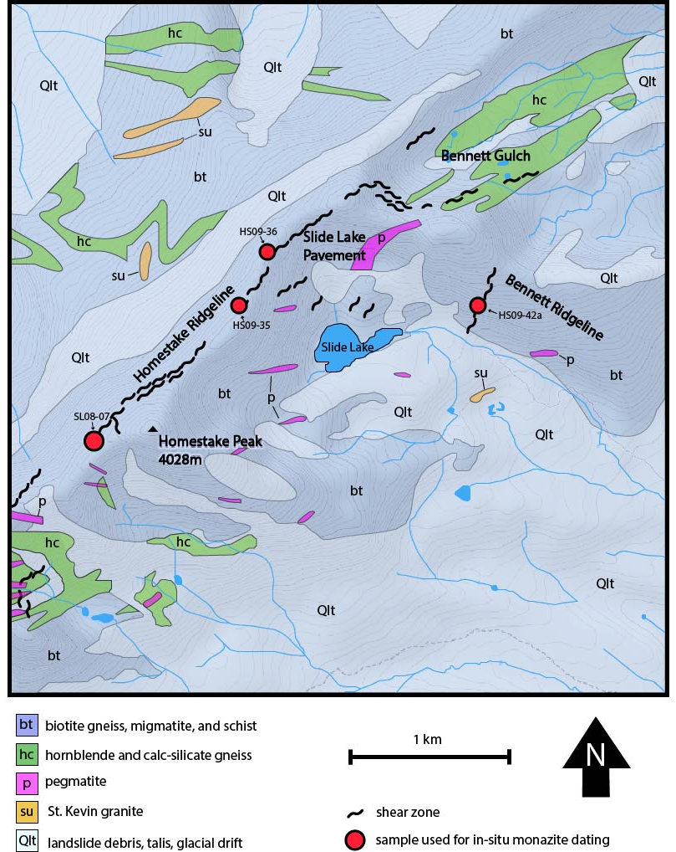
Figure 12: Geologic map of the Slide Lake shear zone field area. Modified from Lee et al., 2012.

4.1. Microstructural framework
HS09-36
Sample HS09-36 is a high-strained gneiss (qtz+fsp+ms+bt) consisting of GBM quartz textures (>500 °C) and BLG feldspar (450 – 600 °C) (Figure 13 & 14). An aluminum- rich layer bisects the sample consisting of syn-deformational muscovite and quartz (Figure 13). This layer, along with other small muscovite-rich layers, appears to crosscut the qtz+fsp+bt dominated fabric, likely corresponding to a later metamorphic / fluid infiltration event Figure 14B). Asymmetry of quartz shear bands presents an S-C fabric suggesting top-to-the-southwest shear sense (Figure 14B).
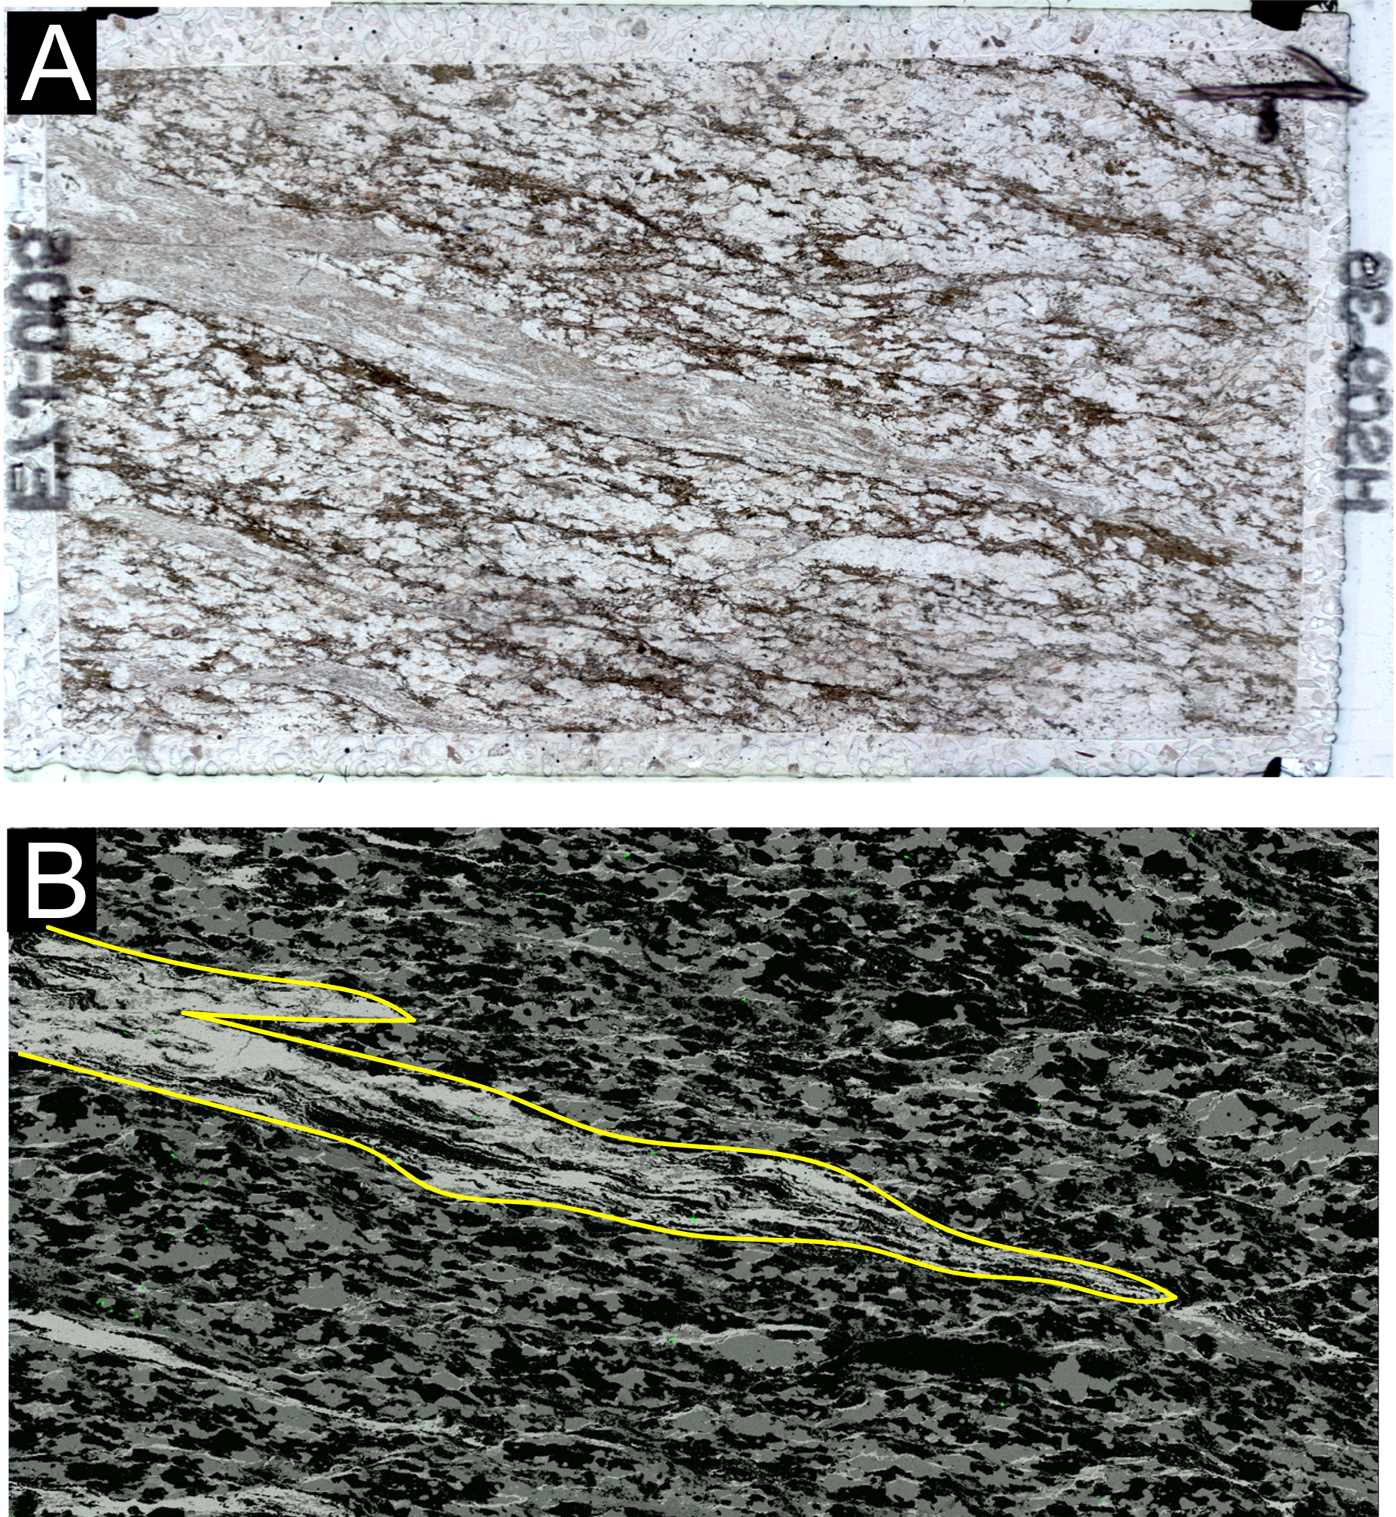

Figure 13: Sample HS09-36. A.) Full thin section scan. B.) Full thin section Al map. High aluminum layer outlined in yellow.
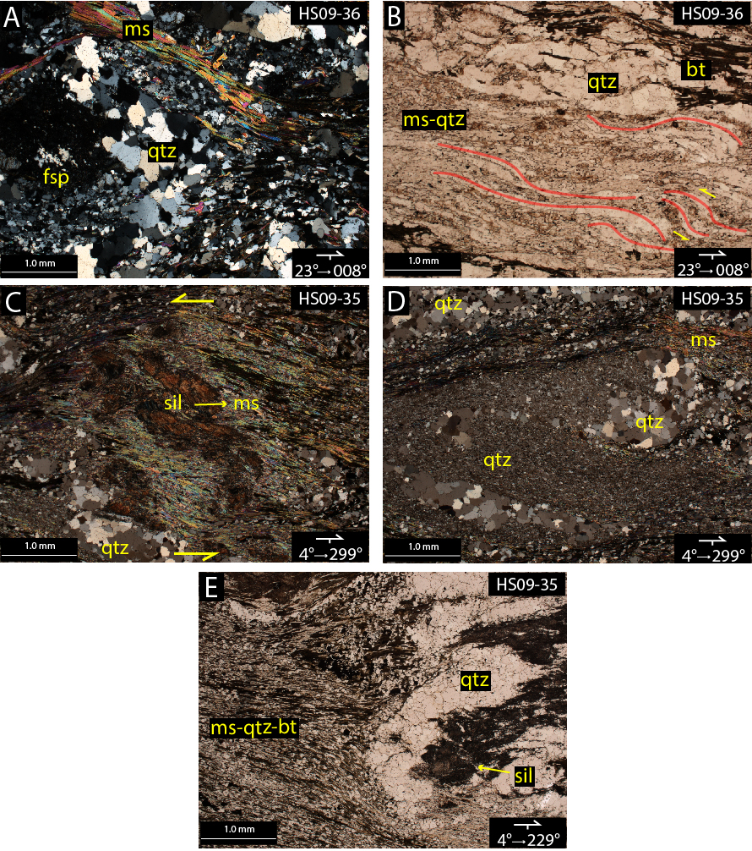
Figure 14: A.) Recrystallized feldspar and GBM quartz clast pinned by phyllosilicate layer in sample HS09-36. B.) High aluminum layer in sample HS09-36. Note the asymmetry of quartz shear bands (red outlines). C.) Sillimanite to muscovite porphyroclast in HS09-35. D.) Grain-size reduced quartz surrounding relict GBM quartz textures. E.) High strained ms + qtz + by fabric flowing around qtz + sil clast.

HS09-35
Sample HS09-35 is a mylonite (qtz+ms+bt+fsp+sil) with a fabric of grain-size reduced quartz and aligned mica grains (Figure 15). Sillimanite is present as relict boudins and porphyroclasts (top-to-the-southeast shear sense), often rimmed by retrograde muscovite (Figure 14C). A large porphyroclast dominates the bottom of the samples, consisting on sillimanite surrounded by GBM quartz (> 500 °C) which appears to have protected the sillimanite from retrograde metamorphic fluids (Figure 14E & 15). In the matrix, relict GBM quartz can be seen undergoing grain-size reduction (Figure 14D). A finer-grained mylonitic fabric of grain-size reduced quartz and phyllosilicates can be seen outside of the clast, suggesting high strained flow around the clast; a similar high-strain fabric can be seen towards the top of the sample as one discontinuous layer (Figure 14E).

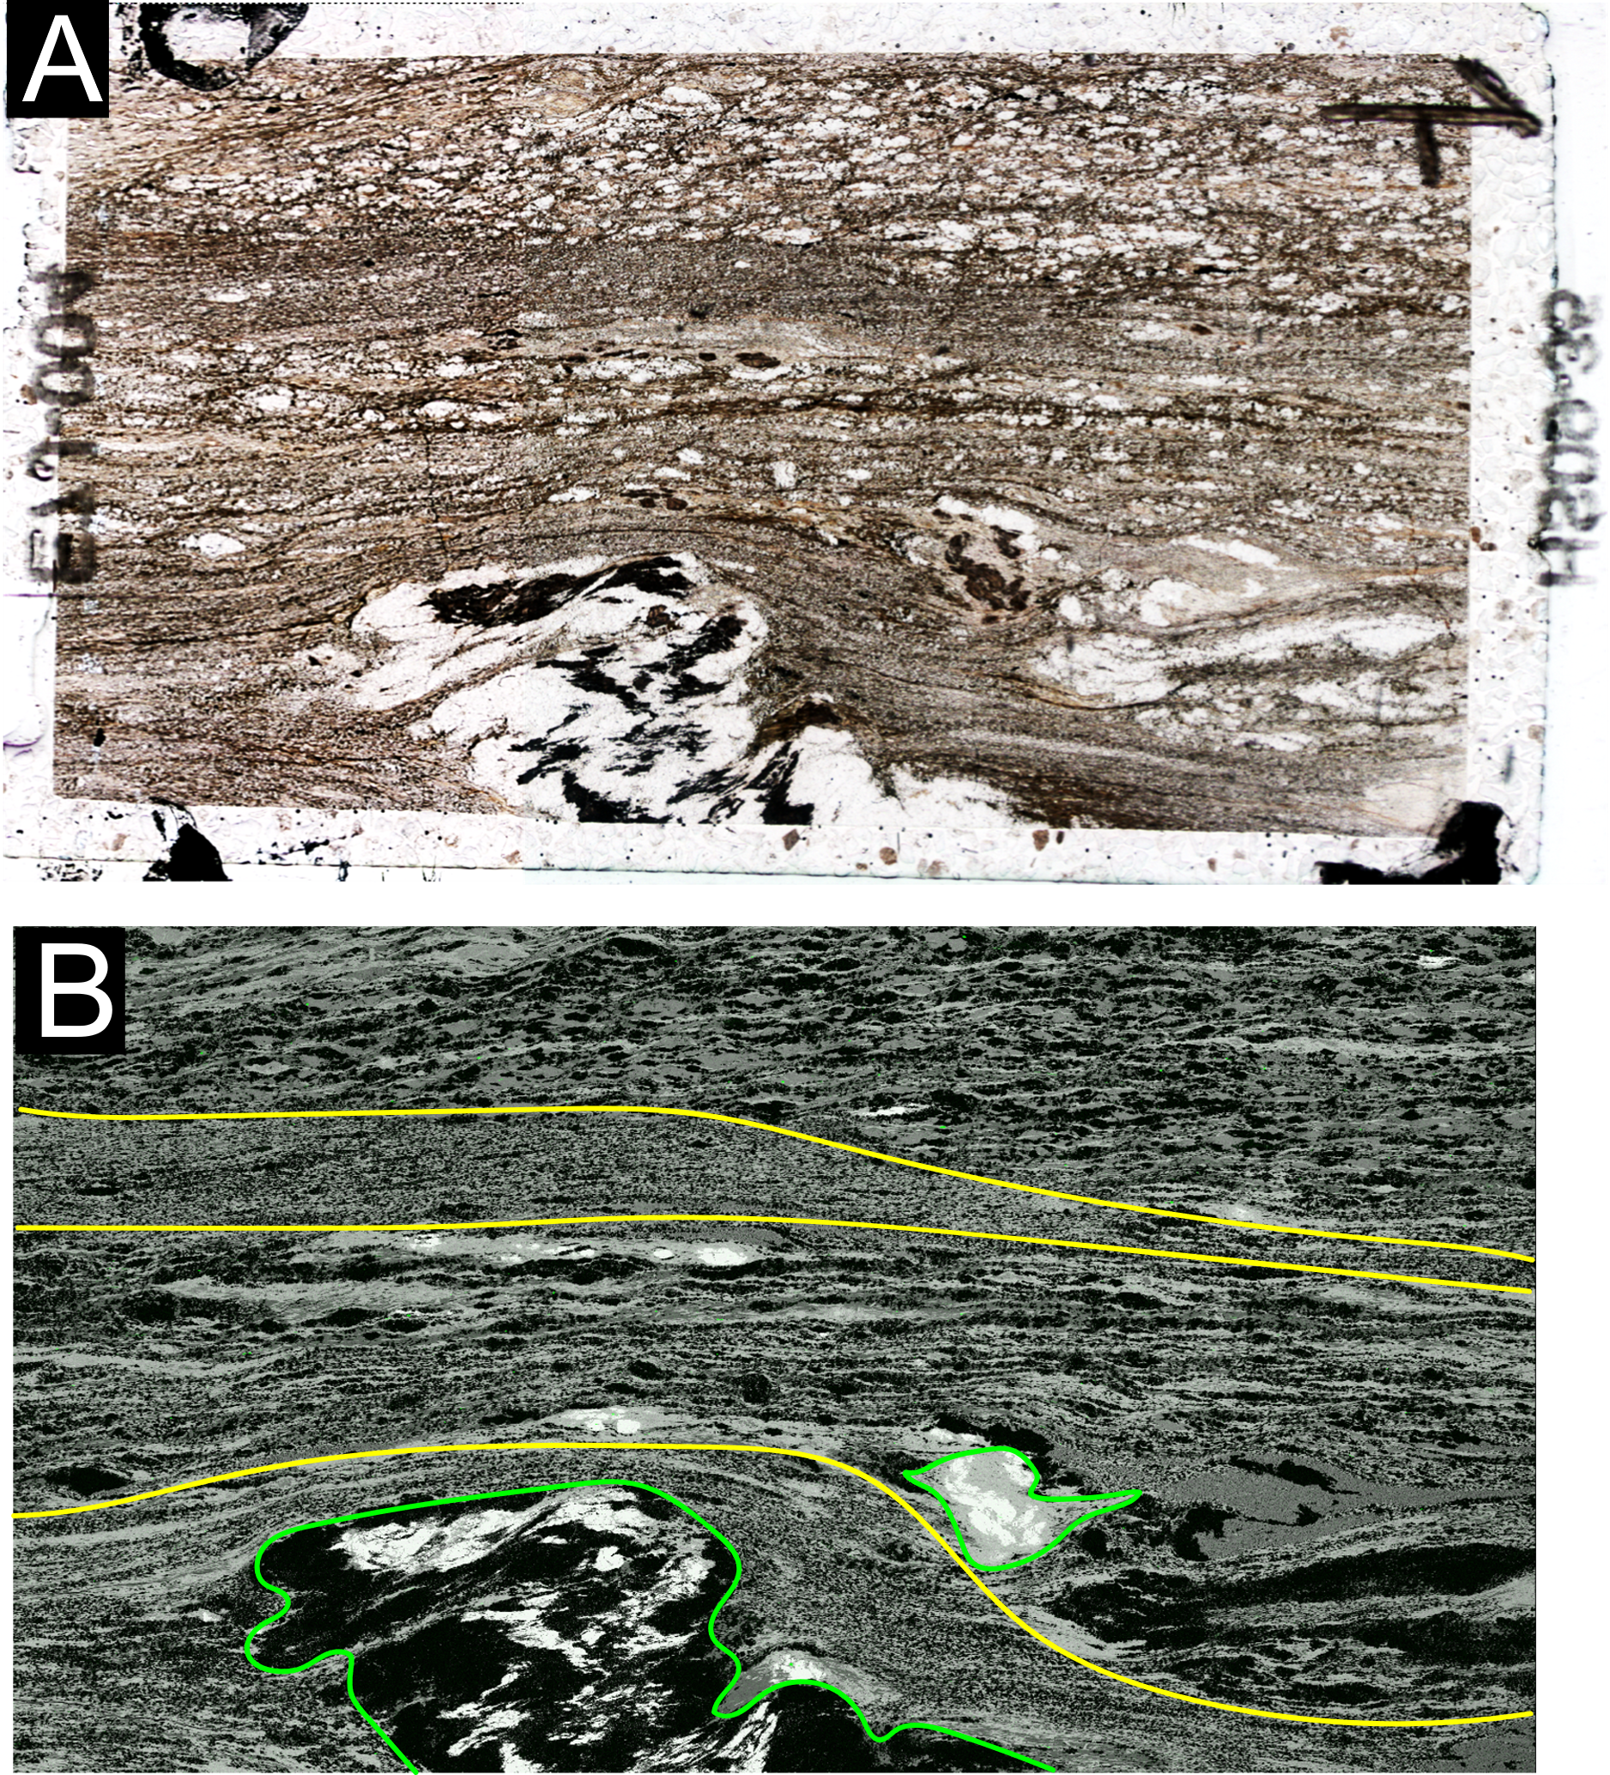
Figure 15: Sample HS09-35. A.) Full thin section scan. B.) Full thin section Al map. Finer-grained mylonitic fabric outlined in yellow. sil+qtz+ms clasts outlined in green.

HS09-42a
Sample HS09-42a is a quartzo-feldspathic mylonite (qtz+fsp+ms+bt) with GBM quartz (> 500°C) flowing around feldspar porphyroclasts showing brittle fracturing (Figure 16). Feldspar porphyroclasts with asymmetric tails show top-to-the-southeast shear sense (Figure 17A). Paralleling the mylonitic fabric of the sample is a mica-rich layer dominated by tabular muscovite and biotite grains, suggesting post-deformational crystallization (Figure 16 & 17). The alignment of phyllosilicates in this layer displays an S-C fabric exhibiting top-to-the-southeast shear sense (Figure 17B).

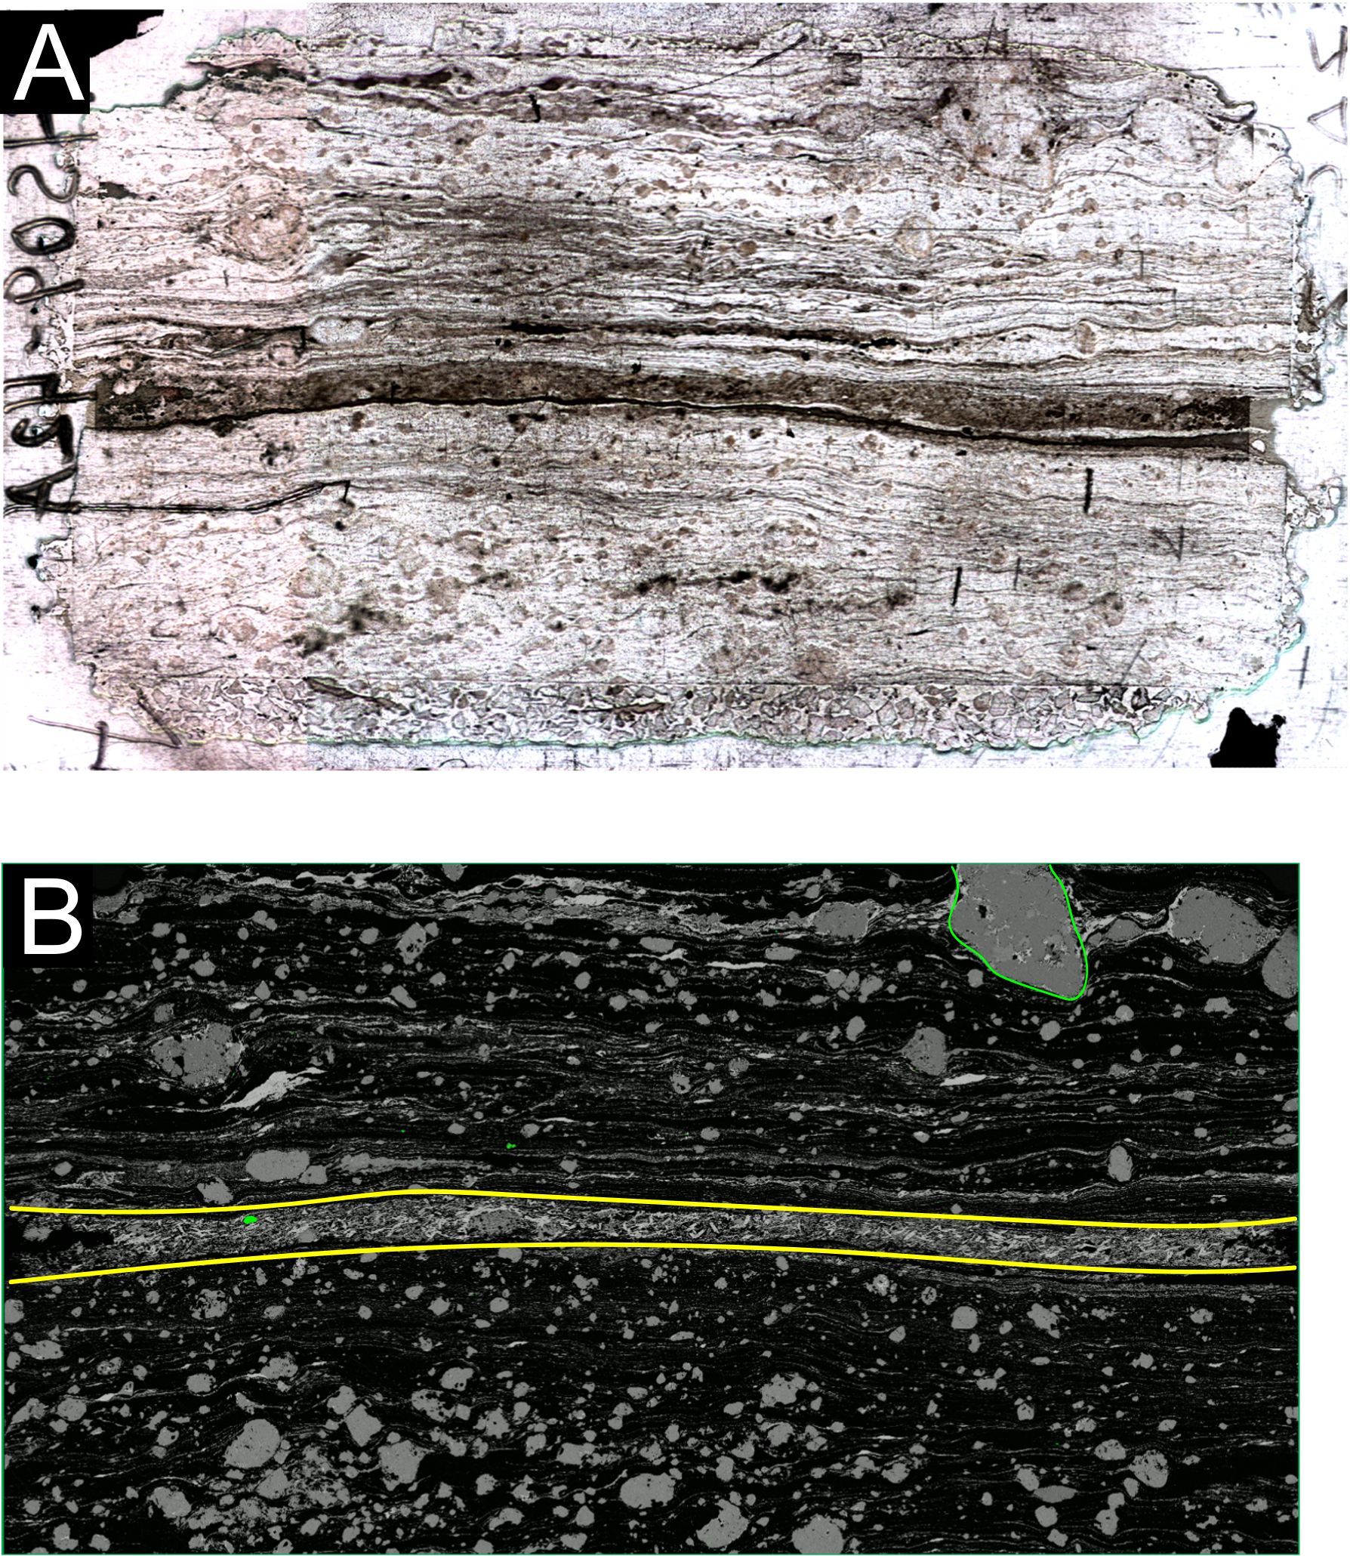
Figure 16: Sample HS09-42a. A.) Full thin section scan. B.) Full thin section Al map. Tabular phyllosilicate layer outlined in yellow. Example of feldspar porphyroclast outlined in green.

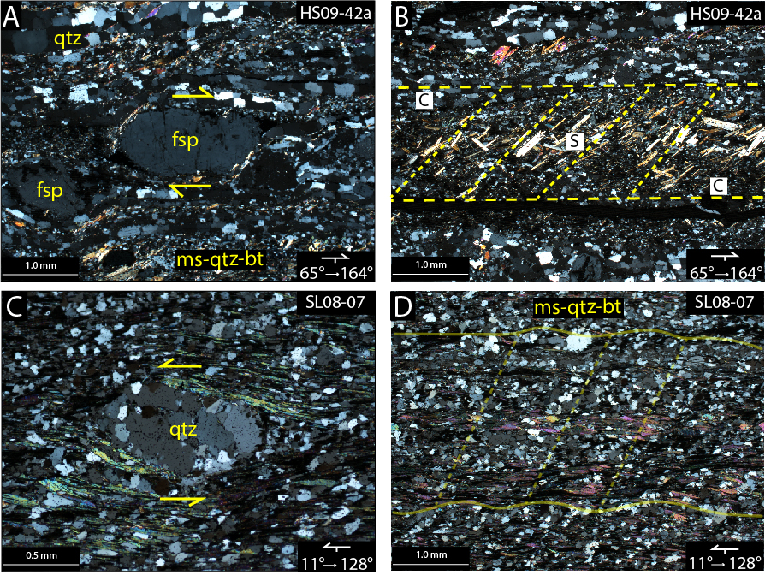

Figure 17: A.) Feldspar porphyroclast showing t-SE shear sense. B.) High phyllosilicate layer and apparent SC fabric. C.) GBM quartz porphyroclast showing t-SE shear sense. D.) Crenulations in SL08-07.

SL08-07
Sample SL08-07 is an ultramylonite (qtz+ms+bt+chl±fsp) that exhibits a significantly grain-size reduced fabric of SGR quartz (400° – 500° C) and phyllosilicates with few relict high-temperature quartz porphyroclasts (showing top-to-the-southeast shear sense; Figure 17C). There is a subtle compositional banding of quartz- and mica-rich domains, the latter of which shows crenulations (Figure 17D).

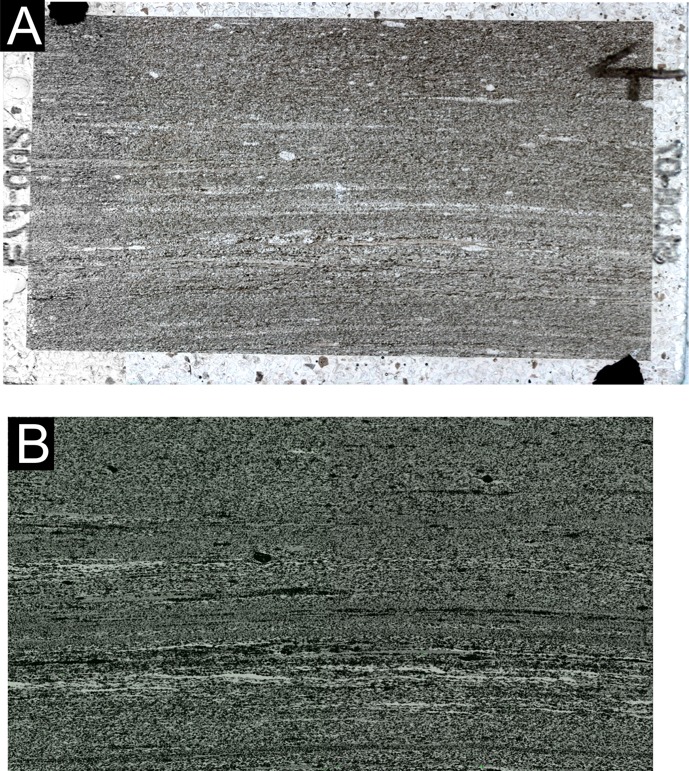
Figure 18: Sample SL08-07. A.) Full thin section scan. B.) Full thin section Al map.

4.2. Monazite
Occurrence
The preliminary qualitative investigation of monazite was conducted for confirmation and recognition of accessory phases. Grains were first investigated using petrography (Figure 19), which were later confirmed using the SEM (Figure 20). Monazite is typically < 100 µm on its longest side, although some grains exceed 300 µm in length. Monazite is found in a variety of microstructural settings, and in association with each of the major silicate phases present (Figure 20). Most grains are isolated from one another in the rock matrix (Figure 20A), but can also collect in grain clusters (Figure 20D), or be enclosed in feldspar or sillimanite porphyroclasts (Figure 19C & 20B). Generations of monazite growth are rare to see with Petrography and SEM analysis (Figure 19D). Monazites long-axis is often oriented sub-parallel to the rock’s foliation, especially when in a layer of paralleling phyllosilicates (Figure 20C). Monazite crystals are rarely euhedral (Figure 19A), often appearing tabular and elongate (Figure 19B).

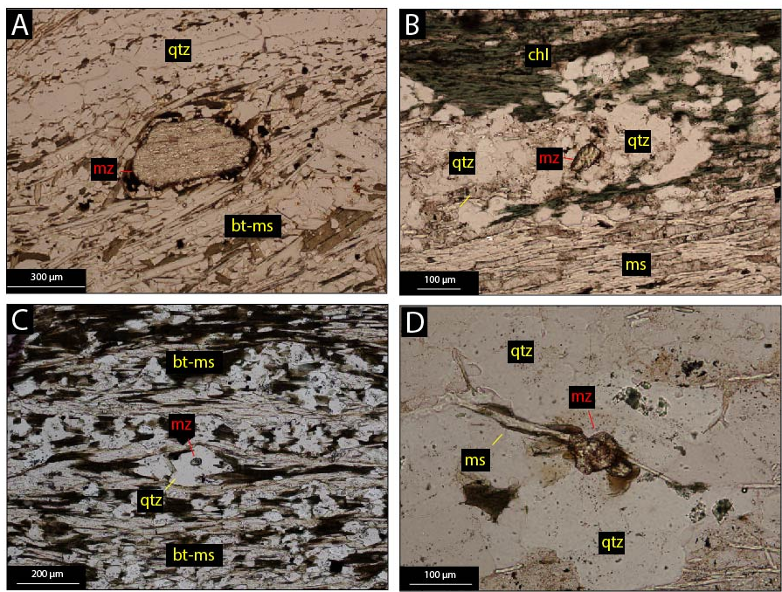

Figure 19: A.) Euhedral monazite crystal elongated sub-parallel to foliation. B.) Tabular monazite grain in quartz clast. C.) Monazite in quartz clast. D.) Monazite showing an apparent overgrowth.

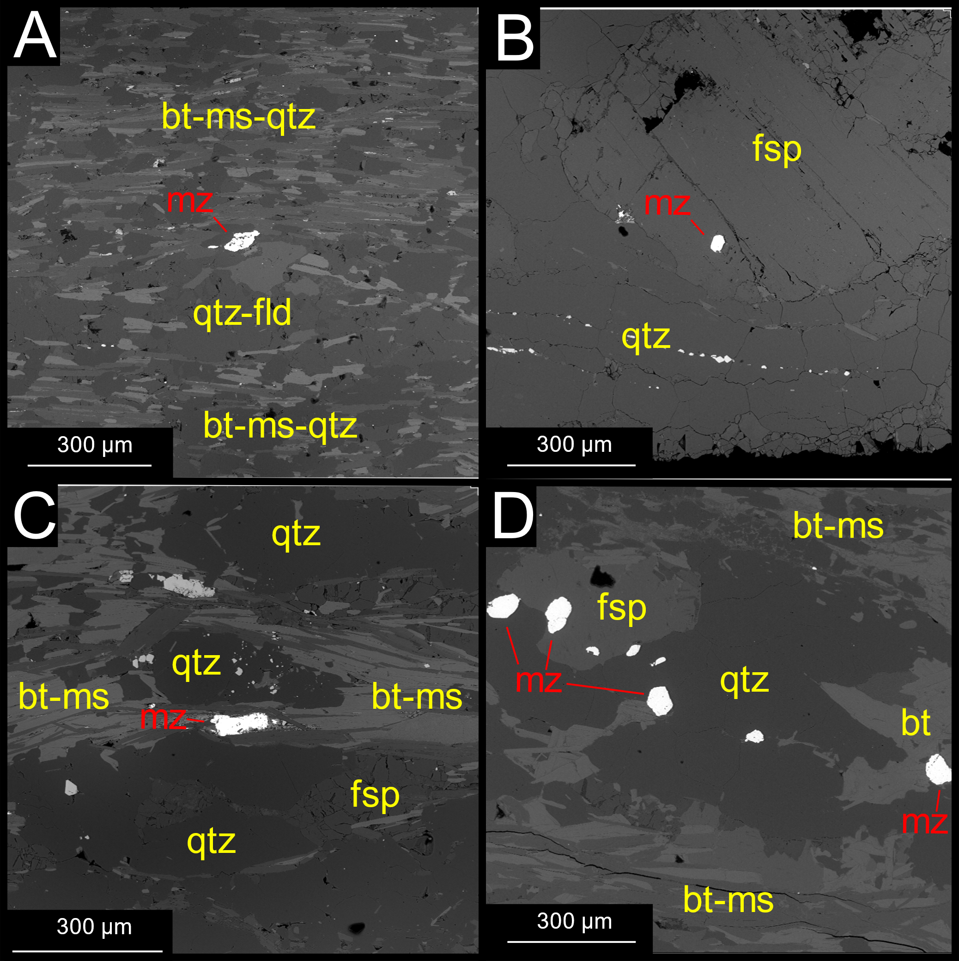
Figure 20: SEM backscatter images of common monazite occurences. A.) Monazite oriented subparallel to high-strained fabric. B.) Monazite enclosed in feldspar porphyroclast. C.) Monazite pinned by paralleling phyllosilicates. D.) Cluster of monazite grains.

Figures 21 and 22 shows examples of monazite in the four selected samples, and will be described separately below.
HS09-36
Monazite from sample HS09-36 has a generally blockly appearance (Figure 21B) but appears more elongate in the high-Aluminum layer (Figure 21A); other grains in this layer appear to have undergone brittle deformation (Figure 21C).

HS09-35
A majority of the monazite is sample HS09-35 parallels aligned phyllosilicates as interstitial grains (Figure 21F). Grains inside sillimanite-phyllosilicates assemblages have irregular shapes (Figure 21E). A few grains are almost completely broken down and consumed by apatite (Figure 21D).

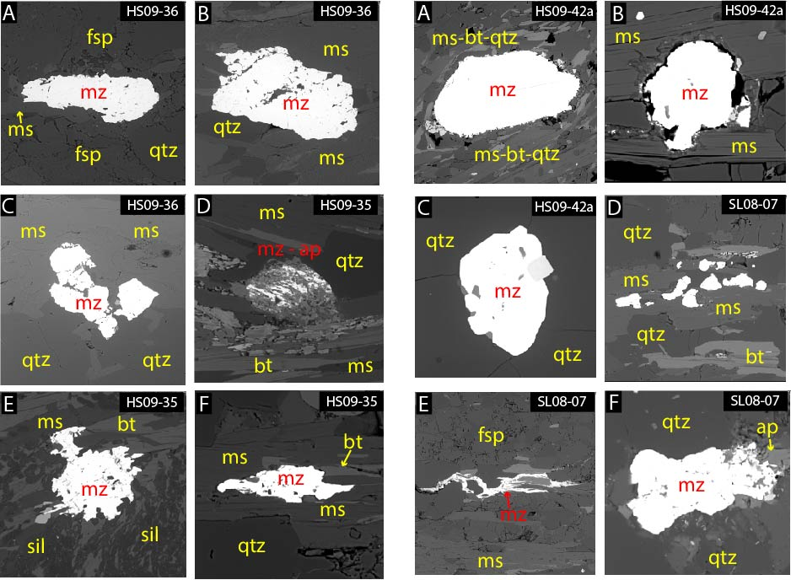
Figure 21: Examples of backscatter SEM images of monazite from samples HS09-36 and HS09-35.

HS09-42a
Monazite grains from HS09-42a have a generally blocky shape, similar to HS09-36. Grains surrounded by phyllosilicates have irregular grain boundary morphology (Figure 22A & B), where they are more uniform when surrounded by quartz (Figure 22C).

SL08-07
Monazite grains in SL08-07 are the most unique in the sample-set, with very few if any of the more equant shaped grains from the other samples. Many of the grains are broken up into small clusters where the grains appear to have undergone brittle deformation (Figure 22D). Grains sometimes have an interstitial appearance to them and look as though they crystallized interstitially between major silicate phases (Figure 22E). Similar to HS09-35, monazite is often found breaking down to form apatite (Figure 22F).

Figure 22: Examples of backscatter SEM images of monazite from samples HS09-42a and SL08-07.

CHAPTER 5:
MONAZITE ANALYSIS
This chapter focuses on the monazite results for the selected samples. Here we present full thin section maps, grain maps, and monazite dates for the four selected samples.

5.1. Monazite age-composition relationships
A total of 68 monazite grain maps were created for the samples to investigate the unique compositional zoning of each. Y Kα maps were primarily used to qualitatively reveal the compositional zoning relationships in each grain. Monazite domains will be described by core, outer core, rim, or main (single dominant domain). Based on qualitative assessment grains commonly possess 3 domains (inner core, outer core, rim), with some having as many as 4 or 5. Rim domains often appear as discontinuous layers with varying thickness along the perimeter of a grain. Y concentration in rim domains is almost always lower than the inner and / or outer core domains. Grains with one main domain typically have the lowest relative Y concentrations in the sample. Anomalously high-Y spots on grains are xenotime inclusions.
U-Th-Pb ages were acquired from 37 domains across the four samples. Age error is reported as 1-sigma standard deviation. Monazite ages from this research span the Paleoproterozoic (> 1.7 Ga) through the Mesoproterozoic (> 1.4 Ga). The range of ages within samples is >100 Ma for each sample, and the 1-sigma age error for the samples ranges from 5 – 80.7 Ma. Inner cores normally record older dates than outer cores, although the reverse is seen as well. Few low-Y rim domains were dated due to the limited analysis space, but low-Y main domains always record younger monazite ages relative to the remainder of the sample. Calculated ages, EMP maps, and elemental data will be considered for each individual sample below.

HS09-36
18 monazite grains from this sample were mapped, revealing three compositional domains distinguished by Y and Th concentrations: 1) low-Y / Th inner core domains, 2) medium to high-Y domains, and 3) low-Y rims (Figure 23). Up to three core domains are present in each grain (ex: Figure 24, m30), which generally increase in Y concentration from the inner to outer core (Figure 24). Group 1 low-Y / Th inner core domains are distinguished separately from the remainder of the core domains that may have comparable Y levels, because of their significantly lower Th concentrations (Figure 24). Some inner cores appear to contain a relict high-Th domain that is overprinted by a lower-Th domain (Figure 24: m22). High-Y outer core domains are the most common domain in each grain. The low-Y rims appear as disconnected lenses that are often attached to the edge of the grain on its longest side. HS09-36 is the only sample where a grain with a low-Y main domain was not identified.
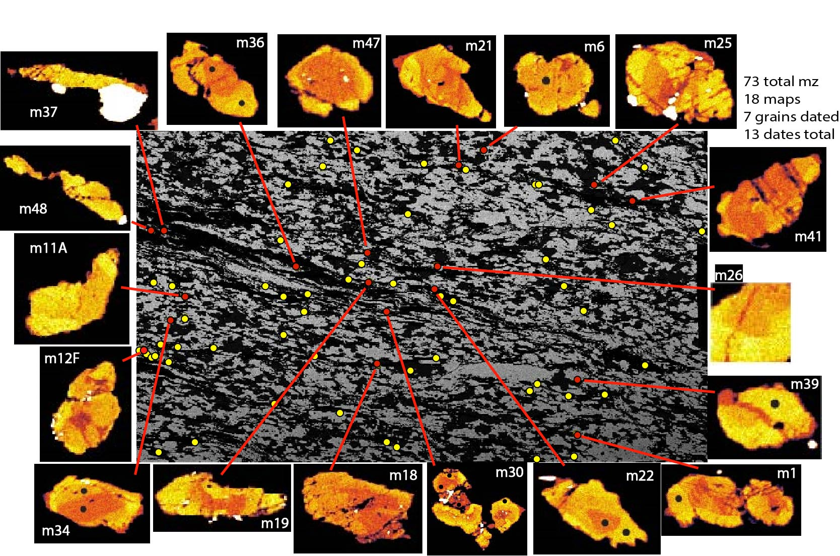
Figure 23: Full thin section Mg map of HS09-36 with monazite Y maps and grain locations. Black dots represent monazite analyses.

Figure 25 shows the normal distribution of monazite ages from HS09-36. HS09-36 has the largest range in monazite ages (1680 to 1366 Ma) and age error (9.7 to 80.7 Ma) of the four samples. There is no obvious zoning-age relationship between the group 2 domains despite the wide range of ages, so they are plotted as separate populations into two older (2a: 1680 - 1620 Ma) and younger (2b: 1602 - 1539 Ma) sub-groups in Figure 24 and 25. The age error is the lowest for the older (2a) group of domains (9.7 to 26.6 Ma), relative to the younger (2b) domains (20 to 80.7 Ma). The only low-Y core domain dated in this sample is from m30 (1620 +/- 15 Ma). The one low-Y rim dated (1366 +/- 30 Ma) is much younger than the group 1 and 2 core domains dated. Grains m22, m30, m34, and m36 have group 2 outer core domains with increasing Y content from the interior to the exterior (Figure 24), but the dates acquired from those domains reveal an inconsistent relationship between core to rim ages and zoning; for example, m36 records an older outer core (1680 Ma) and a younger inner core (1627 Ma), and m22 records an older inner core (1658 Ma) and a younger outer core (1596 Ma).
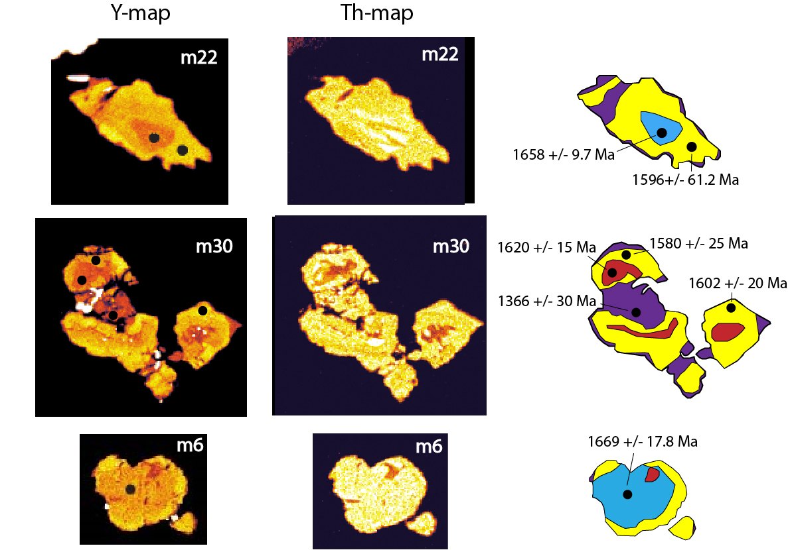

Figure 24: Examples of interpreted monazite domains and respective ages with Y and Th compositional maps from sample HS09-36 (m22, m30 and m6). Domain interpretation: Red = group 1, Blue = group 2a, Yellow = group 2b, Purple = group 3.

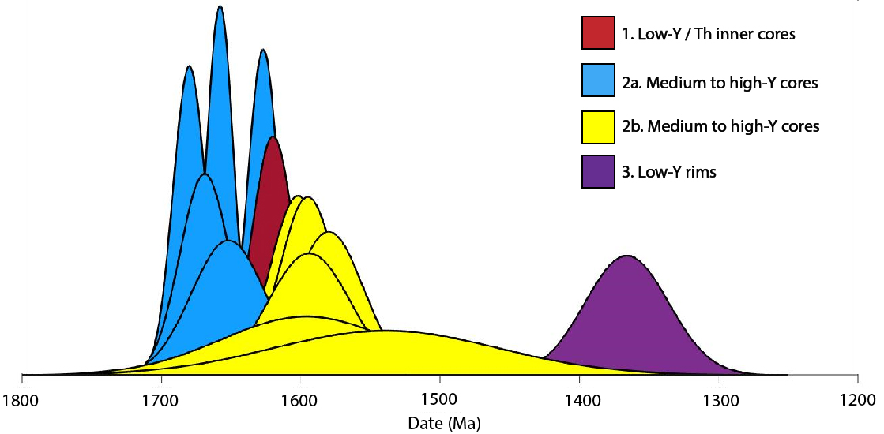

Figure 25: Normal distribution plot of monazite ages from sample HS09-36.

Figure 26 shows the composition – age relationship for monazite from sample HS09-36. In general, outer cores have higher Y concentrations than inner cores.

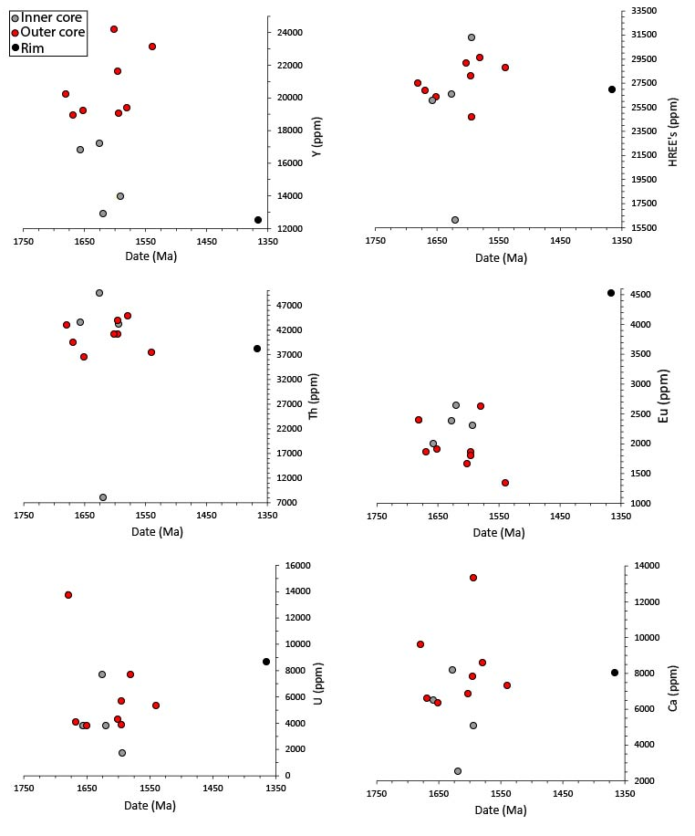
Figure 26: Age-composition relationships for monazite from sample HS09-36

HS09-35
18 of the 49 monazite grains in this sample were mapped, revealing three compositional domains: 1) low-Y inner core, 2) high-Y outer core, 3) low-Y main (Figure 27). Group 1 and 2 core domains make up nearly the entire grain when present. The low-Y rims form a thin layer along the perimeter of the grains, which may correlate with the low-Y main domains, although no rims were analyzed. (Figure 28: m2). Almost half of the grains mapped (8/18) contain one low-Y main domain (m3, 4, 8, 11, 12, 14, 15, 16, 17).
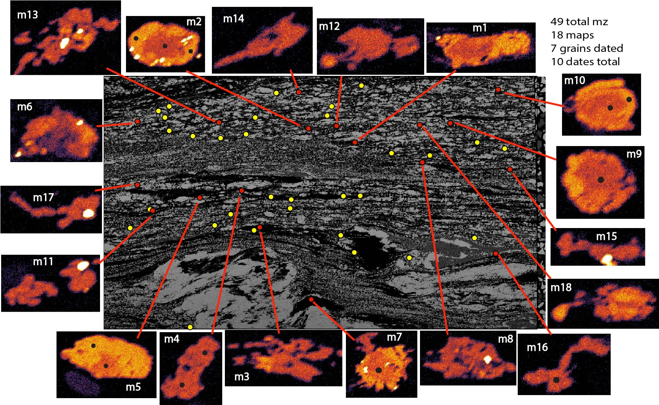

Figure 27: Full thin section Mg map of HS09-35 with monazite Y maps and grain locations

10 of the 18 grains were used for dating (Figure 29). Monazite domain ages range from 1538 to 1420 Ma, with error < 40 Ma for each domain date. Core domains range from 1520 to 1438 Ma, and outer cores range from 1538 to 1481 Ma. Intragrain age relationships for grains m2, m5, and m10 reveal younger inner cores and older outer cores, similar to observations from HS09-36. The two low-Y main domains dated (m4 & m16) record the youngest dates and smallest age-errors in the sample (1420 +/- 9 and 1423 +/- 8).

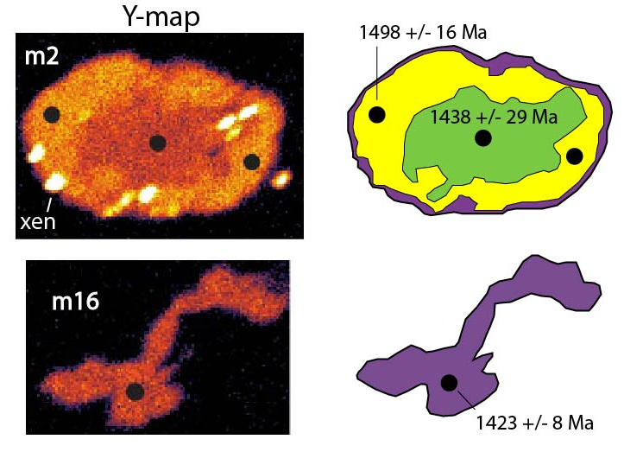
Figure 28: Simplified Y compositional monazite maps from sample HS09-35 (m2 and m16). Domain interpretation: Green = group 1, Yellow = group 2, Purple = group 3. Note the high-Y xenotime inclusions on grain m2.

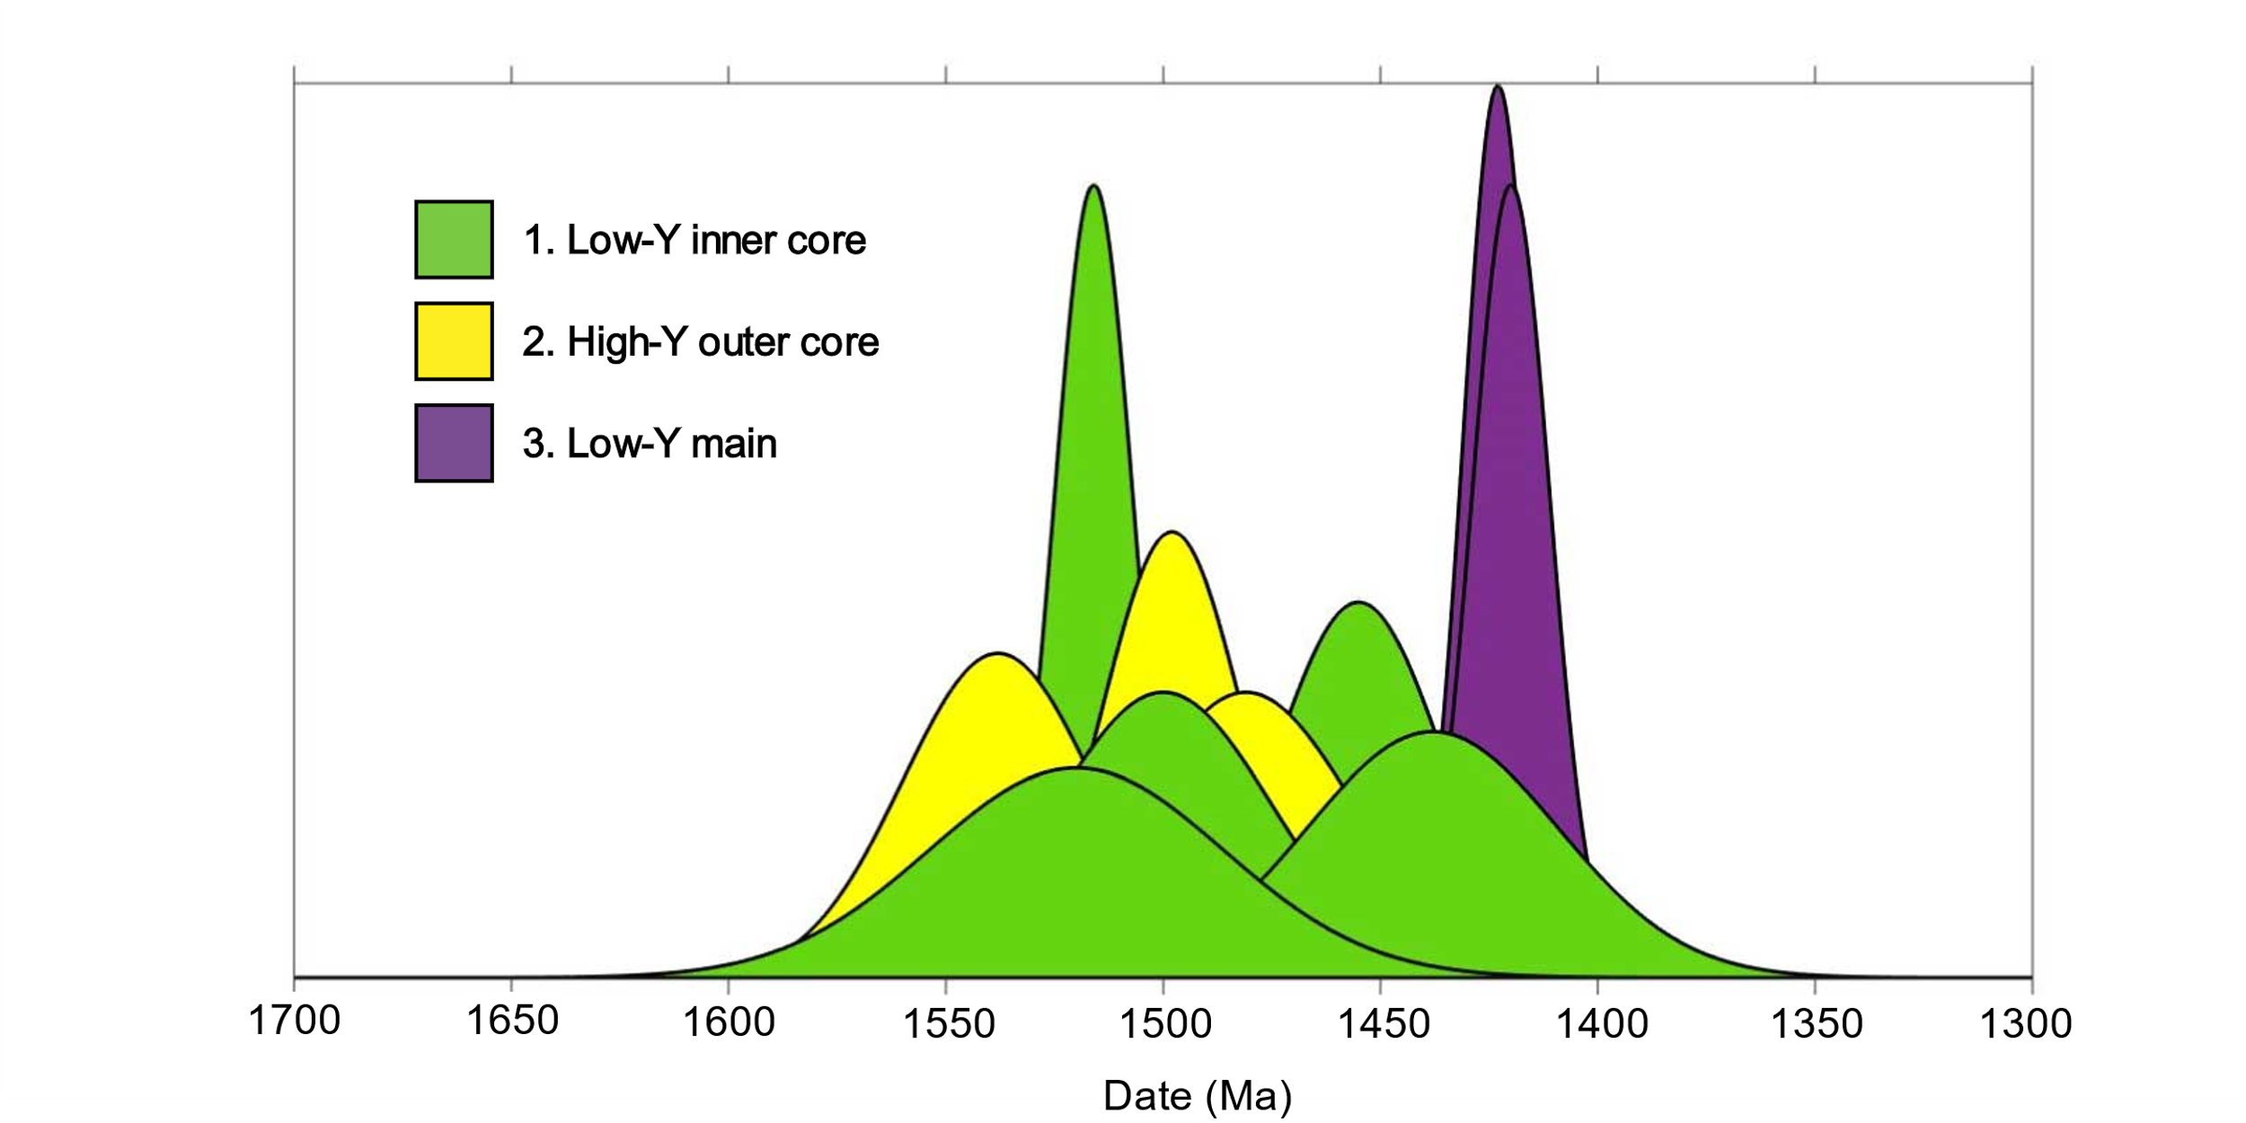
Figure 29: Sample HS09-35. Normal distribution plot of monazite ages.

Age-composition relationships from HS09-35 are presented in Figure 30. Outer cores are enriched in Y, Th and HREE’s relative to their inner core counterparts, yet are depleted in Eu. Main domains are more compositionally like inner cores than outer cores, and are depleted in Y, HREE’s and U, and enriched in Th.

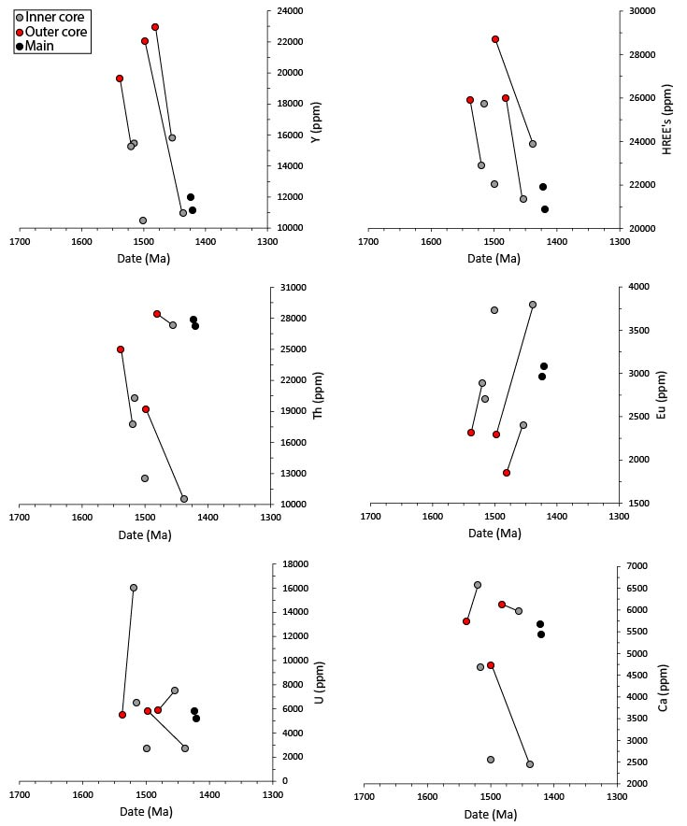
Figure 30: Age-composition relationships for monazite from sample HS09-35. Line connect domains in same grain.

HS09-42a
16 of 27 monazite grains from HS09-42a were mapped, revealing three compositional domains: 1) low-Y / low Th cores, 2) medium to high Y cores and 3) low-Y rims. (Figure 31 and 32). Core domains can be described by relative differences in Y concentrations typically consisting of lower-Y inner cores and a higher-Y outer cores, although this relationship isn’t representative of each grain. The low-Y rim on grain m1 is an inclusion inside a feldspar porphyroclast and therefore cannot be grouped as representative of the other low-Y rims in the matrix, and is therefore grouped with the low-Y cores. The core of m18 has an anomalously low Th concentration relative to the remainder of the core domains in the sample (Figure 32). The low-Y rim domains are seen on almost every grain (ex: m11, m22), and are compositionally indistinguishable from the low-Y main domains (ex: m25, m27). The inner core of mC2 has a clearly similar morphology to the surrounding grain and exhibits sector zoning, which is not seen anywhere else in the monazite grains from this study.

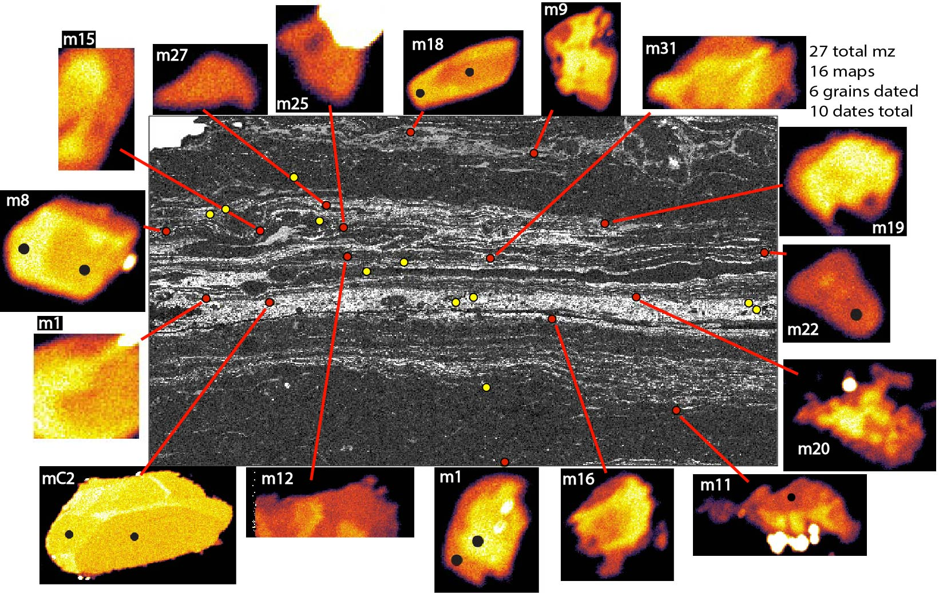
Figure 31: Full thin section Mg map of HS09-42a with monazite Y maps and grain locations. Black dots are monazite analyses.

HS09-42a has the smallest range in monazite ages from 1716 to 1604 Ma, with an age error range of 5 to 31.3 Ma (Figure 33). The four inner core to outer core pairs in this sample (m1, m8, m18, mC2) are constrained to a narrow time period (1716 to 1688 Ma) (Figure 33), and the two low-Y rims (m11 & m22) dates are younger and statistically indistinguishable (1615 and 1604 Ma, respectively).

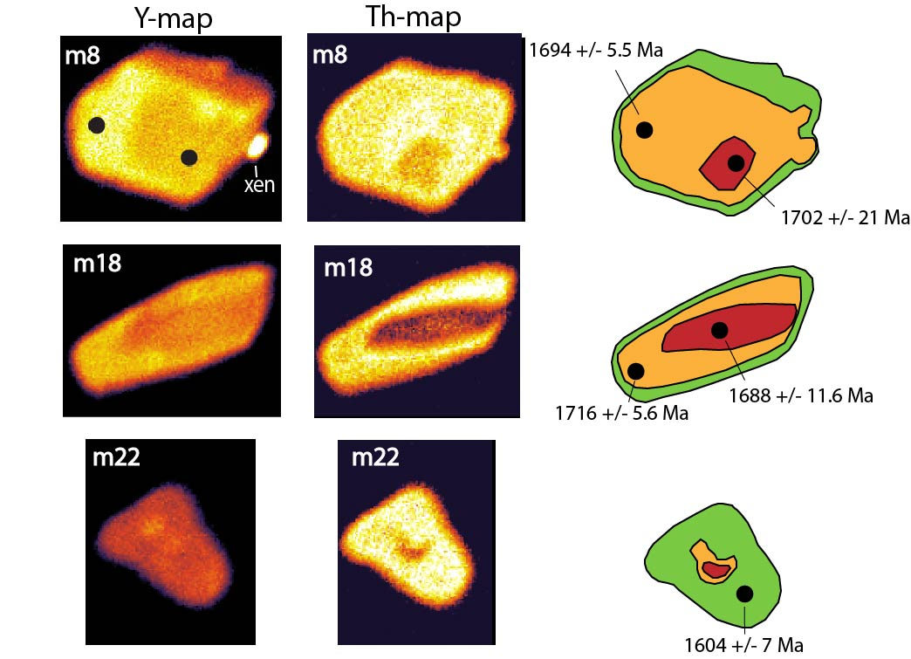
Figure 32: Simplified Y compositional monazite maps from sample HS09-42a (m8 and m22). Domain interpretation: Red = group 1, Orange = group 2, Green = group 3. Note the high-Y xenotime inclusion on grain m8.

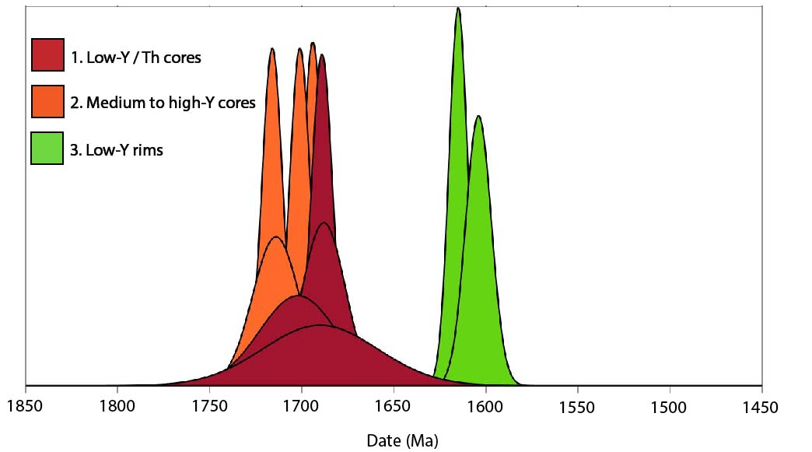
Figure 33: Sample HS09-42a. Normal distribution plot of monazite ages.

Figure 34 shows the composition-age relationships for sample HS09-42a. There is no apparent compositional relationship separating the inner and outer core domains. The main/rim domains have a similar behavior to the main domains in HS09-35, in that they are depleted in Y, HREE’s and U relative to the core domains (Figure 34).

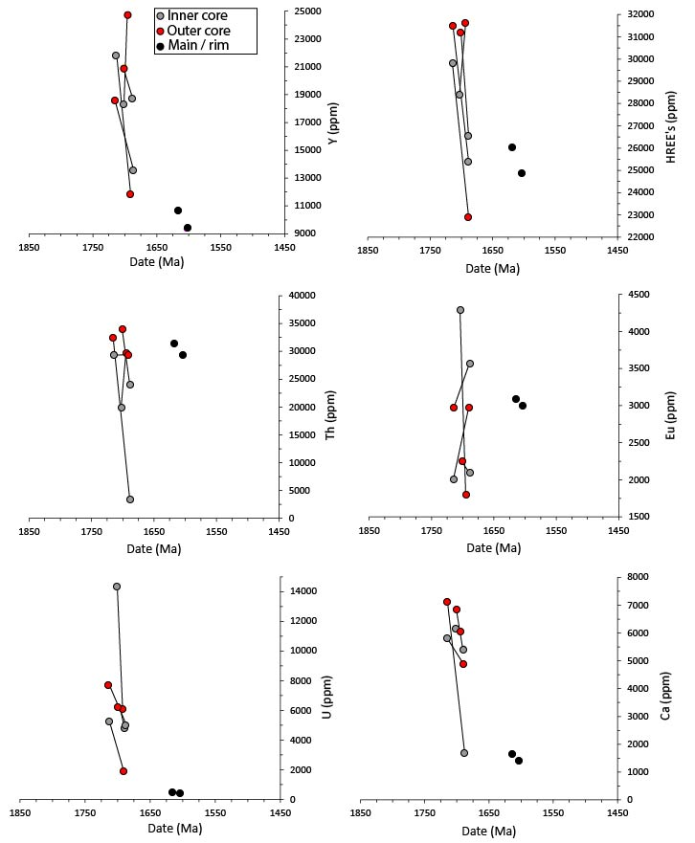
Figure 34: Age-composition relationships for monazite from sample HS09-42a. Line connects domains of the same grain

SL08-07
16 of 24 monazite grains from sample SL08-07 were mapped, and only one compositional domain was recognized: 1) low-Y main (Figure 35 & 36). Grains m1 and m2 have an almost granular appearance to them created by relative differences in Y concentrations.

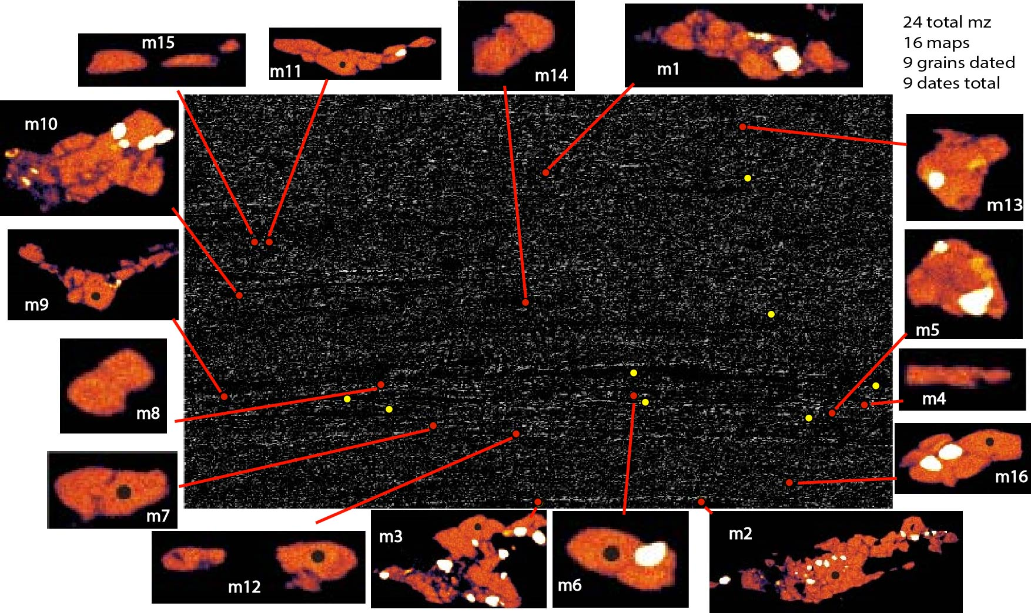
Figure 35: Full thin section Mg map of SL08-07 with monazite Y maps and grain locations.

9 monazite grains were analyzed in this sample, with a majority of the dates ranging from 1439 to 1413 Ma, and one anomalous date at 1310 Ma for grain m7 (Figure 37). The low-Y main domains were further separated into subgroups based on this age gap (Figure 37), between the grouping of 8 ages at around ~1.42 Ga (1a), and grain m7 at 1310 Ma (1b). Group 1a records significantly lower age error values (5.8 to 13.3 Ma) relative to grain m7 (37.8 Ma).

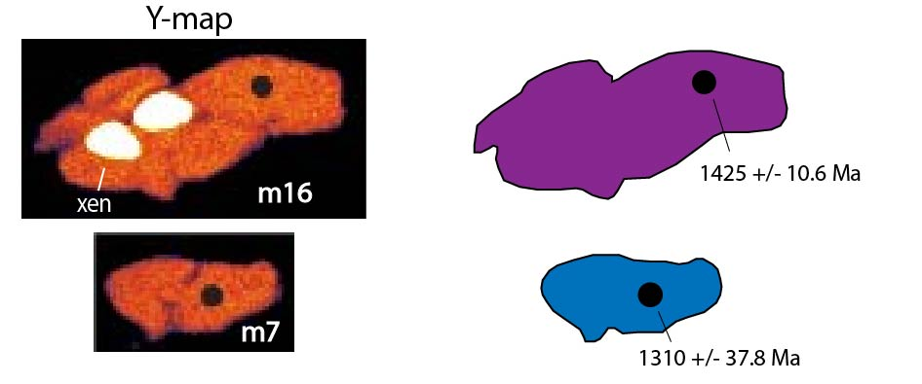
Figure 36: Simplified Y compositional monazite maps from sample SL08-07 (m16 and m7). Note the xenotime inclusions in grain m16.

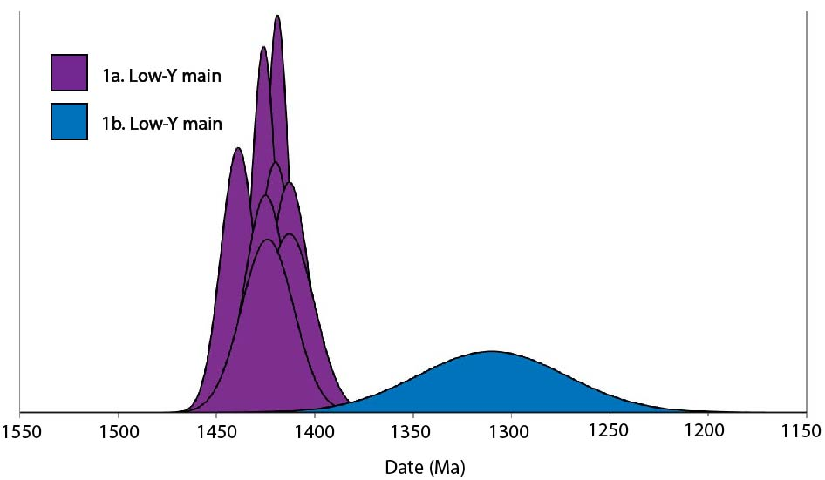
Figure 37: Sample SL08-07. Examples of Y grain maps and the interpreted compositional domains with their respective ages. Normal distribution plot of monazite ages.

The main monazite domains >1400 Ma have no obvious compositional pattern, but the one 1310 Ma monazite is depleted in the trace and REE’s relative to the other monazite dates (Figure 38).

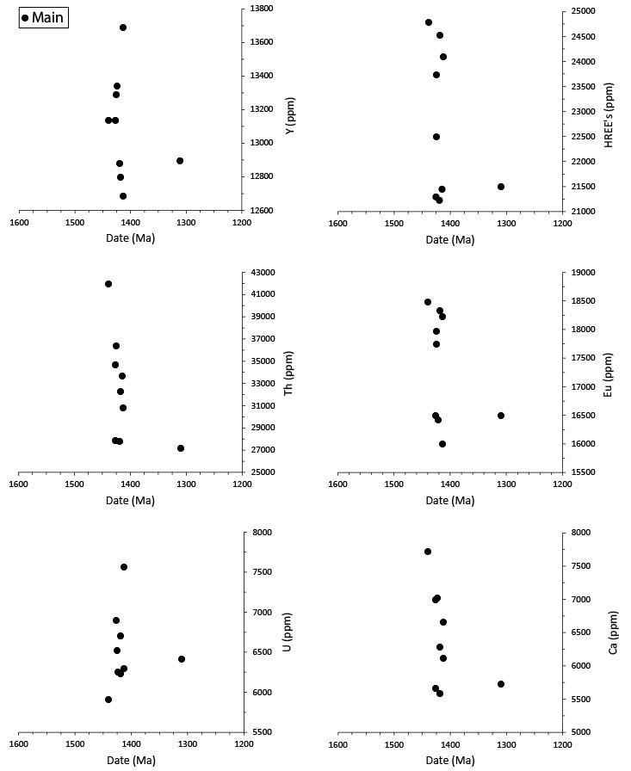
Figure 38: Age-composition relationships for monazite from sample SL08-07.

5.2. Sample comparisons
Figure 39 shows the distribution of in-situ monazite ages and their respective age-errors from this study. Ages span from the Paleoproterozoic through the Mesoproterozoic, with large groupings of ages from ⁓1.7 to 1.6 Ga, and ⁓1.5 to 1.4 Ga. The highest confidence in ages occurs at 1.7 Ga and 1.6 Ga with sample HS09-42a, and at ⁓1.4 Ga with samples HS09-35 and SL08-07. The lowest confidence in ages is shown in a majority of the grains from samples HS09-36 and HS09-35, as well as the ⁓1.31 Ga date for SL08-07.
Figure 40 shows the age-composition relationship for the four selected samples. In general, Y and HREE concentration decrease with age, while Eu concentrations increase. Ca, Th, and U concentrations are comparable across the sample suite. The trend for HREE’s is stronger than that recognized for Eu and Y. SL08-07 has the smallest range in trace and REE concentrations relative to the other samples.

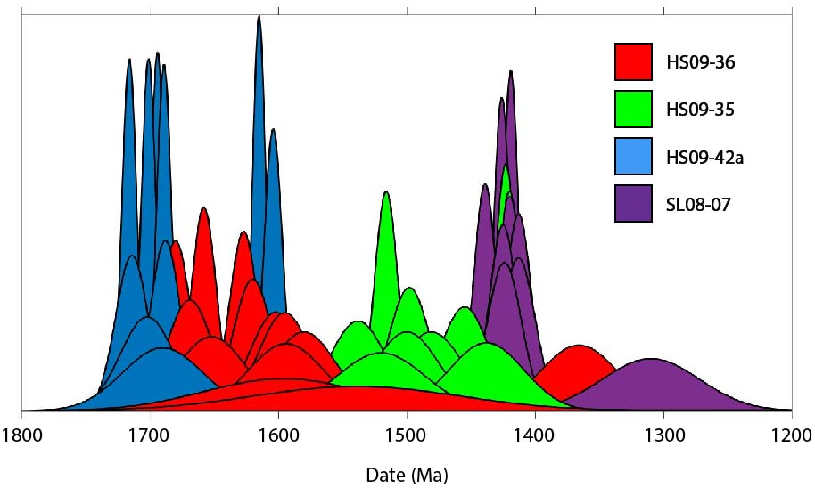
Figure 39: Normal distribution of monazite ages from the four selected samples.
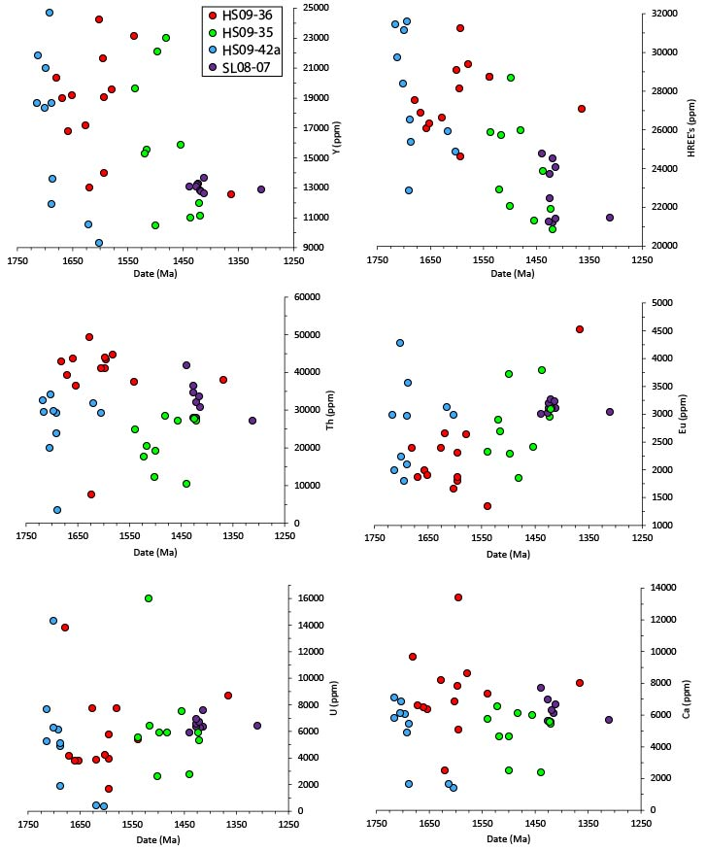
Figure 40: Age vs. composition plots for the monazite domains measured in this study.

CHAPTER 6:
DISCUSSION
Shear zone activity in the CMB is attributed to intracontinental deformation, likely as a response to tectonism on the southern margin of Laurentia ca. 1.4 Ga (McCoy et al., 2005). The shear zones formed from reactivated Paleoproterozoic sub-vertical high-strain zones that developed during the Yavapai and Mazatzal orogeny’s and associated magmatic events. It is unknown as to whether sub-horizontal shear zones in the CMB were part of the same system of reactivated structural fabrics, or if they correspond to a separate mechanism of deformation during intracontinental reshuffling (Lee et al., 2012). This discussion serves to apply the structural relationships in the SLSZ established by Lee et al. (2012) to monazite systematics, to accurately determine the timing of shear zone activity. Shear zone tectonites were specifically targeted in this research to examine monazite domains of rocks that were subject to mylonitic shearing and grain size reduction. Four samples with varying microstructural characteristics were chosen to systematically parse out the difference in monazite domain types and dates between mylonitic samples (HS09-35, HS09-42a, SL08-07), and the high-strained gneissic protoliths from which they originated (HS09-36).

6.1. General age trends
Monazite ages from this study can be divided into two main groups: 1) Paleoproterozoic (~1.7 – 1.6 Ga), and 2) Mesoproterozoic (~1.5 – 1.4 Ga). Table 2 provides weighted averages for the monazite ages from the sample suite. Sample HS09-36 records monazite ages from 1680 – 1580 Ma, with an anomalous rim date at 1366 Ma; monazite core dates from this high strained gneissic sample correlate with timing of the D₂ deformation event (Table 2) (Shaw et al., 2001; McCoy et al., 2005). The youngest ages of the monazite sample suite almost entirely come from samples SL08-07 (avg: 1421 +/- 7.6 Ma) and HS09-35 (avg: 1502 +/- 39 Ma), which implies that mylonitic deformation completely reset the earlier deformation events recorded in monazite. These samples were likely reset by fluid-related alteration between 1.5 and 1.3 Ga, with a high probability at ⁓1.42 Ga, exampled by the cluster of low-Y main dates from SL08-07 , and the two low-Y main dates from HS09-35 (1423 and 1420 Ma). Monazite ages from sample HS09-42a (avg: 1700 +/- 6.9 Ma), however, do not coincide with the other mylonitic samples, implying that the monazite grains were not reset during Mesoproterozoic deformation. Instead, these ages are the oldest recorded in the sample suite and are coeval with the oldest monazite ages in the CMB shear zone system (McCoy et al., 2005).

Table 2: Weighted averages of monazite ages from the four selected samples, and interpreted deformation event. Averages from HS09-36, HS09-35, and HS09-42a only include core domains, and exclude low-Y rim and main domains. Exclusions include: HS09-36, m30-4; HS09-35, m4 and m16; HS09-42a, m11 and m22; SL08-07, m7. CMB deformation events from Shaw et al. (2001) and McCoy et al. (2005).
Sample | Weighted average age (Ma) | Inferred CMB deformation event
HS09-36 | 1640 +/- 23 | D₂: 1.67 – 1.62 Ga
HS09-35 | 1502 +/- 39 | D₃/D₄: 1.45 – 1.3 Ga
HS09-42a | 1700 +/- 6.9 | D₁: 1.73 – 1.69 Ga
SL08-07 | 1421 +/- 7.6 | D₃/D₄: 1.45 – 1.3 Ga

6.2. Microstructural significance of monazite dates
Samples HS09-36, HS09-35, and SL08-07 exhibit a progression of grain-size reduction and shear strain in the more mica-rich rocks from this study (Figure 41). Weighted averages of monazite ages are older in the sample with larger grain sizes and little evidence for shearing (HS09-36: 1640 +/- 23 Ma), and younger in the samples with smaller grain size and more evidence for shearing (HS09-35: 1502 +/- 39 Ma) (SL08-07: 1421 +/- 7.6 Ma). These ages and microstructural characteristics support the model of increasingly higher-strained deformation in the CMB over time (Shaw et al., 2001; McCoy et al., 2005). There is some indication that HS09-36 was active at around the same time as the higher-strain mylonitic samples, evidenced from the one low-Y rim analyzed on grain m30 (1366 Ma). The lack of 1.7 to 1.6 Ga monazite ages of samples HS09-35 and SL08-07 implies that with increasing strain, grain-size reduction and possible fluid-interaction, younger monazite grains form at the expense and complete resetting of inherited monazite. This progression of ages is also reflected by decreasing monazite abundance for each sample (HS09-36: n=73, HS09-35: n=49, SL08-07: n= 24), possibly reflecting a decline in monazite stability in the greenschist-facies mylonites (Kingsbury et al., 1993).
Monazite ages from sample HS09-42a were the only ones that did not coincide with previous findings from the CMB shear zone system. Despite having clear evidence for mylonitic deformation, exampled by rotated feldspar porphyroclasts, the monazite dates from this sample (1716– 1604 Ma) are much older than the dates from the two other mylonite samples (1538 – 1413 Ma). One possible reason for this is the lower permeability in quartzose samples (Morrow et al., 1984), inhibiting the flow of metamorphic fluids necessary to reprecipitate monazite. Sample HS09-42a was the only one which preserved pre-deformative feldspar, suggesting that dissolution-precipitation creep (DPC) was not the dominant deformation mechanism in the rock, which explains the preservation of ⁓1.7 Ga monazite grains (Wawrenitz et al., 2012). The lack of alkali-rich fluids generated from the breakdown of feldspar inhibits the reactivity of pre-deformative monazite grains, regardless of strain or temperature conditions (Wawrentiz et al., 2012).
A majority of the ages from this HS09-42a (avg: 1700 +/- 6.9 Ma) are coeval with the early Paleoproteroizoic deformation (D₁) which was characterized by melt-present regional folding (Shaw et al, 2001). The sector compositional zoning found in grain mC2 (1701 and 1689 Ma) is characteristic of igneous monazite crystallization due to the differential uptake of REE’s onto crystal faces (Cressey et al., 1999). The next main grouping of monazite ages in this sample were from the two low-Y rims and main domains dated at 1615 and 1604 Ma, representing the youngest ages from this sample. This evidence potentially suggests that monazite from this sample are inherited igneous grains that crystallized during the D₁ event, were reset at ⁓1.61 Ga, but were not recrystallized during Mesoproterozoic shearing (1.5 – 1.3 Ga). Monazite ages from this sample are therefore not representative of mylonitic deformation in the steeply dipping Bennett ridgeline splay.

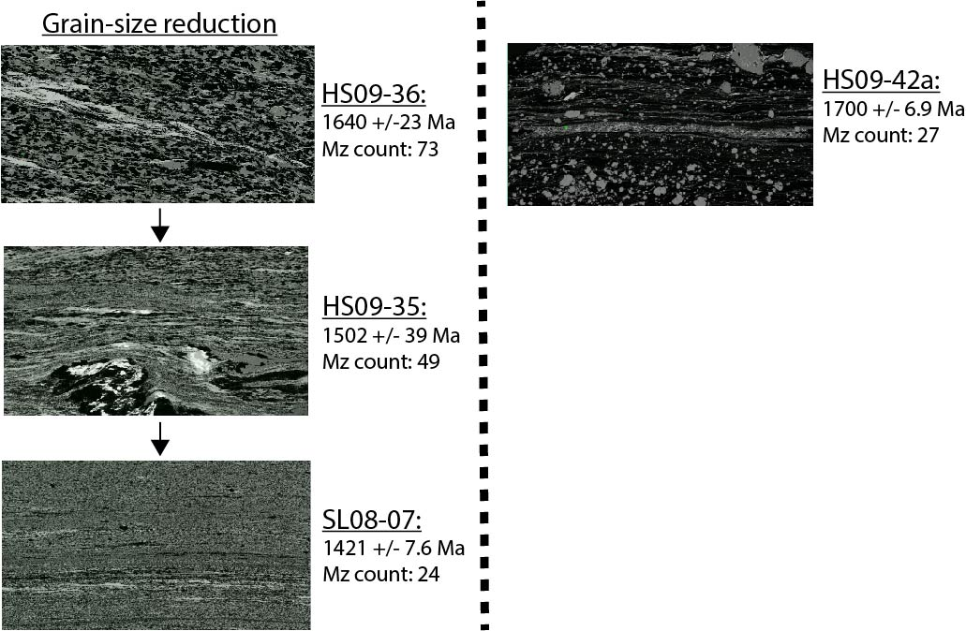
Figure 41: Full thin section Al X-ray maps. Demonstrating qualitative relationship between grain size reduction, average monazite ages (Table 2), and monazite count.

6.2. Core to rim relationships
A common phenomenon in each of the samples exhibiting core-rim zonation (excluding SL08-07) is inconsistent age relationships between inner and outer cores, where inner cores were younger than their respective outer core. Inner cores were often characterized by low Y and Th, the latter of which may be an indicator of fluid-related alteration of U, Th, and/or Pb, distorting the actual age of the monazite (Goncalves et al., 2005; Williams et al., 2011). Age disparity between older outer cores and younger inner cores ranged from 1 Ma (HS09-36: m34) to 60 Ma (HS09-35: m2). Th-maps commonly reveal enigmatic zonation, possibly related to the removal of Th through coupled dissolution – reprecipitation processes. Possible causes for these observations include: fluid-related pseudomorphic replacements of monazite during metasomatism (Harlov and Hetherington, 2010), or grain-scale porosity and permeability permitting metamorphic fluid infiltration (Putnis and Austrheim, 2010).
These domain inconsistencies make it difficult to interpret the geologic significance of the core domains. However, despite the variability in monazite core dates, weighted averages can be used to generalize age range of core domains in each sample (Table 2).

6.3. Trace element trends
The sample-composition comparisons show decreasing Y and HREE concentration over time, with increasing Eu concentration. This observation could represent an increasing favor of xenotime crystallization, which Y and HREE’s favorably fractionate into at lower-grade conditions (Spear and Pyle, 2002). As none of these samples are garnet- or allanite-bearing, monazite and xenotime alone control the balance of Y and HREE’s in the sample (Spear and Pyle, 2002). These observations only provide a qualitative assessment of metamorphic grade and crystallization conditions, as xenotime was not analyzed in this research. The slight increase in Eu in the younger, Mesoproterozoic monazite dates from higher-strained samples (SL08-07 & HS09-35) relative to the older Paleoproterozoic monazite dates could be the result of increasing deformation and dissolution of feldspar grains at lower grades and higher strain rates, releasing Eu (Rubatto et al., 2006). Negative-Eu anomalies are common in metamorphic monazite grains as a result of fractionation into feldspar (Spear and Pyle, 2002), an effect that could lessen with increasing dissolution of feldspar.

6.4 Timing of shear zone activity
Microstructural and geochemical data suggest that fluid-related alteration of monazite in mylonitic samples (HS09-35 and SL08-07) occurred post-1.54 Ga, with a high probability around 1.42 Ga. The lack of inherited monazite grains from these samples implies that this fluid alteration completely reset preexisting monazite grains, precipitating new grains that record this event. Monazite grains breaking down to form apatite also supports fluid-related alteration (Spear and Pyle, 2002). Core domains from HS09-35 record incomplete alteration of monazite grains around ⁓1.5 Ga, with low-Y main domains recording monazite precipitation (1423 and 1420 Ma). The same ⁓1.42 Ga ages are reported in the low-Y main domains in sample SL08-07 (avg: 1421 +/- 7.6 Ma). Only two post-1.4 Ga dates are recorded, but had higher error values (+/- 30 and 37.8 Ma).

6.5. Relationship to Northern Sawatch range
Ages from the SLSZ correlate with other geochronologic constraints from the Northern Sawatch Range (Shaw et al., 2001; McCoy et al., 2005; Shaw et al., 2005). The Paleoproterozoic monazite ages from this research (1716 – 1580 Ma) generally overlap with the D₁ and D₂ events recorded in the neighboring HSZ area (1710 – 1630 Ma; Shaw et al., 2001) and the emplacement of the Cross Creek Batholith (ca. 1675 Ma [Rb-Sr]; Tweto and Lovering, 1977). Inferred shear zone activity from this research also overlaps with HSZ activity (1450 – 1370 Ma), as well as the emplacement of the neighboring St. Kevin Batholith (1396 +/- 40 Ma [U-Th-Pb zircon]; Doe and Pearson, 1969). These findings reinforce the idea that elevated temperatures during ⁓1.4 Ga plutonism in the CMB permitted the thermal weakening and reactivation of high-strain fabrics.
The timing correlation reinforces coeval kinematic motion between the HSZ and SLSZ, like in the model proposed by Lee et al. (2012) involving the coupled top-to-the-southeast shear sense, top-to-the-northwest shear sense, and dextral general shear during regional transpression. Similar deformation temperatures (HSZ: 280 – 500 °C; SLSZ: 280 – 600 °C) as well as similar kinematic shear sense (top-to-the-southeast and top-to-the-northwest) between the HSZ and SLSZ recorded by Lee et al. (2012) is supported by corresponding monazite ages in the HSZ (1.45 – 1.37 Ga) reported by Shaw et al. (2001), and in the SLSZ reported in this study (1.54 – 1.41 Ga). The weighted average for top-to-the-southeast mylonite deformation (D₃) reported by Shaw et al. (2001) ( 1372 +/- 19 Ma) is younger than the weighted averages recorded in the mylonites with similar top-to-the-southeast shear sense from this study (HS09-35: 1502 +/- 39 Ma; SL08-07: 1421 +/- 7.6 Ma), indicating that shear zone deformation in the SLSZ may have preceded that of the HSZ, but more data is needed to confirm this relationship.

CHAPTER 7:
CONCLUSION
The SLSZ is a sub-horizontal mylonitic shear zone from the Northern Sawatch range. As part of the CMB shear zone system, this shear zone serves as an important reference to how sub-vertical and sub-horizontal shear zones operate together during deformation events. Four previously collected samples from the Homestake and Bennett Ridgeline, each with varying microstructural characteristics, were chosen to investigate the monazite ages and geochemistry of the SLSZ. The three samples from the Homestake Ridgeline (HS09-36, HS09-35, and SL08-07) record successively younger monazite dates with more advanced grain-size reduction. Despite being a mylonitic sample, monazite grains cores from HS09-42a (Bennett Ridgeline) record older (avg: 1700 +/- 6.9 Ma) ages that were not reset during shear zone deformation, likely due to the lack of dissolution-precipitation creep deformation in the sample, restricting the reactivity of fluids necessary to dissolve and reprecipitate monazite. Core domains from the high-strained gneissic sample (HS09-36, avg: 1640 +/- 23 Ma) a coeval with the later Paleoproterozoic deformation event (D₂) and may correspond to high-strain zone formation documented around the CMB shear zone system, serving as the precursors to Mesoproterozoic mylonite formation. Monazite ages often record age inconsistencies from the inner core to outer cores, and instead show evidence for incomplete resetting where unbalanced removal of U, Th, or Pb results in distorted dates. Weighted means are better suited to evaluate the range in monazite ages core domains, which was on the scale of 1 – 60 Ma separating younger inner cores from older outer cores. Monazite ages support that fluid-related alteration in the shear zone occurred around ⁓1.42 Ga, exampled by low-Y main monazite domains in grain-size reduced mylonitic samples HS09-35 (1423 and 1420 Ma) and SL08-07 (avg: 1421 +/- 7.6 Ma), as well as preserved monazite – apatite reactions from these samples. Monazite core dates from HS09-35 (avg: 1502 +/- 39 Ma) and low-Y main dates from SL08-07 (avg: 1421 +/- 7.6 Ma) generally coincide with the activity of the HSZ (1450 Ma - 1370Ma), suggesting that the two shear zones were active around the same time during the Mesoproterozoic. This supports previous models of coeval activity between the neighboring shear zones involving coupled top-to-the-northwest, top-to-the-southeast, and dextral motion. The results reinforce previous findings of the activity of the CMB shear zones (1.45 – 1.3 Ga), supporting the existence of a regional shear zone system in Colorado that records intracontinental processes during the Mesoproterozoic.

REFERENCES

Allen, J. L., & Shaw, C. A. (2011). Seismogenic structure of a crystalline thrust fault: Fabric anisotropy and coeval pseudotachylyte–mylonitic pseudotachylyte in the Grizzly Creek shear zone, Colorado. Geological Society, London, Special Publications, 359(1), 135-151.

Anderson, J. L. (1983). Proterozoic anorogenic granite plutonism of North America. Geological Society of America Memoir, 161, 133-154.

Aronoff, R. F. (2016). The role of the Picuris orogeny in the tectonic evolution of Proterozoic North America (Doctoral dissertation, Purdue University).
Asami, M., Suzuki, K., Grew, E.S., 2002. Chemical Th–U–total Pb dating by electron microprobe analysis of monazite, xenotime and zircon from the Archean Napier Complex, East Antarctica; evidence for ultra-high-temperature metamorphism at 2400 Ma. Precambrian Res. 114 (3–4), 249– 275.

Ayers, J. C., Miller, C., Gorisch, B., & Milleman, J. (1999). Textural development of monazite during high-grade metamorphism: Hydrothermal growth kinetics, with implications for U, Th-Pb geochronology. American Mineralogist, 84(11-12), 1766-1780.

Barnes, J. D., Selverstone, J., & Sharp, Z. D. (2004). Interactions between serpentinite devolatilization, metasomatism and strike‐slip strain localization during deep‐crustal shearing in the Eastern Alps. Journal of Metamorphic Geology, 22(4), 283-300.

Bennett, V. C., & DePaolo, D. J. (1987). Proterozoic crustal history of the western United States as determined by neodymium isotopic mapping. Geological Society of America Bulletin, 99(5), 674-685.

Bickford, M. E., Shuster, R. D., & Boardman, S. J. (1989). U-Pb geochronology of the Proterozoic volcano-platonic terrane. Proterozoic geology of the southern Rocky Mountains, 235, 33.

Bickford, M. E., & Van Schmus, W. R. (1985). Discovery of two Proterozoic granite-rhyolite terranes in the buried midcontinent basement: The case for shallow drill holes. In Observation of the Continental Crust through Drilling I (pp. 355-364). Springer, Berlin, Heidelberg.

Bowring, S.A., Karlstrom, K.E., 1990. Growth, stabilization, and reactivation of Proterozoic lithosphere in the southwestern United States. Geology 18, 1203-1206.

Burchfiel, B. C., Quidong, D., Molnar, P., Royden, L., Yipeng, W., Peizhen, Z., & Weiqi, Z. (1989). Intracrustal detachment within zones of continental deformation. Geology, 17(8), 748-752.

Cheong, C.-S., et al., 2002. Early Permian peak metamorphism recorded in U–Pb system of black slates from the Ogcheon metamorphic belt, South Korea, and its tectonic implication. Chem. Geol. 193, 81–92.

Cherniak, D. J., Watson, E. B., Grove, M., & Harrison, T. M. (2004). Pb diffusion in monazite: a combined RBS/SIMS study. Geochimica et Cosmochimica Acta, 68(4), 829-840.

Clarey, T. L., Chase, R. B., & Schmidt, C. J. (2004). Precambrian Influences on the Development of the Royal Gorge Arch, Colorado: A Thick-skinned Fault-Propagation Fold. The Mountain Geologist.

Condie, K. C. (1986). Geochemistry and tectonic setting of early Proterozoic supracrustal rocks in the southwestern United States. The Journal of Geology, 94(6), 845-864.

Corrie, S. L., & Kohn, M. J. (2008). Trace‐element distributions in silicates during prograde metamorphic reactions: Implications for monazite formation. Journal of Metamorphic Geology, 26(4), 451-464.

Cressey, G., Wall, F., & Cressey, B. A. (1999). Differential REE uptake by sector growth of monazite. Mineralogical Magazine, 63(6), 813-828.

Daniel, C. G., Pfeifer, L. S., Jones III, J. V., & McFarlane, C. M. (2013). Detrital zircon evidence for non-Laurentian provenance, Mesoproterozoic (ca. 1490–1450 Ma) deposition and orogenesis in a reconstructed orogenic belt, northern New Mexico, USA: Defining the Picuris orogeny. Bulletin, 125(9-10), 1423-1441.

Doe, B.R., Pearson, R.C., 1969. U-Th-Pb chronology of zircons from the St. Kevin Granite, northern Sawatch Range, Colorado. Geological Society of America Bulletin 80, 2495-2502.

Fitzsimons, I. C. W., Kinny, P. D., Wetherley, S., & Hollingsworth, D. A. (2005). Bulk chemical control on metamorphic monazite growth in pelitic schists and implications for U–Pb age data. Journal of Metamorphic Geology, 23(4), 261-277.

Foster, G., et al., 2004. The generation of prograde P–T–t points and paths; a textural, compositional, and chronological study of metamorphic monazite. Earth Planet. Sci. Lett. 228, 125–142.

Franz, G., Andrehs, G., & Rhede, D. (1996). Crystal chemistry of monazite and xenotime from Saxothuringian-Moldanubian metapelites, NE Bavaria, Germany. European Journal of Mineralogy, 8(5), 1097-1118.

Frost, C. D., & Ronald Frost, B. (1997). Reduced rapakivi-type granites: the tholeiite connection. Geology, 25(7), 647-650.

Frost, B.R., Barnes, C.G., Collins, W.J., Arculus, R.J., Ellis, D.J., and Frost, C.D., 2001, A
geochemical classification for granitic rocks: Journal of Petrology, v. 42, p. 2033-2048.

Goncalves, P., Nicollet, C., Montel, J.M., 2004. Petrology and in-situ U–Th–Pb monazite geochronology of ultra–high temperature metamorphism from the Andriamena mafic unit, north-central Madagascar. Significance of a petrographical PT path in a polymetamorphic context. J. Petrol. 10, 1923–1957.

Goncalves, P., Williams, M. L., & Jercinovic, M. J. (2005). Electron-microprobe age mapping of monazite. American Mineralogist, 90(4), 578-585.

Graubard, C.M., Mattinson, J.M., 1990. Syntectonic emplacement of the approximately 1440-Ma Mt. Evans Pluton and history of motion along the Idaho Springs-Ralston Creek shear zone, central Front Range, Colorado. Geological Society of America Abstracts with Programs 22, 12.

Harlov, D. E., & Hetherington, C. J. (2010). Partial high-grade alteration of monazite using alkali-bearing fluids: Experiment and nature. American Mineralogist, 95(7), 1105-1108.

Hibbard, J.P., Tracy, R.J., Henika, W.S., 2003. Smith River Allochthon; a Southern Appalachian peri-Gondwanan terrane emplaced directly on Laurentia? Geology 31 (3), 215– 218.

Hill, B.M., Bickford, M.E., 2001. Paleoproterozoic rocks of central Colorado: accreted arcs or extended older crust. Geology 29, 1015-1018.

Hirth, G., & Tullis, J. A. N. (1992). Dislocation creep regimes in quartz aggregates. Journal of structural geology, 14(2), 145-159.

Hoffman, P. F. (1988). United plates of America, the birth of a craton: Early Proterozoic assembly and growth of Laurentia. Annual Review of Earth and Planetary Sciences, 16(1), 543-603.

Hoffman, P.F., 1989, Speculations on Laurentia’s first gigayear (2.0-1.0 Ga): Geology, v. 17, p.
135-138.

Jäger, E. (1979). Introduction to geochronology. In Lectures in isotope geology (pp. 1-12). Springer, Berlin, Heidelberg.

Janots, E., Negro, F., Brunet, F., Goffé, B., Engi, M., & Bouybaouene, M. L. (2006). Evolution of the REE mineralogy in HP–LT metapelites of the Sebtide complex, Rif, Morocco: monazite stability and geochronology. Lithos, 87(3-4), 214-234.

Janots, E., Engi, M., Berger, A., Allaz, J., Schwarz, J. O., & Spandler, C. (2008). Prograde metamorphic sequence of REE minerals in pelitic rocks of the Central Alps: implications for allanite–monazite–xenotime phase relations from 250 to 610 C. Journal of Metamorphic Geology, 26(5), 509-526.

Jessup, M.J., Karlstrom, K.E., Connelly, J., Williams, M., Livaccari, R., Tyson, A., Rogers, S.A., 2005. Complex Proterozoic crustal assembly of southwestern North America in an arcuate subduction system: the Black Canyon of the Gunnison, southwestern Colorado. In: Karlstrom, K.E., Keller, G.R. (Eds.), The Rocky Mountain Region: An Evolving Lithosphere. American Geophysical Union Monograph, vol. 154, 1-19.

Jessup, M.J., Jones III, J.V., Karlstrom, K.E., Williams, M.L., Connelly, J.N., Heizler, M.T., 2006. Three Proterozoic orogenic episodes and an intervening exhumation event in the Black Canyon of the Gunnison region, Colorado. Journal of Geology 114, 555-576.

Jones III, J.V., Rogers, S.A., Connelly, J.N., 2010. U-Pb geochronology of Proterozoic granites in the Sawatch Range, central Colorado, U.S.A. Rocky Mountain Geology 45, 1-22.

Jones III, J. V., Daniel, C. G., & Doe, M. F. (2015). Tectonic and sedimentary linkages between the Belt-Purcell basin and southwestern Laurentia during the Mesoproterozoic, ca. 1.60–1.40 Ga. Lithosphere, 7(4), 465-472.

Karlstrom, K.E., Bowring, S.A., 1988. Early Proterozoic assembly of tectonostratigraphic terranes in southwestern North America. Journal of Geology 96, 561-576.

Karlstrom, K.E., Houston, R.S., 1984. The Cheyenne belt: analysis of a Proterozoic suture in southern Wyoming. Precambrian Research 25, 415-446.

Karlstrom, K. E., Bowring, S. A., & Reed, J. C. (1993). Proterozoic orogenic history of Arizona. Precambrian: Conterminous US: Boulder, Colorado, Geological Society of America, Geology of North America, 2, 188-211.

Karlstrom, K.E., Humphreys, E.D., 1998. Persistent influence of Proterozoic accretionary boundaries in the tectonic evolution of southwestern North America: interaction of cratonic grain and mantle modification events. Rocky Mountain Geology 33, 161-179.

Kerrich, R. (1986). Fluid infiltration into fault zones: chemical, isotopic, and mechanical effects. Pure and applied geophysics, 124(1-2), 225-268.

Kingsbury, J. A., Miller, C. F., Wooden, J. L., & Harrison, T. M. (1993). Monazite paragenesis and U-Pb systematics in rocks of the eastern Mojave Desert, California, USA: implications for thermochronometry. Chemical Geology, 110(1-3), 147-167.

Kohn, M. J., & Malloy, M. A. (2004). Formation of monazite via prograde metamorphic reactions among common silicates: implications for age determinations. Geochimica et Cosmochimica Acta, 68(1), 101-113.

Lanzirotti, A., & Hanson, G. N. (1996). Geochronology and geochemistry of multiple generations of monazite from the Wepawaug Schist, Connecticut, USA: implications for monazite stability in metamorphic rocks. Contributions to Mineralogy and Petrology, 125(4), 332-340.

Lee, J. K., Williams, I. S., & Ellis, D. J. (1997). Pb, U and Th diffusion in natural zircon. Nature, 390(6656), 159-162.

Lee, P. E. (2011). Kinematic evolution of the Homestake and Slide Lake shear zones, central Colorado: Implications for mid-crustal deformation during the Mesoproterozoic.

Lee, P. E., Jessup, M. J., Shaw, C. A., Hicks III, G. L., & Allen, J. L. (2012). Strain partitioning in the mid-crust of a transpressional shear zone system: Insights from the Homestake and Slide Lake shear zones, central Colorado. Journal of Structural Geology, 39, 237-252.
Lidiak, E. G., Marvin, R. F., Tnomas, H. H., & Bass, M. N. (1966). Geochronology of the midcontinent region, United States: 4. Eastern area. Journal of Geophysical Research, 71(22), 5427-5438.
Mahan, K. H., Williams, M. L., Flowers, R. M., Jercinovic, M. J., Baldwin, J. A., & Bowring, S. A. (2006). Geochronological constraints on the Legs Lake shear zone with implications for regional exhumation of lower continental crust, western Churchill Province, Canadian Shield. Contributions to Mineralogy and Petrology, 152(2), 223-242.
McCaig, A. M., Wickham, S. M., & Taylor, H. P. (1990). Deep fluid circulation in alpine shear zones, Pyrenees, France: field and oxygen isotope studies. Contributions to Mineralogy and Petrology, 106(1), 41-60.
McCoy, A. M., Karlstrom, K. E., Shaw, C. A., Williams, M. L., & Keller, G. R. (2005). The Proterozoic ancestry of the Colorado Mineral Belt: 1.4 Ga shear zone system in central Colorado. The Rocky Mountain Region: An Evolving Lithosphere—Tectonics, Geochemistry, and Geophysics, 71-90.
Molnar, P., 1988, Continental tectonics in the aftermath of plate tectonics: Nature, v. 335, p. 131-
137.
Montel, J.M., Kornprobst, J., Vielzeuf, D., 2000. Preservation of old U–Th–Pb ages in shielded monazite; example from the Benmi Bousera Hercynian kinzigites (Morocco). J. Metamorph. Geol. 18 (3), 335– 342.

Morrow, C. A., Moore, D. E., & Byerlee, J. D. (1984). Permeability changes in crystalline rocks due to temperature: Effects of mineral assemblage. MRS Online Proceedings Library Archive, 44.

Overstreet, W. C. (1967). The geologic occurrence of monazite (No. 530). [US Geological Survey; for sale by the Supt. of Docs.] US Govt. Print. Off.,.

Passchier, C. W., & Trouw, R. A. (2005). Microtectonics. Springer Science & Business Media.

Premo, W. R., Van Schmus, W. R., Grambling, J. A., & Tewksbury, B. J. (1989). Zircon geochronology of Precambrian rocks in southeastern Wyoming and northern Colorado. Proterozoic geology of the southern Rocky Mountains: Geological Society of America Special Paper, 235, 13-32.

Pryer, L. L. (1993). Microstructures in feldspars from a major crustal thrust zone: the Grenville Front, Ontario, Canada. Journal of structural Geology, 15(1), 21-36.

Putnis, A., & Austrheim, H. (2010). Fluid‐induced processes: metasomatism and metamorphism. Geofluids, 10(1‐2), 254-269.

Pyle, J. M., Spear, F. S., Rudnick, R. L., & McDONOUGH, W. F. (2001). Monazite–xenotime–garnet equilibrium in metapelites and a new monazite–garnet thermometer. Journal of Petrology, 42(11), 2083-2107.

Pyle, J. M., & Spear, F. S. (1999). Yttrium zoning in garnet: coupling of major and accessory phases during metamorphic reactions. Geological Materials Research, 1(6), 1-49.

Pyle, J.M., Spear, F.S., 2003. Four generations of accessory-phase growth in low-pressure migmatites from SW New Hampshire. Am. Mineral. 88 (2–3), 338– 351.

Rasmussen, B., Muhling, J. R., Fletcher, I. R., & Wingate, M. T. (2006). In situ SHRIMP U–Pb dating of monazite integrated with petrology and textures: does bulk composition control whether monazite forms in low-Ca pelitic rocks during amphibolite facies metamorphism?. Geochimica et Cosmochimica Acta, 70(12), 3040-3058.

Rolland, Y., Cox, S. F., & Corsini, M. (2009). Constraining deformation stages in brittle–ductile shear zones from combined field mapping and 40Ar/39Ar dating: the structural evolution of the Grimsel Pass area (Aar Massif, Swiss Alps). Journal of Structural Geology, 31(11), 1377-1394.

Ross, G. M., & Villeneuve, M. (2003). Provenance of the Mesoproterozoic (1.45 Ga) Belt basin (western North America): Another piece in the pre-Rodinia paleogeographic puzzle. GSA Bulletin, 115(10), 1191-1217.

Rubatto, D., Williams, I. S., & Buick, I. S. (2001). Zircon and monazite response to prograde metamorphism in the Reynolds Range, central Australia. Contributions to Mineralogy and Petrology, 140(4), 458-468.
Rubatto, D., Hermann, J., & Buick, I. S. (2006). Temperature and bulk composition control on the growth of monazite and zircon during low-pressure anatexis (Mount Stafford, central Australia). Journal of Petrology, 47(10), 1973-1996.

Selverstone, J., Hodgins, M., Aleinikoff, J. N., & Fanning, C. M. (2000). Mesoproterozoic reactivation of a Paleoproterozoic transcurrent boundary in the northern Colorado Front Range: Implications for∼ 1.7-and 1.4-Ga tectonism. Rocky Mountain Geology, 35(2), 139-162.

Seydoux-Guillaume, A. M., Paquette, J. L., Wiedenbeck, M., Montel, J. M., & Heinrich, W. (2002). Experimental resetting of the U–Th–Pb systems in monazite. Chemical geology, 191(1-3), 165-181.

Shaw, C.A., Allen, J.L., 2007. Field rheology and structural evolution of the Homestake shear zone, Colorado. Rocky Mountain Geology 42, 31-56.

Shaw, C.A., Karlstrom, K.E., 1999. The Yavapai-Mazatzal crustal boundary in the Southern Rocky Mountains. Rocky Mountain Geology 34, 37-52.

Shaw, C. A., Karlstrom, K. E., Williams, M. L., Jercinovic, M. J., & McCoy, A. M. (2001). Electron-microprobe monazite dating of ca. 1.71–1.63 Ga and ca. 1.45–1.38 Ga deformation in the Homestake shear zone, Colorado: Origin and early evolution of a persistent intracontinental tectonic zone. Geology, 29(8), 739-742.
Shaw, C. A., Heizler, M. T., Karlstrom, K. E., & Keller, G. R. (2005). 40Ar/39Ar thermochronologic record of 1.45–1.35 Ga intracontinental tectonism in the southern Rocky Mountains: Interplay of conductive and advective heating with intracontinental deformation. The Rocky Mountain Region–An Evolving Lithosphere: Tectonics, Geochemistry, and Geophysics. American Geophysical Union, Geophysical Monograph, 154, 163-184.
Sibson, R. H. (1977). Fault rocks and fault mechanisms. Journal of the Geological Society, 133(3), 191-213.
Simpson, R.L., Parrish, R.R., Searle, M.P., Waters, D.J., 2000. Two episodes of monazite crystallization during metamorphism and crustal melting in the Everest region of the Nepalese Himalaya. Geology 28 (5), 403–406.

Sindern, S., Gerdes, A., Ronkin, Y. L., Dziggel, A., Hetzel, R., & Schulte, B. A. (2012). Monazite stability, composition and geochronology as tracers of Paleoproterozoic events at the eastern margin of the East European Craton (Taratash complex, Middle Urals). Lithos, 132, 82-97.

Smith, H. A., & Barreiro, B. (1990). Monazite U-Pb dating of staurolite grade metamorphism in pelitic schists. Contributions to Mineralogy and Petrology, 105(5), 602-615.

Spear, F. S., & Pyle, J. M. (2002). Apatite, monazite, and xenotime in metamorphic rocks. Reviews in Mineralogy and Geochemistry, 48(1), 293-335.

Spear, F. S. (2010). Monazite–allanite phase relations in metapelites. Chemical Geology, 279(1-2), 55-62.

Stipp, M., Stünitz, H., Heilbronner, R., & Schmid, S. M. (2002). Dynamic recrystallization of quartz: correlation between natural and experimental conditions. Geological Society, London, Special Publications, 200(1), 171-190.

Suzuki, K., Adachi, M., 1991. Precambrian provenance and Silurian metamorphism of the Tsubonosawa paragneiss in the South Kitakami terrane, Northeast Japan, revealed by the chemical Th–U– total Pb isochron ages of monazite, zircon, and xenotime. Geochem. J. 25, 357– 376.

Suzuki, K., Adachi, M., 1998. Denudation history of the high T/P Ryoke metamorphic belt, Southwest Japan; constraints from CHIME monazite ages of gneisses and granitoids. J. Metamorph. Geol. 16 (1), 23– 37.

Terry, M.P., Robinson, P., Hamilton, M.A., Jercinovic, M.J., 2000. Monazite geochronology of UHP and HP metamorphism, deformation, and exhumation, Nordøyane, Western Gneiss Region, Norway. Am. Mineral. 85, 1651– 1664.

Tickyj, H., Hartmann, L.A., Vasconcellos, M.A.Z., Philipp, R.P.A., Remus, M.V.P., 2004. Electron microprobe dating of monazite substantiates ages of major geological events in the southern Brazilian shield. J. South Am. Earth Sci. 16, 699–713.

Tomkins, H. S., & Pattison, D. R. M. (2007). Accessory phase petrogenesis in relation to major phase assemblages in pelites from the Nelson contact aureole, southern British Columbia. Journal of Metamorphic Geology, 25(4), 401-421.

Tweto, O., 1974. Geologic Map and Sections of the Holy Cross Quadrangle, Eagle, Lake, Pitkin, and Summit Counties, Colorado. United States Geological Survey Miscellaneous Investigations Map I-830, scale 1:24,000.

Tweto, O., 1979. Geologic Map of Colorado. United States Geological Survey, scale
1:500,000.

Tweto, O., and Lovering, T.S., 1977, Geology of the Minturn 15-minute Quadrangle, Eagle and Summit Counties, Colorado: U.S. Geological Survey Professional Paper P-956, 96
Tweto, O.L., Moench, R.H., and Reed, J.C., Jr., 1978. Geologic map of the leadville 1° x 2°
qudrangle, northwestern Colorado. United States Geological Survey Miscellaneous
Investigatons Map I-999, scale 1:250,000.
Tweto, O.L., Sims, P.K., 1963. Precambrian ancestry of the Colorado mineral belt. Geological Society of America Bulletin 74, 991-1014.

Wawrzenitz, N., Krohe, A., Rhede, D., & Romer, R. L. (2012). Dating rock deformation with monazite: The impact of dissolution precipitation creep. Lithos, 134, 52-74.
Whitmeyer, S. J., & Karlstrom, K. E. (2007). Tectonic model for the Proterozoic growth of North America. Geosphere, 3(4), 220-259.
Williams, M.L., Jercinovic, M.J., 2002. Microprobe monazite geochronology: putting absolute time into microstructural analysis. J. Struct. Geol. 24, 1013–1028.

Williams, M.L., Jercinovic, M.J., and Terry, M.P., 1999, Age mapping and dating of monazite on the electron microprobe: Deconvoluting multistage tectonic histories: Geology, vol. 27, 1023–1026.
Williams, M. L., Jercinovic, M. J., Goncalves, P., & Mahan, K. (2006). Format and philosophy for collecting, compiling, and reporting microprobe monazite ages. Chemical Geology, 225(1-2), 1-15.
Williams, M. L., Jercinovic, M. J., Harlov, D. E., Budzyń, B., & Hetherington, C. J. (2011). Resetting monazite ages during fluid-related alteration. Chemical Geology, 283(3-4), 218-225.
Williams, M. L., Jercinovic, M. J., Mahan, K. H., & Dumond, G. (2017). Electron microprobe petrochronology. Reviews in Mineralogy and Geochemistry, 83(1), 153-182.
Wing, B. A., Ferry, J. M., & Harrison, T. M. (2003). Prograde destruction and formation of monazite and allanite during contact and regional metamorphism of pelites: petrology and geochronology. Contributions to Mineralogy and petrology, 145(2), 228-250.
Wooden, J. L., Stacey, J. S., Howard, K. A., Doe, B. R., & Miller, D. M. (1988). Pb isotopic evidence for the formation of Proterozoic crust in the southwestern United States.
Wooden, J.L., and DeWitt, E., 1991, Pb isotopic evidence for the boundary between the Early
Proterozoic Mojave and central Arizona crustal provinces in western Arizona, in
Karlstrom, K.E., ed., Prtoterozoic geology and ore deposits of Arizona: Tuscon, Arizona, Arizona Geological Society Digest, v.19, p. 27-50.

APPENDIX I:
MONAZITE DATA

Analysis | Date | 1-sigma error | Y | HREE's | Th | Eu | U | Ca
HS09-36
Un 17 jl-HS09-36-m22-core | 1658 | 9.7 | 16823 | 26057 | 43692 | 2000 | 3763 | 6502
Un 18 jl-HS09-36-m22-low-rt-rim | 1596 | 61.2 | 21611 | 28119 | 41160 | 1873 | 5727 | 7838
Un 19 jl-HS09-36-m34-core | 1594 | 29.4 | 13986 | 31280 | 43322 | 2307 | 1683 | 5077
Un 20 jl-HS09-36-m34-up-out-core | 1595 | 20.1 | 19056 | 24631 | 43861 | 1800 | 3950 | 13385
Un 21 jl-HS09-36-m36-core | 1627 | 11 | 17242 | 26629 | 49457 | 2387 | 7696 | 8190
Un 22 jl-HS09-36-m36-low-right-rim | 1680 | 11.6 | 20280 | 27516 | 42945 | 2393 | 13839 | 9630
Un 23 jl-HS09-36-m39-up-right-core | 1539 | 80.7 | 23132 | 28764 | 37575 | 1339 | 5338 | 7313
Un 24 jl-HS09-36-m6-core | 1669 | 17.8 | 18945 | 26900 | 39344 | 1863 | 4127 | 6599
Un 25 jl-HS09-36-m1-left-side | 1652 | 26.6 | 19200 | 26362 | 36381 | 1900 | 3827 | 6384
Un 66 JL-HS09-36-m30-1 inner core | 1620 | 15 | 12935 | 16215 | 7908 | 2651 | 3873 | 2534
Un 67 JL-HS09-36-m30-2 outer core | 1580 | 25 | 19435 | 29585 | 44869 | 2629 | 7730 | 8606
Un 68 JL-HS09-36-m30-3 outer core | 1602 | 20 | 24207 | 29231 | 41196 | 1658 | 4266 | 6846
Un 69 JL-HS09-36-m30-4 rim | 1366 | 30 | 12495 | 27018 | 38286 | 4519 | 8695 | 8026
HS09-35
Un 5 jl-HS09-35-m2-core | 1438 | 29 | 10975 | 23895 | 10488 | 3797 | 2790 | 2437
Un 6 jl-HS09-35-m2-left-rim | 1498 | 16 | 22069 | 28705 | 19161 | 2289 | 5856 | 4719
Un 7 jl-HS09-35-m5-core | 1455 | 19 | 15830 | 21344 | 27297 | 2407 | 7499 | 5967
Un 8 jl-HS09-35-m5-up-left | 1481 | 25 | 23023 | 26022 | 28439 | 1857 | 5885 | 6129
Un 9 jl-HS09-35-m9-core | 1500 | 25 | 10459 | 22054 | 12518 | 3728 | 2627 | 2557
Un 10 jl-HS09-35-m10-core | 1520 | 34 | 15256 | 22906 | 17762 | 2892 | 16024 | 6566
Un 11 jl-HS09-35-m10-right-rim | 1538 | 22 | 19609 | 25894 | 25011 | 2318 | 5517 | 5723
Un 12 jl-HS09-35-m7-core | 1516 | 9 | 15485 | 25713 | 20236 | 2700 | 6460 | 4683
Un 13 jl-HS09-35-m4-all | 1420 | 9 | 11144 | 20876 | 27223 | 3081 | 5289 | 5428
Un 14 jl-HS09-35-m16-all | 1423 | 8 | 11979 | 21918 | 27864 | 2952 | 5884 | 5681
Table 3: Sample monazite analyses. Contact jeremyleierzapf@gmail.com or mjessup@utk.edu for full excel spreadsheet.

HS09-42A
Un 29 jl-HS09-42A-mC2-Lower-core | 1689 |  | 5.7 |  | 18721 |  | 26539 |  | 23975 |  | 2093 |  | 4963 |  | 5452
Un 30 jl-HS09-42A-mC2-Left-side | 1701 |  | 5.6 |  | 21013 |  | 31174 |  | 33973 |  | 2248 |  | 6261 |  | 6824
Un 31 jl-HS09-42A-m8-right-core | 1702 |  | 21 |  | 18320 |  | 28383 |  | 19899 |  | 4292 |  | 14346 |  | 6168
Un 32 jl-HS09-42A-m8-left-side | 1694 |  | 5.5 |  | 24726 |  | 31607 |  | 29824 |  | 1807 |  | 6159 |  | 6047
Un 33 jl-HS09-42A-m1-core | 1714 |  | 12.7 |  | 21824 |  | 29741 |  | 29628 |  | 2000 |  | 5240 |  | 5807
Un 34 jl-HS09-42A-m1-left-rim | 1690 |  | 31.3 |  | 11897 |  | 22899 |  | 29363 |  | 2971 |  | 1913 |  | 4881
Un 35 jl-HS09-42A-m18-core | 1688 |  | 11.6 |  | 13556 |  | 25381 |  | 3361 |  | 3561 |  | 5055 |  | 1697
Un 36 jl-HS09-42A-m18-left-rim | 1716 |  | 5.6 |  | 18598 |  | 31465 |  | 32635 |  | 2983 |  | 7697 |  | 7111
Un 37 jl-HS09-42A-m22-low-right | 1604 |  | 7 |  | 9336 |  | 24890 |  | 29257 |  | 2992 |  | 408 |  | 1419
Un 22 JL-42A-m11-rim | 1615 |  | 5 |  | 10541 |  | 26064 |  | 31421 |  | 3093 |  | 491 |  | 1697
SL08-07
Un 41 JL-SL08-m3 | 1413 |  | 6 |  | 12682 |  | 24105 |  | 30744 |  | 3227 |  | 6296 |  | 6103
Un 42 JL-SL08-m11 | 1424 |  | 13.3 |  | 13340 |  | 23724 |  | 36363 |  | 3166 |  | 6263 |  | 7017
Un 43 JL-SL08-m9 | 1420 |  | 9.2 |  | 12876 |  | 21218 |  | 27749 |  | 3231 |  | 6689 |  | 5596
Un 44 JL-SL08-m2 | 1419 |  | 5.8 |  | 12791 |  | 24520 |  | 32253 |  | 3107 |  | 6234 |  | 6269
Un 45 JL-SL08-m6 | 1413 |  | 10 |  | 13690 |  | 21435 |  | 33678 |  | 3091 |  | 7566 |  | 6647
Un 46 JL-SL08-m7 | 1310 |  | 37.8 |  | 12897 |  | 21493 |  | 27131 |  | 3057 |  | 6420 |  | 5723
Un 47 JL-SL08-m16 | 1425 |  | 10.6 |  | 13288 |  | 22487 |  | 34710 |  | 3091 |  | 6519 |  | 6998
Un 48 JL-SL08-m12 | 1426 |  | 6.3 |  | 13131 |  | 21288 |  | 27870 |  | 3029 |  | 6899 |  | 5659
Un 49 JL-SL08-m10 | 1439 |  | 8.7 |  | 13135 |  | 24774 |  | 41949 |  | 3010 |  | 5906 |  | 7715

APPENDIX II:
MICROSTRUCTURAL OBSERVATIONS
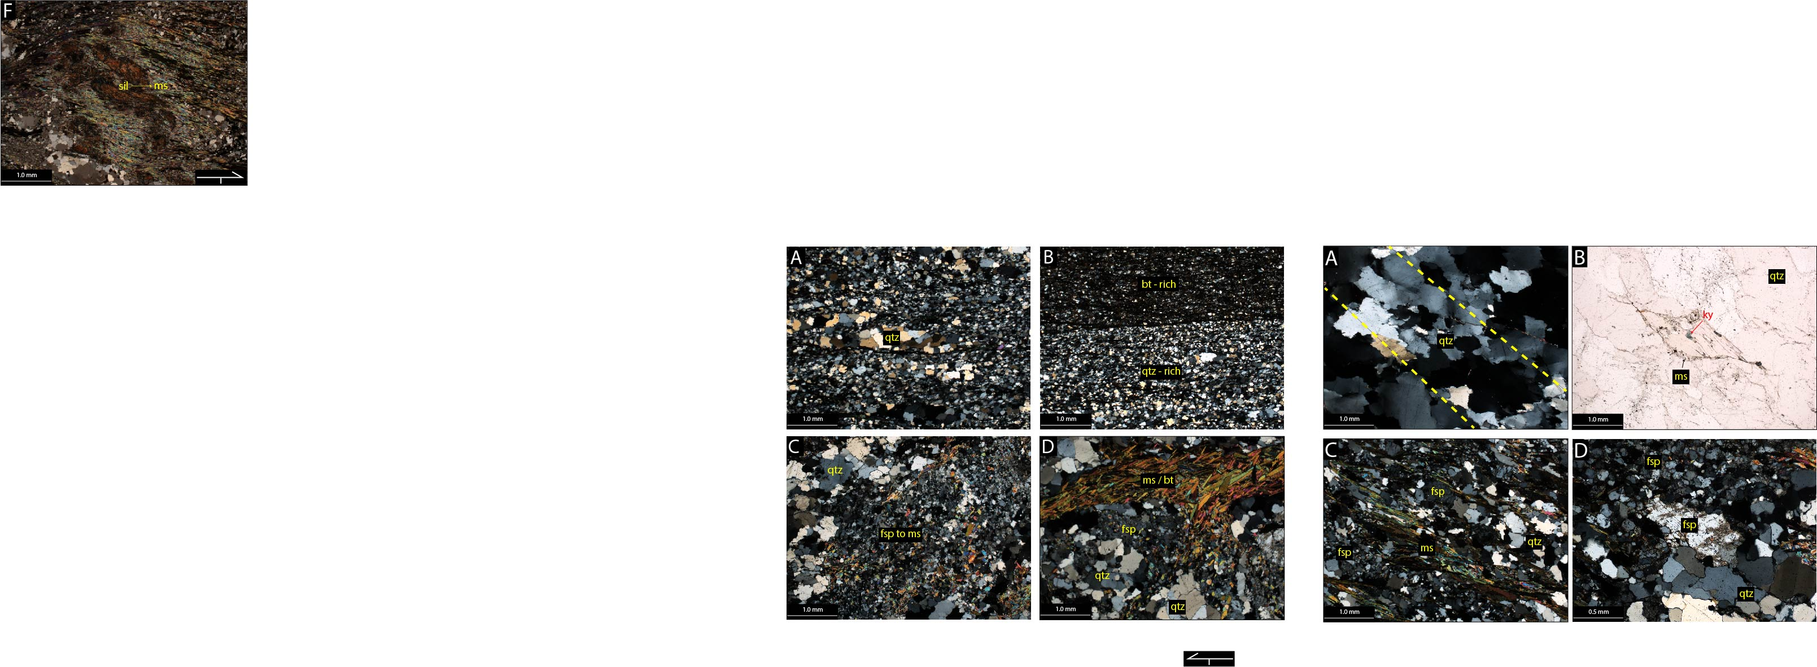
A.) Relict GBM quartz textures surrounded by grain-size reduced quartz and phyllosilicates. B.) Compositional banding between a quartz and biotite rich layer. C.) Recrystallized feldspar altering to muscovite. D.) Phyllosilicate layer flowing around more rigid quartz and feldspar.

A.) GBM quartz with elongated grain shape. B.) Muscovite pseudomorph enclosing relict kyanite. C.) Foliation defined by alternating layers of GBM quartz and recrystallized feldspar, and paralleling phyllosilicates. D.) Relict feldspar grain surrounded by recrystallized BLG feldspar grains and GBM quartz.

APPENDIX III:
FIELD OBSERVATIONS
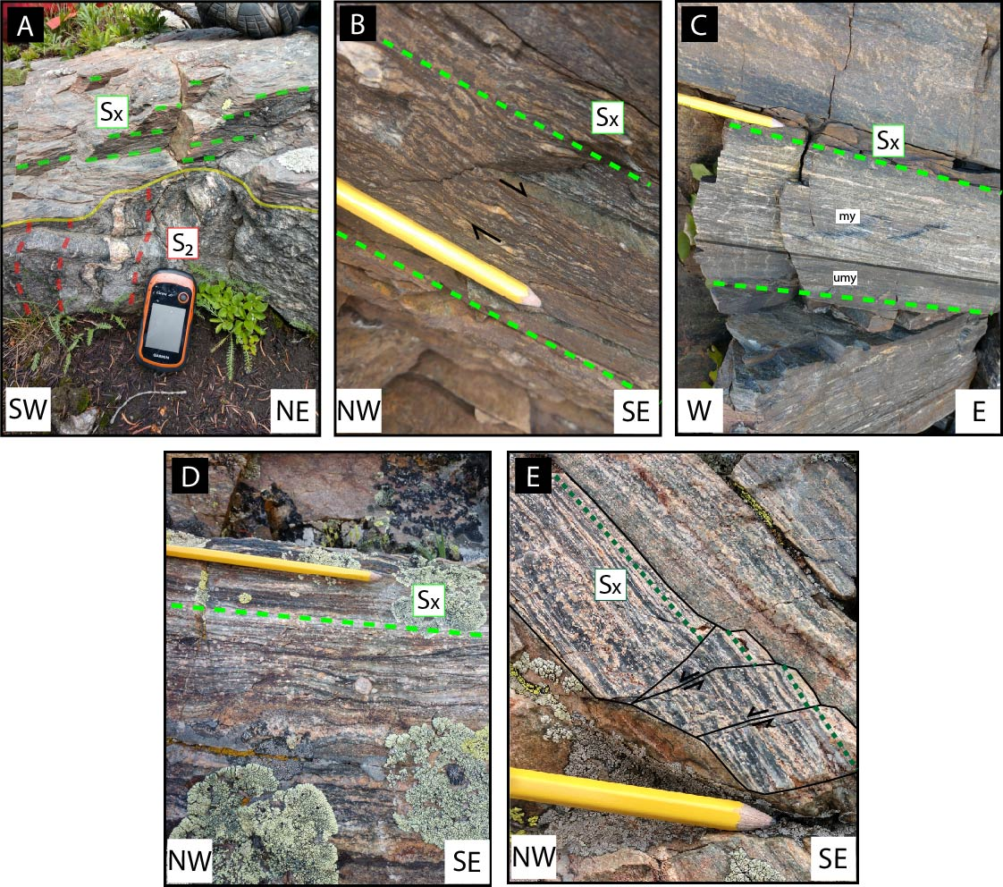
A.) Sub-horizontal high-strain mylonite cross-cutting gneissic leucosome fold. B.) Asymmetric quartz shear band showing t-SE shear sense. C.) Mylonite and ultramylonite from Homestake Peak. D.) Feldspar porphyroclasts in myonite from Bennett ridgeline. E.) t-NW fracturing in mylonite from Bennett ridgeline.

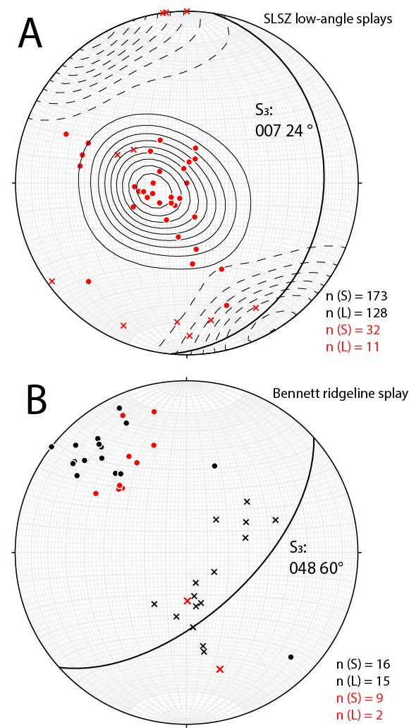
Lower hemisphere equal area stereonets showing foliations and lineations from mylonite splays. Circles are poles to mylonite foliation, and crosses are mineral lineations. Average mylonite foliation (great-circles in black) plotted from Lee et al., 2012. Red markers are from this study, black are from Lee et al., 2012 as a reference. A.) Homestake Ridgeline (Homestake Peak, Slide Lake Cirque, and Slide Lake Pavement). Black contours are from Lee et al., 2012; solid contours are mylonite foliation poles, and dashed contours are mineral lineations. Actual values of Lee et al. 2012 data not included but depicted with contours B.) Bennett Ridgeline mylonite splays.

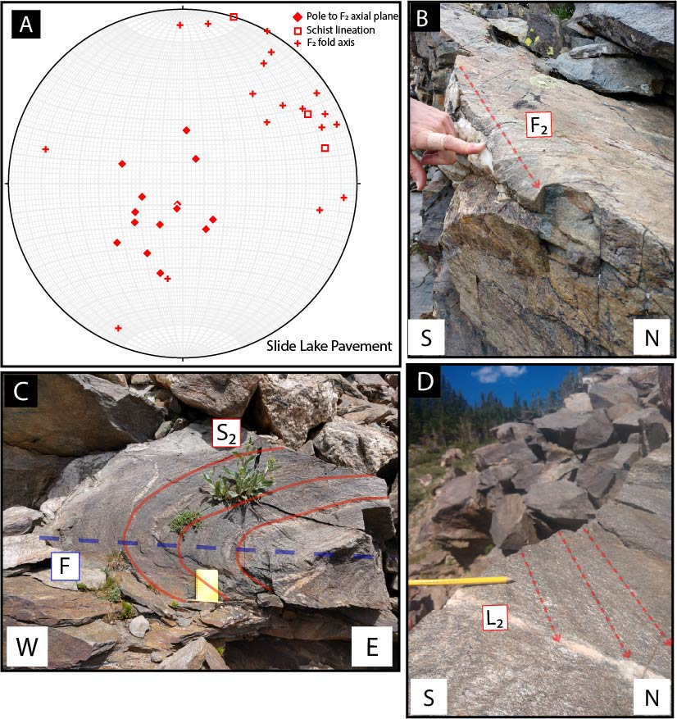

D₂ structures from Slide Lake Pavement. A.) Equal area stereonet showing poles to axial planes (n=14), fold axes (n=18), and crenulation lineations (n=3). B.) F2 fold axis. C.) Sub-horizontal D₂axial plane. D.) Crenulated schist lineation.

VITA
Jeremy Roy Leierzapf was born in Columbia, Maryland, in September 1996 to Susan Elizabeth Barna and Roy Jerome Leierzapf. He attended Long Reach High School and graduated in 2014. He then attended Towson University and received a Bachelor’s of Science in “Geology” in 2018. Jeremy spent the summer of 2018 taking part in the University of St. Andrews Geology Field Camp in Scotland. He started school at the University of Tennessee, Knoxville in fall of 2018, where he taught undergraduate introductory and structural geology lab courses.

