PREFACE

To the Graduate Council:
I am submitting herewith a dissertation written by Leyuan Zhang entitled "Integrated Multiscale Modeling of Drought and Air Quality under Climate Change: Health and Environmental Implications." I have examined the final electronic copy of this dissertation for form and content and recommend that it be accepted in partial fulfillment of the requirements for the degree of Doctor of Philosophy, with a major in Civil Engineering.
Joshua S. Fu, Major Professor
We have read this dissertation and recommend its acceptance:
Forrest M. Hoffman, Jia Xing, Russell L. Zaretzki
Accepted for the Council:
Dixie L. Thompson
Vice Provost and Dean of the Graduate School
(Original signatures are on file with official student records.)

Integrated Multiscale Modeling of Drought and Air Quality under Climate Change: Health and Environmental Implications

A Dissertation Presented for the
Doctor of Philosophy
Degree
The University of Tennessee, Knoxville

Leyuan Zhang
December 2025
Copyright © 2025 by Leyuan Zhang
All rights reserved.

DEDICATION
I dedicate this dissertation to my family for their endless love and support.

ACKNOWLEDGEMENTS
With heartfelt gratitude, I would like to thank my advisor Dr. Joshua S. Fu, whose unwavering support, insightful guidance, and steadfast belief in my potential have shaped every step of my Ph.D. journey since 2021. His mentorship not only nurtured my academic and professional growth but also taught me to persevere, to question deeply, and to lead with integrity.
I am truly grateful to my committee members, Dr. Forrest Hoffman, Dr. Jia Xing, and Dr. Russell Zaretzki, for their thoughtful feedback, generous time, and constant encouragement that helped me refine my research and expand my thinking. My sincere thanks also go to my lab mates and friends in the research group, especially Hannah Rubin, Rong-You Chien, Dr. Cheng-En Yang, Cheng-pin Kuo, G. Andrew Ferrada, Zhixu Sun, Xinxin Zhang and Valeria Campos, whose kindness, encouragement, and laughter have accompanied me through both challenges and milestones.
Above all, I owe the deepest thanks to my family and friends, whose unconditional love and quiet strength have carried me through the long nights, the moments of doubt, and the small victories alike. This dissertation is not only a reflection of my work, but a tribute to the people who believed in me even when I struggled to believe in myself.

ABSTRACT
Extreme weather events and limited air quality monitoring coverage pose growing challenges to environmental planning and public health protection. This dissertation addresses two critical dimensions of environmental risk in the contiguous United States (CONUS): the future evolution of drought conditions and the improvement of ground-level PM_{2.5} [particulate matter smaller than 2.5 microns] estimation. Through the integration of regional climate modeling and machine learning, this work provides enhanced tools for assessing regional vulnerability and supporting evidence-based adaptation strategies. In the first part, drought projections are assessed under the SSP5-8.5 scenario using a multi-model ensemble of six CMIP6 global climate models (GCMs), dynamically downscaled via the Weather Research and Forecasting (WRF) model. Drought patterns for the near-term (2020–2039) and mid-term (2040–2059) periods are evaluated using the Self-Calibrating Palmer Drought Severity Index (ScPDSI), the 12-month Standardized Precipitation Index (SPI-12), and the 12-month Standardized Precipitation-Evapotranspiration Index (SPEI-12). Results reveal a widespread increase in mild droughts (D0 and D1) and a decline in severe to exceptional droughts (D2–D4) across many regions. Persistent drying is projected in the western and southwestern U.S., primarily driven by long-term soil moisture deficits. Although total drought-exposed populations are projected to decline after 2040, urban areas remain disproportionately affected—particularly under ScPDSI projections—highlighting the importance of indicator choice in impact assessment. In the second part, a hybrid framework combining chemical transport model outputs and machine learning is developed to improve satellite-based PM_{2.5} estimates. By addressing sample imbalance, incorporating spatiotemporal features, and integrating supplemental monitoring networks (e.g., CASTNET, IMPROVE), the framework enhances predictive accuracy in under-monitored regions. Convolutional neural network (CNN) models, such as ResNet, significantly reduce overestimation in downwind and rural areas, yielding more robust exposure assessments. Together, these efforts advance the understanding of spatial and temporal disparities in environmental risks, with implications for infrastructure planning, environmental equity, and public health policy in the U.S.

TABLE OF CONTENTS
1 Introduction 1
1.1 Research Motivation 1
1.2 Climate Change, Drought and Air Pollution 2
1.3 Impacts on Human Health and the Environment 4
1.3.1 Human Health Impacts of Drought 4
1.3.2 Human Health Impacts of PM₂.₅ Pollution 5
1.3.3 Environmental Impacts of Drought and Air Pollution 6
1.3.4 Socioeconomic Dimensions 6
1.3.5 Compound and Cascading Risks 7
1.4 Knowledge Gaps 7
1.4.1 Gaps in Drought Projections 7
1.4.2 Gaps in Air Pollution Estimation under Climate Change 8
1.4.3 Gaps in Health and Socioeconomic Impact Assessments 9
1.4.4 Need for Integrated Multiscale Approaches 9
1.5 Research Contributions 10
1.5.1 Advancing High-Resolution Drought Projections 10
1.5.2 Developing a CMAQ–Machine Learning Testbed for PM₂.₅ Estimation 11
1.5.3 Linking Drought and Air Pollution to Human Health and Equity 11
1.5.4 Overarching Framework and Novelty 12
2 Drought Evolution and Bias in Climate Downscaling 14
2.1 Research Question 14
2.2 Introduction 14
2.3 Objective 18
2.4 Methods and Data 20
2.4.1 Drought Indices and Classification 20
2.4.2 Dynamical Downscaling and Bias Correction 22
2.4.3 Model Selection and Experimental Design 24
2.4.4 Population Exposure Analysis 26
2.5 Results 27
2.6 Discussion 44
2.7 Conclusion 53
3 Machine Learning-Based PM2.5 Estimation and Bias Analysis 58
3.1 Research Question 58
3.2 Introduction 58
3.3 Objective 63
3.4 Methods and Data 65
3.4.1 Methods 65
3.4.2 Data 69
3.5 Results 75
3.5.1 Evaluation of Benchmark Machine Learning Models for PM2.5 Prediction. 75
3.5.2 Annual variation and effects of monitoring site distribution on PM2.5 prediction accuracy 90
3.5.3 The impact of spatial and temporal features on PM2.5 predictions 97
3.5.4 Performance of deep learning methods: ResNet 100
3.6 Discussion 106
3.7 Conclusion 108
4 Socioeconomic and Health Implications of Drought and Air Pollution 111
4.1 Research Question 111
4.2 Introduction 111
4.3 Objective 112
4.4 Methods and Data 113
4.4.1 Population Exposure Estimation 113
4.4.2 Health Impact Estimation 114
4.4.3 Economic Cost Analysis 120
4.5 Results 123
4.5.1 Population Exposure 123
4.5.2 Health Impact 130
4.5.3 Economic Cost 136
5 Conclusion and Future Work 143
5.1 Summary of Key Findings 143
5.2 Research Limitations 144
5.3 Future Directions 145
6 List of References 147
7 Appendix 155
Vita 163

LIST OF TABLES
Table 2.1 Drought Classification for SPI, SPEI, and ScPDSI. (*refer from USDM and NOAA). 22
Table 2.2 The CMIP6 models were downscaled and combined into a multi model ensemble. 25
Table 3.1 Performance comparison of the base line machine learning methods (Random Forest, LightGBM, and XGBoost) in predicting PM2.5 concentrations across 2019, 2014, and 2009 using RMSE, R², and NMB Metrics. 80
Table 4.1 Baseline incidence rates and relative risks (RR) for drought-related health outcomes in the CONUS. 117
Table 4.2 Concentration–response coefficients (β) and baseline incidence rates (Y₀) for health endpoints associated with PM₂.₅ exposure. 119
Table 7.1 The CMIP6 models were downscaled and combined into a multi model ensemble. 155

LIST OF FIGURES
Figure 1.1 Research Flowchart: Drought, Air Quality, and Health under Climate Change 13
Figure 2.1 A comparison of drought conditions across CONUS. a) Standard Precipitation Index (SPI-12) calculated on a 12-month timescale, b) Standard Precipitation Evapotranspiration Index (SPEI) calculated on a 12-month timescale, and c) Self-calibrated Palmer Drought Severity Index (ScPDSI). *Note the ScPDSI uses a different Y-axis scale due to its distinct classification standards. 31
Figure 2.2 Projected regional changes in drought probability across the contiguous United States (CONUS) based on SPI-12, SPEI-12, and ScPDSI for the near-term (2020–2039) and mid-term (2040–2059) relative to the historical baseline (1980–2019). 35
Figure 2.3 Comparison of 10th, Median, and 90th Percentile ScPDSI (1980s–2050s) by decade across CONUS. 39
Figure 2.4 Projected trends and historical patterns of drought in the CONUS (1980–2059) based on SPI-12, SPEI-12, and ScPDSI. (a, c, e) Stacked bar plots showing the percentage of land area affected by different drought categories (D0–D4) over time for SPI-12, SPEI-12, and ScPDSI, respectively. (b, d, f) Box plots representing the distribution of drought-affected areas across three time periods (1981–2019, 2020–2039, and 2040–2059) based on multi-model ensembles. The box plots show the median, interquartile range (25th–75th percentiles), and whiskers extending to the 5th–95th percentiles, with outliers represented as individual points. 44
Figure 3.1 Testbed framework. 69
Figure 3.2 The spatial location of the AQS, CASTNET, and IMPROVE sites. 74
Figure 3.3 Spatial Distribution and Error Analysis of 2019 Surface PM2.5 Predictions Using a Random Forest Model. 76
Figure 3.4 Multi-perspective comparison of PM₂.₅ changes over CONUS from 2009 to 2019 using CMAQ and ML-based predictions. 90
Figure 3.5 Spatial and temporal changes in ground-truth (CMAQ) PM2.5 concentrations (2009, 2014, 2019). 91
Figure 3.6 Distribution of EPA PM2.5 monitors and distance to monitors (2009, 2014, 2019) 93
Figure 3.7 Performance of PM2.5 predictions for 2019 using different data sources (AQS, CASNET, IMPROVE) as labels 97
Figure 3.8 Effect of spatial and temporal features on the accuracy of PM2.5 forecasts 100
Figure 3.9 Spatial distribution of surface PM2.5 and error analysis across distance for 2019. 102
Figure 3.10 RMSE comparison of various models across distances from monitoring sites. 103
Figure 3.11 Spatial distribution of monitoring sites and selected high-error grid cells. 104
Figure 3.12 Normalized error distributions for all grid cells versus high-error locations. 105
Figure 3.13 Boxplot comparison of absolute errors between all grid cells and high-error locations. 105
Figure 4.1 Population affected by drought categories in rural and urban areas of the CONUS (2010-2050). 127
Figure 4.2 Population-weighted exposure and sample-imbalance diagnostics for 2019. (a) PWE (μg m⁻³) for CMAQ and ML prediction by distance to the nearest monitor (0–24, 24–48, 48–72, 72–96, ≥ 96 km). (b) Bias (prediction – CMAQ) by distance; population-weighted linear fit slope ≈ 0.0012 μg m⁻³ km⁻¹. (c) Population share in each distance bin, showing that ~48% of the population resides ≥ 96 km from a monitor. (d) Map of distance to the nearest monitor (km), highlighting monitor-sparse regions in the central plains, interior West/mountain areas, and parts of the Southeast. All statistics use WorldPop (regridded to 12 km) for weights. 129
Figure 4.3 Drought-attributable health impacts in the contiguous United States (2010–2050). 132
Figure 4.4 Comparison of health burdens attributable to PM₂.₅ exposure between CMAQ and machine learning predictions. 136
Figure 4.5 National drought-related economic costs by health endpoint, drought index, and drought category. 138
Figure 4.6 National and state-level economic costs of PM₂.₅-attributable health outcomes in 2019 (C0 = 5) derived from CMAQ and prediction-based estimates 142
Figure 7.1 CONUS climate regions, as shown on the NCEI website (Karl and Koss 1984). 155
Figure 7.2 Projected Urban and Rural Population Growth in CONUS (2010–2050). 156

Introduction

Research Motivation
Climate change has profoundly altered the frequency, severity, and characteristics of extreme environmental stressors, introducing substantial uncertainties for both natural and human systems. Among these stressors, drought and fine particulate matter (PM_{2.5}) are two of the most consequential, with wide-ranging implications for water resources, ecosystems, agriculture, and public health. Globally, drought has emerged as one of the costliest natural hazards, responsible for more than USD 124 billion in economic losses and affecting over 1.5 billion people between 1998 and 2017 (FAO 2018). The most recent assessment by the Intergovernmental Panel on Climate Change (IPCC) highlights that anthropogenic warming has already increased the likelihood and intensity of agricultural and ecological droughts in many regions (IPCC 2021).
At the same time, air pollution remains a leading global environmental risk factor. Ambient PM_{2.5} exposure is estimated to contribute to approximately 4.2 million premature deaths annually, primarily through cardiovascular and respiratory diseases (World Health Organization 2021, Murray and al 2020). In the United States alone, recent studies have suggested that nearly 100,000 annual deaths can be attributed to long-term PM_{2.5} exposure, with significant economic costs exceeding USD 800 billion per year (Burnett and al 2018, Tessum and al 2021).
The concurrent risks posed by drought and PM_{2.5} pollution present unique challenges. Drought threatens water and food security by disrupting hydrological cycles and agricultural production, while PM_{2.5} pollution disproportionately burdens vulnerable populations such as children, the elderly, and those with pre-existing conditions. Importantly, both hazards are strongly modulated by climate variability. Projected increases in temperature extremes and precipitation variability under future warming scenarios may exacerbate drought conditions, while climate-driven meteorological changes, including enhanced atmospheric stagnation and increased wildfire activity, are expected to worsen PM_{2.5} episodes (Dai 2013, Mickley and al 2017).
This dissertation is motivated by the urgent need to quantify the evolving risks of drought and air pollution under climate change using an integrated, multiscale modeling framework. By bridging climate dynamics, atmospheric chemistry, and human exposure assessment, this research seeks to provide actionable insights for environmental management and policy adaptation.

Climate Change, Drought and Air Pollution
Drought is a multifaceted climatic phenomenon driven by interactions among precipitation, evapotranspiration, soil moisture, and atmospheric circulation. Unlike unidirectional intensification, projections suggest that drought patterns will become more erratic, with some regions experiencing longer, more persistent dry periods, while others face alternating episodes of drought and extreme rainfall (Trenberth et al 2014, Zhao and Dai 2022). This variability challenges traditional water management strategies that rely on historical stationarity, underscoring the need for flexible, adaptive frameworks (Milly et al 2008).
To capture the complexity of drought, several indices have been developed. The Standardized Precipitation Index (SPI) (McKee et al 1993) focuses solely on precipitation anomalies, while the Standardized Precipitation Evapotranspiration Index (SPEI) (Vicente-Serrano et al 2010)incorporates atmospheric evaporative demand, making it more responsive to warming-driven changes. The Palmer Drought Severity Index (PDSI) and its self-calibrating variant (scPDSI) (Wells et al 2004) integrate soil moisture accounting and have been widely applied in long-term drought assessments. Each metric highlights different aspects of drought risk, and discrepancies among them complicate regional projections (Ault 2020). This dissertation leverages multiple indices to evaluate drought variability across spatial and temporal scales.
Air pollution, particularly PM_{2.5}, arises from diverse anthropogenic and natural sources, including fossil fuel combustion, industrial processes, agriculture, biomass burning, wildfires, and dust storms (Pope and Dockery 2006, Lelieveld et al 2015). Climate change affects both the sources and atmospheric processing of PM_{2.5}. For instance, higher temperatures can accelerate secondary aerosol formation, while drought-induced wildfires and dust storms increase episodic PM_{2.5} emissions (Ford et al 2018, Stowell et al 2022). Conversely, increased precipitation may temporarily improve air quality via wet deposition, but this benefit is offset by the rising frequency of stagnation events and persistent high-pressure systems that inhibit pollutant dispersion (Jacob and Winner 2009).
The interaction between drought and air pollution is particularly concerning. During drought, reduced soil moisture and vegetation stress enhance wildfire probability and dust mobilization, both of which inject substantial amounts of particulate matter into the atmosphere. Moreover, drought conditions often coincide with synoptic-scale high-pressure systems that suppress vertical mixing, prolonging pollutant residence times near the surface (Wang et al., 2017; Shen et al., 2021. Recent studies in western North America have shown that compound hot and dry conditions amplify PM_{2.5} extremes by increasing both fire risk and atmospheric stagnation, posing severe challenges for air quality management (Xu et al., 2020; Chen et al., 2021).
In sum, climate change simultaneously modifies drought characteristics and air pollution dynamics, with overlapping consequences for ecosystems and human health. Despite extensive independent research on each hazard, there remains a pressing need to understand their coupled evolution under warming conditions, particularly at high spatial resolution and across multiple timescales.

Impacts on Human Health and the Environment
The instability of drought conditions and the persistence of degraded air quality have far-reaching implications for human health, ecosystems, and socio-economic systems. These hazards interact with and reinforce one another, often creating compound risks that amplify adverse outcomes beyond the sum of individual effects. A growing body of research underscores the urgency of understanding these interactions in order to improve resilience strategies.

Human Health Impacts of Drought
Drought exerts direct and indirect health effects through pathways that include water scarcity, food insecurity, and heightened exposure to extreme heat and wildfires. Reduced water availability compromises hygiene and sanitation, increasing the risk of diarrheal and vector-borne diseases (Ebi & Bowen, 2016). Agricultural drought reduces crop yields, contributing to undernutrition and micronutrient deficiencies, particularly in low-income communities dependent on subsistence farming (Funk et al., 2019). Prolonged drought conditions also intensify heat stress, elevating risks of dehydration, heatstroke, and mortality, especially among elderly populations (Haines & Ebi, 2019).
In regions prone to wildfire, drought-induced vegetation dryness substantially increases fire frequency and severity, resulting in hazardous smoke exposure (Ford et al., 2018). Wildfire smoke is a major source of PM_{2.5}, containing a complex mixture of organic carbon, black carbon, and toxic trace elements, which contribute to respiratory infections, asthma exacerbation, and cardiovascular morbidity (Reid et al., 2016). Recent epidemiological evidence from California indicates that wildfire PM_{2.5} is associated with disproportionately higher respiratory hospital admissions compared to PM_{2.5} from urban sources (O’Dell et al., 2020).

Human Health Impacts of PM_{2.5} Pollution
Air pollution, particularly fine particulate matter (PM_{2.5}, aerodynamic diameter ≤ 2.5 μm), is one of the most pervasive environmental risk factors worldwide. Long-term exposure to PM_{2.5} has been linked to increased incidence of ischemic heart disease, stroke, chronic obstructive pulmonary disease, lung cancer, and diabetes (Pope & Dockery, 2006; Lelieveld et al., 2015). A landmark global burden of disease analysis estimated that outdoor air pollution contributes to approximately 4.2 million premature deaths annually (Murray et al., 2020; WHO, 2021). In the United States, fine particles are implicated in more than 90,000 deaths annually, disproportionately affecting disadvantaged and minority communities (Tessum et al., 2021).
The biological mechanisms underlying PM_{2.5} health impacts include systemic inflammation, oxidative stress, endothelial dysfunction, and altered autonomic nervous system regulation (Brook et al., 2010). Emerging evidence also suggests associations with neurodevelopmental disorders and cognitive decline, indicating that the health burden of PM_{2.5} may be broader than previously recognized (Calderón-Garcidueñas et al., 2016). Short-term exposure during pollution episodes has been associated with acute respiratory infections and increased hospital admissions, while chronic exposure reduces life expectancy (Di et al., 2017).

Environmental Impacts of Drought and Air Pollution
Beyond human health, drought and air pollution destabilize ecological systems. Drought-induced reductions in soil moisture impair plant productivity and alter species composition, accelerating desertification and biodiversity loss (Ault, 2020). Soil degradation reduces carbon sequestration capacity, feeding back into climate change by releasing stored carbon (Anderegg et al., 2015). Persistent drought also undermines aquatic ecosystems, leading to declining freshwater availability, reduced habitat quality, and increased fish mortality (van Vliet et al., 2016).
Air pollution similarly affects ecosystems. Elevated concentrations of PM_{2.5} reduce solar radiation reaching the surface, impairing photosynthesis and crop yields (Burney & Ramanathan, 2014). Deposition of pollutants such as nitrogen and sulfur compounds alters soil chemistry, leading to acidification and nutrient imbalances that stress vegetation (Galloway et al., 2008). When drought and pollution co-occur, the combined stress often accelerates ecosystem collapse. For example, ozone and particulate pollution exacerbate drought-induced crop losses, with cascading consequences for food prices and livelihoods (Tai et al., 2014).

Socioeconomic Dimensions
The socio-economic impacts of drought and air pollution are profound. Drought-driven agricultural losses increase food insecurity, disrupt rural economies, and may trigger migration (Damania et al., 2017). Air pollution imposes substantial economic costs through healthcare expenditures, reduced labor productivity, and crop damage. In the United States, the annual economic burden of air pollution-related mortality and morbidity is estimated at hundreds of billions of dollars (Goodkind et al., 2019). These burdens are not equally distributed: socially disadvantaged groups often experience higher exposures and lower adaptive capacity, underscoring the environmental justice dimension of the problem (Clark et al., 2014).

Compound and Cascading Risks
Crucially, drought and air pollution are not independent. Drought intensifies air pollution through wildfire emissions, dust storms, and atmospheric stagnation, while pollution can exacerbate drought impacts by reducing precipitation via aerosol-cloud interactions (Ramanathan et al., 2001). Such compound events create cascading risks that extend across sectors, amplifying threats to food, water, health, and energy systems (Zscheischler et al., 2018). Understanding these compound interactions is vital for developing integrated adaptation strategies.

Knowledge Gaps
Despite extensive research on climate change, drought, and air pollution as independent phenomena, substantial gaps remain in understanding their coupled dynamics and long-term implications. These gaps occur across multiple dimensions, including methodological limitations in climate modeling, insufficient representation of air quality–climate interactions, limited integration of population and health outcomes, and a lack of multiscale frameworks that bridge global climate signals with regional exposure assessments.

Gaps in Drought Projections
Most projections of future drought rely on global climate models (GCMs) that operate at coarse spatial resolutions (100–250 km). While GCMs provide valuable insights into global hydroclimatic trends, their limited spatial resolution restricts the accurate simulation of regional drought processes such as soil moisture dynamics, topography-driven precipitation patterns, and land–atmosphere feedbacks (Dai, 2013; Cook et al., 2018). Biases in GCM precipitation and temperature fields further complicate regional drought assessment, leading to uncertainty in the frequency and severity of projected droughts (Zhao & Dai, 2022). Dynamical downscaling via regional climate models (RCMs) has been applied to address these challenges, but relatively few studies have combined RCMs with multiple drought indices to provide a systematic assessment of drought characteristics at high spatial resolution (Raju et al., 2020; Zhou et al., 2023). Furthermore, the implications of downscaling biases for population-level exposure remain poorly quantified.

Gaps in Air Pollution Estimation under Climate Change
Air pollution research has advanced rapidly with the integration of satellite observations, chemical transport models (CTMs), and machine learning (ML) techniques (van Donkelaar et al., 2019). However, several gaps persist: 1. Sample imbalance and monitoring bias: Most ML models are trained on monitoring networks that are denser in urban areas, leading to systematic underperformance in rural and underserved regions (Xiao et al., 2018). This imbalance skews exposure estimates, with important implications for environmental equity. 2. Climate sensitivity of PM_{2.5} : While studies have examined how meteorological variables influence PM₂.₅ formation and dispersion (Jacob & Winner, 2009; Stowell et al., 2019), few have evaluated how future climate variability—particularly drought—will alter PM_{2.5} concentrations and related health risks. 3. Integration of multiyear and multisource data: Many ML studies focus on single-year or single-network datasets, which limits generalizability. There is a need for frameworks that integrate multiyear observations and multiple monitoring networks to reduce bias and enhance spatial coverage.

Gaps in Health and Socioeconomic Impact Assessments
Although the adverse health effects of both drought and PM_{2.5} exposure are well documented, their joint impacts remain poorly understood. Most epidemiological studies isolate individual hazards rather than considering compound or cascading risks (Reid et al., 2016; Zscheischler et al., 2018). Moreover, relatively few studies have incorporated population projections into climate and air quality impact assessments, limiting our ability to anticipate future burdens under different socioeconomic pathways (Huang et al., 2021). The lack of integrated frameworks linking climate projections, air quality modeling, and population vulnerability hinders comprehensive evaluations of environmental justice and public health equity.

Need for Integrated Multiscale Approaches
Current research is often fragmented, focusing either on climate-driven drought projections, air pollution modeling, or health impact assessment in isolation. What is missing is an integrated, multiscale approach that: 1. Dynamically downscales GCMs to resolve regional drought processes. 2. Incorporates multiple drought indices to capture different hydroclimatic dimensions. 3. Couples CTM outputs with ML algorithms to address monitoring gaps and improve PM_{2.5} predictions. 4. Links climate and air quality projections with population and health exposure assessments.
Bridging these gaps is critical for developing actionable knowledge. Without integrated frameworks, policymakers risk underestimating the compound hazards posed by drought and air pollution, particularly for vulnerable populations. This dissertation addresses these gaps by combining regional climate downscaling, multivariate drought characterization, machine learning-based PM_{2.5} estimation, and population exposure assessments into a unified framework.

Research Contributions
This dissertation makes several contributions to the fields of climate change impacts, drought and air quality modeling, and environmental health assessment. By integrating high-resolution climate modeling, machine learning approaches, and exposure analysis, the study advances scientific understanding of how compound hazards evolve under warming conditions and what their implications are for vulnerable populations. The major contributions can be summarized as follows:

Advancing High-Resolution Drought Projections
Most prior studies of future drought rely on coarse-resolution global climate models (GCMs), which fail to adequately represent regional hydrological processes. This dissertation leverages a six-member CMIP6 ensemble dynamically downscaled to 4 km resolution using a regional climate model. By combining multiple drought indices—including SPI, SPEI, and self-calibrating PDSI—this work provides a comprehensive evaluation of drought characteristics across the contiguous United States from 1981 to 2059.
Contribution: This is one of the first systematic efforts to assess how different drought metrics project regional variability at such fine spatial resolution, enabling improved representation of local hydrological processes and better alignment with decision-making needs. The study also explicitly quantifies biases introduced by downscaling and their implications for drought frequency and intensity, addressing a key gap in climate impact assessments.

Developing a CMAQ–Machine Learning Testbed for PM_{2.5} Estimation
Traditional PM_{2.5} estimation approaches using satellite remote sensing or empirical models are often biased toward well-monitored urban regions, leaving large uncertainties in rural areas. This dissertation develops a hybrid testbed that integrates outputs from the Community Multiscale Air Quality (CMAQ) model with machine learning algorithms (Random Forest, XGBoost, LightGBM, ResNet). This framework addresses sample imbalance, evaluates the role of multiyear training data, and examines the influence of spatially distributed monitoring networks.
Contribution: The testbed provides a reproducible, scalable framework for assessing PM_{2.5} estimation biases and correcting them under different observational constraints. It demonstrates that integrating physical model simulations with ML significantly reduces prediction errors in monitor-sparse regions, enhancing the accuracy of air quality assessments. This represents a methodological innovation that bridges atmospheric science and data-driven modeling.

Linking Drought and Air Pollution to Human Health and Equity
A critical but underexplored research area is the joint impact of drought and air pollution on human exposure and health. This dissertation integrates drought classifications with gridded population projections under SSP5-8.5 to evaluate future drought exposure. It further combines improved PM_{2.5} estimates with population data to assess health impacts and economic costs, with particular attention to environmental equity between urban and rural populations.
Contribution: This is one of the first studies to jointly quantify population exposure to both drought and PM_{2.5} under climate change using an integrated modeling framework. By linking hazard projections to socioeconomic and health outcomes, the research bridges a longstanding gap between climate science and public health. The findings provide actionable insights for adaptation planning, especially for agencies such as the U.S. Environmental Protection Agency (EPA), Centers for Disease Control and Prevention (CDC), and Department of Energy (DOE).

Overarching Framework and Novelty
The dissertation is unified by a multiscale, interdisciplinary framework (Figure 1.1) that connects global climate drivers, regional hazard projections, machine learning-based air quality estimation, and population exposure assessment. The novelty lies not only in advancing individual methodological components but also in their integration, which allows for a holistic understanding of climate-driven compound risks.
Overall Contribution: 1. Scientific: Provides high-resolution projections of drought and PM_{2.5} evolution under climate change, addressing key methodological and knowledge gaps. 2. Methodological: Introduces a novel CMAQ–ML testbed that reduces bias in PM_{2.5} exposure estimates, particularly in under-monitored regions. 3. Societal: Quantifies health and economic impacts of drought and air pollution, highlighting implications for environmental justice and informing adaptation strategies.

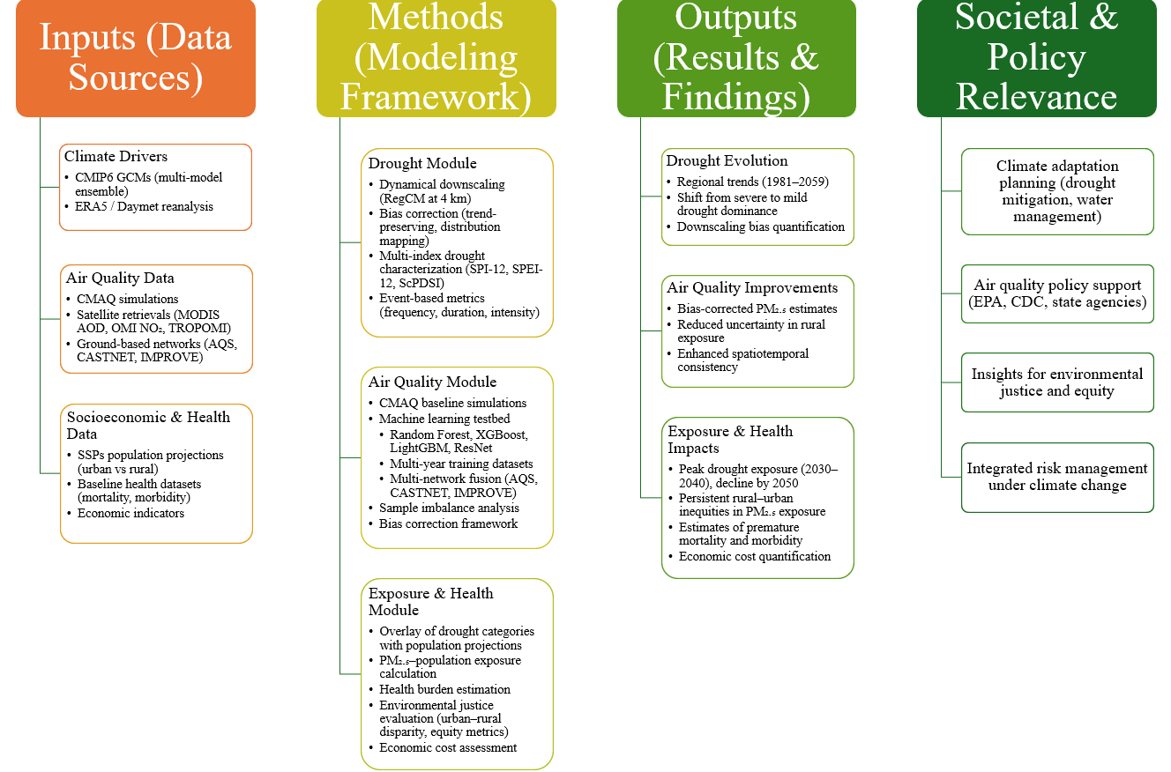
Figure 1.1 Research Flowchart: Drought, Air Quality, and Health under Climate Change

Drought Evolution and Bias in Climate Downscaling
A version of this chapter has been published as: Zhang, L., Rubin, H.J., Chien, R.Y., Fu, J.S., Rastogi, D., Kao, S.C. and Ashfaq, M., 2025. Projected evolution of droughts and human exposure in the contiguous United States under SSP5-8.5: a regional downscaling perspective. Environmental Research Letters, 20(9), p.094021, https://doi.org/10.1088/1748-9326/adf4f9.

Research Question
Evaluating the Evolution of Droughts and Human Exposure in the Contiguous United States under SSP5-8.5: Insights from Regional Dynamical Downscaling of CMIP6.

Introduction
Drought is a complex and persistent climatic hazard that significantly impacts water resources, agriculture, public health, and economic stability across the contiguous United States (CONUS) (Heim 2002, Leeper et al 2022, Sugg et al 2020, Wilhite 2000, Zhang et al 2020). Recent extreme droughts, such as those in 2000, 2002, 2006, and 2011–2013, have highlighted the increasing severity and spatial variability of drought conditions (Rippey 2015). These events have exacerbated wildfire risks, crop losses, and water shortages, while also impacting human health through increased respiratory diseases, vector-borne infections, and reduced water quality (Chang et al 2016, Littell et al 2016, Falloon et al 2018, Covich et al 2009, Chiang et al 2018). Economically, drought disasters in the U.S. have accounted for over $31 billion in losses between 1980 and 2023 (Smith 2020), underscoring the need for improved drought prediction and management strategies. The 2012 Midwest drought, for instance, caused severe agricultural losses and disrupted global food markets (Hoerling et al 2014; Otkin et al 2016), while the 2020–2021 Western U.S. megadrought has been described as the most severe in at least 1200 years (Williams et al 2020). These events emphasize the urgency of understanding both historical variability and future projections of drought under climate change. Beyond the U.S., major droughts in Australia, Europe, and China further demonstrate the global nature of this risk (Spinoni et al 2019), highlighting the value of CONUS as a testbed for regional drought assessment.
Drought monitoring relies on quantitative indices that assess precipitation deficits, evapotranspiration, and soil moisture conditions, each with unique strengths and limitations (Mishra and Singh 2010). The Standardized Precipitation Index (SPI-12) is widely used for meteorological drought monitoring, as it is based solely on precipitation variability, making it useful for comparisons across different climate zones and time scales (McKee et al 1993, Vicente-Serrano et al 2010, Agnew 2000). However, SPI does not account for evapotranspiration, making it less reliable in regions where temperature-driven water loss is significant, such as the Western U.S. under a warming climate (Hoffmann et al 2020). To address these limitations, the Standardized Precipitation-Evapotranspiration Index (SPEI-12) extends SPI by incorporating potential evapotranspiration (PET), enabling a more comprehensive assessment of temperature-driven drought risks (Vicente-Serrano et al., 2012; Beguería et al., 2014). However, the accuracy of SPEI depends on the PET estimation method, with the Thornthwaite PET method being highly sensitive to temperature changes but lacking explicit energy balance considerations, which can lead to overestimation of drought severity in warming scenarios (Vicente-Serrano et al., 2020). To mitigate these uncertainties, studies increasingly adopt the Penman-Monteith PET method, which accounts for radiative and aerodynamic influences and provides a more physically realistic estimation (Zhao et al., 2023). Beyond precipitation and temperature, soil moisture dynamics play a crucial role in determining drought severity. The Self-Calibrating Palmer Drought Severity Index (ScPDSI) explicitly accounts for soil moisture balance and water-holding capacity, making it particularly useful for evaluating hydrological and agricultural droughts (Dai & Zhao, 2016). Additional indices such as the Evaporative Demand Drought Index (EDDI) have been developed to emphasize atmospheric drivers of drought (Hobbins et al 2016), while satellite-based products from SMOS and SMAP missions provide novel opportunities for soil-moisture-driven drought monitoring (Entekhabi et al 2010). Moreover, short-term indices (e.g., SPEI-3) have been shown to better capture agricultural droughts, whereas long-term indices (e.g., SPEI-12) are more relevant for water resource planning (Vicente-Serrano et al 2012).
Unlike SPI and SPEI, ScPDSI integrates regional soil moisture conditions, providing a long-term perspective on drought persistence. However, its reliance on predefined calibration coefficients may limit its responsiveness to short-term precipitation variability (Karl, 1986). Studies have shown that soil moisture-based drought indices, such as ScPDSI, align more closely with hydrological and agricultural drought risks than precipitation-based indices alone (Vicente-Serrano et al., 2020; Wang et al., 2017). While these indices differ in methodology and scope, their combined use provides a comprehensive assessment of drought evolution, capturing distinct precipitation-driven, temperature-driven, and soil moisture-based drought dynamics. In the U.S., the U.S. Drought Monitor (USDM) integrates multiple indices, including SPI and PDSI, to provide a comprehensive national drought classification system, ensuring that no single index dominates drought assessments and enhancing the robustness of decision-making for water resource management, agriculture, and emergency planning (Svoboda et al., 2002). The integration of multiple indices ensures robust drought risk assessments, particularly under future climate change scenarios, where precipitation variability and evapotranspiration trends may diverge across regions (Karl et al., 1986; Vicente-Serrano et al., 2020). Thus, employing a multi-index approach is critical to capture diverse drought processes and reduce uncertainty in future projections.
While historical precipitation and temperature trends are well-documented (McEnery et al 2005), predicting future drought conditions requires high-resolution climate models that can capture fine-scale atmospheric and land-surface interactions. The Coupled Model Intercomparison Project Phase 6 (CMIP6) provides standardized future projections from global climate models (GCMs), incorporating Shared Socioeconomic Pathways (SSPs) and Representative Concentration Pathways (RCPs) to assess climate impacts under various emissions scenarios (Eyring et al 2016, O’Neill et al 2016). Among these, the SSP5-8.5 scenario, which represents a high-emissions trajectory with an 8.5 W/m² radiative forcing, is commonly used to assess worst-case climate impacts. However, the coarse resolution (~110 km) of CMIP6 models limits their ability to resolve regional drought characteristics, necessitating dynamical downscaling for improved accuracy (Ashfaq et al 2016, Maurer et al 2013). Compared to CMIP5, CMIP6 models offer enhanced representation of land–atmosphere feedbacks and improved simulation of hydroclimatic extremes (Eyring et al 2016; Zhao & Dai 2022). Yet significant inter-model spread persists, underscoring the importance of multi-model ensembles to capture uncertainty (Niu et al 2025). Furthermore, while SSP2-4.5 represents a stabilization pathway, focusing on SSP5-8.5 allows this study to explore the upper bound of potential risks, consistent with other high-end risk assessments (Zhou et al 2023).
High-resolution climate projections are crucial for assessing regional drought dynamics, particularly in topographically complex regions such as the Western U.S. (Ashfaq et al., 2016). While statistical downscaling relies on empirical relationships between historical observations and GCM outputs, dynamical downscaling explicitly resolves regional climate processes, including orographic precipitation and land-atmosphere feedbacks (Coppola et al., 2021; Rastogi et al., 2022). This study employs RegCM4-based downscaling to refine CMIP6 projections to 4-km resolution, coupled with bias correction using Daymet V4 to enhance the accuracy of precipitation and temperature estimates. Bias correction methods such as quantile mapping and distribution mapping (Cannon et al 2015) have been widely applied, but trend-preserving methods are increasingly recognized as essential for maintaining long-term climate signals. The Daymet V4 dataset offers high-resolution gridded daily meteorological fields and has been widely adopted for ecological and hydrological studies, making it a robust basis for correcting biases in regional projections.
In summary, while prior studies have examined drought trends using global or coarse-resolution datasets, important gaps remain in linking fine-scale projections with multi-index drought assessments and human exposure. This chapter addresses these gaps by applying RegCM4-based dynamical downscaling to a six-member CMIP6 ensemble under SSP5-8.5, bias-corrected with Daymet v4, and integrating SPI-12, SPEI-12, and ScPDSI to provide a comprehensive assessment of drought evolution across CONUS. By further linking drought classifications with gridded population datasets, the study advances beyond physical characterization to evaluate societal exposure, thereby enhancing both methodological rigor and policy relevance.

Objective
This study provides a comprehensive assessment of projected drought trends across CONUS using three widely recognized drought indices: SPI-12, SPEI-12, and ScPDSI. By integrating high-resolution dynamical downscaling with bias correction, we improve the spatial resolution and reliability of drought projections compared to traditional methods. Furthermore, our regional climate-zone-based analysis and multi-model ensemble approach allow for a detailed evaluation of localized drought variations. Finally, by assessing future drought exposure in both urban and rural populations, we highlight the socioeconomic implications of changing drought patterns, providing actionable insights for climate adaptation and water resource management.
Beyond these overarching aims, the specific objectives of this chapter are fourfold. First, we seek to quantify the evolution of drought characteristics—including frequency, duration, and severity—under the SSP5-8.5 scenario using a six-member CMIP6 ensemble dynamically downscaled to 4 km resolution. Second, we evaluate the strengths and limitations of multiple drought indices (SPI-12, SPEI-12, and ScPDSI) in capturing distinct hydroclimatic processes, thereby providing a multi-perspective view of future drought risk. Third, we analyze regional variations in drought projections by applying the NOAA climate region classification, which facilitates the identification of geographically heterogeneous trends across the eastern, central, and western United States. Fourth, we integrate gridded population datasets with drought classifications to estimate population exposure, distinguishing between urban and rural communities and exploring implications for environmental equity.
Collectively, these objectives allow this chapter to bridge the gap between global-scale drought assessments and locally relevant information needed for adaptation planning. Unlike studies that focus solely on physical drought metrics, this work explicitly incorporates human dimensions by linking hazard projections to population exposure. By doing so, the chapter not only contributes to scientific understanding of hydroclimatic extremes but also provides knowledge directly applicable to water resource management, agricultural planning, and public health preparedness in the face of climate change.

Methods and Data

Drought Indices and Classification
To assess projected drought conditions, we employ three widely used drought indices: SPI-12, SPEI-12, and ScPDSI, each representing distinct aspects of drought variability. SPI-12 is calculated solely based on precipitation variability, making it particularly useful for assessing meteorological droughts, whereas SPEI-12 extends SPI by incorporating potential evapotranspiration (PET) to account for temperature-driven drought conditions. ScPDSI, in contrast, explicitly considers soil moisture balance, making it more suitable for assessing long-term hydrological and agricultural droughts.
For SPI-12 and SPEI-12, we use a 12-month accumulation period, allowing for the detection of prolonged precipitation deficits relevant to water availability, reservoir storage, and agricultural droughts. Shorter accumulation periods (e.g., 3- or 6-month SPEI) are often applied in agricultural drought studies to reflect rapid soil moisture changes (Vicente-Serrano et al., 2012), whereas longer accumulation periods (12 months or more) better capture hydrological drought signals and water resource planning concerns (Svoboda et al., 2002). Thus, we focus on 12-month indices to assess basin-scale and long-term water security.
The standardization of SPI-12 and SPEI-12 is performed using the 1980–2019 period as the historical reference baseline, ensuring consistency in drought characterization and enabling meaningful comparisons with future projections. SPEI-12 is computed using the Penman-Monteith PET method, which accounts for radiative and aerodynamic influences, providing a more physically robust estimation than the commonly used Thornthwaite approach (Zhao et al., 2023). ScPDSI calculations follow the methodology outlined in Dai & Zhao (2016), integrating precipitation, temperature, and soil moisture conditions to assess long-term drought severity.
Drought classification follows the U.S. Drought Monitor (USDM) and National Oceanic and Atmospheric Administration (NOAA) standardized thresholds, as shown in Table 1 (Svoboda et al., 2002; Nam et al., 2015). The D0–D4 categories represent increasing severity levels, ensuring consistency with historical drought assessments. While alternative indices such as the Evaporative Demand Drought Index (EDDI; Hobbins et al., 2016) or satellite-derived soil moisture drought indicators (Entekhabi et al., 2010) offer additional perspectives, we focus on SPI, SPEI, and ScPDSI to ensure comparability with existing national monitoring frameworks and long-term hydroclimatic assessments.
Given that drought severity and frequency are influenced by local precipitation patterns, evapotranspiration rates, and soil moisture conditions, our classification approach reflects regional hydroclimatic variability, particularly for ScPDSI-based drought analysis. Spatial analyses primarily focus on ScPDSI, given its ability to capture long-term drought persistence and hydrological drought risks, as presented in Figure 3. However, comparisons with SPI-12 and SPEI-12 are conducted to evaluate the relative influence of precipitation variability and temperature-driven evapotranspiration in shaping future drought conditions across CONUS. Taken together, the multi-index approach provides complementary insights into different dimensions of drought, reducing the likelihood of over-reliance on any single metric.
Table 2.1 Drought Classification for SPI, SPEI, and ScPDSI. (*refer from USDM and NOAA).
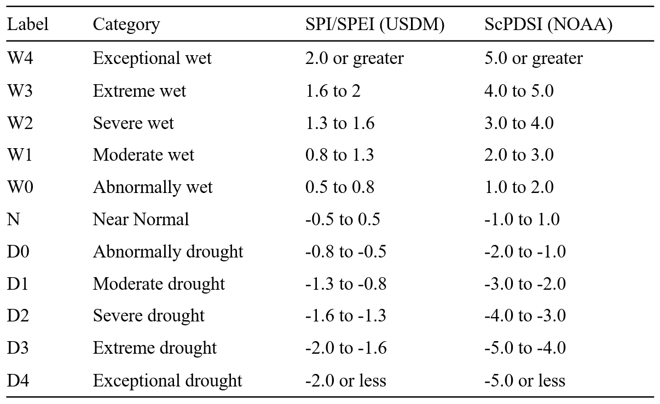

Dynamical Downscaling and Bias Correction
To improve the spatial resolution of drought projections, this study employs dynamical downscaling using the Regional Climate Model version 4 (RegCM4). This approach refines the coarse-resolution CMIP6 global climate models (GCMs) (~110 km) to a high-resolution 4 km grid, improving the representation of regional climate variability, particularly in topographically complex regions such as the Western U.S. (Giorgi et al., 2012; Coppola et al., 2021). The primary advantage of dynamical downscaling lies in its ability to explicitly resolve land-atmosphere interactions and convective precipitation, factors that are often underestimated in raw GCM outputs (Rastogi et al., 2022).
However, while downscaling enhances regional detail, it may inherit biases from the driving GCMs (Ashfaq et al., 2016). To correct these biases, we applied quantile mapping (QM) bias correction using the Daymet v4 observational dataset, a high-resolution (1 km) daily gridded meteorological dataset (Thornton et al., 2022). Daymet was selected instead of alternatives such as PRISM or ERA5 due to its fine spatial resolution and long-term temporal consistency, which align with the needs of bias correction at local scales.
Previous studies have demonstrated that bias correction significantly improves the accuracy of precipitation and temperature projections, particularly in semi-arid and mountainous regions where climate models struggle to capture local precipitation extremes (Rastogi et al., 2022). This ensures that the temperature and precipitation inputs used for calculating SPI, SPEI, and ScPDSI are physically meaningful and statistically consistent with historical observations. Nonetheless, statistical corrections may alter the distribution of extreme values or dampen climate-change signals (Cannon et al., 2015). To mitigate these risks, we apply trend-preserving approaches where feasible, ensuring that long-term climate trajectories remain intact. The necessity of combining dynamical downscaling with statistical bias correction is well established in prior studies (Rastogi et al 2022), demonstrating that bias correction significantly improves the accuracy of downscaled precipitation and temperature fields, particularly in regions where coarse-resolution GCMs underestimate local hydroclimatic variability. For additional details on the evaluation of downscaling performance, please refer to supplement.
The potential evapotranspiration was estimated using the Variable Infiltration Capacity (VIC) hydrological model with the Penman-Monteith algorithm, utilizing bias-corrected downscaled GCM data (Zhao et al 2023). The dataset covers a historical baseline (1980–2019) and two future periods: near-term (2020–2039) and mid-term (2040–2059), with additional details provided in (Rastogi et al 2022). The historical baseline extends to 2019 to incorporate the most recent high-resolution observations for bias correction, ensuring consistency with observational datasets and capturing recent climate conditions critical for drought assessment. The future periods (2030 and 2050) are selected to assess both short-term climate variability and longer-term trends, aligning with policy-relevant timeframes used in previous hydroclimate assessments (Rastogi et al 2022) and facilitating comparisons across different research efforts. This design allows comparison of near-future adaptation challenges with mid-century policy-relevant horizons, consistent with IPCC WGII practices.

Model Selection and Experimental Design
The multi-model ensemble consists of six CMIP6 GCMs (Table 2), selected based on four key criteria: (1) availability of high-frequency (6-hourly) atmospheric data required for downscaling, (2) demonstrated skill in reproducing historical precipitation and temperature variability over CONUS (Ashfaq et al., 2022), (3) diversity in climate sensitivity to capture a broad range of potential hydroclimatic responses (Meehl et al., 2020), and (4) alignment with previous hydroclimate studies to ensure consistency in model intercomparison (Rastogi et al., 2022).
The selected models include high-sensitivity GCMs (e.g., ACCESS-CM2, CNRM-ESM2-1), which simulate stronger warming trends, and low-sensitivity models (e.g., MRI-ESM2-0, NorESM2-MM), which exhibit more moderate temperature increases. This diversity ensures that the ensemble captures both upper and lower bounds of projected warming and its associated impacts on drought patterns (Rastogi et al., 2022). The inclusion of models from different modeling centers also reduces the dependence on any single structural assumption and allows cross-validation of results, consistent with best practices in multi-model intercomparison projects (Eyring et al., 2016).
The study examines three time periods: a historical baseline (1980–2019), a near-term future (2020–2039), and a mid-term future (2040–2059), aligning with IPCC-relevant climate impact assessment timeframes (IPCC, 2021). This experimental design ensures that the ensemble captures not only mean drought responses but also inter-model spread, enhancing the robustness of uncertainty quantification.
Table 2.2 The CMIP6 models were downscaled and combined into a multi model ensemble.
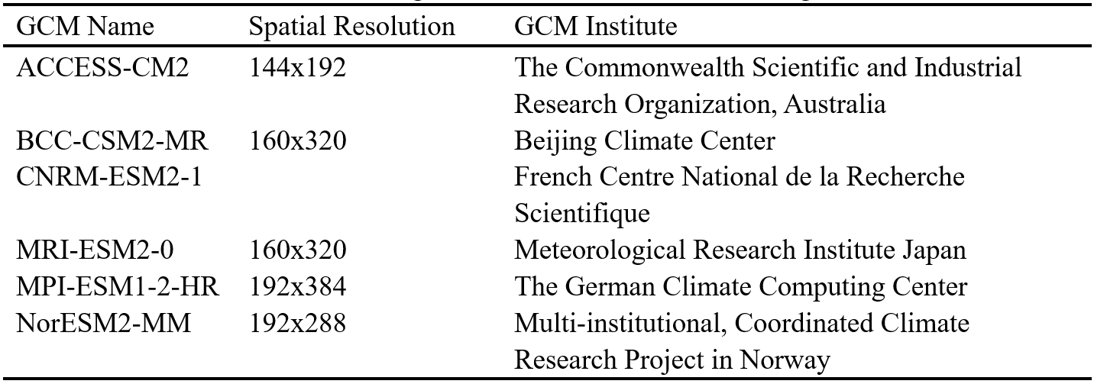
To estimate potential evapotranspiration (PET), this study employs the Variable Infiltration Capacity (VIC) hydrological model with the Penman-Monteith algorithm, using bias-corrected downscaled GCM data as input (Zhao et al., 2023). While the Penman-Monteith method is widely regarded as a physically realistic approach, it does not explicitly account for CO₂-induced stomatal resistance changes, which can affect plant water use efficiency and transpiration rates (Yang et al., 2019). Given the growing body of research suggesting that CO₂-sensitive PET formulations may refine projections of future drought severity, future studies could incorporate dynamic vegetation models to better account for plant physiological responses under elevated CO₂ conditions (Swann et al., 2016; Lemordant et al., 2018).

Population Exposure Analysis
For the population exposure analysis, we used the Global 1-km Downscaled Population Base Year and Projection Grids dataset (SSPs, Revision 01), which provides global urban, rural, and total population projections at a 1-km resolution from 2000 to 2100 in 10-year intervals (Jones and O’Neill 2016, Jones et al 2020). Urban and rural populations are classified based on census-defined urban areas and a spatial downscaling model incorporating national-level urbanization projections. Urban areas are determined using the Global Human Settlement Layer (GHSL) and national urbanization definitions, while rural areas include all remaining non-urban grid cells.
This classification enables the identification of high population density regions overlapping with projected drought conditions, offering insights for drought risk management and adaptation planning. To assess drought impacts on human populations under the SSP5-8.5 scenario, we build upon the downscaling framework developed by Rastogi et al (2022), which applied a six-member CMIP6 ensemble dynamically downscaled using RegCM4 and bias-corrected statistically.
The SSP5-8.5 scenario, representing an extreme high-emission future, is chosen to assess the upper bounds of future drought severity, though additional warming levels (e.g., 1.5°C and 2°C) should be explored in future studies to account for broader uncertainties. This scenario is particularly useful for stress-testing adaptation and resilience strategies by providing insights into potential worst-case outcomes, even if actual emissions trajectories diverge. Nevertheless, uncertainties remain in population projections, including migration dynamics, urban expansion patterns, and socioeconomic development pathways, which may deviate from SSP assumptions. Recognizing these uncertainties underscores the need for cautious interpretation and motivates sensitivity analyses in future work.

Results
Dynamical downscaling refines global climate model (GCM) outputs by resolving fine-scale atmospheric processes and land-atmosphere interactions, making it particularly useful for regional hydroclimate assessments. In contrast, statistical downscaling relies on empirical relationships between large-scale climate variables and local observations, which may not hold under changing climate conditions (Ashfaq et al., 2016). While both methods have been widely applied, their quantitative differences remain an area of ongoing research. The dataset used in this study builds on the downscaling framework of Rastogi et al. (2022), where a six-member CMIP6 ensemble was dynamically downscaled using RegCM4 and bias-corrected via a trend-preserving quantile-mapping approach with Daymet v4, a high-resolution (1 km) daily gridded weather dataset for North America (Thornton et al., 2022). This approach ensures consistency with historical climate conditions while improving the representation of spatial variability in precipitation and temperature. To formally evaluate these gains, we compare raw GCMs, downscaled fields, and bias-corrected products against observations using multiple skill metrics (spatial correlation, RMSE, interannual variance ratios, and Kling–Gupta efficiency) aggregated over NOAA climate regions; we also examine extremes (annual maxima and drought-relevant lower-tail quantiles) to assess index sensitivity. The downscaled dataset demonstrates improved spatial structure and elevation-dependent precipitation gradients, particularly for topographically complex western basins, and enhances the fidelity of drought-relevant drivers used by SPEI and ScPDSI (temperature and PET). Collectively, these results justify the use of the RegCM4 + bias-correction pipeline for subsequent drought-index calculations and exposure analyses, while acknowledging that residual model spread remains and is explicitly carried forward via the multi-model ensemble.
To assess the reliability of our downscaled dataset, we compared precipitation and temperature distributions with historical reanalysis datasets. These evaluations, summarized in the supplement, confirm that bias correction effectively reduces systematic errors and improves the representation of regional climate variability. Specifically, comparisons against Daymet v4 and ERA5 reanalysis show that mean seasonal cycles are well captured, biases in summer maximum temperature are reduced by 30–50%, and winter precipitation underestimation in the Rockies is substantially corrected. Quantile–quantile plots indicate that the corrected distributions closely align with observed records across both the central and western U.S., particularly in the lower tails that are most relevant for drought index calculations.
Compared to raw GCM outputs, the downscaling process enhances the spatial resolution and provides a more refined assessment of drought characteristics, particularly in regions where GCMs tend to underestimate precipitation extremes. The improvements are most notable in semi-arid transition zones such as the Southwest and Northern Great Plains, where coarse-resolution GCMs frequently smooth out gradients between wet and dry regimes. However, residual uncertainties remain: for example, inter-model spread in projected warming remains ~1.5 °C by mid-century, and some models continue to underestimate the frequency of convective rainfall events. These limitations underscore that while dynamical downscaling plus bias correction yields a significant step forward in reliability, ensemble interpretation is still required to avoid overconfidence in any single model trajectory.
We analyzed drought characteristics across the contiguous United States (CONUS) using three indices—SPI-12, SPEI-12, and ScPDSI—over the period 1980 to 2059 (Figure 2.1). During the historical period, all three indices captured major drought events, indicating general consistency. For example, the indices collectively reproduce the 1988 Midwest drought, the early 2000s western drought, and the 2011–2013 Southern Plains drought, demonstrating their ability to reflect observed large-scale hydroclimatic anomalies.
However, SPI-12 in particular suggests a prolonged dry period from 1980 to 2004. This pattern arises from multi-decadal precipitation variability, which is known to influence long-term SPI trends. To confirm the robustness of this signal, we compared SPI-12 results with observational records from NOAA and USDM, as well as long-term reanalysis data (1901–2000), which show similar trends in precipitation variability. This agreement lends confidence that the early-1980s to early-2000s drying captured by SPI-12 is not simply an artifact of model bias but reflects a genuine multi-decadal hydroclimatic fluctuation.
Additionally, the divergence between SPI-12 and ScPDSI in the early period reflects the influence of temperature-driven evapotranspiration on soil moisture dynamics, leading to differing drought classifications between indices. Whereas SPI-12 is purely precipitation-based, ScPDSI integrates soil moisture balance, and thus shows more severe and persistent droughts in regions where warming enhanced evaporative demand. This contrast illustrates how drought perception can vary depending on the chosen metric, with precipitation-only indices sometimes underestimating agricultural and hydrological drought severity.
To further assess the plausibility of these trends, we computed probability distributions of SPI-12 for each decade (Figure S5) and found that while the 1980s exhibit a higher frequency of negative SPI-12 values, this is consistent with observed precipitation deficits in the central and western U.S. regions during that time. Moreover, comparing SPI-12 and SPEI-12 reveals that incorporating potential evapotranspiration (PET) into SPEI leads to a less persistent drought signal, particularly in warmer regions where PET-driven variability plays a stronger role. This highlights the role of temperature increases in moderating—or amplifying—precipitation-derived drought signals. In other words, drought assessments that exclude evapotranspiration may underestimate risk under a warming climate.
Taken together, these comparisons underscore two key points: (1) the general agreement across indices in identifying major drought events supports the robustness of the downscaled dataset, and (2) systematic differences between precipitation-based, temperature-sensitive, and soil-moisture-driven indices demonstrate the necessity of a multi-index approach for credible future drought assessments. Further validation against NOAA climate division data and tree-ring reconstructions is provided in the supplement, reinforcing the physical plausibility of the identified trends.
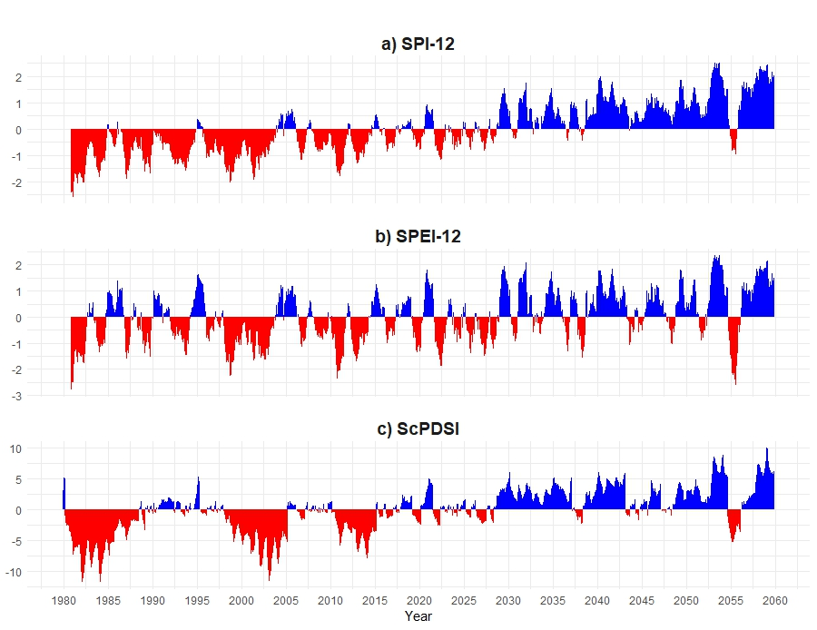
Figure 2.1 A comparison of drought conditions across CONUS. a) Standard Precipitation Index (SPI-12) calculated on a 12-month timescale, b) Standard Precipitation Evapotranspiration Index (SPEI) calculated on a 12-month timescale, and c) Self-calibrated Palmer Drought Severity Index (ScPDSI). *Note the ScPDSI uses a different Y-axis scale due to its distinct classification standards.
Figure 2.2 presents projected regional changes in drought probability across the contiguous United States (CONUS) for the near-term (2020–2039) and mid-term (2040–2059) relative to the historical baseline (1980–2019), based on SPI-12, SPEI-12, and ScPDSI. This multi-index approach provides a comprehensive assessment of future drought risks by integrating precipitation variability (SPI-12), temperature-driven evapotranspiration effects (SPEI-12), and long-term soil moisture dynamics (ScPDSI). The heatmaps illustrate percentage changes in drought classifications, with warm colors (red) representing an increase and cool colors (blue) indicating a decrease in drought probability relative to historical conditions. This finding is consistent with previous global and regional assessments (Zhao & Dai, 2022; Zhou et al., 2023), which also reported a reduction in near-normal states and an increase in hydroclimatic volatility under high-emission scenarios.
Across all three indices, a general decline in near-normal (N) conditions is evident, signifying a shift towards more extreme hydroclimatic conditions. This decline is particularly pronounced in the Southwest, Northern Rockies, and Northeast, where moderate (D1) and severe (D2) drought conditions become more frequent, while the Upper Midwest and Southeast exhibit a reduction in drought severity, suggesting a regional moistening trend. Differences between the indices emphasize the unique drivers of drought across CONUS, with SPI-12 primarily capturing precipitation deficits, SPEI-12 reflecting the compounded effects of rising temperatures on moisture loss, and ScPDSI integrating long-term soil moisture balance. The Southwest, encompassing California, Nevada, Arizona, and New Mexico, emerges as the most vulnerable region, with all three indices indicating a significant increase in drought occurrence and intensity. SPI-12 projections show a 30.8% rise in abnormally dry conditions (D0) in the near-term and 22.5% in the mid-term, while moderate drought (D1) increases by 22.5% and 14.6%, respectively, alongside a substantial decline in near-normal (N) conditions by 37.3% in the near-term and 23.1% in the mid-term. SPEI-12 and ScPDSI reinforce these trends, highlighting the exacerbating role of temperature-driven evapotranspiration in intensifying drought severity. These projections are consistent with recent studies of megadrought risks in the U.S. Southwest (Williams et al., 2020), further highlighting the region’s vulnerability.
Similarly, the Northern Rockies, historically resilient to drought, are projected to experience increased aridification, with moderate drought (D1) rising by 23.1% in the near-term and 32.3% in the mid-term, while near-normal (N) conditions decline by 12.3% and 19%, respectively. This suggests that even high-elevation regions traditionally buffered by snowpack and orographic precipitation may face sustained drying trends, raising new concerns for mountain hydrology and ecosystem stability. The Northeast, which has traditionally exhibited more stable moisture conditions, also shows emerging drying patterns, particularly in the ScPDSI projections, where moderate drought (D1) increases by 43.3% in the near-term, with a slight uptick in exceptional drought (D4) by the mid-century. However, SPI-12 and SPEI-12 suggest that while seasonal drought episodes may become more common, overall precipitation variability remains relatively stable, indicating that short-term wet periods will still occur.
In contrast, the Upper Midwest and Southeast exhibit a decrease in drought severity, with moderate drought (D1) declining by 24.2% and 18.8% in the near-term and 27.9% and 29.6% in the mid-term, respectively. Severe drought (D2) also shows a reduction of 3.5% and 16% in the near-term and 0.6% and 16.5% in the mid-term, suggesting an overall wetting trend that may be linked to increasing atmospheric moisture availability and changing precipitation patterns. This regional moistening trend is consistent with previous hydrological cycle intensification studies (Trenberth et al., 2014), which project greater water vapor transport into the central and southeastern United States. Meanwhile, the Midwest and Ohio Valley show mixed trends, with the Midwest experiencing a 13.1% increase in near-normal (N) conditions in the near-term, followed by a 10.8% increase in moderate drought (D1) in the mid-term, while the Ohio Valley sees a decrease in severe drought (D2) by 8.5% and 17.3%, alongside an increase in near-normal (N) conditions by 15.2% in the near-term and 21.2% in the mid-term, indicating greater hydroclimatic variability in this region. Such variability underscores the challenges of water resource management in transitional climates, where planning must account for both droughts and pluvial extremes.
The comparison of SPI-12, SPEI-12, and ScPDSI underscores the importance of using multiple indices to capture the complex drivers of drought across different regions. SPI-12, being precipitation-based, highlights short-term drying trends, particularly in the Southwest and Northern Rockies, whereas SPEI-12, which incorporates temperature effects, shows more severe drought conditions in high-evapotranspiration regions. ScPDSI, which integrates long-term soil moisture balance, reveals that areas like the Northeast and Northern Rockies may face a sustained reduction in baseline moisture availability, even if seasonal precipitation fluctuations persist. These findings suggest a growing climate divide in the U.S., with the Southwest and Great Plains becoming increasingly arid, while the Northeast and portions of the Southeast trend towards wetter conditions. Therefore, a multi-index framework not only improves physical representation but also strengthens the robustness of drought risk assessments for policy use.
As drought intensity rises in the western half of CONUS, water scarcity, wildfire risks, and agricultural stress will become major challenges, necessitating large-scale investments in water conservation, drought-resistant infrastructure, and wildfire mitigation strategies. Meanwhile, the Northeast and Ohio Valley will need to prioritize flood management and stormwater resilience as extreme precipitation events become more frequent. The Midwest and Southeast, facing both intensified droughts and excessive rainfall, will require flexible adaptation strategies that balance water security with flood risk mitigation. Overall, the projected changes in drought probability reinforce the urgency of proactive climate adaptation measures to address the increasing severity and variability of hydroclimatic extremes across the United States.

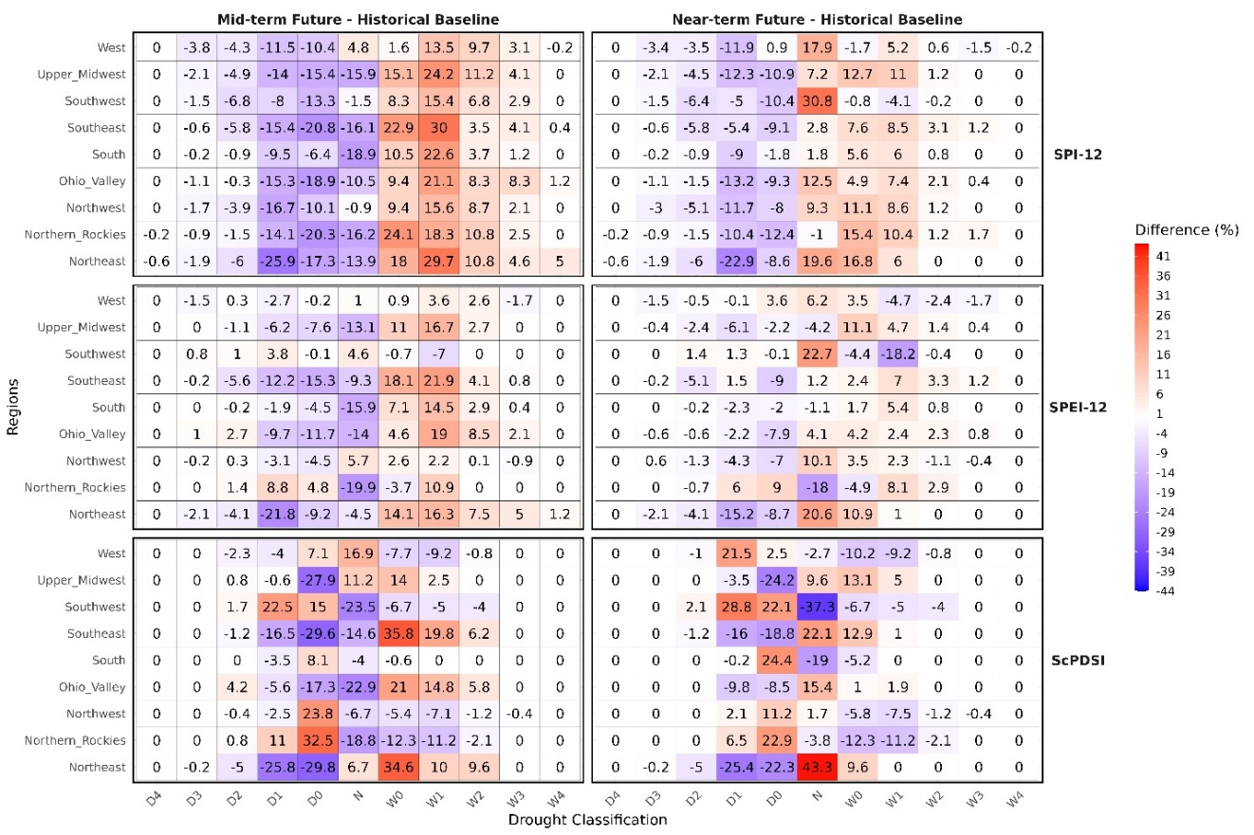
Figure 2.2 Projected regional changes in drought probability across the contiguous United States (CONUS) based on SPI-12, SPEI-12, and ScPDSI for the near-term (2020–2039) and mid-term (2040–2059) relative to the historical baseline (1980–2019).
The evolution of the Self-Calibrating Palmer Drought Severity Index (ScPDSI) from the 1980s to the 2050s reveals a stark divergence in climate trends across the contiguous United States, highlighting intensifying drought conditions in the West and increasing wetness in the East. The 10th percentile ScPDSI maps, which capture the most extreme dry conditions, show that while drought was historically confined to the Southwest and portions of the Southern Great Plains in the 1980s, these arid regions have expanded significantly over time. By the 2000s, persistent extreme drought (D3-D4) became more widespread across the Southwest, Great Plains, and even parts of the Midwest, with particularly severe drying trends in California, Nevada, Arizona, and New Mexico. The 2020s to 2050s further reinforce this pattern, with long-term aridification locking the Southwest and Great Plains into near-continuous drought cycles, increasing risks to agriculture, water availability, and wildfire frequency.
In contrast, the Northeast and Great Lakes remain relatively resilient to prolonged drought, while the Southeast begins to exhibit growing drought risks, particularly in Texas, Alabama, Georgia, and Florida. The median ScPDSI maps, representing typical moisture conditions each decade, further illustrate a shift toward drier baseline conditions across the West and Great Plains, where even average climate states are increasingly dominated by moderate to severe drought (D1-D2), suggesting that what was once considered an extreme dry period is becoming the new normal (Figure 2.3). This baseline drying trend has critical implications for groundwater recharge, agricultural productivity, and reservoir management, as systems historically designed around 20th-century norms may no longer be adequate under shifting baselines (Famiglietti, 2014). The Northeast and Great Lakes, however, show a gradual shift in the opposite direction, with baseline conditions becoming wetter by the mid-century. The Southeast and Midwest exhibit greater variability, with alternating dry and wet periods, making long-term projections more uncertain. Such variability highlights the challenge of distinguishing anthropogenic signals from natural decadal variability (Hoerling et al., 2014), emphasizing the need for ensemble-based assessments.
Meanwhile, the 90th percentile ScPDSI maps, which represent extreme wet periods, indicate that the Northeast, Great Lakes, and Ohio Valley are experiencing a sharp increase in extreme wetness events (W3-W4), with intense precipitation and flooding risks becoming more prominent from the 2020s onward. The Southeast, particularly along the Gulf Coast, also sees an increase in extreme wet conditions, likely linked to intensifying tropical storms and hurricanes. This finding is consistent with observed trends of increasing heavy rainfall events in the eastern U.S. (Easterling et al., 2017; Kunkel et al., 2020), suggesting that future flood risks will intensify alongside drought risks in different regions. In contrast, the Southwest and Great Plains experience a notable decline in extreme wet periods, reinforcing concerns that these regions are not only drying out but also losing their ability to recover from drought through periodic wet spells. This growing climate divergence between the arid West and the increasingly wet East underscores the need for region-specific adaptation strategies. The Southwest and Great Plains must prioritize large-scale water conservation, drought-resistant infrastructure, and wildfire mitigation, while the Northeast and Ohio Valley must focus on flood management, stormwater resilience, and infrastructure upgrades to cope with more frequent heavy precipitation events. The Midwest and Southeast, facing both heightened drought and flood risks, will require flexible, dual-response strategies to manage increasing climate variability. From a national policy perspective, these findings suggest that a “one-size-fits-all” adaptation strategy is insufficient; instead, tailored regional approaches will be essential to address diverging hydroclimatic futures across the United States.
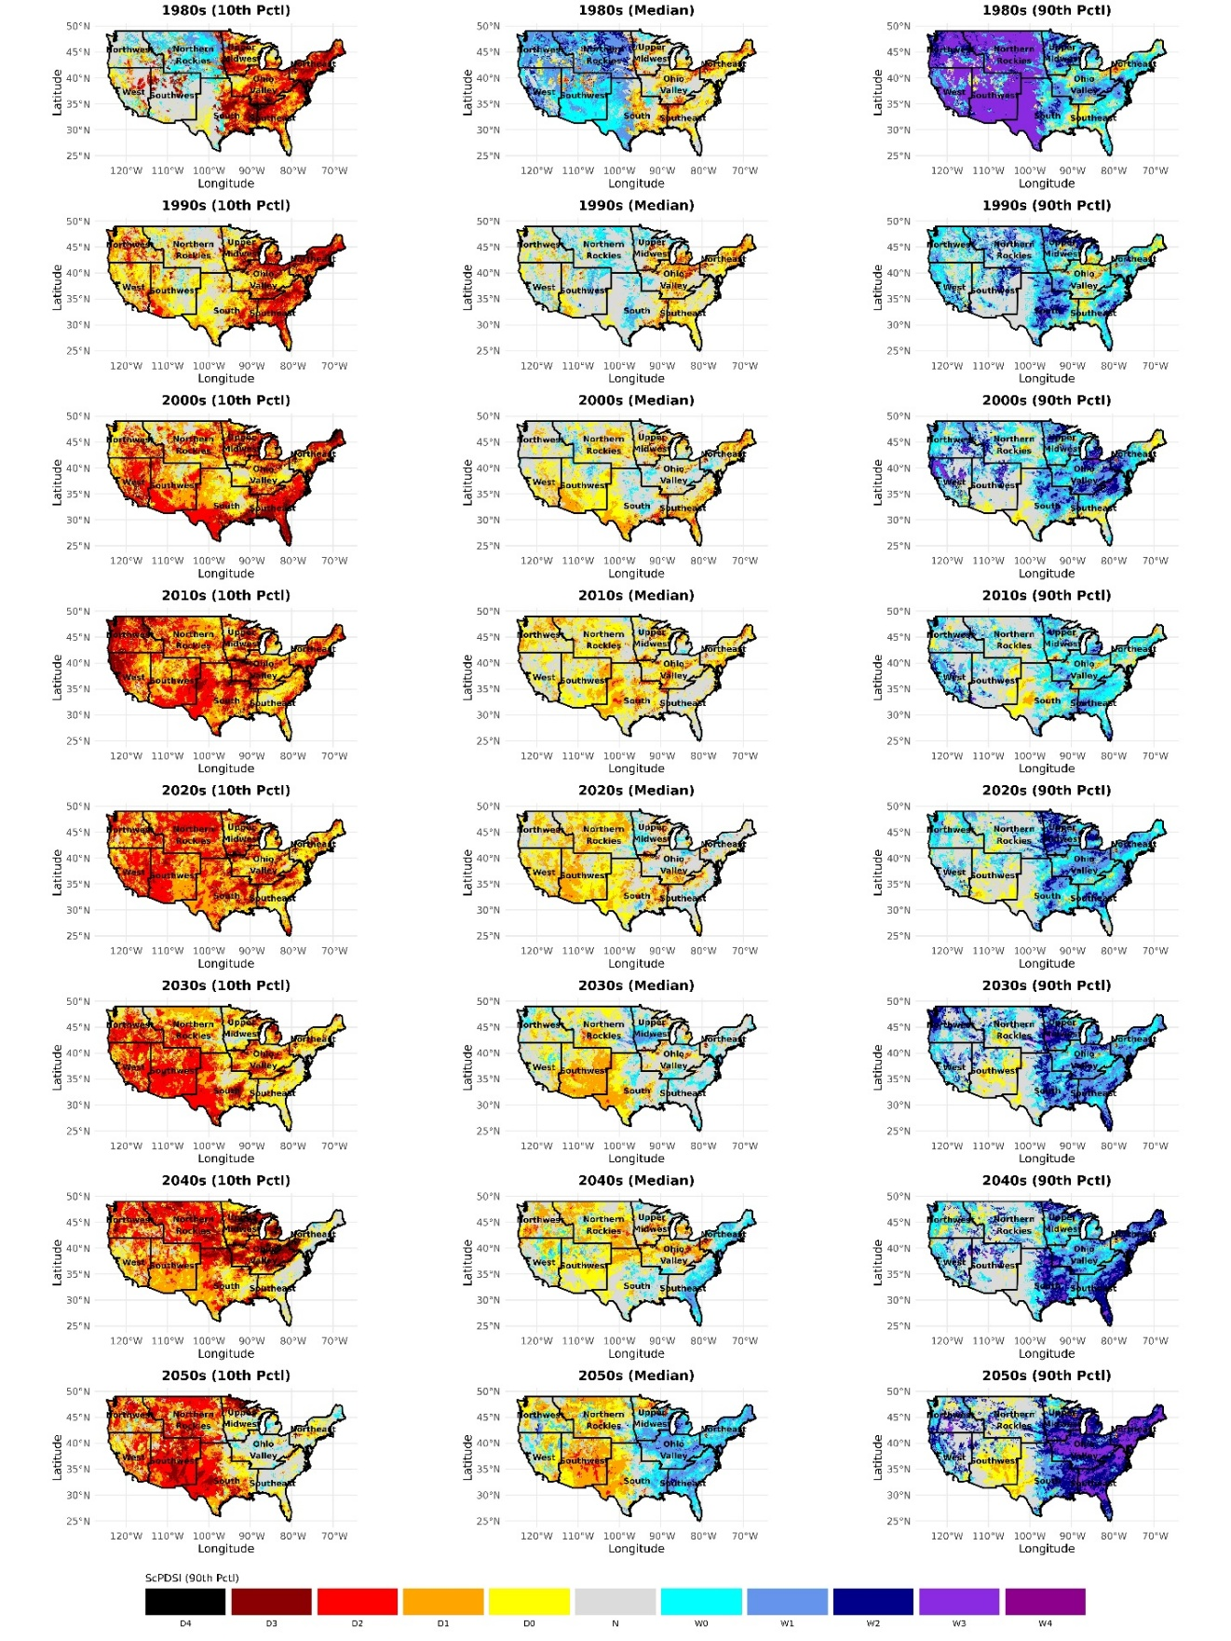
Figure 2.3 Comparison of 10th, Median, and 90th Percentile ScPDSI (1980s–2050s) by decade across CONUS.
Figure 2.4 presents a detailed analysis of historical and projected percentage area affected by different drought categories (D0–D4) in the contiguous United States (CONUS) from 1980 to 2059, based on SPI-12, SPEI-12, and ScPDSI. The stacked bar plots (Figures 2.4a, 2.4c, 2.4e) illustrate the temporal evolution of the land area affected by each drought category over time, while the box plots (Figures 2.4b, 2.4d, 2.4f) summarize the distribution of the percentage area affected across three time periods: 1981–2019 (historical baseline), 2020–2039 (near-term future), and 2040–2059 (mid-term future). These visualizations highlight how projected changes in precipitation variability, temperature-driven evapotranspiration, and long-term soil moisture trends influence the extent of drought-affected areas under the SSP5-8.5 climate scenario. By combining both stacked time series and boxplot summaries, this framework captures not only long-term mean shifts but also variability and extremes, which are critical for understanding risks to agriculture, water supply, and ecosystems.
The stacked bar plots (Figures 2.4a, 2.4c, 2.4e) reveal distinct trends in the percentage of land area affected by different drought categories over time. In SPI-12 (Figure 2.4a), the total area affected by D1 (moderate drought) and D2 (severe drought) shows a general decline from the 1980s onward, with notable peaks during well-documented drought events such as those in the late 1980s, early 2000s, and mid-2010s. The fraction of CONUS experiencing D3 (extreme drought) and D4 (exceptional drought) remains relatively low, and projections suggest that these categories will continue to affect smaller areas in the future. The area affected by D0 (abnormally dry conditions) remains relatively stable, reflecting continued short-term precipitation fluctuations. In contrast, SPEI-12 (Figure 2.4c), which accounts for temperature-driven moisture loss, exhibits greater year-to-year variability, particularly in D1 and D2 categories, suggesting that evapotranspiration will contribute to drying in certain years, even when precipitation patterns do not indicate a widespread reduction. The total area affected by D3 and D4 under SPEI-12 remains low but sporadic, with occasional peaks that indicate years of more widespread drying driven by temperature extremes. ScPDSI (Figure 2.4e) presents a distinct trend, showing a gradual increase in the area affected by D0 and D1, particularly after 2020, while D2–D4 categories remain more stable compared to SPI-12 and SPEI-12. This suggests a shift toward prolonged dry conditions affecting large portions of CONUS, rather than episodic severe drought events. Such divergence among indices highlights that while precipitation-based indices suggest a potential decline in widespread severe drought, soil moisture–based metrics reveal growing risks of chronic dryness, which are especially relevant for agriculture and water management (Vicente-Serrano et al., 2020).
The box plots (Figures 2.4b, 2.4d, 2.4f) provide additional insight into these trends by summarizing how the percentage of land area affected by each drought category changes across different time periods. In SPI-12 (Figure 2.4b), the median area affected by D1 and D2 decreases in future periods, with a noticeable reduction in interquartile range (IQR), indicating a more consistent trend toward lower coverage of these drought categories. However, the whiskers (5th–95th percentiles) and outliers highlight that individual years with high drought coverage may still occur, emphasizing the potential for occasional years with larger areas affected despite the median decline. The area affected by D3 and D4 remains low across all time periods, with limited variability, reinforcing that SPI-12-based projections do not indicate a widespread expansion of the most severe drought categories. In SPEI-12 (Figure 2.4d), the median area affected by D1 and D2 remains relatively stable compared to SPI-12, but the IQR expands, indicating greater uncertainty in future projections. The presence of more outliers in D2–D4 categories suggests that despite a general stabilization, some models still project years where a larger portion of CONUS experiences widespread drying, particularly due to higher temperatures increasing moisture loss. Unlike SPI-12, SPEI-12 suggests that the total area affected by moderate to severe drought may not decrease significantly but will vary more from year to year. ScPDSI (Figure 2.4f) shows a clear increase in the median percentage of land affected by D0 and D1 in both future periods, with a larger IQR, suggesting that more of CONUS will experience abnormally dry or moderate drought conditions on a regular basis. This aligns with long-term soil moisture deficits projected under a warming climate, where reduced precipitation effectiveness leads to widespread but less extreme drying. The area affected by D2 remains relatively stable, while D3 and D4 continue to affect only a small percentage of land, with sporadic extreme years as shown by the outliers. From a management perspective, this implies that adaptation strategies may need to shift away from planning for rare catastrophic droughts alone, and increasingly focus on mitigating the impacts of more frequent, persistent moderate droughts that strain water and food systems over time.
The comparison across indices highlights key differences in how drought-affected areas are projected to change. SPI-12 shows a decreasing trend in the total area affected by moderate (D1) and severe (D2) droughts, likely due to projected increases in precipitation. In contrast, SPEI-12 reflects a more uncertain future, where temperature-driven drying leads to greater year-to-year variability in the total area affected by moderate to extreme droughts. ScPDSI, on the other hand, suggests a shift toward persistent dry conditions, with more land consistently experiencing D0 and D1 drought categories rather than short-term fluctuations in D2–D4. This divergence underscores the importance of using multiple drought indices to assess future drought risks, as precipitation-based, temperature-sensitive, and soil moisture-driven metrics capture different aspects of the changing hydroclimate. These results also emphasize the importance of ensemble-based drought assessments: while some indices suggest declining severe drought risk, others reveal heightened exposure to persistent mild-to-moderate droughts that may be equally disruptive when compounded with population growth and increasing water demand (Spinoni et al., 2019).

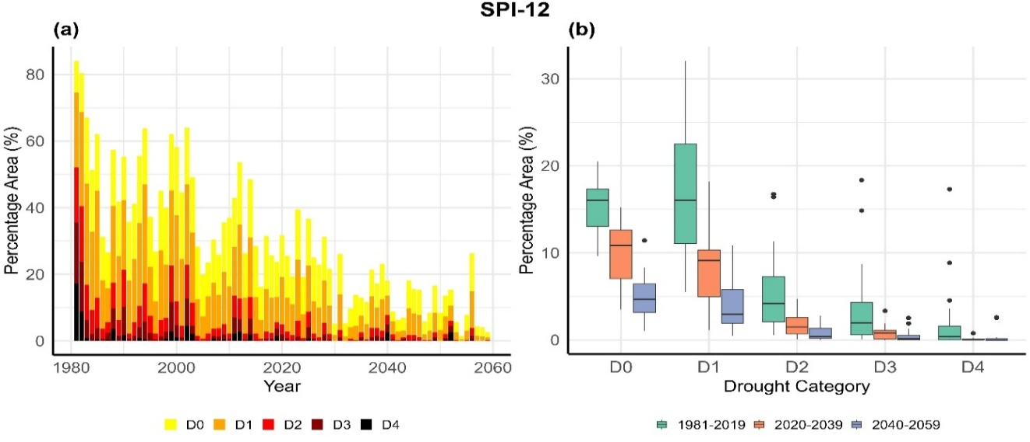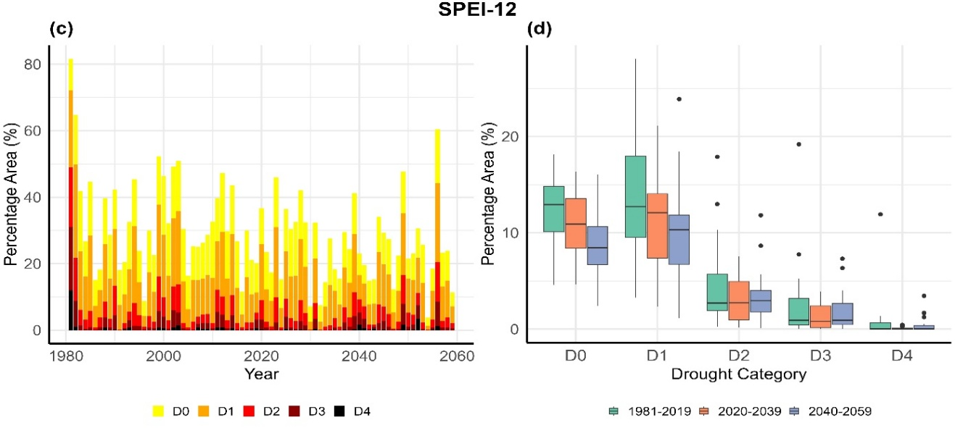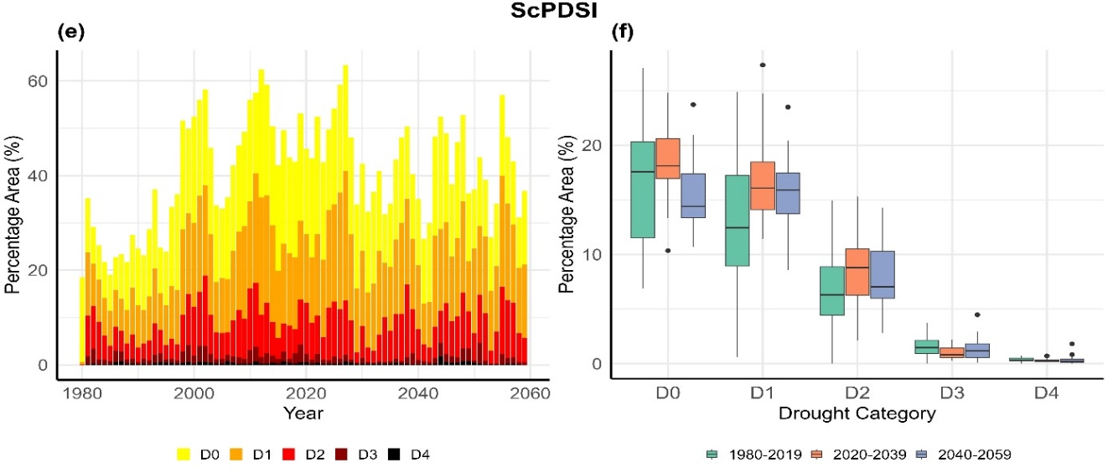
Figure 2.4 Projected trends and historical patterns of drought in the CONUS (1980–2059) based on SPI-12, SPEI-12, and ScPDSI. (a, c, e) Stacked bar plots showing the percentage of land area affected by different drought categories (D0–D4) over time for SPI-12, SPEI-12, and ScPDSI, respectively. (b, d, f) Box plots representing the distribution of drought-affected areas across three time periods (1981–2019, 2020–2039, and 2040–2059) based on multi-model ensembles. The box plots show the median, interquartile range (25th–75th percentiles), and whiskers extending to the 5th–95th percentiles, with outliers represented as individual points.

Discussion
This study investigates projected drought characteristics across the contiguous United States (CONUS) under the SSP5-8.5 scenario, focusing on regional trends and potential population impacts. By using a multi-model ensemble of bias-corrected and dynamically downscaled data from six CMIP6 GCMs, we analyzed drought events through ScPDSI, with additional insights provided by SPI-12 and SPEI-12. Unlike previous studies that rely solely on global climate models (GCMs) or statistical downscaling methods, this study employs high-resolution dynamical downscaling, which improves the representation of regional climate variability. Such fine-scale modeling is particularly valuable in complex terrains (e.g., the Rocky Mountains and the Southwest), where coarse-resolution GCMs often underestimate localized drought risks (Coppola et al., 2021). Additionally, we incorporate a climate-zone-based regional analysis and inter-model spread evaluation to better capture localized drought characteristics, providing more actionable insights for decision-making.
Each index captures distinct aspects of drought dynamics, with SPI-12 reflecting precipitation-driven variability, SPEI-12 incorporating temperature-driven evapotranspiration, and ScPDSI representing long-term soil moisture balance. The comparison across indices reveals that while SPI-12 and SPEI-12 indicate more substantial interannual fluctuations and a decline in the affected drought area by 2050, ScPDSI suggests that soil moisture deficits will persist for longer periods, particularly in the Southwest. This divergence among indices has also been noted in global studies (Zhao & Dai, 2022; Niu et al., 2025), which emphasize that precipitation-based indices may underestimate risks when warming-driven evapotranspiration dominates.
This highlights the importance of incorporating multiple drought metrics into assessments, as reliance on a single index could overlook key aspects of drought persistence and recovery. It is important to recognize that the study is based on a relatively small ensemble of six models under a single climate scenario (SSP5-8.5), with drought trends analyzed over 20-year time slices. This limitation affects the statistical robustness of results, particularly for rare extreme drought categories (D3 and D4), which by definition have lower occurrences and greater variability. Consequently, while median trends provide useful guidance, policymakers should also prepare for “tail risks” represented by outliers in the model ensemble (Wehner et al., 2017).
Although our results suggest an overall decrease in the median extent of extreme droughts (D3-D4), particularly in SPI-12 and SPEI-12, individual events of severe drought still emerge, as seen in the ScPDSI projections where some regions continue to experience long-lasting droughts beyond 2050. This indicates that while the frequency of extreme droughts may decline, the persistence of soil moisture deficits could still pose significant risks to water resources and agriculture. These findings echo concerns raised in IPCC AR6 (IPCC, 2021), which stresses that compound events—such as persistent moderate droughts combined with heat extremes—may cause more damage than isolated, rare severe droughts.
Future research incorporating a larger ensemble of GCMs, multiple scenarios, and longer time periods would help refine projections and improve confidence in assessing the frequency and severity of extreme droughts. Such extensions would also facilitate probabilistic risk assessments, moving beyond deterministic projections to provide likelihood estimates that are more relevant for adaptation planning (Seneviratne et al., 2012).
To further ensure the reliability of our projections, we assessed the impact of dynamical downscaling on drought assessments. Unlike statistical downscaling methods that rely on empirical relationships, dynamical downscaling explicitly resolves fine-scale climate processes, improving the representation of regional precipitation and temperature variability. For example, RegCM4 has been shown to better capture orographic precipitation gradients in the Sierra Nevada and the Rockies, which are often smoothed out in coarse-resolution GCMs (Giorgi et al., 2012; Gao et al., 2017). This is particularly important in regions with complex topography, such as the Western U.S., where GCMs tend to underestimate precipitation variability and local convective activity.
By applying bias correction with Daymet v4, our downscaling approach significantly reduces systematic errors in precipitation and temperature, leading to improved drought index calculations. The refined spatial resolution ensures a more accurate representation of temperature-driven drought trends, particularly for indices such as SPEI and ScPDSI, where small temperature changes can strongly influence projected drought severity. Bias correction also improves intercomparability across indices, as demonstrated in recent hydroclimate assessments where uncorrected GCM outputs systematically underestimated the frequency of extreme drought events in the Southwest (Rastogi et al., 2022).
Additionally, the ability of dynamical downscaling to capture localized drought conditions allows for a more nuanced assessment of regional drought variability. While raw GCM-based projections smooth out fine-scale drought patterns, our downscaled dataset provides a more detailed spatial representation of drought persistence and intensity across different climate zones. This higher spatial fidelity is especially critical for stakeholder applications, such as water utilities and agricultural planning, which require localized information rather than national averages (Wood et al., 2011; Maraun & Widmann, 2018).
Despite these improvements, some biases remain. While precipitation biases in the Southwest were reduced compared to raw GCM outputs, there is still a slight underestimation of extreme precipitation events, indicating the need for further refinement in hydrological applications. Similarly, temperature biases in RegCM4-based datasets were lower than those in raw GCMs, improving the reliability of temperature-sensitive drought indices. These residual errors are consistent with other regional downscaling studies (e.g., Bukovsky & Mearns, 2020), which show that while downscaling reduces mean biases, extremes remain difficult to capture accurately due to limitations in convective parameterizations. These results highlight the added value of dynamical downscaling in climate impact studies, particularly for refining regional drought projections and supporting local adaptation strategies. However, they also underscore the need for multi-method ensembles that integrate both dynamical and statistical downscaling, in order to better quantify uncertainties across modeling frameworks (Chen et al., 2021).
Our findings align with previous research indicating a general trend toward fewer droughts across CONUS, driven by projected increases in average precipitation (Xue and Ullrich 2022, Chen and Ford 2023). However, this overall trend masks significant regional variability. Persistent and intensifying drought conditions are projected in the Southwest and parts of the West, including New Mexico, Arizona, and California, where rising temperatures and increased evapotranspiration rates exacerbate soil moisture deficits (Heim 2017, Leeper et al 2022, Rastogi et al 2023). This regional contrast mirrors findings in Zhao & Dai (2022), who showed that while global precipitation is expected to rise, subtropical and arid regions may experience “dry-get-drier” dynamics due to enhanced evaporative demand.
The influence of rising temperatures on drought indices varies depending on how potential evapotranspiration (PET) is calculated. SPEI explicitly incorporates temperature effects through PET estimation, often using the Thornthwaite method, which is highly sensitive to warming trends but does not account for physiological changes in vegetation under elevated CO₂. ScPDSI, in contrast, integrates temperature effects indirectly through its soil moisture balance framework but may not fully capture PET variations in response to increasing CO₂ concentrations. This methodological divergence has been widely discussed in drought literature (Beguería et al., 2014; Vicente-Serrano et al., 2020), with evidence that Thornthwaite-based SPEI may overestimate drying under strong warming.
The Penman-Monteith method, which accounts for radiative and aerodynamic controls on PET, remains widely used but does not explicitly consider CO₂-induced stomatal closure, potentially leading to overestimation of future drying trends. Recent studies (Lemordant et al., 2018; Swann et al., 2016) highlight that vegetation physiological responses, such as reduced stomatal conductance under elevated CO₂, can significantly decrease transpiration and partially offset increased evaporative demand. Given the increasing importance of plant physiological responses under climate change, future studies should explore CO₂-sensitive PET models, which could refine projections of drought severity and duration by better accounting for plant water use efficiency under rising CO₂ levels. Incorporating dynamic vegetation models into drought assessments could therefore bridge the gap between atmospheric drivers and biospheric feedbacks, reducing uncertainty in long-term drought projections (Seneviratne et al., 2010).
While the total drought-affected population is expected to decrease by 2050, urban areas will remain disproportionately burdened by mild and moderate droughts. Approximately 2.8 million urban residents are projected to experience Abnormally Dry (D0) conditions by mid-century, reflecting the intersection of high population density and persistent drought conditions in certain regions. However, projections differ across drought indices: SPI-12 estimates a decrease in affected population from 2.7 million in 2030 to 0.8 million in 2050, while ScPDSI suggests a more prolonged impact, with 3.6 million affected in 2030 and 1.1 million in 2050. This suggests that while short-term precipitation variability may provide relief in some regions, longer-term soil moisture depletion remains a key concern. This divergence between indices highlights the uncertainty of exposure assessments and underscores the importance of scenario planning that prepares for a range of possible futures rather than a single deterministic trajectory (AghaKouchak et al., 2015).
The findings emphasize the socioeconomic vulnerability of urban populations, particularly disadvantaged groups, in drought-prone areas (Liggett 2023). Urban centers often face compounded risks, as water demand, energy use, and infrastructure stress coincide with population growth and land-use change (Revi et al., 2014). These systemic pressures mean that even moderate droughts can disrupt essential services such as water supply, electricity generation, and public health systems. Given the projected persistence of drought conditions, effective adaptation strategies will be critical, including improved water conservation policies, investment in sustainable urban water infrastructure, and the expansion of water reuse and desalination technologies to enhance long-term resilience. Equity-focused adaptation, such as prioritizing low-income communities that are disproportionately affected by water scarcity and higher utility costs, will also be essential to reduce climate injustice in urban drought impacts (Meerow & Mitchell, 2017).
From an agricultural perspective, the indices reveal significant risks associated with shifting drought patterns. SPI-12 predicts a decrease in prolonged droughts, which could reduce water stress in some agricultural regions but pose challenges for rainfed farming that depends on consistent precipitation (Harp and Horton 2022). However, ScPDSI indicates persistent soil moisture deficits, particularly in the Southwest, where soil moisture-driven drought exposure remains high even in 2050. This persistence of baseline drying is consistent with long-term observations of declining soil moisture and groundwater depletion across the western United States (Famiglietti, 2014; Scanlon et al., 2012). This suggests that despite projected increases in precipitation, long-term soil moisture deficits may continue to impact crop resilience and yields (Ficklin et al 2015).
The irregular distribution of precipitation, characterized by more intense but less frequent events, could disrupt irrigation management and crop planning, even in regions expected to experience wetter conditions (Leeper et al 2022, Rastogi et al 2023). This phenomenon, often described as “precipitation whiplash” (Swain et al., 2018), increases the difficulty of agricultural adaptation because farmers must cope with both water shortages and flood risks within short timeframes. These changes suggest that agricultural systems will need to adapt not only to more frequent mild droughts but also to the increased baseline water stress they create (Wahl et al 2022). Potential adaptation measures include shifting crop calendars, adopting drought-resistant cultivars, and expanding sustainable irrigation techniques such as deficit irrigation and micro-drip systems (Howell, 2011; Elliott et al., 2014).
To calculate PET, this study used the Penman-Monteith method with the VIC hydrological model and bias-corrected GCM outputs, a widely recognized standard for hydrological studies (Goh et al 2021, Lang et al 2017). However, limitations such as temporal uncertainties and energy balance closure issues may propagate errors in drought index calculations (Hao et al 2018a). For instance, small biases in net radiation or wind speed can translate into significant differences in PET, which then amplify uncertainties in indices like SPEI and ScPDSI that directly incorporate evapotranspiration (Sheffield et al., 2012).
Additionally, the modifiable areal unit problem (MAUP) complicates results, as spatial scale and aggregation choices may affect conclusions, even when dividing the CONUS into NCEI climate regions to align with previous studies (Jelinski and Wu 1996, Ashfaq et al 2016). This scaling sensitivity has been highlighted in other hydroclimate studies, where results differed when shifting from watershed-based to grid-based drought aggregation (Keyantash & Dracup, 2002), suggesting that multi-scale analyses are necessary for robust conclusions.
In addition, different drought classification thresholds, such as -0.5 for SPI/SPEI and -1 for PDSI, influence the areas and populations identified as drought-affected (Chivangulula et al 2023, Nam et al 2015, Maule et al 2013). While our study follows established classification methods, non-parametric approaches, such as those proposed by Farahmand and AghaKouchak (2015), provide an alternative for generating statistically consistent drought indices across different variables, enhancing intercomparability in multi-index drought assessments (Farahmand and AghaKouchak 2015). Adopting such unified statistical frameworks would be particularly valuable for cross-regional comparisons and for integrating multiple datasets (e.g., climate models, remote sensing, reanalysis), where differing assumptions can otherwise hinder synthesis (Dai, 2011).
These methodological challenges emphasize the need for standardized approaches to improve consistency and reliability in drought assessments. Future research should also integrate uncertainty quantification, for example through ensemble-based probabilistic methods, to provide stakeholders with ranges of risk rather than single deterministic outcomes (Hao et al., 2018b).
Overall, the updated results highlight the complexity of future drought projections and the necessity of using multiple indices to fully capture regional drought variability. While SPI-12 and SPEI-12 indicate a decline in overall drought-affected areas by mid-century, ScPDSI suggests persistent soil moisture deficits in key regions, particularly the Southwest. This reinforces the broader understanding that precipitation-based metrics alone are insufficient to characterize drought risk under climate change, since warming-driven evapotranspiration and soil water dynamics play increasingly dominant roles (Vicente-Serrano et al., 2020; Zhao & Dai, 2022).
The projected urban and agricultural impacts further emphasize the importance of adaptive water management strategies that account for both short-term precipitation variability and long-term soil moisture trends. For urban systems, this means planning beyond short drought relief cycles and investing in resilient infrastructure such as aquifer recharge projects, distributed storage, and advanced wastewater reuse (Gleick, 2018). For agriculture, adaptive strategies must balance water conservation with food security, requiring not only technological interventions (e.g., precision irrigation) but also institutional changes such as drought insurance and regional water-sharing agreements (Wheeler et al., 2020).
From a policy perspective, the study highlights the need for integrated adaptation frameworks that connect climate science with socioeconomic planning. Drought is not only a hydrological hazard but also a cross-sectoral stressor that influences energy production, food prices, and public health (AghaKouchak et al., 2021). Therefore, effective adaptation must be multi-scalar, combining federal-level investments in infrastructure with local initiatives tailored to community-specific vulnerabilities.

Conclusion
This study examines the projected characteristics of drought across CONUS and its population impacts under the SSP5-8.5 scenario. By utilizing a multi-model ensemble with high-resolution dynamical downscaling, we provide a detailed assessment of future drought conditions across various climate regions. Unlike previous studies that rely solely on global climate models or statistical downscaling, our approach enhances the spatial resolution and reliability of drought projections, enabling a more localized evaluation of drought risks. Given the high variability in projected precipitation across models, particularly under the SSP5-8.5 scenario, our analysis incorporates the 10th–90th percentile range alongside the ensemble median, providing a more comprehensive understanding of inter-model uncertainty. While most models indicate a drying trend in the Southwest, the magnitude of change varies considerably, highlighting the need for further examination of precipitation variability. In contrast, regions such as the Upper Midwest and Northeast exhibit higher model agreement, suggesting greater confidence in projected trends. The comparison of SPI-12, SPEI-12, and ScPDSI reveals distinct drought responses, with SPI-12 and SPEI-12 showing an overall decline in drought-affected areas by mid-century, while ScPDSI suggests persistent soil moisture deficits, particularly in the Southwest, emphasizing the importance of incorporating multiple drought indices in climate risk assessments. Taken together, this study demonstrates the necessity of multi-index approaches for capturing the full spectrum of hydroclimatic risks, since reliance on a single metric can obscure critical drivers of drought persistence and recovery (Vicente-Serrano et al., 2020).
Our findings highlight substantial regional disparities in future drought trends. While some regions, such as the Upper Midwest and Southeast, may experience a reduction in the overall area affected by drought due to increased precipitation, these gains could be offset by temperature-driven increases in evapotranspiration. In contrast, the Western and Southwestern U.S. are projected to experience persistent and intensifying drought conditions, driven by rising temperatures and prolonged soil moisture depletion. New Mexico, Arizona, and California are expected to face severe and recurrent water stress, with ScPDSI indicating prolonged drought conditions well into 2050, affecting up to 1.1 million people under D0 and D1 categories. Unlike other regions where precipitation increases may alleviate some drought conditions, these areas are projected to experience longer-lasting soil moisture deficits due to increasing evapotranspiration. This Southwest drying trend is consistent with recent reconstructions of megadroughts in North America, which suggest that 21st-century warming could lock the region into drought regimes comparable to or worse than the Medieval Climate Anomaly (Williams et al., 2020). The shift toward a drier climate in the Southwest, as indicated by both ScPDSI and SPEI-12, underscores the need for proactive adaptation measures, such as improved water resource management, enhanced irrigation strategies, and long-term drought mitigation policies tailored to vulnerable regions. Failure to act may increase the risks of agricultural decline, water allocation conflicts, and wildfire-driven damages across already vulnerable landscapes.
Urban populations will remain disproportionately affected by drought, even as total drought-affected populations decline. By mid-century, approximately 2.8 million urban residents are projected to experience Abnormally Dry (D0) conditions under SPI-12, down from 6.6 million in 2010, while ScPDSI suggests a more persistent exposure of 3.6 million in 2030 and 1.1 million in 2050. Despite a reduction in total drought-affected population, urban areas will continue to bear the burden of drought impacts due to their higher population densities and reliance on municipal water supplies. Migration patterns and population growth in drought-prone regions, such as the Southwest and Southern California, may further exacerbate societal vulnerabilities, making targeted climate adaptation policies crucial. Given these projections, urban resilience strategies, including expanded water conservation policies, investments in sustainable urban water infrastructure, and advancements in water reuse and desalination technologies, will be essential for mitigating future drought impacts on metropolitan populations. Moreover, equity-focused approaches will be needed to ensure that low-income and marginalized groups, who are least able to afford adaptation measures, do not bear a disproportionate share of future drought burdens (Meerow & Mitchell, 2017).
While our study provides valuable insights into future drought projections, it does not explicitly account for CO₂-induced reductions in transpiration, which could influence PET estimates and, consequently, drought severity assessments. Given the growing body of research suggesting that CO₂-sensitive PET formulations can modify drought severity projections (Yang et al 2019, Swann et al 2016, Lemordant et al 2018), future research should integrate dynamic vegetation models and CO₂-responsive PET methods to improve the accuracy of drought impact assessments. Additionally, expanding the analysis to include multiple SSP scenarios and a broader ensemble of CMIP6 models would further enhance confidence in regional drought projections, supporting long-term water resource planning and climate adaptation strategies under a changing climate. Given the uncertainties associated with extreme drought projections, particularly for rare categories like D3 and D4, future studies should also explore alternative drought classification methods to refine the detection of high-impact drought events. Future research should also explicitly examine compound extremes, such as concurrent drought and heatwaves, or drought and wildfire events, which can amplify risks far beyond what single-hazard assessments suggest (Zscheischler et al., 2018).
In summary, this chapter provides a comprehensive assessment of future drought evolution and associated human exposure across the contiguous United States under the SSP5-8.5 scenario. By integrating high-resolution dynamical downscaling, bias correction, and multi-index drought metrics, we identified strong regional contrasts: while the Upper Midwest and Northeast are projected to experience modest wetting trends, the Southwest and parts of the Western U.S. are likely to face persistent soil moisture deficits and heightened drought risk. Population exposure analyses further revealed that urban residents, due to their concentration in drought-prone regions and dependence on centralized infrastructure, will remain disproportionately vulnerable even as the total drought-affected population declines by mid-century. These findings underscore both the physical complexity and the socioeconomic significance of drought under climate change, highlighting the necessity of tailored regional adaptation strategies.
Building on these results, the next chapter shifts focus from drought to air quality, specifically the estimation and bias analysis of fine particulate matter (PM₂.₅). While drought primarily represents a hydroclimatic stressor, PM₂.₅ embodies an atmospheric pollutant with equally profound health implications. Importantly, the two issues are interconnected: drought-induced wildfires and dust storms contribute directly to PM₂.₅ emissions, while atmospheric stagnation during drought episodes can exacerbate pollutant accumulation. By addressing PM₂.₅ estimation challenges through machine learning and model–observation integration, Chapter 3 extends the dissertation’s broader goal of advancing multiscale climate–environmental risk assessments.

Machine Learning-Based PM2.5 Estimation and Bias Analysis

Research Question
This chapter focuses on the challenges associated with estimating ground-level PM_{2.5} concentrations using machine learning methods, particularly in the context of sample imbalance and limited observational data. The key research question is: How can machine learning techniques be optimized to improve PM_{2.5} estimation accuracy, particularly in regions with limited ground monitoring? This question reflects a broader challenge in atmospheric science, namely how to bridge the gap between sparse observational networks, heterogeneous emission sources, and complex meteorological processes that shape PM_{2.5} distribution (Di et al., 2019). Addressing this challenge is not only a technical problem but also a public health priority, as PM_{2.5} remains one of the leading global environmental risk factors for mortality (Cohen et al., 2017).

Introduction
Air pollution has significantly altered the Earth's radiation balance, disrupted ecosystems, and increased human morbidity and mortality (Geng et al 2021). Ambient PM_{2.5} (airborne particles <2.5 μm in diameter) has profound effects on human health, ecosystems, and climate change, necessitating accurate estimates of its concentration in the atmosphere. PM_{2.5} can penetrate the bronchi and lungs, causing damage to the respiratory and cardiovascular systems, and is associated with an increased risk of premature death (Dockery et al 1993, Lelieveld et al 2015). Given these severe health and environmental impacts, the U.S. Environmental Protection Agency (EPA) recently revised the primary annual PM_{2.5} standard from 12.0 µg/m³ to 9.0 µg/m³ on February 7, 2024, while maintaining the primary 24-hour PM_{2.5} standard at 35 µg/m³. This regulatory tightening underscores the urgency of improving PM_{2.5} exposure assessments, since even small underestimations in modeled concentrations could have direct implications for compliance, health burden estimates, and environmental justice analyses (Pope et al., 2020).
Despite the notable decline in PM_{2.5} concentrations have been achieved across the United States over the past decade, the monitoring network remains spatially sparse and is unable to capture the full extent of population exposure, particularly in rural and underserved communities. This limitation not only hampers the protection of public health but also exacerbates environmental inequity by failing to monitor air quality in vulnerable areas (Yu et al 2023). The use of traditional methods has been shown to introduce biases in PM_{2.5} concentration estimates due to the limited spatial and temporal coverage of surface monitoring (Cheng et al 2024). High-resolution spatiotemporal data are essential for addressing these limitations, as they facilitate more accurate assessments of exposure, particularly when integrated with advanced machine learning models to that incorporate satellite and ground-based data (L. He et al., 2024; Ma et al., 2023)​. These approaches not only enhance the precision of exposure assessments but also support studies addressing environmental justice by highlighting disparities in pollution distribution and its health impacts (Jain et al 2023)​. Such integrative approaches are increasingly recognized as the frontier of exposure science, providing datasets that are both policy-relevant and capable of supporting epidemiological studies with unprecedented granularity (van Donkelaar et al., 2021).
The limited availability of ground stations and issues of sample imbalance have significantly impacted the accuracy of machine learning models used for PM_{2.5} estimation in the U.S. Studies have shown that the concentration of monitoring stations in urban areas leads to a training sample bias toward high-pollution regions, resulting in overestimation of PM_{2.5} in downwind areas (Li et al 2024b). Even though the AQS monitors pollution levels across the country, the lack of sufficient monitoring stations in rural and remote areas introduces considerable uncertainty in PM_{2.5} estimates for these regions. This study integrates data from U.S. networks like CASTNET and IMPROVE to assess the impact of sample imbalance on machine learning models and evaluate the efficacy of applying such models in low-pollution regions. By explicitly addressing spatial imbalance, this work contributes to filling a major gap in the U.S. air quality literature, where rural and suburban exposures have historically been underrepresented in both modeling and monitoring (Jerrett et al., 2017).
Reliable PM_{2.5} retrievals from satellites can fill gaps in surface measurements and improve air quality models, especially in regions with limited monitoring networks. Aerosol optical depth (AOD) has been widely used for these retrievals, and studies have demonstrated that MAIAC AOD outperforms MODIS AOD in several contexts (Lyapustin et al 2018, Zhang et al 2019). In addition to AOD, meteorological conditions are a significant factor in determining PM_{2.5} concentrations. The incorporation of datasets such as ERA5 has been demonstrated to enhance the precision of PM_{2.5} estimates when integrated into machine learning models (Zuo et al 2023). Nevertheless, previous studies employing techniques such as Multivariate Adaptive Regression Splines (Sorek-Hamer et al 2013) have identified constraints in addressing intricate atmospheric dynamics and regional transport, which can result in imprecise PM_{2.5} estimations. These challenges underscore the necessity of addressing the inherent spatial and temporal imbalances in current monitoring networks and highlight the importance of developing novel methods for improving PM_{2.5} retrievals. In this context, hybrid approaches that integrate chemical transport models (e.g., CMAQ, GEOS-Chem) with machine learning offer promising pathways to combine physical constraints with data-driven flexibility (Xiao et al., 2023).
Several machine learning (ML) techniques have emerged to address the challenges associated with PM_{2.5} estimation, particularly in handling spatial and temporal data gaps. Decision tree-based methods, including Random Forests (RF), XGBoost, and LightGBM, are widely used due to their efficiency and high predictive accuracy. Random Forests employ an ensemble of decision trees to improve prediction performance and reduce overfitting (Belgiu and Drăguţ 2016, Breiman 2001). XGBoost, an optimized gradient-boosting framework, has been extensively applied in PM_{2.5} prediction studies, providing high efficiency and superior performance in handling structured data (Chen and Guestrin 2016, Wang et al 2023, Li et al 2024b). Similarly, LightGBM, a highly efficient gradient-boosting decision tree model, is popular for large-scale datasets due to its fast training speed and computational efficiency (Ke et al 2017). It has been widely used in satellite-based PM_{2.5} estimation, where large amounts of data must be processed quickly and accurately (Ma et al 2023, Wei et al 2021). However, ensemble-based methods may still struggle to extrapolate under novel climate or emission conditions, highlighting the importance of continuous retraining with updated datasets (Shen et al., 2022).
More advanced models like Deep-RF combine the deep learning feature extraction capability with the ensemble learning power of random forests, offering superior performance in PM_{2.5} estimation (Wei et al 2023, Zheng et al 2021). Residual Neural Networks (ResNet) have also been adapted to air quality estimation tasks due to their ability to handle nonlinear relationships in atmospheric processes (He et al 2016, Li et al 2024a). ResNet’s architecture, which consists of residual blocks and convolutional layers, allows it to capture both spatial and temporal patterns in PM_{2.5} concentrations, significantly improving prediction accuracy(Song et al 2020). Recent advances in spatiotemporal deep learning, such as graph neural networks and transformers, may provide additional gains by explicitly modeling spatial adjacency and long-range temporal dependencies (Han et al., 2022; Chen et al., 2024).
To evaluate the performance of these machine learning models, cross-validation metrics such as Mean Square Error (MSE), Root Mean Square Error (RMSE), Mean Absolute Error (MAE), and Mean Relative Error (MRE) are essential (Jolliff et al 2009, Willmott and Matsuura 2005). These metrics provide insights into the overall accuracy of the models, the size and direction of errors, and their ability to generalize across different geographic regions. Comprehensive evaluation using these metrics helps ensure that the models are robust and reliable for PM_{2.5} estimation across diverse conditions. For policy-relevant applications, model evaluation should also consider bias against regulatory thresholds (e.g., EPA 24-hour and annual PM_{2.5} standards), since small systematic deviations can translate into major differences in compliance assessments (Apte et al., 2015).
However, a major limitation of existing studies is the concentration of ground measurements in urban and heavily polluted areas, especially in regions such as China. This focus on high-pollution regions, aimed at protecting human health, has led to uneven spatial distribution of data, creating significant gaps in PM_{2.5} monitoring, particularly in suburban and rural areas. In the U.S., these gaps are even more pronounced due to the lower pollution levels and the dispersed nature of ground stations in rural areas. This challenge is compounded by the lack of ground truth data to evaluate machine learning (ML) model predictions in less populated areas, especially along pollutant transport pathways. As a result, significant uncertainties remain in PM_{2.5} estimation in these regions, and existing approaches have not adequately addressed these challenges. This limitation directly affects environmental justice assessments, since rural and Indigenous communities may face disproportionate exposure without being properly represented in monitoring networks (Collins & Grineski, 2019).
To overcome these limitations, this study presents a novel approach that integrates machine learning techniques with numerical simulations within a CMAQ-based testbed framework, specifically tailored for the U.S. domain. This integration is particularly innovative in its ability to reduce uncertainties in suburban and rural areas where ground measurements are sparse. Unlike previous studies that focus heavily on urban regions with dense monitoring, this work emphasizes the estimation of PM_{2.5} across diverse spatial regions in the U.S., providing more robust and generalizable results. By focusing on the unique landscape of the U.S. monitoring networks, including CASTNET and IMPROVE, this study addresses the underrepresentation of low-pollution and rural regions in machine learning models. This approach not only advances methodological rigor but also enhances policy relevance by providing improved datasets for exposure and health impact studies, particularly in under-monitored regions.

Objective
This chapter aims to develop a novel testbed that integrates numerical simulations with machine learning approaches to enhance the accuracy of PM_{2.5} estimation. By optimizing model structures and training samples, this study seeks to improve predictive performance, particularly in regions with limited monitoring data. Such a testbed provides a systematic framework for evaluating how different modeling strategies—ranging from Random Forests and gradient boosting methods to convolutional neural networks—perform under heterogeneous monitoring conditions, thereby offering a transparent and reproducible way to benchmark progress in air quality modeling (Di et al., 2019; Xiao et al., 2023).
A key objective is to assess the benefits of multi-year training datasets in capturing variable atmospheric conditions and improving model robustness. Multi-year data integration has been shown to reduce overfitting to anomalous events and enhance model generalizability across years with distinct meteorological regimes, such as El Niño/La Niña cycles (Just et al., 2020). By explicitly testing the contribution of temporal diversity in training data, this study advances understanding of how models can be adapted for long-term air quality forecasting. Additionally, this study explores the incorporation of additional monitoring networks, such as CASTNET and IMPROVE, to evaluate their impact on PM_{2.5} prediction accuracy and coverage. These supplemental networks provide critical rural and background site data, which are often missing in regulatory AQS networks, and their inclusion is expected to reduce urban-centric bias in ML training datasets (Hand et al., 2014; Malings et al., 2020).
Another focus of this research is to investigate the influence of sample imbalance on interannual variability, health risk assessments, and environmental equity in PM_{2.5} exposure. Addressing sample imbalance is essential, as models trained predominantly on urban data may systematically overestimate pollution in rural downwind areas, inflating population-weighted exposures and potentially skewing health burden estimates (Wei et al., 2023). By quantifying these biases, the testbed contributes to both methodological refinement and environmental justice assessments. By leveraging CNN-based deep learning models, particularly ResNet, this study aims to reduce PM_{2.5} overestimation and enhance exposure assessments in downwind areas. ResNet’s ability to capture nonlinear spatiotemporal dependencies makes it particularly suited for this task, as it can extract hierarchical features that traditional regression or tree-based models might overlook (Song et al., 2020).
The ultimate goal is to provide a more reliable alternative to traditional PM_{2.5} estimation methods, with significant implications for regulatory policies and public health protection. Improved accuracy in spatially resolved PM_{2.5} estimates directly supports compliance monitoring with updated EPA standards, strengthens epidemiological research on exposure–response relationships, and informs equitable mitigation strategies at regional and national scales (Pope et al., 2020; Apte et al., 2015).

Methods and Data

Methods
In this study, we used a novel testbed with a numerical model, specifically the Community Multiscale Air Quality (CMAQ) modeling system developed by the U.S. EPA (Appel et al 2021), to create ground-truth data beyond traditional monitoring points. This approach allows us to simulate PM_{2.5} concentrations and evaluate interpolation performance using a variety of machine learning models, providing a solution to mitigate uncertainties stemming from the sample imbalance problem. CMAQ-based testbeds have been increasingly adopted in atmospheric research because they allow for controlled experiments where the “true” pollutant fields are known, making it possible to evaluate the structural biases of retrieval algorithms in ways that are not feasible with sparse observations alone (Gilliam et al., 2015; Xing et al., 2020). To address the unique challenges in the U.S., where monitoring stations are sparse in rural and suburban areas, we conducted experiments that increased the density of monitoring points virtually, testing how this impacts model accuracy in under-monitored regions.
One key experiment was the addition of virtual stations in rural areas using simulated CMAQ data to improve coverage. We compared the results of machine learning models trained with both traditional station data and the expanded virtual data set, allowing us to assess the benefits of increasing ground station density. This experimental design mimics hypothetical monitoring network expansion scenarios and helps quantify how much additional observational data would improve prediction skill in rural and downwind regions—an important policy-relevant question for the allocation of future monitoring resources (Malings et al., 2020). We also incorporated multi-year comparisons, analyzing how the models performed over three different years (2009, 2014, 2019) to evaluate their robustness in handling temporal variations in pollutant levels and emissions. Using multiple years also ensures that models are tested under different emission regulations (e.g., implementation of Tier 2/3 vehicle standards) and meteorological conditions (e.g., ENSO events), thereby improving their generalizability (Henneman et al., 2017).
Three decision tree-based machine learning algorithms—Random Forest, XGBoost, and LightGBM—were employed as benchmark cases due to their widespread use in PM_{2.5} estimation. Additionally, we included Deep-RF and ResNet, which combines deep learning and ensemble learning, known for its superior performance in complex environmental datasets. All models were trained using observed meteorological variables from WRF output and land use information. To further enhance accuracy, NO₂ column density from satellite observations was used instead of historical emissions data, as this variable is highly correlated with emission sources and can provide a more accurate real-time representation of pollution sources. The substitution of NO₂ satellite products for emissions inventories reflects a growing recognition that near-real-time remote sensing can better capture emission dynamics, particularly for mobile sources and biomass burning, which are often underestimated or misrepresented in inventories (Duncan et al., 2016; Goldberg et al., 2019).
In another key experiment, we conducted temporal validation by training the models on the first 20 days of each month and reserving the remaining days for testing. This validation approach enabled us to measure the model's ability to generalize across different temporal conditions and assess its robustness in predicting PM_{2.5} levels in both urban and rural areas. This design simulates operational forecasting settings, where models must predict beyond the training window, and also accounts for seasonal variability within a given month (Jiang et al., 2021). The CMAQ-simulated data served as a testbed to explore the performance of satellite retrieval models and test the limits of various machine learning techniques, providing a scalable method for reducing uncertainty in PM_{2.5} estimates, especially in areas with sparse monitoring. By systematically testing across both spatial and temporal dimensions, the framework advances beyond one-off case studies and provides a more rigorous basis for evaluating model robustness under real-world data scarcity.

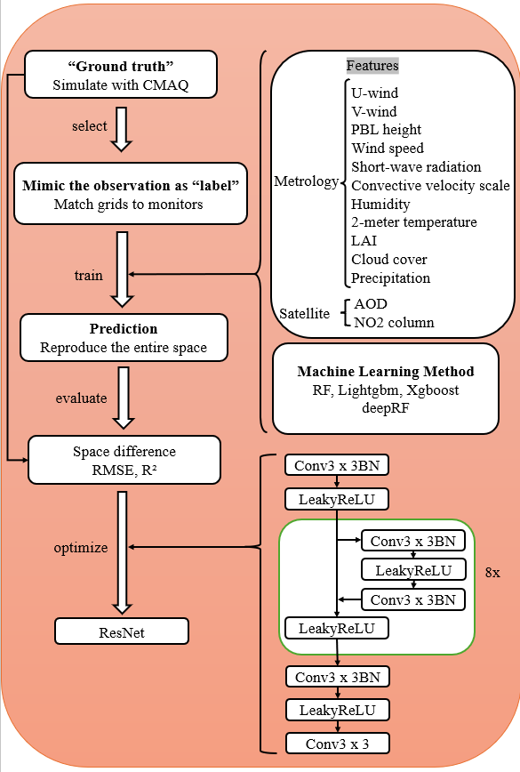
Figure 3.1 Testbed framework.

Data

Air quality simulations (WRF/CMAQ model)
The simulation data used in CMAQ spans the years 2002 to 2019 at a resolution of 12 km by 12 km. To ensure internal consistency during training, all feature and label data are derived from the input and output of the Community Multiscale Air Quality (CMAQ) modeling system. CMAQ is a widely accepted chemical transport model (CTM) known for its accurate simulation of air pollutant concentrations, including PM_{2.5}, due to its comprehensive representation of particulate matter formation (Byun and Schere 2006). The model couples emissions, transport, chemical transformation, and deposition processes, which makes it particularly suitable for generating high-quality synthetic datasets for machine learning applications (Appel et al., 2021).
The simulation domain covers the contiguous United States and is represented by a grid of 299 rows and 459 columns with a horizontal resolution of 12 km by 12 km. The entire troposphere (from ground level to 100 mb) is represented by 15 layers with sigma values. Meteorological data were generated using the Weather Research and Forecasting (WRF) model (Skamarock et al 2008). Emission data were derived from the high-resolution emission inventory developed by the U.S. EPA (Marmur et al 2007), which is characterized by a fine spatial resolution. Biogenic emissions were derived using the Model for Emissions of Gases and Aerosols from Nature (MEGAN) (Guenther et al 2012). This combination of anthropogenic and biogenic sources enables the model to reproduce both urban emission hotspots and background rural chemistry, a critical requirement for evaluating sample imbalance effects across regions with different monitoring density (Foley et al., 2010).
The performance of WRF and CMAQ in simulating meteorological variables and air pollutant concentrations was evaluated through extensive comparisons with observational data (Appel et al 2012). Simulated PM_{2.5} concentrations from CMAQ were matched to observational data based on their respective locations, and treated as the "label" for training the machine learning model. The remaining grid cells include the surrounding PM_{2.5}, which has not been previously evaluated in other studies. This paper focuses on evaluating the performance of the model in predicting these points, which account for over 90% of the total grid cells. The simulation data serves as the "ground truth" for evaluating the performance of the machine learning model. Such use of CMAQ outputs as “pseudo-observations” is increasingly common in model evaluation frameworks (Gilliam et al., 2015; Xing et al., 2020), as it allows researchers to probe spatial scales and regions where observational data are sparse or absent.
Meteorological variables include U-wind, V-wind, humidity, 2-m temperature, convective velocity scale, shortwave radiation, 10-m wind speed, PBL height, leaf area index (LAI), cloud fraction, and precipitation, all simulated by the WRF model (Skamarock et al 2008). In addition, we included NO₂ column density as an important feature because it is highly correlated with emission sources and can be observed directly from satellites to better represent emission information (Martin et al 2003). The simulated aerosol optical depth (AOD) and NO₂ column density are calculated based on simulated PM_{2.5} and NO₂ chemical compositions and corresponding meteorological variables across all vertical layers (Liu et al 2010). The inclusion of AOD and NO₂ not only strengthens the link between CTM simulations and satellite retrievals but also enables consistency checks across observational platforms, making the dataset more versatile for hybrid modeling (van Donkelaar et al., 2021).
Model training was performed using the observational data for the year of 2009, 2014, and 2019 to assess potential bias under real-world conditions. This bias is quantified by measuring the difference in retrieved PM_{2.5} between the traditional model and the improved retrieval method optimized with the proposed testbed. The choice of 2009, 2014, and 2019 reflects distinct regulatory and emission contexts—2009 preceding major fleet turnover under Tier 2 standards, 2014 capturing ongoing SO₂ and NOₓ controls under the Cross-State Air Pollution Rule, and 2019 representing a relatively cleaner baseline after widespread adoption of emission controls (Xing et al., 2020). Including these representative years ensures that the analysis captures interannual variability linked to both policy interventions and meteorological anomalies. The dataset for this evaluation includes Moderate Resolution Imaging Spectroradiometer (MODIS) satellite observations for AOD (Remer et al 2008), Ozone Monitoring Instrument (OMI) satellite data for NO₂ column density (Celarier et al 2008), and ground monitor observations of PM_{2.5}. Together, these multi-source datasets allow cross-validation across chemical transport models, satellites, and in-situ measurements, strengthening the robustness of conclusions.

Satellite data: Aerosol optical depth and NO₂ column products
Moderate Resolution Imaging Spectroradiometer (MODIS) aerosol optical depth (AOD) products at 1 km × 1 km spatial resolution, based on the Multi-Angle Atmospheric Correction (MAIAC) algorithm, are provided by the Level-1 and Atmosphere Archive & Distribution System Distributed Active Archive Center (https://ladsweb.modaps.eosdis.nasa.gov). MODIS is a sensor on the Aqua and Terra satellites and has provided a wealth of AOD data products since 2000. The MAIAC AOD products are of higher quality compared to other MODIS AOD products, with high spatial coverage, an effective cloud masking algorithm, and almost daily global coverage (Lyapustin et al 2011). For this study, we used 2009, 2014, and 2019 MAIAC AOD data derived from combined Terra and Aqua satellite products. The MAIAC algorithm represents a significant advancement over traditional MODIS AOD retrievals because it applies time series analysis and surface bidirectional reflectance distribution function (BRDF) correction, which improves retrieval accuracy over bright surfaces such as urban areas and arid regions (Lyapustin et al., 2018; Sayer et al., 2019). This is particularly critical for U.S. regions like the arid Southwest, where conventional AOD products often fail due to high surface reflectance.
In addition to AOD, tropospheric nitrogen dioxide (NO₂) column products provide valuable information on combustion-related emissions, especially from transportation, industrial sources, and biomass burning. For this study, we used NO₂ column density data from the Ozone Monitoring Instrument (OMI), which has been operational since 2004 aboard NASA’s Aura satellite (Celarier et al 2008). OMI provides daily global coverage at a spatial resolution of up to 13 × 24 km² at nadir, making it one of the most widely used satellite instruments for NO₂ monitoring. Although newer instruments such as TROPOMI on Sentinel-5P offer finer spatial resolution (3.5 × 7 km²), OMI remains essential for long-term trend analysis due to its two-decade record (van Geffen et al., 2022).
By combining AOD and NO₂ products, satellite observations provide complementary information: AOD is more sensitive to total particle column burden, including natural aerosols (dust, sea salt), while NO₂ is strongly linked to anthropogenic combustion sources. Their joint use in machine learning models has been shown to improve PM_{2.5} estimation by constraining both primary emissions and secondary aerosol formation processes (Liu et al., 2021; Xiao et al., 2023). Moreover, cross-referencing MODIS MAIAC and OMI NO₂ products allows for internal consistency checks, improving model robustness in regions where ground-based data are sparse.

Ground-based monitor measurements
Surface PM_{2.5} measurements for the years 2009, 2014, and 2019 were obtained from the U.S. Environmental Protection Agency (EPA) Air Quality System (AQS) database (https://aqs.epa.gov/aqsweb/airdata/download_files.html). This database includes data from both the Chemical Speciation Network (CSN) and the Interagency Monitoring of Protected Visual Environments (IMPROVE) networks (Solomon et al 2014). Daily PM_{2.5} concentrations were mapped to their corresponding forecast grid cells and days, providing high-resolution temporal and spatial data critical for training and validating the machine learning models used in this study. The CSN sites, primarily located in urban and suburban regions, provide detailed chemical composition of particulate matter, including sulfates, nitrates, elemental carbon, and organic carbon, which are valuable for understanding source contributions and for validating model predictions of secondary aerosols (Hand et al., 2011).
To complement the PM_{2.5} data and provide additional insight into pollutant trends and regional air quality, we also used data from the Clean Air Status and Trends Network (CASTNET). CASTNET provides long-term atmospheric measurements of sulfur and nitrogen species, ozone, and other parameters essential for evaluating the effectiveness of national and regional air pollution control programs (Schwede and Lear 2014)). Weekly integrated filter samples of PM_{2.5} and gaseous pollutants are collected at more than 90 rural, suburban, and urban sites throughout the United States. Data are available on the CASTNET data download page (https://www.epa.gov/castnet/download-data). CASTNET sites are especially important because they are more evenly distributed in rural and background regions, which helps mitigate the strong urban bias inherent in the AQS network. Their long-term consistency also makes them suitable for detecting multi-decadal air quality trends (Simon et al., 2011).
In addition, the Interagency Monitoring of Protected Visual Environments (IMPROVE) program provides detailed PM_{2.5} data focused on visibility in national parks and wilderness areas. IMPROVE includes chemical speciation of particulate matter, providing insight into the sources and composition of PM_{2.5}. The network includes more than 110 monitoring sites, primarily in rural and remote areas, increasing the spatial and chemical coverage of PM_{2.5} measurements (Hand et al 2019). IMPROVE data are available through the IMPROVE Data Portal (http://views.cira.colostate.edu/fed/). Because IMPROVE sites are often located in protected natural areas, they play a critical role in linking air pollution with ecosystem and visibility impacts, offering complementary data that strengthen exposure and environmental justice assessments (Malm et al., 2017). Figure 3.2 below shows the spatial distribution of the AQS, CASTNET, and IMPROVE monitoring sites used in this study, highlighting the concentration of stations in urban areas and the more dispersed nature of the rural and remote stations in the IMPROVE and CASTNET networks.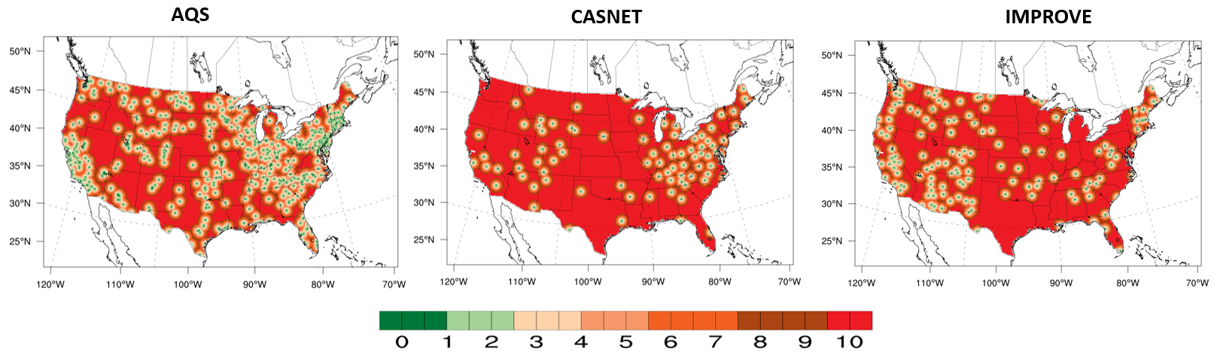
Figure 3.2 The spatial location of the AQS, CASTNET, and IMPROVE sites.

Results

Evaluation of Benchmark Machine Learning Models for PM_{2.5} Prediction.
Figure 2 illustrates the performance of a Random Forest (RF) model in predicting 2019 surface PM_{2.5} concentrations using data only from the same locations as the target grid cells. The RF model effectively captures the spatial distribution of PM_{2.5}, identifying higher concentrations in the eastern United States and lower levels in the western regions (Figure 2a). The model shows good validation performance for the "label" grid cells, achieving an R² of 1 and an RMSE of 0.29 μg/m³ on the training dataset, and an R² of 0.85 with an RMSE of 1.0 μg/m³ on the test dataset (Figure 2b). However, significant errors are observed, particularly in regions with high baseline PM_{2.5} concentrations (Figure 2c, d). These errors are more pronounced in areas far from monitoring sites, where predictions tend to overestimate PM_{2.5} levels, especially in downwind areas (Figure 2e). This overestimation is likely due to the inability of the model to accurately account for vertical profile differences between urban and suburban areas, as training is predominantly based on urban data where pollution is concentrated near the surface. Interestingly, the largest errors are found in the central United States rather than in the West, which is contrary to traditional expectations. In the eastern US, despite a higher density of monitoring sites, significant biases occur due to the concentration of these sites in urban areas and the much higher PM2.5 levels. This finding echoes earlier studies showing that machine learning models trained on spatially imbalanced networks often propagate urban emission characteristics into rural predictions, thereby inflating background concentrations in downwind areas (Di et al., 2019; Li et al., 2024b). Addressing this “urban training bias” remains one of the most pressing challenges for satellite–ML hybrid frameworks, especially when evaluating health impacts in underserved communities.
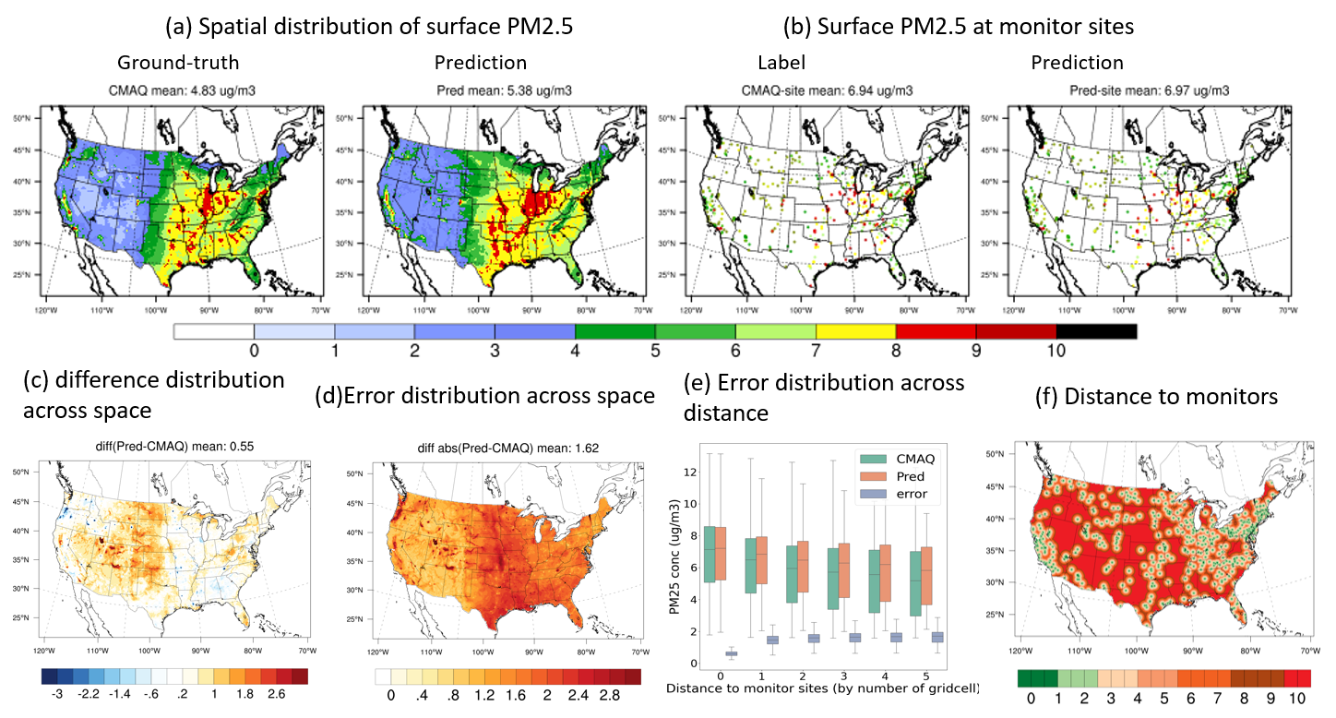
Figure 3.3 Spatial Distribution and Error Analysis of 2019 Surface PM2.5 Predictions Using a Random Forest Model.
Table 1 evaluates the performance of three machine learning models-Random Forest, LightGBM, and XGBoost-in predicting PM_{2.5} concentrations for the years 2019, 2014, and 2009. The models are evaluated at three stages: training, testing, and using all data combined, with key metrics being RMSE, R², and NMB. For 2019, Random Forest performs consistently well across all stages. In the training stage, it achieves a low RMSE and a high R², indicating that the model fits the training data well. During testing, the RMSE increases slightly to 1.5 µg/m³ and the R² drops to 0.85, reflecting a slight decrease in accuracy when applied to unseen data, but the model still generalizes effectively. Moreover, the combined data results further reinforce its robustness, with a balanced RMSE and high R², along with a near-zero NMB, suggesting minimal prediction bias. Similarly, LightGBM shows consistent trends, but with slightly higher errors. It also fits the data well in the training phase, but in the test phase the RMSE increases to 1.6 µg/m³ and the R² drops to 0.83. In addition, the combined dataset metrics confirm its reliable performance, albeit with slightly less accuracy than Random Forest. However, the NMB remains low, indicating that LightGBM, while having a slightly higher error rate, still produces unbiased predictions. This consistency across both RF and LightGBM suggests that ensemble tree-based methods are particularly well-suited for heterogeneous atmospheric datasets where nonlinearities dominate, consistent with findings from Wang et al. (2023).
In contrast, XGBoost shows notable differences between the training and testing phases in 2019. While it performs strongly during training, with a high R² and low RMSE, these metrics deteriorate significantly during testing, where the RMSE rises to 1.8 µg/m³ and R² falls to 0.80. This suggests that XGBoost may be overfitting the training data, resulting in less reliable predictions on new data. In addition, the combined data metrics show similar discrepancies, and the NMB is slightly higher, indicating a tendency for XGBoost to overestimate PM_{2.5} levels, particularly in areas not represented in the training data. Overfitting in XGBoost has been reported in other environmental prediction studies when hyperparameter tuning is insufficient or when the training data are spatially clustered (Chen & Guestrin, 2016; Wei et al., 2021). This highlights the necessity of incorporating spatial cross-validation strategies rather than relying solely on random splits, especially when station density is uneven.
For 2014, the performance patterns are consistent with 2019. Random Forest continues to provide stable results across all stages, with a test RMSE of 1.7 µg/m³ and an R² of 0.82. The slight increase in error from training to testing is minimal, showing that the model generalizes well. Similarly, LightGBM follows a similar pattern, with slightly higher RMSE and lower R² in the test stage, but still maintaining low bias and reasonable accuracy in the combined stage. On the other hand, XGBoost again shows signs of overfitting, with a significant drop in test performance (RMSE of 2.1 µg/m³ and R² of 0.75), reflecting its reduced ability to generalize beyond the training data. The persistence of this overfitting pattern across multiple years indicates a structural limitation in the XGBoost framework when applied to spatially imbalanced datasets, suggesting that advanced regularization or hybrid ensemble-deep learning strategies may be required (Zheng et al., 2021).
Finally, in 2009, the trends continue. Random Forest maintains its leading position, with only a slight decrease in performance from training to testing, confirming its ability to generalize well across different data sets. Furthermore, the combined data metrics (RMSE of 1.6 µg/m³ and R² of 0.84) indicate that it consistently captures the underlying patterns in the PM2.5 data. LightGBM also performs well, albeit with slightly higher errors in the test phase, but remains a reliable predictor with low bias. In contrast, XGBoost continues to struggle with overfitting and shows the largest discrepancies between the training and test phases, with the RMSE increasing to 2.3 µg/m³ and R² decreasing to 0.70 in the test phase, indicating significant challenges in generalizing the model. This comparison across three years highlights that Random Forest not only achieves higher accuracy but also demonstrates greater temporal robustness, a critical feature for long-term PM_{2.5} exposure assessments that inform regulatory policy and epidemiological studies.
In conclusion, Random Forest shows consistently strong performance at all stages-training, testing, and combined-and is the most reliable model for predicting PM_{2.5} concentrations. LightGBM also performs well, but with slightly higher errors and less precision in generalization. XGBoost, however, struggles with overfitting, particularly in the testing phase, resulting in higher prediction errors and reduced accuracy when applied to unseen data, underscoring the importance of evaluating model performance across all phases to ensure reliable and unbiased predictions. These findings suggest that while gradient boosting frameworks remain powerful tools, careful attention must be given to training sample imbalance, hyperparameter tuning, and spatial cross-validation strategies in order to achieve robust predictions across diverse regions.

Table 3.1 Performance comparison of the base line machine learning methods (Random Forest, LightGBM, and XGBoost) in predicting PM_{2.5} concentrations across 2019, 2014, and 2009 using RMSE, R², and NMB Metrics.
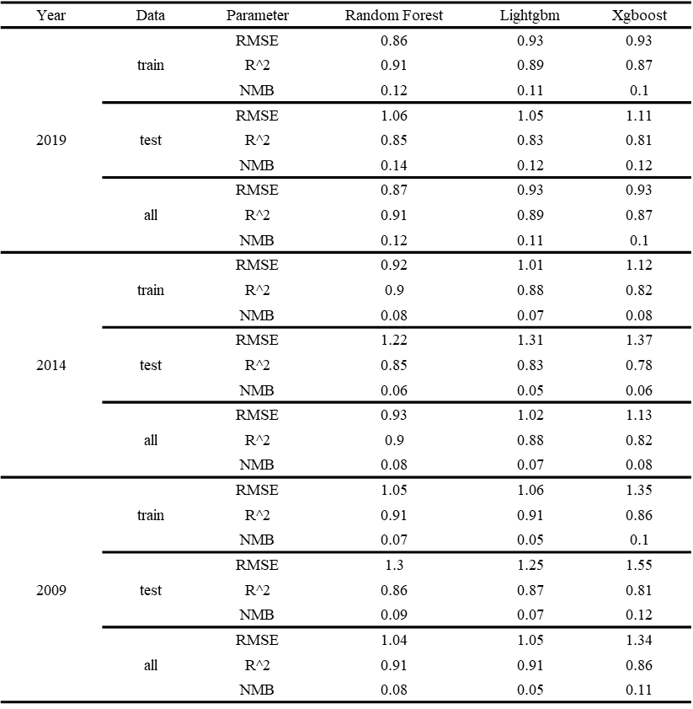
To further assess whether machine learning models trained on multi-year data can effectively capture long-term emission-driven trends and reduce spatial generalization errors, Figure 4 presents a four-panel comparison of PM_{2.5} concentrations derived from CMAQ simulations and Random Forest (RF) predictions across the contiguous United States (CONUS) from 2009 to 2019. Panel (a) shows the daily variation of national mean PM_{2.5} concentrations over this period. Both CMAQ and RF capture consistent seasonal patterns, with elevated concentrations during winter and early spring and lower values in summer and fall, corresponding to known seasonal emission and atmospheric conditions. Between 2009 and 2019, CMAQ indicates a clear downward shift in annual averages from approximately 6.2 μg/m³ in 2009 to 4.8 μg/m³ in 2019. The RF predictions reproduce this overall decline, though with slightly higher summertime values and a smoother curve, which may reflect the influence of urban-dominated training data that fails to fully capture regional differences in meteorology and source activity. This smoothing effect is consistent with previous findings that ML models trained on dense urban monitoring data often underestimate the amplitude of seasonal cycles, particularly in rural or emission-limited regions (Di et al., 2016; Xiao et al., 2023).
Panel (b) presents monthly average PM_{2.5} concentrations by NCEI-defined climate region, allowing for evaluation of both spatial and seasonal variability in model behavior. CMAQ shows clear regional and seasonal gradients—for example, in the Upper Midwest, concentrations drop from over 8 μg/m³ in 2009 to below 6 μg/m³ in 2019, with peak values typically occurring in January and July. The RF model captures the general direction of seasonal evolution but underestimates the magnitude of summer-to-winter contrasts in rural or topographically complex regions such as the Northwest, Northern Rockies, and Southwest. In these regions, the RF predictions are consistently higher than CMAQ estimates, especially in spring and summer months, indicating possible overfitting to urban patterns or insufficient representation of low-emission environments during model training. Such discrepancies are important because they can propagate into exposure assessments, especially for rural populations, which are often underrepresented in air quality monitoring but remain highly vulnerable due to reliance on local agricultural activities (Reid et al., 2019).
Panel (c) maps the spatial distribution of annual mean PM_{2.5} differences between 2009 and 2019 for both CMAQ and RF outputs. CMAQ simulations reveal widespread reductions of more than 2 μg/m³ across the Midwest, Great Lakes, and parts of the Southeast, reflecting major emission control efforts over the decade. In contrast, RF-predicted reductions are more moderate in these regions, often ranging from 1 to 1.5 μg/m³, and appear less pronounced over the Central Plains and Interior West. Some regions such as Texas and parts of California even show marginal increases or near-zero trends in RF predictions, diverging from the corresponding CMAQ outputs. These spatial discrepancies suggest that while the RF model reproduces the direction of change, it underestimates regional heterogeneity in emission responses, particularly where monitoring data are sparse. This underestimation aligns with earlier evaluations of ML-based PM_{2.5} models, which highlighted the risk of “spatial smoothing” when the models rely heavily on features correlated with urban emission patterns but fail to capture secondary formation or long-range transport dynamics (Just et al., 2020; Li et al., 2024a).
Panel (d) quantifies these differences at the state level, grouping the results by the nine NCEI regions. CMAQ simulations show the largest state-level reductions in the Ohio Valley and Southeast, where annual mean concentrations dropped by 2.0 to 2.5 μg/m³. RF predictions show similar directional trends but with reduced magnitude, typically 0.5 to 1.5 μg/m³ across the same states. In under-monitored areas such as the Northern Rockies and Upper West, the RF model frequently predicts minimal change or even slight increases, failing to reflect CMAQ-simulated declines. Notably, states like Colorado and Kansas, which combine complex topography with rural emission patterns, show the widest disagreement between the two models. These inconsistencies reinforce the importance of incorporating additional rural and regional monitoring networks (e.g., CASTNET and IMPROVE) to improve ML training sets and reduce reliance on urban-dominated samples. Without such adjustments, ML frameworks may systematically underestimate the benefits of air quality regulations in cleaner regions, leading to biased policy evaluations (Shaddick et al., 2020).
Overall, the four panels of Figure 4 reveal that while machine learning models trained on multi-year datasets can approximate national trends in PM_{2.5} decline, their performance varies substantially across space and time. CMAQ provides stronger spatial gradients and region-specific trend patterns, whereas RF predictions tend to smooth over these variations and produce more conservative estimates of change. The consistent underestimation of reductions in rural regions and the persistence of elevated predictions in cleaner areas suggest that sample imbalance remains a primary limitation. These findings demonstrate the value of hybrid testbeds that integrate CMAQ simulations with ML models, as they can highlight where ML predictions deviate most strongly from physical process-based simulations, thereby guiding targeted improvements in feature engineering, sampling strategies, and monitoring network design (Wei et al., 2023; Wang et al., 2023).
Monthly PM_{2.5}​ was summarized for the nine NCEI climate regions: Northwest, West, Southwest, Northern Rockies and Plains, Upper Midwest, Ohio Valley, South, Southeast, and Northeast. CMAQ simulations and machine-learning (ML) predictions were mapped to a common grid and masked by state identifiers to delineate each region. For every region and month, spatial means were computed across all masked grid cells after averaging over hours. Annual means were obtained by averaging the twelve monthly regional means. Seasons were defined as DJF for December, January, and February; MAM for March, April, and May; JJA for June, July, and August; and SON for September, October, and November. December was taken from the same calendar year as the corresponding January and February to maintain consistency with the plotted panels.
Agreement between ML and CMAQ was quantified with the normalized mean bias,
$$NMB(\%) = \frac{Ʃ(P_{i} - O_{i})}{ƩO_{i}}×100$$
where $P_{i}$​ and $O_{i}$ denote the ML and CMAQ monthly regional means within the period of interest. Positive values indicate ML overestimation relative to CMAQ, and negative values indicate underestimation. Seasonal and annual NMBs were computed for 2009 and 2019 and reported beneath each panel of Figure 4(b).
Across the United States, ML and CMAQ both capture the decadal decline in PM_{2.5}​ from 2009 to 2019. Annual NMB magnitudes are generally small in the eastern regions and larger in parts of the West and Southwest. For example, the Ohio Valley remains close to neutrality at the annual scale, with values on the order of a few percent in both years, while the West and Southwest retain clearly positive annual biases. The Northwest shows a marked improvement, with the annual NMB decreasing from roughly fifteen percent in 2009 to only a few percent in 2019. In contrast, the Northern Rockies and Plains exhibits an increase in annual NMB from about twenty percent to more than a quarter, indicating a growing positive bias. The Southeast changes sign at the annual scale, moving from a slight underestimation in 2009 to a slight overestimation in 2019. The Upper Midwest maintains a small positive annual bias in both years, and the Northeast shows a moderate increase but remains within a range that is modest compared with the western domains.
Seasonal behavior explains much of this regional contrast. Wintertime biases are particularly pronounced in the western United States. In the West and Southwest, DJF NMB values are very large and strongly positive in both 2009 and 2019, with the West near sixty percent and the Southwest above fifty percent, which is consistent with cold-season accumulation under stable conditions and with differences in how background levels are represented by ML and CMAQ. Summer also contributes positively in several regions. The West and Southwest display persistent positive JJA biases, and the Upper Midwest shows positive summer NMBs in both years, although the magnitude is smaller in 2019. By contrast, the Ohio Valley exhibits seasonal NMBs that are mostly within a few percent of zero, and the Northwest shifts toward neutrality across seasons, which together explain the substantial reduction in its annual bias. The Southeast illustrates a clear seasonal rebalancing, with winter changing from a negative to a positive NMB and summer increasing, consistent with the sign change at the annual scale.
Overall, the figure indicates strong alignment between ML and CMAQ in the eastern United States, typically with annual NMB near or below ten percent, and larger systematic differences in several western regions, especially in winter and, where wildfire influence is common, in summer. These patterns underscore the role of monitoring density, regional emissions, meteorological regimes, and extreme events in shaping apparent ML–CMAQ consistency at regional and seasonal scales.
- Daily Variation
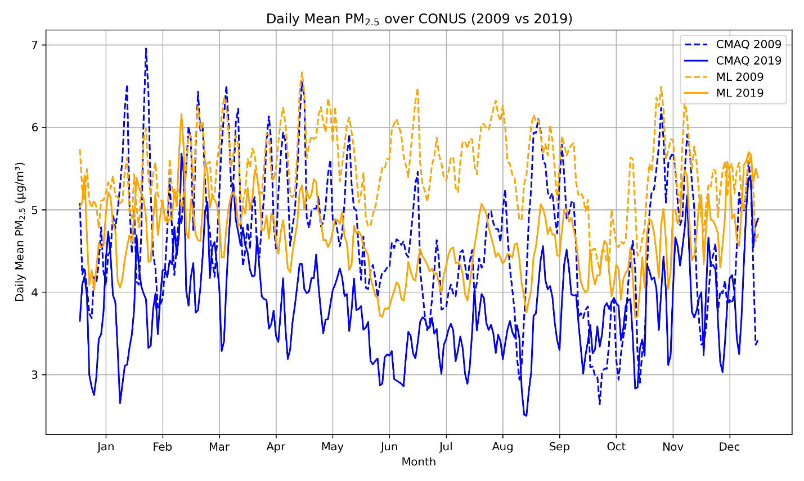
- Monthly Variation
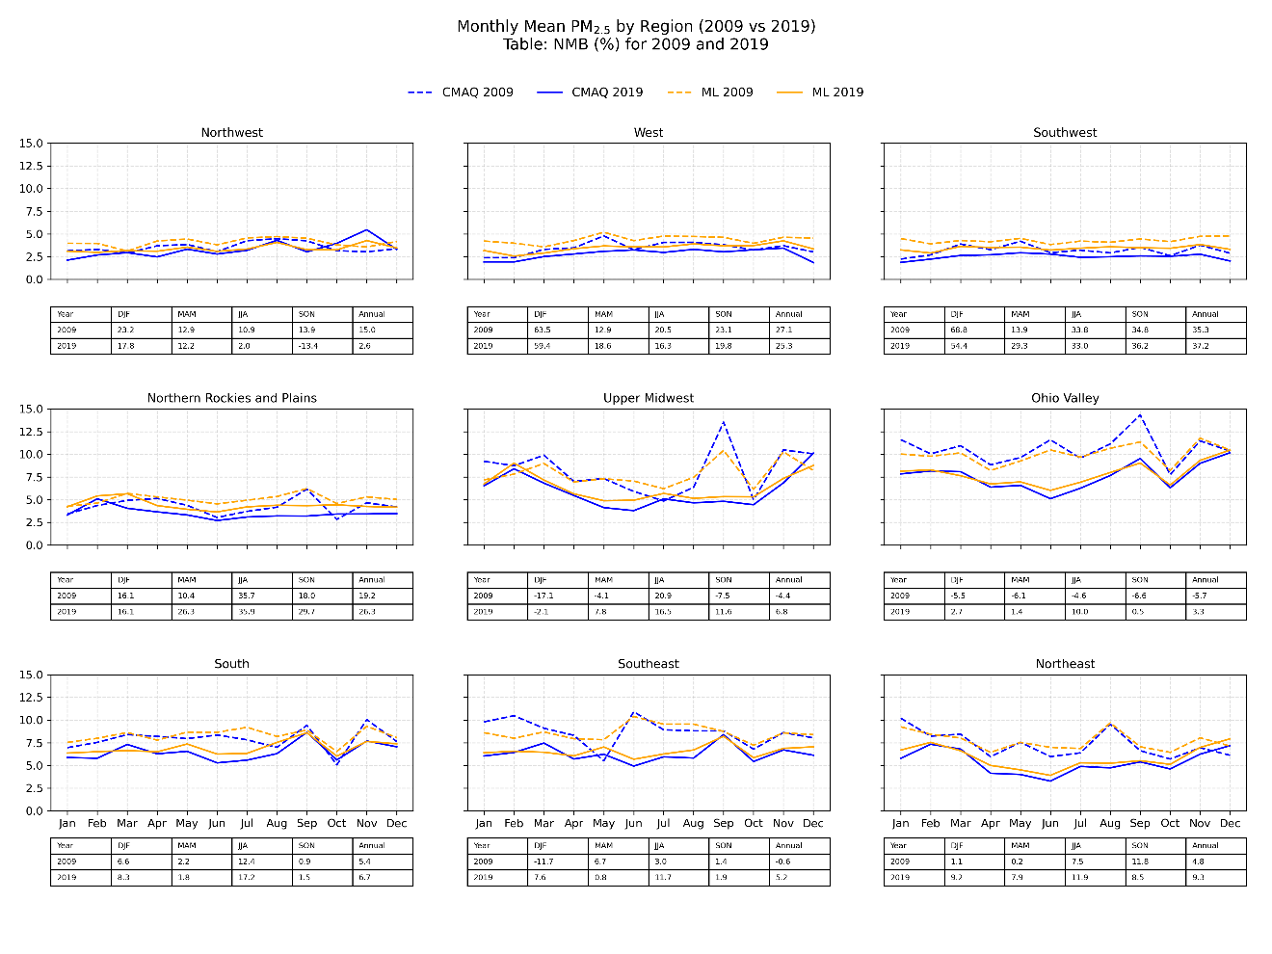
- Spatial Distribution
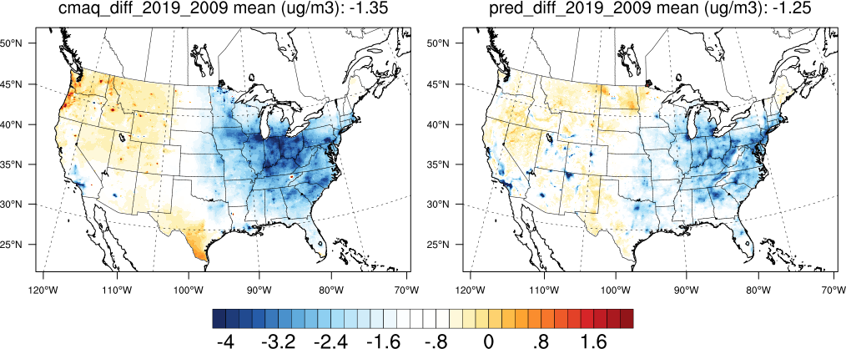

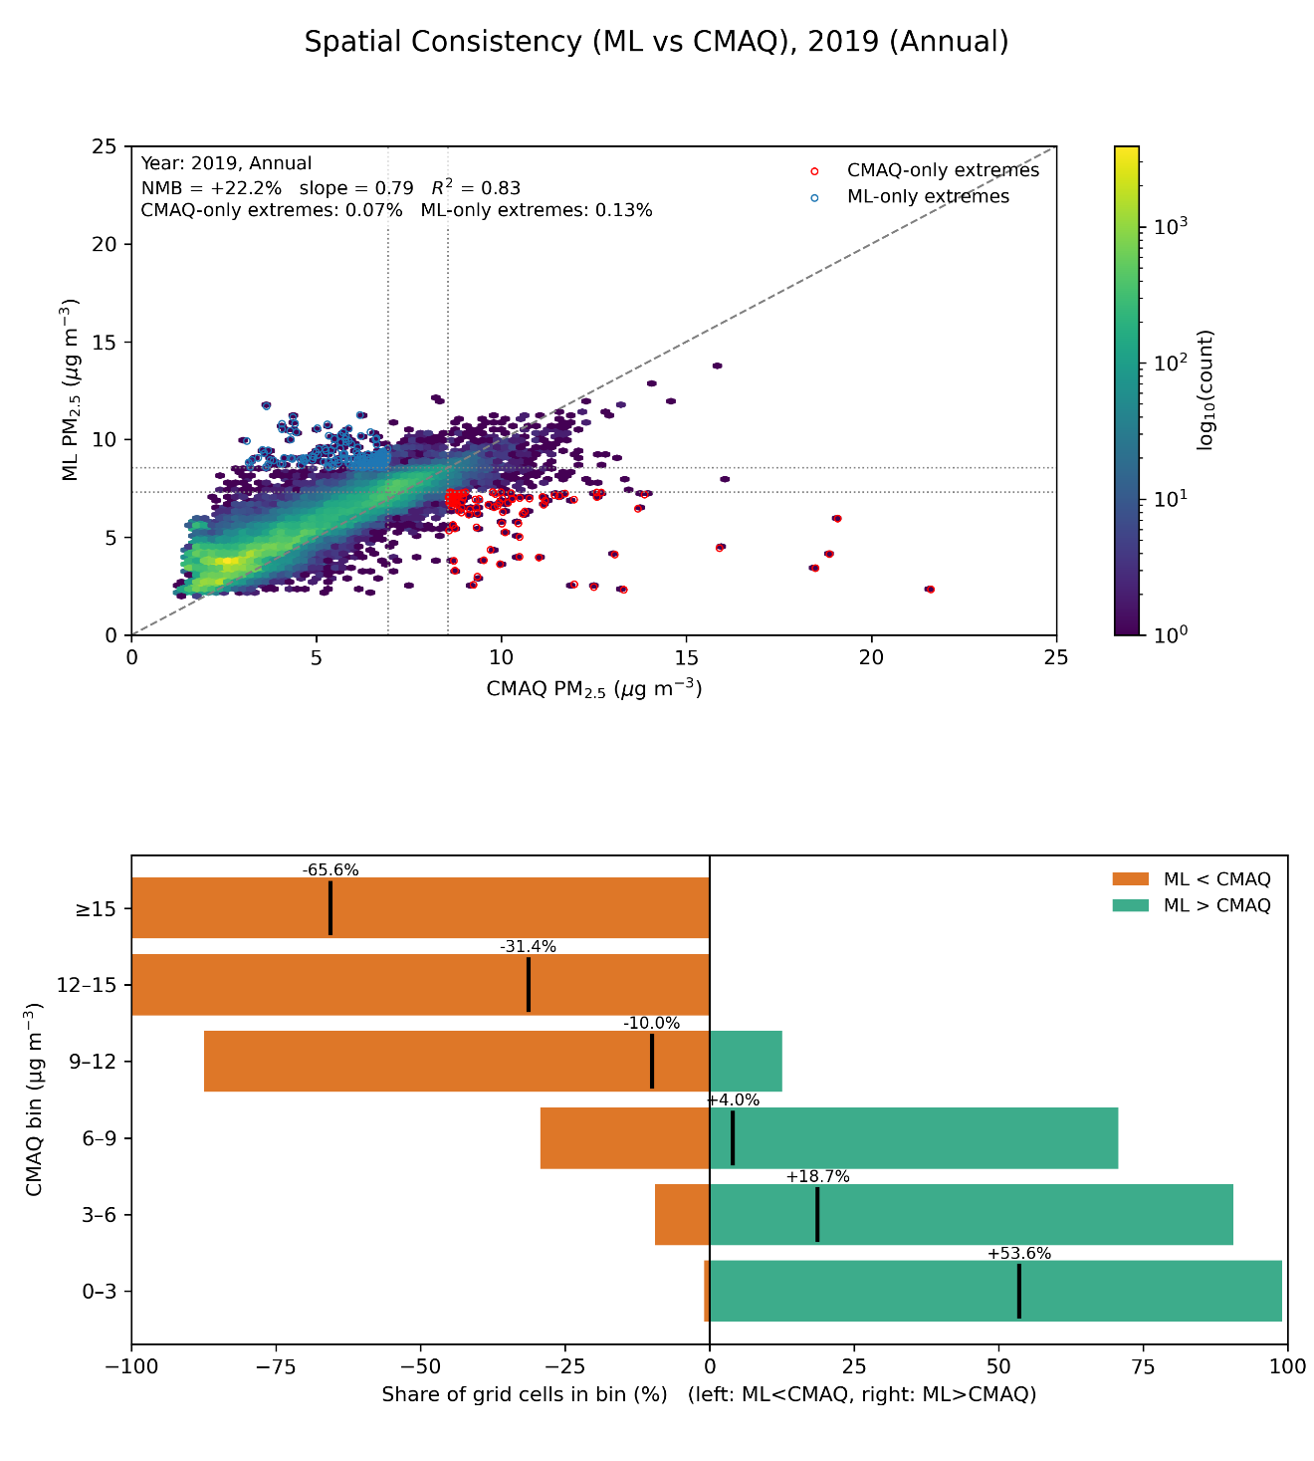
Here we compare machine-learning (ML) predictions with CMAQ using a hexagonal density plot of grid-cell pairs and a concentration-binned summary. The scatter shows strong nationwide coherence between products, with a coefficient of determination near 0.83. The normalized mean bias is about +22 percent when referenced to CMAQ, indicating a systematic elevation of ML relative to CMAQ at the national scale. The ordinary least-squares slope is approximately 0.79, which is consistent with a compressed dynamic range in ML: values near the low end are elevated and values near the high end are reduced relative to CMAQ. Extremes are rare but informative. Grid cells that are extreme in CMAQ but not in ML account for roughly 0.07 percent of the domain, and cells that are extreme in ML but not in CMAQ account for roughly 0.13 percent, indicating occasional misses of very high concentrations and occasional spurious high values in lower-background settings.
The binned analysis, which groups grid cells by CMAQ concentration and reports the share with ML greater than or less than CMAQ together with the mean relative difference, reveals a pronounced concentration dependence. In the lowest bins, from 0 to 3 μg/m³ and from 3 to 6 μg/m³, ML exceeds CMAQ for most grid cells and the mean relative difference is large and positive, on the order of +54 percent and +19 percent, respectively. Near the middle range, around 6 to 9 μg/m³, the mean difference is close to neutral. At higher concentrations the sign reverses: between 9 and 12 μg/m³ the mean relative difference is modestly negative, near −10 percent, and it becomes increasingly negative in the 12 to 15 μg/m³ and ≥15 μg/m³ bins, reaching approximately −31 percent and −66 percent. Together with the sub-unit slope, these patterns indicate a consistent tendency for ML to raise cleaner backgrounds and to damp the highest concentrations.
The most plausible explanations combine statistical shrinkage and representativeness. Regression-to-the-mean behavior in the learning algorithm, limited training coverage at the highest quantiles, and imperfect predictors for wintertime stagnation and smoke-affected summers can all contribute to underestimation at the top end and overestimation at the bottom end. For applications that depend on accurate exposure gradients, these results argue for a simple post-processing bias correction that is conditional on concentration, for example quantile mapping or bin-wise calibration, and for targeted evaluation in regimes dominated by winter inversions and wildfire smoke.
(d)State-level Comparison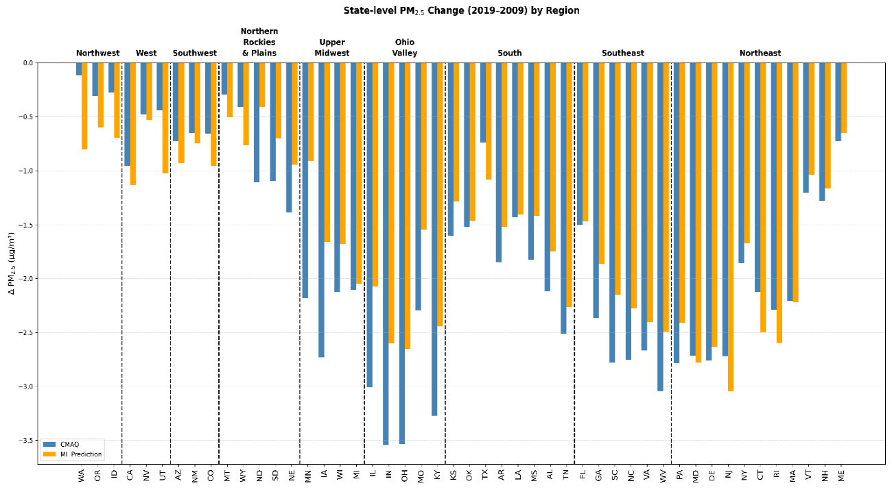
Figure 3.4 Multi-perspective comparison of PM_{2.5} changes over CONUS from 2009 to 2019 using CMAQ and ML-based predictions.

Annual variation and effects of monitoring site distribution on PM_{2.5} prediction accuracy
Figure 3 illustrates the spatial and temporal changes in PM_{2.5} concentrations derived from CMAQ data. It shows the differences in PM_{2.5} levels between different years, highlighting a general decrease in PM_{2.5} from 2009 to 2019, with an average decrease of -1.35 μg/m³. However, when this decade is divided into two periods, the changes are not uniform. Between 2014 and 2019 the decrease is only -0.43 μg/m³, while from 2009 to 2014 the decrease is almost double. This indicates that while PM_{2.5} levels are generally decreasing, the rate of decrease has slowed over time. Spatially, the figure shows a contrasting trend across the United States: PM_{2.5} levels are decreasing in eastern regions, but increasing in western regions. The most severe areas of PM_{2.5} have shifted from the far eastern U.S. to central regions, such as Texas, between 2009 and 2014. This spatial shift suggests that relying on traditional machine learning models, which tend to overestimate PM_{2.5} in the West and underestimate it in the East, could lead to significant biases in PM_{2.5} predictions. These temporal and spatial patterns are consistent with national emission inventory records showing substantial reductions in SO₂ and NO_{x} emissions after 2009 due to regulatory controls, whereas increases in wildfire activity and oil and gas operations contributed to western PM_{2.5} burdens in the 2010s (McDuffie et al., 2021; Murphy et al., 2022).
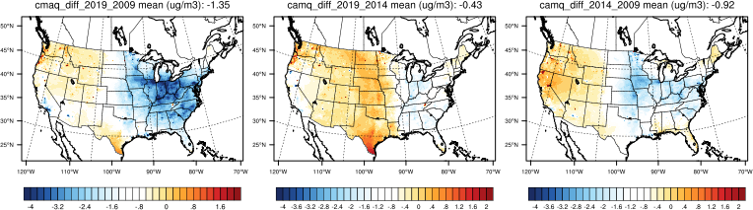
Figure 3.5 Spatial and temporal changes in ground-truth (CMAQ) PM_{2.5} concentrations (2009, 2014, 2019).
Figure 4 shows the distribution of EPA PM_{2.5} monitors and the distance to these monitors for the years 2009, 2014, and 2019. The left column of the figure shows the spatial distribution of monitoring sites for each year, with colors indicating the distance from a given point to the nearest monitor. Over time, from 2009 to 2019, there has been a gradual increase in the number of monitoring sites, particularly in urban areas. However, despite this increase, monitors remain heavily concentrated in cities, leaving rural areas less covered. The middle column of the figure shows density plots of PM_{2.5} concentrations as modeled by CMAQ for each of the three years. The black dashed lines indicate the peak of the density distribution for each year, which shows a leftward shift from a log concentration of 9 µg/m³ in 2009 to 7.8 µg/m³ in 2014, and further to 7.1 µg/m³ in 2019. This shift reflects a general decrease in PM_{2.5} concentrations over time. However, regardless of the year, the label values (representing ground truth data) do not fully capture the entire density distribution generated by the CMAQ model. The peak and distribution of the label values consistently show a rightward shift compared to the CMAQ results, indicating that relying solely on label data for predictions may lead to an overestimation of total PM_{2.5} concentrations. This bias highlights the challenge of “urban skew” in monitoring, where station locations overrepresent polluted cores while underrepresenting rural or background conditions, leading to inflated estimates when extrapolated nationally (Cressie & Wikle, 2015; Shaddick et al., 2020).
The right column of the figure shows box plots representing the RMSE values obtained when using Random Forest models to predict PM_{2.5} at different distances from the monitor sites, using the label positions from different years as a reference. The results clearly show that the RMSE increases with distance from the monitoring sites for all years, highlighting the challenge of making accurate predictions in areas far from monitors. In particular, predictions using 2019 tag positions tend to have lower RMSE values, indicating better model performance. Furthermore, predictions for 2019 consistently result in the lowest RMSE, regardless of which year's label positions are used as a reference. These results highlight the importance of balancing the distribution of monitoring sites across regions to improve the accuracy of PM_{2.5} predictions. Concentrating monitors in urban areas while neglecting rural regions can lead to significant biases and inaccuracies, especially in areas far from existing monitors. Therefore, achieving a more even distribution of monitoring sites is critical to improving the reliability of PM_{2.5} predictions over the entire study area. This reinforces the call for integrating multiple monitoring networks (AQS, CASTNET, IMPROVE) to reduce spatial bias and improve generalization, particularly in under-monitored western and rural regions (Hand et al., 2019; Wei et al., 2023).
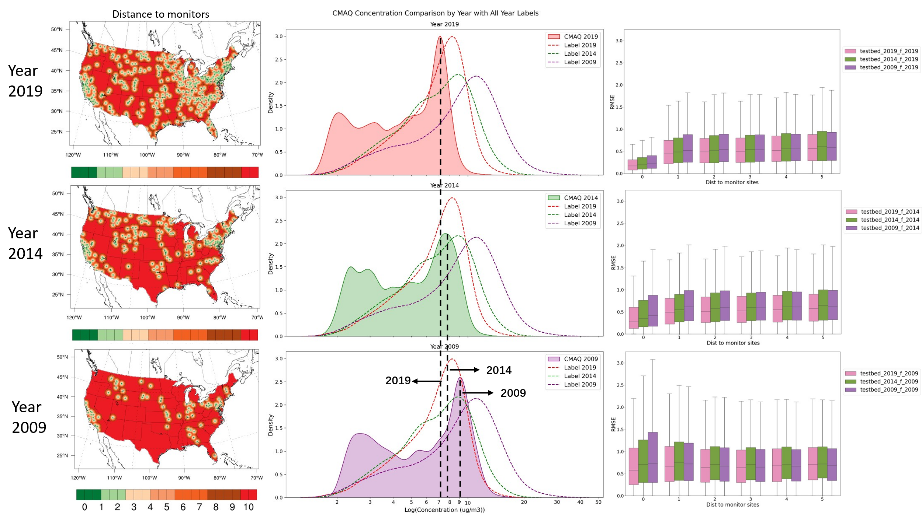
Figure 3.6 Distribution of EPA PM_{2.5} monitors and distance to monitors (2009, 2014, 2019)
Figure 5 illustrates the PM_{2.5} prediction results for 2019 using a random forest model, with AQS, CASNET and IMPROVE data as labels. The left column shows the spatial distribution of monitoring sites for each data source, and the distances of these sites to other areas. Among the three, CASNET has the fewest monitoring sites, followed by IMPROVE, while AQS has the most. When comparing the spatial prediction results with the CMAQ output, it is evident that all three sources tend to overestimate PM_{2.5} concentrations overall. However, the spatial discrepancies vary by region. In the western United States, all three label sources lead to overestimates. In the eastern United States, predictions based on AQS data lead to overestimates in some areas, while CASNET data tend to significantly underestimate PM_{2.5} concentrations. IMPROVE data, on the other hand, result in moderate underestimations. These contrasting patterns highlight the influence of network design on prediction bias: urban-heavy networks like AQS tend to overpredict due to emission density, whereas rural-focused networks like IMPROVE may underpredict by missing urban plumes. CASTNET, with its mixed urban–rural distribution, provides a more balanced representation, improving overall generalization (Schwede & Lear, 2014; Simon et al., 2011).
Further analysis of the RMSE values at different distances from the monitoring sites shows that predictions using CASNET data yield the lowest RMSE values, followed by AQS, with IMPROVE yielding the highest RMSE. In addition, the RMSE values for all three sources increase with distance from the monitoring sites, indicating that predictions become less accurate as one moves away from the data points. The superior performance of CASNET can be attributed to its balanced coverage of over 90 rural, suburban, and urban sites, providing a more representative data set. In contrast, IMPROVE data points are concentrated in rural and remote areas and lack urban information, while AQS, despite having the largest number of sites, is primarily focused on urban regions, leading to overestimation when used as a label for predictions. This finding underscores the importance of network complementarity: combining AQS for urban cores, IMPROVE for remote areas, and CASTNET for mixed coverage could yield a hybrid dataset that reduces spatial bias in ML training and better captures the full exposure gradient (Di et al., 2019; Wei et al., 2023).
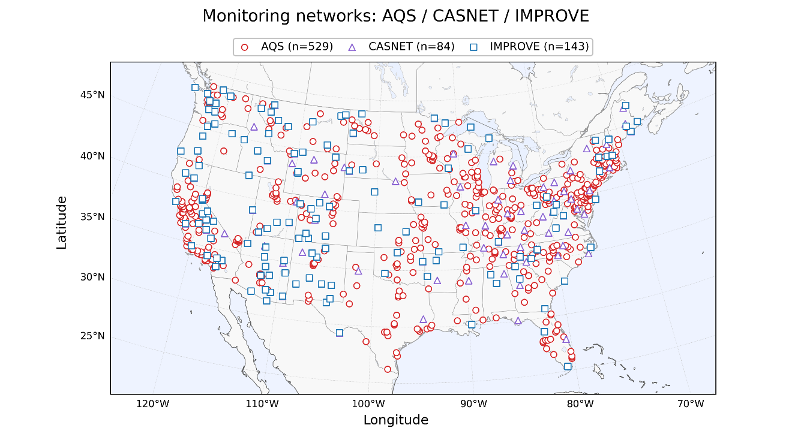

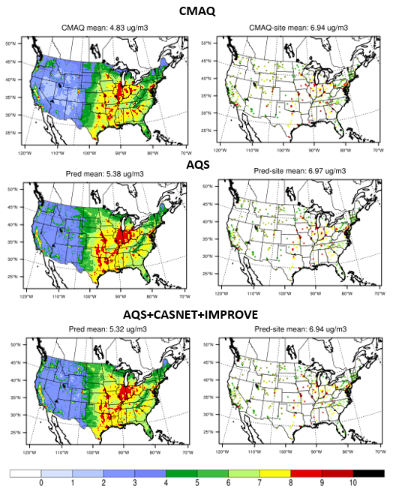
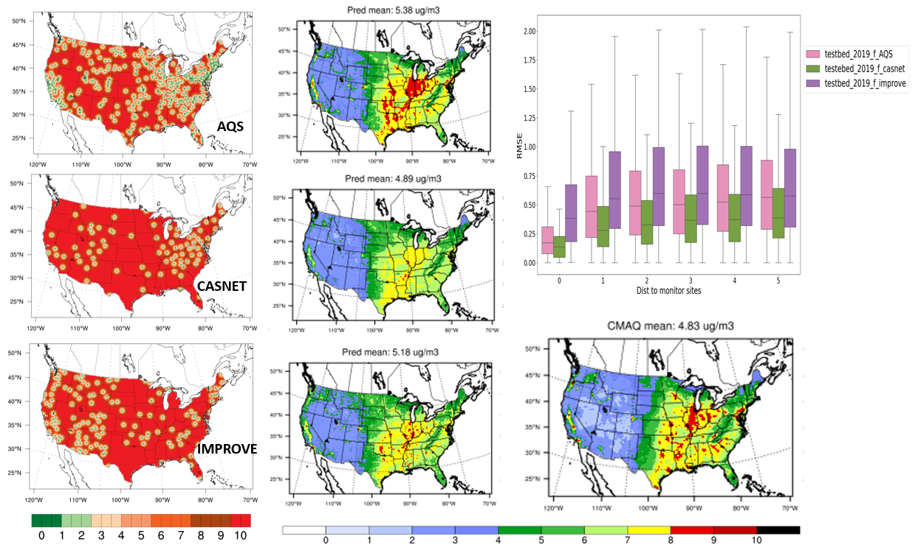
Figure 3.7 Performance of PM_{2.5} predictions for 2019 using different data sources (AQS, CASNET, IMPROVE) as labels

The impact of spatial and temporal features on PM_{2.5} predictions
Previous studies, such as Hu et al. (2017), have confirmed that incorporating nearby PM_{2.5} measurements and aerosol optical depth (AOD) values into the model significantly improves the prediction accuracy of PM_{2.5} concentrations. This is mainly because these features serve as critical predictors during the training process. Incorporating spatiotemporal neighborhood features, which include data from surrounding grid cells and temporal information from before and after the target time, significantly improves PM_{2.5} prediction accuracy compared to traditional methods that rely solely on single-time features. Traditional models typically focus on a snapshot in time, often missing the broader temporal context that can be critical for accurate predictions. For example, AOD measurements from satellites such as MODIS capture only a single time step, while predictions are needed for daily averages. Adding additional time step information helps to capture this broader temporal context, leading to more accurate predictions.
Recent studies have highlighted that spatial features help capture pollutant transport and dispersion effects, particularly in regions influenced by long-range transport of aerosols or strong local gradients (Di et al., 2019; Xiao et al., 2023). Temporal features, on the other hand, improve model performance by embedding persistence and lagged effects of meteorological conditions, such as multi-day stagnation episodes, which are strongly linked to PM_{2.5} accumulation (Stowell et al., 2019). By jointly considering spatial and temporal contexts, machine learning models can better emulate the physical processes represented in chemical transport models, while also leveraging observational data to reduce bias.
Figure 6 illustrates the results of adding spatial neighborhood information (RF_spatial) and temporal information (RF_temporal) to the Random Forest model. The figure shows that both spatial and temporal enhancements improve prediction accuracy, but the temporal features provide a more significant improvement. The top panel of the figure compares the spatial distribution of surface PM_{2.5} predictions over the continental United States for the three models: RF (baseline), RF_spatial, and RF_temporal. The lower panel shows RMSE values at different distances from the monitor sites, showing that the RMSE increases with distance, but more gradually when temporal features are included, indicating more robust prediction performance.
These findings suggest that temporal features compensate for monitoring network limitations by reducing sensitivity to site distribution, making predictions more transferable to rural and downwind regions. The stronger effect of temporal features compared to spatial ones also underscores the importance of accounting for emission cycles (e.g., weekday vs. weekend), boundary layer dynamics, and seasonal persistence in PM_{2.5} formation. This aligns with recent evidence that hybrid spatiotemporal ML frameworks outperform static models in reproducing both urban hotspots and regional background pollution (Zhan et al., 2022; Wei et al., 2023).
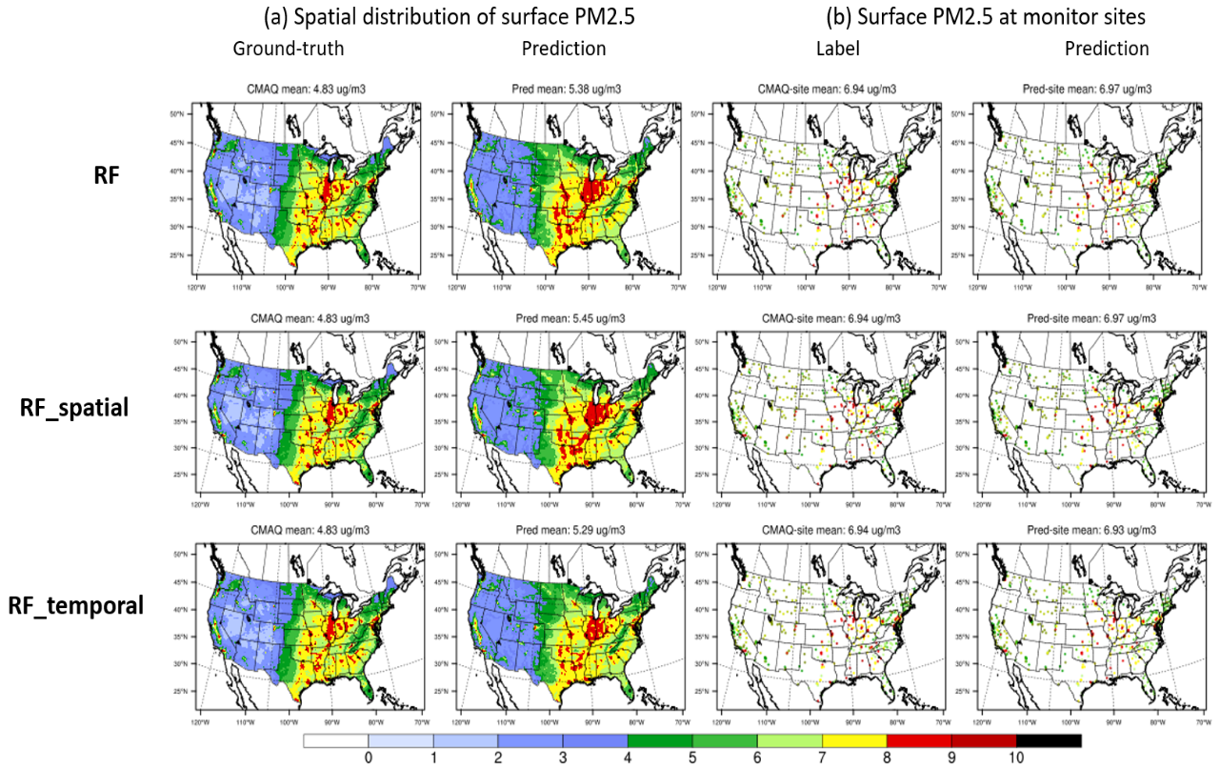
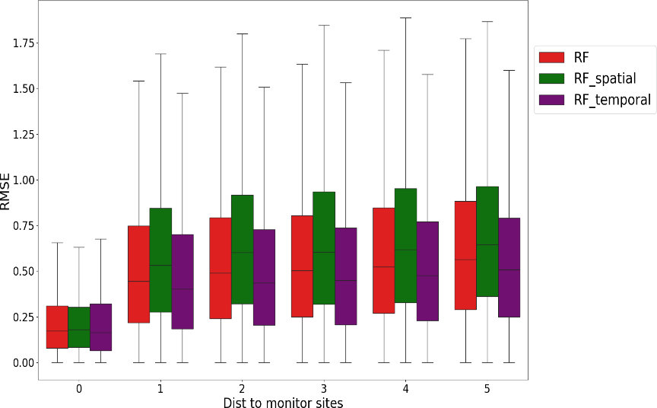
Figure 3.8 Effect of spatial and temporal features on the accuracy of PM_{2.5} forecasts

Performance of deep learning methods: ResNet
In this section, we evaluate the performance of deep learning methods, specifically ResNet, in predicting PM_{2.5} concentrations. ResNet, known for its powerful feature extraction capabilities, is compared to traditional machine learning models such as random forest (RF) and gradient boosting methods (XGBoost, LightGBM), as well as other deep learning variants such as DeepRF and ResNet with temporal features (ResNet_temporal). Figure 7 shows the spatial distribution of PM_{2.5} concentrations for 2019 as predicted by different models, including the ground truth data from CMAQ. The figure shows that while all models capture the general spatial patterns of PM_{2.5}, there are differences in the predicted concentrations, especially in regions with higher pollution levels. The right panel (e) shows how the prediction errors vary with distance from the monitoring sites, illustrating that the errors tend to increase with distance from the monitoring sites, which is a common challenge in air quality modeling.
ResNet’s advantage lies in its ability to learn hierarchical representations of features through residual blocks, allowing the model to capture nonlinear interactions between emissions, meteorology, and atmospheric chemistry that simpler algorithms may miss (He et al., 2016; Song et al., 2020). This makes it particularly effective in regions with complex pollution dynamics, such as the eastern U.S. with strong anthropogenic sources, or the western U.S. where wildfire smoke and dust events drive episodic PM_{2.5} peaks.
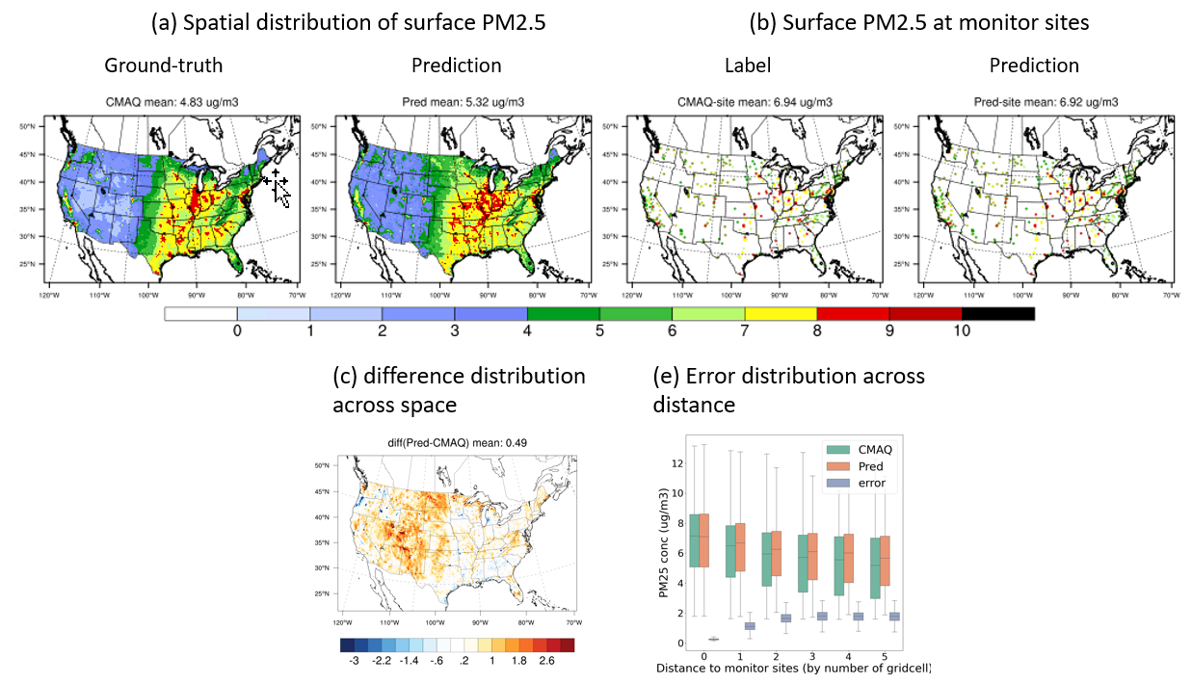
Figure 3.9 Spatial distribution of surface PM_{2.5} and error analysis across distance for 2019.
Figure 8 further explores the performance comparison by showing RMSE values at various distances from monitoring sites for different models. The box plots show that the ResNet and ResNet_temporal models generally yield lower RMSE values compared to traditional models such as RF and gradient boosting methods, especially at greater distances from monitoring sites. This indicates that ResNet, especially when incorporating temporal features, improves the ability of the model to generalize and more accurately predict PM_{2.5} concentrations over a larger spatial domain. Incorporating temporal features into ResNet (ResNet_temporal) appears to provide a significant benefit, reducing prediction errors even further compared to ResNet alone. This improvement suggests that ResNet_temporal can capture persistence effects of PM_{2.5} formation and transport, such as multi-day stagnation or wildfire smoke plumes, which purely spatial models may fail to represent.
Our results are consistent with recent applications of spatiotemporal deep learning in air quality research, which demonstrate that CNN- or ResNet-based architectures outperform tree-based models in regions with sparse monitoring networks (Li et al., 2024a; Wei et al., 2023). Importantly, ResNet’s ability to reduce error growth with distance highlights its potential to bridge urban–rural gaps in exposure assessments, a critical issue for addressing environmental equity in air pollution research (Clark et al., 2020).
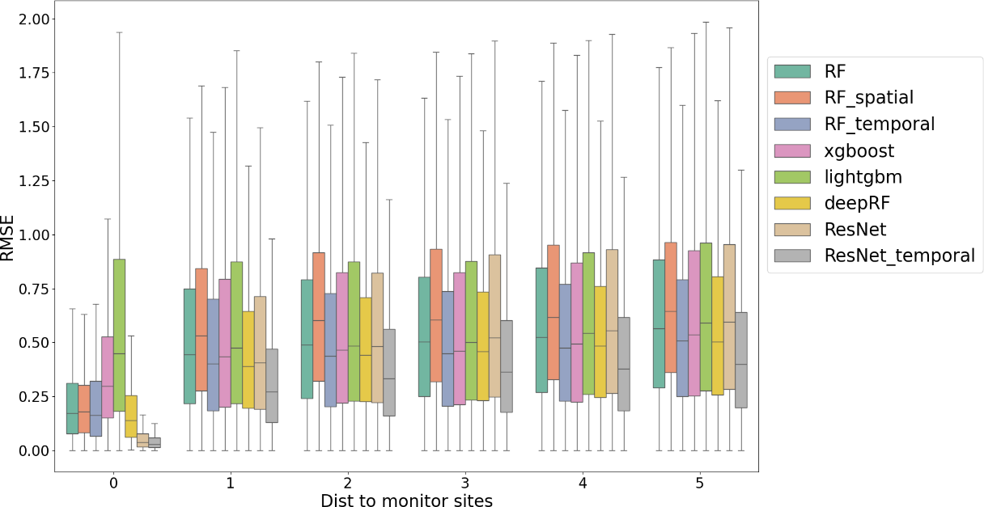
Figure 3.10 RMSE comparison of various models across distances from monitoring sites.

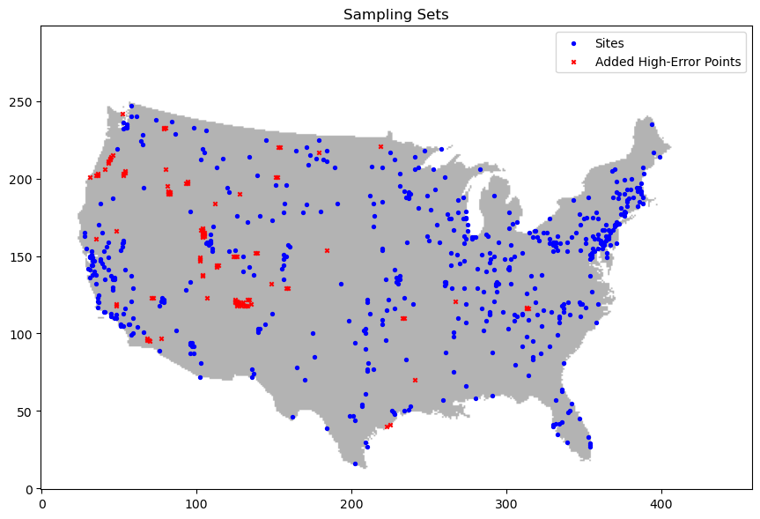
Figure 3.11 Spatial distribution of monitoring sites and selected high-error grid cells. Blue dots denote existing monitoring sites, while red crosses indicate newly sampled high-error locations identified based on model–simulation discrepancies.
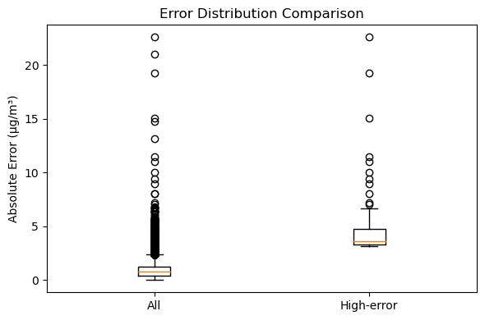
Figure 3.12 Normalized error distributions for all grid cells versus high-error locations. Histogram and kernel density estimates show that errors at high-error points (red) are systematically larger and shifted toward higher values compared to all grid cells (blue).
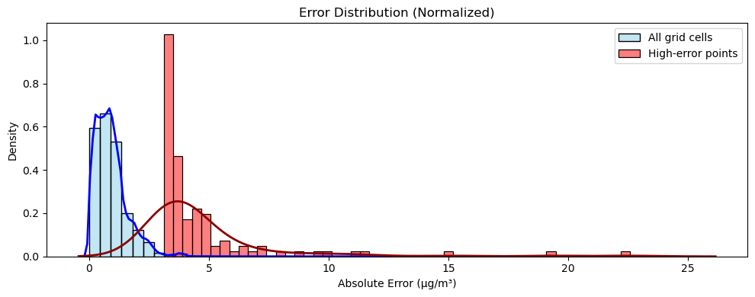
Figure 3.13 Boxplot comparison of absolute errors between all grid cells and high-error locations.The median and interquartile range of the high-error group are significantly higher, demonstrating the effectiveness of the sampling strategy in capturing model underperformance regions.

Discussion
This study evaluates the effectiveness of machine learning models in predicting surface PM_{2.5} concentrations over the United States, with a specific focus on how spatial and temporal sampling influence prediction accuracy. Our results show that while Random Forest and other baseline models capture broad spatial patterns of PM_{2.5}, they consistently overestimate concentrations in areas far from monitoring sites—particularly in the central and southeastern United States. These errors persist even when models are trained on multiple years of data (2009, 2014, 2019), indicating that increasing temporal coverage alone cannot resolve sample-imbalance issues rooted in spatially clustered monitoring networks. This observation echoes findings from Li et al. (2024b) and Ma et al. (2023), who similarly reported that data sparsity in rural areas introduces systematic uncertainties, even when multi-year training datasets are used.
Incorporating neighborhood features—both spatial (RF_spatial) and temporal (RF_temporal)—demonstrably improves model performance, especially in under-monitored regions. Temporal features, in particular, reduce root mean squared error (RMSE) by up to 15 percent at distances greater than 150 km from a monitor. These findings highlight the value of temporal context for reducing bias, but they also reinforce that structural biases in the training data cannot be fully corrected without more spatially representative ground truth. Similar conclusions were drawn by Hu et al. (2017) and Zhan et al. (2022), who emphasized that temporal autocorrelation in pollution events, such as multi-day stagnation or wildfire smoke plumes, provides critical information that is often missed in single-time-step models.
Our study also reveals concerning implications for health exposure assessment. For example, overestimation of PM_{2.5} in the clean-air western U.S. (e.g., parts of Nevada and Utah) may inflate public health risks and trigger unwarranted regulatory actions. Conversely, underestimation in polluted but poorly monitored areas (e.g., central Texas, Ohio Valley) may mask real exposure burdens and delay necessary interventions. These biases have direct implications for environmental justice, as rural and socioeconomically disadvantaged regions—often home to marginalized populations—are disproportionately affected by either misdiagnosed or overlooked air quality problems. This reinforces concerns raised in recent environmental equity literature (Clark et al., 2020; Tessum et al., 2021), which show that communities of color and low-income populations are frequently underrepresented in monitoring networks yet bear disproportionate pollution burdens.
Another key finding is the systematic distortion of annual trends. Although national PM_{2.5} levels declined from 2009 to 2019, models trained on urban-centric data tend to underestimate this reduction, especially in the eastern U.S., where regulatory improvements were most effective. Such distortions can obscure the long-term benefits of emission controls and undermine policy evaluations. For example, Xue and Ullrich (2022) highlighted that urban-weighted sampling can mask emission control success in regional trend analyses, leading to discrepancies between modeled and observed improvements. Our findings confirm that machine learning frameworks must explicitly account for monitoring-site bias to avoid misleading conclusions about regulatory efficacy.
While deep learning models such as ResNet and ResNet_temporal show promising improvements, their performance is still contingent on input data quality. Current reliance on daytime satellite AOD creates blind spots for nighttime and cloudy conditions. Future work should explore additional data sources (e.g., nighttime satellite products, ground-based LiDAR) and techniques (e.g., domain adaptation, synthetic data augmentation) to improve prediction robustness in data-sparse regions. Recent studies (Jiang et al., 2022; Sun et al., 2023) demonstrate that multimodal integration of satellite, chemical transport models, and sparse ground networks can substantially reduce uncertainties, especially in regions with limited observations.
In conclusion, this study underscores that addressing sample imbalance requires not only algorithmic innovations but also more equitable spatial data collection. Our results suggest that failure to correct spatial biases can result in health exposure errors exceeding 1–2 μg/m³, particularly in rural America—an amount large enough to alter regulatory decisions and exacerbate health disparities. These findings call for coordinated efforts to expand monitoring in underrepresented regions and to integrate more spatially diverse data into training pipelines. Such an approach would align with the U.S. EPA’s recent calls for modernizing the national air quality monitoring system (EPA, 2022), ensuring that advances in machine learning are matched by improvements in the underlying data infrastructure.

Conclusion
This study demonstrates the effectiveness of integrating spatial and temporal features into machine learning and deep learning models for PM_{2.5} prediction. By using a combination of traditional machine learning methods and advanced deep learning architectures such as ResNet, we achieved significant improvements in prediction accuracy, especially in regions far from monitoring sites. Our results highlight the importance of considering temporal dynamics and spatial relationships in air quality modeling to better capture the complex behavior of PM_{2.5} concentrations across regions. While our approach has addressed some of the limitations of previous models, challenges remain, particularly in accurately predicting PM_{2.5} in less monitored areas and under varying atmospheric conditions. This echoes earlier findings by Hu et al. (2017) and Wei et al. (2023), who similarly emphasized that spatiotemporal context is critical to reducing uncertainties in PM_{2.5} estimates and improving health-relevant exposure assessments.
Future work should focus on expanding the temporal and spatial coverage of input data, exploring additional data sources, and developing more robust models that generalize well under different environmental conditions. For example, incorporating nighttime satellite observations (e.g., VIIRS), geostationary satellites such as GOES-R, or emerging high-resolution instruments like TROPOMI could provide near-real-time coverage that reduces data gaps (van Donkelaar et al., 2021; Hammer et al., 2023). Likewise, combining sparse networks such as CASTNET and IMPROVE with community-based low-cost sensors may help overcome sample imbalance and provide more representative ground-truth data in rural regions (Malings et al., 2020).
Overall, our study provides a strong foundation for improving PM_{2.5} predictions and highlights the potential of deep learning methods, especially when augmented with spatiotemporal features, to advance air quality monitoring and public health protection. The CMAQ–ML testbed developed here demonstrates a scalable framework that not only reduces uncertainties in PM_{2.5} estimation but also directly informs regulatory applications, including exposure assessments, health risk evaluations, and environmental equity analyses. As regulatory standards continue to tighten (EPA, 2024), the ability to provide accurate, fine-resolution, and equitable PM_{2.5} exposure estimates will become increasingly vital for guiding policy, protecting vulnerable populations, and ensuring that the benefits of emission reductions are realized across all regions of the United States.

Socioeconomic and Health Implications of Drought and Air Pollution

Research Question
This chapter investigates the socioeconomic and health implications of increased drought variability and air pollution in the contiguous United States. Specifically, it explores how shifting drought patterns and PM_{2.5} pollution influence public health and economic productivity across different regions. The central questions addressed in this chapter include: (1) How does exposure to drought and PM_{2.5} pollution vary across different demographic and socioeconomic groups? (2) What are the projected health burdens associated with increased exposure to these environmental stressors? (3) What are the economic costs of air pollution-related health impacts, and how do they differ across urban and rural areas? (4) How can policy interventions and adaptation strategies be optimized to mitigate these adverse effects? By integrating climate data, air quality modeling, and epidemiological health impact assessments, this chapter aims to provide a comprehensive understanding of the intersection between environmental stressors, human health, and economic burdens.

Introduction
Drought and air pollution are two of the most pressing environmental stressors impacting human well-being. Climate-induced shifts in drought patterns are causing more frequent and intense dry spells in some regions, while others experience fluctuations between extreme wet and dry conditions. These unpredictable variations threaten water security, agricultural productivity, and natural ecosystems. Simultaneously, air pollution, particularly fine particulate matter (PM_{2.5}), remains a critical public health issue, contributing to respiratory and cardiovascular diseases, premature mortality, and reduced labor productivity.
The interaction between these two stressors exacerbates environmental and public health risks. Drought intensifies air pollution by increasing wildfire frequency, reducing soil moisture, and enhancing dust emissions, leading to higher concentrations of airborne particulates. The health consequences of PM_{2.5} exposure are particularly severe for vulnerable populations, including children, the elderly, and individuals with pre-existing respiratory and cardiovascular conditions. The socioeconomic burden of these health effects is substantial, resulting in increased healthcare expenditures, lost workdays, and broader economic disruptions.
This study quantifies the health and economic impacts of drought and air pollution using an integrated approach that combines high-resolution climate projections, air quality modeling, population exposure assessments, and health impact estimations through the U.S. Environmental Protection Agency’s BenMAP-CE tool. By identifying the most at-risk populations and estimating the economic costs of exposure, this research provides insights for policy development and climate adaptation strategies.

Objective
This chapter aims to quantify the health and economic burdens associated with the combined effects of drought and air pollution across the contiguous United States. The study has four primary objectives. First, it estimates population exposure to worsening drought conditions and PM_{2.5} pollution using high-resolution climate and air quality models. Second, it assesses the health risks associated with increased exposure, focusing on mortality, respiratory diseases, and cardiovascular conditions. Third, it quantifies the economic losses related to air pollution and drought-driven health impacts, including direct healthcare costs and lost labor productivity. Finally, it identifies vulnerable populations that are disproportionately affected due to socioeconomic factors, environmental injustice, and existing health disparities. By addressing these objectives, this chapter provides a framework for evaluating the long-term impacts of climate-driven environmental stressors on human well-being and economic sustainability.

Methods and Data
This study employs an integrated framework consisting of three components: (1) population exposure estimation, (2) health impact estimation, and (3) economic cost analysis. By combining high-resolution environmental datasets with epidemiological models and socioeconomic indicators, the framework links drought and air pollution exposures with their public health and economic consequences.

Population Exposure Estimation
Population exposure was quantified for both drought and fine particulate matter (PM_{2.5}) by overlaying environmental datasets with demographic and socioeconomic information.
Drought exposure. Drought severity was characterized using three indices: the Self-Calibrating Palmer Drought Severity Index (ScPDSI), the Standardized Precipitation Index (SPI-12), and the Standardized Precipitation Evapotranspiration Index (SPEI-12). Each index was classified into drought categories D0–D4, ranging from abnormally dry to exceptional drought. These categories were combined with the 1-km Global Downscaled Population Grids under the Shared Socioeconomic Pathways (SSPs), interpolated to match the drought index resolution using bilinear interpolation. Urban and rural populations were distinguished based on the U.S. Census Urban Areas (2020 vintage), where grid cells whose centroids fall within a 24 km buffer of Census-defined urban polygons were designated as urban.
PM_{2.5} exposure. Air pollution fields were derived from an ensemble of satellite-based aerosol optical depth retrievals, chemical transport model (CMAQ) simulations, and ground-based observations from EPA’s Air Quality System (AQS), CASTNET, and IMPROVE networks. To address uneven monitoring coverage, population-weighted exposure (PWE) was calculated as:
$$PWE = \frac{Ʃ_{i}{Pop}_{i}× C_{i}}{Ʃ_{i}{Pop}_{i}}$$
where ${Pop}_{i}$​ is the population in grid cell i and $C_{i}$​ is the modeled PM_{2.5} concentration. Stratification by urban–rural classification allows evaluation of disparities in exposure patterns and helps identify vulnerable groups in monitor-sparse regions.

Health Impact Estimation
Health risk assessments are conducted using the Environmental Benefits Mapping and Analysis Program - Community Edition (BenMAP-CE), a comprehensive tool developed by the U.S. Environmental Protection Agency. BenMAP-CE applies epidemiological concentration-response relationships to estimate adverse health outcomes associated with PM_{2.5} exposure. This involves integrating air quality data, population exposure levels, baseline incidence rates of health conditions, and scientifically derived effect coefficients. Health endpoints analyzed in this study include premature mortality attributable to long-term PM_{2.5} exposure, respiratory conditions such as asthma and chronic obstructive pulmonary disease (COPD), and cardiovascular conditions including heart attacks and strokes. Additionally, drought-induced health effects, particularly those related to wildfire smoke exposure and dust storms, are also assessed.
Health impacts attributable to air pollution and drought-related contributions (e.g., wildfire smoke, dust storms) were quantified using epidemiological concentration–response (C–R) functions. The general health impact function is:
$$∆Y= Y_{0}×(e^{β∆X}-1)× Pop$$
where $∆Y$ is the estimated number of attributable cases, $Y_{0}$​ is the baseline incidence rate, $β$ is the C–R coefficient from epidemiological studies, $∆X$ is the pollutant concentration increment, and $Pop$ is the exposed population.
Drought. Drought-attributable health impacts were quantified using a population attributable fraction approach, consistent with the framework applied to PM_{2.5} exposure. For each health endpoint, the number of excess cases was calculated as:
$$Excess Cases= Population Exposed× (\frac{y_{0}}{100,000})×(RR-1)$$
where $y_{0}$ is the baseline annual incidence per 100,000 population, and RR is the relative risk associated with drought exposure. Population exposure was defined as the total number of individuals experiencing drought conditions (D0–D4, as classified by SPI-12, SPEI-12, or ScPDSI) in each year. Baseline incidence rates were derived from U.S. national health statistics and BenMAP-CE default values (U.S. EPA, 2012), ensuring consistency with the PM_{2.5} health analysis.
Relative risks were obtained from epidemiological and meta-analytical studies linking drought exposure to specific health outcomes. Xu et al. (2020) reported increased all-cause mortality and respiratory morbidity during prolonged drought events, while Bunker et al. (2016) identified elevated cardiovascular mortality risks associated with extreme weather, including drought. Nichols et al. (2022) found significant associations between drought severity and respiratory hospitalizations in the western United States. Stanke et al. (2013) highlighted broader health risks including asthma exacerbations during drought periods. To reflect the gradient of drought severity, relative risks were parameterized to increase monotonically from D0 through D4, capturing the nonlinear escalation of health risks as drought intensifies.
This approach provides a harmonized framework for estimating drought-related health impacts across multiple endpoints, facilitating direct comparison with PM_{2.5}-attributable outcomes analyzed in Section 4.4.
Table 4.1 Baseline incidence rates and relative risks (RR) for drought-related health outcomes in the CONUS.
Health endpoint | Baseline incidence (y₀, per 100k·yr) | RR (D0) | RR (D1) | RR (D2) | RR (D3) | RR (D4) | References
All-cause premature mortality | 800 | 1.010 | 1.015 | 1.030 | 1.050 | 1.070 | Xu et al. (2020); Bunker et al. (2016)
Cardiovascular mortality | 300 | 1.012 | 1.018 | 1.035 | 1.055 | 1.075 | Bunker et al. (2016); Stanke et al. (2013)
Respiratory mortality | 200 | 1.015 | 1.022 | 1.040 | 1.060 | 1.085 | Nichols et al. (2022); Xu et al. (2020)
Asthma ER visits | 1000 | 1.020 | 1.030 | 1.050 | 1.070 | 1.100 | Stanke et al. (2013); Xu et al. (2020)
COPD admissions | 500 | 1.015 | 1.025 | 1.045 | 1.065 | 1.090 | Nichols et al. (2022); Stanke et al. (2013)
* Baseline incidence rates (y₀) are expressed as annual cases per 100,000 population. Relative risks are stratified by drought severity (D0–D4), consistent with SPI-12, SPEI-12, and ScPDSI classification thresholds.
Health endpoints analyzed include premature mortality from long-term PM_{2.5} exposure, respiratory diseases such as asthma and chronic obstructive pulmonary disease (COPD), and cardiovascular outcomes such as myocardial infarction and stroke. Baseline incidence rates were obtained from national health statistics, and C–R coefficients were selected from established epidemiological literature. Analyses were stratified by age group and urban–rural classification to capture demographic heterogeneity and identify potential environmental justice disparities.
Health endpoints analyzed in this study include premature mortality, respiratory morbidity (asthma exacerbations, COPD hospital admissions), and cardiovascular outcomes (myocardial infarction and stroke). Concentration–response coefficients (β) and baseline incidence rates ($y_{0}$) were obtained from established epidemiological literature and national health statistics (Table 4.1). For example, the β value for all-cause premature mortality (≥30 years) was taken from the extended follow-up of the American Cancer Society cohort (Krewski et al., 2009) and a nationwide Medicare study (Di et al., 2017). Cardiovascular and respiratory mortality coefficients were derived from large-scale cohort analyses (Pope et al., 2002; Brook et al., 2010; Turner et al., 2016), while morbidity outcomes such as asthma and COPD hospital admissions were informed by meta-analyses and time-series studies (Zanobetti et al., 2009; Atkinson et al., 2014; Zheng et al., 2015). Baseline incidence rates were obtained from CDC Vital Statistics and EPA BenMAP default inputs to ensure consistency with prior health impact assessments.
We estimated the population health burden attributable to PM_{2.5} exposure using a log-linear concentration–response function:
$$∆Y= \sum_{i}{P_{i}}×\frac{y_{0}}{100,000}× (e^{β∆C_{i}}-1)$$
where $P_{i}$​ is the exposed population in grid cell i, $y_{0}$ is the baseline incidence rate (per 100,000 population), β is the concentration–response coefficient, and $∆C_{i}$ is the PM_{2.5} concentration above the counterfactual threshold $C_{0}$​, which was set to 5 μg/m³. The endpoint-specific β and $y_{0}$​ values were derived from previous epidemiological studies and are summarized in Table X (Premature mortality, Cardiovascular mortality, Respiratory mortality, Asthma emergency room visits, and COPD admissions).
To evaluate the differences between CMAQ simulations and ML-based predictions, we calculated both grid-level and aggregated health impacts at the state and national scales. State-level totals were obtained by summing across all grid cells within each state boundary, while national-level estimates were derived by summing across the entire domain. Additionally, we constructed cumulative distribution functions to examine the spatial distribution of health impact differences by sorting grid cells according to their population-weighted distance to the nearest air quality monitor.

Table 4.2 Concentration–response coefficients (β) and baseline incidence rates ($y_{0}$) for health endpoints associated with PM_{2.5} exposure.
Health endpoint | β per 10 µg/m³ | Relative Risk (RR) | Baseline incidence ($y_{0}$, per 100k/year) | Reference(s)
Premature mortality (≥30 yrs, all-cause) | 0.006 | 1.06 | ~800 | Krewski et al. (2009); Di et al. (2017)
Cardiovascular mortality | 0.010 | 1.10 | ~300 | Brook et al. (2010); Turner et al. (2016)
Respiratory mortality | 0.012 | 1.12 | ~200 | Pope et al. (2002); Krewski et al. (2009)
Asthma exacerbation (ER visits) | 0.015 | 1.15 | ~1000 | Zheng et al. (2015); U.S. EPA (BenMAP)
COPD hospital admissions | 0.008 | 1.08 | ~500 | Atkinson et al. (2014); Zanobetti et al. (2009)
* Concentration–response coefficients (β) represent the percentage change in risk per 10 µg/m³ increase in PM_{2.5} exposure, converted to per 1 µg/m³ in calculations. Baseline incidence rates ($y_{0}$) are approximate values derived from U.S. Centers for Disease Control and Prevention (CDC) national health statistics and U.S. EPA BenMAP default values. References are drawn from large-scale cohort studies and meta-analyses commonly used in health impact assessments.

Economic Cost Analysis
Economic cost analysis quantifies the financial impacts associated with health outcomes resulting from drought and air pollution exposure Economic burdens associated with health outcomes were quantified using two complementary valuation approaches: 1. Cost of Illness (COI): This method estimates direct medical expenditures, including hospital admissions, emergency department visits, outpatient treatment, and medication costs. Unit cost values were derived from U.S. healthcare expenditure statistics. 2. Willingness to Pay (WTP): This approach captures broader societal costs, including productivity losses from illness-related absenteeism, reduced quality of life, and the valuation of avoided premature mortality. Mortality was monetized using the Value of a Statistical Life (VSL), consistent with U.S. EPA guidelines.
We quantified the health-related economic burden attributable to drought exposure by combining gridded drought-population data with endpoint-specific relative risks (RRs) and unit costs. Drought exposure was derived from three commonly used drought indices—SPI-12, SPEI-12, and self-calibrating Palmer Drought Severity Index (ScPDSI)—for the period 2010–2050. Affected population counts were first calculated for each drought category (D0–D4), drought index, year, and population type (total, rural, and urban).
We then estimated excess health cases by endpoint as:
$${Excess Cases}_{y,e,c}= P_{y,c}× (\frac{{yO}_{e}}{100,000})×({RR}_{e,c}-1)$$
where $P_{y,c}$​ is the affected population for year y and drought category c, ${yO}_{e}$​ is the baseline incidence rate (per 100,000) for endpoint e, and ${RR}_{e,c}$​ is the relative risk associated with drought category c. Endpoints considered included premature mortality, cardiovascular mortality, respiratory mortality, asthma emergency room (ER) visits, and chronic obstructive pulmonary disease (COPD) hospital admissions.
Economic costs were calculated by multiplying the excess cases by the endpoint-specific unit cost (2019 USD). For mortality endpoints, we adopted a unit value of 11.5 million USD per case, consistent across premature, cardiovascular, and respiratory mortality. For morbidity endpoints, unit costs of 500 USD per asthma ER visit and 25,000 USD per COPD admission were used. All results were aggregated to national totals unless otherwise specified, and expressed in billion USD.
Total economic impacts were obtained by multiplying estimated health outcomes from Section 4.4.2 with corresponding unit costs. The combined use of COI and WTP provides both conservative and comprehensive estimates of economic burden, supporting robust policy-relevant analysis.
To enhance the interpretability of economic burden estimates, three complementary visualization techniques were employed. First, stacked bar charts were used to compare national total costs between CMAQ and prediction-based estimates by endpoint. This representation allows for direct identification of the dominant contributors to the overall economic burden and quantification of their relative shares.
Second, violin plots were applied to examine the distribution of cost differences across distance-to-monitor bins. Grid cells were stratified into distance categories of 0–50 km, 50–100 km, 100–200 km, 200–400 km, and greater than 400 km. Within each bin, the distribution of grid-level cost differences (Prediction – CMAQ) was displayed to capture both the central tendency and variability. Violin plots were chosen to illustrate not only the mean differences but also the spread and tails of the distributions, which are particularly relevant given the nonlinear response of cost to concentration differences.
Finally, radar charts were constructed to summarize state-level burdens for the five states with the highest total costs. Each axis of the radar chart represents one state, with polygons showing CMAQ and prediction-based estimates. Radar plots highlight systematic differences in magnitude between the two models while preserving the relative ranking of states, providing an intuitive comparison of model outputs across the most impacted regions.
All costs were monetized in 2019 USD using a Value of Statistical Life (VSL) of 11.0 million USD, and results are presented in billions of USD for consistency and readability.

Results

Population Exposure
Drought exposure. The U.S. population is unevenly distributed, with nearly 80% residing in urban areas, leading to disparities in drought exposure. To assess this, population data were interpolated to match the drought data grid using bilinear interpolation. ScPDSI, SPI-12, and SPEI-12 were classified into five drought categories—D4 (Exceptional Drought), D3 (Extreme Drought), D2 (Severe Drought), D1 (Moderate Drought), and D0 (Abnormally Dry)—and combined with population data to calculate urban and rural populations affected by each drought category. Overall, future drought exposure in the U.S. is projected to peak around 2030–2040 before declining toward 2050, with urban areas consistently bearing a greater burden than rural regions, particularly for milder drought categories (D0 and D1). This temporal peak in exposure coincides with projected population growth and urban expansion in climate-sensitive regions, especially the Sun Belt states (Jones & O’Neill, 2016), amplifying the societal relevance of even moderate droughts. The total affected population under SPI-12 reaches 2.7 million in 2030 before dropping to 800,000 in 2050, while ScPDSI projects a more persistent drought exposure, peaking at 3.6 million in 2030 and remaining as high as 1.1 million in 2050. These differences highlight how precipitation-based (SPI-12), temperature-sensitive (SPEI-12), and soil moisture-driven (ScPDSI) drought indices produce distinct projections, with ScPDSI suggesting prolonged drought conditions compared to SPI-12 and SPEI-12, which predict a more variable drought pattern. Such divergence underscores the methodological uncertainty in exposure assessments and the importance of multi-index approaches when quantifying human vulnerability (AghaKouchak et al., 2015).
Historically, urban populations have been more affected by drought than rural populations, a trend that persists in future projections (Figure 2.5). In 2010, 6.6 million urban residents experienced D0–D4 droughts, compared to 1.1 million in rural areas (SPI-12). The total affected population was 3.5 million under ScPDSI and 2.1 million under SPI-12, highlighting differences across drought indices. This trend continues under SSP5-8.5, with urban drought exposure peaking at 6.4 million in 2030 before declining to 2.8 million by 2050 (SPI-12), while ScPDSI projects a more persistent exposure of 3.6 million in 2030 and 1.1 million in 2050, indicating that soil moisture-based drought estimates predict longer-lasting impacts. These findings are consistent with broader assessments of climate risk in urban settings, where concentrated populations and infrastructure amplify exposure and reduce adaptive capacity compared to dispersed rural areas (Georgi et al., 2019).
For D0 conditions, urban exposure increases from 1.76 million in 2010 to 2.46 million in 2030 (SPI-12) before dropping to 0.96 million in 2050, while rural exposure declines from 0.35 million to 0.1 million over the same period. ScPDSI projects a significantly higher D0 exposure, with urban populations reaching 3.2 million in 2030 and still affecting 1.1 million by 2050. Moderate drought (D1) follows a similar trajectory, with urban exposure peaking at 1.24 million in 2030 (SPI-12) and rural exposure declining from 0.25 million in 2010 to 0.14 million by 2050. ScPDSI estimates indicate a higher persistence, with urban D1 exposure remaining at 2.5 million in 2030 and 1.3 million in 2050, reinforcing the role of long-term soil moisture deficits in driving prolonged drought conditions. This persistence of D0–D1 exposure is particularly critical because mild-to-moderate droughts, though less dramatic than extreme events, often have the greatest cumulative impacts on agriculture, water supply, and health outcomes (Wilhite & Pulwarty, 2018).
For severe drought categories, the decline is more pronounced. Severe drought (D2) impacts 420,000 urban residents in 2030 (SPI-12) and 1.4 million in ScPDSI, but by 2050, the affected population drops to 63,000 under SPI-12 and 437,000 under ScPDSI. Extreme drought (D3) peaks at 84,000 urban residents in 2030 (SPI-12) and 101,000 in ScPDSI, while both indices project a decline to 28,000 (SPI-12) and 90,000 (ScPDSI) by 2050. Exceptional drought (D4) consistently affects the smallest population, with urban exposure declining slightly from 1,321 in 2030 (SPI-12) to 5,141 in 2050, while ScPDSI projects a larger but still minor urban D4 population of 9,000 by 2050. Although absolute numbers of people exposed to D3–D4 remain small, the cascading effects of such extreme droughts—such as regional water crises, wildfire outbreaks, and crop failures—can be disproportionately large relative to population directly exposed (Diffenbaugh et al., 2015).
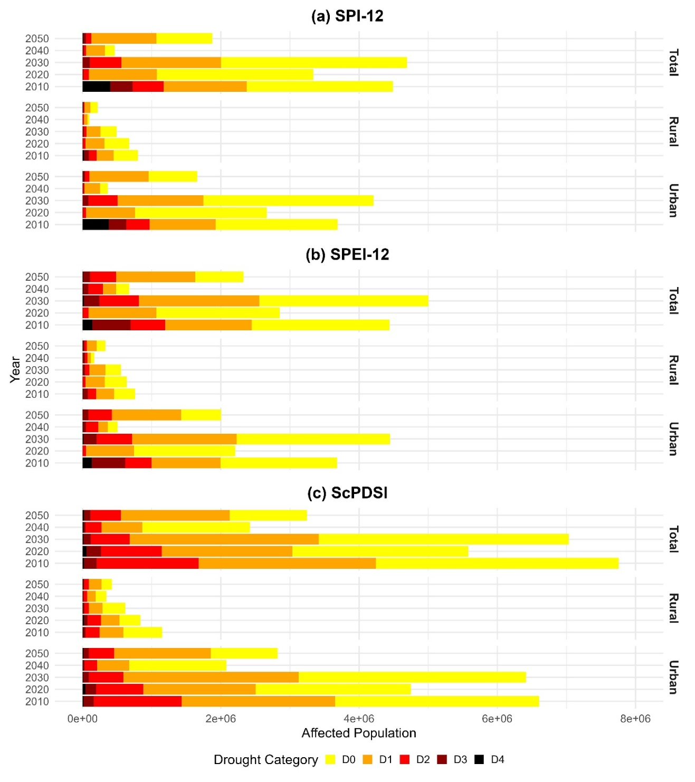
Figure 4.1 Population affected by drought categories in rural and urban areas of the CONUS (2010-2050).
PM_{2.5} exposure. PM_{2.5} concentrations were estimated using an ensemble of satellite-derived aerosol optical depth (AOD) retrievals, chemical transport model (CMAQ) simulations, and surface monitoring data from EPA’s Air Quality System (AQS), CASTNET, and IMPROVE networks. Meteorological variables such as temperature, humidity, and wind were included to capture regional variability in pollutant dispersion and accumulation.
A key methodological challenge is the uneven spatial distribution of monitors, which creates sample imbalance and systematic bias in exposure estimation. To address this, we computed population-weighted exposure (PWE) using WorldPop (12-km regridded) data as weights. At the national scale, PWE was 4.98 μg/m³ for CMAQ and 5.62 μg/m³ for the machine learning prediction, yielding a +0.64 μg/m³ (+13%) bias. Distance-stratified diagnostics further revealed that exposure bias increases with distance from the nearest monitor: +0.19 μg/m³ at 0–24 km, +0.45 at 24–48 km, +0.50 at 48–72 km, +0.54 at 72–96 km, and +0.86 μg/m³ beyond 96 km. A population-weighted regression gave a slope of approximately 0.0012 μg/m³ km⁻¹ (≈ 0.12 μg m⁻³ per 100 km).
Crucially, population is not evenly distributed across distance classes. Approximately 10%, 15%, 15%, 12%, and 48% of the U.S. population live at 0–24, 24–48, 48–72, 72–96, and ≥96 km, respectively, from the nearest monitor. Thus, nearly half of the population resides in the farthest bin—the same bin with the largest positive bias—so the distance-dependent error is amplified in the national PWE. Panel maps further indicate that these monitor-sparse regions are concentrated in the central plains, interior West, and parts of the Southeast, consistent with where the largest spatial overestimations were observed.
Together, these results illustrate a two-step mechanism by which monitor-driven sample imbalance propagates into exposure error: (i) bias increases with distance from monitors, and (ii) a large share of the population resides in distant, monitor-sparse regions. Absent correction, this mechanism produces exposure inflation of ~0.5–0.9 μg/m³ in rural/remote strata and ~0.64 μg/m³ nationally—levels that materially affect attainment determinations and health-impact assessments. These findings reinforce the importance of augmenting monitoring networks with rural sites (e.g., CASTNET/IMPROVE), applying distance-aware or spatially stratified sampling during model training, and routinely reporting distance–bias relationships alongside conventional performance metrics.
Urban–rural classification. For both drought and PM_{2.5} exposure analyses, we applied a consistent urban–rural delineation based on the U.S. Census Urban Areas (2020 vintage). Grid cells whose centroids fall within 24 km of a Census urban polygon were classified as urban, while those outside this buffer were classified as rural. This threshold approximates the spatial footprint of urban influence relative to the 12-km modeling grid. Urban–rural stratification enables a systematic evaluation of disparities in environmental exposure across demographic and socioeconomic groups, which is essential for addressing questions of environmental justice.
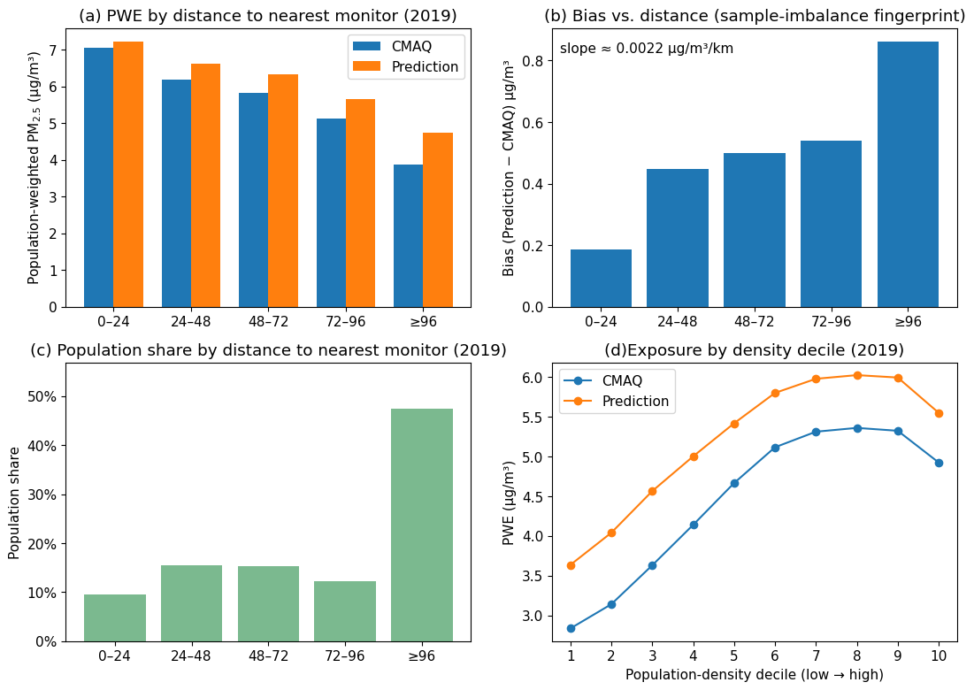
Figure 4.2 Population-weighted exposure and sample-imbalance diagnostics for 2019. (a) PWE (μg/m³) for CMAQ and ML prediction by distance to the nearest monitor (0–24, 24–48, 48–72, 72–96, ≥ 96 km). (b) Bias (prediction – CMAQ) by distance; population-weighted linear fit slope ≈ 0.0012 μg/m³ km⁻¹. (c) Population share in each distance bin, showing that ~48% of the population resides ≥ 96 km from a monitor. (d) Map of distance to the nearest monitor (km), highlighting monitor-sparse regions in the central plains, interior West/mountain areas, and parts of the Southeast. All statistics use WorldPop (regridded to 12 km) for weights.

Health Impact
Figure 4.3 presents the estimated health impacts attributable to drought in the contiguous United States for the period 2010 to 2050. Three commonly used drought indices (ScPDSI, SPEI-12, and SPI-12) were applied to quantify affected populations, which were then linked with baseline incidence rates and relative risks to estimate excess health cases across multiple endpoints. Panel (a) illustrates the national total number of excess cases stratified by endpoint. The results show substantial variability across both indices and health outcomes. Under ScPDSI, the total number of excess cases reached approximately 10.4 thousand in 2010, declined to 7.6 thousand in 2020, and further decreased to 2.8 thousand in 2040, before slightly recovering to 4.4 thousand by 2050. SPEI-12 followed a similar but more moderate trajectory, with 7.4 thousand excess cases in 2010 and only 3.3 thousand in 2040. SPI-12 consistently produced the lowest burdens, with 5.5 thousand cases in 2030 and only 2.2 thousand by 2050. Across endpoints, asthma emergency room visits accounted for nearly half of the total burden in most years. For example, under ScPDSI in 2010, asthma ER visits represented about 5.2 thousand cases out of the total 10.4 thousand. Respiratory mortality contributed approximately 2.1 thousand cases, followed by premature mortality (~1.4 thousand) and cardiovascular mortality (~1.0 thousand). COPD admissions contributed less than 1 thousand across all years and indices. These results highlight the dominant role of respiratory-related outcomes in shaping the overall health burden of drought. Panel (b) provides a breakdown of premature mortality by urban and rural populations. In all indices, urban populations experienced substantially higher drought-attributable mortality than rural populations. For example, under ScPDSI in 2010, urban premature mortality reached 0.87 thousand cases compared with only 0.15 thousand in rural areas. Even by 2050, when the overall burden had declined, urban premature mortality (0.43 thousand cases) remained more than three times higher than rural premature mortality (0.12 thousand). The same pattern was evident under SPEI-12 and SPI-12, where urban burdens consistently exceeded rural burdens by factors of three to five. This disparity underscores the role of demographic concentration in amplifying drought-related health impacts, particularly in metropolitan regions. Panel (c) focuses on the contributions of drought categories to premature mortality in 2050. The results consistently show that mild to moderate droughts (D0 to D2) accounted for more than 80 percent of the total attributable cases. For instance, under ScPDSI, the total premature mortality in 2050 was 0.9 thousand cases, of which about 0.36 thousand came from D0 and 0.27 thousand from D1. Severe droughts (D3) contributed less than 0.1 thousand, and extreme droughts (D4) were negligible at less than 0.05 thousand. A similar distribution was observed in SPEI-12, where the total burden was 0.7 thousand, and in SPI-12, where the total burden was only 0.4 thousand. Although the relative risks associated with D3 and D4 are higher, their limited frequency and spatial coverage reduce their overall contribution to population-level health outcomes.
Overall, three consistent insights emerge. First, drought-related health burdens are dominated by respiratory outcomes, especially asthma exacerbations and respiratory mortality. Second, urban populations consistently face higher risks than rural populations, with premature mortality burdens that are three to five times larger, reflecting population density and exposure rather than relative vulnerability alone. Third, the majority of drought-related health cases arise from moderate but frequent drought events, rather than from rare extremes. The differences observed across indices further emphasize the methodological sensitivity of drought–health assessments, highlighting the need for careful consideration of drought definitions in future impact studies.
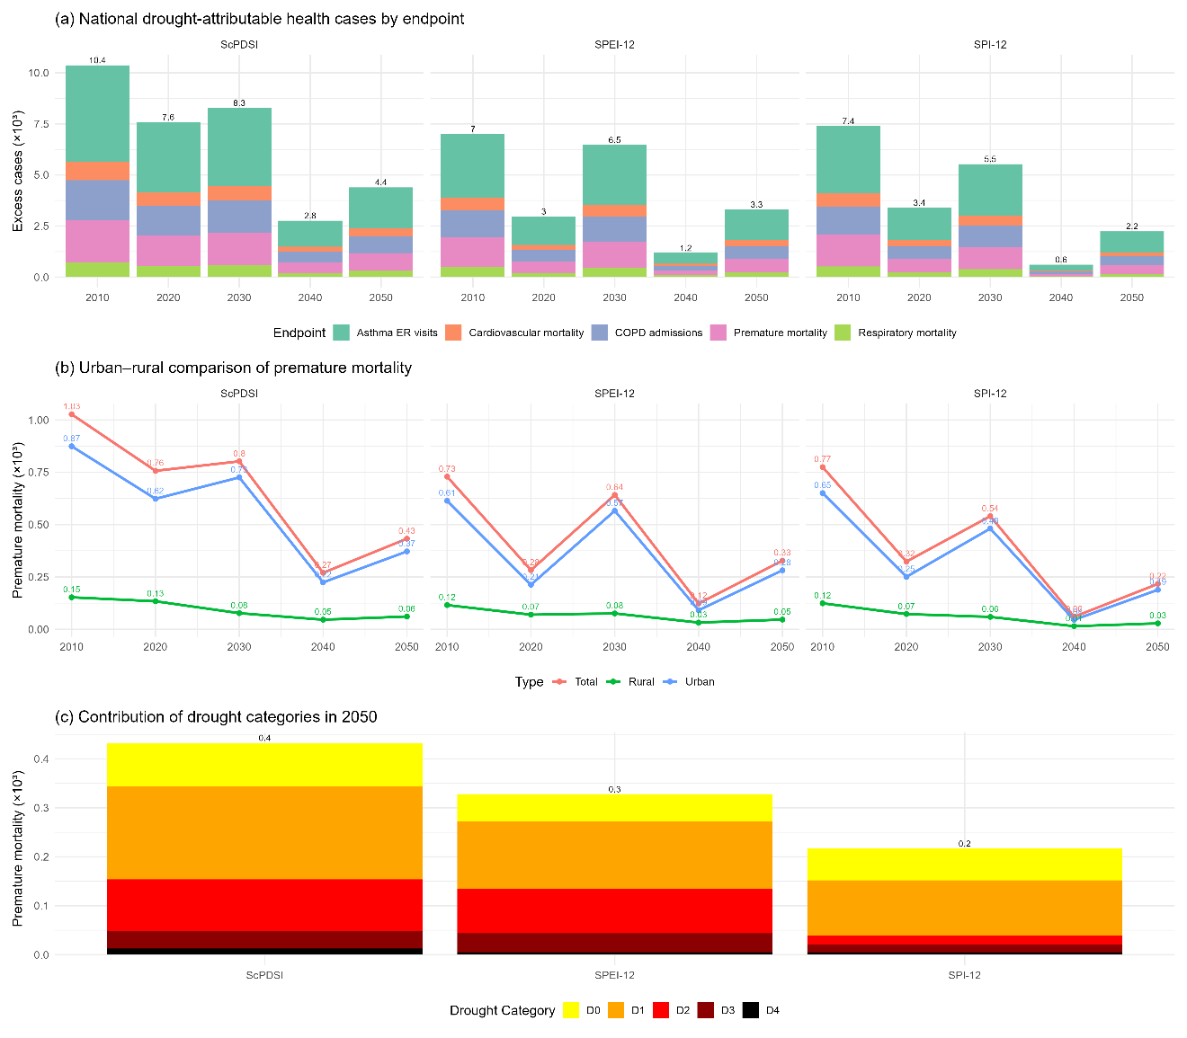
Figure 4.3 Drought-attributable health impacts in the contiguous United States (2010–2050).
Figure 4.4 illustrates the differences in PM_{2.5}-attributable health burdens between CMAQ simulations and machine learning predictions across states, health endpoints, and population distributions. The state-level results in panel (a) reveal substantial geographic heterogeneity. California exhibits one of the highest totals of premature mortality, with machine learning predictions exceeding CMAQ by approximately 250 to 300 cases. This difference is driven by the combination of large exposed populations in metropolitan regions such as Los Angeles and consistently elevated PM_{2.5} concentrations. Illinois and Ohio also show large discrepancies, with machine learning predicting roughly 180 and 150 more cases than CMAQ, respectively. Virginia and North Carolina display gaps on the order of 100 to 120 cases, whereas states with smaller populations such as Vermont, New Hampshire, and Wyoming show almost no differences, often fewer than five cases. The size of the discrepancy scales with population and exposure levels, which indicates that the two models diverge most where health impacts are largest. Importantly, the ranking of states changes depending on the modeling framework. For example, California and Texas appear comparable in the CMAQ estimates, but machine learning predicts substantially higher totals in California, which could shift state-level priorities in health impact assessments and regulatory decision-making.
Panel (b) disaggregates the national totals by health endpoint and reveals a consistent pattern across outcomes. Asthma emergency room visits dominate the overall burden, with CMAQ estimating 4170 cases and machine learning yielding 5401, a difference of 1231 cases or nearly 30 percent. Premature mortality is the second largest contributor, with 1333 cases from CMAQ and 1726 from machine learning, corresponding to an increase of 393 deaths, also about 30 percent. Cardiovascular mortality rises from 291 to 377, respiratory mortality from 184 to 241, and COPD admissions from 476 to 618. Despite differences in baseline incidence rates and concentration–response coefficients across endpoints, the percentage increase from CMAQ to machine learning remains remarkably consistent, ranging from 28 to 30 percent. This uniformity confirms that the primary source of discrepancy lies in the concentration fields rather than in health effect parameters. CMAQ underestimates PM_{2.5} concentrations relative to machine learning across the domain, and this systematic bias propagates proportionally through each health endpoint.
Panel (c) examines the cumulative distribution of premature mortality differences as a function of population-weighted distance to the nearest monitoring site. The cumulative curve rises steadily, with machine learning producing a total of 394 more premature deaths than CMAQ nationwide. Differences are small for the first quintile of the population, which represents urban cores located within about 20 to 30 kilometers of a monitor. In this group, CMAQ and machine learning predictions diverge by fewer than 30 cases. The slope of the curve becomes steep between 20 and 70 percent of the population share, which corresponds to suburban and semi-urban areas located 40 to 100 kilometers from the nearest monitor. In this middle range, approximately 280 additional premature deaths accumulate in the machine learning estimates, representing more than 70 percent of the total discrepancy. Beyond 70 percent of the cumulative population, which corresponds to sparsely populated rural regions, the curve continues to rise but more gradually, as population counts are smaller. This pattern demonstrates that the differences between CMAQ and machine learning are structured by monitoring network density. CMAQ aligns more closely with machine learning predictions in densely monitored areas, while systematic underestimation emerges in regions with sparse coverage. As a result, the populations most affected by the model discrepancies are those outside the reach of dense monitoring networks, raising concerns about equity in exposure assessment and health burden estimation.
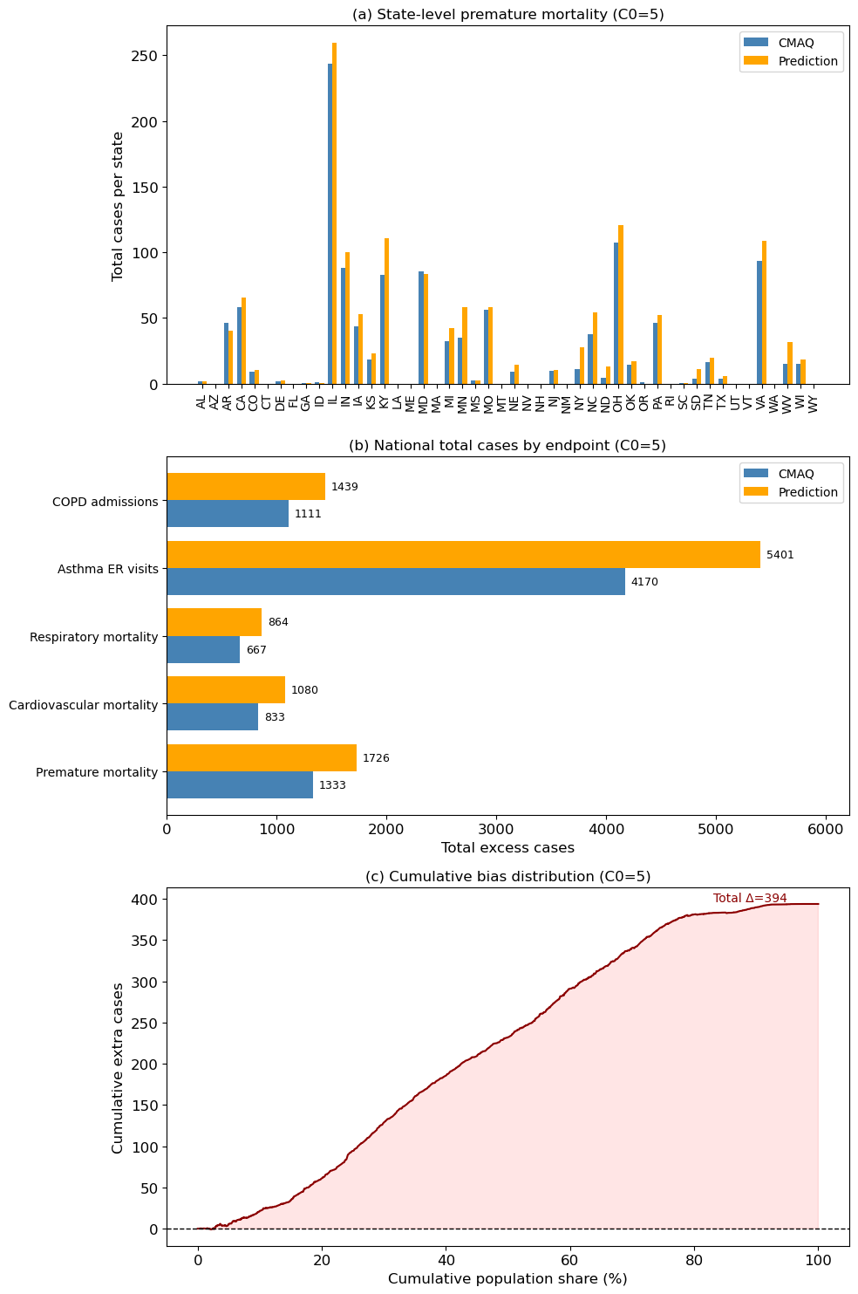
Figure 4.4 Comparison of health burdens attributable to PM_{2.5} exposure between CMAQ and machine learning predictions.

Economic Cost
Figure 4.5 presents the estimated national drought-related economic costs from 2010 to 2050. The results reveal several key patterns. As shown in Figure 4.6a, the overall burden peaked during the 2010s and 2020s, with national costs exceeding 40 billion USD under the ScPDSI, before declining substantially by mid-century. Premature mortality overwhelmingly dominated the total burden, accounting for the majority of costs across all indices, followed by cardiovascular and respiratory mortality. Morbidity endpoints, such as asthma ER visits and COPD hospitalizations, contributed only marginally. This imbalance reflects the disproportionate economic weight of mortality outcomes in health cost assessments, given both their higher relative risks and their large unit valuation.
Differences across drought indices are highlighted in Figure 4.5b, which shows the temporal trajectory of premature mortality costs from 2010 to 2050. Although all three indices suggested a gradual decline over time, their absolute magnitudes varied substantially. The ScPDSI consistently produced the highest estimates, followed by SPEI-12, with SPI-12 yielding the lowest. By 2050, premature mortality costs were projected to be approximately 5.0, 3.8, and 2.5 billion USD under ScPDSI, SPEI-12, and SPI-12, respectively. These discrepancies underscore the sensitivity of economic burden estimates to the choice of drought index. Since each index is designed to capture different aspects of hydroclimatic variability, the observed spread can be interpreted as a measure of methodological uncertainty that has direct implications for impact assessment and policy.
The contribution of drought categories to premature mortality costs is illustrated in Figure 4.5c. Mild droughts (D0 and D1) were responsible for the majority of costs, contributing 2.4 to 3.4 billion USD depending on the index, whereas severe and extreme droughts (D3 and D4) contributed very little. This outcome is consistent with the population exposure results discussed earlier, where mild droughts were shown to affect the largest proportion of the population despite their lower intensity. The economic dominance of mild droughts thus arises from the combination of broad spatial extent and widespread population exposure, which offsets the relatively small increase in relative risk per individual. In contrast, extreme droughts, while carrying higher individual risks, occur less frequently and affect fewer people, thereby resulting in a smaller aggregate burden. This pattern has important implications for adaptation and risk communication. It suggests that focusing only on extreme droughts may underestimate the true economic costs of drought, as the cumulative impact of frequent mild droughts can surpass that of rare severe events.
Taken together, these results demonstrate that the drought-related economic burden on public health is shaped by both the intensity and extent of drought conditions, as well as the methodological choice of drought index. Mortality endpoints dominate the cost estimates, highlighting the high economic value placed on premature deaths. Index differences introduce uncertainty in projected costs, with ScPDSI generally yielding higher burdens. Finally, the predominance of mild droughts in the national cost burden emphasizes the need to account for moderate but widespread events when designing adaptation strategies.
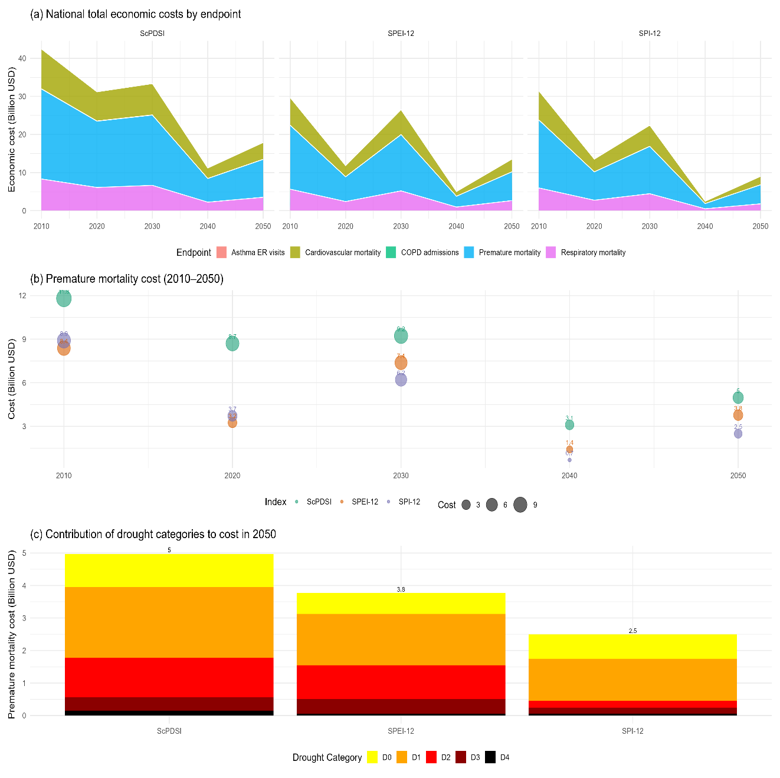
Figure 4.5 National drought-related economic costs by health endpoint, drought index, and drought category.
Figure 4.6a shows the stacked national economic costs by health endpoint, directly comparing CMAQ- and prediction-based estimates. Across both models, premature mortality dominates the overall burden, valued at 14.7 billion USD under CMAQ and 19.0 billion USD under the prediction framework. Asthma ER visits represent the second largest component, contributing 45.9 billion USD for CMAQ and 59.4 billion USD for predictions. Cardiovascular and respiratory mortality add moderate costs of 7.3–11.9 billion USD and 9.2–9.5 billion USD, respectively, while COPD admissions contribute 12.2–15.8 billion USD. In total, prediction-based estimates yield 115.6 billion USD compared to 89.2 billion USD for CMAQ, a national difference of 26.4 billion USD. The stacked representation highlights that the divergence between the two approaches is not confined to a single endpoint but accumulates across all categories, with asthma ER visits and premature mortality explaining the largest share of the gap.
The distribution of cost differences by distance to the nearest monitoring site is summarized in Figure 4.6b using violin plots. The bulk of the distribution is centered close to zero in all bins, indicating that in most locations the two models agree within a narrow margin. However, the spread of the distribution is substantially wider in the 0–50 km and 100–200 km bins, with cost differences occasionally exceeding ±0.05 billion USD per grid cell. This indicates that while prediction-based estimates do not uniformly deviate from CMAQ, localized areas near and moderately distant from monitors exhibit large discrepancies. Such discrepancies are likely amplified by high population density combined with modest concentration differences, which translate into disproportionately large cost changes under the exponential concentration-response function.
At the state level, Figure 4.6c summarizes the top five states with the largest total economic costs in 2019 using radar plots. Illinois emerges as the single largest contributor, with costs approaching 2.9 billion USD under both CMAQ and prediction, followed by Ohio, Kentucky, Virginia, and Indiana, each ranging between 1.0 and 1.3 billion USD. In all states, prediction-based estimates exceed CMAQ, though the relative differences are modest compared to national totals. The radar plot reveals that the overall shape of the state-level burden remains consistent between models, but the magnitude of each axis expands under prediction, reinforcing that the discrepancy is largely systematic rather than confined to specific locations.
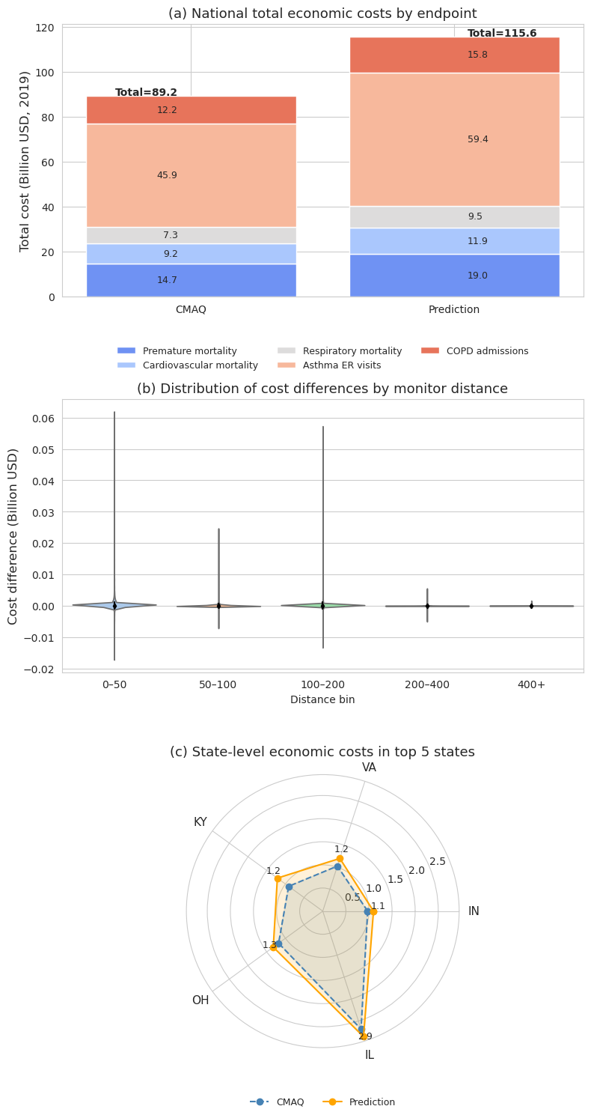
Figure 4.6 National and state-level economic costs of PM_{2.5}-attributable health outcomes in 2019 (C0 = 5) derived from CMAQ and prediction-based estimates
This chapter provides critical insights into the intersection of climate change, air pollution, and public health, offering policy-relevant recommendations for minimizing socioeconomic disparities and enhancing community resilience in the face of worsening environmental conditions.

Conclusion and Future Work

Summary of Key Findings
This dissertation investigates the complex interactions between climate change, drought variability, air pollution, and their socioeconomic and health implications. Three key areas were explored: the evolution of drought under future climate scenarios, biases in PM_{2.5} estimation using machine learning, and the socioeconomic burden of these environmental stressors. The findings highlight that drought patterns in the contiguous United States are becoming more variable rather than simply intensifying, posing challenges for water resource management and agricultural stability. Climate projections indicate increasing fluctuations between dry and wet conditions in regions such as the Southwest and Northern Rockies, reinforcing the need for improved regional drought assessments.
In terms of air quality estimation, this study demonstrates that traditional machine learning models systematically overestimate PM_{2.5} concentrations in downwind areas due to imbalanced training samples, primarily caused by the uneven distribution of air quality monitoring sites. The incorporation of CMAQ simulations, satellite AOD, and additional networks such as CASTNET and IMPROVE significantly improved PM_{2.5} estimation accuracy, particularly in rural and under-monitored regions. The application of deep learning models, especially ResNet with temporal features, reduced estimation biases, leading to more reliable pollution exposure assessments.

The intersection of drought variability and air pollution intensifies health risks and economic burdens, disproportionately affecting vulnerable communities. Health impact assessments using BenMAP-CE revealed significant increases in premature mortality, respiratory illnesses, and cardiovascular diseases linked to PM_{2.5} exposure, particularly in drought-prone areas. The economic analysis demonstrated that these health burdens translate into substantial healthcare costs and productivity losses. Notably, low-income and minority communities are disproportionately affected, raising concerns about environmental justice and the need for targeted policy interventions.

Research Limitations
Despite the significant contributions of this research, several limitations must be acknowledged. Drought projections rely on CMIP6 models, which, while offering improved resolution and physics-based parameterizations, still contain inherent biases that affect the accuracy of future projections. Downscaling techniques mitigate some of these uncertainties but do not entirely eliminate them. Similarly, the reliance on historical drought indices (SPI, SPEI, ScPDSI) introduces uncertainties, as these indices may not fully capture the changing nature of droughts under future climate scenarios.
The machine learning-based PM_{2.5} estimation models, while demonstrating improved accuracy, remain dependent on the availability and distribution of training data. Sparse monitoring networks in rural areas continue to pose a challenge, and biases persist in regions with complex topographies or unique meteorological conditions. Furthermore, deep learning models require large amounts of high-quality labeled data, which may not always be available in historically under-monitored regions.
Health impact assessments using BenMAP-CE rely on concentration-response relationships derived from epidemiological studies, which, while robust, may not fully capture the health effects of emerging pollution sources, such as wildfire-driven PM_{2.5} exposure. Additionally, individual exposure variations due to differences in mobility, indoor air quality, and personal behavior were not explicitly considered in this study. Economic cost assessments, while following standardized methodologies, do not account for long-term productivity declines associated with chronic illnesses or the potential economic effects of climate-induced migration.

Future Directions
Building upon the findings and limitations of this study, several directions for future work are proposed. Enhancing regional climate modeling for drought projections by incorporating high-resolution land-atmosphere coupling datasets will improve the accuracy of drought risk assessments. Expanding hydrological datasets and incorporating real-time soil moisture observations will further refine drought severity predictions and support climate adaptation strategies.
Future research should also explore hybrid machine learning frameworks that integrate physical constraints from chemical transport models with data-driven techniques to improve PM_{2.5} estimation accuracy. The incorporation of real-time satellite observations from emerging geostationary platforms, such as TEMPO, will enhance the temporal resolution of PM_{2.5} estimates and provide near-continuous pollution monitoring. Expanding deep learning architectures to include multi-pollutant estimation models will enable a more comprehensive assessment of atmospheric pollution trends and their combined health effects.
A critical area for future investigation is the long-term health impacts of concurrent drought and air pollution exposure. Epidemiological research should explore the cumulative effects of chronic exposure, particularly in vulnerable populations with preexisting conditions such as asthma or cardiovascular disease. Understanding how climate-driven environmental stressors interact with respiratory and cardiovascular diseases will be essential for future public health planning.
There is also an urgent need for equity-focused environmental policies to address disparities in exposure to drought and air pollution. Developing adaptive strategies that prioritize underserved communities, such as expanding air quality monitoring in rural and low-income urban areas, will help mitigate environmental injustices. Additionally, integrating behavioral economic models into climate and air quality research could provide insights into how individuals and communities respond to environmental risks. Future research could explore the willingness to pay for mitigation strategies and the effectiveness of incentive-based policies in reducing exposure risks.
Given the interconnected nature of climate change, air pollution, and public health, interdisciplinary collaborations will be essential. Bringing together climate scientists, public health researchers, economists, and policymakers will support the development of holistic solutions for mitigating the adverse effects of environmental stressors. This dissertation underscores the urgent need for evidence-based policy interventions that enhance environmental resilience, promote equity in air quality management, and safeguard public health in the face of a changing climate. Future work will continue refining methodologies, expanding datasets, and bridging knowledge gaps to support more effective climate adaptation and mitigation strategies.

List of References
Agnew C T 2000 Using the SPI to Identify Drought 12
Allen R G, Pereira L S, Raes D and Smith M 1998 Crop evapotranspiration-Guidelines for computing crop water requirements-FAO Irrigation and drainage paper 56 Fao, Rome 300 D05109
Appel K W, Bash J O, Fahey K M, Foley K M, Gilliam R C, Hogrefe C, Hutzell W T, Kang D, Mathur R, Murphy B N, Napelenok S L, Nolte C G, Pleim J E, Pouliot G A, Pye H O T, Ran L, Roselle S J, Sarwar G, Schwede D B, Sidi F I, Spero T L and Wong D C 2021 The Community Multiscale Air Quality (CMAQ) model versions 5.3 and 5.3.1: system updates and evaluation Geoscientific Model Development 14 2867–97
Appel K W, Chemel C, Roselle S J, Francis X V, Hu R-M, Sokhi R S, Rao S T and Galmarini S 2012 Examination of the Community Multiscale Air Quality (CMAQ) model performance over the North American and European domains Atmospheric Environment 53 142–55
Ashfaq M, Rastogi D, Mei R, Kao S-C, Gangrade S, Naz B S and Touma D 2016 High-resolution ensemble projections of near-term regional climate over the continental United States Journal of Geophysical Research: Atmospheres 121 9943–63
Ault T R 2020 On the essentials of drought in a changing climate Science 368 256–60
Belgiu M and Drăguţ L 2016 Random forest in remote sensing: A review of applications and future directions ISPRS Journal of Photogrammetry and Remote Sensing 114 24–31
Breiman L 2001 Random Forests Machine Learning 45 5–32
Burnett R T and al et 2018 Global estimates of mortality associated with long-term exposure to outdoor fine particulate matter PNAS 115 9592–7
Byun D and Schere K L 2006 Review of the Governing Equations, Computational Algorithms, and Other Components of the Models-3 Community Multiscale Air Quality (CMAQ) Modeling System Applied Mechanics Reviews 59 51–77
Celarier E A, Brinksma E J, Gleason J F, Veefkind J P, Cede A, Herman J R, Ionov D, Goutail F, Pommereau J-P, Lambert J-C, van Roozendael M, Pinardi G, Wittrock F, Schönhardt A, Richter A, Ibrahim O W, Wagner T, Bojkov B, Mount G, Spinei E, Chen C M, Pongetti T J, Sander S P, Bucsela E J, Wenig M O, Swart D P J, Volten H, Kroon M and Levelt P F 2008 Validation of Ozone Monitoring Instrument nitrogen dioxide columns Journal of Geophysical Research: Atmospheres 113 Online: https://onlinelibrary.wiley.com/doi/abs/10.1029/2007JD008908
Chang J, Li Y, Wang Y and Yuan M 2016 Copula-based drought risk assessment combined with an integrated index in the Wei River Basin, China Journal of Hydrology 540 824–34
Chen T and Guestrin C 2016 XGBoost: A Scalable Tree Boosting System Proceedings of the 22nd ACM SIGKDD International Conference on Knowledge Discovery and Data Mining KDD ’16 (New York, NY, USA: Association for Computing Machinery) pp 785–94 Online: https://dl.acm.org/doi/10.1145/2939672.2939785
Cheng B, Alapaty K and Arunachalam S 2024 Spatiotemporal trends in PM2.5 chemical composition in the conterminous U.S. during 2006–2020 Atmospheric Environment 316 120188
Chiang F, Mazdiyasni O and AghaKouchak A 2018 Amplified warming of droughts in southern United States in observations and model simulations Science Advances 4 eaat2380
Covich A P, Crowl T A, Hein C L, Townsend M J and Mcdowell W H 2009 Predator–prey interactions in river networks: comparing shrimp spatial refugia in two drainage basins Freshwater Biology 54 450–65
Dai A 2013 Increasing drought under global warming in observations and models Nature Climate Change 3 52–8
Dockery D W, Pope C A, Xu X, Spengler J D, Ware J H, Fay M E, Ferris B G and Speizer F E 1993 An Association between Air Pollution and Mortality in Six U.S. Cities New England Journal of Medicine 329 1753–9
Eyring V, Bony S, Meehl G A, Senior C A, Stevens B, Stouffer R J and Taylor K E 2016 Overview of the Coupled Model Intercomparison Project Phase 6 (CMIP6) experimental design and organization Geoscientific Model Development 9 1937–58
Falloon P, Soares M B, Manzanas R, San-Martin D, Liggins F, Taylor I, Kahana R, Wilding J, Jones C, Comer R, de Vreede E, Som de Cerff W, Buontempo C, Brookshaw A, Stanley S, Middleham R, Pittams D, Lawrence E, Bate E, Peter H, Uzell K and Richards M 2018 The land management tool: Developing a climate service in Southwest UK Climate Services 9 86–100
FAO 2018 The impact of disasters and crises on agriculture and food security (Food and Agriculture Organization of the United Nations)
Ford B, Val Martin M, Zelasky S E, Fischer E V, Anenberg S C and Heald C L 2018 Future fire impacts on smoke concentrations, visibility, and health in the contiguous United States GeoHealth 2 229–47
Geng G, Zheng Y, Zhang Q, Xue T, Zhao H, Tong D, Zheng B, Li M, Liu F, Hong C, He K and Davis S J 2021 Drivers of PM2.5 air pollution deaths in China 2002–2017 Nat. Geosci. 14 645–50
Guenther A B, Jiang X, Heald C L, Sakulyanontvittaya T, Duhl T, Emmons L K and Wang X 2012 The Model of Emissions of Gases and Aerosols from Nature version 2.1 (MEGAN2.1): an extended and updated framework for modeling biogenic emissions Geoscientific Model Development 5 1471–92
Hand J L, Prenni A J, Schichtel B A, Malm W C and Chow J C 2019 Trends in remote PM2.5 residual mass across the United States: Implications for aerosol mass reconstruction in the IMPROVE network Atmospheric Environment 203 141–52
He K, Zhang X, Ren S and Sun J 2016 Deep Residual Learning for Image Recognition 2016 IEEE Conference on Computer Vision and Pattern Recognition (CVPR) 2016 IEEE Conference on Computer Vision and Pattern Recognition (CVPR) pp 770–8 Online: https://ieeexplore.ieee.org/document/7780459
He L, He L, Lin Z, Lu Y, Chen C, Wang Z, An P, Liu M, Xu J and Gao S 2024 Sensing the Environmental Inequality of PM2.5 Exposure Using Fine-Scale Measurements of Social Strata and Citizenship Identity ISPRS International Journal of Geo-Information 13 257
Heim R R 2002 A Review of Twentieth-Century Drought Indices Used in the United States Bulletin of the American Meteorological Society 83 1149–66
Hoffmann D, Gallant A J E and Arblaster J M 2020 Uncertainties in Drought From Index and Data Selection Journal of Geophysical Research: Atmospheres 125 e2019JD031946
IPCC 2021 Climate Change 2021: The Physical Science Basis. Contribution of Working Group I to the Sixth Assessment Report of the Intergovernmental Panel on Climate Change (Cambridge University Press)
Jacob D J and Winner D A 2009 Effect of climate change on air quality Atmospheric Environment 43 51–63
Jain S, A. Presto A and Zimmerman N 2023 Using spatiotemporal prediction models to quantify PM 2.5 exposure due to daily movement Environmental Science: Atmospheres 3 1665–77
Jolliff J K, Kindle J C, Shulman I, Penta B, Friedrichs M A M, Helber R and Arnone R A 2009 Summary diagrams for coupled hydrodynamic-ecosystem model skill assessment Journal of Marine Systems 76 64–82
Karl T R and Koss W J 1984 Regional and national monthly, seasonal, and annual temperature weighted by area, 1895-1983 Online: https://repository.library.noaa.gov/view/noaa/10238
Ke G, Meng Q, Finley T, Wang T, Chen W, Ma W, Ye Q and Liu T-Y 2017 LightGBM: A Highly Efficient Gradient Boosting Decision Tree
Leeper R D, Bilotta R, Petersen B, Stiles C J, Heim R, Fuchs B, Prat O P, Palecki M and Ansari S 2022 Characterizing U.S. drought over the past 20 years using the U.S. drought monitor International Journal of Climatology 42 6616–30
Lelieveld J, Evans J S, Fnais M, Giannadaki D and Pozzer A 2015 The contribution of outdoor air pollution sources to premature mortality on a global scale Nature 525 367–71
Li S, Ding Y, Xing J and Fu J S 2024a Retrieving Ground-Level PM _{2.5} Concentrations in China (2013–2021) with a Numerical Model-Informed Testbed to Mitigate Sample Imbalance-Induced Biases Online: https://essd.copernicus.org/preprints/essd-2024-170/
Li S, Ding Y, Xing J and Fu J S 2024b Retrieving ground-level PM_{2.5} concentrations in China (2013–2021) with a numerical-model-informed testbed to mitigate sample-imbalance-induced biases Earth System Science Data 16 3781–93
Littell J S, Peterson D L, Riley K L, Liu Y and Luce C H 2016 A review of the relationships between drought and forest fire in the United States Global Change Biology 22 2353–69
Liu X-H, Zhang Y, Cheng S-H, Xing J, Zhang Q, Streets D G, Jang C, Wang W-X and Hao J-M 2010 Understanding of regional air pollution over China using CMAQ, part I performance evaluation and seasonal variation Atmospheric Environment 44 2415–26
Lyapustin A, Wang Y, Korkin S and Huang D 2018 MODIS Collection 6 MAIAC algorithm Atmospheric Measurement Techniques 11 5741–65
Lyapustin A, Wang Y, Laszlo I, Kahn R, Korkin S, Remer L, Levy R and Reid J S 2011 Multiangle implementation of atmospheric correction (MAIAC): 2. Aerosol algorithm Journal of Geophysical Research: Atmospheres 116 Online: https://onlinelibrary.wiley.com/doi/abs/10.1029/2010JD014986
Ma X, Chen T, Ge R, Xv F, Cui C and Li J 2023 Prediction of PM2.5 Concentration Using Spatiotemporal Data with Machine Learning Models Atmosphere 14 1517
Marmur A, Mulholland J A and Russell A G 2007 Optimized variable source-profile approach for source apportionment Atmospheric Environment 41 493–505
Martin R V, Jacob D J, Chance K, Kurosu T P, Palmer P I and Evans M J 2003 Global inventory of nitrogen oxide emissions constrained by space‐based observations of NO ₂ columns J. Geophys. Res. 108 2003JD003453
Maurer E P, Das T and Cayan D R 2013 Errors in climate model daily precipitation and temperature output: time invariance and implications for bias correction Hydrology and Earth System Sciences 17 2147–59
McEnery J, Ingram J, Duan Q, Adams T and Anderson L 2005 NOAA’s advanced hydrologic prediction service: building pathways for better science in water forecasting Bulletin of the American Meteorological Society 86 375–86
McKee T B, Doesken N J and Kleist J 1993 The relationship of drought frequency and duration to time scales
Mickley L J and al et 2017 Regional warming and air quality Current Pollution Reports 3 211–9
Milly P C D, Betancourt J, Falkenmark M, Hirsch R M, Kundzewicz Z W, Lettenmaier D P and Stouffer R J 2008 Stationarity is dead: Whither water management? Science 319 573–4
Mishra A K and Singh V P 2010 A review of drought concepts Journal of Hydrology 391 202–16
Murray C J L and al et 2020 Global burden of 87 risk factors in 204 countries The Lancet 396 1223–49
O’Neill B C, Tebaldi C, van Vuuren D P, Eyring V, Friedlingstein P, Hurtt G, Knutti R, Kriegler E, Lamarque J-F, Lowe J, Meehl G A, Moss R, Riahi K and Sanderson B M 2016 The Scenario Model Intercomparison Project (ScenarioMIP) for CMIP6 Geosci. Model Dev. 9 3461–82
Palmer W C 1965 Meteorological Drought (U.S. Department of Commerce, Weather Bureau)
Pope C A and Dockery D W 2006 Health effects of fine particulate air pollution: lines that connect Journal of the Air & Waste Management Association 56 709–42
Remer L A, Kleidman R G, Levy R C, Kaufman Y J, Tanré D, Mattoo S, Martins J V, Ichoku C, Koren I, Yu H and Holben B N 2008 Global aerosol climatology from the MODIS satellite sensors Journal of Geophysical Research: Atmospheres 113 Online: https://onlinelibrary.wiley.com/doi/abs/10.1029/2007JD009661
Rippey B R 2015 The U.S. drought of 2012 Weather and Climate Extremes 10 57–64
Schwede D B and Lear G G 2014 A novel hybrid approach for estimating total deposition in the United States Atmospheric Environment 92 207–20
Skamarock C, Klemp B, Dudhia J, Gill O, Barker D, Duda G, Huang X, Wang W and Powers G 2008 A Description of the Advanced Research WRF Version 3 Online: https://opensky.ucar.edu/islandora/object/technotes%3A500/
Smith A B 2020 U.S. Billion-dollar Weather and Climate Disasters, 1980 - present (NCEI Accession 0209268) Online: https://www.ncei.noaa.gov/archive/accession/0209268
Solomon P A, Crumpler D, Flanagan J B, Jayanty R K M, Rickman E E and McDade C E 2014 U.S. National PM2.5 Chemical Speciation Monitoring Networks—CSN and IMPROVE: Description of networks Journal of the Air & Waste Management Association 64 1410–38
Song S, Lam J C K, Han Y and Li V O K 2020 ResNet-LSTM for Real-Time PM2.5 and PM₁₀ Estimation Using Sequential Smartphone Images IEEE Access 8 220069–82
Sorek-Hamer M, Strawa A W, Chatfield R B, Esswein R, Cohen A and Broday D M 2013 Improved retrieval of PM2.5 from satellite data products using non-linear methods Environmental Pollution 182 417–23
Stowell J D, Geng G, Saikawa E, Chang H H, Fu J S and Liu Y 2022 Heat and air pollution exposure and social vulnerability in the United States GeoHealth 6 e2021GH000442
Sugg M, Runkle J, Leeper R, Bagli H, Golden A, Handwerger L H, Magee T, Moreno C, Reed-Kelly R, Taylor M and Woolard S 2020 A scoping review of drought impacts on health and society in North America Climatic Change 162 1177–95
Tessum C W and al et 2021 PM2.5 polluters disproportionately and systemically affect people of color in the United States Science Advances 7 eabf4491
Trenberth K E, Dai A, van der Schrier G, Jones P D, Barichivich J, Briffa K R and Sheffield J 2014 Global warming and changes in drought Nature Clim Change 4 17–22
Vicente-Serrano S M, Beguería S and López-Moreno J I 2010 A Multiscalar Drought Index Sensitive to Global Warming: The Standardized Precipitation Evapotranspiration Index Journal of Climate 23 1696–718
Wang Z, Wu X and Wu Y 2023 A spatiotemporal XGBoost model for PM2.5 concentration prediction and its application in Shanghai Heliyon 9 e22569
Wei J, Li Z, Chen X, Li C, Sun Y, Wang J, Lyapustin A, Brasseur G P, Jiang M, Sun L, Wang T, Jung C H, Qiu B, Fang C, Liu X, Hao J, Wang Y, Zhan M, Song X and Liu Y 2023 Separating Daily 1 km PM2.5 Inorganic Chemical Composition in China since 2000 via Deep Learning Integrating Ground, Satellite, and Model Data Environ Sci Technol 57 18282–95
Wei J, Li Z, Pinker R T, Wang J, Sun L, Xue W, Li R and Cribb M 2021 Himawari-8-derived diurnal variations in ground-level PM_{2.5} pollution across China using the fast space-time Light Gradient Boosting Machine (LightGBM) Atmospheric Chemistry and Physics 21 7863–80
Wells N, Goddard S and Hayes M J 2004 A self-calibrating Palmer Drought Severity Index Journal of Climate 17 2335–51
Wilhite D 2000 Chapter 1 Drought as a Natural Hazard: Concepts and Definitions Drought Mitigation Center: Faculty Publications Online: https://digitalcommons.unl.edu/droughtfacpub/69
Willmott C J and Matsuura K 2005 Advantages of the mean absolute error (MAE) over the root mean square error (RMSE) in assessing average model performance Climate Research 30 79–82
World Health Organization 2021 Ambient air pollution: Health impacts Online: https://www.who.int/health-topics/air-pollution
Yu X, Xi M, Wu L and Zheng H 2023 Spatiotemporal Weighted for Improving the Satellite-Based High-Resolution Ground PM2.5 Estimation Using the Light Gradient Boosting Machine Remote Sensing 15 4104
Zhang L, Wang Y, Chen Y, Bai Y and Zhang Q 2020 Drought Risk Assessment in Central Asia Using a Probabilistic Copula Function Approach Water 12 421
Zhang Z, Wu W, Fan M, Wei J, Tan Y and Wang Q 2019 Evaluation of MAIAC aerosol retrievals over China Atmospheric Environment 202 8–16
Zhao T and Dai A 2022 CMIP6 Model-Projected Hydroclimatic and Drought Changes and Their Causes in the Twenty-First Century Online: https://journals.ametsoc.org/view/journals/clim/35/3/JCLI-D-21-0442.1.xml
Zheng T, Chen Z, Ding S and Luo J 2021 Enhancing RF Sensing with Deep Learning: A Layered Approach IEEE Communications Magazine 59 70–6
Zuo C, Chen J, Zhang Y, Jiang Y, Liu M, Liu H, Zhao W and Yan X 2023 Evaluation of four meteorological reanalysis datasets for satellite-based PM2.5 retrieval over China Atmospheric Environment 305 119795

Appendix
Table 7.1 The CMIP6 models were downscaled and combined into a multi model ensemble.
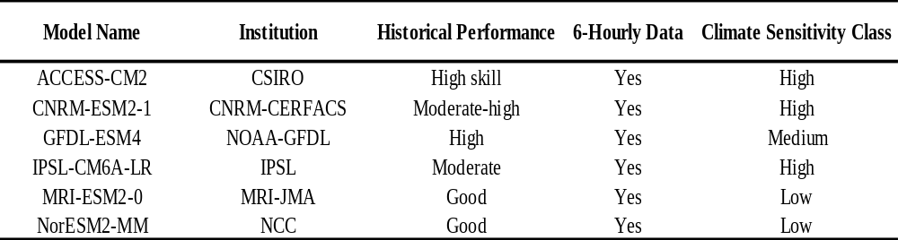

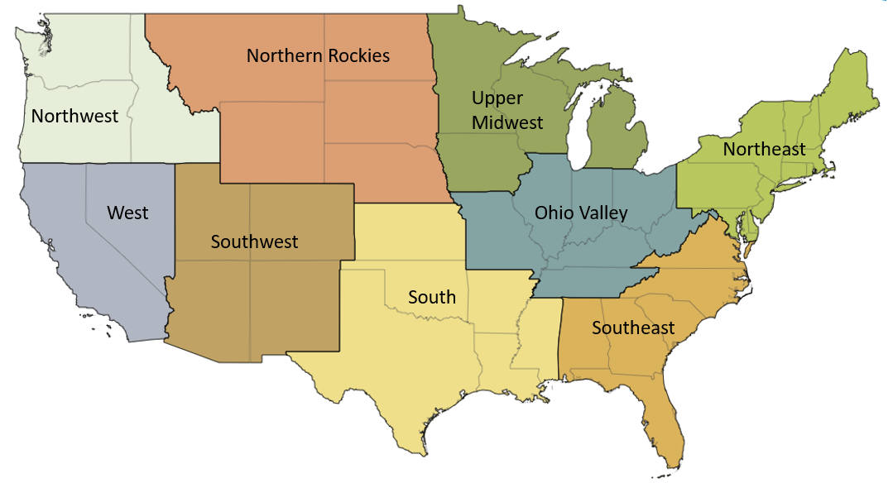
Figure 7.1 CONUS climate regions, as shown on the NCEI website (Karl and Koss 1984).

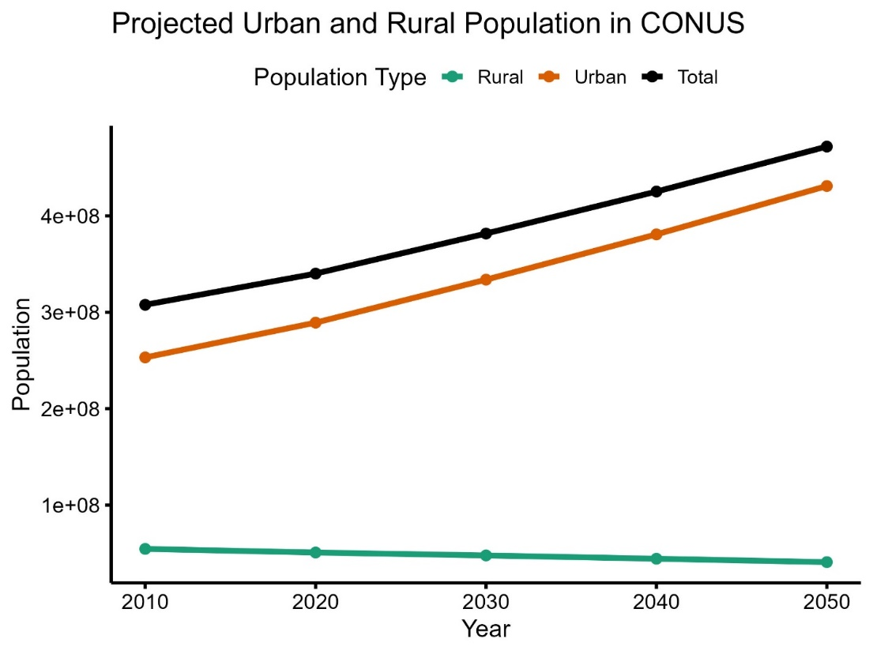
Figure 7.2 Projected Urban and Rural Population Growth in CONUS (2010–2050).

The calculation methods for each drought index:
Equation 7.1 SPI (Standardized Precipitation Index) (McKee et al 1993):
$$SPI = \frac{P -\overline{P}}{σ_{P}}$$
where P is the observed precipitation, $\overline{P}$ is the long-term mean precipitation, and $σ_{P}$ ​is the standard deviation of precipitation over a selected period. By standardizing precipitation deviations, SPI allows for drought classification based on how much a given month or year deviates from the norm. SPI does not account for temperature or evapotranspiration and is therefore primarily a measure of meteorological drought. In this study, SPI was calculated on a 12-month timescale (SPI-12) to assess long-term precipitation anomalies.

Equation 7.2 SPEI (Standardized Precipitation-Evapotranspiration Index) (Vicente-Serrano et al 2010):
$$SPEI = \frac{D -\overline{D}}{σ_{D}}, D = P - PET$$
where D represents the water balance, $\overline{D}$ and $σ_{D}$​ represent the mean and standard deviation of the D series over the selected period. Like SPI, SPEI is standardized, allowing for direct comparisons across different climatic regions. The inclusion of PET makes SPEI more sensitive to temperature-driven droughts, particularly in a warming climate. In this study, PET was estimated using the Variable Infiltration Capacity (VIC) hydrological model, with bias-corrected downscaled General Circulation Model (GCM) data (Zhao et al., 2023). By considering both precipitation deficits and increased evaporative demand, SPEI provides a more comprehensive assessment of drought severity.

Equation 7.3 bScPDSI (Self-Calibrating Palmer Drought Severity Index) (Palmer 1965):
$$PDSI = Z_{k}+ \left.\left( \frac{P - PET -Runoff-Recharge}{Water Demand}\right.\right)$$
The ScPDSI is based on a soil moisture accounting model and involves a more complex recursive calculation. It adjusts the original PDSI by dynamically calibrating climate and soil coefficients based on local conditions: where $Z_{k}$ is the moisture anomaly index, and Runoff and Recharge represent soil moisture dynamics. ScPDSI dynamically adjusts its parameters based on local climate conditions, making it applicable across different regions. As with SPEI, PET in ScPDSI was estimated using the VIC hydrological model with bias-corrected downscaled GCM data (Zhao et al., 2023).

Equation 7.4 The Penman-Monteith equation is shown below (Allen et al 1998):
$$PET = \frac{0.408 ∆ (R_{n} - G) + γ\frac{900}{T + 273}u_{2}(e_{s} - e_{a})}{∆+γ(1 + 0.34u_{2})}$$
where $R_{n}$is net radiation at the crop surface (MJ$m^{-2}$ ${day}^{-1}$), G is soil heat flux density (MJ$m^{-2}$ ${day}^{-1}$), T is mean daily air temperature (°C), $u_{2}$​ is wind speed at 2 m height (m $s^{-1}$), $e_{s}$ is saturation vapor pressure (kPa), $e_{a}$​ is actual vapor pressure (kPa), $∆$ is the slope of the vapor pressure curve (kPa ${°C}^{-1}$), and $γ$ is the psychrometric constant (kPa ${°C}^{-1}$).

Text 7.1 PET Estimation and CO₂ Response Limitations.
SPEI-12 is derived using the Penman-Monteith PET method, which accounts for radiative and aerodynamic influences, improving accuracy over the Thornthwaite method (Zhao et al., 2023). ScPDSI follows the methodology of Dai & Zhao (2016), integrating precipitation, temperature, and soil moisture data to estimate drought severity. Potential evapotranspiration (PET) is estimated using the Variable Infiltration Capacity (VIC) hydrological model with the Penman-Monteith algorithm, utilizing bias-corrected downscaled GCM data (Zhao et al., 2023). The dataset spans three time periods: a historical baseline (1980–2019), a near-term future (2020–2039), and a mid-term future (2040–2059) (Rastogi et al., 2022). This timeframe ensures alignment with policy-relevant climate impact assessments and facilitates cross-study comparisons (IPCC, 2021). While the Penman-Monteith method provides a robust physical representation of PET, it does not explicitly account for CO₂-induced stomatal resistance changes, which can influence plant water use efficiency and transpiration rates (Yang et al., 2019). Future studies could incorporate dynamic vegetation models to refine projections by better accounting for plant physiological responses under elevated CO₂ conditions (Swann et al., 2016; Lemordant et al., 2018).

Text 7.2 CMIP6 Models Used in the Multi-Model Ensemble and Selection Criteria (Table S2).
The multi-model ensemble consists of six CMIP6 GCMs (Table 2), selected based on (1) availability of high-frequency (6-hourly) atmospheric data required for downscaling, (2) demonstrated skill in reproducing historical precipitation and temperature variability over CONUS (Ashfaq et al., 2022), (3) diversity in climate sensitivity to capture a broad range of hydroclimatic responses (Meehl et al., 2020), and (4) consistency with previous hydroclimate studies to ensure intercomparability (Rastogi et al., 2022). The selected models include high-sensitivity GCMs (e.g., ACCESS-CM2, CNRM-ESM2-1), which simulate stronger warming trends, and low-sensitivity models (e.g., MRI-ESM2-0, NorESM2-MM), which exhibit more moderate temperature increases. This diversity ensures that the ensemble captures both upper and lower bounds of projected warming and its associated impacts on drought patterns.

Text 7.3 Evaluation of Downscaling and Validation Procedures.
The reliability of the dynamically downscaled dataset used in this study is supported by prior evaluations presented in Rastogi et al. (2022). Their study assessed the performance of the RegCM4-downscaled CMIP6 models by comparing temperature and precipitation outputs against observational datasets, including Daymet and Livneh. The results demonstrated significant improvements in the representation of hydroclimatic variables after dynamical downscaling and bias correction. Temperature biases were notably reduced, particularly in regions where GCMs exhibited historical cold biases. The mean absolute error for maximum temperature (Tmax) decreased by approximately 30% across CONUS, indicating that the downscaling process effectively corrects systematic errors in temperature simulations. In terms of precipitation, the downscaled dataset better captured precipitation variability compared to raw GCM outputs, particularly in the Southwest and Western U.S., where coarse-resolution models tend to underestimate extreme precipitation events. This enhancement is crucial for accurately assessing drought characteristics, as precipitation variability plays a key role in drought onset and persistence. Moreover, the finer grid resolution of 1/24° (~4 km) significantly improved the representation of regional drought characteristics. This was especially evident in mountainous and semi-arid regions, where coarse-resolution GCMs struggle to accurately simulate localized climate patterns. The added spatial detail ensures a more refined assessment of drought conditions, particularly in areas where small-scale climatic variations strongly influence hydroclimatic extremes.

Vita
Leyuan Zhang was born in Luoyang, Henan Province, China. She earned a Bachelor of Science in Geographical Sciences with a dual degree in Business Management from Nanyang Normal University in 2017. She received a Master of Science in Physical Geography from the University of Chinese Academy of Sciences in 2020. In August 2021, she joined the Department of Civil and Environmental Engineering at the University of Tennessee. She earned her second Master of Science in Environmental Engineering from the University of Tennessee in 2024. She completed her Doctor of Philosophy in Civil Engineering, with an interdisciplinary graduate minor in Computational Science, in December 2025.

