Child/Participant Assent & Survey Pre and Post

The following questions ask about foods and meals you eat, and what you know about nutrition and physical activity. This is not a test. We want to learn about what kids your age eat and know about nutrition and about physical activity.

The answers you give will be kept private. Your name will never be used.

Taking this survey is up to you. Your choice about taking it will not affect how you are treated in this program.

Please be as honest as you can.

Name: ________________________________

Which nutrition tools do you use to help you decide which foods to eat?
MyPlate
Cafeteria color bars
Go, Slow, Whoa chart
Ingredients label
Whole grain stamp/labels on packaging

If you use MyPlate, how often do you use it to help you select the foods you eat?
Almost always
Sometimes
Almost never
I don’t know what MyPlate is

How often do you read the nutrition labels on food packages?
Almost always
Sometimes
Almost never
Never

If you use the Cafeteria Color Bars, how often do you use them to help you select the foods you eat?
Almost always
Sometimes
Almost never
Never

Think about the types of fruits and vegetables that you eat and answer the following questions:
Please circle No or Yes to answer the question below about each of the following foods. |  |  | If you have eaten the food, then circle A, B, C, D, or E, depending on how often you eat the food. |  |  |  |  | Please circle No or Yes to answer the question below about each of the following foods.
Have you ever eaten this food? |  |  | How often do you eat this food? |  |  |  |  | Does your family usually have this food at your house sometime during the year?
 |  |  | More than once a day | Once a Day | Two Times a Week or More | Once a Week | Less Than Once a Week
watermelon  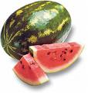 | No | Yes | A | B | C | D | E | watermelon | No | Yes
peaches  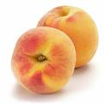 | No | Yes | A | B | C | D | E | peaches | No | Yes
spinach  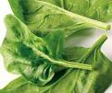 | No | Yes | A | B | C | D | E | spinach | No | Yes
tomatoes  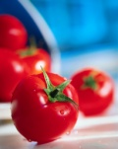 | No | Yes | A | B | C | D | E | tomatoes | No | Yes
plums  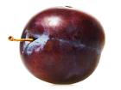 | No | Yes | A | B | C | D | E | plums | No | Yes
carrots  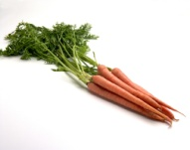 | No | Yes | A | B | C | D | E | carrots | No | Yes
sweet potatoes  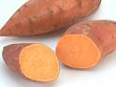 | No | Yes | A | B | C | D | E | sweet potatoes | No | Yes
pears  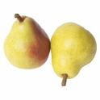 | No | Yes | A | B | C | D | E | pears | No | Yes
pumpkin  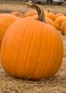 | No | Yes | A | B | C | D | E | pumpkin | No | Yes
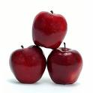  apples | No | Yes | A | B | C | D | E | apples | No | Yes
green beans  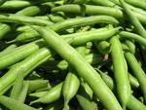 | No | Yes | A | B | C | D | E | green beans | No | Yes
squash  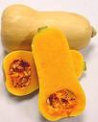 | No | Yes | A | B | C | D | E | squash | No | Yes
cranberry   | No | Yes | A | B | C | D | E | cranberry | No | Yes
celery  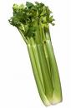 | No | Yes | A | B | C | D | E | celery | No | Yes
cantaloupe  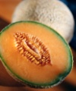 | No | Yes | A | B | C | D | E | cantaloupe | No | Yes
oranges  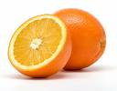 | No | Yes | A | B | C | D | E | oranges | No | Yes
broccoli  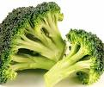 | No | Yes | A | B | C | D | E | broccoli | No | Yes
lemons  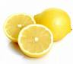 | No | Yes | A | B | C | D | E | lemons | No | Yes
green peppers  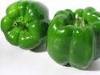 | No | Yes | A | B | C | D | E | green peppers | No | Yes
avocado  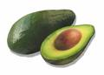 | No | Yes | A | B | C | D | E | avocado | No | Yes
cauliflower  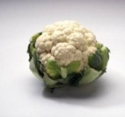 | No | Yes | A | B | C | D | E | cauliflower | No | Yes
bananas  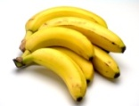 | No | Yes | A | B | C | D | E | bananas | No | Yes
radishes  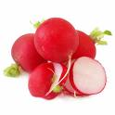 | No | Yes | A | B | C | D | E | radishes | No | Yes
asparagus  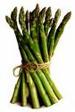 | No | Yes | A | B | C | D | E | asparagus | No | Yes
pineapples  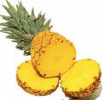 | No | Yes | A | B | C | D | E | pineapples | No | Yes
peas  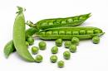 | No | Yes | A | B | C | D | E | peas | No | Yes
grapefruit  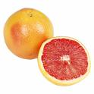 | No | Yes | A | B | C | D | E | grapefruit | No | Yes
lima beans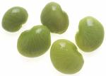 | No | Yes | A | B | C | D | E | lima beans | No | Yes
mangoes  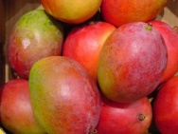 | No | Yes | A | B | C | D | E | mangoes | No | Yes
okra  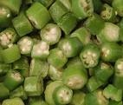 | No | Yes | A | B | C | D | E | okra | No | Yes
cherries  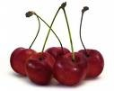 | No | Yes | A | B | C | D | E | cherries | No | Yes
zucchini  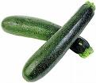 | No | Yes | A | B | C | D | E | zucchini | No | Yes
strawberry  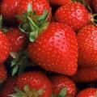 | No | Yes | A | B | C | D | E | strawberry | No | Yes
blackberries  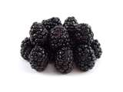 | No | Yes | A | B | C | D | E | blackberries | No | Yes
apricot  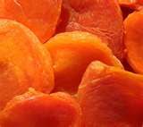  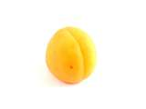 | No | Yes | A | B | C | D | E | apricot | No | Yes
blueberries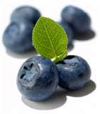 | No | Yes | A | B | C | D | E | blueberries | No | Yes
grapes/raisins  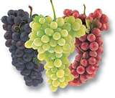 | No | Yes | A | B | C | D | E | grapes/raisins | No | Yes
melon | No | Yes | A | B | C | D | E | melon | No | Yes
kiwifruit | No | Yes | A | B | C | D | E | kiwifruit | No | Yes
nectarine 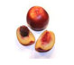 | No | Yes | A | B | C | D | E | nectarine | No | Yes
papaya | No | Yes | A | B | C | D | E | papaya | No | Yes
raspberries | No | Yes | A | B | C | D | E | raspberries | No | Yes
baked potato  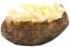 | No | Yes | A | B | C | D | E | baked potato | No | Yes
corn | No | Yes | A | B | C | D | E | corn | No | Yes
Brussels sprouts  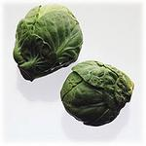 | No | Yes | A | B | C | D | E | Brussels sprouts | No | Yes
eggplant  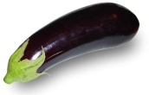 | No | Yes | A | B | C | D | E | eggplant | No | Yes
cabbage  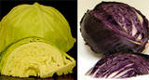 | No | Yes | A | B | C | D | E | cabbage | No | Yes
leaf lettuce  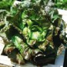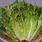 | No | Yes | A | B | C | D | E | leaf lettuce | No | Yes
onion 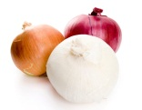 | No | Yes | A | B | C | D | E | onion | No | Yes
beets  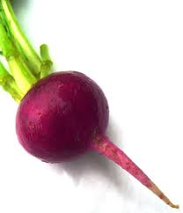 | No | Yes | A | B | C | D | E | beets | No | Yes

Think about the types of breads, cereals, and other grains that you eat and answer the following questions:
Please circle No or Yes to answer the question below about each of the following foods. |  |  | If you have eaten the food, then circle A, B, C, D, or E, depending on how often you eat the food. |  |  |  |  | Please circle No or Yes to answer the question below about each of the following foods.
Have you ever eaten this food? |  |  | How often do you eat this food? |  |  |  |  | Does your family usually have this food at your house sometime during the year?
 |  |  | More than once a day | Once a Day | Two Times a Week or More | Once a Week | Less Than Once a Week
100% whole wheat bread | No | Yes | A | B | C | D | E | 100% whole wheat bread | No | Yes
brown rice | No | Yes | A | B | C | D | E | brown rice | No | Yes
oatmeal | No | Yes | A | B | C | D | E | oatmeal | No | Yes
whole wheat tortillas | No | Yes | A | B | C | D | E | whole wheat tortillas | No | Yes
barley | No | Yes | A | B | C | D | E | barley | No | Yes
quinoa | No | Yes | A | B | C | D | E | quinoa | No | Yes
Wheat Chex® | No | Yes | A | B | C | D | E | Wheat Chex® | No | Yes
Cheerios® | No | Yes | A | B | C | D | E | Cheerios® | No | Yes
Shredded Wheat® | No | Yes | A | B | C | D | E | Shredded Wheat® | No | Yes
whole wheat pasta | No | Yes | A | B | C | D | E | whole wheat pasta | No | Yes
whole grain granola bars | No | Yes | A | B | C | D | E | whole wheat granola bars | No | Yes
whole grain granola cereal | No | Yes | A | B | C | D | E | whole grain granola cereal | No | Yes
Triscuits® or other whole grain crackers | No | Yes | A | B | C | D | E | Triscuits® or other whole grain crackers | No | Yes

Think about the types of sugar-sweetened beverages that you drink and answer the following questions:
Please circle No or Yes to answer the question below about each of the following beverages. |  |  | If you drink the beverage, then circle A, B, C, D, or E, depending on how often you drink the beverage. |  |  |  |  | Please circle No or Yes to answer the question below about each of the following beverages.
Have you ever had this beverage before? |  |  | How often do you drink this beverage? |  |  |  |  | Does your family usually have this beverage at your house sometime during the year?
 |  |  | More than once a day | Once a Day | Two Times a Week or More | Once a Week | Less Than Once a Week
soda like Coke, Sprite or Pepsi | No | Yes | A | B | C | D | E | soda like Coke, Sprite or Pepsi | No | Yes
Kool-Aid® | No | Yes | A | B | C | D | E | Kool-Aid® | No | Yes
sweet tea | No | Yes | A | B | C | D | E | sweet tea | No | Yes
Gatorade®/  other sports drink | No | Yes | A | B | C | D | E | Gatorade®/  other sports drink | No | Yes
fruit drinks | No | Yes | A | B | C | D | E | fruit drinks | No | Yes

Think about the types of milk products that you eat and drink and answer the following questions:
Please circle No or Yes to answer the question below about each of the following milk products. |  |  | If you eat or drink this milk product, then circle A, B, C, D, or E, depending on how often you have the food or milk. |  |  |  |  | Please circle No or Yes to answer the question below about each of the following milk products.
Have you ever had this food or milk product? |  |  | How often do you eat or drink this milk product? |  |  |  |  | Does your family usually have this milk product at your house sometime during the year?
 |  |  | More than once a day | Once a Day | Two Times a Week or More | Once a Week | Less Than Once a Week
whole milk | No | Yes | A | B | C | D | E | whole milk | No | Yes
2% milk | No | Yes | A | B | C | D | E | 2% milk | No | Yes
1% milk | No | Yes | A | B | C | D | E | 1% milk | No | Yes
fat free milk | No | Yes | A | B | C | D | E | fat free milk | No | Yes
flavored milk | No | Yes | A | B | C | D | E | flavored milk | No | Yes
plain white milk | No | Yes | A | B | C | D | E | plain white milk | No | Yes
plain yogurt | No | Yes | A | B | C | D | E | plain yogurt | No | Yes
flavored yogurt | No | Yes | A | B | C | D | E | flavored yogurt | No | Yes
regular cheese | No | Yes | A | B | C | D | E | regular cheese | No | Yes
reduced fat or fat free cheese | No | Yes | A | B | C | D | E | reduced fat or fat free cheese | No | Yes

Think about the types of meats and beans that you eat and answer the following questions:
Please circle No or Yes to answer the question below about each of the following foods. |  |  |  | If you have had this meat or beans, then circle A, B, C, D, or E, depending on how often you have had the food. |  |  |  |  |  |  | Please circle No or Yes to answer the question below about each of the following foods.
Have you ever eaten this food? |  |  |  | How often do you eat this food? |  |  |  |  |  |  | Does your family usually have this food at your house sometime during the year?
 |  |  |  | More than once a day | Once a Day | Two Times a Week or More | Once a Week |  | Less Than Once a Week
baked/grilled/  stewed chicken without skin |  | No | Yes | A | B | C | D |  | E |  | baked/grilled/stewed chicken without skin |  | No |  | Yes
dried beans and peas |  | No | Yes | A | B | C | D |  | E |  | dried beans and peas |  | No |  | Yes
tofu/ vegetarian meat alternatives |  | No | Yes | A | B | C | D |  | E |  | tofu or vegetarian meat alternatives |  | No |  | Yes
peanut butter/nuts |  | No | Yes | A | B | C | D |  | E |  | peanut butter/nuts |  | No |  | Yes
lean or very lean hamburger |  | No | Yes | A | B | C | D |  | E |  | lean or very lean hamburger |  | No |  | Yes
broiled/baked/  grilled/steamed fish |  | No | Yes | A | B | C | D |  | E |  | broiled/baked/  grilled/steamed fish |  | No |  | Yes
tuna packed in water |  | No | Yes | A | B | C | D |  | E |  | tuna packed in water |  | No |  | Yes
pork tenderloin, fat trimmed |  | No | Yes | A | B | C | D |  | E |  | pork tenderloin, fat trimmed |  | No |  | Yes
pork chops, trimmed of all visible fat |  | No | Yes | A | B | C | D |  | E |  | pork chops, trimmed of all visible fat |  | No |  | Yes
steaks and beef, trimmed of all visible fat |  | No | Yes | A | B | C | D |  | E |  | steak and beef, trimmed of all visible fat |  | No |  | Yes
reduced-fat sausage: turkey/chicken/  vegetarian sausage or other lower in fat |  | No | Yes | A | B | C | D |  | E |  | reduced-fat sausage: turkey/chicken/  vegetarian sausage or other lower in fat |  | No |  | Yes
ham, trimmed of all visible fat |  | No | Yes | A | B | C | D |  | E |  | ham, trimmed of all visible fat |  | No |  | Yes
bean dips and bean salsa |  | No | Yes | A | B | C | D |  | E |  | bean dips and bean salsa |  | No |  | Yes
Think about the breakfast foods that you have and answer the following questions:
Please circle No or Yes to answer the question below about each of the following breakfast items. |  |  |  | If you have had this food for breakfast, then circle A, B, C, D, or E, depending on how often you have the food. |  |  |  |  |  |  |  | Please circle No or Yes to answer the question below about each of the following breakfast items.
Have you ever had this for breakfast? |  |  |  | How often do you have this for breakfast? |  |  |  |  |  |  |  | Does your family usually have this breakfast item at your house sometime during the year?
 |  |  |  | Almost always | Some-times | On  occasion |  | Almost never |  | I don’t eat this
fruit or 100% juice | No |  | Yes | A | B | C |  | D |  | E |  | fruit or 100% juice |  | No |  | Yes
milk | No |  | Yes | A | B | C |  | D |  | E |  | milk |  | No |  | Yes
soda | No |  | Yes | A | B | C |  | D |  | E |  | soda |  | No |  | Yes
whole grain waffles, pancakes | No |  | Yes | A | B | C |  | D |  | E |  | whole grain waffles, pancakes |  | No |  | Yes
waffles, pancakes made with refined flour | No |  | Yes | A | B | C |  | D |  | E |  | waffles, pancakes made with refined flour |  | No |  | Yes
whole wheat bread (toast) | No |  | Yes | A | B | C |  | D |  | E |  | whole wheat bread (toast) |  | No |  | Yes
white bread (toast) made with refined grains | No |  | Yes | A | B | C |  | D |  | E |  | white bread (toast) made with refined grains |  | No |  | Yes
leftovers/  sandwiches | No |  | Yes | A | B | C |  | D |  | E |  | leftovers/  sandwiches |  | No |  | Yes
eggs (boiled, scrambled, or fried) | No |  | Yes | A | B | C |  | D |  | E |  | eggs (boiled, scrambled, or fried) |  | No |  | Yes
bacon | No |  | Yes | A | B | C |  | D |  | E |  | bacon |  | No |  | Yes
whole grain cereals | No |  | Yes | A | B | C |  | D |  | E |  | whole grain cereals |  | No |  | Yes
cereals made with refined grains | No |  | Yes | A | B | C |  | D |  | E |  | cereals made with refined grains |  | No |  | Yes
sausage and biscuit | No |  | Yes | A | B | C |  | D |  | E |  | sausage and biscuit |  | No |  | Yes
biscuit and gravy | No |  | Yes | A | B | C |  | D |  | E |  | biscuit and gravy |  | No |  | Yes
biscuit only | No |  | Yes | A | B | C |  | D |  | E |  | biscuit only |  | No |  | Yes
sausage only | No |  | Yes | A | B | C |  | D |  | E |  | sausage only |  | No |  | Yes
Poptarts® | No |  | Yes | A | B | C |  | D |  | E |  | Poptarts® |  | No |  | Yes
croissants | No |  | Yes | A | B | C |  | D |  | E |  | croissants |  | No |  | Yes
breakfast pastry | No |  | Yes | A | B | C |  | D |  | E |  | breakfast pastry |  | No |  | Yes
doughnuts | No |  | Yes | A | B | C |  | D |  | E |  | doughnuts |  | No |  | Yes

Think about the types of added fats and oils that you use and answer the following questions:
Please circle No or Yes to answer the question below about each of the following added fats and oils. |  |  | If you have had this added fat or oil, then circle A, B, C, D, or E, depending on how often you have had the food. |  |  |  |  | Please circle No or Yes to answer the question below about each of the following added fats and oils.
Have you ever had this added fat or oil? |  |  | How often do you have this added fat or oil? |  |  |  |  | Does your family usually have this added fat or oil at your house sometime during the year?
 |  |  | More than once a day | Once a Day | Two Times a Week or More | Once a Week | Less Than Once a Week
avocado | No | Yes | A | B | C | D | E | avocado | No | Yes
nuts and seeds | No | Yes | A | B | C | D | E | nuts and seeds | No | Yes
salmon, trout, mackerel, herring | No | Yes | A | B | C | D | E | salmon, trout, mackerel, herring | No | Yes
lard | No | Yes | A | B | C | D | E | Lard | No | Yes
butter | No | Yes | A | B | C | D | E | butter | No | Yes
stick margarine | No | Yes | A | B | C | D | E | stick margarine | No | Yes
soft (tub) margarine | No | Yes | A | B | C | D | E | soft (tub) margarine | No | Yes
olive or canola oil | No | Yes | A | B | C | D | E | olive or canola oil | No | Yes
other vegetable oils | No | Yes | A | B | C | D | E | other vegetable oils | No | Yes
regular mayonnaise | No | Yes | A | B | C | D | E | regular mayonnaise | No | Yes
reduced or fat free mayonnaise | No | Yes | A | B | C | D | E | reduced or fat free mayonnaise | No | Yes

Think about the types of solid fats and sugars that you eat and answer the following questions:
Please circle No or Yes to answer the question below about each of the following foods. |  |  | If you have eaten the food, then circle A, B, C, D, or E, depending on how often you consume the food. |  |  |  |  | Please circle No or Yes to answer the question below about each of the following foods.
Have you ever eaten this food? |  |  | How often do you eat this food? |  |  |  |  | Does your family usually have this food at your house sometime during the year?
 |  |  | More than once a day | Once a Day | Two Times a Week or More | Once a Week | Less Than Once a Week
cookies | No | Yes | A | B | C | D | E | cookies | No | Yes
cakes | No | Yes | A | B | C | D | E | cakes | No | Yes
candy | No | Yes | A | B | C | D | E | candy | No | Yes
pies | No | Yes | A | B | C | D | E | Pies | No | Yes
doughnuts | No | Yes | A | B | C | D | E | doughnuts | No | Yes
brownies | No | Yes | A | B | C | D | E | brownies | No | Yes

