Exploring University Campus Community’s Perceptions and Barriers toward Biking
Sheikh M. Usman*, Muhammad Adeel
Department of Civil & Environmental Engineering, The University of Tennessee, Knoxville, USA.
* Corresponding Author: Sheikh M. Usman
Email address: susman1@vols.utk.edu
Abstract
Bicycling constitutes an integral component of sustainable non-motorized means of travel. Despite the immense benefits of bicycling, the modal share of bicycling is quite low, specifically among young and low-income commuters, e.g., college and university students. This study explores the perceptions of and barriers to bicycling of the campus community at the University of Tennessee, Knoxville, with the aim of identifying the factors that could enhance bike use among students at the university campus as well as highlighting the barriers that keep the young population away from biking. An online survey about bike use at the university campus was administered, and responses to the survey were recorded. On the methodological front, a binary logit model was estimated with students’ willingness to use bikes on campus as the dependent variable. The survey results revealed that about 47% of the students considered vehicular traffic as the reason for feeling unsafe while biking and emphasized having separate bike routes. Most of the respondents highlighted the need to change clothes after biking in summer or carry things as the reason for not selecting bikes as a mode of transport on the campus, whereas inadequate bike lanes, paths, or trails, insufficient lighting along bike routes, and the lack of adequate bicycle parking were highlighted as the major barriers deterring bike use within the campus. The study suggests the development of a campus bike network with proper bike lanes, bike runnels, installation of safety cameras, and better lighting at the campus, and bike-supporting infrastructure such as communal showers to be provided in campus buildings to encourage bike use among university students. The study findings can assist campus transportation planners in devising a sustainable campus transportation plan incorporating the influencing factors and deterrents of bike use in a university campus setting.
Keywords: Bike use; bike lane; university campus; perceptions; barriers
1. Introduction
Many colleges and universities are interested in promoting sustainable and environmentally friendly transportation with a focus on reducing greenhouse gas emissions and relieving local congestion. However, financial, environmental, and spatial constraints are the decisive factors in developing substitute transportation modes (1, 2). One of the strategies devised to promote alternative non-motorized transportation modes is to provide incentives for alternative transportation modes and disincentives for automobile travel. Bicycling constitutes an integral part of non-motorized transport, with its benefits including but not limited to low access costs, moderate travel speeds, environment-friendliness, and improved health and well-being, making it more appealing to younger and low-income users, i.e., college and university students (1, 3). Despite these benefits, bicycle modal share remains low on many U.S. campuses, and transportation planners are searching for ways to bolster cycling at university campuses (2). The different barriers that can prevent people from cycling include physical obstacles and societal perceptions. The fear of cycling, which encompasses the fear of risk and being judged, is a significant sociological barrier to increasing the bike modal share (4, 5). This study aims to understand the needs of bicyclists living close to campus and identify reasons that keep them away from cycling to help reduce automobile travel, relieve congestion, and enhance environmental protection. The study analyzes students’ (undergraduate and graduate students) perceptions and barriers towards cycling in a survey conducted at the University of Tennessee, Knoxville.
The main motive behind this study is to attain a comprehensive understanding of the needs and concerns of bicyclists and to improve bicycle planning on and around campus. By identifying the specific barriers that prevent people from using their bicycles, administrators can develop targeted interventions that address these obstacles and encourage more people to cycle. While bicycling is known to have numerous benefits over other transportation modes, such as reducing traffic congestion and improving air quality, it remains a relatively underutilized mode of transportation on many college campuses. This study seeks to explore the factors that contribute to this underutilization and provide insights into how administrators can promote and support cycling as a sustainable transportation option.
2. Literature Review
Universities are considered Trip Generating Poles (TGPs), meaning they generate a significant number of trips taken by students, faculty, and staff (6). To minimize the impacts of these trips on the surrounding population, adequate planning is necessary. To create a sustainable environment on their campuses, universities worldwide are increasingly committed to reducing the adverse impacts of motorized transportation modes. Bicycling can significantly reduce the vehicle count on the streets, thereby reducing congestion, vehicle fuel consumption, and hazardous CO₂ emissions. This mode of transportation also promotes a healthier lifestyle for university populations (Balsas, 2003). Several studies have focused on the factors that impact cyclists’ choice of route selection and trip rate. Stinson & Bhat (2003) found travel time as the most critical factor for route selection among cyclists. Additionally, the presence of bike facilities, vehicle density, and pavement surface condition was also found as key determinants of bike modal choice. Bicycling was positively associated with trips other than work, and non-bicyclists tend to avoid biking due to perceived dangers or lack of safe route options. Another study explored individual preferences for cycling environments and found that people are willing to travel up to 20 minutes extra for a better facility (8). High-speed traffic and a high proportion of vehicular traffic raise cyclists' safety concerns (9, 10). Infrastructural weakness, such as the lack of bike-specific roadway infrastructure, forces bike riders to use shared paths with pedestrians and motorized traffic, which can lead to feeling unsafe while cycling (11, 12). Providing bike-specific lanes, traffic signal controls, and other safety measures can improve the perception of safety and increase the legitimacy of cycling as a travel mode (13, 14). Improving the bike-riders’ view of safety while biking is therefore important in promoting cycling as a mode of commuting (15, 16). Krizek & Roland (2005) highlighted issues with discontinuous bike lanes that may increase discomfort for cyclists. Gatersleben & Appleton (2007) found that people's attitudes and perceptions towards cycling can change as they start cycling, suggesting that people can be convinced to continue cycling once they have started using the cycle as a means of transport. However, a university setting varies from urban regions because the campus area is physically delimited, and access points can be controlled. Balsas (2003) notes that university campuses are unique because they have a young and active population, with non-stop movement the entire day, and sporadic schedules. Sustainable transportation policies on campuses can influence the mode choice of the entire population besides the campus community, making campus transportation policies and decisions critical (19, 20).
The current research contributes to the available literature by examining the travel behaviors within a campus environment (specifically, UTK), pinpointing specific groups that could be targeted to increase the percentage of commuters who choose to cycle, and including individual attitudes as a factor in the modeling of transportation mode choices.
3. Conceptual Framework
The conceptual Framework for the study is provided in Figure 1. The study aims to study the impact of the influencers and barriers related to bike use on campus, along with the perceptions of individual bike users toward bike modal choice at the campus.
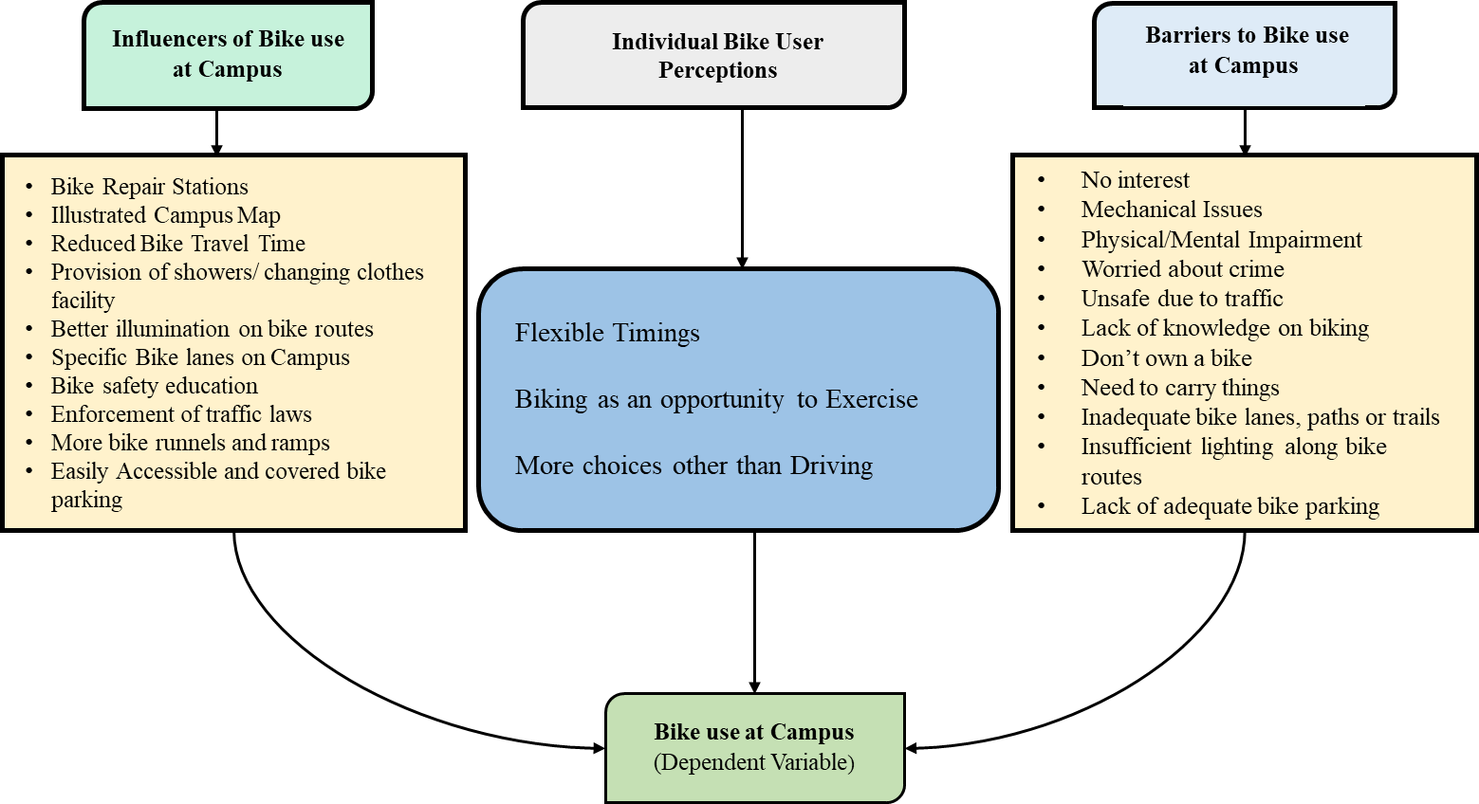
Figure 1. Study Conceptual Framework
4. Overall Study Framework
The graphical representation of the overall study framework is presented in Figure 2. The study collects data from the campus community on bike modal share at the campus through an online-administered bike use survey. After removing incomplete responses, descriptive statistics and a binary logit model are estimated for the final dataset containing perceptions of the campus community on bike modal share at the campus. Suitable recommendations to improve bike modal share at the campus are suggested based on the statistically significant factors influencing bike use at the campus that are obtained through the estimation of the binary logit model.
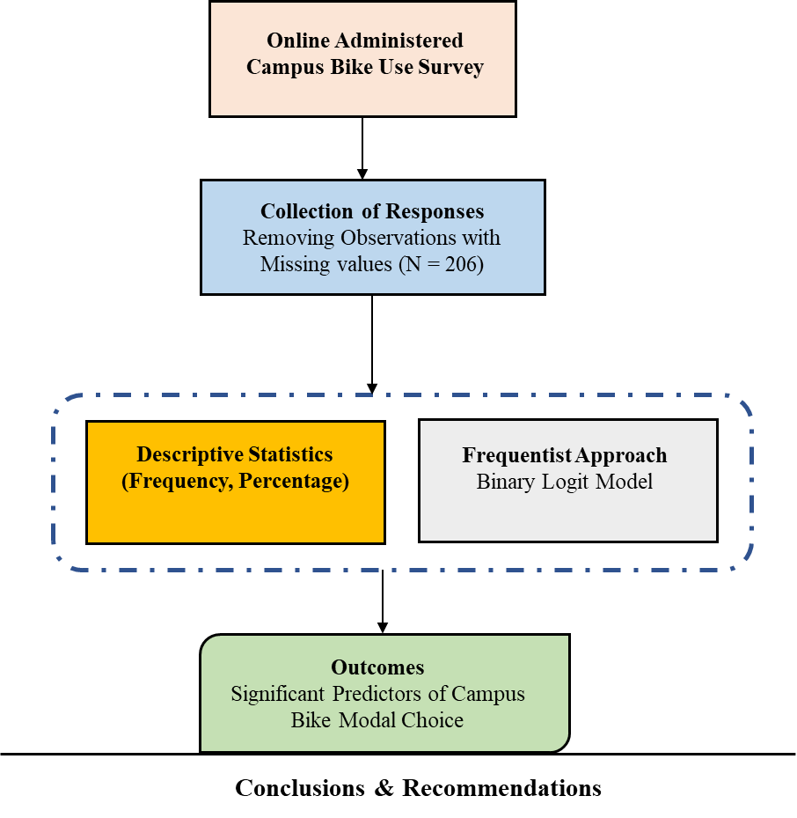
Figure 2. Overall Study Framework
- Data Description and Methodology
The data is collected by conducting an online survey on the “Exploring UTK Campus Community’s Perceptions and Barriers toward Bike Mode Choice”, a sample is attached in Annexure 'A' to the report. The survey form was designed after reviewing past studies and considering the nature of trends among the students at the universities. The survey form was distributed among faculty, staff, and students at The University of Tennessee, Knoxville (UTK) through online sharing. 217 responses were received from the respondents, 11 responses were removed being incomplete, and the remaining 206 responses (complete forms) were selected as the final dataset. For statistical analysis of the data, bike modal choice, i.e., ‘Bike use around the Campus’ is selected as the 'dependent variable', whereas other social and behavioral variables included in the survey form are selected as 'independent variables'. The dependent variable was considered as a binary variable with 1 representing bike use around the campus, while 0 representing commute to/around the campus through all other non-bike modes i.e., personal vehicle, transit, walking, etc. Due to the binary nature of the dependent variable, the 'Binary Logistic Model' is adopted for statistical analysis of the data. The distribution of the dependent variable is shown in Figure 3.
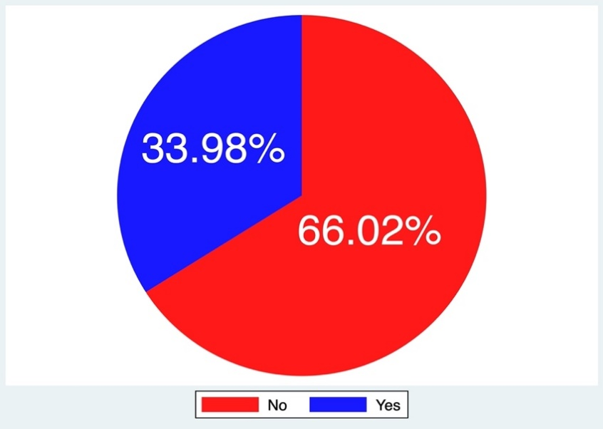
Figure 3. Distribution of the Dependent Variable, “Bike use around the Campus”.
- Descriptive Statistics
The descriptive statistics associated with the variables collected in the study are presented in Table 1. Most of the individuals who responded to the online survey were males (59.71%), whereas 40.29% of respondents were females. The response to the survey was received from almost all categories of people, one-third (31.55%) of the respondents were 21 to 25 years old, with individuals more than 40 years of age responding the least (5.83%). Although an effort was made to distribute the survey forms to the entire campus community i.e., students (graduates/ undergraduates), faculty, and staff, the students responded the most (85.44%), and among students, 44.17% were graduate students, whereas 47.57% were undergraduate students. Most of the respondents (almost one-third i.e., 33.98%) lived within 1 to 5 miles of the campus, followed by individuals who lived less than 1 mile (30.10%), whereas 12.62% of the respondents lived more than 10 miles from the campus. Almost half of the respondents (47.09%) traveled to campus by their personal vehicles, as compared to bicycle riders (12.14%). More than half of the respondents (58.74%) considered they had more choices to travel to campus other than driving, and almost one-third (33.98%) preferred a bike to use around the campus. There is still a potential to convince more individuals toward biking. Since biking is a good way to exercise and remain healthy, 85.44% of the respondents considered riding a bicycle as an opportunity to exercise. More than two-thirds (66.50%) of the respondents had flexible arrival/ departure timings from school/ work, which shows a high potential for bike use within the campus.
In the survey form, suggestions were asked from the respondents regarding campus improvements to encourage more people towards bicycling, and they were given choices to select any three among them. Almost half of the respondents (48.06%) selected the directness of travel of bike routes as their choice as they considered time the major factor in deciding the mode to travel. The existing campus map available online on the university website does not indicate all bike routes, therefore 36.41% of the respondents suggested an illustrated campus map indicating the recommended bicycle routes along with bike racks and repair stations to encourage more people to bike. The fear of any mechanical issues with the bicycle was highlighted as another major barrier discouraging people from biking, therefore 23.79% of the individuals suggested having repair stations for bicycles on campus, to facilitate the use of bicycles. Although most of the areas around the campus have better illumination, one-third of the respondents (31.55%) suggested having improved illumination on campus especially near bike routes to encourage bicycling. More than one-third (38.83%) of individuals suggested having showers and facilities for changing clothes on campus to allow students to take shower and change clothes before attending their classes. One-third (33.50%) of the respondents suggested having specific bike lanes for cyclists, whereas 24.27% emphasized imposing strict traffic laws for cyclists’ protection, and 15.53% suggested arranging bike riding and safety educational classes on campus to encourage more people to bike. Around 25% of respondents suggested having more bike runnels/ ramps, whereas 22.33% recommended covered bike parking on campus to encourage bicycling.
Finally, the respondents were asked to highlight the major issues and barriers that deter them from bicycling to or within the campus. They were given choice to select any three among them. In response, one-fourth of the respondents (25.73%) cited the lack of interest as the primary factor that keeps them away from biking, whereas 18.93% of individuals considered the mechanical issues of the bicycle as a barrier discouraging them from biking. 10.68% stated physical or mental impairment as a major barrier, whereas more than one-third (34.47%) stated that they felt unsafe or worried about crime while biking on campus after dark. Almost half of the respondents (47.09%) considered vehicular traffic as the reason for feeling unsafe while biking, and emphasized having separate bike routes, whereas 19.90% of individuals stated the lack of knowledge on biking as a major barrier discouraging them from bicycling. 40.78% of respondents highlighted the need to change clothes or carry things as the reason for not selecting bikes as a mode of transport on campus, whereas more than one-third (33.98%) considered inadequate bike lanes, paths, or trails as a major barrier. 20.87% highlighted insufficient lighting along bike routes as a barrier, whereas 13.59% of the respondents considered the lack of adequate bicycle parking as a major barrier deterring bike use within the campus. Note that the responses under the “Improvement on Campus Encouraging Bicycling” and “Major Issues that Deter Bicycling to or within the Campus” are not mutually exclusive, as every respondent selected any three choices among the set of provided choices under these questions in the survey. Graphical visualizations of the independent variables are shown in Figure 4.
Table 1. Descriptive Statistics of the Variables.
Variables | Descriptive Statistics (N = 206)
Variables | Frequency | Percentage % | Min | Max
Gender
Male | 123 | 59.71 | 0 | 1
Female | 83 | 40.29 | 0 | 1
Age
Less than 20 years | 37 | 17.96 | 0 | 1
21-25 years | 65 | 31.55 | 0 | 1
25-30 years | 47 | 22.82 | 0 | 1
30-35 years | 29 | 14.08 | 0 | 1
35-40 years | 16 | 7.77 | 0 | 1
More than 40 years | 12 | 5.83 | 0 | 1
Position at University
Student | 176 | 85.44 | 0 | 1
Faculty | 6 | 2.91 | 0 | 1
Staff | 24 | 11.65 | 0 | 1
Physical Disability
Yes | 10 | 4.85 | 0 | 1
No | 196 | 95.15 | 0 | 1
School
Graduate School | 91 | 44.17 | 0 | 1
Undergraduate School | 98 | 47.57 | 0 | 1
None | 17 | 8.25 | 0 | 1
Living Arrangements
On Campus | 49 | 23.67 | 0 | 1
Off-Campus | 157 | 76.32 | 0 | 1
Distance from Campus
Less than 1 mile | 62 | 30.10 | 0 | 1
1 to 5 miles | 70 | 33.98 | 0 | 1
5 to 10 miles | 48 | 23.30 | 0 | 1
More than 10 miles | 26 | 12.62 | 0 | 1
Modes of Transportation To and From Campus
Bicycle | 25 | 12.14 | 0 | 1
Personal Vehicle | 97 | 47.09 | 0 | 1
Public Transit Service | 35 | 16.99 | 0 | 1
Walking | 38 | 18.45 | 0 | 1
Others | 11 | 5.34 | 0 | 1
More Choices to Travel to Campus Other than Driving
Yes | 121 | 58.74 | 0 | 1
No | 85 | 41.26 | 0 | 1
Prefer Bike use around Campus
Yes | 70 | 33.98 | 0 | 1
No | 136 | 66.02 | 0 | 1
Considering Riding Bicycle as an Opportunity to Exercise
Yes | 176 | 85.44 | 0 | 1
No | 30 | 14.56 | 0 | 1
Flexible Arrival/ Departure times from School/ Work
Yes | 137 | 66.50 | 0 | 1
No | 69 | 33.50 | 0 | 1
Improvement on Campus Encouraging Bicycling
The directness of Travel of Bike Routes
Yes | 99 | 48.06 | 0 | 1
Campus Map indicating Bicycle Paths
Yes | 75 | 36.41 | 0 | 1
Repair Station for Bicycles on Campus
Yes | 49 | 23.79 | 0 | 1
Better Illumination on Campus
Yes | 65 | 31.55 | 0 | 1
Shower or Changing Clothes places on Campus
Yes | 80 | 38.83 | 0 | 1
Specific Bike Lanes on campus for cyclists
Yes | 69 | 33.50 | 0 | 1
Bike Riding and Safety Educational Classes
Yes | 32 | 15.53 | 0 | 1
Strict Traffic Laws for Cyclist Protection
Yes | 50 | 24.27 | 0 | 1
More Bike Runnels/ Ramps
Yes | 52 | 25.24 | 0 | 1
Covered Bike Parking
Yes | 46 | 22.33 | 0 | 1
Major Issues that Deter Bicycling to or within the Campus
No Biking Interest
Yes | 53 | 25.73 | 0 | 1
Mechanical issues of Bicycle
Yes | 39 | 18.93 | 0 | 1
Physical or Mental Impairments
Yes | 22 | 10.68 | 0 | 1
Worries about Crime making Bicycle Unsafe
Yes | 71 | 34.47 | 0 | 1
Vehicular Traffic Making Biking Unsafe
Yes | 97 | 47.09 | 0 | 1
Lack of knowledge of Biking
Yes | 41 | 19.90 | 0 | 1
Do not Own a bike
Yes | 67 | 32.52 | 0 | 1
Need to Change Clothes or Carry Things
Yes | 84 | 40.78 | 0 | 1
Inadequate Bike Lanes, Paths, or Trails
Yes | 70 | 33.98 | 0 | 1
Insufficient Lighting along Bike Routes
Yes | 43 | 20.87 | 0 | 1
Lack of adequate Bicycle Parking
Yes | 28 | 13.59 | 0 | 1

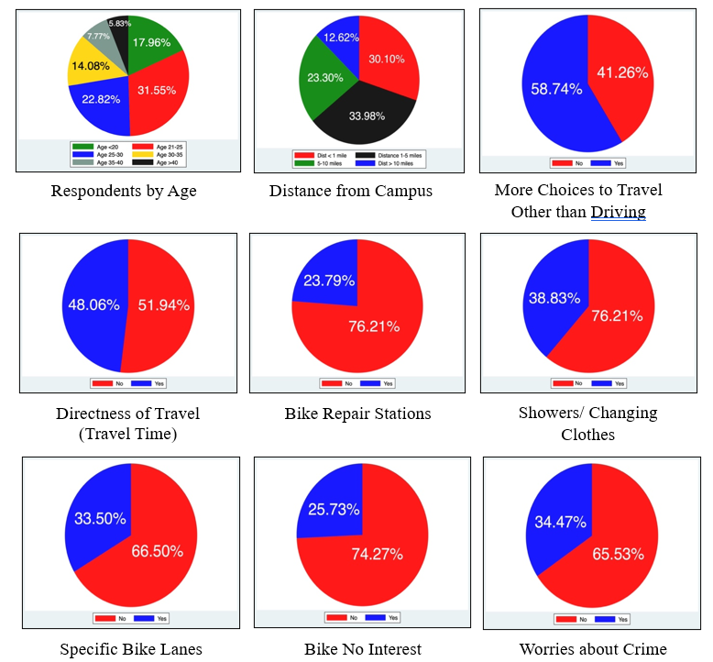
Figure 4: Graphical Visualization of Key Independent Variables
- Discussion of Results
Table 2 presents the results of a binary logistic regression applied to model the mode choice of biking at the UTK campus. Model results reveal that the reduction in travel time associated with biking at the campus is more likely to result in increased bike share at the campus. Marginal effects for the reduced travel time indicator show that the probability of bike use increases by 0.1813 when the value of this indicator switches from 0 to 1. This finding is intuitive as people's decisions to use non-motorized transport are very sensitive to the travel time associated with them (1). Better illumination along bike routes is found positively associated with an increased modal share of bikes at the campus. Marginal effects for this indicator reveal an increase in the probability of bike use by 0.2362 for a change in the value of this indicator variable from 0 to 1. This finding indicates that through better illumination along bike routes, people's perception of safety while biking at night will increase which will eventually lead to more bike use on campus at night and/or in dark conditions. The development of a comprehensive campus bike network map showing bike routes and bike repair stations at the campus was found significantly associated with increased bike use at the campus. Marginal effects for this indicator reveal an increase in the probability of bike use by 0.1464 for a change in the value of this indicator variable from 0 to 1. A detailed campus bike network map with information about bike racks, bike routes, and bike repair stations is expected to encourage the students to use bikes more often on campus. The provision of communal showers for students at campus buildings and departments is found more likely to increase the modal share of bikes at the university. The marginal effects for this indicator variable reveal that the probability of bike use increases by 0.0684 for a change in the value of this indicator variable from 0 to 1. Designating bike-specific lanes on the campus is found to be more likely to result in increased bike use among the campus community. The provision of more bike runnels and ramps at the campus is also found to increase the modal share of bikes. Marginal effects for this indicator indicate that the probability of bike use increases by 0.1127 for a change in the value of this indicator variable from 0 to 1. Bike safety awareness seminars conducted at the university campus are found more likely to increase bike use among the campus community. Such seminars can help spread awareness about bike safety and traffic rules to be observed while biking, resulting in persuading more non-bikers to adopt biking as a mode of transport around the campus. Feeling unsafe while biking at the campus due to vehicular traffic is found significantly associated with reduced bike use at the campus. The marginal effects for this indicator variable reveal that the probability of bike use decreases by 0.4774 for a change in the value of this indicator variable from 0 to 1. The unsafe behavior of car drivers toward bike riders at the campus can discourage bike use among students at campus. This result provides evidence in favor of the provision of bike-specific infrastructure such as bike lanes on the campus to help cyclists feel safer while biking. The indicator of bike users worried about being a victim of a crime while biking after dark is found significantly associated with reduced bike use at the campus. The marginal effects suggest a decrease in the probability of bike use of 0.1546 for a change in the value of this indicator variable from 0 to 1. This result implies that the university administration should ensure better safety on campus for bike riders. The indicator variable representing the need to carry things while moving around campus was also found to decrease bike use at the campus. The marginal effects for this indicator variable reveal that the probability of bike use decreases by 0.2753 for a change in the value of this indicator variable from 0 to 1. The provision of lockers to students to keep their belongings in campus buildings can be a potential solution for this issue. Students with any physical disability or health issues were found less likely to use bikes for commuting around campus. This finding is intuitive as people with health issues such as obesity, lack of stamina, or physical disability are more inclined towards using more comfortable motorized modes of transportation (21).
The model goodness of fit statistics indicate a log-likelihood at convergence value of -87.1588 and a Pseudo R-squared value of 0.3398 which indicates a better model fit as generally a Pseudo R-squared value higher than 0.20 demonstrates a good model fit (22–39). The chi-squared test indicates that the model is overall statistically significant, as the probability of getting a higher value than the chi-squared distributed likelihood ratio is 0.000. The values of Akaike Information Criteria (AIC) and Bayesian Information Criteria (BIC), which are measures of prediction errors in the model are 198.3177 and 238.2522, respectively.
Table 2: Results of the Binary Logit Model
Variable | Coefficient | t-stat | p-value | Marginal Effects
 |  |  |  | Bike use | Other modes
Constant | -3.263 | -4.53 | 0.000
Need to carry things | -2.00 | -3.57 | 0.000 | -0.2753 | 0.2753
Reduced Travel Time | 1.317 | 2.90 | 0.004 | 0.1813 | -0.1813
Better illumination along bike routes | 1.717 | 3.73 | 0.000 | 0.2362 | -0.2362
Illustrated campus bicycle map | 1.064 | 2.54 | 0.011 | 0.1464 | -0.1464
Provision of showers in campus buildings | 0.202 | 2.58 | 0.010 | 0.0684 | -0.0684
Specific bike lane | 0.132 | 2.15 | 0.031 | 0.1127 | -0.1127
Bike safety awareness sessions | 1.356 | 2.80 | 0.005 | 0.1867 | -0.1867
Feeling unsafe due to Vehicular Traffic | -0.167 | -4.47 | 0.000 | -0.4774 | 0.4774
Worries about crime | -1.124 | -2.56 | 0.011 | -0.1546 | 0.1546
Physical disability | -1.971 | -2.12 | 0.034 | -0.2712 | 0.2712
More bike runnels and ramps | 1.071 | 2.45 | 0.014 | 0.1474 | -0.1474
The Goodness of Fit Statistics
Number of Observations | 206
Log-likelihood at zero | -132.0268
Log-likelihood at convergence | -97.1588
Pseudo R-squared | 0.264
LR chi² (11) | 89.74
Prob > chi² | 0.000
AIC | 198.3177
BIC | 238.2522

- Conclusions
This study analyzes the UTK campus community’s perceptions and barriers toward bicycle use on campus. The study objectives are to attain a comprehensive understanding of the needs and concerns of bicyclists and to improve bicycle infrastructure planning on campus. The study collects feedback from the campus community on the determinants of the modal share of bikes at the campus through an online-administered survey. The data collected from the survey was analyzed using a binary logistic regression model to determine the factors significantly influencing bike modal share at the campus. The study results revealed interesting insights into the perceptions of students, staff, and faculty toward bike use on campus. According to the study results, the factors found to significantly increase bike modal share among campus community were reduced travel time associated with biking i.e., more directness of bike routes, provision of bike-specific and bike-supporting infrastructure such as bike lanes, bike runnels, ramps, showers, lockers, etc., improved lighting along bike routes, comprehensive mapping of the campus bike network, and bike safety awareness programs. The factors found significantly associated with discouraging bike use among the campus community included people feeling unsafe while biking at the campus due to vehicular traffic, worried about crime while biking around campus in dark conditions, the need to carry things while moving around the campus, and physical impairments/disabilities. Like all other studies, this study also has some limitations. The results obtained through the binary mode choice model in this study specifically reflect the perceptions of the campus community at the University of Tennessee, Knoxville. The results may not be generalizable to other campus locations or other cities or states. Furthermore, the limited sample size is a hindrance in the estimation of more robust sophisticated statistical models (random parameter models with heterogeneity in means or variances) or machine learning techniques to predict the enforcers and barriers to bike use in a university campus setting.
- Recommendations
The study suggests various countermeasures based on modeling results that can potentially increase bike modal share around the campus. Firstly, a campus bike network needs to be developed with designated bike lanes, bike runnels, and ramps around the campus to ensure congestion-free bike travel around the campus. A detailed campus bike network map with information on bike routes, bike trails, bike repair stations, etc. needs to be developed. Since motorized traffic on campus was found to make bike users feel unsafe, careless driving from the car drivers on campus should be dealt with strictly, imposing heavy fines and stringent penalties on car drivers in case of a crash with cyclists. Since the survey respondents revealed their concerns about safety on campus, especially in the evening or in dark conditions, citing improper or inadequate lighting as a key reason that discourages them from cycling, the study proposes increased security provided by the campus police, installation of safety cameras, and better lighting at the campus to ensure bike-user safety, especially in dark conditions. Bike-supporting infrastructure such as communal showers need to be provided in campus buildings to allow students to take showers after bike rides before attending classes or any meetings. The provision of lockers for students to keep their belongings is suggested in all campus departments to make sure that students do not have to carry many things while using bikes on campus. Bike safety awareness sessions arranged by campus police or safety practitioners are also suggested to educate bike users regarding traffic rules to be observed while biking to improve bike user safety.
The study contributes to the available literature by examining the travel behaviors within a campus environment (specifically, UTK), pinpointing specific groups that could be targeted to increase the percentage of commuters who choose to cycle, and including individual perceptions and preferences as a factor in the modeling of transportation mode choices. The study findings can assist policymakers and safety practitioners to better understand the influencing factors and deterrents of bike modal share in a university campus setting. It is hoped that sustainable transportation policies on university campuses can influence the mode choice of the public besides the campus community, making campus transportation policies and decisions critical to achieving
sustainable transportation development.
‘Annexure-A
Sample Survey Form – “Exploring UTK Campus Community’s Perceptions and Barriers toward Bike Mode Choice”

Q1. Please select your gender.
Male (1)
Female (2)
Non-binary/third gender (3)
Prefer not to say (4)

Q2. Please select your age.
Less than 20 years (1)
21 - 25 years (2)
25 - 30 years (3)
30 - 35 years (4)
35 - 40 years (5)
More than 40 years (6)
I prefer not to answer. (7)
Q3. Please select your position at the University.
- Student (1)
- Faculty (2)
- Visiting (3)
Q4. Do you have any physical disability?
- No (1)
- I prefer not to answer. (2)
- Yes (3)

Q5. What school do you go to?

- Graduate school (1)
- Undergraduate school (2)
- None (3)
Q6. What are your living arrangements?
- I live On Campus (1)
- I live Off-Campus (2)
Q7. How far do you live from campus?
- Less than a mile (< 1 mile) (1)
- 1 to 5 miles (2)
- 5 to 10 miles (3)
- More than 10 miles (4)
Q8. What are your modes of transportation to and from campus?
- Personal vehicle (1)
- Public transit services (2)
- Bicycle (3)
- Walking (4)
- other (Please mention below) (5)
Q9. Do you think you have more choices to travel to campus other than driving?
- Yes (3)
- No (4)
- Does not apply to me. (5)

Q10. Would you prefer riding a bike to and from/around campus?

- Yes (1)
- No (2)
Q11. Do you consider riding a bicycle as an opportunity to exercise?
- Definitely not (1)
- Probably not (2)
- Might or might not (3)
- Probably yes (4)
- Definitely yes (5)

Q12. Do you have flexible arrival/departure times at your school/work?
- No (1)
- Yes (2)
Q13. What improvement would you like to see on campus, that would encourage bicycling?
(Please select any three options)

- Repair station for bicycles available on campus for maintenance. (1)
- An illustrated campus map indicating the recommended bicycle paths. (2)
- Reduced bicycle travel time on campus. (Directness of bike routes) (3)
- Provision of showers or facilities for changing clothes on campus. (4)
- Better illumination on campus to ensure safer travel. (5)
- Specific bike lanes established on campus for cyclists. (6)
- Bike riding and safety education classes provided. (7)
- Strict enforcement of traffic laws to protect cyclists. (8)
- More bike runnels and ramps. (9)
- More easily accessible and covered bike parking available on campus. (10)
Q14. What are the major issues that deter bicycling to or within the UTK campus?
(Please select any three options).

- Biking is not of interest to me. (1)
- Concerns about potential mechanical issues prevent me from biking. (2)
- Physical or mental impairments hinder me from biking. (3)
- Worries about crime make me feel unsafe while biking. (4)
- Vehicular traffic makes me feel unsafe while biking. (5)
- Lack of knowledge on biking prevents me from biking. (6)
- I don't own a bicycle, hindering me from biking. (7)
- The need to change clothes or carry things prevents me from biking. (8)
- Inadequate bike lanes, paths, or trails hinder my ability to bike. (9)
- Insufficient lighting along bike routes makes me feel unsafe while biking. (10)
- The lack of adequate bicycle parking is a barrier to biking. (11)

References
1. Akar, G., and K. J. Clifton. Influence of Individual Perceptions and Bicycle Infrastructure on Decision to Bike. Transportation Research Record, No. 2140, 2009, pp. 165–172. https://doi.org/10.3141/2140-18.
2. Balsas, C. J. L. Sustainable Transportation Planning on College Campuses.
3. Lumsdon, L., and R. Tolley. The National Cycle Strategy in the UK: To What Extent Have Local Authorities Adopted Its Model Strategy Approach? 2001.
4. Parkin, J., T. Ryley, and T. Jones. Barriers to Cycling: An Exploration of Quantitative Analyses. 2007.
5. Horton, D., P. Rosen, and P. Cox. Cycling_and_Society. Taylor and Francis, 2007.
6. Henning, E., T. Ferreira Schubert, and A. Ceccatto Maciel. Modelling of University Student Transport Mode Choice in Joinville: A Binary Logistic Model for Active Modes. Journal of Sustainable Development of Energy, Water and Environment Systems, Vol. 8, No. 4, 2020, pp. 678–691. https://doi.org/10.13044/j.sdewes.d7.0303.
7. Stinson, M. A., and C. R. Bhat. Commuter Bicyclist Route Choice Analysis Using a Stated Preference Survey. 2003.
8. Tilahun, N. Y., D. M. Levinson, and K. J. Krizek. Trails, Lanes, or Traffic: Valuing Bicycle Facilities with an Adaptive Stated Preference Survey. Transportation Research Part A: Policy and Practice, Vol. 41, No. 4, 2007, pp. 287–301. https://doi.org/10.1016/j.tra.2006.09.007.
9. Lutfur Rahman, M., A. B. Moore, and S. Mandic. Adolescents’ Perceptions of School Neighbourhood Built Environment for Walking and Cycling to School. Transportation Research Part F: Traffic Psychology and Behaviour, Vol. 88, 2022, pp. 111–121. https://doi.org/10.1016/j.trf.2022.05.011.
10. Boufous, S., B. Beck, R. Macniven, C. Pettit, and R. Ivers. Facilitators and Barriers to Cycling in Older Residents of New South Wales, Australia. Journal of Transport and Health, Vol. 21, 2021. https://doi.org/10.1016/j.jth.2021.101056.
11. Fishman, E., S. Washington, and N. Haworth. Barriers and Facilitators to Public Bicycle Scheme Use: A Qualitative Approach. Transportation Research Part F: Traffic Psychology and Behaviour, Vol. 15, No. 6, 2012, pp. 686–698. https://doi.org/10.1016/j.trf.2012.08.002.
12. Clayton, W., and C. Musselwhite. Exploring Changes to Cycle Infrastructure to Improve the Experience of Cycling for Families. Journal of Transport Geography, Vol. 33, 2013, pp. 54–61. https://doi.org/10.1016/j.jtrangeo.2013.09.003.
13. Daley, M., C. Rissel, and B. Lloyd. All Dressed Up and Nowhere to Go?: A Qualitative Research Study of the Barriers and Enablers to Cycling in Inner Sydney. Road & Transport Research, Vol. 16, No. 4, 2007, pp. 42–52.
14. Bonham, J., and A. Wilson. Bicycling and the Life Course: The Start-Stop-Start Experiences of Women Cycling. International Journal of Sustainable Transportation, Vol. 6, No. 4, 2012, pp. 195–213. https://doi.org/10.1080/15568318.2011.585219.
15. Akar, G., N. Fischer, and M. Namgung. Bicycling Choice and Gender Case Study: The Ohio State University. International Journal of Sustainable Transportation, Vol. 7, No. 5, 2013, pp. 347–365. https://doi.org/10.1080/15568318.2012.673694.
16. Macmillan, A., and J. Woodcock. Understanding Bicycling in Cities Using System Dynamics Modelling. Journal of Transport and Health, Vol. 7, 2017, pp. 269–279. https://doi.org/10.1016/j.jth.2017.08.002.
17. Krizek, K. J., and R. W. Roland. What Is at the End of the Road? Understanding Discontinuities of on-Street Bicycle Lanes in Urban Settings. Transportation Research Part D: Transport and Environment, Vol. 10, No. 1, 2005, pp. 55–68. https://doi.org/10.1016/j.trd.2004.09.005.
18. Gatersleben, B., and K. M. Appleton. Contemplating Cycling to Work: Attitudes and Perceptions in Different Stages of Change. Transportation Research Part A: Policy and Practice, Vol. 41, No. 4, 2007, pp. 302–312. https://doi.org/10.1016/j.tra.2006.09.002.
19. Adeel, M., N. Ahmad, B. Wali, and A. Khattak. Exploring the Influence of Rider Age and Experience on Motorcycle Crash Risk: Evidence from a Case-Control Study. Journal of Transportation Safety & Security, Vol. 17, No. 5, 2025, pp. 550–571. https://doi.org/10.1080/19439962.2024.2435297.
20. Adeel, M., A. Khattak, S. Mishra, and D. Thapa. Enhancing Work Zone Crash Severity Analysis: The Role of Synthetic Minority Oversampling Technique in Balancing Minority Categories. Accident Analysis & Prevention, Vol. 208, 107794, 2024. https://doi.org/10.1016/j.aap.2024.107794.
21. Usman, S., and M. Adeel. Exploring University Campus Community’s Perceptions and Barriers toward Biking: A Case Study of the University of Tennessee Knoxville. Journal of Transportation Technologies, Vol. 14, No. 2, 2024, pp. 161–178. https://doi.org/10.4236/jtts.2024.142010.
22. Usman, S., and A. Khattak. Beyond the Conventional: Exploring Pedestrian Safety on Interstates with Bayesian and Machine Learning Models. Journal of Safety Research, Vol. 94, 2025, pp. 141–156. https://doi.org/10.1016/j.jsr.2025.06.018.
23. Usman, S., A. Khattak, and L. Patwary. Nighttime Pedestrian Safety in Burdened Communities: Application of Artificial Intelligence Techniques. Faculty Publications and Other Works -- Civil & Environmental Engineering. https://trace.tennessee.edu/utk_civipubs/36/, 2025, pp. 1–27.
24. Usman, S., and A. Khattak. Applying Artificial Intelligence Techniques to Examine Nighttime Pedestrian Crash Injury Severity at Intersections. Journal of Transportation Safety & Security, 2025, pp. 1–47. https://doi.org/10.1080/19439962.2025.2548807.
25. Usman, S., and A. Khattak. Applying Artificial Intelligence to Examine Nighttime Pedestrian Crash Injury Severity at Intersections. Faculty Publications and Other Works -- Civil & Environmental Engineering, https://trace.tennessee.edu/utk_civipubs/37 , 2025, pp. 1–25.
26. Usman, S., A. Khattak, S. Chakraborty, I. Mahdinia, and R. Tavassoli. Detection of Distracted Driving through the Analysis of Real-Time Driver, Vehicle, and Roadway Volatilities. Journal of Transportation Safety & Security, Vol. 16, No. 12, 2024, pp. 1426–1447. https://doi.org/10.1080/19439962.2024.2341393.
27. Usman, S., A. Khattak, S. Chakraborty, I. Mahdinia, and R. Tavassoli. Distracted Driving Detection through the Analysis of Real-Time Driver, Vehicle, and Roadway Volatilities. Faculty Publications and Other Works -- Civil & Environmental Engineering, https://trace.tennessee.edu/utk_civipubs/38, 2025, pp. 1–25.
28. Khattak, A., S. Chakraborty, I. Mahdinia, and S. Usman. Safety Enhancement by Detecting Driver Impairment Through Analysis of Real-Time Volatilities. Collaborative Sciences Center for Road Safety, 2023, pp. 1–75.
29. Adeel, M., M. King, S. Usman, and A. Khattak. Advancing Crash Investigation with Connected and Automated Vehicle Data: Insights from a Survey of Law Enforcement. Journal of Transportation Safety & Security, 2025, pp. 1–30. https://doi.org/10.1080/19439962.2025.2462803.
30. Khattak, A., M. King, M. Adeel, S. Usman, and I. Mahdinia. Advancing Crash Investigation With Connected and Automated Vehicle Data–Phase 2. Collaborative Sciences Center for Road Safety, Vol. CSCRS R-42, 2024.
31. Usman, S., A. Khattak, and A. L. Patwary. Are There Differences in Public Interest toward Automated Vehicles’ Ownership in Burdened and Non-Burdened Communities? Transportation Planning and Technology, 2025, pp. 1–28. https://doi.org/10.1080/03081060.2025.2546096.
32. Rashid, H., S. Shah, and S. Usman. Factors Influencing Motorists’ Injury Severities: An Empirical Assessment of Crashes in District Peshawar, Pakistan. Global Social Sciences Review, VIII, 2023, pp. 211–224. https://doi.org/10.31703/gssr.2023(VIII-II).20.
33. Ijaz, M., L. Lan, S. M. Usman, M. Zahid, and A. Jamal. Investigation of Factors Influencing Motorcyclist Injury Severity Using Random Parameters Logit Model with Heterogeneity in Means and Variances. International Journal of Crashworthiness, Vol. 27, No. 5, 2021, pp. 1412–1422. https://doi.org/10.1080/13588265.2021.1959153.
34. Ijaz, M., L. Liu, Y. Almarhabi, A. Jamal, S. M. Usman, and M. Zahid. Temporal Instability of Factors Affecting Injury Severity in Helmet-Wearing and Non-Helmet-Wearing Motorcycle Crashes: A Random Parameter Approach with Heterogeneity in Means and Variances. International Journal of Environmental Research and Public Health, Vol. 19, No. 17, 2022. https://doi.org/10.3390/ijerph191710526.
35. Usman, S., A. Khattak, and L. Patwary. Nighttime Pedestrian Safety in Different Communities: Application of Artificial Intelligence Techniques. Journal of Safety Research, Vol. 94, 2025, pp. 340–361. https://doi.org/10.1016/j.jsr.2025.06.028.
36. Adeel, M., A. Khattak, S. Usman, and N. Moradloo. Are We Ready for Automated Vehicles? Evaluating Automated Driving Systems’ Safety and Reliability Using Propensity Score Matching. Faculty Publications and Other Works -- Civil & Environmental Engineering. https://trace.tennessee.edu/utk_civipubs/35, 2025, pp. 1–21.
37. King, M., S. Usman, M. Adeel, and A. Khattak. Advancing Crash Investigation with Connected and Automated Vehicle Data: Insights from a Survey of Law Enforcement. Faculty Publications and Other Works -- Civil & Environmental Engineering. https://trace.tennessee.edu/utk_civipubs/32, 2024, pp. 1–20.
38. Usman, S. Exploring Differences in Public Interests toward Automated Vehicles’ Ownership in Burdened and Non-Burdened Communities. Faculty Publications and Other Works -- Civil & Environmental Engineering, https://trace.tennessee.edu/utk_civipubs/40, 2025, pp. 1–30.
39. Usman, S., and A. Khattak. Exploring Pedestrian Safety on Interstates with Bayesian and Machine Learning Models. Faculty Publications and Other Works -- Civil & Environmental Engineering, https://trace.tennessee.edu/utk_civipubs/39, 2025, pp. 1–29.

