Development of Novel Cesium Chloride-based Ultrafast Inorganic Scintillators for Fast Timing Radiation Detection Applications

A Dissertation Presented for the
Doctor of Philosophy
Degree
The University of Tennessee, Knoxville

Daniel Joseph Rutstrom
May 2024
Copyright © 2024 by Daniel Joseph Rutstrom
All rights reserved.

ACKNOWLEDGEMENTS

The work presented in this dissertation would not have been possible without the help and contributions from so many others. I would first like to thank my advisor Dr. Mariya Zhuravleva for giving me a chance as an undergraduate researcher so many years ago. She is an incredible role model, and her guidance and support have been invaluable throughout my journey. I would also like to thank Dr. Charles L. Melcher for seeing potential in me as well. It’s been an honor to work for someone so renowned in the radiation detection community who has so much expertise and wisdom to offer. I owe many thanks to Merry Koschan, who I credit for teaching me what high quality presentations and writing look like and how to be an effective communicator of science. Special thanks to Dr. Luis Stand, as it is no exaggeration to say that I couldn’t have accomplished a fraction of what I have without his mentorship and occasional harsh but necessary critiques. I would also like to thank my committee members Dr. Claudia Rawn and Dr. Jason Hayward for providing their expertise and valuable input to this work. I am also grateful to Dr. Maciek Kapusta for joining my committee, but additionally, for his time and willingness to help with so many measurements over the last couple of years.

I am especially thankful that I had the great pleasure of working alongside former SMRC members – Dr. Matthew Loyd, Dr. Camera Foster, Dr. Cordell Delzer, Dr. Josh Smith, and Dr. Yuntao Wu – who helped shape me as a researcher early on and were always patient in teaching me. Additionally, I would not have succeeded without assistance from recent and current SMRC lab mates – Dr. Matheus Pianassola, Everett Cavanaugh, Kim Pestovich, Dr. Yauhen Tratsiak, Rebecca Lalk, Kate Joshi, Kaden Anderson, Nathan Gillespie, Sarah Longworth, Chris Fritz, and Liam Nguyen – all of whom have positively impacted my time here in various ways. I would also like to thank Dr. Michael Koehler for his assistance with high temperature XRD measurements. This work wouldn’t have been possible without the help of UT Staff including Frank Holiway, Bo Bishop, Doug Fielden and the machine shop, and everyone in the MSE office who have all made life run smoothly so I could accomplish my work in a timely manner.

Finally, I am grateful to my parents for supporting me in everything I do and to my fiancée Grace Thomasson for being my anchor and believing in me even more than I believe in myself. Thank you for sticking beside me throughout the chaos.

This material is based upon work supported by the Department of Energy National Nuclear Security Administration through the Nuclear Science and Security Consortium under Award Numbers DE-NA-0003180 and DE-NA-0003996. This material is also based upon work supported under a Department of Energy, Office of Nuclear Energy, Integrated University Program Graduate Fellowship.
ABSTRACT

Cs₂ZnCl₄ [dicesium zinc tetrachloride] and Cs₃ZnCl₅ [tricesium zinc pentachloride] are relatively new scintillator materials that appear to be promising for use in fast-timing radiation detection applications owing to their 1 to 2 nanosecond decay times. Moreover, they offer several advantages over the state-of-the-art ultrafast inorganic scintillator BaF₂ [barium fluoride]. To fully realize the potential of these novel materials, growth of crystals having improved optical quality must be demonstrated. The mechanism responsible for the ultrafast decay times, core valence luminescence (CVL), in cesium zinc chloride crystals can also be observed in other compounds containing CsCl [cesium chloride]; however, the list of possible materials exhibiting this type of luminescence has not yet been exhausted.

In this dissertation, Cs₂ZnCl₄ and Cs₃ZnCl₅ are first investigated with special attention paid to optimizing synthesis methods and crystal growth parameters to enable growth of large crack-free crystals. We have found that higher light yields than reported in literature can be achieved as a result of superior optical transparency. Additionally, Cs₂ZnCl₄ is successfully grown up to 38 mm in diameter without significant cracking.

Next, we report the discovery of two new scintillators, Cs₂MgCl₄ [dicesium magnesium tetrachloride] and Cs₃MgCl₅ [tricesium magnesium pentachloride], that belong to the same structural families as the Zn-containing compounds. The scintillation mechanism is confirmed to be CVL, and similar benefits regarding light yield, emission wavelengths, and single-component decay times are observed as with Cs₂ZnCl₄ and Cs₃ZnCl₅.

Effects of doping or mixing between Mg²⁺ and Zn²⁺ in these systems are explored as a strategy for improving performance. It is found that light yields of CsMgCl₃ [cesium magnesium trichloride], Cs₂MgCl₄, and Cs₃MgCl₅ can be significantly enhanced when doped with Zn²⁺, directly impacting their timing performance. More importantly, these findings open up possibilities for a new class of bright CVL materials to be discovered moving forward. Possible mechanisms for this impurity-enhanced CVL are discussed.

TABLE OF CONTENTS

Chapter One Introduction 1
1.1 Radiation Detection 2
1.1.1 Detector System Components 2
1.1.2 Principles of Inorganic Scintillators 5
1.2 Applications of Fast Scintillators 13
1.3 Avenues for Ultrafast Emission 14
1.4 Crystal Growth 15
Chapter Two Core Valence Luminescence (CVL) 20
2.1 Barium Fluoride (BaF₂) 22
2.1.1 Discovery in the 1980’s 22
2.1.2 Current Usage 24
2.1.3 Limitations 25
2.2 Potassium (K), Rubidium (Rb), and Cesium (Cs) Based CVL Crystals 25
2.3 Impurity-induced CVL 26
2.4 Recently Discovered Materials 31
Chapter Three Goals and Objectives 34
Chapter Four Experimental Methods 36
4.1 Crystal Growth 36
4.2 X-ray Diffraction (XRD) 41
4.3 Differential Scanning Calorimetry (DSC) 45
4.4 Dynamic Vapor Sorption (DVS) 45
4.5 Scanning Electron Microscopy (SEM) 45
4.6 Sample Cutting and Polishing 46
4.7 Radioluminescence 46
4.8 Scintillation Decay Time 48
4.9 Scintillation Light Yield 49
4.10 Coincidence Time Resolution (CTR) 52
4.11 Optical Transmittance and Absorbance 55
4.12 Density Functional Theory (DFT) 55
Chapter Five Cesium Zinc Chloride 57
5.1 Improved Performance and Growth of Large-volume Crystals 58
5.1.1 Structural and Physical Properties 58
5.1.2 Scintillation Properties – Small Crystals 61
5.1.3 22 mm Diameter Crystals 68
5.1.4 CTR 70
5.2 Experiments to Optimize Growth of 22 mm Diameter Crystals 75
5.2.1 Observation of Defects 75
5.2.2 Vacuum Drying and Translation Rate Experiments 77
5.2.3 Characterization of Defects in Cs₂ZnCl₄ (HZ-01-06) 86
5.3 Growth of 38 mm Diameter Cs₂ZnCl₄ 96
5.3.1 Successful Growth of a Crack-free 38 mm Crystal 96
5.3.2 Determination of Coefficients of Thermal Expansion (CTE) 101
5.3.3 Light Collection with Long Aspect Ratio Crystals 102
5.4 Conclusions 108
Chapter Six Discovery of New Cesium Magnesium Chloride CVL Crystals 110
6.1 Crystal Growth 111
6.2 Radioluminescence 117
6.3 Scintillation Decay Time 119
6.4 Light Yield 123
6.5 Coincidence Time Resolution (CTR) 125
6.6 Band Structure Calculations 128
6.7 Conclusions 132
Chapter Seven Impurity-enhanced CVL in Cesium Magnesium Chloride Crystals via Zn Doping 133
7.1 Crystal Growth 133
7.2 Scintillation properties – pure vs 5% Zn doped 135
7.3 Coincidence time resolution (CTR) – pure vs 5% Zn doped 143
7.4 Mixed crystals (0% to 100% Zn) 145
7.5 Conclusions 153
Chapter Eight Effects of Bromine (Br) Mixing in Cesium Zinc Chloride 154
8.1 Crystal Growth 154
8.2 Scintillation Properties 154
Chapter Nine Conclusions and Future Outlook 161
References 163
Vita 181

LIST OF TABLES

Table 1. Summary of physical and scintillation properties of promising new CVL scintillators compared with those of commercially available BaF₂. 33
Table 2. Investigated compositions and some relevant information for synthesis. 37
Table 3. Melting points of the binary halides used as starting raw materials. 38
Table 4. List of PMT models used for the described measurements, along with some relevant characteristics. 50
Table 5. Physical and scintillation properties of Cs₂ZnCl₄ and Cs₃ZnCl₅ compared with BaF₂. The light yield and decay time values of Cs₂ZnCl₄ and Cs₃ZnCl₅ were measured with Ø7 mm × 3 mm crystals. Values for BaF₂ are taken from [2] unless noted otherwise. 67
Table 6. Summary of synthesis and growth details for different 22 mm diameter Cs₂ZnCl₄ crystals. 83
Table 7. Molar concentrations of Cl, Zn, and Cs determined from EDS area scans corresponding to the regions highlighted in Figure 38. Values for stoichiometric Cs₂ZnCl₄ and Cs₃ZnCl₅ are included for comparison. 92
Table 8. Molar concentrations of Cl, Zn, and Cs determined from EDS area scans corresponding to the regions highlighted in Figure 39. Values for stoichiometric Cs₂ZnCl₄ and Cs₃ZnCl₅ are included for comparison. 92
Table 9. Linear CTE values for Cs₂ZnCl₄ determined from high temperature XRD and comparison of the degree of anisotropy with commercially available halide scintillators LaCl₃:Ce and SrI₂:Eu. 105
Table 10. Crystal structures and reported lattice parameters of Cs₂MgCl₄ and Cs₃MgCl₅ compared to those of CVL scintillators Cs₂ZnCl₄ and Cs₃ZnCl₅. 114
Table 11. Average Cs–Cl bond lengths and decay constants for CsCl, CsMgCl₃, and other known CVL scintillators of the types A₃MX₅ (space group I4/mcm) and A₂MX₄ (space group Pnma). The compound Cs₂BaCl₄ is excluded from the list due to its dissimilar crystal structure (cubic, space group I-43d), in which Cs⁺ and Ba²⁺ (both CVL-active ions) occupy the same crystallographic site, that may additionally influence the CVL properties.[189] Average bond lengths were determined using the Vesta software package and published structural data.[142] For structures with two Cs sites, the total average is weighted based on CN. 122
Table 12. Relevant properties of Cs₂MgCl₄ and Cs₃MgCl₅ and comparison of CTR with Cs₂ZnCl₄. CTR values are for the optimal LE threshold, which was at 9 mV for each. 127
Table 13. Summary of measured scintillation properties for undoped and Zn-doped crystals. 141
Table 14. Summary of measured scintillation properties for Cs₂Mg_{1-x}Zn_{x}Cl₄ and Cs₃Mg_{1-x}Zn_{x}Cl₅ mixed crystals. 147
Table 15. Summary of structural parameters and Rietveld refinement data from powder XRD of Cs₃Mg_{0.75}Zn_{0.25}Cl₅. 150

LIST OF FIGURES

Figure 1. Spectral transmittance of different PMT window materials [2]. 4
Figure 2. Spectral response curves for typical PMTs compared with emission spectra of several common scintillators [2]. 6
Figure 3. Dependence of interaction probabilities on gamma ray energy and Z of the absorber material for the three main types of interactions [1]. 8
Figure 4. Band structure diagram illustrating the different stages of scintillation in inorganic materials [3]. 10
Figure 5. Schematic diagram of the Bridgman growth method showing a sealed ampoule and simplified furnace arrangement. 17
Figure 6. Schematic illustration of the core valence luminescence mechanism for hypothetical CsCl-containing crystals. 23
Figure 7. Band structure schematic of a hypothetical wide bandgap ionic crystal with (a) intrinsic CVL and (b) impurity-induced CVL. The conduction band is denoted as (I), valence band as (II), and outermost core band as (III). [87] 27
Figure 8. Simplified scheme of energy bands of fluorides illustrating that overlapping core bands can promote transport of additional holes to the upper CVL-active core band [5]. 29
Figure 9. Photograph of PhD student Daniel Rutstrom sealing a quartz growth ampoule with an oxy-hydrogen torch. 37
Figure 10. Illustration of sample preparation carried out prior to crystal growth. 38
Figure 11. (left) Photograph of a typical growth furnace used in this work and (right) a schematic diagram of the insulation configuration inside the furnace. 40
Figure 12. CsCl-ZnCl₂ binary phase diagram from [120]. 42
Figure 13. CsCl-MgCl₂ binary phase diagram from [128]. 43
Figure 14. Wire saw used for cutting of halide single crystals. 47
Figure 15. Schematic diagram of the pulse processing chain used for light yield measurements. 51
Figure 16. Example single photoelectron (SPE) spectrum measured with a shaping time of 0.5 µs used to calculate absolute light yield. 53
Figure 17. Simple schematic of the setup for coincidence time resolution (CTR) measurements. 54
Figure 18. Cs₂ZnCl₄ and Cs₃ZnCl₅ single crystals (7 mm diameter). The crystals pictured are 3 mm thick slabs cut from the grown boules. 59
Figure 19. (a-b) Measured powder XRD patterns compared with simulated patterns for Cs₂ZnCl₄ (ICDD ref. code 04-010-5876) and Cs₃ZnCl₅ (ICDD ref. code 04-014-7879). (c) Structural models of Cs₂ZnCl₄ and Cs₃ZnCl₅ generated using Vesta [142]. 59
Figure 20. (a) DVS water sorption curves at 40% relative humidity compared with NaI. (b) DSC curves showing the melting and solidification behavior of Cs₂ZnCl₄ and Cs₃ZnCl₅. The endothermic direction is down. 60
Figure 21. Radioluminescence emission spectra of Cs₂ZnCl₄ and Cs₃ZnCl₅ measured at room temperature. The inset shows a spectrum measured with a reference BaF₂ crystal – the red shaded area depicting the emission related to the fast component. The band expected at 195 nm for BaF₂ was not able to be detected with the setup used for these measurements. 62
Figure 22. Scintillation decay profiles of Cs₂ZnCl₄ and Cs₃ZnCl₅ compared with a reference BaF₂ crystal. The feature between 25 ns and 35 ns for Cs₂ZnCl₄ and Cs₃ZnCl₅ is an instrumental artifact. 64
Figure 23. Fitted scintillation decay profiles for Ø7 mm × 3 mm slabs of (a) Cs₂ZnCl₄ and (b) Cs₃ZnCl₅. Large circles are the measured sample data and small dots are the measured instrumental response (IRF). Solid lines represent a convolution of the IRF with the function I(t) displayed on each plot. The feature between 25 ns and 35 ns in the measured data is an instrumental artifact. 64
Figure 24. Pulse height spectra of Ø7 mm × 3 mm slabs of Cs₂ZnCl₄ and Cs₃ZnCl₅ measured with a 662 keV ¹³⁷Cs source for amplifier shaping times of 0.5 µs and 10 µs. Arrows indicate the position of the full energy photopeaks. 66
Figure 25. Photographs of backlit as-grown 22 mm diameter (a) Cs₂ZnCl₄ and (c) Cs₃ZnCl₅ single crystals. Polished cylinders of (b) Cs₂ZnCl₄ and (d) Cs₃ZnCl₅ cut from the boules. 69
Figure 26. (a) Scintillation decay profiles and (b) pulse height spectra of Ø22 mm cylinders of Cs₂ZnCl₄ and Cs₃ZnCl₅ measured under excitation by a 662 keV ¹³⁷Cs source. In (a), large circles are the measured sample data and small dots are the measured instrument instrumental response (IRF). Solid lines in (a) represent a convolution of the IRF with the corresponding functions I(t) displayed on the plot. 69
Figure 27. CTR measurements of 3×3×5 mm³ (S1 and S2) and 7×7×10 mm³ (L1 and L2) Cs₂ZnCl₄ crystals compared to reference LSO:Ce. The inset photograph shows the polished L1 and L2 crystals that were cut from a Ø22 mm Cs₂ZnCl₄ boule. 72
Figure 28. CTR vs CFD fraction for two Ø7 mm × 3 mm Cs₂ZnCl₄ crystals. 74
Figure 29. Photographs of backlit ~3 mm thick slabs cut from 22 mm diameter (a) Cs₂ZnCl₄ and (b) Cs₃ZnCl₅ and corresponding images taken under cross polarized light with an optical microscope. 76
Figure 30. Carbon-coated 22 mm diameter ampoule used for growth of Cs₂ZnCl₄ sample HZ-01-02. 79
Figure 31. Modified synthesis procedure for growth of 22 mm diameter Cs₂ZnCl₄ sample HZ-01-02. 79
Figure 32. Comparison of 1st and 2nd growth attempts of sample HZ-01-02 showing severe cracking in the 1st as a result of poor seeding in the capillary section of the ampoule. Photographs of the backlit capillaries highlighting the polycrystalline nature vs the appearance of a single grain. 81
Figure 33. Cross section of two different 22 mm diameter Cs₂ZnCl₄ crystals showing the absence of large bubble-like defects around the perimeter of sample HZ-01-02. 81
Figure 34. Photographs of backlit Cs₂ZnCl₄ crystals grown with different drying procedures and translation rates (summarized in Table 6). 84
Figure 35. Photographs showing an example of the surface texture of some Cs₂ZnCl₄, as well as the presence of powder between the as-grown crystal and ampoule wall. 85
Figure 36. DSC curves of powder material obtained from the surface of crystal HZ-01-06. The inset shows a magnified view of the region indicated by a black circle. 87
Figure 37. Optical microscope images of defects in Cs₂ZnCl₄ sample HZ-01-06. 89
Figure 38. SEM image of a defect in Cs₂ZnCl₄ (sample HZ-01-06) and a representative EDS spectrum from the area scans marked by red boxes. Lines visible in the SEM image are scratches from the polishing process. 90
Figure 39. SEM image of a second defect in Cs₂ZnCl₄ (HZ-01-06) and a representative EDS spectrum from the area scans marked by red boxes. Lines visible in the SEM image are scratches from the polishing process. 91
Figure 40. A ~3 mm thick slab cut from Cs₂ZnCl₄ sample HZ-01-06 showing (a) visible defects and change in apparent transparency when viewing (b) directly in contact with grid paper vs (c) elevated above. (d) measured optical transmittance of the same sample. 93
Figure 41. Photograph of a ~3 mm thick slice from Cs₂ZnCl₄ sample HZ-01-06 under 254 nm UV excitation and absorbance measurements from the labeled positions (1)-(5) from the center to the edge. An additional sixth measurement from the very edge was taken (labeled “Edge” in the legend). 95
Figure 42. Thermal gradient measured for the furnace used to grow 38 mm diameter Cs₂ZnCl₄. 98
Figure 43. Photograph of as-grown 38 mm diameter Cs₂ZnCl₄ crystal inside the growth ampoule. 99
Figure 44. Photographs of cut and polished cylinders of 22 mm vs 38 mm diameter Cs₂ZnCl₄. 100
Figure 45. Photographs of various cut and polished pieces from the conical section of the 38 mm diameter Cs₂ZnCl₄ crystal. 100
Figure 46. (a) Measured XRD patterns of Cs₂ZnCl₄ from 25 °C to 350 °C and (b) magnified view showing the shift in peak positions with increasing temperature. 103
Figure 47. Refined lattice parameters as a function of temperature measured (a) from low to high temperature and (b) from high to low temperature. Error bars as calculated from Rietveld refinement were smaller than the data points and are therefore excluded. 104
Figure 48. Effects of crystal size on light yield and scintillation decay time for Cs₂ZnCl₄. 107
Figure 49. Effects of crystal orientation and reflector positioning on light yield for Cs₂ZnCl₄ pixels with a 5 x 5 mm² cross section and varying length. 107
Figure 50. Top row of photographs (a)(c)(e): Cs₂MgCl₄ crystals. Bottom row of photographs (b)(d)(f): Cs₃MgCl₅ crystals. (a)(b) as-grown (left) Ø7 mm crystals and ~4 mm thick slabs (right) that were cleaved from the boules and polished. (c)(d) as-grown Ø12 mm crystals. (e)(f) ~10 mm tall cylinders cut from the Ø12 mm boules and polished. 112
Figure 51. (a) Measured powder XRD pattern of Cs₂MgCl₄ compared to the simulated pattern generated using the Vesta software package. (b) Measured powder XRD pattern of Cs₃MgCl₅ compared to the simulated pattern generated using the Vesta software package [142]. The broad amorphous peak around 20° originates from the protective Kapton film. 114
Figure 52. (a) DSC curves showing the melting and solidification behavior of Cs₂MgCl₄ and Cs₃MgCl₅. The endothermic direction is down. (b) DVS water sorption curves of Cs₂MgCl₄ and Cs₃MgCl₅ at 40% relative humidity compared with NaI:Tl. 116
Figure 53. Radioluminescence emission spectra of Cs₂MgCl₄ and Cs₃MgCl₅ crystals at room temperature. 118
Figure 54. (a) Scintillation decay profile of Cs₂MgCl₄ and Cs₃MgCl₅ compared with a reference BaF₂ crystal. The feature between 55 ns to 65 ns for Cs₂MgCl₄ and Cs₃MgCl₅ is an instrumental artifact. (b) and (c) show the fitted decay profiles, where the fits represent the convolution of the instrument response (IRF) with a single-exponential function. 120
Figure 55. Pulse height spectra of Ø7 mm × 3 mm Cs₂MgCl₄ and Cs₃MgCl₅ crystals measured with a 662 keV ¹³⁷Cs source. 124
Figure 56. CTR measurements of Cs₂MgCl₄ and Cs₃MgCl₅ compared to reference samples of Cs₂ZnCl₄ and LSO:Ce,Ca. All crystals were approximately 3 × 3 × 5 mm³. 126
Figure 57. Calculated partial density of states (DOS) and schematic band diagrams with relevant energies for CVL labeled. 129
Figure 58. Emission spectra converted to energy scale highlighting the low energetic and high energetic edges of CVL that correspond to the parameters E_{g2} and E_{vc}, respectively. 131
Figure 59. Photographs of polished cylinders cut from the grown Ø12 mm undoped and 5% Zn-doped crystals. 134
Figure 60. Photographs of as-grown Ø7 mm mixed crystals inside growth ampoules. 136
Figure 61. (a) Radioluminescence emission spectra and (b) scintillation decay profiles of undoped vs 5% Zn-doped crystals measured at room temperature. The decay profile of a reference BaF₂ crystal is shown for comparison. 137
Figure 62. (a) Pulse height spectra of undoped vs 5% Zn-doped crystals measured at 662 keV with an R2059 PMT illustrating the enhanced light yield (LY) in doped crystals, which corresponds to the higher channel number of the photopeak. (b) Pulse height spectra of undoped vs 5% Zn-doped crystals measured at 662 keV with an R6231 PMT showing improved energy resolution (ER) in doped crystals. 139
Figure 63. CTR vs LE threshold for undoped vs 5% Zn-doped crystals. The measured crystals had dimensions 3 × 3 × 5 mm³. Cs₂ZnCl₄ is included as a reference. 144
Figure 64. (a) Radioluminescence spectra and (b) scintillation decay curves of mixed crystals showing a shift to shorter wavelengths and acceleration of decay time with increasing Zn concentration. 146
Figure 65. Light yield and scintillation decay time as a function of Zn concentration in mixed crystals. Dotted and dashed lines are included simply to guide the eye. 146
Figure 66. Results of Rietveld refinement for Cs₃Mg_{0.75}Zn_{0.25}Cl₅ showing the calculated vs measured XRD pattern. The broad amorphous peak around 20° is from the protective Kapton film. 149
Figure 67. Refined room temperature lattice parameters of mixed crystals showing Vegard’s Law is followed indicating Zn concentrations in the bulk agree closely with nominal concentrations. Error bars are shown as 3σ. In some instances, the data markers are larger than the standard deviation. 151
Figure 68. DSC curves of mixed crystals measured at a heating rate of 3 K/min in sealed quartz crucibles. 152
Figure 69. Photograph of the as-grown 7 mm diameter Cs₂ZnBr₄ crystal. 155
Figure 70. Photographs of backlit 12 mm diameter mixed Cs₂ZnCl_{4-x}Br_{x} crystals inside ampoules, as well as several cut and polished slices. 155
Figure 71. (a) Radioluminescence emission spectra and (b) scintillation decay profiles of Cs₂ZnCl_{4-x}Br_{x} crystals. 156
Figure 72. Comparison of scintillation decay time measured with and without the Cs₂ZnBr₄ sample in the setup. 158
Figure 73. Pulse height spectra measured at 662 keV for Cs₂ZnCl₄, Cs₂ZnCl_{3.8}Br_{0.2}, and Cs₂ZnCl₃Br₁. 160

Introduction

Several sections of this chapter were originally published in the following articles:

- Daniel Rutstrom, Luis Stand, Cordell Delzer, Maciej Kapusta, Jaroslaw Glodo, Edgar van Loef, Kanai Shah, Merry Koschan, Charles L. Melcher, Mariya Zhuravleva, “Improved light yield and growth of large-volume ultrafast single crystal scintillators Cs₂ZnCl₄ and Cs₃ZnCl₅” Optical Materials, Volume 133, 2022.
- Daniel Rutstrom, Luis Stand, Dylan Windsor, Haixuan Xu, Maciej Kapusta, Charles L. Melcher, Mariya Zhuravleva, “New Ultrafast Scintillators with Core Valence Luminescence: Cs₂MgCl₄ and Cs₃MgCl₅” Journal of Materials Chemistry C, 2024, submitted for review.
- Zhehui Wang, Christophe Dujardin, Matthew S. Freeman, Amanda E. Gehring, James F. Hunter, Paul Lecoq, Wei Liu, Charles L. Melcher, C. L. Morris, Martin Nikl, Ghanshyam Pilania, Reeju Pokharel, Daniel G. Robertson, Daniel J. Rutstrom, Sky K. Sjue, Anton S. Tremsin, S. A. Watson, Brenden W. Wiggins, Nicola M. Winch, Mariya Zhuravleva, "Needs, trends, and advances in scintillators for radiographic imaging and tomography," IEEE Transactions on Nuclear Science, Volume 70, 2023.

The excerpts taken from these articles were all written by Daniel Rutstrom – who was either first author or a coauthor of the original article – with the help of his coauthors. The author would like to acknowledge and thank those who contributed to the reviewing and editing of the original works.

1.1 Radiation Detection

Scintillation-based radiation detectors play a critical role in ensuring safety against nuclear threats around the world and are an integral component of medical imaging systems used for early diagnosis of various illnesses or diseases. Intense research efforts focused on developing higher-performing scintillator materials have led to numerous advances in detection capabilities over the past two decades. The benefits of these advancements have included dose reduction for patients in medical diagnostics, increased throughput in cargo screening, and improved accuracy in identification of radioisotopes that could be used to build radiological weapons. Technological innovations in these areas have relied on discovery and development of new and existing scintillators and will continue to do so moving forward.

There are a variety of detector types, and the needs of an application will typically dictate which is most suitable. The two broadest categories are scintillator-based and semiconductor-based detectors. Although semiconductors can provide unmatched spectroscopic performance (ex. – HPGe, CZT, CsPbBr₃), scintillators are generally a more practical choice when energy resolution is not a key requirement due to their much lower fabrication costs. For this reason, this dissertation focuses on scintillator-based detectors.

1.1.1 Detector System Components
Scintillation detectors are comprised of a scintillator material, photodetector, and readout electronics. The scintillator can come in several forms including inorganic single crystals, polycrystalline ceramics, organic crystals, plastics, liquids, and gases. The higher densities and atomic numbers of inorganic solids (crystals and ceramics) are favorable for many applications in that they can provide higher detection efficiency [1, 2].
The light produced by a scintillator must somehow be captured and converted into an electrical signal to extract useful information about the incident radiation quanta (energy, particle type, location, etc.). This is typically accomplished with photosensors like photomultiplier tubes (PMTs) and silicon photomultipliers (SiPMs). PMTs are vacuum tubes that consist of a photocathode (commonly an alkali metal) that converts the optical photon from the scintillator into a photoelectron. The photocathode is followed by a series of dynodes, which can be arranged in different configurations that each provide unique benefits. At each dynode, the number of photoelectrons becomes multiplied (hence the name photomultiplier) via secondary electron emission, finally reaching multiplication on the order of 10⁶ to 10⁷ at the last dynode, at which point a useable electrical signal can be output at the PMT anode [1].

The ability of a PMT to efficiently convert optical photons into photoelectrons depends on a few factors. Primarily, this is determined by the choice of window material and photocathode material. Since the PMT is under vacuum, the scintillation light must first pass through a window that is ideally transparent to all wavelengths of light to be detected. The two common window materials are silica glass (quartz) and borosilicate glass. Quartz is more transparent down to wavelengths <300 nm, whereas the transparency of borosilicate starts to drop off in this region. This is apparent from Figure 1, which shows the spectral transmittance of different window materials. Likewise, photocathodes are not uniformly efficient across all wavelengths of light when it comes to converting optical photons into photoelectrons. The spectral sensitivity, or spectral response, is quantified by a parameter known as quantum efficiency (QE), which is defined as

$$QE= \frac{number of photoelectrons emitted}{number of incident photons}$$
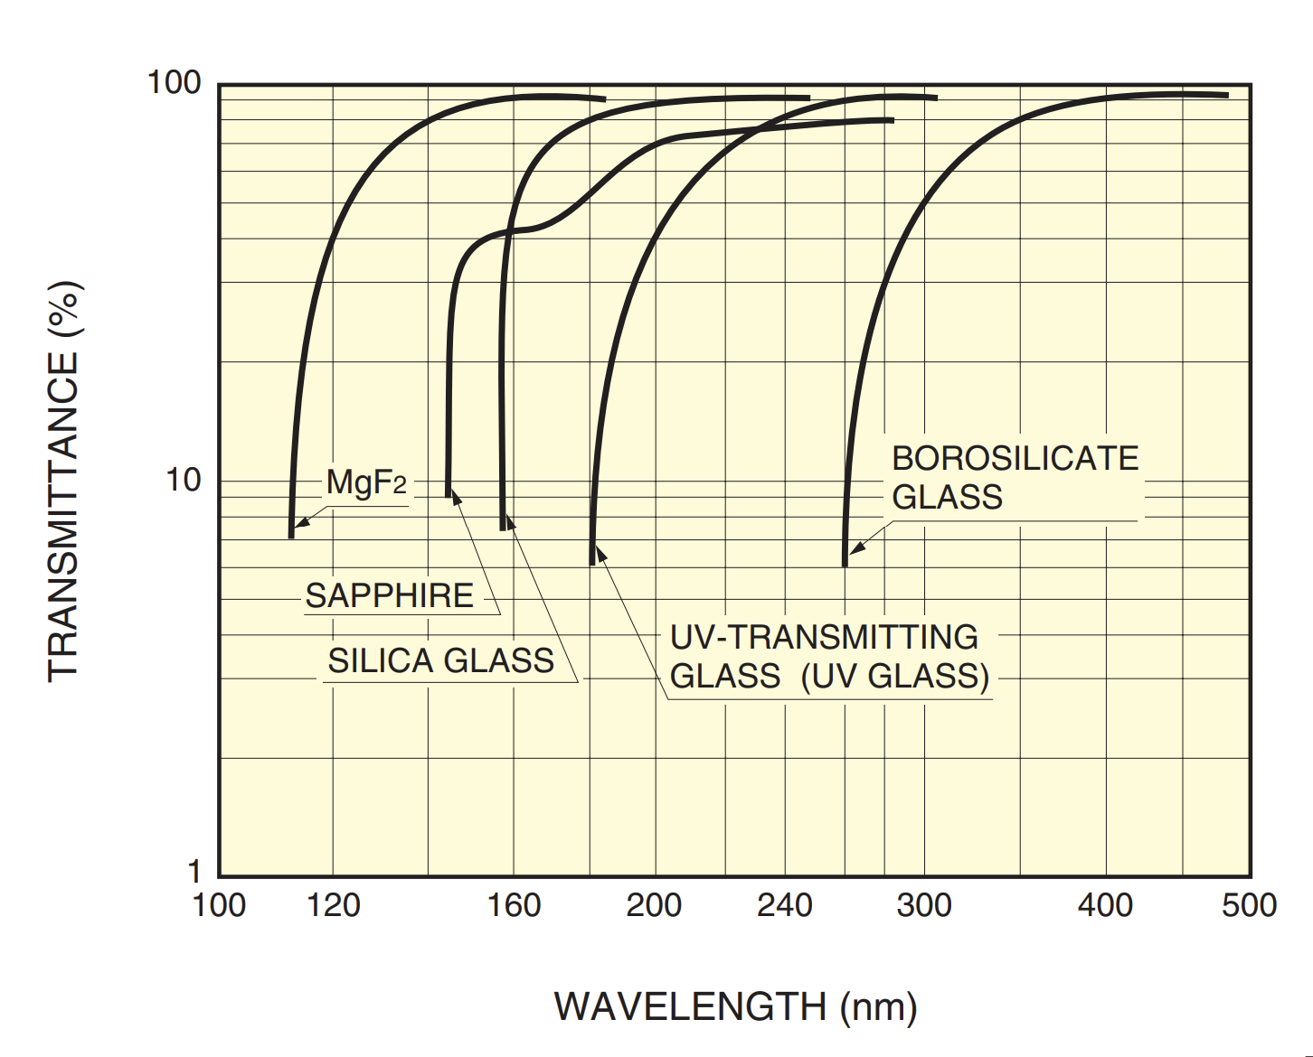
Figure 1. Spectral transmittance of different PMT window materials [2].

Modern super bialkali PMTs are capable of reaching QE’s upwards of 35% or more at the peak sensitivity, but this quickly rolls off below ~200-300 nm and above ~500 nm [1]. The spectral response curves for several different types of PMT photocathodes is illustrated in Figure 2.

Because of these characteristics, scintillators emitting in the violet to blue region (380-500 nm) of the visible spectrum have historically been preferred. This is apparent from Figure 2, in which most of the displayed scintillators (LaBr₃:Ce, NaI:Tl, LSO:Ce, BGO) have peak emission in this range. However, recent advancements have seen photosensors with improved sensitivity in the ultraviolet (UV) and near infrared (IR) regions, opening the possibilities for new types of scintillator materials to be utilized.

1.1.2 Principles of Inorganic Scintillators

Radiation Interactions in Matter

Before discussing the different processes and physical mechanisms that can occur in scintillators, it is necessary to first consider how the incident radiation may interact within the detector medium. For gamma radiation, there are three primary interactions of interest which are (i) photoelectric absorption (ii) Compton scattering and (iii) pair production [1]. During photoelectric absorption, the incident gamma ray photon is completely absorbed by an atom, transferring all its initial energy and leading to the emission of a photoelectron from a tightly bound shell (typically K shell). A small amount of energy is required to remove the bound electron from the atom, therefore, the resulting photoelectron energy is equal to the difference between initial photon energy and the binding energy of the photoelectron.

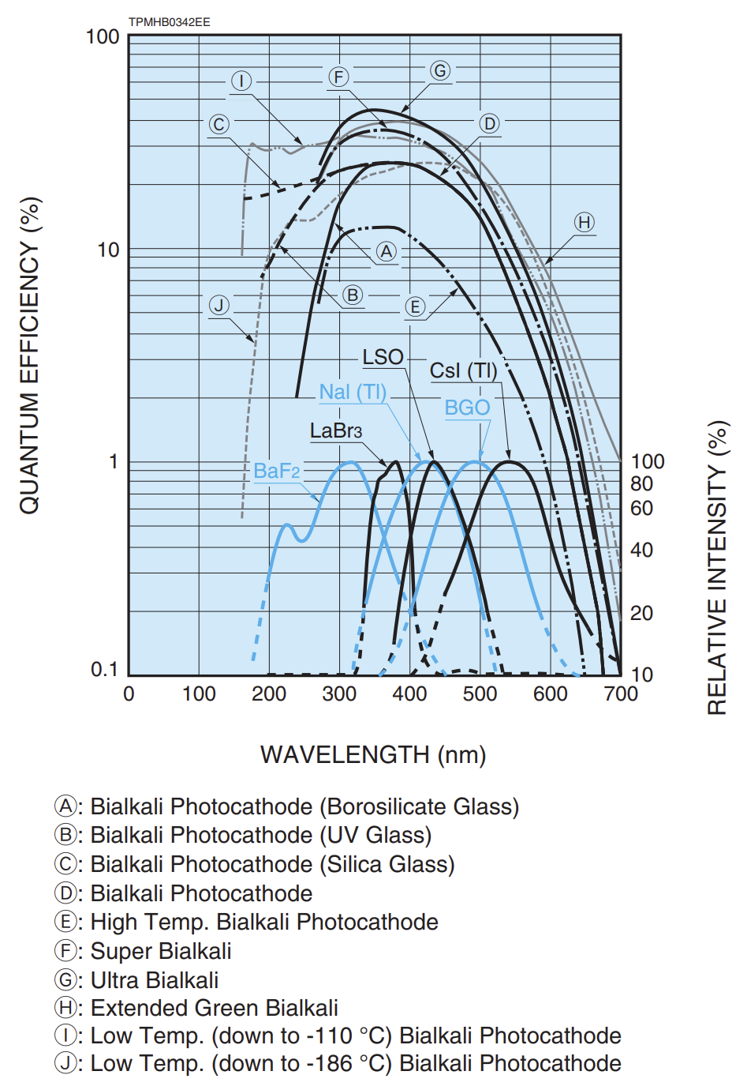
Figure 2. Spectral response curves for typical PMTs compared with emission spectra of several common scintillators [2].

Subsequently, the inner shell vacancy is filled and produces a characteristic X-ray that may then be reabsorbed or can escape the detector entirely. In the former case, all of the original photon energy is deposited in the detector medium. This is the dominant interaction for low energy gamma rays (up to several hundred keV).

During Compton scattering, the incident photon transfers only a portion of its initial energy to an electron referred to as a recoil electron. This process occurs through interactions with loosely bound electrons as opposed to the whole atoms, as is the case for photoelectric absorption. The energy transferred depends on the scattering angle θ and can vary from zero up to a large fraction of the initial photon energy in the case of a head on collision [1]. Pair production is the dominant interaction at high energies (several MeV) and is possible when the gamma ray energy exceeds twice the rest mass of an electron, 1.02 MeV. During this process, the incident gamma ray is replaced by an electron-positron pair that share the excess kinetic energy. Subsequently, the positron will annihilate, generating two annihilation photons.

The probability of all these interactions is dependent on the gamma ray energy and the Z of the absorber material. This is illustrated in Figure 3. The significance of these interactions becomes important in the context of the detector response and spectroscopic capabilities. Specifically, for gamma spectroscopy it is usually necessary to distinguish the full energy photopeak to obtain relevant information about the energy or identity of a source. These interactions are also important from a detection efficiency perspective, with the higher stopping power of dense and high Z_{eff} materials allowing for more compact detector designs.

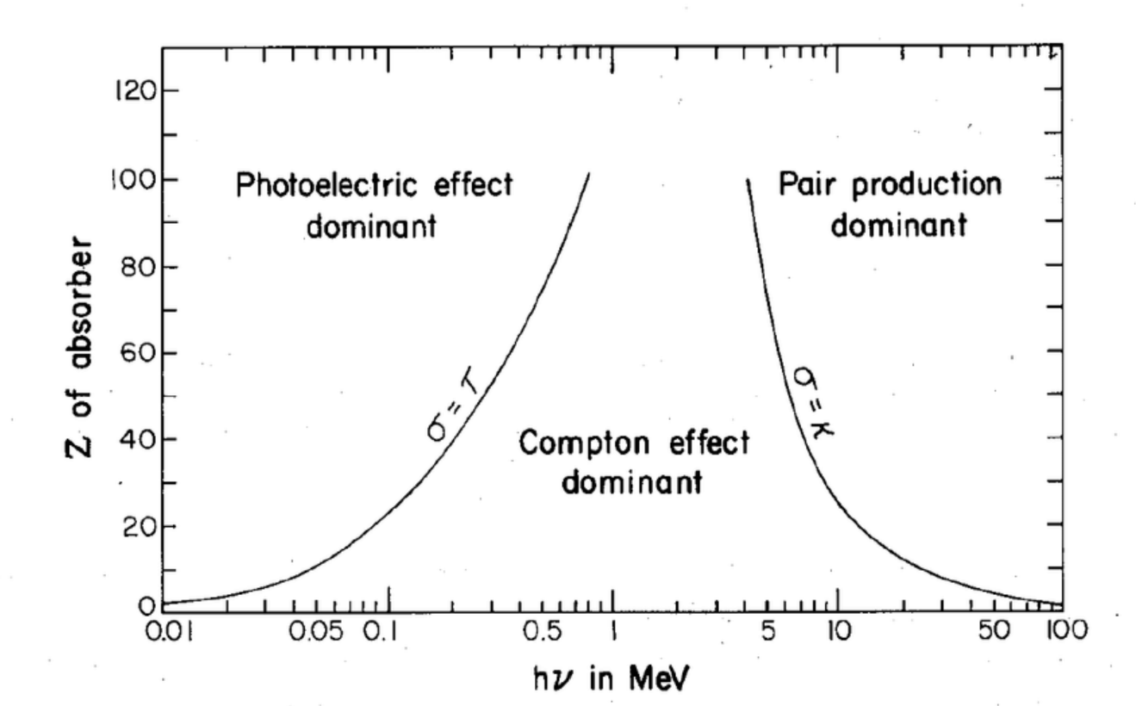
Figure 3. Dependence of interaction probabilities on gamma ray energy and Z of the absorber material for the three main types of interactions [1].

Scintillation Mechanisms

The scintillation process can be broken down into three stages: (i) absorption/conversion (ii) energy carrier migration and (iii) relaxation/emission [2-4]. This entire process is illustrated schematically in Figure 4. During the first stage, the absorbed ionizing radiation interacts via photoelectric absorption and Compton scattering (or pair production at high energies) creating electron-hole pairs. Relaxation of these primary electrons and holes occurs with the creation of secondary electrons, holes, and other electronic excitations. The secondary electrons and holes then thermalize to the bottom of the conduction band and top of the valence band, at which point they may remain as free charge carriers or form impurity-bound excitons. The second stage involves transfer of electrons, holes, or bound excitons to recombination centers. These carriers can migrate through the crystal and may become trapped at electronic defects (associated with impurities and lattice defects) with energy levels within the bandgap, delaying the next stage of the scintillation process. In the final stage, electrons and holes (or alternatively excitons) are sequentially captured at the luminescence center where they recombine radiatively leading to emission of visible light. Energy losses due to non-radiative processes also occur throughout the scintillation processes, which reduce the overall luminosity.

A variety of scintillation mechanisms exist for inorganic materials. These generally fall under two categories – intrinsic or extrinsic. In each case, the differences mainly involve the third stage of the scintillation processes (relaxation/emission). Intrinsic processes include (i) excitonic (ii) core to valence and (iii) self-activated luminescence.
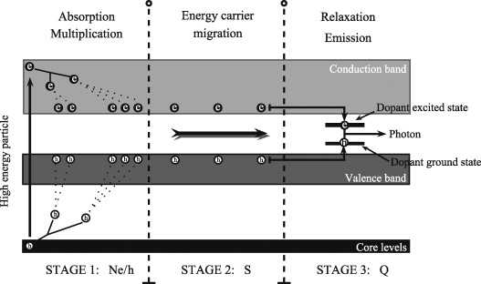
Figure 4. Band structure diagram illustrating the different stages of scintillation in inorganic materials [3].

The most common intrinsic mechanism is that of self-trapped excitons (STEs). During the second stage of the scintillation process (carrier migration), an unstable hole from the valence band may be bound between two anions forming a molecular complex of the type $X_{2}^{-}$ (also known as a V_{k} center) [5, 6]. The V_{k} center is mobile and can migrate throughout the crystal until it is captured by an activator ion (such as Ce³⁺) or alternatively may first trap an electron or hole from the conduction or valence bands to form a self-trapped hole (STH) or STE, respectively. The STE can then relax radiatively or transfer its energy to the activator ion. Typical decay times of STE emission are on the order of microseconds [5, 6].

Core-valence luminescence (CVL) is another intrinsic mechanism and is observed in some wide bandgap halide crystals due to radiative transitions between the valence band and core levels. This mechanism is of interest mainly for the characteristic ultrafast decay times (~1 ns) that can be achieved. Several examples of crystals with CVL include BaF₂, CsF, and CsCaCl₃ [7-12]. This mechanism will be discussed in more detail in the next chapter.

Scintillation properties can often be enhanced by introduction of intentional impurities or dopants, referred to as activators, giving rise to extrinsic scintillation. Common activators include rare-earth ions with efficient 5d to 4f electronic transitions such as Ce³⁺, Pr³⁺, and Eu²⁺. Another common type of activator are the ns² ions like Tl⁺. Examples of widely used scintillators activated with these ions include NaI:Tl, CsI:Tl, LaBr₃:Ce, CLYC:Ce, SrI₂:Eu, LSO:Ce, and GGAG:Ce. It is not uncommon for several different mechanisms to be observed in the same crystal, with each contributing a different fraction to the overall scintillation yield and kinetics. For instance, CLYC:Ce exhibits STE emission, Ce³⁺ 5d to 4f emission, and CVL. As a result, its scintillation decay profile is comprised of three components with time constants of 1 ns (CVL), 50 ns (Ce³⁺), and 1000-6000 ns (STE) [13-15].

One benefit of activated scintillators (in particular rare-earth doped) is the efficiency at which the luminescent ion can capture electrons and holes and their high quantum efficiencies for radiative transitions. This in turn allows much higher light yields to be achieved than in undoped or intrinsic scintillators (on the order of 60,000 to 80,000 ph/MeV for some Ce³⁺ or Eu²⁺-doped crystals). The drawbacks are that the scintillation kinetics are then dictated by the lifetime of the luminescent species, which can limit their practical use depending on the application. The lifetimes tend to be on the order of 10’s of ns for Ce³⁺-activated scintillators and 100’s to 1000’s of ns for Eu²⁺-doped scintillators; however, due to competing processes – such as trapping by defects or energy transfer from STH and excitons – the emission of scintillation photons is often delayed and the resulting decay times are longer than the lifetime of the activator ion excited state. Another drawback of doped scintillators is that often there is a nonuniform distribution of the dopant throughout the bulk of material, especially in the case of directionally grown crystalline scintillators [16-22].

Self-activated materials are sometimes classified as a third separate category, being somewhere in between extrinsic and intrinsic. Examples of self-activated scintillators include Bi₄Ge₃O₁₂ (BGO), CeBr₃, Cs₄EuBr₆, and CaWO₄ [5, 23]. In these cases, the luminescent ion or species is a main constituent of the compound rather than a dopant/impurity, which is why this type is often considered to be distinct from extrinsic luminescence. However, the emission processes for a Ce³⁺-doped vs Ce³⁺-based crystal, for example, arise from the same 5d to 4f electronic transitions of the Ce³⁺ ions.

1.2 Applications of Fast Scintillators

Inorganic scintillator materials possess many attractive properties for detection of gamma rays and X-rays. These properties can include high light yield, good energy resolution, high detection efficiency (high density and large effective atomic number, Z_{eff}), and fast decay time. Recent trends have shifted toward an increased need for faster timing capabilities for time of flight (TOF) measurements (e.g. TOF positron emission tomography (PET) and TOF computed tomography (CT) [24-26]), SiPM-based photon counting computed tomography (PCCT) [27], hard X-ray imaging [24, 28], and other high count rate applications including nuclear material accounting and high energy physics (HEP) experiments [24, 29]. In particular, lately there has also been an emphasis on pushing the limits of timing resolution (the proposed “10 ps challenge” [25]). This is primarily being driven by the medical imaging community, however, improved timing resolution is also important for TOF measurements in HEP [5, 30] and for positron annihilation lifetime measurements [31, 32].

One of the main factors limiting detector time resolution is the photon time density of the scintillation pulse, or the ratio of light yield to decay kinetics of the emitted light. The best coincidence time resolution (CTR) can be obtained with a combination of high light yield (LY) and short decay ($τ_{d}$) and rise ($τ_{r}$) times as described by the relationship:

$$CTR∝\sqrt{τ_{r}τ_{d}/LY}$$

Scintillators having decay times on the order of ~1 ns or less may be the key to pushing these limits. However, of the available technology, only a few inorganic scintillators can achieve such ultrafast decay times; the appeal of (or even necessity for) inorganic over plastic scintillators lies in their spectroscopic capabilities and higher detection efficiency. Efforts toward discovery and development of new ultrafast inorganic scintillators are therefore necessary to keep pace with the demands of next generation radiation detection systems.

1.3 Avenues for Ultrafast Emission

Several different processes for achieving ultrafast emission (~1 ns decay time or less) with inorganic materials – Cherenkov, hot intra-band luminescence, and core-valence luminescence – are currently being explored as strategies for achieving ultrafast emission [24, 33, 34]. Sub-ns decay times resulting from quantum confinement effects are also possible in nanocrystals and nanocomposites [35-37]. For example, a prompt component of 0.79 ns (17% abundance) and effective decay time of about 1.9 ns is observed for lead halide perovskite CsPbBr₃ nanocrystals embedded in a polystyrene matrix, which has been measured to have time resolution twice as good as LYSO (used in commercial TOF-PET scanners) at low energies of 10 keV [36]. Lead halide perovskites used in bulk crystalline form have also shown promising timing characteristics. Sub-100 ps CTR was recently demonstrated with a two-dimensional hybrid organic-inorganic halide perovskite scintillator, Li-doped PEA₂PbBr₄ (CTR of 84 ps FWHM) [38]. Semiconductor scintillators, such as ZnO:Ga [39, 40], are another class of material being considered for fast timing applications due to their ultrafast decay times.

Besides exploiting fast emission processes in inorganic materials, an alternative strategy for designing fast timing detectors currently receiving a great deal of attention is the concept of heterostructures or metascintillators [41-43]. Since a high detection efficiency is required for applications such as TOF-PET, plastic scintillators alone are not a suitable choice (due to low Z_{eff} and density) despite having ultrafast timing properties (about 700 ps decay times for EJ-232Q and BC-422Q). By alternating between layers of a dense scintillator, like BGO, and a fast plastic scintillator, the desired properties from each can be harnessed to achieve better timing resolution without sacrificing detection efficiency. CTR as good as 55 ps full width at half maximum (FWHM) has been measured with LYSO + BC-422 [43]. However, this technology is still in the very early stages of development.

Of the various potential avenues for achieving faster timing performance, core-valence luminescence (CVL) is of particular interest due to overall well-balanced set of properties that can be obtained – sub-ns decay time, moderate density (3 to 6 g/cm³), good chemical stability, and relatively bright emission, for example. Unlike Cherenkov emission and hot intra-band luminescence, which produce very few photons per gamma interaction (~17 photons per 511 keV gamma for BGO [27]), CVL scintillators typically have light yields in the range of 1,000 to 2,000 ph/MeV (at 662 keV), making them more practical for use in a wide range of applications. Likewise, the ability for these materials to be used in bulk form without significant effects from self-absorption provides an advantage over semiconductors. The generally higher density and Z_{eff} of fully inorganic CVL scintillators compared to halide perovskite nanocomposites and hybrid organic-inorganic crystals provides an advantage over these materials. The compositional space in which CVL materials exist has not yet been exhausted, and continued efforts devoted to searching for and developing CVL materials are necessary in order to find suitable alternatives to existing ultrafast inorganic scintillators such as BaF₂.

1.4 Crystal Growth

Most commercially produced inorganic scintillator crystals are grown from the melt using either the Czochralski or vertical Bridgman techniques. The Czochralski method is commonly used to grow oxides and semiconductors (e.g. silicon) and is the preferred method for growing materials with high melting points (>1800 °C). Its widespread use for growth of halides has not yet been adopted due to the high cost of operation and greater challenges regarding the growth atmosphere, the latter relating to the hygroscopic nature of halide materials. The Bridgman method is low cost and is suitable for growth of halide materials, which tend to have relatively low melting points (<900 °C). Additionally, crystals can be grown in sealed ampoules to avoid reaction with moisture and oxygen. The Bridgman technique relies on the use of a thermal gradient to directionally solidify the crystal from the melt. This can be accomplished by either translating the growth vessel through a fixed gradient or by keeping the growth vessel stationary and moving the temperature gradient through the furnace. This is illustrated schematically in Figure 5. In either case, a vertically oriented tube furnace is set up to have a “hot” zone (set higher than the melting point) and a “cold” zone (set lower than the melting point). In the simplest configuration, a single heating element can be used, and the ampoule will be translated from inside the furnace (the “hot zone”) to outside the furnace (the “cold zone”). More commonly, at least two independently controlled zones or heating elements are employed to allow for better control over the gradient. The number of zones in some cases reaches up to 24 or more, which is useful for growth using the moving gradient approach (referred to as an electro-dynamic gradient (EDG) furnace).

One of the most critical features of the growing crystal is the shape and stability of the solid-liquid interface [44-47]. The ideal solid-liquid interface will be slightly convex relative to the solid. This shape promotes the segregation of unwanted impurities and growth of polycrystalline grains toward the ampoule wall rather than toward the center of the crystal. The opposite case, where the interface is concave relative to the solid, is more likely to lead to inclusions or even coring in severe cases and is undesirable.

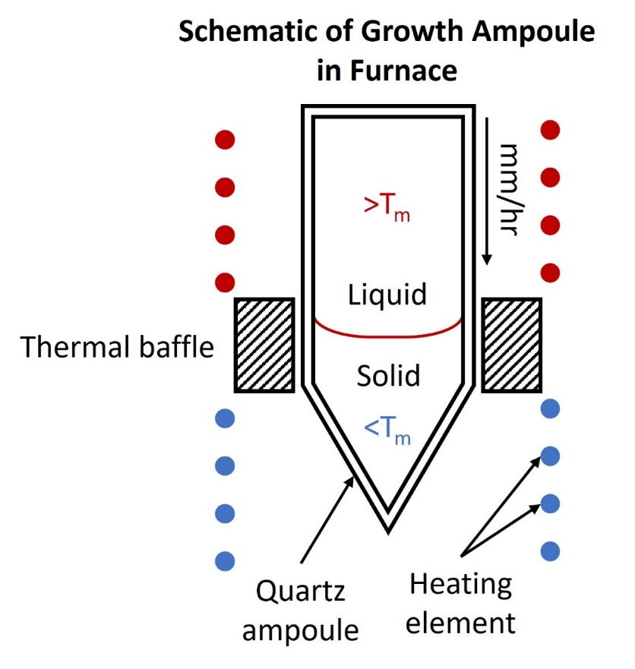
Figure 5. Schematic diagram of the Bridgman growth method showing a sealed ampoule and simplified furnace arrangement.

Several factors affect interface stability, which include (i) the thermal gradient (ii) the translation or pulling rate (iii) the diameter of the crystal and (iv) compositional uniformity of the melt, specifically at the boundary layer directly above the interface. The first three are the easiest to control. As such, these parameters were carefully selected for the crystals grown in this dissertation. Regarding the thermal gradient, it has been shown that it can be sharpened by designing the furnace to have an adiabatic zone or insulating thermal baffle separating the hot and cold zones [47-49]. Strategies such as the accelerated crucible rotation technique (ACRT) [50-52] and the rotating submerged heater method [53, 54] have also been explored to improve the interface shape.

The main obstacle that often prevents complete development of novel scintillator crystals from the research stage into commercial production arises from growth challenges that make fabricating large-size single crystals (1 inch to 3 inches in diameter) both difficult and expensive. Cracking is one of the main problems encountered when scaling up growth to larger sizes. The mechanism by which single crystal halide scintillators crack depends on the specific material. For example, cracking in LaBr₃:Ce is attributed to anisotropic thermal expansion in different crystallographic directions and cleavage along the (1 0 0) plane [55, 56]. For other materials, adhesion to the quartz growth ampoule induces stress in the crystal as it contracts during cooling and is unable to separate freely from the ampoule wall. Macroscopic defects, such as inclusions and precipitates, can also introduce problems during growth and processing (cutting, polishing, etc.), as well as from an optical standpoint (scattering and absorption of light produced by the scintillator, which leads to an overall degradation in performance). The effect these defects have on growth and processing is that they create points of internal stress in the crystal that can also lead to cracking. In some instances, these secondary-phase defects are a consequence of the compound or system itself. For example, excess CsCl has been observed in Cs₂LiYCl₆ as a result of incongruent melting [57], and CsCl inclusions have been observed in Cs₂HfCl₆ [58] (in both cases CsCl is a primary constituent of the compound). In other cases, these inclusions can be secondary phases that form from impurities in the raw material.

Many halides tend to react strongly with air and moisture and although several measures are put in place to avoid exposure to atmosphere, oxygen impurities are often still present in the material. Several papers in literature have assessed the importance of removal of water, oxygen, oxyhalides, and gases from the raw materials prior to growth [59-62]. Typically, this involves drying the raw material under vacuum at an elevated temperature. The temperature at which different hydrates or other undesirable species decompose varies, but common ranges for drying halides can be upwards of 200-350 °C [62-69], depending on the melting point.

Additional problems can arise due to the volatility of precursor materials, which can result in loss of stoichiometry or creation of halogen vacancies. A study by Swider et al. showed the dissociation of chlorine during heating of CsCl raw material, as evidenced by RGA measurements [60]. This initially occurs near 350 °C, and later as the temperature approaches the melting point of CsCl around 645 °C. The presence of Argon gas in the raw material was also observed to be released upon melting.

Core Valence Luminescence (CVL)

Several sections of this chapter were originally published in the following articles:

- Daniel Rutstrom, Luis Stand, Cordell Delzer, Maciej Kapusta, Jaroslaw Glodo, Edgar van Loef, Kanai Shah, Merry Koschan, Charles L. Melcher, Mariya Zhuravleva, “Improved light yield and growth of large-volume ultrafast single crystal scintillators Cs₂ZnCl₄ and Cs₃ZnCl₅” Optical Materials, Volume 133, 2022.
- Daniel Rutstrom, Luis Stand, Dylan Windsor, Haixuan Xu, Maciej Kapusta, Charles L. Melcher, Mariya Zhuravleva, “New Ultrafast Scintillators with Core Valence Luminescence: Cs₂MgCl₄ and Cs₃MgCl₅” Journal of Materials Chemistry C, 2024, submitted for review.
- Zhehui Wang, Christophe Dujardin, Matthew S. Freeman, Amanda E. Gehring, James F. Hunter, Paul Lecoq, Wei Liu, Charles L. Melcher, C. L. Morris, Martin Nikl, Ghanshyam Pilania, Reeju Pokharel, Daniel G. Robertson, Daniel J. Rutstrom, Sky K. Sjue, Anton S. Tremsin, S. A. Watson, Brenden W. Wiggins, Nicola M. Winch, Mariya Zhuravleva, "Needs, trends, and advances in scintillators for radiographic imaging and tomography," IEEE Transactions on Nuclear Science, Volume 70, 2023.

The excerpts taken from these articles were all written by Daniel Rutstrom – who was either first author or a coauthor of the original article – with the help of his coauthors. The author would like to acknowledge and thank those who contributed to the reviewing and editing of the original works.

The mechanism of core valence luminescence (CVL), also called cross luminescence (CL) or Auger-free luminescence (AFL), is one of the more promising avenues towards ultrafast emission. Whereas the typical scintillation mechanism involves electronic transitions that occur within the bandgap of the scintillator material, either as a result of electrons and holes recombining at impurity-type luminescence centers or through intrinsic defects, CVL occurs when an electron in the valence band recombines with a hole generated in the upper core band [15]. The radiative recombination of core holes with valence electrons happens on a time scale much shorter than that of the typical scintillation process, with characteristic decay times of CVL being on the order of about 1 ns.

CVL can be observed in wide bandgap halide crystals if the following condition is satisfied:
$$E_{vc}< E_{g}$$

where E_{vc} is the energy difference between the top of the valence band and top of the outmost core level and E_{g} is the bandgap energy [7]. This is necessary to avoid non-radiative Auger decay of core holes. The above condition (E_{vc} < E_{g}) is met in many fluorides and chlorides containing K⁺, Cs⁺, Rb⁺, and/or Ba²⁺ due to the shallow depth of the cation core levels (binding energies from 12 to 19 eV for the outermost np⁶ shell electrons) and the wide bandgaps of fluoride and chloride-based crystals (~7-10 eV) [7, 70]. The most notable example of CVL is with BaF₂ – one of the few commercially available inorganic scintillators with a sub-nanosecond decay time.

A schematic illustration of CVL is shown in Figure 6 for a hypothetical CsCl-based compound. When X-rays or gamma rays interacting with the crystal are of sufficient energy, an outermost core electron will be ejected to the conduction band leaving behind a core hole. The hole then relaxes to the top of the core level (mainly composed of the alkali metal p orbital) where it can recombine radiatively with an electron from the valence band (mainly composed of the halogen anion p orbital). The result is emission of photons with energies corresponding to p to p transitions (indicated by arrows ‘1’ and ‘2’ in Figure 6), which typically lie in the VUV to UV range of wavelengths. Considering the emitted light must fall within the range of energies from the top and bottom of the valence band to the top of the outermost core band, the emission spectrum is effectively a reflection of the density of states in the valence band. The number of bands in the emission spectrum is dependent on the coordination number (CN) of the alkali metal cation, with additional bands appearing when increasing from CN = 6 (1 band) to CN = 8 (2 bands) to CN = 12 (complex structure) [7, 71].

2.1 Barium Fluoride (BaF₂)

2.1.1 Discovery in the 1980’s
Although BaF₂ was initially discovered as a scintillator in 1971 [72], it wasn’t until the discovery of its ultrafast decay component in 1982 [73, 74] that it started to draw substantial interest. Shortly after, it was found that this type of ultrafast luminescence could be observed in other halides, which included CsF. These two materials quickly became serious contenders in the early days of TOF-PET [8]. In this popular medical imaging technique, the difference in arrival times of two 511 keV annihilation photons must be precisely measured in a pair of detectors to determine the position of a radioactive tracer inside a patient.

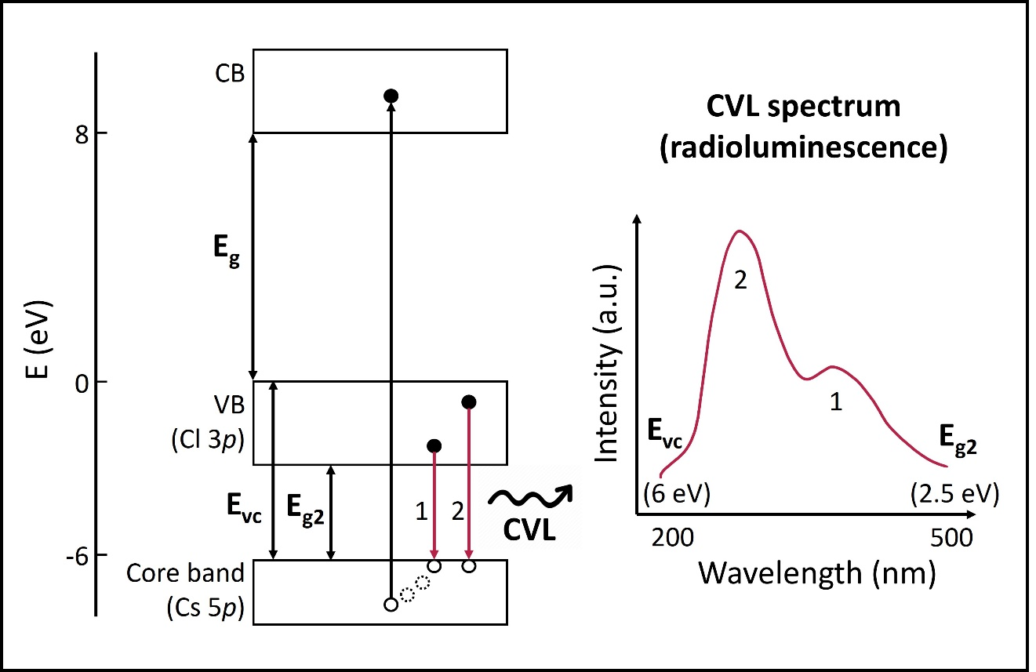
Figure 6. Schematic illustration of the core valence luminescence mechanism for hypothetical CsCl-containing crystals.

The timing resolution of the system is limited by the decay time of the scintillator; therefore, fast scintillators are essential to achieve the desired performance (timing resolution on the order of ten to several hundred picoseconds). First generation TOF-PET scanners developed in the 1980’s and 1990’s were constructed with BaF₂ and CsF crystals [9, 10], which were promising due to being the only ultrafast inorganic scintillators at the time (~0.6 ns and 2.5 ns to 5 ns decay times, respectively) [10-12]. Unfortunately, the drawbacks of these two materials outweighed their benefits, so widespread use was not implemented. Instead, Bi₄Ge₃O₁₂ (BGO) and Ce-doped Lu₂SiO₅ (LSO) were selected for use in PET because of their better overall properties, especially stopping power, despite having decay times at least an order of magnitude slower than those of BaF₂ and CsF.

2.1.2 Current Usage
Although it was not implemented in TOF-PET, BaF₂ is still currently the preferred choice when it comes to ultrafast inorganic scintillators. BaF₂ crystals have been proposed for one of the two imager concepts for the MaRIE hard X-ray (>20 keV) imaging system, which requires a temporal response less than 2 ns to avoid pileup effects due to the GHz frame rates used [1, 4, 6, 7]. Another application making use of BaF₂ is the Detector for Advanced Neutron Capture Experiments (DANCE) located at Los Alamos National Lab (LANL) [75], which consists of 162 elements of BaF₂ crystals designed to enable neutron cross-section measurements. BaF₂ is also being considered for use in various electromagnetic calorimeters for HEP experiments, including the Mu2e-II calorimeter upgrade [76, 77]. Positron annihilation lifetime spectroscopy is another area making use of the timing properties of BaF₂ crystals [31, 32]. It is clear from these examples that BaF₂ has found widespread use being the only commercially manufactured scintillator of its type. However, several of its drawbacks present an opportunity to explore alternative materials to occupy a similar space.

2.1.3 Limitations
One of the main disadvantages of BaF₂ is that in addition to its fast decay component there is a slower 630 ns decay component originating from self-trapped exciton (STE) emission that accounts for 85% of the total light yield [7, 74, 78, 79]. This slow component is undesirable and can cause pulse pileup when count rates are high. Additionally, the wavelengths of the radioluminescence emission spectrum associated with the fast component extend below the deep UV and are slightly outside the range of wavelengths where common photodetectors have the highest sensitivity (300 nm to 500 nm), as discussed in Chapter 1.1.1 Detector System Components. These shortcomings provide motivation to search for alternative ultrafast scintillators that may provide advantages over BaF₂.

Besides BaF₂, there are a number of other halide crystals that are known to have CVL. However, none have offered sufficient benefits to replace or even compete with BaF₂. A review of some novel CVL materials will be presented next, and the most promising candidates for further development will be identified.

2.2 Potassium (K), Rubidium (Rb), and Cesium (Cs) Based CVL Crystals

The outermost core levels of K⁺ (3p) and Rb⁺ (4p) in halide crystals are positioned deeper than that of Cs⁺ (5p) with respect to the valence band minimum (K 3p at 19 eV, Rb 4p at 16 eV, and Cs 5p at 14 eV relative to vacuum level [7, 70]). A critical requirement for observation of CVL (and to avoid non-radiative Auger decay of core holes) is that the energy difference between the top of the valence band and top of the outermost core level must be less than the bandgap energy (or E_{vc} < E_{g}). It is clear then that this condition is less likely to be met with K-containing and Rb-containing crystals than it is for Cs-containing crystals with similar bandgaps. As a result, there are few pure KCl-based and RbCl-based compounds known to have CVL. On the other hand, several fluoride compounds have been shown to have CVL. These include KF, RbF, RbCaF₃, RbMgF₃, KMgF₃, KCaF₃, KYF₄, KLuF₄, and K₂YF₅ [5, 80]. The downside of these compounds is that their emission wavelengths tend to lie below 200 nm.

In addition to BaF₂, early investigations into CVL in the 1980’s and 1990’s focused largely on CsCl and perovskite CsMCl₃-type (M = Mg, Ca, Sr) compounds [8, 81-84]. Part of the appeal of the ternary compounds over CsCl was their higher light yields, which has been attributed to the larger CN of Cs in the perovskite structure (CN = 12) [81, 85]. One other advantage of CsCl-based CVL crystals that was established during this time was the longer wavelength emissions of these compounds compared to those based on Rb⁺ and K⁺.

2.3 Impurity-induced CVL

It is possible to observe CVL in an otherwise CVL-free crystal by doping with CVL-active cations (Ba²⁺, Cs⁺, Rb⁺, and K⁺). This is known as impurity-induced CVL and has been demonstrated in several Cs- and Rb-doped materials including Rb_{1-x}Cs_{x}Cl [86], K_{1-x}Cs_{x}Cl, Rb_{1-x}Cs_{x}Br, Rb_{1-x}Cs_{x}CaCl₃ [87], and K_{1-x}Cs_{x}CaCl₃ [87]. In these cases, the condition E_{vc} < E_{g} is not satisfied in the undoped host compound. With doping, the impurity core level may be positioned such that the energy E_{vc} is lowered and the criteria for CVL is met. This can be seen in Figure 7, where the energy gap E_{g2} in the CVL-free crystal is too large relative to the bandgap (Figure 7a) and the dopant introduces a core level with smaller energy gap E’_{g2} (Figure 7b).

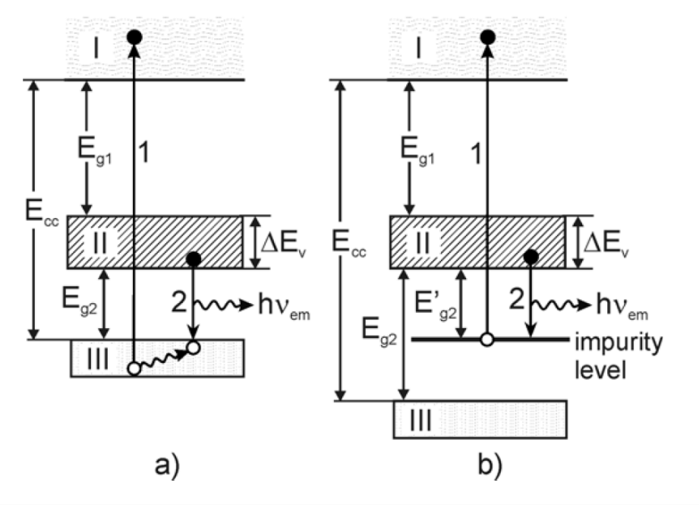
Figure 7. Band structure schematic of a hypothetical wide bandgap ionic crystal with (a) intrinsic CVL and (b) impurity-induced CVL. The conduction band is denoted as (I), valence band as (II), and outermost core band as (III). [87]

In all these cases, the host compound does not exhibit CVL (in other words is “CVL-free”). Seldom explored has been the strategy of doping an existing CVL material either with CVL-active ions or other ions having shallow outermost core levels. The obvious exception to this is BaF₂, in which a variety of dopants have been investigated [40, 88-93]; however, successful attempts have only led to partial suppression of the STE emission rather than enhancement of the CVL emission. Instead, it is interesting to consider whether the CVL yield of some crystals can be increased through doping, in particular using non-optically active species as optically active ones would lead to undesired lengthening of the decay time (i.e. excluding Tl⁺, Eu²⁺, Ce³⁺, etc.). The concept of mixed scintillator crystals is another strategy that has proven successful in enhancing light yield, however, this effect has not been demonstrated for CVL materials [94, 95]. Rather, existing examples mostly involve rare-earth doped scintillators or other mechanisms involving emission from states within the host bandgap. Of the mixed CVL crystals that have been investigated, none have resulted in superior light yield (under gamma-ray excitation) compared to the pure end-member compounds [86, 96-98].

Voloshinovskii has suggested that a significant increase in light yield may be expected in CVL crystals with overlapping core levels due to efficient transfer of the core excitation energy between bands [99, 100]. Similarly, the concept of “transport core bands” has been discussed by Rodnyi in [5]. Figure 8 illustrates that overlapping between Cs5p-Rb4p or Rb4p-Ba5p, for example, is possible. In this case, the lower lying band (deemed the transport band) can deliver additional holes to the upper CVL-active core band. This in turn is expected to lead to a larger share of core holes participating in CVL transitions, and therefore an increase in light yield. Additionally, they highlight the potential for d shell ions (such as Ga³⁺, In³⁺, Tl³⁺, Zn²⁺, and Cd²⁺) to act as transport bands even though they are not “CVL-active” (Figure 8). Despite these expectations, investigation of impurity-associated CVL with d ions is non-existent in the literature.
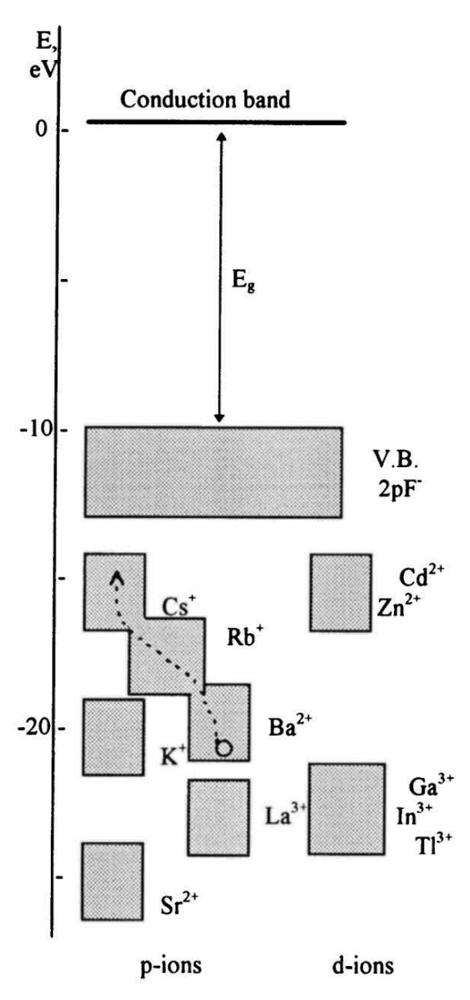
Figure 8. Simplified scheme of energy bands of fluorides illustrating that overlapping core bands can promote transport of additional holes to the upper CVL-active core band [5].

Based on Figure 8, there are several combinations of host and dopant ions that could allow overlapping of core bands. Since CsCl-based crystals tend to have longer wavelength emission (i.e. better spectral match with photosensor) [70, 97], this compositional space will be the focus of the current work. Doping and mixing with Rb⁺ has already been studied extensively, so it is instead interesting to consider the d ions with shallow core levels, Cd²⁺ or Zn²⁺. As will be shown in later chapters, several CVL crystals from the CsCl-MgCl₂ system have shown promising properties. The similar ionic radii of Zn²⁺ (0.6 Å for CN = 4) and Mg²⁺ (0.57 Å for CN = 4) makes this an ideal system for mixing from a crystal growth perspective and provided motivation for pursuing Zn²⁺ as an impurity ion (presented in Chapter 7).

The CVL impurity ion concentrations reported in literature have varied widely. Dopant-level quantities ranging from approximately 0.1 mol% to 10 mol% are often investigated [87, 97, 101, 102]; however, concentrations exceeding 20 mol% have also been explored in several mixed systems [86, 97, 103]. In the case of KF:Rb, Jansons et al. mention that impurity CVL bands from F2p to Rb4p radiative transitions appear in the luminescence spectra with as little as 0.1 mol% Rb⁺. Regarding the upper range of concentrations (i.e. mixed or heavily doped crystals), it is less clear at what point the benefits of impurity-associated CVL might diminish. This likely depends on the system being investigated, therefore, optimization of the impurity concentration is necessary if, for instance, the goal is to optimize the scintillation performance.

In addition to cation impurities, CVL in anion-substituted halides has also been explored, although to a much lesser extent. One notable example is work by Itoh et al. for the CsF_{1-x}Cl_{x} system (for x ≤ 0.03) [104]. Given that CVL transitions occur from states within the valence band, which originate from the halogen p states, significant modifications to the CVL properties may be expected for mixed halide crystals. Looking beyond CVL materials, the strategy of mixed halides has proven to be effective at improving scintillation performance in several different systems owing to the ability to tune the electronic structure or suppress phase transitions [94, 105-110].

2.4 Recently Discovered Materials

Novel CVL scintillators that have been discovered in the last decade include Rb₂ZnCl₄ [111, 112], Cs₂BaCl₄ [113], Cs₃ZnCl₅ [114], and BaGeF₆ [115]. In addition to these novel materials, there has been renewed interest in the more traditional CsMCl₃-type CVL scintillators CsSrCl₃, CsMgCl₃, and CsCaCl₃ due to the advancements made to photodetector technology and signal processing methods since they originally drew interest in the 1990’s [97]. The most promising of these seems to be CsCaCl₃ due to its high light yield of 1,371 ph/MeV and fast decay time of 2.47 ns. The CTR has recently been reported to be 148 ps FWHM for a 2 × 2 × 3 mm³ CsCaCl₃ pixel measured with a VUV SiPM (Hamamatsu, S13370–3075CN), which is superior to that of BaF₂ (CTR of 164 ps FWHM) measured with the same setup [97]. However, one potential drawback of CsCaCl₃ is its slight hygroscopicity.

Cs₂BaCl₄ is one of the fastest and brightest (1.68 ns decay time and 1,369 ph/MeV light yield) materials recently studied in [97]. In a separate study, an even shorter decay constant of 1.2 ns and higher light yield of 1,700 ph/MeV (for the fast component) are reported [113]. Unfortunately, the instability of this compound at room temperature may hinder its usage, as Cs₂BaCl₄ reportedly decomposes upon cooling [97, 116]. This means growth from the melt will present substantial challenges.

From the various CsCl-based compounds known to show CVL, Cs₂ZnCl₄ and Cs₃ZnCl₅ may be the most promising for further study. Several relevant properties are summarized in Table 1. CVL of Cs₂ZnCl₄ was first reported by Ohnishi et al. [117], and more recently, scintillation properties have been reported by Yahaba et al. [118] and Takahashi et al. [114] for both Cs₂ZnCl₄ and Cs₃ZnCl₅. The two compounds are reportedly non-deliquescent, have decay times from 1 ns to 2 ns that account for nearly 100% of the light emitted, and have longer emission wavelengths than BaF₂ that are better suited for use with standard photodetectors [114, 117-119]. The relatively low melting points of Cs₂ZnCl₄ (601 °C) and Cs₃ZnCl₅ (560 °C) [120] compared to that of BaF₂ (T_{m} = 1368 °C) are also favorable for low cost crystal growth methods such as the Bridgman technique. However, the ability to produce large-size crystals with high optical quality was not demonstrated in these studies.

Table 1. Summary of physical and scintillation properties of promising new CVL scintillators compared with those of commercially available BaF₂.
Composition | LY (ph/MeV) | Decay constant (ns) | CVL emission wavelengths (nm) | Hygroscopic | Density  (g/cm³) | Z_{eff} | Ref.
Cs₂ZnCl₄ | 1,280 | 1.6 | 260, 310, 410 | no | 3.35 | 45.3 | [114, 119]
Cs₃ZnCl₅ ª | 440 | 1.1 | 240, 290, 390 | no | 3.44 | 46.6 | [114]
Cs₂BaCl₄ ª | 1,700 | 1.2 | 260, 290 | slightly | 3.76 | 49 | [97, 113]
CsCaCl₃ | 1,371 | 2.47 | 260, 290 | slightly | 2.95 | 42 | [97]
CsMgCl₃ | 1,113 | 2.36 | 260, 290 | slightly | 3.10 | 43 | [97]
BaF₂ | 1,400 | 0.6 – 0.8 | 195, 220 | no | 4.88 | 53 | [121, 122]
ª Discovered in the last three years.

Goals and Objectives

One of the main goals of this work is to assess the potential of Cs₂ZnCl₄ and Cs₃ZnCl₅ as alternatives to existing scintillators, such as BaF₂, being considered for use in fast timing radiation detection applications. Scintillation properties, and more specifically core valence luminescence, have already been reported for these two compounds. These materials are promising due to their ultrafast decay times but may have been overlooked because of the low light yields reported in literature. This dissertation expands upon existing work by showing that larger-size crystals with improved optical quality can be grown. The first objective is to improve the light yields of Cs₂ZnCl₄ and Cs₃ZnCl₅, which will not only make them more practical to use but also lead to better timing performance (i.e. lower CTR). The next objective is to demonstrate the potential for commercial-scale production by successfully growing a crack-free 38 mm diameter crystal.

Additionally, this work aims to explore the possibility of core valence luminescence in Cs₂MgCl₄ and Cs₃MgCl₅, both of which are not currently known to scintillate. There are two primary reasons for investigating these two compounds. The first is to determine if either has superior decay time and light yield or are more favorable for scale-up compared to the Zn-containing analogues. The second reason is to provide more examples of A₂BX₄ and A₃BX₅-type CVL scintillators to help establish relationships between composition, structure, and scintillation properties so that new materials can be designed or engineered more efficiently in the future.

Finally, the strategies of doping and mixing to enhance decay time and/or light yield of various CVL crystals will be investigated. Compositions such as Cs₂Mg_{1-x}Zn_{x}Cl₄, Cs₃Mg_{1-x}ZnCl₅, and CsMg_{1-x}Zn_{x}Cl₃ will be explored (where 0.05 ≤ x ≤ 0.95). Here, doping will refer to concentrations around 5 mol% (x = 0.05) or less, and mixing will refer to concentrations above 5 mol%. Doped or mixed CVL crystals reported in literature are almost exclusively limited to starting with a compound that does not exhibit CVL and then inducing this type of luminescence by introducing a CVL-active ion, known as “impurity-induced” CVL. What is proposed in this dissertation is a new type of “impurity-enhanced” CVL – where the host matrix is a compound that already shows CVL. Unraveling a new pathway for improving the performance of these ultrafast scintillators could deepen our understanding of the CVL mechanism and have a profound impact on the future direction of scintillator research.

The novel materials presented in this dissertation were not investigated with one specific application in mind. Rather, the point of this work is to introduce scintillator materials with properties that are either currently unavailable or seriously lacking in the commercial space and demonstrate that they can offer advantages over materials occupying a similar role. The intended outcomes are either (i) these materials can find use in one or several of the discussed applications (ii) their unique set of properties allow for new detector concepts to be realized or (iii) they allow us to add to the existing body of knowledge in the field of scintillator research.

This work supports the NNSA mission to prevent nuclear weapon proliferation by aiming to develop advanced technology that may enhance our abilities to detect, identify, and locate sources of X-ray and gamma ray radiation, which is a critical aspect of international safeguards efforts. This also supports the NNSA mission to maintain the US stockpile, which relies in part on high-speed X-ray imaging systems to assess the condition of aging weapons without requiring explosive testing.

Experimental Methods

4.1 Crystal Growth

Table 2 lists the compositions investigated in this work. Starting raw materials for crystal growth were purchased from commercial vendors in the form of binary halide salts – CsCl, ZnCl₂, and MgCl₂ – with purities ≥99.99% (≥ 4N). These were obtained either in bead or powder form. The ternary compounds were formed following the general steps below:

(1) weighing out stoichiometric amounts of each component and loading into quartz growth ampoules (7, 12, 22, or 38 mm in diameter) inside a nitrogen-filled glovebox
(2) drying the material under dynamic vacuum at a pressure <10⁻⁶ torr and temperature of 100 °C to remove any residual moisture
(3) sealing the ampoules with a torch while still under vacuum (Figure 9) and
(4) melt synthesizing at a temperature above the melting points of CsCl, MgCl₂, and ZnCl₂ (645 °C, 714 °C, and 290 °C, respectively) for 12 hours followed by cooling to room temperature over several hours

Melt synthesis was carried out with at least two heating and cooling cycles, inverting the ampoule in between steps to allow for better mixing. This process produces a polycrystalline material that must then be grown into single crystal form. A schematic illustration of this process is depicted in Figure 10. The growth ampoules were all equipped with a capillary region at the tip to serve as a self-seeding “grain selector”. Table 3 lists melting points of the constituent compounds.
Table 2. Investigated compositions and some relevant information for synthesis.
Composition | Raw materials | Ampoule sizes, diameter (mm) | Base compound melting point (°C)
Cs₂ZnCl₄ | CsCl, ZnCl₂ | 7, 22, 38 | 601 ^{[120]}
Cs₃ZnCl₅ | CsCl, ZnCl₂ | 7, 22 | 560 ^{[120]}
CsMgCl₃ | CsCl, MgCl₂ | 7, 12 | 610 ^{[123]}
Cs₂MgCl₄ | CsCl, MgCl₂ | 7, 12 | 545 ^{[123]}
Cs₃MgCl₅ | CsCl, MgCl₂ | 7, 12 | 525 ^{[123]}
CsMgCl₃:Zn 5% | CsCl, MgCl₂, ZnCl₂ | 7, 12 | 610 ^{[123]}
Cs₂Mg_{1-x}Zn_{x}Cl₄ | CsCl, MgCl₂, ZnCl₂ | 7, 12 | 545-601
Cs₃Mg_{1-x}Zn_{x}Cl₅ | CsCl, MgCl₂, ZnCl₂ | 7, 12 | 525-560

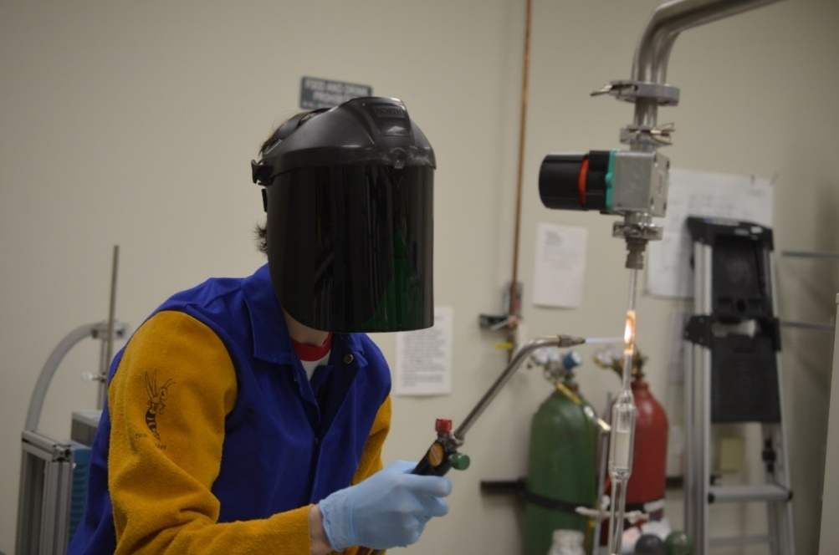
Figure 9. Photograph of PhD student Daniel Rutstrom sealing a quartz growth ampoule with an oxy-hydrogen torch.

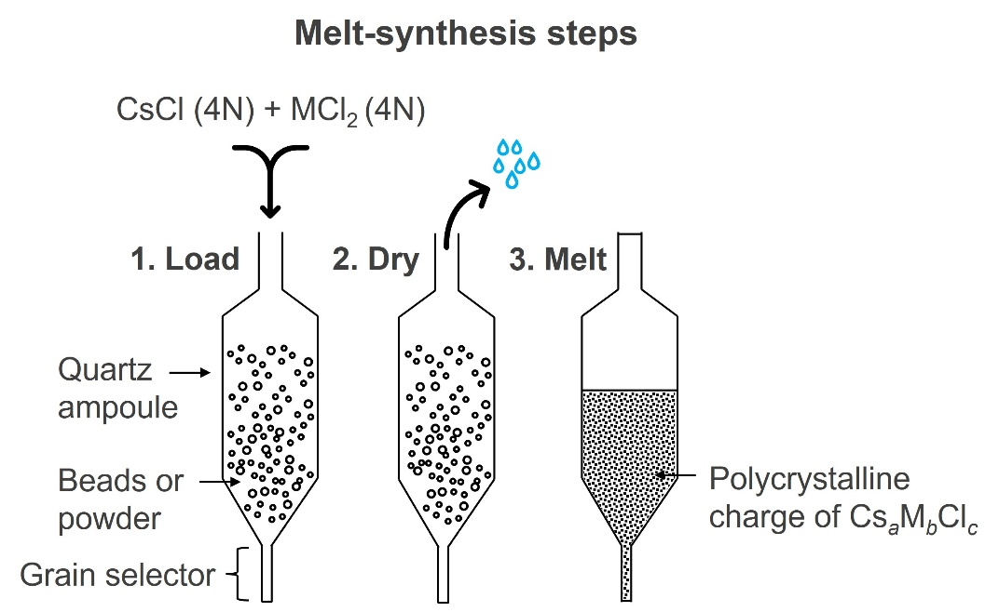
Figure 10. Illustration of sample preparation carried out prior to crystal growth.

Table 3. Melting points of the binary halides used as starting raw materials.
Compound | Melting point (°C)
CsCl | 645
MgCl₂ | 714
ZnCl₂ | 290 (T_{b} = 732)

Due to the low melting point of ZnCl₂ relative to that of CsCl and MgCl₂, drying temperatures had to be kept low (100 °C) to avoid volatilization. Any deviations from this procedure are outlined in more detail in the relevant chapters (in particular 5.2 Experiments to Optimize Growth of 22 mm Diameter Crystals and 5.3 Growth of 38 mm Diameter Cs₂ZnCl₄).

All crystals were grown by the vertical Bridgman technique in 2-zone or 3-zone furnaces. The furnaces were equipped with a donut-shaped alumina baffle separating the hot and cold zones to enhance the thermal gradients. Additional gaps between the baffle and bore of the furnace were filled in with quartz wool to maintain separation between zones. A quartz rod was fused to each growth ampoule using a torch, with the opposite end of the rod being shaped into a ‘hook’ to allow it to be suspended from the translation arm. Translation through the furnace was accomplished with an Arduino-controlled stepper motor, and the rates at which the ampoules were lowered ranged from 0.25 mm/h to 1.0 mm/h depending on size. A photograph and schematic of this setup is shown in Figure 11. Translation was stopped once the growing crystal had passed entirely below the thermal baffle, and the furnace was then cooled slowly to room temperature at rates of 3 °C/h to 7 °C/h, again depending on the size (slower for larger diameter crystals). To achieve a more uniform temperature across the grown crystal during cooling thereby reducing thermal stress, a “top down” approach was used. This consisted of first cooling only the hot zone to match the cold zone temperature. Subsequently, both zones were cooled together to room temperature at the same rate.

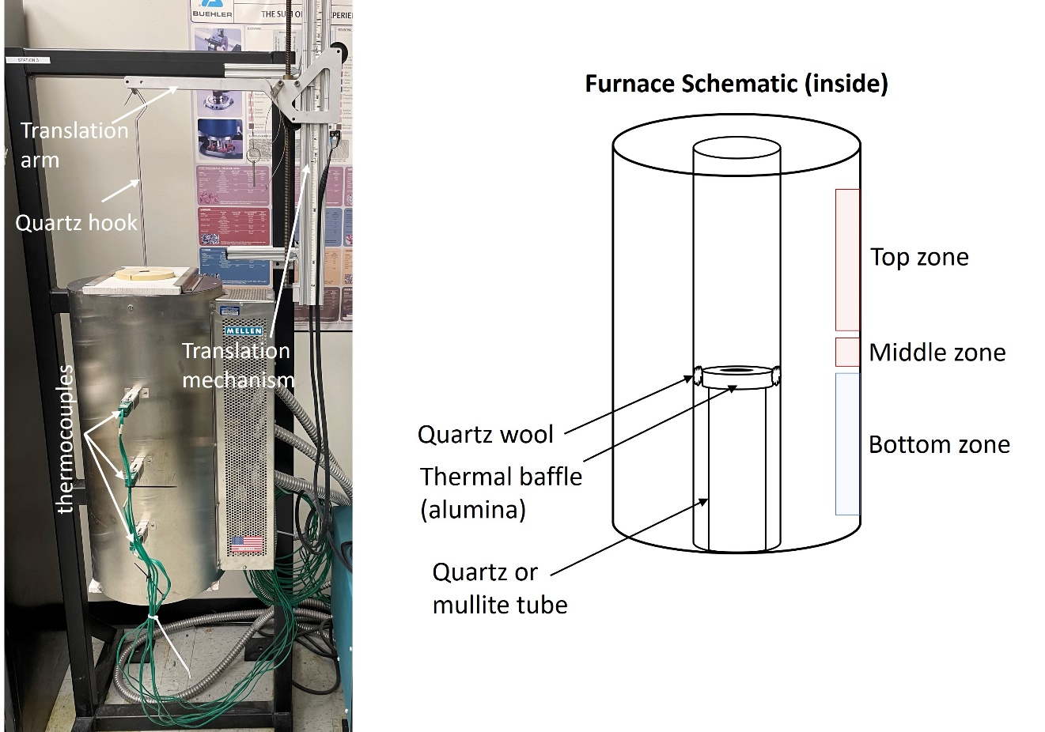
Figure 11. (left) Photograph of a typical growth furnace used in this work and (right) a schematic diagram of the insulation configuration inside the furnace.

Phase diagrams for both the CsCl-ZnCl₂ system (Figure 12) and CsCl-MgCl₂ system (Figure 13) have previously been published. All of the compounds explored in this dissertation are reported to melt congruently and do not have any reported solid-solid phase transitions. Both of these points are important considerations when growing any crystal from the melt. While it is not impossible to grow incongruently melting compounds [57, 124, 125], it is a more complicated process and usually requires growing from a non-stoichiometric starting composition [126]. This limits the overall crystal yield, and finding the optimal amount of excess (or deficiency) of the different components can involve lengthy trial and error. Regarding growth of compounds with structural transitions that occur upon cooling to room temperature, this can be detrimental to both the optical clarity as well as mechanical integrity of the crystal as the stress induced by such phase transitions will often lead to cracking or twinning [127].

4.2 X-ray Diffraction (XRD)

Powder X-ray diffraction (XRD) was performed at the Institute for Advanced Materials and Manufacturing (IAMM). Data was collected at room temperature from 15° to 70° 2-theta with a step size of 0.0066° 2-theta using a PANalytical Empyrean diffractometer with the Bragg-Brentano geometry and theta-theta goniometer. It was equipped with a Cu Kα X-ray source (1.5406 Å wavelength) operated at 45 kV and 40 mA. The incident beam passed through a 0.04 rad Soller slit followed by a 1/4° programmable divergence slit, 10 mm mask, and 1/2° anti-scatter slit. Diffracted beam optics consisted of a 0.04 rad large Soller slit, Ni-beta filter, and a PIXcel3D-Medipix 3 with a 1/4° programmable anti-scatter slit. The sample holder was rotated at a rate of 4 seconds per revolution throughout the measurements. Each scan duration was approximately 40 minutes.

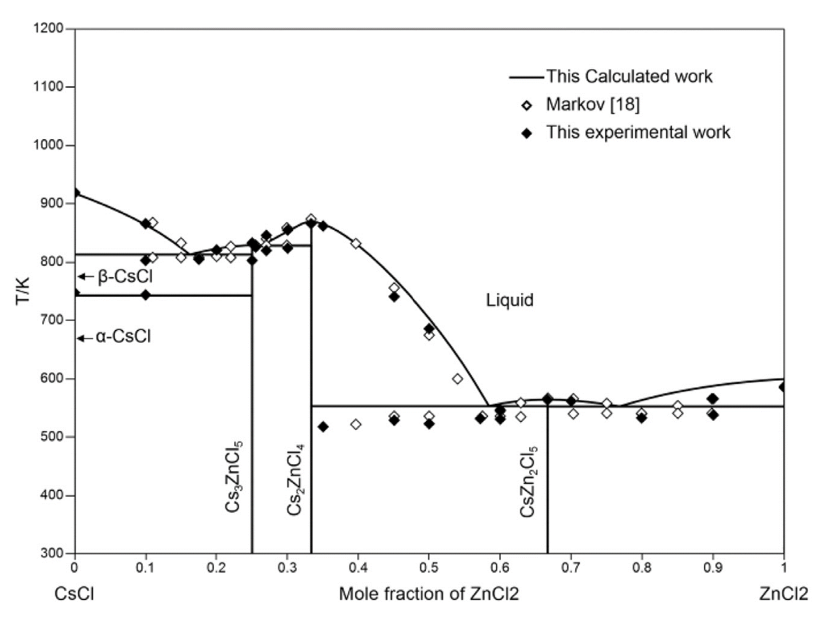
Figure 12. CsCl-ZnCl₂ binary phase diagram from [120].
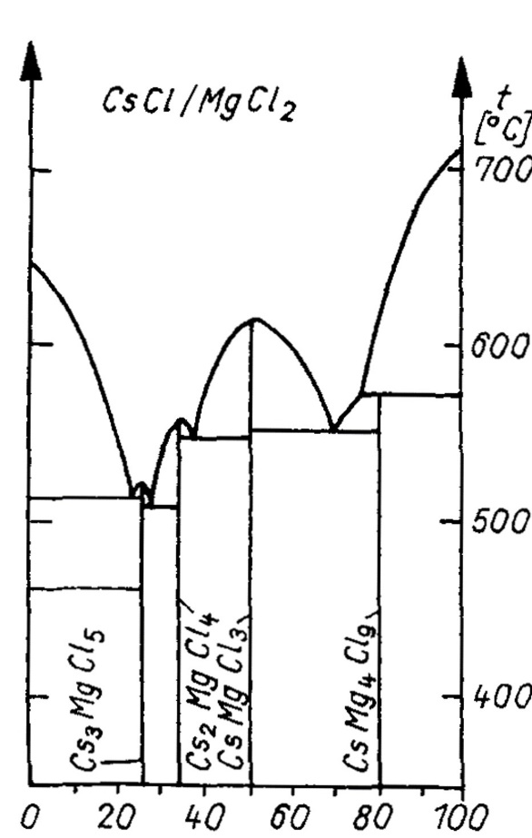
Figure 13. CsCl-MgCl₂ binary phase diagram from [128].

Powdered samples were loaded onto zero-background silicon holders while inside a nitrogen-filled glovebox and encapsulated with a Kapton film to prevent exposure to air during the measurements. The exception was Cs₂ZnCl₄ and Cs₃ZnCl₅, which were measured in air due to their non-hygroscopicity.

High temperature powder XRD measurements were carried out to determine the coefficients of thermal expansion (CTE) for Cs₂ZnCl₄. As a precaution to minimize contact time with air and moisture, the powder was ground inside a glovebox with a mortar and pestle and transferred to the diffractometer in an airtight enclosure. The powder was then quickly loaded onto an alumina sample holder while in air (total duration around 30-60 seconds) before being inserted into the high temperature stage (Anton Paar HTK 1200N high temperature sample stage). Measurements were performed in a nitrogen atmosphere. A heating rate of 5 °C/min was used and the sample was allowed several minutes to reach thermal equilibrium between scans at each temperature. The stage height was adjusted during heating to account for the expansion of the alumina sample mount.

Phase analysis and determination of lattice parameters was performed with the General Structure Analysis System (GSASII), an open-source software package for Rietveld refinement [129]. The following parameters were refined: background, histogram scale factor, sample displacement, lattice parameter, microstrain, and preferred orientation. Instrumental broadening was corrected for using results from a previously measured LaB₆ standard.

4.3 Differential Scanning Calorimetry (DSC)

Differential Scanning Calorimetry (DSC) was measured with a Setaram Labsys Evo with the samples sealed under vacuum in quartz crucibles. The mass of each sample was in the range of 40 to 50 mg. Heating and cooling rates were 5 K/min.

4.4 Dynamic Vapor Sorption (DVS)

Hygroscopicity of the grown crystals was evaluated using the technique of Dynamic Vapor Sorption (DVS) with a Surface Measurement Systems Intrinsic Plus instrument. Samples were obtained in the form of single crystal chunks approximately 40 mg in mass. Samples were prepared inside a glovebox and transferred to the instrument in an airtight container.

4.5 Scanning Electron Microscopy (SEM)

Defects in Cs₂ZnCl₄ crystals were analyzed at the IAMM Microscopy Center using a Zeiss Evo Scanning Electron Microscope (SEM) equipped with a Bruker xFlash 6130 Energy Dispersive X-ray Spectrometer (EDS). The electron beam was operated at 15 kV and 1 nA. Variable pressure mode was used to mitigate charging effects due to the samples being wide bandgap insulators. The samples were polished and then cleaned thoroughly with isopropanol prior to SEM and EDS measurements. There was no observable degradation or reaction due to contact with the isopropanol.

4.6 Sample Cutting and Polishing

Samples used for characterization of scintillation and optical properties were cut from the grown boules into more appropriate sizes (typically around 5 × 5 × 5 mm³ or Ø7 mm × 3 mm). Cutting was done using a diamond wire saw (MTI Corporation), pictured in Figure 14. The boules were mounted to a sample holder using non-hardening positioning putty (Electron Microscopy Sciences), as this was found to reduce the amount of thermally induced cracking compared to mounting wax that requires heat to soften. Mineral oil was applied throughout the cutting process as a lubricant and coolant. Cut samples were then ground and polished with mineral oil and SiC paper in successive steps using 400, 600, 800, and 1200 grits to improve the light collection efficiency for scintillation measurements.

4.7 Radioluminescence

Radioluminescence was measured under excitation by a Cu target X-ray tube operated at 35 kV and 0.1 mA. Emission spectra were collected from 200 nm to 600 nm with a 150 mm focal length Acton SpectraPro 2150i monochromator. To eliminate second order peaks in the range of 400-600 nm, spectra were also collected with a 320 nm longpass optical filter placed between the crystal and monochromator. The full spectra were then reconstructed from the data acquired with and without an optical filter. The emission spectra were not corrected for instrumental distortions, such as the monochromator throughput or detector sensitivity; however, the spectral response is relatively uniform across the measured wavelengths and is not expected to significantly affect any major features of the emission spectra of these samples.

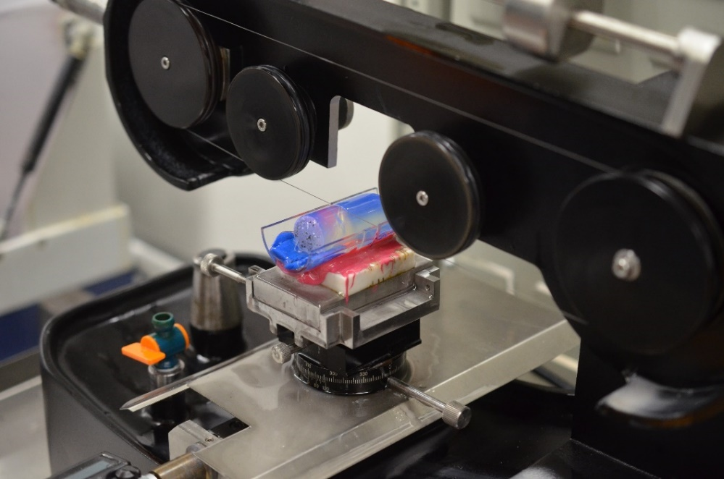
Figure 14. Wire saw used for cutting of halide single crystals.

4.8 Scintillation Decay Time

Scintillation decay time was measured under excitation by a 662 keV ¹³⁷Cs source using the time-correlated single photon counting technique described by Bollinger and Thomas [130]. The emitted light was detected using two Photonis XP2020Q photomultiplier tubes (PMTs) – one acting as the “start” and one as the “stop” – that were oriented at 90°, with the sample and source placed in between. An aperture was placed in front of the stop PMT and adjusted such that the count rate was <5% of the start count rate. The anode signal from the start PMT was fed to a Model 776 Phillips Scientific amplifier followed by an Ortec 935 quad constant-fraction discriminator (CFD) whose output served as the start signal to an Ortec 567 time-to-amplitude converter (TAC). The anode signal of the stop PMT was fed to an Ortec FTA 820 fast amplifier, Ortec 935 quad CFD, and then an Ortec 425A delay whose output served as the stop signal to the same TAC module. The output of the TAC was then connected to a Tukan 8K multi-channel analyzer (MCA), and data was acquired in the Tukan software.

An additional modification to the setup was tested in which the dynode signal of the stop PMT was used to gate the TAC output using a narrow energy window around the single photoelectron spectrum. The dynode signal was fed to a Canberra 2005 preamplifier, Ortec 572A amplifier, Ortec 550A single-channel analyzer (SCA), and an Ortec 416A gate & delay generator. The outputs of the TAC and 416A were then connected to the MCA, and the gating function of the software was applied. The results did not differ significantly from the 5% count rate method.

Repeatability of decay time measurements was tested by measuring the same crystal 10 times. In between measurements, adjustments were made to (i) the sample position/orientation (ii) its distance from each PMT and/or (iii) the ratio of "start" to "stop" counts by adjusting the aperture diameter. The stop counts were maintained below 5% of the start counts at all times. Data was acquired until at least 1,000 counts were collected at the maximum intensity. For a 5 × 5 × 5 mm³ Cs₂ZnCl₄ sample, the average of fitted decay constants was 1.69 ns with a standard deviation of 0.05 ns.

Decay constants were determined by a convolution procedure using the DecayFit analysis software (FluorTools, www.fluortools.com). The instrument response function (IRF) was measured using a ²²Na source while the PMTs were oriented at 180°. Cherenkov emission generated in the PMT windows was used to trigger the start and stop signals. Each PMT was covered with a black cloth to avoid detection of light from the opposite PMT. The total acquisition time for measurement of the IRF was ~3.8 days, which resulted in ~1,000 counts at the maximum intensity. To verify the validity of these methods, two different BaF₂ crystals were measured and fitted. One was a 10 × 10 × 10 mm³ crystal from Proteus Inc., and the other was a 4 × 4 × 20 mm³ crystal from United Crystals. The fitted decay constants for the CVL component were 0.71 ± 0.05 ns and 0.62 ± 0.05 ns, respectively.

4.9 Scintillation Light Yield

Pulse height spectra were collected using a 5 µCi ¹³⁷Cs source with a Hamamatsu R2059 PMT (see Table 4 for details) operated at 1.5 kV using a signal processing chain consisting of a Canberra 2005 preamplifier, an Ortec 672 amplifier set to shaping times of 0.5 µs to 10 µs, and a Tukan 8K MCA. The typical gain setting was 25X. Measurements were performed with the crystals covered or wrapped in sheets of reflective Teflon and coupled directly to the PMT with a thin layer of mineral oil. This is shown schematically in Figure 15. Absolute light yield was calculated as number of photons per MeV using

Table 4. List of PMT models used for the described measurements, along with some relevant characteristics.
PMT | Manufacturer | Measurement | Wavelength range (nm) | Max response (nm) | QE at peak (%) | Photo-cathode | Dynode structure | Window material | Anode pulse rise time (ns)
R955 | Hamamatsu | Radio-luminescence | 160 to 900 | 400 | 29 (at 220 nm) | multialkali | circular cage | quartz/silica | 2.2
XP2020Q | Photonis | decay time | 150 to 650 | 420 | 25 | bialkali | linear focused | quartz/silica | 1.5
R2059 | Hamamatsu | light yield | 160 to 650 | 420 | 26 | bialkali | linear focused | quartz/silica | 1.3
R6231-100 | Hamamatsu | energy resolution | 300 to 650 | 400 | 35 | super bialkali | linear focused | Borosilicate glass | 8.5

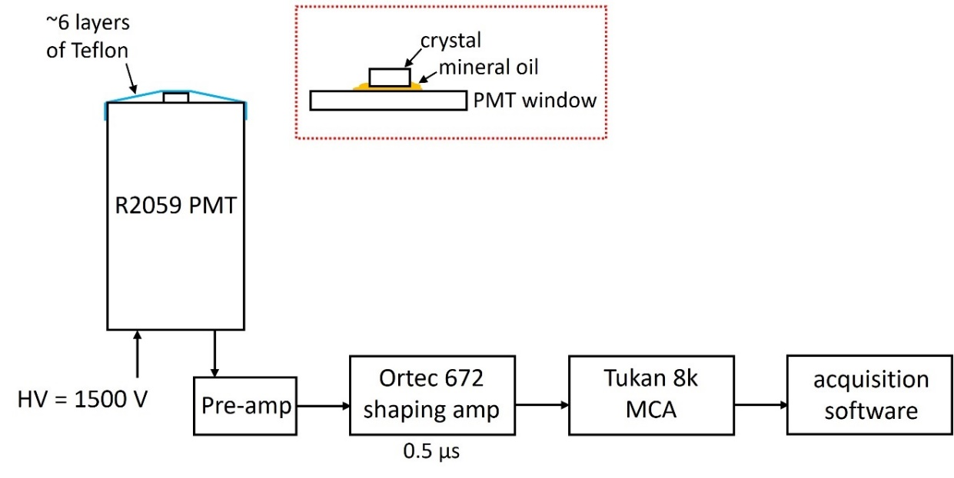
Figure 15. Schematic diagram of the pulse processing chain used for light yield measurements.

the method of Bertolaccini et al. [131], which compares the centroid of the 662 keV full energy photopeak to that of the single photoelectron (SPE) and accounts for the quantum efficiency (QE) of the PMT across the emission wavelengths of the scintillator. The SPE was measured with the maximum amplifier gain setting of 1500X (or 60X higher than the gain for sample measurements). An example spectrum is shown in Figure 16.

4.10 Coincidence Time Resolution (CTR)

Coincidence time resolution (CTR) was measured with 3 × 3 × 5 mm³ crystals (referred to hereon as “test” crystals) that were wrapped in Teflon and coupled to a Broadcom AFBR-S4N44C014M silicon photomultiplier (SiPM) with Viscasil optical grease. The SiPM bias voltage was set to 44.5 V. All test crystals were measured against a reference detector consisting of a 6 × 6 × 6 mm³ LSO:Ce crystal and Hamamatsu H6610 PMT assembly, and the reference detector timing contribution of 135 ps FWHM was deconvolved from the measured results to obtain the CTR of the samples. During the measurements, a ⁶⁸Ge source placed between the test crystal and reference detector emits two 511 keV gamma rays in opposite directions that are detected in coincidence. Timing and energy signals from each detector were readout separately, and only events corresponding to the 511 keV photopeak in both the test crystal and reference detector were considered in the analysis. The experimental setup was similar to “Timing Setup A” described in [132], but with the SiPM replacing the “test detector” PMT. A simplified schematic is shown in Figure 17.

Timing pickoff was performed using a custom-built leading edge (LE) discriminator with an externally electronically controlled threshold, and the samples were measured as the LE threshold was varied from 3 mV to 57 mV in increments of 6 mV. This increment was

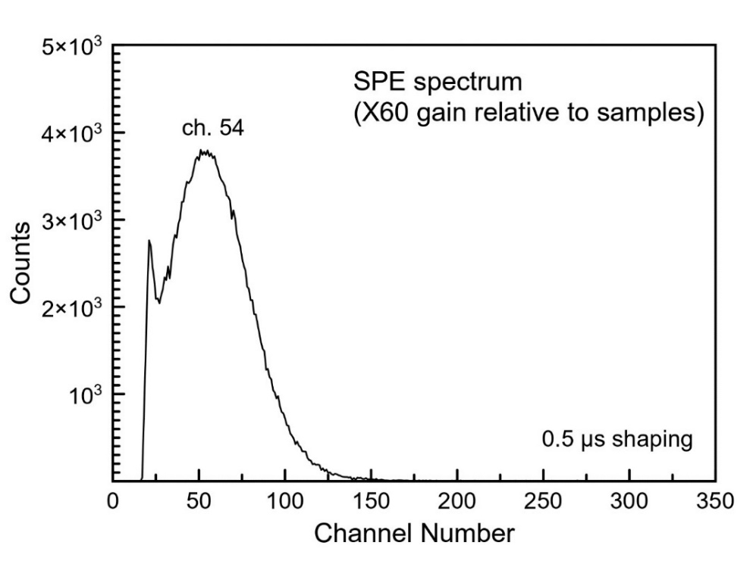
Figure 16. Example single photoelectron (SPE) spectrum measured with a shaping time of 0.5 µs used to calculate absolute light yield.

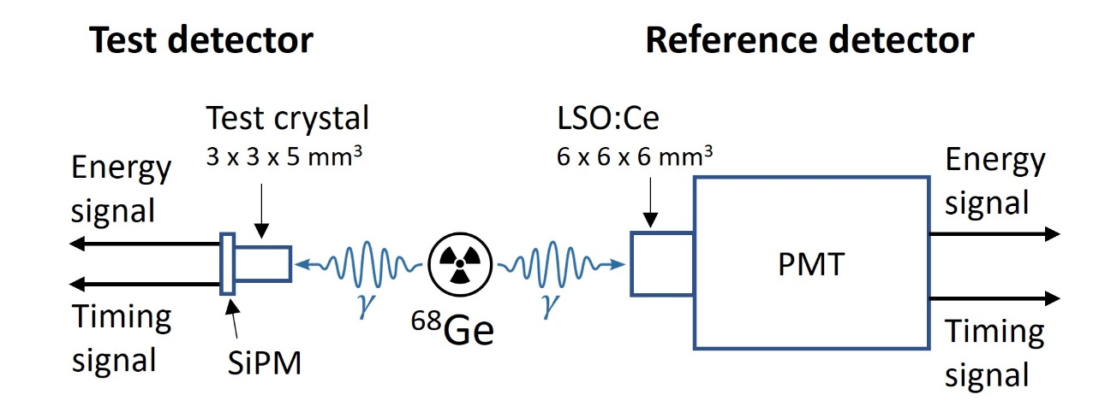
Figure 17. Simple schematic of the setup for coincidence time resolution (CTR) measurements.

based on the value for a single photoelectron that was determined to be 8 mV prior to performing the measurements.

In Chapter 5.1.4 CTR, two slightly different setups are used for measurements with Cs₂ZnCl₄ crystals of varying sizes. The general principle of the measurement is the same in each case. More detailed descriptions of those setups are provided in the relevant section (Chapter 5.1.4 CTR).

4.11 Optical Transmittance and Absorbance

Transmittance and absorbance were measured using a Varian Cary 5000 UV-Vis-NIR spectrophotometer. Measurements were performed with a ~3 mm thick slab of Cs₂ZnCl₄ that had been polished with 600, 800, and 1200 grit SiC paper and mineral oil. Prior to inserting the sample into the measurement compartment, a 100% and 0% transmission scan were each collected and used to apply a baseline correction.

4.12 Density Functional Theory (DFT)

Density functional theory (DFT) simulations were performed within the Vienna ab initio simulations package (VASP) to relax the structure and calculate the density of states (DOS) [133, 134]. The generalized gradient approximation (GGA) functional PBEsol was used for all relaxations, while the DOS calculations were carried out using the Heyd-Scuseria-Ernzerhoff (HSE) screened hybrid functional with a Hartree – Fock range-separation parameter of 20% (HSE06) [135, 136]. A single unit cell, containing 4 formula units, was used for both the Cs₂MgCl₄ and Cs₃MgCl₅ compounds with a Monhorst-Pack k point grid of 6 × 6 × 6 during relaxation and 4 × 4 × 4 during DOS calculations with hybrid functionals to reduce computational load while maintaining sufficient accuracy. The energy cutoff is 600 eV. Planar-augmented wave (PAW) basis [137] composed pseudopotentials are used for each species with the following valence electron configurations: Cs 3p3d4s (9 e⁻), Mg 2s (10 e⁻), and Cl 3s3p (7 e⁻). Each relaxation and self-consistent field calculation was converged to Hellmann-Feynman forces of <0.01 eV/Å and to a total energy difference of <10⁻⁶ eV. The lattice constants found from published data in [138] and in [139] were used for the DOS calculations of Cs₂MgCl₄ and Cs₃MgCl₅. DFT calculations were done in collaboration with Dr. Haixuan Xu and Dylan Windsor at the University of Tennessee.

Cesium Zinc Chloride

Many of the results of this chapter were originally published in a peer-reviewed journal by Daniel Rutstrom et al. Minor changes have been made to improve the flow within the context of this dissertation. The full citation for the published manuscript is as follows: Daniel Rutstrom, Luis Stand, Cordell Delzer, Maciej Kapusta, Jaroslaw Glodo, Edgar van Loef, Kanai Shah, Merry Koschan, Charles L. Melcher, Mariya Zhuravleva, “Improved light yield and growth of large-volume ultrafast single crystal scintillators Cs₂ZnCl₄ and Cs₃ZnCl₅” Optical Materials, Volume 133, 2022. The author would like to thank the coauthors for their contributions to this work.

As was discussed in Chapter 2.4 Recently Discovered Materials, we have identified Cs₂ZnCl₄ and Cs₃ZnCl₅ as two of the most promising candidate CVL materials for further investigation. The focus of the current work is to fabricate larger-size single crystals with superior optical quality than what has previously been shown and to evaluate their scintillation properties and timing resolution. The improved crystal quality is expected to lead to higher light yields and therefore better performance. We also report various structural and physical properties of these compounds. First, Ø7 and Ø22 mm crystals of both Cs₂ZnCl₄ and Cs₃ZnCl₅ are evaluated. Next, the potential for scaling up growth of Cs₂ZnCl₄ to sizes relevant to commercial production is assessed through growth of several crystals from Ø22 mm to Ø38 mm.

5.1 Improved Performance and Growth of Large-volume Crystals

5.1.1 Structural and Physical Properties
Growth of Ø7 mm Cs₂ZnCl₄ and Cs₃ZnCl₅ yielded highly transparent colorless crystals. Some minor cracking was observed, but the crystals were otherwise free of visible defects. Polished slabs cut from the grown boules are shown in Figure 18. The orthorhombic (space group Pnma) and tetragonal (space group I₄/mcm) crystal structures reported for Cs₂ZnCl₄ [140] and Cs₃ZnCl₅ [141], respectively, were confirmed by powder XRD. Both crystals were phase pure and are shown in Figure 19a and Figure 19b, which display the measured patterns compared with simulated patterns from ICDD reference code 04-010-5876 for Cs₂ZnCl₄ and 04-014-7879 for Cs₃ZnCl₅. The reported lattice parameters of Cs₂ZnCl₄ are a = 9.7577(15) Å, b = 12.9704(16) Å, and c = 7.4004(10) Å. The lattice parameters of Cs₃ZnCl₅ are a = b = 9.2421(18) Å and c = 14.4928(15) Å. Structural models generated with Vesta [142] are shown in Figure 19c. Both structures consist of isolated [ZnCl₄]²⁻ tetrahedra and contain two separate Cs sites. The coordination numbers (CN) for the Cs1 and Cs2 sites in Cs₂ZnCl₄ are CN = 8 and CN = 9, respectively. The Cs1 and Cs2 sites in Cs₃ZnCl₅ have CN = 8 and CN = 10, respectively. The calculated densities of Cs₂ZnCl₄ and Cs₃ZnCl₅ are 3.35 g/cm³ and 3.44 g/cm³, respectively.

Air stability and non-deliquescence of Cs₂ZnCl₄ and Cs₃ZnCl₅ are mentioned in literature [114, 118, 143], however, analysis of the hygroscopicity under a controlled environment is not presented. The results of DVS measurements (Figure 20a) show a near-zero percent (<0.05%) change in mass over a 5-hour period at 40% relative humidity for Cs₂ZnCl₄ and Cs₃ZnCl₅, which by most standards can be considered non-hygroscopic.

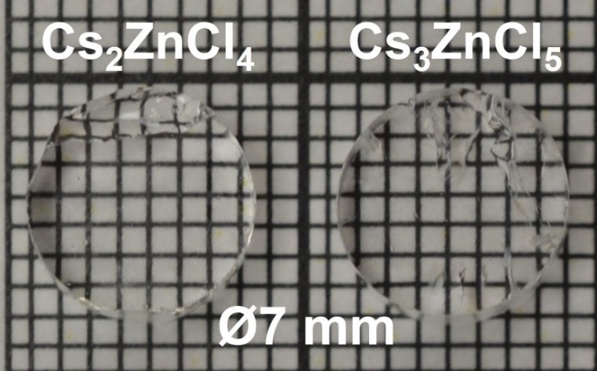
Figure 18. Cs₂ZnCl₄ and Cs₃ZnCl₅ single crystals (7 mm diameter). The crystals pictured are 3 mm thick slabs cut from the grown boules.

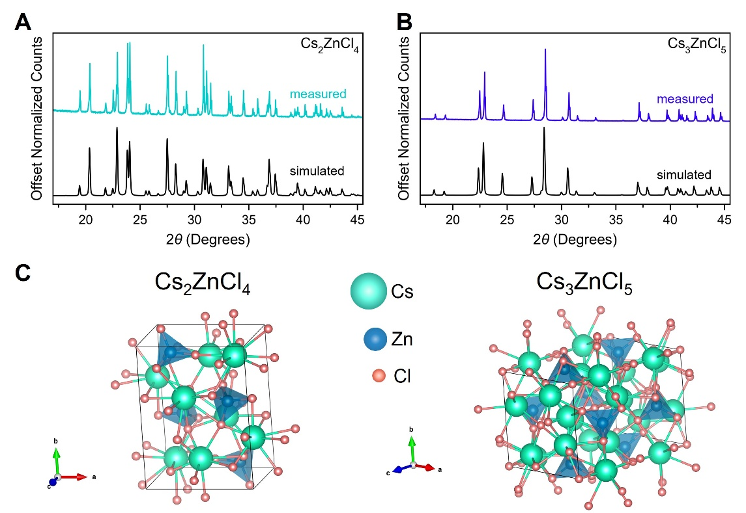
Figure 19. (a-b) Measured powder XRD patterns compared with simulated patterns for Cs₂ZnCl₄ (ICDD ref. code 04-010-5876) and Cs₃ZnCl₅ (ICDD ref. code 04-014-7879). (c) Structural models of Cs₂ZnCl₄ and Cs₃ZnCl₅ generated using Vesta [142].

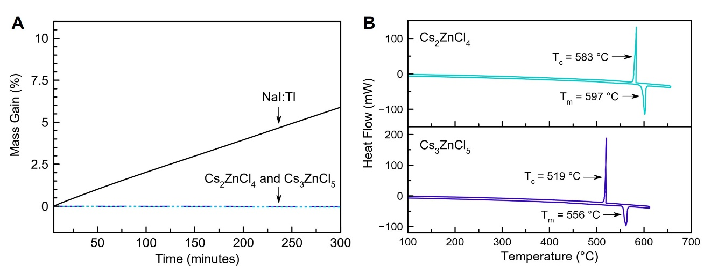
Figure 20. (a) DVS water sorption curves at 40% relative humidity compared with NaI. (b) DSC curves showing the melting and solidification behavior of Cs₂ZnCl₄ and Cs₃ZnCl₅. The endothermic direction is down.

This stability in the presence of moisture and air makes Cs₂ZnCl₄ and Cs₃ZnCl₅ advantageous over many other halide scintillators, which must be hermetically sealed (packaged) before incorporating into a detector system. Melting points were determined from DSC (Figure 20b) and were measured to be 597 °C for Cs₂ZnCl₄ and 556 °C for Cs₃ZnCl₅. These values are consistent with the reported melting points of 601 °C and 560 °C, respectively [120]. Both compounds were observed to melt congruently as can be seen from the single endothermic and exothermic peaks for each in Figure 20b. The relatively low melting points of Cs₂ZnCl₄ and Cs₃ZnCl₅ compared to that of BaF₂ (T_{m} = 1368 °C) could be considered advantageous from a manufacturing standpoint (lower energy costs, for example).

5.1.2 Scintillation Properties – Small Crystals
Figure 21 shows radioluminescence emission spectra of Cs₂ZnCl₄ and Cs₃ZnCl₅, along with a BaF₂ crystal obtained from Proteus, Inc. Cs₂ZnCl₄ has a dominant peak centered at 285 nm with an additional band located at 379 nm. Similar values of 295 nm (4.2 eV) and 375 nm (3.3 eV) are reported in Ref. [119] for an excitation energy of 21.4 eV, with both bands being attributed to CVL. Ohnishi et al. [119] and Takahashi et al. [114] report a third emission band for Cs₂ZnCl₄ located at ~260 nm, however, this was not observed in our measurements. The maximum intensity peak observed for Cs₃ZnCl₅ is centered at 289 nm, with additional bands appearing at 240 nm and 404 nm. Similar values of 240 nm, 290 nm, and 410 nm are reported in Ref. [114] and were also attributed to CVL.

It is well known and apparent from the emission spectrum of BaF₂ in Figure 21 (inset) that the slow component (emission centered at 310 nm) related to self-trapped exciton (STE) emission dominates, with a much smaller fraction of the light originating from the fast CVL process (emission centered at ~220 nm). An additional CVL band is expected at 195 nm but could not be detected with our setup.

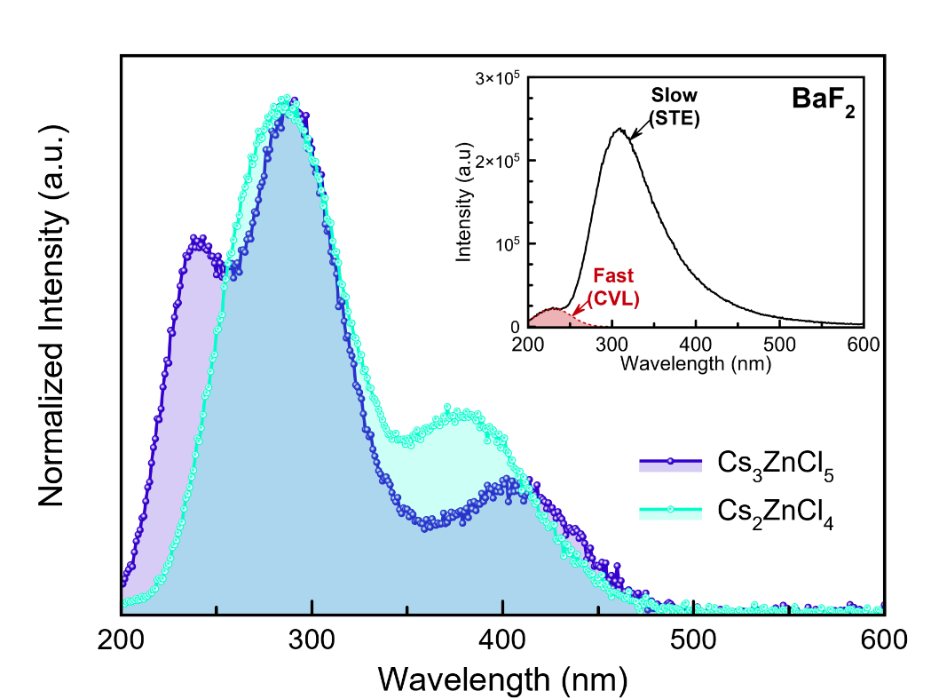
Figure 21. Radioluminescence emission spectra of Cs₂ZnCl₄ and Cs₃ZnCl₅ measured at room temperature. The inset shows a spectrum measured with a reference BaF₂ crystal – the red shaded area depicting the emission related to the fast component. The band expected at 195 nm for BaF₂ was not able to be detected with the setup used for these measurements.

In contrast to BaF₂, the CVL emissions of Cs₂ZnCl₄ and Cs₃ZnCl₅ have maxima at longer wavelengths and extend further into the range where common photodetectors have the highest spectral sensitivity. For example, the QE of the R2059 PMT used to measure light yield of these crystals is ~19% at 200 nm, ~25% at 300 nm, and ~27% at 350 nm.

Figure 22 shows the measured scintillation decay time profiles in comparison with a reference BaF₂ crystal (10×10×10 mm³) from Proteus, Inc. The decay times were determined by fitting a convolution of the instrumental response with a model function, which was a single-exponential for Cs₂ZnCl₄ and Cs₃ZnCl₅ and double-exponential for BaF₂. The fast component of the BaF₂ crystal derived from the fit was 0.71 ns, within the range of well-established values (0.6-0.8 ns) for this material. The decay times of Cs₂ZnCl₄ and Cs₃ZnCl₅ obtained from the fits shown in Figure 23a and Figure 23b were 1.66 ns and 0.82 ns, respectively. These values are similar to the primary decay constants reported in Ref. [114]. Secondary decay components were reported for both compounds in Ref. [114] as well and were explained as possibly originating from STE emission. The decay constants were 𝜏₂ = 15 ns (12%) for Cs₂ZnCl₄ and 𝜏₂ = 13 ns (8%) for Cs₃ZnCl₅ [114]. Unlike Ref. [114], there were no secondary components observed in our measurements of Cs₂ZnCl₄ and Cs₃ZnCl₅, even when performed over a longer time window or for long acquisition times. Typically, lifetimes of STEs are on the order of several hundred nanoseconds to several microseconds [6]. According to Weber [144], STE lifetimes can be on the order of tens of nanoseconds for singlet state decay, however, this process is primarily observed in materials with cubic crystal structures, such as CsI.

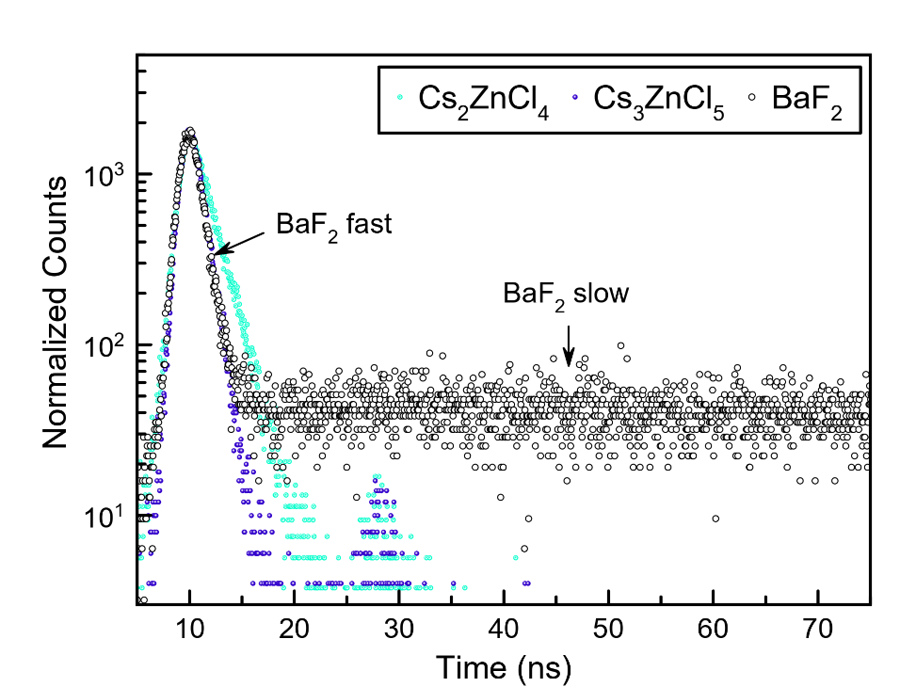
Figure 22. Scintillation decay profiles of Cs₂ZnCl₄ and Cs₃ZnCl₅ compared with a reference BaF₂ crystal. The feature between 25 ns and 35 ns for Cs₂ZnCl₄ and Cs₃ZnCl₅ is an instrumental artifact.

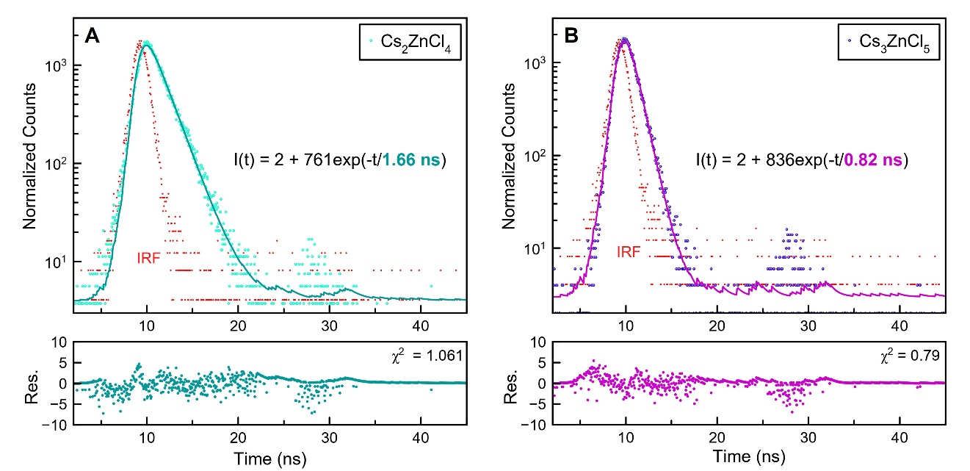
Figure 23. Fitted scintillation decay profiles for Ø7 mm × 3 mm slabs of (a) Cs₂ZnCl₄ and (b) Cs₃ZnCl₅. Large circles are the measured sample data and small dots are the measured instrumental response (IRF). Solid lines represent a convolution of the IRF with the function I(t) displayed on each plot. The feature between 25 ns and 35 ns in the measured data is an instrumental artifact.

One other possible origin for the reported slow components of Cs₂ZnCl₄ and Cs₃ZnCl₅ might be related to impurity or defect mediated emission, which could also explain the presence of a peak around 500 nm in the emission spectra shown in Ref. [114] that is not observed in our measurements. Presently, the exact nature of the secondary decay components is unclear; in any case, it is apparent that at least ~90% of the emission from Cs₂ZnCl₄ and Cs₃ZnCl₅ can be attributed to the fast decay component, providing a significant advantage over BaF₂, for which the slower 630 ns STE decay dominates and accounts for 85% of the emission.

Figure 24 shows pulse height spectra of Ø7 mm × 3 mm thick Cs₂ZnCl₄ and Cs₃ZnCl₅ crystals measured with a ¹³⁷Cs source. The amplifier shaping time was varied from 0.5 µs to 10 µs with little effect on the photopeak position. This provides further confirmation of the absence of long components typical of STE lifetimes (several hundred nanoseconds) in the scintillation time profiles of both crystals. Light yields of Cs₂ZnCl₄ and Cs₃ZnCl₅ were measured to be 1980 ± 100 ph/MeV and 1460 ± 70 ph/MeV, respectively. This is a 55% and 232% improvement over the 1280 ph/MeV and 440 ph/MeV light yields that were previously reported [114]. These are also superior to the light yield of the fast component of BaF_{2,} which is 1400 ph/MeV [145]. Table 5 summarizes relevant properties of Cs₂ZnCl₄ and Cs₃ZnCl₅ crystals from the present work compared with BaF₂.

The light yields of several other small-size crystals of Cs₂ZnCl₄ and Cs₃ZnCl₅ were measured using pieces obtained from the Ø22 mm crystals (discussed in Section 5.1.3) that had dimensions of 5×5×5 mm³. The light yield ranged from 1960-1990 ph/MeV for Cs₂ZnCl₄ and from 1390-1530 ph/MeV for Cs₃ZnCl₅. The values listed in Table 5 that were measured with Ø7 mm × 3 mm crystals are representative of most samples.

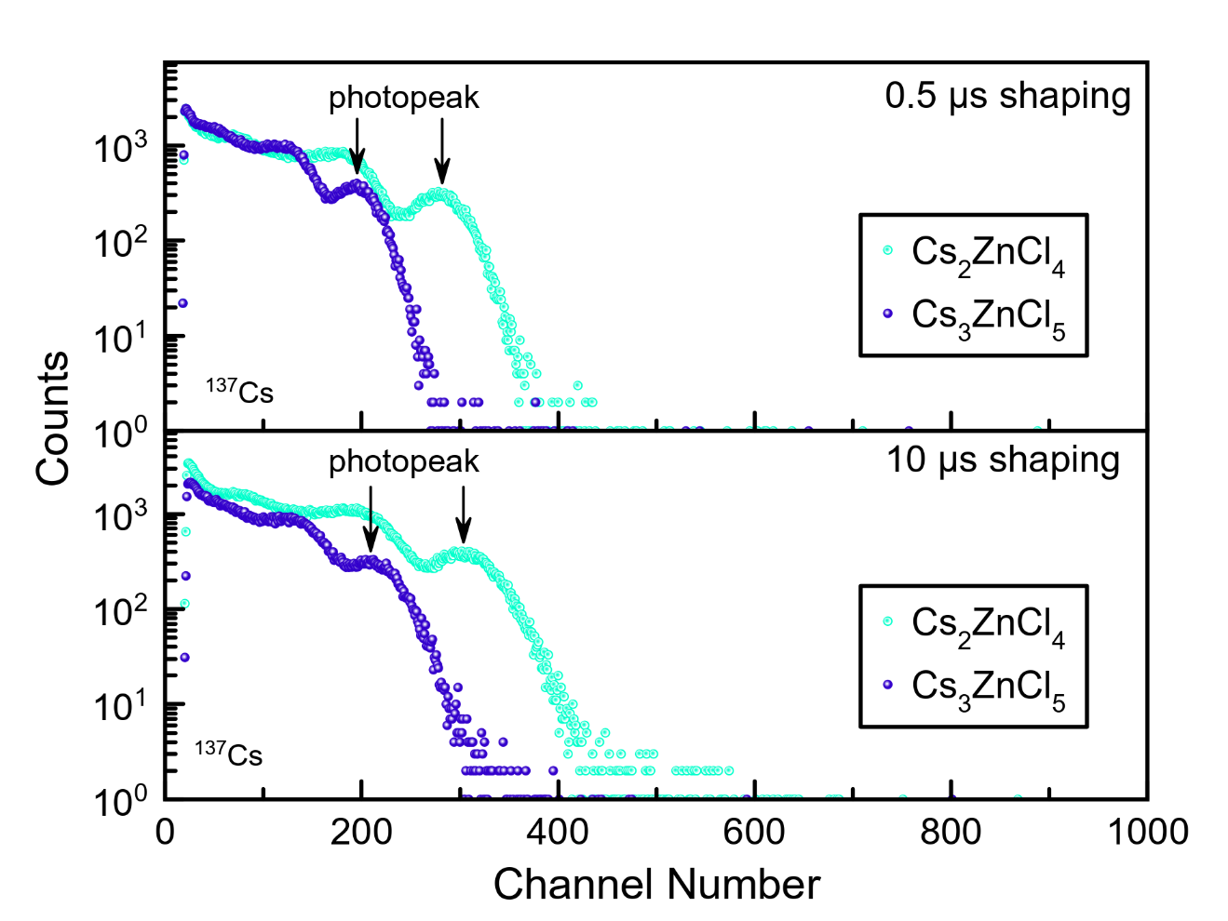
Figure 24. Pulse height spectra of Ø7 mm × 3 mm slabs of Cs₂ZnCl₄ and Cs₃ZnCl₅ measured with a 662 keV ¹³⁷Cs source for amplifier shaping times of 0.5 µs and 10 µs. Arrows indicate the position of the full energy photopeaks.

Table 5. Physical and scintillation properties of Cs₂ZnCl₄ and Cs₃ZnCl₅ compared with BaF₂. The light yield and decay time values of Cs₂ZnCl₄ and Cs₃ZnCl₅ were measured with Ø7 mm × 3 mm crystals. Values for BaF₂ are taken from [2] unless noted otherwise.
 | Cs₂ZnCl₄ | Cs₃ZnCl₅ | BaF₂
Light yield (ph/MeV)
Fast | 1980 ± 100 | 1460 ± 70 | 1400 ^{[145]}
Slow | - | - | 9500 ^{[145]}
Decay time (ns)
Fast | 1.66 | 0.82 | 0.6 – 0.8
Slow | - | - | 630
CVL emission wavelengths (nm) | 285, 379 | 240, 289, 404 | 195, 220
Z_{eff} | 45.3 | 46.6 | 53
Density (g/cm³) | 3.35 (calc.) | 3.44 (calc.) | 4.88
Radiation length, X₀ (cm) | 3.17 | 2.99 | 2.1 ^{[146]}
Melting point (°C) | 597 | 556 | 1368
Hygroscopic | no | no | no

5.1.3 22 mm Diameter Crystals
Photographs of the Ø22 mm crystals are shown in Figure 25. Note that these are ~50X to ~250X larger in volume than Cs₂ZnCl₄ and Cs₃ZnCl₅ crystals shown in previous publications, which typically appear to be several mm across at most [114, 143, 147, 148]. Some minor cracks developed while cutting and polishing the Cs₂ZnCl₄ crystal (Figure 25a), however, the optical uniformity and lack of cracking before processing is encouraging for future scale up efforts. Two mostly crack-free Ø22 mm × 15 mm tall cylinders (Figure 25b) were able to be cut from the Cs₂ZnCl₄ boule for characterization of scintillation properties. Cracking was slightly worse for the Cs₃ZnCl₅ crystal, as can be seen from Figure 25c. Fortunately, these cracks were mainly limited to the outer edge of the crystal. A cylinder, Ø22 mm × 16 mm tall (Figure 25d), with minimal cracking was cut from the middle section of the boule for characterization of scintillation properties.

Scintillation decay time and light yield of the Ø22 mm Cs₂ZnCl₄ and Cs₃ZnCl₅ crystals were measured to evaluate the size dependent performance. Decay profiles and pulse height spectra of the Ø22 mm crystals are shown in Figure 26. Decay times showed little to no change with crystal volume. Cs₃ZnCl₅ had a decay time of ~0.8-0.9 ns for both the Ø7 mm × 3 mm crystal (Figure 23) and Ø22 mm × 16 mm crystal (Figure 26a). The decay time of Cs₂ZnCl₄ was also similar for the small and larger-size crystals – 1.73 ns for a size of Ø22 mm × 15 mm (Figure 26a) compared to 1.66 ns for a size of Ø7 mm × 3 mm (Figure 23).

Light yield decreased slightly for both compounds when increasing the crystal volume, however, both still have well-defined 662 keV photopeaks, as seen in Figure 26b. Cs₃ZnCl₅ decreased to 1050 ± 50 ph/MeV for the larger-size crystal – a 28% decrease from the 1460 ± 70 ph/MeV light yield of the small crystals. Cs₂ZnCl₄ decreased to 1450 ± 70 ph/MeV for the larger-size crystal – a 27% decrease from the 1980 ± 100 ph/MeV
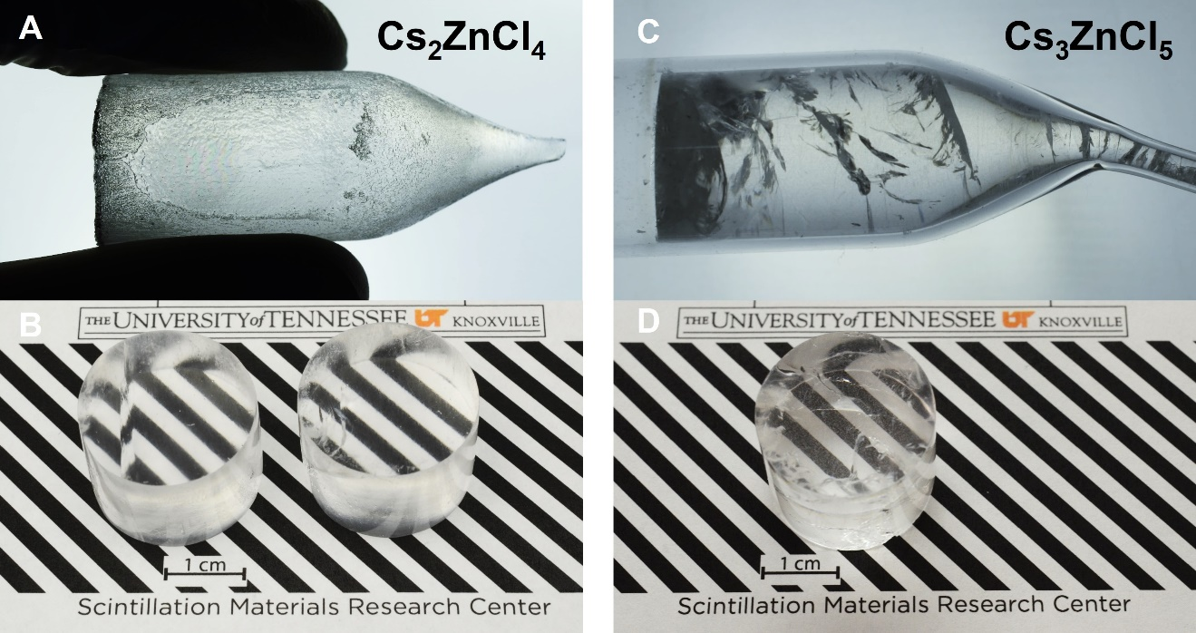
Figure 25. Photographs of backlit as-grown 22 mm diameter (a) Cs₂ZnCl₄ and (c) Cs₃ZnCl₅ single crystals. Polished cylinders of (b) Cs₂ZnCl₄ and (d) Cs₃ZnCl₅ cut from the boules.

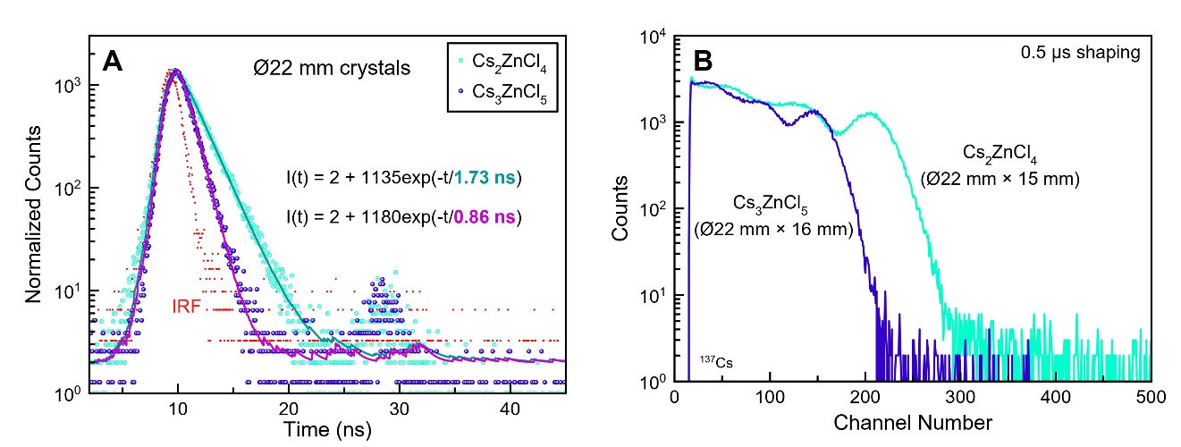
Figure 26. (a) Scintillation decay profiles and (b) pulse height spectra of Ø22 mm cylinders of Cs₂ZnCl₄ and Cs₃ZnCl₅ measured under excitation by a 662 keV ¹³⁷Cs source. In (a), large circles are the measured sample data and small dots are the measured instrument instrumental response (IRF). Solid lines in (a) represent a convolution of the IRF with the corresponding functions I(t) displayed on the plot.

light yield of the small crystals – and was the same for both 15 mm tall cylinders shown in Figure 25b.

The deterioration of light yield in the large crystals is likely due to losses associated with light collection inefficiencies and other non-radiative processes, such as absorption of light by non-luminescent ions and defects in the crystal. This would also explain why the decay time does not lengthen with increasing volume since the light is completely lost rather than re-emitted. With further improvements to crystal quality, the volume dependence of light yield is expected to be less significant. Despite the minor imperfections, these large-volume Cs₂ZnCl₄ and Cs₃ZnCl₅ crystals still outperform any previously reported crystals in terms of light yield [114].

5.1.4 CTR

Timing Setup A – PMTs
Cs₂ZnCl₄ was selected for timing measurements due to its higher light yield compared to Cs₃ZnCl₅. The CTR was measured using crystals cut from a Ø22 mm Cs₂ZnCl₄ boule. Two sizes were compared – a small set with dimensions 3 × 3 × 5 mm³ (samples S1 and S2) and a larger set with dimensions 7 × 7 × 10 mm³ (samples L1 and L2). The 3×5 mm² and 7×10 mm² faces of the crystals were optically coupled to the PMT of a Hamamatsu H6610 assembly by means of Viscasil 600. Samples were wrapped in several layers of Teflon tape to improve the light collection. All measurements were done against a reference detector consisting of a 6 × 6 × 6 mm³ LSO:Ce crystal read out by a second H6610 assembly. Both assemblies contained an R5320 PMT with a transit time spread of 160 ps full width at half max (FWHM) and a cathode blue index of 10.2 µA/lmB. The R5320 PMT has a silica glass entrance window, and its spectral response extends below 300 nm.
The anode signal of the PMT from the tested assembly (containing the Cs₂ZnCl₄ crystal) was fed to a custom-built leading edge (LE) discriminator with an externally electronically controlled threshold. The anode signal of PMT from the reference assembly (containing the LSO:Ce crystal) was fed to a LE discriminator Model 708 Phillips Scientific optimized for best timing performance. The reference detector timing contribution of 110 ps FWHM was deconvolved from the measured results, and coincidence timing for two assumed identical detectors is reported. The discriminator’s outputs of the tested and reference detectors served as start and stop signals to a Canberra Model 2145 TAC module. The outputs of the TAC and spectroscopy amplifiers were then digitized by a CAEN DT5742. In all the analysis, the narrow energy window of 450 keV to 650 keV around 511 keV was used. The system was calibrated by means of linear regression fit to the mean value of 9 timing peaks shifted by 0.5 ns to cover the whole digitizer range.

Figure 27 shows the results of timing measurements with ‘Setup A’. The CTR of samples S1 and S2 is equal to 152 ± 1 ps and 148 ± 1 ps FWHM, while the CTR of samples L1 and L2 is equal to 175 ± 1 ps, 175 ± 1 ps FWHM, respectively. To understand timing differences for the two sizes, the light output was measured and found to be 8% lower for large samples in comparison to the small ones. That difference alone cannot fully explain the time resolution, thus the scintillation photons time jitter in the crystals needs to be additionally considered. The S1 and S2 timing resolution is comparable to the 147 ± 1 ps FWHM measured for 6 × 6 × 6 mm³ LSO:Ce. It is well known that timing resolution is directly proportional to the square root of the ratio of the scintillator’s decay time to its light output. Based on this, a better timing resolution by ~23% would be expected for Cs₂ZnCl₄ (1980 ph/MeV light yield and 1.66 ns decay time) than for LSO:Ce (~30,000 ph/MeV light yield and 42 ns decay time [149-151]). Due to the spectral sensitivity of the PMT and different emission wavelengths of the two scintillators, the
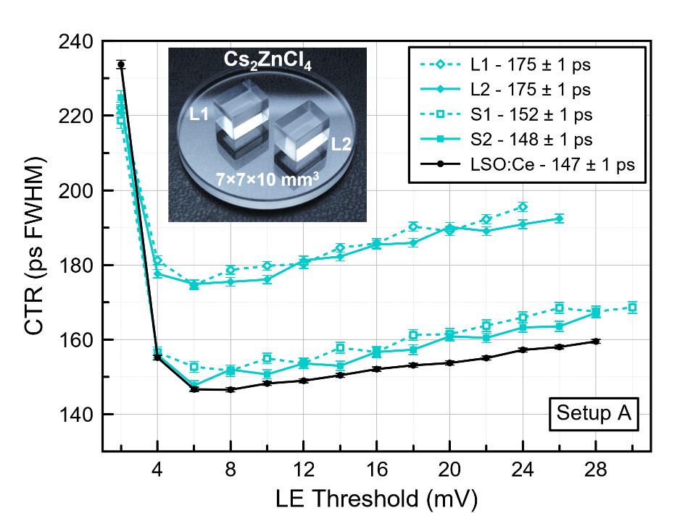
Figure 27. CTR measurements of 3×3×5 mm³ (S1 and S2) and 7×7×10 mm³ (L1 and L2) Cs₂ZnCl₄ crystals compared to reference LSO:Ce. The inset photograph shows the polished L1 and L2 crystals that were cut from a Ø22 mm Cs₂ZnCl₄ boule.

timing resolution became similar. Overall, the ultrafast decay time of Cs₂ZnCl₄ and moderate light yield allows its use in applications where very high-count rate and good timing are required and the long decay time of LSO:Ce would be problematic.

Timing Setup B – SiPMs
To evaluate how the timing resolution may vary depending on the setup, a separate set of measurements were performed independently using different photodetectors and electronics. An additional difference to the setup was that two identical Ø7 mm × 3 mm thick Cs₂ZnCl₄ crystals were measured in coincidence, as opposed to being measured against a reference material. Excitation was from a 2 μCi 511 keV ²²Na source, and each crystal was coupled to an AFBR-S4N44C013 silicon photomultiplier (SiPM) in a single-sided readout configuration. This SiPM shows excellent timing characteristics as well as being well-matched to the emission of the scintillator. The SiPMs were then read out using custom electronics based on Ref. [152], which utilizes both a fast-timing readout as well as a simultaneous energy readout. To improve light collection efficiency, the samples were coupled with BC-630 optical grease and wrapped in Teflon tape. The pulses were then read out using a DRS4 evaluation board from the Paul Scherrer Institute (PSI) [153] with a sample rate of 5 GSPS. Timing pickoff was performed using a CFD. The best timing resolution was obtained using a CFD fraction of 12%.

Figure 28 shows the results of timing measurements with ‘Setup B’. The CTR measured for Cs₂ZnCl₄ was 136 ± 2 ps FWHM using the optimal CFD fraction of 12%. This result is in good agreement with the CTR obtained from ‘Setup A’ and further demonstrates the excellent timing characteristics of this material.

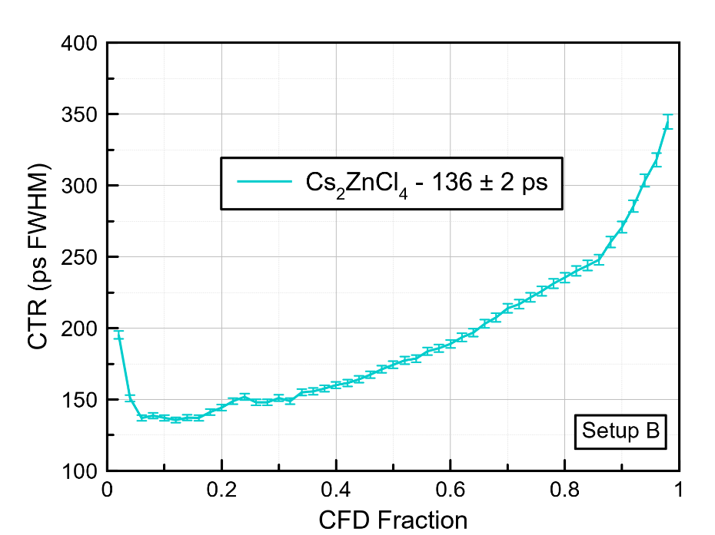
Figure 28. CTR vs CFD fraction for two Ø7 mm × 3 mm Cs₂ZnCl₄ crystals.

5.2 Experiments to Optimize Growth of 22 mm Diameter Crystals

Based on preliminary scale up attempts with both Cs₂ZnCl₄ and Cs₃ZnCl₅ presented in the previous section, it was determined that Cs₂ZnCl₄ would be the more promising candidate for further development. This was in part due to its higher light yield, but also because of the tendency for Cs₃ZnCl₅ crystals to crack, as seen in Figure 25c. Therefore, the remainder of this chapter focuses specifically on scaling up growth of Cs₂ZnCl₄ crystals.

5.2.1 Observation of Defects
Macroscopic bubble-like defects were observed in 22 mm diameter Cs₂ZnCl₄ and Cs₃ZnCl₅. It was evident after cutting that these defects are mostly limited to the outer edge of the crystal for Cs₂ZnCl₄ – up to about 3 mm to 4 mm from the surface. Figure 29a shows photographs of the bubble-like defects in Cs₂ZnCl₄ taken under an optical microscope. They are spherical and vary in size – larger toward the surface and smaller toward the middle of the crystal. The defects in Cs₃ZnCl₅ on the other hand were present throughout the entire crystal, not just near the edges (Figure 29b). The defects in Cs₃ZnCl₅ were also significantly smaller than those in Cs₂ZnCl₄ and often appeared as linear chains Figure 29.

Bubbles in Bridgman-grown crystals have been observed before for a variety of materials including SrI₂ [154], LiCaAlF₆ [155], ZnSe [156], and TeO₂ [157]. The following mechanism was proposed by Fang et al. for the formation of bubbles in melt-grown crystals [53]. It is assumed that at the beginning of growth the melt contains dissolved

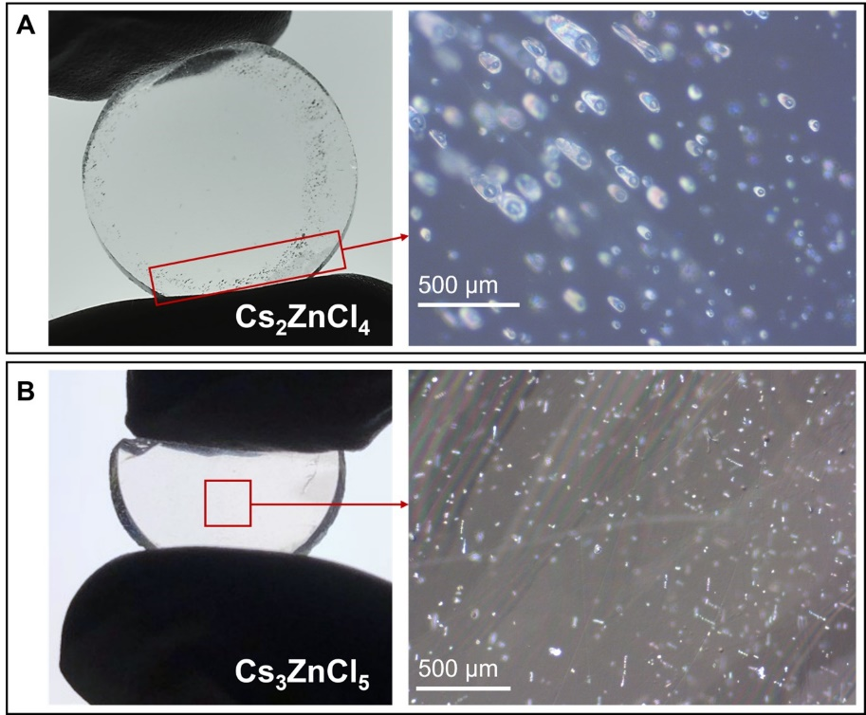
Figure 29. Photographs of backlit ~3 mm thick slabs cut from 22 mm diameter (a) Cs₂ZnCl₄ and (b) Cs₃ZnCl₅ and corresponding images taken under cross polarized light with an optical microscope.

gases. The solubility of the gas is typically much lower in the solid than in the liquid [158], therefore, as the growth proceeds the gas will be rejected by the solid into the melt, which leads to solute pile up at the growth interface. Bubble nucleation may then occur if the concentration becomes supersaturated. The size of the bubble will then increase if the concentration of solute surrounding the bubble is greater than that inside the bubble. Once a critical size is exceeded, the bubble can become trapped in the solid.

Several factors are known to influence the formation and entrapment of bubbles – surface energies, boundary layer thickness, and growth rate for example [53]. Of these, the growth rate is the easiest and most straightforward parameter to control [53, 155, 157]. Therefore, we expect that bubbles in Cs₂ZnCl₄ and Cs₃ZnCl₅ may be mitigated by slowing down the translation rate to < 0.5 mm/h for crystals that are 22 mm in diameter or greater. Another strategy that could potentially mitigate bubble entrapment is to overheat the melt, which was shown to be successful for ZnSe [156]. Melt-aging, or melting the material while under dynamic vacuum, prior to growth may also assist in the removal of dissolved gases from the melt which could help prevent the formation of bubbles [64, 154].

5.2.2 Vacuum Drying and Translation Rate Experiments
In addition to the strategies mentioned above, we were also interested in investigating the effects of modifying the synthesis and drying procedure on the formation of visible defects in Cs₂ZnCl₄ crystals. During our initial experiments with Cs₂ZnCl₄, we observed a tendency for ZnCl₂ to volatilize when dried at temperatures around 200 °C given its relatively low melting point of 290 °C. For this reason, a drying temperature of 100 °C was chosen for most samples. However, it is possible that this lower temperature is insufficient for decomposing already formed hydrate phases, which would become a source of moisture when the material is heated during melt-synthesis. Additionally, there could be volatile or gaseous impurities in the precursor material, as was discussed in [60], that are responsible for the observed bubble-like defects. This section details several modifications that were made to address these possible issues. The sample ID for the first 22 mm diameter Cs₂ZnCl₄ crystal grown using the process established in Chapter 4.1 Crystal Growth is HZ-01-01. The crystal grown using the modified process discussed in this chapter will be referred to as HZ-01-02.

Unlike previously grown samples, a pyrolytic carbon-coated growth ampoule from Sandfire Scientific Ltd. was employed for HZ-01-02 to avoid reaction between the molten charge and ampoule wall, which could be an additional source of impurities and dissolved gases in the melt responsible for the observed bubble-like defects [159]. A photograph of this ampoule is shown in Figure 30. The top section of the ampoule is left uncoated to allow for inspection of the grown crystal without having to open the ampoule. This is useful in case the growth attempt is unsuccessful and adjustments to the growth parameters are necessary.

The following changes were made to the synthesis process for sample HZ-01-02. A summary of the steps can be seen in Figure 31. The raw materials were first synthesized in a round-bottomed ampoule, and later transferred to the separate growth ampoule. For the initial synthesis procedure, the same drying temperature of 100 °C was used as was done with previously grown samples. Melt-synthesis was performed in the same manner as well – two heating cycles up to 700 °C, each with a 12-hour soak. After this step, the round-bottomed ampoule was transferred to a glovebox, the synthesized Cs₂ZnCl₄ polycrystalline charge was extracted, and the material was ground with a mortar and pestle. Pre-synthesizing the material then allowed for a higher drying temperature without concerns of ZnCl₂ volatilization since all of the ZnCl₂ was assumed to be reacted during the formation of Cs₂ZnCl₄ in the previous melt-synthesis step. The
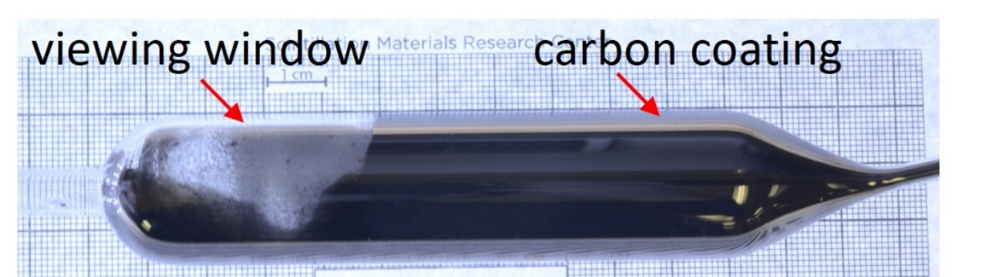
Figure 30. Carbon-coated 22 mm diameter ampoule used for growth of Cs₂ZnCl₄ sample HZ-01-02.

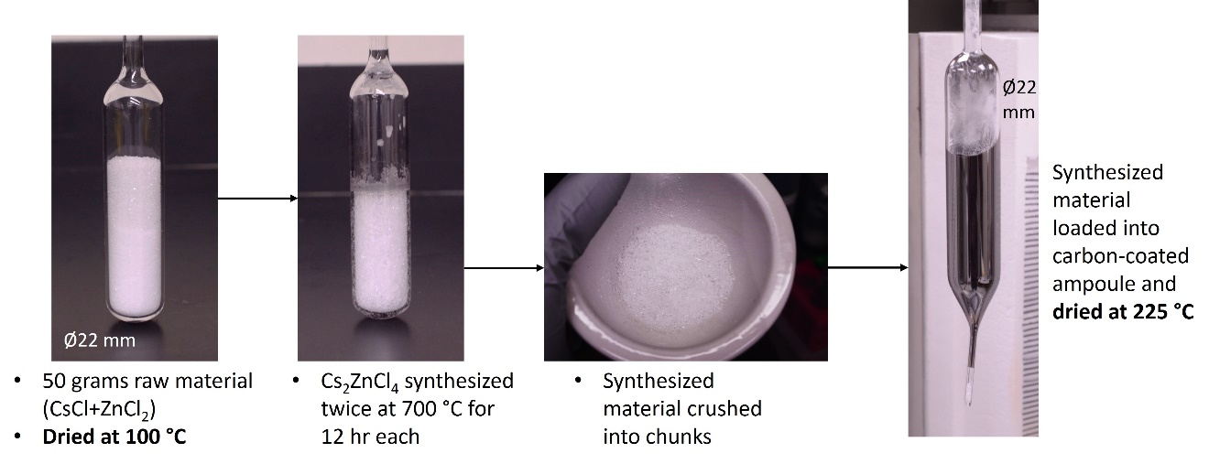
Figure 31. Modified synthesis procedure for growth of 22 mm diameter Cs₂ZnCl₄ sample HZ-01-02.

ground chunks were loaded into the carbon-coated growth ampoule, and vacuum drying was carried out at 225 °C.

Crystal growth for sample HZ-01-02 was carried out with the same parameters as HZ-01-01. The same growth furnace was used, with the hot and cold zones set to 650 °C and 400 °C, respectively (Cs₂ZnCl₄ T_{m} = 597 °C). The ampoule was translated at a rate of 0.5 mm/h and the grown crystal was cooled to room temperature over a 100-hr period. The result of this growth attempt was unsuccessful, producing a cracked crystal as is evident from Figure 32. The cracking appeared to originate in the cone section of the crystal. Further inspection of the capillary region (Figure 32) indicated improper seeding as the source. The capillary region is meant to act as a grain selector, preventing growth of multiple grains into the full diameter section of the ampoule. It is apparent from Figure 32 that the capillary section was entirely polycrystalline for the first attempt. To improve the conditions for seeding, the crystal was regrown with both temperature zones raised by 50 °C to ensure this section was fully melted at the start of the growth. All other parameters were kept the same. The result of this second attempt was the appearance of a single grain in the capillary and a nearly crack-free crystal (Figure 32).

The ~100 µm bubble-like defects were not observed in the crystal grown with modified parameters (HZ-01-02). This is apparent from Figure 33, which shows photographs of the cross sections of cylinders cut from crystal HZ-01-01 and HZ-01-02. The large band of defects near the edge of the HZ-01-01 crystal are not visible in the HZ-01-02 crystal.

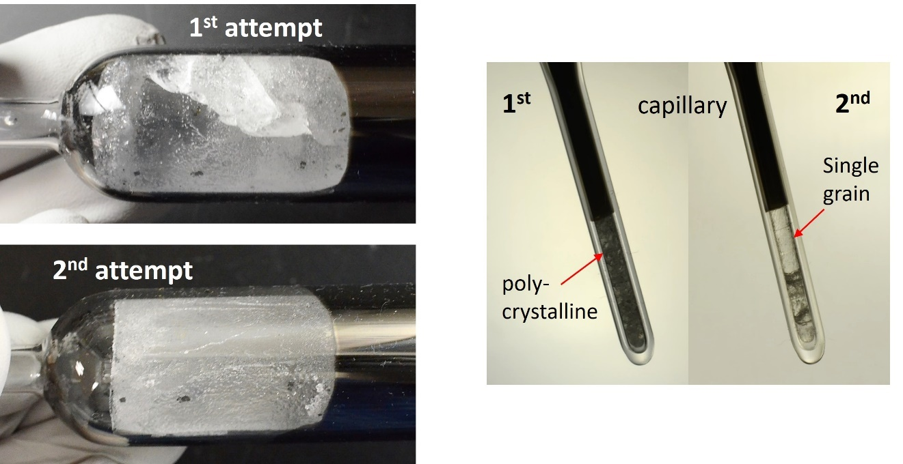
Figure 32. Comparison of 1st and 2nd growth attempts of sample HZ-01-02 showing severe cracking in the 1st as a result of poor seeding in the capillary section of the ampoule. Photographs of the backlit capillaries highlighting the polycrystalline nature vs the appearance of a single grain.

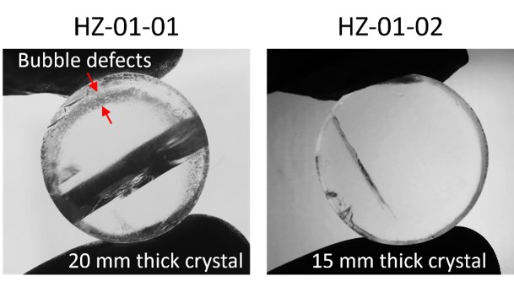
Figure 33. Cross section of two different 22 mm diameter Cs₂ZnCl₄ crystals showing the absence of large bubble-like defects around the perimeter of sample HZ-01-02.

To further assess the influence of synthesis and growth parameters on the formation of defects, several additional 22 mm diameter Cs₂ZnCl₄ crystals were grown. The main purpose of these experiments was to explore higher drying temperatures (300 °C) and slower translation rates (0.25 mm/h). Details are summarized in Table 6 for the two previously discussed samples (HZ-01-01 and -02) and three additional samples (HZ-01-03, -05, and -06).

For samples -03 and -05, the same synthesis and drying procedure shown in Figure 31 was used but with a higher drying temperature. Growth of HZ-01-05 was unsuccessful, yielding a severely cracked crystal. The most likely cause was traced back to a power outage that occurred during drying of the synthesized material, possibly exposing the material to oxygen. Growth of HZ-01-03 yielded a transparent and mostly crack-free crystal, which is pictured inside the ampoule in Figure 34. Unfortunately, the ampoule was later damaged during handling, causing the crystal to shatter into several pieces before any slices were cut from the boule to be analyzed. Still, no macroscopic defects were visible in the bulk of this crystal, indicating that slowing the translation rate can also help prevent the formation of large bubble-like defects. Growth of HZ-01-06 was successful (Figure 34), and characterization of this crystal will be presented next. Overall, growth experiments at the 22 mm diameter size have demonstrated the ability to reproducibly grow Cs₂ZnCl₄ crystals with little to no cracking, as can be seen in Figure 34, which is promising for further scale up efforts.

The Cs₂ZnCl₄ crystals grown in this work all tended to have a heavily textured surface, usually limited to one side of the crystal. This can be seen in the photographs shown in Figure 34 and Figure 35. This texturing does not present any practical concerns, as the surface can easily be smoothed by grinding and polishing; however, it is interesting to

Table 6. Summary of synthesis and growth details for different 22 mm diameter Cs₂ZnCl₄ crystals.
Sample ID | Growth ampoule | Vacuum drying | Drying temperature | Translation rate | Comments
HZ-01-01 | Quartz | Before synthesis | 100 °C | 0.5 mm/h
HZ-01-02 | Carbon coated quartz | Before + after synthesis | 225 °C | 0.5 mm/h
HZ-01-03 | Quartz | Before + after synthesis | 300 °C | 0.25 mm/h | Crystal damaged during handling
HZ-01-05 | Quartz | Before + after synthesis | 300 °C | 0.25 mm/h | Power outage occurred during vacuum drying
HZ-01-06 | Quartz | Before synthesis | 100 °C | 0.25 mm/h

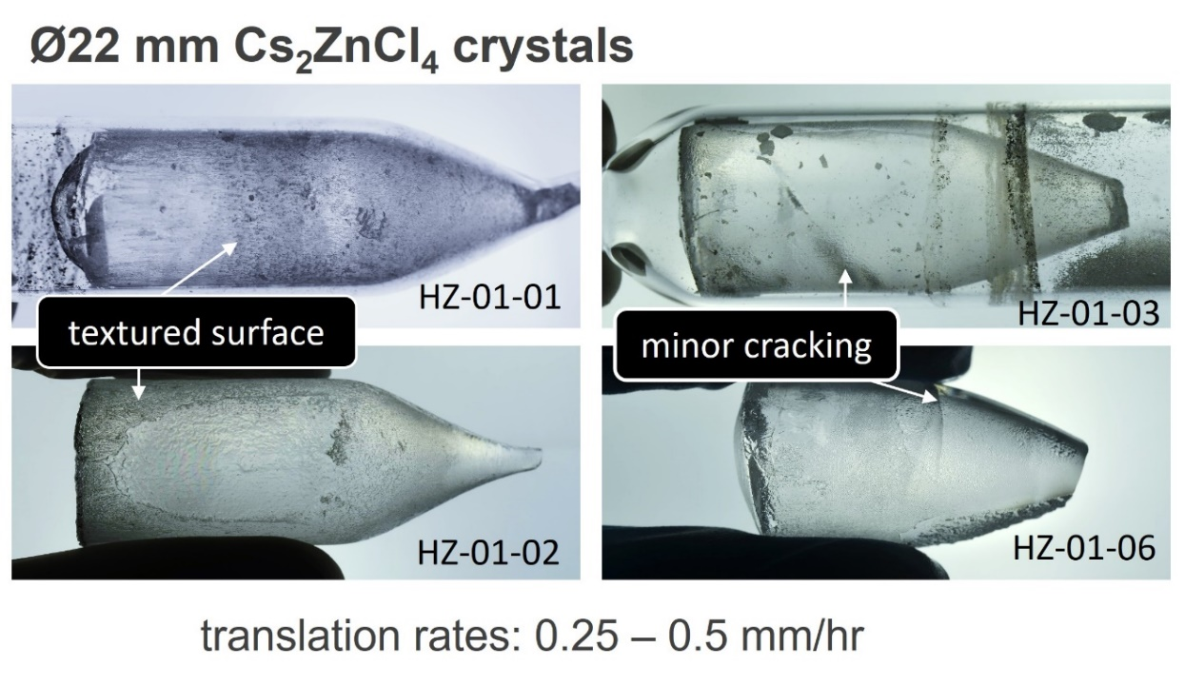
Figure 34. Photographs of backlit Cs₂ZnCl₄ crystals grown with different drying procedures and translation rates (summarized in Table 6).

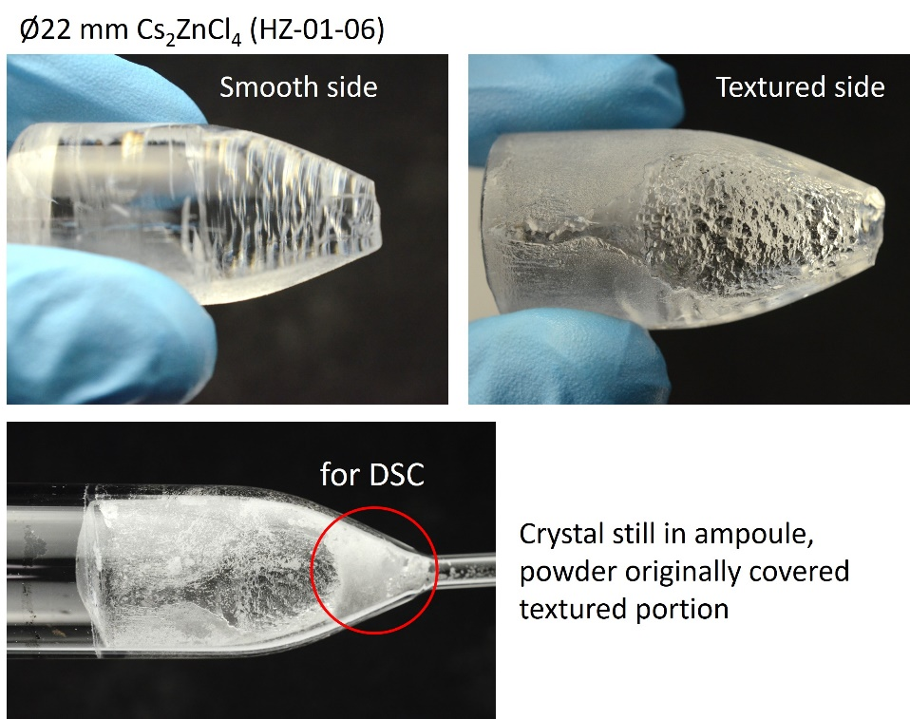
Figure 35. Photographs showing an example of the surface texture of some Cs₂ZnCl₄, as well as the presence of powder between the as-grown crystal and ampoule wall.

consider its origin and whether it can provide insights into the nature of defect formation.

The textured side was usually accompanied by a layer of powder between crystal and ampoule wall. A sample of this surface powder was obtained from HZ-01-06 for a DSC measurement to determine if it differs compositionally from the bulk and possibly shed light on the source of the defects observed in some crystals. The sample was measured inside a sealed quartz crucible to avoid loss of stoichiometry due to volatilization of the constituents. Two heating and cooling cycles were performed, with one at a rate of 5 K/min and one at 10 K/min.

The measured DSC curves are shown in Figure 36. There were no discernable features at temperatures below 500 °C. An exothermic peak corresponding to the reported melting point of Cs₂ZnCl₄ was observed with an onset at 593 °C. Additionally, a weak intensity peak can be seen at ~549 °C. This most likely corresponds to the eutectic reaction (Cs₂ZnCl₄ + Cs₃ZnCl₅) reported at 553 °C for the CsCl-ZnCl₂ system [120]. Overall, there appears to be very little deviation from the bulk composition near the surface of the crystal, despite the different physical appearance.

5.2.3 Characterization of Defects in Cs₂ZnCl₄ (HZ-01-06)

Slices were cut from sample HZ-01-06 to inspect by eye and with an optical microscope. Visible defects were present that appeared to be inclusions as opposed to the bubble-like defects previously observed in HZ-01-01. Additionally, those in HZ-01-01 were spherical whereas these new defects are highly irregular in shape. These were on the order of 10 to 100 microns in size and can be seen in the micrographs shown in

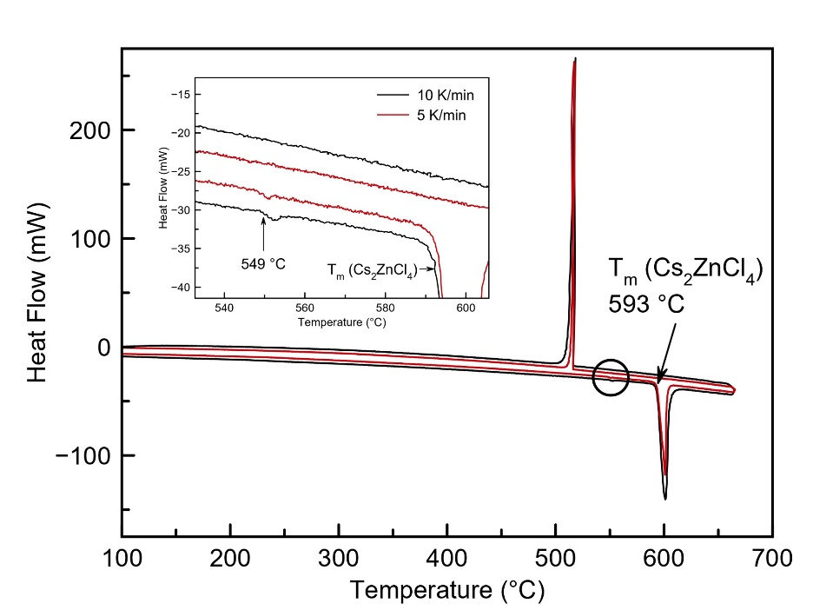
Figure 36. DSC curves of powder material obtained from the surface of crystal HZ-01-06. The inset shows a magnified view of the region indicated by a black circle.

Figure 37. The slices (22 mm in diameter) from HZ-01-06 were further analyzed with SEM and EDS to determine the composition of these defects.

Images and EDS scans were taken of several regions within the sample. Two representative defects are shown in Figure 38 and Figure 39. Area scans were performed on the defects as well as the surrounding bulk defect-free area. These are highlighted by red boxes in the figures. The only elements detected in the EDS spectra were Cs, Zn, and Cl, as expected. The measured concentrations from the different scans are listed in Table 7 and Table 8. The ratios all match closely with the stoichiometric Cs₂ZnCl₄ (28.6% Cs, 14.3% Zn, and 57.1% Cl) for scans of both the defects and bulk of the crystals, indicating little to no difference in composition between the two. It was initially hypothesized that these defects might be Cs-rich inclusions, similar to what has been observed in Cs₂HfCl₆ [58], or secondary phase precipitates of Cs₃ZnCl₅. Both can be ruled out based on the results of EDS scans.

One of the slices from sample HZ-01-06 was used for optical transmittance measurements to better understand how the presence of macroscopic defects might affect the transparency of the crystal. This is important especially from an application standpoint in that scintillators need to be transparent to their own emission to maximize light collection efficiency and detect the highest possible number of photons by the PMT or SiPM. Figure 40 shows a transmittance measurement for a 3 mm thick slab ranging from 200 nm to 800 nm. The max transmittance exceeds 90% above ~600 nm. Close to the peak emission for Cs₂ZnCl₄ (~285 nm), the transmittance is still quite good, staying above 80%. Several scans were taken in regions of both high and low defect concentration with consistent results in each case. This result is promising in that the transparency is not severely hindered despite the presence of defects.

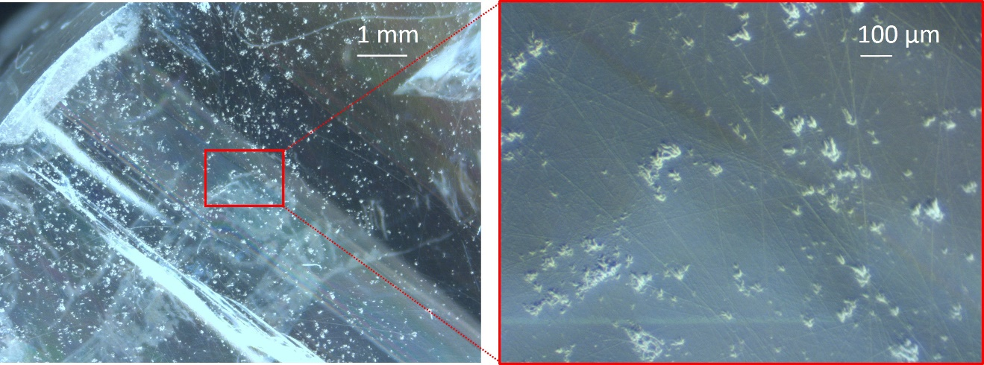
Figure 37. Optical microscope images of defects in Cs₂ZnCl₄ sample HZ-01-06.

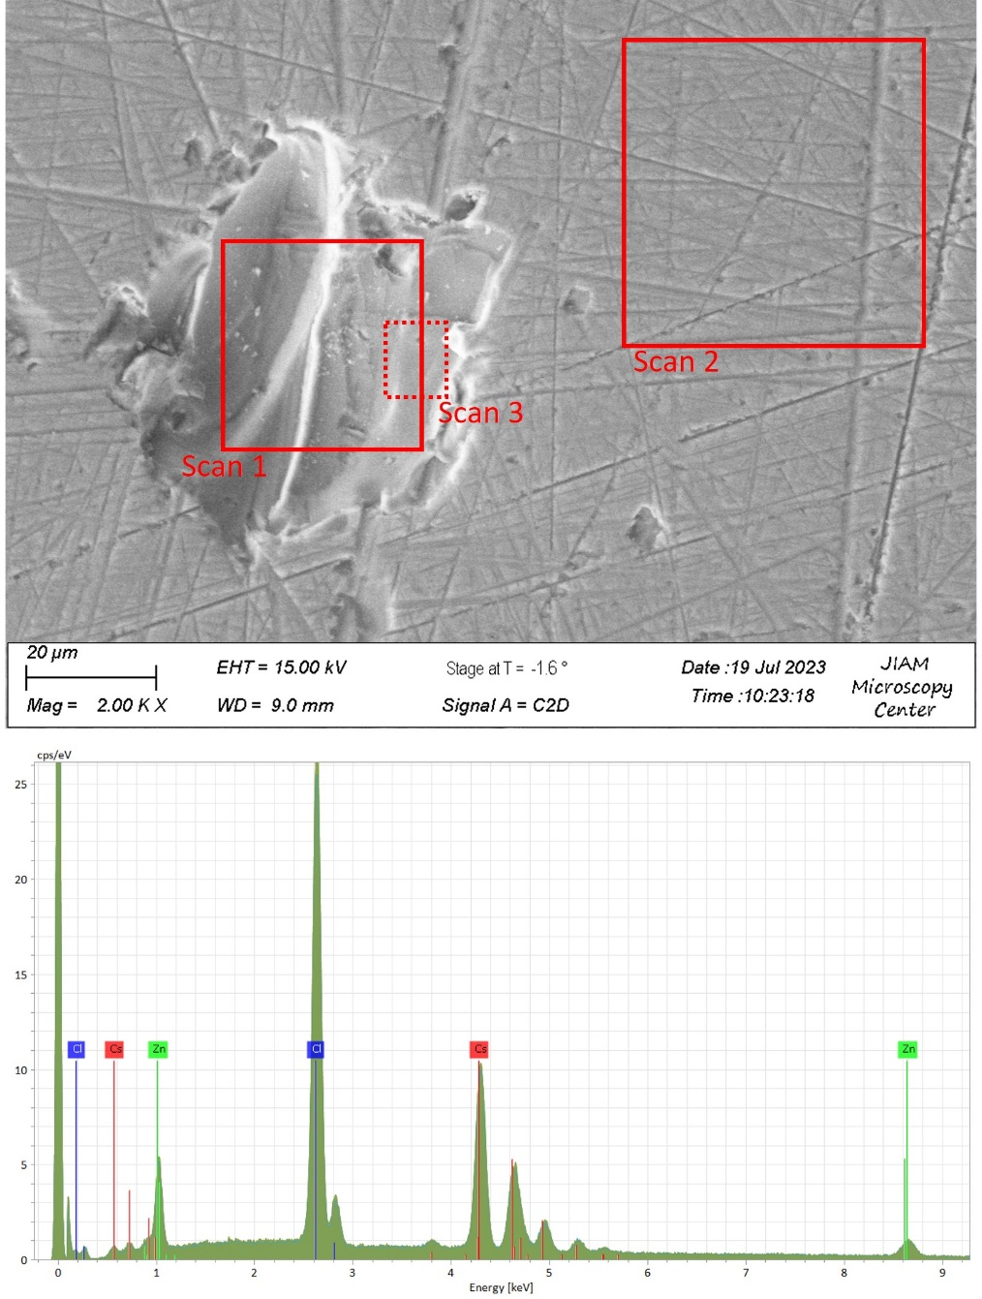
Figure 38. SEM image of a defect in Cs₂ZnCl₄ (sample HZ-01-06) and a representative EDS spectrum from the area scans marked by red boxes. Lines visible in the SEM image are scratches from the polishing process.

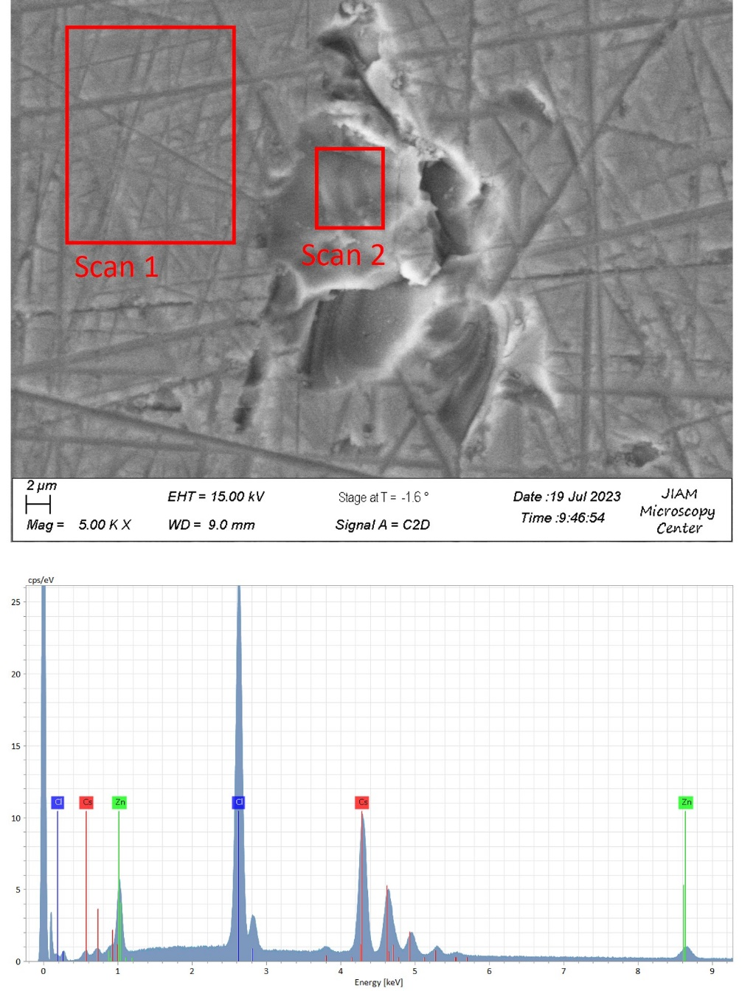
Figure 39. SEM image of a second defect in Cs₂ZnCl₄ (HZ-01-06) and a representative EDS spectrum from the area scans marked by red boxes. Lines visible in the SEM image are scratches from the polishing process.

Table 7. Molar concentrations of Cl, Zn, and Cs determined from EDS area scans corresponding to the regions highlighted in Figure 38. Values for stoichiometric Cs₂ZnCl₄ and Cs₃ZnCl₅ are included for comparison.
 | Chlorine | Zinc | Cesium
Scan 1 (defect) | 57.32% | 14.15% | 28.53%
Scan 2 (bulk) | 56.69% | 14.53% | 28.78%
Scan 3 (defect) | 55.22% | 14.36% | 30.42%
Stoichiometric Cs₂ZnCl₄ | 57.1% | 14.3% | 28.6%
Stoichiometric Cs₃ZnCl₅ | 55.6% | 11.1% | 33.3%

Table 8. Molar concentrations of Cl, Zn, and Cs determined from EDS area scans corresponding to the regions highlighted in Figure 39. Values for stoichiometric Cs₂ZnCl₄ and Cs₃ZnCl₅ are included for comparison.
 | Chlorine | Zinc | Cesium
Scan 1 (bulk) | 56.18% | 14.31% | 29.51%
Scan 2 (defect) | 55.71% | 15.17% | 29.13%
Stoichiometric Cs₂ZnCl₄ | 57.1% | 14.3% | 28.6%
Stoichiometric Cs₃ZnCl₅ | 55.6% | 11.1% | 33.3%

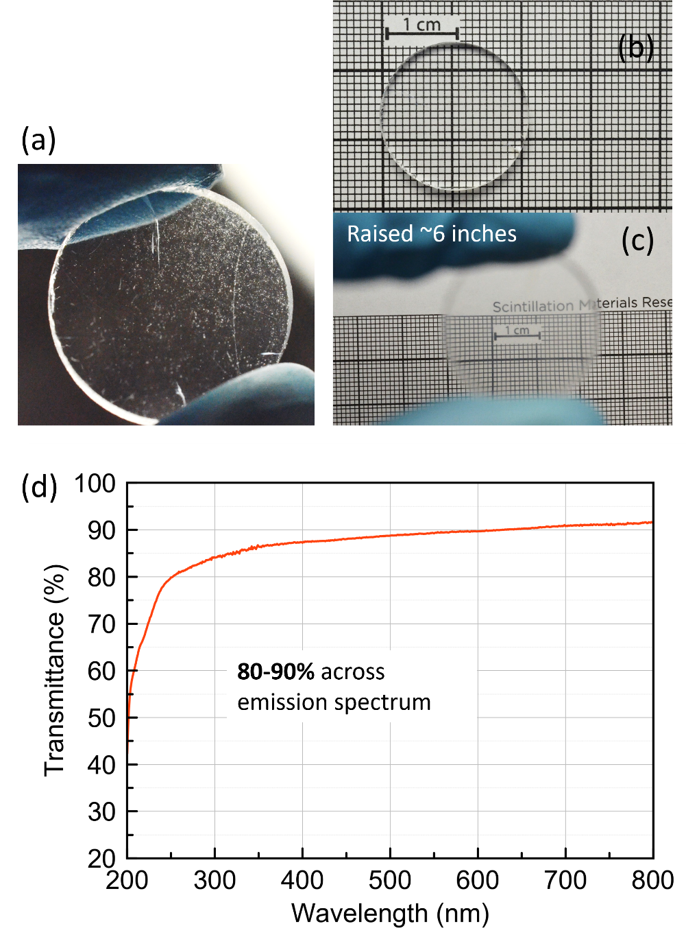
Figure 40. A ~3 mm thick slab cut from Cs₂ZnCl₄ sample HZ-01-06 showing (a) visible defects and change in apparent transparency when viewing (b) directly in contact with grid paper vs (c) elevated above. (d) measured optical transmittance of the same sample.

For most Cs₂ZnCl₄ crystals grown in this work, no visible luminescence could be observed when inspecting samples under excitation from a UV lamp (254 nm or 366 nm excitation). In contrast, sample HZ-01-06 showed blue-green emission under 254 nm excitation. This was almost entirely limited to the edge of the crystal, as can be seen in Figure 41. To investigate the origin of this luminescence and whether it may relate to the observed defects in the crystal, absorbance measurements were performed across the sample from the center to the edge (Figure 41). There were no noticeable differences between measurements (1) through (5). However, a low intensity absorption band was observed at 266 nm when measuring as close to the edge as possible (beyond position ‘5’). A similar band at 267 nm in undoped CsCl crystals grown from the melt and from water solution has previously been ascribed to OH⁻ [160, 161]. Based on this, it seems likely that there is OH⁻ present in the measured Cs₂ZnCl₄ crystal.

The two most likely sources of OH⁻ include (i) the presence of moisture in the ampoule leading to a reaction with the starting raw material and formation of cesium hydroxide (CsOH) or zinc hydroxide (Zn(OH)₂), for example or (ii) OH⁻ impurities in the quartz ampoule that diffused into the melt or growing crystal at elevated temperatures. In the former case, it is possible that these impurities were rejected toward the edge of the crystal during growth if the translation rate was sufficiently slow. The latter would also explain why the OH⁻ concentration would be higher closest to the ampoule wall. The origin and exact mechanism are still unclear; however, these results emphasize the importance of removal of oxygen and water in preventing unwanted impurities in the grown crystal that can affect uniformity and overall crystal quality.

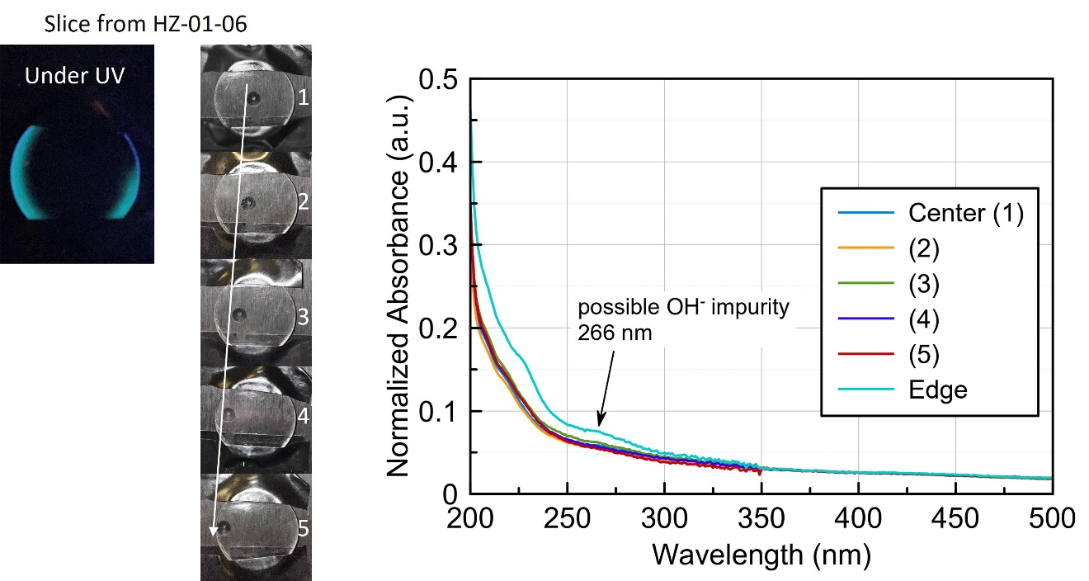
Figure 41. Photograph of a ~3 mm thick slice from Cs₂ZnCl₄ sample HZ-01-06 under 254 nm UV excitation and absorbance measurements from the labeled positions (1)-(5) from the center to the edge. An additional sixth measurement from the very edge was taken (labeled “Edge” in the legend).

5.3 Growth of 38 mm Diameter Cs₂ZnCl₄

5.3.1 Successful Growth of a Crack-free 38 mm Crystal
To demonstrate that growth is possible in sizes comparable to commercially produced scintillator crystals (typically 1” to 3” in diameter), growth of a 38 mm (1.5”) diameter Cs₂ZnCl₄ was pursued next. The results of experiments at the 22 mm size helped inform the decisions on what growth parameters to use. This mainly influenced the choice of translation rate, as this was the more straightforward strategy for avoiding the formation of bubble-like defects.

A 295-gram charge consisting of CsCl and ZnCl₂ was loaded into the 38 mm diameter quartz growth ampoule inside a glovebox. The material was then transferred to the vacuum station and dried at 100 °C for 36 hours. Melt-synthesis was then performed using a slightly modified procedure from that which was previously established. Rather than inverting the ampoule between steps, the use of temperature gradients and cycling between the hot and cold zones were employed during synthesis to promote mixing of the melt similar to the method described by Wei et al. in [162]. This was due to concerns over potential ampoule failure (i.e. quartz breaking) considering the much larger mass of the charge compared to previous samples. Melt-synthesis was carried out in a 3-zone furnace using the following procedure:

- 1st melt: 3-hour soak at 600 °C (all 3 zones), followed by 10-hour soak at 715 °C (all 3 zones). Cooled to room temperature over several hours.
- 2nd melt: 3-hour soak with top/middle/bottom zones set to 750/700/700 °C. Hot and cold zones were then flipped, 6-hour soak with top/middle/bottom zones set to 730/750/750 °C. Cooled to room temperature over several hours.
- 3rd melt: repeat of 2nd melt
Throughout this work, it was observed that a visual clue as to whether the synthesized Cs₂ZnCl₄ material is well-mixed is when the charge consists of large transparent crystallites. By comparison, it was often the case after the first melt-synthesis step that the charge appeared milky/chalky and opaque due to incomplete reaction of the precursor materials. Using the “zone cycling” approach described above, the resulting charge appeared well-mixed.

As was discussed in Chapter 1.4 Crystal Growth, the thermal gradient inside the growth furnace is one factor influencing the shape and stability of the solid-liquid interface. To allow for reproducibility, the thermal gradient for growth of 38 mm diameter Cs₂ZnCl₄ was measured and is shown in Figure 42. The gradient near the melting point of Cs₂ZnCl₄ was determined to be 23 °C/cm. A study on the effects of varying the thermal gradient was not carried out in the present work; however, the measured value is comparable to gradients typically reported for Bridgman growth of halide scintillator crystals, which tend to fall in the range of 15-40 °C/cm [23, 45, 159, 163-166]. In contrast, semiconductors can often be grown using shallower gradients around 5-15 °C/cm [167-170].

The as-grown 38 mm diameter Cs₂ZnCl₄ crystal is pictured in Figure 43. It was transparent and free of cracks with some texturing on the surface similar to what was observed in the 22 mm diameter crystals. Impressively, the crystal remained free of cracks throughout the cutting and polishing process. This is apparent from Figure 44, which shows side and top down views of the 38 mm crystal after removing the cone and last-to-freeze sections. Additionally, pieces with various geometries (ex. - discs, pixels, blocks) and sizes were able to be cut and polished while maintaining their mechanical integrity (Figure 45). The results of this growth are highly encouraging from a scalability perspective.
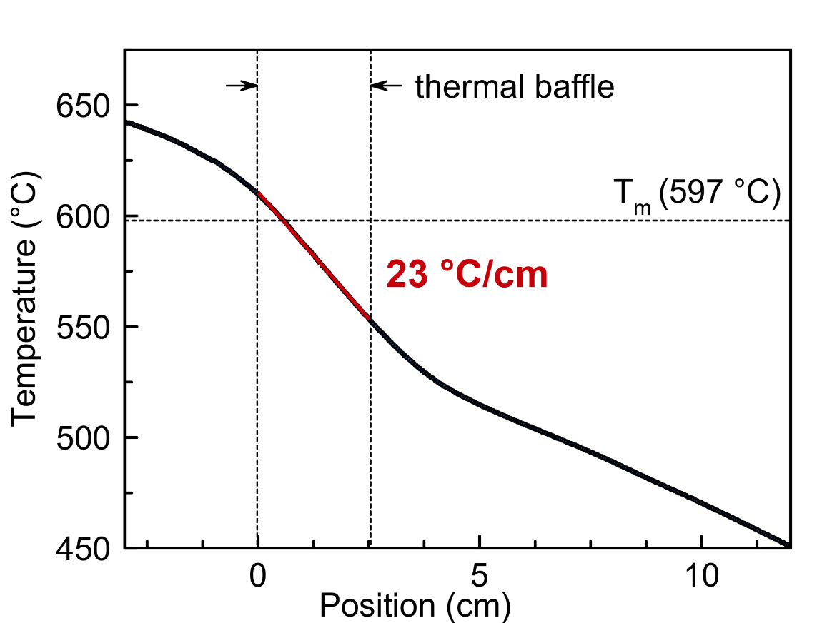
Figure 42. Thermal gradient measured for the furnace used to grow 38 mm diameter Cs₂ZnCl₄.

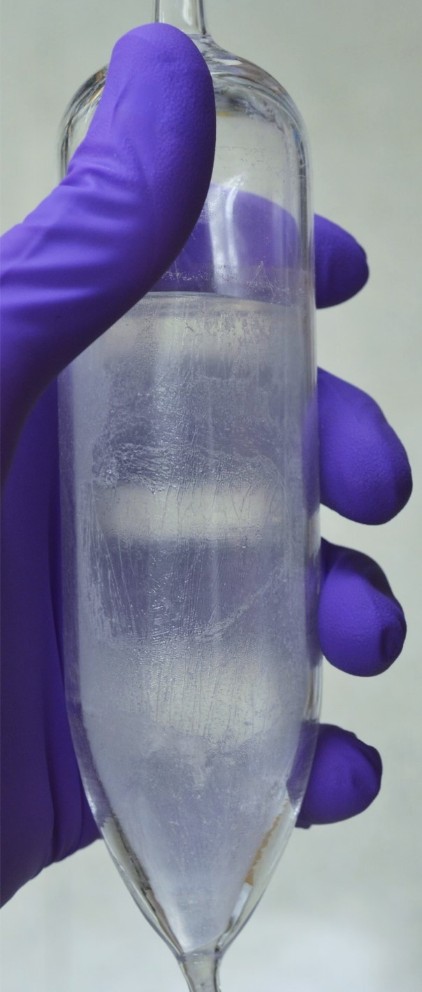
Figure 43. Photograph of as-grown 38 mm diameter Cs₂ZnCl₄ crystal inside the growth ampoule.

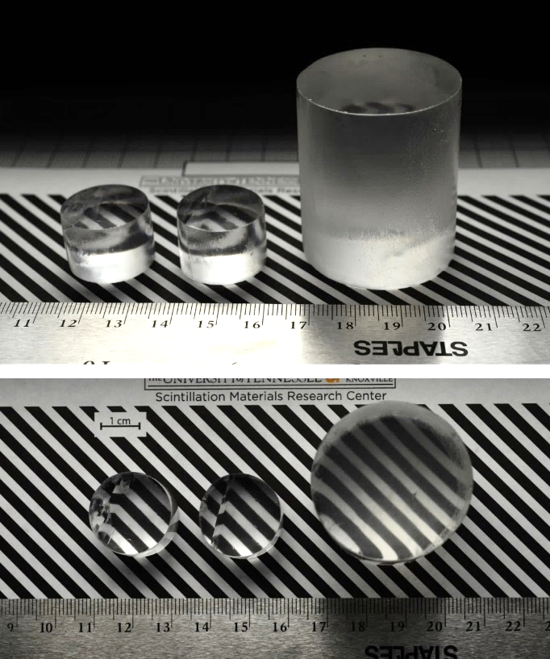
Figure 44. Photographs of cut and polished cylinders of 22 mm vs 38 mm diameter Cs₂ZnCl₄.

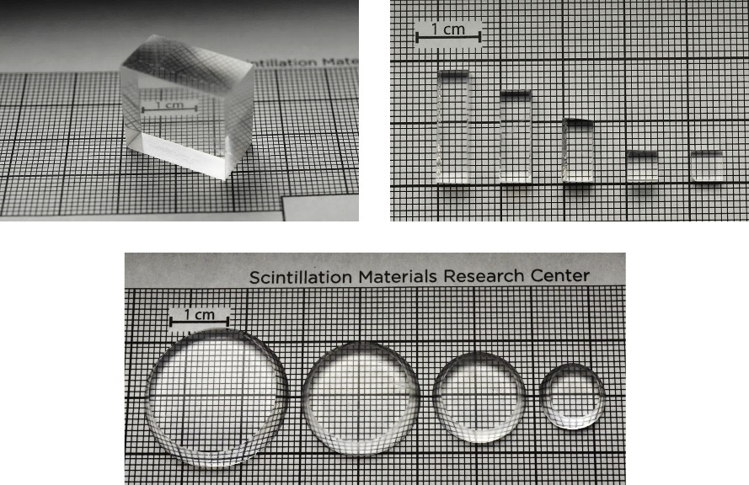
Figure 45. Photographs of various cut and polished pieces from the conical section of the 38 mm diameter Cs₂ZnCl₄ crystal.

5.3.2 Determination of Coefficients of Thermal Expansion (CTE)
Temperature dependent powder XRD of Cs₂ZnCl₄ was measured to determine the coefficients of thermal expansion (CTE). In particular, the degree of anisotropy in the CTE is an important consideration when growing crystals via the Bridgman method. This becomes critical during the cooldown stage since the crystal expansion is restricted by the ampoule walls. A high degree of anisotropy and large mismatch in thermal expansion with the ampoule material (quartz) can exacerbate cracking due to thermally induced stress. By understanding the thermal expansion behavior, steps can potentially be taken to mitigate this issue, specifically by orienting the crystal along the axis of lowest thermal expansion.

Powder XRD of Cs₂ZnCl₄ was measured from room temperature to 350 °C in 50 °C increments. Measurements were taken from low to high temperature, as well as in the reverse direction to confirm consistent results. Rietveld refinement was performed using the General Structure Analysis System (GSASII) software [129] to determine the lattice parameters at each temperature. The starting model for refinement of the room temperature dataset was based on the published data for the orthorhombic Pnma structure of Cs₂ZnCl₄ from [140]. Next, sequential refinement was performed using the refined lattice parameters at each temperature as the starting values for the next temperature refinement. Additional experimental details can be found in Chapter 4.2 X-ray Diffraction (XRD).

The CTE can be calculated by plotting the change in lattice parameter relative to the initial value, ∆l/l₀, as a function of temperature. A linear fit of this data will give a slope that is equal to the CTE, as can be seen from:

$$∆l/l_{0}= α_{1}∆T$$
where α₁ represents the linear CTE and has units of inverse temperature (K⁻¹). The measured diffraction patterns for each temperature are shown in Figure 46a and Figure 46b. No phase transitions were observed in this temperature range, which is consistent with the reported phase diagram [120] and previously presented DSC measurements (Chapter 5.1.1 Structural and Physical Properties). A shift in peak position to lower 2θ with increasing temperature is also apparent, corresponding to an increase in lattice parameter. This is also evident from Figure 47, which shows the refined lattice parameters as a function of temperature. From the linear fit of this data, the linear CTE values were determined to be $\overline{α}$_{a} = 3.34 × 10⁻⁵ K⁻¹, $\overline{α}$_{b} = 6.12 × 10⁻⁵ K⁻¹, and $\overline{α}$_{c} = 7.38 × 10⁻⁵ K⁻¹ for the measurements in the heating direction. The results were consistent for the cooling directions, as can be seen in Figure 47a and Figure 47b. A similar degree of anisotropy (roughly 2:1) as some commercially available halide scintillators (LaCl₃:Ce [171] and SrI₂:Eu [69]) is observed for Cs₂ZnCl₄. Values are summarized in Table 9. This is promising in that although it may present some challenges, the anisotropy of Cs₂ZnCl₄ is not expected to limit its potential scalability and mass production.

5.3.3 Light Collection with Long Aspect Ratio Crystals
The issue of self-absorption is a well-known problem for scintillators activated with rare-earth ions such as Eu²⁺, Ce³⁺, or Yb²⁺ [165, 172-177]. This issue arises due to the overlapping of excitation and emission bands that causes a portion of the emitted light to be absorbed by the crystal and later re-emitted. This has the effect of lengthening decay times and diminishing the light yield and becomes more pronounced with increasing crystal volume or dopant concentration.

In contrast, self-absorption in the classical sense is not expected for the CVL mechanism. However, absorption and scattering of the emitted light by defects in the crystal are still a possibility. To investigate this, the effects of crystal size on the scintillation properties
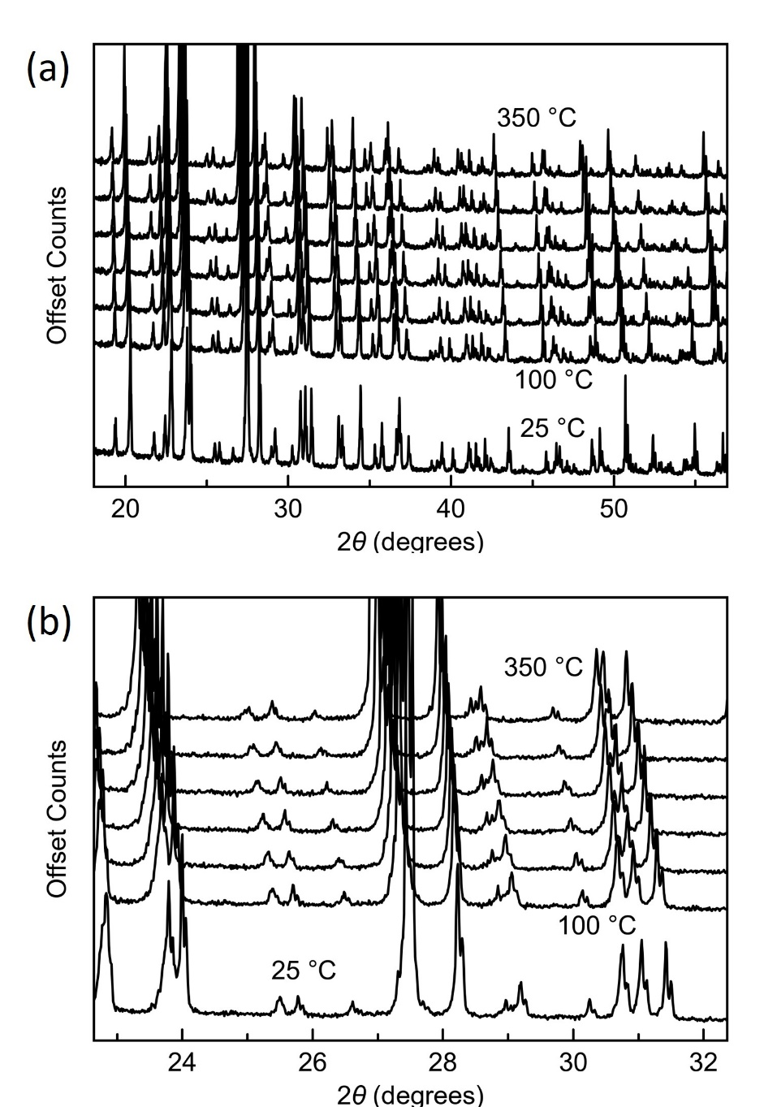
Figure 46. (a) Measured XRD patterns of Cs₂ZnCl₄ from 25 °C to 350 °C and (b) magnified view showing the shift in peak positions with increasing temperature.

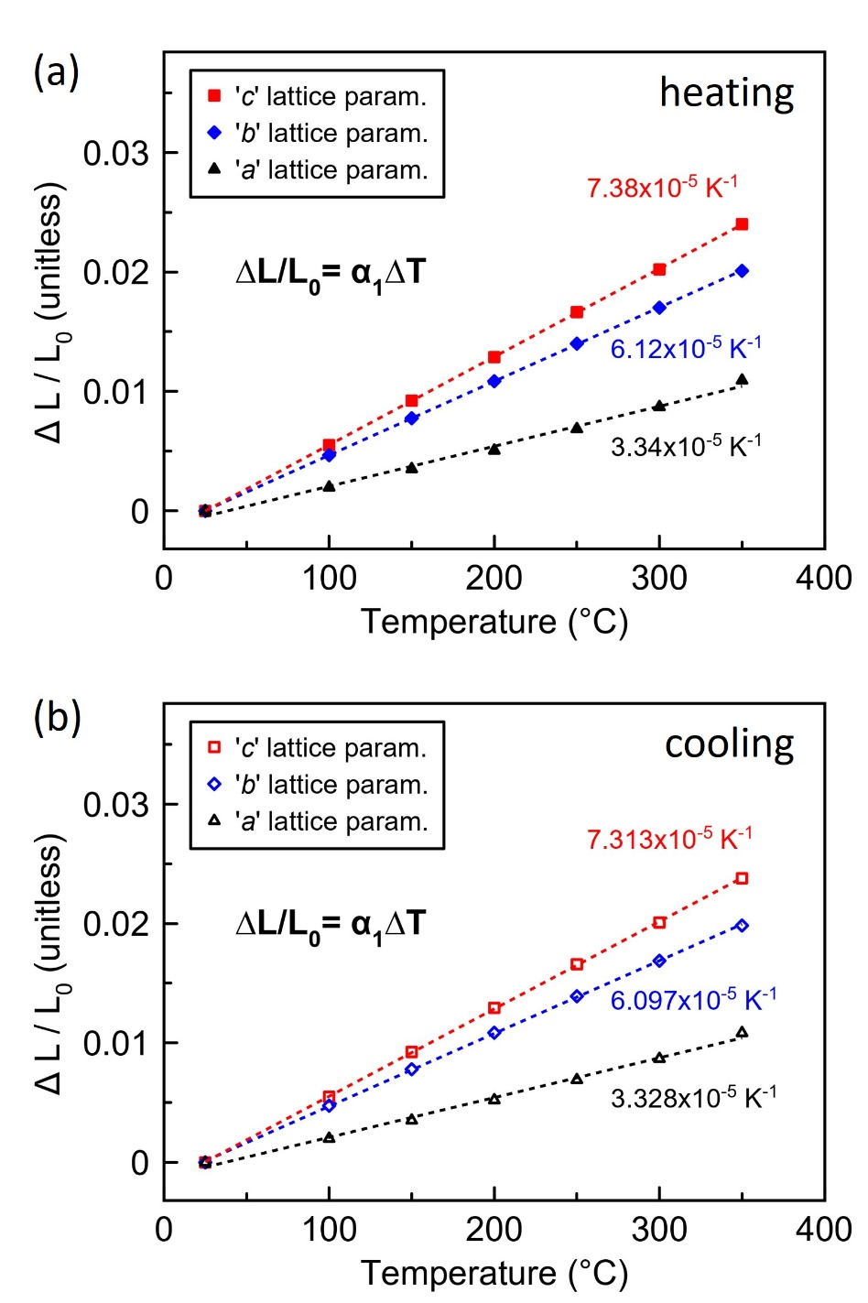
Figure 47. Refined lattice parameters as a function of temperature measured (a) from low to high temperature and (b) from high to low temperature. Error bars as calculated from Rietveld refinement were smaller than the data points and are therefore excluded.

Table 9. Linear CTE values for Cs₂ZnCl₄ determined from high temperature XRD and comparison of the degree of anisotropy with commercially available halide scintillators LaCl₃:Ce and SrI₂:Eu.
 | ᾱ_{a} (10⁻⁵ K⁻¹) | ᾱ_{b} (10⁻⁵ K⁻¹) | ᾱ_{c} (10⁻⁵ K⁻¹) | ᾱ_{a} / ᾱ_{b} | ᾱ_{a} / ᾱ_{c} | ᾱ_{b} / ᾱ_{c}
Cs₂ZnCl₄ (orth.) | 3.34 | 6.12 | 7.38 | 0.55 | 0.45 | 0.83
LaCl₃:Ce (hex.) | 2.5 | 2.5 | 1.1 | 1 | 2.3 | 2.3
SrI₂:Eu (orth.) | 1.55 | 2.16 | 0.92 | 0.7 | 1.7 | 2.3

were explored for Cs₂ZnCl₄. Cylinders of varying size were obtained from 7 mm, 22 mm, and 38 mm diameter crystals. Light yield and scintillation decay time were measured, and the results are shown in Figure 48a and Figure 48b. The light yield decreases by ~61% in going from the smallest volume (LY = 1,980 ph/MeV) to largest volume (LY = 770 ph/MeV). As was discussed in Chapter 5.1.3, the deterioration of light yield is likely due to losses associated with light collection inefficiencies and other non-radiative processes, such as absorption of light by non-luminescent ions and defects in the crystal. Again, this explains why the decay time does not lengthen with increasing volume (Figure 48b) since the light is completely lost rather than re-emitted as is the case with typical self-absorption.

To further investigate the volume dependence of the light yield, five Cs₂ZnCl₄ pixels each having a 5 × 5 mm² cross section with varying length ‘L’ were measured. The samples had lengths of 2 mm, 5 mm, 10 mm, 15 mm, and 18 mm. The effects of crystal orientation and reflector geometry were also tested. Three configurations were compared and are illustrated in Figure 49. For Configuration (1), the long face of the crystal was coupled to the PMT (i.e. horizontal) and Teflon sheets were tented overtop of the sample. For Configuration (2), the 5 × 5 mm² face was coupled to the PMT (i.e. vertical) and Teflon sheets were again tented over the sample. Configuration (3) was similar to number (2), however, the crystals were instead directly wrapped in several layers (~ 1 mm thick) of Teflon. In each case, the crystals were coupled to the PMT using a thin layer of mineral oil. For the 5 × 5 × 2 mm³ and 5 × 5 × 5 mm³ samples, there was no difference between Configurations (1) and (2) since they had no “long” face.

Light yields were measured relative to the smallest sized pixel and are plotted in Figure 49. The least amount of deterioration occurs with the crystals oriented horizontally. The greatest amount of deterioration occurred with the crystals oriented vertically and
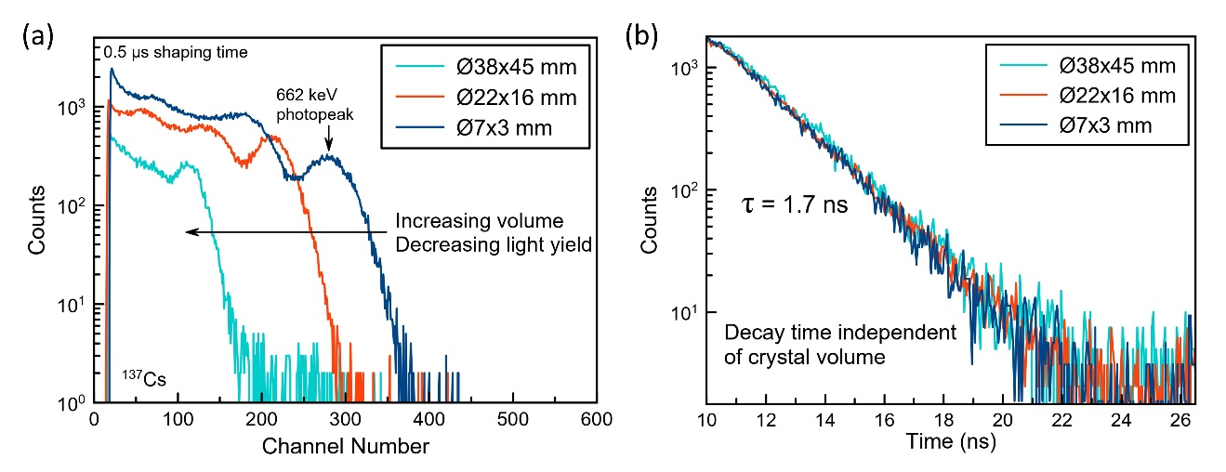
Figure 48. Effects of crystal size on light yield and scintillation decay time for Cs₂ZnCl₄.

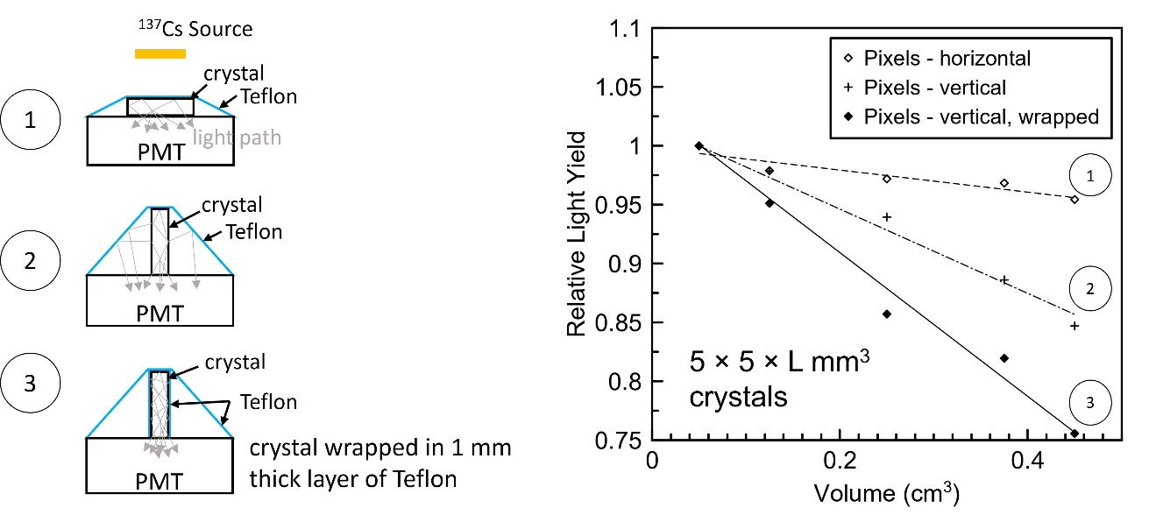
Figure 49. Effects of crystal orientation and reflector positioning on light yield for Cs₂ZnCl₄ pixels with a 5 x 5 mm² cross section and varying length.

directly wrapped in Teflon. The light loss per unit length was quantified from a linear fit to the data to be ~1.5% per mm for the Teflon-wrapped measurements. Similar light losses were reported for commercially produced scintillators LSO:Ce,Ca (2.6% per mm) and LGSO:Ce (1% per mm) in [178] for dimensions 2 × 2 × L mm³.

Considering the measurements of Cs₂ZnCl₄ performed in the vertical orientation (both wrapped and unwrapped), the emitted light is more likely to have to travel a longer distance within the crystal. This increases the probability that the light either gets reabsorbed or is scattered by defects or imperfections in the crystal. The reflectivity of the Teflon should also be considered, as it is likely less efficient near UV wavelengths. Given that the emission spectrum of Cs₂ZnCl₄ extends below 300 nm, this may explain the significant drop in light yield when directly wrapping the crystals. The reflectivity of the Teflon used in this work is unknown, but in general Teflon can drop below 90% at wavelengths shorter than ~300 nm [179, 180]. Overall, the results of this experiment suggest that some of the light losses associated with increasing crystal volume may be avoided by strategic design of the crystal geometry, orientation, and reflector material.

5.4 Conclusions

In this work, we report on the crystal growth, physical properties, and scintillation properties of undoped Cs₂ZnCl₄ and Cs₃ZnCl₅. These materials may be advantageous over BaF₂ for gamma and X-ray detection due to longer emission wavelengths that are more suitable to the spectral sensitivity range of common photodetectors, as well as their fast decay times with the absence of slow components (refer to Table 5 for a more detailed comparison of properties). Highly transparent Ø7 mm single crystals of Cs₂ZnCl₄ and Cs₃ZnCl₅ were grown using the Bridgman method. The crystals were non-hygroscopic and phase pure. They have light yields that exceed those previously reported by 55% and 232%, respectively, when irradiated with a 662 keV ¹³⁷Cs source. An impressive timing resolution was also achieved with Cs₂ZnCl₄, with a CTR of 148 ± 1 ps FWHM for a 3×3×5 mm³ crystal measured against an LSO:Ce reference and 136 ± 2 ps FWHM for two Ø7 mm × 3 mm thick Cs₂ZnCl₄ crystals measured against each other.

The linear CTE values of Cs₂ZnCl₄ were determined from temperature dependent XRD and were $\overline{α}$_{a} = 3.34 × 10⁻⁵ K⁻¹, $\overline{α}$_{b} = 6.12 × 10⁻⁵ K⁻¹, and $\overline{α}$_{c} = 7.38 × 10⁻⁵ K⁻¹. Considering the anisotropic thermal expansion, future growth experiments should explore the use of oriented seed crystals and the effects on cracking. Nonetheless, the degree of anisotropy for Cs₂ZnCl₄ is similar to that of some commercially available halide scintillators and is not expected to be a major obstacle to overcome.

It is recommended that future work involves conducting a more systematic study to identify and eliminate visible defects in Cs₂ZnCl₄. Given the time constraints, duration of each growth, and other focus areas of this dissertation (Chapter 6 and Chapter 7), not all of the growth challenges could be completely solved yet. However, the successful growth of a crack-free Ø38 mm Cs₂ZnCl₄ is encouraging moving forward and demonstrates that scale up to commercial sizes is possible.

Discovery of New Cesium Magnesium Chloride CVL Crystals

A version of this chapter has been submitted to a peer-reviewed journal by Daniel Rutstrom with the approval of his coauthors. Minor changes have been made to improve the flow within the context of this dissertation. The full citation for the submitted manuscript is as follows: Daniel Rutstrom, Luis Stand, Dylan Windsor, Haixuan Xu, Maciej Kapusta, Charles L. Melcher, Mariya Zhuravleva, “New Ultrafast Scintillators with Core Valence Luminescence: Cs₂MgCl₄ and Cs₃MgCl₅” Journal of Materials Chemistry C, 2024, submitted for review. The author would like to thank the coauthors for their contributions to this work.

The favorable properties of Cs₂ZnCl₄ and Cs₃ZnCl₅ (Chapter 5.1 Improved Performance and Growth of Large-volume Crystals) have prompted us to search for new scintillators with similar structure and chemistry in an effort to (i) discover materials with superior light yield or decay time and (ii) add to the list of known CVL materials so that relationships between composition, electronic structure, and scintillation properties can be better understood, possibly allowing higher-performance scintillators to be designed and developed more efficiently in the future.

So far, reports of core valence luminescence in compounds of the types Cs₂MCl₄ and Cs₃MCl₅ (M = alkaline earth metal or transition metal ion) are limited to Cs₂ZnCl₄ [114, 117-119, 132, 181], Cs₂BaCl₄ [97, 113], and Cs₃ZnCl₅ [114, 132]. Although structural and physical properties have been the topic of several studies [138, 139, 182], there are no reports of scintillation properties for Cs₂MgCl₄ and Cs₃MgCl₅. Due to the presence of CsCl and compositional similarities to scintillators such as Cs₂ZnCl₄, Cs₃ZnCl₅, and CsMgCl₃ [82, 97, 183] we expect these compounds will also scintillate and show ultrafast core valence luminescence.

In this work, single crystals of Cs₂MgCl₄ and Cs₃MgCl₅ (both in sizes of Ø7 and Ø12 mm) are grown by the vertical Bridgman technique and evaluated for use as gamma-ray or X-ray detectors. Phase analysis of the grown crystals is carried out using X-ray diffraction (XRD) to ensure the intended compounds are formed and that crystals are phase pure. Scintillation properties (radioluminescence, decay time, light yield) are characterized to determine if Cs₂MgCl₄ and Cs₃MgCl₅ crystals scintillate, assess how their performance compares to existing materials, and to confirm whether CVL is the mechanism responsible for scintillation. Due to the relevance to fast timing applications, coincidence time resolution (CTR) is also investigated. Finally, density functional theory (DFT) is used to calculate electronic band structures to determine if the energy condition (E_{vc} < E_{g}) required for CVL is satisfied for Cs₂MgCl₄ and Cs₃MgCl₅.

6.1 Crystal Growth

Figure 50 shows photographs of the grown Cs₂MgCl₄ and Cs₃MgCl₅ crystals. The purpose of the larger diameter crystals was mainly to assess scalability of growth. The crystals are colorless and transparent with some minor cracking mostly near the surface. Cracking appears to be worse in the A₃MX₅-type crystal, which is also what we observed previously for the Zn-containing analogues [132]. Based on these observations, Cs₂MgCl₄ may be the more promising crystal for scale up purposes. Optimization of growth parameters for both crystals would likely yield better results (i.e. less cracking), but this was outside the scope of the present work.

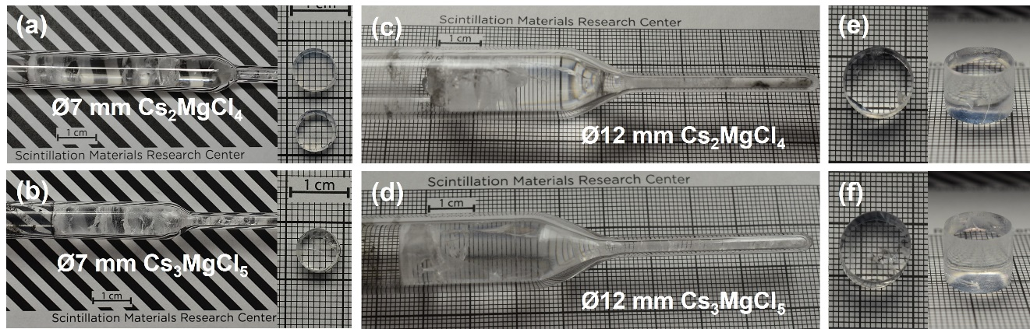
Figure 50. Top row of photographs (a)(c)(e): Cs₂MgCl₄ crystals. Bottom row of photographs (b)(d)(f): Cs₃MgCl₅ crystals. (a)(b) as-grown (left) Ø7 mm crystals and ~4 mm thick slabs (right) that were cleaved from the boules and polished. (c)(d) as-grown Ø12 mm crystals. (e)(f) ~10 mm tall cylinders cut from the Ø12 mm boules and polished.

XRD measurements confirmed the phase purity of the grown crystals. The orthorhombic crystal structure (space group Pnma) was obtained for Cs₂MgCl₄, which is apparent from matching measured and simulated patterns in Figure 51a. The reported lattice parameters of Cs₂MgCl₄ are a = 9.777(4) Å, b = 13.234(6) Å, and c = 7.514(3) Å (V = 972.23 Å³) and the calculated density is 2.95 g/cm³ [138]. The structure consists of isolated [ZnCl₄]²⁻ tetrahedra and two separate Cs sites with coordination numbers (CN) of CN = 8 and CN = 9 for the Cs1 and Cs2 sites, respectively. The structure and space group are the same as those of the CVL scintillator Cs₂ZnCl₄, which has a slightly smaller unit cell with lattice parameters a = 9.7577(15) Å, b = 12.9704(16) Å, and c = 7.4004(10) Å (V = 936.6 Å³) despite the larger ionic radius of Zn²⁺ (0.6 Å for CN = 4) compared to Mg²⁺ (0.57 Å for CN = 4) [140, 184].

The measured XRD pattern for the Cs₃MgCl₅ crystal also matches closely with the simulated pattern, shown in Figure 51b. Cs₃MgCl₅ is isostructural with the CVL scintillator Cs₃ZnCl₅, both adopting the tetragonal structure (space group I₄/mcm). This structure also consists of isolated [ZnCl₄]²⁻ tetrahedra and two separate Cs sites, but in this case with CN = 8 and CN = 10 for the Cs1 and Cs2 sites, respectively. The reported lattice parameters of Cs₃MgCl₅ are a = b = 9.23 Å and c = 14.88 Å (V = 1267.67 Å³) and its calculated density is 3.14 g/cm³ [139]. Similar to the A₂MX₄ compounds, the unit cell volume for the Zn-containing compound is smaller than that of the Mg-containing despite the larger ionic radius of Zn²⁺. Lattice parameters for the isostructural Cs₃ZnCl₅ are a = b = 9.2421(18) Å and c = 14.4928(15) Å (V = 1237.92 Å³) [141]. This data is summarized in Table 10.

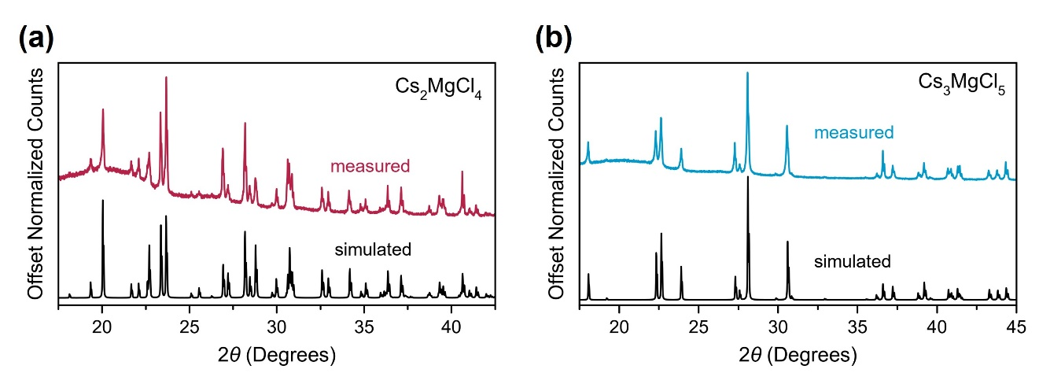
Figure 51. (a) Measured powder XRD pattern of Cs₂MgCl₄ compared to the simulated pattern generated using the Vesta software package. (b) Measured powder XRD pattern of Cs₃MgCl₅ compared to the simulated pattern generated using the Vesta software package [142]. The broad amorphous peak around 20° originates from the protective Kapton film.

Table 10. Crystal structures and reported lattice parameters of Cs₂MgCl₄ and Cs₃MgCl₅ compared to those of CVL scintillators Cs₂ZnCl₄ and Cs₃ZnCl₅.
Composition | Crystal structure | Lat. Param., a (Å) | Lat. Param., b (Å) | Lat. Param., c (Å) | Ref.
Cs₂ZnCl₄ | orthorhombic | 9.7577(15) | 12.9704(16) | 7.4004(10) | [140]
Cs₂MgCl₄ | orthorhombic | 9.777(4) | 13.234(6) | 7.514(3) | [138]
Cs₃ZnCl₅ | tetragonal | 9.2421(18) | 9.2421(18) | 14.4928(15) | [141]
Cs₃MgCl₅ | tetragonal | 9.23 | 9.23 | 14.88 | [139]

DSC of Cs₂MgCl₄ and Cs₃MgCl₅ was measured to confirm the reported congruent melting of these compounds [123, 128, 185, 186], which is favorable for melt growth techniques such as the Bridgman method. A single endothermic and single exothermic peak are observed in the DSC curves of each (Figure 52a) indicating congruent melting (a eutectic reaction can be ruled out per results of XRD). Also evident from DSC is the lack of any solid-solid structural phase transitions, which can negatively impact optical transparency or cause stress-induced cracking during post-growth cooling of the crystal. Melting points were also determined from DSC and are consistent with reported values. The onset of melting measured for Cs₂MgCl₄ was 551 °C (reported T_{m} = 545 °C) and for Cs₃MgCl₅ was 525 °C (reported T_{m} = 527 °C) [123].

DVS measurements reveal that Cs₂MgCl₄ and Cs₃MgCl₅ are slightly hygroscopic. This is apparent from Figure 52b, which shows a ~2.4% mass gain for Cs₂MgCl₄ and ~1.1% mass gain for Cs₃MgCl₅ after 5 hours at 40% relative humidity at room temperature. Compared to many other common halide scintillators (NaI:Tl, for example), this is still a relatively low degree of hygroscopicity. While performing measurements of scintillation properties with samples exposed to air for ~30 minutes at a time, the only noticeable effect was the formation of a thin white film on the surface that made the crystals appear more translucent. However, this film was easily polished away. To verify that the hydrated layer had no effect on the measured scintillation properties, a light yield measurement was performed in air over an 18-hour period with no change in photopeak shape or position observed. Additionally, during overnight CTR measurements, the first few data points (i.e. first few LE values) were repeated after completing the initial series to verify the performance had not changed due to long term air exposure. In the case of overnight measurements, the optical coupling (mineral oil or Viscasil optical grease) preserved the transparency of the crystal face in contact with the photosensor, allowing the emitted light to escape despite the sides and top of the
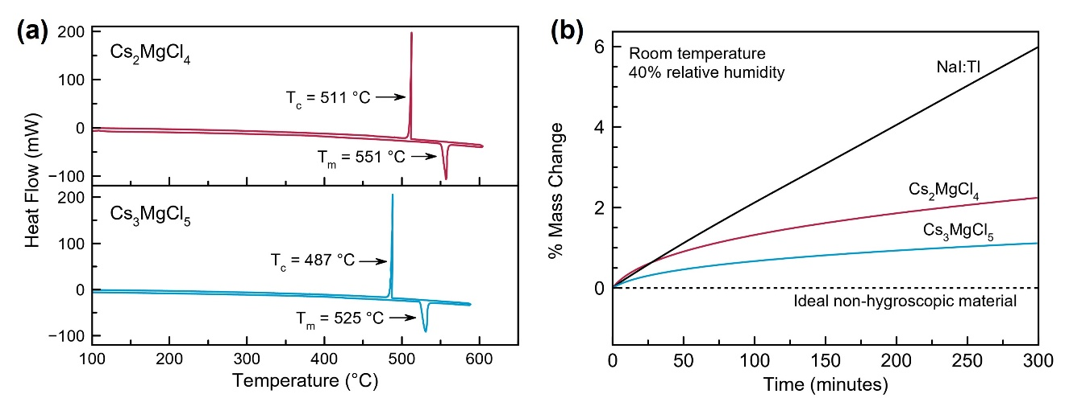
Figure 52. (a) DSC curves showing the melting and solidification behavior of Cs₂MgCl₄ and Cs₃MgCl₅. The endothermic direction is down. (b) DVS water sorption curves of Cs₂MgCl₄ and Cs₃MgCl₅ at 40% relative humidity compared with NaI:Tl.

crystal turning opaque. Given that Cs₂MgCl₄ and Cs₃MgCl₅ are considerably less hygroscopic than the widely employed NaI:Tl, simple hermetic packaging methods would allow their use in real detector systems without major concerns of instability.

6.2 Radioluminescence

Figure 53 shows the X-ray excited emission spectra (radioluminescence) of Cs₂MgCl₄ and Cs₃MgCl₅. To our knowledge, this is the first instance of scintillation reported for either compound. The emission being primarily positioned in the UV region is consistent with CVL observed in other CsCl-based crystals [80, 82, 97, 187]. Likewise, the longer wavelength emission of Cs₂MgCl₄ and Cs₃MgCl₅ compared to fluoride materials (such as BaF₂) is beneficial when considering compatibility with commonly used SiPMs and PMTs that have poor spectral sensitivity in the VUV region where many fluorides emit.

The dominant emission band for Cs₂MgCl₄ is centered near 295 nm, with a lower intensity shoulder around 360 nm (Figure 53). Besides having slightly broader less resolved peaks and being redshifted by several nm, the position and structure closely resemble the emission spectrum of the CVL scintillator Cs₂ZnCl₄ [132]. The emission spectrum of Cs₃MgCl₅ on the other hand consists of two main bands with maxima at 242 nm and 302 nm, with a third band near 425 nm. Similarly, three emission bands with nearly identical position and structure are observed with the Zn-containing analogue, Cs₃ZnCl₅ [132].

It has been established that the number of peaks in the CVL emission spectrum depends on the CN of the CVL-active cation, with the spectra becoming more complicated as CN increases from CN = 6 (1 band) to CN = 8 (2 bands) to CN = 12 (complex structure) [7, 71]. This could explain why the number of emission bands differs between the A₂MX₄-
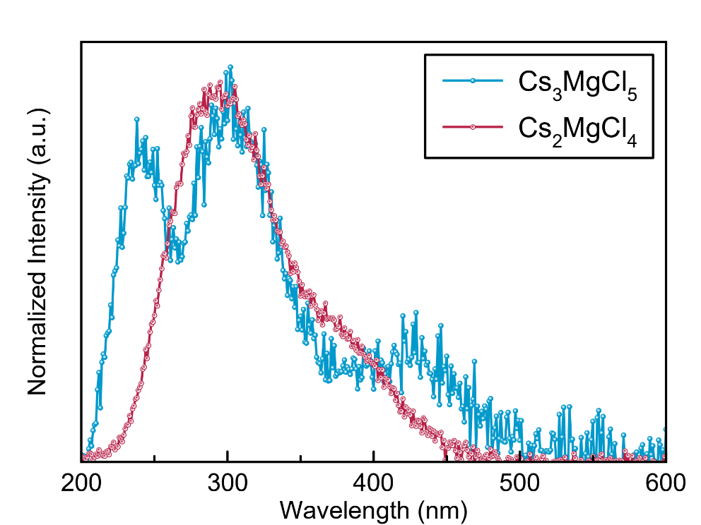
Figure 53. Radioluminescence emission spectra of Cs₂MgCl₄ and Cs₃MgCl₅ crystals at room temperature.

type crystals (2 bands) and A₃MX₅-type crystals (3 bands). As discussed previously, both structures contain two separate Cs sites, however, the CN for the Cs2 site is larger in the A₃MX₅-type structure (CN = 10) than in the A₂MX₄-type structure (CN = 9). Additionally, given that CVL spectra are known to reflect the valence band density of states [7], these results might indicate similar electronic band structures for the analogous Mg- and Zn-containing crystals if in fact the scintillation in Cs₂MgCl₄ and Cs₃MgCl₅ also originates from CVL.

6.3 Scintillation Decay Time

The measured scintillation decay time profiles of Cs₂MgCl₄ and Cs₃MgCl₅ are shown in Figure 54a, along with a BaF₂ reference (United Crystals), with both crystals exhibiting ultrafast timing characteristics typical of CVL. The decay constants of Cs₂MgCl₄ and Cs₃MgCl₅ were determined to be 2.25 ± 0.05 ns and 1.46 ± 0.05 ns, respectively. The decay constant for the fast component of BaF₂ was determined to be 0.62 ± 0.05 ns and agrees closely with the established range between 0.6 ns and 0.8 ns. The time constants were obtained by fitting a convolution of the instrumental response with a single-exponential function (double-exponential for BaF₂), shown in Figure 54b and Figure 54c. The absence of any slow components for Cs₂MgCl₄ and Cs₃MgCl₅ is advantageous for high count rate environments in which pulse pile up must be avoided and where the slow component of BaF₂ (630 ns) is problematic.

The decay times of Cs₂MgCl₄ and Cs₃MgCl₅ are comparable to other ternary CsCl-based CVL crystals, providing further evidence that the emission can be attributed to core valence luminescence. Examples include CsCaCl₃ (2.47 ns) [97], CsMgCl₃ (2.36 ns) [97], Cs₂BaCl₄ (1.68 ns) [97], Cs₂ZnCl₄ (1.66 ns) [132], and Cs₃ZnCl₅ (0.82 ns) [132]. Similar to

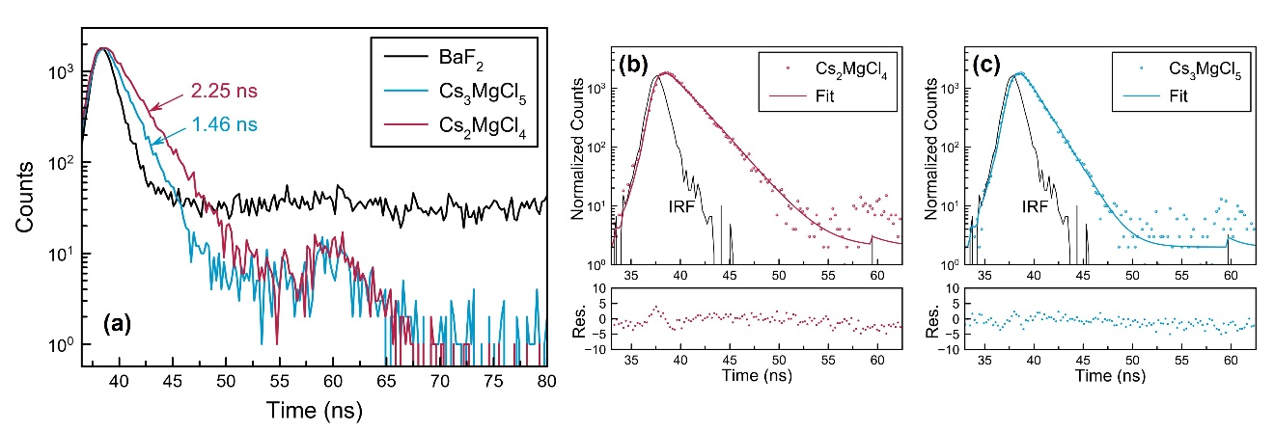
Figure 54. (a) Scintillation decay profile of Cs₂MgCl₄ and Cs₃MgCl₅ compared with a reference BaF₂ crystal. The feature between 55 ns to 65 ns for Cs₂MgCl₄ and Cs₃MgCl₅ is an instrumental artifact. (b) and (c) show the fitted decay profiles, where the fits represent the convolution of the instrument response (IRF) with a single-exponential function.

the Zn-containing analogues, faster decay time is observed with Cs₃MgCl₅ than with Cs₂MgCl₄, possibly hinting that the A₃MX₅-type family of compounds could be the key to discovering additional inorganic scintillators with sub-ns decay time, for which few are currently known to exist.

From these results, it is apparent that for both the A₂MX₄ and A₃MX₅ structure types, full replacement of Zn²⁺ with Mg²⁺ leads to lengthening of the decay time. According to Rodnyi, as the A–X distance increases when changing from an AX to AMX₃ CVL crystal (ex. – Cs to Cl distance from CsCl to CsMgCl₃), decay time and light yield will increase due to a smaller overlap of the wave functions of A⁺ and X⁻ ions and therefore a lower probability of radiative CVL transitions [85]. This relationship has been discussed in other works as well, including [81, 82, 188]. To determine whether the trend holds for the A₃MX₅-type (space group I₄/mcm) and A₂MX₄-type (space group Pnma) compounds, decay constants and average Cs–Cl bond lengths were compiled and are listed in Table 11 along with those of CsCl and CsMgCl₃. It should be noted that the AX and AMX₃-type compounds are a simpler case given that only one crystallographic site exists for Cs ions whereas two sites exist in the A₂MX₄-type and A₃MX₅-type compounds.

When looking solely at the Cs1 site, the trend with decay time appears to be consistent across Cs₃ZnCl₅, Cs₃MgCl₅, Cs₂ZnCl₄, and Cs₂MgCl₄, which show lengthening decay times with increasing bond length. Likewise, the same is true when replacing Zn²⁺ with Mg²⁺ in a given structure type regardless of which site is considered. However, a clear trend is not observed across all compositions for the Cs2 site or the total average bond length.

We speculate one possibility for this result could be that the Cs1 site somehow plays a more prominent role in the CVL process than the Cs2 site in these compounds, however, this has not been verified. Most likely there are more complex factors contributing to
Table 11. Average Cs–Cl bond lengths and decay constants for CsCl, CsMgCl₃, and other known CVL scintillators of the types A₃MX₅ (space group I4/mcm) and A₂MX₄ (space group Pnma). The compound Cs₂BaCl₄ is excluded from the list due to its dissimilar crystal structure (cubic, space group I-43d), in which Cs⁺ and Ba²⁺ (both CVL-active ions) occupy the same crystallographic site, that may additionally influence the CVL properties.[189] Average bond lengths were determined using the Vesta software package and published structural data.[142] For structures with two Cs sites, the total average is weighted based on CN.
Composition | Decay Constant (ns) | Ref. | Cs1 Average Cs–Cl bond length (Å) | Cs2 Average Cs–Cl bond length (Å) | Average Cs–Cl bond length (Å) | Ref.
CsCl | 0.88 | [10] | - | - | 3.564 | [190]
Cs₃ZnCl₅ | 0.82 – 1.1 | [114, 132] | 3.536 | 3.778 | 3.670 | [141]
Cs₃MgCl₅ | 1.46 | this work | 3.563 | 3.804 | 3.697 | [139]
Cs₂ZnCl₄ | 1.6 – 1.7 | [114, 119, 132] | 3.7518 | 3.518 | 3.663 | [140]
Cs₂MgCl₄ | 2.25 | this work | 3.767 | 3.608 | 3.683 | [138]
CsMgCl₃ | 2.1 – 2.36 | [82, 97] | - | - | 3.728 | [191]

the scintillation kinetics in the materials studied in the present work, and further investigation is necessary to draw definitive conclusions about the differences in decay times and how they relate to the Cs–Cl distances. In an investigation of impurity-induced CVL in CaF₂:Ba and SrF₂:Ba, Terekhin et al. also did not observe the expected acceleration of decay time despite the smaller Ba–F distances in the doped compounds compared to BaF₂ and point out that the probability of optical transitions is not only determined by the CVL-active cation to halogen anion distance, but also by the shape of the respective wave functions [188].

6.4 Light Yield

Pulse height spectra for small-sized crystals of Cs₂MgCl₄ and Cs₃MgCl₅ are shown in Figure 55. The full-energy (662 keV) deposition photopeaks can be resolved for both. Measurements were performed at various shaping times to verify the absence of long decay components (on the order of a few hundred nanoseconds or greater) that were not visible in the scintillation decay profiles. No significant change in photopeak position was observed when collecting spectra with shaping time ranging from 0.5 to 10 µs, which provides further evidence that there is no significant contribution from long components in the time profiles of these crystals.

Light yield was calculated to be 2,200 ± 110 ph/MeV for Cs₂MgCl₄ and 1,340 ± 70 ph/MeV for Cs₃MgCl₅. These values are similar to those of the Zn-containing analogues (1,980 ± 100 ph/MeV for Cs₂ZnCl₄ and 1,460 ± 70 ph/MeV for Cs₃ZnCl₅), in which the A₂BX₄-type crystal was also the brighter of the two, indicating another possible connection between crystal structure and CVL properties. Cs₂MgCl₄ has a relatively high light yield compared to many other CVL materials, which are mostly below 1,500

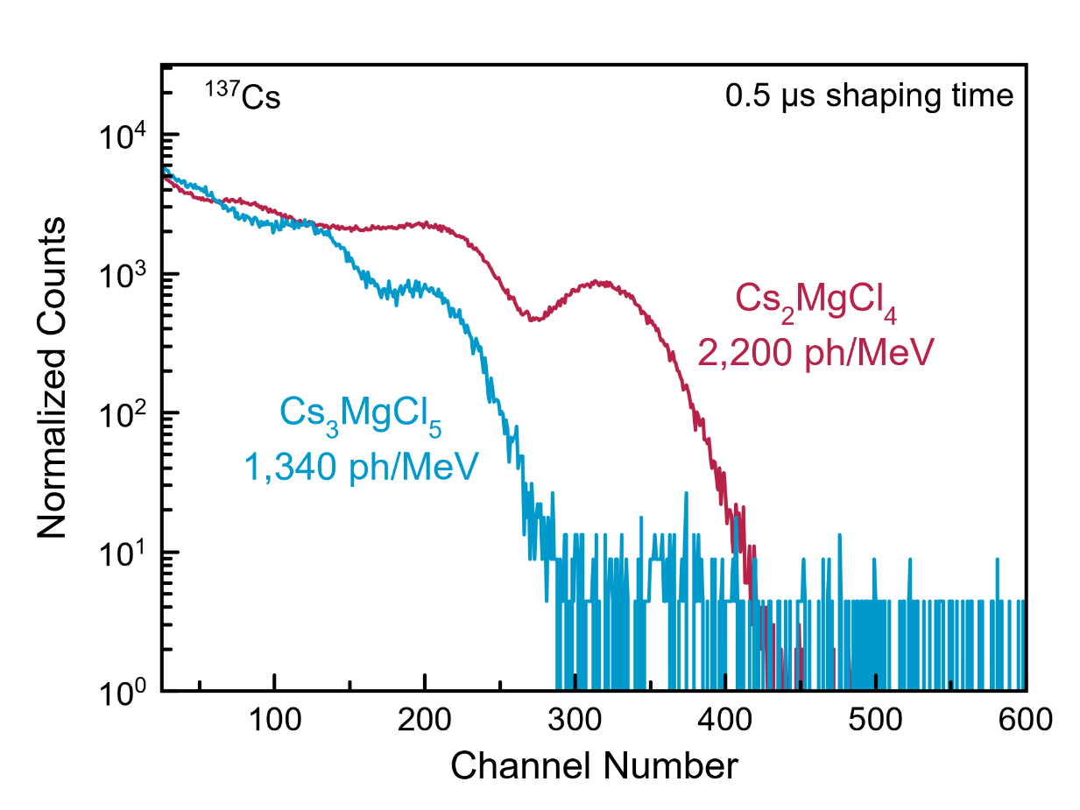
Figure 55. Pulse height spectra of Ø7 mm × 3 mm Cs₂MgCl₄ and Cs₃MgCl₅ crystals measured with a 662 keV ¹³⁷Cs source.

ph/MeV [7, 70, 80, 97]. This higher light yield, or brightness, becomes especially important in applications requiring good timing resolution given that the coincidence time resolution (CTR) is inversely proportional to the square root of the number of detected photons, as discussed in the introduction.

6.5 Coincidence Time Resolution (CTR)

The CTR for 3 × 3 × 5 mm³ samples measured as a function of leading edge (LE) threshold is shown in Figure 56. LSO:Ce,Ca and Cs₂ZnCl₄ are included for comparison, with LSO:Ce,Ca considered as the state-of-the-art and Cs₂ZnCl₄ being a known CVL material. The same Cs₂ZnCl₄ crystal from [132] that we reported to have a CTR of 148 ± 1 ps FWHM was again measured, however, a better CTR of 111 ± 3 ps ps FWHM was achieved in the present work because of several modifications to the experimental setup. The LSO:Ce,Ca crystal had a CTR of 94 ± 3 ps FWHM. Based on the ratios of decay time to light yield, it is expected that Cs₂MgCl₄ and Cs₃MgCl₅ should have CTR values slightly larger than Cs₂ZnCl₄ by approximately 10% and 14%, respectively (see Table 12).

The measured CTR for Cs₂MgCl₄ was 129 ± 4 ps FWHM, or about 16% larger than that of Cs₂ZnCl₄. This result agrees well with the expected 10% and demonstrates the excellent timing capabilities of Cs₂MgCl₄. On the other hand, Cs₃MgCl₅ did not perform as well as expected. The measured CTR was 161 ± 5 ps FWHM, or about 45% larger than that of Cs₂ZnCl₄. A possible explanation is that this difference arises due to the different emission spectra of Cs₂MgCl₄ and Cs₃MgCl₅. More specifically, a larger fraction of the light is emitted below 275 nm for Cs₃MgCl₅ (Figure 53), and the photon detection efficiency (PDE) of the SiPM dips below 10% near 275 nm compared to ~35% near 300 nm.

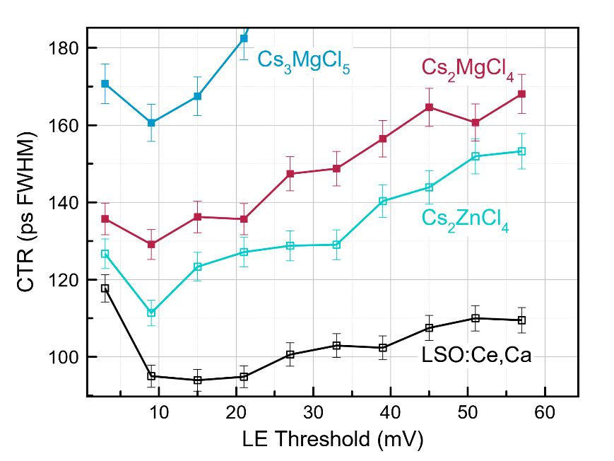
Figure 56. CTR measurements of Cs₂MgCl₄ and Cs₃MgCl₅ compared to reference samples of Cs₂ZnCl₄ and LSO:Ce,Ca. All crystals were approximately 3 × 3 × 5 mm³.

Table 12. Relevant properties of Cs₂MgCl₄ and Cs₃MgCl₅ and comparison of CTR with Cs₂ZnCl₄. CTR values are for the optimal LE threshold, which was at 9 mV for each.
Composition | $τ$ (ns) | LY at 662 keV (ph/MeV) | LY/$τ$ (ph/meV/ns) | $$\frac{\sqrt{τ/LY}}{{\left(\sqrt{τ/LY}\right)}_{Cs2ZnCl4}}$$ | measured CTR (ps FWHM) | expected CTR (ps FWHM)
Cs₂ZnCl₄ | 1.66 ^{[132]} | 1980 ^{[132]} | 1,193 | 1 | 111 ± 3 | -
Cs₂MgCl₄ | 2.25 ± 0.05 | 2,200 ± 110 | 978 | 1.10 | 129 ± 4 | 123
Cs₃MgCl₅ | 1.46 ± 0.05 | 1,340 ± 70 | 918 | 1.14 | 161 ± 5 | 127

6.6 Band Structure Calculations

Density functional theory (DFT) calculations were performed for Cs₂MgCl₄ and Cs₃MgCl₅ to establish the potential for core valence luminescence based on electronic band structures of these compounds. Similar methods have been used to investigate CVL in other materials, such as CsMgCl₃ [183], KMgF₃ [192], LaF₃ [193], and KMgCl₃ [194]. In the present work, these calculations are useful for two primary reasons: (1) to determine if the criteria E_{vc} < E_{g} is satisfied, indicating that core valence luminescence is energetically possible and (2) to compare some features of the calculated density of states (DOS) to measured emission spectra since the CVL spectrum (radioluminescence) should reflect the valence band DOS [7, 8]. This fact is apparent when considering that the emitted light must fall within the range of energies corresponding to transitions from the top and bottom of the valence band to the top of the outermost core band. Put more simply, the low energetic edge of the CVL emission spectrum should correspond to the parameter E_{g2}. The high energetic edge of the CVL spectrum should correspond to the parameter E_{vc}.

Figure 57 shows the calculated partial density of states (PDOS) for Cs₂MgCl₄ and Cs₃MgCl₅ along with schematic illustrations of the band structures. The valence band is primarily composed of Cl-p states for both compounds, while the outermost core level is composed mainly of Cs-p states. It is apparent that the necessary condition E_{vc} < E_{g} is satisfied for Cs₂MgCl₄ (E_{vc} = 5.56 eV and E_{g} = 6.13 eV), further supporting the experimental results that suggest CVL as the scintillation mechanism. Based on the DOS, CVL is expected to occur through radiative transitions between Cs 5p holes and Cl 3p electrons, as is typical for CsCl-based CVL crystals.

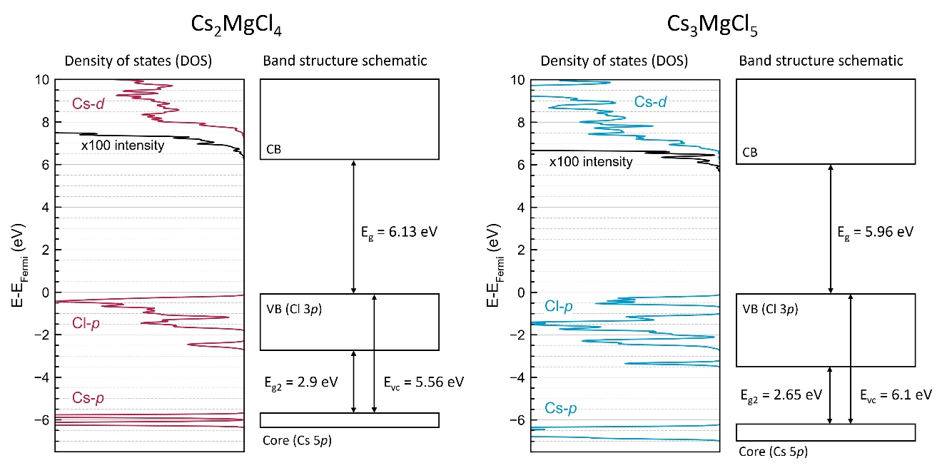
Figure 57. Calculated partial density of states (DOS) and schematic band diagrams with relevant energies for CVL labeled.

Interpretation of the data in Figure 57 is straightforward for Cs₂MgCl₄, as E_{vc} = 5.56 eV is clearly less than E_{g} = 6.13 eV. The story is less obvious with Cs₃MgCl₅, where the DOS shows a very close difference between E_{vc} and E_{g}; however, the values of these parameters overlap only for a small part of the Brillouin zone. In this system, the Cs-p states are ~6.1 eV below the valence band maximum (VBM), the Cl-p states are at the VBM, and the Cs-d states make up the conduction band minimum (CBM) at 5.96 eV. At a particular k-point within the Brillouin zone, each of these states has an energy window over which the Kohn-Sham states (the bands in DFT) vary, leading to a variation in the values of E_{vc} (between 5.99 eV and 6.13 eV) and E_{g} (between 5.96 eV and 7.29 eV). Calculating these two energy differences at every k-point has shown E_{vc} < E_{g} for ~89% of the Brillouin zone and is at most 0.17 eV larger in the other 11%. Additionally, Yang et. al. [195] found that HSE underestimates large band gaps. These results suggest that CVL is possible for Cs₃MgCl₅ as well, as was inferred from the experimental data.

Radioluminescence spectra were converted from wavelength to energy (Figure 58) to allow comparison with the energy parameters E_{g2} and E_{vc} obtained from the calculated DOS. The Jacobian transformation was applied during the conversion, which scales intensity values in order to correct for the uneven interval spacings between wavelength and energy scales [196]. The low energetic and high energetic edges of CVL in both cases were approximated as the peak onsets. The calculated parameters agree reasonably well with the measured CVL edges of 2.5 eV (E_{g2} = 2.9 eV) and 5.5 eV (E_{vc} = 5.56 eV) for Cs₂MgCl₄. There is also good agreement between calculated and measured values for Cs₃MgCl₅, for which the low and high energetic edges of CVL are 2 eV (E_{g2} = 2.65 eV) and 6 eV (E_{vc} = 6.1 eV). The small discrepancy between calculated and experimental values for E_{g2} may be a result of thermal broadening of the valence band.

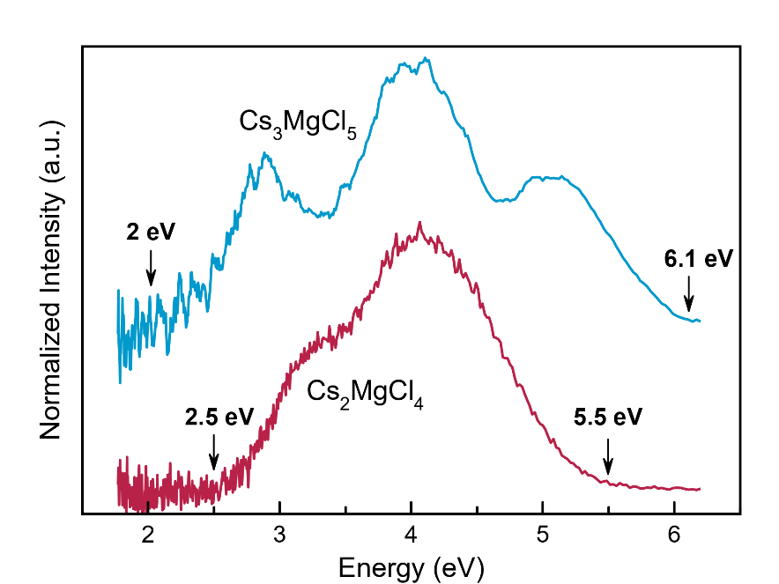
Figure 58. Emission spectra converted to energy scale highlighting the low energetic and high energetic edges of CVL that correspond to the parameters E_{g2} and E_{vc}, respectively.

The larger VB width for Cs₃MgCl₅ compared to Cs₂MgCl₄ in the calculated DOS (Figure 57) also agrees well with the experimental data in which Cs₃MgCl₅ has the broader emission spectrum, spanning a wider energy range.

6.7 Conclusions

Cs₂MgCl₄ and Cs₃MgCl₅ were explored as potential new scintillator materials. Single crystals of each were grown using the Bridgman method, and scintillation was observed for both compounds under X-ray and gamma ray excitation. The ultrafast scintillation decay times (2.25 ± 0.05 ns for Cs₂MgCl₄ and 1.46 ± 0.05 ns for Cs₃MgCl₅) and radioluminescence emission spectra that are consistent with other CVL materials suggest that scintillation in both crystals arises from core valence luminescence. DFT calculations provided further evidence of CVL, illustrating that the necessary energy condition is satisfied (E_{vc} < E_{g}) and that the low and high energetic edges of the measured emission spectra show good agreement with the calculated valence band DOS. Several parallels were observed between Cs₂MgCl₄ and Cs₃MgCl₅ and the previously studied compounds Cs₂ZnCl₄ and Cs₃ZnCl₅, revealing a possible connection between crystal structure and CVL properties in these two systems. Specifically, (i) the emission spectra are nearly identical for the compounds of the same structure type (ii) the A₂MX₄-type compound is the brighter of the two in both cases and (iii) the A₃MX₅-type compound is the faster of the two in both cases. Like the Zn-containing analogues, Cs₂MgCl₄ and Cs₃MgCl₅ can potentially offer advantages over the current state-of-the-art ultrafast scintillator BaF₂, including longer wavelength emission and absence of long decay components. Strategies for improving performance of these materials by means of compositional engineering will be the topic of future work.

Impurity-enhanced CVL in Cesium Magnesium Chloride Crystals via Zn Doping

Building upon the work presented in previous chapters on Cs₂(Zn or Mg)Cl₄ and Cs₃(Zn or Mg)Cl₅ CVL crystals, we set out to investigate the effects of doping and mixing in these systems, as well as the known perovskite CsMgCl₃ CVL crystal. Here, we report crystal growth and characterization of undoped and 5% Zn-doped CsMgCl₃, Cs₂MgCl₄, and Cs₃MgCl₅. Additionally, effects of mixing with higher Zn concentrations are investigated in Cs₂Mg_{1-x}Zn_{x}Cl₄ and Cs₃Mg_{1-x}Zn_{x}Cl₅. The goals of this work are to (i) improve the light yield to decay time ratio of some novel CVL materials, which in turn should lead to superior timing performance and (ii) uncover new aspects of impurity CVL through doping with an ion not traditionally considered to be “CVL-active”. The results of this work reveal a new avenue towards obtaining brighter CVL materials, which could open up possibilities for more advanced ultrafast scintillators to be discovered moving forward.

7.1 Crystal Growth

Growth of Ø12 mm undoped and 5% Zn-doped CsMgCl₃, Cs₂MgCl₄, and Cs₃MgCl₅ resulted in highly transparent crystals (Figure 59). Minor cracking near the surface was observed in some crystals, primarily with Cs₃MgCl₅ (both undoped and Zn-doped). There were no obvious changes in crystal appearance upon doping, with the exception of CsMgCl₃, for which the surface of the CsMgCl₃:Zn crystal was covered in a white hazy residue prior to removal from the ampoule, whereas the surface of the undoped crystal was clear and smooth. This was observed for multiple growth runs with different samples of CsMgCl₃ and CsMgCl₃:Zn. After removal from the ampoule, the hazy surface
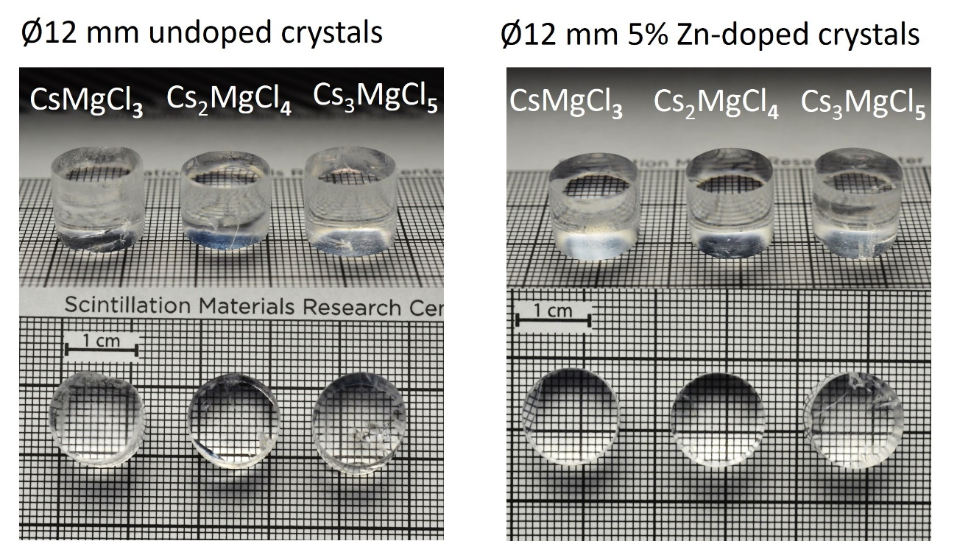
Figure 59. Photographs of polished cylinders cut from the grown Ø12 mm undoped and 5% Zn-doped crystals.

layer could be removed by polishing and revealed a transparent crystal underneath. This is evident when viewing the cross section of the crystal visible in Figure 59.

Given that Cs₂MgCl₄ and Cs₂ZnCl₄ are isostructural (orthorhombic, space group Pnma) and Cs₃MgCl₅ and Cs₃ZnCl₅ are isostructural (tetragonal, space I₄/mcm), solid solutions are expected to form across the entire range of compositions from pure Mg²⁺ (ionic radius 0.57 Å for CN = 4) to pure Zn²⁺ (ionic radius 0.6 Å for CN = 4). Mixed crystals from the Cs₂Mg_{1-x}Zn_{x}Cl₄ and Cs₃Mg_{1-x}Zn_{x}Cl₅ systems (with x = 0, 0.05, 0.1, 0.25, 0.5, and 1) were grown to determine the optimal Zn concentration for achieving the best scintillation performance and are pictured in Figure 60. The optical quality appeared mostly consistent for all samples.

7.2 Scintillation properties – pure vs 5% Zn doped

To determine if the characteristics of CVL in cesium magnesium chlorides are altered when doping or mixing with Zn, radioluminescence, scintillation decay time, and light yield measurements were performed. The resulting radioluminescence emission spectra are shown in Figure 61a. The emission spectra remain mostly unchanged when doping Cs₂MgCl₄ and Cs₃MgCl₅. Similar to what we reported in [D. Rutstrom et al., submitted to J. Mat. Chem. C], the dominant emission bands appear at 295 nm and 302 nm, respectively. Undoped CsMgCl₃ has two main bands, a broad emission centered at 450 nm and a narrower band at 283 nm. The spectrum is similar in shape and position to what was observed in [97]. Interestingly, the broad band is suppressed in the spectrum of CsMgCl₃:Zn 5%, and instead a lower intensity band appears at 372 nm.

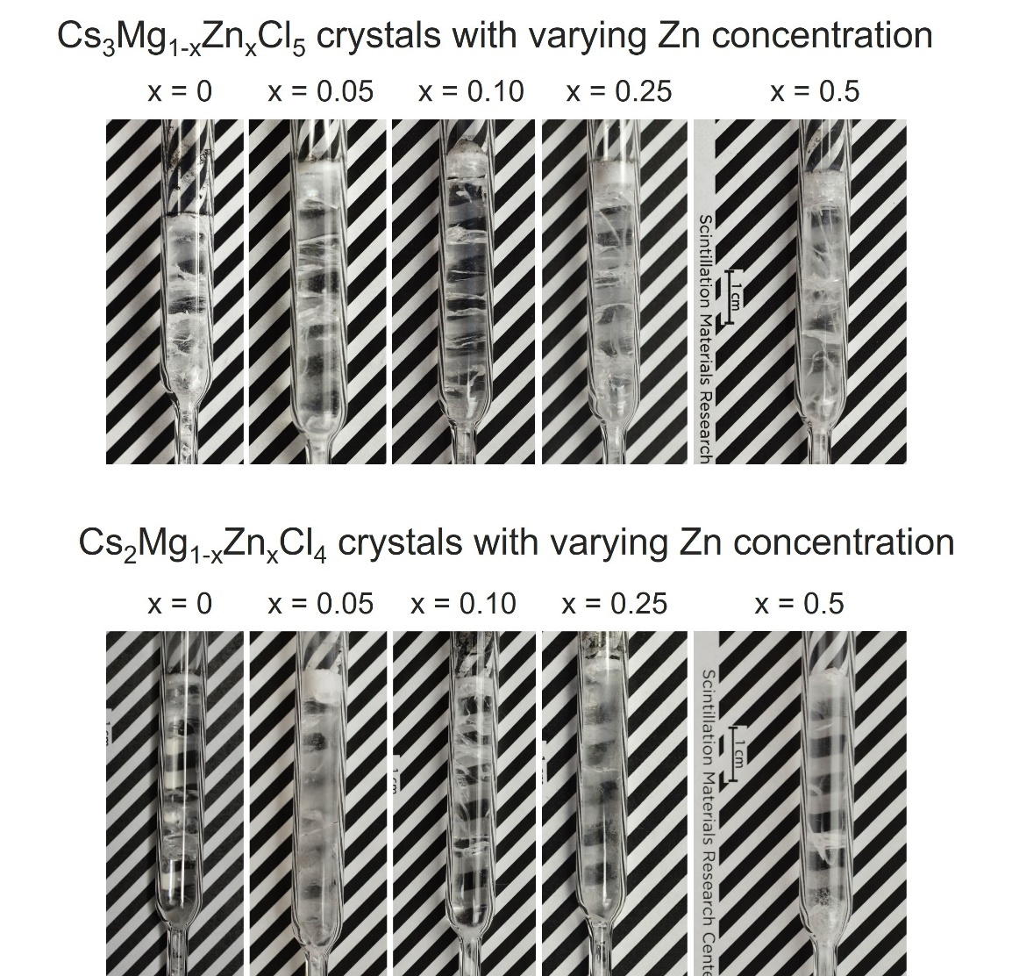
Figure 60. Photographs of as-grown Ø7 mm mixed crystals inside growth ampoules.

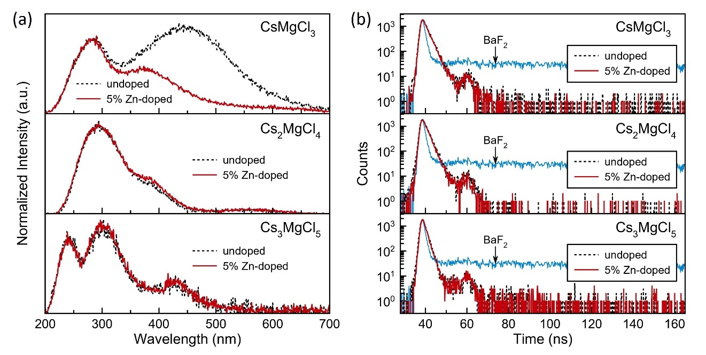
Figure 61. (a) Radioluminescence emission spectra and (b) scintillation decay profiles of undoped vs 5% Zn-doped crystals measured at room temperature. The decay profile of a reference BaF₂ crystal is shown for comparison.

Scintillation decay profiles are shown in Figure 61b. Over the measured time window of 500 ns, all samples appear to consist of single-component decay times (i.e. no long components) ranging from ~1.5 ns to ~2.5 ns. The fitted decay constants are listed in Table 1. The addition of small amounts of Zn into the crystals does not appear to influence the decay behavior, which is apparent from the essentially overlapping curves for undoped vs Zn-doped samples. This was also the case when measuring over longer time windows as well. The interesting case that deserves further consideration is that of CsMgCl₃, for which the broad emission band near 450 nm is uncharacteristic of CVL. Rather, it resembles the structure that is typical of defect-mediated or excitonic emission. However, if this was the case then we should expect to see either a secondary component or an increase in background counts in the decay measurements for CsMgCl₃, which we did not observe.

Vanecek et al. [97] ascribed this broad band in undoped CsMgCl₃ to defect or excitonic emission from at least two different emission centers, which was evident from photoluminescence (PL) measurements that revealed long decay components (ranging from 234 ns to 51 µs) when exciting these bands. Despite this, the ~2 ns CVL component in their scintillation decay time measurements still had an abundance of 99.7%. This result, along with our observations, suggests that there is minimal contribution from a slower decay component in CsMgCl₃ even if the broad emission does in fact originate from an STE, which seems likely.

Pulse height spectra measured with a ¹³⁷Cs source are shown in Figure 62a and Figure 62b. For each compound – CsMgCl₃, Cs₂MgCl₄, and Cs₃MgCl₅ – the light yield increases upon doping with 5% Zn. The most substantial effect is observed between undoped Cs₃MgCl₅ (1,340 ph/MeV) and Cs₃MgCl₅:Zn (2,180 ph/MeV) and between CsMgCl₃ (2,700 ph/MeV) and CsMgCl₃:Zn (3,400 ph/MeV) – improvements of 63% and 26%,
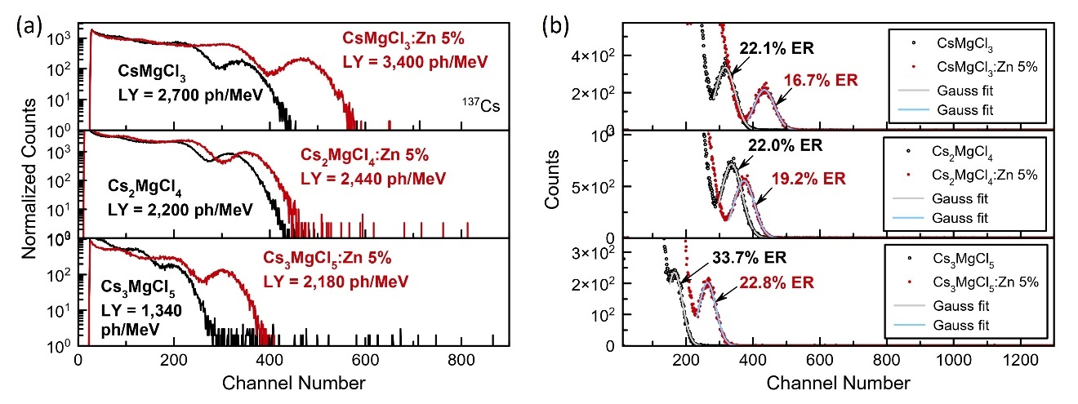
Figure 62. (a) Pulse height spectra of undoped vs 5% Zn-doped crystals measured at 662 keV with an R2059 PMT illustrating the enhanced light yield (LY) in doped crystals, which corresponds to the higher channel number of the photopeak. (b) Pulse height spectra of undoped vs 5% Zn-doped crystals measured at 662 keV with an R6231 PMT showing improved energy resolution (ER) in doped crystals.

respectively. The implications of these results are two-fold: (i) the higher LY makes these materials more practical for use in a wide range of applications and (ii) the enhanced LY is expected to improve timing performance (i.e. CTR). An additional effect of Zn-doping, which is apparent from Figure 62b, is an improvement in energy resolution. Table 13 summarizes the measured scintillation properties for the undoped and 5% Zn-doped crystals.

It should be pointed out that the light yield measured in our lab for CsMgCl₃ is quite different from previously reported values [97]. More generally, light yields reported in literature for a given scintillator tend to show a wide range of values, even for well-known materials such as BGO or LSO. There are several sources for these discrepancies, some of which have been discussed in depth by Moszynski et al. [197]. That study found that the method of calculating the photoelectron number by direct comparison with the SPE position often leads to overestimation (depending on the gain and electronics). Additionally, accuracy (or rather inaccuracy) of the PMT quantum efficiency calibration must be considered. It was also shown in [197] that various LSO crystals measured with Hamamatsu PMTs (R2059 and R6231MOD) had on average higher light yields by about 25.8% compared to measurements performed with an XP2020Q PMT.

Light collection efficiency is another factor affecting the measured light yield, which can include the surface finish of the crystal, how it is coupled to the PMT, and the type and geometry of the reflector material. It is difficult to assess the extent that each of these may be contributing to the different light yields we observe without conducting a systematic study, but this was outside the scope of the present work. Regardless of any potential overestimation of the light yield, the trend of higher light yield with Zn-doping is still evident given that the samples in this work were all measured under identical conditions.
Table 13. Summary of measured scintillation properties for undoped and Zn-doped crystals.
Composition | Decay time (ns) | Light yield at 662 keV (ph/MeV) | Energy resolution at 662 keV (%)
CsMgCl₃ | 2.24 ± 0.05 | 2,700 ± 140 | 22.1
CsMgCl₃:Zn 5% | 2.17 ± 0.05 | 3,400 ± 170 | 16.7
Cs₂MgCl₄ | 2.04 ± 0.05 | 2,200 ± 110 | 22.0
Cs₂MgCl₄:Zn 5% | 1.91 ± 0.05 | 2,440 ± 120 | 19.2
Cs₃MgCl₅ | 1.46 ± 0.05 | 1,340 ± 70 | 33.7
Cs₃MgCl₅:Zn 5% | 1.25 ± 0.05 | 2,180 ± 110 | 22.8

It is important for the applications being considered that the enhanced light yield does not come at the expense of the ultrafast decay times, and so it is necessary to consider the origin of this additional light being produced. For use in fast timing applications, it is often the ratio of light yield to decay time that matters. This means that if an increase in light yield is also accompanied by lengthening of the decay time or the introduction of additional slow components, the benefits may not be fully realized. The mostly unchanged emission spectra and decay times between the undoped and Zn-doped crystals suggests that the presence of Zn has not introduced undesired long-lifetime emission mechanisms. Based on this, it appears as though all (or at least the majority) of the extra light in the Zn-doped crystals originates from CVL or some other ultrafast emission process. Cherenkov emission and hot intraband luminescence (IBL) are unlikely sources given that their yields are typically on the order of tens of photons per MeV [198-200], whereas light yield in the Zn-doped crystals increases by several hundred photons per MeV. Further investigation is necessary to verify its origin, but presently we are attributing this enhanced light yield to processes involving CVL.

Considering that the Cs 5p and Zn 3d core levels are positioned close together in halides [5, 70, 119], one possible explanation for this effect is the migration of core holes from Zn²⁺ to Cs⁺, which then may recombine through Cl 3p to Cs 5p transitions essentially creating an additional channel through which core holes participating in CVL can be created. A similar mechanism was described by Itoh et al. for the Rb_{1-x}Cs_{x}F system [201], however, the effects on light yield were not discussed. Voloshinovskii has also suggested that a significant increase in light yield may be expected in crystals with overlapping core levels due to efficient transfer of the core excitation energy between bands [99, 100]. As mentioned in Chapter 2.3 Impurity-induced CVL, the concept of “transport core bands” has also been discussed by Rodnyi in [5], in which the lower lying band (deemed the transport band) can deliver additional holes to the upper CVL-active core band. This in turn is expected to lead to a larger share of core holes participating in CVL transitions, and therefore an increase in light yield. This effect has yet to be observed experimentally for transfer from d ions to p ions, and while we do not yet have direct evidence that this is the responsible mechanism in the presently studied crystals, this could explain the increase in yield observed upon doping Cs-Mg-Cl crystals with Zn²⁺.

7.3 Coincidence time resolution (CTR) – pure vs 5% Zn doped

As discussed in Chapter 1.2 Applications of Fast Scintillators, the timing performance of a scintillator depends on the ratio of light yield to decay time. To investigate whether performance improves upon doping with Zn²⁺, CTR of the undoped and Zn-doped crystals was measured. Figure 63 shows the CTR data for 3 × 3 × 5 mm³ samples of CsMgCl₃ vs CsMgCl₃:Zn 5%, Cs₂MgCl₄ vs Cs₂MgCl₄:Zn 5%, and Cs₃MgCl₅ vs Cs₃MgCl₅:Zn 5%. The same Cs₂ZnCl₄ crystal for which CTR was measured in Chapter 6 was again measured and is included as a reference.

In each case, it is apparent that CTR improves after doping with Zn²⁺. Considering the higher light yields of the Zn-doped crystal without lengthening of decay times, this result is not surprising. The best CTR is obtained with CsMgCl₃:Zn 5% (also the crystal with the highest light yield), which was 99 ± 3 ps FWHM or a 25% improvement over the 132 ± 4 ps FWHM of the undoped CsMgCl₃ crystal. This is also superior to the CTR measured with Cs₂ZnCl₄, which was 122 ± 4 ps FWHM. The CTR for Cs₂MgCl₄ improves by ~22% and for Cs₃MgCl₅ improves by ~10% with 5% Zn doping. These results demonstrate the ability to improve the timing performance of CVL crystals via compositional engineering, allowing for the limits of timing resolution to be pushed further than was previously possible with CVL materials.

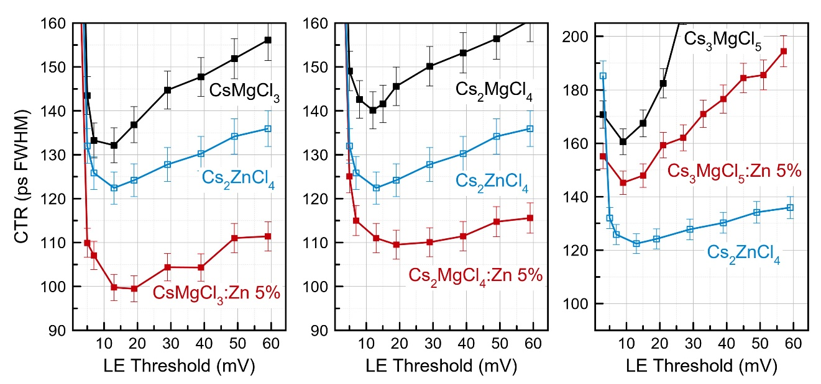
Figure 63. CTR vs LE threshold for undoped vs 5% Zn-doped crystals. The measured crystals had dimensions 3 × 3 × 5 mm³. Cs₂ZnCl₄ is included as a reference.

7.4 Mixed crystals (0% to 100% Zn)

The effects of varying the Zn concentration were explored to determine where the optimal scintillation properties can be achieved. Crystals of Cs₂Mg_{1-x}Zn_{x}Cl₄ and Cs₃Mg_{1-x}Zn_{x}Cl₅ with x = 0, 0.05, 0.1, 0.25, 0.5, and 1 were evaluated. Figure 64a shows radioluminescence spectra for the end-member compounds and for x = 0.5. In moving from pure Mg to pure Zn, the spectra shift to shorter wavelengths and narrowing of the band near 290 nm is observed. The trend was similar across the entire range of mixed compositions, however, only the spectrum for x = 0.5 is shown for clarity. Scintillation decay time of the mixed crystals is shown in Figure 64b. An acceleration of decay time is observed with increasing Zn concentration. This ranges from 1.66 ± 0.05 ns to 2.04 ± 0.05 ns for Cs₂Mg_{1-x}Zn_{x}Cl₄ and from 0.91 ± 0.05 ns to 1.46 ± 0.05 ns for Cs₃Mg_{1-x}Zn_{x}Cl₅.

Figure 65 shows the light yield and decay time of the mixed crystals plotted as a function of Zn concentration. Unlike the radioluminescence and decay time, which show somewhat of a linear dependence with Zn concentration, light yield of the mixed crystals in several instances exceeds that of the end-member compounds (as was the case with 5% Zn). The optimal concentration for achieving the best light yield is around 5-10% in both the Cs₂Mg_{1-x}Zn_{x}Cl₄ and Cs₃Mg_{1-x}Zn_{x}Cl₅ systems, but benefits can still be realized with 25% Zn in the latter case. These results indicate that fine tuning of the scintillation performance is possible with mixed crystals. Table 14 summarizes the scintillation properties for the mixed systems. The best light yield to decay time ratio can be obtained with the composition Cs₃Mg_{0.75}Zn_{0.25}Cl₅.

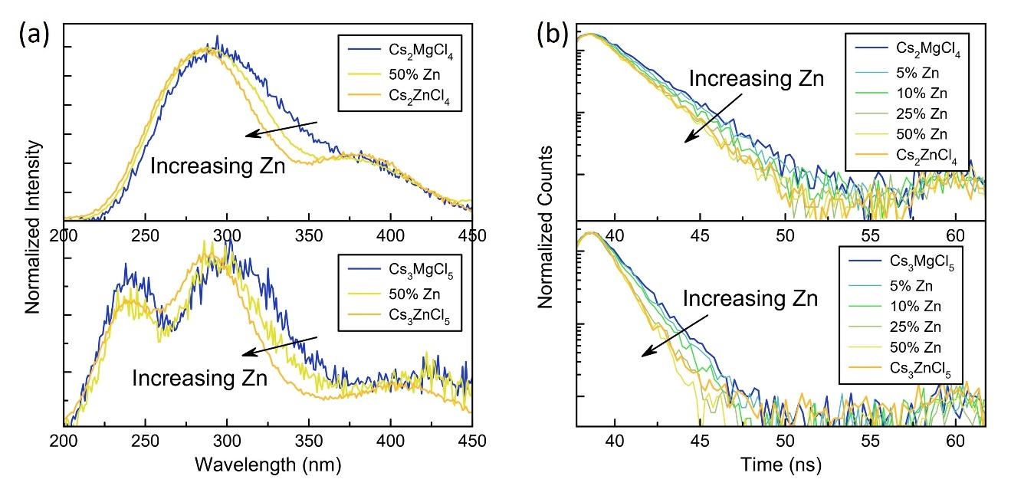
Figure 64. (a) Radioluminescence spectra and (b) scintillation decay curves of mixed crystals showing a shift to shorter wavelengths and acceleration of decay time with increasing Zn concentration.

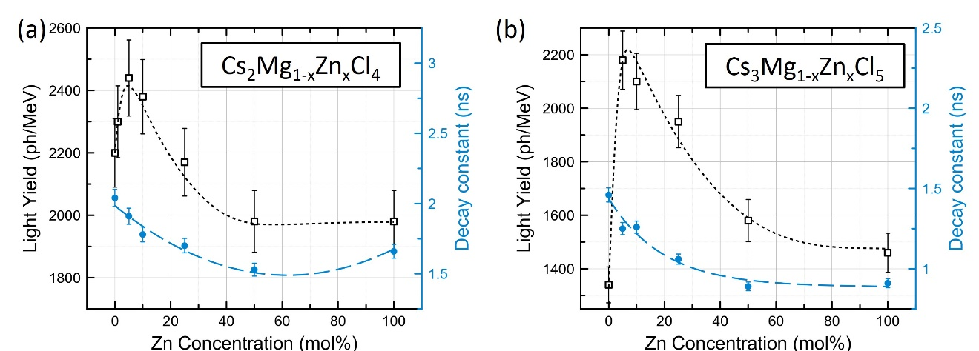
Figure 65. Light yield and scintillation decay time as a function of Zn concentration in mixed crystals. Dotted and dashed lines are included simply to guide the eye.

Table 14. Summary of measured scintillation properties for Cs₂Mg_{1-x}Zn_{x}Cl₄ and Cs₃Mg_{1-x}Zn_{x}Cl₅ mixed crystals.
Composition | x | Decay constant (ns) | LY at 662 keV (ph/MeV) | LY/decay (ph/MeV/ns)
Cs₃Mg_{1-x}Zn_{x}Cl₅ | 0 | 1.46 ± 0.05 | 1,340 | 918
 | 0.05 | 1.25 ± 0.05 | 2,180 | 1,744
 | 0.10 | 1.26 ± 0.05 | 2,100 | 1,667
 | 0.25 | 1.06 ± 0.05 | 1,950 | 1,840
 | 0.50 | 0.89 ± 0.05 | 1,580 | 1,775
 | 1 | 0.91 ± 0.05 | 1,460 | 1,604
Cs₂Mg_{1-x}Zn_{x}Cl₄ | 0 | 2.04 ± 0.05 | 2,200 | 1,078
 | 0.05 | 1.91 ± 0.05 | 2,440 | 1,277
 | 0.10 | 1.78 ± 0.05 | 2,380 | 1,337
 | 0.25 | 1.70 ± 0.05 | 2,170 | 1,276
 | 0.50 | 1.53 ± 0.05 | 1,980 | 1,294
 | 1 | 1.66 ± 0.05 | 1,980 | 1,193

To rule out the possibility that a secondary phase might be contributing to the emission, phase analysis was carried out using powder XRD. Samples were obtained from the middle section of each boule, avoiding the opaque last-to-freeze sections seen at the top of some crystals pictured in Figure 60. Evidence of secondary phases was not observed in the diffraction patterns of any mixed-crystal samples.

The Rietveld technique was applied to obtain refined lattice parameters using the GSASII software. The results are shown in Figure 66 and summarized in Table 15 for Cs₃Mg_{0.75}Zn_{0.25}Cl₅ as an example and were similar for each sample. Peak widths were well-fitted, however, there were occasional discrepancies in peak intensity from preferred orientation due to the use of Kapton film that slightly compacted the powders. The refined lattice parameters were plotted as a function of composition to determine if Vegard’s Law is followed and are shown in Figure 67. The lattice parameters show a mostly linear dependence with Zn concentration. The melting behavior of the mixed crystals was also evaluated to further investigate any potential deviations from Vegard’s Law. Figure 68a and Figure 68b show the DSC heating curves that were used to determine the melting points plotted in Figure 68c and Figure 68d. The melting points were taken as the peak onset. Overall, a mostly linear trend is observed.

These results suggest that, as expected given the matching crystal structures and similar ionic radii of Zn²⁺ and Mg²⁺, the Zn-based and Mg-based compounds are mutually soluble in one another. Additionally, these results indicate that the observed changes in light yield are unrelated to structural effects. This is especially apparent when comparing Cs₃MgCl₅, Cs₃Mg_{0.75}Zn_{0.25}Cl₅, and Cs₃ZnCl₅, for which the light yield shows a strong deviation from linearity (Figure 65b) unlike the lattice parameters.

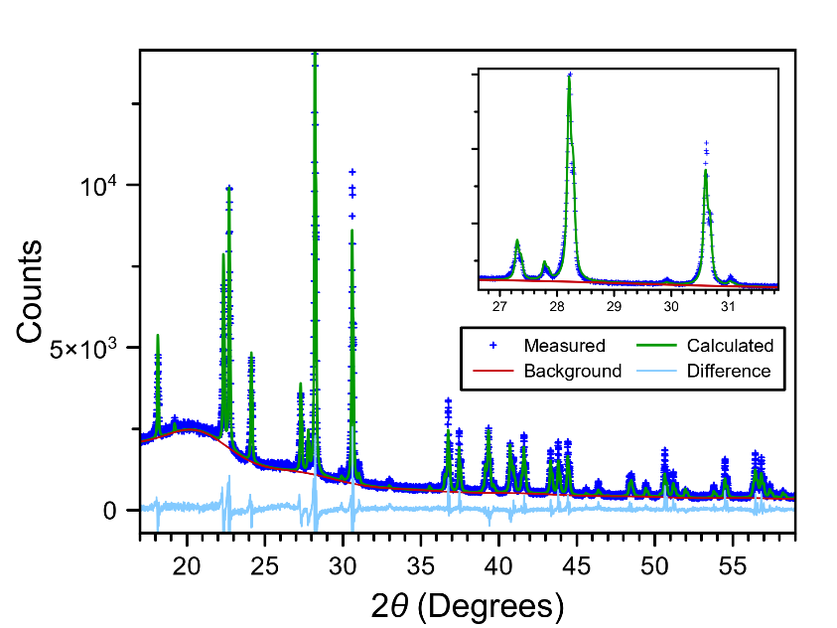
Figure 66. Results of Rietveld refinement for Cs₃Mg_{0.75}Zn_{0.25}Cl₅ showing the calculated vs measured XRD pattern. The broad amorphous peak around 20° is from the protective Kapton film.

Table 15. Summary of structural parameters and Rietveld refinement data from powder XRD of Cs₃Mg_{0.75}Zn_{0.25}Cl₅.
Parameter | Refinement
Crystal system | Tetragonal
Space group | I4/mcm
Formula units | 4
a (Å) | 9.2343(3)
b (Å) | 9.2343(3)
c (Å) | 14.7436(5)
α=β=γ (deg) | 90
Volume (Å³) | 1257.2(1)
wR (%) | 9.94
wR_{min} (%) | 3.07
Goodness of fit (GOF) | 3.24

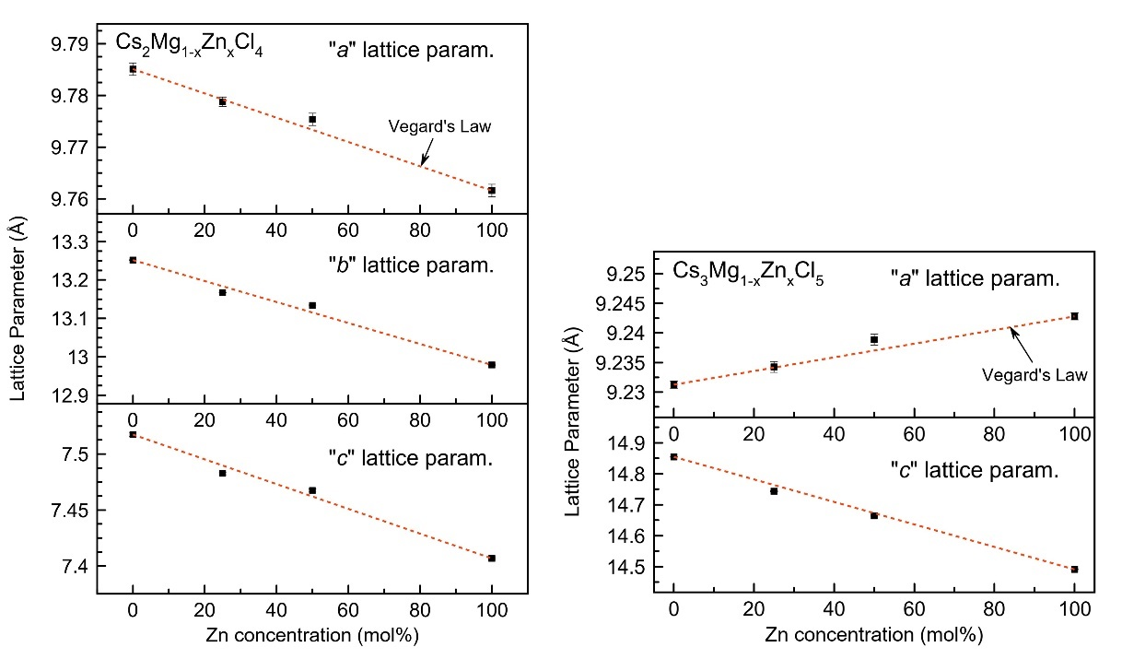
Figure 67. Refined room temperature lattice parameters of mixed crystals showing Vegard’s Law is followed indicating Zn concentrations in the bulk agree closely with nominal concentrations. Error bars are shown as 3σ. In some instances, the data markers are larger than the standard deviation.

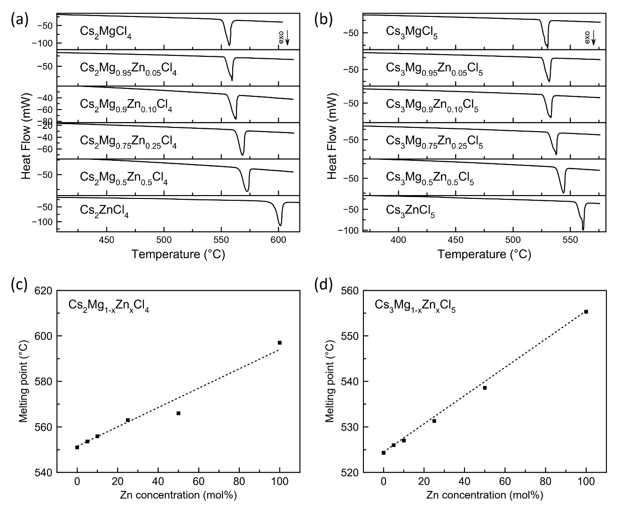
Figure 68. DSC curves of mixed crystals measured at a heating rate of 3 K/min in sealed quartz crucibles.

7.5 Conclusions

We have found that the CVL yield of CsMgCl₃, Cs₂MgCl₄, and Cs₃MgCl₅ can be improved by doping with 5% Zn²⁺, an effect that for the moment we are calling impurity-enhanced CVL. This is a distinction from previously studied examples of impurity-induced CVL. The proposed mechanism relates to the overlapping of Cs5p and Zn3d core bands that provides an additional channel for creation of core holes to be involved in CVL transitions (via transport from Zn²⁺ to CVL-active Cs⁺ ions). To our knowledge, this would be the first experimental evidence of CVL of this nature. Further investigation both experimentally and theoretically is necessary to verify and to fully understand the role of Zn²⁺ in the CVL process. Interestingly, its benefits diminish once the Zn²⁺ concentration exceeds 25%-50%. It is currently unclear why this is the case but suggests a type of quenching effect. The findings presented in this work are valuable from both a theoretical perspective in that they will allow for a deeper understanding of core valence luminescence, as well as from an applied standpoint in that a new avenue for improving the timing performance of CVL crystals is now possible.

Effects of Bromine (Br) Mixing in Cesium Zinc Chloride

In the final chapter, we briefly explore the prospects of CVL in bromine-containing crystals as a future direction for this work. This is motivated by the prompt emission observed in CsBr (<150 ps [202]) due to partially quenched CVL at room temperature as a result of the condition E_{vc} < E_{g} not being satisfied for this compound [10, 12, 203-206]. The drawback of this being a quenched process is that very few photons are emitted (20 ph/MeV [207]). Similarly, a very prompt decay was observed for Cs₂ZnBr₄ in [181] but an emission spectrum could not be measured due to the weak intensity. In an attempt to harness such prompt emission while maintaining practical light yields, here we investigate anion mixing in Cs₂ZnCl_{4-x}Br_{x} crystals.

8.1 Crystal Growth

A 7 mm diameter Cs₂ZnBr₄ was grown and is pictured in Figure 69. The crystal was highly transparent and mostly crack-free. Additionally, three 12 mm diameter mixed crystals with different Cl/Br ratios were grown – Cs₂ZnCl₂Br₂, Cs₂ZnCl₃Br₁, and Cs₂ZnCl_{3.8}Br_{0.2} – which are pictured in Figure 70. The crystals were grown with a translation rate of 0.4 mm/h and cooled at 7 °C/h. Each was free of cracks and was highly transparent.

8.2 Scintillation Properties

The radioluminescence emission spectra and scintillation decay curves are shown in Figure 71a and Figure 71b. Emission of Cs₂ZnBr₄ is almost non-existent, which is consistent with what was reported in [181]. A very faint broad band from 400-600 nm does appear and increases in intensity with the addition of chlorine. This is especially
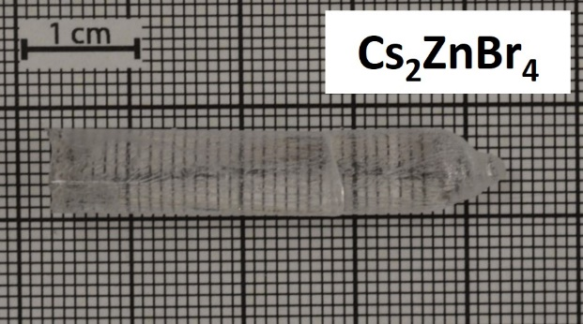
Figure 69. Photograph of the as-grown 7 mm diameter Cs₂ZnBr₄ crystal.

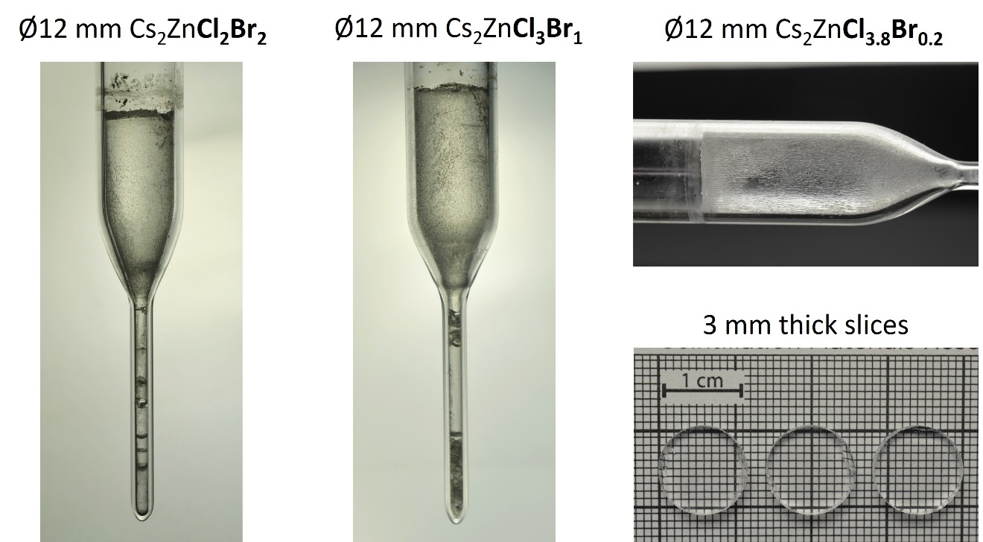
Figure 70. Photographs of backlit 12 mm diameter mixed Cs₂ZnCl_{4-x}Br_{x} crystals inside ampoules, as well as several cut and polished slices.

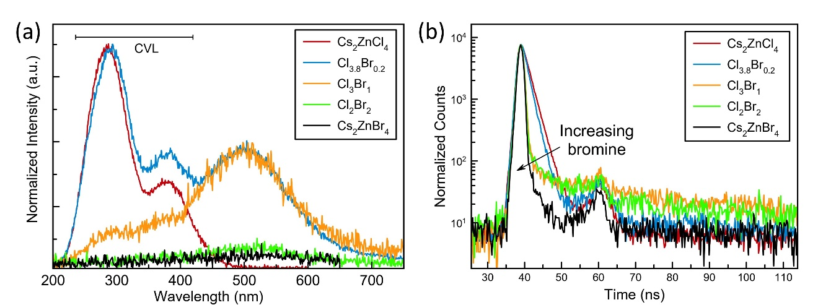
Figure 71. (a) Radioluminescence emission spectra and (b) scintillation decay profiles of Cs₂ZnCl_{4-x}Br_{x} crystals.

apparent for Cs₂ZnCl₃Br₁ and Cs₂ZnCl_{3.8}Br_{0.2}. We currently ascribe this band in Cs₂ZnBr₄ to a quenched STE, however, further investigation is necessary to verify its origin. With high Br/Cl ratios, the CVL emission of Cs₂ZnCl₄ also appears to become quenched. This is evident from suppression (and eventual absence) of the peaks located at ~290 nm and ~375 nm.

Similar to [181], a prompt decay was observed for the Cs₂ZnBr₄ crystal and can be seen in Figure 71b. We were unable to determine its decay constant due to insufficient resolution of the setup. Based on an exponential fit of the data, we estimate the decay time is <350 ps.

To confirm that the measured decay profile of Cs₂ZnBr₄ was actually coming from the sample, an identical measurement was performed with the crystal removed from the setup. The acquisition time was the same for both measurements, 9067 seconds (~2.5 hours). The results are shown in Figure 72, where a substantial difference in the number of raw counts is apparent.

A similar prompt decay appeared in Cs₂ZnCl₂Br₂ and Cs₂ZnCl₃Br₁. However, an additional long component was introduced, likely arising from the broad STE-like emission seen in the radioluminescence spectra. This can be seen in Figure 71b (green and orange curves). The most interesting case is that of Cs₂ZnCl_{3.8}Br_{0.2}. Its decay constant was determined to be 1.35 ± 0.05 ns, faster decay time than that of the pure Cs₂ZnCl₄ crystal (1.66 ± 0.05 ns). Likewise, a significant contribution from the long component observed in the other mixed crystals was not seen.

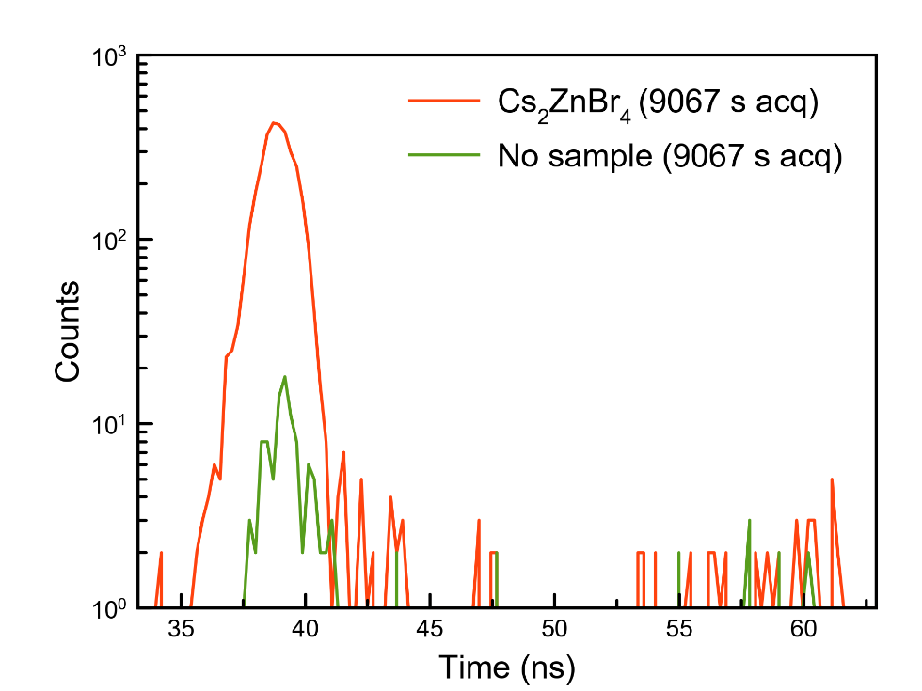
Figure 72. Comparison of scintillation decay time measured with and without the Cs₂ZnBr₄ sample in the setup.

Of particular interest was whether or not the ratio of light yield to decay time for Cs₂ZnCl₄ could be improved with the introduction of Br. A pulse height spectrum measured at 662 keV is shown in Figure 73 for Cs₂ZnCl_{3.8}Br_{0.2} compared to Cs₂ZnCl_{4.} Pulse height spectra could not be measured for the Br-rich samples due to their emission intensities being too weak. Light yield of Cs₂ZnCl_{3.8}Br_{0.2} was calculated to be 1,650 ± 80 ph/MeV giving a slightly better ratio of 1,222 ph/MeV/ns compared to Cs₂ZnCl₄ (1,193 ph/MeV/ns). These results reveal a promising avenue towards improving the performance of Cs₂ZnCl₄ by anion substitution. Further studies to optimize the Br concentration should be considered moving forward.

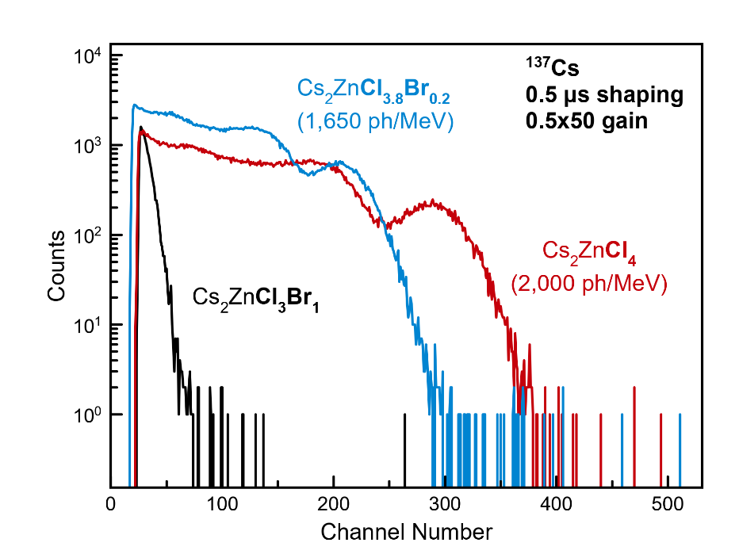
Figure 73. Pulse height spectra measured at 662 keV for Cs₂ZnCl₄, Cs₂ZnCl_{3.8}Br_{0.2}, and Cs₂ZnCl₃Br₁.

Conclusions and Future Outlook

With the ever-growing needs for faster timing capabilities in various applications of radiation detectors, the lack of available inorganic scintillators with ~1 ns decay times presents an opportunity for new materials to emerge. Core valence luminescence (CVL) is an emission process that has received renewed attention in recent years due to the ultrafast decays that can be obtained without completely sacrificing light yield. However, there are still existing gaps in the literature on CVL materials. Some of these gaps have been identified in this work, and new CVL crystals were investigated to address them. Several novel contributions to the field of scintillator research – in particular, relating to core valence luminescence – were presented in this dissertation:

- Promising new ultrafast CVL crystals Cs₂ZnCl₄ and Cs₃ZnCl₅ were explored, and it was demonstrated that crystals with improved optical transparency (80-90% transmittance from 250-800 nm) can be grown by the Bridgman method.
- Higher light yields were achieved with Cs₂ZnCl₄ (1,980 ± 100 ph/MeV) and Cs₃ZnCl₅ (1460 ± 70 ph/MeV) than previously reported, making them more practical for use in a wide range of detection applications.
- First ever growth of a 38 mm diameter Cs₂ZnCl₄ crystal was demonstrated, yielding a transparent crack-free crystal. This is a necessary milestone to break beyond the research stage into commercial viability.
- New ultrafast crystals Cs₂MgCl₄ and Cs₃MgCl₅ were discovered, adding to the list of known CVL materials of the types A₂MX₄ and A₃MX₅, which have rarely been investigated up to this point. Connections between structure and CVL properties were observed, with A₂MX₄-type crystals offering higher light yields and A₃MX₅-type crystals offering faster decay times.
- A new pathway for enhancing the properties of CVL crystals was discovered. Light yield improved by up to 60% when doping Cs₃MgCl₅ with 5 mol% Zn (1,340 ± 70 ph/MeV for undoped and 2,180 ± 110 ph/MeV for Zn-doped), without introducing any slow decay components. The best light yield and timing resolution were obtained with CsMgCl₃:Zn 5% (3,400 ± 170 ph/MeV and 99.5 ± 3 ps FWHM, respectively). These findings show that Zn²⁺ may play an important role in the CVL process as an impurity or dopant, despite not being a “CVL-active” ion. To date, there have been no reports of this type of CVL observed experimentally.

The CsCl-based CVL crystals studied in this work (Cs₂ZnCl₄, Cs₃ZnCl₅, Cs₂MgCl₄, Cs₃MgCl_{5,} Cs₂Mg_{1-x}Zn_{x}Cl₄, Cs₃Mg_{1-x}Zn_{x}Cl₅, CsMgCl₃, and CsMgCl₃:Zn) can all offer advantages over the state-of-the-art ultrafast inorganic scintillator BaF₂. As discussed, this includes their longer wavelength emissions (~300 nm) and single-component decay times (i.e. no long tails in the scintillation pulse).

Future work should investigate (i) radiation hardness to determine suitability for HEP and use in other extreme environments (ii) growth of Cs₂ZnCl₄ with an oriented seed to avoid cracking in large-volume crystals due to the anisotropic thermal expansion (iii) in more depth the theory and possible mechanisms behind enhanced CVL yield upon Zn²⁺ doping and (iv) additional dopants with shallow core levels like Cd²⁺ (in Cs-based crystals) or Ga³⁺ and In³⁺ (in Ba- or K-based crystals) to look for more evidence of d ions serving as “transport core bands” as a way to boost the CVL yield. If this same impurity-enhanced CVL effect can be observed in other host compounds or with other dopants, the possible compositional space for discovery of new bright CVL materials will open up significantly.

References
[1] G. F. Knoll, Radiation Detection and Measurement, 4th Edition. Wiley, 2010.
[2] P. Lecoq, A. Gektin, and M. Korzhik, Inorganic Scintillators for Detector Systems, 2nd ed. Springer, 2017.
[3] G. Bizarri, "Scintillation mechanisms of inorganic materials: From crystal characteristics to scintillation properties," Journal of Crystal Growth, vol. 312, no. 8, pp. 1213-1215, 2010/04/01/ 2010, doi: https://doi.org/10.1016/j.jcrysgro.2009.12.063.
[4] M. Nikl, "Scintillation detectors for x-rays," Measurement Science and Technology, vol. 17, no. 4, p. R37, 2006.
[5] P. A. Rodnyi, Physical Processes in Inorganic Scintillators. CRC Press, 1997.
[6] P. Dorenbos, "Scintillation mechanisms in Ce3+ doped halide scintillators," physica status solidi (a), vol. 202, no. 2, pp. 195-200, 2005, doi: https://doi.org/10.1002/pssa.200460106.
[7] P. A. Rodnyi, "Core–valence luminescence in scintillators," Radiat. Meas., vol. 38, no. 4, pp. 343-352, 2004/08/01/ 2004, doi: https://doi.org/10.1016/j.radmeas.2003.11.003.
[8] A. P. Shpak, O. A. Glike, A. G. Dmitriev, P. A. Rodnyi, A. S. Voloshinovskii, and S. M. Pidzyrailo, "Radiative core-valence transitions in wide-gap crystals," Journal of Electron Spectroscopy and Related Phenomena, vol. 68, pp. 335-338, 1994/05/06/ 1994, doi: https://doi.org/10.1016/0368-2048(94)02131-7.
[9] R. Allemand, C. Gresset, and J. Vacher, "Potential advantages of a cesium fluoride scintillator for a time-of-flight positron camera," (in eng), J Nucl Med, vol. 21, no. 2, pp. 153-5, Feb 1980.
[10] S. Kubota, J.-z. Ruan, M. Itoh, S. Hashimoto, and S. Sakuragi, "A new type of luminescence mechanism in large band-gap insulators: Proposal for fast scintillation materials," Nuclear Instruments and Methods in Physics Research Section A: Accelerators, Spectrometers, Detectors and Associated Equipment, vol. 289, no. 1, pp. 253-260, 1990/04/01/ 1990, doi: https://doi.org/10.1016/0168-9002(90)90267-A.
[11] M. Moszyński, C. Gresset, J. Vacher, and R. Odru, "Properties of CsF, a fast inorganic scintillator in energy and time spectroscopy," Nuclear Instruments and Methods, vol. 179, no. 2, pp. 271-276, 1981/01/15/ 1981, doi: https://doi.org/10.1016/0029-554X(81)90049-5.
[12] P. A. Rodnyi and M. A. Terekhin, "Radiative Core–Valence Transitions in Alkali-Halide Crystals," physica status solidi (b), https://doi.org/10.1002/pssb.2221660131 vol. 166, no. 1, pp. 283-288, 1991/07/01 1991, doi: https://doi.org/10.1002/pssb.2221660131.
[13] J. Glodo et al., "Selected Properties of Cs2LiYCl6, Cs2LiLaCl6, and Cs2LiLaYBr6 Scintillators," IEEE Trans. Nucl. Sci., vol. 58, no. 1, pp. 333-338, 2011, doi: 10.1109/TNS.2010.2098045.
[14] F. Ferrulli et al., "Analysis and comparison of the Core-to-Valence Luminescence mechanism in a large CLYC crystal under neutron and γ-ray irradiation through optical filtering selection of the scintillation light," Sensors and Actuators A: Physical, vol. 332, p. 113151, 2021/12/01/ 2021, doi: https://doi.org/10.1016/j.sna.2021.113151.
[15] E. V. D. v. Loef, P. Dorenbos, C. W. E. v. Eijk, K. W. Krämer, and H. U. Güdel, "Scintillation and spectroscopy of the pure and Ce3+-doped elpasolites: Cs2LiYX6 (X = Cl, Br)," Journal of Physics: Condensed Matter, vol. 14, no. 36, p. 8481, 2002/08/29 2002, doi: 10.1088/0953-8984/14/36/307.
[16] S. Lam, S. E. Swider, A. Datta, and S. Motakef, "The Influence of Cation Impurities on the Scintillation Performance of ${{\hbox {SrI}}_2}$(Eu)," IEEE Trans. Nucl. Sci., vol. 62, no. 6, pp. 3397-3404, 2015, doi: 10.1109/TNS.2015.2496800.
[17] K. Kamada et al., "Composition Engineering in Cerium-Doped (Lu,Gd)3(Ga,Al)5O12 Single-Crystal Scintillators," Cryst. Growth Des., vol. 11, no. 10, pp. 4484-4490, 2011/10/05 2011, doi: 10.1021/cg200694a.
[18] X. Zhang et al., "Effects of Ce segregation on the scintillation properties of Cs2LiLaBr6 crystals," Nuclear Instruments and Methods in Physics Research Section A: Accelerators, Spectrometers, Detectors and Associated Equipment, vol. 1055, p. 168524, 2023/10/01/ 2023, doi: https://doi.org/10.1016/j.nima.2023.168524.
[19] M. Nikl and A. Yoshikawa, "Recent R&D Trends in Inorganic Single-Crystal Scintillator Materials for Radiation Detection," (in English), Adv. Opt. Mater., Review vol. 3, no. 4, pp. 463-481, Apr 2015, doi: 10.1002/adom.201400571.
[20] Y. Yokota et al., "Effects of dopant distribution improvement on optical and scintillation properties for Ce-doped garnet-type single crystals," Journal of Materials Science: Materials in Electronics, vol. 28, no. 10, pp. 7151-7156, 2017/05/01 2017, doi: 10.1007/s10854-017-6696-x.
[21] K. Bartosiewicz et al., "A study of Mg2+ ions effect on atoms segregation, defects formation, luminescence and scintillation properties in Ce3+ doped Gd3Al2Ga3O12 single crystals," Journal of Alloys and Compounds, vol. 905, p. 164154, 2022/06/05/ 2022, doi: https://doi.org/10.1016/j.jallcom.2022.164154.
[22] A. Lindsey, "Material and Process Engineering for Bulk Single Crystal Growth of High Performance Scintillator Potassium Calcium Iodide," Ph.D. Ph.D., Materials Science and Engineering, University of Tennessee, 2016.
[23] Y. T. Wu et al., "Zero-dimensional Cs4EuX6 (X = Br, I) all-inorganic perovskite single crystals for gamma-ray spectroscopy," (in English), J. Mater. Chem. C, Article vol. 6, no. 25, pp. 6647-6655, Jul 2018, doi: 10.1039/c8tc01458b.
[24] C. Dujardin et al., "Needs, Trends, and Advances in Inorganic Scintillators," IEEE Trans. Nucl. Sci., vol. 65, no. 8, pp. 1977-1997, 2018, doi: 10.1109/TNS.2018.2840160.
[25] P. Lecoq, "Pushing the Limits in Time-of-Flight PET Imaging," IEEE Transactions on Radiation and Plasma Medical Sciences, vol. 1, no. 6, pp. 473-485, 2017, doi: 10.1109/TRPMS.2017.2756674.
[26] J. Rossignol et al., "Time-of-flight computed tomography-proof of principle," Physics in Medicine & Biology, vol. 65, no. 8, p. 085013, 2020.
[27] S. J. van der Sar, S. E. Brunner, and D. R. Schaart, "Silicon photomultiplier-based scintillation detectors for photon-counting CT: A feasibility study," Medical Physics, vol. 48, no. 10, pp. 6324-6338, 2021, doi: https://doi.org/10.1002/mp.14886.
[28] Z. Wang et al., Gigahertz (GHz) hard x-ray imaging using fast scintillators (SPIE Optical Engineering + Applications). SPIE, 2013.
[29] R.-Y. Zhu, Progress on inorganic scintillators for future HEP experiments (SPIE Optical Engineering + Applications). SPIE, 2021.
[30] P. Lecoq, M. Korzhik, and A. Vasiliev, "Can Transient Phenomena Help Improving Time Resolution in Scintillators?," IEEE Trans. Nucl. Sci., vol. 61, no. 1, pp. 229-234, 2014, doi: 10.1109/TNS.2013.2282232.
[31] R. Ye et al., "Coincidence time resolution investigation of BaF2-based H6610 detectors for a digital positron annihilation lifetime spectrometer," Journal of Instrumentation, vol. 15, no. 06, p. P06001, 2020/06/01 2020, doi: 10.1088/1748-0221/15/06/P06001.
[32] F. Bečvář, J. Čı́žek, L. Lešták, I. Novotný, I. Procházka, and F. Šebesta, "A high-resolution BaF2 positron-lifetime spectrometer and experience with its long-term exploitation," Nuclear Instruments and Methods in Physics Research Section A: Accelerators, Spectrometers, Detectors and Associated Equipment, vol. 443, no. 2, pp. 557-577, 2000/04/01/ 2000, doi: https://doi.org/10.1016/S0168-9002(99)01156-0.
[33] P. Lecoq et al., "Roadmap toward the 10 ps time-of-flight PET challenge," Physics in Medicine & Biology, vol. 65, no. 21, p. 21RM01, 2020/10/20 2020, doi: 10.1088/1361-6560/ab9500.
[34] V. Vaněček, K. Děcká, E. Mihóková, V. Čuba, R. Král, and M. Nikl, "Advanced Halide Scintillators: From the Bulk to Nano," Advanced Photonics Research, vol. 3, no. 8, p. 2200011, 2022, doi: https://doi.org/10.1002/adpr.202200011.
[35] V. S. Shevelev, A. V. Ishchenko, A. S. Vanetsev, V. Nagirnyi, and S. I. Omelkov, "Ultrafast hybrid nanocomposite scintillators: A review," Journal of Luminescence, vol. 242, p. 118534, 2022/02/01/ 2022, doi: https://doi.org/10.1016/j.jlumin.2021.118534.
[36] K. Děcká et al., "Timing performance of lead halide perovskite nanoscintillators embedded in a polystyrene matrix," J. Mater. Chem. C, 10.1039/D2TC02060B vol. 10, no. 35, pp. 12836-12843, 2022, doi: 10.1039/D2TC02060B.
[37] K. Tomanová et al., "On the structure, synthesis, and characterization of ultrafast blue-emitting CsPbBr3 nanoplatelets," APL Materials, vol. 7, no. 1, p. 011104, 2019, doi: 10.1063/1.5079300.
[38] R. Cala' et al., "Sub-100-picosecond time resolution from undoped and Li-doped two-dimensional perovskite scintillators," Applied Physics Letters, vol. 120, no. 24, p. 241901, 2022, doi: 10.1063/5.0093606.
[39] S. E. Derenzo, E. Bourret-Courshesne, G. Bizarri, and A. Canning, "Bright and ultra-fast scintillation from a semiconductor?," Nuclear Instruments and Methods in Physics Research Section A: Accelerators, Spectrometers, Detectors and Associated Equipment, vol. 805, pp. 36-40, 2016/01/01/ 2016, doi: https://doi.org/10.1016/j.nima.2015.07.033.
[40] C. Hu et al., "BaF2:Y and ZnO:Ga crystal scintillators for GHz hard X-ray imaging," Nuclear Instruments and Methods in Physics Research Section A: Accelerators, Spectrometers, Detectors and Associated Equipment, vol. 950, p. 162767, 2020/01/11/ 2020, doi: https://doi.org/10.1016/j.nima.2019.162767.
[41] F. Pagano, N. Kratochwil, M. Salomoni, M. Pizzichemi, M. Paganoni, and E. Auffray, "Advances in heterostructured scintillators: toward a new generation of detectors for TOF-PET," Physics in Medicine & Biology, vol. 67, no. 13, p. 135010, 2022/06/29 2022, doi: 10.1088/1361-6560/ac72ee.
[42] P. Lecoq et al., "Metascintillators: New Results for TOF-PET Applications," IEEE Transactions on Radiation and Plasma Medical Sciences, vol. 6, no. 5, pp. 510-516, 2022, doi: 10.1109/TRPMS.2022.3161473.
[43] R. M. Turtos, S. Gundacker, E. Auffray, and P. Lecoq, "Towards a metamaterial approach for fast timing in PET: experimental proof-of-concept," Physics in Medicine & Biology, vol. 64, no. 18, p. 185018, 2019/09/19 2019, doi: 10.1088/1361-6560/ab18b3.
[44] P. Dutta, K. Sangunni, H. Bhat, and V. Kumar, "Growth of gallium antimonide by vertical Bridgman technique with planar crystal-melt interface," Journal of crystal growth, vol. 141, no. 1-2, pp. 44-50, 1994.
[45] R. Král, "Study on influence of growth conditions on position and shape of crystal/melt interface of alkali lead halide crystals at Bridgman growth," Journal of Crystal Growth, vol. 360, pp. 162-166, 2012/12/01/ 2012, doi: https://doi.org/10.1016/j.jcrysgro.2011.11.064.
[46] R. K. Route, M. Wolf, and R. S. Feigelson, "Interface studies during vertical Bridgman CdTe crystal growth," Journal of Crystal Growth, vol. 70, no. 1, pp. 379-385, 1984/12/01/ 1984, doi: https://doi.org/10.1016/0022-0248(84)90290-2.
[47] C. E. Chang and W. R. Wilcox, "Control of interface shape in the vertical bridgman-stockbarger technique," Journal of Crystal Growth, vol. 21, no. 1, pp. 135-140, 1974/01/01/ 1974, doi: https://doi.org/10.1016/0022-0248(74)90161-4.
[48] R. J. Naumann, "An analytical approach to thermal modeling of Bridgman-type crystal growth: I. One-dimensional analysis," Journal of Crystal Growth, vol. 58, no. 3, pp. 554-568, 1982/08/01/ 1982, doi: https://doi.org/10.1016/0022-0248(82)90143-9.
[49] E. D. Bourret, J. J. Derby, and R. A. Brown, "Dynamics of bridgman-stockbarger growth of non-dilute binary alloys," Journal of Crystal Growth, vol. 71, no. 3, pp. 587-596, 1985/05/01/ 1985, doi: https://doi.org/10.1016/0022-0248(85)90365-3.
[50] W. G. Coates et al., "Effect of ACRT rotation parameters on Bridgman grown CdxHg1−xTe crystals," Journal of Crystal Growth, vol. 94, no. 4, pp. 959-966, 1989/04/01/ 1989, doi: https://doi.org/10.1016/0022-0248(89)90130-9.
[51] A. Yeckel and J. J. Derby, "Effect of accelerated crucible rotation on melt composition in high-pressure vertical Bridgman growth of cadmium zinc telluride," Journal of Crystal Growth, vol. 209, no. 4, pp. 734-750, 2000/02/02/ 2000, doi: https://doi.org/10.1016/S0022-0248(99)00498-4.
[52] M. S. Divecha and J. J. Derby, "Towards optimization of ACRT schedules applied to the gradient freeze growth of cadmium zinc telluride," Journal of Crystal Growth, vol. 480, pp. 126-131, 2017/12/15/ 2017, doi: https://doi.org/10.1016/j.jcrysgro.2017.10.001.
[53] H. Fang, L. Zheng, H. Zhang, Y. Hong, and Q. Deng, "Reducing Melt Inclusion by Submerged Heater or Baffle for Optical Crystal Growth," Cryst. Growth Des., vol. 8, no. 6, pp. 1840-1848, 2008/06/01 2008, doi: 10.1021/cg700815d.
[54] A. G. Ostrogorsky, V. Riabov, and N. Dropka, "Interface control by rotating submerged heater/baffle in vertical Bridgman configuration," Journal of Crystal Growth, vol. 498, pp. 269-276, 2018/09/15/ 2018, doi: https://doi.org/10.1016/j.jcrysgro.2018.07.002.
[55] A. Iltis, M. R. Mayhugh, P. Menge, C. M. Rozsa, O. Selles, and V. Solovyev, "Lanthanum halide scintillators: Properties and applications," Nuclear Instruments and Methods in Physics Research Section A: Accelerators, Spectrometers, Detectors and Associated Equipment, vol. 563, no. 2, pp. 359-363, 2006/07/15/ 2006, doi: https://doi.org/10.1016/j.nima.2006.02.192.
[56] W. M. Higgins, A. Churilov, E. van Loef, J. Glodo, M. Squillante, and K. Shah, "Crystal growth of large diameter LaBr3:Ce and CeBr3," Journal of Crystal Growth, vol. 310, no. 7, pp. 2085-2089, 2008/04/01/ 2008, doi: https://doi.org/10.1016/j.jcrysgro.2007.12.041.
[57] F. L. Ruta, S. Swider, S. Lam, and R. S. Feigelson, "Understanding phase equilibria and segregation in Bridgman growth of Cs2LiYCl6 scintillator," Journal of Materials Research, vol. 32, no. 12, pp. 2373-2380, 2017/06/01 2017, doi: 10.1557/jmr.2017.168.
[58] C. Delzer et al., "Observations regarding inclusions in the growth of Cs2HfCl6 single crystal scintillators," Journal of Crystal Growth, vol. 531, p. 125336, 2020/02/01/ 2020, doi: https://doi.org/10.1016/j.jcrysgro.2019.125336.
[59] S. Swider et al., "Impurity segregation in zone-refined precursors for crystalline halide scintillators," Nuclear Instruments and Methods in Physics Research Section A: Accelerators, Spectrometers, Detectors and Associated Equipment, vol. 784, pp. 5-8, 2015/06/01/ 2015, doi: https://doi.org/10.1016/j.nima.2014.11.048.
[60] S. Swider, S. Motakef, A. Datta, and W. Higgins, "Residual gas analysis of volatile impurities in halide precursors for scintillator crystals," in Hard X-Ray, Gamma-Ray, and Neutron Detector Physics XV, 2013, vol. 8852: SPIE, pp. 286-292.
[61] B. Suerfu, F. Calaprice, and M. Souza, "Zone Refining of Ultrahigh-Purity Sodium Iodide for Low-Background Detectors," Physical Review Applied, vol. 16, no. 1, p. 014060, 07/26/ 2021, doi: 10.1103/PhysRevApplied.16.014060.
[62] S. Suerfu, "Developing Ultra-Low Background Sodium-Iodide Crystal Detector for Dark Matter Searches," Ph.D., Princeton University, United States -- New Jersey, 10977855, 2018. [Online]. Available: https://utk.idm.oclc.org/login?url=https://www.proquest.com/dissertations-theses/developing-ultra-low-background-sodium-iodide/docview/2161764417/se-2?accountid=14766
https://libkey.io/libraries/203/openurl?genre=article&aulast=Suerfu&issn=&title=&atitle=&volume=&issue=&spage=&date=2018&doi=&sid=ProQuest
[63] L. Boatner et al., Advances in the growth of alkaline-Earth halide single crystals for scintillator detectors (SPIE Optical Engineering + Applications). SPIE, 2014.
[64] Y. Wu et al., "Defect Engineering in SrI2:Eu2+ Single Crystal Scintillators," Cryst. Growth Des., vol. 15, no. 8, pp. 3929-3938, 2015/08/05 2015, doi: 10.1021/acs.cgd.5b00552.
[65] A. C. Lindsey, M. Zhuravleva, L. Stand, Y. Wu, and C. L. Melcher, "Crystal growth and characterization of europium doped KCaI3, a high light yield scintillator," Optical Materials, vol. 48, pp. 1-6, 2015/10/01/ 2015, doi: http://dx.doi.org/10.1016/j.optmat.2015.07.017.
[66] H. Chen, P. Yang, C. Zhou, C. Jiang, and J. Pan, "Growth of LaCl3:Ce3+ Crystal by the Vertical Bridgman Process in a Nonvacuum Atmosphere," Cryst. Growth Des., vol. 6, no. 4, pp. 809-811, 2006/04/01 2006, doi: 10.1021/cg050358c.
[67] L. Alaribe et al., "${\hbox{SrI}}_{2}{:}{\hbox{Eu}}^{2+}$ -Scintillators for Spectroscopy and X-Ray Imaging Applications," IEEE Trans. Nucl. Sci., vol. 59, no. 5, pp. 2193-2195, 2012, doi: 10.1109/TNS.2012.2212208.
[68] D. S. Sofronov, K. A. Kudin, A. Y. Voloshko, A. M. Kudin, and O. V. Shishkin, "Origin of the thermal desorption peaks of gases in NaI above 180°C," Inorganic Materials, vol. 45, no. 11, pp. 1314-1318, 2009/11/01 2009, doi: 10.1134/S0020168509110235.
[69] N. Cherepy et al., SrI[sub]2[/sub] scintillator for gamma ray spectroscopy (SPIE Optical Engineering + Applications). SPIE, 2009.
[70] V. Khanin, I. Venevtsev, and P. Rodnyi, "Recent advances in the study of core-valence luminescence (cross luminescence). Review," Optical Materials, vol. 136, p. 113399, 2023/02/01/ 2023, doi: https://doi.org/10.1016/j.optmat.2022.113399.
[71] A. S. Voloshinovskii, V. B. Mikhailik, and P. A. Rodnyi, "Impurity-induced core-valence lumionescence: A new possibility for fast scintillators creation," Radiat. Meas., vol. 24, no. 4, pp. 383-385, 1995/10/01/ 1995, doi: https://doi.org/10.1016/1350-4487(95)91004-R.
[72] M. R. Farukhi and C. F. Swinehart, "Barium Fluoride as a Gamma Ray and Charged Particle Detector," IEEE Trans. Nucl. Sci., vol. 18, no. 1, pp. 200-204, 1971, doi: 10.1109/TNS.1971.4325864.
[73] N. Ershov, N. Zakharov, and P. Rodnyi, "Spectral-kinetic study of the intrinsic-luminescence characteristics of a fluorite-type crystal," Optics and Spectroscopy, vol. 53, no. 1, pp. 51-54, 1982.
[74] M. Laval et al., "Barium fluoride — Inorganic scintillator for subnanosecond timing," Nuclear Instruments and Methods in Physics Research, vol. 206, no. 1, pp. 169-176, 1983/02/15/ 1983, doi: https://doi.org/10.1016/0167-5087(83)91254-1.
[75] J. L. Ullmann et al., "The Detector for Advanced Neutron Capture Experiments: A 4π BaF2 Detector for Neutron Capture Measurements at LANSCE," AIP Conference Proceedings, vol. 769, no. 1, pp. 918-923, 2005, doi: 10.1063/1.1945154.
[76] K. Byrum et al., "Mu2e-II: Muon to electron conversion with PIP-II," arXiv preprint arXiv:2203.07569, 2022.
[77] C. Hu, C. Xu, L. Zhang, Q. Zhang, and R.-Y. Zhu, "Development of yttrium-doped BaF 2 crystals for future HEP experiments," IEEE Trans. Nucl. Sci., vol. 66, no. 7, pp. 1854-1860, 2019.
[78] H. Han et al., "Development of a fast radiation detector based on barium fluoride scintillation crystal," Review of Scientific Instruments, vol. 84, no. 7, p. 073503, 2013, doi: 10.1063/1.4812789.
[79] R. H. Pots, E. Auffray, and S. Gundacker, "Exploiting Cross-Luminescence in BaF2 for Ultrafast Timing Applications Using Deep-Ultraviolet Sensitive HPK Silicon Photomultipliers," (in English), Frontiers in Physics, Original Research vol. 8, no. 482, 2020-October-29 2020, doi: 10.3389/fphy.2020.592875.
[80] C. W. E. van Eijk, "Cross-luminescence," Journal of Luminescence, vol. 60-61, pp. 936-941, 1994/04/01/ 1994, doi: https://doi.org/10.1016/0022-2313(94)90316-6.
[81] I. Kamenskikh, M. MacDonald, V. Mikhailin, I. Munro, and M. Terekhin, "Cross luminescence of several perovskite‐type crystals," Review of scientific instruments, vol. 63, no. 1, pp. 1447-1449, 1992.
[82] M. A. Macdonald, E. N. Mel'chakov, I. H. Munro, P. A. Rodnyi, and A. S. Voloshinovsky, "Radiative core-valence transitions in CsMgCl3 and CsSrCl3," Journal of Luminescence, vol. 65, no. 1, pp. 19-23, 1995/06/01/ 1995, doi: https://doi.org/10.1016/0022-2313(95)00051-Q.
[83] E. N. Mel'chakov, P. A. Rodnyi, B. Rybakov, A. Y. Smakov, and M. A. e. Terekhin, "Radiative core-valence transitions in CsCl and CsCaCl_3," Fizika Tverdogo Tela, vol. 31, no. 5, pp. 276-278, 1989.
[84] J. Andriessen, P. Dorenbos, and C. Van Eijk, "Molecular cluster calculations of cross-luminescence in BaF2, CsF, CsCl and CsBr," Nuclear Tracks and Radiation Measurements, vol. 21, no. 1, pp. 139-141, 1993.
[85] P. A. Rodnyi, "Progress in fast scintillators," Radiat. Meas., vol. 33, no. 5, pp. 605-614, 2001/10/01/ 2001, doi: https://doi.org/10.1016/S1350-4487(01)00068-3.
[86] A. S. Voloshinovskii et al., "Impurity core–valence luminescence in Rb1−xCsxCl mixed crystals," Journal of Luminescence, vol. 79, no. 2, pp. 107-114, 1998/08/28/ 1998, doi: https://doi.org/10.1016/S0022-2313(98)00030-1.
[87] Y. Chornodolskyy, G. Stryganyuk, S. Syrotyuk, A. Voloshinovskii, and P. Rodnyi, "Features of the core–valence luminescence and electron energy band structure of A1−xCsxCaCl3 (A = K,Rb) crystals," Journal of Physics: Condensed Matter, vol. 19, no. 47, p. 476211, 2007/11/01 2007, doi: 10.1088/0953-8984/19/47/476211.
[88] P. Dorenbos, R. Visser, C. W. E. v. Eijk, J. Valbis, and N. M. Khaidukov, "Photon yields and decay times of cross luminescence in ionic crystals," IEEE Trans. Nucl. Sci., vol. 39, no. 4, pp. 506-510, 1992, doi: 10.1109/23.159656.
[89] C. L. Woody, P. Levy, and J. Kierstead, "Slow component suppression and radiation damage in doped BaF2 crystals," IEEE Trans. Nucl. Sci., vol. 36, no. 1, pp. 536-542, 1989.
[90] P. Schotanus, P. Dorenbos, C. W. E. van Eijk, and H. J. Lamfers, "Suppression of the slow scintillation light output of BaF2 crystals by La3+ doping," Nuclear Instruments and Methods in Physics Research Section A: Accelerators, Spectrometers, Detectors and Associated Equipment, vol. 281, no. 1, pp. 162-166, 1989/08/20/ 1989, doi: https://doi.org/10.1016/0168-9002(89)91229-1.
[91] P. Dorenbos, R. Visser, R. Dool, J. Andriessen, and C. W. E. v. Eijk, "Suppression of self-trapped exciton luminescence in La3+- and Nd3+ -doped BaF2," Journal of Physics: Condensed Matter, vol. 4, no. 23, p. 5281, 1992/06/08 1992, doi: 10.1088/0953-8984/4/23/005.
[92] V. Nesterkina, N. Shiran, A. Gektin, K. Shimamura, and E. Villora, "The Lu-doping effect on the emission and the coloration of pure and Ce-doped BaF2 crystals," Radiat. Meas., vol. 42, no. 4, pp. 819-822, 2007/04/01/ 2007, doi: https://doi.org/10.1016/j.radmeas.2007.02.062.
[93] N. Abe et al., "Crystal Growth and Luminescence Properties of Tm:BaF2 Single Crystals," Japanese Journal of Applied Physics, vol. 49, no. 2R, p. 022601, 2010/02/22 2010, doi: 10.1143/JJAP.49.022601.
[94] A. V. Gektin, A. N. Belsky, and A. N. Vasil'ev, "Scintillation Efficiency Improvement by Mixed Crystal Use," IEEE Trans. Nucl. Sci., vol. 61, no. 1, pp. 262-270, 2014, doi: 10.1109/TNS.2013.2277883.
[95] O. Sidletskiy, "Trends in Search for Bright Mixed Scintillators," physica status solidi (a), vol. 215, no. 13, p. 1701034, 2018, doi: https://doi.org/10.1002/pssa.201701034.
[96] K. Takahashi, M. Koshimizu, Y. Fujimoto, T. Yanagida, and K. Asai, "Auger-free luminescence characteristics of Cs(Ca1−xMgx)Cl3," Nuclear Instruments and Methods in Physics Research Section A: Accelerators, Spectrometers, Detectors and Associated Equipment, vol. 954, p. 161842, 2020/02/21/ 2020, doi: https://doi.org/10.1016/j.nima.2019.01.068.
[97] V. Vaněček et al., "(INVITED) Ultraviolet cross-luminescence in ternary chlorides of alkali and alkaline-earth metals," Optical Materials: X, vol. 12, p. 100103, 2021/12/01/ 2021, doi: https://doi.org/10.1016/j.omx.2021.100103.
[98] A. S. Voloshinovskii et al., "Manifestation of the 3p K+-core excitons in impurity core-valence luminescence of K1−xCsxCl mixed crystals," Solid State Communications, vol. 103, no. 12, pp. 689-691, 1997/09/01/ 1997, doi: https://doi.org/10.1016/S0038-1098(97)00240-8.
[99] A. Voloshinovskii, "Decay of 5pCs-core excitations in halide crystals with core valence luminescence," Radiat. Meas., vol. 33, no. 5, pp. 565-569, 2001/10/01/ 2001, doi: https://doi.org/10.1016/S1350-4487(01)00060-9.
[100] A. S. Voloshinovskii, V. B. Mikhailik, and P. A. Rodnyi, "Impurity-induced core-valence luminescence: A new possibility for fast scintillators creation," Radiat. Meas, vol. 24, no. 4, pp. 383-385, 1995.
[101] J. L. Jansons, V. J. Krumins, Z. A. Rachko, and J. A. Valbis, "Crossluminescence of KF and related compounds," Solid State Communications, vol. 67, no. 2, pp. 183-185, 1988/07/01/ 1988, doi: https://doi.org/10.1016/0038-1098(88)90960-X.
[102] E. N. Mel'chakov, P. A. Rodnyi, N. G. Zakharov, A. Hopkirk, I. H. Munro, and D. Shaw, "Doping of RbCl and KCaCl3 with alkali ions to obtain fast scintillators," Nuclear Instruments and Methods in Physics Research Section B: Beam Interactions with Materials and Atoms, vol. 97, no. 1, pp. 572-574, 1995/05/02/ 1995, doi: https://doi.org/10.1016/0168-583X(95)00198-0.
[103] K. Takahashi, M. Koshimizu, Y. Fujimoto, T. Yanagida, and K. Asai, "Auger-free luminescence characteristics of Rb<sub>1−</sub><i><sub>x</sub></i>Cs<i><sub>x</sub></i>CaCl<sub>3</sub>," Journal of the Ceramic Society of Japan, vol. 126, no. 10, pp. 755-760, 2018, doi: 10.2109/jcersj2.18051.
[104] M. Itoh, N. Ohno, H. Yoshida, S. Hashimoto, K. Kan'no, and M. Kamada, "Auger-free luminescence in mixed alkali halides," Journal of electron spectroscopy and related phenomena, vol. 79, pp. 117-120, 1996.
[105] E. D. Bourret-Courchesne, G. Bizarri, S. M. Hanrahan, G. Gundiah, Z. Yan, and S. E. Derenzo, "BaBrI:Eu2+, a new bright scintillator," Nuclear Instruments and Methods in Physics Research Section A: Accelerators, Spectrometers, Detectors and Associated Equipment, vol. 613, no. 1, pp. 95-97, 2010/01/21/ 2010, doi: https://doi.org/10.1016/j.nima.2009.11.036.
[106] R. Hawrami, E. Ariesanti, V. Buliga, L. Matei, S. Motakef, and A. Burger, "Advanced high-performance large diameter Cs2HfCl6 (CHC) and mixed halides scintillator," Journal of Crystal Growth, vol. 533, p. 125473, 2020/03/01/ 2020, doi: https://doi.org/10.1016/j.jcrysgro.2019.125473.
[107] M. Loyd, A. Lindsey, L. Stand, M. Zhuravleva, C. L. Melcher, and M. Koschan, "Tuning the structure of CsCaI3:Eu via substitution of bromine for iodine," Optical Materials, vol. 68, pp. 47-52, 2017/06/01/ 2017, doi: https://doi.org/10.1016/j.optmat.2016.11.009.
[108] M. Loyd et al., "Investigation of CeBr3−xIx scintillators," Journal of Crystal Growth, vol. 531, p. 125365, 2020/02/01/ 2020, doi: https://doi.org/10.1016/j.jcrysgro.2019.125365.
[109] L. Stand et al., "Characterization of mixed halide scintillators: CsSrBrI2:Eu, CsCaBrI2:Eu and CsSrClBr2:Eu," Journal of Luminescence, vol. 207, pp. 70-77, 2019/03/01/ 2019, doi: https://doi.org/10.1016/j.jlumin.2018.10.108.
[110] J. Xiong et al., "Growth and Characterization of Mixed Halide Scintillators K2LaClxBr5−x:Ce," Crystal Research and Technology, vol. 57, no. 1, p. 2100149, 2022, doi: https://doi.org/10.1002/crat.202100149.
[111] A. Ohnishi, M. Saito, M. Kitaura, M. Itoh, and M. Sasaki, "Auger-free luminescence due to interatomic p–d transition and self-trapped exciton luminescence in Rb2ZnCl4 crystals," Journal of Luminescence, vol. 132, no. 10, pp. 2639-2642, 2012/10/01/ 2012, doi: https://doi.org/10.1016/j.jlumin.2012.05.009.
[112] M. Kitaura, S. Watanabe, K. Ogasarawa, A. Ohnishi, and M. Sasaki, "Comparative study of Auger-free luminescence of Rb2ZnCl4 crystals between experiment and calculation," physica status solidi c, vol. 10, no. 7-8, pp. 993-996, 2013, doi: https://doi.org/10.1002/pssc.201200825.
[113] K. Takahashi, M. Arai, M. Koshimizu, Y. Fujimoto, T. Yanagida, and K. Asai, "Luminescence characteristics of Cs2BaCl4," Japanese Journal of Applied Physics, vol. 59, no. 3, p. 032003, 2020/02/27 2020, doi: 10.35848/1347-4065/ab762b.
[114] K. Takahashi, M. Arai, M. Koshimizu, Y. Fujimoto, T. Yanagida, and K. Asai, "Luminescence and scintillation properties of Cs2ZnCl4 and Cs3ZnCl5," Japanese Journal of Applied Physics, vol. 59, no. 7, p. 072002, 2020/06/10 2020, doi: 10.35848/1347-4065/ab9655.
[115] J. Saaring et al., "Time-resolved luminescence spectroscopy of ultrafast emissions in BaGeF6," Journal of Luminescence, vol. 244, p. 118729, 2022/04/01/ 2022, doi: https://doi.org/10.1016/j.jlumin.2022.118729.
[116] H. J. Seifert and G. Thiel, "Thermal analysis for generating phase diagrams of systems alkali metal chloride/divalent metal chloride," Thermochimica Acta, vol. 100, no. 1, pp. 81-107, 1986/05/01/ 1986, doi: https://doi.org/10.1016/0040-6031(86)87052-6.
[117] A. Ohnishi, M. Kitaura, T. Otomo, and M. Sasaki, "Reflection Spectrum and Auger-Free Luminescence in Molecular Ionic Crystals of Cs2ZnCl4," Journal of the Physical Society of Japan, vol. 72, no. 9, pp. 2400-2401, 2003/09/15 2003, doi: 10.1143/JPSJ.72.2400.
[118] N. Yahaba et al., "X-ray detection capability of a Cs2ZnCl4 single-crystal scintillator," Applied Physics Express, vol. 7, no. 6, p. 062602, 2014/05/27 2014, doi: 10.7567/apex.7.062602.
[119] A. Ohnishi, M. Kitaura, M. Itoh, and M. Sasaki, "Electronic Structure and Auger-Free Luminescence in Cs2ZnCl4 Crystals," Journal of the Physical Society of Japan, vol. 81, no. 11, p. 114704, 2012/11/15 2012, doi: 10.1143/JPSJ.81.114704.
[120] S. Wu et al., "Experimental investigation and thermodynamic assessment of the RbClCsClZnCl2 system and its subsystems," Fluid Phase Equilibria, vol. 487, pp. 33-44, 2019/05/15/ 2019, doi: https://doi.org/10.1016/j.fluid.2019.01.011.
[121] P. Dorenbos, J. T. M. d. Haas, R. Visser, C. W. E. v. Eijk, and R. W. Hollander, "Absolute light yield measurements on BaF/sub 2/ crystals and the quantum efficiency of several photomultiplier tubes," IEEE Trans. Nucl. Sci., vol. 40, no. 4, pp. 424-430, 1993, doi: 10.1109/23.256593.
[122] A. G. Paul Lecoq, Mikhail Korzhik, Inorganic Scintillators for Detector Systems, 2nd ed. Cham, Switzerland: Springer, 2017.
[123] B. F. Markov, Zh. Obshch. Khim, vol. 25, 1955.
[124] L. Stand et al., "Crystal growth and scintillation properties of pure and Tl-doped Cs3Cu2I5," Nuclear Instruments and Methods in Physics Research Section A: Accelerators, Spectrometers, Detectors and Associated Equipment, vol. 991, p. 164963, 2021/03/01/ 2021, doi: https://doi.org/10.1016/j.nima.2020.164963.
[125] T. Jin, S. Hao, Y. Shang, Z. Lei, and C. Yang, "Recent Trends in Elpasolite Single Crystal Scintillators for Radiation Detection," Crystals, vol. 12, no. 7, p. 887, 2022. [Online]. Available: https://www.mdpi.com/2073-4352/12/7/887.
[126] J. Lin, Q. Wei, D. Zhang, G. Tang, L. Qin, and H. Shi, "Crystal Growth and Scintillation Properties of Non-Stoichiometric Cs2LiLaBr6:Ce," Crystal Research and Technology, vol. 54, no. 10, p. 1900047, 2019, doi: https://doi.org/10.1002/crat.201900047.
[127] G. Dhanaraj, K. Byrappa, V. Prasad, and M. Dudley, Springer handbook of crystal growth. Springer, 2010.
[128] H.-J. Seifert and G. Thiel, "Lösungskalorimetrische Messungen an Doppelchloriden des Magnesiums," Zeitschrift für anorganische und allgemeine Chemie, vol. 436, no. 1, pp. 237-243, 1977, doi: https://doi.org/10.1002/zaac.19774360131.
[129] B. H. Toby and R. B. Von Dreele, "GSAS-II: the genesis of a modern open-source all purpose crystallography software package," Journal of Applied Crystallography, vol. 46, no. 2, pp. 544-549, 2013, doi: doi:10.1107/S0021889813003531.
[130] L. M. Bollinger and G. E. Thomas, "Measurement of the Time Dependence of Scintillation Intensity by a Delayed‐Coincidence Method," Review of Scientific Instruments, vol. 32, no. 9, pp. 1044-1050, 1961/09/01 1961, doi: 10.1063/1.1717610.
[131] M. Bertolaccini, S. Cova, and C. Bussolatti, "A technique for absolute measurement of the effective photoelectron per keV yield in scintillation counters," in proceedings of International Symposium on Nuclear Electronics. Versailles, France, 1968.
[132] D. Rutstrom et al., "Improved light yield and growth of large-volume ultrafast single crystal scintillators Cs2ZnCl4 and Cs3ZnCl5," Optical Materials, vol. 133, p. 112912, 2022/11/01/ 2022, doi: https://doi.org/10.1016/j.optmat.2022.112912.
[133] G. Kresse and J. Furthmüller, "Efficiency of ab-initio total energy calculations for metals and semiconductors using a plane-wave basis set," Comp Mater Sci, vol. 6, no. 1, pp. 15-50, 1996-07-01 1996, doi: 10.1016/0927-0256(96)00008-0.
[134] G. Kresse and J. Furthmüller, "Efficient iterative schemes for ab initio total-energy calculations using a plane-wave basis set," Physical Review B, vol. 54, no. 16, pp. 11169-11186, 1996-10-15 1996, doi: 10.1103/physrevb.54.11169.
[135] J. P. Perdew et al., "Restoring the Density-Gradient Expansion for Exchange in Solids and Surfaces," Physical Review Letters, vol. 100, no. 13, p. 136406, 2008-04-04 2008, doi: 10.1103/physrevlett.100.136406.
[136] J. Heyd, G. E. Scuseria, and M. Ernzerhof, "Hybrid functionals based on a screened Coulomb potential," The Journal of Chemical Physics, vol. 118, no. 18, pp. 8207-8215, 2003, doi: 10.1063/1.1564060.
[137] P. E. Blöchl, "Projector augmented-wave method," Physical Review B, vol. 50, no. 24, pp. 17953-17979, 1994-12-15 1994, doi: 10.1103/physrevb.50.17953.
[138] C. S. Gibbons, V. C. Reinsborough, and W. A. Whitla, "Crystal Structures of K2MgCl4 and Cs2MgCl4," Canadian Journal of Chemistry, vol. 53, no. 1, pp. 114-118, 1975, doi: 10.1139/v75-015.
[139] T. W. Couch and G. P. Smith, "Polarized Electronic Absorption Spectrum of Tetragonal NiCl42− Cs3(MgCl4)Cl," The Journal of Chemical Physics, vol. 53, no. 4, pp. 1336-1347, 1970, doi: 10.1063/1.1674177.
[140] J. A. McGinnety, "Crystal structure, crystal forces, and charge distribution in salts of the tetrachlorozincate anion," Inorganic Chemistry, vol. 13, no. 5, pp. 1057-1061, 1974/05/01 1974, doi: 10.1021/ic50135a009.
[141] K. Fejfarova, R. Ouarsal, B. El Bali, M. Dusek, and M. Lachkar, "Tricaesium tetrachloridozincate(II) chloride," Acta Crystallographica Section E, vol. 63, no. 5, pp. i136-i137, 2007, doi: doi:10.1107/S1600536807015899.
[142] "\it VESTA3 for three-dimensional visualization of crystal, volumetric and morphology data," Journal of Applied Crystallography, vol. 44, no. 6, pp. 1272--1276, 2011, doi: 10.1107/S0021889811038970.
[143] B. Su, M. Li, E. Song, and Z. Xia, "Sb3+-Doping in Cesium Zinc Halides Single Crystals Enabling High-Efficiency Near-Infrared Emission," Advanced Functional Materials, vol. 31, no. 40, p. 2105316, 2021, doi: https://doi.org/10.1002/adfm.202105316.
[144] M. J. Weber, "Scintillation: mechanisms and new crystals," Nuclear Instruments and Methods in Physics Research Section A: Accelerators, Spectrometers, Detectors and Associated Equipment, vol. 527, no. 1, pp. 9-14, 2004/07/11/ 2004, doi: https://doi.org/10.1016/j.nima.2004.03.009.
[145] P. Dorenbos, J. T. M. d. Haas, R. Visser, C. W. E. v. Eijk, and R. W. Hollander, "Absolute light yield measurements on BaF2 crystals and the quantum efficiency of several photomultiplier tubes," IEEE Trans. Nucl. Sci, vol. 40, no. 4, pp. 424-430, 1993.
[146] M. Murashita, H. Saitoh, K. Tobimatsu, M. Chiba, T. Hirose, and F. Takasaki, "Performance and radiation damage of a BaF2 calorimeter," Nuclear Instruments and Methods in Physics Research Section A: Accelerators, Spectrometers, Detectors and Associated Equipment, vol. 243, no. 1, pp. 67-76, 1986.
[147] X. Liu, C. Peng, L. Zhang, D. Guo, and Y. Pan, "Te4+-doped zero-dimensional Cs2ZnCl4 single crystals for broadband yellow light emission," J. Mater. Chem. C, 10.1039/D1TC04990A vol. 10, no. 1, pp. 204-209, 2022, doi: 10.1039/D1TC04990A.
[148] X. Wang et al., "Bright luminescence of Sb doping in all-inorganic zinc halide perovskite variant," Journal of Alloys and Compounds, vol. 895, p. 162610, 2022/02/25/ 2022, doi: https://doi.org/10.1016/j.jallcom.2021.162610.
[149] M. Kapusta et al., "Comparison of the scintillation properties of LSO:Ce manufactured by different laboratories and of LGSO:Ce," in 1999 IEEE Nuclear Science Symposium. Conference Record. 1999 Nuclear Science Symposium and Medical Imaging Conference (Cat. No.99CH37019), 24-30 Oct. 1999 1999, vol. 2, pp. 704-708 vol.2, doi: 10.1109/NSSMIC.1999.845765.
[150] M. Kapusta et al., "Non-proportionality and thermoluminescence of LSO:Ce," in IEEE Symposium Conference Record Nuclear Science 2004., 16-22 Oct. 2004 2004, vol. 2, pp. 822-828 Vol. 2, doi: 10.1109/NSSMIC.2004.1462335.
[151] M. A. Spurrier, P. Szupryczynski, K. Yang, A. A. Carey, and C. L. Melcher, "Effects of <formula formulatype="inline"><tex>$\hbox {Ca}^{2+}$</tex> </formula> Co-Doping on the Scintillation Properties of LSO:Ce," IEEE Trans. Nucl. Sci., vol. 55, no. 3, pp. 1178-1182, 2008, doi: 10.1109/TNS.2007.913486.
[152] S. Gundacker, R. M. Turtos, E. Auffray, M. Paganoni, and P. Lecoq, "High-frequency SiPM readout advances measured coincidence time resolution limits in TOF-PET," Physics in Medicine & Biology, vol. 64, no. 5, p. 055012, 2019/02/27 2019, doi: 10.1088/1361-6560/aafd52.
[153] S. Ritt, R. Dinapoli, and U. Hartmann, "Application of the DRS chip for fast waveform digitizing," Nuclear Instruments and Methods in Physics Research Section A: Accelerators, Spectrometers, Detectors and Associated Equipment, vol. 623, no. 1, pp. 486-488, 2010/11/01/ 2010, doi: https://doi.org/10.1016/j.nima.2010.03.045.
[154] A. Yoshikawa et al., "Growth of 2Inch Eu-doped SrI2 single crystals for scintillator applications," Journal of Crystal Growth, vol. 452, pp. 73-80, 2016/10/15/ 2016, doi: https://doi.org/10.1016/j.jcrysgro.2016.04.040.
[155] L. Xiaodong, D. Peizhen, H. Bing, Z. Shunxin, and X. Jun, "Vertical Bridgman growth of Cr3+:LiCaAlF6," in Proc.SPIE, 1993, vol. 1863, doi: 10.1117/12.149265. [Online]. Available: https://doi.org/10.1117/12.149265
[156] J. F. Wang, A. Omino, and M. Isshiki, "Bridgman growth of twin-free ZnSe single crystals," Materials Science and Engineering: B, vol. 83, no. 1, pp. 185-191, 2001/06/21/ 2001, doi: https://doi.org/10.1016/S0921-5107(01)00512-8.
[157] P. Veber, J. Mangin, P. Strimer, P. Delarue, C. Josse, and L. Saviot, "Bridgman growth of paratellurite single crystals," Journal of Crystal Growth, vol. 270, no. 1, pp. 77-84, 2004/09/15/ 2004, doi: https://doi.org/10.1016/j.jcrysgro.2004.06.029.
[158] W. R. Wilcox and V. H. S. Kuo, "Gas bubble nucleation during crystallization," Journal of Crystal Growth, vol. 19, no. 4, pp. 221-228, 1973/07/01/ 1973, doi: https://doi.org/10.1016/0022-0248(73)90043-2.
[159] G. D. Patra, S. G. Singh, D. G. Desai, S. Pitale, M. Ghosh, and S. Sen, "Effect of OH content in the quartz crucible on the growth and quality of CsI single crystals and remedies," Journal of Crystal Growth, vol. 544, p. 125710, 2020/08/15/ 2020, doi: https://doi.org/10.1016/j.jcrysgro.2020.125710.
[160] J. Radhakrishnan and S. Selvasekarapandian, "Photoluminescence of undoped and Eu doped CsCl crystals," Journal of Physics: Condensed Matter, vol. 6, no. 30, p. 6035, 1994.
[161] P. C. Selvan, S. Selvasekarapandian, and P. Neelamegam, "Optical absorption, photoluminescence, and thermally stimulated luminescence of CsCl: Tb crystals," physica status solidi (b), vol. 194, no. 2, pp. 747-756, 1996.
[162] H. Wei, A. Lindsey, Z. Zhao, M. Koschan, M. Zhuravleva, and C. L. Melcher, "Tackling Single Crystal Growth Challenges for Mixed-Elpasolite Scintillators," (in English), Cryst. Growth Des., Article vol. 16, no. 7, pp. 4072-4081, Jul 2016, doi: 10.1021/acs.cgd.6b00605.
[163] V. Vanecek et al., "Modified vertical Bridgman method: Time and cost effective tool for preparation of Cs2HfCl6 single crystals," Journal of Crystal Growth, vol. 533, p. 125479, 2020/03/01/ 2020, doi: https://doi.org/10.1016/j.jcrysgro.2020.125479.
[164] A. C. Lindsey et al., "Determination of thermal expansion of KCaI3 using in-situ high temperature powder X-ray diffraction," Materials Chemistry and Physics, vol. 212, pp. 161-166, 2018/06/15/ 2018, doi: https://doi.org/10.1016/j.matchemphys.2018.03.016.
[165] L. Stand et al., "Exploring growth conditions and Eu2+ concentration effects for KSr2I5:Eu scintillator crystals," (in English), Journal of Crystal Growth, Article vol. 439, pp. 93-98, Apr 2016, doi: 10.1016/j.jcrysgro.2015.12.048.
[166] L. Stand et al., "Exploring growth conditions and Eu2+ concentration effects for KSr2I5:Eu scintillator crystals II: Ø 25 mm crystals," Journal of Crystal Growth, vol. 483, pp. 301-307, 2018/02/01/ 2018, doi: https://doi.org/10.1016/j.jcrysgro.2017.11.010.
[167] G. He, X. Gao, Y. Han, J. Li, and J. Liu, "Effect of temperature gradient on microstructure and properties of GaSb crystals grown with Bridgman method," Materials Research Express, vol. 7, no. 5, p. 055902, 2020/05/11 2020, doi: 10.1088/2053-1591/ab8d60.
[168] G. Li, X. Zhang, H. Hua, and W. Jie, "A modified vertical Bridgman method for growth of high-quality Cd1−xZnxTe crystals," Journal of Electronic Materials, vol. 34, no. 9, pp. 1215-1224, 2005/09/01 2005, doi: 10.1007/s11664-005-0266-3.
[169] B. Yan et al., "Optimizing the temperature gradient for CdZnTe crystal growth using the vertical Bridgman–Stockbarger method," Journal of Crystal Growth, vol. 621, p. 127378, 2023/11/01/ 2023, doi: https://doi.org/10.1016/j.jcrysgro.2023.127378.
[170] A. S. Borshchevsky, R. K. Route, and R. S. Feigelson, "Effects of heat pretreatment of starting materials on the optical transparency of CdGeAs2 crystals," Materials Research Bulletin, vol. 15, no. 4, pp. 409-414, 1980/04/01/ 1980, doi: https://doi.org/10.1016/0025-5408(80)90044-6.
[171] G. Meyer, "Thermal behaviour of complex halides," European journal of solid state and inorganic chemistry, vol. 28, no. 6, pp. 1209-1243, 1991.
[172] M. S. Alekhin, J. T. M. de Haas, K. W. Kramer, and P. Dorenbos, "Scintillation Properties of and Self Absorption in SrI2:Eu2+," (in English), IEEE Trans. Nucl. Sci., Article vol. 58, no. 5, pp. 2519-2527, Oct 2011, doi: 10.1109/tns.2011.2163642.
[173] M. Loyd et al., "Growth of large size (≥ 38 mm diameter) KCaI3:Eu scintillator crystals," Nuclear Instruments and Methods in Physics Research Section A: Accelerators, Spectrometers, Detectors and Associated Equipment, vol. 914, pp. 8-14, 2019/01/11/ 2019, doi: https://doi.org/10.1016/j.nima.2018.10.105.
[174] W. Wolszczak, K. W. Krämer, and P. Dorenbos, "CsBa2I5:Eu2+,Sm2+—The First High-Energy Resolution Black Scintillator for γ-Ray Spectroscopy," physica status solidi (RRL) – Rapid Research Letters, vol. 13, no. 9, p. 1900158, 2019/09/01 2019, doi: 10.1002/pssr.201900158.
[175] D. Rutstrom, L. Stand, B. Dryzhakov, M. Koschan, C. L. Melcher, and M. Zhuravleva, "Crystal growth and scintillation properties of new ytterbium-activated scintillators Cs4CaI6:Yb and Cs4SrI6:Yb," Optical Materials, vol. 110, p. 110536, 2020/12/01/ 2020, doi: https://doi.org/10.1016/j.optmat.2020.110536.
[176] Y. Wu et al., "Crystal structure, electronic structure, optical and scintillation properties of self-activated Cs4YbI6," Journal of Luminescence, vol. 201, pp. 460-465, 2018/09/01/ 2018, doi: https://doi.org/10.1016/j.jlumin.2018.05.037.
[177] M. S. Alekhin, D. A. Biner, K. W. Krämer, and P. Dorenbos, "Optical and scintillation properties of SrI2:Yb2+," Optical Materials, vol. 37, pp. 382-386, 2014/11/01/ 2014, doi: https://doi.org/10.1016/j.optmat.2014.06.030.
[178] E. Auffray et al., "A comprehensive & systematic study of coincidence time resolution and light yield using scintillators of different size and wrapping," IEEE Trans. Nucl. Sci., vol. 60, no. 5, pp. 3163-3171, 2013.
[179] M. Janecek, "Reflectivity Spectra for Commonly Used Reflectors," IEEE Trans. Nucl. Sci., vol. 59, no. 3, pp. 490-497, 2012, doi: 10.1109/TNS.2012.2183385.
[180] C. Silva et al., "Reflectance of polytetrafluoroethylene for xenon scintillation light," Journal of Applied Physics, vol. 107, no. 6, 2010, doi: 10.1063/1.3318681.
[181] N. Hurley, F. Moretti, H. Yan, E. Bourret-Courchesne, Y. S. Chu, and S. S. Wong, "Devising novel methods for the controlled synthesis with morphology and size control of scintillator materials," J. Mater. Chem. C, 10.1039/D0TC01211D vol. 8, no. 25, pp. 8622-8634, 2020, doi: 10.1039/D0TC01211D.
[182] M. H. Brooker and C.-H. Huang, "Raman spectroscopic investigations on the structures of CsMgCl3 and Cs3MgCl5," Materials Research Bulletin, vol. 15, no. 1, pp. 9-16, 1980/01/01/ 1980, doi: https://doi.org/10.1016/0025-5408(80)90154-3.
[183] G. Shwetha, V. Kanchana, and G. Vaitheeswaran, "CsMgCl3: A promising cross luminescence material," Journal of Solid State Chemistry, vol. 227, pp. 110-116, 2015/07/01/ 2015, doi: https://doi.org/10.1016/j.jssc.2015.03.024.
[184] R. D. Shannon, "REVISED EFFECTIVE IONIC-RADII AND SYSTEMATIC STUDIES OF INTERATOMIC DISTANCES IN HALIDES AND CHALCOGENIDES," (in English), Acta Crystallogr. Sect. A, Article vol. 32, no. SEP1, pp. 751-767, 1976, doi: 10.1107/s0567739476001551.
[185] P. Chartrand and A. D. Pelton, "Thermodynamic Evaluation and Optimization of the LiCl-NaCl-KCl-RbCl-CsCl-MgCl2-CaCl2-SrCl2-BaCl2 System Using the Modified Quasichemical Model," Canadian Metallurgical Quarterly, vol. 40, no. 1, pp. 13-32, 2001/01/01 2001, doi: 10.1179/cmq.2001.40.1.13.
[186] H. Yin, J. Song, W. Liu, and B. Hu, "Thermodynamic re-optimization of the AClx-MgCl2 (A=Na, K, Rb, Cs and Ca, x=1 or 2) systems," Calphad, vol. 79, p. 102476, 2022/12/01/ 2022, doi: https://doi.org/10.1016/j.calphad.2022.102476.
[187] V. N. Makhov, "Vacuum ultraviolet luminescence of wide band-gap solids studied using time-resolved spectroscopy with synchrotron radiation," Physica Scripta, vol. 89, no. 4, p. 044010, 2014/02/25 2014, doi: 10.1088/0031-8949/89/04/044010.
[188] M. A. Terekhin, V. N. Makhov, A. I. Lebedev, and I. A. Sluchinskaya, "Effect of local environment on crossluminescence kinetics in SrF2:Ba and CaF2:Ba solid solutions," Journal of Luminescence, vol. 166, pp. 137-142, 2015/10/01/ 2015, doi: https://doi.org/10.1016/j.jlumin.2015.05.022.
[189] G. A. Appleby, A. Edgar, and G. V. M. Williams, "Structure and photostimulated luminescent properties of Eu-doped M2BaX4 (M=Cs, Rb; X=Br, Cl)," Journal of Applied Physics, vol. 96, no. 11, pp. 6281-6285, 2004, doi: 10.1063/1.1814171.
[190] M. Ahtee, Lattice constants of some binary alkali halide solid solutions. Suomalainen Tiedeakatemia, 1969.
[191] G. L. McPherson, T. J. Kistenmacher, and G. D. Stucky, "Single‐Crystal Paramagnetic Resonance Studies of V(II), Mn(II), and Ni(II) in CsMgCl3 and the Crystal Structure of CsMgCl3," The Journal of Chemical Physics, vol. 52, no. 2, pp. 815-824, 2003, doi: 10.1063/1.1673061.
[192] M. Cadatal-Raduban et al., "Tunable vacuum ultraviolet cross-luminescence from KMgF under high pressure as potential fast-response scintillator," The Journal of Chemical Physics, vol. 154, no. 12, 2021.
[193] M. Cadatal-Raduban et al., "Investigation of cross luminescence in lanthanum fluoride as a potential fast-response scintillator," Japanese Journal of Applied Physics, vol. 59, no. 5, p. 052005, 2020/05/01 2020, doi: 10.35848/1347-4065/ab887b.
[194] G. Shwetha and V. Kanchana, "Impurity induced cross luminescence in KMgCl3: an ab initio study," Journal of Physics: Condensed Matter, vol. 31, no. 11, p. 115501, 2019/01/25 2019, doi: 10.1088/1361-648X/aafd0a.
[195] J. Yang, S. Falletta, and A. Pasquarello, "Range-separated hybrid functionals for accurate prediction of band gaps of extended systems," npj Computational Materials, vol. 9, no. 1, 2023, doi: 10.1038/s41524-023-01064-x.
[196] J. Mooney and P. Kambhampati, "Get the Basics Right: Jacobian Conversion of Wavelength and Energy Scales for Quantitative Analysis of Emission Spectra," The Journal of Physical Chemistry Letters, vol. 4, no. 19, pp. 3316-3318, 2013/10/03 2013, doi: 10.1021/jz401508t.
[197] M. Moszyński et al., "Characterization of Scintillators by Modern Photomultipliers—A New Source of Errors," IEEE Trans. Nucl. Sci., vol. 57, no. 5, pp. 2886-2896, 2010, doi: 10.1109/TNS.2010.2054111.
[198] S. Gundacker et al., "Experimental time resolution limits of modern SiPMs and TOF-PET detectors exploring different scintillators and Cherenkov emission," Physics in Medicine & Biology, vol. 65, no. 2, p. 025001, 2020/01/16 2020, doi: 10.1088/1361-6560/ab63b4.
[199] R. Ota, K. Nakajima, T. Hasegawa, I. Ogawa, and Y. Tamagawa, "Timing-performance evaluation of Cherenkov-based radiation detectors," Nuclear Instruments and Methods in Physics Research Section A: Accelerators, Spectrometers, Detectors and Associated Equipment, vol. 923, pp. 1-4, 2019/04/11/ 2019, doi: https://doi.org/10.1016/j.nima.2019.01.034.
[200] S. I. Omelkov et al., "Scintillation yield of hot intraband luminescence," Journal of Luminescence, vol. 198, pp. 260-271, 2018/06/01/ 2018, doi: https://doi.org/10.1016/j.jlumin.2018.02.027.
[201] M. Itoh, N. Ohno, and S. Hashimoto, "Core-hole migration and relaxation effect in alkali halide excited by synchrotron radiation," Physical review letters, vol. 69, no. 7, p. 1133, 1992.
[202] A. Voloshinovskii, I. Pashuk, Y. Chornodol'Skyi, G. Stryganyuk, and P. Rodnyi, "Peculiarities of core–valence luminescence of CsBr and Rb1− xCsxBr crystals," physica status solidi (b), vol. 241, no. 11, pp. 2613-2619, 2004.
[203] S. Kubota, M. Macdonald, and I. H. Munro, "AUGER-FREE LUMINESCENCE EXCITATION-SPECTRA IN CSCL AND CSBR BETWEEN 50 AND 140 EV," Journal of Luminescence, vol. 48-9, pp. 589-592, Jan-Feb 1991. [Online]. Available: <Go to ISI>://WOS:A1991FC74600033.
[204] A. Ejiri and K. Arakaki, "Vacuum UV photoelectric yield and photoluminescence in CsCl and CsBr," Solid state communications, vol. 110, no. 10, pp. 575-580, 1999.
[205] M. Itoh, M. Kamada, and N. Ohno, "Temperature dependence of Auger-free luminescence in alkali and alkaline-earth halides," Journal of the Physical Society of Japan, vol. 66, no. 8, pp. 2502-2512, 1997.
[206] M. M. Hamada, "Auger-free luminescence of the BaF2: Sr, BaF2: MgF2 and CsBr: LiBr crystals under excitation of VUV photons and high-energy electrons," Nuclear Instruments and Methods in Physics Research Section A: Accelerators, Spectrometers, Detectors and Associated Equipment, vol. 340, no. 3, pp. 524-539, 1994.
[207] K. Shibuya, H. Saito, M. Koshimizu, and K. Asai, "Outstanding Timing Resolution of Pure CsBr Scintillators for Coincidence Measurements of Positron Annihilation Radiation," Applied Physics Express, vol. 3, no. 8, p. 086401, 2010/07/23 2010, doi: 10.1143/APEX.3.086401.

Vita
Daniel Rutstrom was born in Kingsport, Tennessee, and is the youngest of three children. He began attending the University of Tennessee in 2015 where he obtained his Bachelors (2018) and Masters (2021) degrees in Materials Science and Engineering. From 2016-2024, Daniel worked as a research assistant at the Scintillation Materials Research Center (SMRC) studying novel inorganic single crystal scintillator materials and their applications. During this time, he was a fellow of the Nuclear Science and Security Consortium (NSSC) (2016-2018 and 2022-2024) and a fellow of the Department of Energy NEUP Integrated University Program (IUP) (2019-2021). Daniel will be continuing a career in the field of radiation detection materials development upon completion of his PhD. His interests outside of the lab include spending time with his fiancée Grace Thomasson, traveling, watching football (go Vols!) and hockey, playing music, and exploring the vast world of specialty coffee.

