Remediating a Toxic Town: Power, Place, and Justice in Anniston, Alabama

A Thesis Presented for the

Doctor of Philosophy

Degree

The University of Tennessee, Knoxville

Melanie Ann Barron

December 2016

Copyright © 2016 by Melanie Ann Barron
All rights reserved.

DEDICATION

For Ben.

ACKNOWLEDGEMENTS

Committee, West Anniston, family, friends.

ABSTRACT

Anniston is home to a struggle for environmental justice that has marked the city for several decades. Monsanto Chemical Company placed Anniston on the map as one of the most toxic cities in United States because of its negligent disposal of Polychlorinated Biphenyls (PCBs) in the city’s soil, water, and air. In the wake of the pollution and its impacts on the city, Monsanto has shifted its “persona” in ways that are instructive for understanding the power of corporate identity, how it shapes corporations’ relationships with legal systems and other state bodies, and how it impacts the production of space as communities seek to recover from corporate-driven environmental degradation. As scholars work toward comprehensive solutions to environmental inequalities, it is imperative to understand environmental inequalities in relation to the ways corporate actors and institutions strategically utilize and transform scale to ensure their survival. Drawing on literatures in legal geography, critical economic geography, and broader theoretical debates about the production of scale, this work, based on field research in Anniston, identifies how corporations produce identities that allow them to function with a great deal of flexibility as compared to other actors who become embroiled in struggles over environmental injustices.

TABLE OF CONTENTS

Chapter 1: INTRODUCTION 1
GEOGRAPHIC CONTEXT 6
HISTORICAL CONTEXT 7
DISSERTATION CONTEXT 11
Abstract 15
LITERATURE REVIEW 15
Risk, Scale, and Tensions with Justice 17
Legal Geography & Environmental Justice 21
Justice and Legal beings – Claims, Grievances and Corporate Personhood 23
Litigation & Justice 29
Alternative Justice 33
Memory, Power, Place, and Justice 34
References 40
CHAPTER 3 Risk, Power, Personhood and Survival: Understanding Corporate Scalar Transformations and the Production of Environmental Inequalities in Anniston, Alabama 41
Abstract 42
Introduction 42
Risk Society , Neoliberalism, and Scale 45
Case Study: Corporate Scalar Transformations and A Struggle for Environmental Justice 48
Monsanto’s Early Corporate Identity 49
Trouble in Chemical Paradise 55
The Other Side of Corporate Responsibility 57
Conclusion 59
References 61
Appendix 64
CHAPTER 4 TITLE TBD 65
ABSTRACT 66
Introduction 66
A Litigious Landscape 67
Superfund Alternative & Consent Decree: Policy Choices, Neoliberal Expertise 73
Vignette 2: Settlement and Distribution 76
Discussion 84
CHAPTER 5 88
REMEDIATING A SENSE OF PLACE: MEMORY AND ENVIRONMENTAL JUSTICE IN ANNISTON, ALABAMA 88
ABSTRACT 1
Anniston, Alabama is home to an ongoing struggle for Environmental Justice (EJ) as residents remain embroiled in a remediation process to clean up PCB pollution left by The Monsanto Company. This paper engages with literature in Black Geographies, public memory, and environmental justice to argue that remedial processes neglect senses of place that are valued by impacted communities. In West Anniston, the predominantly black neighborhood that bore the brunt of the pollution, the remediation’s failure to restore a sense of place contributes to an ongoing erasure of black life from the landscape. As a result, the remediation transforms from a relatively benign project to one that facilitates a violence of forgetting. In addition, this paper examines how black life is remembered, commemorated, and valued by residents who participate in the remedial process. 1
INTRODUCTION 1
ANNISTON, ALABAMA: BACKGROUND AND CONTEXT 4
LITERATURE REVIEW 6
REMEDIATION AND FORGETTING IN ANNISTON 11
RECONSTRUCTING THE INVISIBLE THROUGH MEMORY 17
CONCLUSION 25
VITA 30

LIST OF TABLES

Table 1. Table title. 5
Table 2: This Is The Second Table 5

LIST OF FIGURES

Figure 1. Shapes. 5

Chapter 1: INTRODUCTION
The intersections of race, class, and environmental harm have motivated decades of research and activism in the Environmental Justice (EJ) movement. EJ describes a social movement and interdisciplinary research agenda to change the destructive patterns of industrial activities (Holifield 2001; Holifield 2012) among other environmental problems. Despite the institutionalization of EJ language in state policy, the path to justice in the wake of environmental inequalities remains uncertain (Pulido et al 2016, Pellow 2016).
What does it mean to achieve EJ? Who decides? While decades of activism and science have mainstreamed the EJ agenda, it remains an unfinished project (Pulido et al 2016, Pellow 2016). Recently, scholars observed through retrospective inquiry that most EJ movements have relied heavily on direct engagement with the state to achieve justice, but the limits to such an engagement are becoming more clear (Pulido et al 2016). The state has not yet proven its ability to sufficiently provide justice for communities harmed by pollution and environmental neglect. This dissertation expands on this notion through analysis of the implementation of the state’s praxis for EJ through a case study in Anniston, Alabama. Since the mid-1990s, Anniston residents, legal professionals, corporate actors, and state environmental officials have participated in the cleanup of Polychlorinated Biphenyls (PCBs) dumped by The Monsanto Company. Stretching over several decades, involving one of the world’s most notorious multinational corporations, and home to one of the largest toxic tort settlements in U.S. history, the Anniston case is a rich, well-documented microcosm of the challenges many communities must face to compel the neoliberal U.S. state to meet the demands of the EJ movement.
This case study lies at the confluence of EJ, political economy, legal geography, and public memory, and examines the tensions between everyday people, the state, and corporations in the struggle for EJ in Anniston. The design and implementation of environmental laws, legal decisions, and regulations largely excludes public involvement, relegating such decision-making to scientific and legal experts (Kohl 2015). As a result, the ideals expressed by EJ movement actors and ordinary residents are distant from the day-to-day design and implementation of EJ policy. This has an enormous impact on the way places recover from environmental injustice over the long term.
This research is guided by observational and archival methodologies. From 2013-2016, I attended semi-monthly Community Advisory Group (CAG) meetings held by Anniston residents. These meetings, a relatively common piece of long-term EPA cleanups, are held to inform communities impacted by pollution about the state of the pollution and the progress to clean it up. Over the course of my time in Anniston, themes continued to emerge (and erupt) from these meetings around the dialectical tensions of power/disempowerment and recognition/erasure. Anniston’s case exemplifies notion that everything contains its opposite (Ollman 2003). These emergent themes drive the research questions in this dissertation, which seeks to shed light on the historical and spatial underpinnings of the tensions that animate Anniston’s story. This research is guided by the following questions:

1) What relationships do corporate actors produce across scales to mitigate the consequences of environmental injustice?
Corporate entities are key players in many EJ conflicts as the instigators of environmental problems and as major players in processes to clean up pollution. However, corporations’ relationships to cleanup processes are complex in contemporary neoliberal environmental governance. Corporations may be environmental policymakers (Pellow 2001), environmental stewards (Berry and Rondinelli 1998), and environmental violators (Brammer and Pavelin 2005) depending on the time and circumstances. Corporations shift the ways in which they identify with environmental issues depending on situational, temporal, and spatial circumstances, strategically transforming their relationships with actors across different scales. Corporations’ relationships to the environment both shape and are shaped by the notion of scale.
In the chapter titled “Corporate Transformations and the erasure of Environmental Injustice in Anniston, Alabama,” the author uses archival data to reconstruct how The Monsanto Company shifted its relationships with environmental issues over time in response to multiple pressure points across scales. A dialectical analysis of these shifts demonstrates that multi-scalar pushes toward enforcing greater environmental stewardship in corporate culture had the inverse effect of empowering corporate actors’ ability to control the debates about pollution in Anniston. The institutionalization of corporate environmental sensibilities created a new avenue to take power in environmental decision-making and messaging. Monsanto’s strategic shift toward environmental stewardship produced new relationships across scales to downplay the impacts and scope of the pollution, ensure the survival of the company, and ensure influence in the cleanup process itself.

2) How did legal and scientific experts guide the construction and implementation of the cleanup plan? How is environmental governance shaped by the political economy of the US?
Legal and scientific authorities rely heavily on scientific “objectivity” and “expertise” to create authoritative remedial plans and guidelines. These plans calculate acceptable levels of risk for residents living in the midst of polluted environments, and determine the process through which acceptable levels of pollution are achieved. However, as as Giddens, Beck, and many others who use the framework of the “Risk Society” argue (Beck 1992; Beck 2013; Cable, Shriver, and Mix 2008; Ekberg 2007; Giddens 1999; Giddens 2013), the notion of risk is more than a scientific calculation. Risk is also socially constructed and shaped by political-economic context. In Anniston, acceptable risks were calculated to manage the limitations of the political and economic moment during which the crisis unfolded.
“A Geography of Risk,” a critical reading of Anniston’s settlement documentation, analyzes the way scientific and legal authority is used to manage pollutant risks in Anniston. This chapter uses three vignettes to to demonstrate this point: the rationale and decision-making behind the decision to settle lawsuits in 2003, the decision to designate Anniston as a Superfund “Alternative” Site, and the EPA’s responses to public comments about cleanup plans.

3) What role does memory play in the articulation of ongoing environmental injustices?
Remedial plans focus on the physical erasure of pollution – clean soil, water, and air – but in the process of the cleanup in Anniston, the remediation has also contributed to the erasure of a sense of place. Lots lay vacant, many homes are dilapidated, many businesses in the most heavily impacted areas have struggled or failed, schools are being shut down, and the population is dwindling. Among people still living in the area who are still involved in the remediation process, this transformation raises questions about what the remedial plan was designed to accomplish.
“Remediating a Sense of Place” analyzes the impacts of PCB pollution and remediation on the qualitative notions of “place” in Anniston. While remediation may have positive intentions, it neglects the qualities of life that people in West Anniston valued most: a sense of community, and a positive sense of place. This analysis draws questions about the way systems of environmental governance (re)produce racialized inequalities expressed in space and place. In addition, due to the impact that this pollution has and continues to have on black lives and livelihoods in the city, this issue speaks to broader issues about the (de)valuation of black life in U.S. society. What appears to be a benign extension of environmentalist goodwill unto West Anniston instead functions as another violent encounter from the state; remediation becomes a tool to facilitate the violence of forgetting.

GEOGRAPHIC CONTEXT
Nestled in the foothills of the Appalachian mountains, Anniston’s tree-lined main thoroughfare, Quintard Avenue, showcases a quaint downtown complete with stately stone churches, elegant old homes, and several local businesses and restaurants. West of Quintard Avenue is Noble Street, the downtown area that city officials seek to revitalize after several decades of depression. Recent additions to the district include several new restaurants, boutiques, and a micro-brewery. The city is reminiscent of many small southern industrial towns, where officials attempt to reinvent a cultural life in the wake of neoliberal reorganization and industrial divestment.
The West Anniston neighborhood, a wide-reaching area that begins west of Noble Street, seems exempt from this attention. West Anniston stands in stark contrast to the quaint charms of the east side. Elegant old homes are crumbling, some with residents inside, others abandoned to the elements and a thriving kingdom of kudzu. Many lots sit curiously vacant, leaving gaps that disrupt the flow of the streets, drawing questions about what is missing. Why does this land sit in such contrast—yet in such close proximity—to parts of the city that are actively redeveloping?
Carver Community Center breathes some life into this landscape. It holds a branch of the community library, recreational facilities, and is a common meeting place for organizations in the neighborhood. It has been the longtime public meeting location of the Community Advisory Group for the Consent Decree (CAG), a group that organizes informational sessions about the progress of the PCB cleanup in the area. The pollution’s severity earned Anniston the unfortunate nickname, “Toxic City,” after Monsanto was held liable for the negligent disposal of PCBs in the city’s soil, water, and air. The meeting is located in West Anniston because it is the neighborhood that was most directly affected by the pollution, and has been the home of a significant amount of cleanup activities.

HISTORICAL CONTEXT
From the 1930s to the 1990s, The Monsanto Company operated an industrial chemical company in Anniston. During that time it manufactured PCBs, a key component of its best-selling product, Aroclors, used as insulation for heavy equipment (Spears 2014). This product, engineered by industrial chemists working for Monsanto, was one of the most profitable products in the entire company, and Anniston was one of only two places in the United States that manufactured it. As part of the manufacturing process, PCBs were routinely dumped into a landfill or directly into the nearest river, and today, the town’s soil, water, and air remain contaminated some 37 years after the chemical was banned in 1979 due to global concerns about its toxicity for humans and the environment.
Anniston is the PCB contamination "capital" of the United States. Residents are routinely cited in EPA documentation with the highest blood levels of PCBs of any known population (“Anniston- PCBs and Dioxins/furans in Soil, Blood, and Air and Pesticides in Soil.” 1999). PCBs are widely known to cause health problems, and are included on the EPA's "probable carcinogens" list (Cogliano 1996). The dangers of PCBs have been documented almost since the very start of their manufacture, when workers reported developing a skin condition called chlorachne, wherein large, painful open sores would emerge and linger after direct contact with the substance. Workers complained of headaches, nosebleeds, and would frequently come down with strange cancers and illnesses of the liver and major organs. Before long, residents were complaining of the same kinds of conditions, and local informal records indicate that people living near the factory, in the predominantly black West Anniston neighborhood, frequently died from strange diseases that no one could medically explain (Spears 2014). Horrific stories abound in the archives, like this one, where a reporter recounted the story of a young boy: “[His sister described] How Manuel "blanked out" and went into seizures at age 9. How doctors took a spinal tap and reported "unknown toxins" in his body. How by his late 30s, he was so weak he could not lift his hand to feed himself. How Manuel, completely blind, was overcome by psychosis and saw monsters coming for him at the end. He died of heart failure last year at a nursing home, at the age of 40” (Barry 2004).
It was not until Monsanto began quietly buying up properties in Anniston in the 1990s that the pollution became more widely known to the general public. These buyouts resulted in massive changes in the landscape that made the issue increasingly difficult to ignore, particularly among West Anniston residents, who were propositioned to make choices about selling their homes or continuing to reside on polluted land.
As a result, local residents organized a social movement to investigate the issue and advocate for those who were becoming entangled in this conflict. Community leaders and residents from areas most affected by the pollution--particularly in the West Anniston neighborhood--formed a group called Community Against Pollution (CAP) to organize against Monsanto's negligence and fight for their community, which was being rapidly decimated by the property buyouts (Spears 2014). A once vibrant black community was decimated, as Monsanto tore down structures on its buyout properties, leaving them vacant, and devaluing those that remained.
In many ways, the movement spearheaded by CAP was terrifically effective. It was eventually revealed, through persistent investigation and advocacy, that Monsanto had scientific evidence about the toxicity and dangers of PCB pollution as early as the 1960s (Spears 2014). In addition, through a series of permit applications for landfill sites, it was also evident that the State of Alabama was aware of the presence of hazardous material, but did little to inform the broader community about potential dangers (“ADEM Hazardous Waste Facility Permit No. 004-019-048” 1986). The discovery of this information enraged local residents, and inspired mass numbers of people to pursue multiple lawsuits against Monsanto and the company to which it strategically divested its chemical holdings in the late 1990s, Solutia.
These lawsuits attracted national attention in the news media (“Monsanto Hid Decades Of Pollution” 2015; “Toxic Secret” 2013), and they attracted internationally renowned supporters, notably Johnny Cochran, a lawyer famous for his advocacy of O.J. Simpson, who attracted 5,000 potential clients when he came to meet with people in Anniston in 2001 (Spears 2014, 262-3). His suit would grow to attract nearly 20,000 plaintiffs. In addition, the trials allowed the movement to partially achieve its goals of winning compensation for Anniston residents. One of the trials, Sabrina Abernathy v. Monsanto, was successful in earning a ruling that Monsanto was responsible for negligent pollution, forcing Monsanto to award damages totaling $40 million. This put substantial pressure on Monsanto, Solutia, and the courts to bring all of the cases to a simultaneous conclusion in 2003 with a global settlement totaling $700 million, the largest toxic tort settlement at that point in U.S. history (Spears 2014, 263).
During the settlement negotiations, a consent decree document governing the cleanup process ordered: 1) a lump sum of money to be divided amongst the plaintiffs according to various degrees of damages; 2) an environmental remediation plan to be funded by Solutia and co-executed and managed by the Environmental Protection Agency (EPA); 3) the formation of the Community Advisory Group for the Consent Decree (CAG), which was tasked to oversee the cleanup process and represent the community’s interests; 4) a health clinic funded by Solutia; 5) at least two nonprofit entities to support the West Anniston community: The Anniston Community Education Foundation and the West Anniston Foundation. These various groups are key stakeholders throughout this cleanup process.

DISSERTATION CONTEXT
The questions guiding this dissertation pick up Anniston’s story at a time when the public drama surrounding the PCB crisis was largely over. When I began visiting Anniston in 2013, the settlements were distributed, the cleanup was designed, and the system was simply playing out the plans that various stakeholders had created. However, there is a quiet danger in that banality that is important for scholars and EJ activists to understand. Long after the excitement of these cases dwindles down, there are many more decisions to be made, a hundred more meetings to attend, tens of thousands of pages to be read – settlements and consent decrees are hardly resolutions at all. It is the beginning of a next step in environmental governance where experts take the helm, where law executes its authority (for better and for worse), and where cities are reshaped from pollution minefields into whatever it is they will ultimately turn out to be. At this point, there is little more that ordinary people can do within the confines of our current system to change the outcome, even if the outcome is as dismal as West Anniston’s appears to be.
My approach to this field seeks to clarify the path to environmental justice by taking seriously the contributions of critical human geography’s understandings of the production of space and uneven development. In political economy, I draw on the works of Neil Smith and Erik Swyngedoew, who seek to understand the reorganization of spatial relationships in the wake of neoliberal globalization. Their analyses, which broadly argue that uneven development is a necessary component to capitalism as it continuously seeks out the most profitable places for development, dovetails well with the patterns that we observe in Environmental Justice literatures. Often, the places that are most vulnerable to environmental malfeasance are also the places that have low costs of doing business- lax environmental regulations, low restrictions on labor, and so forth. This is why there is a broad global trend of primary industries – such as mining – taking place in the global south, and increasingly, in the U.S. south, where states are in a race to the bottom for attracting re-investment from mining, manufacturing and other heavy industries. In addition, scholars like Ruthie Gilmore, Katherine McKittrick, and Josh Inwood, connect this uneven development to broader processes of racialization that dialectically shape the production of landscape. They bring into sharp focus development is not just about economics but it also about value: who is valued, how people are valued, and how that is expressed both in our legal systems and through the landscapes that we create. We have to think beyond paradigms of environmental justice that only quantify injury, that assign differential values to bodies, that reproduce the patterns of uneven development that continue to injure nonwhite communities in the United States and beyond.
This dissertation, as critical as it may be of the impacts of certain strategies of EJ, is shaped by a deep appreciation for struggle; even while people face incredible odds against their success, and may be devalued by our systems of governance, they fight. And sometimes, they win. Appreciating the people’s struggle for Environmental Justice, as scholars like Laura Pulido and Rob Nixon do, can help society create a primer for building a better world. It is through bearing witness the acts of courageous people that courage may become contagious.

CHAPTER 2
LITERATURE REVIEW

Abstract

<Insert Abstract Here>

LITERATURE REVIEW
Modern geographic scholarship teaches how humans are all linked, albeit unevenly, by the current economic epoch of global neoliberal capitalism. Our problems, our lives, and the ultimate outcomes of our existences are all intertwined as capital leaves us, arrives anew, exploits, connects, separates. We all have a role to play in capital's search for its "fix," a term in Harvey's (2001) geographic analyses of globalization. In his analysis, Capitalism’s current incarnation has three important characteristics: 1) it is necessarily expansionary for its survival due to crises of over-accumulation; 2) it requires innovations in technology and communication to facilitate this expansion; 3) expands and changes based on its mode of expansion, whether seeking new sources of resources, labor, and/or markets. The nature of capitalism's changes depends on what is needed to achieve capital's fix--"fix" meaning both its immediate survival needs, but also its ability to continue to exist, be fixed, in a particular place.
The law is ever-present in this circulation of capital and resources, and is produced alongside capital's fixity in place as well as its journey to find its fix across space. It creates and destroys paths for capital accumulation and mobility, a process that has been fairly well-documented on the macro-scale as new supra-state structures have been created to facilitate its expansion and mobility (Gowan 1999; Robinson 2001). In addition, there is interesting work about the local impacts of globalization (Herod 2001; Grant and Nijman 2002). However, what interests me, is the messy middle area somewhere between the local and the global, where I see the law as being particularly important. In an almost literal sense, it is a place where actors at multiple scales of power converge and are forced to reckon with each other, and the impacts of that reckoning create new structures that have material consequences. Thus, this work is structured as an answer to Barkan’s (2009) call for geographic scholarship that engages with the law empirically and theoretically to “help us conceptualize more rigorously the processes by which political and economic space is formulated, contested, reproduced, and transformed” (2009: 602) in a global society.
Furthermore, I seek to expand on Pulido’s (2000) call to take seriously the relationship between environmental injustices and the structures that produce racialized, classed, and white supremacist spaces. Because pollution and environmental hazards disproportionately impact nonwhite communities, the structures in place that shape those outcomes should be challenged. Social sciences literature is full of examples of how our current systems of governance--economic, social, and legal--disproportionately underserve and/or exploit poor, nonwhite populations. However, there is less known about the opposite side of that coin: how do our current systems of governance favor the white, wealthy, and powerful? Just as systems are created to serve the exploitative needs of capital, they are created to benefit those with significant economic and social privilege. Thus if, I argue, if the point of our scholarly existence is help create positive, just changes the world, then litigious--or, perhaps, any--engagement with the formal legal system in its current Westphalian moment must be critically scrutinized as an avenue through which we should focus our energy as scholars, advocates, and activists.
This review weaves together relatively disparate conversations about the environment and justice in three sub-fields: political economy, legal geography, and landscape/memory studies. This review explores the intersections of EJ with these fields, and identifies the key areas in the field to which this dissertation is poised to make a contribution. First, deepening the connection between environmental justice and the critical use of scale in geography. Second, deepening a critique of neoliberalism’s impact on the current legal systems for environmental justice. Third, strengthening connections between environmental justice and memory studies.

Risk, Scale, and Tensions with Justice
Ulrich Beck’s now-classic text, Risk Society, identifies a paradigm that emerged hand-in-hand with modern industrialization (1992). He argues that class society, or the “dictatorship of scarcity,” has dominated the source of conflict and social stratification throughout modernization. However, in some parts of the world, “the struggle for one’s ‘daily bread’ has lost its urgency as a cardinal problem overshadowing everything else,” and collective risks created by modernization have emerged as the basis of a new social system.
The geographic arrangements, and the different scales at which risks are experienced, determined, and mediated raises questions about how the risk society produces scalar configurations of political and economic power. Expanding on the work of geographers like Erik Swyngedouw (Swyngedouw 2004), Neil Smith (Smith and Harvey 2008; Smith 1996), and others outside the discipline writing about environmental political economy (Beck, Foster, etc), I seek to expand analyses of the risk society by analyzing the role of scale in cases of environmental inequality such as Anniston's. This kind of understanding is important because, according to Swyngedouw (2004), the production of scale is intimately tied to "struggles for control and empowerment" (33). An understanding of the how scale is produced and by whom it is harnessed is important for innovating solutions in EJ cases.
As scholars work toward comprehensive solutions to environmental inequalities, it is imperative that we understand notions of justice across scales in order to understand the local context of environmental inequalities in relation to the global activities of corporate actors and institutions. Otherwise, we risk allowing a cycle of impunity to persist, wherein corporations are able to settle conflicts in one geographic area, satisfying localized prescriptions for justice, while continuing to inflict environmental injustices in other places, wherein the path to justice may be differentially conceived. Moving forward, I discuss how these concerns about scale intersect with EJ and legal geography literatures.
There are geographies embedded in the risk society that suggest multiple scales of political and economic power are produced in this trend. For example, the same uneven development that brought industrialization to the neoliberal, deregulated US South (Cobb 1993) also brought with it uneven industrial exposures along the lines of racial identity (Bullard 2000). Communities that desperately needed employment opportunities and tax revenue have participated in the "race to the bottom" for high-risk industries on a regional scale. On other scales, the risk society is defined, in part, by a reliance on expert knowledge to mediate between the scientific world and the world of economic development, which operate in less localized institutional and social arrangements through national bureaucratic agencies such as the EPA. This mirrors the tendency in neoliberalism to rely on a world of international experts to drive economic and political policy such as the IMF, World Bank, and World Trade Organization. In both risk society and neoliberal society, the impetus for decision-making is decidedly "top-down," from the risk society's scientific intelligentsia class to neoliberalism's academic and policy elite.
Nancy Fraser argues we are in a period of "abnormal justice," where the formal systems and discourses society has constructed to achieve justice are proving themselves to be decreasingly applicable to modern claims of injustice. This assessment hinges largely on the diminishing relevance of the Westphalian system of organizing statehood and citizenship in the wake of an increasingly globalized civilization.
In our most recent moment of "normal justice"--which she defines as being in the midcentury, after WWII, sometime before the deeply globalized present--the "Keynesian-Westphalian" (Fraser 2010, 12) imagination dominated the ways in which justice was conceived, sought, and dispensed. In the Westphalian political imagination, the "domestic" and "international" spheres of legal and political space are distinct (ibid, 12), limiting the bounds of justice claims to national geographic units. Only a few issues were "international"--famines, genocides, refugee crises (ibid, 13), but the framing of such conflicts still hinged on the national unit. Similarly, the global economic system, managed through the Bretton-Woods agreement, relegated economic distribution to the national unit, and, at least in the Western context, claims for redistributive justice were sought through a Keynesian "moral economy" framework (Ibid, 12; Harvey 2008).
However, major shifts in the economic organization of the world, particularly driven by the onset of global neoliberalism, have created a moment of "abnormal justice" where the Westphalian national unit has become an inadequate scale for addressing many claims of injustice. She argues that emerging claims of injustice at this moment in history struggle with "radical heterogeneity" and "incommensurability" in the way justice systems assess claims. It is because the claims coming forward are qualitatively distinct -- radically heterogeneous -- and difficult, if not impossible, to measure with any degree of impartiality -- they are incommensurable within the current Westphalian model.
Struggles for environmental justice frequently include a direct engagement with the legal system; therefore, legal systems often significantly shape the possibilities for how environmental justice is conceived. However, the multiple scales of power embedded in legal actions, proceedings, and arguments raises questions about inclusion/exclusion; are the scales of justice truly balanced in a system where corporations have the rights of "personhood" (Barkan 2011; Barkan 2012; Barkan 2015; Pollman 2012)? What are the legal-political implications of scalar transformations such as globalization, as corporate persons have obligations, interests, and networks that transcend the local (Fraser 2010)? What does this mean for local actors who lack access to such arrangements, and how is power gained (Swyngedouw 2004)? This research takes place in a context where the legal system's prescriptions for justice do not align with conceptions of justice victims advocate, suggesting a spatial mismatch to be explored.

Legal Geography & Environmental Justice
Recent reviews throughout the discipline of geography have called for more substantial engagement with the way in which law forms space, place, and scale (Barkan 2009, Delaney 2014, Kurtz 2003, Walker 2009). Rather than viewing law as a taken-for-granted norm, these calls urge a critical view of the law and the systems of power it embeds and naturalizes during globalization (Barkan 2009), landscape production (Mitchell 2013), and racialization (Kurtz 2003). These calls have a resonant unity when viewed through the lens of Environmental Justice, wherein people mired in racialized inequality challenge global scales of power by confronting corporations responsible for deadly pollution in their communities.
My research examines the law's role in creating new geographies by critically examining the conceptions of justice that are included and excluded from environmental settlement and cleanup agreements, interrogating the multiple scales of power that become inscribed in those geographies (Barkan 2009, Kurtz 2003), and understanding how they are expressed in the landscape (Mitchell 2013) and in geographies of memory (Till 2014). The way settlements are designed and implemented is instructive for answering questions about the interactions between the law, the environment, and community stakeholders (corporations, citizens, local and regional governance) and for the ways the landscape changes wrought by remedial agreements impact understandings of environmental justice.
I also seek to explore how movement actors push beyond the realm of the legal in search of justice. This brings alternatives to current modes of justice to the fore, including restorative notions of justice (Inwood 2012; Kurki 2000; Llewellyn and Howse 1999). In the context of the U.S. South, a region that has been a major target of environmental racism, and a region that is also mired in legal injustices through what many increasingly argue is a white-supremacist legal system (Alexander 2012), one of the ways in which geographers can contribute to innovating new modes of justice is to conduct analyses that empower notions of space and place conceived from the "bottom-up," rather than relying on the present modes of expert-driven authority.

Justice and Legal beings – Claims, Grievances and Corporate Personhood
Claims for legal recognition are framed in 2 ways 1) in regard the need for a place in the political order--what Fraser describes as "ordinary political injustices...when skewed decision rules compromise the political voice of some who are already counted as members, impairing their ability to participate as peers in social interaction" (Fraser 2010, 6). This draws into question the ordinary modes of liberal democractic systems: are electoral voting mechanisms sufficient means of representing the political body (Ibid, 19)? Further, is a system that is blind to identity, but claims political equality, actually following through with that claim (Ibid, 19)?
These are questions endemic to liberal democratic systems whose main concern is to ensure political equality for all while also privileging individual rights above all others (Purcell 2008, 40). This is bound in a negative conceptualization of rights and liberties wherein protection from state tyranny includes protection from obligation. If there are no formal restrictions from being able to vote, participate in public life, and be represented in the political system then the system is working.
Redistributive claims are the most economistic of the three types Fraser elaborates upon, as they seek justice through an egalitarian distribution of resources throughout society. She cites organizations such as labor unions as being emblematic organizational apparatuses for these claims (Fraser 2010, 103), but during much of the labor movement's heyday, redistributive claims were not extended to everyone. They were limited to the national framework, and they were often limited to white men, because of the racial exclusivity of many labor unions (Mandel 1955) and the lack of labor organization rights granted sectors of the economy where nonwhite workers were most prevalent (Meltzer 1974).
This discussion highlights a moment where claims of representation come into tension with claims around redistribution in the US context. According to liberal logic, the state should only be concerned with reducing its interference in people’s personal lives, not necessarily with promoting a “positive” conception of rights. This would entail “ensure[ing] the provision of people’s basic needs so that they are free to flourish to the best of their abilities (Purcell 2008, 41).” Many of the fights for Civil Rights in the United States have hinged on these representational claims, including the right to vote, the right to exist in public space, and most importantly, the right to be recognized as a citizen, regardless of the color of your skin. While these advances certainly allowed greater participation in the formal system, they did not necessarily align with what would be considered "equality," a more economically redistributive concept. ML King, quoted in Dawson’s Black Visions, touches on this tension:
“There is not even a common language when the term ‘equality’ is used. Negro and white have a fundamentally different definition. Negroes have proceeded from a premise that equality means what it says, and have taken white Americans at their word when they talked of it as an objective. But most whites…proceed from a premise that equality is a loose expression for improvement” (Dawson 267).
This tension is palpable because the very logic of negative rights that was used to justify racially progressive reforms, which mainly focused on advancing representation, was also used to justify their retreat. During the 1970s economic crisis and during the 1980s under the Reagan administration, policy became radically more conservative and pro-white than in previous decades, as Reagan and Bush took a strong anti-affirmative action stance (Browne-Marshall, 2007), claiming that such policies gave additional privileges to nonwhite people, promoting unfair advancement. Part of what made this possible lies in the ambiguity of anti-discrimination law, which makes it difficult to “defend its genuine interests against those whose interests are supported by opposing visions that also lie within the same discourse” (Crenshaw 1988, 1349).
For opponents of many civil rights advances, equal representation was being stripped from white Americans with policies like affirmative action, even going so far as to call these policies “reverse discrimination” or “reverse racism” (Omi and Winant 1994) because they supposedly levied advantages to people of color that were unavailable to white people. The epistemological stance of the “colorblind” or “raceless society” was being applied to preserve privilege instead of progress the disadvantaged, and this was legally possible because of the state’s imperative to prioritize individual liberty above group interests.
Recognition, and who can legally claim it, is debated on a number of fronts:
"...group identity, autonomous achievement, or autonomous personhood; cultural distinctiveness, individual achievement, or autonomous personhood; cultural distinctiveness, common humanity, or the claimant's standing as a partner in a social interaction (Fraser 2010, 32). "
What political unit deserves the recognition of the law? This tenet of Fraser's argument pushes the boundaries of the law the furthest in claims for racial justice, in my estimation. Who may be recognized as a person worthy of rights pushes the boundaries of the Westphalian system to its limits, as claims to justice intersect with identity in ways that push the boundaries of citizenship past their current legal possibilities. Claims for recognition demand an alternative. There are two scenarios that come to mind when I make this claim.
Legally, how personhood is defined is closely connected to how rights are defined and protected, and for whom rights are defined and protected. The notion of corporate personhood draws the power embedded into the concept of personhood into sharp focus. Personhood is a concept that has been utilized strategically over time to ascribe rights to certain beings, entities, and institutions over the course of the history of United States. Conversely, the denial of personhood has been used to strip rights from certain beings and institutions over the course of that same history. This draws into question the morality of the use of personhood at all:
The concept of personhood, has a dual function: (1) It protects those considered persons against suffering the hurts and indignities which the selfish tendencies of human psychology could inflict on them, and (2) it justifies treating those creatures not considered persons selfishly. By assigning them moral rights, the concept of personhood protects some creatures from being treated merely as means to human satisfaction. By denying them moral rights, the concept of personhood, justifies treating other creatures, that is, those considered property or creatures of nature, merely as means to human satisfaction. Is it morally acceptable and preferable to have a concept which functions in this way? (Sapontzis 1981, 617)
For other types of entities that have and enjoy legal personhood, the struggle for legal recognition has been less difficult. It is particularly telling that nonhuman entities, such as corporations, are able to be recognized as persons in a legal sense. Thus they are able to enjoy some of the same rights that individual person has. How is this possible? Graver (1999) argues that it is wrapped up in the way that the court is able to define persons:
To recognize an entity as a person, the court asks to what extent the entity acts as an individual agent. Because corporations can act with purposes distinct from those of the people that comprise them, the court is disposed to accept corporations as people. After all, corporations are vividly in action before the law. They obligate themselves (but none of the humans that make them up) through contracts. They sue and are sued. They carry out projects, deliver goods and services, collect and distribute money, hire and fire employees. An extreme version of the real entity theory would end its analysis here and declare the corporation just as much a person as any living human being because it acts individually in the world and is liable for its actions just like any human being. (Graver 1999, 242-243)
In order to understand why a corporation would prefer to be treated as an individual, it is important to understand the reasoning for incorporation in the first place. The corporation is a business entity in which ownership is held by multiple shareholders. Shareholders are entitled to profit from the corporation’s activities, but they are not necessarily involved in the day-to-day operations of the corporation. For that there is usually a Board of Directors some form of leadership in place. Corporations have birthdays but not death dates; they are intended to extend the life of wealth and capital beyond a single generation. The corporation itself can be held liable, can be sued and counter-sue, can enter agreements, and generally function as an individual businessperson while its existence is predicated on its ownership and control by multiple actors. The overarching value of incorporation, however, is to protect the personal property of individuals (Pollman 2011).

Litigation & Justice
Throughout the history of the United States, litigation has been a "go-to" strategy for many in social movements to attempt to bring progressive change to major institutions. The decision to engage in litigation is heavily influenced by the legacy of previous successes, most notably the landmark Brown v. Board of Education decision (Meyer and Boutcher 2013). Social movement actors move fairly fluidly between causes throughout their lives, and they bring with them their experiences of success and failure that influence future decisions. The decision to litigate is influenced by the actors' previous experiences, combined with the climate of political opportunity which often facilitates the ability to emulate previous strategies for social change (Meyer and Boutcher 2013).
However, in spite of some landmark victories, the empirical impacts of the many decisions to engage in litigation are unclear, at best. Institutional barriers embedded into litigious strategies make it difficult for alternatives to be proposed. Scholars argue that limited liberal legal logic restricts the scope of the problems that may be addressed and the solutions that may be proposed (NeJaime 2011, 950-1). Even landmark Civil Rights cases such as Brown v. Board of Education have been critiqued in light of their limits. Rosenberg and Klarman's study (as cited in Nejaime 2011) found the judge's decision alone did not spur desegregation of schools, nor did it massively change public opinion or cause great reaction within the African American community. They write that the "claim that a major contribution of the courts in civil rights was to give the issue salience, press political elites to act, prick the consciences of whites, legitimate the grievances of blacks, and fire blacks up to act is not substantiated" (Nejaime 2011, 951). Further, many scholars extend this pessimistic view by noting that segregation still exists, as does massive racialized inequality in the public school system, drawing the utility of the decision even deeper into question in the long view (Bell 2005).
On a more positive note, NeJaime offers positive scholarly perspectives on the outcomes of litigation, wherein a positive outcome in court makes it easier for organizers to frame issues and construct campaigns around enforcing a legal decision, it raises consciousness and awareness of a particular problem, and it provides a central post around which groups can form their identity (NeJaime 2011, 954-955). Furthermore, these engagements may increase a movement's bargaining power, connections, and, in the event of victory, authoritative affirmation of the movement's central aims (NeJaime 2011).
On the other hand, the legal literature gives the impression that there is a great deal of pressure to settle out of court: "Since the court dockets are overflowing with lawsuits, all else equal, litigants should be encouraged to resolve their disputes privately through out-of-court settlement" (Spier 1994, 84). The vast majority of all cases do settle, in part because the incentive to settle is high when compared with the cost of going to court. The decision is most often framed as an economic one: "When two litigants resolve a dispute through out-of-court settlement rather than trial, they realize joint gains of trade equal to the sum of the costs both parties would have incurred had they obtained a trial judgment minus the costs they incur reaching settlement" (Korobkin and Guthrie 1994, 1).
Because of the costs involved, and the "winner take all" outcome of going to trial, trials are often considered failures within the legal profession (Lederman 1999, 319). However, there could be a multitude of additional factors that influence this decision beyond economics. For example, Korobkin and Guthrie (1994) argue that the style and strategy behind the negotiation process can greatly impact the likelihood of successful negotiations. There is also a good deal of discussion about the (a)symmetry of the information about the lawsuit between the two parties, and how that information is shared during the negotiation process (Reinganum and Wilde, 1986). These discussions, aimed at lawyers seeking to make more informed strategies, paint this negotiation process as a game: how much are information you willing to give to your opponent? Are you willing to lay your cards down first, or are you going to wait and see what your opponent does? And the economics of the decision still play a strong role: are you willing to pay the consequences of not working it out by going to a potentially costly and lengthy trial?
However, these observations leave the decision-making and bargaining behind litigation squarely in the hands of those who are in expert roles: lawyers. Are lawyers really in the best position to decide what justice will be for people whose personal health and living spaces have been poisoned?
The role of the state in being able to ameliorate the issues of environmental justice has come into question, particularly with Kurtz's work calling for a deeper engagement with Critical Race Theory in environmental justice studies (Kurtz 2009). If the state itself is engaged in a project of racial exploitation and domination, then why does environmental justice activism so frequently center its efforts in the litigious arena? What are the limitations of that kind of engagement? One connection for exploring these questions is through the lens of legal geography.
In the discipline of Geography, Laura Pulido spearheaded the effort to bring the concept to the fore (Pulido 1996; Pulido 2000; Pulido 2014) with her studies of environmental justice in southern California. Recent geographic work has followed Pulido's lead in tying racial justice to environmental justice. One of the main problems in this arena has been the issue of conceptual framing, as the imperatives for justice press against the scales at which justice can be achieved (Kurtz 2003): at what scale does one assess responsibility for claims of injustice, and whose claims are legitimate?
While litigation may quell one conflict in one area, the underlying problem remains, if not for the individual or group involved, then for the people in the neighboring town who have tin ore under their feet waiting to be extracted, or the children living next to an open field that is being considered as the next landfill location for a chemical company. Pollution, sickness, and the general neglect of human welfare are symptomatic of a broader problem in legal systems’ (de)valuation of human life.

Alternative Justice
Humans have a great responsibility to overcome the ways our existences are partitioned into classes, races, sexes, and nationals in order to build solidarity in the wake of human and environmental destruction. But how is such a project achieved? One possibility is through some form of restorative justice, which removes the power from the hands of the justice system (at least to some degree) and could “give victims, offenders, and the community decision-making power (Roach 2000, 253).”
Instead of allowing the government to maintain a strict monopoly over punishment, restorative justice initiatives allow for those who are affected the most by crime—“the victim, the offender, and the community” (Kurki 2000, 236)—to take ownership of the justice process. It can be a highly formalized process—such as a formal truth commission, or it can be a very small-scale personal process. In the criminal justice system, restorative justice generally involves a very small group of people: the victim(s), the offender(s), and their associated family members and supporters (Roach 2000). In this setting, “victims play the most crucial role and this gives them some of the autonomy and power that was taken away by the crime” (Roach 2000, 256), something that seems would resonate in situations of Environmental Justice. Restorative justice is perhaps the most postmodern of modes of justice; if it is possible to break down the history of an event or era of violence and abuse, and understand the full effects of that time, then perhaps it becomes possible to for the truth to be the foundation to build a new reality. Llewellyn and Howse echo that notion:
The idea of justice as restorative opens up the possibility of a rich contextual exploration of what, at a given juncture in the evolution of society, both victims and perpetrators need for equality to be established or reestablished in light of the offences that have occurred. The emphasis is on reintegrative measures that build or rebuild social bonds, as opposed to measures such as imprisonment and the death penalty that isolate and alienate the perpetrator from society (Llewellyn and Howse 1999, 357). Restorative methods are just one of many that could be proposed, but a focus on community-driven solutions to problems that affect ordinary people would be a good starting point.

Memory, Power, Place, and Justice
How we remember and why shapes how societies and social actors place themselves in the world. Geographic research has amassed a wide range of theoretical and empirical work in understanding the impacts of memory in the landscape, and how collective and individual memory is formed and deployed on multiple scales and in multiple venues. Following, I examine some of these dimensions of memory research, assaying how memory is used to express identity, how it holds power, and how it shapes place through "memory work" in places such as museums, memorials, and grassroots/vernacular sites of memory. I discuss why geographers would connect studies of race and justice to geographies of memory, both from theoretical and research praxis perspectives.
The way in which people construct and deploy memory can be seen "as a social activity, as an expression and active force of group identity" (Hoelscher and Alderman 2004, 348). One of the most important aspects of memory is the power it wields, or can potentially wield, in society: "...social memory is inherently instrumental: individuals and groups recall the past not for its own sake, but as a tool to bolster different aims and agendas" (ibid, 349). The power of memory to shape identity and to express power has been of particular interest to geographers. For some, memory may be a grounding force in a world of "rapid social transformation" as in some ways grounded identities have been lost in "unrelenting social-political-economic forces that have come to be called globalization" (Foote and Azaryahu 2007, 349). In large-scale national memory projects, wherein versions of national identity are expressed through memory projects such as memorials to wars and other historical events, memory is used as a tool to build the relevance of the nation-state. In the "post-Westphalian" context of the national body, wherein borders are theorized to be decreasingly relevant with the rise of transnational identity and state formations (Fraser 2010), memory deployed in the service of nationalism can be a powerful force that grounds identity in place.
This observation connects memory to material expressions of power; memorials and memorial landscapes often reflect the power structures and regimes that created them (Foote and Azaryahu 2007), communicating selectively about historical events, figures, and valued identity characteristics (Till 2005). These expressions are frequently tied to an effort to build national cohesion as "hegemonic forces in society manipulate historical memory to legitimize their authority" (Foote and Azaryahu 2007, 130). The rhetorical and discursive construction of such events is deeply influenced by memory actors’ agendas, leading to representations of significant people and events that may be altered and/or sanitized to satisfy various political motives (DeLyser 1999). These realities have resulted in significant, powerful biases in the remembrance of events throughout the world that influence the lens through which the public is able to interpret modern social issues.
Among the many reasons why some events are remembered more frequently and clearly than others is the lack of invested individuals to bring obscured events to the collective fore as important moments for reflection, debate, and learning (Fine and McDonnell 2007, 171; Foote 2003). As a result, decisions regarding which events should be remembered publicly through concrete acts such as commemoration and memorialization often remain in the hands of those with enough resources, influence, and institutional connections to ensure the survival of those memories (Dwyer 2000).
This can result in "historical amnesia" (Foote and Azaryahu 2007, 129), wherein events unimportant to the narratives espoused by the powerful are omitted and thereby forgotten. Not all sites with great social significance are necessarily recognized by the state or actors powerful enough to construct formal memorial sites. As Alderman and Dwyer (2008, 168) note, "...the social process of remembering is accompanied, simultaneously, by a process of forgetting--an excluding of other historical narratives from public consideration and recognition." No nationalized identity is a completely inclusive one, rendering discursive analyses of memorial sites and landscapes particularly important in understanding the complex, contesting meanings of official, unofficial, and unrecognized sites of memory.
Memory, of course, is expressed on more scales than the national. Karen Till's notion of wounded cities offers a way to understand memory on the urban scale by actors who do not necessarily act in any "official" capacity. She argues that places which have undergone mass violence and histories of displacement are active centers for "memory work" around those issues, and the memories surrounding these issues are so ubiquitous that they become integral pieces that shape urban life. In regard to displacement, she notes how city residents experience "root shock" when confronted with massive changes in urban environments, changes that create an emotional and physiological connection to places even when physical relationships have been broken. "When places are physically demolished, not only is the stability of the taken-for-granted rhythms destroyed, an individual's personal and intrasubjective emotional ecosystems become damaged (root shock)" (Till 2012, 10). As a result, people attempt to create healing places in the wake of such damage through artistic and activist work to maintain emotional connections to those places, and to articulate alternative political visions. "Materially, memory-work motivates the creation of social capital, provides a range of memorialization activities, creates new forms of pubic memory, and is committed to intergenerational education and social outreach" (Till 2012, 7). For people who have experienced displacement and marginalization, this work can simply beg for people to become visible, to stake their claim in a landscape and urban system that renders them invisible and unvaluable. Her work values the "performative" nature of memorial expressions (see also Alderman and Dwyer 2008), where memory is invoked through (a number of ways but in this instance) political protest and artistic activism. Her work is an important contribution to understanding how social groups actively resist annihilation from the landscape by deploying the political implications of memory work.
These examples demonstrate that memory is potentially a powerful tool for advocating and acting for transformative social justice. Memorial sites, for instance, "are important conduits not just giving voice to certain visions of history, but casting legitimacy upon them--a way of ordering and controlling the public meaning of the past" (Alderman and Inwood 2013). The act of bringing marginalized voices to the fore through memory projects, then, provides a venue for legitimation (Alderman and Dwyer 2008); similarly, the act of contesting memorial landscapes from oppressive regimes legitimizes the struggles of the oppressed. Landscapes, again borrowing Alderman and Dwyer's (2008) framework, can be analyzed discursively, disentangling the textual metaphors defining memorial sites and projects, as arenas of politicized conflict and debate, and as areas of memorial participation, where people actively shape memorial landscapes and sites. These overlapping perspectives and analytical tools can be used not just to understand the official narratives that memorials present, but can also help scholars and society understand and appreciate who and what is missing from our memorial landscapes, and why. This is an important project that also extends beyond simply wanting a just representation in memorials, which is certainly an important and noble goal in itself. From a broader perspective, it is about learning as a society to value one another enough to be inclusive in the first place when constructing memorial projects, and to engage with the past from multiple historical and geographic perspectives even if they conflict with one another. "Like all cultural landscapes, memorials have a normative power, at once reflecting and reproducing social ideas about the past, and thereby shaping the future" (Alderman and Dwyer 2008, 167). If the future we want is one that values participation, democracy, and inclusion, then a good place to start is to make sure the way we communicate about our society is inclusive, embraces debate, and allows the people most impacted by the events we memorialize the ability to participate in their construction.

References

<Insert References Here>

CHAPTER 3
Risk, Power, Personhood and Survival: Understanding Corporate Scalar Transformations and the Production of Environmental Inequalities in Anniston, Alabama

Abstract
<Insert Abstract Here>

Introduction

Much of my archival research for this dissertation was conducted in the main branch of the Anniston Public Library. . The library is always bustling, particularly with internet users – people filling out job applications, browsing, listening to music. One day, while taking a break in taking a break in the periodicals, a young man approached me and asked what I had been working on all day – the main reading room is one large room, so there’s not much anonymity to be had. I told him I was researching Monsanto and the PCB pollution in Anniston. Typically when I talked to Annistonians about this topic there is a familiar groan of understanding – “oh, it’s awful isn’t it, really terrible what happened.” However, I was stunned by this young man’s reply: “But, isn’t Monsanto responsible for feeding half the world?”
Admittedly, he was not entirely wrong – while I disagree with the politics of his statement, Monsanto has had a major impact on the global agricultural system. However, there is something else to work through in this interaction: Anniston, Alabama, ground zero for one of Monsanto’s worst pollution disasters, seems like one of the most unlikely places in the world to find a staunch Monsanto defender. However, when considered in the long view of Monsanto’s activity in Anniston, it makes more sense. Monsanto was a very important part of the community even while it was engaging in practices that were actively eroding the quality of life in the city. On the local scale, Monsanto maintained a relatively positive identity as a benevolent employer. In addition, for most of Monsanto’s history, it was known primarily as an industrial chemical company rather than a biotechnology company, and its products were used to advance the modern world. On a national, or even global scale, then, Monsanto was able to construct a progressive identity.
This paper analyzes Monsanto’s transitions over time in the context of growing public awareness of environmental issues and a rapidly developing environmental regulatory system in the U.S., also known as the “risk society.” This analysis shows how corporate actors use scale and a legally flexible identity to mitigate the legal, financial, and environmental impacts of their productive activities. As scholars work toward comprehensive solutions to environmental inequalities, it is imperative to understand them in relation to the multiscalar strategies of corporate actors and institutions. Drawing on literatures in legal geography, critical economic geography, and broader theoretical debates about the production of scale, this work identifies how corporations produce identities that allow them to function with a great deal of flexibility as compared to other actors who become embroiled in struggles over environmental injustices.
I argue corporations construct different identities depending on the scale of interaction. Corporate identities may hold power a step beyond what is possible for the human person because of their flexibility. These identities occupy strategic scalar positions allowing corporations to survive and create advantages for themselves within legal and other state systems that are simply not available to other types of individuals.
Corporations transform themselves regularly with activities such as acquisitions, mergers, and divestments. While these activities may seem to be mundane financial transactions, occurring in some a-spatial realm of financial capital, their significance becomes more grounded when understood as strategic endeavors to shape a corporation’s ability to survive in a particular locality, thereby directly impacting the production of space.
This paper traces how corporate actors strategically produced and transformed identities at different scales over time to 1) produce a chemical known to be dangerous within such close proximity to a residential district, 2) to reduce anxiety about the danger of their operations, and 3) survive strategy in the wake of litigation. This remainder of this paper demonstrates how mundane corporate activities have important impacts on the production of space, the experience of place, and the struggle to achieve environmental justice.
This paper proceeds with a brief overview of relevant literatures, contextualizing this case within the political-economic framework of the “risk society,” and discusses how this conceptual framework intersects with geographic theorizing about scale and environmental justice. I use discourse analysis to analyze the transformations of The Monsanto Chemical Company’s identity in Anniston, and argue that these transformations are instructive for understanding the strategic use of scale by corporate entities in the wake of environmental conflicts.

Risk Society , Neoliberalism, and Scale

Anniston’s story is important to understand within the context of the broader trajectory of US-led global industrialization, wherein the distribution and management of risks have become an important aspect of modern life. Ulrich Beck argues that as modernization has improved living conditions due to technological and industrial innovations, alongside those innovations have come collective risks threatening the survival of humanity. For example, PCB pollution that takes hundreds of years to decompose and causes serious diseases, yet they were a key component of the expansion of the electrical grid throughout the mid-20th century. Therefore, new social and institutional arrangements have formed to reckon with hazards endemic to modern, industrialized societies (Cable et al. 2008, Ekberg 2007), such as chemical pollution. These hazards have come into existence as society's dependence on environmental risks to create growth has increased.
The “risk society” has developed in tandem with neoliberalism, which has the potential to exacerbate the impacts of potential risks. For example, industrial and labor deregulation results in uneven exposures to risk from the by-products of industrial development. The same neoliberal deregulation that attracts heavy industries to the US South (Cobb 1993) also brings with it uneven industrial exposures along the lines of racial identity (Bullard 2000). The concept of scale helps to clarify this relationship.
The geographic arrangements, and the different scales at which risks are experienced, determined, and mediated raises questions about how the risk society produces scalar configurations of political and economic power. Though geography has seen a robust debate about the nature of scale (see especially, Marston 2001, Brenner 2001, Marston and Smith 2001, Marston et al 2005), this research draws most strongly on the notion that scale is socially produced (Marston and Smith 2001).
Scale is constantly being actively created and reworked, and it takes on different meanings and manifestations based on place and context. This kind of understanding is important because, according to Swyngedouw (2004), the production of scale is intimately tied to "struggles for control and empowerment" (33). In her work on environmental justice, Hilda Kurtz (2003) developed the notion of “scale frames” and “counter scale frames” as a way to explain the discursive constructions of responsibility and blame utilized by activists fighting the construction of a PVC production facility in Louisiana. This paper borrows this analytical concept of “framing” and joins it with the idea that scales are produced. The result is being able to view different lenses through which corporate entities in Anniston constructed scalar framings and understandings to diminish and mitigate risks wrought by their chemical production activities in the city. This demonstrates that when viewing corporations, a number of scalar positionalities can be simultaneously present, depending on the political, economic, social, and geographic context. This creates a way into understanding the nuance and multi-pronged strategy embedded in corporate governance.
This insertion of scalar analysis is more than just adding a geographical dimension to an already existing analysis; it is creating a space to connect EJ movements to broader discussions of political economy and the importance of scale. Kurtz is drawing on a popular debate within geography about scale: how is it defined? How do we use it? Is scale a pre-existing category, or is it produced socially? Kurtz takes the position, alongside Marston and Smith (YEAR), that scale is not a pre-existing concept. There is no hierarchical division that necessarily exists – local, state, national, etcetera—into which we can consistently plug our analyses. Rather, scale is a concept that is produced to serve specific purposes for those who create it. While there is a materiality to scale – for example, in the way states divide bureaucratic systems on local, regional, and national levels – this line of thinking denaturalizes these hierarchies provides an analytical framework to understand for what purposes they are produced. In this sense, scale is a more than an analytical concept, but also as a powerful tool. Kurtz uses the framing concept to analyze when and how scale is being summoned and created, how actors connect scales, and what the purpose of scale is in struggles to gain power.
My work here takes a similar approach, but flips the foci of my analysis away from movement actors themselves and instead toward the corporate actors held responsible for the cleanup. My reasoning behind this is two-fold: first, there is relatively little critical literature about the specific strategies deployed by corporate actors in EJ scenarios. While we have many ethnographies of the impacts of corporations’ bad behaviors , and the critical globalization literature helps us understand the role of corporations from a broader structural perspective. However, it is strategically important in the struggle for justice in these scenarios to understand more clearly the specific moves and strategies of corporations as they seek their own form of justice from their perspective.
Second, this analysis can lend insight on the relationships that corporations form with legal bodies, state bodies, and state actors to gain/retain power in the U.S. political economy. Corporations are powerful entities in our state, most popularly known as such because of the financial power they have in electoral politics. However, I argue that the power they employ is much more widespread and mundanely practiced through the relationships they cultivate with state agencies such as the EPA through agreements and cleanup processes such as this one in Anniston. They play a key role in cultivating the culture and practice of state-sanctioned neglect, thereby playing a part in the production of racialized spaces of inequality in the U.S.

Case Study: Corporate Scalar Transformations and A Struggle for Environmental Justice

Monsanto’s Early Corporate Identity
The story of Monsanto’s involvement in Anniston can be confusing, in no small part because Monsanto is no longer directly involved in the Anniston situation at all. In fact, the only visible mark left by Monsanto in the City of Anniston is a lone street sign – Monsanto Avenue – off of Highway 202 near the chemical factory where Monsanto was once located. This absence is telling.
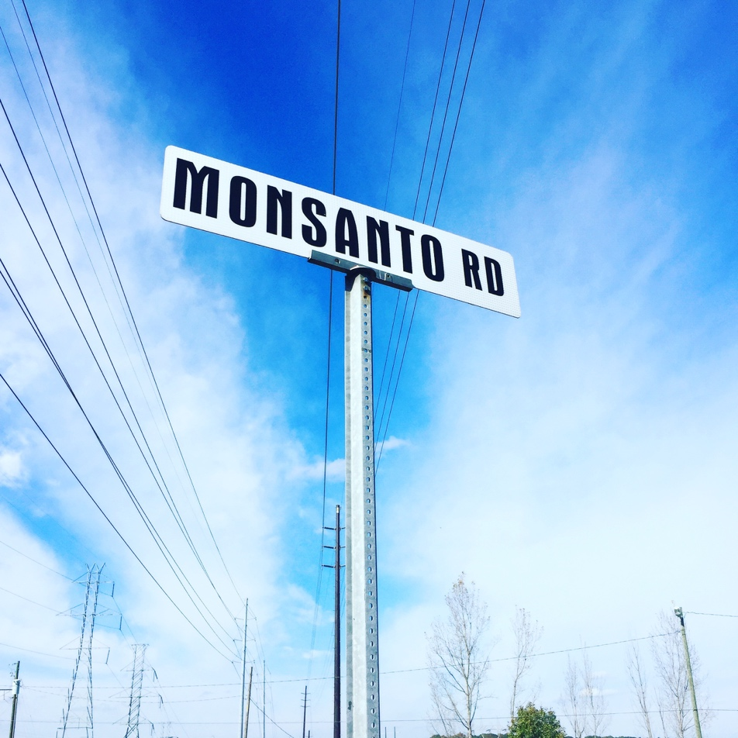
Early in its development, Monsanto was primarily a chemical company, specializing in a wide variety of products but gaining early prominence in the early 1900s as a manufacturer of the artificial sweetener saccharin (Spears 2014, 34-35). Many of the company’s most profitable products facilitated rapid industrialization and infrastructure development. For example, the development and production of Aroclors (the branded name for PCBs), exemplifies this trend. Originally manufactured in Anniston by the Swann Chemical Company (Spears 2014, page #), Monsanto acquired the Anniston plant in 1935 (Spears 2014, 57). Aroclors held myriad uses, but its most profitable was as an industrial-grade insulant. Power companies and electrical manufacturers across the globe used PCBs in large facilities, but the most familiar, mundane use of the product was in transformer boxes on utility poles. With the growth of electrical connectivity came the expansion of the market for PCBs, and the growth of the geography that PCBs impacted, a sobering reality that would only be revealed in the coming decades as knowledge of the substance’s toxicity became widely known.
Therefore, Monsanto’s early corporate identity was closely tied with the chemical industry’s role in industrial development and modern life. In a 1938 booklet, “The Story of Monsanto Company,” the company describes a history of chemistry, commenting:
Thus the chemical industry was born of the union of scientific knowledge and the needs of industry. How rapid has been its growth is evidenced by the almost unbelievable fact that we are not in some way brought into contact with many things in the production of which chemistry and chemical products have played a vital, although often unseen, part. Practically everything we eat and wear, every article we touch or smell, a large part of what we see and much of what we hear, somewhere along the line of their production came in contact with chemicals.
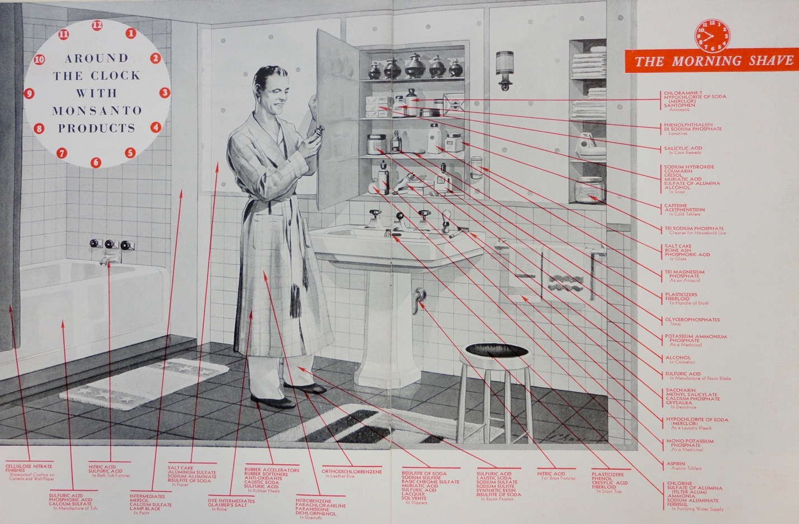
The final sentence of this passage rings especially true for the people who worked in Monsanto’s factories and lived in their vicinity, but not necessarily in the positive light that Monsanto would endorse. As Ellen Griffith Spears carefully documents in Baptized in PCBs: Race, Pollution, and Justice in an All-American Town, Anniston Monsanto workers and residents living near the factory were regularly exposed to levels of PCBs that Monsanto corporate executives knew were extremely hazardous, well before the formal ban of PCBs in 1979.
Meanwhile, the company was forging a much more positive identity for itself in the city as a gracious employer and community presence. The 1953 and 1954 issues of the company’s magazine for the Anniston Plant, “The Record Buster,” advertise community activities such as bowling leagues and golf tournaments, commemorate workers winning safety awards, and give safety tips and advice on accident prevention. Company Christmas parties and picnics, while racially segregated, earn considerable space in the magazine, depicting well-dressed employees playing games, dancing, and celebrating with their families. 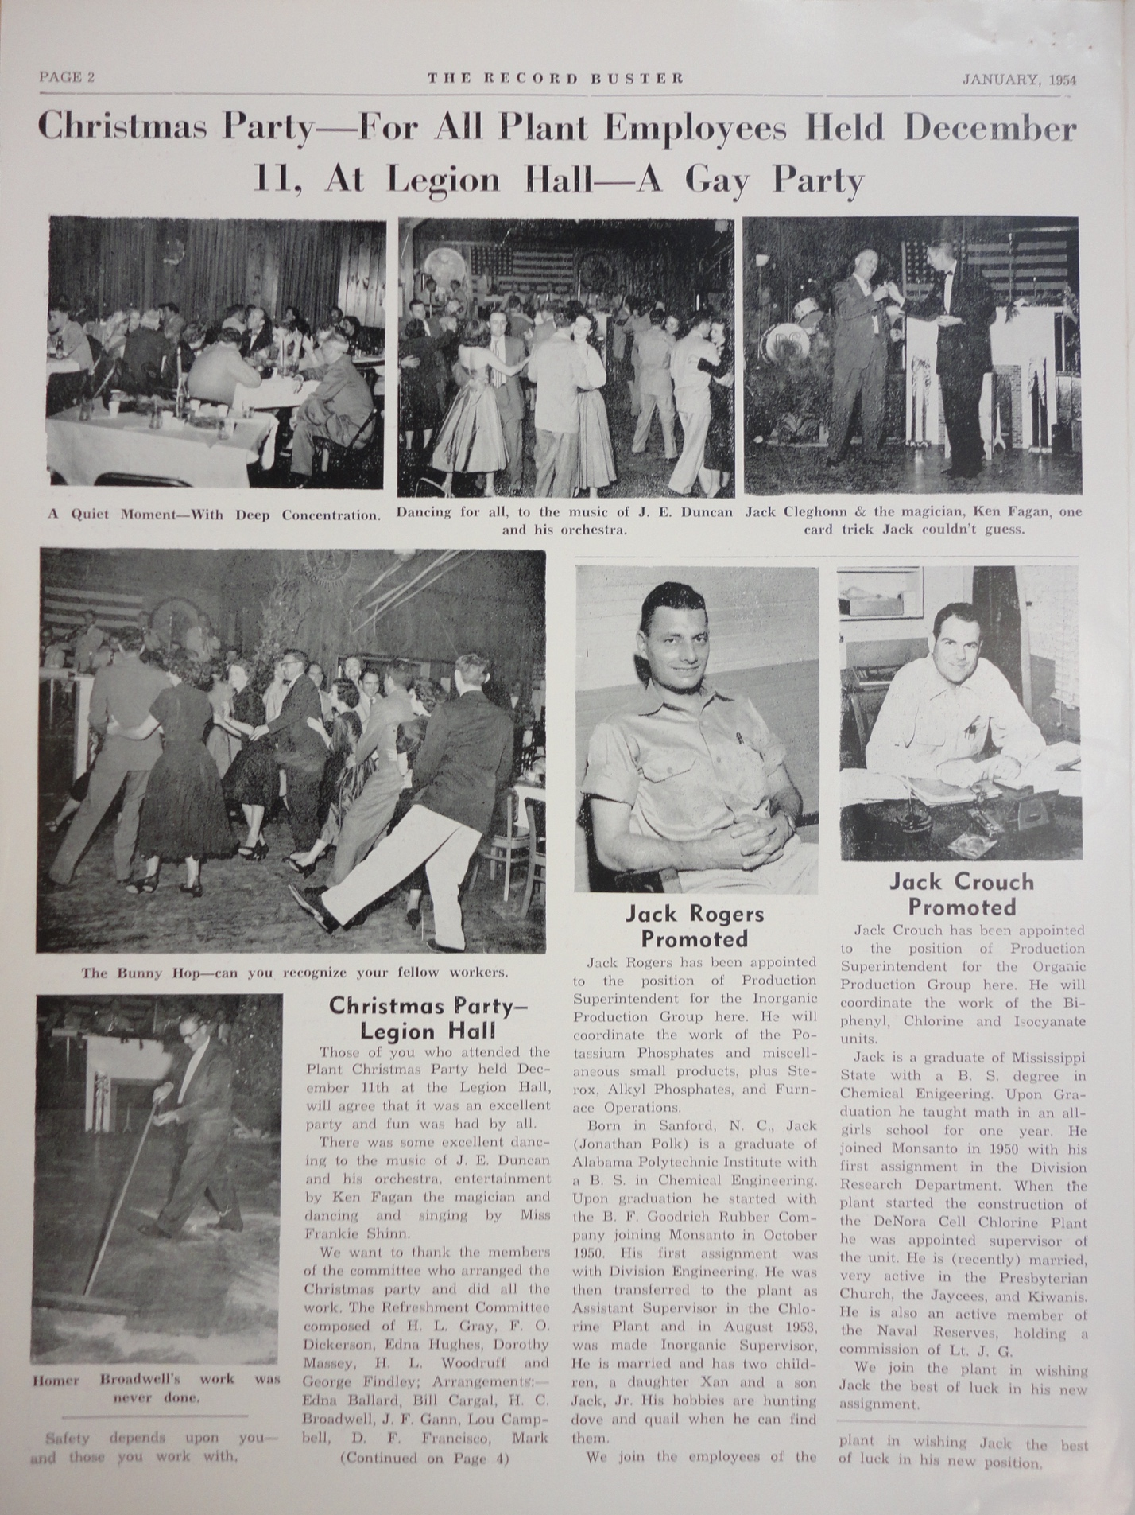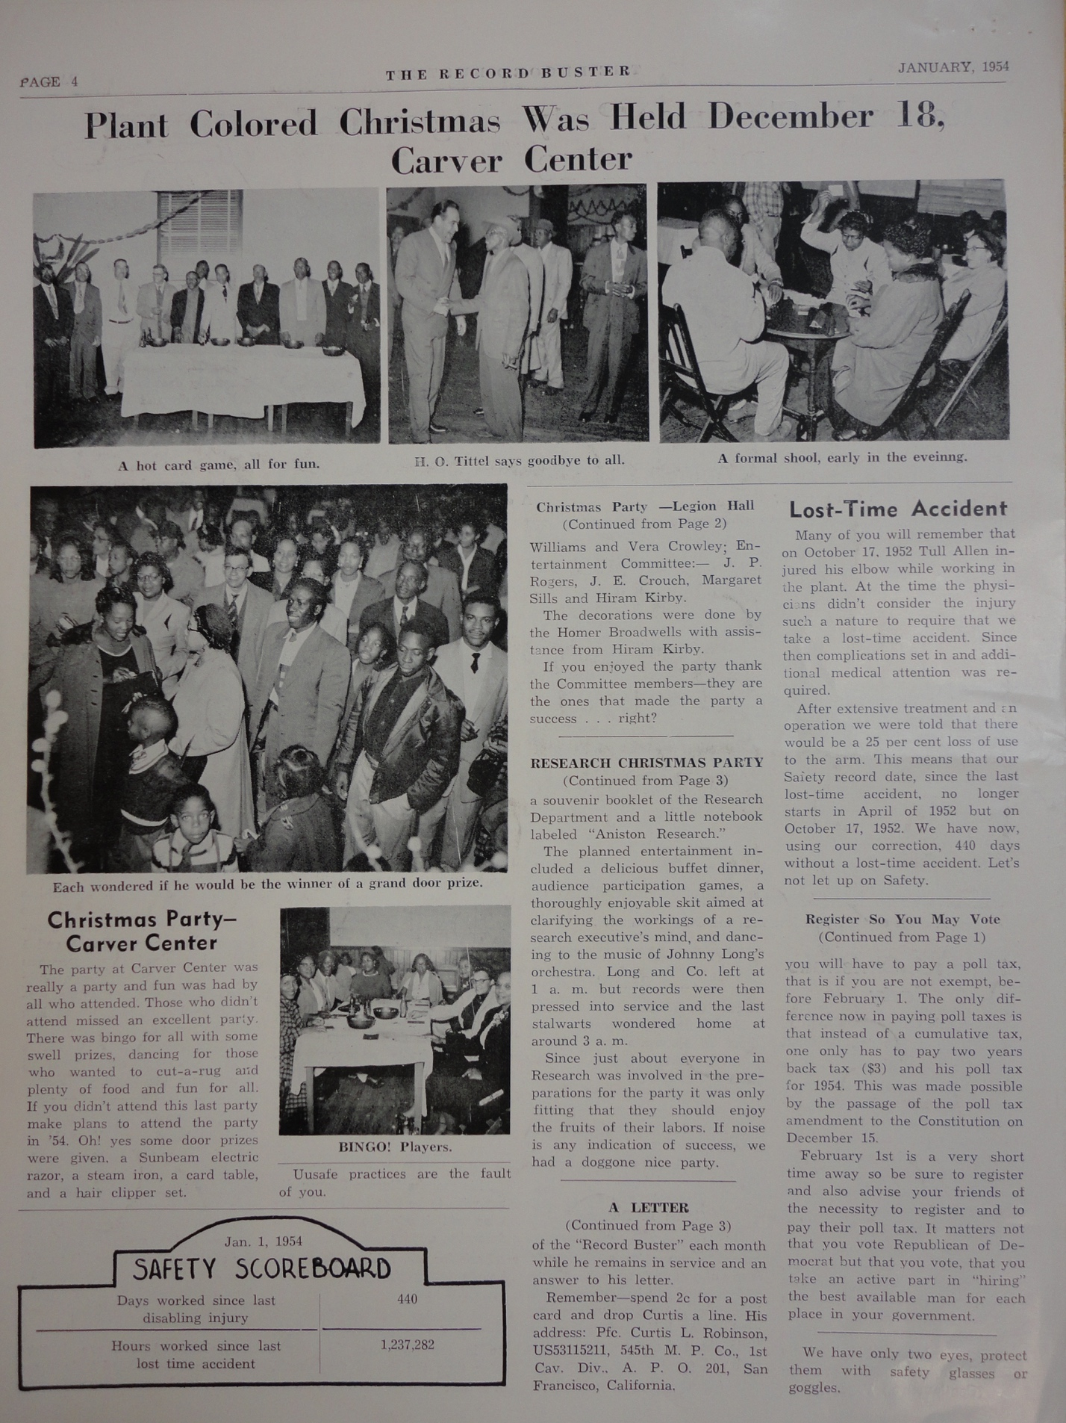
During this period, Monsanto balanced two scalar identities: a global company that was ushering in the modern world, and a friendly place to work in a small town. However, this identity was not to last, as Monsanto’s products started causing trouble on a global scale, as PCBs were increasingly linked to human illnesses and environmental problems. In order to survive, it had to engineer a transformation of its identity on both a global and local scale, rendering major changes in the corporation’s global and local scalar relationships over time.

Trouble in Chemical Paradise
Monsanto started experiencing financial and public relations difficulties in the late 1970s and throughout the 1980s. This time period was cited by future Solutia executive Dennis Canver as an early time of transition for the company in a speech, “How Solutia Became Its Own Company” at an engineering conference in 1998, stating that Monsanto was responding to the 1979 global oil crisis by investing in biotechnology, and “systematically began to shed underperforming businesses – mostly in the chemicals area.”
Canver’s narrative cites global economic crises as a main factor of the transition, and paints Monsanto as a company adapting to a changing global business climate through shifts in investment. What he omits, however, is that the U.S. was leading the world at the time by regulating the emission of toxic chemicals in the environment (Spears 2014). Companies like Monsanto were facing greater scrutiny than ever before because of the localized impacts of their manufacturing activities. In fact, the year Canver cites, 1979, is the same year that the U.S. banned the production and use of PCBs. One of Monsanto’s most profitable products was illegal, and forced the company to transform its global corporate identity. This mirrors the way Beck discusses the risk society; due to new knowledge construction about the dangers some chemicals posed to society, it became imperative for governing bodies as well as corporate bodies to learn to manage that risk in such a way that few people would be endangered by it.
This transition was not limited to PCB production. Locally in Anniston, Monsanto officials also halted the manufacture of Parathion, a controversial insecticide, citing a “global restructuring” that was taking place on a company-wide level (Edwards 1985). Parathion, like PCBs, had come under scrutiny at a grassroots level because of its toxicity. Canver’s omission of the environmental activism surrounding of the company’s restructuring signals that Monsanto and Solutia are actively producing an alternative scalar frame (Kurtz 2003) of the company’s transformation. Rather than a response to wide environmental criticism, Monsanto was simply making a wise move in a complex global business climate. This allowed the company to appear in control and powerful when, in fact, its means of subsistence – industrial chemistry -- was under heavy assault at that time.
This assault was felt more acutely on the local scale. This transition threatened Monsanto’s survival as the friendly neighborhood employer, and many people in the city suddenly faced the prospect of unemployment. “I feel like somebody’s died. I really hate it. They’ve benefitted a lot of people,” said Melvin Womack, an Anniston community member, quoted in The Anniston Star (Sapers 1985). By the late 1980s, however, Monsanto was beginning to recover, and newspaper headlines signified a new direction for the company’s local identity: “Monsanto gets new Environmental Permit” (Mullan 1986), “Monsanto has new manager, new plan” (Spoon 1987), “Monsanto vows to lower emissions” (Saltonstall 1988). Throughout the late 1980s and early 1990s, Monsanto locally transitioned to a proactive environmental steward.

The Other Side of Corporate Responsibility
In the 1990s, Monsanto started buying up properties surrounding its plant in Anniston. It set up an office in the Sweet Valley-Cobbtown neighborhood, the area of West Anniston closest to the plant. Residents were offered lump sums of cash for their properties in exchange for agreements not to litigate in the future. In the wake of these buyouts, a group of activists called Community Against Pollution (CAP) started to investigate the health problems in this community, drawing connections between the Monsanto factory and the litany of illnesses plaguing the community. Many people were suffering from cancer, liver disease, and kidney disease, and other diseases that no one could readily explain.
When CAP and other groups engaged in litigation against Monsanto starting in the late 1990s, Monsanto used its early environmental “proactivity” as evidence of its good community stewardship. Discursively placing itself as a caretaker of the environment, it attempted to soften the blow of the accusations it was facing as an intentionally negligent polluter. In a climate of increased scrutiny of the impact of chemicals on the environment, and the enforcement of regulations through legislation such as CERCLA, Monsanto’s identity transition reveals itself as strategic, rather than benevolent.
The final scalar strategic transformation in this paper is the ultimate spinoff of Monsanto’s chemical division into a new company entirely—the neutrally denominated “Solutia.” The new name was part of a carefully crafted transition for Monsanto away from the chemicals business and for Solutia’s quiet, sanitized entrance. Solutia is, for all intents and purposes, a rebranded Monsanto: “We’re an almost 100-year old, brand-new company,” said Dennis Canver, in his speech, “How Solutia Became Its Own Company.” Solutia lives on in the community—in part, as a prominent corporate sponsor of civil rights memorials, a bitter irony that is deeply unsettling considering its role in the perpetuation of racialized environmental injustice in the city. Even more recently, Solutia was bought by Eastman chemical, a growing presence throughout the southern United States. Eastman’s name is also present on Anniston’s landscape, sponsoring scholarship programs, a teen reading room at the local library, and participating heavily in the activities of the local Chamber of Commerce.
For Monsanto, its association with chemical production was rendered toxic by the many revelations of the company’s malfeasance across the globe (Spears 2014), and in 1997, it fully transitioned into a biotechnology company when it shed its chemical holdings. Its global survival as Monsanto was dependent on producing a new identity, and a new scale of responsibility. On September 8, 1997, The Anniston Star reported that “Monsanto Co.’s shares have risen 10 percent since it spun off its chemicals division, as investors bet the company’s agricultural and pharmaceuticals business will thrive without it” (Clarke 1997).

Conclusion
The scalar transformations deployed by Monsanto have reaped enormous rewards for corporate actors in the long run. Monsanto remains powerful globally. Solutia continues to be a community presence, sponsoring scholarship contests and donating to the local library. In 2008, Solutia declared bankruptcy, a move that many argue was intended to slow down the cleanup process in Anniston. In 2012, Solutia emerged from bankruptcy and was sold to Eastman Chemical for $4.8 billion. No human individual was ever legally punished for any crime in the Anniston case. When strategizing solutions for environmental inequalities, it is important to understand the power that corporations hold within the legal system as both legal individuals and as entities that are able to undergo transformations like those that are described here. More than transfers of ownership, these are transfers of responsibility, and transformations of scalar relationships that render corporate actors disproportionately powerful in comparison to ordinary people who face them in a court of law.
In contrast, West Anniston struggles to survive; the landscape is littered with abandoned factories, homes, schools, and businesses. The settlement was divided among over 20,000 plaintiffs, meaning, after legal fees, many received little, if anything at all. The city attempts to move on from this struggle, but the scars remain. A way forward is difficult to see, but the many of the people in West Anniston possess an astounding resilience, continuing to struggle for justice. The visions of what West Anniston once was are perhaps an inspiration for their struggle. Interview participants recall it was a place where every family had gardens, where black businesses thrived, and where there was a strong, safe community where you could raise your children. How can these visions of community be restored? Can technocratic, legalistic notions of “justice” ever restore these lost traits of community, this sense of place? Could any amount of settlement dollars satisfy the loss that has been felt? Can environmental remediation ever bring back how a safe community feels? These are questions that beg for innovation in the ways in which we conceive of environmental injustices and their solutions.
In the immediate future, however, the power that corporate entities hold in our justice systems is disconcerting, not least of which because the Anniston case teaches us they have the power to reproduce inequalities, even when they are held responsible for social and environmental degradation. Scholar-activists and activists must strive to innovate alternate strategies that produce outcomes that bring society closer to a world that reflects values of justice and equality, rather than reproducing the inequalities that we aim to combat.

References

Barkan, Josh. 2013. Corporate Sovereignty: Law and Government under Capitalism. Minneapolis: University Of Minnesota Press.
Bullard, Robert D. 2000. Dumping In Dixie: Race, Class, And Environmental Quality, Third Edition. Third Edition edition. Boulder, Colo: Westview Press.
Cable, Sherry, and Tamara L. Mix. 2002. “Different Voices, Different Venues: Environmental Racism Claims by Activists, Researchers, and Lawyers.” Research in Human Ecology 9 (1): 26–42.
Cable, Sherry, Thomas E. Shriver, and Tamara L. Mix. 2008. “Risk Society and Contested Illness: The Case of Nuclear Weapons Workers.” American Sociological Review 73 (3): 380–401.
Canver, Dennis. 1998. “How Solutia Became Its Own Company.” www.archive.org.
Clarke, Toni. 1997. “Solutia Sees Monsanto Shares Rise.” The Anniston Star, September 8.
Cobb, James C. 1993. Selling of the South: The Southern Crusade for Industrial Development, 1936-90. 2nd edition. Urbana: University of Illinois Press.
Edwards, Bill. 1985. “Monsanto Employees Keep Faith.” The Anniston Star, October 27.
Ekberg, Merryn. 2007. “The Parameters of the Risk Society A Review and Exploration.” Current Sociology 55 (3): 343–66. doi:10.1177/0011392107076080.
Harvey, David. 2010. A Brief History of Neoliberalism. Oxford; New York: Oxford University Press.
Heynen, Nik. 2013. “Urban Political Ecology I: The Urban Century.” Progress in Human Geography, August, 0309132513500443. doi:10.1177/0309132513500443.
Heynen, Nikolas C., Maria Kaika, and Erik Swyngedouw. 2006. In the Nature of Cities: Urban Political Ecology and the Politics of Urban Metabolism. Taylor & Francis.
Heynen, Nik, Harold A. Perkins, and Parama Roy. 2006. “The Political Ecology of Uneven Urban Green Space The Impact of Political Economy on Race and Ethnicity in Producing Environmental Inequality in Milwaukee.” Urban Affairs Review 42 (1): 3–25.
Holifield, Ryan. 2009. “Actor-Network Theory as a Critical Approach to Environmental Justice: A Case against Synthesis with Urban Political Ecology.” Antipode 41 (4): 637–58.
Interview with Anniston resident. July 23, 2015.
Interview with Anniston resident, July 27, 2015.
Kurtz, Hilda E. 2003. “Scale Frames and Counter-Scale Frames: Constructing the Problem of Environmental Injustice.” Political Geography 22 (8): 887–916.
Love, Dennis. 2007. My City Was Gone: One American Town’s Toxic Secret, Its Angry Band of Locals, and a $700 Million Day in Court. Reprint edition. New York: Harper Perennial.
Mullan, Sheila. 1986. “Monsanto Gets New Environmental Permit.” The Anniston Star, September 16.
Robinson, William I., and Jerry Harris. 2000. “Towards a Global Ruling Class? Globalization and the Transnational Capitalist Class.” Science & Society 64 (1): 11–54.
Saltonstall, Sally. 1988. “Monsanto Vows to Lower Emissions.” The Anniston Star, July 1.
Sapers, Johnathan. 1985. “Monsanto: The Wizard Now Sleeps.” The Anniston Star, October 27.
Spears, Ellen Griffith. 2014. Baptized in PCBs: Race, Pollution, and Justice in an AllAmerican Town. Unabridged MP3CD edition. Blackstone Audio.
Spoon, Gregory. 1987. “Monsanto Has New Manager, New Plan.” The Anniston Star, January 30.
Swyngedouw, Erik. 2004. “Globalisation or ‘glocalisation’? Networks, Territories and Rescaling.” Cambridge Review of International Affairs 17 (1): 25–48. doi:10.1080/0955757042000203632.
“The Record Buster.” 1953. Monsanto Chemical Company.
“The Story of Monsanto Company.” 1938. Monsanto Chemical Company.
Till, Karen E. 2012. “Wounded Cities: Memory-Work and a Place-Based Ethics of Care.” Political Geography 31 (1): 3–14. doi:10.1016/j.polgeo.2011.10.008.
Walenta, Jayme. 2015. “Corporate Personhood and the Corporate Body: The Case of Former Energy Giant Enron on Trial for Fraud.” Environment and Planning D: Society and Space 33 (3): 545–59.

Appendix

CHAPTER 4
TITLE TBD

ABSTRACT
<insert abstract here>

Introduction

One of the most notable aspects of Anniston’s story is the large settlement awarded to litigants, $700 million, one of the largest ever for toxic tort litigation. In addition, the EPA negotiated a Consent Decree with Monsanto/Solutia for the cleanup and funds for an education foundation. For a town hovering around 25,000 people, this seems comprehensive. However, upon closer inspection, many more adjectives could be used to describe the deals cut in Anniston: fair, unfair, lawful, corrupt, comprehensive, incomplete. It could certainly be said that the deals caused money to exchange hands, and a cleanup plan was performed as a result. Whether these outcomes represent justice for the people living there – that is a different, perhaps unanswerable question.
What can be known, however, are some disparities between what people hoped for when this case began and what was delivered in the long run. What caused this disparity? This chapter explores this question from a policy and legal perspective. First, the rapidly changing political landscape surrounding the Superfund program at the time of this case impacted how the cleanup was conceived and implemented, giving corporate actors a roomier seat at the table than would be expected in a traditional Superfund arrangement. This reflects a deepening neoliberal order, where cuts in state funding forced the creation of new financial and political arrangements that lower barriers for businesses to play a role in policymaking.
Second, this chapter discusses at length the complexity of the process for claimants to participate in the lawsuits. Because there were multiple lawsuits filed at different times with different requirements and different law firms, the distribution of the settlement funds was uneven and, to some, unfair. This raises questions about the decisions imposed on ordinary people who wind up in an impossibly difficult situation; again, this reflects a neoliberal penchant for individualized responsibility in decision-making. Reflecting on recent debates regarding reparations, and radically different visions for what judicial systems could provide, this case highlights inconsistencies, inefficiencies, and limitations within liberal, individualized judicial systems, problems which deeply conflict with the ideals and aspirations of the Environmental Justice Movement.

A Litigious Landscape
In 1993, fish contaminated with Polychlorinated Biphenyls (PCBs) were discovered in Choccolocco Creek, a narrow river that winds through Calhoun, Talledega, Cleburne, and St. Clair counties in north-central Alabama. Its watershed impacts the cities of Anniston, Oxford, and Talladega, a mostly rural area with pockets of rapid development, particularly surrounding I-20. A contractor working in the creek discovered several deformed fish and informed the Alabama Department of Environmental Management (ADEM), which completed further testing and found all but one of the 19 fish they tested surpassed the permissible amount of 2 parts per million (ppm). “One spotted bass registered more than 38 ppm, or 19 times the limit” (July 10 1994 Anniston Star p 8A).
Property owners living alongside the water on the southern stretch of the watershed, including on popular recreation area Logan Martin Lake, sued The Monsanto Company in several separate suits, citing declining property values and fear for their health. One suit was filed by Gordon and Ritta Sewell, owners of a fish market (Reilly 1994), for whom the problem of contaminated fish was a direct threat to their livelihood. Some simply wanted someone to take action, as described in the Anniston Star on August 30, 1994:

“Standing in the doorway of one of those [Logan Martin Lake] homes, Herbert Miller – tanned, shorts, no shirt – looked like an advertisement for the waterfront good life. ‘This water is the only reason we’re down here,’ said Miller, who has lived 11 years on the creek. ‘If it gets much worse, it’s going to lower the property values.’ Given that the PCBs might be disperse (sic) everywhere throughout the creek, however, he wasn’t sure the creek will ever be cleaned up. ‘I don’t know how they could get it out.’ A few docks down, his pessimism was shared by James McCullars. Formerly of Oxford, McCullars guessed that he hadn’t eat (sic) a fish from the creek in two or three years. Like a number of his neighbors, he has signed on to one of the lawsuits currently pending against Monsanto. As far as any state or federal action, he had heard nothing. ‘I just wish somebody would do something about it,’ he said” (Anniston Star August 30, 1994).

As time wore on, the PCB problem continued to erupt closer and closer to the source of pollution, the Monsanto factory in Anniston. A landfill used by the company overlooked the West Anniston neighborhood, a working class, largely black area of the city. In 1995, residents in Sweet Valley – Cobbtown, the neighborhood nearest the factory, gathered at the request of ADEM, where they were asked to submit “their soil, house dust, and even, possibly, their blood” (Pezzullo and Spencer 1995) for PCB testing. The meeting co-incided with Monsanto’s launch of a home buyout program, an effort to consolidate 40 acres of land surrounding the contaminated creek. If they lived on contaminated land, residents would be offered the appraised value of their home, plus a 75 percent premium, and up to $7000 in miscellaneous and moving expenses. This was the first restitution offer made in the Choccolocco watershed PCB saga that would continue to unfold until even the writing of this paper, over two decades. However, a response to this first meeting foreshadowed the upcoming struggle:
“’I grew up in this area and lived off of everyone’s vegetable garden,’ said [Alberta Freeman] the mother of three, who grew up around the Mars Hill Church [near which soil had tested for 200,000 ppm PCBs]. ‘With the smell from the plant I always worried that there was some contamination.’ Thursday’s meeting didn’t put Ms. Freeman’s mind at ease. ‘I’m leaving here more concerned than when I came,’ she said.”
Ultimately, others would share her concern. For Sharon Cowan, whose 4-year-old daughter died of a rare form of cancer, falling ill soon after moving into her mother’s West Anniston home, the PCB pollution raised questions about the root cause of her death. “At a meeting conducted by Alabama Department of Public Health…residents were angry and confused at what they view as a cover-up by the health department and Monsanto. ‘Rich people can get away with anything they want,’ shouted one resident. ‘We have lots of cancer around our neighborhood,’ said another resident. ‘How do we know that hasn’t caused it’” (Pezzulo February 11 1996). The buyouts did not fully assuage these fears. “’What kind of message does it send to these people when Monsanto is trying to get them off the land, buy up their homes and property?’ asked Anniston attorney Bud Turner, who is representing some of the residents. ‘The fact is, for folks who live out there, the anxiety and the fear is very real’” (Pezzulo February 11 1996).
On March 30, 1996, the Anniston Star reported that residents of Sweet Valley-Cobbtown were suing Monsanto for $750 million. “One lawsuit seeks $3 million for each of the 250 plaintiffs who ‘have lived in and around the … Monsanto company’s plant site or have worked or visited the areas around (the plant) on a regular basis for many years.’ The other seeks $3 million for Thomas Long, a resident of the Sweet Valley community who registered a high level of PCBs in a blood test.” These suits were in addition to a $20 million lawsuit filed by Stewart on behalf of Mars Hill Baptist Church on March 19. In May 1996, Cassandra Roberts organized a meeting of the Sweet Valley Cobbtown Environmental Justice Task Force, which organized yet another lawsuit of 450 current and former residents of West Anniston. In addition to unspecified damages, the suit asked for a full accounting of information regarding pollution so residents could make an informed decision about whether to stay or leave, as well as lifelong medical expenses for the impacted populations (Pezzulo May 14, 1996).
As one might expect, Monsanto resisted these claims. “Monsanto denies that it knowingly contaminated communities around its west Anniston plant and says residents must take some responsibility for any health hazards they encountered as a result of PCBs being dumped there…. ‘Plaintiffs did not take reasonable steps available to them to mitigate the damages alleged to have (been) suffered…’” (Pezzulo April 29, 1996). The company also called its buyout program “more than fair” (Pezzullo July 21, 1996). Monsanto also leaned heavily on etiological uncertainty, or the lack of toxological data tying PCBs directly to deadly illnesses, although the EPA does list the chemical on its “probable carcinogens” list.
As time went on, more and more people were recruited to participate in lawsuits. In the meantime, Monsanto spun off its chemical holdings and liabilities to a new company called Solutia. (For dates after 1997, I will refer to the corporate actors in this paper as Monsanto/Solutia.) The next piece of this story compares the expectations of residents as expressed in the lawsuits described above - which focused on fair restitution, health compensation and monitoring, and an effective cleanup plan – to the legal and policy results of their efforts.
These results are best understood through two themes – First, the policy decision to remediate the site using a Superfund Alternative Approach (SAA), rather than a traditional Superfund arrangement listed on the National Priorities List (NPL). The SAA program was created during the Bush Administration, an era that saw defunding of the Superfund itself and a cozier relationship between the state and corporations. This piece reflects two major pieces of neoliberal governance strategy: diminishing government funding, and creating alternative financial channels. In addition to this broad structural understanding of SAA, there was localized elite support of the program, from EPA officials who endorsed it in a courtroom, to city and corporate actors who feared a “Superfund Stigma.” In addition, the process used to design the partial consent decree (PCD) that governs the cleanup process was controversial. Residents, community groups, and environmental activists raised questions about the manner in which the EPA designed the PCD, namely in meetings with Monsanto/Solutia, the Potentially Responsible Party (PRP). While the EPA maintained this was nothing out of the ordinary, critics raised the structural potential for improper collusion between corporate actors and the state.
Second, the legal settlement and distribution of funds for the nearly 20,000 plaintiffs who eventually participated in the suits. There was a lack of centralized, coordinated response to the PCB pollution as the crisis unfolded for the population of the Choccolocco watershed. Relatively small groups of individuals filed multiple lawsuits with different requirements for participation and expectations of restitution. It was often unclear which state agencies to call on for assistance, and, in the buyout program, Monsanto functioned as an environmental agency in a pre-emptive attempt to avoid the litigation that ensued. The EPA did not become involved until 1998. In spite of residents’ and activists’ agitation for greater recognition of the qualitative concerns surrounding health and safety, many were met with an individualized, quantitative logic. The choice of where one lived, which lawsuit one joined, whether one got a blood test – those were the choices that made determined one’s settlement. In contrast, Monsanto never had to admit fault for the choice it made to pollute. Instead, it was positioned to impose a series of choices upon a population who never asked to be a part of this conflict in the first place.

Superfund Alternative & Consent Decree: Policy Choices, Neoliberal Expertise
The intent of the Superfund program, as defined by the Comprehensive Environmental Response, Compensation, and Liability Act of 1980 (CERCLA), is to ensure that environmental contamination is cleaned up in a timely manner whether or not a company steps up to the plate to fund the cleanup. The Superfund was once funded heavily through corporate taxes, but that started to shift in 1995 when corporate Superfund taxes expired. George W. Bush elected not to renew the taxes. This had a substantial impact on the public burden for Superfund: “In 1994, taxpayers paid $250 million for Superfund cleanups, or about 21 percent of the $1.2 billion fund, which corporate taxes paying $950 million, or about 79 percent. Taxpayers paid $350 million in 1999, and since then have paid about 50 percent of the cost. Mr. Bush proposes that taxpayers pay $700 million, or more than 50 percent of the $1.3 billion fund, in 2003” (Seelye 2002).
In light of this shift, the Superfund Alternative Arrangement (SAA) program was implemented. The program essentially flips the Superfund script. Under normal procedures, the EPA would independently execute the cleanup and pay for it using the Superfund trust. Later, after PRPs are identified, the EPA would sue to replenish the fund. In a SAA agreement, if the PRP takes responsibility for the pollution and agrees to pay for the cleanup, they sign an agreement with the EPA to fund and execute the cleanup according to CERCLA procedures and regulations. While the EPA’s internal review of SAA “found no obvious trends that distinguished SAA sites from NPL sites” and “the general response to SAA is positive” (Superfund Alternative Approach Baseline Assessment April 2011), at the time of its inception in Anniston, the implementation of this program was marked with significant controversy.
There were several reasons for this. One, the EPA met with Monsanto/Solutia independently of the people of Anniston or other potential stakeholders to craft the consent decree. As a result, the Consent Decree came unexpectedly (Anniston Star March 16, 2002). Two, the consent decree did not include long term health studies or compensation, instead including an education fund for children with learning disabilities. Three, the consent decree was created while current litigation was being tried in court, which would have put ADEM in charge of the cleanup of public areas and dump sites. After the consent decree was entered, Monsanto/Solutia filed a motion for the court to dismiss the state’s cleanup as part of the litigation, saying that the Consent Decree covered that need. Critics, however, were concerned about Solutia performing its own cleanup; it was akin to “letting the fox into the hen house” (Anniston Star March 16, 2002).
Additionally, controversy ensued over the decision against listing the site on the NPL. Perceptions of the potential impact listing Anniston on the NPL versus pursuing SAA or even continuing to allow the state of Alabama to pursue cleanup varied. City officials, worried that an NPL listing would lengthen the time to completion compared to what would be possible with a SA agreement (CITATION). In addition, many in the city were worried about a potential “stigma” surrounding a Superfund designation. An editorial in the Anniston Star stated:
“…a lot of people have an aversion to Superfund and being designated a Superfund site. That’s totally understandable. If your community is designated Superfund, you can get some powerful help from the federal officials, but the label it gives you isn’t something to brag about. ‘Hi, I’m from Anniston, Ala., home to the nation’s most recent Superfund site’ isn’t a line that would go over too well at a cocktail party much less an industrial recruiting trip” (Fleming 2002).

On the other hand, the community insisted in public comment periods and the local newspaper that a NPL listing would ensure a more thorough, fair cleanup. An EPA lawyer attempted to argue this point in court with an environmental lawyer who openly opposed the SA program for the Anniston case based on their experience with the PCB pollution the Hudson River (CITATION). Solutia claimed that “it’s going to get everything done in an expedited manner,” (Anniston Star March 16, 2002). However, the Anniston PCB site (“site” refers to the entire cleanup area in the Choccolocco watershed) remains incomplete, confirming the EPA’s own assessment that the SAA program does not result in shorter cleanup times.

Furthermore, groups like the Environmental Working Group have raised questions about the Bush Administration’s connections to Monsanto, as a meta-critique of situations like Anniston’s. While it is next-to-impossible to draw a straight line from such individuals to the decisionmaking that happens in an Alabama courtroom, the spectre of a conflict of interest weighs heavily on the people of Anniston and other activists who watched this case.

Vignette 2: Settlement and Distribution
The legal literature gives the impression that there is a great deal of pressure to settle out of court: "Since the court dockets are overflowing with lawsuits, all else equal, litigants should be encouraged to resolve their disputes privately through out-of-court settlement" (Spier 1994, 84). The vast majority of all cases do settle, in part because the incentive to settle is high when compared with the cost of going to court. The decision is most often framed as an economic one: "When two litigants resolve a dispute through out-of-court settlement rather than trial, they realize joint gains of trade equal to the sum of the costs both parties would have incurred had they obtained a trial judgment minus the costs they incur reaching settlement" (Korobkin and Guthrie 1994, 1).
Because of the costs involved, and the "winner take all" outcome of going to trial, trials are often considered failures within the legal profession (Lederman 1999, 319). However, there could be a multitude of additional factors that influence this decision beyond economy. For example, Korobkin and Guthrie (1994) argue that the style and strategy behind the negotiation process can greatly impact the likelihood of successful negotiations. There is also a good deal of discussion about the (a)symmetry of the information about the lawsuit between the two parties, and how that information is shared during the negotiation process (Reinganum and Wilde, 1986). These discussions, aimed at lawyers seeking to make more informed strategies, paint this negotiation process as a game: how much are information you willing to give to your opponent? Are you willing to lay your cards down first, or are you going to wait and see what your opponent does? And, of course, the economics of the decision still play a strong role: are you willing to pay the consequences of not working it out by going to a potentially costly and lengthy trial?
In 2003, the judge overseeing the Anniston lawsuits – at that time largely consolidated into two mass action suits (Abernathy v. Monsanto and Tolbert v. Monsanto)—strongly encouraged the litigants to settle, as Solutia threatened bankruptcy. In the archives, it is constantly mentioned how lengthy, complex, and wide-ranging this case was for everyone involved.
“At the outset, [Judge] Laird said he wanted to expedite the hearings, and perhaps the PCB cleanup itself…However, the hearings have been plagued with ‘stops and starts,’ attorneys said. In spite of the delays, the acrimony and Solutia attorneys’ regular objections to Laird rulings, a certain boot-camp atmosphere has pervaded the hearings. Some of them have lasted almost to midnight and involved hours of testimony on PCB data collection and the multi-regulatory actions at the site since 1993” (Anniston Star, April 15, 2002).

When the time came to settle,

"The two judges had proven instrumental in bringing both sets of cases--state and federal--to a simultaneous conclusion. 'Ordinarily, federal and state courts don't interact,' Judge Clemon said later. But the companies were not going to settle unless the parties could resolve all of the cases pending in federal and state court....Overhanging the state cases was the prospect that the conservative Alabama Supreme Court might overturn all the verdicts hammered out in Laird's court. When the landmark accord was announced in Judge Clemon's Birmingham courtroom, all of the lawyers rose to acknowledge the judges, with a standing ovation" (Spears 2014, 263).

However, in spite of some landmark victories, most notably the landmark Brown v. Board of Education decision (Meyer and Boutcher 2013), the empirical impacts of the many decisions to engage in litigation are unclear, at best. In Anniston, the issues that were considered allowable in court were significantly whittled down from the residents' original major concerns. When the PCB problem first became public, it appears that health issues were consistently among the most frightening and pervasive issue for residents in the city. However, as a result of the legal process, health issues were largely ruled out as potential liabilities for Monsanto/Solutia. According to articles published by the International Chemical Information Service (ICIS), a market research provider for industry professionals, ruling these out was a key concern and goal for the defendants (CITATIONS).
In these articles, health issues were simply framed as a part of the lawsuit, and a consistent obstacle that Monsanto fought (CITATIONS). Lawyers relied on scientific uncertainty regarding the direct toxic impacts of PCBs in order to argue, and eventually win in court, that health claims could only be considered if the patient was currently ill and could tie that illness directly to the PCB contamination (Sauer 2013). Therefore, even though many people had PCB levels in their bloodstream that were tens of times higher than was allowed by the standards set forth by the Centers for Disease Control (Spears 2014), the fear of the impacts of PCB content in their blood was not enough to win compensation. Furthermore, even if the plaintiffs were currently ill, and suspected that PCBs were the cause, unless there was a study providing scientific proof that their condition was tied to PCB contamination, then they could not prove that their illness was not caused by some external factor, in spite of the widespread belief among scientists that PCBs are wholly carcinogenic (Spears 2014).
What happened next constitutes one of the most contentious pieces in any legal drama: the struggle over money. The cases were agglomerated into two main groups: Abernathy v. Monsanto and Tolbert v. Monsanto. Abernathy claimants, of whom there were roughly 3,500, were some of the earliest to enter into litigation once the PCB drama made its way up the river to Anniston. Tolbert claimants began signing up in 2001, when community organizers helped organize a second case to ensure that everyone who wanted to attempt restitution could participate. The participation in this case ballooned when celebrity lawyer Johnny Cochran came to Anniston to recruit clients, and at the time of the settlement, 18,447 claimants were represented.
Herein lies the rub: the settlement was divided evenly between the two groups. Each group of lawyers were also compensated the same amount - $120 million in each case. The remaining amounts were split among the plaintiffs based on a combination of factors including property damage, time living in the area, and the amount of PCBs in their blood. The Abernathy claimants’ average payout was $49,000. The average payout for Cochran’s clients was under $9,000. The decisions people made about which case to sign up for represent an individualization of the responsibility for determining restitution. An example in a Forbes article on the settlement distribution highlighted the peculiarity of this problem: “Cynthia Tucker, 46, and her older sister, Julia Oliver, grew up in the same house, located 2 miles away from the Monsanto plant. But Julia was a Stewart [Abernathy] client, and she was, Cynthia says, ‘paid handsomely.’ Cynthia, on the other hand, is a federal [Tolbert] plaintiff and is still waiting for money” (Kitchens 2004).
There are few details available publicly about how the Abernathy settlement was distributed, aside from what was reported in the press:

“[Judge] Laird gave Stewart [the lawyer] sole discretion in allocating cash, except for payouts to children and some estates. Rather than devising a payment matrix on his own, Stewart says he relied on a statistical analysis company in New York to decide on levels of compensation, based on earlier jury awards. He insists that he is happy with the settlement and most of his clients are, too. But some claimants, such as Reverend Thomas Long, say they aren’t sure how Stewart came up with the compensation amounts that he did. ‘There is no accountability here,’ he says” (Kitchens 2004).

In a letter addressed to Tolbert claimants who complained about the diminutive size of their settlements in comparison, lawyers explain the disparity in further detail [see Figure 1].
Who were the claimants in these cases? There are clues. In the Abernathy case, the letter pictured in Figure 1 claims that most of the claimants lived near the factory, which is a working class, largely black neighborhood [insert map here]. In early newspaper coverage, legal teams and local health authorities talked about blood testing, encouraging residents to participate. Qualitative evidence suggests once again a low income level for these claimants: “‘I don’t have time to get to the post office [to get test results],’ said Juell Jackson, a Cobb Town resident who works the night shift at Tyson Foods. ‘I get home from work in the mornings and have enough time to take a bath and go to bed’” (Pezzullo January 21, 1996). Additionally, the settlements were divided, the caretakers of the Abernathy settlement fund were sued by the United States government to recover Medicare payments; the suit alleges that 907 of the 3,500 claimants were Medicare beneficiaries (CSK Legal 2010).
Therefore, it is possible that many of the people most acutely exposed and impacted by the pollution did received a comparatively more significant settlement than those who participated in the Tolbert case, which encompassed a much wider range of people. However, the original lawsuits sought roughly $3 million in restitution for each individual claimant, hardly close to the average $49,000 per claimant amount reported.
In contrast, the Tolbert suit represented an astoundingly wide range of people. “Of the 18,000 claimants in the Tolbert case, about 14,000 lived in Alabama, mostly in the Anniston area, but 4,000 lived in forty-four other states and overseas. Two hundred were in prison and one hundred were located in foreign countries. Three hundred were deceased when Tolbert settled” (Gentle 2009, 1251). Edgar C. Gentle, III was appointed as the claims administrator for the suit, and he describes the process to distribute the funds as “Design by Collaboration” (Gentle 2009, 1256). The legal team held meetings in Anniston to construct a formula where residents’ settlements were calculated, including the amount of PCBs in the claimants’ blood stream, personal property damage and time spent living in the Anniston area. After all expenses, including $25 million set aside for a health clinic, the average settlement amount was $7726.63 (Gentle 2009).
What amount of money would be appropriate? Does a check replace a home? A sense of safety and comfort? During the Abernathy trial, Monsanto tried to have Judge Laird recused from the case, citing bias against them in the courtroom. The Supreme Court of Alabama denied their claim, but the following passage quoted helps contextualize the feelings that people expressed about these settlements, as well as the overall candor of some discussions in the courtroom:
“[unnamed party]: I understand what they are talking about the property law, before and after, what the value of the property is before and after. And there is a law under nuisance that says they are supposed to be made whole under those circumstances, and that certainly was created.
The other damage I was saying to the Court that is existing there is what is happening to these people as a result of the continuing problems on this particular site.
The Court [Judge Laird]: Well, certainly—
Mr. Stewart [Abernathy lawyer]: It is in the air breathe-[sic]
The Court: There again, if you are looking at it-If the jury comes back with an award—say the difference between before and after the fair market value is $50,000, and they come back and give a plaintiff $50,000, but yet it costs $100,000 to clean it up, then the plaintiff still can’t clean it up. And there is still a continuous-
Mr. Prater [Monsanto Lawyer]: Perhaps, your honor, that plaintiff[s] may have to elect that remedy; although, I still think the law is clear in Alabama that they are not entitled in a property-damage case to get more than the value of the property before and after. That law is 200 years old in this state.
Mr. Stewart: Of course, that law doesn’t contemplate what happened in this instance, judge.
The Court: Well, a person’s home is his castle, right.
Mr. Prater: Yes, sir.
The Court: I wonder what the king would think if his property was contaminated. I really wonder what the president of Monsanto would think if his property was contaminated and it was worth less than-it had a negative value, was going to cost twice as much to clean it up as it was worth, and his wife didn’t want to leave that castle. What do you think the king would do when the queen didn’t want to leave?
Mr. Prater: One of those things we are going to persuade you, your Honor.
Mr. Peck [Monsanto lawyer]: Your Honor, aside from the legal point that –
The Court: I’m ready to go.
Mr. Peck: Ok. There is also a foundational problem.
The Court: I’m past ready to go.
Mr. Peck: Ok. Got it” (Supreme Court of Alabama).

Discussion
In 1991, the First National People of Color Environmental Leadership Summit was held in Washington, DC. The attendees drafted and adopted a list of 17 principles of Environmental Justice, with the following text as an introduction:
“We, the people of color gathered at this multinational People of Color Environmental Leadership Summit, to begin to build a national and international movement of all peoples of color to fight the destruction and taking of our lands and communities, do hereby re-establish our spiritual interdependence to the sacredness of our Mother Earth; to ensure environmental justice; to promote economic alternatives which would contribute to the development of environmentally safe livelihoods; and, to secure our political, economic, and cultural liberation that has been denied for over 500 years of colonization and oppression, resulting in the poisoning of our communities and land and the genocide of our peoples, do affirm and adopt these Principles of Environmental Justice” (Environmental Justice Network 1991).
Just five years later, in 1996, President Clinton signed Executive Order 12898, Federal Actions to Address Environmental Justice in Minority Populations and Low-Income Populations. The following excerpt captures the strategic goals for the order:
“1–103. Development of Agency Strategies. (a) Except as provided in section 6–605 of this order, each Federal agency shall develop an agency-wide environmental justice strategy, as set forth in subsections (b)–(e) of this section that identifies and addresses disproportionately high and adverse human health or environmental effects of its programs, policies, and activities on minority populations and low-income populations. The environmental justice strategy shall list programs, policies, planning and public participation processes, enforcement, and/or rulemakings related to human health or the environment that should be revised to, at a minimum: (1) promote enforcement of all health and environmental statutes in areas with minority populations and low-income populations; (2) ensure greater public participation; (3) improve research and data collection relating to the health of and environment of minority populations and low-income populations; and (4) identify differential patterns of consumption of natural resources among minority populations and low-income populations. In addition, the environmental justice strategy shall include, where appropriate, a timetable for undertaking identified revisions and consideration of economic and social implications of the revisions.”

I present these documents in conjunction with each other not for comparative purposes; they are almost incomparable except to say the demands placed on government agencies by President Clinton were hardly as revolutionary as the first document’s ideals. Rather, this juxtaposition is presented to stir reflection on the ways in which activist ideals are significantly filtered by the time they make their way into public policy. These are both environmental justice documents, but they are almost unrecognizable from one another in terms of their
Similarly, this case demonstrates how the expectations people in Anniston held for the justice system were filtered by the structural conditions of environmental policymaking as well as the individualized liberal logic that governs the U.S. justice system.
Figure 1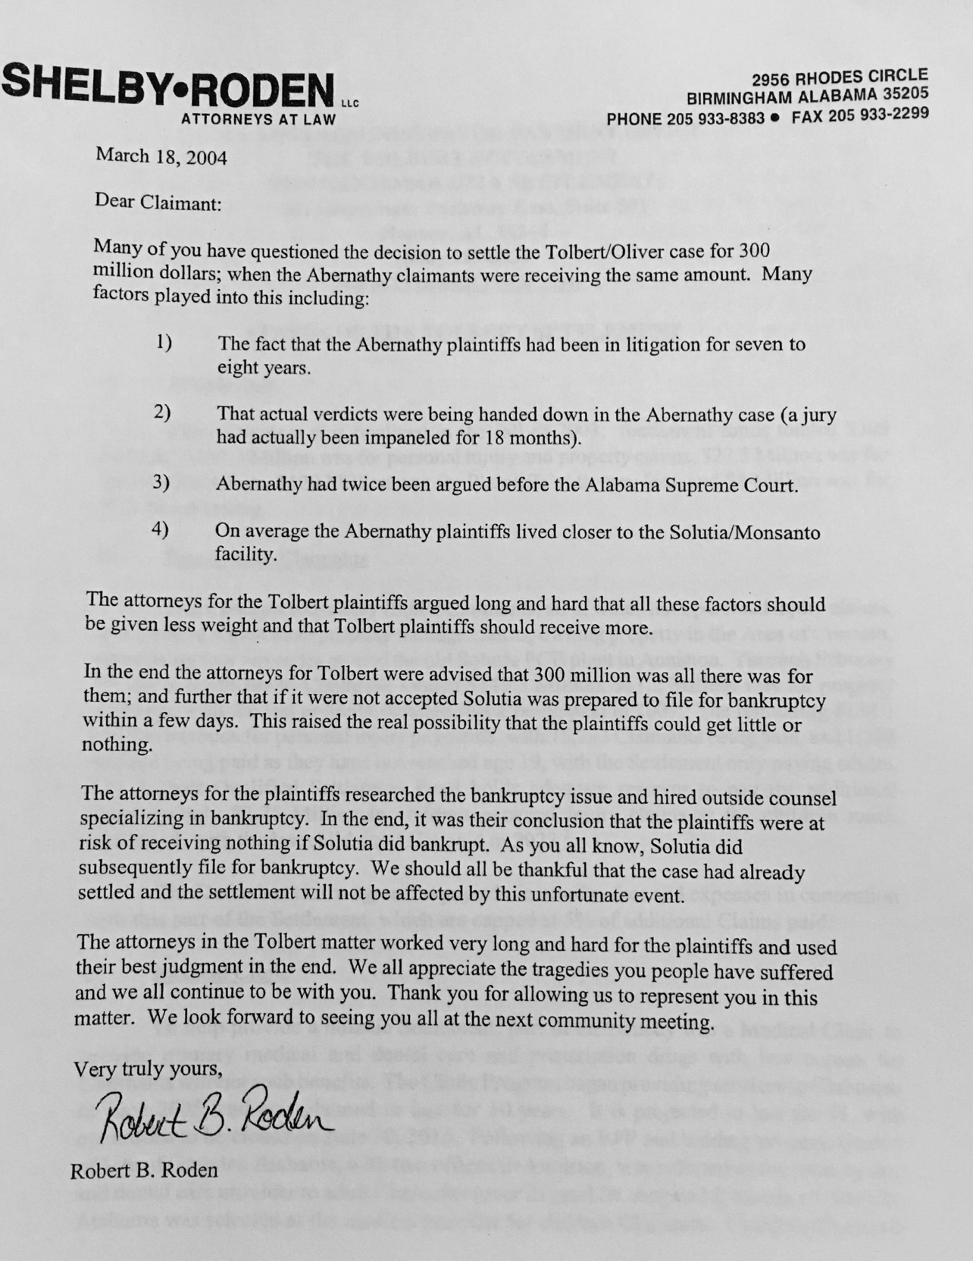

CHAPTER 5

REMEDIATING A SENSE OF PLACE: MEMORY AND ENVIRONMENTAL JUSTICE IN ANNISTON, ALABAMA

ABSTRACT
Anniston, Alabama is home to an ongoing struggle for Environmental Justice (EJ) as residents remain embroiled in a remediation process to clean up PCB pollution left by The Monsanto Company. This paper engages with literature in Black Geographies, public memory, and environmental justice to argue that remedial processes neglect senses of place that are valued by impacted communities. In West Anniston, the predominantly black neighborhood that bore the brunt of the pollution, the remediation’s failure to restore a sense of place contributes to an ongoing erasure of black life from the landscape. As a result, the remediation transforms from a relatively benign project to one that facilitates a violence of forgetting. In addition, this paper examines how black life is remembered, commemorated, and valued by residents who participate in the remedial process.

INTRODUCTION
“The material landscape itself, as it is produced by the black subject and mapped as unimaginably black, must be rewritten into black, and arguably human, existence on different terms…. invisible geographies, marginality, indicate a struggle, and ways of knowing the world, which can also illustrate wider conceptual and material spaces for consideration: real, lived dispossessions and reclamations, for example. The margins and invisibility, then, are also lived and right in the middle of our historically present landscape.” Katherine McKittrick, Demonic Grounds – pp. 5- 7
On September 23, 2013, people in Anniston, Alabama gathered at the Carver Community Center in the West Anniston neighborhood. They met about an ongoing cleanup of PCBs dumped by The Monsanto Company, a decades-long pollution event that gave the town the unfortunate designation “Toxic City” (Tutor 2016). The Community Advisory Group for the Consent Decree – or “The CAG,” as participants in this process call it –gathered around several folding tables positioned in a U-shape in front of a small audience. One at a time, a representative from the EPA, a corporate representative, and a technical advisor gave presentations about the progress of the cleanup of PCBs, now over a decade in progress, to the CAG and a small audience of community members. As banal as this seems, these meetings were often very tense as residents and experts would openly spar over the details of the cleanup.
Over the next three years of attending these meetings and dissecting Anniston’s cleanup process in the archives, community participants would use a “Band-Aid” analogy frequently to describe a pervasive sense of dissatisfaction with the outcomes of a long-term struggle for Environmental Justice. While residents of Anniston are recipients of one of the largest toxic tort settlements in U.S. history, $700 million in restitution, including cleanup costs, a health clinic, and individual payouts determined by property damage and amounts of PCBs detected in residents’ bloodstreams, many people remain concerned about the state of the city.
The buildings that remain intact in the city are surrounded by vacant lots, dilapidated homes, closed schools, and abandoned industrial sites. While the remedial process has been largely completed for residential areas in Anniston, save for several areas where the EPA has not been granted access by the owners, people who attend meetings about the cleanup frequently invoke the state of the West Anniston neighborhood as a persistent source of pain because of the memory of what this place once was- a cohesive, thriving black neighborhood. The remediation’s failure to reconcile this memory with the present state of the city becomes one more layer of injustice in a long history of violence toward black life.
While environmental remediation may be able to repair the soil, water, and air, could it also be possible to remediate another piece of what’s lost in the slow violence (Nixon 2011) of environmental disasters: a “sense of place”? What are remediation’s limitations, and why do they exist? This paper argues that environmental remediation in its current form, even if well-intended, contributes to an ongoing systematic devaluation and erasure of black life in the landscape because it does not take seriously the qualitative connections people have to “place.” The pollution itself is invisible in the city’s contemporary landscape; one cannot readily see PCBs, or lead, another widespread contaminant throughout the neighborhood. But, seeing through the lens of what West Anniston once was, the pollution’s impacts become impossible to overlook, and the limits of remediation become more clear.
This research is based on fieldwork conducted in Anniston from August 2013-January 2016. The author attended events related to the cleanup of PCBs in Anniston, particularly West Anniston, and conducted archival research of local publications such as the Anniston Star newspaper, documentation from the EPA describing and governing the cleanup, and documentation kept by local organizations regarding the history of Anniston and the cleanup process. This paper highlights ways in which residents expressed qualitative characteristics of West Anniston’s sense of place through various stages of the remedial process. In particular, residents’ use of memory to critique the impacts of remediation accomplishes two things: 1) it challenges the boundaries of what remediation is designed to accomplish, and 2) invokes a little-recognized memorial geography of black life. The remediation’s failure (by accident or design) to value the ongoing “memory-work” (Till 2012) happening in the process to clean up the city implicates it as a participant in an ongoing erasure of black life, one layered among the already devastating erasures wrought by the pollution and the state’s failure to protect its citizenry, as well as the devastation wrought by the impacts of deindustrialization in this working class city. It represents an active neglect of what people value about place at the very moment that one could reasonably hope some sense of place to be restored.

ANNISTON, ALABAMA: BACKGROUND AND CONTEXT
Anniston is a small city with 22,666 residents, and according to the 2010 census, its population is majority Black or African American (51.5 percent). It is nestled in a picturesque area in the southernmost tip of the Appalachian Mountains, and its motto, “Near Atlanta…Near Birmingham…Near Perfect” (Grunwald 2002) notes its relatively close proximity to major metropolitan areas. From the 1930s to the 1990s, The Monsanto Company operated an industrial chemical factory in Anniston. PCBs were a key component of its best-selling product, Aroclors, used as insulation for heavy equipment (Spears 2014). As part of the manufacturing process, PCBs were routinely dumped into a landfill or directly into the nearest streams, and today, although the chemical was banned by the U.S. government in 1979, many parts of the town and surrounding area remain contaminated.
Anniston residents are routinely cited in EPA documentation as having the highest levels of PCBs in their blood of any known population (“Anniston- PCBs and Dioxins/furans in Soil, Blood, and Air and Pesticides in Soil” 1999). PCBs are widely known to cause health problems, and are included on the EPA's "probable carcinogens" list (Cogliano 1998). The dangers of PCBs have been documented almost since the very start of their manufacture, when workers reported developing a skin condition called chloracne, a reaction where large, painful open sores would emerge and linger after direct contact with the substance. Workers would also complain of headaches, nosebleeds, and would frequently fall ill with strange cancers and illnesses of the liver and major organs. Before long, residents were complaining of the same kinds of conditions, and local informal records indicate that people living near the factory, in the predominantly black West Anniston neighborhood, frequently died from strange diseases that no one could medically explain (Grunwald 2002, Spears 2014, WAPO Article).
The issue takes on greater significance considering most pollution occurred during the state’s enforcement of Jim Crow segregation laws that kept black people in neighborhoods with poisoned soil, water, and air. This segregation, which persists in contemporary settlement patterns, ensured that vulnerable and marginal populations were routinely exposed to the most dangerous environmental conditions in the city. While there is evidence that the state of Alabama was aware of the pollution and its dangers for many decades (Shelby 2002), it was not until Monsanto began quietly buying up and razing properties in Anniston in the 1990s that the pollution became more widely known to the general public. Community leaders and residents from areas most affected by the pollution--particularly in the West Anniston neighborhood--formed a group called Community Against Pollution (CAP) to organize against Monsanto's negligence and fight for their community, which was being rapidly decimated by the property buyouts (Spears 2014). Eventually, this group joined with others in the region to sue The Monsanto Company, which resulted in the settlement and the implementation of the Consent Decree, which included the founding of the CAG. This research picks up Anniston’s story roughly at this point in time, examining the implementation and impacts of the remediation in the city.

LITERATURE REVIEW
Environmental Justice scholars are increasingly taking up the role of memory in communities’ struggles against environmental violence. Geographers have have long shown interest in memorial landscapes and formalized memorial projects, and have contributed to understanding the relationship between memory, geography, and power. Memorial projects often reflect the power structures and regimes that created them (Foote and Azaryahu 2007), communicating selectively about historical events, figures, and valued identity characteristics (Till 2005). This has resulted in significant, powerful biases in the public memory of events and people throughout the world that influence the lens through which the public is able to interpret modern social issues.
In part, this can explain why Black Geographies are absent or marginalized; a lack of formal recognition and power leads to a lack of formal memorial geography of marginalized populations and events (Nieves 2007, 85). As a result, decisions regarding which events should be remembered publicly through concrete acts such as commemoration and memorialization often remain in the hands of those with enough resources, influence, and institutional connections to ensure the survival of those memories (Dwyer 2000). This can result in "historical amnesia" (Foote and Azaryahu 2007, 129), where events unimportant to the narratives espoused by the powerful are omitted and potentially forgotten. As Dwyer and Alderman (2008, 168) note, "...the social process of remembering is accompanied, simultaneously, by a process of forgetting--an excluding of other historical narratives from public consideration and recognition."
Memory is not always so destructive. There are exciting ways in which memory is used a tool for achieving social and environmental justice and producing counter-narratives. It can “serve as a bulwark against the erasure, neglect, or elision of a memory as a potential source and opportunity for history” (Hanchard 2008, 52). Recent literature in environmental justice explores how people use memory to bring alternative environmental and social visions to public life (Houston 2012, Vasudevan 2012). “The tasks of witnessing, storytelling, and memory work create a space through which the unimaginable of environmental pollution and unequal environmental protection can be expressed…storytelling provides a framework for understanding how multiple realities of environmental injury come together in ways that are not always readily discernible through policy or scientific practice” (Houston 2012, 419). A common problem with environmental policy and enforcement is that it does not necessarily attempt to reconcile what communities value about places.
Memory is an avenue through which impacted communities and individuals can articulate this disconnect. In Pavithra Vasudevan’s account of making a film called “Remembering Kearneytown,” about a foundational case of environmental injustice in Warren County, North Carolina, she writes, “it may seem, from outsider accounts and mainstream narratives of environmental justice, that the remediation of the landfill brought closure to residents of Warren County. Yet…the story has not ended” (Vasudevan 2012, 22). Vasudevan writes of how the widespread notoriety surrounding Warren County’s story created the assumption among outsiders that justice was achieved. However, locally, residents continue to face “substantive challenges that constrain citizens from having effects” (Pezzullo 2001, 3). Vasudevan contextualizes her use of filmmaking as “an attempt at using performance as research to enable proximity where distance has failed to do justice, an effort to re-root the story of environmental justice in the bodies and landscapes of Warren County” (Vasudevan 2012, 22).
Karen Till's notion of wounded cities offers another way to understand how memory is used by actors who are not creating formalized memorial projects. She argues that places which have undergone mass violence and histories of displacement are active centers for "memory work" around those issues. "When places are physically demolished, not only is the stability of the taken-for-granted rhythms destroyed, an individual's personal and intrasubjective emotional ecosystems become damaged (root shock)" (Till 2012, 10). As a result, people attempt to create healing places in the wake of such damage through artistic and activist work to maintain emotional connections to those places, and to articulate alternative political visions. "Materially, memory-work motivates the creation of social capital, provides a range of memorialization activities, creates new forms of public memory, and is committed to intergenerational education and social outreach" (Till 2012, 7).
These overlapping perspectives on the forms and uses of memory, both by state and non-state actors, and in formal and informal settings, are instructive for understanding another layer of why environmental justice remains so elusive in spite of decades of research and activism in this arena (Pulido, Kohl, and Cotton 2016). Noticing how the state uses erasure can be instructive for understanding another layer of the power relationships embedded in struggles for Environmental Justice. Community uses of memory can give scholars and activists fresh demands in the environmental justice movement. This is also why drawing a connection between Environmental Justice and Black Geographies is important. Learning to value the ways black life is actively remembered and valued can shape how community reparation in the wake of state-sanctioned violence is conceptualized. “The realization of these desires can transform a world when these visions are based in traditions that see place as the location of co-operation, stewardship, and social justice rather than sites just to be dominated, enclosed, commodified, exploited, and segregated. Black Geographies will play a central role in the reconstruction of the global community” (McKittrick and Woods 2007, 6).
In Anniston’s case, environmental remediation could value the sense of place that West Anniston residents express through memory-work, which could lead to a greater sense of justice for the people who remain in the city. This paper contributes to the literatures on memory and environmental justice in two ways. The following section, Remediation and Forgetting in Anniston, examines how state environmental remediation encourages forgetting the erasure of black life in and qualitative concerns about the cleanup in Anniston in favor of a cleanup process that operates according to EPA-defined conventions. It demonstrates the limitations EPA imposes on what the cleanup is designed to accomplish. In the next section, Reconstructing the Invisible Through Memory, Black Geographies are analyzed in both memorial projects in the city and participation in the remedial process through informal “memory work.” This analysis highlights the disconnect between the process of PCB remediation in the city and the way residents use memory to articulate alternative visions of Anniston’s sense of place and the potential for remediation.

REMEDIATION AND FORGETTING IN ANNISTON
There are thousands of pages of documentation about the cleanup of PCBs in Anniston. Most of this is scientific documentation of every step of the cleanup. What is more difficult to find is an accessible entryway that members of the public may use to understand clearly what is happening. Some documents, however, are helpful for understanding the details and modes of thinking that guide remedial processes. One such type of document is a public comment period. The EPA publishes a document outlining a plan, the public has an opportunity to comment, and the EPA issues responses to the comments. While these may not always garner much attention, the comment periods in Anniston were a widely used opportunity to participate in the discussion about remediation. Community groups, law firms, individuals, and corporate entities participated.
One such comment period lends understanding to the way the EPA views its responsibilities in the remedial process when confronted with questions from the public. The EPA held a public comment period in response to “Section 122 Administrative Agreement and Order on Consent for Removal Action,” the results of which were published on January 17, 2006. This agreement clarified the responsibilities for the cleanup of lead and PCBs in the Anniston area. While PCBs clearly had one major polluter, The Monsanto Company, responsibility for the cleanup of widespread lead pollution that was discovered during the PCB cleanup had to be divvied among several additional parties. According to the EPA, most of the lead pollution came from foundry sand that was used as filler dirt in residential properties. This document is also particularly revealing because of the amount of detail the EPA provides about the nature of the comments they received, how many comments they received on a given topic, and how EPA actors respond to the criticism of their plan.
The ways in which the EPA responds or does not respond to certain types of criticism is significant. For example, in the following comment, residents question which properties are being focused upon for the cleanup, with particular concern about where children play:
Comment: The area covered by the Agreement is too small; Agreement should require cleanup of commercial properties. How many properties must be sampled? Are all lots that are undeveloped excluded from the definition of Residential Properties or only those not zoned residential? The definition of Residential Properties should include vacant lots since they could be developed in the future and children sometimes play on them.

These comments were submitted in various forms by several parties, including a law firm, a church, individuals, community groups, and a petition signed by 237 people.
EPA’s response explains the logic guiding the cleanup, stating that over 2,000 residential properties have been sampled. It does not directly address the concern about where children play. Rather, they attempt to assuage concern:
…Only “Undeveloped Vacant Lots” are excluded from the definition of “Residential Properties.” These are intended to be properties that, although zoned residential, have no indication that they have ever been subject to development or re-grading. As such, they are unlikely to have had Foundry Sand placed on them and there is little risk of lead exposure from Respondents’ past activities.
This inattention to concern about children’s play is significant because the issue of where children play came up frequently in CAG meetings I attended years later in Anniston. In spite of the city’s toxic history, there are no signs that indicate where pollutants may be or have been in the city, even though attendees at CAG meetings have requested them. EPA officials have given two responses to such requests: one, it is up to the city to place such signs. Two, EPA has conducted a thorough cleanup and no one is in danger.
An example of this second type of response is also evident in the comment period. When comments requested continued oversight, the EPA plainly cited a handbook:
Comment: The agreement should provide for long term monitoring and institutional controls, including procedures for enforcing the controls.
This comment was submitted by several parties, including three community groups.
Response: After completion of the cleanup called for in the Agreement, all residential soils addressed by the Agreement will contain less than 400ppm in the top 2 feet of soil. Consistent with EPA Region 4’s practices and EPA’s Superfund Lead Contaminated Residential Sites Handbook, OSWER 9285.7-50, EPA believes this provides adequate protection without the need to implement additional institutional controls.
Another very brief exchange is almost comical:
Comment: The people of Anniston should be treated fairly and with respect.
This comment was submitted by seven individuals.
Response: EPA agrees with this comment and will continue to treat the residents of Anniston fairly and with respect.
Rather than respond with reflexive concern for their perception among residents, EPA’s response is pithy and dismissive. The previous two comments also take this tone; rather than respond with concern for where children play, or whether the neighborhood has access to continued monitoring, the EPA’s response is consistent: thank you for participating, we are currently doing everything correctly.
This lack of concern is linked to the process of erasure because residents are expected to move on, to forgive and forget long-term, well-founded feelings of mistrust toward state agencies for the sake of the expediency of the cleanup. Concerns like those above about technical aspects of the cleanup are regularly dismissed under the banner of scientific and regulatory authority, both in this document and in CAG meetings. This is reminiscent of Hanchard’s use of Nietzsche to explain forgetting: “…forgetting is necessary in order for people to live beyond the burdens and impasses of past traumas” (2008, 50). In remediation, it serves the state and the process well to encourage people to forget.
This forgetting, however, does not serve the people of Anniston equally as well. In addition to The Monsanto Company, state authorities also hold responsibility for allowing the city to become polluted. The following exchange regards an agency called the Alabama Department of Environmental Management (ADEM), which repeatedly allowed The Monsanto Company to continue dumping PCBs in Anniston, and they did almost nothing to tell the public about the pollution after testing revealed its persistence throughout the 1980s and early 1990s (Shelby 2002).
Comment: Explain what oversight issues are charged to ADEM. Why is ADEM given any oversight authority when the community does not trust them?
This comment was submitted by several parties, including two individuals, and two community groups.
Response: EPA strives to create and promote strong partnerships with its State counterparts. Although EPA and ADEM have not yet finalized any specific division of labor for oversight responsibilities of the work required under the Agreement, EPA believes ADEM’s involvement will provide valuable assistance to EPA and the Anniston community. EPA anticipates that in addition to reviewing and providing comments on work plans and reports, ADEM will assist EPA by directly providing on-site field oversight of Respondents’ sampling and cleanup activities under the agreement.
In its response, EPA says nothing to acknowledge the statement that the community does not trust ADEM. It only says that ADEM will be highly involved in this process, and they are actively investigating how ADEM could be more involved as per usual in EPA policy.
These exchanges demonstrate how limited the remediation is. The process is only designed to achieve a prescribed physical condition – 400 ppm of lead in the top two feet of soil, for example. Anything beyond that – additional monitoring, active concern for the play patterns of children, establishing trust, or showing concern for EPA’s reception in the community- is not necessarily included. Remediation is a very impactful and invasive experience for a residential community to undergo. Federal authorities come onto private land and determine, with very little choice or input from the people living there whether or not a dwelling and its surrounding area is safe. This could decide whether your property remains valuable, whether your neighborhood is desirable, whether you are even able to keep your home, or able to reasonably maintain the belief that you will be safe from illness. Therefore, the EPA’s lack of response to the qualitative concerns residents raise in the comment period and in meetings about the nature of the cleanup attempts to erase those concerns and, in the ADEM example, force an attempt to forget the details of how the pollution came to be in Anniston in the first place. In the following section, however, it is clear that residents will not allow those details to be so easily forgotten. The open question is if, and how, such memories could become valued by remedial processes.

RECONSTRUCTING THE INVISIBLE THROUGH MEMORY
On October 20, 1996, an Anniston Star headline reported: “Last Days for a Neighborhood,” describing Eloise Mealing’s decision to sell her home to Monsanto and move away from her neighborhood, Sweet Valley-Cobbtown. Her daughter, Cassandra Roberts, received land in the same neighborhood from her father when she got married, and had just sold it to The Monsanto Company. “My daddy wanted me to have that land….I had a real hard time signing those papers. It was so emotional I could hardly take it” (Pezzullo 1996). The article describes Mrs. Mealing’s beauty salon, her friendly connections to neighbors, and the farming practiced in the neighborhood before pollution was discovered that changed their lives, and changed the city of Anniston, Alabama for years to come.
Just before these events, it became public that The Monsanto Company had knowingly polluted large swaths of the city. Sweet Valley-Cobbtown was the neighborhood closest to the factory and was the first area in the city to experience any kind of cleanup. This initial cleanup deal, struck between ADEM and Monsanto in March 1996, stipulated that Monsanto had 21 days to offer relocation to residents, and 60 days to identify all PCB contaminated areas. By October 1996, Eloise Mealing and her neighbors were the last to leave. In 6 months’ time, a neighborhood built over the course of decades – complete with memories, and a sense of community - was physically erased.
[Insert figure 1 here] Now the entire area lies vacant as an open wound to remaining residents, with no marker of what once existed. Aside from an abandoned car wash, there is little evidence there today to suggest what had been there. Now the entire area is bordered by a chain link fence. In a couple of places, roads turn into the area and eerily stop where the fence starts.
As noted in the opening quote to this paper, McKittrick argues such “invisible geographies” are home to a story of struggle that deserves to be told; this struggle is an important yet systematically neglected facet of Anniston’s geography. As properties lay to waste or are destroyed in the wake of this cleanup, so go too many of the physical manifestations of the memories that people so frequently describe. This is not uncommon in areas with histories of black life and struggle (Nieves 2007). Sweet Valley-Cobbtown is not the only place in the city where these “invisible geographies” exist, but it is the most concentrated site of physical destruction. Other parts of the West Anniston neighborhood, such as the West 15th street district, once known for local businesses, seem relatively more active, but, largely, play unfortunate host to vacant lots, abandoned homes, and closed-up businesses.
However, there are several ways in which residents have sought to recover these visions of West Anniston’s sense of place. One is through the struggle to have a greater recognition of values and interests beyond physical remediation through residents’ participation in the formal cleanup process. This is why the CAG meetings were often contentious. As mentioned in the introduction, the cleanup is referred to as a “Band-Aid solution” by community members in attendance at CAG meetings, an impermanent solution to the city’s, and West Anniston’s, long term problems. While the cleanup may meet benchmarks for soil, water, and air quality – all of which still come up for debate in these meetings – it has not repaired the ruptured the pace and quality of life in West Anniston since the extent of the pollution was discovered.
One CAG member frequently emphasized the need for Anniston to “be whole” again, signaling what needed to be replaced could not be found in scientific remediation. This resonated frequently with what I heard in the time for community feedback at the meetings. Attendees would talk about specific properties that remained in disrepair, express anxieties about the air quality or soil quality due to properties that had not been cleaned up, relate fear over safety in schools and churches frequented by many people from all over the city – parts remediated and not. Field notes include observations of corporate and remedial officials getting into arguments with community members about the manner of the cleanup process, expressions of frustration over ongoing unaddressed health issues, and, most relevant to this paper, expressions of pain and frustration about Anniston today compared to what it once was. These discussions in particular are “memory work” (Till 2012). While they take place outside of a conventional memorialization context, memory and connection to place emerge as important factors that remain overlooked in the remedial process.
In meetings, residents would frequently recall a different time for the city, when West Anniston was a much better place to live: when there were thriving black-owned businesses, when the population was higher, and neighborhoods felt more like communities. Many of the worries about West Anniston’s present state – crime, poverty, threats to close schools in the area, a lack of development – were tied by residents to a disconnect between the idea of what Anniston once was and what the remediation process was actually designed to accomplish.
While the settlement agreement did include provisions for an education fund and a health clinic, pollution has left a scar on the landscape that people have difficulty ignoring- in part because the pollution interfered with a sense of neighborhood-scale self-reliance in West Anniston. In meetings, people described the practice of subsistence fishing and agriculture before the pollution, and a landscape of gardens and fruit trees—but the PCB pollution made that impossible to continue. David Baker, a leader in the fight against PCBs, stated in a Senate hearing in 2002:
“…we have had to take off our shoes when we got ready to go into the house. Our children cannot play on the grass, so they play in the streets. Our children should wash their balls if they are playing outside, wash the dogs if they wanted to play with their own pets in their yard. We cannot plant a garden in our yard anymore. Many of the times we have been told, ‘Well, you can plant the garden, but you have to be careful how you plant it.’ We have people planting collard greens in five-gallon buckets just to enjoy the land that they live on.”
Outside of the remediation process, residents have left a record of this ignored sense of place formally in a public mural project and informally in the archives of local historical newspapers. These sources are additional sites to understand West Anniston’s sense of place; the mural inserts an alternative narrative directly into the site of erasure caused by environmental injustice. The newspaper articles are an undervalued record of life in the city that reflects many of the testimonies about that life that have been expressed in CAG meetings.
West 15th Street in Anniston holds a legendary status among many in the community, particularly among older generations of people who have memories growing up in the area. It runs perpendicular to the main thoroughfares of the historically white side of the city – Quintard Avenue and Noble Street. Today, driving West on 15th street from Anniston’s downtown, one is greeted to the neighborhood with a mural titled, “A City Within a City.” [Insert Figure 2 here]
Designed by a white artist named Joseph Giri, the mural covers the entire side of a building. In an online interview the artist stated that he, along with the Spirit of Anniston Foundation, a nonprofit organization that also created a Civil Rights trail in the city, solicited input from the West Anniston community for the contents of the mural. From left to right, he describes women singing in a church choir, and children roller skating on West 15th and Pine street, in front of “some buildings that are now gone.” A worker, said to be local West Anniston artist John Davis, stands in front of pipe factories, an industry that Anniston was once known for but “has gone by the wayside.” Next, Cobb Avenue High School (which no longer exists) and its mascot, the Black Panthers, a World War II soldier, and a church, said to be a Presbyterian church that has since been torn down and replaced (West Anniston Mural, Anniston, Alabama 2014).
This mural functions as a counter-narrative to what is readily observable in West Anniston: a neighborhood suffering from poverty and abandonment. It reimagines what the space of West Anniston was and could be as it stands in contrast to the readily observable “material ‘lack’” in the neighborhood (McKittrick and Woods 2007, 7). The presence and themes of the mural give visibility to a black sense of place that is rooted in a sense of community and particular sites of pride. While the artist tends to point out what has gone away – the buildings, the pipe factory – the mural demands a recognition of a different perspective on the value of this neighborhood, that “there are always many ways of producing and perceiving space” (McKittrick and Woods 2007, 7).
The mural also connects to the concerns that people expressed in the remediation process; for example, the children in the mural could be the same children someone wrote about in their comment to the EPA. While the landscape of West Anniston may be an open wound, the mural provides a powerful visual alternative in a small town landscape. In this sense, the mural is a story: “…people are making decisions all the time about the kinds of worlds they want to live in and they are imaginatively and practically striving towards them. Stories about environmental justice can carry these diverse ideas along together to produce different environmental imaginaries…in and of a damaged world” (Houston 2012, 433). While the mural may not be directly about Anniston’s struggle for environmental justice, its positive presence and placement directly in a landscape so marked by environmental devastation acts as an “Angel of Alternate History,” (Solnit, as used in Houston 2012). Houston explains, “Solnit’s angel asks us to believe in the invisible and the unimaginable because it is here that alternative knowledge is sustained and where different futures might be enacted” (Houston 2012, 419). In other words, the mural is a reminder and an encouragement to imagine something different for this place.
Finally, the Anniston Star newspaper, as a relatively progressive newspaper in the region, did include some limited sections dedicated to the mundane aspects of everyday black life in the city (as opposed to nothing at all). For example, in 1901, the paper describes a celebration of Emancipation Day: “A feature of the parade, which was an unusually long one, was a trade display in which a dozen floats represented as many negro business housed in the city, drug stores, grocery stores, bicycle repair shops, restaurants, benevolent insurance societies, herb doctors and general stores, all being represented” (Anniston Star 1901). Much of the coverage in subsequent years accompanies this business theme, and several articles mention the formation of a chapter of the Negro Business and Professional Men’s Club. This club, which first started meeting in Anniston in 1943, was part of a nationwide network of such organizations which were started by Booker T. Washington. Washington’s approach to achieving black equality- a focus on education, entrepreneurship, and an acceptance of incrementalism and assimilationism, was and remains controversial, particularly among more radically minded-thinkers such as W.E.B Dubois (1994). However, Anniston residents’ participation – along with neighboring Hobson City, which was an all-black municipality nearby – gives perspective on the pervasiveness of Washington’s ideas and the impacts of his organizing, something that has been largely under-explored due in no small part to Dubois’ critique (Boston 2010).
Not only does this archival evidence provide a paper trail for residents’ claims of a thriving black business district earlier in Anniston’s history, it helps bring that memory to life in a more animated way. Given Anniston’s currently wounded landscape, the Emancipation Day Parade, and the streets lined with businesses once again open up an alternate history for the city. Anniston was not just a place where the KKK bombed Freedom Riders, it was not just a place where pollution ruined lives. If stories produce a new world (Houston 2012, 422), archives help recreate a once-valued, now-forgotten world. These moments in time and space add up to a “sense of place” that has been badly damaged by environmental violence. What if remediation could restore the communities one can read about here? What if these qualitative aspects of place could also be valued, and the ways in which these values are expressed – whether looking back through history, paying attention to art, or simply listening to what people say in public meetings, could also matter?

CONCLUSION
The Monsanto Company was responsible for some of the most dramatic and deadly destruction in this city – a massive pollution event, poisioning the air, water, and soil, contaminating the bloodstreams of thousands of people, setting the stage for massive divestment from West Anniston and the City of Anniston as a whole. The scale of The Monsanto Company’s destruction calls for something much deeper and more transformative than a lead or PCB soil content quota. It calls for a serious, deep reckoning, with the toll that pollution takes on human life and human connections to place. Without this, remediation plays its own quiet role in the ongoing devaluation of black life because it fails to even nominally recognize pleas to restore the qualitative characteristics that make places worth living in.
In between the memory of West Anniston and the present day landscape, there is a story to be told – one about urban blight, and deindustrialization, and pollution, but also one about a vibrant community that residents valued. This was a community built in segregated, white supremacist Alabama, a place people – and public art – describe as “A City Within a City.” Through the lens of memory, state-driven remediation emerges as a tool in the ongoing strategic erasure of black life from the state’s project to move on from Anniston’s legacy of pollution. What appears to be a benign extension of environmentalist goodwill unto West Anniston instead functions as another violent encounter from the state. Remediation becomes a tool to facilitate the violence of forgetting.
In remedial projects, particularly in cases of environmental racism, there is a need to innovate methods to not only remediate the soil, but remediate that sense of place that has been lost over time, and to take seriously the rupture created by absence. To remediate means to repair, to make right, to restore. In any case of environmental injustice, pollution isn’t a discrete issue- its presence is embedded in a context that allowed it to be there, that allowed the slow painful death of friends, family, neighbors, and place. People engaged in remediation projects should be challenged to think beyond the current paradigms of environmental governance and pay closer attention to grassroots demands for justice over the long term. Scholars must pay closer attention to what communities value in life- not just what has been lost through death.

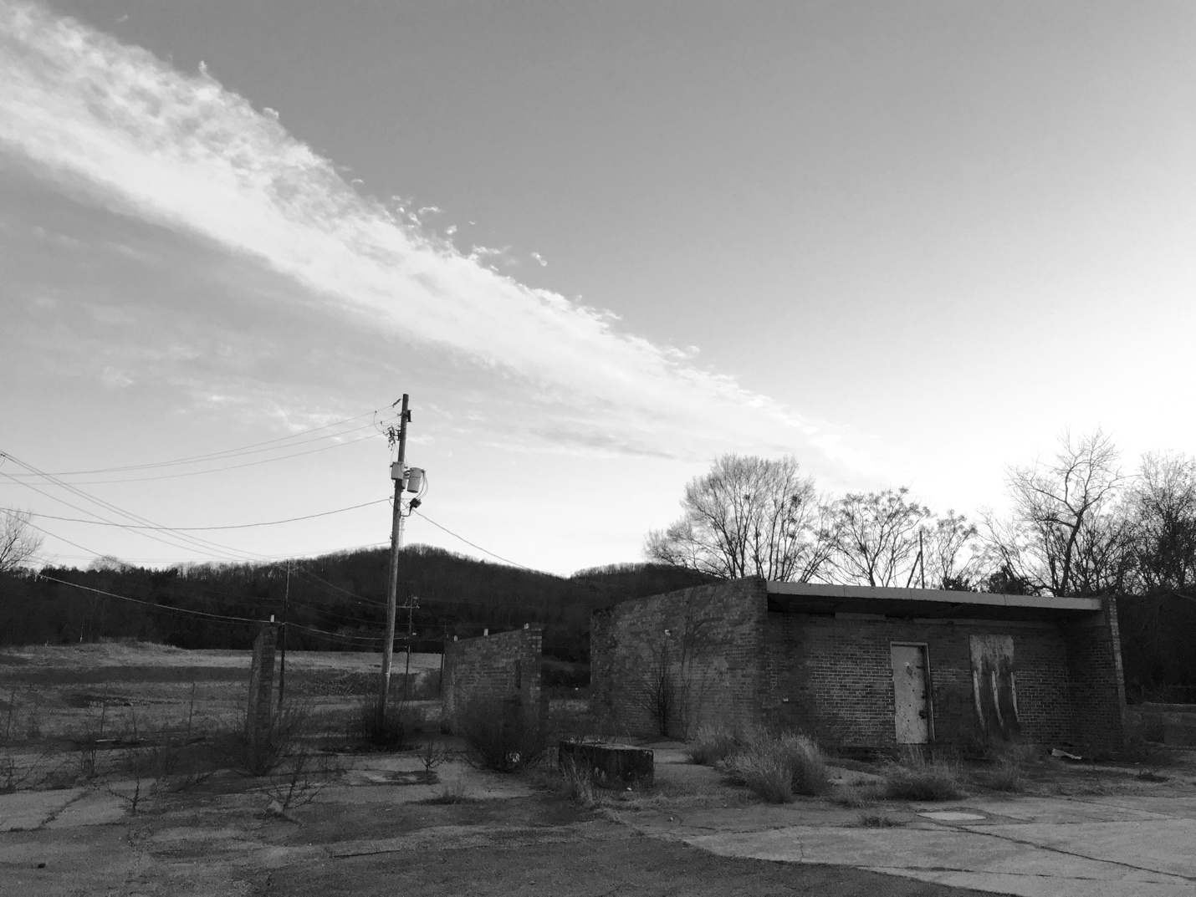
Figure 1. Caption: The old car wash in Sweet Valley – Cobbtown. Photo by Author.

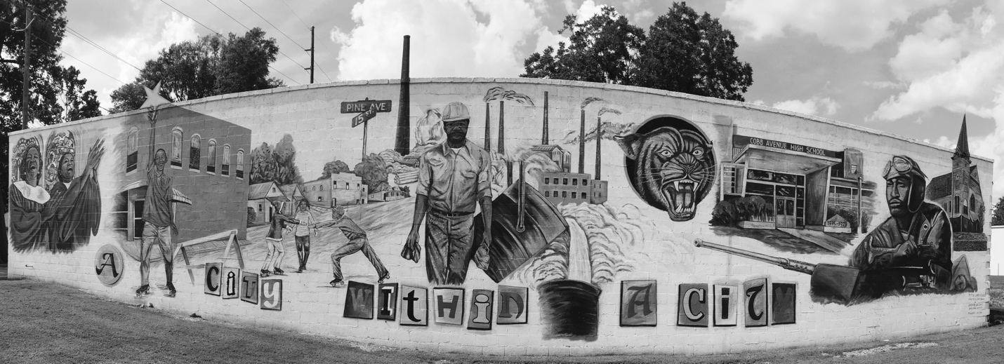
Figure 2. Caption: “A City Within a City.” Photo by author.

REFERENCES
<Insert References Here>

VITA

Melanie Barron was raised in Dalton, Georgia. She graduated from Georgia Southern University in May 2010, and joined the Department of Geography at the University of Tennessee in August 2010. She earned her M.S. in 2012 under the direction of Dr. Joshua Inwood. She currently works as an organizer and researcher for United Campus Workers.

The other town was Monsanto, Illinois. It has since been renamed Sauget, Illinois. It is part of the St. Louis metropolitan area.

