CONSEQUENCES OF ALLIARIA PETIOLATA (GARLIC MUSTARD) INVASION ON BELOWGROUND MYCORRHIZAL FUNGI

A Thesis Presented for the
Master of Science
Degree
The University of Tennessee, Knoxville

Jessica Marie Hammonds
May 2025
For my Dad who taught me that science is all around us and my Grandma who showed me the beauty in dirt.
“We shouldn’t be afraid to experiment. Experimentation is about pushing the parameters of our knowledge.” - David Bowie, 1993

ACKNOWLEDGMENTS
A huge thank you to my advisor, Stephanie Kivlin, for believing in me, pushing me when I doubted myself, and for being one of the only people in my life that is always happy to have a conversation about soil. Thank you to Jim Fordyce for being the only person I know that can make stats seem so joyful and exciting, you have been a brilliant teacher. Thank you to Jen Schweitzer and Joe Bailey for being such amazing sounding boards and all-around wonderful humans. I thank my thesis committee, Susan Kalisz and Dan Simberloff for not only taking the time to be on my committee, but also for all the help, insightful questions, and support during my thesis work. You are trail blazers in your fields, and I am thrilled to have had the opportunity to work with you both. I also have to give a special thanks to Susan for teaching me the art of rhizome harvesting, keeping me caffeinated during the 2024 field season, and most importantly for securing the grant that has allowed this important research to take place for so many years. I am incredibly grateful for the support, patience, and love from my amazing family and friends. Thank you to the Trillium Trail field crews from The University of Tennessee, Knoxville and Texas Tech for battling the heat and rain in 2024 and to all the researchers that have been studying and caring for this site for more than 15 years. A thank you also goes to the Genomic Core at The University of Tennessee, Knoxville for sequencing our 2024 root samples which will be vital in continuing research.

ABSTRACT
Invasive plant species are a ubiquitous global change pressures across ecosystems and pose serious threats to plant diversity and productivity. Despite their prevalence, the impact of invasive plants on native plant communities is often unpredictable. One way that native plants may be impacted by plant invasions is via mutualism disruption of their nutrient-acquiring mycorrhizal fungal symbionts belowground, specifically arbuscular mycorrhizal (AM) fungi, by allelochemicals produced by invasive plants. AM fungi associate with ~90% of terrestrial plant species, and play a crucial role in nutrient cycling, plant growth, and overall soil health. A common invasive species in North American temperate forests is Alliaria petiolata (Brassicaceae), commonly called garlic mustard, which was introduced to North America via Europe in the 1800’s. Garlic mustard produces secondary allelochemicals that are toxic to soil bacteria and fungi, including AM fungi, and can have long-term effects on plant community composition and ecosystem services. I hypothesized that AM fungal-plant mutualism disruption is common following garlic mustard invasion, therefore native plant mycorrhizal fungal interactions can be used as a metric to assess the impacts of invasion across similar ecosystems. My research addresses two questions. (1) To what extent do allelopathic invasive plants alter the species richness and composition of mycorrhizal fungi in the roots of native plants, and (2) how are bipartite networks of native plants and AM mycorrhizal fungi rewired following invasion and to what extent does this affect plant-mycorrhizal fungal network stability? By assaying AM fungi in roots of native understory plant species from the Trillium Trail field site in Fox Chapel, Pennsylvania I address long-term impacts of invasive species on mycorrhizal fungal-plant networks and their wider implications for ecosystem stability and restoration.

TABLE OF CONTENTS
Section 1: Introduction 1
Research Questions 5
Section 2: Hypotheses 11
Section 3: Methods 12
Sample Collection 12
Bioinformatics 15
Statistics 15
Section 4: Results 16
Network Analysis 16
Number of Share Plant Hosts 16
Modularity 21
Linkage Density 21
Robustness 21
Section 5: Discussion 25
Overview 25
Species Richness and Composition Influences on Network Structure 25
Network Properties and Variability Across Space 25
Additional Contingencies and Future Directions 26
Conclusion: What Does All of This Mean For Invasion and Restoration? 27
References 29
Vita 34

LIST OF FIGURES
Figure 1: Split Plot Design 3
Figure 2: Garlic Mustard Coverage 4
Figure 3: Network Stability Metrics 6
Figure 4: Example of an Incomplete Bipartite Network. 7
Figure 5: A Complete (Perfect) Bipartite Network 9
Figure 6: AM Fungal Diversity 17
Figure 7: AM Fungal Composition 18
Figure 8: Plant-AM Fungal Networks by Plot and Treatment 19
Figure 9: Number of Shared Plant Hosts 20
Figure 10: Modularity 22
Figure 11: Linkage Density 23
Figure 12: Plant Robustness 24
Section 1. Introduction
Temperate mixed deciduous and hardwood forests are important biomes, especially in North America where they are widely distributed across the Eastern part of the continent and provide important ecosystem functions such as carbon (C) storage and wildlife habitat [1,2,3]. Most forests are under constant environmental pressure from invasive plant species, many of which have been introduced deliberately or accidentally through anthropogenic disturbances [4]. Alliaria petiolata (Brassicaceae), commonly called garlic mustard, was originally introduced to North America via Europe in the 1800’s as a medicinal herb and food source that escaped cultivation and quickly spread to most habitable biomes across the continent. Garlic mustard produces secondary allelochemicals that are toxic to soil bacteria and fungi, including mycorrhizal fungi and can have long-term effects on plant community composition and ecosystem services [5]. These allelopathic chemicals can cause physiological stress and reduce population growth rates of mycorrhizal dependent native forest understory plant species [6]. It is vital to understand the extent to which such long-term effects of noxious allelopathic invasive species cause disruptions in plant-fungal symbioses, such as changes in mycorrhizal fungal community composition and richness, which can affect the stability of plant-mycorrhizal fungal networks.
While research in this field is limited, data regarding network interactions between native plants and mutualistic arbuscular mycorrhizal (AM) fungi are especially rare. In general, biological networks studies focus largely on plant-pollinator networks, predator-prey networks, or food webs. To date, there is almost no information on the structural organization of species-rich mutualistic networks [7], such as between native plants and mutualistic arbuscular mycorrhizal (AM) fungi. Recently, advances in genetic sequencing technology have allowed the exploration of complex AM fungal-plant networks [8].
As we continue to face dramatic global environmental changes, it is now more important than ever that we focus on these understudied systems of AM fungal community composition, AM fungal richness, and plant-AM fungal networks. AM fungi associate with over 90% of terrestrial plant species, and in particular herbaceous plant species [9]. AM fungi play a crucial role in all ecosystems, including forest ecosystems, where they are critical to nutrient cycling, plant growth, and overall soil health, which all impact ecosystem functions [10]. The composition of AM fungal communities determines the benefit of the symbiosis for plants [10]. If AM fungal community composition is disrupted by invasive species, it could be not only detrimental to native plant species but could allow for an acceleration in the spread of invasive species [11]. Understanding networks, as models and empirically, is also a vital step in gaining a more complete view of how mycorrhizal fungi are persisting in native plant communities and how these mutualisms are responding to invasion [9]. As we face ongoing climate change and increases in human-driven invasion by noxious allelopathic species, we need to understand how often-overlooked belowground microbiomes, specifically AM fungal-plant mutualisms, are being impacted to develop ways to react to and ameliorate current and future ecosystem impacts caused by these anthropogenic disruptions.
To date, most studies on the effect of invasion on mycorrhizal fungi have been observational [12]. Furthermore, most post-invasion studies have historically focused solely on aboveground plant communities without looking at long-term effects of invasion on belowground microbiomes. Attempts to culture AM fungi independent of their host species have so far mostly been a failure [12]. Field study experiments thus are necessary to further research of AM fungal-plant symbioses in response to plant invasions. Field experiments that manipulate the presence of an invasive species are key to pinpointing the exact mechanisms through which the invasives may disrupt belowground biomes. For 18 years, the Trillium Trail (TT) project has studied the effects of the noxious invasive species garlic mustard on changes in and disruptions to the symbioses between native understory plants and AM fungi. The TT field site is in a mixed deciduous forest in Fox Chapel, PA that has been managed since 1949 as a forest wildflower preserve [5]. The TT preserve boasts a variety of woody understory and herbaceous species including the long lived and co-occurring Trillium erectum, Maianthemum racemosum, and Arisaema triphyllum [5]. The TT study was set up as a manipulative split-plot experimental design with fully crossed treatments with five (previously 7) 14 m x 14 m plots divided into thirty-six 2 m x 2 m subplots for a total of 180 subplots. Since 2006, half of each plot has had natural garlic mustard invasion (ambient) that has been allowed to grow and disperse (18 ambient subplots/plot). In the other half of each plot all garlic mustard is removed (weeded) from each subplot annually in addition to being annually protected from garlic mustard seed dispersal during the dispersal period (18 weeded subplots/plot) (Fig. 1). All five plots used for this study have also been enclosed by fencing to exclude American white-tailed deer (Odocoileus virginianus) from the plots preventing animal dispersal of garlic mustard seeds and herbivory of the native plants.
Plots vary in composition and diversity of native plants as well as density of A. petiolata coverage (Fig. 2) with cover of garlic mustard in 2018 in some invaded plots being almost 1/3 of the total plant cover whereas others are less than 1%. In a previous, 11-year study at the TT site, garlic mustard weeding altered the community composition, decreased community evenness, and increased the abundance of understory herbs that associate with mycorrhizal fungi [6]. Thus, while garlic mustard cover may differ amongst plots and across years, there is a consistently negative effect of garlic mustard

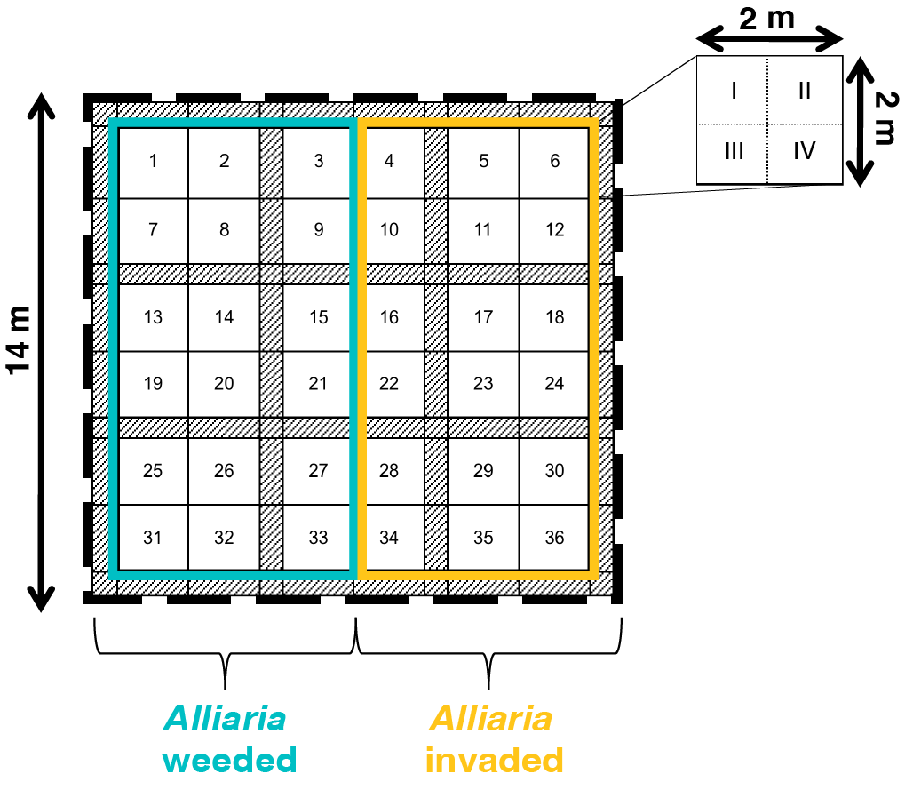

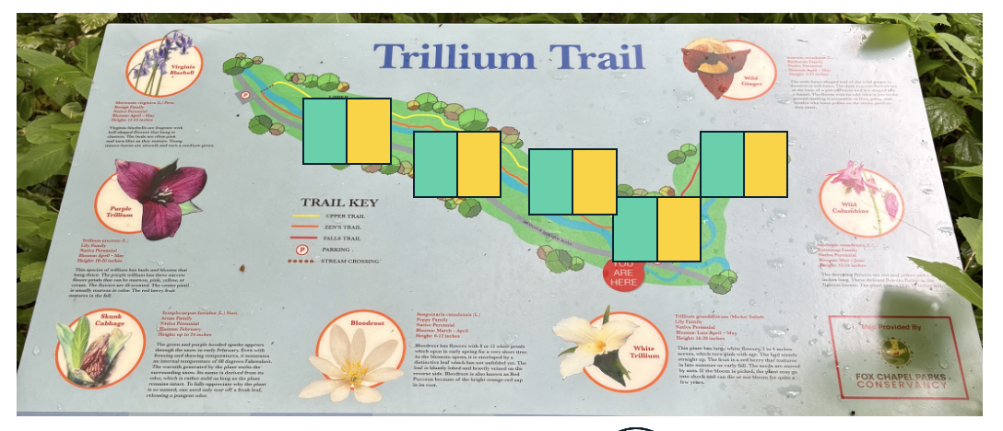


Fig. 1: Split Plot Design. Split plot design at the Trillium Trail field site. Alliaria weeding treatment began in 2006. Alliaria weeded plots are represented in teal. Alliaria invaded plots are represented in mustard. Grey strips represent walking paths between the 36 sampling subplots. There are five such plots across the Trillium Trail site.

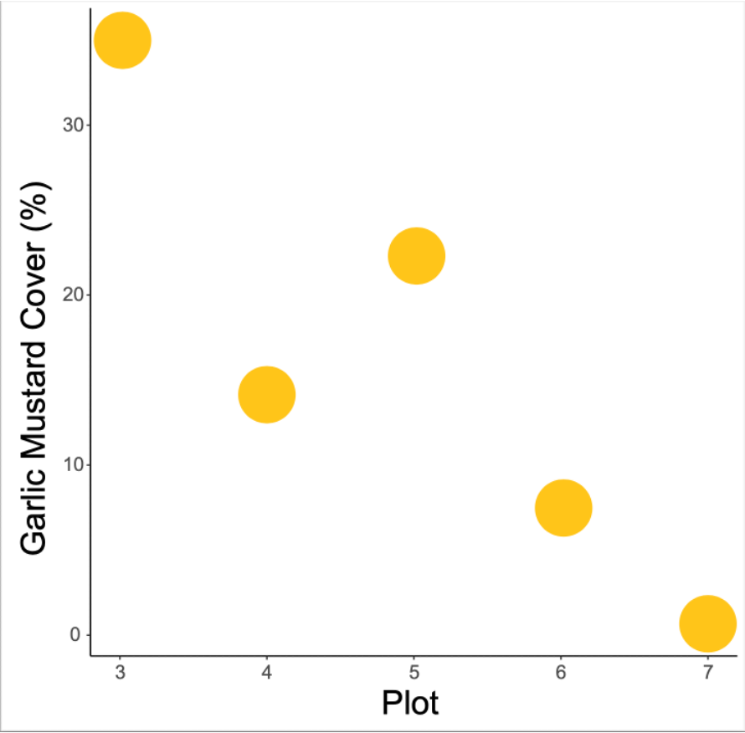

Fig. 2: Garlic Mustard Coverage. A. petiolata cover in invaded plots varies across the TT site. Some plots have garlic mustard coverage of approximately 33% of total plant cover whereas others are less than 1% covered by garlic mustard in the 2018 survey.

on native plant communities over time.
This design along with the results from long-term studies at the TT site have allowed us to gain a unique insight into the effects of invasive garlic mustard on the aboveground plant community. Studies from this site have shown that garlic mustard invasion directly contributes to the decline of native plant fitness [13] and causes carbon stress and vital rate decline in native understory plants [14]. While mutualism disruption between native plants and AM fungi at the TT site has been observed throughout the 18-year course of the TT study, detailed demographic and physiological studies have focused mainly on three native, co-occurring plant species: Red Trillium (Trillium erectum), False Solomon’s Seal (Maianthemum racemosum), and Jack in the Pulpit (Arisaema triphyllum).
Previous studies at TT have also demonstrated that garlic mustard invasion shifts the
composition [5], reduces the abundance [15], and increases diversity [15] of AM fungi. Furthermore, native herbaceous community has shifted to higher percentages of native plant species with either no associations with AM fungi or that are less dependent on mycorrhizal fungi for nutrient acquisition [6]. Due to the lasting effects of allelochemicals from invasive garlic mustard, fungal community composition at the TT site may still be changing in response to invasion, which could have a noticeable effect on the structure of plant-mycorrhizal fungal networks. More research is needed to fully understand the extent to which shifts in the AM fungal partners have occurred within individual species and across the network of interaction for a wider group of plants beyond the three initial focal plant species. To fill this gap, this study focuses on 10 understory plant species collected from all plots in 2018 including the three original focal species. These plants range from annual to perennial and cover a range of mycorrhizal dependencies. DNA sequences from the roots of these ten species were analyzed to quantify AM fungal composition and AM fungal-plant network structure at the plot level.

Research Questions
(1) To what extent do allelopathic invasive plants alter the species richness and composition of arbuscular mycorrhizal fungi?
Research in plant species invasion has largely focused on post-invasion changes in the plant community [16], however, much more research is needed on the post-invasion changes to belowground AM fungal communities. Biological invasion can heavily impact AM fungal community composition and by understanding how invasive species impact native mycorrhizal fungal community composition we can more accurately predict where and when negative effects will occur in the invaded range [17]. Previous studies have shown that garlic mustard invasion has increased the diversity of AM fungi species in the plots at the TT field site [15]. This finding sets up a conundrum. In general, an increase in diversity of AM fungi leads to better overall soil health and improved nutrient uptake by AM fungal plant symbionts [18]. However, research at TT has demonstrated that plants are physiologically stressed following garlic mustard invasion, suggesting that higher AM fungal diversity does not lead to more beneficial plant outcomes of symbiosis. This might be occurring because the connections among AM fungi plants belowground (e.g., the external AM fungal hyphal network) has been disrupted by allelochemicals. These results lead us to our next aim, focusing on the plant-mycorrhizal fungal network consequences of invasion.
(2) How are bipartite networks of plant-mycorrhizal fungal mutualism rewired following invasion and does this affect plant-mycorrhizal fungal network stability?
To address this question, I will define which metrics I am using to measure plant-AM fungal network stability (Fig. 3). Networks are powerful tools for the study of complex microbiomes, with the potential to elucidate structural patterns of stable communities and generate testable hypotheses, via models, for experimental validation. However, there is a lack of agreement on best practices for implementing these network analyses [19], and for that matter, what a mutualistic bipartite network represents in the context of plant-AM fungal mutualisms.
In his paper on the complex nested structures of pollination webs, Pedro Jordano’s description of artist Alexander Calder’s kinetic glass and wire mobiles encapsulates the functions of ecological networks. Jordano writes, “the dynamics of interconnected parts [such as those in ecological networks] depends on the way they are connected or linked to each other” illustrating the delicate balance of mobiles, bipartite networks, and ecological functions. In plain language, when balance is altered, whether by removing a key species in an ecosystem or by removing a key weight from a mobile, the distribution of the network is disrupted (Fig. 4). The effects of this disturbance can be positive or negative to the stability of the artist’s mobile or an ecological network. The focus of Jordano’s study is on bipartite plant-pollinator networks, but many of the same rules and metrics can be applied to AM fungal-plant networks. Nature does not exist in a vacuum and interactions can best be viewed within the network of community level interactions [20].

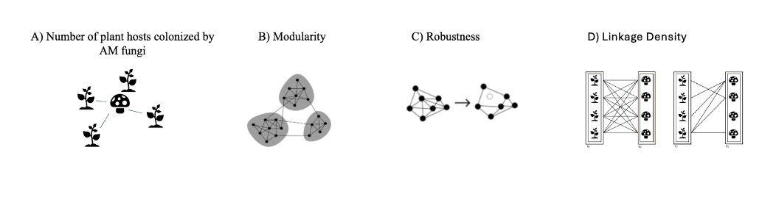

Fig. 3: Network Stability Metrics. Network stability metrics. (A) The number of plant hosts colonized by AM fungi - a measure of generalist vs. specialist AM fungi (B) Network modularity - the degree of clustering of nodes (i.e. AM fungi species or native plant species) into groups, or modules, compared to what would be expected at random [19]. (C) Network robustness - the ability of a component species to persist given the extinction of a partner [19]. (D) Linkage density - the ratio of realized network edges to the total possible number of edges [19].

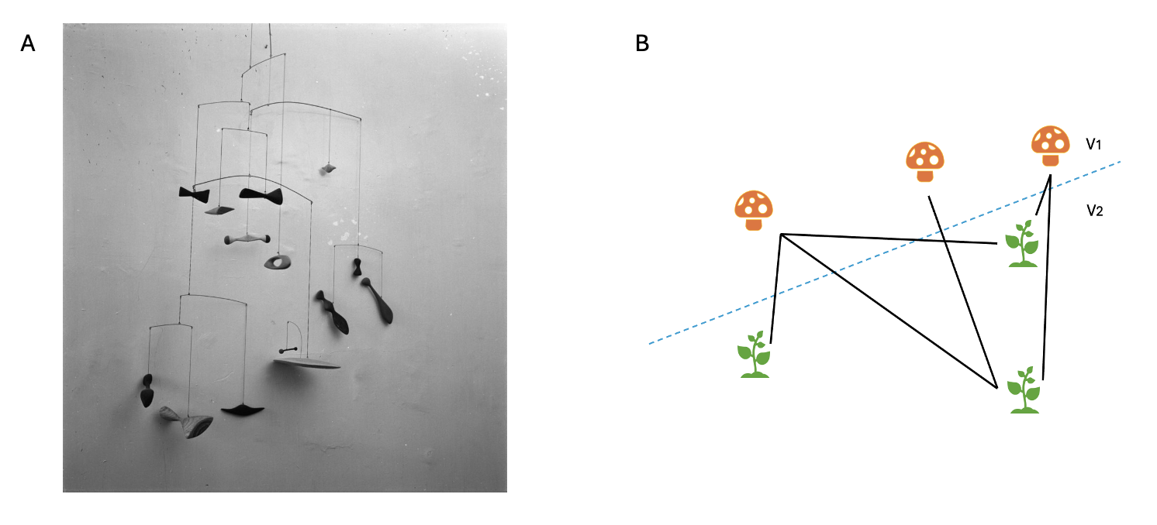

Fig. 4: Example of an Incomplete Bipartite Network. (A) A photo by Herbert Matter of Alexander Calder’s Constellation Mobile, 1943. (B) An incomplete bipartite network. If one piece, or node, is removed from either the mobile or the bipartite network there will be a disturbance in the stability of the structure. The effects of disturbance can be positive or negative.

Microbiome stability is the ability of a microbiome to resist disturbance or recover quickly from a disturbance [19]. It is important to understand that network stability can be hard to define using only one metric because networks in nature, like Calder’s mobiles, consist of many pieces at play in a fragile equilibrium. This equilibrium is balanced in the way both the number and the size of the pieces are connected collectively [20]. It is generally agreed that stable networks can be described as those that have high modularity, high linkage density and high species richness/diversity (here, Shannon Diversity) (Table 1). I will also be taking into consideration the number of native plant important to realize that while this study focuses on changes in plant-AM fungal networks, we are currently only creating models that may or may not directly reflect the It is microbiome and will need to utilize future observational and empirical studies to understand the validity of these models.

Table 1. Network metrics, definitions, and expected outcomes of network stability.

Metric | Definition | Weeded | Invaded
Modularity | The partitioning within network communities into distinct and highly connected subcommunities [21] | High modularity | Low modularity
Linkage Density | The ratio of realized network edges to the total possible number of edges [19]. | High linkage density | Lower linkage density
Shannon Diversity | A measure of both the number of species (richness) and their relative abundance (evenness) used to determine the biodiversity of a specific ecosystem. | Low diversity (based on previous surveys) | High diversity (based on previous surveys)
Robustness | The ability of a network to resist rapid collapse in the face of disturbance [19] | High Robustness | Low Robustness

The lack of knowledge of large symbiotic networks has been a hindrance to understanding the full span of determinants of ecological network architecture [21]. Bipartite networks can be useful in understanding the different metrics of fungal network stability and variance. To use bipartite networks to explore the impacts of invasive garlic mustard on AM fungal networks, one can look at the network as comprised of nodes and edges where the nodes can represent microbial taxa, genes, metabolites, or other properties of the biome and where edges indicate statistically significant relationships between nodes [19] (Fig. 5).
Networks reveal a visible landscape of plant-AM fungal interaction in a system that has until recently been considered by many difficult to quantify. This study of AM fungal-plant mutualism disruption at the TT field site aims to analyze the effects of garlic mustard invasion on AM fungal Shannon diversity, composition, and plant-AM fungal network stability to provide insight into potential impacts on other invaded sites and help determine the focuses of current and future ecological restoration efforts. While further empirical studies will be needed to understand if network models are actual reflections of

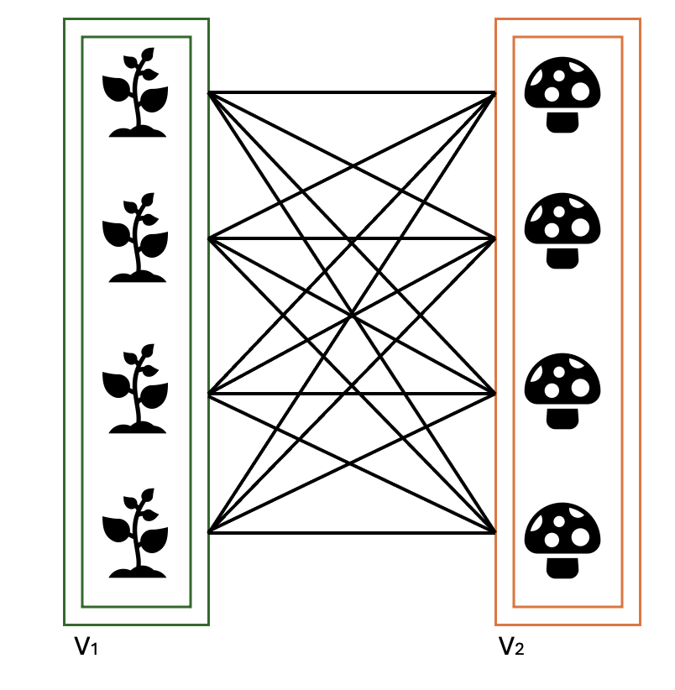

Fig. 5: A Complete (Perfect) Bipartite Network A complete, or perfect, bipartite network where every possible edge is associated with every possible node such that no edge has both endpoints in the same subset. The basic formula for a bipartite network is G = (V1, V2, E) where V1 and V2 are two distinct sets of vertices representing two partitions of nodes and where E represents every possible edge that could connect vertices in different partitions.
what is happening in the microbiome, analysis of AM fungal-plant networks adds a new dimension to our understanding of the effects of invasion on mutualist networks. Conservation and restoration efforts in native ecosystems continue to increase in importance. Understanding the interactions between native species and their environments we will be better able to address the many issues being caused by climate and anthropogenic change.

Section 2. Hypotheses
H1: Long term invasion by A. petiolata at the TT field site has consistently increased the diversity of AM fungi, changing the overall community composition.
Non-native invasive species can release chemicals into the environment that impact belowground microbial communities, mutualists, and soil [22]. While A. petiolata’s effects can differ among sites and studies [24], previous studies at the TT site have shown an increase in AM fungal diversity within garlic mustard invaded plots [13]. Such increased diversity is generally predicted to result in better overall soil health and improved nutrient uptake by AM fungal plant symbionts [18]. Despite this increase in fungal diversity, the plants in the invaded plots at the TT field site are consistently physiologically stressed. This leads me to hypothesize that the long-term invasion of A. petiolata at the TT field site has caused a change in overall AM fungal community composition and that AM fungi could be connected differently to plant symbionts resulting in a less functional belowground network.
H2: Invasion by A. petiolata at the TT field site has shifted the bipartite network properties of plant-mycorrhizal fungi to make them less stable, as is expected following disturbance.
Network studies allow us to take a holistic approach to understanding disturbance impacts in complex biomes. Disturbances, such as invasion by non-native A. petiolata, are expected to decrease plant-AM fungal network stability over time. It is generally agreed that a stable network exhibits high modularity, high linkage density, and high species richness. We expect these network metrics to be lower in our models for the invaded plots at the TT field site as the result of plant-AM fungal mutualism disruption.

Section 3. Methods

Sample collection
In 2018 and 2024, we harvested roots from ten native understory herbaceous plant species at the TT site (Table 2) previously characterized as AM fungal partners. The three original focal species harvested were Red Trillium (Trillium erectum), False Solomon’s Seal (Maianthemum racemosum), and Jack in the Pulpit (Arisaema triphyllum) alongside seven new focal species, Wild Ginger (Asarum canadense), Wood Fern (Dryopteris spp.), Jewelweed (Impatiens capensis), Sweet Cicely (Osmorhiza claytonii), Mayapple (Podophyllum peltatum), Solomon’s Seal (Polygonatum biflorum), and Bloodroot (Sanguinaria canadensis).
These species range from annual to perennial and cover a range of mycorrhizal dependencies from highly dependent, Trillium, to facultatively dependent, Impatiens (Table 2 and 3). A total of ~ 200 plants across all 10 species were collected. The addition of more native plant species adds depth to our understanding of plant-AM fungal interactions. We repeated sampling in 2024, but those samples will be the focus of future analyses.
In both years, plants were carefully removed from the field site to keep roots and, if applicable, rhizomes intact. The plants were then stored in coolers and delivered to the laboratory where any plant shoots, fruit, and leaves were separated from the roots and rhizomes and stored to be utilized for other studies. Roots and rhizomes were rinsed to remove visible soil and sterilized in preparation for DNA extraction. Roots and rhizomes were soaked for 5 seconds in 95% ethanol to work as a wetting agent, then surface sterilized for 2 minutes in 0.5% bleach (NaOCl). Roots and rhizomes were then placed in70% ethanol for 2 minutes to remove the bleach followed by 1 minute in sterile water to remove the ethanol. Roots were then clipped from the rhizomes, and both were gently patted dry and placed in individually labelled plastic bags. Samples were frozen and returned in coolers to the University of Tennessee, Knoxville, where they were stored at -80° C. In 2018, DNA was extracted from roots using the Qiagen Power Plant DNA extraction kit and amplified with AM-fungal specific primers, AML2-NS31 nested within general eukaryotic primers (NS1-NS4). Samples were sequenced on a MiSeq lane with 2

Table 2. Number of plots from which each of the native plant species was harvested in 2018 and 2024.

Species | 2018 |  | 2024
 | Weeded | Ambient | Weeded | Ambient
Arisaema triphyllum | 3 | 3 | 2 | 2
Asarum canadense | 2 | 3 | 2 | 3
Dryopteris sp. | 2 | 4 | 5 | 5
Impatiens capensis | 4 | 4 | 4 | 4
Maianthemum racemosum | 2 | 4 | 4 | 5
Osmorhiza claytonii | 1 | 1 | 3 | 2
Podophyllum peltatum | 3 | 3 | 3 | 2
Polygonatum biflorum | 2 | 3 | 3 | 3
Sanguinaria canadensis | 1 | 3 | 3 | 3
Trillium erectum | 4 | 5 | 5 | 5

Table 3. Level of mycorrhizal dependency by plant species.

Plant Species | Mycorrhizal Dependency
Red Trillium (Trillium erectum) | Obligately dependent [25]
False Solomon’s Seal (Maianthemum racemosum) | Obligately dependent [26]
Jack in the Pulpit (Arisaema triphyllum) | Obligately dependent [27]
Wild Ginger (Asarum canadense) | Obligately dependent [28]
Wood Fern (Dryopteris spp.) | Obligately to facultatively dependent [29]
Sweet Cicely (Osmorhiza claytonii) | Obligately dependent [30]
Mayapple (Podophyllum peltatum) | Obligately dependent [31]
Solomon’s Seal (Polygonatum biflorum) | Obligately dependent [32]
Bloodroot (Sanguinaria canadensis) | Obligately dependent [33]
Jewelweed (Impatiens capensis) | Facultatively dependent [34]

x 300 b reads. See Bialic-Murphy et al. 2021 for complete methods. DNA from 2024 samples was extracted from roots by the Genomics Core at UTK and amplified using the same methods.

Bioinformatics
DNA sequences were processed using the standard settings in the DADA2 pipeline [35] and grouped into virtual taxonomic units (VTXs) using the MaarjAM database [36].
Sequences were then rarefied to the lowest sampling effort (3928 sequences) in 1000 iterations. All statistics have been run on these 1000 matrices. Samples collected in 2024 will be processed similarly.

Statistics
Only the 2018 sequences from all ten native plant species will be reported here. For hypothesis 1, I analyzed composition and diversity at the plot level, where diversity is calculated using the Shannon diversity index. Composition was compared among weeded and invaded plots using the dbRDA function in the Vegan package in R with plot as a random effect. To analyze hypothesis 2, we used the bipartite package in R to analyze network properties specifically focusing on generalism, modularity, linkage density, and robustness as detailed in Table 1. These metrics allow us to assess the stability of AM fungal networks in a defined manner which will give us insight into the long-term effects of invasive garlic mustard on these communities. I analyzed each of the 1000 rarefied matrices separately and then graphed the distribution by treatment within the plot. I then compare the number of times the weeded plots had higher values for a given metric compared to the invaded plots.

Section 4. Results
H1: Long term invasion by A. petiolata at the TT field site has consistently increased the diversity of AM fungi, changing the overall community composition.
After rarefaction, weeded plots were consistently and significantly lower in AM fungal diversity than ambient plots in every comparison (Figure 6). Interestingly invaded plots differ in the amount of increase in AM fungal diversity. For instance, plot 5 shows an almost negligible increase in AM fungal diversity in invaded subplots, while in plot 6, the increase is pronounced. This is likely due to differences in both garlic mustard coverage and differences in native plant communities among plots.Despite the increase of AM fungal richness in invaded plots, AM fungal composition did not vary among invaded and weeded plots (F = 1.19, P = 0.20 (Figure 7)). Comparing the composition of all AM fungal taxa in both ambient and weeded plots showed large variance in AM fungal composition across plots which masked any effects of the garlic mustard weeding treatment.
H2: Invasion by A. petiolata at the TT field site has shifted the bipartite network properties of plant-mycorrhizal fungi to make them less stable, as is expected following disturbance.

Network Analysis
Network analysis models showed incomplete bipartite networks in all the invaded and weeded plots (Fig. 8). This is to be expected as complete bipartite networks (shown in Fig. 5) rarely occur in nature. Each plot had a different composition of focal native plants and AM fungal species and the differences in network interactions between plants and AM fungi are clearly shown in the network figures. With the exception of plot 5, A. petiolata-invaded plots had a higher diversity of native focal plant species sampled. While these trends are evident in our models, more empirical evidence is critical to interpret the results.

Number of Shared Plant Hosts
Based on sampling 10 focal species, AM fungi in invaded plots consistently associated with more plant hosts (~2-3 more species (Figure 9)). This finding suggests that plant

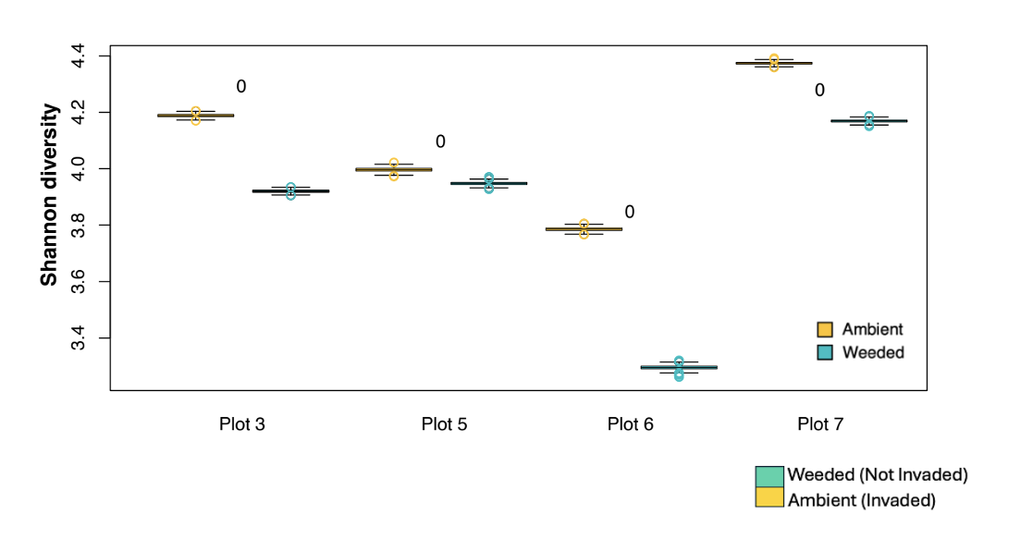

Fig. 6: AM Fungal Diversity. Weeded plots had lower AM fungal diversity in every comparison. Numbers represent the number of times weeded plots had higher values for a given metric compared to invaded plots after analyzing 1000 rarefied matrices separately.

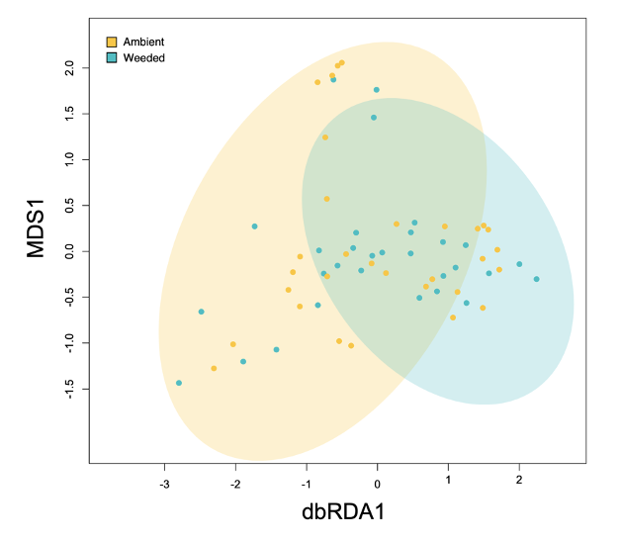

Fig. 7: AM Fungal Composition. AM fungal composition did not vary between weeded and invaded plots (F = 1.19, P = 0.20). Each point represents a set of 4 subplots within a treatment (ambient = mustard yellow, and garlic mustard weeded = turquoise). Each treatment is plotted with an ellipse of 2 standard errors around the centroid of the mean composition.

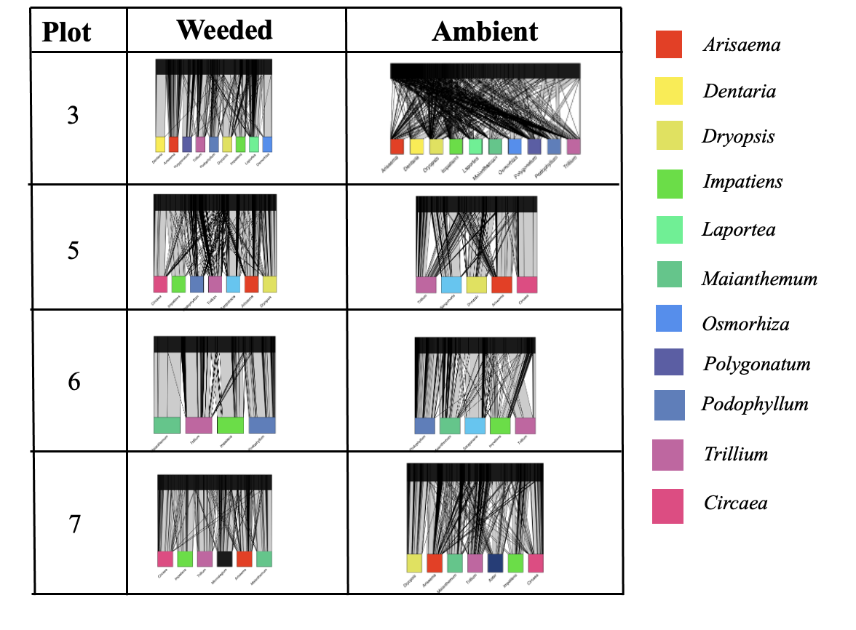

Fig 8: Plant-AM Fungal Networks by Plot and Treatment. Plant-AM fungal networks by plot and treatment. Each plot and treatment had a different composition of native plant and AM fungal species. DNA sequences were rarefied to the lowest sampling effort (3928 sequences) in 1000 iterations.

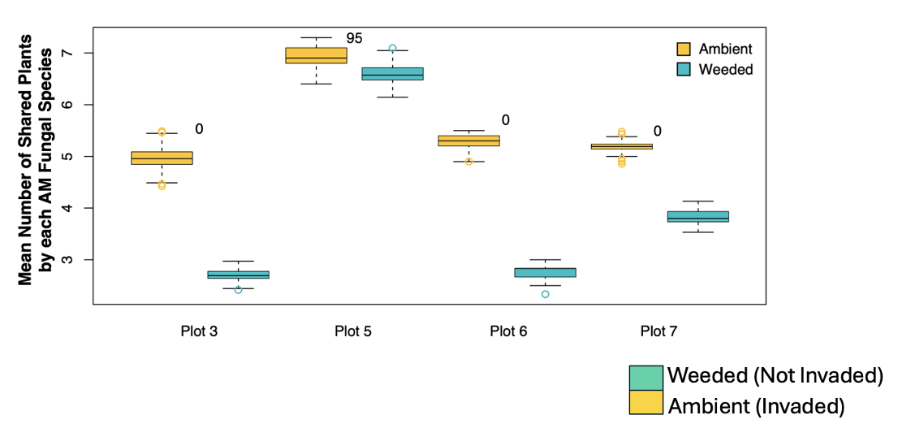

Fig. 9: Number of Shared Plant Hosts. Mean number of shared plants by each AM fungal species. AM fungi in weeded plots consistently associate with fewer plant hosts.

invasion increased the generalism of plant-AM fungal associations, with more specialist AM fungi taxa in weeded plots.

Modularity
The modularity between AM fungi-plant mutualisms in the A. petiolata weeded plots is generally higher than in the ambient plots, which fits with our expected findings, however, plot 5 exhibited lower modularity in the weeded subplots (Fig. 10).

Linkage Density
I saw lower linkage density between native plants and their AM fungal mutualists in weeded plots. This is different from what I expected based on our assumption that weeded plots would show more network stability, and thus, higher linkage density (Figure 11).

Robustness
Network robustness, much like the metrics that comprise it (network linkage density, network species richness, network modularity, and species generalism), varied among plots (Figure 12). Some plots (plot 7) had more robust networks in weeded treatment as expected, but others (plot 3) exhibited the opposite pattern.

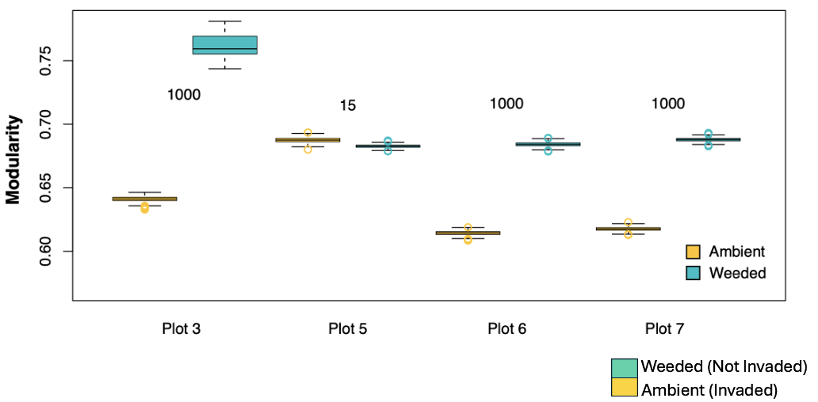

Fig 10: Modularity. Modularity by plot. Weeded plots have overall higher modularity with the exception of plot 5.

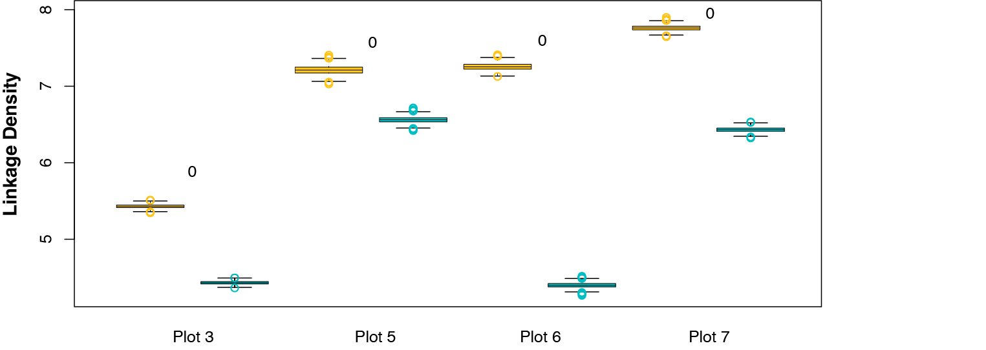


Fig. 11: Linkage Density. Linkage density by plot. Linkage density between native plants and AM fungi was lower in weeded plots.

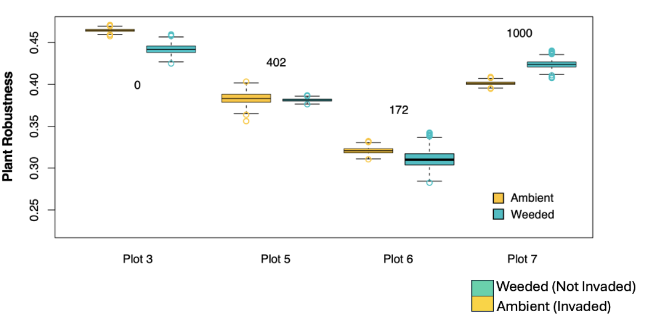

Fig. 12: Plant Robustness. Plant robustness by plot. Robustness was lower in all weeded plots with the exception of plot seven.

Section 5. Discussion

Overview
While bipartite networks have been studied in various other systems, there are not many studies that fully and specifically focus on the bipartite network relationships between AM fungi and their native plant mutualists, especially across space in long-term experimental manipulations. This study aimed to determine if the previously observed effects of invasion-based increases in AM fungal diversity have persisted and if they have affected the network stability of AM fungal-plant bipartite networks. The data show trends in the weeded plots that are different from what I anticipated. I expected invasion by A. petiolata at the TT field site to shift the bipartite network properties of plant-mycorrhizal fungi to make the networks less stable, as is expected following disturbance. However, I also expected that removal of A. petiolata from the control sites would create an improvement in ecosystem recovery, increasing stability over the 18 years that this site has been weeded. While modularity in weeded plots aligned with what we expected (higher modularity, i.e. more stability in the weeded plots), both robustness and linkage density are lower than expected in plots without A. petiolata invasion. These effects can be interpreted in the light of species richness and composition.

Species Richness and Composition Influences on Network Structure
Models show that invaded plots consistently had increased AM fungal diversity; however, the composition of these fungi did not vary with invasion. The network
perspective allowed us to understand if interactions among plants and AM fungi shifted regardless of shifts in composition. Indeed, we observed that AM fungi in invaded plots associated with more plant species, making them more host generalist compared to the same (or similar) AM fungal species in the weeded plots. Generalist communities often have higher network stability, which may have contributed to the inconsistent signal of network robustness among plots.

Network properties and variability across space
An interesting and likely important aspect of this study is the variation among plots due to differences in garlic mustard coverage. While metrics in our models, such as modularity and linkage density, reflected similarly across all plots regardless of garlic mustard coverage, plot 7, the plot with minimal garlic mustard coverage in 2018 was the only plot to show lower robustness in the invaded subplots. This could occur because garlic mustard has had less of an impact on this specific plot. However, if that is the case, I would expect differences in the other network metrics as well. Long-term trends of garlic mustard coverage over time could resolve these conflicting indicators of network stability.
Variation in bipartite network models is also possibly due to spatial variation in native plant community composition among plots. Studies have shown that both the composition of AM fungi in roots and the production of their spores can be influenced by host plants [37]. As the first rule of ecology states, “everything is connected to everything”, therefore it makes sense that shifts in plant communities could be a factor in the variability of the modeled network properties across space [38]. There is emerging evidence that AM fungi may have greater host specificity than previously recognized [39], which could be why AM fungal species have shifted to more generalist species in response to shifting plant composition. If this is the case, shifts in plant community composition could be a factor partially explaining higher mean number of shared plants by AM fungal species, lower modularity, higher linkage density, and higher robustness among the different invaded plots across the site. Plant diversity can control root fungi, especially at “local neighborhood” scale [40], thus shifts in local plant diversity caused by invasion at the TT site has likely been a factor in the plot-level network trends seen in this study. Ecological patterns can change across spatial and temporal scales due to changes in key ecological processes [40], such as shifts in plant composition and therefore plant-AM fungal mutualisms at the field site.

Additional contingencies and future directions
As the goal of this study is to understand the long-term consequences of A. petiolata invasion in a holistic and beneficial manner, it is important to have multiple time points to see if these trends persist. In 2024, we harvested 610 root samples from the same 10 focal species at the TT site (Table 2). These roots have recently been amplified by the Genomics Core at The University of Tennessee, Knoxville using the same methods as were used for the 2018 root samples. This will allow future research to analyze that data following the methods from this study to establish a deeper understanding of the changes occurring at this field site over a longer time period. One of the farther-reaching desired outcomes of this study is to better understand the consequences of garlic mustard invasion on AM fungi in order to gain insight into how to utilize this approach of looking at not only above ground plant communities post-invasion, but also disruptions of native plant-AM fungal mutualisms to create restoration plans across a variety of invaded ecosystems.

Conclusions: What does all this mean for invasion and restoration?
Network patterns can provide valuable information on the stability of biotic interactions post-disturbance [41] and are powerful tools for understanding the degrees of specificity for entire symbiotic communities [42]. To create restoration frameworks for invaded ecosystems we need a more holistic approach to looking at post-invasion disruptions and our analysis of AM fungal diversity, composition, and network metrics has already had unexpected results. Sequencing results showed that garlic mustard invasion paradoxically increased the species richness of AM fungi in native plant roots while the composition of AM fungal species did not differ between weeded and invaded plots. Native plants growing in garlic mustard invaded plots were less modular but had higher linkage density and number of shared AM fungal partners. Native plants associated with more generalist AM fungal taxa in invaded plots. Finally native plant-AM fungal networks appear to be more robust in invaded plots. Taken together, invasion shifted plant-AM fungal networks to have higher species diversity of AM fungi but as these fungi tended to be generalists, this suggests that their functions may have declined in invaded environments. The shift from more specialist to more generalist fungi with invasion also increased network robustness (i.e., stability) potentially making restoration more challenging. Restoration efforts might be most effective when they focus on disrupting associations among native plants and generalist AM fungi and renewing connections with AM fungal specialists. If networks are degraded following invasion in these systems, restoration should focus on reinoculation with keystone AM fungi after garlic mustard removal. If networks are more stable after invasion and subsequent/continued removal of the invasive species, this may be an indication that the ecosystem has shifted to an alternative stable state, making restoration more challenging. There is a continued need for more data to study these phenomena on a larger time scale to create a prescription for post-invasion restoration. My work examined one of the longest running invasive species manipulations to date, allowing us to gain novel insight into the long-term impacts of invasion belowground and is an important first step in taking a holistic approach to understanding the consequences of invasion on belowground microbiomes and the efforts required for restoration in hopefully not only these, but other allelopathic invaded ecosystems.

References
- Bonan, G.B. Forests and climate change: forcings, feedbacks, and the climate benefits of forests. Science 320, pp. 1444-1449 (2008)
- McKinley, D.C., Ryan, M.G., Birdsey, R.A., Giardina, C.P., Harmon, M.E., Heath, L.S., Houghton, R.A., Jackson, R.B., Morrison, J.F., Murray, B.C., Pataki, D.E., & Skog, K.E. A synthesis of current knowledge on forests and carbon storage in the United States. Ecological Applications 21, pp. 1902-1924 (2011)
- Bellassen, V., Luyssaert, S. Carbon sequestration: managing forests in uncertain times. Nature 506, pp. 153-155 (2014)
- Řezáčová, V., Řezáč, M., Gryndler, M., Hršelová, H., Gryndlerová, H., & Michalová, T. Plant invasion alters community structure and decreases diversity of arbuscular mycorrhizal communities. Applied Soil Ecology 167, 104039 (2021)
- Burke, D., Carrino-Kyker, S., Hoke, A., Cassidy, S., Bialic-Murphy, L., & Kalisz, S. Deer and invasive plant removal alters mycorrhizal fungal communities and soil chemistry: Evidence from a long-term field experiment. Soil Biology and Biochemistry 128, pp. 13-21 (2019)
- Roche, M. Pearse, I., Bialic-Murphy, L., Kivlin, S., Sofaer, H., & Kalisz, S. Negative effects of an allelopathic invader on AM fungal plant species drive community-level responses. Ecology 102(1) e03201 (2021)
- Bascompte, J., Jordano, P., Melián, C., & Olesen, J. The nested assembly of plant-animal mutualistic networks. PNAS 100(16), pp. 9383-9387 (2003)
- Garrido, J., Alcántara, J., López-García, Á., Ozuna, C., Perea, A., Prieto, J., Rincón, A., & Azcón-Aguilar, C. The structure and ecological function of the interactions between plants and arbuscular mycorrhizal fungi through multilayer networks. Functional Ecology 37 pp. 2217-2230 (2023)
- Smith, S.E., and Read, D.J. Mycorrhizal Symbiosis (3rd edition). Academic Press, London (2008)
- Frew, A., Weinberger, N., Powell, J.R., Watts-Williams, S.J., Aguilar-Trigueros, C.A. Community assembly of root-colonizing arbuscular mycorrhizal fungi: beyond carbon and into defense? The ISME Journal 18:1 (2024)
- Reinhart, K.O. and Callaway, R.M. Soil biota and invasive plants. New Phytologist 170:3, pp. 445-457 (2006)
- Bunn, R.A., Simpson, D.T., Bullington, L.S., Lekberg, Y., and Janos, D.P. Revisiting the ‘direct mineral cycling’ hypothesis: arbuscular mycorrhizal fungi colonize leaf litter, but why? The ISME Journal 13, pp. 1891-1898 (2019)
- Bialic-Murphy, L., Brouwer, N., and Kalisz, S. Direct effects of a non-native invader erode native plant fitness in the forest understory. Journal of Ecology 108:1 pp. 189-198 (2019).
- Brouwer, N., Hale, N., and Kalisz, S. Mutualism-disrupting allelopathic invader drives carbon stress and vital rate decline in a forest perennial herb. AoB Plants v7 (2015).
- Bialic-Murphy, L., Smith, N.G., Voothuluru, P., McElderry, R.M., Roche, M.D., Cassidy, S.T., Kivlin, S.N., and Kalisz, S. Invasion-induced root-fungal disruptions alter plant water and nitrogen economies. Ecology Letters 24:6, pp. 1145-1156 (2021)
- D’Antonio, C.M. and Vitousek, P.M. Biological invasions by exotic grasses, the grass/fire cycle, and global change. Annual Review of Biology and Systematics 23, pp. 63-87 (1992)
- Levine, J.M., Vilà, M., D’Antonio, C.M., Dukes, J.S., Grigulis, K., and Lavorel, S. Mechanisms underlying the impacts of exotic plant invasions. The Royal Society 270, pp. 775-781 (2003)
- Lee, E., Eo, J., Ka, K., and Eom, A. Diversity of arbuscular mycorrhizal fungi and their roles in ecosystems. Mycobiology 41:3, pp. 121-125 (2018)
- Kajihara, K.T., and Hynson, N.A. Networks as tools for defining emergent properties of microbiomes and their stability. Microbiomes 12:184 (2024)
- Jordano, P., Bascompte, J., & Olesen, J. The Ecological Consequences of Complex Topology and Nested Structures in Pollination Webs. The University of Chicago Press, EEUU, pp. 173-199 (2006)
- Montesinos-Navarro, A., Segarra-Moragues, J.G., Valiente-Banuet, A., & Verdú, M. The network structure of plant-arbuscular mycorrhizal fungi. New Phytologist 194:2, pp. 536-547 (2012
- Toju, H., Guimarães, P.R., Olesen, J.M., and Thompson, J.N. Assembly of complex plant-fungus networks. Nature Communications 5:5273 (2014)
- Inderjit, Simberloff, D., Kaur, H., Kalisz, S., and Bezemer, T.M. Novel chemicals engender myriad invasion mechanisms. New Phytologist 232, pp. 1184-1200 (2021)
- Hale, A. & Kalisz, S. Perspectives on allelopathic disruption of plant mutualisms: a framework for individual- and population-level fitness consequences. Plant Ecology 213, pp. 1991-2006 (2012)
- Brundrett, M. and Kendrick, B. The roots and mycorrhizas of herbaceous woodland plants. New Phytologist 114:3, pp. 469-479 (1990)
- Hale, A.N., Tonsor, S.J., and Kalisz, S. Testing the mutualism disruption hypothesis: physiological mechanisms for invasion of intact perennial plant communities. Ecosphere 2:10, pp. 1-15 (2011)
- Burke, D.J. Effects of Alliaria petiolata (garlic mustard; Brassicaceae) on mycorrhizal colonization and community structure in three herbaceous plants in a mixed deciduous forest. Botany 95:11, pp. 1416-1425 (2008)
- Brundrett, M. and Kendrick B. The mycorrhizal status, root anatomy, and phenology of plants in a sugar maple forest. Canadian Journal of Botany 66:6, pp. 1153-1173 (1988)
- Kessler, M., Jonas, R., Stasberg, D., and Lehnert, M. Mycorrhizal colonization of ferns and lycophytes on the island of La Réunion in relation to nutrient availability. Basic and Applied Ecology 11:4, pp. 329-336 (2010)
- Phillips-Mao, L. Garlic mustard (Alliaria petiolata) invasion & impacts: implications for management and restoration of woodland herbs. University of Minnesota ProQuest Dissertation and Theses 3630624 (2012)
- Watson, M.A., Scott, K., Griffith, J., Dieter, S., Jones, C.S., and Nanda, S. The developmental ecology of mycorrhizal associations in mayapple, Podophyllum peltatum, Berberidaceae. Evolutionary Ecology 15, pp. 425-442 (2002)
- Shi, J., Chen, P., Zhu, M., Chen, H., Si, J., and Wu, L. Adaptation of Polygonatum genotypes to the areas of transplantation greatly influences the rhisospheric microbial community. Plant Soil (2024)
- Hornbeck, J.H., Sieg, C.H., and Reyher, D.J. Conservation assessment for bloodroot in the Black Hills National Forest, South Dakota and Wyoming. United States Department of Agriculture, Forest Services, Rocky Mountain Region (2003)
- McCary, M.A., Zellner, M., Wise, D.H. The role of plant-mycorrhizal mutualisms in deterring plant invasions: Insights from an individual-based model. Ecology and Evolution 9:4, pp. 2018-2030 (2019)
- Callahan, B.J., McMurdie, P.J., Rosen, M.J., Han, A.W., Johnson, A.J., and Holmes, S.P. DADA2: High resolution sample inference from Illumina amplicon data. Nat Methods 13:7, pp. 581-583 (2016)
- Öpik, M., Vanatoa, A., Vanatoa, E., Moora, M., Davison, J., Kalwij, J.M., Reier, Ü., and Zovel, M. The online database MaarjAM reveals global and ecosystemic distribution patterns in arbuscular mycorrhizal fungi (Glomeromycota). New Phytologist 188:1, pp. 223-241 (2010)
- Johnson, D., IJdo, M., Genney, D., Anderson, I., & Alexander, I. How do plants regulate the function, community structure, and diversity of mycorrhizal fungi? Journal of Experimental Botany 56:417, pp. 1751-1760 (2005)
- Fei, S., Kivlin, S., Domke, G., Jo, I., LaRue, E., & Phillips, R. Coupling of plant and mycorrhizal fungal diversity: its occurrence, relevance, and possible implications under global change. New Phytologist 234, pp. 1960-1966 (2021)
- Kokkoris, V., Lekberg, Y., Antunes, P., Fahey, C., Fordyce, J., Kivlin, S., & Hart, M. Codependency between plant and arbuscular mycorrhizal fungal communities: what is the evidence? New Phytologist 228, pp. 828-838 (2020)
- Kivlin, S. & Hawkes, C. Differentiating between effects of invasion and diversity: impacts of aboveground plant communities on belowground fungal communities. New Phytologist 189, pp. 526-535 (2010)
- Kajihara, K., Egan, C., Swift, S., Wall, C., Muir, C., & Hynson, N. Core arbuscular mycorrhizal fungi are predicted by their high abundance-occupancy relationship while host-specific taxa are rare and geographically structured. New Phytologist 234, pp. 1464-1476 (2022)
- Bascompte, J. Disentangling the web of life. Science 325, pp. 426-419 (2009)

Vita
Originally from Nashville, Tennessee, Jessica Hammonds grew upside outside of Knoxville in the foothills of the Smoky Mountains. She grew up hiking in the Smokies and exploring many of the creeks, woodlands, and farms surrounding her home. Jessica always knew that she was fascinated by natural sciences and after graduating from The University of Tennessee, Knoxville in 2007 with a B.S. in Retail Management, she started a small truck farm based in Seymour, Tennessee growing heirloom vegetables and becoming obsessed with soil. After years of gaining appreciation for the interconnectedness of the earth and its inhabitants, both through farming and through working with many local farmers in her role as a chef, Jessica felt it was time to continue building on the knowledge and passions she had gained through her work. In 2023, she joined the Ecology and Evolutionary Biology department at The University of Tennessee, Knoxville to begin her work on a Master of Science degree. She looks forward to using all that she has learned, in life and in graduate school, to help restore and conserve the Appalachian region she feels so fortunate to call home.

