3D Experimental Studies of Temperature and

Crystallographic Effects on Creep and Strength in Rock Salt

A Dissertation Presented for the

Doctor of Philosophy

Degree

The University of Tennessee, Knoxville

Amirsalar Moslehy

December 2023
Copyright © 2023 by Amirsalar Moslehy
All rights reserved.

DEDICATION

To my mother Laleh, my wife Brittany, my son Leo, and my friends and family for their continuous love and support.

ACKNOWLEDGEMENTS

First and foremost, I would like to thank my advisor Prof. Khalid Alshibli, professor and the head of graduate studies at the Department of Civil and Environmental Engineering, the University of Tennessee - Knoxville (UTK). The materialization of this dissertation would not be possible without his motivation, enthusiasm, and support. I would also like to thank Prof. Angel Palomino, Prof. Claudia Rawn, and Prof. Timothy Truster, my dissertation committee, for their support, insights, and help.

This dissertation is based on work supported by the National Science Foundation (NSF) under Grant # CMMI- 1641054. Any opinions, findings, conclusions, and recommendations expressed in this material are those of the authors and do not necessarily reflect the views of NSF.

This dissertation used resources of the Beamline 1-ID at Advanced Photon Source (APS), Argonne National Laboratory. Use of the Advanced Photon Source, an Office of Science User Facility operated for the U.S. Department of Energy (DOE) Office of Science by Argonne National Laboratory, was supported by the U.S. DOE under Contract No. DE-AC02-06CH11357.

Laue and powder x-ray diffractions (XRD) and scanning electron microscope (SEM) were acquired at the Joint Institute for Advanced Materials (JIAM) Diffraction Facility of the University of Tennessee, Knoxville.

I would also like to thank my research colleagues at UTK, Dr. Zaher Jarrar, Dr. Wadi Imseeh, Dr. Siavash Amirrahmat, Ibrahim Aklouk, Darcie Halliburton, Isabella Alamilla, Tyler Galyon, Jeremiah Pham, Karen Abercrombie, Jeremy Melton, Brady Nutt, and Faith Harris at the University of Tennessee, Knoxville, for their help and support.

ABSTRACT

Salt domes utilization as storage reservoirs in the energy sector has led to extensive studies on rock salt’s mechanical and geothermal behavior. These important facilities’ safety and serviceability rely on understanding rock salt’s compressive strength and creep behavior under various loading directions, water contents, in-situ stresses, and temperatures. Despite numerous studies on rock salt’s mechanical behavior in the literature, there are still many unanswered questions about rock salt’s behavior. This dissertation was aimed at utilizing state-of-the-art experimental techniques such as 3D synchrotron micro-computed tomography (SMT) and 3D x-ray diffraction (3DXRD) along with hundreds of compression and creep experiments to enhance our understanding of crystal orientation and temperature’s influences on rock salt’s strength, creep behavior, and internal structural changes. Unconfined compressive strength (UCS) of natural single-crystal rock salt was observed to be lesser than synthetic single-crystal rock salt reported in the literature. Changing the loading direction from parallel to [1 0 0] crystal direction to 30º to (1 0 0) in (0 1 0) direction resulted in higher UCS values. The same loading direction rotation in single-crystal rock salt’s creep decreased the accumulated axial strain and the transient and steady-state strain rates. During dry and wet 1D compressions of rock salt grains, unique critical porosity values of 32% and 37% respectively were established that caused a linear relationship between the porosity and logarithm of axial stress. Rock salt prepared in 1D compression exhibited a strong {1 1 1} texture and displayed a dominant {1 1 1}<1 -1 0> slip system under unconfined compression, which contrasted with rock salt possessing a randomly distributed texture. Polycrystalline rock salt’s UCS was higher when the grain boundaries were nominally dry rather than wet (64.3MPa versus 16.2 MPa). Annealed polycrystalline rock salt regardless of its grain-boundary’s condition demonstrated a UCS of about 40 MPa and manifested a critical axial stress of 30 MPa and a critical porosity of 5.7% under compression where it developed a fully connected crack network indicating compromises to its impermeability. Increasing the deviatoric stress during polycrystalline rock salt’s creep increased transient and steady state strain rates and accelerated tertiary creep rupture.

TABLE OF CONTENTS

CHAPTER 1 INTRODUCTION 1
1.1 Motivation 2
1.2 Objectives 3
1.3 Literature Review 3
1.3.1 Polycrystalline Rock Salt’s 1D Compression and Unconfined Compression Behavior 3
1.3.2 High-Pressure Thermal Cells 6
1.3.3 Influence of Temperature and Crystal Orientation on Rock Salt’s Compressive Strength 6
1.3.4 Evolution of Texture and Internal Stresses within Rock Salt under Compression 8
1.3.5 Effects of Crystal Orientation, Temperature, Deviatoric Stress, and Confining Stress on Creep of Rock Salt 10
References 14
Appendix 20
CHAPTER 2 ASSESSMENT OF THE PROPERTIES OF POLYCRYSTALLINE ROCK SALT SYNTHESIZED UNDER NOMINALLY DRY AND WET CONDITIONS 22
2.1 Abstract 23
2.2 Introduction 23
2.3 Raw Material 26
2.4 Compression Setup 26
2.5 Specimen Compression 27
2.6 Scanning Electron Microscopy (SEM) 29
2.7 Unconfined Compression Experiments 31
2.8 Conclusions 32
2.9 Acknowledgments 33
References 33
Appendix 36
CHAPTER 3 INFLUENCE OF TEMPERATURE AND CRYSTAL ORIENTATION ON COMPRESSIVE STRENGTH OF ROCK SALT USING A NEWLY DEVELOPED HIGH-PRESSURE THERMAL CELL 47
3.1 Abstract 48
3.2 Introduction 48
3.3 High-Pressure Thermal Cell 50
3.3.1 Background 50
3.3.2 Base Design 51
3.3.3 Heating System 52
3.3.4 Pressure System 53
3.4 Specimen Preparation 54
3.4.1 Raw Material 54
3.4.2 Polycrystalline Rock Salt Specimens 54
3.4.3 Single-Crystal Rock Salt Specimens 55
3.5 Unconfined Compression Experiments 56
3.5.1 Polycrystalline Specimens 56
3.5.2 Single-Crystal Specimens 57
3.6 Conclusions 59
3.7 Acknowledgments 60
References 60
Appendix 64
CHAPTER 4 EVOLUTION OF TEXTURE AND INTERNAL STRESSES WITHIN POLYCRYSTALLINE ROCK SALT USING IN-SITU 3D SYNCHROTRON COMPUTED TOMOGRAPHY AND 3D X-RAY DIFFRACTION 81
4.1 Abstract 82
4.2 Introduction 82
4.3 Experiments 86
4.3.1 Specimen preparation 86
4.3.2 Unconfined compression test with in-situ SMT and 3DXRD 87
4.4 Results and Discussion 87
4.4.1 Global strength behavior of the specimens 87
4.4.2 Evolution of the texture and internal stresses within the grains 88
4.4.3 The evolution of the crack networks 93
4.5 Summary and Conclusions 95
4.6 Acknowledgments 96
References 97
Appendix 101
CHAPTER 5 EFFECTS OF CRYSTAL ORIENTATION, TEMPERATURE, DEVIATORIC STRESS, AND CONFINING STRESS ON CREEP OF ROCK SALT 121
5.1 Abstract 122
5.2 Introduction 122
5.3 Background and Motivation 123
5.4 Materials and Experiments 126
5.4.1 Single-Crystal Specimens 126
5.4.2 Polycrystalline Specimens 127
5.4.3 Triaxial Creep Experiments 127
5.5 Results 128
5.5.1 Single-Crystal Experiments 128
5.5.2 Polycrystalline Experiments 129
5.6 Discussion 130
5.6.1 Single-Crystal Rock Salt’s Creep 130
5.6.2 Polycrystalline Rock Salt’s Creep 131
5.7 Conclusions 132
5.8 Acknowledgments 132
References 132
Appendix 135
CHAPTER 6 CONCLUSIONS AND RECOMMENDATIONS 156
6.1 Summary of Major Conclusions 157
6.2 Recommendations for Future Work 158
VITA 159

LIST OF TABLES

Table ‎2-1. Physical properties of polycrystalline rock salt specimens 36
Table ‎2-2. Porosity values and average grain sizes of different layers of representative dry, dry-annealed, and wet-annealed specimens. 37
Table ‎2-3. The unconfined compression experiment results on the polycrystalline rock salt specimens at room temperature 38
Table ‎3-1. Initial physical properties of polycrystalline rock salt specimens. 64
Table ‎3-2. Initial physical properties of single-crystal rock salt specimens. 65
Table ‎3-3. Summary of unconfined compression experiment results on the three types of polycrystalline rock salt specimens at various temperatures. 66
Table ‎3-4. Summary of unconfined compression experiment results on single-crystal rock salt specimens with different crystal orientations at various temperatures. 67
Table ‎3-5. Schmid and cleavage factors of single-crystal specimens with different crystal orientations. 68
Table ‎4-1. Physical properties of the specimens after annealing, and crystal properties of rock salt grains calculated from P-XRD results 101
Table ‎5-1. Initial physical properties of single-crystal rock salt specimens 135
Table ‎5-2. Initial physical properties of polycrystalline rock salt specimens 137
Table ‎5-3. The coefficients of the $ϵss$ experimental fits obtained from the creep experiments 138
LIST OF FIGURES

Fig. ‎1-1. Summary of dissertation objectives 20
Fig. ‎1-2. Rock salt’s crystal structure and its primary and secondary slip systems 21
Fig. ‎2-1. Specimen compression setup: (a) 3D rendering; (b) Experiment setup; (c) Exploded view of the parts 39
Fig. ‎2-2. Polycrystalline rock salt specimens: (a) dry; (b) dry-annealed; (c) wet; (d) wet-annealed 40
Fig. ‎2-3. Porosity versus axial stress during the compression of (a) dry; (b) wet; (c) dry and wet specimens 41
Fig. ‎2-4. Porosity versus axial stress’ logarithm during the 1D compression of (a) dry; (b) wet; (c) dry and wet specimens 42
Fig. ‎2-5. SEM scan of a dry specimen: (a) top layer; (b) middle layer; (c) bottom layer 43
Fig. ‎2-6. SEM scan of a dry-annealed specimen: (a) top layer; (b) middle layer; (c) bottom layer 44
Fig. ‎2-7. SEM scan of a wet-annealed specimen: (a) top layer; (b) middle layer; (c) bottom layer 45
Fig. ‎2-8. Axial stress versus axial strain during unconfined compression experiments on two dry, dry-annealed, wet, and wet-annealed specimens 46
Fig. ‎3-1. The new high-pressure thermal cell’s design 69
Fig. ‎3-2. Exploded view of the high-pressure thermal cell parts 70
Fig. ‎3-3. Thermal cell’s top plate and the heating components attached to it 71
Fig. ‎3-4. Specimen end caps, membrane, and silicone O-rings 72
Fig. ‎3-5. The high-pressure thermal triaxial system 73
Fig. ‎3-6. Photos of polycrystalline rock salt specimens 74
Fig. ‎3-7. Single-crystal rock salt specimens. The solid lines show the specimen’s edges and the dotted lines show the specimen’s crystal orientation 75
Fig. ‎3-8. Axial strain versus axial stress during unconfined compression experiments on polycrystalline specimens at various temperatures 76
Fig. ‎3-9. Axial strain versus axial stress during unconfined compression experiments on single-crystal specimens with different crystal orientations at various temperatures 77
Fig. ‎3-10. Crystal structure of rock salt and its slip systems 78
Fig. ‎3-11. Effect of temperature on the unconfined compressive of various rock salt specimens 79
Fig. ‎3-12. Single-crystal specimens with different crystal orientations before and after unconfined compression tests 80
Fig. ‎4-1. Rock salt’s crystal structure and its primary and secondary slip systems 102
Fig. ‎4-2. (a) Bragg’s law (b) 3DXRD setup (Alshibli et al., 2013) 103
Fig. ‎4-3. Polycrystalline rock salt specimen preparation: (a) the compression setup; (b) specimen #1 after the 1-D compression and annealing 104
Fig. ‎4-4. (a) The unconfined compression apparatus; (b) the volume scanned in the 3DXRD measurements; (c) in-situ SMT-3DXRD setup at beamline 1-ID, APS, ANL 105
Fig. ‎4-5. Global axial strain versus global axial stress during the unconfined compression experiments 106
Fig. ‎4-6. The evolution of texture within the specimens with respect to z-axis at different global axial strains: (a) through (e) Specimen #1; (f) through (k) Specimen #2 107
Fig. ‎4-7. The changes in$σzz$ within grains at different global axial strains: (a) through (e) Specimen #1; (f) through (k) Specimen #2 108
Fig. ‎4-8. Distribution of stresses within grains at different global axial strains: (a) through (e) Specimen #1; (f) through (k) Specimen #2 110
Fig. ‎4-9. Percentage of the grains surpassing initial CRSS on different slip systems at any given global axial strain 112
Fig. ‎4-10. Location of the grains surpassing the initial CRSS on {1 1 0}<1 -1 0> and {1 1 1}<1 -1 0> slip systems: (a) through (e) Specimen #1 on {1 1 0}<1 -1 0> slip system; (f) through (j) Specimen #1 on {1 1 1}<1 -1 0> slip system; (k) through (p) Specimen #2 on {1 1 0}<1 -1 0> slip system; (q) through (v) Specimen #2 on {1 1 1}<1 -1 0> slip system 113
Fig. ‎4-11. The SMT scans of specimen #1: (a) at the initial state; (b) at the end of the test; and specimen #2: (c) at the initial state; (d) at the end of the test 117
Fig. ‎4-12. The evolution of cracks within the specimens at different global axial strain steps: (a) through (e) Specimen #1; (f) through (l) Specimen #2 118
Fig. ‎4-13. (a) The connected crack network within specimen #2 at 3.32% strain; (b) porosity of the specimens at different global axial strains 120
Fig. ‎5-1. Different stages of creep deformation under constant stress 139
Fig. ‎5-2. Crystal structure of rock salt and its slip systems 140
Fig. ‎5-3. Single-crystal rock salt specimens with different crystal orientations 141
Fig. ‎5-4. A representative polycrystalline rock salt specimen and an SEM scan of its middle section 142
Fig. ‎5-5. The room-temperature triaxial system compared with the high-pressure thermal triaxial system 143
Fig. ‎5-6. 150° C_0.1_12_0°_2 creep test results before and after LVDT noise filtration process 144
Fig. ‎5-7. Creep test results of single-crystal rock salt specimens with various crystal orientations 145
Fig. ‎5-8. Creep test results of single-crystal rock salt specimens under various deviatoric stresses 147
Fig. ‎5-9. Creep test results of single-crystal rock salt specimens at experimented at various temperatures 149
Fig. ‎5-10. Creep test results of single-crystal rock salt specimens under various confining stresses 150
Fig. ‎5-11. Creep test results of polycrystalline rock salt specimens under various deviatoric stresses 151
Fig. ‎5-12. Creep test results of polycrystalline rock salt specimens at experimented at various temperatures 152
Fig. ‎5-13. Creep test results of polycrystalline rock salt specimens under various confining stresses 153
Fig. ‎5-14. Influence of crystal oriental, deviatoric stress, temperature, and confining stress on the steady-state strain rate of single-crystal rock salt under creep loads 154
Fig. ‎5-15. Influence of deviatoric stress and temperature on the steady-state strain rate of polycrystalline rock salt under creep loads 155

CHAPTER 1
INTRODUCTION

Motivation

Evaporation of seawaters, especially enclosed and inland seas, results in sedimentation of the seawaters’ dissolved salt (NaCl) which gradually develops rock salt formations. With time and sedimentation of other minerals on top of rock salt formation, the depth of rock salt formations can reach kilometers from the surface. Rock salt’s density is relatively low in comparison to the density of the adjacent formations. Furthermore, rock salt is much more ductile than the adjacent formations and the tectonic forces can thrust rock salt upwards through cracks and shear faults of overlaying rock layers and form salt domes. The vacancies emerged around salt domes can trap oil and natural gas and become excellent reservoirs of fossil fuels. On the other hand, rock salt’s unique properties such as low porosity, low permeability, ductility, and self-healing at certain temperatures and pressures make caverns and cavities within salt domes (natural or man-made) an exceptional candidate for storing various forms of energy or hazardous waste materials.
Drilling through salt domes to reach the trapped oil reservoir, in addition to building and maintaining caverns within salt domes imposes various types of mechanical loads such as compressional, tensional, dynamic, and cyclic loads to salt domes. Moreover, the surrounding environment at salt dome depths, drilling through rock salt, and most of the stored material within salt caverns (such as nuclear waste) obtrude significant thermal loads onto rock salt. Therefore, the safety and serviceability of these important reservoirs or storages rely on a thorough understanding of the behavior of rock salt under the discussed loading conditions. Rock salt is a polycrystalline material composed of smaller rock salt (halite) crystals ranging in size from a few micrometers to a few meters. Hence, to understand the behavior of rock salt formations, the behavior of both polycrystalline and single-crystal rock salt needs to be investigated. Despite the fact that rock salt’s mechanical behavior has been extensively studied since the beginning of the 20th century, there are yet many unknowns to discover.
Single-crystal rock salt’s mechanical behavior is anisotropic due to its Face-Centered-Cubic (FCC) crystal structure. Additionally, any single-crystalline material found in nature contains a significant number of defects within its crystal structure in contrast to synthetic crystals, which directly affects the material’s mechanical behavior. Hence, the mechanical properties of natural single-crystal rock salt, which inherently are anisotropic, such as compressive strength and creep behavior at various temperatures, confining pressures, and loading directions must be unraveled. Rock salt formations are usually composed of thousands or millions of smaller rock salt single-crystals. The conditions at which rock salt crystals have been consolidated against each other (such as the presence of water, the amount applied loads, and temperature) and the crystal boundaries that these crystals form with each other influence their mechanical behavior and their response to changes of in-situ stresses. Therefore, the effects of water content, applied stresses, and temperature on the compression of rock salt crystals must be further studied to better understand the formation of rock salt layers in nature. Looking back at the bigger picture (polycrystalline rock salt formations themselves), the applied loads on rock salt formations, depending on their severity, may introduce internal changes and damages to rock salt. The key questions that are still not fully answered revolve around the development and distribution of internal stresses, texture, pores, and cracks within polycrystalline rock salt under compressive loads. The four mentioned processes are not fully independent from each other; hence, the influences of the distribution of internal stresses on texture, pores, and eventually cracks must be fully defined.
All in all, experimenting on natural single-crystal rock salt in lieu of laboratory-grown crystals, which have been extensively used in the literature, leads to a better understanding of actual mechanical properties of single-crystal rock salt in nature such as compressive strength and creep behavior. Secondly, the formation of polycrystalline rock salt in nature can be mimicked by transforming natural rock salt single crystals into polycrystalline specimens in the laboratory. Lastly, with the introduction of state-of-the-art techniques such as 3D synchrotron micro-computed tomography (SMT) and 3D x-ray diffraction (3DXRD) in recent years, the development of internal stresses, texture, pores, and cracks within various materials (e.g., rock salt) can finally be quantified with a high degree of accuracy.

Objectives

The objective of this dissertation is to employ state-of-the-art experimental techniques such as 3D SMT and 3DXRD and a long list of tests to enhance our understanding of anisotropy, strength, creep behavior, and internal structural changes of rock salt. The scientific contribution of this dissertation not only provides fundamental knowledge and original contribution critically needed to develop, validate, and calibrate constitutive models that can predict rock salt’s engineering behavior but also directly help in designing safer caverns and enhancing drilling efficiency through thick formation of rock salt deposits by providing critical rock salt properties. The dissertation will achieve the following objectives as shown in Fig. ‎1-1 (please note that all the Figures and Tables throughout this dissertation are placed in the Appendix of each Chapter.):
- Study the effects of crystallographic orientation and temperature on compressive strength and creep behavior of single-crystal rock salt.
- Examine the influence of temperature as well as preparation process on compressive strength and creep behavior of polycrystalline rock salt.
- Investigate the evolution of internal stresses, texture, pores, and cracks within polycrystalline rock salt under compression using nondestructive 3DXRD and SMT techniques.

Literature Review

This dissertation is organized into four Chapters that either have been published in peer-reviewed journals or are in the process of being submitted for publication. Each individual Chapter contains an “Introduction” Section encompassing a review of the current literature about the specific topic of the Chapter. The following sections provide a summary of the literature presented in the following four Chapters.
Disclaimer: Portions of this literature review are repeated in following Chapters.

Polycrystalline Rock Salt’s 1D Compression and Unconfined Compression Behavior
Rock salt, or halite, is a sedimentary rock formed by the evaporation of bodies of water (Dusseault et al., 2004). Therefore, rock salt formations are mostly bedded and can have impurities (Hansen and Leigh, 2011; Titler and Curry, 2011) and can develop into salt domes depending on the tectonic pressures and movements because of their lower density compared to their surrounding materials (Dronkert and Remmelts, 1996; Sannemann, 1968; Trusheim, 1960). Rock salt formations, bedded or dome-shaped, usually have low permeability and porosity; therefore, they are mainly used as repositories for hazardous waste or oil storage (Fam et al., 1998; Hunsche and Hampel, 1999; Marques et al., 2013; Pouya, 1991; Urai et al., 1986). The conditions imposed on rock salt deposits during their compressions such as temperature, time, pressure, and presence of humidity or water can influence the density, porosity, and size of the grains of the deposit (Holcomb and Zeuch, 1988; Hwang et al., 1993). Different deformation mechanisms such as dislocation, crystal plasticity, pressure solution, and dynamic recrystallization can be mobilized during the compression. The applied stress during the compression has the most significant effects on rock salt’s mechanical properties after the compression. The presence of water during the compression of rock salt can significantly facilitate dislocation, sliding, and pressure solution of salt grains. Conversely, in the absence of humidity, salt grains tend to crush and deform plastically (J. Ding et al., 2016; Hwang et al., 1993). However, recrystallization of salt grains, especially dynamic recrystallization, does not normally occur at temperatures below 150° C (J. Ding et al., 2016; Mills et al., 2018).
Holcomb and Zeuch (1988) investigated the compression of dry crushed rock salt. They used quasi-static compactions and creep tests to evaluate the time-dependent compression of rock salt. The tests were conducted at various temperatures, stresses, and time durations. By fitting an empirical model to the results obtained from the test, Holcomb and Zeuch (1988) further developed a plastic yield and power-law creep model to the response of the material. Hwang et. al. (1993) employed an in-situ scanning electron microscope (SEM) during the compression process to study the activation of different deformation mechanisms on the compression of rock salt. They found the compression of crushed rock salt is governed by grain crushing and shearing at low water contents and it was controlled by sliding of the grains at higher water contents. Ding et. al. (2016) examined the mechanical behavior of dry rock salt during the compression where the tests were performed at various temperatures and along different load paths. The findings were that temperature has the most significant influence on the compression of the material while the grain size and loading path have limited effects. Moreover, by using reflected light micrographs, they identified the dominant deformation mechanism to be crystal plasticity and found the recrystallization of the material began slowly at temperatures above 150 °C. Mills et. al. (2018) performed creep compression tests to investigate the active deformation mechanisms during the compression of rock salt. With aid of different observational methods, they concluded that the presence of water at or above 1% water content within the specimen would cause the pressure solution to effectively enhance the compression and increase the cohesion of grain boundaries. Shen and Arson (2019) concluded that pressure solution, crystal slip plasticity, and grain boundary sliding are the main deformation mechanisms in axial compression of rock salt at temperatures below 350 °C.
The compression of rock salt further affects its mechanical properties by influencing the grains and grain boundaries of the medium. Grain boundaries are crystallographically defective regions between grains within rock salt formations. Compressed rock salt normally retains 0.01% to 1.24% water within its grain boundaries in nature (De Las Cuevas and Pueyo, 1995). The properties of grain boundaries, such as water content, can thus influence the mechanical behavior of compressed rock salt by obstructing or facilitating the movements of the grains (Mouritz, 2012). Moreover, activation of deformation mechanisms such as recrystallization (annealing) and crystal plasticity can affect the properties of the grains, including their size and shape, which influences the mechanical behavior and strength of the medium after the compression (Knudsen, 1959; Ostapenko et al., 1993; Peach et al., 2001). Stormont et al. (2017) compressed polycrystalline rock salt specimens under hydrostatic stresses up to 40 MPa and temperatures up to 250 °C. The results of their work showed that specimens compressed at higher stresses have lower final porosities and therefore lower permeabilities. Moreover, they observed specimens with porosities below a critical porosity value (in the range of 0.02 to 0.05) did not possess a connected pore network, whereas specimens prepared above the critical porosity had a connected pore network. Paneru et al. (2018) investigated the thermal properties of granular salt specimens made by either compression at high axial stresses at ambient temperature or compression at a longer period of time and elevated temperatures. The specimens that were prepared using the short-time compression method had open grain boundaries with cleavage cracking compared to the long-time compressed specimens with similar porosity which had saturated and fused grain boundaries.
Lebensohn et. al. (2003a) investigated the deformation and texture development in polycrystalline rock salt by compressing and testing different types of specimens using triaxial extension experiments. The specimens were compressed by cold-pressing rock salt grains at 120° C and an axial stress of 200 MPa. Selected compressed specimens were then annealed at 650 °C for one day. The comparison of the specimens after the compression showed the annealed specimens had double the average grain size of cold-pressed specimens. Moreover, during triaxial experiments, annealed specimens exhibited a lower compressive strength. Ter Heege et. al. (2005) studied the dynamic recrystallization of wet compressed polycrystalline rock salt specimens by axial compression tests on the specimens. The specimens initially contained 0.1% water content and were cold pressed at 200 MPa; then they were cured at 150 °C and 100 MPa axial stress for one week. A set of prepared specimens were annealed at a temperature of 515 °C for one day to make them nominally dry.
The triaxial compression tests on the specimens showed more dynamic recrystallization occurred within the wet specimens, and they possessed a lower compressive strength. Liang et al. (2012) tested natural low porosity polycrystalline rock salt specimens under monotonic and cyclic unconfined compression conditions. The specimens tested under monotonic loading condition showed elastoplastic behavior and failed in a ductile manner because the main observed deformation mechanism was grain sliding along the grain boundaries. Bourcier et. al. (2013) investigated crystal plasticity and grain boundary sliding in different types of specimens. Salt grains with two different initial sizes were hot-pressed at a temperature of 150 °C and an axial stress of 100 MPa. Selected prepared specimens with initially coarser grains were annealed at a temperature of 750 °C for two days. Uniaxial compression experiments on the specimens revealed the recrystallized (annealed) specimens exhibited a lower compressive strength while the specimens with the minimum initial grain size showed the highest compressive strength. Ding et al. (2017) studied micro-crack network development in polycrystalline rock salt under cyclic loading. The specimen showed a dominant elastic behavior during the initial load cycle before yielding, whereas it showed a ductile behavior and deformed plastically with work hardening throughout the next cycles of loading. The plastic deformation of the specimen was attributed to grain boundary microcracks which were preferably oriented in the loading direction. In addition to the grain boundary microcracks, the plastic deformation of the grains is the other main mechanism in rock salt’s plastic deformation under axial loading (Müller et al., 2018; Shen et al., 2020).

High-Pressure Thermal Cells
The combination of a high confining pressure and an elevated temperature needed for some particular tests on rock salt makes designing a thermal cell challenging. Cekerevac et al. (2005) employed a hot bath to circulate hot water inside a coil within a traditional triaxial cell for heating. Cekerevac et al. (2005) cell can withstand a temperature up to 90° C and a confining pressure up to 2 MPa. Zhang et al. (2010) designed a temperature-controlled triaxial cell capable of applying thermo-mechanical loading on soft sedimentary rocks. They added a cartridge heater and a temperature sensor inside a conventional triaxial cell controlled by a voltage regulator-based temperature controlling unit able to adjust the temperature at a stable rate. The designed cell’s temperature and confining pressure ratings were 90° C and 10 MPa, respectively. Many high-pressure thermal cells have been designed by modifying either a traditional Bishop triaxial cell (Bishop and Donald, 1961) or a Bishop-Wesley triaxial cell (Bishop and Wesley, 1975) to add thermal capacities to them (Ghembaza et al., 2015; Uchaipichat et al., 2011). Uchaipichat et al. (2011) added a heater and a temperature sensor inside Bishop-Wesley triaxial cell to test unsaturated soils. Their modified cell can withstand a temperature up to 60° C and a confining pressure of 600 KPa. Uchaipichat et al. (2011) decided to employ a glass wall tube instead of a conventional Perspex cylinder after the Perspex cylinder used in their initial design exhibited permanent expansion and chemical reaction during elevated temperature experiments. Ghembaza et al. (2015) adopted Bishop-Wesley triaxial cell as a baseline design to test unsaturated soils using the osmotic method by substituting the conventional Perspex cell cylinder with an aluminum jacket, adding a heating collar outside the cell, and adding a temperature probe inside the cell to make the cell suitable for experiments at a temperature up to 80° C. Ghembaza et al. (2015) used the osmotic technique to impose suctions inside the cell with a range of 1.0 to 8.5 MPa. Jaradat et al. (2020) developed a modified thermomechanical triaxial cell capable of changing the temperature within a range of 0.001° C/min to 0.4° C/min for thermo-mechanical loading path tests. The heating source in the thermal cell designed by Jaradat et al. (2020) was a thermo-electrical heater installed around the cell chamber. The designed cell can reach a maximum of 70° C temperature and a maximum of 2 MPa confining pressure.

Influence of Temperature and Crystal Orientation on Rock Salt’s Compressive Strength
Salt domes usually trap oil, gas, and valuable minerals beneath them due to their low porosity and impermeability. Extracting trapped resources requires drilling through thousands of meters of rock salt formations which introduces many challenges such as stability of the wellbore, case collapses, and thermal stresses (Fredrich et al., 2003; Hansen and Leigh, 2011). On the other hand, rock salt’s low porosity, impermeability, high ductility, and self-healing make salt domes excellent and reliable repositories for hazardous wastes, including nuclear waste, and energy resources (Marques et al., 2013). Most of the stored hazardous wastes within salt domes are either hot when they are transferred to the domes or may produce heat over time while they are stored inside the domes (Hansen and Leigh, 2011). Therefore, the applications of salt domes in the energy industry have initiated studies on the effects of temperature on the behavior of rock salt. Different testing procedures such as triaxial, uniaxial, and creep experiments have been used to investigate temperature’s short-term and long-term effects on rock salt (Neville L. Carter and Hansen, 1983; Lebensohn et al., 2003b; W. G. Liang et al., 2006; Senseny et al., 1992; Ter Heege et al., 2005).
Sedimentary rock salt formations develop as a result of the evaporation of enclosed water bodies such as lakes; therefore because of their formation process, they are mostly polycrystalline, bedded, and may include impurities (Xing et al., 2015). They usually retain a very low water content in the range of 0.01% to 1.24% (De Las Cuevas and Pueyo, 1995). Polycrystalline rock salt known as halite is made of a large number of smaller halite crystals (grains) bonded to each other at grain boundaries. Grain boundaries are crystallographically defective regions where two or more crystals with different crystal orientations bond to each other (Locke et al., 2012). The crystal formation process, whether in the laboratory or in nature, influences the properties of a polycrystalline medium’s grains and grain boundaries. The properties of a polycrystalline material’s grains such as their size, shape, and crystal perfectness degree affect its strength and behavior (Knudsen, 1959; Ostapenko et al., 1993). The grain boundaries and their properties also influence the material’s behavior and strength because they can hinder the movement of crystal dislocations (Mouritz, 2012). On the other hand, an elevated ambient temperature normally decreases the strength of polycrystalline materials and increases their ductility (Evans et al., 1970; Takasugi and Izumi, 1985). Lebensohn et al. (2003b) found increasing the temperature from 20° C to 100° C reduces the compressive strength of polycrystalline halite from 60 MPa to 34 MPa without a noticeable increase in the axial strain and ductility of the material. Ter Heege et al. (2005) reported a decrease in the compressive strength of polycrystalline halite when the material was exposed to elevated temperatures. No obvious changes in the ductility of polycrystalline halite were reported in Ter Heege et al.’s study (2005). The results of the aforementioned studies did not report a clear increase of ductility at elevated temperatures in polycrystalline rock salt’s behavior.
Some rock salt formations consist of relatively large halite grains (>100 mm) that have grown in size during a geological time scale under high tectonic hydraulic pressures (Wawersik and Hannum, 1980). At a microscopic scale, the constitutive properties of rock salt are governed by the behavior of rock salt single-crystals (grains). The constitutive behavior of rock salt single-crystals is anisotropic and their strength can vary based on what crystal orientation they are loaded on. Carter and Heard (1970) tested synthetic melt-grown rock salt single-crystals in tension loaded on three different crystal orientations at various temperatures and strain rates. The selected crystal orientations were parallel to [0 0 1], 30° to (1 0 0) in (0 -1 1), and 45° to [0 0 1] in (0 1 0). The specimens extended on 30° to (1 0 0) in (0 -1 1) and 45° to [0 0 1] in (0 1 0) were found to have a higher work-hardening rate and higher ultimate tensile strengths because the secondary slip systems became the dominant slip systems compared to which have higher critical resolved shear stress (CRSS) values. Moreover, all specimens showed a decrease in the strain-hardening rate and ultimate tensile strength with the increase of temperature and decrease of the applied strain rate. Although the studies conducted on synthetic single-crystal rock salt can be a good starting point in understanding the anisotropic response of rock salt single crystals, the constitutive behavior of natural single-crystal rock salt is not necessarily the same as synthetic rock salt. Natural rock salt single-crystals often possess more crystal defects when compared to synthetic rock salt crystals (Sedlmayr, 2014). Therefore, natural single-crystal rock salt can fail in an entirely different mode than synthetic rock salt, which is yet not thoroughly studied.

Evolution of Texture and Internal Stresses within Rock Salt under Compression
Caverns within rock salt deposits or domes have been used as reliable storage for various materials for many years (Bauer and Urquhart, 2016; N L Carter et al., 1993; Cosenza et al., 1999; Fam et al., 1998; Senseny et al., 1992; Staudtmeister and Rokahr, 1997; Zhu and Arson, 2014). Recently, designing containerless storage caverns for compressed air or gas has gained more attention (Wang et al., 2018; Zeljaś, 2016; Q. Y. Zhang et al., 2017). However, switching to a containerless storage design emphasizes the importance of the low porosity and impermeability of the material used for storage. Rock salt’s physical and mechanical properties, such as low porosity, low permeability, ductility, and self-healing, making it a viable choice for containerless storage (Chen et al., 2020; Habibi, 2019; Liu et al., 2019; Sun et al., 2019; Hong-wu Yin et al., 2019; Hongwu Yin et al., 2020). In low porosity materials such as compressed polycrystalline rock salt, the existence of a connected pore network controls the permeability of the rock mass. Therefore, understanding the development of a connected pore network within the rock salt formation impacts the serviceability of rock salt storage. Undeformed polycrystalline rock salt with porosities below a critical value ranging from 0.02 to 0.05 usually does not have a connected pore network (Paneru et al., 2018). The distribution of stresses within rock salt under loading can initiate and propagate cracks and result in an undesirable connected pore network. In addition, the initial texture of polycrystalline materials influences the development of the pore network within them (W. Ding et al., 2014). Rock salt grains’ anisotropic response to the applied stresses highly depends on the initial texture of the polycrystalline rock salt deposit. Rock salt has a face-centered cubic (FCC) crystal structure (Fig. ‎1-2a). Crystals with an FCC structure have a set of 6 primary slip systems along the {1 1 0} planes and <1 -1 0> directions (Fig. ‎1-2b). Additionally, FCC crystal structures have 6 secondary slip systems along {1 0 0} planes in the directions of <0 1 1> (Fig. ‎1-2c) and 12 secondary slip systems along {1 1 1} planes in the directions of <1 -1 0> (Fig. ‎1-2d).
Depending on the ambient conditions and tectonic pressures at which a rock salt deposit has been compressed, it might develop a preferred crystal orientation (texture). Skrotzki et al. (1983) studied rock salt’s texture development during halokinesis by conducting extrusion tests on natural rock salt blocks. A circular billet was forced through a conical die containing the rock salt specimen, applying a uniaxial stress up to 700 MPa on the core being extruded. The texture of the specimens was then identified using neutron diffraction. Specimens extruded at room temperature or below showed strong <1 1 1> and <1 1 5> fibers, while specimens extruded at higher temperatures exhibited a dominant <1 0 0> fiber. However, the texture can develop differently depending on the direction of the applied stresses. Lebensohn et al. (2003a) investigated the evolution of plastic deformations and texture in synthetic polycrystalline rock salt. The texture of the compacted specimens was found to be uniform. The specimens were then tested in extensional triaxial experiments, and their texture after the deformation was evaluated using the electron beam scattering pattern method. The deformed specimens were found to have strong texture components of both {1 0 0} and {1 1 1}. The abundance of grains with {1 0 0} orientations was due to the fact that these grains had a higher probability to slip on {1 1 0} <1 1 0>, resulting in significant plastic deformations of the grains. The deformed grains could then recrystallize and grow to form a dominant {1 0 0} texture. Linckens et al. (2016) tested natural rock salt single-crystal specimens using the unconfined compression procedure at a strain rate of 10⁻⁷ s⁻¹ to investigate the initiation of deformation mechanisms. The stresses were applied perpendicular to {1 0 0} planes to facilitate the activation of {1 1 0} <1 1 0> slip system. Light and scanning electron microscopy were used to examine the activation of the mentioned slip system. The major deformation mechanism was found to be dislocation creep through the formation of sub-grains caused by activating {1 1 0} <1 1 0> slip system. Albeit plastic deformations within rock salt can result in crack propagations, not all components of plastic deformations contribute to it. Na et al. (2018) employed a crystal plastic and a multi-phase field-based approach to simulate the anisotropic thermomechanical response of single-crystal rock salt. The findings showed that by separating the strains of the individual grains into volumetric and deviatoric strains and then only considering the deviatoric strains, the predicted crack propagation within the specimen converges with the actual crack propagation.
Popp et al. (2001) investigated the relationship between wave velocity, permeability, and porosity of natural polycrystalline rock salt specimens in hydrostatic compaction and compressional and extensional triaxial experiments. Specimens tested in hydrostatic loading up to 30 MPa did not show any dilatancy, and their permeability decreased by more than 10 times compared to the original cores. The decrease in the permeability of the specimens was due to the closure of microcracks formed by the coring process used to collect them. The specimens tested in triaxial experiments had a dilatancy onset at a differential stress of about 12 MPa. The permeability of the specimens was found to increase upon reaching the dilatancy onset. However, the specimens did not show a significant crack propagation until reaching differential stresses between 18 and 30 MPa (corresponding to axial strains between 5% and 15%), where the increase in the permeability reached a constant plateau. The findings showed that the cracks mainly formed along {1 0 0} planes of the grains, and their orientations with respect to the specimen were highly influenced by the loading path, which caused an anisotropic permeability in the specimens. Alkan et al. (2009) developed a percolation model describing the relationship between the dilatancy and permeability of rock salt at stresses caused by excavation. The specimens were tested under compression triaxial conditions and the development of cracks within the specimens were investigated by microscopy after the test. The main dislocation of the grains was found to be in the direction of the major principal stress ($σ_{1}$), causing the permeability to increase in this direction. The specimens showed a dilatancy boundary approximately at $σ_{1}$=22 MPa, where the micro-fractures within the specimen formed an interconnected pore network resulting in a significant spike in permeability. On the other hand, under high hydrostatic stresses, the deformations may result in complete closure of the cracks within rock salt formations. Singh et al. (2018) studied the deformations caused by boring cavities inside polycrystalline rock salt deposits. The specimens showed preferred orientation on <1 0 0> and <1 1 0> when tested in triaxial compression for the purpose of model verification. The results prove that if the lateral earth pressure is high enough (e.g., if the depth of the cavity is greater than 1000 m), the visco-elasto-plastic deformations over a span of 10 years can be close the opening entirely.
Computed tomography (CT) has been proven to be a suitable, non-destructive technique to capture the crack network and its evolution within rock salt (Keller et al., 2014; Thiemeyer et al., 2015). However, the sole usage of CT does not provide any insights regarding the evolution of stresses or texture within rock salt specimens. A solution to overcome this shortcoming is the utilization of electron backscatter scanning diffraction (EBSD) on representative sections of the specimen (Lebensohn et al., 2003a). EBSD can only scan the surface of the specimen or capture scans inside the specimen, it becomes a destructive method; therefore, it cannot be employed in conjunction with mechanical testing methods. As a result, EBSD can only reveal the texture of the specimen after mechanical tests, such as an unconfined compression test, and it cannot track the evolution of texture or stresses inside the specimen. 3-dimensional x-ray diffraction (3DXRD) is a non-destructive in-situ technique that can measure the development of texture and internal stresses of a crystalline material composed of thousands of grains (Amirrahmat et al., 2020; R C Hurley et al., 2016; Ryan C Hurley et al., 2018; Imseeh et al., 2020; Imseeh and Alshibli, 2018; Sharma et al., 2012a, 2012b).
Borthwick et al. (2012) employed an in-situ 3DXRD technique on annealing experiments conducted on a melt-grown single-crystal rock salt specimen. The specimen was heated up to 400° C and a sub-volume of it was mapped by 3DXRD scans before and after annealing. The sub-grain boundary misorientations changed during the annealing process, though it did not show a clear decreasing or increasing pattern. Moreover, a clear trend of sub-grain sub-division was observed within the areas that did not exhibit misorientations before. Furthermore, Borthwick et al. (2012) compared the previously obtained results from in-situ 3DXRD during the annealing of the specimen to the results obtained from in-situ EBSD scans obtained from the same specimen. The analyses of the EBSD scans confirmed all the findings from the 3DXRD scans regarding the changes in sub-grain misorientations and sub-grain subdivision. However, the sub-grain boundary migration rates found using the 3DXRD scans were significantly higher. This discrepancy shows that 2D EBSD scans cannot fully capture grain/sub-grain boundary migration. Viganò et al. (2016; 2018) proposed the implementation of diffraction contrast tomography (DCT), a 3DXRD technique coupled with computerized tomography (CT), for determining grain and grain boundary characteristics such as crystallographic orientation in polycrystalline rock salt. The specimen was composed of large NaCl grains and fine-sized Cu particles as a contrast agent. A sub-volume of the specimen containing about 300 grains was successfully scanned and reconstructed. The spatial positions of the mapped grains and their crystallographic orientations were comparably more accurate than the ones collected from EBSD scans captured for verification.

Effects of Crystal Orientation, Temperature, Deviatoric Stress, and Confining Stress on Creep of Rock Salt
Different stages of the creep of rock salt (halite) have been associated with the failure of structures and wellbores made within rock salt formations (Bérest et al., 2019; Carter and Hansen, 1983; Chen et al., 1997; Hampel and Hunsche, 2002; Moslehy et al., 2021; Moslehy et al., 2022; Urai et al., 1986). Containerless or contained (lined with a steel or concrete layer) caverns built within rock salt deposits are used as storage for a wide range of material in various forms - solid, liquid, or gas (Carter and Heard, 1970; Fam et al., 1998; Hansen and Leigh, 2011; Le Comte, 1965; Moslehy et al., 2021; Senseny et al., 1992; Staudtmeister and Rokahr, 1997; Titler and Curry, 2011; Wang et al., 2018; Zeljaś, 2016; Zhang et al., 2017; Zhu and Arson, 2014). Wells on the other hand are bored through rock salt deposits to reach gas, oil, or valuable minerals sources that are located under rock salt domes (Fredrich et al., 2003; Hansen and Leigh, 2011; Imseeh et al., 2022; Moslehy and Alshibli, 2021; Taheri et al., 2020; Yang et al., 1999). Three stages of the creep of rock salt are the initial (transient), secondary (steady-state), and tertiary creep stages. The transient creep regimen begins following the elastic (and potentially plastic) deformations caused by the applied deviatoric stresses where the strain rate continuously decelerates. The steady-state creep of rock salt follows the transient stage and usually is the longest-lasting stage. The strain rates associated with the steady-state creep of rock salt are extremely smaller than the transient strain rates (${10}^{-5}-{10}^{-13} s^{-1}$). The tertiary creep of rock salt consists of rapid acceleration of strain rates which can lead to failure of rock salt under the constant applied deviatoric stresses (Andargoli et al., 2018; Bérest et al., 2019; Carter and Hansen, 1983; Chen et al., 1997; Ma et al., 2021). Albeit the steady-state creep of rock salt can have a positive effect on the stiffness of rock salt due to strain hardening, the tertiary creep of rock salt can result in failure wells and caverns built within rock salt deposits (Andargoli et al., 2018; Carter and Hansen, 1983; Hampel and Hunsche, 2002; Ma et al., 2021; Mansouri and Ajalloeian, 2018; Thom and Goldsby, 2019; Wawersik and Hannum, 1980). Hence, comprehension of the creep behavior of rock salt under long-term sustained stresses directly influences the safety of the structures made within rock salt formations.
The creep of rock salt is directly influenced by the crystallographic structure and the mineralogy of the rock salt deposit, the applied deviatoric stress, the present confining stress, and the ambient temperature (Carter and Hansen, 1983; Guillope and Poirier, 1979; Le Comte, 1965; Ma et al., 2021; Yang et al., 1999). The crystallographic structure of rock salt can have a significant impact on its creep behavior, where polycrystalline and single-crystal rock salt behave entirely differently under creep conditions (Carter and Hansen, 1983). Therefore, the creep behavior of polycrystalline and single-crystal rock salt must be studied separately. Le Comte (1965) performed creep experiments on nominally dry artificial polycrystalline rock salt specimens under various confining stresses ($σ_{3}$), deviatoric stresses ($σ_{d}$), and temperatures. The results showed that the increase in the steady-state creep rate (${\dot{ϵ}}_{ss}$) at higher temperatures significantly grows surpassing a temperature of 104.5° C. The effect of increasing $σ_{3}$ on ${\dot{ϵ}}_{ss}$ was found to be negligible at lower temperatures; however, at temperatures higher than 104.5° C increasing $σ_{3}$ results in a decrease in ${\dot{ϵ}}_{ss}$. Lastly, increasing $σ_{d}$ caused a considerable rise in ${\dot{ϵ}}_{ss}$. Wawersik and Zeuch (1986) investigated the steady-state creep behavior of polycrystalline rock salt obtained from five different sources at temperatures below 160° C. The general power law creep model for ${\dot{ϵ}}_{ss}$ in polycrystalline rock salt can be represented as Equation 1-1:

$${\dot{ϵ}}_{ss}=C.{σ_{d}}^{n}.\exp\left(-\frac{Q}{RT}\right)$$ | (‎1-1)

where T, C, n, Q, and R are the temperature, the coefficient of the relationship, the power coefficient larger than 1, the creep activation energy, and the universal gas constant, respectively. Wawersik and Zeuch (1986) established that the parameters that fit a power-law creep model for the steady-state creep of rock salt must be calibrated differently according to the temperature during the creep experiments since n and Q are significantly affected by the change in temperature. Yang et al. (1999) examined the transient and steady-state creep of natural impure polycrystalline rock salt tested under various deviatoric stresses and confining stresses. The results showed that increasing $σ_{d}$ during the experiments increased both the transient and steady-state strain rates. Increasing $σ_{3}$ decreased both the transient creep strain rate and the steady-state strain rate although they mentioned at higher confining stresses ${\dot{ϵ}}_{ss}$ is not sensitive to $σ_{3}$. Considering the effect of $σ_{3}$ on the steady-state creep behavior of rock salt, Yang et al. (1999) expanded the power-law model creep model for ${\dot{ϵ}}_{ss}$ in polycrystalline rock salt to Equation ‎1-2:

$${\dot{ϵ}}_{ss}=C.{σ_{d}}^{n}.\exp\left(-σ_{3}\right).\exp\left(-\frac{Q}{RT}\right)$$ | ‎(1-2)

In addition to the mentioned factors, there are other material properties and test conditions that can alter the creep behavior of rock salt. Urai et al. (1986) studied the influence of brine found in natural polycrystalline rock salt on its creep behavior. The presence of water at the grain boundaries enhanced the grain boundary mobility and resulted in a so-called weakening of rock salt where solution transfer creep became the dominant deformation mechanism and a rapid flow behavior was viewed. Urai et al. (1986) emphasized since there are at least traces of brine in natural rock salt, the influence of brine on the creep behavior of rock salt cannot be ignored and preferably natural or nominally wet artificial polycrystalline specimens must be employed in investigating the creep behavior of rock salt. Chen et al. (1997) investigated the deformation mechanisms during the steady-state creep and the failure mechanisms during the tertiary creep of rock salt through experiments and theoretical models. They highlighted rock salt’s secondary creep cannot be called a true steady-state creep because of the development of microcracks within the material. The main deformation mechanism past the secondary creep stage was the evolution of localized damages and microcracks into macrocracks across the whole material. Chen et al. (1997) also pointed out the applied deviatoric load cannot be perfectly maintained at the designated constant load because of the sudden deformations caused by the propagation of macrocracks. Hampel and Hunsche (2002) developed a composite model for the transient and steady-state creep of polycrystalline rock salt considering the impacts of impurities and crystal defects on the deformation mechanisms under creep conditions. The model parameters in this model were correlated to the physical properties of the specimens such as the spatial distribution of impurities within the sub-grains that could be determined through experimental fit and checked by physical measurements. This model defined each sub-grain as a set of sub-grain walls with high amounts of dislocation that encompassed regions with lower amounts of dislocation density; therefore, the model could recognize the impurities as obstacles on the moving dislocations paths.
The influence of the loading conditions and modes on the creep behavior of rock salt also needs to be considered to fully understand rock salt’s creep behavior. Andargoli et al. (2018) studied the transient and steady-state creep behavior of natural impure polycrystalline rock salt through stepwise creep experiments in addition to constant stress creep experiments. They proposed a combined Burger’s rheological model and Lubby 2 constitutive model for describing the creep behavior of polycrystalline rock salt. Andargoli et al. (2018) found that calibrating the transient creep model parameters using the experimental data obtained from the stepwise creep experiments and fitting the steady-state creep model parameters to the experimental data obtained from the constant stress creep experiments yielded the most accurate combined Burger’s rheological model and Lubby 2 constitutive model. Mansouri and Ajalloeian (2018) examined the evolution of the microstructure of bedded polycrystalline rock salt under creep loads. Their observations showed that grain-boundary cracking and grain-boundary sliding were the dominant deformation mechanisms. Additionally, some of the specimens previously tested in creep experiments were subjected to uniaxial compression experiments. These specimens showed a higher rate of strain hardening and higher elastic modulus values compared to the specimens tested under the uniaxial compression procedure without any prior creep loading history because of the significant amount of free dislocations that occurred under the prior creep loads. Bérest et al. (2019) developed a modified creep model for polycrystalline rock salt that specifically considers the far-field stress conditions caused by excavations within rock salt formations. Five 2-year long creep tests at low deviatoric stresses (below 1.0 MPa) resulting in ${\dot{ϵ}}_{ss}={10}^{-13}-{10}^{-12} s^{-1}$ at controlled temperature and humidity levels were conducted. Pressure solution was the dominant deformation mechanism during the steady-state creep and Bérest et al. (2019) recommended under far-field stress conditions rock salt behaves similar to a Newtonian fluid. Taheri et al. (2020) evaluated polycrystalline rock salt’s creep behavior through step-wise creep experiments at various temperatures and confining stresses to better understand the collapse of the well casings drilled through rock salt formations. They found the creep behavior of Gachsaran rock salt, Khuzestan, Iran, was nearly insensitive to increasing $σ_{3}$. However, increasing the temperature and $σ_{d}$ (in a stepwise manner) increased ${\dot{ϵ}}_{ss}$ and the creep behavior still followed a power-law model. Ma et al. (2021) investigated the mechanical behavior of natural impure polycrystalline rock salt under combined creep and fatigue loading conditions. Their observations showed that micro-cracks were generally formed during the load ramping periods and they only grew during the creep loading phases. The accumulated cyclic and creep damage displayed a clear positive interaction; meaning under combined creep and fatigue loading, rock salt’s cycling life is considerably lower than it’s cycling life under pure creep or fatigue loads.
Understanding the creep behavior of single-crystal rock salt not only is necessary in investigating polycrystalline rock salt’s creep behavior but also has direct applications in certain design and safety cases like the near-field creep conditions caused by excavations through rock salt formations depending on its grain size. Although studying single-crystal rock salt’s creep eliminates the need for considering certain factors such as the material’s texture, grain size, and grain-boundary conditions, other material properties like the crystal orientation and crystal defects become influential. Rock salt has a Face-Centered-Cubic (FCC) crystal structure as shown in Figure 2a. Major plastic deformations that can lead to a tertiary creep rupture normally occur on the material’s slip systems (Aoki and Izumi, 1979; Cox Jr, 1954; Wimmer et al., 1963). Rock salt’s slip systems consist of the following: 6 primary slips systems along {1 1 0} planes on <1 -1 0> directions (Figure 2b), 6 secondary slip systems along {1 0 0} planes on <0 1 1> directions (Figure 2c), and another set of 12 secondary slip systems along {1 1 1} planes on <1 -1 0> directions (Figure 2d). Depending on the direction of the applied stresses to the specimen with respect to its crystal orientation, one of the mentioned slip systems can become dominant and control the potential specimen rupture. Guillope and Poirier (1979) examined the dynamic recrystallization of pure and impure single-crystal rock salt under uniaxial creep loads along the [0 0 1] crystal axis. Macroscopic observations showed that at lower temperatures and $σ_{d}$ values only rotation recrystallization occurred; however, at temperatures and $σ_{d}$ values higher than unique critical values, sub-grain migration recrystallization happened as well. Moreover, highly impure specimens only displayed rotation recrystallization. Carter and Heard (1970) investigated the creep behavior of artificial single-crystal rock salt under creep loads applied in various directions with respect to the specimens’ crystal orientations. Three loading directions were selected to favor each of rock salt’s slip systems separately. The observations showed even during the experiments set to favor the secondary slip systems, a significant amount of slip still occurs on the primary slip system. Additionally, the experiments favoring the secondary slip systems were found to be more sensitive to the increase in temperature, where at temperatures above 400° C their creep behavior became much more similar to the experiments favoring the primary slip system. Lastly, significantly higher strain-hardening was observed throughout the experiments that showed more interactions of dislocations on oblique systems. Thom and Goldsby (2019) performed nanoindentation creep experiments on single-crystal rock salt specimens. The results showed that the hardness was a dependent of the applied strain rates and the size of the indentation. Thom and Goldsby (2019) found that the behavior of single-crystal rock salt during nanoindentation creep matches the behavior of polycrystalline rock salt that follows a dislocation creep flow model.
The creep behavior of polycrystalline rock salt as discussed earlier has received much more attention compared to the creep behavior of single-crystal rock salt. Understanding natural single-crystal rock salt’s creep behavior, especially the effect of crystal orientation in conjunction with other factors, is necessary for certain analyses such as near-field stress conditions in some salt formations and fundamental studies of polycrystalline rock salt’s creep behavior. On the other note, when artificial polycrystalline specimens are used in investigating rock salt’s creep behavior, ensuring the presence of water within the specimens is crucial since natural salt formations certainly contain at least traces of water (Urai et al., 1986). This paper is dedicated to addressing the gap in the current status of knowledge of the anisotropic creep behavior of natural single-crystal rock salt. Natural single-crystal rock salt specimens were prepared and tested in triaxial creep experiments in various loading directions with respect to the specimens’ crystal orientations at different temperatures, confining stresses, and deviatoric stresses. Moreover, the creep behavior of artificial polycrystalline rock salt prepared in a wet compression that can be an accessible representative of natural polycrystalline rock salt is studied. The effects of temperature, deviatoric stress, and confining stress on the creep behavior of polycrystalline rock salt were examined in triaxial creep experiments on the mentioned artificial specimens.

References

Abdelaziz, S. L., and Jaradat, K. A. (2020). Thermomechanical Triaxial Cell for Rate-Controlled Heating-Cooling Cycles. Geotechnical Testing Journal, 43(4).
Alkan, H. (2009). Percolation model for dilatancy-induced permeability of the excavation damaged zone in rock salt. International Journal of Rock Mechanics and Mining Sciences, 46(4), 716–724.
Amirrahmat, S., Imseeh, W. H., Alshibli, K. A., Kenesei, P., Jarrar, Z. A., and Sharma, H. (2020). 3D Experimental Measurements of Evolution of Force Chains in Natural Silica Sand. Journal of Geotechnical and Geoenvironmental Engineering, 146(5), 4020027.
Bauer, S., and Urquhart, A. (2016). Thermal and physical properties of reconsolidated crushed rock salt as a function of porosity and temperature. Acta Geotechnica, 11(4), 913–924.
Bishop, A. W., and Donald, I. B. (1961). The experimental study of partly saturated soil in the triaxial apparatus. Proceedings of the 5th International Conference on Soil Mechanics and Foundation Engineering, Paris, 1, 13–21.
Bishop, A. W., and Wesley, L. D. (1975). A Hydraulic Triaxial Apparatus for Controlled Stress Path Testing. Geotechnique, 25(4), 657–670. https://doi.org/10.1680/geot.1975.25.4.657
Borthwick, V. E., Schmidt, S., Piazolo, S., and Gundlach, C. (2012). Quantification of mineral behavior in four dimensions: Grain boundary and substructure dynamics in salt. Geochemistry, Geophysics, Geosystems, 13(5).
Borthwick, V., Schmidt, S., Piazolo, S., Gundlach, C., Griera, A., Bons, P. D., and Jessell, M. W. (2012). The application of in situ 3D X-ray diffraction in annealing experiments: first interpretation of substructure development in deformed NaCl. Materials Science Forum, 715, 461–466.
Bourcier, M., Bornert, M., Dimanov, A., Héripré, E., and Raphanel, J. L. (2013). Multiscale experimental investigation of crystal plasticity and grain boundary sliding in synthetic halite using digital image correlation. Journal of Geophysical Research: Solid Earth, 118(2), 511–526. https://doi.org/10.1002/jgrb.50065
Carter, N L, Horseman, S. T., Russell, J. E., and Handin, J. (1993). Rheology of rocksalt. Journal of Structural Geology, 15(9–10), 1257–1271.
Carter, Neville L., and Hansen, F. D. (1983). Creep of rocksalt. Tectonophysics, 92(4), 275–333. https://doi.org/10.1016/0040-1951(83)90200-7
Carter, Neville L, and Heard, H. C. (1970). Temperature and rate dependent deformation of halite. American Journal of Science, 269(3), 193–249.
Cekerevac, C., Laloui, L., and Vulliet, L. (2005). A novel triaxial apparatus for thermo-mechanical testing of soils. Geotechnical Testing Journal, 28(2), 161–170.
Chen, J., Peng, H., Fan, J., Zhang, X., Liu, W., and Jiang, D. (2020). Microscopic investigations on the healing and softening of damaged salt by uniaxial deformation from CT, SEM and NMR: effect of fluids (brine and oil). RSC Advances, 10(5), 2877–2886.
Cosenza, P., Ghoreychi, M., Bazargan-Sabet, B., and De Marsily, G. (1999). In situ rock salt permeability measurement for long term safety assessment of storage. International Journal of Rock Mechanics and Mining Sciences, 36(4), 509–526.
De Las Cuevas, C., and Pueyo, J. J. (1995). The influence of mineralogy and texture in the water content of rock salt formations. Its implication in radioactive waste disposal. Applied Geochemistry, 10(3), 317–327.
Ding, J., Chester, F. M., Chester, J. S., Zhu, C., and Arson, C. (2017). Microcrack Network Development in Salt-Rock During Cyclic Loading at Low Confining Pressure. 51st US Rock Mechanics/Geomechanics Symposium.
Ding, J., Chester, F. M., Chester, J. S., Zhu, C., Arson, C., and others. (2016). Mechanical behavior and microstructure development in consolidation of nominally dry granular salt. 50th US Rock Mechanics/Geomechanics Symposium.
Ding, W., Li, H., Pfeifer, P., and Dittmeyer, R. (2014). Crystallite-pore network model of transport and reaction of multicomponent gas mixtures in polycrystalline microporous media. Chemical Engineering Journal, 254, 545–558.
Dronkert, H., and Remmelts, G. (1996). Influence of salt structures on reservoir rocks in Block L2, Dutch continental shelf. In Geology of Gas and Oil under the Netherlands (pp. 159–166). Springer.
Dusseault, M. B., Rothenburg, L., Bachu, S., and others. (2004). v. Canadian International Petroleum Conference.
Evans, A. G., Gilling, D., and Davidge, R. W. (1970). The temperature-dependence of the strength of polycrystalline MgO. Journal of Materials Science, 5(3), 187–197. https://doi.org/10.1007/BF00550995
Fam, M., Santamarina, J. C., and Dusseault, M. B. (1998). Wave-based monitoring processes in granular salt. Journal of Environmental and Engineering Geophysics, 3(1), 15–26.
Fredrich, J. T., Coblentz, D., Fossum, A. F., Thorne, B. J., and others. (2003). Stress perturbations adjacent to salt bodies in the deepwater Gulf of Mexico. SPE Annual Technical Conference and Exhibition.
Ghembaza, M. S., Taibi, S., and Fleureau, J. M. (2015). New thermal triaxial apparatus for unsaturated soils using the osmotic method. Arabian Journal of Geosciences, 8(6w), 3365–3380.
Habibi, R. (2019). An investigation into design concepts, design methods and stability criteria of salt caverns. Oil & Gas Science and Technology-Rev. IFP Energies Nouvelles, 74, 14.
Hansen, F. D., and Leigh, C. D. (2011). Salt disposal of heat-generating nuclear waste. Sandia National Laboratories Albuquerque, NM.
Holcomb, D. J., and Zeuch, D. H. (1988). Consolidation of Crushed Rock Salt: Part L: Experimental Results for Dry Salt Analyzed Using a Hot-pressing Model (Issue 1469). Sandia National Laboratories.
Hunsche, U., and Hampel, A. (1999). Rock salt—the mechanical properties of the host rock material for a radioactive waste repository. Engineering Geology, 52(3–4), 271–291.
Hurley, R C, Hall, S. A., Andrade, J. E., and Wright, J. (2016). Quantifying interparticle forces and heterogeneity in 3D granular materials. Physical Review Letters, 117(9), 98005.
Hurley, Ryan C, Herbold, E. B., and Pagan, D. C. (2018). Characterization of the crystal structure, kinematics, stresses and rotations in angular granular quartz during compaction. Journal of Applied Crystallography, 51(4), 1021–1034.
Hwang, C. L., Wang, M. L., and Miao, S. (1993). Proposed healing and consolidation mechanisms of rock salt revealed by ESEM. Microscopy Research and Technique, 25(5–6), 456–464.
Imseeh, W. H., and Alshibli, K. A. (2018). 3D finite element modelling of force transmission and particle fracture of sand. Computers and Geotechnics, 94, 184–195.
Imseeh, W. H., Alshibli, K. A., Moslehy, A., Kenesei, P., and Sharma, H. (2020). Influence of Crystal Structure on Constitutive Anisotropy of Silica Sand at Particle-Scale. Computers and Geotechnics, 126, 103718.
Keller, L. M., Jobmann, M., Schuetz, P., and Gasser, P. (2014). On the potential of tomographic methods when applied to compacted crushed rock salt. Transport in Porous Media, 104(3), 607–620.
Knudsen, F. P. (1959). Dependence of Mechanical Strength of Brittle Polycrystalline Specimens on Porosity and Grain Size. Journal of the American Ceramic Society, 42(8), 376–387. https://doi.org/10.1111/j.1151-2916.1959.tb13596.x
Lebensohn, R. A., Dawson, P. R., Kern, H. M., and Wenk, H.-R. (2003a). Heterogeneous deformation and texture development in halite polycrystals: comparison of different modeling approaches and experimental data. Tectonophysics, 370(1–4), 287–311.
Lebensohn, R. A., Dawson, P. R., Kern, H. M., and Wenk, H. R. (2003b). Heterogeneous deformation and texture development in halite polycrystals: Comparison of different modeling approaches and experimental data. Tectonophysics, 370(1–4), 287–311. https://doi.org/10.1016/S0040-1951(03)00192-6
Liang, W. G., Xu, S. G., and Zhao, Y. S. (2006). Experimental Study of Temperature Effects on Physical and Mechanical Characteristics of Salt Rock. Rock Mechanics and Rock Engineering, 39(5), 469–482. https://doi.org/10.1007/s00603-005-0067-2
Liang, W., Zhang, C., Gao, H., Yang, X., Xu, S., and Zhao, Y. (2012). Experiments on mechanical properties of salt rocks under cyclic loading. Journal of Rock Mechanics and Geotechnical Engineering, 4(1), 54–61.
Linckens, J., Zulauf, G., and Hammer, J. (2016). Experimental deformation of coarse-grained rock salt to high strain. Journal of Geophysical Research: Solid Earth, 121(8), 6150–6171.
Liu, W., Zhang, Z., Chen, J., Fan, J., Jiang, D., Jjk, D., and Li, Y. (2019). Physical simulation of construction and control of two butted-well horizontal cavern energy storage using large molded rock salt specimens. Energy, 185, 682–694.
Locke, C. W., Severino, A., Via, F. La, Reyes, M., Register, J., and Saddow, S. E. (2012). Chapter 2 - SiC Films and Coatings: Amorphous, Polycrystalline, and Single Crystal Forms. In S. E. Saddow (Ed.), Silicon Carbide Biotechnology (pp. 17–61). Elsevier. https://doi.org/https://doi.org/10.1016/B978-0-12-385906-8.00002-7
Marques, F. O., Burg, J.-P., Armann, M., and Martinho, E. (2013). Rheology of synthetic polycrystalline halite in torsion. Tectonophysics, 583, 124–130.
Mills, M. M., Stormont, J. C., and Bauer, S. J. (2018). Micromechanical processes in consolidated granular salt. Engineering Geology, 239, 206–213.
Mouritz, A. P. (2012). 4 - Strengthening of metal alloys. In A. P. Mouritz (Ed.), Introduction to Aerospace Materials (pp. 57–90). Woodhead Publishing. https://doi.org/https://doi.org/10.1533/9780857095152.57
Müller, C., Frühwirt, T., Haase, D., Schlegel, R., and Konietzky, H. (2018). Modeling deformation and damage of rock salt using the discrete element method. International Journal of Rock Mechanics and Mining Sciences, 103, 230–241.
Na, S., and Sun, W. (2018). Computational thermomechanics of crystalline rock, Part I: A combined multi-phase-field/crystal plasticity approach for single crystal simulations. Computer Methods in Applied Mechanics and Engineering, 338, 657–691.
Ostapenko, N. I., Sugakov, V. I., and Shpak, M. T. (1993). Dislocations and Optical Properties of Organic Crystals. In Spectroscopy of Defects in Organic Crystals (pp. 133–158). Springer Netherlands. https://doi.org/10.1007/978-94-011-1675-6_4
Paneru, L. P., Bauer, S. J., and Stormont, J. C. (2018). Thermal Properties of Consolidated Granular Salt as a Backfill Material. Rock Mechanics and Rock Engineering, 51(3), 911–923.
Peach, C. J., Spiers, C. J., and Trimby, P. W. (2001). Effect of confining pressure on dilatation, recrystallization, and flow of rock salt at 150 C. Journal of Geophysical Research: Solid Earth, 106(B7), 13315–13328.
Popp, T., Kern, H., and Schulze, O. (2001). Evolution of dilatancy and permeability in rock salt during hydrostatic compaction and triaxial deformation. Journal of Geophysical Research: Solid Earth, 106(B3), 4061–4078.
Pouya, A. (1991). Correlation between mechanical behaviour and petrological properties of rock salt. The 32nd US Symposium on Rock Mechanics (USRMS).
Sannemann, D. (1968). Salt-stock families in northwestern Germany.
Sedlmayr, A. (2014). Experimental Investigations of Deformation Pathways in Nanowires. KIT Scientific Publishing.
Senseny, P. E., Hansen, F. D., Russell, J. E., Carter, N. L., and Handin, J. W. (1992). Mechanical-Behavior of Rock Salt - Phenomenology and Micromechanisms. International Journal of Rock Mechanics and Mining Sciences, 29(4), 363–378. https://doi.org/Doi 10.1016/0148-9062(92)90513-Y
Sharma, H., Huizenga, R. M., and Offerman, S. E. (2012a). A fast methodology to determine the characteristics of thousands of grains using three-dimensional X-ray diffraction. I. Overlapping diffraction peaks and parameters of the experimental setup. Journal of Applied Crystallography, 45(4), 693–704.
Sharma, H., Huizenga, R. M., and Offerman, S. E. (2012b). A fast methodology to determine the characteristics of thousands of grains using three-dimensional X-ray diffraction. II. Volume, centre-of-mass position, crystallographic orientation and strain state of grains. Journal of Applied Crystallography, 45(4), 705–718.
Shen, X., and Arson, C. (2019). An isotropic self-consistent homogenization scheme for chemo-mechanical healing driven by pressure solution in halite. International Journal of Solids and Structures, 161, 96–110.
Shen, X., Arson, C., Ding, J., Chester, F. M., and Chester, J. S. (2020). Mechanisms of Anisotropy in Salt Rock Upon Microcrack Propagation. Rock Mechanics and Rock Engineering, 1–21.
Singh, A., Kumar, C., Kannan, L. G., Rao, K. S., and Ayothiraman, R. (2018). Engineering properties of rock salt and simplified closed-form deformation solution for circular opening in rock salt under the true triaxial stress state. Engineering Geology, 243, 218–230.
Skrotzki, W., and Welch, P. (1983). Development of texture and microstructure in extruded ionic polycrystalline aggregates. Tectonophysics, 99(1), 47–61.
Staudtmeister, K., and Rokahr, R. B. (1997). Rock mechanical design of storage caverns for natural gas in rock salt mass. International Journal of Rock Mechanics and Mining Sciences, 34(3–4), 300--e1.
Stormont, J. C., Lampe, B. L., Lynn, T. D., Bauer, S. J., and others. (2017). Gas Permeability of Granular Salt During Consolidation. 51st US Rock Mechanics/Geomechanics Symposium.
Sun, Z., Fan, J., Wu, F., and Chen, J. (2019). A dilatancy-damage model considering temperature effect for rock salt from unloading path. Thermal Science, 23(Suppl. 3), 997–1003.
Takasugi, T., and Izumi, O. (1985). High temperature strength and ductility of polycrystalline Co3Ti. Acta Metallurgica, 33(1), 39–48. https://doi.org/https://doi.org/10.1016/0001-6160(85)90217-2
Ter Heege, J. H., De Bresser, J. H. P., and Spiers, C. J. (2005). Dynamic recrystallization of wet synthetic polycrystalline halite: dependence of grain size distribution on flow stress, temperature and strain. Tectonophysics, 396(1–2), 35–57.
Thiemeyer, N., Habersetzer, J., Peinl, M., Zulauf, G., and Hammer, J. (2015). The application of high resolution x-ray computed tomography on naturally deformed rock salt: Multi-scale investigations of the structural inventory. Journal of Structural Geology, 77, 92–106.
Titler, R. V, and Curry, P. (2011). Chemical analysis of major constituents and trace contaminants of rock salt. Pennsylvania Department of Environmental Protection.
Trusheim, F. (1960). Mechanism of salt migration in northern Germany. AAPG Bulletin, 44(9), 1519–1540.
Uchaipichat, A., Khalili, N., and Zargarbashi, S. (2011). A temperature controlled triaxial apparatus for testing unsaturated soils. Geotechnical Testing Journal, 34(5), 424–432.
Urai, J. L., Spiers, C. J., Zwart, H. J., and Lister, G. S. (1986). Weakening of rock salt by water during long-term creep. Nature, 324(6097), 554.
Vigano, N., and Ludwig, W. (2018). Advances in 6d diffraction contrast tomography. Journal of Instrumentation, 13(04), C04017.
Viganò, N., Tanguy, A., Hallais, S., Dimanov, A., Bornert, M., Batenburg, K. J., and Ludwig, W. (2016). Three-dimensional full-field X-ray orientation microscopy. Scientific Reports, 6(1), 1–9.
Wang, T. T., Ma, H. L., Shi, X. L., Yang, C. H., Zhang, N., Li, J. L., Ding, S. L., and Daemen, J. J. K. (2018). Salt cavern gas storage in an ultra-deep formation in Hubei, China. International Journal of Rock Mechanics and Mining Sciences, 102, 57–70.
Wawersik, W. R., and Hannum, D. W. (1980). Mechanical behavior of New Mexico rock salt in triaxial compression up to 200°C. Journal of Geophysical Research: Solid Earth, 85(B2), 891–900. https://doi.org/10.1029/JB085iB02p00891
Xing, W., Zhao, J., Hou, Z., Were, P., Li, M., and Wang, G. (2015). Horizontal natural gas caverns in thin-bedded rock salt formations. Environmental Earth Sciences, 73(11), 6973–6985.
Yin, Hong-wu, Ma, H., Shi, X., Li, H., Ge, X., and Gao, A. (2019). Experimental study on repair characteristics of damaged rock salt of underground gas storage. Journal of Central South University, 26(8), 2185–2196.
Yin, Hongwu, Yang, C., Ma, H., Shi, X., Zhang, N., Ge, X., Li, H., and Han, Y. (2020). Stability evaluation of underground gas storage salt caverns with micro-leakage interlayer in bedded rock salt of Jintan, China. Acta Geotechnica, 15(3), 549–563.
Zeljaś, D. (2016). How to localize an Underground Gas Storage (UGS) in a salt structure of the Fore-Sudetic Monocline in light of its geomechanical properties. AGH Drilling, Oil, Gas, 33(4).
Zhang, Q. Y., Duan, K., Jiao, Y. Y., and Xiang, W. (2017). Physical model test and numerical simulation for the stability analysis of deep gas storage cavern group located in bedded rock salt formation. International Journal of Rock Mechanics and Mining Sciences, 94, 43–54.
Zhang, S., Nakano, H., Xiong, Y., Nishimura, T., and Zhang, F. (2010). Temperature-controlled triaxial compression/creep test device for thermodynamic properties of soft sedimentary rock and corresponding theoretical prediction. Journal of Rock Mechanics and Geotechnical Engineering, 2(3), 255–261.
Zhu, C., and Arson, C. (2014). A thermo-mechanical damage model for rock stiffness during anisotropic crack opening and closure. Acta Geotechnica, 9(5), 847–867.

Appendix

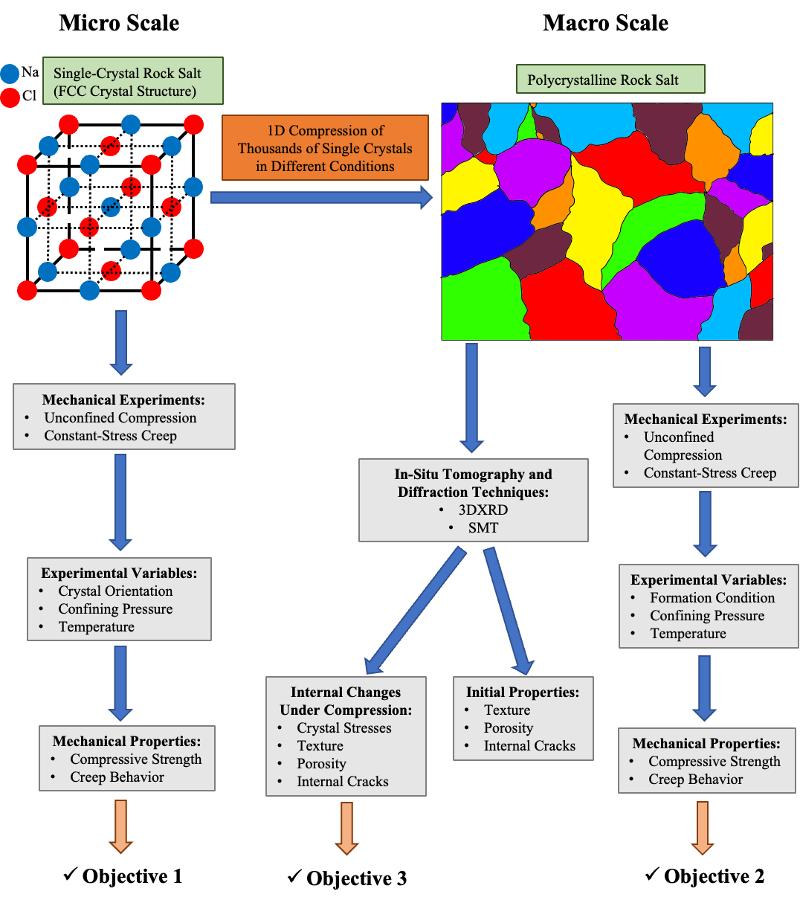

Fig. ‎1-1. Summary of dissertation objectives
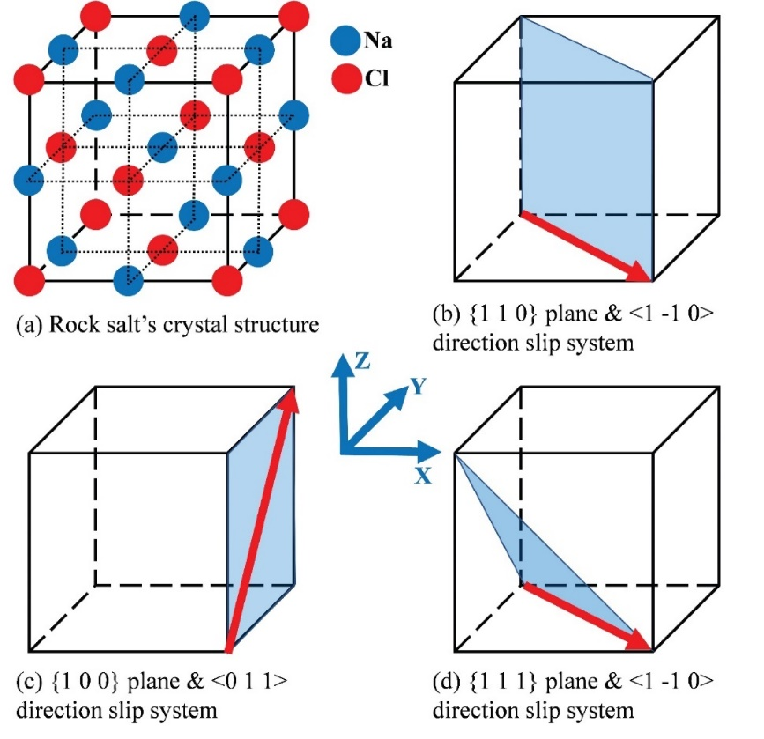

Fig. ‎1-2. Rock salt’s crystal structure and its primary and secondary slip systems

CHAPTER 2
ASSESSMENT OF THE PROPERTIES OF POLYCRYSTALLINE ROCK SALT SYNTHESIZED UNDER NOMINALLY DRY AND WET CONDITIONS

A version of this Chapter was originally published by Amirsalar Moslehy and Khalid A. Alshibli:
Moslehy, A., & Alshibli, K. (2021). Assessment of the properties of polycrystalline rock salt synthesized under nominally dry and wet conditions. Journal of Rock Mechanics and Geotechnical Engineering, 13(2), 311-320.

My contribution to this paper is performing the experimental tests, data analysis, and preparing the original draft and all Figures.

Abstract

Polycrystalline rock salt’s compression is a function of applied stresses, exposure duration to the applied stresses, ambient temperature, and water content. Rock salt’s compressional behavior under different conditions and its effects on the specimens’ mechanical properties have been investigated in the literature. However, polycrystalline rock salt’s 1D compression behavior at various water contents and how the specimen’s compression at different water contents further affects its physical and mechanical properties are not fully understood yet. In this study, polycrystalline rock salt specimens were prepared under nominally dry and wet conditions and some of the dry and wet specimens were annealed after the preparation. The relationship between the porosity of the specimens and the logarithm of the applied axial stresses during the 1D compression was found to follow a linear relationship after reaching unique critical porosities of 32% and 37% for the dry and wet specimens, respectively. Unloading and reloading the specimens did not result in any major changes in the porosity of the specimens. The specimens compressed under wet condition showed an average porosity of 2.6% compared to 6.9% for the dry specimens. The dry and wet specimens that were annealed after the compression exhibited a lower porosity in comparison to the dry and wet specimens, respectively. Unconfined compression experiments on the specimens showed dry and wet specimens possess averaged unconfined compressive strengths ($σ_{u}$) of 64.3 and 16.2 MPa, respectively. Annealing decreased $σ_{u}$ of the dry specimens to 39.6 MPa and increased $σ_{u}$ of the wet specimens to 41 MPa.
Keywords: Halite, rock salt, unconfined compression, 1D compression

Introduction

Rock salt, or halite, is a sedimentary rock formed by evaporation of bodies of water (Dusseault et al., 2004). Therefore, rock salt formations are mostly bedded and can have impurities (Hansen and Leigh, 2011; Titler and Curry, 2011) and can develop into salt domes depending on the tectonic pressures and movements because of their lower density compared to their surrounding materials (Dronkert and Remmelts, 1996; Sannemann, 1968; Trusheim, 1960). Rock salt formations, bedded or dome-shaped, usually have low permeability and porosity; therefore, they are mainly used as repositories for hazardous waste or oil storage (Fam et al., 1998; Hunsche and Hampel, 1999; Marques et al., 2013; Pouya, 1991; Urai et al., 1986). The conditions imposed on rock salt deposits during their compressions such as temperature, time, pressure, and presence of humidity or water can influence the density, porosity, and size of the grains of the deposit (Holcomb and Zeuch, 1988; Hwang et al., 1993). Different deformation mechanisms such as dislocation, crystal plasticity, pressure solution, and dynamic recrystallization can be mobilized during the compression. The applied stress during the compression has the most significant effects on rock salt’s mechanical properties after the compression. The presence of water during the compression of rock salt can significantly facilitate dislocation, sliding, and pressure solution of salt grains. Conversely, in the absence of humidity, salt grains tend to crush and deform plastically (J. Ding et al., 2016; Hwang et al., 1993). However, recrystallization of salt grains, especially dynamic recrystallization, does not normally occur at temperatures below 150° C (J. Ding et al., 2016; Mills et al., 2018).
Holcomb and Zeuch (1988) investigated the compression of dry crushed rock salt. They used quasi-static compactions and creep tests to evaluate the time-dependent compression of rock salt. The tests were conducted at various temperatures, stresses, and time durations. By fitting an empirical model to the results obtained from the test, Holcomb and Zeuch (1988) further developed a plastic yield and power-law creep model to the response of the material. Hwang et. al. (1993) employed an in-situ scanning electron microscope (SEM) during the compression process to study the activation of different deformation mechanisms on the compression of rock salt. They found the compression of crushed rock salt is governed by grain crushing and shearing at low water contents and it was controlled by sliding of the grains at higher water contents. Ding et. al. (2016) examined the mechanical behavior of dry rock salt during the compression where the tests were performed at various temperatures and along different load paths. The findings were that temperature has the most significant influence on the compression of the material while the grain size and loading path have limited effects. Moreover, by using reflected light micrographs, they identified the dominant deformation mechanism to be crystal plasticity and found the recrystallization of the material began slowly at temperatures above 150 °C. Mills et. al. (2018) performed creep compression tests to investigate the active deformation mechanisms during the compression of rock salt. With aid of different observational methods, they concluded that the presence of water at or above 1% water content within the specimen would cause the pressure solution to effectively enhance the compression and increase the cohesion of grain boundaries. Shen and Arson (2019) concluded that pressure solution, crystal slip plasticity, and grain boundary sliding are the main deformation mechanisms in axial compression of rock salt at temperatures below 350 °C.
The compression of rock salt further affects its mechanical properties by influencing the grains and grain boundaries of the medium. Grain boundaries are crystallographically defective volumes between grains within rock salt formations. Compressed rock salt normally retains 0.01% to 1.24% water within its grain boundaries in nature (De Las Cuevas and Pueyo, 1995). The properties of grain boundaries, such as water content, can thus influence the mechanical behavior of compressed rock salt by obstructing or facilitating the movements of the grains (Mouritz, 2012). Moreover, activation of deformation mechanisms such as recrystallization (annealing) and crystal plasticity can affect the properties of the grains, including their size and shape, which influences the mechanical behavior and strength of the medium after the compression (Knudsen, 1959; Ostapenko et al., 1993; Peach et al., 2001). Stormont et al. (2017) compressed polycrystalline rock salt specimens under hydrostatic stresses up to 40 MPa and temperatures up to 250 °C. The results of their work showed that specimens compressed at higher stresses have lower final porosities and therefore lower permeabilities. Moreover, they observed specimens with porosities below a critical porosity value (in the range of 0.02 to 0.05) did not possess a connected pore network, whereas specimens prepared above the critical porosity had a connected pore network. Paneru et al. (2018) investigated the thermal properties of granular salt specimens made by either compression at high axial stresses at ambient temperature or compression at a longer period of time and elevated temperatures. The specimens that were prepared using the short-time compression method had open grain boundaries with cleavage cracking compared to the long-time compressed specimens with similar porosity which had saturated and fused grain boundaries.
Lebensohn et. al. (2003a) investigated the deformation and texture development in polycrystalline rock salt by compressing and testing different types of specimens using triaxial extension experiments. The specimens were compressed by cold-pressing rock salt grains at 120° C and an axial stress of 200 MPa. Selected compressed specimens were then annealed at 650 °C for one day. The comparison of the specimens after the compression showed the annealed specimens had double the average grain size of cold-pressed specimens. Moreover, during triaxial experiments, annealed specimens exhibited a lower compressive strength. Ter Heege et. al. (2005) studied the dynamic recrystallization of wet compressed polycrystalline rock salt specimens by axial compression tests on the specimens. The specimens initially contained 0.1% water content and were cold pressed at 200 MPa; then they were cured at 150 °C and 100 MPa axial stress for one week. A set of prepared specimens were annealed at a temperature of 515 °C for one day to make them nominally dry. The triaxial compression tests on the specimens showed more dynamic recrystallization occurred within the wet specimens, and they possessed a lower compressive strength. Liang et al. (2012) tested natural low porosity polycrystalline rock salt specimens under monotonic and cyclic unconfined compression conditions. The specimens tested under monotonic loading condition showed elastoplastic behavior and failed in a ductile manner because the main observed deformation mechanism was grain sliding along the grain boundaries. Bourcier et. al. (2013) investigated crystal plasticity and grain boundary sliding in different types of specimens. Salt grains with two different initial sizes were hot-pressed at a temperature of 150 °C and an axial stress of 100 MPa. Selected prepared specimens with initially coarser grains were annealed at a temperature of 750 °C for two days. Uniaxial compression experiments on the specimens revealed the recrystallized (annealed) specimens exhibited a lower compressive strength while the specimens with the minimum initial grain size showed the highest compressive strength. Ding et al. (2017) studied micro-crack network development in polycrystalline rock salt under cyclic loading. The specimen showed a dominant elastic behavior during the initial load cycle before yielding, whereas it showed a ductile behavior and deformed plastically with work hardening throughout the next cycles of loading. The plastic deformation of the specimen was attributed to grain boundary microcracks which were preferably oriented in the loading direction. In addition to the grain boundary microcracks, the plastic deformation of the grains is the other main mechanism in rock salt’s plastic deformation under axial loading (Müller et al., 2018; Shen et al., 2020).
This paper focuses on proposing a simple model to define the relationship between the applied axial stress and porosity in 1D compression of rock salt under wet and dry conditions. Detailed specimen preparation methods presented in this study are economical, easy to execute, and fast; therefore, they can be used to prepare a large number of polycrystalline rock salt specimens for various studies in the future. Moreover, the reproducibility of the specimens is investigated using micro- and macro-scale methods. Two compression procedures; namely dry and wet, were employed to assess the effects of water on the compression of rock salt. The specimens prepared in dry and wet compression are denoted as dry and wet specimens, respectively. Some of the dry and wet compressed specimens were annealed after the compression and they are labeled as dry-annealed and wet-annealed specimens, respectively. SEM was performed on representative specimens of dry, dry-annealed, and wet-annealed types to study and compare the local porosities and average grain size of differently prepared specimens. Lastly, two specimens of each type were tested using the unconfined compression test to determine their compressive strength.

Raw Material

Rock salt grains used for specimen preparation in the study were collected from Windsor Salt Mine, Ontario, Canada. Natural non-commercial grade rock salt does not contain any additives such as anticaking agents, which can affect the behavior of the material. Mineralogy and purity of the material were examined by powder x-ray diffraction method; the composition of the material was 99.9% pure halite. Larger blocks of rock salt were cut and ground to a grain size smaller than 0.075 mm to provide the starting grains for the compression of different types of polycrystalline specimens. Moreover, the initial nominal water content of the starting grains was found to be 0.1% based on ASTM D2216-19 procedure (ASTM, 2019).

Compression Setup

Stainless-steel tubes with an inner diameter of 25.65 mm, a wall thickness of 3.05 mm, and a height of 76.2 mm were used in this study to prepare specimens with a diameter of approximately 25.65 mm and a height of 50.8 mm. A cylindrical stainless-steel die with an inner diameter of 31.76 mm, a wall thickness of 22.22 mm, and a height of 76.2 mm was used to confine the specimen tubes. A stainless-steel disk of 25.4 mm in diameter and 12.7 mm in height was placed at the bottom of the specimen tubes to prevent contact of specimens with other parts of the setup. A 76.2 mm stainless-steel rod with a diameter of 25.7 mm was used to press the salt grains inside the specimen tubes (Fig. ‎2-1a and b). Furthermore, the following parts were used to confine specimens during the annealing process:
- A 127 mm x 127 mm square steel plate with a thickness of 19.05 mm and eight ½ inches (12.7 mm)-13 threaded holes (bottom plate)
- Eight ½ inches (12.7mm)-13 threaded steel rods with lengths of 228.6 mm
- A 127 mm x 127 mm square steel plate with a thickness of 19.05 mm and eight 12.45 mm through holes (top plate)
- Eight ½ inches (12.7mm)-13 stainless-steel nuts
Lastly, another stainless-steel rod with a diameter of 25.7 mm and a height of 76.2 mm was used to transfer the axial stresses to the setup when the compression setup was placed inside the confining system. Fig. ‎2-1c shows all the parts used in the compression setup in an exploded view.

Specimen Compression

Dry specimens (Fig. ‎2-2a) were made by cold pressing the ground salt grains in three layers each with equal thickness. Each layer was compressed using a uniaxial stress of 200 MPa for 20 seconds. The uniaxial stress was applied at a constant displacement rate of 0.085 mm/s, which is equal to a strain rate of 0.0023 s⁻¹. During the one-dimensional (1D) compression of each layer, the specimen was unloaded and then reloaded at 10 and 70 MPa axial stresses to investigate the recoverability of the deformations. The specimen was then compressed at the same uniaxial stress for an hour after the 1D compression of the final layer. Then, the tube containing the specimen was extruded from the cylindrical die and was cut across its height to split it for easy removal of the specimen. The ends of the specimen were sanded to make them parallel and maintain the cylindrical shape of the specimen. A bedding plane (layer boundary) can be observed on the surface of the specimen between every two consecutive layers (Fig. ‎2-2a). The three layers of dry-annealed specimens, as shown in Fig. ‎2-2b, were made similar to the dry specimens, but the confinement parts were used during the one-hour compression of the specimen; thus, the uniaxial stress could be contained on the specimens throughout the annealing process. The setup was then placed in an oven with a temperature of 200° C for 7 days. The specimens were extruded and sanded using a procedure similar to the dry specimens. Dry-annealed specimens also showed bedding planes between the consecutive layers as well (Fig. ‎2-2b).
Wet and wet-annealed specimens were composed of the salt grains and salt-saturated de-aired deionized water with a ratio of 75% to 25%, respectively. Deionized water saturated with salt was used to prevent the addition of any substances to the specimens and to prevent the water from dissolving the salt grains within the specimens. Salt grains were added to the de-aired deionized water until the solution could not dissolve more salt grains and the addition of more salt grains would result in the settlement of the added salt grains. The mixture of salt and salt-saturated de-aired deionized water was cold pressed and annealed (in case of wet-annealed specimens) in the same manner used in the preparation of dry and dry-annealed specimens. The specimen was extruded from the specimen tube and was sanded to maintain its cylindrical shape (Fig. ‎2-2c and d). Wet and wet-annealed specimens did not exhibit any bedding planes being formed between the consecutive layers of compression showing more interconnection between the grain boundaries of the consecutive layers. Table ‎2-1 summarizes the dimensions, weights, and global porosities of 8 specimens, two of each type, measured after compression while being prepared for unconfined compression experiments.
Fig. ‎2-3a and b show the porosity ($∅)$ of the specimen versus the applied axial stress ($σ_{1})$during the 1D compression of all layers for two dry and two wet specimens, respectively. B, M, and T in Fig. 3 legend refer to the bottom, middle, and top layers of each specimen, while F denotes the final compression on the whole specimen. The porosities of the specimens were calculated from the measured axial deformations knowing the volume change of the specimens occurs only due to axial deformations. Moreover, the elastic (recoverable) volume change of the grains during the 1D compression was neglected because of the difficulties of measuring the volume change of the grains in the experimental setup used in this study. Comparing the results obtained from the dry 1D compression of the different layers of a dry specimen (D_1 or D_2) the relationship of $∅$ with $σ_{1}$ follows a unique decaying exponential curve. The uniqueness of the exponential curve describing $∅$of the specimen versus $σ_{1}$ shows during the 1D compression of a layer, the layers compressed previously (which were being reloaded) did not exhibit a significant deformation. Equation 2-1 is a decaying exponential fit to the loading curves of $∅$ versus $σ_{1}$of the dry specimens with a coefficient of determination (R²) of 0.997. Moreover, a comparison between the results obtained from the 1D compression of specimens D_1 and D_2 demonstrates no statistical difference between the results obtained from each specimen, which shows the reproducibility of the compression procedure. Referring to Fig. ‎2-3b, the results obtained from different layers of the two wet specimens W_1 and W_2 are similar and provide the same findings as to the dry specimens. Equation 2-2 describes the relationship of $∅$ versus $σ_{1}$for wet specimens:

$$ϕ_{L}=47.45 exp⁡(-0.00956σ_{1}) R^{2}=0.997$$ | (2-1)
$$ϕ_{L}=52.93 exp⁡(-0.013σ_{1}) R^{2}=0.985$$ | (2-2)

The final 1D compression of both types of compression (reloading the whole specimen) or the unloading-reloading curves of the 1D compression display a linear relationship between $∅$ and $σ_{1}$. Equations 2-3 and 2-4 represent the slope of the fitted lines for dry and wet 1D compression unloading and reloading phases of the experiments, respectively. The change in the porosity of the specimens during the unloading-reloading is due to the elastic deformation of the grains which is considered negligible when compared to the non-recoverable deformations.

$$ϕ_{R}=-0.01σ_{1} R^{2}=0.979$$ | (2-3)
$$ϕ_{R}=-0.011σ_{1} R^{2}=0.958$$ | (2-4)

Fig. ‎2-3c compares the 1D compression results of dry specimen D_1 and wet specimen W_1 and shows that the wet specimens’ porosities decreased at a steeper rate than dry specimens’ porosities both during the loading and reloading of the material. Because the applied strain rate during the 1D compression is relatively fast in comparison to creep, only time-independent deformation mechanism of rock salt such as grain rearrangement, cataclasis (grains brittle failure because of intra-grain slips or local stress concentrations), and grain crystal plasticity have a chance to occur. The grain boundaries of the wet specimen, which are mainly composed of the added brine to the salt grains, facilitate the dislocation (rearrangement) of the grains during the compression and decrease cataclases compared to the dry specimen. This difference in the developed deformation mechanisms explains the higher reduction of the porosity of the wet specimen in comparison to the dry specimen.
By plotting $∅$of the specimens being compressed against the logarithm of the applied axial stresses, a point can be found on the curves where the relationship of $\log_{10}{(σ_{1})}$ versus$∅$ becomes linear (Fig. ‎2-4) and is denoted in this study as the critical porosity. This critical porosity value can be physically explained as the point where the dominant deformation mechanisms transition from grain rearrangement and cataclasis to grain crystal plasticity and eventually grain boundary diffusion. The critical porosities of the specimens being compressed in dry and wet manners were found to be 32% and 37%, respectively. As shown in Fig. ‎2-4, the wet specimens reached the critical porosity earlier compared to the dry specimens due to the effects of added brine to the grain boundaries. Equations 2-5 and 2-6 show the fitted lines to the 1D compression of the specimens during dry and wet 1D compressions after reaching the critical porosities, respectively.

$$ϕ_{L}=-35.94\log_{10}{σ_{1}}+90.44 R^{2} =0.999$$ | (2-5)
$$ϕ_{L}=-34.25\log_{10}{σ_{1}}+85.1 R^{2}=0.998$$ | (2-6)
Porosities of the specimens versus the applied axial stresses during unloading and reloading of the specimens for the dry and wet 1D compressions were fitted to Equations 2-7 and 2-8, respectively. The fitted lines representing the unloading-reloading curves started to diverge from the actual reloading curves as the axial stresses became closer to the axial stresses on the loading path. The lower values of R² for Equations 2-7 and 2-8 are caused by the deviation of the fitted lines from the actual reloading curves. During the reloading of the material when $σ_{1}$ advances towards the loading curve, the reapplied stresses on the specimen can cause further crystal plasticity and grain boundary diffusion, which decreases the porosity of the specimens at a higher rate.

$$ϕ_{R}=-0.228\log_{10}{σ_{1}} R^{2}=0.985$$ | (2-7)
$$ϕ_{R}=-0.399\log_{10}{σ_{1}} R^{2}=0.983$$ | (2-8)

The slope of the lines fitted to the unloading-reloading phases of dry and wet 1D compression in both normal and semi-logarithmic scales are marginal and quite close to zero (Equations 2-3, 2-4, 2-7, and 2-8). These nearly horizontal slopes show that the elastic deformations within the specimen are marginal, and the compressed specimen nearly maintains its final porosity after unloading.
The averages of the porosities of dry and wet specimens at the end of 1D compression of each layer were 8.1% and 6.4%, respectively (Fig. ‎2-4). The one-hour compression after the 1D compression of the individual layers caused a decrease in the averages of the porosities of dry and wet specimens to 6.9% and 2.6%, respectively (Table ‎2-1). This one-hour compression contributed to the activation of time-dependent deformation mechanisms within the specimens such as grain boundary diffusion and pressure solution. However, pressure solution can only occur in the presence of water at the grain boundaries. Pressure solution is the simultaneous development of grain dissolution at highly stressed grain boundaries, its diffusion into the wet grain boundary, and its precipitation at less stressed grain boundaries, which justifies the greater reduction in the porosities of the wet specimens. Lastly, the averages of the final porosities of dry-annealed and wet-annealed specimens were measured to be 1.6% and 0.8%, respectively (Table ‎2-1). Time-dependent deformation mechanisms continued to cause a decrease in the porosity of the specimens during the annealing process. Both dry and wet specimens exhibited a considerable decrease in $∅$ after the annealing process. Annealing in polycrystalline rock salt recrystallizes the compressed grains (crystals), which further results in a reduction in the porosity of the material (Ding et al., 2016).

Scanning Electron Microscopy (SEM)

One representative specimen of each of dry, dry-annealed, and wet-annealed types were cut across their height into five disks with equal thicknesses of 8 mm. The bottom surface of the top disk corresponding to the middle of the top layer, the top surface of the middle disk corresponding to the middle of the middle layer, and the top surface of the bottom disk corresponding to the middle of the bottom layer were selected for further examination using SEM method. Each disk was sanded and further polished using P3000 sandpaper to achieve an average surface roughness of R_{a}=0.018 µm. A relatively low Electron High Tension (EHT) voltage of 1 kV was employed to prevent the scanned surfaces from being charged because rock salt is not electrically conductive and was not coated with a conductive layer. Type II Secondary Electron (SE2) signals were used by the SEM detector to scan the disks, so the scan would reflect a two-dimensional (2D) topography of the surfaces.
Fig. ‎2-5 through ‎2-7 show 2-D scans of representative dry, dry-annealed, and wet-annealed specimens where scans a, b, and c show the top, middle, and bottom of the cross-section of the specimens, respectively. Local porosity and average grain size of each scan were calculated using Avizo (FEI., 2018) image processing software. Black pixels of the scan were thresholded and segmented to represent the voids inside the specimen. The local porosity of the scan was calculated by dividing the area of the voids by the total area of the scan. The grains of the specimen shown on the scans were found by labeling function of Avizo and the average grain size of the scan was determined by using label analyses function. Table ‎2-2 summarizes the values of porosities and average grain sizes of the scans. Across the height of the scanned dry specimen, the porosity and average grain size increase from the top to the bottom layers. The presence of sharp-cornered cubical grains shows the dominance of cataclases within the dry specimen. Moreover, grain boundary diffusion can also be noted between the grains. The one-hour compression in the process of preparing a specimen impacted the top layer more than the layers beneath it. The axial stresses applied to the specimen during the one-hour compression specifically intensified cataclases within the top layer of the specimen, which decreased the porosity of the top layer (Fig. ‎2-5).
The dry-annealed specimen also exhibits well defined cubical grains, which indicates the dominance of cataclases; however, the grains have rounded corners (Fig. ‎2-6). Grain boundary diffusion and recrystallization of the grains can also be seen in the scans displayed in Fig. ‎2-6. It is worth mentioning due to the small grain size in the dry and dry-annealed specimens, crystal plasticity of the grains cannot be investigated. The average grain size within the dry-annealed specimen increased from the top layer to the bottom layer, which is the same pattern as the dry specimen. The similarity of the increase in the porosity of the specimen from the top layer to the bottom layer in dry and dry-annealed specimens is inherited from the one-hour compression step, up to where the two types of specimens are prepared using the same procedure. Moreover, the mentioned similarity shows that annealing increased the size of the grains proportional to their initial sizes. Lastly, we note that the significant increase in the average grain size of the bottom layer disk obtained from the dry-annealed specimen, as seen in Fig. ‎2-6c, may not accurately represent the average grain size of the bottom layer of the dry-annealed specimen. Each SEM scan shows a very small area of each disk where this specific area of the bottom disk may have been influenced by environmental influences such as absorbing moisture during the SEM scan preparation steps.
Larger grains of the wet-annealed specimen, which are not perfectly cubical in shape, show that cataclasis was not the dominant deformation mechanism in the 1D compression of wet rock salt. Because of the larger grain size, the SEM scans of the wet-annealed specimen demonstrate the crystal plasticity imposed on the grains, where some grains have eventually fractured. Irregular diffused grain boundaries also point out to the pressure solution that has occurred inside the specimen during the one-hour compression of the specimen. Moreover, the recrystallization developed during the annealing process is clearer compared to the dry-annealed specimen. In contrast to the dry specimen, the dry-annealed and wet-annealed specimens possessed a lower porosity within the top and bottom layers compared to the middle layer (Fig. ‎2-6 and ‎2-7). From the macroscopic point of view, during the annealing of the material the air and water in the voids move out of the specimens. The purge of the fluid from the specimen depends on the distance from the void to the outside of the specimen and the inter-connectivity of the voids throughout the specimen. Therefore, the voids enclosed inside the middle layer have a lower chance to exit the specimen.
A comparison amongst the variation of average grain sizes and porosities in the layers of different specimens shows wet annealed specimens exhibited a more uniform profile of average grain size and porosity with their height. Besides the global porosities in Table ‎2-1, the local porosities of the specimens obtained from Fig. ‎2-5 through ‎2-7 show that annealing of the specimens decreases the porosities of the specimens significantly.

Unconfined Compression Experiments

Two specimens of each type of prepared specimens were tested in unconfined compression experiments at 20° C. The test equipment included a 44.5 kN (10,000 pounds) servo automated load frame coupled with a 44.5 kN load cell and a 76.2 mm (3 in) range Linear Variational Differential Transformer (LVDT). The specimens were compressed at a constant strain rate of $1.7×{10}^{-4} s^{-1}$ according to ASTM D7012-14 standard procedure (ASTM, 2014).
Fig. ‎2-8 shows the results of the unconfined compression experiments on dry specimens (D_1 and D_2), dry-annealed specimens (DA_1 and DA_2), wet specimens (W_1 and W_2), and wet-annealed specimens (WA_1 and WA_2). Table ‎2-3 summarizes the unconfined compressive strength ($σ_{u}$) and axial strain ($ε_{1}$) of the specimens at failure. Dry specimens showed an average $σ_{u}$of 64.3 MPa which is higher than $σ_{u}$ of dry-annealed specimens (39.6 MPa). Bourcier et al. (2013) reported that polycrystalline rock salt specimens with smaller average grain size possess a higher $σ_{u}$. Smaller average grain size inhibits the formation of connected crystal dislocations. Moreover, dry specimens have high porosity grain boundaries compared to dry-annealed specimens, which are naturally immobile at room temperature (Guillope and Poirier, 1979). The immobility of grain boundaries results in an increase in $σ_{u}$ of the material and reduces its ductility, explaining why dry specimens have lower ductility,$ε_{1}=$ ~2.9% at failure, compared to the other specimens.
Wet specimens had a $σ_{u}$ of 16.1 MPa on average, which was the lowest compared to the other three types of specimens. The presence of water within the grain boundaries of salt crystals can cause weakening of the material. This weakening is associated with increased inter-granular deformation, grain boundary diffusion, and pressure solution in wet polycrystalline rock salt. Comparing $σ_{u}$ of wet to dry specimens shows the effects of the weakening on $σ_{u}$ of wet specimens. Moreover, wet specimens reached steady-state flow stress at $ε_{1}=$ ~2% and showed work-softening after approximately $ε_{1}=$ 3.5%. The water within the grain boundaries of wet specimens also increased the ductility of the material due to enhanced inter-granular deformation, grain boundary diffusion, and pressure solution in the specimens.
Wet-annealed specimens exhibited a completely different behavior in the unconfined compression experiment compared to wet specimens. Wet-annealed specimens did not show weakening. During the annealing process, wet-annealed specimens lost most of the water within the grain boundaries and the porosities of the specimens were decreased on average from 2.6% to 0.8%. The evaporation of the water around the grain boundaries decreased the inter-connectivity of wet grain boundaries, resulting in sparse wet grain boundaries within mostly dry grain boundaries. Moreover, annealing grows the size of the grains inside the polycrystalline media resulting in an increase in the grain to grain contacts and more interlocking inside the wet-annealed specimens. The changes in the properties of the grain boundaries, porosities, and grain sizes of the wet-annealed specimens after annealing led to work-hardening in the material during the unconfined compression experiments after about 0.8% axial strains. $σ_{u}$ of wet-annealed specimens increased to 41 MPa as a result of the aforementioned changes within the specimen.
Comparing the results obtained from the unconfined compression experiments on wet compressed specimens to dry compressed specimens, the wet compressed specimens showed a more ductile behavior. This increase in ductility is a direct result of increased grain boundary mobilities due to the presence of water within grain boundaries of wet compressed specimens. Moreover, the bedding planes that were observed between the layers of the dry and dry-annealed specimens tend to obstruct crystal dislocations during the unconfined compression experiments which cause a more brittle response of the material.

Conclusions

The relationships between the porosity and the applied axial stresses in dry and wet 1D compressions of polycrystalline rock salt were fitted using decaying exponential models. The porosity in wet 1D compressions decreased at a higher rate when compared to the dry ones due to the presence of water during the compression that facilitated the dislocation of the grains. When the porosity is plotted versus the logarithm of the applied axial stress, both dry and wet 1D compressions show a linear relationship between porosity and the logarithm of axial stress after reaching unique critical porosity values. The critical porosities of dry and wet 1D compressions were found to be 32% and 37%, respectively. The relationships of the porosity and the applied axial stress in dry and wet 1D compressions in unloading and reloading regions were fitted with linear trend lines that have slopes close to zero, which means the elastic deformations during the 1D compression are marginal and nearly the entire deformation is non-recoverable.
Wet compressed specimens possessed a lower porosity after the one-hour compression when compared to dry compressed specimens because of the development of pressure solution deformation mechanism. Annealing of both the dry and wet specimens after the one-hour compression resulted in a decrease in their porosities and an increase in their average grain sizes. The local porosity of the non-annealed specimens increased from the top layer to the bottom layer, while the local porosities of the annealed were maximum in the middle layer. Wet-annealed specimens showed more homogeneity in local porosities and average grain sizes compared to the other types of the prepared specimens.
Dry specimens exhibited the highest unconfined compressive strength (64.3 MPa) compared to the other types of specimens. Moreover, dry specimens failed in a brittle manner. Dry-annealed specimens had a lower unconfined compressive strength of 39.6 MPa and exhibited a ductile behavior when compared to dry specimens. Wet specimens exhibited weakening during the unconfined compression experiments and their unconfined compressive strength was averaged at 16.2 MPa. Wet specimens had a ductile failure. Wet-annealed specimens had an increase in their average unconfined compressive strength to 41 MPa compared to wet specimens. Wet-annealed specimens had a ductile failure behavior.
The authors suggest studying the behavior of the prepared specimens in unconfined compression tests at elevated temperatures for future work. Moreover, conducting creep experiments on the prepared specimens can reveal valuable insights about their creep behavior. Conducting in-situ x-ray diffraction on granular rock salt under 1D compression can also help better understand the elastic and plastic deformation of the individual grains, especially in fine-grained rock salt.

Acknowledgments

This material is based on work supported by the National Science Foundation under Grant No. CMMI- 1641054. Any opinions, findings, conclusions, and recommendations expressed in this material are those of the authors and do not necessarily reflect the views of the National Science Foundation. XRD and SEM were acquired at the Joint Institute for Advanced Materials (JIAM) Diffraction Facility of the University of Tennessee, Knoxville. The authors are grateful to Ibrahim Aklouk, Karen Abercrombie, Tyler Galyon, and Darcie Halliburton, undergraduate research assistants at the University of Tennessee, Knoxville, for their help in the preparation of the specimens. The authors also thank the anonymous reviewers who contributed constructive comments and suggestions to improve this paper.

References

ASTM. (2014). D7012-14 (2014). Standard Test Method for Compressive Strength and Elastic Moduli of Intact Rock Core Specimens under Varying States of Stress and Temperatures, ASTM International, West Conshohocken, Pa., DOI: 10.1520/D7012-14E01, 10.
ASTM. (2019). D2216-19 (2019). Standard Test Methods for Laboratory Determination of Water (Moisture) Content of Soil and Rock by Mass, ASTM International, West Conshohocken, Pa., DOI: 10.1520/D2216-19.
Bourcier, M., Bornert, M., Dimanov, A., Héripré, E., and Raphanel, J. L. (2013). Multiscale experimental investigation of crystal plasticity and grain boundary sliding in synthetic halite using digital image correlation. Journal of Geophysical Research: Solid Earth, 118(2), 511–526. https://doi.org/10.1002/jgrb.50065
De Las Cuevas, C., and Pueyo, J. J. (1995). The influence of mineralogy and texture in the water content of rock salt formations. Its implication in radioactive waste disposal. Applied Geochemistry, 10(3), 317–327.
Ding, J., Chester, F. M., Chester, J. S., Zhu, C., and Arson, C. (2017). Microcrack Network Development in Salt-Rock During Cyclic Loading at Low Confining Pressure. 51st US Rock Mechanics/Geomechanics Symposium.
Ding, J., Chester, F. M., Chester, J. S., Zhu, C., Arson, C., and others. (2016). Mechanical behavior and microstructure development in consolidation of nominally dry granular salt. 50th US Rock Mechanics/Geomechanics Symposium.
Dronkert, H., and Remmelts, G. (1996). Influence of salt structures on reservoir rocks in Block L2, Dutch continental shelf. In Geology of Gas and Oil under the Netherlands (pp. 159–166). Springer.
Dusseault, M. B., Rothenburg, L., Bachu, S., and others. (2004). v. Canadian International Petroleum Conference.
Fam, M., Santamarina, J. C., and Dusseault, M. B. (1998). Wave-based monitoring processes in granular salt. Journal of Environmental and Engineering Geophysics, 3(1), 15–26.
FEI. (2018). Avizo. 9.7 ed. FEI.
Guillope, M., and Poirier, J. P. (1979). Dynamic recrystallization during creep of single-crystalline halite: An experimental study. Journal of Geophysical Research: Solid Earth, 84(B10), 5557–5567. https://doi.org/10.1029/JB084iB10p05557
Hansen, F. D., and Leigh, C. D. (2011). Salt disposal of heat-generating nuclear waste. Sandia National Laboratories Albuquerque, NM.
Holcomb, D. J., and Zeuch, D. H. (1988). Consolidation of Crushed Rock Salt: Part L: Experimental Results for Dry Salt Analyzed Using a Hot-pressing Model (Issue 1469). Sandia National Laboratories.
Hunsche, U., and Hampel, A. (1999). Rock salt—the mechanical properties of the host rock material for a radioactive waste repository. Engineering Geology, 52(3–4), 271–291.
Hwang, C. L., Wang, M. L., and Miao, S. (1993). Proposed healing and consolidation mechanisms of rock salt revealed by ESEM. Microscopy Research and Technique, 25(5–6), 456–464.
Knudsen, F. P. (1959). Dependence of Mechanical Strength of Brittle Polycrystalline Specimens on Porosity and Grain Size. Journal of the American Ceramic Society, 42(8), 376–387. https://doi.org/10.1111/j.1151-2916.1959.tb13596.x
Lebensohn, R. A., Dawson, P. R., Kern, H. M., and Wenk, H.-R. (2003). Heterogeneous deformation and texture development in halite polycrystals: comparison of different modeling approaches and experimental data. Tectonophysics, 370(1–4), 287–311.
Liang, W., Zhang, C., Gao, H., Yang, X., Xu, S., and Zhao, Y. (2012). Experiments on mechanical properties of salt rocks under cyclic loading. Journal of Rock Mechanics and Geotechnical Engineering, 4(1), 54–61.
Marques, F. O., Burg, J.-P., Armann, M., and Martinho, E. (2013). Rheology of synthetic polycrystalline halite in torsion. Tectonophysics, 583, 124–130.
Mills, M. M., Stormont, J. C., and Bauer, S. J. (2018). Micromechanical processes in consolidated granular salt. Engineering Geology, 239, 206–213.
Mouritz, A. P. (2012). 4 - Strengthening of metal alloys. In A. P. Mouritz (Ed.), Introduction to Aerospace Materials (pp. 57–90). Woodhead Publishing. https://doi.org/https://doi.org/10.1533/9780857095152.57
Müller, C., Frühwirt, T., Haase, D., Schlegel, R., and Konietzky, H. (2018). Modeling deformation and damage of rock salt using the discrete element method. International Journal of Rock Mechanics and Mining Sciences, 103, 230–241.
Ostapenko, N. I., Sugakov, V. I., and Shpak, M. T. (1993). Dislocations and Optical Properties of Organic Crystals. In Spectroscopy of Defects in Organic Crystals (pp. 133–158). Springer Netherlands. https://doi.org/10.1007/978-94-011-1675-6_4
Paneru, L. P., Bauer, S. J., and Stormont, J. C. (2018). Thermal Properties of Consolidated Granular Salt as a Backfill Material. Rock Mechanics and Rock Engineering, 51(3), 911–923.
Peach, C. J., Spiers, C. J., and Trimby, P. W. (2001). Effect of confining pressure on dilatation, recrystallization, and flow of rock salt at 150 C. Journal of Geophysical Research: Solid Earth, 106(B7), 13315–13328.
Pouya, A. (1991). Correlation between mechanical behaviour and petrological properties of rock salt. The 32nd US Symposium on Rock Mechanics (USRMS).
Sannemann, D. (1968). Salt-stock families in northwestern Germany.
Shen, X., and Arson, C. (2019). An isotropic self-consistent homogenization scheme for chemo-mechanical healing driven by pressure solution in halite. International Journal of Solids and Structures, 161, 96–110.
Shen, X., Arson, C., Ding, J., Chester, F. M., and Chester, J. S. (2020). Mechanisms of Anisotropy in Salt Rock Upon Microcrack Propagation. Rock Mechanics and Rock Engineering, 1–21.
Stormont, J. C., Lampe, B. L., Lynn, T. D., Bauer, S. J., and others. (2017). Gas Permeability of Granular Salt During Consolidation. 51st US Rock Mechanics/Geomechanics Symposium.
Ter Heege, J. H., De Bresser, J. H. P., and Spiers, C. J. (2005). Dynamic recrystallization of wet synthetic polycrystalline halite: dependence of grain size distribution on flow stress, temperature and strain. Tectonophysics, 396(1–2), 35–57.
Titler, R. V, and Curry, P. (2011). Chemical analysis of major constituents and trace contaminants of rock salt. Pennsylvania Department of Environmental Protection.
Trusheim, F. (1960). Mechanism of salt migration in northern Germany. AAPG Bulletin, 44(9), 1519–1540.
Urai, J. L., Spiers, C. J., Zwart, H. J., and Lister, G. S. (1986). Weakening of rock salt by water during long-term creep. Nature, 324(6097), 554.

Appendix

Table ‎2-1. Physical properties of polycrystalline rock salt specimens

Specimen | Height | Diameter | Weight | Porosity
Specimen | (mm) | (mm) | (g) | (%)
Dry  D_1 | 51.8 | 25.9 | 55.21 | 6.8
Dry  D_2 | 53.5 | 25.9 | 57.14 | 6.9
Dry-annealed DA_1 | 50.0 | 25.4 | 54.03 | 1.6
Dry-annealed  DA_2 | 50.4 | 26.0 | 57.37 | 1.5
Wet  W_1 | 46.1 | 25.9 | 51.24 | 2.8
Wet  W_2 | 43.6 | 25.9 | 48.63 | 2.4
Wet-annealed  WA_1 | 40.5 | 25.5 | 44.46 | 0.7
Wet-annealed  WA_2 | 48.2 | 24.6 | 49.09 | 1.0

Table ‎2-2. Porosity values and average grain sizes of different layers of representative dry, dry-annealed, and wet-annealed specimens.

Specimen | Layer | Porosity | Average Grain Size
Specimen | Layer | (%) | (µm)
Dry | Top | 5.8 | 0.13
Dry | Middle | 6.8 | 0.15
Dry | Bottom | 8.1 | 0.18
Dry-annealed | Top | 1.9 | 0.17
Dry-annealed | Middle | 3.1 | 0.25
Dry-annealed | Bottom | 1.2 | 0.78
Wet-annealed | Top | 0.8 | 0.67
Wet-annealed | Middle | 1.3 | 0.60
Wet-annealed | Bottom | 0.6 | 0.63

Table ‎2-3. The unconfined compression experiment results on the polycrystalline rock salt specimens at room temperature

Specimen | Unconfined compressive strength | Axial strain at failure
Specimen | (MPa) | (%)
Dry  D_1 | 66.8 | 2.9
Dry  D_2 | 61.9 | 2.8
Dry-annealed  DA_1 | 40.2 | 4.0
Dry-annealed  DA_2 | 39.0 | 3.4
Wet  W_1 | 16.4 | 6.4
Wet  W_2 | 15.8 | 9.2
Wet-annealed  WA_1 | 39.9 | 8.0
Wet-annealed  WA_2 | 42.1 | 7.8

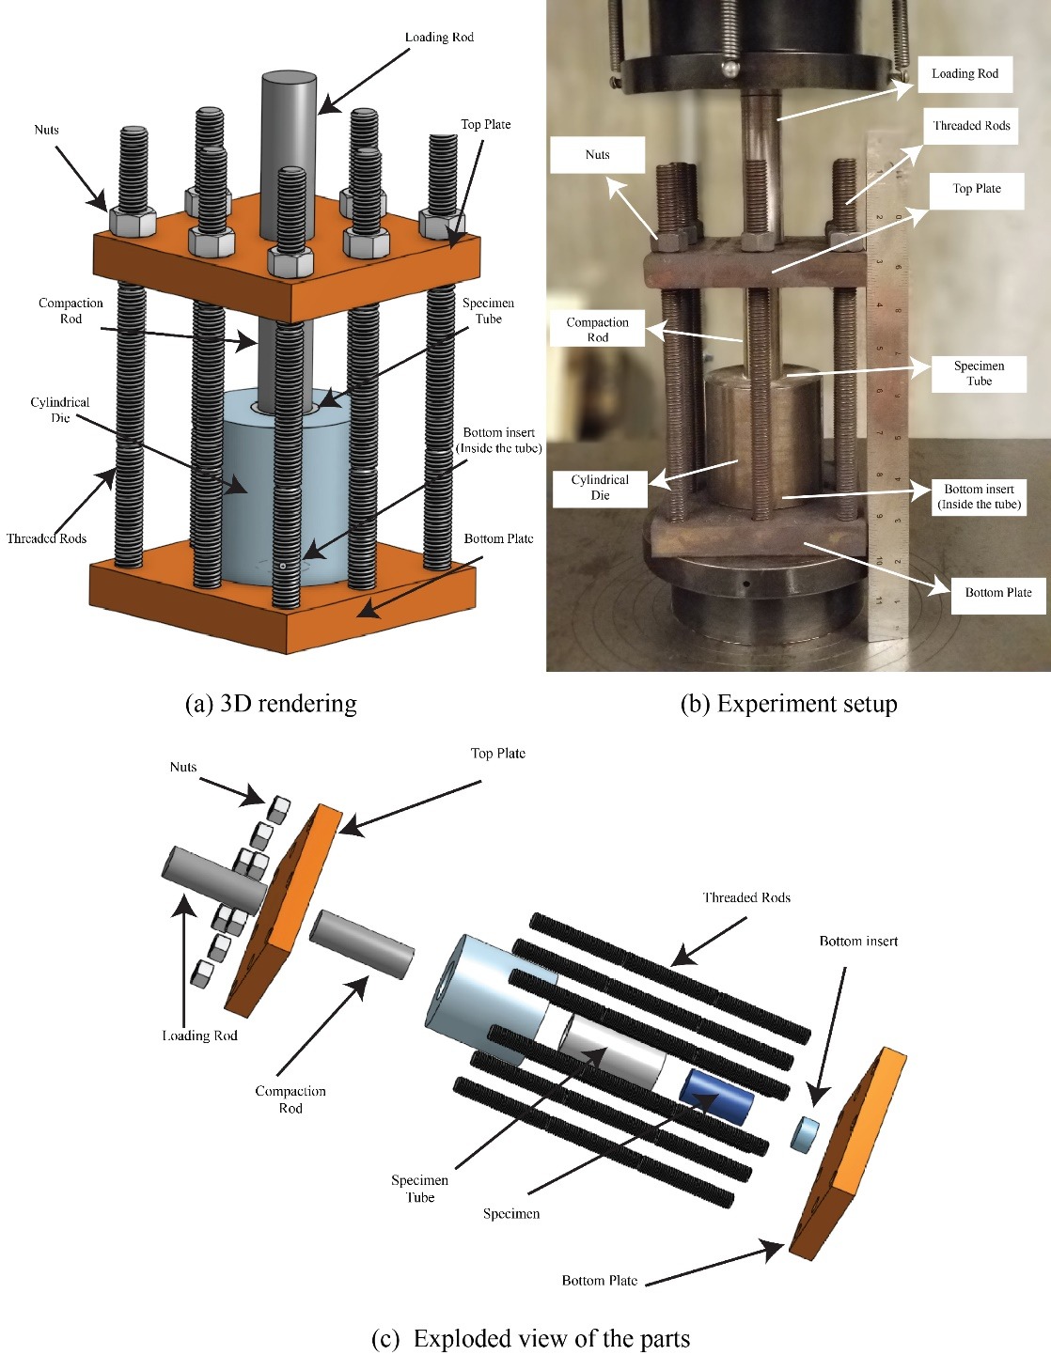

Fig. ‎2-1. Specimen compression setup: (a) 3D rendering; (b) Experiment setup; (c) Exploded view of the parts

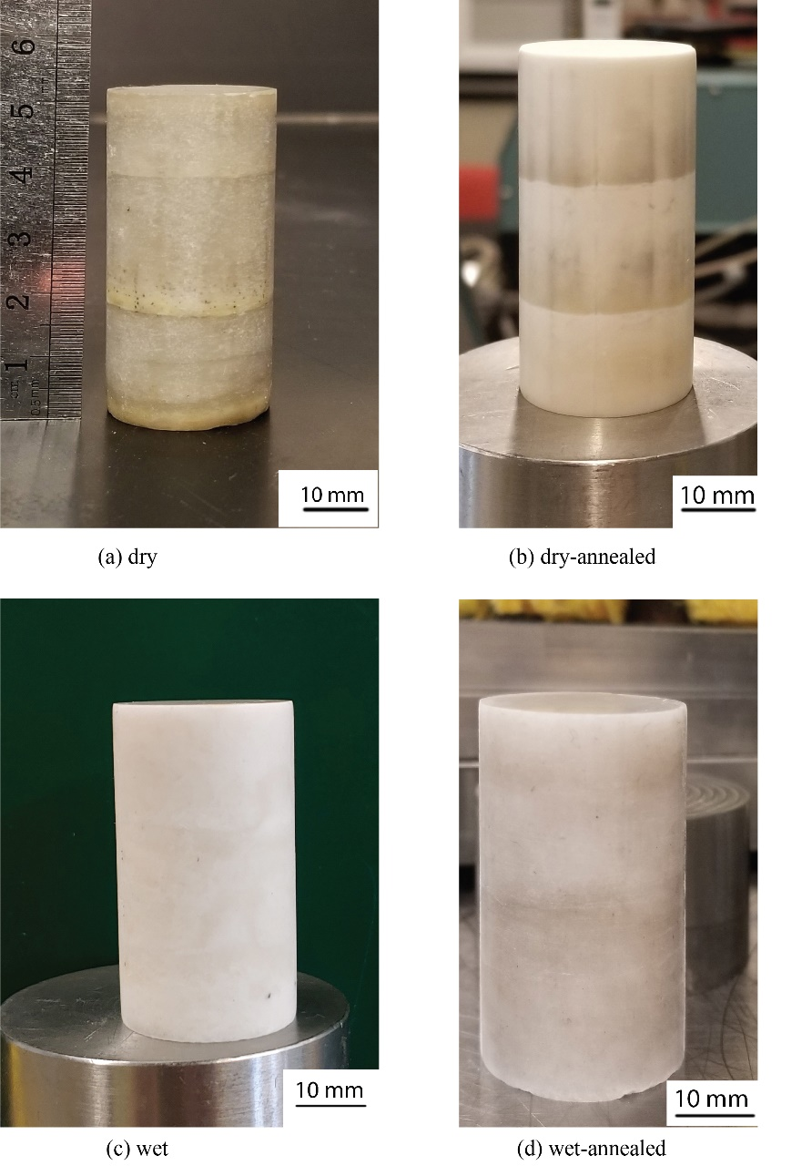

Fig. ‎2-2. Polycrystalline rock salt specimens: (a) dry; (b) dry-annealed; (c) wet; (d) wet-annealed

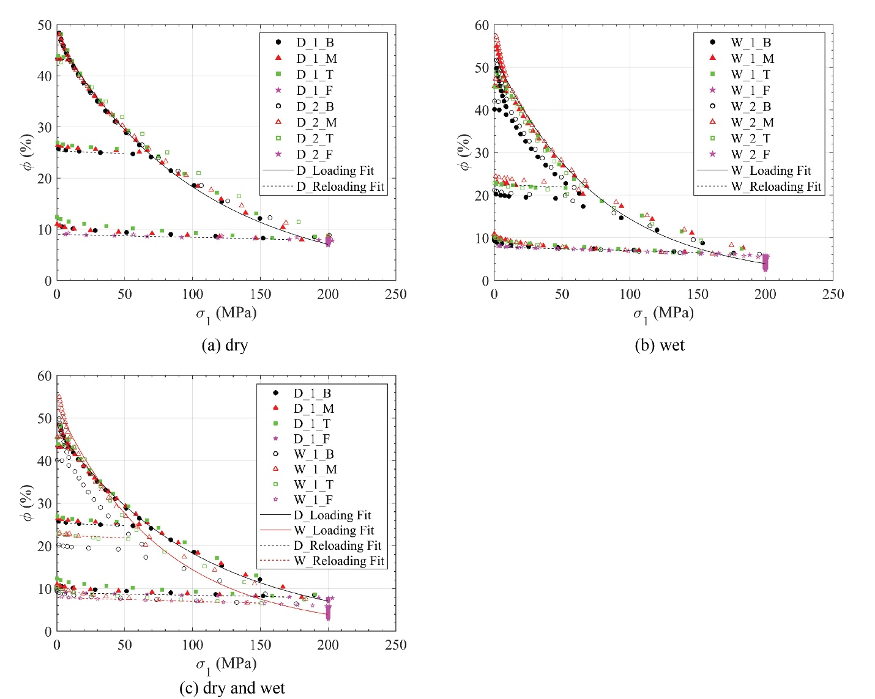

Fig. ‎2-3. Porosity versus axial stress during the compression of (a) dry; (b) wet; (c) dry and wet specimens

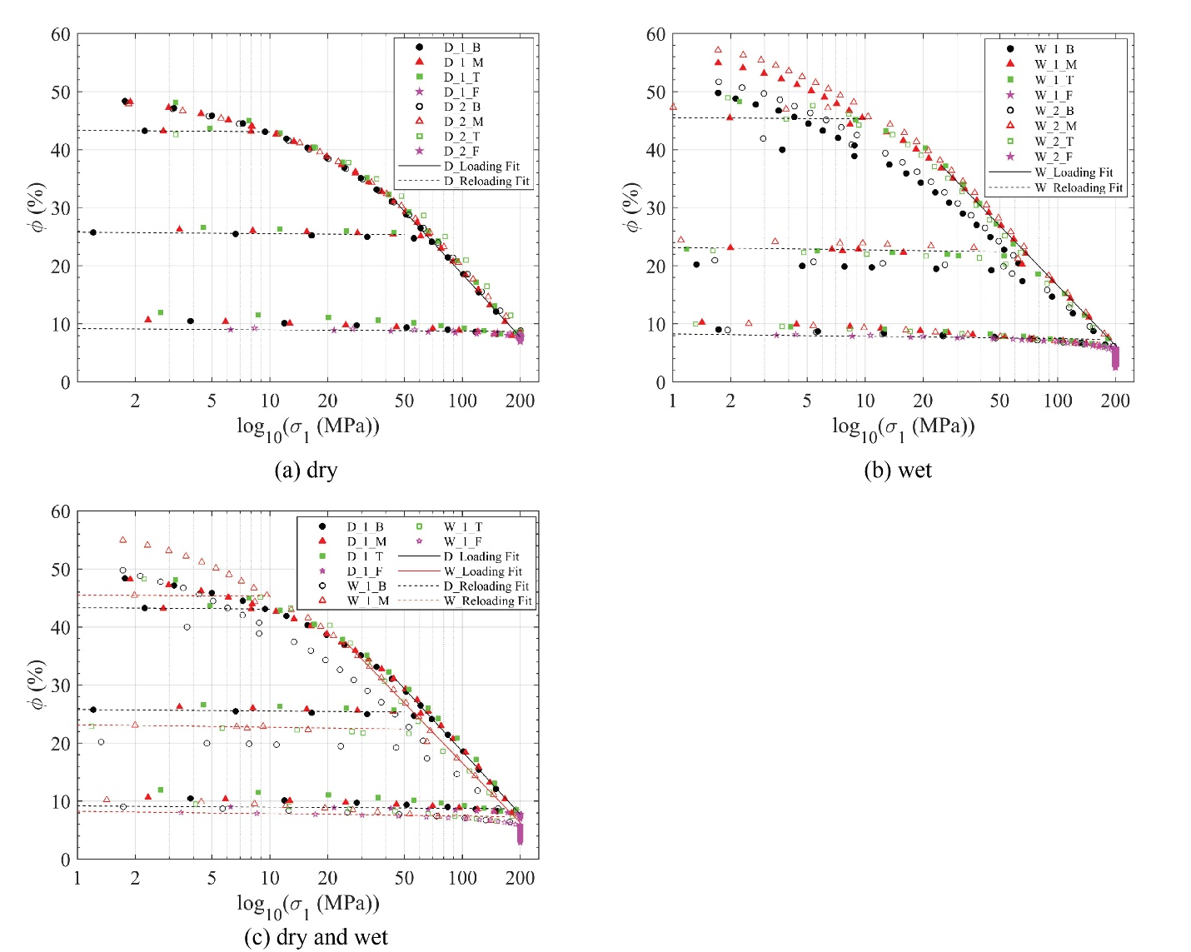

Fig. ‎2-4. Porosity versus axial stress’ logarithm during the 1D compression of (a) dry; (b) wet; (c) dry and wet specimens

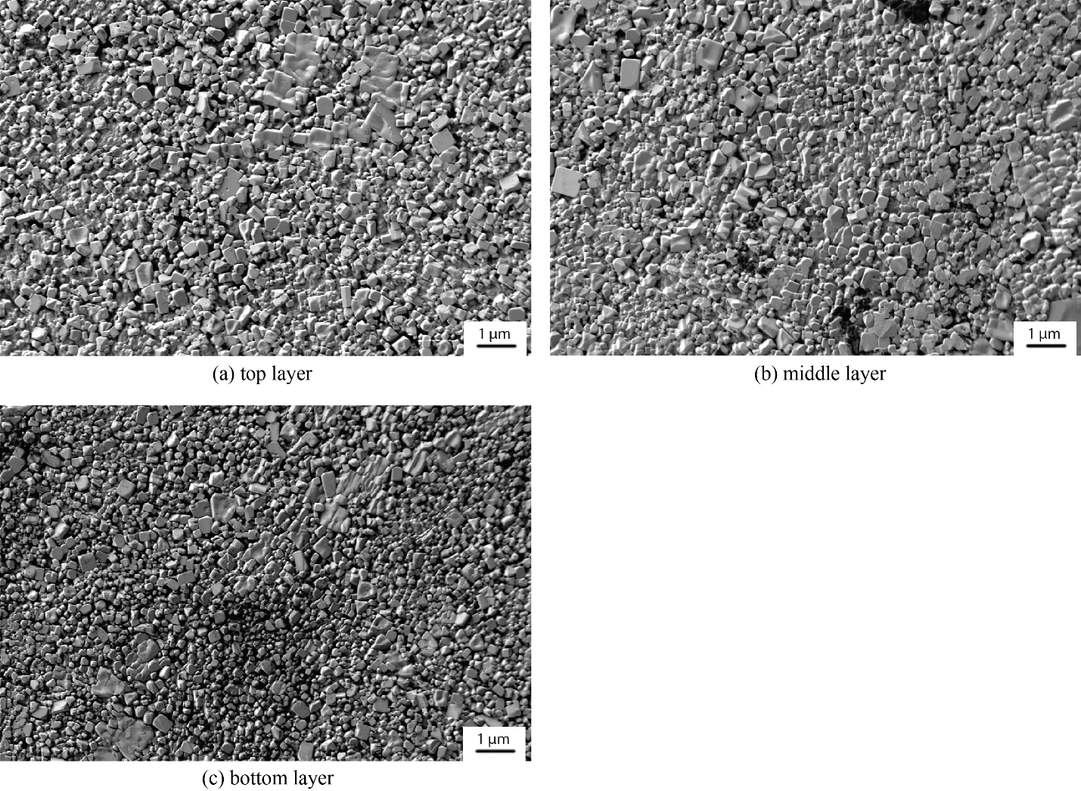

Fig. ‎2-5. SEM scan of a dry specimen: (a) top layer; (b) middle layer; (c) bottom layer

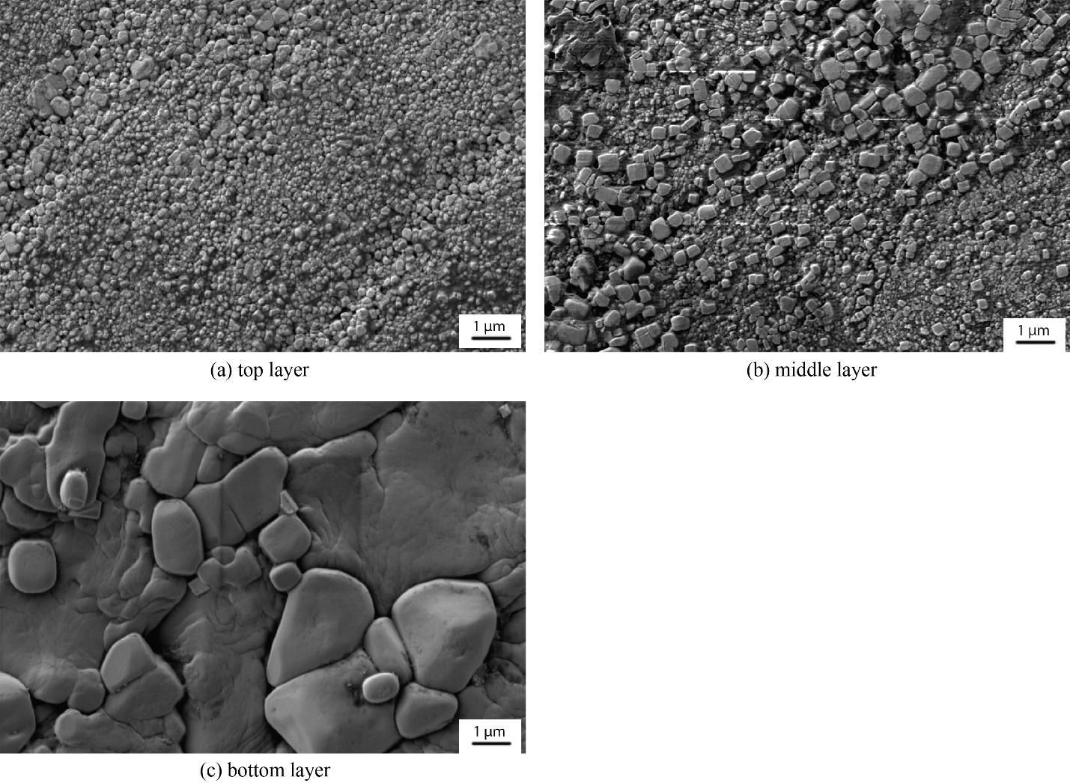

Fig. ‎2-6. SEM scan of a dry-annealed specimen: (a) top layer; (b) middle layer; (c) bottom layer

Note: As mentioned in the text, we note that the significant increase in the average grain size of the bottom layer may not accurately represent the average grain size of the bottom layer of the specimen. Each SEM scan shows a very small area of each disk where this specific area of the bottom disk may have been influenced by environmental influences such as absorbing moisture during the SEM scan preparation steps.

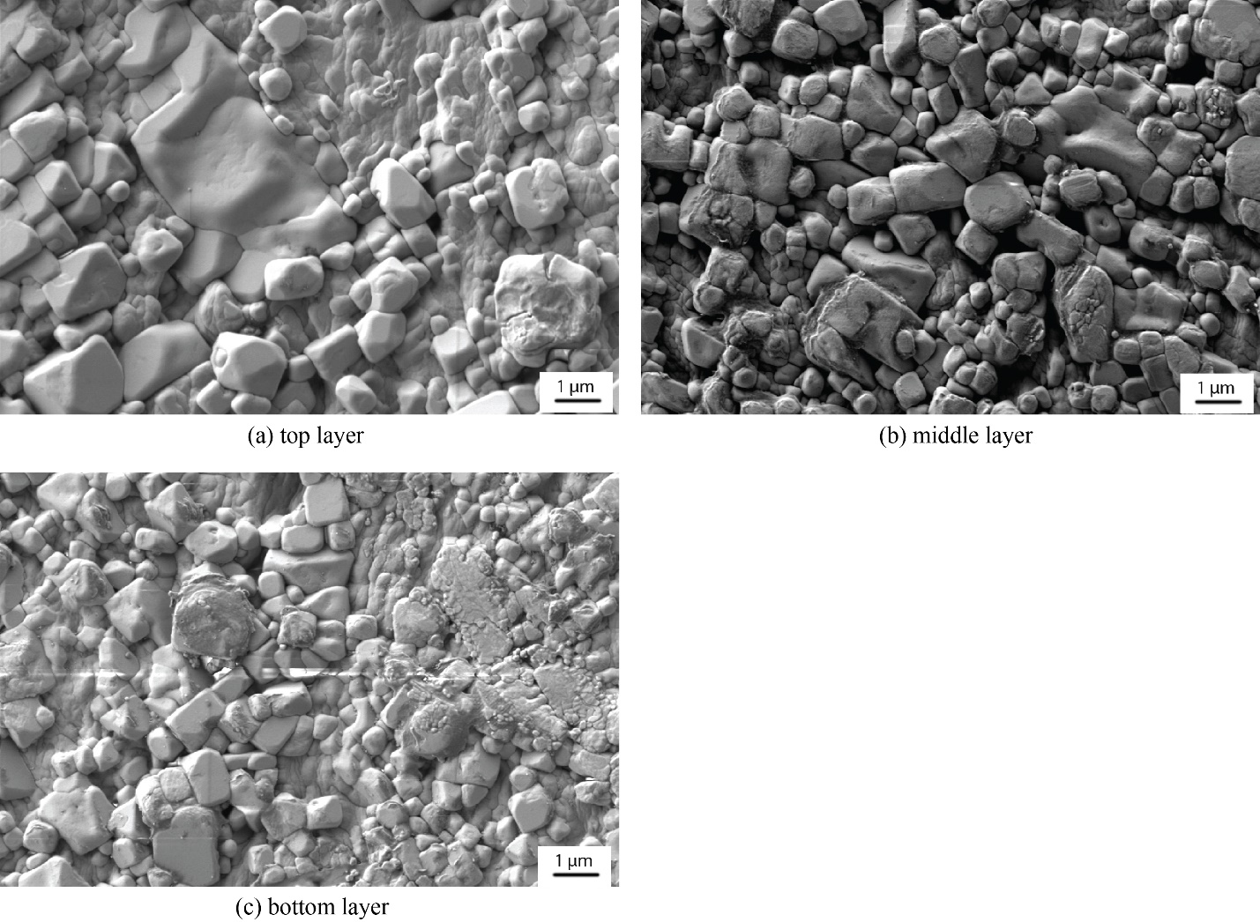

Fig. ‎2-7. SEM scan of a wet-annealed specimen: (a) top layer; (b) middle layer; (c) bottom layer

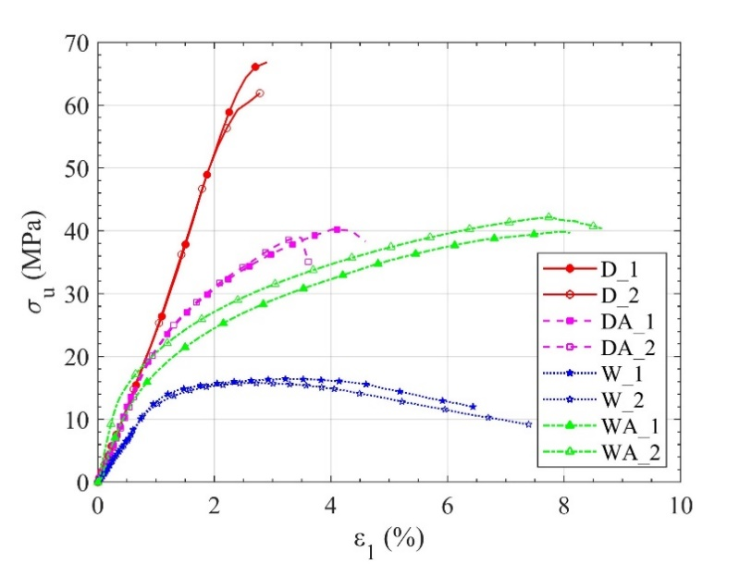

Fig. ‎2-8. Axial stress versus axial strain during unconfined compression experiments on two dry, dry-annealed, wet, and wet-annealed specimens

CHAPTER 3
INFLUENCE OF TEMPERATURE AND CRYSTAL ORIENTATION ON COMPRESSIVE STRENGTH OF ROCK SALT USING A NEWLY DEVELOPED HIGH-PRESSURE THERMAL CELL

A version of this chapter was originally published by Amirsalar Moslehy, Khalid A. Alshibli, and Timothy J. Truster:
Moslehy, A., Alshibli, K. A., & Truster, T. J. (2022). Influence of temperature and crystal orientation on compressive strength of rock salt using a newly developed high-pressure thermal cell. Rock Mechanics and Rock Engineering, 55(1), 91–108.

My contribution to this paper is performing the experimental tests, data analysis, and preparing the original draft and all Figures.

Abstract

Rock salt is found in nature either in a single-crystal or polycrystalline form where crystal structure, grain, and grain boundary properties have major effects on its strength. The compressive strength of single-crystal rock salt is highly dependent on the loading direction with respect to rock salt’s crystal orientation. Most salt formations are either located in a hot environment or exposed to elevated temperatures. Therefore, the influence of temperature should be considered when evaluating the constitutive behavior of rock salt. In this paper, the details of the design of a new high-pressure thermal cell that can withstand a confining pressure up to 15 MPa and a maximum temperature of 150° C are presented. Three types of polycrystalline rock salt specimens with different grain and grain boundary properties were synthesized to study the effects of grain and grain boundary properties on the strength properties of polycrystalline rock salt. The results of the experiments were then used to examine the influences of grain size, grain boundary properties, annealing process, and temperature on the unconfined compressive strength of polycrystalline rock salt. In addition, 18 natural single-crystal rock salt specimens were prepared and tested at three different crystal orientations relative to loading direction at different temperatures. Specimens tested parallel to [1 0 0] and 19º to (1 0 0) in (0 1 0) showed quite a similar behavior. However, specimens tested on 30º to (1 0 0) in (0 1 0) exhibited a much higher unconfined compressive strength at 20º C while their unconfined compressive strength was significantly reduced when the temperature was increased.
Keywords: Single-crystal rock salt · Polycrystalline halite · Unconfined compression · High-temperature · Crystal structure

Introduction

Salt domes usually trap oil, gas, and valuable minerals beneath them due to their low porosity and impermeability. Extracting trapped resources requires drilling through thousands of meters of rock salt formations which introduces many challenges such as stability of the wellbore, case collapses, and thermal stresses (Fredrich et al., 2003; Hansen and Leigh, 2011). On the other hand, rock salt’s low porosity, impermeability, high ductility, and self-healing make salt domes excellent and reliable repositories for hazardous wastes, including nuclear waste, and energy resources (Marques et al., 2013). Some of the stored hazardous wastes within salt domes are either hot when they are transferred to the domes (such as hot oil or oil drilling operations waste) or may produce heat over time while they are stored inside the domes (nuclear waste for example) (Davis et al., 1978; Hansen and Leigh, 2011). Therefore, the applications of salt domes in the energy industry have initiated studies on the effects of temperature on the behavior of rock salt. Different testing procedures such as triaxial, uniaxial, and creep experiments have been used to investigate temperature’s short-term and long-term effects on rock salt (Carter and Hansen, 1983; Lebensohn et al., 2003; Liang et al., 2006; Senseny et al., 1992; Ter Heege et al., 2005).
Sedimentary rock salt formations develop as a result of the evaporation of enclosed water bodies such as lakes; therefore because of their formation process, they are mostly polycrystalline, bedded, and may include impurities (Xing et al., 2015). They usually retain a very low water content in the range of 0.01% to 1.00% (De Las Cuevas and Pueyo, 1995). Polycrystalline rock salt known as halite is made of a large number of smaller halite crystals (grains) bonded to each other at grain boundaries. Grain boundaries are crystallographically defective regions where two or more crystals with different crystal orientations bond to each other (Locke et al., 2012). The crystal formation process, whether in the laboratory or in nature, influences the properties of a polycrystalline medium’s grains and grain boundaries. The properties of a polycrystalline material’s grains such as their size, shape, and crystal perfectness degree affect its strength and behavior (Knudsen, 1959; Ostapenko et al., 1993). The grain boundaries and their properties also influence the material’s behavior and strength because they can hinder the movement of crystal dislocations (Mouritz, 2012). On the other hand, an elevated ambient temperature normally decreases the strength of polycrystalline materials and increases their ductility (Evans et al., 1970; Takasugi and Izumi, 1985). Lebensohn et al. (2003) found increasing the temperature from 20° C to 100° C reduces the compressive strength of polycrystalline halite from 60 MPa to 34 MPa under the same confining pressure of 50 MPa without a noticeable increase in the axial strain and ductility of the material. Ter Heege et al. (2005) reported a decrease in the compressive strength of polycrystalline halite when the material was exposed to elevated temperatures. No obvious changes in the ductility of polycrystalline halite were reported in Ter Heege et al.’s study (2005). The results of the aforementioned studies did not report a significant increase of ductility at elevated temperatures in polycrystalline rock salt’s behavior.
Some rock salt formations consist of relatively large halite grains (>100 mm) that have grown in size during a geological time scale under high tectonic hydraulic pressures (Wawersik and Hannum, 1980). At a microscopic scale, the constitutive properties of rock salt are governed by the behavior of rock salt single-crystals (grains). The constitutive behavior of rock salt single-crystals is anisotropic and their strength can vary based on what crystal orientation they are loaded on. Carter and Heard (1970) tested synthetic melt-grown rock salt single-crystals in tension loaded on three different crystal orientations at various temperatures and strain rates. The selected crystal orientations were parallel to [0 0 1], 30° to (1 0 0) in (0 -1 1), and 45° to [0 0 1] in (0 1 0). The specimens extended on 30° to (1 0 0) in (0 -1 1) and 45° to [0 0 1] in (0 1 0) were found to have a higher work-hardening rate and higher ultimate tensile strengths because the secondary slip systems became the dominant slip systems compared top which have higher Critical resolved shear stress (CRSS) values. Moreover, all specimens showed a decrease in the strain-hardening rate and ultimate tensile strength with the increase of temperature and decrease of the applied strain rate. Although the studies conducted on synthetic single-crystal rock salt can be a good starting point in understanding the anisotropic response of rock salt single crystals, the constitutive behavior of natural single-crystal rock salt is not necessarily the same as synthetic rock salt. Natural rock salt single-crystals often possess more crystal defects when compared to synthetic rock salt crystals (Sedlmayr, 2014). Therefore, natural single-crystal rock salt can fail in an entirely different mode than synthetic rock salt, which is yet not thoroughly studied.
This paper presents the design details of a new thermal cell suitable for testing rocks at elevated temperatures and high confining pressures and compares the compressive strength and ductility of differently prepared polycrystalline rock salt specimens. Each of the prepared polycrystalline rock salt specimens represents a distinct polycrystalline rock salt formation. We then investigate the influence of temperature on ductility and compressive strength of different polycrystalline rock salt specimens. Additionally, the effects of crystal orientation and temperature on the behavior of natural single-crystal rock salt are studied by preparing specimens with different crystal orientations and testing them in unconfined compression experiments at various temperatures.

High-Pressure Thermal Cell

Background
The combination of a high confining pressure and an elevated temperature makes designing a thermal cell challenging. Cekerevac et al. (2005) employed a hot bath to circulate hot water inside a coil within a traditional triaxial cell for heating. Cekerevac et al. (2005) cell can withstand a temperature up to 90° C and a confining pressure up to 2 MPa. Zhang et al. (2010) designed a temperature-controlled triaxial cell capable of applying thermo-mechanical loading on soft sedimentary rocks. They added a cartridge heater and a temperature sensor inside a conventional triaxial cell controlled by a voltage regulator-based temperature controlling unit able to adjust the temperature at a stable rate. The designed cell’s temperature and confining pressure ratings were 90° C and 10 MPa, respectively. Many high-pressure thermal cells have been designed by modifying either a traditional Bishop triaxial cell (Bishop and Donald, 1961) or a Bishop-Wesley triaxial cell (Bishop and Wesley, 1975) to add thermal capacities to them (Ghembaza et al., 2015; Uchaipichat et al., 2011). Uchaipichat et al. (2011) added a heater and a temperature sensor inside Bishop-Wesley's triaxial cell to test unsaturated soils. Their modified cell can withstand a temperature up to 60° C and a confining pressure of 600 kPa. Uchaipichat et al. (2011) decided to employ a glass wall tube instead of a conventional Perspex cylinder after the Perspex cylinder used in their initial design exhibited permanent expansion and chemical reaction during elevated temperature experiments. Ghembaza et al. (2015) adopted Bishop-Wesley triaxial cell as a baseline design to test unsaturated soils using the osmotic method by substituting the conventional Perspex cell cylinder with an aluminum jacket, adding a heating collar outside the cell, and adding a temperature probe inside the cell to make the cell suitable for experiments at a temperature up to 80° C. MTS Systems Corporation’s various thermal triaxial cells as reported in the literature, such as in Mishra and Janecek (2017), are another all-around alternative for rock core testing. Some MTS thermal cells can withstand confining pressures higher than 100 MPa and be operated at temperatures up to 200° C using external heating bands and cartridge heaters embedded within the lower loading platen. Additionally, MTS thermal cells are compatible with MTS chain extensometers for measuring lateral deformations during compression tests. Jaradat et al. (2020) developed a modified thermomechanical triaxial cell capable of changing the temperature within a range of 0.001° C/min to 0.4° C/min for thermo-mechanical loading path tests. The heating source in the thermal cell designed by Jaradat et al. (2020) was a thermo-electrical heater installed around the cell chamber. The designed cell can reach a maximum of 70° C temperature and a maximum of 2 MPa confining pressure.
The choice of the fluid for applying confining pressure and/or transferring the heat to the material being tested significantly impacts the thermal cell’s operational temperature. Although water has been used as the heat transfer fluid in the literature (mainly for soil testing purposes), the maximum achievable and safe temperature inside the thermal triaxial cell cannot exceed 90° C (a safe temperature below water’s boiling point). The temperature inside salt domes can reach 150° C or more due to their depth or the heat produced by the material stored inside the rock salt cavities. Moreover, using water as the confining fluid in the presence of rock salt (in case the membrane separating the specimen and the confining fluid is defective) can lead to specimen dissolution, cell corrosion, and eventually failure of the cell. Therefore, the high-pressure thermal cell designed in this study uses a heat-transfer oil to reach temperatures up to 150° C and withstand a maximum confining pressure of 15 MPa.

Base Design
Three common methods are widely used for adding thermal capacities to conventional triaxial cells. Circulation of a fluid within a metallic coil using a hot bath source or a cooling system is the most used design for changing the cell temperature. The coil used in the fluid circulation method is either wrapped around the cell or submerged around the specimen (Alshibli and Jarrar, 2020; Cekerevac et al., 2005). In the fluid circulation method, the confining pressure is applied inside the thermal cell using a different fluid. In the second method, a collar heater wrapped around the specimen or the triaxial cell can produce the desired temperature inside the cell (Abdelaziz and Jaradat, 2020; Ghembaza et al., 2015). A pressurized fluid applies the confining pressure within the cell similar to the first approach. In the mentioned techniques, if the heating source is mounted outside the cell, the cell chamber needs to transfer the heat to the confining fluid and then the heat is transmitted to the specimen. In the internal heater method (third method), an immersion heater installed inside the cell heats the confining fluid (mostly liquid) to transfer the heat to the specimen (Uchaipichat et al., 2011; Zhang et al., 2010). Based on the heater’s wattage and the liquid heat capacity and thermal conductivity of the confining fluid, an internal heater method can increase and equilibrate the temperature much faster than the other two heating methods especially if the cell is not designed for thermal or thermo-mechanical loading paths that may add more challenges. Therefore, the cell designed in this paper employs an internal heater method considering its advantages.
The thermal cell’s requirements (holding a maximum confining pressure of 15 MPa and a maximum cell temperature of 150° C) led to a flange-based design to overcome the applied stresses (Fig. ‎3-1). A flange-based cell provides more rigidity and better sealing when compared to a conventional triaxial cell where the flanges encircle the cell chamber and prevent it from bulging. The increased moment of inertia by adding the flanges to the cell prevents bending at the top and bottom cell plates caused by the internal pressure. Additionally, the compressional forces caused by the bolts and nuts attaching the top and bottom plates to the flanges provide enough pressure on the O-ring between the plates and flanges to seal the cell. The new thermal cell is designed according to the American Society of Mechanical Engineers (ASME) Boilers and Pressure Vessels (BPVC) code with a factor of safety of 1.5 applied on the yield stresses of the materials. Fig. ‎3-2 displays an exploded view of all the components of the new high-pressure thermal cell. 316 stainless steel was selected as the design material for all cell metallic parts to prevent thermal strength losses and corrosion that could potentially happen when testing rock salt. The cell confining chamber has an outer diameter of 127.00 mm (5 in), a wall thickness of 6.35 mm (0.25 in), and a height of 152.40 mm (6 in) to accommodate the heater and other thermal elements within the cell. The 190.50 mm (7.5 in) long and 25.40 mm (1 in) thick square flanges were welded to the cell chamber. The top and bottom plates are square with the same dimensions except that their thicknesses are 25.40 mm (1 in) and 19.05 mm (0.75 in), respectively. A set of 12 3/8-in (9.50 mm) fine thread grade 8 bolts and nuts attaches each of the plates to its respective flange. The 19.05 mm (0.75 in) diameter loading rod can transfer an axial load up to 44.5 kN (10,000 lb) to the material being tested. Fig. ‎3-3 shows the details of the top plate and the placement of the tying bolts on it.
Fig. ‎3-4 shows the stainless-steel specimen caps. An O-ring groove was machined on the caps for placing an O-ring around the specimen membrane to secure it. The bottom cap is attached to the cell’s bottom plate using a threaded rod to ensure proper alignment of the specimen with the loading rod. Considering the height of the cell chamber and other parts inside the cell, such as specimen caps, the cell can accommodate specimens with heights up to 70 mm (2.75 in) and diameters up to 35 mm (1.38 in). Widely used latex membranes have a temperature range of – 55° C to 82° C; therefore, they cannot be used in experiments at temperatures exceeding 82° C. Neoprene membranes with a recommended temperature rate of 135° C are normally the alternative to the latex membranes for hot temperature experiments. However, the pyrolysis of neoprene does not occur before 200° C (Caballero et al., 2005). Hence, they still can be a viable solution for experiments up to a temperature of 200° C for an extended time. Additionally, a neoprene membrane was placed in a hot bath filled with Therminol 55 heat transfer fluid at a temperature of 150° C for 60 days before adopting them in this study. No decomposition or puncture was observed after 60 days. Neoprene membranes have a dimension of 101.60×30.50×0.60 mm (4×1.2×0.025 in) and can be secured around the specimen and caps using high-temperature silicone O-rings (rated up to 232° C). Silicone O-rings are dash number 023 size with an outer diameter of 30.25 (1.19 in), an inner diameter of 26.7 (1.05 in), and a width of 1.78 mm (0.07 in). The load frame used in this study was a 44.5 kN (10,000 lb) Sigma-1 servo automated test system manufactured by Geotac coupled with a 44.5 kN (10,000 lb) S-shape load cell by Omega Engineering Inc. The axial deformations in the loading direction are measured using a 76.20 mm (3 in) range Linear Variational Differential Transformer (LVDT) by Geotac placed on top of the thermal cell. Fig. ‎3-5 shows a photo of the entire test set-up including the load frame and the coupled sensors with it.

Heating System
The cell’s maximum design temperature of 150° C required a heat transfer fluid with a maximum extended use temperature and a flashpoint above 150° C that does not emit toxic fumes. A heat transfer fluid with a high thermal conductivity and a low heat capacity also conducts the heat faster and lets the cell temperature become stable much faster. Therminol 55 heat transfer fluid manufactured by Eastman (2020) satisfies all of the four previously mentioned thermal properties and was selected as the heat transfer fluid. Therminol 55’s flashpoint is 177 °C with an extended use temperature up to 335 °C. Like the cell designs by Uchaipichat et al. (2011) and Zhang et al. (2010), the initial design in this study used a cartridge heater immersed from the top of the cell. The cartridge heater was 650 W and 152.40 mm (6 in) long which could heat the fluid in contact with the whole length of the heater. Therminol 55’s 0.000961/°C coefficient of thermal expansion causes its density to decrease from 872 kg/m³ at 20 °C to 784 kg/m³ at 150 °C. As a result, the heated oil inside the initially designed cell constantly flew towards the cell’s top plate, and the cold oil moved to the bottom. The fluid flow inside the cell caused a significant heat gradient of 60° C between the top plate and the bottom plate when the top plate was at 150° C. To prevent a heat gradient with the height of the cell, the heat needs to be applied at the bottom of the cell instead of along its height. Installing the heater at the very bottom of the cell causes a density-based fluid circulation which makes the temperature uniform along the height of the cell. However, a straight cartridge heater with enough heat capacity cannot fit in a horizontal direction at the bottom of triaxial cells. Tubular heaters, on the other hand, are bendable; therefore, they can fit inside a thermal triaxial cell. The bendability of the tubular heaters comes at the price of larger diameters and longer cold ends. The tubular heater substituting the initial cartridge heater is an RDN16L1S-27 Watlow heater with a wattage of 650, has a diameter of 9.53 mm (0.375 in) and a length of 422.28 mm (16.625 in) and was bent into a ring shape (Fig. ‎3-3). The substitution of the heater reduced the heat gradient along the height of the cell to a maximum of 1.7° C at any time.
The heat controlling unit consists of a Watlow Series CV temperature controlling unit (model CV-CBJHD) and a 152.40 mm (6 in) long type J thermocouple submerged inside the cell through the top plate. The heating system keeps the cell’s temperature within a range of ±1.7° C of the target temperature. A fiberglass insulation jacket is also wrapped around the cell chamber to minimize heat loss. Lastly, two continuous temperature-indicating labels with a temperature range of 90° C to 120° C are attached to the top plate the bottom plates for safety purposes. If for any unforeseen reason the thermocouple fails, these temperature-indicating labels alert the user by changing their color.

Pressure System
The cell’s independent pressure system uses a Teledyne Isco 500D syringe pump with a fluid capacity of 500 ml, is capable of providing a maximum pressure of 25.85 MPa (3750 psi), and uses the same Therminol 55 heat transfer fluid to apply the confining pressure within the cell. All the tubes connecting the pump system to the cell are made of 316 stainless steel due to high pressures. An SS-2P4T4 Swagelok valve rated up to 6.9 MPa (1000 psi) at 204° C or 20.7 MPa (3000 psi) at room temperature is mounted on top of the thermal cell to purge the gas out of the cell at the time of filling it with the heat transfer fluid through the bottom port. The high confining pressure at elevated temperatures makes sealing the cell another challenging task. Viton O-rings rated up to 204° C seal the gaps between the flanges attached to the top and bottom plates (Fig. ‎3-1). Furthermore, a torque of 50 N-m (37 lbs-ft) is applied to the bolts and nuts holding the top and bottom plates to provide enough compression pressure for sealing the mentioned surfaces. Initially, an O-ring loaded rubber U-cup with a rating of 34.5 MPa (5000 psi) and 150° C was used for sealing the gap between the loading rod and the top plate (Fig. ‎3-3). However, during the thermal cell’s proof test at a temperature of 150° C the rubber made U-cup dried after approximately 50 hours and caused a fluid leakage around the loading rod. Therefore, a custom-made Viton O-ring loaded U-cup seal rated up to 204° C with a dimension of 25.40×19.05×4.75 mm (1×0.75×0.187 in) was used instead of the rubber U-cup. The proof tests on the thermal cell after the installation of the custom-made U-cup seal showed it can seal the loading rod at a confining pressure up to 6.9 MPa (1000 psi) at 150° C, which is the maximum confining pressure the authors intend to use the cell for. However, if a user chooses, a special-made Polytetrafluoroethylene (PTFE) spring-loaded U-cup seal can seal the loading rod up to a pressure of 15 MPa at 150° C. Additionally, a 38.10×19.05×12.70 mm (1.5×0.75×0.5 in) Buna-N cotton-reinforced piston-cup seal is placed around the loading rod beneath the top plate to help seal the loading rod (Fig. ‎3-1).

Specimen Preparation

Raw Material
The source rock salt used in preparing both synthetic polycrystalline and natural single-crystal rock salt specimens was acquired from Windsor Salt Mine in Ontario, Canada. The 1.5 × 1.5 × 0.3 m source rock salt was cut into smaller blocks with diligence to provide the raw material for preparing the specimens. Powder x-ray diffraction (PXRD) revealed that the material is 99.9% NaCl.

Polycrystalline Rock Salt Specimens
Crushed Rock salt grains with a size smaller than 0.075 mm (US sieve #200) were used to prepare the polycrystalline specimens. Three types of polycrystalline halite specimens were synthesized to represent various polycrystalline rock salt formations. The synthesis procedures of the polycrystalline halite specimens are not reported in this paper for the sake of brevity and the reader is referred to Moslehy and Alshibli (Moslehy and Alshibli, 2021) for more details. Dry polycrystalline halite specimens were made by cold-pressing halite grains (containing 0.1% moisture) in three layers with equal thicknesses at 200 MPa uniaxial stress. Dry specimens were fine-grained with an average grain size of 0.15 µm and possessed a global porosity of about 7.2%. Porosity and average grain size inside dry specimens at the top layer were 5.8% and 0.13 µm, respectively. Porosity and average grain size of dry specimens increased from the top layer to the bottom layer, where the porosity and average grain size were 8.1% and 0.18 µm, respectively. Dry specimens represent the younger polycrystalline rock salt formations that did not have the same amount of time for annealing when compared to older formations.
Dry-annealed polycrystalline halite specimens were prepared similar to the dry specimens; however, they were annealed at a temperature of 200° C for 7 days after compaction. Dry-annealed specimens had a larger average grain size (0.40 µm) and their global porosities were about 1.8%. The average grain size increased in dry-annealed specimens from the top layer (0.17 µm) to the bottom layer (0.78 µm). Porosity, on the other hand, was at the highest within the middle layer (3.1%) compared to the top layer at 1.9% and the bottom layer at 1.2%. Dry-annealed specimens represent older bedded polycrystalline rock salt formations, where the grains had more time to anneal. The bedding in the mentioned formations is caused by different layers of sedimentation throughout the history of the formation.
Wet-annealed polycrystalline halite specimens were prepared by cold-pressing a mixture of halite grains and salt-saturated deionized de-aired water with a ratio of 75% to 25%, respectively. The cold-press was completed in three equal layers at 200 MPa uniaxial stress. Wet-annealed specimens were annealed at a temperature of 200° C for 7 days as well and have an average grain size of 0.63 µm which is larger than the other two types. Wet-annealed specimens also had smaller global porosities compared to the other two types (0.8%). The average grain size and porosity of wet-annealed specimens were almost uniform alongside their height. However, the middle layer had a slightly smaller average grain size (0.60 µm) compared to 0.67 and 0.63 µm at the top and bottom layers, respectively. The porosity of the middle layer (1.3%) was also slightly higher than the top layer (0.8%) and the bottom layer (0.6%). Although most of the water was ejected during the cold-press process, some water could be trapped in the middle layer that caused its porosity to be slightly higher than the other two layers and prevented the grains from annealing and growing in size (Moslehy and Alshibli, 2021). Wet-annealed specimens mimic old polycrystalline rock salt formations without clear beddings that have a higher uniformity in their properties. 6 of each type of specimens were prepared to conduct unconfined compression experiments at various temperatures. Table ‎3-1 lists the height, diameter, mass, and porosity of the specimens. Although the successful reproducibility of the properties of the specimens produced in this paper is briefly summarized here, the readers are referred to Moslehy and Alshibli (Moslehy and Alshibli, 2021) for the detailed reproducibility discussion. Fig. ‎3-6a and b show the boundaries of the compaction layers of a dry and a dry-annealed specimen, which caused the beddings within the specimens. However, no clear bedding could be seen within wet-annealed specimens (Fig. ‎3-6c).

Single-Crystal Rock Salt Specimens
Halite’s face-centered-cubic (FCC) crystal structure with natural cleavage planes on {1 0 0} crystal planes makes preparing standard cylindrical rock cores quite futile. As a result, cuboidal-shaped specimens with an average height of ~ 45.00 mm and a height to width or length ratio of 2:1 were adopted in this study. The existence of visible orthogonal {1 0 0} cleavage planes within the nearly transparent source rock was used as an identifier for locating large single-crystals within the source rock and their orientation. Large cubical single-crystals with dimensions of ~ 76.20 mm were separated from the source rock. The crystal orientations of the single-crystals were estimated to be aligned with the cube’s surfaces. Specimens with three different crystal orientations were then cut from the single-crystal cubes with the following orientations: parallel to [1 0 0], 19º to (1 0 0) in (0 1 0), and 30º to (1 0 0) in (0 1 0). The crystal orientations of the specimens in the Bunge Euler definition were $\left[\begin{matrix}φ_{1}=0 \\ Φ=0 \\ φ_{2}=0\end{matrix}\right]$, $\left[\begin{matrix}φ_{1}=19° \\ Φ=0 \\ φ_{2}=0\end{matrix}\right]$, and $\left[\begin{matrix}φ_{1}=30° \\ Φ=0 \\ φ_{2}=0\end{matrix}\right]$ respectively; therefore, for simplicity, these specimens are referred to as 0º, 19º, and 30º specimens, respectively. $φ_{1}$, $Φ$, and $φ_{2}$ in order are the counterclockwise rotation angles of the specimen’s axes about the z-axis, [1 0 0] direction, and [0 0 1] direction, to transfer specimen axes to the crystal axes. Specimens were gradually sanded with P3000 sandpaper to fine-tune their crystal orientation and to smooth their surface. Fig. ‎3-7 shows a representative specimen of each type. The crystal orientations of the specimens were verified by conducting Laue x-ray diffraction (LXRD) experiments on 6 representative specimens to determine their crystal orientations with respect to the specimens’ surface. 6 specimens of each crystal orientation were prepared to conduct the unconfined compression experiments at various temperatures (Table ‎3-2).

Unconfined Compression Experiments

Polycrystalline Specimens
Strain-controlled uniaxial compression experiments were conducted on 18 specimens employing the new high-pressure thermal cell. The experiments were carried out at 20º, 100º, and 150° C, and two specimens of each polycrystalline rock salt type were tested at each temperature. The experiments were performed according to ASTM D7012 (2014) standard using a constant loading strain rate of $1.7×{10}^{-4} s^{-1}$. The results are summarized in Table ‎3-3, and Fig. ‎3-8a, b, and c show the axial strain ($ϵ_{1}$) versus axial stress ($σ_{1}$) relationships of dry, dry-annealed, and wet-annealed specimens, respectively, at various temperatures. Dry specimens exhibited an average unconfined compressive strength ($σ_{u})$of 64.38 MPa at room temperature (20º C), which is much higher than dry-annealed and wet-annealed specimens’ unconfined compressive strength at room temperature (39.58 and 41.02 MPa, respectively; Fig. ‎3-8). Bourcier et al. (2013) similarly found that polycrystalline rock salt specimens with smaller average grain sizes displayed a higher unconfined compressive strength. A smaller average grain size prevents the formation of connected crystal dislocations. On the other hand, dry specimens had high porosity grain boundaries, which are naturally immobile at room temperature (Guillope and Poirier, 1979). The immobility of grain boundaries resulted in a surge in the unconfined compressive strength of the material and reduced its ductility, which explains the lesser ductility of dry specimens, ~2.84% axial strain at failure, compared to the other specimens (Fig. ‎3-8).
As mentioned earlier, dry-annealed specimens displayed a similar unconfined compressive strength to wet-annealed specimens at room temperature (Fig. ‎3-8b and c). This similarity is due to the comparably large average grain size of the dry-annealed and wet-annealed specimens, which allowed crystal dislocations to form and grow. However, the dry-annealed specimens’ ductility, ~3.73% axial strain at failure, was considerably less than wet-annealed specimens’ ~7.88% axial strain at failure (Fig. ‎3-8b and c). The beddings within dry and dry-annealed specimens in addition to their high porosity grain boundaries could further obstruct crystal dislocations in comparison to wet-annealed specimens (Schenk et al., 2006). Moreover, the presence of water within grain boundaries of wet-annealed specimens facilitated the grain boundary migration. Comparing the results of unconfined compression experiments on the three types of polycrystalline specimens at various temperatures, the trend is the same in the results of different polycrystalline specimens: the increase of temperature leads to a decline of the unconfined compressive strength and gain of ductility (Fig. ‎3-8). During the compression experiments at elevated temperatures, dynamic recrystallization of rock salt grains occurs (Watanabe and Peach, 2002). Dynamic recrystallization increases the average grain size and eases the grain boundary migration, which were the causes of unconfined compressive strength drops and ductility gains.
The dry specimens tested at 150° C showed work hardening and reached a steady-state flow stress during the tests due to grain boundary migration compared to the dry specimens tested at 20° and 100° C. Moreover, the unconfined compressive strength dropped 33% at 150° C compared to the unconfined compressive strength at room temperature. Dry grain boundary migration does not occur in polycrystalline rock salt at temperatures below 400° C (Guillope and Poirier, 1979); however, Schenk et al. (2006) showed a small presence of water (even 0.1%) at the grain boundaries allows grain boundary migration to occur at a temperature above 125° C. Dry-annealed and wet-annealed specimens displayed work hardening and reached a steady-state flow stress during the experiments conducted above 100° C due to the higher mobility of the grain boundaries caused by annealing. The unconfined compressive strength of dry-annealed and wet-annealed specimens decreased 25% from room temperature to 150° C, in comparison to a 33% drop observed for dry specimens. Dry-annealed and wet-annealed specimens had experienced static recrystallization during their annealing; therefore, their unconfined compressive strengths showed less reduction. Moreover, wet-annealed specimens showed more increase in ductility at elevated temperatures in comparison to dry-annealed specimens due to the higher mobility of wet grain boundaries (Fig. ‎3-8).

Single-Crystal Specimens
Similar to the polycrystalline specimen experiments, a total of 18 single-crystal specimens (6 of each crystal orientation) were tested at the following condition: a pair of specimens with a specific crystal orientation at 20º, 100º, and 150° C. The same constant loading strain rate of $1.7×{10}^{-4} s^{-1}$ was used for testing the single-crystal specimens. Table ‎3-4 summarizes the results of the experiments, and Fig. ‎3-9a, b, and c depict the axial strain ($ϵ_{1}$) versus $σ_{1}$ relationships of 0º, 19º, and 30º specimens respectively, at various temperatures.
Fracture (failure) of FCC single-crystals (Fig. ‎3-10a) is often controlled by the activation of either some slip systems or cleavage planes within the crystal (Cox Jr, 1954). Slip systems are plastic deformation mechanisms causing the crystal to fail in a ductile manner, while the activation of cleavage planes causes a brittle fracture of the crystal (Aoki and Izumi, 1979; Wimmer et al., 1963). Rock salt has 6 primary slips systems along {1 1 0} planes on <1 -1 0> directions (Fig. ‎3-10b). They are accompanied by 6 secondary slip systems along {1 0 0} planes on <0 1 1> directions (Fig. ‎3-10c) and 12 more secondary slip system along {1 1 1} planes on <1 -1 0> directions (Fig. ‎3-10d). Any of these 24 slip systems activates if the resolved shear stress (RSS) on the slip system exceeds the critical resolved shear stress (CRSS) of the slip system. RSS on any slip system can be calculated using Equation 3-1. Rock salt’s orthogonal cleavage planes are along {1 0 0} planes, where the activation of a cleavage plane depends on the cleavage plane’s resolved normal stress (RNS) surpassing the plane’s critical resolved normal stress (CRNS). RNS on a cleavage plane is calculated from Equation 3-2:

$$RSS=cos\left(∅\right)×cos\left(λ\right)×σ=m×σ$$ | (‎3-1)
$$RNS=\cos^{2}\left(∅\right)×σ=cleavage factor×σ$$ | (‎3-2)

where $∅$ is the angle between the cleavage or slip plane and the stress axis, $λ$ is the angle between the slip direction and the stress direction, $σ$ is the applied stress, and m is the slip system’s Schmid factor. Table ‎3-5 shows the Schmid and cleavage factors of the specimens with different crystal orientations. The CRSS values of rock salt’s primary slip systems are generally smaller than the secondary slip systems’ CRSS (Carter and Heard, 1970); therefore, normally rock salt’s primary slip systems are more active during single-crystal rock salt deformation (depending on the loading direction). However, the secondary slip systems’ CRSS values are more sensitive to an increase of temperature; therefore, at elevated temperatures, the secondary slip systems may become activated more often. Smaller applied strain rates can also facilitate the activation of rock salt’s slip systems resulting in a ductile creep rupture of the specimens, which prevails the more brittle cleavage fracture. The cleavage fracture of rock salt is a function of the density of the ionic bonds at cleavage planes. Rock salt single-crystals with more defects and atomic vacancies naturally have a lower ionic bond density at their cleavage planes yielding a lower CRNS value (Schultz et al., 1994).
Fig. ‎3-11a shows the results of a representative specimen of each crystal orientation tested at various temperatures. The specimens loaded parallel to [1 0 0] crystal planes (0° specimens) at 20° C had a lower average unconfined compressive strength (19.72 MPa) in comparison to the specimens loaded on 19º to (1 0 0) in (0 1 0) and 30º to (1 0 0) in (0 1 0) with average unconfined compressive strengths of 22.39 MPa and 38.18 MPa, respectively. However, the unconfined compressive strength of the 0° specimens was lower than the confined extensional strength of similar specimens (28 MPa) reported by Carter and Heard (1970). The specimens prepared by Carter and Heard (1970) were synthetic specimens that normally contain fewer artifacts, impurities, and inclusions when compared to the naturally sourced specimens tested in this study. Fig. ‎3-12a and d show specimen 0°_1_20° C before and after the test, respectively. The macroscopic observations of 0º specimens after the failure manifest the distortion of the {1 0 0} cleavage planes on the {1 1 0} <1 -1 0> slip system and activation of a significant number of the {1 0 0} cleavage planes, meaning cleavage fracture had eventually governed the failure. Single-crystal rock salt (based on tests conducted on synthetic rock salt) is normally expected to undergo a significant continuous dislocation on an activated slip system at room temperature until the specimen is deemed failed because of the amount of the axial strain or the specimen fractures due to lattice rotations caused by the accumulated plastic deformation on the slip systems. However as shown here, the defects and flaws within natural rock salt single-crystals can facilitate a cleavage fracture to occur much sooner than the axial strains reach the expected values. The 0° specimens also possessed an average elastic modulus of 0.9 GPa compared to 1.5 and 2.0 GPa for the 19° and 30° specimens, which was also lower than the 1.76 GPa reported by Carter and Heard (1970) for synthetic 0° specimens.
The specimens loaded on 19º to (1 0 0) in (0 1 0) at 20° C showed an average unconfined compressive strength of 21.89 MPa. The unconfined compressive strength of 19º specimens is interestingly $\frac{1}{19° cleavage factor}$ times higher than the unconfined compressive strength of 0º specimens. 19º specimens also exhibited the same distortion and significant activation of the {1 0 0} cleavage planes (Fig. ‎3-12b and e). The conjunction of these two observations means that the dominant accumulated slip system during the tests on 19º specimens had been {1 1 0} <1 -1 0> and they failed by cleavage fracture on the {1 0 0} planes. The 38.18 MPa average unconfined compressive strength of 30º specimens, on the other hand, does not follow a similar relationship with the 0º specimens. Visual inspection of 30º specimens tested at 20º C (Fig. ‎3-12c and f) did not reveal a significant amount of distortion of the {1 0 0} planes along the {1 1 0} <1 -1 0> slip system. One explanation could be activation of some of the {1 1 1} <1 -1 0> slip systems which had an increased Schmid factor of 1.18 on this specific crystal orientation. The dislocations caused by slipping on the {1 1 1} <1 -1 0> slip system due to their directions can impede the propagation of the {1 0 0} cleavage planes making the specimens fracture at a higher $σ_{1}$ under the same applied $ϵ_{1}$.
Fig. ‎3-11b shows the changes in the unconfined compressive strength of the specimens with an increase in temperature where the unconfined compressive strength of 0º and 19º specimens did not change with the increase of temperature from 20º C to 150º C, while 30º specimens and all polycrystalline specimens showed a decrease in their unconfined compressive strength. Increasing the temperature not only can reduce the value of CRSS and CRNS on slip systems and cleavage planes but also can cause a change in the most active slip system at any time during the test and eventually the failure mode. 0º and 19º specimens’ yield stress and the work-hardening rate decreased at higher temperatures in addition to the fact that their unconfined compressive strength did not change (Fig. ‎3-9a and b). This observation provides clear evidence that the {1 1 0} <1 -1 0> still had been the dominant accumulated slip system while its CRSS value had been decreased and the dislocation on the {1 1 0} <1 -1 0> slip system was facilitated at elevated temperatures. Moreover, the value of CRNS for 0º and 19º specimens did not change and the specimens eventually after showing a significant amount of axial strain (>20%) fractured by the activation of the {1 0 0} cleavage planes. The unconfined compressive strength of the 30º specimens showed a significant drop at elevated temperatures. At 100º C, 30º specimens did not show any drop in their yield strength and their ductility was still comparable to the specimens tested at 20º C. However, the increase of temperature to 150º C resulted in a decrease in the yield strength of the 30º specimens, a significant decrease in the work-hardening rate, and a significant increase in their ductility. All of the aforementioned observations demonstrated a change in the complex interaction of the active slip systems within the specimen. Cater and Heard (1970) showed that CRSS value of the {1 0 0} <0 1 1> slip system decreases at a higher rate compared to the other two slip systems, where at elevated temperatures CRSS of the {1 0 0} <0 1 1> slip system can even become smaller than CRSS of the {1 1 1} <1 -1 0> slip system. The plastic deformations on the {1 0 0} <0 1 1> slip system are along the {1 0 0} cleavage planes; therefore, if activated, they facilitate the propagation of the {1 0 0} cleavage planes (in contrast to the plastic deformations on the {1 1 1} <1 -1 0> slip system). At 150º C, the unconfined compressive strength of the 30º specimens is $\frac{1}{30° cleavage factor}$ times of the unconfined compressive strength of 0º specimens at 150º C. This observation shows that at least some {1 0 0} <0 1 1> slip systems had been activated during the tests conducted at 150º C on 30 specimens.

Conclusions

In this paper, a new high-pressure thermal triaxial cell was designed whose features made it a suitable and safe apparatus for testing rock salt. The thermal cell is cost-effective considering its application and is easy to fabricate. It is capable of reaching a maximum confining pressure of 15 MPa (a PTFE spring-loaded U-cup seal substitution needed for confining pressures higher than 6.9 MPa), a maximum working temperature of 150° C, a maximum 1.7° C heat gradient alongside the height of the cell, and a maximum of 44.5 kN axial load.
Three different types of polycrystalline rock salt specimens were prepared in this study to investigate the influence of temperature on the strength properties of polycrystalline rock salts with different grain sizes and grain boundary properties. 18 unconfined compression experiments were then conducted on the specimens at various temperatures which lead to the following conclusions: (1) fine-grained rock salt containing nominally dry grain boundaries has the highest unconfined compressive strength and is the most brittle type of polycrystalline rock salt; (2) annealing regardless of the grain boundary water content results in a decrease in the unconfined compressive strength and increases the ductility; (3) bedding planes decrease rock salt’s ductility; (4) increasing temperature in all cases decreases the unconfined compressive strength of polycrystalline rock salt and increases its ductility, where fine-grained rock salt with dry grain boundaries (younger rock salt formations) are more susceptible to the mentioned thermal changes.
Lastly, natural single-crystal rock salt specimens with three different crystal orientations with respect to the loading direction were prepared for investigating the influence of crystal orientation and temperature on strength of natural single-crystal rock salt using the unconfined compression experiment. 18 tests were conducted at various temperatures which yielded the following conclusions: (1) natural single-crystal rock salt is more brittle and has a smaller unconfined compressive strength than synthetic single-crystal rock salt (typically tested in the literature; (2) cleavage fracture occurs at smaller applied axial strains in natural rock salt; (3) the loading direction with respect to rock salt’s crystal orientation significantly influences its strength, where generally rotation of the loading direction from parallel to [1 0 0] direction to 30º to (1 0 0) in (0 1 0) direction increases the unconfined compressive strength; (4) elevation of temperature does not affect rock salt’s response in all crystal orientations the same. Increasing the temperature resulted in a lower yield strength, a lower work-hardening rate, and a higher ductility rock salt tested parallel to [1 0 0] and 19° to (1 0 0) in (0 1 0). However, the ductility and yield strength of rock salt tested on 30° to (1 0 0) in (0 1 0) did not change before increasing the temperature to 150°.

Acknowledgments

This material is based on work supported by the National Science Foundation (NSF) under Grant # CMMI- 1641054. Any opinions, findings, conclusions, and recommendations expressed in this material are those of the authors and do not necessarily reflect the views of NSF. PXRD and LXRD were acquired at the Joint Institute for Advanced Materials (JIAM) Diffraction Facility of the University of Tennessee, Knoxville. The authors are grateful to Tyler Galyon, Ibrahim Aklouk, Karen Abercrombie, and Jeremy Melton, undergraduate research assistants at the University of Tennessee, Knoxville, for their help in preparing some of the specimens.

References

Abdelaziz, S. L., and Jaradat, K. A. (2020). Thermomechanical Triaxial Cell for Rate-Controlled Heating-Cooling Cycles. Geotechnical Testing Journal, 43(4).
Alshibli, K., and Jarrar, Z. A. (2020). Four-dimensional dynamic synchrotron microcomputed tomography imaging of gas-water interface at high pressure and low temperature. Geotechnical Testing Journal, 44(4).
Aoki, K., and Izumi, O. (1979). Cleavage fracture of the intermetallic compound Ni3Ge single crystals. Acta Metallurgica, 27(5), 807–816.
ASTM. (2014). D7012-14 (2014). Standard Test Method for Compressive Strength and Elastic Moduli of Intact Rock Core Specimens under Varying States of Stress and Temperatures, ASTM International, West Conshohocken, Pa., DOI: 10.1520/D7012-14E01, 10.
Bishop, A. W., and Donald, I. B. (1961). The experimental study of partly saturated soil in the triaxial apparatus. Proceedings of the 5th International Conference on Soil Mechanics and Foundation Engineering, Paris, 1, 13–21.
Bishop, A. W., and Wesley, L. D. (1975). A Hydraulic Triaxial Apparatus for Controlled Stress Path Testing. Geotechnique, 25(4), 657–670. https://doi.org/10.1680/geot.1975.25.4.657
Bourcier, M., Bornert, M., Dimanov, A., Héripré, E., and Raphanel, J. L. (2013). Multiscale experimental investigation of crystal plasticity and grain boundary sliding in synthetic halite using digital image correlation. Journal of Geophysical Research: Solid Earth, 118(2), 511–526. https://doi.org/10.1002/jgrb.50065
Caballero, J. A., Conesa, J. A., Martín-Gullón, I., and Font, R. (2005). Kinetic study of the pyrolysis of neoprene. Journal of Analytical and Applied Pyrolysis, 74(1), 231–237. https://doi.org/https://doi.org/10.1016/j.jaap.2004.11.007
Carter, N. L., and Hansen, F. D. (1983). Creep of rocksalt. Tectonophysics, 92(4), 275–333. https://doi.org/10.1016/0040-1951(83)90200-7
Carter, N. L., and Heard, H. C. (1970). Temperature and rate dependent deformation of halite. American Journal of Science, 269(3), 193–249.
Cekerevac, C., Laloui, L., and Vulliet, L. (2005). A novel triaxial apparatus for thermo-mechanical testing of soils. Geotechnical Testing Journal, 28(2), 161–170.
Cox Jr, J. J. (1954). CRITICAL STRESSES FOR SLIP, TWINNING, AND CLEAVAGE IN SINGLE CRYSTALS OF IRON.
Davis, K. E., Guha, T. K., and Henderson, R. L. (1978). HIGH TEMPERATURE UNDERGROUND THERMAL ENERGY STORAGE. THERMAL ENERGY STORAGE IN, 62.
De Las Cuevas, C., and Pueyo, J. J. (1995). The influence of mineralogy and texture in the water content of rock salt formations. Its implication in radioactive waste disposal. Applied Geochemistry, 10(3), 317–327.
Eastman. (2020). Therminol 55 Heat Transfer Fluid. https://www.therminol.com/product/71093433
Evans, A. G., Gilling, D., and Davidge, R. W. (1970). The temperature-dependence of the strength of polycrystalline MgO. Journal of Materials Science, 5(3), 187–197. https://doi.org/10.1007/BF00550995
Fredrich, J. T., Coblentz, D., Fossum, A. F., Thorne, B. J., and others. (2003). Stress perturbations adjacent to salt bodies in the deepwater Gulf of Mexico. SPE Annual Technical Conference and Exhibition.
Ghembaza, M. S., Taibi, S., and Fleureau, J. M. (2015). New thermal triaxial apparatus for unsaturated soils using the osmotic method. Arabian Journal of Geosciences, 8(6w), 3365–3380.
Guillope, M., and Poirier, J. P. (1979). Dynamic recrystallization during creep of single-crystalline halite: An experimental study. Journal of Geophysical Research: Solid Earth, 84(B10), 5557–5567. https://doi.org/10.1029/JB084iB10p05557
Hansen, F. D., and Leigh, C. D. (2011). Salt disposal of heat-generating nuclear waste. Sandia National Laboratories Albuquerque, NM.
Knudsen, F. P. (1959). Dependence of Mechanical Strength of Brittle Polycrystalline Specimens on Porosity and Grain Size. Journal of the American Ceramic Society, 42(8), 376–387. https://doi.org/10.1111/j.1151-2916.1959.tb13596.x
Lebensohn, R. A., Dawson, P. R., Kern, H. M., and Wenk, H. R. (2003). Heterogeneous deformation and texture development in halite polycrystals: Comparison of different modeling approaches and experimental data. Tectonophysics, 370(1–4), 287–311. https://doi.org/10.1016/S0040-1951(03)00192-6
Liang, W. G., Xu, S. G., and Zhao, Y. S. (2006). Experimental Study of Temperature Effects on Physical and Mechanical Characteristics of Salt Rock. Rock Mechanics and Rock Engineering, 39(5), 469–482. https://doi.org/10.1007/s00603-005-0067-2
Locke, C. W., Severino, A., Via, F. La, Reyes, M., Register, J., and Saddow, S. E. (2012). Chapter 2 - SiC Films and Coatings: Amorphous, Polycrystalline, and Single Crystal Forms. In S. E. Saddow (Ed.), Silicon Carbide Biotechnology (pp. 17–61). Elsevier. https://doi.org/https://doi.org/10.1016/B978-0-12-385906-8.00002-7
Marques, F. O., Burg, J.-P., Armann, M., and Martinho, E. (2013). Rheology of synthetic polycrystalline halite in torsion. Tectonophysics, 583, 124–130.
Mishra, D. A., and Janecek, I. (2017). Laboratory Triaxial Testing-from Historical Outlooks to Technical Aspects. ISRM European Rock Mechanics Symposium-EUROCK 2017.
Moslehy, A., and Alshibli, K. (2021). Assessment of the properties of polycrystalline rock salt synthesized under nominally dry and wet conditions. Journal of Rock Mechanics and Geotechnical Engineering, 13(2), 311–320. https://doi.org/https://doi.org/10.1016/j.jrmge.2020.09.010
Mouritz, A. P. (2012). 4 - Strengthening of metal alloys. In A. P. Mouritz (Ed.), Introduction to Aerospace Materials (pp. 57–90). Woodhead Publishing. https://doi.org/https://doi.org/10.1533/9780857095152.57
Ostapenko, N. I., Sugakov, V. I., and Shpak, M. T. (1993). Dislocations and Optical Properties of Organic Crystals. In Spectroscopy of Defects in Organic Crystals (pp. 133–158). Springer Netherlands. https://doi.org/10.1007/978-94-011-1675-6_4
Schenk, O., Urai, J. L., and Piazolo, S. (2006). Structure of grain boundaries in wet, synthetic polycrystalline, statically recrystallizing halite – evidence from cryo-SEM observations. Geofluids, 6(1), 93–104. https://doi.org/10.1111/j.1468-8123.2006.00134.x
Schultz, R. A., Jensen, M. C., and Bradt, R. C. (1994). Single crystal cleavage of brittle materials. International Journal of Fracture, 65(4), 291–312.
Sedlmayr, A. (2014). Experimental Investigations of Deformation Pathways in Nanowires. KIT Scientific Publishing.
Senseny, P. E., Hansen, F. D., Russell, J. E., Carter, N. L., and Handin, J. W. (1992). Mechanical-Behavior of Rock Salt - Phenomenology and Micromechanisms. International Journal of Rock Mechanics and Mining Sciences, 29(4), 363–378. https://doi.org/Doi 10.1016/0148-9062(92)90513-Y
Takasugi, T., and Izumi, O. (1985). High temperature strength and ductility of polycrystalline Co3Ti. Acta Metallurgica, 33(1), 39–48. https://doi.org/https://doi.org/10.1016/0001-6160(85)90217-2
Ter Heege, J. H., De Bresser, J. H. P., and Spiers, C. J. (2005). Dynamic recrystallization of wet synthetic polycrystalline halite: dependence of grain size distribution on flow stress, temperature and strain. Tectonophysics, 396(1–2), 35–57.
Uchaipichat, A., Khalili, N., and Zargarbashi, S. (2011). A temperature controlled triaxial apparatus for testing unsaturated soils. Geotechnical Testing Journal, 34(5), 424–432.
Watanabe, T., and Peach, C. J. (2002). Electrical impedance measurement of plastically deforming halite rocks at 125°C and 50 MPa. Journal of Geophysical Research: Solid Earth, 107(B1), ECV 2-1-ECV 2-12. https://doi.org/10.1029/2001JB000204
Wawersik, W. R., and Hannum, D. W. (1980). Mechanical behavior of New Mexico rock salt in triaxial compression up to 200°C. Journal of Geophysical Research: Solid Earth, 85(B2), 891–900. https://doi.org/10.1029/JB085iB02p00891
Wimmer, F. T., Kobes, W., and Fine, M. E. (1963). Tensile Properties of NaCl-BaNr Solid Solution Single Crystals. Journal of Applied Physics, 34(6), 1775–1778.
Xing, W., Zhao, J., Hou, Z., Were, P., Li, M., and Wang, G. (2015). Horizontal natural gas caverns in thin-bedded rock salt formations. Environmental Earth Sciences, 73(11), 6973–6985.
Zhang, S., Nakano, H., Xiong, Y., Nishimura, T., and Zhang, F. (2010). Temperature-controlled triaxial compression/creep test device for thermodynamic properties of soft sedimentary rock and corresponding theoretical prediction. Journal of Rock Mechanics and Geotechnical Engineering, 2(3), 255–261.

Appendix

Table ‎3-1. Initial physical properties of polycrystalline rock salt specimens.

Specimen | Type | Height | Diameter | Mass | Porosity
Specimen | Type | (mm) | (mm) | (g) | (%)
D_1 | Dry | 51.8 | 25.9 | 55.21 | 6.8
D_2 | Dry | 53.5 | 25.9 | 57.14 | 6.9
D_3 | Dry | 53.7 | 25.5 | 55.24 | 7.4
D_4 | Dry | 47.4 | 25.5 | 48.51 | 7.7
D_5 | Dry | 52.9 | 25.9 | 56.04 | 7.3
D_6 | Dry | 53.5 | 25.9 | 56.91 | 7.0
DA_1 | Dry-annealed | 50.0 | 25.4 | 54.03 | 1.6
DA_2 | Dry-annealed | 50.4 | 26.0 | 57.37 | 1.5
DA_3 | Dry-annealed | 47.5 | 25.6 | 52.16 | 2.1
DA_4 | Dry-annealed | 41.2 | 25.3 | 44.06 | 1.8
DA_5 | Dry-annealed | 45.6 | 25.3 | 48.91 | 2.0
DA_6 | Dry-annealed | 39.5 | 25.3 | 42.25 | 1.8
WA_1 | Wet-annealed | 40.5 | 25.5 | 44.46 | 0.7
WA_2 | Wet-annealed | 48.2 | 24.6 | 49.09 | 1.0
WA_3 | Wet-annealed | 46.3 | 25.5 | 50.67 | 0.8
WA_4 | Wet-annealed | 46.2 | 24.8 | 47.88 | 0.9
WA_5 | Wet-annealed | 48.4 | 25.5 | 53.21 | 0.8
WA_6 | Wet-annealed | 44.8 | 25.5 | 49.09 | 0.8

Table ‎3-2. Initial physical properties of single-crystal rock salt specimens.

Specimen | Crystal Orientation | Height | Length | Width | Mass | Porosity
Specimen | Crystal Orientation | (mm) | (mm) | (mm) | (g) | (%)
0°_1_20° C | Parallel to [1 0 0] | 32.0 | 16.9 | 14.8 | 17.28 | 0.4
0°_2_20° C | Parallel to [1 0 0] | 37.3 | 21.7 | 19.0 | 32.95 | 0.9
0°_3_100° C | Parallel to [1 0 0] | 41.5 | 19.2 | 16.6 | 28.47 | 0.8
0°_4_100° C | Parallel to [1 0 0] | 45.5 | 22.7 | 19.8 | 43.85 | 1.3
0°_5_150° C | Parallel to [1 0 0] | 42.3 | 24.7 | 24.2 | 54.52 | 0.7
0°_6_150° C | Parallel to [1 0 0] | 41.7 | 22.1 | 20.2 | 39.88 | 1.0
19°_1_20° C | 19° to  (1 0 0) in (0 1 0) | 49.1 | 32.7 | 27.5 | 95.3 | 0.6
19°_2_20° C | 19° to  (1 0 0) in (0 1 0) | 37.2 | 24.2 | 22.3 | 42.88 | 1.7
19°_3_100° C | 19° to  (1 0 0) in (0 1 0) | 46.3 | 30.2 | 26.3 | 79.15 | 0.9
19°_4_100° C | 19° to  (1 0 0) in (0 1 0) | 49.6 | 26.4 | 19.0 | 53.61 | 0.7
19°_5_150° C | 19° to  (1 0 0) in (0 1 0) | 38.1 | 26.3 | 23.3 | 49.97 | 1.5
19°_6_150° C | 19° to  (1 0 0) in (0 1 0) | 38.7 | 24.7 | 21.6 | 43.77 | 2.3
30°_1_20° C | 30° to  (1 0 0) in (0 1 0) | 43.6 | 25.7 | 24.2 | 58.21 | 0.8
30°_2_20° C | 30° to  (1 0 0) in (0 1 0) | 36.8 | 25.0 | 24.8 | 48.66 | 1.3
30°_3_100° C | 30° to  (1 0 0) in (0 1 0) | 61.3 | 27.0 | 24.8 | 88.48 | 0.8
30°_4_100° C | 30° to  (1 0 0) in (0 1 0) | 55.5 | 27.9 | 22.9 | 76.21 | 1.0
30°_5_150° C | 30° to  (1 0 0) in (0 1 0) | 41.1 | 25.6 | 22.6 | 50.60 | 2.1
30°_6_150° C | 30° to  (1 0 0) in (0 1 0) | 42.2 | 25.7 | 21.5 | 49.50 | 2.3

Table ‎3-3. Summary of unconfined compression experiment results on the three types of polycrystalline rock salt specimens at various temperatures.

Specimen | Temperature | Yield Stress | Unconfined compressive strength | Axial strain at failure | Elastic Modulus
Specimen | (° C) | (MPa) | (MPa) | (%) | (GPa)
D_1 | 20 | 64.37 | 66.83 | 2.90 | 2.6
D_2 | 20 | 56.34 | 61.92 | 2.78 | 2.6
D_3 | 100 | 54.52 | 55.90 | 3.21 | 2.5
D_4 | 100 | 55.51 | 57.85 | 3.40 | 2.5
D_5 | 150 | 35.07 | 43.78 | 7.83 | 2.1
D_6 | 150 | 28.28 | 42.25 | 9.57 | 2.1
DA_1 | 20 | 18.69 | 40.19 | 4.01 | 2.4
DA_2 | 20 | 18.69 | 38.96 | 3.45 | 2.4
DA_3 | 100 | 16.48 | 35.19 | 9.53 | 1.4
DA_4 | 100 | 16.43 | 34.12 | 7.18 | 1.4
DA_5 | 150 | 16.09 | 30.56 | 10.10 | 0.7
DA_6 | 150 | 15.62 | 30.99 | 11.05 | 0.7
WA_1 | 20 | 12.79 | 39.87 | 7.97 | 3.6
WA_2 | 20 | 13.27 | 42.17 | 7.78 | 2.4
WA_3 | 100 | 13.27 | 36.98 | 16.26 | 1.4
WA_4 | 100 | 11.07 | 34.47 | 12.04 | 1.4
WA_5 | 150 | 12.72 | 29.71 | 17.89 | 1.4
WA_6 | 150 | 13.22 | 31.92 | 20.90 | 1.1

Table ‎3-4. Summary of unconfined compression experiment results on single-crystal rock salt specimens with different crystal orientations at various temperatures.

Specimen | Temperature | Yield Stress | Unconfined compressive strength | Axial strain at failure | Elastic Modulus
Specimen | (° C) | (MPa) | (MPa) | (%) | (GPa)
0°_1_20° C | 20 | 8.06 | 19.68 | 8.77 | 0.9
0°_2_20° C | 20 | 8.66 | 19.76 | 7.77 | 0.9
0°_3_100° C | 100 | 7.54 | 18.92 | 12.74 | 0.7
0°_4_100° C | 100 | 8.03 | 18.86 | 15.02 | 1.0
0°_5_150° C | 150 | 5.79 | 19.05 | 20.69 | 0.5
0°_6_150° C | 150 | 6.62 | 17.69 | 21.24 | 1.0
19°_1_20° C | 20 | 7.46 | 21.41 | 8.45 | 1.1
19°_2_20° C | 20 | 9.58 | 22.36 | 8.55 | 2.0
19°_3_100° C | 100 | 10.72 | 22.48 | 12.68 | 0.7
19°_4_100° C | 100 | 7.38 | 21.91 | 13.35 | 0.7
19°_5_150° C | 150 | 6.86 | 22.79 | 22.81 | 0.5
19°_6_150° C | 150 | 7.48 | 22.29 | 20.07 | 0.7
30°_1_20° C | 20 | 12.47 | 38.48 | 8.01 | 2.0
30°_2_20° C | 20 | 12.08 | 37.88 | 8.90 | 2.0
30°_3_100° C | 100 | 12.62 | 30.25 | 8.79 | 1.1
30°_4_100° C | 100 | 11.37 | 29.29 | 7.81 | 1.1
30°_5_150° C | 150 | 10.09 | 22.72 | 15.66 | 1.3
30°_6_150° C | 150 | 9.81 | 24.07 | 17.86 | 0.9

Table ‎3-5. Schmid and cleavage factors of single-crystal specimens with different crystal orientations.

Specimen | {1 1 0} <1 -1 0> | {1 0 0} <0 1 1> | {1 1 1} <1 -1 0> | {1 0 0} Cleavage
0° | 1 | 0 | 1 | 1
19° | 0.89 | 0.31 | 1.20 | 0.89
30° | 0.75 | 0.43 | 1.18 | 0.75

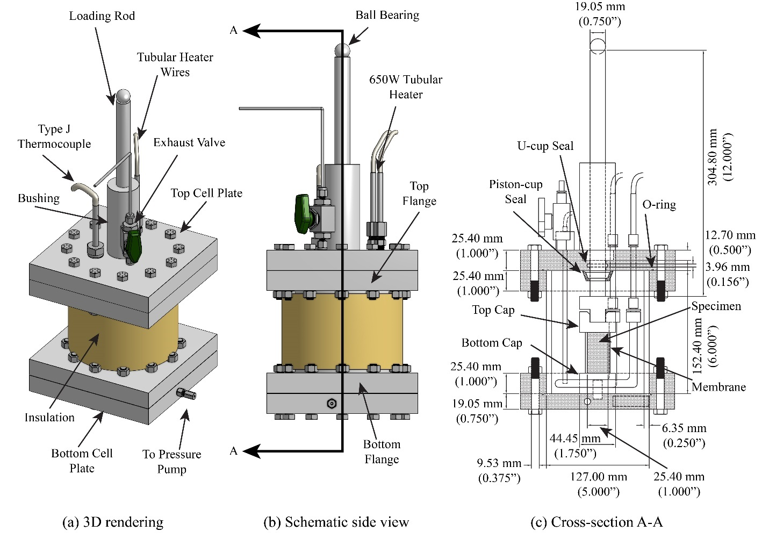

Fig. ‎3-1. The new high-pressure thermal cell’s design
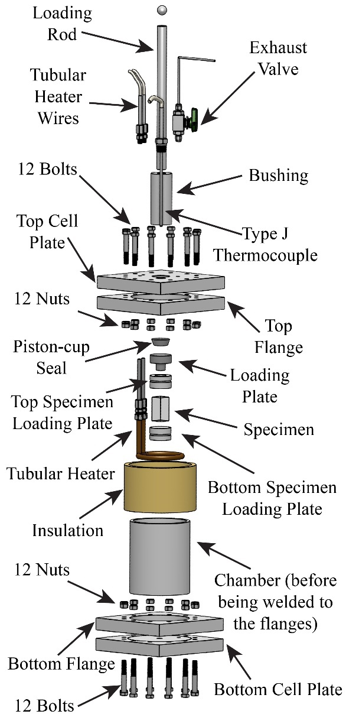

Fig. ‎3-2. Exploded view of the high-pressure thermal cell parts
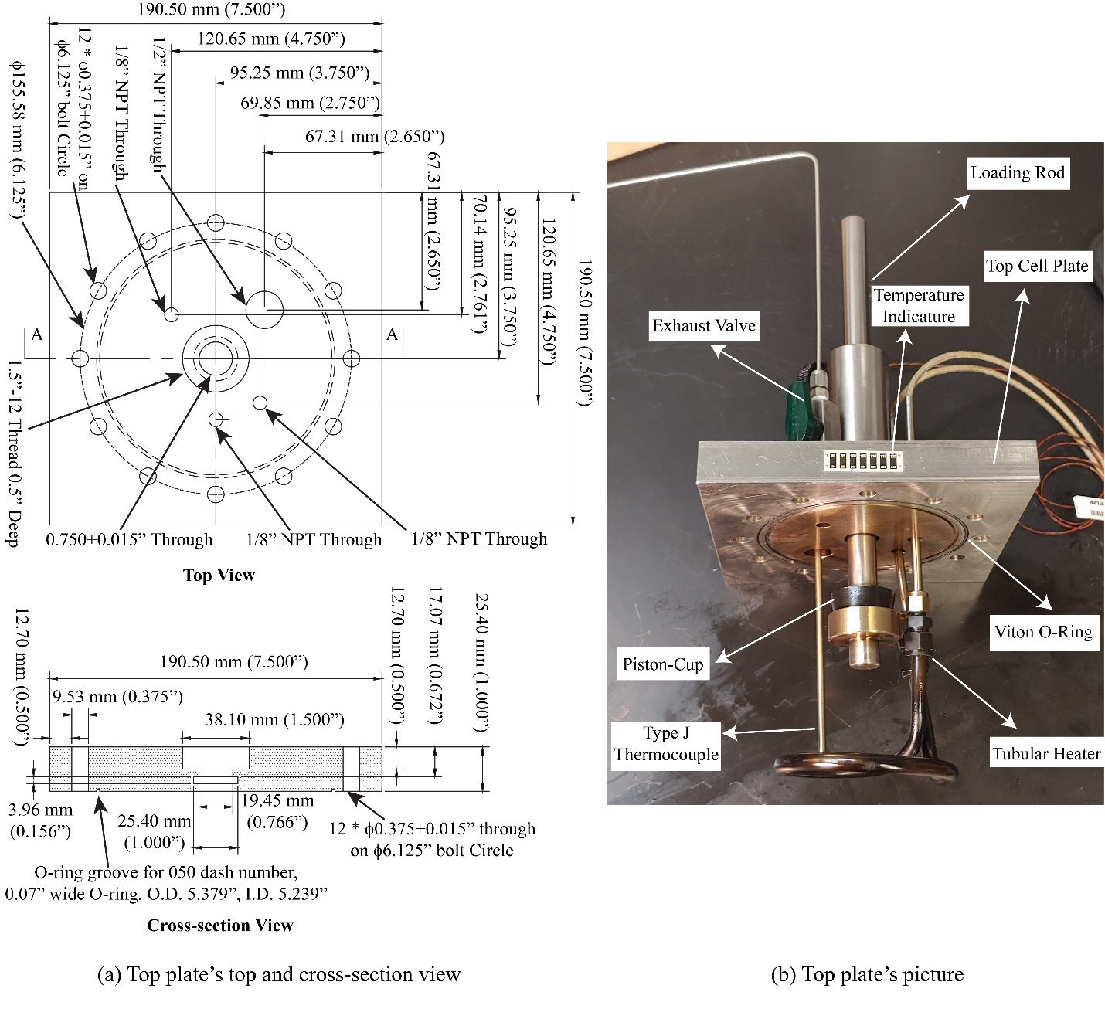

Fig. ‎3-3. Thermal cell’s top plate and the heating components attached to it
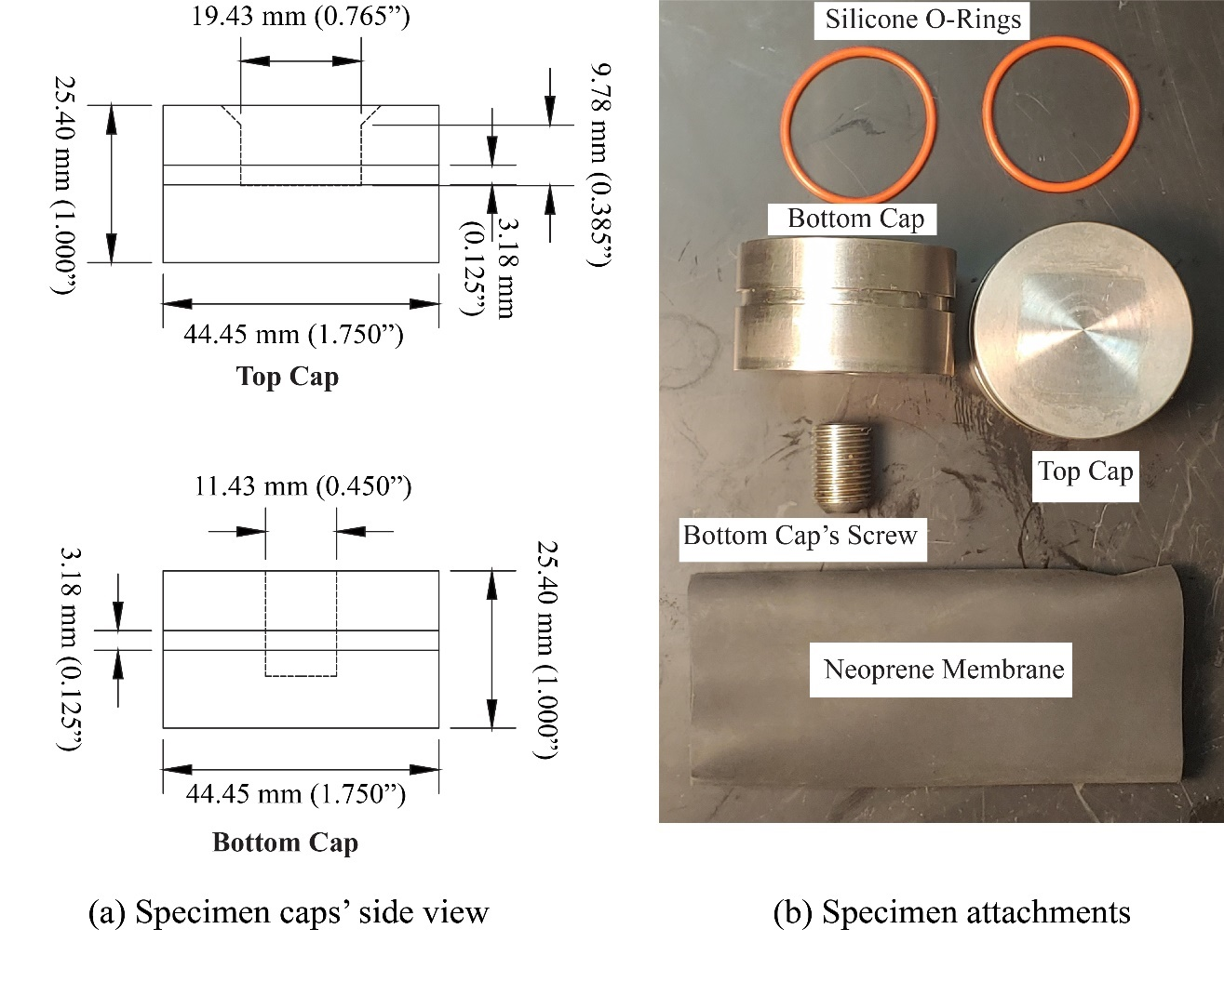

Fig. ‎3-4. Specimen end caps, membrane, and silicone O-rings
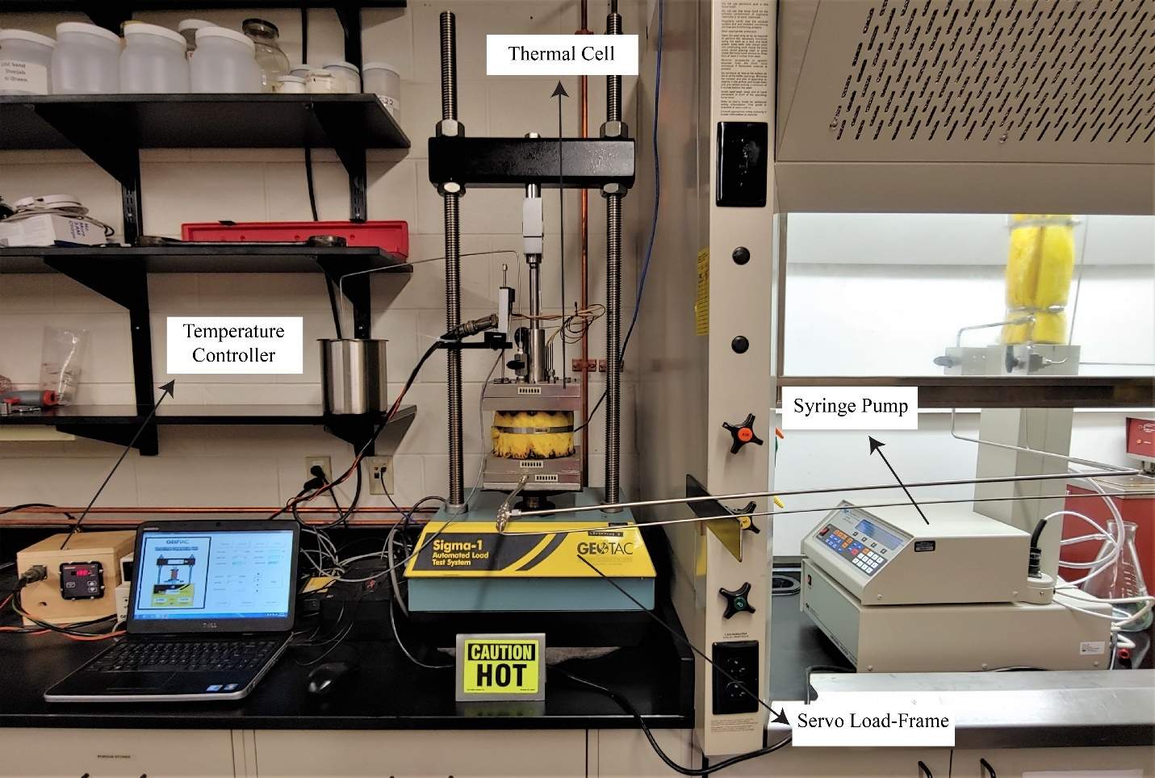

Fig. ‎3-5. The high-pressure thermal triaxial system

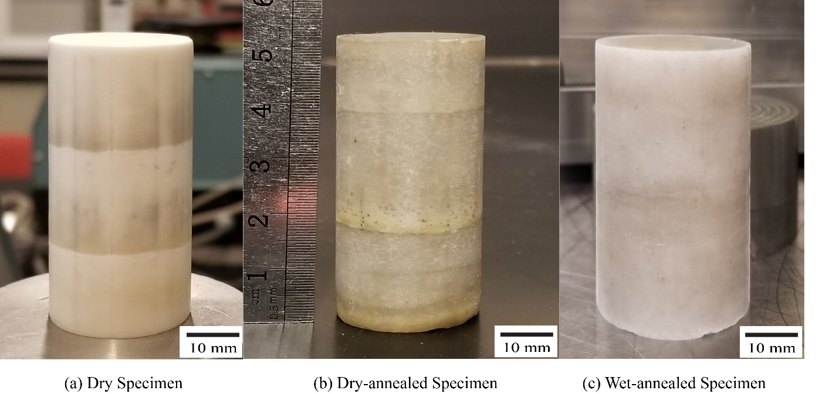

Fig. ‎3-6. Photos of polycrystalline rock salt specimens

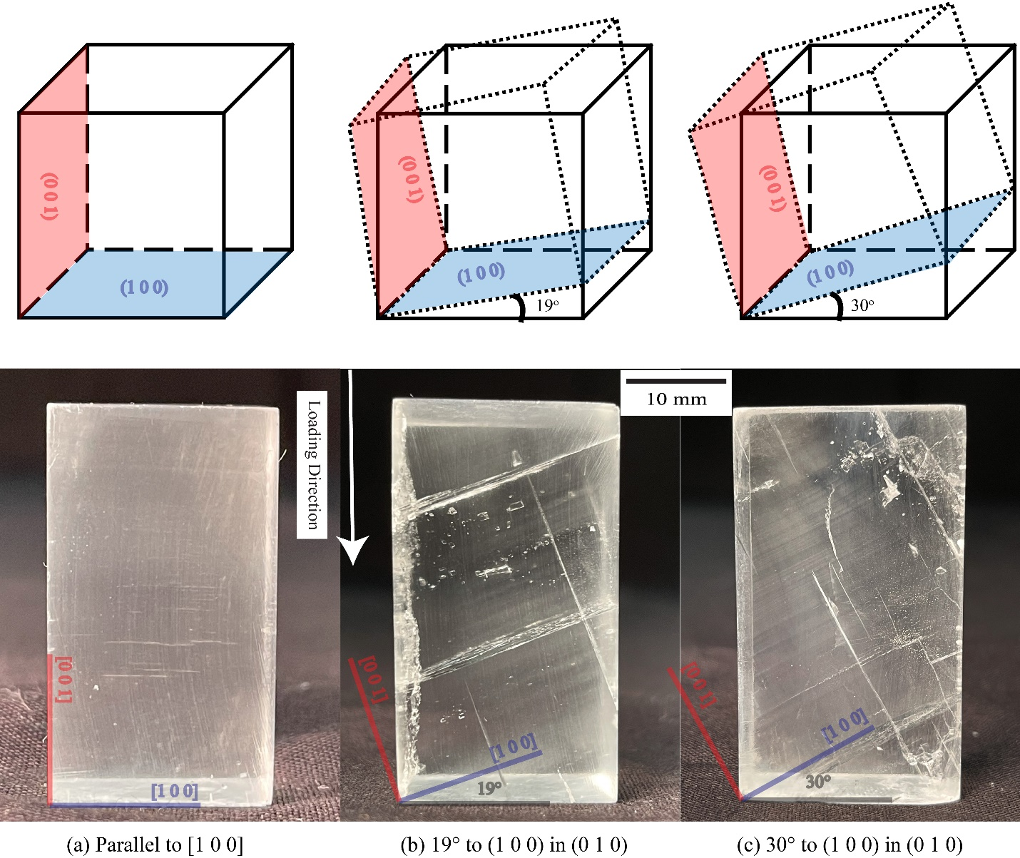

Fig. ‎3-7. Single-crystal rock salt specimens. The solid lines show the specimen’s edges and the dotted lines show the specimen’s crystal orientation
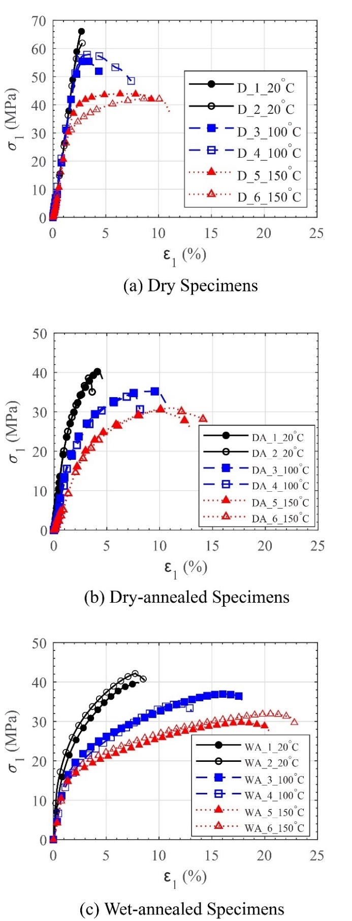

Fig. ‎3-8. Axial strain versus axial stress during unconfined compression experiments on polycrystalline specimens at various temperatures
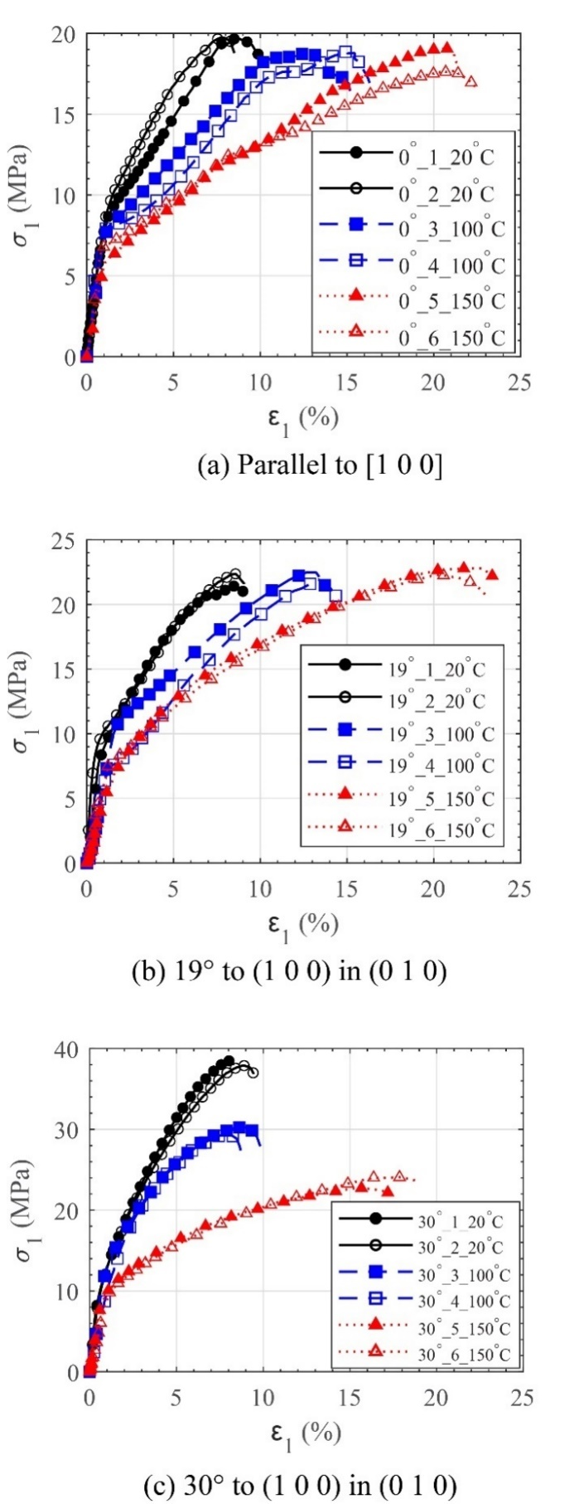

Fig. ‎3-9. Axial strain versus axial stress during unconfined compression experiments on single-crystal specimens with different crystal orientations at various temperatures
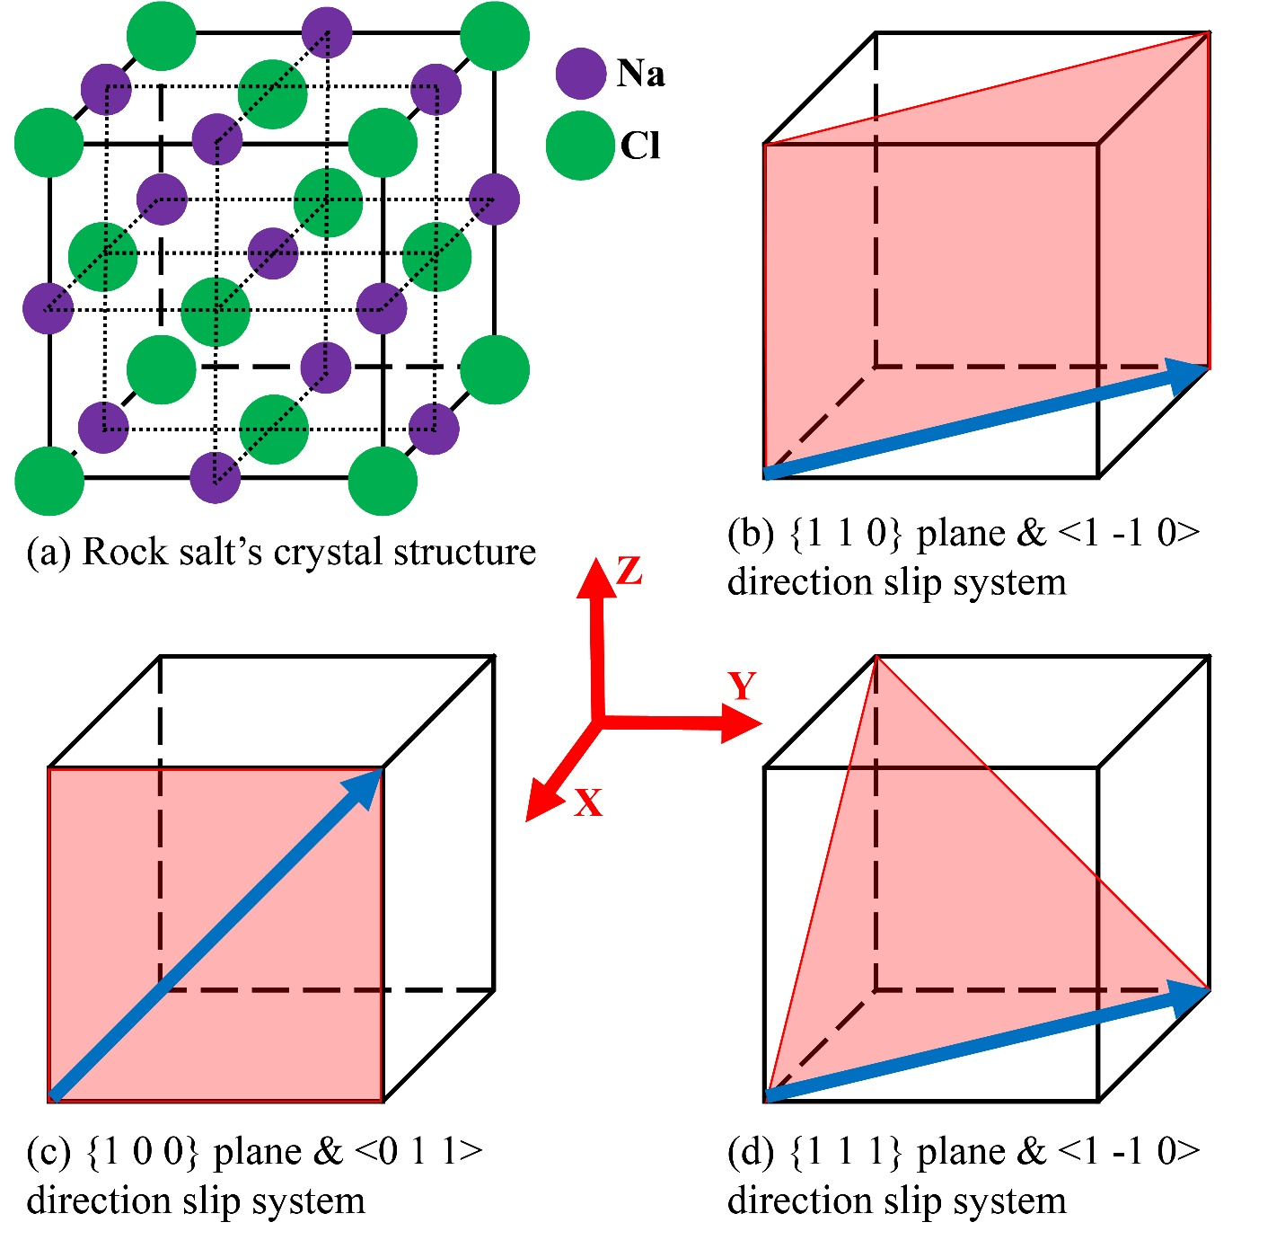

Fig. ‎3-10. Crystal structure of rock salt and its slip systems
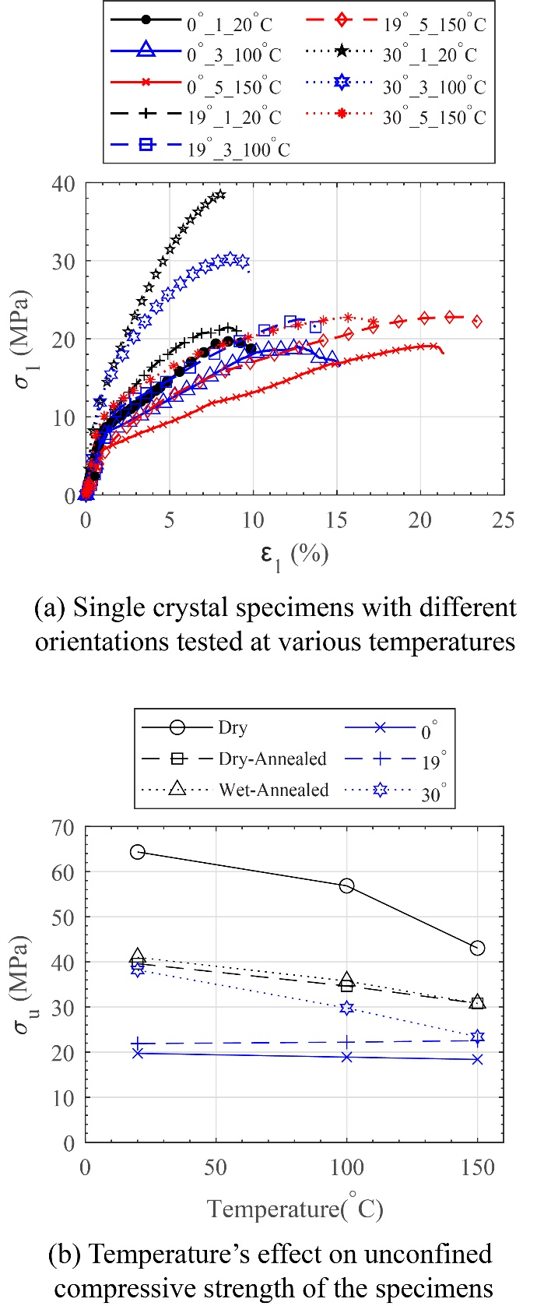

Fig. ‎3-11. Effect of temperature on the unconfined compressive of various rock salt specimens

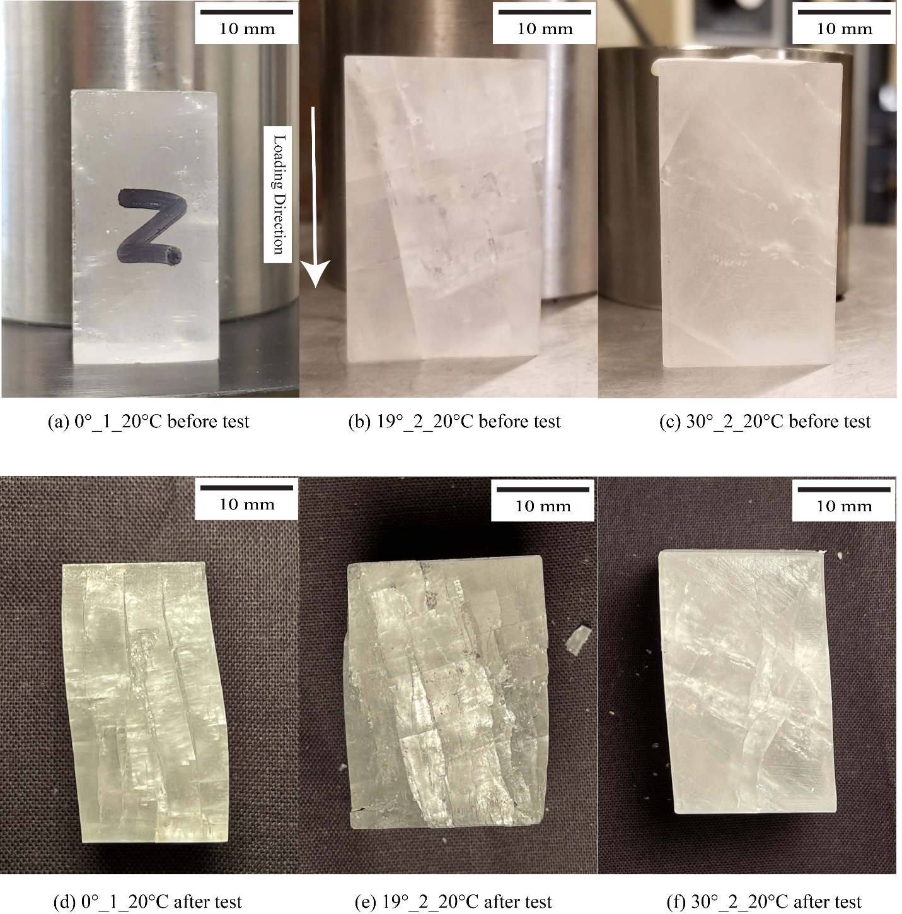

Fig. ‎3-12. Single-crystal specimens with different crystal orientations before and after unconfined compression tests

CHAPTER 4
EVOLUTION OF TEXTURE AND INTERNAL STRESSES WITHIN POLYCRYSTALLINE ROCK SALT USING IN-SITU 3D SYNCHROTRON COMPUTED TOMOGRAPHY AND 3D X-RAY DIFFRACTION

A version of this chapter was originally published by Amirsalar Moslehy, Khalid A. Alshibli, Timothy J. Truster, Peter Kenesei, Wadi H. Imseeh, Zaher Jarrar, Hemant Sharma:
Moslehy, A., Alshibli, K. A., Truster, T. J., Kenesei, P., Imseeh, W. H., Jarrar, Z., & Sharma, H. (2021). Evolution of texture and internal stresses within polycrystalline rock salt using in situ 3D synchrotron computed tomography and 3D X-ray diffraction. Journal of Applied Crystallography, 54(5), 1379-1393.

My contribution to this paper is preparing the specimens, performing some of the experiments, data analysis, and preparing the original draft and all figures.

Abstract

Rock salt caverns have been extensively used as reliable repositories for hazardous waste such as nuclear waste, oil, or compressed gases. Undisturbed rock salt deposits in nature are usually impermeable and have very low porosity. However, rock salt formations under excavation stresses can develop crack networks, which increase their porosities; and in the case of a connected crack network within the media, rock salt may become permeable. Although the relationship between the permeability of rock salt and the applied stresses has been reported in the literature, a microscopic study that investigates the properties influencing this relationship, such as the evolution of texture and internal stresses, has yet to be conducted. This study employs in-situ 3-dimensional (3D) synchrotron micro-computed tomography (SMT) and 3D x-ray diffraction (3DXRD) on two small-scale polycrystalline rock salt specimens to investigate the evolution of the texture and internal stresses within the specimens. 3DXRD technique measures the 3D crystal structure and lattice strains within rock salt grains. The specimens were prepared under 1-D compression condition and have shown an initial {1 1 1} preferred texture, a dominant {1 1 0} <1 -1 0> slip system, and no fully connected crack network. The {1 1 1} preferred texture under the unconfined compression experiment became stronger, while the {1 1 1} <1 -1 0> slip system became more prominent. The specimens did not have a fully connected crack network until reaching applied axial stresses of about 30 MPa, at a point where the impermeability of the material becomes compromised due to development of multiple major cracks.
Keywords: x-ray diffraction, lattice strain, rock salt crystal structure, grain stress, micro-structure of halite.

Introduction

Caverns within rock salt deposits or domes have been used as reliable storage for various materials for many years (Bauer and Urquhart, 2016; Carter et al., 1993; Cosenza et al., 1999; Fam et al., 1998; Senseny et al., 1992; Staudtmeister and Rokahr, 1997; Zhu and Arson, 2014). Recently, designing containerless storage caverns for compressed air or gas has gained more attention (Wang et al., 2018; Zeljaś, 2016; Zhang et al., 2017). However, switching to a containerless storage design emphasizes the importance of the low porosity and impermeability of the material used for storage. Rock salt’s physical and mechanical properties, such as low porosity, low permeability, ductility, and self-healing, making it a viable choice for containerless storage (Chen et al., 2020; Habibi, 2019; W. Liu et al., 2019; Sun et al., 2019; Hong-wu Yin et al., 2019; Hongwu Yin et al., 2020). In low porosity materials such as compressed polycrystalline rock salt, the existence of a connected pore network controls the permeability of the rock mass. Therefore, understanding the development of a connected pore network within the rock salt formation impacts the serviceability of rock salt storage. Undeformed polycrystalline rock salt with porosities below a critical value ranging from 0.02 to 0.05 usually does not have a connected pore network (Paneru et al., 2018). The distribution of stresses within rock salt under loading can initiate and propagate cracks and result in an undesirable connected pore network. In addition, the initial texture of polycrystalline materials influences the development of the pore network within them (W. Ding et al., 2014). Rock salt grains’ anisotropic response to the applied stresses highly depends on the initial texture of the polycrystalline rock salt deposit. Rock salt has a face-centered cubic (FCC) crystal structure (Fig. ‎4-1a). Crystals with an FCC structure have a set of 6 primary slip systems along the {1 1 0} planes and <1 -1 0> directions (Fig. ‎4-1b). Additionally, FCC crystal structures have 6 secondary slip systems along {1 0 0} planes in the directions of <0 1 1> (Fig. ‎4-1c) and 12 secondary slip systems along {1 1 1} planes in the directions of <1 -1 0> (Fig. ‎4-1d).
Depending on the ambient conditions and tectonic pressures at which a rock salt deposit has been compressed, it might develop a preferred crystal orientation (texture). Skrotzki et al. (1983) studied rock salt’s texture development during halokinesis, the process of salt formations flowing towards the surface under tectonic forces (Talbot, 1978), by conducting extrusion tests on natural rock salt blocks. A circular billet was forced through a conical die containing the rock salt specimen, applying a uniaxial stress up to 700 MPa on the core being extruded. The texture of the specimens was then identified using neutron diffraction. Specimens extruded at room temperature or below showed strong <1 1 1> and <1 1 5> fibers, while specimens extruded at higher temperatures exhibited a dominant <1 0 0> fiber. However, the texture can develop differently depending on the direction of the applied stresses. Lebensohn et al. (2003) investigated the evolution of plastic deformations and texture in synthetic polycrystalline rock salt. The texture of the compacted specimens was found to be uniform. The specimens were then tested in extensional triaxial experiments, and their texture after the deformation was evaluated using the electron beam scattering pattern method. The deformed specimens were found to have strong texture components of both {1 0 0} and {1 1 1}. The abundance of grains with {1 0 0} orientations was due to the fact that these grains had a higher probability to slip on {1 1 0} <1 1 0>, resulting in significant plastic deformations of the grains. The deformed grains could then recrystallize and grow to form a dominant {1 0 0} texture. Linckens et al. (2016) tested natural rock salt single-crystal specimens using the unconfined compression procedure at a strain rate of 10⁻⁷ s⁻¹ to investigate the initiation of deformation mechanisms. The stresses were applied perpendicular to {1 0 0} planes to facilitate the activation of {1 1 0} <1 1 0> slip system. Light and scanning electron microscopy were used to examine the activation of the mentioned slip system. The major deformation mechanism was found to be dislocation creep through the formation of sub-grains caused by activating {1 1 0} <1 1 0> slip system. Albeit plastic deformations within rock salt can result in crack propagations, not all components of plastic deformations contribute to it. Na et al. (2018) employed a crystal plastic and a multi-phase field-based approach to simulate the anisotropic thermomechanical response of single-crystal rock salt. The findings showed that by separating the strains of the individual grains into volumetric and deviatoric strains and then only considering the deviatoric strains, the predicted crack propagation within the specimen converges with the actual crack propagation.
Intact rock salt formations usually have low porosity and permeability; however, local cracks may develop during excavation and drilling activities which can significantly increase rock salt’s permeability (Schulze et al., 2001). Popp et al. (2001) investigated the relationship between wave velocity, permeability, and porosity of natural polycrystalline rock salt specimens in hydrostatic compaction and compressional and extensional triaxial experiments. Specimens tested in hydrostatic loading up to 30 MPa did not show any dilatancy, and their permeability decreased by more than 10 times compared to the original cores. The decrease in the permeability of the specimens was due to the closure of microcracks formed by the coring process used to collect them. The specimens tested in triaxial experiments had a dilatancy onset at a differential stress of about 12 MPa. The permeability of the specimens was found to increase upon reaching the dilatancy onset. However, the specimens did not show a significant crack propagation until reaching differential stresses between 18 and 30 MPa (corresponding to axial strains between 5% and 15%), where the increase in the permeability reached a constant plateau. The findings showed that the cracks mainly formed along {1 0 0} planes of the grains, and their orientations with respect to the specimen were highly influenced by the loading path, which caused an anisotropic permeability in the specimens. Alkan et al. (2009) developed a percolation model describing the relationship between the dilatancy and permeability of rock salt at stresses caused by excavation. The specimens were tested under compression triaxial conditions and the development of cracks within the specimens was investigated by microscopy after the test. The main dislocation of the grains was found to be in the direction of the major principal stress ($σ_{1}$), causing the permeability to increase in this direction. The specimens showed a dilatancy boundary approximately at $σ_{1}$=22 MPa, where the micro-fractures within the specimen formed an interconnected pore network resulting in a significant spike in permeability. On the other hand, under high hydrostatic stresses, the deformations may result in complete closure of the cracks within rock salt formations. Singh et al. (2018) studied the deformations caused by boring cavities inside polycrystalline rock salt deposits. The specimens showed preferred orientation on <1 0 0> and <1 1 0> when tested in triaxial compression for the purpose of model verification. The results prove that if the lateral earth pressure is high enough (e.g., if the depth of the cavity is greater than 1000 m), the visco-elasto-plastic deformations over a span of 10 years can close the opening entirely.
Computed tomography (CT) has been proven to be a suitable, non-destructive technique to capture the crack network and its evolution within rock salt (Keller et al., 2014; Thiemeyer et al., 2015). However, the sole usage of CT does not provide any insights regarding the evolution of stresses or texture within rock salt specimens. A solution to overcome this shortcoming is the utilization of electron backscatter scanning diffraction (EBSD) on representative sections of the specimen (Lebensohn et al., 2003). EBSD can only scan the surface of the specimen or to capture scans inside the specimen, it becomes a destructive method; therefore, it cannot be employed in conjunction with mechanical testing methods. As a result, EBSD can only reveal the texture of the specimen after mechanical tests, such as an unconfined compression test, and it cannot track the evolution of texture or stresses inside the specimen. 3-dimensional x-ray diffraction (3DXRD) is a non-destructive in-situ technique that can measure the development of texture and internal stresses of a crystalline material composed of thousands of grains (Amirrahmat et al., 2020; R C Hurley et al., 2016; Ryan C Hurley et al., 2018; Imseeh et al., 2020; Imseeh and Alshibli, 2018; Sharma et al., 2012a, 2012b). In 3DXRD, an incident x-ray beam is targeted at the crystalline specimen. The incident beams diffract when they reach the crystal planes of the grains of the specimen. The diffracted beams follow Bragg’s law (Fig. ‎4-2a and Equation ‎4-1):
$$2d_{hkl}sinθ_{hkl}=λ$$ | (‎4-1)

where hkl is crystal plane (h k l) with Miller indices of h, k, and l, $d_{hkl}$ is the lattice distance between two consecutive hkl planes, $θ_{hkl}$ is the diffraction angle, and $λ$ is the incident beam’s wavelength. When the incident x-ray beam diffracts from the (h k l) plane, it forms Debye-Scherrer rings on a detector placed behind the specimen (Fig. ‎4-2b). Therefore, by having the values of $λ$ and $θ_{hkl}$, the interplanar distance of $d_{hkl}$, which is directly related to lattice parameters of a crystal, can be calculated. By measuring the lattice parameters of a crystal under various applied stresses, the lattice strains of a crystal can be calculated throughout an experiment. The rotation of a polycrystalline specimen about the loading axis allows the diffraction patterns of different (h k l) planes of each crystal to be collected, which eventually yields the strain matrix of individual crystals.
Borthwick et al. (2012) employed an in-situ 3DXRD technique on annealing experiments conducted on a melt-grown single-crystal rock salt specimen. The specimen was heated up to 400° C and a sub-volume of it was mapped by 3DXRD scans before and after annealing. The sub-grain boundary misorientations changed during the annealing process, though it did not show a clear decreasing or increasing pattern. Moreover, a clear trend of sub-grain sub-division was observed within the areas that did not exhibit misorientations before. Furthermore, Borthwick et al. (2012) compared the previously obtained results from in-situ 3DXRD during the annealing of the specimen to the results obtained from in-situ EBSD scans obtained from the same specimen. The analyses of the EBSD scans confirmed all the findings from the 3DXRD scans regarding the changes in sub-grain misorientations and sub-grain subdivision. However, the sub-grain boundary migration rates found using the 3DXRD scans were significantly higher. This discrepancy shows that 2D EBSD scans cannot fully capture grain/sub-grain boundary migration. Viganò et al. (2016; 2018) proposed the implementation of diffraction contrast tomography (DCT), a 3DXRD technique coupled with computerized tomography (CT), for determining grain and grain boundary characteristics such as crystallographic orientation in polycrystalline rock salt. The specimen was composed of large NaCl grains and fine-sized Cu particles as a contrast agent. A sub-volume of the specimen containing about 300 grains was successfully scanned and reconstructed. The spatial positions of the mapped grains and their crystallographic orientations were comparably more accurate than the ones collected from EBSD scans captured for verification.
In summary, there have been many studies on the evolution of porosity and cracks or the development of internal stresses and texture within polycrystalline rock salt under loading. However, no study has yet studied the evolution of all the aforementioned properties in rock salt specimens under loading in conjunction with each other and how they affect each other. This paper studies the evolution of cracks, porosity, texture, and internal stresses in polycrystalline rock salt under unconfined loading condition. Moreover, the internal stresses developed within the specimens are compared with the stresses applied at the specimens’ boundaries. Two polycrystalline rock salt specimens were prepared in this study by dry compression of salt grains. They were tested under the unconfined compression procedure coupled with in-situ 3DXRD and synchrotron micro-computed tomography (SMT) measurements. The SMT scans were analyzed by image processing procedures to track the porosity and crack network of the specimens throughout the experiments. The 3DXRD scans were used for evaluating the internal stresses and orientations of the grains within a sub-volume of the specimen during the experiments containing more than 10,000 grains.

Experiments

Specimen preparation
The raw salt grains used to prepare the specimens for this study were sourced from Windsor Salt Mine, Ontario, Canada. The original prismoidal rock salt block obtained from the mine was about 1.5 × 1.5 × 0.3 m, and it was cut into smaller specimens for various experiments. Rock salt grains needed for preparing small scale specimens were prepared by grinding larger single crystal specimens into a grain size smaller than 0.075 mm (sieve #200). The nominal water content of the ground grains prior to specimen preparation was found to be 0.1% according to ASTM D2216-19 (2019). The specimen preparation method was inspired by the procedure for preparing dry polycrystalline rock salt specimens by Moslehy & Alshibli (Moslehy and Alshibli, 2021); however, the specimens prepared in this study are significantly smaller in size, enabling them to be scanned by a typical synchrotron x-ray beam. Rock salt grains were deposited in three equal layers into a nylon tube that had an inner diameter (ID) of 1.66 mm and a wall thickness of 0.76 mm; such that the tube could be extruded without a need to apply excessive axial stresses directly to the specimen. The nylon tube was placed inside a cylindrical acrylic die with an ID of 3.18 mm, a wall thickness of 14.29 mm, and a length of 38.10 mm to withhold axial stresses of more than 200 MPa (Fig. ‎4-3a). Each layer of the grains was compressed at an axial stress of 200 MPa at room temperature for 20 seconds. Upon the end of the compression of the last layer, the specimen was additionally compressed for 1 hour using the same axial stress. The specimen was then extruded and annealed at a temperature of 200° C for 7 days. Fig. ‎4-3b shows a photo of specimen #1 after the annealing process. The specimens were not perfectly cylindrical, and the edges of the top and bottom of the specimens were elevated (Fig. ‎4-3b). Considering the small size of the specimens, the ends could not be ground using conventional specimen mounting techniques without introducing damages to the specimens; however, precision lapping fixtures can be employed in future studies for mounting and grinding specimens of this size. The dimensions and weight of the specimens were measured, and their initial porosities were calculated assuming a specific gravity of 2.17 for the rock salt grains (Table ‎4-1).
The crystal properties of the constituent grains of the specimens is a key input in determining the properties of the grains being scanned using the in-situ 3DXRD technique. Therefore, a representative amount of the ground grains was evaluated using the powder x-ray diffraction (P-XRD) method. The grains were scanned by a PANalytical Empyrean diffractometer using $k_{α_{1}}$ beams generated from a copper tube and the diffraction pattern was captured using a PIXcel3D detector. Additionally, the instrument was calibrated by conducting a complete P-XRD on LaB₆ standard reference material in accordance with the NIST standard (Black et al., 2011) to eliminate the instrumental errors. Phase identification was initially conducted on the diffraction pattern using the HighScore suite (Degen et al., 2014). The collected pattern matched the halite’s powder diffraction file (PDF) by 99.9%. The collected pattern was then refined by the full Rietveld procedure (McCusker et al., 1999) using GSAS II (Toby and Von Dreele, 2013) based on Swanson and Fuyat’s standard halite diffraction pattern (Swanson and Fuyat, 1953). The calculated crystal properties of the rock salt grains used in this study are presented in Table ‎4-1.

Unconfined compression test with in-situ SMT and 3DXRD
The unconfined compression tests in this study were conducted using a special compression apparatus designed by Druckrey & Alshibli (2016) with a minor modification. The apparatus is a small-scale servo automated load frame capable of applying axial loads up to 1700 N. The bottom part of the cell is stationary and houses a load cell. The axial forces are applied by a stepper motor placed on the top part of the test cell. The top part of the load frame is mounted by 4 acrylic rods on the bottom part to provide access to the loading platens, while they do not interfere significantly with x-ray beams due to their low mass attenuation. The 4-mm diameter loading platens are made of tungsten to prevent any indentation by the samples being tested (Fig. ‎4-4a). The apparatus can be operated in both stress- and strain-controlled modes, where the deformations are obtained from the stepper motor applying the axial load. The specimens were tested in a strain-controlled mode at a constant displacement rate of 0.0009 mm.s⁻¹ resulting in a constant strain rate of ~ 4 × 10⁻⁴ s⁻¹. In addition to the initial SMT and 3DXRD scans, loading was paused at predetermined strains to acquire the SMT and 3DXRD scans. The test on specimen #1 was paused at 0.15%, 0.54%, 1.10%, and 1.98% axial strains while test on specimen #2 was paused at 0.23%, 0.51%, 0.97%, 1.53%, 2.04%, and 3.32% axial strains.
The in-situ SMT and 3DXRD measurements were acquired using x-ray beamline 1-ID at the Advanced Photon Source (APS), Argonne National Laboratory (ANL), Illinois, USA. Fig. ‎4-4c shows the test cell setup on the beamline stage. SMT scans were acquired in 2 stacks each measured 2.1 mm (width) × 1.3 mm (height). The cell was rotated 360° at 0.25° increments and exposure time of 0.9 seconds, which produced a total of 2304 2D SMT radiographs with a spatial resolution of 1.17 µm/pixel. The 2D scans were processed using tomoRecon code (Rivers, 2012). The 3DXRD scans were acquired in 3 layers; each measured 2.1 (width) × 0.4 mm (height) beam on a sub-volume of the specimens at 0.1° rotation increments scanning more than 10,000 grains. Fig. ‎4-4b shows the position of the sub-volume of the specimens scanned using the 3DXRD beam. The 3DXRD scans were analyzed by Microstructural Imaging Diffraction Analysis Software (MIDAS) (Sharma et al., 2012a, 2012b). MIDAS calculates various properties of the grains of the specimens being scanned including, but not limited to, unit cell lattice parameters, spatial coordinates with respect to the specimen’s coordinate system, orientation matrices with respect to the specimen’s coordinate system, and lattice strains.

Results and Discussion

Global strength behavior of the specimens
Fig. ‎4-5 shows the relationship between the global axial strain ($ϵ_{zz}$) and the global axial stresses ($σ_{zz}$). The black diamonds and red squares show $ϵ_{zz}$ where SMT and 3DXRD scans were acquired. The $ϵ_{zz}$ values were initially obtained from the displacements derived by the rotational displacement of the stepper motor. The elevated edges of the specimens were crushed with the increase of the applied global $σ_{zz}$, resulting in artificially high $ϵ_{zz}$ (6-7 times higher than expected) even when they were adjusted using the displacements obtained from the SMT scans. The final adjusted $ϵ_{zz}$ were obtained by tracking traceable micro-cracks within the specimens located at the top and the bottom of the specimens in the SMT scans at different strains steps. These micro-cracks were selected at a distance of two times the height of the elevated edges towards the center of the specimens in the loading direction (z) to avoid the stress fluctuations caused by the elevated edges. The cross-sectional area used in calculating $σ_{zz}$ was also initially calculated according to Equation 4-2, per ASTM-D2850 (2015) and ASTM-D4767 (2020) standards which is valid only under unconfined compression condition and assuming there is no volume change within the specimen:

$$A=\frac{A_{0}}{\left(1-ϵ_{zz}\right)}$$ | (‎4-2)

where $A_{0}$ is the initial cross-sectional area and A is the adjusted cross-sectional area of the specimen at $ϵ_{zz}$. Equation 4-2 accounts for the increase in the cross-sectional area of the specimens with the increase in the axial load. Although the estimated A calculated by Equation 4-2 is usually considered accurate, the assumption of no volume changes within the specimens might not be valid at all instances. Furthermore, the SMT scans provide a much more accurate measurement of the cross-sectional area of the specimens throughout the experiments. Therefore, the cross-sectional area of the specimens was additionally adjusted using the SMT scans.
The unconfined compressive strength of specimens #1 and 2 is very close to the dry compressed specimens and dry annealed specimens reported by Moslehy & Alshibli (Moslehy and Alshibli, 2021). The dry compressed specimens in Moslehy & Alshibli (Moslehy and Alshibli, 2021) were not annealed at all, while the dry annealed specimens were annealed under their compression stresses for 7 days. However, specimens #1 and 2 in this study were annealed without any applied stresses for 7 days. The average unconfined compressive strength of specimens #1 and 2 (~ 59 MPa) was skewed towards the unconfined compressive strength of the dry compressed specimens. The grains of the dry compressed specimens were found to be less recrystallized compared to the dry annealed specimens. Moreover, dry compressed specimens’ grain boundaries were not diffused in contrast to the dry annealed specimens. Therefore, this closeness to the dry compressed specimens shows that in the absence of applied stresses during the annealing process in the preparation of specimens #1 and 2, neither the grains had the opportunity to fully recrystallize, nor did their grain boundaries have the chance to significantly diffuse during specimen preparation.
Specimens #1 and 2 showed higher strains prior to failure when compared to the dry compressed specimens. The aforementioned imperfections (such as the elevated edges) of specimens #1 and 2, even considering the remedies used to remove their adverse effects on the calculated strains, resulted in larger displacements (strains) being calculated. Secondly, the applied stresses on the specimens were paused multiple times during the tests, which resulted in the creep and relaxation of the specimens, enabling them to undergo more deformations. Lastly, recrystallization and grain boundary diffusion lead to the behavior of the material towards a more ductile behavior resulting in higher strains (Moslehy and Alshibli, 2021).

Evolution of the texture and internal stresses within the grains
MIDAS measures the orientations of the scanned grains in 3DXRD with respect to the specimen axes at each 3DXRD measurement. The orientation of each grain was then processed by an orientation matrix defined in Equation 4-3, which transforms the grain’s coordinate system into the specimen’s global coordinate system:

$$R=\left[\begin{matrix}a_{xx} & a_{xy} & a_{xz} \\ a_{yx} & a_{yy} & a_{yz} \\ a_{zx} & a_{zy} & a_{zz}\end{matrix}\right]$$ | (‎4-3)

where $a_{xi}$, $a_{yi}$, and $a_{zi}$ define the [1 0 0], [1 0 0], and [1 0 0] directions of the grain with respect to the specimen global coordinate system. The orientations of the grains obtained from MIDAS were then converted to Bunge Euler angles by solving the following:

$$R^{T}=\left[\begin{matrix}cosφ_{1}cosφ_{2}-sinφ_{1}sinφ_{2}cosΦ & sinφ_{1}cosφ_{2}+cosφ_{1}sinφ_{2}cosΦ & sinφ_{2}sinΦ \\ -cosφ_{1}sinφ_{2}-sinφ_{1}cosφ_{2}cosΦ & -sinφ_{1}sinφ_{2}+cosφ_{1}cosφ_{2}cosΦ & cosφ_{2}sinΦ \\ sinφ_{1}sinΦ & -cosφ_{1}sinΦ & cosΦ\end{matrix}\right]$$ | (‎4-4)

where $φ_{1}$, $Φ$, and $φ_{2}$ are the counterclockwise rotation angles of the specimen’s axes about the z-axis, the [1 0 0] direction, and [0 0 1] direction; respectively, to transfer specimen axes to the crystal axes. The Euler angles of the grains were then used to define the Orientation Distribution Function (ODF) of the specimens using the MTEX MATLAB toolbox (Hielscher and Schaeben, 2008). The obtained ODF results were employed to investigate the changes in the specimens’ texture. Fig. ‎4-6 shows the texture of the specimens with respect to the z-axis of the specimens at different $ϵ_{zz}$ measured in Multiples of Random Distribution (MRD). Both specimens exhibit a strong texture along {1 1 1} orientation before the test (Fig. ‎4-6a and f); however, specimen #1 exhibited a strong texture along {0 3 5} as well. Moreover, specimen #2 showed a stronger presence of {0 0 1} texture whereas specimen #1 showed a very low presence of {0 0 1} texture. These findings demonstrate that rock salt specimens prepared by the 1-D compression method have an initially preferred texture on {1 1 1} orientation which contrasts with the conventional assumption of having an initial random texture (Lebensohn et al., 2003; Y. Liu et al., 2005).
Specimen #1 developed a stronger texture along {1 1 1} orientation and the {0 3 5} texture diminished with the increases of $σ_{zz}$. Moreover, the {0 3 5} texture moved towards {0 1 1} texture in addition to previously mentioned {1 1 1} texture during the experiment. The increase in the intensity of the {1 1 1} texture is a clear indication that the {1 1 1} <1 -1 0> slip system had been the dominant active slip system within the grains (Lebensohn et al., 2003). Specimen #2 likewise developed a stronger texture about the {1 1 1} orientation, which shows the potential high activity of the {1 1 1} <1 -1 0> slip system. The presence of the {1 1 1} texture within the specimens before the tests could increase the activity of the {1 1 1} <1 -1 0> slip system in comparison to the other slip systems, whereas rock salt specimens without any initial texture usually show more activity of the {1 1 0} <1 -1 0> slip system at room temperature (Linckens et al., 2016). Additionally, specimen #2 evolved a moderate texture towards the {0 1 1} orientation, as well. The increase in the {0 1 1} texture (Goss texture) of the specimens during the experiments could be a direct result of grain migration and rotation, where instead of the interior/space diagonal of the grains being parallel to the specimen’s z-axis, their face diagonals became parallel to the specimen’s z-axis. In other words., the grain edges became dominant in the perpendicular plane to specimen’s z-axis rather than the two vertices connecting the grain’s space diagonal. The initial texture found after the 1-D compression loading used in the specimen preparation can be utilized to calibrate numerical models in lieu of assuming a random initial texture for the material. Moreover, the development of texture for the unconfined compression experiments can be employed in the validation of future numerical models, which eventually leads to better prediction of the material’s response.
MIDAS also calculates the lattice strains that occurred within the grains at any given strain in the specimen coordinates system using Bragg’s law explained earlier. The general form of the lattice strains for a grain is:

$$ϵ=\left[\begin{matrix}ϵ_{xx} & ϵ_{xy} & ϵ_{xz} \\ ϵ_{yx} & ϵ_{yy} & ϵ_{yz} \\ ϵ_{zx} & ϵ_{zy} & ϵ_{zz}\end{matrix}\right]$$ | (‎4-5)

where $ϵ_{ij}$ is the strain on a plane with a normal vector parallel to the i-axis, towards the j-axis. To calculate the stresses of the grains from their strains, the strains needed to be defined in the coordinate system of the individual grains. The strains of the grains in their own coordinate system ($ϵ^{'}$) were calculated using Equation 4-6. Further, using the Voigt notation and the stiffness matrix (C) of rock salt, the stresses of the grains in their own coordinate system ($σ_{V}^{'}$) were determined (Equation 4-7). The stress matrices of the grains ($σ^{'}$) were then reconstructed from the $σ_{V}^{'}$ (Equation 4-8).

$$\left[ϵ^{'}\right]=\left[R\right]\left[ϵ\right]\left[R^{T}\right]$$ | (‎4-6)
$\left[σ_{V}^{'}\right]=\left[C\right]\left[ϵ_{V}^{'}\right]$ or $\left[\begin{matrix}σ_{xx}^{'} \\ σ_{yy}^{'} \\ σ_{zz}^{'} \\ σ_{yz}^{'} \\ σ_{zx}^{'} \\ σ_{xy}^{'}\end{matrix}\right]=\left[\begin{matrix}C_{11} & C_{12} & C_{12} & 0 & 0 & 0 \\ C_{12} & C_{11} & C_{12} & 0 & 0 & 0 \\ C_{12} & C_{12} & C_{11} & 0 & 0 & 0 \\ 0 & 0 & 0 & C_{44} & 0 & 0 \\ 0 & 0 & 0 & 0 & C_{44} & 0 \\ 0 & 0 & 0 & 0 & 0 & C_{44}\end{matrix}\right]\left[\begin{matrix}ϵ_{xx}^{'} \\ ϵ_{yy}^{'} \\ ϵ_{zz}^{'} \\ {2ϵ}_{yz}^{'} \\ {2ϵ}_{zx}^{'} \\ {2ϵ}_{xy}^{'}\end{matrix}\right]$ | (‎4-7)
$$σ^{'}=\left[\begin{matrix}σ_{xx}^{'} & σ_{xy}^{'} & σ_{zx}^{'} \\ σ_{xy}^{'} & σ_{yy}^{'} & σ_{yz}^{'} \\ σ_{zx}^{'} & σ_{yz}^{'} & σ_{zz}^{'}\end{matrix}\right]$$ | (‎4-8)

where $C_{11}$, $C_{12}$, and $C_{44}$ are the only independent stiffness coefficients of FCC crystal structures. Rock salt’s C₁₁, C₁₂, and C₄₄ are 49 GPa, 13 GPa, and 13 GPa, respectively (Ahrens, 1995; Q. Liu and He, 2007). By having $σ^{'}$ of the grains, the stresses of the grains in the specimen coordinates system ($σ$) were acquired by employing the orientation matrices of the grains (Equation 4-9).

$$\left[σ\right]=\left[R^{T}\right]\left[σ^{'}\right]\left[R\right]$$ | (‎4-9)

To evaluate the distribution of the stresses within the grains visually, the sub-volume of the specimens scanned by 3DXRD (Fig. ‎4-4b) was divided into a 3D fine mesh grid, where the stresses of each grid were interpolated from the nearest grain to the grid. Fig. ‎4-7a-e show the evolution of $σ_{zz}$ of the specimen #1 grains at different global $ϵ_{zz}$, whereas Fig. ‎4-7g-l depict the evolution of $σ_{zz}$ of the specimen #2 grains at various global $ϵ_{zz}$. Both specimens exhibited a consistent evolution of $σ_{zz}$ within the grains with increase in the global $ϵ_{zz}$. The trend matches the observation from the measured global $σ_{zz}$ showing that both specimens began to develop columns of grains transferring the axial stresses across their heights. Additionally, $σ_{zz}$ began concentrating in specific parts of the specimens. These parts of the specimens, which were under higher axial stresses, had the potential to deform relatively more compared to the rest of the specimen. The presence of differential deformation within the specimens eventually can lead to the propagation of cracks at the grain boundaries. A closer look at Fig. ‎4-7c through e shows that specimen #1 grains located in the negative y-axis space experienced a much higher $σ_{zz}$. Coincidentally, the aforementioned crown-shaped edges of specimen #1 were longer in the positive y-direction (Fig. ‎4-7f, which shows specimen #1’s volume rendering). The longer edges on the positive y-direction were crushed under high stresses, preventing the complete evolution of $σ_{zz}$ in the grains located within the positive y-direction space. Meanwhile, $σ_{zz}$ was distributed uniformly within specimen #2, which had a uniform edge at both ends. The spatial location of the grains with a high $σ_{zz}$ (Fig. ‎4-7) demonstrates that no clear force columns or structures form during this loading condition. Instead, the highly stressed grains and regions are randomly distributed within the material.
Fig. ‎4-8 depicts the distribution of stresses within the grains of each specimen. The $σ_{zz}$ distribution of the grains within both specimens showed a clear increase of 20 and 30 MPa in the mean $σ_{zz}$, respectively, at the end of the experiments. On the other hand, the distribution of the rest of the independent components of the $σ$ tensors of the grains did not exhibit any significant changes during the experiments. This observation confirms that the global stresses applied to the specimens by the top loading platen are carried almost entirely vertically without forming any major force columns in the other directions. Fig. ‎4-8a and f show the distribution of the stresses within the specimens after the preparation. The mean values of shear components of the $σ$ tensors of the grains ($σ_{XY}$,$σ_{XZ}$, and $σ_{YZ}$) were zero. $σ_{XY}$,$σ_{XZ}$, and $σ_{YZ}$ were obtained from the 3DXRD measurements directly and represent the shear strains of the grains in the three orthogonal cartesian directions of the specimens. The absence of the shear components of the $σ$ tensors is due to the fact the symmetry of the specimens and the specimens are at equilibrium. However, the presence of the normal components of the $σ$ tensors after the specimen preparation demonstrates the presence of residual normal lattice strains within the grains after the preparation. The mean of $σ_{XX}$,$σ_{YY}$, and $σ_{ZZ}$ within grains were about +10 MPa meaning that the scanned grains, which were located in the center of the specimens, were under tension. The specimens after the annealing were immediately removed from the oven and were cooled down by being exposed to air at room temperature (20° C). The exposure to a temperature difference of about 180° C leads to a temperature shock. Therefore, the grains closer to the surface of the specimens cooled down faster than the grains closer to the center of the specimens, leaving the grains closer to the center under tension. This observation shows that rock salt grains located closer to the surface and the grains closer to the center can easily develop compressional and tensional normal stresses, respectively, when exposed to a temperature shock.
Plastic deformations can only occur when the applied resolved shear stress (RSS) along at least one of the 24 slip systems reaches the critical resolved shear stresses (CRSS) on that specific slip system. CRSS of each slip system increases as the applied stresses to the grains increase and the grains experience strain hardening. Although, the values of CRSS depend on the stress history of a grain, still by comparing the RSS of the grains with the initial value of CRSS on a slip system, the activity of that slip system can be examined. The initial CRSS values, meaning there has been no strain hardening, for rock salt at room temperature under strain rates ~ 10⁻⁴ s⁻¹ in order for the {1 1 0} <1 -1 0> (${CRSS}_{\{110\}}$), {1 0 0} <0 1 1> (${CRSS}_{\{100\}}$), and {1 1 1} <1 -1 0> (${CRSS}_{\{111\}}$) slip systems, are 5 MPa, 25 MPa, and 20 MPa, respectively (Carter and Heard, 1970). RSS of the grains along each individual slip direction can be calculated from the stress matrices of the grains in their own coordinate system ($σ^{'}$) using Equation 4-10.

$$RSS=\left[d\right]·\left[σ^{'}\right]·[n]$$ | (‎4-10)

where d is the direction of the slip and n is the unit normal vector to the slip plane. The calculated RSS of each individual grain was compared to the set of the initial CRSS of the slip systems to determine if each specific slip system could have been activated within the grain at any strain step.
Fig. ‎4-9 shows the number of the grains that had the chance to deform plastically on different potentially activated slip systems at any given global axial strain step. Initially, more than 87% of the grains of the specimens showed at least one potentially activated slip system. Therefore, a significant amount of plastic deformation occurred within the grains during the preparation of the specimens. More than 25% of the grains only could potentially slip on {1 1 0} <1 -1 0> slip system, while about 25% of the grains had the potential to slip on both {1 1 0} <1 -1 0> and {1 1 1} <1 -1 0> slip systems. Additionally, less than 10% of the grains exhibited RSS on all three slip systems surpassing the corresponding initial CRSS values. It is worth reiterating that the RSS values are calculated based on the remained lattice strains within the individual grains. Therefore, these RSS values represent the locked-in stresses within the grains after the specimen preparation process due to the tension caused by thermal shock. To compare the RSS values with the CRSS values of the grains after strain hardening occurs within the grains, a matching algorithm similar to the algorithm developed by Amirrahmat et al. (2020) is needed to trace individual grains at each global axial strain step. The strain or stress tensor of each individual grain at each global axial strain step can then be compared to its initial value to obtain the strain or stress history of the grain. The strain or stress history of the grains can then be utilized to evaluate the stress state of the grain and compare the RSS values with its respective CRSS values at any stress state. However, in the case of polycrystalline rock salt composed of fine grains, the resolution of an SMT scanner is not sufficient to obtain the precise spatial location of each individual grain needed for a matching algorithm.
The texture of the specimens after the preparation, which exhibited the strong presence of the {1 1 1} texture (Fig. ‎4-6a and f), shows that the approximately 25% of the grains that had the potential to slip on both {1 1 0} <1 -1 0> and {1 1 1} <1 -1 0> slip systems indeed slipped on the {1 1 1} <1 -1 0> slip system. The RSS values of the grains after the specimen preparation illustrate that under the high axial stresses applied to the specimens during the preparation (~ 200 MPa), the {1 1 1} <1 -1 0> slip system that has an initial CRSS value 5 times more than the initial CRSS of the {1 1 0} <1 -1 0> slip system can be activated even at room temperature. Findings of previous studies (J. Ding et al., 2016; Mills et al., 2018; Moslehy and Alshibli, 2021) demonstrate that grain boundary migration, cataclasis, grain rotation, recrystallization, and grain boundary diffusion are the main deformation mechanisms present during 1-D compression loading of rock salt. However, the high values of RSS determined based on the lattice strains occurring within the grains show that crystal plasticity contributes to the material deformations accumulated in 1-D compression loading as well.
As the compression progressed, more than 98% of the grains within the specimens exhibited at least one activated slip system at the final 3DXRD scan. Moreover, the percentage of the grains that only could slip on the {1 1 0} <1 -1 0> slip system dropped to below 10% of the grains. On the other hand, the number of the grains that had the potential to slip on both {1 1 0} <1 -1 0> and {1 1 1} <1 -1 0> slip systems increased to more than 80%. These changes in the potential slip systems agreed with the observations from the texture of the specimens, which showed a significant increase in the {1 1 1} texture with the increase of the applied stresses to the specimens (Fig. ‎4-6). Although the increase in the number of the grains that had the potential to slip on both {1 1 0} <1 -1 0> and {1 1 1} <1 -1 0> slip systems started with the increase in the applied global $σ_{zz}$, the decrease in the number of the grains that could slip only on the {1 1 0} <1 -1 0> slip system did not occur until the applied global $σ_{zz}$ reached 10 MPa. As mentioned earlier, the number of the grains that showed at least one active slip system increased as soon as the experiments started. A hasty inference could be that the new grains that exhibited the potential to slip on any slip systems had the potential to slip on both {1 1 0} <1 -1 0> and {1 1 1} <1 -1 0> slip systems. However, a deeper look at the initial CRSS values of the different slip systems shows that at room temperature, the chances of the RSS of the {1 1 1} <1 -1 0> slip system surpassing the initial CRSS before the RSS of the {1 1 0} <1 -1 0> slip system surpasses its initial CRSS is marginal. In fact, the new grains that could slip on at least one slip system, had the chance to slip on the {1 1 0} <1 -1 0> slip system, and the grains that initially had the potential to slip on the {1 1 0} <1 -1 0> slip system, could then slip on both {1 1 0} <1 -1 0> and {1 1 1} <1 -1 0> slip systems, although the {1 1 0} <1 -1 0> slip system still was found to be the dominant slip system.
Fig. ‎4-10 depicts the location of the grains that had the potential to deform plastically on {1 1 0} <1 -1 0> slip system (Fig. ‎4-10a through e for specimen #1 and Fig. ‎4-10k through p for specimen #2) and the grains that could slip on both {1 1 0} <1 -1 0> and {1 1 1} <1 -1 0> slip systems (Fig. ‎4-10f through j for specimen #1 and Fig. ‎4-10q through v for specimen #2) throughout the experiments. Specimen #1’s grains that were located in the negative y-direction showed a higher conversion from the potential to slip only on the {1 1 0} <1 -1 0> slip system to the potential to slip on both {1 1 0} <1 -1 0> and {1 1 1} <1 -1 0> slip systems compared to the grains located in the positive y-direction. This observation illustrates once again how the uneven crown-shaped edges of specimen #1 influenced the stresses transmitted to individual grains. The grains located in the negative y-direction experienced higher axial stresses in the z-direction due to the earlier development of the force columns in their region. Specimen #2’s grains, on the other hand, exhibited an entirely randomly distributed position of the grains having the {1 1 0} <1 -1 0> slip system and both the {1 1 0} <1 -1 0> and {1 1 1} <1 -1 0> slip systems activated throughout the experiment.

The evolution of the crack networks
Fig. ‎4-11 depicts the reconstructed 3D images of the specimens before the unconfined compression tests and after the tests. To identify the crack network within the specimens each reconstructed 3D image was first filtered by an anisotropic diffusion filter using Avizo (FEI., 2018) to remove the instrumental noises within the image. The image was then thresholded to separate the pores and cracks from the rest of the medium. A closer look at Fig. ‎4-11 shows x-shape artifacts within all reconstructed 3D images caused by the existence of the apparatus’ 4 acrylic rods, which adversely influenced both the specimen’s segmented crack networks and calculated porosity. These x-shape artifacts were mostly removed from the SMT scans by using Avizo’s interactive and hysteresis thresholding modules. Ring artifacts are another common type of artifact in the computed tomography images, which were observed in the collected SMT scans (as later seen in Fig. ‎4-12). Since ring artifacts follow a perfect 2D circle shape, the equation of the governing circle of each ring artifact can be found within the affected scans using Avizo’s inspection and measuring tools. The identified ring artifacts were then removed from the segmented images using Avizo’s “Not” module. Upon remedying the mentioned artifacts, the separated pores within the specimens with a volume of fewer than 3000 µm³ were then found and removed from the image because they were not part of any locally connected pore (crack) network within the specimens. The locally connected pore network within the specimens at each strain level was generated to investigate the evolution of the crack networks with loading (Fig. ‎4-12).
Both specimens had some pre-developed local crack networks prior to the tests and exhibited a dome-shaped, pre-developed crack as shown in Fig. ‎4-12a and f. As noted before, the specimens were prepared in three equal height layers, and these dome-shaped, horizontally-oriented crack networks show the pores at the boundary of the different layers. In other words, the boundaries of these layers were not fully integrated. These horizontally-oriented crack networks did not further develop and gradually decreased in size as the applied global stresses increased. The evolution of the cracks up to global axial strains of about 0.50% did not have any preferred orientation. The cracks normally can occur along the grain boundaries or as a result of the cracks forming within the grains. Moreover, because the specimens’ grains were smaller than the resolution of the SMT scans, the cracks formed within the grains could not be detected, and all the cracks showed in the images were a result of the cracks formed at the grain boundaries. Grain boundaries depending on the condition in which they have been formed, are usually weaker than the grains themselves. As a result, cracks along the grain boundaries are more likely to form under lower applied stresses. Therefore, up to 0.50% global axial strain ($σ_{zz}$ of about 10 MPa) the cracks had been developing along the grain boundaries, which did not necessarily follow any specific texture or direction.
The cracks formed after the global axial strains of about 0.50% gradually became vertical and started developing locally connected crack networks in the z-direction. Looking back at Fig. ‎4-8, the grains only exhibited a significant increase in $σ_{zz}$ compared to the other components of the $σ$ tensors. These vertical cracks were found to be more prominent far from the specimens’ axes where the lateral support by the specimen itself is much lower. The vertical cracks formed within specimen #1 had a stronger presence in the parts of the specimen located in the positive y-direction (Fig. ‎4-12e). As seen in Fig. ‎4-10e, the grains located in the positive y-direction of specimen #1 mainly showed higher activities on the {1 1 0} <1 -1 0> slip system compared to the grains located in the negative y-direction. The initial CRSS of the {1 1 0} <1 -1 0> slip system is much lower than the {1 1 1} <1 -1 0> slip system. Therefore, the grains slipping on the {1 1 0} <1 -1 0> slip system could exhibit higher plastic deformations, which could eventually lead to the development of intra- and inter-grain cracks. Fig. ‎4-12l shows a substantial increase in the development of the crack network within specimen #2. As seen in Fig. ‎4-5, specimen #2 at this stage experienced significant plastic deformations, which caused the greater evolution of the crack network within specimen #2.
The SMT scans of the specimens were further analyzed to evaluate the existence of a fully connected crack network across the specimens at each global axial strain. Only specimen #2 at the $ϵ_{zz}$= 3.32% showed a fully connected crack network across the specimen, which is shown in Fig. ‎4-13a. Comparing Fig. ‎4-13a with Fig. ‎4-12l demonstrates that not all of the locally connected crack networks contributed to the development of the fully connected network within specimen #2 and did not become part of it. The vertical cracks developed closer to the specimen’s surface evolved into a fully connected crack network while the horizontal cracks and the vertical cracks located closer to the specimen’s cylindrical axis were less involved in the fully connected crack network. The evolution of a fully connected crack network within specimen #2 in the z-direction demonstrates that after undergoing $ϵ_{zz}$ of 3.32% the specimen could become permeable, though only in the loading direction. On the other hand, the absence of a fully connected crack (pore) network within the specimens at the other global axial strain steps shows that the material up to $ϵ_{zz}$ of 2.00% remains potentially impermeable.
The porosities of the specimens at each global axial strain were calculated from the volume of the pores (cracks) with respect to the total volume of the specimens. Fig. ‎4-13b shows the relationship between the porosities of the specimens (ϕ) and $ϵ_{zz}$. Specimen #1 and 2 neither displayed a significant increase in their porosities up to $ϵ_{zz}$ of about 2.00%. As discussed before, the specimens coincidentally did not exhibit a spike in the development of the crack networks up to this stage. Therefore, it is safe to deduce the porosity of rock salt remains small below an $ϵ_{zz}$ of about 2.00% (corresponding to $σ_{zz}$ of about 30 MPa). Albeit not significant, a direct increase in the porosities of the specimens was observed with the increase in the applied $ϵ_{zz}$. If the applied global $σ_{zz}$ exceeds the critical value of 30 MPa, the material eventually evolves a fully connected crack network in the z-direction, which significantly increases the permeability of the material in the z-direction. Therefore, global $σ_{zz}$ higher than 30 MPa can be detrimental to the stability and serviceability of rock salt caverns possessing a similar initial texture and porosity to the specimens studied in this paper. Porous rock salt under unconfined compression loading generally shows an initial contraction (caused by the closure of the cracks and pores within the media) followed by a continuous expansion until the failure. However, the specimens tested in this study exhibited a continuous expansion throughout the tests. They were prepared at a uniaxial stress of 200 MPa and possessed a low initial porosity, which reduced their potential to show contraction at the beginning of the experiments. Moreover, significant closure of the cracks within the specimens was not observed in the SMT scans obtained throughout the experiments (Fig. ‎4-12). Specimen #2 showed a spike in ϕ at the final global axial strain step (3.32%), where it possessed a fully connected crack network. The porosity of specimen #2 at this step (ϕ=5.7%) surpassed the upper limit of the critical ϕ value (5%) suggested by Paneru et al. (2018), which corresponds to the porosity of rock salt where it becomes permeable. Conversely, the specimens under $ϵ_{zz}$ of more than 0.50% surpassed lower limit of the critical ϕ value (2%), although they did not demonstrate a fully connected crack network. The discrete scanning nature of the in situ 3DXRD and SMT limited the number of steps at which the specimens could be scanned in a timely manner. As a result, the certain critical ϕ where the specimens evolved a fully connected crack network remains unknown. However, based on the SMT scans obtained at $ϵ_{zz}$ about 2.00% and 3.32%, the critical ϕ of the specimens could be bound between 2.5% and 5.7%.

Summary and Conclusions

Two small-scale polycrystalline specimens were prepared at 200 MPa uniaxial stress inside an acrylic die. The specimens were then tested under the unconfined compression procedure coupled with in-situ SMT and 3DXRD scanning. The SMT and 3DXRD scans in conjunction with the global stress-strain measurements from the tests were analyzed to investigate the evolution of texture, internal stresses, cracks, and porosity of the specimens initially and at different strain steps during the unconfined compression tests. A preferred texture along {1 1 1} orientation was observed after the specimen preparation under the 1-D compression loading and annealing. More than 87% of the grains potentially had deformed plastically during the preparation process showing that a significant amount of crystal plasticity occurs during the 1-D compression of the material. The dominant slip system was identified as {1 1 0} <1 -1 0> at this stage. The only pre-existing crack networks were dome-shaped crack networks oriented horizontally and located at the boundaries of the different layers by which the specimens were prepared, which shows the boundaries of these layers were not fully diffused. On the other hand, the porosity of the material was about 1.6% and it did not possess a fully connected crack network after the preparation pointing out to low permeability of the material.
During the unconfined compression test, the specimens developed a stronger texture along the {1 1 1} orientation, and the other textures diminished with the increases of global axial strain. As the applied stresses increased, the grains showed more activity on the {1 1 1} <1 -1 0> slip system and the activity of the {1 1 0} <1 -1 0> slip system was decreased showing that within polycrystalline rock salt with an initially strong {1 1 1} texture, {1 1 1} <1 -1 0> slip system can become more dominant compared to polycrystalline rock salt with a random initial texture. No clear force chain or structure formation was observed during the tests.
Under global axial strains up to about 0.50% (corresponding to global axial stresses of about 10 MPa), the specimens showed developments of local crack networks in all directions. The porosity of the material was still under 2% and no fully connected crack network was observed. However, surpassing global axial strains of about 0.50%, the crack networks started to develop mainly in the z (loading) direction, albeit fully connected crack networks throughout the material were not formed. Meaning the material can still be considered as nearly impermeable. Reaching the global axial strain of 3.32% (corresponding to global axial stresses of about 30 MPa) and porosity of 5.7% a fully connected crack network indicating a potential increase in the permeability of the material.

Acknowledgments

This material is based on work supported by the National Science Foundation (NSF) under Grant # CMMI- 1641054. Any opinions, findings, conclusions, and recommendations expressed in this material are those of the authors and do not necessarily reflect the views of NSF. P-XRD was acquired at the Joint Institute for Advanced Materials (JIAM) Diffraction Facility of the University of Tennessee, Knoxville. The SMT and 3DXRD images were collected using Beamline 1-ID at Argonne Photon Source (APS), Argonne National Laboratory. Use of the Advanced Photon Source, an Office of Science User Facility operated for the U.S. Department of Energy (DOE) Office of Science by Argonne National Laboratory, was supported by the U.S. DOE under Contract No. DE-AC02-06CH11357. The authors thank Dr. Siavash Amirrahmat, Isabella Alamilla, and Darcie Halliburton, undergraduate research assistants at the University of Tennessee, Knoxville, for their help.

References

Ahrens, T. J. (1995). Mineral physics & crystallography: a handbook of physical constants (Vol. 2). American Geophysical Union.
Alkan, H. (2009). Percolation model for dilatancy-induced permeability of the excavation damaged zone in rock salt. International Journal of Rock Mechanics and Mining Sciences, 46(4), 716–724.
Alshibli, K., Cil, M. B., Kenesei, P., and Lienert, U. (2013). Strain tensor determination of compressed individual silica sand particles using high-energy synchrotron diffraction. Granular Matter, 15(5), 517–530.
Amirrahmat, S., Imseeh, W. H., Alshibli, K. A., Kenesei, P., Jarrar, Z. A., and Sharma, H. (2020). 3D Experimental Measurements of Evolution of Force Chains in Natural Silica Sand. Journal of Geotechnical and Geoenvironmental Engineering, 146(5), 4020027.
ASTM. (2015). D2850-15, Standard Test Method for Unconsolidated-Undrained Triaxial Compression Test on Cohesive Soils. ASTM International, West Conshohocken, PA.
ASTM. (2019). D2216-19 (2019). Standard Test Methods for Laboratory Determination of Water (Moisture) Content of Soil and Rock by Mass, ASTM International, West Conshohocken, Pa., DOI: 10.1520/D2216-19.
ASTM. (2020). D4767-11(2020), Standard Test Method for Consolidated Undrained Triaxial Compression Test for Cohesive Soils. ASTM International, West Conshohocken, PA.
Bauer, S., and Urquhart, A. (2016). Thermal and physical properties of reconsolidated crushed rock salt as a function of porosity and temperature. Acta Geotechnica, 11(4), 913–924.
Black, D. R., Windover, D., Henins, A., Filliben, J., and Cline, J. P. (2011). Certification of standard reference material 660B. Powder Diffraction, 26(2), 155–158.
Borthwick, V. E., Schmidt, S., Piazolo, S., and Gundlach, C. (2012). Quantification of mineral behavior in four dimensions: Grain boundary and substructure dynamics in salt. Geochemistry, Geophysics, Geosystems, 13(5).
Borthwick, V., Schmidt, S., Piazolo, S., Gundlach, C., Griera, A., Bons, P. D., and Jessell, M. W. (2012). The application of in situ 3D X-ray diffraction in annealing experiments: first interpretation of substructure development in deformed NaCl. Materials Science Forum, 715, 461–466.
Carter, Neville L, and Heard, H. C. (1970). Temperature and rate dependent deformation of halite. American Journal of Science, 269(3), 193–249.
Carter, N L, Horseman, S. T., Russell, J. E., and Handin, J. (1993). Rheology of rocksalt. Journal of Structural Geology, 15(9–10), 1257–1271.
Chen, J., Peng, H., Fan, J., Zhang, X., Liu, W., and Jiang, D. (2020). Microscopic investigations on the healing and softening of damaged salt by uniaxial deformation from CT, SEM and NMR: effect of fluids (brine and oil). RSC Advances, 10(5), 2877–2886.
Cosenza, P., Ghoreychi, M., Bazargan-Sabet, B., and De Marsily, G. (1999). In situ rock salt permeability measurement for long term safety assessment of storage. International Journal of Rock Mechanics and Mining Sciences, 36(4), 509–526.
Degen, T., Sadki, M., Bron, E., König, U., and Nénert, G. (2014). The highscore suite. Powder Diffraction, 29(S2), S13--S18.
Ding, J., Chester, F. M., Chester, J. S., Zhu, C., Arson, C., and others. (2016). Mechanical behavior and microstructure development in consolidation of nominally dry granular salt. 50th US Rock Mechanics/Geomechanics Symposium.
Ding, W., Li, H., Pfeifer, P., and Dittmeyer, R. (2014). Crystallite-pore network model of transport and reaction of multicomponent gas mixtures in polycrystalline microporous media. Chemical Engineering Journal, 254, 545–558.
Druckrey, A. M., and Alshibli, K. A. (2016). 3D finite element modeling of sand particle fracture based on in situ X-Ray synchrotron imaging. International Journal for Numerical and Analytical Methods in Geomechanics, 40(1), 105–116. https://doi.org/10.1002/nag.2396
Fam, M., Santamarina, J. C., and Dusseault, M. B. (1998). Wave-based monitoring processes in granular salt. Journal of Environmental and Engineering Geophysics, 3(1), 15–26.
FEI. (2018). Avizo. 9.7 ed. FEI.
Habibi, R. (2019). An investigation into design concepts, design methods and stability criteria of salt caverns. Oil & Gas Science and Technology-Rev. IFP Energies Nouvelles, 74, 14.
Hielscher, R., and Schaeben, H. (2008). A novel pole figure inversion method: specification of the MTEX algorithm. Journal of Applied Crystallography, 41(6), 1024–1037.
Hurley, R C, Hall, S. A., Andrade, J. E., and Wright, J. (2016). Quantifying interparticle forces and heterogeneity in 3D granular materials. Physical Review Letters, 117(9), 98005.
Hurley, Ryan C, Herbold, E. B., and Pagan, D. C. (2018). Characterization of the crystal structure, kinematics, stresses and rotations in angular granular quartz during compaction. Journal of Applied Crystallography, 51(4), 1021–1034.
Imseeh, W. H., and Alshibli, K. A. (2018). 3D finite element modelling of force transmission and particle fracture of sand. Computers and Geotechnics, 94, 184–195.
Imseeh, W. H., Alshibli, K. A., Moslehy, A., Kenesei, P., and Sharma, H. (2020). Influence of Crystal Structure on Constitutive Anisotropy of Silica Sand at Particle-Scale. Computers and Geotechnics, 126, 103718.
Keller, L. M., Jobmann, M., Schuetz, P., and Gasser, P. (2014). On the potential of tomographic methods when applied to compacted crushed rock salt. Transport in Porous Media, 104(3), 607–620.
Lebensohn, R. A., Dawson, P. R., Kern, H. M., and Wenk, H.-R. (2003). Heterogeneous deformation and texture development in halite polycrystals: comparison of different modeling approaches and experimental data. Tectonophysics, 370(1–4), 287–311.
Linckens, J., Zulauf, G., and Hammer, J. (2016). Experimental deformation of coarse-grained rock salt to high strain. Journal of Geophysical Research: Solid Earth, 121(8), 6150–6171.
Liu, Q., and He, Q. (2007). Elastic constants for various classes of solids at high temperature. Acta Physica Polonica A, 112(1), 69–76.
Liu, W., Zhang, Z., Chen, J., Fan, J., Jiang, D., Jjk, D., and Li, Y. (2019). Physical simulation of construction and control of two butted-well horizontal cavern energy storage using large molded rock salt specimens. Energy, 185, 682–694.
Liu, Y., Gilormini, P., and Ponte Castañeda, P. (2005). Homogenization estimates for texture evolution in halite. Tectonophysics, 406(3), 179–195. https://doi.org/https://doi.org/10.1016/j.tecto.2005.06.007
McCusker, L. B., Von Dreele, R. B., Cox, D. E., Louër, D., and Scardi, P. (1999). Rietveld refinement guidelines. Journal of Applied Crystallography, 32(1), 36–50.
Mills, M. M., Stormont, J. C., and Bauer, S. J. (2018). Micromechanical processes in consolidated granular salt. Engineering Geology, 239, 206–213.
Moslehy, A., and Alshibli, K. (2021). Assessment of the properties of polycrystalline rock salt synthesized under nominally dry and wet conditions. Journal of Rock Mechanics and Geotechnical Engineering, 13(2), 311–320. https://doi.org/https://doi.org/10.1016/j.jrmge.2020.09.010
Na, S., and Sun, W. (2018). Computational thermomechanics of crystalline rock, Part I: A combined multi-phase-field/crystal plasticity approach for single crystal simulations. Computer Methods in Applied Mechanics and Engineering, 338, 657–691.
Paneru, L. P., Bauer, S. J., and Stormont, J. C. (2018). Thermal Properties of Consolidated Granular Salt as a Backfill Material. Rock Mechanics and Rock Engineering, 51(3), 911–923.
Popp, T., Kern, H., and Schulze, O. (2001). Evolution of dilatancy and permeability in rock salt during hydrostatic compaction and triaxial deformation. Journal of Geophysical Research: Solid Earth, 106(B3), 4061–4078.
Rivers, M. L. (2012). tomoRecon: High-speed tomography reconstruction on workstations using multi-threading. In S. R. Stock (Ed.), Developments in X-Ray Tomography VIII (Vol. 8506, pp. 169–181). SPIE. https://doi.org/10.1117/12.930022
Schulze, O., Popp, T., and Kern, H. (2001). Development of damage and permeability in deforming rock salt. Engineering Geology, 61(2), 163–180. https://doi.org/https://doi.org/10.1016/S0013-7952(01)00051-5
Senseny, P. E., Hansen, F. D., Russell, J. E., Carter, N. L., and Handin, J. W. (1992). Mechanical-Behavior of Rock Salt - Phenomenology and Micromechanisms. International Journal of Rock Mechanics and Mining Sciences, 29(4), 363–378. https://doi.org/Doi 10.1016/0148-9062(92)90513-Y
Sharma, H., Huizenga, R. M., and Offerman, S. E. (2012a). A fast methodology to determine the characteristics of thousands of grains using three-dimensional X-ray diffraction. I. Overlapping diffraction peaks and parameters of the experimental setup. Journal of Applied Crystallography, 45(4), 693–704.
Sharma, H., Huizenga, R. M., and Offerman, S. E. (2012b). A fast methodology to determine the characteristics of thousands of grains using three-dimensional X-ray diffraction. II. Volume, centre-of-mass position, crystallographic orientation and strain state of grains. Journal of Applied Crystallography, 45(4), 705–718.
Singh, A., Kumar, C., Kannan, L. G., Rao, K. S., and Ayothiraman, R. (2018). Engineering properties of rock salt and simplified closed-form deformation solution for circular opening in rock salt under the true triaxial stress state. Engineering Geology, 243, 218–230.
Skrotzki, W., and Welch, P. (1983). Development of texture and microstructure in extruded ionic polycrystalline aggregates. Tectonophysics, 99(1), 47–61.
Staudtmeister, K., and Rokahr, R. B. (1997). Rock mechanical design of storage caverns for natural gas in rock salt mass. International Journal of Rock Mechanics and Mining Sciences, 34(3–4), 300--e1.
Sun, Z., Fan, J., Wu, F., and Chen, J. (2019). A dilatancy-damage model considering temperature effect for rock salt from unloading path. Thermal Science, 23(Suppl. 3), 997–1003.
Swanson, H. E., and Fuyat, R. K. (1953). Standard X-ray diffraction patterns. Sodium chloride, Na Cl (cubic). National Bureau of Standards, 539, 41–43.
Talbot, C. J. (1978). Halokinesis and thermal convection. Nature, 273(5665), 739–741. https://doi.org/10.1038/273739a0
Thiemeyer, N., Habersetzer, J., Peinl, M., Zulauf, G., and Hammer, J. (2015). The application of high resolution x-ray computed tomography on naturally deformed rock salt: Multi-scale investigations of the structural inventory. Journal of Structural Geology, 77, 92–106.
Toby, B. H., and Von Dreele, R. B. (2013). GSAS-II: the genesis of a modern open-source all purpose crystallography software package. Journal of Applied Crystallography, 46(2), 544–549.
Vigano, N., and Ludwig, W. (2018). Advances in 6d diffraction contrast tomography. Journal of Instrumentation, 13(04), C04017.
Viganò, N., Tanguy, A., Hallais, S., Dimanov, A., Bornert, M., Batenburg, K. J., and Ludwig, W. (2016). Three-dimensional full-field X-ray orientation microscopy. Scientific Reports, 6(1), 1–9.
Wang, T. T., Ma, H. L., Shi, X. L., Yang, C. H., Zhang, N., Li, J. L., Ding, S. L., and Daemen, J. J. K. (2018). Salt cavern gas storage in an ultra-deep formation in Hubei, China. International Journal of Rock Mechanics and Mining Sciences, 102, 57–70.
Yin, Hong-wu, Ma, H., Shi, X., Li, H., Ge, X., and Gao, A. (2019). Experimental study on repair characteristics of damaged rock salt of underground gas storage. Journal of Central South University, 26(8), 2185–2196.
Yin, Hongwu, Yang, C., Ma, H., Shi, X., Zhang, N., Ge, X., Li, H., and Han, Y. (2020). Stability evaluation of underground gas storage salt caverns with micro-leakage interlayer in bedded rock salt of Jintan, China. Acta Geotechnica, 15(3), 549–563.
Zeljaś, D. (2016). How to localize an Underground Gas Storage (UGS) in a salt structure of the Fore-Sudetic Monocline in light of its geomechanical properties. AGH Drilling, Oil, Gas, 33(4).
Zhang, Q. Y., Duan, K., Jiao, Y. Y., and Xiang, W. (2017). Physical model test and numerical simulation for the stability analysis of deep gas storage cavern group located in bedded rock salt formation. International Journal of Rock Mechanics and Mining Sciences, 94, 43–54.
Zhu, C., and Arson, C. (2014). A thermo-mechanical damage model for rock stiffness during anisotropic crack opening and closure. Acta Geotechnica, 9(5), 847–867.

Appendix

Table ‎4-1. Physical properties of the specimens after annealing, and crystal properties of rock salt grains calculated from P-XRD results

Specimen | Height |  | Diameter | Weight | Porosity
Specimen | (mm) |  | (mm) | (g) | (%)
#1 | 2.32 |  | 2.04 | 0.0162 | 1.6
#2 | 2.51 |  | 2.01 | 0.0170 | 1.6
Property |  | Value
Chemical Formula |  | NaCl
Crystal System |  | FCC
Lattice System |  | FCC
Space Group Number |  | 225
Space Group Name |  | Fm-3m
Unit Cell Lattice Parameters |  | a: 5.6386(Å)  b: 5.6386 (Å)  c: 5.6386 (Å)  α: 90 °  β: 90 °  γ: 90 °
Volume: |  | 179.27 (Å³)
Calculated Density: |  | 2.165 (g/cm³)

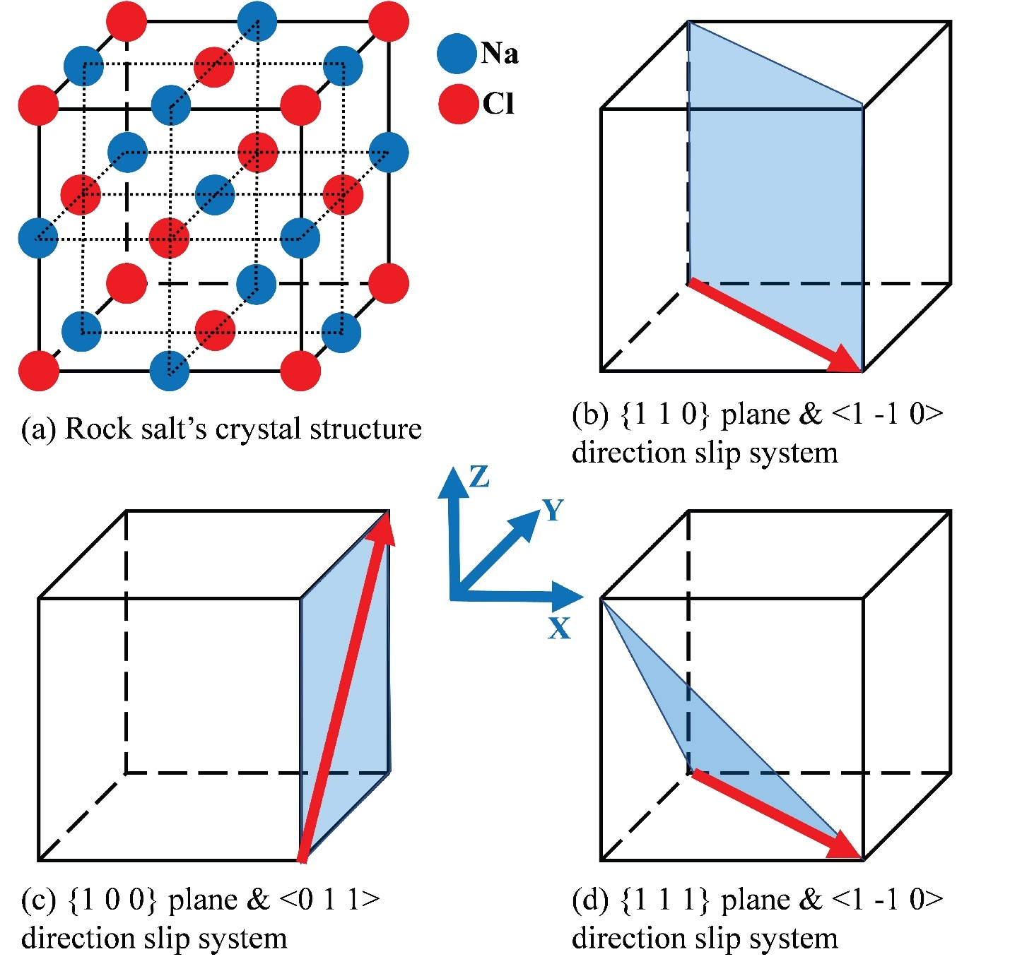

Fig. ‎4-1. Rock salt’s crystal structure and its primary and secondary slip systems

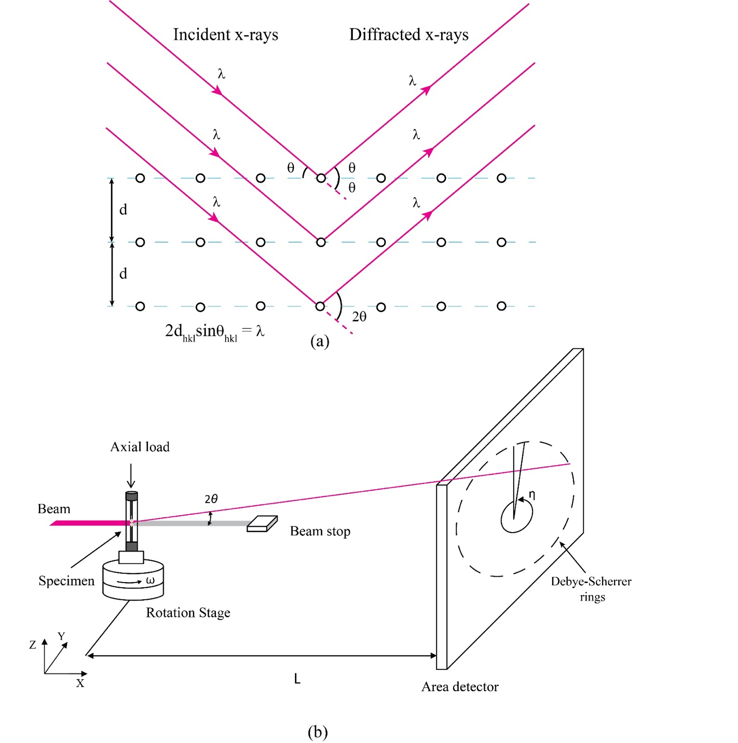

Fig. ‎4-2. (a) Bragg’s law (b) 3DXRD setup (Alshibli et al., 2013)
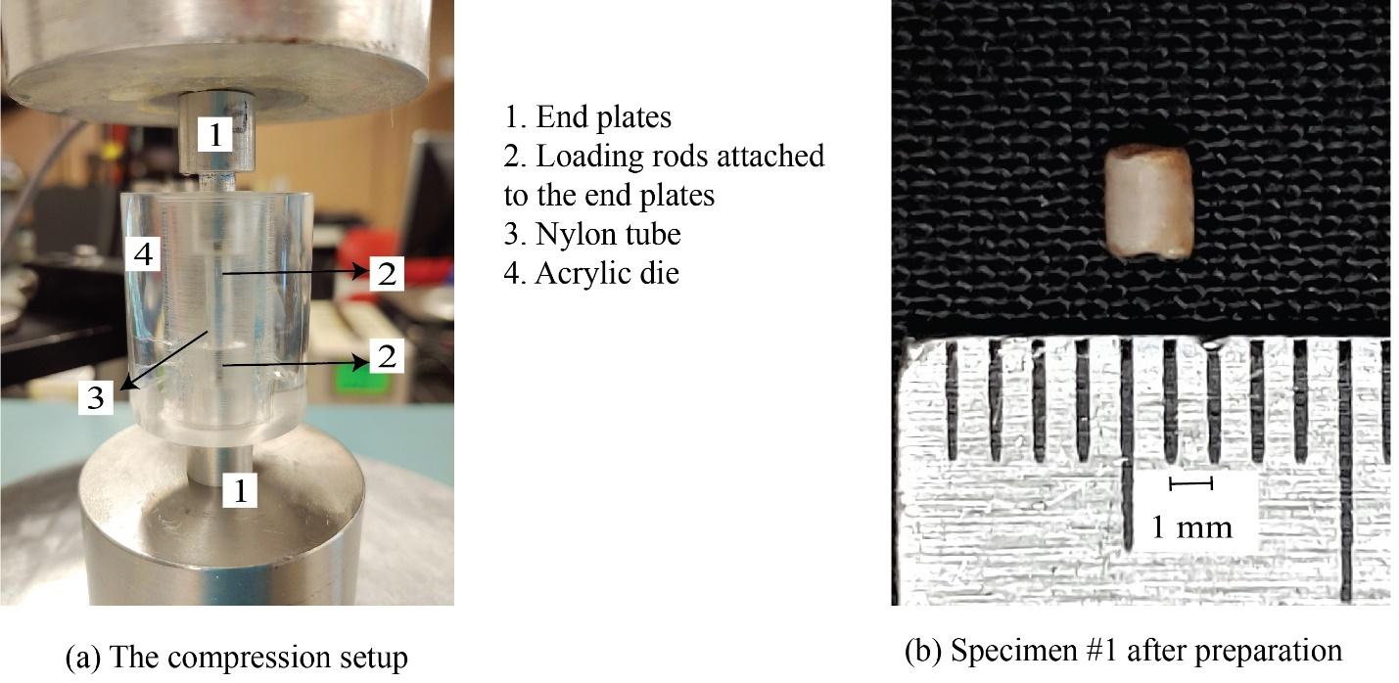

Fig. ‎4-3. Polycrystalline rock salt specimen preparation: (a) the compression setup; (b) specimen #1 after the 1-D compression and annealing
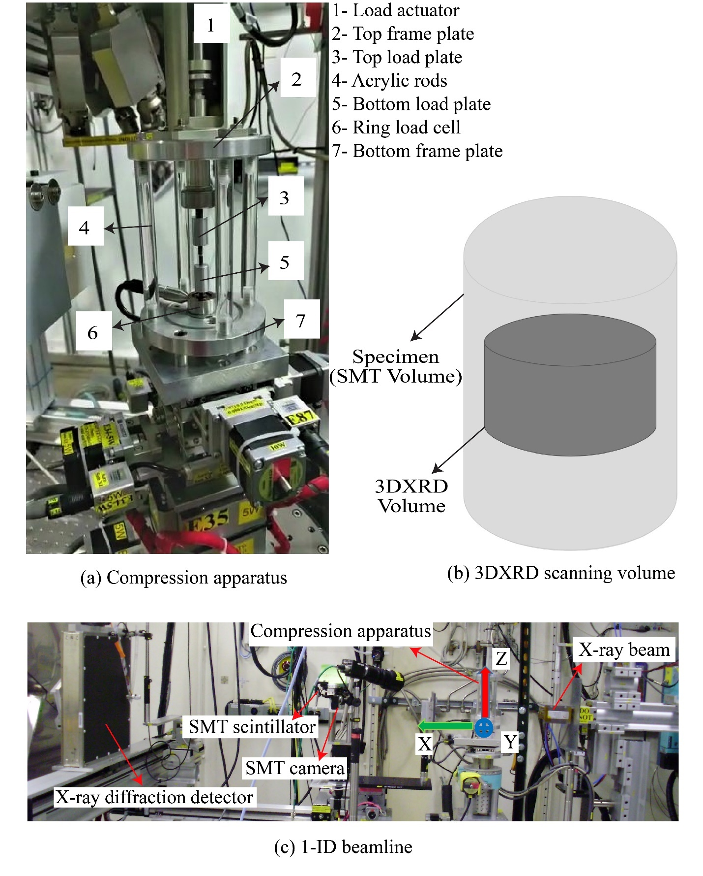

Fig. ‎4-4. (a) The unconfined compression apparatus; (b) the volume scanned in the 3DXRD measurements; (c) in-situ SMT-3DXRD setup at beamline 1-ID, APS, ANL
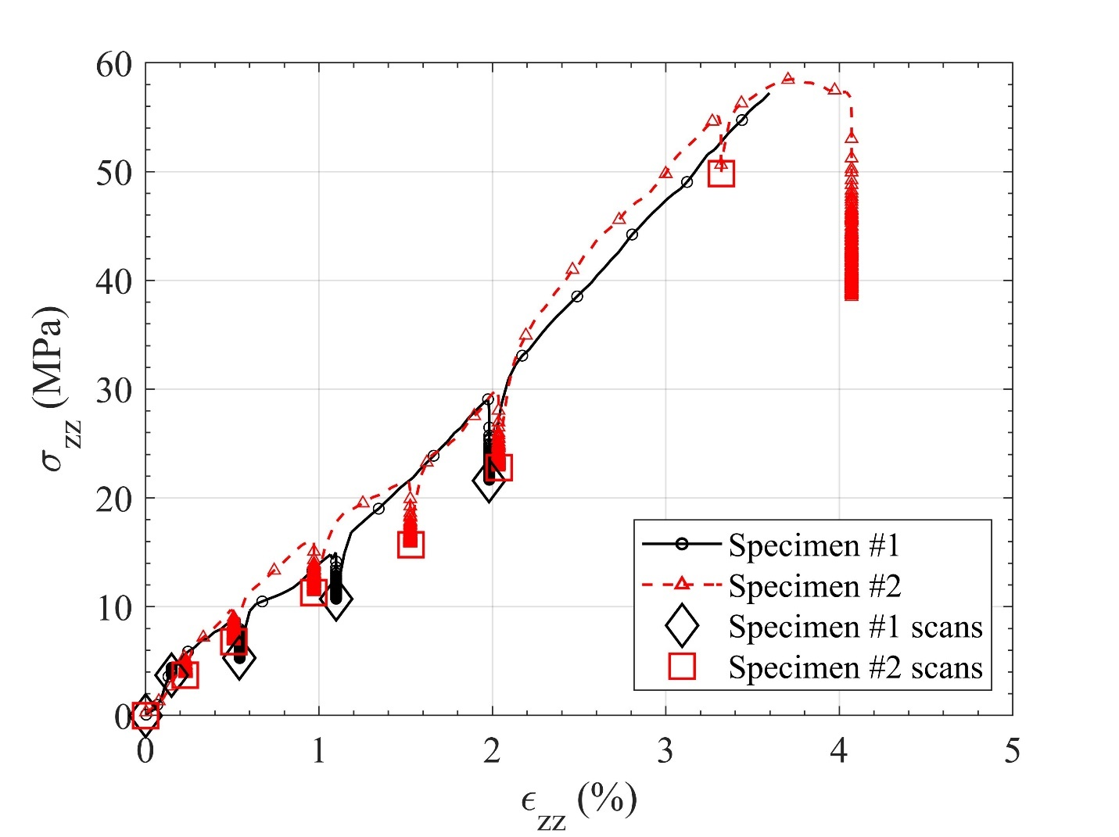

Fig. ‎4-5. Global axial strain versus global axial stress during the unconfined compression experiments
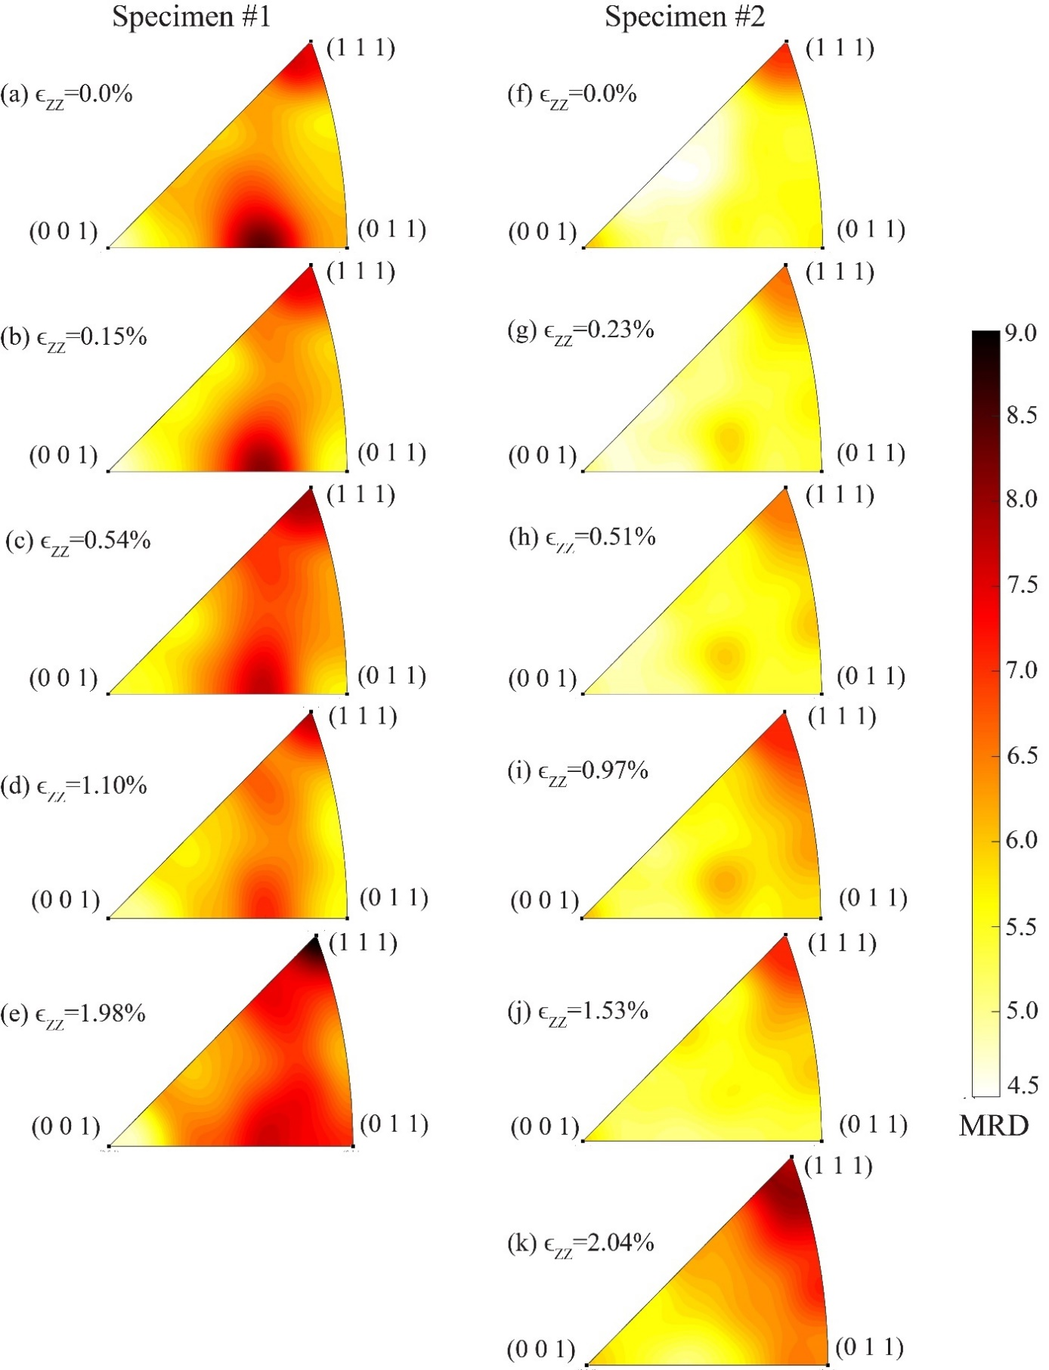

Fig. ‎4-6. The evolution of texture within the specimens with respect to z-axis at different global axial strains: (a) through (e) Specimen #1; (f) through (k) Specimen #2
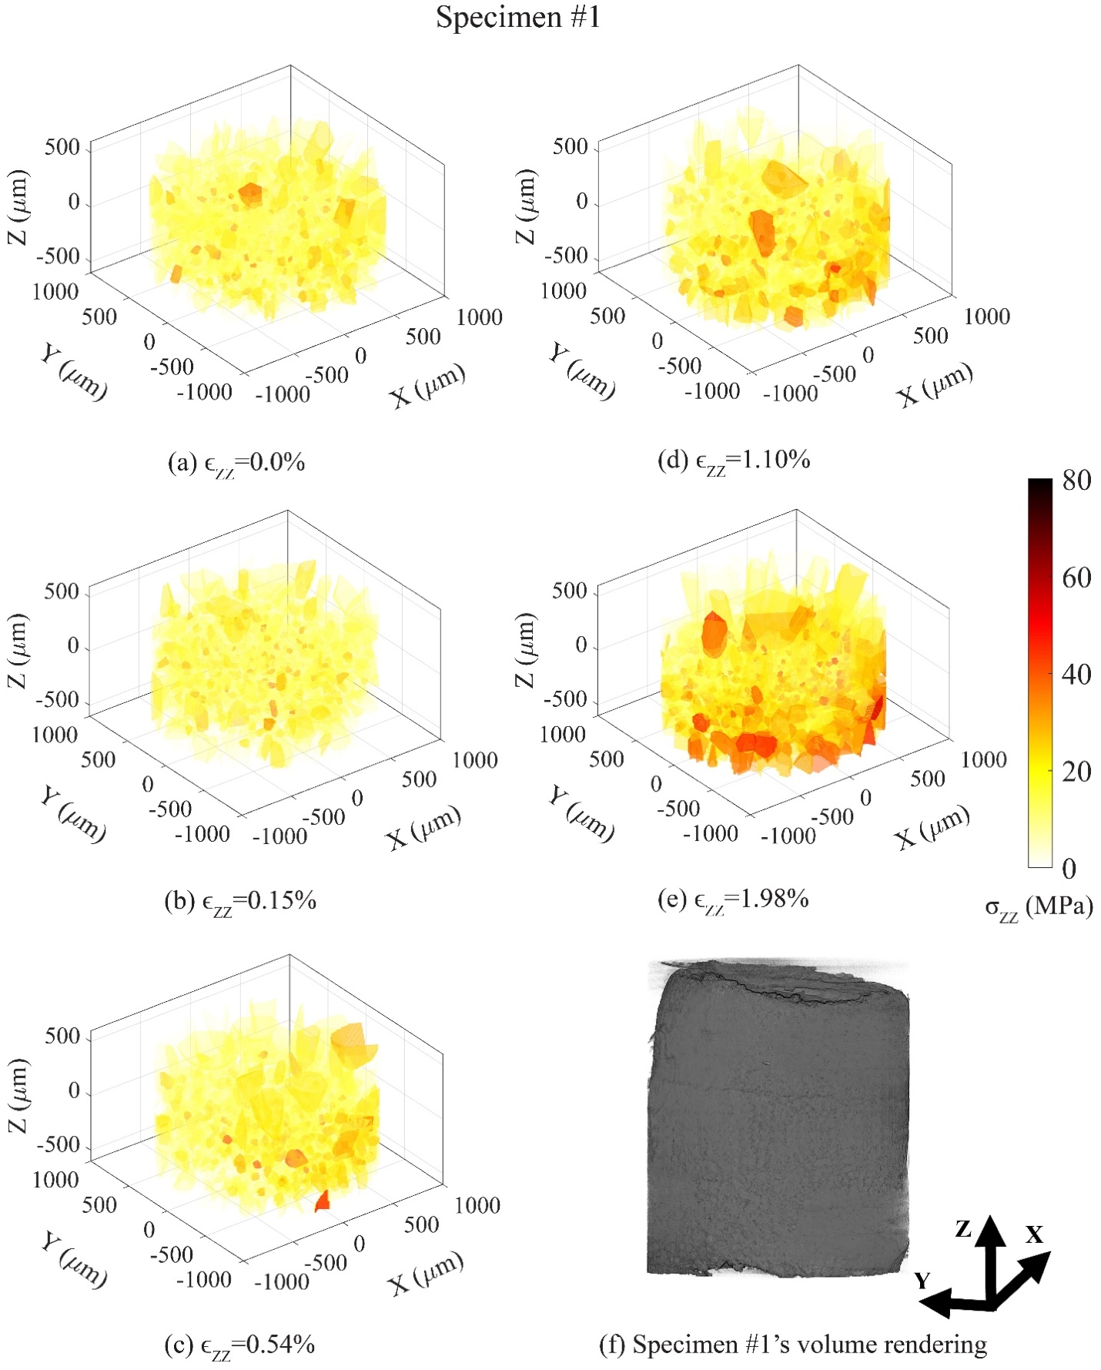

Fig. ‎4-7. The changes in${ σ}_{zz}$ within grains at different global axial strains: (a) through (e) Specimen #1; (f) through (k) Specimen #2
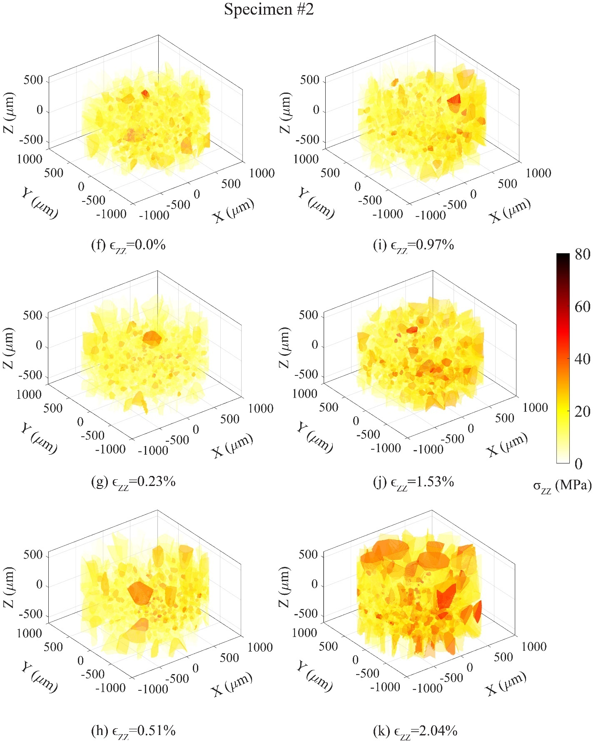

Fig. ‎4-7 Continued
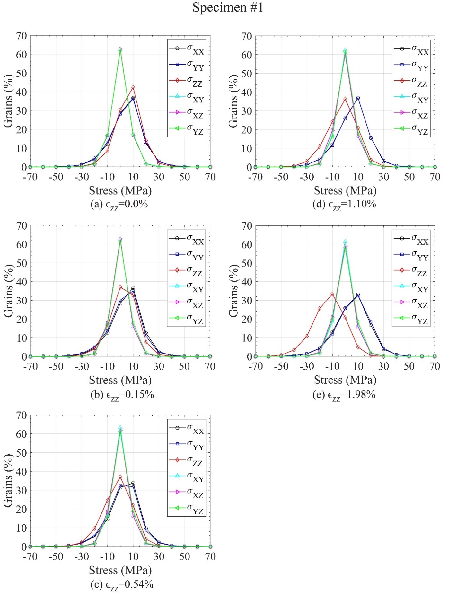

Fig. ‎4-8. Distribution of stresses within grains at different global axial strains: (a) through (e) Specimen #1; (f) through (k) Specimen #2
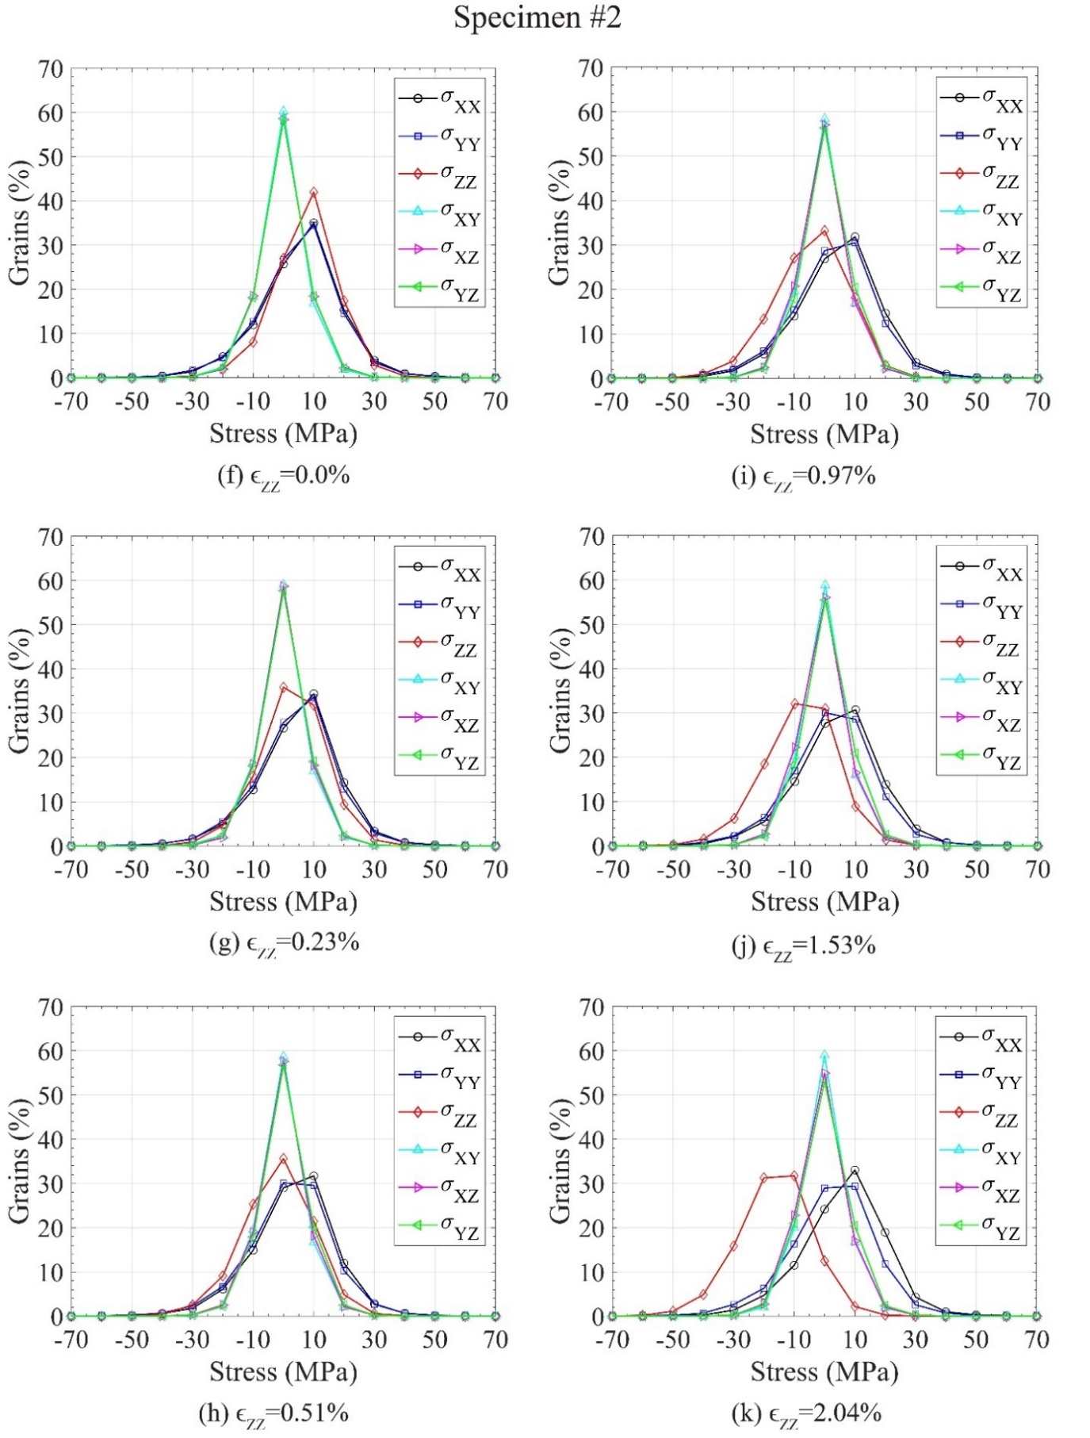

Fig. ‎4-8 Continued
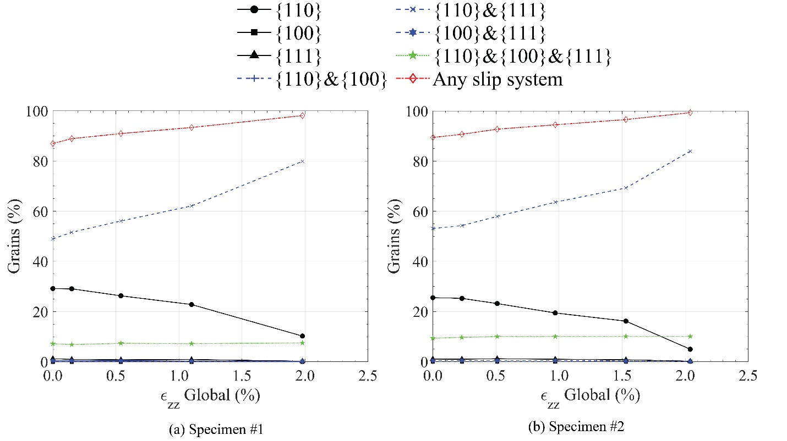

Fig. ‎4-9. Percentage of the grains surpassing initial CRSS on different slip systems at any given global axial strain

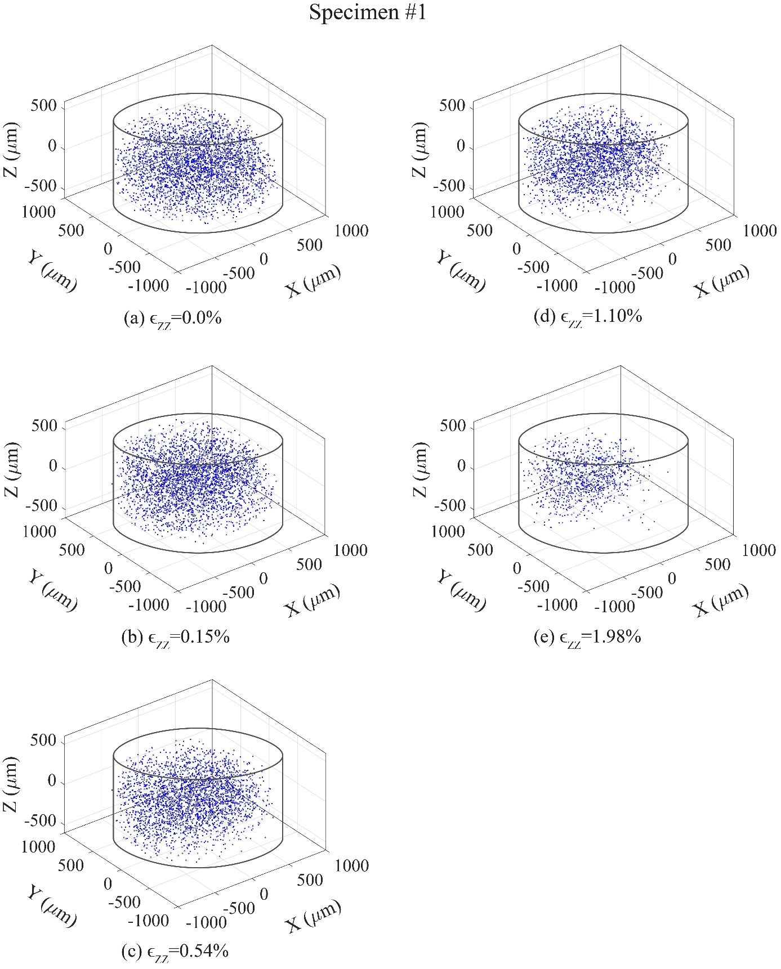

Fig. ‎4-10. Location of the grains surpassing the initial CRSS on {1 1 0}<1 -1 0> and {1 1 1}<1 -1 0> slip systems: (a) through (e) Specimen #1 on {1 1 0}<1 -1 0> slip system; (f) through (j) Specimen #1 on {1 1 1}<1 -1 0> slip system; (k) through (p) Specimen #2 on {1 1 0}<1 -1 0> slip system; (q) through (v) Specimen #2 on {1 1 1}<1 -1 0> slip system
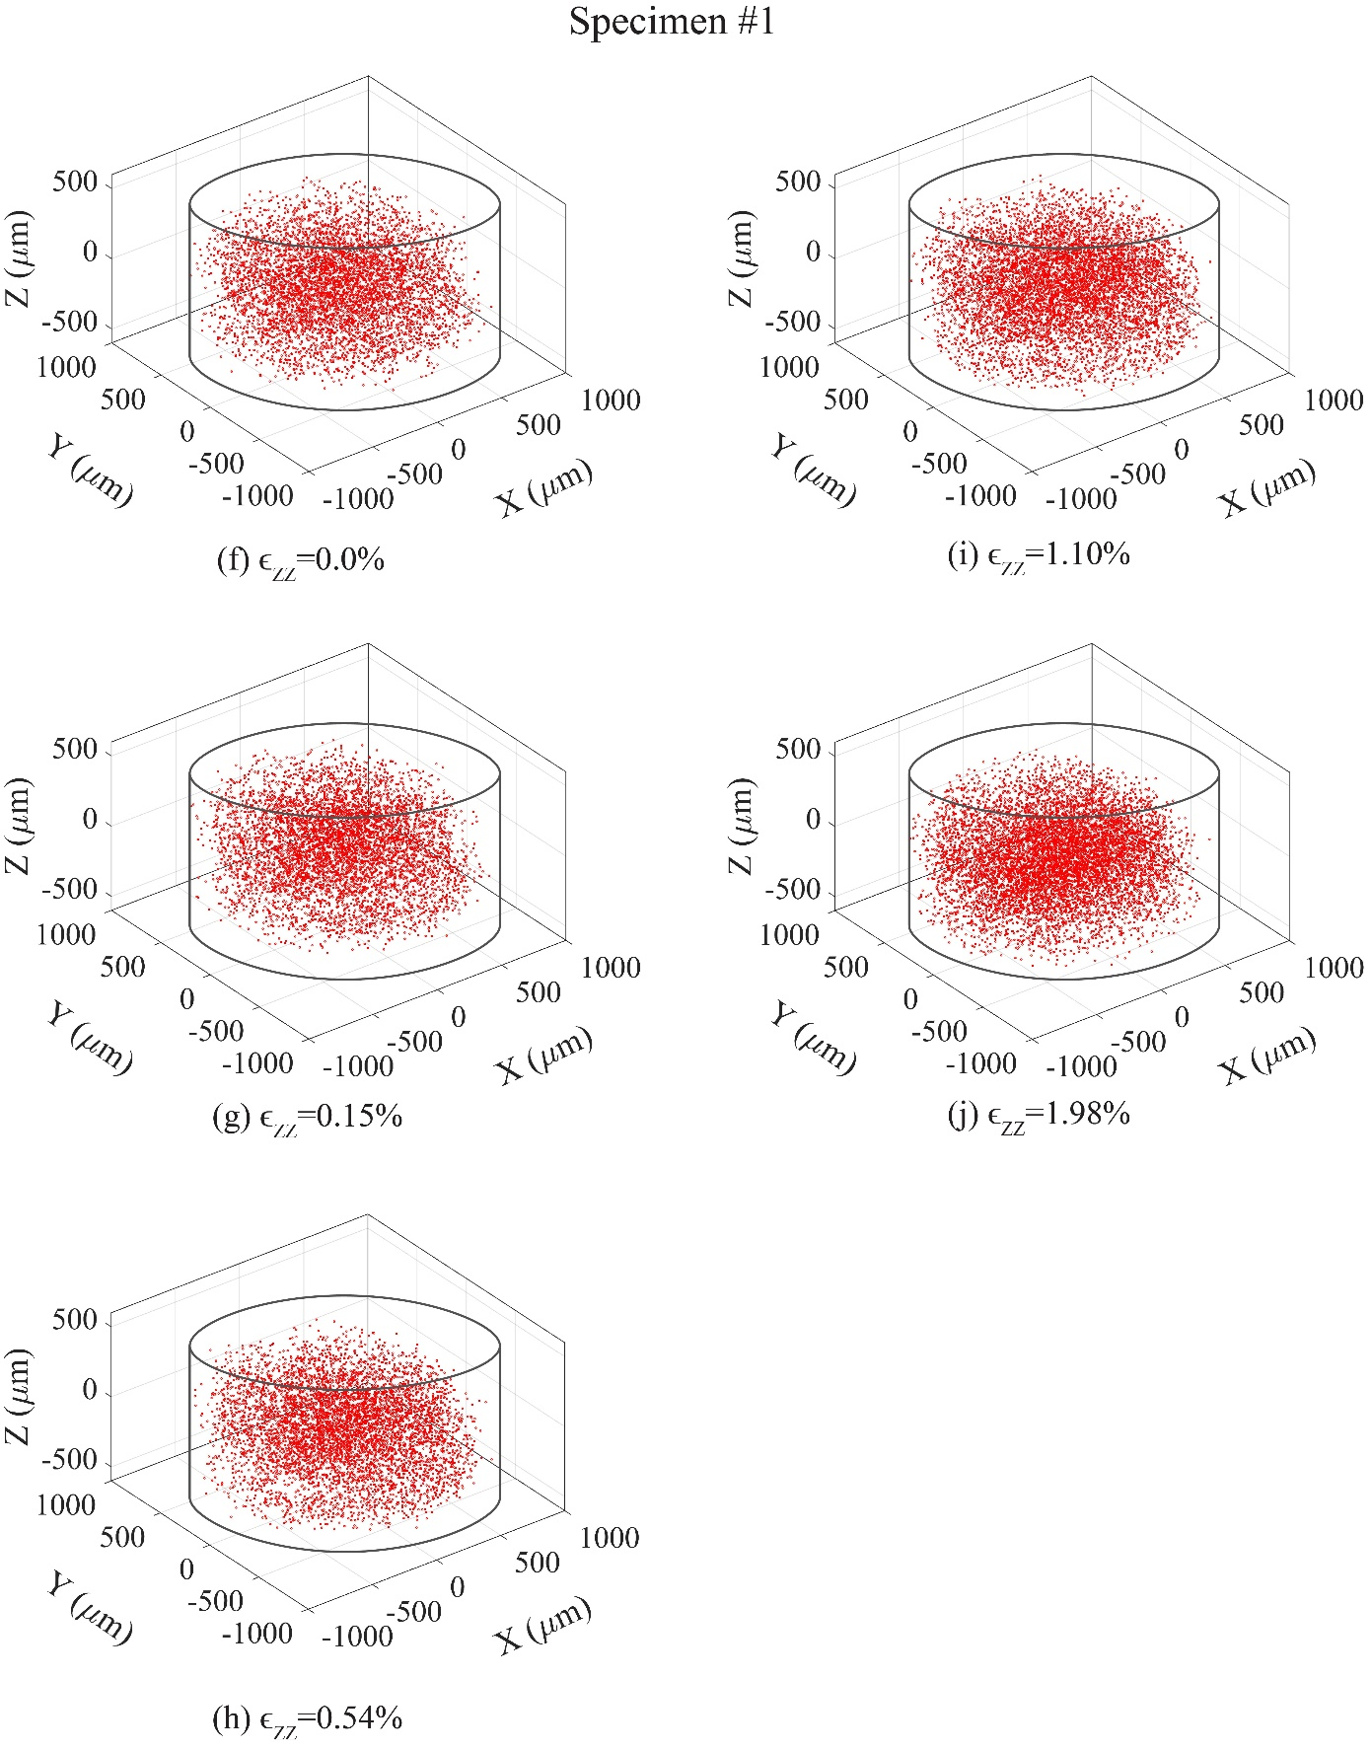

Fig. ‎4-10 Continued
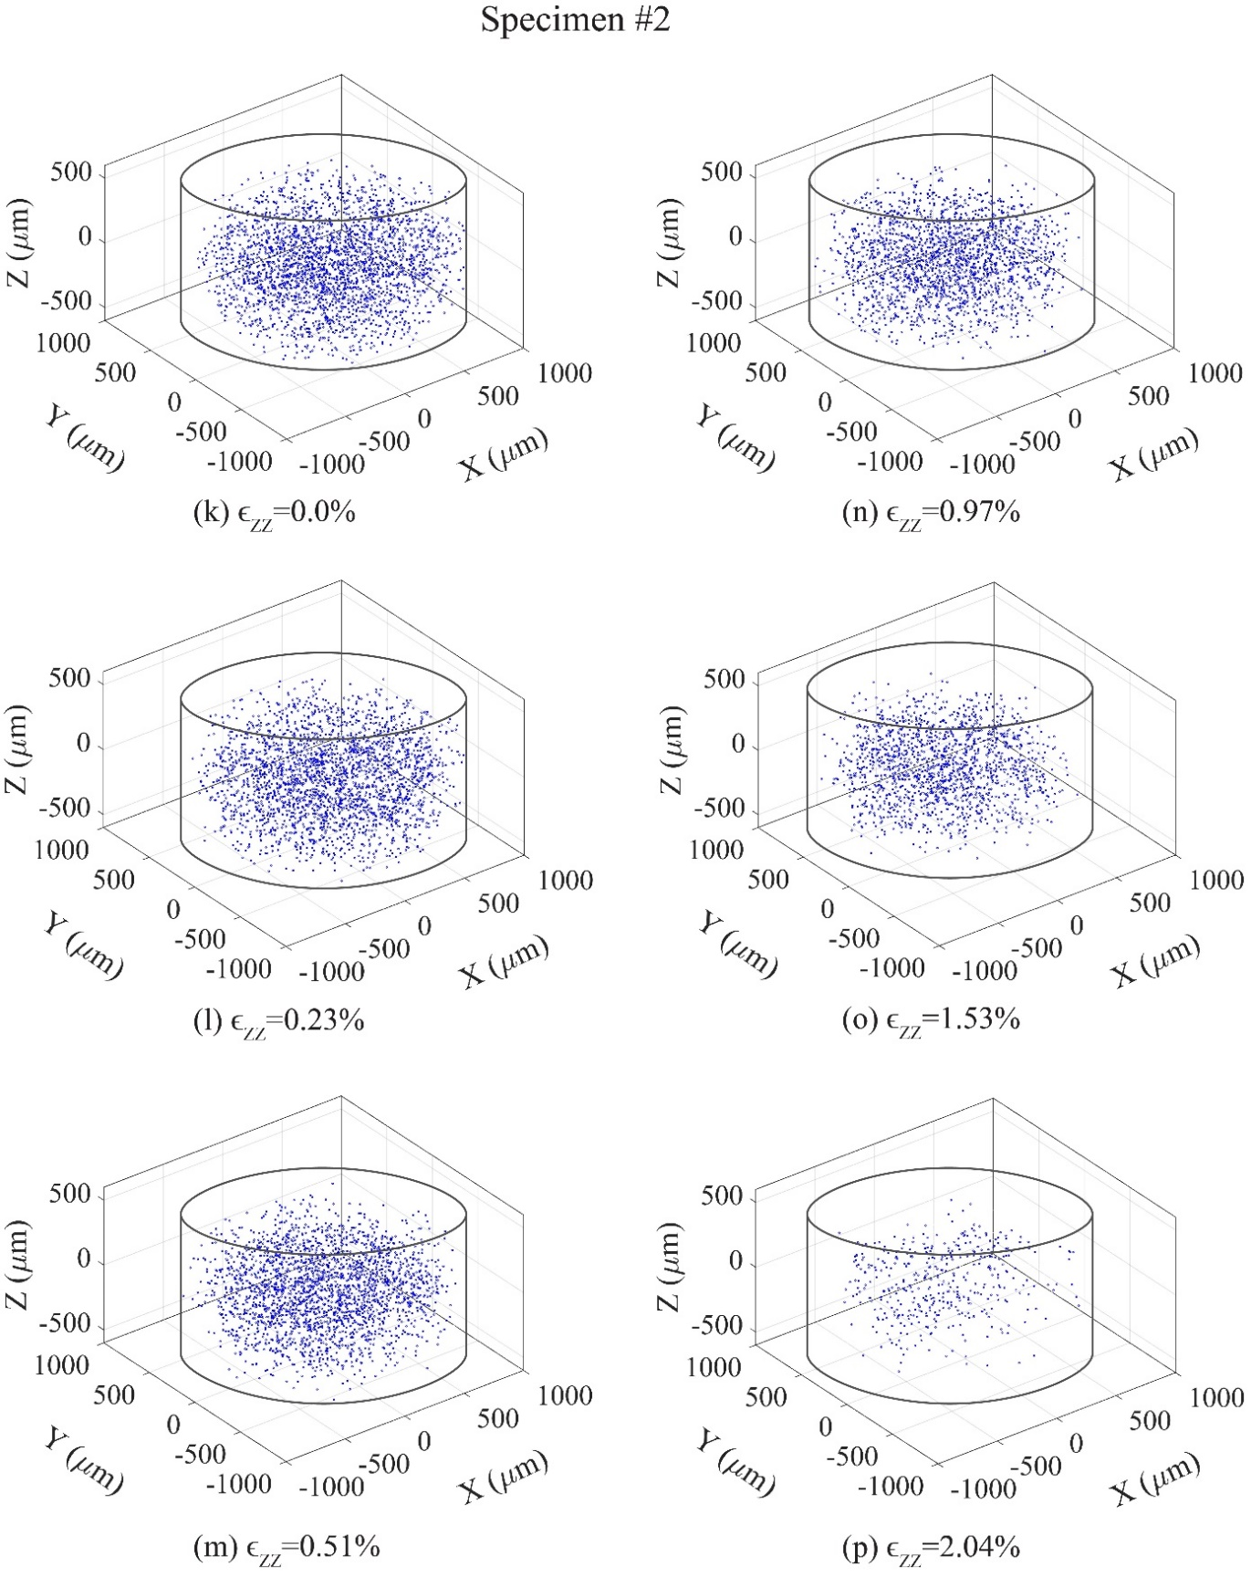

Fig. ‎4-10 Continued
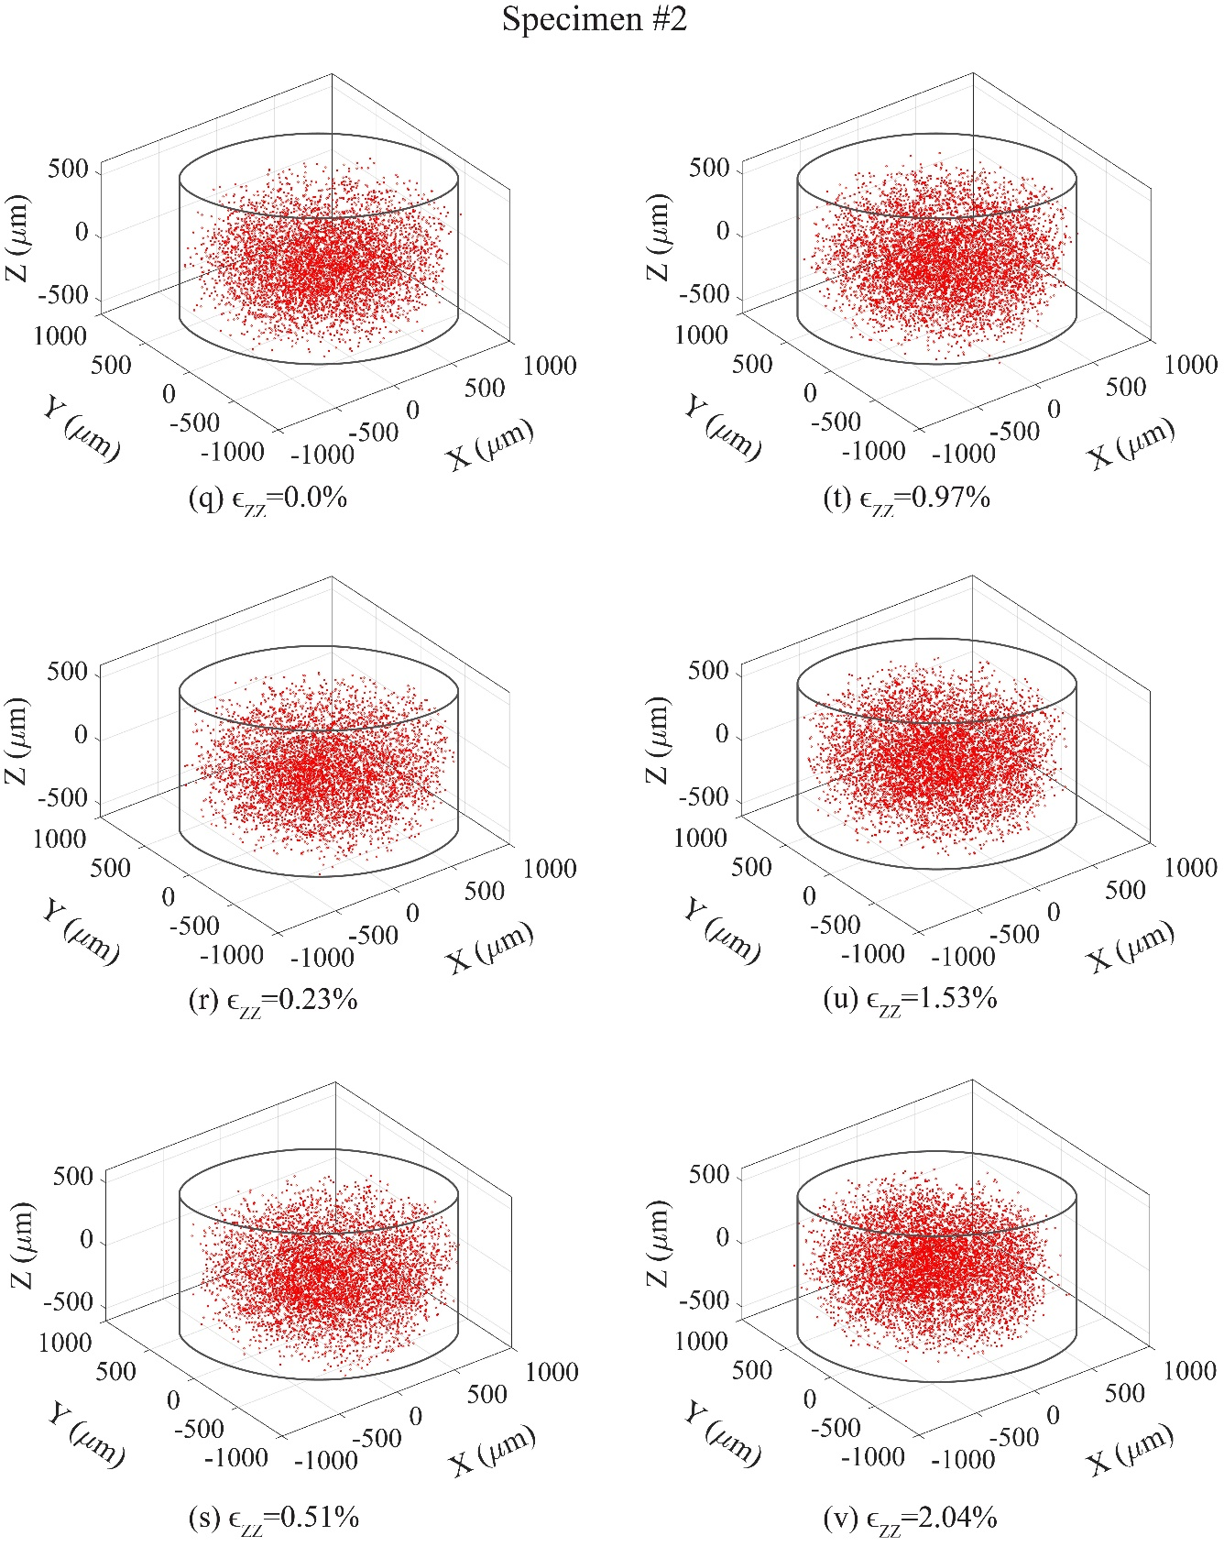

Fig. ‎4-10 Continued
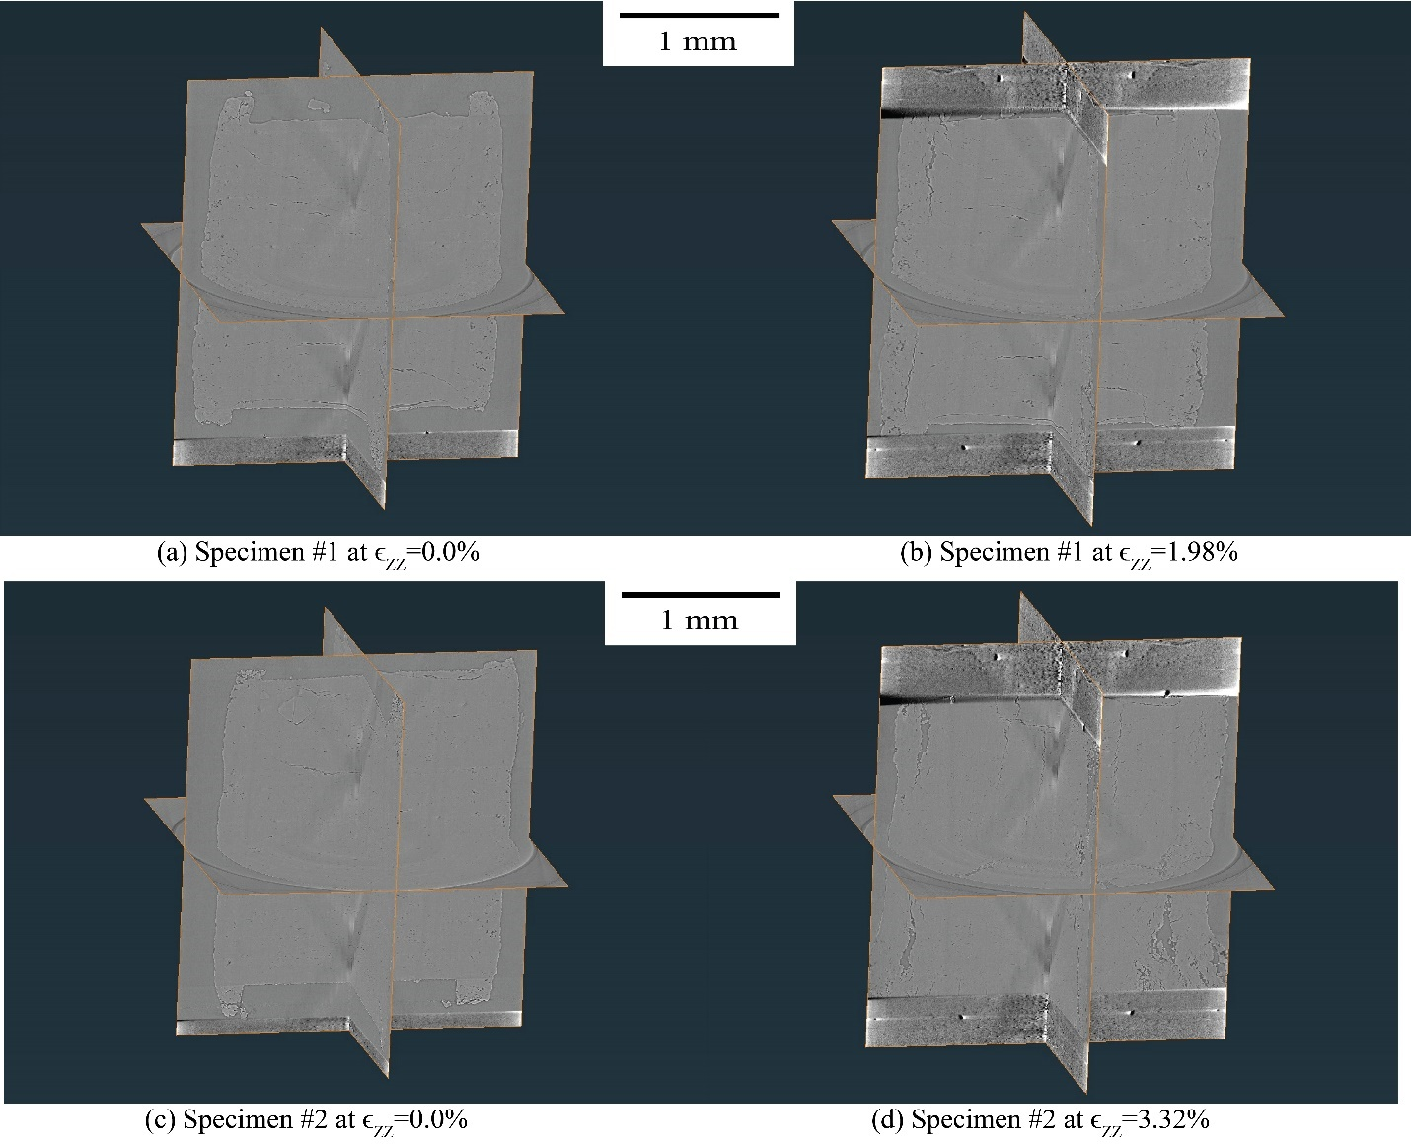

Fig. ‎4-11. The SMT scans of specimen #1: (a) at the initial state; (b) at the end of the test; and specimen #2: (c) at the initial state; (d) at the end of the test

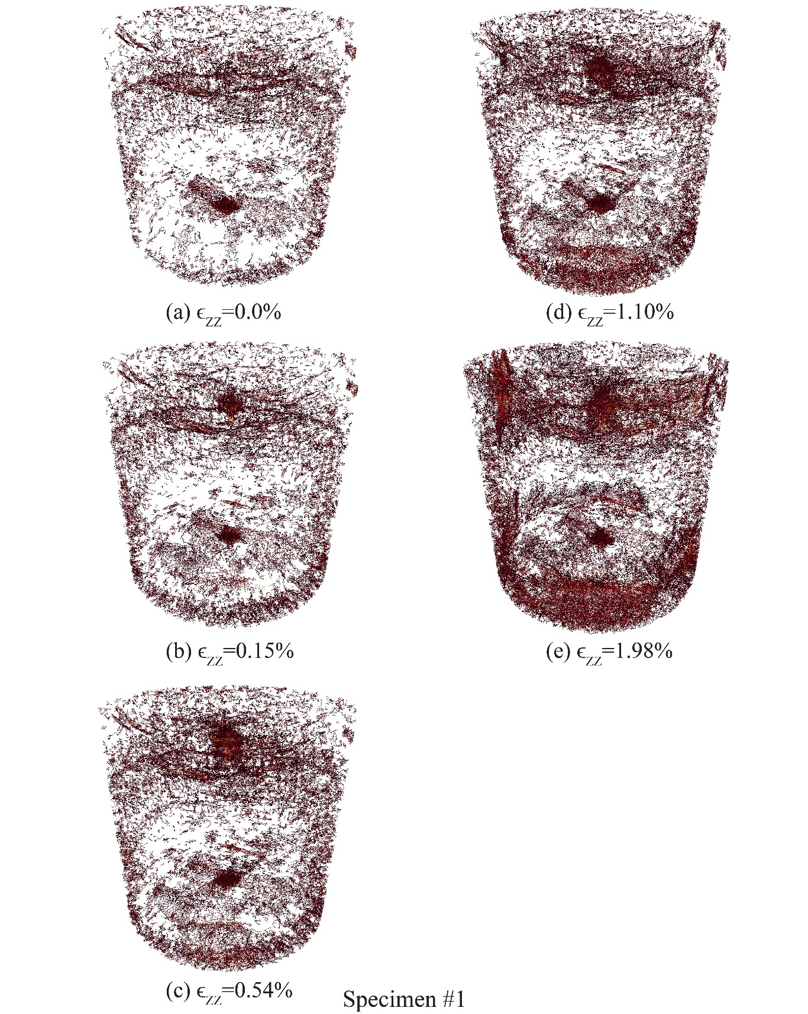

Fig. ‎4-12. The evolution of cracks within the specimens at different global axial strain steps: (a) through (e) Specimen #1; (f) through (l) Specimen #2
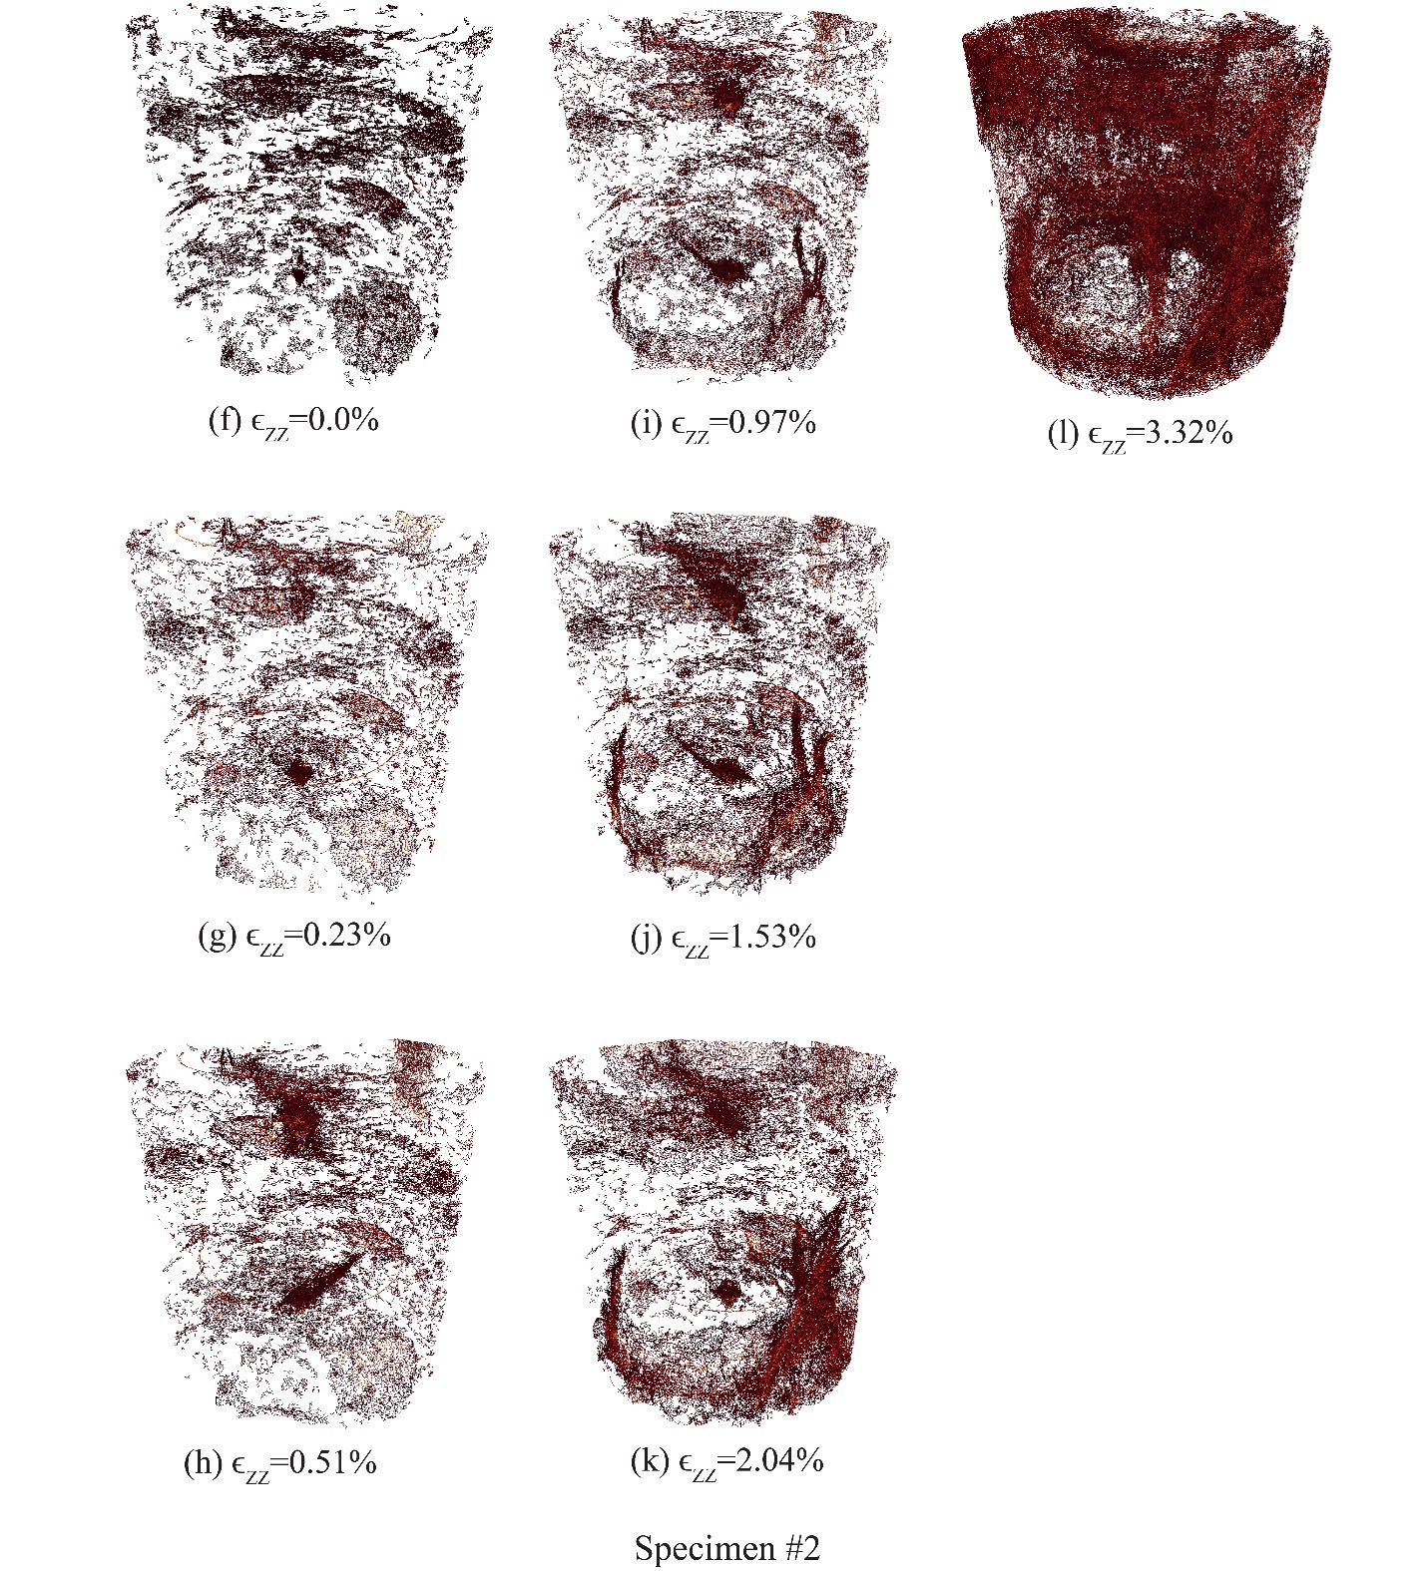

Fig. ‎4-12 Continued
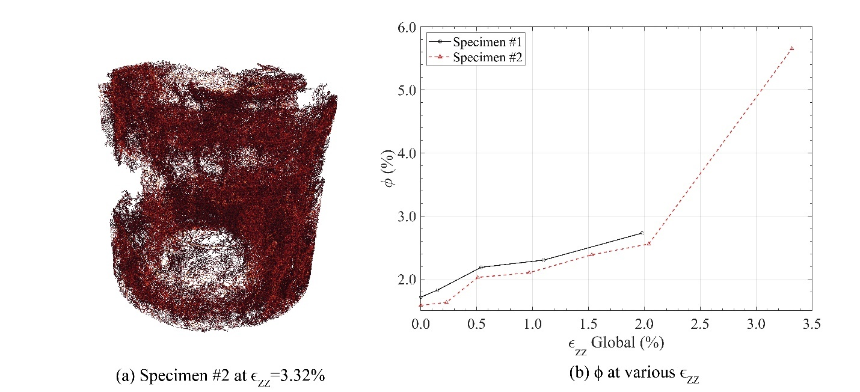

Fig. ‎4-13. (a) The connected crack network within specimen #2 at 3.32% strain; (b) porosity of the specimens at different global axial strains

CHAPTER 5
EFFECTS OF CRYSTAL ORIENTATION, TEMPERATURE, DEVIATORIC STRESS, AND CONFINING STRESS ON CREEP OF ROCK SALT

A version of this chapter will be published by Amirsalar Moslehy, Khalid A. Alshibli, and Timothy J. Truster:
Moslehy, A., Alshibli, K. A., & Truster, T. J. (2023). Effects of Crystal Orientation, Temperature, Deviatoric Stress, and Confining Stress on Creep of Rock Salt. Under submission.

My contribution to this paper is performing the experimental tests, data analysis, and preparing the original draft and all figures.

Abstract

The creep of rock salt greatly influences the performance and safety of rock salt caverns when they are used as an underground repository for oil, nuclear waste, or other hazardous materials. Creep may cause shearing of casings of oil wells drilled through thick layers of salt rock formation. The crystallographic structure of salt rock grains, in-situ deviatoric stress changes caused by excavation, confining stress from the surrounding environment, and ambient temperature can have a significant impact on the creep behavior of rock salt. Although the creep behavior of polycrystalline rock salt has been extensively studied by many researchers, the creep behavior of single-crystal natural rock salt is not yet fully understood. This paper investigates the influence of crystal orientation, temperature, deviatoric stress, and confining stress on the creep behavior of single-crystal and polycrystalline rock salt. 42 long-term creep experiments with various temperatures, confining stresses, and deviatoric stresses were conducted on natural single-crystal specimens. The temperatures were 20, 100, and 150° C, the confining stresses were 0.1, 1.0, and 5.0 MPa, and the various deviatoric stresses were applied in different loading directions with respect to the specimen’s crystal orientations. Additionally, 18 long-term creep experiments were performed on synthetic polycrystalline specimens with wet grain boundaries at temperatures of 20, 100, and 150° C, at confining stresses of 0.1, 1.0, and 5.0 MPa, and various deviatoric stresses. The effects of the mentioned experimental conditions on the accumulated axial strain, transient strain rate, and steady-state strain rate during the creep of rock salt were then examined and discussed in detail. Moreover, simple statistical models are proposed to predict the influence of the experimental parameters on the steady-state creep of rock salt.
Keywords single-crystal halite, polycrystalline rock salt, creep, crystal orientation, temperature

Introduction

Containerless or contained caverns built within rock salt deposits are commonly used as storage for a wide range of materials in various forms of solid, liquid, or gaseous states (Le Comte, 1965; Carter and Heard, 1970; Senseny et al., 1992; Staudtmeister and Rokahr, 1997; Fam et al., 1998; Leigh and Hansen, 2011; Titler and Curry, 2011; Zhu and Arson, 2014; Zeljaś, 2016; Zhang et al., 2017; Wang et al., 2018; Moslehy and Alshibli, 2021). Oil wells on the other hand usually involve drilling through thick layers of rock salt deposits to reach the trapped gas, oil, or valuable minerals sources underneath the rock salt domes (Yang et al., 1999; Fredrich et al., 2003; Leigh and Hansen, 2011; Taheri et al., 2020; Moslehy et al., 2021; Imseeh et al., 2022). Different stages of the creep of rock salt (halite) have been associated with the failure of structures and wellbores made within rock salt formations (Carter and Hansen, 1983; Urai et al., 1986; Chen et al., 1997; Bérest et al., 2019; Hampel and Hunsche, 2020; Moslehy et al., 2021; Moslehy et al., 2022). The creep of rock salt consists of three stages, which are the initial (transient), secondary (steady-state), and tertiary creep stages. Fig. ‎5-1 presents an illustrative example of the three stages of rock salt’s creep at a constant applied deviatoric stress. The transient creep phase begins after the elastic (and potentially plastic) deformations caused by the applied deviatoric stresses where the strain rate continuously decelerates. The steady-state creep of rock salt follows the transient stage and is usually the longest-lasting stage (note Fig. ‎5-1b is drawn on a logarithmic scale). The strain rate associated with the steady-state creep of rock salt is much smaller than the transient strain rates (${\dot{ϵ_{t}}= 10}^{-5}-{10}^{-13} s^{-1}$). The tertiary creep of rock salt consists of a rapid increase of the strain rate which may lead to the failure of rock salt when the material is subjected to a constant applied deviatoric stress (Carter and Hansen, 1983; Chen et al., 1997; Bérest et al., 2019; Eslami Andargoli et al., 2019; Ma et al., 2021). Albeit the steady-state creep of rock salt may have a positive influence on its stiffness due to strain hardening, the tertiary creep can result in the failure of well casing drilled through salt rock or caverns built within rock salt deposits (Wawersik and Hannum, 1979; Carter and Hansen, 1983; Mansouri and Ajalloeian, 2018; Eslami Andargoli et al., 2019; Thom and Goldsby, 2019; Hampel and Hunsche, 2020; Ma et al., 2021). Therefore, it is critical to fully understand the creep behavior of rock salt for safe long-term performance of structures and operations that interact with rock salt.

Background and Motivation

The crystallographic orientation of rock salt, the applied deviatoric stress ($σ_{d}$), the present confining stress ${(σ}_{3}$), and the ambient temperature (T) have a great influence on the creep behavior of rock salt (Le Comte, 1965; Guillope and Poirier, 1979; Carter and Hansen, 1983; Yang et al., 1999; Ma et al., 2021). Polycrystalline and single-crystal rock salt exhibit different behavior under creep conditions (Carter and Hansen, 1983). Therefore, the creep behavior of polycrystalline and single-crystal rock salt must be studied separately. Le Comte (1965) performed creep experiments on nominally dry synthetic polycrystalline rock salt specimens under various $σ_{3}$, $σ_{d}$, and T, and the results showed that the increase in the steady-state creep rate (${\dot{ϵ}}_{ss}$) at higher T significantly grows when T is higher than of 104.5° C. The effects of increasing $σ_{3}$ on ${\dot{ϵ}}_{ss}$ was found to be negligible when T < 104.5° C; however, for T > 104.5° C, increasing $σ_{3}$ caused a decrease in ${\dot{ϵ}}_{ss}$. Lastly, increasing $σ_{d}$ caused a considerable increase in ${\dot{ϵ}}_{ss}$. Wawersik and Zeuch (1986) investigated the steady-state creep behavior of polycrystalline rock salt that was acquired from five different sources at temperatures below 160° C. The general power law creep model for ${\dot{ϵ}}_{ss}$ for polycrystalline rock salt can be described according to Equation 5-1.

$${\dot{ϵ}}_{ss}=C.{σ_{d}}^{n}.\exp\left(-\frac{Q}{RT}\right)$$ | (‎5-1)

where T, C, n, Q, and R are the temperature, fitting coefficient, the power law exponent larger than unity, the creep activation energy, and the universal gas constant, respectively. Wawersik and Zeuch (1986) suggested that the parameters that fit a power-law creep model for the steady-state creep of rock salt must be calibrated using experiments with varying T since n and Q are highly influenced by temperature variation. Yang et al. (1999) examined the transient and steady-state creep of natural polycrystalline rock salt with impurities that were tested under various $σ_{3}$ and $σ_{d}$ values and the results showed that increasing $σ_{d}$ during the experiments caused an increase in both the transient ($\dot{ϵ_{t}}$) and steady-state strain rates ${(\dot{ϵ}}_{ss}$). Yang et al. (1999) reported that ${\dot{ϵ}}_{ss}$ is not sensitive to $σ_{3}$ at higher $σ_{3}$ values. Considering the effects of $σ_{3}$ on the steady-state creep behavior of rock salt, Yang et al. (1999) expanded the power-law creep model for ${\dot{ϵ}}_{ss}$ for polycrystalline rock salt and proposed the following model as Equation 5-2:

$${\dot{ϵ}}_{ss}=C.{σ_{d}}^{n}.\exp\left(-σ_{3}\right).\exp\left(-\frac{Q}{RT}\right)$$ | (‎5-2)

In addition to the aforementioned factors, other material properties and test conditions can alter the creep behavior of rock salt as well. Urai et al. (1986) studied the influence of brine found in natural polycrystalline rock salt upon its creep behavior. The presence of water at the grain boundaries enhanced the grain boundary mobility and resulted in a so-called weakening of rock salt where solution transfer creep became the dominant deformation mechanism, and a rapid flow behavior was reported. Urai et al. (1986) advocated for the influence of brine on the creep behavior of rock salt and its influence should be incorporated when investigating the creep behavior of rock salt. Chen et al. (1997) studied the deformation mechanisms during the steady-state creep and the failure mechanisms during the tertiary creep of rock salt using laboratory tests and theoretical statistical models. The highlighted rock salt’s secondary creep cannot be called a true steady-state creep because of the development of microcracks within the material. The main deformation mechanism after the secondary creep stage is the evolution of localized damages and microcracks into macrocracks that propagate at a larger scale within the rock salt formation. Chen et al. (1997) pointed out a target value of applied deviatoric load that cannot be maintained at the designated constant load due to sudden deformations that were caused by the onset and propagation of macrocracks. Hampel and Hunsche (2020) developed a composite model for the transient and steady-state creep of polycrystalline rock salt by considering the effects of impurities and crystal defects on deformation mechanisms that take place during creep. The model parameters were correlated to the physical properties of the specimens such as the spatial distribution of impurities within the sub-grains. Hampel and Hunsche (2020) model defined each sub-grain as a set of walls with high amounts of dislocation density that encompassed regions with lower amounts of dislocation density; therefore, the model could recognize the impurities as obstacles to gliding dislocations.
The influence of the loading condition and phases on the creep of rock salt need to be considered to fully understand rock salt’s creep behavior. Eslami Andargoli et al. (2019) studied the transient and steady-state creep behavior of natural impure polycrystalline rock salt using stepwise creep experiments as well as constant stress creep experiments. They proposed a combined Burger’s rheological model and Lubby 2 constitutive model to describe the creep behavior of polycrystalline rock salt. Andargoli et al. (2018) found that calibrating the transient creep model parameters using the experimental data acquired from the stepwise creep experiments and fitting the steady-state creep model parameters to the experimental data obtained from the constant stress creep experiments yielded the most accurate combined Burger’s rheological model and Lubby 2 constitutive model. Mansouri and Ajalloeian (2018) examined the evolution of the microstructure of bedded polycrystalline rock salt under creep loads and reported that grain-boundary cracking and grain-boundary sliding were the dominant deformation mechanisms. Additionally, some of the specimens previously tested in creep experiments were subjected to uniaxial compression experiments. These specimens exhibited a higher rate of strain hardening and a higher elastic modulus in comparison to the specimens tested under the uniaxial compression procedure without any prior creep loading history. This is due to the significant amount of free dislocations that occurred under the prior creep loads. Bérest et al. (2019) developed a modified creep model for polycrystalline rock salt that specifically considers the far-field stress conditions caused by excavations within rock salt formations. Five 2-year long creep tests were conducted at low deviatoric stresses (less than 1.0 MPa), controlled temperature, and humidity levels resulting in ${\dot{ϵ}}_{ss}={10}^{-13}-{10}^{-12} s^{-1}$. Pressure solution was the dominant deformation mechanism during the steady-state creep, and Bérest et al. (2019) reported rock salt behaves similar to a Newtonian fluid under far-field stress conditions. Taheri et al. (2020) evaluated polycrystalline rock salt’s creep behavior using stepwise creep experiments at various temperatures and confining stresses to better understand the collapse of well casing drilled through rock salt formations. They concluded that the creep behavior of Gachsaran rock salt in Khuzestan, Iran, is insensitive to $σ_{3}$ variation. However, increasing the temperature and $σ_{d}$ (in a stepwise manner) increased ${\dot{ϵ}}_{ss}$, and the creep behavior still followed a power-law model. Ma et al. (2021) investigated the mechanical behavior of natural impure polycrystalline rock salt under combined creep and fatigue loading conditions and showed that micro-cracks generally developed during the load ramping phase and the cracks only propagated during the creep loading phases. The accumulated cyclic and creep damage exhibited a clear positive interaction; meaning under combined creep and fatigue loading, rock salt’s cycling life is considerably lower than it’s cycling life under pure creep or fatigue loads.
Understanding the creep behavior of single-crystal rock salt is not only necessary for investigating polycrystalline rock salt’s creep behavior but also has a major direct impact on certain designs and safety cases such as the creep response of relatively larger rock salt single crystals in the immediate vicinity of the excavations made through rock salt formations. Although studying single-crystal rock salt’s creep eliminates the need to consider certain material properties such as the material’s texture, grain size, and grain-boundary conditions, other material properties such as the crystal orientation and crystal defects are major contributors to the material response. Rock salt has a Face-Centered-Cubic (FCC) crystal structure as depicted in Fig. ‎5-2a. Major plastic deformations that can lead to a tertiary creep rupture usually occur on the material’s slip systems (Cox Jr, 1954; Wimmer et al., 1963; Aoki and Izumi, 1979). Halite’s slip systems consist of 6 primary slips systems along planes $\left\{1 1 0\right\}$ on <1 -1 0> directions (Fig. ‎5-2b), 6 secondary slip systems along $\left\{1 0 0\right\}$ planes on <0 1 1> directions (Fig. ‎5-2c), and another set of 12 secondary slip systems along $\left\{1 1 1\right\}$ planes on <1 -1 0> directions (Fig. ‎5-2d)(Aoki and Izumi, 1979). Depending on the direction of the applied stresses relative to the specimen’s crystal orientation, one of the mentioned slip systems can become activated and controls the potential specimen rupture. Guillope and Poirier (1979) examined the dynamic recrystallization of pure and impure single-crystal rock salt under uniaxial creep loads along the [0 0 1] crystal axis. Macroscopic observations showed that only rotation recrystallization occurred at lower temperatures and $σ_{d}$ values; however, at T and $σ_{d}$ values higher than unique critical values, then sub-grain migration recrystallization happened as well. Moreover, highly impure specimens only exhibited rotation recrystallization. Carter and Heard (1970) investigated the creep behavior of synthetic single-crystal rock salt under creep loads applied in various directions with respect to the specimens’ crystal orientations. Three loading directions were selected to favor each of halite’s slip systems separately. The observations showed that, even during the experiments set to favor the secondary slip systems, a significant amount of slip still occurred on the primary slip system. Additionally, the experiments favoring the secondary slip systems were found to be more sensitive to the increase in T, when T > 400° C than creep behavior became considerably similar to the experiments favoring the primary slip system. Lastly, a significantly higher strain-hardening was observed throughout the experiments that showed more interactions of dislocations on oblique systems. Thom and Goldsby (2019) performed nanoindentation creep experiments on single-crystal rock salt specimens and the results showed that the hardness was dependent on the applied strain rates and the size of the indentation. Thom and Goldsby (2019) found that the behavior of single-crystal rock salt during nanoindentation creep matches the behavior of polycrystalline rock salt that follows a dislocation creep flow model.
The creep behavior of polycrystalline rock salt as discussed earlier has received much more attention in comparison to the creep behavior of single-crystal rock salt. Understanding natural single-crystal rock salt’s creep behavior, especially the effect of crystal orientation in conjunction with other factors, is essential for certain applications. These applications include near-field stress conditions in some salt formations and fundamental studies of polycrystalline rock salt’s creep behavior. On an additional note, when synthetic polycrystalline specimens are used in investigating rock salt’s creep behavior, ensuring the presence of water within the specimens is crucial since natural salt formations contain traces of water (Urai et al., 1986). This paper is focused on addressing the gap in the current state of knowledge of the anisotropic creep behavior of natural single-crystal rock salt. Natural single-crystal and synthetic polycrystalline rock salt specimens were prepared and tested in triaxial creep experiments at various loading directions with respect to the specimens’ crystal orientations at different temperatures, confining stresses, and deviatoric stresses. Utilizing natural single-crystal rock salt specimens in contrast to melt-grown synthetic specimens, such as used by Carter and Heard (1970), is essential since as previously mentioned natural single-crystal rock salt inherently contains crystal imperfections and defects such as internal damage, impurities, and entrapped water molecules. Additionally, the creep experiments performed by Carter and Heard (1970) were constant-strain tensional creep experiments. Therefore, the constant-stress compressional creep experiments performed in this work provide the creep response of rock salt under an entirely different loading condition.

Materials and Experiments

Single-Crystal Specimens
The single-crystal specimens utilized in this study were acquired from Windsor Salt Mine in Ontario, Canada. The average grain size of the source blocks was well above 100 mm and consisted of 99.9% NaCl (halite) based on the results of powder x-ray diffraction (PXRD) analysis. Due to halite’s natural cleavage planes on $\left\{1 0 0\right\}$ crystal planes, preparing cylindrical natural rock salt specimens without inducing significant initial damage was a challenge (Carter and Hansen, 1983; Moslehy and Alshibli, 2021). Therefore, cuboidal specimens with a height-to-width ratio between 2.0 and 1.1 to 1.0 were adopted in this study. First, large single-crystal grains with dimensions larger than 76.20 mm were separated from the source blocks. The visible orthogonal $\left\{1 0 0\right\}$ cleavage planes within the transparent single crystals were used to identify separate single crystals and approximately find their crystal orientations with respect to their boundaries. The single crystals were then cut into cubes along the $\left\{1 0 0\right\}$ cleavage planes such that their lattice axes were estimated to be aligned with their outer surfaces. The single crystals were then cut into smaller specimens with the following crystal orientations: parallel to [1 0 0], 19º to (1 0 0) in (0 1 0), and 30º to (1 0 0) in (0 1 0). Using the Bunge Euler definition, the crystal orientations of specimens are defined as $\left[\begin{matrix}φ_{1}=0 \\ Φ=0 \\ φ_{2}=0\end{matrix}\right]$, $\left[\begin{matrix}φ_{1}=19° \\ Φ=0 \\ φ_{2}=0\end{matrix}\right]$, and $\left[\begin{matrix}φ_{1}=30° \\ Φ=0 \\ φ_{2}=0\end{matrix}\right]$. For simplicity, these specimens are referred to as 0º, 19º, and 30º specimens, respectively. $φ_{1}$, $Φ$, and $φ_{2}$ in order are the counterclockwise rotation angles of the specimen’s axes about the z-axis, [1 0 0] direction, and [0 0 1] direction, to transfer the specimen’s axes to the crystal’s axes. The $\left\{1 1 1\right\}$ <1 -1 0> slip system is the dominant slip system under the loading direction of the 0º specimens due to its Schmid factor and critical resolved shear stress (CRSS). In contrast, the $\left\{1 1 1\right\}$ <1 -1 0> and $\left\{1 0 0\right\}$ <0 1 1> slip systems have higher chances of activation under the loading directions of the 19º and 0º specimens; respectively, because of the Schmid factor and CRSS comparisons to the 0º specimens (Moslehy et al., 2021). The specimens’ surfaces were gradually sanded with P3000 sandpaper to make minor adjustments to their crystal orientation and to reduce their surface roughness. The assumption of the specimens being single crystal and the estimated crystal orientations of specimens with respect to the specimens’ surface were verified using the Laue x-ray diffraction (LXRD) technique on selected specimens. Fig. ‎5-3 displays representative specimens cut with different crystal orientations with respect to their surfaces. The dimensions and physical properties of the single-crystal specimens are summarized in Table ‎5-1.

Polycrystalline Specimens
Single crystals from the source blocks were crushed into grain sizes smaller than 0.075 mm (US sieve #200) to prepare the polycrystalline specimens. A mixture of rock salt grains and salt-saturated deionized de-aired water with a ratio of 75% (salt) to 25% (water) was then prepared. The polycrystalline specimens were synthesized by cold-pressing the mixture in three equal layers at 200 MPa confined uniaxial stress where a thick-walled die was used to prepare the specimens. They were subsequently annealed at a temperature of 200° C for 7 days and were then removed from their casing and sanded with P3000 sandpaper to smoothen their surfaces. A representative polycrystalline specimen microstructure that was analyzed using a scanning electron microscope (SEM) image acquired from its middle section is displayed in Fig. ‎5-4. The full synthesis procedure of the polycrystalline specimens and their properties after the preparation is discussed in detail in (Moslehy and Alshibli, 2021), and Table ‎5-2 lists the dimensions and physical properties of the polycrystalline specimens.

Triaxial Creep Experiments
The creep experiments were conducted according to the ASTM D7070-16 standard procedure (ASTM, 2016). The majority of the single-crystal creep experiments took 30 to 60 days with a few experiments that lasted up to 90 days to fully observe the steady-state creep behavior. The polycrystalline creep experiments on the other hand lasted either for 45 days or up to the specimen rupture due to tertiary creep. The nuclear waste deposited within rock salt excavations and borings usually causes a rise of the near-field temperature to about 150° C, which can last for the entire lifespan of the nuclear waste repository (Blanco et al., 2015). Therefore, experiments were conducted at 20° C, 100° C and 150° C to assess the influence of temperature on the creep behavior of rock salt. The creep experiments at elevated temperatures 100° C and 150° C were performed using the high-pressure thermal cell that was developed by the authors (Moslehy et al., 2022), as shown in Fig. ‎5-5. Moreover, experiments with similar conditions (same specimen type, temperature, and $σ_{d}$) were conducted at $σ_{3}$ = 0.1, 1.0, and 5 MPa to investigate the influence of confining stress on the creep behavior of rock salt. Lastly, the $σ_{d}$ for each experiment was selected based on the unconfined compressive strength ($σ_{u}$) of the specific specimen (polycrystalline or single-crystal with specific crystal orientation) to allow specimens to reach the transient creep stage ($σ_{d}>0.2 σ_{u}$). The $σ_{u}$ values of both the single-crystal and polycrystalline rock salt specimens used in this study were tested at similar loading directions and ambient temperature and were previously established by the authors (Moslehy et al., 2022). Table ‎5-1 and ‎5-2 in order summarize the applied temperature, $σ_{3}$, and $σ_{d}$ for the 42 single-crystal and 18 polycrystalline creep experiments. In the legends of Figures that follow, the naming scheme for specimens is: temperature, $σ_{3}$, $σ_{d}$, orientation, and sample number.

Results

Single-Crystal Experiments
The axial displacements ($δh$) were measured using a Linear Variational Differential Transformer (LVDT). The axial strains ($ϵ_{1}$) and the axial strain rates ($\dot{ϵ_{1}}$) were then calculated using the $δh$ values and the initial height of the specimen. As previously established in the literature, the calculated $\dot{ϵ_{1}}$ values from traditional LVDT readings during creep experiments on rock salt, especially the $\dot{ϵ_{ss}}$ values, usually exhibit a significant amount of signal noise. The observed signal noises are associated with the temperature and electricity signal spikes that occur during the long time of the tests in addition to the relatively small values of rock salt’s deformations (Chen et al., 1997). The calculated $\dot{ϵ_{1}}$ values contained notable amounts of signal noises as well. For example, Fig. ‎5-6a shows the relationship of time (t) versus $\dot{ϵ_{1}}$ in logarithmic scale for 150° C_0.1_12_0°_2 experiment before any signal noise filtration. To “clean” the observed signal noises, the calculated $\dot{ϵ_{1}}$ values were filtered using Hampel and Savitzky-Golay signal noise filtering functions in MATLAB (Matlab, 2012). Fig. ‎5-6b depicts the relationship between t versus $\dot{ϵ_{1}}$ in logarithmic scale for the 150° C_0.1_12_0°_2 experiment after signal noise filtration, where the transient and steady-state creep stages are more easily distinguished as a result of the filtering process.
Fig. ‎5-7 shows the relationships of t versus $ϵ_{1}$ and t versus $\dot{ϵ_{1}}$ in logarithmic scale obtained from creep experiments under different experimental conditions (T and $σ_{d}$) for 0°, 19°, and 30° specimens each with two samples. We note that although the duration of the experiments, 30 to 90 days, may seem short to reach the steady-state creep of rock salt, as shown in Fig. ‎5-7 and the subsequent figures the majority of the specimens exhibited near or at steady state creep strain rates. The accumulated axial strain ($ϵ_{t}$) of the 0° specimens throughout the experiments was consistently higher than the 19° and 30° specimens (Fig. ‎5-7a, c, e, and g). The higher values of $ϵ_{t}$ of the 0° specimens compared to the specimens loaded in the other directions is associated with the easier activation of the {1 1 0} <1 -1 0> slip system (as previously mentioned due to its higher Schmid factor in this direction and lower CRSS value compared to other slip systems). Moreover, $ϵ_{t}$ of the 30° specimens at 20° C and 100° C was considerably smaller when compared to the 0° and 19° specimens (Fig. ‎5-7a, c, and e). This observation is justified by the activation of the {1 1 1} <1 -1 0> slip system which impedes the deformations of the {1 0 0} cleavage planes and the {1 1 0} <1 -1 0> slip system (Carter and Heard, 1970; Moslehy et al., 2022). At 150° C the differences in $ϵ_{t}$ of the specimens tested in different loading directions became smaller (Fig. ‎5-7g). The differences in the CRSS values of the primary and secondary slip systems decrease at elevated temperatures which in turn causes the $ϵ_{t}$ generated during loading in various directions to be comparable. However, the 150° C_1_12_19°_2 specimen displayed an unexpectedly higher $ϵ_{t}$ value and a greater strain hardening rate than expected. Considering the higher porosity of the 150° C_1_12_19°_2 specimen in conjunction with its strain hardening rate, one could conclude that the presence of voids explains the expected $ϵ_{t}$ value. Looking at the transient strain rates ($\dot{ϵ_{t}}$), the 0° specimens exhibited higher $\dot{ϵ_{t}}$ values when compared with the 19° and 30° specimens (Fig. ‎5-7b, d, f, and h). However, $\dot{ϵ_{t}}$ of the specimens tested in various loading directions become much closer to each other at higher $σ_{d}$ (13 MPa) or temperatures (150° C).
The influence of $σ_{d}$ on $ϵ_{1}$ and $\dot{ϵ_{1}}$ of the specimens subjected to various loading directions, temperatures, and $σ_{3}$ are depicted in Fig. ‎5-8. Increasing $σ_{d}$ resulted in a consistent and noticeable increase in $ϵ_{t}$ in all experiments (Fig. ‎5-8a, c, e, g, and i). However, the $ϵ_{t}$ values of the 19° and 30° specimens were more susceptible to increasing $σ_{d}$ (Fig. ‎5-8g and i), where the higher applied $σ_{d}$ can facilitate the activation of the secondary slip systems. Additionally, some experiments including 20° C_0.1_8_0°_1, 20° C_1_10_0°_1, and 20° C_0.1_10_30°_1 exhibited abnormally higher $ϵ_{t}$. Although these anomalies cannot be explained fully without measuring other specimen characteristics such as crystal defects and initial damages, they do not change the clear influence of $σ_{d}$ on $ϵ_{t}$. The $\dot{ϵ_{t}}$, on the other hand, in various experiments at low and elevated temperature were scattered rather than exhibiting a clear trend in relation to $σ_{d}$ (Fig. ‎5-8b, d, f, h, and j).
Fig. ‎5-9 displays the relationship of t versus $ϵ_{1}$ and t versus $\dot{ϵ_{1}}$ in logarithmic scale in creep experiments of two sets of 0° specimens tested at various temperatures and under similar $σ_{3}$ and $σ_{d}$ for each specimen set. Increasing the temperature with otherwise similar conditions led to an increase of $ϵ_{t}$ (Fig. ‎5-9a and c) which is simply explained by the reduction in the CRSS values of halite’s slip systems at higher temperatures. Comparing Fig. ‎5-9a and c, the surge in $ϵ_{t}$ at elevated temperatures is exaggerated at lower applied $σ_{3}$ showing a positive interaction between the lack of high $σ_{3}$ and the presence of high temperatures. $\dot{ϵ_{t}}$ of the specimens tested at 100° C and 150° C was more than of the specimens tested at 20° C (Fig. ‎5-9b and d). Meanwhile, the $\dot{ϵ_{t}}$ of the specimens tested at 100° C and 150° C is nearly indistinguishable which shows slower progression of $\dot{ϵ_{t}}$ with temperature. Fig. ‎5-10 displays the influence of $σ_{3}$ on $ϵ_{1}$ and $\dot{ϵ_{1}}$ of the 0° specimens tested at 150° C and $σ_{d}$=12 MPa. Increasing $σ_{3}$ led to a clear decline of $ϵ_{t}$ (Fig. ‎5-10a), whereas it did not significantly impact $\dot{ϵ_{t}}$ (Fig. ‎5-10b). Yang et al. (1999) reported a similar finding regarding the diminish of $ϵ_{t}$ with increasing $σ_{3}$ and less dependability of $\dot{ϵ_{t}}$ on $σ_{3}$ during creep experiments on polycrystalline rock salt. Although the study by Yang et al. (1999) was performed on polycrystalline rock salt, single-crystal rock salt appears to follow a similar behavior.

Polycrystalline Experiments
The relationship of t versus $ϵ_{1}$ and t versus $\dot{ϵ_{1}}$ in logarithmic scale in creep experiments of two sets of polycrystalline specimens tested at various $σ_{d}$ and under similar $σ_{3}$ and temperature for each specimen set is shown in Fig. ‎5-11. Increasing $σ_{d}$ at 20° C not only increased $\dot{ϵ_{t}}$ but also led the creep to eventually enter the tertiary creep stage where the specimens fractured (Fig. ‎5-11b). At higher applied $σ_{d}$, the deformation mechanisms such as dislocation glide especially in specimens with high grain boundary mobility due to the presence of brine become accelerated which can lead to fracture during tertiary creep. However, changes of $ϵ_{t}$ prior to fracture with changes of $σ_{d}$ do not exhibit a definite increase (Fig. ‎5-11a and c). The increase of $σ_{d}$ at 100° C resulted in an increase of $\dot{ϵ_{t}}$ and $\dot{ϵ_{ss}}$ values where the transient and both steady-state creep stages lasted for shorter periods of time (Fig. ‎5-11d). Higher temperatures in addition to easing various deformation mechanisms can lead to the occurrence of certain deformation mechanisms such as dislocation climb which normally have higher activation energy levels. Fig. ‎5-12 demonstrates the effects of temperature on $ϵ_{1}$ and $\dot{ϵ_{1}}$ of the specimens tested at different temperatures under similar $σ_{d}$ and $σ_{3}$. Both $\dot{ϵ_{t}}$ and its duration were increased with increasing the temperature (Fig. ‎5-12b and d). However, the observed steady-state creep stages lasted relatively shorter. In addition, the recorded $ϵ_{t}$ significantly increased, where $ϵ_{t}$ values are between 45% to 50% at 150° C (Fig. ‎5-12a and c). The relationship of t versus $ϵ_{1}$ and t versus $\dot{ϵ_{1}}$ in logarithmic scale in creep experiments of polycrystalline specimens tested at various $σ_{3}$ at 150° C and $σ_{d}$= 25 MPa is depicted in Fig. ‎5-13. The proximity of the applied $σ_{d}$ to $σ_{u}$ of the polycrystalline specimens at 150° C (30 to 32 MPa) resulted in a premature fracture of some of the specimens prior to entering any tangible creep stages (Fig. ‎5-13). Therefore, the scatter in the observed $\dot{ϵ_{t}}$ and $\dot{ϵ_{ss}}$ values cannot be associated to the applied $σ_{3}$, and the effects of $σ_{3}$ under the applied $σ_{d}$ of 25 MPa is inconclusive.

Discussion

Single-Crystal Rock Salt’s Creep
Fig. ‎5-14a, b, c, and d show the relationship of $\dot{ϵ_{ss}}$ with the loading direction (crystal orientation), $σ_{d}$, T, and $σ_{3}$ during the single-crystal rock salt creep experiments, respectively. The relationship between crystal orientation with $\dot{ϵ_{ss}}$ was fitted using a simple second-order polynomial function solely to show the changes in $\dot{ϵ_{ss}}$ at various crystal orientations. However, the equations and coefficients of these polynomial functions are intentionally omitted because the influence of crystal orientation on $\dot{ϵ_{ss}}$ cannot be extrapolated using experimental fits created from the results of experiments at just three specific crystal orientations. Providing an experimental fit to the relationship between crystal orientation and $\dot{ϵ_{ss}}$ of single-crystal rock salt must rather be performed in three dimensions which requires conducting tests at many more crystal orientations. The information provided by this study can be used to calibrate numerical models to predict the steady-state creep behavior of single-crystal rock salt and later verify their predictions, such as in (Imseeh et al., 2022). Changing the loading direction from 0° towards 30° at room temperature diminished the observed $\dot{ϵ_{ss}}$ which is in agreement with the fact that the primary and secondary halite slip systems in 19° and 30° loading directions need higher $σ_{d}$ or temperatures to get activated. Accordingly, changing the crystal orientation from 0° towards 30° during the experiments at elevated temperatures yielded little to no increase in $\dot{ϵ_{ss}}$. As previously stated, the CRSS values of halite’s primary and secondary slip systems decrease at elevated temperatures which eventually resulted in the facilitation of slippage resulting in higher strain rates.
The growth of $\dot{ϵ_{ss}}$ with increasing $σ_{d}$ fits a power function with the general formula described by Equation 5-3, and the coefficients of the fit are given in Table ‎5-3. Raising $σ_{d}$ in all experimental conditions led to increase of $\dot{ϵ_{ss}}$; however, the amount of the increase in $\dot{ϵ_{ss}}$ is not the same in the specimens tested in different loading directions. 19° specimens showed a lesser increase (n=0.1) when compared with the 30° specimens (n=2.2). This observation can only be explained by considering the absolute $\dot{ϵ_{ss}}$ values of the 19° and 30° specimens in addition to the changes of $\dot{ϵ_{ss}}$. The Schmid factor of the primary slip system in the 19° loading direction is greater than the 30° loading direction; hence, the specimens tested in the 19° loading direction already experience a higher amount of slippage on the primary slip system, and increasing $σ_{d}$ does not result in a significant growth in the occurred slippage.

$${\dot{ϵ}}_{ss}=C.{σ_{d}}^{n}$$ | (‎5-3)

The relationship of $\dot{ϵ_{ss}}$ with temperature was fitted to an exponential function with the general formula described in Equation 5-4 and with fit coefficients tabulated in Table ‎5-3. Referring to Fig. ‎5-14c, $\dot{ϵ_{ss}}$ increases at higher temperatures. However, the anomalies viewed in the $\dot{ϵ_{ss}}$ of the specimens tested at room temperature under $σ_{3}$ = 0.1 MPa do not obey this trend. Lastly, $\dot{ϵ_{ss}}$ as a function of $σ_{3}$ was correlated to the exponential function defined by Equation 5-5 with coefficients given in Table ‎5-3. $\dot{ϵ_{ss}}$ consistently diminishes with the increase of $σ_{3}$ which is fully captured by the provided exponential function. This observation agrees with the effects of $σ_{3}$ on the $\dot{ϵ_{ss}}$ values reported by Yang et al. (1999) that were conducted on polycrystalline rock salt specimens. Therefore, $σ_{3}$ appears to have the same influence on $\dot{ϵ_{ss}}$ in both single-crystal and polycrystalline rock salt creep experiments.

$${\dot{ϵ}}_{ss}=C.\exp\left(-\frac{a}{T}\right)$$ | (‎5-4)
$${\dot{ϵ}}_{ss}=C.\exp\left(-b.σ_{3}\right)$$ | (‎5-5)

Polycrystalline Rock Salt’s Creep
The relationship of $\dot{ϵ_{ss}}$ versus $σ_{d}$ and temperature for the polycrystalline rock salt creep experiments are shown in Fig. ‎5-15a and b, respectively. The $\dot{ϵ_{ss}}$ and $σ_{d}$ relationship of the polycrystalline specimens follows the power-law described in Equation 5-3 which is similar to single-crystal specimens. The coefficients of the power-law fit for the polycrystalline specimens are also listed in Table ‎5-3. As expected, increasing the applied $σ_{d}$ caused a higher $\dot{ϵ_{ss}}$ for the polycrystalline creep experiments. However, the increase in $\dot{ϵ_{ss}}$ of the experiments performed at 100° C (n = 15.9) is considerably more than the experiments conducted at room temperature (n = 4.5). Rock salt grains tested at high $σ_{d}$ ( $σ_{d}$ = 0.6 to 0.8$σ_{u}$in this study), and at elevated temperatures can dynamically recrystallize. Dynamic recrystallization results in the growth of the average grain size and facilitates the grain boundary migration, which manifests as a surge in the observed $\dot{ϵ_{ss}}$ during the steady-state creep (Watanabe and Peach, 2002). The exponential fit of Equation 5-4 was also used to describe the relationship of $\dot{ϵ_{ss}}$ with temperature of polycrystalline specimens. The coefficients of this fit are presented in Table ‎5-3 where a surge in the coefficients calculated for the experiments conducted under $σ_{3}$ = 1.0 MPa and $σ_{d}$ = 25 MPa is viewed. A closer look at the observed $\dot{ϵ_{ss}}$ reveals that $\dot{ϵ_{ss}}$ of the 150° C_1_25_P_2 specimen is the sole cause of this spike in the coefficients of the fit. 150° C_1_25_P_2 specimen as seen in Fig. ‎5-12d, exhibited a premature fracture which led to the unexpected $\dot{ϵ_{ss}}$ value obtained from this experiment.

Conclusions

To study the influence of crystal orientation, deviatoric stress ($σ_{d}$), temperature, and confining stress ($σ_{3}$), a total of 42 creep experiments each lasting 30 to 90 days were conducted on natural single-crystal rock salt specimens. The following are the major conclusions of this study:
- Changing the creep loading direction from parallel to [1 0 0], to 19º to (1 0 0) in (0 1 0), and then 30º to (1 0 0) in (0 1 0) diminishes the accumulated axial strain ($ϵ_{t}$), transient axial strain ($\dot{ϵ_{t}}$), and steady-state strain rate ($\dot{ϵ_{ss}}$); however, $\dot{ϵ_{t}}$ and $\dot{ϵ_{ss}}$ appear less sensitive to the loading direction at elevated temperatures or high $σ_{d}$.
- Raising the applied $σ_{d}$ increases $ϵ_{t}$ and $\dot{ϵ_{ss}}$ where the rate of the increase is highly influenced by the direction of $σ_{d}$; however, $\dot{ϵ_{t}}$ other than at elevated temperatures is insensitive to $σ_{d}$.
- Elevated temperatures increase $ϵ_{t}$ (especially under low $σ_{3}$), $\dot{ϵ_{t}}$, and $\dot{ϵ_{ss}}$.
- Increasing $σ_{3}$ reduces $ϵ_{t}$ and $\dot{ϵ_{ss}}$ whereas $\dot{ϵ_{t}}$ is insensitive to $σ_{3}$.
In addition, a total of 18 creep experiments lasting up to 45 days were conducted on synthetic polycrystalline rock salt specimens to investigate the effects of $σ_{d}$, temperature, and $σ_{3}$ on creep behavior of rock salt aggregates. The following are the main findings of these experiments:
- Raising the applied $σ_{d}$ not only increases $\dot{ϵ_{ss}}$ (especially at elevated temperatures) and $\dot{ϵ_{t}}$ but also accelerates the tertiary creep rupture.
- Elevated temperatures increase $\dot{ϵ_{t}}$ and $\dot{ϵ_{ss}}$ and reduce the time needed for tertiary creep rupture.
- Under $σ_{d}$ about 80% of the unconfined compressive strength of the material at 150° C polycrystalline rock salt ruptures early during the transient stage; therefore, the effects of $σ_{3}$ on the creep behavior for this specific condition cannot be investigated.

Acknowledgments

This material is based on work supported by the National Science Foundation (NSF) under Grant # CMMI- 1641054. Any opinions, findings, conclusions, and recommendations expressed in this material are those of the authors and do not necessarily reflect the views of NSF. PXRD and LXRD were acquired at the Joint Institute for Advanced Materials (JIAM) Diffraction Facility of the University of Tennessee, Knoxville. The authors are grateful to Tyler Galyon, Ibrahim Aklouk, Karen Abercrombie, Darcie Halliburton, and Jeremy Melton, undergraduate research assistants at the University of Tennessee, Knoxville, for their help in preparing some of the specimens.

References

Aoki, K. & Izumi, O. (1979) Cleavage fracture of the intermetallic compound Ni3Ge single crystals. Acta Metallurgica 27(5):807-816.
Bérest, P., Gharbi, H., Brouard, B., Brückner, D., Devries, K., Hévin, G., Hofer, G., Spiers, C. & Urai, J. (2019) Very slow creep tests on salt samples. Rock Mechanics and Rock Engineering 52:2917-2934.
Blanco, M. L., Rutqvist, J., Birkholzer, J. & Battistelli, A. (2015) Long-term modeling of coupled processes in a generic salt repository for heat-generating nuclear waste: preliminary analysis of the impacts of halite dissolution and precipitation. In 49th US Rock Mechanics/Geomechanics Symposium.) OnePetro.
Carter, N. L. & Hansen, F. D. (1983) Creep of rocksalt. Tectonophysics 92(4):275-333.
Carter, N. L. & Heard, H. C. (1970) Temperature and rate dependent deformation of halite. American Journal of Science 269(3):193-249.
Chen, Z., Wang, M. & Lu, T. (1997) Study of tertiary creep of rock salt. Journal of engineering mechanics 123(1):77-82.
Cox Jr, J. (1954) CRITICAL STRESSES FOR SLIP, TWINNING, AND CLEAVAGE IN SINGLE CRYSTALS OF IRON.
Eslami Andargoli, M. B., Shahriar, K., Ramezanzadeh, A. & Goshtasbi, K. (2019) The analysis of dates obtained from long-term creep tests to determine creep coefficients of rock salt. Bulletin of Engineering Geology and the Environment 78:1617-1629.
Fam, M., Santamarina, J. & Dusseault, M. (1998) Wave-based monitoring processes in granular salt. Journal of Environmental and Engineering Geophysics 3(1):15-26.
Fredrich, J. T., Coblentz, D., Fossum, A. F. & Thorne, B. J. (2003) Stress perturbations adjacent to salt bodies in the deepwater Gulf of Mexico. In SPE annual technical conference and exhibition.) OnePetro.
Guillope, M. & Poirier, J. (1979) Dynamic recrystallization during creep of single‐crystalline halite: An experimental study. Journal of Geophysical Research: Solid Earth 84(B10):5557-5567.
Hampel, A. & Hunsche, U. (2020) Extrapolation of creep of rock salt with the composite model. In Basic and Applied Salt Mechanics.) CRC Press, pp. 193-207.
Imseeh, W. H., Ma, R., Truster, T. J., Moslehy, A. & Alshibli, K. A. (2022) 3D Dislocation Density–Based Crystal Plasticity Model for Rock Salt under Different Temperatures and Strain Rates. Journal of engineering mechanics 148(3):04021166.
Le Comte, P. (1965) Creep in rock salt. The Journal of Geology 73(3):469-484.
Leigh, C. D. & Hansen, F. D. (2011) Salt disposal of heat-generating nuclear waste.
Ma, L., Wang, Y., Wang, M., Xue, B. & Duan, L. (2021) Mechanical properties of rock salt under combined creep and fatigue. International Journal of Rock Mechanics and Mining Sciences 141:104654.
Mansouri, H. & Ajalloeian, R. (2018) Mechanical behavior of salt rock under uniaxial compression and creep tests. International Journal of Rock Mechanics and Mining Sciences 110:19-27.
Matlab, S. (2012) Matlab. The MathWorks, Natick, MA.
Moslehy, A. & Alshibli, K. (2021) Assessment of the properties of polycrystalline rock salt synthesized under nominally dry and wet conditions. Journal of Rock Mechanics and Geotechnical Engineering 13(2):311-320.
Moslehy, A., Alshibli, K. A. & Truster, T. J. (2022) Influence of temperature and crystal orientation on compressive strength of rock salt using a newly developed high-pressure thermal cell. Rock Mechanics and Rock Engineering 55(1):91-108.
Moslehy, A., Alshibli, K. A., Truster, T. J., Kenesei, P., Imseeh, W. H., Jarrar, Z. & Sharma, H. (2021) Evolution of texture and internal stresses within polycrystalline rock salt using in situ 3D synchrotron computed tomography and 3D X-ray diffraction. Journal of Applied Crystallography 54(5):1379-1393.
Senseny, P., Hansen, F., Russell, J., Carter, N. & Handin, J. (1992) Mechanical behaviour of rock salt: phenomenology and micromechanisms. In International journal of rock mechanics and mining sciences & geomechanics abstracts.) Elsevier, vol. 29, pp. 363-378.
Staudtmeister, K. & Rokahr, R. (1997) Rock mechanical design of storage caverns for natural gas in rock salt mass. International Journal of Rock Mechanics and Mining Sciences 34(3-4):300. e1-300. e13.
Taheri, S. R., Pak, A., Shad, S., Mehrgini, B. & Razifar, M. (2020) Investigation of rock salt layer creep and its effects on casing collapse. International Journal of Mining Science and Technology 30(3):357-365.
Thom, C. A. & Goldsby, D. L. (2019) Nanoindentation studies of plasticity and dislocation creep in halite. Geosciences 9(2):79.
Titler, R. V. & Curry, P. (2011) Chemical analysis of major constituents and trace contaminants of rock salt. Pennsylvania Department of Environmental Protection.
Urai, J. L., Spiers, C. J., Zwart, H. J. & Lister, G. S. (1986) Weakening of rock salt by water during long-term creep. Nature 324(6097):554-557.
Wang, T., Ma, H., Shi, X., Yang, C., Zhang, N., Li, J., Ding, S. & Daemen, J. (2018) Salt cavern gas storage in an ultra-deep formation in Hubei, China. International Journal of Rock Mechanics and Mining Sciences 102:57-70.
Watanabe, T. & Peach, C. J. (2002) Electrical impedance measurement of plastically deforming halite rocks at 125 C and 50 MPa. Journal of Geophysical Research: Solid Earth 107(B1):ECV 2-1-ECV 2-12.
Wawersik, W. & Zeuch, D. (1986) Modeling and mechanistic interpretation of creep of rock salt below 200 C. Tectonophysics 121(2-4):125-152.
Wawersik, W. R. & Hannum, D. W. (1979) Mechanical behavior of New Mexico rock salt in triaxial compression up to 200/sup 0/C.
Wimmer, F., Kobes, W. & Fine, M. (1963) Tensile Properties of NaCl‐BaNr Solid Solution Single Crystals. Journal of Applied Physics 34(6):1775-1778.
Yang, C., Daemen, J. & Yin, J.-H. (1999) Experimental investigation of creep behavior of salt rock. International Journal of Rock Mechanics and Mining Sciences 36(2):233-242.
Zeljaś, D. (2016) How to localize an Underground Gas Storage (UGS) in a salt structure of the Fore-Sudetic Monocline in light of its geomechanical properties. AGH Drilling, Oil, Gas 33(4):699-711.
Zhang, Q., Duan, K., Jiao, Y. & Xiang, W. (2017) Physical model test and numerical simulation for the stability analysis of deep gas storage cavern group located in bedded rock salt formation. International Journal of Rock Mechanics and Mining Sciences 94:43-54.
Zhu, C. & Arson, C. (2014) A thermo-mechanical damage model for rock stiffness during anisotropic crack opening and closure. Acta Geotechnica 9:847-867.

Appendix

Table ‎5-1. Initial physical properties of single-crystal rock salt specimens

Specimen | Height | Length | Width | Mass | Porosity | Crystal Orientation | $$σ_{d}$$ | $$σ_{3}$$ | Temp
Specimen | (mm) | (mm) | (mm) | (g) | (%) | Crystal Orientation | (MPa) | (MPa) | (° C)
20° C_0.1_3_0°_1 | 29.6 | 27.1 | 26.0 | 44.91 | 0.7 | 0° | 3 | 0.1 | 20
20° C_0.1_3_0°_2 | 24.7 | 24.6 | 22.3 | 29.12 | 0.7
20° C_0.1_5_0°_1 | 29.1 | 26.8 | 26.3 | 44.27 | 0.3 | 0° | 5 | 0.1 | 20
20° C_0.1_8_0°_1 | 25.3 | 25.2 | 22.3 | 30.66 | 0.5 | 0° | 8 | 0.1 | 20
20° C_0.1_9_0°_1 | 27.2 | 26.4 | 25.0 | 38.41 | 1.5 | 0° | 9 | 0.1 | 20
20° C_0.1_9_0°_2 | 29.4 | 27.7 | 18.9 | 33.20 | 0.7
20° C_0.1_10_30°_1 | 39.5 | 30.7 | 28.0 | 73.19 | 0.8 | 30° | 10 | 0.1 | 20
20° C_0.1_12_0°_1 | 25.2 | 22.2 | 19.4 | 23.33 | 0.7 | 0° | 12 | 0.1 | 20
20° C_0.1_12_0°_2 | 29.8 | 21.6 | 20.6 | 28.48 | 1.0
20° C_0.1_12_19°_1 | 32.2 | 27.8 | 21.5 | 41.47 | 0.8 | 19° | 12 | 0.1 | 20
20° C_0.1_12_19°_2 | 38.3 | 25.5 | 23.9 | 49.98 | 1.2
20° C_0.1_12_30°_1 | 37.4 | 24.0 | 18.4 | 35.54 | 0.8 | 30° | 12 | 0.1 | 20
20° C_0.1_12_30°_2 | 38.4 | 21.1 | 20.9 | 36.49 | 0.6
20° C_0.1_13_0°_1 | 40.9 | 23.0 | 19.0 | 38.70 | 0.4 | 0° | 13 | 0.1 | 20
20° C_0.1_13_0°_2 | 29.9 | 21.5 | 20.2 | 27.99 | 0.9
20° C_0.1_13_19°_1 | 33.5 | 25.4 | 24.9 | 45.79 | 0.3 | 19° | 13 | 0.1 | 20
20° C_0.1_13_19°_2 | 36.8 | 24.0 | 20.7 | 39.50 | 0.6
20° C_0.1_13_30°_1 | 36.8 | 25.9 | 20.3 | 41.86 | 0.6 | 30° | 13 | 0.1 | 20
20° C_0.1_13_30°_2 | 34.6 | 24.5 | 19.9 | 36.14 | 1.0
20° C_1_4_0°_1 | 30.3 | 27.9 | 28.3 | 51.64 | 0.5 | 0° | 4 | 1.0 | 20
20° C_1_10_0°_1 | 28.7 | 28.1 | 22.4 | 38.71 | 0.9 | 0° | 10 | 1.0 | 20
20° C_1_12_0°_1 | 33.9 | 24.6 | 19.8 | 35.53 | 0.8 | 0° | 12 | 1.0 | 20
20° C_1_12_0°_2 | 27.4 | 24.0 | 21.6 | 30.59 | 0.5
100° C_0.1_6_0°_1 | 26.1 | 23.5 | 22.2 | 29.40 | 0.5 | 0° | 6 | 0.1 | 100
100° C_0.1_12_0°_1 | 38.4 | 22.9 | 21.4 | 40.48 | 1.0 | 0° | 12 | 0.1 | 100
100° C_0.1_12_0°_2 | 36.4 | 24.2 | 23.9 | 45.12 | 1.1
100° C_0.1_12_19°_1 | 38.3 | 21.8 | 21.5 | 38.90 | 0.2 | 19° | 12 | 0.1 | 100
Table ‎5-1. Continued
100° C_0.1_12_19°_2 | 43.2 | 20.1 | 17.1 | 31.97 | 0.7
100° C_0.1_12_30°_1 | 38.4 | 20.9 | 19.0 | 32.84 | 0.8 | 30°
100° C_0.1_12_30°_2 | 45.6 | 18.8 | 18.4 | 33.98 | 1.3
100° C_1_12_0°_1 | 36.4 | 28.1 | 18.6 | 40.85 | 1.1 | 0° |  | 1.0
100° C_1_12_0°_2 | 39.1 | 22.3 | 20.3 | 38.46 | 0.3
150° C_0.1_12_0°_1 | 39.1 | 24.8 | 19.9 | 41.88 | 0.3 | 0° | 12 | 0.1 | 150
150° C_0.1_12_0°_2 | 39.9 | 19.9 | 18.7 | 31.95 | 1.2
150° C_1_12_0°_1 | 39.5 | 19.1 | 17.3 | 28.02 | 1.2 | 0° | 12 | 1.0 | 150
150° C_1_12_0°_2 | 38.2 | 25.0 | 24.0 | 49.41 | 0.8
150° C_1_12_19°_1 | 43.0 | 26.4 | 18.9 | 45.94 | 1.1 | 19° | 12 | 1.0 | 150
150° C_1_12_19°_2 | 44.3 | 28.7 | 18.9 | 51.40 | 1.2
150° C_1_12_30°_1 | 37.8 | 28.3 | 25.2 | 57.94 | 1.1 | 30° | 12 | 1.0 | 150
150° C_1_12_30°_2 | 45.8 | 21.0 | 19.2 | 39.77 | 0.7
150° C_5_12_0°_1 | 37.5 | 22.2 | 16.5 | 29.68 | 0.4 | 0° | 12 | 5.0 | 150
150° C_5_12_0°_2 | 37.4 | 20.4 | 17.2 | 28.19 | 1.0

Table ‎5-2. Initial physical properties of polycrystalline rock salt specimens

Specimen | Height | Diameter | Mass | Porosity | $$σ_{d}$$ | $$σ_{3}$$ | Temperature
Specimen | (mm) | (mm) | (g) | (%) | (MPa) | (MPa) | (° C)
20° C_0.1_20_P_1 | 49.1 | 25.5 | 54.00 | 1.1 | 20 | 0.1 | 20
20° C_0.1_20_P_2 | 47.5 | 25.6 | 52.36 | 0.9 | 20 | 0.1 | 20
20° C_0.1_25_P_1 | 48.3 | 25.5 | 53.14 | 0.4 | 25 | 0.1 | 20
20° C_0.1_25_P_2 | 44.0 | 25.5 | 48.52 | 0.8 | 25 | 0.1 | 20
20° C_1_25_P_1 | 46.9 | 25.5 | 51.63 | 0.8 | 25 | 1.0 | 20
20° C_1_25_P_2 | 38.4 | 25.6 | 42.57 | 0.8 | 25 | 1.0 | 20
100° C_0.1_20_P_1 | 43.7 | 25.6 | 48.27 | 1.0 | 20 | 0.1 | 100
100° C_0.1_20_P_2 | 47.9 | 25.6 | 52.82 | 1.1 | 20 | 0.1 | 100
100° C_0.1_25_P_1 | 43.1 | 25.6 | 47.71 | 0.7 | 25 | 0.1 | 100
100° C_0.1_25_P_2 | 47.5 | 25.6 | 52.62 | 0.8 | 25 | 0.1 | 100
100° C_1_25_P_1 | 39.6 | 25.5 | 43.53 | 0.9 | 25 | 1.0 | 100
100° C_1_25_P_2 | 46.0 | 25.5 | 50.68 | 0.6 | 25 | 1.0 | 100
150° C_0.1_25_P_1 | 44.6 | 25.5 | 48.77 | 1.2 | 25 | 0.1 | 150
150° C_0.1_25_P_2 | 47.0 | 25.6 | 52.01 | 0.7 | 25 | 0.1 | 150
150° C_1_25_P_1 | 47.5 | 25.6 | 52.36 | 0.9 | 25 | 1.0 | 150
150° C_1_25_P_2 | 44.4 | 25.6 | 49.07 | 0.9 | 25 | 1.0 | 150
150° C_5_25_P_1 | 42.7 | 25.9 | 48.29 | 1.2 | 25 | 5.0 | 150
150° C_5_25_P_2 | 42.2 | 25.9 | 47.78 | 0.6 | 25 | 5.0 | 150

Table ‎5-3. The coefficients of the $\dot{ϵ_{ss}}$ experimental fits obtained from the creep experiments

Equation | Crystal Orientation | $$σ_{d}$$ | $$σ_{3}$$ | Temperature | C | n | a | b
Equation | Crystal Orientation | (MPa) | (MPa) | (° C)
3 | 0° | Various | 0.1 | 20 | 1.860e-06 | 0.5
3 | 0° | Various | 1.0 | 20 | 1.89e-07 | 1.3
3 | 0° | Various | 0.1 | 100 | 1.203e-06 | 0.3
3 | 19° | Various | 0.1 | 20 | 5.474e-06 | 0.1
3 | 30° | Various | 0.1 | 20 | 1.3e-08 | 2.2
4 | 0° | 12 | 0.1 | Various | 6.641e-06 |  | -9.1
4 | 0° | 12 | 1.0 | Various | 8.657e-06 |  | 6.2
5 | 0° | 12 | Various | 150 | 8.498e-06 |  |  | 0.1
3 | Poly | Various | 0.1 | 20 | 3.1e-12 | 4.5
3 | Poly | Various | 0.1 | 100 | 1.3e-26 | 15.9
4 | Poly | 25 | 0.1 | Various | 1.216e-4 |  | 10.1
4 | Poly | 25 | 1.0 | Various | 1.47e1 |  | 981.1

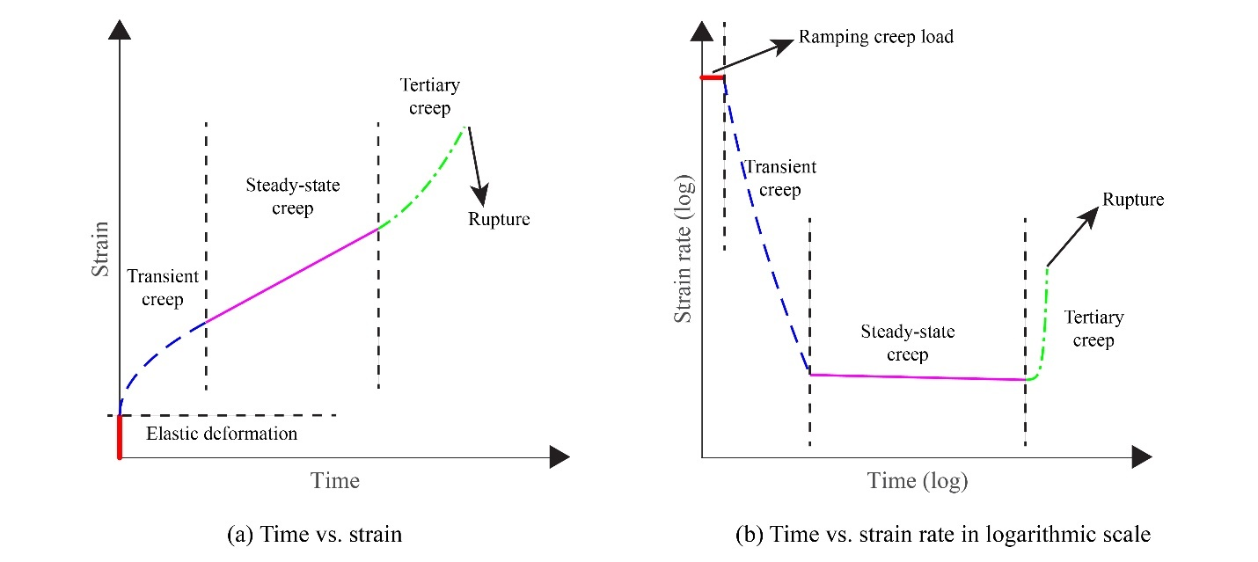

Fig. ‎5-1. Different stages of creep deformation under constant stress

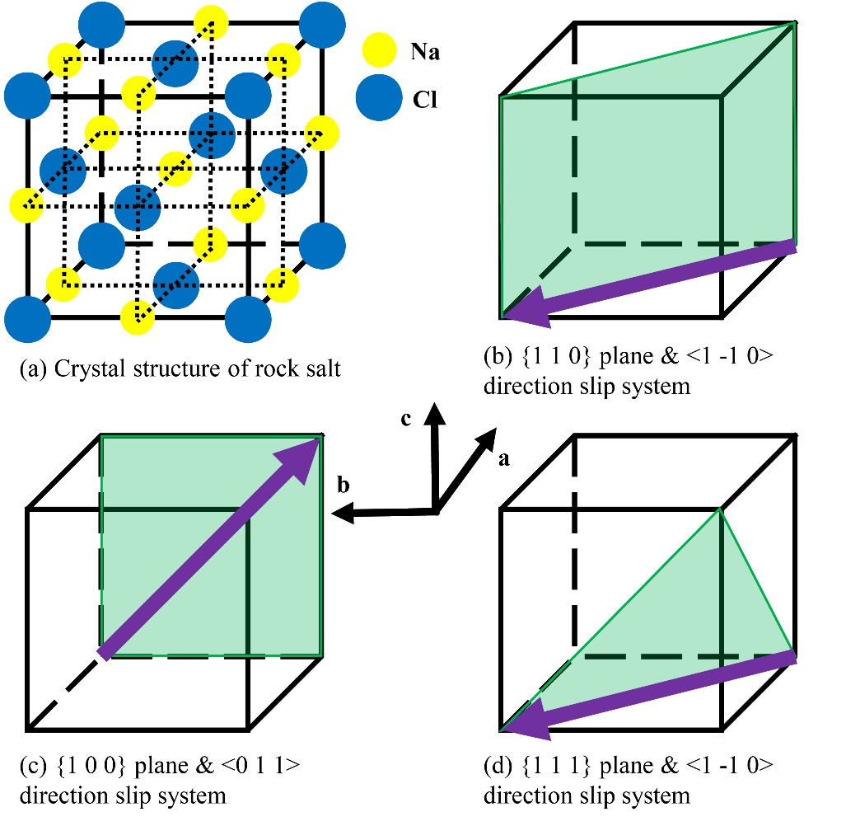

Fig. ‎5-2. Crystal structure of rock salt and its slip systems

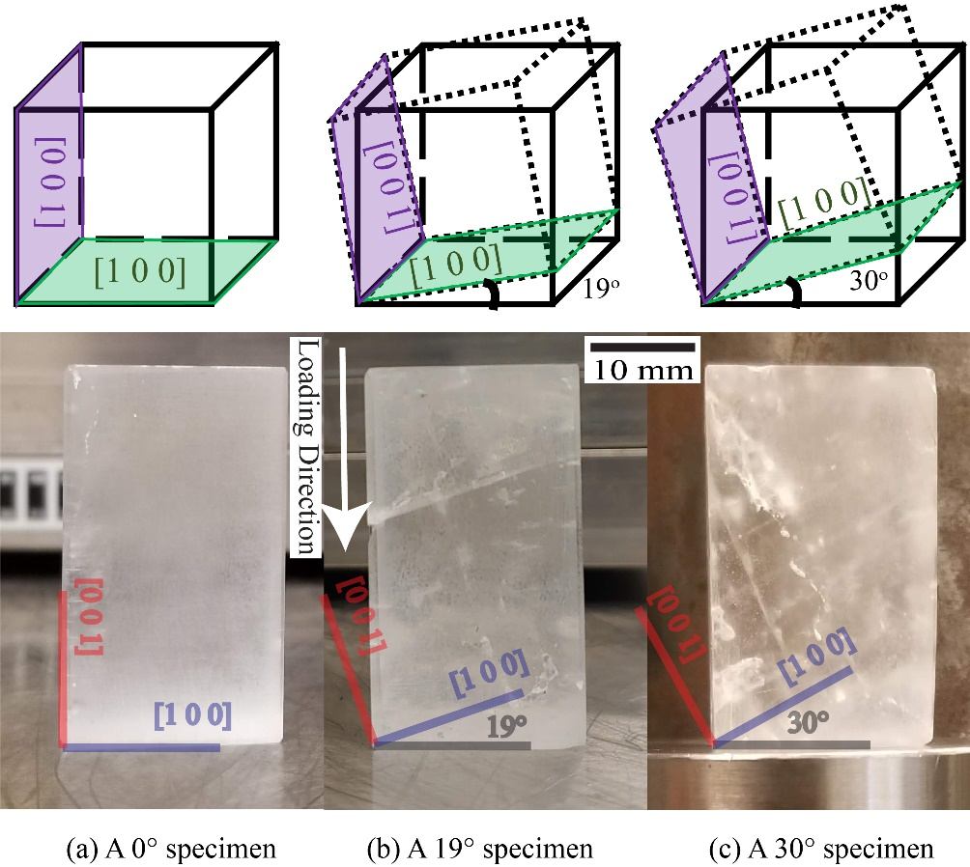

Fig. ‎5-3. Single-crystal rock salt specimens with different crystal orientations

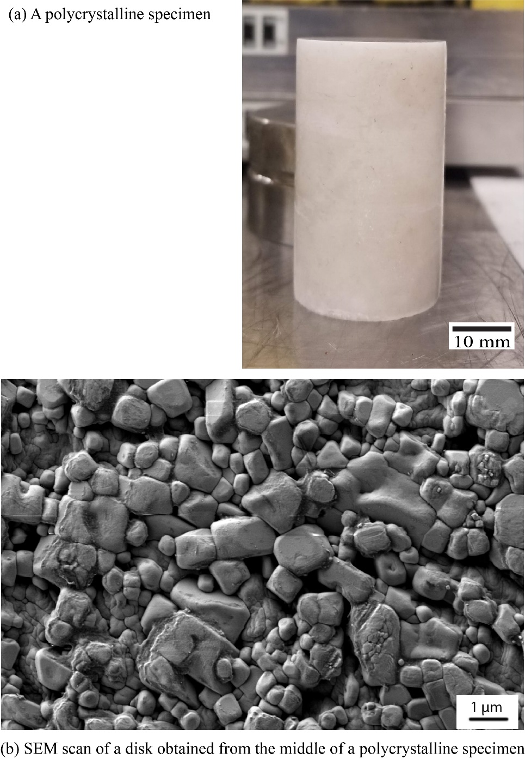

Fig. ‎5-4. A representative polycrystalline rock salt specimen and an SEM scan of its middle section

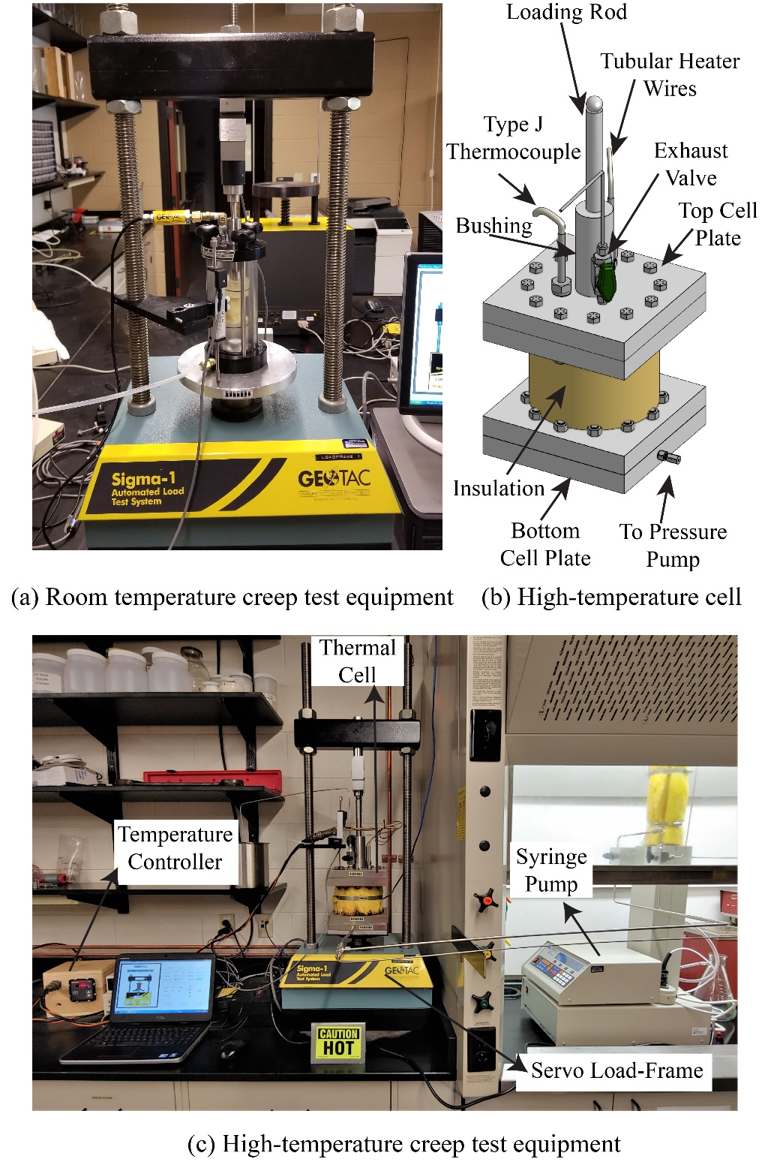

Fig. ‎5-5. The room-temperature triaxial system compared with the high-pressure thermal triaxial system
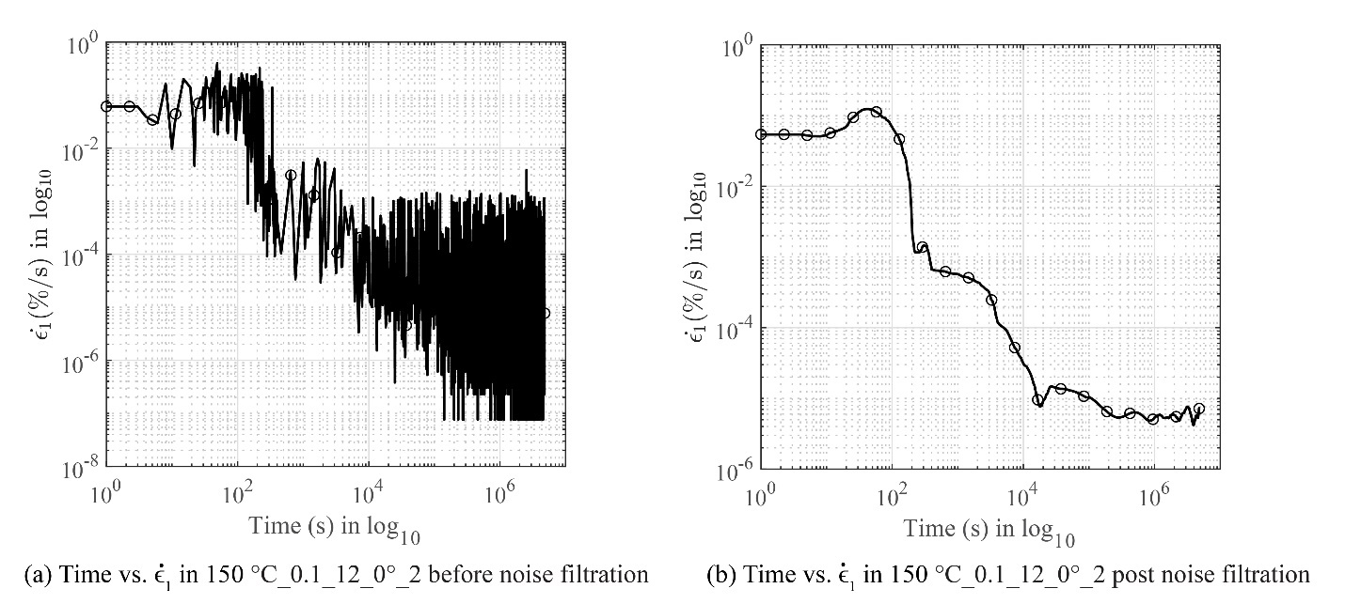

Fig. ‎5-6. 150° C_0.1_12_0°_2 creep test results before and after LVDT noise filtration process

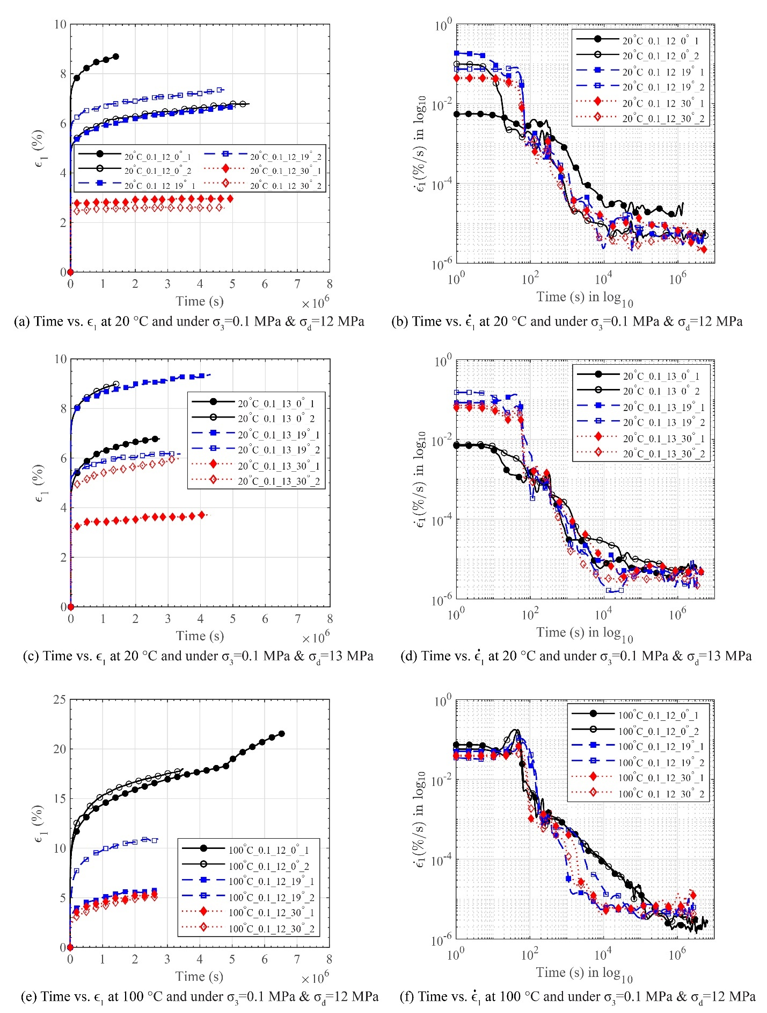

Fig. ‎5-7. Creep test results of single-crystal rock salt specimens with various crystal orientations
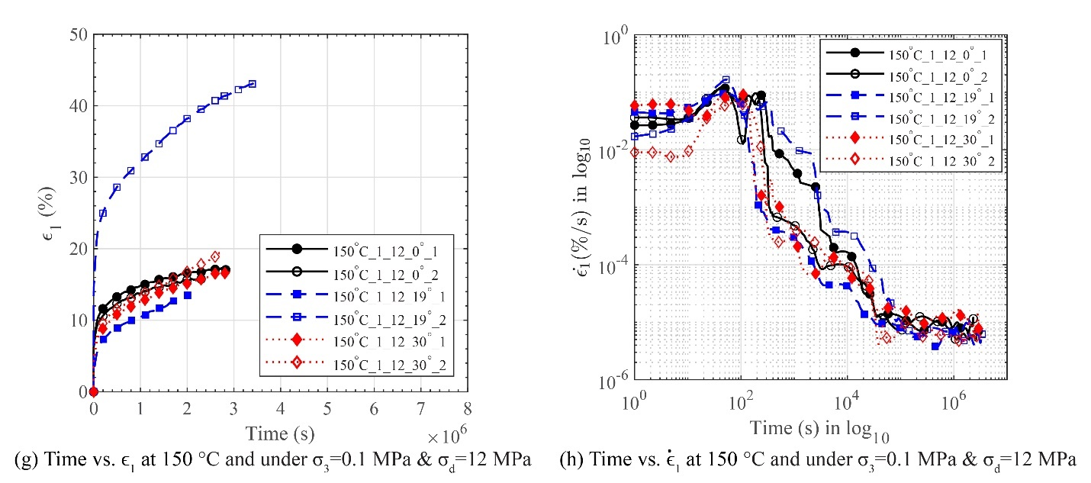

Fig. ‎5-7 Continued
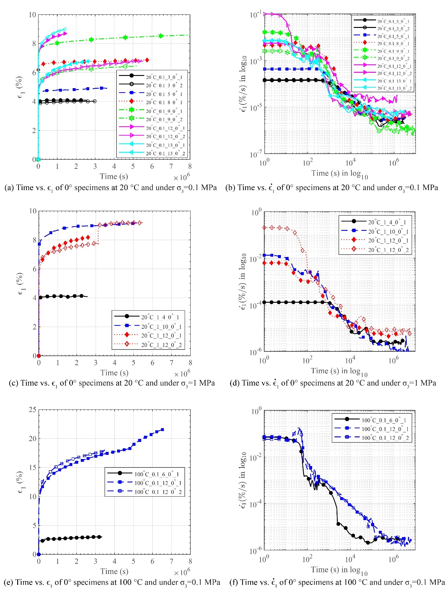

Fig. ‎5-8. Creep test results of single-crystal rock salt specimens under various deviatoric stresses
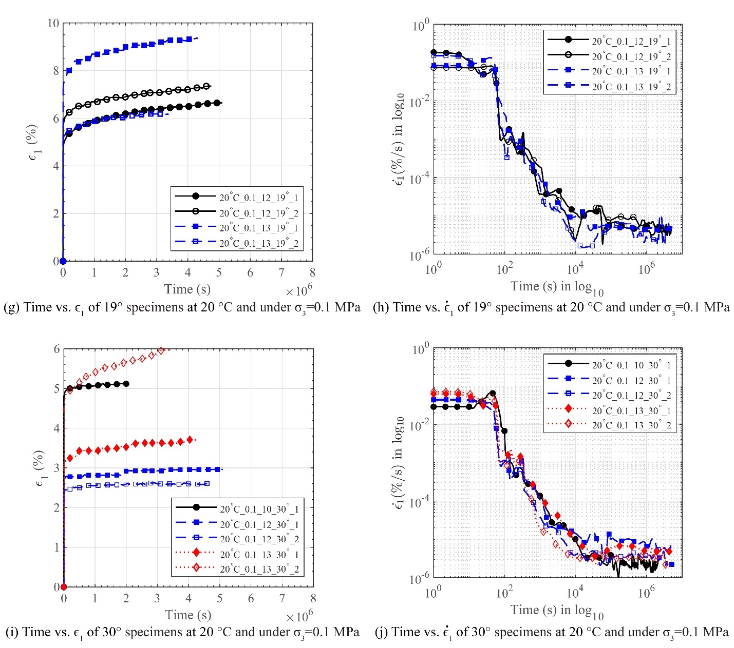

Fig. ‎5-8 Continued
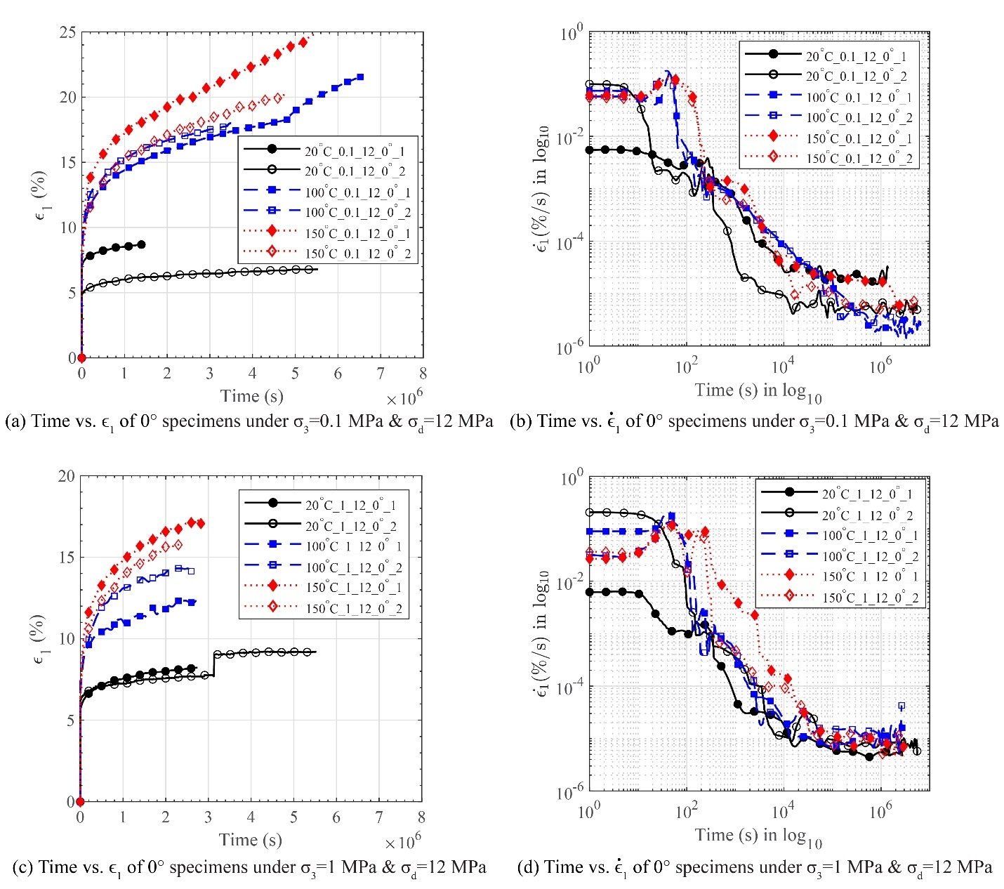

Fig. ‎5-9. Creep test results of single-crystal rock salt specimens at experimented at various temperatures
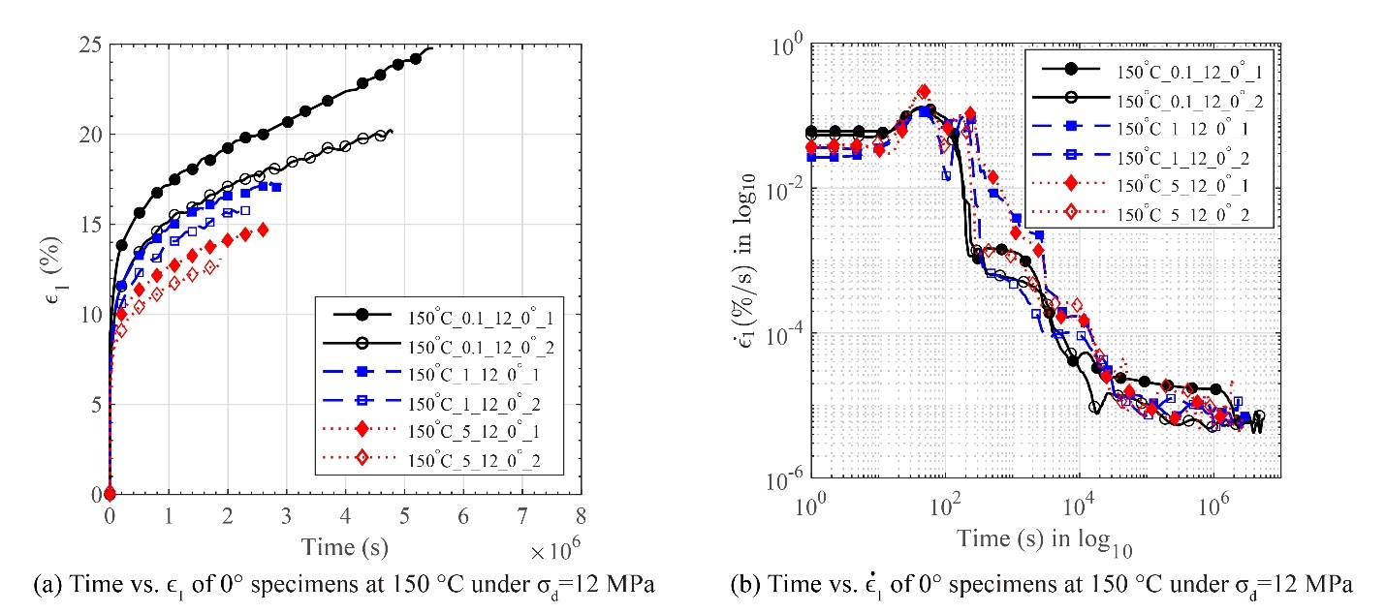

Fig. ‎5-10. Creep test results of single-crystal rock salt specimens under various confining stresses
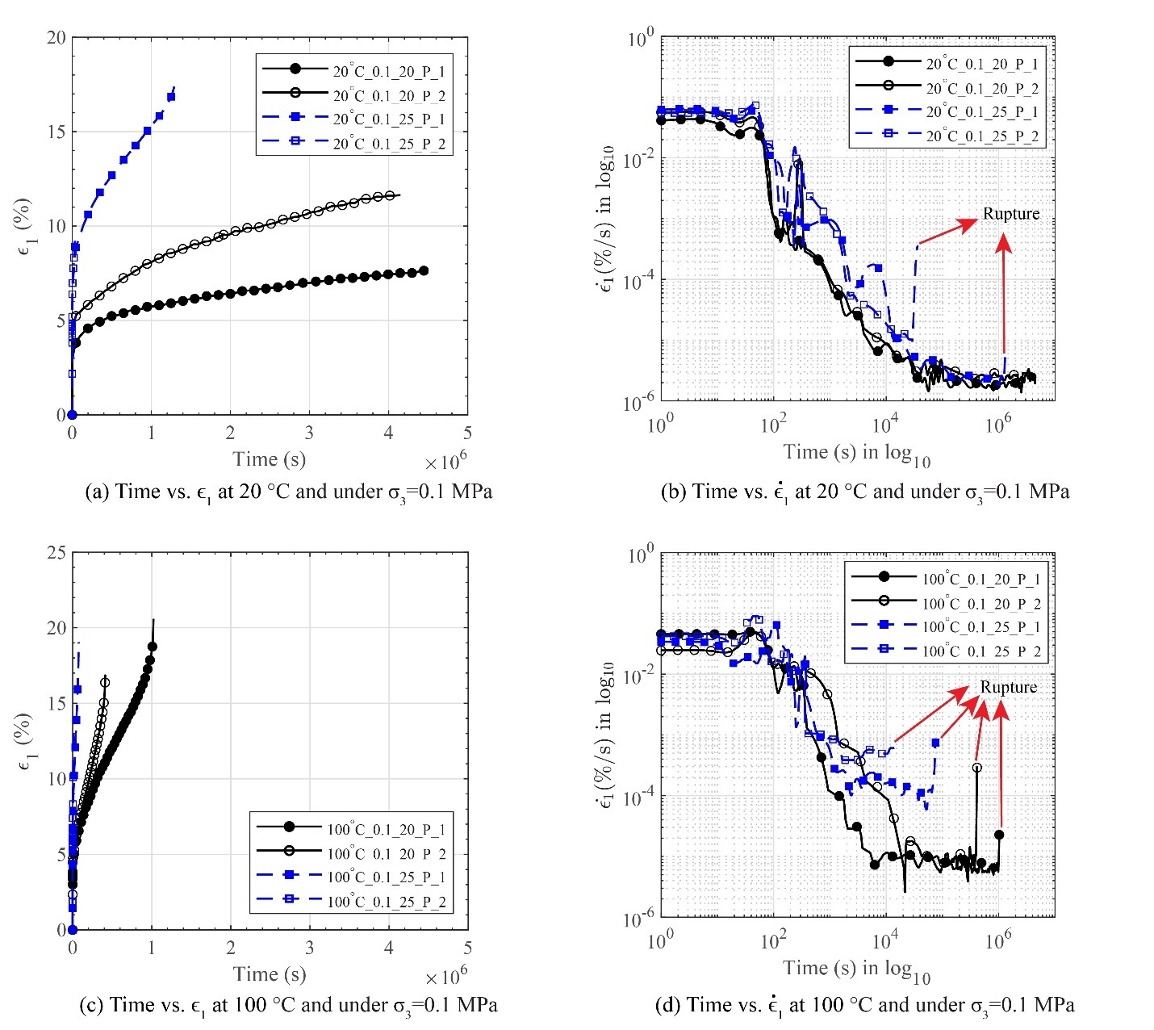

Fig. ‎5-11. Creep test results of polycrystalline rock salt specimens under various deviatoric stresses
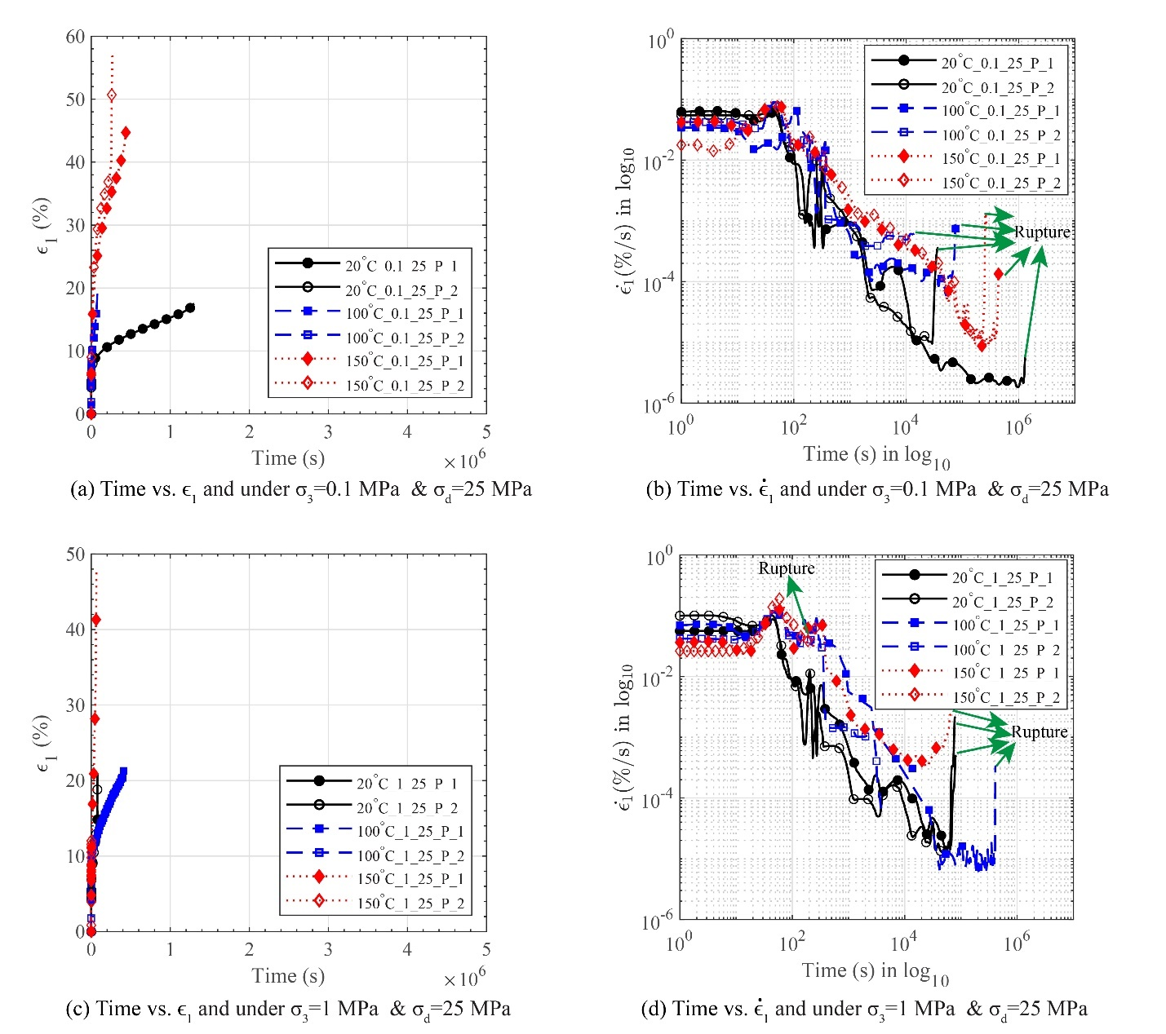

Fig. ‎5-12. Creep test results of polycrystalline rock salt specimens at experimented at various temperatures
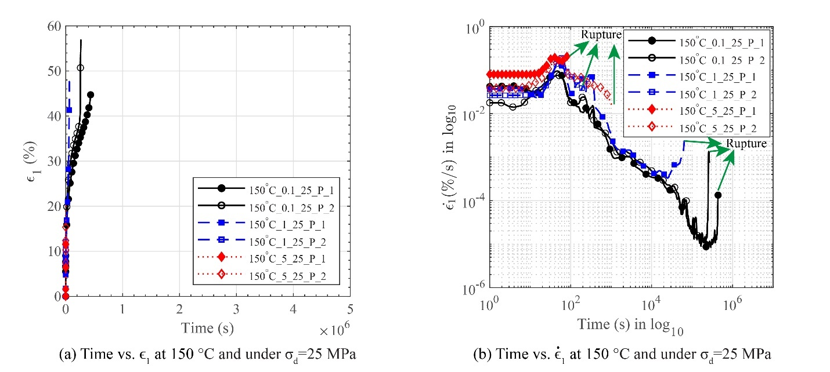

Fig. ‎5-13. Creep test results of polycrystalline rock salt specimens under various confining stresses
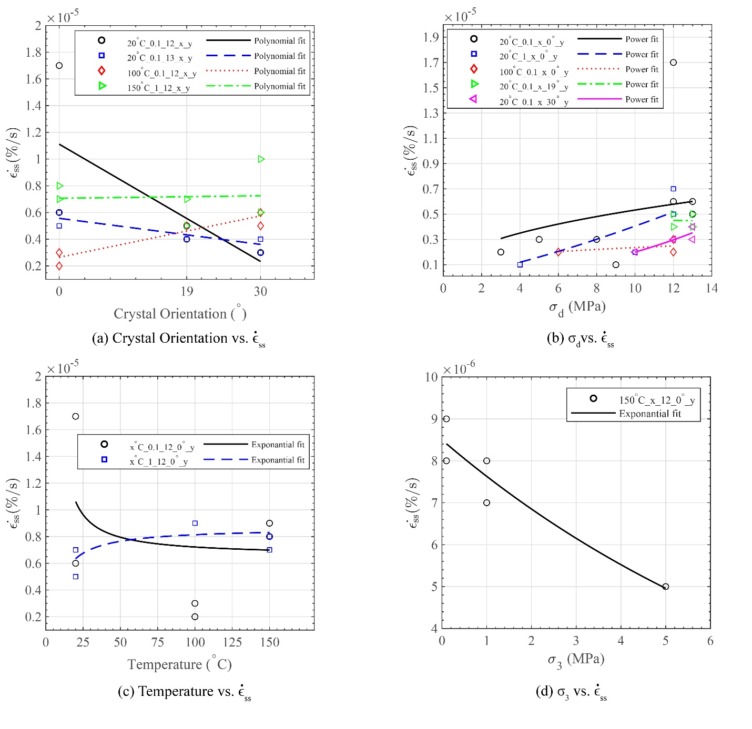

Fig. ‎5-14. Influence of crystal oriental, deviatoric stress, temperature, and confining stress on the steady-state strain rate of single-crystal rock salt under creep loads
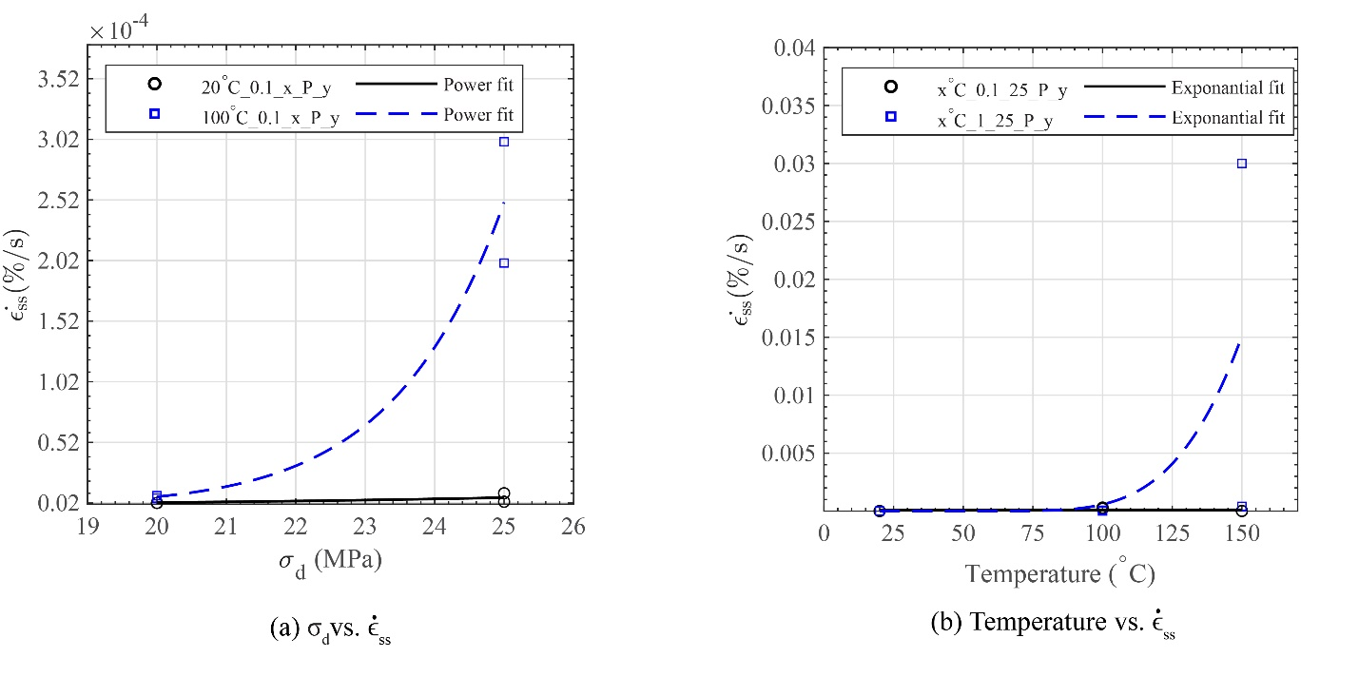

Fig. ‎5-15. Influence of deviatoric stress and temperature on the steady-state strain rate of polycrystalline rock salt under creep loads

CHAPTER 6
CONCLUSIONS AND RECOMMENDATIONS

Summary of Major Conclusions

This dissertation investigated the anisotropy, strength, creep behavior, and internal structural changes of rock salt. Various experiments such as 1-D compression, unconfined compression, and creep tests under different conditions including different types of rock salt specimens and various crystal orientation at various temperatures and in conjunction with state-of-the-art techniques such as 3D synchrotron micro-computed tomography (SMT) and 3D x-ray diffraction (3DXRD) were conducted on natural single-crystal and synthetic polycrystalline rock salt specimens. The following is a summary of the major findings of this dissertation:
- The relationships between the porosity and the applied axial stresses in dry and wet 1D compressions of polycrystalline rock salt were fitted using a decaying exponential model. When the porosity is plotted versus the logarithm of the applied axial stress, both dry and wet 1D compressions show a linear relationship between porosity and the logarithm of axial stress after reaching unique critical porosity values. The critical porosities of dry and wet 1D compressions were found to be 32% and 37%, respectively.
- The relationships of the porosity and the applied axial stress in dry and wet 1D compressions in unloading and reloading regions were fitted with linear trend lines that have slopes close to zero, which means the elastic deformations during the 1D compression are marginal and nearly the entire deformation is non-recoverable.
- Fine-grained polycrystalline rock salt containing nominally dry grain boundaries has a higher unconfined compressive strength and is more brittle compared to rock salt containing nominally wet grain boundaries. Increasing temperature decreases the unconfined compressive strength of all forms of polycrystalline rock salt and increases its ductility, where fine-grained rock salt with dry grain boundaries (younger rock salt formations) are more susceptible to the mentioned thermal changes.
- Natural single-crystal rock salt is more brittle and has a smaller unconfined compressive strength than synthetic single-crystal rock salt that has been reported in the literature. The loading direction with respect to rock salt’s crystal orientation significantly influences its strength, where generally rotation of the loading direction from parallel to [1 0 0] direction to 30º to (1 0 0) in (0 1 0) direction increases the unconfined compressive strength. Elevation of temperature does not affect rock salt’s response in all crystal orientations the same. Increasing the temperature resulted in a smaller yield strength, a lower work-hardening rate, and a higher ductility rock salt tested parallel to [1 0 0] and 19° to (1 0 0) in (0 1 0). However, the ductility and yield strength of rock salt tested on 30° to (1 0 0) in (0 1 0) did not change before increasing the temperature to 150° C.
- During the unconfined compression, polycrystalline rock salt developed a strong texture along the {1 1 1} orientation, and the other textures diminished with the increases of global axial strain. Within rock salt with an initially strong {1 1 1} texture, {1 1 1} <1 -1 0> slip system became more dominant compared to rock salt with a random initial texture that has exhibited a dominant {1 1 0} <1 -1 0> slip system in the literature. No clear force chain or structure formation was observed.
- The well stablished properties of the polycrystalline specimens synthesized in this study such as porosity distributions, average grain sizes, dominant grain textures, and compressive strength of specimens with various grain boundary conditions provides future experimental research in this field with a cost-effective and reproducible process to study polycrystalline rock salt’s mechanical behavior.
- Under global axial stresses of up to about 10 MPa in unconfined compression procedure, polycrystalline rock salt showed developments of local crack networks in all directions and its porosity was under 2% without any fully connected crack network. Reaching global axial stresses of about 30 MPa and porosity of 5.7% a fully connected crack network was formed within the material indicating a potential increase in its permeability.
- Changing the loading direction in creep experiments of single-crystal rock salt from parallel to [1 0 0], to 19º to (1 0 0) in (0 1 0), and then 30º to (1 0 0) in (0 1 0) diminished the accumulated axial strain ($ϵ_{t}$), transient axial strain ($\dot{ϵ_{t}}$), and steady-state strain rate ($\dot{ϵ_{ss}}$). However, $\dot{ϵ_{t}}$ and $\dot{ϵ_{ss}}$ appeared less sensitive to the loading direction at elevated temperatures or high deviatoric stresses.
- During the creep experiments of polycrystalline rock salt, raising the applied $σ_{d}$ not only increased $\dot{ϵ_{ss}}$ (especially at elevated temperatures) and $\dot{ϵ_{t}}$ but also lead to tertiary creep rupture. Elevated temperatures increased $\dot{ϵ_{t}}$ and $\dot{ϵ_{ss}}$ and reduced the time needed for tertiary creep rupture.
- Certain finding of this work such as the established critical axial stresses and porosity where impermeability of rock salt becomes compromised or the deviatoric stresses and temperatures that accelerate the tertiary creep rupture of rock salt can be directly used in industrial designs to ensure the safety of existing or future structures made within rock salt deposits.
- The remaining findings of this research including but not limited to the unconfined compressive and creep behavior of natural single-crystal rock salt in contrast to melt-grown synthetic single-crystal rock salt can be directly incorporated in rock salt’s numerical models which eventually will be used in ensuring the safety of structures built within rock salt deposits.

Recommendations for Future Work

Considering the findings of this dissertation, the following research tasks are recommended for future studies:
- Conducting in-situ x-ray diffraction on granular rock salt under 1D compression can help better understand the elastic and plastic deformation of the individual grains, especially in fine-grained rock salt.
- Investigating the unconfined compressive and creep behavior of single-crystal rock salt tested under additional crystal orientations can further the current state of the knowledge.
- In-situ SMT and 3DXRD of polycrystalline specimens with various grain sizes under unconfined compression can expand our understanding of the effects of grain size on the compressive behavior of rock salt.
- Testing rock salt specimens under a wider range of deviatoric stresses can result in identifying the critical deviatoric stress that accelerates the onset of the tertiary creep of single-crystal and polycrystalline rock salt.

VITA

Amirsalar Moslehy is currently continuing his career as a geotechnical engineer and is an adjunct lecturer at the University of Tennessee, Knoxville. He earned his BS degrees in Civil Engineering from Iran University of Science and Technology, Tehran, Iran in 2015, and his MSc degree in Geotechnical Engineering from University of Tehran, Tehran, Iran in 2017. He also earned a concurrent MSc degree in Civil Engineering from University of Tennessee, Knoxville, TN, USA in 2020 while pursuing his PhD in Civil Engineering with a minor in Computational Science. His research interests include (1) experimental studies on the constitutive behavior of rock salt; (2) experimental studies on the constitutive behavior of granular material; and (3) numerical modeling of granular materials.

