An Application of Path-Percolation Theory and Lattice-Boltzmann Model on Mass Transfer in a PEFC Cathode

A Thesis Presented for the

Doctor of Philosophy

Degree

The University of Tennessee, Knoxville

Ozgur Cekmer

May 2015

Copyright © 2015 by Ozgur Cekmer
All rights reserved.

DEDICATION

Even though this page is optional
I dedicate my work to you.

ACKNOWLEDGEMENTS

Thank you all for your help. However, this page is optional.

ABSTRACT

In this dissertation, a software was developed to investigate the single- and multi-phase mass, and momentum transfer through the porous layers of a polymer electrolyte fuel cell (PEFC) cathode. A novel statistical approach called path-percolation theory, and single- and multi-phase lattice-Boltzmann models were used with parallel programming implementations. The software was used to run two-dimensional oxygen and water transport simulations using randomly generated porous channels and digitized real gas diffusion layer (GDL) micro-computed tomographies to observe the multi-phase flow effects on a simulated and real PEFC cathode. A GDL and a catalyst layer (CL) of a PEFC can have porosities between 60-80% and 40-70%, respectively. A multi-phase water flow in GDL and CL is common, since PEFC is a low-temperature fuel cell system and works at 20-100ºC of temperature. The liquid formation in the channels decreases the effective porosity, significantly. Tortuosity, which is defined as the actual path that a molecule travels between the inlet and the outlet of a channel divided by the shortest path between the same points, has a significant effect on mass diffusion. It is very hard to predict the effective tortuosity especially for the channels with porosities lower than 50%. A mesoscopic approach is proposed to acquire more accurate predictions on mass transfer through a PEFC cathode in this dissertation. Moreover, polytetrafluoroethylene (PTFE) content in GDL and catalyst distribution in CL are the further considerations of this work. PTFE has hydrophobic effects and repels water, hence has an effect on water transport in GDL. It also changes the effective tortuosity for oxygen molecules. On the other hand, catalyst distribution in CL must be considered, and mesoscopically simulated to obtain a more accurate active catalyst area. Finally, a two-dimensional macroscopic cathode model was developed and the statistical results were compared to well-known models. The novel techniques introduced in this study can be utilized in any application area of heterogeneous porous media with single- and/or multi-phase transport with/without source and sink terms for mass and momentum transport as water supply management in hydrogeology, nuclear waste disposal, or underground water flow modeling.

PREFACE

This page is optional.

TABLE OF CONTENTS

INTRODUCTION 1
Heading 2 1
Heading 2 1
Heading 3 1
Heading 3 1
Heading 2 1
CHAPTER 1 Application of Path-Percolation Theory and Lattice-Boltzmann Method to Investigate Structure-Property Relationship in Porous Media 2
Abstract 3
Introduction 3
Path-Percolation Theory 5
Confidence Level Studies 5
Random Porous Media Generation with Cluster Labeling 7
Lattice-Boltzmann Method 10
RAE Selection 10
LBM Utilization 14
Results 17
Path-Percolation Theory 17
The Lattice Boltzmann Model 22
A New D_{eff}/D_{bulk} Model 26
Conclusions 27
CHAPTER 2 A Combined Path-Percolation - Lattice-Boltzmann Model to Investigate the Effects of Liquid Formation on Mass Transfer in Porous Media with OpenMP Implementation 28
Abstract 29
Introduction 29
Methodology 30
Inhomogeneous Porous Media Construction 31
The Lattice-Boltzmann Model 32
OpenMP Implementation 38
Results and Discussion 43
Conclusions 60
CONCLUSION 63
Heading 2 63
REFERENCES 64
VITA 67

LIST OF TABLES

Table 1. History calculations for path-percolation model. 6
Table 2. History calculations for Lattice-Boltzmann model. 13
Table 3. History calculations for Lattice-Boltzmann model. 32
Table 4. History calculations for Lattice-Boltzmann model 37
Table 5. Effective porosity, tortuosity, and diffusion ratio calculation example for SRAE with 0% condensation. 46

LIST OF FIGURES
Figure 1. Random porous medium generation for three cases: (a) the worst case; porosity:0.6002, effective porosity:0.1634 (b) the medium case; porosity: 0.5975, effective porosity: 0.3119 (c) the best case; porosity: 0.6051, effective porosity: 0.5144. 9
Figure 2. SRAE size determination. 11
Figure 3. SRAE size determination results. 12
Figure 4. SRAE element number determination; tortuosity against the element number. 13
Figure 5. A D₂Q₉ lattice (a) a lattice and its velocity components (b) red arrows are the lattice velocities at boundaries; the dashed ones are unknown. 14
Figure 6. Probability distributions of porosities of three cases for three confidence levels, (a) Φ=90%, (b) Φ=75%, (c) Φ=60%. 18
Figure 7. Probability distributions of porosities and effective porosities for three cases. Confidence level is 99%. (a) All three porosities (b) Φ=90%, (c) Φ=75%, (d) Φ=60%. 19
Figure 8. Initial and final forms of three porous samples (a) Best Case (Φ=0.605050, Φ_{eff}=0.499025), (b) Medium Case (Φ=0.598900, Φ_{eff}=0.321900), (c) Worst Case (Φ=0.597200, Φ_{eff}=0.139800 21
Figure 9. Path-Percolation results – (a) Effective porosity vs. porosity. The horizontal axis is the target porosities of the domains generated by path-percolation method. For higher porosities, the effective porosities are quite predictable. When the target porosity decreases, effective porosities can take many different values, hence become difficult to predict, (b) tortuosity vs. porosity, (c) tortuosity vs. effective porosity 21
Figure 10. An example procedure for a 60% porosity medium. (a) inhomogeneous porous domain with Φ=0.59705, (b) effective domain with Φ_{eff}=0.59705, (c) τ=1.30127, (d) τ=1.39888, (e) τ=1.31409. 24
Figure 11. Probability distributions of tortuosities for three cases with a confidence level of 99%, (a) Φ=60%, (b) Φ=75%, (c) Φ=90% 25
Figure 12. Bruggeman, Carman, and the new effective diffusivity model – D_{eff}/D_{bulk} vs. effective porosity. 26
Figure 13. A D₂Q₉ lattice (a) a lattice and its velocity components (b) red arrows are the lattice velocities at boundaries; the dashed ones are unknown. 35
Figure 14. Flowchart of the serial code for a single trial. 39
Figure 15. OpenMP implementation to the serial code. Flowchart of the parallel code for a single trial and demonstration of the fork-join model with 4 threads.owchart of the serial code for a single trial. 41
Figure 16. Path-percolation model for initial porous medium generation (a) domain before cluster labelling (b) cluster labelling (c) effective domain (d) - (f) three random RAEs 44
Figure 17. Effective porosity & tortuosity calculations for RAEs of an example trial with 80% porosity and 0% condensation (a) Φ_{eff} with 0% condensation (b) τ_{eff} with 0% condensation (a) Φ_{eff} with 10% condensation (b) τ_{eff} with 10% condensation (a) Φ_{eff} with 20% condensation (b) τ_{eff} with 20% condensation 45
Figure 18. Velocity vectors along RAE #2. Tortuosity is 1.153163. 47
Figure 19. Evolution of phase separation of a 10% condensed two-phase fluid in REV #2 48
Figure 20. Vapor phase mass transfer with a 10% condensation (a) liquid formation (b) the voids occupied by liquid are shown in gray (c) Mass transfer in vapor phase, the effective tortuosity is 1.310297. 50
Figure 21. Vapor phase mass transfer with a 20% condensation (a) liquid formation (b) liquid formations are shown in gray (c) Velocity field of the vapor phase, the effective tortuosity is 1.551636. 51
Figure 22. Effects of condensation on mass transfer for a single example trial (a) effective porosity and tortuosity vs. condensation (b) diffusion ratio vs. condensation 52
Figure 23. Confidence level results for initially generated 100x100 porous media with 70%, 80%, and 90% porosity 52
Figure 24. Confidence level results for SRAEs with (a) 90%, (b) 80%, and (c) 70% porosity. Figures on the left and right are probability distributions of effective porosity and tortuosity, respectively. 53
Figure 25. Liquid formation in an example RAE for 70% target porosity (a) 10%, (b) 20% 55
Figure 26. Velocity fields in effective domains with (a) 0%, (b) 10%, (b) 20% condensation. Computed tortuosities are 1.403323, 1.447953, and 1.28602, respectively. 56
Figure 27. Diffusion ratio probability distributions with a medium with (a) 0%, (b) 10%, (c) 20% liquid formation 58
Figure 28. Critical liquid formation probability distributions with a medium with 70%, 80%, and 90% target porosity. 58
Figure 29. Performance analysis for parallel application 60

INTRODUCTION

Heading 2
This is the introduction to the entire paper. It can be chapter one, or just a stand-alone introduction chapter. In any case, it isn’t just an introduction to part 1.
You may use single, double, or 1.5 spacing. You may use any font of your choosing, but you must be consistent, and the font must be embedded or at least subset in the document. This will happen automatically if you use Adobe Acrobat

Heading 2

Use subheadings consistently. Check spacing, capitalization, and punctuation.

Heading 3
Use of styles is helpful in generating a table of contents. This sample document uses the headings to automatically generate the table of contents, list of tables, and list of figures.

Heading 3
Once you use styles to generate the lists, you can update them quickly and easily. Use of styles is helpful in generating a table of contents. This sample document uses the headings to automatically generate the table of contents, list of tables, and list of figures. This document is set up to follow APA as well as UTK Guidelines. If you want to change formatting for the headings, you can highlight heading or other text you wish to change, then either change the font and then find whatever style you wish to change in the Styles window. Right click on that style and choose “Update [Style] to match selection.” Alternatively, you can choose “Modify” to change the style without choosing text.

Heading 2

Don’t forget to have your thesis/dissertation reviewed by the thesis/dissertation consultant before the preliminary review deadline. If you wait until the deadline to schedule an appointment, it is likely that you will not be able to get an appointment.

CHAPTER 1
Application of Path-Percolation Theory and Lattice-Boltzmann Method to Investigate Structure-Property Relationship in Porous Media

(Beyond the title, this page should be blank. The publication statement, abstract, and the rest of the chapter should begin on the next page.)

A version of this chapter was originally published by Ozgur Cekmer, Sukkee Um, and Matthew M. Mench:
Ozgur Cekmer, Sukkee Um, Matthew M. Mench. “Application of path-percolation theory and Lattice-Boltzmann method to investigate structure-property relationship in porous media”, International Journal of Heat and Mass Transfer (under review), (2014)

The student must add a brief explanatory statement at the beginning of each article, stating how the article was revised and/or detailing the student’s involvement in the article. Any co-researchers should be identified and their role clarified as part of this statement.

Abstract

In this study, the path-percolation theory was applied to randomly generate porous media, and effective porosities of these domains were determined. A statistical approach was pursued to determine effective porosity with confidence levels of 95%, 97%, and 99%. Furthermore, the Lattice-Boltzmann method was applied to obtain the velocity distribution throughout the porous channels to evaluate effective tortuosity. Two dimensional lattices with nine velocity components were utilized for fluid flow simulations. A new effective diffusivity model for porous media was developed using effective porosity and tortuosity determined by path-percolation and Lattice-Boltzmann theories, respectively. Diffusion behavior of gasses in porous media as a function of porosity is typically unpredictable when the porosity is below 0.6, but the developed diffusion model as a function of effective porosity is shown to be useful in all effective porosity ranges.

Introduction

Percolation theory describes a probabilistic model that includes a phase transition [1]. This theory can be used to simulate an inhomogeneous medium, which must be constituted by at least two phases. As an example, a virtual, square porous media can be constructed randomly with void and solid constituents and it can be considered as a flow path. Let us assign the probability of generating a void (pore) as p, hence the solid generation probability becomes 1-p. Percolation theory dictates that the fluid particles can only move in four directions; up, down, left, and right, and they cannot move to cross nodes. The probability of an open path from the center of the porous domain to any of the sides is called the percolation probability and denoted by θ(p) [2]. Percolation probability becomes one if the whole domain is void, θ(1)=1, and it starts decreasing as p decreases. After a critical point called the percolation threshold, p_{c}, it becomes zero.
The Lattice Boltzmann Method (LBM) is a mesoscopic scale technique, which lies between microscopic and macroscopic scale analyses, and is utilized by investigating the behavior of a collection of particles as a unit [3-5]. A distribution function represents any property of these units. LBM can be used to simulate single and multiphase flows with a wide range of behaviors including condensation, cavitation, phase separation, surface interaction, etc. In this study, LBM was utilized to simulate mass and momentum flow in randomly generated porous media.
There are a few studies which combine percolation theory and Lattice-Boltzmann applications to examine flow in porous media. Nabovati and Sousa [6] simulated fluid flow in two dimensional random porous media by using the Lattice-Boltzmann method to determine the relation between permeability and porosity. They randomly placed identical rectangles with free overlapping to construct the porous domains. It was found that the permeability decreased when the regularity of the porous medium was disturbed for the same porosity. Furthermore, permeability varied exponentially with porosity, independently from porous media organization. Koponen et al. [7] investigated the relationship between tortuosity and porosity by using a lattice-gas cellular automation method. In their simulations, they constructed their domain by randomly placing rectangles of the same size with free overlapping. A porosity range of 0.5 – 0.9 was used, while the tortuosity varied linearly with porosity. They also analyzed permeability and effective porosity of porous media by using the same methods as in [7] in another study [8]. A Newtonian, incompressible, two dimensional flow was used for the simulations and they obtained curve fit equations for tortuosity, effective porosity, and permeability as functions of porosity. Matyka et al. [9] performed a numerical study on the relation between tortuosity and porosity in a microscopic model of porous medium. The domain was arranged by freely overlapping squares and they obtained streamlines of the flow by using Lattice-Boltzmann theory. A new curve fit model was found for tortuosity depending on system size and porosity. Grucelski and Pozorski [10] applied the Lattice Boltzmann method to perform fluid flow and heat transfer computations. The domain was constructed by uniformly placing circular particles with different diameters within a certain range. They provided free overlapping and intersection of the particles with the system boundaries. The temperature profiles and pressure drop were obtained as the results of their study.
A new alternative method called path-percolation modeling was developed by Jung et al. [11] to simulate the electrical property variations in a spatially disordered porous medium. This method was adapted to the determination of micro-properties related to mass transfer through a porous medium in this study. After randomly constructing the porous domain, and performing the cluster labeling, the Lattice-Boltzmann method was utilized to solve the momentum balance equation and obtain the velocity distribution throughout the channel. The uniqueness of this study is based on the statistical modeling it pursues and the cluster labeling process, which is described in detail in the following section. Preventing the overlapping is also another novel outcome described in this study. Besides the stochastic based random diffusion media generation, the other target of the study is to develop a new effective diffusivity model suitable for all values of porosity using effective porosity, tortuosity, and diffusion ratio determined by combined path-percolation and Lattice Boltzmann methods. The results of this study will be useful to predict the mass diffusion behavior in any porous medium application.

Path-Percolation Theory

There are three steps in this adaptation of statistical based path-percolation theory. The first step is determination of the system characteristics, specifically; total node numbers, trials and porosity. To do this; a confidence-level study must be performed. After determining the system characteristics, a random porous media generation is done as the second step. Pores or solids are assigned to each node in the porous medium depending on the specified porosity. A cluster labeling process is followed to eliminate the unconnected (orphan) pores, since they have no ability to transport through porous media. The physical counterpart of the percolation probability is the effective porosity, which is a micro-property of the porous domain. The effective porosity is distinct from the porosity, and obtained after the cluster labeling process.

Confidence Level Studies
The confidence level [12] expresses the reliability of any estimate and values of 95%, 97%, and 99% confidence levels were analyzed for our model.
$$Pr\left\{\left|\frac{k}{n}-p\right|≤ε\right\}=CL$$ | (1.1)

In Equation (1.1), p stands for the probability of an event to occur, which is the probability of a pore to occur in a node in our analysis. Total trial number is represented by n whereas k stands for the number of cases of Pr {void} = p in n trials. Error is represented by ε and shows the difference between the true and estimated probabilities of an event. Finally, Pr and CL represent the probability of the event in the brackets and confidence level, respectively.
Equation (1.2) is obtained after applying the law of large numbers [12]:
$$Pr\left\{\left|\frac{k}{n}-p\right|≤ε\right\}=2 G\left(ε\sqrt{\frac{n}{pq}}\right)-1=CL$$ | (1.2)

where q=1-p is the probability of generating a solid, and $G$ is the Gaussian function which is related to error function as follows:
$$G\left(z\right)-\frac{1}{2}=erf⁡(z)$$ | (1.3)

after combining Equations (1.2) and (1.3), the following relation is obtained:
$$\operatorname{erf}\left(ε\sqrt{\frac{n}{pq}}\right)=\frac{CL}{2}$$ | (1.4)

Error, ε, is accepted as 3x10⁻⁴ for this study. Although a wide porosity range was investigated in this study, confidence level studies of three cases with Φ=0.60, Φ=0.75, and Φ=0.90 were analyzed in detail, and the related p values are 0.60, 0.75, and 0.90, respectively. Hence, the q values (1-p) become 0.40, 0.25, and 0.10. The total number of histories were calculated by using Equation (1.4) and an error function table [12]. Mathematically, the number of the history is the trial number multiplied by the total nodes. The calculations and the results are shown in Table 1.

Table 1. History calculations for path-percolation model.
Confidence Level | $$\operatorname{erf}\left(ε\sqrt{\frac{n}{pq}}\right)$$ | $$ε\sqrt{\frac{n}{pq}}$$ | $$ϕ$$ | $$n$$ | Trials | Nodes
95% | 0.475 | 1.9604 | 0.90 | 3,843,168 | 384 | 100x100
95% | 0.475 | 1.9604 | 0.75 | 8,006,600 | 801 | 100x100
95% | 0.475 | 1.9604 | 0.60 | 10,248,448 | 1025 | 100x100
97% | 0.485 | 2.1707 | 0.90 | 4,711,938 | 209 | 150x150
97% | 0.485 | 2.1707 | 0.75 | 9,816,539 | 436 | 150x150
97% | 0.485 | 2.1707 | 0.60 | 12,565,169 | 558 | 150x150
99% | 0.495 | 2.5767 | 0.90 | 6,639,383 | 166 | 200x200
99% | 0.495 | 2.5767 | 0.75 | 13,832,048 | 346 | 200x200
99% | 0.495 | 2.5767 | 0.60 | 17,705,021 | 443 | 200x200

Random Porous Media Generation with Cluster Labeling
After determining the trial numbers needed and the total node numbers, porous media generation with cluster labeling can be started. It should be emphasized that the porous media generated here are considered as gas diffusion channels, and the lower and upper boundaries are accepted as inflow and outflow boundaries, respectively, while the side walls are impervious boundaries, and thus reflective.
An in-house program was developed to construct a porous medium by randomly assigning numbers between 1 and 100 to each node. After the random number assignment, the nodes with the values greater than 60 were accepted as solid and the remaining nodes became pores for a 60% porous medium simulation. Figures 1(a), (b), and (c) show a sample procedure for 60% porous media with low, medium, and high effective porosities, respectively. In this simple demonstration, 100 by 100 nodes were used. At this point, it must be emphasized that, since the transport of molecules is the basic consideration in this study; low, medium, and high effective porosities are therefore referred as worst, medium, and best cases, respectively. Hence, Figures 1(a), (b), and (c) show the worst, medium, and best cases for transport, respectively.
The next step is the cluster labeling. The connected pores are grouped into clusters. Clusters that are connected to neither inflow nor outflow boundaries are eliminated and considered as orphaned and isolated, and are therefore equivalent to a solid. After cluster labeling, the effective diffusion domains are obtained as shown in Figure 1. The porosity of the effective domain is called the effective porosity. For the cases shown in Figures 1(a), (b), and (c) the effective porosities obtained are 0.1634 for the worst case, 0.3119 for the medium case, and 0.5144 for the best case, respectively.

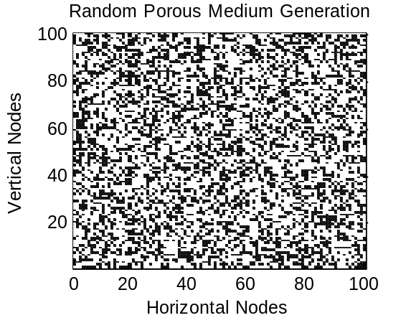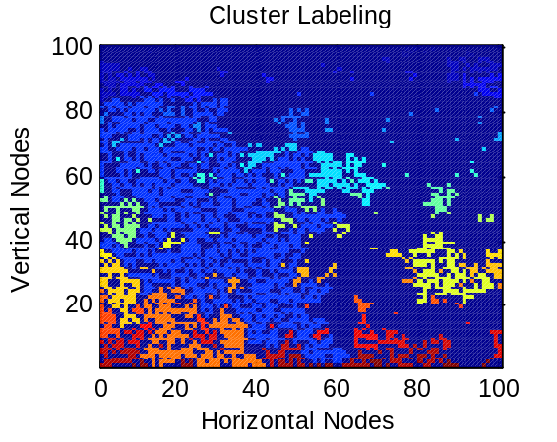
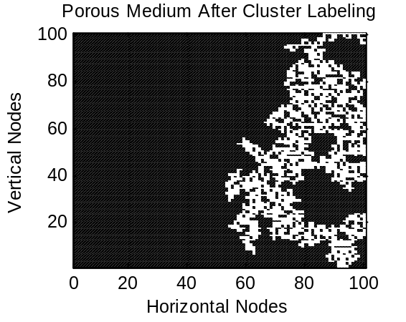
(a)

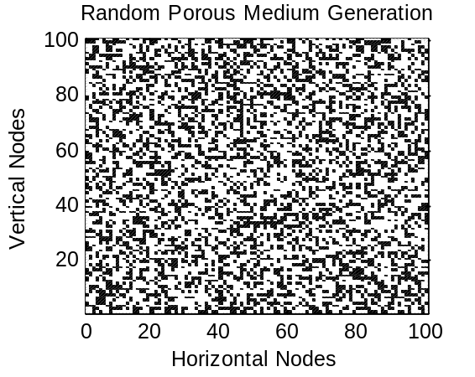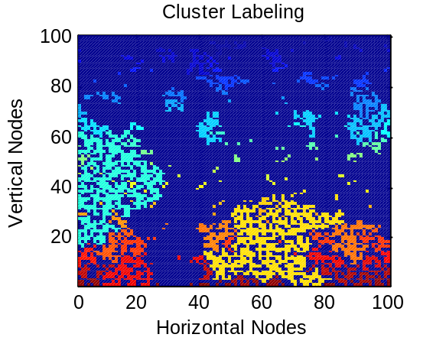
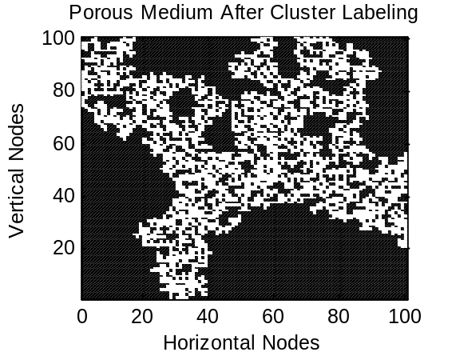
(b)

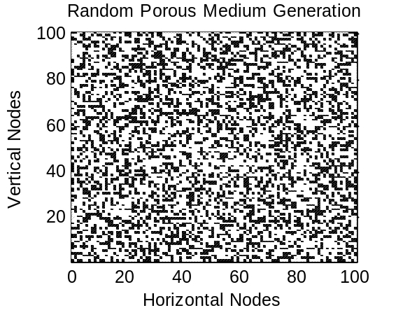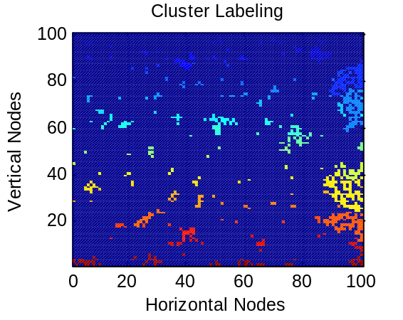
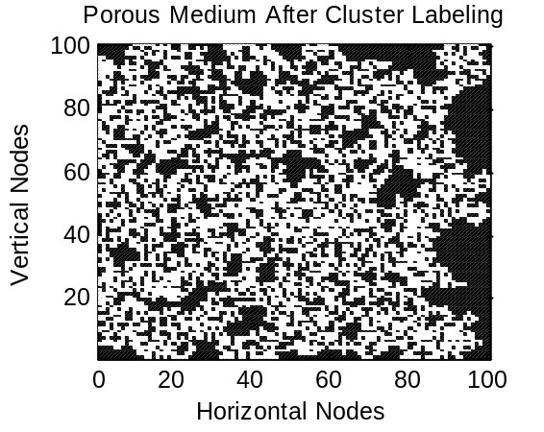
(c)
Figure 1. Random porous medium generation for three cases: (a) the worst case; porosity:0.6002, effective porosity:0.1634 (b) the medium case; porosity: 0.5975, effective porosity: 0.3119 (c) the best case; porosity: 0.6051, effective porosity: 0.5144.

The entire path-percolation method procedure including the confidence level analyses was analyzed in the results section to explain and illustrate this model thoroughly.

Lattice-Boltzmann Method
Ludwig Boltzmann’s works [4] are based on a statistical treatment performed for the particles that constitute a gas. Actions of the gas particles can be described by two mechanisms; streaming in space and collisions. Detailed information about the kinetic theory of gases can be found in references [3-5]. The Lattice-Boltzmann Method (LBM) is a simplified form of Boltzmann’s original view, by which the particle spatial positions are reduced and time is discretized into distinct steps. In this study, it was applied to obtain the velocity distribution and tortuosity for the porous channels, which were generated by statistical path-percolation theory.

RAE Selection
Although LBM is not as mathematically complicated as Navier-Stokes equations, since it is a first order partial differential equation (PDE), whereas the latter is second order, it is still computationally intensive. Therefore, before applying LBM to the current problem, a representative smaller domain should be chosen from the entire domain, which is called the representative area element (RAE). The RAE is a finite area in the domain, which represents the macroscopic properties of the entire domain with a specified accuracy.
In the current problem, the represented (post-cluster-labeling) macroscopic property is the effective porosity. However, the aim of using LBM is to solve the momentum balance equations and to determine the effective tortuosity. Hence, a single RAE may not represent the tortuosity of the entire porous domain with the desired accuracy, although it may represent the porosity of the entire area. Therefore, an alternative method is used in this study; instead of choosing a single RAE, a set of small areas called a statistical representative area element set (SRAE Set) is optimally chosen from the entire domain [13, 14].
There are two steps to determine SRAE. First, the size of the small areas must be considered. Then, the number of the small areas in a set should be determined. For the first step, the domain was divided into sixteen regions, as shown in Figure 2.

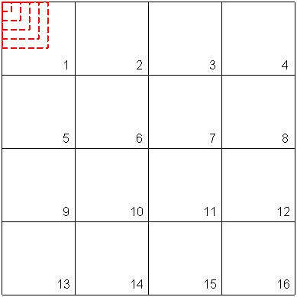
Figure 2. SRAE size determination.

Starting from a 1x1 matrix from the top-left corner of each section, matrix sizes are increased as 2x2, 3x3, etc. and the porosities are plotted against the matrix size. To do this, a random porous medium with 75% porosity is generated as described in Section 2. Then, the relative error between the porosities of the domain and the SRAEs were plotted against the SRAE size for each section shown in Figure 2. Four of these plots can be seen in Figure 3 and will be analyzed in the results section.

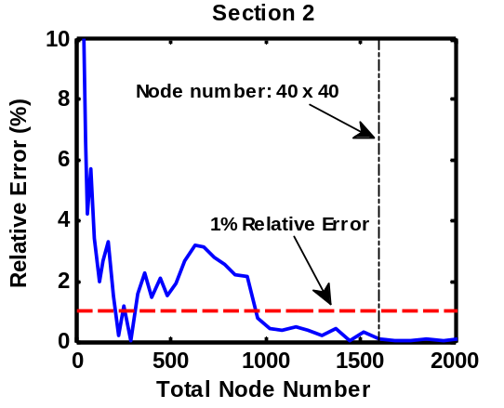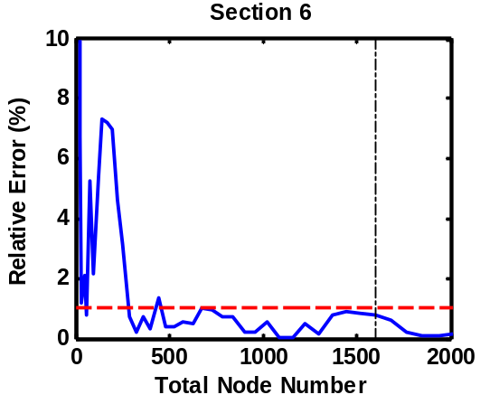
(a) (b)
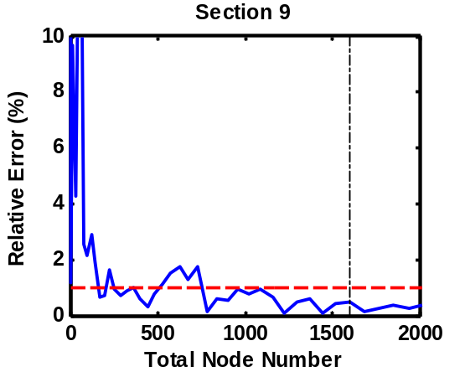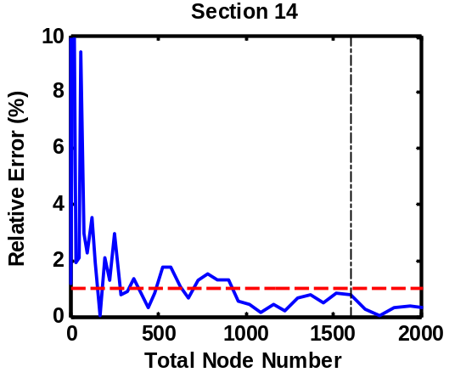
(c) (d)
Figure 3. SRAE size determination results.

After the determination of the SRAE size, the number of elements in an SRAE set must be determined as the second step. To do this, confidence level studies are revisited. Total number of histories were already determined in Section 2.1, and as explained in Section 4.1, 99% confidence level is applied for tortuosity determination. Therefore, the node number and the total SRAE set number must be calculated for the momentum balance analysis regarding to the total history numbers shown in Table 1. The results are shown in Table 2.

Table 2. History calculations for Lattice-Boltzmann model.
Confidence Level | $$\operatorname{erf}\left(ε\sqrt{\frac{n}{pq}}\right)$$ | $$ε\sqrt{\frac{n}{pq}}$$ | $$ϕ$$ | $$n$$ | Trials | SREV Nodes | SREV Set Number
99% | 0.495 | 2.5767 | 0.90 | 6,639,383 | 166 | 40x40 | 25
99% | 0.495 | 2.5767 | 0.75 | 13,832,048 | 346 | 40x40 | 25
99% | 0.495 | 2.5767 | 0.60 | 17,705,021 | 443 | 40x40 | 25

The procedure is the same as before, except the node numbers. In this table, total history is defined as the multiplication of the SRAE set number (number of small RAEs), trial number, and node number of a single RAE.
To choose the constituents of the sets optimally, the entire domain is scanned and all possible SRAEs with the determined size are extracted and the errors are calculated. Starting from the SRAE with the smallest error (the best option), several SRAEs are added, respectively, and the ensemble average of the porosities with the relative errors are calculated (Figure 4).
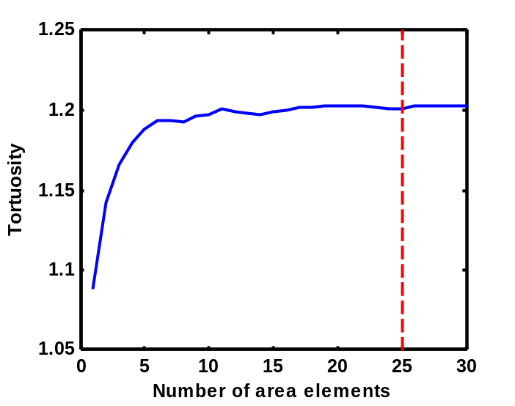
Figure 4. SRAE element number determination; tortuosity against the element number.

It is expected that when the number of elements in an SRAE set increases, the relative error between the effective porosity of the entire domain and the ensemble averaged porosities will also increase, since the elements are optimally chosen. The ensemble averages for any property can be calculated as follows:
$$\hat{X}=\frac{1}{N}\sum_{m=1}^{N}{X_{m}}$$ | (1.5)

In Equation (1.5), $X_{m}$ is any property of the m^{th} element, N is the total element number, and $\hat{X}$ is the ensemble average. The detailed analysis is explained in the results section.

LBM Utilization
In this section, application of LBM to the SRAEs are described. D₂Q₉ is a Cartesian lattice with 2 dimensions and 9 velocity components as seen in Figure 5(a) where f represents the velocity distribution function.

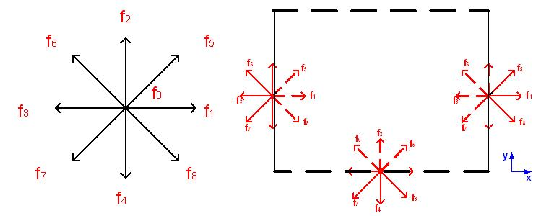
(a) (b)
Figure 5. A D₂Q₉ lattice (a) a lattice and its velocity components (b) red arrows are the lattice velocities at boundaries; the dashed ones are unknown.

All nodes of the domain, which was obtained from path-percolation theory, are treated as D₂Q₉ lattices. The velocities of the lattices can be written as follows:
$c_{0,x}=0$, $c_{0,y}=0$, $c_{1,x}=1$, $c_{1,y}=0$, $c_{2,x}=0$, $c_{2,y}=1$ | (1.6)
$c_{3,x}=-1$, $c_{3,y}=0$, $c_{4,x}=0$, $c_{4,y}=-1$, $c_{5,x}=1$, $c_{5,y}=1$ | (1.6)
$c_{6,x}=-1$, $c_{6,y}=1$, $c_{7,x}=-1$, $c_{7,y}=-1$, $c_{8,x}=1$, $c_{8,y}=-1$ | (1.6)

Collisions and streaming can be calculated by Equations (1.7) and (1.8), respectively, where f is defined as the distribution function.
$$f_{k}\left(x+c∆t,y+c∆t,t+∆t\right)-f_{k}\left(x,y,t\right)=-Ω\left[f_{k}\left(x,y,t\right)-f_{k}^{eq}\left(x,y,t\right)\right]$$ | (1.7)
$$f_{k}\left(x+∆x,y+∆y,t+∆t\right)=f_{k}\left(x,y,t+∆t\right)$$ | (1.8)

In Equations (1.7) and (1.8), c, x, y, and t represent speed of sound, horizontal coordinate, vertical coordinate, and time, respectively. $Ω$ is the collision matrix as shown in Equation (1.9):
$$Ω=M^{-1}SM$$ | (1.9)

The constant matrix, M, and the relaxation matrix, S, are shown in Equations (1.10) and (1.11), respectively [3].

$$M=\left[\begin{matrix}1 & 1 & 1 & 1 & 1 & 1 & 1 & 1 & 1 \\ -4 & -1 & -1 & -1 & -1 & 2 & 2 & 2 & 2 \\ 4 & -2 & -2 & -2 & -2 & 1 & 1 & 1 & 1 \\ 0 & 1 & 0 & -1 & 0 & 1 & -1 & -1 & 1 \\ 0 & -2 & 0 & 2 & 0 & 1 & -1 & -1 & 1 \\ 0 & 0 & 1 & 0 & -1 & 1 & 1 & -1 & -1 \\ 0 & 0 & -2 & 0 & 2 & 1 & 1 & -1 & -1 \\ 0 & 1 & -1 & 1 & -1 & 0 & 0 & 0 & 0 \\ 0 & 0 & 0 & 0 & 0 & 1 & -1 & 1 & -1 \end{matrix}\right]$$ | (1.10)

$$S=\left[\begin{matrix}s_{0} & 0 & 0 & 0 & 0 & 0 & 0 & 0 & 0 \\ 0 & s_{1} & 0 & 0 & 0 & 0 & 0 & 0 & 0 \\ 0 & 0 & s_{2} & 0 & 0 & 0 & 0 & 0 & 0 \\ 0 & 0 & 0 & s_{3} & 0 & 0 & 0 & 0 & 0 \\ 0 & 0 & 0 & 0 & s_{4} & 0 & 0 & 0 & 0 \\ 0 & 0 & 0 & 0 & 0 & s_{5} & 0 & 0 & 0 \\ 0 & 0 & 0 & 0 & 0 & 0 & s_{6} & 0 & 0 \\ 0 & 0 & 0 & 0 & 0 & 0 & 0 & s_{7} & 0 \\ 0 & 0 & 0 & 0 & 0 & 0 & 0 & 0 & s_{8}\end{matrix}\right]$$ | (1.11)

$s_{0}=s_{3}=s_{5}=1, s_{4}=s_{6}=1.2, s_{1}=s_{4}-0.1$ | (1.12)
$$s_{2}=s_{1}-0.1, s_{7}=s_{8}=\frac{2}{1+6ν}$$ | (1.12)

where $ν$ is the kinematic viscosity. f_{k}^{eq} is the equivalent distribution factor and can be formulated as follows:
$$f_{k}^{eq}\left(x,y,t\right)=w_{k}ρ\left(x,y,t\right)\left[1+3\frac{\vec{c_{k}}∙\vec{V}}{c^{2}}+\frac{9}{2}\frac{{\left(\vec{c_{k}}∙\vec{V}\right)}^{2}}{c^{4}}-\frac{3}{2}\frac{{\vec{V}}^{2}}{c^{2}}\right]$$ | (1.13)

where, k, ρ, $\vec{c_{k}}$, and $\vec{V}$ are lattice index, macroscopic density, unit lattice velocity, and velocity vector ($\vec{V}=u\vec{i}+v\vec{j}$), respectively. w_{k} is the weighting factor, which is defined for all lattice components in Equation (1.14) and c is equal to $1/\sqrt{3}$.
$w_{0}=4/9$ | (1.14)
$$w_{1}=w_{2}=w_{3}=w_{4}=1/9$$ | (1.14)
$w_{5}=w_{6}=w_{7}=w_{8}=1/36$ | (1.14)

The lattice density, and horizontal and vertical components of a lattice velocity can be determined by Equations (1.15), (1.16), and (1.17), respectively.
$$ρ=\sum_{k=0}^{8}{f_{k}}$$ | (1.15)
$$u=\frac{1}{ρ}\sum_{k=0}^{8}{{c_{k,x}f}_{k}}$$ | (1.16)
$$v=\frac{1}{ρ}\sum_{k=0}^{8}{c_{k,y}f_{k}}$$ | (1.17)

Bounce back boundary conditions were applied on side walls, whereas the lower boundary is input and the upper boundary is open. In Figure 5(b), three lattices at the boundaries are shown. The velocity vectors shown by dashed lines are not known, whereas the solid lines were calculated from streaming process. For the left and right side boundaries; fluid molecules bounce back from the walls. Hence, the dashed vectors become equal to solid ones. For inflow boundary, which is at the bottom of the channel; an equilibrium condition is used as shown in Equations (1.18) to (1.20).
$$f_{2}-{f_{2}}^{eq}=f_{4}-{f_{4}}^{eq}$$ | (1.18)
$$f_{6}-{f_{6}}^{eq}=f_{8}-{f_{8}}^{eq}$$ | (1.19)
$$f_{5}-{f_{5}}^{eq}=f_{7}-{f_{7}}^{eq}$$ | (1.20)
Tortuosity ($τ$) is a measure of the actual path travelled by a particle, λ, divided by the shortest distance between the same points, H.
$$τ=\frac{λ}{H}$$ | (1.21)
An alternative way to determine the tortuosity by using the velocity profiles in the porous channel is shown in Equation (1.22).
$$τ=\frac{\int_{A}{VdA}}{\int_{A}{vdA}}$$ | (1.22)

Bruggeman’s equation [15] is an approximation for the effective diffusion coefficient in porous media calculations and can be written as follows:
$$D_{eff}=D_{bulk}Φ^{m}$$ | (1.23)
D_{eff} and D_{bulk} represent the effective diffusion coefficient and bulk diffusion coefficient, respectively. In this equation, the power of the porosity is caused by the tortuosity which is assumed to be the denominator. Bruggeman’s approximation estimates the tortuosity as follows [16]:
$$τ=Φ^{-0.5}$$ | (1.24)
Hence, m becomes 1.5.
Carman [17], related the tortuosity to the effective diffusion coefficient:
$$D_{eff}=D_{bulk}\frac{Φ}{τ}$$ | (1.25)
Both approximations are analyzed in this study.

Results
This study was initiated with random porous media generation by path-percolation method. The first step was the confidence level studies to obtain the needed total histories. Then, three effective porous domains were demonstrated for the worst, the medium, and the best transport cases. Path-percolation results are analyzed in Section 4.1. Before applying the LBM, SRAE sets were chosen and statistical representative area elements were determined. Hence, velocity fields were obtained in several domains and tortuosities were calculated using Equation (1.22). LBM results are discussed in Section 4.2. Effective porosities resulted by path-percolation theory and tortuosities calculated by LBM were used to derive a new model for effective diffusion coefficient. These results are summarized in Section 4.3.

Path-Percolation Theory
The path-percolation theory was applied for 60%, 75%, and 90% porous media with 95%, 97%, and 99% confidence levels. Probability distributions against porosity were plotted for all three porous media and confidence levels as seen in Figure 6.

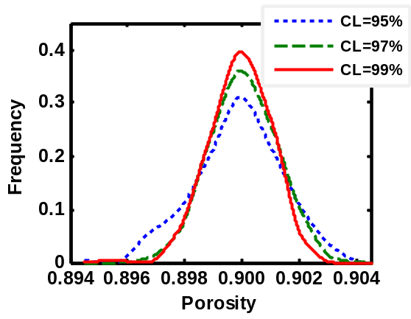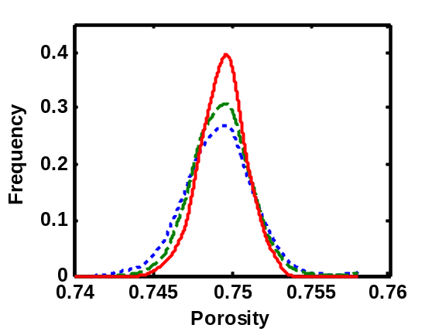
- (b)

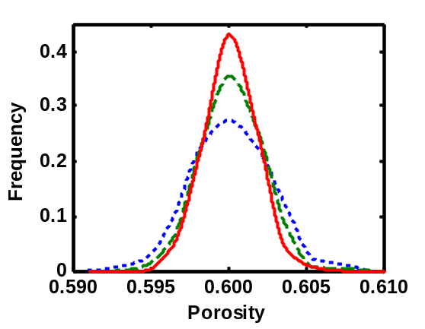
(c)
Figure 6. Probability distributions of porosities of three cases for three confidence levels, (a) Φ=90%, (b) Φ=75%, (c) Φ=60%.

To do this, porosities were divided into subgroups and after each simulation, the resulting porosity was added to its subgroup. The vertical axis is the occurrence frequency of the subgroups. As seen in the figures, the probability curves are Gaussian. In the case of 99% confidence level, the porosity ranges are smaller than the other cases. When confidence level decreases, the range of the probable porosity of the randomly generated porous media increases. Furthermore, the frequency of the desired porosity level increases with confidence level. Based on Figure 6, 99% confidence level was used in the remaining results described in this work.
In Figure 7(a), the probability distributions for porosities and effective porosities were plotted for all three porous cases with 99% confidence level. In Figure 7(b), the target porosity is 90%, and it is observed that the probability distribution of effective porosity almost coincides with that for porosity. As seen in Figures 7(c) for 75% porosity, and (d) for 60% porosity, when the target porosity decreases, the effective porosity - probability distribution curve becomes wider in range, and shifts to the left. The Gaussian shape becomes more disturbed when the target porosity approaches to the percolation threshold. Figure 7(d) shows that the porosity probability curve is quite narrow in range and the frequency of the target porosity range almost reaches to 50%. As seen in Table 1, the node numbers and the trial number for this case are 200x200 and 443, respectively. However, the effective porosities are in a wide porosity range.

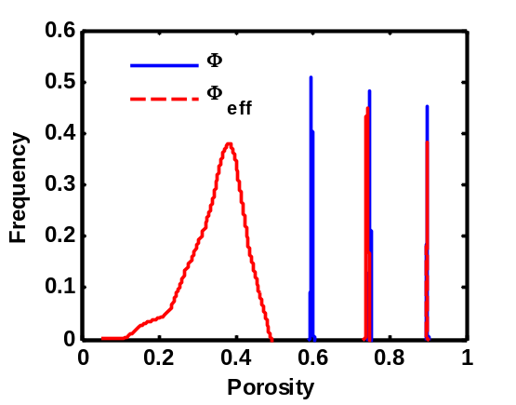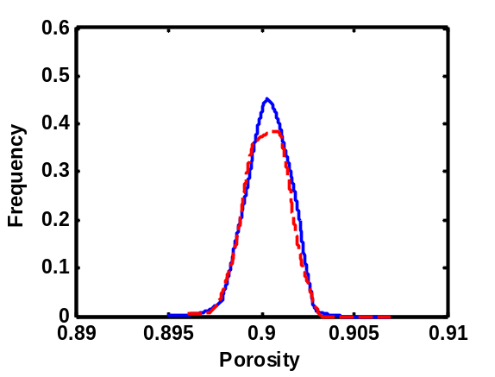
(a) (b)
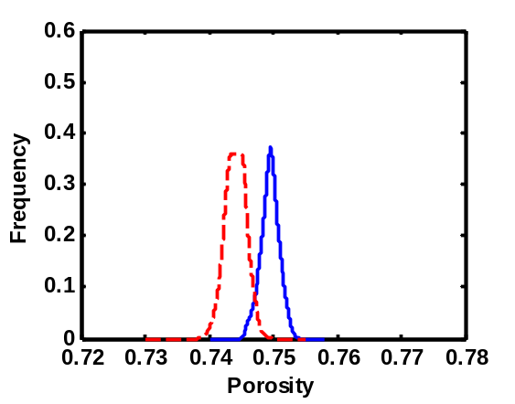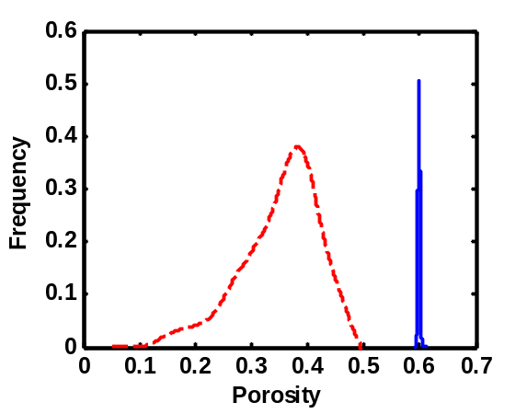
(c) (d)

Figure 7. Probability distributions of porosities and effective porosities for three cases. Confidence level is 99%. (a) All three porosities (b) Φ=90%, (c) Φ=75%, (d) Φ=60%.
The same result is also explained in Figure 8. Here, three different simulations can be seen for the case of 60% porosity and 99% confidence level. Figures 8 (a), (b), and (c) demonstrates the best, medium, and worst transport cases, respectively. Porosities in all these cases are almost the same; 0.60505, 0.59890, and 0.59720. On the other hand, the effective porosities show significant differences. They are 0.499025, 0.321800, and 0.139800 for the best, medium, and worst cases, respectively.

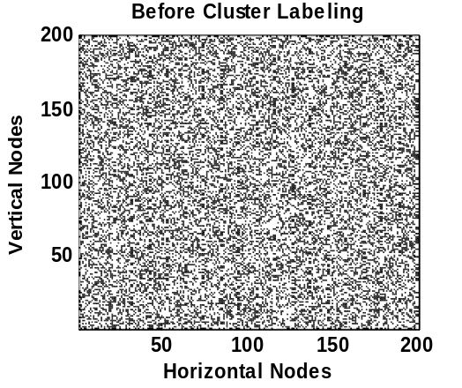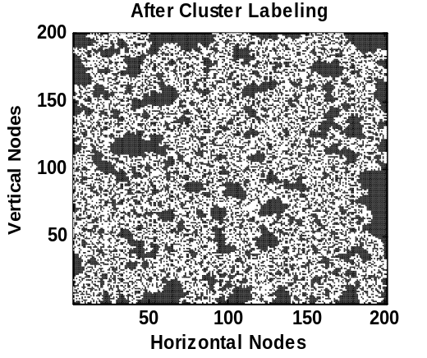
(a)
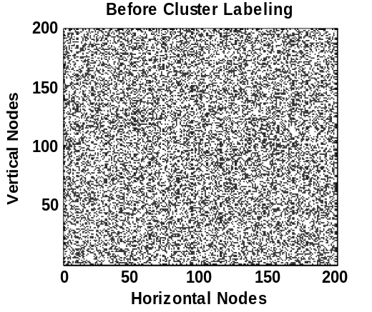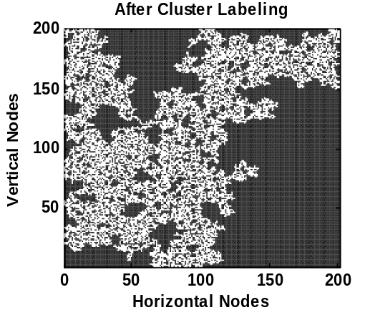
(b)
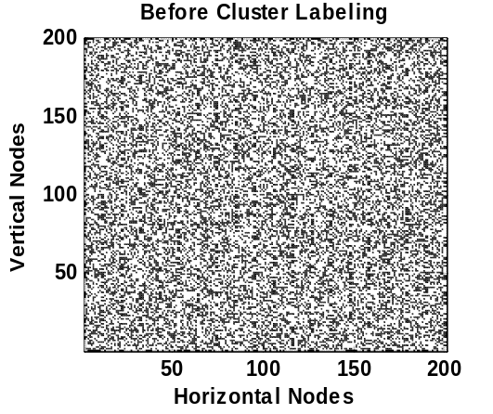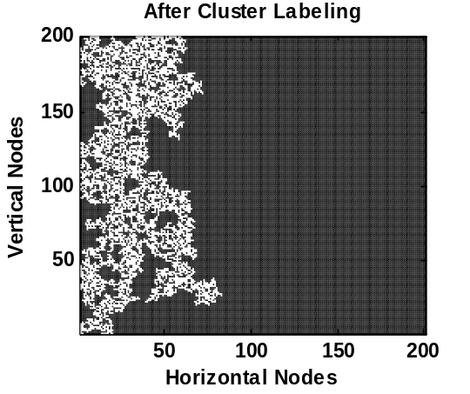
(c)
Figure 8. Initial and final forms of three porous samples (a) Best Case (Φ=0.605050, Φ_{eff}=0.499025), (b) Medium Case (Φ=0.598900, Φ_{eff}=0.321900), (c) Worst Case (Φ=0.597200, Φ_{eff}=0.139800

The same conclusion can also be seen in Figure 9 (a). In this figure, porosities before and after the cluster labeling are plotted, and the effective porosities observed as more predictable for higher porosities. It is important to note that when porosity approaches the percolation threshold (Section 1) or the confidence level decreases, significant variances occur in the effective porosities.

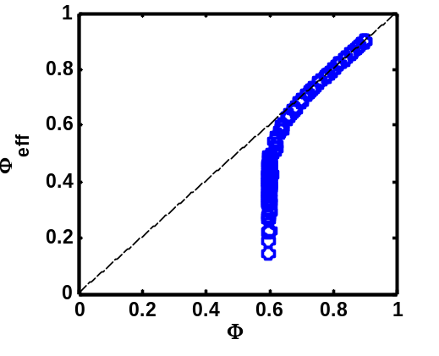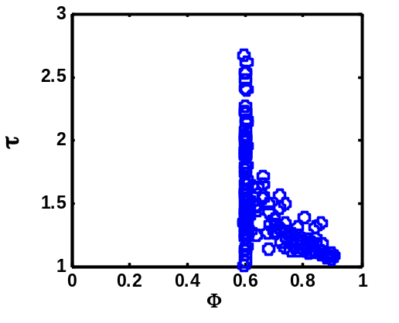
(a) (b)
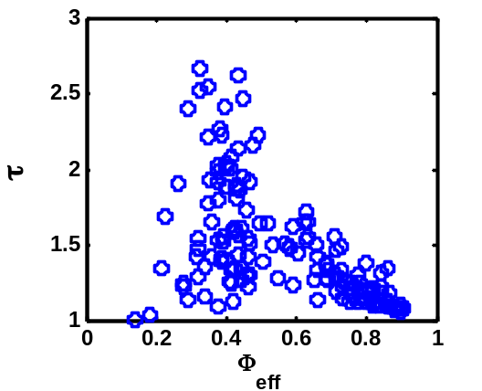
(c)

Figure 9. Path-Percolation results – (a) Effective porosity vs. porosity. The horizontal axis is the target porosities of the domains generated by path-percolation method. For higher porosities, the effective porosities are quite predictable. When the target porosity decreases, effective porosities can take many different values, hence become difficult to predict, (b) tortuosity vs. porosity, (c) tortuosity vs. effective porosity

The Lattice Boltzmann Model
Before utilizing LBM on the current problem, an SRAE set was constructed for each porous domain created by path-percolation theory as described in Section 3.1. A porous domain was created and divided into 16 regions, as seen in Figure 2. Starting from the left upper part of each section by a 1x1 matrix (just a node), the node numbers were increased until the subdomain took the entire region. The relative errors between the porosities of the entire domain and the subdomains against the total node numbers of the subdomains, named statistically representative area elements, were plotted. Four of these sixteen regions were selected randomly for presentation as seen in Figure 3. For this study, it was decided that the relative errors of less than 1% was acceptable. Hence, 40x40 nodes were considered as sufficient after observing the results in all regions.
After deciding the total node number of an SRAE, element number in a SRAE was determined by confidence level studies. For each SREV set, 25 RAEs were determined as seen in Table 2. To optimally select these representative areas, the entire effective porous domain was scanned and all possible 40x40 area elements were extracted. Porosities and relative errors were calculated and the extracted areas were ranked according to their errors. Starting from one area element, tortuosities against the area element number were plotted, as seen in Figure 4. It should be noted that the ensemble averages were calculated by Equation (1.5), whereas the tortuosities were computed as explained in Section 3.2. To do this, Lattice-Boltzmann method in two dimensions was utilized to simulate the momentum transfer in the SRAE sets, which were extracted from porous media created by path-percolation theory. After obtaining the velocity distribution, tortuosity was calculated by using Equation (1.22). As a summary, an SRAE set, including twenty-five statistical area elements with 40x40 nodes, was considered as an RAE. Therefore, the ensemble averaged properties of these sets were considered as the property of the RAE. Hence, tortuosities of the porous media generated by path-percolation theory were computed by using Lattice-Boltzmann method to obtain a new diffusion model.
One of the tests for 60% porosity is explained here in detail to clarify the entire procedure. An inhomogeneous porous medium was generated as seen in Figure 10(a) and the effective domain was obtained after cluster labelling process as shown in Figure 10(b). The porosity and effective porosity of this example are 0.597050 and 0.305625, respectively. Then, 25 representative area elements were extracted from the domain. The maximum relative error between the effective porosities of the selected RAEs and the entire domain is 1.287x10⁻¹². Then, momentum balance equation in all the RAEs was solved using LBM and the ensemble tortuosity of the SRAE was determined as 1.33467. Three of the RAEs with the velocity directions are shown in Figure 10(c) to (e).

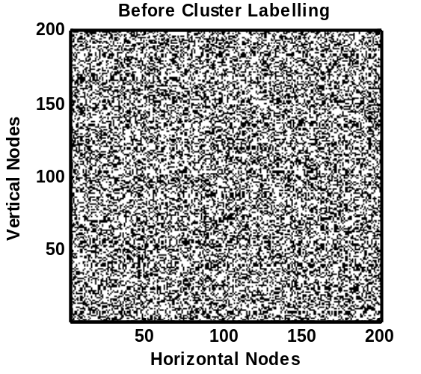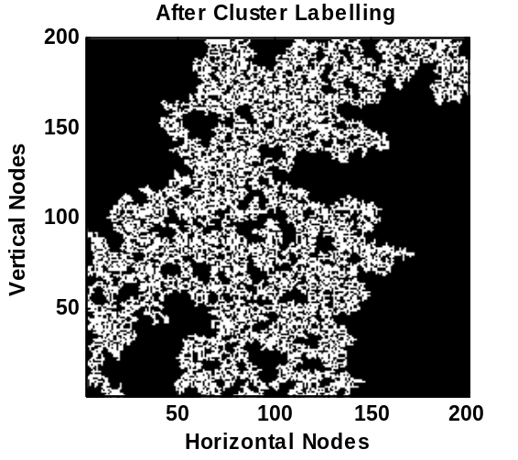
(a) (b)
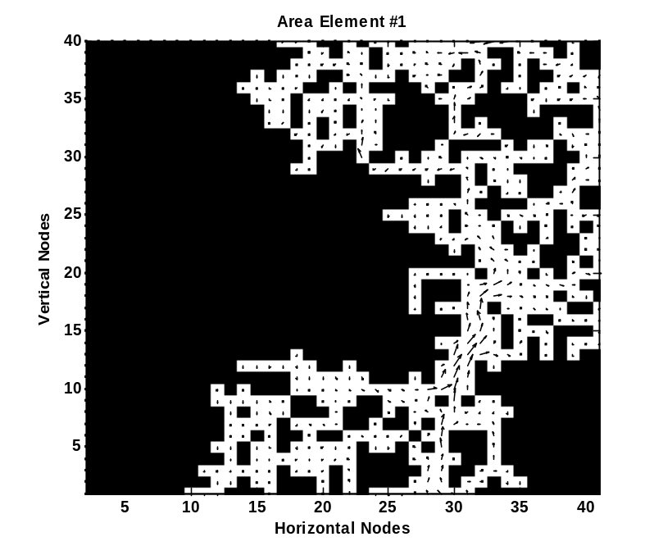
(c)
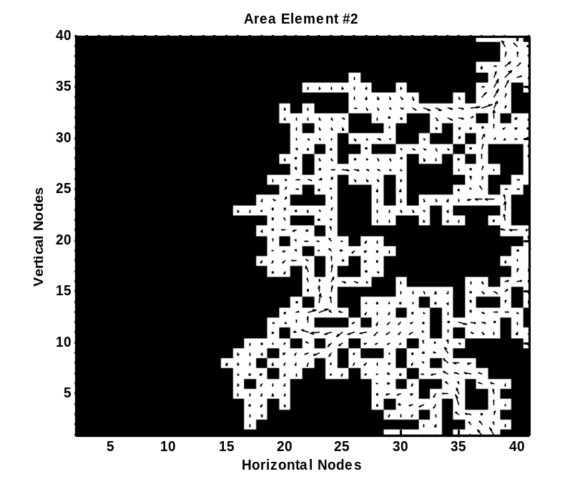
(d)
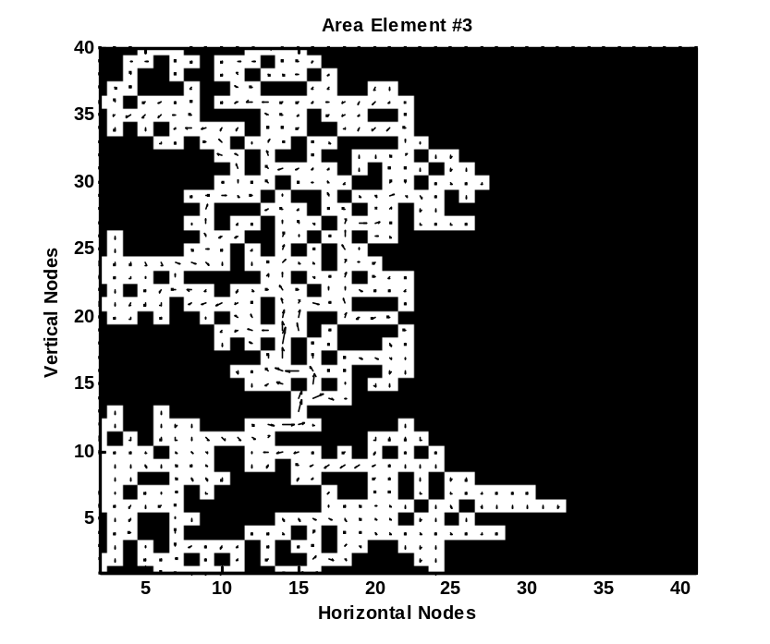
(e)
Figure 10. An example procedure for a 60% porosity medium. (a) inhomogeneous porous domain with Φ=0.59705, (b) effective domain with Φ_{eff}=0.59705, (c) τ=1.30127, (d) τ=1.39888, (e) τ=1.31409.

The probability distributions for effective tortuosities for all porosity cases with 99% confidence level is shown in Figure 11.
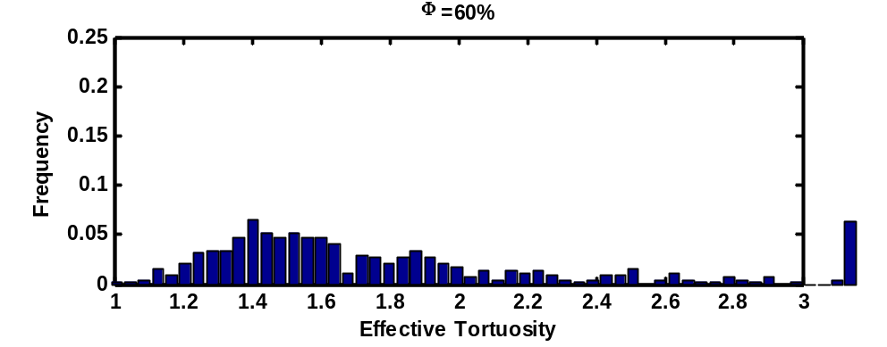
(a)
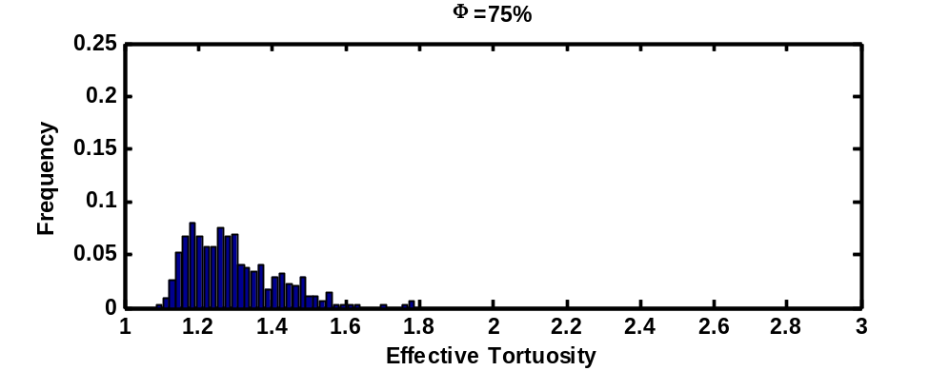
(b)
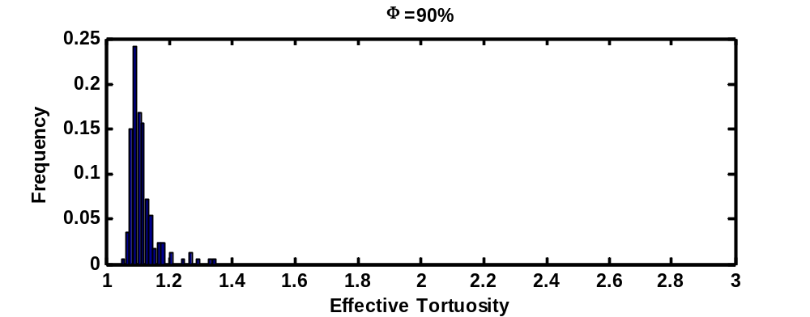
(c)
Figure 11. Probability distributions of tortuosities for three cases with a confidence level of 99%, (a) Φ=60%, (b) Φ=75%, (c) Φ=90%

As seen in the figure, the effective tortuosity has a great probability to have values between 1.0 and 1.2 for the case of 90% porosity. When porosity decreases, the range of the probable tortuosity values broadens. In addition, it can be seen that when the porosity increases, the occurrence frequency of a value of tortuosity also increases, hence the tortuosity can be said more predictable for higher porosities.

A New D_{eff}/D_{bulk} Model
A new approach was pursued in developing a new effective diffusion model using effective porosity instead of porosity. Further simulations were performed in addition to the results with the porosities of 60%, 75%, and 90% to include a wider range of porosity. Figure 12 shows a comparison between Bruggeman and Carman models with effective diffusion coefficient.

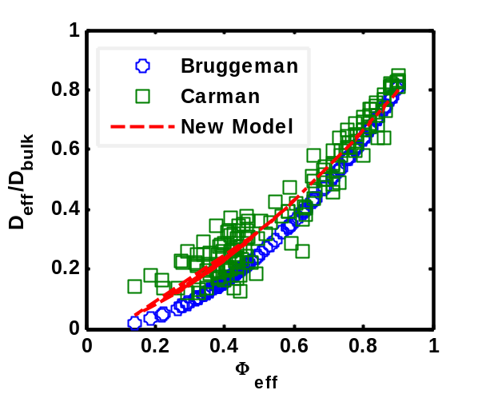
Figure 12. Bruggeman, Carman, and the new effective diffusivity model – D_{eff}/D_{bulk} vs. effective porosity.
It must be stated that in both of these models, the porosity term was changed to the effective porosity. D_{eff}/D_{bulk} values were calculated using $Φ_{eff}$ and $τ$ obtained from path-percolation theory and Lattice-Boltzmann model and plotted against effective porosity for both models. As the effective porosity increases, two models predict closer effective diffusion coefficients. For the lower effective porosities, the Carman model has higher estimates. This is caused by the tortuosity factor. A new model is developed by using the path-percolation and LBM results and it can be seen in Figure 12 and Equation (1.26). The superscript counts for the tortuosity factor.
$$D_{eff}=D_{bulk}{Φ_{eff}}^{1.6556}$$ | (1.26)
This model is a starting point for this series of diffusion studies. There are several sources of potential error, which are the subject of ongoing study. First of all, this model is two-dimensional and there is a significant loss of accuracy because of this lack of geometry in the third dimension. Second, only the Carman model and simulation results were used for this model, and experimental validation is needed.
The advantage of including effective porosity instead of porosity in this model is the better accuracy in effective diffusion coefficient prediction especially when porosity is lower than 0.6. It is caused by the effects of tortuosity as shown in Figures 9(b) and (c). In these figures, it can be observed that when porosity is 0.6, the tortuosity range is much wider than that for the effective porosity. In other words, tortuosity is more predictable as a function of effective porosity than porosity. Therefore, the effective diffusion coefficient becomes much predictable since it is strongly dependent on tortuosity. Note that, the effective porosity becomes zero when the porosity is below 0.6 and there is no mass flow observed in the domain at this porosity range. Thus, tortuosity becomes indeterminate. On the other hand, the physical porosity of any porous sample can be obtained experimentally very easily, but the effective porosity determination implies a path-percolation application, hence an additional effort. Hence, a digitized domain of the porous sample must be obtained to determine the effective porosity, before using this model.

Conclusions
Statistical based path-percolation theory was utilized to investigate the effective porosity of porous media in this study. Porous media were generated in a random manner and the orphan pores were eliminated by cluster labelling. Confidence levels of 95%, 97%, and 99% were examined and probability distributions for porosities and effective porosities were analyzed. When the porosity approaches the percolation threshold, or the confidence level decreases, the effective porosity becomes less predictable. A representative area element was determined to utilize the Lattice-Boltzmann simulations. A statistical approach was pursued and instead of using one RAE, an optimal set of statistical area elements were optimally extracted from the porous domain. After the size and the number of elements in a set were determined, LBM was performed to obtain the velocity distributions and tortuosity in porous channels.
Using the effective porosities determined by path-percolation theory and the tortuosity values determined by LBM, an effective diffusion model was developed for dry porous media. In the new model, effective diffusion coefficient is a function of effective porosity instead of porosity and it is valid for all effective porosity ranges. The results of this work can be used in any porous media application related to heat and mass transfer.

CHAPTER 2
A Combined Path-Percolation - Lattice-Boltzmann Model to Investigate the Effects of Liquid Formation on Mass Transfer in Porous Media with OpenMP Implementation

Abstract
In this work, a single-component single-phase and a single-component multi-phase Lattice-Boltzmann models were developed to investigate the effects of liquid formation on mass transfer in porous channels generated by path-percolation theory. A two-dimensional lattice with nine velocity components was used in both lattice-Boltzmann models. A confidence level of 99% was utilized to obtain statistical results of porosity, effective porosity, and tortuosity of the system with 0%, 10%, and 20% liquid formation. Velocity distributions in randomly generated inhomogeneous porous channels with different solid-liquid-vapor combinations were analyzed. The statistical results show that the porosity range of the initially generated porous media lies between the specified error limit of 0.001 determined by the confidence level study for all three cases with 70%, 80%, and 90% target porosity. When target porosity decreases, the difference between porosity and effective porosity increases and the effective porosity range gets wider than the range of porosity. Effective diffusion coefficient decreases with increase in liquid formation, since the effective porosity decreases significantly.

Introduction
The Lattice-Boltzmann Method (LBM) is an explicit technique based on Ludwig Boltzmann’s kinetic theory of gases [4] and used to simulate transport equations. In kinetic theory, a statistical treatment is performed for fluid particles and the actions of these particles are described by streaming and collision mechanisms. Detailed information about the kinetic theory of gases can be found in references [3, 4, 18, 19]. The LBM treats a group of particles as a lattice unit and investigates the behavior of the units in the system. In terms of computational fluid dynamics, LBM can be used to simulate single and multiphase flows, and in this study it was applied to simulate two-phase momentum transfer in porous media. Many studies with multi-phase LBM in porous media can be found in literature [20-28]. Among these, the authors decided to develop a single-component multiphase (SCMP) LBM model similar to that in the study of Chau et al. [28]. They used a two-dimensional, SCMP LBM code to investigate the effects of gravity on liquid formation, hence the gaseous diffusion in partially saturated porous media. They found that the relative (effective) diffusion coefficient shows a difference of about 25% by different liquid configurations under zero gravity. The target of the current study is observing the effects of liquid formation on diffusivity by determining the effective porosity and tortuosity in randomly generated inhomogeneous porous channels with 0%, 10%, and 20% liquid formation based on a statistical point of view.
A statistical based “path-percolation theory” was developed by Jung et al. [11] to investigate the electrical property variations in inhomogeneous porous media. A process called “cluster labelling” was applied for a path determination scheme. Cekmer et al. [29] applied this theory with a combination of a single-phase lattice-Boltzmann model to investigate the mass transfer in randomly generated inhomogeneous porous media. A new effective diffusion model was developed in terms of effective porosity obtained by eliminating the pores, which were not connected to inlet and outlet of a channel. This model was also tested and compared with two well-known diffusion models [15, 17]. In this study, the path-percolation theory was utilized to generate random inhomogeneous porous channels and determine the effective porosity after liquid particles plugged some of the paths for the particles in vapor-phase.
In addition, an application programming interface called open multi-processing (OpenMP) was implemented to the code to gain higher performance and speedup. OpenMP was applied to solve SCMP LBM for many representative area elements of random porous channels by multi threads simultaneously instead of sharing a single LBM simulation to avoid the time lost by message passing between the nodes. However, the main novelty of this article is its statistical results of multi-phase effective diffusion process for a number of different solid-vapor-liquid configurations determined by the confidence level studies.
The motivation of this work is to develop a statistical based diffusion behavior estimation of two-phase systems in inhomogeneous porous media. This work will provide a better understanding of the effects of internal structure of the porous channels on multi-phase mass flow than macroscopic approaches. The novel methods introduced and the outcome of the work can be utilized in any application area of heterogeneous porous media involving single- and multi-phase mass and momentum transport. Furthermore, gained speedup with OpenMP implementation is another significant improvement, since it has a potential to provide a more accurate statistical results with a higher confidence level using high performance computing systems.

Methodology
Three different models were used in this study to investigate the effects of liquid formation on mass transfer in randomly generated porous media. The first one is called the path-percolation model and used for random porous media generation and cluster labelling process, which are explained in the following section. Then, a single-component single-phase (SCSP) LBM was utilized to solve the momentum balance equation and obtain the velocity distribution in representative area elements of the randomly generated channels. As the third model, a SCMP LBM was applied to observe the effects of liquid formation on mass transfer. Furthermore, parallel processing by OpenMP was implemented to the code and a performance analysis was performed.

Inhomogeneous Porous Media Construction
The statistical based path-percolation theory was used to generate random inhomogeneous porous media as the first step of the current study. To start with, a confidence level study was performed to obtain the necessary trial and node numbers of the simulations. A detailed analysis of confidence level studies can be found in [14, 15, 18]. In the current work, 99% confidence level was considered and procedure of the history number determination is as follows:
The confidence level [18] expresses the reliability of any estimate:
$$CL=Pr\left\{\left|\frac{k}{n}-p\right|≤ε\right\}$$ | (2.1)

In Equation (2.1), p is the probability of a pore to occur in a node, which is called the porosity in this study. Total history number is represented by n whereas k stands for the number of void generation in n histories. Error is represented by ε and shows the difference between the true and estimated probabilities of an event. As an example, if ε is 1% for a target porosity of 90%, then the resulting porosity of the statistically generated porous media would be between 89% and 91%, by a 99% of probability. Finally, Pr and CL represent the probability of the event in the brackets and confidence level, respectively. In this study, CL and ε are 0.99 and 0.001, respectively. Hence, Equation (2.1) says that the confidence level of 99% is the probability of the difference between the estimated and the true probabilities of the porosity to be lower than or equal to the assigned error, which is 0.001. After the application of the law of large numbers [18], Equation (2.2) is obtained:
$$Pr\left\{\left|\frac{k}{n}-p\right|≤ε\right\}=2 G\left(ε\sqrt{\frac{n}{pq}}\right)-1=CL$$ | (2.2)

In Equation (2.2), q is the probability of generating a solid, hence it is 1-p, and $G$ is the Gaussian function which is related to the error function as follows:
$$G\left(z\right)-\frac{1}{2}=erf⁡(z)$$ | (2.3)

The following equation is obtained after inserting Equation (2.3) into Equation (2.2):
$$\frac{CL}{2}=\operatorname{erf}\left(ε\sqrt{\frac{n}{pq}}\right)$$ | (2.4)

Confidence level of 99% was applied to all three cases of Φ=0.70, Φ=0.80, and Φ=0.90 reminding that the related p values are 0.70, 0.80, and 0.90, respectively. Hence, the q values (1-p) become 0.30, 0.20, and 0.10. The total number of history (n) is the trial number of the simulations multiplied by the total node number and is calculated by Equation (2.4) and an error function table [18]. The calculations and the results are shown in Table 3.
Table 3. History calculations for multi-component Lattice-Boltzmann model.
Confidence Level | $$\operatorname{erf}\left(ε\sqrt{\frac{n}{pq}}\right)$$ | $$ε\sqrt{\frac{n}{pq}}$$ | Nodes | $$ϕ$$ | $$n$$ | Trials
99% | 0.495 | 2.5767 | 100x100 | 0.70 | 1,394,270 | 140
 |  |  |  | 0.80 | 1,062,301 | 107
 |  |  |  | 0.90 | 597,544 | 60

Hence, the trial number and node number for all three cases were determined and the next step is performing the simulations. An in-house program was developed to random inhomogeneous porous media generation by assigning random numbers to each 10,000 nodes. Then, depending on the porosity, the nodes are labeled as solid or void, reminding that the porous media generated here are considered as gas diffusion channels, and the lower and upper boundaries are accepted as inflow and outflow boundaries, respectively, while the side walls are impervious boundaries, and thus reflective.
For the next step, the cluster labeling process was performed [14, 15] by clustering the inter-connected pores. Orphaned (or isolated) clusters, which were not connected to either inflow and outflow boundaries, were eliminated and considered equivalent to a solid. The domain obtained after the cluster labeling process is called the effective domain, and the porosity of the effective domain is called the effective porosity. Thus, a single-component multiphase model can be developed now to investigate the momentum flow in the effective domains (channels) constructed by the path-percolation theory.

The Lattice-Boltzmann Model
The Lattice-Boltzmann Method (LBM) is a mesoscopic approach which lies between microscopic and macroscopic approaches. In LBM, neither every single molecule is followed as in a true microscopic approach nor are the averaged properties of the entire system averaged as in a macroscopic approach. Instead, the average property of a selected cluster of molecules is used.
The Lattice-Boltzmann equation was derived by Ludwig Boltzmann in 1872 and is counted as the cornerstone of the kinetic theory of gases [2]. The probability density function, f, must be introduced before analyzing the Lattice-Boltzmann model (LBM). The probability of a molecule to be at position $\vec{x}$ at time t with momentum $\vec{p}$ is called the probability density (or probability distribution) function and symbolized as $f(\vec{x},\vec{p},t)$. At time t+dt, new positions and momenta of the molecules will be as follows [3]:
$$x+\frac{\vec{p}}{m}dt=x+\frac{m\vec{u}}{m}dt=x+\vec{u}dt=x+\frac{d\vec{x}}{dt}dt=x+d\vec{x}$$ | (2.5)

$$\vec{p}+\vec{F}dt=\vec{p}+\frac{d\vec{p}}{dt}dt=\vec{p}+d\vec{p}$$ | (2.6)

where $m$ is the mass of the particle, and $\vec{F}$ is an external force field that is assumed to be much smaller than the intermolecular forces. Hence, at time t+dt, the probability distribution function is written as $f(\vec{x}+d\vec{x},\vec{p}+d\vec{p},t+dt)$. If there are no collisions, the following streaming equation is obtained:
$$f\left(\vec{x}+d\vec{x},\vec{p}+d\vec{p},t+dt\right)d\vec{x}d\vec{p}=f\left(\vec{x},\vec{p},t\right)d\vec{x}d\vec{p}$$ | (2.7)

However, there are intermolecular collisions that must be considered. Some of the molecules start at the condition of $\vec{x},\vec{p}$ but at time t+dt, they collide with other molecules and cannot reach $\vec{x}+d\vec{x},\vec{p}+d\vec{p}$, and the number of these molecules is called loss, $Γ^{L}$. Similarly, some of the molecules start with a condition other than $\vec{x},\vec{p}$ but after the collisions they reach the condition of $\vec{x}+d\vec{x},\vec{p}+d\vec{p}$, which is called gain, $Γ^{G}$. Then, Equation (2.7) becomes:

$$f\left(\vec{x}+d\vec{x},\vec{p}+d\vec{p},t+dt\right)d\vec{x}d\vec{p}-f\left(\vec{x},\vec{p},t\right)d\vec{x}d\vec{p}=\left(Γ^{G}-Γ^{L}\right)d\vec{x}d\vec{p}dt$$ | (2.8)

Furthermore, the first term on LHS of Equation (2.8) can be written in the first order Taylor series expansion form as follows:
$$f\left(\vec{x}+d\vec{x},\vec{p}+d\vec{p},t+dt\right)d\vec{x}d\vec{p}=\left(1+dt\frac{∂}{∂t}+d\vec{x}∙\frac{∂}{∂\vec{x}}+d\vec{p}∙\frac{∂}{∂\vec{p}}\right)f\left(\vec{x},\vec{p},t\right)d\vec{x}d\vec{p}$$ | (2.9)

Inserting Equation (2.9) into Equation (2.8), dividing both sides of Equation (2.9) by $d\vec{x}d\vec{p}dt$, and performing the further steps as follows, the Boltzmann equation is obtained as shown in Equation (2.10).
$$fd\vec{x}d\vec{p}+dt\frac{∂f}{∂t}d\vec{x}d\vec{p}+d\vec{x}\frac{∂f}{∂\vec{x}}d\vec{x}d\vec{p}+d\vec{p}\frac{∂f}{∂\vec{p}}d\vec{x}d\vec{p}-fd\vec{x}d\vec{p}=\left(Γ^{G}-Γ^{L}\right)d\vec{x}d\vec{p}dt$$
$$\frac{∂f}{∂t}+\frac{d\vec{x}}{dt}∙\frac{∂f}{∂\vec{x}}+\frac{d\vec{p}}{dt}∙\frac{∂f}{∂\vec{p}}=Γ^{G}-Γ^{L}$$

$$\frac{∂f}{∂t}+\vec{u}∙\frac{∂f}{∂\vec{x}}+\vec{F}∙\frac{∂f}{∂\vec{p}}=Γ^{G}-Γ^{L}$$ | (2.10)
or
$$\frac{Df\left(\vec{x},\vec{p},t\right)}{Dt}=Ω$$ | (2.11)

where
$$\frac{D}{Dt}=\left(\frac{∂}{∂t}+\vec{u}∙\frac{∂}{∂\vec{x}}+\vec{F}∙\frac{∂}{∂\vec{p}}\right)$$ | (2.12)
$$Ω=Γ^{G}-Γ^{L}$$ | (2.13)

In Equation (2.11), $Ω$ represents the collision operator and can be defined as follows [2-4, 19]:
$$Ω=-\frac{f-f^{eq}}{τ}$$ | (2.14)

where, $f^{eq}$ and $τ$ are the distribution function in local equilibrium and collisional relaxation factor, respectively. When Equation (2.11) is solved, the distribution function will be determined. To obtain the macroscopic variables; density and velocity, the following equations are used:
$$ρ=\int{fd\vec{c}}$$ | (2.15)

$$ρ\vec{u}=\int{\vec{c}fd\vec{c}}$$ | (2.16)

where $ρ, \vec{c}, \vec{u}$ are fluid density, unit velocity vector, and macroscopic flow velocity vector ($\vec{u}=u_{x}\vec{i}+u_{y}\vec{j}$ ), respectively. In this study, a two-dimensional lattice system called D₂Q₉ is applied to solve the momentum balance equation as shown in Figure 13(a).

(a) (b)
Figure 13. A D₂Q₉ lattice (a) a lattice and its velocity components (b) red arrows are the lattice velocities at boundaries; the dashed ones are unknown.

A D₂Q₉ has nine velocity components in two dimensions. The following coupled discretized equations are derived from (Equation 2.11) and used for the collision and streaming steps [2].
$$f_{k}\left(x+c∆t,y+c∆t,t+∆t\right)-f_{k}\left(x,y,t\right)=-\frac{1}{τ}\left[f_{k}\left(x,y,t\right)-f_{k}^{eq}\left(x,y,t\right)\right]$$ | (2.17)
$$f_{k}\left(x+∆x,y+∆y,t+∆t\right)=f_{k}\left(x,y,t+∆t\right)$$ | (2.18)

f_{k}^{eq} is the equivalent distribution factor and formulated for D₂Q₉ lattice as follows [3]:
$$f_{k}^{eq}\left(x,y,t\right)=w_{k}ρ\left(x,y,t\right)\left[1+3\frac{\vec{c_{k}}∙\vec{u}}{{c_{s}}^{2}}+\frac{9}{2}\frac{{\left(\vec{c_{k}}∙\vec{u}\right)}^{2}}{{c_{s}}^{4}}-\frac{3}{2}\frac{{\vec{u}}^{2}}{{c_{s}}^{2}}\right]$$ | (2.19)

where, k, ρ, and $\vec{c_{k}}$ are lattice index (0 to 8 as shown in Figure 13), macroscopic density, and unit lattice velocity vector, respectively. The lattice speed of sound is represented by $c_{s}$ and equal to 1/3. The unit velocities of the lattice shown in Figure 13(a) can be written as:
$c_{0,x}=0$, $c_{0,y}=0$, $c_{1,x}=1$, $c_{1,y}=0$, $c_{2,x}=0$, $c_{2,y}=1$ | (2.20)
$c_{3,x}=-1$, $c_{3,y}=0$, $c_{4,x}=0$, $c_{4,y}=-1$, $c_{5,x}=1$, $c_{5,y}=1$ | (2.20)
$c_{6,x}=-1$, $c_{6,y}=1$, $c_{7,x}=-1$, $c_{7,y}=-1$, $c_{8,x}=1$, $c_{8,y}=-1$ | (2.20)
Furthermore, w_{k} in Equation (2.19) is the weighting factor, which is defined for all lattice components as:
$w_{0}=4/9$ | (2.21)
$$w_{1}=w_{2}=w_{3}=w_{4}=1/9$$ | (2.21)
$w_{5}=w_{6}=w_{7}=w_{8}=1/36$ | (2.21)

The lattice density, and lattice velocity components are determined by Equations (2.22) to (2.24).
$$ρ=\sum_{k=0}^{8}{f_{k}}$$ | (2.22)
$$u_{x}=\frac{1}{ρ}\sum_{k=0}^{8}{{c_{k,x}f}_{k}}$$ | (2.23)
$$u_{y}=\frac{1}{ρ}\sum_{k=0}^{8}{c_{k,y}f_{k}}$$ | (2.24)

For the boundaries in Figure 13(b), bounce back boundary conditions were applied on side walls, hence the dashed (unknown) vectors become equal to solid ones (computed by streaming process). The upper boundary is open. For inflow boundary, which is at the bottom of the channel; an equilibrium condition is used as shown in Equations (2.25) to (2.27).
$$f_{2}-{f_{2}}^{eq}=f_{4}-{f_{4}}^{eq}$$ | (2.25)
$$f_{6}-{f_{6}}^{eq}=f_{8}-{f_{8}}^{eq}$$ | (2.26)
$$f_{5}-{f_{5}}^{eq}=f_{7}-{f_{7}}^{eq}$$ | (2.27)
Thus, a single-component (means single chemical species) single-phase D₂Q₉ model was constructed. To investigate the mass transfer in simulated porous media, a significant parameter called “effective tortuosity”, $τ_{eff}$, which is defined as the actual path travelled by a particle, divided by the shortest distance between the same points, should be computed. To do this, the velocity profile in the channel is used as follows [20]:
$$τ=\frac{\int_{A}{udA}}{\int_{A}{u_{y}dA}}$$ | (2.28)
To investigate the multiphase flow, a single-component multi-phase LBM must be constructed [3, 21]. No long-range attractive forces are considered between the molecules in a single-component single-phase model. In a single-component multi-phase model, intermolecular interactions are considered and the attractive forces between the molecules cause a phase separation between liquid and vapor. Interaction between the solid surface and the fluid is not considered here and is left as a further study. In this paper, the main focus is on the effects of liquid volume on mass transfer in inhomogeneous porous media. The van der Waals equation of state (EOS), which is a non-ideal EOS, is used to account the intermolecular attractive forces in the model:

$$P=\frac{nRT}{V-nb}-a{\left(\frac{n}{V}\right)}^{2}$$ | (2.29)

where, $T$, $V$, $n$, and $P$ are temperature, volume, number of moles, and pressure of the fluid, respectively, and $R$ is gas constant. In Equation (2.29), the second term on RHS accounts for intermolecular attractive forces and $nb$ represents the non-negligible volume of molecules. The following equation, that was obtained by He and Doolen [22], is used as a simpler form of the van der Waals EOS and it is applied to compute the pressure distribution along the channel:
$$P=\frac{ρ}{3}+\frac{G}{6}Ψ^{2}$$ | (2.30)
where $Ψ$ and $G$ are interaction potential and interaction strength, respectively. The interaction potential is consistent in isothermal processes with the following formula [21]:
$$Ψ=Ψ_{0}exp⁡(\frac{{-ρ}_{0}}{ρ})$$ | (2.31)
where, $Ψ_{0}$ and $ρ_{0}$ are arbitrary constants. Finally, the attractive force can be computed for a D₂Q₉ LBM by Equation (2.32).
$$F=-GΨ(x,t)\sum_{k=1}^{8}{w_{k}Ψ(x+c_{k}dt,t)}c_{k}$$ | (2.32)
It must be noted that the non-negligible volume term of the van der Waals EOS is neglected in this approach. It is assumed that a two-phase fluid with a nonzero thermodynamic quality percolated an inhomogeneous channel, and then a phase separation occurred due to intermolecular attractive forces as time passes. Hence, there is no phase change in the channels. The initial density is the controlling parameter of the two-phase system. A typical simulation is demonstrated in the results section.
The developed single-component multi-phase LBM was not applied to the entire domain with the node number of 100x100 (Table 3). Instead, a set of representative area elements (SRAE) were used as domain. A representative area element (RAE) is defined as a smaller area that represents the entire domain. The represented parameters by RAE in this study are effective porosity and tortuosity since the mass transfer is investigated. However, only the effective porosity of the entire domain is known. Hence, a single RAE may not represent the entire domain, because there is no information about the tortuosity. To increase the accuracy of the representation, a certain number of RAEs were optimally extracted from the entire domain. The term ”optimally extracted” means that the effective porosities of all possible RAEs were computed, then the relative errors between those and the effective porosity of the entire domain were determined, all RAEs were ranked, and the ones with the least errors were selected. To determine the node number of a single RAE and the number of RAEs in an SRAE, confidence level studies were repeated as seen in Table 4.
Table 4. History calculations for Lattice-Boltzmann model
Confidence Level | $$\operatorname{erf}\left(ε\sqrt{\frac{n}{pq}}\right)$$ | $$ε\sqrt{\frac{n}{pq}}$$ | $$ϕ$$ | $$n$$ | Trials | RAE Nodes | SRAE Set Number
99% | 0.495 | 2.5767 | 0.70 | 1,394,270 | 140 | 25x25 | 16
99% | 0.495 | 2.5767 | 0.80 | 1,062,301 | 107 | 25x25 | 16
99% | 0.495 | 2.5767 | 0.90 | 597,544 | 60 | 25x25 | 16

In this case, the total number of histories is the multiplication of trial number, node number of an RAE, and number of RAEs in an SRAE. The details of the SRAE selection procedure can be found in [15, 23, 24]. The ensemble average of any property of an SRAE can be calculated as follows:
$$\hat{X}=\frac{1}{N}\sum_{m=1}^{N}{X_{m}}$$ | (2.33)

In Equation (2.33), $X_{m}$ is any property of the m^{th} element, N is the total element number, and $\hat{X}$ is the ensemble average. Hence, a single-component multi-phase model was completed.
To investigate the diffusion behavior, a dimensionless parameter called diffusion ratio, which is the ratio of the effective (D_{eff}) and bulk (D_{bulk}) diffusion coefficients, must be computed. Three diffusion models were discussed in this study. Bruggeman’s model [17] is an approximation for the effective diffusion coefficient in porous media calculations and can be written as follows:
$$D_{eff}=D_{bulk}Φ^{m}$$ | (2.34)
In this equation, the power of the porosity is caused by the tortuosity which is the denominator. Bruggeman’s approximation estimates the tortuosity as follows [25]:
$$τ=Φ^{-0.5}$$ | (2.35)
Hence, m becomes 1.5.
Carman’s model [16] includes tortuosity in addition to porosity to calculate the effective diffusion coefficient:
$$D_{eff}=D_{bulk}\frac{Φ}{τ}$$ | (2.36)
The last model discussed in this study was developed by Cekmer et al.[15], and it will be tested in this study. In this new model, the tortuosity term was modeled as:
$$τ=Φ^{-0.6556}$$ | (2.37)
Thus, the developed effective diffusion equation becomes:
$$D_{eff}=D_{bulk}{Φ_{eff}}^{1.6556}$$ | (2.38)
The resulting diffusion ratios will be computed by all these models and discussed in the results section.

OpenMP Implementation
An in-house program was developed to utilize the path-percolation and Lattice-Boltzmann models to investigate the multi-phase mass transfer in randomly generated porous media. A simple flowchart of the serial code for a single trial is shown in Figure 14.

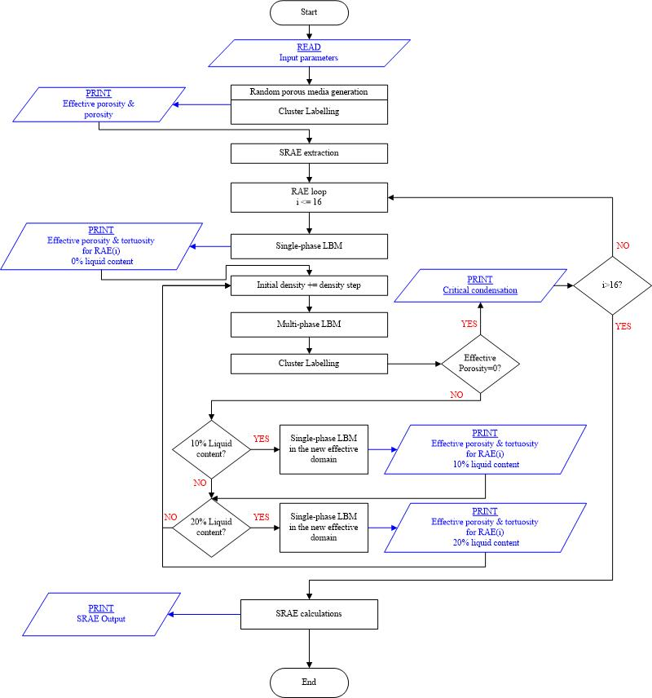

Figure 14. Flowchart of the serial code for a single trial.

The program reads the input parameters and starts the path-percolation model. After applying the cluster labeling process, it prints the porosity and the effective porosity of the randomly generated inhomogeneous domain, then starts the SRAE selection process. It optimally extracts 16 RAEs for an SRAE and starts LBM to solve momentum balance equation for each RAE. Single-phase results are printed and the multi-phase loop starts by increasing the controlling parameter, which is the initial density. An automated scanning system is developed and applied to the code to obtain the exact liquid formations of 10% and 20% in the system and a critical liquid formation value where the effective porosity becomes zero and beyond that no fluid flow occurs. Multi-phase LBM followed by cluster labelling process is applied for all initial density values until the effective porosity of the RAE reaches zero (the critical liquid formation). When the liquid formation becomes 10% or 20%, the program sets up the new effective domain by treating the liquid volume that plugged the channels as solids, and then starts cluster labelling and single-phase LBM to obtain the effective porosity and tortuosity, respectively. Then, the computations for the new RAE starts until the set number is reached. Finally, the effective porosity and the tortuosity of an SRAE is calculated by Equation (2.31). Furthermore, the diffusion ratio of the SRAE is calculated by three models discussed in the previous section by Equations (2.32), (2.34), and (2.35).
As shown in Table 4, there are 4912 simulations to perform (total trials multiplied by the number of RAEs in a set). In a serial code, only one CPU with a single thread is used. Parallelizing a code in CPU provides the execution of multiple sets of instructions (or threads) [26]. To use multi-threads in this study, OpenMP was implemented in the serial code. OpenMP is the abbreviation of Open Multi-Processing and it is a shared-memory application programming interface [27]. The parallel implementation is demonstrated in Figure 15.

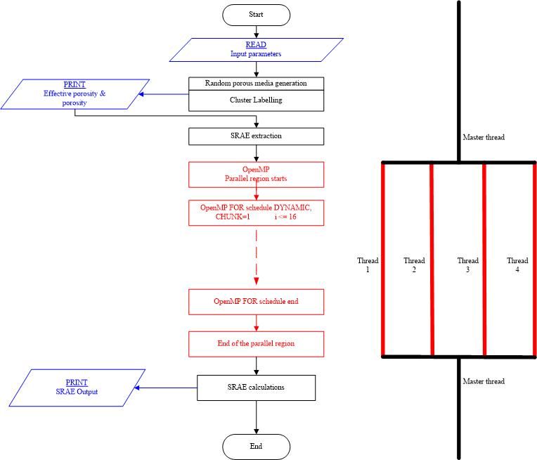
Figure 15. OpenMP implementation to the serial code. Flowchart of the parallel code for a single trial and demonstration of the fork-join model with 4 threads.owchart of the serial code for a single trial.

After the SRAE set extraction and before the LBM application on the RAEs, an OpenMP FOR directive was implemented to allow multi-threads to work simultaneously. In Figure 15, in the upper red box, the term “chunk” stands for the number of tasks assigned per thread. Hence, each thread is assigned for one RAE (chunk=1). The command “dynamic” makes a thread be dynamically assigned to another RAE after completing one. If “static” assignment was selected, then the total number of the RAEs would be divided by the thread number and all the threads would be assigned to equal number of RAEs. A dynamic for loop was applied in this implementation. The fork-joint model of OpenMP with four threads is also demonstrated in the figure. The program starts with a single thread, called master thread. When a parallel region starts, the master thread generates a specified number of threads. All the threads except the master thread are terminated at the end of the parallel region.
Speedup (S), which is defined as the ratio of the runtime with a single processor (T₁) to the runtime of the parallel configuration with n threads (T_{n}), is used in performance analysis of parallel implementation [26]:
$$S=\frac{T_{1}}{T_{n}}$$ | (2.38)

Another parameter to demonstrate the performance of the parallel code is the parallel efficiency which is determined by dividing the speedup by the number of threads [27]:
$$ε_{parallel}=\frac{T_{1}}{n∙T_{n}}$$ | (2.39)

To comment on the performance of the parallelized code, it will be useful to compare it with the peak performance of the used hardware. A personal computer with 4 processors with 2.40 GHz speed, each manages 4 instructions per cycle, in other words 4 floating-point operation (Flop) per cycle was used in this project. Hence, the peak performance becomes:
$$P_{peak}=\frac{2.40 GHz}{1 core}×\frac{4 Flop}{cycle}×4 cores=38.4\frac{GFlop}{sec}$$ | (2.40)
To calculate the performance of the code, total floating-point operations, which is a function of RAE effective porosity and number of multi-phase iterations per RAE, must be determined and divided by the runtime. The resulting number of the total floating-point operations in the code is calculated below:
$$N=5.55×{10}^{9}\sum_{i=1}^{16}{Φ_{eff}\left(i\right)\left[ITER\left(i\right)+3.4145\right]}+8.0128×{10}^{4}+3\sum_{i=1}^{16}{ITER\left(i\right)}$$ | (2.41)
In Equation (2.41), ITER (i) is the iteration number for RAE number i where i=1,2,,…,16. In this equation, the second and the third terms do not contribute to the result, hence they are considered negligible. The resulting performance equation is shown in Equation (2.42).
$$P=5.55×{10}^{3}\sum_{i=1}^{16}{Φ_{eff}\left(i\right)\left[ITER\left(i\right)+3.4145\right]}/Execution Time$$ | (2.42)
A performance application programming interface (PAPI) timer [28] was used to measure the execution time. Three simulations per each porosity level were performed with different thread numbers and the results of the parallel program performance were analyzed in the following section.

Results and Discussion
The first step of this study is the confidence-level analysis, which is the beginning part of the statistical based path-percolation theory. As seen in Table 3, porous media with 70%, 80%, and 90% porosity and 100x100 nodes were generated, and the calculated trial numbers with 99% confidence level are 140, 107, and 60, respectively. Then, the cluster labelling process was performed for each trial to obtain the effective domains. Before, discussing the confidence level results, a typical trial with an 80% of target porosity is explained here.
In this example simulation, a random inhomogeneous porous medium was generated as seen in Figure 16(a) with a porosity of 0.809. Then, cluster labelling process was performed to group the interconnected pores, and eliminate the orphan pore clusters. In Figure 16(b), the orphan clusters can be seen with different colors. The effective domain was obtained after treating the orphan clusters as solid nodes as seen in Figure 16(c). The effective domain is now considered as a porous flow channel with an inlet at the bottom and an outlet at the top boundaries. The effective porosity was computed as 0.796. The next step is the SRAE extraction. The program optimally extracted 16 RAEs from the effective domain. Three samples are shown in Figure 16(d)-(f).

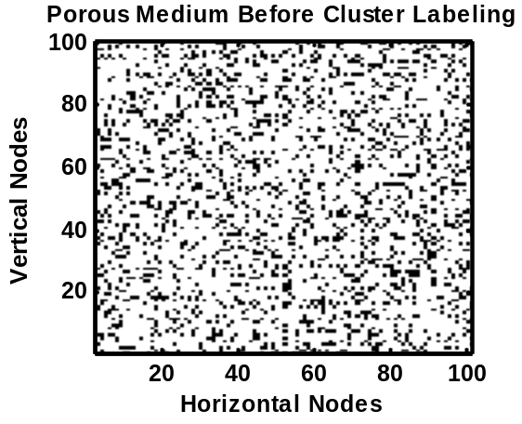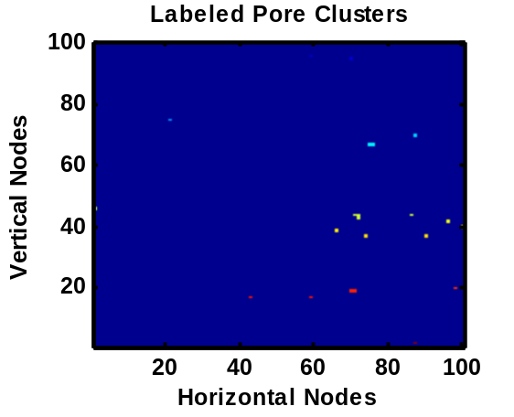
(a) (b)
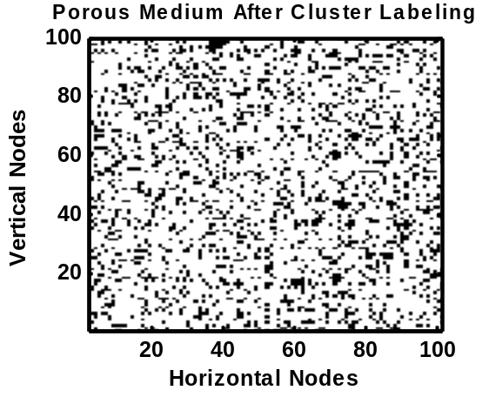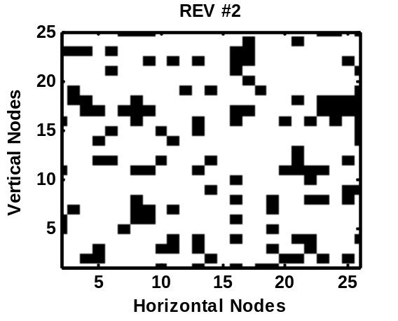
(c) (d)
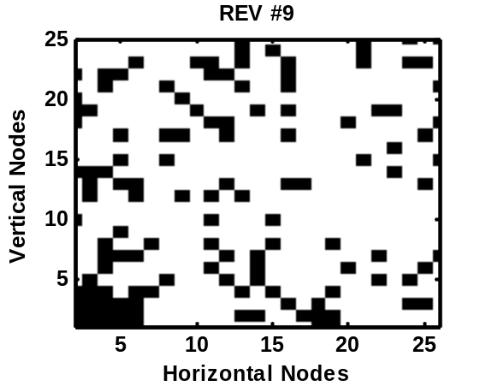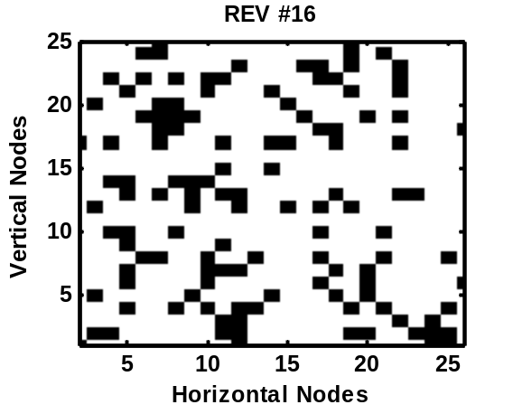
(e) (f)

Figure 16. Path-percolation model for initial porous medium generation (a) domain before cluster labelling (b) cluster labelling (c) effective domain (d) - (f) three random RAEs

The effective porosities of all of the RAEs can be seen in Figure 17(a). Then, a single-component single-phase LBM was applied to obtain the velocity distribution in these 16 domains and the effective tortuosities were computed as seen in Figure 17(b).

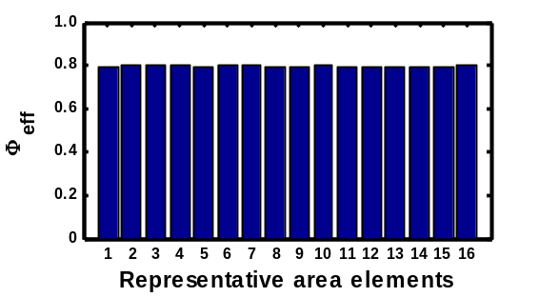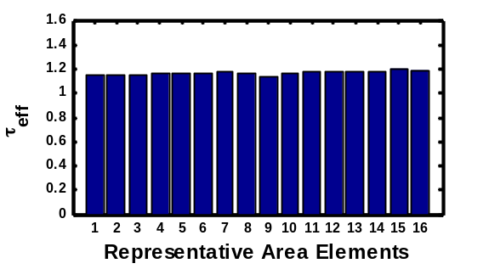
(a) (b)
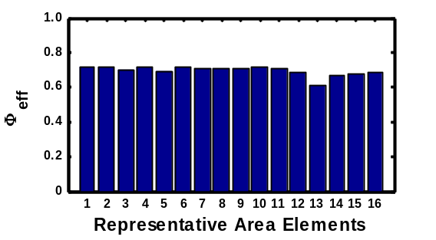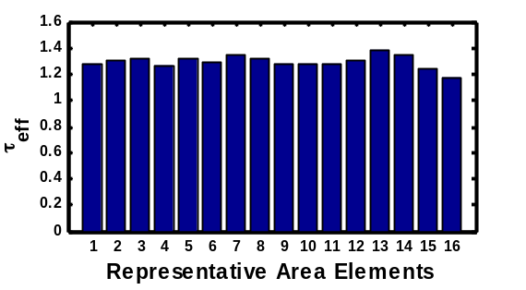
(c) (d)
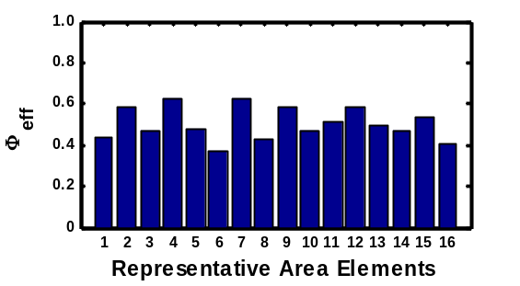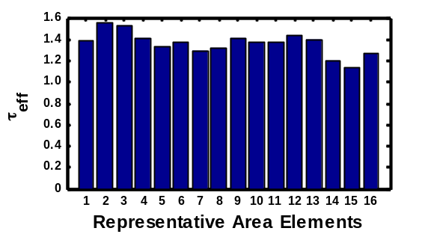
(e) (f)
Figure 17. Effective porosity & tortuosity calculations for RAEs of an example trial with 80% porosity and 0% condensation (a) Φ_{eff} with 0% condensation (b) τ_{eff} with 0% condensation (a) Φ_{eff} with 10% condensation (b) τ_{eff} with 10% condensation (a) Φ_{eff} with 20% condensation (b) τ_{eff} with 20% condensation

The same results were also demonstrated in Table 5 with an addition of effective porosity and tortuosity calculated for SRAE by Equation (2.31), and the diffusion ratios by three different models.

Table 5. Effective porosity, tortuosity, and diffusion ratio calculation example for SRAE with 0% condensation.
RAE # | φ_{eff} | τ_{eff} | φ_{eff,SRAE} | τ_{eff,SRAE} | Q_{Bruggeman} | Q_{Carman} | Q_{NewModel}
1 | 0.795200 | 1.150737 | 0.795200 | 1.164617 | 0.709112 | 0.682800 | 0.684272
2 | 0.800000 | 1.153163
3 | 0.801600 | 1.154434
4 | 0.798400 | 1.157320
5 | 0.793600 | 1.155720
6 | 0.798400 | 1.162446
7 | 0.796800 | 1.173685
8 | 0.792000 | 1.161168
9 | 0.795200 | 1.130812
10 | 0.798400 | 1.161545
11 | 0.792000 | 1.169265
12 | 0.788800 | 1.170493
13 | 0.788800 | 1.175958
14 | 0.790400 | 1.177900
15 | 0.792000 | 1.196414
16 | 0.801600 | 1.182811

It can be concluded that the Carman model and the new model overlap within this effective porosity range (about 80%). The results for REV #2 were analyzed in detail in the remaining part of this example. The effective domain of this representative area can be seen in Figure 16(d). The path of the fluid particles was obtained after the application of single-phase LBM as shown in Figure 18.

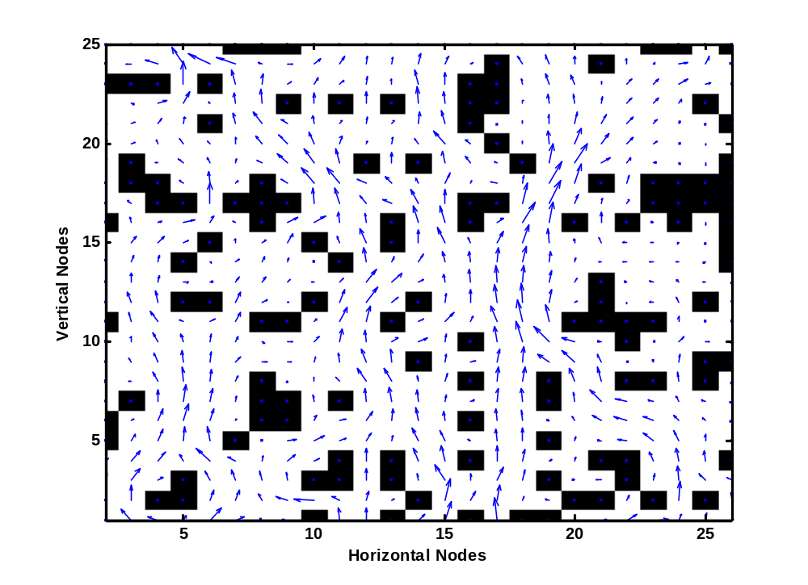
Figure 18. Velocity vectors along RAE #2. Tortuosity is 1.153163.
The tortuosity was computed as 1.153 whereas the effective porosity was 0.8. The effects of liquid formation on effective porosity and tortuosity will be discussed in the next step.
A multi-phase LBM was applied to the 16 RAEs of the domain of the example. At this time, a portion of the percolated fluid was assumed to be in two-phase and the liquid particles started to merge due to intermolecular attractive forces. The time evolution of this intermolecular attraction of a 10% condensed fluid in RAE #2 is shown in Figure 19.

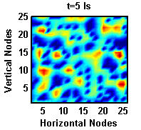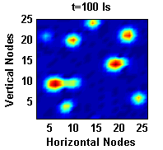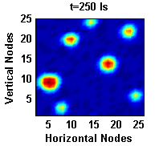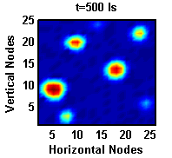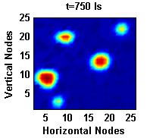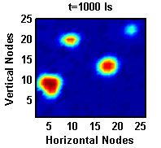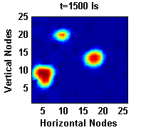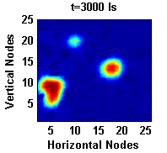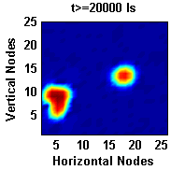
Figure 19. Evolution of phase separation of a 10% condensed two-phase fluid in REV #2

It must be noted that all the units of the lattice parameters are called the lattice units and the relation to the SI units can be found in [2-4]. After 5 lattice seconds (ls) liquid and vapor phases started to separate from each other and the liquid particles clustered together as time passes. After 20,000 ls the system reached steady-state. To analyze the vapor flow in the channel, single-phase LBM must be applied. Before that, the system was set up by considering the liquid clusters as solid, since they plugged some of the void nodes. Then, the cluster labelling process was performed to obtain the new effective domain with 10% condensate as seen in Figure 20. Liquid formation is shown in gray in Figure 20(b) and they were considered solid as were orphan pore clusters. The effective domain with an effective porosity of 0.714 can be seen with the velocity field of the molecules in vapor phase in Figure 20(c). The effective tortuosity is observed to be increased to 1.310 when the condensate became 10%.

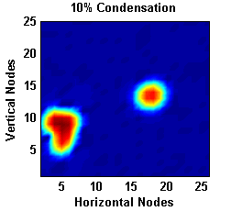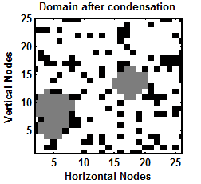
(a) (b)
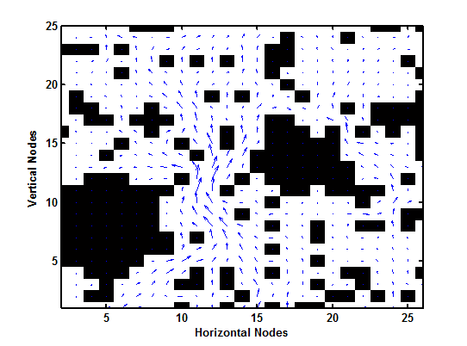
(c)

Figure 20. Vapor phase mass transfer with a 10% condensation (a) liquid formation (b) the voids occupied by liquid are shown in gray (c) Mass transfer in vapor phase, the effective tortuosity is 1.310297.

Figure 17(c) and (d) shows the effective porosities and tortuosities of all RAEs with a condensate of 10%, respectively. The effective porosity values decreased about 10% and a slight increase in tortuosity levels are observed. Similarly, 20% liquid formation effects is shown in Figure 21 and the effective porosity and tortuosity are 0.584 and 1.552, respectively.

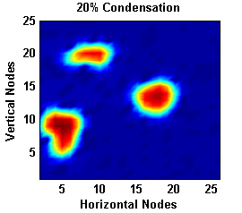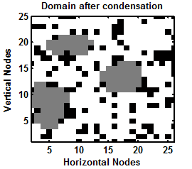
(a) (b)

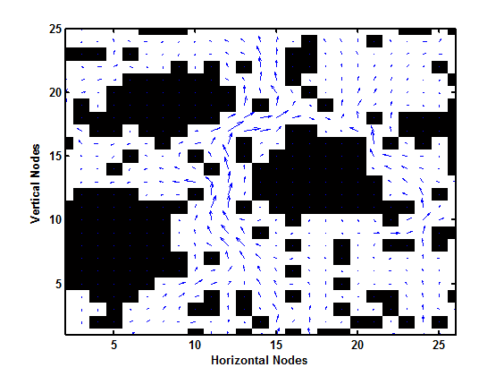
(c)
Figure 21. Vapor phase mass transfer with a 20% condensation (a) liquid formation (b) liquid formations are shown in gray (c) Velocity field of the vapor phase, the effective tortuosity is 1.551636.

In Figure 17(e) and (f), all the RAE parameters are demonstrated by a bar plot and the SRAE properties with diffusion ratio results are shown in Figure 22(a) and (b), respectively.

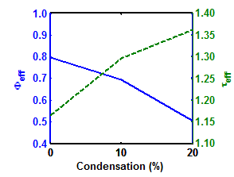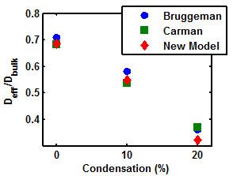
(a) (b)
Figure 22. Effects of condensation on mass transfer for a single example trial (a) effective porosity and tortuosity vs. condensation (b) diffusion ratio vs. condensation

The statistical results guided by confidence level studies can be discussed at this point. The previous example was a single trial with 80% porosity. As seen in Table 3, 140, 107, and 60 trials must be completed for 70%, 80%, and 90% porosity, respectively, each with one SRAE constituted by 16 RAEs. The results for the porosities and the effective porosities of the initially generated random porous media are shown in Figure 23. In this figure, probability distributions for both porosities and effective porosities for the media with all three target porosities with a confidence level of 99% were plotted. The results for all trials were divided into subgroups and these subgroups were plotted versus their occurrence frequency. It is observed that all six curves have Gaussian shapes. For 90% target porosity, the effective porosity and porosity probability curves almost coincide. When the target porosity decreases, the effective porosity - probability distribution curve becomes wider in range, and shifts to the left.

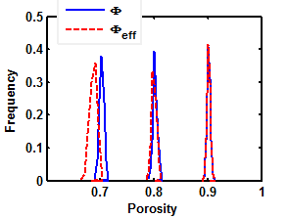
Figure 23. Confidence level results for initially generated 100x100 porous media with 70%, 80%, and 90% porosity

Figure 24 shows the effects of liquid formation on effective porosity and tortuosity.

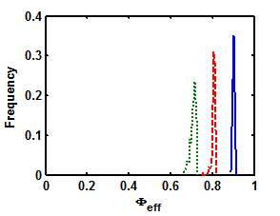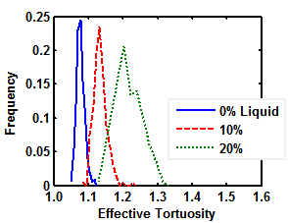
(a)
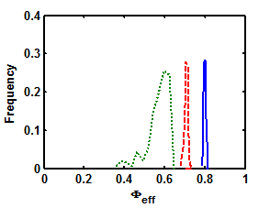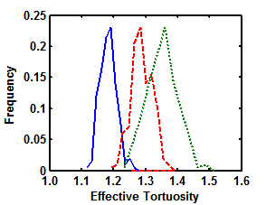
(b)
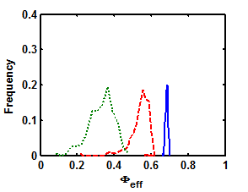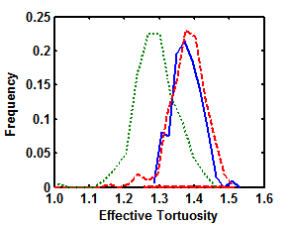
(c)
Figure 24. Confidence level results for SRAEs with (a) 90%, (b) 80%, and (c) 70% porosity. Figures on the left and right are probability distributions of effective porosity and tortuosity, respectively.
In Figure 24(a), the results for 90% target porosity is shown. Effective porosity was decreased by increased liquid formation in the channel and the effective porosity probability distribution range was increased. Furthermore, the occurrence frequency was also decreased. Similar results were observed for the other target porosity cases, Figure 24(b) for 80%, and (c) for 70% target porosity, respectively, only the distribution ranges got wider, and the occurrence frequency was decreased with target porosity. The effective tortuosity results do not show a certain trend as the effects of liquid formation on effective porosity as seen in the figures on the right, especially for the target porosity of 70% (Figure 24(c)). To start with, as the target porosity decreases the tortuosity in dry media and the probability distribution range of tortuosity increase. For a target porosity of 80% and 90%, the liquid formation increases the tortuosity (Figure 24(a) and (b)) as in the example for 80% target porosity discussed above (Figures 16 to 22). For 70% target porosity, the results do not follow this trend for 20% condensate as seen in Figure 24(c). For 10% liquid formation, tortuosity probability distribution curve slightly shifts to the right and the width of the curve slightly increases. For 20% liquid formation, the curve shifts to the left and gets wider in range. To understand this behavior, many trials were examined, one of which is discussed here. The trial had a target porosity of 70% and the resulting porosity and effective porosity values are 0.701 and 0.687, respectively. Multi-phase effects in RAE #1 was studied and shown in Figures 25 and 26.

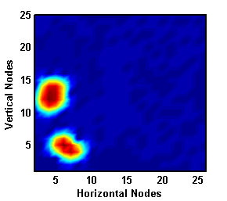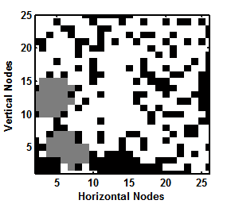
(a)
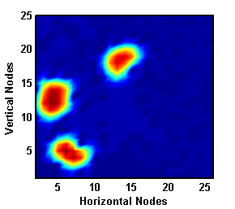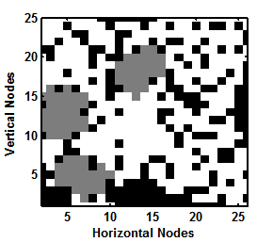
(b)
Figure 25. Liquid formation in an example RAE for 70% target porosity (a) 10%, (b) 20%

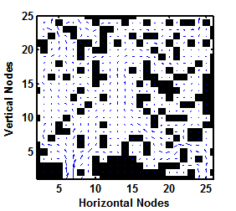
(a)
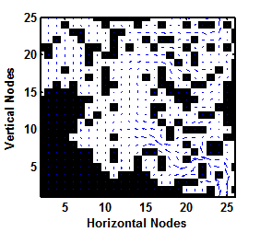
(b)
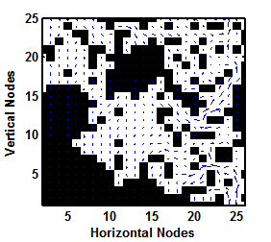
(c)

Figure 26. Velocity fields in effective domains with (a) 0%, (b) 10%, (b) 20% condensation. Computed tortuosities are 1.403323, 1.447953, and 1.28602, respectively.

In Figure 25(a) and (b), 10% liquid formation is observed and the cluster labelling was applied to the figures on the right. The domains in Figure 26 are the effective domain obtained after cluster labelling process. In Figure 26(a), the velocity field in a dry domain is shown. The computed effective porosity and tortuosity are 0.686 and 1.403, respectively. With 10% liquid formation, a portion of the channel at bottom left was closed by liquid clusters and a little portion of that was constituted by orphan clusters, hence eliminated and considered as solid by cluster labelling process. Then, tortuosity increased to 1.448 whereas the effective porosity decreased to 0.576. The related velocity field can be seen in Figure 26(b). With 20% condensate, the liquid clusters from the previous case with 10% condensate widened and a new liquid cluster occurred as seen in Figure 25(b). The velocity field in the effective domain for this case can be seen in Figure 26(c). After comparing the paths of the molecules between dry and 20% liquid cases, it is observed that two main paths (one on the left and one at the center) were eliminated as seen in Figure 26(c). Hence, the most of the molecules travel from the right part of the channel with a tortuosity of 1.286. The effective porosity in this case is 0.522. It can be concluded that the eliminated paths by liquid formation made the tortuosity decrease. Although a reduced tortuosity improves the mass transfer [16], the effective diffusion coefficient can still decrease, because of the changes in the effective porosity, which have a great impact on mass transfer. Figure 27 shows the effects of liquid formation on diffusion ratio in porous media with a target porosity of 70% for three diffusion models. As observed in the figure, diffusion ratios calculated by all three model equations decreased with increasing liquid formation in porous channels and the probability distribution curves of diffusion ratio got wider in range. Furthermore, it can be seen that the diffusion ratio calculated by the Carman model differed significantly from the other models in media with 20% liquid formation. The reason is clearly the tortuosity effect. From Figure 27, it can be concluded that the effects of tortuosity become more important in mass transfer when the liquid formation increases and the effective porosity decreases.

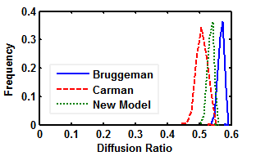
(a)
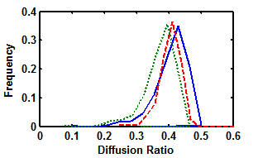
(b)
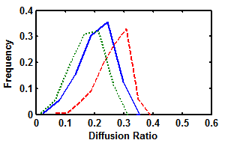
(c)

Figure 27. Diffusion ratio probability distributions with a medium with (a) 0%, (b) 10%, (c) 20% liquid formation

The critical liquid formation is another consideration of mass transfer. When the liquid formation reaches a critical value where the effective porosity becomes zero, no more mass transfer occurs in a channel. Figure 28 shows the critical liquid formation probability distributions for all target porosities.

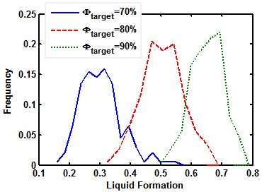

Figure 28. Critical liquid formation probability distributions with a medium with 70%, 80%, and 90% target porosity.
For 90% target porosity, critical liquid formation had values between 0.5 and 0.8, and the range was approximately 0.3, as seen in the figure. The maximum occurrence frequency is 22% and the related critical liquid formation is around 70%. Critical liquid formation probability range increases significantly by decreased target porosity. The maximum occurrence frequency for 80% porosity is about 20% and the most encountered critical liquid formation values are around 45%. The critical liquid formation has values between 0.32 and 0.69, hence the range is 0.37, which is 7% greater than that for 90% target porosity. For 70% target porosity, the critical liquid formation has values between 0.16 and 0.57, hence the probability distribution range is 0.41, which is 4% and 11% larger than the cases with 80% and 90% target porosity. On the other hand, the maximum occurrence frequency reduced to 16% for around 32% critical liquid formation.
OpenMP was implemented to the code and the plots for speedup, parallel efficiency, and performance of the simulations for three domains with 70%, 80%, and 90% target porosity can be seen in Figure 29.

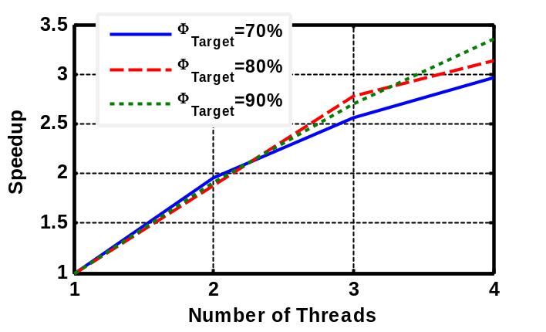

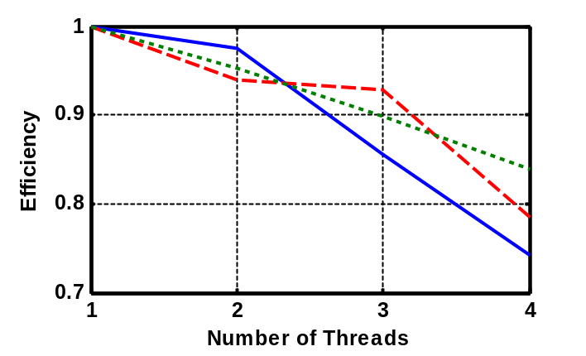

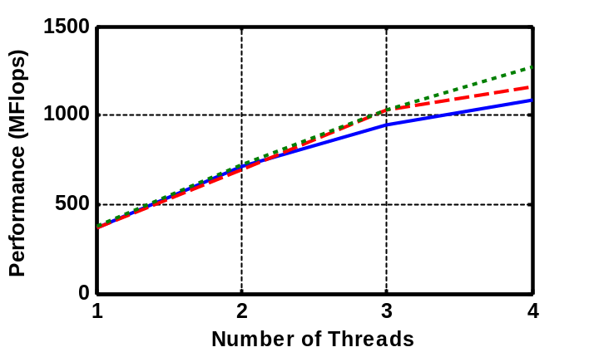

Figure 29. Performance analysis for parallel application

The maximum performance was obtained with 4 threads for the channel with 90% porosity as 1.275 GFlops, which is 2.6% of the peak performance. The related speedup and efficiency were computed 3.355 and 83.88%, respectively. The performance and speedup decreased with reduced target porosity. The reason of this result is that the total iteration number also decreases with the target porosity, since the program finds the critical liquid formation faster. It is concluded that the change in iteration number gets greater than the change in execution time (Equation 2.40), when target porosity increases. On the other hand, when more than 4 threads were used, no further speedup was achieved and the efficiency continued to decrease. Therefore, the most efficient way for this particular program with used hardware is assigning one thread to each physical core. The best option with the specified confidence level study is using 16 physical cores and assigning 16 threads.
This model is a two-dimensional approximation to a multi-phase problem in a porous medium and there are several sources of potential error. The surface-liquid interaction effects were neglected. Furthermore, the neglected third dimension would cause a significant loss of accuracy. Moreover, an experimental validation is needed for this computational study. On the other hand, an improvement on parallel application can be performed by utilizing an alternative hybrid parallel model to increase the speedup, efficiency, and performance. These missing physics are the subject of the ongoing study.

Conclusions
In this chapter, the path-percolation theory and Lattice-Boltzmann method were utilized to develop a model to investigate the effects of liquid formation on mass transfer in porous media. A statistical study with 99% confidence level was performed to analyze the behavior of effective porosity and tortuosity under different solid-liquid-vapor configurations of the media with 70%, 80%, and 90% porosity. The results show that the effective porosity decreases when the liquid formation in a channel increases. The impact of liquid formation on effective tortuosity changes with porosity. For porous media with 80% and 90% target porosity, effective tortuosity increases with liquid formation. For 70%-porosity media, it increases slightly when the liquid formation becomes 10%. When there is 20% liquid in the channel, the tortuosity decreases because of plugged long paths of the vapor molecules by liquid clusters. Effective diffusion coefficients of randomly generated inhomogeneous porous channels with liquid formations of 0%, 10%, and 20% were also studied, and it is concluded that the diffusion ratio decreases with liquid formation. Furthermore, critical liquid formation was investigated for all three media and its value increased with increased target porosity as expected. On the other hand, when the target porosity decreases, it becomes hard to predict the critical liquid formation since the range of the possible results gets wider. Finally, OpenMP was implemented to the model code and a performance analysis was applied using multi threads. The observed maximum speedup was 3.355 with a performance of 1.275 GFlops using four threads.
The results of this study can be used for any porous media application related to two-phase mass transfer and it is expected to provide an alternative statistical source to estimate the effective porosity, tortuosity, and diffusion ratio in porous media with a range of porosity and liquid formation.

CONCLUSION

This is the conclusion for the entire document. It can be a numbered chapter or it can stand alone. If you did not make your introduction a chapter and give it a number, you should not make the conclusion a numbered chapter. If you did call your Introduction “Chapter 1”, you should give your conclusiona chapter number.

Heading 2
Write here.

REFERENCES

[1] H. Kesten, What is percolation?, Notices of the American Mathematical Society, 53 (2006) 572-573.
[2] G. Grimmett, Percolation and disordered systems, Lect Notes Math, 1665 (1996) 153-300.
[3] A.A. Mohamad, Lattice Boltzmann Method: Fundamentals and Engineering Applications with Computer Codes, Springer-Verlag, London, 2011.
[4] L. Boltzmann, Lectures on gas theory, University of California Press, Berkeley,, 1964.
[5] M.C. Sukop, D.T. Thorne, Lattice Boltzmann Modeling An Introduction for Geoscientists and Engineers, Springer-Verlag, Berlin, Heidelberg, 2006.
[6] A. Nabovati, A.C.M. Sousa, Fluid flow simulation in random porous media at pore level using Lattice Boltzmann Method, New Trends in Fluid Mechanics Research, (2007) 518-521.
[7] A. Koponen, M. Kataja, J. Timonen, Tortuous flow in porous media, Phys Rev E, 54 (1996) 406-410.
[8] A. Koponen, M. Kataja, J. Timonen, Permeability and effective porosity of porous media, Phys Rev E, 56 (1997) 3319-3325.
[9] M. Matyka, A. Khalili, Z. Koza, Tortuosity-porosity relation in porous media flow, Phys Rev E, 78 (2008) 026306.
[10] A. Grucelski, J. Pozorski, Lattice Boltzmann simulation of fluid flow in porous media of temperature-affected geometry, J Theor App Mech-Pol, 50 (2012) 193-214.
[11] H.M. Jung, W. Choi, S. Um, Path-percolation Modeling of the Electrical Property Variations with Statistical Procedures in Spatially-disordered Inhomogeneous Media, J Korean Phys Soc, 56 (2010) 591-597.
[12] A. Papoulis, Citation Classic - Probability, Random-Variables, and Stochastic-Processes, Cc/Eng Tech Appl Sci, (1980) 14-14.
[13] E.A. Wargo, A.C. Hanna, A. Cecen, S.R. Kalidindi, E.C. Kumbur, Selection of representative volume elements for pore-scale analysis of transport in fuel cell materials, J Power Sources, 197 (2012) 168-179.
[14] E.A. Wargo, A.C. Hanna, A. Cecen, S.R. Kalidindi, E.C. Kumbur, A representative volume element approach for pore-scale modeling of fuel cell materials, Ecs Transactions, 41 (2011) 131-139.
[15] D.A.G. Bruggeman, Calculation of various physics constants in heterogenous substances I Dielectricity constants and conductivity of mixed bodies from isotropic substances, Annalen Der Physik, 24 (1935) 636-664.
[16] D.W. Chung, M. Ebner, D.R. Ely, V. Wood, R.E. Garcia, Validity of the Bruggeman relation for porous electrodes, Model Simul Mater Sc, 21 (2013) 074009.
[17] P.C. Carman, Flow of gases through porous media, Butterworth's Scientific Publications, London, 1956.
[18] S. Succi, The lattice Boltzmann equation for fluid dynamics and beyond, Clarendon Press; Oxford University Press, Oxford New York, 2001.
[19] M.C. Sukop, D.T. Thorne, Lattice Boltzmann Modeling: An Introduction for Geoscientists and Engineers, Springer, Berlin ; New York, 2006.
[20] M.C. Sukop, H.B. Huang, P.F. Alvarez, E.A. Variano, K.J. Cunningham, Evaluation of permeability and non-Darcy flow in vuggy macroporous limestone aquifer samples with lattice Boltzmann methods, Water Resour Res, 49 (2013) 216-230.
[21] X.P. Li, Y. Zhang, X.W. Wang, W. Ge, GPU-based numerical simulation of multi-phase flow in porous media using multiple-relaxation-time lattice Boltzmann method, Chem Eng Sci, 102 (2013) 209-219.
[22] H.B. Huang, J.J. Huang, X.Y. Lu, M.C. Sukop, On Simulations of High-Density Ratio Flows Using Color-Gradient Multiphase Lattice Boltzmann Models, Int J Mod Phys C, 24 (2013).
[23] A. Genty, V. Pot, Numerical Simulation of 3D Liquid-Gas Distribution in Porous Media by a Two-Phase TRT Lattice Boltzmann Method, Transport Porous Med, 96 (2013) 271-294.
[24] H. El Abrach, H. Dhahri, A. Mhimid, Numerical Simulation of Drying of a Saturated Deformable Porous Media by the Lattice Boltzmann Method, Transport Porous Med, 99 (2013) 427-452.
[25] H.B. Huang, Z.T. Li, S.A.S.A. Liu, X.Y. Lu, Shan-and-Chen-type multiphase lattice Boltzmann study of viscous coupling effects for two-phase flow in porous media, Int J Numer Meth Fl, 61 (2009) 341-354.
[26] H.B. Huang, L. Wang, X.Y. Lu, Evaluation of three lattice Boltzmann models for multiphase flows in porous media, Comput Math Appl, 61 (2011) 3606-3617.
[27] M.C. Sukop, H. Huang, C.L. Lin, M.D. Deo, K. Oh, J.D. Miller, Distribution of multiphase fluids in porous media: Comparison between lattice Boltzmann modeling and micro-x-ray tomography, Phys Rev E, 77 (2008).
[28] J.F. Chau, D. Or, M.C. Sukop, Simulation of gaseous diffusion in partially saturated porous media under variable gravity with lattice Boltzmann methods, Water Resour Res, 41 (2005).
[29] O. Cekmer, S. Um, M.M. Mench, Application of path-percolation theory and Lattice-Boltzmann method to investigate structure-property relationship in porous media, International Journal of Heat and Mass Transfer (under review), (2014).

VITA

John X. Doe was born. He wrote a thesis. He graduated. This page really is required.

