Using virus-induced gene silencing to identify novel regulators of plasmodesmal function

Adam Greeley, Elena Ganusova, Tessa Burch-Smith

An Honors Thesis Project at the University of Tennessee

Abstract
Studying the genetic regulation of plasmodesmata in plant cells can be accomplished with virus-induced gene silencing (VIGS). VIGS can be used to silence endogenous genes involved in plasmodesmata regulation. In this experiment, a library of VIGS constructs with fragments of endogenous gene sequences housed in Agrobacterium vectors was infiltrated Nicotiana benthamiana plants. The effect of silencing each gene on the phenotype of the plant was noted. In addition, the effect of silencing each gene on the plasmodesmal function was measured by bombarding each plant with a DNA construct for expression of green fluorescent protein (GFP) and then monitoring the spread of GFP to adjacent cells. In this study, YY genes were silenced in VV plants. KK plants showed visible phenotypes including yellowing. TT plants showed increased intercellular spread of GFP compared to control plants, making these genes candidates for regulating plasmodesmata.

Introduction
The plasmodesma is an important structure in plants. Plasmodesmata are channels between cells that allow cytoplasmic continuity and intercellular movement of various molecules. They can be a single channel, a pair of adjacent channels, or a branched channel. Inside a plasmodesma is a portion of endoplasmic reticulum called the desmotubule. The desmotubule connects the endoplasmic reticulum of the adjacent cells. The space between the wall of the channel and the desmotubule is called the cytoplasmic sleeve. While cytoplasmic sleeves are small in diameter, there is space for proteins to associate with the walls of the channel and the desmotubule (1-3). The size-exclusion limit describes the size-related limitation for particles that can move through a plasmodesma (2-4).
The size-exclusion limit can be changed by a variety of factors. Callose deposits, for example, can lower the limit, effectively making the plasmodesma channel smaller (1-3). Actin associated with plasmodesmata can also affect the size-exclusion limit (2). Certain viruses have been found to affect the size-exclusion limit of plasmodesmata by influencing the formation of callose deposits or the polymerization of actin. The Tobacco mosaic virus and Cucumber mosaic virus are two examples of viruses that affect the size-exclusion limit by depolymerizing actin filaments (2).
Discovering genes that regulate plasmodesmata function can be difficult. This is because intercellular communication in plants is essential for life and the plasmodesmata are essential for intercellular communication (1, 5). The signaling molecules that travel through plasmodesmata during embryogenesis are important for their role in the determination of cell fate, nutrient distribution, and the coordination of behavior between individual cells (5). Therefore, studying the regulation of plasmodesmata through mutagenic experiments will cause defects in development and death during embryogenesis. One way to bypass this limitation is through the use of VIGS. Viruses can be used study the genetic factors that regulate plasmodesmata in plants that have already grown (6).
VIGS is an epigenetic technique commonly used to characterize the function of plant genes through post-transcriptional gene silencing. This technique ultimately results in the degradation of endogenous mRNA by the RNAi silencing complex (RISC complex), which is activated to degrade mRNA after association of the complex with small-interfering RNA (siRNA). This degradation is sequence-specific, as RISC will be targeted to mRNA sequences that are complementary to the sequence of the associated siRNA. siRNA is formed when the dicer complex associates with and cleaves double-stranded RNA (dsRNA) (6, 7). Double-stranded RNA can originate from a couple of different sources. One source of dsRNA is an RNA-dependent RNA polymerase from the host. This polymerase is activated as a defense mechanism in response to foreign nucleotides introduced by a transgene (6, 8). Another possible source of the dsRNA can be a retrovirus that is going through the replicative cycle (6). Therefore, VIGS basically involves using a virus to suppress expression of an endogenous gene.
A commonly used virus for VIGS is TRV. TRV is an effective virus for VIGS because the symptoms of infection are mild, the virus often infects large areas, and this particular virus can be used for silencing in growing plants, reducing the amount of time needed for host growth (9). TRV is a bipartite virus, which means it requires two RNAs to achieve silencing in the model organism Nicotiana benthamiana, a plant often used for VIGS research (6, 10). In N. benthamiana, TRV has been found to give good results that are persistent and consistent between experiments (6). This virus is usually spread by soil-dwelling nematodes, which can transmit the virus when they feed on the roots. The first RNA, conveniently termed “RNA1”, is important for allowing the virus to multiply and spread within the host. The second component, RNA2, is essential because it encodes the coat protein and is necessary for transmission from the nematode. Therefore, the virus cannot be transmitted with RNA1 alone (9, 11). Plasmids for both components are necessary for VIGS. In VIGS, RNA2 is the vector that contains the gene of interest. An example of an RNA2 vector is pYY13, a plasmid that can accommodate any sequence for insertion that has compatible ends (10).
The purpose of this study was to examine the effects of virus-induced gene silencing of various host genes on the size exclusion limit of plasmodesmata by examining the spread of green fluorescent protein (GFP) between cells. If silencing of a gene results in increased plasmodesmal size exclusion limit, GFP that is created in one cell will be able to spread to adjacent cells (1). While GFP is free to move in a cell unhindered due to the lack of interaction with cell constituents, it cannot easily move through the plasmodesmata due to size constraints (4). This study identified one construct that increased the size exclusion limit, resulting in spreading of GFP.

Materials and Methods
Preparation of Plants and Bacteria
The organism used as the host plant in this experiment was Nicotiana benthamiana. Seedlings of N. benthamiana were transplanted into pots (one per pot) after about two weeks after germination. Plants were grown under long-day conditions (16 hours of light and 8 hours of darkness) at 28ºC during the day and 22ºC during the night with a light intensity of 120 μmol photons m⁻² s⁻¹. Throughout the entire experiment, the plants were watered regularly. Two plants were grown for each VIGS construct to be infiltrated. A library, which contained many VIGS constructs, was used for the RNA2 plasmid. Each construct contained a fragment of a different gene of interest, and throughout this experiment, the constructs were named based on the location of their well in the 96 well plate they were kept in (A1, A2, A3, B1, etc.). These plates were stored in the -80ºC freezer. Three control plasmids were also used as the RNA2: pTBS10 (to silence the N. benthamiana Pyhtoene Desaturase (PDS) gene), pYC1 (TRV alone control), and pTBS13 (to silence the N. benthamiana Increased Size Exclusion Limit 2 (ISE2) gene). Strain pYL192 contained the plasmid encoding TRV RNA1. In order to prepare these plasmids for infiltration, the Agrobacterium containing the plasmids were grown on plates with Luria Broth (LB) medium. This medium had 50 µg/ml kanamyacin, 100 µg/ml gentomyacin, and 100 µg/ml rifampicin. For pYL192 and for the three controls, this was sufficient for bacterial growth. For the samples in the VIGS construct library, the bacteria had to be grown on LB without the antibiotics to revive them from the -80ºC freezer. They were then transferred to plates with the antibiotics.

Silencing Procedure
After growing for four weeks, the plants were ready for infiltration with the agrobacterium containing RNA1 and RNA2. At this time, the bacteria were transferred from the plates with solid LB medium and the three antibiotics to liquid cultures with LB containing the antibiotics. These liquid cultures were grown overnight at 28ºC. Bacterial cells were collected by transferring cultures to individual 50 ml falcon tubes and then spinning for 15 minutes at 3000 RPM. The supernatant was removed from each, and the pellets were resuspended in the small volume of supernatant left at the bottom of each tube by vortexing. Infiltration medium containing 10 mM MES and 10 mM MgCl₂. After resuspending the pellets in each falcon tube, one microliter of 0.2M aceytosyringone was added to the infiltration buffer for a final concentration of 0.2 µM. About 10 ml of infiltration buffer was then added to each falcon tube and the UV-Vis spectrophotometer was used to measure the OD₆₀₀ in order to determine the concentration of sample in each tube. If the concentration for a sample was greater than 1.0 M, infiltration buffer was added until the concentration fell to the 0.8 M – 1.0 M range. Once each of the concentrations was adjusted to this range, 1 ml of pYL192 was combined with 1 ml of each RNA2 plasmid in a separate falcon tube for each RNA2 sample. These mixtures were incubated overnight at room temperature and then used for the infiltration.
Each plant was infiltrated by cutting a small slit in two leaves. A 1 ml needleless syringe was used to infiltrate the mixture of RNA1 and RNA2 into each leaf at the slits. For each VIGS construct and control, two plants were infiltrated. After infiltration, the plants were left in a cool location overnight and then returned to their normal growth conditions.

Bombardment Procedure
After two weeks in the growth chambers, gene silencing in some of the plants was evident by a change in phenotype. At this time, all plants were bombarded with GFP DNA. The vectors containing 1x GFP and 2x GFP DNA were first scraped off a plate into a flask with a 500 ml solution of LB medium with the antibiotics previously mentioned. These flasks were left on the shaker in the 28ºC incubator overnight. For the first round of bombardment, a QIA PrepSpin Miniprep procedure was used to prepare 1x GFP and 2x GFP plasmids. DNA concentration in each was measured with a NanoDrop (Thremo Scientific). For the second round of bombardment, a PureYield Maxiprep procedure was used to prepare and determine the concentration of 1x GFP and 2x GFP. For each preparation, the printed instructions included in the kit were followed.
The next step was to bombard the silenced plants with either 1x GFP DNA or 2x GFP DNA. For the first two rounds of bombardment, one plant for each VIGS construct was bombarded with 1x GFP DNA while the other plant for each VIGS construct was bombarded with 2x GFP DNA. For the third round, only the 2x GFP DNA was delivered through bombardment due to poor results from the plants bombarded with the 1x GFP. For the first round of bombardment, GFP was delivered to plants silenced with pTBS10, pYC1, pTBS13, and A1 – A12. For the second round of bombardment, GFP was delivered to plants silenced with B5 – B12 and C1 – C4. For the third round of bombardment, GFP was delivered to plants silenced with C5 – C12 and D1 – D10.
The first step was to prepare plates with 1/2 MS and 1.0% sucrose. One plate was prepared for each plant infiltrated. Pictures were taken of each plant’s phenotype prior to bombardment and then a single leaf (preferably one displaying the silenced phenotype) was cut from each plant and placed on a plate. Prior to the bombardment, a large amount of aluminum foil circles were also cut with a hole punch. The next step was to coat the Tungsten particles with DNA. 500 µg of Tungsten per shot and 4 µL of water per shot were added to an Eppendorf tube. Each leaf was shot twice with the bombardment device, so the number of shots was equal to the number of silenced plants times two. For the first two rounds of bombardment, two Eppendorf tubes were prepared, one for the 1x GFP DNA and one for the 2x GFP DNA. For the third round of bombardment, only one Eppendorf tube was needed since only the 2x GFP DNA was used for the bombardment. The Tungsten particles were suspended in the water by vortexing at a low speed. After suspension, 10 µL of 0.1 M spermidine and 10 µL of 2.5M CaCl₂ were added to each Eppendorf tube. For the first round of bombardment, enough DNA was also added to each tube to give a final concentration of 1 µg/µL. For the second and third bombardments, enough DNA was added to each tube to give a final concentration of 5 µg/µL. The DNA was allowed to adhere to the Tungsten for 15 – 30 minutes. During this time, the cooling moisture trap for the bombardment device was turned on. It was critical that this trap be turned on at least 30 minutes prior to bombardment. Once the DNA had adhered to the Tungsten, the Eppendorf tubes were washed twice with 70% ethanol and then once with 100% ethanol. The Tungsten in each tube was then resuspended in enough 100% ethanol to give 5 µL of ethanol per shot.
The pressure of helium was set at 60 psi. DNA was delivered to each leaf by pipetting 5 µL of the suspended Tungsten onto an aluminum foil circle. This circle was then placed upside down on top of the two washers positioned over the screen. The adapter tube was screwed into place on top of the foil and the leaf was placed inside the bombardment chamber. The vacuum pump was switched on and the pressure in the chamber was adjusted to 25 mmHg. Then, the pump was switched off and the red button on the bombardment device was pressed, which shot the DNA from the aluminum foil through the screen and into the leaf. A second shot was performed after slightly adjusting the position of the leaf and then this procedure was repeated with a leaf from another plant until bombardment of all leaves was complete. The plates containing the leaves were then placed back into the 28ºC/22ºC overnight to allow translation of the GFP within the plant cells.

Fluorescent Microscopy
Next, a 1x1 cm square was cut from each leaf for examination under the fluorescent microscope. Examination of the leaves involved looking for spreading of GFP between adjacent cells. Images were taken of each sample that showed GFP expression. Particular interest was given to samples that showed GFP expression and the spreading of GFP to adjacent cells. If a cell expressing GFP was found in a plant, an attempt was made to find up to two other cells in that same sample that also expressed GFP. GFP expression was indicated by a bright green glow around a cell that disappeared when switching from the GFP option to the CFP, YFP, RFP, and white light options. After completion of the experiment, all plants and plates with leaves were discarded into the biohazard containers.

Results
Post-Silencing Phenotype Results
Qualitative analysis of the leaf phenotype was used to examine the effects of gene silencing on each plant. Chlorosis is one way to confirm that the virus was successfully inserted and that it spread in N. benthamiana. Chlorosis is the yellowing of a leaf due to insufficient chlorophyll production. It can be relatively mild, which is indicated by yellowing of the leaves, or it can more severe. Severe chlorosis can lead to bleaching, a condition indicated by large white splotches (6, 10). Several of the plants in this experiment exhibited chlorosis two weeks after infiltration.
One of the controls, pTBS10, exhibited bleaching while another, pTBSl3, exhibited mild chlorosis with a yellow leaf phenotype (table 1, top two lines). Of the VIGS constructs that were infiltrated for the first round of bombardment, several exhibited chlorosis. A1, A3, A9, A10, and A12 all showed signs of yellowing. A2, A4, A5, A6, A7, A8, and A11 exhibited more severe bleaching (table 1). None of these samples were completely bleached, but all of them had a significant amount of white splotches on the leaves. Of the constructs that were infiltrated for the second and third rounds of bombardment, there were fewer instances of chlorosis. None of these plants exhibited as much bleaching as the plants from the first round, but chlorosis was visible in B9, B11, C2, C3, C4, and C8 (table 1).
Construct | Phenotype | Construct | Phenotype
pTBS10 | 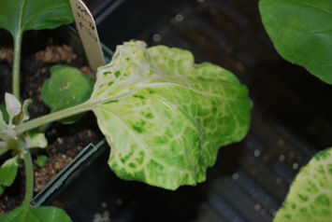 | pYC1 | 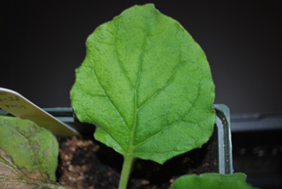
PTBS13 | 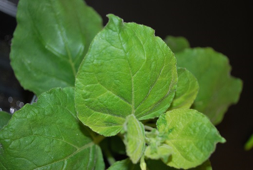 | A1 | 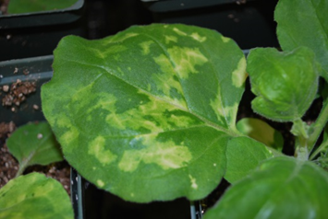
A2 | 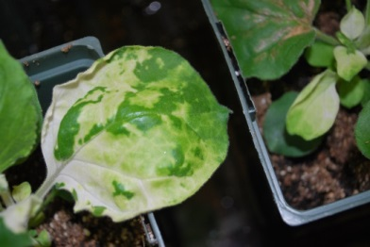 | A3 | 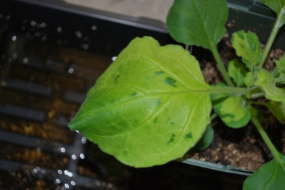
A4 | 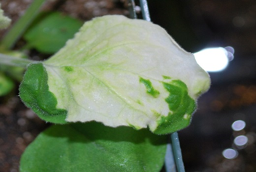 | A5 | 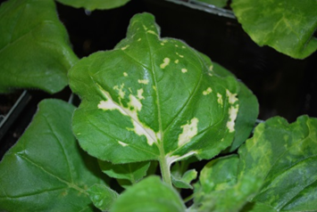
A6 | 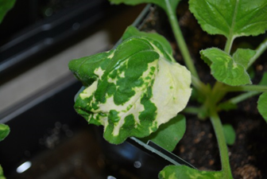 | A7 | 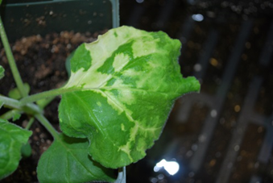
A8 | 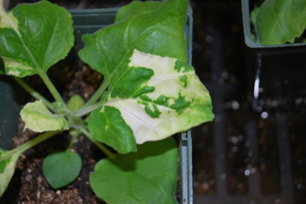 | A9 | 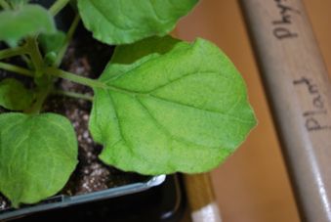
A10 | 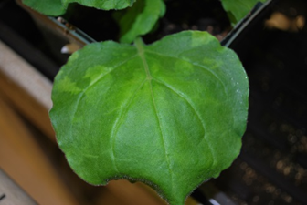 | A11 | 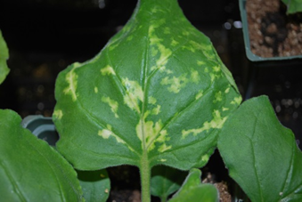
A12 | 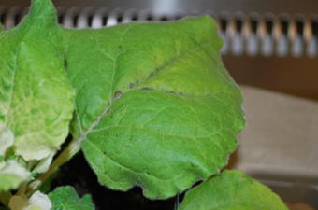 | B5 | 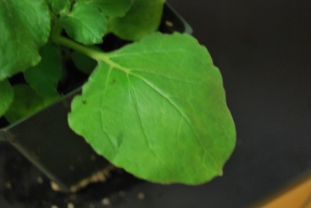
B6 | 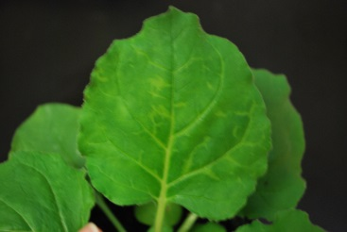 | B7 | 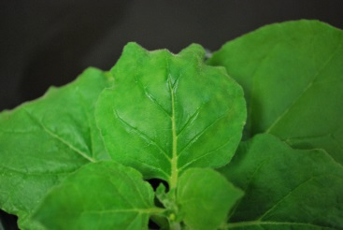
B8 | 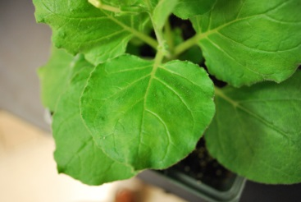 | B9 | 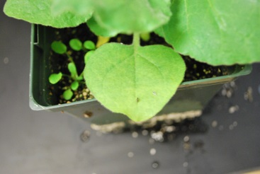
B10 | 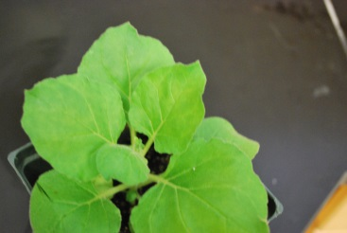 | B11 | 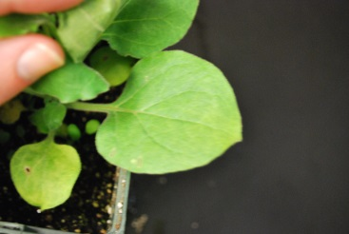
B12 | 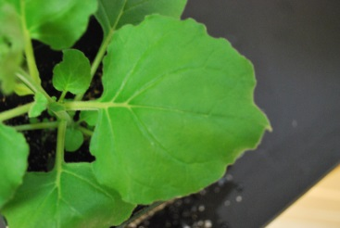 | C1 | 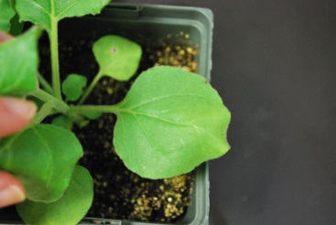
C2 | 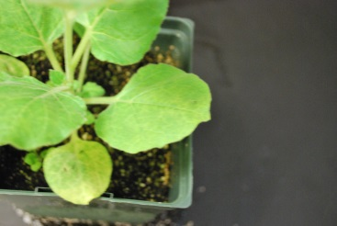 | C3 | 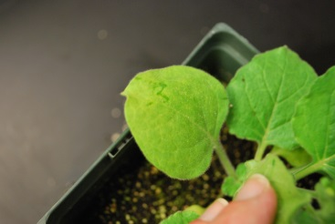
C4 | 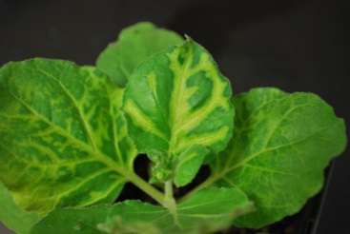 | C5 | 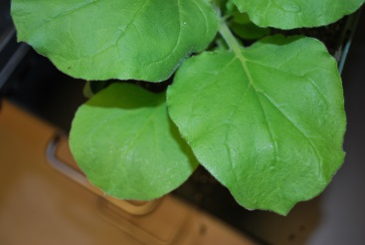
C6 | 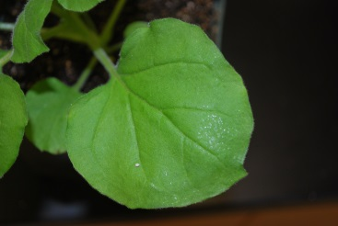 | C7 | 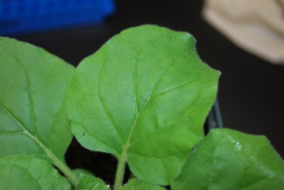
C8 | 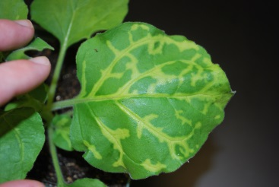 | C9 | 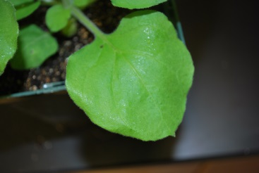
C10 | 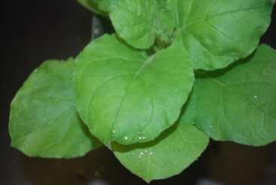 | C11 | 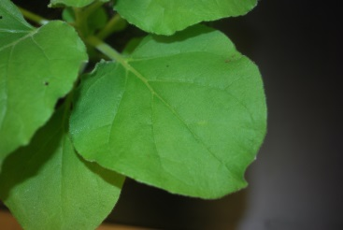
C12 | 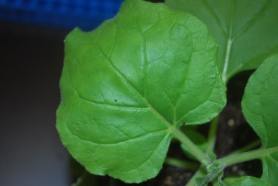 | D1 | 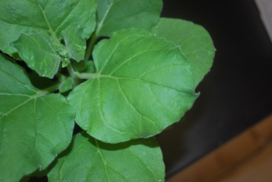
D2 | 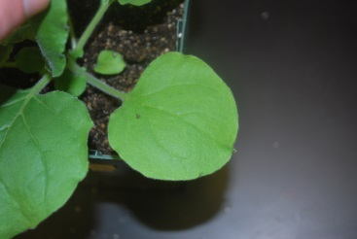 | D3 | 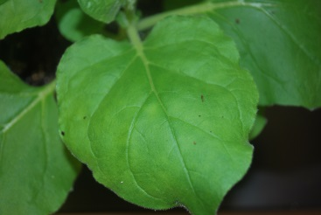
D4 | 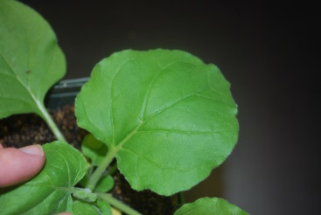 | D5 | 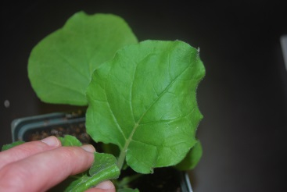
D6 | 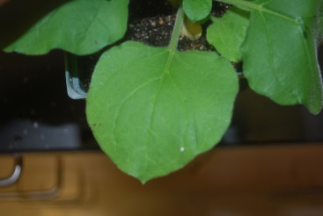 | D7 | 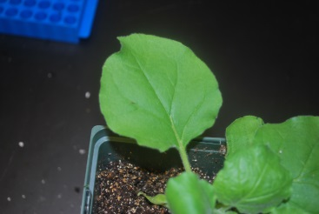
D8 | 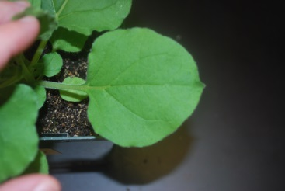 | D9 | 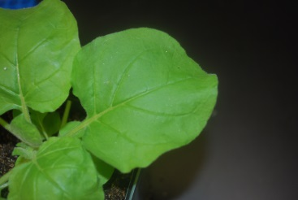
D10 | 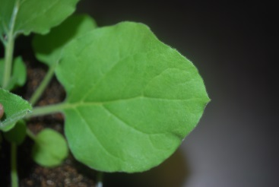
Table 1: Phenotype of plants after being silenced with either a control or a VIGS construct.

Post-Bombardment Microscopy Results
GFP expression was determined by placing a small square from each leaf onto a slide and observing each under a fluorescent microscope. If a ring of bright green color was observed around one of the epidermal plant cells, GFP expression was present. In order to confirm that the green color was, in fact, caused by GFP expression, the same cell was observed with the YFP, CFP, RFP, and white light options on the fluorescent microscope.
Only a few of the plants actually expressed GFP in the plant cells following bombardment. In the first batch of plants, pYC1, A1, A4, and A11 all expressed GFP (Fig. 1). The signal appeared much stronger in A4 (Fig. 1c) than in the others, and this was the only sample that also appeared to show GFP spreading. None of the samples in the first round that were bombarded with 2x GFP showed GFP expression. This could have been due to errors made in the 2x GFP DNA preparation.

a. 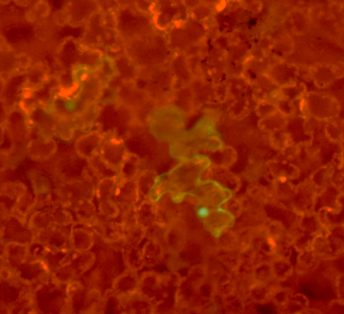 b. 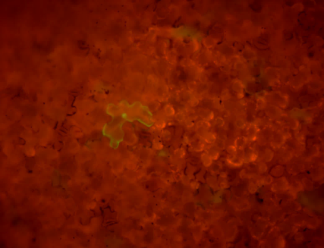
c. 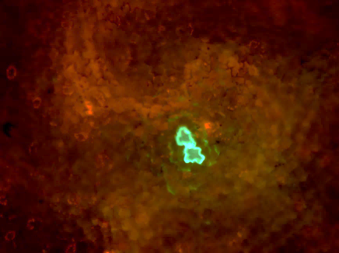 d. 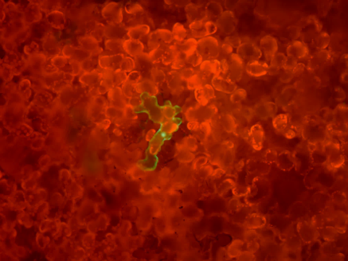
Figure 1: Images from the fluorescent microscope at 10x magnification showing 1x GFP expression in the plants that expressed GFP from the first batch that was bombarded. (a) pYC1; (b) A1; (c) A4; (d) A11.

Due to an equipment malfunction, images of samples from the second round of bombardment are not available. While the microscope was available for observation, images could not be taken of the samples following observation under the microscope. Of this batch of samples, B7, B8, B9, and C3 all expressed 2x GFP, though spreading of GFP was not apparent in any of these samples. None of the samples that were bombarded with 1x GFP showed GFP expression. For this reason, only 2x GFP was used in the third round of bombardment. From this batch of constructs, the samples infiltrated with C9, C12, D4, D5, and D10 expressed the 2x GFP (Fig. 2). All of these samples appeared to express GFP at roughly the same strength of signal. None exhibited any movement of GFP to adjacent cells.

a. b. c.
d. e.
Figure 2: Images from the fluorescent microscope at 10x magnification showing 2x GFP expression in the plants that expressed GFP from the third batch that was bombarded. (a) C9; (b) C12; (c) D4; (d) D5; (e) D10.

Discussion
Gene silencing in the plants gave a wide variety of phenotypes, as can be seen in table 1. Generally, photobleaching is seen as a good indication of whether or not the silencing actually occurred (6, 10). pTBS10, A2, A4, A5, A6, A7, A8, and A11 all showed signs of significant bleaching. In these samples, the splotches of white were randomly distributed and variable in terms of the amount of leaf bleached. Some of these plants, like A4, showed a significant amount of bleaching, while others, like A11, only showed a small amount of bleaching. Several of the plants that did not show severe bleaching still yellowed, indicating that the gene silencing caused a less severe chlorosis. Leaves from A1, A3, A9, A10, A12, B9, B11, C2, C3, C4, and C8 all yellowed to varying extents, as can be seen in table 1. Interestingly, in C4 and C8, the chlorosis was confined to the areas right around the veins of the leaves. Meanwhile in A9, the chlorosis was everywhere except for the areas immediately surrounding the veins.
1x GFP and 2x GFP were both initially delivered in order to compare the expression of each. For all of the leaves in which GFP was successfully delivered, only one showed spreading of the GFP to adjacent cells. After the first round of bombardment, pYC1, A1, A4, and A11 all expressed GFP when viewed under the fluorescent microscope (Fig. 1). After the second round of bombardment, B7, B8, B9, and C3 all showed expression of GFP when viewed under the fluorescent microscope. After the third round of bombardment, C9, C12, D4, D5, and D10 all showed GFP expression under the fluorescent microscope (Fig. 2). Of all of these samples, A4 was the only sample with spreading (Fig. 1c). This indicates that VIGS of the gene resulted in increased intercellular trafficking by the plasmodesmata. This is why the GFP was able to move between adjacent cells to a greater extent than observed in the control plants. Interestingly, A4 was also the sample that showed the greatest amount of photobleaching following infiltration (table 1). This could indicate a correlation between the extent of photobleaching caused by silencing and the widening of the plasmodesmata.
This experiment could be improved significantly. Due to the short time span that this experiment was conducted in (only four months), only a limited number of VIGS constructs were tested. The VIGS construct library is large, and it is regrettable that there was not more time to test more of the library. If there had been more time, this experiment could have also been improved upon by redoing the silencing procedure for the constructs used in the first round of bombardment (A1 – A12). The reason for this is because the amount of DNA delivered through bombardment was increased significantly for the second and third rounds from 1 µg/µL to 5 µg/µL. Therefore, in order to achieve better consistently, and hopefully better results, the entire procedure should have been repeated for A1 – A12 with the larger amount of DNA.

Conclusions
Of all the VIGS constructs that were used for this project, only A4 influenced the plasmodesmata in a way that affected GFP transport. In the leaf that was silenced with A4, one can conclude that the virus-induced gene silencing widened the plasmodesmata, allowing the spreading of GFP to adjacent cells. A4 was also the construct that caused the most extensive amount of bleaching. None of the other leaves in which GFP was expressed showed spreading of GFP. However, these experiments demonstrate that VIGS followed by GFP expression is a viable strategy for identification of novel regulators of plasmodesmal function.

References

1. T. M. Burch-Smith, P. C. Zambryski, Plasmodesmata paradigm shift: regulation from without versus within. Annual review of plant biology 63, 239-260 (2012)10.1146/annurev-arplant-042811-105453).
2. S. Ueki, V. Citovsky, Plasmodesmata-associated proteins: Can we see the whole elephant? Plant signaling & behavior 9, (2014); published online EpubFeb 11 (
3. Y. Stahl, R. Simon, Gated communities: apoplastic and symplastic signals converge at plasmodesmata to control cell fates. Journal of experimental botany 64, 5237-5241 (2013); published online EpubDec (10.1093/jxb/ert245).
4. O. Liarzi, B. L. Epel, Development of a quantitative tool for measuring changes in the coefficient of conductivity of plasmodesmata induced by developmental, biotic, and abiotic signals. Protoplasma 225, 67-76 (2005); published online EpubApr (10.1007/s00709-004-0079-x).
5. Y. Benitez-Alfonso, Symplastic intercellular transport from a developmental perspective. Journal of experimental botany 65, 1857-1863 (2014); published online EpubApr (10.1093/jxb/eru067).
6. T. M. Burch-Smith, J. C. Anderson, G. B. Martin, S. P. Dinesh-Kumar, Applications and advantages of virus-induced gene silencing for gene function studies in plants. The Plant journal : for cell and molecular biology 39, 734-746 (2004); published online EpubSep (10.1111/j.1365-313X.2004.02158.x).
7. H. Vaucheret, C. Beclin, M. Fagard, Post-transcriptional gene silencing in plants. Journal of cell science 114, 3083-3091 (2001); published online EpubSep (
8. T. Dalmay, A. Hamilton, S. Rudd, S. Angell, D. C. Baulcombe, An RNA-dependent RNA polymerase gene in Arabidopsis is required for posttranscriptional gene silencing mediated by a transgene but not by a virus. Cell 101, 543-553 (2000); published online EpubMay 26 (
9. F. Ratcliff, A. M. Martin-Hernandez, D. C. Baulcombe, Technical Advance. Tobacco rattle virus as a vector for analysis of gene function by silencing. The Plant journal : for cell and molecular biology 25, 237-245 (2001); published online EpubJan (
10. Y. Dong, T. M. Burch-Smith, Y. Liu, P. Mamillapalli, S. P. Dinesh-Kumar, A ligation-independent cloning tobacco rattle virus vector for high-throughput virus-induced gene silencing identifies roles for NbMADS4-1 and -2 in floral development. Plant physiology 145, 1161-1170 (2007); published online EpubDec (10.1104/pp.107.107391).
11. S. A. MacFarlane, Molecular biology of the tobraviruses. The Journal of general virology 80 ( Pt 11), 2799-2807 (1999); published online EpubNov (

