To the Graduate Council:

I am submitting herewith a thesis written by Boone Hillenbrand entitled “An Investigation for the need of Secondary treatment of Residential Wastewater when applied with a Subsurface Drip Irrigation System.” I have examined the final copy of this thesis for form and content and recommend that it be accepted in partial fulfillment of the requirements for the degree of Master of Science, with a major in Biosystems Engineering.

______________________________
John R. Buchanan, Major Professor

We have read this thesis and
recommend its acceptance:

_________________________
John S. Tyner

_________________________
Jaehoon Lee

Accepted for the Council:

______________________________
Carolyn R. Hodges
Vice Provost and Dean of the Graduate School

An Investigation for the need of Secondary treatment of Residential Wastewater when applied with a Subsurface Drip Irrigation System

A Thesis Presented for
the Master of Science
Degree
The University of Tennessee, Knoxville

Boone Hillenbrand
August 2010

ABSTRACT
A Subsurface Drip Irrigation System (SDIS) was analyzed to determine the need for a secondary filtering requirement for residential wastewater dispersal. The theory suggests the use of SDIS will take advantage the soil’s natural purifying capabilities and be able to treat domestic wastewater effectively without the use of secondary treatment.
Two systems were analyzed. Both are located in residential subdivided communities. Each home has individual septic tanks for primary treatment. The effluent is linked to a decentralized wastewater treatment facility consisting of a sand filter and absorption field. Each location has a test plot with effluent dispersal using a SDIS. Raw Septic Tank Effluent (STE) is applied to one half of each test plot and the other half receives Recirculated Sand Filtered Effluent (RSFE). The objectives of this study were to: determine the level of treatment of effluent in the soil on each side and compare the two sides.
Physical and Chemical properties were analyzed using Statistical Analysis Software (SAS 2008). Saturated Conductivity (Ksat) was the physical property investigated while Nitrate-Nitrogen (NO3ˉ), Total Carbon (TC), Total Nitrogen (TN), and Total Phosphorus (TP) were the chemical properties investigated. Each property was analyzed separately using mixed model analysis of variance to determine their mean separations. Each mean separation analyzed the differences between treatments (STE, RSFE, and Control), differences due to depth of sample (1ft and 2ft below emitter), and the interactions between depth and treatment.
Results show that the STE samples had a lower Ksat average than the RSFE and control samples. This is evidence of a more developed biological layer in the soil matrix. The biological layer is beneficial to the removal of contaminants present in wastewater. The NO3ˉ and TN levels were elevated on the STE side. This was expected because of the recirculating sand filter’s higher efficiency at removing nitrogen before it was applied to the soil. This also explains the absence of a biological layer on the RSFE side. The sand filtered effluent on the RSFE side lack the nutrients needed to feed the organisms in the biological layer.
Total carbon is lower on the STE side. Literature suggests that this is due to the increased microbiological activity. High Organic Matter is conducive to a high Biochemical Oxygen Demand (BOD). Residential wastewater typically has a high BOD which feeds the organisms in the biological layer in the STE side. The RSFE side does not have a developed biological layer so it cannot deal with the increased BOD of the wastewater.

Chapter 1
INTRODUCTION
According to the U.S. EPA (2000), more than 25% of homes in the United States rely on decentralized wastewater treatment systems for their wastewater dispersal needs. Forty percent of new homes being built are also going to be connected to decentralized wastewater systems (U.S. EPA, 2000). This means that they are not connected to any sort of central sewerage system. A conventional decentralized wastewater treatment system consists of a septic tank for primary treatment and an absorption field for effluent dispersal (figure 1.1). Due to inadequate soil conditions and or the availability of land, some systems are required to add a secondary-treatment device to the system before applying effluent to the soil. Secondary treatment usually involves an aerobic treatment unit (ATU) or a recirculating media filter (RSF).
Figure 1.1 - Conventional Subsurface Wastewater Infiltration System
The soil has a tremendous ability to renovate domestic wastewater under aerobic and non-saturated conditions. The formation of a clogging zone (biomat) in the soil where the effluent is being applied is beneficial for the removal of viruses and bacteria but the use of secondary treatment may retard this formation. Utilization of a secondary treatment can reduce total suspended solids (TSS) and biochemical oxygen demand (BOD) but may not be an effective means of removing bacteria and viruses. The clogging zone reduces the percolation rate of the effluent allowing for prolonged contact between the wastewater and the soil particles allowing for adsorption of bacteria and viruses.
Secondary treated effluent allows for greater hydraulic loading because of the reduced clogging potential. This means that a smaller area absorption field can be used or shorter distance between infiltration zone and a restrictive layer (such as groundwater or bedrock). However this may reduce treatment in the soil due to shorter contact time between the effluent and soil particles.
Secondary treatment is an effective method to advance purification of primary effluent but it may leave groundwater vulnerable to contamination from pathogens present in residential waste (Van Cuyk, 2001a; Lowe et al., 2007).
This study is specifically dealing with the comparison of two alternative decentralized wastewater treatment systems. One system utilizes a RSF to provide secondary treatment to the wastewater before it is applied and the second system applies the wastewater directly from the septic tank. The reason these systems are considered “alternative” is because they use a subsurface drip irrigation system (SDIS) to apply the effluent to the soil instead of a conventional gravel filled trench system. The general consensus is that when using a SDIS, secondary treatment is required to reduce system failure through the clogging of emitters and filters due to biological growth and the buildup of particulate matter (Gilbert., et al 1979; Gillespie and Tasato, 1980; Nakayama and Bucks, 1991; Massoud et al., 1994; Ravina et al., 1997). A benefit of subsurface drip irrigation (SDI) is that it allows for adsorption fields to be installed on land where a conventional dispersal system would not be appropriate. SDI can be installed on shallower soils and in poor soil conditions. Soil has a tremendous ability to renovate residential wastewater. SDI applies the effluent to the soil in a way that maximizes this property so that the effluent can meet proper purification requirements before it reaches the groundwater or surface waters (i.e. rivers and lakes).
Justification
Many studies have been conducted to investigate the effects of irrigating with wastewater but few look at the application of wastewater using SDI. Even fewer authors research the need for secondary treatment of wastewater when irrigating with a SDIS. Secondary treatment can be very expensive and may not be necessary. This study will show the comparison between identical SDIS’s with one receiving primary effluent and the other receiving secondary effluent. Jnad et al. (2001) discusses the effects of irrigating with wastewater using SDI on the soil’s chemical and physical properties. This study (like Jnad et al. (2001)) used both an elemental and a physical approach to analyze the effectiveness of each treatment. This analysis is used to make the comparison.

Hypothesis
The primary hypothesis of this study is that:
- With SDIS, secondary (sand filter) treatment is not needed to adequately purify residential wastewater

This study will prove or disprove this hypothesis by analyzing the soil and soil solution below the emitter. By looking at the saturated hydraulic conductivity measured as Ksat; it can be seen how effluent that has been secondarily treated with a sand filter (RSFE) and primary effluent (STE) change the soil’s physical properties. An elemental analysis will also help determine other effects of wastewater dispersal on the soil. The elemental analysis will include nitrate-nitrogen (NO3ˉ), total nitrogen (TN), total phosphorus (TP), and total carbon (TC). These are the main constituents in residential wastewater that may be of concern in the environment. Nitrogen making its way into drinking water is of concern because of the potential for disease like methemoglobinemia (blue baby syndrome). Phosphorus runoff into bodies of water can result in eutrophication, destroying habitat for local fish and water wildlife. Measuring TC will provide information on how much oxygen demand the wastewater is adding to the system.

Chapter 2
REVIEW OF LITERATURE
Soil’s Purification Abilities
Soil based wastewater renovation for onsite and small community applications commonly relies on infiltration and percolation of primary effluent through soil to achieve purification prior to recharge to groundwater (US EPA, 1978, 1980, 1997; Jenssen and Seigrist, 1990; Crites and Tchobanoglous, 1998; Van Cuyk et al., 2000). The soil removes wastewater constituents through filtration of suspended solids, sorption of phosphorus, transformations of nitrogen, biodegradation of organic matter, die-off of bacteria, and inactivation of viruses (Siegrist and Van Cuyk, 2007). Studies have shown that pathogens can be reduced (99% to 99.9% removal) through 0.6-0.9m of unsaturated subsoil (Kristiansen, 1981; Van Cuyk et al., 2004). Unsaturated flow conditions promote lengthy contact of the wastewater constituents and the surface of the soil particles and associated biofilm (which is talked about later) which is critical for the purification of wastewater (Emerick et al., 1997; Schwagger and Boller, 1997; Van Cuyk et al., 1998; Van Cuyk et al., 2001b; Siegrist et al., 2000; Beach et al., 2005). Van Cuyk (2000) wrote “extensive and lengthy contact between wastewater constituents and the soil matrix and associated biofilms occurs during unsaturated flow achieved by intermittent dosing of daily loadings limited to a small fraction of the soil’s saturated hydraulic conductivity and by spatially uniform application.” Meaning that with unsaturated conditions, the wastewater is forced into contact with the biofilm that is attached to the soil particles. Under saturated conditions, the wastewater can flow by the soil particles without directly contacting the biofilm. Also, with lengthy contact and unsaturated flow conditions, critical oxygen will be provided to aide micro-organisms (in the soil’s biofilm) to consume organic wastewater constituents and more time is allowed for important processes to occur. These processes include: filtration of TSS and bacteria, nitrification / denitrification, adsorption of phosphorus, and inactivation of viruses by adsorption. Subsurface drip irrigation allows uniform application and the intermittent dosing of daily loads (also called dosing cycle) needed for the development and control of the biofilm layer.
Lance and Gerba (1984) found that virus penetration during unsaturated flow is much less than during saturated flow.
Studies show that most of the biological activity occurs within the initial percolation zone (McCoy and Zeibell, 1975; Hagedorn et al., 1981; Gill et al., 2007). This means that most of the purification process is occurring in this area. The biomat (also called: clogging layer, biological layer, etc…) is the biologically active layer that develops at the infiltrative surface of conventional gravel filled trenches as a result of wastewater application (Beach et al., 2005). Not to be confused with biofilm, the biomat is a result of an accumulation of suspended solids that collect in the soil pores and microbial growth (Jones & Taylor, 1965; Thomas et al., 1966; Bouma, 1975; Siegrist and Boyle, 1987; Tyler et al., 1991; Tyler & Converse, 1994; Beach et al., 2005). The biomat is a biofilm that has become so thick that it can overly restrict the downward flow of effluent.
The influence that residential wastewater has on soil hydraulic properties depends on the effluent quality, application rate, and soil type (Jnad et al., 2001b). These variables control the extent of development of the biomat layer. If the biomat grows too dense it may cause reduced infiltration at the emitter due to lower hydraulic conductivity. Drip dispersal allows for dosing and resting cycles that will maximize soil-water-oxygen contact and aerobic conditions can be maintained thus controlling the biomat formation (Buchanan, unpublished presentation). Biomat is developed during saturated anaerobic conditions. The dosing and resting cycles of the SDIS creates the balance between beneficial biofilm and potentially detrimental biomat growth by providing the oxygen needed to limit the biomat growth. Biofilm is a biologically active layer that develops in the biofilter media, in this case soil.
Figure 2.1 illustrates a simple example of biofilm versus biomat. The biofilm aides greatly in the purification of effluent and this zone can be retarded by highly pretreated effluent (e.g. sand filter effluent) (Van Cuyk et al., 2001b). This retardation may limit the soils purification capabilities.
Figure 2.1 –Biofilm vs. Biomat
Hepner found that application of Septic Tank Effluent (STE) from 3 single family homes received significant treatment when it was applied using SDI (Hepner et al., 2007). Hepner measured a statistically significant reduction of BOD5, NH4-N, NO3ˉ-N, and Phosphorus.
Gill et al. (2007) found that STE achieved equivalent purification as secondary effluent after it had percolated through 0.6m of unsaturated soil. Their study was done at 4 sites, 2 receiving STE and 2 receiving sand filter effluent (SE because Gill did not specify if it was recirculated). The effluent was applied using conventional percolation trenches. Samples for effluent evaluation were collected using suction lysimeters placed at 1, 2, and 3 feet (0.3, 0.6, and 1.0 m) below the invert of the percolation trenches. Gill also found that SE received no further substantial treatment in the subsoil, except for P which was dependant on the characteristics of the soil. Due to the reduced treatment from the soil, Gill stated that N loading was higher (resulting in higher N loads moving toward groundwater because of less nitrification/denitrification taking place in the soil). Bohrer (2000) found that levels of fecal coliform and E. coli from 3 STE only sites were below detection levels at a depth of 45 cm below the drip line. Lance (1976) found that most viruses used in their study were removed within the first few centimeters of soil. Once the sewage travelled past the first 2 cm of soil the rate of virus removal is dramatically reduced leading the authors to believe that absorption of the viruses onto soil particles is not the only factor in virus removal. Lance suggests that an increase in microbial activity near the infiltrative surface might have led to optimum conditions for virus removal. Maybe the increased biomat reduced the infiltration rate such that the viruses have more time to absorb to the soil particles.
Similar Study
Jnad et al (2001) conducted a study concentrating on the soil’s physical and chemical characteristics and how they changed when residential effluent was applied through subsurface drip tubing. The study looked at four sites in which residential effluent flowed through an artificial wetland and then delivered to a subsurface drip irrigation system. Samples were collected by using an Uhland soil core sampler (Blake and Hartge, 1986). They found that the quantity and distribution of chemical constituents in the soil profile were influenced by soil properties, soil structure that affected water movement patterns, crop uptake, concentration of the chemical in applied effluent, concentration of the chemical in the original soil, and distance from the emitter. They found no significant change in the concentrations of soil TN, Ca, Mg, K, EC, and TOC. This study concluded that the most important effect of wastewater irrigation using SDI was the increase of Na in the soil when the applied effluent had a high Na concentration. Increased sodium concentration in the soil is a concern when irrigating with wastewater with any method of application. Jnad found an increase in sodium where Ca and Mg concentrations were reduced and they found an increase in P concentrations near the surface. An increase in Na could create a saline environment which would leave the fields barren. Also an increase in P near the surface could lead to surface water pollution. Increased P could cause eutrophication.
The soil physical properties investigated include; soil water retention curve around the emitters, pore size distribution around the emitters, and the saturated hydraulic conductivity around the emitters. Results show that the deeper the soil is, the number of pores increased and the pore size decreased. Also, the saturated hydraulic conductivities tended to decrease compared to the control, as the soil got deeper underneath the emitters but was greater above the emitters. (effect of soil sodicity?).
Although the Ksat decreased as the soil got deeper, the Ksat values where still within an order of magnitude of the original soils. Jnad’s study shows some of the parameters that will be used to assess the performance of purification of residential effluent for each system in this study.
Nitrogen and Phosphorus Removal
Research has shown that the soil can remove greater than 90% of the Suspended Solids (SS) and BOD in wastewater through filtration, sorption, and biodegradation processes but the removal of nitrogen and phoshorus can be more limited (Virarghavan and Warnock, 1976; USEPA, 1980; Jenssen and Siegrist, 1990; Van Cuyk et al., 2001b; Rodgers et al., 2004; Beal et al., 2005; Gill et al., 2007). Common nutrients contained in wastewater that may constrain hydraulic loading by limiting the amount of water that can be added to the soil are usually nitrogen and phosphorus (Vasquez-Montiel et al., 1996). Wastewater irrigation can also significantly increase the amount of N, P, and potassium (K) in the soil (Jnad et al., 2001a; Munir et al., 2006). The nitrogenous organic matter in the wastewater undergoes different complex processes, such as decomposition, nitrification and denitrification, micelle fixation to soil particles, nitrate (NO3ˉ) leaching, and volatilization in the soil water system (Kunjikutty et al., 2007). Nitrogen removal is vital to reduce the risk of consumption of polluted water at potentially toxic levels to humans. The U.S. EPA has set a limit of 10 ppm for NO3ˉ in drinking water with the Safe Drinking Water Act. Consumption of water with NO3ˉ levels exceeding 10 ppm can result in methoglobinemia (blue baby syndrome) in infants (Majundar, 2003). Blue Baby Syndrome is caused by the ingestion on N in the form of nitrate. NO3ˉ is reduced in the body to nitrite (NO2ˉ) in the intestine. Nitrite forms methemoglobin which is a substance that prevents oxygen from being transported to tissues causing asphyxiation.
Nitrogen is removed by the nitrification/denitrification process. For wastewater infiltration systems, nitrification occurs beneath the biomat in the unsaturated zone (Pell and Nyberg, 1989; Van Cuyk et al., 2001b). The oxidation of wastewater ammonium in aerobic and unsaturated conditions form nitrite (NO2ˉ) then nitrate (NO3ˉ). Denitrification takes place in oxygen depleted environments, during the saturated period, and produces gaseous forms of nitrogen that evolves to the atmosphere.
Phosphorus pollution leads to eutrophication of surface waters (Mamo, 2005; Bowden et al., 2008). Phosphorus can be removed from the wastewater before it reaches groundwater by Fe, Al, or Ca retention in the soil (Mamo, 2005). Significant leaching of phosphorus can occur via leaching through sandy soils (Mamo, 2005). Sandy soils do not have Fe, Al, and Ca and are therefore subject to P leaching. Mamo (2005), states that the agricultural practice that is most conducive to the significant downward phosphorus movement is the long-term application of organic wastes. Application of organic wastes increases the saturation of P in the soil causing increased leaching.

Chapter 3
MATERIALS AND METHODS
Site Description
In order to ensure a consistent supply of domestic wastewater, this research was conducted at two residential subdivisions, each being serviced by a decentralized wastewater management system. At both location, wastewater from each home flows into a septic tank (primary treatment). On a demand basis, a pump transfers the filtered effluent into a small diameter pressurized effluent sewer. This transfers the effluent to a recirculating media filter for secondary treatment. The highly renovated effluent is then dispersed to the soil using subsurface drip irrigation.
At each location, two 1000-ft² SDI plots were constructed. With the objective of conducting side-by-side trials with septic tank effluent (STE) and recirculating sand filter effluent (RSFE). A diversion valve was installed just prior to the media filter in order to collect primary treated water for this investigation.
For the purposes of this experiment the STE is considered high-strength effluent and RSFE is considered low-strength effluent. The research plots in each location are nearly identical. Each plot has 1000-ft of drip tubing installed. In four zones, a 100-ft, 200-ft, 300-ft, and 400-ft foot length zone was installed in each plot. Each zone is made up of drip tubing that is laid out in lines spaced 2-ft apart. The drip tubing has emitters placed 2-ft apart so that every 4-ft² of the plot has an emitter delivering water to it. The soil receives 0.1 gallons of wastewater per day per square-foot. Each field receives 200 gallons per day every day. Figure 3.1 shows the basic layout of each site.

House
Figure 3.1 - Study Site Layout
Septic Tanks
House
House
House

Figure 3.2 shows the layout of the drip tubing in each subplot.
Figure 3.2 - Subplot Tubing Layout

The first site, Jackson Bend (JB), is located in Blount County, TN. The soil in JB is primarily a sandy loam and is 4-8-ft to groundwater. Jackson Bend is made up of high-end housing with large lots. The second site, Crescent Glen (CG), is located in Rutherford County, TN. The soil in CG is primarily a clay loam with about 2-ft to bedrock. The homes in Crescent Glen are mainly starter homes with small lots. Figures 3.3a and 3.3b show satellite images of the two sites. The highlighted areas show the locations of the test plots and RSF’s.
Figure 3.3a - Jackson Bend, Blount County, TN
Figure 3.3b - Crescent Glenn, Rutherford County, TN

Sample Collection and Analysis
Four rounds of sampling were completed starting in August of 2009 and ending in April, 2010. Samples were collected from the area surrounding the test plots for a control. Soil samples were collected in a similar manner as Lesikar (2001). Soil samples were collected from each subplot within each site. Soil samples were taken with a coring device and transported to the lab to be analyzed. The individual cores have 5 cm in diameters and are 7.6 cm long. Samples were obtained from two depths; 30 cm below the emitter level, and 60 cm below the emitter level. At each depth samples were taken at 6 locations relative to the emitter. Each core location was labeled with a number 1-14 depending on its location relative to the drip emitter. Locations 1-12 were located near the emitter while locations 13 and 14 were the control samples. The control samples were used to determine the background properties of the soil. Figure 3.4 shows the locations of the core samples relative to the emitter.
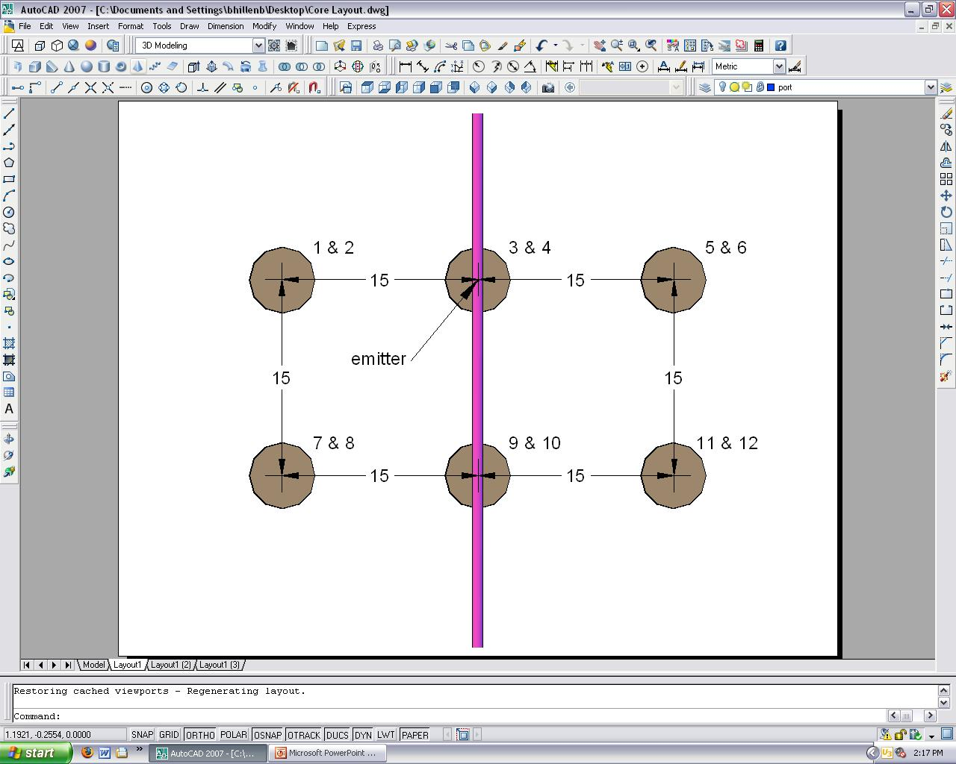
Figure 3.4 - Location of the Core Samples

The odd numbered cores correspond with samples taken from the 30 cm depth and even numbered cores correspond with samples taken from the 60 cm depth. Figure 3.5 show a front and side view of the locations where the samples were taken. Samples are taken directly below the drip emitter and at 30 cm to either side of the drip later and 30 cm down the drip lateral. The same pattern is repeated at 60 cm below the drip lateral.
Figure 3.5 – Front and Side View of Sample Placement
A picture from an actual sampling site is shown in figure 3.6. This picture was taken from the RSFE side of the Crescent Glen location on September 1, 2009.
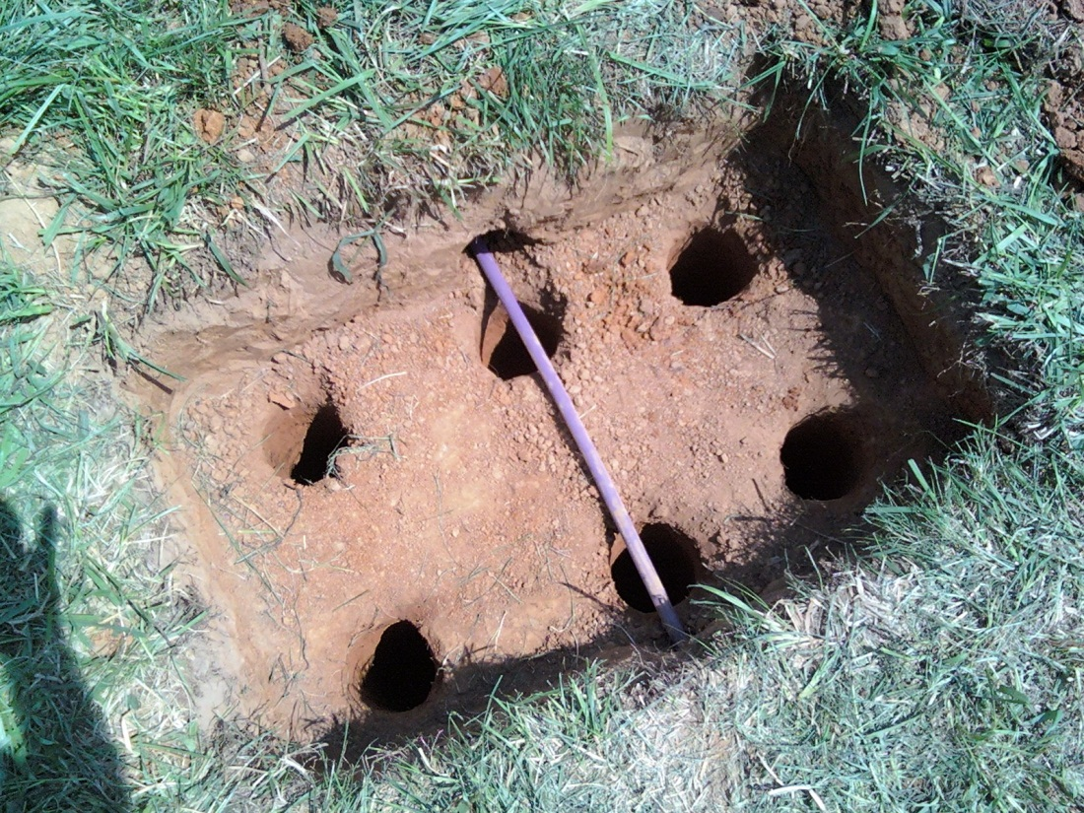
Figure 3.6 – Sample Site, Crescent Glen, RSFE, September 1, 2009

An initial rectangular hole was excavated to the depth of the drip tubing. The holes seen in Figure 3.6 were made using a 15cm diameter coring device. Each hole was initially excavated to a depth of 25 cm so that the coring sampler could extract grab a sample with the 30 cm depth in the middle of the core. Once the first core was taken, a loose soil sample was collected for soil solution extraction. The hole was then extended to a depth of 55 cm and a core sample and loose soil sample was taken again. The process is then repeated for the next 5 locations around the drip tubing. Locations 3 and 4 are located directly beneath the drip emitter. The same sampling process was repeated one more time in an area surrounding the drip field that is not affected by the lateral flow of the treated wastewater for control samples. This whole process was done in both plots (STE and RSFE) at both locations (JB and CG).

Physical Analysis
Figure 3.7 – Falling Head Permeameter Setup
A falling head permeameter setup was used to determine the saturated hydraulic conductivity (Ksat) of each core sample. Figure (3.7) shows the basic setup. Fourteen permeameters were installed in a rack to run all 14 samples for each sampling event at one time. Preliminary testing showed that the saturated hydraulic conductivity for the samples ranged from 0.3 to 0.8 cm/day. Equation (3.1) was used to calculate the Ksat. The cross sectional area of the standpipe (a), the cross sectional area of the sample (A), the length of the sample (L), time (t), and the heights of the water levels relative to the bottom of the sample (H1 and H2) were used to calculate the Ksat for each core.

Equation 3.1-Falling Head Permeameter Equation

Soil Solution Extraction
After preliminary testing, it was determined that soil solution cannot be reliably collected from soil samples directly taken from the field. Even when soil solution samples can be collected the field the concentrations are highly variable between different samples due to the differing moisture contents of the fields. Soil samples collected in the same area but on different dates produce solutions that have differing concentrations because the moisture contents are constantly fluctuating. This is influenced by several factors but the most influential with samples collected at the same site is the intensity and the time since the last rainfall event. To standardize the method of analysis, many researchers recommend drying the soil and rewetting it to some percent of its field capacity for water. This was not done because the drying process alters the chemical makeup of the soil so it will not be exactly the same as in field condition. Drying methods releases phosphorus in the soil solution when rewetted (Blackwell et al 2009). Many researchers show the effects of drying and rewetting of the soil with the nitrogen and carbon (Birch, 1958; Merckx et al., 2000; Kruse et al., 2004; Dyer et al., 2007; Blackwell et al., 2009). The effects of drying and rewetting the soil, on the soil solution, are different for different soils. Preliminary testing showed an increase in phosphorus and nitrate concentrations for a soil sample that was separated and solution collected directly from part of the sample and the other part was dried, ground to pass through a 2mm sieve, and rewetted and then centrifuged to collect a soil solution sample.
To more accurately determine the difference in purification between the two sides, as many variables need to be made constant as possible. In this study, 100g of each sample (wet wt.) was measured and added to a bottle and 50ml of deionized water was added. The leftover sample was dried at 105°C for 24 hours and weighed to determine the moisture content. This method provided a means to collect a soil solution volume, which can be reliably taken, and the final solution concentration can be corrected for dilution. Equation 3.2 was used to calculate the concentration on an mg-constituent / kg-soil basis.

Equation 3.2 – Equation used to correct for dilution for final concentration

Example Calculation

Figure 4.8 – Example calculation for concentration of NO3

Total Kjeldahl Phosphorus (TKP) and Total Kjeldahl Nitrogen (TKN) and Soluble Nitrogen were determined by the Block Digestor Method in the Biosystems Water Quality Lab (APHA). Total Organic Carbon (TOC) was determined using the Combustion Method in the same lab (APHA). TKN measures the organic nitrogen and ammonium in the sample. Soluble nitrogen includes nitrate and nitrite, is not determined using the TKN method. Most soil elemental analysis does not include soluble nitrogen due to the ease of the TKN method and the concentration of nitrate and nitrite in most soils is very limited. Because wastewater is being applied to this soil, the concentrations of soluble nitrogen should be greater and is important to this study.
Statistical Analysis
Each plot was sampled 4 times. The experimental design used is a randomized block design – split-plot (RBD-SP). The analysis of variance (ANOVA) using the mixed models procedure for RBD split-plot design (SAS version 8.0, University of Tennessee, Knoxville) was used to analyze the data. Each location (Jackson Bend and Crescent Glen) was divided into two whole plots receiving either STE or RSFE. Depth is the second factor that was tested by the split-plot design. The control samples were also analyzed as a whole plot, giving a third main treatment factor. In order for the P-values level of significance to be trusted, log transformations had to be done on Ksat, NO3, and TP. The estimated means reported are the back transformed means (figures X.X). The code used for the SAS analysis is attached in the appendix.

Chapter 4
RESULTS AND DISCUSSION
Hydraulic Conductivity
Saturated hydraulic conductivity (Ksat) was measured to test the differences in the STE and RSFE treatments to the soil. Different treatment level means (STE, RSFE, and Control) at two depths (1 and 2 ft) were compared using the LSD method (SAS 2008). The analysis found no significant differences between the two main treatments (STE and RSFE) and a control and the two depths (1 and 2 ft below the emitter). At 1 ft and 2 ft beneath the level of the emitter, the STE and the RSFE sides have similar values for Ksat (0.032 and 0.036 cm/day respectively). At 1 ft below the emitter the control samples had higher Ksat values than the STE and RSFE samples but the difference with the RSFE samples were not statistically significant due to the variability in the data. At 2 ft below the emitter the control samples again have a higher Ksat value than the STE and RSFE samples but are not statistically different from either STE or RSFE. Two methods were used to improve the normality of the data. First a logarithm transformation was conducted to improve the confidence in the P values generated by SAS. This transformation is necessary to accurately detect significant differences in the means. Second, some of the outliers were deleted. The letter groupings are based on this transformation and then the transformed estimates are back transformed and are presented in the btestimate column in table 4.1.
Hydraulic conductivity is of interest in this study because it shows an indication of what might be happening in the soil because of the introduction of wastewater. Normally when using soil absorption fields to treat wastewater, the accumulation of suspended solids and microbial material will cause a clogging layer in the infiltrative surface of the soil and in conventional adsorption systems this clogging layer will develop to a point where the field will fail to accept wastewater resulting in surfacing of wastewater in the field or even worse, backflow into the home. The dosing cycles of a SDIS system will allow for some biological growth to develop during the anaerobic stage (which is beneficial) but will keep this layer in check during the aerobic stage so that the SDIS will not reach the point of failure. The results show a lowered Ksat for the STE and the RSFE treatments as compared to the Control but it is in the same order of magnitude. It was expected that the STE treatment would cause a greater difference in Ksat than it did however the data suggests that the STE and RSFE are essentially the same. Based on hydraulic conductivity, it cannot be shown that there is any benefit of using a RSF to pre-treat wastewater before applying with a SDIS.

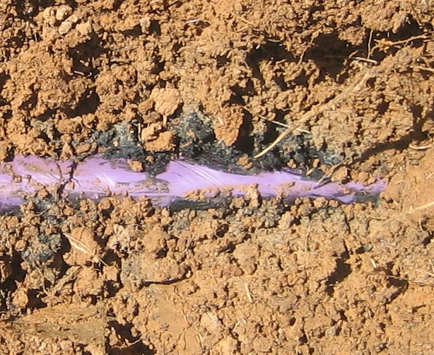

Figure 4.1 – Biomat Growth
Nitrate
The nitrate means were significantly different between the STE side and the RSFE side (8 ppm and 1 ppm respectively). Nitrogen was much greater on the STE side at 1 ft and 2 ft below the emitter (9.1 and 7.0 ppm - STE, 0.9 and 1.0 ppm – RSFE respectively). The RSFE side was expected to have very low concentrations of NO3ˉ because of the RSFs ability to denitrify the wastewater. The control samples showed higher levels of nitrate than the RSFE side (1.7 ppm), this was probably due to the RSFE mobilizing the nitrate already present in the soil or this section might nitrogen deficient although it would be strange for this to happen in both locations (Jackson Bend and Crescent Glen). Depth was also significant in this analysis. The samples taken at 1 ft below the emitter had higher levels of NO3ˉ than at 2 ft below the emitter (2.9 ppm and 2.2 ppm respectively). The STE and Control areas show differences with concentrations due to depth but the differences were not statistically significant. The difference in NO3ˉ concentration in the RSFE area due to depth is not as great as with the STE and Control. The Control sample shows an initial NO3ˉ concentration in the soil, which the RSFE’s relatively low NO3ˉ concentration is probably removing some of this initial concentration from the RSFE side resulting in lower NO3ˉ levels. Table 4.2 shows the results of the mean separation conducted by SAS.
Total Carbon
There were no differences found in total carbon for either side or the control. Data for total carbon was highly variable ranging from 0 to over 350 ppm. The statistical means for the STE, RSFE and control were 21.72, 34.45, and 35.63 ppm respectively. The means show that the RSFE side and the control had higher concentrations of total carbon than the STE side. This was not expected due to the RSF’s ability to remove BOD5 from the wastewater. The mean separation did not show differences because of the high standard errors that resulted from the variability in the data. Apparent outliers were removed to improve the confidence in the LSD results. The removed outliers helped a little but still the errors are too high to statistically detect a difference. Attached in the appendix is a list of the raw data collected before outliers were removed. The SAS code is attached in the appendix were the data after outliers are removed can be reviewed.
Concentrations of total carbon in the STE side might have been lower because of the biologically active layer present at the infiltrative surface of the soil (Figure 4.1). The biomat on the RSFE and Control side may not be as developed as with the STE and may not consume organic carbon from the wastewater as effectively. Figure 4.3 shows the SAS generated LSD table for total carbon.
Total Nitrogen
TN or Total Kjeldahl Nitrogen (TKN) is the measure of organic nitrogen and ammonium in the soil. When wastewater exits the septic tank, most of the nitrogen is in the form of ammonium (Feigin et al., 1991). By the time the wastewater enters the soil, NH4 is typically oxidized to NO3ˉ (Jnad et al., 2001).
Much like the Nitrate test, the STE side showes higher concentrations of TN than the RSFE side or the Control area although the RSFE and the Control do have a greater ratio of organic nitrogen to STE than with the inorganic forms. The Control sample at 1 ft below the emitter is even statistically not different than the STE samples at 1 and 2 ft below the emitter. Organic forms of nitrogen are much more abundant in the soil and these results confirm that. Many studies do not include inorganic nitrogen in their analysis for this reason.
Total Phosphorus
The background Phosphorus (P) was found to be twice the average concentration as on either the STE or the RSFE side (0.246, 0.128, 0.128 ppm respectively) of the test plots (table 4.5). Soil usually acts as a sink for P, it is understood that oxides of Fe and AL and free Ca will retain P in the soil. It is possible for P to move through the soil once it is already saturated with P, many studies show this occurrence happening after 10-12 years of wastewater application (Sommers et al., 1979; King et al.,1990; Sims et al., 1998; Toor et al., 2004; Mamo et al., 2005). The trt*depth interaction showed little differences due to depth. The treatment effects were more important to the level of concentration of P in the soil. As was expected the concentration of P was greater near the emitter but the difference was not significant.

Differences in Locations
Ksat
The hydraulic conductivities in both locations were very similar with Ksat values ranging from 0.02 to 0.03 cm/day at both depths (1 and 2 ft) and with both RSFE and STE treatments (table 4.6a and 4.6b). The Control in from Jackson Bend averaged around 0.08 cm/day at both depths while the Crescent Glen Control only produced a value for the 1 ft depth and it was 0.08 cm/day also.
Nitrate
The nitrate concentrations for the RSFE and Control are much lower at Crescent Glen than at Jackson Bend (table 4.7a and 4.7b) but the CG STE nitrate concentration is nearly twice as the JB STE nitrate concentration. Depth was a significant factor for nitrate concentration at JB with the concentration getting higher nearer the emitter. Depth did not matter at CG but the greatest difference in depth occurred with the CG STE samples. The concentration on NO3ˉ at 1 ft below the emitter at CG – STE was 14.6 ppm but by 2 ft below the emitter, the concentration is lower than the 10 ppm regulation the EPA has set for drinking water.
Total Carbon
The concentration of total carbon at JB for the STE treatment was much lower than with the RSFE and Control treatments but not significant due to the variability in the data (table 4.8a and 4.8b). The differences less with the CG samples, the TC concentrations in CG range from 25.6 to 29.8 ppm for the STE, RSFE and Control treatments, all of these are less than the RSFE and Control Concentrations from JB. The depth did not seem to impact the concentration of TC found in the soil.
Total Nitrogen
The total nitrogen concentration at JB did was not significantly different between the 3 treatments. The treatment means ranged from 6.4 to 8.4 ppm (table 4.9a and 4.9b). The differences between the means were more significant at CG. The RSFE and Control TN concentrations were 2.8 ppm while the STE was 9.8 ppm.
Total Phosphorus
The overall treatment differences in TP at JB and CG were not significantly different but there were differences when the trt*depth interactions are examined. The control samples from JB at the 1 ft depth are significantly higher than the STE and RSFE samples (table 4.10a and 4.10b). The means for RSFE at JB are higher than the means for STE but are not significant. The RSFE samples at CG have a lower TP concentration than the STE and Control samples which is different than the overall results where the STE and RSFE had the same concentration (0.128 ppm) and the Control had roughly twice the concentration (0.246 ppm) as RSFE and STE (table 4.5).

Conclusion
The purpose of this study was to evaluate two strengths of wastewater (STE and RSFE) being applied to a SDIS to determine the need for secondary treatment. The purpose was not to evaluate the performance of SDIS as a whole. The soil has a tremendous ability to treat wastewater but its full potential may be retarded by the use of a costly RSF. Physical and chemical properties of the soil were measured to make the comparison. It was found that the soil had been irrigated with the high strength wastewater (STE) was not significantly different than the soil that had been irrigated with secondary treated wastewater (RSFE). The hydraulic conductivity of the STE side show significant reduction as compared to the RSFE and control areas and this is beneficial for the treatment of the wastewater. Nitrate and total nitrogen were significantly higher in the STE treated areas but showed a decrease with depth. TC and TP showed no significant differences.
The RSF is efficient at removing nitrogen from wastewater because it allows for aerobic/anaerobic cycles to enhance denitrification. With the use of SDIS, dosing and resting cycles have the same effect on wastewater but this kind of treatment depends on time and length of travel through the soil for this to take place. wastewater from the RSF has had the nitrogen removed before it enters the soil so it was expected to see higher concentrations of nitrogen in the areas irrigated with STE.

References
APHA, AwastewaterA, WEF. 2005. Standard Methods for the Examination of Water and Wastewater, 21th ed. Washington D.C.: APHA.

Beach, D.N.H., J.E. McCray, K.S. Lowe, R.L. Siegrist, (2005). Temporal Changes in Hydraulic Conductivity of Sand Porous Media Biofilters During Wastewater Infiltration Due to Biomat Formation. Journal of Hydrology 311: 230-243.

Beal, C.D., E.A. Gardner, and N.W. Menzies, (2005). Process, Performance, and Pollution Potential: A Review of Septic Tank–Soil Absorption Systems. Aust. J. Soil Res. 43:781–802.

Birch, H.F.(1958). The Effect of Soil Drying on Humus Decomposition and Nitrogen Availability. Plant and Soil X. 1: 9-31.

Blackwell, M.S.A., P. C. Brookes, N. de la Fuente-Martinez, P. J. Murray, K. E. Snars, J. K. Williams, and P. M. Haygarth. (2009). Effects of Soil Drying and Rate of Re-Wetting on Concentrations and Forms of Phosphorus in Leachate. Biology of Fertile Soils. 45: 635–643.

Blake, G. R., and K. H. Hartge. (1986). Bulk density. In Methods of Soil Analysis: Part 1. Physical and Mineralogical Methods. A. Klute, ed. Madison, Wisc.: American Society of Agronomy, 363–375.
Bouma, J., (1975). Unsaturated Flow During Soil Treatment of Septic Tank Effluent. ASCE, Journal of Environmental Engineering Division 101 (EE6), 967–983

Bowden, W.B., Greenwald, M.J., Gooseff, M.N., Zarnetske, J.P., McNamara, J.P., Bradford, J., and Brosten, T. (2008). Carbon, Nitrogen, and Phosphorus Interactions in the Hyporheic Zone of Arctic Stream that Drain Areas of Continuous Permafrost. In D.L. Kane and K.M. Hinkel (Eds.), Proceedings of the Ninth International Conference on Permafrost, University of Alaska Fairbanks, June 29-july 3, 2008, pp 165-170.

Bohrer, R. M. (2000). Drip Distribution Soil Performance and Operations in a Northern Climate. Agricultural Engineering. University of Wisconsin Madison. Master of Science: Chapter 7: Summary and Conclusions.

Buchanan, J. R. (2006). Onsite Domestic Wastewater Treatment, Dispersal, and Reuse. Introductory PowerPoint Presentation.

Bucks, D.A., F.S. Nakayama, and R.G. Gilbert. (1979). Trickle Irrigation Water Quality and Preventive Maintenance. Agriculture Water Management. 2: 149– 162.

Burns, J.C., P. Westerman, L.D. King, G.A. Cummings, M.R. Overcash and L. Goode. (1985). Swine Lagoon Effluent Applied to Coastal Bermudagrass:1. Forage Yield, Quality, and Element Removal. Journal of Environmental Quality. 14 (1): 9–14.
Burton, D. J., F. H. Harned, B. J. Lesikar, J. F. Prochaska, R.J. Suchecki. (2001). Design Principles for Drip Irrigation Disposal of Highly Treated On-Site Wastewater Effluent. On-Site Wastewater Treatment, Proc. Ninth National Symposium on Individual and Small Community Sewage Systems. Fort Worth, ASAE.

Coelho, R. D., and L. F. Faria. (2003). Comparing Drippers for Root Intrusion in Subsurface Drip Irrigation Applied to Citrus and Coffee Crops. ASAE Meeting Paper No. 032095, St. Joseph, Mich. ASAE.

Crites R. C. and G. Tchobanoglous. (1998). Small and Decentralized Wastewater Systems. McGraw-Hill Publishing Company, Boston.

Dyer, D.L., D.M. Kopittke, A.R. Sheldon, and N.W. Menzies. (2007). Influence of Soil Moisture Content on Soil Solution Composition. Soil Science Society of America Journal. 72:355-361.

Emerick, R.W., R.M. Test, G. Tchobanoglous, and J. Darby. (1997). Shallow Intermittent Sand Filtration: Microorganism Removal. The Small Flows Journal. 3(1):12-22.

Gilbert, R.G., F.S. Nakayama, and D.A. Bucks. (1979). Trickle Irrigation:
Prevention of Clogging. Transactions of the ASAE. 22: 514-519.

Gilbert, R.G., F.S. Nakayama, D.A. Bucks, O.F. French, and K.C. Adamson. (1981). Trickle Irrigation: Emitter Clogging and Flow Problems. Agricultural Water Management. 6: 159.

Gill, L.W., C. O’Súlleabháin, B.D. Misstear, and P.J. Johnston,(2007). The Treatment Performance of Different Subsoils in Ireland Receiving On-Site Wastewater Effluent. Environmental Quality 36: 13.

Gillespie, B., G. Tasato, (1980). Treatment of Secondary Sewage Effluent for Use in Drip Irrigation. Hawaiian Sugar Technologists. 39: 5.

Hagedorn, C., E.L. McCoy, and T.M. Rahe. (1981). The Potential for Groundwater Contamination from Septic Effluents. Journal of Environmental Quality. 10:1–8.

Hepner, L.D., D. Linde, C. Weber, and D. Smith. (2007). Reduction of Bacteriologic and Chemical Constituents of Septic Tank Effluent with Depth Using a Drip Dispersal System. ASAE Publication No. 701P1107, St. Joseph, Mich. ASAE.

Jenssen, P.D., and R.L. Siegrist. (1990). Technology Assessment of Wastewater
Treatment by Soil Infiltration Systems. Water Science Technology. 22:83–92.

Jnad, I., B. Lesikar, A. Kenimer, G. Sabbagh. (2001a). Subsurface Drip Dispersal of Residential Effluent: I. Soil Chemical Characteristics. Transactions of the ASAE. 44(5): 1149-1157.

Jnad, I., B. Lesikar, A. Kenimer, G. Sabbagh. (2001b). Subsurface Drip Dispersal of Residential Effluent: II. Soil Hydraulic Characteristics. Transactions of the ASAE. 44(5): 1159-1165.

Jones, J.H., G.S. Taylor. (1965). Septic Tank Effluent Percolation Through Sands Under Laboratory Conditions. Soil Science. 99(5): 301–309.

King, L.D., J.C. Burns, and P.W. Westerman. 1990. Long-term swine lagoon effluent applications on ‘Coastal’ bermudagrass. II. Effect on nutrient accumulation in soil. J. Environ. Qual. 19:756–760.

Kristiansen, R. (1981). Sand-filter Trenches for Purification of Septic Tank
Effluent: III. The Microflora. Journal of Environmental Quality. 10:361–364.

Kruse, J.S., D.E. Kissel, and M.L. Cabrera. (2004). Effects of Drying and Rewetting on Carbon and Nitrogen Mineralization in Soils and Incorporated Residues. Nutrient Cycling in Agroecosystems 69: 247–256.

Kunjikutty, S.P., S.O. Prasher, M.P. Ramanbhai, F.B. Suzelle, and Kim S. (2007). Simulation of Nitrogen Transport in Soil under Municipal Wastewater Application. Journal of the American Water Resources Association. 43(5): 1097-1107.

Lance, J. C., C.P. Gerba, and J.L. Melnick. (1976). Virus Movement in Soil Columns Flooded with Secondary Sewage Effluent. Applied and Environmental Microbiology. 32(4): 7.

Lance, J. C., C. P. Gerba. (1984). Virus Movement in Soil During Saturated and Unsaturated Flow. Applied and Environmental Microbiology. 47(2): 3.

Li, J., L. Chen, Y. Li, and Y. Liu. (2008). Field Evaluation of Emitter Clogging in Subsurface Drip Irrigation Systems. ASAE Meeting Paper No. 083512, St. Joseph, Mich. ASAE.

Lowe, K.S., Van Cuyk, S., Siegrist, R.L. (2007). Soil Treatment Unit Performance as Affected by Hydraulic Loading Rate and Applied Effluent Quality. Eleventh Individual and Small Community Sewage Systems Conference Proceedings 20-24 October 2007, (Warwick, Rhode Island, USA) Publication Date 20 October 2007. ASABE Publication Number 701P1107

Majundar, D. (2003). The Blue Baby Syndrome: Nitrate Poisoning in Humans. Resonance. 20 – 30.

Mamo, M., S.C. Gupta, C.J. Rosen, and U.B. Singh. (2005). Phosphorus Leaching at Cold Temperatures as Affected by Wastewater Application and Soil Phosphorus Levels. Journal of Environmental Quality. 34: 1243-1250.

Massoud A.T., J.H. David, and T. George. (1994). Pretreatment of Secondary Effluent for Drip Irrigation. Journal of Irrigation and Drainage Engineering.
120( 4):716–731.

McCoy, E.L., and W.A. Ziebell. (1975). p. 67. In N. McClelland (ed.)
Individual Onsite Wastewater Systems. Proceedings of the 2nd National Conference Ann Arbor Sci., Chelsea, MI.

Merckx, R., K. Brans, and E. Smolders. (2000). Decomposition of Dissolved Organic Carbon after Soil Drying and Rewetting as an Indicator of Metal Toxicity in Soils. Soil Biology and Biochemistry. 33: 235-240.

Munir, J.M.R., S. Hinnawi, and L. Rousan. (2006). Long Term Effect of Wastewater Irrigation of Forage Crops on Soil and Plant Quality Parameters. Desalination. 215 : 143–152

Nakayama, F.S. and D.A. Bucks. (1991). Water Quality in Drip Trickle Irrigation: A Review. Irrigation Science. 12: 187–92.

Pell, M., and F. Nyberg. (1989). Infiltration of Wastewater in a Newly Started
Pilot Sand-filter System: III. Transformation of Nitrogen. Journal of Environmental Quality. 18:463–467.

Powlson, D.S. (1993). Understanding the Nitrogen Cycle. Soil Use and Management. 9: 86–94.

Ravina, I., E. Paz, Z. Sofer, A. Marcu, A. Schischa, G. Sagi, Z. Yechialy. and Y. Lev. (1997). Control of Clogging in Drip Irrigation with Stored Treated Municipal Sewage Effluent. Agricultural Water Management. 33: 127–137.

Rodgers, M., E. Clifford, J. Mulqueen, and P. Ballantyne. (2004). Organic
Carbon and Ammonium Nitrogen Removal in a Laboratory Sand
Percolation. Journal of Environmental Science. 39:2355–2368.

Schwager, A., and M. Boller. (1997). Transport Phenomena in Intermittent Filters. Water Sciences Technology. 35(6): 13–20.

Siegrist, R.L., and W.C. Boyle. (1987). Wastewater Induced Soil Clogging Development. Journal of Environmental Engineering. 113(3): 550–566.
Siegrist, R.L., E.J. Tyler, and P.D. Jenssen. 2000. Design and Performance of Onsite Wastewater Soil Absorption Systems. Proc. Decentralized Wastewater Management Research Needs Conf., Washington Univ., St. Louis, MO. May 19-20. Electric Power Research Institute, St. Louis, MO.

Siegrist, R.L., E.J. Tyler, P.D. Jenssen. ( 2001). Design and Performance of Onsite Wastewater Soil Absorption Systems. Invited White Paper Presented at the National Research Needs Conference Proceedings: Risk-Based Decision Making for Onsite Wastewater Treatment. EPRI Report No. 1001446, Electric Power Research Institute, Palo Alto, CA.

Siegrist, R.L., and S. Van Cuyk. (2007) Wastewater Soil Absorption Systems: The performance Effects of Process and Environmental Conditions. Pp. 41-51 in On-Site Wastewater Treatment, Proc. Ninth Natl. Symp. on Individual and Small Community Sewage Systems (11-14 March 2001, Fort Worth, Texas, USA), ed. K. Mancl., St. Joseph, Mich. ASAE 701P0009.

Sims, J.T., R.R. Simard, and B.C. Joern. 1998. Phosphorus loss in agricultural drainage: Historical perspective and current research. J. Environ. Qual. 27:277–293.

Sommers, L.E., D.E. Nelson, and L.B. Owens. (1979). Status of inorganic phosphorus in soils irrigated with municipal wastewater. Soil Sci. 127:340–350.

Suarez-Rey, E., C.Y. Choi, P.M. Waller, and D.M. Kopec. (2000). Comparison of Subsurface Drip Irrigation and Sprinkler. Transactions of the ASAE. 43(3): 631-640.

Thomas, R.E., W.A. Schwartz, T.W. Bendixen. (1966). Soil Chemical Changes and Infiltration Rate Reduction Under Sewage Spreading. Soil Science Society of America Proceedings. 30: 641–646.

Toor,G.S., L.M. Condron, H.J.Di, and K.C. Cameron. (2004). Seasonal fluctuations in phosphorus loss by leaching from a grassland soil. Soil Sci. Soc. Am. J. 68:1429–1436.
Tyler, E.J., M. Milner, J.C. Converse. (1991). Wastewater Infiltration From Chamber and Gravel Systems. On-Site Wastewater Treatment: Proceedings of the Seventh National Symposium on Individual and Small Community Sewage Systems. ASAE Publication, St Joseph, MI. 10–91, see also pages 214–222.

Tyler, E.J., and J.C. Converse. (1994). Soil Acceptance of Onsite Wastewater as Affected by Soil Morphology and Wastewater Quality. On-Site Wastewater Treatment: Proceedings of the Seventh National Symposium on Individual and Small Community Sewage Systems. ASAE Publication, St Joseph, MI. 18–94, see also pages 185–194.

USEPA. (1980). Design Manual: Onsite Wastewater Treatment and Disposal
Systems. USEPA Rep. 625/1-80-012. USEPA, Cincinnati, OH.

USEPA. (2000). EPA Guidelines for Management of Onsite/Decentralized Wastewater Systems. U.S. Environmental Protection Agency Office of Water. Washington,D.C. Available at: wastewaterw.epa.gov/owm/septic/septic _guidelines_factsheet.pdf. Accessed 14 June 2010.

USEPA. (2002). Onsite Wastewater Treatment Systems Manual 2002. U.S. Environmental Protection Agency. Washington,D.C. Available at: http://wastewaterw.epa.gov/nrmrl/pubs/625r00008/625r00008.pdf.

Van Cuyk, S., R. Siegrist, A. Logan, S. Masson, E. Fescher, and L. Figueroa. (2001a). Hydraulic and Purification Behaviors and Their Interactions During Wastewater Treatment in Soil Infiltration Systems. Water Res. 35(4): 953-964.

Van Cuyk, S., R.L. Siegrist. (2001b). Pathogen Fate in Wastewater Soil Absorption Systems as Affected by Effluent Quality and Soil Clogging Genesis. Pp. 125-136 in On-Site Wastewater Treatment: Proc. 9th Nat. Symp. Individual and Small Community Sewage Systems (11-14 March 2001, Fort Worth, Texas, USA), ed. Karen Mancl. St. Joseph, Michigan: ASAE 701P0009.

Van Cuyk, S., R.L. Siegrist, K. Lowe, and R.W. Harvey. (2004). Evaluating
Microbial Purification During Soil Treatment of Wastewater with
Multi-component Tracer and Surrogate Tests. Journal of Environmental Quality. 33:316–329.

Vargas, M., C. Casas, and J.A. Baeza. (2008). Maintenance of Phosphorus Removal in an EBPR System Under Permanent Aerobic Conditions Using Propionate. Biochemical Engineering Journal. 43: 288–296.

Vasquez-Montiel, O., N.J. Horan, D.D. and Mara. (1996). Management of Domestic Wastewater for Use in Irrigation. Water Science and Technology. 33(10-11): 8.

Viraraghavan, T., and R.G. Warnock. (1976). Efficiency of Septic Tank Tile
Systems. Journal of Water Pollution Control Fed. 48:934–944.

Yuan, Z., P. M. Waller, and C. Y. Choi. 1998. Effect of Organic Acids on Drip Emitter Clogging and Soil Infiltration. Transactions of the ASAE. 41(6): 1689–1696.

Zabowski, D., and F.C. Ugolini. (1990). Lysimeter and Centrifuge Soil Solutions: Seasonal Differences between Methods. Soil Science Society of America Journal. 54:1130–1135.

Klute (1986) describes the standard diameter and length for soil core samples that are going to be analyzed in the laboratory. The diameter of the core sample should be between 2 and 10 cm and the length should be between 5 and 25 cm (Klute, pg. 691).
Deleted data available in the appendix
Biomat occurs when the oxygen demand is cannot be met within the immediate area around the emitter
See tables 4.7a and 4.7b
trt*depth is a heading from the SAS output
Due to missing data, SAS was only able to generate Ksat means for 1 ft depth

