In the Name of the Moon:
Female Mangaka and the Manga Industry

Sarah Daugherty
University of Tennessee, Knoxville
Chancellor’s Honors Program
May 2020

Advisor: Noriko Horiguchi

Abstract
Manga is a Japanese word meaning comic, but Western comics and Japanese manga are two different breeds of the same thing. We in the West differentiate between “comics” and “graphic novels,” as the former conjures up images of bespectacled nerds lining up to purchase the latest issue of a Deadpool comic, and the latter brings to mind more serious material like Alison Bechdel’s graphic memoir Fun Home or Art Spiegelman’s Maus, which, respectively, deal with heavy subjects like sexuality and the trauma of a Holocaust survivor. As varied and incredible as they may be, comics and graphic novels in the US and other Western countries are still viewed by many as something for children and draw in a small percentage of readers as compared to the total population of these nations. Manga, on the other hand, are a different creature entirely in Japan. Manga are incredibly popular with all demographics, “[enticing] the young and [entertaining] the old," and each demographic has its own genres and subgenres that are cultivated with the people within in mind (Beaty and Weiner xi).
Despite this wide readership, however, manga began as and still largely is a male-dominated field. Until the cultural shift that began when the Japanese economy underwent the event known as the “Bubble Burst,” the majority of manga authors (hereafter known as mangaka) were men, and although they wrote stories about women, they did not write them with women in mind. Now, however, as more women have inundated the industry, the world of manga has begun to evolve into something new entirely. Thus, despite the manga industry being a male-dominated field, female manga artists have had a profound influence on the shape of the industry today, impacting representations of women, portrayals of gender and sexuality, and the prolificity and popularity of certain genres and the works within them.

- Introduction
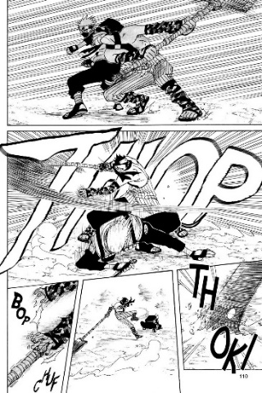
Before diving into the effect female mangaka have had on the manga industry, one must first understand exactly what manga are and what it is that makes them different from Western comics and graphic novels. Perhaps the most obvious differences are the similar visual elements found in the majority of manga. No matter the plot, characters, or art style, most people with even the slightest bit of knowledge on graphic works would be immediately able to recognize if a work was manga or not. Naruto by Masashi Kishimoto and Cardcaptor Sakura by CLAMP, are two highly popular series, and although the two stories – the former about an orphaned boy ninja with dreams of becoming the leader of his village and the latter about a primary school girl who gains magical powers after discovering some mysterious cards in her basement – possess few similarities, and the art styles clearly differ between mangaka, the two share some characteristics that set them apart from Western comics. In chapter thirteen of Naruto, the title character’s instructor Kakashi faces off against rogue ninja Zabuza, and Kishimoto employs hatched shading, clean, dark lines, and sound effects in the form of stylized words, known as onomatope in Japanese (see fig. 1).

Figure 1. White-haired ninja Kakashi and swordsman Zabuza engage in a fight from Masashi Kishimoto, Naruto (VIZ Media, 2003), vol. 3, p. 110.
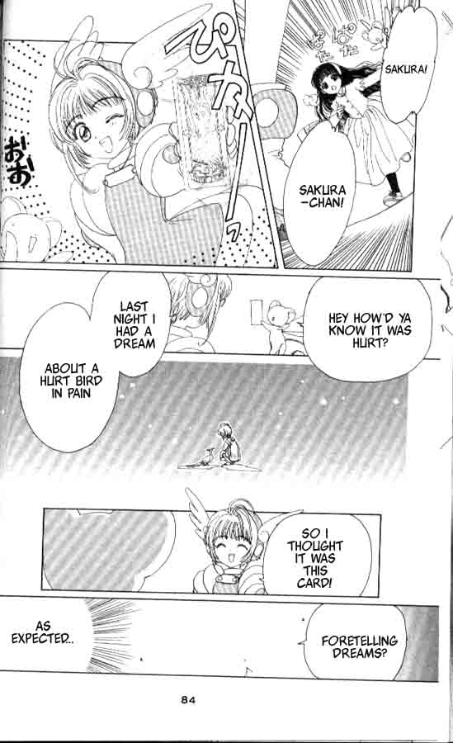
In some English translations, as in this translation of Naruto, these onomatope are translated into English, but in others, like this publication of CLAMP’s Cardcaptor Sakura, keep the onomatope in their original Japanese (fig. 2). Regardless, their presence is a tell-tale way of identifying a manga, as often these onomatope signify things that English onomatopoeia do not do, like actions or even emotions. Similarly, in Cardcaptor’s second chapter, CLAMP also use these clean, dark lines, onomatope, and use of pen strokes as shading, in addition to the stereotypical overlarge, glittering “manga eyes,” and elements like these are found in countless manga past and present.
Figure 2. Sakura shows off her newly captured card to best friend Tomoyo from CLAMP, Cardcaptor Sakura (Dark Horse, 2010), vol. 1, p. 84.

Aside from visual aspects, manga also exists more as a “cultural cycle” than anything, and it is in part due to its cyclical nature that allowed women to forge spaces for themselves in the industry (Beaty and Weiner xi). According to Beaty and Weiner, three primary cultural cycles comprise the manga industry: the publication cycle, the participation cycle, and the consumption cycle. Manga is usually printed in “thick, inexpensively printed anthologies that are published in serial form,” and since there are so many individual manga within these anthologies, it becomes easier for less well-known or less popular authors – many of whom may be women – to gain readership for their stories (xi). If a manga becomes popular enough, it may be bound into paperback volumes known as tankōban that feature several chapters at once, and this will most likely also spawn the creation of merchandise ranging from keychains to stationery and, if you are lucky, an anime (literally “animation”) adaptation. Think of Sailor Moon. It is one of the most well-known and beloved manga series of all time – written by a woman for young women – and it became such a hit that it got several anime adaptations and merchandise, live action films and musicals, and even themed cafés in various places in Japan. Thus, as Beaty and Weiner so aptly put it, “a successful manga in Japan isn’t merely the launching pad for a franchise – it is the fuel on which the country’s cultural engine runs” (xi). The effect of manga on Japanese culture at large as these authors describe explains how it is that women in manga impacted the industry in such a major way: when something as popular as Sailor Moon exists, people notice, and other works featuring similar elements – teenaged superheroes, female friendships, healthy LGBTQ relationships, or non-stereotypical gender roles – start to appear in the market and, as a result, change the shape of the industry and society as a whole.
Hand-in-hand with the publication cycle comes the participation cycle, without which the manga industry would not exist. The participation cycle refers to the authors and mangaka who actually create the manga, and they are often recruited after regular entry into drawing and storytelling competitions conducted by the very manga magazines who hire them. This provides a certain amount of anonymity for up and coming mangaka, so many women past and present utilize both this and pen names to keep their true identity and their gender hidden from the readership. For example, readers tend to assume that mangaka Haruichi Furudate, the author of popular sports manga, Haikyū!!, is a woman, but they have never officially clarified their gender to their readership. This may be due to fear of negative reaction to their gender or simply because mangaka of all genders want some degree of privacy in their high-profile lives, but it nonetheless provides a way for people typically less common in a field to feel more confident entering and working in it.
The cultural cycle of consumerism, moreover, concerns the large and varied readership of the manga industry. “There is manga for every stage of life,” so as a result there are specific types of manga for every age group, and each of these age groups also contain a number of subgenres ranging from mainstream to simply weird (Beaty and Weiner xi). Most people outside of Japan know about the tightly focused genres of manga for people of different ages and genders, since Weekly Shōnen Jump is popular both inside and outside of Japan. Shōnen means “boy” in Japanese, and this genre, naturally, targets middle and high school aged boys with its wild tales of young male protagonists who save the world with the power of friendship, among other things. Shōnen manga are often the most popular in Japan, and they feature subgenres from the typical comedy and action to the more niche subgenres of sports, mecha, and harem – the latter of which being exactly what you think it is. Although shōnen is traditionally written by men, about male characters, and for teenaged boys, this paper will later touch on just how women have impacted shōnen manga, as authors within and outside the genre. Some of the other genres with the largest audience are seinen (“young man”), josei (“young woman”), and, one of the primary focuses of this paper, shōjo. Meaning “young woman,” shōjo provided a way for female authors to successfully enter into the male-dominated manga world and depict what being a woman was like in such a way that “brought readers a sense of liberation from social norms and restrictions” (Aoyama et al. 6). Thus, as the next section will explain, shōjo manga allowed women to not only create a space for themselves in the manga industry but also to provide stories for young girls and women to relate to and through which to explore their own identities.

- Shōjo Manga as Subversion
Shōjo manga has its roots from the beginnings of the culture that gives the genre its name. Shōjo culture, much like shōjo manga, tended to be brushed aside as frivolous or even maudlin – something only silly, immature young girls could ever enjoy. It began in the 1920s and 1930s with “novels and illustrations… specifically targeted [at] the girl audience,” and these depicted norms and ideals that differed quite vastly from the societal norms perpetuated by the government and the newly-formed all-girl high schools that were cropping up around Japan. During this time, the government-sponsored education system looked much different for boys and girls: boys were regarded as the next generation of Japanese people who would “work toward the formation of the nation-state,” but girls were meant to strive toward the ideal of something called “ryōsai kenbo” or “good wife, wise mother” (Honda 14). A “good wife, wise mother” was considered the ideal woman, and her entire purpose was to raise good children who would become good Japanese citizens and cater to her husband’s every whim, something many young girls and women, naturally, disputed. Thus, in order to give girls a sense of identity other than simply someone who will eventually be married and become a “wife” rather than simply a “woman” or “person,” young women published the novels and illustrations that would come to define shōjo culture.
These works in the early days of shōjo culture “departed from the norm…escaped the patriarchal social order and were in opposition to the mores of the education system,” and those selfsame subversive ideas still thrived when shōjo manga emerged in the 1970s (Honda 16). At this point, “both artists and readers shifted the genre to focus on girls,” and it became “an expression of girls’ agency… and a genre that offers a place from which to investigate ideas of gender as they relate to females” (Ogi 78). Before, shōjo manga was written by men with other men in mind, and their female protagonists represented a kind of “ideal femininity” and existed solely as objects for male consumption and sexualization. Now, however, it became something that was, essentially for the first time, by women for girls and young women just like them – from shōjo to shōjo. Directly spawning from the second-wave feminism that began in the West, shōjo manga portrayed girls in ways that eschewed traditional gender roles and allowed them to be defined by something other than that which they cannot control – things like friendships and interests and abilities. Shōjo protagonists still, in a sense, represent the ideal femininity, but they do so in a far different way than before: they represent the ideal femininity because they show that all presentations of femininity (or lack thereof) are the ideal femininity. Thus, they are, in a sense, free from gender, and they navigated their worlds in ways that young female readers could relate to and use to explore their own relationship with gender (Ogi 93).
Behind the characters with large sparkling eyes, flowery backgrounds, and somewhat melodramatic plot devices common in shōjo manga, there lies a rather profound examination of gender presentation and what exactly it means to be a woman. In Naoko Takeuchi’s Sailor Moon, nearly the entire cast is made of female superheroes known as Sailor Scouts, and although all of them are young women, they each have different characteristics – good and bad – that are all treated as valid and respectable by the narrative. For example, the protagonist Usagi likes shopping and boys and hanging out with her friends, but she also loves video games and food and hates school with a burning passion, as shown repeatedly throughout the narrative. Her fellow Sailor Scouts Rei, Ami, and Makoto also have typical teenaged girl interests, like romance novels, boys, and gardening, but they also show far more depth than one-dimensional shōjo characters of the past, the narrative focusing far more on their hotheadedness or intelligence or strength instead without suggesting that these facets make them any less feminine. Perhaps most significantly, Takeuchi presents the idea that girls need not be feminine at all in order to be female, and she does so in the form of Sailor Uranus, or Haruka Tenoh. Usagi and her friend actually mistake Haruka as a guy upon their first meeting in an arcade after school (Figure 5), but she is soon revealed to be a girl when she transforms into a Sailor Scout. Haruka, however, does not really care how people perceive her: her gender, and other’s views of it, comes second to her identity as a person and as a Sailor Scout, a complete “defiance of the reductive male/female binary” (Bailey 208). As a result, Takeuchi illustrates that there is no one correct way to be a girl: girls can be strong or weak, smart or ignorant, feminine or masculine, and all of these are perfectly fine ways to exist as a woman.
Often in feminist works, authors or characters eschew traditional femininity in order to illustrate that women do not need femininity to be women. This concept is not without value, as women who claim that “I only wear makeup because I want to,” or “I wear dresses because they’re comfortable” are far less radical and still performing the patriarchally-accepted traditional femininity despite citing their own reasons for it, but this author feels that one must also shift how society perceives femininity to truly be “feminist.” The core problem lies, of course, in the fact that specific traits and characteristics are ascribed to certain genders, but the fact remains that traditionally feminine things are considered inferior, which should not be the case. All people should be allowed to like romance novels or gardening or sewing or children without having femininity prescribed onto them; people of all genders who enjoy these things often face disdain since they are feminine and therefore bad. Shōjo “allows the expression of girlish aesthetics, concerns and everyday politics to be enacted and valued,” and this is why they are important (Fraser and Monden 545). Thus, authors of shōjo manga, in many ways, shift the paradigm and, in giving interests such as these to all characters rather than just female ones, eliminate the traditional gender roles associated with them.
In CLAMP’s Cardcaptor Sakura, elementary school girl Sakura, much like the Sailor Scouts in Sailor Moon, goes about her average life while also using her magical powers to save the world, but Cardcaptor does something far more revolutionary in terms of its portrayal of male characters. Sakura’s older brother Touya is somewhat stoic but incredibly caring and kind towards his younger sister, and Touya’s best friend and love interest Yukito is just as doting, making meals for Sakura and Touya frequently and openly displaying his affection for the two. The narrative paints this in a positive light, and the two boys – although altogether too wrapped up in each other to care about female attention – are still beloved among their female classmates, showing that these traits in no way diminish their perceived masculinity. As a matter of fact, these stereotypically feminine qualities are celebrated and in no way treated as drawbacks or weaknesses in these two male characters. The two are both powerful magic users, and these qualities – their love for others and for each other – only serve to make them stronger, and it is only due to these “weak” and “feminine” qualities that Touya ultimately sacrifices his powers to save Yukito and his alter ego Yue, as shown in Figure 3. These boys are no less boys for their attraction to each other, range of emotions, or stereotypically feminine interests, and this portrayal of masculinity illustrated to readers and authors alike that men, too, need not act or present in hypermasculine ways in order to be valid as men.

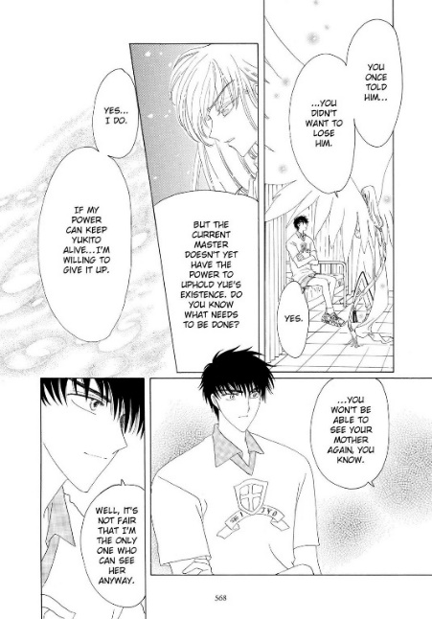
Figure 3. Touya tells Yue, his love interest's magical alter ego, that he is willing to give up his powers to save him from CLAMP, Cardcaptor Sakura (Dark Horse, 2010), p. 568.
When shōjo manga underwent its evolution in its depiction of women and its primary authorship in the 1970s the genre also shifted its portrayal of many male characters from relatable or hypermasculine to bishōnen (meaning “beautiful boy”) who are “androgynously beautiful” (Unser-Schutz 137). This androgyny often only appears in ethereal male characters, many of which are found in the shōjo subgenre of shōnen ai, or boys’ love, but those androgynous female characters can be used in any means, from insensitive gags to serious examinations of gender identity and presentation outside of the gender binary. Sailor Moon’s Haruka Tenoh certainly does the latter to a certain extent, but as a minor character, the author can only use her so much to explore important issues. Other female mangaka have included similar characters to similar effects, but no manga, in my opinion at least, deals with this better than Bisco Hatori’s Ouran High School Host Club. Fifteen-year-old high school first year Haruhi Fujioka, after much hard work, gains a scholarship to the prestigious Ouran Academy attended by heirs and heiresses and all manner of wealthy children from powerful families. She stumbles upon the Host Club while looking for somewhere quiet to study, and, in a cruel twist of fate, ends up breaking an expensive vase and working as their “dog” until she can pay off her debt to them. In addition, due to her short hair, straight figure, and baggy clothes, they mistake her as a guy. The Host Club eventually discover their mistake, but Haruhi is such a natural at being a host that she joins the club as a member, concealing her true identity from the rest of the student body.
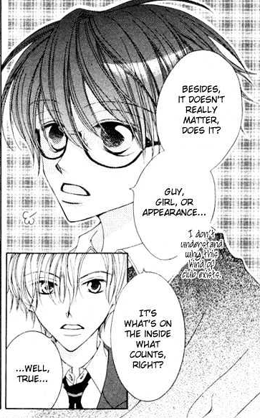
However, Haruhi really could not care less about how others perceive her, since she herself does not really care to define her gender identity and does not know why other people prescribe such value to that of others (Fig. 4). Many fans read Haruhi as nonbinary, and even if this was not Hatori’s original intent, it still serves to show that she has had a massive impact on readers and is a character with a lot of influence. Readers see themselves in Haruhi, and her prominence as either an androgynous woman or a nonbinary person is not without note.
Often in shōjo, especially mahou shōjo, or magical girls, the female protagonists fight the villain, the school board, the bully, or whatever form the antagonist takes, in feminine garb, almost to counteract the masculinity of their actions and therefore still make them desirable to men (Fraser and Monden, 550). Using characters like Haruhi, Sailor Moon’s Haruka Tenoh, or Revolutionary Girl Utena’s titular protagonist to explore gender, however, does so away from the “‘safe’ trappings of girlishness” (546). Shōjo manga was created to give girls a space to explore themselves away from the male gaze and from societal norms and expectations, and characters like these have given them a way to accomplish just that: you do not need to look like a girl, act like a girl, or even be a girl at all, and what matters, as Haruhi says in Figure 4, is what is on the inside.
Figure 4. Protagonist Haruhi comments on her views on gender identity and presentation from Bisco Hatori, Ouran High School Host Club (VIZ Media, 2011), vol. 1, p. 19.
,
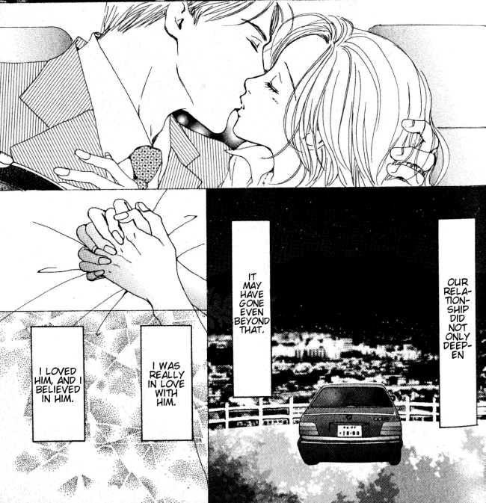
Including characters who defy gender roles is fine on its own, but in order to truly be impactful, authors must ensure their stories are not “inextricably androcentric and heteronormative”, and although some shōjo certainly do adhere to heteronormativity, almost none entertain the male gaze (Bailey 209). One of the most important things women-written shōjo achieved for the genre and for the shōjo themselves, the young girls who make up the largest portion of their readership, was present preteen and teenaged girls in realistic lights free from sexualization and the male gaze. Shōjo explores romance, sex, and sexuality “without turning an objectifying gaze on female bodies,” and it gives both heterosexual and non-heterosexual couples the space to do so (Ogi 89). Heterosexual romances are often placed at the center of the narrative in shōjo manga, but before the 1990s, sex was never portrayed. Chapters and chapters of a budding romance would ultimately culminate in a kiss and nothing more, but “today, shōjo manga explores sexuality among ‘real’ girls” (Prough 129). From suggested to explicit, healthy to problematic, shōjo manga began to deal with sex, as “one of the key issues that arises in adolescence is sexuality,” and this was something their readers were interested in seeing (129). Nana follows the story of two twenty-something women both named Nana who must navigate their lives and romantic woes while also struggling to thrive in Tokyo, and within the very first chapter, there is a panel suggesting that one of the Nanas had sex with a man while in high school (Fig. 5). Although not explicit in any way, it serves to normalize the idea that young people have sex and have always done so, and though the portrayal of heterosexual relationships themselves is not revolutionary in any capacity, the method many female shōjo authors employ to do so is. In depicting sex in a sphere away from the sexualizing male gaze, these women provided a way for young girls to explore their sexuality through fictional relationships and decide when, if ever, they wanted to have sex.
Figure 5. Nana Komatsu kisses her boyfriend in his car, which leads to sex, as indicated by their intertwined hands from Ai Yazawa, Nana, (VIZ Media, 2012), vol. 1, p. 18.

Men so often fetishize romantic relationships between women, so to include them in worlds without the male gaze and without heteronormativity, somewhere young girls could perhaps discover their own identities without these interferences, is crucial. As Catherine Bailey writes, “life outside the boundaries imposed by norms of gender and sexuality is infrequently positioned as a lasting option for female protagonists within the narrative structures that guide literature and social relations alike,” but Sailor Moon does just the opposite, positioning life outside the norms as both lasting and valid (211). As aforementioned, when Haruka Tenoh first appears in Chapter 27, Usagi and her two friends immediately mistake her to be a boy, and this is only rectified after Usagi has kissed Haruka, something they regard as a simple misunderstanding not worth much thought. Later, Takeuchi reveals that Haruka and her frequent companion Michiru are actually girlfriends, and this is completely normalized by the narrative and the characters within it. No labels are ever applied to the two girls, and this has two results: firstly, to treat their relationship “like any other” and portray it as “long-term, loving, and sustainable,” and secondly, to “illustrate the superfluous nature of gender categories” and encourage others to “examine the roots of their own need for labels” (215). This is only one example out of the many queer romances found in shōjo manga – from Revolutionary Girl Utena and Cardcaptor Sakura to Tokyo Babylon and Ouran High School Host Club, and these depictions served to normalize queer relationships and people and to pave the way for further representation in shōjo.
Shōjo has undergone a massive change since its origins as stories of idealized young women meant for male consumption. Once women began to enter the genre in the 1970s and wrote stories for shōjo themselves – and from people who were once shōjo – they used their platform to discuss issues important to young girls and teenagers in a way untainted by society’s norms or by male desire, issues like gender roles, sexuality, and gender presentation. Women reclaimed shōjo for themselves, and they used this space now safe for women to comment on many of the negative things girls experience in Japanese society. However, shōjo is just one thing: what happens when women enter into a space that does not even deal with female protagonists or that is not geared toward female readers? They fight and struggle to be heard in the shōnen genre is what happens, and even though there are still relatively few women in shōnen manga, they have used their experiences and voices to create manga geared at boys with better representation of female characters, of what it means to be a man, and of relationships between people of all genders and have a massive impact in the process.

- Shōnen Women are People Too
Shōnen manga, which draws its primary readership from boys between the ages of 12 and 18, is by far the most popular genre of manga in Japan and around the world, and the vast majority of these come from the magazine Weekly Shōnen Jump, including the three shōnen from the early 2000s known as the “Big Three.” Although this was by no means an official list, these three manga almost always seized the top three spots in Weekly Shōnen Jump’s ranking, and despite all of these but one having ended years ago, no other shōnen manga has ever quite been able to match the degree of popularity or adoration these three manga had and still have, which are none other than Naruto, Bleach, and One Piece. The three, in terms of plot, bear little resemblance to one another, but there are so many shared themes and ideals between the three that it is no wonder they all became popular at the same time.
As aforementioned, Naruto follows the titular protagonist on his journey to become the leader of his village, called the Hokage, and also to save his best friend Sasuke from himself after he defects from the village. Naruto is, as his jōnin sensei (older ninja instructor) Kakashi Hatake puts it, the “maverick show-stopper… comedy ninja” who messes around and rarely is serious, but he has a single-minded determination for his goals and for his friends, and it is this, ultimately, that allows him to achieve his dreams (Kishimoto 3:10). Bleach follows the story of fifteen-year-old Ichigo who inherits his parents’ destiny to be a “Soul Reaper,” one who protects humans from evil spirits and guides the dead to the afterlife. This protagonist is nothing like Naruto, in that he is incredible cynical and unwilling to follow his destiny, but as time goes on, he embraces his role as a Soul Reaper and truly prides himself in what he is able to do. The final member of the Big Three, One Piece, follows Monkey D. Luffy, a boy whose body has the properties of rubber, as he journeys with his loyal pirate crew to find the fated treasure known as the One Piece and become the King of the Pirates. Luffy is rather like Naruto, in that he is carefree and generally happy, but he, unlike Naruto, acts much dumber than he actually is. At first glance, these three have almost nothing in common, but they all share themes of chasing dreams, being a young boy against the world, using a balance of talent and sheer force of will to accomplish goals, and finding your family amongst your friends, all of which are still prevalent in contemporary shōnen like My Hero Academia and Demon Slayer. However, one crucial thing missing from these shōnen that, thankfully, has begun to change in recent years, is well-written female characters.
Shōjo manga, with women as their authors and the majority of their readers, naturally center their stories around women, and shōnen do the same for their male authors and male audiences, which is not a problem at all. Boys need to see realistic representations of themselves just as much as girls do, as deciding how you want to live your life and how you want to think should come from more than just those who are around you. However, what is problematic about shōnen manga, including the Big Three, are their depictions of women made with men in mind. Many times, women in shōnen manga are often not meant to be realistic representations of women; instead, much like shōjo women written by male authors before the 70s, they are idealized or tropey versions of women meant to advance the plot, serve only as a love interest for various male characters, or be consumed by their male authors and readers. Some authors do attempt to give women more realistic representation, but the fact remains that “even female characters… possessing non-stereotypical capabilities are still placed in situations aligning them with traditionally feminine characters” (Unser-Schutz 136). Thus, to examine just how women have impacted the shōnen genre, I will look at two popular shōnen manga and how they depict women within the bounds of the genre and the distinct ways they do so.
I could go into detail about the things the various female characters in the Big Three and other shōnen manga experience, from abnormal body proportions and overly sexualized clothing to fridging (a term for when female characters are harmed or killed for the sole purpose of causing a male character pain and advancing their characterization and the plot) and having to be “feminine” in some way, but by far the worst offender, in my opinion, is Masashi Kishimoto’s Naruto. Although Naruto focuses primarily on the growth and the story of Naruto himself, it also looks at the lives of the two other beginning ninjas on his team under Kakashi, Sasuke Uchiha and Sakura Haruno. Sasuke is the last surviving member (or so they say) of the renowned Uchiha clan, whose bloodline dates back to the founding of their village and the beginning of ninjas themselves, and he serves as Naruto’s rival, best friend, and narrative foil throughout the plot. He is a ninja prodigy, but he is blinded by a desire to exact revenge on his older brother, Itachi, for killing their entire clan. Sasuke sees some of the most radical character growth in the entire series, and his relationship with Naruto is the driving force of the plot in the latter half of the series: Naruto simply would not be the same manga without it. Sakura serves as the other main character in the series, but where Sasuke experiences incredible development and plays a major role in the plot, Sakura does none of these things despite being a constant presence throughout the entire series.
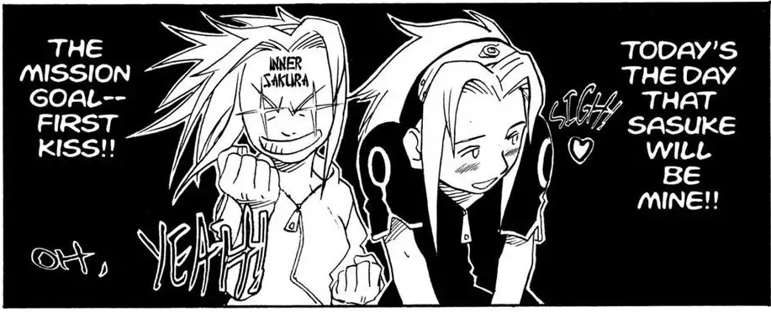
On the surface, Sakura seems like she may actually be a well-written female character, especially in the latter half of the series. She is strong, skilled, and fierce, going so far as to cut off her own hair to escape the clutches of an enemy ninja, and she uses her abilities for ninja arts and for healing effectively when she needs to. However, throughout the entire narrative, her character is reduced to nothing more than her crush on Sasuke. The first chapter in which she appears centers her character around Sasuke (Fig. 6), and even though Sasuke treats her horribly, calling her annoying, being horribly cruel to her, and even trying to kill her on multiple occasions, in the final chapters he is still her primary motivator for every action she takes and every desire she has (Fig. 7).
Figure 6. Sakura expresses her plan to finally secure her first kiss and Sasuke’s heart from Masashi Kishimoto, Naruto (VIZ Media, 2003), vol. 1, p. 90.
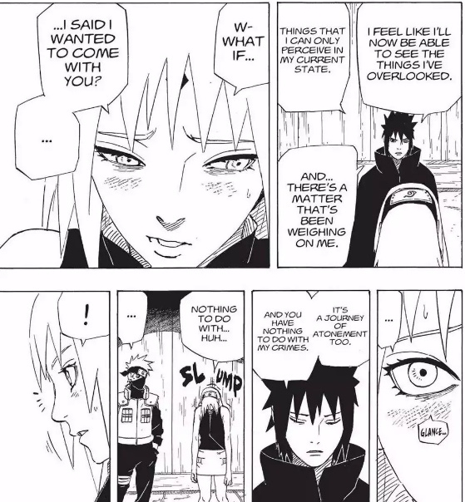

Figure 7. Sakura asks Sasuke if she can come with him on his journey of discovery and atonement and is summarily rejected from Masashi Kishimoto, Naruto (VIZ Media, 2015), vol. 72, p. 181.

In addition, as Unser-Schultz states, despite her seeming non-traditional traits, Kishimoto still aligns her with stereotypically feminine characters and interests. Sakura may be incredibly strong due to her degree of chakra control, but she prefers to use her abilities for healing instead of fighting, staying away from the frontlines during the war that occurs for much of the latter half of Naruto. Sakura is allowed exactly one battle of her own, when she and an elderly ninja called Chiyo defeat rogue ninja Sasori, and after this she reverts to her same old boring, passive self. Kishimoto also characterizes her almost as an overbearing mother, as she is nitpicky and even emotionally manipulative at times, but ultimately, she is just concerned for Naruto and Sasuke’s well-being. The narrative consistently portrays her in such a manner, and her accomplishments are always undermined by Naruto and Sasuke’s growth in strength; no matter how much effort Sakura puts into growing stronger, Naruto and Sasuke always come out ahead of her. Thus, Sakura is perhaps the textbook case for what Japanese society seems to think women are (or should be, anyway): parental, compassionate, passive, and only valuable for their relationships with the men in their lives.
Daniel Flis, in his article “Straddling the Line,” discusses something he terms the “shōnen framework” in which elements of shōnen all adhere to certain standards – including female characters (78). The women in Naruto are all shadows of real women, but they all fall within the shōnen framework that places women either in the male gaze or in the position to later fulfill the very “Good Wife, Wise Mother” ideal – the idea that women should aspire to become nothing more than wives to husbands and mothers to children – that shōjo manga tried its best to overthrow (78). Tsunade might be Hokage and be able to shatter the earth with a punch, but her character design reflects male desire, as she uses a technique to make herself appear much younger than she actually is. Ino is the blunt and intelligent daughter of the leader of the Torture and Investigation Unit of the village of Konohagakure, but she, like Sakura and almost every other female character their age, is obsessively in love with Sasuke, even though he speaks to her maybe twice in Naruto’s 700 chapters, putting her in the position to become a good wife and wise mother. Hinata is heir to one of the most powerful clans in Konoha and possesses an inherited ability that rivals even Sasuke’s, and her almost painful shyness would not be a negative trait if not for the fact that the only reason she comes out of her shell and recognizes her worth and strength is Naruto. Tenten is perhaps the only somewhat realistic and well-written female character, but she sees little page time throughout the narrative, which only drives home Kishimoto’s (perhaps unintentional) point that the only women worth men’s time are those whose lives revolve around men or those who fulfill or will fulfill gender expectations. These are only a few of Naruto’s women, but all of them are just the same as these, mere caricatures with no more substance than pretty faces painted onto wood. Masashi Kishimoto has done nothing revolutionary or even unique in his portrayal of women, and all of his female characters – from deuteragonist Sakura to the most minor of minor characters – fit perfectly into the boxes shōnen has made for them.
On a completely different end of the female representation spectrum than Naruto lies Hiromu Arakawa’s Fullmetal Alchemist. Right from the beginning this manga sets itself apart from typical shōnen because even though its subversion of typical gender norms and stereotypes “[does] not always reject the shōnen framework altogether,” it still “present[s] new ways for gender performance to be represented within it” (Flis 76). Fullmetal Alchemist (hereafter known as FMA) follows the journey of Fullmetal Alchemist himself Edward Elric and his not-so-little little brother Alphonse as they endeavor to discover the legendary Philosopher’s Stone in order to bring back the limbs (and, in Al’s case, body) they lost four years ago when trying to bring their mother back from the dead using alchemy. Ultimately, they uncover a plot involving homunculi, immortals, and government conspiracies that leads them to the very thing for which they had been searching. Although, as is the shōnen norm, the protagonist is male, there is no shortage of female characters within FMA, and all of them are absolutely wonderful, realistic characters who, despite sometimes adhering to shōnen stereotypes, subvert norms in some way.
The Elric brothers may not have a mother anymore, but they certainly have a mother figure in their lives, one by the name of Izumi Curtis. After their mother dies, the Elrics decide to learn alchemy to perform the forbidden act of human transmutation in order to bring their mother back to life, and they study under Izumi for a few years before moving back home. Izumi tells the boys they must never commit the taboo, but what they do not know is she herself performed human transmutation once, in order to bring her still-born child back to life. This cost her many of her internal organs, rendering her unable to bear children, but this did not stop her from adopting the Elrics in all but name, showing that, even though she is aligned with a traditionally female thing (motherhood), her physical body does not have to do so. Izumi is more than a walking womb, and despite the fact that she cannot bear children, she is still a good mother to the Elric boys. In addition, Izumi, despite being a master alchemist and an accomplished and formidable woman, chooses to consistently identify herself as “just a housewife” (Arakawa 5:170). This, too, satirizes the “good wife, wise mother” expectation for women, as even though she is a housewife and structures her identity around it, she subverts expectations for how housewives are meant to act. Women are most certainly allowed to want to be wives or mothers and identify themselves as such, but Arakawa shows through Izumi that this is never the entirety of a woman’s identity.
Another member of the Elrics’ patchwork family is Winry Rockbell, the boys’ childhood friend and Ed’s love interest. Winry is an automail mechanic, responsible for designing and creating the metal limbs that attach to Ed’s nerve endings and enable him to perform alchemy and use them almost identically to flesh limbs. She is, aside from her blonde hair, the opposite of a female stereotype, with her nerdiness and obsession with automail, but she experiences one moment that could be classified as being subject to the sexualizing male gaze. In Chapter 84, Winry begins changing clothes unaware that an equally oblivious Ed is in the room, but no nudity is shown at all. Unlike most fanservice in shōnen, Ed does not revel in this moment – he is just as embarrassed as Winry is and suffers a real beating from her. As a result, this shows male readers that it is never okay to intrude upon someone’s privacy or to objectify women and female readers that retaliation against sexual harassment is okay.
Perhaps the most significant way in which Winry subverts gender norms happens in FMA’s final chapter, when she sees Ed off at the train station in their hometown. Their romantic interest in one another takes a backburner to the major plot within the story, but it is always simmering just underneath their reactions. Neither of them, Winry included, is defined by their love for one another, a departure from Kishimoto’s portrayal of nearly all his female characters, but the final chapter does see a proposal of sorts. However, rather than upholding the shōnen framework that “legitimize[s] the dominant position of men in society and [justifies] the subordination of women,” Ed makes an egalitarian proposal, citing the alchemic principle of equivalent exchange in which something must be exchanged for something of equal value, as pictured in Figures 8 and 9 (Flis 77). Winry in no way belongs to Ed or is beholden to him, and he makes this clear when he offers up half of his life for half of hers. He does not presume that she belongs to him in anyway, and although Winry replies that she would willingly give him her whole life, this is her own choice to do so. She does not belong to Ed, and she has not given up her active role in the story to become his “submissive carer” (89). In fact, Ed actually sacrifices his alchemic abilities to save his brother and physically can no longer serve as her protector or a fighter. Although it could be said he and Winry begin the series on unequal footing, what with Ed’s prominence as a State Alchemist on the government’s payroll, then end it as equals in every aspect. Neither is more active or passive than the other, and Arakawa ends the series this way, with a declaration of female equality.
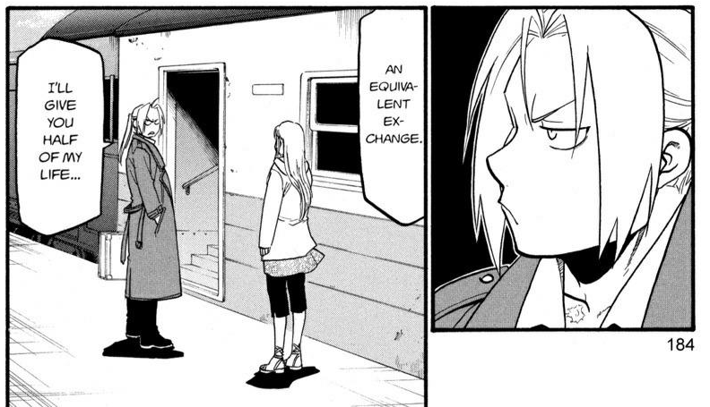
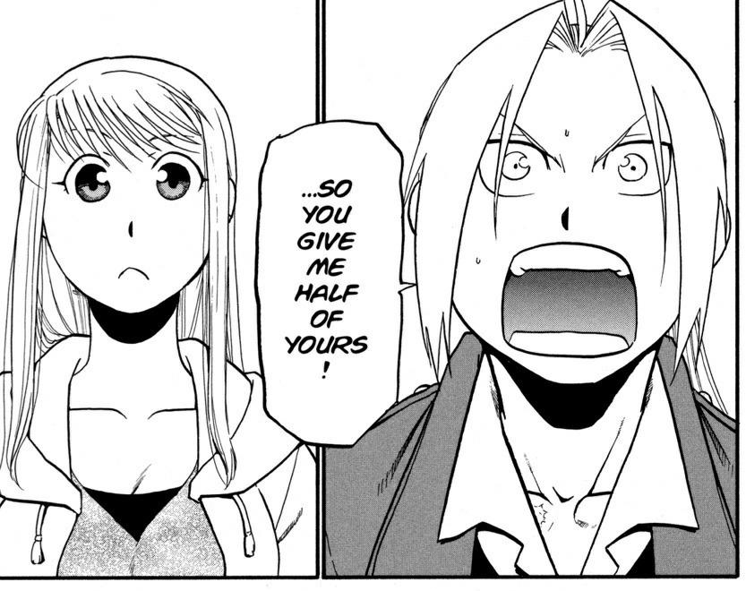
Figures 8 and 9. Ed promises Winry to give her half of his life in exchange for half of hers from Hiromu Arakawa, Fullmetal Alchemist (Square Enix, 2011), vol. 27, p. 184-185.
Obviously, having well-written and realistic female characters in a shōnen is not a sign that the female authors who created these characters have had an influence on the genre as a whole, but their popularity means that their readers – primarily young men and an increasing number of young women – are receptive of these characters. Until the 1990s, very few women wrote shōnen, but now “female authors of shōnen manga have become more common and their works often reach a mainstream audience,” including works like FMA, Rumiko Takahashi’s Inuyasha, and Adachitoka’s Noragami. Due to this increased popularity and visibility from female mangaka, it is no wonder some male-authored shōnen like Gintama and Hunter x Hunter, which are two of Weekly Shōnen Jump's best-selling manga of all time, subvert gendered stereotypes for all their characters, overthrowing the two pillars of the shōnen framework Flis discussed, creating realistic women and sympathetic men, and portraying characters of all gender presentations and sexualities, from trans women to effeminate men, in a positive way. Although some opposed to female intrusion into male spaces argue that either women need to stay in their own space or open shōjo back up to male authors, the fact remains that the entire world existed as a space that revolved around men and men’s interests for so long that women still need a space of their own and should still have the right to include themselves in male spaces in order to foster change, which, judging by the popularity of female-authored shōnen and the evolution of male-authored shōnen, they have done successfully.

- Girls Love Boys Love
At any sort of fan convention held across the world, droves of women who call themselves fujoshi cosplay with their friends as their favorite male-male relationships (from Naruto and Sasuke to BL visual novel DRAMAtical Murder’s Aoba and Kōjaku), flock to Artist Alley to commission fanart of their OTPs (fandom slang for “One True Pairing”), and spank other cosplayers and attendants with wooden “Yaoi Paddles.” As YouTube user Red Bard’s video “The Rise and Fall of the Yaoi Paddle” discusses,” these paddles had words like seme (the “top” in the relationship), uke (the “bottom”), and simply yaoi (supposedly an acronym for “no climax, no point, no meaning,” but nonetheless synonymous with shōnen ai) plastered across them, and they were made of a sturdy wood, something that, unsurprisingly, posed a problem at fan conventions. These paddles were strong enough to have served as weapons, and they were eventually banned from almost all major fan events across the world after an attendant allegedly shattered someone’s pelvis at a convention. Why people – again, mostly women – apparently enjoy something enough to waltz around (willingly!) in public with objects emblazoned with words fetishizing gay male relationships and remarking on their sexual preference raises two questions: first, if most BL stories are highly unrealistic, sexually explicit, problematic, and heteronormative, why do women create and consume them so voraciously; and second, is there anything of value within a genre such as this?
According to James Welker, BL came about as a subgenre of shōjo manga in the 1970s, the same time female authors and artists entered the shōjo genre and reclaimed it for themselves, and “it quickly became among the most popular shōjo manga genres… its creators [becoming] some of the best-loved artists in the industry” (841). Queer people are by no means a recent invention. Same-sex relations were completely ordinary around the world, with many girls and women enjoying “long-lived, intimate, loving friendships” with one another that, in today’s terms, would have been classified as romantic and sexual relationships, and same-sex relationships between men were just as common, although they looked much different than those between women (Smith-Rosenberg 1). The concept of heterosexuality is a rather new thing, and by the time BL rose to popularity in the 70s, queer relationships were no longer acceptable in the way they used to be. Now, though, rather than representing same-sex relationships as they actually are, “the figure of the beautiful boy in boys’ love manga acts as ‘a disruptor of heterosexuality, a presence standing outside the conventions of patriarchy, a hole in the fabric of gender dualism,’” (Welker 842). BL provides a way for its readers to question the norms involving gender and sexuality around them and explore their own identities outside of male-oriented society and of the gender binary.
However, this still does not explain why nearly all BL authors and readers are female, but I rather think it has something to do with distancing making topics feel safer. Questioning gender and sexuality is strange at best and terrifying at worst, and sometimes seeing people who look too much like yourself makes it harder to do so. For some people, of course, this is not the case, and they would much prefer to see people who look and act like they do and relate to the text through those characters. For many young women, though, BL apparently provides an outlet, a place away from the heterosexual patriarchy and from oversexualization of women, and this gives women “freedom from mundane reality, freedom of imagination, interpretation, and expression, and freedom from conventional gender restrictions and cultural hierarchy” (Aoyama 65). A male reader of shōnen ai Song of the Wind and Trees reported that he “‘found [himself] unable to embrace the sensual aspect of the story because it related to [his] own body,’” and this certainly applies to women as well (Ogi 89). “Removing the femme avatar can open up a freedom of sexual exploration and imagination for female artists that they don’t find in heterosexual erotica,” so creating these romances between men removes the female body from the scenario and allows for a greater degree of identification and choice; with two men, no one has to play a certain gendered role in a relationship, so women can decide for themselves with whom they want to identify (Camper 24). If writing and reading BL gives women a way to explore sex, sexuality, and gender dynamics in a society that expects them to become nothing more than good wives and wise mothers, then it is no wonder it is so prevalent and beloved in Japan. The problematic and heteronormative nature of BL notwithstanding, the non-heterosexual relationship in and of itself allows women to explore sexuality without having to subject their own bodies to scrutiny, to “bypass misogyny and female stereotypes,” and this is surely why women comprise the majority of the authorship and readership: it simply has more value and importance to them than it does to men (24).
Yaoi certainly has value to women, but the value does not come from the content of the stories themselves as much as from the elements that comprise them. The question remains, then, if BL does have any sort of value to society as a social commentator and agent of change. Shōjo and shōnen manga, with their enormous popularity amongst the youth of Japan and manga’s role as the country’s cultural engine, have certainly impacted Japanese culture in a positive way: views on women are beginning to change, gender roles have begun to shift, and a greater degree of acceptance for all has appeared in the country. Boys’ love, judging by its popularity and its content, should also have done the same, but when the elements that constitute the majority of these stories are just as misogynistic and heteronormative as society at large, little happens at all. The only thing revolutionary about most shōnen ai are the genders of the love interests, and they still adhere to strictly heterosexual norms despite not being heterosexual.
BL is a sort of strange middle ground between society and subversion that destroys social norms while also adhering to them, and a perfect example of a yaoi that does this is Junjō Romantica. Junjō Romantica possesses all the elements a story needs to be considered a boys’ love manga: a small, easily embarrassed protagonist who serves as the uke, a much larger, more mature, and more experienced love interest who is the seme, a wealth of the bishōnen rampant in shōjo, and a questionable power dynamic between the two. Misaki, the protagonist, is an 18-year-old aspiring college student who, when he fails all his entrance exams, is forced to hire his brother’s 28-year old friend Akihiko to tutor him, and they, naturally, fall in love. As BL relationships go, this one edges as close to non-problematic as possible, as Misaki is, at the very least, a legal adult when he and Akihiko begin their relationship, but since a 28 year old novelist and BL author and a recent high school graduate are in two completely different stages of life, not to mention Akihiko’s role as Misaki’s tutor, this makes this relationship somewhat sketchy from the beginning. If this imbalance of power was not enough already, consent and lack thereof is played off almost as a joke in Junjō as well as in most yaoi. It seems to be considered “hot” for the seme to force the uke into physical affection that he will “warm up to” as time passes, with Akihiko frequently coercing Misaki into kisses and sex, but even if this allows female authors and readers to explore differences in power between two people in a relationship, it is in no way acceptable or productive.
In addition, Misaki, as shown in Figure 10, is always shown as smaller, more lithe, and more feminine than Akihiko, which also adds to the element of heteronormativity prevalent in BL stories. This, combined with authors’ ascription of the roles of “bottom” and “top” with no changing at all almost defeats the purpose of depicting male-male relationships in the first place. If someone, a somewhat feminine, small-statured man, has to be the “woman” in the relationship, this only enforces the gender binary BL authors may be trying to circumvent.
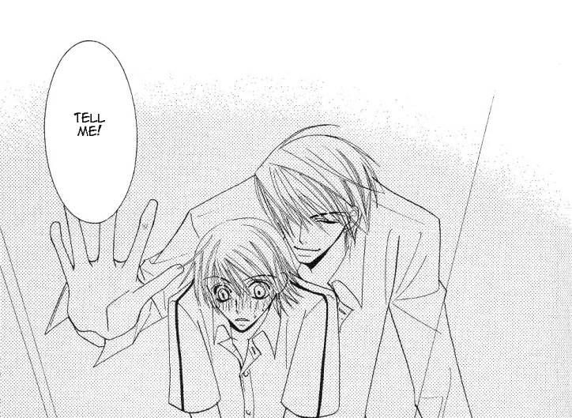
Figure 10. Akihiko looms over the smaller, embarrassed Misaki from Shungiku Nakamura, Junjō Romantica: Pure Romance (Kadokawa Shoten, 2007), vol. 4, p. 135.
Some concessions must be allowed, though, since prior to BL, most stories like these that depicted sexual relationships were heterosexual ones, with the woman bearing the brunt of the mistreatment and of the sexualization. Thus, in making both parties men, it eliminates that element from the equation and allows for examination of what we determine as okay in sexual relationships without having the “hotness” factor of having a woman in the relationship. However, it still presents the relationship solely for female consumption, which turns female readers into those doing the fetishizing and the sexualizing, and I do not know if the positives of portraying non-heterosexual relationships in shōnen ai outweigh all the negatives involved.
Contemporary BL has begun to vary from the BL of the 90s and early 2000s. Leaving behind the exaggerated proportions, the dubious consent, and the complete lack of social commentary, many yaoi manga have appeared that depict realistic, healthy, and interesting relationships that allow readers to truly explore their gender and sexuality and influence their long-held convictions about these topics. As Camper states, queerness in Japan looks differently than queerness in the West. Here, it is often about being out and proud of your identity, and although this is absolutely wonderful for those who want to live their lives this way, in Japan, a society that is traditionally all about the family and about reservation, this is rather uncommon (26). Yaoi like Junjō Romantica depict gay life as an insular world relatively free from homophobia or societal expectations, and while this is a useful form of escapism for female readers looking to leave the real world behind, the BL that venture to make social commentary do so in a highly effective and moving way.
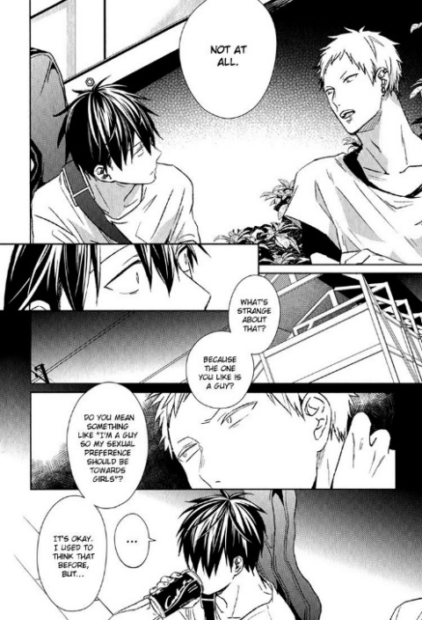
Given, by Natsuki Kizu, follows the story of four young men, two high school second years and two university students, as they navigate love and life while trying to find success in their rock band. Although not complete yet, Given has completely blown most BL out of the water in its portrayal of relationships and of sexuality. In chapter 7, protagonist and lead guitarist Uenoyama Ritsuka discusses his crush on bandmate/classmate Mafuyu with their drummer, Akihiko, and he worries that his having a crush on Mafuyu makes him “strange” (Kizu 2:20). Akihiko, as shown in Figure 11, tells the younger boy that he need not feel obligated to be interested in only women, since sexuality is, in reality, far more complicated that society leads people to believe, and that he, too, has had relationships with other guys before. This mature take on sexuality and compulsory heterosexuality seems like something that would not belong in BL, a form of media many consider to be lowbrow, but Kizu’s inclusion of this truly provides a way for readers to empathize with her characters and explore their sexuality. Furthermore, this acknowledgement of greater society’s push for heterosexuality diverges from the norm most BL present as a magical fantasy world where homophobia and societal expectations magically do not exist. Although many shōnen ai stories are problematic and homophobic despite their premises, it has paved the way for realistic and mature discussions of gender and sexuality like that found within Given and has allowed female readers, much like the overarching umbrella of shōjo, to explore their own sexuality in a place free from the heterosexual patriarchy.
Figure 11. Blond Akihiko tells Ritsuka, after Ritsuka asks if his crush on his male friend makes him strange, that it does not at all from Natsuki Kizu, Given (SuBLime, 2020), vol. 2, p. 20.

BL has also given readers the tools, so to speak, to read between the lines in non-BL texts and “change elite homo-sexual and homo-social and misogynistic literature into a more inclusive, egalitarian narrative” (Aoyama 77). Although never confirmed as canon, male shōnen authors have done their level best to make interactions between male characters as homoerotic as possible, and they have done so completely by accident. As previously described, Naruto serves as a perfect example of a shōnen that sticks firmly within the shōnen framework in the most stereotypical of ways, and since every female character within is passive and largely non-essential to the plot, every single line of emotional importance is also given to male characters. As aforementioned, Part Two of Naruto puts Naruto’s quest to become the Hokage on hold while he strives to save the world while also bring former teammate and best friend Sasuke back to Konoha. Sasuke defects at the end of Part One in order to go train with the evil Orochimaru in order to become powerful enough to kill his brother, Itachi, and avenge the Uchiha clan, but he has several run-ins with Naruto throughout the series that, to a trained eye, sound a bit more like romance than Kishimoto probably intended.
If Naruto centering his entire drive to become stronger around saving Sasuke is not enough on its own, he also, in one of the series’ most emotional moments, lies next to Sasuke completely exhausted after their final battle with one another and asks if this is heaven while he thinks about his and Sasuke’s relationship up to now. Sasuke had spent the entire second half attempting to ignore his care for Naruto in order to kill him and finally move on with his life, but he simply cannot kill him and now lies here next to Naruto, the blood from their missing arms bleeding together almost as though they would be holding hands if they still had them (Fig 12).
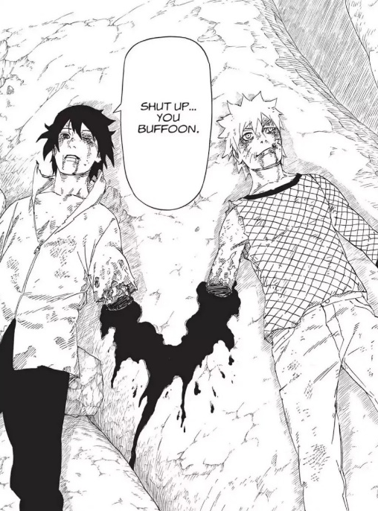
Figure 12. Sasuke, left, and Naruto, right, lie bleeding out on a rock after their final epic battle and a conversation that was a long time coming, the blood from the stumps of their arms meeting in the middle from Masashi Kishimoto, Naruto (VIZ Media, 2015), vol. 72, p. 161.
Sasuke asks Naruto why he believes in him after everything, and after Naruto responds that it’s because Sasuke is his friend, Sasuke asks what friend means to Naruto, to which he responds, “You ask me to explain it, but honestly, it’s not like I really understand it either… Just that when I see you take on stuff and get all messed up… it kinda… hurts” (Kishimoto 72:150). They are equals in every sense of the word, down to the arms they each blew off the other, and to someone who knows how to read into a relationship and knows what to look for, this seems like two people who are madly in love with one another. Naturally, countless people have projected onto relationships like these found in heteronormative source material. This sort of thinking applies to works like Les Misérables, Star Wars, and Harry Potter, and even if BL does present many problematic elements, it has allowed readers to connect to highbrow, heteronormative texts in ways they could not have before.
Shōnen ai has enabled women not only to explore their own sexualities and the norms that compose the patriarchy that governs society but also to equip themselves to relate to texts without canonical queer content and pave the way for further representation, further exploration, and further evolution of depictions of same-sex relationships. A majority of boys’ love presents scenarios that are neither realistic nor productive means of fostering communication and examination of why society is the way it is, but its usefulness as both a means of female expression and as an examination of queerness, at least in a basic sense, enabled some readers to “[follow] the signs to see past the illusions and, grasping the options laid bare by the figure of the beautiful boy… [transcend] the fantasy world to themselves embody transgressively gendered and sexual alternatives” (Welker 866).

- Conclusion
This essay discussed the various ways in which female mangaka have influenced the manga industry. It illustrated women’s take-over of the shōjo genre and their influence on its evolution into a genre by women, about women, and for women, and this allowed female readers to, perhaps for the first time, relate to female characters in a realistic way and to do so without the ever-present sexualizing male gaze all women must endure. I also explored how women made a space for themselves in shōnen, a genre previously established as a world revolving around men, and how, in doing so, they became well-known and beloved names in the genre and, through their popularity, paved the way for better treatment of female characters and further examination of gender roles. Lastly, I looked at the emergence of the shōjo subgenre of boys’ love and how, despite the heteronormative and problematic nature of many of the elements that make up BL stories, provided female authors and readers a means of exploring sexuality in a way that was impossible to result in sexualization of the female body and equipped them to expect more from mainstream media in terms of discussions on gender and sexuality. Successful manga, as previously quoted from Beaty and Weiner, are the “fuel on which the country’s cultural engine runs,” so inundating the market with female-written works that constantly challenge the norm and give women and other marginalized people the voices and the representation they deserve has, hopefully, begun to plant seeds of real change in Japanese society and across the world.

Bibliography
Aoyama, Tomoko, et al. “Shōjo Manga: Past, Present, and Future--An Introduction.” U.S.-Japan Women's Journal, no. 38, 2010, pp. 3–10.
Aoyama, Tomoko. “BL (Boys’ Love) Literacy: Subversion, Resuscitation, and Transformation of the (Father’s) Text.” U.S.-Japan Women’s Journal, no. 43, 2012, pp. 63-84.
Arakawa, Hiromu. Fullmetal Alchemist. VIZ Media, 2011. 27 vols.
Bailey, Catherine E. “Prince Charming by Day, Superheroine by Night?: Subversive Sexualities and Gender Fluidity in Revolutionary Girl Utena and Sailor Moon.” Colloquy, no. 24, 2012, pp. 207–222.
Beaty, Bart, and Stephen Weiner. Critical Survey of Graphic Novels: Manga. Salem Press, 2013.
Camper, Cathy. “Yaoi 101: Girls Love ‘Boys’ Love.’” Women’s Review of Books, vol. 25, no. 5, 2006, pp. 24-26.
CLAMP. Cardcaptor Sakura. Dark Horse, 2010. 3 vols.
Flis, Daniel. “Straddling the Line: How Female Authors Are Pushing the Boundaries of Gender Representation in Japanese Shonen Manga.” New Voices in Japanese Studies, vol. 10, 2018, pp. 76–97.
Fraser, Lucy, and Masafumi Monden. “The Maiden Switch: New Possibilities for Understanding Japanese Shōjo Manga (Girls' Comics).” Asian Studies Review, vol. 41, no. 4, 2017, pp. 544–561.
Hatori, Bisco. Ouran High School Host Club. VIZ Media, 2011. 18 vols.
Honda, Masuko. “The Invalidation of Gender in Girls' Manga Today, with a Special Focus on ‘Nodame Cantabile.’” U.S.-Japan Women's Journal, no. 38, 2010, pp. 12–24.
Kishimoto, Masashi. Naruto. VIZ Media, 2003. 72 vols.
Kubo, Tite. Bleach. VIZ Media, 2004. 63 vols.
Nakamura, Shungiku. Junjō Romantica: Pure Romance. Blu Manga, 2006. 23 vols.
Kizu, Natsuki. Given. Shinshokan, 2019. 5 vols.
Oda, Eiichiro. One Piece. VIZ Media, 2019. 92 vols.
Ogi, Fusami. “Beyond Borders: Shōjo Manga and Gender.” U.S.-Japan Women's Journal, no. 54, 2018, pp. 75–97.
Prough, Jennifer Sally. Straight from the Heart: Gender, Intimacy, and the Cultural Production of Shōjo Manga. University of Hawaii Press, 2011.
“The Rise and Fall of the Yaoi Paddle.” YouTube, uploaded by Red Bard, 17 May 2019, https://www.youtube.com/watch?v=oYG6J_iaMXQ.
Smith-Rosenberg, Caroll. “The Female World of Love and Ritual.” Signs, vol. 1, 1975, pp. 1-29.
Takeuchi, Naoko. Pretty Guardian Sailor Moon. Kodansha Comics, 2011. 12 vols.
Unser-Schutz, Giancarla. “What Text Can Tell Us about Male and Female Characters in Shōjo and Shōnen Manga.” East Asian Journal of Popular Culture., vol. 1, no. 1, 2015, pp. 133–153.
Welker, James. “Beautiful, Borrowed, and Bent:" Boys' Love’ as Girls' Love in Shōjo Manga.” Signs: Journal of Women in Culture and Society, vol. 31, no. 3, 2006, pp. 841–870.
Yazawa, Ai. Nana. VIZ Media, 2012. 21 vols.

