PlentiFull Business Proposal
Tayler Tate
Thesis Advisor: Mr. Lynn Youngs
ttate8@vols.utk.edu
865-809-8838

Acknowledgements

Thank you to Mr. Lynn Youngs for his continuous support throughout this entire process. His patience and commitment to my success in this project has not only guided the development of PlentiFull but also has helped me to develop as a student and a professional.

I would also like to thank Dr. Mark Moon for his support as the director of the Global Leadership Scholars program. His persistent encouragement helped me tremendously throughout the writing of this proposal.

Finally, I would like to thank my mother, Dr. Wendy Tate, for her ability to keep me focused on what is important and her supply chain consulting in writing and developing this proposal.

Table of Contents
EXECUTIVE SUMMARY 1
RESEARCH ANALYSIS 3
INDUSTRY ANALYSIS 5
Market Overview 5
Market Segmentation 6
CUSTOMER ANALYSIS 9
Customer Needs 9
Products and Services 10
COMPETITIVE ANALYSIS 12
Direct Competitors 12
Indirect Competitors 14
Competitive Advantage 15
GO-TO-MARKET STRATEGY 17
Pricing 17
Promotional Plan 19
Distribution Plan 20
OPERATIONAL STRATEGY 21
Key Operational Process 21
Milestones 29
FINANCIAL STRATEGY 31
Revenue Model 31
Financial Highlights 33
KEY LESSONS LEARNED 37
APPENDIX 1 38
APPENDIX 2 39
APPENDIX 3 40
APPENDIX 4 43
APPENDIX 5 46
WORKS CITED 49

EXECUTIVE SUMMARY
On average 6 in 10 restaurants are likely to fail in their first three years in business (Arora, 2006). This is for a number of reasons with one of them being not being able to create value for customers. Therefore, in order to be able to increase chances of success, restaurants need to be looking for ways to create value for their customers. This entails running an exceptional front-end and also back-end of a restaurant, meaning exceptional customer service and exceptional supply chain operations. This is where the idea of PlentiFull started. The key mission of the business is to provide a service that not only adds bottom line value to the restaurants in terms of pricing, but it also creates value for the customers as they will be able to enjoy the best quality products at a restaurant that is able to offer the best price.
Challenges: In conducting research and understanding the current issues that restaurant owners face, the problem of back-end operations can be summarized into five main categories:
- Inventory management 4) Low bargaining power
- Delivery scheduling 5) Lack of a formal ordering process
- Lack of demand visibility
Inventory management and delivery scheduling are hindrances in the daily operations of the restaurant as they often create interruptions in daily flow. These tasks are also time consuming and take the restaurant managers hours to perform simple tasks. The lack of demand visibility creates risk for the restaurants as they are constantly having to balance the value of holding inventory with the expense of having to throw away perishables. The low bargaining power is a result of only being able to order small quantities of the perishables and not being able to buy in bulk which would increase the leverage with the supplier and decrease the price. Finally, an overall lack of a formal ordering process drives the serious challenges faced by these restaurants and creates further inefficiencies in the day to day operations. These challenges have created a unique market that can be filled through the use of a group-purchasing organization called PlentiFull.
Overcoming the challenges: PlentiFull is a group-purchasing organization (GPO) that will concentrate on improving operations of locally owned restaurants which in turn will increase both the top and bottom line of the restaurants. The concept behind PlentiFull stems from the already successful business model of GPOs that are currently in place for the medical industry with over 95% of all orders being handled by these GPOs (Curran, 2016).
Like those organizations in the medical industry, PlentiFull utilizes a software system that takes the individualized demands of each restaurant and combines them into one larger pool of demand which creates leverage against suppliers through economies of scale. This ultimately drives down the price for each product ordered and helps to resolve the challenge that each restaurant faces with their lack of bargaining power (Tate et al., 2016). The integrated software system syncs with the point of sale systems already in place at the restaurants (Twain, 2015), in order to keep track of inventory which helps to reduce the time spent on cycle counting and turning the inventory to keep the items fresh. It also helps to improve the lack of demand visibility because it offers historical data, pools community information, and checks other local restaurant demands to help determine if the forecasting variance is within reason.
Furthermore, by utilizing a software system such as the one that will be developed for PlentiFull, it helps to create a formalized ordering process that is efficient and effective for the restaurant owners. By streamlining these aspects of the system, the owners can focus on the things that are important, menus, pricing strategies and advertising for example. The PlentiFull organization can add bottom line value to a restaurant by using a software system and a local warehouse in order to consolidate and distribute demand.
Business Model: PlentiFull will incorporate as a limited liability company in the state of Tennessee. PlentiFull will have revenue streams coming in terms of a membership fee of a flat rate of $45 dollars and it will also generate revenue through a 3% administrative fee per transaction which will cover the cost of contract management, insurance and legal fees that might be necessary. In order to break even in costs, PlentiFull will have to have 16 restaurants within the network. Assuming an anticipated growth rate of new restaurants at 4% per month, this means that PlentiFull begins to generate a profit by the end of month 6 in the second year of operation (see Appendix for financial statements).
Funding: In order to finance the high startup costs and the initial operating costs that come from warehouse leasing, software development and payroll expenses, PlentiFull will be seeking funding assistance of approximately $200,000. Part of this, around $85,000 will come from an angel investor that sees the value of such a business. Some of the funding will also come from personal resources.

RESEARCH ANALYSIS
Group-purchasing organizations (GPOs) are a well-established concept within the health care industry. The first GPO was established over a century ago, in 1909, for New York area hospitals. This first GPO formed the Hospital Bureau of Standards and Supplies Inc., which was the very first “cooperative buying” power and the predecessor of modern day GPOs (Barlow, 2017). However, since the start of the cooperative buying initiatives, very few GPOs have been established outside of the health care industry. With 64.9% of all group purchasing organizations operating in health care practice, successfully handling an estimated 95% of all orders in that industry, this leaves a lot of potential for other industries such as the restaurant industry (Curran, 2016), where a company like PlentiFull will be able to fill a specific niche role. This is true particularly for small to mid-sized restaurants, which is an incredibly untouched market with only one main competitor, Foodbuy.
In order to better understand the challenges that local Knoxville restaurant owners are facing with regard to the ordering and inventory processes, eight interviews were conducted. The primary goal of these interviews was to see if there was a need for an organization like PlentiFull. These interviews were very beneficial to the development of the company’s business plan, as they clarified key issues and helped to focus the business plan on what was really needed and helped to maneuver PlentiFull around the many different alternatives that could have been taken. Table 1 shows the participants in the informational interviews.
Table 1- Interview Participants and Duration
Restaurant Name | Interviewee Name | Duration of Interview
Oliver Royale | John, Executive Chef | 25 minutes
Trio | Dylan, Day Manager | 15 minutes
Not Watsons | Eric, Night Manager | 17 minutes
Blue Coast Grill | Beana, Day Manager | 20 minutes
Tomato Head | Jeremy, Manager | 10 minutes
Market House Café | Patrick, Day Manager | 10 minutes
Coco Moon | Javier, Night Manager | 15 minutes

The most significant point that came from these interviews is that ordering for a restaurant is both expensive and time-consuming. This is a direct result of not having a formal ordering process as well as not having the time or resources available to constantly be searching for the best price. Javier, the evening manager at Coco Moon, located in Market Square in Knoxville, TN, stated, “The prices are changing three times a week, you constantly have to be able to balance the value of your dollar and the time spent searching for the best price.” Restaurant owners are very aware of the fact that they are overpaying but often accept the prices they are given due to the time constraints.
Furthermore, when asked what the most difficult part of the entire ordering process was, over half of the interviewees stated that trying to forecast weekly demand was the hardest part of the entire ordering process. In addition to the challenges in forecasting, restaurant managers often talked about the time that was consumed in counting inventory. One of those that was interviewed said that cycle counting took one to two hours every day as they were constantly ordering, replenishing and using products. This restaurant, despite claiming to strive for up-to-date and accurate information, had a completely manual process for inventory management, ordering and receiving. The interviews were a crucial part of the development of the PlentiFull business model and indicated the potential success of such a company. See Appendix 1 for all interview responses.

INDUSTRY ANALYSIS

Market Overview
In 2016, the GPO industry had revenues of $4.7 billion dollars with the life cycle of the industry consistently being classified in the growth stage. Furthermore, the GPO industry is rated as low in revenue volatility and capital intensity (Curran, 2016). Of this $4.7 billion dollar market share, approximately 92% is related to separate industries such as healthcare and industrial manufacturing. Figure 1, breaks down even further the current state of the industry (Curran, 2016). Within the larger industry, PlentiFull has an incredible opportunity to be an initial player for the restaurant industry. In the next five years, industry revenue growth is supposed to increase by approximately 4% every year.

Figure 1- Target Market Segmentation
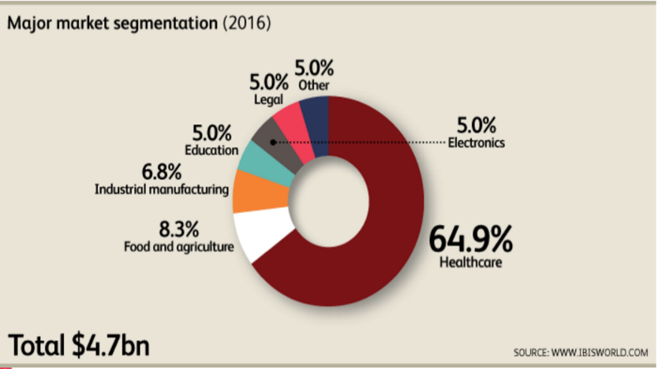
In conjunction with the GPO industry, the restaurant industry and its growth will greatly impact the PlentiFull business model. The restaurant industry has expected revenue of over $187 billion dollars with projected annual growth between 2-3%. This industry is a fairly simple industry to operate within as there are low barriers to entry, low revenue volatility and medium-level of regulation. However, this industry is extremely competitive (Alvarez, 2017). Specifically for the state of Tennessee, there are over ten thousand restaurants in operation with projected sales being at $12.2 billion dollars (National Restaurant Association, 2017). Because of the extremely competitive landscape and the low barriers to entry, it opens up an opportunity for PlentiFull to fill a niche role in the restaurant industry.

Market Segmentation
In order to establish the target market, a list of all the restaurants in operation within the greater Knoxville area was generated. This area was established as approximately 30 miles around the downtown area. In total, the number of restaurants in operation in the greater Knoxville area included 451 different companies (East Tennessee Dining, 2017). This, in turn, was broken down into 4 different categories. The categories were local, local chains, regional chains, and national chains.
The target market was established as local restaurants which are defined as any restaurant with two or fewer restaurants that are all located in the 30-mile perimeter around the greater Knoxville area. An example of a local restaurant is Bistro at the Bijou located on South Gay Street. Another example of a local restaurant is Lunch Box Market and Cafe. Lunch Box has a location in Downtown but they also have a location in West Knoxville. Despite having two store fronts they were still considered a local restaurant, not a local chain. Of the 450 restaurants that were the entire market, 313 of them fell into the locally-owned restaurant category (East Tennessee Dining, 2017).
A local chain is defined as any restaurant that has two or more store fronts within the greater Knoxville area. An example of a local chain is Calhoun’s. Calhoun’s has locations all over Knoxville, but they also have locations located in Pigeon Forge and Gatlinburg. Targeting local chains will be part of the long-term growth strategy for Plentifull, but initially these restaurants are not part of the target market. From the entire market segment, 7 of them fell into the local chain category (East Tennessee Dining, 2017).
The next step from a local chain is a regional chain. A regional chain is any restaurant with operations in other states that are located in the South East region. In order to be classified as a regional chain, three or more stores had to be in operation. An example of a regional chain is Carolina Ale House. They have operations in Tennessee, North Carolina, South Carolina, Florida and other southern states that classified them as a regional chain. They also are not part of the initial target market, but in terms of long-term expansion, they will be invaluable to connect with on a local scale then ultimately in a new geographic location. Of the greater Knoxville area, the total number of regional chains is 30 restaurants (East Tennessee Dining, 2017). Similar to the local chains, regional chains will not be part of the initial target market, but with future expansion will be part of the greater target market.
Finally, the last category was national chains. Restaurants that fall under this category are common, household names including Chilis, Buffalo Wild Wings or Chuy’s Tex-Mex Grill. These restaurants will not be part of the target market, even after expansion as they already have the corporate structure in place to support a formalized ordering process. In the Knoxville area, there were 100 national chains in operation (East Tennessee Dining, 2017). Figure 2 shows the breakdown of each of the 4 categories and how many restaurants can be classified within that category.
Figure 2- Target Market Restaurant Classifications

Upon breaking the different markets up into 4 categories, they were then separated even further by zip code. In order to break it down into zip code, the restaurant name was searched for on Google giving a breakdown of each of the zip codes of the restaurants. These zip codes were then sorted and classified into different neighborhoods within Knoxville. These neighborhoods included: Bearden, Farragut, West, Powell, Lenoir City, Maryville, Fountain City, Clinton, Downtown, University of Tennessee Campus, Oak Ridge, Hardin Valley and several others. Based on the zip code of downtown, 37902, the ultimate target market is 48 restaurants. The complete list of the 48 restaurants is located in Appendix 2.
The downtown area was selected as the target market for three main reasons. One for a single neighborhood, it had the highest number of locally owned restaurants. This creates a greater opportunity for growth in the initial years; furthermore, from a purely logistical perspective having a target market in one neighborhood allows for better optimization of assets. This includes better utilization of the delivery routes and creating delivery windows for the entire area alleviating one of the five major problems of doing business for a restaurant. Furthermore, by having a target market in one neighborhood it allows for better forecasting projections as fluctuations in demand are often centralized around one area so it would not make sense to compare forecasts for the downtown area with forecasts of the Bearden area.

CUSTOMER ANALYSIS

Customer Needs
After interviewing potential customers in the target market, an understanding of their primary concerns could be placed into five main categories: Inventory management, delivery scheduling, lack of demand visibility, low bargaining power and a lack of a formal ordering process as discussed in the previous sections.
First, inventory management was a key issue for the customer because of the time that it takes to ensure correct inventory levels. Inventory management constitutes the times that it takes to perform cycle counting, the storage of the product on the facility or at a different location, and the accounting side of inventory management of ensuring that all received goods were accounted for in the system.
The second main concern of the restaurant owners was the delivery scheduling. Delivery scheduling was a major hindrance to daily operations because often times they did not know exactly when their products would be coming in. This included the amount of time that it takes to receive the goods, checking the invoice against the delivered products, ensuring quality and no damage of any of the products, lead times being unstable, as well as the delivery windows being long and often incorrect.
The third main category of needs is a greater visibility of demand. Often, restaurant owners are utilizing their best judgment of trends and of community events to determine how much to order. Although this system does work sometimes, many times human error can become an issue and the restaurants are looking for a way to better understand and forecast for the inevitable fluctuations of demand.
The fourth improvement that restaurant owners are looking for is increased buying power. Restaurant owners are constantly looking for the best value for their money and it is impossible for them to increase their buying power, as it comes at the expense of quality of goods. These small restaurants lack the economies of scale in order to successfully be able to negotiate better prices from the suppliers and do not have any sort of leverage in the relationship (Tate et al., 2016).
The final concern is a lack of formalized ordering process. This was an underlying theme that although was not explicitly stated was obvious when analyzed further. After a long day of cooking, dealing with customers and then hours after closing having to clean the facility, perform inventory counts and determine how much to order for the next day, the restaurants would experience the issue of not being able to communicate with their suppliers. They would often leave a message of the order for the next day only to not have confirmation waiting in the morning. This process leaves the restaurants in a position of risk where they may or not be getting what the ordered. These concerns were reiterated throughout the interviews that were conducted as well as the research conducted on the restaurant industry as a whole.

Products and Services
In order to meet the customer needs, PlentiFull will utilize a completely integrated software system that provides inventory management assistance, demand planning, demand pooling, and extensive training in order to ensure that the software is being utilized to its full potential. Inventory management will be solved by integrating the PlentiFull software with the point of sale system that is currently in place in the restaurant. This will require less changeover in terms of ease of transition for the restaurants and it allows for the PlentiFull system to focus on its core competencies which do not include point of sale services. Furthermore, by knowing exactly how much is sold, and when it is sold, this provides information that can be utilized in creating demand visibility as well as real-time data for inventory management. Also, a function of the software that will assist in the accounting aspect of inventory management is that in order to receive a shipment of goods into the system, the invoice must be scanned into the system. This creates a digital record that will alleviate the time taken for the restaurants to reconcile their accounting books.
Another service that will be offered through the PlentiFull software system is the demand forecasting tools. These tools will be created utilizing historical data, a local calendar of events and taking the demands of the other restaurants and comparing the differences. By helping in this way, the PlentiFull software service not only removes the human error that can often time be part of the ordering process, but it also helps eliminate the guess work that the restaurant managers are currently performing.
The third service that PlentiFull will offer is concrete delivery windows. By ensuring that the product is correctly delivered at the right time this will create value for the restaurant owners whose days are often interrupted by deliveries. Also by utilizing a local warehouse, this will allow for PlentiFull to check the product when it first arrives from the supplier ensuring the right order amount and the right quality.
Finally the goal is to offer flexible customer service. In the initial years, this will include on call service to assist with any issues that may arise as a result of the software or of the process in general. In one of the interviews, Jeremy the day manager at Tomato Head, said that the toughest part for him was that he felt the entire process lacked the personal connection and felt a lack of communication made the entire ordering process harder than necessary. This is why PlentiFull will offer exceptional customer service so that the restaurants never feel that they are without support.

COMPETITIVE ANALYSIS

Direct Competitors
The industry size of GPOs is quite large; however, in the restaurant specific area, there is one key player in the market that has taken over the ordering of many of the large food-chain companies. Foodbuy, LLC. is based in Alpharetta, GA and is a subsidiary of Compass Group PLC with a purchasing power of around $5 billion annually and revenue projections of $90 million in 2016. They have an estimated market share of 1.9% of the total GPO industry (Curran, 2016), which indicates that there is still much opportunity in this market. This GPO is one of the only direct competitors for PlentiFull. Foodbuy, however, does not compete for the same target market as PlentiFull.
The main strength of Foodbuy is its established infrastructure. This means they have capital buy-in from member restaurants, and they have established relationships with suppliers and growers that allow them to get better prices with higher volumes.
The major weaknesses for Foodbuy includes the fact that they have over 12,000 members which makes personalized relationships difficult to maintain. Furthermore, due to scale, they do not offer localized warehousing operations which reduce the flexibility that Foodbuy is able to offer its members. Although Foodbuy is directly competing in the GPO realm, they are not specialized with locally-owned restaurants. Table 2 shows a SWOT analysis of both Foodbuy and PlentiFull.

Table 2- SWOT Analysis between Foodbuy and PlentiFull
Foodbuy | Strengths  - Established network of members and suppliers  - Greater economies of scale which reduce the price per unit even further  - Diverse supplier pool and wide range of products offered (food, alcohol, paper towels, etc.) | Weaknesses  - Less flexibility to offer smaller businesses in terms of local suppliers, delivery scheduling, and customer service  - Larger quantities are necessary to negotiate with larger supplier which can trap restaurants into using a specific supplier  - Organization based off of contracts instead of relationships | Threats  - Consumer preferences trending towards sustainably sourced product (National Restaurant Association, 2015)  - Low barriers to entry making market penetration fairly easy  - Price competitiveness with national GPOS | Opportunities  - Restaurant chains outsourcing more of the ordering processes  - National/ International expansion to global markets  - Focusing on local restaurants with locally sourced products
PlentiFull | Strengths  - Local sourcing from regional farms  - Ability to tailor software packages to fit the needs of individual restaurants  - Relationship based organization | Weaknesses  - Smaller economies of scale, challenging to compete with national brands  - Price competitiveness with value being driven from entire system not just cost savings  - 3. Focused target market with scale coming from geography | Threats  - Larger organizations focusing on the smaller markets  - Not being able to scale quickly enough to be competitive  - Lack of product range in building years | Opportunities  - Southeast has several markets with similar composition to expand into  - Diversifying product range outside of just food  - Developing relationships with suppliers to drive innovation

Indirect Competitors
The major indirect competitors for PlentiFull will be the complete restaurant management systems that offer total restaurant management solutions. An example of this would be Peach Works’ Win2Manage web application (PeachWorks, 2017). This system offers forecasting assistance, inventory management, recipe builders, employee scheduling, manager notes, team communication platforms, analytics and point of sale integration.
A major strength of these types of systems is that they are mobile and can be accessed from any phone or IPad. Furthermore, the focus the operation around the entire back-end operation, not just the ordering process and the processes that interact within that scope.
A major weakness of the restaurant management systems is that it does not fix the actual ordering process. The restaurant owners still have to spend the time researching the costs for each ingredient and they are still responsible for placing the orders. In addition to not offering a way to fix the ordering process, they also do not offer added bottom line value through demand pooling. Furthermore, the cost is extremely expensive. At $195 a month it is not price competitive. Finally, a weakness of this type of system is that they lock companies into using their entire system as opposed to being able to pick and choose which applications to utilizing in the back-of-house operations.
Other indirect competitors would be wholesale grocery chains such as Costco and Sam’s Club. They offer the opportunity to buy produce, meat and other necessities in bulk at a very low cost with a low membership cost for each business. The strengths of the wholesalers are that they offer widespread access for the restaurant owners. Sam’s Clubs and Costco are easily accessible and they offer very low membership fees per year (Cohen, 2016). This places them as much more price competitive than PlentiFull’s complete system.
The major weakness for these wholesale companies is that they do not offer the advanced software system that PlentiFull offers, or like the restaurant management systems, they do not add bottom line value to the restaurants and they do not develop an ordering system. Furthermore, the selection is often limited to very few suppliers of each product making supplier diversity a major weakness. Lack of supplier diversity does not necessarily lower the price per ingredient, but it does remove the competitive advantage that the owners pride themselves on for their locally-sourced products. PlentiFull offers the services of both complete restaurant management systems and a bottom line value that the wholesalers offer, but with many additional benefits through its network of suppliers and its integrated software system.

Competitive Advantage
Although there are competitive forces that exist in this industry much of it is concentrated around the national chains. Where PlentiFull differs itself is in the specialization of providing locally-sourced, high-quality ingredients to neighborhood restaurants. This is an untapped market for group-purchasing organizations, as PlentiFull will be focused on providing value to the restaurant owners using a unique leverage position with both the smaller suppliers, minority owned business or small farms and the larger distributors that work directly with the farms.
Furthermore, relationship building and trust will be at the core of each interaction with the members and suppliers. Currently, both direct and indirect competitors are forced to work with the largest suppliers and the largest manufacturers which means creating leverage in the negotiations is much more difficult. That is why in interacting with both restaurants and the suppliers, the intent will be to foster a relationship and grow together. In an article published in the Journal of Business Research it states, “When a member trusts a GPO, it is willing to establish and maintain an enduring relationship with that GPO” (Doucette, 1997). PlentiFull, in contrast to many of the larger GPOs, is focused on consolidating the needs of the smaller-scale operations which allows for a better negotiating position. In addition it allows a strong opportunity to develop relationships so that the prices are not based solely on quantity, but on the foundation that is built between PlentiFull and the supplier.
Another unique characteristic of PlentiFull is bringing the software and advanced expertise in implementation and troubleshooting to the restaurant door. Because PlentiFull will be locally owned and operated it will create an opportunity to develop a partnership with the member restaurants. This creates a competitive advantage over the larger organizations because PlentiFull will be able to work closely with the member organizations to improve the software as well as quickly troubleshoot any problems when they initially arise. As with any company, being able to provide focused, ground-level customer service will be a driving force in PlentiFull’s growth.
Finally, PlentiFull’s competitive advantage will arise from being able to consolidate and redistribute the product from a local warehouse. This will allow for additional checks by PlentiFull to ensure that supplier quality is excellent and that the orders are being fulfilled correctly. It will also allow for PlentiFull to do the order checking and be the primary contact for both the restaurants and the suppliers to eliminate the communication barrier between the two parties. Furthermore, if there are any discrepancies in the order or the billing, the problem can be resolved through PlentiFull as a third party with digital documentation and three-way matching (Tate et al., 2016). Although there is competition in the market, PlentiFull is differentiated enough in its market position to ensure that the competitors will not engulf the market opportunity. Figure 3 shows the breakdown of the strengths and weakness of the different indirect and direct competitors.
Figure 3- Competitive Analysis of PlentiFull and Direct and Indirect Competitors
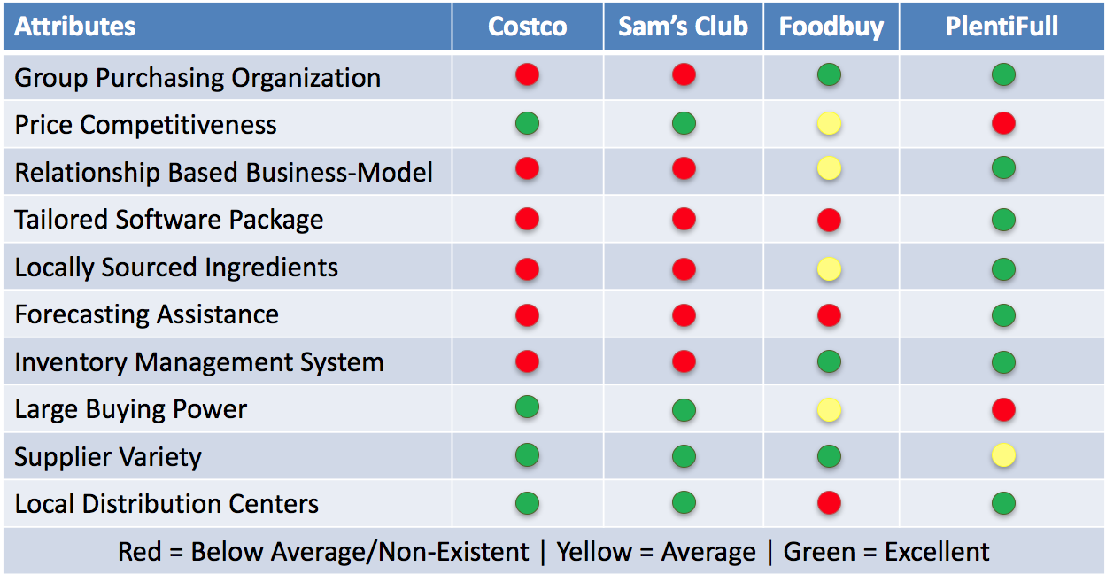

GO-TO-MARKET STRATEGY

Pricing
PlentiFull’s pricing strategy includes a membership fee of $45 per month and a 3% administrative transaction fee for each order. PlentiFull will be taking a premium pricing strategy in comparison to other competitors. The pricing will be broken down into one base price for each member.
This strategy will allow for the member restaurants and PlentiFull to add value without being overcharged. By charging a monthly fee this breaks up the costs into more manageable fees; however, the contracts will be signed annually. This will allow a continuity of members but it does not lock the members into any arrangements long term.
In terms of cancellation of services, the members will be expected to pay for their last month of membership, provide a 30 day notice, and also pay a prorated amount for any processed transactions. The members will have to give a 30-day notice if they plan to break the contract with PlentiFull and the monthly payments will be due at the first of every month with a five-day grace period. After the five day grace period, if the payment has not been turned in, the membership fee will increase 10% if the fee is not paid on time. If the member chooses to cancel their membership halfway through the month they will be expected to pay for their current month and a prorated amount until the 30 day time period is finished. In order to determine these payment terms, the Tennessee late rental fees laws were used as a reference to guide charges and time periods (Stewart, 2017).
PlentiFull will negotiate on behalf of the restaurant owners to have 2/10 net 14 day payment terms so the suppliers will be paid back in a timely manner. This will allow for both the suppliers to be paid consistently on-time promoting a more cooperative relationship, and it also allows for the simplicity in billing at the restaurant owners will be invoiced directly by the supplier, but this can be done through the PlentiFull software system. The payment terms were established based on the fact that orders will have to be placed regularly whether weekly or bi-weekly depending on the number of suppliers currently in use. By keeping the payment period low this will eliminate the build-up of unpaid orders and simplify the ordering process even further. The pricing structure will provide for an optimized billing system for all of the parties involved. The software system that is already being utilized for receiving and placing orders will be able to sync with the current accounting software that is in place, in addition, it will offer basic accounting processes with accounts payable and accounts receivables.

Promotional Plan
Before PlentiFull is able to become a business, the first promotional strategy that must be taken in order to be stable in the long-term is to create interest in the idea of a GPO for the locally owned restaurant chains. This starting marketing strategy will be going door to door within the target market and meeting with the different restaurant owners. This meeting it will be crucial to start building the relationships and working with the restaurant owners to drive innovation and to create value on both sides. In the initial relationship development stages, the process will be to establish meetings with owners, create an understanding of the business model of GPOs, and ultimately create buy-in from the restaurants.
After the official beginning of PlentiFull, the promotional strategy will slightly shift away from soliciting business to utilizing word of mouth, niche marketing, and drip marketing (Bueno et al., 2013). Word of mouth marketing will be done through the natural flow of information throughout the industry, but also by going out to the restaurants and meeting informally with the restaurant owners, similar to the strategy taken in the relationship development stages. Niche marketing will involve creating promotional material to be distributed via email and mail to the target restaurants. It explains what role PlentiFull can play in the restaurant's daily operations. Drip marketing includes periodically sending out information to the target market about successes, updated information, and news releases. An example of drip marketing includes sending positive press releases to target customers, sending testimonials of members to the restaurants and sending potential customers the upgrades when they happen to the software. These emails will be sent out one to two times a month depending on the growth of PlentiFull during that month.
The promotional strategy will be based on two main concepts: value-adding and relationship building. In order to express the relationship side of PlentiFull, the marketing will focus on the six-month trial period that will allow the restaurant's transition time and allow them to try the service as opposed to being locked in from the beginning. Marketing that will be focused on value-adding will not only explain the efficiency creators and also focus on the compensation at year end for the differences between actual cost savings and the membership fee. Both of these marketing strategies will promote growth in the long term.
Even after the initial growth stages, the marketing will continue to be exceptionally targeted toward the restaurant owners. Broad stroke marketing will not be utilized as a marketing strategy for PlentiFull. As stated in the market segmentation, the target market is selected based on three different criteria. The first criterion is based on the density of locally-owned restaurant. The second criterion is based on the geographic layout of the restaurants. Because these are two very specific qualifications to meet, the marketing will have to be much more targeted than general media promotion.

Distribution Plan
In order to purchase from PlentiFull, the software will be the crucial aspect of every transaction. The software can be purchased by working directly with the PlentiFull implementation team that will install and train the restaurant employees on how to use the software. Furthermore, the software will be cloud based so it can be accessed through several different channels including with a mobile phone and anywhere that has internet access. Cloud based software can be defined as, “The practice of storing regularly used computer data on multiple servers that can be accessed through the Internet,” (Merriam-Webster, 2017). Taking this definition into account, cloud based enables the software to be more integrated into daily operations and it does not require any new hardware. However, as already stated being cloud based allows for mobility of the product. This means that even if a restaurant works with IPads in their daily operations, an example restaurant who currently uses IPads in its daily operation is Tomato Head, they can still access the software at any point in order to stay up-to-date with what is happening in the restaurant. Due to initial scale, PlentiFull will not have any licenses, but this will be an opportunity moving forward. Figure 4 demonstrates the process of buying the entire PlentiFull system from initial interest to annual reviews.
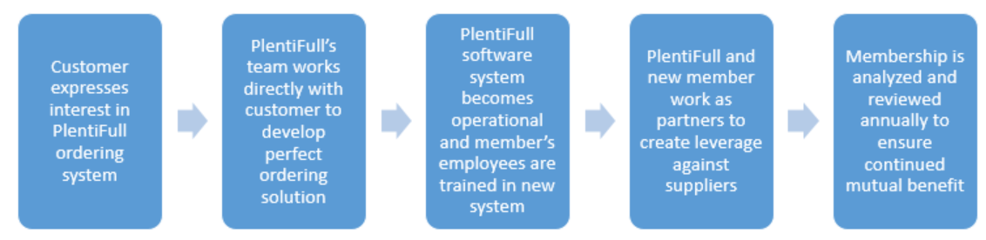
Figure 4- PlentiFull Distribution Plan

OPERATIONAL STRATEGY

Key Operational Process
In the growing stages of PlentiFull, much of the daily operations will be performed by the President and CEO. The operations include warehouse management, procurement, and sales and marketing. Roles that will be filled through the use of external consultants include the accounting and finance, software development, and legal.
Starting in the first month of the first year, PlentiFull will hire one full-time warehouse employee and one manager to run and operate the warehouse. This strategy has been taken in order to ensure that the products get delivered and processed through the PlentiFull warehouse in a timely manner, but also that the employees are efficiently using their time. At month 5, a part-time employee will be added to the warehouse operation in order to be trained and ultimately become full-time in the warehouse team at the beginning of the 7 months of the first year. In total at the end of the first year, the warehouse will employ three employees, two full-time and one manager.
In addition to the warehouse workers, at the beginning of month 7 in the first year, the first salaried employee will be hired to run the accounting and finance department. This role will be the first to be filled as handling the money and specifically the accounts payable in addition to the annual statements will be crucial to the first year’s success of the company. This role will be paid an annual salary of $58,000.
In the initial growth stages, as President and CEO, there will not be a salary until the company is able to break even and support an annual salary of approximately $55,000. This will be at the beginning of year 3. Thereafter, the salary of the President and CEO will be $55,000 until the company has grown to over $1,000,000 in profits annually.
The long-term strategy of PlentiFull will ultimately have six departments that will be under the PlentiFull organizational structure. The six departments will all contribute in their own way to the growth of the company. They will all play crucial roles in the early success of the company and eventually the long-term stability of the organization.

Software Development
The first department will be the software development team. Their primary purpose will be to continuously improve the software looking for bug fixes, new add-ons to make the software better and also adapting the software for the members as needed. As this department will be the backbone of PlentiFull, it is imperative that the software is continuously improving and as cyber-security is a huge factor in today’s society, the systems must be well-protected and well-maintained by the software development team. Furthermore, the software development team will be part of the implementation team that interacts with the customers during the initial setup and training phases.
Initially, the software development will be outsourced, but in year three the software development will be brought in-house with the hire of the first software developer. The salary for this role will be $69,000. This is slightly above the average salary of a starting applications engineer in Knoxville, Tennessee (SalaryExperts, 2017).

Procurement
The second department that will be crucial to the success of PlentiFull is the procurement department. As the entire PlentiFull business model is based on utilizing the best practices in terms of purchasing this department is both cutting edge and imperative to the success of PlentiFull. The purchasing department will eventually be broken up into two teams. The first team will work exclusively with the restaurant owners. This part of the team will work to ensure that demand is input in a timely manner, to receive approval for any changes that get made to the supplier and to ensure that the relationship between PlentiFull and the restaurant is in good standing. The second part of the team is responsible for actively pursuing new suppliers, qualifying them and maintaining the supplier quality and the optimal supplier relationship. Also, part of this team’s role will be to do continuous improvement projects with our suppliers to either develop the relationship, build capability or work toward further innovation between PlentiFull and the supplier. Both of the teams have crucial roles to play for the progress of PlentiFull.
In the first 5 years, this role will be filled by the President and CEO. After that, the first role to be filled will be a procurement specialist role. This role will be compensated at $55,000 a year the average starting salary of a supply chain professional coming out of the University of Tennessee.

Warehousing
The third department will be the warehousing team. This department is also a major part of the operations of PlentiFull because part of the company’s competitive advantage is based on localized warehouse operations. As a result, the warehousing department will be responsible for continuous improvement and follow the ideas of lean six sigma to eliminate waste. Furthermore, this department will be responsible for warehouse layout in order to best optimize the flow of goods in and out of the warehouse. The warehouse manager will also be responsible for ensuring a productive workforce as well as training the warehouse personnel in best practices and in the ways to look for poor quality.
This department will be led initially by the President and CEO, but ultimately will have its own salaried role within the organizational structure. This department will also be responsible for working with the supplier on quality issues. As they are the first line of defense in regards to quality control they will be in contact with the procurement team and the suppliers about any potential problems.
The warehouse employees will be compensated at $7.25 per hour and the warehouse manager will be compensated at $10 per hour. The salaries of the warehouse employees for the first 4 years is the greatest salaries and in total account for 34% of all operating expenses for the first 5 years. Figure 5 shows the breakdown of operating expenses for the first 5 years, including the amount the warehouse employee salaries will cost.
Figure 5- Operating Expense Breakdown for Five Years
Human Resources
Because of the prime location of Knoxville, TN the primary recruiting opportunity will be from the University of Tennessee. The procurement department and the warehousing department can be staffed with students graduating from the third best supply chain program in the nation. Furthermore, as East Tennessee does not have a shortage of hourly workers, this will be beneficial to filling the warehouse personnel. The human resource team and their roles in PlentiFull are imperative to the success of the company. As most millennials are looking at the company culture for job placement, establishing a positive culture full of learning and growth with a fast pace is this department's primary role in the early stages.
A unique addition to the PlentiFull human resource plan is the implementation of an internship program. This program will be extremely beneficial in the beginning stages of PlentiFull because it will allow the company access to young talent that can hold project-based roles without the cost of an annual salary. This will also help the company grow in reputation around the local area by targeting the younger students from the local university.
The human resource role will be filled after the first 5 years of growth. Because the company’s employee growth will be slow and deliberate in the beginning years the human resource role will not be as imperative until after the company has grown to its full potential. The internship program will begin in the sixth year as creating the connection to the University of Tennessee is a major step for further development for PlentiFull. Ultimately the human resource personnel will be compensated at $50,000 annually.

Finance and Accounting
As with any company, the true powerhouse of the organization is the accounting and finance department, especially in the early stages where trying to gain financial stability is crucial to the success of PlentiFull. The accounting and finance department will be looking for the best options to invest and ensuring that the accounts payable and receivables are constantly being managed. This will be a major task for the accounting department because PlentiFull will be working as an intermediary between the supplier and the restaurant owners so ensuring that bills are getting paid accurately and on-time not only maintains the stability of the company but also ensures that PlentiFull can continue to maintain a productive relationship with its suppliers.
Because this role is so crucial to the long-term success of the company, this role will be filled as soon as possible. Therefore, the role will be filled after the first six months of the first year of business. This role will be compensated at $58,000 annually. Since this role will not be filled until halfway through the first year, the salary will be prorated to the months worked.

Sales and Marketing
PlentiFull is a new company based around a not very common idea of GPOs in the restaurant business. In this case, the success of a GPO structure is completely dependent on a greater level of buy-in from the restaurant owners and from the employees. The Sales and Marketing Department will have one of the most challenging jobs in the company. Their task will be to generate interest in and create a need for such a company as PlentiFull. Furthermore, since the promotional plan will have to be targeted to one geographic area, this department will initially have a very hands-on role in the initial stages of the company. This means they will be meeting with potential clients as well as doing a “boots on the ground” approach that will allow for a more targeted marketing approach.
In addition, they will be responsible for maintaining a state-of-the-art marketing plan and maintaining the relationships that they have built with the customers. The Marketing and Sales team will work closely with the procurement team in terms of working to build a relationship with each individual restaurant owner. This role will be in charge of the website, creating advertising materials and ensuring the go-to-market strategy is accurately implemented.
Initially, this role will be filled by the President and CEO. This has two positive outcomes for the company. The first positive outcome is that it will help foster the relationships necessary for long-term growth. Furthermore, by having the founder recruiting the initial key partners, this will allow for the restaurant owners to start to build trust in both the leadership of the company and the business model of the company.
In the fifth year of operation, this role will be filled by a new hire into the company. In order to sustain growth, this role will be responsible for developing unique marketing plans for further growth and soliciting new members into the organization. This role will be compensated at $50,000 annually.
The different departments will provide both structure and support for the company in its early stages. Furthermore, by structuring in this way it will allow for growth internally and externally which will provide stability for the company. Figure 6 represents the long-term organizational growth chart for PlentiFull.

Figure 6- Long-Term Organizational Growth Chart
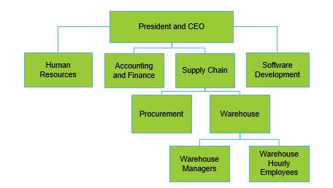
In addition to the internal organization of the company, PlentiFull will organize as a limited liability company in the state of Tennessee. By organizing in such a way it adds value because it reduces the financial exposure of the initial investors, easier operating procedures, and fewer restrictions on profit sharing (U.S. Small Business Administration, 2017).

Milestones
The first major hurdle will be gaining funding from different investment sources. This should be accomplished no later than a year and a half before the opening of the business. After receiving the necessary funding, the next step will be to contract out the software development. This process, according to SOLTECH will take between 6-9 months (SOLTECH, 2016).
Based on this information, the software should be completed 3 months before the software is introduced to the restaurants. Throughout the duration of the development of the software, the potential restaurants should be approached to generate interest. The contracts for the restaurants should be signed and finished a month before the software is deployed. In addition to developing the relationships with the restaurant owners, the software development stage should be used to generate interest in terms of the suppliers and begin to qualify them in order to ensure that they are capable of meeting the increased demand.
By having the supplier qualification process established and completed it will allow for the marketing and sales team to have a confirmed pipeline of ingredients which will not only simplify the process for ordering but it will also create an easier task for the Marketing and Sales department as they can ensure products for the potential new restaurant owners. One month to the deployment of the software, the warehouse contract should be established and the job opening for the warehouse employee and the warehouse manager roles posted onto different hiring websites such as monster and Indeed.com
After the deployment of the software, the first major target point will be to hire an additional warehouse employee and fill the accounting and finance role. This will be imperative to long-term growth and success and will be completed within the first six months of operations.
The next major milestone will be to double the number of customers involved in the organization. Having 25 members will provide both financial stability and be the point to which to expand outside of the initial target market. By expanding outside of the initial target market this will provide both an opportunity for greater growth, but it will also include new logistical challenges. PlentiFull should obtain approximately half of the target market (or 25 members) by the beginning of the third year. In addition to doubling the number of members, at the beginning of year 3, an in-house software developer will be added to the PlentiFull team.
The next major hurdle will be to start searching for the next market to expand into, outside of the greater Knoxville area. This includes working to start targeting the next major growth area and working to start building the relationships that are imperative to the success of PlentiFull. Figure 7 represents the projected growth of PlentiFull for the first five years of operation.
Figure 7- PlentiFull Growth Timeline
Year one of operations

FINANCIAL STRATEGY

Revenue Model
The revenue model will be based on two sources of income. The first source of income is from the monthly membership fees that each restaurant will pay. This fee will be a standard fee of $45 dollars per month. This monthly fee will be the primary source of income, but due to the initial promotional strategy of offering six months without the membership fee, this source of revenue will not be implemented until halfway through the first year.
The second source of income will be from the administrative fee of 3% on every transaction. This fee is the industry standard for group-purchasing organizations. Upon benchmarking the weekly costs for small restaurants, the weekly average cost of goods sold is $2,500 (Franchise Direct, 2016). Therefore, placing an order with that amount once a week will equate in profits for PlentiFull of $75 for each restaurant for each transaction. In addition, this creates fairness in terms of pricing for the different size restaurants. For the restaurants who are ordering more than once a week, they will provide increased revenue into the PlentiFull structure.
In addition to the revenue models, there are factors in play that limit the financial exposure of PlentiFull. This first important factor is that the inventory will not be held by PlentiFull. The structure of the receiving terms is that the supplier will own the product until it is delivered to the PlentiFull warehouse where the product will then change over to the restaurant owners. This eliminates the liability of PlentiFull and eliminates the financial exposure for holding the inventory (Berman et al., 2013). The second key factor is that the restaurants will be responsible for paying for transportation, however PlentiFull will be working diligently to utilize the total cubic feet on the trailers to ensure lower transportation costs and will have strategic relationships with key transportation providers (Holcomb et al., 2016).
The restaurants will be charged for the percent of the truck that their order takes up. This not only saves the restaurant money in transportation costs by consolidating the movement of goods into one load in conjunction with other restaurants. The cost of the transportation will be charged with the administrative fee of 3%. The final factor that reduces the financial exposure of PlentiFull is that the cost of goods sold is only the cost of creation and maintenance of the software. Therefore, it depreciates over time reducing the total cost for the company and increasing total profit over time. The revenue structure is exactly the same to the hospital GPO industry and therefore has been proven successful. Figure 7 demonstrates the different revenue sources for PlentiFull.
Figure 7- Revenue Structure of PlentiFull
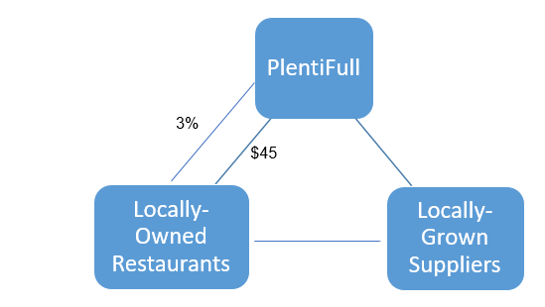

Financial Highlights
PlentiFull will have a positive net income after the first month of the second year. For the first two years, the administrative costs will equate to just under $200,000 and the annual memberships will equate to just over $10,000. In order to be profitable, the company must have 16 members within the organizational structure.
The largest expenses for the initial years are warehouse employees and full-time salaries. The second largest expense is the cost to lease the warehouse. As it is unreasonable to purchase a warehouse in the growth stages of PlentiFull this means that the company will have to lease. This incurs a large expense, but not as significant in comparison to the cost of buying an entire warehouse.
Another initial expense that plays a factor in the establishment of PlentiFull is the need for heavy initial investment in order to develop the software system that is imperative to the business model. This software is estimated to cost about $100,000. This is a major initial investment for the company and will consume a majority of the initial startup funds.

Income Statement
On the income statement, located in Appendix 3, three key figures are relevant to the long-term sustainment of PlentiFull. The key figure is that PlentiFull will have a net income in year 1 of -$82,483.38, a net income of $68,220.60, net income of $155,609.29 for year 3, $357,307.15 for year 4, and a net income of $409,660.73 for year 5. This shows a long-term sustainable growth for the company. These numbers were developed based on the GPO growth rate and the growth rate of the restaurant industry.
The second key figure to address on the net income is the cost of goods sold. This number was calculated by amortizing the cost of the software development over the number of members that are participating in the group-purchasing organization. Therefore, the cost of goods sold significantly decreases over the five years of financial statements.
The final key figure to address in the net income statement is that of the total operating expenses. As already addressed, salaries are by far the largest expense, but on the income statement, it demonstrates what a significant expense this will be. In order to keep PlentiFull financially viable, it will be imperative to keep operating expenses low.

Balance Sheet
On the balance sheet located in Appendix 4, it projects the growth of PlentiFull for the next five years. Some important figures to note are the growth in cash. As the restaurants continue to join the PlentiFull organizational structure, the cash flow will grow substantially over the course of five years. In the first year, one minor dip in cash flows is due to the hiring of the new accounting and finance role. As a result, the cash flows is slightly decreased for that month.
Another key figure to note is that accounts payable are consistently growing in value. This is anticipated to be true because as the company continues to grow the expenses that are incurred will also grow. An example of these expenses includes paying for the startup costs, office supplies and furniture, ads in journals, and other miscellaneous costs. PlentiFull will have more non-inventory accounts payable than inventory. They also will have no accounts receivable because PlentiFull will not own any of the inventory or directly purchase any of the product.

Statement of Cash Flows
On the statement of cash flows, located in Appendix 5, it demonstrates the different projected cash inflows and outflows for PlentiFull. The most important part of this statement is that profits will begin to be shared in the third month of the second year. At this point, the profit will be distributed among the initial investors. The amount of profit will be dependent on the amount of profit generated that period. For each period, 25% of the profits will be distributed to the investors until such time that they have been fully paid off. This is true except in the fifth year. After this time, there will be dividends paid which will be determined at a later point. In the fifth year, it is the largest growing year for PlentiFull with taking in more salaries for warehouse employees and filling in-house roles, the cash flows will slightly decrease.
Another important factor is that in the fifth year the initial investment should no longer be part of the cash flows. However, during the previous four years, this investment is still greatly part of the growth of PlentiFull. Depending on the speed in which the initial income from investors is spent, there may be a need to search for a bank loan in order to keep PlentiFull financially stable in terms of liquidity.

Funding Requirements/Use of Funds
In order to build PlentiFull, there will be a need to raise capital investment from different resources equally approximately $125,000. It will also be necessary to ask for an investment from another investor equal to $85,000 to be paid back in two years after the initial start of the company. The funds will be utilized in the beginning operations of the company. The funds from an angel investor will be utilized in hiring warehouse employees ($41,240), paying for rent for the first year ($35,424), building the marketing strategy ($6,000), and ultimately paying for a portion of the finance and accounting role’s salary (8% of first year accounting and finance salary). This level of investment will entitle a 40% stake in the company.
In conjunction the $125,000 this will pay for the software, leaving $25,000 of funds to be utilized in the start-up costs that are incurred by a new business. These expenses include the cost of creating a business in the state of Tennessee, the initial costs of creating bank accounts in the PlentiFull name and other beginning expenses. Once these initial expenses have been covered, the operating revenue that is generated will cover the cost of sustaining business in the long-term. As the $100,000 is an estimate from SOLTECH, it does include some room for error which can also be covered by the additional $25,000. In conclusion the $85,000 from an angel investor will be utilized to cover the operational expenses that will be incurred in the first years of doing business.

KEY LESSONS LEARNED
In summary, this opportunity to develop a business plan has helped me to think through many of the business processes. There are a number of key lessons learned as takeaways when I move into my career as a supply chain consultant.

- Developing and running a business from the ground up requires a diverse range of knowledge and a diverse range of skills. This became evident in developing the proposal as the entire plan could not be based around supply chain, despite it being the core competency of the company.

- In order to develop the business plan, a deep understanding of financial analysis and metrics was necessary to provide validity to the long-term stability of the potential company.

- A business proposal has to be encompassed in research and industry analysis. This involves doing extensive research through journals and articles as well as being able to interview the potential target customers.

- Determining a target market does not include simply stating the information but must be backed up by numbers and analysis of the emerging market.

- Understanding how to do a SWOT analysis provides clarity into who is the direct and indirect competitors of the potential new company. Often times the indirect competitors are the biggest threats to the potential new company.

APPENDIX 1
Complete Interview Responses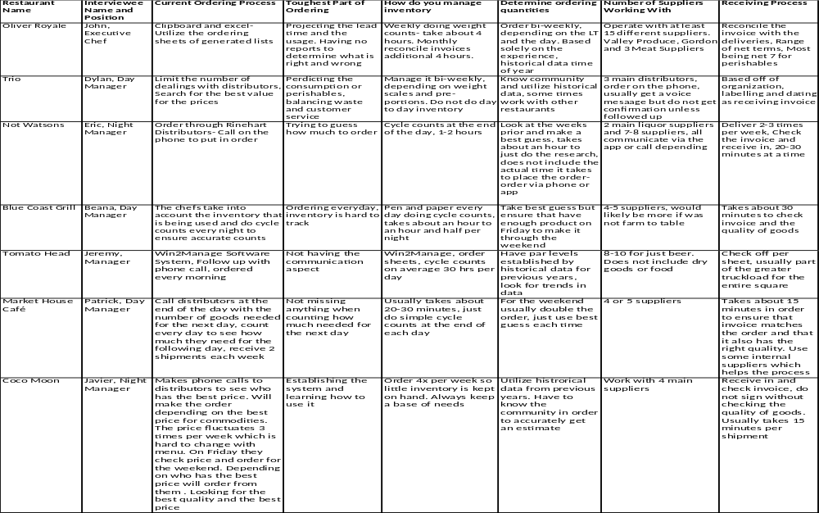

APPENDIX 2
Complete List of Restaurants in Target Market
Balter Beerworks | J. C. Holdway Café
Bistro at the Bijou | Knox Mason
Boyd's Jig & Reel Pub | Love Shack
Cafe 4 Market Square | Lunchbox Market and Cafe
Cairo Cafe - The Mirage of Knoxville | Mahogany's Restaurant
Chesapeake's | Market House Café
Chivo Taqueria | Not Watsons Kitchen & Bar
Clancy's Tavern and Whiskey House | Old City Java
Cocoa Moon Fresh Cuisine | Olibea
Coffee and Chocolate | Oliver Royale
Coolato Gellato | Oodles Uncorked
Crown & Goose Pub | Pete's Coffee Shop
Cru Bistro & Wine Bar | Preservation Pub
DaVinci's Pizza | Rankin Restaurant
Dazzo's Italian Castle | Sapphire's Restaurant
Downtown Grill & Brewery | Sassy Ann's
Duncan Café | Shuck Raw Bar & Ale
bi Sushi and Sake House | Soccer Taco
Empire Deli | Stock & Barrel
French Market Creperie | Tomato Head
Frussie's Deli | Trio Cafe on Market Square
Garrett's Downtown Deli | Urban Bar and Corner Cafe
Higher Grounds Inc. | Vassin Falafel Hut
Icon Restaurant & Lounge | Windows on the Park Restaurant

APPENDIX 3
Income Statements
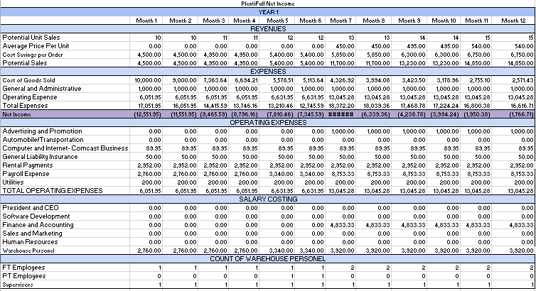

Assumptions
- Growth Rate of 4%
- Cost of Goods Sold equating to percentage of the software development and maintenance
- Payroll salaries based on averages from Knoxville, TN area
- Rental Payments based on Warehouse pricing on loopnet.com
- Internet based on Comcast business class online quote
- Utilities based on average for Knoxville, TN warehouse

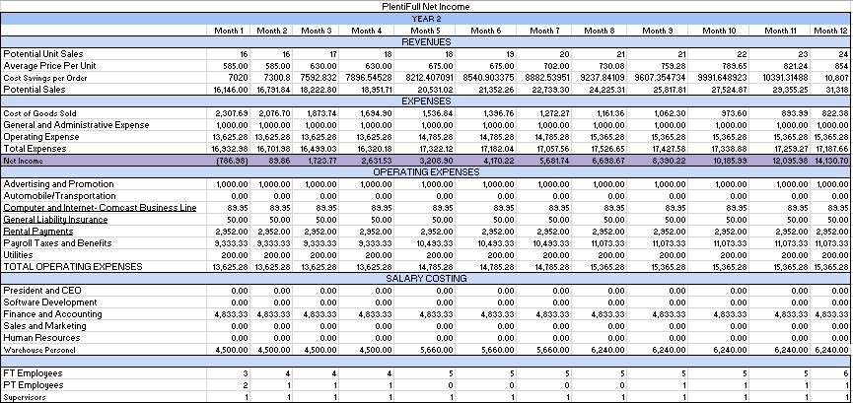

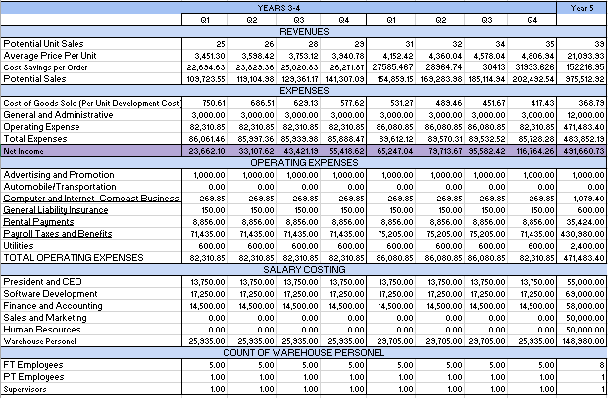

APPENDIX 4
Balance Sheets
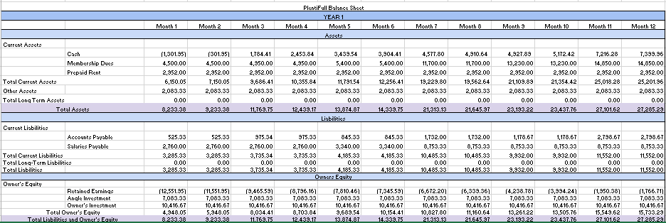

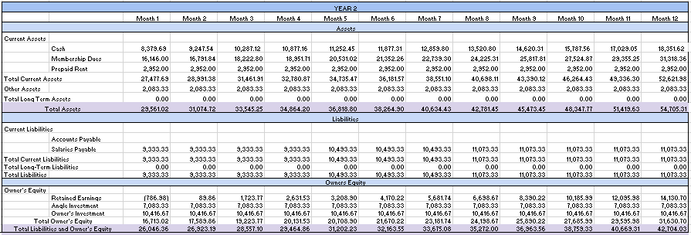
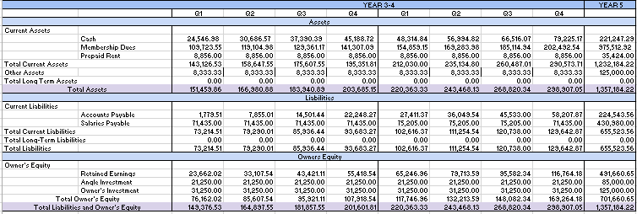

APPENDIX 5
Statement of Cash Flow
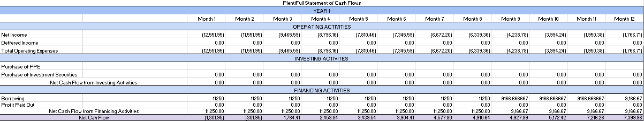
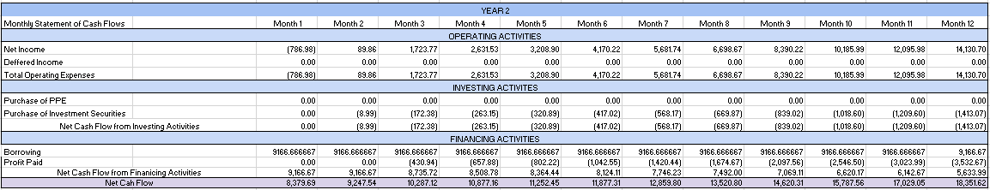

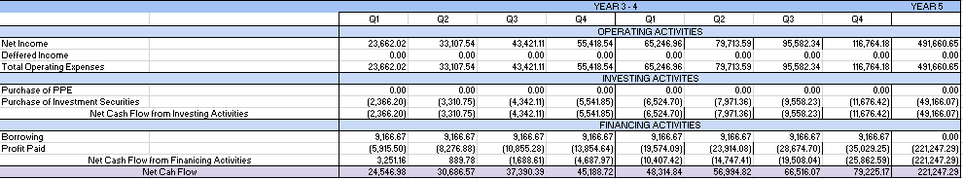

WORKS CITED

Alvarez, Andrew. "Single Location Full-Service Restaurants in the US." IBISWorld Industry Report (2017). Web. 16 Apr. 2017. <http://clients1.ibisworld.com/reports/us/industry/default
.aspx?entid=1678>.

Arora, Raj, and Joe Singer. "Customer Satisfaction and Value as Drivers of Business Success for Fine Dining Restaurants." Services Marketing Quarterly 28.1 (2006): 89-102. Print.

Barlow, Rick Dana. "GPO Inc. Demonstrates Heavy, but Precious Mettle: Group Purchasing's Evolutionary Roller-Coaster Ride Unlikely to Change." Healthcare Purchasing News 41.3 (2017): 10-12. Print.

Bueno, BJ, and Scott Jeffery. “52 Types of Marketing Strategies.” The Cult Branding Company, 10 Oct 2013. Web. 16 Apr. 2017. <http://cultbranding.com/ceo/52-types-of-marketing-strategies/>.

Curran, Jack. "Group Purchasing Organizations in the US." IBISWorld Industry Report (2016). Web. 16 Apr. 2017. <http://clients1.ibisworld.com/reports/us/industry/ataglance.aspx?entid=5963>.

Cohen, Anya. “Warehouse Clubs & Supercenters in the US.” IBISWorld Industry Report (2016). Web. 16 Apr. 2017. <http://clients1.ibisworld.com/reports/us/industry/default.aspx?entid=1092>.

Doucette, William R. "Influences on Member Commitment to Group Purchasing Organizations." Journal of Business Research 40.3 (1997): 183-89. Print.

East Tennessee Dining. “Knoxville Metro Restaurant Listing.” Knoxville Dining at a Glance (2017). Web. 16 Apr. 2017. <http://www.easttennesseedining.com/kreview.htm>.

Franchise Direct. "Subway Franchise Cost & Fee, Subway FDD & Franchise Information." Franchise Direct, 2016. Web. 20 Apr. 2017. <http://www.franchisedirect.com/directory/subway/ufoc/915/>.

Holcomb, Mary C., and Karl B. Manrodt. "25th Annual Masters of Logistics." Logistics Management. Council of Supply Chain Management Professionals, 21 Sept. 2016. Web. 16 Apr. 2017. <http://www.logisticsmgmt.com/article/25th_annual_masters_of_logistics>.

National Restaurant Association. "Looking for 2016's Top Food Trends? Yep, Sustainability!" National Restaurant Association (2015). Web. 16 Apr. 2017. <http://www.restaurant.org/News-Research/News/sustainable-food-trends-in-2016>.

Merriam-Webster. “Cloud Computing.” Merriam-Webster (2017). Web. 16 Apr. 2017. <https://merriam-webster.com/dictionary/cloud%20computing>.

PeachWorks. "The Complete Restaurant Management Platform." PeachWorks: Restaurant Management Software (2017). Web. 16 Apr. 2017. <https://peachworks.com/>.

SalaryExperts. “Applications Engineer Salary in Knoxville, TN.” Economic Research Institute (2017). Web. 16 Apr. 2017. <https://www.salaryexpert.com/salary/job/applications-engineer/united-states/tennessee/knoxville>.

SOLTECH. "How Much Does Custom Software Cost?" SOLTECH (2016). Web. 16 Apr. 2017. <http://soltech.net/how-much-does-custom-software-cost/>.

Stewart, Marcia. "Tennessee Late Fees, Termination for Nonpayment of Rent, and Other Rent Rules." NOLO (2017). Web. 16 Apr. 2017. <http://www.nolo.com/legal-encyclopedia/tennessee-late-fees-termination-nonpayment-rent-other-rent-rules.html>.

Tate, Wendy, et al. Purchasing & Supply Management. Ed. MyEducator. 1 ed. Vol. 1. Utah: MyEducator, 2016. Print.

Twain, Bob. "What Every Retailer Should Know About Integrating POS & Accounting Software Systems." Point of Sale Software Buyers Guide (2015). Web. 16 Apr. 2017. <http://www.possoftwareguide.com/articles/pos-accounting-integration.html>.

U.S. Small Business Administration. “Limited Liability Company.” U.S Small Business Administration (2017). Web. 17 Apr. 2017. <https://www.sba.gov/starting-business/choose-your-business-structure/limited-liability-company >.

