Bluegrass: a Voicing

A Thesis Presented for the
Master of Music
Degree
The University of Tennessee, Knoxville

Cade Botts
August 2023

Abstract

In 2010, Fred Bartenstein detailed the voice stackings found in bluegrass in his article “Bluegrass Voicings.” This thesis will go beyond Bartenstein’s discussion of the arrangement of voices to an examination of the harmonic voicing styles found in bluegrass music. Stamps-Baxter’s 1937 arrangement of “Farther Along” and transcriptions of recordings of versions of this song by bluegrass legends Bill Monroe, Stanley Brothers, Reno & Smiley, the Osborne Brothers, Dolly Parton, and the Grascals will be used as a case study to look at multiple chord voicings. Based on the analyses of these transcriptions, a list of “voice-leading conventions” for bluegrass compositions will be presented.

Table of Contents
Introduction…..…………………………………………….……..1
Section 1: Bluegrass………………………………………………2
Section 2: “Farther Along” (Stamps-Baxter, 1937)………………10
Section 3: Analysis of “Further Along”…………………………. 12
Section 4: Case Study of Bluegrass covers of “Farther Along”….16
Conclusion………………………………………………..………44
Bibliography………………...……………………………………47
Appendices………………………………..………………..……50
Appendix A……………………………………….………51
Appendix B………………………………...……………..53
Vita……………………………………………………………..59

List of Figures
Figure 1…………………………………………………………… 14
Figure 2…………………………………………………………… 15
Figure 3 …….……………………………………………………. 19
Figure 4………………………………………………………….. 21
Figure 5 ………………………………………………………… 25
Figure 6 ……………………………………………………….…. 25
Figure 7………………………………………………………..…. 27
Figure 8………………………………………………………..…. 29
Figure 9……………………………………………………….…. 31
Figure 10…………………………………………………………. 34
Figure 11…………………………………………………………. 37
Figure 12…………………………………………………………. 37
Figure 13…………………………………………………………. 38
Figure 14…………………………………………………………. 40
Figure 15…………………………………………………………. 40
Figure 16…………………………………………………………. 42
Figure 17…………………………………………………………. 45

Introduction
Bluegrass music has been described as music that places voices “high in pitch and lonesome in sound” as they wail about the sorrows of the mountains and their people. But high and lonesome are not the only qualities that give bluegrass its unique sound. Stylistic preferences in the vertical arrangement of the voices, voice-leading tendencies, and a nasal timbre also set it apart from other genres. In his 1984 book Bluegrass Breakdown, Robert Cantwell says that “in the future, bluegrass is certain to develop, maybe in the study of composition.” Even though his book was published almost 40 years ago, Cantwell’s prediction has yet to be fulfilled; there has been little scholarly and theoretical analysis conducted on the genre of bluegrass music. This paper aims to fulfill Cantwell’s prediction through the analysis of some bluegrass music and the creation of a list of “rules” of stylistic tendencies of bluegrass for application in composition, theoretical study, and the advancement of scholarly discourse of bluegrass as a genre. This research will include, as a case study, the analysis of the church hymn “Farther Along” and several transcriptions of bluegrass arrangements of the tune. By limiting the analysis to only one song, this paper provides a concise study of how a tune can be rearranged and reinterpreted by multiple and diverse bluegrass artists. “Farther Along” has been recorded by many bluegrass legends, and a comparison of notable artists within the genre demonstrates general patterns and artistic differences that can become part of the bluegrass composition/arranger’s toolbox. The Stamps-Baxter’s 1937 hymn arrangement, which originally popularized the tune with numerous appearances in church hymnals, will be used as the basis for comparison with its bluegrass interpretations. This case study serves a starting point for future analysis of bluegrass music.
Section 1: Bluegrass
Bluegrass is usually categorized as its own genre of music, but it is technically a subgenre of country music created by Bill Monroe and named after his famous band, Bill Monroe & his Bluegrass Boys. For the sake of simplicity and consistency, I will utilize Murphy Henry’s definition of bluegrass music as music played by groups featuring “the five-string banjo played in the three-finger Scruggs style.” Although the origin of bluegrass music is heavily debated, many historians cite 1945 as the beginning of bluegrass since this year is when Earl Scruggs joined the band. His hard driving rhythms and roll patterns along with the high lonesome sound of Bill Monroe came together at this time to create the classic bluegrass sound that persists today.
Alan Lomax, folklorist and American ethnomusicologist, described bluegrass music as “folk music in overdrive.” Bluegrass music, for the most part, does have a comparatively faster tempo than its related counterparts, e.g., folk, gospel (hymnal), and old-time music. However, there are bluegrass songs that have a slower pulse, as well as some that are faster than folk and old-time tunes, but, in general, a lot of bluegrass songs are fast. A range of tempos can be seen in this study as some of the renditions of “Farther Along” are relatively slow, while some are much faster. Bluegrass music is also associated with the term “drive” which is different from Lomax’s term overdrive that says the music is going fast; there is more to drive than tempo. The term drive tries to explain why bluegrass music feels the way it does. Although a discussion of drive is out of the realm of this paper, it should be noted that bluegrass music’s drive involves multiple layers of rhythms produced by the entire ensemble, conflicting against each other. It is inaccurate to solely credit the speed in which the music is played as the reason for drive.
The staple instrumentation in bluegrass groups includes acoustic instruments, such as the five-string banjo, guitar, mandolin, fiddle, and bass, in addition to vocals. The bass is an exception to the rule of acoustic instruments. An electric bass, adjusted to fit within a predominantly acoustic setting, is sometimes used. Other supplementary instruments may include the dobro (accepted as a standard instrument in bluegrass but featured less often), autoharp, mountain dulcimer, hammered dulcimer, harmonica, and accordion. The vocals in bluegrass involve one to three vocalists, with up to four to five singers on occasion, singing as high as possible in their register. This usually results in the singers moving to their falsetto range and mixed voices with tones reaching well above middle C.
There are different arraignments of voices that occur in bluegrass music. Wayne Erbsen explains that, in the standard trio, the tenor part sings a third or fifth above the lead and the baritone sings a third under the lead. In the high lead trio, Erbsen mentions that the baritone in the high lead trio will sing a third above the tenor, which is also above the melody. Fred Bartenstein also expounds on the stacking of voices found within bluegrass, the most popular being the standard trio arrangement. In bluegrass music, the tenor and baritone parts do not refer to the vocal range; instead, the tenor line refers to “the part that has the melodic structure of a typical, just-above-the-melody tenor harmony.” It does not matter if the tenor line is sung above or below the melody; as long as it has the line a tenor part would sing (a third above the lead), it is referred to as the tenor. For example, if the tenor line is sung below the lead, then it is called a low tenor, likewise, if the baritone part is sung above the lead, it is called a high baritone.
There are three common arrangements of the bluegrass trios (Table 1): (1) The standard trio, as mentioned above, which was pioneered by Bill Monroe and has the lead singing the melody in the middle, a tenor line above, and a baritone line below. Monroe’s voicing style is inspired by the shape-note singing tendencies of The Sacred Harp which placed the lead or melody in the tenor line (singable by other parts) with soprano (traditionally called treble) and alto lines placed above it. (2) The high baritone trio voicing, a popular arrangement by the Stanley Brothers, features the lead in the lowest voice with a tenor and a high baritone part above the lead and mirrors the shape-note style more closely than Bill Monroe’s voicing. The high baritone part is an octave higher than the baritone part and will be above the tenor. (3) The high lead trio stacking, popularized by the Osborne Brothers (plus Red Allen), resembles the common European-Western style of having the lead/melody on top harmonized by two lower voices – the
baritone and a “low tenor” part, which is the tenor an octave lower. This trio is also known as a “pile-on.”
In Industrial Strength Bluegrass, Larry Nager explains the story of how the high lead trio voicing was discovered. In Nager’s chapter, the testimonies of Red Allen and Bobby Osborne
Table 1: Fred Bartenstein’s chart of bluegrass trio voicings.

 | Standard Trio | High Baritone Trio | High Lead Trio
Highest: | Tenor | High Baritone | Lead (Melody)
Middle: | Lead (Melody) | Tenor | Baritone
Lowest | Baritone | Lead (Melody) | Low Tenor

prove that there are rules to bluegrass harmony. While practicing their song “Once More,” Bobby Osborne is quoted as saying, “We tried regular three-part harmony: tenor on top, lead in the middle, and baritone underneath.” He then said that the group was not happy with this configuration of voicing, but they kept using it anyway. One night, while rehearsing in the car, they began to sing “Once More” with the standard trio voicing. Bobby Osborne sung the lead while Sonny Osborne sang tenor, but Red Allen was intoxicated and didn’t feel like singing the tenor part above Bobby Osborne’s lead. Instead, Allen sang the tenor part an octave lower. Though by accident, they had rediscovered the Western convention of the lead in the top voice. When they recorded the song, Wesley Rose, their recording engineer, stated, “If I let you do that, you’ll probably lose your recording contract, MGM’s got you signed up to do bluegrass and that ain’t bluegrass.” Despite the stereotype that bluegrass does not change, there are new sounds that make their way into bluegrass that become defining characteristics of the genre, such as the Osborne Brother’s voicing choice. This story proves that there are unspoken rules to bluegrass and the community is well aware that they exist, and that it may be possible to add to these conventions.
Because most of the chords used in bluegrass are three note triads and the tenor and baritone voices sing intervals a third away from the lead, it is implied that the voices will, for the most part, fill out the triad. Cantwell corroborates this idea by stating, the “voices are expected to fill in each note of the triad, though anticipations, passing tones, and ornamental slides often create dissonances that ‘dispel the predictable homophony’ of school or church singing.” Cantwell’s statement adds non-chord tones that create dissonances and colorful inflections that resolve to complete triads. However, Fred Bartenstein states, “Conversely, part-doubling, i.e., two members singing the same note, or the singing of non-triad tones can result in trio harmony that sounds empty, undesirable, and/or dissonant.” From these quotes, we would expect to see complete triads without doublings, while Cantwell’s and Bartenstein’s conflicting statements raises the question on whether non-chord tones are acceptable or not in bluegrass harmonies.
Bluegrass has commonly been associated with the term “close harmony” (i.e., voicings where the notes of the chord are as close to each other as possible without being in unison) and smoothly blended voices. Cantwell explains that bluegrass voicing is not always as close as it could be nor is it necessarily trying to blend all the voices together. He elaborates by stating that the close voices with an already high lead and an even higher tenor harmony highlight the dissonances between the vocals and do not necessarily achieve blending. “The chilling and sometimes eerie beauties of bluegrass harmony singing, too, are wrought with high energies and powerful tensions. Bluegrass harmonies are not choral; bluegrass harmony seeks to oppose, not to join voices, not to blend but to fuse them.” When Cantwell states that “bluegrass harmonies are not choral,” he is most likely referring to bluegrass not following choral voice-leading tendencies and proper vocal techniques. Fusing of voices is mentioned by Erbsen who says that the bluegrass blending of voices as exemplified by the Blue Sky Boys creates “voices blended so completely, it’s often hard to tell which of the brothers is singing the lead and which is singing the harmony;” the voices here can be said to be fused into one sound. Blending is achieved through the combination of tone quality, balance (relative volume of the parts to not overpower each other), and diction, but the voices can still have contrapuntal motion that helps retain their individuality. According to several bluegrass musicians, blending is a very important factor in bluegrass, but what Cantwell is claiming is that bluegrass goes beyond blending to fuse the three voices into one voice. Erbsen believed that it was the blend between the Blue Sky Boys that made it hard to decipher who was singing which part, but it is really the voice lines being so close and lacking individuality that makes it difficult to interpret the voice parts; this is the fusion effect that Cantwell is describing. It seems that blending has become a catch-all term to explain why bluegrass voicing is uniformly one voice, but blending may not be the best term for this sound. Even if voices are blended well, the vocal lines may still be decipherable as individual voices. Cantwell’s term fusing is a more accurate depiction of bluegrass singing because it describes the complete lack of individuality among the voices, making them sound as one. In fact, when transcribing the arrangements for this case study, the fusing of voices made it difficult to decipher one part from another, supporting Cantwell’s claim. Bluegrass voicing has all parts singing in a way that creates one individual voice. Blending is simply another way to help increase this effect.
Cantwell also mentions that “powerful tensions” can occur between the voices. Peter Rowan, who sang with Bill Monroe, reflects on these tensions: “when you get those two notes vibrating together, there’s often a strange overtone… almost a buzz rather than a note.” Erbsen corroborates these claims stating that bluegrass vocalists place their lead at the top of their vocal ranges and that tessitura, coupled with the “tight vocal chords,” gives bluegrass its strident tone. He says, “When you add a high tenor voice to an already high lead, what you get is an intensity found only in bluegrass.” This intensity may also be from a combination of both Erbsen’s explanation and Cantwell’s description of bluegrass voices seeking to fuse together into one sound. The fusing that is present in bluegrass is from the musicians trying to get the best quality of sound, not from the actual voicing. The voices are on the brink of colliding with each another, with the voices as close as possible without being in unison. In traditional voice leading, dissonances are usually met and resolved by voices in contrary motion; however, in bluegrass, the voices use similar motion. The dissonances that arise are an exemplification of the friction between voices as they try to merge with one another.
Based on what others have written about bluegrass, we can expect to see certain characteristics and trends in most bluegrass music, including the piece used in this research, “Farther Along.” Common instrumentation and fast tempos are expected. Voice stackings could vary between artists. The most prevalent features expected are the high vocal ranges and close harmony. In addition, because most songs are sung by a trio, it will be impossible to have the chords in root position if the root of the chord is in the melody and the melody is not the lowest voice. The texture is also predicted to be homophonic/homorhythmic with a few instances of polyphony. Lastly, to achieve fusion, there will be most likely be parallel or similar motion throughout, incidences of voice crossing, and repeated notes and intervals.

Section 2: “Farther Along” (Stamps-Baxter, 1937)
To create the most accurate representation of bluegrass stylistic tendencies, transcription of pieces is necessary since there are very few scores of bluegrass performances. Transcriptions can be analyzed to find patterns within the music and to help explain why the genre has the distinctive sound that it does. It is also important to compare the transcriptions with the original version of the piece (in this case, the original hymn) to determine the impact the hymn and shape-note singing may have had on the music that influenced bluegrass’ style. For this case study, the church hymn “Farther Along” was chosen because it has been recorded a plethora of times by bluegrass and country artists alike and has a long tradition within both genres. Charlie Monroe & His Boys (Charlie is Bill Monroe’s brother) recorded the song in 1938 for their album The Early Years. Charlie Monroe also sang the song in a quartet (even though only Charlie and Bill Calhoun are credited for the vocals). “Farther Along” was also the first song to be sung by a quartet at the Grand Ole Opry, by none other than Bill Monroe’s band in 1939; Monroe said “Farther Along” was “The first quartet I sang on the Grand Ole Opry- back in them [sic] days I sang a high lead with a tenor under it [name not mentioned] and Tommy Magnus sang a baritone and Cleo Davis sang bass.” The hymn is written in four voices and its earliest recordings and performances are also a quartet, which contrasts to how bluegrass groups traditionally sing many of their tunes.
The earliest written version of the hymn “Farther Along” is found in the 1911 hymnal Select Hymns for Christian Worship and General Gospel Service under its original title, “Further Along.” In this version, only the lyrics were printed. The hymn was marked as arranged by “B.E.W.,” Barney E. Warren, one of the editors of the hymnal. The most common musical arrangement, featured in a multitude of hymnals, is the 1937 Stamps-Baxter arrangement of the song; Virgil Stamps and J.R. Baxter Jr. were business partners that established the Stamps-Baxter Music Company, a publishing company, together. After hearing their song on the radio, another composer, W.B. Stephens, contacted the Stamps-Baxter Music Company claiming to be the sole author of the hymn; and his name has been included as the author in every publication of this arrangement by Stamps-Baxter since. Besides Stephens, other songwriters have come forward claiming to be the composer of this song. W.A. Fletcher claims that he wrote the song and sold the lyrics to J.R. Baxter, Jr. (partner in Stamps-Baxter) who sat next to him on a train ride. W.E. Lindsay is credited for writing the words and melody as published in Eureka Sacred Carols (1921), a version that has a place for copyright but no date. W.P. Jay also claims authorship; his version was spread by the folk music magazine Sing Out!, which attributes him for the adapted words and music. “Farther Along” also appears in the 2010 edition of Christian Harmony with a copyright date of 1911 and credits W.B. Stevens as the composer and J.R Baxter Jr. as the sole arranger (Appendix A.2). We may never know who actually composed the song, but we do know that it is an extremely popular hymn and a staple in bluegrass music.

Section 3: Analysis of “Further Along”
The analysis of “Farther Along” will begin with a look at the Stamps-Baxter’s version of the song (see Figure 1 and Appendix A.1 ). Noting the similarities and differences between the hymn and bluegrass versions of the song will enlighten us as to how hymns have influenced bluegrass and provide a better understanding of the history and progression of how bluegrass came to be. The hymn arrangement, written in traditional SATB voicing, has a common bluegrass chord progression, I-IV-I-V/V-V-I-IV-I-V-I. The feature that is most prevalent in this hymn is the lack of contrary motion between the bass and other voices. The bass is static, with the chords remaining in root position throughout; the only motion is the bass’s jump to the root of the next chord whenever the chord changes and its “walk” down to the V in measures 3 and 11 (Figure 1). The only contrary motion occurs between the soprano and tenor voices in measures 2 to 3 (Figure 2). The soprano (the melody) is the most active line with only two instances of repeated tones, with the rest of the voices moving in similar or parallel motion to the melody.
Close harmony is found in “Farther Along.” For example, measures 2-3 (see Figure 2) are the only time that the harmonies are in an open position, while the rest of the tune is in a closed position. Close harmony is a defining characteristic of bluegrass and is present throughout all the transcriptions of this case study. This shows the shift between standard part writing and southern tradition. Western music may use both open and closed spacing, but in Southern hymns, open spacing is rarely used, which is how the term close harmony was coined.
There is an emphasis on similar motion in both the hymn and bluegrass versions of the tune. Classical music voice-leading rules call for independence in the voices, created by the use of contrary or oblique motion. However, this tune uses an extensive amount of similar and parallel motion between the upper three voices, with the only instance of contrary motion being in measures 2-3 (see Figure 2). There are moments where all the voices leap at the same time and in the same direction. For example, in measure 2 from beat 2 to beat 3 there is a change of voicing that has all the voices moving by leap in the same direction, which is against classical part writing rules. The lack of individuality between the voices through the lack of contrapuntal motion and the extensive use of similar motion, along with the trend of close harmony, show how southern gospel music is separate from other genres (i.e., classical music). These traits are also found throughout this case study, and examining these characteristics highlight how southern gospel has influenced the genre of bluegrass.

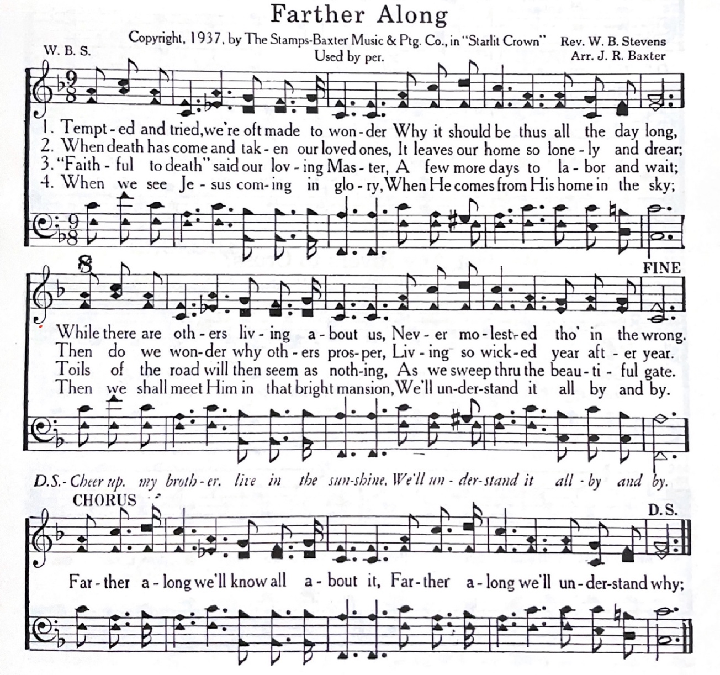
Figure 1: Stamps-Baxter’s arrangement of “Farther Along.”

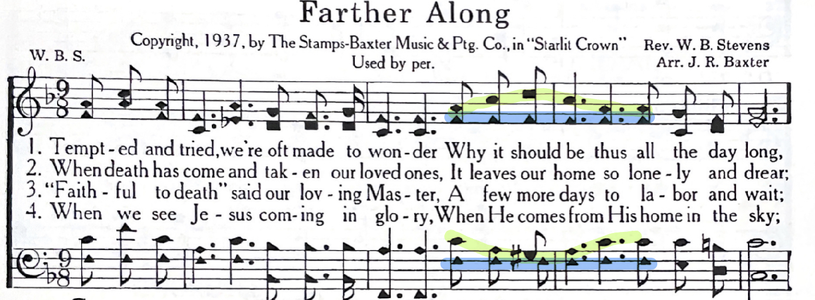

Figure 2: Soprano and tenor line in contrary motion while the alto and bass move in oblique motion, mm 2-3 of “Farther Along,” Stamps-Baxter’s version arrangement.

Section 4: Case Study of Bluegrass Covers of “Farther Along”
Now that we have looked at the original hymn, we can compare that with the various bluegrass versions of “Farther Along.” Six arrangements of this tune have been transcribed: four trios, one solo, and one duet by a range of artists. The four trios of “Farther Along” are by Reno & Smiley (1975), Stanley Brothers (1972), Dolly Parton/Emmylou Harris/Linda Ronstadt (called Trio in this paper) (1987), and the Grascals (2008). The other two versions are by soloist Bill Monroe (1964) and the duet Osborn Brothers (1994). (See Appendixes B.1-B.6 for the transcriptions of these recordings.) I chose these versions specifically for their impact on bluegrass, variety of performance practices, and diversity of gender. Bill Monroe, the Stanley Brothers, and Reno & Smiley are all first-generation bluegrass musicians, which provides a beginning for this study. The Osborne Brothers are part of the second generation of bluegrass performers, influenced by those before them. I also wanted to discover if female voices incorporate the same ideas as their male counterparts thus, I included Trio – group of accomplished female country artists with influences in the bluegrass genre. Lastly, I studied the Grascals, a fifth generation group based on Bartenstein’s work, as I wanted to include a recent band to determine if bluegrass patterns are still changing.
The audio of the versions of “Farther Along” used in this case study are as follows:
- Bill Monroe - https://youtu.be/EaBzj5WkK5w?t=1505
- Osborne Brothers - https://youtu.be/Aw54-w1nefQ
- Stanley Brothers - https://youtu.be/Sbyakb1mbOE
- Reno & Smiley - https://youtu.be/2fPXQugtb28?t=999
- Trio - https://youtu.be/w9H3qPqJ3uI
- Grascals - https://youtu.be/iP2toIdnu5k
Overall, the analysis of the transcriptions reveals common characteristics and slight differences between each version and the original hymn. The melodies of each rendition are slightly different with unique stylistic melismas. Fusion is achieved in each version through the extensive use of similar and parallel motion and close harmony is present in all of the versions. Some of the chords themselves are ambiguous; there are incomplete and inverted triads that contain non-chord tones that briefly imply several possible harmonies. These implied harmonies are linear and non-functional and are used to smooth out the voice lines. For instance, there are linear chords that are used for passing and neighbor motion, and if they do have a vertical function, it is purely coincidental. Lastly, there is one prominent reharmonization (changing the I chord to a vi chord in beat two of measure 7) that occurs in half of the versions which has become traditional, not only in “Further Along,” but in other songs as well, such as “I’ll Fly Away.”
Many conventions of the transcriptions can be deemed “rules of writing in a bluegrass style” which written out below and discussed in light of the transcriptions of “Farther Along.” These “rules” can be applied to composition or arrangements of tunes specifically for bluegrass voice arrangements (not including the instruments that are accompanying the voices). These rules are described as follows:

- The melody should be changed in some way from the original but must still remain recognizable to the original.
The melodies in each of the performer’s renditions of “Farther Along” are different from
the original Stamps-Baxter arrangement while keeping the song recognizable. The musicians all add their own style and interpretation of the melody by adding melismas, scooping (sliding into a note), and other ornamentations that alters the rhythms of the melody, as well as changing the intervals between notes of the melody that alter the contour of lines. Figure 3 shows Bill Monroe’s version of the tune (originally in the key of C, but transposed to the key of F for easier comparison to the original melody) and the melody of the Stamps-Baxter version. It should be noted that the transcription of Monroe’s version of the melody does not include every melismatic
alteration because it is impossible to fully capture every aspect of an aural performance with notation. Additionally, it is easier to compare and study these versions of the song while still staying true to their performance if the ornamentations are not present. However, melismas are highly recommended in performance because they are part of the bluegrass style. When, where, and how many melismas to incorporate are stylistic choices of the performer. All transcriptions are treated the same, but grace notes are included if they recurred on a regular basis.
Changes to the melody can be found in each measure of the excerpt seen in Figure 3. These changes are small. In measure 1, instead of a G4-F4-G4 motion on beat 3, there is a G4-F4-D4 motion leading to a change of the first note in the second measure – which does not change the underlying harmony of either measure. Other changes are similar: a neighbor motion on beat 3 of measure 2 is deleted, a scoop from the A4 to a F4 on beat 2 of measure 3 is added, and the motion on last beat of that measure is inverted. None of these changes make the melody unidentifiable or change the harmony of these measures.

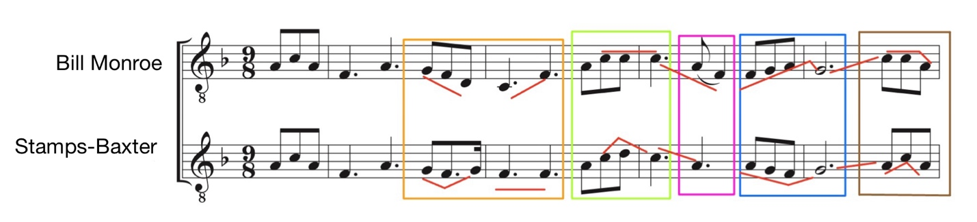

Figure 3: Bill Monroe’s and Stamps-Baxter’s melody lines of “Farther Along.”

Bill Monroe is not the only person who alters their melody. Every artist changed their melody in some way. Figure 4 shows the first 4 measures of other artists’ transcriptions with small but clear differences between them, most on beats 1 and 3 of the measure. Based on this study, it is standard that bluegrass artists do not copy melody lines exactly. Future research of other bluegrass standards will most likely result in traits that are considered traditional and/or unspoken requirement(s) for an arrangement of certain tunes.

- A bluegrass arrangement for three voices will use a voice stacking of one of the following three types (see Figure 1):
  - The Standard Trio – From top to bottom: tenor, lead (melody), and baritone
  - The High Baritone Trio - From top to bottom: high baritone, lead, and tenor
  - The High Lead Trio - From top to bottom: high lead, baritone, and low tenor
A duet will have the lead in the bottom voice with a harmony above.
Of the four trios that were transcribed for this study, three of them (Stanley Brothers, Reno & Smiley, and Trio) were arranged in the standard trio voicing popularized by Bill Monroe: the melody/lead in the middle voice, tenor on top, and baritone below. Though this study had a small sampling, it illustrates that this voicing, popularized by Bill Monroe, is the most common voicing found in the genre of bluegrass. The Grascals stood out by being the only arrangement that utilized the high baritone trio with the lead in the bottom voice (Appendix B.6). After listening to a multitude of arrangements for “Farther Along,” I have yet to find a bluegrass version that sings an arrangement of this tune with high lead trio.
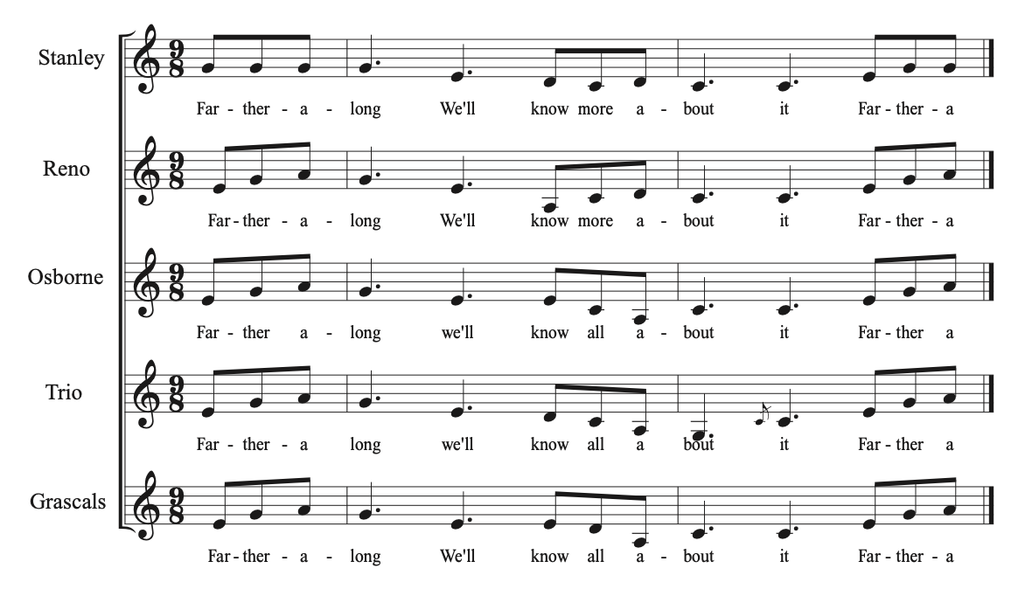
Figure 4: The melody lines of all artists transposed to the key of C major.

The Stamps-Baxter arrangement has the lead in the top voice, but their version, found in Christian Harmony, has the melody in the tenor voice with the alto and soprano (treble) above and the bass below (Appendix A.2). Due to shape-note singing’s influence on bluegrass and its impact on Bill Monroe, the creator of the genre, I believe that having harmonies above the lead may be another traditional aspect of this song.
In voicing a duet, the lead should be the bottom voice with the harmony in the tenor above it. In this case study, the Osborne Brothers’ duet rendition of this tune has the lead in the bottom and the tenor harmonizing above. Bartenstein claims, “Ninety-nine percent of all bluegrass duets are arranged in the lead-low/tenor-high style.” Bartenstein also states that there are a few exceptions to this rule when the melody is passed between the vocal lines, when the harmony will pass from above the melody to below the melody, and when a female singer has the melody with the male tenor singing in a lower octave.

- Close spacing of the chords is used throughout to create close and/or tight harmonies. Close spacing means the largest space between the bottom and top voice is an octave. Duets consistently have the tenor harmony a 6th above the lead instead of the closer interval of the 3rd.
Bluegrass, along with other southern genres, is associated with “close harmony.” In his book Close Harmony, James R. Goff Jr. portrays closely spaced harmonies as “tight.” Erbsen also described bluegrass as having “tight vocal chords.” The Stamps-Baxter arrangement is almost entirely in close spacing, except for a few beats in measures 4 and 5 which are in an open spacing. Close harmony is also evident in bluegrass versions with all voices in close proximity of each other. The space between the bottom and top voice is always within the range of an octave or less in every trio in this case study. All of the trios have their voice parts within the range of a fifth from each other with only a few exceptions. The Stanley Brother’s has a sixth between the baritone and lead on beat 3 of measure 6. This interval lasts for a third of the beat before moving down to a fifth. The sixth, in most cases, is a brief ornament that will quickly go back into the range of a fifth. Even then, the interval of a fifth and above was rare, with the vast majority of the intervals being a third or a fourth. The only way that these voices could be any closer is to have them all sing in unison. Cantwell described the sound produced by this close spacing as “fusing” because the voices are as close together as possible and moving in the same motion. These voices are relentlessly sliding against one another creating a friction that never resolves. The voices are attempting to fuse with one another, but never achieve perfect unison. The closeness of the voices is perhaps bluegrass’s most unique characteristic.
Cantwell says that bluegrass vocals are not always close, but in this case study, every sample contains tight vocals within the range of a fifth from each other and was predominantly within the range of an octave between the top and bottom voices. For example, in measure 1 of beat 3 of the Stanley Brothers’ version, the beat starts with the baritone and tenor in unison, an octave apart (Figure 5). Coincidently, the tenor line then immediately moves up to D4 on the next eighth while the baritone remains on C3, which creates an interval of a ninth, but the baritone on the next eighth note, moves up to D4 to put the voices back within the range of an octave. Aside from this one instance, which lasted for only one eighth note, I found no other moment when the voices were not within the range of an octave. In measure 6 of the Stanley Brothers’ arrangement, there was an interval of a sixth between the baritone and lead on beat 3 (see Appendix B.3). This too, last for only an eighth note before moving down to a fifth. The sixth, in most cases, is a brief ornament that will quickly go back to the interval of a fifth. Even then, the interval of a fifth was not the most common, with the vast majority of the intervals being a third or a fourth.
More study needs to occur to conclusively confirm or deny Cantwell’s claims that bluegrass voices are not always as close as they should be, but based on this study, bluegrass trios should be in close position with the space of an octave or less between the top and bottom voice and the range of a fifth at most between each voice. Intervals of a sixth or higher should only be used for brief ornamentation before moving back to an acceptable range. In the case of duets, this rule varies slightly. Fred Bartenstein states that “Because duets incorporate only one harmony line, the tenor singer has great freedom to choose harmonizing notes that are close (the third or the fourth above the lead) or more widely separated (the fifth, sixth, or seventh above).” Peter Wernick affirms this statement by saying it is standard for the tenor to sing above the lead in duets, and that the tenor may sing “an open harmony – notes higher than the closet high harmony.” He states that Bill Monroe would do this in his duet harmonies as well to create a harsher, lonesome sound. The Osborne Brothers’ performance transcribed here has the tenor singing mostly sixths above the lead (Figure 6). Out of the 42 intervals sung in one verse of this version, 25 intervals were a fifth or above (19 of them being a sixth), 59.5% percent of the piece.
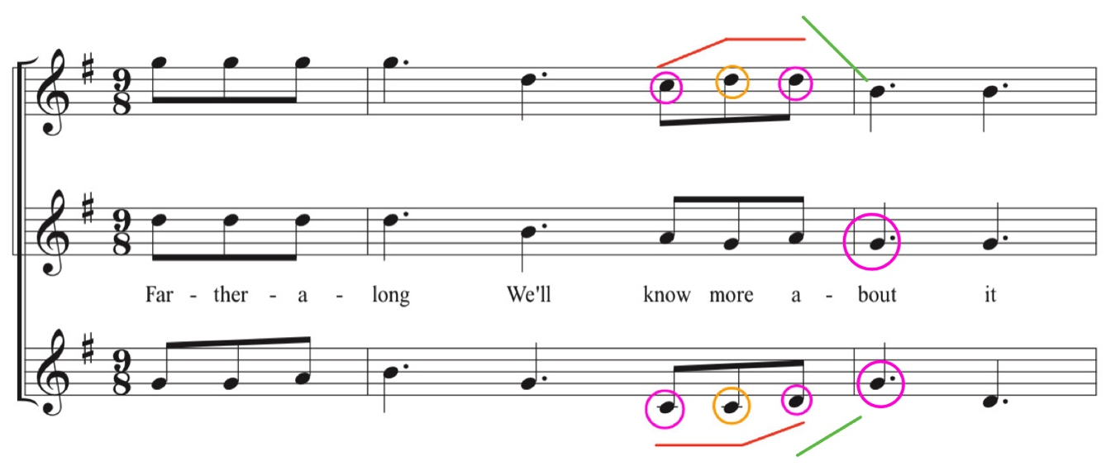
Baritone
Lead
Tenor
Figure 5: First two measures of the Stanley Brothers.

Tenor
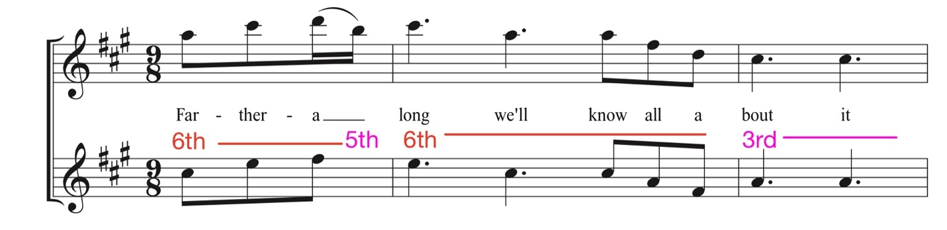
Lead
Figure 6: Osborne Brother’s first 2 measures.

To be close harmony, the tenor line would sing mostly below the interval of a fifth from the lead, but in this rendition, the tenor soars high above the lead in sixths. Jeff Westerinen describes brother duets as “[featuring] very tight two-part harmony where one brother sings lead and the other brother would sing a harmony line that consists of notes above the lead that seem to blend well with the lead part.” In the case of the Osborne Brothers’ version of this tune, the intervals used are not consistently close enough to be considered tight harmonies. Bartenstein provides the most accurate description of duos in bluegrass by stating that the harmony line may not be as tight all the time with more freedom to move up to high harmonies.

- Voices should move most often in similar and oblique motion. Contrary motion should be used sparingly and, in most cases, should only be used to avoid breaking another rule.
Similar motion, an important factor in fusion, should be used most often, but oblique motion is used frequently as well. For example, in measure 5 of Reno & Smiley’s version, the bottom voice stays on a note while the upper two voices move (Figure 7). On beat 3 of that same measure, the baritone and tenor remain the same while the melody line moves. The next three
measures have all the voices moving entirely in similar motion, except for the top voice that remains static on F# on beat 3 and beat 1 of measures 5-6, creating more oblique motion.
If contrary motion is used, it should be brief and used to put the voices closer together but can be used to create distance if needed.

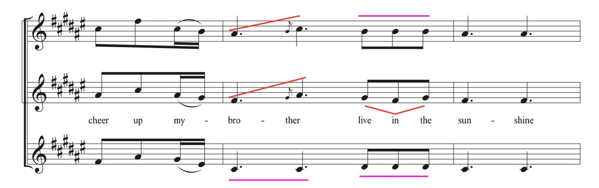
Baritone
Lead
Tenor
Figure 7: Measures 5-6 of Reno & Smiley’s version.

For example, in the pickup measure into measure 6 of the Trio version, the voices move in similar motion until the last eighth note of beat 3 when the tenor voice moves in contrary motion while the other two voices continue moving down (Figure 8). The notes between the tenor and lead were in the space of a second, so contrary motion was most likely used to help create some space between these two voices. The voices moving down creates an interval of a sixth between the tenor and lead voices on beat 1 of measure 6. The tenor line then remains static while the bottom voices move up to close the intervallic gap caused by the contrary motion of the previous measure. Likewise, in the last eighth note of measure 1 of the Stanley Brothers’ version, the baritone moves in contrary motion to the top voice (see Figure 5). The contrary motion in this instance moves the voices closer together. When contrary motion
was noted in this case study, it was used for a purpose to avoid open spacing or to avoid the voices becoming too close to one another. Therefore, contrary motion should only be used when there is a valid reason to use it, such as the reasons stated above.
The constant use of similar motion along with the close spacing, creates the effect of fusion by creating one distinctive voice, but this is not the same as unison. Unison would mean the voices are one voice. Cantwell describes the sound of bluegrass as, “Everywhere there is friction or stridency, a kind of electrostatically charged field.” This tension is caused by the voices being pitched high in range with very close voicing while moving in similar motion. This is the fusion effect which does not sound like choral harmony or voicing nor like unison, but rather, the sound of fusion is as one voice singing surrounded by its own overtones. Throat
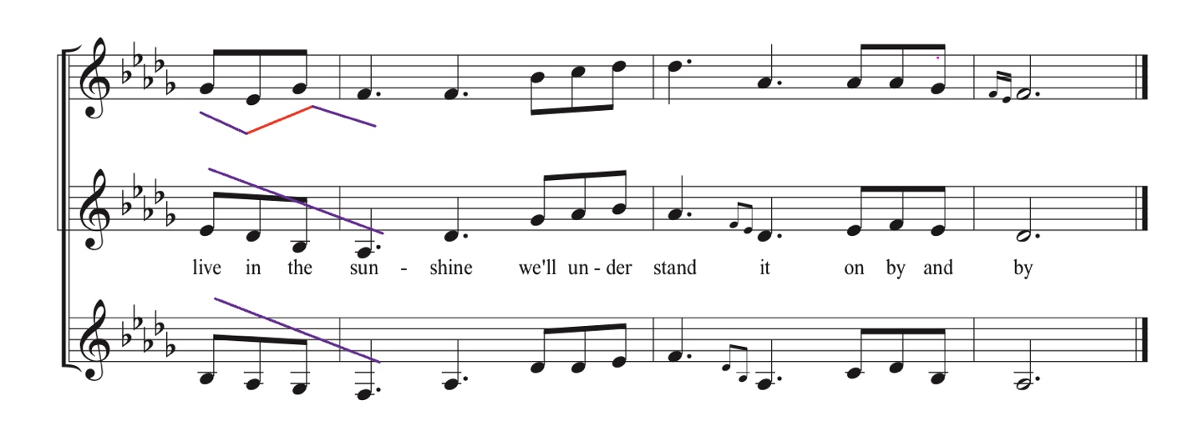
Baritone
Tenor
Lead
Figure 8: Measures 6-8 of Trio’s version.

singing would be a good comparison to this effect. The other voices do make harmonies that go along with the melody, but the tenor and baritone parts sound like partials in the harmonic series, rather than the sound of traditional harmonies found in Western classical music. By not following these rules, then this unique effect and characteristic in bluegrass would not be achieved.

- Incomplete chords are acceptable. In incomplete chords, it is common to omit any note of the chord and double any chord tone.
The previously mentioned literature states that bluegrass music should use complete triads as much as possible, making doublings of notes in the chords not usually needed. However, in this study, doublings did occur frequently. If doublings occur, any note of the chord can be doubled. For example, in the Grascals’ rendition, the pick-up measure begins with a full tonic triad, but the G major triad on the first beat of measure 1 has the tonic with no root and the third of the chord doubled (Figure 9). On the next beat, the root of the G major triad is doubled in the top and bottom voice, and there is no fifth. The final beat of the measure moves to the subdominant (C major) without the root and doubling the third. The first beat of measure 2, another G major triad, has the tonic with no third and the fifth doubled. These incomplete chords and doublings continue until measure 4 when a complete dominant triad occurs. Cases of doublings and incomplete chords were featured prominently throughout this case study. In Western practice it is common to double the root and omit the fifth, but in bluegrass, no doubling takes priority over the other. Any chord tone within the triad may be omitted or doubled, and at least two of the chord tones of the triad should be present. However, the beginnings and endings of phrases are more likely to have a complete triad.
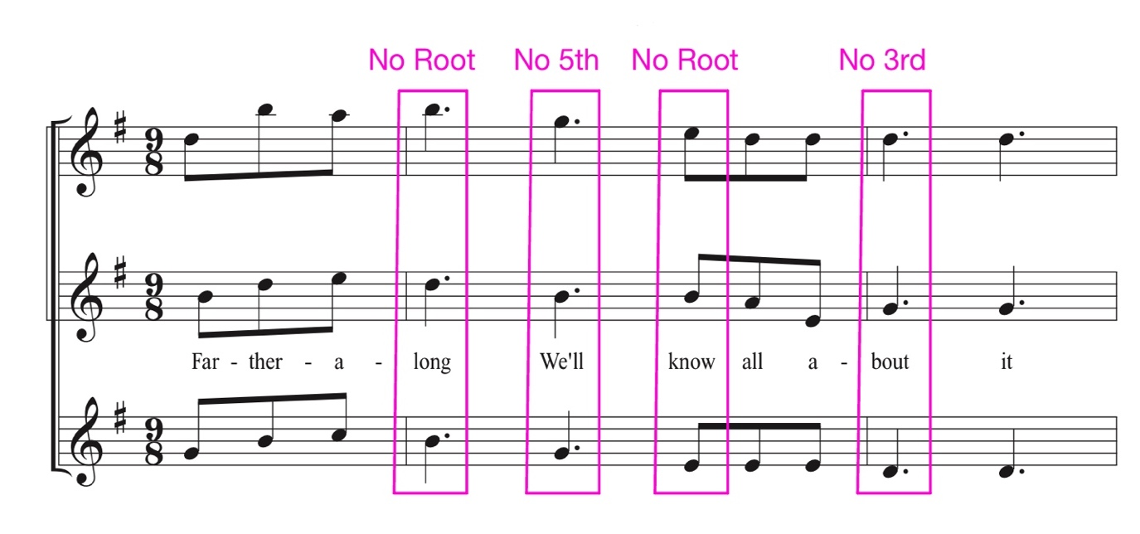
High Baritone
Tenor
Lead
G
G
C
G
Figure 9: First 2 measures of the Grascals’ version.

In addition, the chord tone that is omitted usually occurred recently before or after its omission in a repetition of the same chord. By omitting a chord tone that was recently played, the full triadic sonority would be heard even though all three chord tones may not have been present at the same time. It is also important to note that even though there are acapella sections in some of these version, all of them were accompanied with instrumentations that did play the entire chord.

- Unisons are acceptable within the following parameters:
  - Never should two voices meet and continue in unison;
    - If voices stay in unison it should not be for any substantial length or duration (no longer than 1 beat).
  - Never should all voices be in unison at the same time.
If a chord is incomplete, then doubling a note of the chord creates octaves or unison. Unisons or octaves are most times approached or left in contrary motion, most likely to avoid any further unison. The last eighth note of measure 1 of the Grascals (see Figure 9) has a unison in the lead in the bottom voice and the tenor line above it that leaps into and out of unison. In this case, these voices move in contrary motion to each other out of this unison, most likely to avoid any further unison. All of the other trios also have instances of unison: the Stanley Brothers version has a unison between the baritone and lead on the first beat of measure 2, Trio has a unison on beat 4 of measure 4 between the lead and tenor, and Reno & Smiley have one eighth note unison on beat 3 of measure 1 between the baritone and lead. All of these examples’ unisons are approached and left by leap in at least one voice. Unisons did occur, but the voices were not moving in unison, preserving the individuality of the voices and the integrity of the chords.
Extensive use of unison would dampen the effect of fusion. Instances of unison and doublings highlight the fusing of voices; multiple voices would just become one voice if all were singing the same note. If unisons are used, they should be used sparingly and never should the voices move in unison. In this case study, there was only one occurrence of meeting and moving in unison that occurred on the last beat of measure 7 of the Grascals’ version (Figure 10). Based on the necessity for fusion and the need for complete chords to be used, this should be considered an anomaly.
Even with the evidence provided by this study, more research needs to be done to fully confirm the rule of unisons/octaves. Mike Seeger, in an interview, claimed that “Bluegrass harmony departed from old time harmony in that it was an absolute no-no to hit a unison or an octave. You have passing notes but you’re supposed to eliminate the place where you’re hitting a unison – cross the other part but not actually hit the note together.” This quote conflicts with the evidence found in this case study. There were times when voices were in unison or in octaves especially with an outer voices. In addition, there was no voice crossing evident in any of the renditions of this song. Peter Wernick elaborates more by stating, “Sometimes the baritone has to sing above the lead for a few notes to avoid a unison with a melody line that dips down abruptly. Sometimes the tenor has to sing closer to the lead.” Based on these quotes, unisons should never occur and should be avoided to the point that lines must cross or voices need to be limited
in their movement to avoid unison. As previously mentioned, Bartenstein also states that doublings should be avoided because this causes undesirable unisons or octaves. According to this literature, octaves and unisons should be avoided, but in this case study, they did occur.

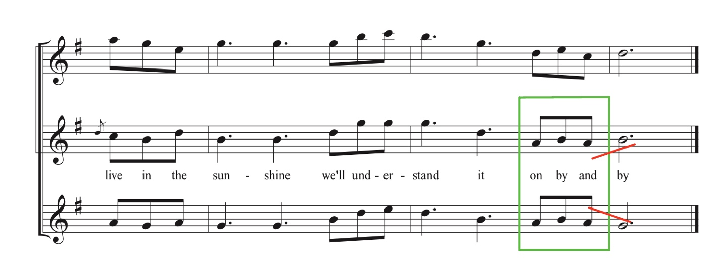
Lead
Tenor
High Baritone
Figure 10: Measures 6-8 of the Grascals version.

Based on this study, the notion that unison should always be avoided needs to be reexamined and reconsidered.

- Cadences may end on second inversion triads due to the stacking of the voices.
It is significant to note that sections and entire bluegrass tunes can end on inversions of the tonic triad, specifically second inversion, even though cadencing on inversions is avoided in many musical practices due to their inconclusive sound. A second inversion chord is considered the most unstable position due to the emphasis on the dissonant 4th and the tendencies of intervals 4 and 6 to resolve to 3 and 5, thus also the least conclusive since these intervals are not resolved, yet this is entirely acceptable in bluegrass. Not only is this acceptable, but it is also desirable. Melody lines usually and naturally end on tonic for the purpose of conclusiveness. If the melody line is not in the bottom voice and will most likely have the root of the chord, then the final chord will be in an inversion. Ending on an inverted chord most often occurs in the standard trio and the high lead trio voicing. The three trios that utilized the standard trio stacking, which are the Stanley Brothers, Reno & Smiley, and Trio, all end on a second inversion triad rather than on a first inversion (see Appendix B.3, B.4, and B.5). Duets and the high baritone can end in root position because the melody line containing the root is in the bottom voice.

- Non-chord tones should be used in a bluegrass arrangement. Passing and neighbor tones should be the most used NCTs with slight uses of suspension.
Non-chord tones are used frequently and are a prominent characteristic of bluegrass. Cantwell states that non-chord tones are used frequently in bluegrass, while Bartenstein argues that their use makes undesirable harmonies. In many situations in this case study, the non-chord tones were in more than one voice, creating interesting dissonances harmonies that add color and friction before achieving resolution, supporting Cantwell’s claims. Non-chord tones can also influence the perception of harmonies with omitted notes. For example, Trio’s version (in Db major) has non-chord tones that imply alternate harmonies. The third beat of measure 1 is a IV chord that, at first, is written as a ii chord (Bb-Eb-G) (Figure 11). The Eb is an accented nonchord tone on a strong beat that moves to Db, but briefly implies another harmony with a predominant function – a ii7. The chords that are created and the harmonies they imply result from linear motion. The most prevalent non-chord tones are suspensions and passing or neighbor motion that only delay the resolution to a chord tone.
Reno & Smiley’s rendition utilizes oblique motion to create an implied harmony (Figure 12). On the third beat of measure 1, the melody has a motive that ascends from D#, F#, and then G# while the tenor and baritone remain on the same note, baritone on D# and tenor on B. While the piece is in the key of F#M, the first two eighth notes belong to B major (the IV), but the G# at the end spells a G# minor (ii in the key of F#M). The G# only lasts for a moment and is an non-chord tone. In the next phrase, however, the material repeats in measure 5, but this time it starts on the G# being a double neighbor that encompasses F# (see Figure 7). The minor sonority can be heard with the F# in the middle that emphasizes the G#. Another example of the use of nonchord tones changing the analysis of a chord can be seen in the second to last chord of the tune (Figure 13). Beat 3 of measure 7 should be a V chord (C#) that resolves to I (F#) as the final chord, but the group of eighth notes lack the complete triad. Beat 3 of measure 7 starts with a G# minor chord in second inversion that moves to a F# major neighbor chord before going back to G# minor to resolve to tonic in 2nd inversion. The notes C# and G# (which are never sung at the
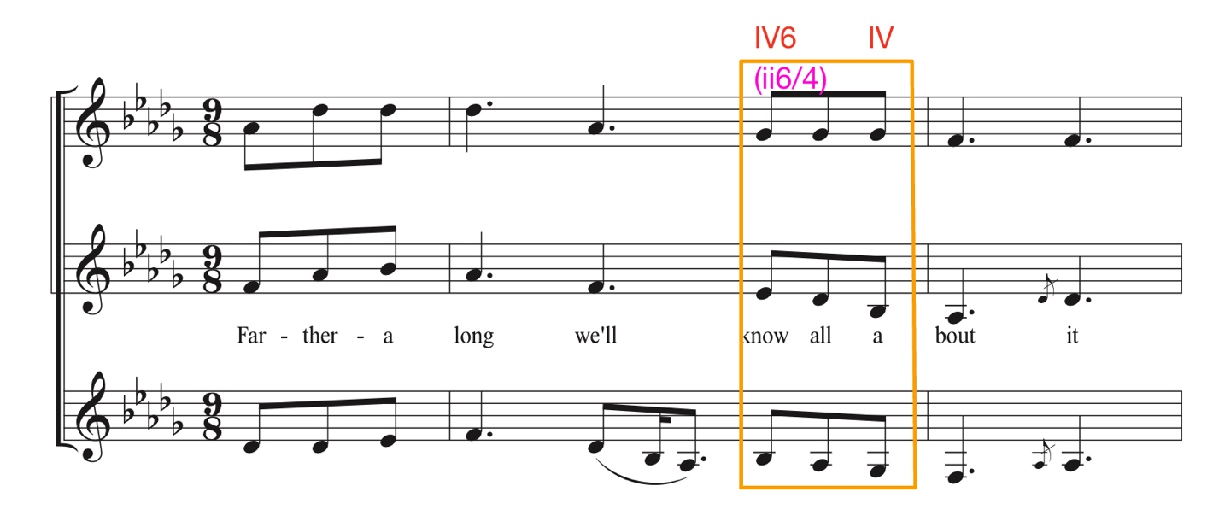
Baritone
Tenor
Lead
Figure 11: Trio’s rendition of “Farther Along.”

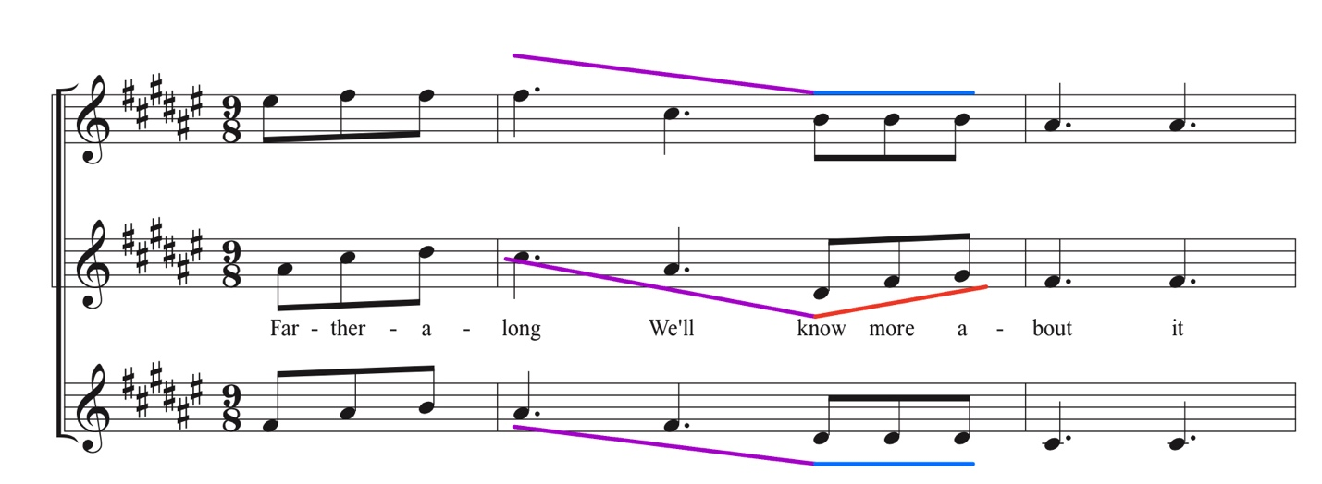
Baritone
Lead
Tenor

Figure 12: Measures 1-2 of Reno & Smiley’s rendition of “Farther Along.”
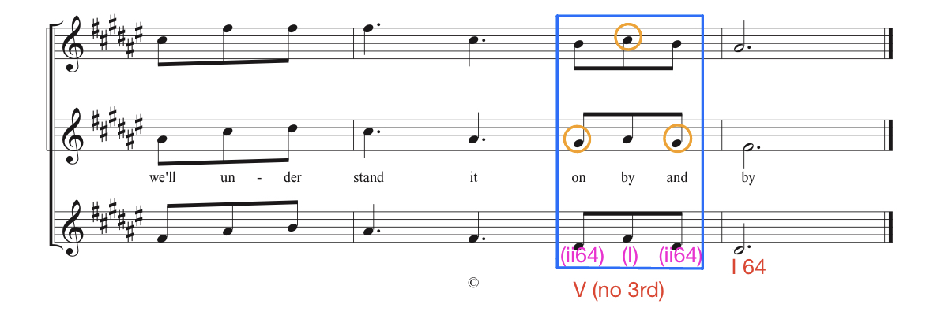
Baritone
Tenor
Lead
Figure 13: The ending of Reno and Smiley’s version that lacks a complete V chord.

same time) are present, but there is not an E# to complete the triad. Since all the voices resolve to the tonic by step, the lines themselves have a dominant function while not creating a dominant chord. Trio’s version (Figure 14) contains the same technique in measure 7, but it is slightly altered; they begin on a V6, move to I, and then moves to ii64 that resolves by step to I in second inversion in the key of Db major. All versions consistently contain incomplete chords that are not as important as the focus on the linear progressions.
More non-chord tones can be seen in the Stanley Brother’s version that employs non-chord tones on the same third beat of measure 1 as Reno & Smiley and Trio. The chord here should be a IV (C major) in the key of G. The first eighth note has C in the baritone and tenor voices with the lead singing A - implying an A minor chord – a ii (Figure 15). However, the A is
a non-chord tone that is passing to the G, but the tenor voice moves as well up to D while the baritone remains oblique on C (spelling C, G, and D in order from lowest voice to highest). This quintal harmony implies C and G, but the Cs before prepares the listener to favor a C sonority hearing. The voices keep moving to a fifth (D to A) on the last eighth note of this beat, implying a D chord. This has the outer voices in unison on D and the melody line singing A which more closely resembles the V chord. On beat one of measure 2, the voices move to a G chord with the A as neighbor to G and the Ds moving by leap into chord tones G and B, creating a G chord with a double root having unison with the melody (Figure 15). All of these examples prove the use of doublings and unison found in this case study.
As Cantwell, Erbsen, and Bartenstein have claimed, all notes of the triad should be sung. If the melody moves from a chord tone up by step into a non-chord tone and since the other voices are obligated to move in similar motion, then there will certainly be passing motion between chords. Mike Seeger states that, “In a carefully worked-out trio, the three voices blend
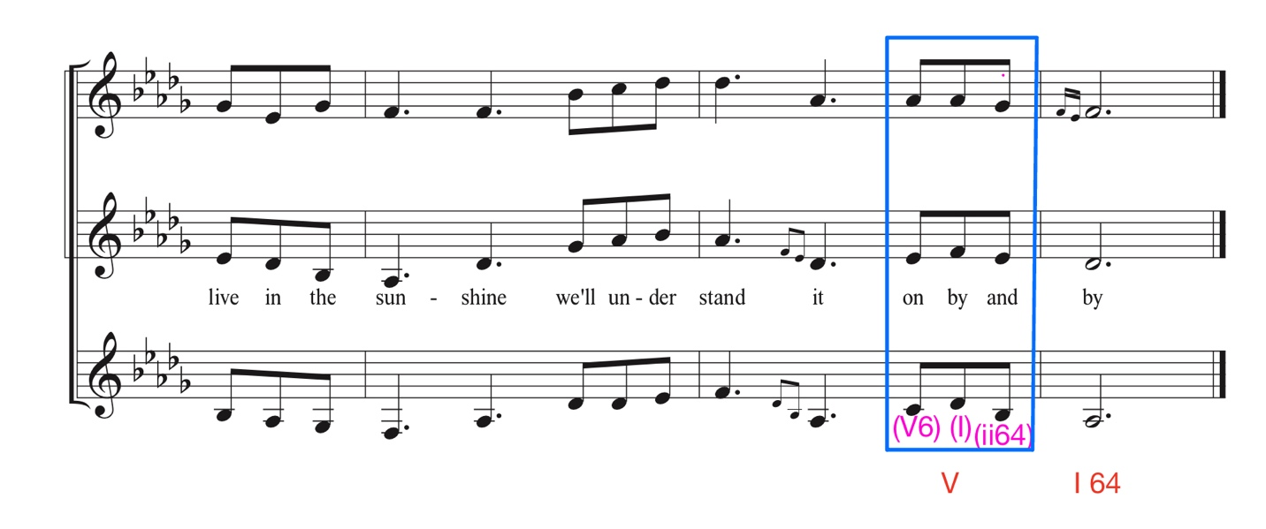
Baritone
Tenor
Lead
Figure 14: The ending of Trio’s version that briefly sings V at the beginning of the beat.

Tenor
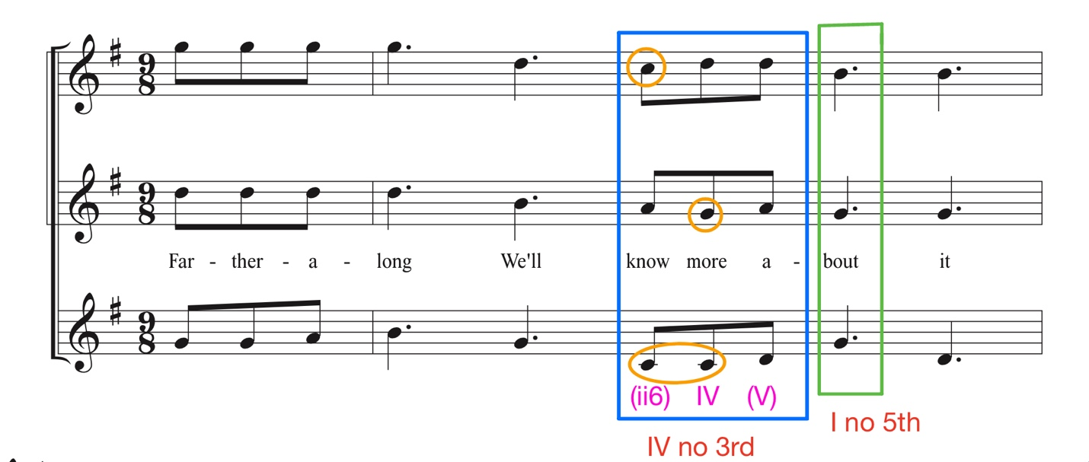
Lead
Baritone
Figure 15: First 2 measures of the Stanley Brother’s version.

in some kind of chord at all times.” Even though the melody may be on a non-chord tone, the other voices will harmonize it, which is what creates the other chords outside the main progression. Though these are chords, they have no real function in the progression; they are passing chords or neighbor chords. The colorful embellishments and chords should be disregarded in the progression, concentrating on the chords that actually function.

- Tendency tones should resolve in the direction of their tendency.
- the leading tone in secondary dominant chords should be placed in the top voice and resolve up.
- The diatonic leading tone can be placed in any voice and should resolve to the tonic.
- The seventh of a seventh chord should resolve down.
- Leading tones and seventh resolutions can be delayed or be transferred to another voice.
Looking at measure 3 in any of the transcriptions found in Appendix B will reveal the accidental belonging to the leading tone of a secondary dominant that every artist, including the duet by the Osborne Brothers, placed in the top voice in order to make the chromatic pitch stand out. The diatonic leading tone, on the other hand, is placed in any voice part. Tendency tones, e.g., leading tones and sevenths, should resolve in the direction of their tendency. If the tendency tone is not resolved in the voice part that it is in, another voice will take the resolution. In the Grascals’ version, for example (Figure 16), the secondary dominant in measure 3 adds a 7th (the G) that first appears in the lead which walks up and then baritone part sings the 7th. Instead of
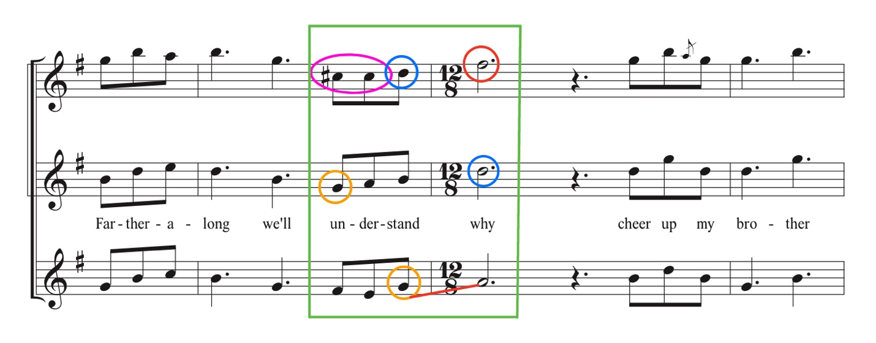
Tenor
Lead

High Baritone
Figure 16: Measure 3 of the Grascals’ version.

resolving the 7th down, the baritone part moves up to A with the tenor voice singing the resolution. Likewise, the leading tone in the secondary dominant (C#) resolves early (an anticipation) before leaping to the F# and the lead takes the resolution of the leading tone to D on the next measure. In contrast, in the Stanley Brothers’ (Figure 17) version, measure 3 has the same situation with the seventh first appearing in the lead and then the baritone, but the baritone did resolve the seventh down. Also, in the Grascals’ version (see Figure 16), the V chord on the last beat of measure 7 has the seventh in the high baritone that resolves up while the tenor line beneath it sings the resolution. The Trio version contains no sevenths while the other trios contained sevenths. In the Stanley Brothers and Reno & Smiley versions, the sevenths resolve down. Tendency tones resolve in the direction of their tendency. A stylistic choice, or current trend in bluegrass, is to frustrate their 7ths by having its resolution in another voice.

Conclusion
Based on the analysis of the transcriptions of the versions of “Farther Along,” some conventions in bluegrass were found that establish that there are “rules” within the genre that contribute to its unique sound. These rules are:
- The melody should be changed in some way from the original but must still remain recognizable to the original.
- A bluegrass arrangement for three voices will use a voice stacking of one of the following three types. A duet will have the lead in the bottom voice with a harmony above.
- Close voicing is used throughout to create close harmony or tight harmonies. The largest space between the bottom and top voice is an octave.
- Voices should move most often in similar and oblique motion. Contrary motion should be used the least.
- Incomplete chords are acceptable. In incomplete chords, it is common to omit any note of the chord and double any chord tone.
- Unisons are acceptable within the certain parameters.
- Cadences may end on second inversion due to the stacking of the voices.
- NCTs should be used frequently as linear motion to smooth out the vocal line. All chords created by this linear motion are purely coincidental. Passing and neighbor should be the most used NCTs with slight uses of suspension. Appoggiatura and anticipation should be used less often.

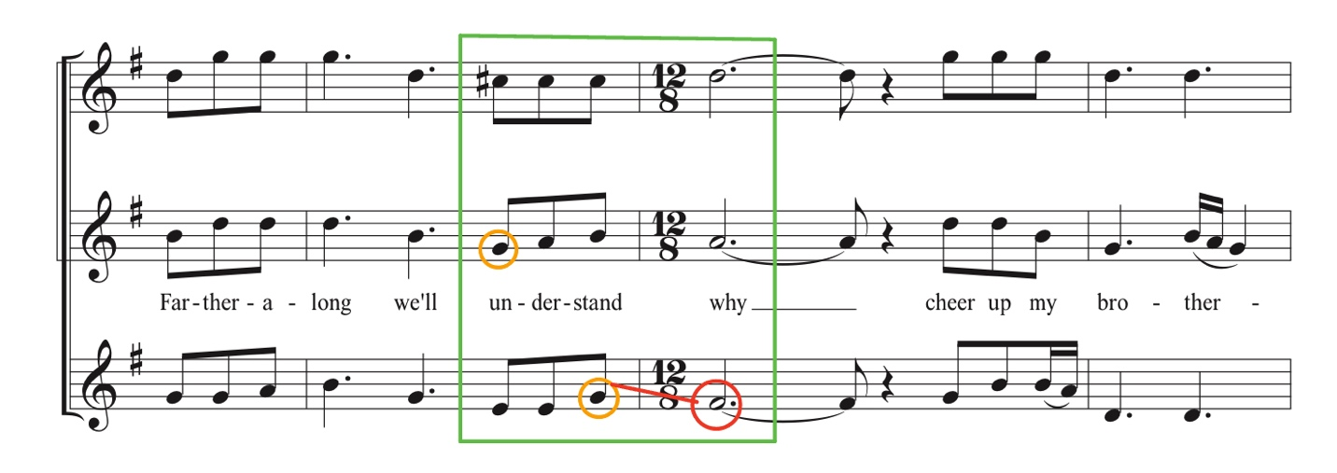
Tenor
Lead
Baritone
Figure 17: Measure 3 of the Stanley Brothers’ version.

- The leading tone in secondary dominant chords should be placed in the top voice. The diatonic leading tone can be placed in any voice and should resolve to the tonic. 7ths may resolve up or down, but down is preferred. If the 7th moves up, it should be because it is moving either linear to another chord tone or another voice beneath moves to fulfill the resolution.
Some of these rules, such as linear progressions and tendency tone resolutions (rules 8 and 9), can be found in Classical music and other genres as well, but since these rules are a requirement for the “bluegrass sound” to occur, they are included in this list of conventions for bluegrass voicing.
In this case study, the analysis of the transcriptions found other interesting chord progressions and voice movements that should be noted although they should not be considered rules of bluegrass. For example, a reharmonization of I chord to vi chord on beat 2 of measure 7 occurred in half of the transcriptions (Bill Monroe, the Stanley Brothers, and the Grascals). There are other songs in the bluegrass canon that also use this chord such as “I’ll Fly Away,” “I Saw the Light,” “Riding on that Midnight Train,” “Worried Man Blues,” and “Amazing Grace.” This reharmonization is completely optional with some choosing to use it while others don’t, which is evident in this case study. Chord choices are outside of the scope of this paper, but the reharmonization occurring in this case study should be recognized, since half chose to use it while the other half did not (Reno & Smiley, Trio, and the Osborne Brothers).
There was also a change of meter that also occurred in several of the arrangements in measure 4; the time signature changed from 9/8 to 12/8 because a held note was written out in the music (Appendix B.2, B.3, B.5, and B.6). Based on hearing a multitude of versions of this song and listening to bluegrass as a whole, I propose that the change of meter that occurs in the renditions of this song is a traditional choice and is not a trait that can typically be found in many tunes. Meter changes do occur in bluegrass, but this case study does not produce enough information to confidently make statements on this topic; a separate study would be required to study meter changes.
Following the rules presented here will create a piece that is in the bluegrass style. The previously recounted story of the Osborne Brothers being told that their version of “Once More” isn’t bluegrass proves that those in the genre are aware that there are rules and that they know what they are. This study attempted to codify these rules. Robert Cantwell hoped that bluegrass would be studied by composers and implemented in their own music. In the past, there has not been significant scholarly study of bluegrass music theory due to bluegrass being an oral tradition, musicians being unable to communicate their rules, theorists who are able to communicate these rules not being interested in the genre, and/or simply that no one has thought to create a set of rules that define bluegrass music. There may also be those who believe that the work of Erbsen, Cantwell, and Bartenstein are enough. Regardless of whichever reason might be the cause of few studies to date of bluegrass music, there is still plenty of research and analysis of bluegrass music that can be done. Bluegrass is an underrepresented and understudied genre that is worthy of theoretical analysis and discussion. This study shows that it can and should be included in the scholarly discussion. Bluegrass music can be used in the study of composition, arranging, and improvisation. For that to happen, there needs to be even more analysis and study done to expand upon what we know about the genre. There are “rules” to bluegrass music that only those who participate in the genre know and which can, hopefully, be shared to add more accessibility to all.

Bibliography
Barnwell, Tom. “An Introduction to Bluegrass Jamming.” Record Review: SouthEastern Bluegrass Association, 1997. https://barnwell.ece.gatech.edu/roles.html.
Bartenstein, Fred, and Curtis W. Ellison. Industrial Strength Bluegrass: Southwestern Ohio's Musical Legacy. Urbana, IL: University of Illinois Press, 2021.
Bartenstein, Fred. “Bluegrass Vocals.” Fred Bartenstein: Bartenstein & Bluegrass, 2010. http://fredbartenstein.com/bgvocals.html.
Cade Botts, “Drive: The Force Behind Bluegrass” (Paper presented at the String Band Summit, Johnson City, Tennessee February 2023).
Cantwell, Robert. Bluegrass Breakdown: The Making of the Old Southern Sound. Urbana, IL: University of Illinois Press, 1984.
Erbsen, Wayne. Rural Roots of Bluegrass: Songs, Stories & History. Asheville, NC: Native Ground Music, 2003.
Ewing, Tom. Bill Monroe: The Life and Music of the Blue Grass Man. Urbana, IL: University of Illinois Press, 2021.
“Farther Along by Bill Monroe and His Blue Grass Boys.” Second Hand Songs - A Cover Songs Database. Accessed March 4, 2023. https://secondhandsongs.com/performance/365513/versions.
Goff, James R. Close Harmony: A History of Southern Gospel. Chapel Hill, NC: University of North Carolina Press, 2002.
Hamrick, David. “Farther Along,” December 22, 2013. http://drhamrick.blogspot.com/2013/12/farther-along.html.
Henry, Murphy. Pretty Good for a Girl: Women in Bluegrass. Urbana, IL: University of Illinois Press, 2013.
“The Importance of Balance.” Vocal Manoeuvres Academy (en-AU), April 6, 2018. https://vmacademy.net.au/news/the-importance-of-balance.
Nager Larry, “Sing Me Back Home: Early Bluegrass Venues in Southwestern Ohio” in Industrial Strength Bluegrass: Southwestern Ohio’s Musical Legacy, ed. by Bartenstein, Fred, and Curtis W. Ellison (Urbana, IL: University of Illinois Press,) 2021, 88-100.
Pennell, Charles. “Discography of Blue Grass Sound Recordings, ‘The Early Years.’” Bluegrass Discography: Viewing full record for. ibiblio, January 1, 1996. https://www.ibiblio.org/hillwilliam/BGdiscography/?v=fullrecord&amp;albumid=12252.
Roig-Francolí, Miguel A. Harmony in Context. New York City, NY: McGraw-Hill, 2020.
Rooney, James. Bossmen: Bill Monroe Et Muddy Waters. New York, NY: Da Capo Pr., 1991.
Rosenburg, Neil V. “Bluegrass.” Essay in Encyclopedia of Southern Culture, edited by Charles Reagan Wilson and William R. Ferris, Chapel Hill, NC: University of North Carolina Press, 1989.
Rosenberg, Neil V. Bluegrass: A History. Urbana, IL: University of Illinois Press, 2005.
Walker, William. The Christian Harmony. Christian Harmony Music Company, Inc., 2010.
Wernick, Peter. Bluegrass Songbook. New York, NY: Oak Publications, 1992.
Westerinen, Jeff. “The Bluegrass Voice.” Blue Octane Bluegrass Band, November 16, 2019. https://blueoctanebluegrass.com/the-bluegrass-voice/.

Appendices

Appendix A - Scores

Appendix A.1: Stamps-Baxter’s arrangement of “Farther Along” found in Red-Back Hymnal.

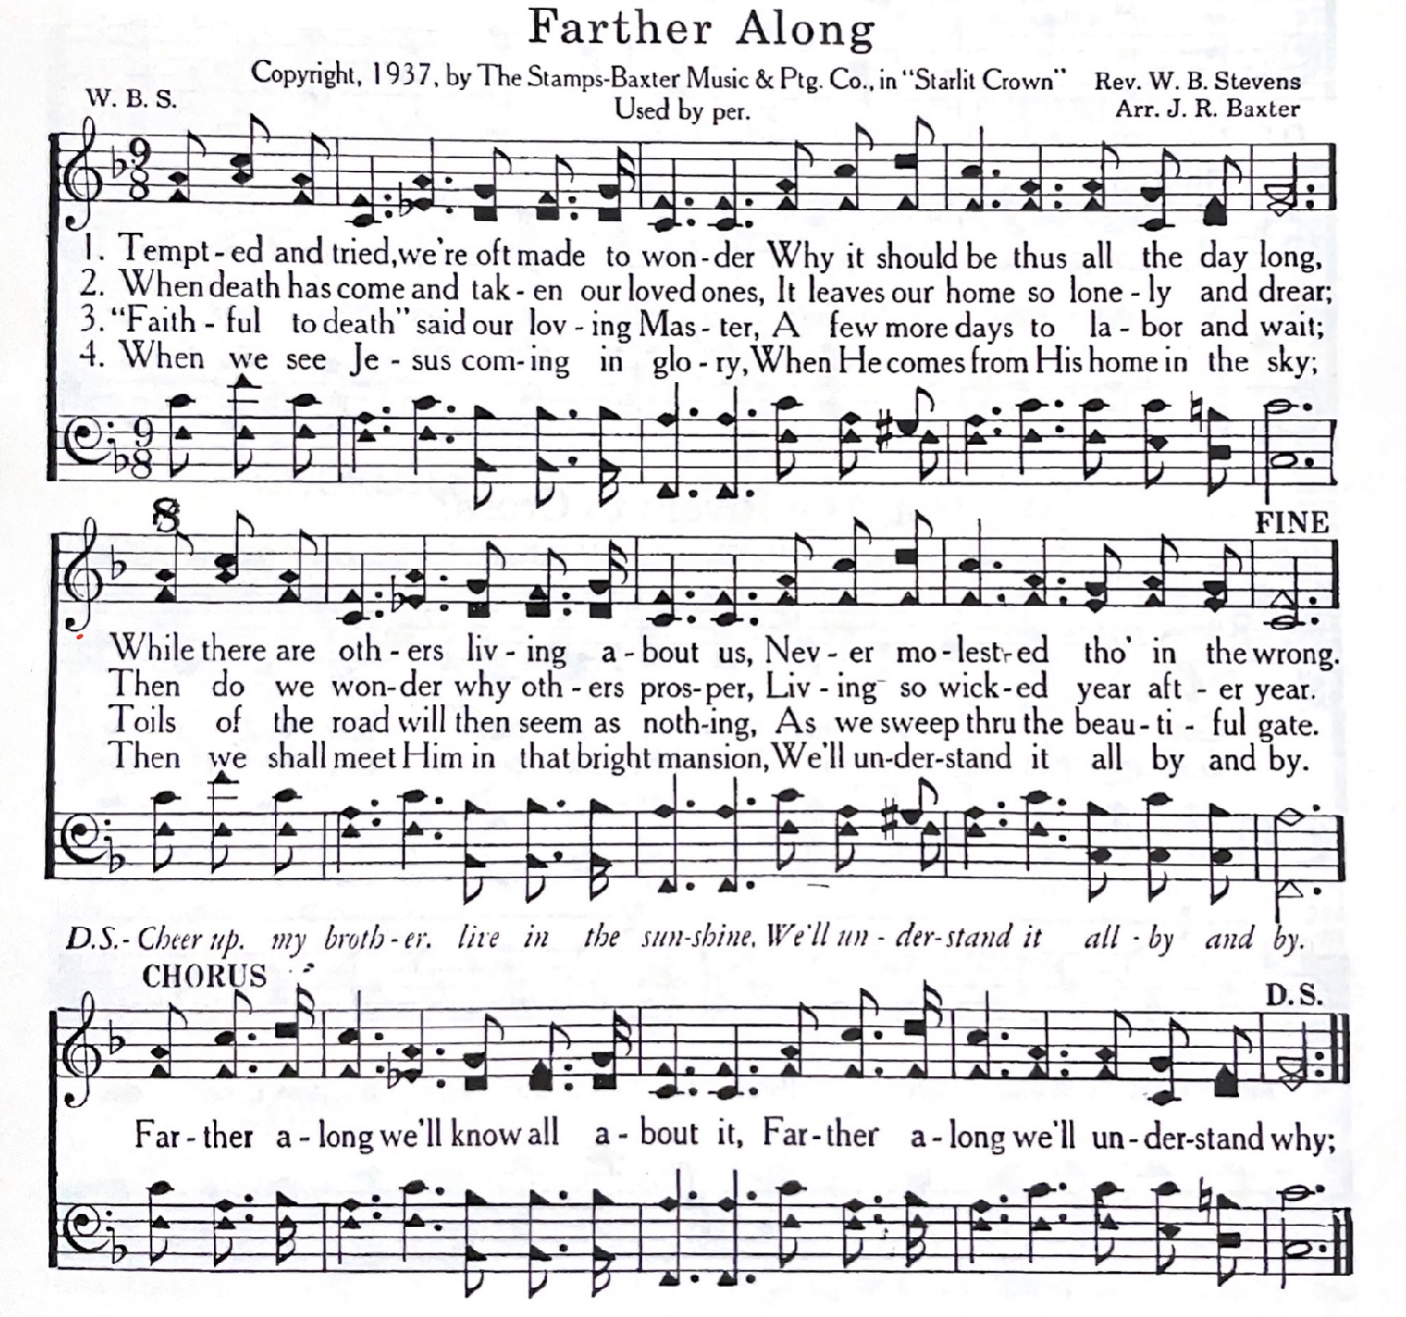

Appendix A.2: Stamps-Baxter’s arrangement of “Farther Along” found in Christian Harmony.
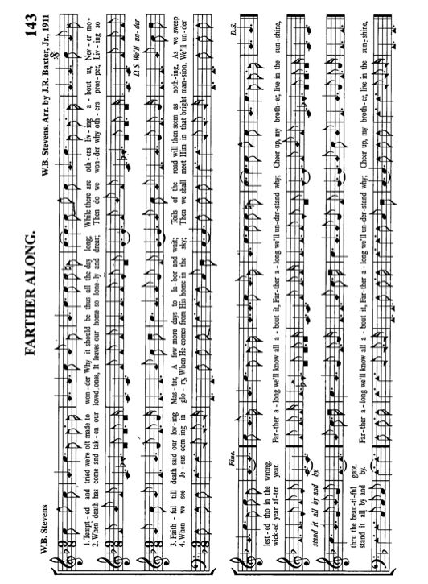

Appendix B – Transcriptions

Appendix B.1: Transcription of Bill Monroe’s cover of “Farther Along.”
Appendix B.2: Transcription of the Osborne Brothers’ cover of “Farther Along.”

Appendix B.3: Transcription of the Stanley Brothers’ cover of “Farther Along.”
Appendix B.4: Transcription of Reno & Smiley’s cover of “Farther Along.”
Appendix B.5: Transcription of Trio’s cover of “Farther Along.”
Appendix B.6: Transcription of the Grascals’ cover of “Farther Along.”
Vita
Cade Botts, a native from Huntsville, Tennessee, graduated from the University of
Tennessee, Knoxville with his Bachelor’s in Music Theory in 2021. He completed his Master’s degree in Music Theory also from the University of Tennessee, Knoxville in 2023. His academic focus centers around bluegrass music and banjo performance. In addition to his thesis, he has presented papers on the topic of bluegrass at the International Country Music Conference in 2022 and 2023 as well as presenting at East Tennessee State University’s String Band Summit in 2023. He hopes to improve the academic and scholarly discourse surrounding bluegrass and its perception in a professional setting

Fred Bartenstein, “Bluegrass Vocals,” Fred Bartenstein: Bartenstein & Bluegrass, 2010, http://fredbartenstein.com/bgvocals.html.
“Farther Along by Bill Monroe and His Blue Grass Boys,” Second Hand Songs - A Cover Songs Database, accessed March 4, 2023, https://secondhandsongs.com/performance/365513/versions.
Tom Ewing, Bill Monroe: The Life and Music of the Blue Grass Man (Urbana: University of Illinois Press, 2021), 284.
Robert Cantwell, Bluegrass Breakdown: The Making of the Old Southern Sound (Urbana: University of Illinois Press, 1984), 174.
Neil Rosenburg, “Bluegrass,” essay in Encyclopedia of Southern Culture, ed. Charles Reagan Wilson and William R. Ferris (Chapel Hill, NC: University of North Carolina Press, 1989), 933.
Murphy Henry, Pretty Good for a Girl: Women in Bluegrass (Urbana: University of Illinois Press, 2013) 9-10.
Cantwell, Bluegrass Breakdown, 61.
Cade Botts, “Drive: The Force Behind Bluegrass” (Paper presented at the String Band Summit, Johnson City, Tennessee February 2023).
Tom Barnwell, “An Introduction to Bluegrass Jamming,” Record Review, SouthEastern Bluegrass Association, 1997, https://barnwell.ece.gatech.edu/roles.html.
Cantwell, Bluegrass Breakdown, 67.
Wayne Erbsen, Rural Roots of Bluegrass: Songs, Stories & History, (Asheville: Native Ground Music, 2003), 42.
Peter Wernick, Bluegrass Songbook (New York: Oak Publications, 1992), 103.
Fred Bartenstein, “Bluegrass Vocals” http://fredbartenstein.com/bgvocals.html.
Ewing, Bill Monroe, 15 and 30.
Ewing, Bill Monroe, 164.
Erbsen, Rural Roots of Bluegrass, 42.
Larry Nager, “Sing Me Back Home: Early Bluegrass Venues in Southwestern Ohio” in Industrial Strength Bluegrass: Southwestern Ohio's Musical Legacy, ed. by Fred Bartenstein,, and Curtis W. Ellison (Urbana, IL: University of Illinois Press), 2021, 88.
Wernick, Bluegrass Songbook, 103.
Nager, “Sing Me Back Home,” 88.
Nager, “Sing Me Back Home,” 88.
Thomas Cassell, “In Seeking a Definition of Mash: Attitude in Musical Style” (2021). Electronic Thesis and Dissertations. Paper 3916. https://dc.etsu/etd/3916
Cantwell, Bluegrass Breakdown, 67.
Fred Bartenstein, “Bluegrass Vocals” http://fredbartenstein.com/bgvocals.html.
Cantwell, Bluegrass Breakdown, 212.
Cantwell, Bluegrass Breakdown, 212.
Erbsen, Rural Roots of Bluegrass, 42.
“The Importance of Balance,” Vocal Manoeuvres Academy (en-AU), April 6, 2018, https://vmacademy.net.au/news/the-importance-of-balance.
Cantwell, Bluegrass Breakdown, 212.
Wernick, Bluegrass Songbook, 104-105.
Erbsen, Rural Roots of Bluegrass, 42.
Ewing, Bill Monroe, 15 and 30.
Second Hand Songs, “Farther Along.”
Charles Pennell, “Discography of Blue Grass Sound Recordings, ‘The Early Years,’” Bluegrass Discography: Viewing full record for (ibiblio, January 1, 1996), https://www.ibiblio.org/hillwilliam/BGdiscography/?v=fullrecord&albumid=12252.
James Rooney, Bossmen: Bill Monroe & Muddy Waters (New York: Da Capo Pr., 1991), 35.
David Hamrick, “Farther Along,” Farther Along, December 22, 2013, http://drhamrick.blogspot.com/2013/12/fartDrher-along.html.
William Walker, The Christian Harmony (Christian Harmony Music Company Inc., 2010), 143.
Capitol CMG Publishing has graciously given me permission to use “Farther Along” for the purposes of this paper.
This chord progression is I IV I V/V V, I IV I V I.
Goff, James R. Close Harmony: A History of Southern Gospel. Chapel Hill, NC: University of North Carolina Press, 2002.
Roig-Francolí, Harmony in Context. (Boston: McGraw-Hill, 2020), 118.
Roig-Francolí, Harmony in Context. 121.
Reproduced from Red-Back Hymnal with permission from Capitol CMG.
Dolly Parton, Emmylou Harris, and Linda Ronstadt did a collaborative album called Trio, but they did not choose a name for their group. I will be referring to them as “Trio” after of the name of their album.
Fred Bartenstein, “Bluegrass Generations: A Historical Perspective,” Bartenstein & Bluegrass: Bluegrass Generations. August 7, 2013, http://www.fredbartenstein.com/bgPerspective.html. Please refer to Bartenstein’s paper for more specifics on the generations.
Though there is a history of quartets and quintets, they are few and far between, especially in studio recordings.
In addition, high lead trio is the least common of the three possible voicings to be used in bluegrass with the standard trio being the most popular and the high baritone being common.
Fred Bartenstein, “Bluegrass Vocals,” http://fredbartenstein.com/bgvocals.html.
James R. Goff, Close Harmony: A History of Southern Gospel, (Chapel Hill, NC: University of North Carolina Press, 2002), 5.
Cantwell, Bluegrass Breakdown, 212.
Bartenstein, “Bluegrass Vocals.”
Wernick, Bluegrass Songbook, 102.
Wernick, Bluegrass Songbook, 102.
Jeff Westerinen, “The Bluegrass Voice,” Blue Octane Bluegrass Band, November 16, 2019, https://blueoctanebluegrass.com/the-bluegrass-voice/.
Cantwell, Bluegrass Breakdown, 174.
Wernick, Bluegrass Songbook, 102.
Wernick, Bluegrass Songbook, 102.
Based on this study alone, I found these NCTs to be the most prevalent. For example, appoggiaturas and anticipation notes were used. Other NCTs maybe acceptable in bluegrass, but more study is required.
Wernick, Bluegrass Songbook, 102.
Though there is a history of quartets and quintets, they are few and far between.

