On the Paleoethnobotanical Significance of Cherokee Farm
By. Hattie Ruleman

An Honors Thesis Project in Anthropology
Advisor: Prof. Kandace Hollenbach
Introduction
Tennessee alone has been found to have over 26,000 archaeological sites across the state, a number that has and will continue to grow in the future due to the undoubtedly innumerable number of sites we are not yet aware of across Tennessee (Tennessee Division of Archaeology 2019). The antiquity of these sites ranges all the way from the Paleoindian Period to the Mississippian to contact with Europeans. At the Cherokee Farm site in Knoxville, Tennessee, and many other surrounding sites, the Late Archaic Period and the Early Woodland Period are well represented. These are particularly interesting time periods because they mark a shift from dependence on hunting and gathering for food procurement to the intensification of agriculture and farming subsistence patterns. One way to examine these subsistence patterns and the changes in them is to look at the botanical remains the people of these time periods left behind. These remains are often burned, broken, and microscopic, but they can tell us a lot about the environment and the foodways of people, such as what these early people were eating, why they ate what they ate, and how they were interacting with their environment (Watson 1990).
Overall, botanical remains are vastly under-investigated compared to other archaeological remains and artifacts. The collection and study of paleoethnobotanical data is a relatively newer archaeological method with few reports dating before the 1960s and is, therefore, relatively scarce in the amount of information known (Yarnell and Black 1985). Due to this, there are gaps not only in the overall knowledge of early subsistence patterns, but especially in our understanding of the role of crops and plants in the transition between subsistence patterns, such as in the Late Archaic and Early Woodland Periods. In addition, the applicability of knowledge is spatially and environmentally variable, as the environment of one area may be completely different than another, so the foodways of people in each area will be dependent on the environment and resources that are on hand. In this paper, I examine the botanical remains from the Cherokee Farm site in Knoxville, Tennessee, to understand the plant use and availability in Eastern Tennessee as a whole, along with the interactions between people and their environment, to compare this site to other Late Archaic/Early Woodland sites, and to add another case study and comparative site to the database for future paleoethnobotanical studies.
History of Cherokee Farms and the Early Woodland Period
Occupations at the Cherokee Farm site span from the Late Archaic to the Mississippian Period; however, it is in the middle of these, the Woodland Period, that the middens that will be examined primarily stem from. The Early Woodland Period, spanning from 1000 B.C. to 200 B.C., is often seen as an intensification of changes that began in the Late Archaic Period (3000 B.C. to 1000 B.C.) (Minnis 2003). The Archaic/Late Archaic Period saw the arrival of more semi-permanent camps (many times along floodplains for easy access to aquatic food sources), the beginnings of long-distance trade networks, advancements in hunting and gathering techniques, and the introduction of gardening into subsistence patterns, an introduction that would result in the domestication of plants such as goosefoot, sumpweed, squash and sunflower even before the Woodland Period began (Chapman et al. 1982; Smith 2011;). The domestication of plants and the increasing reliance on farming from the Late Archaic period intensified during the Early Woodland Period. People also began to make pottery, further develop storage, and in some places developed more extensive long-distance trade networks. The sedentism from the Late Archaic increased even more with “repeated occupation of choice locales” (Minnis 2003: 32). This means that instead of the semi-permanent camps from the Late Archaic escalating to permanent base camps in the Early Woodland, people chose instead to establish multiple camps which they moved between seasonally (Delcourt et al. 1998; Minnis 2003). Of course, all these changes did not happen on their own; the interactions of people with their environment and the adaptations they have to make to survive affect and call for changes in food ways, changes that we can study and see by examining the botanical remains they left behind.
Paleoethnobotany of the Late Archaic and Early Woodland Periods
Before the intensification of agriculture in the Early Woodland Period, people often depended on hunting, gathering, and fishing. Gathering wild foods, such as nuts, fruits, and herbs from the surrounding environment served as an excellent source of nutrition and foodstuffs. However, long-lasting food storage was extremely important to provide for people during the resource-sparse times of the year, such as winter and spring. Nuts, such as hickory, acorns, and black walnut, account for a great amount of these stored foods in Eastern Tennessee due to their longevity, abundancy, and nutrition (Smith 2011). The amount of these nuts varies between sites based on availability and preference, but hickory nuts and walnuts have often been recovered in relatively greater amounts in the Late Archaic period of the east, with amounts decreasing significantly in the Early Woodland. Acorns follow the opposite trend, increasing in significance in the Early Woodland period, with acorn taking over hickory in terms of importance (Yarnell and Black 1985). The recovery of fruits, such as grape, plum, and persimmon, is significantly less than nutshells due to preservation factors; however, evidence suggests that people gathered and ate a wide variety of fruits, a number that increased over the Woodland Period (Smith 2011; Yarnell and Black 1985). The study of these fruits can reveal another layer of the subsistence strategies of the people of the area, providing us with information on the importance and role of fruits in the diet, a role that is often underrepresented in the archaeological record. Of course, trends in fruit and nut use vary over temporal and spatial areas, differing depending on availability of the resource and preferences of peoples in the area.
Relationships between people and plants were built over time through purposeful actions on the part of humans towards plants; these relationships provide important information for understanding how people interacted with the plants and the meaning behind these interactions (Minnis 2003). Late Archaic/Early Woodland peoples used tactics to improve the yield of their environment or change it to suit their subsistence patterns; for example, they used the reduction of forests to increase floodplain coverage and the production of nuts, and selected (whether intentionally or unintentionally) certain traits in seeds over others to increase yield (Gremillion 1993; Smith 2011). Looking at the changes in the environment and its resources over time can tell us what these people-plant interactions were and why they may have been interacting with their surroundings in certain ways.
Eastern North America is considered an independent center of plant domestication, where people grew a suite of plants known as the “Eastern Agricultural Complex” (Delcourt et al. 1998). The domestication of plants is believed to have begun with weedy annuals by 2000 B.C., and over the next several thousand years people shifted to more intensive farming (Minnis 2003). Subsistence practices of Late Archaic peoples included foraging of nuts (very often acorns and hickory in the east) and fruits, and eventually included gardening, which increased substantially into the Early Woodland Period when agriculture became commonplace in the Midwest and Midsouth. There are many different factors that contributed to the intensification of agriculture; however, remains recovered from floodplains and river-side sites suggest that the earliest domesticated plants were domesticated along the disturbed soils of river tributaries (Smith 2011). However, research of morphological changes in recovered plant species show that, before the Early Woodland Period began, the four plants in the Eastern Agricultural Complex, squash (Cucurbita pepo), sumpweed (marshelder, Iva annua), sunflower (Helianthus annuus), and chenopod (Chenopodium berlandieri), had already been domesticated (Chapman et al. 1982; Smith 2011). The domestication of these plants can be observed through the physical and morphological changes associated with them: a larger size seed, a thin seed coat, and the change in rind thickness (Gremillion 1993).
Plants were not merely sources of sustenance and energy but were also used in a wide variety of other ways, such as medicine, clothing and fiber, and cultural objects (Minnis 2003). Firewood and other building materials were a significant use early people had for wood and trees (Chapman et al. 1982). Even the distribution and placement of peoples across the region was influenced by proximity and availability of not only food plants, but all plants in general. Early peoples had an extensive knowledge base in plants, including ingenious ways to prepare them, the best use for them, ways to encourage them to grow, and how to get the most out of what they had (Watson 1990). People used this knowledge to develop efficient subsistence patterns for the group, differing from group to group and place to place depending on the resources available and the group dynamics.
History of Cherokee Farm
Cherokee Farm in Knoxville, Tennessee, is home to the University of Tennessee Research Park and a plethora of Archaic, Early Woodland, and Mississippian deposits. This location used to be a dairy farm owned by the UT Institute of Agriculture until it was moved in 2004 to make way for the research park that is currently there. It is located along the Tennessee River and includes several middens and Mississippian villages in the 80-acre site area. These river-edge sites are extremely common along the Tennessee River with sites like Goose Creek and the Edge Water Condominiums Sites that have been excavated down the river from the Cherokee Farm Site (Angst and Kocis 2004; Creswell 2011).
Cherokee Farm: Questions to Examine
The questions I aim to answer in this paper using the botanical remains from the Cherokee Farm site revolve around the foodways of the peoples living there and their relationship with their environment/plants. In addition, I investigate how the changes in plant use over time reflect changes in this relationship between people and plants.
I explore some aspects of the foodways of the site. What does the composition of the food plant assemblage look like? By looking at ratios of the count of seed crops to total plant weight (grams) per sample, we can see the overall importance or reliance on these crops. Are there any patterns or relationships between the use of nuts and fruits versus crop foods over time? Comparing the seed count to the nut count over time will show us if these relationships or reliance change over time. What can the ratio of these food types tell us about the subsistence strategies and dependence on different food stuffs over time?
In this paper, I also look at peoples’ relationships to the environment at the site. What do the botanical remains tell us about the availability of resources and the environmental conditions in the area? What plant materials show up in the assemblage and what can they tell us about their environment? How do the local environmental conditions of the site (topography, seasonally available foodstuffs, materials) affect the use, processing, storage, and variability in the plants eaten? Does the use of plant materials over time inform us about changes in the environment and can we infer any aspects of the people-plant relationship through these assemblages? By looking at changes of plant material over time, such as the change in the use of different nuts or edible seeds over time, we can examine how they interacted with and responded to their environment. In addition, by looking at the changes level by level, we can see if this relationship changed over time.
Another aspect I investigate in this paper is how this site compares to other sites in the same region and time period, such as the Goose Creek, Townsend, and Greene County sites in East Tennessee. How does this site compare to other Late Archaic and Early Woodland sites in the broader Southeast? What are the similarities and differences in the botanical assemblages and how do these reflect the overall environmental layout? What do these tell us about the differences in interactions of people with their local environments between sites?
Methods and Materials
Excavations of the four 1-m-x-1-m squares examined in this paper were overseen by Dr. Kandace Hollenbach of the Anthropology Department at the University of Tennessee, Knoxville. Dr. Hollenbach and a team of students and instructors excavated these samples in 2019 at the Cherokee Farm site near the University of Tennessee Research Park. Two of the four 1-m-x-1-m squares were located near the Tennessee River’s edge while the other two were located further inland and north. Each test unit was excavated in levels of 5 cm intervals with one sample collected per level. Overall, there were around 24 samples total (15 collected by the river’s test units [Test Units 1 and 4] and 9 from the inland test units [Test Units 2 and 3]) that amounted to about 12-15 liters in size each.
After Dr. Hollenbach and her team had collected the samples, I floated them to separate the dirt from the botanical, ceramic, and lithic contents. This produced a light fraction and a heavy fraction which were then left hanging to dry. Once the samples had dried, they were placed through nested geological sieves to be size-graded. I examined each size for each sample through a stereoscopic microscope at 10 to 40 power magnification to be sorted into their respective classifications. Classifications for the materials greater than 2.0 mm included five categories: shell, lithics, ceramics, bone, and botanical remains. The shell, lithics, ceramics, and bone were then counted, weighed, and bagged. Botanical remains were then separated again and identified to the lowest taxonomic level. For materials less than 2.0 mm, only seeds were pulled from the samples. However, acorn shell was pulled from the 1.4 mm size grade as well to compensate for its tendency to break into much smaller fragments compared to other nuts. Identification was completed through the assistance of Dr. Kandace Hollenbach, use of comparative collections at the UT Anthropology and McClung Museum Paleoethnobotany Lab, and reference to the online PLANTS database (US Department of Agriculture – Natural Resources Conservation Service 2020). After identification, botanical remains were then also counted, weighed, and bagged respectively. The form used for the analysis can be found in Appendix A.
After collection and sorting of all floated remains, the information from each sample was then entered into a Microsoft Access database to be digitized and organized. This database was exported to a Microsoft Excel sheet where the information was used to study the amounts, ratios, trends in usage, and changes over time of both botanical and ceramic/lithic/bone remains. Graphs were produced for Test Unit (TU) 3 and TU 4 by each level for plant density (plant weight/sample volume), lithic density (lithic weight/sample volume), ceramic density (ceramic weight/sample volume), and other botanical-specific graphs such as looking at corn ([corn kernel (cf.) + corn glume (cf.) + corn cupule (cf.)] weight/sample volume), edible seeds ([chenopod + maygrass + little barley + wild rice] weight/sample volume), and nutshell ([acorn + hickory + black walnut + hazelnut] weight/sample volume). These graphs were compared against each other to look at site-wide distribution of remains as well as differences between TU 3 and TU 4 in terms of change of types of remains over time.
Findings from these graphs and comparisons were then compared to contemporaneous sites around the Knoxville area, such as Goose Creek, an Early/Middle Woodland midden located slightly further up the Tennessee River from the Cherokee Farm site (Creswell 2011). They were also compared to sites around, but not in, Knoxville, such as the Birdwell and Neas sites, which are two sites located in Greene County, Tennessee, and the Townsend sites, a set of Archaic/Woodland sites in Blount County, Tennessee (Driskell et al. 2013; Hollenbach and Yerka 2011). Botanical remains, subsistence patterns, and other trends between Cherokee Farm and these sites were compared, paying special attention to the reasons these sites may be similar or different from each other and how the importance of different kinds of foodstuffs at Cherokee Farm compares to other contemporaneous sites.
Results
The majority of data in this study derive from TU 3 (one of the inland test units) and TU 4 (one of the test units by the river). The use of just the two units was due to the incomplete testing of the other test units due to the 2020 COVID-19 pandemic. But they did allow the ability to compare the botanical remains between the test units further inland and the test units by the river in order to investigate the distribution of and composition of remains, with these two test units serving as examples for each location. Test Unit 3 contains samples from levels 2-6 while Test Unit 4 has samples from levels 1-7. Data from Test Units 3 and 4 were compiled and formatted into graphs looking at plant density, edible seeds, nuts, corn, wood, ceramics, lithics, and bone over the different levels of each test unit. Following are the descriptions of the results from the comparisons of these graphs. The total of all the plant remains found in each level can be found in Appendix B. Table 1 below lists all the plant remains recovered per test unit. The remains are grouped by nuts, fruits, edible seeds/crops, and miscellaneous. This table can also be found in Appendix C.
Table 1. Plant Remains Recovered by Test Unit at the Cherokee Farm Site.
 |  |  | Unit 1 (n=3) |  | Unit 3 (n=5) |  | Unit 4 (n=7)
Common Name | Taxonomic Name | Seasonality | Count | Weight (g) | Count | Weight (g) | Count | Weight (g)
Nuts:
Acorn | Quercus spp. | fall | 8 | 0.01 | 102 | 0.11 | 35 | 0.06
Black walnut | Juglans nigra | fall |  |  | 4 | 0.02 | 4 | 0.06
Black walnut cf. | Juglans nigra cf. | fall | 2 | 0.01 | 3 | 0.02
Hazelnut cf. | Corylus sp. cf. | late summer/fall |  |  |  |  | 1 | 0.00
Hickory | Carya spp. | fall | 5 | 0.05 | 126 | 1.21 | 32 | 0.36
Nutshell |  |  |  |  |  |  | 1 | 0.01
Nutshell cf. |  |  |  |  |  |  | 2 | 0.00
Walnut family | Juglandaceae | fall |  |  | 6 | 0.05 | 3 | 0.00
Fruits:
Black gum cf. | Nyssa sylvatica cf. | late summer/fall |  |  | 1 | 0.00
Grape | Vitis spp. | summer | 1 | 0.00 | 6 | 0.01 | 9 | 0.01
Grape cf. | Vitis spp. cf. | summer |  |  | 2 | 0.00 | 4 | 0.00
Groundcherry | Physalis sp. | summer |  |  |  |  | 1 | 0.00
Mulberry | Morus sp. | summer |  |  |  |  | 1 | 0.00
Mulberry cf. | Morus sp. cf. | summer | 1 | 0.00 |  |  | 7 | 0.00
Persimmon cf. | Diospyros virginiana cf. | fall |  |  | 4 | 0.00 | 2 | 0.00
Strawberry cf. | Fragaria sp. cf. | summer |  |  |  |  | 1 | 0.00
Edible Seeds/Crops:
Bearsfoot | Smallanthus uvedalia | summer/fall | 30 | 0.06 | 50 | 0.02 | 70 | 0.04
Cheno/am | Chenopodium/Amaranthus | late summer/fall | 1 | 0.00 |  |  | 1 | 0.00
Chenopod | Chenopodium sp. | late summer/fall |  |  | 1 | 0.00 | 3 | 0.00
Chenopod cf. | Chenopodium sp. cf. | late summer/fall | 1 | 0.00
Corn cupule | Zea mays | late summer/fall | 265 | 1.29 |  |  | 1 | 0.00
Corn cupule cf. | Zea mays cf. | late summer/fall | 10 | 0.04 | 2 | 0.00 | 2 | 0.00
Corn glume | Zea mays | late summer/fall | 63 | 0.10
Corn glume cf. | Zea mays cf. | late summer/fall |  |  | 2 | 0.00
Corn kernel | Zea mays | late summer/fall | 6 | 0.01 | 2 | 0.01
Corn kernel cf. | Zea mays cf. | late summer/fall |  |  | 8 | 0.01 | 4 | 0.02
Knotweed cf. | Polygonum sp. cf. | late summer/fall |  |  |  |  | 1 | 0.00
Little barley | Hordeum pusillum | spring/early summer |  |  |  |  | 2 | 0.00
Maygrass | Phalaris caroliniana | spring/early summer | 3 | 0.00 | 14 | 0.00 | 15 | 0.00
Maygrass cf. | Phalaris caroliniana cf. | spring/early summer | 2 | 0.00 | 6 | 0.00 | 6 | 0.00
Tobacco | Nicotiana sp. | late summer/fall | 1 | 0.00
Wild rice | Zizania aquatica | fall | 166 | 0.16
Miscellaneous:
Aster family cf. | Asteraceae |  |  |  |  |  | 11 | 0.02
Bark cf. |  |  |  |  |  |  | 3 | 0.02
Bedstraw | Galium sp. | summer | 27 | 0.03 |  |  | 3 | 0.00
Bulrush cf. | Scirpus cf. | summer |  |  | 1 | 0.00
Bur |  |  |  |  | 8 | 0.00
Cane | Arundinaria sp. |  | 3 | 0.00 | 1 | 0.00 | 2 | 0.00
Carpetweed | Mollugo sp. | summer/fall | 1 | 0.00 | 1 | 0.00 | 3 | 0.00
Gall |  |  | 7 | 0.01 | 49 | 0.03 | 5 | 0.00
Grass family cf. | Poaceae cf. |  | 1 | 0.00
Monocot stem |  |  |  |  | 1 | 0.00
Morninglory cf. | Convolvulus/Ipomoeae | summer/fall |  |  | 1 | 0.00
Peduncle |  |  |  |  |  |  | 1 | 0.00
Pine cone | Pinus spp. |  |  |  |  |  | 3 | 0.00
Pine cone cf. | Pinus sp. cf. |  |  |  | 1 | 0.00
Pine seed cf. | Pinus sp. cf. | fall | 1 | 0.00
Pink family | Caryophyllaceae |  |  |  |  |  | 1 | 0.00
Pitch |  |  | 5 | 0.04 | 36 | 0.30 | 37 | 0.35
Purslane | Portulaca sp. | summer/fall | 8 | 0.00 | 1 | 0.00 | 11 | 0.00
Sida cf. | Sida cf. | summer/fall |  |  |  |  | 1 | 0.00
Smartweed | Polygonum cf. pensylvanicum | summer/fall |  |  | 1 | 0.00
Spore clump |  |  | 1 | 0.00 | 2 | 0.00
Stem |  |  |  |  |  |  | 14 | 0.01
Stem/receptacle |  |  |  |  | 1 | 0.00 | 12 | 0.00
Weedy legume | Fabaceae | late summer/fall | 1 | 0.00 | 1 | 0.00 | 1 | 0.00
Unidentifiable |  |  | 42 | 0.15 | 4 | 0.01 | 10 | 0.02
Unidentifiable seed |  |  | 48 | 0.02 | 51 | 0.03 | 51 | 0.00

Plant Density by Level
The plant density by level of each test unit was calculated by dividing plant weight per level by the total sample volume. These numbers were calculated for each level of both TU 3 and TU 4. They were then plotted against their respective level for the separate test levels. The resulting graphs are Figure 1 and Figure 2 below. In the more inland TU 3, plant density peaked at approximately 0.126 g/m³ around level 2, which is 50-55 cmbd, while in the river-adjacent TU 4, plant density peaked at approximately 0.04 g/m³ around level 3, which is 55-60 cmbd. This shows that plant density was significantly higher overall inland in TU 3 than by the river in TU 4. This may reveal that occupation at the Cherokee Farm site, or in particular food acquisition, preparation, consumption, and deposition, occurred more inland than by the river or that preservation was better in the inland regions. These TU levels are not known to be stratigraphically contiguous, so it cannot be determined if the peaks at level 2 in TU 3 and level 3 in TU 4 are correlated with the same time period. While this prevents any specific interpretations of the levels of each site, the plant density is observed to trend downwards in the lower levels probably due to the lessening preservation of plant remains the older in time. TU 4 almost shows the site’s progressive occupation as it begins almost near zero in the lower test units, with a small peak in level 7, and builds up to peak again in level 3 when it decreases afterwards. The same can be said for TU 3, which starts with little to no botanical remains in the early levels and increases over time, showing an increase in the intensity of occupation over time. These peaks may be portraying the greatest intensity of occupation at the site, with the riverside TU 4 seeing greater occupation in levels 3 and 7 and the inland TU 3 seeing a slow rising occupation from levels 3-6 and a spike in level 2.
Figure 1 (TU 3) and Figure 2 (TU 4) show the plant density by level for both TU 3 and TU 4. This data was derived by dividing plant weight per level by the total sample volume of each level.
Ceramic Density by Level
To examine the use of ceramics over time, the ceramic weight was divided by the sample volume to find the ceramic density of each level in the two test units. Graphs were then produced for the resulting numbers which are Figure 3 and Figure 4 below.
Both test units show a similar overall ceramic density with both peaking between 0.2 g/m³ and 0.25 g/m³. In TU 3, the peaks followed by stagnations indicates punctuated periods of greater ceramic use followed by a decrease in use. While both test units have similar peaks, use of ceramics was more widespread through time in TU 3 despite the periods of less use. Ceramic density peaks up twice in TU 3, while in TU 4, it peaks in the earlier level 6 and then decreases over time. This trend could indicate a greater use in ceramics more inland than by the riverside, especially later in the time of the occupation. The lack of ceramics in level 7 of TU 4 may indicate that it dates back to the Late Archaic, before pottery was in use while the high prevalence of ceramics from the beginning of TU 3 and onwards could indicate that it most likely dates to the Woodland or Mississippian periods when pottery was used heavily.
Figure 3 (TU 3) and Figure 4 (TU 4) showcase the ceramic density for both TU 3 and TU 4. These numbers were calculated by dividing the ceramic weight by the sample volume for each level.
Lithic Density by Level
The lithics density for each level in each test unit was calculated by dividing the lithic weight of each level by the total sample volume of the level. This resulted in a total lithic density for each level that was graphed against the corresponding level (shown in Figure 5 and Figure 6).
The major trend in lithics between these two test units is the seemingly opposite trends in their graphs. As lithic density decreases in level 6 of TU 3, it increases in level 7 of TU 4, and as lithic density decreases in level 7 of TU 4, it begins to slope upwards after level 4 of TU 3. While these test units are not stratigraphically contiguous, this trend reveals that there may have been a shift in the use of lithics by the river in the earlier periods of occupation to the greater use of lithics nearing the end of the occupation. Lithic use was also greater inland as lithic density peaks around 0.11 g/m³ in TU 3, but only around .07 g/m³ in TU 4, suggesting a more extensive use or deposition of lithics inland. Like the plant density and ceramic density, the lithic density increases later in TU 3 and around levels 4 and 7 in TU 4. In addition, while ceramics were nonexistent in level 7 of TU 4, there is a large amount of lithics. This supports the idea that this level dates back to the Late Archaic as we see very little pottery, but plenty of lithics during this period of more intense occupation.
Figure 5 (TU 3) and Figure 6 (TU 4) show the lithic density for each level of the two test units. This was calculated by dividing the lithic weight by the sample volume.
Bone Density by Level
The bone density for each level was calculated by dividing the bone weight for each level by the total sample volume of the level. This resulted in a bone density for each sample that was then graphed against the level it was from. Figure 7 and Figure 8 below are the resulting graphs.
Figure 7 (TU 3) and Figure 8 (TU 4) show the bone density in each level of TU 3 and TU 4. This was calculated by the division of the bone weight by the sample volume.
In TU 3, bone density was relatively high in the earlier stages of occupation, but later dipped down. Later in the occupation, it began to rise again, peaking higher than before around 0.0015 g/m³. TU 4 showed an opposite trend where, in the earlier times of occupation, it also peaked around 0.0015 g/m³, but then similarly decreased, increasing only slightly again later in the occupation. This perhaps shows a shift from greater bone use near the river in the earlier times of occupation to a greater bone use inland in the later times of occupation. The lull in the middle of each may suggest that they switched to relying more on a different form of subsistence for a while like agriculture or nuts or that it was a period of less intense occupation of the site. Combined with the plant density, ceramic density and lithic density, these graphs show that there were periods of greater occupation in level 2 of TU 3 and levels 3 and 7 of TU 4 as the density most often peaks during those periods.
Edible Seed Density by Level
The quantity of edible seeds in each level of each TU was added together to create an edible seed count. They were then divided by the plant weight of the level to determine the edible seed density by level. Count of edible seeds in place of weight was used due to the low weight of seeds. In this case, edible seeds are cultivated seeds that are not fruits or vegetables. The edible seeds included in this tabulation were chenopod, maygrass, little barley, and wild rice (any cf. was excluded from the calculation because of the uncertainty in its identification). Corn was also excluded as it is examined in a calculation of its own. The edible plant densities found are plotted in Figure 9 and Figure 10. Edible seed density trended opposite of plant density in TU 3: the density of the edible seeds increased more the lower the level was, so that level 6 showed the greatest density of edible seeds. This is extremely interesting mainly because of preservation. Preservation of plant remains tends to decrease over time, so it is noteworthy to see the largest peak of remains associated with the earliest occupation. Both test units had similar peaks at the lowest level examined with level 6 of TU 3 peaking at 29 and level 7 of TU 4 peaking at 24. While TU 3 trended downward from there, TU 4 trended downward and then rose again at level 4 and beyond. This corresponds to the peak in plant density that was seen in level 3 for plant density. However, it contradicts the plant density findings that portrayed a greater occupation of TU 3 in the higher levels. Instead, it seems as though edible seeds began with a similar density both inland and by the river, but decreased throughout time more inland than by the river. The edible seed density supports the previously stated theory of a greater occupation in level 7 and level 3 of TU 4, but contradicts the same theory in level 2 of TU 3.
Figure 9 (TU 3) and Figure 10 (TU 4) show the edible seed densities for TU 3 and TU 4. These numbers were calculated from the seed count and plant weight for each level.
Nutshell Density by Level
The nut density for each level was calculated by combining the weight of nuts from each level and dividing it by the plant weight. Nuts included in this tabulation included black walnut, acorn, hickory, and hazelnut, as well as any unidentified nutshell (cf.). The weights for each of these specimens in a level were added together and used for the total nut weight that was divided by the plant weight to create the nut density per level. These were then graphed against their respective levels to find the nut density by level for TU 3 and TU 4. The resulting graphs are Figure 11 and Figure 12 below.
Figure 11 (TU 3) and Figure 12 (TU 4) show the nutshell density by level. This is a combination of the weight of black walnut, acorn, hickory, and hazelnut in each level.
The data from these two graphs show a downward trend in use of nuts at the Cherokee Farm site. Closer to the surface, the reliance on nuts decreases. Overall, there is a similar density peak between the two graphs with TU 3 peaking at 0.75 g/m³ in level 6 and TU 4 peaking at 0.65 g/m³ in level 4. In TU 3, after a small dip, there is a consistent use of nutshell for the next three levels until it dips down drastically in level 2. In TU 4, after the initial dip in level 7, the nutshell density jumps up even higher before it drops down to nearly 0. These trends support that there was a major decrease over time on nutshell in general, possibly due to a shift towards corn. It does not indicate any major difference between nutshell use in the more inland TU from the riverside TU, but reveals that there may had been an event in TU 4 (riverside) that caused nutshell use to dip dramatically and then peak back up again. We once again see this trend of higher density in levels 3 (often 4 in the other remains) and 7 of TU 4, but don’t see that intense occupation in TU 3 that the plant density, ceramics, lithics, and bone suggest.
Corn Density by Level
The corn density for each level of each test unit was calculated by combining the weight of all the corn remains and dividing the resulting weight by the plant weight. The corn remains used in this tabulation included corn cupules, corn kernels, and corn glume. The weights of these remains were added together for a total corn weight of each level that was then divided by the total sample volume to find the density of these remains. These numbers were then graphed against their respective levels. The results are Figure 13 and Figure 14.
Characteristically, for TU 4, the corn density does not peak until the more recent levels, presumably associated with the Mississippian period, when corn agriculture was more commonplace. Before level 2, there was no corn found in the samples for TU 4. However, in TU 3, we see another story with a peak in density in the lower level 5 that decreases in the more recent levels. This could indicate that either the lower levels in TU 3 are more recent than those in TU 4 or that use of corn began earlier inland, but appeared at the riverside later in time. Either way, corn was more prevalent overall in TU 4. This higher presence overall could indicate that corn was grown, processed, eaten, or deposited in the riverside test unit far more than in the inland test unit. In relation to nutshell, in TU 4, corn began to peak one level after nut use had decreased significantly. This shows a clean transition from a heavy reliance on foraged nuts to a reliance on more agricultural products like corn. However, this is not corroborated in TU 3, which shows a consistent reliance on nuts when corn agriculture is also important. Perhaps the more inland area saw more nutshell than corn due to the proximity to more wooded areas while the riverside was further away and used for more agricultural purposes. Either way, these graphs reveal that the two test units are certainly not stratigraphically equivalent and that TU 3 most likely is associated with a much later time period than TU 4. Because of the large amount of corn so early into the levels of TU 3, it is very likely that it’s levels date to the Mississippian period instead of the Woodland period like TU 4. However, the large amount of edible seeds in level 6 and the lack of corn suggest that the earliest level could date to the end of the Woodland period. This confirms that the two test units reflect very different periods in time, one with a well-established agricultural system in place and the other with a still heavy reliance on nuts and edible seeds.
Figure 13 (TU 3) and Figure 14 (TU 4) show the total corn density for each test unit’s levels. The weight for corn remains of each level were added and divided by the plant weight to find the total corn density for each level.
Wood Density by Level
The wood density for each test unit was calculated by dividing the wood weight by the sample volume for each level. These numbers were then plotted against their levels by test unit in Figure 15 and Figure 16 shown below.
Figure 15 (TU 3) and Figure 16 (TU 4) show the wood density by level for each test unit. This density was calculated by dividing the wood weight for each level by the sample volume of each level.
Overall, the wood density in both test units tends to lie below 0.2 g/m³, showing a mostly consistent use of wood between the inland test unit and the riverside test unit. However, there is a large peak in wood density nearing the end of TU 3 where other evidence suggests there was an intense period of occupation. It strays from the normal amount of wood density below 0.02 g/m³ and peaks up to 0.11 g/m³. This indicates that there may have been an event near the inland test unit that caused an influx of wood to be gathered and used. Perhaps there was a growing need for building materials or firewood, there was a large clearing of land for more space, or there was greater preservation in the younger samples. Either way, the use of wood spiked dramatically nearing the end of the occupation of Cherokee Farm.
Overall Trends
In TU 3, in the earlier levels, the amount of plant remains such as edible seeds, nutshell, and corn were all high, but then decreased through time. Plant density as a whole and wood remains showed an opposite trend, starting in low amounts in the lower levels and gaining in prevalence over time (possibly due to preservation). Materials like lithics, bone, and ceramics all followed a similar trend of starting off high, decreasing, and then peaking again. All of this information implies that this inland site area may have had punctuated periods of occupation. The peak in plant density in level 2 suggest that the later occupation was more intense than the earlier ones. However, the amount of edible seeds, nutshell, and corn suggest that these remains were more heavily utilized earlier in time. The higher plant density but lower corn, nutshell, and edible seed density later in time suggest that there may have been a switch from a reliance on these plants to other ones. However, the lower plant density earlier in time could have been to the poor preservation of plant remains. Most of the evidence points towards a lull in occupation in the middle of the levels of TU 3, with a period of intensive occupation in level 2. The high amounts of corn found early in the levels of TU 3 also suggest that it dates to the Mississippian period rather than the Archaic or Woodland periods. But the large amount of edible seeds and the lack of corn in level 6 indicate that this earliest level could date back to the Woodland period. When corn begins to show up, this edible seed density decreases drastically, revealing that transition between the Woodland and Mississippian periods and the shift from the reliance on one type of food to another.
In the early occupation seen in TU 4, there are large amounts of ceramics, lithics, and bone as well as plant remains like edible seeds and nutshell. Plant density as a whole is relatively low compared to TU 3 but does have a small peak in level 3 later in the occupation. Unlike the edible seeds and nutshell, the corn was not prevalent until later in the occupation. Wood density was relatively stagnant over time. TU 4, as a whole, shows an expected reflection of a Late Archaic/Early Woodland site. Plant density is relatively stable over time, but the composition of that density changes characteristically of a site associated with these time periods. In the earlier occupation of the site, the plant assemblage consisted mostly of nutshells and edible seeds. But as the shift towards corn agriculture occurred, the edible seed and nutshell density decreased as corn density increased. The amount of ceramics, lithics, and bone found earlier in time could indicate a greater occupation of this site during the earlier period, but the very slow regression of these materials indicates that people still occupied this area. Overall, TU 4 shows a mostly consistent occupation of the riverside test unit with corn density overshadowing nutshell and edible seeds about halfway through the test unit levels.
The plant density, ceramic density, lithic density, and bone density all suggest that an intense occupation of the site occurred around level 2 in the inland TU 3 and levels 3 and 7 in the river side TU 4. The edible seed density and nutshell density corroborate this theory for TU 4, but not for TU 3. The amounts of remains in TU 3 as a whole, however, support the idea that there was a period of intense occupation in level 2 but, because the separate plant type densities do not reflect this, this period should be investigated for how peoples were subsisting during this occupation. Perhaps they relied on the riverside more for their plant procurement, use, and disposal or perhaps they obtained food from elsewhere. Overall, the Cherokee Farm site was occupied primarily during levels 3 or 4 and level 7 in the riverside TU 4 and during level 2 of the inland, possibly Mississippian, TU 3.
Discussion
From the information gathered in the study, we can get a look into what the occupation at Cherokee Farm looked like in terms of foodways and environmental interactions. In the earlier time of occupation of the site of the inland test unit, the diet of the people living there consisted mostly of edible seeds like maygrass, nuts like acorn, black walnut, hickory, and corn. Over time, these same foods were consumed, but in lower quantities, suggesting that there was a less intensive occupation later into the occupation period. Occupation by the riverside showed similar picture with the earlier diet consisting of nuts like acorn, hickory, black walnut, and hazelnut and edible seeds like maygrass, chenopod, and little barley. As time went on and the occupants adopted corn agriculture, corn was present in a much higher concentration than nutshell and edible seeds. The great amount of bearsfoot among all of the levels in both test units support the idea that ground was disturbed for activities like agriculture. Fruits like grape, persimmon, and mulberry were consumed between both the inland test unit and the riverside test unit. Overall, the riverside test unit suggests that there was a continuous heavy occupation in that area while the inland test unit showed a greater amount of occupation early on that decreased over time.
All of this information can be compared to other contemporaneous sites in the area to explore trends in the plant assemblages for the time and place. These sites include the Goose Creek site, an Early/Middle Woodland midden located slightly further up the Tennessee River from the Cherokee Farm site, the Birdwell and Neas sites, which are two sites located in Greene County, Tennessee, and the Townsend site, an Archaic/Woodland site in Blount County, Tennessee (Creswell 2011; Driskell et al. 2013; Hollenbach and Yerka 2011).
Goose Creek Site
Site 40KN317, also known as the Goose Creek site, is a site dating back to the Early Archaic and Early Woodland periods in Knoxville Tennessee. Like Cherokee Farm, this site was located right along the Tennessee River and test units from near the river and more inland were excavated in 2009 (Creswell 2011:1-2). Similar to the riverside test units at the Cherokee Farm site, those deposits nearest the river at the Goose Creek site contained the greatest concentration of remains overall and decreased further inland (Creswell 2011:42, 49). This is similar to how the riverside TU 4 seemed to have a continuous occupation throughout time while the inland TU 3 had an intensive occupation at one point that later decreased. While the bone remains in this Cherokee Farm site were not analyzed and identified, those remains found in the Goose Creek site were identified as mammals. Botanical remains were collected from the test units and features at this site as well. One major botanical finding from this site was the extensive use of cane by the inhabitants. While the Cherokee Farm site excavations yielded some cane, it was not a significant amount. Similar to the Cherokee Farm site, the test units at the Goose Creek site contained large amounts of hickory, acorn, and some black walnut suggesting that they, too, relied heavily on nuts for part of their diet. In terms of fruits, grape dominated the fruit remains, but in a very small amount. Edible seeds found at the two sites were also similar with a large amount of maygrass and some chenopod. Corn was also found in a small abundance, but the samples also included squash, something not seen in the Cherokee Farm site remains (Creswell 2011:124-136). The findings from the test units in this site correspond to many of the same findings in the Cherokee Farm site that suggest that the people living at these riverside sites depended heavily on gardening, nuts, and some fruits.
Birdwell and Neas Sites
The Birdwell site (40GN228) and Neas site (40GN229) are located in Greene County, Tennessee. The Birdwell site dates to the Middle Woodland and Mississippian periods while the Neas site dates to the Late Archaic and Middle Woodland periods. Like the Cherokee Farm site, these sites were located alongside a river, the Nolichucky River, and across from each other (Driskell et al. 2013:1-2). Characteristic to the region, nut remains consisted mostly of acorn shell at the Birdwell site and hickory shell at the Neas site. Large amounts of black walnut were also found, but not as in big of concentrations. Unlike the Cherokee Farm site, however, small amounts of chestnut were found in these sites, possibly due to the thin shell that is usually destroyed in fire. Fruit assemblages between all three sites were also similar with each having a majority of grape and then some mulberry and persimmon remains. Overall, however, the Birdwell site and the Neas site had a much more extensive edible seed assemblage that consisted of large amounts of chenopod and maygrass, as well as, small amounts of little barley, sunflower, and wild bean. Bean, in addition to corn and squash, were important Mississippian period agricultural crops of the area, with corn, much like at the Cherokee Farm site, dominating the crop assemblage (Driskell et al. 2013:152-161). The Cherokee Farm site and the Birdwell and Neas sites are extremely similar in terms of their plant assemblages with the exception of a wider range of agricultural crops used in the Birdwell and Neas site, such as beans and squash, while corn was the only major crop found in use at the Cherokee Farm site.
Townsend Sites
The Townsend sites (40BT89, 40BT90, 40BT91, and 40BT94) are a collection of prehistoric and historic archaeological sites located in Blount County, Tennessee, along the Little River. Together, these sites span a wide period of time, covering from the Late Archaic period to the Historic Cherokee periods (Hollenbach and Yerka 2011:1-3). For this comparison, I looked mostly at the Late Archaic/Early Woodland findings from the Townsend sites. Unlike all of the sites examined so far, the most abundant nut in the Townsend site assemblages was hickory. In the other sites, acorn was most often the most abundant nut found, with hickory a close second. But at the Townsend sites, acorn was found in a high abundance, but not nearly as high as hickory. Acorn is often underrepresented because of its fragile nature, however. Black walnut and hazelnut were also found in addition to butternut, something not seen in the assemblage of the Cherokee Farm site. Similar fruits were found between the sites as well, with the Townsend Site assemblage containing small amounts of grape, maypop, and persimmon. Another large difference is the distribution of which edible seeds are more prevalent between the sites. At the Cherokee Farm site, maygrass was the most widely uncovered edible seed but, in the Townsend sites, little barley dominated in terms of abundance with smaller amounts of maygrass, chenopod, and sunflower. Like the Goose Creek site and the Birdwell and Neas sites, both corn and squash were cultivated at the Townsend Sites (Hollenbach and Yerka 2011:367-377). While the Cherokee Farm site and the Townsend sites are both located alongside rivers in East Tennessee, the Townsend sites in the Late Archaic and Early Woodland periods show a more extensive use of hickory nuts, little barley, and squash that the Cherokee Farm site did not.
Conclusion
The excavation and investigation of the botanical remains at the Cherokee Farm site reveal characteristics common to many other Late Archaic/Early Woodland sites in East Tennessee, but also some interesting insights into how the occupation and diet at the Cherokee Farm site may have changed over time. Characteristic of the other Late Archaic/Early Woodland sites used for comparison in this paper, the botanical assemblage at the Cherokee Farm site contains nuts like acorns, black walnut, hickory, and a small amount of hazelnut, edible seeds like maygrass, chenopod, and little barley, and corn as the staple crop found dating to the Mississippian period. Trends within the test units show a long and strong occupation near the river and a shorter one more inland, as well as a big reliance on nuts and edible seeds that shifts to a reliance on corn crops instead. Overall, this site is characteristic of the Late Archaic/Early Woodland shift towards gardening as a staple part of the diet, with fruits, nuts, and edible seeds to supplement it. This study allows the Cherokee Farm site to be added to the list of many other Late Archaic/Early Woodland East Tennessee sites that can be implemented in the study of how the peoples of the past gathered, interacted with, and used the plant remains and environment around them and the traces they left behind to portray this story.
References Cited
Angst, Michael G., and James Kocis
2004 Phase II Archaeological Evaluation of 40KN276 at the Proposed Edgewater Condominiums, Fort Loudon Reservoir, Knox County, Tennessee. Department of Anthropology, The University of Tennessee, Knoxville.
Chapman, Jefferson, Paul A. Delcourt, Patricia Cridlebaugh, Andrea Shea, and Hazel R. Delcourt
1982 Man-Land Interaction: 10,000 Years of American Indian Impact on Native Ecosystems in the Lower Little Tennessee River Valley, Eastern Tennessee. Southeastern Archaeology, 1(2):115-121.
Creswell, Bradley A.
2011 Phase III Investigations at Site 40KN317 (Goose Creek), Knox County, Tennessee. Department of Anthropology, The University of Tennessee, Knoxville.
Delcourt, Paul A., Hazel R. Delcourt, Cecil R. Ison, William E. Sharp, and Kristen J. Gremillion
1998 Prehistoric Human Use of Fire, the Eastern Agricultural Complex, and Appalachian Oak-Chestnut Forests: Paleoecology of Cliff Palace Pond, Kentucky. American Antiquity 63(2):263-278.
Driskell, Boyce N., Matthew D. Gage, and Jessie L. Johanson
2013 Phase III Archaeological Investigations at the Birdwell (40GN228) and Neas (40GN229) Sites, Greene County, Tennessee. Department of Anthropology, The University of Tennessee, Knoxville.
Gremillion, Kristen J.
1993 Plant Husbandry at the Archaic/Woodland Transition: Evidence from the Cold Oak Shelter, Kentucky. Midcontinental Journal of Archaeology 18(2):161-189.
Hollenbach, Kandace D., and Stephen J. Yerka
2011 Archaic and Woodland Occupations in Tuckaleechee Cove, Blount County, Tennessee. Department of Anthropology, The University of Tennessee, Knoxville.
Minnis, Paul E.
2003 People and Plants in Ancient Eastern North America. Smithsonian Books, Washington.
Smith, Bruce D.
2011 The Cultural Context of Plant Domestication in Eastern North America. Current Anthropology 52(S4):S471-S484.
Tennessee Division of Archaeology
2019 Tennessee Division of Archaeology. Retrieved from https://www.tn.gov/environment/program-areas/arch-archaeology.html
Watson, Patty J.
1990 Trend and Tradition in Southeastern Archaeology. Southeastern Archaeology 9(1):43-54.
Yarnell, Richard A., and Jean M. Black
1985 Temporal Trends Indicated by a Survey of Archaic and Woodland Plant Food Remains from Southeastern North America. Southeastern Archaeology 4(2):93-106.

Appendix A – Data Collection Sheet
Archaeobotanical Analysis

Site ___________ Bag# ____________ Fea # _____________ Zone ___________
Unit __________ Level _______ Depth _____________ Date _______ Initials ________
Comments ______________________________________________________________

Light Fraction Analyst ________ Date _________
Sample Wt _____________ Subsample Wt ___________ Contaminant Wt ___________
Plant Wt _______________ Shell Wt ________________ Residue Wt _______________
Bone Ct ______ Wt ______ Lithic Ct ______ Wt ______ Ceramic Ct ______ Wt ______

Taxon Count Weight Comments
Wood

Heavy Fraction Analyst ________ Date _________
Sample Wt _____________ Subsample Wt ___________ Contaminant Wt ___________
Plant Wt _______________ Shell Wt ________________ Residue Wt _______________
Bone Ct ______ Wt ______ Lithic Ct ______ Wt ______ Ceramic Ct ______ Wt ______

Taxon Count Weight Comments
Wood

Appendix B – Recovered Plant Remains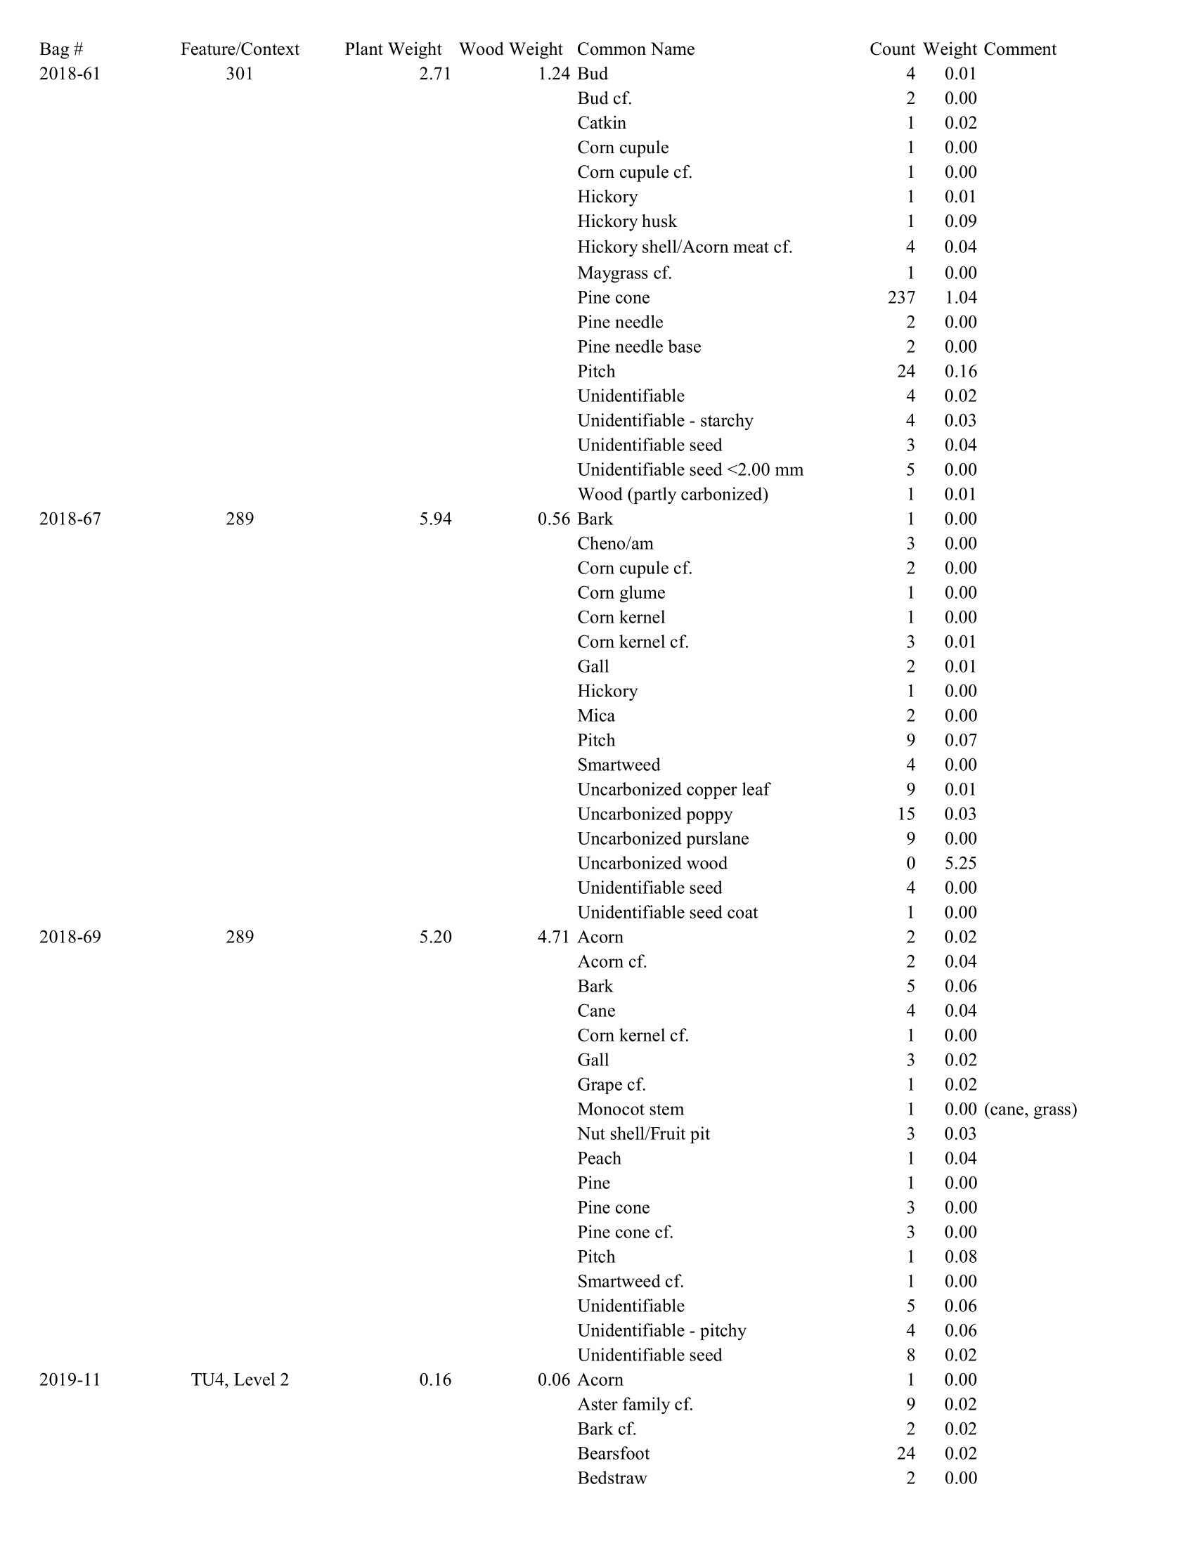
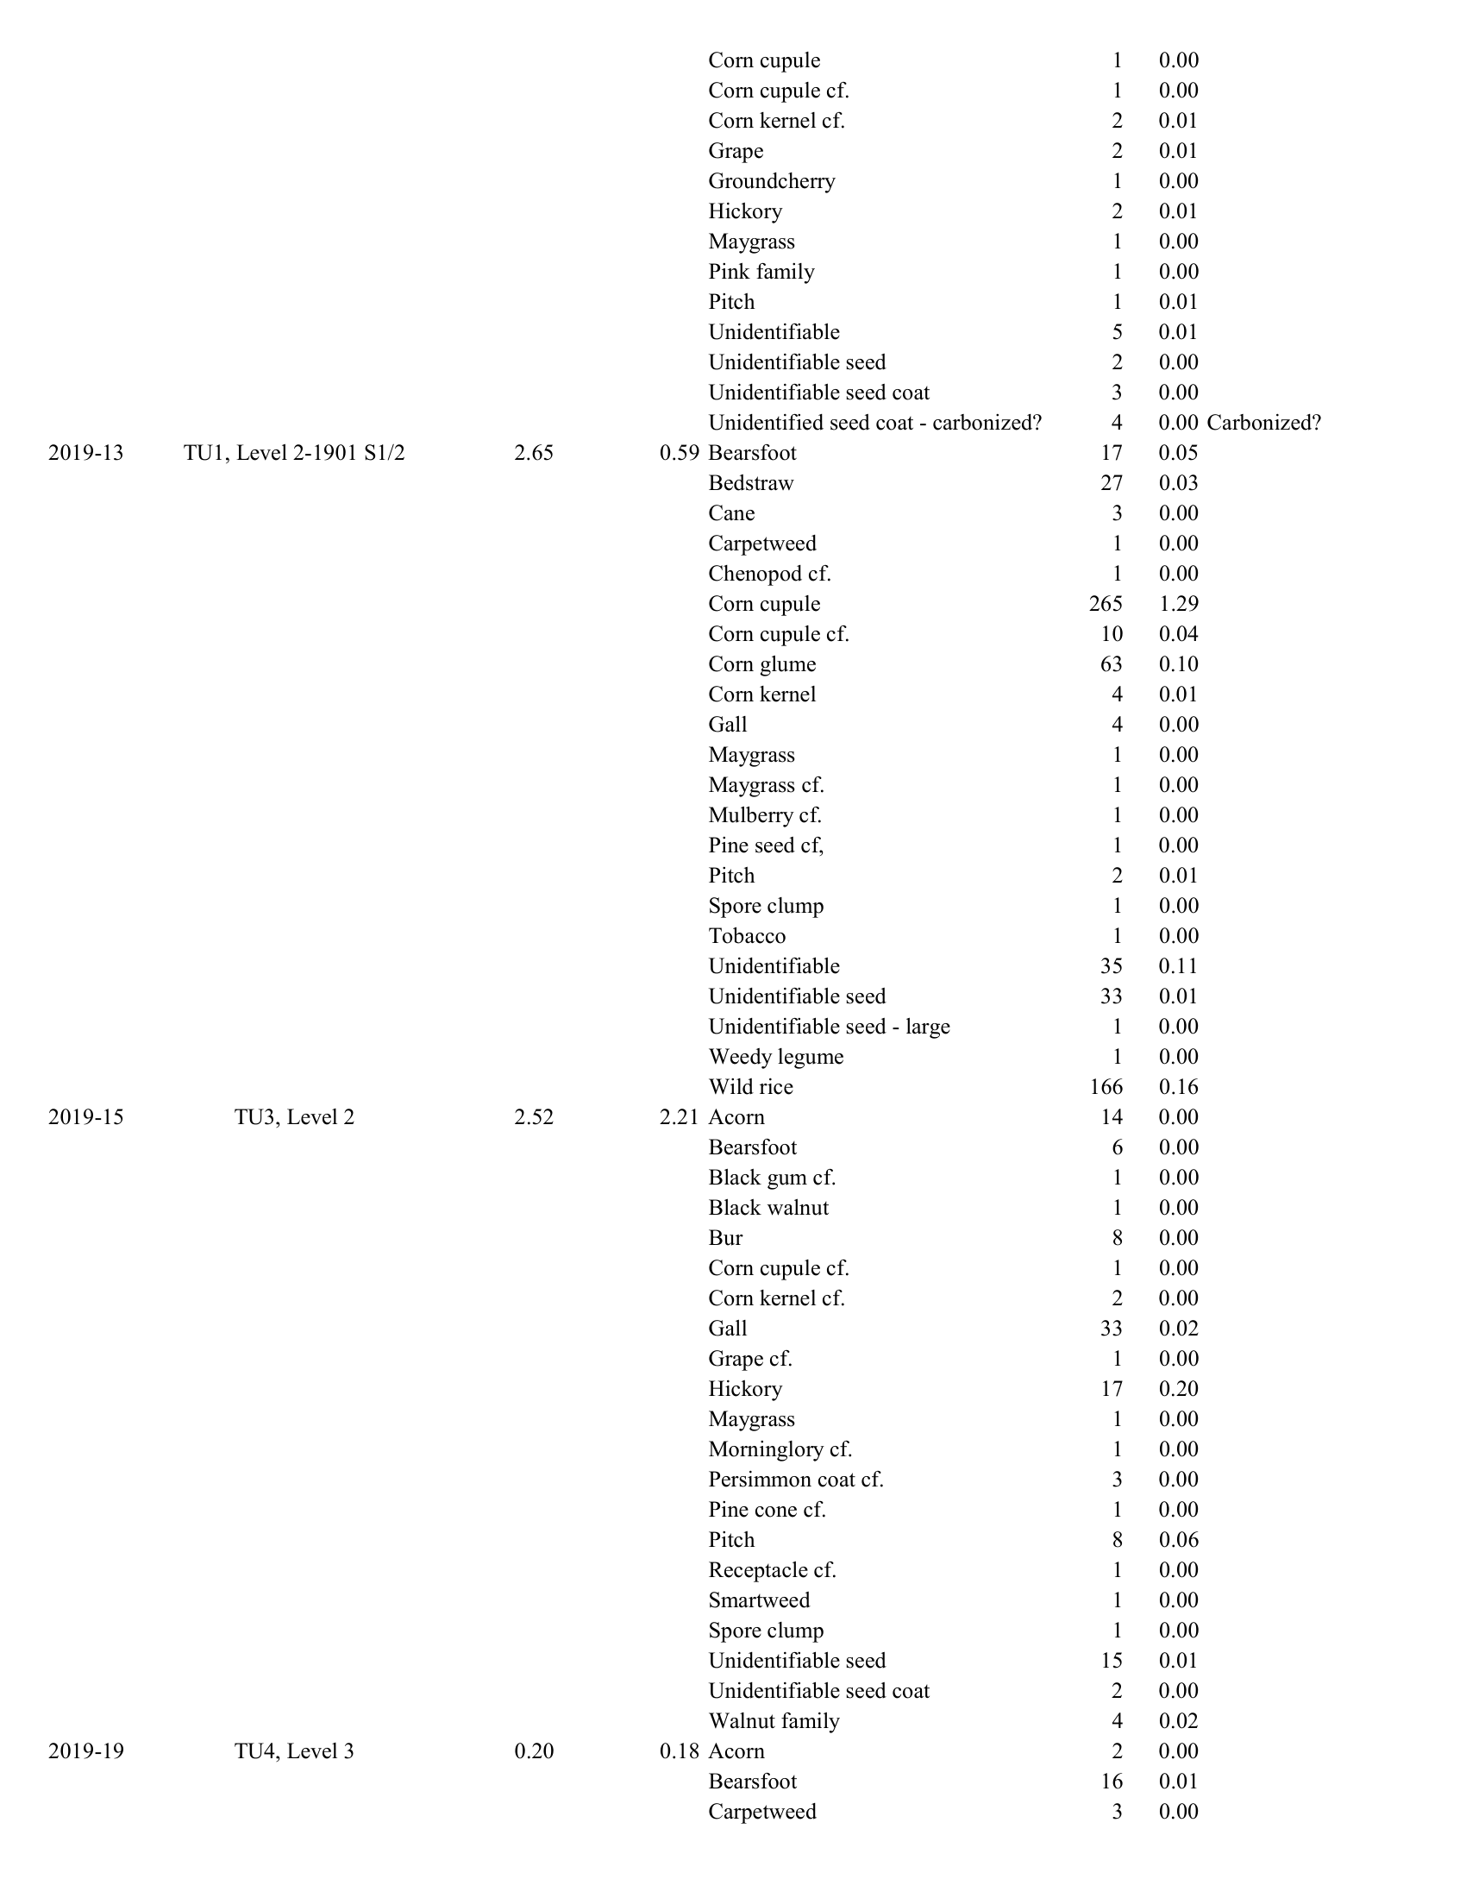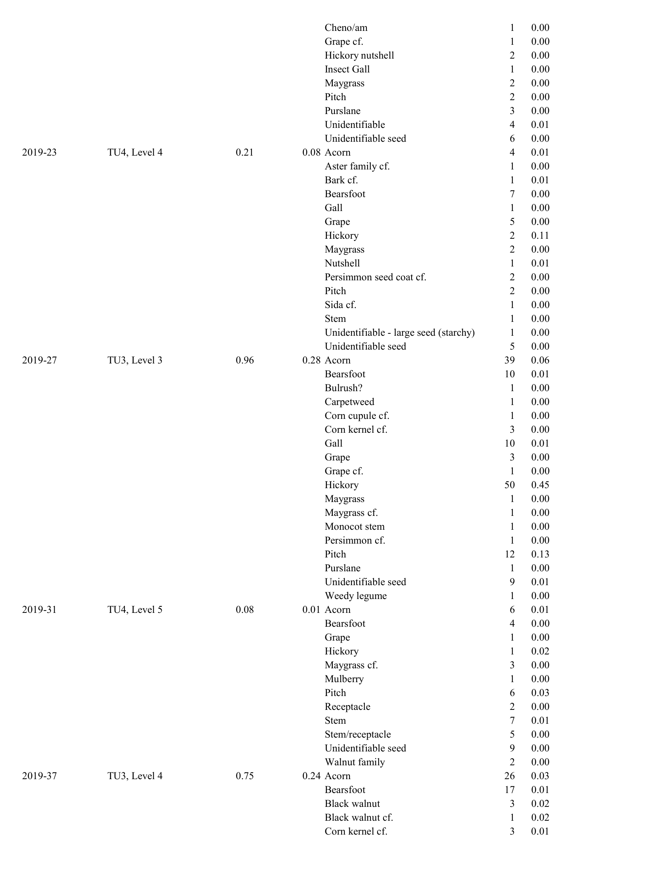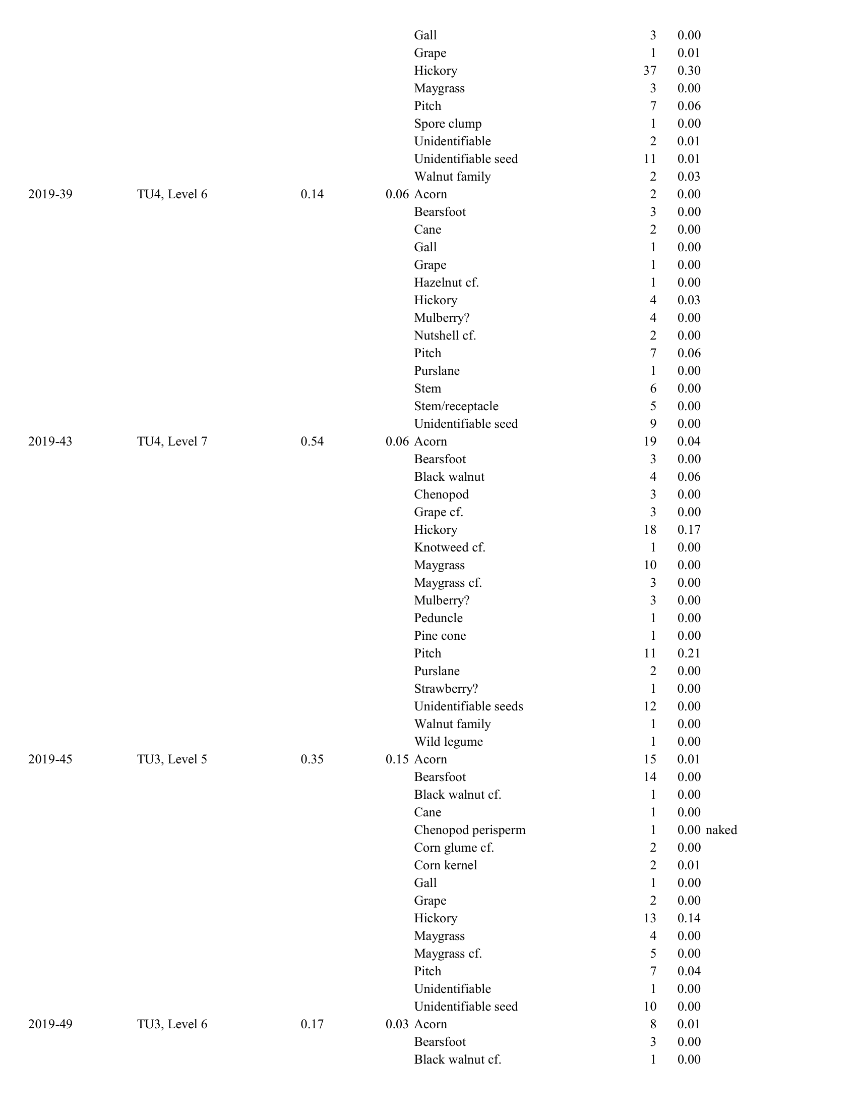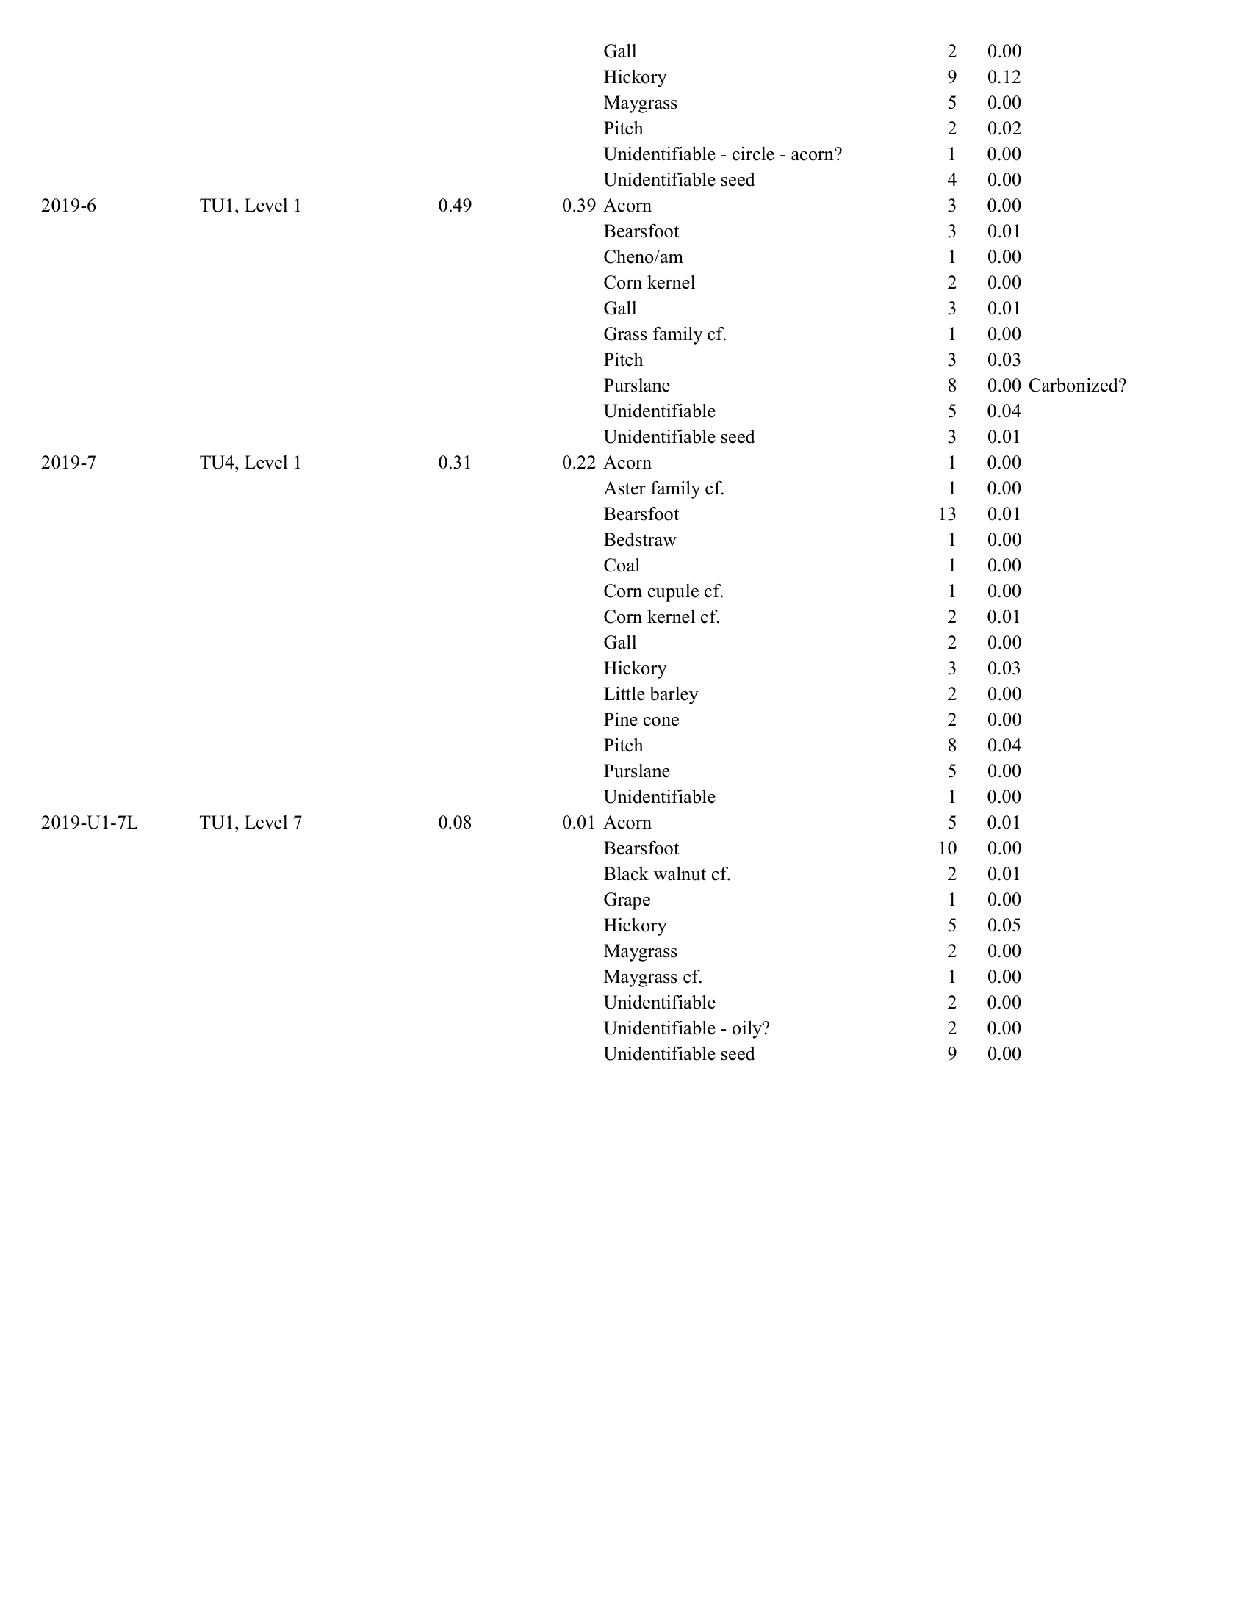

Appendix C: Plant Remains Recovered by Test Unit at the Cherokee Farm Site.
 |  |  | Unit 1 (n=3) |  | Unit 3 (n=5) |  | Unit 4 (n=7)
Common Name | Taxonomic Name | Seasonality | Count | Weight (g) | Count | Weight (g) | Count | Weight (g)
Nuts:
Acorn | Quercus spp. | fall | 8 | 0.01 | 102 | 0.11 | 35 | 0.06
Black walnut | Juglans nigra | fall |  |  | 4 | 0.02 | 4 | 0.06
Black walnut cf. | Juglans nigra cf. | fall | 2 | 0.01 | 3 | 0.02
Hazelnut cf. | Corylus sp. cf. | late summer/fall |  |  |  |  | 1 | 0.00
Hickory | Carya spp. | fall | 5 | 0.05 | 126 | 1.21 | 32 | 0.36
Nutshell |  |  |  |  |  |  | 1 | 0.01
Nutshell cf. |  |  |  |  |  |  | 2 | 0.00
Walnut family | Juglandaceae | fall |  |  | 6 | 0.05 | 3 | 0.00
Fruits:
Black gum cf. | Nyssa sylvatica cf. | late summer/fall |  |  | 1 | 0.00
Grape | Vitis spp. | summer | 1 | 0.00 | 6 | 0.01 | 9 | 0.01
Grape cf. | Vitis spp. cf. | summer |  |  | 2 | 0.00 | 4 | 0.00
Groundcherry | Physalis sp. | summer |  |  |  |  | 1 | 0.00
Mulberry | Morus sp. | summer |  |  |  |  | 1 | 0.00
Mulberry cf. | Morus sp. cf. | summer | 1 | 0.00 |  |  | 7 | 0.00
Persimmon cf. | Diospyros virginiana cf. | fall |  |  | 4 | 0.00 | 2 | 0.00
Strawberry cf. | Fragaria sp. cf. | summer |  |  |  |  | 1 | 0.00
Edible Seeds/Crops:
Bearsfoot | Smallanthus uvedalia | summer/fall | 30 | 0.06 | 50 | 0.02 | 70 | 0.04
Cheno/am | Chenopodium/Amaranthus | late summer/fall | 1 | 0.00 |  |  | 1 | 0.00
Chenopod | Chenopodium sp. | late summer/fall |  |  | 1 | 0.00 | 3 | 0.00
Chenopod cf. | Chenopodium sp. cf. | late summer/fall | 1 | 0.00
Corn cupule | Zea mays | late summer/fall | 265 | 1.29 |  |  | 1 | 0.00
Corn cupule cf. | Zea mays cf. | late summer/fall | 10 | 0.04 | 2 | 0.00 | 2 | 0.00
Corn glume | Zea mays | late summer/fall | 63 | 0.10
Corn glume cf. | Zea mays cf. | late summer/fall |  |  | 2 | 0.00
Corn kernel | Zea mays | late summer/fall | 6 | 0.01 | 2 | 0.01
Corn kernel cf. | Zea mays cf. | late summer/fall |  |  | 8 | 0.01 | 4 | 0.02
Knotweed cf. | Polygonum sp. cf. | late summer/fall |  |  |  |  | 1 | 0.00
Little barley | Hordeum pusillum | spring/early summer |  |  |  |  | 2 | 0.00
Maygrass | Phalaris caroliniana | spring/early summer | 3 | 0.00 | 14 | 0.00 | 15 | 0.00
Maygrass cf. | Phalaris caroliniana cf. | spring/early summer | 2 | 0.00 | 6 | 0.00 | 6 | 0.00
Tobacco | Nicotiana sp. | late summer/fall | 1 | 0.00
Wild rice | Zizania aquatica | fall | 166 | 0.16
Miscellaneous:
Aster family cf. | Asteraceae |  |  |  |  |  | 11 | 0.02
Bark cf. |  |  |  |  |  |  | 3 | 0.02
Bedstraw | Galium sp. | summer | 27 | 0.03 |  |  | 3 | 0.00
Bulrush cf. | Scirpus cf. | summer |  |  | 1 | 0.00
Bur |  |  |  |  | 8 | 0.00
Cane | Arundinaria sp. |  | 3 | 0.00 | 1 | 0.00 | 2 | 0.00
Carpetweed | Mollugo sp. | summer/fall | 1 | 0.00 | 1 | 0.00 | 3 | 0.00
Gall |  |  | 7 | 0.01 | 49 | 0.03 | 5 | 0.00
Grass family cf. | Poaceae cf. |  | 1 | 0.00
Monocot stem |  |  |  |  | 1 | 0.00
Morninglory cf. | Convolvulus/Ipomoeae | summer/fall |  |  | 1 | 0.00
Peduncle |  |  |  |  |  |  | 1 | 0.00
Pine cone | Pinus spp. |  |  |  |  |  | 3 | 0.00
Pine cone cf. | Pinus sp. cf. |  |  |  | 1 | 0.00
Pine seed cf. | Pinus sp. cf. | fall | 1 | 0.00
Pink family | Caryophyllaceae |  |  |  |  |  | 1 | 0.00
Pitch |  |  | 5 | 0.04 | 36 | 0.30 | 37 | 0.35
Purslane | Portulaca sp. | summer/fall | 8 | 0.00 | 1 | 0.00 | 11 | 0.00
Sida cf. | Sida cf. | summer/fall |  |  |  |  | 1 | 0.00
Smartweed | Polygonum cf. pensylvanicum | summer/fall |  |  | 1 | 0.00
Spore clump |  |  | 1 | 0.00 | 2 | 0.00
Stem |  |  |  |  |  |  | 14 | 0.01
Stem/receptacle |  |  |  |  | 1 | 0.00 | 12 | 0.00
Weedy legume | Fabaceae | late summer/fall | 1 | 0.00 | 1 | 0.00 | 1 | 0.00
Unidentifiable |  |  | 42 | 0.15 | 4 | 0.01 | 10 | 0.02
Unidentifiable seed |  |  | 48 | 0.02 | 51 | 0.03 | 51 | 0.00

