ASERL Spring 2011 Membership Meeting
Update: Best Practices for Resource Sharing
David Atkins, University of Tennessee

1. Benchmarking Basics: ASERL Interlibrary Loan Needs Assessment and Best Practices Survey

Scope and Purpose: A working group of ASERL librarians designed a survey to assess resource sharing issues and identify best practices. The results will assist ASERL in identifying programming and project areas to support resource sharing. The survey will also produce ILL and resource sharing benchmarks useful for future planning and assessment. The survey inquires into fundamental resource sharing outputs, networks, and technologies. To measure current best practices, the survey also incorporates Rethinking Resource Sharing "STARS" A Checklist Interlibrary Loan Assessment, devised by ALA/RUSA/STARS.
Survey Areas: Survey respondents answered questions in the following areas:
- Library Member Characteristics and ILL Technology
- Resource Sharing Consortia and Networks
- Campus Document Delivery
- Issues and Challenges
- Best Practices as defined by Rethinking Resource Sharing "STARS" A Checklist Interlibrary Loan Assessment. Libraries scoring 80% or higher earn STARS award.

Participation: 32 out of 38 eligible libraries completed the survey.

Preliminary Summary: Distributed during November’s meeting. Committee expanding report and seeking publication and presentation opportunities.

Some Results

2. Whose Best Practices? Rethinking Resource Sharing (RRS)

RRS’s Goal: Create and promote best policies and practices for truly valued and valuable resource sharing. Lines blurring between ILL, circulation, acquisitions, reference. How does resource sharing fit in a changing landscape.

Many Libraries Currently Follow RRS Best Practices
- All 32 follow 9 practices (e.g.)
- Library’s holdings are discoverable in www.worldcat.org
- Library utilizes open URL resolvers
- Library’s borrowing policies and procedures are posted for users
- Library staff is aware of the sharing permissions of the licensed content at the library
- Library participates in reciprocal agreements with other library

- 31 Libraries follow 19 practices (e.g)
  - Library processes user requests within 2 business days
  - Library provides online status of requests for users 24/7
  - Borrowing library sends request to libraries outside of home country
  - Lending library loans new items
  - Library allows for remote renewals of materials

Many Libraries Aren’t Following Other Practices
- Only 12% follow these practices
  - Lending library allows unlimited renewals for items not needed locally
  - Borrowing library allows for direct delivery of materials from the lending library to the end user
  - Lending library distinguishes fees for unique materials
  - Library uses DOCLINE EFTS to manage fee transactions
  - Lending library offers incentives for early return of materials

18 of 32 scored 80% or higher, earning the newly created RRS “Star” Award. (forthcoming)


- Auburn University  - College of William and Mary  - East Carolina University  - Emory University  - Florida International University  - Florida State University  - Mississippi State University  - North Carolina State University  - University of Florida | - University of Georgia  - University of Mississippi  - University of North Carolina at Chapel Hill  - University of South Carolina  - University of Tennessee  - Vanderbilt University  - Virginia Commonwealth University  - Wake Forest University
Using the Results? Example: Benchmark who’s is doing what for “Purchase on Demand”

RRS Best Practice 53. Library considers buy-on-demand before sending requests to library suppliers.
23 out of 27 respondents provide this service today or will do so by mid 2011.

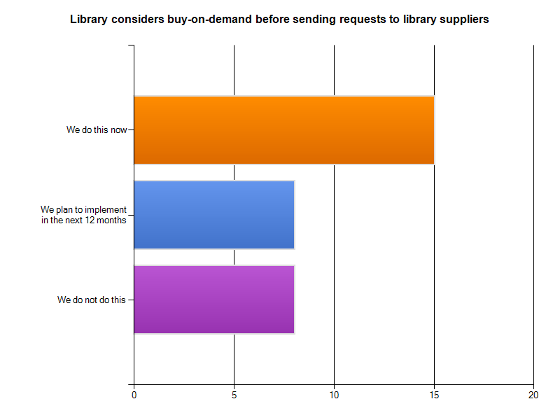

3. Next Steps
A. Complete survey reports including custom reports by institution
B. Coordinate with RUSA/STARS on use and promotion of the Best Practices Checklist
C. Figure out the Next Steps: What does ASERL want to do with Resource Sharing?
  - Programming and Training to Expand Best Practices?
  - Expand Kudzu and Courier?
  - Other Ideas such as ILL/Acquisitions?

ASERL Survey Team: David Atkins, University of Tennessee; John Burger, ASERL; William Gee, East Carolina University; Judy Greenwood, University of Mississippi; Pam King, Auburn University; Kristine Shrauger, University of Central Florida; and Shirley Thomas, Virginia Commonwealth University.

Contact:
David Atkins
Resource Sharing & Document Delivery
University of Tennessee, Knoxville
datkins@utk.edu and 865-974-6866

