CHARACTERIZING PATHOGENESIS-RELATED PROTEINS AND ENVIRONMENTAL CONDITIONS THAT SUPPRESS DOLLAR SPOT INFECTIONS OF BENTGRASS

A Thesis Presented for the
Master of Science
Degree
The University of Tennessee, Knoxville

Dillon T. McCallum
December 2024

ACKNOWLEDGEMENTS
Thank you to all my committee members, Dr. Keenan Amundsen, Ryan Kuster, and Dr. Aaron Onufrak for all the support and guidance during my time at the University of Tennessee. To my advisor, Dr. Brandon Horvath, I want to give a special thanks for his patience and willingness to help me with my degree and life outside of research. I have matured the most under your guidance and look forward to working with you in the future. I also want to thank my undergraduate research advisors, Dr. Kevin Jones and Dr. Markos Koutmos, and Brian Schweihofer for taking a chance on me and increasing my interest in research and the turfgrass industry. To my fellow graduate students and research technicians, David Shell, Maureen Kahiu, Caitlin Dalton, Robert Petursson, Ben Pritchard, Brooke Keadle, Tyler Carr, and Taylor Williams, I thank you for your advice and friendship during my degree. Lastly, I want to thank my parents and partner for their unwavering support throughout my time as a student. I could not have finished this degree without you.
ABSTRACT

Dollar spot (Clarireedia spp.) infects almost every turfgrass grown in the U.S. but is especially damaging to cool season turfgrasses. Thus, fungicides are needed to control this pathogen during high disease pressure. Due to the heavy reliance on fungicides, dollar spot populations have developed fungicide resistance, demonstrating the need for new effective treatments that substitute for fungicides. As a result, this study investigated the transcriptional differences between highly susceptible creeping bentgrass (Agrostis stolonifera L.) and colonial bentgrass (Agrostis capillaris L.), a species of bentgrass that is more resistant to dollar spot. I hypothesized colonial bentgrass will possess differentially expressed genes critical in pathogen defense between control and inoculated plants that are either unique to its genotype, expressed higher than creeping bentgrass, or have higher constitutive expression in the non-inoculated controls than creeping bentgrass. To test this hypothesis, pots of both bentgrass species were inoculated with Clarireedia jacksonii and then diseased tissue was harvested at 48, 60, 72 , and 96 hours post inoculation (hpi) for RNA sequencing. Additionally, non-inoculated controls were placed in the same conditions and harvested at the 48 hpi and 96 hpi. Our results indicated colonial bentgrass uses 77 potential resistance genes to prevent dollar spot infection that are either unique or have increased expression in comparison to creeping bentgrass.
This study also determined what environmental factors impact the size of dollar spot infection foci. Previous work in our lab demonstrated, in the absence of ultraviolet light B radiation(UVB), dollar spot infection foci were larger and more severe. As a result, I hypothesized that as the dose of UVB increases, the size of dollar spot infection foci will decrease. To test this hypothesis, creeping bentgrass was inoculated with dollar spot, placed in a growth chamber for 24 hours, and then treated with UVB light at either 1x normal sunlight or 2x normal sunlight for seven days. Our results suggest that dollar spot is UVB light-sensitive because UVB treated plants had infection foci that either stayed the same or decreased in size over the course of the experiment. Thus, UVB light plays a key role in limiting the spread of dollar spot on the turfgrass surface, suggesting the possibility of using UV light as a dollar spot treatment.

Table of Contents
CHAPTER 1 LITERATURE REVIEW 1
DOLLAR SPOT 2
Reclassification 2
Symptoms & Pathogenesis 4
Management 8
CREEPING BENTGRASS 15
Morphology & Genetics 15
Disease Susceptibility 16
COLONIAL BENTGRASS 17
Morphology & Distribution 17
Disease Susceptibility 18
PLANT DEFENSE PATHWAYS 19
PAMP-Triggered Immunity 19
Effector-Triggered Immunity 20
Pathogenesis-Related Proteins 21
Systemic Acquired Resistance 28
ULTRAVIOLET LIGHT B (UVB) 29
LIST OF REFERENCES 33
CHAPTER 2 THE TRANSCRIPTOME OF THE DOLLAR SPOT-BENTGRASS PATHOSYSTEM OVER THE TIME COURSE OF INFECTION 70
ABSTRACT 71
INTRODUCTION 72
MATERIALS AND METHODS 76
Inoculum Preparation 76
Study Design 76
Plant Material & Inoculations 78
Tissue Sampling, RNA Extraction, & RNA Sequencing 78
Data Processing 79
RESULTS 84
Dollar Spot Mapping and Bentgrass Transcriptome Comparisons 84
Unique Transcripts 86
Shared Transcripts 86
Constitutive Expressed Transcripts 91
DISCUSSION 98
Pattern Recognition Receptors 98
PR-3 and PR-4: Chitinases 104
PR-5: Thaumatin-like Proteins 107
PR-6: Protease Inhibitors 107
PR-9: Peroxidases 108
Callose Synthase 109
PR-10: Ribonucleases 110
PR-15: Germin Proteins (Oxalate Oxidases) 112
PR-16: Germin-like Proteins 113
Secondary Defense Proteins 115
CONCLUSION 116
LIST OF REFERENCES 118
CHAPTER 3 INVESTIGATING DOLLAR SPOT INFECTION CENTER SIZE 146
ABSTRACT 147
INTRODUCTION 148
MATERIALS AND METHODS 150
Inoculum Preparation 150
Study Design 150
Plant Material 151
Inoculations and Light Treatments 151
Data Collection and Data Analysis 152
RESULTS 153
DISCUSSION AND CONCLUSION 156
LIST OF REFERNCES 160
APPENDIX 166
INOCULATION OPTIMIZATION 167
Materials & Methods 167
Results & Conclusions 167
SEEDLING SELECTION EXPERIMENT 170
Material and Methods 170
Results and Conclusions 172
Vita 175

LIST OF TABLES
Table 1.1 Pathogenesis-related protein families and associated functions (adapted from dos Santos and Franco, 2023) 22
Table 2.1 Run 1 mapped reads to dollar spot reference genome. 85
Table 2.2 Run 2 mapped reads to dollar spot reference genome. 85
Table 2.3. Assembly statistics for each genotype’s de novo transcriptome individually. 85
Table 2.4. Differential expression analysis between the two non-inoculated controls in run 1. 88
Table 2.6. List of gene ontology terms and functional annotations for all differentially expressed transcripts associated with unique transcripts. Red text highlights genes only found in run 1. 90
Table 2.7. List of gene ontology terms and functional annotations for all shared differentially expressed transcripts with increased expression in ‘BCD’ compared to creeping bentgrass genotypes at all time points. Red text highlights genes only found in run 1. 92
Table 2.8. List of constitutively expressed transcripts with increased expression in ‘BCD’ compared to the creeping bentgrass genotypes. Red text highlights genes only found in run 1. 95
Table 3.1. Mixed model ANOVA table for precent green cover calculated using digital image analysis. 154
Table 3.2. Mixed model ANOVA table for precent disease severity. 154
Table 3.3. Mixed model ANOVA table for infection foci size. 154
Table 3.4. Paired t-test to determine phototoxic effects in positive control 2 plants. 157
Table S1.1. The Horsfall-Barrett scale used for rating disease progress 168

LIST OF FIGURES
Figure 2.1. RNA sequencing experiment study design. Three different genotypes were inoculated except for controls and tissue collected at four different time points (48 hours post inoculation (HPI), 60 HPI, 72 HPI, and 96 HPI). 77
Figure 2.2. Bioinformatics pipeline used for processing raw RNA sequence reads. 80
Figure 2.3. Statistical analysis pipeline used for analyzing processed RNA sequencing reads. 82
Figure 2.4. Reciprocal BLASTn results displaying the number of unique and shared transcripts for (A) ‘BCD’, (B) ‘Crenshaw’, and (C) ‘Declaration’. 87
Figure 2.5. Defense-related gene ontology terms after analyzing (A) unique differentially expressed transcripts (DETs), (B) shared DETs, and (C) constitutively expressed DETs. 89
Figure 3.1. Time course of dollar spot pathogenesis. (A) Changes in normalized percent green cover, (B) Disease severity (%), and (C) infection center size. Error bars show one standard deviation around the mean. and the Dunnetts test was used to assign significance by comparing treatment 1 (orange) and treatment 2 (black) against positive control 1. *** Significant at 0.001; ** Significant at 0.01; * Significant at 0.05; . Significant at 0.1 155
Figure S1.1. The uniform distribution of each amount of inoculum on the surface of plant samples. 2.5 and 3 grams of inoculum fully cover the surface. 169
Figure S1.2. A scatter plot where the disease severity associated with each treatment was plotted over time. Disease severity was measured using the Horsfall-Barrett scale. 171
Figure S1.3. Timepoint confirmation using light microscopy. First column is 48 hours post inoculation (hpi) with the top picture showing the appearance from above the canopy and the bottom picture is a leaf sampled from random in the pot. The second column is 96 hpi with the picture of the canopy on top and a picture of a leaf sample underneath a light microscope on the bottom. The red arrows highlight the runner hyphae present on the leaf’s surface. 174

CHAPTER 1
LITERATURE REVIEW

                - DOLLAR SPOT
Dollar spot (Clarireedia spp.) is one of the most economically and environmentally devastating diseases in turfgrass systems. Approximately 43% of the projected total acres on golf courses in the United States are composed of C3 grasses (creeping bentgrass, annual bluegrass, and Kentucky bluegrass are most common), all of which are highly susceptible to dollar spot (United States Golf Association, 2021). This pathogen was first discovered by J. Monteith (1927), who called it little brown patch, and then characterized by F.T. Bennett (1937). In England, he observed that the pathogen produced spores and conidia similar to ascomycetes found in the Sclerotinia genus. Consequently, he named the pathogen Sclerotinia homoeocarpa F. T. Bennett (Bennett, 1937). Today, this pathogen affects all short-grown turf on golf courses and sports fields around the world.
Reclassification
In 1945, taxonomy of the Sclerotinia genus was restricted to only include fungi that produce apothecia from tuberoid sclerotia (Whetzel, 1945). Over the next 80-plus years, morphological and DNA sequence data showed that dollar spot was incorrectly placed in the genus Sclerotinia, and various works proposed placement in other genera within the Rutstroemiaceae such as Lanzia, Moellerodiscus, Lambertella, etc. (Carbone and Kohn, 1993; Holst-Jensen et al., 1997; Jackson, 1973; Powell, 1998). A seminal paper from Salgado-Salazar et al. (2018) using three different DNA markers (CaM, ITS, Mcm7) proved dollar spot should be placed in its own genus within the Rutstroemiaceae family. After sampling DNA from isolates distributed across the US, Canada, and UK, including the isolates F.T. Bennett collected, they found four species present: Clarireedia homoeocarpa (F.T. Benn.)L.A. Beirn, B.B. Clarke, C. Salgado, J.A. Crouch, Clarireedia bennettii L.A. Beirn, B.B. Clarke, C. Salgado, J.A. Crouch, Clarireedia jacksonii C. Salgado, L.A. Beirn, B.B. Clarke, J.A. Crouch, and Clarireedia monteithiana C. Salgado, L.A. Beirn, B.B. Clarke, J.A. Crouch. Of these four new species, C. jacksonii and C. monteithiana are most prevalent in the U.S. with C. jacksonii primarily infecting C3 grasses, and C. monteithiana primarily infecting C4 grasses. Recently, Hu et al. (2019) and Zhang et al. (2022b) discovered a fifth and sixth species, C. paspali J. Hu & K. Lamour and C. hainanense H. Zhang & J. Hu, respectively. Both pathogens were discovered infecting carpet grass (Axonopus compressus P. Beauv) and seashore paspalum (Paspalum vaginatum O.G. Swartz) on golf courses in China. Hu et al. (2019) also detailed C. jacksonii isolates pathogenic on seashore paspalum, a new finding for this dollar spot species. In addition to reclassification, the genome of each Clarireedia spp. has been fully sequenced and published to aid further molecular studies (Crouch et al., 2021; Zhang et al., 2022a).
Several research papers prior to reclassification of the genus suggested the possibility of C. jacksonii and C. monteithiana isolates having the ability to infect both C3 and C4 grasses (Liberti et al., 2012; Putman et al., 2015). However, Aynardi et al. (2019) proved both C. jacksonii and C. monteithiana can infect C3 and C4 grasses. This group also found C. jacksonii is more virulent on C3 and C4 grasses compared to C. monteithiana. The underlying reasons for this adaptation are unclear.

Symptoms & Pathogenesis
Clarireedia spp. are foliar pathogens that grow along the leaf surface until they find a stomate or wounded leaf blade to penetrate. Once inside the leaf blade, the pathogen extends its hyphal tips along the edges of cell walls before forming infection pegs that penetrate the cell walls, resulting in a coordinated attack. This pathogen is a hemibiotroph since it has a short biotrophic phase where it grows inside the plant without infecting (Rioux et al., 2021). Symptoms of dollar spot appear as an hourglass-shaped lesion of tan tissue that spans the width of the leaf. These areas of the leaf then become water soaked before turning a bleached white or straw color. During prolonged periods of high relative humidity and excessive leaf moisture white, cobweb-like mycelia may appear in the canopy of the turfgrass surface. Throughout the infection period, it is also common to have dieback from the leaf tip (Smiley et al., 2005). On shorter cut turfgrass swards, the white or straw-colored turf appears as silver dollar-sized spots (~5 cm). If left untreated, these spots become pitted and sunken when compared to surrounding healthy turf, affecting uniform ball role across the surface. When disease pressure is severe the spots will coalesce to form large areas of blighted turfgrass (Bennett, 1937; Monteith, 1927).
Dollar spot disease pressure is highest under certain environmental conditions. While the pathogen is active at temperatures between 15-30 °C, dollar spot grows most optimally between 21-27 °C. Some additional favorable environmental conditions include cool nights, prolonged periods of high humidity in the canopy, and rain events. Thus, moderately warm, humid days with cool, dew producing nights increase the likelihood of dollar spot epidemics (Smiley et al., 2005). Other factors that increase the severity of dollar spot include low soil water content, nitrogen fertility, and amount of oxalic acid production by Clarireedia spp. (Allen et al., 2005; Couch and Bloom, 1960; Rioux et al., 2021).
Oxalic acid is a compound that many different fungi use in order to aid entry into a host cell. Sclerotinia sclerotiorum (Libert) de Bary uses oxalic acid synergistically with secreted cell-wall degrading enzymes to infect host tissue (Dutton and Evans, 1996; Marciano et al., 1983). While oxalic acid primarily functions in decreasing the pH of the host-pathogen interface, it also can alter the redox environment of the host, induce programmed cell death, and suppress plant defense mechanisms (Kabbage et al., 2013; Kim et al., 2008; Williams et al., 2011). S. sclerotiorum also uses oxalic acid to detoxify its hyphal tips from excess Ca²⁺ ions that are released from dying cells (Heller and Witt-Geiges, 2013). Similar to S. sclerotiorum Venu et al. (2009) showed that dollar spot produces oxalic acid using the pH indicator bromophenol blue.
Rioux et al. (2021) and Townsend et al. (2020) conducted experiments to determine the function and significance of oxalic acid in dollar spot pathogenesis. Townsend et al. (2020) measured the concentration of oxalic acid secreted by a C. jacksonii isolate after altering environmental pH and exposing it to compounds found in creeping bentgrass cell walls such as cellulose, lignin, pectin, and xylan. First, they found oxalic acid production in the fungus was increased at pH 7 when compared to pH 4, which had almost no acid production. Second, they found C. jacksonii reacted with higher oxalic acid production in the presence of only xylan. This suggests that oxalic acid production is important in lowering environmental pH and helping break down xylan by activating xylanases that are integral in degradation of the plant cell wall.
Rioux et al. (2021) determined how oxalic acid production differed between isolates and changed over the time course of infection. They found that different isolates produce different amounts of oxalic acid when creeping bentgrass plants were inoculated, isolates with lower production were slower to infect and had reduced disease severity. Additionally, they determined that oxalic acid is more important during early stages of infection (before symptoms appear on leaves) since accumulation peaks at 48 hpi and declines steadily after. As a result, they concluded that oxalic acid lowers pH and creates conditions favorable for cell-wall degradation, similar to S. sclerotiorum. Another possibility is that oxalic acid is able to suppress host defense pathways, however, more research is needed to confirm this hypothesis (Kabbage et al., 2013; Williams et al., 2011).
Orshinsky et al. (2012) evaluated gene expression of the creeping bentgrass-dollar spot pathosystem at 96 hours post inoculation (hpi) in order to determine pathogenicity factors of dollar spot and what defense pathways are activated in response to this pathogen. They found the pathogen had numerous different glycosyl hydrolases and proteinases upregulated, whereas creeping bentgrass had numerous transcripts associated with germin, germin-like proteins, and transposons. Germin and germin-like proteins function as oxalate oxidases, which break down oxalic acid into hydrogen peroxide (H₂O₂) and carbon dioxide (CO₂), indicating indirectly the importance of oxalic acid in the epidemiology of dollar spot. Additionally, the product of oxalic acid degradation, hydrogen peroxide, is an important defense signaling molecule, toxic to fungal hyphae, increases cell wall lignification, and stimulates phytoalexin production (Davidson et al., 2009). While these results offered some of the first insights genees, associated with the dollar spot-bentgrass pathosystem, recent improvements in sequencing technology, bioinformatic applications, and genome annotations suggest an update is needed. Additionally, this study used only one cultivar of creeping bentgrass limiting its ability to determine how this interactions changes between cultivars with differing dollar spot resistances.
Bahri et al. (2023) explored other pathogenesis factors present in different species of dollar spot. They found that in addition to oxalic acid production, genes involved in mitogen-activated protein kinase cascades, appressorium formation, and glycolytic pathways were also present. Between the three species C. paspali, C. jacksonii, and C. monteithiana, there were 366 single nucleotide polymorphisms (SNP) present in these gene groups, suggesting that each of these species may involve varied pathways and methods to successfully infect the host. Future research can focus on how different Clarireedia spp. infect their hosts and if they use unique methods.
Due to Clarireedia spp. do not produce sexual spores or asexual conidia, scientists were unsure how dollar spot epidemics could become established in an area (Agarwal et al., 1997; Carbone and Kohn, 1993). One hypothesis was mowers and other maintenance equipment spread infected clippings and mycelia (Fenstermacher, 1980). However, a study on the spatial structure of dollar spot epidemics conducted by Horvath et al. (2007) showed epidemics occur in a clustered pattern and that they only move a short distance (<1m) calling into question how effective mowers and other equipment might be spreading infected tissue when clippings are collected. Shortly after, DeVries et al. (2008) found that isolates from each location grouped together after phylogenetic analysis, suggesting the presence of founder effects. A founder effect is when a small number of individuals from the parent population establish a new population. Thus, all descendants are related to the limited number of founders. As a result, Rioux et al. (2014) determined whether Clarireedia spp. were present in commercial seed, explaining the founder effect finding. They were able to isolate a small amount of dollar spot from a commercial seed vendor. While only 0.0028% of sampled seeds were positive for Clarireedia spp., this equates to ~70 infected seeds per kg. A typical golf course green is approximately 6,500 ft² and seeded at a rate of 0.45-0.68 kg per 1000 ft². As a result, after seeding, a new green contains ~210 seeds contaminated with Clarireedia spp.
Management
Dollar spot is a stressor for superintendents and athletic field managers because it aggressively kills turfgrasses, impacts uniform roll of the green or field, and is expensive to treat. Cultural control practices are an essential first step for controlling and limiting harmful effects of epidemics. Ellram et al. (2007) and Williams et al. (1996) found that removing dew daily through mowing and dew squeegeeing in order to prevent excessive moisture in the foliage of the plant was most effective in controlling dollar spot. Williams et al. (1996) also found that adequate nitrogen fertility and removing grass clippings reduced dollar spot epidemics, a finding confirmed by Allen et al. (2005) and Townsend et al. (2021). Additional cultural control techniques that have been proven to be effective at suppressing dollar spot outbreaks are lightweight rolling, sand topdressing, and vertical mowing. Both sand topdressing and vertical mowing dilute organic matter found in the thatch and top inches of the soil profile, where dollar spot survives between epidemics (Allan-Perkins et al., 2018; Giordano et al., 2012; Green et al., 2019). Lastly, topdressing with composts have been shown to decrease dollar spot severity even after being unused and stored for a few years (Boulter et al., 2002; Doherty & Roberts, 2023).
While cultural control techniques reduce disease severity, these techniques alone will not achieve acceptable control of dollar spot for most superintendents and field managers. As a result, adequate control of dollar spot relies heavily on frequent applications of fungicides. Both contact and penetrant fungicides are used to treat dollar spot. Contact fungicides are only effective if applied as a preventative treatment because they cannot translocate into the plant (Latin, 2011). As a result, using a forecasting model is helpful for timing applications of these fungicides. The first dollar spot predictive models were developed by Mills and Rothwell (1982) and Hall (1984). Both attempted to determine what specific weather conditions can warn of a dollar spot epidemic. Mills and Rothwell found that when maximum daytime temperature was ≥25 °C and maximum relative humidity was ≥90% over three days in a seven-day period an epidemic of dollar spot was likely. In the other study, Hall determined that two or more consecutive wet days with daytime temperatures ≥22 °C hinted at dollar spot epidemics. However, both models were only partially useful and did not consider enough parameters, resulting in Mills and Rothwell overpredicting and Hall underpredicting epidemics. Thus, a calendar-based model was still the best way of spraying fungicides for dollar spot control until Smith et al. (2018) was able to improve on forecasting dollar spot epidemics.
Smith et al. (2018) converted weather data to a five-day moving average and then used logistic regression to create the model. Variables that passed the collinearity test and most associated with dollar spot epidemics were binomial fungicide application (FUNG), mean daily air temperature (AT), mean day relative humidity (RH), and maximum daily air relative humidity (MAXRH). Using AT and RH, the Smith-Kerns model was created and predicts the probability of dollar spot infection over periods of time. Smith et al. determined setting a prediction threshold of 20% and applying fungicides when the model predicted a higher probability, produced dollar spot control similar to a 21-day spray interval program and saved one to three sprays per year subject to location and year.
After using the Smith-Kerns model during growing seasons, it was determined that the model was still overpredicting epidemics due to modern varieties having increased resistance to dollar spot. Therefore, Hempfling et al. (2021) improved on this model to make it more accurate. Hempfling at al. used the results of Ryan et al. (2012), who discovered the creeping bentgrass cultivar was also an important factor for predicting dollar spot infection when using the growing degree day model, to improve upon the Smith-Kerns model. Thus, they decided to test five action thresholds for dollar spot control on six cultivars of creeping bentgrass, representing a wide range of dollar spot susceptibilities contained in the creeping bentgrass family. Hempfling et al. concluded that cultivars with lower susceptibilities may be able to use an action threshold that exceeds 20%. However, this may be dependent on other factors associated with each individual golf course that uses these cultivars. Another conclusion was that moderately and highly susceptible cultivars still should use the 20% action threshold suggested by Smith et al. (2018). Together, the Smith-Kerns model and work by Hempfling et al. allow golf course superintendents and athletic field managers to apply fungicides more effectively and match their expectations and budgets to provide excellent control of this disease.
Contact fungicides are products that when sprayed coat the surface of plants and prevent a fungus from growing on the leaf and penetrating inside the plant. Most are classified as multi-site mode of actions that are only effective when applied preventatively. Additionally, these fungicides have a shorter period of control because the product is removed from the surface by daily mowing when clippings are collected. Penetrant fungicides or systemic fungicides can be absorbed by the plant, thus offering both preventative and curative treatment options. Some common penetrant mode of actions used against dollar spot include demethylation inhibitors (DMIs), succinate dehydrogenase inhibitors (SDHIs), quinine outside inhibitors (QoIs), dicarboximides, and benzimidazoles. While fungicides in these mode of actions offer a longer interval of control, there is a significant risk for development of resistance within Clarireedia spp. isolates. This is because each mode of action of penetrant fungicides targets a single site within the fungus inhibiting a critical pathway involved in growth and survival. Thus, the principles of natural selection apply because synthetic fungicides create a selection pressure, for which only the fittest individuals can survive. When the same class of fungicides is used repeatedly, these fit individuals are still able to reproduce and now make up a greater proportion of the population, leading to resistance.
Resistant populations of dollar spot worldwide have been documented for all classes of penetrant fungicides described above except QoIs (Burpee et al., 1997; Cole et al., 1968; Deitweiler et al., 1983; Golembiewski et al., 1995; J. Hu et al., 2021; Popko et al., 2018; Warren et al., 1974). DMI resistance occurs in dollar spot populations primarily due to overexpression of ATP-binding cassette (ABC) efflux transporters (ShatrD & ShPDR1) that actively pump out the fungicide’s active ingredients (a.i.) from their cells. Additionally, overexpression of the target gene (ShCYP51B) has been observed in resistant populations but has a reduced effect in comparison to ABC transporters (Hulvey et al., 2012; Sang et al., 2015). SDHI resistance develops differently than DMI resistance. Popko et al. (2018) observed four different SNPs in the SdhB (H267Y) and SdhC (G91R, G150R, and G159W) subunits leading to a change in amino acid composition of the protein. After this, Lee et al. (2021) found two more SNPs (B-H267R and C-P80L) associated with resistant isolates. These mutations alter the folding of the protein and potentially inhibit the ability of the fungicide’s a.i. to bind and restrict its function. Similarly, resistance to benzimidazoles occurs through one SNP (E198A) found in the β-tubulin gene that substitutes an alanine for a glutamic acid (glutamate) (Ostrander et al., 2014). Sang et al. (2017) found that field isolates resistant to the dicarboximide, iprodione, not only contained a SNP (I366N) in the target gene Shos1 but also overexpressed the ABC transporter gene ShPDR1. Lastly, multiple drug resistant (MDR) isolates have been discovered around the world. These isolates typically highly express ABC transporter genes allowing Clarireedia spp. to pump out the a.i. from its cells. However, SNPs in certain MDR populations may play a role as well (Sang et al., 2018).
One additional treatment option is using fungicides in combination with plant growth regulator (PGR) (i.e. paclobutrazol, trinexapac-ethyl, or flurprimidol) to suppress dollar spot. It was discovered that some PGRs exist on a continuum with fungicides but have less effect. Previous reports have found tank mixing PGRs with fungicides increases the duration of control of dollar spot and other foliar diseases (Burpee et al., 1996; Fidanza et al., 2006; Golembiewski & Danneberger, 1998; Putman et al., 2011). However, resistance to PGR appeared in Clarireedia populations over time since it has a similar biochemical mode of action as DMI fungicides (Ok et al., 2011). Therefore, there is a need for novel fungicide a.i. development and additional treatment options in order to continue managing dollar spot effectively.
Biological control products offer another option that presents a low risk of dollar spot acquiring systemic resistance. These products contain either fungi or bacteria that hyperparasitize plant pathogens, secondary metabolites that these fungi or bacteria produce, or natural organic oils. Koch et al. (2021) carried out a large study on several available biological and oil-based fungicides and their effect on dollar spot. While some products showed they were able to control dollar spot when disease pressure was low or moderate, no product can be relied on for year-round control of this pathogen. Furthermore, Marvin et al. (2020) determined that biological control agents did control dollar spot when combined with reduced rates of a synthetic fungicide. Thus, efficacy of these products is lower than synthetic fungicide, demonstrating a barrier that leads to reduced use by turf managers. However, there have been some recent studies that have looked at promising novel biological control methods. Shehata et al. (2016) determined three endophytes from ancient maize were effective at controlling dollar spot in vitro and in greenhouse trials. Similarly, an endophyte (Epichloë festucae Leuchtmann, Schardl & Siegel) that infects strong creeping red fescue (Festuca rubra subsp. rubra L.) renders the turfgrass almost completely resistant to dollar spot in the field (Clarke et al., 2006). As a result, the compound that was responsible for antifungal activity in E. festucae was isolated and used to conduct in vitro assays, in vivo assays, and field trials on creeping bentgrass. They concluded the antifungal compound Efe-AfpA produced similar control of dollar spot as many synthetic fungicides on the market today (Fardella et al., 2022; Tian et al., 2017). Another study by Gan et al. (2022) determined whether culturing creeping bentgrass with Trichoderma virens (J.H. Miller, Giddens & A.A. Foster) Arx produced increased resistance to Clarireedia spp. They determined that T. virens acts as a second layer of defense by interacting with Clarireedia spp. first during infection, upregulating the production of oleic and linolenic acids, compounds with antifungal properties, within its own cells and simultaneously warning plant cells of the presence of the pathogen, activating the plants defense response. While there are some promising novel methods of controlling dollar spot, more research is needed in order to make these biocontrol methods available for use by golf course superintendents and athletic field managers.
Another treatment option for dollar spot that can alleviate the reliance on synthetic fungicides is creating germplasm that are genetically resistant to Clarireedia spp. With the advent of new molecular techniques and sequencing technology, the ability to accelerate breeding processes for any desirable trait is possible within the turf industry. Breeding for resistance to dollar spot in creeping bentgrass has been an interest of this industry for over 25 years. However, more research is needed to understand the dollar spot-bentgrass pathosystem in order to create molecular markers and guide breeder’s work.
                - CREEPING BENTGRASS
Morphology & Genetics
The Agrostis genus (bentgrasses) is complex and comprised of at least 100 recognized species that represent diverse phenotypes, ploidy levels, reproductive systems, environmental adaptation, pest tolerance, and response to management (Warnke et al., 2003). Creeping bentgrass (A. stolonifera L.) is a cool-season grass species native to Eurasia and North Africa but can be found today in the northern parts of the United States, Canada, and in parts of Australia (Esser, 1994). It is heavily used on golf course putting greens, tees, and fairways because it forms a dense sod that withstands traffic even at exceptionally low mowing heights. Creeping bentgrass is distinct due to its rolled vernation, pointed leaf tip, and prominent membranous ligule. In addition, this turfgrass produces stolons and rhizomes, allowing it to spread horizontally and fill in more rapidly. The stoloniferous and rhizomatous nature of creeping bentgrass produces excess organic matter resulting in larger thatch layers. Thus, this turfgrass is intensely managed by golf course superintendents in order to produce a premium surface. Some cultural management techniques include vertical mowing, core aerification, and sand topdressing (Warnke et al., 2003).
Creeping bentgrass was reported by K. Jones (1956) to be an allotetraploid. This mode of inheritance was confirmed by a high mean chiasma frequency of 24.86 and subsequent genetic analysis (Warnke et al., 1998). Additionally, inheritance of isozyme loci strictly followed disomic segregation patterns suggesting that there may be pairing control gene present similar to the Ph gene in wheat (Triticum aestivum L.) (Warnke et al., 2003). Further complicating the complexity of the genus, interspecific hybrids can form between species confounding taxonomic boundaries. For example, many interspecific hybrids have been reported between colonial and creeping bentgrass (Belanger et al., 2004; Bradshaw, 1958). While these hybrids are sterile, the vegetative nature of these bentgrasses allow for gene flow to occur (Belanger et al., 2004).
Disease Susceptibility
Creeping bentgrass is susceptible to many different diseases such as dollar spot (Clarireedia spp.), brown patch (Rhizoctonia solani J. Kühn), anthracnose (Colletotrichum cereale M.), pink snow mold (Michrodochium nivale (Fries) Samuels & I. C. Hallett), pythium diseases (Pythium spp. Pringsheim), grey snow mold (Typhula incarnata Fr.), bentgrass dead spot (Ophiosphaerella agrostis Dernoeden, M. P. S., Câmara, N. R., O’Neill, Van Berkum, & M. E. Palm), take-all patch (Gaeumannomyces graminis (Sacc.) Arx & D. Olivier var. avenae (E. M. Turner) Dennis, and leaf spot (Drechslera spp. Fries; Bipolaris spp. Shoemaker). Recently, breeding cultivars that have increased genetic resistance to dollar spot has become an interest of turfgrass industry. Previous work performed by Bonos et al. (2003; 2006; 2011), showed that dollar spot resistance is quantitatively inherited in creeping bentgrass. Thus, QTL mapping found 13 markers that are heavily correlated with resistance and can be used for future marker assisted selection (Chakraborty et al., 2006; Honig et al., 2014).
Additional studies have looked at creating transgenic creeping bentgrass by introducing pathogenesis-related (PR) genes from other organisms that are resistant to dollar spot. Fu et al. (2004) and Guo et al. (2003) successfully introduced genes from Arabidopsis thaliana and Oryza spp., respectively, that share homology with the PR5 family into the bentgrass genome. After establishing these transgenic lines in the field, they found a reduction in dollar spot infection in comparison to the non-transgenic turfgrass plots.
                - COLONIAL BENTGRASS
Morphology & Distribution
Similar to creeping bentgrass, colonial bentgrass (Agrostis capillaris L.) is native to Eurasia, has a rolled vernation, membranous ligule, pointed leaf tip, and is an allotetraploid. However, the growth habit of colonial bentgrass is categorized as bunch type with small rhizomes, limiting its ability to spread vigorously and produce a high-density turf like creeping bentgrass. Colonial bentgrass was originally used on golf course greens, tees, and fairways. However, as mowing heights of these areas decreased out of the preferred range (1.0 to 2.5 cm) of colonial bentgrass, it led to its substitution by creeping bentgrass. Colonial bentgrass also has less shade tolerance, wear tolerance, recuperative ability, and higher herbicide sensitivities (Warnke et al., 2003).
Colonial bentgrass in the United States is found most often in the Pacific Northwest and Northeast Atlantic coast. This is because it is one of the most cold-tolerant turfgrasses in the world (Carrol, 1943). Additionally, it has poor heat and drought tolerance making it tough to move this turfgrass southward (Elmore et al., 1997). Its use is mostly on home lawns, roadsides as erosion control, and golf course fairways in a blend with creeping bentgrass (Ozdemir & Budak, 2011).
Disease Susceptibility
Disease susceptibility of colonial bentgrass is very similar to creeping bentgrass except for brown patch and dollar spot. While it is more susceptible to brown patch, colonial bentgrass is more resistant to dollar spot than any creeping bentgrass cultivar. Specific genes that are responsible for this observed difference in dollar spot susceptibility are unknown. However, Rotter et al. (2009) determined whether dollar spot resistance could be backcrossed into creeping bentgrass from an interspecific hybrid (A. capillaris x A. stolonifera), created a molecular genetic linkage map of the colonial bentgrass genome, and determined if QTL loci for dollar spot existed. In their field study, they found 11% of the backcross population contained dollar spot resistance suggesting successful gene transfers. After creating a genetic linkage map for colonial bentgrass, they determined that 81% of expressed sequence tags mapped to similar locations within chromosomes as rice (Oryza sativa L.) and no dollar spot resistance QTLs were present in their analysis suggesting the presence of a major gene. However, it is still possible that a group of genes with minor effects on dollar spot do exist because the population size was too small to detect these genes.
                - PLANT DEFENSE PATHWAYS
Unlike mammals, plants do not have special immune cells that defend against attacking pathogens and microbes. Instead, they rely on activation of two pathways either through detection of pathogen-associated molecular patterns (PAMPs), also known as microbe-associated molecular patterns (MAMPs), or effectors, which are pathogen virulence molecules. If the cell perceives PAMPs then it induces PAMP-triggered immunity (PTI) and, if the cell senses effectors it induces effector-triggered immunity (ETI). Results of both pathways include changes in hormone signaling, production of different pathogenesis-related (PR) proteins, the hypersensitive response (HR), cell to cell signaling, and ultimately systemic acquired resistance (SAR) (Dodds & Rathjen, 2010; Jones & Dangl, 2006).
PAMP-Triggered Immunity
Detection of fungal PAMPs, such as chitin, xylanase, and endopolygalacturonases, occurs on the outside of the plant cell by pattern recognition receptors (PRR). Once the receptor binds a PAMP, it induces a kinase cascade inside the plant cell, resulting in production of reactive oxygen species (ROS), known as oxidative burst, a rapid influx of Ca²⁺, closure of plasmodesmata between cells, callose (papillae) deposition in the cell wall, activation of hormone signaling pathways, and production of PR proteins (Bushnell and Bergquist, 1975; DeFalco & Zipfel, 2021; Doke, 1983; Zipfel, 2014). The extracellular oxidative burst is produced by nicotinamide adenine dinucleotide phosphates (NADPH) (Desikan et al., 1996), peroxidases (Prx) (Bolwell et al., 2002), poly(di)amine oxidases (Angelina and Federico, 1989), and oxalate oxidases (OxO) bound to the cell wall (Lane, 1994). Apoplastic oxidative burst is mediated by Prxs (Bolwell et al., 2002) and respiratory burst oxidase homologues (rboh) (Overmyer et al., 2003). This response serves two purposes, first as a toxin for infecting fungi but also as a secondary messenger inside the cell along with Ca²⁺ (Heldt & Piechulla, 2011). Closure of plasmodesmata and callose deposition make it difficult for attacking fungi to enter the cell or move from cell to cell. Primary hormones that are stimulated include auxin, salicylic acid (SA), jasmonic acid, and ethylene. Lastly, PR proteins effectively suppress and kill the fungus preventing its spread and ultimately conferring resistance (Ali et al., 2024). Another class of receptors that sense pathogens outside the cell are wall-associated kinases (WAKs) and wall-associated kinase-like (WAKL) proteins. WAK’s and WAKL’s transmembrane domain covalently binds to pectin in the cell wall and have a domain on either side of the cell wall. The receptor is activated by binding to pathogen-induced pectin fragments, or oligogalacturonides (OGs). Once activated this receptor also induces a kinase cascade that activates transcription factors and overlaps with PTI (Amsbury, 2020; Cosgrove, 2001; Kohorn, 2016).
Effector-Triggered Immunity
Successful pathogens inhibit the PTI response and prevent early detection. As a result, plants have a second pathway called ETI that has a similar response to PTI, but it is stronger and faster. ETI can be activated by PTI but also has its own unique class of receptors called intracellular nucleotide binding leucine rich repeat (NB-LRR) domain receptors (NLRs) (Jones & Dangl, 2006). NLRs localize in multiple locations within a cell, including the nucleus, plasma membrane, and cytoplasm (Marone et al., 2013). These receptors have increased pathogen specificity compared to PRRs and either bind intracellular secreted effectors directly or are activated by accessory proteins that have bound an effector (Dodds & Rathjen, 2010). Once an effector is bound, the hypersensitive response (HR) is activated, leading to programmed cell death at the infection site and upregulation of PR proteins in neighboring cells. This limits the spread of the pathogen by priming surrounding cells for eventual pathogen infection, thus, keeping the plant alive.
Pathogenesis-Related Proteins
The result of both PTI and ETI is upregulation and production of PR proteins. PR proteins are considered any plant protein that is induced by pathogens or symbionts and classified using biochemical and molecular-biological techniques, such as gel electrophoresis and cDNA sequence homology (van Loon et al., 1994). There are 19 unique families currently and Table 1 contains functions and properties of all PR families. The families of PR genes that are critically important when plants defend against fungal pathogens include PR-1, PR-2, PR-3, PR-4, PR-5, PR-6, PR-8, PR-9, PR-10, PR-11, PR-15, and PR-16. PR-1 proteins were first isolated from tobacco (Nicotiana tabacum L.) infected with the tobacco mosaic virus (TMV) and found in barley (Hordeum vulgare L.), tomato (Solanum lycopersicum L.), maize (Zea mays L.), and rice shortly after (Antoniw et al., 1980; Cornelissen et al., 1985). These proteins are functionally diverse and most active in the HR response but also have activity during systemic acquired resistance (SAR). Expression of PR-1 proteins is regulated differently depending on what type of microorganism it is responding too (Javed et al., 2024). When
Family | Properties/Functions | References
PR-1 (1a, 1b, and 1c) | • Found in apoplast | Antoniw et al., 1980; Cornelissen et al., 1986a
PR-1 (1a, 1b, and 1c) | • SA-mediated defense response marker | Antoniw et al., 1980; Cornelissen et al., 1986a
PR-1 (1a, 1b, and 1c) | • Targeted by pathogen effectors | Antoniw et al., 1980; Cornelissen et al., 1986a
PR-1 (1a, 1b, and 1c) | • Inhibit pathogen effectors | Antoniw et al., 1980; Cornelissen et al., 1986a
PR-2 (Classes: I, II, and III) | • Found in the plant cell wall | Antoniw et al., 1980; Kauffmann et al., 1987
PR-2 (Classes: I, II, and III) | • Execute physiological processes | Antoniw et al., 1980; Kauffmann et al., 1987
PR-2 (Classes: I, II, and III) | • β -1,3-glucan hydrolysis | Antoniw et al., 1980; Kauffmann et al., 1987
PR-3; PR-4; PR-8; PR-11 (Classes: I, II, IV, V, VI, and VII) | • Found in the plant cell wall | Legrand et al., 1987; Metraux et al., 1988; Melchers et al., 1994; Van Loon, 1992
PR-3; PR-4; PR-8; PR-11 (Classes: I, II, IV, V, VI, and VII) | • Hydrolytically cleaves of chitin
PR-3; PR-4; PR-8; PR-11 (Classes: I, II, IV, V, VI, and VII) | • Both acidic and basic forms
PR-3; PR-4; PR-8; PR-11 (Classes: I, II, IV, V, VI, and VII) | • Lysozyme activity (PR-8 only)
PR-5 | • Similarities with thaumatin | Cornelissen et al., 1986b; Van Loon, 1992
PR-5 | • β-1,3-glucan hydrolysis | Cornelissen et al., 1986b; Van Loon, 1992
PR-5 | • Creates transmembrane pore | Cornelissen et al., 1986b; Van Loon, 1992
PR-6 | • Protease inhibitors | Green & Ryan, 1972
PR-6 | • Cleave exopeptidases | Green & Ryan, 1972
PR-7 | • Endoproteases | Vera & Conejero, 1988
PR-7 | • Mechanism of action is understudied | Vera & Conejero, 1988
PR-9 | • Peroxidase activity | Lagrimini et al., 1987
PR-9 | • Cell wall lignification and papillae formation | Lagrimini et al., 1987
PR-10 | • Ribonucleases | Somssich et al., 1986
PR-10 | • Programmed cell death during HR | Somssich et al., 1986
Table 1.1 Pathogenesis-related protein families and associated functions (adapted from dos Santos and Franco, 2023)
Family | Properties/Functions | References
PR-12 | • Defensins | Terras et al., 1995
PR-12 | • Produced constitutively in plant structures | Terras et al., 1995
PR-12 | • Increased abundance during infection | Terras et al., 1995
PR-13 (Classes: I, II, III, IV) | • Thionins—bacterial membrane lysis | Epple et al., 1995
PR-13 (Classes: I, II, III, IV) | • Found in the plant cell wall and vacuole | Epple et al., 1995
PR-14 | • Nonspecific lipid transfer proteins | Garcia-Olmedo et al., 1995
PR-14 | • Associated with the plant cell wall | Garcia-Olmedo et al., 1995
PR-14 | • Cuticle synthesis | Garcia-Olmedo et al., 1995
PR-15; PR-16 | • Oxalate oxidase and oxalate-oxidase-like | Wei et al., 1998; Zhang et al., 1995
PR-15; PR-16 | • Germin and Germin-like proteins | Wei et al., 1998; Zhang et al., 1995
PR-15; PR-16 | • Responsible for ROS burst | Wei et al., 1998; Zhang et al., 1995
PR-17 | • Similarities with aminopeptidase | Christensen et al., 2002; Okushima et al., 2000
PR-17 | • Secretory protein | Christensen et al., 2002; Okushima et al., 2000
PR-17 | • Proteolytic activity | Christensen et al., 2002; Okushima et al., 2000
PR-18 | • Carbohydrate oxidase properties | Custers et al., 2004
PR-18 | • Substrate specificity resulting in hydrogen peroxide as reaction product | Custers et al., 2004
PR-19 | • Biological role is not deciphered yet | Asiegbu et al., 2003
Table 1.1. Cont.

responding to fungi, gene regulation is controlled primarily by WRKY transcription factors (TF) but also by TGACCG-motif binding TFs, calcium dependent kinases, non-expressers of PR, and systemic acquired resistance deficient 1 proteins (Chen et al., 2018; Chen et al., 2021; Sarkar et al., 2017; Xu et al., 2006; Yang et al., 2022). Additionally, epigenetics modulates expression of PR-1 proteins through ncRNA regulation, histone modification, and DNA methylation (Dutta et al., 2017; Miao et al., 2013; Seo et al., 2019). When a pathogen is infecting a cell and PR-1 proteins are expressed, some pathogen effectors interact with PR-1 proteins by countering them through deactivation of the protein (Bi et al., 2020; Breen et al., 2016; Lu et al., 2014; Qiu et al., 2023; Sung et al., 2021). Overall, PR-1 proteins are great markers of SA cascade-mediated defense response (Han et al., 2023).
PR-2 proteins are β-1,3-glucanases (GNS) that serve a dual purpose in the cell: defend against fungal pathogens and execute physiological and developmental processes such as formation of the cell plate during cytokinesis (Kauffmann et al., 1987). GNS breakdown β-1,3-glucan, a critical component of fungal cell walls (Bartnicki-Garcia, 1968). In monocots, there are four subfamilies (A-D) of GNS that differ in molecular size, isoelectric point (pI), amino acid sequence, nucleotide sequence, substrate specificity, and expression patterns (Romero et al., 1998; Simmons, 1994).
Subfamily A GNS are integral in plant defense because they hydrolyze not only β-1,3-glucanases but also nearby β-1,6-glucan branch linkages on the polymer chain, a unique characteristic of fungal cell walls (Romero et al., 1998). Activation of this subfamily occurs when oligosaccharide elicitors, such as chitin and glucan, are sensed through the octadecanoid or salicylic signaling pathways (Durner et al., 1997; Kaku et al., 1997; Mueller et al., 1993). All GNS proteins contain a hydrophobic N-terminal signal peptide that traffics them into the endoplasmic reticulum. If the GNS contains an additional glycosylated C-terminal propeptide extension, then it is directed to the vacuole. Absence of this propeptide extension results in secretion into the apoplast (Linthorst and Van Loon, 1991; Neuhaus, 1996).
Subfamilies B, C, and D are primarily involved in plant growth and development because their substrate specificity is β-1,3;1,4-glucans found in plant cell walls. Romero et al. (1998) reported subfamily B were expressed in roots, young shoots, callus and immature seed, while genes in subfamily C and D were not upregulated when treated with elicitors, salicylate, or wounding. Additionally, subfamily D GNS share nucleotide and amino acid sequence homology with A6 genes from Brassica and Arabidopsis, which are expressed during callase enzyme production and microsporogenesis (Hird et al., 1993). This suggests an additional role in reproductive development of the plants (Romero et al., 1998).
PR-3, PR-4, PR-8, and PR-11 are different groups of chitinases. Chitinases hydrolyze glycosidic bonds in chitin, which is part of fungal cell walls, thus preventing fungi from continuing to invade neighboring cells (Schlumbaum et al., 1986). PR-3 contains chitinase classes I, II, IV, V, VI, and VII, PR-4 contains classes I and II, PR-8 contains class III, and PR-11 contains class I (Sinha et al., 2014). PR-3 proteins were first characterized by Legrand et al. (1987) in tomatoes. They found two acidic and two basic isoforms that were produced during infection with tomato mosaic virus. While PR-4 proteins are also chitin binding proteins, some contain ribonuclease activity separating them from other chitinase proteins (Filipenko et al., 2013). Some examples include protein CBP-20 from tomato and barwin from barley (Ludvigsen and Poulsen, 1992; Ponstein et al., 1994). PR-8 proteins display both chitinase activity and lysozyme activity, which allows them to be effective against invading bacteria (Bernasconi et al., 1987; Terwisscha van Scheltinga et al., 1996). More recently, this type of chitinase was found in rice (Tanaka et al., 2022). Lastly, PR-11 proteins share little structural homology with other chitinases. Instead, they share sequence and structural homology with a bacterial exo-chitinase. Similar to other chitinases though, they are activated during infection by different plant pathogens (Melchers et al., 1994).
PR-5 proteins were first characterized in tomato after infection with TMV and found to have high sequence similarity to the sweet-tasting protein, thaumatin, from the fruit of miracle berry (Thaumatococcus daniellii Bennett (Benth.) ex BD Jacks) (Cornelissen et al., 1986). As a result, these proteins were called thaumatin-like proteins (TLP) and subsequently found in many other high plants, such as barley, rice, oat (Avena sativa L.), etc. They also share homology with permatin, osmotin, and zeamatin (Lin et al., 1996; Reimmann and Dudler, 1993; Reiss et al., 2001). TLPs either hydrolytically cleave β-1,3-glucans in the fungal cell wall or insert themselves into the fungal cell wall opening a transmembrane pore, resulting in an influx of water and osmotic burst (Abad et al., 1996; Batalia et al., 1996; Grenier et al., 1999; Osmond et al., 2001; Roberts and Selitrennikoff, 1990). Additionally, these proteins can inhibit xylanases, α-amylase, and trypsin, preventing these compounds from degrading the cell wall of the plant (Fierens et al., 2007; Schimoler-O’Rourke et al., 2001). This process occurs in the apoplast because TLPs have a secretory signal protein that traffics them through the endoplasmic reticulum and to the cell membrane (Wang et al., 2010).
PR-9 proteins are peroxidases that when under attack from a pathogen, deposit lignin in the plant cell walls, toughening them up in order to resist penetration attempts by the fungus (Lagrimini & Rothstein, 1987). Lignification is carried out by cross-linking extensin monomers and feruloylated polysaccharides (Lamport, 1986). PR-9 proteins are found localized to the cell walls allowing them to act quickly after penetration of fungal hyphae. An additional function of these proteins is producing ROS that are used in oxidative burst and secondary signaling (Chai and Doke, 1986).
PR-10 proteins are localized in the cytosol and vacuole with an ability to pass through the cell membrane of invading pathogens (Somssich et al., 1986). These proteins are not only studied due to their fungicidal effects but also because they are allergens, causing a number of food and pollen sensitivities in humans (Bufe et al., 1996; Yamamoto et al., 1997; Neudecker et al., 2001; Puehringer et al., 2003). Chadha and Das (2006) determined a peanut (Arachis hypogaea L. var. ICGS1) PR-10 protein was able to inhibit growth of Fusarium oxysporum Schlechtendal and R. solani in vitro by passing through the pathogen’s membrane and cleaving RNA molecules (RNase activity). Additionally, when a loss-of-function mutation was introduced, growth of each fungus was restored. Another study conducted by Kim et al. (2011) demonstrated that a rice PR-10 protein is involved in apoptosis and the hypersensitive response.
PR-15 and PR-16 proteins are germin and germin-like, respectively. They function as oxalate oxidases, degrading oxalic acid into H₂O₂ and CO₂ at the cell membrane and extracellular space interface. Pathogens that secrete oxalic acid use this compound to lower extracellular pH and increase activity of secreted cell wall degrading enzymes (Rioux et al., 2021). As a result, PR-15 and PR-16 proteins are critically important during early stages of pathogen invasion because they inhibit the function of oxalic acid and then use H₂O₂ as a secondary messenger to upregulate defense response including cell wall lignification and papillae deposition (Wei et al., 1998; Zhang et al., 1995).
Systemic Acquired Resistance
Between synthesis of PR proteins and changes in auxin, SA, jasmonic acid, and ethylene signaling a plant can achieve systemic acquired resistance (SAR) against a wide variety of pathogens. SAR typically occurs in plant cells distal to the initial infection area, creating a barrier and surrounding the pathogen so that it cannot continue to infect. SAR has been shown to be durable for weeks to months after the initial infection (Conrath et al., 2006). Previous work has established that SA is required for developing SAR in non-infected tissue. These studies disrupted the SA signal by introducing mutants affecting SA production and signaling in Arabidopsis and observed the plants inability to activate SAR (Dong, 2001; Van Wees and Glazebrook, 2003). Additional studies have enhanced production of SA and found these plants were more resistant to pathogens (Mauch et al., 2001; Verberne et al., 2000).
SAR is also inducible when no pathogen is present. When non-inoculated plants are treated with SA, dichloroisonicotinic acid (ISM), or benzothiadiazole (BTH) the plant is primed to defend itself when elicitors are present (Katz et al., 1998; Kauss et al., 1992). Priming results in faster and stronger defense gene activation, leading to SAR. However, NPRs act as a negative regulator of SAR leading to the eventual loss of the priming signal. Many studies have focused on constitutively expressing PR proteins or SAR activators in susceptible hosts in order to increase disease resistance. However, the plant incurs fitness costs, such as reduced growth and impaired seed set (Bowling et al., 1994; Bowling et al., 1997; Heil et al., 2000, Mauch et al., 2001). Priming does not have as severe of an effect on plant growth and development. Van Hulten et al. (2006) found when comparing priming to constitutive expression of defense pathways, growth and seed set was affected only marginally, demonstrating its viability as a disease control method.
                - ULTRAVIOLET LIGHT B (UVB)
Ultraviolet (UV) light is electromagnetic radiation emitted by the sun with wavelengths from 10-400 nm. The spectrum of UV light is split in three groups, UVA, UVB, and UVC with wavelengths 316-400, 280-315, and 10-279 nm, respectively. UVA comprises the majority of UV radiation that reaches the earth’s surface (~95%). Long term exposure to UVA causes skin aging, formation of wrinkles, and contributes to some skin cancers through directly affecting epidermis morphology and metabolism (Pearse et al., 1986). UVB is responsible for ~5% of UV radiation that reaches the earth’s surface.
Because it has a shorter wavelength, UVB is higher energy than UVA, and thus more damaging to all living organisms. In humans, UVB light has enough energy to cause damage to DNA, lipids, proteins, and membranes in skin cells, which can lead to enhanced skin aging and increased skin cancer risk (Hollósy, 2002). UVC light has the highest energy, but the earth’s atmosphere completely absorbs or reflects this type of UV light, resulting in no effects on plants and animals on earth’s surface.
Most of UVB light from the sun is shielded by the oxygen and ozone layer in our upper atmosphere. However, as the ozone layer is depleted, more UVB light will start reaching the earth’s surface. This will ultimately impact all living organisms on this planet and so the review by Rozema et al. (1997) highlights research that has determined how different plants and microorganisms are likely to respond to increase in light stress. UVB light primarily impacts the photosynthetic apparatus in plants. Direct effects include impairment of photosystem II (PSII) and to a lesser extent photosystem I (PSI), decreased Rubisco activity, decreased carbon dioxide fixation and oxygen production, and reduction in dry weight, starch, and chlorophyll content. Indirect effects include induction of stomatal closure, changes in leaf thickness and anatomy, and changes in canopy morphology. Due to these effects, a plants UVB sensitivity is determined by the plant cell’s ability to mitigate damage through expression of multiple repair processes (Hollósy, 2002). Frohnmeyer and Staiger (2003) determined at high doses of UVB radiation plants activated DNA damage and repair mechanisms, which include photoreactivation, nucleotide excision repair, and homologous recombination. At low doses of UVB, plants activated synthesis of secondary metabolites, ROS-responsive pathway, and calcium-sensitive pathway as protective measures. Thus, plants are unable to prevent damage from UVB light but rather have a vast array of repair mechanisms for when damage occurs.
Studies looking at the impacts UVB light on turfgrass found similar results to other plants. Nangle et al. (2015) and Sarkar et al. (2011) found that increased doses of UVB light on cool season turfgrasses resulted in decreased photosynthetic efficiency and increased secondary metabolites (phenolics, anthocyanins, and flavonoids) production. Bartley (2012) also found that chlorophyll and carotenoid concentrations decreased in creeping bentgrass after one week of increased UVB irradiation. Decreases in photosynthetic efficiency also was specifically mediated by deactivation of PSII and Rubisco. UVB radiation also can inhibit tiller production and decrease the growth rate of cool-season grasses. However, turfgrasses with more coarse leaf blades than creeping bentgrass have a higher tolerance to UVB light (Huarancca Reyes et al., 2020; Nangle et al., 2016).
While plants and humans have many pathways to repair UVB radiation damage, many fungi are very sensitive to this type of UV radiation. UVB light has been shown to affect morphogenesis, growth, and sporulation of many fungi (Ensminger, 1993; Fourtouni et al., 1998). As a result, scientists have been interested in UV’s potential to replace synthetic fungicides as a treatment for control of plant pathogenic fungi. There have been studies using UVB as an effective treatment for powdery mildew (Podosphaera aphanis Wallr.; Uncinula necator (Schw.) Burr.) in strawberry fields (Fragaria x ananassa Duchesne.) and grape vines (Vitis vinifera L.), black spot (Diplocarpon rosae Wolf.) in roses (Rosa x hybrida Vill.), blister blight (Exobasidium vexans Massee.) in tea (Camellia sinensis (L.) Kuntze), and stripe rust (Puccinia striiformis f. sp. tritici Eriksson.) in wheat (Gunasekera et al., 1997; Kono et al., 2023; Onofre et al., 2021; H. Wang et al., 2018; Willocquet et al., 1996). Additionally, previous work in our lab indicated there is a relationship between UVB light and Clarireedia spp. (unpublished data). When UVB light is shielded in the field from the canopy of turfgrass plots, dollar spot gets more severe, and the infection foci size increases. Additionally, in vitro work concluded when Clarireedia spp. isolates were exposed to higher intensities of UVB light, the growth of the fungus was slowed significantly (Hu, 2013).

LIST OF REFERENCES

Abad, L. R., D’Urzo, M. P., Liu, D., Narasimhan, M. L., Reuveni, M., Zhu, J. K., Niu, X., Singh, N. K., Hasegawa, P. M., & Bressan, R. A. (1996). Antifungal activity of tobacco osmotin has specificity and involves plasma membrane permeabilization. Plant Science, 118(1), 11–23. https://doi.org/10.1016/0168-9452(96)04420-2
Agarwal, V. K., and Sinclair, J. B. (1997). Principles of seed pathology. 2nd ed. CRC Lewis Publishers. P. 539.
Allan-Perkins, E., Manter, D., & Jung, G. (2018). Abundance of Bacteria, Fungi, and Sclerotinia homoeocarpa in the Thatch and Soil of Golf Courses. Phytobiomes Journal, 2(2), 71–81. https://doi.org/10.1094/PBIOMES-09-17-0036-R
Allen, T.W., A. Martinez-Espinoza, and L.L. Burpee. (2005). Dollar spot of turfgrass. The Plant Health Instructor. https://doi.org/10.1094/PHI-I-2005-0217-02
Ali, S., Tyagi, A., & Mir, Z. A. (2024). Plant Immunity: At the Crossroads of Pathogen Perception and Defense Response. Plants, 13(11), Article 11. https://doi.org/10.3390/plants13111434
Amsbury, S. (2020). Sensing Attack: The Role of Wall-Associated Kinases in Plant Pathogen Responses. Plant Physiology, 183(4), 1420–1421. https://doi.org/10.1104/pp.20.00821
Antoniw, J. F., Ritter, C. E., Pierpoint, W. S., & Van Loon, L. C. (1980). Comparison of Three Pathogenesis-related Proteins from Plants of Two Cultivars of Tobacco Infected with TMV. Journal of General Virology, 47(1), 79–87. https://doi.org/10.1099/0022-1317-47-1-79
Asiegbu, F. O., Choi, W., Li, G., Nahalkova, J., & Dean, R. A. (2003). Isolation of a novel antimicrobial peptide gene (Sp-AMP) homologue from Pinus sylvestris (Scots pine) following infection with the root rot fungus Heterobasidion annosum. FEMS Microbiology Letters, 228(1), 27–31. https://doi.org/10.1016/S0378-1097(03)00697-9
Aynardi, B. A., Jiménez-Gasco, M. M., & Uddin, W. (2019). Effects of isolates of Clarireedia jacksonii and Clarireedia monteithiana on severity of dollar spot in turfgrasses by host type. European Journal of Plant Pathology, 155(3), 817–829. http://dx.doi.org/10.1007/s10658-019-01813-z
Bahri, B. A., Parvathaneni, R. K., Spratling, W. T., Saxena, H., Sapkota, S., Raymer, P. L., & Martinez-Espinoza, A. D. (2023). Whole genome sequencing of Clarireedia aff. Paspali reveals potential pathogenesis factors in Clarireedia species, causal agents of dollar spot in turfgrass. Frontiers in Genetics, 13. https://www.frontiersin.org/articles/10.3389/fgene.2022.1033437
Bartley, G. K. (2012). Applicability of pigment compounds for reducing light stress in bentgrass [M.S. University of Tennessee, Knoxville].
Bartnicki-Garcia, S. (1968). Cell Wall Chemistry, Morphogenesis, and Taxonomy of Fungi. Annual Review of Microbiology, 22, 87-108. https://doi.org/10.1146/annurev.mi.22.100168.000511
Batalia, M. A., Monzingo, A. F., Ernst, S., Roberts, W., & Robertus, J. D. (1996). The crystal structure of the antifungal protein zeamatin, a member of the thaumatin-like, PR-5 protein family. Nature Structural Biology, 3(1), 19–22. https://doi.org/10.1038/nsb0196-19
Belanger, F. C., Bonos, S., & Meyer, W. A. (2004). Dollar Spot Resistant Hybrids between Creeping Bentgrass and Colonial Bentgrass. Crop Science, 44(2), 581–586. https://doi.org/10.2135/cropsci2004.5810
Bennett, F. T. (1937). Dollar spot disease of turf and its causal organism Sclerotinia homoeocarpa n. Sp. Annals of Applied Biology, 24(2). https://www.cabdirect.org/cabdirect/abstract/19371101555
Bernasconi, P., Locher, R., Pilet, P. E., Jollès, J., & Jollès, P. (1987). Purification and N-terminal amino-acid sequence of a basic lysozyme from Parthenocissus quinquifolia cultured in vitro. Biochimica et Biophysica Acta (BBA) - Protein Structure and Molecular Enzymology, 915(2), 254–260. https://doi.org/10.1016/0167-4838(87)90307-4
Bi, W., Zhao, S., Zhao, J., Su, J., Yu, X., Liu, D., Kang, Z., Wang, X., & Wang, X. (2020). Rust effector PNPi interacting with wheat TaPR1a attenuates plant defense response. Phytopathology Research, 2(1). https://doi.org/10.1186/s42483-020-00075-6
Bolwell, G. P., Bindschedler, L. V., Blee, K. A., Butt, V. S., Davies, D. R., Gardner, S. L., Gerrish, C., & Minibayeva, F. (2002). The apoplastic oxidative burst in response to biotic stress in plants: A three‐component system. Journal of Experimental Botany, 53(372), 1367–1376. https://doi.org/10.1093/jexbot/53.372.1367
Bonos, S. A., Casler, M. D., & Meyer, W. A. (2003). Inheritance of Dollar Spot Resistance in Creeping Bentgrass. Crop Science, 43(6), 2189–2196. https://doi.org/10.2135/cropsci2003.2189
Bonos, S. A. (2006). Heritability of dollar spot resistance in creeping bentgrass. Phytopathology, 96(8), 808–812. https://doi.org/10.1094/PHYTO-96-0808
Bonos, S. A. (2011). Gene Action of Dollar Spot Resistance in Creeping Bentgrass. Journal of Phytopathology, 159(1), 12–18. https://doi.org/10.1111/j.1439-0434.2010.01705.x
Boulter, J. I., Boland, G. J., & Trevors, J. T. (2002). Evaluation of Composts for Suppression of Dollar Spot (Sclerotinia homoeocarpa) of Turfgrass. Plant Disease, 86(4), 405–410. https://doi.org/10.1094/PDIS.2002.86.4.405
Bowling, S. A., Clarke, J. D., Liu, Y., Klessig, D. F., & Dong, X. (1997). The cpr5 mutant of Arabidopsis expresses both NPR1-dependent and NPR1-independent resistance. The Plant Cell, 9(9), 1573–1584. https://doi.org/10.1105/tpc.9.9.1573
Bowling, S. A., Guo, A., Cao, H., Gordon, A. S., Klessig, D. F., & Dong, X. (1994). A mutation in Arabidopsis that leads to constitutive expression of systemic acquired resistance. The Plant Cell, 6(12), 1845–1857. https://doi.org/10.1105/tpc.6.12.1845
Bradshaw, A. D. (1958). Natural Hybridization of Agrostis Tenuis Sibth. And a. Stolonifera L. New Phytologist, 57(1), 66–84. https://doi.org/10.1111/j.1469-8137.1958.tb05917.x
Breen, S., Williams, S. J., Winterberg, B., Kobe, B., & Solomon, P. S. (2016). Wheat PR-1 proteins are targeted by necrotrophic pathogen effector proteins. The Plant Journal, 88(1), 13–25. https://doi.org/10.1111/tpj.13228
Bufe, A., Spangfort, M. D., Kahlert, H., Schlaak, M., & Becker, W.-M. (1996). The major birch pollen allergen, Bet v 1, shows ribonuclease activity. Planta, 199(3), 413–415. https://doi.org/10.1007/BF00195733
Burpee, L. L. (1996). Interactive Effects of Plant Growth Regulators and Fungicides on Epidemics of Dollar Spot in Creeping Bentgrass. Plant Disease, 80(11), 1245-1250. https://doi.org/10.1094/PD-80-1245
Burpee, L. L. (1997). Control of Dollar Spot of Creeping Bentgrass Caused by an Isolate of Sclerotinia homoeocarpa Resistant to Benzimidazole and Demethylation-Inhibitor Fungicides. Plant Disease, 81(11), 1259–1263. https://doi.org/10.1094/PDIS.1997.81.11.1259
Bushnell, W. R., & Bergquist, S. E. (1975). Aggregation of Host Cytoplasm and the Formation of Papillae and Haustoria in Powdery Mildew of Barley. Phytopathology, 65(3), 310-318. https://doi.org/10.1094/Phyto-65-310
Carbone, I., & Kohn, L. M. (1993). Ribosomal DNA Sequence Divergence within Internal Transcribed Spacer 1 of the Sclerotiniaceae. Mycologia, 85(3), 415–427. https://doi.org/10.1080/00275514.1993.12026293
Carroll, J. C. (1943). Effects of Drought, Temperature And Nitrogen on Turf Grasses. Plant Physiology, 18(1), 19–36.
Chadha, P., & Das, R. H. (2006). A pathogenesis related protein, AhPR10 from peanut: An insight of its mode of antifungal activity. Planta, 225(1), 213–222. https://doi.org/10.1007/s00425-006-0344-7
Chai, H. B., & Doke, N. (1987). Superoxide Anion Generation: A Response of Potato Leaves to Infection with Phytophthora infestans. Phytopathology, 77(5), 645-649. https://doi.org/10.1094/Phyto-77-645
Chakraborty, N., Curley, J., Warnke, S., Casler, M. D., & Jung, G. (2006). Mapping QTL for dollar spot resistance in creeping bentgrass (Agrostis stolonifera L.). Theoretical and Applied Genetics, 113(8), 1421–1435. https://doi.org/10.1007/s00122-006-0387-y
Chen, J., Mohan, R., Zhang, Y., Li, M., Chen, H., Palmer, I. A., Chang, M., Qi, G., Spoel, S. H., Mengiste, T., Wang, D., Liu, F., & Fu, Z. Q. (2019). NPR1 Promotes Its Own and Target Gene Expression in Plant Defense by Recruiting CDK81. Plant Physiology, 181(1), 289–304. https://doi.org/10.1104/pp.19.00124
Chen, J., Zhang, J., Kong, M., Freeman, A., Chen, H., & Liu, F. (2021). More stories to tell: NONEXPRESSOR OF PATHOGENESIS-RELATED GENES1, a salicylic acid receptor. Plant, Cell & Environment, 44(6), 1716–1727. https://doi.org/10.1111/pce.14003
Christensen, A. B., Cho, B. H., Næsby, M., Gregersen, P. L., Brandt, J., Madriz-Ordeñana, K., Collinge, D. B., & Thordal-Christensen, H. (2002). The molecular characterization of two barley proteins establishes the novel PR-17 family of pathogenesis-related proteins. Molecular Plant Pathology, 3(3), 135–144. https://doi.org/10.1046/j.1364-3703.2002.00105.x
Clarke, B. B., White, J. F., Hurley, R. H., Torres, M. S., Sun, S., & Huff, D. R. (2006). Endophyte-Mediated Suppression of Dollar Spot Disease in Fine Fescues. Plant Disease, 90(8), 994–998. https://doi.org/10.1094/PD-90-0994
Cole, H., Taylor, B., & Duich, J. (1968). Evidence of differing tolerances to fungicides among isolates of Sclerotinia homoeocarpa. Phytopathology, 58(5), 683–686.
Conrath, U. (2006). Systemic Acquired Resistance. Plant Signaling & Behavior, 1(4), 179–184. https://doi.org/10.4161/psb.1.4.3221
Cornelissen, B. J., Hooft van Huijsduijnen, R. A., Van Loon, L. C., & Bol, J. F. (1986a). Molecular characterization of messenger RNAs for “pathogenesis related” proteins la, lb and lc, induced by TMV infection of tobacco. The EMBO Journal, 5(1), 37–40. https://doi.org/10.1002/j.1460-2075.1986.tb04174.x
Cornelissen, B. J. C., Hooft van Huijsduijnen, R. A. M., & Bol, J. F. (1986b). A tobacco mosaic virus-induced tobacco protein is homologous to the sweet-tasting protein thaumatin. Nature, 321(6069), 531–532. https://doi.org/10.1038/321531a0
Cosgrove, D. J. (2001). Plant cell walls: Wall-associated kinases and cell expansion. Current Biology, 11(14), R558–R559. https://doi.org/10.1016/S0960-9822(01)00342-6
Couch, H. B. (1995). Disease of turfgrasses. 3rd ed. Krieger Publ.
Couch, H. B., and Bloom, J. R. (1960). Influence of environment on diseases of turfgrasses. II. Effect of nutrition, pH, and soil moisture on Sclerotinia dollar spot. Phytopathology, 50, 761-763.
Crouch, J. A., Beirn, L. A., Boehm, M. J., Carbone, I., Clarke, B. B., Kerns, J. P., Malapi-Wight, M., Mitchell, T. K., Venu, R. C., & Tredway, L. P. (2021). Genome Resources for Seven Fungal Isolates That Cause Dollar Spot Disease in Turfgrass, Including Clarireedia jacksonii and C. monteithiana. Plant Disease, 105(3), 691–694. https://doi.org/10.1094/PDIS-06-20-1296-A
Custers, J. H. H. V., Harrison, S. J., Sela-Buurlage, M. B., Van Deventer, E., Lageweg, W., Howe, P. W., Van Der Meijs, P. J., Ponstein, A. S., Simons, B. H., Melchers, L. S., & Stuiver, M. H. (2004). Isolation and characterisation of a class of carbohydrate oxidases from higher plants, with a role in active defence. The Plant Journal, 39(2), 147–160. https://doi.org/10.1111/j.1365-313X.2004.02117.x
Davidson, R. M., Reeves, P. A., Manosalva, P. M., & Leach, J. E. (2009). Germins: A diverse protein family important for crop improvement. Plant Science, 177(6), 499–510. https://doi.org/10.1016/j.plantsci.2009.08.012
DeFalco, T. A., & Zipfel, C. (2021). Molecular mechanisms of early plant pattern-triggered immune signaling. Molecular Cell, 81(17), 3449–3467. https://doi.org/10.1016/j.molcel.2021.07.029
Desikan, R., Hancock, J. T., Coffey, M. J., & Neill, S. J. (1996). Generation of active oxygen in elicited cells of Arabidopsis thaliana is mediated by a NADPH oxidase-like enzyme. FEBS Letters, 382, 213–217. https://doi.org/10.1016/0014-5793(96)00177-9
Detweiler, A. R., Vargas, J. M., & Danneberger, T. K. (1983). Resistance of Sclerotinia homoeocarpa to Iprodione and Benomyl. Plant Disease, 67(6), 627. https://doi.org/10.1094/PD-67-627
DeVries, R. E., Trigiano, R. N., Windham, M. T., Windham, A. S., Sorochan, J. C., Rinehart, T. A., & Vargas, J. M. (2008). Genetic Analysis of Fungicide-Resistant Sclerotinia homoeocarpa Isolates from Tennessee and Northern Mississippi. Plant Disease, 92(1), 83–90. https://doi.org/10.1094/PDIS-92-1-0083
Dodds, P. N., & Rathjen, J. P. (2010). Plant immunity: Towards an integrated view of plant–pathogen interactions. Nature Reviews Genetics, 11(8), 539–548. https://doi.org/10.1038/nrg2812
Doherty, J. R., & Roberts, J. A. (2023). Topdressing Biochar Compost Mixtures and Biological Control Organism Applications Suppress Foliar Pathogens in Creeping Bentgrass Fairway Turf. Plant Disease, 107(8), 2346–2351. https://doi.org/10.1094/PDIS-07-22-1629-RE
Doke, N. (1983). Involvement of superoxide anion generation in the hypersensitive response of potato tuber tissues to infection with an incompatible race of Phytophthora infestans and to the hyphal wall components. Physiological Plant Pathology, 23(3), 345–357. https://doi.org/10.1016/0048-4059(83)90019-X
Dong, X. (2001). Genetic dissection of systemic acquired resistance. Current Opinion in Plant Biology, 4(4), 309–314. https://doi.org/10.1016/S1369-5266(00)00178-3
dos Santos, C., & Franco, O. L. (2023). Pathogenesis-Related Proteins (PRs) with Enzyme Activity Activating Plant Defense Responses. Plants, 12(11), Article 11. https://doi.org/10.3390/plants12112226
Durner, J., Shah, J., & Klessig, D. F. (1997). Salicylic acid and disease resistance in plants. Trends in Plant Science, 2(7), 266–274. https://doi.org/10.1016/S1360-1385(97)86349-2
Dutta, A., Choudhary, P., Caruana, J., & Raina, R. (2017). JMJ27, an Arabidopsis H3K9 histone demethylase, modulates defense against Pseudomonas syringae and flowering time. The Plant Journal, 91(6), 1015–1028. https://doi.org/10.1111/tpj.13623
Dutton, M. V., & Evans, C. S. (1996). Oxalate production by fungi: Its role in pathogenicity and ecology in the soil environment. Canadian Journal of Microbiology, 42(9), 881–895. https://doi.org/10.1139/m96-114
Ellram, A., Horgan, B., & Hulke, B. (2007). Mowing Strategies and Dew Removal to Minimize Dollar Spot on Creeping Bentgrass. Crop Science, 47(5), 2129–2137. https://doi.org/10.2135/cropsci2006.10.0649
Elmore, C.L., Wilen, C., Cudney, C.W., & Gibeault, V. (1997). UC IPM Pest Management Guidelines P: Turfgrass. UC DANR Publication 3365-T.
Ensminger, P. A. (1993). Control of development in plants and fungi by far-UV radiation. Physiologia Plantarum, 88(3), 501–508. https://doi.org/10.1111/j.1399-3054.1993.tb01365.x
Epple, P., Apel, K., & Bohlmann, H. (1995). An Arabidopsis thaliana Thionin Gene Is Inducible via a Signal Transduction Pathway Different from That for Pathogenesis-Related Proteins. Plant Physiology, 109(3), 813–820. https://doi.org/10.1104/pp.109.3.813
Esser, Lora L. (1994). "Agrostis stolonifera". Fire Effects Information System (FEIS). US Department of Agriculture (USDA), Forest Service (USFS), Rocky Mountain Research Station, Fire Sciences Laboratory. Retrieved 2024-07-03.
Fardella, P. A., Tian, Z., Clarke, B. B., & Belanger, F. C. (2022). The Epichloë festucae Antifungal Protein Efe-AfpA Protects Creeping Bentgrass (Agrostis stolonifera) from the Plant Pathogen Clarireedia jacksonii, the Causal Agent of Dollar Spot Disease. Journal of Fungi, 8(10), 1097. https://doi.org/10.3390/jof8101097
Fenstermacher, J. M. (1980). Certain features of dollar spot disease and its causal organism Sclerotinia homeocarpa. In P. O. Larsen & B. G. Joyner (Eds.), Advances in turfgrass pathology, (pp. 49–53). Harcourt, Brace, Jovanovich.
Fidanza, M. A., Wetzel, H. C., Agnew, M. L., & Kaminski, J. E. (2006). Evaluation of fungicide and plant growth regulator tank-mix programmes on dollar spot severity of creeping bentgrass. Crop Protection, 25(9), 1032–1038. https://doi.org/10.1016/j.cropro.2006.02.005
Fierens, E., Rombouts, S., Gebruers, K., Goesaert, H., Brijs, K., Beaugrand, J., Volckaert, G., Van Campenhout, S., Proost, P., Courtin, C. M., & Delcour, J. A. (2007). TLXI, a novel type of xylanase inhibitor from wheat (Triticum aestivum) belonging to the thaumatin family. Biochemical Journal, 403(3), 583–591. https://doi.org/10.1042/BJ20061291
Filipenko, E. A., Kochetov, A. V., Kanayama, Y., Malinovsky, V. I., & Shumny, V. K. (2013). PR-proteins with ribonuclease activity and plant resistance against pathogenic fungi. Russian Journal of Genetics: Applied Research, 3(6), 474–480. https://doi.org/10.1134/S2079059713060026
Fourtouni, A., Manetas, Y., & Christias, C. (1998). Effects of UV-B radiation on growth, pigmentation, and spore production in the phytopathogenic fungus Alternaria solani. Canadian Journal of Botany, 76(12), 2093–2099. https://doi.org/10.1139/b98-170
Frohnmeyer, H., & Staiger, D. (2003). Ultraviolet-B radiation-mediated responses in plants. Balancing damage and protection. Plant Physiology, 133(4), 1420–1428. https://doi.org/10.1104/pp.103.030049
Fu, D., Tisserat, N. A., Xiao, Y., Settle, D., Muthukrishnan, S., & Liang, G. H. (2005). Overexpression of rice TLPD34 enhances dollar-spot resistance in transgenic bentgrass. Plant Science, 168(3), 671–680. https://doi.org/10.1016/j.plantsci.2004.09.032
Gan, L., Yin, Y., Niu, Q., Yan, X., & Yin, S. (2022). New Insights into the Mechanism of Trichoderma virens-Induced Developmental Effects on Agrostis stolonifera Disease Resistance against Dollar Spot Infection. Journal of Fungi, 8(11), 1186. https://doi.org/10.3390/jof8111186
García-Olmedo, F., Molina, A., Segura, A., & Moreno, M. (1995). The defensive role of nonspecific lipid-transfer proteins in plants. Trends in Microbiology, 3(2), 72–74. https://doi.org/10.1016/S0966-842X(00)88879-4
Giordano, P. R., Nikolai, T. A., Hammerschmidt, R., & Vargas Jr, J. M. (2012). Timing and Frequency Effects of Lightweight Rolling on Dollar Spot Disease in Creeping Bentgrass Putting Greens. Crop Science, 52(3), 1371–1378. https://doi.org/10.2135/cropsci2011.07.0373
Golembiewski, R. C. (1995). Detection of Demethylation Inhibitor (DMI) Resistance in Sclerotinia homoeocarpa Populations. Plant Disease, 79(5), 491-493. https://doi.org/10.1094/PD-79-0491
Golembiewski, R. C., & Danneberger, T. K. (1998). Dollar Spot Severity as Influenced by Trinexapac-ethyl, Creeping Bentgrass Cultivar, and Nitrogen Fertility. Agronomy Journal, 90(4), 466–470. https://doi.org/10.2134/agronj1998.00021962009000040004x
Green, T. O., Rogers, J. N., Crum, J. R., Vargas, J. M., & Nikolai, T. A. (2019). Effects of Rolling and Sand Topdressing on Dollar Spot Severity in Fairway Turfgrass. HortTechnology, 29(4), 394–401. https://doi.org/10.21273/HORTTECH04272-19
Green, T. R., & Ryan, C. A. (1972). Wound-Induced Proteinase Inhibitor in Plant Leaves: A Possible Defense Mechanism against Insects. Science, 175(4023), 776–777. https://doi.org/10.1126/science.175.4023.776
Grenier, J., Potvin, C., Trudel, J., & Asselin, A. (1999). Some thaumatin-like proteins hydrolyse polymeric β-1,3-glucans. The Plant Journal, 19(4), 473–480. https://doi.org/10.1046/j.1365-313X.1999.00551.x
Gunasekera, T. S., Paul, N. D., & Ayres, P. G. (1997). The effects of ultraviolet-B (UV-B: 290–320 nm) radiation on blister blight disease of tea (Camellia sinensis). Plant Pathology, 46(2), 179–185. https://doi.org/10.1046/j.1365-3059.1997.d01-216.x
Guo, Z., Bonos, S., Meyer, W. A., Day, P. R., & Belanger, F. C. (2003). Transgenic creeping bentgrass with delayed dollar spot symptoms. Molecular Breeding, 11(2), 95–101. https://doi.org/10.1023/A:1022458101221
Hall, R. (1984). Relationship between weather factors and dollar spot of creeping bentgrass. Canadian Journal of Plant Science, 64(1), 167–174. https://doi.org/10.4141/cjps84-021
Han, Z., Xiong, D., Schneiter, R., & Tian, C. (2023). The function of plant PR1 and other members of the CAP protein superfamily in plant–pathogen interactions. Molecular Plant Pathology, 24(6), 651–668. https://doi.org/10.1111/mpp.13320
Heil, M., Hilpert, A., Kaiser, W., & Linsenmair, K. E. (2000). Reduced growth and seed set following chemical induction of pathogen defence: Does systemic acquired resistance (SAR) incur allocation costs? Journal of Ecology, 88(4), 645–654. https://doi.org/10.1046/j.1365-2745.2000.00479.x
Heldt, H.-W., & Piechulla, B. (2011). 19—Multiple signals regulate the growth and development of plant organs and enable their adaptation to environmental conditions. In H.-W. Heldt & B. Piechulla (Eds.), Plant Biochemistry (Fourth Edition) (pp. 451–485). Academic Press. https://doi.org/10.1016/B978-0-12-384986-1.00019-3
Heller, A., & Witt-Geiges, T. (2013). Oxalic Acid Has an Additional, Detoxifying Function in Sclerotinia sclerotiorum Pathogenesis. PLoS ONE, 8(8): e72292. https://doi.org/10.1371/journal.pone.0072292
Hempfling, J. W., Ward, D. L., Lalancette, N., Clarke, B. B., & Murphy, J. A. (2021). Novel action thresholds of a logistic regression model to forecast dollar spot on bentgrasses. Crop Science, 61(5), 3124–3133. https://doi.org/10.1002/csc2.20510
Hird, D. L., Worrall, D., Hodge, R., Smartt, S., Paul, W., & Scott, R. (1993). The anther-specific protein encoded by the Brassica napus and Arabidopsis thaliana A6 gene displays similarity to β-1,3-glucanases. The Plant Journal, 4(6), 1023–1033. https://doi.org/10.1046/j.1365-313X.1993.04061023.x
Hollósy, F. (2002). Effects of ultraviolet radiation on plant cells. Micron, 33(2), 179–197. https://doi.org/10.1016/S0968-4328(01)00011-7
Holst-Jensen, A., Kohn, L. M., & Schumacher, T. (1997). Nuclear rDNA phylogeny of the Sclerotiniaceae. Mycologia, 89(6), 885–899. Scopus. https://doi.org/10.2307/3761109
Honig, J. A., Kubik, C., Majewski, M., Poulsen, C., Weibel, E., Amundsen, K., Warnke, S. E., Meyer, W. A., & Bonos, S. A. (2014). A PCR-based linkage map of Agrostis stolonifera and identification of QTL markers for dollar spot resistance. Molecular Breeding, 34(1), 185–203. https://doi.org/10.1007/s11032-014-0029-z
Horvath, B. J., Kravchenko, A. N., Robertson, G. P., & Vargas, J. M. (2007). Geostatistical analysis of dollar spot epidemics occurring on a mixed sward of creeping bentgrass and annual bluegrass. Crop Science, 47(3), 1206–1216. https://doi.org/10.2135/cropsci2006.09.0565
Hu, J., Zhang, H., Dong, Y., Jiang, S., Lamour, K., Liu, J., Chen, Y., & Yang, Z. (2021). Global Distributions of Clarireedia Species and Their In Vitro Sensitivity Profiles to Fungicides. Agronomy, 11(10), 2036. https://doi.org/10.3390/agronomy11102036
Hu, J., Zhou, Y., Geng, J., Dai, Y., Ren, H., & Lamour, K. (2019). A new dollar spot disease of turfgrass caused by Clarireedia paspali. Mycological Progress, 18(12), 1423–1435. https://doi.org/10.1007/s11557-019-01526-x
Hu, C. (2013). The Effect of Photocatalytic Titanium Dioxide and Ultraviolet B Radiation on Sclerotinia homoeocarpa Growth and Pathogenicity [M.S., University of Tennessee, Knoxville].
Huarancca Reyes, T., Pompeiano, A., Ranieri, A., Volterrani, M., Guglielminetti, L., & Scartazza, A. (2020). Photosynthetic performance of five cool-season turfgrasses under UV-B exposure. Plant Physiology and Biochemistry, 151, 181–187. https://doi.org/10.1016/j.plaphy.2020.03.025
Hulvey, J., Popko, J. T., Sang, H., Berg, A., & Jung, G. (2012). Overexpression of ShCYP51B and ShatrD in Sclerotinia homoeocarpa Isolates Exhibiting Practical Field Resistance to a Demethylation Inhibitor Fungicide. Applied and Environmental Microbiology, 78(18), 6674–6682. https://doi.org/10.1128/AEM.00417-12
Jackson, N. (1973). Apothecial production in Sclerotinia homoeocarpa F.T. Bennett. J. Sports Turf Res. Inst., 49, 58–63. Scopus.
Javed, T., Wang, W., Yang, B., Shen, L., Sun, T., Gao, S.-J., & Zhang, S. (2024). Pathogenesis related-1 proteins in plant defense: Regulation and functional diversity. International Journal of Molecular Science, 25(12), 6463. https://doi.org/10.1080/07388551.2024.2344583
Jones, J. D. G., & Dangl, J. L. (2006). The plant immune system. Nature, 444(7117), 323–329. https://doi.org/10.1038/nature05286
Jones, K. (1956). Species differentiation in Agrostis. Journal of Genetics, 54(3), 377-393. https://doi.org/10.1007/BF02982954
Kabbage, M., Williams, B. & Dickman, M.B. (2013) Cell death control: the interplay of apoptosis and autophagy in the pathogenicity of Sclerotinia sclerotiorum. PLoS Pathogens, 9:e1003287.
Kaku, H., Shibuya, N., Xu, P., Aryan, A. P., & Fincher, G. B. (1997). N-acetylchitooligosaccharides elicit expression of a single (1→3)-β-glucanase gene in suspension-cultured cells from barley (Hordeum vulgare). Physiologia Plantarum, 100(1), 111–118. https://doi.org/10.1111/j.1399-3054.1997.tb03460.x
Katz, V. A., Thulke, O. U., & Conrath, U. (1998). A Benzothiadiazole Primes Parsley Cells for Augmented Elicitation of Defense Responses. Plant Physiology, 117(4), 1333–1339.
Kauss, H., Theisinger-Hinkel, E., Mindermann, R., & Conrath, U. (1992). Dichloroisonicotinic and salicylic acid, inducers of systemic acquired resistance, enhance fungal elicitor responses in parsley cells. The Plant Journal, 2(5), 655–660. https://doi.org/10.1111/j.1365-313X.1992.tb00134.x
Linthorst Ph.D., H. J. M., & Van Loon Ph.D., L. C. (1991). Pathogenesis‐related proteins of plants. Critical Reviews in Plant Sciences, 10(2), 123–150. https://doi.org/10.1080/07352689109382309
Mauch, F., Mauch-Mani, B., Gaille, C., Kull, B., Haas, D., & Reimmann, C. (2001). Manipulation of salicylate content in Arabidopsis thaliana by the expression of an engineered bacterial salicylate synthase. The Plant Journal, 25(1), 67–77. https://doi.org/10.1111/j.1365-313X.2001.00940.x
Mueller, M. J., Brodschelm, W., Spannagl, E., & Zenk, M. H. (1993). Signaling in the elicitation process is mediated through the octadecanoid pathway leading to jasmonic acid. Proceedings of the National Academy of Sciences of the United States of America, 90(16), 7490–7494.
Neuhaus, J.-M. (1995). Protein targeting to the plant vacuole. Plant Physiol. Biochem., 34, 217–221.
Romero, G. O., Simmons, C., Yaneshita, M., Doan, M., Thomas, B. R., & Rodriguez, R. L. (1998). Characterization of rice endo-β-glucanase genes (Gns2–Gns14) defines a new subgroup within the gene family1. Gene, 223(1), 311–320. https://doi.org/10.1016/S0378-1119(98)00368-0
Kauffmann, S., Legrand, M., Geoffroy, P., & Fritig, B. (1987). Biological function of ‘pathogenesis‐related’ proteins: Four PR proteins of tobacco have 1,3‐β‐glucanase activity. The EMBO Journal, 6(11), 3209–3212. https://doi.org/10.1002/j.1460-2075.1987.tb02637.x
Kim K. S. , Min J-Y, Dickman MB (2008) Oxalic acid is an elicitor of plant programmed cell death during Sclerotinia sclerotiorum disease development. Mol Plant Microbe Interact, 21, 605-612.
Kim, J.-Y., Park, S.-C., Hwang, I., Cheong, H., Nah, J.-W., Hahm, K.-S., & Park, Y. (2009). Protease Inhibitors from Plants with Antimicrobial Activity. International Journal of Molecular Sciences, 10(6), 2860–2872. https://doi.org/10.3390/ijms10062860
Koch, P. l., Hockemeyer, K., & Buczkowski, E. (2021). Evaluating biological and oil-based fungicides for dollar spot suppression on turfgrass. Agronomy Journal, 113(5), 3808–3818. https://doi.org/10.1002/agj2.20407
Kohorn, B. D. (2016). Cell wall-associated kinases and pectin perception. Journal of Experimental Botany, 67(2), 489–494. https://doi.org/10.1093/jxb/erv467
Kono, A., Kawabata, A., Yamazaki, A., Ohkubo, Y., Sofo, A., & Hosokawa, M. (2023). Control of Black Spot Disease by Ultraviolet-B Irradiation in Rose (Rosa × hybrida) Production. The Horticulture Journal, 92(1), 88–96. https://doi.org/10.2503/hortj.QH-037
Lagrimini, L. M., Burkhart, W., Moyer, M., & Rothstein, S. (1987). Molecular cloning of complementary DNA encoding the lignin-forming peroxidase from tobacco: Molecular analysis and tissue-specific expression. Proceedings of the National Academy of Sciences, 84(21), 7542–7546. https://doi.org/10.1073/pnas.84.21.7542
Lamport, D. T. A. (1986). In H. Greppin, C. Penel, & T. Gaspar (Eds.), Molecular and physiological aspects of plant peroxidases (pp. 199–208).
Latin, R. (2011). A practical guide to turfgrass fungicides. The American Phytopathological Society.
Lee, J., Elliott, M. R., Kim, M., Yamada, T., & Jung, G. (2021). A Rapid Molecular Detection System for SdhB and SdhC Point Mutations Conferring Differential Succinate Dehydrogenase Inhibitor Resistance in Clarireedia Populations. Plant Disease, 105(3), 660–666. https://doi.org/10.1094/PDIS-04-20-0724-RE
Legrand, M., Kauffmann, S., Geoffroy, P., & Fritig, B. (1987). Biological function of pathogenesis-related proteins: Four tobacco pathogenesis-related proteins are chitinases. Proceedings of the National Academy of Sciences of the United States of America, 84(19), 6750–6754.
Liberti, D., Rollins, J. A., & Harmon, P. F. (2012). Evidence for Morphological, Vegetative, Genetic, and Mating-Type Diversity in Sclerotinia homoeocarpa. Phytopathology, 102(5), 506–518. https://doi.org/10.1094/PHYTO-06-11-0180
Lin, K. C., Bushnell, W. R., Szabo, L. J., & Smith, A. G. (1996). Isolation and expression of a host response gene family encoding thaumatin-like proteins in incompatible oat-stem rust fungus interactions. Mol Plant Microbe Interact, 9(6), 511-522. https://doi.org/10.1094/mpmi-9-0511

Linthorst, H. J. M., & Van Loon, L. C. (1991). Pathogenesis‐related proteins of plants. Critical Reviews in Plant Sciences, 10(2), 123–150. https://doi.org/10.1080/07352689109382309
Lu, S., Faris, J. D., Sherwood, R., Friesen, T. L., & Edwards, M. C. (2014). A dimeric PR-1-type pathogenesis-related protein interacts with ToxA and potentially mediates ToxA-induced necrosis in sensitive wheat. Molecular Plant Pathology, 15(7), 650–663. https://doi.org/10.1111/mpp.12122
Ludvigsen, S., & Poulsen, F. M. (1992). Three-dimensional structure in solution of barwin, a protein from barley seed. Biochemistry, 31(37), 8783–8789. https://doi.org/10.1021/bi00152a014
Marciano, P., Di Lenna, P., & Magro, P. (1983). Oxalic acid, cell wall-degrading enzymes and pH in pathogenesis and their significance in the virulence of two Sclerotinia sclerotiorum isolates on sunflower. Physiological Plant Pathology, 22(3), 339–345. https://doi.org/10.1016/S0048-4059(83)81021-2
Marone, D., Russo, M. A., Laidò, G., De Leonardis, A. M., & Mastrangelo, A. M. (2013). Plant Nucleotide Binding Site–Leucine-Rich Repeat (NBS-LRR) Genes: Active Guardians in Host Defense Responses. International Journal of Molecular Sciences, 14(4), 7302-7326. https://doi.org/10.3390/ijms14047302
Marvin, J. W., Kerr, R. A., McCarty, L. B., Bridges, W., Martin, S. B., & Wells, C. E. (2020). Curative Evaluation of Biological Control Agents and Synthetic Fungicides for Clarireedia jacksonii. HortScience, 55(10), 1622–1625. https://doi.org/10.21273/HORTSCI15088-20
Melchers, L. S., Groot, M. A., Van Der Knaap, J. A., Ponstein, A. S., Sela-Buurlage, M. B., Bol, J. F., Cornelissen, B. J. C., Van Den Elzen, P. J. M., & Linthorst, H. J. M. (1994). A new class of tobacco chitinases homologous to bacterial exo-chitinases displays antifungal activity. The Plant Journal, 5(4), 469–480. https://doi.org/10.1046/j.1365-313X.1994.05040469.x
Métraux, J. P., Streit, L., & Staub, Th. (1988). A pathogenesis-related protein in cucumber is a chitinase. Physiological and Molecular Plant Pathology, 33(1), 1–9. https://doi.org/10.1016/0885-5765(88)90038-0
Miao, Y., Jiang, J., Ren, Y., & Zhao, Z. (2013). The Single-Stranded DNA-Binding Protein WHIRLY1 Represses WRKY53 Expression and Delays Leaf Senescence in a Developmental Stage-Dependent Manner in Arabidopsis. Plant Physiology, 163(2), 746–756. https://doi.org/10.1104/pp.113.223412
Mills, G., Rothwell, J. D. (1982) Predicting diseases—the hygrothermograph. Greenmaster, 8,14–15.
Monteith, J. (1927). Can you Identify Brown-Patch? The National Greenkeeper, 7–11.
Mueller, M. J., Brodschelm, W., Spannagl, E., & Zenk, M. H. (1993). Signaling in the elicitation process is mediated through the octadecanoid pathway leading to jasmonic acid. Proceedings of the National Academy of Sciences of the United States of America, 90(16), 7490–7494.
Nangle, E. J., Gardner, D. S., Metzger, J. D., Petrella, D. P., Danneberger, T. K., Rodriguez-Saona, L., & Cisar, J. L. (2016). Cool-season Turfgrass Color and Growth Habit Response to Elevated Levels of Ultraviolet-B Radiation. HortScience, 51(4), 439–443. https://doi.org/10.21273/HORTSCI.51.4.439
Nangle, E. J., Gardner, D. S., Metzger, J. D., Rodriguez-Saona, L., Guisti, M. M., Danneberger, T. K., & Petrella, D. P. (2015). Pigment Changes in Cool-Season Turfgrasses in Response to Ultraviolet-B Light Irradiance. Agronomy Journal, 107(1), 41–50. https://doi.org/10.2134/agronj14.0249
Neudecker, P., Schweimer, K., Nerkamp, J., Scheurer, S., Vieths, S., Sticht, H., & Rösch, P. (2001). Allergic Cross-reactivity Made Visible: SOLUTION STRUCTURE OF THE MAJOR CHERRY ALLERGEN Pru av 1*. Journal of Biological Chemistry, 276(25), 22756–22763. https://doi.org/10.1074/jbc.M101657200
Neuhaus, J.-M. (1995). Protein targeting to the plant vacuole. Plant Physiol. Biochem., 34, 217–221.
Ok, C.-H., Popko, J. T., Campbell-Nelson, K., & Jung, G. (2011). In vitro Assessment of Sclerotinia homoeocarpa Resistance to Fungicides and Plant Growth Regulators. Plant Disease, 95(1), 51–56. https://doi.org/10.1094/PDIS-02-10-0098
Okushima, Y., Koizumi, N., Kusano, T., & Sano, H. (2000). Secreted proteins of tobacco cultured BY2 cells: Identification of a new member of pathogenesis-related proteins. Plant Molecular Biology, 42(3), 479-488. https://doi.org/10.1023/A:1006393326985
Onofre, R. B., Gadoury, D. M., Stensvand, A., Bierman, A., Rea, M., & Peres, N. A. (2021). Use of Ultraviolet Light to Suppress Powdery Mildew in Strawberry Fruit Production Fields. Plant Disease, 105(9), 2402–2409. https://doi.org/10.1094/PDIS-04-20-0781-RE
Orshinsky, A. M., Hu, J., Opiyo, S. O., Reddyvari-Channarayappa, V., Mitchell, T. K., & Boehm, M. J. (2012). RNA-Seq Analysis of the Sclerotinia homoeocarpa – Creeping Bentgrass Pathosystem. PLOS ONE, 7(8): e41150. https://doi.org/10.1371/journal.pone.0041150
Osmond, R. I. W., Hrmova, M., Fontaine, F., Imberty, A., & Fincher, G. B. (2001). Binding interactions between barley thaumatin-like proteins and (1,3)-β-D-glucans. European Journal of Biochemistry, 268(15), 4190–4199. https://doi.org/10.1046/j.1432-1327.2001.02331.x
Ostrander, J. C., Todd, R. B., & Kennelly, M. M. (2014). Resistance of Kansas Sclerotinia homoeocarpa Isolates to Thiophanate-Methyl and Determination of Associated β-Tubulin Mutation. Plant Health Progress, 15(2), 80–84. https://doi.org/10.1094/PHP-RS-13-0120
Overmyer, K., Brosché, M., & Kangasjärvi, J. (2003). Reactive oxygen species and hormonal control of cell death. Trends in Plant Science, 8(7), 335–342. https://doi.org/10.1016/S1360-1385(03)00135-3
Ozdemir, B. S., & Budak, H. (2011). Agrostis. In C. Kole (Ed.), Wild Crop Relatives: Genomic and Breeding Resources: Millets and Grasses (pp. 1–13). Springer. https://doi.org/10.1007/978-3-642-14255-0_1
Pearse, A. D., Gaskell, S. A., & Marks, R. (1987). Epidermal Changes in Human Skin Following Irradiation With Either UVB or UVA. Journal of Investigative Dermatology, 88(1), 83–87. https://doi.org/10.1111/1523-1747.ep12465094
Ponstein, A. S., Bres-Vloemans, S. A., Sela-Buurlage, M. B., van den Elzen, PJM., Melchers, L. S., & Cornelissen, BJC. (1994). A Novel Pathogen- and Wound-Inducible Tobacco (Nicotiana tabacum) Protein with Antifungal Activity. Plant Physiology, 104(1), 109–118. https://doi.org/10.1104/pp.104.1.109
Popko, J. T., Sang, H., Lee, J., Yamada, T., Hoshino, Y., & Jung, G. (2018). Resistance of Sclerotinia homoeocarpa Field Isolates to Succinate Dehydrogenase Inhibitor Fungicides. Plant Disease, 102(12), 2625–2631. https://doi.org/10.1094/PDIS-12-17-2025-RE
Powell, J. F. (1998). Seasonal variation and taxonomic clarification of the dollar spot pathogen: Sclerotinia homoeocarpa [Ph.D., Michigan State University].
Powell, J. F., Vargas, J. M., Nair, M. G., Detweiler, A. R., & Chandra, A. (2000). Management of Dollar Spot on Creeping Bentgrass with Metabolites of Pseudomonas aureofaciens (TX-1). Plant Disease, 84(1), 19–24. https://doi.org/10.1094/PDIS.2000.84.1.19
Puehringer, H. M., Zinoecker, I., Marzban, G., Katinger, H., & Laimer, M. (2003). MdAP, a novel protein in apple, is associated with the major allergen Mal d 1. Gene, 321, 173–183. https://doi.org/10.1016/S0378-1119(03)00822-9
Putman, A. I., & Kaminski, J. E. (2011). Mowing Frequency and Plant Growth Regulator Effects on Dollar Spot Severity and on Duration of Dollar Spot Control by Fungicides. Plant Disease, 95(11), 1433–1442. https://doi.org/10.1094/PDIS-04-11-0278
Qiu, X., Kong, L., Chen, H., Lin, Y., Tu, S., Wang, L., Chen, Z., Zeng, M., Xiao, J., Yuan, P., Qiu, M., Wang, Y., Ye, W., Duan, K., Dong, S., & Wang, Y. (2023). The Phytophthora sojae nuclear effector PsAvh110 targets a host transcriptional complex to modulate plant immunity. The Plant Cell, 35(1), 574–597. https://doi.org/10.1093/plcell/koac300
Reimmann, C., & Dudler, R. (1993). cDNA cloning and sequence analysis of a pathogen-induced thaumatin-like protein from rice (Oryza sativa). Plant Physiology, 101(3), 1113–1114.
Reiss, E., & Horstmann, C. (2001). Drechslera teres–infected barley (Hordeum vulgare L.) leaves accumulate eight isoforms of thaumatin-like proteins. Physiological and Molecular Plant Pathology, 58(4), 183–188. https://doi.org/10.1006/pmpp.2001.0325
Rioux, R. A., Shultz, J., Garcia, M., Willis, D. K., Casler, M., Bonos, S., Smith, D., & Kerns, J. (2014a). Sclerotinia homoeocarpa Overwinters in Turfgrass and Is Present in Commercial Seed. PLoS ONE, 9(10): e110897. https://doi.org/10.1371/journal.pone.0110897
Rioux, R. A., Stephens, C. M., Koch, P. L., Kabbage, M., & Kerns, J. P. (2021). Identification of a tractable model system and oxalic acid-dependent symptom development of the dollar spot pathogen Clarireedia jacksonii. Plant Pathology, 70(3), 722–734. https://doi.org/10.1111/ppa.13319
Roberts, W. K., & Selitrennikoff, C. P. (1990). Zeamatin, an antifungal protein from maize with membrane-permeabilizing activity. Microbiology, 136(9), 1771–1778. https://doi.org/10.1099/00221287-136-9-1771
Romero, G. O., Simmons, C., Yaneshita, M., Doan, M., Thomas, B. R., & Rodriguez, R. L. (1998). Characterization of rice endo-β-glucanase genes (Gns2–Gns14) defines a new subgroup within the gene family1. Gene, 223(1), 311–320. https://doi.org/10.1016/S0378-1119(98)00368-0
Rotter, D., Merewitz, E., Huang, B., & Belanger, F. C. (2012). Chromosomal regions associated with dollar spot resistance in colonial bentgrass. Plant Breeding, 131(1), 193–197. https://doi.org/10.1111/j.1439-0523.2011.01891.x
Rozema, J., van de Staaij, J., Björn, L. O., & Caldwell, M. (1997). UV-B as an environmental factor in plant life: Stress and regulation. Trends in Ecology & Evolution, 12(1), 22–28. https://doi.org/10.1016/S0169-5347(96)10062-8
Ryan, C. P., Dernoeden, P. H., & Grybauskas, A. P. (2012). Seasonal Development of Dollar Spot Epidemics in Six Creeping Bentgrass Cultivars in Maryland. HortScience, 47(3), 422–426. https://doi.org/10.21273/HORTSCI.47.3.422
Salgado-Salazar, C., Beirn, L. A., Ismaiel, A., Boehm, M. J., Carbone, I., Putman, A., Tredway, L. P., Clarke, B. B., & Crouch, J. A. (2018). Clarireedia: A new fungal genus comprising four pathogenic species responsible for dollar spot disease of turfgrass. Fungal Biology, 122(8), 761–773. https://doi.org/10.1016/j.funbio.2018.04.004
Sang, H., Hulvey, J., Popko Jr, J. T., Lopes, J., Swaminathan, A., Chang, T., & Jung, G. (2015). A pleiotropic drug resistance transporter is involved in reduced sensitivity to multiple fungicide classes in Sclerotinia homoeocarpa (F.T. Bennett). Molecular Plant Pathology, 16(3), 251–261. https://doi.org/10.1111/mpp.12174
Sang, H., Popko, J. T., Chang, T., & Jung, G. (2017). Molecular Mechanisms Involved in Qualitative and Quantitative Resistance to the Dicarboximide Fungicide Iprodione in Sclerotinia homoeocarpa Field Isolates. Phytopathology, 107(2), 198–207. https://doi.org/10.1094/PHYTO-05-16-0211-R
Sang, H., Hulvey, J. P., Green, R., Xu, H., Im, J., Chang, T., & Jung, G. (2018). A Xenobiotic Detoxification Pathway through Transcriptional Regulation in Filamentous Fungi. mBio, 9(4): e00457-18. https://doi.org/10.1128/mBio.00457-18
Sarkar, D., Bhowmik, P. C., Young-In-Kwon, & Shetty, K. (2011). The role of proline-associated pentose phosphate pathway in cool-season turfgrasses after UV-B exposure. Environmental and Experimental Botany, 70(2), 251–258. https://doi.org/10.1016/j.envexpbot.2010.09.018
Sarkar, S., Das, A., Khandagale, P., Maiti, I. B., Chattopadhyay, S., & Dey, N. (2017). Interaction of Arabidopsis TGA3 and WRKY53 transcription factors on Cestrum yellow leaf curling virus (CmYLCV) promoter mediates salicylic acid-dependent gene expression in planta. Planta, 247(1), 181-199. https://doi.org/10.1007/s00425-017-2769-6
Schimoler-O’Rourke, R., Richardson, M., & Selitrennikoff, C. P. (2001). Zeamatin Inhibits Trypsin and α-Amylase Activities. Applied and Environmental Microbiology, 67(5), 2365–2366. https://doi.org/10.1128/AEM.67.5.2365-2366.2001
Schlumbaum, A., Mauch, F., Vögeli, U., & Boller, T. (1986). Plant chitinases are potent inhibitors of fungal growth. Nature, 324(6095), 365–367. https://doi.org/10.1038/324365a0
Seo, J. S., Diloknawarit, P., Park, B. S., & Chua, N.-H. (2019). ELF18-INDUCED LONG NONCODING RNA 1 evicts fibrillarin from mediator subunit to enhance PATHOGENESIS-RELATED GENE 1 (PR1) expression. New Phytologist, 221(4), 2067–2079. https://doi.org/10.1111/nph.15530
Shehata, H. R., Lyons, E. M., Jordan, K. S., & Raizada, M. N. (2016). Bacterial endophytes from wild and ancient maize are able to suppress the fungal pathogen Sclerotinia homoeocarpa. Journal of Applied Microbiology, 120(3), 756–769. https://doi.org/10.1111/jam.13050
Simmons, C. R. (1994). The Physiology and Molecular Biology of Plant 1,3-β-D-Glucanases and 1,3;1,4-β-D-Glucanases. Critical Reviews in Plant Sciences, 13(4), 325–387. https://doi.org/10.1080/07352689409701919
Sinha, M., Singh, R. P., Kushwaha, G. S., Iqbal, N., Singh, A., Kaushik, S., Kaur, P., Sharma, S., & Singh, T. P. (2014). Current Overview of Allergens of Plant Pathogenesis Related Protein Families. The Scientific World Journal, 2014(1), 1-19. https://doi.org/10.1155/2014/543195
Smiley, R. W., Dernoeden, P. H., and Clarke, B. B. (2005). Compendium of Turfgrass Diseases. The American Phytopathological Society. (pg. 22-24)
Smith, D. L., Kerns, J. P., Walker, N. R., Payne, A. F., Horvath, B., Inguagiato, J. C., Kaminski, J. E., Tomaso-Peterson, M., Koch, P. L., & Link to external site, this link will open in a new window. (2018). Development and validation of a weather-based warning system to advise fungicide applications to control dollar spot on turfgrass. PloS One, 13(3):e0194216. http://dx.doi.org/10.1371/journal.pone.0194216
Somssich, I. E., Schmelzer, E., Bollmann, J., & Hahlbrock, K. (1986). Rapid activation by fungal elicitor of genes encoding “pathogenesis-related” proteins in cultured parsley cells. Proceedings of the National Academy of Sciences, 83(8), 2427–2430. https://doi.org/10.1073/pnas.83.8.2427
Sung, Y.-C., Outram, M. A., Breen, S., Wang, C., Dagvadorj, B., Winterberg, B., Kobe, B., Williams, S. J., & Solomon, P. S. (2021). PR1-mediated defence via C-terminal peptide release is targeted by a fungal pathogen effector. New Phytologist, 229(6), 3467–3480. https://doi.org/10.1111/nph.17128
Tanaka, J., Takashima, T., Abe, N., Fukamizo, T., Numata, T., & Ohnuma, T. (2023). Characterization of two rice GH18 chitinases belonging to family 8 of plant pathogenesis-related proteins. Plant Science, 326, 1-10. https://doi.org/10.1016/j.plantsci.2022.111524
Terras, F. R. G., Eggermont, K., Kovaleva, V., Raikhel, N. V., Osborn, R. W., Kester, A., Rees, S. B., Torrekens, S., Van Leuven, F., Vanderleyden, J., Cammue, B. P. A., & Broekaert, W. F. (1995). Small cysteine-rich antifungal proteins from radish: Their role in host defense. Plant Cell, 7(5), 573–588.
Terwisscha van Scheltinga, A. C., Hennig, M., & Dijkstra, B. W. (1996). The 1.8 Å Resolution Structure of Hevamine, a Plant Chitinase/Lysozyme, and Analysis of the Conserved Sequence and Structure Motifs of Glycosyl Hydrolase Family 18. Journal of Molecular Biology, 262(2), 243–257. https://doi.org/10.1006/jmbi.1996.0510
Tian, Z., Wang, R., Ambrose, K. V., Clarke, B. B., & Belanger, F. C. (2017). The Epichloë festucae antifungal protein has activity against the plant pathogen Sclerotinia homoeocarpa, the causal agent of dollar spot disease. Scientific Reports, 7(1), Article 1. https://doi.org/10.1038/s41598-017-06068-4
Townsend, R. V., Rioux, R. A., Kabbage, M., Stephens, C., Kerns, J. P., & Koch, P. (2020). Oxalic Acid Production in Clarireedia jacksonii Is Dictated by pH, Host Tissue, and Xylan. Frontiers in Microbiology, 11, Article 1732. https://doi.org/10.3389/fmicb.2020.01732
Townsend, R., Millican, M. D., Smith, D., Nangle, E., Hockemeyer, K., Soldat, D., & Koch, P. L. (2021). Dollar Spot Suppression on Creeping Bentgrass in Response to Repeated Foliar Nitrogen Applications. Plant Disease, 105(2), 276–284. https://doi.org/10.1094/PDIS-05-20-1031-RE
United States Golf Association (2021). Call for Proposals. Pg. 6.
Van Hulten, M., Pelser, M., van Loon, L. C., Pieterse, C. M. J., & Ton, J. (2006). Costs and benefits of priming for defense in Arabidopsis. Proceedings of the National Academy of Sciences of the United States of America, 103(14), 5602–5607. https://doi.org/10.1073/pnas.0510213103
Van Loon, L. C. (1992). Regulation of Changes in Proteins and Enzymes Associated with Active Defence against Virus Infection. In Wood, R. K. S. (Eds.), Active Defense Mechanisms in Plants (pp. 247-273). NATO Advanced Study Institutes Series, 37. https://doi.org/10.1007/978-1-4615-8309-7_14
Van Loon, L. C., Pierpoint, W. S., Boller, T., & Conejero, V. (1994). Recommendations for naming plant pathogenesis-related proteins. Plant Molecular Biology Reporter, 12(3), 245-264. https://doi.org/10.1007/BF02668748
Van Wees, S. C. M., & Glazebrook, J. (2003). Loss of non-host resistance of Arabidopsis NahG to Pseudomonas syringae pv. Phaseolicola is due to degradation products of salicylic acid. The Plant Journal, 33(4), 733–742. https://doi.org/10.1046/j.1365-313X.2003.01665.x
Venu, R. C., Beaulieu, R. A., Graham, T. L., Medina, A. M., and Boehm, M. J. (2009). Dollar spot fungus Sclerotinia homoeocarpa produces oxalic acid. Int. Turfgrass Res. J., 11, 263–270.
Vera, P., & Conejero, V. (1988). Pathogenesis-Related Proteins of Tomato 1: P-69 as an Alkaline Endoproteinase. Plant Physiology, 87(1), 58–63. https://doi.org/10.1104/pp.87.1.58
Verberne, M. C., Verpoorte, R., Bol, J. F., Mercado-Blanco, J., & Linthorst, H. J. M. (2000). Overproduction of salicylic acid in plants by bacterial transgenes enhances pathogen resistance. Nature Biotechnology, 18(7), 779–783. https://doi.org/10.1038/77347
Wang, H., Qin, F., Cheng, P., Ma, Z., & Wang, H. (2018). Effects of UV-B radiation intensity and timing on epidemiological components of wheat stripe rust. Journal of Integrative Agriculture, 17(12), 2704–2713. https://doi.org/10.1016/S2095-3119(18)62020-9
Wang, X., Tang, C., Deng, L., Cai, G., Liu, X., Liu, B., Han, Q., Buchenauer, H., Wei, G., Han, D., Huang, L., & Kang, Z. (2010). Characterization of a pathogenesis-related thaumatin-like protein gene TaPR5 from wheat induced by stripe rust fungus. Physiologia Plantarum, 139(1), 27–38. https://doi.org/10.1111/j.1399-3054.2009.01338.x
Warnke, S. E., Douches, D. S., & Branham, B. E. (1998). Isozyme Analysis Supports Allotetraploid Inheritance in Tetraploid Creeping Bentgrass (Agrostis palustris Huds.). Crop Science, 38(3), 801-805. https://doi.org/10.2135/cropsci1998.0011183X003800030030x
Warnke, S. (2003). Creeping Bentgrass (Agrostis stolonifera L.) & Colonial Bentgrass (Agrostis tenuis Sibth.). In M. D. Casler & R. R. Duncan (Eds.), Turfgrass Biology, Genetics, and Breeding (pp. 175–200). John Wiley & Sons, Inc.
Warren, C. G., Sanders, P., & Cole, H. (1974). Sclerotinia homoeocarpa Tolerance to Benzimidazole Configuration Fungicides. Phytopathology, 64(8), 1139-1142. https://doi.org/10.1094/Phyto-64-1139
Wei, Y., Zhang, Z., Andersen, C. H., Schmelzer, E., Gregersen, P. L., Collinge, D. B., Smedegaard-Petersen, V., & Thordal-Christensen, H. (1998). An epidermis/papilla-specific oxalate oxidase-like protein in the defence response of barley attacked by the powdery mildew fungus. Plant Molecular Biology, 36(1), 101-112. https://doi.org/10.1023/A:1005955119326
Whetzel, H. H. (1945). A synopsis of the genera and species of the Sclerotiniaceae, a family of stromatic inoperculate discomycetes. Mycologia, 37(6), 648–714. Scopus.
Williams, D. W., Powell, A. J., Vincelli, P., & Dougherty, C. T. (1996). Dollar Spot on Bentgrass Influenced by Displacement of Leaf Surface Moisture, Nitrogen, and Clipping Removal. Crop Science, 36(5), 1304-1309. https://doi.org/10.2135/cropsci1996.0011183X003600050039x
Williams, B., Kabbage, M., Kim, H., Britt, R. & Dickman, M.B. (2011) Tipping the balance: Sclerotinia sclerotiorum secreted oxalic acid suppresses host defenses by manipulating the host redox environment. PLoS Pathogens, 7:e1002107.
Willocquet, L., Colombet, D., Rougier, M., Fargues, J., & Clerjeau, M. (1996). Effects of radiation, especially ultraviolet B, on conidial germination and mycelial growth of grape powdery mildew. European Journal of Plant Pathology, 102(5), 441–449. https://doi.org/10.1007/BF01877138
Xu, X., Chen, C., Fan, B., & Chen, Z. (2006). Physical and Functional Interactions between Pathogen-Induced Arabidopsis WRKY18, WRKY40, and WRKY60 Transcription Factors. The Plant Cell, 18(5), 1310–1326. https://doi.org/10.1105/tpc.105.037523
Yamamoto, M., Torikai, S., & Oeda, K. (1997). A Major Root Protein of Carrots with High Homology to Intracellular Pathogenesis-Related (PR) Proteins and Pollen Allergens. Plant and Cell Physiology, 38(9), 1080–1086. https://doi.org/10.1093/oxfordjournals.pcp.a029275
Yang, Y., Li, H.-G., Liu, M., Wang, H.-L., Yang, Q., Yan, D.-H., Zhang, Y., Li, Z., Feng, C.-H., Niu, M., Liu, C., Yin, W., & Xia, X. (2022). PeTGA1 enhances disease resistance against Colletotrichum gloeosporioides through directly regulating PeSARD1 in poplar. International Journal of Biological Macromolecules, 214, 672–684. https://doi.org/10.1016/j.ijbiomac.2022.06.099
Zhang, H., Dong, Y., Jin, P., Hu, J., Lamour, K., & Yang, Z. (2022a). Genome Resources for Four Clarireedia Species Causing Dollar Spot on Diverse Turfgrasses. Plant Disease, 107(3), 929-934. https://doi.org/10.1094/PDIS-08-22-1921-A
Zhang, H., Dong, Y., Zhou, Y., Hu, J., Lamour, K., & Yang, Z. (2022b). Clarireedia hainanense: A New Species Is Associated with Dollar Spot of Turfgrass in Hainan, China. Plant Disease, 106(3), 996–1002. https://doi.org/10.1094/PDIS-08-21-1853-RE
Zhang, Z., Collinge, D. B., & Thordal-Christensen, H. (1995). Germin-like oxalate oxidase, a H2O2-producing enzyme, accumulates in barley attacked by the powdery mildew fungus. The Plant Journal, 8(1), 139–145. https://doi.org/10.1046/j.1365-313X.1995.08010139.x
Zipfel, C. (2009). Early molecular events in PAMP-triggered immunity. Current Opinion in Plant Biology, 12(4), 414–420. https://doi.org/10.1016/j.pbi.2009.06.003
CHAPTER 2
THE TRANSCRIPTOME OF THE DOLLAR SPOT-BENTGRASS PATHOSYSTEM OVER THE TIME COURSE OF INFECTION

                - ABSTRACT
Creeping bentgrass (Agrostis stolonifera) is the most economically important bentgrass because of its prolific use on golf courses in the United States. Dollar spot is one of the most widespread fungal diseases in turfgrass systems and is especially damaging to creeping bentgrass. Thus, more money is spent on fungicides to control this fungus than any other each year. Due to the heavy reliance on fungicide application, many dollar spot populations have developed fungicide resistance, limiting superintendents’ ability to control large scale outbreaks. Thus, this study investigated the transcriptional differences between creeping and colonial bentgrass (Agrostis capillaris), a species of bentgrass that is more resistant to dollar spot, after being infected with the fungus. I hypothesized colonial bentgrass will display higher resistance to dollar spot inoculation than creeping bentgrass due to differentially expressed genes that are either unique to it, expressed higher than creeping bentgrass, or have higher constitutive expression in the non-inoculated controls than creeping bentgrass. To test this hypothesis, pots of both bentgrass species were inoculated with Clarireedia jacksonii and then diseased tissue was harvested at 48, 60, 72 , and 96 hours post inoculation (hpi) for RNA sequencing. Additionally, non-inoculated controls were placed in the same conditions and harvested at the 48 hpi and 96 hpi. The goal of this study is to characterize genes associated with dollar spot resistance and susceptibility and create markers that can be utilized by breeders to make more resistant varieties reducing the reliance on synthetic fungicides to control this disease. Our results indicated colonial bentgrass expresses 77 potential resistance genes differently than creeping bentgrass to prevent dollar spot infection. Thus, this is the first study that identified genes that are critical for dollar spot resistance in colonial bentgrass and offers insights into how to make creeping bentgrass more resistant. Additional research will be needed to confirm, which of the 77 genes are most responsible for the increased resistance in colonial bentgrass.
                - INTRODUCTION
Dollar spot is an ascomycete found in the Rutstroemiaceae family and Clarireedia genus. There are six known species of dollar spot currently, but C. jacksonii C. Salgado, L.A. Beirn, B.B. Clarke, J.A. Crouch and C. monteithiana C. Salgado, L.A. Beirn, B.B. Clarke, J.A. Crouch are the two species most commonly found in the United States. C. jacksonii primarily infects C3 turfgrasses while C. monteithiana primarily infects C4 turfgrasses (Aynardi et al., 2019; Salgado-Salazar et al., 2018). Dollar spot was first discovered by J. Monteith in 1927 but formally characterized by F. T. Bennett in 1937. Morphologically, dollar spot produces y-branching white mycelia with septa. This fungus does not produce spores (sexual reproduction) or conidia (asexual reproduction) in the field, and so spreads short distances via infected clippings and extension of hyphal tips (Horvath et al., 2007). One potential method of long-distance dissemination is believed to occur through infected seeds found in seed lots (Rioux et al., 2014).
Epidemics of dollar spot typically occur in moderately warm temperatures with high relative humidity and are more severe on turfgrass surfaces suffering from low nitrogen fertility. Rain events may precede an outbreak but are not necessary. The first sign of disease is the presence of the white mycelia on the surface of the canopy leading to hourglass-shaped lesions forming on the infected leaves before becoming water soaked and turning straw-colored. After this happens, the sunken silver dollar-sized spots form on the turfgrass surface and if left untreated spots will coalesce and become pitted. This affects the uniform roll of the surface requiring turfgrass managers to control this disease (Walsh et al., 1999).
Creeping bentgrass (Agrostis stolonifera L.) is one of the most susceptible species of turfgrass to dollar spot. More money is spent each year in control of this disease than any other in the industry (Goodman & Burpee, 1991). Creeping bentgrass is a stoloniferous C3 turfgrass with very fine texture, a rolled vernation, and a membranous ligule (Esser, 1994). It is highly adapted to golf courses because it not only tolerates extremely low mowing heights found on fairways, greens, and tees, but also spreads horizontally allowing it to quickly recuperate from divots, ball marks, or other surface disruptions.
Colonial bentgrass (A. capillaris L.) is a bunch type C3 turfgrass with small rhizomes that also has a very fine texture, rolled vernation, and short membranous ligule. Unlike creeping bentgrass, it is only used in some fairway mixtures with creeping bentgrass because it has lower density, limiting its mowing height range, and is unable to spread vigorously, preventing it from recuperating as quickly as creeping bentgrass from surface disruptions. Additionally, colonial bentgrass’s drought, heat, shade, and wear tolerance is inferior to creeping bentgrass. However, colonial bentgrass is significantly more resistant to dollar spot (Warnke et al., 2003).
Previous work by Bonos et al. (2003; 2006; 2011) focused on breeding new cultivars of dollar spot resistant creeping bentgrass because of the increase in fungicide resistant dollar spot populations. In their studies, they determined inheritance of resistance was linked to a QTL locus. Chakraborty et al. (2006) confirmed this conclusion by performing QTL mapping, finding 13 markers heavily linked with resistance. Similarly, Rotter et al. (2009) performed QTL mapping on colonial bentgrass infected with dollar spot, but instead they detected no QTL loci, suggesting the presence of a major gene. However, due to the population size being small, QTL loci may still be present. A study by Orshinsky et al. (2012) took a different approach characterizing differentially expressed genes in the creeping bentgrass-dollar spot pathosystem at 96 hours post inoculation (hpi). In creeping bentgrass they found numerous upregulated transcripts mapped to germin, germin-like, and transposon genes whereas dollar spot’s upregulated transcripts mapped to glycosyl hydrolases and proteinases.
Venu et al. (2009) found Clarireedia spp. secrete oxalic acid, which is degraded by germin and germin-like proteins (GLP). Townsend et al. (2020) and Rioux et al. (2021) determined what role oxalic acid has in dollar spot epidemiology. Townsend et al. altered environmental pH and exposed a C. jacksonii isolate to compounds found in creeping bentgrass cell walls such as cellulose, lignin, pectin, and xylan. They found oxalic acid production in the fungus was increased at pH 7 when compared to pH 4 and C. jacksonii reacted with higher oxalic acid production in the presence of only xylan. Rioux et al. ascertained how oxalic acid production differed between isolates and changed over the time course of infection. They found different isolates produce different amounts of oxalic acid when infecting creeping bentgrass and accumulation peaked at 48 hpi, declining steadily after. Both studies concluded oxalic acid is important during the early stages of infection by lowering the pH in the extracellular space, increasing the activity of cell-wall degrading enzymes like xylanases. Studies with Sclerotinia sclerotiorum have also determined oxalic acid is able to suppress host defense pathways, suggesting this function is used by Clarireedia spp. as well. (Kabbage et al., 2013; Williams et al., 2011).
Unlike mammals, plants do not have special immune cells that defend against attacking pathogens and microbes. Instead, they rely on activation of two pathways either through detection of pathogen-associated molecular patterns (PAMPs), also known as microbe-associated molecular patterns (MAMPs), or effectors, which are pathogen virulence molecules. If the cell perceives PAMPs using pattern recognition receptors (PRRs) then it induces PAMP-triggered immunity (PTI) and, if the cell senses effectors using intracellular nucleotide binding leucine rich repeat (NB-LRR) domain receptors (NLRs) it induces effector-triggered immunity (ETI). Results of both pathways include changes in cell-to-cell hormone signaling, production of a vast array of pathogenesis-related (PR) proteins, the hypersensitive response (HR), and ultimately systemic acquired resistance (SAR) (Dodds & Rathjen, 2010; Jones and Dangl, 2006).
In order to improve on the findings of Orshinsky et al., this study investigates if gene expression differences over the time course of infection between creeping and colonial bentgrass genotypes when infected with dollar spot explains the differences in susceptibility between the two Agrostis species. Our hypothesis is that transcripts will be differentially expressed between control and inoculated samples that belong to pathogen identification and resistance pathways. Some of these transcripts in colonial bentgrass will be unique to its genotype, expressed higher than creeping bentgrass, or constitutively expressed. Our goal is to understand the interaction between bentgrasses and dollar spot and find novel methods to exploit this interaction in favor of creeping bentgrass.
                - MATERIALS AND METHODS
Inoculum Preparation
Inoculum was prepared using a protocol adapted from Bonos et al. (2003). 60 ml of deionized water (DI) water was added to an Erlenmeyer flask containing 40 g of Kentucky bluegrass (Poa pratensis L.) (KBG) seed (1:1 vol/vol KBG seed/DI Water). The KBG seed was autoclaved on a liquid 30 cycle and allowed to cool overnight. twenty-twenty five potato dextrose agar (PDA, Difco, Franklin Lakes, NJ) cubes (1 cm length/width) from a pure culture of C. jacksonii isolate ‘LWC-10’ were added to the flask. The flask was parafilmed, placed in the dark at room temperature (~21 °C), and shaken once a day until it reached maturity (~2-3 weeks).
Study Design
For this experiment, tissue sampling occurred at 48, 60, 72, and 96 hpi. These time points were selected after observing all inoculations in the seedling selection experiment and documenting what times certain signs and symptoms of dollar spot appeared. Observations from literature were also used to refine what timepoints were used (Orshinsky et al., 2012; Rioux et al., 2021). Negative controls (non-inoculated) were only added at the first (48) and last (96) timepoints due to space restrictions in the growth chamber. Three replicates were collected at each timepoint for every genotype resulting in a total sample size of 54 plants (3 genotypes x 6 treatments (2 controls & 4 experimental) x 3 replications) (Figure 2.1).

‘Declaration’
‘Crenshaw’
‘BCD’ (Colonial)
Time Point 2
60 HPI
Time Point 3
72 HPI
48 HPI
Time Point 1
Control
96 HPI
Control
Time Point 4
Figure 2.1. RNA sequencing experiment study design. Three different genotypes were inoculated except for controls and tissue collected at four different time points (48 hours post inoculation (HPI), 60 HPI, 72 HPI, and 96 HPI).
Plant Material & Inoculations
The seedling chosen from the seedling selection experiment for each genotype was maintained in the same way as the previous experiment. Once each clone matured, they were vegetatively propagated until there were 30 plants. From these, eighteen were selected that had the best density and pot coverage and randomly assigned to a treatment group. All bentgrass plants were lightly mown, placed in a gallon sized zip-top bag along with three wet paper towels, and misted five times with DI water. All plants not marked as control had 2.5 g of inoculum evenly spread on the canopy. Bags were sealed, inflated, and placed in a CMP 6010 growth chamber (Conviron, Winnipeg, Manitoba). Growth chamber maintained a daytime temperature of 26 °C, nighttime temperature of 16 °C, and DLI ~5 mol/m²/day (12-hour light/dark cycle).
Tissue Sampling, RNA extraction, & RNA Sequencing
At the appropriate time point for each treatment, samples were removed from the growth chamber and brushed five times with a glass stirring rod to remove KBG seed and stand up the leaf tips for tissue collection. Then, the leaf blades were clipped using sterilized scissors into a sterilized weigh boat, where a smaller aliquot was selected at random by a sterilized pair of forceps and placed in a coin envelope, frozen in liquid nitrogen, and placed in a -80 °C freezer. All instruments were cleaned with alcohol wipes and set out to dry between each sample in order to ensure no cross contamination of samples. Once all time points were collected, samples were shipped on dry ice overnight to OmegaBioservices (Norcross, GA) for RNA extraction and sequencing. The extraction kit used was Truseq plant total RNA (Illumina, San Diego, CA) and sequencing was completed on the HiseqX10 platform (Illumina, San Diego, CA). Sequencing output was paired end reads at 150 bp with a depth of ~20 million reads per sample.
Data Processing
Sequencing reads were analyzed at the University of Tennessee Institute of Agriculture Computational Resources Center. Initial data quality was checked using FastQC v0.12.1 (Andrews, 2010) before removing all low-quality reads and trimming adapter sequences using Skewer v0.2.2 (Jiang et al., 2014). Dollar spot RNA was removed from each sample by mapping to the C. jacksonii isolate ‘LWC10’ reference genome using Bowtie2 v2.5.1 (Langmead & Salzberg, 2012). Then, mapped and unmapped reads were separated into separate files using Seqtk v1.4 (Li, 2013) and SAMtools v1.17 (Danecek et al., 2021). Unmapped read files from the first run were used to assemble de novo transcriptomes for each genotype individually in addition to a combined transcriptome, containing all genotypes, using Trinity v2.8.5 (Grabherr et al., 2011) and checked for completeness using BUSCO v5.5.0 (Manni et al., 2021). This was because sequencing depth of the first run was deeper, producing more unique transcripts. In order to limit the number of isotigs for each given transcript, only the longest isotigs were selected and combined into new de novo transcriptome files, which were used for all subsequent analyses. For differential expression analysis, reads were mapped and counted by Salmon v1.10.2 (Patro et al., 2017) (Figure 2.2) and exported to RStudio v2023.9.0.463 (Posit, 2024).
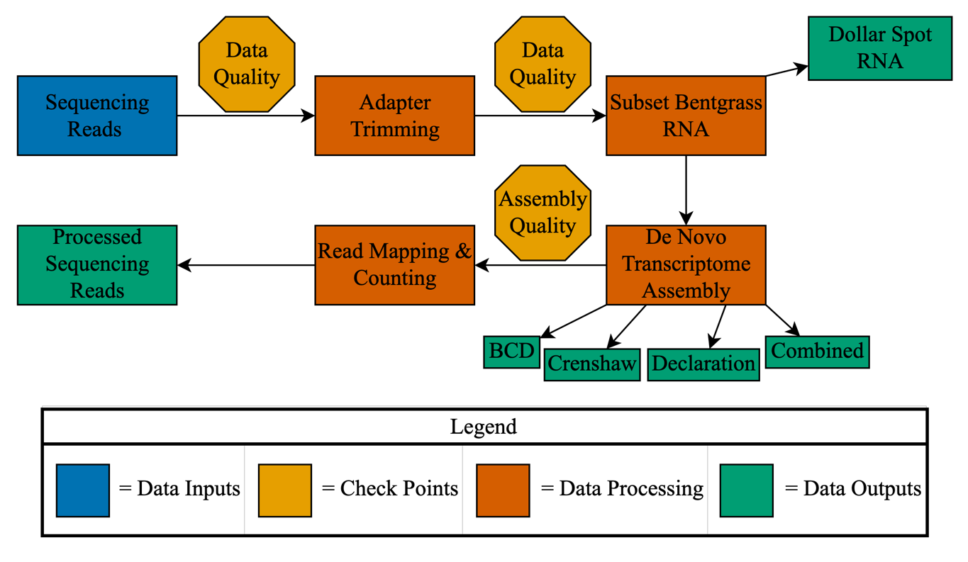
Figure 2.2. Bioinformatics pipeline used for processing raw RNA sequence reads.
Data Analysis
Differential expression analysis was performed on the two negative control time points using DESeq2 v1.44.0 (Love et al., 2014) in order to determine if large expression differences existed. Because the first run had little expression differences between the two control time points and the second run’s expression differences were due to housekeeping genes, all subsequent differential expression analysis used 48 hpi control samples as the reference. Each individual de novo transcriptome was then compared using reciprocal BLASTn (Wachholtz et al., 2013) to find which transcripts were shared and unique between the genotypes. From there, three different analyses were performed. Figure 2.3 shows the pipeline that was followed to analyze data.
The first analyses determined if transcripts unique to colonial bentgrass confer dollar spot resistance. The processed data was run through DESeq2 in order to resolve what transcripts were differentially expressed (DE) within each genotype individually. All the unique IDs of the significantly DE transcripts (p<0.1) were collected. These unique IDs and their corresponding sequences were mapped to the reference genome of wheat (Triticum aestivum L.) and subjected to single enrichment analysis in agriGO (v2.0) (Tian et al., 2017), assigning each transcript a functional pathway, biologic process, and cellular location. The groups were filtered for key terms linked to plant defense: apoplast, biotic stimulus, carbohydrate metabolism, cell recognition, chitinase, defense response, extracellular region, glucan metabolism, hormone stimulus, hydrolase activity, nutrient reservoir, oxidative stress, pattern binding, SOS response, and wounding (Ding et al., 2022; Priyashantha et al., 2023). Functional annotation for each of these
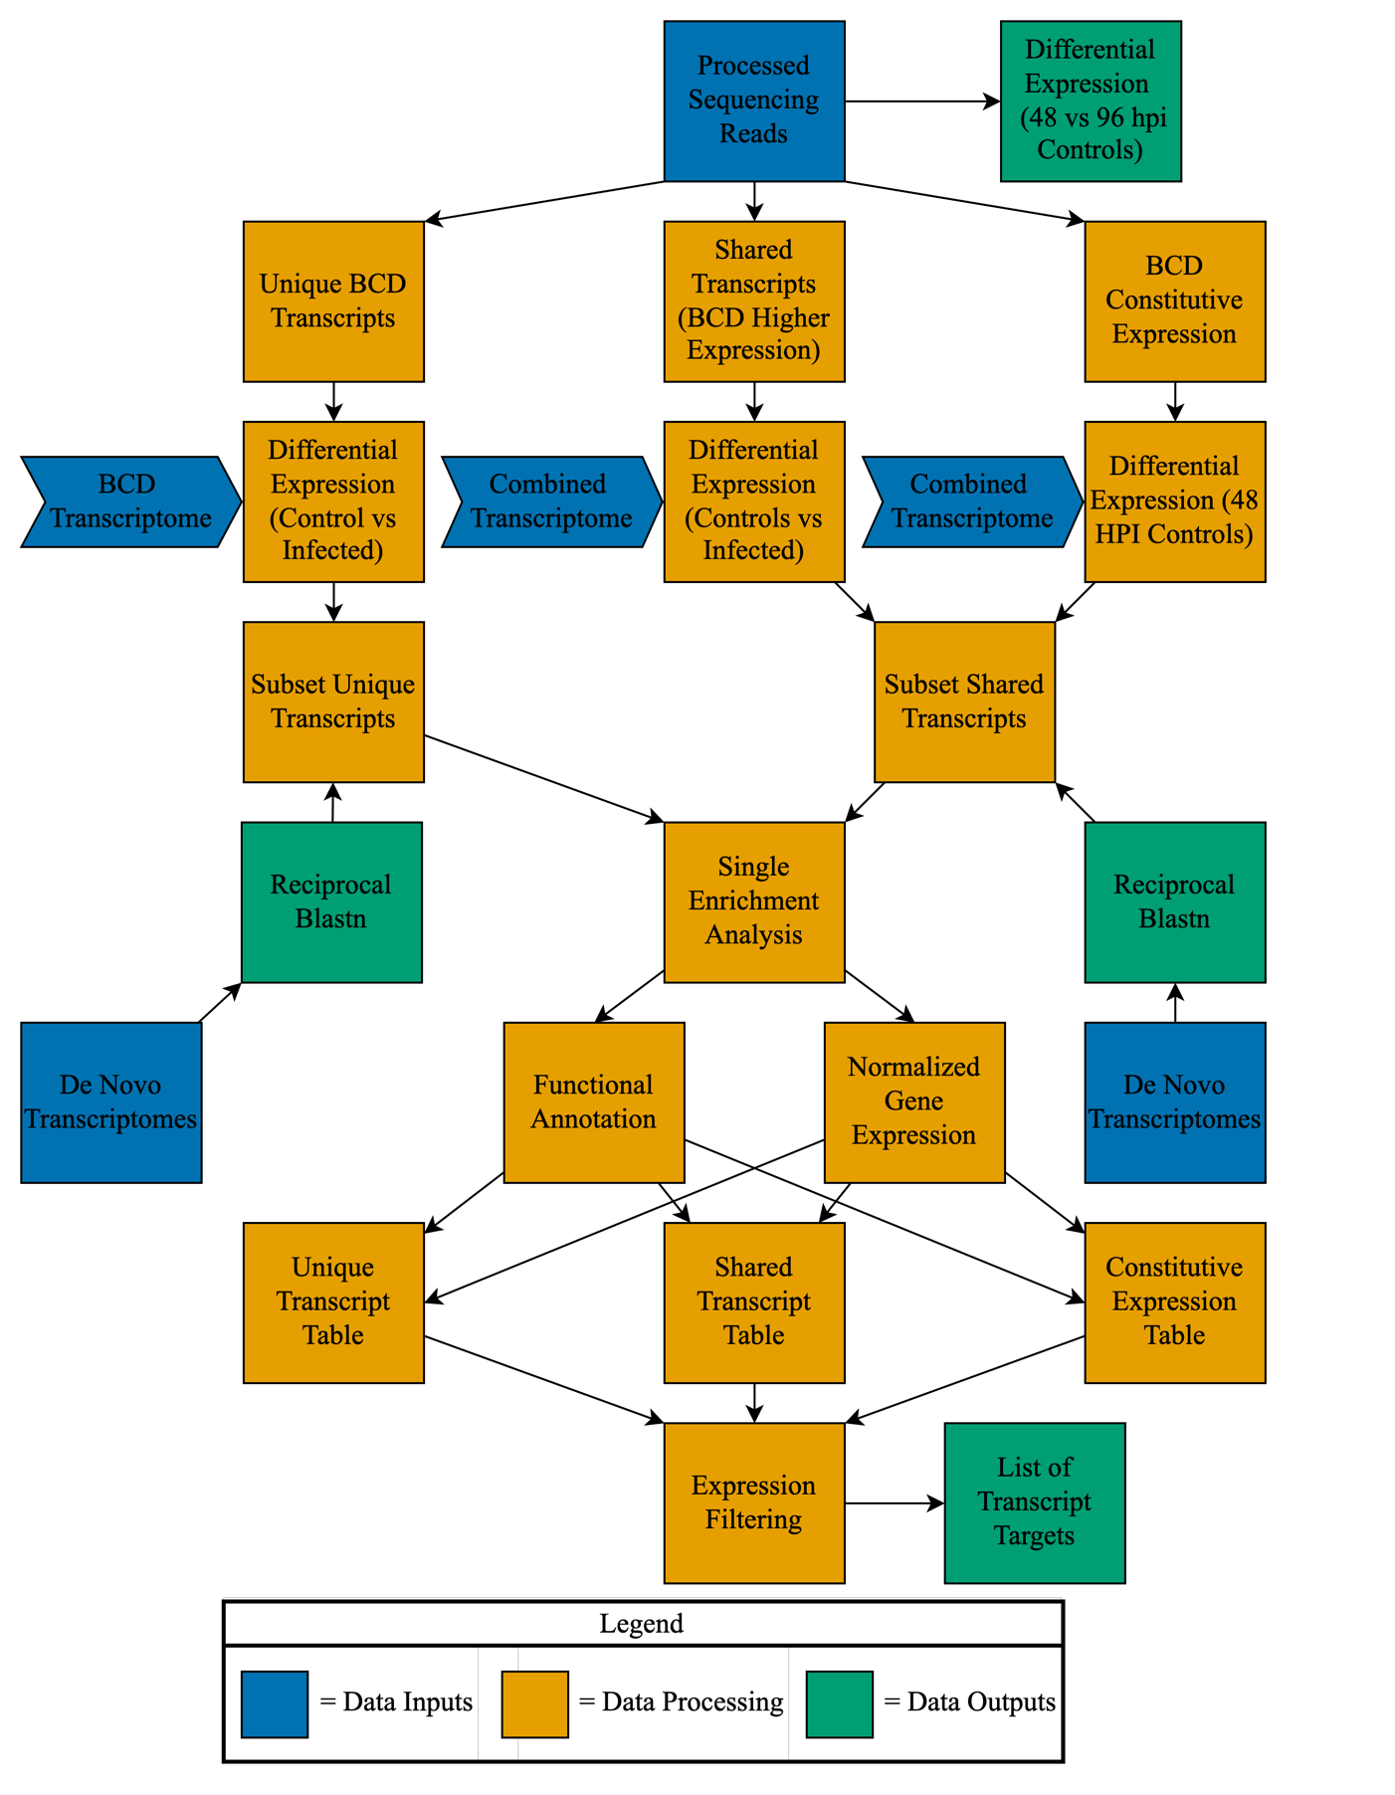
Figure 2.3. Statistical analysis pipeline used for analyzing processed RNA sequencing reads.
transcripts was completed by creating a composite reference genome containing wheat, purple false brome (Brachypodium distachyon L.), perennial ryegrass (Lolium perenne L.), and barley (Hordeum vulgare L.). Each de novo transcriptome was queried against the composite reference genome using BLASTn v2.14.1 (Camacho et al., 2009) Lastly, transcript expression data for each of the transcripts was obtained from the DESeq2 count table and combined with the functional annotation data into a Microsoft Excel file (Redmond, WA). Transcripts that were upregulated at all time points were subsetted and reported. Second run data was used to confirm the presence or absence of genes from the first run.
The second analysis determined expression differences of shared DE transcripts between the three genotypes. First, the combined de novo transcriptome was used when mapping and counting reads in order to have consistent transcript IDs. Using the original DE data from comparisons within each genotype individually, shared transcripts between the genotypes that were significantly DE (p<0.1) were collected. Using the transcript IDs, single enrichment analysis was performed, and the results were subsetted using the same key terms from the previous analysis. All these transcripts were functionally annotated and added to an Excel table containing transcript expression data. Transcripts that had higher expression in ‘BCD’ compared to ‘Crenshaw’ and ‘Declaration’ at every time point were subsetted and reported.
The third analysis determined ‘BCD’ transcripts that were constitutively expressed in control plants using a previously published pipeline (Amaradasa & Amundsen, 2016; Ramm et al., 2013). The combined de novo transcriptome was used again for this analysis. The 48 hpi control samples were subjected to DE analysis. Single enrichment analysis was performed on all transcripts that were DE (p<0.1). Functional annotations were collected following the same method as the first two analyses and added to the expression Excel table produced by DESeq2. Similar to the analysis of shared transcripts, transcripts that had higher expression in colonial bentgrass compared to creeping bentgrass at every time point were subsetted and reported. Plots for all analyses were created using ggplot2 v3.5.1 (Wickham, 2016) and tables using Excel.
                - RESULTS
Dollar Spot Mapping and Bentgrass Transcriptome Comparisons
The first run had a total of 386, 418, and 428 million(M) reads across all inoculated samples of ‘BCD’, ‘Crenshaw’, and ‘Declaration’, respectively. Out of the ‘BCD’, ‘Crenshaw’, and ‘Declaration’ total read counts, 19.2% (74.2M), 10.64% (44.4M), and 15.10% (64.7M) mapped to the dollar spot genome, respectively (Table 2.1). In run 2, ‘BCD’ had 16.02% of its 266M reads (42.6M), ‘Crenshaw’ had 17.22% of its 266M reads (45.9M), and ‘Declaration’ had 20.93% of its 296M reads (62M) map to the dollar spot genome (Table 2.2).
The BUSCO scores for each assembly were greater than 87%, and the average transcript length was between 650-735 base pairs (Table 2.3). Reciprocal BLASTn found 56.1% of assembled transcripts from the ‘BCD’ de novo transcriptome was unique to its genotype, which was a higher percentage than both ‘Crenshaw’ and ‘Declaration’, who had 40.1% and 36.3%, respectively. Interestingly, ‘BCD’ shared a higher percentage of transcripts with both ‘Crenshaw’ (55.7%) and ‘Declaration’ (56.3%) than ‘Crenshaw’
Run 1
Genotype | Number of Reads | Number of DS Reads | % DS Reads
BCD | 386,758,834 | 74,246,128 | 19.20%
Crenshaw | 418,105,358 | 44,497,012 | 10.64%
Declaration | 428,562,498 | 64,713,380 | 15.10%
Table 2.1 Run 1 mapped reads to dollar spot (DS) reference genome.
Table 2.2 Run 2 mapped reads to dollar spot (DS) reference genome.
Run 2
Genotype | Number of Reads | Number of DS Reads | % DS Reads
BCD | 266,103,106 | 42,617,609 | 16.02%
Crenshaw | 266,712,510 | 45,919,377 | 17.22%
Declaration | 296,497,044 | 62,058,012 | 20.93%

Table 2.3. Assembly statistics for each genotype’s de novo transcriptome individually

De Novo Transcriptome | Number of Transcripts | Average Length | N50 | BUSCO Score
BCD | 875867 | 703.9 | 1076 | 87.9%
Crenshaw | 741912 | 720.5 | 1115 | 90.6%
Declaration | 618298 | 731.4 | 1163 | 88.5%
Combined | 1628084 | 650.4 | 910 | 91.2%

with ‘Declaration’ (36.4%) (Figure 2.4A-C).
Table 2.4 summarizes the DE analysis of control plants at 48 hpi and 96 in the first run: ‘BCD’ had 0.60%, ‘Crenshaw’ had 0.26%, and Declaration had 1.75% of their transcripts differentially expressed. In the second run, ‘BCD’ increased to 9.73%, ‘Crenshaw’ to 7.34%, and ‘Declaration’ to 19.11%, indicating higher variance (Table 2.5).
Unique Transcripts
After calculating the percentage of unique differentially expressed transcripts (DETs) out of all unique transcripts associated with each GO term, nutrient reservoir, oxidative stress, and chitinase had the highest percentages at 58.1%, 28.4%, and 27.8%, respectively (Figure 2.5A). Functional characterization of all differentially expressed transcripts from each GOterm found in Figure 2.5A, uncovered receptor kinases, chitinases, germin proteins, germin-like proteins, peroxidases, cell-wall synthesis proteins, and other defense-related proteins (Table 2.6). Unique transcripts mapping to G- type lectin S-receptor-protein kinase At4g21390, callose synthase 3, cellulose synthase E6 and H1, xyloglucan endotransglucosylase 6, and wall-associated receptor-like kinases 3, 4, and 5 were only upregulated at all time points in the first run.
Shared Transcripts
The total number of shared DETs for each GO term and the number of transcripts that had increased expression or decreased expression in ‘BCD’ compared to the creeping bentgrass genotypes at all time points is shown in Figure 2.5B. Interestingly, All GO terms except defense response had more transcripts with decreased expression than
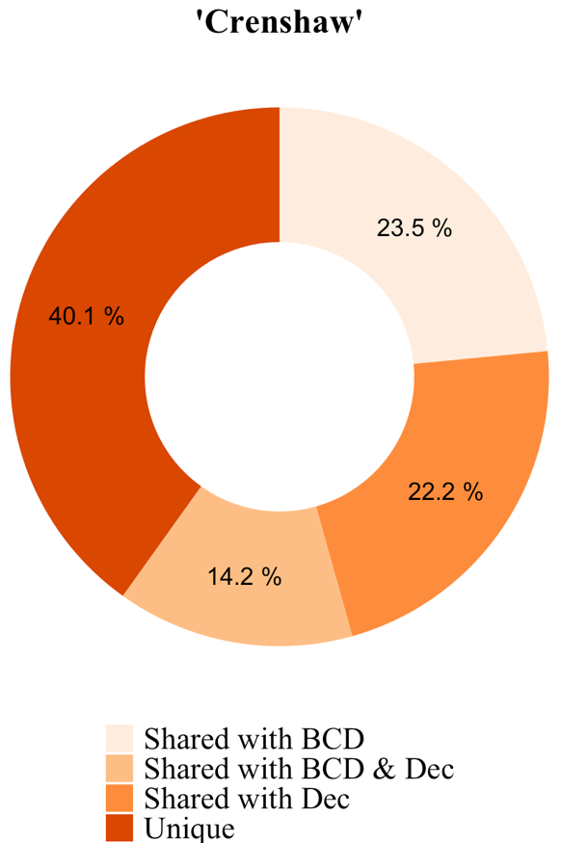
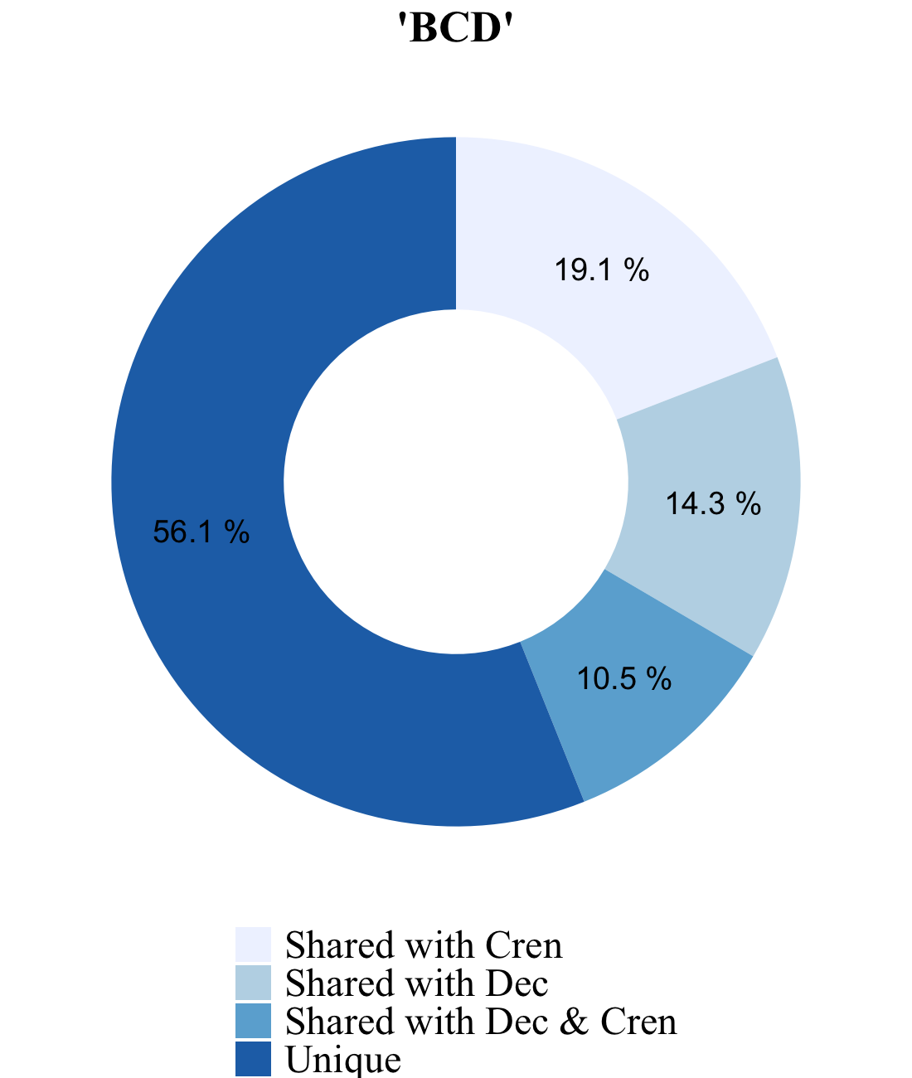
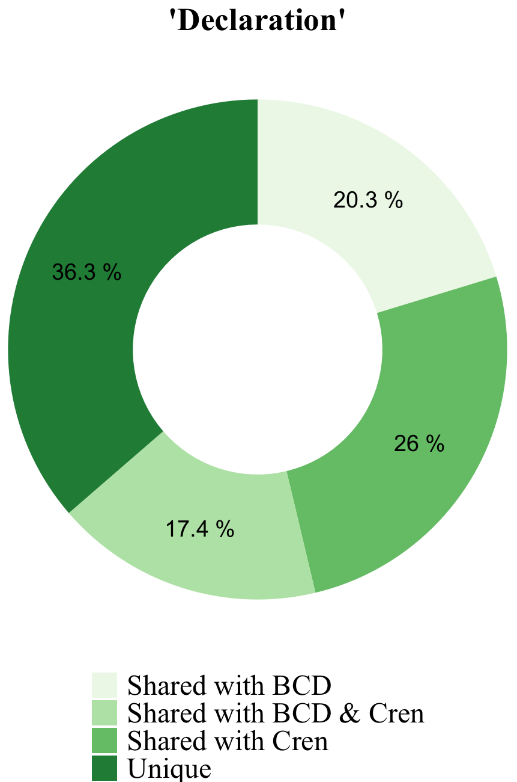
Figure 2.4. Reciprocal BLASTn results displaying the number of unique and shared transcripts for (A) ‘BCD’, (B) ‘Crenshaw’, and (C) ‘Declaration’.
A
B
C

Run 1
Genotype | Upregulated | Downregulated | Total Differentially Expressed | Total Number Transcripts | Percent Total
BCD | 338 | 241 | 579 | 96741 | 0.60%
Crenshaw | 52 | 169 | 221 | 85289 | 0.26%
Declaration | 822 | 371 | 1193 | 68179 | 1.75%
Table 2.4. Differential expression analysis between the two non-inoculated controls in run 1
Table 2.5. Differential expression analysis between the two non-inoculated controls in run 2.

Run 2
Genotype | Upregulated | Downregulated | Total Differentially Expressed | Total Number Transcripts | Percent Total
BCD | 3628 | 3184 | 6812 | 70043 | 9.73%
Crenshaw | 3264 | 2119 | 5383 | 73371 | 7.34%
Declaration | 6704 | 6843 | 13547 | 70886 | 19.11%

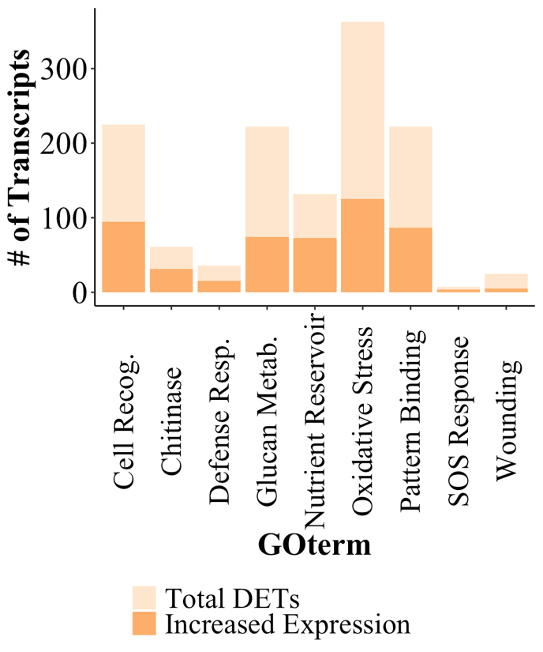
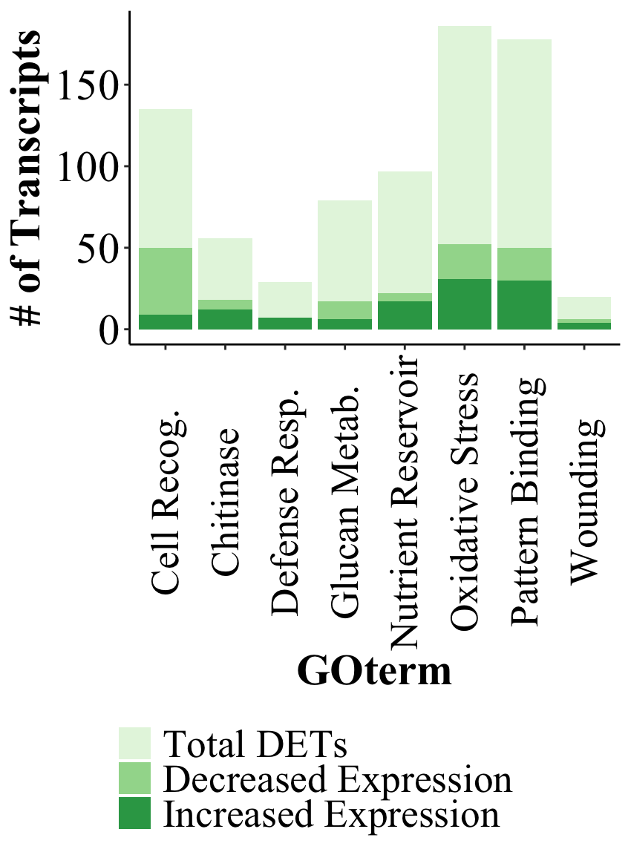
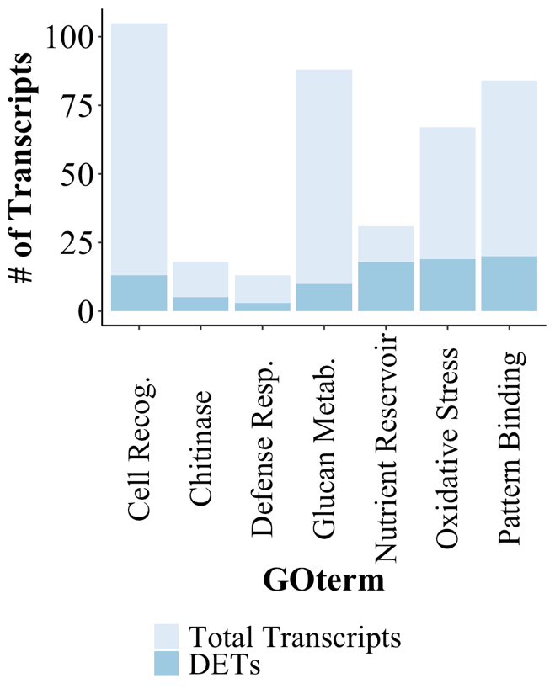
Unique DETs
Shared DETs
Constitutive DETs
A
B
C
Figure 2.5. Defense-related gene ontology terms after analyzing (A) unique differentially expressed transcripts (DETs), (B) shared DETs, and (C) constitutively expressed DETs.
GO term | Functional Annotation | Gene IDs | Qt. | Reference
Cell Recognition | G-Type lectin S-receptor-protein kinase | At1g34300, At2g19130, At4g21390,  ZmPK1 | 13 | Walker & Zhang, 1990
Cell Recognition | L-type lectin-domain receptor kinase | At5g10530 | 1 | Hervé et al. 1996
Chitinase | Chitinase | 1, 5 | 3 | Schlumbaum et al. 1986
Chitinase | Endochitinase | A | 1 | Schlumbaum et al. 1986
Defense Response | Barwin |  | 1 | Svensson et al. 1992
Defense Response | Major pollen allergen | Aln g 1 | 1 | Bufe et al. 1996
Defense Response | MLO Protein | 1 | 1 | Büschges et al. 1997
Glucan Metabolism | Callose synthase | 3 | 1 | Verma and Hong, 2001
Glucan Metabolism | Cellulose synthase | A7, E6, H1 | 7 | Robinson et al. 1972
Glucan Metabolism | Xyloglucan endotransglucosylase | 6 | 1 | Fry et al. 1992
Nutrient Reservoir | Germin-like protein | 2-1, 4-1, 8-4, 8-7, 8-8, 8-11, 8-14 | 16 | Lane et al. 1993
Nutrient Reservoir | Oxalate oxidase | GF-2.8 | 2 | Berna & Bernier, 1997
Oxidative Stress | Catalase | 1 | 6 | Loew, 1900
Oxidative Stress | Cationic peroxidase | SPC4 | 5 | Dicko et al. 2006
Oxidative Stress | Peroxidase | 2, 3 | 5 | Planche, 1810
Pattern Binding | Wall-associated receptor kinase-like | 1, 2, 3, 4, 5 | 18 | Verica & He, 2002
Table 2.6. List of gene ontology (GO) terms and functional annotations for all differentially expressed transcripts associated with unique transcripts. Red text highlights genes only found in run 1.
increased expression. Defense response, chitinase, and wounding had the highest percentage of transcripts with increased expression at 24.1%, 21.4%, and 20.0%, respectively, while cell recognition, chitinase, and wounding had the highest percentage of transcripts with decreased expression at 37.0%, 32.1%, and 30.0%, respectively.
After functionally annotating each shared transcript, genes from the unique transcript analysis were present, except G-type lectin S-receptor-protein kinase At4g21390, receptor kinase ZmPK1, chitinase 1, callose synthase 3, barwin, cellulose synthase A, xyloglucan endotransglucosylase 6, germin-like protein 2-1, 8-7, 8-8, and 8-14, peroxidase 3 and wall-associated receptor-like kinase 4 (Table 2.7). In addition to these genes, novel genes were present such as, wax ester synthase 11, receptor-like serine/threonine-protein kinase At4g21380, MLO protein 13, pathogenesis-related protein STH-21, germin-like protein 3-7, oxalate oxidase 1 and 2, callose synthase 6 and 8, catalase 2, L-ascorbate peroxidase 4 and 6, peptide methionine sulfoxide reductase A2 and B5, peroxidase 1, 5, 12, 25, 47, 50, A2, N, and P7, disease resistance receptor Lr10, cytochrome C oxidase subunit A, and subtilisin/chymostrypsin inhibitor 2A. Genes that were not expressed in the second run were chitinase 6, MLO protein 1, germin-like protein 4-1, catalase 2, L-ascorbate peroxidase 4 and 6, peroxidase 1, 25, and P7.
Constitutive Expressed Transcripts
More constitutively expressed transcripts were uncovered than shared and unique based on the filters specified in the methods. Oxidative stress, cell recognition, and pattern binding had the highest number of constitutively expressed DETs with increased expression in ‘BCD’ compared to the two genotypes of creeping bentgrass, while SOS
Table 2.7. List of gene ontology (GO) terms and functional annotations for all shared differentially expressed transcripts with increased expression in ‘BCD’ compared to creeping bentgrass genotypes at all time points. Red text highlights genes only found in run 1.
GO term | Functional Annotation | Gene IDs | Qt. | Reference
Cell Recognition | Wax ester synthase | 11 | 1 | Li et al. 2008
Cell Recognition | G-type lectin S-receptor protein kinase | At1g34300, At2g19130, At4g21380 | 8 | Walker & Zhang, 1990
Cell Recognition | L-type lectin-domain receptor kinase | At5g10530 | 2 | Hervé et al. 1996
Chitinase | Chitinase | 5, 6 | 5 | Schlumbaum et al. 1986
Chitinase | Endochitinase | A | 3 | Schlumbaum et al. 1986
Defense Response | MLO Protein | 1, 13 | 4 | Büschges et al. 1997
Defense Response | Pathogenesis-related protein | STH-21 | 1 | Marineau et al. 1987
Defense Response | Pollen allergen | Aln g 1 | 1 | Bufe et al. 1996
Glucan Metabolism | Callose synthase | 6, 8 | 2 | Verma and Hong, 2001
Glucan Metabolism | Cellulose synthase | E6, H1 | 4 | Robinson et al. 1972
Nutrient Reservoir | Germin-like protein | 3-7, 4-1, 8-4, 8-11 | 11 | Lane et al. 1993
Nutrient Reservoir | Oxalate oxidase | 1, 2, GF-2.8 | 5 | Berna & Bernier, 1997
Oxidative Stress | Catalase | 1, 2 | 3 | Loew et al., 1900
Oxidative Stress | Cationic peroxidase | SPC-4 | 1 | Dicko et al. 2006
Oxidative Stress | L-ascorbate peroxidase | 4, 6 | 2 | Groden and Beck, 1979
Oxidative Stress | Peptide methionine sulfoxide reductase | A2, B5 | 3 | Sánchez et al. 1983
Oxidative Stress | Peroxidase | 1, 2, 5, 12, 25, 47, 50, A2, N, P7 | 17 | Planche, 1810

GO term | Functional Annotation | Gene IDs | Qt. | Reference
Pattern Binding | Cytochrome C oxidase | Subunit A | 1 | Wikström, 1977
Pattern Binding | Disease resistance receptor | Lr10 | 5 | McIntosh et al., 1995
Pattern Binding | Wall-associated receptor kinase-like | 1, 2, 3, 5 | 16 | Verica & He, 2002
Wounding | Subtilisin-chymotrypsin inhibitor | 2A | 3 | Jonassen & Svendsen, 1982
Table 2.7. Cont.
response (57.1%), nutrient reservoir (55.3%), chitinase (50.8%), had the highest percentage of transcripts with increased expression (Figure 2.5C). Functional annotation of these DETs revealed the same genes as the previous two analyses except, wax ester synthase 11, pathogenesis-related protein STH-21, germin-like protein 8-14 and 4-1, peroxidase 4, cytochrome C oxidase subunit A, and subtilisin/chymotrypsin inhibitor 2A.
Novel genes included G-Type lectin S-receptor-like serine/threonine-protein kinase At5g24080 and At1g11300, chitinase 2 and 8, pathogenesis-related protein PR-4, pollen allergen Car b 1, stress-induced protein SAM22, wheatwin 2, callose synthase 5, 7, 9, and 10, cellulose synthase E2 and G3, disease-resistance protein RGA5, inactive UDP-arabinopyranose mutase 1 and 2, mixed-linked glucan synthase, pentatricopeptide repeat-containing protein At1g16830, xyloglucan endotransglucosylase 7, 13, 28, and 31, 11S globulin seed storage 2, 12S seed storage globulin 1, germin protein 2-4 and 5-1, glutathione peroxidase 1, L-ascorbate peroxidase 2, 3, and 7, peroxidase 4, 17, 66, and 70, PR5-like receptor kinase, wall-associated receptor-like kinase 6, 14, 16, and 20, zinc finger BED domain protein RICESLEEPER, DNA repair protein recA homolog 1, 2, 3, and subtilisin-chymotrypsin inhibitor 2B (Table 2.8).
Constitutively expressed DETs that were only expressed in the first run included G-Type lectin S-receptor-like serine/threonine-protein kinase At1g34300 and At1g11300, chitinase 2, pathogenesis-related protein like PR-4, callose synthase 7 and 8, cellulose synthase G3, disease resistance protein RGA5, pentatricopeptide repeat-containing protein At1g16830, xyloglucan endotransglucosylase 6, 13, 28, and 31, germin-like protein 2-4, oxalate oxidase 1, L-ascorbate peroxidase 6, peroxidase 16, 24, 25, 42, 51
Table 2.8. List of constitutively expressed transcripts with increased expression in ‘BCD’ compared to the creeping bentgrass genotypes. Red text highlights genes only found in run 1.

GO term | Functional Annotation | Gene ID | Qt. | Reference
Cell Recognition | G-Type lectin S-receptor-like serine/threonine-protein kinase | At1g34300, At2g19130, At5g24080, At4g21390, At4g21380  At1g11300,  ZmPK1 | 93 | Walker & Zhang, 1990
Cell Recognition | L-type lectin-domain receptor kinase | At5g10530 | 6 | Hervé et al. 1996
Chitinase | Chitinase | 1, 2, 5, 6, 8 | 19 | Schlumbaum et al. 1986
Chitinase | Endochitinase | A | 6 | Schlumbaum et al. 1986
Defense Response | Barwin |  | 3 | Svensson et al. 1992
Defense Response | MLO protein | 1, 13 | 7 | Büschges et al. 1997
Defense Response | Pathogenesis-related protein like | PR-4 | 1 | Caporale et al. 2003
Defense Response | Pollen allergen | Car b 1, Aln g 1 | 2 | Swoboda et al. 1996
Defense Response | Stress-induced protein | SAM22 | 1 | Crowell et al. 1992
Defense Response | Wheatwin | 2 | 1 | Caruso et al. 1993
Glucan Metabolism | Callose synthase | 3, 5, 6, 7, 8, 9, 10 | 18 | Verma and Hong, 2001
Glucan Metabolism | Cellulose synthase | A7, E2, E6, G3, H1 | 40 | Robinson et al. 1972
Glucan Metabolism | Disease resistance protein | RGA5 | 1 | Donald et al. 2002
Glucan Metabolism | Inactive UDP-arabinopyranose mutase | 1, 2 | 7 | Konishi et al. 2007
Glucan Metabolism | Mixed-linked glucan synthase |  | 1 | Purushotham et al. 2022
Glucan Metabolism | Pentatricopeptide repeat-containing protein | At1g16830 | 1 | Auborg et al. 2000
Glucan Metabolism | Xyloglucan endotransglucosylase | 6, 7, 13, 28, 31 | 7 | Fry et al. 1992
Table 2.8. Cont.
GO term | Functional Annotation | Gene ID | Qt. | Reference
Nutrient Reservoir | 11S globulin seed storage protein | 2 | 1 | Wolf & Briggs, 1959
Nutrient Reservoir | 12S seed storage globulin | 1 | 1 | Pang et al. 1988
Nutrient Reservoir | Germin-like protein | 2-1, 2-4, 3-7, 5-1, 8-4, 8-7, 8-8, 8-11 | 54 | Lane et al. 1993
Nutrient Reservoir | Oxalate oxidase | 1, 2, GF-2.8 | 16 | Berna & Bernier, 1997
Oxidative Stress | Catalase | 1, 2 | 9 | Loew et al. 1900
Oxidative Stress | Cationic peroxidase | SPC4 | 16 | Dicko et al. 2006
Oxidative Stress | Glutathione Peroxidase | 1 | 7 | Holland et al. 1993
Oxidative Stress | L-ascorbate peroxidase | 2, 3, 4, 6, 7 | 8 | Groden and Beck, 1979
Oxidative Stress | Peptide methionine sulfoxide reductase | A2, B5 | 5 | Sánchez et al. 1983
Oxidative Stress | Peroxidase | 1, 2, 4, 5, 12, 16, 17, 24, 25, 42, 47, 50, 51, 55, 65, 66, 70, A2, N, P7 | 79 | Planche, 1810
Pattern Binding | Disease-resistance receptor | Lr-10 | 13 | McIntosh et al. 1995
Pattern Binding | PR5-like receptor kinase | PR5K | 1 | Wang et al. 1996
Pattern Binding | Wall-associated receptor kinase-like | 1, 2, 3, 4, 5, 6, 14, 16, 20 | 71 | Verica & He, 2002
Pattern Binding | Zinc finger BED domain protein RICESLEEPER |  | 1 | Knip et al. 2012
SOS Response | DNA repair protein recA | homolog 1, 2, 3 | 4 | Cerutti et al. 1992

Table 2.8. Cont.

GO term | Functional Annotation | Gene ID | Qt. | Reference
Wounding | Subtilisin-chymotrypsin inhibitor | 2B | 5 | Jonassen & Svendsen, 1982

55, and 65, wall-associated receptor-like kinase 14 and 20, and DNA repair protein recA homolog 1 (Table 2.8).
                - DISCUSSION
This study revealed many genes in creeping and colonial bentgrass localized to the cell wall or plasma membrane suggesting an important role in defense against Clarireedia spp. To further classify genes obtained in Table 2.6-2.8, they were categorized into groups: pattern recognition receptors (PRRs), pathogenesis-related (PR) proteins, or secondary defense proteins. As presented in the introduction, PRRs bind PAMPs or effectors from plant pathogen, activating PTI or ETI, respectively. Both immunity pathways result in the expression of PR proteins, which are plant proteins functioning primarily in pathogen defense that are induced upon infection. Secondary defense proteins play a role in cell development and are important in repairing pathogen damage to the plant. Transcripts reported in this study were functionally characterized based on the highest mapping match in BLASTn. Thus, the following discusses our findings along with work from previous studies that have increased our understanding of each mapped gene. Whether or not the transcripts from this study function in a similar manner as the mapped gene must be confirmed in future studies.
Pattern Recognition Receptors
In this study, DETs mapped to multiple Arabidopsis thaliana lectin-receptor protein kinase genes: At1g34300, At2g19130, At5g24080, At4g21390, At1g11300, At4g21380, and At5g10530, suggesting they play a role in dollar spot PAMP detection. Teixeira et al. (2018) and Bouwmeester and Grover (2009) reclassified these genes as
AtG-LecRK-I.1, AtG-LecRK-I.2, AtG-LecRK-I.6, AtG-LecRK-IV.2, AtG-LecRK-V.1, AtG-LecRK-VI.3, and LecRK-IX.1, respectively. AtG-LecRK-I.2 detects bacterial PAMPs and increases the resistance of Arabidopsis thaliana L. through modulating stomatal immunity, callose deposition, and cell to cell signaling using Ca²⁺ and reactive oxygen species (ROS) (Chien et al., 2024). A study conducted by Chae et al. (2009) determined transcripts of AtG-Lec-IV.2 were upregulated in response to separate inoculations with fungal pathogens: grey mold (Botrytis cinerea Persoon), powdery mildew (Erysiphe spp. Hedwig ex de Candolle), downy mildew (Peronospora parasitica (Persoon) Constantinescu), and white tip (Phytophthora porri Foister). AtG-LecRK-VI.3, also known as serine/threonine receptor like kinase SD1-8, has been linked to self-incompatibility in A. thaliana (Welgemoed et al., 2020). Transcripts in coffee (Coffea arabica L.) that mapped to this gene were upregulated in response to coffee leaf rust (Hemileia vastatrix Berkeley & Broome), indicating its role in detecting fungal pathogens and mediating signaling pathways inside the cell (Florez et al., 2017). In contrast with the previous three receptors, LecRK-IX.1 is a L-type lectin receptor protein kinase. However, a study conducted by Wang et al. (2015) found this receptor functions similarly binding PAMPs, effectors, or external adenine triphosphate (eATP) during water mold (Phytophthora brassicae de Cock & Man in 't Veld) and phytophthora blight (P. capsici Leonian) infection and activating defense signaling pathways in the plants. While AtG-LecRK-I.1 and AtG-LecRK-I.6 have not been observed to be upregulated in response to biotic stress within A. thaliana, both have been found to be upregulated in response to many abiotic stress, such as drought, salt, heat, and wounding (Kalladan et al., 2017; Mondal et al., 2021). Similarly, AtG-LecRK-V.1, also known as enhanced growth on mannitol1 (EGM1), exhibited potential differential expression under different abiotic stresses (Mondal et al., 2021, Teixeira et al., 2018).
Previous studies concerning AtG-LecRK-I.2, AtG-LecRK-IV.2, AtG-LecRK-VI.3, and LecRK-IX.1 support the findings of this study. Colonial bentgrass DETs indicate these four receptors are important in detecting PAMPs from dollar spot and activating PTI. Furthermore, the presence of transcripts from these four genes in each analysis suggests these receptors likely contribute to the increased resistance of colonial bentgrass to dollar spot when compared to creeping bentgrass. AtG-LecRK-I.2 is especially interesting because of its links to stomatal closure and callose deposition in the plant cell wall. These responses would limit the ability of Clarireedia spp. to pass through leaves' waxy cuticle and penetrate cell walls preventing the fungus from infecting. In contrast, previous studies suggested AtG-LecRK-I.1, AtG-LecRK-I.6, and AtG-LecRK-V.1 are more important in abiotic stress. While this indicates a similar abiotic function in colonial bentgrass, future studies could elicit whether these receptors can also bind fungal PAMPs in colonial bentgrass activating PTI.
In this study, DETs in ‘BCD’ also mapped to nine of the twenty-one WAKL genes (WAK1, WAK2, WAK3, WAK4, WAK5, WAK6, WAK14, WAK16, and WAK20) characterized in A. thaliana, demonstrating their importance in binding PAMPs and activating expression of PR proteins. Twenty-one WAKLs in A. thaliana share sequence homology in their transmembrane and kinase domains to the five wall-associated receptor kinases (WAK), which are instrumental in pathogen perception and stimulation of defense response (He et al., 1999; Verica and He, 2002). Many WAKs and WAKLs physically link the extracellular matrix to the cytoplasm by binding to the cell wall or plasma membrane (He et al., 1996; Kohorn et al., 2000, Verica et al., 2003). This suggests colonial bentgrass WAKLs in this study play an important role of sensing Clarireedia spp. hyphae present in the extracellular space and activating kinase signaling pathways inside the cell.
Previous studies have also determined the importance of WAKs and WAKLs in the defense response of many model species in the Poaceae family. Li et al. (2009) discovered a WAK (OsWAK1) in rice (Oryza sativa L.) that is bound to the cell wall, upregulated in response to rice blast (Magnaporthe oryzae Cavara) infection, and induced by mechanical wounding, SA, and methyl jasmonic acid, indicating its importance in the defense response to fungal pathogens. Delteil et al. (2016) also uncovered WAKs and WAKLs important in regulation of rice blast disease. They found OsWAK14, OsWAK91, and OsWAK92 were positive regulators and OsWAK112 was a negative regulator of the defense response. In contrast, Hurni et al. (2015) and Zuo et al. (2015) determined the impacts of corn (Zea mays L.) WAKs and WAKLs on northern corn blight (Exserohilum turcicum (Passerini) K.J.Leonard & E.G.Suggs) and head smut (Sporisorium reilianum (J.G. Kühn) Langdon & Fullerton), respectively. Hurni et al. revealed the disease resistance gene Htn1 mapped to an area that contained three genes total, two of which were WAKLs (ZmWAK-RLK1 and ZmWAK-RLK2). When knockout mutant plants were created, ZmWAK-RLK1 was found to be critical for resistance to northern corn blight. Zuo et al. discovered that a ZmWAK was present in the qHSR1 QTL locus conferring resistance to head smut. Lastly, Qi et al. (2021) identified TaWAK-6D was induced in wheat (Triticum aestivum L.) under infection with sharp eyespot (Rhizoctonia cerealis van der Hoeven) and crown rot (Fusarium pseudograminearum O'Donnell & T. Aoki) or exogenous pectin treatment, suggesting it plays a critical role in the defense response to both pathogens. These studies involving grasses closely related to colonial bentgrass support this studies results. The presence of this gene group during dollar spot infection indicates their importance in activating defense responses.
The primary difference between WAKs and WAKLs is that WAKLs have diversified extracellular domain structures, suggesting WAKLs have different substrate specificities than WAK proteins (Verica et al., 2003). WAKs in A. thaliana have been proven to bind pectin fragments called oligogalacturonides (OGs) that are primarily released by the plant cell wall when under biotic stress (Decreux and Messiaen, 2005). Additionally, OGs are one of the products of fungal cell wall degradation by plant secreted chitinases (Vaghela et al., 2022). Similar to these WAKs, Ma et al. (2024) confirmed WAKL14 can also bind OGs. The ability of this gene family to bind OGs in other species, suggests WAKLs expressed by colonial bentgrass have a similar function and are important in dollar spot detection. The substrates bound by all other WAKLs are unclear. Thus, future research should elicit what substrates these WAKLs bind and whether there some have specificity for certain pathogens.
Verica et al. (2003) characterized WAKL1-WAKL7, all of which were expressed in colonial bentgrass except WAKL7. Similar to WAKL3 and WAKL5, WAKL1 was expressed lowest in leaves and highest in the roots, while stem and flower expression amounts were in between these two tissues. In stems and leaves, WAKL1 had the most expression followed by WAKL3 and then WAKL5, which had no expression in either tissue. The lack of expression of WAKL5 in leaves and stems contrasts with colonial bentgrass’s expression because only these two tissues were collected for RNA sequencing. However, due to these species not diverging recently, colonial bentgrass may have evolved differently, resulting in expression of WAKL5 in leaves and stems. In contrast, WAKL2, WAKL4, WAKL6, and WAKL7 were expressed similarly in all tissues with minor differences in amount between each gene.
This study also ascertained WAKL expression levels under treatment with 2,6-dichloroisonicotinic acid (INA), an analog of salicylic acid (SA). All genes except WAKL3 were induced by INA, suggesting their importance in defense response. Furthermore, WAKL5 and WAKL7 had the highest expression after treatment indicating they are PR-proteins and critical for induction of SAR. Due to DETs mapping to WAKL5 being present in all three analyses and the results of this study, this gene likely contributes to colonial bentgrass’s increased resistance to dollar spot compared to creeping bentgrass. Future studies should target this gene directly and confirm this conclusion.
The remaining ‘BCD’ DETs mapped to receptor protein kinase ZmPK1, disease resistance receptor Lr10, and disease resistance protein RGA5. ZmPK1 was the first RLK isolated and cloned from higher plants (Walker and Zhang, 1990). A study by Zhang and Walker (1993) found the extracellular domain of this receptor shares homology with self-incompatibility S-locus glycoproteins detected in Brassica spp. While no published studies link ZmPK1 to defense pathways, the RNA sequencing data from our study suggests it plays a role in dollar spot identification in colonial bentgrass. Disease resistance receptor Lr10 and disease resistance protein RGA5 were isolated and characterized in wheat and rice, respectively, as intracellular nucleotide binding leucine rich repeat domain receptors (NLRs). Previous work has demonstrated Lr10 binds effector proteins from brown rust (Puccinia triticina Eriksson) while RGA5 binds effectors from rice blast disease activating ETI inside the plant cell (Césari et al., 2013; Loutre et al., 2009). From these studies, expression of Lr10 and RGA5 in colonial bentgrass indicate NLRs are important in recognizing dollar spot effector proteins and activating ETI leading to the HR response. Due to colonial bentgrass having fewer dollar spot infection foci in the field compared to creeping bentgrass, indicating the fungus has not penetrated the cell wall, NLRs may play a minimal role in the different susceptibilities between the bentgrass species.
PR-3 and PR-4: Chitinases
PR-3 proteins are chitinases that hydrolyze the glycosidic bonds found in chitin, a component of fungal cell walls. Colonial bentgrass DETs from all analyses mapped to 6 different PR-3 chitinase genes: chitinase 1, 2, 5, 6, 8, and endochitinase A, indicating chitinases are important in colonial bentgrass’s defense response dollar spot and may play a role in its increased resistance compared to creeping bentgrass. Previous work by Brogue et al. (1991) and Zhu et al. (1994) supports these results. Brogue et al. demonstrated transgenic tobacco constitutively expressing a bean chitinase had increased resistance to Rhizoctonia solani. Moreover, Zhu et al. showed transgenic tobacco co-expressing a chitinase from rice and a glucanase from alfalfa constitutively was more resistant to frogeye disease (Cercospora nicotianae).
More recently, a genome wide analysis of chitinase genes present in rice was performed in order to understand each individual gene’s function and phylogenetic relationships (Wang et al., 2020). After mining data from Ribot et al. (2008), they discovered chitinase 1, 3, 4, 5, 6, and 8 were upregulated and chitinase 2 was down regulated in response to grey leaf spot (Magnaporthe grisea (Hebert) Barr) infection. Furthermore, Tian et al. (2018) discovered chitinase 1 and chitinase 3 in rice were upregulated in response to rice blast disease. Both of these results suggest chitinase 1 and 3 likely play a larger role and chitinase 2 likely plays a smaller role in colonial bentgrass’s defense response against Clarireedia spp. Nakazaki et al. (2006) determined chitinase 5, a class IV chitinase, had increased expression in the meristem, indicating the primary role of this gene is in embryogenesis or seed maturation. Thus, similar to chitinase 2, chitinase 5 may play a smaller role in defending against dollar spot.
Endochitinase A is a gene characterized from corn and classified as a PR-3 protein. Previous work determined this gene inhibits the growth of Fusarium oxysporum Schlechtendal, Alternaria solani Sorauer, and Trichoderma reesei E.G. Simmons in vitro but had no effect on Phytophthora infestans (Montagne) de Bary, Sclerotinia sclerotiorum (Libert) de Bary, and Gaeumannomyces graminis (Saccardo) von Arx & Olivier (Huynh et al., 1992). Thus, due to colonial bentgrass expressing endochitinase A in response to dollar spot, this gene may play a role in resistance.
PR-4 proteins, similar to PR-3 proteins, function in chitin hydrolysis and are localized to the cell wall but differ mainly because PR-4 proteins also have ribonuclease activity (Filipenko et al., 2013). Colonial bentgrass expressed DETs that mapped to PR-4 proteins: barwin, wheatwin2, and pathogenesis-related PR-4-like protein. Barwin and wheatwin2 were isolated from barley (Hordeum vulgare L.) and wheat, respectively, and share significant sequence homology, while pathogenesis-related PR-4-like protein contains only a homologous barwin-domain (Caruso et al., 1993; Svensson et al., 1992). A study conducted by Caruso et al. (1996) determined that wheatwin2 inhibited ~60% of the growth of B. cinerea at a concentration of 25 μg ml⁻¹ and completely inhibited Fusarium culmorum (W.G.Smith) Saccardo and F. graminearum Schwabe at 10 μg ml⁻¹ in vitro, demonstrating its ability to defend against fungal pathogens. Moreover, wheat PR-4 proteins are also expressed in response to SAR signaling hormones such as salicylic acid and methyl jasmonate (Bertini et al., 2003). Both of these studies suggest in colonial bentgrass PR-4 proteins may have significant activity against dollar spot and also might be responsible for the increased resistance to dollar spot in colonial bentgrass compared to creeping bentgrass. Because pathogenesis-related PR-4-like protein only contains a homologous barwin-domain it likely lacks chitinase activity but still retains RNase activity. A PR-4 protein from cocoa trees (Theobroma cacao L.) with similar structure, only displayed RNase and DNase, inhibiting witches’ broom disease (Moniliophthora perniciosa (Stahel) Aime & Phillips-Mora) (Menenzes et al., 2014). As a result, this protein may still have activity on dollar spot. However, there was only one transcript mapping to this gene from all three analyses, indicating it likely plays a minimal role in the different disease susceptibilities between the bentgrass species.
PR-5: Thaumatin-like Proteins
Colonial bentgrass’s transcript that mapped to PR-5-like receptor kinase (PR5K) had increased constitutive expression compared to creeping bentgrass. PR-5 proteins are classified as thaumatin-like proteins (TLP) that either hydrolytically cleave β-1,3-glucan or insert themselves into the fungal cell wall, opening a transmembrane pore. This leads to rapid influx of water followed by osmotic bursting of the cell (Abad et al., 1996; Grenier et al., 1999). TLP genes can also fuse with protein kinase genes resulting in a PR5K, where the ligand-binding domain is related to TLPs and the intracellular domain to protein kinases. As a result, PR5K functions similar to a PRR by binding fungal PAMPs before activating defense signaling cascades within the cell (Wang et al., 1996). This demonstrates its importance as a potential RLK for colonial bentgrass that senses dollar spot. Furthermore, Guo et al. (2003) introduced this same gene into a lines of transgenic creeping bentgrass and observed a delayed onset of dollar spot symptoms for 29-45 days in the field, suggesting PR5K plays a critical role in dollar spot resistance and is likely a gene responsible for the differences in susceptibilities between the two bentgrasses.
PR-6: Protease Inhibitors
‘BCD’ DETs mapped to two PR-6 genes in this study's analyses: subtilisin-chymotrypsin inhibitor 2A and 2B. PR-6 genes are protease (or proteinase) inhibitors that bind to pathogen secreted enzymes, blocking the active site from binding substrates and carrying out their function (Green and Ryan, 1972). Thus, these inhibitors can limit a pathogens ability to infect and allow the plant time to upregulate other PR proteins to defend itself. Subtilisin-chymotrypsin inhibitors specifically bind to subtilisins and chymotrypsins that are secreted by certain pathogenic fungi, insects, and bacteria (Terras et al., 1993), suggesting a role in colonial bentgrass’s general plant defense. Currently, subtilisins and chymotrypsins have not been isolated from Clarireedia spp. making it unclear whether these two genes impact dollar spots pathogenesis. Moreover, the exact function of ‘BCD’ DETs that mapped to subtilisin-chymotrypsin inhibitors is also still undetermined and so these transcripts may have activity on other homologous serine proteases expressed by Clarireedia spp. (Burchacka et al., 2021).
PR-9: Peroxidases
PR-9 proteins are class III peroxidases (Prx), localized in the cell wall or vacuole of plants (Passardi et al., 2005). Colonial bentgrass DETs mapped to 21 Prxs, of which nineteen were isolated from A. thaliana, one from horseradish (Armoracia rusticana), and one from turnip (Brassica rapa subsp. rapa). Prxs are involved in a wide range of cellular functions, but when defending against a pathogen, PR-9 Prxs metabolize auxin, help synthesize lignin and suberin in the cell wall, cross-link cell wall components, synthesize phytoalexins, and generate ROS and reactive nitrogen species (RNS) (Almagro et al., 2009). This suggests a similar function is associated with the Prxs identified from colonial bentgrass. Additionally, ROS and RNS are integral in the oxidative burst because they are both toxic to invading pathogens and act as a secondary messenger inside the cell leading to production of other PR proteins. As a result, colonial bentgrass Prxs may contribute to the difference in dollar spot susceptibilities between the two bentgrass species in this study. However, more research is needed in order to determine the magnitude of their role.
In addition to Prxs, colonial bentgrass DETs mapped to cationic peroxidase SPC4. SPC4 was isolated from sorghum grain (Sorghum bicolor) and catalyzes degradation of H₂O₂, phenolic compounds, auxin, and biosynthesis of lignin (Dicko et al., 2006). This suggests the transcripts expressed by colonial bentgrass have similar roles in response to dollar spot as Prxs.
Callose Synthase
While callose synthase (CalS) proteins are not part of the PR-9 family, they share a similar function by increasing cell wall rigidity through depositing callose in the cell wall, preventing fungal penetration. They are typically localized to the plasma membrane by trafficking through the trans-Golgi apparatus (Han et al., 2019). In total, DETs mapped to seven CalS genes in A. thaliana, CalS3, CalS5, CalS6, CalS7, CalS8, CalS9, and CalS10 or as referred more commonly in literature glucan synthase-like (GSL) 12, GSL2, GSL11, GSL7, GSL4, GSL10, and GSL8, respectively. GSL2, GSL8, and GSL10, are grouped together because they are most active during pollen development (Dong et al., 2005; Huang et al., 2009; Toeller et al., 2008). Additionally, GSL8 and GSL10, with support from GSL6, assist formation of the cell plate during mitosis (Chen et al., 2009; Hong et al., 2001; Toeller et al., 2008).
In contrast, GSL4, GSL7, and GSL12 are grouped together and most active in response to pathogen infection. Thus, these three genes are likely most integral in colonial bentgrass’s defense response to dollar spot. While they all deposit callose in the cell wall creating a barrier that is difficult for pathogens to penetrate, GSL7 is responsible for depositing callose into phloem sieve tubes, limiting a pathogens ability to spread via the phloem (Barratt et al., 2011; Xie et al., 2011). In contrast, GSL4 and GSL12 also deposit callose into the plasmodesmata, preventing the pathogen from spreading rapidly from cell to cell (Cui and Lee, 2016; Wang et al., 2013). These studies suggest differential expression of GSL4, GSL7, and GSL12 plays a critical role in the different dollar spot susceptibilities between colonial bentgrass and creeping bentgrass.
PR-10: Ribonucleases
Aln g 1, Car b 1, STH-21, and SAM22 are PR-10 genes that colonial bentgrass differentially expresses in response to dollar spot infection, indicating their importance in defense against this pathogen. PR-10 proteins or plant ribonucleases (RNase) function in gametophytic self-incompatibility, phosphorus remobilization, plant defense, and plant mRNA degradation (Green et al., 1993; Green et al., 1994; Lee et al., 1992; Lee et al., 1994; Moiseyev et al., 1994). More recent studies have demonstrated that some plant defense RNases are expressed throughout the plant and secreted into the apoplast or extracellular matrix in order to prevent the advance of plant pathogens (Hugot et al., 2002; MacIntosh et al., 2010; Sugawara et al., 2016). Aln g 1 and Car b 1 are classified as cytoplasmic pollen allergens that share high sequence similarity to the gene Bet v 1. Bet v 1 homologous proteins were found to be upregulated in anthracnose (colletotrichum fructicola Prihastuti, L. Cai & K.D. Hyde) resistant cultivars of strawberry (Fragaria vesca L.) in response to pathogen infection (Yang et al., 2021), suggesting Aln g 1 and Car b 1 could play a key role in colonial bentgrass defense against dollar spot.
STH-21 was isolated from potato tuber disks, after being treated with effectors from potato late blight (P. infestans) and demonstrated RNase and antifungal activity in Jatropha curcas L. (Matton and Brisson, 1989). Other studies found that this gene or a homologous gene is induced in vegetative tissue by either elicitation or infection by potato late blight on potato (Solanum tuberosum L.), bacterial wilt (Ralstonia solanacearum (Smith) Yabuuchi et al. emend. Safni et al.) on tomato (Solanum lycopersicum L.), and powdery mildew (Erysiphe (Sect. Microsphaera) pulchra (Cooke & Peck) U. Braun & S. Takamatsu) on flowering dogwood (Cornus florida L.) (Constabel and Brisson, 1994; Dahal et al., 2009; Mmbaga et al., 2006). These studies support our findings that STH-21 is part of the defense response to dollar spot in colonial bentgrass and may contribute to the difference in susceptibility with creeping bentgrass
Crowell et al. (1991) characterized soybean (Glycine max) genes involved in starvation response. They isolated five cDNA clones, of which starvation-associated message 22 (SAM22) was found to accumulate in the absence of cytokinin and auxin. In a following study, SAM22 was induced by chitosan, a fungal PAMP, in vivo (Crowell et al., 1992), suggesting its importance in defense against fungal pathogens. SAM22 also shares sequence homology with Bet v 1 (~53%) and is localized in the nucleus and cytoplasm of plant cells, suggesting it possesses RNase activity (Kleine-Tebbe et al., 2002, Qu et al., 2022). The sequence homology to Bet v 1, similar to Aln g 1 and Car b 1, may indicate its importance as a gene that contributes to colonial bentgrasses increased dollar spot resistance compared to creeping bentgrass.
PR-15: Germin Proteins (Oxalate Oxidases)
Colonial bentgrass DETs in this study mapped to three germin genes: oxalate oxidase (OxO) 1, OxO2, and OxO-gf-2.8. OxO1 and OxO2 were first isolated in barley while OxO-gf-2.8 was isolated in wheat (Lane et al., 1991; Lane et al., 1993). These proteins break down oxalic acid into H₂O₂ and CO₂ (Lane et al., 1993). Dollar spot secretes oxalic acid in order to lower the pH surrounding the cell wall and increase the activity of cell wall degrading enzymes (Rioux et al., 2021). As a result, OxOs prevent dollar spot from decreasing the pH in the extracellular space making it more difficult for the pathogen to penetrate the cell wall. Furthermore, production of H₂O₂, a ROS species, by OxOs serves two purposes, first as a direct toxin to infecting fungal hyphae and second as a signaling molecule inside the plant cell, increasing expression of PR proteins (Lamb and Dixon, 1997). These studies confirm the importance of OxOs in colonial bentgrass’s general defense response against dollar spot.
Woo et al. (2000) discovered that OxO1 and OxO2 also have superoxide dismutase (SOD) activity that detoxifies superoxide anions (O₂⁻) found in the extracellular space, producing additional H₂O₂ and protecting the cell from oxidative stress. OxO-gf-2.8 was introduced into the soybean genome resulting in resistance to Sclerotinia sclerotiorum infection (Donaldson et al., 2001), suggesting its importance in plant defense against oxalic acid secreting fungi. Due to oxalic acid increasing the severity of dollar spot infections (Rioux et al., 2021), differential expression of OxOs in colonial bentgrasses compared to creeping bentgrass likely play a vital role in the different susceptibilities between these species.
PR-16: Germin-like Proteins
Similar to germin proteins, germin-like proteins (GLPs) are a functionally diverse class of cupin-domain containing proteins that are localized to the cell wall and extracellular matrix (Breen and Bellgard, 2010). In this study, DETs mapped to 8 GLPs originally characterized in rice: GLP2-1, GLP2-4, GLP3-7, GLP4-1, GLP5-1, GLP8-4, GLP8-7, GLP8-8, GLP8-11, and GLP8-14. GLPs were first characterized in barley by Dumas et al. (1993), who determined that previously isolated OxOs shared many characteristics with germin proteins. Some GLPs not only function as OxOs but also have SOD and ADP glucose pyrophosphatase/phosphodiesterase activity. As a result, GLPs, similar to germin proteins, also play a role in H₂O₂ generation and signaling, production of ROS integral in the oxidative burst, cell wall lignification, cellular detoxification, and control of metabolic flow in plants towards starch, cell wall polysaccharide, glycoproteins, and glycolipids (Rodríguez-López et al., 2001; Yamahara et al., 1999). The combination of all these functions suggests GLPs, similar to OxOs, are important in the defense response of colonial bentgrasses to dollar spot.
Liu et al. (2016) and Sun et al. (2023) reported GLP2-1 and GLP3-7, respectively, were significantly induced under rice blast and bacterial blight infection (Xanthomonas oryzae pv. oryzae (Ishiyama) Swings, van den Mooter, Vauterin, Hoste, Gillis, Mew & Kersters). This data in addition to colonial bentgrass’s expression of these specific genes indicates they may play a role in defense against dollar spot. Both research groups also overexpressed these genes in transgenic lines, resulting in a quantitative increase in the plants resistance and discovery of its role in the jasmonic acid signaling pathway. These findings further support our study, suggesting GLP2-1 and GLP3-7 likely contribute to colonial bentgrass’s decreased susceptibility to dollar spot compared to creeping bentgrass.
A group of genes (GLP8-4, GLP8-7, GLP8-8, GLP8-11, GLP8-14), located on chromosome 8 of rice, are part of the rice blast disease QTL locus (Manosalva et al., 2009). Further studies on these five genes have revealed that when responding to rice blast disease, GLP8-4 and GLP8-8 are only expressed during early stages in rice growth and development, whereas GLP8-7, GLP8-11, and GLP8-14 are expressed during all development stages (Banerjee and Maiti, 2010; Li et al., 2016). This suggests GLP8-7, GLP8-11, and GLP8-14 are more important in plant defense of mature rice plants against fungal pathogens. Colonial bentgrass DETs mapping to these three genes are likely most critical from this QTL in defending colonial bentgrass against dollar spot infection. An additional study conducted by Banerjee et al. (2010) expressed GLP8-14, or GLP1, transgenically and confirmed it exhibits SOD activity due to homology with barley OxOs. As a result, this protein plays a role in mitigating oxidative stress in the plant and hyper-accumulation of H₂O₂. Due to only unique transcripts from ‘BCD’ mapping to GLP8-14 and the findings of Banerjee et al., this gene likely contributes to the increased resistance to dollar spot observed in colonial bentgrass by increasing efficacy of the oxidative burst and upregulation of PR-proteins within the cell.
Conversely, GLP2-4 was highly expressed during plant growth and upregulated in response to desiccation and salt stress, suggesting a critical role in plant development and abiotic stress (Li et al., 2016). Thus, this gene likely is not involved in dollar spot defense but rather abiotic stress in colonial bentgrass. Unlike GLP2-4, GLP4-1 was downregulated in response to various abiotic stresses and upregulated in response to purple witchweed (Striga hermonthica (Delile) Bentham), a parasitizing weed. However, it was not upregulated in response to grey leaf spot, suggesting it is not integral for plant defense against fungal pathogens like dollar spot (Li et al., 2016). Lastly, Ilyas et al. (2020) reported GLP5-1 co-expresses with Laccase (Lac2) gene, suggesting a critical role in cell wall lignification, during different biotic and abiotic stresses. As a result, colonial bentgrass DETs that mapped to GLP5-1 in response to dollar spot, may support Prxs with cell wall lignification, however, more research is needed to confirm it is co-expressed with Laccase. Similar to GLP2-1, GLP3-7, GLP8-7, GLP8-11, and GLP8-14, GLP5-1 could contribute to colonial bentgrass’s increased resistance to dollar spot.
Secondary Defense Proteins
In addition to the 77 genes described as pattern recognition receptors and PR-proteins, 27 genes were categorized as secondary defense proteins. Some examples from Table 2.6-2.8 include cellulose synthases, xyloglucan endotransglucosylase, and mixed-linked glucan synthase, which repair degraded parts of the cell wall (Fry et al., 1992; Purushotham et al., 2022; Taylor et al., 1999). DNA repair protein recA homolog 1-3 is critical for repairing damaged DNA within chloroplasts and mitochondria (Cerutti et al., 1992), while peptide methionine sulfoxide reductase A2 and B5 repair oxidized cystine amino acids. While these genes were differentially expressed in response to the pathogen, these proteins most likely do not interact with the pathogen or impact its epidemiology directly, but rather are expressed to repair damage caused by the pathogen. Therefore, these genes likely do not help prevent dollar spot infections in colonial bentgrass but rather decrease recovery times.
                - CONCLUSION
This study discovered colonial bentgrass DETs from PRRs, chitinases, TLPs, protease inhibitors, peroxidases, callose synthases, ribonucleases, germin proteins, and GLPs are expressed higher than homologous copies in creeping bentgrass in response to dollar spot. These proteins are localized to the extracellular matrix, apoplast, cell wall, or cytosol, directly interacting with Clarireedia spp., leading to increased resistance to dollar spot in the field. Future studies should confirm that these genes have activity on Clarireedia spp. leading to the creation of molecular markers. Once a reference genome is published for both bentgrass species, data from this study can be used to create annotations, while future studies could confirm the presence or absence of unique PRR and PR genes in colonial bentgrass.
When managing turfgrasses on golf courses and sport’s fields, turf managers must limit the development of necrotic tissue on the turfgrass surface because it is aesthetically unappealing to the athlete and unacceptable from most employers. Thus, in order for new cultivars of creeping bentgrass to be useful and limit the number of fungicides needed, cells must prevent cell wall penetration from dollar spot. Breeders should focus on upregulating constitutive or pathogen-induced expression of genes found in this study that are localized to the extracellular matrix, apoplast, or cell wall because these are most likely to help resist penetration by the fungus. While more research is needed on the dollar spot-bentgrass pathosystem, this study creates a foundation for creating molecular markers and understanding the interaction between colonial and creeping bentgrass and dollar spot.

LIST OF REFERENCES

Abad, L. R., D’Urzo, M. P., Liu, D., Narasimhan, M. L., Reuveni, M., Zhu, J. K., Niu, X., Singh, N. K., Hasegawa, P. M., & Bressan, R. A. (1996). Antifungal activity of tobacco osmotin has specificity and involves plasma membrane permeabilization. Plant Science, 118(1), 11–23. https://doi.org/10.1016/0168-9452(96)04420-2
Almagro, L., Gómez Ros, L. V., Belchi-Navarro, S., Bru, R., Ros Barceló, A., & Pedreño, M. A. (2009). Class III peroxidases in plant defence reactions. Journal of Experimental Botany, 60(2), 377–390. https://doi.org/10.1093/jxb/ern277
Amaradasa, B. S., & Amundsen, K. (2016). Transcriptome Profiling of Buffalograss Challenged with the Leaf Spot Pathogen Curvularia inaequalis. Frontiers in Plant Science, 7. https://doi.org/10.3389/fpls.2016.00715
Andrews, S. (2010). FastQC: A Quality Control Tool for High Throughput Sequence Data [Online]. Available online at: http://www.bioinformatics.babraham.ac.uk/projects/fastqc/
Aubourg, S., Boudet, N., Kreis, M., & Lecharny, A. (2000). In Arabidopsis thaliana, 1% of the genome codes for a novel protein family unique to plants. Plant Molecular Biology, 42(4), 603-613. https://doi.org/10.1023/A:1006352315928
Aynardi, B. A., Jiménez-Gasco, M. M., & Uddin, W. (2019). Effects of isolates of Clarireedia jacksonii and Clarireedia monteithiana on severity of dollar spot in turfgrasses by host type. European Journal of Plant Pathology, 155(3), 817–829. http://dx.doi.org/10.1007/s10658-019-01813-z
Banerjee, J., Das, N., Dey, P., & Maiti, M. K. (2010). Transgenically expressed rice germin-like protein1 in tobacco causes hyper-accumulation of H2O2 and reinforcement of the cell wall components. Biochemical and Biophysical Research Communications, 402(4), 637–643. https://doi.org/10.1016/j.bbrc.2010.10.073
Banerjee, J., & Maiti, M. K. (2010). Functional role of rice germin-like protein1 in regulation of plant height and disease resistance. Biochemical and Biophysical Research Communications, 394(1), 178–183. https://doi.org/10.1016/j.bbrc.2010.02.142
Barratt, D. H. P., Kölling, K., Graf, A., Pike, M., Calder, G., Findlay, K., Zeeman, S. C., & Smith, A. M. (2011). Callose Synthase GSL7 Is Necessary for Normal Phloem Transport and Inflorescence Growth in Arabidopsis. Plant Physiology, 155(1), 328–341. https://doi.org/10.1104/pp.110.166330
Bennett, F. T. (1937). Dollar spot disease of turf and its causal organism Sclerotinia homoeocarpa n. Sp. Annals of Applied Biology, 24(2). https://www.cabdirect.org/cabdirect/abstract/19371101555
Berna, A., & Bernier, F. (1997). Regulated expression of a wheat germin gene in tobacco: Oxalate oxidase activity and apoplastic localization of the heterologous protein. Plant Molecular Biology, 33(3), 417–429. https://doi.org/10.1023/A:1005745015962
Bonos, S. A. (2006). Heritability of dollar spot resistance in creeping bentgrass. Phytopathology, 96(8), 808–812. https://doi.org/10.1094/PHYTO-96-0808
Bonos, S. A., Casler, M. D., & Meyer, W. A. (2004). Plant Responses and Characteristics Associated with Dollar Spot Resistance in Creeping Bentgrass. Crop Science, 44(5), 1763–1769. https://doi.org/10.2135/cropsci2004.1763
Bonos, S. A., Casler, M. D., & Meyer, W. A. (2003). Inheritance of Dollar Spot Resistance in Creeping Bentgrass. Crop Science, 43(6), 2189–2196. https://doi.org/10.2135/cropsci2003.2189
Bouwmeester, K., & Govers, F. (2009). Arabidopsis L-type lectin receptor kinases: Phylogeny, classification, and expression profiles. Journal of Experimental Botany, 60(15), 4383–4396. https://doi.org/10.1093/jxb/erp277
Breen, J., & Bellgard, M. (2010). Germin-like proteins (GLPs) in cereal genomes: Gene clustering and dynamic roles in plant defence. Functional & Integrative Genomics, 10(4), 463–476. https://doi.org/10.1007/s10142-010-0184-1
Bufe, A., Spangfort, M. D., Kahlert, H., Schlaak, M., & Becker, W.-M. (1996). The major birch pollen allergen, Bet v 1, shows ribonuclease activity. Planta, 199(3), 413–415. https://doi.org/10.1007/BF00195733
Burchacka, E., Pięta, P., & Łupicka-Słowik, A. (2022). Recent advances in fungal serine protease inhibitors. Biomedicine & Pharmacotherapy, 146, Article 112523. https://doi.org/10.1016/j.biopha.2021.112523
Büschges, R., Hollricher, K., Panstruga, R., Simons, G., Wolter, M., Frijters, A., van Daelen, R., van der Lee, T., Diergaarde, P., Groenendijk, J., Töpsch, S., Vos, P., Salamini, F., & Schulze-Lefert, P. (1997). The Barley Mlo Gene: A Novel Control Element of Plant Pathogen Resistance. Cell, 88(5), 695–705. https://doi.org/10.1016/S0092-8674(00)81912-1
Camacho, C., Coulouris, G., Avagyan, V., Ma, N., Papadopoulos, J., Bealer, K., & Madden, T. L. (2009). BLAST+: architecture and applications. BMC bioinformatics, 10, 421.
Caporale, C., Facchiano, A., Bertini, L., Leonardi, L., Chilosi, G., Buonocore, V., & Caruso, C. (2003). Comparing the modeled structures of PR-4 proteins from wheat. Journal of Molecular Modeling, 9(1), Article 1. https://doi.org/10.1007/s00894-002-0103-z
Caruso, C., Caporale, C., Chilosi, G., Vacca, F., Bertini, L., Magro, P., Poerio, E., & Buonocore, V. (1996). Structural and antifungal properties of a pathogenesis-related protein from wheat kernel. Journal of Protein Chemistry, 15(1), 9-15. https://doi.org/10.1007/BF01886809
Caruso, C., Caporale, C., Poerio, E., Facchiano, A., & Buonocore, V. (1993). The amino acid sequence of a protein from wheat kernel closely related to proteins involved in the mechanisms of plant defence. Journal of Protein Chemistry, 12(4), 379-386. https://doi.org/10.1007/BF01025037
Cerutti, H., Osman, M., Grandoni, P., & Jagendorf, A. T. (1992). A homolog of Escherichia coli RecA protein in plastids of higher plants. Proceedings of the National Academy of Sciences, 89(17), 8068–8072. https://doi.org/10.1073/pnas.89.17.8068
Césari, S., Thilliez, G., Ribot, C., Chalvon, V., Michel, C., Jauneau, A., Rivas, S., Alaux, L., Kanzaki, H., Okuyama, Y., Morel, J.-B., Fournier, E., Tharreau, D., Terauchi, R., & Kroj, T. (2013). The Rice Resistance Protein Pair RGA4/RGA5 Recognizes the Magnaporthe oryzae Effectors AVR-Pia and AVR1-CO39 by Direct Binding. The Plant Cell, 25(4), 1463–1481. https://doi.org/10.1105/tpc.112.107201
Chae, L., Sudat, S., Dudoit, S., Zhu, T., & Luan, S. (2009). Diverse Transcriptional Programs Associated with Environmental Stress and Hormones in the Arabidopsis Receptor-Like Kinase Gene Family. Molecular Plant, 2(1), 84–107. https://doi.org/10.1093/mp/ssn083
Chakraborty, N., Curley, J., Warnke, S., Casler, M. D., & Jung, G. (2006). Mapping QTL for dollar spot resistance in creeping bentgrass (Agrostis stolonifera L.). Theoretical and Applied Genetics, 113(8), 1421–1435. https://doi.org/10.1007/s00122-006-0387-y
Chen, X.-Y., Liu, L., Lee, E., Han, X., Rim, Y., Chu, H., Kim, S.-W., Sack, F., & Kim, J.-Y. (2009). The Arabidopsis Callose Synthase Gene GSL8 Is Required for Cytokinesis and Cell Patterning. Plant Physiology, 150(1), 105–113. https://doi.org/10.1104/pp.108.133918
Chien, C.-C., Chang, C.-H., & Ting, H.-M. (2024). A novel lectin receptor kinase gene, AtG-LecRK-I.2, enhances bacterial pathogen resistance through regulation of stomatal immunity in Arabidopsis. Plant Science, 343, Article 112071. https://doi.org/10.1016/j.plantsci.2024.112071
Constabel, C. P., & Brisson, N. (1995). Stigma- and Vascular-Specific Expression of the PR-10a Gene of Potato: A Novel Pattern of Expression of a Pathogenesis-Related Gene. Molecular Plant-Microbe Interactions, 8(1), 104-113. https://doi.org/10.1094/MPMI-8-0104
Crowell, D. N., & Amasino, R. M. (1991). Induction of Specific mRNAs in Cultured Soybean Cells during Cytokinin or Auxin Starvation 1. Plant Physiology, 95(3), 711–715. https://doi.org/10.1104/pp.95.3.711
Crowell, D. N., John, M. E., Russell, D., & Amasino, R. M. (1992). Characterization of a stress-induced, developmentally regulated gene family from soybean. Plant Molecular Biology, 18(3), 459-466. https://doi.org/10.1007/BF00040662
Cui, W., & Lee, J.-Y. (2016). Arabidopsis callose synthases CalS1/8 regulate plasmodesmal permeability during stress. Nature Plants, 2(5), 1–9. https://doi.org/10.1038/nplants.2016.34
Dahal, D., Heintz, D., Van Dorsselaer, A., Braun, H.-P., & Wydra, K. (2009). Pathogenesis and stress related, as well as metabolic proteins are regulated in tomato stems infected with Ralstonia solanacearum. Plant Physiology and Biochemistry, 47(9), 838–846. https://doi.org/10.1016/j.plaphy.2009.05.001
Danecek, P., Bonfield, J. K., Liddle, J., Marshall, J., Ohan, V., Pollard, M. O., Whitwham, A., Keane, T., McCarthy, S. A., Davies, R. M., & Li, H. (2021). Twelve years of SAMtools and BCFtools. GigaScience, 10(2), giab008. https://doi.org/10.1093/gigascience/giab008
Decreux, A., & Messiaen, J. (2005). Wall-associated Kinase WAK1 Interacts with Cell Wall Pectins in a Calcium-induced Conformation. Plant and Cell Physiology, 46(2), 268–278. https://doi.org/10.1093/pcp/pci026
Delteil, A., Gobbato, E., Cayrol, B., Estevan, J., Michel-Romiti, C., Dievart, A., Kroj, T., & Morel, J.-B. (2016). Several wall-associated kinases participate positively and negatively in basal defense against rice blast fungus. BMC Plant Biology, 16(1), Article 17. https://doi.org/10.1186/s12870-016-0711-x
Dicko, M. H., Gruppen, H., Hilhorst, R., Voragen, A. G. J., & van Berkel, W. J. H. (2006). Biochemical characterization of the major sorghum grain peroxidase. The FEBS Journal, 273(10), 2293–2307. https://doi.org/10.1111/j.1742-4658.2006.05243.x
Ding, L.-N., Li, Y.-T., Wu, Y.-Z., Li, T., Geng, R., Cao, J., Zhang, W., & Tan, X.-L. (2022). Plant Disease Resistance-Related Signaling Pathways: Recent Progress and Future Prospects. International Journal of Molecular Sciences, 23(24), . https://doi.org/10.3390/ijms232416200
Donald, T. M., Pellerone, F., Adam-Blondon, A.-F., Bouquet, A., Thomas, M. R., & Dry, I. B. (2002). Identification of resistance gene analogs linked to a powdery mildew resistance locus in grapevine. Theoretical and Applied Genetics, 104(4), 610-618. https://doi.org/10.1007/s00122-001-0768-1
Donaldson, P. A., Anderson, T., Lane, B. G., Davidson, A. L., & Simmonds, D. H. (2001). Soybean plants expressing an active oligomeric oxalate oxidase from the wheat gf-2.8 (germin) gene are resistant to the oxalate-secreting pathogen Sclerotina sclerotiorum. Physiological and Molecular Plant Pathology, 59(6), 297–307. https://doi.org/10.1006/pmpp.2001.0369
Dong, X., Hong, Z., Sivaramakrishnan, M., Mahfouz, M., & Verma, D. P. S. (2005). Callose synthase (CalS5) is required for exine formation during microgametogenesis and for pollen viability in Arabidopsis. The Plant Journal, 42(3), 315–328. https://doi.org/10.1111/j.1365-313X.2005.02379.x
Dumas, B., Sailland, A., Cheviet, J. P., Freyssinet, G., & Pallett, K. (1993). Identification of barley oxalate oxidase as a germin-like protein. Comptes Rendus de l’Academie Des Sciences. Serie III, Sciences de La Vie, 316(8), 793–798.
Esser, Lora L. (1994). "Agrostis stolonifera". Fire Effects Information System (FEIS). US Department of Agriculture (USDA), Forest Service (USFS), Rocky Mountain Research Station, Fire Sciences Laboratory. Retrieved 2024-07-03.
Florez, J. C., Mofatto, L. S., do Livramento Freitas-Lopes, R., Ferreira, S. S., Zambolim, E. M., Carazzolle, M. F., Zambolim, L., & Caixeta, E. T. (2017). High throughput transcriptome analysis of coffee reveals prehaustorial resistance in response to Hemileia vastatrix infection. Plant Molecular Biology, 95(6), 607-623. https://doi.org/10.1007/s11103-017-0676-7
Fry, S. C., Smith, R. C., Renwick, K. F., Martin, D. J., Hodge, S. K., & Matthews, K. J. (1992). Xyloglucan endotransglycosylase, a new wall-loosening enzyme activity from plants. Biochemical Journal, 282(3), 821–828. https://doi.org/10.1042/bj2820821
Goodman, D. M., & Burpee, L. L. (1991). Biological Control of Dollar Spot Disease of Creeping Bentgrass. Phytopathology, 81(11), 1438-1446. https://doi.org/10.1094/Phyto-81-1438
Grabherr MG, Haas BJ, Yassour M, Levin JZ, Thompson DA, Amit I, Adiconis X, Fan L, Raychowdhury R, Zeng Q, Chen Z, Mauceli E, Hacohen N, Gnirke A, Rhind N, di Palma F, Birren BW, Nusbaum C, Lindblad-Toh K, Friedman N, Regev A. (2011). Full-length transcriptome assembly from RNA-Seq data without a reference genome. Nature Biotechnology, 29, 644-652. https://pubmed-ncbi-nlm-nih-gov.utk.idm.oclc.org/21572440/
Green, P. J. (1993). Control of mRNA Stability in Higher Plants. Plant Physiology, 102(4), 1065–1070.
Green, P. J. (1994). The Ribonucleases of Higher Plants. Annual Review of Plant Biology, 45, 421–445. https://doi.org/10.1146/annurev.pp.45.060194.002225
Green, T. R., & Ryan, C. A. (1972). Wound-Induced Proteinase Inhibitor in Plant Leaves: A Possible Defense Mechanism against Insects. Science, 175(4023), 776–777. https://doi.org/10.1126/science.175.4023.776
Grenier, J., Potvin, C., Trudel, J., & Asselin, A. (1999). Some thaumatin-like proteins hydrolyse polymeric β-1,3-glucans. The Plant Journal, 19(4), 473–480. https://doi.org/10.1046/j.1365-313X.1999.00551.x
Groden, D., & Beck, E. (1979). H2O2 destruction by ascorbate-dependent systems from chloroplasts. Biochimica et Biophysica Acta (BBA) - Bioenergetics, 546(3), 426–435. https://doi.org/10.1016/0005-2728(79)90078-1
Guo, Z., Bonos, S., Meyer, W. A., Day, P. R., & Belanger, F. C. (2003). Transgenic creeping bentgrass with delayed dollar spot symptoms. Molecular Breeding, 11(2), 95–101. https://doi.org/10.1023/A:1022458101221
Han, X., Huang, L.-J., Feng, D., Jiang, W., Miu, W., & Li, N. (2019). Plasmodesmata-Related Structural and Functional Proteins: The Long Sought-After Secrets of a Cytoplasmic Channel in Plant Cell Walls. International Journal of Molecular Sciences, 20(12). https://doi.org/10.3390/ijms20122946
He, Z.-H., Cheeseman, I., He, D., & Kohorn, B. D. (1999). A cluster of five cell wall-associated receptor kinase genes, Wak1–5, are expressed in specific organs of Arabidopsis. Plant Molecular Biology, 39(6), 1189–1196. https://doi.org/10.1023/A:1006197318246
He, Z.-H., Fujiki, M., & Kohorn, B. D. (1996). A Cell Wall-associated, Receptor-like Protein Kinase*. Journal of Biological Chemistry, 271(33), 19789–19793. https://doi.org/10.1074/jbc.271.33.19789
Hervé, C., Serres, J., Dabos, P., Canut, H., Barre, A., Rougé, P., & Lescure, B. (1999). Characterization of the Arabidopsis lecRK-a genes: Members of a superfamily encoding putative receptors with an extracellular domain homologous to legume lectins. Plant Molecular Biology, 39(4), 671-682. https://doi.org/10.1023/A:1006136701595
Holland, D., Ben-Hayyim, G., Faltin, Z., Camoin, L., Strosberg, A. D., & Eshdat, Y. (1993). Molecular characterization of salt-stress-associated protein in citrus: Protein and cDNA sequence homology to mammalian glutathione peroxidases. Plant Molecular Biology, 21(5), 923–927. https://doi.org/10.1007/BF00027124
Hong, Z., Delauney, A. J., & Verma, D. P. S. (2001). A Cell Plate–Specific Callose Synthase and Its Interaction with Phragmoplastin. The Plant Cell, 13(4), 755–768. https://doi.org/10.1105/tpc.13.4.755
Horvath, B. J., Kravchenko, A. N., Robertson, G. P., & Vargas, J. M. (2007). Geostatistical analysis of dollar spot epidemics occurring on a mixed sward of creeping bentgrass and annual bluegrass. Crop Science, 47(3), 1206–1216. https://doi.org/10.2135/cropsci2006.09.0565
Huang, L., Chen, X.-Y., Rim, Y., Han, X., Cho, W. K., Kim, S.-W., & Kim, J.-Y. (2009). Arabidopsis glucan synthase-like 10 functions in male gametogenesis. Journal of Plant Physiology, 166(4), 344–352. https://doi.org/10.1016/j.jplph.2008.06.010
Hugot, K., Ponchet, M., Marais, A., Ricci, P., & Galiana, E. (2002). A Tobacco S-like RNase Inhibits Hyphal Elongation of Plant Pathogens. Molecular Plant-Microbe Interactions, 15(3), 243–250. https://doi.org/10.1094/MPMI.2002.15.3.243
Hurni, S., Scheuermann, D., Krattinger, S. G., Kessel, B., Wicker, T., Herren, G., Fitze, M. N., Breen, J., Presterl, T., Ouzunova, M., & Keller, B. (2015). The maize disease resistance gene Htn1 against northern corn leaf blight encodes a wall-associated receptor-like kinase. Proceedings of the National Academy of Sciences of the United States of America, 112(28), 8780–8785. https://doi.org/10.1073/pnas.1502522112
Huynh, Q. K., Hironaka, C. M., Levine, E. B., Smith, C. E., Borgmeyer, J. R., & Shah, D. M. (1992). Antifungal proteins from plants. Purification, molecular cloning, and antifungal properties of chitinases from maize seed. Journal of Biological Chemistry, 267(10), 6635–6640. https://doi.org/10.1016/S0021-9258(19)50474-4
Ilyas, M., Irfan, M., Mahmood, T., Hussain, H., Latif-ur-Rehman, Naeem, I., & Khaliq-ur-Rahman. (2020). Analysis of Germin-like Protein Genes (OsGLPs) Family in Rice Using Various In silico Approaches. Current Bioinformatics, 15(1), 17–33. https://doi.org/10.2174/1574893614666190722165130
Jiang, H., Lei, R., Ding, S.W. and Zhu, S. (2014) Skewer: a fast and accurate adapter trimmer for next-generation sequencing paired-end reads. BMC Bioinformatics, 15, 182.
Jonassen, I., & Svendsen, I. (1982). Identification of the reactive sites in two homologous serine proteinase inhibitors isolated from barley. Carlsberg Research Communications, 47(4), 199–203. https://doi.org/10.1007/BF02907871
Jones, J. D. G., & Dangl, J. L. (2006). The plant immune system. Nature, 444(7117), 323–329. https://doi.org/10.1038/nature05286
Kabbage, M., Williams, B., & Dickman, M. B. (2013). Cell Death Control: The Interplay of Apoptosis and Autophagy in the Pathogenicity of Sclerotinia sclerotiorum. PLoS Pathogens, 9(4), Article e1003287. https://doi.org/10.1371/journal.ppat.1003287
Kalladan, R., Lasky, J. R., Chang, T. Z., Sharma, S., Juenger, T. E., & Verslues, P. E. (2017). Natural variation identifies genes affecting drought-induced abscisic acid accumulation in Arabidopsis thaliana. Proceedings of the National Academy of Sciences, 114(43), 11536–11541. https://doi.org/10.1073/pnas.1705884114
Kleine-Tebbe, J., Wangorsch, A., Vogel, L., Crowell, D. N., Haustein, U.-F., & Vieths, S. (2002). Severe oral allergy syndrome and anaphylactic reactions caused by a Bet v 1– related PR-10 protein in soybean, SAM22. Journal of Allergy and Clinical Immunology, 110(5), 797–804. https://doi.org/10.1067/mai.2002.128946
Knip, M., de Pater, S., & Hooykaas, P. J. (2012). The SLEEPERgenes: A transposase-derived angiosperm-specific gene family. BMC Plant Biology, 12(1), Article 192. https://doi.org/10.1186/1471-2229-12-192
Kohorn, B. D. (2000). Plasma Membrane-Cell Wall Contacts. Plant Physiology, 124(1), 31–38.
Lamb, C., & Dixon, R. A. (1997). THE OXIDATIVE BURST IN PLANT DISEASE RESISTANCE. Annual Review of Plant Biology, 48, 251–275. https://doi.org/10.1146/annurev.arplant.48.1.251
Lane, B. G., Bernier, F., Dratewka-Kos, E., Shafai, R., Kennedy, T. D., Pyne, C., Munro, J. R., Vaughan, T., Walters, D., & Altomare, F. (1991). Homologies between members of the germin gene family in hexaploid wheat and similarities between these wheat germins and certain Physarum spherulins. Journal of Biological Chemistry, 266(16), 10461–10469. https://doi.org/10.1016/S0021-9258(18)99247-1
Lane, B. G., Dunwell, J. M., Ray, J. A., Schmitt, M. R., & Cuming, A. C. (1993). Germin, a protein marker of early plant development, is an oxalate oxidase. Journal of Biological Chemistry, 268(17), 12239–12242. https://doi.org/10.1016/S0021-9258(18)31377-2
Lane, B. G. (1994). Oxalate, germin, and the extracellular matrix of higher plants. The FASEB Journal, 8(3), 294–301. https://doi.org/10.1096/fasebj.8.3.8143935
Langmead, B., & Salzberg, S. L. (2012). Fast gapped-read alignment with Bowtie 2. Nature Methods, 9(4), 357–359. https://doi.org/10.1038/nmeth.1923
Lee, H.-S., Huang, S., & Kao, T. (1994). S proteins control rejection of incompatible pollen in Petunia inflata. Nature, 367(6463), 560–563. https://doi.org/10.1038/367560a0
Lee, H.-S., Singh, A., & Kao, T. (1992). RNase X2, a pistil-specific ribonuclease from Petunia inflata, shares sequence similarity with solanaceous S proteins. Plant Molecular Biology, 20(6), 1131–1141. https://doi.org/10.1007/BF00028899
Li, F., Wu, X., Lam, P., Bird, D., Zheng, H., Samuels, L., Jetter, R., & Kunst, L. (2008). Identification of the Wax Ester Synthase/Acyl-Coenzyme A:Diacylglycerol Acyltransferase WSD1 Required for Stem Wax Ester Biosynthesis in Arabidopsis. Plant Physiology, 148(1), 97–107. https://doi.org/10.1104/pp.108.123471
Li, H., Zhou, S.-Y., Zhao, W.-S., Su, S.-C., & Peng, Y.-L. (2009). A novel wall-associated receptor-like protein kinase gene, OsWAK1, plays important roles in rice blast disease resistance. Plant Molecular Biology, 69(3), 337–346. https://doi.org/10.1007/s11103-008-9430-5
Li, H. (2013). SEQTK: Toolkit for processing sequences in FASTA/Q Formats. GitHub. https://github.com/lh3/seqtk
Li, J., Sun, Y., Liu, H., Wang, Y., Jia, Y., & Xu, M. (2015). Natural variation of rice blast resistance gene Pi-d2. PubMed. https://pubmed.ncbi.nlm.nih.gov/25730062/
Li, L., Xu, X., Chen, C., & Shen, Z. (2016). Genome-Wide Characterization and Expression Analysis of the Germin-Like Protein Family in Rice and Arabidopsis. International Journal of Molecular Sciences, 17(10), 1622. https://doi.org/10.3390/ijms17101622
Liu, Q., Yang, J., Yan, S., Zhang, S., Zhao, J., Wang, W., Yang, T., Wang, X., Mao, X., Dong, J., Zhu, X., & Liu, B. (2016). The germin-like protein OsGLP2-1 enhances resistance to fungal blast and bacterial blight in rice. Plant Molecular Biology, 92(4), 411–423. https://doi.org/10.1007/s11103-016-0521-4
Loew, O. (1900). A New Enzyme of General Occurrence in Organisms. Science, 11(279), 701–702. https://doi.org/10.1126/science.11.279.701
Loutre, C., Wicker, T., Travella, S., Galli, P., Scofield, S., Fahima, T., Feuillet, C., & Keller, B. (2009). Two different CC-NBS-LRR genes are required for Lr10-mediated leaf rust resistance in tetraploid and hexaploid wheat. The Plant Journal, 60(6), 1043–1054. https://doi.org/10.1111/j.1365-313X.2009.04024.x
Love, M. I., Huber, W., & Anders, S. (2014). Moderated estimation of fold change and dispersion for RNA-seq data with DESeq2. Genome Biology, 15(12), 550. https://doi.org/10.1186/s13059-014-0550-8
Ma, Y., Wang, Z., Humphries, J., Ratcliffe, J., Bacic, A., Johnson, K. L., & Qu, G. (2024). WALL-ASSOCIATED KINASE Like 14 regulates vascular tissue development in Arabidopsis and tomato. Plant Science, 341, 112013. https://doi.org/10.1016/j.plantsci.2024.112013
MacIntosh, G. C., Hillwig, M. S., Meyer, A., & Flagel, L. (2010). RNase T2 genes from rice and the evolution of secretory ribonucleases in plants. Molecular Genetics and Genomics, 283(4), 381–396. https://doi.org/10.1007/s00438-010-0524-9
Manni, M., Berkeley, M. R., Seppey, M., Simão, F. A., & Zdobnov, E. M. (2021). BUSCO Update: Novel and Streamlined Workflows along with Broader and Deeper Phylogenetic Coverage for Scoring of Eukaryotic, Prokaryotic, and Viral Genomes. Molecular Biology and Evolution, 38(10), 4647–4654. https://doi.org/10.1093/molbev/msab199
Manosalva, P. M., Davidson, R. M., Liu, B., Zhu, X., Hulbert, S. H., Leung, H., & Leach, J. E. (2009). A Germin-Like Protein Gene Family Functions as a Complex Quantitative Trait Locus Conferring Broad-Spectrum Disease Resistance in Rice. Plant Physiology, 149(1), 286–296. https://doi.org/10.1104/pp.108.128348
Marineau, C., Matton, D. P., & Brisson, N. (1987). Differential accumulation of potato tuber mRNAs during the hypersensitive response induced by arachidonic acid elicitor. Plant Molecular Biology, 9(4), 335-342. https://doi.org/10.1007/BF00014908
Matton, D. P., & Brisson, N. (1989). Cloning, Expression, and Sequence Conservation of Pathogenesis-Related Gene Transcripts of Potato. Molecular Plant-Microbe Interactions, 2(6), 325-331. https://doi.org/10.1094/MPMI-2-325
McIntosh, R. A., Wellings, C. R., & Park, R. F. (1995). Wheat Rusts. CSIRO Australia.
Mmbaga, M. T., Avila, F. J., Howard, E. F., & Myles, E. L. (2006). Accumulation of a Protein Associated with Plant Defense in Powdery Mildew Resistant Dogwood (Cornus florida). Journal of Environmental Horticulture, 24(2), 115–118. https://doi.org/10.24266/0738-2898-24.15
Moiseyev, G. P., Beintema, J. J., Fedoreyeva, L. I., & Yakovlev, G. I. (1994). High sequence similarity between a ribonuclease from ginseng calluses and fungus-elicited proteins from parsley indicates that intracellular pathogenesis-related proteins are ribonucleases. Planta, 193(3), 470-472. https://doi.org/10.1007/BF00201828
Mondal, R., Biswas, S., Srivastava, A., Basu, S., Trivedi, M., Singh, S. K., & Mishra, Y. (2021). In silico analysis and expression profiling of S-domain receptor-like kinases (SD-RLKs) under different abiotic stresses in Arabidopsis thaliana. BMC Genomics, 22(1), Article 817. https://doi.org/10.1186/s12864-021-08133-9
Monteith, J. (1927). Can you Identify Brown-Patch? The National Greenkeeper, 7–11.
Nakazaki, T., Tsukiyama, T., Okumoto, Y., Kageyama, D., Naito, K., Inouye, K., & Tanisaka, T. (2006). Distribution, structure, organ-specific expression, and phylogenic analysis of the pathogenesis-related protein-3 chitinase gene family in rice (Oryza sativa L.). Genome, 49(6), 619–630. https://doi.org/10.1139/g06-020
Orshinsky, A. M., Hu, J., Opiyo, S. O., Reddyvari-Channarayappa, V., Mitchell, T. K., & Boehm, M. J. (2012). RNA-Seq Analysis of the Sclerotinia homoeocarpa – Creeping Bentgrass Pathosystem. PLOS ONE, 7(8), Article e41150. https://doi.org/10.1371/journal.pone.0041150
Pang, P. P., Pruitt, R. E., & Meyerowitz, E. M. (1988). Molecular cloning, genomic organization, expression and evolution of 12S seed storage protein genes of Arabidopsis thaliana. Plant Molecular Biology, 11(6), 805–820. https://doi.org/10.1007/BF00019521
Passardi, F., Cosio, C., Penel, C., & Dunand, C. (2005). Peroxidases have more functions than a Swiss army knife. Plant Cell Reports, 24(5), 255–265. https://doi.org/10.1007/s00299-005-0972-6
Patro, R., Duggal, G., Love, M. I., Irizarry, R. A., & Kingsford, C. (2017). Salmon provides fast and bias-aware quantification of transcript expression. Nature Methods, 14(4), 417–419. https://doi.org/10.1038/nmeth.4197
Petre, B., Major, I., Rouhier, N., & Duplessis, S. (2011). Genome-wide analysis of eukaryote thaumatin-like proteins (TLPs) with an emphasis on poplar. BMC Plant Biology, 11(1), Article 33. https://doi.org/10.1186/1471-2229-11-33
Planche, L. A. (1810). Note sur la sophistication de la résine de jalap et sur les moyens de la reconnaître. Bull Pharm, 2, 578-580.
Posit team (2024). RStudio: Integrated Development Environment for R. Posit Software, PBC, Boston, MA. URL http://www.posit.co/.
Priyashantha, A. K. H., Dai, D.-Q., Bhat, D. J., Stephenson, S. L., Promputtha, I., Kaushik, P., Tibpromma, S., & Karunarathna, S. C. (2023). Plant–Fungi Interactions: Where It Goes? Biology, 12(6). https://doi.org/10.3390/biology12060809
Purushotham, P., Ho, R., Yu, L., Fincher, G. B., Bulone, V., & Zimmer, J. (2022). Mechanism of mixed-linkage glucan biosynthesis by barley cellulose synthase–like CslF6 (1,3;1,4)-β-glucan synthase. Science Advances, 8(45), Article eadd1596. https://doi.org/10.1126/sciadv.add1596
Qi, H., Guo, F., Lv, L., Zhu, X., Zhang, L., Yu, J., Wei, X., & Zhang, Z. (2021). The Wheat Wall-Associated Receptor-Like Kinase TaWAK-6D Mediates Broad Resistance to Two Fungal Pathogens Fusarium pseudograminearum and Rhizoctonia cerealis. Frontiers in Plant Science, 12. https://doi.org/10.3389/fpls.2021.758196
Qu, S., Cai, Q., Cui, H., Abraham, L., Jiao, Y., Ma, G., & Wang, P. (2022). Bioinformatics and Functional Analysis of High Oleic Acid-Related Gene GmSAM22 in Soybean [Glycine max (L.) Merr.]. Phyton-International Journal of Experimental Botany, 92(2), 501–519. https://doi.org/10.32604/phyton.2022.023479
Ramm, C., Saathoff, A., Donze, T., Heng-Moss, T., Baxendale, F., Twigg, P., Baird, L., & Amundsen, K. (2013). Expression Profiling of Four Defense-Related Buffalograss Transcripts in Response to Chinch Bug (Hemiptera: Blissidae) Feeding. Journal of Economic Entomology, 106(6), 2568–2576. https://doi.org/10.1603/EC13267
Rioux, R. A., Shultz, J., Garcia, M., Willis, D. K., Casler, M., Bonos, S., Smith, D., & Kerns, J. (2014). Sclerotinia homoeocarpa Overwinters in Turfgrass and Is Present in Commercial Seed. PLoS ONE, 9(10), Article e110897. https://doi.org/10.1371/journal.pone.0110897
Rioux, R. A., Stephens, C. M., Koch, P. L., Kabbage, M., & Kerns, J. P. (2021). Identification of a tractable model system and oxalic acid-dependent symptom development of the dollar spot pathogen Clarireedia jacksonii. Plant Pathology, 70(3), 722–734. https://doi.org/10.1111/ppa.13319
Robinson, D. G., White, R. K., & Preston, R. D. (1972). Fine structure of swarmers of Cladophora and Chaetomorpha. Planta, 107(2), 131–144. https://doi.org/10.1007/BF00387719
Rodrı́guez-López, M., Baroja-Fernández, E., Zandueta-Criado, A., Moreno-Bruna, B., Muñoz, F. J., Akazawa, T., & Pozueta-Romero, J. (2001). Two isoforms of a nucleotide-sugar pyrophosphatase/phosphodiesterase from barley leaves (Hordeum vulgare L.) are distinct oligomers of HvGLP1, a germin-like protein. FEBS Letters, 490(1–2), 44–48. https://doi.org/10.1016/S0014-5793(01)02135-4
Rotter, D., Amundsen, K., Bonos, S. A., Meyer, W. A., Warnke, S. E., & Belanger, F. C. (2009). Molecular Genetic Linkage Map for Allotetraploid Colonial Bentgrass. Crop Science, 49(5), 1609–1619. https://doi.org/10.2135/cropsci2008.12.0714
Salgado-Salazar, C., Beirn, L. A., Ismaiel, A., Boehm, M. J., Carbone, I., Putman, A., Tredway, L. P., Clarke, B. B., & Crouch, J. A. (2018). Clarireedia: A new fungal genus comprising four pathogenic species responsible for dollar spot disease of turfgrass. Fungal Biology, 122(8), 761–773. https://doi.org/10.1016/j.funbio.2018.04.004
Sánchez, J., Nikolau, B. J., & Stumpf, P. K. (1983). Reduction of N-Acetyl Methionine Sulfoxide in Plants 1. Plant Physiology, 73(3), 619–623. https://doi.org/10.1104/pp.73.3.619
Schlumbaum, A., Mauch, F., Vögeli, U., & Boller, T. (1986). Plant chitinases are potent inhibitors of fungal growth. Nature, 324(6095), 365–367. https://doi.org/10.1038/324365a0
Sharma, A., Shumayla, Tyagi, S., Alok, A., Singh, K., & Upadhyay, S. K. (2020). Thaumatin-like protein kinases: Molecular characterization and transcriptional profiling in five cereal crops. Plant Science, 290, Article 110317. https://doi.org/10.1016/j.plantsci.2019.110317
Sugawara, T., Trifonova, E. A., Kochetov, A. V., & Kanayama, Y. (2016). Expression of an extracellular ribonuclease gene increases resistance to Cucumber mosaic virus in tobacco. BMC Plant Biology, 16(3), Article 246. https://doi.org/10.1186/s12870-016-0928-8
Sun, B., Li, W., Ma, Y., Yu, T., Huang, W., Ding, J., Yu, H., Jiang, L., Zhang, J., Lv, S., Yang, J., Yan, S., Liu, B., & Liu, Q. (2023). OsGLP3-7 positively regulates rice immune response by activating hydrogen peroxide, jasmonic acid, and phytoalexin metabolic pathways. Molecular Plant Pathology, 24(3), 248–261. https://doi.org/10.1111/mpp.13294
Sun, Y., Qiao, Z., Muchero, W., & Chen, J.-G. (2020). Lectin Receptor-Like Kinases: The Sensor and Mediator at the Plant Cell Surface. Frontiers in Plant Science, 11. https://doi.org/10.3389/fpls.2020.596301
Svensson, B., Svendsen, I., Hoejrup, P., Roepstorff, P., Ludvigsen, S., & Poulsen, F. M. (1992). Primary structure of barwin: A barley seed protein closely related to the C-terminal domain of proteins encoded by wound-induced plant genes. Biochemistry, 31(37), 8767–8770. https://doi.org/10.1021/bi00152a012
Swoboda, I., Hoffmann-Sommergruber, K., O’Ríordáin, G., Scheiner, O., Heberle-Bors, E., & Vicente, O. (1996). Bet v 1 proteins, the major birch pollen allergens and members of a family of conserved pathogenesis-related proteins, show ribonuclease activity in vitro. Physiologia Plantarum, 96(3), 433–438. https://doi.org/10.1111/j.1399-3054.1996.tb00455.x
Taylor, N. G., Scheible, W. R., Cutler, S., Somerville, C. R., & Turner, S. R. (1999). The irregular xylem3 locus of Arabidopsis encodes a cellulose synthase required for secondary cell wall synthesis. The Plant Cell, 11(5), 769–780.
Teixeira, M. A., Rajewski, A., He, J., Castaneda, O. G., Litt, A., & Kaloshian, I. (2018). Classification and phylogenetic analyses of the Arabidopsis and tomato G-type lectin receptor kinases. BMC Genomics, 19, Article 239. https://doi.org/10.1186/s12864-018-4606-0
Tian, T., Liu, Y., Yan, H., You, Q., Yi, X., Du, Z., Xu, W., & Su, Z. (2017). agriGO v2.0: A GO analysis toolkit for the agricultural community, 2017 update. Nucleic Acids Research, 45, 122–129. https://doi.org/10.1093/nar/gkx382
Töller, A., Brownfield, L., Neu, C., Twell, D., & Schulze-Lefert, P. (2008). Dual function of Arabidopsis glucan synthase-like genes GSL8 and GSL10 in male gametophyte development and plant growth. The Plant Journal, 54(5), 911–923. https://doi.org/10.1111/j.1365-313X.2008.03462.x
Townsend, R. V., Rioux, R. A., Kabbage, M., Stephens, C., Kerns, J. P., & Koch, P. (2020). Oxalic Acid Production in Clarireedia jacksonii Is Dictated by pH, Host Tissue, and Xylan. Frontiers in Microbiology, 11, Article 1732. https://doi.org/10.3389/fmicb.2020.01732
Williams, B., Kabbage, M., Kim, H.-J., Britt, R., & Dickman, M. B. (2011). Tipping the Balance: Sclerotinia sclerotiorum Secreted Oxalic Acid Suppresses Host Defenses by Manipulating the Host Redox Environment. PLOS Pathogens, 7(6), Article e1002107. https://doi.org/10.1371/journal.ppat.1002107
Vaghela, B., Vashi, R., Rajput, K., & Joshi, R. (2022). Plant chitinases and their role in plant defense: A comprehensive review. Enzyme and Microbial Technology, 159, Article 110055. https://doi.org/10.1016/j.enzmictec.2022.110055
Verica, J. A., Chae, L., Tong, H., Ingmire, P., & He, Z.-H. (2003). Tissue-Specific and Developmentally Regulated Expression of a Cluster of Tandemly Arrayed Cell Wall-Associated Kinase-Like Kinase Genes in Arabidopsis. Plant Physiology, 133(4), 1732–1746. https://doi.org/10.1104/pp.103.028530
Verica, J. A., & He, Z.-H. (2002). The Cell Wall-Associated Kinase (WAK) andWAK-Like Kinase Gene Family. Plant Physiology, 129(2), 455–459. https://doi.org/10.1104/pp.011028
Verma, D. P. S., & Hong, Z. (2001). Plant callose synthase complexes. Plant Molecular Biology, 47(6), 693–701. https://doi.org/10.1023/A:1013679111111
Wachholtz, M., Heng-Moss, T., Twigg, P., Baird, L., Lu, G., & Amundsen, K. (2013). Transcriptome analysis of two buffalograss cultivars. BMC Genomics, 14(1), Article 613. https://doi.org/10.1186/1471-2164-14-613
Walker, J. C., & Zhang, R. (1990). Relationship of a putative receptor protein kinase from maize to the S-locus glycoproteins of Brassica. Nature, 345(6277), 743–746. https://doi.org/10.1038/345743a0
Walsh, B., Ikeda, S. S., & Boland, G. J. (1999). Biology and Management of Dollar Spot (Sclerotinia homoeocarpa); an Important Disease of Turfgrass. HortScience, 34(1), 13–21. https://doi.org/10.21273/HORTSCI.34.1.13
Wang, Y., Cordewener, J. H. G., America, A. H. P., Shan, W., Bouwmeester, K., & Govers, F. (2015). Arabidopsis Lectin Receptor Kinases LecRK-IX.1 and LecRK-IX.2 Are Functional Analogs in Regulating Phytophthora Resistance and Plant Cell Death. Molecular Plant-Microbe Interactions, 28(9), 1032–1048. https://doi.org/10.1094/MPMI-02-15-0025-R
Wang, B., Andargie, M., & Fang, R. (2022). The function and biosynthesis of callose in high plants. Heliyon, 8(4), Article e09248. https://doi.org/10.1016/j.heliyon.2022.e09248
Wang, X., Tang, C., Deng, L., Cai, G., Liu, X., Liu, B., Han, Q., Buchenauer, H., Wei, G., Han, D., Huang, L., & Kang, Z. (2010). Characterization of a pathogenesis-related thaumatin-like protein gene TaPR5 from wheat induced by stripe rust fungus. Physiologia Plantarum, 139(1), 27–38. https://doi.org/10.1111/j.1399-3054.2009.01338.x
Wang, X., Zafian, P., Choudhary, M., & Lawton, M. (1996). The PR5K receptor protein kinase from Arabidopsis thaliana is structurally related to a family of plant defense proteins. Proceedings of the National Academy of Sciences, 93(6), 2598–2602. https://doi.org/10.1073/pnas.93.6.2598
Warnke, S. (2003). Creeping Bentgrass (Agrostis stolonifera L.) & Colonial Bentgrass (Agrostis tenuis Sibth.). In M. D. Casler & R. R. Duncan (Eds.), Turfgrass Biology, Genetics, and Breeding (pp. 175–200). John Wiley & Sons, Inc.
Welgemoed, T., Pierneef, R., Sterck, L., Van de Peer, Y., Swart, V., Scheepers, K. D., & Berger, D. K. (2020). De novo Assembly of Transcriptomes From a B73 Maize Line Introgressed With a QTL for Resistance to Gray Leaf Spot Disease Reveals a Candidate Allele of a Lectin Receptor-Like Kinase. Frontiers in Plant Science, 11. https://doi.org/10.3389/fpls.2020.00191
Wickham H (2016). ggplot2: Elegant Graphics for Data Analysis. Springer-Verlag New York. ISBN 978-3-319-24277-4, https://ggplot2.tidyverse.org.
Wikstrom, M. K. F. (1977). Proton pump coupled to cytochrome c oxidase in mitochondria. Nature, 266(5599), 271–273. https://doi.org/10.1038/266271a0
Williams, B., Kabbage, M., Kim, H.-J., Britt, R., & Dickman, M. B. (2011). Tipping the Balance: Sclerotinia sclerotiorum Secreted Oxalic Acid Suppresses Host Defenses by Manipulating the Host Redox Environment. PLOS Pathogens, 7(6), Article e1002107. https://doi.org/10.1371/journal.ppat.1002107
Wolf, W. J., & Briggs, D. R. (1959). Purification and characterization of the 11S component of soybean proteins. Archives of Biochemistry and Biophysics, 85(1), 186–199. https://doi.org/10.1016/0003-9861(59)90462-X
Woo, E.-J., Dunwell, J. M., Goodenough, P. W., Marvier, A. C., & Pickersgill, R. W. (2000). Germin is a manganese containing homohexamer with oxalate oxidase and superoxide dismutase activities. Nature Structural Biology, 7(11), 1036–1040. https://doi.org/10.1038/80954
Xie, B., Wang, X., Zhu, M., Zhang, Z., & Hong, Z. (2011). CalS7 encodes a callose synthase responsible for callose deposition in the phloem. The Plant Journal, 65(1), 1–14. https://doi.org/10.1111/j.1365-313X.2010.04399.x
Xu, Y., Zhu, Q., Panbangred, W., Shirasu, K., & Lamb, C. (1996). Regulation, expression and function of a new basic chitinase gene in rice (Oryza sativa L.). Plant Molecular Biology, 30(3), 387–401. https://doi.org/10.1007/BF00049319
Yamahara, T., Shiono, T., Suzuki, T., Tanaka, K., Takio, S., Sato, K., Yamazaki, S., & Satoh, T. (1999). Isolation of a Germin-like Protein with Manganese Superoxide Dismutase Activity from Cells of a Moss, Barbula unguiculata *. Journal of Biological Chemistry, 274(47), 33274–33278. https://doi.org/10.1074/jbc.274.47.33274
Zhang, J., Wang, F., Liang, F., Zhang, Y., Ma, L., Wang, H., & Liu, D. (2018). Functional analysis of a pathogenesis-related thaumatin-like protein gene TaLr35PR5 from wheat induced by leaf rust fungus. BMC Plant Biology, 18, Article 76. https://doi.org/10.1186/s12870-018-1297-2
Zhang, R., & Walker, J. C. (1993). Structure and expression of the S locus-related genes of maize. Plant Molecular Biology, 21(6), 1171–1174. https://doi.org/10.1007/BF00023612
Zuo, W., Chao, Q., Zhang, N., Ye, J., Tan, G., Li, B., Xing, Y., Zhang, B., Liu, H., Fengler, K. A., Zhao, J., Zhao, X., Chen, Y., Lai, J., Yan, J., & Xu, M. (2015). A maize wall-associated kinase confers quantitative resistance to head smut. Nature Genetics, 47(2), 151–157. https://doi.org/10.1038/ng.3170

CHAPTER 3
INVESTIGATING DOLLAR SPOT INFECTION CENTER SIZE

                - ABSTRACT
J. Monteith in 1927 and F. T. Bennett in 1937 were unsure why dollar spot infection foci remain the size of a silver dollar and grow no larger. Currently, no research has been published answering this question. Thus, this study determined what environmental factors impact the size of dollar spot infection foci. Previous work in our lab has demonstrated in the absence of ultraviolet light B radiation(UVB) dollar spot infection foci become larger and more severe. As a result, I hypothesized that as the dose of UVB increases, the infection center size will decrease. Additionally, at high doses of UVB radiation plant health will deteriorate. To test this hypothesis, creeping bentgrass was inoculated with dollar spot, placed in a dark growth chamber for 24 hours, and then treated with UVB radiation at either 1x normal sunlight or 2x normal sunlight for seven days. Our results suggest that dollar spot is UVB radiation-sensitive because UVB treated plants had infection foci that either stayed the same or decreased in size over the course of the experiment. Thus, this results suggest as dollar spot infects and thins the canopy of the turf surface, allowing more UVB radiation to interact with the fungus, there is a point where the amount of UVB radiation inhibits pathogen growth across the turfgrass surface. Future studies can determine whether administering a treatment of UV radiation to the surface of turfgrass can be an effective strategy for dollar spot control.
                - INTRODUCTION
In 1927, J. Monteith discovered dollar spot, but it wasn’t until 1937 when it was characterized by F.T. Bennett. He originally classified it as Sclerotium homoeocarpa F. T. Bennett, however it was known this classification was incorrect. As a result, Salgado-Salazar et al. (2018) sequenced three DNA markers (CaM, ITS, Mcm7) from different dollar spot isolates and classified it in the Rutstroemiaceae family and Clarireedia genus. There are six known species of dollar spot currently with C. jacksonii C. Salgado, L.A. Beirn, B.B. Clarke, J.A. Crouch and C. monteithiana C. Salgado, L.A. Beirn, B.B. Clarke, J.A. Crouch as the two species most commonly found in the United States. C. jacksonii primarily infects C3 turfgrasses while C. monteithiana primarily infects C4 turfgrasses (Aynardi et al., 2019). This disease is more severe on C3 grasses than C4 grasses as it has a more rapid growth rate and adequate nitrogen fertility typically masks this disease in warm season grasses.
Symptoms of dollar spot appear as an hourglass-shaped lesion of tan tissue that spans the width of the leaf. These areas of the leaf then become water soaked before turning a bleached white or straw color. During prolonged periods of high relative humidity (>95%) and excessive leaf moisture white, cobweb-like mycelia may appear in the canopy of the turfgrass surface. On the turfgrass surface, silver-dollar-sized spots form and may coalesce creating larger diseased areas. If these spots are left untreated, they become pitted, interrupting the uniform ball roll of the turfgrass surface (Walsh et al., 1999).
Creeping bentgrass (Agrostis stolonifera L.) is one of the most commonly used turfgrasses on golf course greens, tees, and fairways due to its ability to tolerate extremely low mowing heights. It is also very susceptible to dollar spot and so this disease is a constant stressor for turf managers. Control of this disease relies on a multifaceted approach. First, cultural control practices are employed such as dew sweeping, lightweight rolling, proper nitrogen fertility, vertical mowing, and sand topdressing (Giordano et al., 2012; Green et al., 2019; Townsend et al., 2016; Williams et al., 2016). However, these practices alone do not adequately control dollar spot and so use of synthetic fungicides is necessary. Overuse of these chemistries has led to resistant populations to every mode of action except quinine outside inhibitors (QoIs) (J. Hu et al., 2021). Predictive models have been created in order to apply fungicides more effectively resulting in excellent control of dollar spot but do not address the growing problem of resistance populations (Hempfling et al., 2021; Smith et al., 2018). Thus, new alternative treatments need to be developed.
One of the most promising alternative treatments is the use of ultraviolet radiation (UV) to inhibit dollar spot’s growth. UV radiation spectra is split into three categories: UVA, UVB, UVC. UVA has a wavelength range of 316-400 nm and accounts for ~95% of UV radiation that reaches the earth’s surface. UVB accounts for the other ~5% and has a wavelength range of 280-315 nm. Photons of UVB have more energy than UVA, causing them to be more damaging to organisms on earth’s surface. UVC has the highest energy photons and has a wavelength range from 10-279 nm but is completely absorbed or reflected by our atmosphere (Hollósy et al., 2002). In this study, we are uniquely interested in determining if UVB radiation affects the size of dollar spot infection foci on shorter cut turfgrass. Monteith (1927) documented that dollar spots do not become larger than a silver dollar and Bennett (1937) stated infection foci only grew to a 2-inch diameter. We hypothesize that increasing UVB radiation will lead to smaller areas of blighted turf. The objectives of this study are to assess the size of dollar spot infection foci and severity of disease over the course of one week when samples are subjected to different doses of UVB radiation and determine associated phototoxic effects during the study.
                - MATERIALS AND METHODS
Inoculum Preparation
Inoculum was prepared using a protocol adapted from Bonos et al. (2003). 60 ml of deionized water (DI) water was added to an Erlenmeyer flask containing 40 g of Kentucky bluegrass (Poa pratensis L.) (KBG) seed (1:1 vol/vol KBG seed/DI Water). The KBG seed was autoclaved on a liquid 30 cycle and allowed to cool overnight. twenty-twenty five potato dextrose agar (PDA, Difco, Franklin Lakes, NJ) cubes (1 cm length/width) from a pure culture of C. jacksonii isolate ‘LWC-10’ were added to the flask. The flask was parafilmed, placed in the dark at room temperature (~21 °C), and shaken once a day until it reached maturity (~2-3 weeks).
Study Design
A randomized complete block design with replication and repeated measures was used to determine the effects of ultraviolet light B (UVB) on the epidemiology of dollar spot. There were four treatments: 0.4 mol m⁻² day⁻¹ + non-inoculated grass (PC1), No UVB + inoculated grass (PC2), 0.2 mol m⁻² day⁻¹ + inoculated grass (T1), 0.4 mol m⁻² day⁻¹ + inoculated grass (T2). The study was also performed twice. The model used for statistical analysis was:
$$y= μ+T+F+B+B*T+F*T+T*F*B+Replication(T*F*B)$$
In this model T is treatment, F is daily ratings of disease severity and phototoxic effects, and B is run number.
Plant Material
Ten pots were seeded with ‘L-93’ creeping bentgrass and grown to maturity. Mature plants were split and vegetatively propagated in 80/20 sand/peat soil mix with a complete fertilizer of 20-20-20 applied at 48 kg N ha⁻¹ during planting. After this, fertilizer was applied every seven days at a reduced rate of 9.6 kg N ha⁻¹. Plants were grown in the greenhouse at an average daytime temperature of 26 °C and nighttime temperature of 20 °C. Turf was irrigated to prevent drought stress by maintaining field capacity.
Inoculations and Light Treatments
After inoculum matured, all ‘L-93’ plants were placed in gallon-sized zip-top bags along with three wet paper towels. The canopy of each plant was misted 5 times with a spray bottle of DI water before placing 0.3 g of inoculum in the middle of each pot of ‘L-93’ except PC1 (positive control 1). Bags were then sealed, inflated, and all plants were placed in the dark CMP 6010 growth chamber (Conviron, Winnipeg, Manitoba) with a temperature set at 24°C to allow inoculum to establish. After aerial mycelia was observed (~24 hpi), each plant was placed on shelving units with light boxes emitting ~5.18 mol m⁻² day⁻¹ of photosynthetically active radiation (PAR), with an average temperature of 25 °C. UVB Treatments began at 24 hpi and were administered using one AgroMax F54T5 HO Pure UV Spectrum fluorescent bulb (Summerdale, AL) in addition to the PAR lights and continued daily until 192 hpi (7 treatments total). Each treatment was administered for 12 hours at 0x, 1x (0.2 mol m⁻² day⁻¹) , and 2x (0.4 mol m⁻² day⁻¹) the average daily sunlight dose of UVB radiation on a bright sunny day in east Tennessee. Plants remained bagged for the entire experiment, except when collecting data.
Data Collection and Data Analysis
Starting at 24 hpi, dollar spot infection foci size (cm), disease severity (%), and turf quality (1-9 scale) data were collected once daily. Photos were taken to quantify disease severity from 0-192 hpi using a Canon PowerShot ELPH 360 HS (Ota City, Japan). These photos were subjected to digital image analysis using TurfAnalyzer (Karcher et al., 2017) to quantify the percent green coverage of each pot. Each sample was normalized using the amount of green tissue present at 0 hpi. In order to evaluate differences in treatment, time and treatment-by-time, all data was tested for normality and equal variance using the Shapiro-Wilk test and Levene’s test for equality of variance, respectively. Visual quality ratings did not pass the normality assumptions even after transformation; therefore, this data was dropped. Disease severity was natural log transformed in order to pass the normality assumption. Descriptive statistics were calculated by treatment and time on untransformed data. Due to disease pressure decreasing significantly after 120 hpi, data from 0-120 hpi was subsetted and used to determine differences between treatments. This data was analyzed using a a type III mixed model ANOVA with Kenward-Roger’s method. Dunnett’s test was used to slice all variables by time point before comparing T1 and T2 to the reference treatment, PC1.
In order to determine the phototoxic effects of UVB radiation on creeping bentgrass, treatment PC2 green cover (%) at 0 hpi and 168 hpi were subsetted. Data passed both normality and equal variance assumptions. As a result, a paired t-test was performed on the data. All data analysis was performed in RStudio v2024.04.2.764 (Posit, 2024) and plots were generated using ggplot2 v3.5.1 (Wickham, 2016).
                - RESULTS
Using a mixed model ANOVA, normalized green cover differed significantly by treatment (p<0.05), time point (p<0.001), and treatment:time point (p<0.1) (Table 3.1), disease severity differed significantly by time point (p<0.001) and treatment:time point (p<0.05), and infection foci size by treatment (p<0.05), time point (p<0.001), and treatment:time point (p<0.001) (Table 3.2 & 3.3). Post-hoc tests revealed normalized green cover from T1 differed significantly (p<0.1) from PC1 between 48-120 hpi, whereas T2 differed significantly only (p<0.05) between 72-120 hpi (Figure 3.1A). Both T1 and T2 differed significantly (p<0.05) from PC1 in disease severity from 96-120 hpi. The greatest rate of increase in percent diseased tissue was from 72-96 hpi in PC1, while T1 and T2 plants increased slightly over the course of the entire experiment (Figure 3.1B). The infection foci size revealed both T1 and T2 differed significantly (p<0.05)
Normalized % Green Cover
Source | Numerator DF | Denominator DF | F value | P_{r}(>F) | Significance
TRT | 2 | 2 | 30.90 | 0.031 | *
Time | 4 | 12 | 21.33 | 2.20E-05 | ***
TRT:Time | 8 | 12 | 2.79 | 0.053 | .
Table 3.1. Mixed model ANOVA table for precent green cover calculated using digital image analysis.
Abbreviations: TRT:Treatment; DF:Degrees of Freedom; NS:Not Significant
*** Significant at 0.001; ** Significant at 0.01; * Significant at 0.05; . Significant at 0.1

Table 3.2. Mixed model ANOVA table for precent disease severity.
Abbreviations: TRT:Treatment; DF:Degrees of Freedom; NS:Not Significant
*** Significant at 0.001; ** Significant at 0.01; * Significant at 0.05; . Significant at 0.1
% Disease Severity
Source | Numerator DF | Denominator DF | F value | P_{r}(>F) | Significance
TRT | 2 | 2 | 7.31 | 0.12 | NS
Time | 3 | 9 | 14.11 | 9.47E-04 | ***
TRT:Time | 6 | 9 | 5.36 | 0.013 | *

Table 3.3. Mixed model ANOVA table for infection foci size.
Abbreviations: TRT:Treatment; DF:Degrees of Freedom; NS:Not Significant
*** Significant at 0.001; ** Significant at 0.01; * Significant at 0.05; . Significant at 0.1
Infection Foci Size (cm)
Source | Numerator DF | Denominator DF | F value | P_{r}(>F) | Significance
TRT | 2 | 2 | 19.988 | 0.048 | *
Time | 4 | 12 | 11.848 | 3.94E-04 | ***
TRT:Time | 8 | 12 | 19.093 | 1.03E-05 | ***

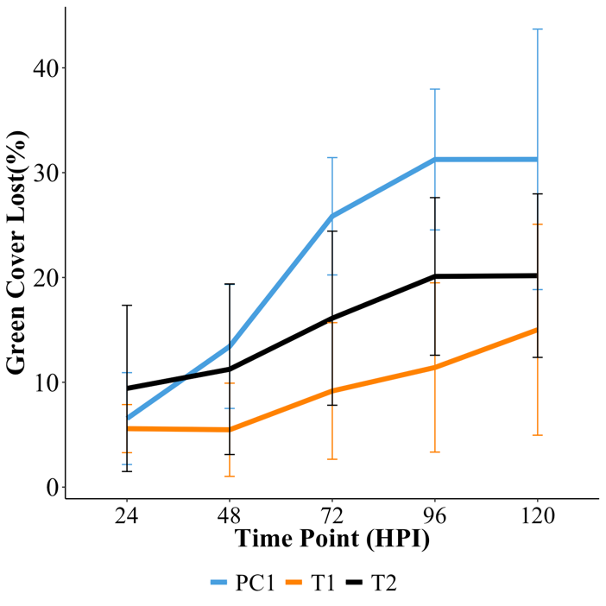
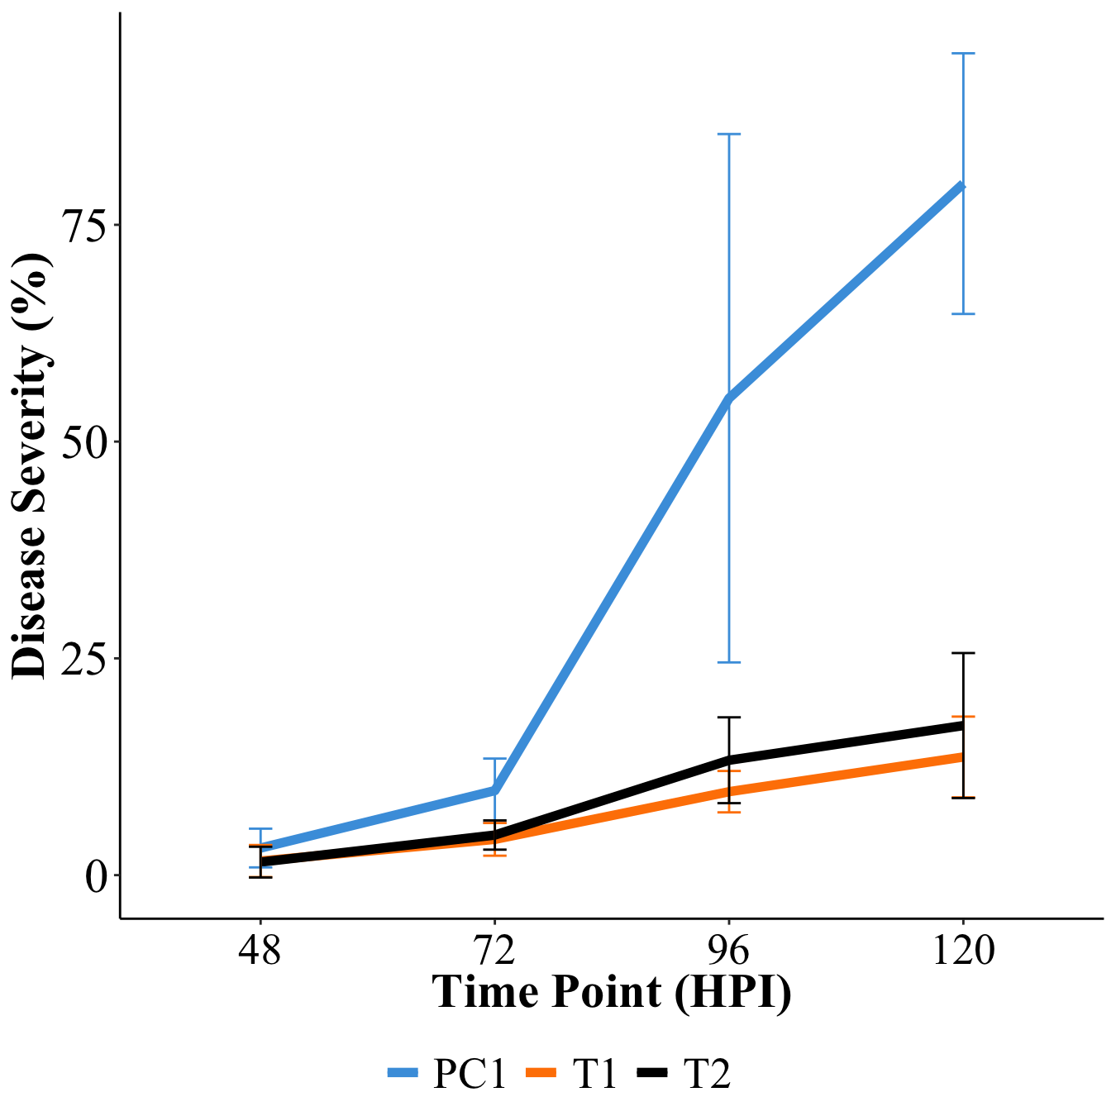
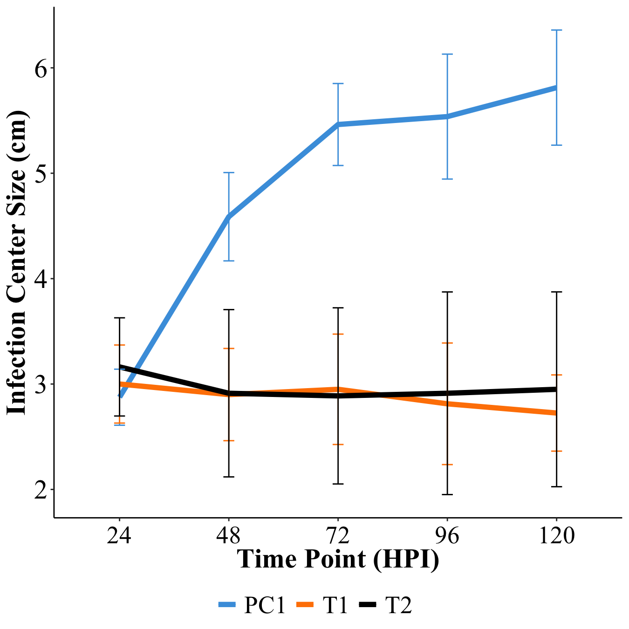
Figure 3.1. Time course of dollar spot pathogenesis. (A) Changes in normalized percent green cover, (B) Disease severity (%), and (C) infection foci size. Error bars show one standard deviation around the mean. and the Dunnetts test was used to assign significance by comparing treatment 1 (orange) and treatment 2 (black) against positive control 1. *** Significant at 0.001; ** Significant at 0.01; * Significant at 0.05; . Significant at 0.1
.
A
NS
NS
NS
*
.
***
***
**
*
*
NS
*
**
**
**
C
NS
**
**
**
*
B
NS
NS
**
**
NS
NS
**
**

from PC1 at all time points except 24 hpi. Overall, PC1 plants had larger spots than T1 and T2 plants. Infection foci size in T1 and T2 plants decreased slightly after 24-hour incubation period (Figure 3.1C). Phototoxicity analysis revealed a significant difference (p<0.001) in green cover between 0 hpi and 168 hpi samples. The t value was 6.71 with a 95% confidence interval of 24.25 to 11.61 (Table 3.4).
                - DISCUSSION AND CONCLUSION
Since dollar spot was first described and characterized by Monteith (1927) and Bennett (1937), respectively, the question of why dollar spot infection foci do not grow bigger than a U.S. silver dollar has remained unanswered. Previous work in our lab, has demonstrated that when UV radiation from the sun is shielded from the canopy of the turfgrass, dollar spot infection foci occur earlier and expand beyond their typical size (data unpublished). Additionally, exposing C. jacksonii to increased levels of UVB radiation in vitro led to increased inhibition of growth (Hu et al., 2013). Thus, this study characterized the effects of UV radiation on the epidemiology of dollar spot in vivo and whether an increased amount of UV radiation above normal sunlight dose could reduce dollar spot foci without negative impacts on plant health.
In this study, UVB radiation, even at only 1x normal sunlight, significantly inhibited the spread of dollar spot in each pot leading to smaller infection foci. Conversely, the non-UVB-treated samples had increased infection foci size that in most cases stretched across the entire pot and percent disease ratings >80% at 120 hpi. These results suggest that dollar spot growth is likely inhibited in the field by UV radiation from the sun, leading to the appearance of smaller infection foci than other common turfgrass
Table 3.4. Paired t-test to determine phototoxic effects in positive control 2 plants.

% Green Cover (0 hpi vs 168 hpi)
t value | DF | 95% CI Low | 95% CI High | p value | Significance
6.71 | 7 | 24.25 | 11.61 | 2.75E-04 | ***
Abbreviations: CI:Confidence Interval; DF:Degrees of Freedom
*** Significant at 0.001

pathogens. As a result, this study combined with previous work in our lab indicate the main environmental condition that causes dollar spot infection foci to remain silver dollar-sized is UV radiation, specifically UVB. This effect may also contribute to why dollar spot is most severe in the spring, fall, during prolonged periods of cloudy weather, and in higher cut turf areas. Each of these environmental phenomena reduce the amount of UV radiation penetrating the upper thatch, where this fungus survives, limiting its ability to be fungicidal.
Treating the PC2 plants with ~2x the normal sunlight daily UVB dose caused a significant reduction in green cover. These results are supported by Bartley (2012), who determined increased UVB radiation on creeping bentgrass significantly reduced the chlorophyll and carotenoid concentrations in cells, decreasing their photosynthetic efficiency. Deactivation of PSII and Rubisco also caused a decrease in photosynthetic efficiency. Furthermore, Nangle et al. (2015) and Sarkar et al. (2011), determined cool season turfgrass increased production of secondary metabolites such as phenolics, anthocyanins, and flavonoids while experiencing decreased photosynthetic efficiency. Thus, increased amounts of UVB radiation likely overwhelmed the photocenters of T2 plants, resulting in a decline of green cover at later time points when signs of dollar spot infection were not present.
There is interest in the turfgrass industry in using UV radiation to treat high value turf surfaces (fairways, greens, tees, sports fields) in order to inhibit UV sensitive pathogens like dollar spot. Other studies have shown UVB radiation can inhibit the growth, morphogenesis, and sporulation of many fungi (Ensminger, 1993; Fourtouni et al., 1998). UVB radiation has been effective against powdery mildew (Podosphaera aphanis Wallr.; Uncinula necator (Schw.) Burr.) in strawberry fields (Fragaria x ananassa Duchesne.) and grape vines (Vitis vinifera L.), black spot (Diplocarpon rosae Wolf.) in roses (Rosa x hybrida Vill.), blister blight (Exobasidium vexans Massee.) in tea (Camellia sinensis (L.) Kuntze), and stripe rust (Puccinia striiformis f. sp. tritici Eriksson.) in wheat (Gunasekera et al., 1997; Kono et al., 2023; Onofre et al., 2021; H. Wang et al., 2018; Willocquet et al., 1996). All these studies indicate the potential UV radiation treatments against dollar spot. In this study, we confirm that C. jacksonii is sensitive to UV radiation in vivo. However, cool season turfgrasses such as creeping bentgrass are subject to phototoxic effects from this type of radiation and so more research is needed to mitigate these effects. Future studies can determine the UVB radiation threshold that leads to dollar spot inhibition, if UVC light can decrease treatment duration leading to less phototoxicity, or whether application of different pigments to cool season grasses can limit phototoxic effects.

LIST OF REFERNCES
Aynardi, B. A., Jiménez-Gasco, M. M., & Uddin, W. (2019). Effects of isolates of Clarireedia jacksonii and Clarireedia monteithiana on severity of dollar spot in turfgrasses by host type. European Journal of Plant Pathology, 155(3), 817–829. http://dx.doi.org/10.1007/s10658-019-01813-z
Bartley, G. K. (2012). Applicability of pigment compounds for reducing light stress in bentgrass [M.S. University of Tennessee, Knoxville].
Bennett, F. T. (1937). Dollar spot disease of turf and its causal organism Sclerotinia homoeocarpa n. Sp. Annals of Applied Biology, 24(2). https://www.cabdirect.org/cabdirect/abstract/19371101555
Bonos, S. A., Casler, M. D., & Meyer, W. A. (2003). Inheritance of Dollar Spot Resistance in Creeping Bentgrass. Crop Science, 43(6), 2189–2196. https://doi.org/10.2135/cropsci2003.2189
Ensminger, P. A. (1993). Control of development in plants and fungi by far-UV radiation. Physiologia Plantarum, 88(3), 501–508. https://doi.org/10.1111/j.1399-3054.1993.tb01365.x
Fourtouni, A., Manetas, Y., & Christias, C. (1998). Effects of UV-B radiation on growth, pigmentation, and spore production in the phytopathogenic fungus Alternaria solani. Canadian Journal of Botany, 76(12), 2093–2099. https://doi.org/10.1139/b98-170
Giordano, P. R., Nikolai, T. A., Hammerschmidt, R., & Vargas Jr, J. M. (2012). Timing and Frequency Effects of Lightweight Rolling on Dollar Spot Disease in Creeping Bentgrass Putting Greens. Crop Science, 52(3), 1371–1378. https://doi.org/10.2135/cropsci2011.07.0373
Green, T. O., Rogers, J. N., Crum, J. R., Vargas, J. M., & Nikolai, T. A. (2019). Effects of Rolling and Sand Topdressing on Dollar Spot Severity in Fairway Turfgrass. HortTechnology, 29(4), 394–401. https://doi.org/10.21273/HORTTECH04272-19
Gunasekera, T. S., Paul, N. D., & Ayres, P. G. (1997). The effects of ultraviolet-B (UV-B: 290–320 nm) radiation on blister blight disease of tea (Camellia sinensis). Plant Pathology, 46(2), 179–185. https://doi.org/10.1046/j.1365-3059.1997.d01-216.x
Hempfling, J. W., Ward, D. L., Lalancette, N., Clarke, B. B., & Murphy, J. A. (2021). Novel action thresholds of a logistic regression model to forecast dollar spot on bentgrasses. Crop Science, 61(5), 3124–3133. https://doi.org/10.1002/csc2.20510
Hollósy, F. (2002). Effects of ultraviolet radiation on plant cells. Micron, 33(2), 179–197. https://doi.org/10.1016/S0968-4328(01)00011-7
Hu, J., Zhang, H., Dong, Y., Jiang, S., Lamour, K., Liu, J., Chen, Y., & Yang, Z. (2021). Global Distributions of Clarireedia Species and Their In Vitro Sensitivity Profiles to Fungicides. Agronomy, 11(10). https://doi.org/10.3390/agronomy11102036
Karcher, D. E., Purcell, C. J., Richardson, M. D., Purcell, L. C., & Hignight, K. W. (n.d.). A New Java Program to Rapidly Quantify Several Turfgrass Parameters from Digital Images. Retrieved August 13, 2024, from https://scisoc.confex.com/scisoc/2017am/meetingapp.cgi/Paper/109313
Kono, A., Kawabata, A., Yamazaki, A., Ohkubo, Y., Sofo, A., & Hosokawa, M. (2023). Control of Black Spot Disease by Ultraviolet-B Irradiation in Rose (Rosa × hybrida) Production. The Horticulture Journal, 92(1), 88–96. https://doi.org/10.2503/hortj.QH-037
Monteith, J. (1927). Can you Identify Brown-Patch? The National Greenkeeper, 7–11.
Nangle, E. J., Gardner, D. S., Metzger, J. D., Rodriguez-Saona, L., Guisti, M. M., Danneberger, T. K., & Petrella, D. P. (2015). Pigment Changes in Cool-Season Turfgrasses in Response to Ultraviolet-B Light Irradiance. Agronomy Journal, 107(1), 41–50. https://doi.org/10.2134/agronj14.0249
Onofre, R. B., Gadoury, D. M., Stensvand, A., Bierman, A., Rea, M., & Peres, N. A. (2021). Use of Ultraviolet Light to Suppress Powdery Mildew in Strawberry Fruit Production Fields. Plant Disease, 105(9), 2402–2409. https://doi.org/10.1094/PDIS-04-20-0781-RE
Posit team (2024). RStudio: Integrated Development Environment for R. Posit Software, PBC, Boston, MA. URL http://www.posit.co/.
Salgado-Salazar, C., Beirn, L. A., Ismaiel, A., Boehm, M. J., Carbone, I., Putman, A., Tredway, L. P., Clarke, B. B., & Crouch, J. A. (2018). Clarireedia: A new fungal genus comprising four pathogenic species responsible for dollar spot disease of turfgrass. Fungal Biology, 122(8), 761–773. https://doi.org/10.1016/j.funbio.2018.04.004
Sarkar, D., Bhowmik, P. C., Young-In-Kwon, & Shetty, K. (2011). The role of proline-associated pentose phosphate pathway in cool-season turfgrasses after UV-B exposure. Environmental and Experimental Botany, 70(2), 251–258. https://doi.org/10.1016/j.envexpbot.2010.09.018
Smith, D. L., Kerns, J. P., Walker, N. R., Payne, A. F., Horvath, B., Inguagiato, J. C., Kaminski, J. E., Tomaso-Peterson, M., Koch, P. L., & Link to external site, this link will open in a new window. (2018). Development and validation of a weather-based warning system to advise fungicide applications to control dollar spot on turfgrass. PloS One, 13(3), Article e0194216. http://dx.doi.org/10.1371/journal.pone.0194216
Townsend, R., Millican, M. D., Smith, D., Nangle, E., Hockemeyer, K., Soldat, D., & Koch, P. L. (2021). Dollar Spot Suppression on Creeping Bentgrass in Response to Repeated Foliar Nitrogen Applications. Plant Disease, 105(2), 276–284. https://doi.org/10.1094/PDIS-05-20-1031-RE
Walsh, B., Ikeda, S. S., & Boland, G. J. (1999). Biology and Management of Dollar Spot (Sclerotinia homoeocarpa); an Important Disease of Turfgrass. HortScience, 34(1), 13–21. https://doi.org/10.21273/HORTSCI.34.1.13
Wang, H., Qin, F., Cheng, P., Ma, Z., & Wang, H. (2018). Effects of UV-B radiation intensity and timing on epidemiological components of wheat stripe rust. Journal of Integrative Agriculture, 17(12), 2704–2713. https://doi.org/10.1016/S2095-3119(18)62020-9
Wickham H (2016). ggplot2: Elegant Graphics for Data Analysis. Springer-Verlag New York. ISBN 978-3-319-24277-4, https://ggplot2.tidyverse.org.
Williams, D. W., Powell, A. J., Vincelli, P., & Dougherty, C. T. (1996). Dollar Spot on Bentgrass Influenced by Displacement of Leaf Surface Moisture, Nitrogen, and Clipping Removal. Crop Science, 36(5), 1304-1309. https://doi.org/10.2135/cropsci1996.0011183X003600050039x
Willocquet, L., Colombet, D., Rougier, M., Fargues, J., & Clerjeau, M. (1996). Effects of radiation, especially ultraviolet B, on conidial germination and mycelial growth of grape powdery mildew. European Journal of Plant Pathology, 102(5), 441–449. https://doi.org/10.1007/BF01877138
APPENDIX
                - INOCULATION OPTIMIZATION
Materials & Methods
An experiment was conducted to look at two factors that affect the consistency of inoculations. The first factor was maturity time of inoculum. Two batches of inoculum were started. One was incubated for three weeks while the other incubated for four weeks. Once the inoculum matured, the second factor, amount of inoculum, was tested. Treatments of 1, 1.5, 2, 2.5, and 3 grams of inoculum were spread on the canopy of seeded pots of ‘L-93’ creeping bentgrass (Agrostis stolonifera L.). Plants were then bagged and placed in a CMP 6010 growth chamber (Conviron, Winnipeg, Manitoba) with a daytime temperature of 22 °C, nighttime temperature of 18 °C, and a daily light integral (DLI) of ~5 mol/m²/day (12-hour light/dark cycle). Disease severity was evaluated using the Horsfall-Barrett scale (1-12) and pictures were taken at from 24-196 hours post inoculation (hpi). Table S1.1 shows the Horsfall-Barrett scale used and the disease severity percentage ranges for each group.
Results & Conclusions
Maturity time of inoculum batches and amount of inoculum used for inoculations were two factors investigated in this experiment. First, inoculum batches required three weeks to mature. Clumping and presence of mycelia on the walls of the Erlenmeyer flask were the best traits associated with maturity. For determining the amount of inoculum for RNAseq experiments, 2.5 g of inoculum gave an even spread across the whole pot (Figure S1.1). After this, we proceeded with treatment levels, 2, 2.5, and 3 g, and found that both 2.5 and 3 grams (g) of inoculum produced the most tissue death on our plant
Horsfall-Barrett Scale
Category | Disease severity range (%)
1 | 0
2 | 0-3
3 | 3-6
4 | 6-12
5 | 12-25
6 | 25-50
7 | 50-75
8 | 75-88
9 | 88-94
10 | 94-97
11 | 97-100
12 | 100
Table S1.1. The Horsfall-Barrett scale used for rating disease progress

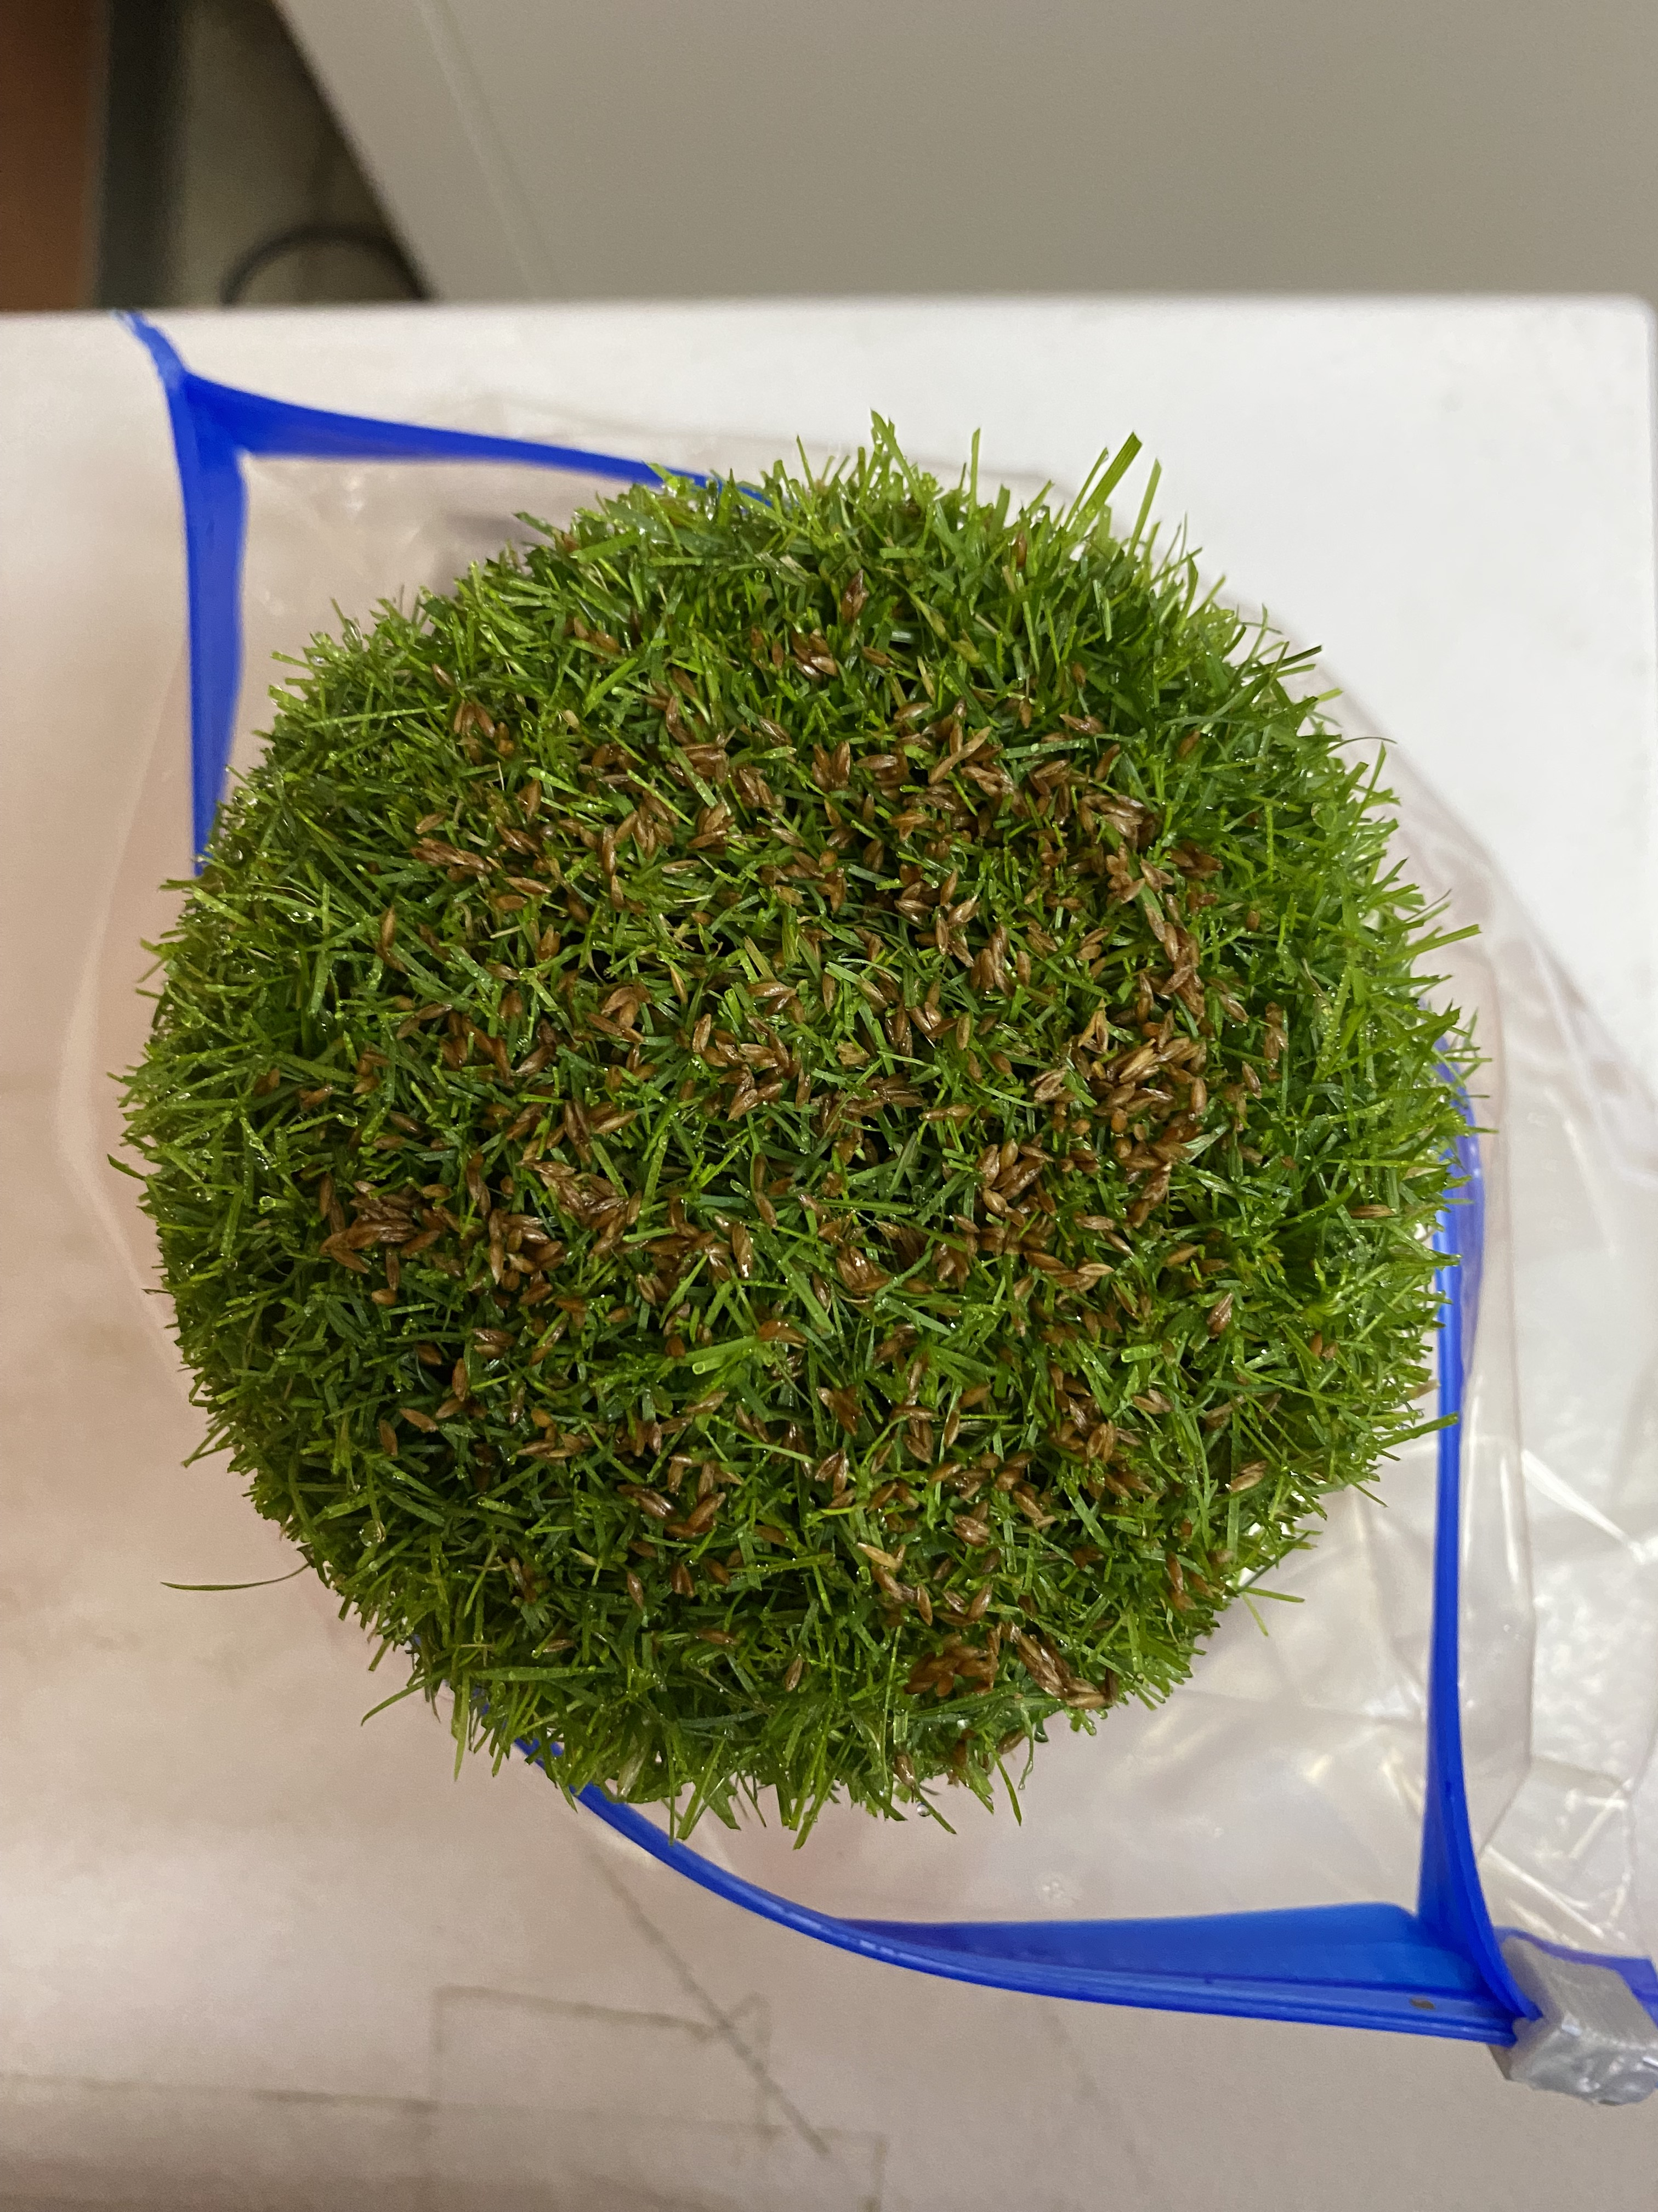
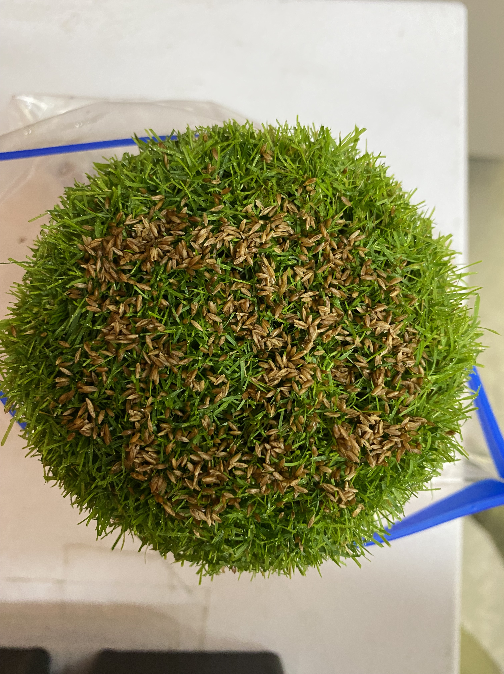
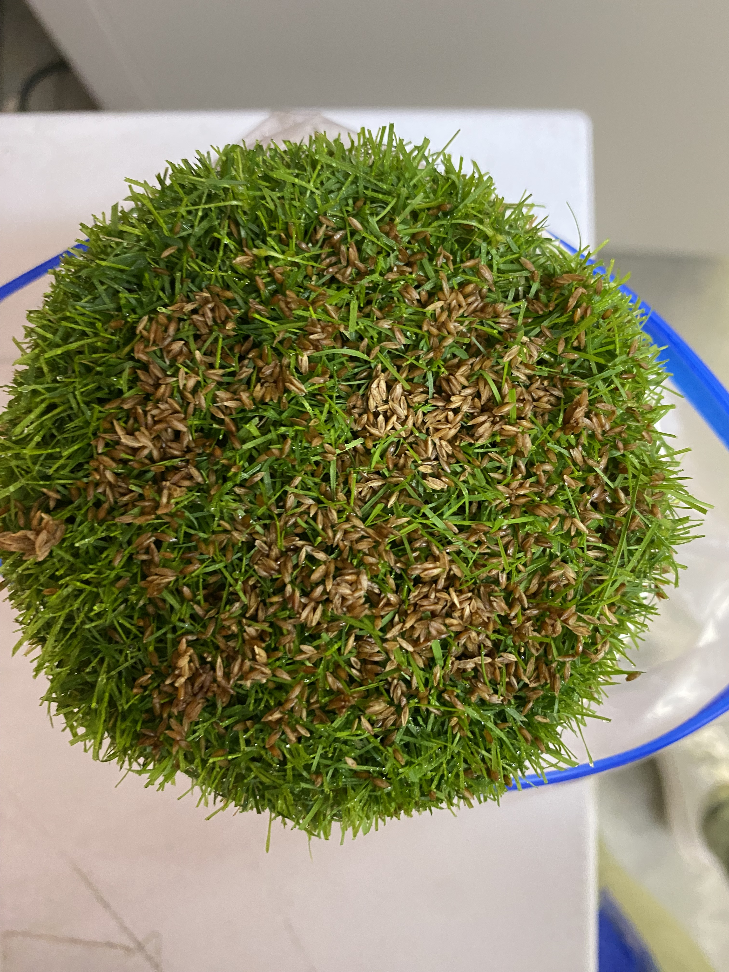
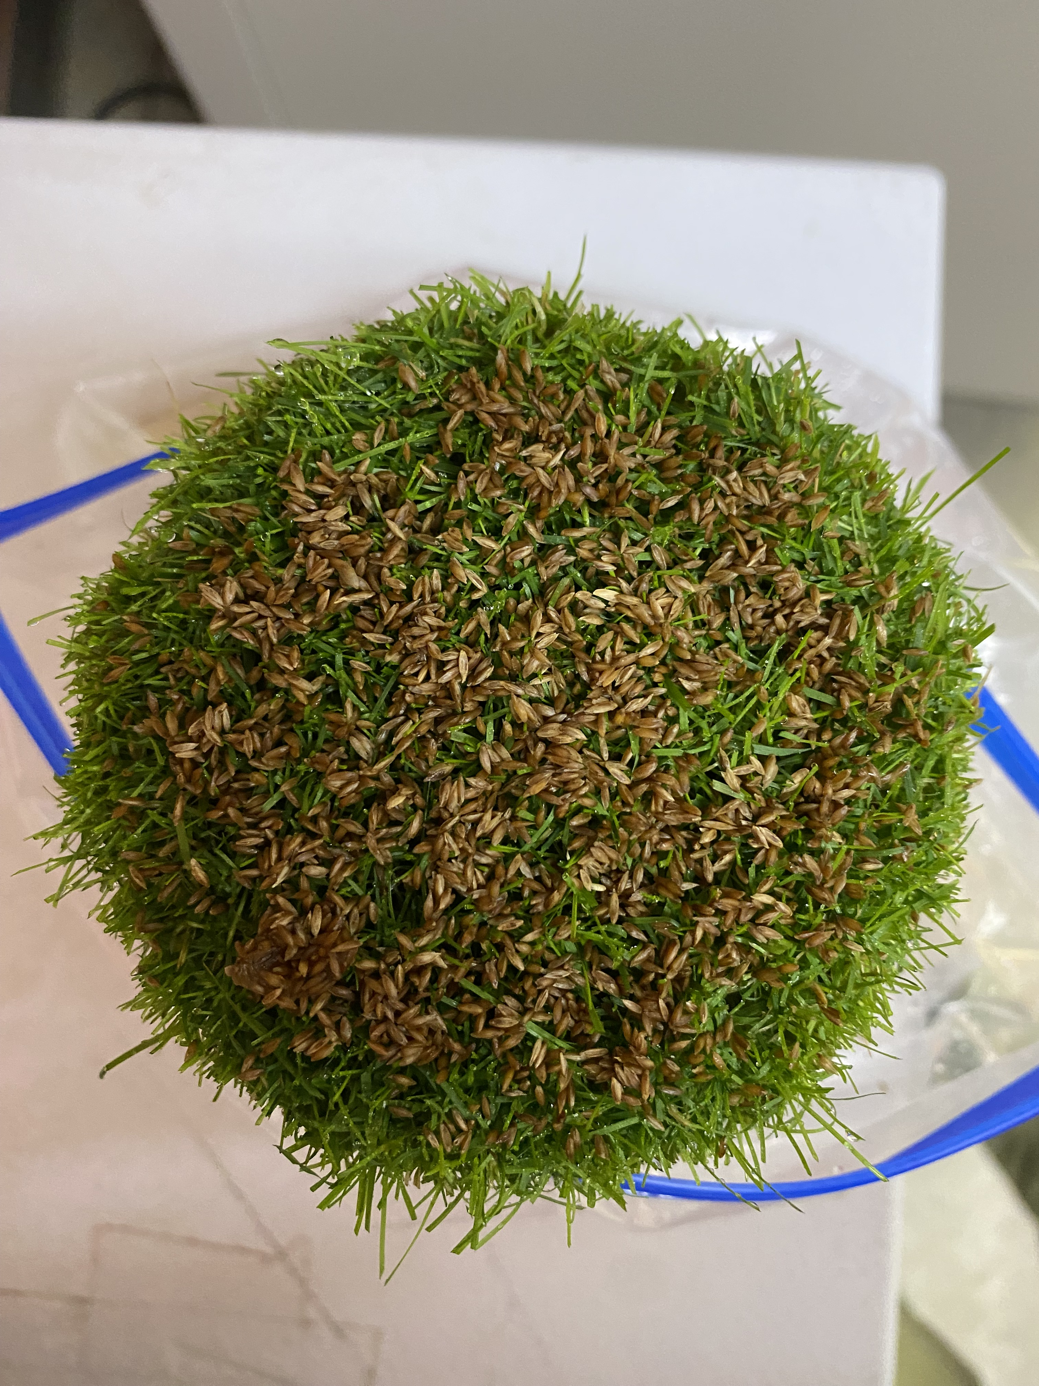
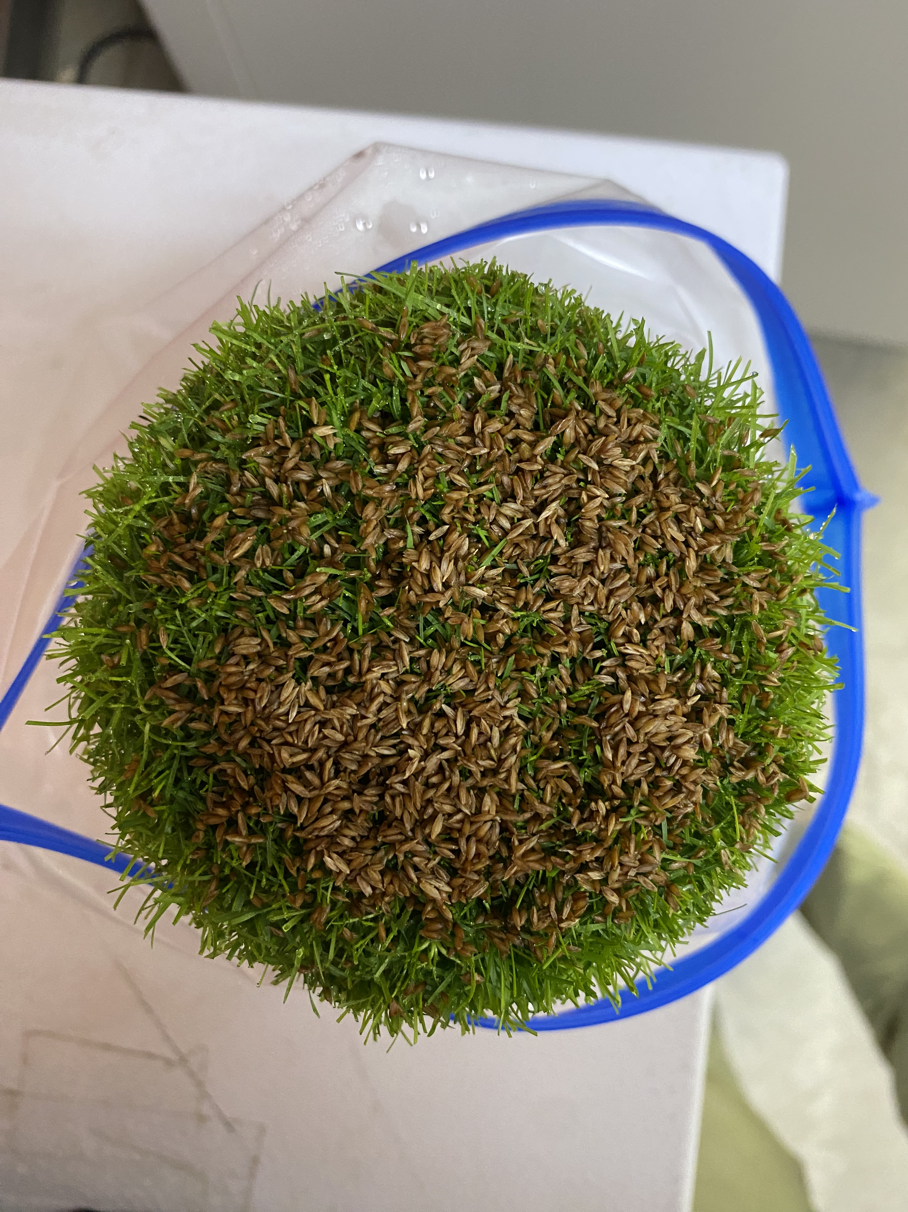
1.0 g
1.5 g
2.0 g
2.5 g
3.0 g
Figure S1.1. The uniform distribution of each amount of inoculum on the surface of plant samples. 2.5 and 3 g of inoculum fully cover the surface.

samples (Figure S1.2). Thus, we chose to use 2.5 grams for all RNAseq experiments since there was no additional benefit when adding an additional 0.5 g of inoculum. the plant.
                - SEEDLING SELECTION EXPERIMENT
Material and Methods
Three genotypes were selected for this study, one colonial bentgrass (Agrostis capillaris L.) (‘BCD’) and two creeping bentgrass (‘Declaration’ & ‘Crenshaw’) cultivars. ‘BCD’ represented the dollar spot resistant, ‘Declaration’ the moderately resistant, and ‘Crenshaw’ the susceptible populations. 20 single seeds of each genotype were planted in 80:20 sand:peat soil mix in 3” diameter pots. Pots were maintained in the greenhouse with an average daytime temperature of 27°C and nighttime temperature of 24°C . Each pot was mowed to maintain a height of ~2 cm, watered to field capacity as needed, and fertilized with 9.6 kg N ha⁻¹ using a 20-20-20 complete water-soluble fertilizer (Master Plant-Prod Inc., Brampton, ON) weekly until the pots were filled. The first 10 seedlings to fill their pot were selected to be vegetatively propagated. The clones of each seedling were maintained in the same manner as above until they reached maturity (~4 weeks).
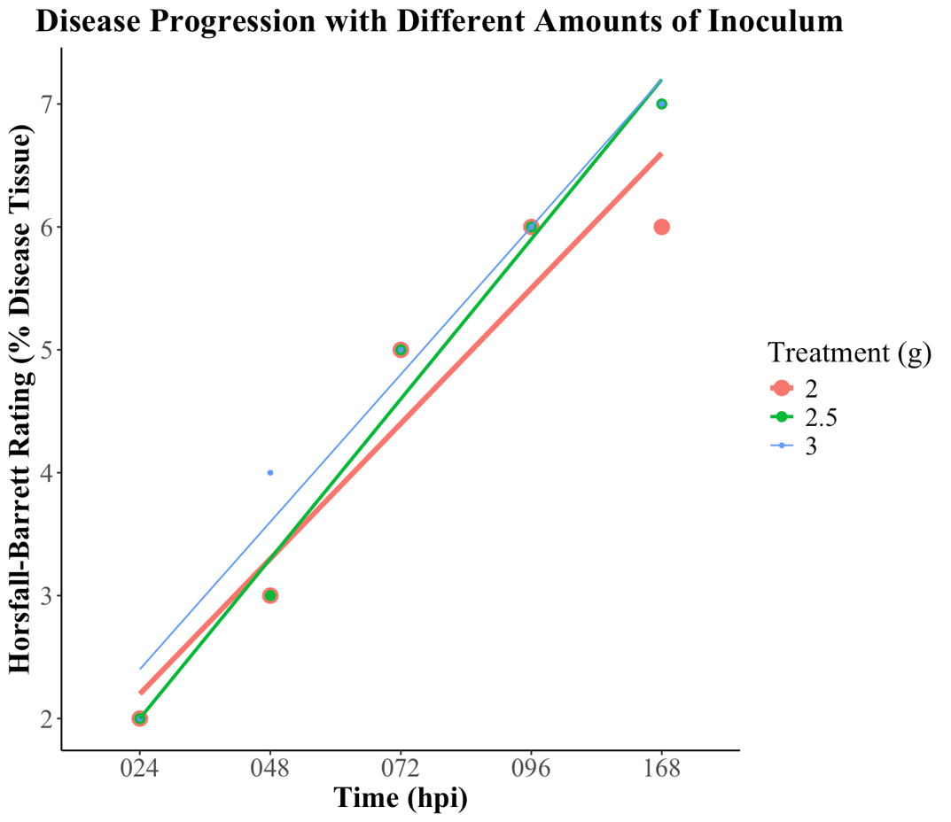
Figure S1.2. A scatter plot where the disease severity associated with each treatment was plotted over time. Disease severity was measured using the Horsfall-Barrett scale.
Once each single seedling pair for all genotypes reached maturity, one of the clones (10 plants from each genotype, 30 total) was selected for the seedling selection experiment. Fertilizer was withheld for one month prior to the experiment. All 30 plants
were lightly mown, misted five times using deionized water, and covered with two grams of inoculum. Plants were placed in gallon sized zip-top bags with three wet paper towels and sealed to increase the relative humidity. Plants were placed in a CMP 6010 growth chamber (Conviron, Winnipeg, Manitoba) that maintained a daytime temperature of 22°C, nighttime temperature of 18 °C, and DLI of ~5 mol/m²/day (12-hour light/dark cycle). All pots were photographed and rated for disease percentage using the Horsfall-Barratt scale from 0-120 hpi. Light microscopy was also performed to determine the time point when mycelia was present on leaves and most likely penetrated through stomata.
Results and Conclusions
When comparing the diseased area percentage between the ten seedlings from the each creeping and colonial bentgrass genotype, no significant differences were found at all time points. Therefore, a seedling was selected at random from each genotype to be vegetatively propagated for all RNAseq experiments. In addition, pictures were reviewed at the conclusion of the experiment to check disease progress over time and select time points for tissue collection during the RNAseq experiments. These pictures displayed aerial mycelia present starting at 48 hpi and lesions forming at 96 hpi. Multiple inoculation test experiments were conducted and confirmed these findings. Light microscopy results also confirmed the first and last time point because mycelia were prevalent on the leaf surface starting at 48 hpi and penetration into the plant occurred at this time or shortly after (Figure S1.3). As a result, because our RNAseq study is targeting early detection and resistance, time points at 48, 60, 72, and 96 hpi would provide insight into the bentgrass-dollar spot pathosystem.
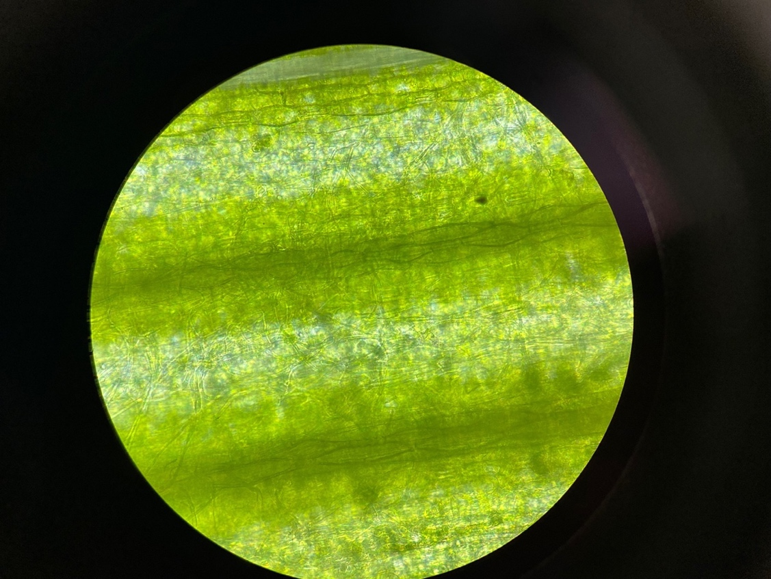
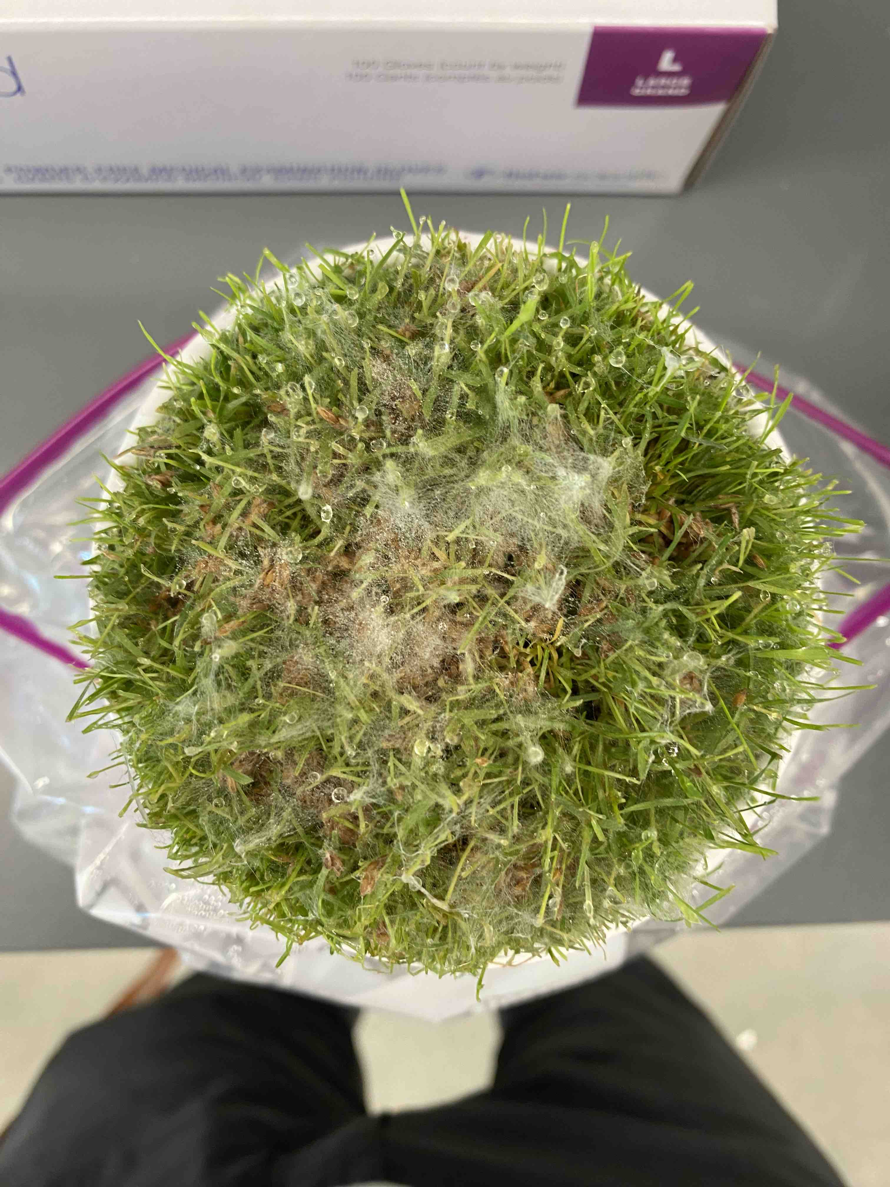
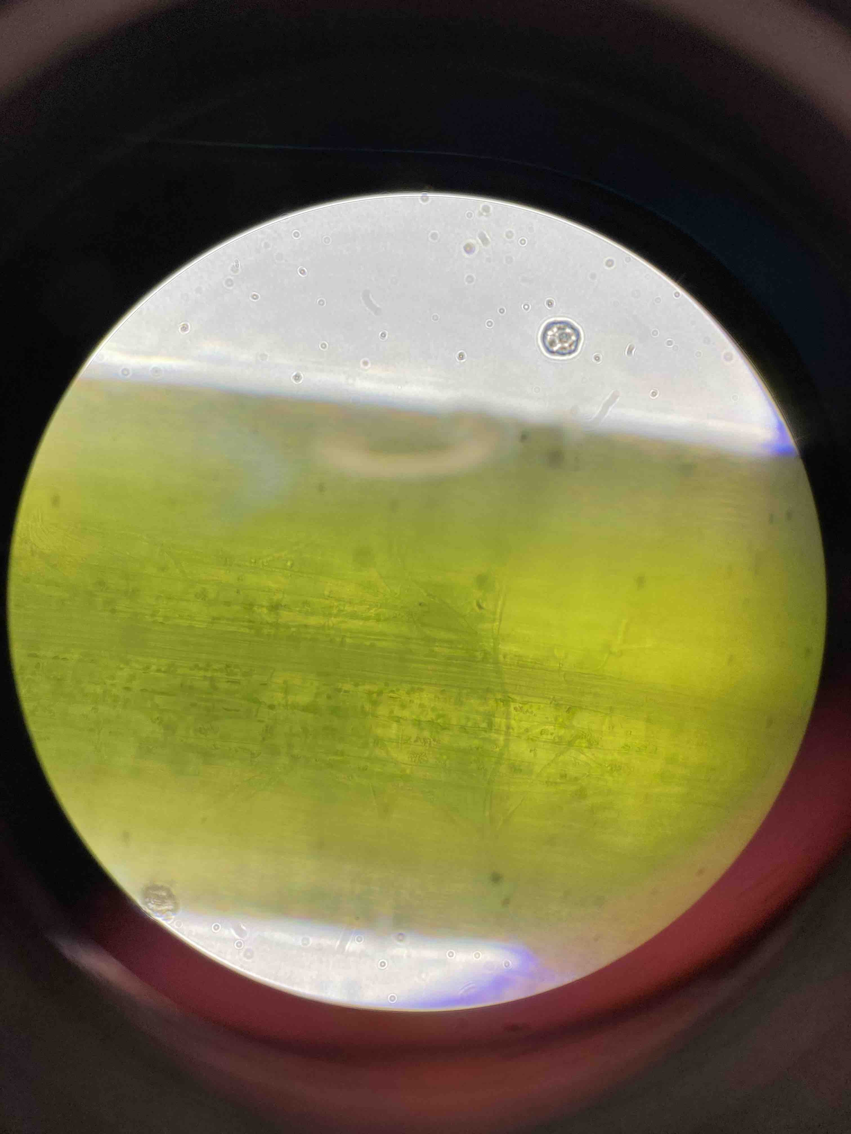
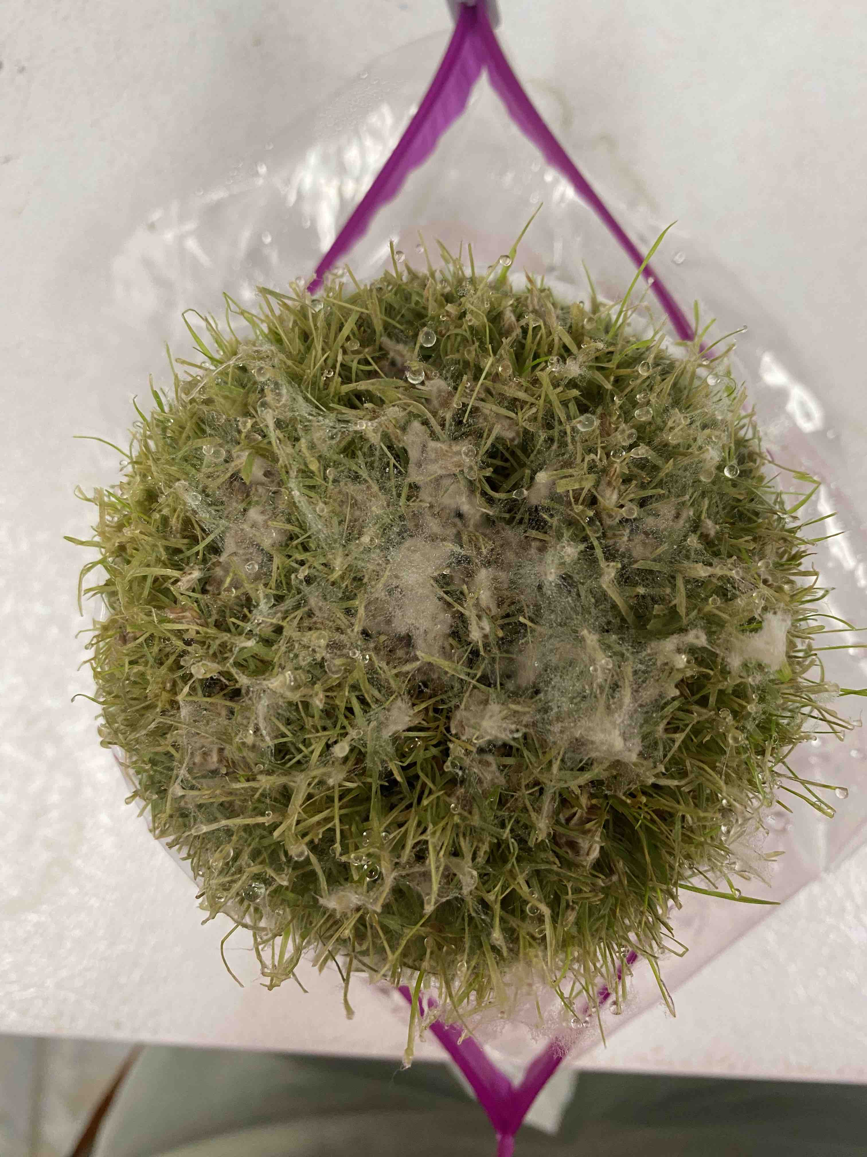
96 HPI
48 HPI
Figure S1.3. Timepoint confirmation using light microscopy. First column is 48 hours post inoculation (hpi) with the top picture showing the appearance from above the canopy and the bottom picture is a leaf sampled from random in the pot. The second column is 96 hpi with the picture of the canopy on top and a picture of a leaf sample underneath a light microscope on the bottom. The red arrows highlight the runner hyphae present on the leaf’s surface.
Vita
Dillon McCallum grew up in Lake Orion, Michigan, a city at the northernmost edge of Detroit’s suburbs, where in high school he earned an athletic letter in cross country, hockey, and golf and an academic letter all four years. After high school, he attended the University of Michigan and obtained a Bachelor of Science in Biochemistry with a minor in Latin. During his studies he earned university honors (3.5+ GPA an academic year) all four years and was a James B. Angell scholar twice (All A’s in three consecutive semesters). Additionally, he began his research career at the University of Michigan as a freshman and continued to be involved in projects through his senior year.
After graduating with high distinction, Dillon moved to Knoxville, TN and started a M.S. degree in Plant Science and the University of Tennessee. While a student at UT, he has earned the Haxelwood scholarship, Walter J. Travis memorial scholarship, Tom & Emily Austin plant science fellowship award, Bill Rose foundation travel scholarship, and outstanding graduate student award. Additionally, he served as vice president and then president of the PSGSA, playing an instrumental role in growing the seminar exchange program to include four schools and creating a document that outlines the expectations of the mentor-mentee relationship that was approved by the faculty. He has presented his research during his studies at ASA-CSSA-SSSA society conference, southeastern turf conference, Pure Seed field day, and Beacon field day. Lastly, outside of school he is a lead coach for The First Tee – Greater Knoxville Area, where he teaches kids of all skill levels how to become better golfers while mixing in life lessons and the nine core values.

