Distributed Sensor Network Data Fusion for Nuclear Security Applications

A Dissertation Presented for the
Doctor of Philosophy
Degree
The University of Tennessee, Knoxville

Ian Robert Stewart
December 2020

Copyright © 2020 by Ian Robert Stewart
All rights reserved.

This is dedicated to my family, friends, and colleagues
who have all helped me along my journey.

Acknowledgements
This work was not possible without the generous support and guidance of so many people. To my family for all of their love, support, and encouragement. To my dearest friends and colleagues in all parts of the country for all of their support, both in the pursuit of my degree and in life.

I want to thank my advisor, Dr. Howard Hall, for his dedication, support, and, most of all, his patience over the last few years. I would not have been successful in graduate school without his support. I also want to thank my committee members from the University of Tennessee-Knoxville, Dr. Jason Hayward and Dr. Lawrence Heilbronn, as their support and feedback make it possible for students to pursue their dreams.

I must also thank Dr. Daniel (Dan) Archer and the Radiation Detection and Imaging group at Oak Ridge National Laboratory. Dan took a chance by supporting my graduate school studies as well as my research activities and I am forever grateful for that opportunity. Dan’s mentorship in both my pursuit of a career after graduate school and in life has been invaluable. Additionally, the entire Radiation Detection and Imaging group took me in and gave me the opportunity of a lifetime to learn, grow, and explore a brave new world. Their words of encouragement through this process and the friendships made along the way will not be forgotten.

Lastly, I want to show my sincere appreciation to the Office of Combatting Weapons of Mass Destruction at U.S. Department of Homeland Security for their financial support during my studies.

Abstract
NEED TO UPDATE. Detecting, locating, and interdicting radiological materials out of regulatory control or that pose a threat to the general public remains a high national security priority. Conventional methods employed a radiation detection system to detect radiological materials and alerting the appropriate authorities for interdiction procedures. More recently, the concept of operations has focused to deploying multiple radiation detection systems to detect and track radiological materials, providing more detail to the end-users during the interdiction process. The research proposed in this document utilizes data from a distributed sensor network (DSN) to detect and track radiation anomalies through a network. The primary original contributions of the proposed research focus on (1) creating data fusion techniques between contextual sensors (e.g. LIDAR, Video, Bluetooth, etc.) and radiation sensors and (2) constructing a network-level decision making architecture across the deployed sensors. The data fusion techniques focus on extracting features from multiple modalities populate an anomaly feature vector to provide more detail regarding the detected radiation anomaly. Furthermore, utilizing the extracted features from each sensor modality positioned at a node in the network, additional information can be inferred, (e.g. source activity, direction, velocity, or time-to-next node), which can be sourced to increase downstream sensors’ sensitivities. The constructed anomaly feature vector can be utilized across the DSN to cross-correlate signals through the spatial and temporal domains in the network and reduce false alarm rate observed from the radiation sensors. The network-level decision making architecture can be constructed in a manner to decrease the amount of communication (i.e. data) across the network and only compare local raw sensor signals with the extracted features in the anomaly feature vector. This architecture decreases the amount of total information sent over the network by extracting features from raw signals locally (i.e. edge computing) and can provide a relatively straightforward methodology for statistical data fusion (e.g. Bayesian-based network decision making).
Table of Contents
1: Introduction 1
1.1: Organization of Work 3
1.2: Radiation Detection Overview 3
1.3: Relevant Published Literature 19
1.4: Problem Statement 38
2: Distributed Sensor Network Data 39
3: Anomaly Detection and Feature Extraction Methodologies 43
3.1: Radiation Data Analysis 44
4: Distributed Radiation Detection 44
4.1: Energy Spectra Comparison 45
4.2: Region-of-Interest Detection 68
3.3: Analysis of Sensor Array Data 92
4.4: Bayesian Classification Methodology 117
4.5: Dempster-Shafer Classification Methodology 158
5: Distributed Multi-modality Sensor Network 158
6: Conclusions and Future Work 158
Appendix 159
Vita 161
References 162

List of Tables

Table 1: List of radioisotopes with material properties relevant to radiation detection 13
Table 2: Spectral comparison results for L¹ and L² norm methods. 66
Table 3: Spectral comparison results for Chi-squared, K-S Test and Cosine Similarity. 67
Table 4: Probability of Detection for multiple detection options on synthetic data. 91
Table 5: Event 1 cosine similarity values for anomalous spectra. 101
Table 6: Event 2 cosine similarity values for anomalous spectra. 110
Table 7: Event 3 cosine similarity values for anomalous spectra. 116

List of Figures
Figure 1: Gamma-ray gross count rate variation with corresponding location in downtown Knoxville, TN. 18
Figure 2: Image of the DSN-CC sensor array at LANL 23
Figure 3: Image of the LLNL Adaptable Radiation Area Monitor system 24
Figure 4: Passport System Inc. prototype detection devices in support of the DHS-IRSS project 26
Figure 5: Testbed for DHS-RAIN with radiation detection sensors and video cameras along a roadway 27
Figure 6: Testbed for DHS-RAIN showing license plate readers position above flowing traffic. 28
Figure 7: D3S RIID from Kromek with gamma and neutron detection capability 29
Figure 8: Map of SIGMA systems deployed during Washington, D.C. data collection experiment. 29
Figure 9: Illustration of DHS-MURS sensor configuration. 31
Figure 10: Image of the MURS modular system utilized for urban search operations 32
Figure 11: Image of the RadMAP system showing various sensors incorporated on the mobile platform. 33
Figure 12: Example RadMAP output from fusing coded-aperture and stitched video data. 34
Figure 13: Example of data processing of image segmentation for background estimation for RadMAP 35
Figure 14: Velodyne LIDAR and radiation detector configuration at the University of Florida 36
Figure 15: Example of fusing LIDAR and Radiation data from the University of Florida 37
Figure 16: General schematic diagram for processing sensor data utilized in proposed work. 38
Figure 17: Illustration showing location of nodes in ORNL sensor array. 39
Figure 18: Image of a node (left) on the ORNL sensor array along with an image inside the enclosure (right). 40
Figure 19: Count rate histogram for nodes in the ORNL sensor array using arbitrary 10-second integration time. 41
Figure 20: Normalized energy spectra for nodes in the ORNL sensor array. 42
Figure 21: Count rate time series for example anomalous event from ORNL sensor array. 43
Figure 22: Example distributions for background and a radioactive source. 47
Figure 23: Source spectrum from two locations. (Top) Example energy spectrum collected during anomalous event at Node01. (Bottom) Example energy spectrum collected during anomalous event at Node02. 48
Figure 24: Background subtracted energy spectra for Node01 (top) and Node02 (bottom). 49
Figure 25: Filtered spectra for Node01. (Top) Filters of various window lengths using a linear model. (Bottom) Filters of various window length using quadratic model. 52
Figure 26: Filtered spectra for Node02. (Top) Filters of various window lengths using a linear model. (Bottom) Filters of various window length using quadratic model. 53
Figure 27: Background-subtracted and filtered spectra for both example anomalous spectra. 54
Figure 28: Normalized and filtered spectra using divide-by-max and sum-to-unity approach. 55
Figure 29: Illustration of L¹ and L² norm distance measures. 60
Figure 30: Cumulative density functions for Node01 and Node02 anomalous spectra. 62
Figure 31: Illustration of cosine similarity concept comparing two vectors. 64
Figure 32: Background-subtracted spectra with highlighted regions-of-interest using heuristic approach. 69
Figure 33: Filtered spectra with highlighted region-of-interest. 70
Figure 34: Multiple-linear regression detection methodology using region-of-interest approach. 78
Figure 35: Illustration comparing least-squares and ridge regression on arbitrary data. 79
Figure 36: Example illustration of prediction error for least squares and ridge regression methods. 81
Figure 37: Histogram of count rates per bin for a deployed radiation detector. 82
Figure 38: Ridge regression detection methodology using region-of-interest approach. 83
Figure 39: Example ridge trace plot for multiple coefficients using arbitrary data. 84
Figure 40: Ridge trace for radiation detectors deployed at ORNL. 86
Figure 41: Mean squared error for ridge and least squares regression models on each ORNL sensor node. 87
Figure 42: Count rate of synthetic data for comparing detection methods. 89
Figure 43: Receiver operator characteristic curve comparing gross counts and least-squares methods. 90
Figure 44: Illustration of vehicle carrying radioactive material through ORNL sensor array for Events 1 and 2. 93
Figure 45: Illustration of path of a vehicle carrying radioactive material through ORNL sensor array for Event 3. 93
Figure 46: Event 1 time series of count rates observed on the ORNL sensor array. 95
Figure 47: Event 1 alarm and background spectra collected at four nodes. 96
Figure 48: Event 1 region-of-interest from filtered anomalous spectrum at Node06. 97
Figure 49: Event 1 decision metric time-series for remaining nodes. 98
Figure 50: Event 1 anomalous spectra after background-subtracting, filtering, and normalizing. 100
Figure 51: Event 1 cosine similarity time-series. 101
Figure 52: Event 2 time series of count rates observed on the ORNL sensor array. 103
Figure 53: Event 2 region-of-interest from filtered anomalous spectrum at Node06. 104
Figure 54: Event 2 decision metric time-series for remaining nodes. 105
Figure 55: Event 2 alarm and background spectra collected at five nodes. 107
Figure 56: Event 2 anomalous spectra after background-subtracting, filtering, and normalizing. 108
Figure 57: Event 2 cosine similarity time-series. 109
Figure 58: Event 3 time series of count rates observed on the ORNL sensor array. 111
Figure 59: Event 3 region-of-interest from filtered anomalous spectrum at Node04. 112
Figure 60: Event 3 decision metric time-series for remaining nodes. 113
Figure 61: Event 3 alarm and background spectra collected at three nodes. 114
Figure 62: Event 3 anomalous spectra after background-subtracting, filtering, and normalizing. 115
Figure 63: Event 3 cosine similarity time-series. 116
Figure 64: Schematic of single node process for processing radiation sensor data. 119
Figure 65: Schematic of single node process for processing radiation sensor data utilizing previous information. 120
Figure 66: Example network diagram for decision-making process. 123
Figure 67: Energy spectra for Scenario 1 comparing different anomalous spectra from Node04. 131
Figure 68: Energy spectra for Scenario 2 comparing Event 1 and Event 3 anomalies from Node04. 131
Figure 69: Cosine similarity conditional probability for Node01 in Event 1. 133
Figure 70: Example Poisson distribution for arbitrary count rate data. 135
Figure 71: Count rate conditional probabilities for arbitrary count rate data. 136
Figure 72: Expected time-of-arrival conditional probabilities for arbitrary data. 140
Figure 73: Schematic of initial alarm node procedure. 141
Figure 74: Schematic for constructing Bayesian beliefs after initial alarm. 142
Figure 75: Initialization process of prior and conditional probabilities for Bayesian framework. 143
Figure 76: Event 3 posterior probabilities using the Bayesian framework. 145
Figure 77: Event 3 posterior probabilities using the Bayesian framework with the weighted probability approach. 147
Figure 78: Event 1 posterior probabilities using the Bayesian framework. 148
Figure 79: Event 2 posterior probabilities using the Bayesian framework. 150
Figure 80: Event 2 time-series count rate with additional radioactive material present. 152
Figure 81: Event 2 time-series posterior probabilities with additional Am-241 source. 153
Figure 82: Event 2 time-series posterior probabilities with additional Cs-137 source. 153
Figure 83: Event 2 cosine similarity conditional probability values for multiple source scenario. 155
Figure 84: Event 2 time-series posterior probabilities with additional Am-241 source for multiple events. 156
Figure 85: Event 2 time-series posterior probabilities with additional Cs-137 source for multiple events. 157

1: Introduction
A large amount of resources has been devoted to detecting, locating, and interdicting radiological materials that pose harm to the general public, such as materials for a weapon or dispersal device. Historically, to combat this threat, special nuclear materials (SNM) have been safeguarded and secured by employing detection and material accountancy measures at specific facilities that produce and/or process SNM. As the threat landscape progressed with the emergence of new nuclear powers and non-State actors, the nuclear security regime has focused on improving the effectiveness of deployed sensors positioned away from production and processing facilities, such as utilizing active assay techniques of shipping containers at major seaports or portal monitors positioned at points of ingress. [1, 2] Despite these investments and efforts carried out around the world, over the last two decades, multiple thefts of radioactive materials have occurred. A compiled list of events involving the theft or potential misuse use of nuclear materials can be found in [3, 4, 5] along with additional contextual information.

Unfortunately, several operational parameters decrease the effectiveness of persistently monitoring large-areas or pathways around high-valued assets. Furthermore, in the absence of any ground-breaking technologies that drastically improves sensor performance, the current standard operating procedures utilize detection technologies from decades past, such as thallium-doped sodium iodide (NaI(Tl)) or polyvinyl toluene (PVT) gamma-ray detectors, for static and mobile detection operations. [5, 7]

In an effort to counter such scenarios from occurring, current research and development (R&D) efforts focus on utilizing a distributed sensor network (DSN) to improve the overall performance and effectiveness of detecting and tracking radiological material in transit. Using a DSN to integrate available information from multiple detection systems can potentially improve detection sensitivity, assist alarm adjudication processes to reduce false alarm rates, and track radiological anomalies in the monitored area. To date, R&D efforts have primarily focused on two concept of operations:

- close-proximity sensor networks, or
- distributed sensor networks.

The former has ability to infer parameters regarding the radiological material (e.g. activity, location, or velocity) by observing the signal simultaneously on multiple sensors while the latter does not have the ability for simultaneous observation of the same signal. [8, 9]. This work primarily focuses on the utilizing DSN, where the sensors are positioned at locations where simultaneously observing the same radiological material is highly unlikely. This work does not assess large, disparate radiation sensor networks, such as the networks utilized for the Comprehensive Test Ban Treaty Organization or the U.S. Environmental Protection Agency RadNet, as this work primarily focuses on utilizing sensor networks close enough for near-field search operations pertinent to search operations. [10, 11, 12]

1.1: Organization of Work
This work is organized to progressively introduce the reader the problem space by first providing a brief overview of concepts that the author deems key to radiation detection in uncontrolled environments, such as an urban area. Following the brief overview, a literature review of relevant published works along with notable sensor network projects within the U.S. is provided. In the second chapter, the dataset utilized that is used to evaluate the methods proposed in this work. Additionally, a brief overview of the equipment, key system parameters, and assumptions that made before the proposed analytical methods can be employed. In the third chapter, the analytical methods used to analyze each specific the data collected from each sensor modality in the dataset. Chapter four introduces a decision-making classification framework using Bayes’ theorem to track radiological material that is travelling through an area being monitored by a sensor array with only radiation detectors. In this chapter, the initial anomaly information is leveraged to obtain multiple data features along with likelihood functions for the purpose of performing a series of hypothesis tests. The hypothesis tests are performed to classify an observed anomaly as either no anomaly, same anomaly, or different anomaly. The following chapter introduces an alternative method to tracking anomalies in a radiation-only sensor array via Dempster-Shafer theory. The work is summarized in the final chapter along with a discussion regarding opportunities for future work.

1.2: Radiation Detection Overview
There exist a variety of methodologies to detect radiation emitted from materials and are generally organized into two categories; active interrogation or passive detection. Active interrogation utilizes other phenomena to stimulate the material to emit radiation, such as using a neutron beam to interact with, or interrogate, a specific material. The material under interrogation has unique interaction properties along with specific emission characteristics which can be subsequently detected in other detectors. The emitted emissions after the initial interrogation can provide informative signals at a higher rate than passive approaches to help identify properties of said material. This approach is ideal for material with small specific activity or high self-shielding. [13, 14]

Radiological search operations primarily focus on scenarios wear a potential radiological threat material is traveling in an area open to the general public. Therefore, active interrogation methods are less than ideal as the radiation dose rate drastically increases as large area would be irradiated. For these reasons, passive detection systems are employed for search operations, which are generally smaller and simpler to operate as only a detection system is required compared to an emission source and detection systems for active interrogation. [14, 15]

With the goal of sensor network to position static radiation sensors to passively detect and track radioactive materials, several parameters effect observed signal and should be accounted for in an appropriate manner in order to provide meaningful information to an end-user. Several key concepts and relevant parameters to this problem space discussed in the following subsections.

1.2.1: Signal Detection Theory
A primary concept in this problem space is resides in detecting an anomalous signal from a radiation detector. In this use case, the signal observed from the radiation detectors are subject to statistical fluctuations primarily due to radioactive decay being inherently a stochastic process. This noise is exacerbated due primordial radioactivity originating from naturally occurring radioactive material (NORM), such as radioactive isotopes found in soil or physical infrastructure. Three primordial radioisotopes along with their respective daughter isotopes are typically discussed in literature as being dominant; namely, Potassium-40, Uranium-238, and Thorium-232. [16] The fluctuations observed are referred to as counting statistics, which is used in anomaly detection to quantify the natural fluctuations to approximate the expected signal. One approach to quantifying the noise contribution is to collect data absent of any radioactive sources and constructing a likelihood distribution for the background noise signals. [17] Subsequently, this likelihood distribution can be utilized to detect anomalies by fitting a function to the background noise data. This is conventionally accomplished by fitting a discrete Poisson distribution or, possibly more commonly utilized, a continuous Gaussian distribution and utilizing the underlying distribution’s properties to quantify the likelihood of observing a specific sample. This concept can be visualized in Figure 1 for a time-series frequency data for an inserted radioactive source.

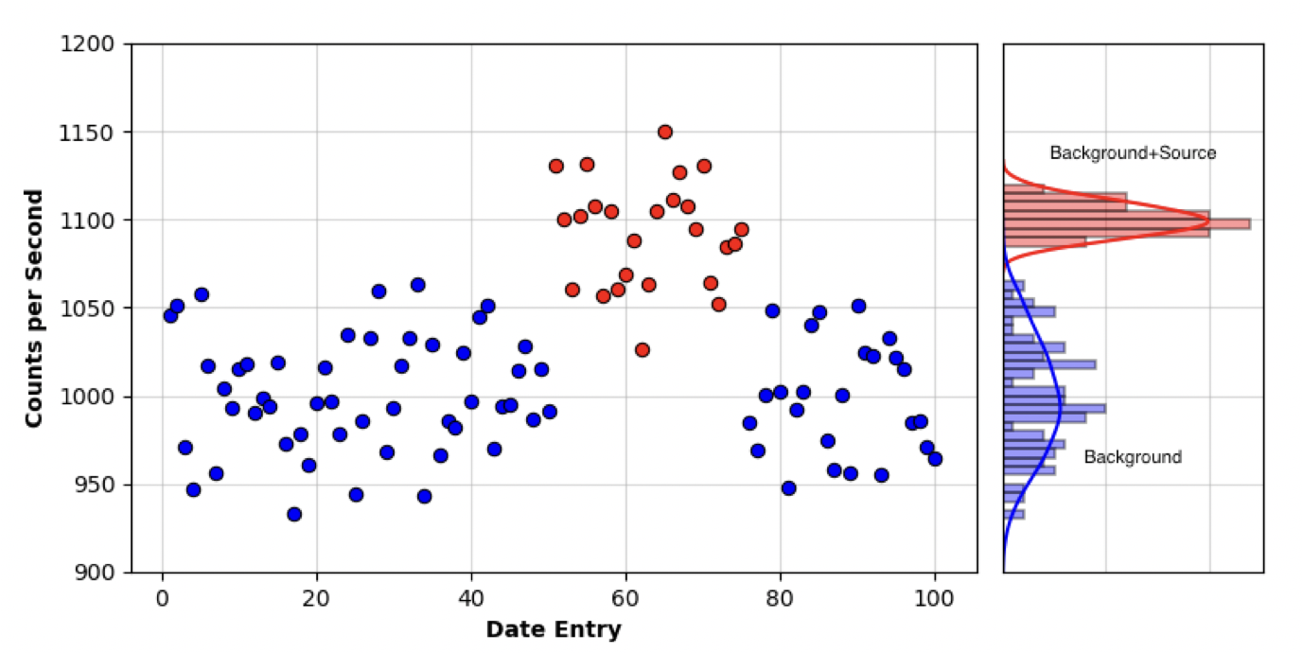
Figure 1: Example of count rate distributions for normal background noise and background plus source.
Classifying observed signals or data as an anomaly is dependent on several factors, such as the width of the background distribution, the separation between the background and anomalous distributions, and the detection methodology output parameter being employed. The detection output parameters are unique for each anomaly detection methodology and can have a complicated distribution (i.e. not a Gaussian distribution). For binary classification procedures, a threshold on the detection output parameter is applied to classify collected signals as normal background or anomalous. An approach to selecting the appropriate threshold leverages two types of error, specifically the Type I and Type II error. Type I error is referred to as false-positive (FP) error and represents the error in classifying a signal as anomalous when in fact the signal was a normal background noise. Type II error is also known as false-negative (FN) error and represents the error in classifying a signal as normal background noise when the signal was anomalous. illustrates these relationships between true and predicted classification along with introducing the true-positive (TP) and true-negative (TN) parameters. In the radiation anomaly detection scenario, the positive classification represents that a radioactive material is present, and the negative classification means that no radioactive material is present. [17, 18]

Table 1: Classification decision matrix.
 |  | True Classification
 |  | Positive | Negative
Predicted Classification | Positive | True Positive  (TP) | False Positive  (FP)
Predicted Classification | Negative | False Negative  (FN) | True Negative  (TN)

For additional context, if the two distributions are known for both the background noise and the anomaly, the classification parameters can be visualized as area under the curves, as shown in Figure 2. [19] The vertical line illustrates the threshold value that can be modified for specific scenarios based on the classification parameters, such false-positive rate.

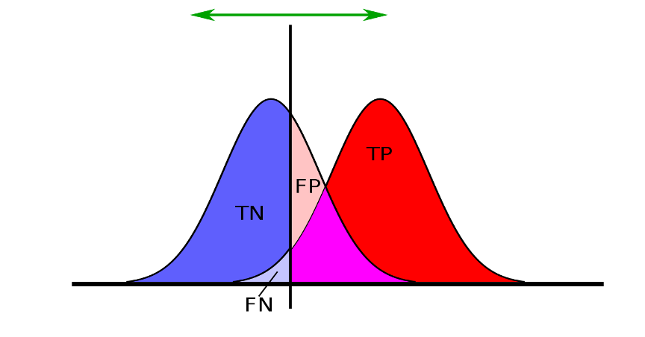
Figure 2: Illustration of classification parameters for two distributions, background (left) and anomalous (right). [19]

A common approach to analyzing the data detection methodology and selecting an appropriate threshold value on the output parameter is to plot the detection rate, or true-positive rate, as a function of the false-positive rate. This plot is referred to as a receiver operator characteristic (ROC) curve and helps convey the performance of the anomaly detection methodology being utilized. In real-world scenarios, the distribution of the anomalous signal is likely unknown and a surrogate anomaly, or example radioactive source, is utilized to select a detection threshold. Furthermore, certain operational scenarios can dictate the threshold selection process by determining a threshold value based on a false-alarm rate, as false-alarms increase the effort required to adjudicate the alarm, which can increase costs and decrease the overall system efficiency. For example, if the anomaly detection methodology is employed on a radiation detection system for background (i.e. no source present) along with two radioactive sources with unique activities or intensities, a ROC curve can be created based on the output parameter from the detection algorithm, as shown in Figure 3 and Figure 4. On the ROC curve, a diagonal line labelled No sensitivity represents a random guess process, thus an algorithm’s ling on the ROC curve should never fall below the No sensitivity line.

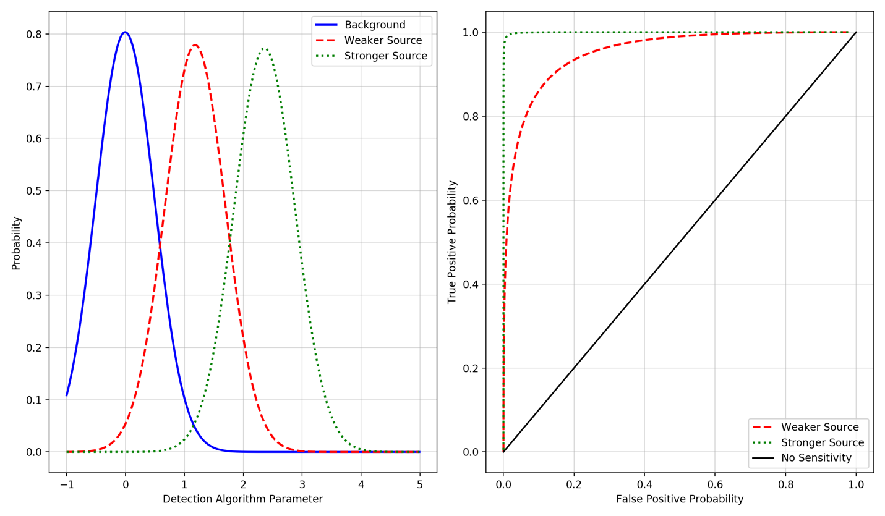
Figure 3: Example distributions of an anomaly detection parameter.
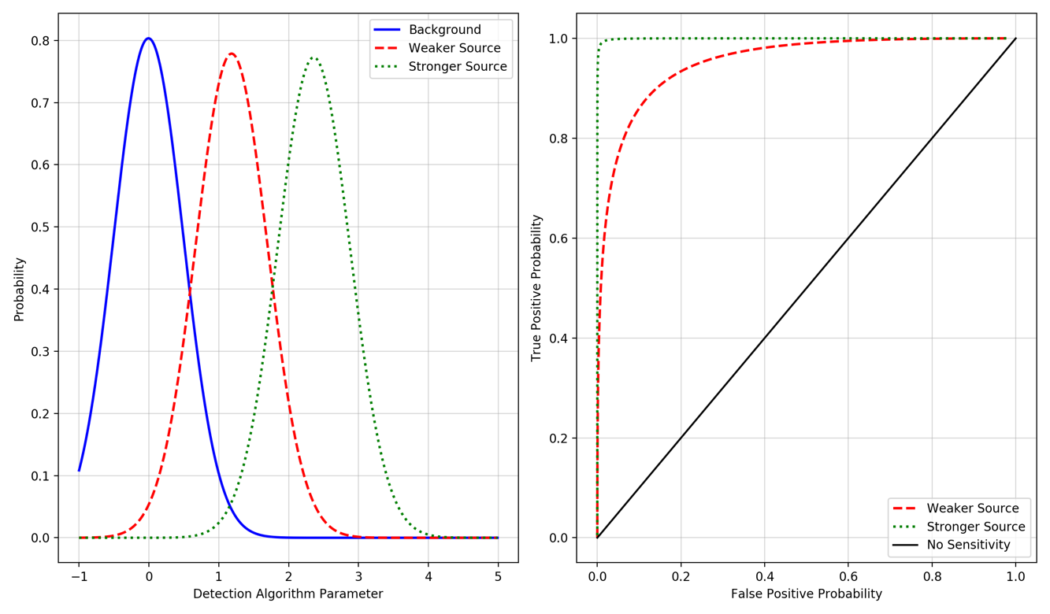
Figure 4: Example receiver operator characteristic curve for two arbitrary distributions.

A ROC curve, such as that shown in Figure 4, an optimal classifier would be extremely close to the upper-left hand corner, similar to the Stronger Source distribution. The top-right corner of the ROC curve represents a small algorithm output parameter resulting in 100% true-positive rate and 100% false-positive rate. As the anomaly algorithm output parameter is increased, the false-positive rate and the true-positive rate decreases. The ROC curve can also be plotted in log-normal plot, as shown in Figure 5, where the false-positive probability along the X-axis is on a logarithmic scale. This can be useful in visualizing the lower false-positive probability region, which can be used when selecting the appropriate detection threshold.

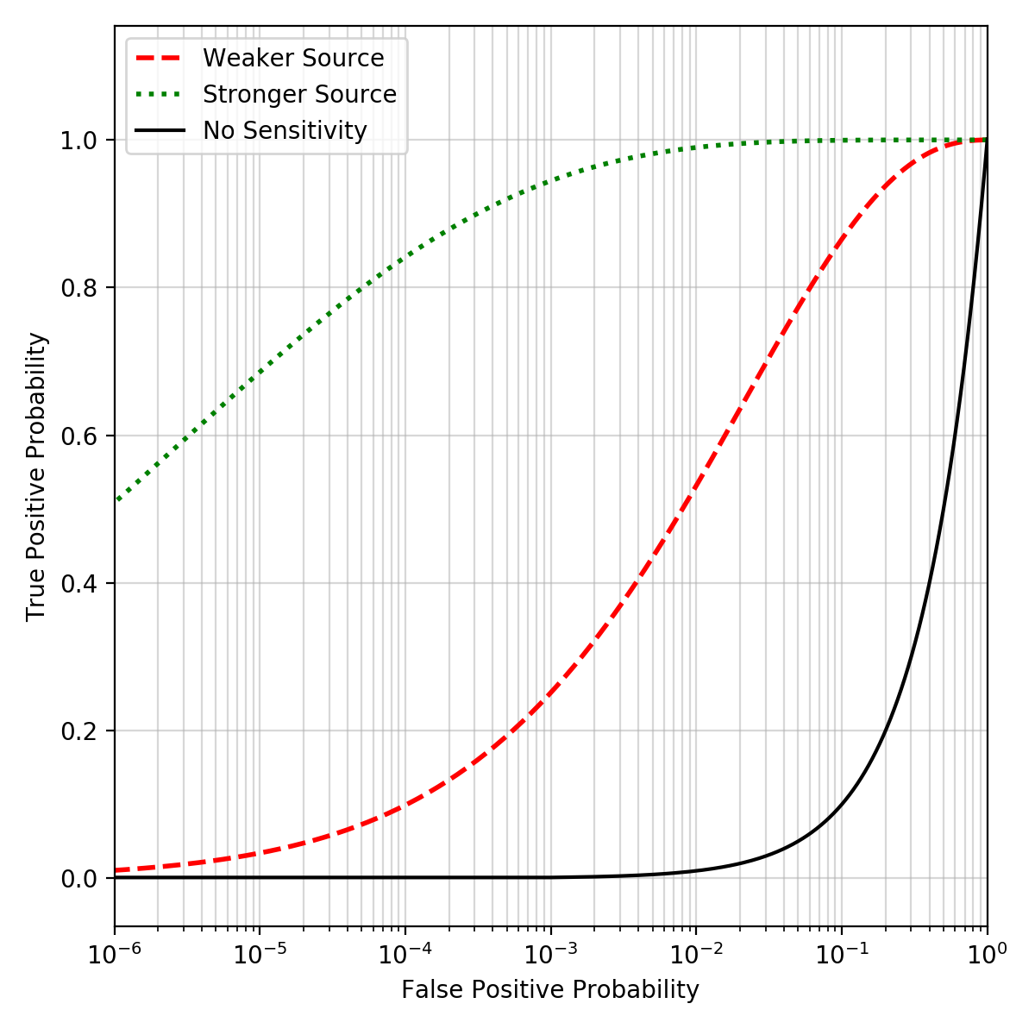
Figure 5: Example logarithmic receiver operator curve for two arbitrary distributions.

Uncertainty quantification methods for receiver operator curve are occasionally used to bound the true-positive and false-positive probabilities by providing a degree of belief or error bars. [20] Assuming the classifier is a binomial distribution, multiple methods can be used to quantify the uncertainty, such as normal approximation confidence intervals, Wilson confidence intervals, or Clopper-Pearson intervals. [21, 22, 23, 24, 25] For instance, if the normal approximation approach is used, the confidence intervals utilize $z$-scores ($z$) to provide specific bounds to the ROC curve based on the number of success ($n_{s}$) and number of failures ($n_{f}$) in $N$ number of Bernoulli trials. [26]

$$Normal Approximation: \frac{n_{s}}{N} ± \frac{z}{N\sqrt{N}} \sqrt{n_{s}n_{f}}$$

The $z$-score is obtained using a $z$-table for a specified confidence level. For example, a $95\%$ confidence results in a target error rate ($α$) of $5\%$. This error rate is subsequently used to obtain the quantile for a standard normal distribution in the $z$-tables resulting in a $z$-value of 1.96 at $95\%$ confidence. Worth noting, this method along with constructing the ROC curve is primarily dependent on the particular analyzed data and may not provide identical results for new data. The normal approximation confidence intervals will be utilized in this work to provide some context to the ROC curves for the radiation anomaly detection methodology used to analyze sensor network data.

1.2.1: Type of Radiation Detector
A key consideration in this operational space involves choosing the correct radiation detector to passively detect the radioactive material (e.g. gamma, beta, alpha, or neutron). If the threat radiological material is known beforehand, a rather intuitive and straightforward approach is to utilize a detection system that is highly sensitive in detected the specific radiological material. A list of example radioactive materials is provided in Table 2 along with several material properties. [15]

Table 2: List of radioisotopes with material properties relevant to radiation detection. [15]
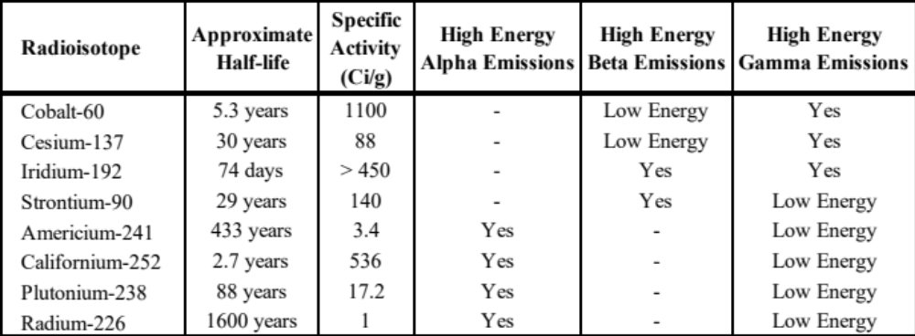

For instance, if the threat radiological material primarily contains Cobalt-60 or Cesium-137, a gamma-ray detector should be utilized. For special nuclear materials, such as Uranium-235 or Plutonium-239, passive detection sensitivity decreases due to a relatively weak specific activity (i.e. number of radiation quanta released by gram of material) coupled with self-shielding effects. If gamma-rays are detected from a gamma-ray emitting radiological source, radioisotope identification is possible as gamma-rays are emitted at discrete energies following nuclear decay. Additionally, gamma-rays have a relatively large mean free path (i.e. average distance travelled before interacting with a material) in air which provides the capability for standoff detection; ideal for nuclear security scenarios. A primary concern in passively detecting gamma-rays occurs when the radioactive material is shielded by either a cluttered environment between the source and the radiation detector or dense materials are positioned around the material, attenuating and absorbing the radiation emissions. [14, 15].

Neutron detection is also a relatively common choice for active assay, passive assay, or radiological search operations due to their penetration power (i.e. ability to pass through dense materials). As neutrons have no charge, neutrons do not interact with the Coulomb force which primarily dominates the energy loss mechanisms as charged particles or electrons. Neutrons interact with the nucleus of an atom, which can result in the emission of secondary radiations that can be detected (i.e. primarily heavy charged particles). [15] Additionally, the background, or noise, contribution in neutron detection system is primarily from showers of cosmic rays and remains relatively low, especially compared to gamma-ray detection systems. [] This low noise contribution results in an increased detection sensitivity and can reduce the over false-alarm rate of detection system. Unfortunately, unlike the discrete emissions for gamma-rays, neutrons are emitted with a wide energy spectrum, decreasing the effectiveness in radioisotope identification.

Detection of other radiation emissions, such as the aforementioned beta and alpha radiation, have limited capability in this particular scenario due to the ease in shielding both radiation emissions and the relative short mean free path in air. For these reasons, gamma-ray detectors are typically employed to detect radioactive materials. Worth noting, gamma-ray detectors detect photons emitted from radioactive materials, which also include photons in the x-ray region of the energy spectrum. In this work, the term gamma-ray detector is used as it is a colloquially employed to encompass radiation detectors that detect photons in the energy range relevant in this work; namely, 10 keV to 3000 keV.

1.2.2: Radiation Detector Efficiency
The absolute detection efficiency ($ϵ_{abs}$) is conventionally expressed as the ratio of signal pulses recorded by the detector system to the number of emitted radiation quanta. This ratio incorporates the intrinsic efficiency ($ϵ_{int}$) of the detector material to convert the incident radiation into a signal pulse as well as the geometry efficiency ($ϵ_{geo}$) of the specific detection scenario.

$$ϵ_{abs}=\frac{number of pulses recorded}{number of radiation quanta emitted}=ϵ_{int}*ϵ_{geo}$$

The intrinsic efficiency is typically depends on the primarily on the detection material, the energy of the incident radiation, and the thickness of the material in the direction of the incident radiation. For example, for a gamma-ray detection scenario, an ideal detector would contain a high-Z material with high density whereas a neutron detector generally contains low-Z materials with high interaction cross section for the specific neutron energy. [17]. The geometric efficiency, commonly calculated as the solid angle, is of utmost importance in this scenario as the source to the detector distance is generally larger than a laboratory environment, thus decreasing the absolute efficiency. The solid angle ($Ω$), measured in steradians, is defined as the integral over the face of the detector surface ($dA$) in the direction of source defined by the angle ($α$) normal to the detector face at a source-to-detector distance $\left(r\right)$.

$$Ω=\int_{A}{\frac{\cos\left(α\right)}{r^{2}} dA}$$

If the source is not a point source, an additional integration must be performed over the volume of the source as well. A relatively common implementation assumes the source can be modelled as a point source located along the center axis of right circular cylinder with a face area of $(a)$, resulting a simplified calculation.

$$Ω=2π\left(1-\frac{r}{\sqrt{r^{2}+a^{2}}}\right)$$

To increase the geometric efficiency, naively increasing the size of the detector material size may not improve the overall sensitivity as the signal from the background radiation could potentially scale at a larger rate than the source signal contribution, decreasing the signal-to- noise ratio (SNR). [28] As an example, operational solutions to improve the detector sensitivity can be accomplished with longer acquisition times with the material of interest (e.g. static source or decrease traffic speed to increase interaction time) or by decreasing the distance of closest approach (e.g. source-to-detector distance).

The efficiency of a detection system can be estimated by first performing a particle transport model to quantify a relative efficiency as a function of the incident radiation energy. This model will provide an approximation, or rough order of magnitude estimate, for an ideal system, but may not address any loss in efficiencies that can occur in other processes of the detection system (e.g. photomultiplier tube efficiency for scintillators). A fixed experiment with known source emission energies, emission rates, and relative positioning to the detection system can be performed to quantify the total efficiency for the particular detection system.

Often times when the experimental data is analyzed, only the photopeak efficiencies are utilized to calculate the efficiencies. This method is less sensitivity to other effects at energies lower than the photopeak that can occur from interactions with materials surrounding the detection system or inherent noise in the system.

1.2.3: Data Acquisition Timing Resolution
It is assumed that the radioactive material of interest is in transit and thus the timing resolution, particularly of the data acquisition system, is a vital parameter. The timing resolution should at least be set to a value that maximizes the SNR based on a constant background, where an analytical solution as function of source velocity for optimizing the hyperparameter is provided in [29], which will be discussed later in this work. Due to the short interaction time that is inherent to a mobile-source, static-detector scenario, optimal timing resolution allows for the maximal source contribution with limited noise contribution during the collection time.

1.2.4: Spatio-temporal Background Noise
A commonly observed issue in the radiation detection field, especially for mobile search scenarios, is distinguishing background, or noise, from a real source signal. This problem is prominent in urban environments, see Figure 6, as background fluctuations occur due different building compositions, higher probability of nuisance source interaction (e.g. medical isotopes), and variations in angle-of-open-sky (i.e. variations in sky shine contributions). [30, 31, 32]

Figure 6: Gamma-ray gross count rate variation with corresponding location in downtown Knoxville, TN.

For a fixed radiation detector, temporal changes are primarily contributed to the dynamic nature of scene surrounding the sensor and from weather-induced signal changes, such as radon washout. [33] These observations are extremely important for the second DSN concept of operations, where spatial differences occur from the unique background or noise contributions and temporal changes may not be observed at all sensor locations.

1.2.5: Other Key Parameters
Two notable parameters that are key in the majority of detection scenarios, but not mentioned here involve gain stabilization and time synchronization. The former involves stabilizing the output signal of the detector in order accurately correlate and compare signals over a period of time, while the latter in concerned with synchronizing the timing across all sensors in a network to cross-correlate collected signals. For more information, the author suggests reviewing several references to understand the central problem and applicable solutions. [34, 35, 36]

1.3: Relevant Published Literature
This section provides a brief review of nuclear security relevant efforts and is divided into two subsections: close-proximity sensor networks and distributed sensor networks. At the end of the section, an additional section is provided that highlights recent relevant research performed utilizing contextual sensors for domain awareness and source localization.

1.3.1: Close-proximity Sensor Networks
For a network of sensors positioned in close proximity of one another, often times referred to as a dense network, the primary purpose is to fuse signals from multiple sensors to more confidently detect and locate a radioactive source travelling through the network. Combining the raw sensor data is possible due to the small source-to-detector distances in the network or from a higher relative source activity that provides quantifiable signal contribution to multiple sensors simultaneously. This allows for source parameter inference, such as source activity, location, or velocity, and is primarily accomplished by employing a derivation of inverse-square law, where the isotropic source intensity$(S)$ decreases as a function of distance to the detector $(r)$, not accounting for geometric or intrinsic efficiencies.

$$I\left(S,r\right)=\frac{S}{4πr^{2}}$$

Utilizing this geometric relationship between a source and sensor, two primary methods have been employed to locate a radiological source:

- analytical solution [37, 38, 39, 40, 41] and
- Bayesian inference. [41, 42, 43, 44, 45, 46, 47]

The majority of published research on this subject attempt to solve for an unknown source position and intensity using known sensor positions, background count rate, and timing resolution. With this information, the previous equation can be expanded to calculate the expected intensity at each sensor $(Is)$ for a source activity $(S)$ at a given position $(x,y)$ in the predefined search space, shown in the following equation.

$$I_{s}\left(t\right)=\left[\frac{S}{{\left(x_{s}-x\right)}^{2}-{\left(y_{s}-y\right)}^{2}}-B\right]*t$$

This equation expands the r2 term in the denominator to match an $(x,y)$ position within the search space and incorporates the background $(B)$ at each sensor location $(xs,ys)$ for a given timing resolution $(t)$. Using the observed intensity at each sensor, the equation can be rearranged to solve for the activity at each point in the search space surrounding the sensor network.

$$S_{est}\left(x,y\right)=\left(\frac{I_{s}\left(t\right)}{t}-B\right)\left[{\left(x_{s}-x\right)}^{2}-{\left(y_{s}-y\right)}^{2}\right]$$

With three unknowns (i.e. $x$, $y$, and $S_{est}(x, y)$), the analytical approach requires data from at least three sensors observed the source’s signal; otherwise, the system is underdetermined. The majority of the published research efforts utilize this relationship to locate, estimate velocity vectors, and track a source through a network. A plethora of unique methods have been proposed to estimate these parameters, which either rely on at least three sensors to observed the phenomena (e.g. genetic algorithms [37, 41], sequential probability testing for triangulation [38]) or attempt to integrate a likelihood function based on simultaneous source observations from multiple sensors (e.g. Bayesian log-likelihood ratio [42], Gaussian kriging [45], Markov Chain Monte Carlo [47]). Unfortunately, these publications do not address the impact on localization for distributed sensors with large distances between each.

1.3.2. Distributed Network Sensing
As shown in the previous section, multiple research efforts have focused on close-proximity detection networks, where multiple, simultaneous observations of radioactive materials can be leveraged to detect, locate, and track materials. Less research in the nuclear security field has been published for distributed sensor networks compared to close-proximity networks. Distributed sensor networks have conventionally been treated as single detector problems, where each sensor, or radiation detector, operates independently to detect radiation anomalies without leveraging other information within the network (i.e. constituting a detect-and-wait scenario scenario). This section highlights notable projects and programs, in chronological order, that utilized distributed sensor networks primarily conducted in the Department of Energy’s National Laboratory network. [48]

One of the earliest programs that focused on distributed sensor networks in the nuclear security realm was the Detection and Tracking System (DTS) at Lawrence Livermore National Laboratory (LLNL). [49, 50] The DTS project began in the 1990s, integrating output from fixed and mobile radiation detection systems with information from various other preexisting sensors, such as traffic systems, to detect and track radiation anomalies in an area to guide interdiction operations. Unfortunately, very limited information was published on the DTS project, therefore the detection and data fusion methodologies and results are not available.

The DTS program efforts at LLNL were continued under the Wide-Area Tracking System (WATS) aimed at fusing a heterogenous sensor array of radiation detectors, photogrammetry, traffic monitoring system data, and various other sensors (e.g. magnetometers, acoustics, or vibration) to a central processing center to process the data for end-users. [51, 52] The Similar to the DTS program, the WATS program utilized commercial-off-the-shelf sensors coupled with radiation detectors at fixed locations to monitor an urban area but expanded on the previous efforts under DTS to synthesize and correlate data, both in the temporal and spatial domain. After a radiation anomaly is detected, WATS utilized a Bayesian-based statistical construct to account for expected time-of-arrival at other sensor locations based observed velocity vector to track an anomaly through the network. [53, 54] Identical to the DTS program, very limited information was published, therefore the detection and data fusion methodologies and results are not available.

Around the same time, the Distributed Sensor Network with Collective Computation (DSN-CC) project at Los Alamos National Laboratory began investigating the use of small, inexpensive, radiation detectors coupled with contextual sensors (i.e. namely, microphones, ﻿accelerometers, and magnetometers) in a fixed configuration to track radiation anomalies. [55] The primary deliverables for the program focused on creating a testbed of commercial-off-the-shelf (COTS) sensors and provide preliminary analysis of tradeoffs when combining contextual sensors with radiation signal for tracking anomalies; image of the constructed testbed is provided in the following Figure 7. [56]

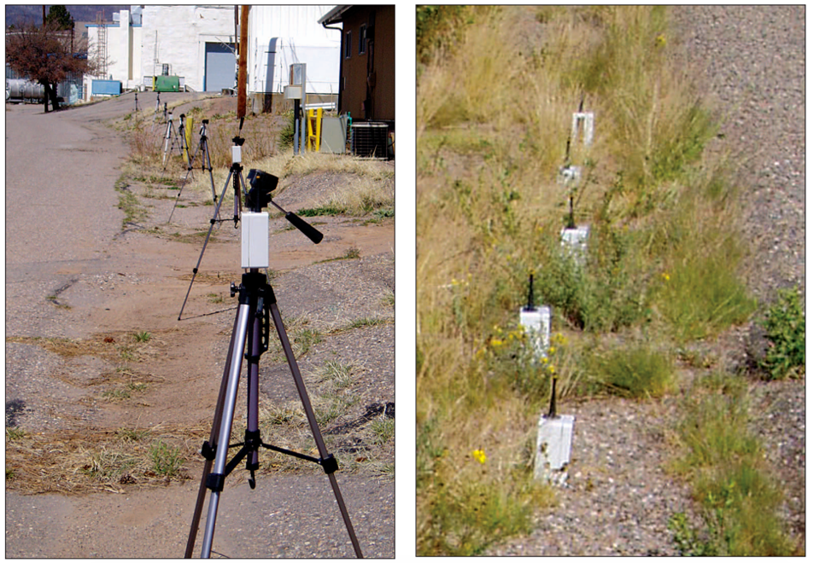
Figure 7: Image of the DSN-CC sensor array at LANL. [56]

DSN-CC utilized a simple logical approach for tracking anomalies by calculating the time-of-arrival for subsequent sensors by assuming a constant object velocity and known sensor positions. Moreover, the radiation signal was only processed to detect anomalies when one of the contextual sensors triggered, resulting in a reported lower false-alarm rate. In [57], Nemzek et al. illustrated a method using multiple sensor signals to approximate a vehicle’s velocity by employing inverse-square law signal depreciation coupled with a Bayesian construct. Limited data fusion or information sharing occurred between sensors in the network, except the estimated time-of-arrival. Furthermore, even though the attempt was to utilize the sensor network to cover a large area, only close-proximity, linear configurations along a roadway were analyzed in the publications. [55, 56, 57]

The Adaptable Radiation Area Monitor (ARAM) at LLNL continued the research efforts from the previous LLNL DTS and WATS projects. The ARAM project constructed and tested portable systems, provided in Figure 8, containing radiation detectors, photogrammetry and global positioning system (GPS) sensors that can be positioned in any configuration to meet an end-user’s operational need. [58]

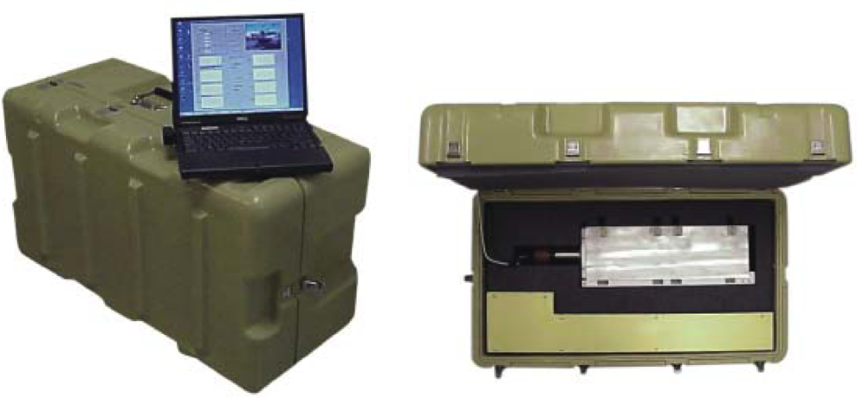
Figure 8: Image of the LLNL Adaptable Radiation Area Monitor system. [58]

The ARAM system utilized list-mode processing of radiation data to help increase signal-to-noise ratio, and thus improve detection sensitivity, along with photographs collected before, during, and after observing an anomalous event. The processed data is subsequently made available on secure web transmission for remote telemetry and end-user viewing. From the available publications and LLNL reports, it is unclear how, or even if, ARAM utilized data other detection systems in the network, or if each system was operated in a stand-alone detection configuration. [58]

From approximately 2008 to present, the majority of research in sensor networks for nuclear security has focused on either networks of mobile, small-form factor detection systems or networks fixed, static systems along roadways or at points of ingress. Most notably, the U.S. Department of Homeland Security (DHS) Domestic Nuclear Detection Office (DNDO), now incorporated into Countering Weapons of Mass Destruction Office, funded two efforts called Intelligent Radiation Sensing System (IRSS) and Radiation Awareness and Interdiction Network (RAIN). The IRSS project was focused on providing equipping State, local, and tribal law enforcement with persistent radiation detection capabilities via a small form-factor radiation sensor with a flexible, wireless network architecture. [59] As one of the grant awardees, Passport Systems Inc. published their efforts in the IRSS program that utilized small, cylindrical NaI(Tl) radiation detectors, image provided in Figure 9, coupled to an Android smartphone device to provide GPS data and communication capabilities to a base station. [60, 61]

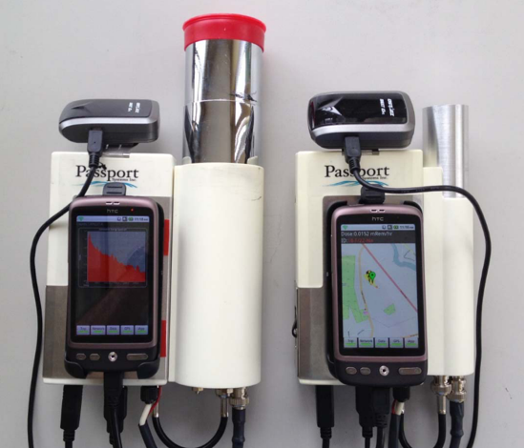
Figure 9: Passport System Inc. prototype detection devices in support of the DHS-IRSS project. [61]

During experimentation and testing phases of the DHS-IRSS project, these detector systems were deployed in fixed locations as well as on mobile system to survey a specific urban area. Each detector relayed radiation data (i.e. raw counts) to create a grid-based, radiation background map in order to obtain a baseline of the area for which to employ an anomaly detection algorithm. Upon initial detection of an anomaly on a single system, other adjacent systems in the specific region are sampled to localize the source based on the collected raw counts. In the publications, the developed algorithms required multiple observations of a source, either by dense network positioning or relatively strong radioactive source strength. [62] Similar to the close-proximity network methodologies expressed in [53] and [55], Bayesian inference approach was utilized by the DHS-IRSS vendors to incorporate the detector systems in the region to localize and track radioactive materials. [60, 61] Due to the requirement for simultaneous observations on multiple detector systems, the published work from this program does not address the issue of detecting and tracking anomalies in a truly distributed sensor network.

The DHS-RAIN project investigated the benefits of fusing radiation detection with contextual sensors, namely video cameras and license plate readers, for monitoring roadways for radioactive threat materials with minimal impact to free-flowing traffic. [63, 64] Under the DHS-RAIN project, a collaboration between Passport Systems, Inc. and Charles River Analytics, Inc. created an experimental testbed of COTS sensors to collect data in a controlled environment. [64]


Figure 10: Testbed for DHS-RAIN with radiation detection sensors and video cameras along a roadway. [64]
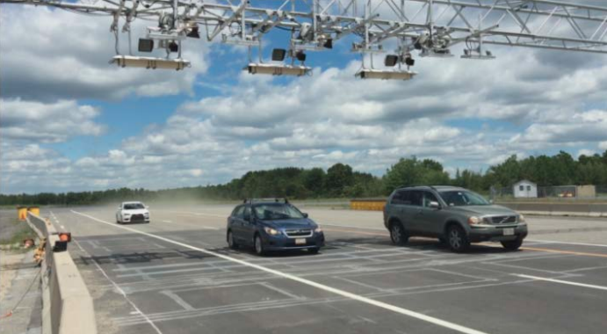
Figure 11: Testbed for DHS-RAIN showing license plate readers position above flowing traffic. [64]

This collaborative effort focused on a feature-level data fusion, similar to the proposed research in this report, by extracting features from each modality and providing that information to an end-user. The video cameras were utilized to track vehicles and obtain coherent vehicle tracks in order to attribute an observed radiation signal to a vehicle. Utilizing an inverse-square law approximation, the vehicle that most closely meets the expected fit to raw radiation counts with the maximum likelihood estimate utilized to choose the source-carrying vehicle. [62] Of note, there existed no data fusion architecture between each radiation sensor nor an approach to incorporate prior knowledge from prior events. [62, 64] This is key to highlight as this proposed research will attempt to utilize both of these factors.

In 2014, the Defense Advanced Research Project Agency (DARPA) SIGMA program aimed to significantly overall cost of deploying a city-scale, mobile, small form-factor spectroscopic systems with robust networking capability. [65] This program utilizes each detection system to continuously survey an area and send information to a central node to process the spectral data and update a background map of the region. Utilizing detection systems made by Kromek, such as the D3S system, the program has successfully deployed the smartphone-size systems to first responders in large metropolitan areas. [66, 67]


Figure 12: D3S RIID from Kromek with gamma and neutron detection capability. [67]

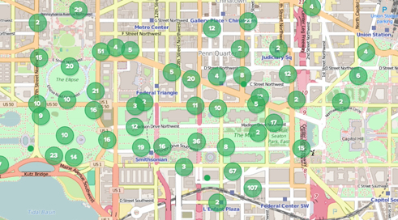
Figure 13: Map of SIGMA systems deployed during Washington, D.C. data collection experiment. [66]

Limited information is published regarding the algorithms and results for anomaly detection and fusion of the data. The primary reported successes highlight the capability to successfully network a large number of sensors (i.e. greater than 1000) and stream the data to a central node for processing. [68]

1.3.3: Additional Relevant Works
This section highlights other relevant research efforts to the proposed work in this document, primarily focusing on the use of orthogonal sensor modalities for increased situation awareness. The research efforts presented here are not sensor networks, thus were not included in the previous two subsections. There exist three notable projects that utilize additional sensor modalities in conjunction with radiation sensors:

- Mobile Urban Radiation Search (MURS) project [69, 70, 71],
- Radiological Multi-sensor Analysis Platform (RadMAP) project [72, 73], and
- Radiological Source Detection and Tracking Based on Multi-Sensor Data Fusion project. [76, 77, 78].

The MURS project, funded under U.S. DHS-DNDO at Lawrence Berkeley National Laboratory (LLBL), constructed and tested a modular designed detection system to be used within vehicle platform during radiological search operations. [69, 70] The system utilized six NaI(Tl) radiation detectors positioned in a cylindrical configuration to localize a radioactive material by comparing count rates in each detector as well as two ⁶LiF/ZnS neutron detectors to be positioned along both sides of the vehicle. Upon detection of a radioactive source, the MURS system begins capturing information from the non-radiological sensors, namely video cameras, infrared cameras, and LIDAR units, to provide additional information to the end-user for attribution. See Figure 14 and Figure 15 showing the MURS configuration. [71]

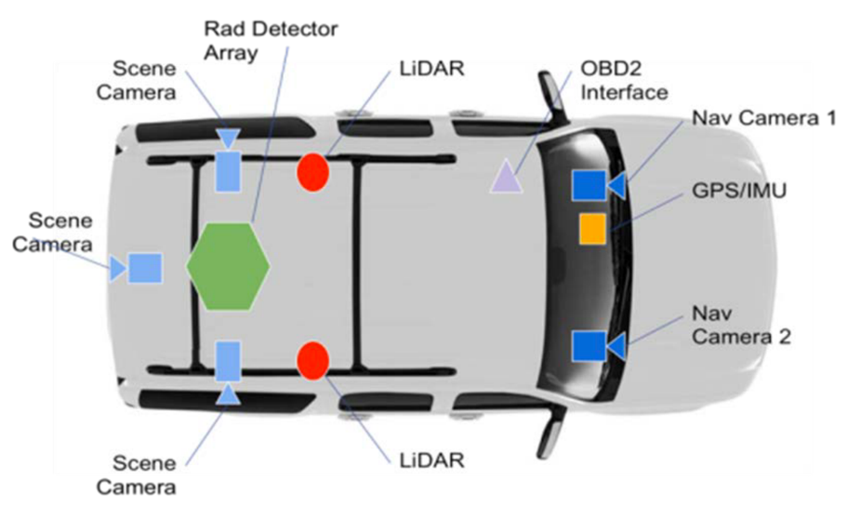
Figure 14: Illustration of DHS-MURS sensor configuration. [71]

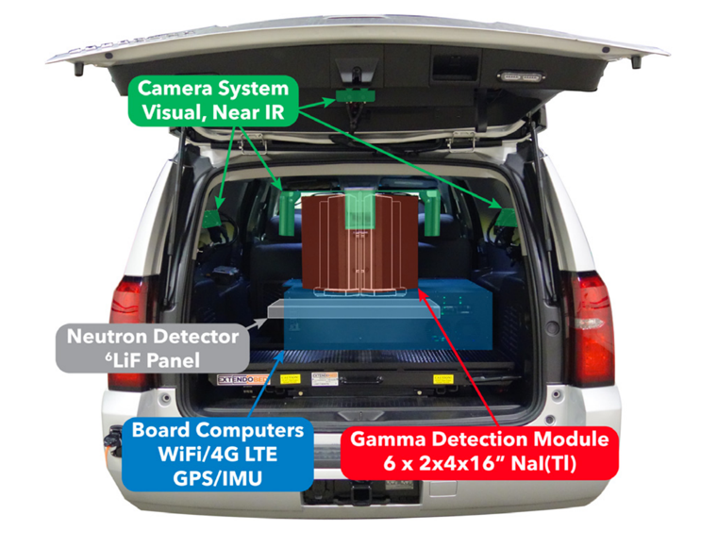
Figure 15: Image of the MURS modular system utilized for urban search operations. [71]

The primary data fusion between radiation and contextual sensors that has been reported or published on the MURS project occurs by providing images to the end-users of the region estimated from the cylindrical NaI(Tl) module. Limited information is available on truly fusing the data streams or extracted features from the data streams to either infer anomaly properties or provide additional context to an end-user. [71]

The RadMAP system, a DHS-DNDO funded effort at LLBL similar to the DHS-MURS project, outfitted a large truck platform with a multitude of sensors to study emerging concepts in mobile search scenarios. [72] The system, cutaway view provided in Figure 16, contained a 10 x 10 array of NaI(Tl) detectors with a coded aperture mask made of lead for imaging, two arrays of high-purity germanium (HPGe) detectors, an array of liquid scintillator neutron detectors, two Velodyne LIDAR units, two video cameras, hyperspectral imaging systems, GPS units, and an onboard weather station. [73]

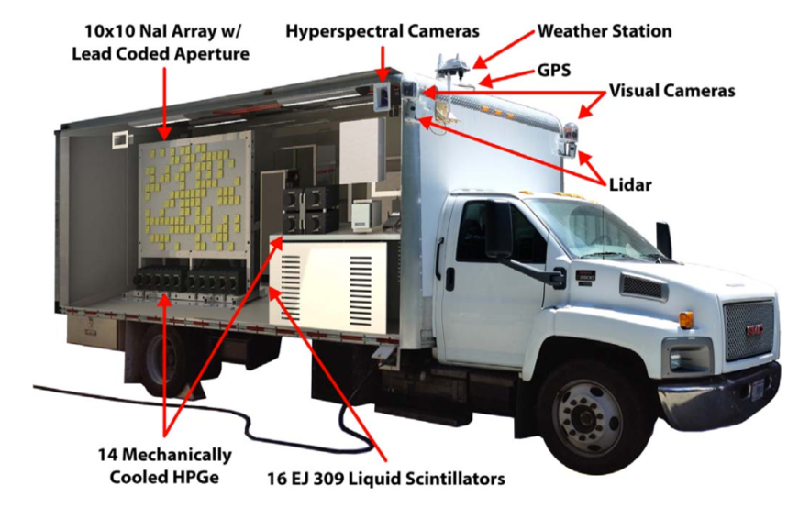
Figure 16: Image of the RadMAP system showing various sensors incorporated on the mobile platform. [73]

Utilizing a large array of radiation detectors for imaging coupled with the high-resolution HPGe systems provides the ability to detect, locate, and identify radiological anomalies during mobile search operations. The RadMAP project research efforts has utilized the data from the contextual sensors for two primary uses: (1) localize a radiological source in 3D space and (2) online radiation background estimation. [72, 73] Using the output from the NaI(Tl) coded mask array, a radiological source position is approximated using the angle and depth calculations over a series of time intervals. In a post-process manner, these estimates are subsequent used to project the position on the stitched video data and LIDAR data; an image of this process is provided in Figure 17. [73]

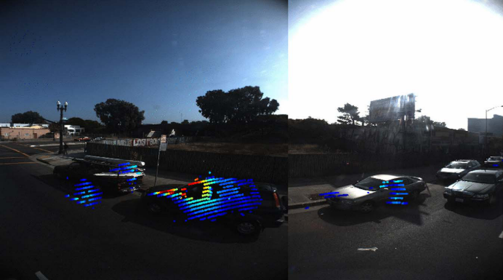
Figure 17: Example RadMAP output from fusing coded-aperture and stitched video data. [73]

The second data fusion purpose was for radiological background, or noise, estimation during search operations. To estimate the expected background contribution, the video data is segmented using edges calculated within the video field-of-view (FOV) and is subsequently classified using a random forest classifier into a class, or material, category (i.e. grass, building, asphalt, or vehicle), as illustrated in Figure 18. [74] Each classification has a predetermined spectral shape and activity, similar to a template matching methods that convolves observed signal with known signal templates. [75]

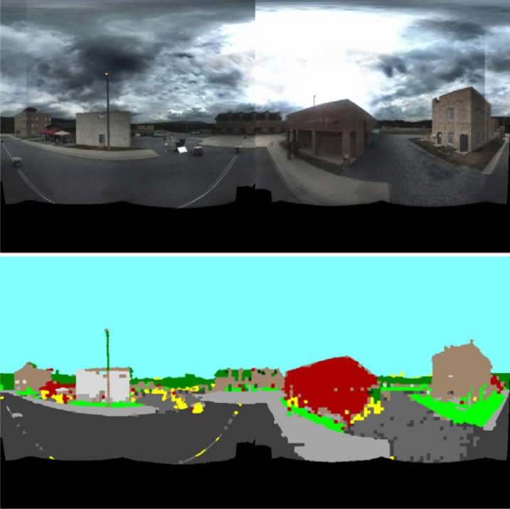
Figure 18: Example of data processing of image segmentation for background estimation for RadMAP. [74]

A solid angle is then calculated between the segmented regions and the effective area of the detection system. A linear attenuation is applied for specific photon energies within the spectral information for each class category to estimate the expected background contribution by the segmented region. The results provided in [74] provide reasonably accurate results for estimating background contributions on the detection system, but can vary rather wildly if the preset spectral profile or activity of the material is not accurately known. Furthermore, image segmentation is highly dependent on edges or colors in the image, thus can provided questionable results if, for example, a material is a different than the expected color or a weather pattern is moving through the area creating unique shading the camera FOV. Important to note in regard to the discussed RadMAP project, a rather common problem with fusing video or LIDAR data, especially 3D pointclouds, is the computational power required to process each data stream. This is only compounded in the mobile search operation, when the reference frame is constantly changing within a fully dynamic scene.

The third relevant research effort highlighted in this subsection is a DHS-DNDO Academic Research Initiative project conducted at the University of Florida (UF) that coupled a Velodyne LIDAR unit with a radiation detector to localize a mobile radiological source, as shown in Figure 19. [76]

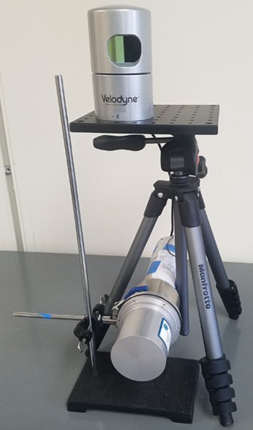
Figure 19: Velodyne LIDAR and radiation detector configuration at the University of Florida. [76]

The research efforts utilize a down sampled 2D pointcloud from the LIDAR and track objects in the LIDAR FOV using a Kalman filter. The positions of the objects tracked are utilized along with the raw count rate to calculate a correlation metric based on the inverse-square law. The cosine distance and the Pearson correlation methods were employed as the correlation metric between the position and observed count rate, where the object with the highest correlation was chosen as the source carrying object, as shown in Figure 20. [76, 77, 78]

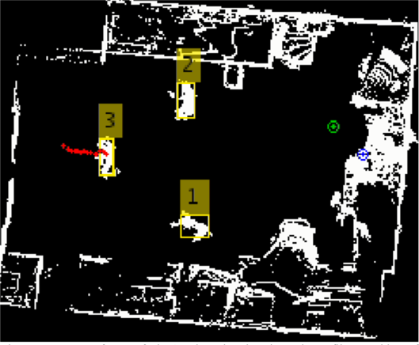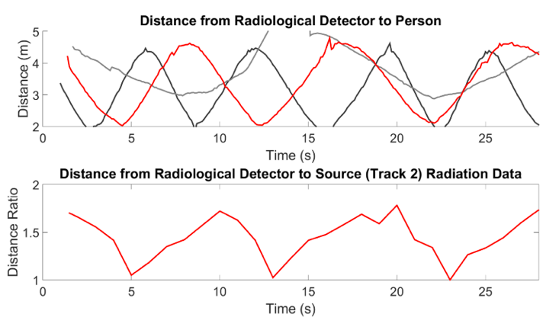
Figure 20: Example of fusing LIDAR and Radiation data from the University of Florida. [78]
(Left) 2D LIDAR pointcloud showing objects tracked in yellow boxes. (Right) Observed distances of objects from LIDAR and inverse-square ratio of highest probable object.

The work continues to provide a method for multiple source being present in the scene by expanding the single source search to a source search equal to the number of detected objects. [78] This method allows for continuous searching for source when an object is detected in the LIDAR pointcloud. This work at UF provides a relevant example of feature-level data fusion between contextual sensor (e.g. LIDAR) and a radiation sensor at a single, fixed position. The experimental efforts performed do not to extract other features, such as velocity or object classification. Furthermore, since the UF efforts focused on single, fixed locations, there is no method to utilize the extract features at other locations or nodes. Both of these comments will be addressed in the proposed research in the document.

1.4: Problem Statement
This work expands upon the previous approaches utilized in distributed sensor networks for tracking mobile radioactive materials. This is accomplished by utilizing data from the initial detected anomaly to increase detection sensitivity and correlate subsequent signals at other sensors with the initial anomalous data. Multiple features are extracted from the initial anomalous data and are used in a Bayesian-based classification method to track radioactive materials in the area. Additional, collocated sensors (i.e. namely, video data and LIDAR point clouds) are analyzed in order to improve the classification method, improve detection sensitivity, and reduce false-alarm rates. For context, a high-level schematic diagram is provided in Figure 21 showing the general process of combining the primary sensor (i.e. radiation detector) and secondary sensors (i.e. LIDAR or video).

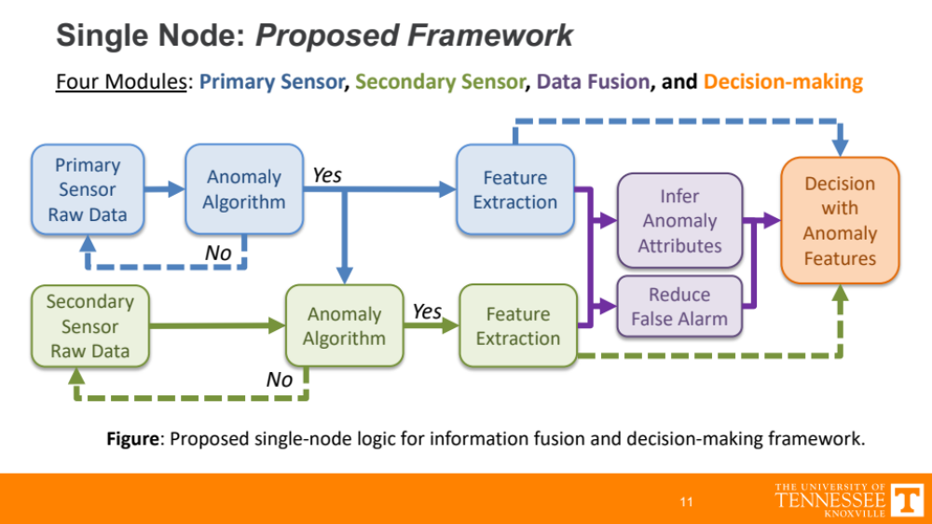
Figure 21: General schematic diagram for processing sensor data utilized in proposed work.

In the spirit of full disclosure, the individual methods utilized to analyze each respective data stream may not be by itself novel, but the fusion of the data streams coupled with the created decision-making frameworks have yet to fully analyzed in literature. For this reason, the research efforts presented in this work provide a novel approach to feature-level data fusion for improved detection and tracking of radiological threats travelling through a distributed sensor network.

2: Distributed Sensor Network Data
The data analyzed in this work was collected from a sensor network deployed on the campus of Oak Ridge National Laboratory. The sensor array is positioned around facilities that handle radiological materials and observes rather unique signals during facility operations, as shown in Figure 22. The enclosures, denoted to as nodes, are referred throughout this work by the number specified in Figure 22; specifically, Node01, Node04, Node06, Node10, Node11, and Node12.

Figure 22: Illustration showing location of nodes in ORNL sensor array.

The sensors are located within and around temperature controlled, weather-proof enclosures, and utilize a network time protocol for time synchronization across the networks. With six nodes operational, each node, see Figure 23 for an image of a node on the ORNL sensor array, in the network contains a 2” × 4” × 16” NaI(Tl) radiation detector, 3” × 3” NaI(Tl) cylindrical radiation detector, Davis Instruments weather station, GPS modules, Velodyne VLP-16 Puck LIDAR sensor, and a single-board computer operating the data acquisition system (DAQ). [79, 80, 81] Additionally, a network of Ubiquitis UniFi video cameras is positioned in the area and is time synchronized with the DAQ to provide additional contextual information during the data analysis. [82]

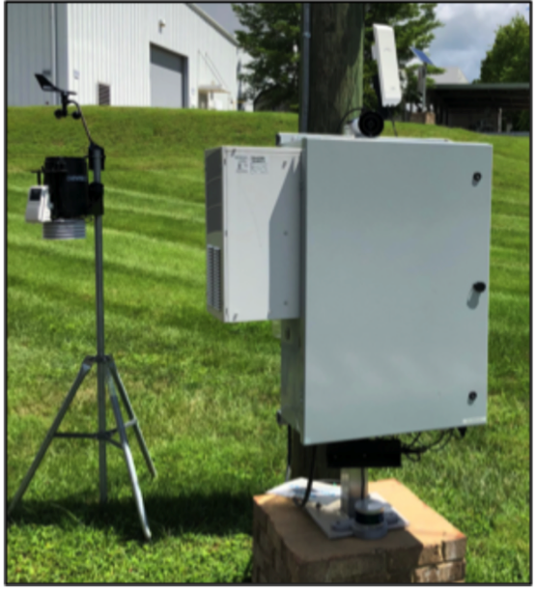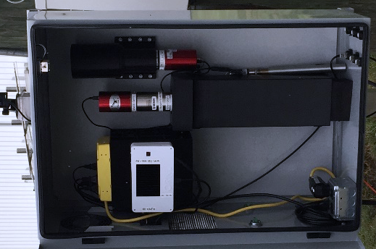
Figure 23: Image of a node (left) on the ORNL sensor array along with an image inside the enclosure (right).

The primary sensors utilized in this work include the 2” × 4” × 16” NaI(Tl) radiation detector, Velodyne VLP-16 Puck LIDAR sensor, and the video cameras. The radiation detectors are considered the primary sensors that initiates an anomalous event with the LIDAR and video cameras referred to as secondary sensors that provide additional, or contextual, information during anomalous events. The radiation signal observed at each location varies from node to node, both in signal intensity and spectrally, as shown in Figure 24 and Figure 25. The variations in the observed signal is attributed to the unique background signals originating from naturally occurring radioactive materials observed at different geospatial locations.

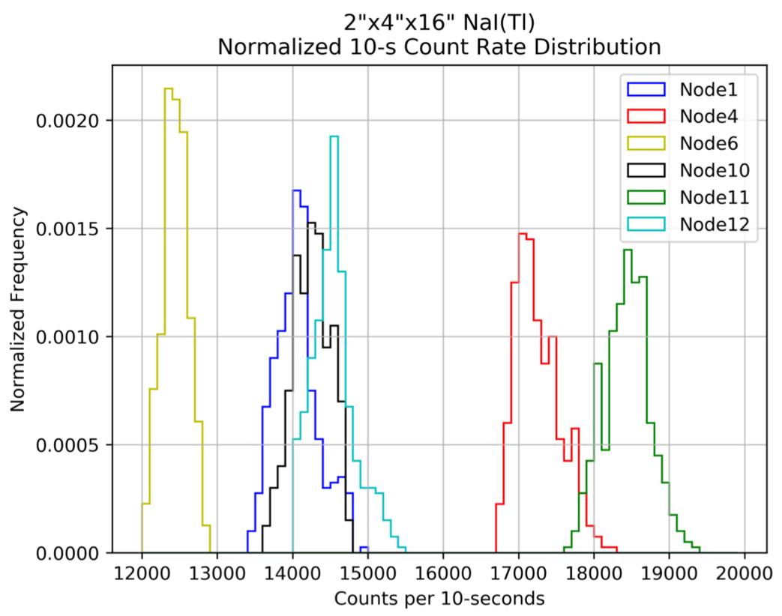
Figure 24: Count rate histogram for nodes in the ORNL sensor array using arbitrary 10-second integration time.

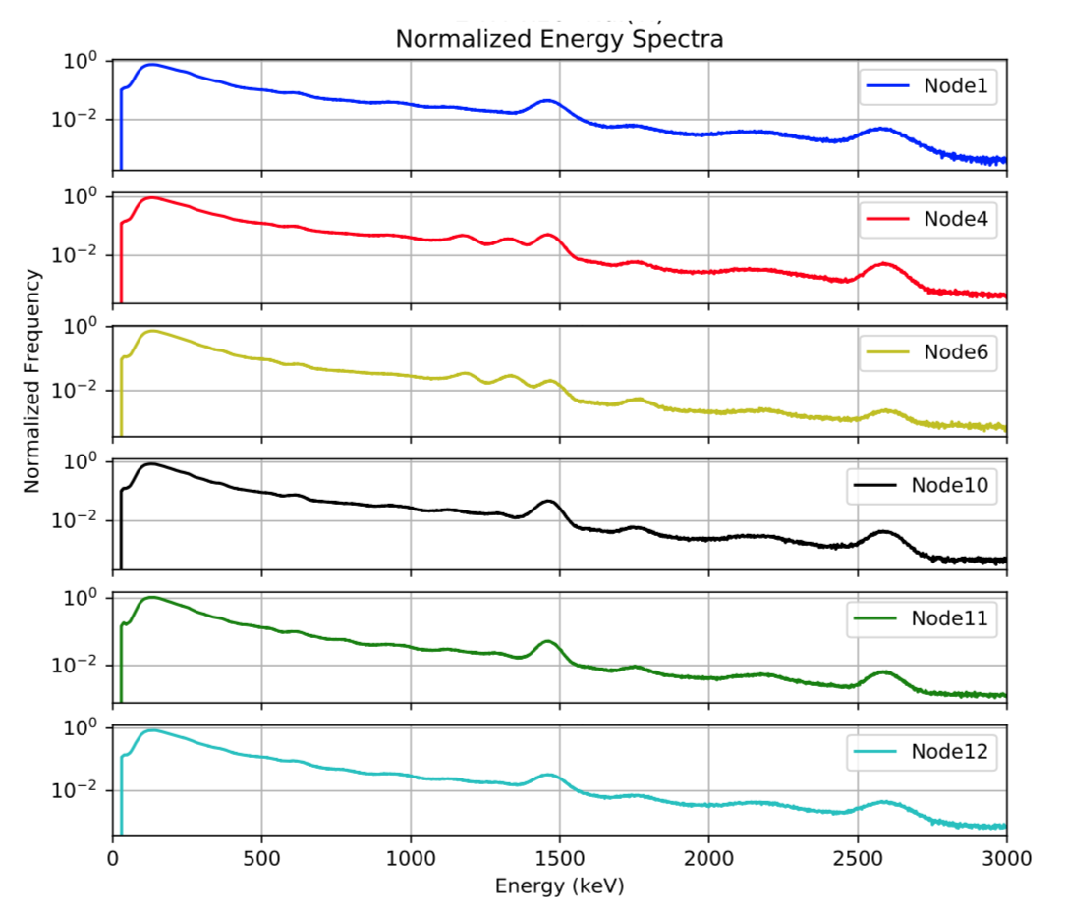
Figure 25: Normalized energy spectra for nodes in the ORNL sensor array.

The radiation data analyzed in this work are gain-stabilized by tracking the gamma-ray emission from K-40 at approximately 1460 keV. This allows for a more accurate comparison between spectra collect at different times on the same node as well as comparing spectra collect from different nodes, as the amplification gain in the photomultiplier tubes and system electronics can shift over time. [83, 84] An energy calibration was initially performed using Eu-152 and Am-241 radioactive source to provide multiple photopeaks for fitting a calibration curve for a 3 keV binning structure from 0.0 to 3000.0 keV. The data from the DAQ are collected 0.1 second time resolution but are summed to 1 second resolution in this work, as shown by the frequency in the example scenario provided in Figure 26 along with the corresponding images observed from the video data.

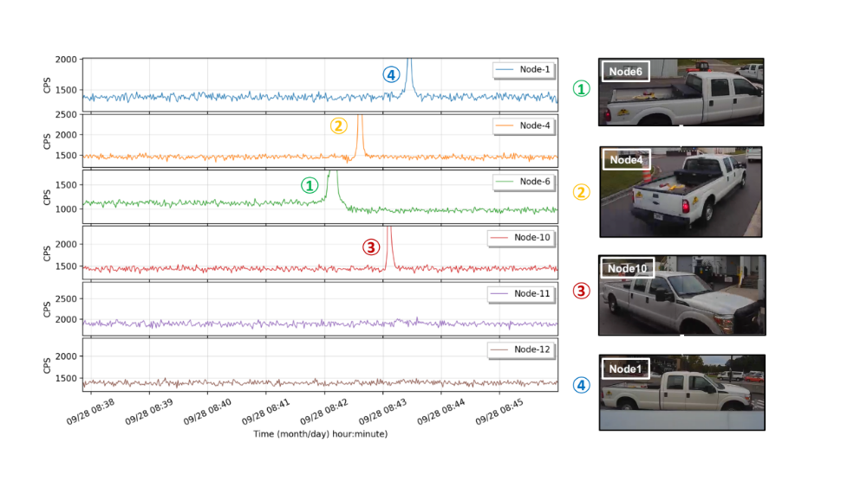
Figure 26: Count rate time series for example anomalous event from ORNL sensor array.

Analysis and feature extraction for each data stream is described in the following chapter.

3: Anomaly Detection and Feature Extraction Methodologies
This chapter introduces and describes the methods utilized to analyze three data streams; radiation data, LIDAR point clouds, and video data. The analysis methods are utilized to extract specific features from the respective data stream to construct a feature-level data fusion, discussed on later sections of this work.

3.1: Radiation Data Analysis
As the primary anomaly detection sensor in this work, the data collected from the 2” × 4” × 16” NaI(Tl) radiation detector require a robust analysis method as each sensor has unique signal features; namely, intensity and spectral shape. The primary goal in analyzing the radiation data is to detect anomalies and outliers in the signal with a high true-positive rate (TPR) and low false-positive rate (FPR). Time-series anomaly detection is utilized in numerous of domains with a plethora of published research in recent years. [85, 86, 87] Furthermore, there exists a multitude of algorithms specifically for the use of detecting anomalous signals in real-world radiation data. [88, 89, 90, 91]

In this work, a conventional gross count rate approach is utilized to detect anomalies in the total count rate across the entire energy range (i.e. 0 to 3000 keV). This approach will be referred to as the gross counts detection method and utilizes two rolling-windows in the total

4: Distributed Radiation Detection
To quantify the benefit contextual sensors provide to tracking anomalies through a sensor network, it is first important to first understand the ability and limitations of a radiation-only sensor network. In the absence of any available literature on truly distributed radiation sensor networks, this work presents two approaches that can be utilized in unison for tracking anomalies. The first utilizes spectral information collected during the radiation anomaly and compares the collected spectrum with subsequent radiation anomalous spectra collected at down-stream sensors. This approach provides quantifiable evidence that the anomalous spectra collected at multiple sensors originated from the same radioactive source distribution. The second approach presented utilizes the spectral information to create a region-of-interest approach to improve down-stream detection sensitivity. The region-of-interest is selected by obtaining the highest signal-to-noise ratio region from the initial anomalous energy spectrum. This approach expands upon a reported censor energy window method to provide a more robust approach. [INSERT]

In this chapter, both approaches are first presented with analysis on multiple methodologies to accomplish their respective goal. The down-selected methods for both approaches are then employed on anomalous radiation events from ORNL sensor array to observe chosen methods’ output on real-world data. The final section of this chapter attempts to tie the former sections together by providing a more in-depth assessment to create a decision-making architecture using the previous output on the of the ORNL sensor array data.

4.1: Energy Spectra Comparison
Upon detecting an anomalous signal from the radiation detector, the spectral information during the alarm event can be utilized for several reasons. If the source intensity is relatively high compared to background and high energy resolution detection system is employed, then radioisotope identification methods can be employed. Conventional radioisotope identification methods utilize precalculated energy spectra templates for various radioisotopes and compare with the collected energy spectrum with the template. [1, 93] In an operational setting, radioisotope identification can be difficult due to short interaction times, weak source activity, or lack of signal in the photopeak due to the presence of shielding or attenuating material between the source and detector. Conventionally, radiation detection systems with low to moderate energy resolution (e.g. NaI(Tl) or PVT) detectors are utilized, further increasing the difficulty of the radioisotope identification due to the broad energy peaks. [INSERT] Worth noting, spectra from low resolution detectors have been able to accurately identify source in low signal-to-noise ratio operations by deconvolving the spectral data. Performing the deconvolution filtering process requires full knowledge of the detector’s response, which is typically acquired by modelling the response using particle transport codes (e.g. Monte Carlo N-Particle code, or MCNP). [INSERT] In this work, the NaI(Tl) radiation detectors utilized are low energy resolution and primarily observe mobile radioactive source moving at high rates of speed, thus no radioisotope identification process is employed.

If partial or imperfect spectral information is obtained and radioisotope identification is difficult to accurately obtain, the collected anomalous energy spectra can be compared to spectra collected at other detection systems. This process assists in tracking a source in an area by measuring the similarity between the collected anomalous signals. For instance, assume a relatively strong source is detected at a location and no radioisotope identification is made. The energy spectra collected during the anomalous event can be combined and background-subtracted to obtain an, often very noisy, approximation of the source spectra. If the same source subsequently passes another detection system, the apparent source spectra measured during the previous anomalous event can be compared to the current background-subtracted spectra to verify if this is the same radioactive material or a new material all together. To provide additional context to this example, a source spectrum was modelling in MCNP with gaussian broadening employed for two different source activities combined with a normalized background spectrum obtained from the ORNL array; both distributions are shown in Figure 27.

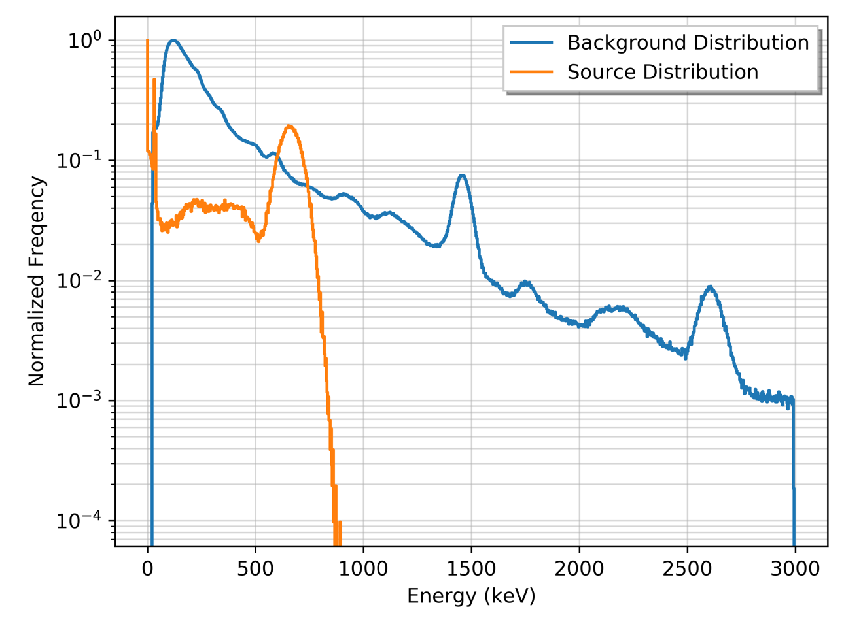
Figure 27: Example distributions for background and a radioactive source.

Assuming the radioactive source is initially detected at Node01 and, after some amount of time passes, is detected at Node02, the spectra during the events can be summed, as shown in Figure 28.

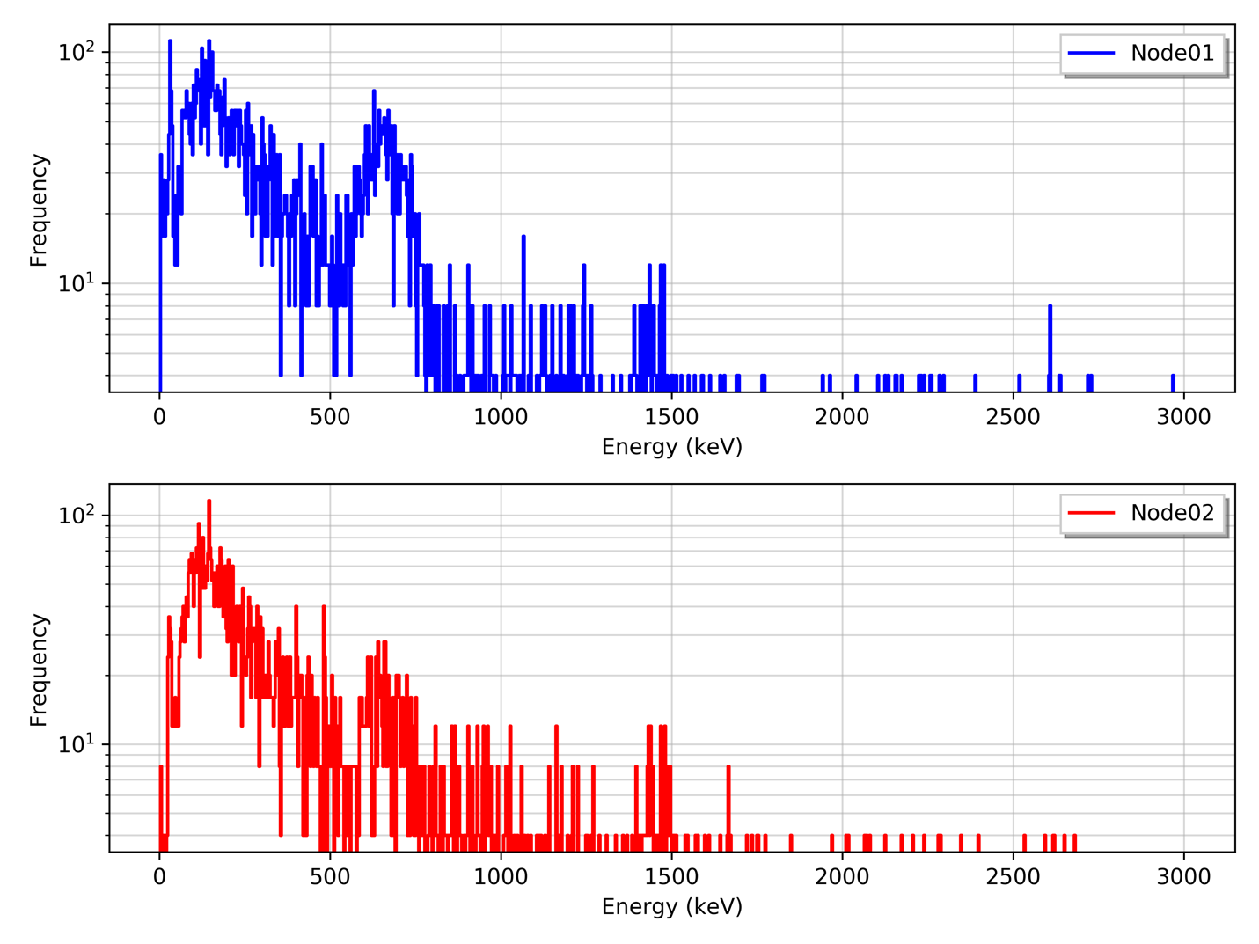
Figure 28: Source spectrum from two locations. (Top) Example energy spectrum collected during anomalous event at Node01. (Bottom) Example energy spectrum collected during anomalous event at Node02.

Both spectra obtained from the MCNP models are sampled as Poisson variables to align with realistic samples. Moving forward, if the radiation background is relatively stable for both Node01 and Node02 systems, a background spectrum can be subtracted from the anomalous spectra which should be analogous to a sample distribution from the source spectrum, show in Figure 29.

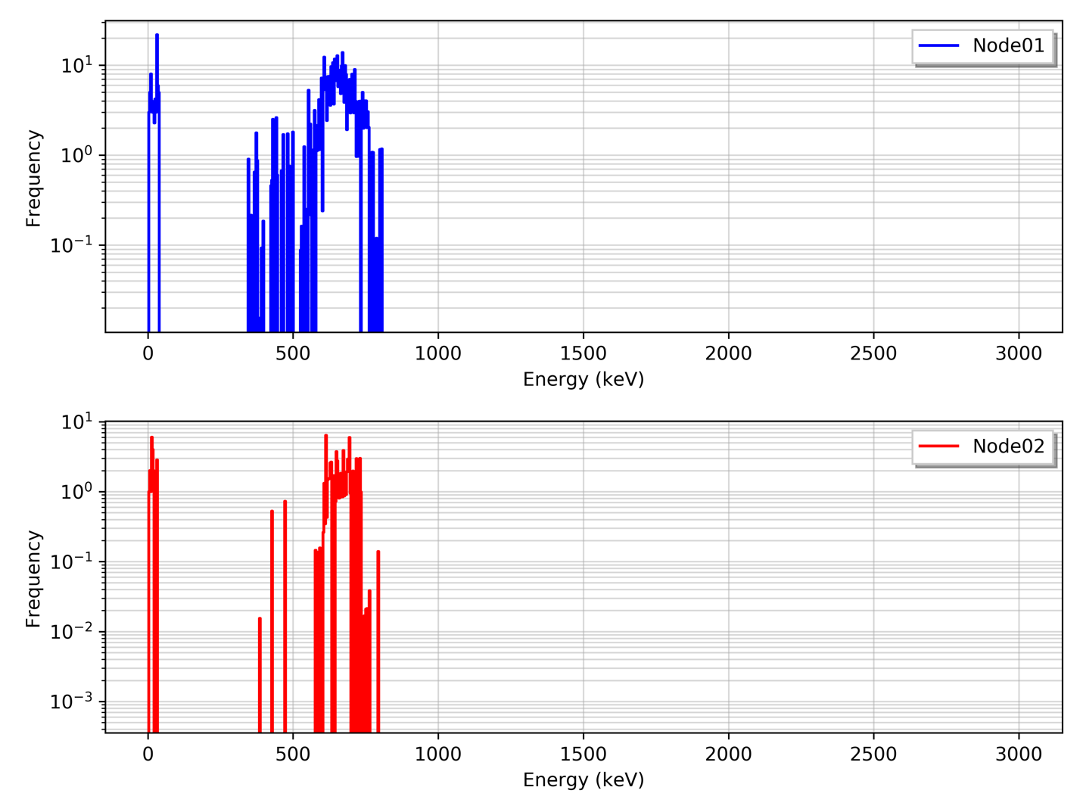
Figure 29: Background subtracted energy spectra for Node01 (top) and Node02 (bottom).

Two issues arise when attempting to compare the resulting background-subtracted spectrum. First, if the anomalous events typically occur quickly and the radioactive material has a low to moderate activity, the resulting spectrum collected can be sparse and noisy. Second, the intensity observed can be can vastly differ, primarily governed by the inverse-square law, timing resolution, and speed of the source, which creates unique issues when comparing the spectra using distance-based measures.

To overcome the sparse and noisy nature of collected spectrum, two approaches can be utilized:

- modify the spectrum binning structure, or
- apply a filter to smooth the spectra.

Applying a new binning structure to the spectra has benefits to lower the signal-to-noise ratio in specific region where signal from the source is much greater than the background component, but resolution is sacrificed. A common solution is to linearly combine, or summate, the bins in the spectrum to a lower order (e.g. 1024 bins to 128 bins). The second approach applies a filter to decrease the noise while preserving the overall shape of the spectra by smoothing the data. With a plethora of filtering algorithms available, there exist multiple methods to smooth noisy data, such as polynomial smoothing splines, moving average convolutions, or kernel density functions. It is key that the filter chosen should conserve the underlying statistics, where the area under the curve remains equal with no values are lost and nonphysical values are possible, such as values at negative energies. If a moving average, or windowed, approach is utilized, the size of the window as well as the regression method used are key hyperparameters to predetermine to match the user case. In the case of radiation spectra, these hyperparameters should account for the underlying energy resolution by selecting a larger window for low to moderate energy resolution systems (e.g. NaI(Tl)) and a smaller window for high energy resolution systems (e.g. HPGe). Furthermore, care should be taken when selecting the polynomial order utilized during regression or spline methods, where nonphysical values can occur in sparse regions of the spectrum.

In this work, a popular digital filter method known as the Savitzky–Golay filter is utilized to smooth the spectra. This filter convolves the spectra by applying a low-degree polynomial to successive subsets of the spectra via linear least squares regression. A moving average method is applied to the spectra to smooth the high frequency bins to populate the counts starved, sparse regions of the spectra. To optimize the window length and polynomial order hyperparameters, the windows size is varied from 5 to 101 for a first and second order polynomial model. The window size is required to be an odd integer as an even integer length window forces an undesired shift in the filtered signal, since the filter is applied on a delay of $(N-1)/2$ for $N$ samples. This is similar to the reasoning for utilizing odd-length windows for a moving-average filter. Using these parameters, the filter was applied to the background-subtracted spectra at Node01 and Node02 in the previous example.

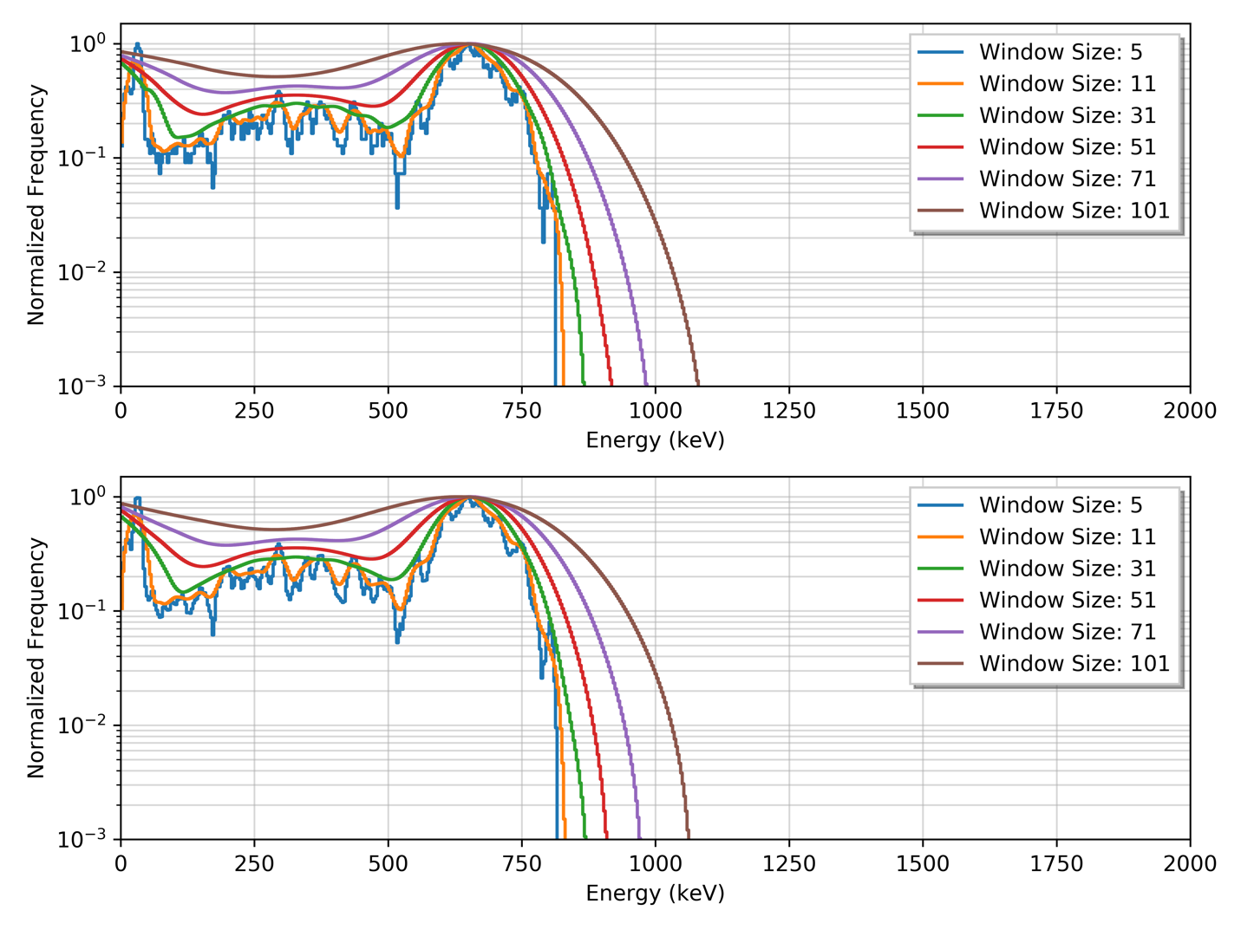
Figure 30: Filtered spectra for Node01. (Top) Filters of various window lengths using a linear model. (Bottom) Filters of various window length using quadratic model.

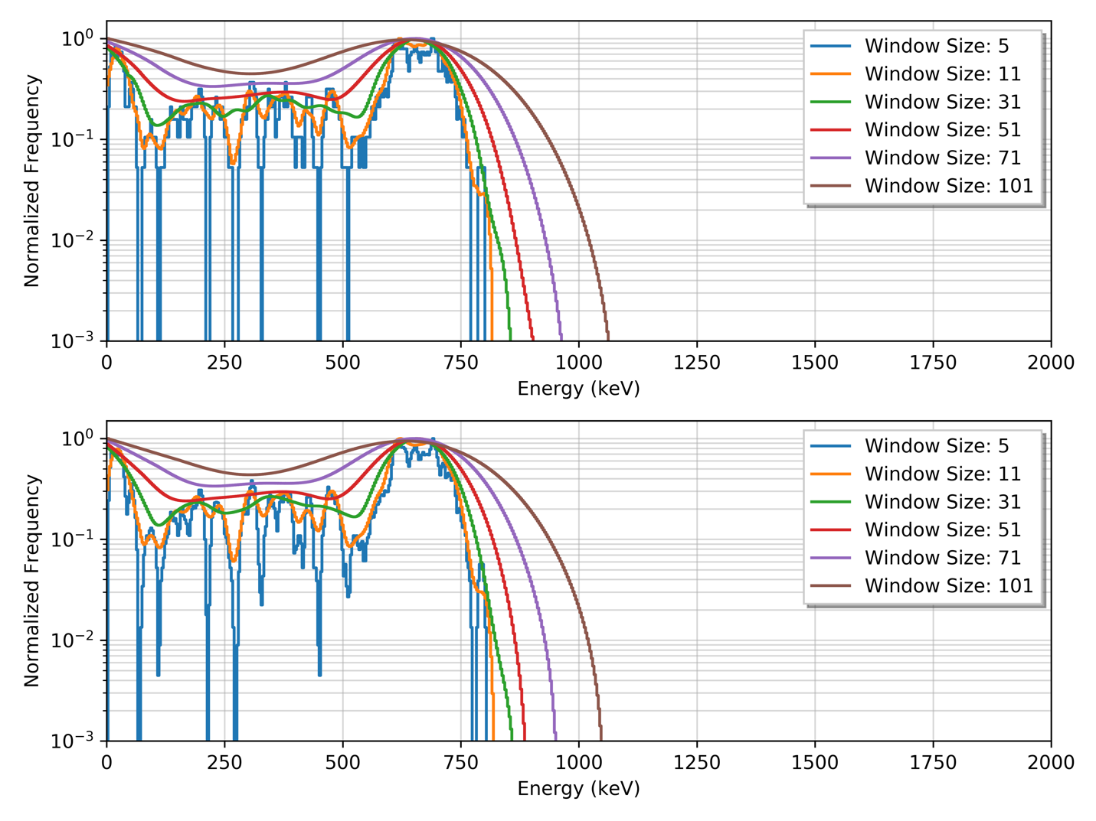
Figure 31: Filtered spectra for Node02. (Top) Filters of various window lengths using a linear model. (Bottom) Filters of various window length using quadratic model.

It has been shown in other works that the estimated variance decreases as the window length increases, but also increases the bias error at the same time. [94] This relationship remains true until a particular window length threshold is met where the variance begins as the length is too large; therefore, there is a tradeoff when selecting the design hyperparameters. For this analysis, a quadratic model is chosen as it provides a higher degree of smoothing in the sparse regions of the spectra for both nodes and a window length of 51 is selected when using the original 1000 bin structure. Using these design hyperparameters, Figure 32 provides the resulting filtered spectra for both nodes.
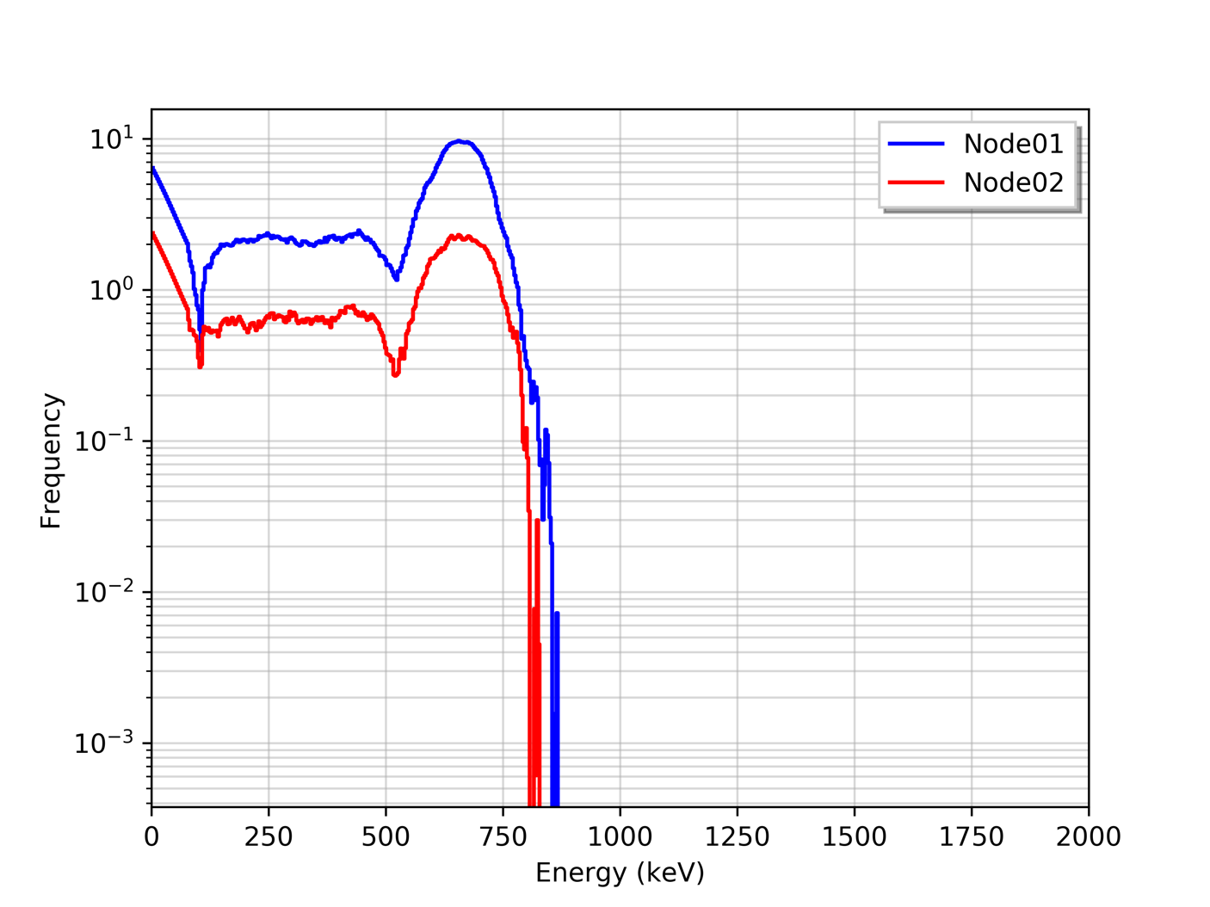
Figure 32: Background-subtracted and filtered spectra for both example anomalous spectra.

Now that sparsity of the spectra has been decreased by smoothing each spectrum by applying the Savitzky–Golay filter, the second issue previously highlighted regarding comparing the spectra was the difference in intensity between spectra. This can create an issue when comparing the spectra if a distance metric (e.g. L¹ or L² norm) is used to provide a quantitative comparison between the two spectra. To overcome this issue, one can either normalize the spectra to the same scale to provide relatively equal frequency values yet maintain the overall shape or use a comparison method that is scale invariant. Two such approaches to normalize or standardize spectrum is the divide-by-maximum and the sum-to-unity methods. The divide-by-maximum method normalizes the spectrum by dividing each value by the maximum value of the spectrum, while the sum-to-unity approach normalizes the spectrum by dividing each value by the summation of spectrum. Both approaches were applied to Node01 and Node02 filtered spectra, as shown in Figure 33.

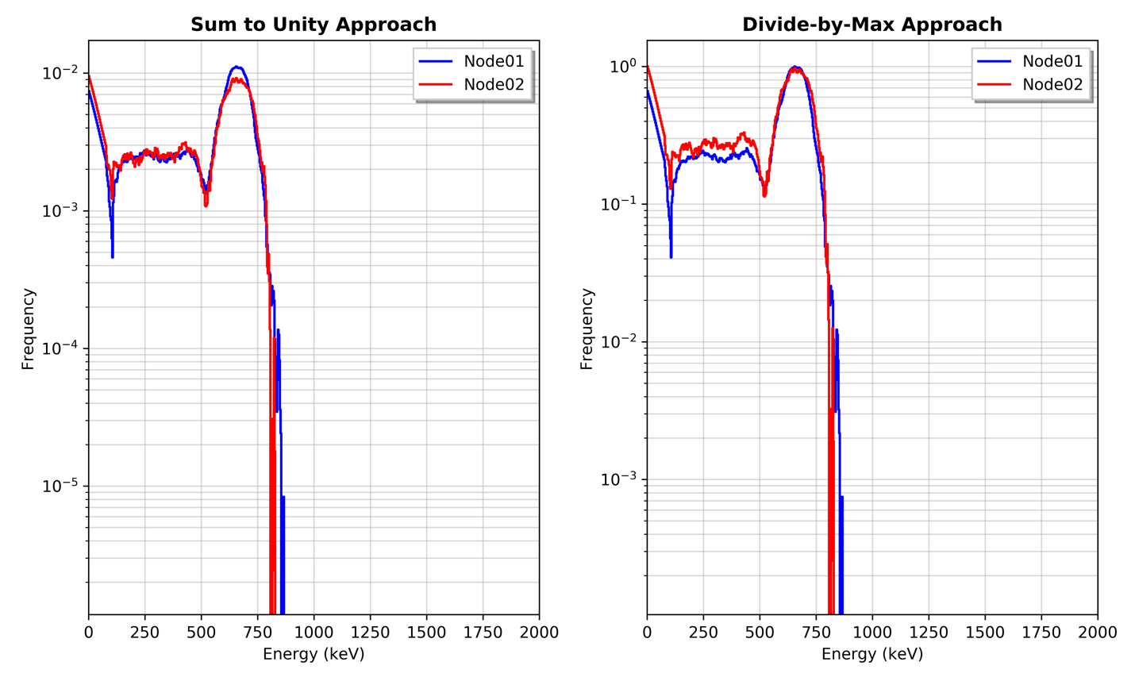
Figure 33: Normalized and filtered spectra using divide-by-max and sum-to-unity approach.

With the spectra on similar scales, multiple distance-based models can now be used to quantify the similarity between spectra with results provided later in this report. It is important to note that there exist two key properties that are vital when comparing energy spectra. First, the detector systems should be relatively identical, or the vector comparison can fail as physical properties that contribute to each energy spectrum will differ (e.g. energy resolution or intrinsic efficiency). Secondly, the spectra should have near-identical binning structure. In practice, the calibration can change due to various operational parameters. Methods exist for performing online stabilization, which can assist in verifying that each element in the spectra being compared correspond to the same energy range. [INSERT] Furthermore, provided a known energy calibration, the spectra can be binned to a user-specified binning structure to verify near-identical binning structures for the compared spectra.

There exist several models that quantifies the similarity between two vectors. In this work, several comparison methods are evaluated: chi-squared test, vector norms (i.e. L¹ and L² norm), Kolmogorov–Smirnov test, and cosine similarity. Each of the models are briefly introduced and later applied to the example anomalous spectra to compare each model using both the initial filtered spectra and the normalized, filtered spectra.

4.1.1: Chi-Squared Test Methodology
A chi-squared test is possibly the most common and well-known method for performing a goodness-of-fit test and testing relationships between parameters. This is accomplished by performing a hypothesis test and calculates a chi-squared ($χ^{2}$) test statistic value to evaluate the hypotheses. The conventional chi-squared test of independence assesses if a significant relationship between variables exists, which can be utilized in this case if one sample is assumed as the expected frequency distribution. The test statistic is then calculated and compared to an expected $χ^{2}$-distribution for a given number of degrees of freedom, most commonly calculated as one less than length of vector. The conventional $χ^{2}$ statistic commonly used is calculated by taking the squared differences between the observed and expected data divided by the expected frequency for that bin and summing over all bins.

$$χ^{2}=\sum_{i=1}^{k}{\frac{{\left(O_{i}-E_{i}\right)}^{2}}{E_{i}}}$$

Given a specific significance level ($α$), the calculated test statistic can be compared to the critical value in a chi-square table. If the test statistic is greater than the critical value at the specific significance level, than there exists a significant difference between the observed and expected vectors. A more conventional notion is that large $χ^{2}$ values indicate the null hypothesis (i.e. the observed data is drawn from the expected distribution) is relatively unlikely.

In this work however, a two-sample test approach is employed as it provides a method. The two sample test states that the two samples are drawn from the same distribution, while the alternate hypothesis states the samples are not drawn from the same distribution. Note that this test does not explicitly state the form of the underlying distribution, only tests if the samples are drawn from the same distribution. For the chi-squared two sample test, the test statistic is calculated as follows:

$$χ^{2}=\sum_{i=1}^{k}{\frac{{\left(K_{1}R_{i}-K_{2}S_{i}\right)}^{2}}{R_{i}+S_{i}}}$$

where, the summation is performed over the two $k$-length samples, $R$ and $S$ and $K_{1}$ and $K_{2}$ are scaling constants when the two samples have unequal number of data points. $K_{1}$ and $K_{2}$ are calculated as follows.

$$K_{1}=\sqrt{\frac{\sum_{i=1}^{k}{S_{i}}}{\sum_{i=1}^{k}{R_{i}}}}$$

$$K_{2}=\sqrt{\frac{\sum_{i=1}^{k}{R_{i}}}{\sum_{i=1}^{k}{S_{i}}}}$$

In cases presented in this work, two energy spectra are being compared with identical binning structures. Therefore, the scaling constants are no longer required and can be removed, resulting in the following two-sample chi-squared equation.

$$χ^{2}=\sum_{i=1}^{k}{\frac{{\left(R_{i}-S_{i}\right)}^{2}}{R_{i}+S_{i}}}$$

For more information regarding the derivation and reasoning behind this derived form of the chi-squared test, the author suggests reviewing Chapter 14 Section 3 of [INSERT]. Upon obtaining a $χ^{2}$ value, a chi-squared percent point function for given significance level ($α$) and degrees of freedom is calculated numerically, similar to the conventional chi-squared test. In this case, the degrees of freedom value is obtained by subtracting the number of filled bins (i.e. bins with nonzero values) by one. The reason being is that if both samples contain no value in a bin, a divide-by-zero error is introduced in the previous equation. Using this method, the chi-squared value supplies a p-value which, given a set significance value, the test can either accept or reject the null hypothesis, which is how the decision when comparing two spectra will be made.

4.1.2: Vector Norm Methodology
A norm is a mathematical function that with specific properties of scalability and additivity, which are not addressed in this work. For more information on norms, the author recommends a review of [INSERT]. A norm function, ${\left|x\right|}_{p}$, referred to as p-norm, is used in a variety of machine learning operations to measure the distance between vectors. The p-norm function of a single vector is provided in the following equation, where parameter p represents the order of the norm, such L¹ and L² norm.

$${\left|x\right|}_{p}={\left(\sum_{i}{{\left|x_{i}\right|}^{p}}\right)}^{p}$$

The L¹ norm, where p is equal to 1 in this case, is a natural way of measuring the distance of between vectors as it calculates the sum of absolute difference of the components of the vectors. It remains a useful method for many applications, such as image processing and compressed sensing, as it is robust against extreme or outlier values. as represented in the following equation for two n-length vectors.

$$X=\left[x_{1}, x_{2}, …, x_{n}\right]$$

$$Y=[y_{1}, y_{2}, …, y_{n}]$$

$$L^{1}={\left|X-Y\right|}_{1}={\left(\sum_{i}{{\left|x_{i}-y_{i}\right|}^{1}}\right)}^{\frac{1}{1}}=\left|x_{1}-y_{1}\right|+\left|x_{2}-y_{2}\right|+…+\left|x_{n}-y_{n}\right|$$

This norm function is informally referred to as the Manhattan Distance or Taxicab norm as the distance between two points resembles the path a vehicle, or taxi, would drive in an urban area, such as Manhattan. Another way of stating this is that this method is the sum of the lengths of a line segment between two points, as depicted in Figure 34.

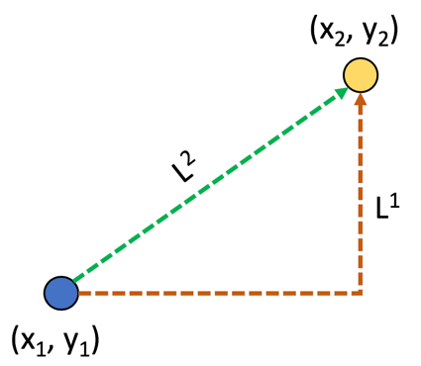
Figure 34: Illustration of L¹ and L² norm distance measures.

The L² norm measures the distance by calculating the square root sum of the squares of two vectors. This norm function is commonly referred to as the Euclidean norm or Euclidean distance, representing the shortest distance between two points and is invariant under rotation Using the same vectors as the L¹ norm equations, the following equation provides the L² norm.

$$L^{2}={\left|X-Y\right|}_{2}={\left(\sum_{i}{{\left|x_{i}-y_{i}\right|}^{2}}\right)}^{\frac{1}{2}}=\sqrt{{\left|x_{1}-y_{1}\right|}^{2}+{\left|x_{2}-y_{2}\right|}^{2}+⋯+{\left|x_{n}-y_{n}\right|}^{2}}$$

Due to each component in the vectors being squared, outliers are given additional weight, potentially skewing the results, compared to L¹ which measures outliers linearly. In a more general sense, the larger the p-value in the norm function, the more important and weight the largest single feature distance becomes.

Recall that a primary issue when using a distance-based approach for comparing the vectors is to obtain an optimal method for standardizing or normalizing the vectors. After the distances are calculated using a specific method, such as the L¹ or L² norm, the user must quantify how the distance method output correlates to vector similarity. This is data-specific as well as situational-specific with potential for increased error or misclassifications, such as poor vector standardization. For this reason, more robust methods should be utilized.

4.1.3: Kolmogorov–Smirnov Test Methodology
The Kolmogorov-Smirnov test, often referred to as the K-S test, is a nonparametric test meaning that this method does not require the data to follow a Gaussian, or normal, distribution, unlike the parametric tests such as the t-test, ANOVA, and f-test. [INSERT] This is a key property as no assumptions regarding the underlying distributions for both samples are made. The K-S test is utilized to compare the overall shape of two sample distributions by performing a hypothesis test. The null hypothesis states that the two samples, or spectra in this case, are drawn from the same distribution. The K-S test performs a hypothesis test by first calculating the cumulative density function (CDF) of the two sample distributions and measures the difference, element-by-element between the two CDFs. In this instance, the sum-to-unity, filtered spectra are used as the probability density functions to create the CDF, as shown in Figure 35.

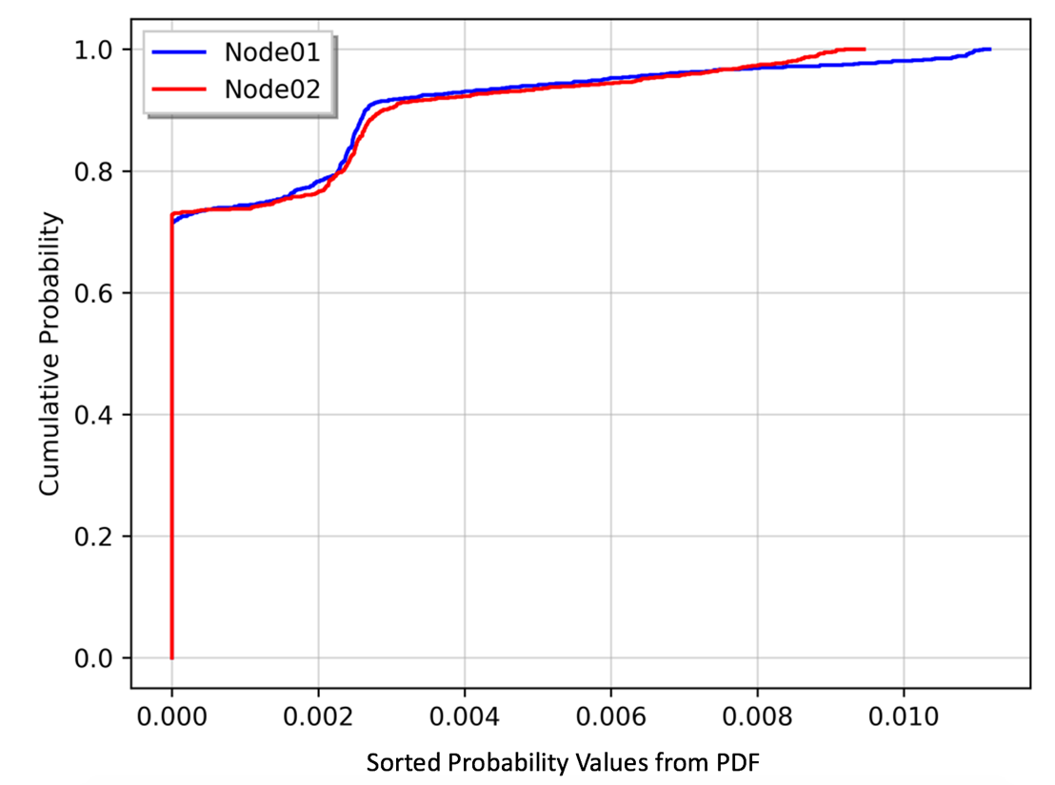
Figure 35: Cumulative density functions for Node01 and Node02 anomalous spectra.

The K-S test uses test statistic, D, to quantify the similarity between the two CDFs. This parameter is equal to the maximum absolute difference between the two CDFs. As such, the K-S test remains robust and relatively sensitive to both the amplitude and the shape of the distributions of the CDFs. If the two distributions were exactly identical, the two CDFs would lie on top of one another and the D test statistic would be zero, near impossible in practice. Ideally, an extremely small test statistic would indicate that the two samples are drawn from the same distribution.

This test statistic alone does not provide enough information to perform the hypothesis test previously presented. To accomplish this, a K-S Table is utilized to calculate the p-value representing the probability of observing the test statistic, D, at least as large as the calculated test statistic. Kolmogorov populated such a table for the expected distribution of the test statistic if the null hypothesis (i.e. both samples are drawn from the same distribution) is true. A more general approach to hypothesis testing rejects the null hypothesis if the following equation is true given a predetermined rejection level, $α$ (i.e. Type I error).

$$D_{n,m}>c\left(α\right)\sqrt{\frac{ n+m}{n*m}}$$

In this equation, $n$ and $m$ are lengths of the two vectors, $D_{n,m}$ is the calculated test statistic, and $c\left(α\right)$ is follows the relationship:

$$c\left(α\right)≅\sqrt{-\frac{1}{2} ln\left( \frac{α}{2} \right)}$$

For large length vectors, these two equations can be utilized in the hypothesis testing without using the p-value tables created by Kolmogorov. This approach along with table lookup p-value will be used when evaluating each vector comparison approach.

4.1.4: Cosine Similarity Methodology
The cosine similarity approach has gained popularity in recent years as machine learning and data analytics have become more heavily utilized in various industries. This approach differs from the approaches previously discussed, as no standardization or normalization of the two vectors being compared is required; a fundamental flaw in the other approaches. That is, the cosine similarity measures the angle between two vectors in a multi-dimensional ($R^{N}$) space, irrespective of their magnitudes, where a small angle represents high similarity. Figure 36 provides an illustration of this concept in a three-dimensional ($R^{3}$) space. From this illustration, the angle between the two vectors, denoted by the red curve, represents the value measured by the cosine similarity.

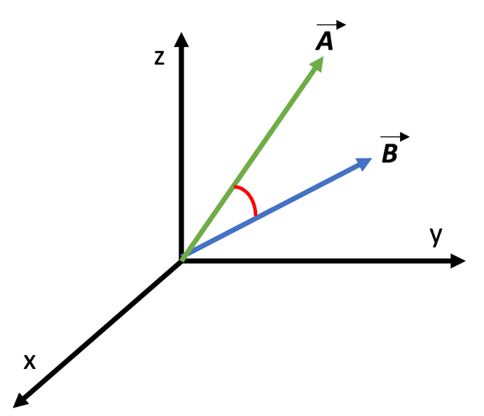
Figure 36: Illustration of cosine similarity concept comparing two vectors.

The cosine of two vectors is calculated by dividing the Euclidean dot, or inner, product of the vectors by their norms (i.e. commonly referred to as magnitudes or lengths) as expressed in the following equations.

$$\vec{a}∙\vec{b}=\left\|\vec{a}\right\| \left\|\vec{b}\right\|\cos{θ}$$

$$\cos{θ}=\frac{\vec{a}∙\vec{b}}{\left\|\vec{a}\right\| \left\|\vec{b}\right\|}$$

Where, the inner product is the sum of the products of the components for each vector and the norms is the square root of the dot product of the vector, as provided in the following equations.

$$\vec{a}∙\vec{b}=\sum_{1}^{n}{a_{i}∙b_{i}}$$

$$\left\|\vec{a}\right\|=\sqrt{\vec{a}∙\vec{a}}=\sqrt{\sum_{1}^{n}{a_{i}^{2}}}$$

$$\left\|\vec{b}\right\|=\sqrt{\vec{b}∙\vec{b}}=\sqrt{\sum_{1}^{n}{b_{i}^{2}}}$$

Combining these equations back into the original cosine equation, the following is obtained.

$$∴\cos{θ=}\frac{\sum_{1}^{n}{a_{i}∙b_{i}}}{\sqrt{\sum_{1}^{n}{a_{i}^{2}}}\sqrt{\sum_{1}^{n}{b_{i}^{2}}}}$$

This final equation is used to calculate the cosine similarity between two vectors. The resulting values range from [-1.0, 1.0] representing exactly opposite and exactly identical, respectively, with a value 0.0 indicating orthogonality. Thus, in this work, if the background-subtracted, anomalous spectra from multiple nodes have a cosine similarity near 1.0, then it is expected that the same radioactive material triggered each. Furthermore, negative values returned from the cosine similarity method is physically impossible in this case as that would require negative values in the spectrum, thus the expected value range is reduced to [0.0, 1.0].

4.1.5: Preliminary Analysis of Comparison Methodologies
Each of the vector comparison methods discussed previously is utilized on the example anomalous spectra provided in the beginning of this section. To provide a more comprehensive analysis, each approach is evaluated on three spectra from both nodes (i.e. Node01 and Node02):

Spectra Type 1: background-subtracted spectra,
Spectra Type 2: background-subtracted, filtered spectra, and
Spectra Type 3: background-subtracted, filtered, sum-to-unity normalized spectra.

The results for the vector norm methods (i.e. L¹ and L² norms) are presented in a separately to limit the reader from directly comparing the results with either the two-sample chi-squared test, K-S Test, or the cosine similarity methods. As previously stated, the vector norm methods employed in this work provide a distance measure between two vectors and a distance threshold for accepting or rejecting the comparison must be independently acquired for the specific user-case.

Table 3: Spectral comparison results for L¹ and L² norm methods.
 | Spectra Type 1 | Spectra Type 2 | Spectra Type 3
L¹ Norm | 671.0 | 616.5 | 0.15
L² Norm | 60.0 | 48.2 | 0.01

Table 4: Spectral comparison results for Chi-squared, K-S Test and Cosine Similarity.
 | Spectra Type 1 | Spectra Type 2 | Spectra Type 3
Two-Sample $χ^{2}$ Test | 344.5 | 0.57 | 0.02
K-S Test (p-value) | 0.18 (3.3E-15) | 0.10 (1.4E-5) | 0.03 (0.69)
Cosine Similarity | 0.75 | 0.98 | 0.98

All the methods improve as the spectra are smoothed and standardized by applying the Savitzky-Golay filter and sum-to-unity normalization. This is shown by a decrease in distance for the norm-based methods and decrease in the test statistic for both the two-sample chi-squared test and K-S Test. The cosine similarity observes an increase after the filter is applied to the background-subtracted spectra but shows no improvement after normalization. Recall that the cosine similarity is invariant to the vector magnitudes, therefore no normalization is required as shown in this example.

A primary disadvantage of the distance based L¹ and L² norm approaches is selecting a threshold for the specific test statistic. For this reason, a more robust, generalizable solution for comparing vectors will be chosen, such as the methods in Table 4. Of the remaining methods, the cosine similarity provides the more robust solution, as no normalization is required, and the calculated value provides an intuitive way to quantify the similarity between two spectra (i.e. recall, a value of 1.0 represents similar vectors). For these reasons, the cosine similarity method will be utilized for comparing anomalous spectra when a radioactive source moves through the distributed sensor network.

4.2: Region-of-Interest Detection
Provided that a radiation detector in the distributed sensor network has detected an anomaly, the spectral information collected can then be utilized at other sensor locations. To increase detection sensitivity a detection algorithm can be operated on a specific area, or areas, of the collected energy spectrum, referred to as a region-of-interest. The objective of this strategy is to maximize the signal-to-noise ratio by using the previously collected anomalous spectrum. For instance, if a known source distribution is primarily in a low-energy region, a detection algorithm that analyzes the entire spectrum (i.e. full gross counts) would add unwanted noise by summing the energies bins above the low-energy region. To minimize this noise contribution to the detection algorithm and thus increasing the signal-to-noise ratio, a detection can be applied only to the low energy region.

In [INSERT], a relatively heuristic approach is used to accomplish this task. This approach returns a list of bins that maximize the signal-to-nose ratio, which could be utilized at down-stream sensor. This is accomplished by the following steps:

- Combine spectra during anomalous event and divide by the total live time to time-normalize,
- Calculate the mean background spectra by combining spectra prior to anomalous event and divide the total live time of the combined spectra to time-normalize,
- Calculate the signal-to-noise ratio vector by dividing the source spectra by the square root of the sum of the source and background spectra,
- Sort the signal-to-noise from greatest to least,
- Step through the sorted vector and sum each element until the summation begins to decrease, and.
- Return the bin indexes that maximize signal-to-noise ratio.

This method can be expanded to supply a region- or regions-of-interest within the energy spectra for increased detection sensitivity, rather than solely the individual bins. The returned bins are identical to the positive bins return from the background-subtracted spectra previously calculated in Figure 29. The regions-of-interest would therefore appear similar to the highlighted areas in Figure 37.

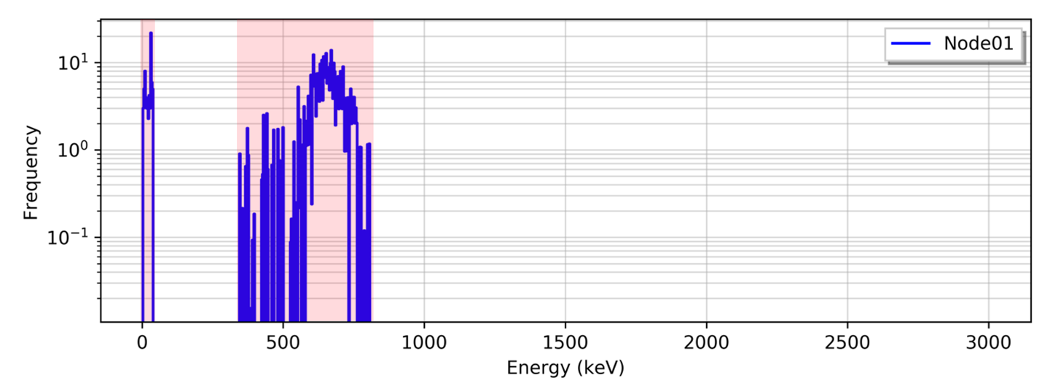
Figure 37: Background-subtracted spectra with highlighted regions-of-interest using heuristic approach.

A smoothing filter, such as the methods discussed previously in this work, can be applied to decrease the sparsity and provide a more realistic representation of the source distribution. In this particular example, the filtered spectrum is continuous with no zero-valued bins resulting in a single region-of-interest, shown in Figure 38.

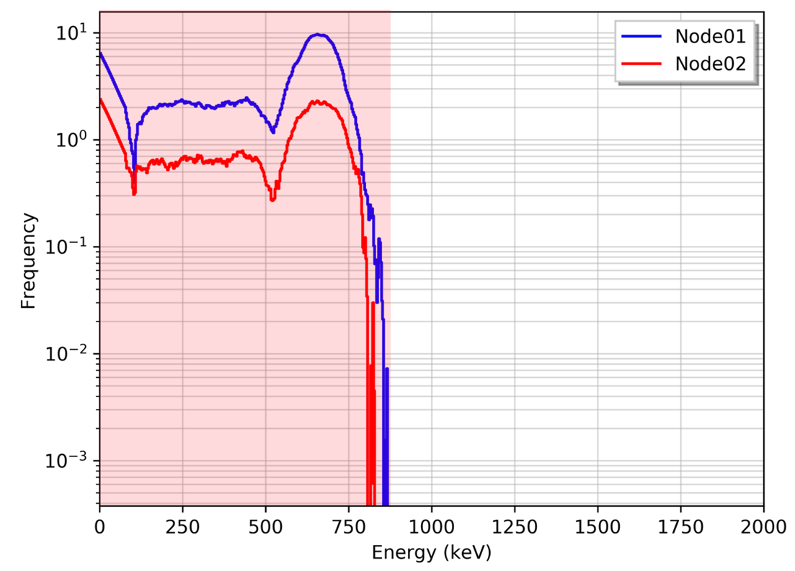
Figure 38: Filtered spectra with highlighted region-of-interest.

.
In Figure 38, the region-of-interest after the spectra are filtered results in a single region-of-interest is constructed. This may not always be the case, where multiple regions-of-interest may result even after the spectra are filtered due to low counting statistics or noise in the data. A more physical approach should be utilized where a single region-of-interest is guaranteed by selecting all bins up to the highest bin in the background-subtracted, filtered anomalous spectra. This allows for a more realistic region-of-interest as scattering interactions (e.g. Compton scattering) of the photons emitted from the radioactive source are typically dominant. Thus, in this work, a region-of-interest below the highest energy bin anomaly is used.

4.2.1: Multiple Gross Count Methods
With a region-of-interest selected, the conventional gross counts detection method can be utilized on the data within the region-of-interest. Caution should be exercised when selecting the appropriate decision threshold as now two detection algorithms are operated simultaneously (i.e. full spectrum gross counts and region-of-interest gross counts). Each detection method will have distinct true-positive and false-positive rates, thus naively selecting a decision threshold can potentially increase the detection system’s false alarm rate. To maintain a constant false-alarm rate, each decision threshold must be scaled. One method to accomplish this is employ the Dunn-Šidák correction. [95] The Dunn-Šidák correction assumes each test, or detection method, is independent and error rates ($α_{n}$) for each method to meet the specified total error rate ($α_{T}$) is unknown. First, to derive the correction formula, the probability that at least one of the methods is successful given $α_{n}$ is equal to one minus the probability that none of the methods are successful. Assuming the independence between detection methods, the probability that none of the methods are successful is equal to the product of the probabilities that each of method is not successful. This is illustrated by the following equation. [95]

$${1-α}_{T}={\left(1-α_{n}\right)}^{n}$$

Subsequently solving for $α_{n}$ provides the error rate to be employed for $n$ detection methods.

$$α_{n}=1-{\left(1-α_{T}\right)}^{\frac{1}{n}}$$

For instance, if a confidence value of 95% and, thus, an error rate of 0.05 is specified for a detection system, then a confidence value 97.5% with an associated error range of 0.025 is required for a two-detection method approach. This approach will be utilized when using the conventional, full spectrum gross counting and the region-of-interest gross counting methods concurrently.

4.2.2: Multiple-linear Regression Method
An alternative approach employs a regression model to estimate the count rate within a specific region-of-interest using the count rate outside of the region-of-interest. The regression model attempts to learn the expected count rate for the region-of-interest and if the observed count rate is greater than the expected count rate, a radioactive source is most likely present. An extension of the ordinary least-squares regression method is utilized that uses multiple independent, explanatory variables (i.e. out-of-region spectrum bins) to predict the multiple dependent, response variables (i.e. in-region spectrum bins) via a linear model. This type of model attempts to create a linear relationship to approximate the dependent variables provided a set of independent variables. The model is calculated by first forming a linear equation where each independent variable ($x$) is weighted by a coefficient ($β$) added to an axis-intercept parameter ($β_{0}$) to predict a dependent variable ($y$). As it is near-impossible, if not impossible, to create a perfect regression model, some amount of error between the predict value and the observed will occur. The multiple-linear regression model incorporates an error term ($ϵ$) to account for the error and is assumed to be a zero-mean, normally distributed value. The general formula for the multiple-linear regression model for $n$-independent, predictor parameters is provided as follows.

$$y=β_{0}+β_{1}x_{1}+β_{2}x_{2}+…+β_{n}x_{n}+ϵ$$

$$=β_{0}+\left( \sum_{1}^{n}{β_{n}x_{n}}\right)+ϵ$$

Of note, more complex regression models can be used when hypothesized to better represent the data, such as higher power orders on independent, predictor parameters or interactions between the independent, predictor parameters (e.g. multiplication). Regardless of the complex model chosen, these models will remain a linear regression model as the parameters are expressed a linear combination of the independent, predictor parameters.
The best-fit line for the observed data ($x_{1}, x_{2}, …, x_{n}$) is calculated by minimizing a cost function, typically mean squared error or residual sum of squares ($RSS$), of the deviations from each observed element in the data to the best-fit line. Minimizing the error is similar to maximizing the likelihood of $L\left(x\right|β_{0},β_{1},…,β_{n})$, where both provide optimal coefficients for the regression model. This is a common technique with a plethora of literature discussing the vast assortment of use cases along with the full derivation of the equations utilized during minimization. In the following paragraphs, a shortened derivation of the methods utilized in this work is provided and the author suggests reviewing others works that provide additional information regarding the assumptions and reasoning behind the methods. [INSERT]

Using a sum of the squared residuals method on a set of data, the regression model can be moved into a matrix form where linear algebra methodologies can be employed to efficiently calculate the optimal coefficients. This is accomplished by first taking the sum of the squared residuals over the observed data (i.e. $x$, $y$) and the predicted data (i.e. $\hat{y}, β$).

$$RSS=\sum_{i=1}^{n}{e_{i}^{2}}=\sum_{i=1}^{n}{{\left(y_{i}-\hat{y_{i}}\right)}^{2}}={\sum_{i=1}^{n}{\left(y_{i}-β_{0}-\sum_{j=1}^{k}{β_{j}x_{ij}}\right)}}^{2}$$

The formula can be conveniently formulated into a matrix form by first assigning the following matrices. Note that in this report, a conventional labelling method is employed where bold-faced lowercase letters denote vectors and the bold-face uppercase letters indicate matrices.

$$y=\left[ \begin{matrix}y_{1} \\ \begin{matrix}y_{2} \\ \begin{matrix}⋮ \\ y_{n}\end{matrix}\end{matrix}\end{matrix} \right]$$

$$X=\left[\begin{matrix}1 & x_{11} & \begin{matrix}x_{12} & ⋯ & x_{1k}\end{matrix} \\ 1 & x_{21} & \begin{matrix}x_{22} & ⋯ & x_{2k}\end{matrix} \\ \begin{matrix}⋮ \\ 1\end{matrix} & \begin{matrix}⋮ \\ x_{n1}\end{matrix} & \begin{matrix}\begin{matrix}⋮ \\ x_{n2}\end{matrix} & \begin{matrix} \\ ⋯\end{matrix} & \begin{matrix}⋮ \\ x_{nk}\end{matrix}\end{matrix}\end{matrix}\right]$$

$$β=\left[ \begin{matrix}β_{0} \\ \begin{matrix}β_{1} \\ \begin{matrix}⋮ \\ β_{n}\end{matrix}\end{matrix}\end{matrix} \right]$$

$$ϵ=\left[ \begin{matrix}ϵ_{1} \\ \begin{matrix}ϵ_{2} \\ \begin{matrix}⋮ \\ ϵ_{n}\end{matrix}\end{matrix}\end{matrix} \right]$$

Using the created vectors and matrices, the linear regression model can now be constructed into a more compact notation.

$$y=Xβ+ϵ$$

Recall that the goal is to minimize the residual error ($ϵ$), which in linear algebra terminology is the same as obtaining the coefficient vector ($β$) that minimizes the following the equation.

$$\sum_{i=1}^{n}{{\left(y_{i}-\hat{y_{i}}\right)}^{2}}=ϵ^{T}ϵ={\left(y-Xβ\right)}^{T}(y-Xβ)$$

$$=y^{T}y-β^{T}X^{T}y-y^{T}Xβ+β^{T}X^{T}Xβ$$

$$=y^{T}y-2β^{T}X^{T}y+β^{T}X^{T}Xβ$$

The latter equation takes advantage of the fact that a transpose of a scalar is the scalar, resulting in double the value in this case (i.e. $y^{T}Xβ$ is equal to $β^{T}X^{T}y$). Now the partial derivative with respect to the coefficient vector provides an equation in matrix form that can be utilized for calculating the optimal coefficient values. The partial derivative is then set equal to zero and the coefficient can be separated from the other terms, as shown in the following derivations.

$$\frac{∂\left(ϵ^{T}ϵ\right)}{∂β}=-2X^{T}y+2X^{T}Xβ=0$$

$$-X^{T}y+{(X}^{T}X)β=0$$

$$∴β={\left(X^{T}X\right)}^{-1} X^{T}y$$

This derivation only exists if the inverse exists (i.e. columns in $X$ are linearly independent or if more independent parameters than observations exists, $n>k$), where if the opposite if true and the inverse does not exit, then the solution may not unique. This solution provides a method for obtaining the optimal coefficients in the original regression equation solely based on the observed independent data ($X$) and the observed dependent data ($y$). The derived equation it typically used to solve for the optimal coefficient vector using observed data and subsequently insert into the original regression equation to predict the dependent values. A hat, positioned above the dependent parameter ($\hat{y}$), is utilized in this context to denote an estimator or an estimated parameter. Eliminating the residual error term from the original equation as the optimal solution attempted to provide a near-zero sum of squares, new dependent values can be approximated.

$$\hat{y}=Xβ=X{\left(X^{T}X\right)}^{-1} X^{T}y$$

A matrix referred to as the hat-matrix ($H$) is often utilized to shorten the derived equation by incorporating all the independent vectors into a single parameter that maps the observed data to the unobserved data.

$$H=X{\left(X^{T}X\right)}^{-1} X^{T}$$

$$\hat{y}=Hy$$

The variance of the regression model is important to measure as the accuracy of the model and the confidence of a decision threshold depend on the variance. A relatively common approach to calculate the model’s error, or standard deviation of the model, is the mean squared error ($MSE$). The $MSE$ for the calculated regression hyperplane is equal to the sum of the squared errors between the predicted and observed dependent values divided by the degrees of freedom ($d$) minus one. The degrees of freedom value is calculated by subtracting the number of samples ($n$) by the number of independent predictors ($k$).

$$MSE=\frac{ϵ^{T}ϵ}{d-1}=\frac{\sum_{i=1}^{n}{{\left(y_{i}-\hat{y_{i}}\right)}^{2}}}{n-k-1}={\hat{σ}}_{MSE}^{2}$$

$${\hat{σ}}_{MSE}=\sqrt{{\hat{σ}}_{MSE}^{2}}=\sqrt{\frac{\sum_{i=1}^{n}{{\left(y_{i}-\hat{y_{i}}\right)}^{2}}}{n-k-1}}$$

This can also be referred to as the root mean-squared error or square root of the mean square error. Note that the standard deviation equation requires more observations than the number of independent variables, as the denominator would become negative resulting in an imaginary number for the standard deviation. Recall that this is also required for the inverse to exist. The standard deviation is used to weight the difference between the expected and observed in-region counts, as shown in Figure 39.

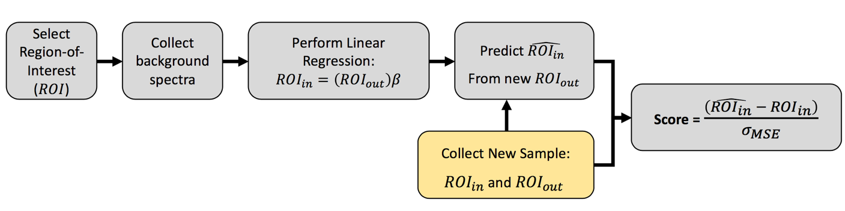
Figure 39: Multiple-linear regression detection methodology using region-of-interest approach.

At this point, the above multiple-linear regression model could be sufficient in providing an estimated count rate in the region-of-interest by using the count rates outside the region-of-interest. This model will be utilized later using synthetic and real spectral data, but an alternative approach that expands upon the regression method is first derived.

To avoid overfitting the data and provide a more robust regression model, a more recent method called Tikhonov regularization can be applied. Tikhonov regularization, which is more commonly referred to as ridge regression or L² regularization, expands upon the previously derived multiple-linear regression model and overcomes the primary issues previously discussed; namely, instances where there exist more predictor parameters than observed parameters and the inability weight parameters based on importance. Furthermore, ridge regression has been traditionally employed when multicollinearity is present, meaning the independent variables exhibit a correlation amongst themselves. In the case of analyzing collected data in radiation spectra, correlations can exist between bins as the underlying physical properties that govern the frequency can be strongly correlated.

As shown previously, the multiple-linear regression model adjusts the coefficient vector ($β$) based on the observed data, referred to as training data in the machine learning context. As noise is generally inherent to all observed data, the coefficients will optimize to values that model the noise effectively. This is where regularization methods can benefit. Ridge regression accomplishes this task by using a ridge estimator, or tuning parameter, that increases the bias to improve the variance of the model, such as changing the slope of a line in a two-dimensional space. Admittedly, this can result in lower performance when training the regression model on the observed data but potentially perform well on both observed and predicted data while not overfitting. This concept is illustrated in Figure 40.

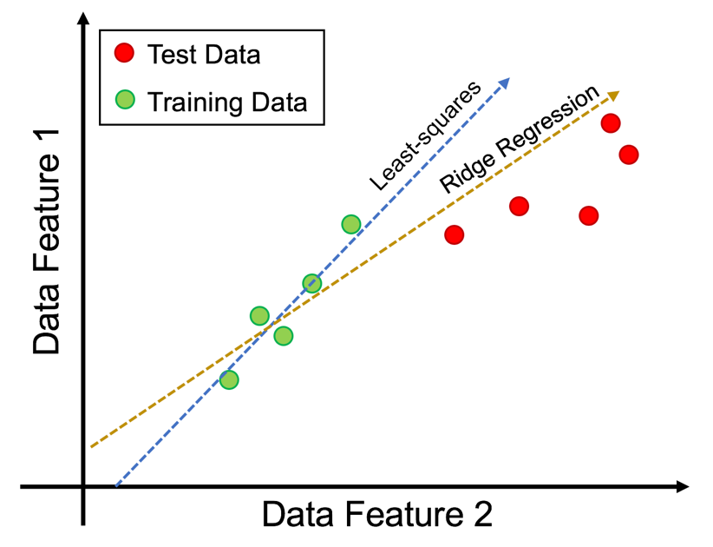
Figure 40: Illustration comparing least-squares and ridge regression on arbitrary data.

This tuning parameter ($λ$) decides the extent to which the flexibility of the regression model is penalized. This is accomplished in the minimization step by adding a penalty term to the residual error, as shown in the following equations.

$$RSS_{Ridge}=RSS+λ\sum_{j=1}^{k}{β_{j}^{2}}$$

$$RSS_{Ridge}={\sum_{i=1}^{n}{\left(y_{i}-β_{0}-\sum_{j=1}^{k}{β_{j}x_{ij}}\right)}}^{2}+λ\sum_{j=1}^{k}{β_{j}^{2}}$$

The tuning parameter is constrained to be equal to or greater than zero, where a zero-valued tuning parameter results in the identical residual sum of the squares ($RSS$) as least-squares regression. Following the derivation steps provided previously for the multiple-linear regression, the equation can be placed in matrix form and the ridge coefficient vector ($β_{R}$) can be isolated after performing the partial derivative. This results in the following equation, where tuning parameter is multiplied by the identity matrix ($I$) creating a diagonal ridge that is added to the correlation matrix ($X^{T}X$).

$$β_{R}={\left(X^{T}X+λI\right)}^{-1} X^{T}y$$

The additional term in the ridge sum of the squares ($RSS_{Ridge}$) containing the summation over the entire coefficient vector squared is commonly referred to as the shrinkage term and the tuning parameter controls the amount of shrinkage. A large tuning parameter forces the coefficient estimates to approach zero and, thus, reducing the model variance. This increase in bias can be beneficial in reducing the variance to a point but can begin underfitting the data and lose important properties in the data. This is illustrated in Figure 41 using arbitrary data. For an amount of shrinkage, which is identical to the tuning parameter value, an optimal value can is obtained at the minimum of the prediction error. In general, the bias increases as the tuning parameter increases and the variance decreases as the tuning parameter increases (i.e. bias-variance tradeoff).

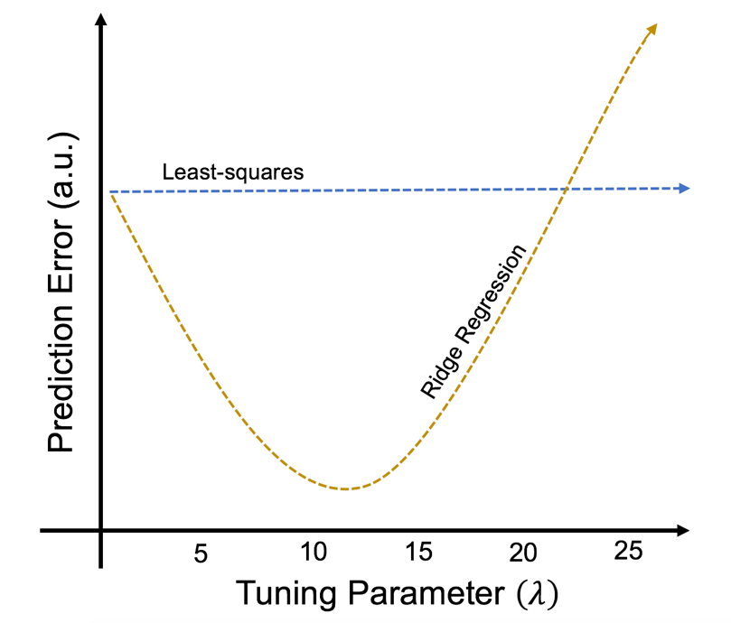
Figure 41: Example illustration of prediction error for least squares and ridge regression methods.

Standardization of the data is required in ridge regression in order to even the amount of change, or shrinkage, for each coefficient. For instance, if the observed data were on vastly different scales, the shrinkage would be biased as their contributions to the penalty term would differ because the penalized term is the sum of the squares of the coefficients. Scaling of the data decreases the need for large values in the coefficient vector ($β_{R}$), resulting in a smaller, optimal tuning parameter. A conventional solution is to mean-center and scale the data to have a unit variance (i.e. variance equal to one) prior to performing ridge regression. Thus, both the independent ($X$) and dependent ($y$) data are scaled through subtraction of their means and divided by their standard deviation providing a variance of one.

Worth noting, when analyzing sparse data where many zero-valued features exist, ridge regression can fail to provide accurate predictions for said features as the coefficients calculated in the ridge regression model cannot be exactly zero, but rather very close zero. Generally, this issue is addressed by a process called variable selection and requires prior grooming of the data to select only relevant data features to analyze. [INSERT] This issue can also decrease the predictive accuracy of the ordinary least squares regression method quite substantially. In this case, radiation spectra can often be sparse with a moderate to high quantity of empty bins. This is illustrated in Figure 42 providing a histogram of count rates for a detector in the ORNL sensor network for a 0.0 to 3.0 MeV energy range.

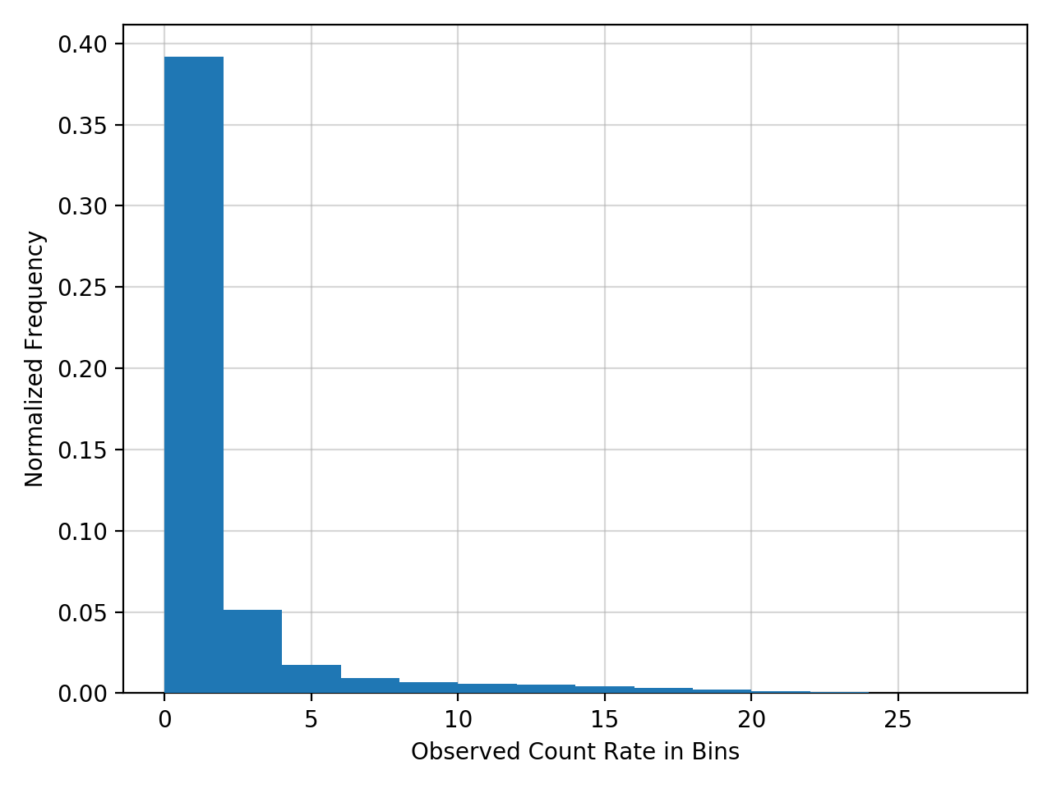
Figure 42: Histogram of count rates per bin for a deployed radiation detector.

This hindrance is decreased when using the region-of-interest estimation approach, where the out-of-region frequency estimations are typically nonzero. This does not completely alleviate the issue, as scenarios do exist where zero-valued regions occur and are subsequently used to predict the in-region frequency. For instance, if the region-of-interest consumes the majority of spectrum (e.g. 90% of the bins), then the region outside the region-of-interest could have a zero-valued frequency (e.g. high photon energy regions due to low photon flux or minute interaction cross sections). The author thus suggests utilizing a threshold for using the region-of-interest regression methods, where the out-of-region frequency must be equal to or greater than the threshold, say 20 counts per second. With a mean count rate equal to or greater than 20, a normal approximation can be made confidently for a Poisson process and small values are probabilistically not likely.

Moving forward, the overall approach of using ridge regression in this context, shown in Figure 43, is similar to the multiple-linear regression approach with an additional step of optimizing the tuning parameter in the penalty term of the regression model.

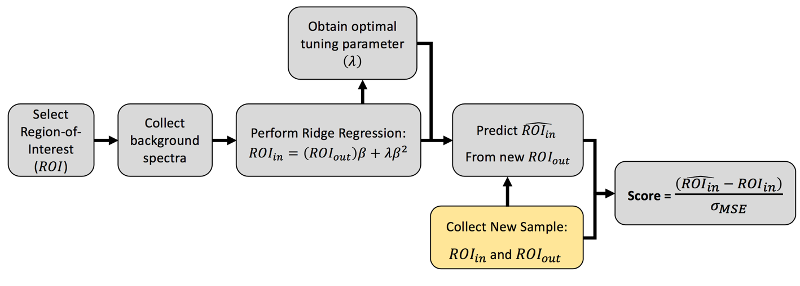
Figure 43: Ridge regression detection methodology using region-of-interest approach.

Selecting the optimal tuning parameter ($λ$) is a rather controversial undertaking and several methods can be utilized. In [96], Hoerl suggest a graphical approach by plotting each regression coefficient as a function of the tuning parameter value. Using this graph, referred to as a ridge trace, an analyst has the ability of selecting the smallest tuning parameter where the regression coefficients stabilize. The coefficients can vary greatly at low tuning parameter values but selecting the smallest value when the coefficients stabilize avoids introducing unwarranted bias to the model. [96, 97] To provide context, an example ridge trace plot is provided in Figure 44 for artificially created data. From Figure 44, the ten coefficients are initially spread out and begin to converge as the tuning parameter increases. A tuning parameter value can be selected by choosing a value prior to the convergence, say 5E-6 in this example, where the coefficients appear relatively stabilized.

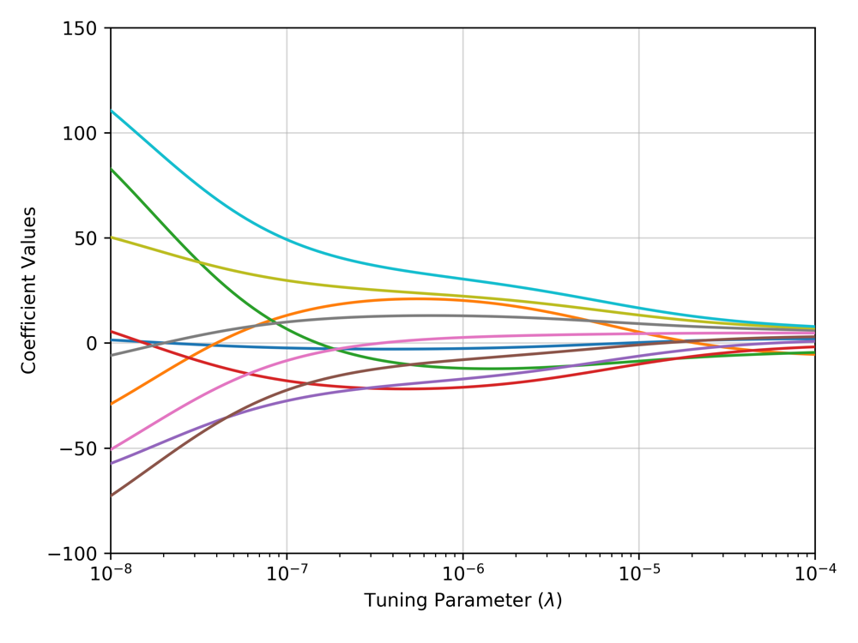
Figure 44: Example ridge trace plot for multiple coefficients using arbitrary data.

Unfortunately, using the ridge trace graph to select the tuning parameter has no objective basis and is prone to user bias. In more recent years, other methods have been proposed for selecting the optimal tuning parameter value, which include using techniques such as: Akaike’s Information Criterion, Bayesian Information Criterion, and, most notably, cross-validation. [98, 99, 100] These techniques assist in the model selection phase when analyzing data but are not addressed in this work. The reason being is that by using the region-of-interest approach for the energy spectra, there only exists a single coefficient in the coefficient vector ($β$). Thus, a more simplistic approach is to select the tuning parameter that meets a specific stabilization rate.

To assess the relationship between the ridge coefficient and the tuning parameter on real-world radiation data, a ridge trace is provided in Figure 45 for each radiation detector in the ORNL sensor network using the region-of-interest highlighted in the previous example spectra, shown in Figure 38 (i.e. approximately 0.0 to 0.8 MeV).

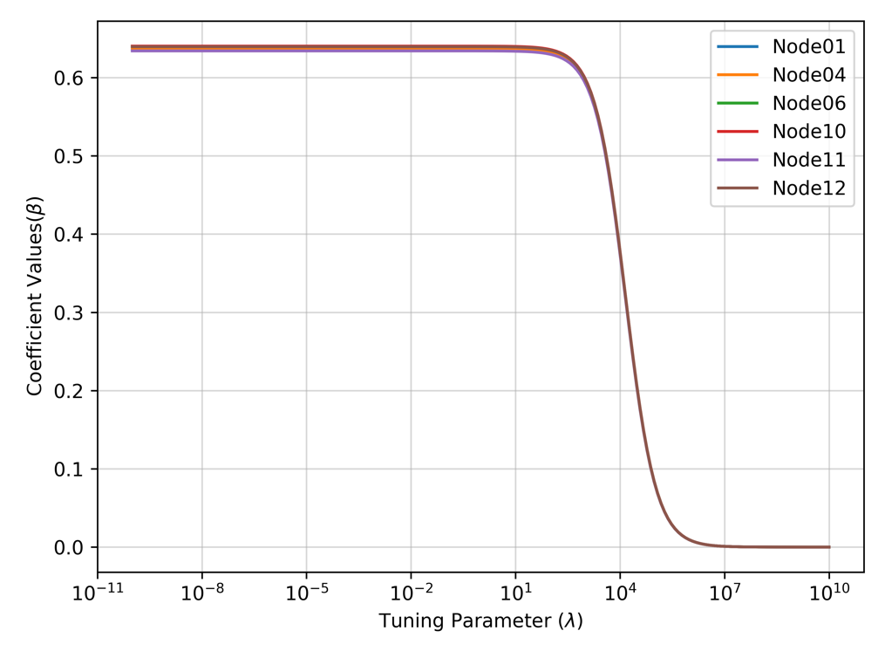
Figure 45: Ridge trace for radiation detectors deployed at ORNL.

Figure 45 shows the ridge trace using 24-hours of radiation data with no anomalous signals and illustrates the previous claim that a large tuning parameter moves the coefficient estimates towards zero. The coefficient values remain relatively flat below a tuning value of approximately 10, which is an interesting outcome as a small tuning parameter will decrease the penalty term in the ridge regression model, thus approaching a linear regression model. This is shown in Figure 46 that provides the mean squared error for the ridge and multiple-linear (i.e. referred to as least-squares in Figure 46) regression models for each node on the ORNL sensor network.

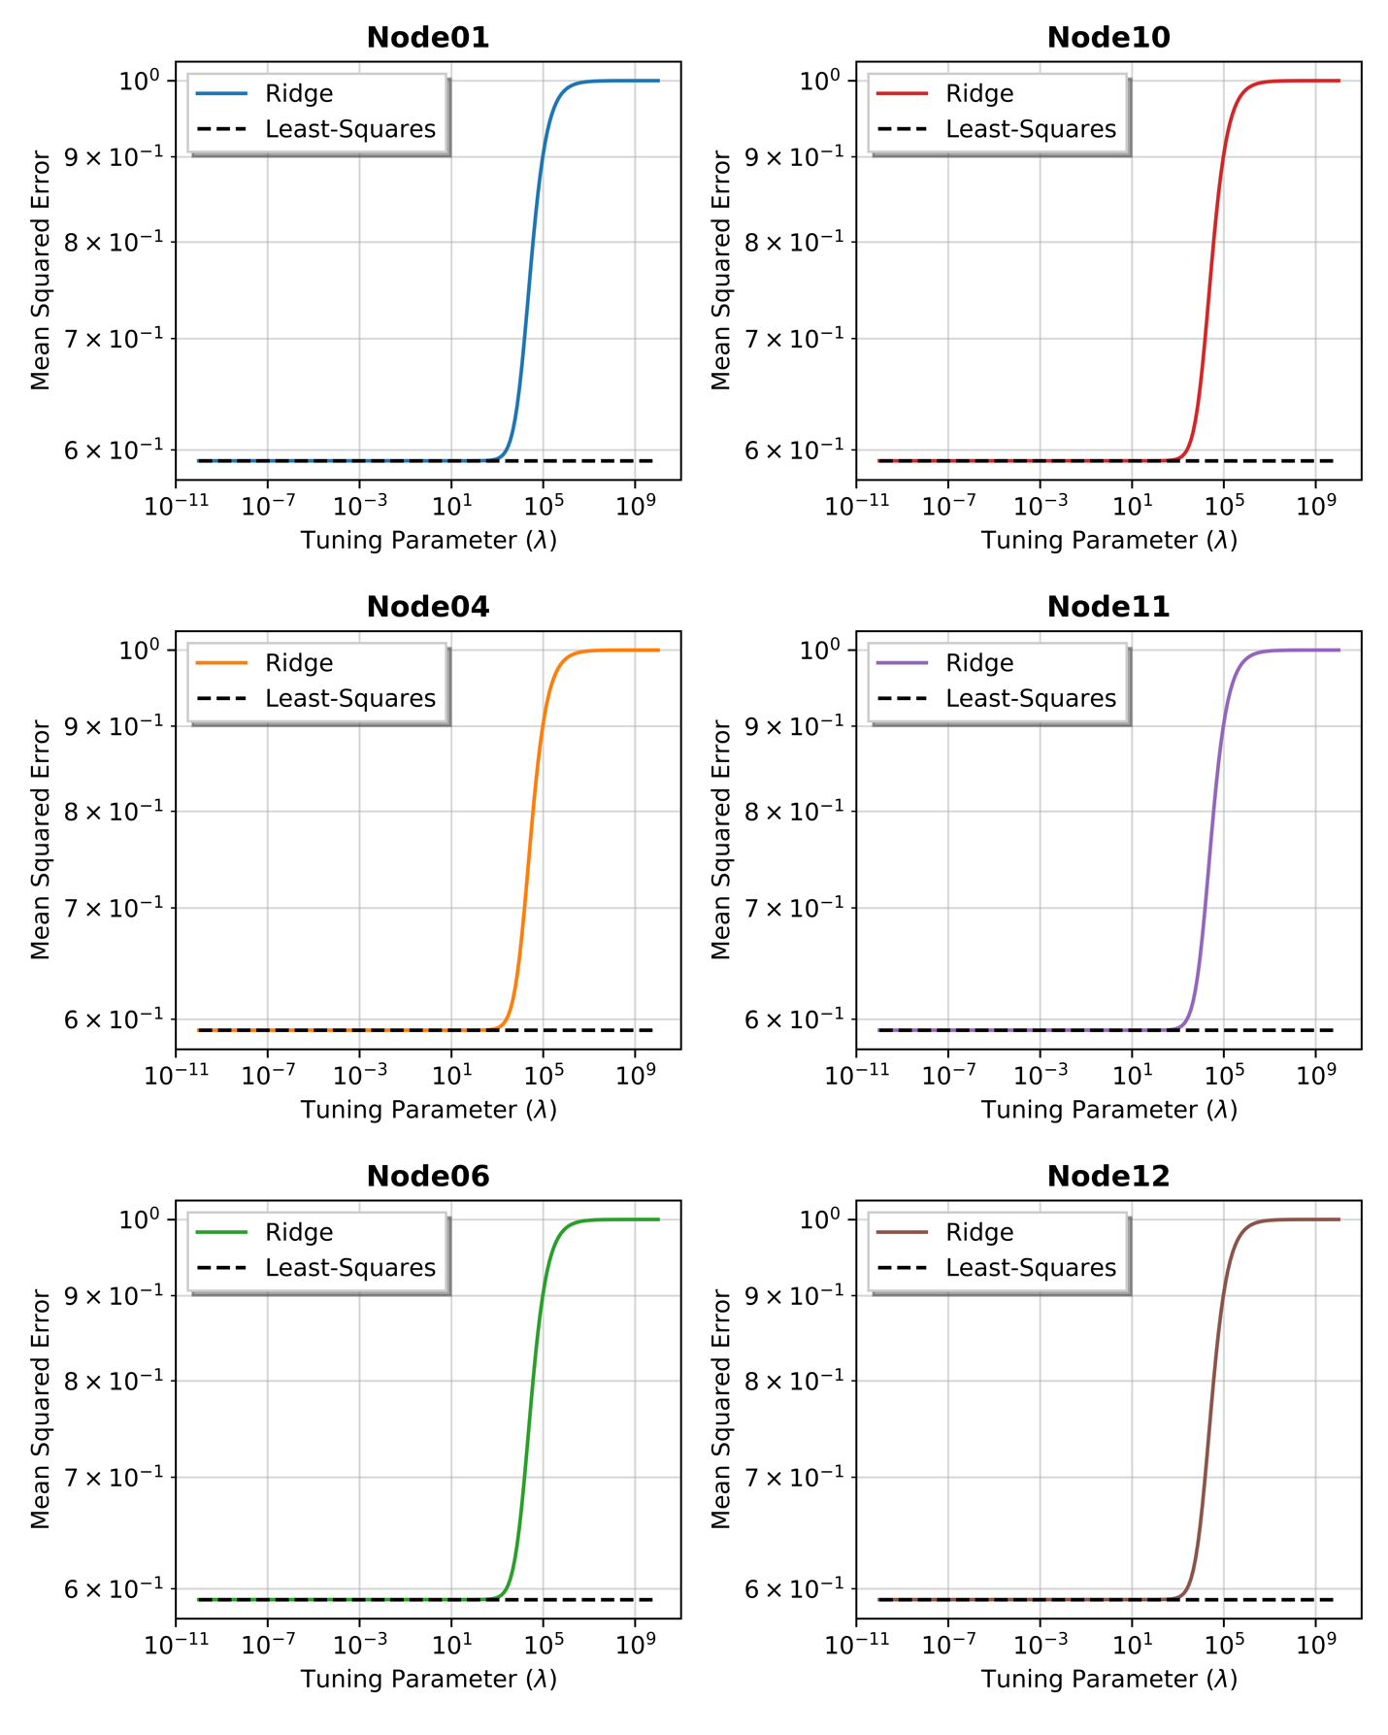
Figure 46: Mean squared error for ridge and least squares regression models on each ORNL sensor node.

Using the mean square error to compare the two approaches, the ridge regression is concluded to not provide any benefit compared to the multiple-linear regression model using the region-of-interest approach presented in this work.

A receiver operator characteristic curve is utilized to compare the detection sensitivity the proposed methods provide over the full spectrum, gross count detection method. Synthetic data was created using the source and background distributions provided previously in Figure 27 to compare the methods. Using a one second timing resolution, the source distribution is introduced for 4 seconds every 60 seconds with a constant background source term. This is illustrated in Figure 47 containing the gross count rate, the count rate within the region-of-interest, and the count rate outside the region-of-interest.

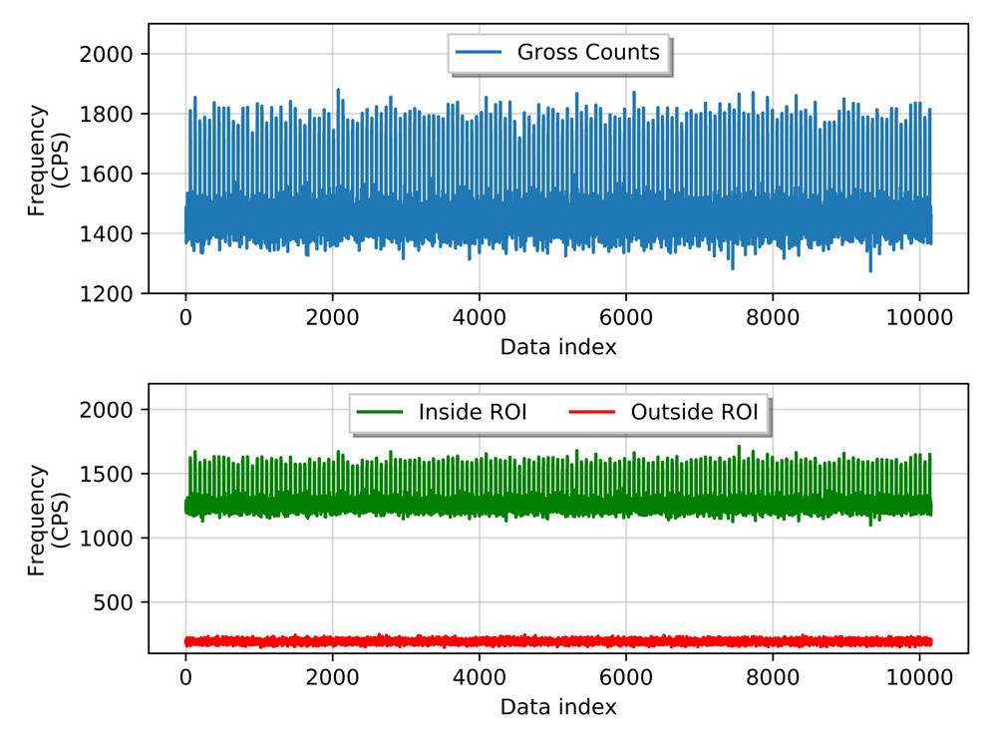
Figure 47: Count rate of synthetic data for comparing detection methods.
(Top) Gross counts of the synthetic data. (Bottom) Count rate within the region-of-interest (green) and outside the region-of-interest (red).

The gross counts method and the linear squares approach utilize a rolling-window approach to analyze time series data. Two rolling-windows are employed for the background and foreground, respectively, where the width of each window is preselected. In this analysis, a 10 second background window and a 2 second foreground window are used with a 4 second separation between the two windows. The resulting receiver operator characteristic curves are provided in Figure 48. Wilson score intervals were utilized to provide a confidence interval at a 95% confidence level with an error rate ($α$) of 0.05 and are represented by the shaded regions in Figure 48. The intervals are rather large at low decision threshold values (i.e. right side of curve) due to the high number of false positive classifications, increasing the uncertainty.

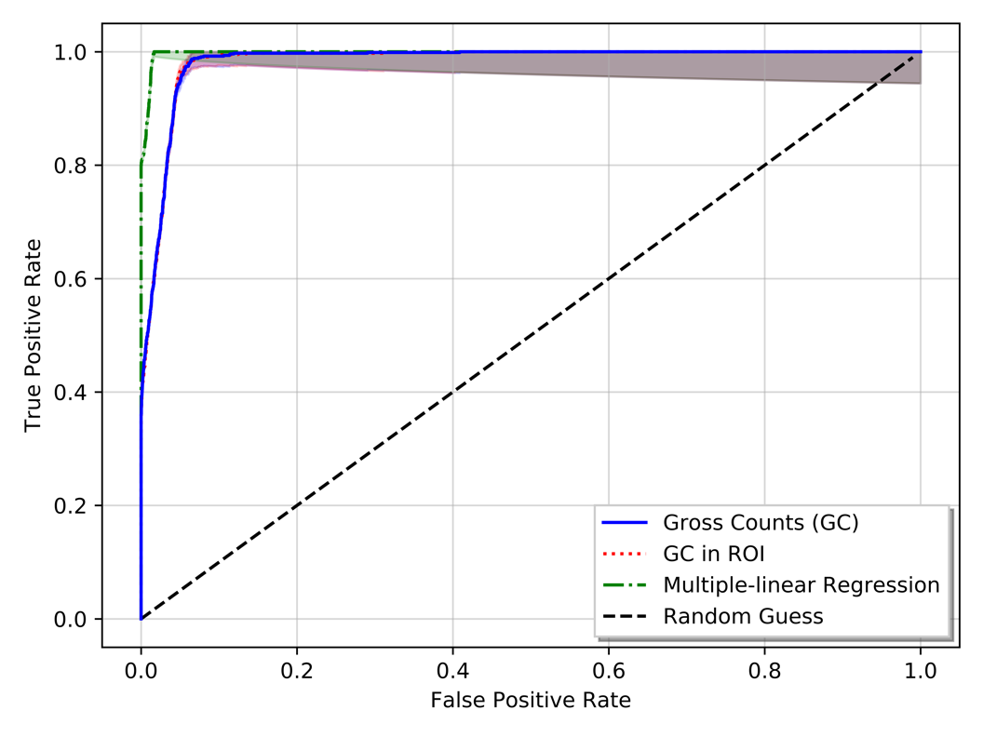
Figure 48: Receiver operator characteristic curve comparing gross counts and least-squares methods.

The multiple-linear regression provides the better prediction method, which is illustrated by its high true positive rate at low false positive rate values. Both the region-of-interest gross count method and the conventional gross count method maintain a competitive prediction capability with minute differences between the two.

Operating an additional detection algorithm may provide increased detection capability or sensitivity, but at the cost of combining multiple error rates. Recall that to account for this change and to maintain a specified error rate, the Dunn-Šidák correction can be utilized. If a total error rate of 0.05 is specified, the resulting error rate for a two-detection algorithm approach required a failure rate of 0.025 for each detection algorithm. Using this updated failure rate, the methods are compared to the conventional gross counts (Option 1) method using the probability of detection metric. The results are provided in Table 5.

Table 5: Probability of Detection for multiple detection options on synthetic data.
 | Error Rate per Method | Total Error Rate ($α$) | Probability of Detection
Option 1: Full GC | 0.05 | 0.05 | 0.95
Option 2: Full GC and  ROI GC | 0.025 | 0.05 | 0.69
Option 3: Full GC and  ROI MLR | 0.025 | 0.05 | 0.99

The probability of detection decreases when using the second option in Table 5, where both the conventional gross count and the region-of-interest gross count detection methods are used. The data on the receiver operator characteristic curve for both of these detection methods nearly perfectly overlaps, thus using the region-of-interest coupled with a more stringent confidence level results in lower detection probability or true positive rate compare to the conventional approach in Option 1. The multiple-linear regression model provides an increased sensitivity, which is reflected by the separation of the data receiver operator characteristic curve in the upper left corner. Even when utilized the Dunn-Šidák correction, the resulting probability of detection is increased from 0.95 to 0.99.

3.3: Analysis of Sensor Array Data
The methods previously discussed are extended to analyze several anomalous events observed on the ORNL sensor array. The raw outputs for the spectral comparison and region-of-interest detection methods are provided in this section and are further evaluated in the following section for a decision-making architecture. Therefore, this section solely supplies the reader with several the previous methods’ outputs on real-world examples.

Each anomalous event begins by first detecting an anomaly at one of the sensors in the array and, subsequently, calculating a region-of-interest after filtering the background-subtracted anomalous spectra. Three anomalous events are analyzed that traverse through the ORNL sensor array. The first two events follow identical paths starting at Node06 and the third event starts at Node 04 with all events exiting the area at Node01, as depicted in Figure 49 and Figure 50.

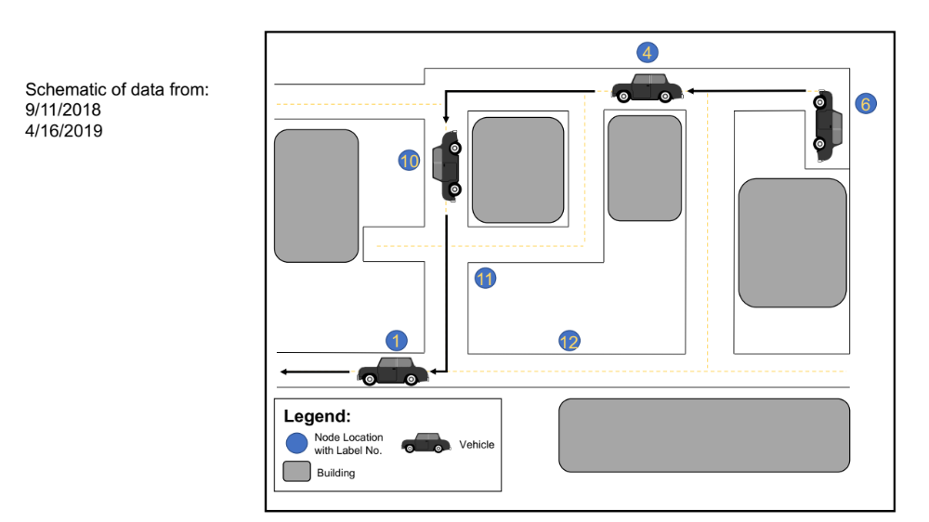
Figure 49: Illustration of vehicle carrying radioactive material through ORNL sensor array for Events 1 and 2.

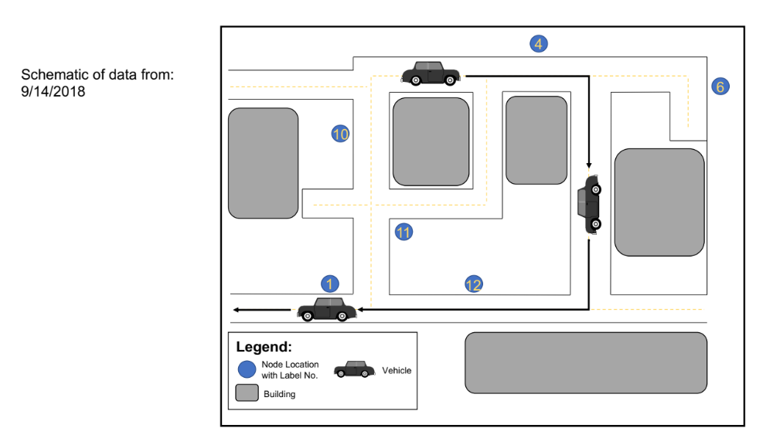
Figure 50: Illustration of path of a vehicle carrying radioactive material through ORNL sensor array for Event 3.
The radioactive material moving through the sensor array is different for each event, resulting in unique observed count rates and spectral features. The time-series gross count rates observed at each node in the ORNL sensor array for the events are provided in Figure 51, Figure 57, and Figure 63. Each event is analyzed in order following the figures.

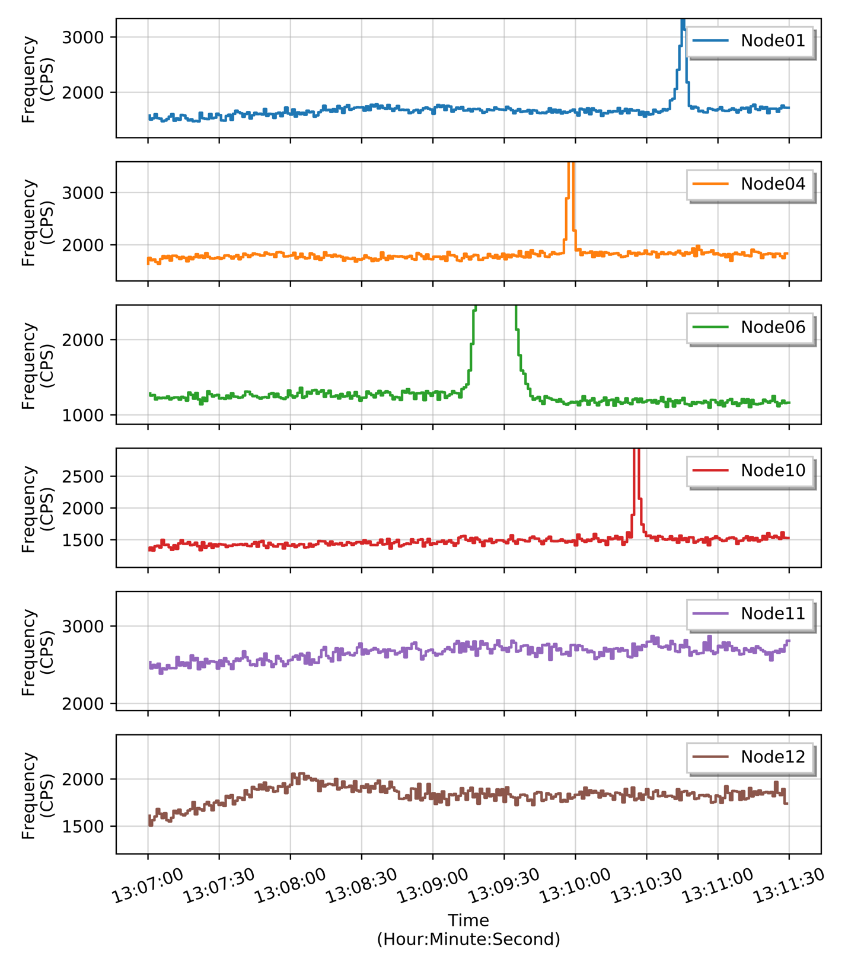
Figure 51: Event 1 time series of count rates observed on the ORNL sensor array.

In Event 1, four nodes detect an anomaly due to the high increases in count rate during the time period of 13:09:15 to 13:10:50. The radioactive material traveling through the sensor array during Event 1 is a mixture of unknown radioisotopes with three prominent peaks. This is observed in Figure 52 showing the summed energy spectra during the anomalous event along with a one-minute summed background energy spectra prior to each detected anomaly.

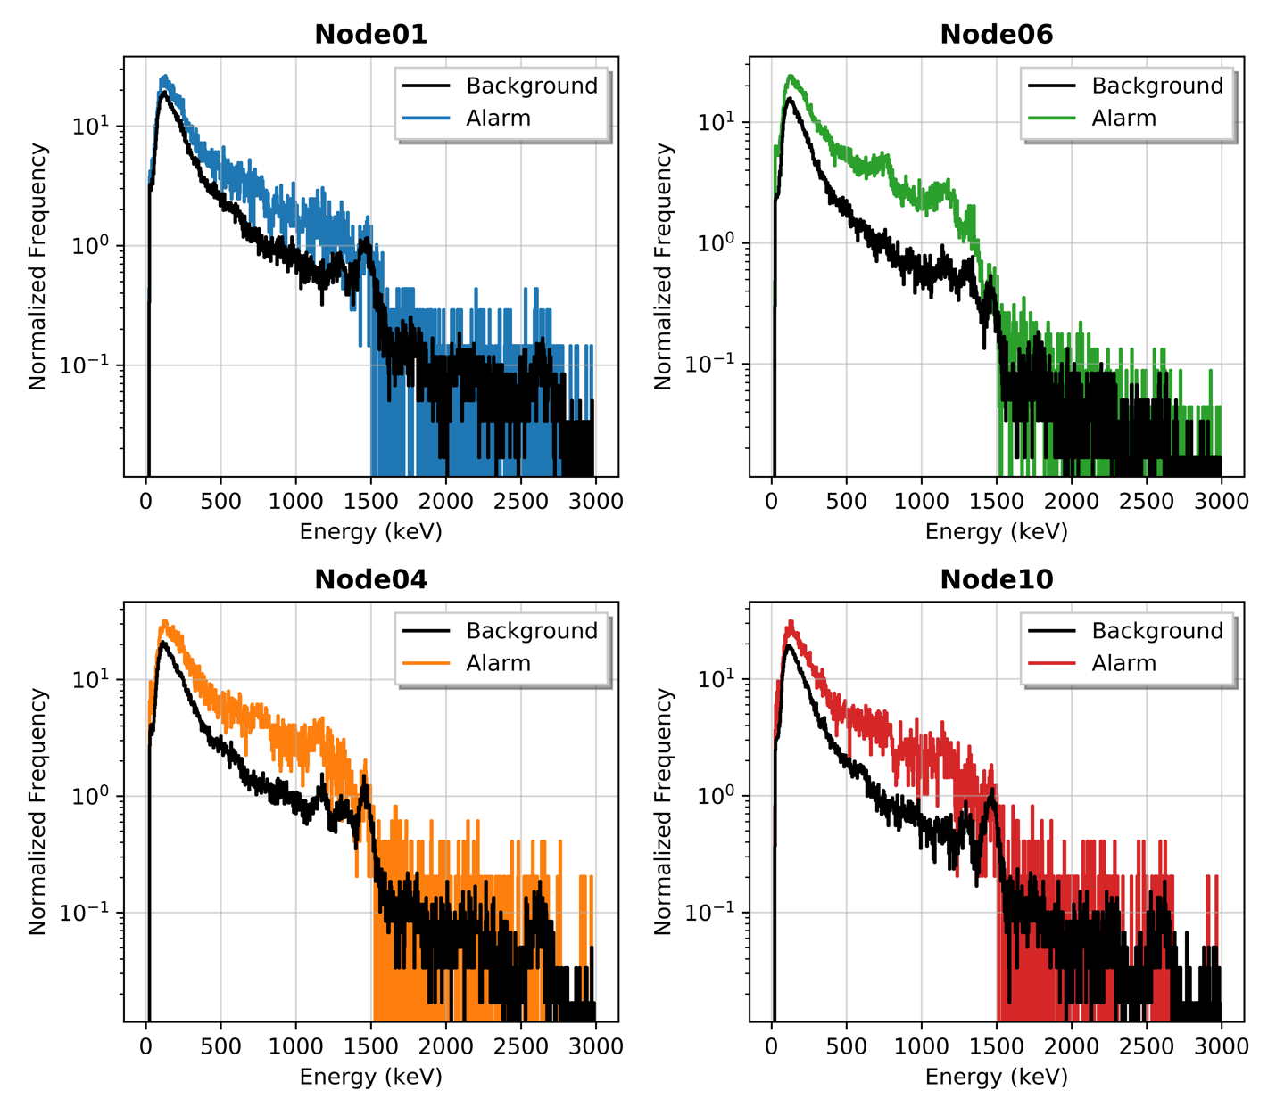
Figure 52: Event 1 alarm and background spectra collected at four nodes.

Qualitatively comparing anomalous spectra observed at Node01, Node04, Node06, and Node10, high count rates are observed below approximately 1400 keV from the unknown radioactive material with three obscure peaks around 760 keV, 1170 keV, and 1330 keV. Regardless of the exact radioisotope, or radioisotopes, in the material, the two approaches previously discussed of comparing anomalous spectra and increasing probability detection by operating an additional algorithm. The region-of-interest is first created on the initial anomalous, background-subtracted, filtered spectrum collected at Node06 shown in Figure 53. In this case, the filtering of the anomalous spectrum does not provide much benefit as the source strength and the total time integrated during the alarm are both relatively large, resulting in a dense sample spectrum.

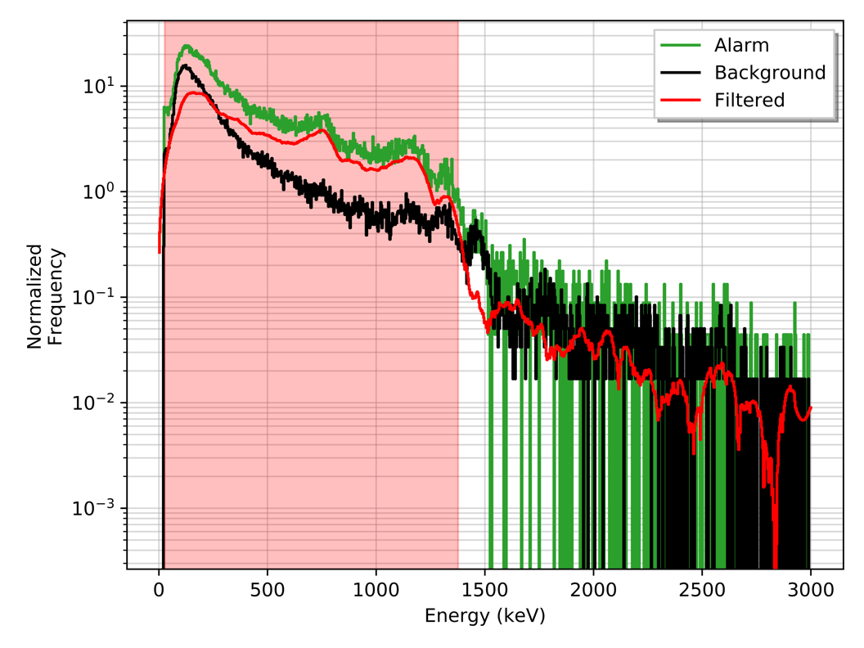
Figure 53: Event 1 region-of-interest from filtered anomalous spectrum at Node06.

This region-of-interest, highlighted in light-red in Figure 53, can then be subsequently used at the other nodes in the network with the multiple-linear regression detection method and the Dunn-Šidák correction. The Event 1 time-series of the decision metrics for both the conventional gross counts and the multiple-linear regression detection methods is shown in Figure 54. The decision metric values are normalized by mean subtraction and dividing by the standard deviation to give a zero-mean, unit variance distribution. This allows the two methods to be compared on similar scales.

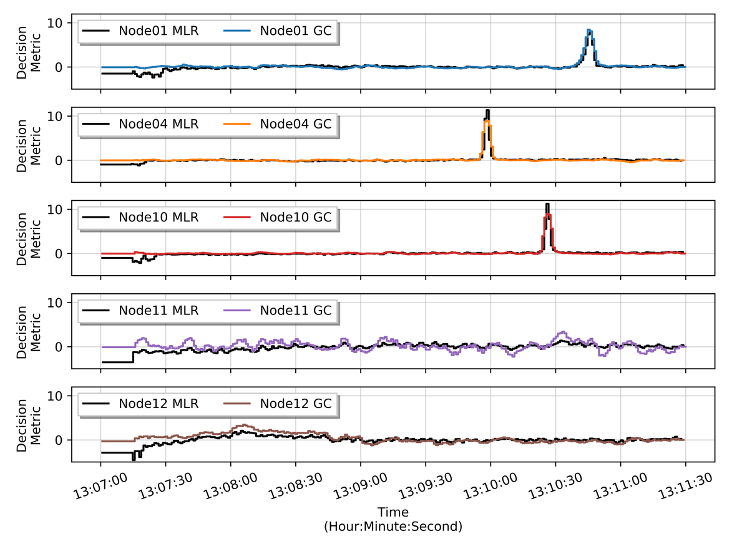
Figure 54: Event 1 decision metric time-series for remaining nodes.

Using a 95% and 97.5% confidence value for the single detection algorithm method (i.e. gross counts) and double detection algorithm method (i.e. multiple-linear regression and gross counts), respectively, the anomalies are correctly detected at Node01, Node04, and Node10. The multiple-linear regression method does provide a slightly higher probability of detection on Node04 and Node10 than the conventional gross count detection algorithm, but both methods in this case provide greater than 99.0% probability of detection due to the large count rate increase.

The combined spectra during the anomalous events at Node01, Node04, Node06, and Node10 are provided in Figure 55 after background-subtracting, smoothing, and applying the sum-to-unity normalization. Recall that the normalization is not required for the cosine similarity method but is utilized in this work to provide a more intuitive, qualitative comparison. Discrepancies between the filters are observed in high energy bins (i.e. > 1.5 MeV) which is primarily due to the low count rate in that region during the background-subtraction resulting poor statistics. This is compounded when the filtering method is applied resulting large disagreements between the spectra.

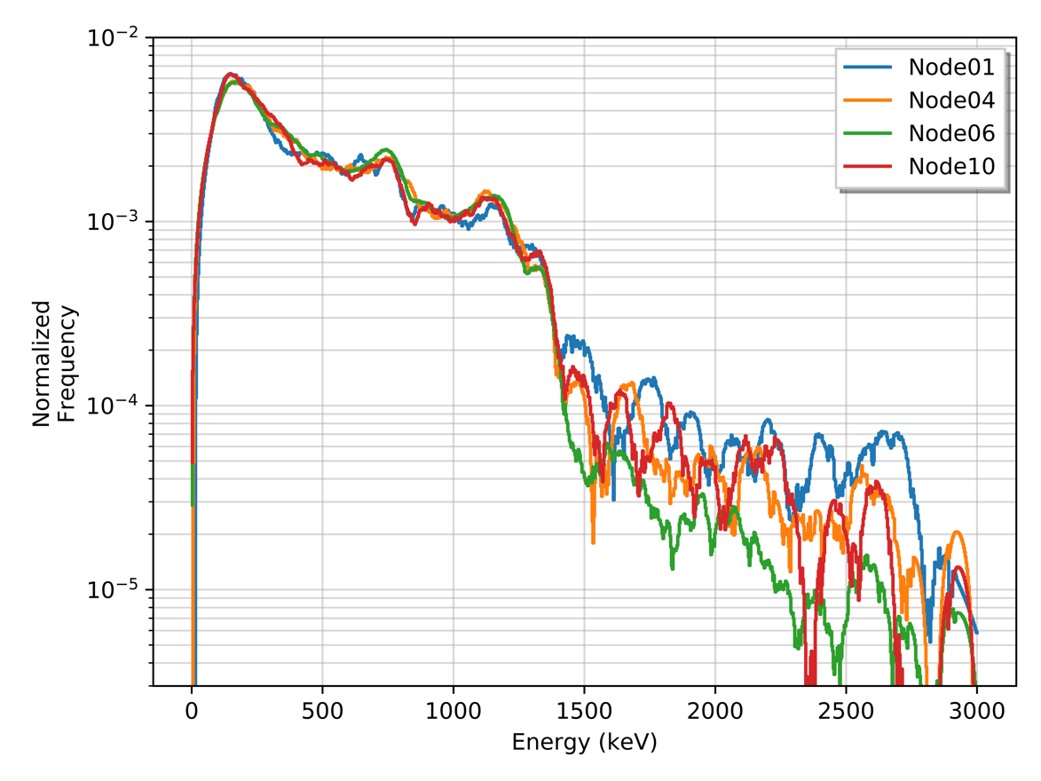
Figure 55: Event 1 anomalous spectra after background-subtracting, filtering, and normalizing.
At lower energies, the peak previously identified around 760 keV, 1170 keV, and 1330 keV appear to align along with near identical intensities in the energy bins below 1400 keV. The cosine similarity method is utilized to compare the anomalous spectra collected from Node01, Node04, and Node10 with the initial anomalous spectra from Node06. Recall that the cosine similarity method provides a quantitative value from 0.0 to 1.0, where a value near 1.0 is represents strong similarity between the two spectra and is assumed that both spectra are samples from the same source distribution. The cosine similarity values for each collected spectrum Node01, Node04, and Node10 to the Node06 spectrum is provided in Figure 56 along with the cosine similarity values for the combined anomalous spectra provided in Table 6.

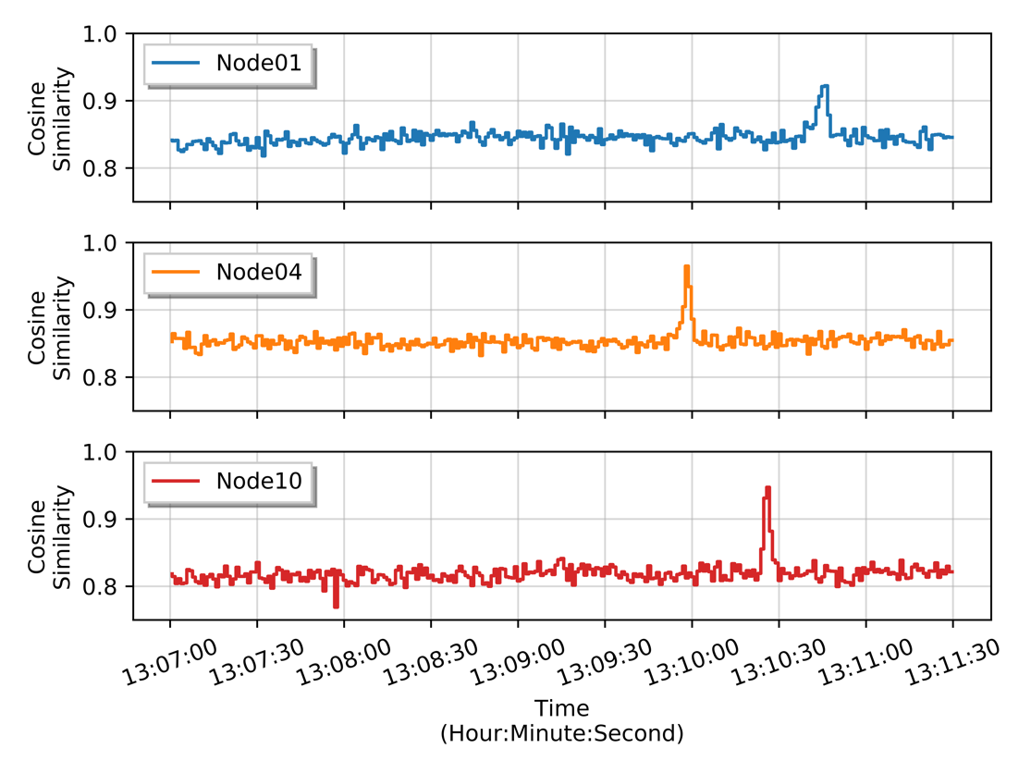
Figure 56: Event 1 cosine similarity time-series.

Table 6: Event 1 cosine similarity values for anomalous spectra.
Node | Cosine Similarity
Node01 | 0.993
Node04 | 0.998
Node10 | 0.996

The similarity values for the collected spectra in time-series are relatively high for background spectra, generally maintaining a value greater than 0.8 for Node01, Node04, and Node10 in Event 1. In particular, Node04 in Event 1 observes a median cosine similarity value of 0.85 primarily due to the background spectra at the location is complex with energy peaks near the observed peaks in the anomalous spectra. [This forces a more stringent threshold to be specified in order to confidently state the spectra collected is a sample from the same distribution as the combined anomalous spectrum from Node06. INSERT] Of note, the time-series cosine-similarity values presented in Figure 56 are not background-subtracted, thus higher values is expected as there can exist large correlation values at lower energies, where both the background and anomalous spectra have similar shapes due to down scatter from higher photon energies. This issue only increases if no spectral features are present, such as an increase in counts across the entire energy spectrum which will be shown later.

Event 2 observes radioactive material initial being detected at Node06 then, similar to the path travelled in Event 1, moves through the sensor array before exiting the area at Node01. The time-series count rate for each node for Event 2 is provided in Figure 57.

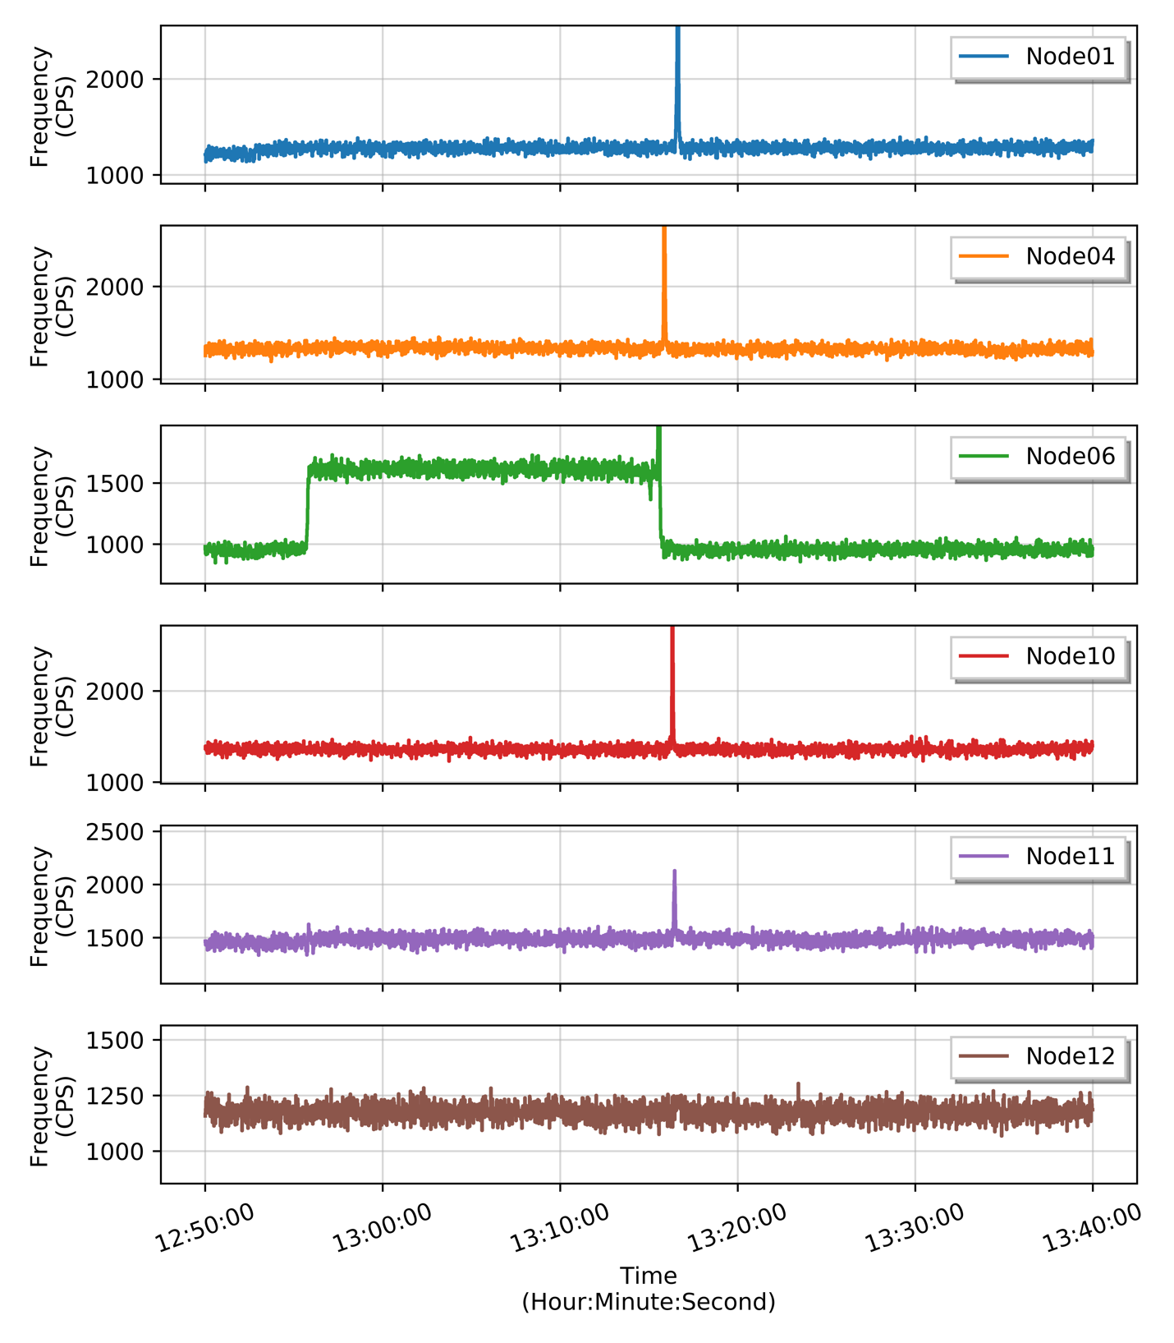
Figure 57: Event 2 time series of count rates observed on the ORNL sensor array.

The spectra are combined during the detected alarm period from 12:55:45 to 13:15:40 on Node06. The resulting anomalous spectra is provided in Figure 58 along with the calculated the region-of-interest from 0.0 to 1.39 MeV. Worth noting, applying the filter to the spectrum provides limited benefit in this particular case, as the spectra is not sparse due to the prolonged exposure time coupled with a moderate source activity.

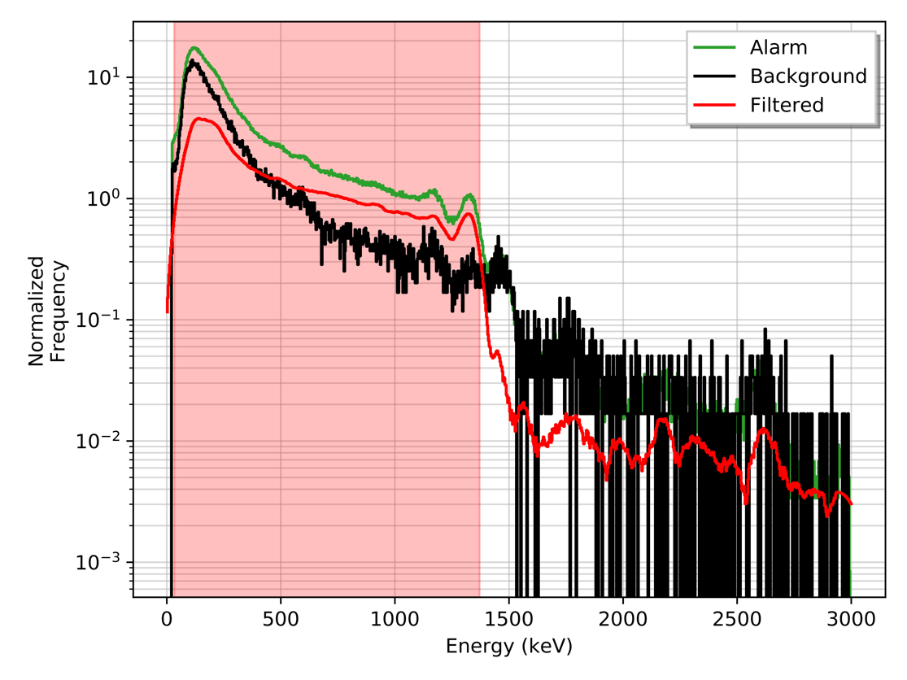
Figure 58: Event 2 region-of-interest from filtered anomalous spectrum at Node06.

From the initial, observed anomalous spectra from Node06, two prominent energy peaks are observed around 1770 keV and 1330 keV, most likely resulting from ⁶⁰Co in the radioactive material. These peaks and their associated down scatter result in a calculated region-of-interest from 0.0 to 1400 keV. Using this region-of-interest, the for the single detection method and double detection method were both employed to compare the techniques. The decision metric values are provided in for other nodes in the ORNL sensor array. The decision metrics are normalized by mean subtracting an dividing by the standard deviation to provide a better means to compare the methods on similar scales. Again, this normalization provides a zero-mean, unit variance distribution.

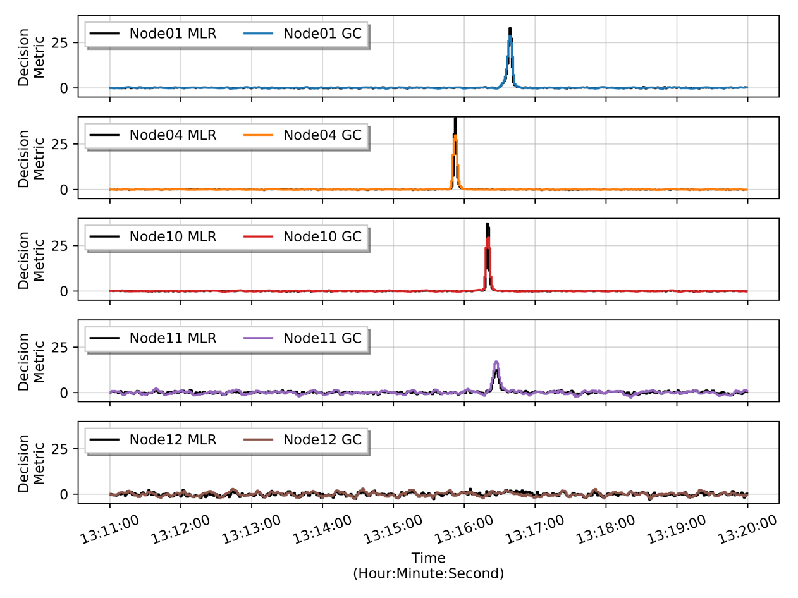
Figure 59: Event 2 decision metric time-series for remaining nodes.

Using a 95% and 97.5% confidence value for the single and double detection algorithm, respectively, the anomalies are correctly detected at Node01, Node04, Node10 and Node11. The multiple-linear regression method does provide a slightly higher probability of detection on Node01, Node04 and Node10 than the conventional gross count detection algorithm, but both provide a probability of detection greater than 100% for all three nodes due to the high source activity.

The anomalous spectra are provided in Figure 60 for each alarm node with an alarm during Event 2. The anomalous spectra at each node is then background-subtracted, filtered, and normalized to provide a more accurate comparison. The resulting spectra are provided in Figure 61.

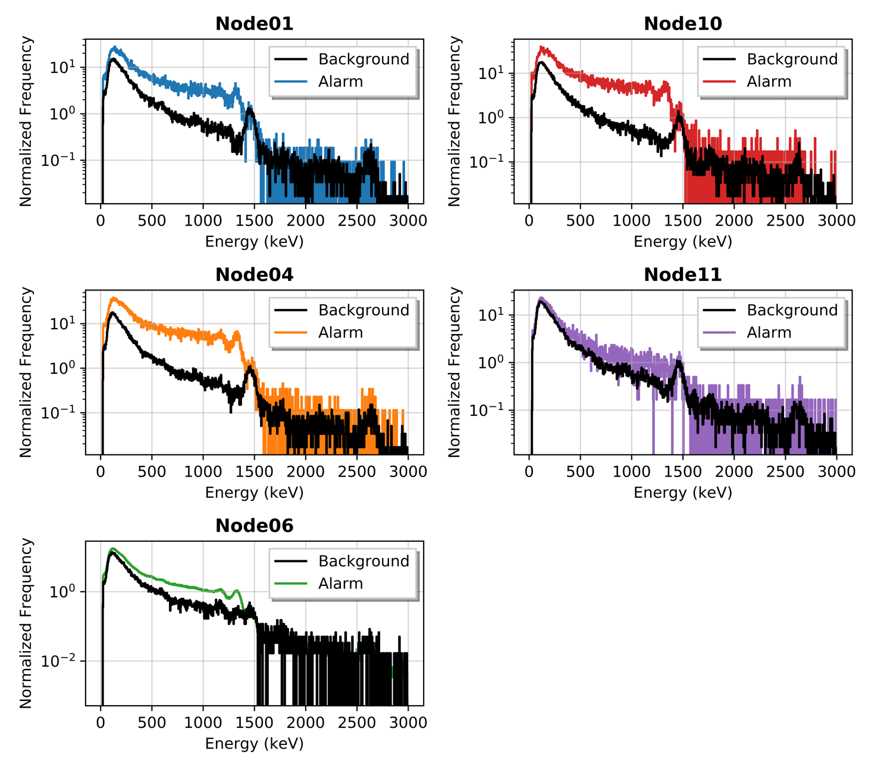
Figure 60: Event 2 alarm and background spectra collected at five nodes.
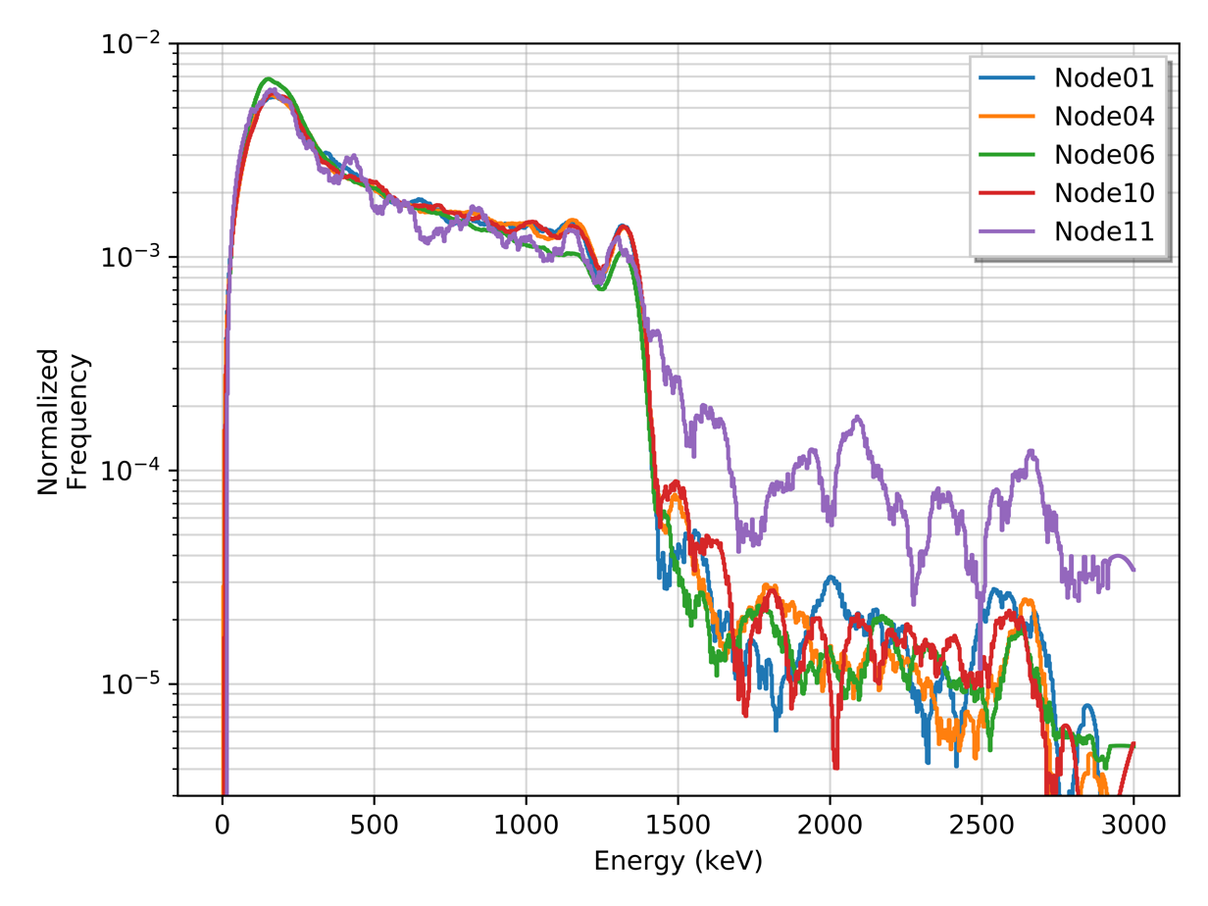
Figure 61: Event 2 anomalous spectra after background-subtracting, filtering, and normalizing.

At lower energies, the peak previously identified around 1.17 MeV, and 1.33 MeV appear to align along with similar intensities in the energy bins below 1.40 MeV. Additionally, a relatively sharp increase at 0.200 MeV is observed which is hypothesized to be a result from shielding around the material in transit as well as a cumulation of overlapping back scatter peaks. Node11 observes large discrepancies between the original anomalous spectrum from Node06 and varies greatly at energies above the region-of-interest. This is contributed to the relative low count rate and a short alarm length observed during the anomalous event at Node11. This results in a sparse energy spectrum with limited spectral information, such as the two identified energy peaks, and large noise at higher energies even after filtering is applied. Again, the intensity is not a factor when employ the cosine similarity method, thus the high normalized frequency in the higher energy region is not of particular concern.

The cosine similarity method is utilized to compare the anomalous spectra collected from Node01, Node04, Node10, and Node11 with the initial anomalous spectra from Node06. The cosine similarity values for each collected spectrum Node01, Node04, Node10, and Node11 to the Node06 spectrum is provided in Figure 56 along with the cosine similarity values for the combined anomalous spectra provided in Table 6.

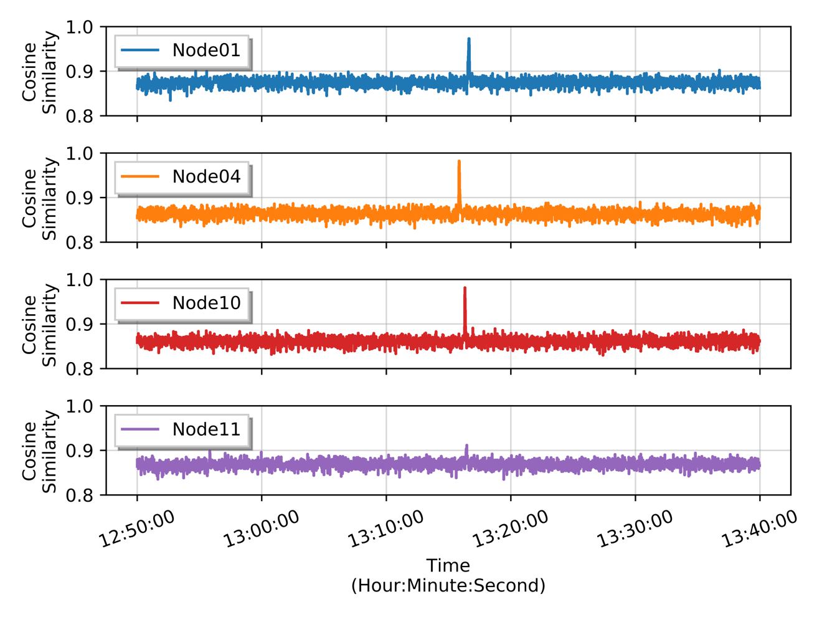
Figure 62: Event 2 cosine similarity time-series.

Table 7: Event 2 cosine similarity values for anomalous spectra.
Node | Cosine Similarity
Node01 | 0.992
Node04 | 0.994
Node10 | 0.994
Node11 | 0.991

Similar to Event 1, Event 2 observes larger cosine similarity values for the combined anomalous spectra with values slightly greater than 0.990, but still observes relatively high values for background spectra.

Event 3 has a unique alarm sequence to that of Event 1 and Event 2. The radioactive material is initial detected at Node04 then is subsequently detected at Node12 before exiting the area at Node01. The time-series count rate data for the nodes during Event 3 is provided in Figure 63.
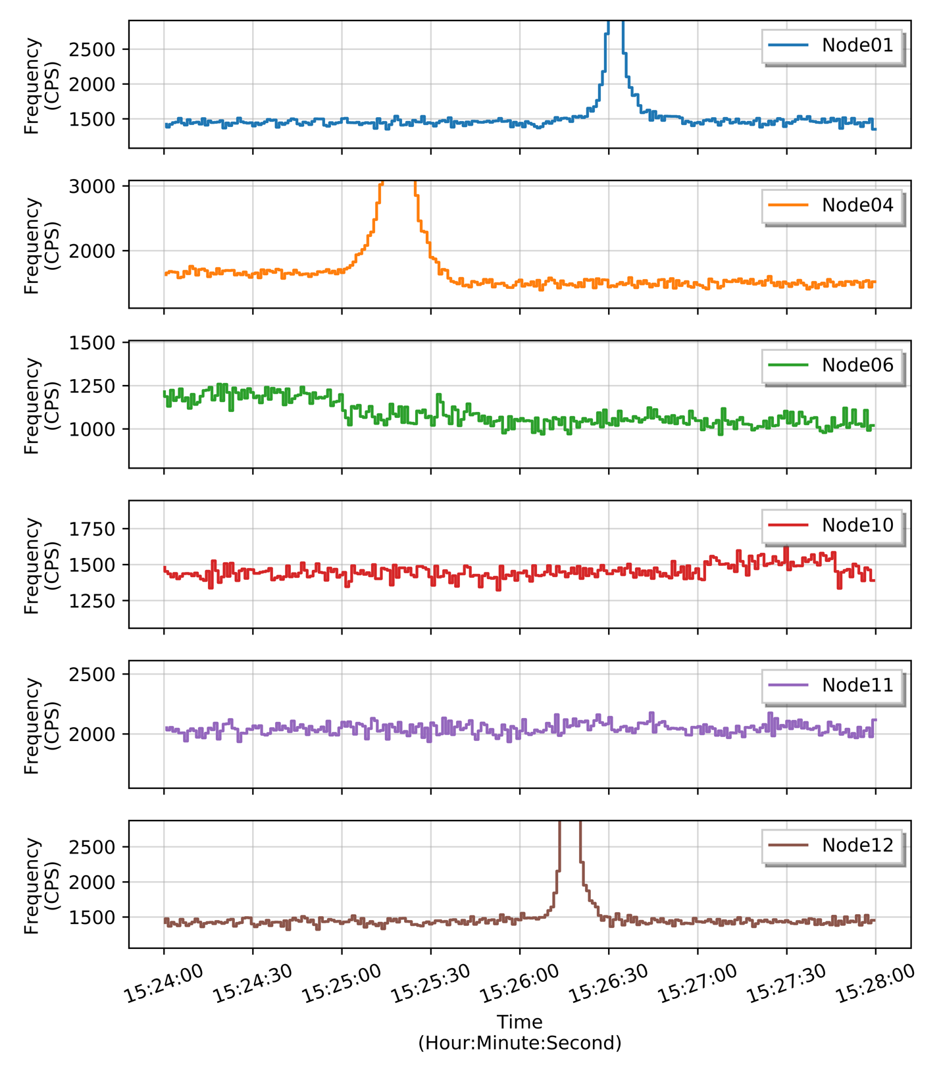
Figure 63: Event 3 time series of count rates observed on the ORNL sensor array.

The region-of-interest is then calculated from the initial event at Node01. The resulting region-of-interest calculated for Node04, shown as the light-red region in Figure 64, ranges from 0.0 to 1.39 MeV after applying the region-of-interest algorithm to the background-subtracted, filtered anomalous spectrum.

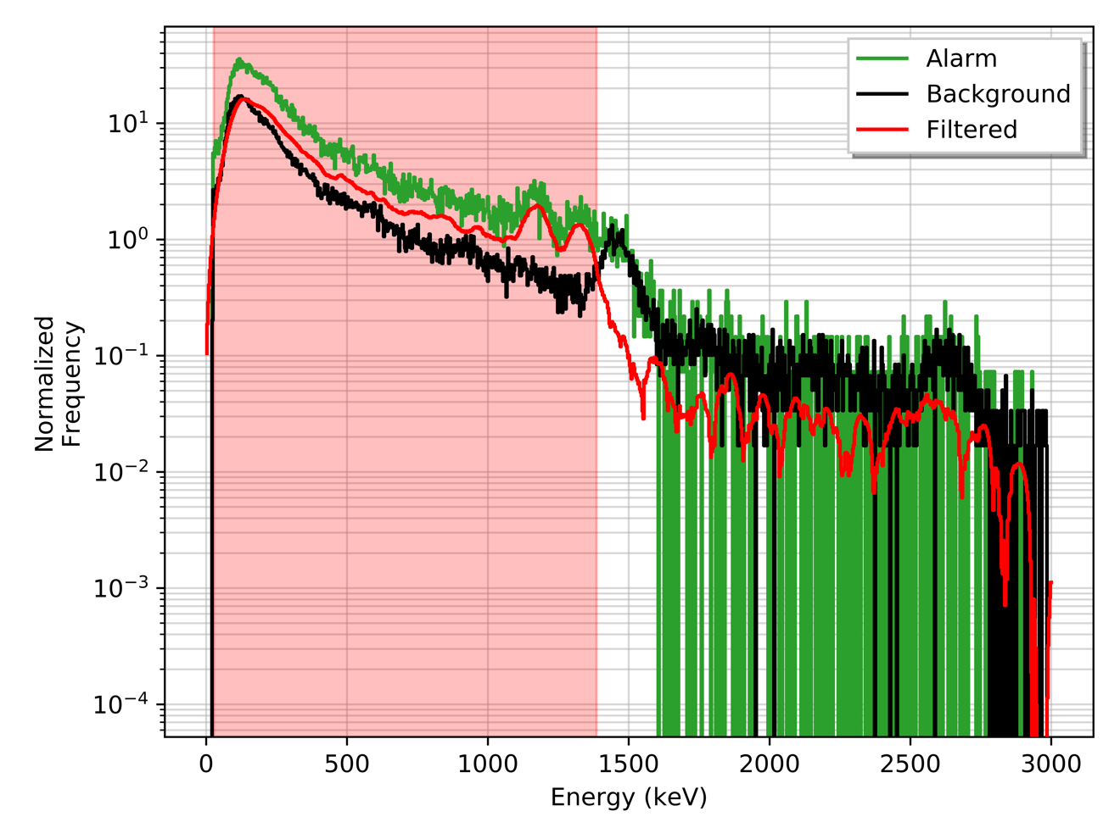
Figure 64: Event 3 region-of-interest from filtered anomalous spectrum at Node04.

From the initial alarm at Node04, two energy peaks are observed around 1.17 and 1.33 MeV with an associated down scatter, most likely resulting from ⁶⁰Co in the radioactive material similar to Event 2. Identical to the previous analysis performed for Event 1 and Event 2, the region-of-interest is utilized in the double detection method where the multiple-linear regression model detection method is operated along with the gross count detection method. The time-series decision metrics for both the single and double detection methods are shown in Figure 65. Again, the decision metrics are normalized for construct a zero-mean, unit variance distribution.

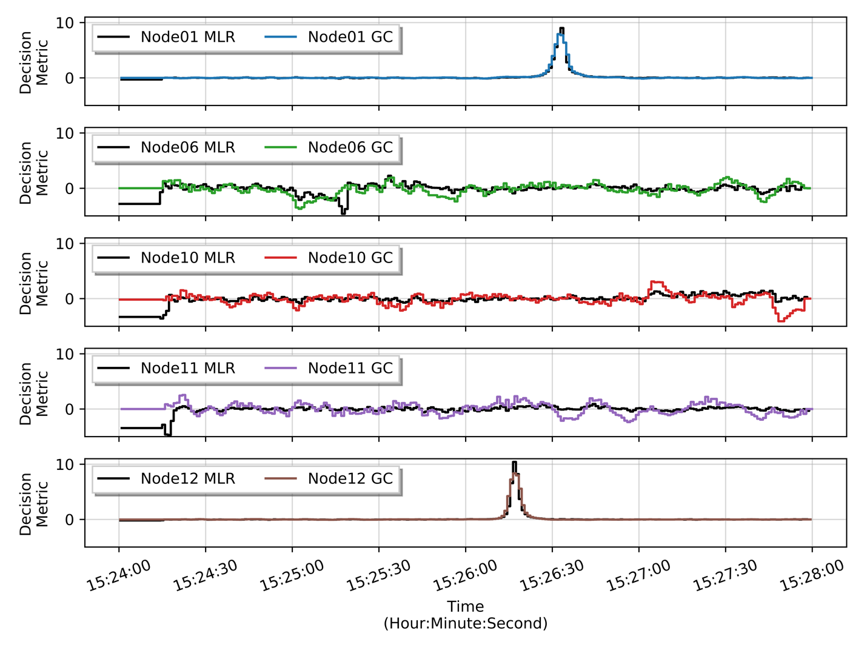
Figure 65: Event 3 decision metric time-series for remaining nodes.

Similar to the previous Event 1 and Event 2, with a 95% and 97.5% confidence, both anomalous events are detected with a slight increase in sensitivity in the region-of-interest approach, visible by a higher decision metric.

The anomalous spectra are provided in Figure 66 for each alarm node with an alarm during Event 3. Identical to the previous analysis on Event 1 and Event 2, the anomalous spectra at each node is then background-subtracted, filtered, and normalized to provide a more accurate comparison. The resulting spectra are overlaid together in Figure 67.

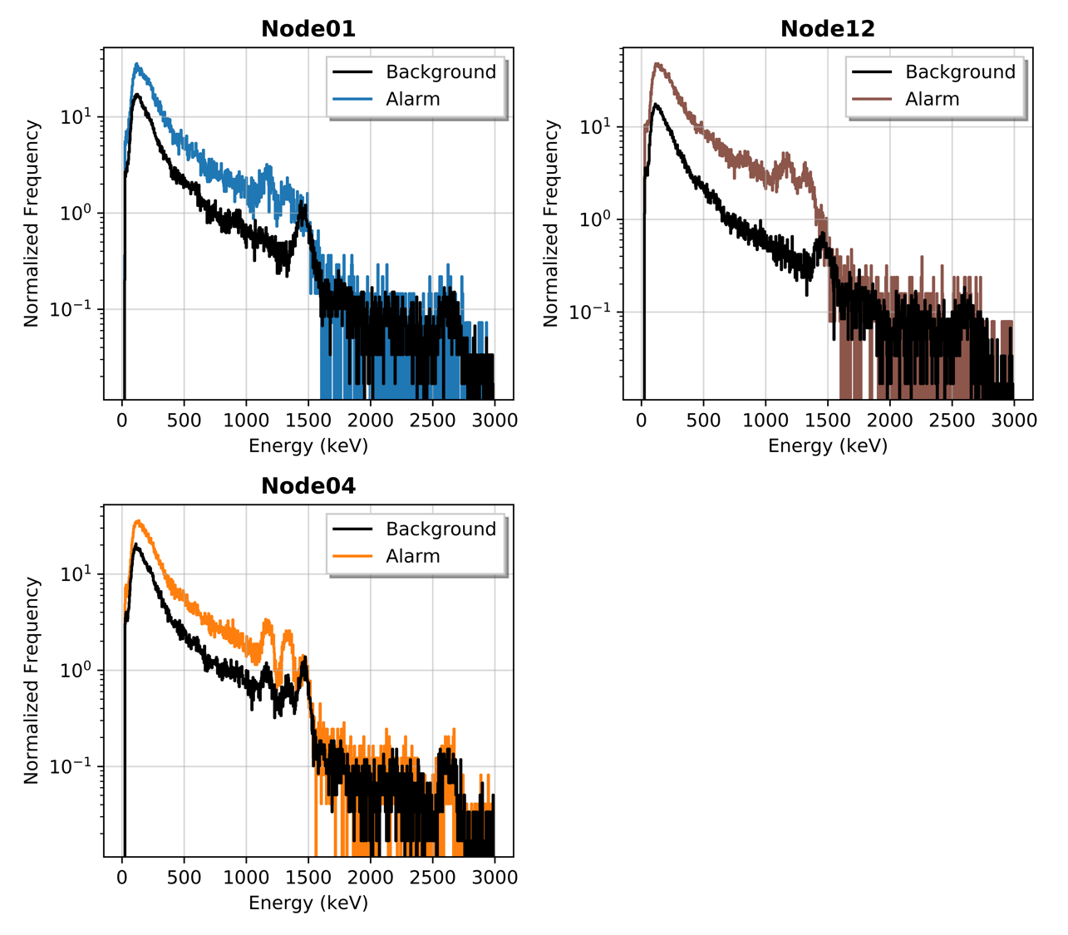
Figure 66: Event 3 alarm and background spectra collected at three nodes.
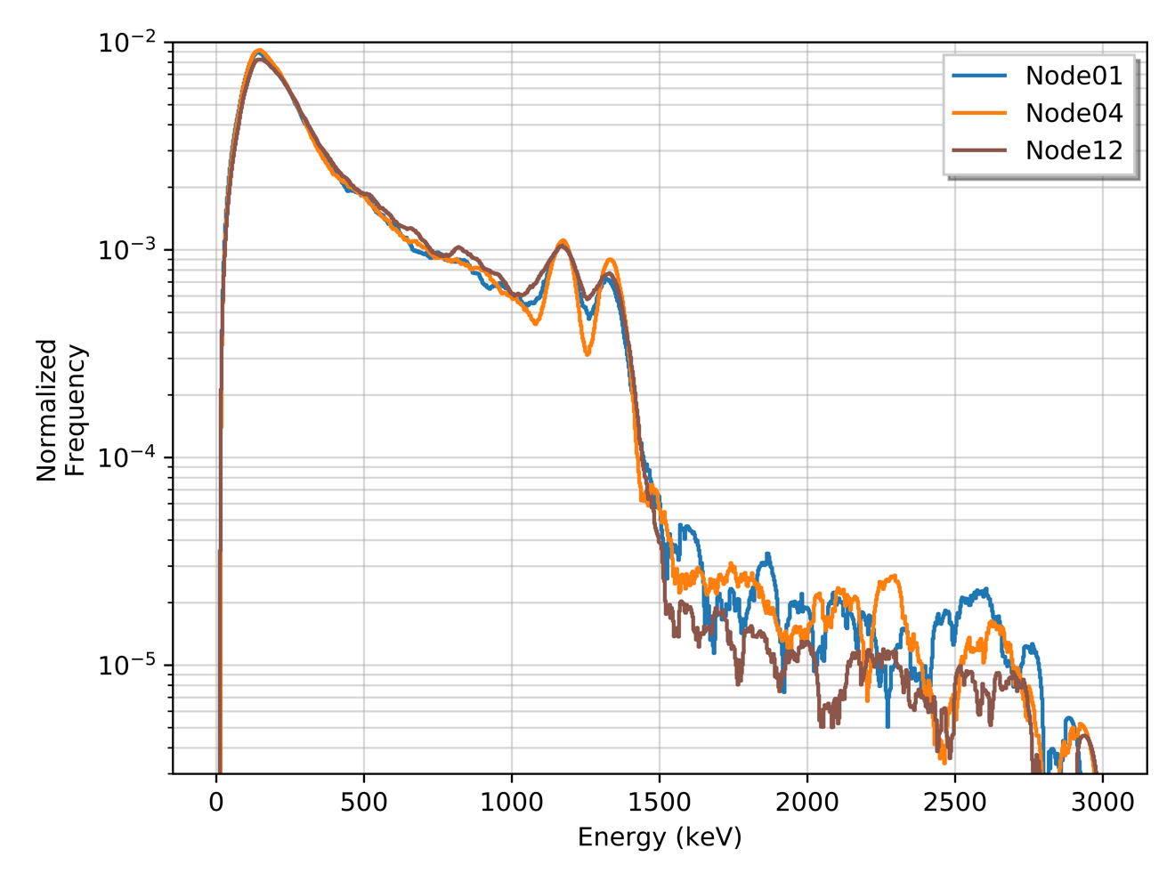
Figure 67: Event 3 anomalous spectra after background-subtracting, filtering, and normalizing.

At lower energies, the peak previously identified around 1.17 and 1.33 MeV appear to align along with similar intensities in the energy bins below 1400 keV. The cosine similarity values for each collected spectrum Node01, Node06, Node10, Node11, and Node12 to the Node04 spectrum is provided in Figure 68 along with the cosine similarity values for the combined anomalous spectra from Node01 and Node12 are provided in Table 8.
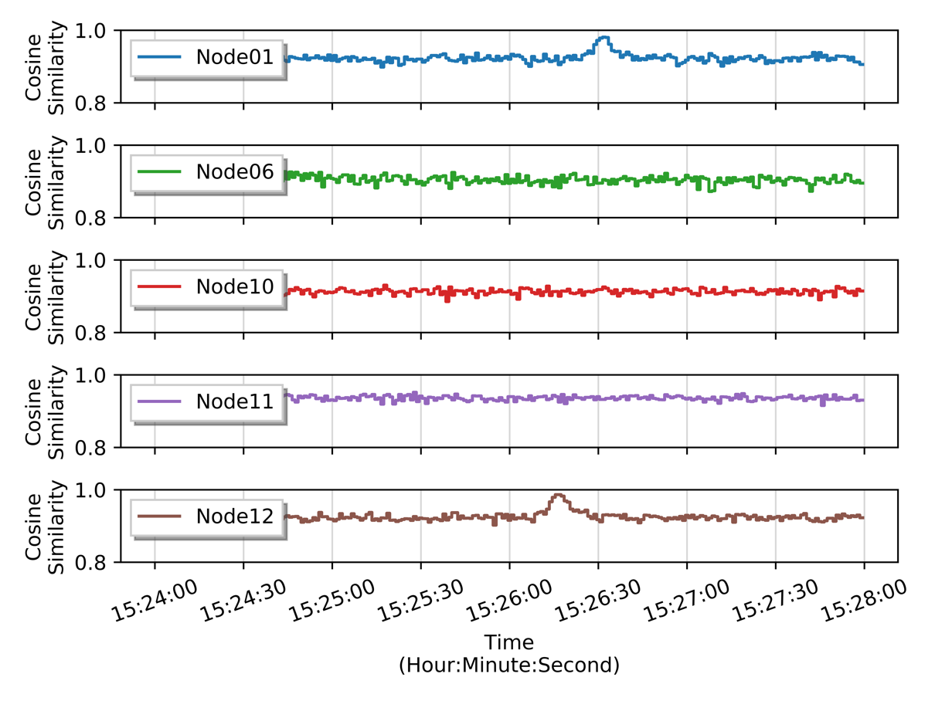
Figure 68: Event 3 cosine similarity time-series.

Table 8: Event 3 cosine similarity values for anomalous spectra.
Node | Cosine Similarity
Node01 | 0.998
Node12 | 0.997

Identical to Event 1 and Event 2, the cosine similarity values in the time-series figure illustrate an interesting issue when attempting to decide whether the collect spectra at each node are samples from the same distribution as the anomalous spectrum from Node04 due to the relatively high cosine similarity values (i.e. greater than 0.85 for nodes in Event 3). Additionally, the combined spectra collected during the anomalous events at Node01 and Node12 provide a much higher cosine similarity values of 0.997 and 0.998, respectively, increasing the confidence that the anomalous spectra are samples from the same radioactive material.
Another extension of this method was observed when utilizing this region-of-interest selection method on real-world data where sources that produced an increase across the entire energy spectrum. This is typically a result of high-energy photon down scatter from neutrons sources interacting with materials between the source and detector. In such cases, a region-of-interest would encompass a majority, or all, of the energy bins in the spectrum, resulting in near-identical detection method in the region-of-interest to the conventional gross counts method. Additionally, the lower count rate typically observed in the higher energy bins can create minute differences in detection sensitivity if the region-of-interest encompasses the majority of energy bins. For this work, a threshold is set to 1.80 MeV, where if the region-of-interest extends beyond the threshold, the region-of-interest methods are not utilized.

4.4: Bayesian Classification Methodology
To remain organized in using raw data and information as it becomes available, this section provides a systematic approach the outputs previously presented on radiation data for robust decision-making. It is important to note that the decision-making process presented are nearly identical to classification processes that are employed for pattern recognition in machine learning with a plethora of literature on numerous unique approaches and background information exists. Thus, if the reader is interested in such process, the author suggests reviewing both decision theory, pattern recognition, and classification theory. [INSERT]

Prior to introducing the decision-making approaches utilized in this work, a few key concepts should be discussed as they create the foundation for the decisions made for the proposed architecture. A significant issue when creating a process to analyze data and make decisions from multiple nodes exists within network communication. Most notably, latency and bandwidth issues can be prevalent and are only further exacerbated when analyzing relatively large datasets at high frequency. Latency quantifies the time delay in transferring data; therefore, a high latency increases the time delay before the data can be transmitted or received. In this work, latency issues are largely ignored as long as the latency either remains relatively small or resolves itself to a lower value in the near feature, before a subsequent event is detected at another node. For distributed sensor networks with large distances between the sensors, the latency should be smaller than the expected travel time between the nodes, which, again, is assumed to not be limiting factor in this scenario. Bandwidth refers to the maximum rate at which data can be transferred and can create a large back log of information that is vital downstream if, for instance, the bandwidth is small relative to the size (e.g. number of bytes) of the data and frequency of transfer. This matter can further be exacerbated if the bandwidth begins to shrink as new nodes are operated simultaneously on the same network. Bandwidth issues can be minimized, if not virtually alleviated, by reducing the size of the data to be transferred over the network. The data queued for transfer over the network can be decreased by processing the data collected from the sensors locally at each node. This type of distributed computing paradigm for minimizing the bandwidth and detection response time locally is often referred to as edge computing. [INSERT] The processed data products, or features, can subsequently be transferred rather than the raw data (e.g. full energy spectra), therefore reducing the total size of the data transferred. Furthermore, unlike in decades past, the current state of computational and processing power in commercially available electronics (e.g. single-board computers) provides the ability to process multiple data streams on a single system. This work assumes all sensor data can be efficiently processed locally, requiring no cloud computing or central processing center.
Thus far, the sequential methodology for analyzing radiation data and tracking anomalies by means of increasing detection sensitivity via the region-of-interest approach and comparing the anomalous spectra via the cosine similarity can be generally explained by Figure 69.

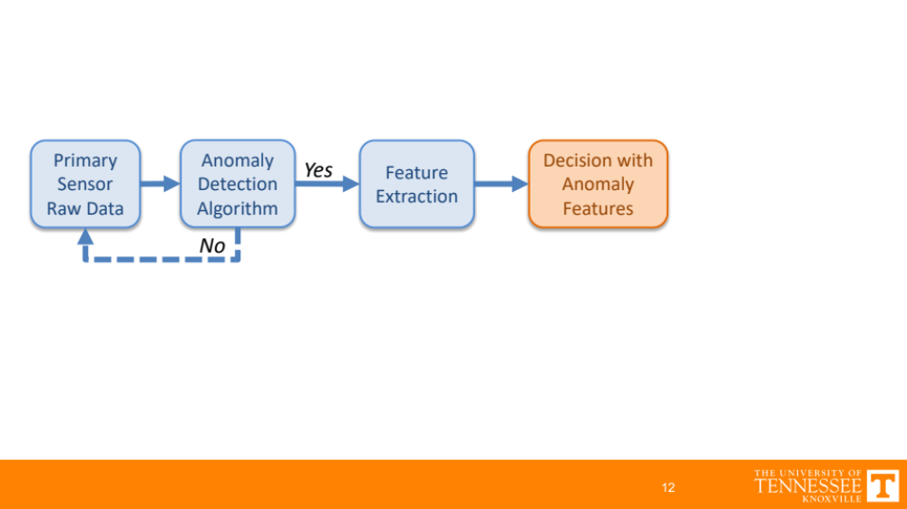
Figure 69: Schematic of single node process for processing radiation sensor data.

Prior to beginning an anomalous event sequence, the data from the primary sensor, in this case a radiation detector, is initially analyzed using the conventional gross counts detection methodology. Upon detection of an anomalous signal using a predetermined decision threshold for that system, the two previously discussed features are extracted: $(1)$ region-of-interest that optimizes the signal-to-noise and $(2)$ background-subtracted, filter anomalous spectra. That information is to be appropriately packaged (i.e. compressed and/or encrypted) and transferred to other nodes on the network. Subsequently, the other nodes in the network utilize the information to improve detection sensitivity and classify if an observed anomaly is similar to the initial anomaly.

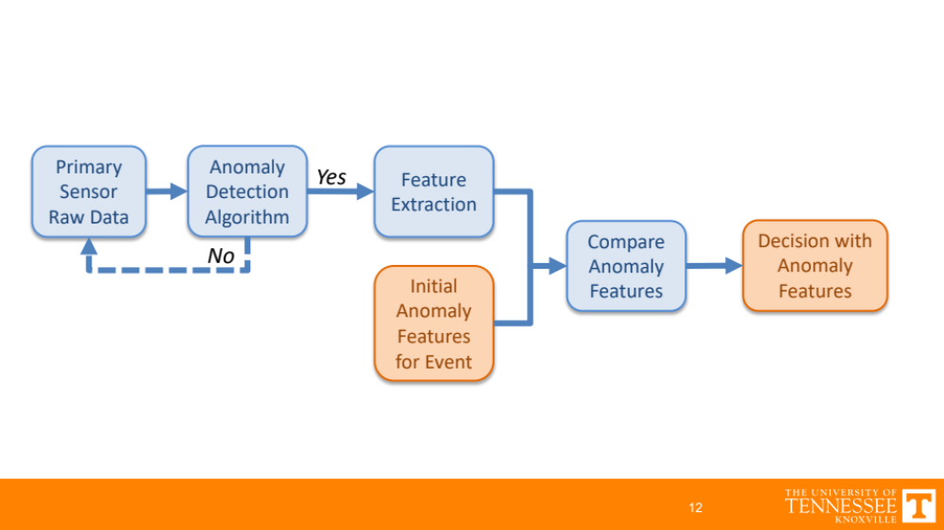
Figure 70: Schematic of single node process for processing radiation sensor data utilizing previous information.

Making a classification by comparing data can be accomplished by performing a series of hypotheses tests on three propositions:

$H_{0}$ : no anomaly is observed;
$H_{1}$ : the local anomaly observed is the same as the initial anomaly for the event; and
$H_{2}$ : the local anomaly observed is different than the initial anomaly for the event.

In such scenarios, the specified propositions, or hypotheses, should be Boolean with either True or False values selected by from a numerical degree of belief. Constructing and testing hypotheses is utilized various reasoning processes and can be extended to update the system beliefs when new information becomes available for statistical inference. This can be accomplished by constructing a Bayesian relationship between the evidence (i.e. output from sensors) and the hypotheses. Bayesian methods for decision theory, often referred to as Bayes classifiers, provide a paradigm to systematically deal with proposition uncertainties when making decision. Bayesian analysis utilizes Bayes’ theorem, provided in the following equation, which is constructed by taking advantage of definitions of the conditional and joint probabilities for the given evidence ($E$) and hypotheses ($H$). A full derivation is provided in the Appendix.

$$P\left(H | E\right)=\frac{P\left(E | H\right) P\left(H\right)}{P\left(E\right)}$$

In many scenarios, such as fusing data from multiple sensors, the evidence and hypotheses parameters are written in vector form. For instance, for the evidence vector $E∈R^{d}$ (i.e. feature vector in d-dimensional space) and $j$-number of hypotheses, the original equation is written as the following.

$$P\left(H_{j} | E\right)=\frac{P\left(E | H_{j}\right) P\left(H_{j}\right)}{P\left(E\right)}$$

This process allows for the probability that a hypothesis ($H$) is true given the evidence ($E$) to be numerically calculated with values typically between 0 and 1, if the normalization probability $P\left(E\right)$ is used to scale the numerator. The normalization probability in the dominator is calculated through the summation of ($j$) possibilities, as show in the following equation.
$$P\left(H_{j} | E\right)=\frac{P\left(E | H_{j}\right) P\left(H_{j}\right)}{\sum_{j}{P\left(E | H_{j}\right) P\left(H_{j}\right)}}$$

The higher the posterior probability for a hypothesis, the more likely that the respective hypothesis is supported by the evidence. Thus, a common method for selecting a hypothesis is to select the hypothesis with the highest posterior probability, which is referred to as the maximum a posteriori, or MAP, decision rule when selecting the mode of the posterior distribution. The denominator can be removed to simplify the calculation as users are often times interested in the hypothesis prediction rather than the actual likelihood value. For instance, the following decision rule could be employed for a two-hypothesis test regime.

Decision 1: Choose $H_{0}$ if $P\left(E | H_{0}\right) P\left(H_{0}\right)$ > $P\left(E | H_{1}\right) P\left(H_{1}\right)$
Decision 2: Otherwise, choose $H_{1}$for $P\left(E | H_{0}\right) P\left(H_{0}\right)$ $≤$ $P\left(E | H_{1}\right) P\left(H_{1}\right)$
Or, in a more shorthand approach with multiple hypotheses, this stated as the following.

Decision: $H^{*}={argmax}_{j} P\left(H_{j} | E\right)$

This is a natural approach to govern the decision space by selecting the decision solely based on the posterior probability, $P\left(H_{j} | E\right)$. Worth noting, this method will observe distinct solutions in various scenarios. For instance, for a given observation $E$, the likelihood functions for two hypotheses are equal (i.e. $P\left(H_{0} | E\right)=P\left(H_{1} | E\right)$ ), this decision-making approach is governed by the priors $P(H_{0})$ and $P\left(H_{1}\right)$. Additionally, if the priors for two hypotheses are equal, this approach is governed solely by the likelihoods.

Using the information previously discussed, classification and decision-making frameworks can be thought of as a network that performs an action based on a function’s output of the data, or evidence, vector. Such frameworks are relatively common for pattern classifiers utilizing both parametric and nonparametric methods. In this context, these functions are typically referred to as discriminant functions and perform an operation that assigns a score to the data from the input space. The discriminant functions $g\left(X\right)$ can create decision boundaries or surfaces that partition the data input space governed by the vector $X$. The primary goal of these functions is to obtain an optimal decision based on the data in the input space. [101] These frameworks are often shown as block diagram or network that illustrates the general process flow from a $d$-dimensional input vector and $c$ discriminant functions to decision or classification; example diagram provided in Figure 71.

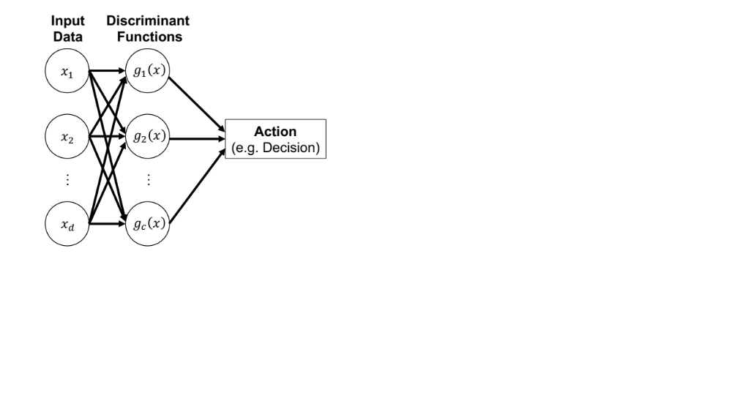
Figure 71: Example network diagram for decision-making process.

Similar to the aforementioned MAP methodology, the highest value output from the discriminant function is used to selects the decision as described by the following.

$Choose decision D_{i} if g_{i}\left(X\right)>g_{j}\left(X\right) for all j≠i$.

In the pure Bayesian context, the discriminant function is generally selected to minimize the risk of taking an action (i.e. minimize the probability of taking a wrong action). In other words, this process produces a classification decision based on estimates of the state of the system represented as outputs of the discriminant functions. This Bayesian risk construct is created by introducing a conditional loss function $λ\left(α_{i} | H_{j}\right)$ if, in this case, the true state of the system is $H_{j}$ and action $a_{i}$ is chosen. Given $P\left(H_{j} | X\right)$, which represents the probability that the true state of the system is $H_{j}$ given the data vector $X$, and conditional loss function, a conditional probability of the risk of choosing action $α_{i}$ given the data vector $X$ is represented as follows. [101]

$$R\left(α_{i} | X\right)=\sum_{j=1}^{c}{λ\left(α_{i} | H_{j}\right) P\left(H_{j} | X\right)}$$

The overall risk is minimized by selecting action $α_{i}$ that provides the smallest conditional risk $R\left(α_{i} | X\right)$, which is commonly referred to as Bayes risk. [101] A vital and sometimes difficult step is selecting the appropriate loss function. Primarily for its simplicity, a zero-one loss function can be employed to minimize the error rate by multiplying the conditional probability $P(ω_{j}|X)$ by either 0 or 1 for an incorrect or correct decision, respectively, representing all errors are equally costly. This is expressed as the following piecewise function.

$$λ\left(α_{i} | H_{j}\right)=\left\{\begin{aligned} 0 i=j \\ 1 i≠j\end{aligned}\right. for i,j=1, …, c$$

Inserting the zero-one loss function into the previous equation for the conditional risk, a simplification is observed due to all incorrect actions being eliminated.

$$R\left(α_{i} | X\right)=\sum_{j=1}^{c}{λ\left(α_{i} | H_{j}\right) P\left(H_{j} | X\right)}$$

$$R\left(α_{i} | X\right)=\sum_{j≠i}^{c}{ P\left(H_{j} | X\right)}=1-P\left(H_{j} | X\right)$$

With this relationship, it is observed at the conditional risk is minimized when the posterior probability $P\left(ω_{j} | X\right)$ is maximized. Thus, using the zero-one loss function results in an identical decision rule as the previous MAP decision rule. Using this relationship, the minimum conditional risk or the posterior probability can be utilized as the discriminant function to minimize the conditional risk or the error rate, respectively.

$$Minimize conditional risk: g_{i}\left(x\right)=-R\left(α_{i} | X\right)$$
$$Minimize error rate: g_{i}\left(x\right)=P\left(H_{j} | X\right)$$

The error rate minimization is often presented as the product of the likelihood and prior probability, which recall is equal to the posterior probability after removing the evidence probability $P\left(X\right)$ that normalizes, or scales, the product. Furthermore, the natural logarithm is commonly utilized on the discriminant function resulting in a summation rather than a product as shown in the following.

$$\ln{g_{i}\left(x\right)}=\ln\left(P\left(X | H_{j}\right) P\left(H_{j}\right)\right)$$

$$\ln{g_{i}\left(x\right)}=\ln{P\left(X | H_{j}\right)}+\ln{P\left(H_{j}\right)}$$

Prior to creating the decision surfaces for the data collected from the radiation sensors, it is vital to first construct the likelihood and prior probabilities. Continuing with the framework previously provided in Figure 71, the input data vector $X$ contains the features from the radiation data stream; namely, the cosine similarity. In this work, two additional features are added to the input layer that represent estimates of the probability of the count rate is an anomaly and the time of arrival probability to the sensor. The notations for each are parameter in the input data vector $X$ are described in the following list.

$x_{0}$ : cosine similarity value between initial anomaly spectrum and local spectrum;
$x_{1}$ : probability observed count rate is an anomaly; and,
$x_{2}$ : expected time-of-arrival initial anomaly.

With the parameters now defined, the original Bayesian equation can be expanded to reveal how the actual posterior $P(H_{j}|X)$ is calculated, as shown in the following.

$$P\left(H_{j} | X\right)=\frac{P\left(X | H_{j}\right) P\left(H_{j}\right)}{P\left(X\right)}=\frac{P\left(X | H_{j}\right) P\left(H_{j}\right)}{\sum_{i}{P\left(X | H_{i}\right) P\left(H_{i}\right)}}$$

$$P\left(H_{j} | x_{0},x_{1},x_{2}\right)=\frac{P\left(x_{0} | H_{j}\right) P\left(x_{1} | H_{j}\right) P \left(x_{2} | H_{j}\right) P\left(H_{j}\right)}{\sum_{i}{P\left(x_{0} | H_{i}\right) P\left(x_{1} | H_{i}\right) P\left(x_{2} | H_{i}\right) P\left(H_{i}\right)}}$$

Again, this assume the likelihood functions for the three parameters are independent of one another, which eliminates the conditional probabilities between the data parameters. Of note, assuming the data parameters are independent in this way is often referred to as the naïve Bayes method. If solely the output values of the posterior are utilized in that the maximum value will be selected as the classification, the normalization factor in the denominator will no longer be required to scale the values between 0 and 1.

$$P\left(H_{j} | { x}_{0},x_{1},x_{2}\right)=P\left(x_{0} | H_{j}\right) P\left(x_{1} | H_{j}\right) P\left(x_{2} | H_{j}\right) P\left(H_{j}\right)$$

However, in this work, the posterior probabilities will be sequentially updated, thus requiring the normalizing factor in the denominator to scale the values. At this point, the conditional probabilities for each data parameter and the prior distributions for the three hypotheses need to be calculated. The prior distribution will be sequentially updated by utilizing the previous time step’s posterior but requires an initial value. The initial values are selected rather heuristically by using the following values, where $x_{1,B}$ represents the background, or historic, count rate data.

$$P\left(H_{0}\right)=P\left(x_{1,B} | H_{0}\right)$$

$$P\left(H_{1}\right)=0.01$$

$$P\left(H_{2}\right)=P\left(x_{1,B} | H_{2}\right)$$

Although an original assumption in this work is that no signal will be simultaneously observed at multiple node, the probability that the current state is same anomaly, or $P\left(H_{1}\right)$, is specified as 0.01, rather than zero. This eliminate a zero probability from existing after obtaining the product in the numerator of Bayes’ formula. The $P\left(H_{0}\right)$ and $P\left(H_{2}\right)$prior distributions are selected to reflect the system state is governed initially by the observed count rate for no anomaly and different anomaly, respectively. This method for initializing $P\left(H_{0}\right)$ and $P\left(H_{2}\right)$ provides a straightforward method for calculating the specific values by using a previous time step’s background count rate data, denoted at $x_{1,B}$, rather than arbitrarily selecting a fixed value. Lastly, the prior probabilities are renormalized to force the $P\left(H_{1}\right)$ to the specified value of 0.01. The conditional probabilities will be constructed in the following sections for each parameter in the data vector $X$.

4.4.1: Cosine Similarity Conditional Probability
Recall that the cosine similarity values attempt to provide a degree of belief that the local spectrum is a sample from the same radioactive material observed in the initial anomaly. It is shown in the cosine similarity time-series figures (i.e. see Figure 62, Figure 65, and Figure 68) that normal background spectra values remain relatively high with a mean values around 0.85 for all three examples. The actual anomalous spectra observed similarity values greater than 0.97 for the individual, 1-second anomalous spectra and similarity values greater than 0.99 for the combined anomalous spectra in all three events. With this information, the conditional probabilities can be constructed. A normal, or Gaussian, distribution can be utilized to construct the conditional probability, which requires two parameters to be selected; namely, mean and variance. Each conditional probability is addressed in order for $P\left(x_{0} | H_{0}\right)$, $P\left(x_{0} | H_{1}\right),$ and $P\left(x_{0} | H_{2}\right)$.

First, constructing the conditional probability that the cosine similarity value is observed given that system state is no anomaly ($H_{0}$) is created by utilizing by the cosine similarity values prior to the initial anomaly being detected. This allows for the expected cosine similarity mean and variance for $H_{0}$ to be estimated solely based on each sensor’s background spectrum and produces unique results for each sensor. This step is vital as the background energy spectra can drastically vary spatially. For all three examples, 30-seconds of spectral data is utilized to obtain an estimate of the mean and variance. In this particular case, all three examples had cosine similarity near identical means and variances with expected values at approximately 0.85 and 0.009 for the mean and variance, respectively.

Second, the conditional probability that the cosine similarity value is observed given that system state is same anomaly ($H_{1}$) is created by coupling the observed values from the anomalies in the three examples with the theoretical expectation. Recall that if the two samples under comparison using the cosine similarity approach, a perfect match equates to a value of 1.0. Thus, the expected mean of the conditional probability is set to 1.0 with a variance 0.0025, which allows for values to slightly differ from an exact match and limits the values around the typically observed no anomaly values. This conditional probability is a truncated normal distribution as values above 1.0 are not possible, resulting in only the lower half of the distribution being considered, as shown in the example provided in Figure 74.

Lastly, the conditional probability that the cosine similarity value is observed given that system state is different anomaly ($H_{2}$) requires more detail prior to constructing. With no prior information regarding detecting radioactive material with unknown spectral features, the resulting conditional probability remain robust to encompass all possible scenarios, even a different radioactive material with a similar signature as the initial. Furthermore, the cosine similarity methodology has yet to be utilized for a different radioactive source in this work. Recall that for radioactive materials with spectral features in the higher energy region of the spectrum (i.e. >1500 keV) and no features in the lower energy region, will generally maintain similarity values as the photon downscatter region will remain similar in shape. Two scenarios from the ORNL sensor array, referred to as Different Alarm in this scenario, are provided to examine the impact different spectral feature in the lower energy region impact the cosine similarity values. Both are compared other anomalies detected on Node04 in the ORNL sensor array on different days and are compared to the anomalous spectrum observed from Event 3 (see Figure 64 and Figure 66), which is represented as Initial Alarm in this scenario. The first example (Figure 72) is a radioactive material with a prominent photopeak around 60 keV most likely resulting from a radioactive material with Am-241 (i.e. gamma-ray emission at 59.5 keV). The second example (Figure 73) is the observed Node04 anomalous response during Event 1 shown previously (see Figure 52) that shows relatively large deviations from the initial alarm from 500 keV to 1100 keV.

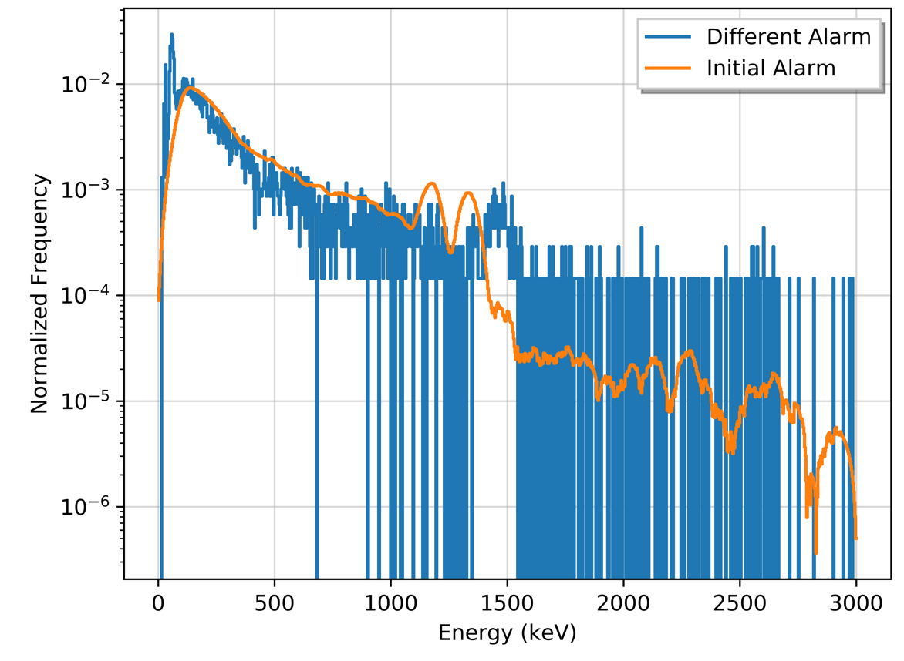
Figure 72: Energy spectra for Scenario 1 comparing different anomalous spectra from Node04.
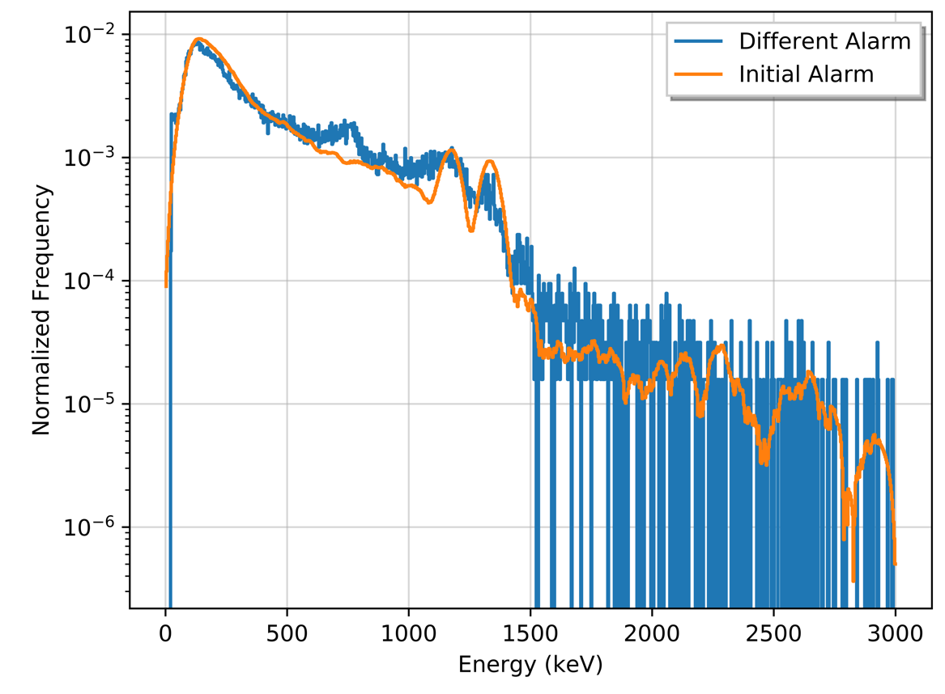
Figure 73: Energy spectra for Scenario 2 comparing Event 1 and Event 3 anomalies from Node04.

The cosine similarity values between the different anomalous spectra Scenario 1 and Scenario 2 and the initial alarm are 0.747 and 0.987, respectively. These results highlight the reasoning for using a conditional probability for $H_{2}$ to encompass a multitude of scenarios, including larger discrepancies, such as Scenario 1, and similar, or even nearly identical, sensor responses from a different radioactive material, such as Scenario 2. To cover the regions in the probability space, a normal distribution with a relatively large variance is utilized with a mean between the expected values for the no anomaly and same anomaly hypotheses. For this work, the mean and variance are obtained for this hypothesis by selected a mean 5% higher than the background, or no anomaly, values and a variance equal to 1% of the selected mean. These values are selected as they encompass the physical expectations of this hypothesis, but more optimal solutions may be possible if a full sensitivity analysis were to be performed. Additionally, a different radioactive material with identical, or near-identical, photon emissions could enter the area being monitored by the sensor array, which could force the Bayesian framework to classify the different material as same anomaly based on the high cosine similarity values. Such a scenario is deemed highly unlikely by the author and is not addressed in this work, but it is worth noting.

With these methods for calculating the means and variances of the conditional probabilities for each hypothesis, the probabilities can be constructed assuming a normal distribution. For instance, this approach applied to Node01 in Event 1 provided the following mean and variance for each hypothesis. The tilde symbol ($\sim$) means that the parameter, or in this instance the conditional probability, is distributed as the function provided, $N$ is a normal distribution, and $E$ represents the expected value.

$P\left(x_{0} | H_{0}\right) \sim N\left(μ_{0}, σ_{0}^{2}\right) with E\left(μ_{0}\right), {E(σ}_{0}^{2})=0.85, 0.01$
$$P\left(x_{0} | H_{1}\right) \sim N\left(μ_{1}, σ_{1}^{2}\right) with E\left(μ_{1}\right), {E(σ}_{1}^{2})= 1.00, 0.003$$
$$P\left(x_{0} | H_{2}\right) \sim N\left(μ_{2}, σ_{2}^{2}\right) with E\left(μ_{2}\right), {E(σ}_{2}^{2})=0.91, 0.01$$

Using these parameters, the conditional probabilities are provided in Figure 74.

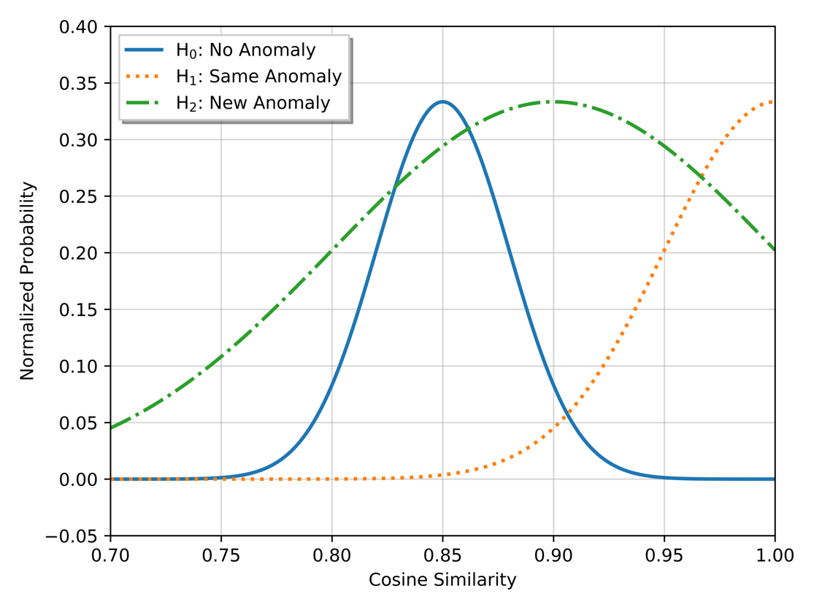
Figure 74: Cosine similarity conditional probability for Node01 in Event 1.

The probabilities do not exist above a cosine similarity value of 1.0 as a value greater than 1.0 is impossible and, more importantly, Figure 74 shows the amount of overlap between the probabilities. Recall that a large overlap between distribution decreases a classifier’s sensitivity and potentially increasing the false-positive rate. Utilizing other parameters can alleviate this issue or, at the very least, increase the system’s sensitivity.

4.4.2: Count Rate Conditional Probability
Given that the radiation emission process follows a Poisson process, the probability that an observed count rate is an outlier is relatively trivial. As a discrete distribution, the Poisson distribution can be utilized to calculate expected time to obtain a specific number of events given the mean of the rate ($μ$) for the data, as shown in the following.

$$Poisson\left(k events in time interval\right)=e^{-μ}\frac{μ^{k}}{k!}$$

Using this relationship in the context for radiation count rate data, the rolling-window method is utilized to obtain the probability that the observed count rate is an anomaly from the expected, background count rate. For instance, if the mean count rate ($μ_{CR}$) in the background window is 1800 and a value of 1875 is observed. The probability of observing a value of 1875 of less if 96%, which means the probability of observing a value greater than 1875 if 4%, as shown in Figure 75.

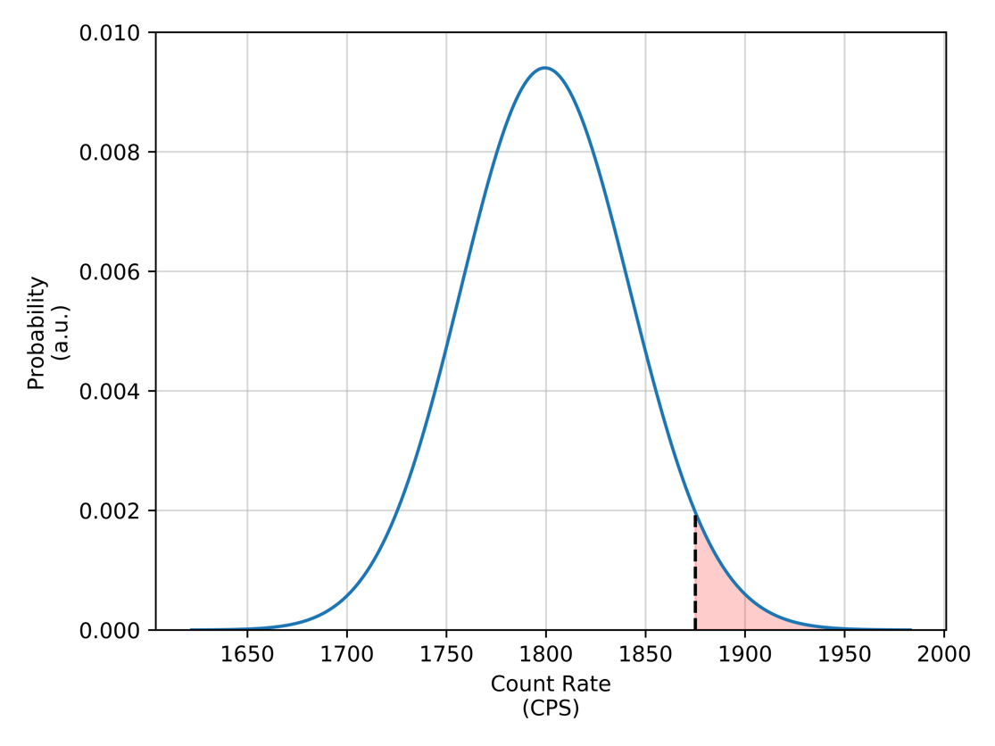
Figure 75: Example Poisson distribution for arbitrary count rate data.

In the context of this work, count rate anomalies are expected to be above the mean of the background as this work does not address count rate suppression anomalies. Therefore, the conditional probabilities for $P\left(x_{1}\right|H_{1})$ and $P\left(x_{1}\right|H_{2})$can be expressed as opposite of $P\left(x_{1}\right|H_{0})$ above its mean. Both of the conditional probabilities $P\left(x_{1}\right|H_{1})$ and $P\left(x_{1}\right|H_{2})$ are equal in this regime, as no information is utilized to discriminant between the two hypotheses solely based on the observed count rate. Additionally, in the absence of any contextual information regarding the relative position of the radioactive material to the radiation sensor, no estimate for the activity can be made and, thus, the likelihood values remain equal for all large count rate values. Using the previous example for a mean count rate of 1800, Figure 76 shows the conditional probabilities for $P\left(x_{1}\right|H_{0})$, $P\left(x_{1}\right|H_{1})$, and $P\left(x_{2}\right|H_{2})$ normalized to sum to 1.0. The conditional probabilities are only shown above the mean as count rates below the mean are not classified as anomalies. Furthermore, in order to address an issue that will arise in later sections of this work, an increase of 0.01 to the conditional probabilities $P\left(x_{1} | H_{1}\right)$ and $P\left(x_{1} | H_{2}\right)$ is applied in order to eliminate the probabilities from being exactly zero. This addition provides a minute change to the distribution by allowing the posterior probabilities to exist for all real values without greatly impacting the overall probabilities. As a result, the conditional probability $P\left(x_{1} | H_{0}\right)$ below the mean can then be expressed in $P\left(x_{1} | H_{0}\right)=0.98$ for $x_{1}≤μ_{CR}$.

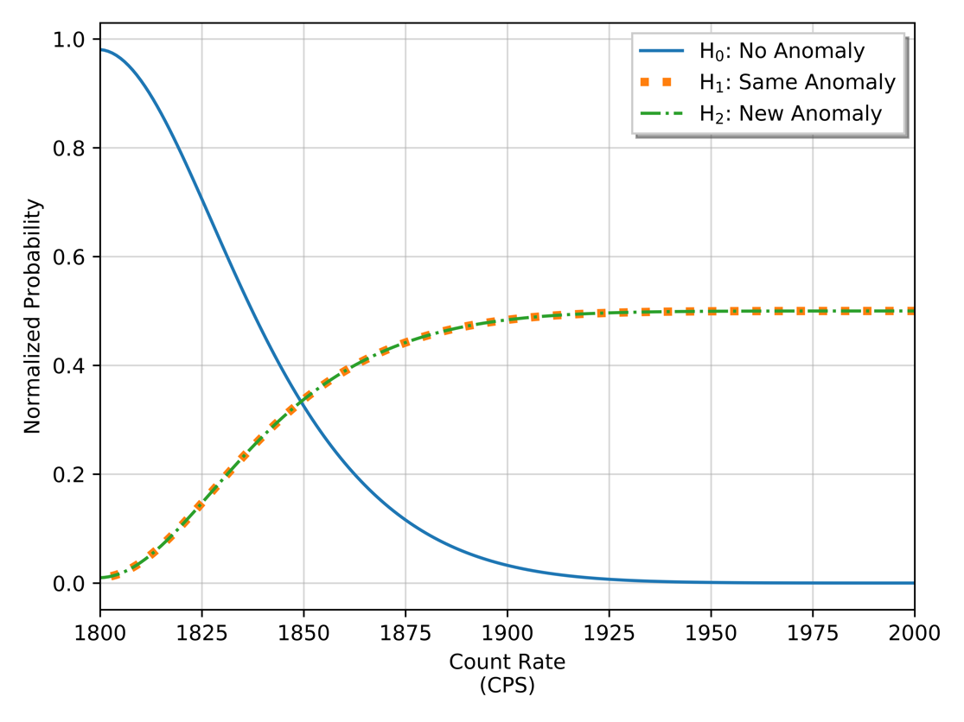
Figure 76: Count rate conditional probabilities for arbitrary count rate data.

It worth noting that modelling radiation count rate as a Poisson random variable may introduce significant error in predicting anomalies as other parameters other than the radiation emission process contribute to the observed count rate, such as fluctuations in system’s electronics, dynamic environment in the vicinity of the system, or weather patterns. These fluctuations increase the variance in the data, widening the distribution. To overcome these issues as normal distribution could be utilized as a substitute for the Poisson as the mean count rate is typically large enough and, along with the variance, can easily be obtained from historic data in a rolling-window. As a continuous distribution, the normal distribution is not able to calculate an exact probability of observing a discrete sample.

4.4.3: Expected Time-of-Arrival Conditional Probability
In the early stages of this work, an observation was made when analyzing data from distributed sensors in an attempt to correlate observed signals across the network in the absence of any contextual data or ground truth information. Nonphysical observations were found in which a radioactive material (e.g. medical radioisotope) was detected from a sensor in the network and subsequently detected at a distant location in a relatively short time period. The expected travel time between the two sensors was far greater than the elapsed time between the two similar signals (e.g. 2 seconds between sensor alarms positioned 10 miles apart along a roadway). To overcome this issue initially, a minimum elapsed time after the initially anomaly was manually specified. Rather than having to manually specify a minimum elapsed time, the conditional probabilities can be constructed to remove nonphysical scenarios. Unfortunately, this concept only effects the $H_{1}:same anomaly$, as the other two hypotheses are equally likely, or uniform, as time elapses.

Assuming that the expected travel time between sensors on the network is known via onboard GPS modules or the node positions are known beforehand, the conditional probability $P\left(x_{2} | H_{1}\right)$ can be constructed using an exponentially modified normal distribution. This function is created using the left, lower portion of a normal distribution and applies an exponential decay after the peak at the mean value. The variance used for the normal distribution should reflect the expected travel time, primarily effecting the probability at lower time values. The exponential tail is necessary in this case as expected travel times can vary drastically between two points due to a multitude of reasons (e.g. traffic, weather, stops along the route, etc.) and multiple pathways can exist, all of which result in a longer-than expected travel time.

To add context, assume an expected travel time ($μ_{t}$) between the sensor that initially observed the anomaly and a subsequent sensor in the network is 15 minutes. Additionally, it is assumed that the expected travel time is obtained from a reputable source (e.g. live time traffic maps) increasing the confidence in that expected travel time, thus a standard deviation ($σ_{t}$) of 20% of the mean (i.e. 3 minutes, in this instance) is utilized. A decay constant for the exponential tail is obtained by assuming the probability is 25% of the mean at twice the mean; calculated as follows.

$$T=T_{0}e^{-λt}$$

$$λ\left(0.25\right)=-\frac{\ln\left( T/T_{0} \right)}{2 t_{exp}}=-\frac{\ln\left(0.25\right)}{2*15min}$$

A piecewise function is created to combine the two function over the specific sub-domains of $x_{2}$.

$$P\left(x_{2} | H_{1}\right)=\left\{\begin{aligned}N\left(μ_{t},σ_{t}^{2}\right) if t≤μ_{t} \\ T_{0}\exp\left(-λ t\right) if t>μ_{t}\end{aligned}\right.$$
$P\left(x_{2} | H_{0}\right)$ and $P\left(x_{2} | H_{2}\right)$ are modelled as uniform distributions as the likelihood of observing the two scenarios are equally likely at any time. To sum to a likelihood of 1.0, the $P\left(x_{2} | H_{0}\right)$ and $P\left(x_{2} | H_{2}\right)$ conditional probabilities are calculated as follows.

$$1=\sum_{j=0}^{2}{P\left(x_{2} | H_{j}\right)}=P\left(x_{2} | H_{0}\right)+P\left(x_{2} | H_{1}\right)+P\left(x_{2} | H_{2}\right)$$

$$1=P\left(x_{2} | H_{0}\right)+2\left(P_{1,2}\right) where, { P}_{1,2}=P\left(x_{2} | H_{1}\right)=P\left(x_{2} | H_{2}\right)$$

$$P_{1,2}=\frac{1-P\left(x_{2} | H_{0}\right)}{2}=P\left(x_{2} | H_{1}\right)=P\left(x_{2} | H_{2}\right)$$

Using this information along with the assumption made for this example scenario, the conditional probability $P\left(x_{2} | H_{1}\right)$ is constructed along with the uniform distributions for $P\left(x_{2} | H_{0}\right)$ and $P\left(x_{2} | H_{2}\right)$, as shown in Figure 77.
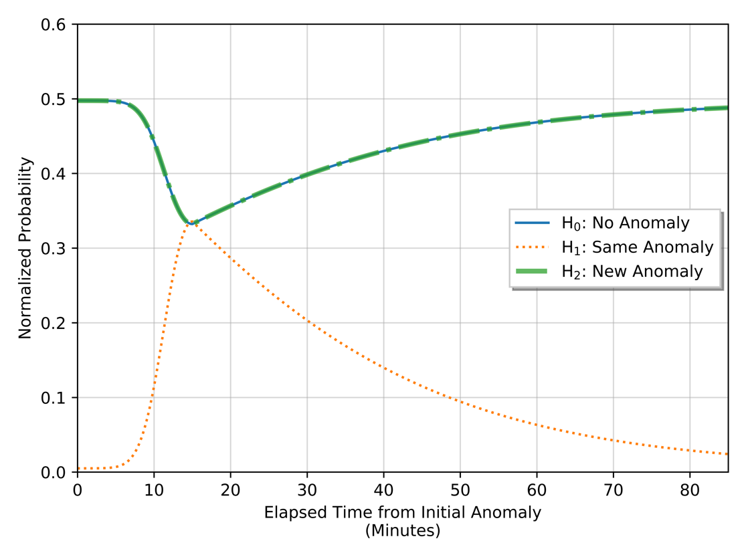
Figure 77: Expected time-of-arrival conditional probabilities for arbitrary data.

Worth mentioning, $P\left(x_{2} | H_{2}\right)$ conditional probability could be modified if the expected likelihood for a new anomaly is significantly low. For instance, if the sensor network is located in a remote area that typically observes a low anomaly rate due to the locations being monitored, conditional probability$P\left(x_{2} | H_{2}\right)$ should be decreased, as the likelihood is not equal to $P\left(x_{0} | H_{2}\right)$. This would increase $P\left(x_{2} | H_{1}\right)$ while decreasing $P\left(x_{2} | H_{0}\right)$ and would directly impact the posterior probabilities $P\left(H_{j} | X\right)$ calculated. For a proof-of-concept, this work utilizes the previous methods of assuming equal, uniform distribution for $P\left(x_{2} | H_{0}\right)$ and $P\left(x_{2} | H_{2}\right)$ and does not address altering the $P\left(x_{2} | H_{2}\right)$ conditional probability as it is operational dependent.

4.4.5: Overview of Bayesian Framework Procedure
This section compiles the previous sections to provide a brief, more organized procedure from the initial anomaly to extracting the data features from the radiation data, constructing the conditional probabilities, and calculating the posterior probability. Prior to detecting sensor data as an anomaly, each node in the network follows the procedure shown in Figure 78.

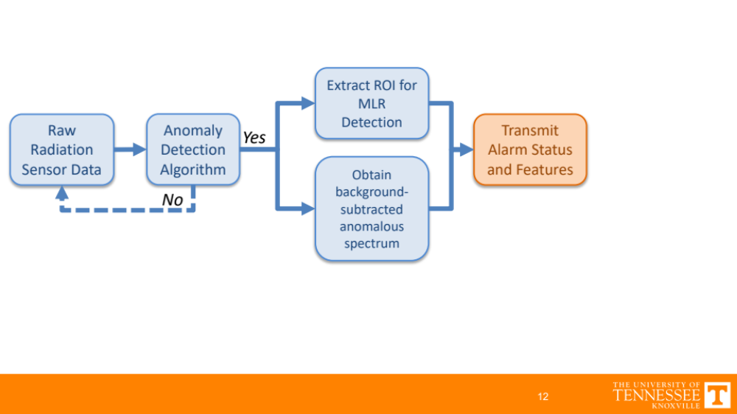
Figure 78: Schematic of initial alarm node procedure.

Using the methods described in the previous sections for determining the region-of-interest to increase detection sensitivity along with calculating a combined background-subtracted spectrum during the observed anomaly, the resulting timestamped information can be compressed and transmitted to other nodes in the network. The subsequent nodes in the network use the features from the initial anomaly to construct the conditional probabilities and perform the hypothesis test to classify the local node’s information as one of the three hypotheses. Figure 79 provides an overview of this process.

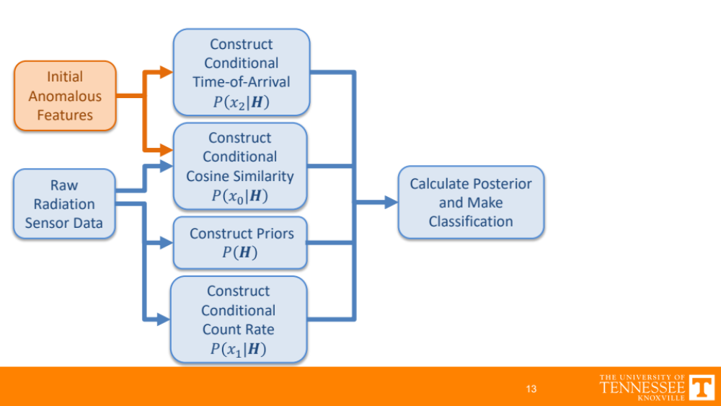
Figure 79: Schematic for constructing Bayesian beliefs after initial alarm.

The exact procedure utilized to construct the initial prior and conditional probabilities is expressed in the following Figure. This procedure does require normalization in order scale the probabilities to sum to unity and is performed in later analysis of the previous three example events from the ORNL sensor array.

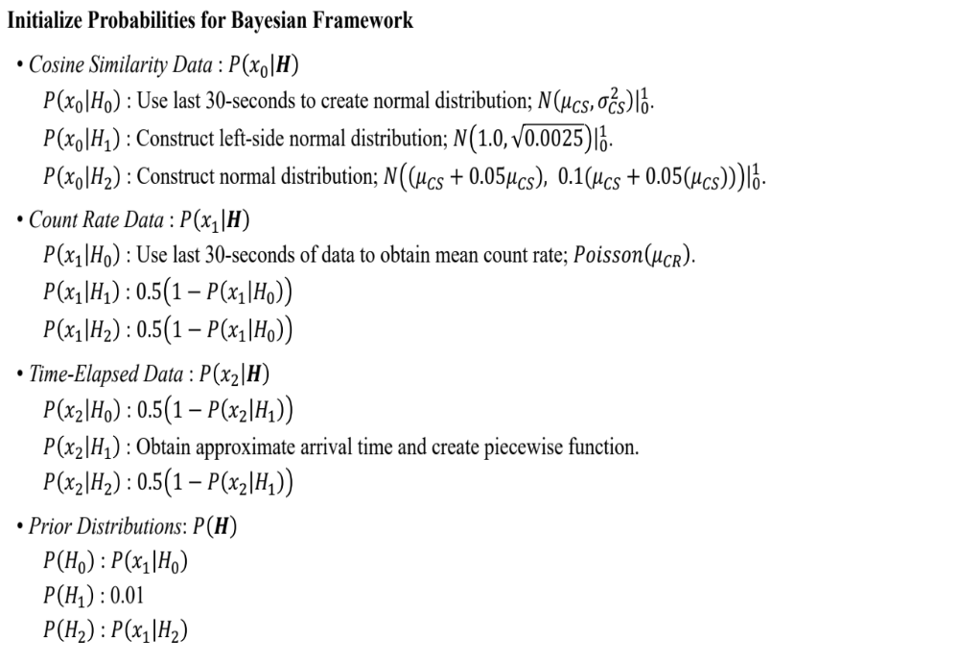
Figure 80: Initialization process of prior and conditional probabilities for Bayesian framework.

The posterior $P{\left(X | H\right)}_{t}$ of the current timestamp $\left(t\right)$ is used as the following timestamp $\left(t+1\right)$ prior $P{\left(H\right)}_{t+1}$to continuously update the system belief. Additional context is provided in the following section where the processes are utilized on the three example scenarios previously described from the ORNL sensor array.

4.4.6: Bayesian Framework on ORNL Sensor Array
Using the methods described in the previous sections to construct the conditional probabilities, the posterior probability, which recall is the optimal discriminant function when minimizing the error rate (see page 125), is calculated for the three anomalous events on the ORNL sensor array presented in Section 3.3: Analysis of Sensor Array. The examples are use the identical designation of Event 1, Event 2, and Event 3 and analyzed in the following pages. For reasons that will be addressed in shortly, the analysis performed on Event 3 is present first followed by Event 1 and Event 2.

Recall that the alarm sequence for Event 3 started at Node04 and subsequently observed at Node12 and Node01. Using the process outlined in Figure 80, the radiation data is utilized to construct the prior and conditional probabilities. Approximations for the time-of-arrival are created by assuming the radioactive material is travelling at the local speed limit of 20 MPH for a linear distance calculated from the GPS modules at each node. Upon initialization of the probabilities, the posterior probabilities for each of the three hypotheses are calculated and sequentially updated as new data is obtained. The resulting time-series, normalized posterior probabilities for Event 3 are provided in Figure 83.

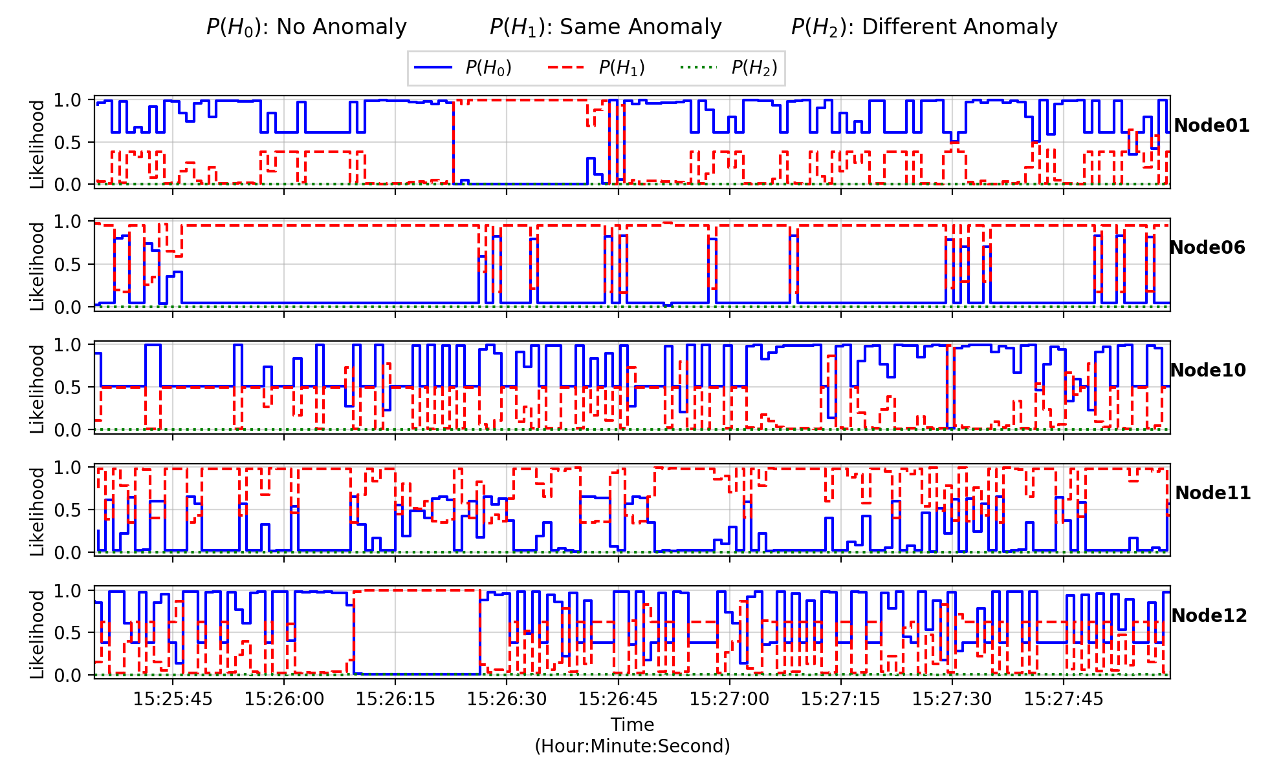
Figure 81: Event 3 posterior probabilities using the Bayesian framework.

The observed posterior probabilities alternate between $P\left(H_{0}\right)$ and $P\left(H_{1}\right)$, even at locations where the radioactive material was not detected (e.g. Node06, Node10, and Node11). This is primarily attributed to the high cosine similarity values between the normal background energy spectra and the initial anomalous spectra from Node04 (see Figure 68 for cosine similarity time-series data). The average cosine similarity values for the nodes ranged from 0.91 to 0.94 for the normal background energy spectra. To overcome this issue, the conditional probabilities are weighted to better represent their importance in the hypothesis test. If the cosine similarity values for the historic 30-second normal background energy spectra are above 0.90, the prior distributions are weighted more heavily towards the observed count rate and lowered for both the cosine similarity and the time-of-arrival. The specific weights are provided in the following relation for a given mean cosine similarity value $\left(μ_{CS}\right)$ for the background energy spectra.

$$If μ_{CS}≥0.90:$$
$$P\left(x_{0}|H\right)=0.05\left(P\left(x_{0}|H\right)\right)$$
$$P\left(x_{1}|H\right)=0.90\left(P\left(x_{1}|H\right)\right)$$
$$P\left(x_{2}|H\right)=0.05\left(P\left(x_{2}|H\right)\right)$$
$$Otherwise:$$
$$P\left(x_{0}|H\right)=0.40\left(P\left(x_{0}|H\right)\right)$$
$$P\left(x_{1}|H\right)=0.40\left(P\left(x_{1}|H\right)\right)$$
$$P\left(x_{2}|H\right)=0.20\left(P\left(x_{2}|H\right)\right)$$

As shown in the previous relation, the weights are also applied during scenarios with lower cosine similarity values. Additionally, the weighting scheme lowered the dependency on the time-of-arrival data, as these values can vary drastically vary and is not expected to have a high contribution to the classification process. This weighting scheme proposed will be utilized moving forward. The results for Event 3 using the updated weighting scheme are shown in Figure 82.

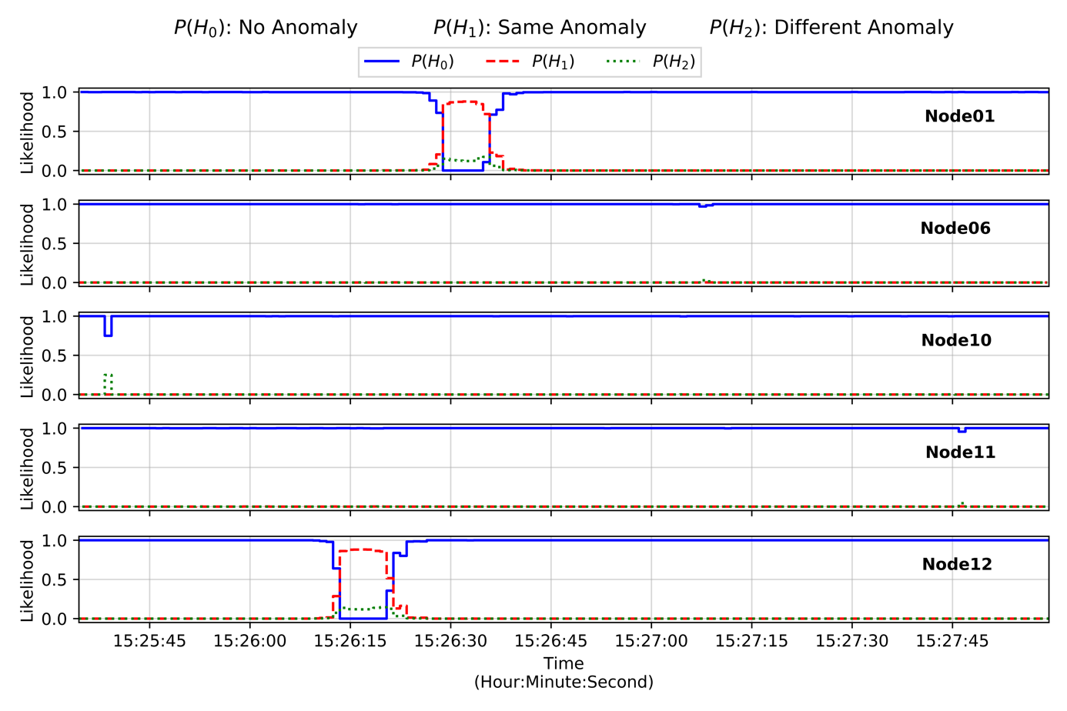
Figure 82: Event 3 posterior probabilities using the Bayesian framework with the weighted probability approach.

After applying the proposed weighting scheme, the anomalies observed at Node12 and Node01 are correctly identified and classified as $P\left(H_{1}\right)$ same anomaly at 15:26:10 and 15:26:28, respectively. Additionally, no false positives are observed on any of the nodes, increasing the confidence that the proposed weight scheme improves the classification performance.

Switching back to Event 1, the initial anomaly was observed on Node06, thus the remaining nodes in the array are analyzed using the Bayesian framework. An identical process to the previous analysis for Event 3 is utilized to construct the prior and conditional probabilities. However, in contrast to Event 3, the cosine similarity values between normal background energy spectra and Node06’s initial alarm spectra all lie below 0.90 resulting in the different weighting scheme shown previously. The resulting time-series, normalized posterior probabilities for Event 1 are provided in Figure 83.

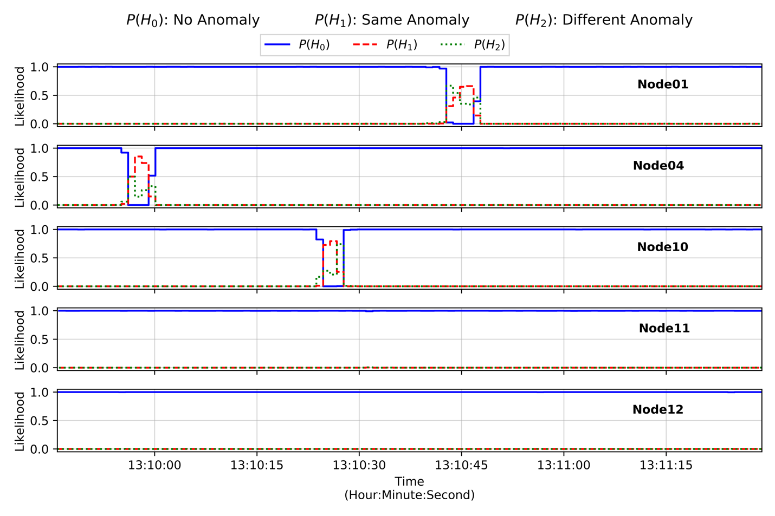
Figure 83: Event 1 posterior probabilities using the Bayesian framework.

Recall that the true alarm sequence for Event 1 begins at Node06 and progresses to Node04, Node10, and Node01, in that order. Node04 and Node01 correctly identify two anomalies shown by the $P\left(H_{1}\right)$same anomaly hypothesis being dominant at approximately 13:09:50 and 13:10:38, respectively. More interesting is the misclassification occurs at the beginning and end of the anomalies at Node10 and Node0, respectively, where the $P\left(H_{2}\right)$ different anomaly hypothesis is dominant. This is primarily attributed to the moderate cosine similarity values for normal background at Node10 (i.e. 0.87 compared to 0.82 and 0.84 for Node01 and Node04, respectively) resulting in less sensitivity in discriminating between the $P\left(H_{1}\right)$ and $P\left(H_{2}\right)$ due to the increased overlapping of their respective conditional probabilities, $P\left(x_{0} | H_{1}\right)$ and $P\left(x_{0} | H_{2}\right)$. Furthermore, at lower count rate anomalies, less spectral feature will be observed which will generally result in a slight change in the cosine value until higher count rates are observed providing more features. No solution is proposed to overcome this issue, which the author believes highlights the need for additional data features, say features extracted from other sensor modalities, to alleviate misclassifications and false positives.

In Event 2, the radioactive material was initially detected at Node06 before travelling to Node04, Node10, Node11, and Node01, in that specific order. Similar to Event 1, the cosine similarity values between the normal background spectra and anomalous spectra observed from Node06 lie well below 0.90 (see Figure 62) . The time-series, normalized posterior probabilities for Event 2 are provided in Figure 84.

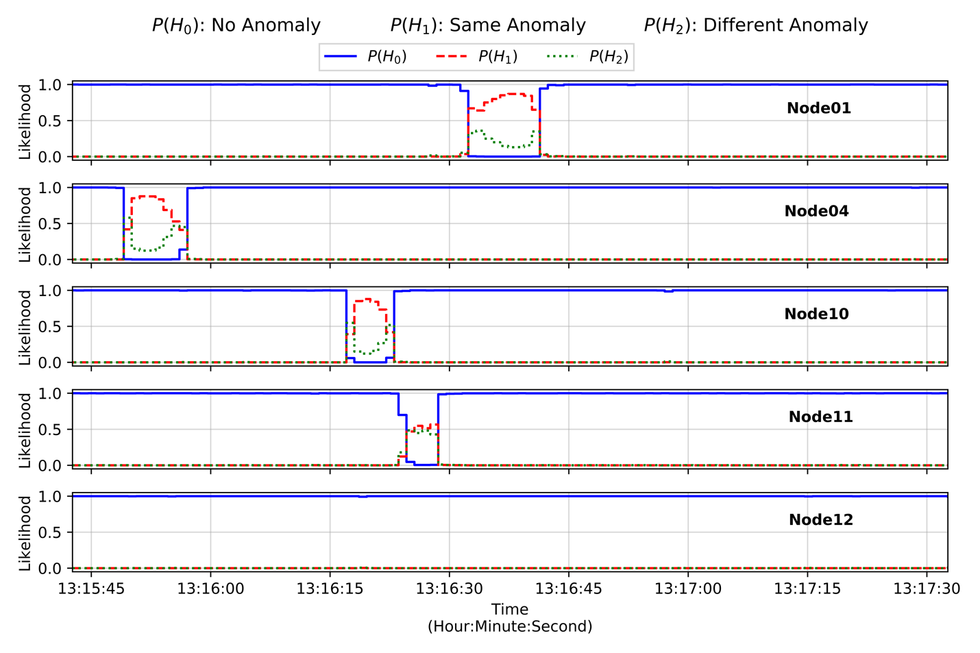
Figure 84: Event 2 posterior probabilities using the Bayesian framework.

All the alarms were identified with proper $P\left(H_{1}\right)$ same anomaly classifications at Node04, Node10, Node11, and Node01 with no false positives. The $P\left(H_{2}\right)$ different anomaly probabilities does observe an increase during the anomalous events, but is not the dominant, or highest, classification during the anomalies. Similar to the Event 1, the initial spectra observed during the anomalous events provide a cosine similarity value between no anomaly values $P\left(x_{0} | H_{0}\right)$ and same anomaly values $P\left(x_{0} | H_{1}\right)$, which is wear the different anomaly $P\left(x_{0} | H_{2}\right)$ is dominant.

A key takeaway from this analysis is highlighted by the competition between the same anomaly and different anomaly during an anomalous event containing the same radioactive material. This is primarily due to the approaches utilized when constructing the conditional probabilities for the three data features used in this framework. This issue is inherent to scenarios that solely utilize radiation sensors, forcing the use of uninformative or overlapping probabilities to that of the same anomaly probabilities, $P\left(x_{0},x_{1},x_{2} | H_{1}\right)$. Thus, the system’s sensitivity in discriminating between the two hypotheses decreases.

4.4.7: Bayesian Framework Multiple Source Injection Study
While the current methodology using the Bayesian framework with the updated weighting scheme provides a more robust approach than the unweighted scheme, a sensitivity analysis should be performed to further examine how the framework operates in other scenarios. For instance, in the three events provided, each anomaly is known to be observed from the same radioactive material. No anomaly sequence yet has analyzed the impact of an additional radioactive material entering the area after the initial anomaly is detected. This is addressed by inserting energy spectra from a different radioactive material into Event 2. Two different source spectra are modelled in MCNP for a material containing Am-241 (see Figure 72 for example energy spectra) and a material containing Cs-137 (see Figure 27 for example energy spectra).

The new event sequence attempts to model a radioactive material traversing from Node01 to Node12 with anomalies at 13:16:00 and 13:16:20, respectively. The activity for the new radioactive materials were manually specified to provide a moderate probability of detection (i.e. high signal-to-noise) but remain small enough to remain near the normal background spectra to reframe from large spectral deviations. This is observed in Figure 85 showing the time-series count rate with the initial Event 2 anomalous event highlighted in the light red regions and the inserted anomalous event highlighted in the light green regions.

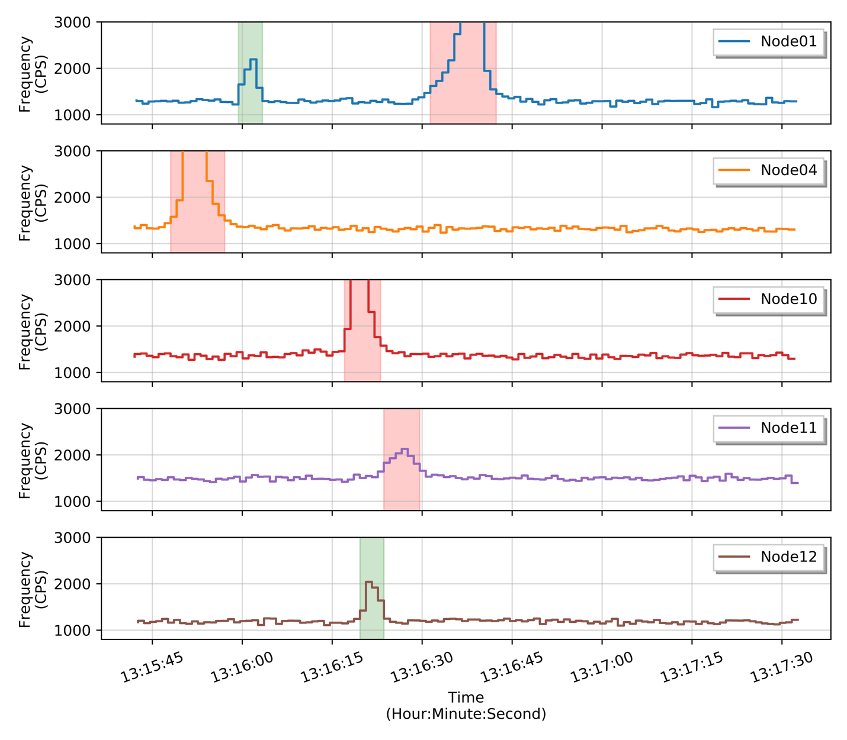
Figure 85: Event 2 time-series count rate with additional radioactive material present.

If the Bayesian framework proposed in this work were utilized, the time-series posterior probabilities can be calculated, as shown in Figure 86 and Figure 87 for the Am-241 and Cs-137 inserted sources, respectively.
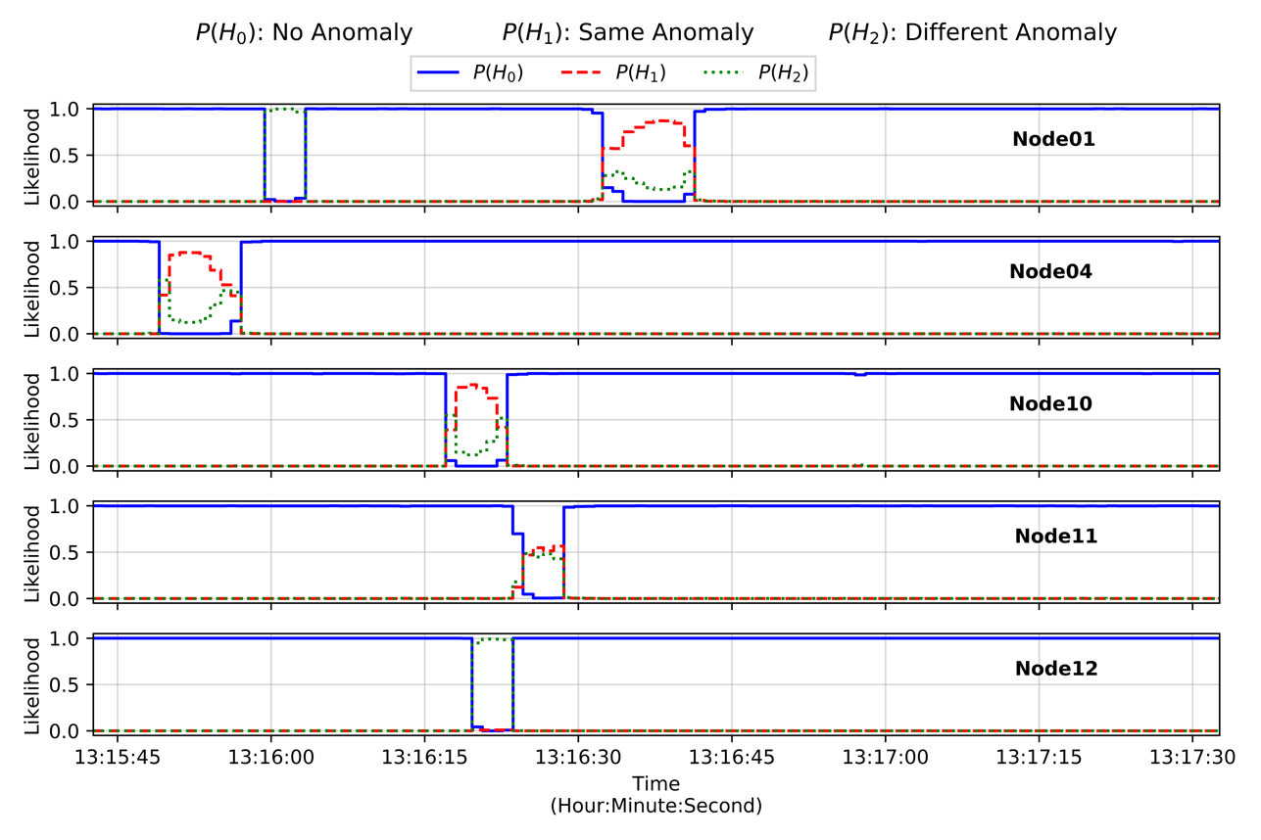
Figure 86: Event 2 time-series posterior probabilities with additional Am-241 source.
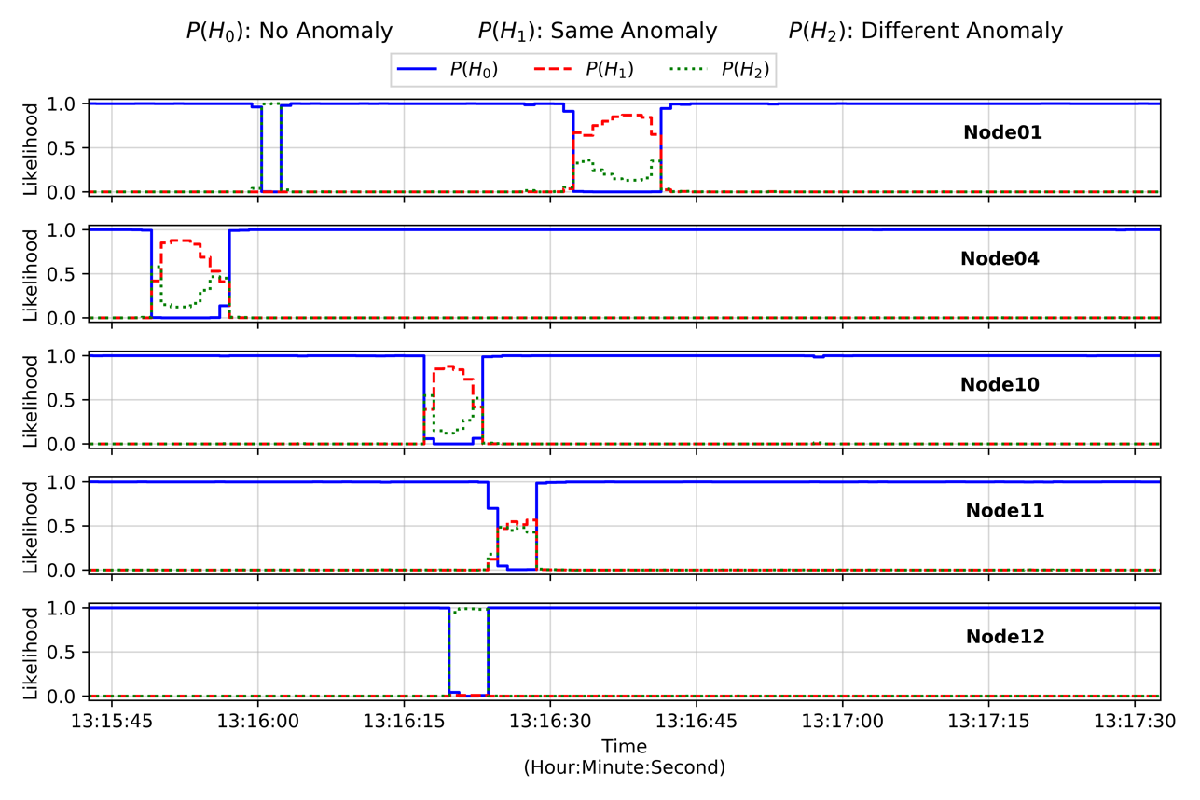
Figure 87: Event 2 time-series posterior probabilities with additional Cs-137 source.

Despite the relatively small source strength, the inserted anomalies at 13:16:00 and 13:16:20 on Node01 and Node12, respectively, are correctly classified as different anomalies, which again is primarily due to the large spectral deviation from both the normal background and initial alarm spectrum. To handle multiple, simultaneous anomalous events in a more formal manner, the Bayesian framework appends an additional hypothesis for the new anomalies and performs the identical posterior calculations as the three-hypothesis scheme. For example, if the initial anomalous is referred to as Event 0 and the Bayesian framework subsequently detects an anomaly at another node with a different anomaly classification, referred to here as Event 1, an additional hypothesis is appended to the hypothesis vector $H$. The posterior probabilities would therefore be calculated by the following.

$$P\left(H_{j} | X^{*}\right)=\frac{P\left(X^{*} | H_{j}\right) P\left(H_{j}\right)}{P\left(X^{*}\right)}$$

The value $j$ represents the $j^{th}$ index in the hypothesis vector $H$ containing the likelihoods for the $H_{0}:$ no anomaly, $H_{1}:$ Event 1 anomaly, $H_{2}:$ different anomaly, and $H_{3}:$ Event 2 anomaly. Upon classifying a different anomaly, a new set of conditional probabilities are constructed using the extracted features, denoted by the asterisk superscript signifying the additional parameter to account for the $H_{3}$ hypothesis.

$$P\left(H_{j} | X^{*}\right)=\frac{P\left(x_{0}^{*} | H_{j}\right) P\left(x_{1}^{*} | H_{j}\right) P\left(x_{2}^{*} | H_{j}\right) P\left(H_{j}\right)}{\sum_{i}{P\left(x_{0}^{*} | H_{i}\right) P\left(x_{1}^{*} | H_{i}\right) P\left(x_{2}^{*} | H_{i}\right) P\left(H_{i}\right)}}$$

In these example scenarios, the cosine similarity values range from 0.45 to 0.55 for both the Am-241 and Cs-137 sources relative to the initial anomalous spectra. The conditional probability $P\left(x_{0}^{*} | H_{3}\right)$ for the newly observed anomaly is obtained by creating a normal distribution with a mean obtained from the spectra classified as different anomaly. Figure 88 shows the unnormalized conditional probabilities from this method for the inserted source scenarios.

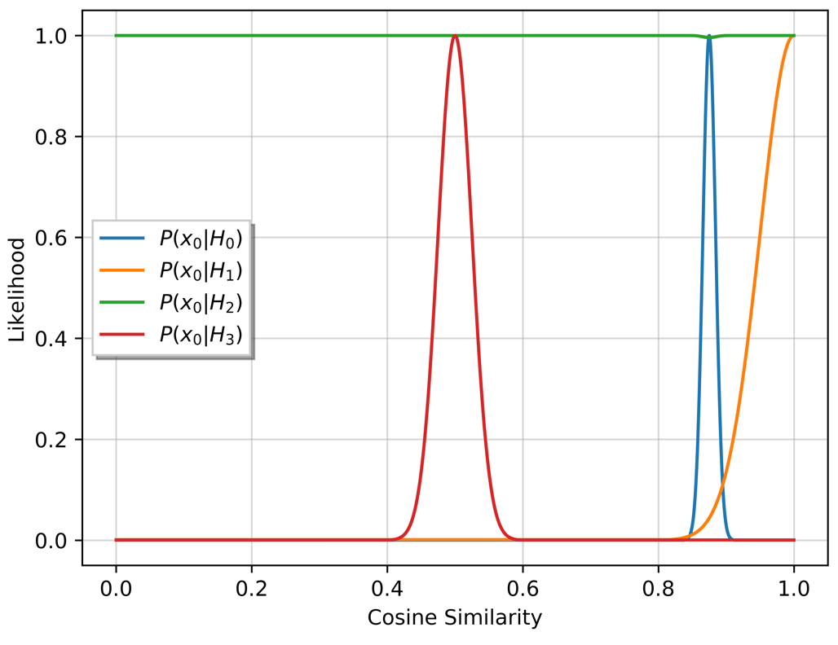
Figure 88: Event 2 cosine similarity conditional probability values for multiple source scenario.

Identical methods to the previous events for calculating the expected time-of-arrival are employed for the multi-source scenarios and the conditional count rate probability $P\left(x_{1} | H_{3}\right)$ is identical to $P\left(x_{1} | H_{1}\right)$ and $P\left(x_{1} | H_{2}\right)$. The resulting time-series posterior for both the Am-241 and Cs-137 scenarios is provided in . Note that the timestamp begins after Node01 classifies the anomaly at 13:16:00 as a different anomaly and subsequently initiating four hypothesis methodology.

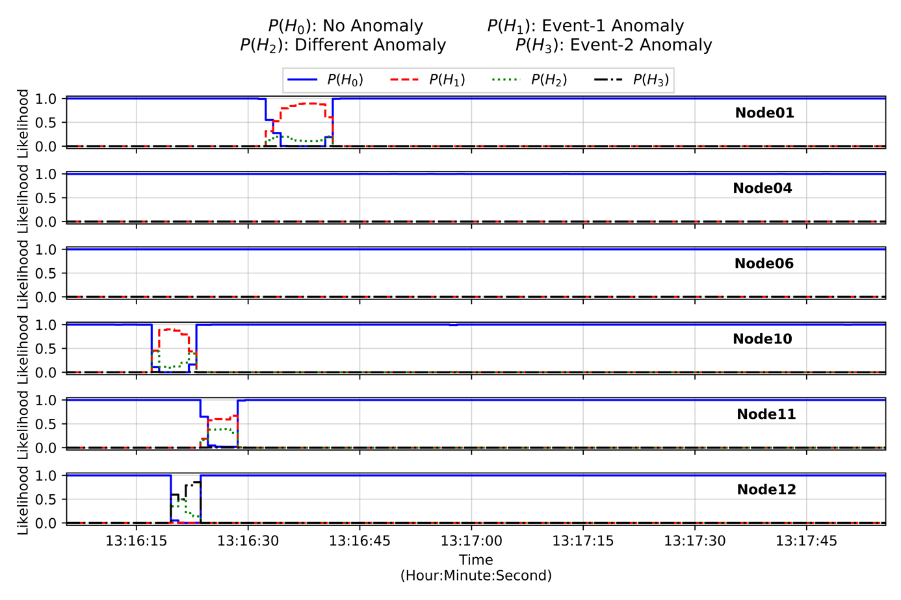
Figure 89: Event 2 time-series posterior probabilities with additional Am-241 source for multiple events.

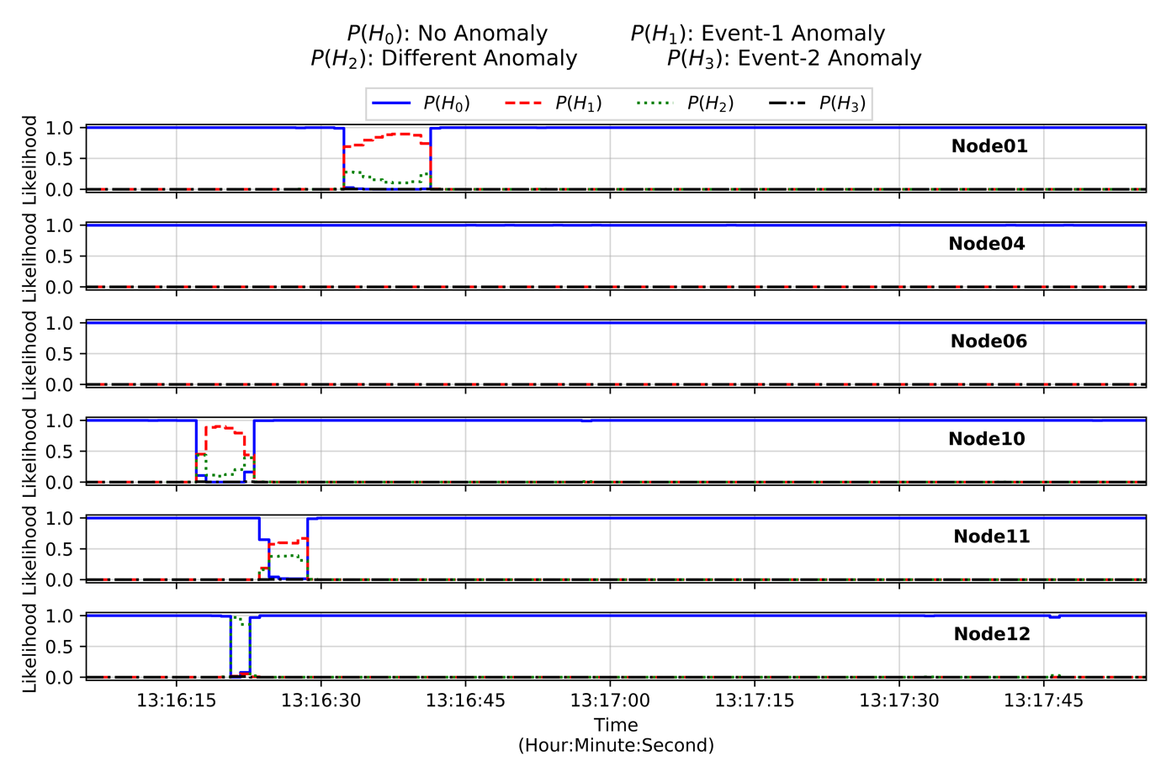
Figure 90: Event 2 time-series posterior probabilities with additional Cs-137 source for multiple events.

A few observations can be made from Figure 89 and Figure 90. First, recall that initial anomalous Event 2 sequence involves Node10, Node11, and Node01, in that order. The anomalies detected at said nodes correctly classified with the $H_{1}:$ Event 1 anomaly remaining dominant. The anomaly from the inserted sources at 13:16:20 on Node12 is classified correctly as $H_{3}:$Event2 anomaly for the Am-241 source and incorrectly as $H_{2}:$different anomaly for the Cs-137 source. The cosine similarity values observed for the Cs-137 remained around 0.90 during the anomalous event, where the conditional probability $P\left(x_{0} | H_{2}\right)$ is dominant. This compounded by the short interaction time and a low count rate source, resulting in an energy spectrum more similar to the normal background spectra.

These results highlight the difficulty in correctly discriminating between each hypothesis utilizing these selected features in the Bayesian framework. Furthermore, it was stated previously that the Bayesian framework would not be able to correctly classify a different radioactive material with identical, or near-identical, photon emissions. In an attempt to improve the classification accuracy and simultaneously decrease the false-positive rate, other sensor modalities can be utilized to populate additional features in the data vector $X$.

4.5: Dempster-Shafer Classification Methodology

5: Distributed Multi-modality Sensor Network

6: Conclusions and Future Work

Appendix
The information in this section provides the reader with additional details on concepts discussed in this work.
Derivation of Bayes’ Theorem
Bayes’ Theorem, also commonly referred to as Bayes’ Rule, reorganizes the joint probability definition between two events to create a method to, among other things, update a belief function. A joint probability provides the probability that two events by multiplying the probability of one event occurring by the conditional probability that given that event occurring the second event occurs. The conditional probability is another way of expressing the probabilistic causality for a given relationship. This joint probability for Event $A$ and Event $B$ is expressed given the following relationship.

$$P\left(A∩B\right)=P\left(A\right) P\left(B | A\right)$$

Additionally, the joint probability is also equal to the opposite event sequence, which provided in the following relationship.

$$P\left(A∩B\right)=P\left(B\right) P\left(A | B\right)$$

Equating the two relationships provides a method to update the belief for an event based on the relationships previously derived.

$$P\left(A\right) P\left(B | A\right)=P\left(B\right) P\left(A | B\right)$$

$$∴P\left(A|B\right)=\frac{P\left(A\right) P\left(B | A\right) }{P\left(B\right)}$$

This final equation is conventional formula known as Bayes’ Theorem and is the basis for statistical inference. In addition, portions of the derived relationship are commonly expressed with unique titles, such as the prior probability, posterior probability, and the normalization probability, as provided in the following equation.

$$posterior=\frac{prior×likelihood}{evidence}$$

In this case, the prior probability, or often referred to as a priori information, corresponds to $P\left(A\right)$ and illustrates the prior belief that Event A occurs. The posterior is the probability that was derived, $P\left(A | B\right)$, and expresses the new belief of the system. The probability $P\left(B\right)$ divides the product in the numerator to normalize the probability, resulting in values between the 0.0 to 1.0. In many applications, the normalization probability can be difficult, if not near-impossible, to calculate analytically. Thus, the normalization probability can be removed from the final formula resulting in values outside the original 0.0 to 1.0 range. In such scenarios, the hypothesis tests selects the highest value probability

Vita

Ian received his Bachelor of Science and Master of Science in Nuclear Engineering from the University of Tennessee in Knoxville, Tennessee in 2013 and 2015, respectively. During his tenure in graduate school, Ian focused on matters relating to proliferation detection and nuclear security as a graduate research student at the Institute for Nuclear Security as well as multiple work experiences at Department of Energy national laboratories. After completing a one-year fellowship at the National Nuclear Security Administration in Washington, D.C., Ian returned to the University of Tennessee to finish his Ph.D. while working in the Radiation Detection and Imaging group at Oak Ridge National Laboratory. After graduation, Ian plans to continue to focus on national security issues from both a technology and a policy standpoint.

References
- R. Byrd, J.M. Moss, W.C. Priedhorsky, C.A. Pura, G.W. Richter, K.J. Saeger, W.R. Scarlett, S.C. Scott, and R.L. Wagner, ., Nuclear Detection to Prevent or Defeat Clandestine Nuclear Attack, Los Alamos Manuscript LA-UR -04-0629, submitted to IEEE Sensors Journal, Special Issue on Sensors for the Prevention of Terrorist Acts (2004).
- Runkle, R. C., Smith, L. E., and Peurrung, A. J. (2009). The Photon Haystack and Emerging Radiation Detection Technology. Journal of Applied Physics, 106(4). https://doi.org/10.1063/1.3207769.
- Medalia, J. (2011). Dirty Bomb: Technical Background, Attack Prevention and Response, Issues for Congress. Congressional Research Service. CRS Report No. R41890. Retrieved on: December 2019. Retrieved from: https://fas.org/sgp/crs/nuke/R41890.pdf.
- Nuclear Threat Initiative. Radiological Terrorism and Nuclear Security - Module 3: Radiological Terrorism and Nuclear Sabotage. Retrieved on: December 2019. Retrieved from: https://tutorials.nti.org/nuclear-and-radiological-security/terrorism-radiological/.
- Nuclear Threat Initiative. (2019). CNS Global Incidents and Trafficking Database. Retrieved on: December 2019. Retrieved from: https://media.nti.org/documents/global_incidents_trafficking_2018.pdf.
- Brennan, S. M., Mielke, A. M., Torney, D. C., and Maccabe, A. B. (2004). Radiation detection with distributed sensor networks. Computer, 37(8), 5759. https://doi.org/10.1109/MC.2004.103.
- Mielke, A. M., Brennan, S. M., Smith, M. C., Torney, D. C., Maccabe, A. B., and Karlin, J. F. (2005). Independent sensor net- works. IEEE Instrumentation and Measurement Magazine, 8(2), 3337. https://doi.org/10.1109/MIM.2005.1438842.
- The Royal Society. (2008). Detecting nuclear and radiological materials Workshop. p.1-33.
- Liu, A., Wu, M., Chandy, K. M., Obenshain, D., Smith, M., and Mclean, R. (n.d.). (2010) Design Tradeoffs for Radiation Detection Sensor Networks.California Institute of Technology. Pasadena, CA.
- Schulze, J., M. Auer, and R. Werzi. (2000). Low level radioactivity measurement in support of the CTBTO. Applied Radiation and Isotopes. V52:p.23-30.
- Hart, J. K., and Martinez, K. (2006). Environmental Sensor Networks: A revolution in the earth system science? Earth-Science Reviews, 78(34), 177191. https://doi.org/10.1016/j.earscirev.2006.05.001.
- Environmental Protection Agency. (1988). Environmental Radiation Ambient Monitoring System - Project Overview. EPA 520/5-84-007.
- Tsahi Gozani, ed. (1981). Active Nondestructive Assay of Nuclear Materials, Principles and Applications. U.S. Nuclear Regulatory Commission. DOI: 10.2172/6215952/.
- Reilly, D., Ensslin, N., and Smith, H. Jr. (1991). Passive nondestructive assay of nuclear materials (NUREG/CR–5550). U.S. Nuclear Regulatory Commission. Retrieved from: https://www.lanl.gov/org/ddste/aldgs/sst-training/technical-references.php.
- Ferguson, C. and W. Potter. The Four Faces of Nuclear Terrorism. (2004). Center for Nonproliferation Studies. Monterey, CA. ISBN: 978-0415952439.
- Murray, A., R. Marten, A. Johnston, and P. Martin. Analysis for naturally occurring radionuclides at environmental concentrations by gamma spectrometry. In: Journal of Radioanalytical and Nuclear Chemistry 115.2 (1987), pp. 263–288.
- Knoll, G. F. Radiation Detection and Measurement. John Wiley and Sons, 2010. ISBN: 9780470131480.
- Fawcett, Tom (2006). An Introduction to ROC Analysis. Pattern Recognition Letters. 27 (8): 861–874. DOI:10.1016/j.patrec.2005.10.010.
- Receiver Operator Curve. (2020). Wikipedia. Retrieved from: https://en.wikipedia.org/wiki/Receiver_operating_characteristic.
- Macskassy, S., and F. Provost. (2004). Confidence Bands for ROC Curves: Methods and an Empirical Study. Conference on ROC Analysis in Artificial Intelligence. Valencia, Spain.
- Wallis, S. (2013). Binomial confidence intervals and contingency tests: mathematical fundamentals and the evaluation of alternative methods. Journal of Quantitative Linguistics. 20 (3): 178–208. DOI:10.1080/09296174.2013.799918.
- Wilson, E. (1927). Probable inference, the law of succession, and statistical inference. Journal of the American Statistical Association. 22 (158): 209–212. DOI:10.1080/01621459.1927.10502953. JSTOR 2276774.
- Newcombe, R. (1998). "Two-sided confidence intervals for the single proportion: comparison of seven methods". Statistics in Medicine. 17 (8): 857–872. DOI:10.1002/(SICI)1097-0258[.
- Clopper, C. and E. Pearson. (1934). The use of confidence or fiducial limits illustrated in the case of the binomial. Biometrika. 26 (4): 404–413. DOI:10.1093/biomet/26.4.404.
- Thulin, M. (2014-01-01). The cost of using exact confidence intervals for a binomial proportion. Electronic Journal of Statistics. 8 (1): 817–840. arXiv:1303.1288. DOI:10.1214/14-EJS909. ISSN 1935-7524.
- Brown, L., T. Cai, and A. DasGupta. (2001). Interval Estimation for a Binomial Proportion. Statistical Science. 16 (2): 101–133. CiteSeerX 10.1.1.50.3025. DOI:10.1214/ss/1009213286.
- Ziegler, J.F. Terrestrial Cosmic Rays. (1996). In: IBM Journal of Research and Development. ISSN: 0018-8646. DOI: 10.1147/rd.401.0019.
- Ziock, K. P. (2002). The Lost Source, Varying Backgrounds and Why Bigger May Not Be Better. AIP Conference Proceedings, 632(1), 6070. https://doi.org/10.1063/1.1513955.
- Aucott, T. J., Chivers, D. H., & Vetter, K. (2011). Proximity localization with the Mobile Imaging and Spectroscopic Threat Identification (MISTI) system. In 2011 IEEE Nuclear Science Symposium Conference Record (pp. 1303–1305). IEEE. https://doi.org/10.1109/NSSMIC.2011.6154330.
- Willis, M., I. Stewart, A. Nicholson, D. Archer, and W. Ray. Systematic Study of Variation in Radiation Data in Cluttered Environments. Nuclear Instruments and Methods in Physics Research Section A: Accelerators, Spectrometers, Detectors and Associated Equipment, (2018) ISSN: 0168-9002.
- Xiong, S. (2014). Detection and Estimation Final Project Report: Modeling and the K-Sigma Algorithm for Radiation Detection. New Brunswick, New Jersey.
- Iyengar, Anagha, Beach, Matthew, Newby, Robert J., Fabris, Lorenzo, Heilbronn, Lawrence H., and Hayward, Jason P. Systematic measurement of fast neutron background fluctuations in an urban area using a mobile detection system. United States: N. p., 2015. Web. doi:10.1016/j.nima.2014.10.045.
- Archer, D. E., Johnson, J. O., Miller, T. M., Nicholson, A. D., Patton, B. W., and Peplow, D. E. (2015). Systematic Assessment of Neutron and Gamma Backgrounds Relevant to Operational Modeling and Detection Technology Implementation. Oak Ridge National Laboratory, (ORNL/TM-2014/687).
- Seeman, B. (Nov 1975). US patent document 3,922,541.
- Saucke, K., G. Pausch, J. Stein, H.G. Ortlepp, and P. Schotanus. Stabilizing Scintillation Detector Systems with Pulsed LEDs: A Method to Derive the LED Temperature from Pulse Height Spectra. IEEE Transactions on Nuclear Science. 52(6):3160-3165. DOI: 10.1109/TNS.2005.862929.
- Mills, D. L. Internet time synchronization: the network time protocol. IEEE Transactions on communications. p. 1482 - 1493 (1991). DOI: 10.1109/26.103043.
- Liu, A., Wu, M., Chandy, K. M., Obenshain, D., Smith, M., and Mclean, R. (n.d.). Design Tradeoffs for Radiation Detection Sensor Networks. Thesis (2010). California Institute of Technology. Pasadena, CA.
- Rao, N. S. V., Shankar, M., Chin, J.-C., Yau, D. K. Y., Srivath- san, S., Iyengar, S. S., Hou, J. C. (2008). Identification of Low- Level Point Radiation Sources Using a Sensor Network. International Conference on Information Processing in Sensor Networks, 493504. https://doi.org/10.1109/IPSN.2008.19.
- Nemzek, R. J., Dreicer, J. S., Torney, D. C., and Warnock, T. T. (2004). Distributed sensor networks for detection of mobile radioactive sources. IEEE Transactions on Nuclear Science, 51(4 I), 16931700. https://doi.org/10.1109/TNS.2004.832582.
- Morelande, M. R., and Ristic, B. (2009). Radiological source detection and localisation using Bayesian techniques. IEEE Transactions on Signal Processing, 57(11), 42204231. https://doi.org/10.1109/TSP.2009.2026618.
- Liu, A. H., Bunn, J. J., and Chandy, K. M. (2010). An analysis of data fusion for radiation detection and localization. In 2010 13th International Conference on Information Fusion (pp. 18). Edinburgh, UK: IEEE. https://doi.org/10.1109/icif.2010.5711879.
- Shenton-Taylor, C., Gillespie, S., Blackie, D., Caister, A., Bell, A., Murphy, R., Shute, N. (2016). Distributed detector radiation networks: Static and mobile sensor configurations. 2014 IEEE Nuclear Science Symposium and Medical Imaging Conference, NSS/MIC 2014. https://doi.org/10.1109/NSSMIC.2014.7431093.
- Alagha, A., S. Singh, R. Mizouni, and A. Ouali. Data-Driven Dynamic Active Node Selection for Event Localization in IoT Applications - A Case Study of Radiation Localization. IEEE Access (Volume 7). p. 16168 - 16183 (2019). DOI: 10.1109/ACCESS.2019.2894956.
- Whipps, G. T., and Moses, R. L. (2015). Distributed Sensing for Quickest Change Detection of Point Radiation Sources. In 18th International Conference on Information Fusion (pp. 2227). Washington, D.C.: IEEE. Retrieved from http://www.dtic.mil/dtic/tr/fulltext/u2/1027422.pdf.
- King, M. J., Harris, B., Toolin, M., DuBord, R. M., Skowron- ski, V. J., LuSoto, M. A., Shokhirev, K. N. (2010). An urban environment simulation framework for evaluating novel distributed radiation detection architectures. 2010 IEEE International Conference on Technologies for Homeland Security (HST), 01810, 446452. https://doi.org/10.1109/THS.2010.5654958.
- Stephens, D. L., and Peurrung, A. J. (2004). Detection of moving radioactive sources using sensor networks. IEEE Transactions on Nuclear Science, 51(5), 22732278. https://doi.org/10.1109/TNS.2004.834713.
- Hite, Jason, Mattingly, John, Archer, Daniel E., Willis, Michael J., Rowe, Andrew J., Bray, Kayleigh B., Carter, Jr., Jake, and Ghawaly, James M. Localization of a radioactive source in an urban environment using Bayesian Metropolis methods. United States: N. p., 2018. Web. doi:10.1016/j.nima.2018.09.032.
- U.S. Department of Energy. National Laboratory Network. (2020) Retrieved from https://www.energy.gov/national-laboratories.
- Anastasio, M. R. Establishment of the Department of Homeland Security. Hearing of the U.S. Senate Energy and Natural Resources Committee. Livermore, CA.
- Hernandez, J. E., & Valentine, J. (2004). 2002-2003 Engineering Accomplishments : Unconventional Nuclear Weapons Detection. In UCRL-TR-204274. Livermore, CA: Lawrence Livermore National Laboratory.
- Lawrence Livermore National Laboratory. (2004). Science and Technology Review: Atoms for Peace after 50 Years. Livermore, CA.
- Lawrence Livermore National Laboratory. (2005). Science and Technology Review: Award-Winning Science and Technology 2005 R&D 100 Awards. Livermore, CA. Available on: https://doi.org/10.1176/pn.37.23.0001c.
- Cunningham, C. (1995). Detection and Track of Stochastic Target using Multiple Measurements. Livermore, CA.
- Keillor, M. E. (2000). Principal component analysis of low-resolution energy spectra to identify gamma sources in moving vehicle traffic. Dissertation. Oregon State University.
- Lanman, D. R. (2001). Distributed Sensor Networks with Collective Computation (Vol. LA-UR-01-4).
- Brennan, S. M., Mielke, A. M., & Torney, D. C. (2005). Radioactive source detection by sensor networks. IEEE Transactions on Nuclear Science, 52(3), 813–819. https://doi.org/10.1109/TNS.2005.850487.
- Nemzek, R. J., Dreicer, J. S., Torney, D. C., & Warnock, T. T. (2004). Distributed sensor networks for detection of mobile radioactive sources. IEEE Transactions on Nuclear Science, 51(4 I), 1693–1700. https://doi.org/10.1109/TNS.2004.832582.
- Lawrence Livermore National Laboratory. (2004). Science and Technology Review: Atoms for Peace after 50 Years. Livermore, CA.
- U.S. Deparment of Homeland Security. Intelligent Radiation Sensing System. Available on: https://www.dhs.gov/intelligent-radiation-sensing- system. Retrieved on: December 2019.
- Cooper, D. A., Ledoux, R. J., Kamieniecki, K., Korbly, S. E., Thompson, J., Batcheler, J., Aiyawar, V. (2010). Intelligent Radiation Sensor System (IRSS) advanced technology demonstrator (ATD). 2010 IEEE International Conference on Technologies for Homeland Security, 414420. https://doi.org/10.1109/THS.2012.6459901.
- Cooper, D. A., Ledoux, R. J., Kamieniecki, K., Korbly, S. E., Thompson, J., Batcheler, J., Aiyawar, V. (2012). Intelligent Radiation Sensor System (IRSS) advanced technology demonstrator (ATD). 2012 IEEE International Conference on Technologies for Homeland Security, HST 2012, 511516. https://doi.org/10.1109/THS.2012.6459901.
- Cooper, D. A., Ledoux, R. J., Kamieniecki, K., Korbly, S. E., Hemp- stead, D., Janney, L., Monnier, C. (2015). Advanced Algorithm Development for Detection, Tracking , and I Identification of Vehicle Radiation Source es in a Multi-Sensor, Distributed Testbed.
- U.S. Department of Homeland Security. (2017). Emerging Technologies for Large Event Monitoring. Presentation. Washington, DC.
- Cooper, D. A. (2017). Performance of the Multi-sensor Interdiction System Testbed (MIST) Advanced Technology Demonstration (ATD) for Detection and Tracking of Vehicle-borne Radiation Sources. In IEEE Nuclear Science Symposium Conference (pp. 1–14). Atlanta, GA: IEEE.
- DARPA SIGMA. (2014). SIGMA. [online] Darpa.mil. Available at: https://www.darpa.mil/program/sigma.
- DARPA SIGMA. (2016). SIGMA. [online] Darpa.mil. Available at: https://www.darpa.mil/about-us/timeline/sigma.
- Kromek Group PLC. D3S NET Networked Radiation Detector. Retrieved from: https://www.kromek.com/product/d3s-net/. Retrieved on: December 2019.
- DARPA SIGMA+. (2017). Radioactive Threat Detection System Completes Emergency Vehicle Test Deployment in Nation’s Capital https://www.darpa.mil/news-events/2017-03-01. Slide(s) 6.
- U.S. Department of Homeland Security. (2016). Domestic Nuclear Detection Office - Advanced Technology Demonstrations Report. Washington, DC. Available on: https://www.dhs.gov/sites/default/files/publications/ATD%20Fact%20Sheet%20%28April%202016%29_0.pdf.
- U.S. Department of Homeland Security. (2017). Emerging Technologies for Large Event Monitoring. Presentation. Washington, DC.
- Curtis, J. C., Cooper, R. J., Joshi, T. H., Cosofret, B., Schmit, T., Wright, J., … Speicher, J. (2018). Simulation and validation of the Mobile Urban Radiation Search (MURS) gamma-ray detector response. Nuclear Instruments and Methods in Physics Research, Section A: Accelerators, Spectrometers, Detectors and Associated Equipment, 954 (August 2018), 161128. https://doi.org/10.1016/j.nima.2018.08.087.
- Vetter, K. (2016). Multi-sensor radiation detection, imaging, and fusion. Nuclear Instruments and Methods in Physics Research, Section A: Accelerators, Spectrometers, Detectors and Associated Equipment, 805, 127–134. https://doi.org/10.1016/j.nima.2015.08.078.
- Bandstra, M. S., Aucott, T. J., Brubaker, E., Chivers, D. H., Cooper, R. J., Curtis, J. C., … Vetter, K. (2016). RadMAP: The Radiological Multi-sensor Analysis Platform. Nuclear Instruments and Methods in Physics Research, Section A: Accelerators, Spectrometers, Detectors and Associated Equipment, 840, 59–68. https://doi.org/10.1016/j.nima.2016.09.040.
- Bandstra, M. S., Quiter, B. J., Curtis, J. C., Bilton, K. J., Joshi, T. H. Y., Meyer, R., … McLean, M. S. L. (2018). Attribution of gamma-ray background collected by a mobile detector system to its surroundings using panoramic video. Nuclear Instruments and Methods in Physics Research, Section A: Accelerators, Spectrometers, Detectors and Associated Equipment, 954 (August 2018). https://doi.org/10.1016/j.nima.2018.08.085.
- Turin, G. L. (1960). An Introduction to Matched Filters. IRE Transactions on Information Theory. 6 (3): 311–329. doi:10.1109/TIT.1960.1057571.
- Henderson, K., Stadnikia, K., Martin, A., Enqvist, A., & Koppal, S. (2017). Tracking Radioactive Sources through Sensor Fusion of Omnidirectional LIDAR and Isotropic Rad-Detectors. In International Conference on 3D Vision (pp. 97–106). Qingdao, China. https://doi.org/10.1109/3DV.2017.00021.
- Stadnikia, K., Martin, A., Henderson, K., Koppal, S., & Enqvist, A. (2018). Data-Fusion for a Vision-Aided Radiological Detection System: Sensor dependence and Source Tracking. In Advancements in Nuclear Instrumentation Measurement Methods and their Applications (Vol. 170, pp. 1–6). https://doi.org/10.1051/epjconf/201817007013.
- Stadnikia, K., Henderson, K., Koppal, S., & Enqvist, A. (2018). Data Fusion for a Vision-aided Radiological Detection System: Correlation Methods for Multi-source Scenarios. In IEEE Nuclear Science Symposium and Medical Imaging Conference (pp. 1–4). Sydney, Australia: IEEE. https://doi.org/10.1109/NSSMIC.2018.8824275.
- Alpha Spectra, Inc. (2020). Scintillation Detectors. Retrieved from: https://alphaspectra.com/.
- David Instruments. (2019). Vantage Pro2 Weather Station. Retrieved from: https://www.davisinstruments.com/solution/vantage-pro2/.
- Velodyne Lidar, Inc. (2020). Puck Lidar Sensor, High-Value Surround Lidar. Retrieved from: https://velodynelidar.com/products/puck/.
- Ubiquiti, Inc. (2020). Ubiquiti - UniFi Video Camera G3. Retrieved from: https://www.ui.com/unifi-video/unifi-video-camera-g3/.
- Seeman, B. (Nov 1975). US patent document 3,922,541. Available from INIS: http://inis.iaea.org/search/search.aspx?orig_q=RN:08284304.
- Compagnie de Saint-Gobain S.A. (2020). Gain Stabilization Methods. Retrieved form: https://www.crystals.saint-gobain.com/sites/imdf.crystals.com/files/documents/gain_stabilization_methods.pdf.
- Bl'azquez-Garc'ia, A., Conde, A., Mori, U., & Lozano, J.A. (2020). A review on outlier/anomaly detection in time series data. ArXiv, abs/2002.04236.
- Hodge, V. J., & Austin, J. (2004). A Survey of Outlier Detection Methodologies. Artificial Intelligence Review, 22(1969), 85–126. https://doi.org/10.1007/s10462-004-4304-y.
- Chandola, V., Banerjee, A., & Kumar, V. (2009). Anomaly Detection - A Survey. ACM Computing Surveys, 41(3), 1–58. https://doi.org/10.1145/1541880.1541882.
- Pfund, D. M., Anderson, K. K., Detwiler, R. S., Jarman, K. D., McDonald, B. S., Milbrath, B. D., … Woodring, M. L. (2016). Improvements in the method of radiation anomaly detection by spectral comparison ratios. Applied Radiation and Isotopes, 110, 174–182. https://doi.org/10.1016/j.apradiso.2015.12.063.
- Anderson, K. K., Jarman, K. D., Mann, M. L., Pfund, D. M., & Runkle, R. C. (2008). Discriminating nuclear threats from benign sources in gamma-ray spectra using a spectral comparison ratio method. Journal of Radioanalytical and Nuclear Chemistry, 276(3), 713–718. https://doi.org/10.1007/s10967-008-0622-x.
- Jarman, K. D., Smith, L. E., & Carlson, D. K. (2004). Sequential probability ratio test for long-term radiation monitoring. IEEE Transactions on Nuclear Science, 51(4 I), 1662–1666. https://doi.org/10.1109/TNS.2004.832543.
- Liu, A. H., Julian, B. J., & Mani, C. K. (2010). An Analysis of Data Fusion For Radiation Detection and Localization. In 13th Conference on Information Fusion. Edinburgh, UK: IEEE. https://doi.org/10.1109/ICIF.2010.5711879.
- Gosnell, T. B., Hall, J. M., Ham, C. L., Knapp, D. A., Koenig, Z. M., Luke, S. J., … Wolford, J. K. (1997). Gamma-Ray Identification of Nuclear Weapon Materials. Livermore, CA. https://doi.org/UCRL-ID-127436.
- Fagan, D. K., Robinson, S. M., & Runkle, R. C. (2012). Statistical methods applied to gamma-ray spectroscopy algorithms in nuclear security missions. Applied Radiation and Isotopes, 70(10), 2428–2439. https://doi.org/10.1016/j.apradiso.2012.06.016.
- Sadeghi, M., & Behnia, F. (2018). Optimum window length of Savitzky-Golay filters with arbitrary order. Retrieved from http://arxiv.org/abs/1808.10489.
- ﻿Šidák, Z.K. Rectangular Confidence Regions for the Means of Multivariate Normal Distribution. Journal of the American Statistical Association 62 (318): 626–633; 1967.
- Hoerl, Arthur E. (1962). "Application of Ridge Analysis to Regression Problems". Chemical Engineering Progress. 58 (3): 54–59.
- Hoerl, A. E., & Kennard, R. W. (1976). Ridge Regression Iterative Estimation of the Biasing Parameter. Communications in Statistics - Theory and Methods, 5(1), 77–88. https://doi.org/10.1080/03610927608827333.
- ATKINSON, A. C. (1980). A note on the generalized information criterion for choice of a model. Biometrika, 67(2), 413–418. https://doi.org/10.1093/biomet/67.2.413.
- Khalaf, G., & Shukur, G. (2005). Choosing Ridge Parameter for Regression Problems. Communications in Statistics - Theory and Methods, 34(5), 1177–1182. https://doi.org/10.1081/STA-200056836.
- Liu, S., & Dobriban, E. (2019). Ridge Regression: Structure, Cross-Validation, and Sketching, 1–27. Retrieved from http://arxiv.org/abs/1910.02373
- Duda, R. O., Hart, P. E., & Stork, D. G. (2000). Pattern Classification. (2nd ed.). Wiley-Interscience. Retrieved from http://eu.wiley.com/WileyCDA/WileyTitle/productCd-0471056693.html.

