Charged Chain Ends of Amphiphilic Oligomers Mediate Molecular Organization
in Bulk and on The Liquid/Liquid Interface

A Thesis Presented for the
Doctor of Philosophy
Degree
The University of Tennessee, Knoxville

Tianyu Li
May 2022
Copyright © 2022 by Tianyu Li
All rights reserved.

ACKNOWLEDGEMENTS
This section will be finished later

ABSTRACT
Oligomeric ionic and zwitterionic liquids (OILs and OZLs), which engaged an intermediate position between conventional and polymeric analogs of ionic or zwitterionic liquids, exhibit combined and unique properties of both ionic liquids and oligomers, especially a significant chain-end effect on their properties. However, despite the intense studies, effects of charged chain ends on properties of OILs and OZLs are still not fully understood, including different classes of cations and the difference between ionic and zwitterionic chain ends. The work described in this dissertation is aimed at using well-characterized end-group functionalized oligodimethylsiloxane (oDMS) as model materials for the theoretical understanding of end-group effects on the structural organization of charged oligomers in bulk and across the interface, which will help us design novel materials with desirable properties.
The first part of this work focuses on the synthesis and structure characterization of chain-end functionalized oDMS. Mono-ionic and mono-zwitterionic chain ends were introduced from hydroxyl group of oDMS. For the thermal properties, most chain ends increase thermal degradation temperature (T_{d}) of ODMS oligomers, except for morpholinium bromide, which degraded ODMS. Both cations and anions of amphiphilic oligomers influence their T_{d}s.
The second part includes the phase behavior of oDMS with functionalized chain ends. Revealed by small-angle x-ray scattering (SAXS) measurements, amphiphilic oligomers self-assembled into well-defined morphologies, including lamella and hexagonally packed cylinders with domain spacings of 6.04 to 8.34 nm and various order-disorder transition temperatures (T_{ODT}) depending on different chain ends. To further understand the phase behavior during the heating and cooling processes, ion conductivities of functionalized oligomers were measured by dielectric spectroscopy as the increased conductivity elucidates a more strongly connected domain.
The third part studies the molecular organization of amphiphilic oDMS on the oil/aqueous interface. As evidenced by sum frequency generation (SFG) spectroscopy, the charged end groups and hydrophobic oDMS chains resulted in the adsorption of amphiphilic oligomers at the hexadecane/aqueous interface. Moreover, by spectral fitting, the conformational changes of the oDMS tails at the interface were extracted.
The final part compared the thermal properties and phase behavior of block copolymers with chain-end modified oligomers to check the universality of obtained conclusions

TABLE OF CONTENTS
CHAPTER 1 INTRODUCTION TO OLIGOMERIC IONIC AND ZWITTERIONIC LIQUIDS 1
1.1 The Unique Features and Applications of Oligomeric Ionic Liquids 2
1.1.1 Conventional Ionic Liquids 2
1.1.2 Polymeric Ionic Liquids 4
1.1.3 Oligomeric Ionic Liquids 6
1.2 The Nature Inspired Materials: Oligomeric Zwitterionic Liquids 6
1.2.1 Zwitterionic Biomolecules: Lipids 6
1.2.2 Oligomeric Zwitterionic Liquids 8
1.3 End-group Effects on Properties of Oligomeric Ionic and Zwitterionic Liquids 8
1.3.1 Thermal Properties 10
1.3.2 Phase Separation Behavior and Ionic Conductivity 11
1.3.3 Molecular Organization at Interfaces 13
1.4 Motivations 13
1.4.1 Effects of Charged Chain Ends on Thermal Properties of Charged Amphiphilic Oligomers 13
1.4.2 Impacts of Charged End Groups on Phase Separation Behavior and Ion Conductivity 14
1.4.3 Influences of Cations and Anions on Molecular Organization at Oil/Aqueous Interface 14
1.4.4 System Design for The Objectives 14
1.5 Characterization Methods for Molecular Organization 15
1.5.1 Phase Separation Behavior in Bulk 15
1.5.2 The Macroscopic Ion Conductivity 15
1.5.3 Structures at Liquid/Liquid Interface 15
References 15
CHAPTER 2 SYNTHESIS OF END-GROUP FUNCTIONALIZED DIMETHYL SILOXANE OLIGOMERS (ODMS) 3
Abstract 4
2.1 Introduction 6
2.2 Experiments 8
2.2.1 Materials 8
2.2.2 Synthesis of anion and cation oDMS precursors 8
2.2.3 Preparation of oDMS with ionic chain ends 10
2.2.4 Synthesis of oDMS with zwitterionic chain ends 12
2.3 Characterization 12
2.3.1 Proton Nuclear Magnetic Resonance (¹H NMR) Analysis 12
2.3.2 Matrix-assisted Laser Desorption/ionization Time-of-flight (MALDI-TOF) Mass Spectrometry Measurement 12
2.4 Results and Discussion 12
2.5 Conclusion 14
Reference 14
CHAPTER 3 EFFECTS OF CHAIN ENDS ON THERMAL PROPERTIES OF CHARGED OLIGOMERS 2
Abstract 3
3.1 Introduction 3
3.2 Experimental Part 3
3.2.1 Characterization of Thermal Stability 3
3.2.2 Measurement of Glass Transition Temperature 3
3.2.3 Characterization of Crystallization and Melting Temperature 3
3.3 Results and Discussion 3
3.3.1 Influences of Cations on Thermal Properties 3
3.3.2 Impacts of Anions on Thermal Properties 3
3.4 Conclusion 3
Reference 3
CHAPTER 4 INFLUENCES OF CHAIN ENDS ON PHASE BEHAVIOR IN BULK 4
Abstract 5
4.1 Introduction 5
4.2 Experimental Part 5
4.2.1 Fabrication of Thin Films of End-group Functionalized oDMS 5
4.2.2 Measurement of Nanostructures on Thin Films by Small-angle X-ray Scattering (SAXS) 5
4.2.2 Analysis of Ion Conductivity by Dielectric Spectroscopy 5
4.3 Results and Discussion 5
4.3.1 Analysis of Domain Spacing, Morphology and Order-to-disorder Transition Temperature (T_{ODT}) of Nanostructure 5
4.3.2 Study of Segregation Strength of Ions and Repulsion Between oDMS and End Groups 5
4.3.3 Evaluation of Ion Conductivity During Heating and Cooling Process 5
4.4 Conclusion 5
References 5
CHAPTER 5 IMPACTS OF CHAIN ENDS ON MOLECULAR ORGANIZATION OF AMPLIPHILIC ODMS ON OIL/AQUESOUS INTERFACE 6
Abstract 7
5.1 Introduction 7
5.2 Experimental Part 7
5.2.1 Sum frequency generation (SFG ) Measurement 7
5.2.2 Spectral Fitting 7
5.3 Results and Discussion 7
5.3.1 Influences of Cations on Molecular Organization 7
5.3.2 Effects of Anions on Molecular Organization 7
5.4 Conclusion 7
References 7
CHAPTER 6 COMPARSION OF BLOCK COPOLYMERS WITH CHAIN-END MODIFIED OLIGOMERS 8
Abstract 9
6.1 Introduction 9
6.2 Experimental Part 9
6.2.1 Materials 9
6.2.2 Synthesis of Parent Block Copolymers 9
6.2.3 Modification of Pendant Groups of Parent Block Copolymers 9
6.2.3 Characterization of Thermal Properties and Phase Separation Behavior 9
6.3 Results and Discussion 9
6.3.1 Influences of Cations and Anions on Thermal Properties 9
6.3.2 Effects of Cations and Anions on Phase Separation Behavior 9
6.4 Conclusion 9
References 9
CHAPTER 7 CONCLUSION, FUTURE WORK AND PERSPECTIVE 10
7.1 Conclusions 11
7.2 Future Work and Perspectives 11
References 11
Appendix 12
VITA 30

LIST OF TABLES

LIST OF FIGURES
Figure 1.1 Structures of conventional ionic liquids, polymeric ionic liquids, and oligomeric ionic liquids. 3
Figure 1.2 Tuning of domain spacings with anion exchange. 5
Figure 1.3 Phase separation of homo PIL. 5
Figure 1.4 Nature produced OIL 7
Figure 1.5 Comparison of IL or ZL 9
Figure 1.6 Structures of lipids 9
Figure 1.7 Tuning of morphology and conductivity with introduction of charged chain ends. 12
Figure 1.8 Tuning of morphology and conductivity of OIL by changing of anions. 12

LIST OF SCHEMES
Scheme 2.1 Summary of Amphiphilic Oligomers 5

CHAPTER 1 INTRODUCTION TO OLIGOMERIC IONIC AND ZWITTERIONIC LIQUIDS

1.1 The Unique Features and Applications of Oligomeric Ionic Liquids
With the growing demand for replacement of damaging solvents in both industry and academia, salts in the liquid forms were prepared as the extensions to the available solvents for synthetic chemistry. However, instead of using molten salts as solvents under hundreds of degrees, ionic liquids (IL), organic salts entirely formed by ions with freezing points below 100 ˚C, were developed and widespread used in research laboratories or industry.¹ In 1914, ethylammonium nitrate with a melting point of 12 ˚C was reported by Walden and coworkers as the first room temperature ionic liquids.² After one century, as the enrichment of chemical diversity for ILs, numerous cations and cations were combined to provide diverse behaviors of ILs to broad their applications. Furthermore, with the combination of organic and polymer chemistry, new types of ILs with unique and attractive properties were developed. Based on their molecular weights and chemical positions of ionic liquid groups, there categories were introduced: (1) Conventional ionic liquid. (2) Polymeric ionic liquids. (3) Oligomeric ionic liquids. Examples of each category are shown in Figure 1.1.

1.1.1 Conventional Ionic Liquids
As described above, conventional ionic liquids are composed of large ions completely. They have a high thermal stability with a workable viscosity (< 100 cP) and a good specific conductivity (< 10 mS/cm).³ When applying as the solvents, ILs are better than common solvents: (1) both organic and inorganic compounds can be dissolved in ILs which is in one phase. (2) ILs are highly polar solvents while they are non-coordinating due to the poorly coordination ability of ions. (3) Some organic solvents are immiscible with ILs and ILs can replace aqueous phase in a two-phase system as the polar alternative. (4) Vapor pressure of ILs is negligible and they can be applied in high-vacuum systems.⁴ Not only a pure solvent, but also the solvent for catalysis, several ILs were
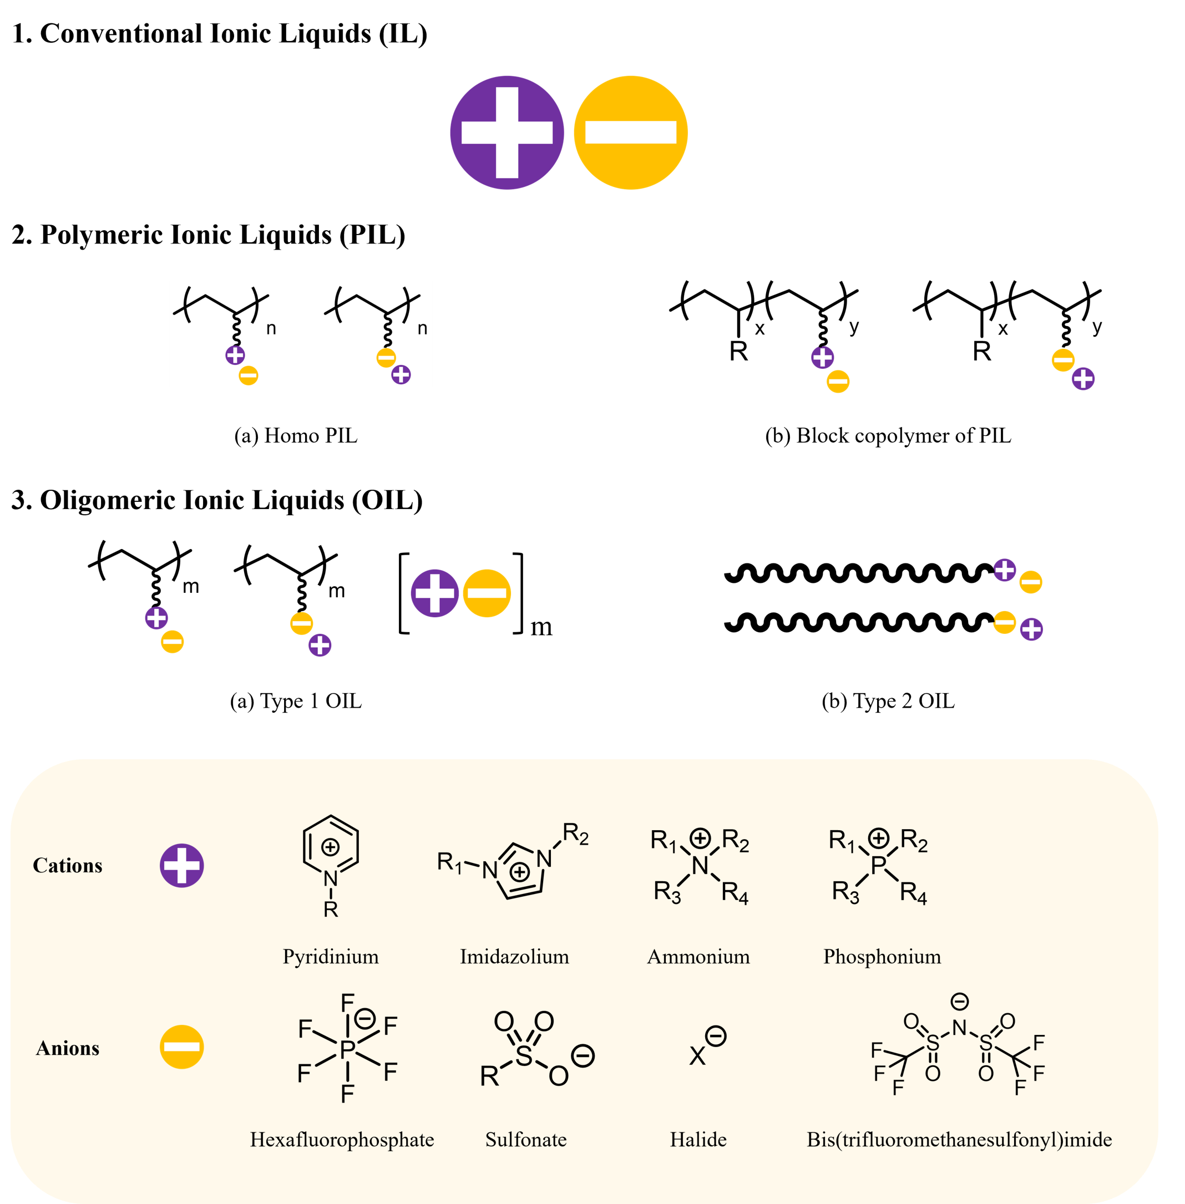
Figure 1.1 Structures of conventional ionic liquids, polymeric ionic liquids, and oligomeric ionic liquids.

found to give a high regioselectivity of O-alkylation reaction for sodium 2-naphthoxide.⁵ Furthermore, some cations or anions on ILs are pharmaceutical ions and ILs may be easier administered to patients because of their liquid form make them as pharmaceutical salts. Finally, by using mixture of ILs, ILs with long alkyl-chain cations can be used as lubricants.⁶

1.1.2 Polymeric Ionic Liquids
Polymeric ionic liquids (PIL) have ionic pendant groups on each repeat unit connecting with the polymeric backbone. Incorporation of ILs into polymers expand the families and applications of polyelectrolytes. Ion pairs of PILs are weaker than that of common polyelectrolytes which contains inorganic salts, and the intermolecular interaction is reduced. Thus, compared with common polyelectrolytes, ionic groups of PILs have less influence on the properties of polymers. In terms of corresponding ILs, the ionic conductivity of PILs is significantly decreased due to the reduced ion mobility.⁷
One unique feature for PILs and their block copolymers is microphase separation behaviors. PILs and PIL block copolymers can provide an ideal well-defined model system. Unlike common block copolymers, a library of block copolymers with different compositions are needed to change the morphology. With only anion exchange, Garcia and coworker modified the domain sizes of PIL block copolymer from 34 to 73 nm within the same morphology, which was illustrated in Figure 1.2.⁸ In terms of homopolymers of PILs, phase separation can also be archived due to the incompatibility hydrophobic polymer and hydrophilic charged groups. Yuan and coworker prepared onion-like vesicles with multilamellar morphology in water and shown in Figure 1.3.⁹
Oher applications of PILs includes thermoresponsive materials with the lower and upper critical solution temperature-type phase transitions, carbon dioxide capture/separation, and so on.¹⁰⁻¹³
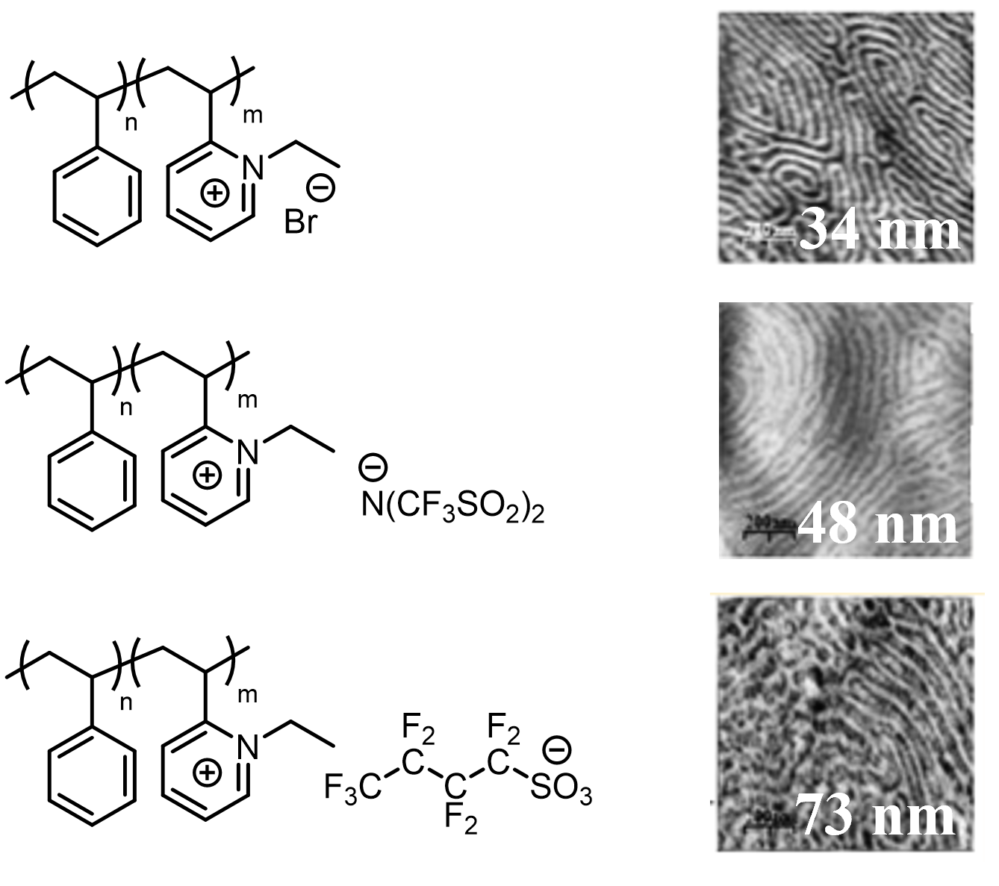
Figure 1.2 Tuning of domain spacings with anion exchange.

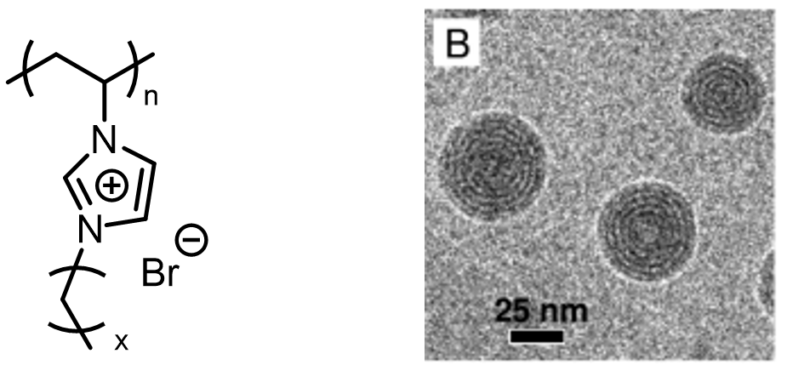
Figure 1.3 Phase separation of homo PIL.

1.1.3 Oligomeric Ionic Liquids
There are two kinds of oligomeric ionic liquids (OIL): (1) First kind of OILs (named as type 1 OIL in this dissertation) has the same structures as PILs, while molecular weights of these OILs are lower to the range of oligomers. Another sort of OILs (named as type 2 OIL in this dissertation) is oligomers have ILs as the chain ends. Compared with PILs, which are often solids below 100 ˚C, OILs can exist in a liquid state or gel state due to the nature of oligomers.¹⁴ Like ILs and PILS, OILs can also work as solvent for synthesis and catalysis.^{15, 16}
More specifically, type 1 OIL is applied in the application which requires liquid state. For examples, Iwasa, Aida and coworkers developed hexafluorophosphate salts of imidazolium ion tetramer as the new class of electrolytes for electric double layer capacitors.¹⁷
In terms of type 2 OIL, numbers of ionic liquid groups on type 2 OIL are more less than that of ILs, PILs, and type 1 OIL. However, type 2 OIL can still exhibit the properties of ILs. Furthermore, with the single one chain end, the properties of OIL can be tuned, which will be discussed more in Section 1.3. Thus, this work was focused on type 2 OIL instead of type 1 OIL.

1.2 The Nature Inspired Materials: Oligomeric Zwitterionic Liquids
Although the intensive utilities of ILs, there is few reports on nature produced ILs. The first report on naturally occurred IL was from Davis Jr and coworkers in 2014. They found this IL was formed when ants S. invicta confronted N. fulva. To detoxify the alkaloid-based S. invicta venom, N. fulva groomed it with its own formic acid venom. The mixture formed the amino formic acid-based IL with long alkyl chains, which was explained in Figure 1.4 and it has the similar structure as type 2 OIL.¹⁸ Unlike ILs, zwitterionic liquid (ZL) or zwitterions be found easily in nature.

1.2.1 Zwitterionic Biomolecules: Lipids
Zwitterions are molecules contain functional groups with equal numbers of positive and
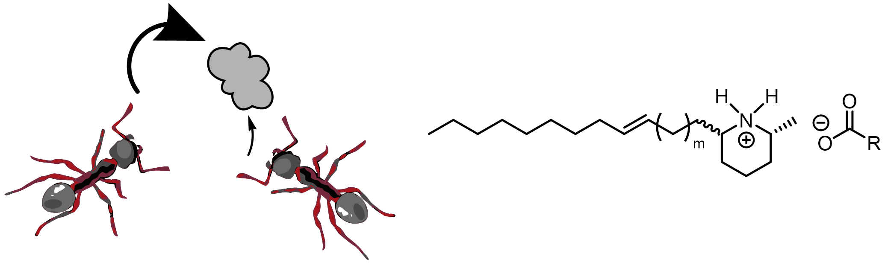
Figure 1.4 Nature produced OIL

negative charge. Differently from ILs whose ions are separated, ions of ZLs are bonded covalently, which was elucidated in Figure 1.5.¹⁹ The noteworthy difference in structure will issue unsimilar properties. From the aspect of nature, ZLs are less ecotoxic than ionic analogs.²⁰ Nature offers a variety of ZLs. For examples, lipids in cell membranes, which are critical to bioactivities. The structure of lipids, showing in Figure 1.6, usually contains a long hydrophobic alkyl tail and a hydrophilic zwitterionic head, which is pretty similar to the type 2 OIL.

1.2.2 Oligomeric Zwitterionic Liquids
Here oligomeric zwitterionic liquids are defined as the oligomers with zwitterionic chain ends to compare with oligomers with ionic end groups. To the best of our knowledge, most literature on OZLs are focused on the area of biomaterials and antifouling materials.^{21, 22}
Hadjichristidis and coworkers developed polystyrene-b-polyisoprene with one zwitterionic chain end and triblock copolymer of polystyrene and polyisoprene with both end groups modified as zwitterions. With introduction of zwitterionic end groups, mono-functionalized block copolymers found to be aggregated in carbon tetrachloride, which is a good solvent for both polystyrene and polyisoprene. And the Difunctionalized triblock copolymer even formed gel below critical overlap concentration.²³ The zwitterionic chain ends significantly affected the properties of polymers and they were expected to play an more important role in OZLs because the lower molecular weights, the higher number of functionalized chain ends per mole.

1.3 End-group Effects on Properties of Oligomeric Ionic and Zwitterionic Liquids
Chain end is a critical structure parameter of polymers and oligomers which dominates their properties, including thermal properties, conformational properties, self-assembly behavior,
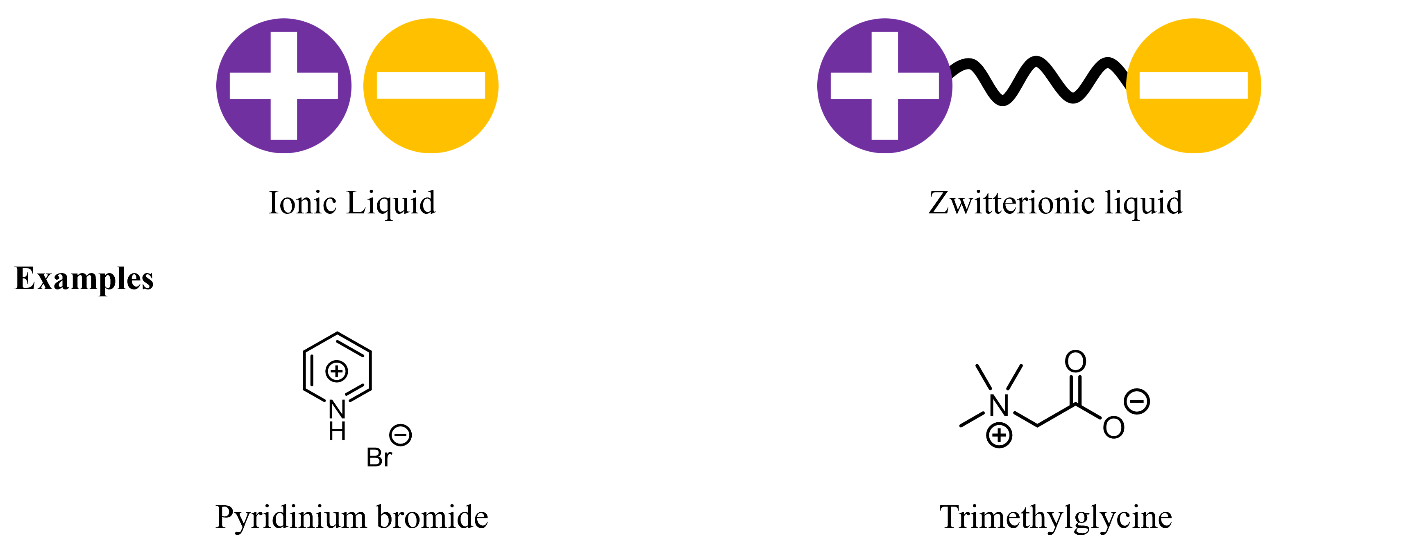
Figure 1.5 Comparison of IL or ZL
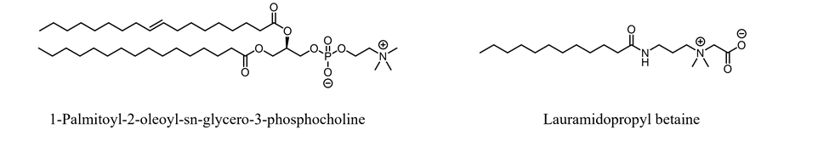
Figure 1.6 Structures of lipids

surface properties, ion transportation properties, phase transition behaviors and so on.²⁴⁻²⁸ For ILs and ZLs, the charged functionalities changed the original properties of unfunctionalized materials. According to the applications of ILs and ZLs, the following properties were discussed in this work, including: (1) thermal properties, which giving room temperature ILs or low temperature ILs for specific tasks. (2) Phase separation behavior. Charged chain ends induced nanostructures in bulk and at the interface make themselves potential candidates for next generation of nanopatterning, lubricants, and antiwear materials.²⁹ (3) Ion conductivity because the usage as polyelectrolytes. (4) Molecular organization at interfaces. Inspired by the natural lipids, the hydrophilic charged ends with designed hydrophobic chains mimic the amphiphilic nature of lipids to form membranes at interfaces, which is a powerful model for study of medium transfer between interfaces and charge transfer.^{30, 31}

1.3.1 Thermal Properties
The various combinations of cations and anions offer different thermal properties. For ILs, thermal stability (thermal degradation temperature, T_{d}) and melting points (T_{m}) are the key points to applications. After introduction of polymers and oligomers, glass transition temperature (T_{g}) is also included.
Brennecke and coworkers studied the thermal stability of imidazolium-based and pyridinium ILs. For the counterions of imidazolium with n-alkyl chains, the thermal stability followed the order of bis(trifluoromethanesulfonyl)imide (Tf₂N) > tris(trifluoromethanesulfonyl)methide (methide) > triflate > tetrafluoroborate (BF₄) > dicyanamide (dca) > bromide (Br). In terms of pyridinium type cations, the counterions followed the order of bis(trifluoromethanesulfonyl)imide (Tf₂N) > tetrafluoroborate (BF₄) > bromide (Br). They concluded that cations had a small effect on T_{d}, while anions primarily dominated T_{d} which decided by the coordination ability and size of anions. However, this conclusion for cations needs more studies because the studied cations were different only in positions and lengths of alkyl chains while the chemical properties of cations were the similar.^{32, 33} For example, based on their results, 1-hexylpyridinium bromide degraded at 511 ˚C while 1-hexyl-3-methylimidazolium bromide was 549 ˚C, which had a temperature difference of 38 ˚C. Furthermore, the effect of anions and cations of charged chain ends on thermal properties of OILs and OZLs is still not clear.
For T_{g}, Meng and coworkers developed a library of OILs with different anions and their T_{g}s are closed but shown the order of Br > BF₄ > dodecylbenzenesulphonate (A-SO₃) > (+)-10-camphorsulphonate (D-SO₃).³⁴ If the ILs based materials were liquid crystals, they would have a T_{m}.

1.3.2 Phase Separation Behavior and Ionic Conductivity
Chain end was powerful enough to tune the properties of polymers and oligomers. Park and coworkers synthesized the block copolymer of polystyrene and poly(ethylene glycol) (PS-b-PEG) which showed a poorly defined morphology. After the hydroxyl chain ends of PS-b-PEG were converted to sulfonate end groups then charged chain ends, the morphology was changed from lamellar to hexagonal cylindrical phases. Furthermore, compared with hydroxyl terminated PS-b-PEG, ion conductivity was doubled for sulfonate-terminated PS-b-PEG. Their work proves that one chain end is enough to tune the morphology and conductivity of polymer electrolytes, which was illustrated in Figure 1.7.³⁵
For OILs, Meng and coworkers prepared a series of OILs whose morphology and ion conductivity were able to be tuned with exchanging of different anions, which was explained in Figure 1.8. Morphologies were changed from lamellar to bicontinuous cubic to hexagonal columnar phase with the exchanging of anions from Br to A-SO₃ to D-SO₃.
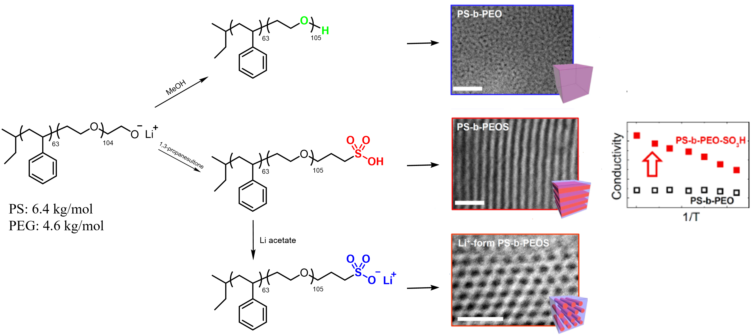
Figure 1.7 Tuning of morphology and conductivity with introduction of charged chain ends.
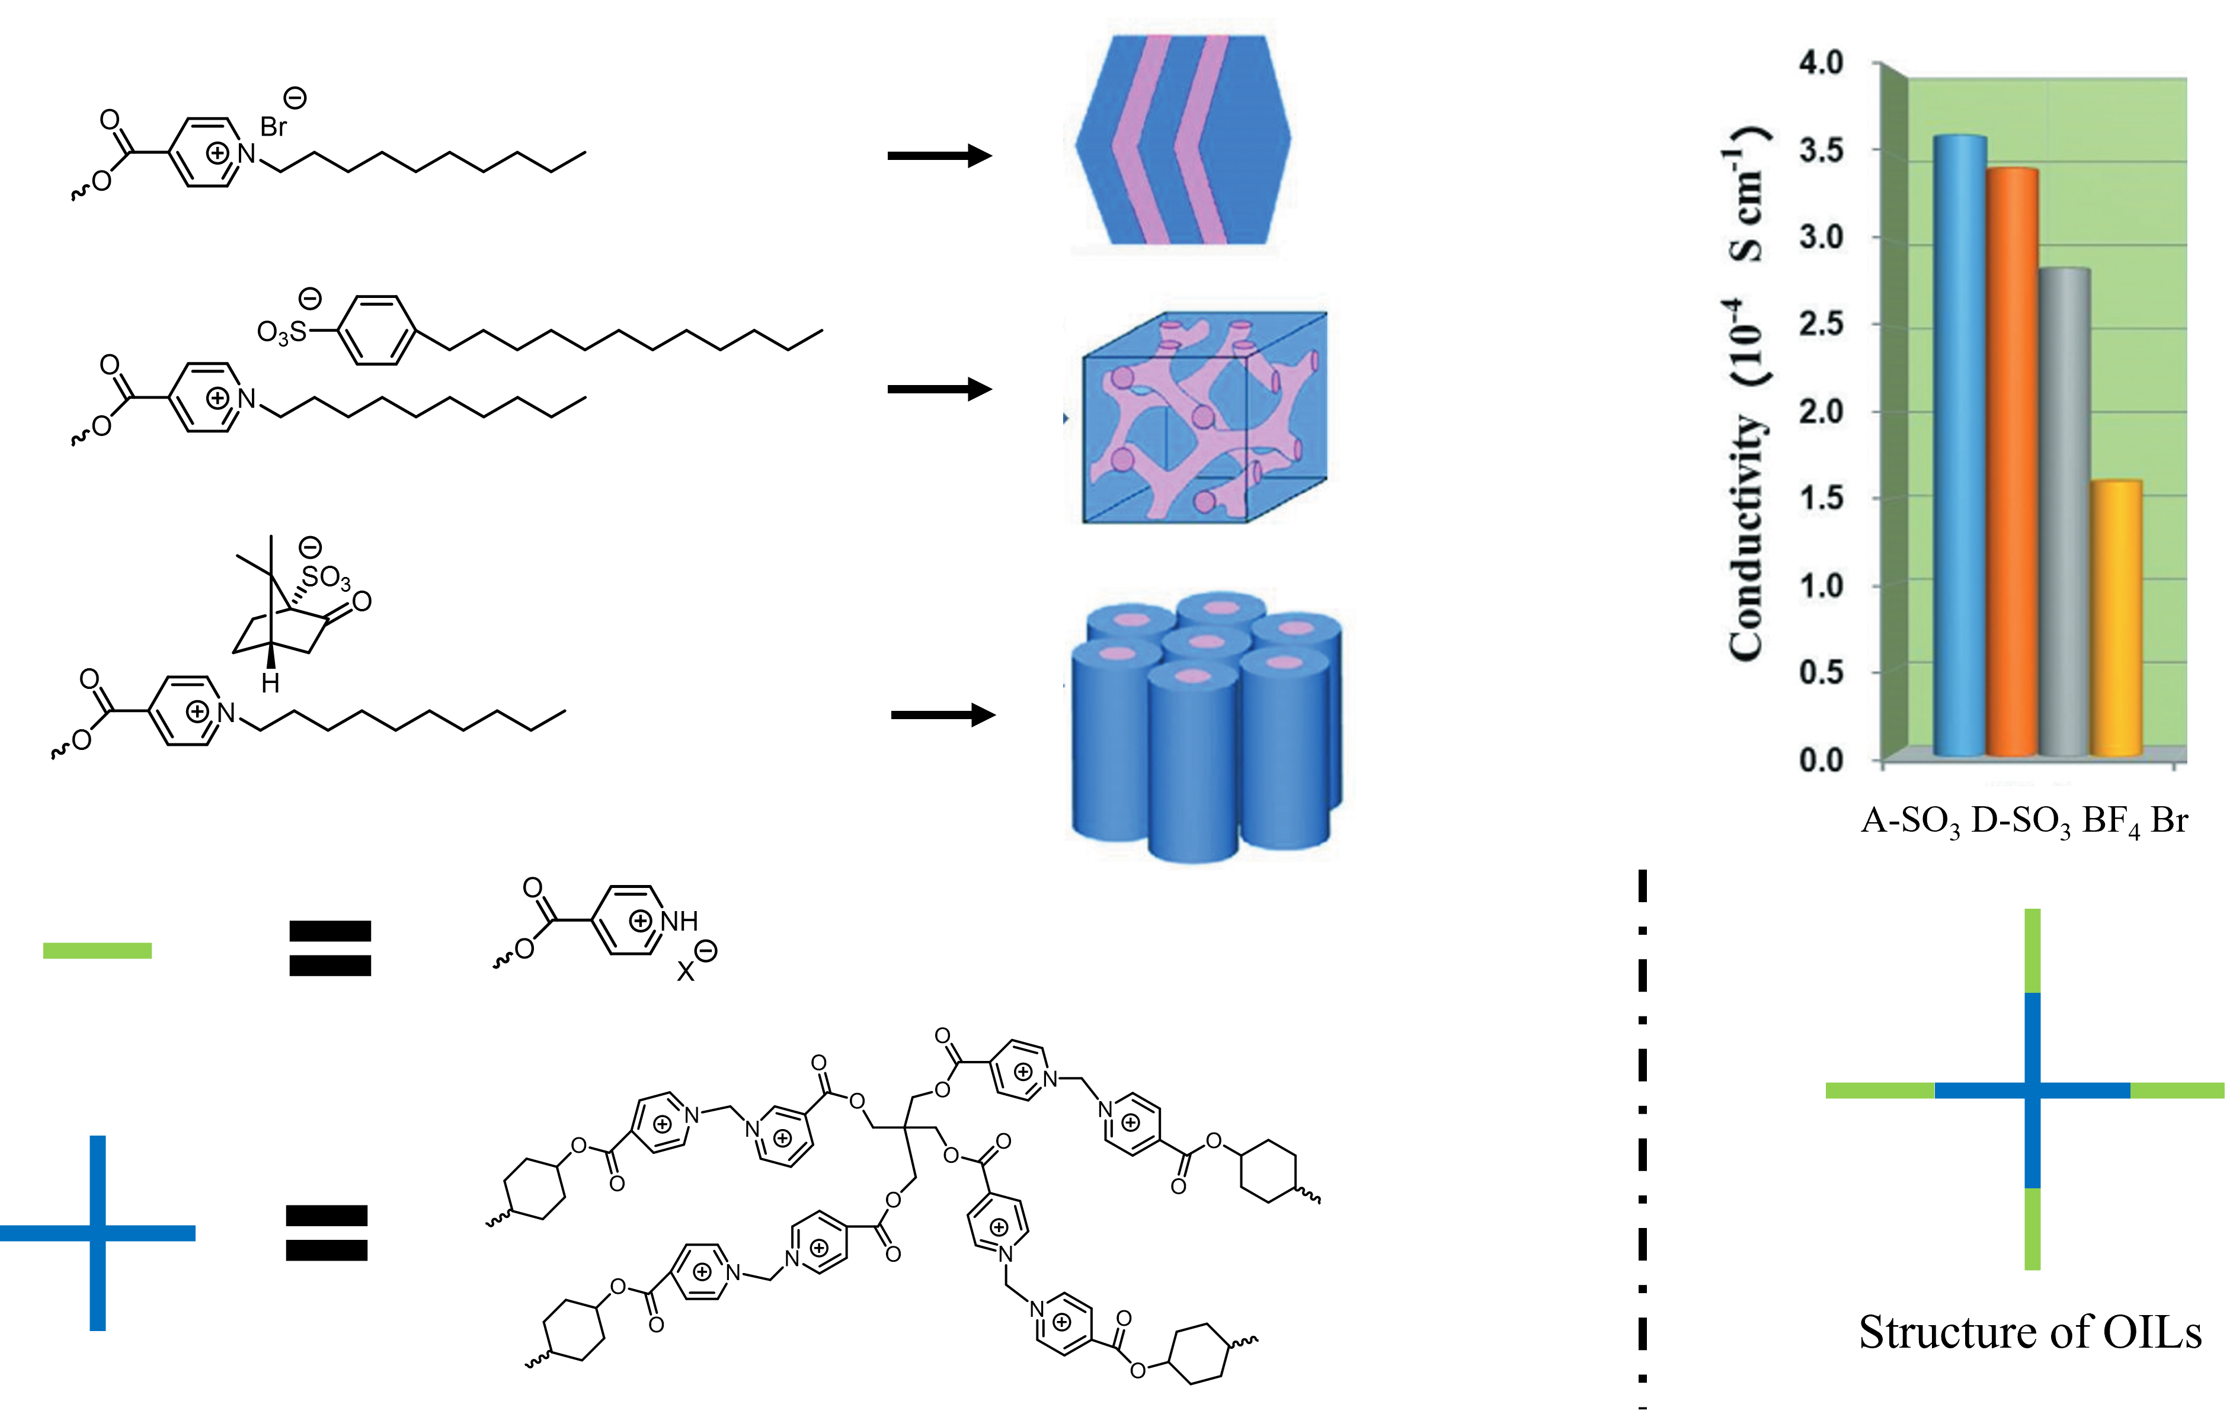
Figure 1.8 Tuning of morphology and conductivity of OIL by changing of anions.

Furthermore, the ion conductivity of anions followed the order of A-SO₃ > D-SO₃ > BF₄ > Br.³⁴ However, the effect of cations on the morphology and ion conductivity is unknown.
In terms of zwitterions, Xu and coworkers synthesized a triblock copolymer of poly(butyl methacrylate) with POSS pendant groups, poly(2-diethylaminoethyl methacrylate), and poly(3-dimethyl(methacryloyloxyethyl) ammonium propanesulfonate) which formed nano micelles in water.²⁵ Nonetheless, to the best of our knowledge, there is no system for OIL with zwitterionic chain ends for phase separation in bulk. It would be interesting to compare the ionic and zwitterionic chain ends under the same system because the connection of zwitterions limited the movement of ions compared with ion liquids.

1.3.3 Molecular Organization at Interfaces

1.4 Motivations
In this work, four objectives were focused to provide symmetrical and fundamental understanding on the effects of charged chain ends on the important properties of charged amphiphilic oligomers. The studied properties were closed related to their potential applications. Thus, a theoretical approach could be built based on this work to design and apply the materials for next generations. Here were the four objectives:

1.4.1 Effects of Charged Chain Ends on Thermal Properties of Charged Amphiphilic Oligomers
As indispensable parameters for design of laboratory measurement conditions and guidance of practical applications, thermal propertis of ILs were inensively studied. However, the effect of cations with different chemical natures on thermal propertis was still not clear for both ILs and OILs. Furthermore, both OILs and OZLs have charged chain ends but disctint in the connection methods of ions. More efforts were needed to analyse the influence of different connecting styles, including ion pairs and covlantly bonded ions.

1.4.2 Impacts of Charged End Groups on Phase Separation Behavior and Ion Conductivity
Phase separation behavior and ion conductivity are important features for PILs and OILs. First, the effect of cations on these two properties of OILs is empty. Moreover, these two properties are correlated that the degree of the internal order formed by phase separation significantly affect the macroscopic ion conductivity. The stronger connected domains leaded to an increasing of conductivity.³⁶ Thus, a complex system was produced. Cations/anions influenced the morphologies and degrees of the internal order by the nature of ions, including coordination ability, size, charge density, electronegativity, and other possible parameters. Simultaneously, one or more of these parameters also affected the ion conductivity. There might be the situation that one cation or anion would suppress the degree of the internal order while improve the ion conductivity. To fully understand the effect of cations and anions on phase separation behavior and ion conductivity, a well-designed system containing a library of samples were required and it would be discussed in the following section 1.4.4.

1.4.3 Influences of Cations and Anions on Molecular Organization at Oil/Aqueous Interface

1.4.4 System Design for The Objectives
Based on the objectives, a system with the ability of phase separation to have morphologies and organization at oil/aqueous interface is needed. Inspired by the natural lipids and high-χ block copolymers, amphiphilic oligomers are perfectly suitable for this mission. To simply the system, instead of using block co-oligomers, homo oligomers are preferred. Because of the hydrophilic chain ends, the hydrophobic oligomer chains are necessary. Among the hydrophobic oligomeric candidates, oDMS was selected in this study due to its unique ability: (1) Great hydrophobicity and incompatibility with charged chain ends. (2) Good solubility in organic solvents for synthesis. (3) Different chemical shifts of backbones and chain ends made it convenient to monitor end group modification and confirm the final products. (3) A potential etch mask given products a possibility for application of nanopatterning.³⁷
Thus, oDMS with mono charged chain ends was developed in this work. The cations of end groups contained imidazolium, pyridinium, and morpholinium which were different in nucleophilicities. For anions, mesylate, tosylate, triflate and bromide were used. The anions were distinct in several aspects: (1) size: triflate > tosylate > mesylate > bromide. (2) Coordination ability: triflate > tosylate ≈ mesylate > bromide. (3) Charge density: bromide > mesylate > tosylate > triflate. (4) Ability of moving to interface: bromide > mesylate > tosylate > triflate. Furthermore, sulfobetaine and tertiary amino methanesulfonic acid were selected to compare the difference between zwitterionic and ionic chain ends. By tuning the combinations of ions and correlating to achieved properties, the relationship between anions/cations/combinations of ions and properties were obtained.

1.5 Characterization Methods for Molecular Organization

1.5.1 Phase Separation Behavior in Bulk

1.5.2 The Macroscopic Ion Conductivity

1.5.3 Structures at Liquid/Liquid Interface

References
1. MacFarlane, D. R.; Kar, M.; Pringle, J. M., Fundamentals of ionic liquids: from chemistry to applications. John Wiley & Sons: 2017.
2. Walden, P., Molecular weights and electrical conductivity of several fused salts. Bull. Acad. Imper. Sci.(St. Petersburg) 1914, 1800.
3. Johnson, K. E., What’s an ionic liquid? The Electrochemical Society Interface 2007, 16 (1), 38.
4. Welton, T., Room-temperature ionic liquids. Solvents for synthesis and catalysis. Chemical reviews 1999, 99 (8), 2071-2084.
5. Badri, M.; Brunet, J.-J.; Perron, R., Ionic liquids as solvents for the regioselective O-alkylation of C/O ambident nucleophiles. Tetrahedron letters 1992, 33 (31), 4435-4438.
6. Freemantle, M., An introduction to ionic liquids. Royal Society of chemistry: 2010.
7. Yuan, J.; Mecerreyes, D.; Antonietti, M., Poly (ionic liquid) s: An update. Progress in Polymer Science 2013, 38 (7), 1009-1036.
8. Carrasco, P. M.; Ruiz de Luzuriaga, A.; Constantinou, M.; Georgopanos, P.; Rangou, S.; Avgeropoulos, A.; Zafeiropoulos, N. E.; Grande, H.-J.; Cabanero, G.; Mecerreyes, D., Influence of anion exchange in self-assembling of polymeric ionic liquid block copolymers. Macromolecules 2011, 44 (12), 4936-4941.
9. Yuan, J.; Soll, S.; Drechsler, M.; Müller, A. H.; Antonietti, M., Self-assembly of poly (ionic liquid) s: Polymerization, mesostructure formation, and directional alignment in one step. Journal of the American Chemical Society 2011, 133 (44), 17556-17559.
10. Seno, K. I.; Kanaoka, S.; Aoshima, S., Synthesis and LCST‐type phase separation behavior in organic solvents of poly (vinyl ethers) with pendant imidazolium or pyridinium salts. Journal of Polymer Science Part A: Polymer Chemistry 2008, 46 (17), 5724-5733.
11. Yoshimitsu, H.; Kanazawa, A.; Kanaoka, S.; Aoshima, S., Well-defined polymeric ionic liquids with an upper critical solution temperature in water. Macromolecules 2012, 45 (23), 9427-9434.
12. Kausar, A., Research progress in frontiers of poly (ionic liquid) s: A review. Polymer-Plastics Technology and Engineering 2017, 56 (17), 1823-1838.
13. Mecerreyes, D., Polymeric ionic liquids: Broadening the properties and applications of polyelectrolytes. Progress in Polymer Science 2011, 36 (12), 1629-1648.
14. Stryutsky, A. V.; Korolovych, V. F.; Lee, H.; Mikan, E.; Erwin, A.; Sobko, O. O.; Gumenna, M. A.; Klimenko, N. S.; Shevchenko, V. V.; Bulavin, L. A. In Oligomeric and polymeric ionic liquids: Engineering architecture and morphology, International Conference Physics of Liquid Matter: Modern Problems, Springer: 2018; pp 93-118.
15. Dewilde, S.; Dehaen, W.; Binnemans, K., Ionic liquids as solvents for PPTA oligomers. Green Chemistry 2016, 18 (6), 1639-1652.
16. Matuszek, K.; Brzeczek-Szafran, A.; Kobus, D.; MacFarlane, D. R.; Swadźba-Kwaśny, M.; Chrobok, A., Protic ionic liquids based on oligomeric anions [(HSO4)(H2SO4) x]−(x= 0, 1, or 2) for a clean ϵ-caprolactam synthesis. Australian Journal of Chemistry 2019, 72 (2), 130-138.
17. Matsumoto, M.; Shimizu, S.; Sotoike, R.; Watanabe, M.; Iwasa, Y.; Itoh, Y.; Aida, T., Exceptionally high electric double layer capacitances of oligomeric ionic liquids. Journal of the American Chemical Society 2017, 139 (45), 16072-16075.
18. Chen, L.; Mullen, G. E.; Le Roch, M.; Cassity, C. G.; Gouault, N.; Fadamiro, H. Y.; Barletta, R. E.; O'Brien, R. A.; Sykora, R. E.; Stenson, A. C., On the formation of a protic ionic liquid in nature. Angewandte Chemie International Edition 2014, 53 (44), 11762-11765.
19. Skoog, D. A.; West, D. M.; Holler, F. J.; Crouch, S. R., Fundamentals of analytical chemistry. Cengage learning: 2013.
20. Jesus, F.; Passos, H.; Ferreira, A. M.; Kuroda, K.; Pereira, J. L.; Gonçalves, F. J.; Coutinho, J. A.; Ventura, S. P., Zwitterionic compounds are less ecotoxic than their analogous ionic liquids. Green Chemistry 2021, 23 (10), 3683-3692.
21. Hashimoto, H.; Nelson, M. G.; Switzer, C., Zwitterionic DNA. Journal of the American Chemical Society 1993, 115 (16), 7128-7134.
22. Ga, D.-H.; Lim, C.-M.; Jang, Y.; Son, T. I.; Han, D. K.; Joung, Y. K., Surface-Modifying Effect of Zwitterionic Polyurethane Oligomers Complexed with Metal Ions on Blood Compatibility. Tissue Engineering and Regenerative Medicine 2022, 19 (1), 35-47.
23. Pispas, S.; Hadjichristidis, N., End-functionalized block copolymers of styrene and isoprene: synthesis and association behavior in dilute solution. Macromolecules 1994, 27 (7), 1891-1896.
24. Yoon, S.; MacKnight, W. J.; Hsu, S. L., End‐group effect on chain conformation of poly (propylene glycol) and poly (ethylene glycol). Journal of applied polymer science 1997, 64 (1), 197-202.
25. Xu, Y.; Huang, J.; Li, Y.; Wang, M.; Cao, Y.; Yuan, C.; Zeng, B.; Dai, L., A novel hybrid polyhedral oligomeric silsesquioxane-based copolymer with zwitterion: Synthesis, characterization, self-assembly behavior and pH responsive property. Macromolecular Research 2017, 25 (8), 817-825.
26. Jalbert, C.; Koberstein, J. T.; Hariharan, A.; Kumar, S. K., End group effects on surface properties of polymers: semiempirical calculations and comparison to experimental surface tensions for α, ω-functional poly (dimethylsiloxanes). Macromolecules 1997, 30 (15), 4481-4490.
27. Jo, G.; Kim, O.; Kim, H.; Hyeok Choi, U.; Lee, S.-B.; Jeong Park, M., End-functionalized block copolymer electrolytes: effect of segregation strength on ion transport efficiency. Polymer Journal 2016, 48 (4), 465-472.
28. Qiu, X.; Koga, T.; Tanaka, F.; Winnik, F. M., New insights into the effects of molecular weight and end group on the temperature-induced phase transition of poly(N-isopropylacrylamide) in water. Science China Chemistry 2013, 56 (1), 56-64.
29. Perkin, S.; Albrecht, T.; Klein, J., Layering and shear properties of an ionic liquid, 1-ethyl-3-methylimidazolium ethylsulfate, confined to nano-films between mica surfaces. Physical Chemistry Chemical Physics 2010, 12 (6), 1243-1247.
30. Santos, H. A.; García‐Morales, V.; Pereira, C. M., Electrochemical properties of phospholipid monolayers at liquid–liquid interfaces. ChemPhysChem 2010, 11 (1), 28-41.
31. Volkov, A. G., Liquid interfaces in chemical, biological and pharmaceutical applications. CRC Press: 2001.
32. Fredlake, C. P.; Crosthwaite, J. M.; Hert, D. G.; Aki, S. N.; Brennecke, J. F., Thermophysical properties of imidazolium-based ionic liquids. Journal of Chemical & Engineering Data 2004, 49 (4), 954-964.
33. Crosthwaite, J. M.; Muldoon, M. J.; Dixon, J. K.; Anderson, J. L.; Brennecke, J. F., Phase transition and decomposition temperatures, heat capacities and viscosities of pyridinium ionic liquids. The Journal of Chemical Thermodynamics 2005, 37 (6), 559-568.
34. Liu, S.; Yan, G.; Wang, J.; Zhou, J.; Bie, L.; Jia, Y.; Meng, F., Self-assembly, phase behaviour and ion-conducting property of pyridinium-based ionic liquid-crystalline oligomers. Liquid Crystals 2021, 48 (2), 201-214.
35. Jo, G.; Ahn, H.; Park, M. J., Simple route for tuning the morphology and conductivity of polymer electrolytes: one end functional group is enough. ACS Macro Letters 2013, 2 (11), 990-995.
36. Hayes, R.; Warr, G. G.; Atkin, R., Structure and nanostructure in ionic liquids. Chemical reviews 2015, 115 (13), 6357-6426.
37. Nickmans, K.; Schenning, A. P., Directed Self‐Assembly of Liquid‐Crystalline Molecular Building Blocks for Sub‐5 nm Nanopatterning. Advanced Materials 2018, 30 (3), 1703713.

CHAPTER 2 SYNTHESIS OF END-GROUP FUNCTIONALIZED DIMETHYL SILOXANE OLIGOMERS (ODMS)

Abstract
In this chapter, a library of ODMS oligomers with different ionic and zwitterionic end groups were synthesized by a metal-free and scalable method with the high conversion. Starting from the commercially available monon-hydroxyl terminated oDMS (oDMS-OH), different anion precurors, including mesylate, tosylate, triflate and bromide, were introduced by esterification or S_{N}2 substitution. Then, different cations was installed through S_{N}2 substitution with the corresponding amines, including imidazole, pyridine and morpholine, to afford the mono-ionic chain end oDMS (oDMS-IL). For mono-zwitterionic chain ends, hydroxyl groups were modified into tertiary amine groups, followed by ring opening of 1,3-propanesultone to obtain the mono-zwitterionic (sulfobetaine) chain end oDMS (oDMS-ZW). To compare effects of ionic and zwitterionic chain ends, tertiary amine terminated oDMS was reacted with methanesulfonic acid to afford oDMS-IL with the similar chemical structure as oDMS-ZW. The chemical structures of all end-group functionalized oDMS were summarized in Scheme 2.1.
Throughout the reaction, proton nuclear magnetic resonance (¹H NMR) spectroscopy was employed to monitor the reaction and confirm the purity of the resulting materials. As shown in the spectra of ¹H NMR and matrix-assisted laser desorption/ionization time-of-flight (MALDI-TOF) mass spectrometry, the peaks in ¹H NMR shift very cleanly in the expected manner for each product and the exact molecular weights of oDMS with different cationic species identically matched the excepted numbers, which proofing the purity of the end-functionalized oDMS.

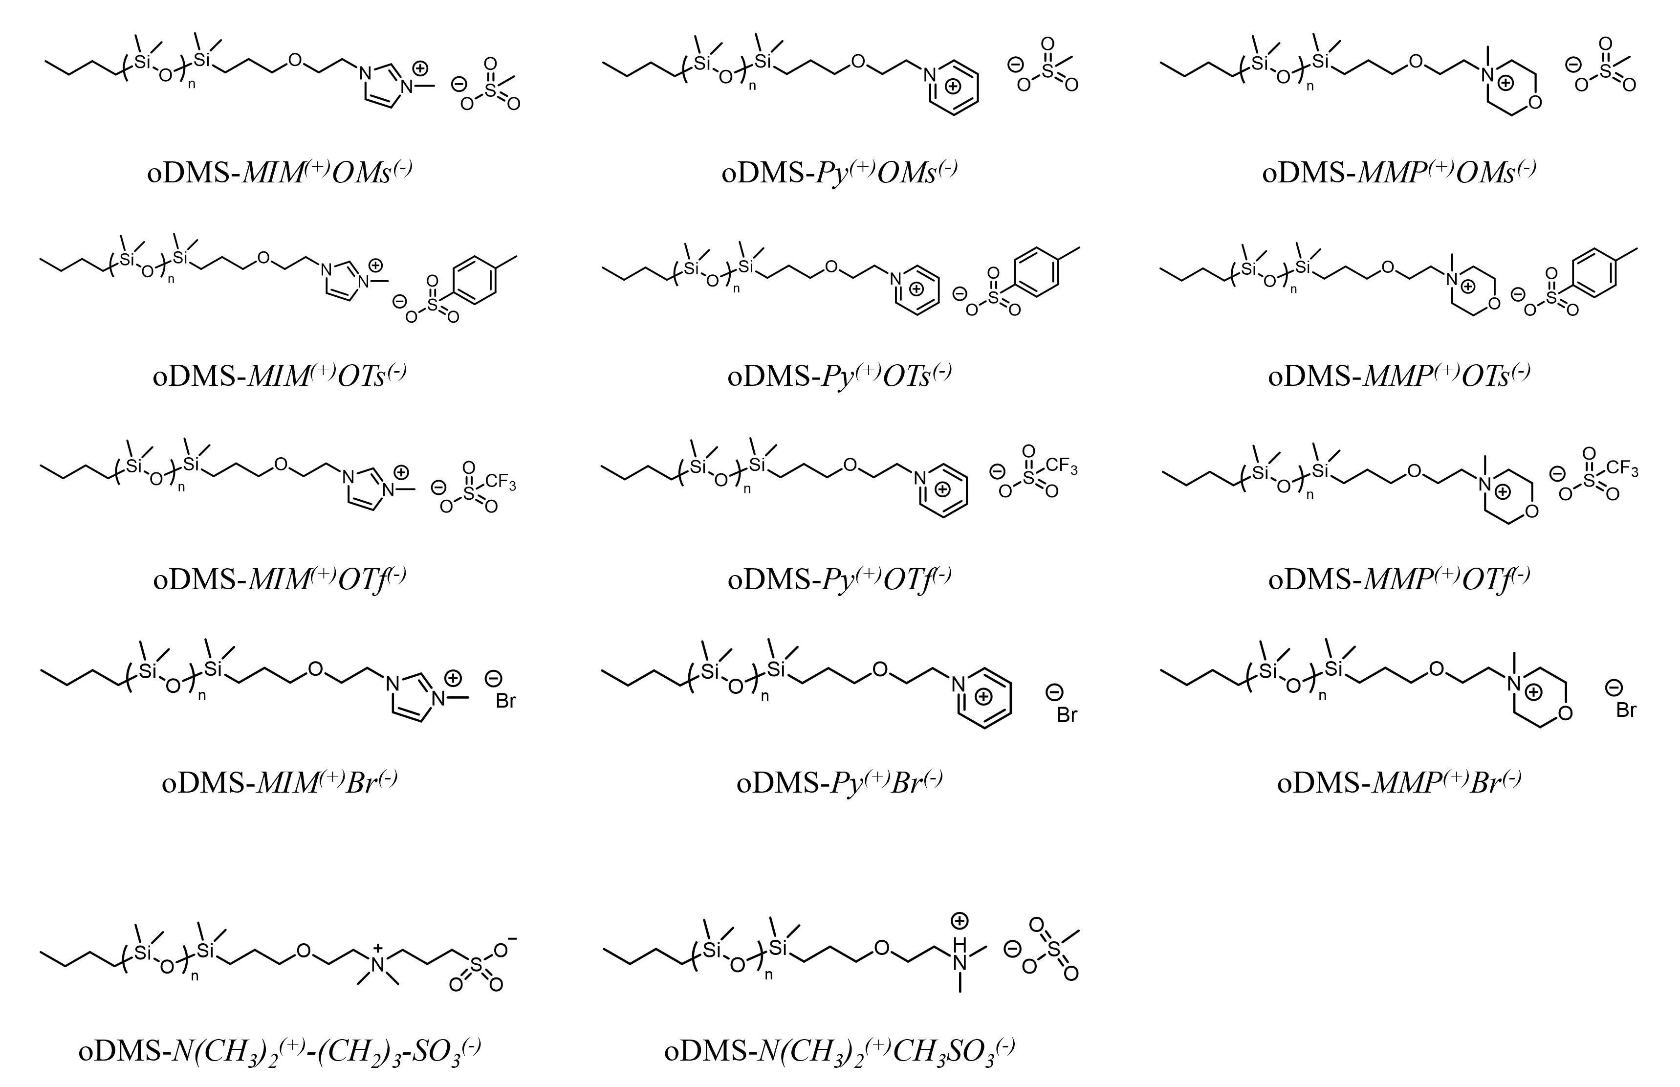
Scheme 2.1 Summary of Amphiphilic Oligomers

2.1 Introduction
The development of new materials with unique properties, including self-assembly, ion conducting, and other tunable features, requires specific functionality in polymers or oligomers. One straightforward approach to introduce functionality on backbone or side chains of polymers is controlled polymerization of tailor-made monomers with predesigned structures. However, the synthesis of special monomers is usually time-consuming and the functionality itself will affect the polymerization process which leading to a large dispersity or even the failure of the polymerization. Thus, this high-precision method gives limited examples for well-defined polymers. To obtain various kinds of functional polymers, methodologies, including chain extension from functionalized initiators and chain-end transformation of well-defined samples are applied. Both approaches provide end groups for further modifications, involving end-capping with amine, halides, carboxyl, ester, ionic and zwitterionic groups, by taking advantage of knowledge from organic chemistry.^{1, 2} Although the number of functionalized groups on chain-end modified polymers is much lower than that of highly functionalized polymers from designed monomers, the properties of end-group modified polymers or oligomers can be tuned with one single chain end, which has been discussed in Chapter 1. Because of its efficiency and convenience, end group modification is preferred in this work.
Among diverse end groups, hydroxyl groups are often selected as the starting point because it can be effectively reacted into ether, ester, mesylate, tosylate, triflate, halide, amines, and other end groups with a conversion higher than 90%.³ However, this efficiency is still not enough for end group modification of oligomers because of their moderate molecular weights between polymers and small molecules. First, compared with small molecules, the oligomer chains lower the chances of collisions between chain ends and reactants which gives a suppressed yield. In general, tosylation of decyl alcohol with p-toluenesulfonyl chloride is almost quantitative.⁴ In terms of oligo(isobutylenes), Mülhaupt, Iván and coworkers obtained a conversion of 93% for tosylation and 7% hydroxyl groups were converted into chloride groups.⁵ Second, the nature of oligomers make them hard to purify. Small molecules can be purified by column chromatography or recrystallization, while low functionalities of oligomers give a weak signal on thin layer chromatography leading to losing of materials and most of them will not crystallize. Although oligomers can be purified via column chromatography, this technique will be the last choice due to the potential risk of material lose. Like polymers, the best purification method is precipitation, while the choice of reactants is limited due to the solubility for precipitation process. Thus, development of end group modification method with high conversion for oligomers is needed.
For silicone-based materials, metal catalysts are often used because its high efficiency. For example, hydrosilylation with Karstedt catalyst. However, based on our experiences, platinum in Karstedt catalyst cannot be separated from oDMS oligomers after reactions which give a black colored oil. So, a metal-free method is also required to obtain chain-end modified oligomers with high purity.
To prove the success of end group modification and purity of obtained samples, end-group analysis is necessary. ¹H NMR spectroscopy and MALDI-TOF MS are the most powerful techniques for this task. ¹H NMR spectroscopy gives reliable signals with integrations that are directly related to protons at different chemical environments and end groups can be identified and quantified. Not only end groups but also molecular weight of end-group functionalized oligomers can be calculated based on ratios of protons at end groups and backbones.^{6, 7} However, another important parameter, dispersity, which proving the quality of samples that oligomers do not be degraded during reactions, cannot be analyzed by ¹H NMR spectroscopy. With MALDI-TOF MS, both end groups and repeat units can be determined according to the single-charged quasi-molecular ions with fragmentations.⁸
In summary, to obtain high quality model materials, a metal-free and high-conversion end group modification method was developed for oDMS in this work from the synthesis to the purification.

2.2 Experiments

2.2.1 Materials
All reagents were used as received from Sigma-Aldrich without further purification unless otherwise noted. oDMS-OH was purchased from Gelest and the molecular weight (1256 kg/mol, n=14) was checked with ¹H NMR, which was shown in the Appendix Figure S1.

2.2.2 Synthesis of anion and cation oDMS precursors
Oligodimethylsiloxane mesylate (ODMS-OMs) was synthesized by the following procedure: Into a 250 ml Schlenk flask, ODMS-OH (10.0 g, 10 mmol, 1.0 eq), triethylamine (1.3 g, 13 mmol, 1.3 eq) and dichloromethane (100 ml) was added under an inert atmosphere. Then, methanesulfonyl chloride (MsCl) (1.4 g, 12 mmol, 1.2 eq) was added dropwise into the solution in an ice bath. The reaction was stirred overnight at room temperature. After condensing the solution, oligomer solution was precipitated in a large excess of cold methanol/ H2O (v/v = 8/1) solution, affording the pure target product as a colorless oil with quantitative yield. ¹H NMR spectrum was shown in the Appendix Figure S2.
Oligodimethylsiloxane tosylate (ODMS-OTs) was prepared by the similar procedure: A 250 ml Schlenk flask was charged with 10.0 g of ODMS-OH (10 mmol, 1.0 eq), 1.3 g of triethylamine (13 mmol, 1.3 eq) and 100 ml of dichloromethane. Then, the flask was subsequently put into an ice bath. 2.3 g of p-toluenesulfonyl chloride (TsCl) (12 mmol, 1.2 eq) was added portionwise into the solution under an inert atmosphere. The reaction was allowed warm to room temperature and stir for overnight. The solution was then condensed and precipitated in a large excess of cold methanol/ H2O (v/v = 8/1) solution, affording the colorless oil as the crude product as 92% ODMS-OTs and 8% ODMS-OH. ODMS-OTs was separated by column chromatography (Hexanes/DCM = 2:1) and a colorless oil was obtained as the final product. (92% yield) ¹H NMR spectrum was shown in the Appendix Figure S3.
Oligodimethylsiloxane triflate (ODMS-OTf) was converted by the descried method: 10.0 g of ODMS-OH (10 mmol, 1.0 eq), 1.1 g of pyridine (14 mmol, 1.4 eq) and 100 ml of anhydrous dichloromethane were added into a 250 mL Schlenk flask. The mixture was then put into an acetone/dry ice bath. 3.38 g of trifluoromethanesulfonic anhydride (OTf₂) (12 mmol, 1.2 eq) was added dropwise into the solution under a nitrogen atmosphere. The reaction was kept in the acetone/dry ice bath and stirred for 4 hours. Then, water was added into the reaction. Organic layer was collected and washed with water quickly for 3 times. After drying the organic layer with MgSO₄, the solvent was removed. ODMS-OTf was purified with by column chromatography (Hexanes/DCM = 5:1) as a colorless oil. (74% yield). ¹H NMR spectrum was shown in the Appendix Figure S4.
Oligodimethylsiloxane bromide (ODMS-Br) was synthesized by the following method: A 500 ml Schlenk flask under an inert atmosphere was added with ODMS-OH (15.0 g 15 mmol, 1.0 eq), triphenylphosphine (PPh₃) (4.8 g, 18 mmol, 1.2 eq) and 180 ml of dichloromethane. After putting the flask into an ice bath, 6.0 g of carbon tetrabromide (CBr₄) (18 mmol, 1.2 eq) was added portionwise and stirred overnight at room temperature. Sequentially, the condensed solution was precipitated in the cold methanol/ H2O (v/v = 8/1) solution to obtain the colorless oil with quantitative yield. ¹H NMR spectrum was shown in the Appendix Figure S5.
Dimethylamine terminated oligodimethylsiloxane (ODMS-N(CH₃)₂) was prepared from ODMS-Br. Into a 250 ml Schlenk flask, 10 g of ODMS-Br (10 mmol, 1.0 eq) and 3.3 mL of pyridine (41 mmol, 4.1 eq) were first added. Then, 100 ml of dimethylamine (2.0 M) in THF solution was charged into the mixture and stirred overnight at 40 ˚C. After precipitation of condensed solution in the cold methanol/ H2O (v/v = 6/1) solution, a light-green oil with quantitative yield was afforded as the pure compound. ¹H NMR spectrum was shown in the Appendix Figure S6.

2.2.3 Preparation of oDMS with ionic chain ends
Imidazolium based oDMS with ionic chain ends, including oligodimethylsiloxane imidazolium mesylate (oDMS-MIM⁽⁺⁾OMs⁽⁻⁾), oligodimethylsiloxane imidazolium tosylate (oDMS-MIM⁽⁺⁾OTs⁽⁻⁾), oligodimethylsiloxane imidazolium triflate (oDMS-MIM⁽⁺⁾OTf⁽⁻⁾), and oligodimethylsiloxane imidazolium bromide (oDMS-MIM⁽⁺⁾Br⁽⁻⁾), were converted from the corresponding anion oDMS precursors. Anion oDMS precursors (2.0 g, 2.0 mmol, 1.0 eq), 1-methylimidazole (2.0 g, 24.4 mmol, 12.2 eq) and 2 ml of toluene were added into a 20 mL vial. After purging with nitrogen for 30 mins, the mixture was heated at 110 ˚C for 24 hours. Toluene and excess of imidazolium was removed at 90 ˚C under high vacuum for 48 hours to obtain the final product as the brown gel with quantitative yield. ¹H NMR and MS spectrum were shown in the Appendix from Figure S7 to S14.
Pyridinium based oDMS with ionic chain ends, consist of oligodimethylsiloxane pyridinium mesylate (oDMS-Py⁽⁺⁾OMs⁽⁻⁾), oligodimethylsiloxane pyridinium tosylate (oDMS- Py ⁽⁺⁾OTs⁽⁻⁾), oligodimethylsiloxane pyridinium triflate (oDMS- Py ⁽⁺⁾OTf⁽⁻⁾), and oligodimethylsiloxane pyridinium bromide (oDMS- Py ⁽⁺⁾Br⁽⁻⁾), were synthesized through the following approach: Into a 20 mL vial, anion oDMS precursors (2.0 g, 2.0 mmol, 1.0 eq) and 5 mL of pyridine were added and then purged with nitrogen for 30 mins. After heating at 90 ˚C for 24 hours, removal of excess of pyridinium was performed at 90 ˚C under high vacuum for 48 hours to afford the brown gel with quantitative yield. ¹H NMR and MS spectrum were shown in the Appendix from Figure S15 to S22.
Morpholinium based oDMS with ionic chain ends, comprising oligodimethylsiloxane morpholinium mesylate (oDMS-MMP⁽⁺⁾OMs⁽⁻⁾), oligodimethylsiloxane morpholinium tosylate (oDMS- MMP ⁽⁺⁾OTs⁽⁻⁾), oligodimethylsiloxane morpholinium triflate (oDMS- MMP ⁽⁺⁾OTf⁽⁻⁾), and oligodimethylsiloxane morpholinium bromide (oDMS- MMP ⁽⁺⁾Br⁽⁻⁾), were prepared by the similar method: After adding 2.0 g of anion oDMS precursors (2.0 mmol, 1.0 eq), 2.46 g of N-methylmorpholine (24.3 mmol, 12.2 eq), and 2 ml of toluene into a 20 mL flask, the solution was purged with nitrogen for 30 mins, followed by heating at 90 ˚C for 24 hours. Solvent and excess reactant were removed under high vacuum for 2 days at 90 ˚C. A brown gel was collected with quantitative yield as the final product without further purification, except for oDMS- MMP ⁽⁺⁾Br⁽⁻⁾. During the reaction, white solids started to precipitate due to the poor thermal stability of oDMS- MMP ⁽⁺⁾Br⁽⁻⁾. After filtering the white salts, the crude oDMS- MMP ⁽⁺⁾Br⁽⁻⁾ was purified by column chromatography to remove the unreacted oDMS-Br with DCM and collect the pure product with methanol (80% yield). ¹H NMR and MS spectrum were shown in the Appendix from Figure S23 to S30.
Oligodimethylsiloxane tertiary amino methanesulfonic acid (oDMS-NH(CH₃)₂⁽⁺⁾MeSO₃⁽⁻⁾) was synthesized by the descried procedure: 0.5 g of cation oDMS precursor, which is ODMS-N(CH₃)₂ (0.5 mmol, 1.0 eq) was dissolved in 5 mL of acetone in a 20 mL vial. Then, acetone solution which contains equimolar methanesulfonic acid (MeSO₃H) was added dropwise into the mixture under the ice batch. After stirring at room temperature for 1 hour, acetone was removed without hearing under vacuum. The product was redissolved in n-hexane and centrifuged to remove undissolved methanesulfonic acid if it existed. The pure product was a green viscous gel with quantitative yield. ¹H NMR and MS spectrum were shown in the Appendix from Figure S31 to S32.

2.2.4 Synthesis of oDMS with zwitterionic chain ends
Oligodimethylsiloxane sulfobetaine (oDMS-N(CH₃)₂⁽⁺⁾-(CH₂)₃-SO₃⁽⁻⁾) was prepared from cation oDMS precursor. A 250 ml Schlenk flask was charged with 5 g of ODMS-N(CH₃)₂ (5 mmol, 1.0 eq) and 28 ml of acetone. After purging with nitrogen for 30 mins, 1.3 g of 1, 3-propanesultone (5.5 mol, 1.1 eq) was added in the solution. Then, the reaction was stirred overnight at 40 ˚C. The crude product was purified by column chromatography with DCM to remove the unreacted 1, 3-propanesultone and DCM/methanol (5:1) to collect the pure product as the white solids (90% yield). ¹H NMR and MS spectrum were shown in the Appendix from Figure S33 to S34.

2.3 Characterization

2.3.1 Proton Nuclear Magnetic Resonance (¹H NMR) Analysis
¹H NMR spectra were recorded on a Bruker-500 MHz NMR spectrometer at 25 ˚C in deuterated chloroform (CDCl₃) (7.27 ppm ¹H reference) with a relaxation delay of 5 s, number of scans as 32, and loop counter of 2, unless otherwise noted.

2.3.2 Matrix-assisted Laser Desorption/ionization Time-of-flight (MALDI-TOF) Mass Spectrometry Measurement

2.4 Results and Discussion
¹H NMR signals of protons on the chain ends and oDMS backbone, they were significantly different in chemical shifts due to the dramatically change of chemical environments. Protons on oDMS chains had chemical shifts of 0.1 ppm and the chemical shifts of C₄H₇ end groups were ranged from 0.5 to 1.7 ppm with 4 peaks. These signals would not be changed during the reaction because lack of functionalities and their positions with ratios of integrations can be used as references for calculation of converted end groups. For the side of functional end groups, their signals moved to the direction of down-field regions due to electronegativity of neighboring oxygens. Thus, the conversion of end groups can be easily monitored during the reactions without the influence of oDMS backbones and another chain ends.
It was found that the esterification with MsCl or OTf₂ and the S_{N}2 substitution with CBr₄/PPh₃ or dimethylamine are all highly efficient, evidenced by ¹H NMR spectra where the disappear of the three sets of protons related to hydroxyl chain ends after the reactions. For the esterification with TsCl, 92% of OH groups were converted to tosyl groups. The unreacted oDMS-OH can be easily removed by column chromatography. Subsequently, S_{N}2 reactions between amines and anion precursors on oDMS yield the different counter-ions. Both pyridine and N-methylmorphine reached quantitative conversion under 90 ˚C, while 1-methylimidazole required 110 ˚C because of different nucleophilicities. Also, the excess amounts of amines can be cleanly removed under high vacuum with heating to produce pure material easily. For zwitterionic end groups, a sulfobetaine chain end was obtained by ring opening of 1,3-propanesultone. All resulting ionic oligomers are liquids at 90 ˚C and weak gels at room temperature, while zwitterionic oligomer is solid at room temperature. Interestingly, unlike other end groups, with the end group of MMP⁽⁺⁾Br⁽⁻⁾ or NH(CH₃)₂⁽⁺⁾MeSO₃⁽⁻⁾, oDMS started to degrade under certain conditions. When appling heating, oDMS- MMP ⁽⁺⁾Br⁽⁻⁾ was not stable with precipitating of white solids during reaction, which was also shown in the thermalgravity measurement in the next chapter. In terms of NH(CH₃)₂⁽⁺⁾MeSO₃⁽⁻⁾, excess amount of MeSO₃H, which providing an acidic condition, hydrolyzed the siloxane oxygen bonds of oDMS backbone.[ Organometallics 2002, 21, 11, 2165–2175] So, it is critical to add equimolar MeSO₃H and neutralize or remove any possible excess of MeSO₃H after the reaction.
Furthermore, MALDI-TOF MS was applied to confirm the purity of the obtained amphiphilic oligomer, including molecular weight, dispersity, and end group analysis. The calculated molecular weights and mass of end groups were matched with theoretical numbers indicated the completion of end group modification. Based on the MS spectra, the dispersity of synthesized samples is about 1.04 to 1.11 which explained the quality of the samples that oDMS does not degrade during the synthesis.

2.5 Conclusion
A library of ODMS oligomers with different ionic and zwitterionic chain ends were successfully prepared by a metal-free, high-conversion and scalable method. And the success of synthesis work was evidenced by ¹H NMR spectroscopy and MALDI-TOF MS. Compared with the starting materials and their precurosrs, the obained materials were signicantly different in phsyical states with relpacing just one single chain end. Futher investigiation was needed to fully standstand the properteis and the effects of chain ends on properteis of these instersting samples.

Reference
1. Kim, J.; Jung, H. Y.; Park, M. J., End-group chemistry and junction chemistry in polymer science: Past, present, and future. Macromolecules 2020, 53 (3), 746-763.
2. Grubbs, R. B.; Grubbs, R. H., 50th Anniversary Perspective: Living Polymerization Emphasizing the Molecule in Macromolecules. Macromolecules 2017, 50 (18), 6979-6997.
3. Wuts, P. G.; Greene, T. W., Greene's protective groups in organic synthesis. John Wiley & Sons: 2006.
4. Kabalka, G. W.; Varma, M.; Varma, R. S.; Srivastava, P. C.; Knapp Jr, F. F., The tosylation of alcohols. The Journal of Organic Chemistry 1986, 51 (12), 2386-2388.
5. Pásztói, B.; Trötschler, T. M.; Szabó, Á.; Szarka, G.; Kerscher, B.; Mülhaupt, R.; Iván, B., Synthesis of Tosyl-and Nosyl-Ended Polyisobutylenes with High Extent of Functionalities: The Effect of Reaction Conditions. Polymers 2020, 12 (11), 2504.
6. Otte, D. A.; Borchmann, D. E.; Lin, C.; Weck, M.; Woerpel, K., 13C NMR spectroscopy for the quantitative determination of compound ratios and polymer end groups. Organic letters 2014, 16 (6), 1566-1569.
7. Päch, M.; Zehm, D.; Lange, M.; Dambowsky, I.; Weiss, J.; Laschewsky, A., Universal Polymer Analysis by 1H NMR Using Complementary Trimethylsilyl End Groups. Journal of the American Chemical Society 2010, 132 (25), 8757-8765.
8. Chen, H.; He, M.; Pei, J.; Liu, B., End-Group Analysis of Blue Light-Emitting Polymers Using Matrix-Assisted Laser Desorption/Ionization Time-of-Flight Mass Spectrometry. Analytical Chemistry 2002, 74 (24), 6252-6258.

CHAPTER 3 EFFECTS OF CHAIN ENDS ON THERMAL PROPERTIES OF CHARGED OLIGOMERS

Abstract

3.1 Introduction

3.2 Experimental Part

3.2.1 Characterization of Thermal Stability

3.2.2 Measurement of Glass Transition Temperature

3.2.3 Characterization of Crystallization and Melting Temperature

3.3 Results and Discussion

3.3.1 Influences of Cations on Thermal Properties

3.3.2 Impacts of Anions on Thermal Properties

3.4 Conclusion

Reference

CHAPTER 4 INFLUENCES OF CHAIN ENDS ON PHASE BEHAVIOR IN BULK

Abstract

4.1 Introduction

4.2 Experimental Part

4.2.1 Fabrication of Thin Films of End-group Functionalized oDMS

4.2.2 Measurement of Nanostructures on Thin Films by Small-angle X-ray Scattering (SAXS)

4.2.2 Analysis of Ion Conductivity by Dielectric Spectroscopy

4.3 Results and Discussion

4.3.1 Analysis of Domain Spacing, Morphology and Order-to-disorder Transition Temperature (T_{ODT}) of Nanostructure

4.3.2 Study of Segregation Strength of Ions and Repulsion Between oDMS and End Groups

4.3.3 Evaluation of Ion Conductivity During Heating and Cooling Process

4.4 Conclusion

References

CHAPTER 5 IMPACTS OF CHAIN ENDS ON MOLECULAR ORGANIZATION OF AMPLIPHILIC ODMS ON OIL/AQUESOUS INTERFACE

Abstract

5.1 Introduction

5.2 Experimental Part

5.2.1 Sum frequency generation (SFG ) Measurement

5.2.2 Spectral Fitting

5.3 Results and Discussion

5.3.1 Influences of Cations on Molecular Organization

5.3.2 Effects of Anions on Molecular Organization

5.4 Conclusion

References

CHAPTER 6 COMPARSION OF BLOCK COPOLYMERS WITH CHAIN-END MODIFIED OLIGOMERS

Abstract

6.1 Introduction

6.2 Experimental Part

6.2.1 Materials

6.2.2 Synthesis of Parent Block Copolymers

6.2.3 Modification of Pendant Groups of Parent Block Copolymers

6.2.3 Characterization of Thermal Properties and Phase Separation Behavior

6.3 Results and Discussion

6.3.1 Influences of Cations and Anions on Thermal Properties

6.3.2 Effects of Cations and Anions on Phase Separation Behavior

6.4 Conclusion

References

CHAPTER 7 CONCLUSION, FUTURE WORK AND PERSPECTIVE

7.1 Conclusions

7.2 Future Work and Perspectives

References

Appendix
TABLE OF FIGURES
Figure S1 ¹H NMR spectrum of oDMS-OH 14
Figure S2 ¹H NMR spectrum of oDMS-OMs 14
Figure S3 ¹H NMR spectrum of oDMS-OTs 15
Figure S4 ¹H NMR spectrum of oDMS-OTf 15
Figure S5 ¹H NMR spectrum of oDMS-Br 16
Figure S6 ¹H NMR spectrum of oDMS-N(CH₃)₂ 16
Figure S7 ¹H NMR spectrum of oDMS-MIM⁽⁺⁾OMs⁽⁻⁾ 17
Figure S8 MS spectrum of oDMS-MIM⁽⁺⁾OMs⁽⁻⁾ 17
Figure S9 ¹H NMR spectrum of oDMS-MIM⁽⁺⁾OTs⁽⁻⁾ 18
Figure S10 MS spectrum of oDMS-MIM⁽⁺⁾OTs⁽⁻⁾ 18
Figure S11 ¹H NMR spectrum of oDMS-MIM⁽⁺⁾OTf⁽⁻⁾ 19
Figure S12 MS spectrum of oDMS-MIM⁽⁺⁾OTf⁽⁻⁾ 19
Figure S13 ¹H NMR spectrum of oDMS-MIM⁽⁺⁾Br⁽⁻⁾ 20
Figure S14 MS spectrum of oDMS-MIM⁽⁺⁾Br⁽⁻⁾ 20
Figure S15 ¹H NMR spectrum of oDMS-Py⁽⁺⁾OMs⁽⁻⁾ 21
Figure S16 MS spectrum of oDMS-Py⁽⁺⁾OMs⁽⁻⁾ 21
Figure S17 ¹H NMR spectrum of oDMS-Py⁽⁺⁾OTs⁽⁻⁾ 22
Figure S18 MS spectrum of oDMS-Py⁽⁺⁾OTs⁽⁻⁾ 22
Figure S19 ¹H NMR spectrum of oDMS-Py⁽⁺⁾OTf⁽⁻⁾ 23
Figure S20 MS spectrum of oDMS-Py⁽⁺⁾OTf⁽⁻⁾ 23
Figure S21 ¹H NMR spectrum of oDMS-Py⁽⁺⁾Br⁽⁻⁾ 24
Figure S22 MS spectrum of oDMS-Py⁽⁺⁾Br⁽⁻⁾ 24
Figure S23 ¹H NMR spectrum of oDMS-MMP⁽⁺⁾OMs⁽⁻⁾ 25
Figure S24 MS spectrum of oDMS-MMP⁽⁺⁾OMs⁽⁻⁾ 25
Figure S25 ¹H NMR spectrum of oDMS-MMP⁽⁺⁾OTs⁽⁻⁾ 26
Figure S26 MS spectrum of oDMS-MMP⁽⁺⁾OTs⁽⁻⁾ 26
Figure S27 ¹H NMR spectrum of oDMS-MMP⁽⁺⁾OTf⁽⁻⁾ 27
Figure S28 MS spectrum of oDMS-MMP⁽⁺⁾OTf⁽⁻⁾ 27
Figure S29 ¹H NMR spectrum of oDMS-MMP⁽⁺⁾Br⁽⁻⁾ 28
Figure S30 MS spectrum of oDMS-MMP⁽⁺⁾Br⁽⁻⁾ 28
Figure S31 ¹H NMR spectrum of oDMS-NH(CH₃)₂⁽⁺⁾MeSO₃⁽⁻⁾ 29
Figure S32 MS spectrum of oDMS-NH(CH₃)₂⁽⁺⁾MeSO₃⁽⁻⁾ 29
Figure S33 ¹H NMR spectrum of oDMS-N(CH₃)₂⁽⁺⁾-(CH₂)₃-SO₃⁽⁻⁾ 29
Figure S34 MS spectrum of oDMS-N(CH₃)₂⁽⁺⁾-(CH₂)₃-SO₃⁽⁻⁾ 30

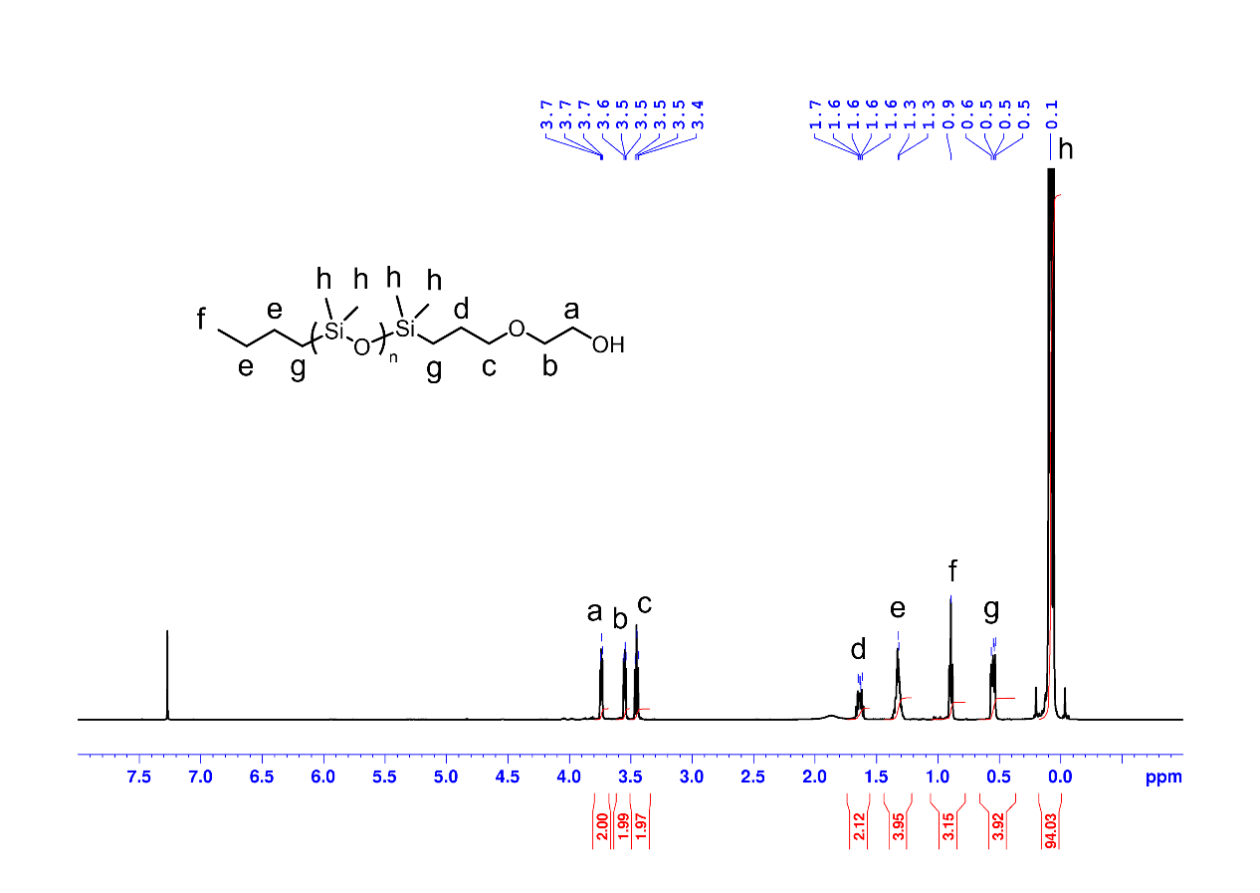
Figure S1 ¹H NMR spectrum of oDMS-OH

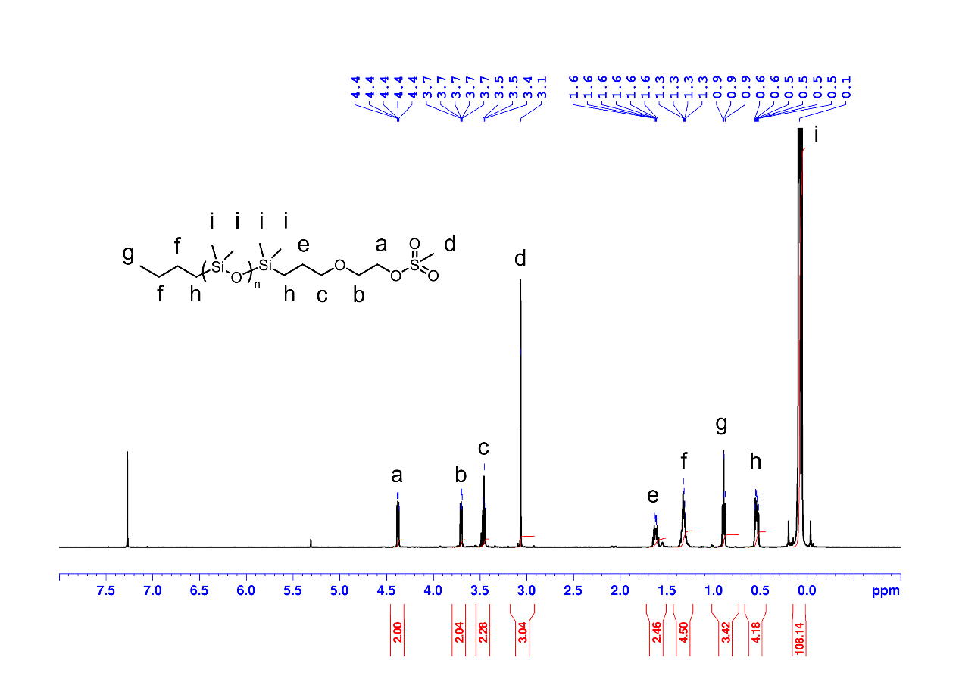
Figure S2 ¹H NMR spectrum of oDMS-OMs
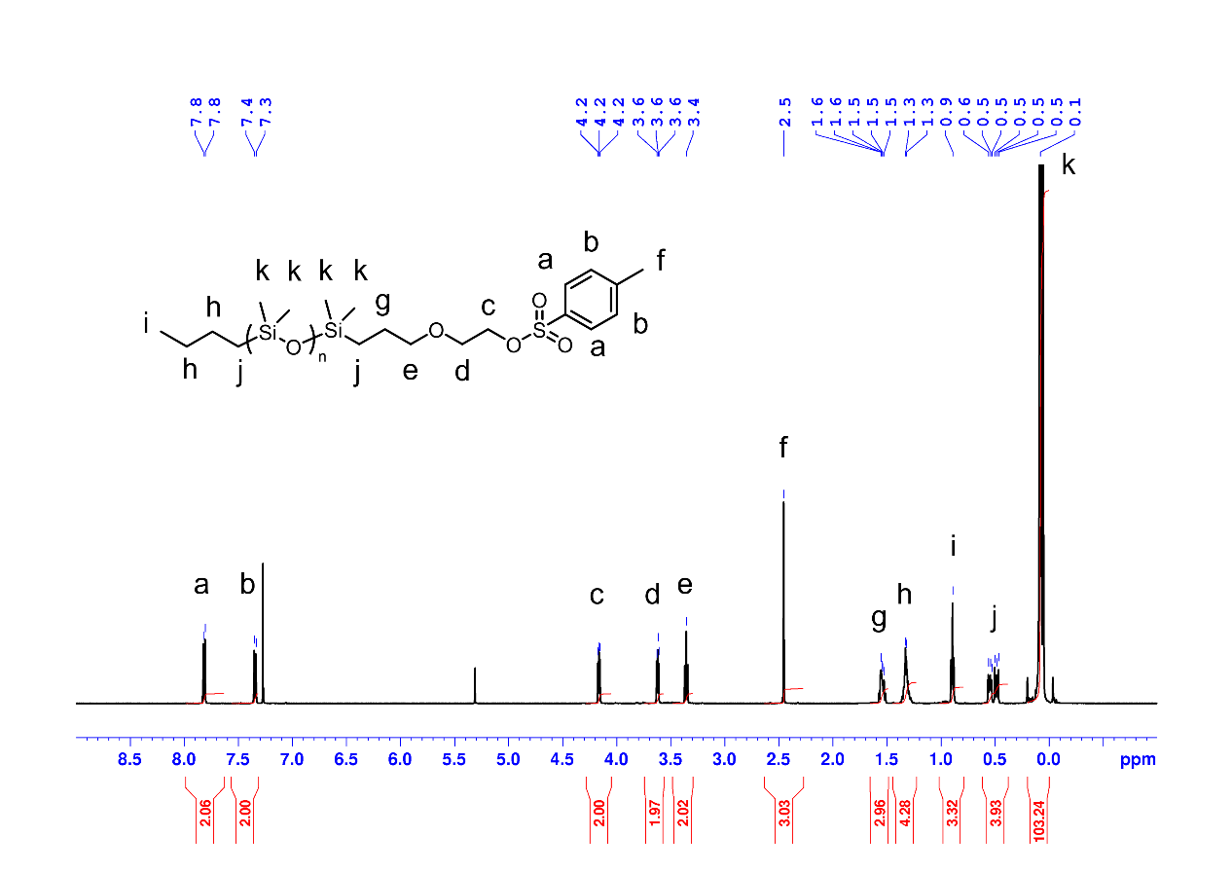
Figure S3 ¹H NMR spectrum of oDMS-OTs
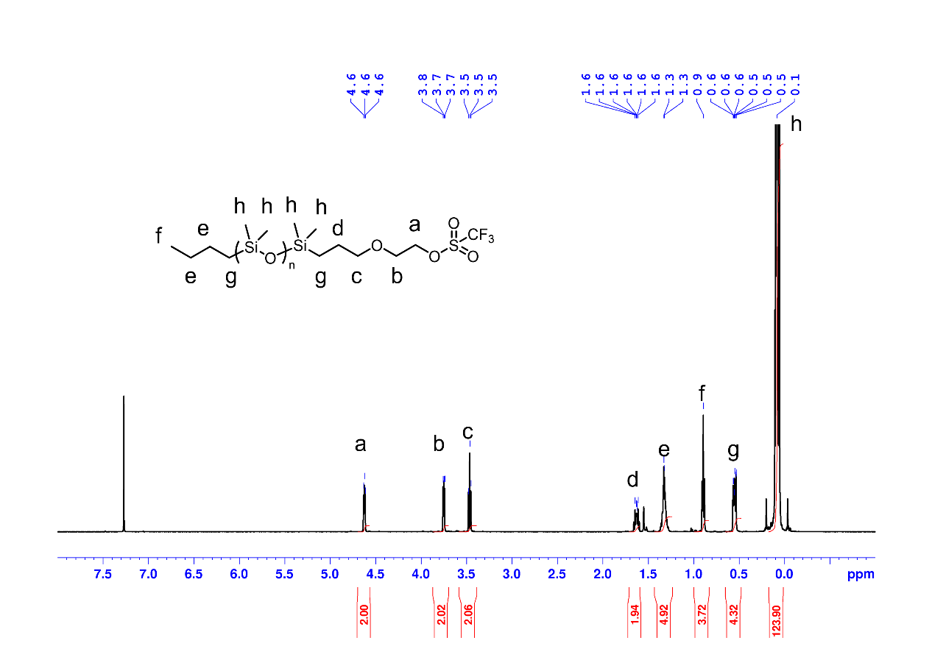
Figure S4 ¹H NMR spectrum of oDMS-OTf
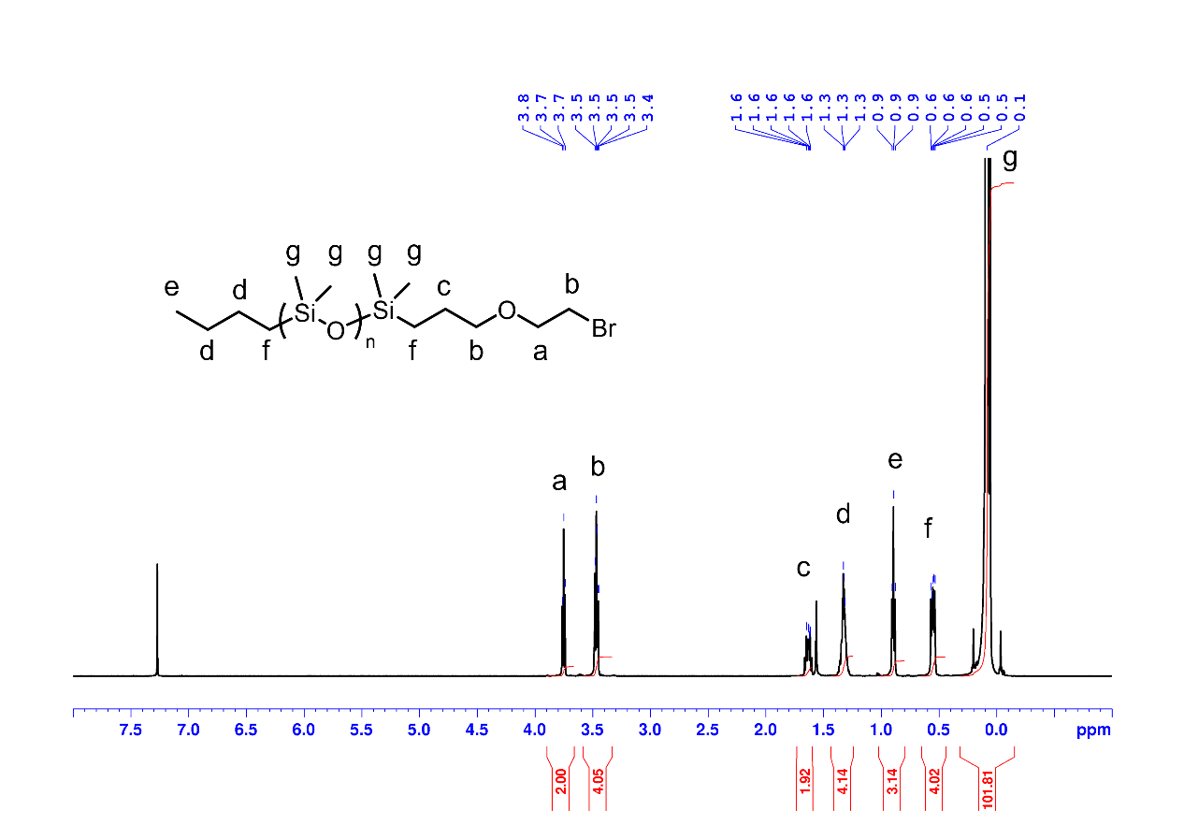
Figure S5 ¹H NMR spectrum of oDMS-Br
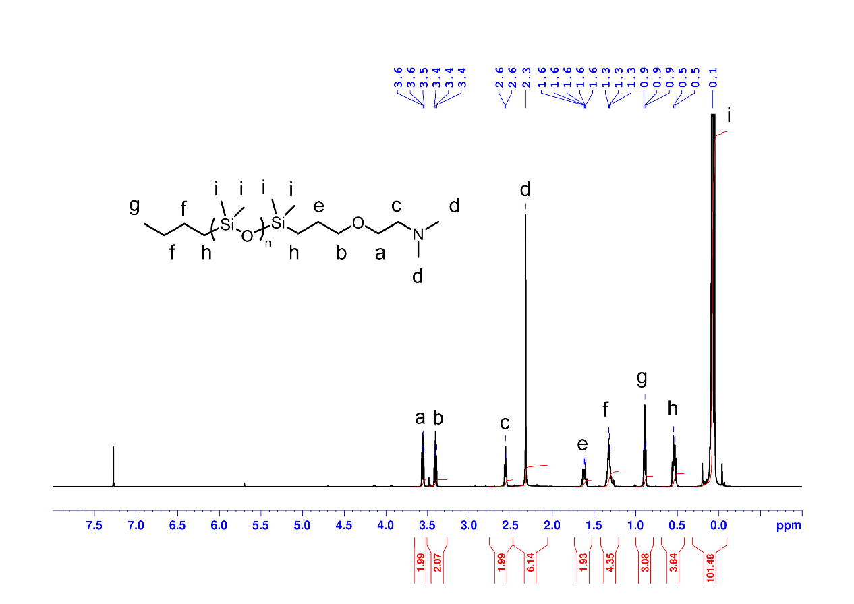
Figure S6 ¹H NMR spectrum of oDMS-N(CH₃)₂
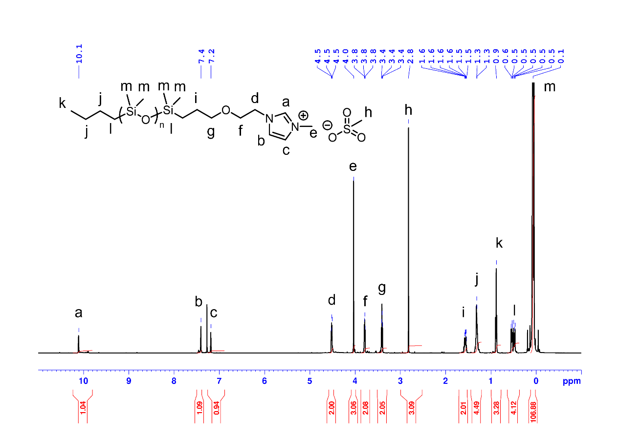
Figure S7 ¹H NMR spectrum of oDMS-MIM⁽⁺⁾OMs⁽⁻⁾
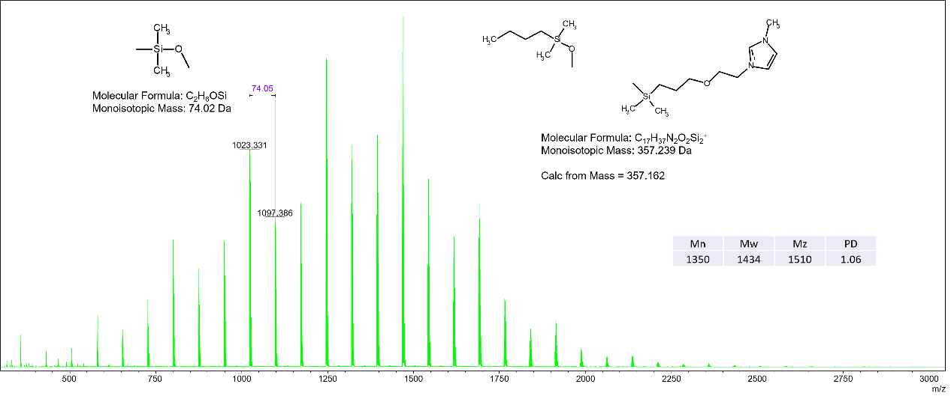
Figure S8 MS spectrum of oDMS-MIM⁽⁺⁾OMs⁽⁻⁾
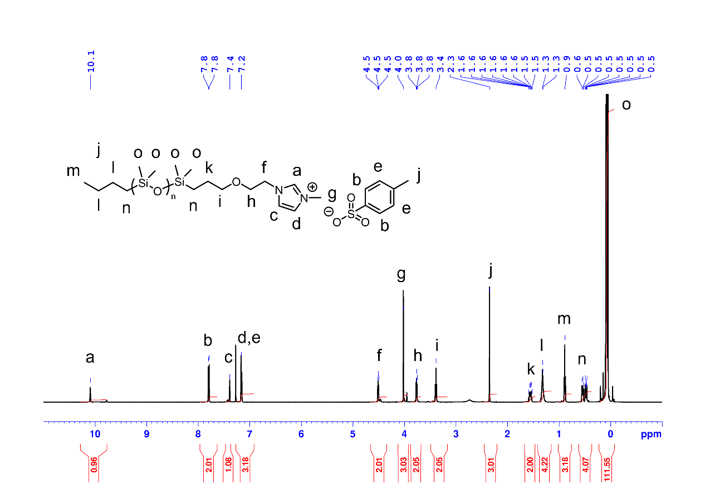
Figure S9 ¹H NMR spectrum of oDMS-MIM⁽⁺⁾OTs⁽⁻⁾
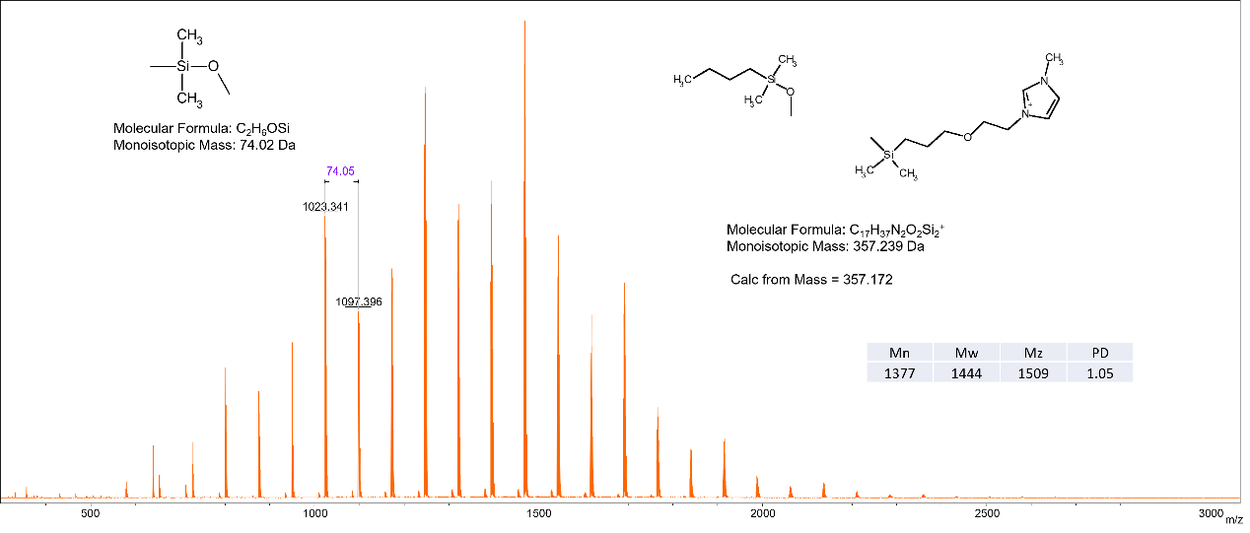
Figure S10 MS spectrum of oDMS-MIM⁽⁺⁾OTs⁽⁻⁾
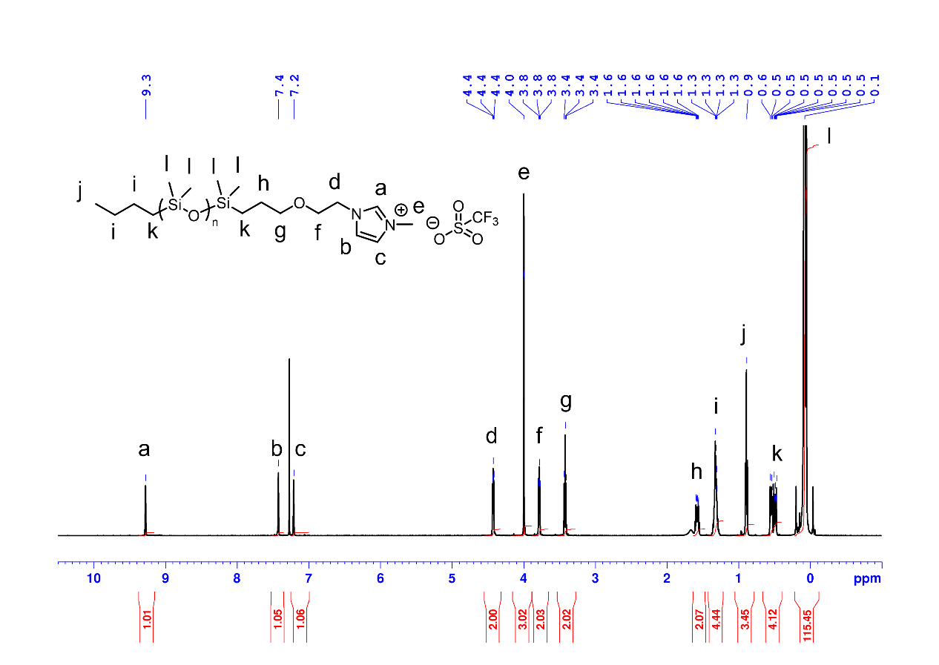
Figure S11 ¹H NMR spectrum of oDMS-MIM⁽⁺⁾OTf⁽⁻⁾
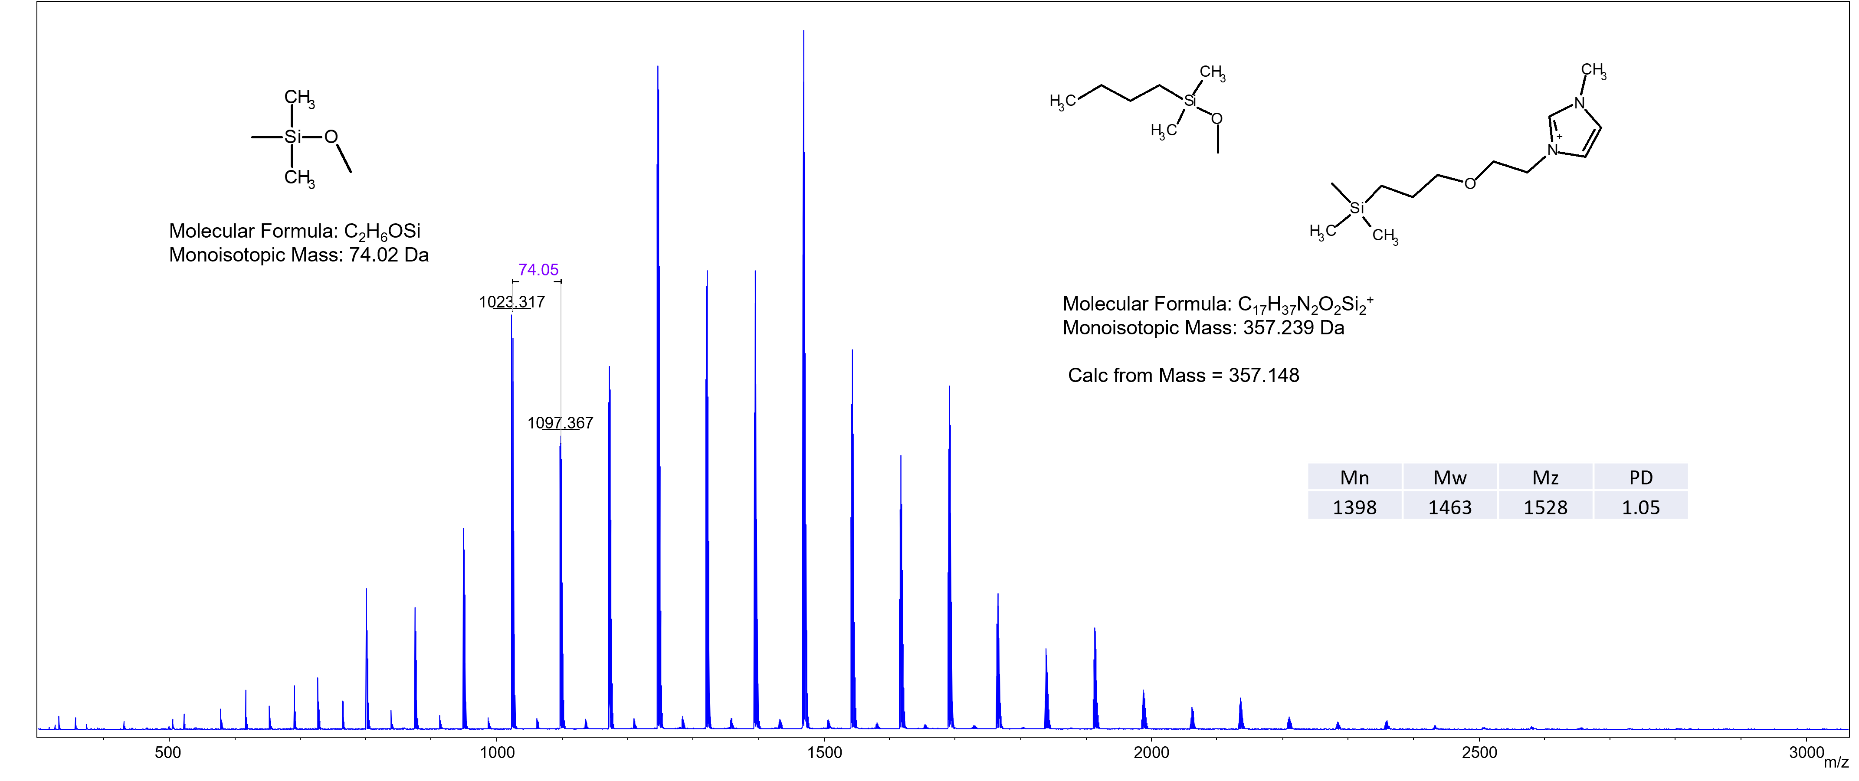
Figure S12 MS spectrum of oDMS-MIM⁽⁺⁾OTf⁽⁻⁾
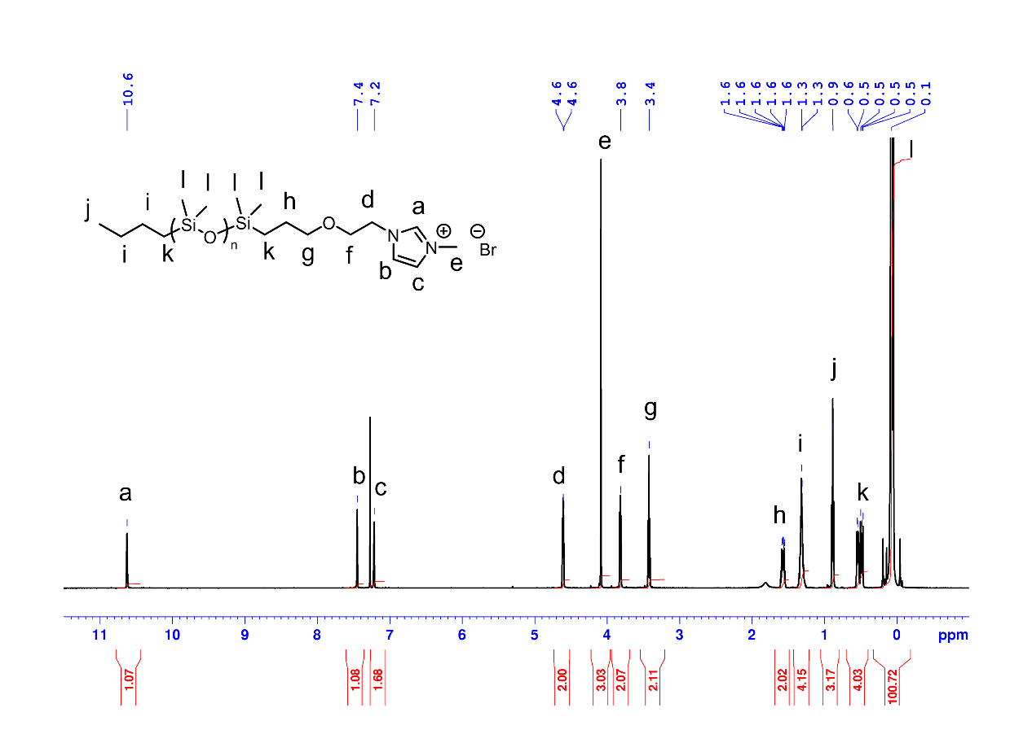
Figure S13 ¹H NMR spectrum of oDMS-MIM⁽⁺⁾Br⁽⁻⁾
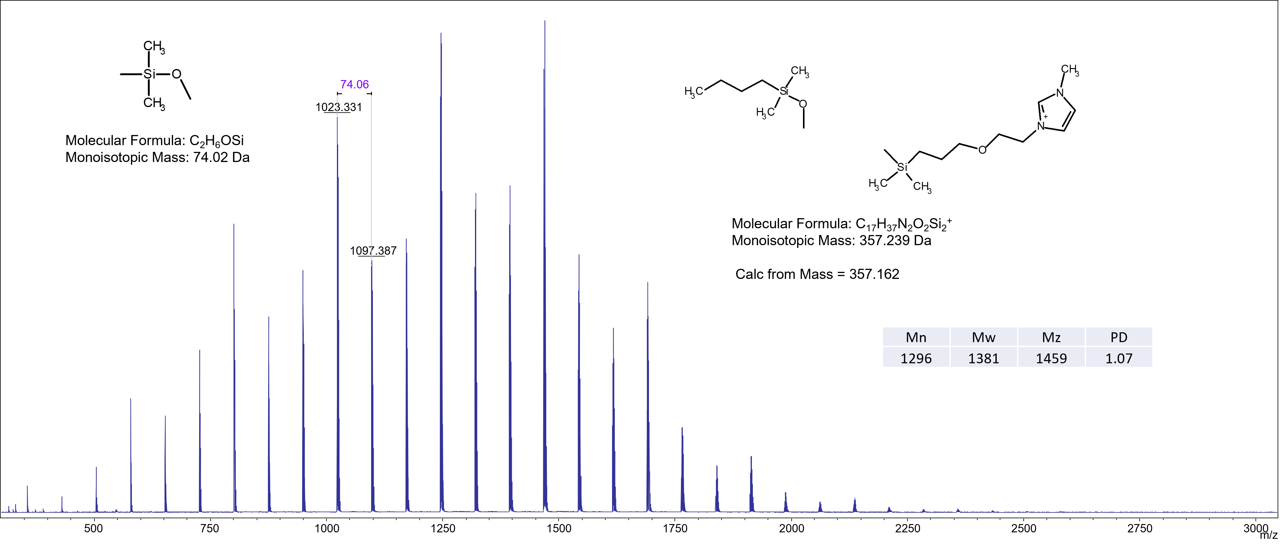
Figure S14 MS spectrum of oDMS-MIM⁽⁺⁾Br⁽⁻⁾
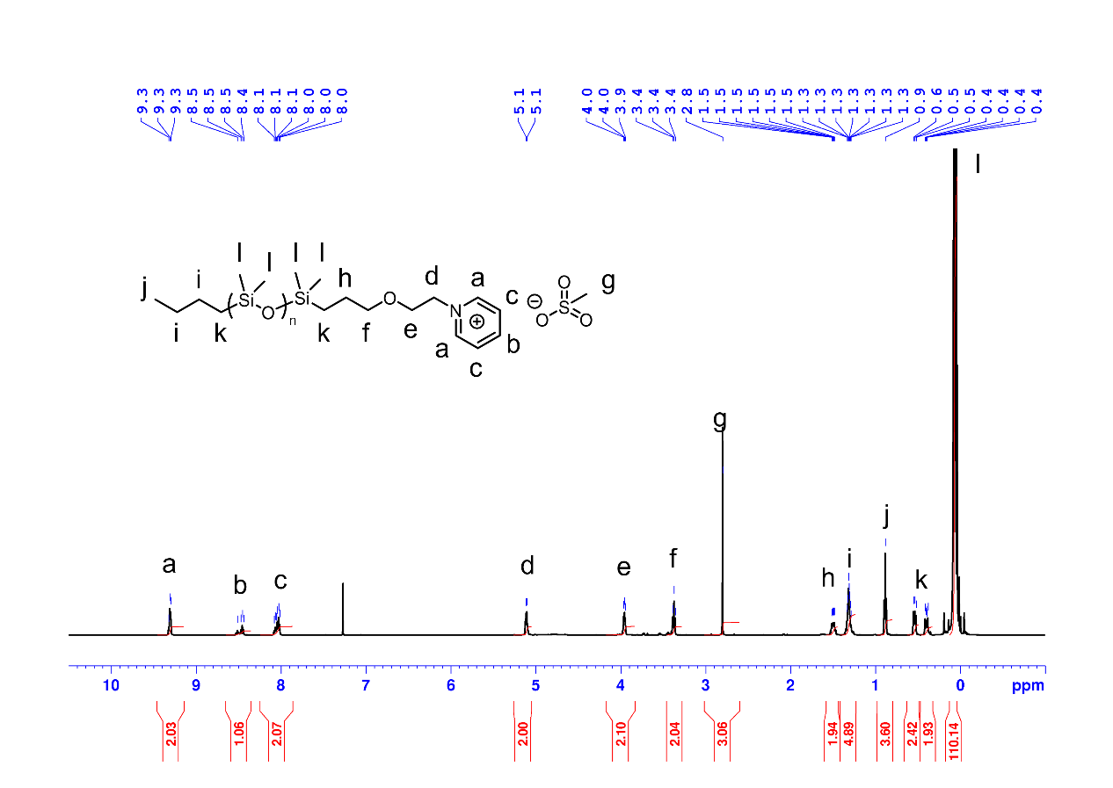
Figure S15 ¹H NMR spectrum of oDMS-Py⁽⁺⁾OMs⁽⁻⁾
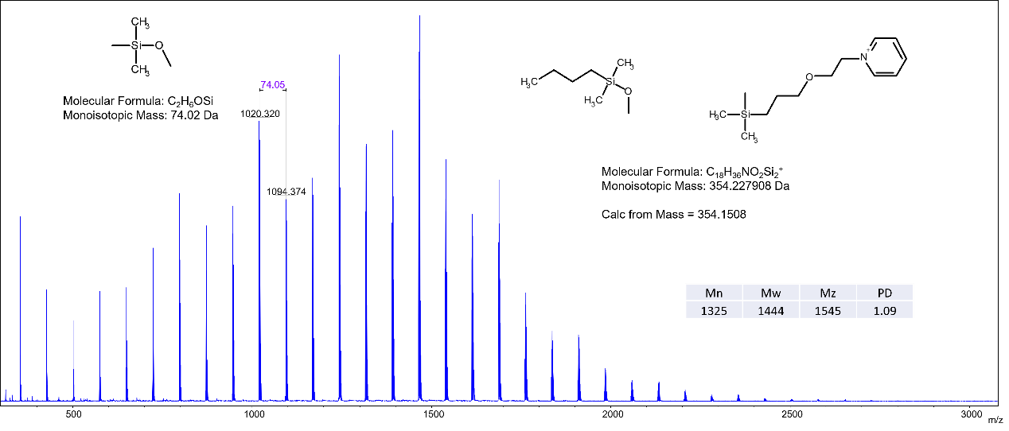
Figure S16 MS spectrum of oDMS-Py⁽⁺⁾OMs⁽⁻⁾
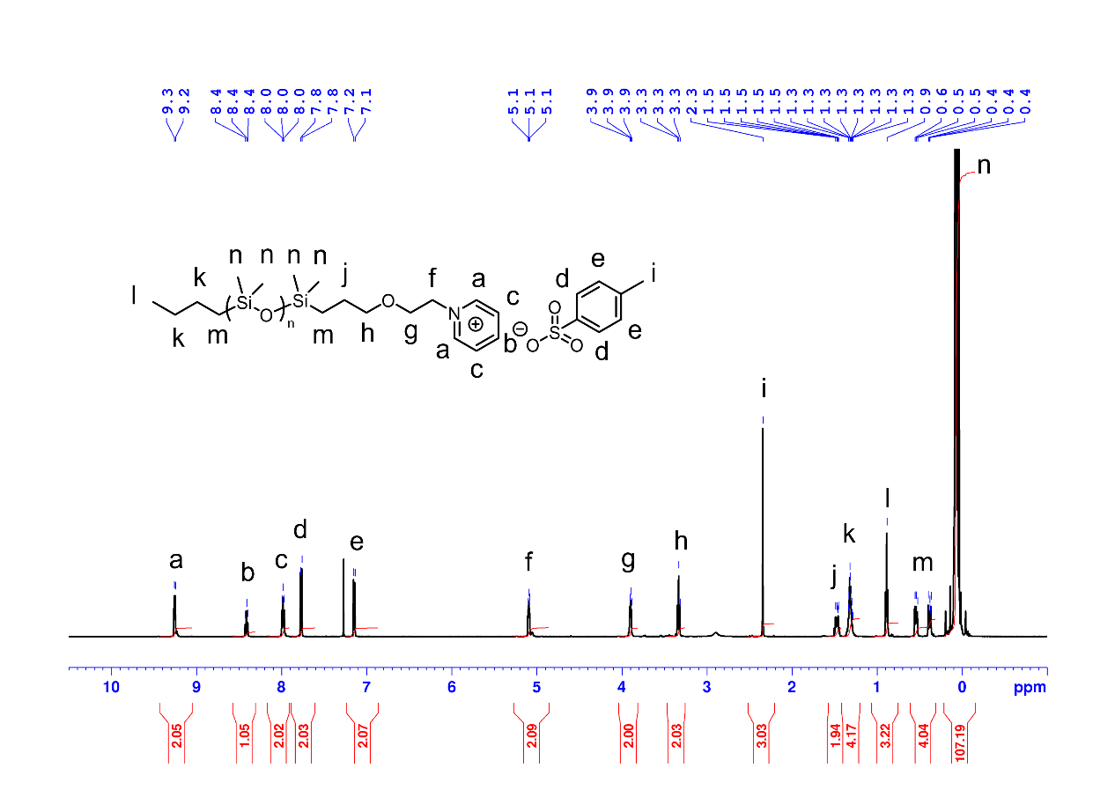
Figure S17 ¹H NMR spectrum of oDMS-Py⁽⁺⁾OTs⁽⁻⁾
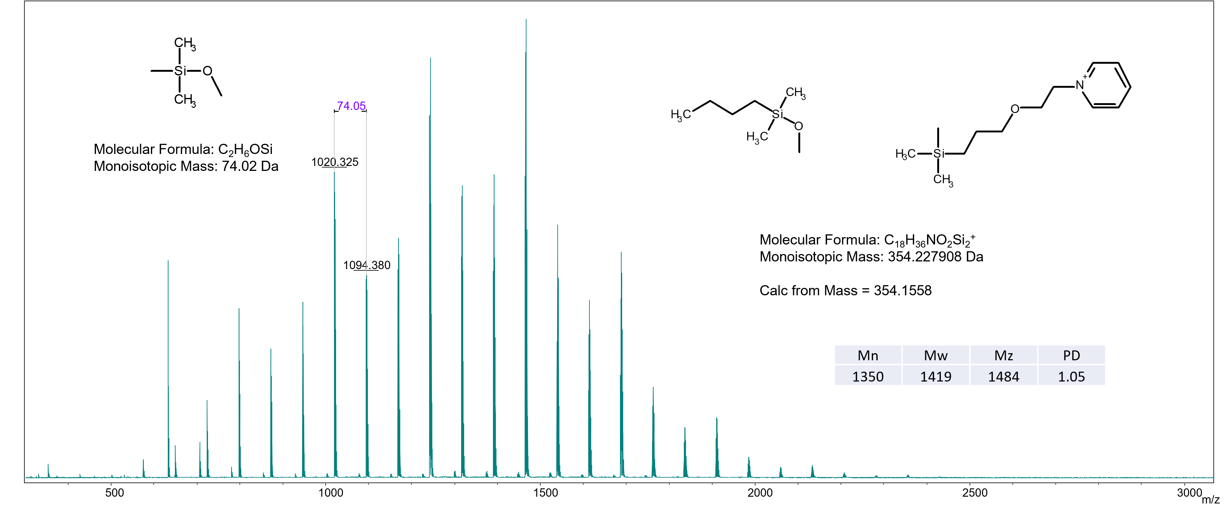
Figure S18 MS spectrum of oDMS-Py⁽⁺⁾OTs⁽⁻⁾
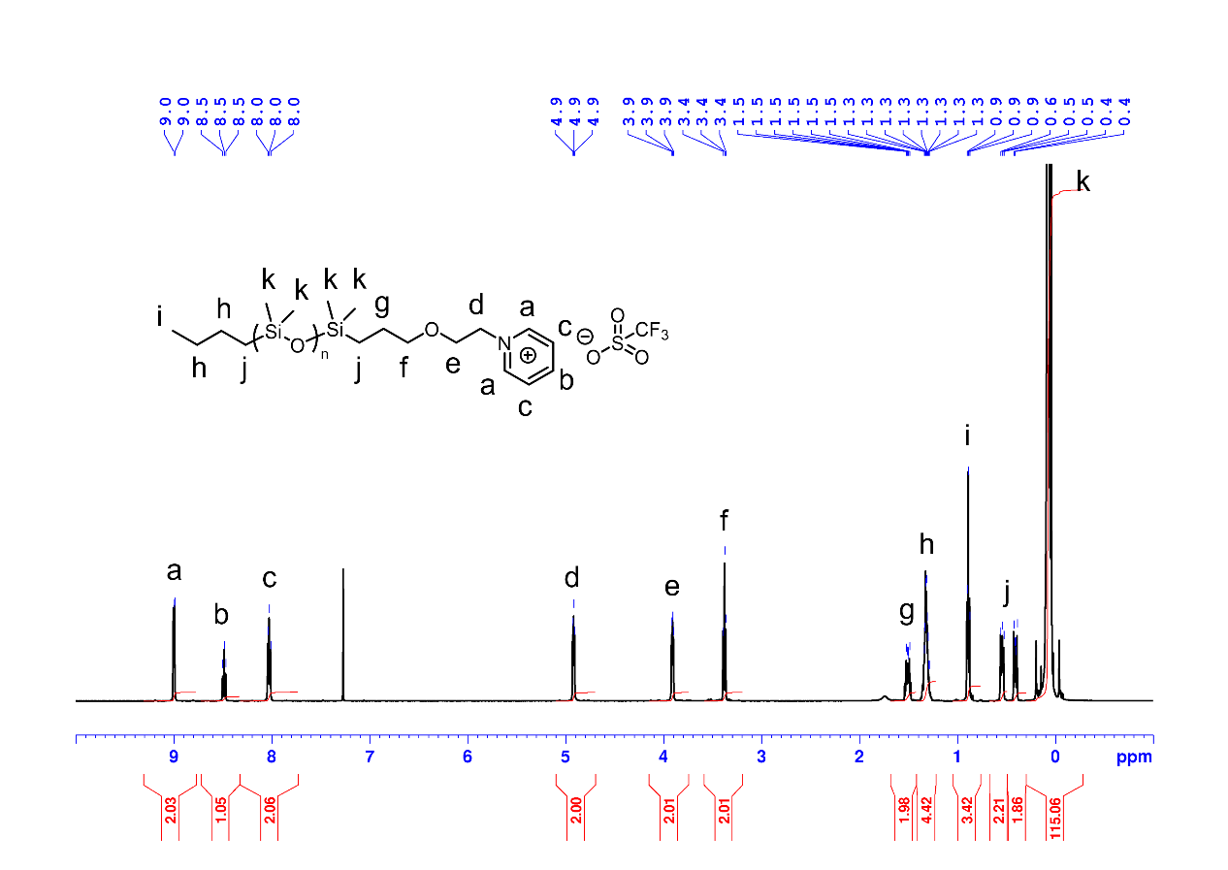
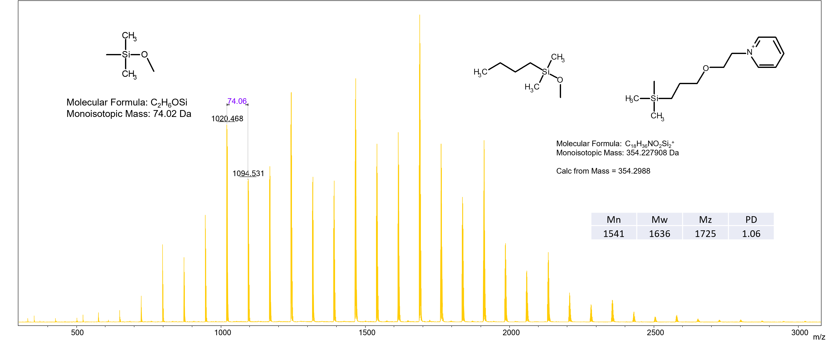
Figure S19 ¹H NMR spectrum of oDMS-Py⁽⁺⁾OTf⁽⁻⁾
Figure S20 MS spectrum of oDMS-Py⁽⁺⁾OTf⁽⁻⁾
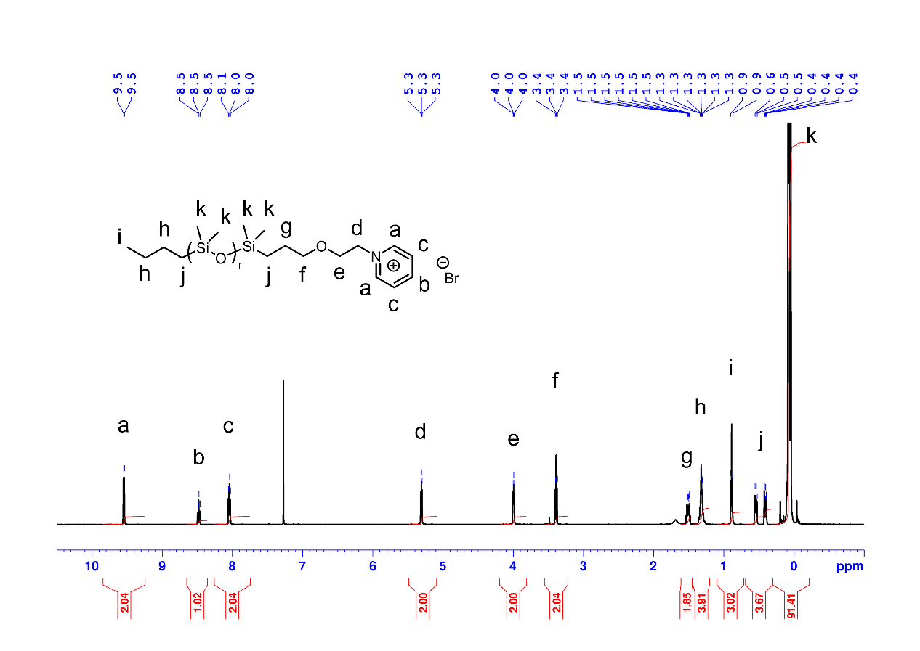
Figure S21 ¹H NMR spectrum of oDMS-Py⁽⁺⁾Br⁽⁻⁾
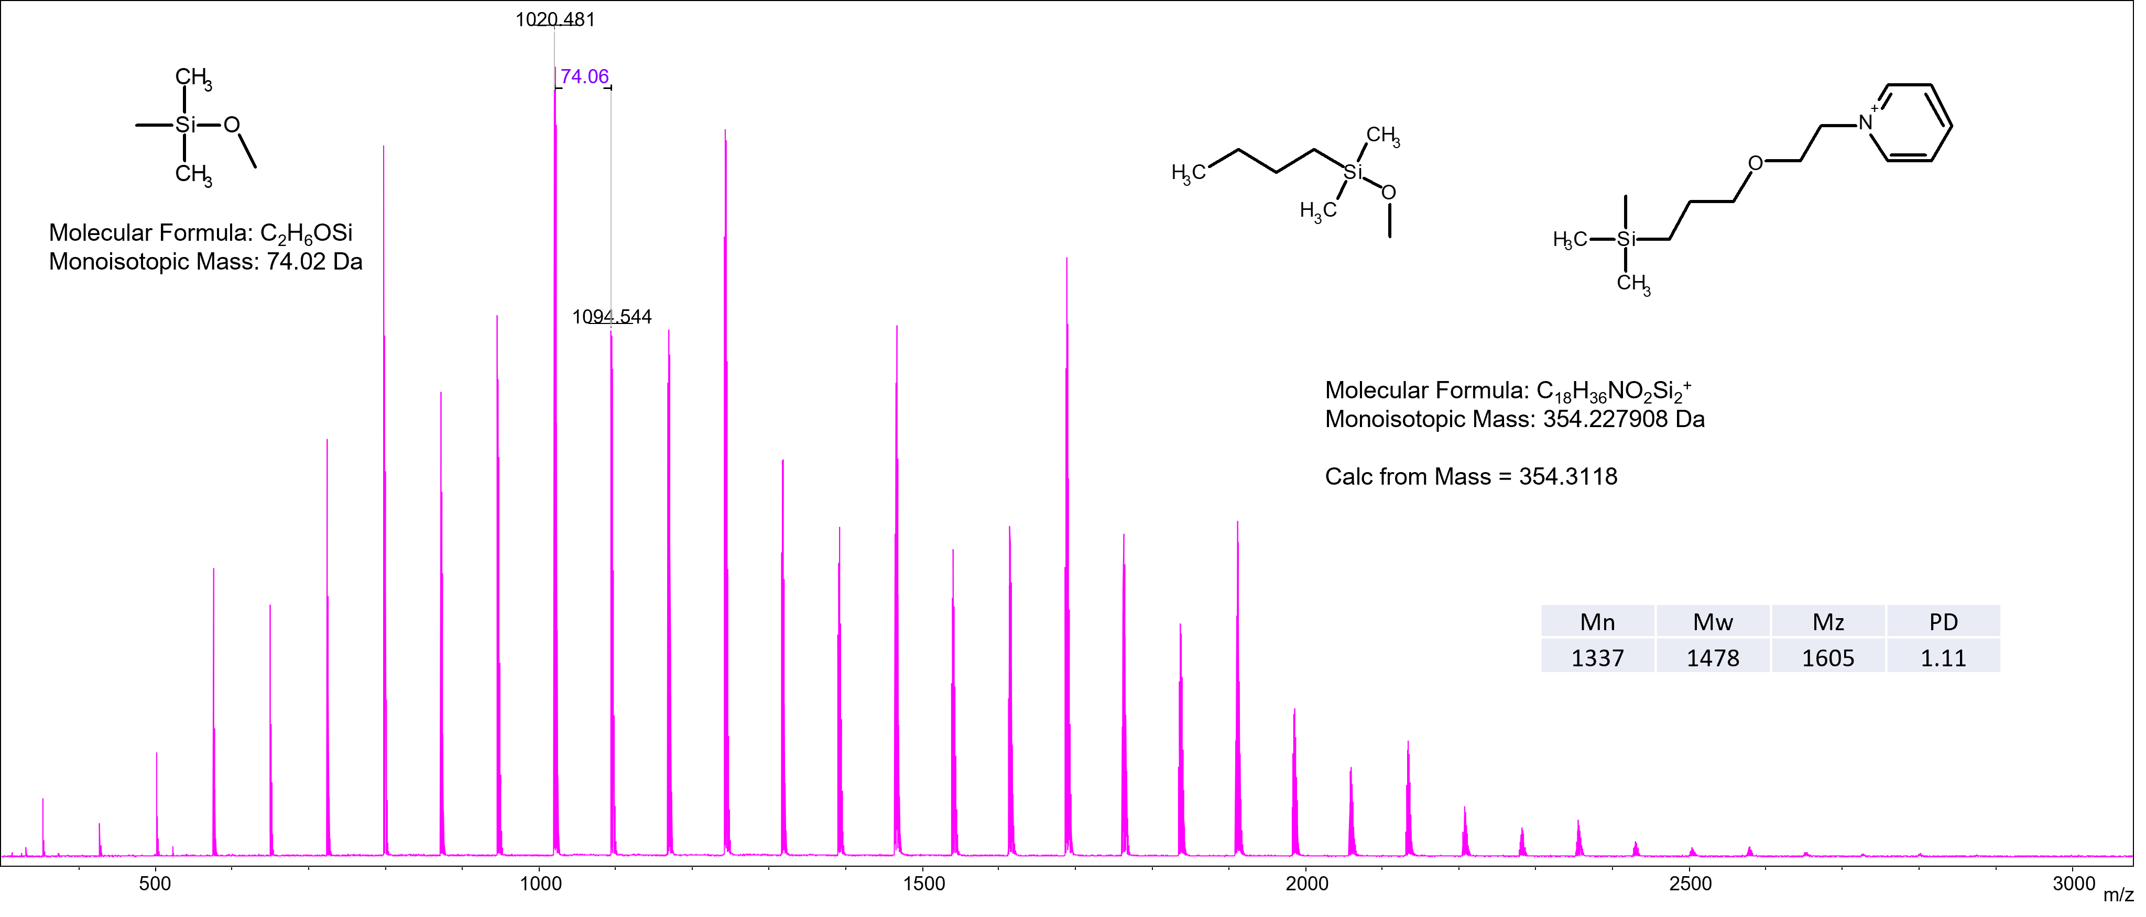
Figure S22 MS spectrum of oDMS-Py⁽⁺⁾Br⁽⁻⁾
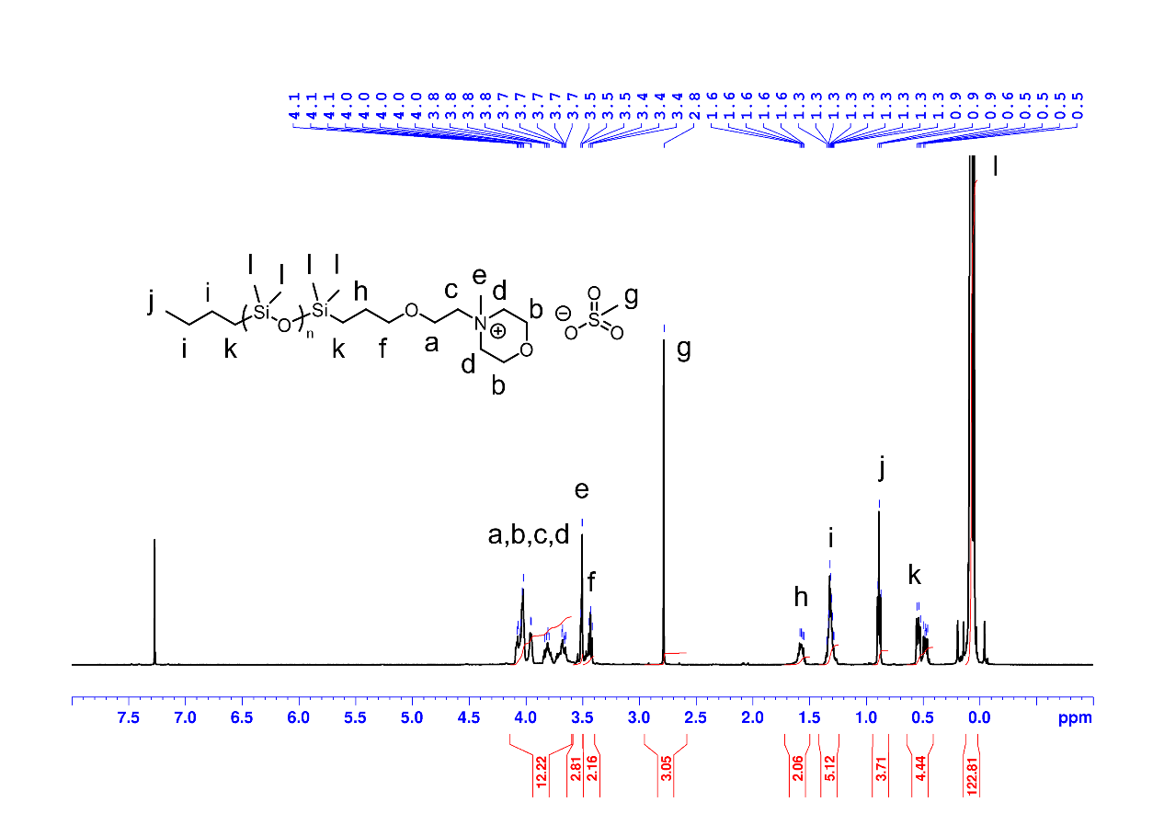
Figure S23 ¹H NMR spectrum of oDMS-MMP⁽⁺⁾OMs⁽⁻⁾
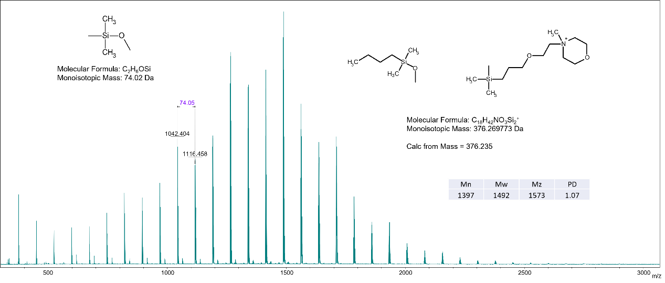
Figure S24 MS spectrum of oDMS-MMP⁽⁺⁾OMs⁽⁻⁾
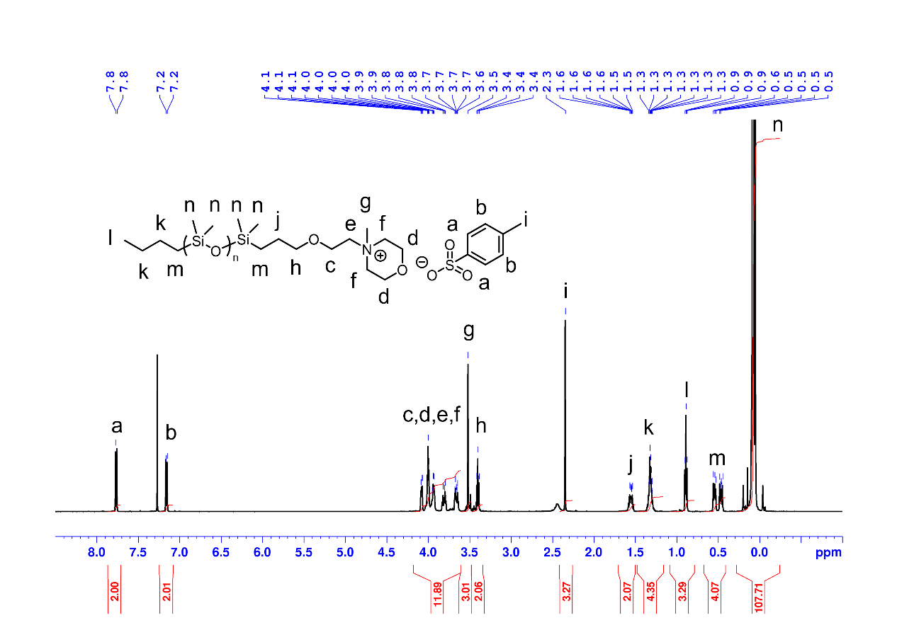
Figure S25 ¹H NMR spectrum of oDMS-MMP⁽⁺⁾OTs⁽⁻⁾
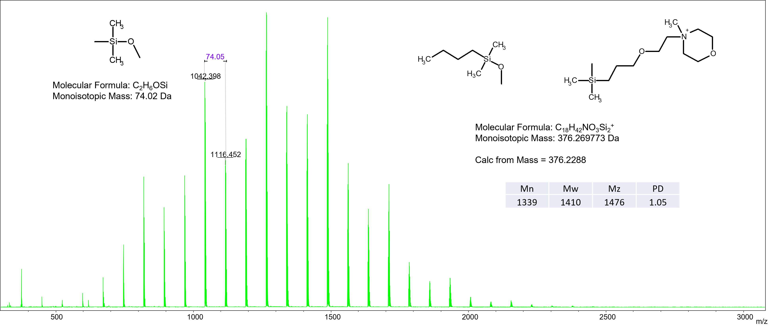
Figure S26 MS spectrum of oDMS-MMP⁽⁺⁾OTs⁽⁻⁾
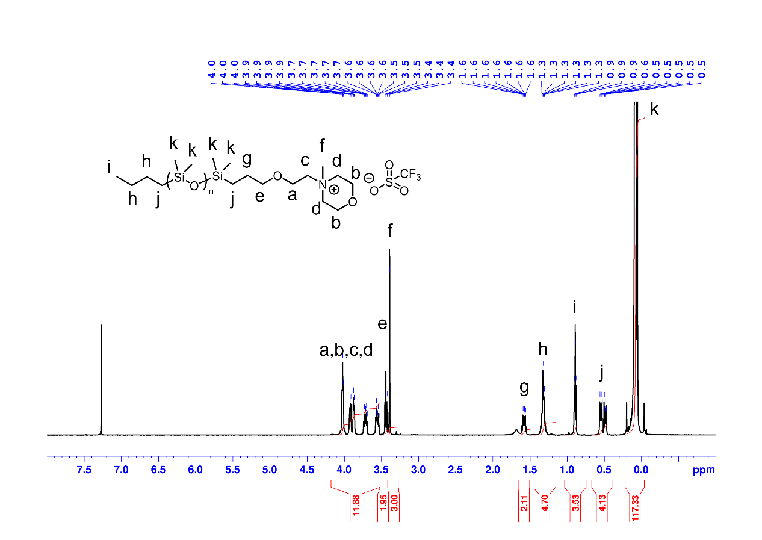
Figure S27 ¹H NMR spectrum of oDMS-MMP⁽⁺⁾OTf⁽⁻⁾
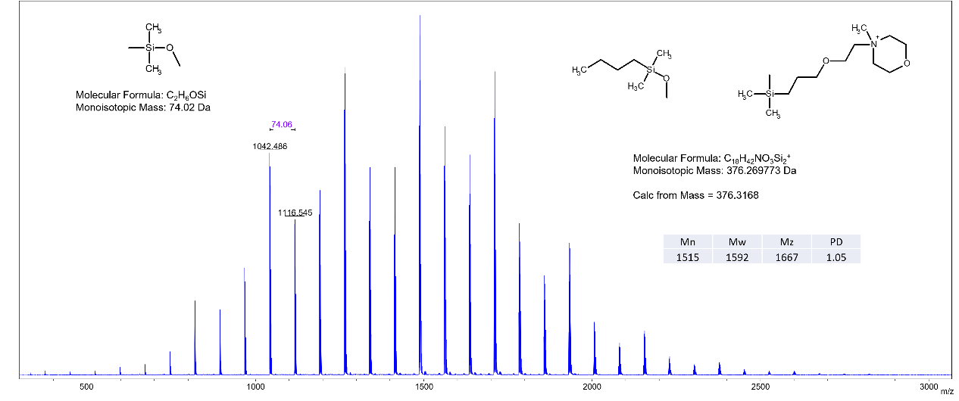
Figure S28 MS spectrum of oDMS-MMP⁽⁺⁾OTf⁽⁻⁾
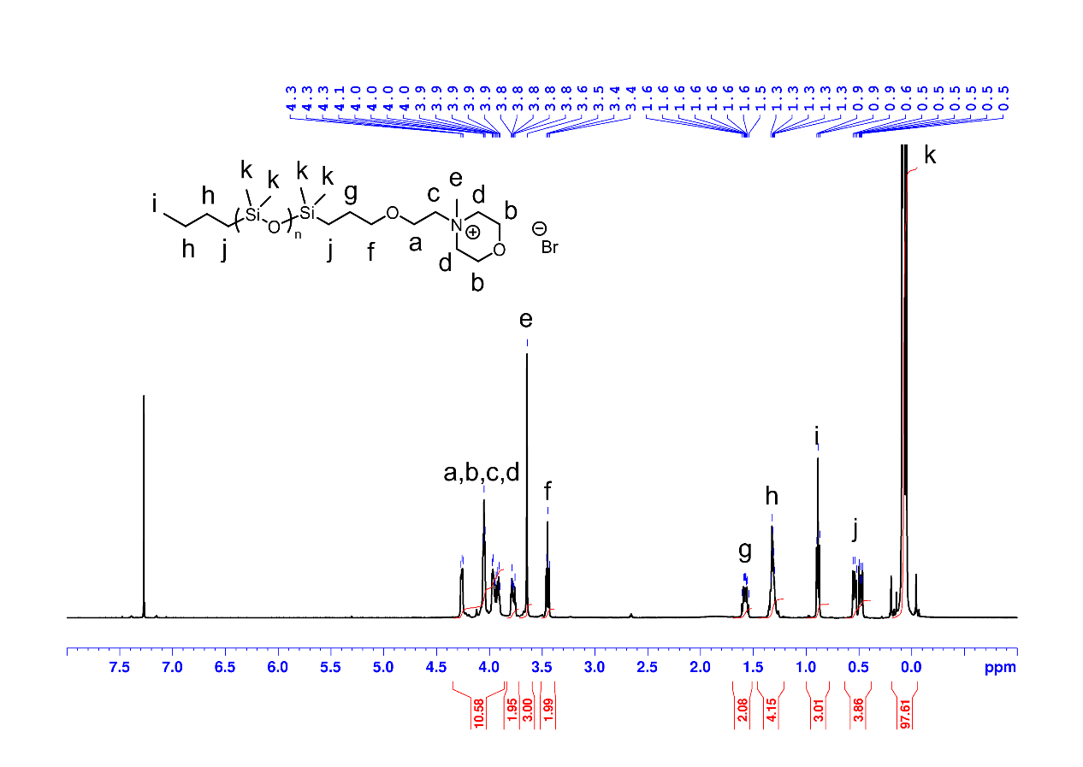
Figure S29 ¹H NMR spectrum of oDMS-MMP⁽⁺⁾Br⁽⁻⁾
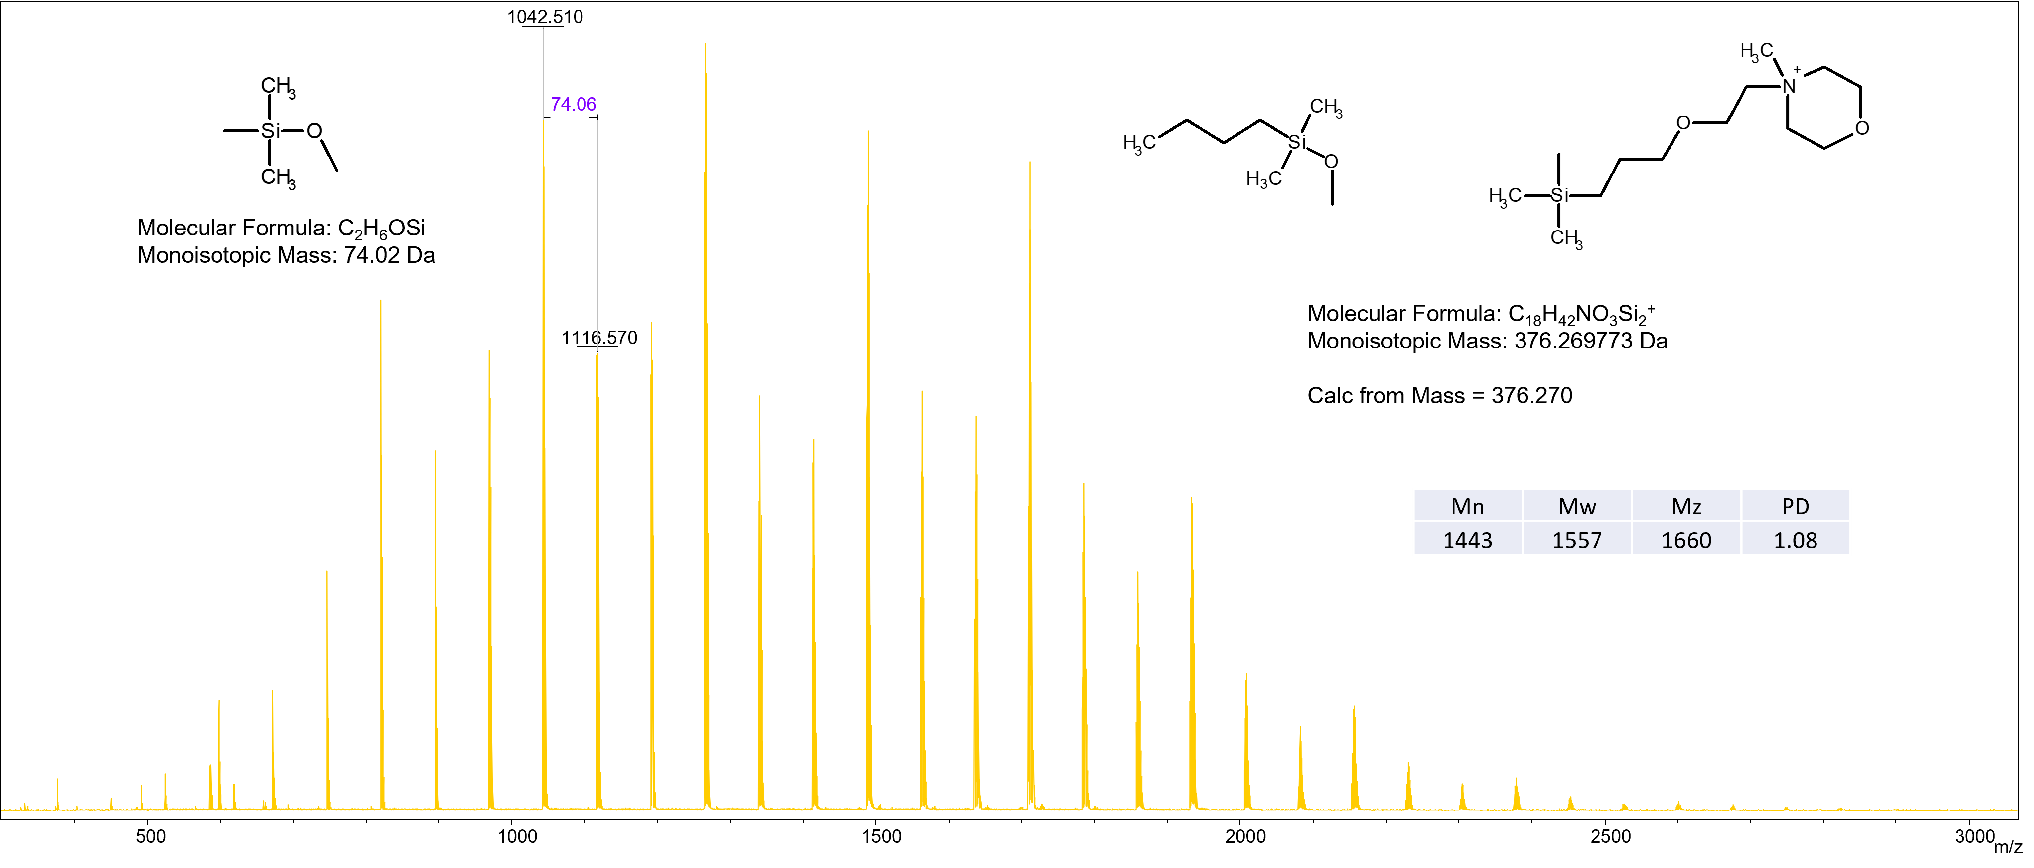
Figure S30 MS spectrum of oDMS-MMP⁽⁺⁾Br⁽⁻⁾

Figure S31 ¹H NMR spectrum of oDMS-NH(CH₃)₂⁽⁺⁾MeSO₃⁽⁻⁾

Figure S32 MS spectrum of oDMS-NH(CH₃)₂⁽⁺⁾MeSO₃⁽⁻⁾
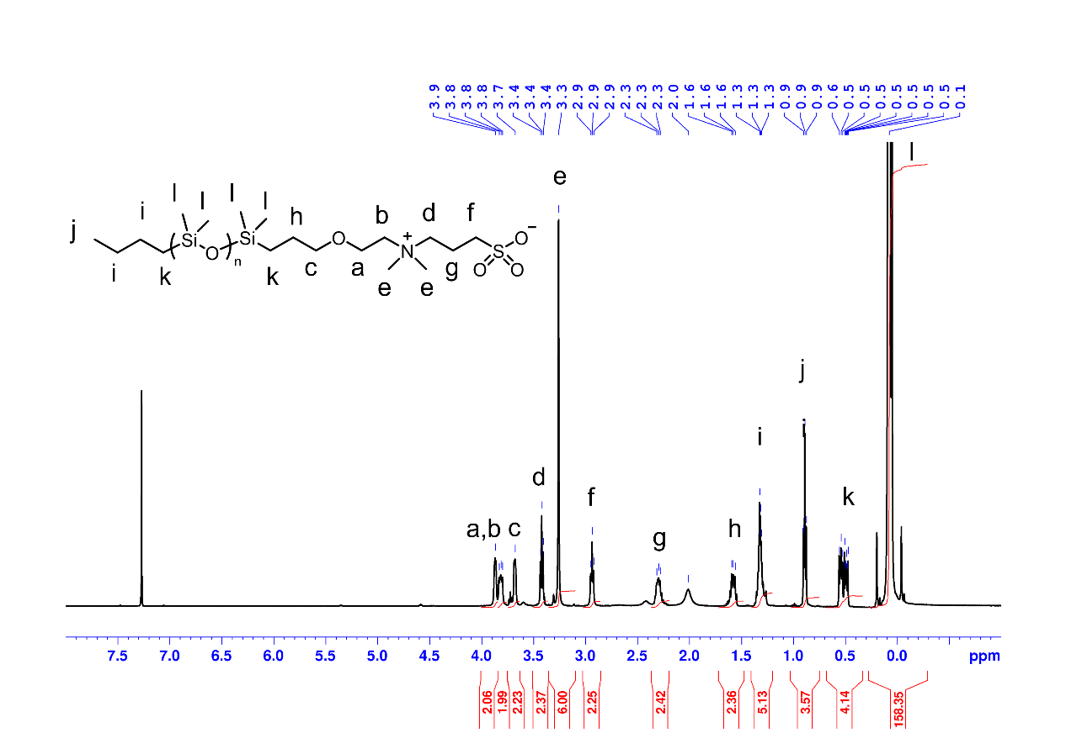
Figure S33 ¹H NMR spectrum of oDMS-N(CH₃)₂⁽⁺⁾-(CH₂)₃-SO₃⁽⁻⁾
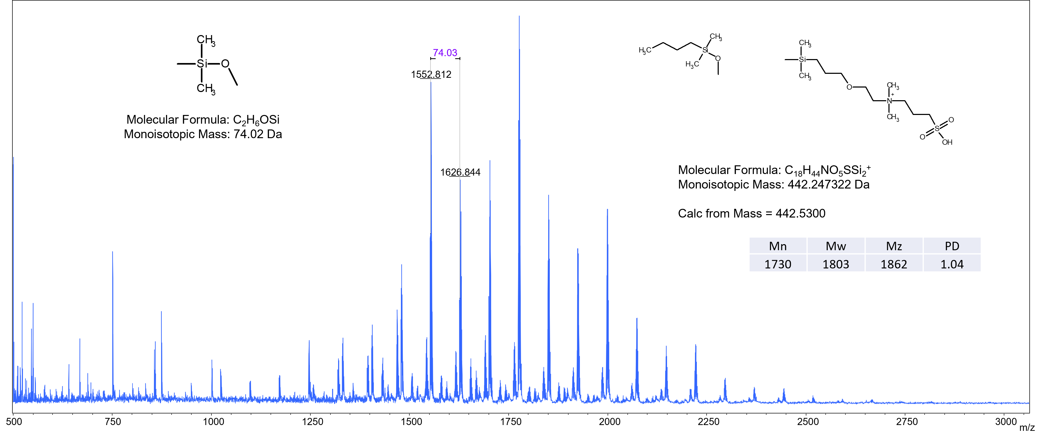
Figure S34 MS spectrum of oDMS-N(CH₃)₂⁽⁺⁾-(CH₂)₃-SO₃⁽⁻⁾

VITA

