Influence of Traditional and Dual-Use Cropping on Arthropods and
Slugs in Soybean in Tennessee

A Thesis Presented for the
Master of Science
Degree
The University of Tennessee, Knoxville

Matthew L. Longmire
August 2020

Copyright © 2020 by Matthew L. Longmire
All rights reserved.

Dedication

To
Charles Lee Longmire
and
Sandra Gail Longmire
my parents
Thank you for the constant love and support throughout my life and for raising me to be the person that I am. I would have never made it this far without you.
And to
Edna Ruth Tudor
My grandmother who always believed in me. Thank you for always encouraging my love for bugs, even though you didn’t always want to be around them like I did.

Acknowledgements

I would first like to thank my major advisor Dr. Jerome Grant for providing me with the knowledge and encouragement to guide me through this project. His constant willingness to help everyone and incredible work ethic never cease to inspire me. Thank you to my other committee members, Dr. Scott Stewart and Dr. Virginia Sykes, who at different times, have offered their encouragement, support, and knowledge from beginning to end. Without the use of Dr. Sykes’s research plots this project would not have been possible.
I also wish to thank the numerous undergraduate students (Kailee Alred, Davis Harmon, and Maddy Richmond) that assisted me with various sampling throughout my research project. Thank you to my fellow graduate students (David Bechtel, Amira Cornish, and Julian Cosner) for their willingness to lend a helping hand and provide some much needed encouragement. I owe a very special thanks to Brianna Alred, Philip Hensley, Kassie Hollabaugh, and Forest Palmer who helped me sample on so many long and hot days and numerous long road trips. Without their assistance, I truly could not have taken so many samples.
I would like to thank Weston Bracey for the use of his research plots and yield data as well as some helpful advice and insight into cover cropping. I would also like to thank the crews at the East and Middle Tennessee AgResearch and Education Centers, especially Joe David Plunk, for their assistance and maintenance of the plots. I would also like to thank the Tennessee Soybean Promotion Board for their monetary support of my program.
And lastly, I owe a great deal of thanks to my parents and family who have stood by me with their unconditional love and support throughout this entire process.

Abstract

Soybean is the number one agricultural crop in Tennessee for both number of hectares planted and economic value. Soybean, used in various products, is marketed globally. In recent years, Tennessee soybean growers have shown an increased interest in the use of cover crops with soybean. A cover crop is planted before the cash crop and can minimize some weeds, diseases, insects, and other pests. Traditionally, cover crops are terminated in the spring before cash crop planting. Traditional methods of cover cropping provide many benefits but can also produce some undesired results. Dual-use cover cropping is a newer method of cover cropping in which dual-purpose cover crops are harvested as a forage crop prior to planting the cash crop. Unfortunately, little research has investigated the impact of dual-use cropping on populations of insects and other arthropods, as well as slugs, in Tennessee.
A two-year study designed to evaluate the impact of dual-use cover cropping on pest and beneficial arthropods and slugs was initiated in east and middle Tennessee by using a five cover crop treatments and two management practices in soybean. The primary research goals of this project were to: 1) evaluate impact of dual-use cover cropping on pest and beneficial arthropods, 2) assess influence of dual-use cover cropping on density and impact of slugs, and 3) determine influence of dual-use cover cropping and pests on soybean yield. The results of this study have shown that management practice (i.e., traditional or dual-crop) did not have a significant (p≥0.05) effect on overall arthropod or slug densities. However, significant (p<0.05) differences were found between some of the cover crop treatments and arthropod densities. Management practice and cover crop treatment did not result in an increase in pest problems in soybean. Cover crop treatment and management practice also did not significantly (p≥0.05) impact soybean yield. Findings from this research should enable soybean growers to better understand cover crop-arthropod interactions to enhance soybean production in Tennessee. Further research on impact of plot sizes and insecticide seed treatment on insects and slugs may better define results and increase use of dual-cropped soybean.
Table of Contents

CHAPTER I
INTRODUCTION 1

Soybean 3

Cover Crops 4

Dual-use Cover Crops 8

Research Objectives 10

CHAPTER II
EVALUATION OF THE IMPACT OF DUAL-USE COVER CROPPING ON PEST AND BENEFICIAL ARTHROPOD POPULATIONS 11

Introduction 11

Materials and Methods 13

Establishment of Research Plots 13

Arthropod Sampling 14

Data Analysis 16

Results and Discussion 17

2019……….. 17

2020……….. 20

Summary........................................................................................................................25

CHAPTER III
ASSESSMENT OF DUAL-USE COVER CROPPING ON DENSITY AND IMPACT OF SLUGS...................................................................................................................................28

Introduction....................................................................................................................28

Materials and Methods 29

Slug Sampling 29

Data Analysis 30

Results and Discussion 30

2019……….. 30

2020……….. 32

Summary........................................................................................................................33

CHAPTER IV
DETERMINING THE INFLUENCE OF DUAL-USE COVER CROPPING AND PESTS
ON COVER CROP BIOMASS AND SOYBEAN YIELD 35

Introduction....................................................................................................................35

Materials and Methods 36

Assessment of Cover Crop Biomass 36

Assessment of Soybean Yield...….........................................................................37

Data Analysis.........................................................................................................37

Results and Discussion 38

2019…....…............................................................................................................38

2020……... ……………...…….............................................................................39

Summary........................................................................................................................40

CHAPTER V
CONCLUSIONS....................................................................................................................42

REFERENCES.....................................................................................................................47

APPENDIX...........................................................................................................................54

VITA......................................................................................................................................107

List of Tables

Table 1. Cover crop plot establishment and termination/harvest dates; soybean planting and harvest dates, 2018 to 2020 56

Table 2. Cover crop variety and seeding rate information, 2018 to 2020 56

Table 3. Replication number, cover crop species, cover crop management practice, and number of all short-season plots at the East Tennessee AgResearch and Education Center (ETREC) and Middle Tennessee AgResearch and Education Center (MTREC) in 2018-2019 57

Table 4. Replication number, cover crop species, cover crop management practice, and number of all short-season plots at the East Tennessee AgResearch and Education Center (ETREC) and Middle Tennessee AgResearch and Education Center (MTREC) in 2019-2020 60

Table 5. Model of average total number of pest arthropods per sweep-net sample, 2019, ANOVA GLM (p ≤ 0.05) 62

Table 6. Influence of cover crop species on number of pest and beneficial arthropods and slugs at two locations in Tennessee, 2019 65

Table 7. Model of average total number of beneficial arthropods per sweep-net sample, 2019, ANOVA GLM (p ≤ 0.05) 66

Table 8. Model of average total number of pest arthropods per beat-sheet sample, 2019, ANOVA GLM (p ≤ 0.05) 69

Table 9. Model of average total number of beneficial arthropods per beat-sheet sample, 2019, ANOVA GLM (p ≤ 0.05) 71

Table 10. Influence of cover crop species on total number of pest arthropods in sweep nets before cover crop termination in cover crops at two locations in Tennessee, 2019
and 2020 73

Table 11. Influence of cover crop species on total number of beneficial arthropods in sweep nets before cover crop termination in cover crops at two locations in Tennessee, 2019
and 2020 74

Table 12. Influence of cover crop species on total number of pest arthropods in sweep
nets after soybean planting in cover crops at two locations in Tennessee, 2019 and 2020...75

Table 13. Influence of cover crop species on total number of beneficial arthropods in sweep nets after soybean planting in cover crops at two locations in Tennessee, 2019 and 2020 76

Table 14. Model of total number of Aphididae per sweep-net sample, 2019, ANOVA GLM
(p ≤ 0.05). 77

Table 15. Model of total number of parasitoid/predatory wasps per sweep-net sample, 2019, ANOVA GLM (p ≤ 0.05) 78

Table 16. Model of total number of Curculionidae per sweep-net sample, 2019, ANOVA GLM (p ≤ 0.05) 79

Table 17. Model of total number of threecornered alfalfa hopper per sweep-net sample, 2019, ANOVA GLM (p ≤ 0.05) 80

Table 18. Influence of cover crop management practice on number of pest and beneficial arthropods at two locations in Tennessee, 2019 and 2020 81

Table 19. Model of average total number of pest arthropods per sweep-net sample, 2020, ANOVA GLM (p ≤ 0.05) 82

Table 20. Model of average total number of beneficial arthropods per sweep-net sample, 2020, ANOVA GLM (p ≤ 0.05) 83

Table 21. Influence of cover crop species on number of pest and beneficial arthropods at two locations in Tennessee, 2020 86

Table 22. Model of total number of Aphididae per sweep-net sample, 2020, ANOVA GLM
(p ≤ 0.05) 89

Table 23. Model of total number of Curculionidae per sweep-net sample, 2020, ANOVA GLM (p ≤ 0.05). 90

Table 24. Model of total number of Chrysomelidae per sweep-net sample, 2020, ANOVA GLM (p ≤ 0.05) 91

Table 25. Model of total number of Cicadellidae per sweep-net sample, 2020, ANOVA GLM
(p ≤ 0.05) 92

Table 26. Model of total number of Apidoidea per sweep-net sample, 2020, ANOVA GLM
(p ≤ 0.05) 93

Table 27. Model of total number of big-eyed bug per sweep-net sample, 2020, ANOVA GLM
(p ≤ 0.05) 94

Table 28. Model of total number of Coccinellidae per sweep-net sample, 2020, ANOVA GLM
(p ≤ 0.05) 95

Table 29. Model of total number of Syrphidae per sweep-net sample, 2020, ANOVA GLM (p ≤ 0.05) 96

Table 30. Model of total number of threecornered alfalfa hoppers per sweep-net sample, 2020, ANOVA GLM (p ≤ 0.05) 97

Table 31. Model of total number of minute pirate bugs per sweep-net sample, 2020, ANOVA GLM (p ≤ 0.05) 98

Table 32. Model of average total number of slugs collected in traps, 2019, ANOVA GLM
(p ≤ 0.05) 100

Table 33. Model of average total number of slugs per trap at Spring Hill, 2019, ANOVA GLM
(p ≤ 0.05) 103

Table 34. Model of average total number of slugs per trap at Knoxville, 2019, ANOVA GLM
(p ≤ 0.05) 104

Table 35. Cover crop biomass (kg/ha) at two locations in Tennessee, 2019 and 2020 105

Table 36. Pearson’s correlation coefficients (r) between arthropods/slugs and cover crop biomass/soybean yield at two locations in Tennessee, 2019 and 2020. 106

List of Figures

Figure 1. Layout of short-season plots at Plant Sciences Unit of the East Tennessee AgResearch and Education Center (ETREC) in Knoxville, TN, 2018-2019 55

Figure 2. Layout of short-season plots at the Middle Tennessee AgResearch and Education Center (MTREC) in Spring Hill, TN, 2018-2019 55

Figure 3. Layout of short-season plots at Plant Sciences Unit of the East Tennessee AgResearch and Education Center (ETREC) in Knoxville, TN, 2019-2020 59

Figure 4. Layout of short-season plots at the Middle Tennessee AgResearch and Education Center (MTREC) in Spring Hill, TN, 2019-2020 59

Figure 5. Influence of cover crop on average number of pest arthropods per sweep sample found in cover crops, 2019 63

Figure 6. Influence of cover crop on average number of pest arthropods per sweep sample found in soybean, 2019 64

Figure 7. Influence of cover crop on average number of beneficial arthropods per sweep sample found in cover crops, 2019 67

Figure 8. Influence of cover crop on average number of beneficial arthropods per sweep sample found in soybean, 2019 68

Figure 9. Influence of cover crop on average number of pest arthropods per beat-sheet sample found in soybean, 2019. 70

Figure 10. Influence of cover crop on average number of beneficial arthropods per beat-sheet sample found in soybean, 2019 72

Figure 11. Influence of cover crop on average number of pest arthropods per sweep sample found in cover crops, 2020 84

Figure 12. Influence of cover crop on average number of pest arthropods per sweep sample found in soybean, 2020 85

Figure 13. Influence of cover crop on average number of beneficial arthropods per sweep sample found in cover crops, 2020 87

Figure 14. Influence of cover crop on average number of beneficial arthropods per sweep sample found in soybean, 2020 88

Figure 15. Preparation of slug traps for placement in the field 99

Figure 16. Average number of slugs by cover crop found in cover crops, 2019. 101

Figure 17. Average number of slugs by cover crop found in soybean, 2019. 102

CHAPTER I
Introduction/Literature Review
Introduction
The industry of agriculture produces food for countless individuals on a global basis, and plays a critical role in keeping people fed in most countries, including the United States. In the 1930s, one farmer only had to grow enough food for about four people (Kirschenmann 2001). According to the 2017 Census of Agriculture, an average United States farm now provides food for 166 people annually in the United States and abroad (AFBF 2020). With so few farmers producing food for such a large number of people, precise and effective farming techniques are becoming more and more important. The global population is expected to increase by 2.2 billion by 2050, which would mean that farmers in the United States and abroad would have to produce about 70% more food than what is currently being grown (AFBF 2020). High yielding crops with minimal losses will become increasingly more crucial as populations rise.
Insects have an enormous impact on the agricultural industry. Some insects can help to increase yields through pollination or predation of other pests. However, other insects can be detrimental to agricultural systems. An agricultural pest is defined as an “animal or plant whose population density exceeds some unacceptable threshold level, resulting in economic damage” (Horn 1988). By that definition, it comes as no surprise that many insects are considered to be pests of agriculture. Even with the widespread use of pest management tactics, Pimentel and co-workers (2005) estimated that insect pests annually damage about 13% of potential crop production representing a value of about $33 billion in the United States. Additionally, non-native invasive species, species that have expanded outside their native range and are considered to be pests, account for around 40% of agricultural insect pest species (Pimentel et al. 2005). On a global scale, herbivorous insects are annually responsible for destroying nearly one fifth of the world's total crop production (Sallam et al. 2013). The introduction of new invasive species has become much more of a common and frequent occurrence because of increases in global trade and travel, and it is unlikely that the rate of new introductions will slow down any time soon (Pimentel et al. 2005).
Growers generally select crops based on high yields and nutritious value (Sallam et al. 2013). Because farms have a limited area, crops are typically clustered in a confined area. These conditions provide the right conditions not only for agricultural production, but also provide a highly conducive environment for insect pests (Sallam et al. 2013). Humans artificially select for specific desired traits for crops. In an effort to produce crops that meet consumer demand, growers may exacerbate the conditions that are highly susceptible for insect infestations.
Chemical pesticides are commonly and widely used as a primary method of control against insect pests. However, several issues are associated with the use of pesticides. One issue is that they can be costly. Every year, about 3 billion kg (active ingredients) of pesticides are applied worldwide with a cost of nearly $40 billion (Pimentel and Burgess 2014). In the United States alone, approximately 500 million kg (active ingredients) of more than 600 different types of pesticide are applied annually at a cost of $10 billion (Pimentel et al. 2005). Another issue is that pesticide use does not always decrease crop losses. Despite a more than 10-fold increase in the use of insecticide in the United States from 1945 to 2000, Pimentel and Burgess (2014) estimated that total crop losses resulting from insect damage have nearly doubled from 7% to 13%. This increase is, in part, due to the fact that insects are capable of quickly adapting to new environmental stresses and conditions (Sallam et al. 2013). Because of their adaptability, insects can develop resistance to pesticides making them less effective or completely ineffective at controlling pests (Sallam et al. 2013).
Pesticides can also have an impact on non-target, beneficial insects (Fernandes et al. 2016). Even if these beneficial insects are not directly killed by contact with a pesticide, they can still be affected. For example, a predatory species, such as Orius insidiosus (Say), may consume the target pest of an insecticide treatment who has ingested the insecticide and kill the predator as a result. Synthetic chemical pesticides have been used widely during the last 80 years, and their use will continues to play a vital role in pest management. However, they are a short-term solution because they may have to be applied several times during the growing season and usually must be applied every growing season. Thus, applications must continue to remain effective. As agricultural production expands and becomes increasingly important, more long-term, ecological and sustainable solutions will also be needed to combat these pests.
Soybean
Soybean, Glycine max (L.) Merr., is a legume believed to have been first cultivated in China during the 11th century B.C. (Qiu and Chang 2010, University of Nebraska 2018). China was the world’s leading producer and exporter of soybean for the first half of the 20th century, however, by the early 21st century, they ranked fourth after the United States, Brazil, and Argentina (Qiu and Chang 2010). To meet their own demands, China is now the largest importer of soybean. Soybean was first introduced to the United States in 1765 by a colonist in Georgia (North Carolina Soybean Producers Association 2014a). However, it was not until the 1870s that soybean became popular with American farmers as a forage crop to feed livestock.
Soybean is now the second-most-planted field crop in the United States after corn (USDA ERS 2017). The majority of soybean in the United States is grown in the Midwest, however, amounts are grown in several southeastern states, including Tennessee, where it is the number one agricultural crop in terms of both number of hectares planted and in economic value (Smith 2017, USDA/NASS 2018). In 2017, 3.36 metric tons of soybean were harvested per hectare across almost 688,000 harvested hectares in Tennessee. The estimated value of this crop was $680.3 million for 2017. In 2019, soybean persisted as an important crop with 3.16 metric tons harvested per hectare across approximately 554,400 hectares (UT Crops 2020). Soybean has a variety of uses and is marketed globally. Soybean is used in feeds, food, vegetable oil, biofuel, plastics, and even in inks and crayons (North Carolina Soybean Producers Association 2014b). Because soybean is such an important crop, particularly in Tennessee, it is imperative that farmers have all the information available to protect their investment. Using sound and effective pest management strategies is a good way to ensure this protection.
Cover Crops
One method that many farmers are implementing in enhance their soybean system is cover cropping. A cover crop is a crop that is planted before the cash crop primarily in an effort to manage soil erosion, soil fertility, soil quality, biodiversity, and wildlife in an agricultural system (Gesch et al. 2014). In some cases, cover cropping can help to enhance growers’ profits through programs that will sometimes pay subsidies for using cover crops, such as the Natural Resources Conservation Services’s Environmental Quality Incentives Program (EQIP). Cover cropping can also be used to minimize the number of weeds, diseases, insects, and other pests that impact the cash crop (Clark 2008, McClure et al. 2017). However, there is not much research on cover crop – pest interactions. Cover cropping also adds new plant species into the system, which can change plant and animal compositions and increase biodiversity (Schipanski et al. 2014). Some cover crops can increase beneficials, such as pollinators and predatory insects (Bugg and Waddington 1994, Clark 2008, Eberle et al. 2015, Schipanski et al. 2014). Cover crops can also aid in reducing the need for fertilizers and pesticides (Schipanski et al. 2014, Snapp et al. 2005). This reduction in fertilizer and pesticide use could potentially mean that cover cropping could become more of a cost effective and long-term solution for pest management than solely relying on pesticides for control.
For annual cash crops, cover crops are typically grown through the winter and usually terminated in the spring before planting the cash crop to avoid competition between the two crops (Craighead 2016). However, some common cover crop species are grown simultaneously with the cash crop as “trap crops,” in which a small percentage of a field is grown with cover crops (Hokkanen 1991). This trap crop can protect the cash crop by preventing pests from reaching the crop, enhancing natral enemies (Bugg and Waddington 1994), or by concentrating pests in the cover-cropped area so when the cover crop is terminated, the pests also will be destroyed (Hokkanen 1991).
Typically, cover crops fall into three functional groups: cereals or grasses, legumes, and brassicas (Florence 2016, Salon 2012, Sykes 2019). Cereals have higher carbon/nitrogen (C/N) ratios compared to legumes so they decompose slowly and generally provide greater weed suppression for the cash crop (Salon 2012, Sykes 2019). However, they can also use available nitrogen, leaving less for the cash crop (Florence 2016, Salon 2012, Sykes 2019). Legumes are nitrogen fixers, so they can provide a greater amount of nitrogen when terminated, but they decompose quickly making them less effective at weed suppression (Salon 2012, Snapp et al. 2005, Sykes 2019). They can also provide a source of nutrients for foraging pollinators. Brassicas can break up soil compaction with a unique tap root (Chen et al. 2014, Salon 2012, Sykes 2019). Some brassicas, as well as cereal rye, are allelopathic and exude chemicals that can prevent weed germination and reduce soil-dwelling pathogen populations (Salon 2012, Sykes 2019). These allelopathic compounds can also be toxic to some insects and nematodes (Haramoto and Gallandt 2004). However, some studies have shown that the use of cover crops that exhibit allelopathy, such as rye and wheat, can reduce the growth of the cash crop (Allen et al. 2012, Shekoofa et al. 2020).
Cover cropping is sometimes used in other agricultural cash crops, such as corn and cotton (Eckert 1988, Koch et al. 2012, McClure et al. 2017, Smith et al. 1988). The extent of the ecological benefits that cover crop species can provide when incorporated into a soybean production system is highly dependent on regional adaptation and adaptation to rotation systems, which can vary in timing of cover crop establishment and termination (Sykes 2019). These adaptions mostly rely on management practices, especially time of planting (Sykes 2019). Choosing a cover crop species that is poorly adapted to its production system reduces the return on investment (Sykes 2019).
In recent years, growers in Tennessee have had an increased interest in the use of cover crops with soybean (Craighead 2016, Flinchum 2001). When introducing cover cropping to an established row crop system, it is important to achieve a balance between ecological benefits and economic returns (Sykes 2019). Thus choosing the right crops for the right system is vital. A mixture of several cover crop species is often used (Florence 2016, Salon 2012, Sykes 2019, White and Barbercheck 2017), but potential cover crops must first be evaluated individually to determine their effectiveness (Bugg and Waddington 1994, Craighead 2016, Hooks and Johnson 2003, McClure et al. 2017, White and Barbercheck 2017). It is imperative to know which species of pests and beneficials are present on each crop species, because each crop creates its own unique system with its own unique complex of organisms. One crop may be more attractive to certain pests. For example, many clover species are a poor host for soybean cyst nematode (Heterodera glycines Ichinohe), while hairy vetch (Vicia villosa Roth) is a good host for this nematode (McClure et al. 2017).
Even though cover cropping provides a wealth of benefits, some negative aspects to cover cropping exist. One such limitation of cover cropping is that, in traditional cover cropping, growers must use valuable time and resources on a cover crop which is not harvested. As previously mentioned, certain species of cover crops can actually increase populations of certain pests (McClure et al. 2017). If the cover crop attracts a pest that also happens to be a pest species of the cash crop, then that cover crop can actually endanger the cash crop yield.
Another issue with traditional cover cropping involves a pest that has been steadily increasing in importance, slugs. Slugs can actually be pests of many crops, such as alfalfa (Grant et al. 1982), corn, and beans (Hammond 2000). They inflict the most damage during crop establishment and early growth in the spring and fall (Douglas and Tooker 2012, Hammond 2000). Slug damage is typically most severe under cool, wet conditions, which slow crop growth while slugs remain active (Douglas and Tooker 2012, Grant et al. 1982). They can be difficult to control because only a limited number of management tactics are currently available (Douglas and Tooker 2012). In soybean, slugs defoliate leaves (Hammond 1985, 2000) by creating craters in cotyledons and ragged holes in leaves, but plants die when the apical meristem is killed. In small numbers, slugs do not cause many problems, but in large numbers, they can cause severe enough damage to require replanting (Hammond 1985).
Slug damage to some crops has shown to be heaviest in no-tillage systems (Grant et al. 1982, Hammond 1985). The implementation of no-tillage results in less ground disturbance which would otherwise disturb slugs already present in the system. Increased slug incidence in no-tillage sytems is particularly a major concern for soybean growers in Tennessee, as nearly all soybean grown in Tennessee is part of a no-tillage system (Flinchum 2001, UT Crops 2020). In past years, slugs were typically not considered a major pest of soybean (Hammond 1985). In recent years, however, issues with slugs in soybean have seemingly increased (Ernest 2017, Hammond 2000, Stewart 2017, 2018). One possible explanation for this escalation in concern for slugs could potentially be the increased interest and applied use of cover crops in soybean systems. As more growers begin to shift the management of row crops to include conservation tillage methods, slugs are becoming increasingly important as crop pests (Douglas and Tooker 2012). Typically, when cover crops are terminated, they are left in the field as “dead mulch” (Jackson and Harrison 2008, Mangan et al. 1995, Vernavá et al. 2004). As the biomass of this dead mulch begins to degrade, it acts as a fertilizer and provides a source of added nutrients to the cash crop as it grows. However, leaving dead mulch in a system has also shown to increase the incidence of slugs and other pests (Mangan et al. 1995, Vernavá et al. 2004). Thus, the traditional method of cover cropping is not without its flaws. However, a newer approach of cover cropping (i.e., dual-use cover cropping) could potentially help to combat some of the shortcomings associated with traditional cover cropping.
Dual-use Cover Crops
Dual cropping is the use of dual-purpose cover crops that are harvested as a forage crop prior to cash crop planting (Gesch et al. 2014). Dual cropping provides more immediate economic advantages to growers because they are profiting from both the cover crop and the cash crop (Gesch et al. 2014). To ensure that a cover crop has minimal residue and can be successful as a dual-purpose crop, the following criteria must be met: 1) it should be easy to establish; 2) it should have a rapid growth rate so as to provide ground coverage quickly; 3) it should produce a sufficient quantity of dry matter for maintenance of residues; 4) it should be disease resistant and not act as a host for diseases of the cash crop; 5) it should be easy to kill; and 6) it must be economically viable (Reeves 2018). Harvesting cover crops as dual-purpose crops has other added benefits. Dual-purpose crops can also act as trap crops. When the cover crops are harvested, the canopy- and stem-dwelling insects residing in them will be removed along with the cover crops. By removing a cover crop for forage, growers also eliminate dead mulch from the field, which could potentially help to reduce slug and other pest incidences within the cash crop.
A dual-cropping system also has some disadvantages to traditional cover cropping. The removal of dead mulch also removes much of the added source of nutrients for the cash crop that would have been provided by the cover crop if it had remained in the field. By harvesting the cover crop rather than leaving it in the field, there are added costs in the time and effort that it takes to harvest (Coombs et al. 2017, Hartwig and Ammon 2002, Reeves 2018). Depending on the cover crop species, the profit from the harvest of the cover crop may not be worth the effort of harvesting.
The development of management practices and alternative crop rotations to improve the compatibility between cover crops and crop rotation in production systems is something that has not been studied in depth (Reeves 2018). Dual-use cover cropping systems, in conjunction with proper crop rotations, may develop into a reliable long-term method of pest control to enhance profitability. Currently, dual cropping has primarily been studied using cover crops for grazing rather than for harvest (Bell et al. 2015). Dual cropping is still a relatively new method, so little research has been conducted with harvested dual-cropping systems, particularly in Tennessee. Likewise, traditional cover cropping has been used commonly with soybean, but little is known about soybean as part of a dual-purpose cropping system. Even less research has been conducted to compare the success of traditional cover cropping to dual cropping.
Research Objectives
The primary focus of this study is to determine if dual cropping can be an alternative method to the practice of traditional cover cropping for soybean systems in Tennessee. This research will also seek to identify important arthropod and slug populations specific to several individual cover crop species and to improve the understanding of how these species perform individually to identify the best potential mixtures of these cover crops. These concerns will be addressed by completing the following objectives:
1) Evaluate the impact of dual-use cover cropping on pest and beneficial arthropods,
2) Assess the influence of dual-use cover cropping on density and impact of slugs, and
3) Determine the influence of dual-use cover cropping and pests on soybean yield.

CHAPTER II
Evaluation of the Impact of Dual-use Cover Cropping
on Pest and Beneficial Arthropod Populations

Introduction
Soybean was first introduced to the United States in 1765 by a colonist in Georgia (North Carolina Soybean Producers Association 2014a). After corn, soybean is now the second-most-planted field crop in the United States (USDA ERS 2017), and large amounts are grown in several southeastern states, including Tennessee. Soybean is the number one agricultural crop in terms of both number of hectares planted and in economic value in Tennessee (Smith 2017, USDA/NASS 2018). The use of sound and effective pest management strategies is the best way to ensure the protection of this important crop.
One method that many farmers are choosing to implement is cover cropping. A cover crop is a crop planted before the cash crop primarily for soil health benefits. Some studies have also found that cover cropping can reduce issues caused by some weeds, diseases, insects, and other pests that impact the cash crop (Clark 2008, McClure et al. 2017). However, less is known about potential positive or negative impacts of cover crops on diseases and insects. Some cover crops have been shown to increase beneficial arthropod populations, such as pollinators and predatory insects (Bugg and Waddington 1994, Clark 2008, Eberle et al. 2015, Schipanski et al. 2014). Cover cropping can also eliminate some of the need for fertilizers and pesticides (Schipanski et al. 2014, Snapp et al. 2005). The extent of the ecological benefits that cover crop species can provide is decidedly reliant on regional adaptation and adaptation to rotation systems, which can vary in timing of cover crop establishment and termination (Sykes 2019). Achieving a balance between ecological benefits and economic returns is important when introducing cover cropping to an established row crop system (Sykes 2019). Choosing the right crops for the right system is crucial. A mixture of several cover crop species is often used (Florence 2016, Salon 2012, Sykes 2019, White and Barbercheck 2017), but it is important to evaluate potential cover crops individually to determine their effectiveness (Bugg and Waddington 1994, Craighead 2016, Hooks and Johnson 2003, McClure et al. 2017, White and Barbercheck 2017). Each cover crop has its own unique arthropod community. Therefore, it is essential to know the composition of pest and beneficial arthropods present within each crop species.
Cover cropping in the traditional sense can have some limitations. Growers must use valuable time and resources on a cover crop which is not harvested. However, a method called dual-use cover cropping could eliminate this issue. Dual-use cover cropping, or dual cropping, is the use of cover crops that are harvested as a forage crop prior to cash crop planting (Gesch et al. 2014). To ensure the success of a dual-purpose crop, the following criteria must be met: 1) it should be easy to establish; 2) it should have a rapid growth rate so as to provide ground coverage quickly; 3) it should produce a sufficient quantity of dry matter; 4) it should be disease resistant and not act as a host for diseases of the cash crop; 5) it should be easy to kill; and 6) it must be economically viable (Reeves 2018).
Currently, dual cropping has primarily been studied through the use of cover crops for grazing rather than for harvest (Bell et al. 2015). Relatively little research has been conducted with harvested dual-cropping systems, particularly in Tennessee. Similarly, traditional cover cropping has been used commonly with soybean, but little is known about soybean as part of a dual-purpose cropping system. Questions to be answered by this study include: Does the type of cover crop management practice, whether traditional or dual-use, impact pest or beneficial arthropod populations and their densities? What composition of arthropods corresponds to each cover crop species? Does the species of cover crop affect pest or beneficial arthropod populations and their densities?
Materials and Methods
Establishment of Research Plots
In 2018, a research study in the University of Tennessee Department of Plant Sciences was ongoing to evaluate the regional adaptation, impact on cash crop yield and quality, and ecological impacts among 17 cool-season annual cover crop monocultures under two crop rotation systems (corn/cover crop/soybean and soybean/cover crop/corn) (Bracey 2020). This study was conducted at two locations in Tennessee, where 216 corn/cover crop/soybean rotation plots were established. Of these plots, 108 were planted in Knoxville at the Plant Sciences Unit of the East Tennessee AgResearch and Education Center (ETREC) (Fig. 1), and 108 were planted in Spring Hill at the Middle Tennessee AgResearch and Education Center (MTREC) (Fig. 2). Plots at both locations were established using a randomized complete block design consisting of three replications of the 17 cover crop species and one no cover crop (control) plot using two cover crop management practices. These management practices include: 1) Cover crops terminated prior to soybean planting and not harvested (traditional cover crop termination) and 2) cover crops terminated prior to soybean planting and harvested as a forage crop (dual-use cover crop harvest). Each plot was 3.05 m x 9.14 m (10 ft x 30 ft). Cover crop and soybean planting dates, as well as harvesting and termination dates, for both years are listed in Table 1.
For this study, 5 of the 18 cover crop treatments were used including: no cover crop (control), cereal rye (Secale cereale) (positive control), canola (Brassica napus), crimson clover (Trifolium incarnatum), and woollypod vetch (V. villosa Roth ssp. dasycarpa). Among these treatments, a grass, a brassica, and two legume species were represented (Fig. 1 and 2). Cereal rye was represented as a “positive control” because it is already a widely used and well-studied cover crop species (Bottenberg et al. 1997, Creamer et al. 1996, Eckert 1988, Koch et al. 2012, Laub and Luna 1991, Mangan et al. 1995, Ruffo et al. 2004, Smith et al. 1988, Tillman et al. 2004). Cover crop varieties and seeding rate information for both years are provided in Table 2, and information on experimental design related to cover crop, management practice, replication and plot number is listed in Table 3. In 2019, cover crops were terminated in mid-April, and soybean was planted in each plot in mid-May (Table 1). The soybean was harvested in early October. Seeding and fertility rates (both cover crops and soybean) were based on recommendations from UT Extension Publication “Forage and Field Crop Seeding Guide for Tennessee” (Bates et al. 2008) (Table 2). The soybean variety used for this study was Credenz 4548 LL at both locations in 2019 and Asgrow 53X0 in 2020. Because these plots were also used for another study, these varieties had an insecticide seed treatment. The same process for the establishment and harvest of cover crop plots and soybean was repeated at the same locations in 2020 (Fig. 3 and 4, Tables 1, 2, and 4).
Arthropod Sampling
To evaluate the impact of dual-use cover cropping on pest and beneficial arthropods, samples of arthropod populations were taken from each cover crop treatment mentioned above and the subsequent soybean from both management practices. Sampling of the cover crop treatments at the Knoxville location occurred weekly beginning in mid-March and ending in mid-April 2019, when cover crops were terminated. Sampling of the cover crops in 2020 began in early-April and ended in late April 2020. Sampling began later in 2020 (April) due to colder temperatures lasting longer into the season, and ended when the cover crops were terminated. All cover crop samples were collected using a standard sweep-net (38 cm diameter). Collections consisted of three sets of five sweeps per plot in a line through the center of each plot. These sweep samples were placed in either 0.94 L or 3.78 L plastic bags, placed in an ice chest, and transferred to a laboratory, where they were processed and sorted at a later date. In the laboratory, sweep samples were sorted into four categories: 1) beneficial insects (including both pollinators and predatory insects), 2) pest insects, 3) incidental insects, and 4) spiders. Commonly-occurring pests and beneficial insects were identified to species. All others were identified to family with the exception of spiders.
Sampling of soybean began in early June and continued until early October at both locations in 2019 and 2020. Soybean sampling included the previously mentioned sweeping method, as well as sampling using beat-sheets (standard 1m² canvas). Beat-sheet sampling consisted of three samples per plot beginning in July when the soybean was tall enough to bend over the canvas. Once plants were bent over the sheet, they were beaten vigorously, and all beat-sheet samples were assessed into the four previously mentioned categories in the field rather than collected. A combination of sweep-net samples and beat-sheet samples were taken because they are the most common methods of sampling insects in soybean, and when implemented together, they provide a more complete assessment of arthropod incidence (Bechinski and Pedigo 1982, Turnipseed and Kogan 1976).
Sampling methods prior to cover crop termination and after soybean planting at the Spring Hill location were the same as those at the Knoxville location during the same time frame. However, plots at Spring Hill were sampled monthly rather than weekly. All samples (sweep-net and beat-sheet) at both locations were always taken along the middle two rows of each plot to minimize edge effects.
Data Analysis
Totals for pest and for beneficial arthropods were averaged per treatment plot. An analysis of variance was performed using GLM in SAS 9.4 (Cary,NC). Tukey’s HSD was used for mean separation. A P-value of less than 0.05 was used to determine statistical significance. The fixed effects were location, cover crop species, and cover crop management practice, for each year separately. Analyses of both sweep-net and beat-sheet samples compared average total number of pest arthropods by cover crop species; average total number of beneficial arthropods by cover crop species; average total number of pest arthropods by cover crop management practice; and average total number of beneficial arthropods by cover crop management practice. For these analyses, two primary categories (pest arthropods and beneficial arthropods) were used. Incidental insects were excluded from the analyses because they did not fit into pest or beneficial arthropods for soybean or any of the cover crop species used in this study. Pest arthropods included: Acrididae, Aphididae, Cerotoma trifurcata (Förster) (bean leaf beetle), other Chrysomelidae, Cicadellidae, Languria mozardi Latreille (clover stem borer), Curculionidae, Dectes texanus LeConte (Dectes stem borer), Popillia japonica Newman (Japanese beetle), Megacopta cribraria (Fabricius) (kudzu bug), Noctuidae, Pentatomidae (specifically stink bugs), Lygus lineolaris (Palisot de Beauvois) (tarnished plant bug), and Spissistilus festinus (Say) (threecornered alfalfa hopper). Beneficial arthropods included: Apidoidea (pollinators), Geocoris spp. (big-eyed bug), Carabidae, Coccinellidae, Nabis spp. (damsel bug), Orius insidiosus (Say) (minute pirate bug), all parasitoid and predatory hymenoptera, Podisus maculiventris (Say) (spined soldier bug), spiders, and Syrphidae. These categories were selected based on frequency of collection. Some species were collected, but not in large enough quantities to be included, such as Blissus leucopterus (Say) (true chinch bug).
Results and Discussion
2019
In 2019, when sampling began in early March, cover crops were only about 12 cm tall, and little biomass was present until April. When sampling closer to cover crop termination, all cover crops were flowering, which likely attracted more pollinators as well as other arthropods to the increasing biomass. Significant differences in the average total number of pest arthropods in sweep samples in cover crops was observed between the Knoxville and Spring Hill locations (Table 5 and Fig. 5). Significantly greater numbers of pest arthropods were collected from Spring Hill than from Knoxville. However, the only significant difference in average number of pests observed within each location was between canola and cereal rye at Spring Hill before cover crop termination and when combining pre-terminated cover crop data and post-planted soybean data (Table 6 and Fig. 5). The average total number of pest arthropods in sweep samples was not significantly different among cover crop species after soybean planting (Fig. 6). There were significant differences in the average number of pest arthropods between time of collection (whether the collections were taken before cover crops were terminated or after soybean was planted) (Table 5). At Knoxville, there was a significantly greater number of pest arthropods collected after soybean planting than before cover crop termination. However, at Spring Hill, a significantly greater number of pest arthropods collected before cover crop termination than after soybean planting. This difference was likely due to the large number of aphids that were collected before cover crop termination at Spring Hill.
The average total number of beneficial arthropods in sweep samples was not significantly different between cover crop species (Tables 6 and 7, Fig. 7 and 8). However, significant differences in the average number of pest arthropods between time of collection were observed (Table 7). At Knoxville, just like with pest arthropods, a significantly greater number of beneficial arthropods collected after soybean planting than before cover crop termination. At Spring Hill, also like with pest arthropods, a significantly greater number of pest arthropods were collected before cover crop termination than after soybean planting. This difference was likely due to the large number of aphid parasitoids that were collected before cover crop termination at Spring Hill.
For beat-sheet samples, the average number of pest arthropods was not significantly different among location or cover crop species (Tables 6 and 8, Fig. 9). However, the average number of beneficial arthropods was significantly different between locations but not among cover crops (Tables 6 and 9, Fig. 10). Beat-sheet samples were only taken after soybean was planted. Therefore, no comparisons could be made between time of collection for beat-sheet samples.
The total number of each pest and beneficial arthropod category for each cover crop species before cover crop termination (Tables 10 and 11) provide a general idea about the composition of arthropods that comprise each cover crop community. More than five times as many arthropods were collected in cover crops at Spring Hill (n=5,825) than at Knoxville (n=997) before cover crop termination (Tables 5, 10, and 11). This difference in number of arthropods is primarily due to large numbers of aphids and parasitoid/predatory hymenoptera at Spring Hill. However, after soybean planting, almost seven times as many arthropods were collected at Knoxville (n=8,551) than at Spring Hill (n=1,291) (Tables 5, 12, and 13).
At both locations, aphids were the dominant pest present among all cover crop species before cover crop termination, especially at Spring Hill (Table 10). The most common species of aphid found was Acyrthosiphon pisum (Harris) (pea aphid). Significantly greater numbers of aphids were found at Spring Hill than at Knoxville (Table 14). A significantly greater number of aphids were found in cereal rye and crimson clover than from all other cover crops at Spring Hill. There were also significantly more aphids collected before cover crop termination than after soybean planting at both locations (Table 14). This difference likely implies that the species of aphids that were collected before cover crop termination were not a typical soybean pest. A large number of aphids were found in the no cover control plots at Spring Hill. Cover crop species that had large numbers of aphids also had large numbers of wasps that were parasitoids of these aphids (primarily identified to be Braconidae) (Tables 11, 13, and 15). A significantly greater number of these parasitoids were collected from Spring Hill than from Knoxville (Table 15). This difference is likely because of the greater number of aphids in Spring Hill. There were also significantly greater number of parasitoids before cover crop termination than after soybean planting, likely because the majority of aphids were found before cover crop termination. There were significantly more Curculionidae collected from Spring Hill than from Knoxville (Table 16). Significantly greater numbers of Curculionidae were present in canola than in any of the other cover crop treatments at both locations (Table 10). A significantly greater number of Curculionidae were collected before cover crop termination than after soybean planting (Table 16). While parasitoid and predatory wasps were the most common beneficial arthropods at both locations prior to cover crop termination, Coccinellidae and spiders were also common beneficials (Table 11).
The total number of each pest and beneficial arthropod category for each cover crop species after soybean planting are represented in Tables 12 and 13. During this time, threecornered alfalfa hoppers were by far the most common pest at Knoxville and second most common at Spring Hill (Table 12). Although they were common in all cover crops, significant differences in density of threecornered alfalfa hoppers were found among cover crops (Table 17). They were significantly more abundant in crimson clover and woollypod vetch than in other cover crop treatments at Knoxville (Table 12). Significantly greater numbers of threecornered alfalfa hopper were present at Knoxville than Spring Hill (Table 17). Also, significantly greater numbers were collected after soybean planting than before cover crop termination. Cicadellidae, Noctuidae, and tarnished plant bug were also common pests at both locations after soybean planting (Table 12). Big-eyed bugs, Coccinellidae, damsel bugs, minute pirate bugs, and spiders were the most common predatory beneficial arthropods at both locations after soybean planting (Table 13). They were all distributed fairly evenly among all cover crops.
In 2019, the average number of pest or beneficial arthropods per sweep-net or beat-sheet samples were not significantly different between cover crop management practice (traditional or dual-use) at either location (Tables 5, 6, 7, 8, 9, and 18). The fact that there is not a significant difference in the average number of arthropods could imply that arthropod populations are not affected by cover crop management strategy. If this is true, it would mean that growers would not have to be concerned about whether different cover crop management strategies would result in problems with arthropods carrying over into the cash crop.
2020
In 2020, sampling did not begin until early April, when cover crops were just beginning to flower. By the time cover crops were terminated in late April, the cover crops were fully flowering. The average number of pest arthropods per sweep-net sample differed significantly between locations, with significantly greater numbers collected in Spring Hill (Table 19). The average number of beneficial arthropods did not differ significantly between locations (Table 20). The average number of pest and beneficial arthropods per sweep sample was significantly different among cover crops (Tables 19 and 20). Pest densities in woollypod vetch were significantly greater than in all other cover crop species at the Knoxville location and greater in woollypod vetch and crimson clover than other cover crops at Spring Hill before cover crop termination (Fig.11). The average number of pest arthropods in sweep-net samples were significantly different between crimson clover and canola and between crimson clover and the no cover control, but only when combining pre-termination cover crop data and post-planting soybean data (Table 21). Average number of pest arthropods per sweep-net sample was significantly greater in crimson clover at Spring Hill than in all cover crop species at Knoxville and Spring Hill before cover crop termination, with the exception of woollypod vetch at Spring Hill (Table 21 and Fig. 11). The average number of pests also were not significantly different among cover crop species at either location after soybean planting (Fig. 12).
The average number of beneficial arthropods per sweep-net sample was significantly greater between woollypod vetch and all other cover crop species at Knoxville, but only when combining pre-termination cover crop data and post-planting soybean data (Table 21). The average number of beneficial arthropods in crimson clover also differed significantly from the no cover control at Knoxville only when combining pre-termination cover crop data and post-planting soybean data (Table 21). When separating these data into pre-terminated cover crop and post-planted soybean, the average number of pest arthropods per sweep-net sample was not significantly different among cover crop species at either location or between locations (Fig. 13 and 14). Significantly more pest arthropods were collected before cover crop termination than after soybean planting (Table 19). However, at the time of finalizing this thesis, fewer samples had been collected after soybean planting than before cover crop termination. Sampling will continue until the soybean is harvested.
The total number of arthropods collected in 2020 before cover crop termination was more similar between locations than in 2019 (Tables 10 and 11). The number of arthropods before cover crop termination was almost identical between Knoxville (n=1,548) and Spring Hill (n=1,586) (Tables 12 and13). The total number of arthropods after soybean planting were also similar between Knoxville (n=389) and Spring Hill (n=547) (Tables 10 and 11). Aphids were still the most abundant pest at both locations in 2020 before cover crop termination and were significantly different among cover crops (Table 22). There tended to be a greater number of aphids in plots in which the cover crop species had more biomass (i.e., crimson clover, cereal rye, and woollypod vetch) (Tables 10 and 11). Unlike 2019, there was not a significant difference in aphid density between locations in 2020 (Table 22). However, just as in 2019, a significantly greater number of aphids were found before cover crop termination than after soybean planting in 2020. Also as in 2019, significantly more Curculionidae were collected from Spring Hill than from Knoxville (Table 23) and from canola than any other cover crop treatment (Table 10). Significantly greater numbers of Curculionidae also were collected before cover crop termination than after soybean planting (Table 23). Other common pests before cover crop termination included Chrysomelidae and Cicadellidae. A significantly greater number of Chrysomelidae were collected from Spring Hill than from Knoxville (Table 24). However, Cicadellidae density did not differ significantly between locations (Table 25). Cover crop significantly impacted numbers of Chrysomelidae and Cicadellidae (Tables 24 and 25), as crimson clover and woollypod vetch had significantly greater numbers of Chrysomelidae and Cicadellidae compared to other cover crop species (Table 10). Significantly greater numbers of Chrysomelidae were found before cover crop termination, while significantly greater numbers of Cicadellidae were found after soybean planting (Tables 24 and 25). However, at the time of finalizing this thesis, fewer samples had been collected after soybean planting than before cover crop termination. Significantly greater numbers of pollinators (Apidoidea) were collected from Spring Hill than Knoxville and before cover crop termination (Table 26). Significantly more Apidoidea were present in canola and crimson clover plots, which were both flowering at the time of collections (Table 11). The most common predatory arthropods before cover crop termination were big-eyed bugs, Coccinellidae, and Syrphidae (Table 12). Significantly greater numbers of each of these predators were found before cover crop termination than after soybean planting. While there was not a significant difference in big-eyed bug density between locations (Table 27), significantly greater numbers of Coccinellidae and Syrphidae were found at Knoxville than at Spring Hill (Tables 28 and 29). Because a significantly greater number of pest arthropods, especially aphids, was found at Spring Hill, the greater numbers of Coccinellidae and Syprhidae were expected (Table 19). Significantly greater numbers of big-eyed bugs and Coccinellidae were found in crimson clover and woollypod vetch than in other cover crops, probably resulting from prey food preferences (Table 12). Significantly greater numbers of Syrphidae were found in woollypod vetch than in any other cover crop treatment (Tables 12 and 29).
After soybean planting, Chrysomelidae, Cicadellidae, and threecornered alfalfa hoppers were the most common pests in 2020, primarily in the soybean plots that had previously contained crimson clover, cereal rye, and woollypod vetch (Table 12). While significantly greater numbers of Chrysomelidae were collected before cover crop termination, they were still the second most common pest after soybean planting. Significant differences in threecornered alfalfa hopper density were found between locations and between time of collection (Table 30). Significantly greater numbers of threecornered alfafa hoppers were collected from Spring Hill and after soybean was planted (Tables 10 and 12). Tarnished plant bug was also a common pest in all cover crop plots except for canola, but only at Knoxville (Table 12). The most common beneficial arthropods after soybean planting were big-eyed bugs, minute pirate bugs, and spiders at both locations (Table 13). Most of these beneficials were distributed fairly evenly among all of the cover crop species at both locations. However, minute pirate bug densities significantly differed among cover crops, as significantly greater numbers were found in woollypod vetch than in cereal rye and after soybean was planted (Tables 13 and 31). These numbers might be due to a large number of Cicadellidae also present in these plots during the same time (Table 12). Cicadellidae density did not significantly differ between locations, however, a significantly greater density of minute pirate bug was found at Spring Hill.
In 2020, the average number of pest arthropods per sweep-net sample was not significantly different between cover crop management practice (traditional or dual-use) at either location (Tables 18 and 19). The average number of beneficial arthropods per sweep-net sample was also not significantly different between cover crop management practice at either location (Tables 18 and 20). This absence of significance may imply that arthropod populations are not affected by cover crop management strategy, and growers would be able to choose a management strategy based on other factors that are right for them without having to be concerned about arthropod problems. However, until all data from 2020 have been collected, these results are subject to change.
Summary
Overall, a greater number of both pest and beneficial arthropods were collected from sweep netting than from beat-sheets after soybean planting. This difference was in contrast to a previous study on evaluating sampling techniques for soybean insects that found beat-sheeting to be a more effective method to predict insect populations (Marston et al. 1976). However, as previously mentioned, a combination of sweep netting and beat-sheeting has been shown to provide a more complete representation of arthropod incidences (Bechinski and Pedigo 1982, Turnipseed and Kogan 1976).
Plots with woollypod vetch and crimson clover tended to both have more pest and beneficial arthropods before cover crop termination in both 2019 and 2020, while canola and the no cover control tended to have the least number of arthropods. This difference can likely be explained due to the fact that woollypod vetch and crimson clover tend to have more biomass compared to canola and the no cover control (Bracey 2020). However, it was unexpected that the no cover control also tended to have a high average number of pests and beneficials per sweep net at Spring Hill in 2019 both before cover crop termination and after soybean planting. In fact, the no cover control had the highest average number of pest arthropods per beat-sheet after soybean planting among all cover crop species (i.e., canola, crimson clover, cereal rye, and woollypod vetch) at Spring Hill in 2019. Only a small amount of biomass from winter vegetation and weeds remained in the no cover control plots (see Chapter III). Though it did not differ significantly from other cover crop species, a larger number of beneficials per sample were observed in the no cover control after soybean planting at Spring Hill in 2019. Beneficial arthropods analyzed for this study consisted mostly of predators that should only be present if there were pests for them to prey on. This finding may imply that cover cropping was effectively aiding in the reduction of insect pests after soybean planting. Average numbers of pest and beneficial arthropods per sample tended to be higher at Spring Hill before cover crop termination in 2019. Average numbers of pest and beneficial arthropods per sample tended to be more evenly distributed among all cover crop species after soybean planting in 2019 and 2020. This even distribution makes sense because no significant differences in the average number of pest and beneficial arthropods were found among cover crop species after soybean planting, which could mean that the cover crop species used may not have an effect on arthropod populations after soybean planting. However, the insecticide seed treatment on the soybean varieties used may have altered the composition of insect communities after soybean planting. Insecticide seed treatments have shown to be effective at reducing certain soybean pests, such as bean leaf beetles, especially at early growth stages (Koch et al. 2005, Witkowski and Echtenkamp 1996). It is important to note that insecticide seed treatments were used in this study because they depict typical soybean plantings in Tennessee. Additionally, the plots used in this study were small (3.05 m x 9.14 m). It is likely that most arthropods were continuously moving between these small plots. Larger plots may have generated a more accurate representation of insect populations in these types of systems.
No significant differences in the average number of pest arthropods per sample between cover crop management practice (traditional or dual-use) were found at either location in 2019 or 2020, which could imply that arthropod populations are not affected by cover crop management strategy. However, it is still important to know the density and composition of arthropod communities with different cover crop species, particularly if the cover crop will be harvested. These data can provide useful information to growers about what cover crops to select for when considering arthropods. If a grower is experiencing issues with a certain pest, they should consider if a cover crop species could intensify the problem. For instance, if a grower has had issues with Curculionidae pests in the past, data from this study show that they should reconsider the use of canola as a cover crop. If a grower wants to attract more pollinators, a flowering cover crop species is a good option.
An important note on the 2020 study is that, at the time of finalizing this thesis (mid-July), only one sampling date had been processed for sweep samples after soybean planting at both locations, and no beat-sheet samples had been collected. Upon analysis of all sweep-net and beat-sheet samples after soybean harvest in 2020, the results could potentially change. Further research is still needed to fully understand the impact of dual-use cover cropping on arthropod populations in soybean.

CHAPTER III
Assessment of Dual-use Cover Cropping on Density and Impact of Slugs

Introduction
As previously stated in Chapter I, soybean is a crop that is vital to Tennessee as the number one agricultural crop in the state (Smith 2017, USDA/NASS 2018). This importance to the Tennessee agricultural economy makes the protection of soybean through the use of effective pest management strategies a primary concern. By implementing the use of cover crops, growers can reduce some of the issues caused by weeds, diseases, insects, and other pests (Clark 2008, McClure et al. 2017). However, cover crops can also contribute problems of their own.
One issue with traditional cover cropping is that it has the potential to increase slug incidence. A limited number of management tactics are currently available for the control of slugs (Douglas and Tooker 2012). In soybean, slugs defoliate leaves, and in large densities, they can cause severe enough damage to require a second planting (Hammond 1985). In recent years, damage caused by slugs has become an increasing problem in soybean (Ernest 2017, Stewart 2017, 2018). The increased interest and implementation of cover crops may have contributed to greater slug incidence. In traditional methods of cover cropping, when cover crops are terminated, they are left in the field as “dead mulch” (Jackson and Harrison 2008, Mangan et al. 1995, Vernavá et al. 2004). The resulting biomass left on the ground from this dead mulch has shown to increase the incidence of slugs and other pests (Mangan et al. 1995, Vernavá et al. 2004). A combination of extra shade and moisture provided by cover crops combined with the use of no-tillage planting methods create an ideal condition for slugs (Douglas and Tooker 2012). As problems with slugs continue to rise, alternate forms of cover cropping should prove beneficial in combatting slug damage.
When implementing dual-purpose cover cropping, the cover crops are harvested. By removing the cover crop, the dead mulch that would have remained on the ground is also eliminated. The removal of this dead mulch could potentially result in a reduction of slug incidence after soybean is planted. However, by removing the dead mulch, nutrients that would have been added to the soil will also be removed. It is important to evaluate the effectiveness of different management and planting techniques and what effects they could have on slug populations. Questions to be answered by this study include: Do certain species of cover crops result in higher numbers of slugs? Does dual-use cropping lead to a decrease in slug incidence?
Materials and Methods
Slug Sampling
This study was described in Chapter II, which focused on pest and beneficial arthropods. Slugs also were assessed in those same plots. To determine the influence of dual cropping on the density and impact of slugs, slug incidence was assessed in each cover crop treatment and the subsequent soybean from both management practices. Sampling for slugs prior to cover crop termination at both Knoxville and Spring Hill occurred weekly in 2019 from late February until cover crops were terminated in mid-April and again after soybean was planted from late May until mid-June. Sampling in 2020 was conducted between early April until cover crops were terminated in late April and again after soybean planting from early-to-mid-June.
To sample for slugs, a mixture of beer and oatmeal in a ratio of roughly two parts beer to one part oats was placed in a 100 mm × 15 mm Petri dish (Fig. 15). Three of these slug traps were evenly spaced in a line along the center of each plot. The traps were placed in the plots in the afternoon, left overnight, and remained until the following morning, when the number of slugs was recorded for each corresponding plot. When inspecting for slugs, in addition to any slugs present in the trap, slugs within a 0.61 m (2 ft) radius of the trap were also recorded, including any slugs under a trap. Approximately 30 seconds was spent to search for slugs within 0.61 m of each trap.
Data Analysis
An analysis of variance was performed using the GLM in SAS 9.4 (Cary,NC). Tukey’s HSD was used for mean separation. A P-value of less than 0.05 was used to determine statistical significance. The fixed effects were location, cover crop species, and cover crop management practice.
Results and Discussion
2019
The slug species found in this study was the marsh slug, Deroceras leave Muller. In 2019, slugs were sampled on five dates at Knoxville and three dates at Spring Hill before cover crop termination (i.e., before soybean was planted). After soybean was planted, slugs were sampled on three dates at Knoxville and two dates at Spring Hill. Slugs were only sampled until soybean was between 12.7 and 15.24 cm (5 to 6 in) tall. At that point, slugs cannot cause a sufficient amount of damage to injure the soybean. They inflict the most damage during crop establishment and early growth in the spring and fall (Douglas and Tooker 2012).
The average total number of slugs collected over the entire sampling period was significantly greater at Knoxville than at Spring Hill (Table 32). In fact, almost 15X more slugs were collected at Knoxville (n=291) than at Spring Hill (n=20). Despite there being a greater number of slugs in Knoxville, slug incidence was still slow, especially when considering that 90 traps were sampled on eight different dates. Several reasons could help to explain this low slug incidence. Several of the sampling dates in 2019 had freezing temperatures overnight. Optimal temperatures for slugs are between 17 and 20° C (63 to 68° F) (Douglas and Tooker 2012). While slugs prefer cool, wet conditions (Douglas and Tooker 2012), they been have shown to reduce their activity in heavy rainfall (Grant et al. 1982). In 2019, heavy rainfall occurred early in the year at both locations. The Knoxville location may have simply had a denser slug population than Spring Hill. However, since few slugs were collected from both locations, it is likely that neither location possessed damaging populations of slugs.
Combined for both locations, the average number of slugs per trap was not significantly different among cover crop species (Table 32, Fig 16 and 17). However, because a significant difference between locations was found, each location was analyzed separately. The average number of slugs per trap was significantly different among cover crops at Spring Hill (Table 33) but not at Knoxville (Table 34). The average number of slugs were significantly different between cereal rye and the no cover control treatments at Spring Hill, but only when combining all slugs collected over the entire sampling period (Table 33).
Timing of slug collections, however, had a significant impact on densities of slugs collected between before and after crop termination at Knoxville (Table 32). In fact, 23X more slugs were collected before (n=279) cover crop termination than after (n=12). No significant differences in the numbers of slugs collected prior to cover crop termination and at Spring Hill were detected (Table 33). However, the number of slugs were significantly different prior to cover crop termination and after soybean planting at Knoxville (Table 34), as significantly greater number of slugs were found prior to cover crop termination. This difference in number of slugs could be because cover crops created more biomass and shade than that provided by the soybean seedlings. Time between cover crop termination and soybean planting may have also been a factor in reduced slug density after planting. Cover crops were terminated two weeks prior to soybean planting at both locations. This time period provided two weeks with no living biomass for slugs to feed on in the plots, which may be a reason that fewer slugs were found after soybean was planted. Slugs may have left these plots to find suitable food in other areas. High numbers of slugs were collected from plots containing cereal rye, woollypod vetch, and crimson clover at both locations. These cover crops provided the most shade and the most biomass (Table 35). The average number of slugs was second highest in the no cover control plots at Knoxville before cover crop termination. Although shade and food was lacking in some areas of the control plots, slugs may have been attracted to the biomass (e.g., weeds and winter vegetation) that grew in these plots (Table 35). It is possible that these slugs were in nearby plots and were attracted to the traps in the control plots. However, the small size of the plots in this study (3.05 m x 9.14 m) may affect slug populations, as the slugs would be capable of moving freely between them.
The average number of slugs were also not significantly different between cover crop management practice (traditional or dual-use) at either location (Table 18). This lack of difference may suggest that harvesting a cover crop as a dual-use crop, thereby removing dead mulch, does not effect slug populations as originally predicted, which is in contrast to previous studies showing that dead mulch can lead to increased slug incidence (Mangan et al. 1995, Vernavá et al. 2004).
2020
In 2020, slugs were sampled on three dates at Knoxville and two dates at Spring Hill before cover crop termination. Sampling began later in 2020 (April) because cold temperatures lasted later into the season. Like in 2019, after soybean was planted, slugs were sampled only until soybean was between 12.7 and 15.24 cm (5 to 6 in) tall. After soybean was planted, slugs were sampled on two dates at Knoxville and two dates at Spring Hill. Unfortunately, slug populations were sparse, and sufficient numbers of slugs were not collected to enable statistical analysis. Only one slug was collected at Knoxville over all five sampling dates. This slug was collected in woollypod vetch before cover crop termination. Only four slugs were collected at Spring Hill over all four sampling dates. Of these collected slugs, two were in woollypod vetch, one in cereal rye, and one in crimson clover all on the same collection date (April 21) before cover crop termination. On this date, cover crops were nearing full growth and were flowering. At this stage, woollypod vetch, cereal rye, and crimson clover had the most biomass among all cover crop treatments (Table 35), which may explain why slugs collected in 2020 were found in these crops.
Summary
Slug incidence was low among all cover crops at both Knoxville and Spring Hill in 2019 and 2020. This low incidence of slugs could be explained due to adverse weather conditions, such as cold and freezing temperatures and heavy rainfall. Both 2019 and 2020 had heavy rainfall early in the year at both locations. It is also possible that a large slug population was not present at either location used in this study. All of the slugs in 2019 and 2020 were visually identified to be the same species (the marsh slug, Deroceras leave Muller). In 2019, significantly greater numbers of slugs were collected prior to cover crop termination than after soybean planting. This difference in number of slugs could be because cover crops created more biomass and shade than the soybean seedlings. Time between cover crop termination and soybean planting may have also been a factor. At both locations, average slug incidence was greater in cereal rye, woollypod vetch, and crimson clover than in canola or the no cover control plots. In fact, all of the slugs found in 2020 were found in these three cover crops. These occurrences could be explained due to the fact that these cover crop species provide the most shade and the most biomass (Table 35). However, due to the small size of the plots in this study (3.05 m x 9.14 m) slugs would have been capable of moving freely between plots. In 2019, the average number of slugs was second highest in the no cover control plots at Knoxville before cover crop termination. However, there was still some biomass in these plots in the form of weeds and winter vegetation.
In 2019, slug incidence was not significantly different between cover crop management practices. This absence of difference between management practices could mean that harvesting a cover crop as a dual-use crop does not have an effect on slug populations as originally predicted, which differs from the results of previous studies that show dead mulch can lead to increased slug incidence (Mangan et al. 1995, Vernavá et al. 2004). Further research is needed to determine the relationship between dual-use cover crops and slug populations, especially given the limited amount of slug data collected for this study. While the number of collected slugs for this study was low, the information provided from their collection has the potential to inform growers on which cover crops to select, particularly if slugs are a major pest within their production systems.

CHAPTER IV
Determining the Influence of Dual-use Cover Cropping and Pests
on Cover Crop Biomass and Soybean Yield

Introduction
Soybean is a crop that has become essential to agricultural production in Tennessee (Smith 2017). In 2017, 3.36 metric tons of soybean were harvested per hectare across almost 688,000 harvested hectares in Tennessee with an estimated value of $680.3 million, and in 2019, 3.16 metric tons were harvested per hectare across nearly 554,400 hectares (UT Crops 2020). Cover crops have the potential to become a strategy to protect soybean from some weeds, diseases, insects, and other pests (Clark 2008, McClure et al. 2017), but they also have the potential to increase yield by managing soil erosion and increasing soil fertility, soil quality, and biodiversity (Gesch et al. 2014). Some cover crops have been shown to increase beneficials, such as pollinators and predatory insects (Bugg and Waddington 1994, Clark 2008, Eberle et al. 2015, Schipanski et al. 2014). Cover crops can also aid in reducing the need for fertilizers and pesticides, which can reduce costs (Schipanski et al. 2014, Snapp et al. 2005). When choosing to implement cover cropping, achieving a balance between ecological benefits and economic returns becomes essential (Sykes 2019). Selecting the right crops for each unique system is crucial. However, traditional methods of cover cropping have certain limitations, such as using valuable time and resources on planting cover crops which are not harvested. Some cover crops also have the potential to increase issues with certain pests, which could decrease yield (McClure et al. 2017).
Dual cropping may have the potential to overcome some of the concerns with traditional cover cropping. By harvesting the cover crop before the cash crop is planted, dual cropping provides more immediate economic advantages to growers, who profit from both the cover crop and the cash crop (Gesch et al. 2014). Dual cropping still provides most of the same advantages as traditional cover cropping, however, harvesting the cover crop removes an added source of nutrients that would have been present for use by the cash crop. There are also added costs in time and effort to harvest the cover crop rather than leaving it behind (Coombs et al. 2017, Hartwig and Ammon 2002, Reeves 2018). If growers intend to implement dual-use crops, they need to consider these costs. Some cover crop species may simply not be profitable enough to justify harvesting.
The development of dual-use cover cropping systems in coordination with proper crop rotations could potentially become a reliable long-term method for both control of pests and for profitability. Currently, only a limited amount of research has been conducted with harvested dual-cropping systems, particularly in Tennessee. More research is needed to compare the success of traditional cover cropping to dual-use harvested crops. This study was designed to answer the following question: Is there a correlation between arthropod or slug densities and cover crop biomass or soybean yield?
Materials and Methods
Assessment of Cover Crop Biomass
This study was described in Chapter II, which focused on the impact of dual-use cover cropping on pest and beneficial arthropod populations. To determine the influence of dual cropping and the potential impact of pests (both insects and slugs) on soybean yield, biomass samples of cover crops were taken prior to termination, and soybean yield was measured at the end of the season. Prior to cover crop termination, biomass from a randomly selected 0.09 m² area of each plot was trimmed and collected in paper bags. These biomass samples were weighed, dried at 65°C for 72 hours, and then weighed again to calculate dry matter. Biomass present in no cover control plots consisted of weeds and winter vegetation. Three dual-use plots did not contain sufficient amounts of biomass for collection and one sample was lost (Table 35). These samples were collected at both locations in mid-April 2019 and late April 2020.
Assessment of Soybean Yield
Soybean harvest occurred in early October in Knoxville and late September at Spring Hill in 2019 (Table 1). At this time (mid-July), soybean harvest has not occurred for 2020 but is expected to occur in early-to-mid-October. Soybean was harvested in the middle two rows of each four-rowed plot with a small plot combine. Total plot weight and moisture were recorded. Yields were adjusted to a per hectare basis and converted to standard crop moistures (13% for soybean).
Data Analysis
Correlations were used to investigate the relationship between arthropod or slug populations and cover crop biomass and between arthropod or slug populations and soybean yield. An analysis of variance was performed using the cor.test function in the R 4.02 programming language. Pearson’s correlation coefficients (r) was used to test the relationships between arthropod and slug populations and cover crop biomass; and between arthropod and slug populations and soybean yield. Values close to ±1 have a high degree of correlation.

Results and Discussion
2019
In 2019, a few plots at Spring Hill did not have sufficient cover crop biomass or soybean yield to harvest (Table 35). In this study, there were two weeks between cover crop termination and soybean planting. This delayed planting likely aided the soybean as it has been shown that planting cash crops immediately after cover crop termination can lead to in increased seedling disease and reduced emergence, growth, and yield (Acharya et al. 2017). This two-week gap also likely minimized any allelopathic impacts that may have endangered soybean germination. Allelopathic effects on cash crops have shown to decrease as timing between cover crop termination and cash crop planting increase (Shekoofa et al. 2020).
The correlations between cover crop biomass and average number of pest arthropods for both sweep-net and beat-sheet samples, between cover crop biomass and average number of beneficial arthropods, and between cover crop biomass and average number of slugs all had low degrees of correlation at both locations (Table 36). Though correlation does not equal causation, these results could imply that the amount of cover crop biomass did not impact pest and beneficial arthropods and slugs among all cover crop species tested in this study. However, other than canola and the no cover control, all of the cover crop treatments used in this study had similarly large amounts of biomass, and even some canola plots had a lot of biomass (Table 35). Correlations may have been different if cover crop treatments that result in less biomass had been used.
Correlations between soybean yield and average number of pest arthropods for both sweep-net and beat-sheet samples, between soybean yield and average number of beneficial arthropods, and between soybean yield and average number of slugs all had low degrees of correlation at both locations (Table 36). These correlations may imply that both pest and beneficial arthropods and slug populations did not impact soybean yield in 2019.
2020
At the time of writing this thesis (mid-July), no beat-sheet samples had been collected and the soybean had not been harvested for 2020. Because of insufficient numbers of collected slugs, no correlations were performed for slugs in 2020. While there was not a sufficient number of slugs to compare for 2020, the low slug incidence in 2019 and 2020 suggests that they would not have impacted cover crop biomass or soybean yield at either of the locations used for this study. As long as slugs do not kill seedlings, soybean can withstand moderate levels of defoliation without suffering significant yield loss (Hammond 2000). A correlation was performed between cover crop biomass and the average number of pest arthropods collected in sweep-net samples. A high degree of correlation was found at Knoxville and a moderate degree of correlation was found at Spring Hill (Table 36). A comparison between cover crop biomass and the average number of beneficial arthropods collected in sweep-net samples resulted in a high degree of correlation at Knoxville and a low degree of correlation at Spring Hill (Table 36). These correlations contrast the results from 2019, and may imply that both the number of pest and beneficial arthropods did impact the amount of cover crop biomass or that, vice versa, the amount of cover crop biomass affected the number of pest and beneficial arthropods. If pest and beneficial arthropods did impact the amount of cover crop biomass in 2020, they could also affect soybean yield. More will be learned about these correlations once all of the 2020 sampling and soybean harvest has been completed.

Summary
While all correlations only had low degrees of correlation in 2019, the correlations between both the average number of pest arthropods and cover crop biomass and between the average number of beneficial arthropods and cover crop biomass showed a strong correlation at Knoxville in 2020 and medium or close-to-medium correlation at Spring Hill. Though correlation does not equal causation, the 2019 results could imply that pest and beneficial arthropods and slugs did not impact the amount of cover crop biomass among all cover crop species tested and did not affect soybean yield. In contrast, the 2020 data imply that both the number of pest and beneficial arthropods did affect the amount of cover crop biomass. After all data for the growing season have been collected, correlations between arthropod populations and soybean yield will be made for 2020.
The insecticide seed treatment on the soybean varieties used may have protected yield, but could have also likely changed the composition of insect communities after soybean planting. Insecticide seed treatments have shown to be effective at reducing some soybean pests, such as bean leaf beetles, especially at early growth stages (Koch et al. 2005, Witkowski and Echtenkamp 1996). Therefore the seed treatment used in this study could have reduced numbers of bean leaf beetle, at least during the early growth of the soybean. Other arthropods, both pests and beneficials, were also potentially impacted. However, insecticide seed treatments are a commonly used tactic in soybean production systems in Tennessee, so it provided a practical assessment for this study.
Even though sufficient numbers of slugs were not found to compare for 2020, the low slug incidence in 2019 and 2020 suggests that they would not have impacted cover crop biomass or soybean yield at either of the locations used for this study. Further research may be able to discover if dual-use cover cropping has an impact on slugs, but the data for this study was far too limited to develop a true assessment. Research is necessary in a system that has denser slug populations to make a true comparison between slug incidence and soybean yield.
This study showed that the average number of pest or beneficial arthropods was not significantly different between cover crop management practices (see Chapter II). A study conducted in conjunction with this one that used the same research plots showed that there was not a significant difference between cover crop management practice and soybean yield (Bracey 2020). This information could mean that even if arthropods have a different impact in dual-cropped soybean than in traditionally cover cropped soybean, that impact may not be significant.

CHAPTER V
Conclusions
Soybean was first introduced to the United States in 1765 in Georgia (North Carolina Soybean Producers Association 2014a), and is now the second-most-planted field crop in the United States (USDA ERS 2017). In Tennessee, soybean has become the number one agricultural crop for both number of hectares planted and economic value (Smith 2017, USDA/NASS 2018). In 2019, 3.16 metric tons were harvested per hectare across approximately 554,400 hectares in Tennessee (UT Crops 2020). The use of sound and effective pest management strategies is vital to ensure the viability of soybean in Tennessee. To this end, some farmers are choosing to implement cover cropping as a method to protect against some weeds, diseases, insects, and other pests impacting the cash crop (Clark 2008, McClure et al. 2017). Choosing the right crops for the right system is a fundamental decision. Though a mixture of several cover crop species is often used together (Florence 2016, Salon 2012, Sykes 2019, White and Barbercheck 2017), it is important to evaluate cover crop species individually to determine their effectiveness (Bugg and Waddington 1994, Craighead 2016, Hooks and Johnson 2003, McClure et al. 2017, White and Barbercheck 2017).
Cover cropping in the traditional sense is believed to have some limitations, such as time and resources spent on a crop that will not be harvested. The dead mulch left on the ground after cover crop termination has shown to increase the incidence of slugs and other pests (Mangan et al. 1995, Vernavá et al. 2004). Dual-use cover cropping has the potential to increase profits by also allowing growers to profit from the cover crop. The harvest of cover crops through dual-use cover cropping would also exclude dead mulch, potentially leading to a reduction of slug incidence after soybean is planted. However, the removal of cover crops may also impact yield by eliminating the added nutrients provided from leaving these crops in the field. Thus, it is important to evaluate the effectiveness of different management and planting techniques.
Results from this study indicated that cover crop species with more biomass, such as woollypod vetch and crimson clover, tended to have more arthropods than canola and the no cover control. However, the average number of pests and beneficials per sample in the no cover control plots tended to be higher at Spring Hill in 2019 both before cover crop termination and after soybean planting. These results may imply that cover cropping effectively reduced numbers of some insect pests and increased some beneficials after soybean planting at this location. No significant differences were found for pest or beneficial arthropod populations among the four cover crop species after soybean planting, which could mean that the cover crop species used may not have an effect on arthropod populations after soybean planting. The average number of pest and beneficial arthropods per sample was also not significantly (p>0.05) different between cover crop management practice (traditional or dual-use) at either location in 2019 or 2020. This finding may imply that arthropod populations are not affected by cover crop management strategy.
Further research on the density and composition of arthropod communities present in different cover crop species is still important, especially if cover crops are harvested as a dual-use crop. Several factors could have impacted the arthropod data collected for this study. The insecticide seed treatment that was used on the soybean likely protected yield, but may have altered the composition of insect communities after soybean planting. However, this tactic was included in this study because it is commonly used in soybean production systems in Tennessee. Despite the randomized approach of plot establishment, on some occasions, the same cover crop species was established in two adjacent plots, which could have effectively acted as one large plot. Additionally, most insects are fairly mobile and likely continuously moved between the small plots in this study. Larger plots may have yielded a more realistic representation of insect populations in these types of systems.
Slug incidence was low among all cover crops at both Knoxville and Spring Hill in 2019 and 2020. These low densities may have resulted from adverse weather conditions, such as rainfall and temperature, which were not conducive to slugs or may be simply due to sparse populations of slugs at these two locations. Of the collected slugs, more were found prior to cover crop termination than after soybean planting. This higher number could be because cover crops created more biomass and shade than the soybean seedlings. It may also be due, in part, to the fact that cover crops were terminated two weeks before soybean was planted, leaving a gap of time with no living biomass for slugs to feed on. Though it was not significant, at both locations, slug incidence was greater in cereal rye, woollypod vetch, and crimson clover, which were the cover crop species that provided the most shade and biomass. In 2019, the average number of slugs was not significantly different between cover crop management practices. This finding suggests that harvesting a cover crop as a dual-use crop, thereby removing dead mulch, does not have an effect on slug populations as originally predicted, which is in contrast to previous studies showing that dead mulch can lead to increased slug incidence (Mangan et al. 1995, Vernavá et al. 2004). As discussed previously, this study used small plots. The incorporation of additional studies using larger plots may be able to better define influence of dead mulch on slug incidence.
While all correlations only had a low degree of correlation in 2019, the correlations between both the average number of pest arthropods and cover crop biomass and between average number of beneficial arthropods and cover crop biomass showed a strong correlation at Knoxville in 2020 and medium or close-to-medium correlation at Spring Hill. The results for this part of the study were inconclusive. More research is needed to determine relationships between arthropod or slug densities and cover crop biomass and between arthropod or slug densities and soybean yield. Low slug incidence in 2019 and 2020 would likely mean slugs would not have had an impact on cover crop biomass or soybean yield at either of the locations used for this study. This study found no significant difference between cover crop management practice and average number of pest or beneficial arthropods. A study in conjunction with this study using the same research plots showed no significant (p>0.05) difference between cover crop management practice and soybean yield (Bracey 2020). This information may imply that even if arthropod densities vary between traditionally cover-cropped soybean and dual-cropped soybean, they may not negatively impact soybean yield.
Further research is needed to better determine if dual-use cover cropping has an impact on slugs, especially given the limited amount of slug data collected for this study. While slug incidence in this study was low, the information provided from their collection has the potential to inform growers which cover crops to select. If issues with slugs already exist in a system, growers should avoid the use of cover crops or be prepared to manage them to reduce slug damage. More research is necessary in a system that has denser slug populations to make a true comparison between slug incidence and soybean yield. Upon analysis of all sweep-net and beat-sheet samples after the 2020 soybean harvest, the results of this study will be more complete. Additional research will be needed to fully determine the impact of dual-use cover cropping and arthropod populations on soybean yield. While, results would likely vary on a system by system basis, as results from both locations in this study were often different from one another, a greater number of studies with similar objectives to this one will provide a more complete depiction of the potential success of dual-use cover cropping.

REFERENCES

Acharya, J., M. G. Bakker, T. B. Moorman, T. C. Kaspar, A. W. Lenssen, and A. E. Robertson. 2017. Time interval between cover crop termination and planting influences corn seedling disease, plant growth, and yield. Plant Disease 101: 591-600. https://doi-org.proxy.lib.utk.edu/10.1094/PDIS-07-16-0975-RE.

AFBF (American Farm Bureau Federation). 2020. Fast Facts About Agriculture and Food. https://www.fb.org/newsroom/fast-facts.

Allen, V.G., C.P. Brown, R. Kellison, P. Green, C.J. Zilverberg, and C.J. Johnson. 2012. Integrating cotton and beef production in the Texas southern high plains: I. Water use and measures of productivity. Agronomy 104: 1625–1642. https://doi-org.proxy.lib.utk.edu/10.2134/agronj2012.0121.

Bates, G., C. Harper, A. McClure, T. Raper, and V. Sykes. 2008. Forage and Field Crop Seeding Guide for Tennessee. The University of Tennessee Agricultural Extension Service. Publication PB378 (Rev.) https://extension.tennessee.edu/publications/documents/pb378.pdf.

Bechinski, E. J., and L. P. Pedigo. 1982. Evaluation of methods for sampling predatory arthropods in soybeans. Environmental Entomology 11: 756–761. https://doi.org/10.1093/ee/11.3.756.

Bell, L. W., M. T. Harrison, and J. A. Kirkegaard. 2015. Dual-purpose cropping – capitalising on potential grain crop grazing to enhance mixed-farming profitability. Crop and Pasture Science 66, i–iv. https://doi.org/10.1071/CPv66n4_FO.

Bottenberg, H., J. Masiunas, C. Eastman, and D. M. Eastburn. 1997. The Impact of rye cover crops on weeds, insects, and diseases in snap bean cropping systems. Journal of Sustainable Agriculture 9: 131–155. https://doi.org/10.1300/J064v09n02_09.

Bracey, W. M. 2020. Cool-season annual cover crop species and dual-use forage cover crops in no-till Tennessee production systems. Master’s thesis, University of Tennessee, Knoxville, TN.

Bugg, R. L., and C. Waddington. 1994. Using cover crops to manage arthropod pests of orchards: A review. Agriculture, Ecosystems and Environment 50: 11–28. https://doi.org/10.1016/0167-8809(94)90121-X.

Chen, G., R.R. Weil, and R.L. Hill. 2014. Effects of compaction and cover crops on soil least limiting water range and air permeability. Soil and Tillage Research 136: 61–69. https://doi.org/10.1016/j.still.2013.09.004.

Clark, A. 2008. Managing Cover Crops Profitably, 3rd ed. SARE Program Handbook Series 9. United Book Press, Inc., College Park, MD.

Coombs, C., J.D. Lauzon, B. Deen, and L.L. Van Eerd. 2017. Legume cover crop management on nitrogen dynamics and yield in grain corn systems. Field Crops Research 201: 75–85. https://doi.org/10.1016/j.fcr.2016.11.001.

Craighead, B. J. 2016. An Evaluation of Cover Crop Species and Mixtures for Tennessee Organic Production Systems. University of Tennessee Honors Thesis Projects. https://trace.tennessee.edu/utk_chanhonoproj/1946.

Creamer, N. G., M. A. Bennett, B. R. Stinner, and J. Cardina. 1996. A Comparison of four processing tomato production systems differing in cover crop and chemical inputs. Journal of the American Society for Horticultural Science 12: 559–568.

Douglas, M. R., and J. F. Tooker. 2012. Slug (Mollusca: Agriolimacidae, Arionidae) ecology and management in no-till field crops, with an emphasis on the mid-Atlantic Region. Journal of Integrated Pest Management 3, C1–C9. https://doi.org/10.1603/IPM11023.

Eberle, C. A., M. D. Thom, K. T. Nemec, F. Forcella, J. G. Lundgren, R. W. Gesch, W. E. Riedell, S. K. Papiernik, A. Wagner, D. H. Peterson, and J. J. Eklund. 2015. Using pennycress, camelina, and canola cash cover crops to provision pollinators. Industrial Crops and Products 75: 20–25. https://doi.org/10.1016/j.indcrop.2015.06.026.

Eckert, D. J. 1988. Rye cover crops for no-tillage corn and soybean production. Journal of Production Agriculture 1: 207–210. https://doi.org/10.2134/jpa1988.0207.

Ernest, E. 2017. Got Slugs? Soybean Edition. Weekly Crop Update - Cooperative Extension in Delaware. https://extension.udel.edu/weeklycropupdate/?p=10368.

Fernandes, M. E. S., F. M. Alves, R. C. Pereira, L. A. Aquino, F. L. Fernandes, and J. C. Zanuncio. 2016. Lethal and sublethal effects of seven insecticides on three beneficial insects in laboratory assays and field trials. Chemosphere 156: 45–55. https://doi.org/10.1016/j.chemosphere.2016.04.115.

Flinchum, W. T. 2001. PB1608 Soybean Production in Tennessee. The University of Tennessee Agricultural Extension Service, PB1608-1.5M-5/01 (Rev) R12-5210-07-001-01, http://trace.tennessee.edu/utk_agexcrop/51.

Florence, A. 2016. Cover Crop Mixture Diversity and Function. Doctoral dissertation, University of Nebraska, Lincoln, NE. https://digitalcommons.unl.edu/agronhortdiss/100.

Gesch, R. W., D. W. Archer, and M. T. Berti. 2014. Dual-cropping winter camelina with soybean in the Northern Corn Belt. Agronomy Journal 106: 1735–1745. https://doi.org/10.2134/agronj14.0215.

Grant, J. F., K. V. Yeargan, B. C. Pass, and J. C. Parr. 1982. Invertebrate organisms associated with alfalfa seedling loss in complete-tillage and no-tillage plantings. Journal of Economic Entomology 75: 822–826.
https://doi-org.proxy.lib.utk.edu/10.1093/jee/75.5.822.

Hammond, R. B. 2000. Simulation of moderate levels of slug injury to soybean. Crop Protection 19: 113-120. https://doi.org/10.1016/S0261-2194(99)00087-3.

Hammond, R. B. 1985. Slugs as a new pest of soybeans. Journal of the Kansas Entomological Society 58: 364–366. JSTOR.

Haramoto, E.R., and E.R. Gallandt. 2004. Brassica cover cropping for weed management: A review. Renewable Agriculture and Food Systems 19: 187–198. https://doi.org/10.1079/rafs200490.
Hartwig, N.L., and H.U. Ammon. 2002. Cover crops and living mulches. Weed Science 50: 688–699. https://doi.org/10.1614/0043-1745(2002)050[0688:AIACCA]2.0.CO;2.

Hokkanen, H. M. T. 1991. Trap cropping in pest management. Annual Review of Entomology 36: 119–138.

Hooks, C. R. R., and M. W. Johnson. 2003. Impact of agricultural diversification on the insect community of cruciferous crops. Crop Protection 22: 223–238. https://doi.org/10.1016/S0261-2194(02)00172-2.

Horn, D. J. 1988. Ecological Approach to Pest Management. The Quilford Press, New York, NY. https://www-cabdirect-org.proxy.lib.utk.edu/cabdirect/abstract/19881107394.

Jackson, D. M., and H. F. Harrison. 2008. Effects of a killed-cover crop mulching system on sweetpotato production, soil pests, and insect predators in South Carolina. Journal of Economic Entomology 101: 1871–1880. https://doi.org/10.1603/0022-0493-101.6.1871.

Kirschenmann, F. 2001. How many farmers will we “need”? Iowa State University Extension and Outreach. https://www.extension.iastate.edu/agdm/articles/others/KirJan01.htm.

Koch, R. L., E. C. Burkness, W. D. Hutchison, and T. L. Rabaey. 2005. Efficacy of systemic insecticide seed treatments for protection of early-growth-stage snap beans from bean leaf beetle (Coleoptera: Chrysomelidae) foliar feeding. Crop Protection 24: 734-742. https://doi.org/10.1016/j.cropro.2004.12.010.

Koch, R. L., P. M. Porter, M. M. Harbur, M. D. Abrahamson, K. A. G. Wyckhuys, D. W. Ragsdale, K. Buckman, Z. Sezen, and G. E. Heimpel. 2012. Response of soybean insects to an autumn-seeded rye cover crop. Environmental Entomology 41: 750–760. https://doi.org/10.1603/EN11168.

Laub, C. A., and J. M. Luna. 1991. Influence of winter cover crop suppression practices on seasonal abundance of armyworm (Lepidoptera: Noctuidae), cover crop regrowth, and yield in no-till corn. Environmental Entomology 20: 749–754. https://doi.org/10.1093/ee/20.2.749.
Mangan, F., R. DeGregorio, M. Schonbeck, S. Herbert, K. Guillard, R. Hazzard, E. Sideman, and G. Litchfield. 1995. Cover cropping systems for Brassicas in the Northeastern United States. Journal of Sustainable Agriculture 5:15–36. https://doi.org/10.1300/J064v05n03_04.

Marston, N. L, C. E. Morgan, G. D. Thomas, and C. M. Ignoffo. 1976. Evaluation of four techniques for sampling soybean insects. Journal of the Kansas Entomological Society 49: 389-400.

McClure, A., L. Steckel, T. Raper, V. Sykes, G. Montgomery, H. Kelly, S. Stewart, and J. Lee. 2017. Cover Crops Quick Facts. The University of Tennessee Agricultural Extension Service, Publication W417 (Rev.). https://extension.tennessee.edu/publications/Documents?W417.pdf.

North Carolina Soybean Producers Association. 2014a. History of Soybeans. https://ncsoy.org/media-resources/history-of-soybeans/.

North Carolina Soybean Producers Association. 2014b. Uses of Soybeans https://ncsoy.org/media-resources/uses-of-soybeans/.

Pimentel, D., and M. Burgess. 2014. Environmental and economic costs of the application of pesticides primarily in the United States, pp. 47-71. In D. Pimentel and R. Peshin (eds.), Integrated Pest Management: Pesticide Problems, Vol. 3. Springer, New York, NY. https://doi.org/10.1007/978-94-007-7796-5_2.

Pimentel, D., R. Zuniga, and D. Morrison. 2005. Update on the environmental and economic costs associated with alien-invasive species in the United States. Ecological Economics 52: 273–288. https://doi.org/10.1016/j.ecolecon.2004.10.002.

Qiu, L., and R. Chang. 2010. The origin and history of soybean, pp. 1-23. In S. Guriqbal (ed.), The Soybean: Botany, Production and Uses. CABI, Wallingford (United Kingdom). https://doi.org/10.1079/9781845936440.0001.

Reeves, D. W. 2018. Cover Crops and Rotations, pp. 125-172. In J. L. Hatfield and B. A. Stewart (eds.), Crops Residue Management, 1st ed. CRC Press, Boca Raton, FL. https://doi.org/10.1201/9781351071246-7.

Ruffo, M. L., D. G. Bullock, and G. A. Bollero. 2004. Soybean yield as affected by biomass and nitrogen uptake of cereal rye in winter cover crop rotations. Agronomy Journal 96: 800–805. https://doi.org/10.2134/agronj2004.0800 .

Sallam, M. M. M., D. A. Mejía, and B. L. Lewis. 2013. Insect Damage Post-harvest Operations. FAO (Food and Agriculture Organization of the United Nations).

Salon, P. R. 2012. Diverse cover crop mixes for good soil health. Cornell University. http://www.hort.cornell.edu/expo/proceedings/2012/Cover%20Crops/Cover%20Crops%20Salon.pdf.

Schipanski, M. E., M. Barbercheck, M. R. Douglas, D. M. Finney, K. Haider, J. P. Kaye, A. R. Kemanian, D. A. Mortensen, M. R. Ryan, J. Tooker, and C. White. 2014. A framework for evaluating ecosystem services provided by cover crops in agroecosystems. Agricultural Systems 125: 12–22. https://doi.org/10.1016/j.agsy.2013.11.004.

Shekoofa, A., S. Safikhan, T. B. Raper, and S. A. Butler. 2020. Allelopathic impacts of cover crop species and termination timing on cotton germination and seedling growth. Agronomy 10: 638; https://doi.org/10.3390/agronomy10050638

Smith, A. 2017. 2017 Tennessee Agricultural Outlook. https://ag.tennessee.edu/arec/Documents/crops/TFGA2017sas.pdf.

Smith, A. W., R. B. Hammond, and B. R. Stinner. 1988. Influence of rye-cover crop management on soybean foliage arthropods. Environmental Entomology 17: 109–114. https://doi.org/10.1093/ee/17.1.109.

Snapp, S.S., S.M. Swinton, R. Labarta, D. Mutch, J.R. Black, et al. 2005. Evaluating cover crops for benefits, costs and performance within cropping system niches of crop and impact of foregoing a cash crop, some farmers express Michigan and New York producers are experimenting. Agronomy Journal 97(i): 322–332. https://doi.org/10.2134/agronj2005.0322.

Stewart, S. 2017. Critters in Our Crops. UT Crops News. http://news.utcrops.com/2017/05/critters-in-our-crops/.

Stewart, S. 2018. Will this be another slug year? UT Crops News. http://news.utcrops.com/2018/04/will-this-be-another-slug-year/.

Sykes, V. 2019. Cover Crop Species Selection for Tennessee Corn and Soybean Systems. UT Crops News. https://news.utcrops.com/2019/09/cover-crop-species-selection-for-tennessee-corn-and-soybean-systems/.

Tillman, G., H. Schomberg, S. Phatak, B. Mullinix, S. Lachnicht, P. Timper, and D. Olson. 2004. Inﬂuence of cover crops on insect pests and predators in conservation tillage cotton. Journal of Economic Entomology 97: 1217-1232.

Turnipseed, S. G., and M. Kogan. 1976. Soybean entomology. Annual Review of Entomology 21: 247–282. https://doi.org/10.1146/annurev.en.21.010176.001335.

University of Nebraska – Lincoln Institute of Agriculture and Natural Resources. 2018. History of Soybean Management. CropWatch. https://cropwatch.unl.edu/soybean-management/history-soybean-management.
USDA ERS (United States Department of Agriculture Economic Research Service). 2017. Soybean and Oil Crops. https://www.ers.usda.gov/topics/crops/soybeans-oil-crops/background/.

USDA/NASS (United States Department of Agriculture National Agricultural Statistics Service). 2018. 2018 State Agriculture Overview for Tennessee. https://www.nass.usda.gov/Quick_Stats/Ag_Overview/stateOverview.php?state=TENNESSEE.

UT Crops. 2020. Soybean Resources. University of Tennessee Institute of Agriculture. http://utcrops.com/soybean/index.htm.

Vernavá, M. N., P. M. Phillips‐Aalten, L. A. Hughes, H. Rowcliffe, C. W. Wiltshire, and D. M. Glen. 2004. Influences of preceding cover crops on slug damage and biological control using Phasmarhabditis hermaphrodita. Annals of Applied Biology 145: 279–284. https://doi.org/10.1111/j.1744-7348.2004.tb00384.x.

White, C., and M. Barbercheck. 2017. Making the Most of Mixtures: Considerations for Winter Cover Crops. Pennsylvania State University Extension. https://extension.psu.edu/making-the-most-of-mixtures-considerations-for-winter-cover-crops.

Witkowski, J. F., and G. W. Echtenkamp. 1996. Influence of planting date and insecticide on the bean leaf beetle (Coleoptera: Chrysomelidae) abundance and damage in Nebraska soybean. Journal of Economic Entomology 89: 189–196 https://doi-org.proxy.lib.utk.edu/10.1093/jee/89.1.189.

APPENDIX

 |  |  |  |  |  |  |  |  |  |  |  |  |  |  |  |  |  |  |  |  |  | 3.05 m
 |  | 625 | 626 | 627 |  |  | 628 |  | 629 |  | 630 | 631 |  | 632 |  | 633 |  | 634 |  |  | 635 |  | 636 | 9.14 m
Block R3 |  | 624 | 623 | 622 |  |  | 621 |  | 620 |  | 619 | 618 |  | 617 |  | 616 |  | 615 |  |  | 614 |  | 613
 |  | 601 | 602 | 603 |  |  | 604 |  | 605 |  | 606 | 607 |  | 608 |  | 609 |  | 610 |  |  | 611 |  | 612
 |  | 536 | 535 | 534 |  |  | 533 |  | 532 |  | 531 | 530 |  | 529 |  | 528 |  | 527 |  |  | 526 |  | 525
Block R2 |  | 513 | 514 | 515 |  |  | 516 |  | 517 |  | 518 | 519 |  | 520 |  | 521 |  | 522 |  |  | 523 |  | 524
 |  | 512 | 511 | 510 |  |  | 509 |  | 508 |  | 507 | 506 |  | 505 |  | 504 |  | 503 |  |  | 502 |  | 501
 |  | 425 | 426 | 427 |  |  | 428 |  | 429 |  | 430 | 431 |  | 432 |  | 433 |  | 434 |  |  | 435 |  | 436
Block R1 |  | 424 | 423 | 422 |  |  | 421 |  | 420 |  | 419 | 418 |  | 417 |  | 416 |  | 415 |  |  | 414 |  | 413
 |  | 401 | 402 | 403 |  |  | 404 |  | 405 |  | 406 | 407 |  | 408 |  | 409 |  | 410 |  |  | 411 |  | 412
Figure 1. Layout of short-season plots at Plant Sciences Unit of the East Tennessee AgResearch and Education Center (ETREC) in Knoxville, TN, 2018-2019. Shaded cells indicate plots used for this study. Plot numbers correspond to treatments listed in Table 3.

 |  |  |  |  |  |  |  |  |  |  |  |  |  |  | 3.05 m
Block R3 | 625 |  | 626 |  | 627 |  | 628 |  | 629 |  | 630 |  | 631 | 632 |  | 633 | 634 |  |  | 635 | 636 | 9.14 m
Block R3 | 624 |  | 623 |  | 622 |  | 621 |  | 620 |  | 619 |  | 618 | 617 |  | 616 | 615 |  |  | 614 | 613
Block R3 | 601 |  | 602 |  | 603 |  | 604 |  | 605 |  | 606 |  | 607 | 608 |  | 609 | 610 |  |  | 611 | 612
Block R2 | 536 |  | 535 |  | 534 |  | 533 |  | 532 |  | 531 |  | 530 | 529 |  | 528 | 527 |  |  | 526 | 525
Block R2 | 513 |  | 514 |  | 515 |  | 516 |  | 517 |  | 518 |  | 519 | 520 |  | 521 | 522 |  |  | 523 | 524
Block R2 | 512 |  | 511 |  | 510 |  | 509 |  | 508 |  | 507 |  | 506 | 505 |  | 504 | 503 |  |  | 502 | 501
Block R1 | 425 |  | 426 |  | 427 |  | 428 |  | 429 |  | 430 |  | 431 | 432 |  | 433 | 434 |  |  | 435 | 436
Block R1 | 424 |  | 423 |  | 422 |  | 421 |  | 420 |  | 419 |  | 418 | 417 |  | 416 | 415 |  |  | 414 | 413
Block R1 | 401 |  | 402 |  | 403 |  | 404 |  | 405 |  | 406 |  | 407 | 408 |  | 409 | 410 |  |  | 411 | 412
Figure 2. Layout of short-season plots at the Middle Tennessee AgResearch and Education Center (MTREC) in Spring Hill, TN, 2018-2019. Shaded cells indicate plots used for this study. Plot numbers correspond to treatments listed in Table 3.

Table 1. Cover crop plot establishment and termination/harvest dates; soybean planting and harvest dates, 2018 to 2020.
Year | Location | Cover Crops |  | Soybean
Year | Location | Establishment | Termination | Planting | Harvest
2018-2019 | ETREC¹ | 12 Oct 2018 | 24 April 2019 | 9 May 2019 | 2 Oct 2019
2018-2019 | MTREC¹ | 5 Oct 2018 | 18 April 2019 | 8 May 2019 | 25 Sept 2019
2019-2020 | ETREC | 11 Oct 2019 | 6 May 2020 | 14 May 2020 | N/A
2019-2020 | MTREC | 11 Oct 2019 | 1 May 2020 | 14 May 2020 | N/A

¹ETREC = Plant Sciences Unit of the East Tennessee AgResearch and Education Center in Knoxville, TN; MTREC = Middle Tennessee AgResearch and Education Center in Spring Hill, TN.

Table 2. Cover crop variety and seeding rate information, 2018 to 2020.
Cover crop | Seeding rate  (kg ha⁻¹) | Planting  depth (cm) | Variety
Cover crop | Seeding rate  (kg ha⁻¹) | Planting  depth (cm) | 2018-2019 | 2019-2020
Clover, crimson | 28.03 | 1.27 | Dixie | Dixie
Vetch, woollypod | 33.63 | 5.08 | Lana | Lana
Cereal rye | 168.15 | 5.08 | VNS | VNS
Canola | 8.97 | 1.27 | Edimax CL | Edimax CL

Table 3. Replication number, cover crop species, cover crop management practice, and number of all short-season plots at the East Tennessee AgResearch and Education Center (ETREC) and Middle Tennessee AgResearch and Education Center (MTREC) in 2018-2019.
Location | Rep | Species | Mgt | Plot
ETREC¹ | 1 | Cereal Rye | T² | 408
ETREC | 1 | Clover, Crimson | T | 412
ETREC | 1 | Canola | T | 418
ETREC | 1 | Vetch, Woollypod | D | 419
ETREC | 1 | No Cover | D | 424
ETREC | 1 | Clover, Crimson | D | 426
ETREC | 1 | Canola | D | 429
ETREC | 1 | No Cover | T | 433
ETREC | 1 | Cereal Rye | D | 434
ETREC | 1 | Vetch, Woollypod | T | 435
ETREC | 2 | Cereal Rye | D | 502
ETREC | 2 | Vetch, Woollypod | D | 510
ETREC | 2 | Clover, Crimson | D | 512
ETREC | 2 | Canola | T | 514
ETREC | 2 | No Cover | D | 517
ETREC | 2 | Clover, Crimson | T | 521
ETREC | 2 | Canola | D | 524
ETREC | 2 | Vetch, Woollypod | T | 527
ETREC | 2 | No Cover | T | 530
ETREC | 2 | Cereal Rye | T | 533
ETREC | 3 | No Cover | T | 602
ETREC | 3 | Vetch, Woollypod | D | 604
ETREC | 3 | Canola | T | 609
ETREC | 3 | Vetch, Woollypod | T | 617
ETREC | 3 | Clover, Crimson | D | 618
ETREC | 3 | Clover, Crimson | T | 620
ETREC | 3 | Canola | D | 625
ETREC | 3 | Cereal Rye | D | 627
ETREC | 3 | Cereal Rye | T | 630
ETREC | 3 | No Cover | D | 636
MTREC¹ | 1 | Canola | D | 402
MTREC | 1 | Cereal Rye | T | 404
MTREC | 1 | Clover, Crimson | D | 407
MTREC | 1 | No Cover | D | 413
MTREC | 1 | Vetch, Woollypod | T | 414
MTREC | 1 | Vetch, Woollypod | D | 415
MTREC | 1 | No Cover | T | 416
Table 3 Continued
MTREC | 1 | Clover, Crimson | T | 420
MTREC | 1 | Canola | T | 425
MTREC | 1 | Cereal Rye | D | 432
MTREC | 2 | Cereal Rye | D | 503
MTREC | 2 | No Cover | D | 506
MTREC | 2 | Canola | D | 508
MTREC | 2 | Clover, Crimson | D | 512
MTREC | 2 | No Cover | T | 514
MTREC | 2 | Clover, Crimson | T | 521
MTREC | 2 | Cereal Rye | T | 523
MTREC | 2 | Canola | T | 525
MTREC | 2 | Vetch, Woollypod | T | 531
MTREC | 2 | Vetch, Woollypod | D | 534
MTREC | 3 | No Cover | D | 601
MTREC | 3 | Canola | T | 609
MTREC | 3 | Clover, Crimson | T | 613
MTREC | 3 | Canola | D | 618
MTREC | 3 | No Cover | T | 620
MTREC | 3 | Vetch, Woollypod | T | 621
MTREC | 3 | Cereal Rye | T | 622
MTREC | 3 | Clover, Crimson | D | 626
MTREC | 3 | Cereal Rye | D | 630
MTREC | 3 | Vetch, Woollypod | D | 632
¹ETREC = Plant Sciences Unit of the East Tennessee AgResearch and Education Center in Knoxville, TN; MTREC = Middle Tennessee AgResearch and Education Center in Spring Hill, TN.
²Management practices were T=Traditional cover cropping and D=Dual-use cover cropping.

 |  |  |  |  |  |  |  |  |  |  |  |  | 3.05 m
Block R3 | 325 | 326 | 327 | 328 |  | 329 | 330 | 331 | 332 | 333 | 334 | 335 | 336 | 9.14 m
Block R3 | 324 | 323 | 322 | 321 |  | 320 | 319 | 318 | 317 | 316 | 315 | 314 | 313
Block R3 | 301 | 302 | 303 | 304 |  | 305 | 306 | 307 | 308 | 309 | 310 | 311 | 312
Block R2 | 236 | 235 | 234 | 233 |  | 232 | 231 | 230 | 229 | 228 | 227 | 226 | 225
Block R2 | 213 | 214 | 215 | 216 |  | 217 | 218 | 219 | 220 | 221 | 222 | 223 | 224
Block R2 | 212 | 211 | 210 | 209 |  | 208 | 207 | 206 | 205 | 204 | 203 | 202 | 201
Block R1 | 125 | 126 | 127 | 128 |  | 129 | 130 | 131 | 132 | 133 | 134 | 135 | 136
Block R1 | 124 | 123 | 122 | 121 |  | 120 | 119 | 118 | 117 | 116 | 115 | 114 | 113
Block R1 | 101 | 102 | 103 | 104 |  | 105 | 106 | 107 | 108 | 109 | 110 | 111 | 112
Figure 3. Layout of short-season plots at Plant Sciences Unit of the East Tennessee AgResearch and Education Center (ETREC) in Knoxville, TN, 2019-2020. Shaded cells indicate plots used for this study. Plot numbers correspond to treatments listed in Table 4.

 |  |  |  |  |  |  |  |  |  |  |  |  |  |  |  |  |  |  |  | 3.05 m
Block R3 | 325 | 326 | 327 | 328 |  | 329 |  | 330 |  | 331 |  |  | 332 |  | 333 |  | 334 |  | 335 |  | 336 | 9.14 m
Block R3 | 324 | 323 | 322 | 321 |  | 320 |  | 319 |  | 318 |  |  | 317 |  | 316 |  | 315 |  | 314 |  | 313
Block R3 | 301 | 302 | 303 | 304 |  | 305 |  | 306 |  | 307 |  |  | 308 |  | 309 |  | 310 |  | 311 |  | 312
Block R2 | 236 | 235 | 234 | 233 |  | 232 |  | 231 |  | 230 |  |  | 229 |  | 228 |  | 227 |  | 226 |  | 225
Block R2 | 213 | 214 | 215 | 216 |  | 217 |  | 218 |  | 219 |  |  | 220 |  | 221 |  | 222 |  | 223 |  | 224
Block R2 | 212 | 211 | 210 | 209 |  | 208 |  | 207 |  | 206 |  |  | 205 |  | 204 |  | 203 |  | 202 |  | 201
Block R1 | 125 | 126 | 127 | 128 |  | 129 |  | 130 |  | 131 |  |  | 132 |  | 133 |  | 134 |  | 135 |  | 136
Block R1 | 124 | 123 | 122 | 121 |  | 120 |  | 119 |  | 118 |  |  | 117 |  | 116 |  | 115 |  | 114 |  | 113
Block R1 | 101 | 102 | 103 | 104 |  | 105 |  | 106 |  | 107 |  |  | 108 |  | 109 |  | 110 |  | 111 |  | 112
Figure 4. Layout of short-season plots at the Middle Tennessee AgResearch and Education Center (MTREC) in Spring Hill, TN, 2019-2020. Shaded cells indicate plots used for this study. Plot numbers correspond to treatments listed in Table 4.

Table 4. Replication number, cover crop species, cover crop management practice, and number of all short-season plots at the East Tennessee AgResearch and Education Center (ETREC) and Middle Tennessee AgResearch and Education Center (MTREC) in 2019-2020.
Location | Rep | Species | Mgt | Plot
ETREC¹ | 1 | Clover, Crimson | T² | 106
ETREC | 1 | Cereal Rye | D | 109
ETREC | 1 | No Cover | D | 111
ETREC | 1 | No Cover | T | 115
ETREC | 1 | Vetch, Woollypod | T | 117
ETREC | 1 | Canola | T | 120
ETREC | 1 | Canola | D | 122
ETREC | 1 | Clover, Crimson | D | 125
ETREC | 1 | Cereal Rye | T | 126
ETREC | 1 | Vetch, Woollypod | D | 128
ETREC | 2 | Vetch, Woollypod | D | 211
ETREC | 2 | Canola | T | 218
ETREC | 2 | Cereal Rye | D | 219
ETREC | 2 | Clover, Crimson | T | 223
ETREC | 2 | Cereal Rye | T | 225
ETREC | 2 | Clover, Crimson | D | 227
ETREC | 2 | Vetch, Woollypod | T | 228
ETREC | 2 | No Cover | T | 232
ETREC | 2 | No Cover | D | 234
ETREC | 2 | Canola | D | 236
ETREC | 3 | Clover, Crimson | T | 303
ETREC | 3 | Clover, Crimson | D | 305
ETREC | 3 | Vetch, Woollypod | T | 307
ETREC | 3 | Canola | T | 311
ETREC | 3 | Vetch, Woollypod | D | 312
ETREC | 3 | Canola | D | 315
ETREC | 3 | No Cover | D | 319
ETREC | 3 | No Cover | T | 324
ETREC | 3 | Cereal Rye | T | 328
ETREC | 3 | Cereal Rye | D | 332
MTREC¹ | 1 | No Cover | D | 102
MTREC | 1 | Clover, Crimson | T | 105
MTREC | 1 | Clover, Crimson | D | 110
MTREC | 1 | No Cover | T | 111
MTREC | 1 | Cereal Rye | D | 113
MTREC | 1 | Vetch, Woollypod | T | 121
MTREC | 1 | Canola | T | 124

Table 4 Continued
MTREC | 1 | Vetch, Woollypod | D | 127
MTREC | 1 | Canola | D | 130
MTREC | 1 | Cereal Rye | T | 131
MTREC | 2 | Cereal Rye | D | 205
MTREC | 2 | Cereal Rye | T | 209
MTREC | 2 | Clover, Crimson | D | 213
MTREC | 2 | Canola | D | 214
MTREC | 2 | No Cover | T | 217
MTREC | 2 | No Cover | D | 222
MTREC | 2 | Canola | T | 223
MTREC | 2 | Vetch, Woollypod | D | 224
MTREC | 2 | Vetch, Woollypod | T | 228
MTREC | 2 | Clover, Crimson | T | 231
MTREC | 3 | Canola | D | 305
MTREC | 3 | No Cover | T | 306
MTREC | 3 | Vetch, Woollypod | D | 307
MTREC | 3 | Canola | T | 315
MTREC | 3 | No Cover | D | 324
MTREC | 3 | Cereal Rye | T | 326
MTREC | 3 | Clover, Crimson | T | 327
MTREC | 3 | Vetch, Woollypod | T | 332
MTREC | 3 | Cereal Rye | D | 333
MTREC | 3 | Clover, Crimson | D | 335

¹ETREC = Plant Sciences Unit of the East Tennessee AgResearch and Education Center in Knoxville, TN; MTREC = Middle Tennessee AgResearch and Education Center in Spring Hill, TN.
²Management practices were T=Traditional cover cropping and D=Dual-use cover cropping.

Table 5. Model of average total number of pest arthropods per sweep-net sample, 2019, ANOVA GLM (p ≤ 0.05).
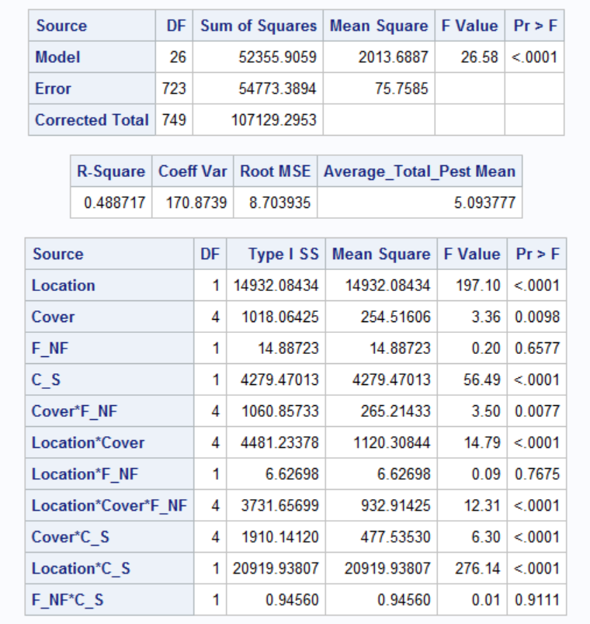
²

³

¹

¹Management practices: F=Dual-use cover cropping and NF=Traditional cover cropping.
²C=data collected before cover crop termination and S=data collected after soybean planting.
³The asterisk (*) denotes analysis of interaction between variables.

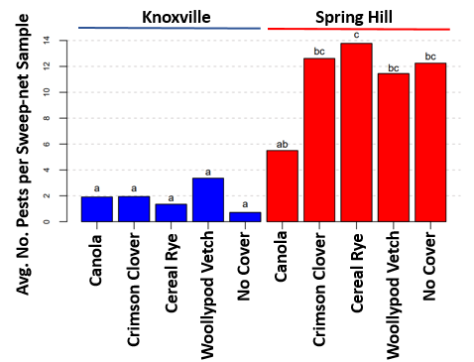
Figure 5. Influence of cover crop on average number of pest arthropods per sweep sample found in cover crops, 2019. Species with the same letter are not significantly different (p>0.05) (Tukey’s HSD). Bars shaded in blue represent data from the Plant Sciences Unit of the East Tennessee AgResearch and Education Center in Knoxville, TN (ETREC). Bars shaded in red represent data from the Middle Tennessee AgResearch and Education Center in Spring Hill, TN (MTREC). Outliers were removed from MTREC data to better display these data; significance between cover crops was the same with or without outliers.

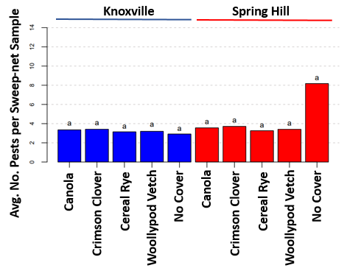
Figure 6. Influence of cover crop on average number of pest arthropods per sweep sample found in soybean, 2019. Species with the same letter are not significantly different (p>0.05) (Tukey’s HSD). Bars shaded in blue represent data from the Plant Sciences Unit of the East Tennessee AgResearch and Education Center in Knoxville, TN (ETREC). Bars shaded in red represent data from the Middle Tennessee AgResearch and Education Center in Spring Hill, TN (MTREC).

Table 6. Influence of cover crop species on number of pest and beneficial arthropods and slugs at two locations in Tennessee, 2019.
2019 Cover Crop Comparison | Average Total Pest for Sweeps |  | Average Total Beneficial for Sweeps |  | Average Total Pest for Beat-sheet |  | Average Total Beneficial for Beat-sheet |  | Average Slug Incidence
2019 Cover Crop Comparison | ETREC¹ | MTREC¹ | ETREC | MTREC | ETREC | MTREC | ETREC | MTREC | ETREC | MTREC
2019 Cover Crop Comparison | Pr(>|z|) | Pr(>|z|) | Pr(>|z|) | Pr(>|z|) | Pr(>|z|) | Pr(>|z|) | Pr(>|z|) | Pr(>|z|) | Pr(>|z|) | Pr(>|z|)
Cereal Rye – Canola | 0.933² | 0.028³ | 1.000 | 0.988 | 0.888 | 1.000 | 1.000 | 0.999 | 0.191 | 0.197
Crimson Clover – Canola | 1.000 | 0.180 | 0.997 | 0.463 | 0.457 | 0.990 | 1.000 | 1.000 | 0.348 | 1.000
No Cover – Canola | 0.443 | 0.562 | 0.999 | 0.191 | 0.978 | 1.000 | 0.789 | 0.999 | 0.331 | 0.989
Woollypod Vetch - Canola | 0.965 | 0.715 | 0.992 | 0.814 | 0.941 | 0.859 | 0.999 | 0.957 | 0.615 | 0.952
Crimson Clover – Cereal Rye | 0.877 | 0.950 | 0.980 | 0.776 | 0.947 | 0.990 | 1.000 | 0.994 | 0.988 | 0.197
No Cover – Cereal Rye | 0.900 | 0.605 | 0.987 | 0.452 | 0.997 | 1.000 | 0.768 | 1.000 | 0.941 | 0.064
Woollypod Vetch – Cereal Rye | 0.593 | 0.450 | 0.964 | 0.977 | 1.000 | 0.859 | 0.999 | 0.865 | 0.975 | 0.604
No Cover – Crimson Clover | 0.349 | 0.957 | 1.000 | 0.986 | 0.816 | 0.998 | 0.846 | 0.994 | 0.504 | 0.989
Woollypod Vetch – Crimson Clover | 0.987 | 0.882 | 1.000 | 0.980 | 0.898 | 0.985 | 1.000 | 0.981 | 0.718 | 0.952
Woollypod Vetch – No Cover | 0.131 | 0.999 | 1.000 | 0.814 | 1.000 | 0.926 | 0.894 | 0.865 | 0.637 | 0.753

¹ETREC = Plant Sciences Unit of the East Tennessee AgResearch and Education Center in Knoxville, TN; MTREC = Middle Tennessee AgResearch and Education Center in Spring Hill, TN.
² P-values represent combined pre-termination cover crop data and post-planting soybean data, with the exception of beat-sheet samples which were only collected after soybean planting.
³Bold text indicates significant difference between cover crop species (p<0.05); Tukey’s HSD.

Table 7. Model of average total number of beneficial arthropods per sweep-net sample, 2019, ANOVA GLM (p ≤ 0.05).
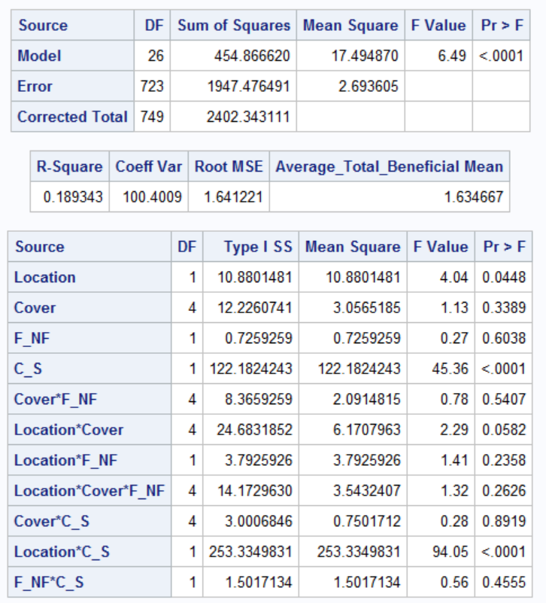
³

²

¹

¹Management practices: F=Dual-use cover cropping and NF=Traditional cover cropping.
²C=data collected before cover crop termination and S=data collected after soybean planting.
³The asterisk (*) denotes analysis of interaction between variables.

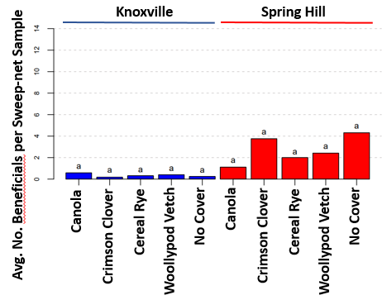
Figure 7. Influence of cover crop on average number of beneficial arthropods per sweep sample found in cover crops, 2019. Species with the same letter are not significantly different (p>0.05) (Tukey’s HSD). Bars shaded in blue represent data from the Plant Sciences Unit of the East Tennessee AgResearch and Education Center in Knoxville, TN (ETREC). Bars shaded in red represent data from the Middle Tennessee AgResearch and Education Center in Spring Hill, TN (MTREC).

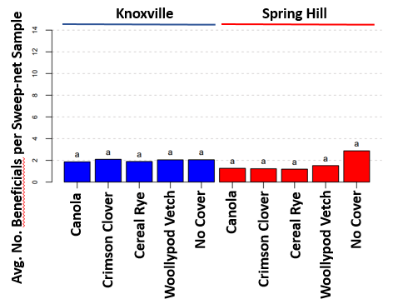
Figure 8. Influence of cover crop on average number of beneficial arthropods per sweep sample found in soybean, 2019. Species with the same letter are not significantly different (p>0.05) (Tukey’s HSD). Bars shaded in blue represent data from the Plant Sciences Unit of the East Tennessee AgResearch and Education Center in Knoxville, TN (ETREC) Bars. shaded in red represent data from the Middle Tennessee AgResearch and Education Center in Spring Hill, TN (MTREC).

Table 8. Model of average total number of pest arthropods per beat-sheet sample, 2019, ANOVA GLM (p ≤ 0.05).
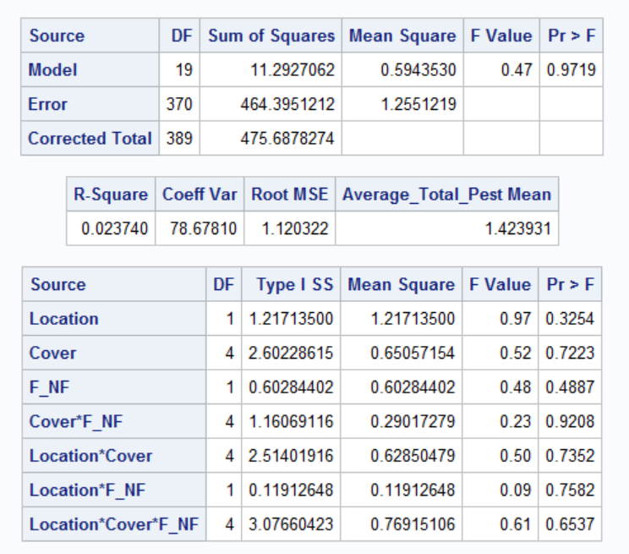
²

¹

¹Management practices: F=Dual-use cover cropping and NF=Traditional cover cropping.
²The asterisk (*) denotes analysis of interaction between variables.

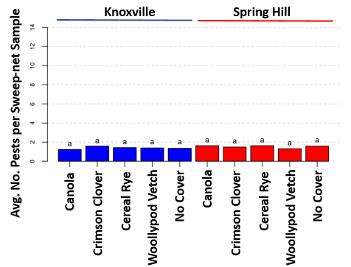
Figure 9. Influence of cover crop on average number of pest arthropods per beat-sheet sample found in soybean, 2019. Species with the same letter are not significantly different (p>0.05) (Tukey’s HSD). Bars shaded in blue represent data from the Plant Sciences Unit of the East Tennessee AgResearch and Education Center in Knoxville, TN (ETREC). Bars shaded in red represent data from the Middle Tennessee AgResearch and Education Center in Spring Hill, TN (MTREC).

Table 9. Model of average total number of beneficial arthropods per beat-sheet sample, 2019, ANOVA GLM (p ≤ 0.05).
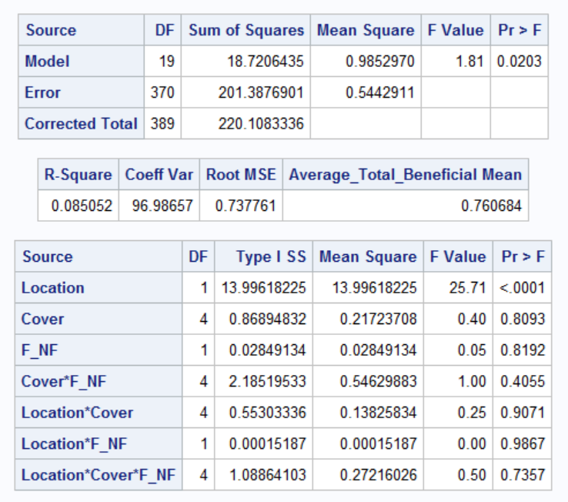
²

¹

¹Management practices: F=Dual-use cover cropping and NF=Traditional cover cropping.
²The asterisk (*) denotes analysis of interaction between variables.

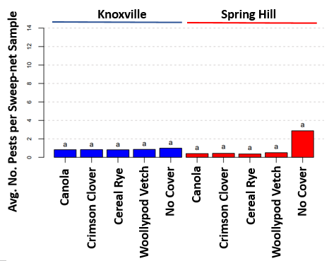
Figure 10. Influence of cover crop on average number of beneficial arthropods per beat-sheet sample found in soybean, 2019. Species with the same letter are not significantly different (p>0.05) (Tukey’s HSD). Bars shaded in blue represent data from the Plant Sciences Unit of the East Tennessee AgResearch and Education Center in Knoxville, TN (ETREC). Bars shaded in red represent data from the Middle Tennessee AgResearch and Education Center in Spring Hill, TN (MTREC).

Table 10. Influence of cover crop species on total number of pest arthropods in sweep nets before cover crop termination in cover crops at two locations in Tennessee, 2019 and 2020.

 | Arthropod | ETREC¹ |  |  |  |  |  | MTREC¹
 | Arthropod | Canola | Crimson Clover | Cereal Rye | Woollypod Vetch | No cover | Total | Canola | Crimson Clover | Cereal Rye | Woollypod Vetch | No cover | Total
2019 | Acrididae | 4 | 6 | 7 | 4 | 1 | 22 | 1 | 1 | 0 | 3 | 0 | 5
2019 | Aphididae | 127 | 158 | 109 | 253 | 59 | 706 | 146 | 1,384 | 1,831 | 886 | 1,022 | 5,269
2019 | Bean leaf beetle | 0 | 0 | 0 | 0 | 0 | 0 | 0 | 0 | 0 | 0 | 0 | 0
2019 | Chrysomelidae | 2 | 5 | 5 | 12 | 3 | 27 | 1 | 2 | 0 | 5 | 2 | 10
2019 | Cicadellidae | 0 | 4 | 3 | 21 | 1 | 29 | 0 | 6 | 3 | 1 | 1 | 11
2019 | Clover stem borer | 0 | 0 | 0 | 0 | 0 | 0 | 0 | 0 | 0 | 0 | 0 | 0
2019 | Curculionidae | 37 | 1 | 0 | 6 | 0 | 44 | 48 | 8 | 0 | 2 | 5 | 63
2019 | Dectes stem borer | 0 | 0 | 0 | 0 | 0 | 0 | 0 | 0 | 0 | 0 | 0 | 0
2019 | Japanese beetle | 0 | 0 | 0 | 0 | 0 | 0 | 0 | 0 | 0 | 0 | 0 | 0
2019 | Kudzu bug | 0 | 0 | 0 | 0 | 0 | 0 | 0 | 0 | 0 | 0 | 0 | 0
2019 | Noctuidae | 1 | 0 | 0 | 0 | 0 | 1 | 0 | 0 | 0 | 0 | 0 | 0
2019 | Stink bug | 0 | 0 | 0 | 0 | 0 | 0 | 0 | 0 | 0 | 0 | 0 | 0
2019 | Tarnished plant bug | 1 | 0 | 0 | 1 | 0 | 2 | 2 | 1 | 0 | 2 | 0 | 5
2019 | Threecornered alfalfa hopper | 0 | 1 | 0 | 5 | 0 | 6 | 0 | 5 | 0 | 3 | 1 | 9
2019 | Total | 172 | 175 | 124 | 302 | 64 | 837 | 198 | 1,407 | 1,834 | 902 | 1,031 | 5,372
2020 | Acrididae | 6 | 5 | 3 | 3 | 5 | 22 | 1 | 1 | 0 | 0 | 4 | 6
2020 | Aphididae | 19 | 148 | 80 | 362 | 21 | 630 | 75 | 155 | 174 | 122 | 20 | 546
2020 | Bean leaf beetle | 0 | 1 | 0 | 0 | 0 | 1 | 0 | 0 | 0 | 0 | 0 | 0
2020 | Chrysomelidae | 13 | 34 | 4 | 129 | 6 | 186 | 4 | 180 | 16 | 293 | 4 | 497
2020 | Cicadellidae | 2 | 26 | 6 | 15 | 7 | 56 | 1 | 24 | 2 | 8 | 1 | 36
2020 | Clover stem borer | 0 | 1 | 0 | 0 | 0 | 1 | 1 | 45 | 0 | 0 | 0 | 46
2020 | Curculionidae | 49 | 18 | 4 | 1 | 16 | 88 | 87 | 35 | 3 | 30 | 16 | 171
2020 | Dectes stem borer | 0 | 0 | 0 | 0 | 0 | 0 | 0 | 0 | 0 | 0 | 0 | 0
2020 | Japanese beetle | 0 | 0 | 0 | 0 | 0 | 0 | 0 | 0 | 0 | 0 | 0 | 0
2020 | Kudzu bug | 0 | 0 | 0 | 0 | 0 | 0 | 0 | 0 | 0 | 0 | 0 | 0
2020 | Noctuidae | 6 | 4 | 0 | 20 | 0 | 30 | 1 | 7 | 2 | 4 | 0 | 14
2020 | Stink bug | 0 | 2 | 1 | 0 | 0 | 3 | 2 | 7 | 1 | 1 | 1 | 12
2020 | Tarnished plant bug | 0 | 10 | 0 | 13 | 1 | 24 | 0 | 3 | 1 | 5 | 0 | 9
2020 | Threecornered alfalfa hopper | 0 | 12 | 0 | 3 | 0 | 15 | 0 | 8 | 0 | 2 | 0 | 10
2020 | Total | 95 | 261 | 98 | 546 | 56 | 1,056 | 172 | 465 | 199 | 465 | 46 | 1,347

¹ETREC = Plant Sciences Unit of the East Tennessee AgResearch and Education Center in Knoxville, TN; MTREC = Middle Tennessee AgResearch and Education Center in Spring Hill, TN.

Table 11. Influence of cover crop species on total number of beneficial arthropods in sweep nets before cover crop termination in cover crops at two locations in Tennessee, 2019 and 2020.

 | Arthropod | ETREC¹ |  |  |  |  |  | MTREC¹
 | Arthropod | Canola | Crimson Clover | Cereal Rye | Woollypod Vetch | No cover | Total | Canola | Crimson Clover | Cereal Rye | Woollypod Vetch | No cover | Total
2019 | Apidoidea | 6 | 0 | 0 | 2 | 0 | 8 | 4 | 1 | 0 | 1 | 1 | 7
2019 | Big-eyed bug | 1 | 0 | 0 | 1 | 0 | 2 | 0 | 4 | 0 | 0 | 1 | 5
2019 | Carabidae | 0 | 0 | 0 | 0 | 3 | 3 | 0 | 0 | 0 | 1 | 0 | 1
2019 | Coccinellidae | 3 | 3 | 1 | 3 | 0 | 10 | 3 | 31 | 1 | 11 | 7 | 53
2019 | Damsel bug | 0 | 0 | 0 | 0 | 0 | 0 | 0 | 0 | 0 | 0 | 0 | 0
2019 | Minute pirate bug | 0 | 0 | 0 | 0 | 0 | 0 | 0 | 0 | 0 | 0 | 1 | 1
2019 | Parasitoid/ predatory wasp | 35 | 9 | 27 | 26 | 18 | 115 | 23 | 85 | 27 | 67 | 139 | 341
2019 | Spined soldier bug | 0 | 0 | 0 | 0 | 0 | 0 | 0 | 0 | 0 | 0 | 10 | 10
2019 | Spider | 3 | 4 | 0 | 5 | 3 | 15 | 7 | 11 | 0 | 5 | 5 | 28
2019 | Syrphidae | 5 | 0 | 0 | 2 | 0 | 7 | 3 | 2 | 0 | 1 | 1 | 7
2019 | Total | 53 | 16 | 28 | 39 | 24 | 160 | 40 | 134 | 28 | 86 | 165 | 453
2020 | Apidoidea | 6 | 13 | 0 | 2 | 1 | 22 | 16 | 23 | 1 | 3 | 0 | 43
2020 | Big-eyed bug | 0 | 15 | 1 | 23 | 0 | 39 | 0 | 23 | 0 | 15 | 0 | 38
2020 | Carabidae | 0 | 0 | 0 | 0 | 0 | 0 | 0 | 0 | 0 | 0 | 0 | 0
2020 | Coccinellidae | 4 | 25 | 12 | 52 | 1 | 94 | 1 | 19 | 2 | 13 | 3 | 38
2020 | Damsel bug | 0 | 1 | 0 | 0 | 0 | 1 | 0 | 1 | 0 | 0 | 0 | 1
2020 | Minute pirate bug | 0 | 0 | 0 | 0 | 0 | 0 | 0 | 0 | 0 | 0 | 0 | 0
2020 | Parasitoid/ predatory wasp | 6 | 31 | 30 | 26 | 7 | 100 | 14 | 7 | 3 | 8 | 2 | 34
2020 | Spined soldier bug | 0 | 0 | 0 | 0 | 0 | 0 | 1 | 6 | 0 | 0 | 0 | 7
2020 | Spider | 2 | 9 | 12 | 4 | 4 | 31 | 8 | 13 | 18 | 6 | 7 | 52
2020 | Syrphidae | 17 | 9 | 4 | 174 | 1 | 205 | 3 | 2 | 1 | 20 | 0 | 26
2020 | Total | 35 | 103 | 59 | 281 | 14 | 492 | 43 | 94 | 25 | 65 | 12 | 239

¹ETREC = Plant Sciences Unit of the East Tennessee AgResearch and Education Center in Knoxville, TN; MTREC = Middle Tennessee AgResearch and Education Center in Spring Hill, TN.

Table 12. Influence of cover crop species on total number of pest arthropods in sweep nets after soybean planting in cover crops at two locations in Tennessee, 2019 and 2020.

 | Arthropod | ETREC¹ |  |  |  |  |  | MTREC¹
 | Arthropod | Canola | Crimson Clover | Cereal Rye | Woollypod Vetch | No cover | Total | Canola | Crimson Clover | Cereal Rye | Woollypod Vetch | No cover | Total
2019 | Acrididae | 64 | 74 | 59 | 78 | 71 | 346 | 9 | 9 | 8 | 11 | 9 | 46
2019 | Aphididae | 6 | 2 | 5 | 2 | 1 | 16 | 3 | 7 | 7 | 8 | 7 | 32
2019 | Bean leaf beetle | 9 | 12 | 9 | 2 | 12 | 44 | 25 | 12 | 20 | 7 | 9 | 73
2019 | Chrysomelidae | 96 | 73 | 90 | 58 | 92 | 409 | 31 | 24 | 24 | 17 | 16 | 112
2019 | Cicadellidae | 261 | 281 | 229 | 271 | 191 | 1,233 | 27 | 39 | 32 | 50 | 44 | 192
2019 | Clover stem borer | 5 | 3 | 1 | 4 | 1 | 14 | 5 | 5 | 1 | 0 | 5 | 16
2019 | Curculionidae | 1 | 0 | 1 | 3 | 3 | 8 | 1 | 1 | 1 | 1 | 0 | 4
2019 | Dectes stem borer | 1 | 0 | 0 | 1 | 1 | 3 | 4 | 3 | 1 | 5 | 3 | 16
2019 | Japanese beetle | 1 | 2 | 1 | 1 | 4 | 9 | 3 | 4 | 2 | 5 | 4 | 18
2019 | Kudzu bug | 46 | 37 | 57 | 45 | 55 | 240 | 3 | 7 | 5 | 8 | 4 | 27
2019 | Noctuidae | 143 | 171 | 138 | 139 | 131 | 722 | 37 | 25 | 21 | 23 | 29 | 135
2019 | Stink bug | 15 | 22 | 18 | 19 | 25 | 99 | 16 | 21 | 21 | 18 | 24 | 100
2019 | Tarnished plant bug | 108 | 141 | 87 | 143 | 80 | 559 | 3 | 6 | 5 | 5 | 7 | 26
2019 | Threecornered alfalfa hopper | 141 | 903 | 146 | 861 | 117 | 2,168 | 25 | 36 | 26 | 26 | 26 | 139
2019 | Total | 897 | 1,721 | 841 | 1,627 | 784 | 5,870 | 192 | 199 | 174 | 184 | 187 | 936
2020 | Acrididae | 0 | 4 | 3 | 3 | 1 | 11 | 20 | 21 | 18 | 21 | 18 | 98
2020 | Aphididae | 0 | 1 | 0 | 0 | 0 | 1 | 1 | 1 | 0 | 1 | 0 | 3
2020 | Bean leaf beetle | 0 | 0 | 0 | 0 | 0 | 0 | 0 | 0 | 0 | 0 | 1 | 1
2020 | Chrysomelidae | 1 | 20 | 23 | 6 | 11 | 61 | 4 | 10 | 40 | 7 | 1 | 62
2020 | Cicadellidae | 18 | 14 | 23 | 42 | 28 | 125 | 17 | 15 | 6 | 27 | 15 | 80
2020 | Clover stem borer | 1 | 1 | 0 | 0 | 0 | 2 | 0 | 2 | 2 | 2 | 0 | 6
2020 | Curculionidae | 0 | 0 | 0 | 0 | 0 | 0 | 0 | 1 | 0 | 1 | 0 | 2
2020 | Dectes stem borer | 0 | 0 | 0 | 0 | 0 | 0 | 0 | 0 | 0 | 0 | 0 | 0
2020 | Japanese beetle | 0 | 1 | 0 | 0 | 1 | 2 | 0 | 0 | 0 | 0 | 0 | 0
2020 | Kudzu bug | 0 | 1 | 2 | 0 | 4 | 7 | 0 | 0 | 0 | 0 | 0 | 0
2020 | Noctuidae | 2 | 0 | 3 | 0 | 2 | 7 | 3 | 8 | 2 | 6 | 1 | 20
2020 | Stink bug | 0 | 0 | 0 | 0 | 0 | 0 | 0 | 0 | 0 | 0 | 0 | 0
2020 | Tarnished plant bug | 0 | 3 | 8 | 6 | 4 | 21 | 0 | 0 | 0 | 0 | 0 | 0
2020 | Threecornered alfalfa hopper | 5 | 13 | 13 | 6 | 15 | 52 | 29 | 3 | 14 | 15 | 15 | 76
2020 | Total | 27 | 58 | 75 | 63 | 66 | 289 | 74 | 61 | 82 | 80 | 51 | 348

¹ETREC = Plant Sciences Unit of the East Tennessee AgResearch and Education Center in Knoxville, TN; MTREC = Middle Tennessee AgResearch and Education Center in Spring Hill, TN.

Table 13. Influence of cover crop species on total number of beneficial arthropods in sweep nets after soybean planting in cover crops at two locations in Tennessee, 2019 and 2020.

 | Arthropod | ETREC¹ |  |  |  |  |  | MTREC¹
 | Arthropod | Canola | Crimson Clover | Cereal Rye | Woollypod Vetch | No cover | Total | Canola | Crimson Clover | Cereal Rye | Woollypod Vetch | No cover | Total
2019 | Apidoidea | 7 | 12 | 5 | 4 | 11 | 39 | 2 | 1 | 3 | 2 | 0 | 8
2019 | Big-eyed bug | 175 | 198 | 178 | 214 | 244 | 1,009 | 20 | 18 | 15 | 23 | 21 | 97
2019 | Carabidae |  | 8 | 8 | 10 | 9 | 35 | 3 | 1 | 2 | 4 | 3 | 13
2019 | Coccinellidae | 44 | 41 | 40 | 60 | 43 | 228 | 10 | 6 | 5 | 2 | 5 | 28
2019 | Damsel bug | 98 | 103 | 104 | 86 | 102 | 493 | 4 | 6 | 3 | 1 | 3 | 17
2019 | Minute pirate bug | 55 | 40 | 31 | 48 | 43 | 217 | 9 | 11 | 10 | 10 | 9 | 49
2019 | Parasitoid/ predatory wasp | 50 | 58 | 39 | 43 | 36 | 226 | 5 | 4 | 8 | 11 | 8 | 36
2019 | Spined soldier bug | 1 | 7 | 1 | 4 | 0 | 13 | 2 | 1 | 0 | 0 | 0 | 3
2019 | Spider | 72 | 95 | 104 | 80 | 63 | 414 | 13 | 18 | 18 | 29 | 25 | 103
2019 | Syrphidae | 2 | 2 | 0 | 1 | 2 | 7 | 0 | 0 | 0 | 0 | 1 | 1
2019 | Total | 504 | 564 | 510 | 550 | 553 | 2,681 | 68 | 66 | 64 | 82 | 75 | 355
2020 | Apidoidea | 2 | 1 | 1 | 2 | 1 | 7 | 0 | 0 | 0 | 0 | 0 | 0
2020 | Big-eyed bug | 3 | 8 | 7 | 1 | 9 | 28 | 7 | 10 | 2 | 8 | 10 | 37
2020 | Carabidae | 0 | 1 | 1 | 0 | 0 | 2 | 0 | 0 | 0 | 0 | 0 | 0
2020 | Coccinellidae | 1 | 3 | 3 | 1 | 1 | 9 | 1 | 0 | 0 | 0 | 0 | 1
2020 | Damsel bug | 2 | 3 | 5 | 1 | 2 | 13 | 0 | 0 | 0 | 1 | 0 | 1
2020 | Minute pirate bug | 4 | 3 | 0 | 2 | 1 | 10 | 4 | 2 | 2 | 23 | 14 | 45
2020 | Parasitoid/ predatory wasp | 3 | 0 | 0 | 1 | 0 | 4 | 2 | 2 | 1 | 3 | 2 | 10
2020 | Spined soldier bug | 0 | 0 | 0 | 0 | 0 | 0 | 0 | 0 | 0 | 0 | 0 | 0
2020 | Spider | 1 | 10 | 8 | 4 | 4 | 27 | 27 | 23 | 21 | 19 | 15 | 105
2020 | Syrphidae | 0 | 0 | 0 | 0 | 0 | 0 | 0 | 0 | 0 | 0 | 0 | 0
2020 | Total | 16 | 29 | 25 | 12 | 18 | 100 | 41 | 37 | 26 | 54 | 41 | 199

¹ETREC = Plant Sciences Unit of the East Tennessee AgResearch and Education Center in Knoxville, TN; MTREC = Middle Tennessee AgResearch and Education Center in Spring Hill, TN.

Table 14. Model of total number of Aphididae per sweep-net sample, 2019, ANOVA GLM (p ≤ 0.05).
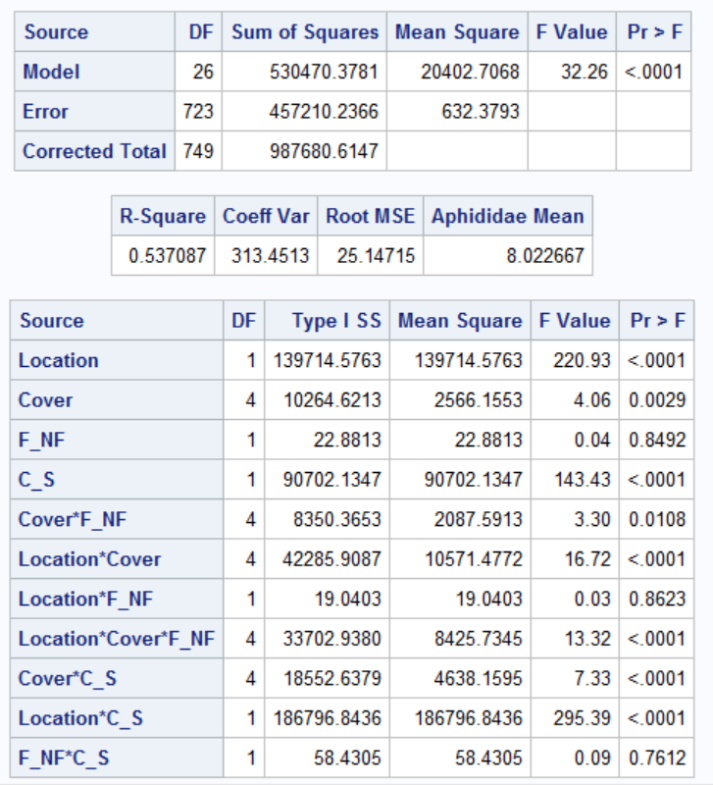
³

²

¹

¹Management practices: F=Dual-use cover cropping and NF=Traditional cover cropping.
²C=data collected before cover crop termination and S=data collected after soybean planting.
³The asterisk (*) denotes analysis of interaction between variables.

Table 15. Model of total number of parasitoid/predatory wasps per sweep-net sample, 2019, ANOVA GLM (p ≤ 0.05).
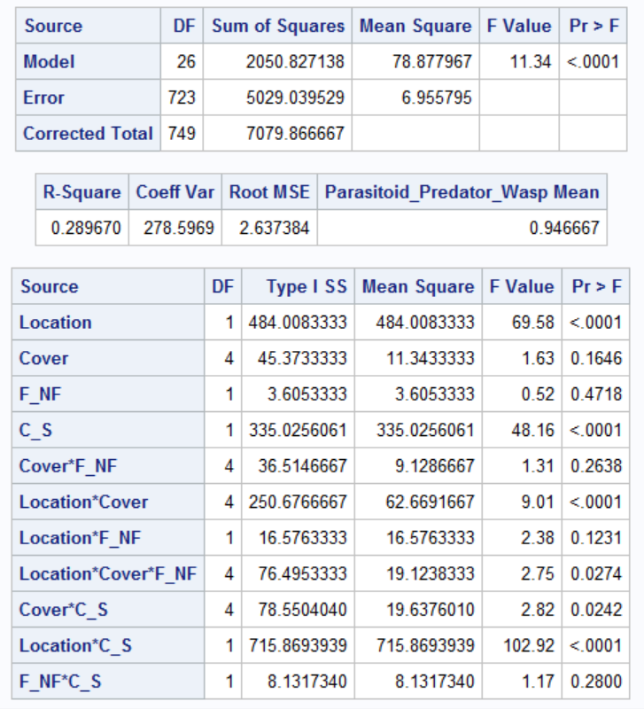
³

²

¹

¹Management practices: F=Dual-use cover cropping and NF=Traditional cover cropping.
²C=data collected before cover crop termination and S=data collected after soybean planting.
³The asterisk (*) denotes analysis of interaction between variables.

Table 16. Model of total number of Curculionidae per sweep-net sample, 2019, ANOVA GLM (p ≤ 0.05).
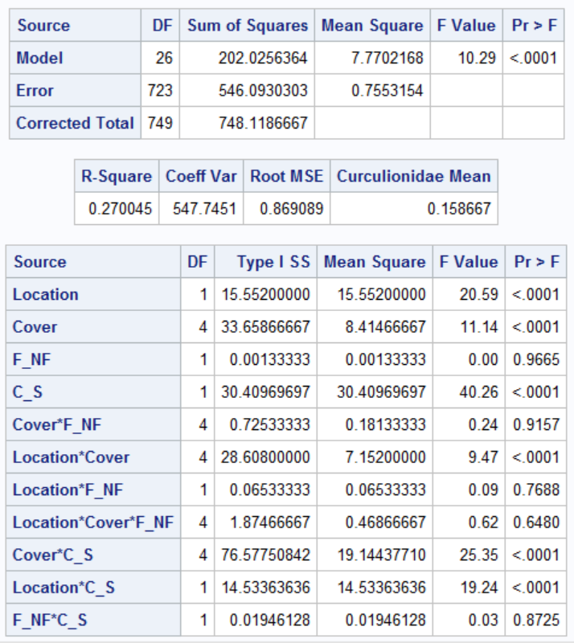
³

²

¹

¹Management practices: F=Dual-use cover cropping and NF=Traditional cover cropping.
²C=data collected before cover crop termination and S=data collected after soybean planting.
³The asterisk (*) denotes analysis of interaction between variables.

Table 17. Model of total number of threecornered alfalfa hopper per sweep-net sample, 2019, ANOVA GLM (p ≤ 0.05).
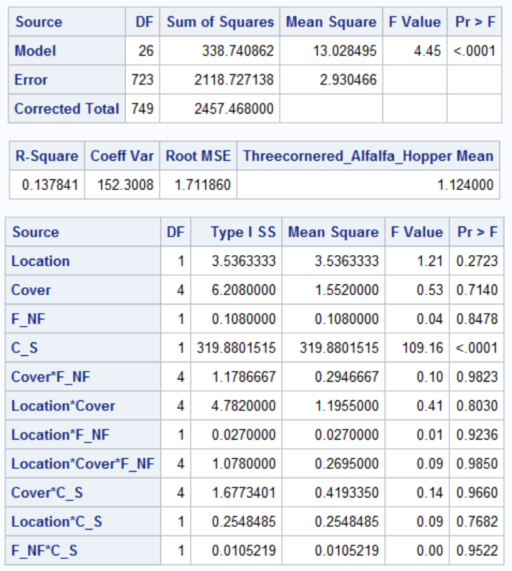
³

²

¹

¹Management practices: F=Dual-use cover cropping and NF=Traditional cover cropping.
²C=data collected before cover crop termination and S=data collected after soybean planting.
³The asterisk (*) denotes analysis of interaction between variables.

Table 18. Influence of cover crop management practice on number of pest and beneficial arthropods at two locations in Tennessee, 2019 and 2020.
Year | Comparison of Cover Crop Management Practice | Average Total Pests in Sweeps |  | Average Total Beneficials in Sweeps |  | Average Total Pests in Beat-sheet |  | Average Total Beneficials in Beat-sheet |  | Average Slug Incidence
Year | Comparison of Cover Crop Management Practice | ETREC¹ | MTREC¹ | ETREC | MTREC | ETREC | MTREC | ETREC | MTREC | ETREC | MTREC
Year | Comparison of Cover Crop Management Practice | Pr(>|z|) | Pr(>|z|) | Pr(>|z|) | Pr(>|z|) | Pr(>|z|) | Pr(>|z|) | Pr(>|z|) | Pr(>|z|) | Pr(>|z|) | Pr(>|z|)
2019 | Traditional – Dual-use | 0.425² | 0.485 | 0.945 | 0.384 | 0.462 | 0.941 | 0.848 | 0.858 | 0.482 | 0.400
2020 | Traditional – Dual-use | 0.972 | 0.749 | 0.569 | 0.964 | N/A | N/A | N/A | N/A | N/A | N/A

¹ETREC = Plant Sciences Unit of the East Tennessee AgResearch and Education Center in Knoxville, TN; MTREC = Middle Tennessee AgResearch and Education Center in Spring Hill, TN.
² P-values represent combined pre-termination cover crop data and post-planting soybean data, with the exception of beat-sheet date which were only collected after soybean planting. Analyzed at p=0.05, Tukey’s HSD.

Table 19. Model of average total number of pest arthropods per sweep-net sample, 2020, ANOVA GLM (p ≤ 0.05).
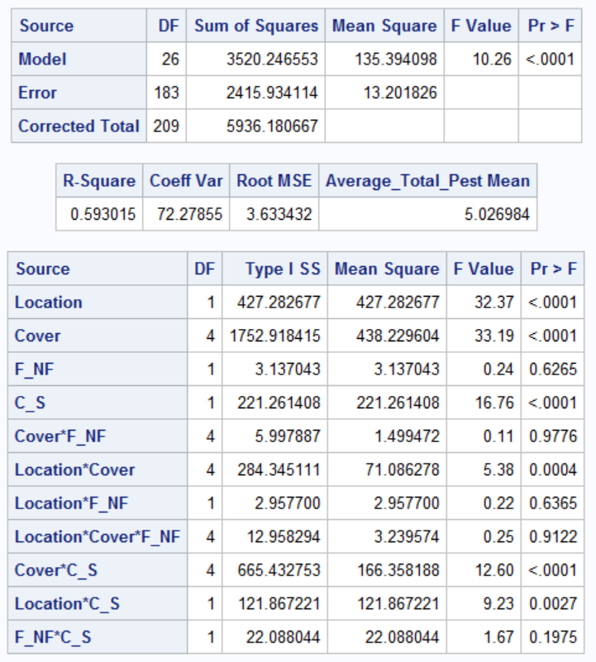
³

²

¹

¹Management practices: F=Dual-use cover cropping and NF=Traditional cover cropping.
²C=data collected before cover crop termination and S=data collected after soybean planting.
³The asterisk (*) denotes analysis of interaction between variables.

Table 20. Model of average total number of beneficial arthropods per sweep-net sample, 2020, ANOVA GLM (p ≤ 0.05).
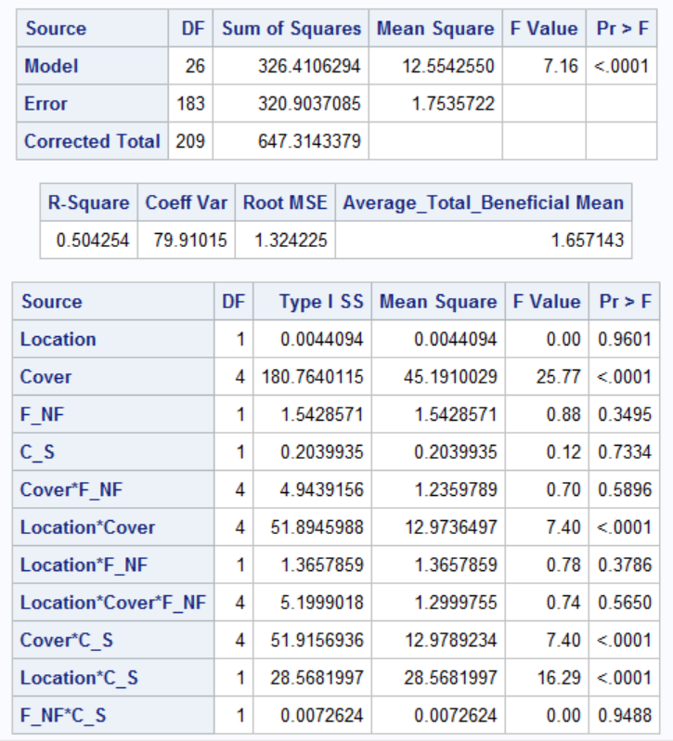
³

²

¹

¹Management practices: F=Dual-use cover cropping and NF=Traditional cover cropping.
²C=data collected before cover crop termination and S=data collected after soybean planting.
³The asterisk (*) denotes analysis of interaction between variables.

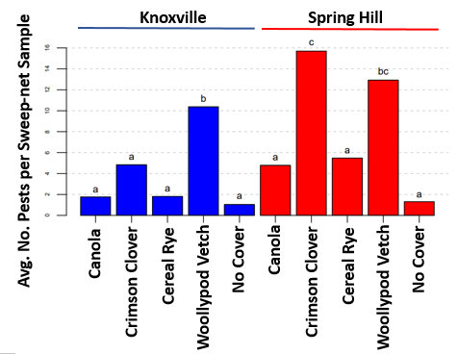
Figure 11. Influence of cover crop on average number of pest arthropods per sweep sample found in cover crops, 2020. Species with the same letter are not significantly different (p>0.05) (Tukey’s HSD). Bars shaded in blue represent data from the Plant Sciences Unit of the East Tennessee AgResearch and Education Center in Knoxville, TN (ETREC). Bars shaded in red represent data from the Middle Tennessee AgResearch and Education Center in Spring Hill, TN (MTREC).

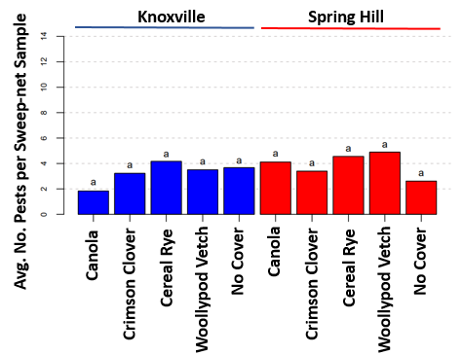
Figure 12. Influence of cover crop on average number of pest arthropods per sweep sample found in soybean, 2020. Species with the same letter are not significantly different (p>0.05) (Tukey’s HSD). Bars shaded in blue represent data from the Plant Sciences Unit of the East Tennessee AgResearch and Education Center in Knoxville, TN (ETREC). Bars shaded in red represent data from the Middle Tennessee AgResearch and Education Center in Spring Hill, TN (MTREC).

Table 21. Influence of cover crop species on number of pest and beneficial arthropods at two locations in Tennessee, 2020.
2020 Cover Crop Comparison | Average Total Pest in Sweeps |  | Average Total Beneficial in Sweeps
2020 Cover Crop Comparison | ETREC¹ | MTREC¹ | ETREC | MTREC
2020 Cover Crop Comparison | Pr(>|z|) | Pr(>|z|) | Pr(>|z|) | Pr(>|z|)
Cereal Rye – Canola | 0.957² | 0.997 | 0.787 | 0.612
Crimson Clover – Canola | 0.026³ | < 0.001 | 0.108 | 0.429
No Cover Crop – Canola | 1.000 | 0.523 | 0.973 | 0.198
Woollypod Vetch - Canola | <0.001 | 0.011 | <0.001 | 0.814
Crimson Clover – Cereal Rye | 0.158 | 0.002 | 0.698 | 0.735
No Cover Crop – Cereal Rye | 0.934 | 0.313 | 0.403 | 0.451
Woollypod Vetch – Cereal Rye | <0.001 | 0.032 | <0.001 | 0.974
No Cover Crop – Crimson Clover | 0.019 | < 0.001 | 0.020 | 0.992
Woollypod Vetch – Crimson Clover | <0.001 | 0.939 | <0.001 | 0.972
Woollypod Vetch – No Cover Crop | <0.001 | < 0.001 | <0.001 | 0.823

¹ETREC = Plant Sciences Unit of the East Tennessee AgResearch and Education Center in Knoxville, TN; MTREC = Middle Tennessee AgResearch and Education Center in Spring Hill, TN.
² P-values represent combined pre-termination cover crop data and post-planting soybean data.
³Bold text indicates significant difference between cover crop species (p<0.05); Tukey’s HSD.

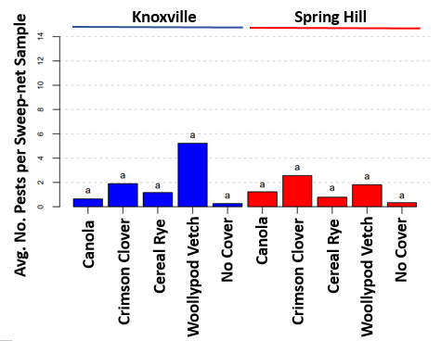
Figure 13. Influence of cover crop on average number of beneficial arthropods per sweep sample found in cover crops, 2020. Species with the same letter are not significantly different (p>0.05) (Tukey’s HSD). Bars shaded in blue represent data from the Plant Sciences Unit of the East Tennessee AgResearch and Education Center in Knoxville, TN (ETREC). Bars shaded in red represent data from the Middle Tennessee AgResearch and Education Center in Spring Hill, TN (MTREC).

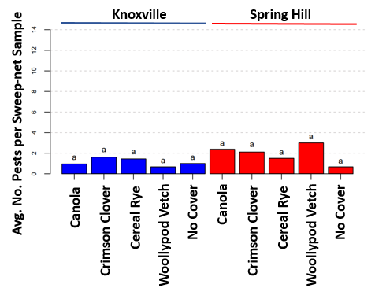
Figure 14. Influence of cover crop on average number of beneficial arthropods per sweep sample found in soybean, 2020. Species with the same letter are not significantly different (p>0.05) (Tukey’s HSD). Bars shaded in blue represent data from the Plant Sciences Unit of the East Tennessee AgResearch and Education Center in Knoxville, TN (ETREC). Bars shaded in red represent data from the Middle Tennessee AgResearch and Education Center in Spring Hill, TN (MTREC).

Table 22. Model of total number of Aphididae per sweep-net sample, 2020, ANOVA GLM (p ≤ 0.05).
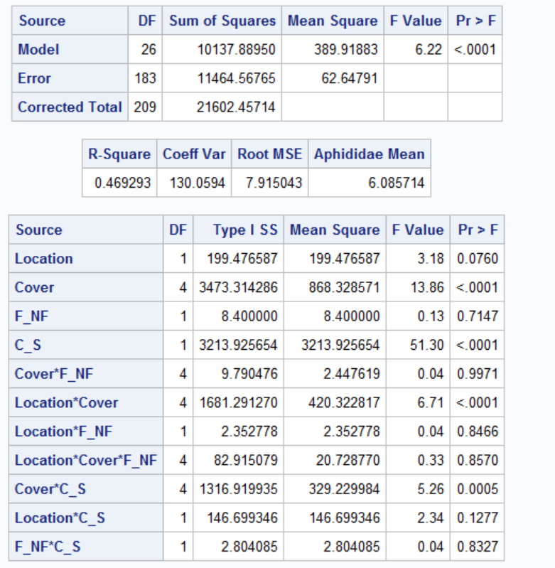
³

²

¹

¹Management practices: F=Dual-use cover cropping and NF=Traditional cover cropping.
²C=data collected before cover crop termination and S=data collected after soybean planting.
³The asterisk (*) denotes analysis of interaction between variables.

Table 23. Model of total number of Curculionidae per sweep-net sample, 2020, ANOVA GLM (p ≤ 0.05).
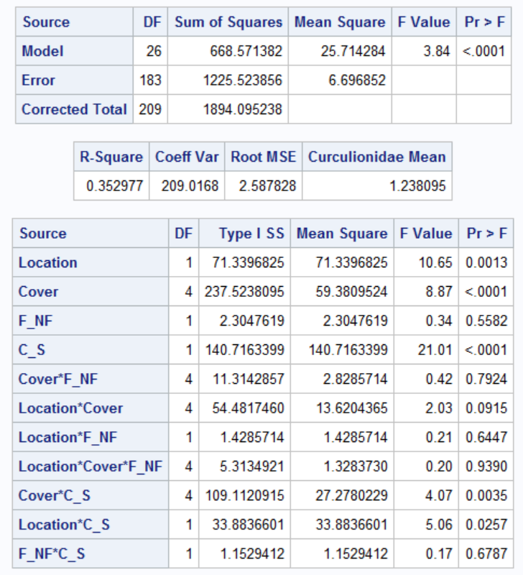
³

²

¹

¹Management practices: F=Dual-use cover cropping and NF=Traditional cover cropping.
²C=data collected before cover crop termination and S=data collected after soybean planting.
³The asterisk (*) denotes analysis of interaction between variables.

Table 24. Model of total number of Chrysomelidae per sweep-net sample, 2020, ANOVA GLM (p ≤ 0.05).
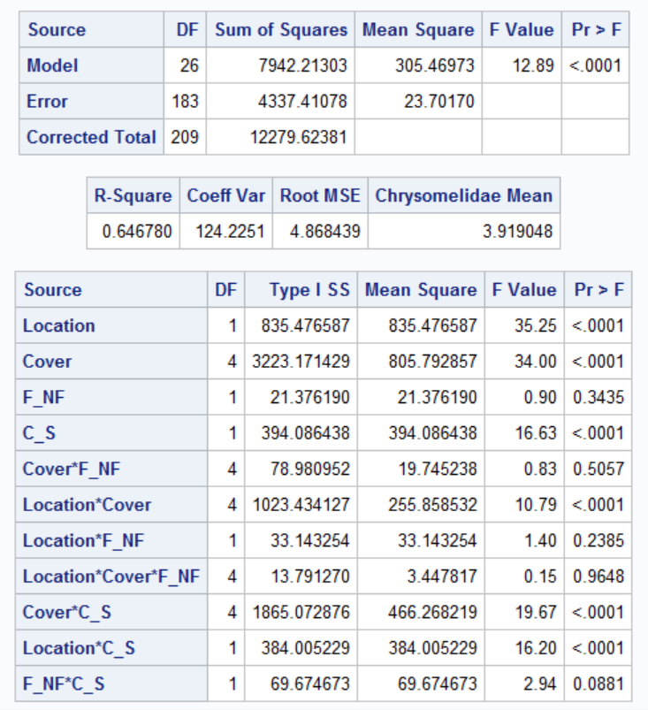
³

²

¹

¹Management practices: F=Dual-use cover cropping and NF=Traditional cover cropping.
²C=data collected before cover crop termination and S=data collected after soybean planting.
³The asterisk (*) denotes analysis of interaction between variables.

Table 25. Model of total number of Cicadellidae per sweep-net sample, 2020, ANOVA GLM (p ≤ 0.05).
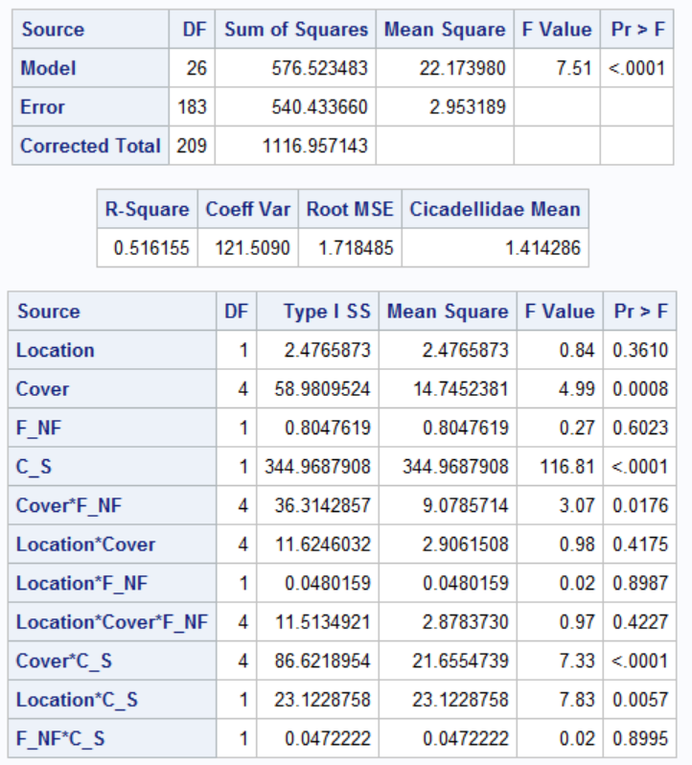
³

²

¹

¹Management practices: F=Dual-use cover cropping and NF=Traditional cover cropping.
²C=data collected before cover crop termination and S=data collected after soybean planting.
³The asterisk (*) denotes analysis of interaction between variables.

Table 26. Model of total number of Apidoidea per sweep-net sample, 2020, ANOVA GLM (p ≤ 0.05).
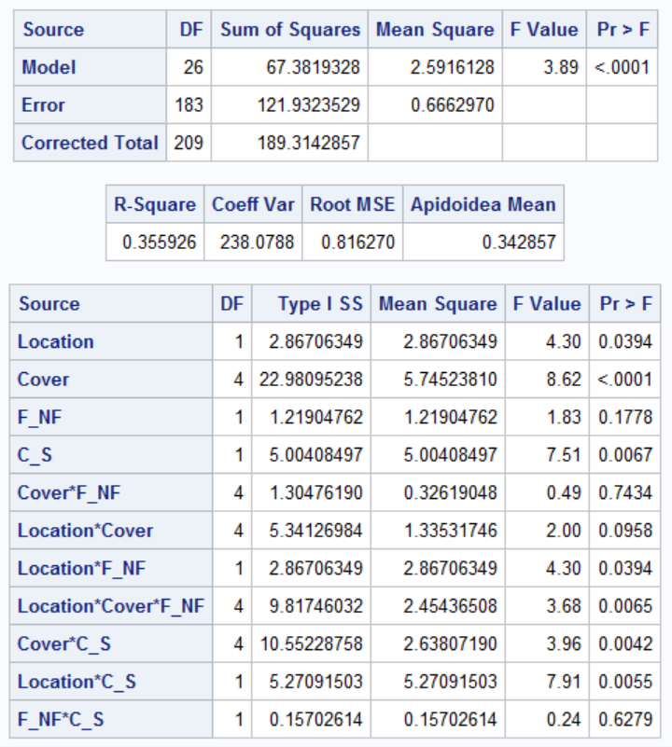
³

²

¹

¹Management practices: F=Dual-use cover cropping and NF=Traditional cover cropping.
²C=data collected before cover crop termination and S=data collected after soybean planting.
³The asterisk (*) denotes analysis of interaction between variables.

Table 27. Model of total number of big-eyed bug per sweep-net sample, 2020, ANOVA GLM (p ≤ 0.05).
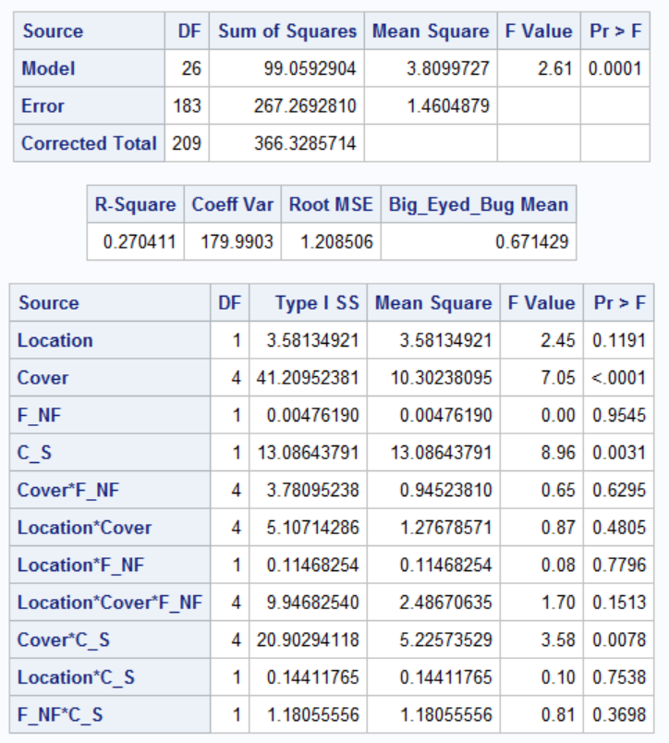
³

²

¹

¹Management practices: F=Dual-use cover cropping and NF=Traditional cover cropping.
²C=data collected before cover crop termination and S=data collected after soybean planting.
³The asterisk (*) denotes analysis of interaction between variables.

Table 28. Model of total number of Coccinellidae per sweep-net sample, 2020, ANOVA GLM (p ≤ 0.05).
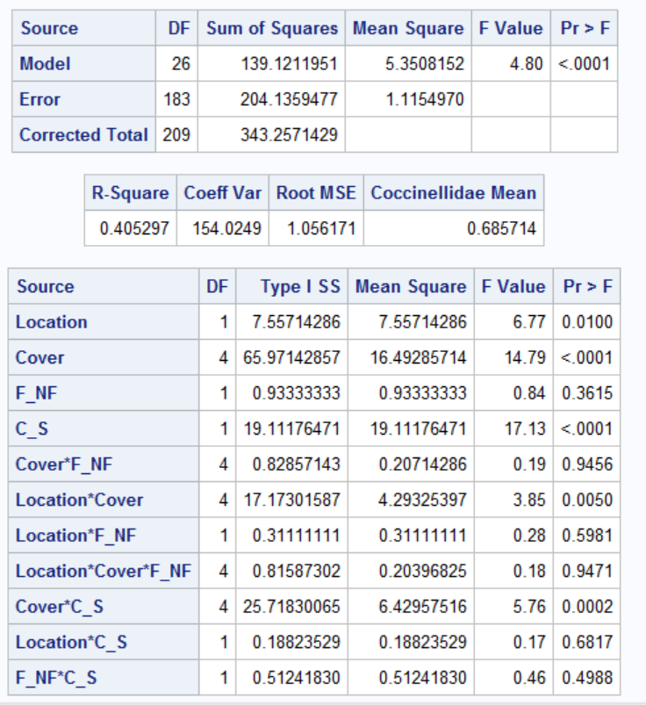
³

²

¹

¹Management practices: F=Dual-use cover cropping and NF=Traditional cover cropping.
²C=data collected before cover crop termination and S=data collected after soybean planting.
³The asterisk (*) denotes analysis of interaction between variables.

Table 29. Model of total number of Syrphidae per sweep-net sample, 2020, ANOVA GLM (p ≤ 0.05).
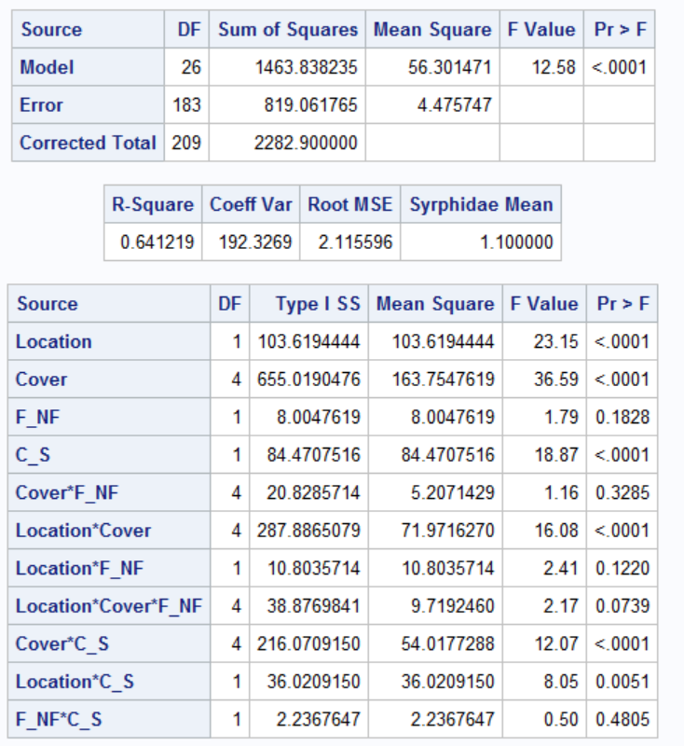
³

²

¹

¹Management practices: F=Dual-use cover cropping and NF=Traditional cover cropping.
²C=data collected before cover crop termination and S=data collected after soybean planting.
³The asterisk (*) denotes analysis of interaction between variables.

Table 30. Model of total number of threecornered alfalfa hoppers per sweep-net sample, 2020, ANOVA GLM (p ≤ 0.05).
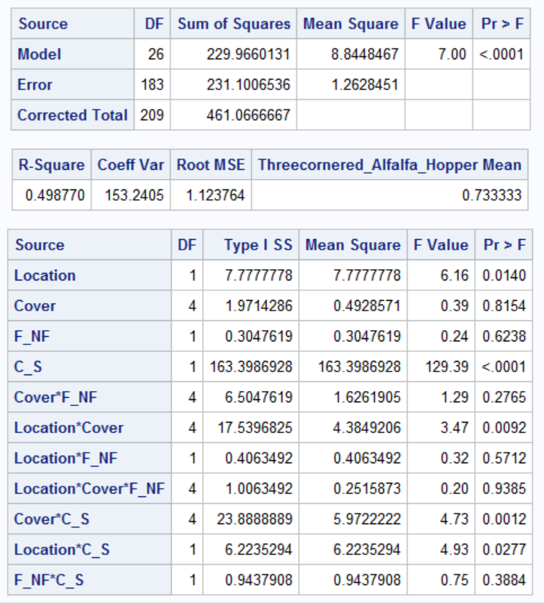
³

²

¹

¹Management practices: F=Dual-use cover cropping and NF=Traditional cover cropping.
²C=data collected before cover crop termination and S=data collected after soybean planting.
³The asterisk (*) denotes analysis of interaction between variables.

Table 31. Model of total number of minute pirate bugs per sweep-net sample, 2020, ANOVA GLM (p ≤ 0.05).
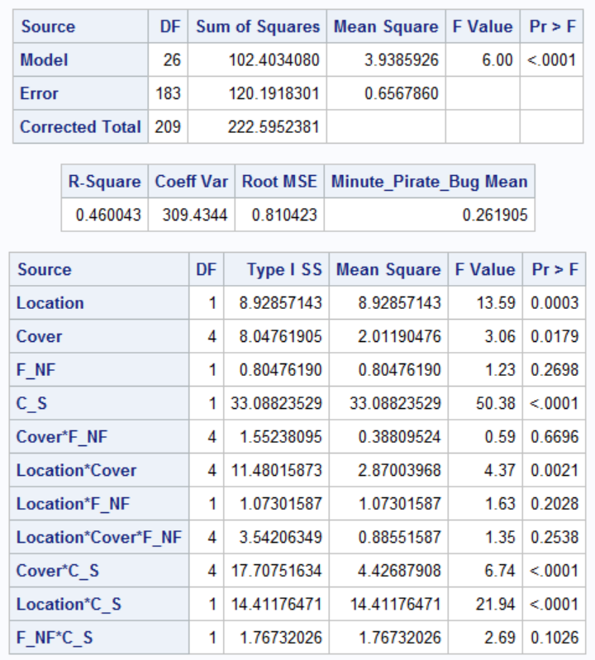
³

²

¹

¹Management practices: F=Dual-use cover cropping and NF=Traditional cover cropping.
²C=data collected before cover crop termination and S=data collected after soybean planting.
³The asterisk (*) denotes analysis of interaction between variables.

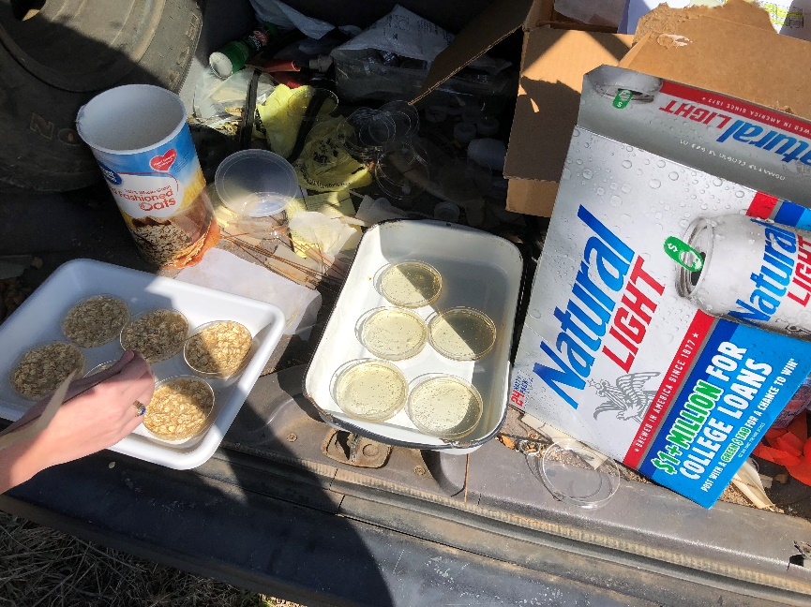

Figure 15. Preparation of slug traps for placement in the field.

Table 32. Model of average total number of slugs collected in traps, 2019, ANOVA GLM
(p ≤ 0.05).
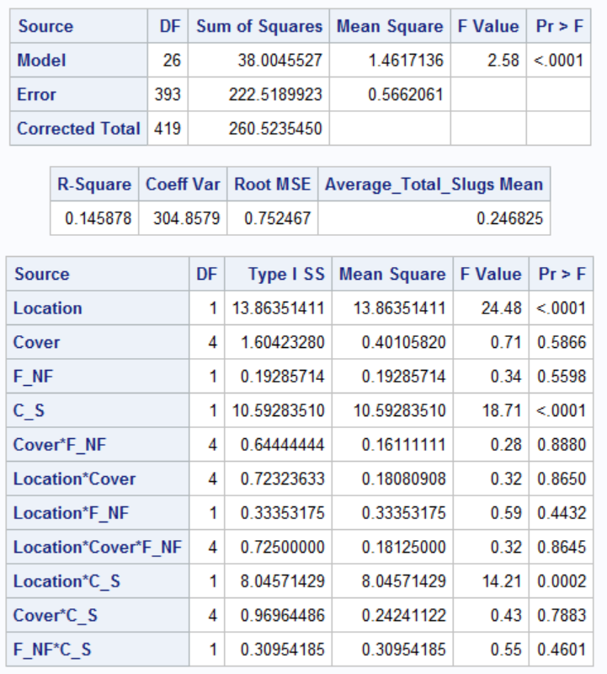
³

²

¹

¹Management practices: F=Dual-use cover cropping and NF=Traditional cover cropping.
²C=data collected before cover crop termination and S=data collected after soybean planting.
³The asterisk (*) denotes analysis of interaction between variables.

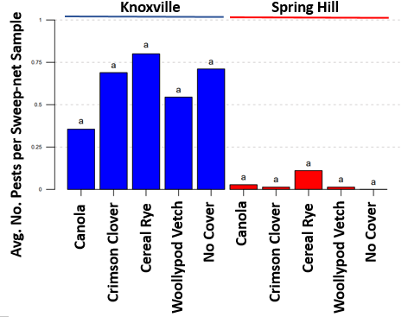
Figure 16. Average number of slugs by cover crop found in cover crops, 2019. Species with the same letter not significantly different (Tukey’s HSD) (p=0.05). Bars shaded in blue represent data from the Plant Sciences Unit of the East Tennessee AgResearch and Education Center in Knoxville, TN (ETREC). Bars shaded in red represent data from the Middle Tennessee AgResearch and Education Center in Spring Hill, TN (MTREC).

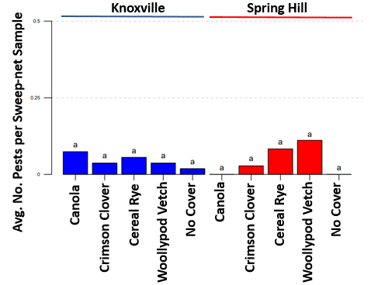
Figure 17. Average number of slugs by cover crop found in soybean, 2019. Species with the same letter not significantly different (Tukey’s HSD) (p=0.05). Bars shaded in blue represent data from the Plant Sciences Unit of the East Tennessee AgResearch and Education Center in Knoxville, TN (ETREC). Bars shaded in red represent data from the Middle Tennessee AgResearch and Education Center in Spring Hill, TN (MTREC).

Table 33. Model of average total number of slugs per trap at Spring Hill, 2019, ANOVA GLM (p ≤ 0.05).
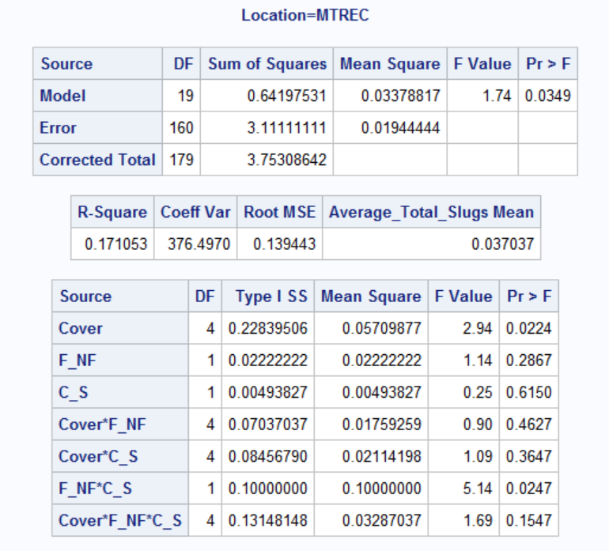
³

²

¹

¹Management practices: F=Dual-use cover cropping and NF=Traditional cover cropping.
²C=data collected before cover crop termination and S=data collected after soybean planting.
³The asterisk (*) denotes analysis of interaction between variables.

Table 34. Model of average total number of slugs per trap at Knoxville, 2019, ANOVA GLM (p ≤ 0.05).
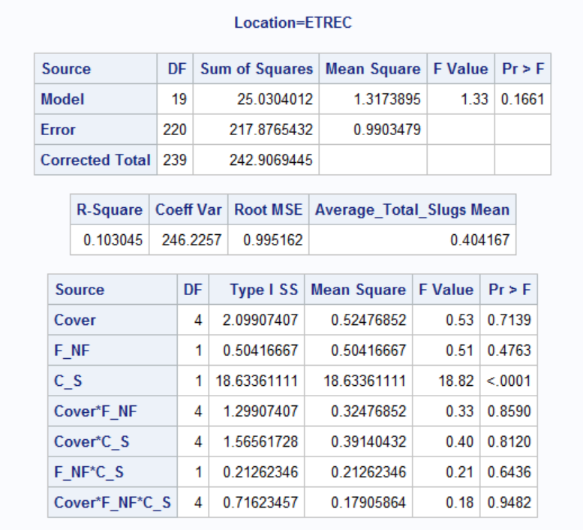
³

²

¹

¹Management practices: F=Dual-use cover cropping and NF=Traditional cover cropping.
²C=data collected before cover crop termination and S=data collected after soybean planting.
³The asterisk (*) denotes analysis of interaction between variables.

Table 35. Cover crop biomass (kg/ha) at two locations in Tennessee, 2019 and 2020.
Year | Location | Cover Crop | Replication 1 |  | Replication 2 |  | Replication 3
Year | Location | Cover Crop | T² | D² | T | D | T | D
2019 | ETREC¹ | Canola | 914.932 | 505.904 | 1248.614 | 968.752 | 775.002 | 290.626
2019 | ETREC | Crimson Clover | 1367.017 | 1227.086 | 1722.226 | 1162.502 | 2185.074 | 2421.880
2019 | ETREC | Cereal Rye | 1227.086 | 1130.211 | 1959.032 | 1022.571 | 1550.003 | 1991.323
2019 | ETREC | Woollypod Vetch | 1065.627 | 1302.433 | 2970.839 | 1367.017 | 4240.981 | 2357.296
2019 | ETREC | No Cover | 150.695 | 75.347 | 247.570 | 570.487 | 204.514 | 365.973
2019 | MTREC¹ | Canola | 2680.214 | 7750.015 | 7986.821 | 7222.584 | 5801.543 | N/A
2019 | MTREC | Crimson Clover | 5984.734 | 4068.758 | 7911.474 | 6393.763 | 5091.748 | 4262.509
2019 | MTREC | Cereal Rye | 6253.832 | 7179.528 | 5317.372 | 5102.094 | 4972.927 | 4456.259
2019 | MTREC | Woollypod Vetch | 2960.075 | 3788.896 | 1636.114 | 2841.672 | 3358.340 | 2680.214
2019 | MTREC | No Cover | 990.280 | N/A³ | 2518.755 | 678.126 | 35.521 | 613.543
2020 | ETREC | Canola | 222.222 | 555.556 | 133.333 | 72.2222 | 333.333 | 55.556
2020 | ETREC | Crimson Clover | 3555.556 | 2777.778 | 2111.111 | 3333.333 | 2333.333 | 2777.778
2020 | ETREC | Cereal Rye | 2111.111 | 2333.333 | 1111.111 | 1888.889 | 2555.556 | 3333.333
2020 | ETREC | Woollypod Vetch | 7000.000 | 7000.000 | 4444.444 | 5333.333 | 6111.111 | 4555.556
2020 | ETREC | No Cover | 22.222 | 55.556 | N/A | 55.556 | 111.111 | 27.778
2020 | MTREC | Canola | 111.111 | 333.333 | 888.889 | 1111.111 | 333.333 | 222.222
2020 | MTREC | Crimson Clover | 5777.778 | 3111.111 | 3222.222 | 4888.889 | LOST⁴ | 4888.889
2020 | MTREC | Cereal Rye | 2555.556 | 3888.889 | 3222.222 | 3222.222 | 3333.333 | 3222.222
2020 | MTREC | Woollypod Vetch | 3666.667 | 4777.778 | 3000.000 | 3777.778 | 4777.778 | 5000.000
2020 | MTREC | No Cover | 111.111 | 222.222 | 222.222 | 444.444 | 666.667 | 222.222

¹ETREC = Plant Sciences Unit of the East Tennessee AgResearch and Education Center in Knoxville, TN; MTREC = Middle Tennessee AgResearch and Education Center in Spring Hill, TN.
²Management practices were T=Traditional cover cropping and D=Dual-use cover cropping.
³N/A denotes insufficient biomass present in the plot for harvest.
⁴This plot was accidently terminated prematurely.

Table 36. Pearson’s correlation coefficients (r) between arthropods/slugs and cover crop biomass/soybean yield at two locations in Tennessee, 2019 and 2020.
Correlation | 2019 |  | 2020
Correlation | ETREC¹ | MTREC¹ | ETREC | MTREC
Cover Crop Biomass – Soybean Yield | 0.250² | -0.204 | N/A | N/A
Average Total Pests in Sweeps – Cover Crop Biomass | 0.095 | 0.115 | 0.641 | 0.461
Average Total Beneficials in Sweeps – Cover Crop Biomass | -0.069 | -0.042 | 0.646 | 0.233
Average Total Pests in Beat-sheet – Cover Crop Biomass | 0.016 | 0.084 | N/A | N/A
Average Total Beneficials in Beat-sheet – Cover Crop Biomass | -0.073 | 0.056 | N/A | N/A
Average Slug Incidence – Cover Crop Biomass | -0.001 | 0.018 | N/A | N/A
Average Total Pests in Sweeps – Soybean Yield | 0.029 | 0.167 | N/A | N/A
Average Total Beneficials in Sweeps – Soybean Yield | 0.016 | 0.012 | N/A | N/A
Average Total Pests in Beat-sheet – Soybean Yield | 0.059 | -0.064 | N/A | N/A
Average Total Beneficials in Beat-sheet – Soybean Yield | 0.025 | 0.060 | N/A | N/A
Average Slug Incidence – Soybean Yield | -0.010 | 0.021 | N/A | N/A

¹ETREC = Plant Sciences Unit of the East Tennessee AgResearch and Education Center in Knoxville, TN; MTREC = Middle Tennessee AgResearch and Education Center in Spring Hill, TN.
² Values close to ±1 have a high degree of correlation.

VITA
Matthew Lee Longmire was born March 3, 1997, at the University of Tennessee Medical Center in Knoxville, TN, to his parents Charles and Sandra Longmire. He grew up in Anderson County, Tennessee on his family’s farm. Since he was little, he was always fascinated with the world of insects. In elementary school, he would check out books from the library on insects and began his insect collection, which he maintains to this day.
In May of 2015, he graduated third in his class from Anderson County High School in Clinton, TN. After high school, he attended the University of Tennessee in Knoxville Tennessee, where he obtained a Bachelor of Science degree in Biological Sciences with a concentration in Ecology and Evolutionary Biology, and a minor in Entomology and Plant Pathology in May of 2018. In August of 2018, Matthew began a Master of Science program in the laboratory of Dr. Jerome Grant in the Department of Entomology and Plant Pathology at the University of Tennessee, Knoxville and concluded his program in August of 2020. Matthew is a member of the Tennessee Entomological Society and the Entomological Society of America.

