Improvements to the Predictive Capability of FCM Fuel Performance Modeling

A Dissertation Presented for the
Doctor of Philosophy
Degree
The University of Tennessee Knoxville

Daniel Schappel
July 2017

Acknowledgements
Later

Abstract

A proposed fuel type for improved accident performance in LWRs (Light Water Reactors) is the TRISO (Tristructural-Isotropic) particles embedded in a NITE (Nano Infiltrated Eutectic) silicon carbide matrix. TRISO fuel particles consist of a spherical fuel kernel, which can contain either fissile or fertile materials, which for LWR applications will likely range from about 500 to in excess of 800microns in diameter. The kernel and buffer layer are then typically coated with three isotropic layers consisting of a dense inner pyrolytic carbon (IPyC), a silicon carbide (SiC) layer, and an outer layer of dense, pyrolytic carbon (OPyC). These layers are typically around 40 microns thick, but can range from 20 to 60microns. The TRISO particle packing fraction in the NITE-SiC matrix is expected to be ~40vol%.

The release of radioactivity into the coolant is dependent on the integrity of the silicon carbide layer of the TRISO particles and the NITE-SiC matrix. Currently BISON is one of the codes being used to simulate the thermo-mechanical behavior of this fuel type. BISON, a code under development by Idaho National Laboratory, is built on the Multi-physics Object Oriented Simulation Environment (MOOSE). MOOSE is a massively parallel, finite element computational system that uses a Jacobian-free, Newton-Krylov (JFNK) method to solve coupled systems and non-linear partial differential equations. The partial differential equations are contained in kernels stored within the BISON program.

Due to the anisotropic geometry of the FCM pellet, the capability to model a large and random arrangement of discrete TRISO particles was developed. Additional work has been performed to develop models for the fracture of the FCM materials and transport of silver and cesium has been developed. This combination allows sufficient predictive capability to perform preliminary analysis of FCM fuel performance.

Keywords: FCM, TRISO, thermo, mechanical, BISON, fracture

Table of Contents

Acknowledgements iii
Abstract iv
Table of Contents v
List of Tables vii
List of Figures ix
CHAPTER 1: INTRODUCTION 1
1.1 Background 1
1.2 Summary of TRISO Fuel Performance Modeling 1
1.3 Review of Irradiation Effects 2
1.3.1 Structure 2
1.3.2 Graphite Dimensional Change 3
1.3.3 Pyrolytic Carbon Microstructural Changes Under Irradiation 4
1.3.4 Isotropic Pyrolytic Carbon Irradiation Induced Dimensional Change 4
1.3.5 Thermal Creep 4
1.3.6 Irradiation Creep 5
1.3.7 Poisson Ratio in Creep 6
1.3.8 Irradiation Behavior of SiC 6
1.3 Summary 6
1.4 Paper Overview 7
CHAPTER 2: MATERIAL MODELS 8
2.1 Property Summary and Assumptions 8
2.2 Uranium Nitride 9
2.2.1 Thermal Conductivity 9
2.2.2 Swelling and Fission Gas Release 9
2.3 High Density Pyrolytic Carbon 10
2.3.1 Irradiation Induced Dimensional Change and Thermal Conductivity 10
2.4 Low Density (Buffer) Pyrolytic Carbon 11
2.4.1 Irradiation Induced Dimensional Change and Thermal Conductivity 11
2.5 Chemical Vapor Deposited (CVD) and Nano Infiltrated Transient Eutectic (NITE) Silicon Carbide 11
2.5.1 Swelling and Thermal Conductivity 12
2.6 Graphite 12
2.6.1 Dimensional Change 12
2.6.2 Thermal Conductivity 13
2.6.3 Irradiation Creep 13
2.7 Zircaloy Cladding 13
2.8 Summary 13
CHAPTER 3: FCM MODEL 15
3.1 Two Dimensional Single Particle Comparison 15
3.2 Two Dimensional RZ Five TRISO Particles in a FCM Matrix 15
3.3 Shell Simulations 16
3.4 Interface Debonding and Through Wall Fracture 17
3.4.1 Through Wall Crack Propagation Methods 17
3.4.2 Debonding 18
3.4.3 Crack Thermal Conductivity 18
3.5 Single TRISO Particle with NITE-SiC Shell 19
3.6 FCM Particle 20
3.7 FCM Simulation in a HTGR Environment 20
3.8 FCM Simulation in a LWR Environment 21
3.9 FCM Pellet Radial Power and Fast Neutron Flux Distribution 23
3.10 Cracking Development and Comparisons 23
3.10.1 Plate Crack Propagation 23
3.10.2 Uranium Dioxide Pellet Thermal Expansion Crack Development 23
3.10.3 FCM Pellet Crack Propagation Principal Stress Fracture Criterion 23
3.11 Silver and Cesium Transport 24
3.11.1 Transport Setup 24
3.11.2 Comparisons to Analytical Calculations 25
3.11.3 FCM Simulation with Cracking and Transport 26
3.12 Summary 26
CHAPTER 4: EXPERIMENTAL COMPARISONS 28
4.1 Experiments 28
4.1.1 NPR Experiments 28
4.1.2 High Flux Isotope Reactor 29
4.2 Simulations 30
4.2.1 Setup and Initial Results 30
4.2.2 Effect of Hydrostatic Stress 30
4.2.3 Effect of Poisson Ratio in Creep 31
4.2.4 Effect of Accelerated Low Temperature Creep 32
4.3 Alternate Irradiation Induced Dimensional Change Correlation for Pyrolytic Carbon 32
4.4 Recommendations for PyC Dimensional Change Behavior 34
4.5 Summary 35
CHAPTER 5 PARAMETER VARIATIONS 36
5.1 Light Water Reactor Simulations 36
5.1.1 Irradiation Induced Dimensional Change 36
5.1.2 Pyrolytic Carbon Creep 36
5.1.3 Hydrostatic Stress Limited Dimensional Change 37
5.1.4 Linear Power 37
5.1.5 TRISO Particle Geometry 38
5.1.6 BISO (Bilayer ISOtropic) Particles 38
5.2 High Temperature Gas Reactor Simulations 39
5.2.1 Irradiation Induced Dimensional Change 39
5.2.2 Coolant Temperature 39
5.2.3 Linear Power 39
5.2.4 Graphite and NITE-SiC Binder 40
5.3 Conclusions 40
Appendix of Related Features 42
Ductile Failure 42
Thermal Fatigue 42
Zircaloy and Steam Reaction 43
Appendix of Tables 45
Appendix of Figures 53
List of References 101

List of Tables

Table 1. List of the prominent measured irradiation creep constants for isotropic pyrolytic carbon at 1200C. Table available from Petti et al [8]. 46
Table 2. The constant properties used for UN, low and high density pyrolytic carbon, and Zr-4 cladding. The NITE and CVD SiC use the same mechanical properties. At this time BISON did not allow for anisotropic properties with the exception of dimensional change. Hence the properties listed in the table are applied isotropically. 46
Table 3. Below are the diffusion properties for the modeled elements. Data was lacking for palladium and cadmium. Data is taken from reputable sources as much as possible, but considerable gaps in knowledge exist. 46
Table 4. A list of the thicknesses and outer radii of the TRISO particle layers used in the case 11 comparison. 47
Table 5. This table lists the parameters used for the fracture of the silicon carbide and high density PyC fracture and PyC debonding [71,3,56]. 47
Table 6. a) This table lists the geometry of the 1130µm diameter TRISO particles used in the LWR FCM simulation. b) This table lists the geometry of the 900µm diameter TRISO particles used in the HTGR FCM simulation. 47
Table 7. List of the high temperature gas reactor and light water reactor geometry parameters. 48
Table 8. The geometry for a RISO III fuel pellet. Dishes and chamfers were not used in the model. A smear power of 35kW m⁻¹ or 1.2W per particle with a 41.5vol% packing fraction was used in this model. 48
Table 9. The TRISO particle geometry as layer thickness and outer radii used in the FCM pellet in a light water reactor environment. 48
Table 10. List of the TRISO geometry for the NPR experiments [55]. 49
Table 11. NPR irradiation parameters [8]. 49
Table 12. List of the TRISO layer failure fractions from the NPR experiments [8,55]. 49
Table 13. List of the TRISO geometry used in the HFIR irradiations. 50
Table 14. List of the irradiation parameters for the HFIR irradiations. 50
Table 15. Comparison of the NPR results with BISON calculations. In these simulations, the failure probability of the SiC is highly dependent on the fracture of the IPyC layer. As a result, the SiC failure probabilities are not included in this table. The FZJ correlation provides a moderate level of agreement however the LLNL correlations produce results that are significantly different than the observations. However, LLNL correlations were intended for lower temperatures than what was experienced in the NPR experiments. 50
Table 16. List of the NPR failure fractions using hydrostatic stress limited dimensional change. 50
Table 17. List of the failure probabilities for the IPyC layer in NPR simulations. The FZJ correlation used a Poisson ratio in creep of 0.4 and the LLNL use a value of 0.5 which is the reverse of the recommended values. 51
Table 18. Comparison of the predicted failure probabilities using the modified IIDC correlation with the experimental NPR results. 51
Table 19. This list the experimental data from Blandfor et al. for SS 316L. 51
Table 20. lists the material constants used to calculate the crack growth per cycle [64]. 51
Table 21. List of the material parameters used in the clad-steam reaction kernel [72,65,66]. 52

List of Figures

Figure 1. a) Photomicrographs showing a TRISO particle with its individual layers of porous carbon buffer, inner pyrolytic carbon, silicon carbide, and outer pyrolytic carbon. b) Schematic illustration of the geometrical model for an FCM particle containing 40% packing fraction of TRISO particles. 54
Figure 2. a) A representation for the hexagonal and rhombahedral stacking sequences in graphite. C-axis is in the vertical direction and A-axis is horizontal. Adapted from University of Strathclyde [15]. b) Representation of the turbostratic structure observed in HOPG. Adapted from a paper by B. Claub [16]. 54
Figure 3. A TEM image of the cracks running parallel to the basal plane caused by thermal contraction. Adapted from Tongxiang Liang at Tsinghua University [19]. 55
Figure 4. a) A micrograph of the turbostratic structure seen in HOPG [21]. The C-axis orientation is diagonal to the top right. Two thermal contraction cracks can be seen oriented parallel to the basal planes. b) A TEM image of as deposited PyC with a density of about 1.3 g cm⁻³ [27]. Note both images are similar in scale. 55
Figure 5. a) Plot of the volumetric change for graphite irradiated at 900 and 600C. b) Plot of the dimensional change for graphite irradiated at 900C. c) Plot of the dimensional change for graphite irradiated at 600C. The estimated conversion for fluence to dpa for these experiments is 0.148x10²⁶ n m⁻² dpa⁻¹. This produces a maximum dose of about 13.6, and 24.3 dpa for the 900 and 600C irradiations, respectively [23]. 56
Figure 6. A schematic of the proposed interstitial loop driven dimensional change in graphite. The interstitial loop is thought to cause expansion in the perpendicular direction and contraction in the parallel axis. 56
Figure 7. HREM images for room temperature electron irradiated graphite [24]. a) On the left are the images of vacancy loop formation and positive climb [24]. b) On the right are the images for interstitial loop formation. 57
Figure 8. TEM images of as deposited low density PyC [27]. a) Image of the growth features. b) A close up image of the domains contained within each growth feature. 57
Figure 9. a) A plot of the parallel dimensional change data overlayed by the FZJ and LLNL correlations. b) A plot of the perpendicular dimensional change data overlayed by the FZJ and LLNL correlations. c) Curve fits to data from Ballenger et al. with the 700C interpolation and extrapolation also displayed [31]. 58
Figure 10. The above figures plot the different creep trends at low temperatures from British and American-Russian sources. Adapted from IAEA-Tecdoc-1154 Figure 5.2. a) A plot of the trend from Kelly and Brocklehurst. b) A plot of the data from Kennedy and Platonov. 58
Figure 11. A plot of the Poisson ratio in creep data from Kaae for pyrolytic carbon [30]. 59
Figure 12. a) Plot of the unirradiated uranium nitride thermal conductivity fit. The figure indicates that the unirradiated UN reaches a maximum thermal conductivity around 1500 K. Measurements were done with the flash laser method. Adapted from Kim and Hoffman Figure 5-3 [39]. b) Plot of the modeled UN thermal conductivity versus burnup. This is a combination of the unirradiated UN data from Kim and Hoffman and the UO₂ thermal conductivity degradation data from Luceta et al. The trend predicts less degradation at higher temperatures. 59
Figure 13. The uranium nitride swelling is based on the MATPRO library used in the SCDAP/RELAP5 program [40]. The densification and gaseous fission product swelling are temperature dependent, but the solid fission product swelling is not. Also, the fission gas release increases with temperature which allows the long term swelling slopes to be similar as a function of temperature at high burnups. 60
Figure 14. These are plots of the fission gas release using the SIFGRS model. Kernel density was set to 11.3 g cm⁻³. Changing the density of the kernel had no impact on the predicted fission gas release. 60
Figure 15. a) Plot of the irradiation dimensional change of the dense pyrolytic carbon using the LLNL correlation. At 30% volumetric swelling, the pyrolytic carbon is assumed to be too brittle to continue swelling. However, under load the pyrolytic carbon may stabilize at a considerably lower swelling amount. b) Plot of the predicted thermal conductivity using the LLNL IIDC correlations plotted in Figure 5a. Due to the dependence on density, the thermal conductivity is the inverse of the volumetric dimensional change. c) Plot of the FZJ IIDC. The FZJ correlation was originally intended for a maximum fluence of 5x10²⁵ n m⁻². However, it extrapolates very well. d) Plot of the PyC thermal conductivity using the FZJ IIDC correlation. 61
Figure 16. a) The swelling of the 50% dense pyrolytic carbon buffer, based on the German FZJ correlations [8]. The buffer is predicted to shrink isotropically. b) Plot of the predicted buffer thermal conductivity versus fluence assuming a saturation dimensional change as plotted in Figure 6a. As with dense PyC, the buffer thermal conductivity is expected to be solely dependent on density. 61
Figure 17. a) The swelling of NITE SiC as a function of fast neutron fluence [E > 0.1MeV]. The SiC swells due to the combined effects of dislocation loops and annealing. The resulting effect is greater swelling at low temperatures. This swelling gradient generates the compressive hoop stress in the perimeter of the matrix and is expected to provide an effective barrier to fission product release. b) Plot of the thermal conductivity for NITE-SiC. Thermal conductivity of SiC is a function of both volumetric swelling and temperature. c) Plot of the thermal conductivity for CVD-SiC. CVD-SiC is predicted to have the same trends as NITE-SiC but greater degradation with swelling. Silicon carbide irradiation creep appears to be dependent on swelling, and therefore it shows the same trend with fluence and temperature which is a rapid increase between 0.1-1x10²⁵ n m⁻² and then saturation [35]. Thermal creep is not considered here since it is essentially absent at T<1400°C [73]. Equation 6 shows the predicted dependence of silicon carbide creep on irradiation swelling. 62
Figure 18. a) A plot of the H-451 graphite dimensional change from HFIR irradiations at 600C [23]. b) A plot of the H-451 graphite dimensional change from HFIR irradiations at 900C [23]. c) A plot of the resulting correlations from the graphite IIDC data for 900C. 63
Figure 19. a) Curve fits to data obtained by Li and Mohokov [46]. b) A plot of the resulting correlations showing the fluence dependence of the thermal conductivity. c) Data for the thermal conductivity of graphite irradiated at 600C [47,74,75]. d) A plot of the temperature dependence of graphite thermal conductivity when unirradiated and at 10x10²⁵ n m⁻². 63
Figure 20. a) A plot of the data for graphite creep at 600C and -20.7MPa compressive stress [48]. b) plot of the data for graphite creep at 900C and -20.7MPa compressive stress [48]. c) A plot comparing the graphite and PyC creep constants with temperature. Both correlations are assumed to be constant below 600C. 64
Figure 21. A representation of the mesh used on the 2D-RZ single particle comparison to PARFUME. This is a 2D-RZ mesh which is revolved about the centerline (left edge) to produce a spherical particle rather than an infinite cylinder [76]. 64
Figure 22. a) A plot comparing the BISON and PARFUME calculations for the SiC inner edge hoop stress. b) IAEA Tecdoc 1674 Figure 9-19 showing the calculated hoop stress from several TRISO fuel performance code [10]. c) A plot comparing the BISON and PARFUME calculation for the fission gas pressure applied to the Buffer/IPyC interface. d) IAEA Tecdoc 1674 Figure 9-19 showing the calculated gas pressures of the various codes [10]. 65
Figure 23. Mesh sensitivity for the IAEA Case 11 comparison. The mesh size was varied from 5 to 40μm. The maximum difference in gas pressure was 0.3 MPa and as a result is not plotted. a) Plot of the hoop stress at the inner edge of the SiC layer. b) Plot of the difference in hoop stress compared to the 5μm mesh simulation. 65
Figure 24. This figure separates the effects of dimensional change, creep, and gas pressure for the Case11 comparison. a) Comparing the hoop stress in the SiC layer for a full physics simulation with a simulation that has the gas pressure disabled. b) A plot of the hoop stress in the SiC layer when the creep and gas pressure are disabled. BISON had some difficulty calculating the stresses above 10GPa. 66
Figure 25. This is the mesh used for the five particles embedded in a matrix. Particles are spaced at 200, 100, 50, and 25µm increments top to bottom in the Z-direction. 66
Figure 26. a) Image of the matrix hoop stress profile at 24x10²⁵ n m⁻². As expected, the largest stress occurs at the closest particle spacing. b) Plot of the hoop stress from the smallest particle spacing of 25µm which is a probable event in a FCM pellet. The plot of the hoop stress follows the volumetric PyC IIDC trend exactly. 66
Figure 27. a) The mesh used in the shell simulations. Three layers each 50µm thick with an outer diameter of 1mm. The simulation was isothermal with no pressure boundary conditions. The “IPyC” condition has the outer two layers as silicon carbide but the inner is PyC. This approximates the partially restrained IPyC. The “OPyC” condition has the inner and outer layers as silicon carbide but the middle layer is OPyC. This illustrates the differences in creep behaviors when fully and partially restrained. b) A plot showing the importance of the Poisson ratio in creep if the PyC is fully constrained and the lack of importance if the PyC is not or only partially constrained. c) A plot showing the effect of creep rate for 1x, 2x, and 4x multipliers of the recommended CEGA creep constant [8]. 67
Figure 28. These plots compare the gap width predictor with the actual gap size. a) Plot of the gap width when the debondable layer has IIDC and thermal expansion disabled. Ideally the predictor should match the calculated displacements exactly. b) Plot of the predicted and expected gap widths when dimensional change is enabled in the debondable layer. The expected line accounts for the expected gap width contribution from shrinkage of the debondable layer. c) At large strains the accuracy of the predictor decreases. At 240% radial strain the gap width predictor is off by about 17%. 68
Figure 29. a) The mesh used in the single TRISO particle surrounded by a 500µm thick NITE-SiC shell. b) A plot of the hoop stress at the OPyC/NITE-SiC interface. c) A plot of the buffer/IPyC interface gap. The gap forms due to the rapid and large buffer shrinkage, and then closes due to the kernel and IPyC expansion. d) A plot of the maximum particle temperature. Due to the symmetry of the simulation the maximum temperature is found at the kernel center point. This is vastly different than in a FCM pellet. Also, note the similar trend to the buffer/IPyC gap width. 69
Figure 30. Plots illustrating the potential effects of variable elastic modulus and stress limited dimensional change in a single TRISO particle. a) Plot of the modeled elastic modulus for different sensitivities. b) Plot of the resulting hoop stresses at the NITE-SiC/OPyC interface. c) Plot of the hoop stresses resulting from stress limited dimensional change. 70
Figure 31. FCM TRISO particle mesh showing the various layers and debonding regions. The kernel is divided into inner and outer regions. This is to provide additional constraint when the buffer debonds. Also, the use of tetrahedral elements in the kernel regions was undesirable, but unavoidable due to the meshing limitations of the mesh program. 70
Figure 32. a) The mesh used in the HTGR simulation. Due to the lack of symmetry it was necessary to have a central FCM pellet. The lack meshing and computational capability required the use of three 120° segments of uniform NITE-SiC cylinders. b) A top down representation of the VHTR core [52]. 71
Figure 33. a) A plot comparing the maximum elemental hoop stress reported within the matrix of the central FCM pellet versus fluence for the FZJ and LLNL dimensional change correlations. b) A plot of the maximum temperature within the matrix of the central FCM pellet. Interestingly enough the trends are almost identical. c) A plot of the fission gas pressure. Given the same level of burnup and irradiation temperatures it is unsurprising to predict a similar gas pressure. As for the value for the gas pressure, it should be noted that the centerline temperature of the FCM pellet was less than a 1000C and the maximum burnup was 3.78at%. d) A vertical slice through the center of the FCM pellet showing hoop stress profile at 2.56x10²⁵ n m⁻². The stresses in the graphite were less than 35MPa which suggests that fracture and debonding will be limited. e) A vertical slice through the center of the FCM pellet showing hoop stress profile at 13x10²⁵ n m⁻². 72
Figure 34. This is a representation of the mesh used for the FCM pellet in a LWR environment. 73
Figure 35. This figure illustrates the effects of constant volume growth versus large volumetric swelling in the PyC irradiation induced dimensional change. a) This is a plot comparing the maximum and 95% threshold matrix hoop stress using LLNL dimensional change correlations. The large increase in stress for the LLNL trend is due to the predicted PyC swelling. b) This plot shows the maximum and 95% threshold for the matrix hoop stress using FZJ dimensional change correlations. The unusual wave behavior shown in the FZJ trend seems to be from partial interface debonding/recontact. c) This is a plot showing the maximum temperature in the matrix. In the LLNL trend the buffer/IPyC gaps close at about 11-13x10²⁵ n m⁻². This reduces the maximum matrix temperature and the fission gas released to the buffer. d) This representation shows the temperature profile across the matrix and cladding at 33x10²⁵ n m⁻². The TRISO particles have been removed for visualization purposes. e) This figure compares the fission gas pressure for the LLNL and FZJ simulations. The burnup is quite high however, the difference in gas pressure is related to the lower temperature predicted with the LLNL dimensional change correlation. 74
Figure 36. A vertical slice through the centerline of the pellet with the particles removed. The color scale shows the magnitude of the hoop stress. Tension is positive while compression is negative. a) The fluence is 0.02x10²⁵ n m⁻². At this low dose, the thermal stresses dominate. Consequently, the perimeter of the pellet is in tension while the interior is in compression. b) At a fluence of 3.2x10²⁵ n m⁻². The NITE-SiC matrix swelling has saturated and the swelling gradients dominate the stress profile. Note the compressive perimeter and tensile interior. SiC swells more at low temperature than at higher temperatures up to 1000°C. c) Hoop stress profile at 13.1x10²⁵ n m⁻². This shows the maximum effect of the dense pyrolytic carbon swelling. The high stress is due to the OPyC swelling. d) Hoop stress profile at 33x10²⁵ n m⁻². At this fluence the creep has relaxed the stress and returned to the SiC swelling dominated profile. 75
Figure 37. A vertical slice through the centerline of the pellet with the particles removed. The color scale shows the magnitude of the hoop stress. Tension is positive while compression is negative. a) The fluence is 0.02x10²⁵ n m⁻². At this low dose, the thermal stresses dominate. Consequently, the perimeter of the pellet is in tension while the interior is in compression. b) At a fluence of 3.2x10²⁵ n m⁻². The NITE-SiC matrix swelling has saturated and the swelling gradients dominate the stress profile. Note the compressive perimeter and tensile interior. SiC swells more at low temperature than at higher temperatures up to 1000°C. c) Hoop stress profile at 13.1x10²⁵ n m⁻². This shows the maximum effect of the dense pyrolytic carbon swelling. The high stress is due to the OPyC swelling. d) Hoop stress profile at 33x10²⁵ n m⁻². This profile shows the effect of continuous high temperature NITE-SiC matrix swelling. e) Plot comparing the global maximum hoop stress in the matrix for stress independent and stress limited IIDC. f) A plot of the 95% hoop stress which refers to the level that 95% of the matrix elements are less than. The 95% values are roughly half of the maximum elemental values. 76
Figure 38. A comparison of the maximum matrix hoop stress using four different distributions for the debonding threshold values. The results show differences but the same general trends. 77
Figure 39. Radial power and fast neutron flux profiles across the FCM pellet. Spherical power profile within the kernels was not considered. 77
Figure 40. Comparison of the radial power and fast neutron flux profiles with uniform distributions. A factor of two variation was used. a) Fast neutron flux profile used in the radial distribution. The power profile was the same but reversed so that it was higher on the perimeter then in the center. b) Plot of the global maximum hoop stress in the matrix. The initial larger thermal stresses seem to be due to the differential thermal expansion of the PyC and SiC near the perimeter. Thermal expansion coefficients were 5.6 and 4.5 respectively. c) Hoop stress profile for the radial distribution at end of simulation 43.7x10²⁵ n m⁻² d) Hoop stress profile for the uniform distribution at end of simulation 33x10²⁵ n m⁻² e) Temperature profile for the radial distribution at 43.7x10²⁵ n m⁻² f) Temperature profile for the uniform distribution at 33x10²⁵ n m⁻². 78
Figure 41. This shows the results of a test simulation for the cracking model. This geometry was selected due to its simplicity. a) The mesh used in the simulation. The five circular regions provide the stress necessary to cause significant cracking in the surrounding SiC plate. b) Resulting crack patterns from pressure boundary conditions applied in the circular regions. c) Temperature profile and discontinuities from the cracks. Heat was rejected through the left surface. 79
Figure 42. A comparison of the cracking patterns for a UO₂ pellet. a) Overview of the predicted surface cracks in the UO₂ pellet. The axial surface cracks near the middle are due to the axial thermal expansion of the pellet core which is limited by the cooler perimeter. These axial cracks are predicted to be about a 1mm deep. b) Cross section view of the UO₂ pellet 3.5mm below the midplane that shows the radial crack profile. 80
Figure 43. Plots of the predicted cracking at the FCM pellet surface. Representations are at PyC volumetric swellings of 12.61, 16.48, and 20.76% for a, b, and c respectively. 80
Figure 44. This shows the predicted development of the cracks within a FCM pellet with a characteristic stress of 426MPa. a-d) Rθ cross section view of the predicted cracking patterns at midplane for PyC volumetric swellings of 9.15, 12.61, 16.48, and 20.76%. e-h) RZ cross section view of the predicted cracking patterns at midplane for PyC volumetric swellings of 9.15, 12.61, 16.48, and 20.76%. 81
Figure 45. a and b) Temperature profiles at 9.15 and 20.76% volumetric swelling. c) Maximum temperature in the pellet or particles versus fluence. 82
Figure 46. Representations of the predicted cracking patterns using the FZJ pyrolytic carbon dimensional change correlation which assumes a constant volume behavior. a) Overview of the predicted cracking patterns on the surface of the NITE matrix at 33x10²⁵ n m⁻². b) Vertical slice through the matrix that shows the predicted cracking patterns within the NITE matrix at 33x10²⁵ n m⁻². c) Horizontal slice through the matrix that shows the predicted cracking patterns within the NITE matrix at 33x10²⁵ n m⁻². 82
Figure 47. The plots above compare the BISON and analytical solutions to a time dependent 1D silver diffusion. The accuracy of the BISON model improves with increasing concentration. a) Short term and high temperature comparison plot of the silver concentration 0.5mm from the source. b) Short term and high temperature comparison plot of the silver concentration 1.0mm from the source. c) Long term and lower temperature comparison at 0.5mm. d) Long term and lower temperature comparison at 1.0mm. 83
Figure 48. Plots of figures of the one dimensional silver diffusion through a cracked plate of silicon carbide. The crack diffusion coefficient was 1000x the intact coefficient. a) Plot comparing the concentration at the crack end for crack widths of 5, 1, and 0.1 microns. Temperature was 600C. b) Plot comparing the concentration at the crack end for crack widths of 5, 1, and 0.1 microns. Temperature was 800C. Minimal releases were predicted for 0.1micron case. c) Silver concentration at 1620 days and 800C for the 5micron wide crack. d) Silver concentration at 1620 days and 800C for the 1micron wide crack. e) Silver concentration at 1620 days and 800C for the 0.1micron wide crack. 84
Figure 49. Representations of the predicted cracking patterns and temperature profiles in the matrix at 33x10²⁵ n m⁻³ and 671 full power days. a) external cracking pattern. b) Vertical slice through the centerline of the pellet. c) Horizontal slice through the midplane of the pellet. d) RZ slice showing the temperature profile in the matrix. 85
Figure 50. Representations of the silver and cesium transport in the matrix at 671 full power days and 440 days after PyC dimensional change was modeled as capping. a) Silver transport in the matrix. The model predicts a mostly crack driven movement. b) Cesium transport in the matrix. The model predicts a significant influence from thermal diffusion but the effects of cracks can still be seen. 86
Figure 51. Plots of the silver and cesium transport in the NITE-SiC matrix. The power generation was removed and the coolant temperature was increased for about 12 days. a) Total silver release fraction. b) Total cesium release fraction. 86
Figure 52. Representations of the silver and cesium transport through the matrix after 12 days at elevated temperatures. a, c and e) Silver transport at 1500, 1800, and 2100K respectively. b, d, and f) Cesium transport at 1500, 1800, and 2100K respectively. 87
Figure 53. a) Representation of the mesh used to simulate the NPR experiments. Debondable layers are represented with the white regions. Blue, green, and red layers are the OPyC, SiC, and IPyC layers respectively. The buffer is represented by the salmon colored layer and the kernel by the purple region. b) The mesh used in the BISON model for HFIR simulations. The TRISO particle is embedded in a NITE-SiC matrix (gray region) which is approximated as a 500μm thick shell of NITE-SiC. Debondable layers at the OPyC/matrix, IPyC/SiC, and Buffer/IPyC interfaces were added. 88
Figure 54. Plots showing the predicted OPyC/matrix and IPyC/SiC interface gap widths using FZJ and LLNL dimensional change correlations with 0.5 and 0.4 Poisson ratios in creep respectively. While the predicted gaps are small, the experiments did not find any evidence of these predicted interface gaps. a) Global maximum gap widths using FZJ correlations with a 0.5 Poisson ratio in creep. b) Global maximum gap widths using LLNL correlations with a 0.4 Poisson ratio in creep. The same creep correlation was used in all cases. 88
Figure 55. The above figures plot the different creep trends at low temperatures from British and American-Russian sources. Adapted from IAEA-Tecdoc-1154 Figure 5.2. a) A plot of the trend from Kelly and Brocklehurst. b) A plot of the data from Kennedy and Platonov. 89
Figure 56. a) Plot of the OPyC/NITE-SiC gap widths when accelerated (2.9x CEGA) low temperature creep is used. b) Plot of the OPyC/NITE-SiC gap widths when normal (2x CEGA) low temperature creep is used. Only minor differences in the gap widths were predicted. 89
Figure 57. These are plots showing the dimensional change dependence on initial density, temperature, and anisotropy. a) Volumetric change at 800C and initially isotropic. b) Plot showing the tangential, radial behaviors and comparing the anisotropic and isotropic volume change at 1200C and BAF 1.16. c) Plot of the dimensional change at 1200C and BAF of 1.036. d) Plot of the dimensional change at 600C and BAF of 1.16. e) Plot of the dimensional change at 600C and BAF of 1.036. The density of figures b through d is 1.8 g cm⁻³. 90
Figure 58. Plots showing the effect of anisotropy and temperature at 2.0 g cm⁻³. a and b) Plots showing the modeled effect of anisotropy at 1200C and initial density of 2.0 g cm⁻³. c and d) Plots showing the modeled effect of anisotropy at 600C and initial density of 2.0 g cm⁻³. 91
Figure 59. Plot of the Poisson ratio in creep for pyrolytic carbon as a function of minimum principal stress. The model can be configured to use the absolute value or only tensile stresses. 91
Figure 60. a) Maximum predicted OPyC interface debonding from the NITE-SiC shell at a neutron fluence of 4.25x10²⁵ n m⁻². 92
Figure 61. Two possible geometries for a fully constrained PyC sample. Green represents the SiC or constraining material, while blue indicates the PyC layer. a) A cylindrical geometry. b) A spherical geometry. 92
Figure 62. A plot of the expected stress in the outer SiC shell as a function of shell thickness. The different trends refer to the hydrostatic stress thresholds for PyC. 93
Figure 63. Plots of the predicted maximum hoop stress in the matrix for various dimensional change relationships. a) Plot of the maximum hoop stress using the LLNL correlation with reduced swelling rates of 0.5x, 0.25x, and 0.1x. b) plot showing the minimal effect of swelling rate when hydrostatic stress is active. Stress threshold was set to 160MPa and the temp dependent LLNL correlation was used for the PyC dimensional change but without the cap at 30% volume expansion. c) Plot of the maximum matrix hoop stress using the FZJ correlation and the FZJ with a reduced tangential shrinkage rate. d) Plot comparing the LLNL, FZJ, and hybrid correlations. 93
Figure 64. Plots comparing the effects from PyC creep rate and Poisson ratio in creep. a) Plot of the maximum matrix hoop stress using creep rates ranging from 1x to 4x the recommended CEGA correlation. The normal value used in other simulations 2x CEGA. b) Plot of effect of Poisson ratio in creep. A value of 0.5 constrains the OPyC to creep at constant value whereas a value of 0.4 allows it to expand and contract based on the stress. c) Effect of creep rate when hydrostatic stress limited dimensional change is used. 94
Figure 65. Plot of the effects from hydrostatic stress limited dimensional change. The threshold which was considered sufficient to prevent any additional volume increase was varied from 50 to 200MPa. 94
Figure 66. Plots of the effects from linear power varied from 15 to 55 kW m⁻¹. a) Maximum matrix hoop stress. b) The maximum temperature. Due to the geometry resulting in heat flow through other particles, the matrix centerline temperature and the maximum temperature anywhere in the fuel compact are about the same. 95
Figure 67. Effects of the TRISO particle spacing and OpyC layer thickness. a) Maximum matrix hoop stress versus increasing minimum particle spacing. b) Matrix hoop stress with a range of OPyC layer thicknesses. 95
Figure 68. Plots for the effects of BISO particles on the matrix. a) Maximum matrix hoop stress for NITE-SiC having the same swelling (1x) as CVD-SiC, 1.1x, and 1.25x the CVD swelling. b) The maximum matrix hoops stress for various interface bond strengths between the CVD and NITE-SiC. 95
Figure 69. Plot of the maximum stress induced in the FCM matrix when used in a high temperature low power environment. LLNL correlation predicts volume expansion, FZJ constant volume, and hybrid includes a stress-limited behavior. 96
Figure 70. Effects of the coolant temperature on the matrix hoop stress. a) Maximum matrix hoop stress b) Maximum temperature. c) Minimum predicted matrix temperature. 96
Figure 9. Plots for the linear power variation in a HGTR environment. a) Maximum matrix hoop stress using LLNL dimensional change correlation. b) Maximum matrix hoop stress using FZJ dimensional change correlation. The linear increase in stress is due to the high temperature SiC swelling. 97
Figure 10. Plot of the maximum matrix hoops stress when using a NITE-SiC binder versus a graphite binder. a and b) Maximum matrix hoop stress and maximum binder hoop stress for LLNL dimensional change correlation. c and d) Maximum matrix hoop stress and maximum binder hoop stress for FZJ dimensional change correlation. 97
Figure 73. a) Tensile specifications from INL. Blandford et al. b) Mesh of the INL specimen. 98
Figure 74. Figures from Blandford et al. showing the plots of the engineering and true stress for SS 316L [63]. 98
Figure 75. Plastic damage equation. The plastic damage is equal to the plastic strain divided by the failure strain. The failure strain is a function of the mean and vonMises stresses. The “A” and “B” variables are functions of temperature and curve fits to data from Blandford et al [63]. 98
Figure 76. a) Plot of the plastic strain and resulting necking effect. b and c) Crack initiation and propagation patterns. 99
Figure 77. a) This plots the crack length for the 5x5x50mm bar with 1250 and 1800 mesh elements. b) This plots the crack growth rate for various temperatures. c) This plots the crack growth rate for load ratio 0.1 and 0.5 at 25 and 300C. 99
Figure 78. a) Signed von Mises failure criterion with 1250 elements. b) Signed von Mises with 1800 elements. c) Max principal stress failure criterion with 1250 elements. d) Max principal stress with 1800 elements. The 1800 element mesh using max principal had some difficulty cracking the last row of elements. As a result, using signed von Mises is recomened. 100
Figure 79. Diagram of the zirconium and oxygen phase diagram adapted from Urbanic and Heidrick [65]. Low temperature beta zirconium oxide is monoclinic, alpha zirconium oxide is tetragonal, and at high temperatures a cubic structure is formed. 100

CHAPTER 1: INTRODUCTION

1.1 Background

This dissertation is focused on the improvements made to finite element based thermal mechanical fuel performance modeling of the FCM fuel concept for commercial light water reactors (LWRs). The Fully enCapsulated Micro-ceramic (FCM) fuel concept is a proposed replacement for conventional uranium dioxide fuel pellets [1]. The potential benefit is reduced economic impact and contamination from accident scenarios such as station blackout and loss of coolant.

The FCM concept for LWR applications consists of a standard zircaloy cladding surrounding a silicon carbide pellet, also referred to as the “matrix.” This matrix has been embedded with TRistructural-ISOtropic (TRISO) fuel bearing particles that are approximately 1mm in diameter. A schematic of the geometry is shown in Figure 1. The matrix provides a means to contain the TRISO particles with minimal damage, low centerline temperatures due to the high thermal conductivity, and long diffusion distances to limit radioactivity release to the environment [1,2]. The matrix is produced by the Nano Infiltration Transient Eutectic process, which produces NITE-SiC. In brief, the NITE process uses cold pressing to consolidate the SiC nanopowder with aluminum and yttrium oxides. This “green” pellet is then sintered to form the NITE-SiC matrix. A paper by Terrani et al. discusses the process in detail [3].

The following is a general description of a TRISO particle, which contains the fuel and is embedded in the NITE-SiC matrix. Each TRISO particle has five distinct layers. At the core of the particle is the fuel kernel. The fuel kernel is spherical and ranges from 500 to in excess of 800μm in diameter. A range of fuel materials can be used such as uranium dioxide, uranium oxycarbide, and uranium nitride. The second layer is the “buffer.” This buffer layer is a low density isotropic pyrolytic carbon (~1g cm⁻³), typically about 50-100μm thick, and reduces its volume under irradiation by ~25-35%. The shrinkage of the buffer layer provides additional volume for the swelling of the fuel kernel and accumulation of fission gases. The third layer is the Inner Pyrolytic Carbon (IPyC) layer. This is a 90% dense (~1.9-2.1 g cm⁻³) isotropic pyrolytic carbon layer that is about 30 to 40μm thick [4]. This layer provides a suitable substrate and corrosion protection for the fourth layer that is a Chemical Vapor Deposited silicon carbide (CVD-SiC) layer. There are many variations to the CVD process, but in general the SiC carrier gas methyltrichlorosilane (MTS) and argon cover gas flow over a heated carbon substrate. The increase in temperature causes the MTS to decompose which deposits the SiC onto the carbon substrate [5]. This produces a high purity and monolithic SiC that is typically about 40µm thick. This allows the SiC layer in the TRISO particle to act as a pressure vessel and barrier to fission product release into the coolant [6]. The fifth layer is the outer pyrolytic carbon (OPyC) layer, which is similar to the IPyC and is a 90% dense isotopic pyrolytic carbon that is about 30µm thick. The OPyC layer prevents cracks in the SiC pellet from propagating into the CVD-SiC TRISO particle layer and vice versa [4].

1.2 Summary of TRISO Fuel Performance Modeling

Current established TRISO fuel performance codes are one dimensional models that use either a closed form analytical solution or finite elements. The closed form solution solves the stresses radially outwards from the center of the particle. This method allows for a rapid set of solutions but does not capture three dimensional effects. The finite element models have the potential to be expanded to three dimensions but require extensive computational resources and are not designed for statistical variations of parameters [7]. PARFUME is a TRISO fuel performance model (FPM) that employs the closed form solution with ABAQUS to provide the solutions for three dimensional effects [7,8,9]. This allows a wide range of effects and parameters to be simulated for a single particle while maintaining a reasonable computational requirement. PARFUME has been verified against ABAQUS and validated with the IAEA TRISO benchmarks [9,10].

However, the lack of symmetry in the TRISO particle arrangement within the NITE-SiC matrix generates the need for three dimensional modeling capabilities of a large system. Hence, the goal is to develop a finite element based thermal-mechanical fuel performance model to predict the behavior and performance of TRISO-based FCM fuel. This requires the development of accurate and predictive models for heat transfer, fission product release from the fuel kernel, and thermal-mechanical stresses. In addition, possible gaps or interfacial debonding may develop between the TRISO buffer and inner pyrolytic carbon layer, or between the outer pyrolytic carbon layer and the silicon carbide matrix. Thus, predictive models must be available for thermal expansion, thermal conductivity, density changes, and irradiation creep phenomena as a function of fluence and temperature for LWR conditions. Also of importance, is the potential for release of fission products from failed TRISO particles and their subsequent diffusional transport in the NITE-SiC matrix. This work is being performed using the BISON code developed at Idaho National Laboratory [11].

The BISON code is under development by Idaho National Laboratory, which is built upon the Multi-physics Object Oriented Simulation Environment (MOOSE) [11,12,13]. MOOSE is a massively parallel, finite element computational system that uses a Preconditioned Jacobian-free, Newton-Krylov (PJFNK) method with an implicit Euler solver to provide solutions to coupled systems and non-linear partial differential equations. The partial differential equations are contained in kernels stored within the BISON program. MOOSE is built on LIBMESH and PETSc programs that provide the numerical solutions. This configuration allows highly coupled physics to be solved simultaneously. Also, additional equations can be added or modified with minimal disruption to the other kernels [14].

1.3 Review of Irradiation Effects

1.3.1 Structure
Due to the limited data available for isotropic pyrolytic carbon, it is insightful to examine the irradiation behavior of graphite and highly ordered pyrolytic graphite despite the differences in structure. Graphite has two general structures: hexagonal and rhombahedral. Figure 2 shows representations of these structures and compares them to the turbostratic structure seen in Highly Ordered Pyrolytic Graphite (HOPG) [15,16]. The basal planes are oriented along the a-axis (horizontal direction) while the c-axis refers to the vertical direction displayed in Figure 2. The turbostratic structure has planes that are randomly rotated and translated. It should also be noted that the turbostratic structure has greater distances on average between planes (3.44A°) than the hexagonal or rhombahedral structures (3.35A°) [17]. Highly Ordered Pyrolytic Graphite (HOPG) is the turbostratic structure with a mosaic spread of about 0.1-3.0 degrees, while isotropic pyrolytic carbon (PyC) appears to have amorphous pockets and growth features on the order of 0.5μm in diameter which are composed of small domains ranging from 2-5nm [18].

The atoms in the basal plane are covalently bonded while Van der Waals bonding occurs between layers (C-axis). This difference in bond type produces significant effects in some of the bulk properties. In graphite, the thermal expansion coefficient in the C-axis is far higher than parallel to the basal plane (A-axis). Mrozowski cracks parallel to the basal plane are caused by this thermal contraction. The graphitization process occurs at 2600-3000C. Upon cooling, the Van der Waals bonding between the graphene planes may allow fracture. It has been estimated that about 1000C change in temperature is required to generate these cracks [17,19]. Figure 3 shows a Transmission Electron Microscope (TEM) image of several Mrozowski cracks as seen in graphite. In the TEM image, the basal planes are aligned mostly vertically and slightly to the right. The scale is 100nm, which suggests that the crack concentration is quite large.

According to Bokros et al., these thermal contraction cracks do not occur in pyrolytic carbon [20]. Given the lower temperatures of the chemical vapor deposition (CVD) process (1450C) and the disordered structure, it seems reasonable that such cracks would not be plentiful or as large. However, both graphite and highly ordered pyrolytic graphite appear to have greater temperature dependence than the isotropic pyrolytic carbon. Figure 4 shows TEM images of HOPG and isotropic pyrolytic carbon [21,22]. The planes of the HOPG are oriented diagonally, and two cracks can be seen in the TEM image. The PyC close up TEM image of a growth feature shows the disordered domain structure and three isotropic pockets.

1.3.2 Graphite Dimensional Change
In graphite, the fluence for the turnaround from volumetric shrinkage to swelling and maximum shrinkage is accelerated and reduced respectively by increasing temperature [23]. Figure 5 plots experimental results for a small sample of H-451 graphite irradiated at 900 and 600C. The experiments were performed in the High Flux Isotope Reactor (HFIR). Initial density was 1.75g cm⁻³. The mechanisms for the dimensional change behavior are not very well understood. However, it is interesting to note that the Irradiation Induced Dimensional Change (IIDC) in the parallel to the basal planes follows the perpendicular direction but in a delayed manner. The figures show that graphite experiences initial shrinkage in both directions followed by a turnaround. After the turnaround, the perpendicular direction expands more rapidly than the parallel direction. It is unknown if graphite will saturate at some level or how sensitive the dimensional change is to stress.

One of the proposed mechanisms for graphite dimensional change is that irradiation damage generates interstitial loops which become additional planes in the C-axis. However, the Mrozowski cracks accommodate these atoms, and the resulting vacancies in the A-axis collapse to generate net shrinkage. After the cracks are filled, the C-axis begins to swell.
Figure 6 illustrates this concept.

A different proposed mechanism is vacancy loop dissociation and positive climb [24]. Graphite was electron beam irradiated at room temperature and dose rates 10⁻⁴ to 10⁻³ dpa s⁻¹. The noise filtered HREM images indicate that additional lattice planes can be generated by vacancy loops. Figure 7 shows the HREM images for vacancy loop and interstitial loops. Vacancy loops were observed more frequently than interstitial loops. However, there was also a molecular dynamics article suggesting the that these observed features could be ramp type defects and vacancy lines [25].

1.3.3 Pyrolytic Carbon Microstructural Changes Under Irradiation
As previously mentioned, PyC is composed of growth features about 500nm in diameter. At low density these features are roughly spherical, but as density increases, the pores around each feature are filled. Each of these features contains domains or crystallites that are initially about 2-3nm across in the C-axis. These domains will increase in size under both heat and irradiation. Heat treatments by Zhang et al. saw an increase in the domain C-axis size from about 2 to 5nm at a temperature of 1800C [26]. Figure 8
Figure 8 shows as deposited TEM images of low density (~1.3 g cm⁻³) PyC [27]. Low temperature HFIR irradiations of high density (~2.0 g cm⁻³) PyC at about ~320C and fluence of 7.25x10²⁵ n m⁻² have produced domain sizes of about 15-25nm [28].

Irradiations by Kaae showed the densification of the growth features. It was estimated that most of the densification came primarily from within the growth features rather than the closure of intra-feature pores. It was also observed that the domains on the surface of growth features have the basal planes oriented parallel to the surface [18].

1.3.4 Isotropic Pyrolytic Carbon Irradiation Induced Dimensional Change
The available data for PyC dimensional change is limited to about 4-8x10²⁵ n m⁻² and intended for high temperature applications. Fast neutron fluences ranging up to 30x10²⁵ n m⁻² are expected in the FCM fuel concept. There is considerable scatter in the available data, and the lack of a mechanistic understanding prevents the ability to extrapolate to higher fluences with any degree of confidence.

There are two notable published correlations available. The first is the German FZJ correlation, which assumes an essentially constant volume IIDC with radial expansion and tangential shrinkage. The second is the Lawrence Livermore National Laboratory (LLNL) correlation, which assumes a turnaround similar to the graphite dimensional change. Figure 9 a and b display the available experimental data as points and then overlays the FZJ and LLNL IIDC correlations [29,30,20,31]. Figure 9 c displays the curve fits to the data used in extrapolating/interpolating the LLNL correlation [31].

1.3.5 Thermal Creep
Graphite thermal creep has been noted to be a strong function of applied stress angle from the C-axis. In compression the thermal creep rate varies by a factor of four with the maximum occurring at 45° to the C-axis. In tension, the thermal creep rate varies by about five orders of magnitude with the maximum occurring parallel to the C-axis [17]. This suggests a constant volume slip mechanism between the basal planes in compression. In tension, it seems likely that the mechanism is micro cracking which allows volume expansion. If this latter mechanism is accurate, then after tensile stresses are applied in the C-axis resulting in micro cracking, a compressive stress in the same direction should decrease the net volume. Whereas initially applying a compressive stress should result in a slip mechanism, which could be approximated as a constant volume creep. As a result, the effective Poisson ratio in creep may change under irradiation and applied conditions. In addition, it should be noted that irradiation creep is far greater in magnitude than thermal creep. However, the mechanisms of thermal and irradiation creep may be related.

1.3.6 Irradiation Creep
There is significant scatter in the information available for the irradiation creep rate of isotropic pyrolytic carbon. A factor of five spread is shown in
Table 1, and disagreement in low temperature trends is shown in Figure 10. The extensive uncertainty has not yet been resolved.

Low temperature irradiation creep data for graphite from Kennedy and Platonov indicated an increase in creep rate at temperature below 500C while graphite data from Kelly and Brocklehurst indicated a constant creep rate at low temperatures [32]. Figure 10 plots the discrepancy. A constant creep rate below 600C is more defendable at this time since a mechanism for a low temperature increase has not been suggested. However, carbon materials are known for their unique behaviors.

1.3.7 Poisson Ratio in Creep
Data from Kaae indicates that the Poisson ratio in creep for isotropic pyrolytic carbon may change with creep strain [30]. Figure 11
Figure 11 plots the results.

Due to the low bond strength between graphene layers, pyrolytic carbon may experience what is essentially micro cracking. As a result, a change in volume may occur and could be approximated as low Poisson ratio in creep. A Poisson ratio in creep of 0.4 is used in the STRESS3 TRISO fuel performance code [8].

1.3.8 Irradiation Behavior of SiC
Based on a combination of data from Snead et al. and Price et al.[33,34,35,36], the silicon carbide swelling appears to saturate for temperatures less than 1000C and is inversely proportional to temperature. This is thought to be caused by greater interstitial and vacancy recombination at higher temperatures. However, at temperatures between 1000 and 1250C data from Price et al. suggests there is a transition to cavity formation [36]. The expected result is a linear swelling that is only fluence dependent for temperatures above 1250C. Also based on Oak Ridge data, the thermal conductivity and irradiation creep are modeled as dependent on the irradiation swelling. This produces a stable material under irradiation.

The effect of these behaviors on an FCM pellet in a light water reactor is to generate more swelling on the perimeter of the pellet due to its lower temperature, which causes compressive hoop stresses at the surface. This is expected to reduce the probability of cracks reaching the surface of the pellet. However, the high temperature SiC swelling can eventually reach the same amount as the saturated perimeter of the pellet. When this occurs, the hoop stress profile inverts and tensile stresses are predicted at the surface of the pellet.

1.3 Summary

In summary, the FCM fuel concept has the potential to reduce economic impact, provide additional coping time, and energy storage in the event of an accident. However, there is considerable uncertainty in the material properties of the pyrolytic carbon. The shrinkage of this material could cause interface debonding which can increase the probability of through wall fracture of the CVD-SiC layer within the TRISO particles leading to increased radioactivity release. Also, there is the possibility of significant volumetric increase from PyC dimensional change which has the potential to cause very large stresses in the matrix. Additional factors such as Poisson ratio in creep and hydrostatic stress may substantially reduce the stress and thereby improve the fuel performance.

The effect of low temperature SiC swelling is beneficial to FCM fuel. The greater swelling at low temperatures compared to 1000C produces compressive stress in the perimeter of the pellet. However, operating the fuel type in mixed saturated/continuous swelling regimes for long durations has the potential to cause tensile hoop stresses in the perimeter of the pellet. This profile inversion would occur when the interior swelling exceeds that of the perimeter. The remaining operating condition is the high temperature regime where the pellet perimeter is above 1250C. Operating at this high of a temperature should be possible, however, substantial fission gas pressures may occur at high burnups. The fission gas pressure will also depend on the porosity of the kernel and volume of the buffer.

1.4 Paper Overview

Chapter 2 introduces the material models used in the BISON simulations. These materials are uranium nitride, low density pyrolytic carbon, high density pyrolytic carbon, CVD silicon carbide, NITE silicon carbide, graphite, and Zircaloy-4. In some cases uranium dioxide properties have been substituted for uranium nitride due to lack of data.

Chapter 3 covers the BISON code and the methods used to progress from a two dimensional single particle to a FCM fuel pellet. This chapter also includes the implementation of matrix cracking, debonding, and the Bateman equations used for silver and cesium transport.

Chapter 4 discusses the difficulty in predicting both high and low temperature TRISO experiments with the same material correlations. As a result, an empirical correlation for PyC dimensional change that depends on initial density, Bacon Anisotropy Factor (BAF), temperature, and fluence was developed.

Chapter 5 presents the results of the FCM sensitivity study simulations. The parameters of interest are PyC dimensional change, hydrostatic stress, Poisson ratio in creep, creep rate, variable elastic modulus, and linear power with the resulting high temperature silicon carbide swelling.

CHAPTER 2: MATERIAL MODELS

2.1 Property Summary and Assumptions

There are several materials used in this fuel type that exhibit different behaviors under irradiation. This combination of effects can interact to generate unexpected results. Hence, a review of the material properties is essential to understanding the simulation results and uncertainties. The elastic modulus, Poisson ratio, and coefficient of linear thermal expansion (CTE) were modeled as constants (the effect of dose and temperature on these properties was neglected) for all materials.

In the case of SiC, ignoring dose effects for these properties is reasonable since <10% change is detected [33]. The temperature trend for CTE saturates at about 1000K. The CTE at 500K is about 16% below its saturation value. The specific heat increases from about 1050 J kg⁻¹ K⁻¹ at 500K to about 1300 J kg⁻¹ K⁻¹ at 1500K [33]. The constant SiC specific heat assumption is the most questionable. However, in this application the power levels and temperatures change slowly. During accident modeling, this assumption will need to be improved.

Data used in the CEGA model for PyC shows that the bulk average coefficient of thermal expansion varies with temperature from about 4.5x10⁻⁶ K⁻¹ at 350K to about 5.6x10⁻⁶ K⁻¹ at 850K [8,37]. Data for thermal expansion dependence on fluence is limited, and no recommendations are given from German, British or American sources [8]. Elastic Poisson ratio values in literature vary from 0.3 to 0.21 and are constant with fluence and temperature. In this model the CEGA recommendation of 0.21 is used for dense PyC while a value of 0.3 is used for porous buffer PyC [8,37]. The Young’s modulus is a different situation. FZJ recommends a constant 29GPa, but BNFL suggests that it saturates at 1.5x10²⁵ n m⁻² with a value of 33GPa. The CEGA recommendation is a linear increase from 29GPa for unirradiated PyC to a value of 55GPa at a fluence of 4x10²⁵ n m⁻² [8]. Due to difference in trends a constant value of 47GPa is used in this model which is also the value used by the BISON team at INL [38].

Table 2 provides the constant properties for the uranium nitride kernel, ~50% dense carbon buffer, dense pyrolytic carbon, graphite, and Zircaloy-4 cladding. UO₂ data was used for the UN elastic modulus and thermal conductivity degradation. These values were obtained from the available literature [8,38,39,40,41].

Table 3 lists the data used for the silver and cesium transport model. Transport in graphite was not considered due to its anisotropic nature, the limitations of BISON, and the available data sets. Soret thermal gradient diffusion was also considered and included in the transport term, but due to a lack of data the effect remains disabled.

However, there is considerable data available for silver and cesium in silicon carbide which is the primary material that resists the release of these elements. As a result, it is possible to provide insight into the potential effects of cracking in the NITE-SiC matrix and CVD-SiC TRISO layers. It should be noted that as the diffusion coefficient increases, the time step size must also decrease to allow for convergence of the solution. As a result, simulations involving high temperature require a large amount of computational resources. The implementation of the silver and cesium transport will be discussed in the following chapter.

2.2 Uranium Nitride

2.2.1 Thermal Conductivity
Figure 12a plots the parabolic curve fit for un-irradiated UN thermal conductivity data from 500 to 2000K [39]. The curve fit is based on experimental data using a laser flash method performed by Arai et al [41]. The curve was extrapolated out to 3000K to ensure reasonable numbers if temperatures above 2000 K are encountered in the simulation. Figure 12b plots the predicted UN thermal conductivity trends versus burnup. These trends are based on the known thermal conductivity degradation in UO₂ [42]. At high temperature, the net reduction in thermal conductivity becomes less after irradiation. Equation 1 provides the UN thermal conductivity equation.

(Eq. 1) (Eq. 1a)
(Eq. 1b)
Equation 1. Where B is the burnup in MWD per kg UN and T is the temperature is in °C.

2.2.2 Swelling and Fission Gas Release
Figure 13 plots the irradiation swelling of UO₂ which is based on correlations from the RELAP5 library [40]. This correlation has been adapted to model UN kernel swelling. Initially, the fuel densifies and then swells due to solid and gaseous fission products. At high burnups, the swelling rate is modeled at about 0.7% volumetric swelling per at% burnup. The gaseous fission product swelling increases with temperature as does the amount of fission gas released. The fission gas release was modeled using the Simple Integrated Fission Gas Release and Swelling (SIFGRS) model which at low temperatures predicts an incubation period preceding quadratic release [43]. The net effect is that the early life UN swelling is temperature dependent. However, the swelling rate at high burnups is nearly temperature independent. Due to the dominating nature of the irradiation swelling, it was assumed that uranium nitride creep would be negligible in comparison and thus is not included in the model.

Figure 14 plots an example fission gas release fraction from a spherical kernel at temperatures from 1500 to 900C. At low temperatures there is an incubation period, but at high temperatures the gas release begins almost immediately.

2.3 High Density Pyrolytic Carbon

2.3.1 Irradiation Induced Dimensional Change and Thermal Conductivity
LLNL correlations were used, which rely on experimental data out to about 4x10²⁵ n m⁻². The curve fits are extrapolated and interpolated for fluences beyond 4x10²⁵ n m⁻². The experimental data indicates that the dense pyrolytic carbon will initially shrink [31]. However, the PyC may experience volumetric swelling at high fluence. The maximum swelling is expected to be limited by the increasing brittleness of the material and external stress. Hence, the LLNL correlations with a 30% maximum volumetric swelling recommendation were used in the model [31]. Equation 2a and Equation 2b provide the LLNL relationship for the anisotropic swelling. Equation 2c and Equation 2d provide the FZJ IIDC trend [8]. Equation 2e provides the conversion from radial and tangential strain to volumetric change [31].

(Eq. 2a)
(Eq. 2b)
(Eq. 2c)
(Eq. 2d)
(Eq. 2e)
Equation 2. Where S indicates the swelling fraction and is the fast neutron fluence with E>0.1MeV.
a plots Equation 2a and Equation 2b with the maximum swelling limited to 30% by volume. This limit is reached at about 13×10²⁵ n/m² (E>0.1 MeV).

Figure 15 a plots Equations 2c and 2d. The radial strain continues in a linear fashion reaching about 85% at 30x10²⁵ n m⁻². The pyrolytic carbon thermal conductivity trend is solely driven by volumetric swelling [7]. Equation 3 provides the relationship between porosity and thermal conductivity.

(Eq. 3)
Equation 3. The equation used for the PyC thermal conductivity [7].

Figure 15 c and Figure 15 d shows a plot of the dense pyrolytic carbon thermal conductivity for LLNL and FZJ respectively. It is essentially the inverse of the volumetric swelling, which reaches a maximum about 4x10²⁵ n m⁻² then decreases until the swelling saturates at about 13x10²⁵ n m⁻².

Pyrolytic carbon creep was modeled as a function of fluence and initial density. The CEGA correlations with a 2x creep constant multiplier and a Poisson ratio of 0.5 were used for both the dense and buffer creep rates [8]. Equation 4 provides the creep constant correlation. The creep rate of the pyrolytic carbon increases with temperature, but decreases with initial density.

(Eq. 4)
Equation 4. The CEGA correlation for the isotropic pyrolytic carbon creep [37]. Where K is the creep constant [m² n⁻¹ MPa⁻¹ s⁻¹], T is the temperature in °C, and ρ₀ is the initial density.

Data obtained in zirconium alloys suggests that hydrostatic stress may limit the amount of dimensional change. The recommendation of a linear dependence on hydrostatic stress was used[44]. Equation 5 provides the relationship between the hydrostatic stress and dimensional change. The swelling rate refers to the volumetric change. It was assumed that a tensile or positive hydrostatic stress would accelerate an increase in volume, but reduce a reduction in volume. The reverse of this was also assumed for a compressive hydrostatic stress. Thus the is used in Equation 5 takes the same sign as the volumetric change.

(Eq. 5)
Equation 5.This equation gives the adjusted dimensional change due to hydrostatic stress. Where “A” sets the stress value that gives a 100% change in IIDC. The IIDC multiplier is limited to a range from zero to two. σ_{hydrostatic} is the average of the three principal stresses. When the volumetric dimensional change is increasing the term is additive, but when there is volumetric shrinkage the stress term is subtracted.

2.4 Low Density (Buffer) Pyrolytic Carbon

2.4.1 Irradiation Induced Dimensional Change and Thermal Conductivity
The buffer is a 50% dense pyrolytic carbon material intended to accommodate fuel kernel swelling and fission gas release. Figure 16 a plots the irradiation swelling for the buffer material. The German swelling correlations are used for the buffer, which predicts a rapid shrinkage and then saturation at about 3x10²⁵ n m⁻². Due to the highly porous nature of the buffer, it is expected to shrink isotropically.

The thermal conductivity of the buffer is likewise based solely on the material swelling. The German correlations indicate that the buffer would shrink and then saturate at about -25% volumetric swelling. Figure 16 b plots the resulting thermal conductivity, which indicates a rapid increase and then saturation.

2.5 Chemical Vapor Deposited (CVD) and Nano Infiltrated Transient Eutectic (NITE) Silicon Carbide

2.5.1 Swelling and Thermal Conductivity
Prior experimental data [33,34,35] indicates that the thermal conductivity and creep of silicon carbide is dependent on the swelling of the material. Constant temperature irradiations indicate that SiC swells and rapidly saturates by about 1x10²⁵ n m⁻² for temperatures less than 800 C. In this temperature range, the swelling of the material decreases as the temperature rises. This trend is important to the FCM pellet stress profile. Increased swelling at low temperature produces a compressive pellet perimeter. Data from Price [8,36] indicates that at temperatures above 1000°C the SiC swells continuously with fluence. This is also included in the model. Figure 17a plots the volumetric swelling for SiC at temperatures of 400 to 800C.

Figure 17 b and Figure 17 c plot the thermal conductivity of CVD [33] and NITE SiC [3] respectively which is dependent on swelling and temperature. Unirradiated SiC thermal conductivity decreases with temperature due to the increase in phonon-phonon (Umklapp) scattering. Thermal conductivity of irradiated SiC in the swelling saturation regime is inversely proportional to the temperature due to higher defect mobility and annealing mechanisms [45].

(Eq. 6)
Equation 6. This gives the relationship between creep rate, swelling, and stress for silicon carbide.

2.6 Graphite

2.6.1 Dimensional Change
Graphite is considered for use as the “matrix” in high temperature gas reactors. Graphite is predicted to have a higher thermal conductivity at high temperatures and fluences than NITE-SiC. Graphite also creeps rapidly and is comparatively soft to the materials used in the TRISO particles. This would reduce the stresses that pellets can induce on each other. The disadvantage is that graphite is far less resistant to the diffusion of fission products than NITE-SiC.

Figure 18 shows the IIDC data and correlations used for the graphite. The IIDC is based on the Oak Ridge irradiations [23]. In the HTGR simulation the perpendicular direction (C-axis which is perpendicular to the basal planes) was set to the vertical Z-axis of the pellet. The IIDC is implemented in the same fashion as the Zircaloy growth which employs cylindrical rather than the spherical coordinates which are used for the PyC IIDC within each TRISO particle. Due to lack of data, the initial shrinkage rate is independent of temperature. However, the amount of shrinkage is determined by the temperature difference from graphitization. As a result the fluence at which the turnaround occurs is temperature dependent. The swelling is capped at 30% volumetric which was borrowed from the PyC recommendation by Lawrence Livermore National Laboratory [31]. The swelling cap is an estimate for the limitation that the material is expected to encounter for additional expansion under any appreciable stress. Later in this paper a stress limited dimensional change relationship will be introduced as an attempt to provide a more justifiable limit to the possible volume expansion of the PyC.

2.6.2 Thermal Conductivity
Figure 19 shows the thermal conductivity data and resulting correlations for graphite. The thermal conductivity data is from Li, Mohokov, Bell et al., and Kelly et al.[46,47]. The behavior is a rapid decrease in the thermal conductivity followed a saturated trend with fluence and limited temperature dependence.
Figure 19 a and c plot the experimental data while b and d show the modeled behavior of the graphite thermal conductivity.

2.6.3 Irradiation Creep
The creep constant of graphite was assumed to have a similar trend with temperature as the PyC CEGA correlation. Based on Oak Ridge data for compressive stress at 600 and 900C, an increased creep constant ranging from about 3.5 to 5 times higher than the PyC correlation in the model was used [48]. Figure 20 shows the data and a comparison of the graphite and PyC creep constants. Equation 7 shows the relationship for the graphite creep constant.

(Eq. 7a)
(Eq. 7b)
Equation 7.Where K has units of [MPa n m⁻²]⁻¹, T is the temperature in C, and ρ is the density in g cm⁻³. The correlation is based on the CEGA creep equation for PyC at high temperature [37].

2.7 Zircaloy Cladding

A constant of 16 W m⁻¹ K⁻¹ was used for the thermal conductivity of Zr-4. The ESCORE fuel performance model and FRAPCON were used for the swelling and creep respectively [12,49,50].

2.8 Summary

Material correlations have been selected for the necessary materials to simulate FCM fuel. There is a large amount of confidence in the SiC properties below 1000C. Above 1000C there is some question about the SiC swelling and its temperature dependence. However, the CVD and NITE silicon carbides are expected to perform well for the FCM applications.

The thermal conductivity and creep rate of the pyrocarbon materials is reasonably well understood. However, the dimensional change is highly uncertain and requires further experiments to verify its behavior.

The is substantial uncertainty in the properties of the uranium nitride, but unless this material has far greater fission gas release fractions than UO₂ it is not expected to be a limiting factor in FCM fuel performance.

CHAPTER 3: FCM MODEL

3.1 Two Dimensional Single Particle Comparison

To gain confidence in the model setup and predictive capability, a single particle comparison to other fuel performance codes was conducted. The benchmark trends was taken from IAEA Tecdoc1674 Figure 9-19 and displayed in this document as Figure 22 [10]. The geometry used in these simulations is listed in Table 6.The outer temperature was set to 1516K, particle power was 0.263W, the simulated duration was 351 effective full power days, and 14.6 at% burnup was reached. Figure 21 shows the 2D mesh that was used for the BISON simulation. The figures from Tecdoc 1674 show that there is a considerable uncertainty among the various TRISO fuel performance codes. Initially, the swelling of the SiC and shrinking PyC places the SiC layer in compression. Once the SiC swelling saturates and the PyC shrinkage rate lessens, the PyC creep relaxes the stress induced in the SiC layer. By about 5 at% burnup, the fission gas pressure is the dominating cause of the stress.

Conventionally, RZ coordinates refers to an infinite cylinder that is fully constrained axially. However, in MOOSE/BISON RZ meshes are revolved about the Z-axis. This allows cylindrical and spherical geometries to be simulated with a variety of axial boundary conditions. The buffer/IPyC interface was modeled as an initial gap of 5μm. This does increase the temperature of the kernel by about 20 degrees and thereby also increase the gas pressure somewhat. The other interfaces were constrained to remain in contact at all conditions, and a 0.1MPa pressure boundary condition was applied to the outer OPyC surface.

A mesh sensitivity study was conducted of the IPyC, SiC, and OPyC layers. However, the geometry, material properties, and simulation conditions remained the same. The mesh in the outer layers was set to 5, 10, 20, and 40μm, and Figure 23 plots the results. All mesh sizes gave reasonable results for both gas pressure and hoop stress. However, on closer inspection it can be seen that the precision of the results improve considerably from the 40μm to the 10μm mesh simulations.

The primary terms affecting the stress in the silicon carbide layer are the PyC dimensional change, creep, and fission gas pressure. As a result, the next set of simulations isolates each of these effects. Displayed is the effect of only the PyC IIDC, then PyC IIDC with creep, and then the previously seen IIDC with creep and fission gas pressure. Figure 24 shows the results. It can be seen that creep has a very important effect on reducing the stress and that gas pressure is the cause of the tensile stresses at high burnup.

3.2 Two Dimensional RZ Five TRISO Particles in a FCM Matrix

This simulation uses the mesh shown in Figure 25, and the purpose was to investigate inter particle effects. The particles were placed along the Z-axis centerline which when revolved produces spherical geometry for the particle. Likewise, the NITE-SiC matrix when revolved produces a cylinder that is constrained on the bottom edge but free to move upward in the Z-axis. The particle spacing is 200, 100, 50, and 25µm from top to bottom in the Z-direction. This setup shows the effect of particle spacing on the matrix. The particles are 900µm in diameter with the OPyC, SiC, and IPyC being 30, 40, and 30µm thick respectively. This is different from the geometry used in the Case 11 benchmark but still useful for investigating the potential effects of embedded particles on the NITE-SiC matrix.

The outer matrix edge was set to a temperature 1000K. However, due to the presence of only five particles there is not a substantial temperature gradient across the matrix. Due to the lack of temperature gradient in the matrix, the effects of matrix swelling cannot be investigated with this simulation. Also, this simulation is the first one in this paper to use the Lawrence Livermore National Laboratory (LLNL) pyrolytic carbon (PyC) irradiation induced dimensional change (IIDC) correlations. These correlations assume that similarly to graphite [51], the PyC will encounter volumetric turnaround from shrinkage to swelling at high fluence. This assumption has not been confirmed by experimental data [8,31]. However, it is a conservative assumption that can have significant potential effects.

Figure 26b plots the matrix hoop stress for the stress concentration generated by the bottom particle, which follows the PyC volumetric dimensional change trend. This strongly indicates that the OPyC is the dominate source of these large stresses. In this simulation, all interfaces are constrained to remain in contact. The result is that the initial PyC shrinkage generates a compressive stress on the matrix, and the subsequent PyC swelling causes large tensile stress in the matrix. It should be noted, that these particle effects have a maximum range in the matrix of about 300-400µm, and the stress in the CVD-SiC layer is the opposite of the matrix. The existence of these large stresses suggests at least the possibility of debonding at fluences less than 5x10²⁵ n m⁻².

3.3 Shell Simulations

Three spherical regions were meshed to illustrate the effects of Poisson ratio in creep and free volume. In these simulations the LLNL pyrolytic carbon dimensional change correlations were used. The “IPyC” simulation condition consisted of an inner PyC shell with the outer two layers being SiC. The “OPyC” condition was where the middle layer is PyC, while the outer and inner shells were SiC. In the first simulation the “IPyC” condition is simulated with constant volume creep and displayed as the red line in Figure 27b. There are some stresses induce in the SiC by the PyC however, the free volume within the shells prevents excessive stress levels. In the next two simulations the “OPyC” condition is simulated with a Poisson ratio of 0.5 and 0.4 as the green and blue lines respectively. The resulting stress from the constant volume green line in Figure 27b has the same trend as the volumetric behavior predicted by the IIDC correlation. This is due to the lack of free volume available to the OPyC and the inability to reduce volume without elastic strain. The blue line in Figure 13b with a Poisson ratio in creep of 0.4 has the ability to reduce volume in creep. As a result the stress is relaxed after the IIDC saturates. Figure 27c plots the predicted effect of creep rate for the “OPyC” condition with a Poisson ratio in creep of 0.4. As expected larger creep rates reduce the maximum stress and recovery time after PyC saturation.

3.4 Interface Debonding and Through Wall Fracture

3.4.1 Through Wall Crack Propagation Methods
At the simulation start, each element is assigned a random failure probability between zero and one. If that value is exceeded, then the element is considered to be cracked. These assigned probabilities were given a normal distribution with a mean of 0.5 and standard deviation of 0.2. This assigned failure probability could be referred to as “failure probability at fracture” to distinguish it from the Weibull failure probability which is a function of stress, element volume and material properties. In the event that an element cracks, the time step is greatly reduced. This decouples crack propagation from other effects such as creep and swelling. Once the propagation is complete, normal simulation time steps resume, and the cracking process is entirely explicit. To approximate the behavior of a crack, a cracked element has a reduced modulus and thermal conductivity. Also, to prevent heat from disappearing from the simulation the specific heat is set to zero. This effectively sets the time derivative to zero.

To prevent the cracks from resembling stress concentrations, it was necessary to limit the number of elements that are allowed to crack each time step. Selecting elements that have the highest stresses and exceed their failure probability at fracture has worked well. Using the exponential term from Equation 8 with a Weibull modulus of about 20 provides a wide spread in the resulting values which creates a reliable selection process even at high stresses. The result is that a large crack modulus of 1-10GPa instead of a much lower 1kPa can be used and still obtain a satisfactory crack propagation pattern. This allows larger and more unstable systems to be simulated.

Equation 8 was derived from Weibull statistics and was used to calculate the failure probability per element. The integral has been dropped since the volume averaged stress is reported in each element.

(Eq. 8a)
(Eq.8b)
Equation 8. Where Fp is the failure probability per element, Fcumulative is the cumulative failure probability over the layer, σc and Vc are the characteristic stress and volume obtained experimentally, Ve is the mesh element volume used in simulation, σh is the hoop stress, σr is the radial stress, σa is the axial stress, and m is the scale parameter.

Crack closure is determined by comparing the element’s density to what is should be considering initial density, volumetric swelling, and thermal expansion. If the crack closes, element’s modulus and thermal conductivity are restored to allow for the transfer of stresses across the crack. Contact thermal conductivity was not implemented in this model. To allow crack reopening, the failure probability at fracture is reduced to approximately zero. This allows “closed” cracks to reopen without having to fail the material again. Inevitably, this introduces the possibility for elements to infinitely cycle between open and closed configurations. As a result, elements that oscillate in such fashion are considered permanently cracked open.

3.4.2 Debonding
Interface fracture can occur from shear and normal forces. Normal stress dominates the debonding mechanism, but both are considered in the model. Debonding is modeled similarly to brittle fracture with a few modifications. Equation 9 shows the modifications to the failure probability equation, which allows different characteristic shear and normal stresses.

(Eq. 9)
Equation 9. As before, F_{p} is the failure probability per element, σ_{c} and V_{c} are the characteristic stress and volume obtained experimentally, V_{e} is the mesh element volume used in simulation, σ_{h} is the hoop stress, σ_{r} is the radial stress, and m is the scale parameter.

If the failure probability exceeds the assigned failure probability at fracture then the element is considered fractured. However a tensile radial stress is required to predict an open gap since an interface gap cannot occur when it is compressed in the radial direction. The gap width is calculated by the change in element volume from the initial value at simulation start and accounts for the volumetric change from swelling and thermal expansion. Table 5 lists the material properties used for pyrolytic carbon and silicon carbide interface debonding.

3.4.3 Crack Thermal Conductivity
Crack thermal conductivity is essentially an order of magnitude estimate. Due to underlying assumption of heat conduction in a solid material, the cracked elements are considered gas filled.
Equation 10 for element average thermal conductivity is derived from 1D Cartesian heat resistance and makes the conservative assumption that all the heat must pass through the crack.

A set of simulations was conducted to estimate the accuracy of the predicted gap width. The geometry consists of an IPyC, debondable interface layer, and buffer regions. The outer IPyC surface was constrained to remain stationary. The Poisson ratio in creep was 0.5 or constant volume for all layers. In the first simulation, dimensional change and thermal expansion was disabled for the debondable layer while the buffer shrinks by about 30% volumetric. This allows a direct comparison of the calculated displacements and the gap width predictor. The second simulation enables the dimensional change and thermal expansion in the debondable layer , and the third simulation is to compare the results for very large gaps and show the limitations of the predictor. Figure 28 plots the results. The results show good agreement for small gaps which is acceptable for FCM fuel performance where the largest gap is expected to be about 20-30µm. Additionally, the width of the debondable layer con be increase to give greater accuracy is desired.

(Eq. 10)

Equation 10. The gas conductivity, k_{crack}, is determined using MATPRO equations in BISON material files. The considered gases released to the buffer are Nitrogen, Krypton and Xenon. The initial gas was modeled as a small quantity (10⁻¹⁵ mol) of Argon. The crack volume is estimated during the simulation using density, swelling, and thermal expansion to estimate the increase in volume that resulted from stress. This assumes that volume is conserved in creep or that creep with low Poisson ratio in creep is negligible.

3.5 Single TRISO Particle with NITE-SiC Shell

A simulation of a single particle with surrounded by a 500µm thick SiC shell was developed to examine the potential effects of interface debonding and layer interactions. The cracked modulus of elements at the Buffer/IPyC interface was set to 1kPa, while a modulus of 1GPa was used for the IPyC/SiC and OPyC/matrix interfaces. The 1kPa buffer/IPyC modulus was necessary to prevent an increase in the probability of the IPyC debonding from the SiC layer. The thermal conductivity reduction at the buffer/IPyC interface includes the fission gas contributions. This typically results in an order of magnitude lower conductivity than the IPyC/SiC and OPyC/matrix gaps which are approximated as residual Argon gas from the manufacturing process. Figure 29a shows the mesh used in the simulation. Figure 29b compares the maximum hoop stress in the NITE-SiC shell when the PyC IIDC is modeled with the LLNL and FZJ correlations. Figure 29c and d plot the buffer/IPyC gap width and the maximum kernel temperature for different dimensional change behaviors.

So far the model has used the assumption of constant elastic properties. However, it has been observed that the elastic modulus of graphite increases as the material shrinks, and been inferred that it should deteriorate after the turnaround is reached and volumetric swelling begins [23]. A set of simulations were conducted to investigate the potential effect in single TRISO particles should the elastic modulus decrease with volumetric swelling. The elastic modulus was set to deteriorate at swelling levels ranging from 5% to 50% volumetric. Also, debonding at the OPyC/matrix interface was disabled for these simulations to provide a readable plot of the hoop stresses. Figure 30 a and b plot the results for the variable elastic modulus. The larger sensitivity of the PyC modulus to swelling produces a greater stresses during the initial shrinkage, but a faster reduction after the turnaround. The minimum modulus was set to 0.1GPa and was found to be sufficiently small to negate the effects of 30% volumetric swelling. The prediction of nearly identical stresses during the initial shrinkage, despite a factor of two differences in modulus, was unexpected since the creep magnitude in these simulations was within 1% of each other. When the same simulations were rerun without creep the resulting stresses were about a factor of two different, which indicates that the ability of the creep reduce, stress is proportional to the modulus.

The potential effect of hydrostatic stress limiting the dimensional change was considered and included in a separate set of simulations. Figure 30 c plots the results of using a linear dependence and varying the 100% stress level from 100 to 25MPa. The 100% level refers the amount of hydrostatic stress required to completely stop the PyC dimensional change. The small spike in the 100MPa trend occurred when the buffer made contact with the IPyC. Both the variable modulus and stress limited dimensional change have the potential to produce major effects in the SiC stresses and thereby the FCM fuel performance.

3.6 FCM Particle

The meshing limitations in the case of a TRISO particle used in the FCM pellet required the use of tetrahedral elements in the kernel and the subdivision of the kernel into inner and outer regions to provide sufficient constraint once the buffer debonded from the IPyC. Figure 31 shows the mesh of a FCM TRISO particle. Table 6 lists the geometry for the TRISO particles used in the LWR FCM simulation.

3.7 FCM Simulation in a HTGR Environment

The HTGR simulation features a FCM pellet with embedded TRISO particles in the center cylinder with three 120° sections of uniform NITE-SiC heat generating cylinders. Graphite is the moderating material between the NITE-SiC cylinders. Three 120° coolant channels are also present. Due to meshing limitations, the length of the fuel was only 5.08mm. The heat generation was set to 10kW m⁻¹ per fuel rod for a total of 101.6W in total, and the duration was 671 full power days. The geometry used was listed in a paper by Travis and El-Genk [52] and is displayed here in
Table 7. Figure 32 shows the HTGR mesh and schematic of the top down view of the general core layout. Due to the low linear power and resulting small temperature gradient across the pellet, the NITE-SiC swelling gradients do not cause much of a compressive perimeter. However, as will be later discussed the high power LWR cases expect significant compressive stresses at the perimeter of the pellet.

The combination of moderate temperatures and burnup less than 1000C and 3.78at% respectively are expected to produce low fission gas pressures which are applied at the buffer/IPyC interface. This indicates that high thermal conductivity of the NITE-SiC and graphite allow for the FCM fuel type to operate in this environment without high risk of fission gas overpressure.

Figure 33 shows the results of the HTGR simulation at 10kW m⁻¹ and a coolant temperature of 700C. Coolant channel diameter was set to 15.875mm, the FCM pellet diameter was 15.45mm, and the length of a single channel hex side was 18.8mm. The verticle length of the single channel segment was 5.08mm.

3.8 FCM Simulation in a LWR Environment

Figure 34 shows the mesh used for the FCM pellet with the matrix removed for visibility. The modeled FCM pellet is 8.2mm in diameter, 13.5mm long, and contains 41.5vol% TRISO particles. However, the dishes and chamfers were not included in the FCM matrix. The dishes and chamfers can be neglected in this case because the NITE-SiC only swells about 2% under irradiation. The embedded TRISO particles are 1130µm in diameter with 780µm diameter kernels. Minimum particle separation was 35.2 µm, minimum radial pellet cover was 31.1µm, and the minimum axial cover was 36.4µm and 38.8µm for the bottom and top surfaces respectively.
Table 8 lists the dimensions of the FCM pellet. The previous Table 6 lists the geometry of the embedded TRISO particles used in the simulation. A steady state simulation was run with a power level of 1.2W per particle that corresponds to an average power of 662W cm⁻³ averaged over the pellet, and a linear power of 350W per cm. The coolant temperature was modeled to be 290°C and 15.5MPa.

The outer surfaces of the pellet was constrained using a penalty Dirichlet boundary condition. This allows for displacement at the perimeter but provides enough constraint for the simulation to converge. The power history was an initial ramp up to full power over 2.78hours, then remaining at a constant value for 671days, and reaching an average burnup of about 290MWd per kg of UN.

Figure 35a plots the maximum reported elemental hoop stress in the matrix versus fluence. The global maximum matrix hoop stress will occur where particles are in close proximity to each other or the pellet surfaces and will not display any symmetry. Figure 35a plots the maximum hoop stress and the stress at which 95% of the elements in the matrix are below. This figure displays the results using the LLNL pyrolytic carbon dimensional change correlations. Figure 35b plots maximum and 95% threshold hoop stresses using the German FZJ correlations. The primary difference is in the base assumptions of constant volume dimensional change for the FZJ and volumetric swelling in the LLNL correlations. Figure 35c compares the maximum temperature in the matrix for LLNL and FZJ correlations. When using the LLNL dimensional change the buffer/IPyC gaps were predicted to close at a fluence of about 11-14x10²⁵ n m⁻². As a result, the maximum temperature decreased. Figure 35d shows a representation of the temperature profile across the matrix and cladding. A considerable amount of heat passes through additional particles on its way to the matrix surface. As a result the thermal resistance caused by interface gaps has an impact on the temperature of the matrix and interior particles. This is also why homogenous particles are insufficient for FCM fuel performance. Figure 35e plots the global maximum fission gas pressure as a function of burnup. Initially the temperatures for the FZJ and LLNL pellets are almost identical at low burnup, and as a result so are the fission gas pressures. However, the different gas pressure trend occurs once the buffer/IPyC gaps close in the LLNL pellet and the temperature decreases.

Figure 36 a through Figure 36 d show vertical slices of the hoop stress through the pellet at 0.02, 3.5, 13.0, and 33x10²⁵ n m⁻². Early in life the matrix stresses are dominated by the differential thermal expansion of the NITE-SiC matrix. This produces a tensile perimeter and compressive interior. At a fluence of about 1x10²⁵ n m⁻² the matrix stress is dominated by the matrix swelling gradient. This produces a compressive perimeter and tensile interior. This is due to the SiC swelling more at low then at high temperature. At 13.1x10²⁵ n m⁻² the LLNL IIDC predicts very large volumetric swelling. This large dimensional change in combination with the geometry produces the profile seen in Figure 36 c. After the IIDC has saturated the 0.4 Poisson ratio in creep allows the OPyC to reduce its volume and relax the PyC swelling stresses. In Figure 36 d, the profile is now dominated by the saturated perimeter, kernel swelling, and gas pressure.

An additional simulation was performed to examine and compare the potential effect of hydrostatic stress on the PyC dimensional change and the resulting stresses in the matrix. The dimensional change was modeled as having a linear dependence on hydrostatic stress. Additionally the effect of hydrostatic stress was modeled as being capable of accelerating or inhibiting the dimensional change depending on the direction of the stress and volumetric change. Figure 37 a through d shows the effects of using a stress limited PyC IIDC. In the simulation, a hydrostatic stress of 50MPa was considered to be sufficient stress to prevent volumetric increase. The limiting of the IIDC prevents the characteristic peak in matrix hoop stress and maintains the compressive perimeter and tensile interior as shown in Figure 37 c.

Due to each element being assigned a random value for the fracture threshold criterion, it was necessary to consider the uncertainty from using this method. It proved difficult to establish random seed that would provide a unique distribution for each simulation. As a result, four simulations were conducted that called the threshold distribution function different number of times. This was successful in generating four unique distributions for comparison of the results. The FZJ dimensional change correlations were selected for these FCM simulations due to the higher dependence on partial debonding and recontact. The remaining parameters are the same as the previous LWR FCM simulations which include 8.2mm diameter by 13.5mm long pellet operating at 35kW per m. Figure 38 shows the results. The different distributions do have an impact on the maximum matrix hoop stress. However, the trends are the same and the values are similar. This gives confidence to continue moving forward with the FCM model.

3.9 FCM Pellet Radial Power and Fast Neutron Flux Distribution

A radial power distribution was included to examine its potential effects. Additionally, a reciprocal fast neutron flux profile was also included. A factor of two variation from min to max was used for these simulations following a simple R squared profile as shown in Figure 39.

A FCM pellet simulation was performed to examine the effects. Average linear power remained 35kW per m. Maximum fast neutron fluence reached 43.7x10²⁵ n m⁻² by the end of the simulation. The dimensional change was the FZJ correlation with constant volume Poisson ratio in creep. The centerline temperature was somewhat lower. However, the initial thermal stresses near the perimeter of the pellet were considerably higher despite the thermal gradient across the pellet being reduced. This is most likely due to the modeled higher thermal expansion coefficient for the PyC than the NITE-SiC near the perimeter of the pellet. The stresses above about 1x10²⁵ n m⁻² were very similar to those predicted by the uniform distributions. Figure 40 shows the results.

3.10 Cracking Development and Comparisons

3.10.1 Plate Crack Propagation
To test the cracking model on a simple geometry, a plate one element thick was simulated. The plate contained five circular heat generating regions with pressure boundary conditions to create large stresses. Figure 41 a shows the mesh. The intact element modulus was 300GPa while the cracked element modulus was 1GPa. The total heat generation was small but still sufficient to show the temperature discontinuities caused by the cracked elements. The heat was rejected through the left surface. Figure 41 b and c show the results.

3.10.2 Uranium Dioxide Pellet Thermal Expansion Crack Development
The next simulation is a comparison to a UO₂ pellet. The cylinder is 8.2mm in diameter and 13.5mm long. Linear power was set to 25kW m⁻¹ and the power is uniformly distributed throughout the pellet. The characteristic fracture stress was 200MPa with a characteristic volume 1.57mm³ and scale parameter of 7.25. The mesh type was the “thex” form. This was selected due its use in the FCM matrix. The element density was 230 elements mm⁻³. The intact modulus was 200GPa with a cracked element modulus of 10GPa. Figure 42 shows the results. The radial cracking pattern with a depth of about 40% is a reasonable prediction. The axial cracks near the midplane of the cylinder are due to the axial thermal expansion of the interior, which is restrained by the perimeter. This prediction gives a reasonable amount of confidence in the usefulness of the cracking model for FCM fuel performance.

3.10.3 FCM Pellet Crack Propagation Principal Stress Fracture Criterion
The purpose of this simulation was to investigate how a FCM pellet might crack if it were overstressed from pyrolytic carbon swelling and the PyC maintained its elastic properties while swelling. However due to the uncertainty in dense pyrolytic carbon behavior under irradiation at high fluences, the implications of this simulation are purely speculatory. The same LWR geometry as before was used, which is an 8.2mm diameter 13.5mm long pellet containing 41.5vol% TRISO particles. The pellet was operated with a total power of 472.5W which is about 35kW m⁻¹.

The characteristic stress was set 426MPa and the scale parameter to 8.0 with a characteristic volume of 1.57mm³ [3]. Figure 43 shows the predicted pellet surface crack while Figure 44 shows the interior cracking patterns. The elements that were assigned a small failure probability at fracture began to crack at about 8x10²⁵ n m⁻², but the cracks did not propagate until the matrix stress was much higher. The bulk cracking began at about 9.9x10²⁵ n m⁻² and a mostly chaotic pattern with some circumferential cracking was predicted. However, with a crack thermal conductivity on the order of 10⁻⁴ W m⁻¹K⁻¹, the centerline temperature was increased by about 100°C. The simulation was stopped at about 20% volumetric swelling of the PyC or 11.65x10²⁵ n m⁻² due to substantial crack development. Figure 45 shows the temperature profile across the pellet.

Cracking of the TRISO particle layers was included in the simulation. The failure criterion uses tensile normal stresses and since these are all compressive the model did not predict much cracking within the particles. The large shear stresses of about 1-2GPa are expected make the model’s prediction of minimal TRISO layer failure somewhat concerning. However, ceramics typically fail from normal tensile stresses instead of shear stress. As a result, it is likely that the characteristic shear failure stress is considerably higher than the tensile normal stress. However the large magnitude of the shear stresses may potentially cause problems for this assumption. When a simulation using the signed Von mises failure criterion with a 426 MPa characteristic stress was performed the CVD-SiC shells fractured extensively, but the matrix was not predicted to experience additional fracture.

A simulation was performed to compare the cracking patterns if the FZJ dimensional change correlation is used. The Poisson ratio in creep was set to a constant volume 0.5, but all other parameters were unchanged from the previous LLNL cracking simulation. The results did not predict any large or propagating cracks. This indicates that the PyC volumetric change is much more important to the NITE matrix failure then the separate effects of radial or tangential dimensional change. Figure 46 shows the predicted cracking patterns when using the FZJ dimensional change correlation.

3.11 Silver and Cesium Transport

3.11.1 Transport Setup
The release of silver and cesium is primarily dependent on the temperature and cracks or faults in the SiC materials. The temperature transport was modeled with the Arrhenius diffusion equation. Elements that are considered cracked are given a factor of a thousand larger diffusion coefficient. This assumes that temperature is important to release even along a crack.

Silver has two stable and several short lived isotopes. As a result, the assumption that the silver is generated in the kernel and then transported out without loss or gain is not always sufficient. Hence, radioactive decay, neutron activation and diffusion were coupled together. Below is the resulting equation. In case of short parent half lives or large activation cross sections, the grandparent source term is used to allow for convergence of the solution. Equation 11 shows the pde used for calculating silver and cesium transport.

(Eq. 11)
Equation 11. Where N is the concentration and f”’ is the fission source term. The kernel was configured to account for up to three parent isotopes. The Soret effect was not used in any of these simulations due to a lack of coefficient data.

The Soret effect was added due to the noticeable temperature gradient across the matrix. However, due to lack of coefficient data this effect remained disabled. As for the activation and decay terms, Silver-109 has three primary parents. Hence, the kernel was configured to handle zero to three possible parent isotopes. Decay and activation chains for silver and cesium were modeled. The isotopic data used in the simulation was obtained from the Korean Atomic Energy Research Institute (KAERI) and Japanese Atomic Energy Agency (JAEA) [53,54]. Also, the neutron activation cross sections were set to half of the thermal cross sections. This was to obtain a rough estimate of the one group neutron cross sections.

3.11.2 Comparisons to Analytical Calculations
A set of simulations to compare the BISON results with analytical calculations for silver diffusion rates in silicon carbide were conducted. A constant concentration source with one dimensional diffusion was setup. Equation 12 shows the relationship between concentration, time and distance for the simulations.
(Eq. 12)
Equation 12. This describes the analytical solution for the time dependent concentration with a source configuration.

The maximum diffusion distance was 2mm. The selected temperatures were 1800, 2000, and 2400C, and a total time of 14 days was used for the short duration. The long duration set of simulations used a final time of 1600 days and temperatures of 1200, 1400, and 1600C to compare the predicted diffusion over a reasonable fuel lifetime. Figure 47 compares analytical and BISON results of the silver the diffusion. The accuracy of the transport model increases with concentration. Also due to the high activation energy, long range silver diffusion is not expected through intact silicon carbide for temperatures below 1000C during the operating time of the fuel.

The next set of simulations shows the effect of adding a small crack to the 1D diffusion at low temperatures but over a long duration. The SiC plate is 40μm across with cracks 0.1, 1.0, and 5.0μm wide. The temperatures were 600 and 800C and the duration was 1620days. Figure 48 shows the results. The model predicts a significant dependence on the width of the crack even at elevated temperatures. The model predicts minimal release even with cracks in the SiC and over short distances for temperatures less than 600C. The implications are that the FCM fuel type should be effective at retaining fission products during normal operating conditions. During adverse conditions, the long diffusion distances provided by the NITE-matrix should provide additional time for resolving the situation.

3.11.3 FCM Simulation with Cracking and Transport
A simulation was performed that combined the cracking and transport models. A light water reactor FCM pellet with linear power at 35kW m⁻¹ was selected with tensile principal stress failure criterion. The LLNL dimensional change correlation was used but a 18% volume expansion cap was used instead of the recommended 30% cap. The result was the prediction of extensive cracking in the matrix but continued convergence was still possible. Both the silver and cesium chains were simulated and the diffusion coefficients were assumed to be 1000x higher in a crack than in intact material. Both open and closed cracks were considered to have accelerated diffusion coefficients. Due to the low temperatures near the pellet perimeter and long diffusion distances no appreciable release from the matrix was predicted. However, transport near the center of the pellet was predicted and the acceleration from cracks can be seen. It is interesting to note that the model predicts the silver transport as being mostly crack driven whereas thermal diffusion had a much greater influence on the predicted cesium transport. Figure 49 shows the predicted cracking patterns in the matrix. Figure 50 shows the silver and cesium transport in the matrix at 671 full power days and about 440 days after cracking was completed. This point in time corresponds to a fluence of 33x10²⁵ n m⁻².

This simulation was then restarted at the 671 full power day mark. The power was set to 1.5x10⁻⁴ kW m⁻¹ and the coolant temperature was increased to 1500K. This condition was held for 12.5 days. This process was repeated for coolant temperatures of 1800 and 2100K. Due to convergence issues, it was necessary to remove thermal expansion from the restarted simulations. However, an extensive cracking network was still present in the simulations. The model predicted small release fractions (~10⁻²% of inventory) at 1500K. However, as temperature increased substantial release fractions were predicted after several days. While the 2100K simulation did predict large release fractions, it should be noted that the 1% threshold for cesium release was not reached until about 50 hours. Figure 51 shows the results. The cesium release fractions are about an order of magnitude higher than the silver release due to the selected pre-exponential factor for thermal diffusion. Figure 52 compares the radial profile of the silver and cesium after 12 days of high temperatures.

3.12 Summary

A comparison between BISON and PARFUME was performed and good agreement in stress and gas pressure was obtained. This provided confidence in the setup of the BISON model. Interface debonding was added using a reduction in modulus and thermal conductivity. This approach avoids the convergence issues of using an unmeshed gap and allows for recontact. However, friction and thermal contact resistance are not included in the model. In the event of partial recontact, this can lead to elements with higher stress concentrations then is realistic. In addition, for convergence it was necessary to debond all elements that exceeded their stress threshold for debonding in each timestep. As a result, the predicted patches during partial interface debonding are most likely larger then what would be experimentally observed.

The transition from 2D to 3D was completed. Methods to mesh and simulate a large random arrangement of discrete TRISO particles were developed. This gives the ability to determine stresses, temperatures, and gas pressures for FCM fuel in both LWR and HTGR environments. Due to meshing limitations, tetrahedral and pyramid elements were used for the fuel kernels. As a result, the model can predict temperatures but not stresses within the UN kernels. This is not expected to be significant limitation for the current applications.

A fracture model was developed to predict cracking patterns in the matrix and TRISO particles. The fracture model uses a reduced timestep size during crack propagation to decouple the process from other effects. Also, only the elements with the highest failure probabilities were allowed to fracture each time step. This allows the crack to propagate in a believable fashion rather than resembling a stress concentration. However, this model is computationally intensive and shear stresses are not included in the element failure probability.

A preliminary model for silver and cesium transport was developed. The transport model is based on thermal diffusion. The crack pathways are included as a diffusion coefficient multiplier. In these simulations, a factor of 1000 was used since there is very little information for the effects of cracks on the movement of silver and cesium. It should also be noted that for convergence, the effective diffusion coefficient is limited to a range from about 1x10⁻⁸ to 1x10⁻²⁷ m² s⁻¹. This produces some limitations on the sensitivity to crack pathways and maximum temperature.

CHAPTER 4: EXPERIMENTAL COMPARISONS

4.1 Experiments

4.1.1 NPR Experiments
Previously, TRISO irradiation experiments have been performed in the Advanced Test Reactor (ATR) as part of the New Production Reactor initiative (NPR), which is a modular high temperature gas cooled reactor. Average irradiation temperatures ranged from 746 to 1052C with fast neutron fluences of 1.9 to 3.8x10²⁵ n m⁻² [8]. The reported burnups were very high ranging from 64-79at%, however the fission gas pressures were not reported. The geometry of the TRISO particles is listed in
Table 10, and the irradiation parameters are listed in Table 11 [8,55]. Table 12 lists the NPR coating layer failure fractions and compares them to previous PARFUME calculations [8]. This data set gives a good comparison for the FZJ dimensional change correlations in the BISON model since that relationship is based on high temperature irradiation data with a similar initial density for the pyrolytic carbon [18].

The PyC was given an initial density of 1880 kg m⁻³ with a mean fracture stress of 1316 MPa µm^{3/m} and Weibull parameter of 9.5 [55,56]. The characteristic shear and normal debond stresses were reduced from 240 and 100MPa to 190 and 80 MPa respectively due to the lower density. Fission gas pressure was applied at the buffer/IPyC interface and the outer OPyC surface was given a 0.1MPa pressure boundary condition. The particle power was modeled as constant for the duration of the simulation.

4.1.2 High Flux Isotope Reactor
Surrogate TRISO particles in a NITE-SiC matrix were irradiated in the High Flux Isotope Reactor (HFIR) [28]. The irradiation temperature was about 320C and reached fluences of 7.7x10²⁵ n m⁻². The gamma heating was estimated at 32 Watts per gram with an irradiation time 88 days [28]. The geometry of the TRISO particles is listed in
Table 13 [57], and Table 14 lists the irradiation parameters [28]. The initial density of the PyC was estimated at 2012 kg m⁻³ with a Bacon Anisotropy Factors (BAF) of 1.009 and 1.029 for the OPyC and IPyC respectively [28,57]. The debonding shear and normal characteristic stresses were set to 240 and 100 MPa respectively due to the higher density than in the NPR experiments.

Post irradiation inspection did not find any evidence of debonding or through wall fracture with the exception of debonding at the kernel/buffer interfaces. This is a significant difference compared to the NPR experiments which found substantial fractions of failed IPyC layers and a few failed SiC layers [8,28].

4.2 Simulations

4.2.1 Setup and Initial Results
Figure 53 shows the meshes used for the NPR and HFIR simulations. The NPR mesh consists of a single TRISO particle with debondable IPyC/SiC and Buffer/IPyC interfaces. The external pressure was set to 0.1MPa. The HFIR mesh includes a 500µm thick NITE-SiC shell surrounding the single TRISO particle with an additional debondable OPyC/NITE-SiC interface.

The FZJ correlations over predicted the results for the NPR simulations. While there are considerable differences between predictions and observations in typical TRISO fuel performance codes, it is hoped that greater accuracy can be achieved. However, the LLNL dimensional change correlations did not produce reasonable agreement with the NPR observations and severely under predicted the failure fractions as shown in Table 15. This is due to a mixture of a 0.4 Poisson ratio in creep that does not require volume to be conserved during creep and a slower initial PyC shrinkage.

For the HFIR simulations, it was found that neither the FZJ nor the LLNL dimensional change correlations were able to predict the lack of OPyC and IPyC interface debonding. This implies that the dimensional change is a function of density, temperature. There is also a possibility of hydrostatic stress, variable Poisson ratio in creep, and an increase in creep rate below 500-600C which may produce significant effects [32]. Table 15 lists the results for the NPR simulations while Figure 54 plots the predicted gap widths for the HFIR irradiations. It should be noted that the OPyC was predicted to completely debond, while a partial debond was predicted for the IPyC when using the LLNL correlations. Whereas when using the FZJ correlation both layers were predicted to completely debond.

4.2.2 Effect of Hydrostatic Stress
The effect of hydrostatic stress was considered. It was found that reasonable agreement with the NPR simulations can be obtained using a stress limited FZJ dimensional change correlation. However, stress limited dimensional change was not able to prevent the prediction of interface debonding in the HFIR simulations. In addition, a power of five for the hydrostatic stress ratio (n) was required to obtain agreement with experiments instead of the recommended linear dependence [44]. The 100% variation stress was set to 155MPa for the NPR simulations while far lower values of 50-25MPa were considered for the HFIR simulations. The volumetric swelling multiplier equation is shown in Equation 13, and Table 16 lists the NPR results.
(Eq. 12)
Equation 13. This equation gives the adjusted dimensional change due to hydrostatic stress. Where “A” sets the stress value that gives a 100% change in IIDC. The IIDC multiplier is limited to a range from zero to two. σ_{hydrostatic} is the average of the three principal stresses. When the volumetric dimensional change is increasing the term is additive, but when there is volumetric shrinkage the stress term is subtracted. Five was the value used for n.

The stress limited dimensional change was active in the HFIR simulation. However, once the FZJ volumetric trend began to recover some of its initial shrinkage the IPyC/SiC, and OPyC/matrix interfaces began to debond. In the case of the OPyC, it was possible to prevent complete debonding except for a short duration from about 1.6 to 1.8x10²⁵ n m⁻². The duration of this total debonding period increases with larger hydrostatic stress limits. However, the IPyC interface completely debonded in all simulations. These results suggest that hydrostatic stress may be present in the experiments but it is not the only significant factor causing the difference seen at high and low temperatures.

4.2.3 Effect of Poisson Ratio in Creep
The FZJ correlation uses the assumption of constant volume in creep or a 0.5 Poisson ratio in creep. Whereas the LLNL correlation assumes a volume change in creep and a value of 0.4 for the Poisson ratio in creep. A set of simulations was performed where the Poisson ratios in creep for the FZJ and LLNL correlations were reversed and set to 0.4 and 0.5 respectively.

Table 17 lists the results. The results indicate that using a value of 0.4 for the Poisson ratio in creep for the FZJ and 0.5 for the LLNL correlations did improve the accuracy somewhat. However, the agreement is not very good in either case.

4.2.4 Effect of Accelerated Low Temperature Creep
Graphite data from Russian and American sources suggest an increase in creep rate below 500C. However, data from British sources indicates a constant creep rate at low temperature as shown in
Figure 10 [32]. In the BISON model, the constant creep behavior at low temperatures is used due to it being the conservative and more defendable assumption. However, the following HFIR simulations were conducted to investigate the potential effect of accelerated low temperature creep. A creep multiplier of 1.45 was used (2.9x CEGA) and Figure 56 shows the resulting OPyC/NITE-SiC gap widths for FZJ and LLNL dimensional change correlations. The results show only minor differences in the predicted gap widths. As a result, it is clear the dimensional change behavior must be different in the NPR case versus the HFIR environment.

4.3 Alternate Irradiation Induced Dimensional Change Correlation for Pyrolytic Carbon

The FZJ and LLNL dimensional change correlations are independent of density, temperature, and Bacon Anisotropy Factor (BAF). Based on the above NPR and HFIR irradiation results, it seems probable that -these variables have a notable impact on the PyC behavior and thereby TRISO fuel performance. As a result, it is desirable to account for these variables considering that the LWR environment and TRISO manufacturing processes span a wide range of conditions and material properties respectively.

The low density buffer has been observed to shrink isotropically, and was assumed to saturate for densities less than 1000 kg m⁻³[8]. Initially, the high density PyC shrinks but was assumed to experience large volumetric swelling at high fluence [31]. It was also assumed that the transition between low and high density behavior was continuous and that an equilibrium density at high neutron dose would be encountered. An additional assumption was made that the temperature and BAF effects would accentuate the anisotropic behavior, but density would function as the dominate volume change mechanism. This conclusion is based on observations from HOPG irradiations by Bokros at various temperatures, BAFs, and densities [20]. The methods used to develop this correlation are similar to those used by Wang [30], which started with developing the isotropic correlation and then incorporated the anisotropy. Equation 14 shows the equations used for the IIDC correlation. The two primary terms can loosely be described as empirical estimates for dimensional change resulting from pore shrinkage and defect formation within the domains.

(Eq. 14a)
(Eq. 14b)
(Eq. 14c)
(Eq. 14d)
(Eq. 14e)
(Eq. 14f)
(Eq. 14g)
(Eq. 14h)
(Eq. 14i)
(Eq. 14j)
Equation 14. The equations used for the correlation. Where the fluence, Φ, has units of 1x10⁻²⁵ n m⁻², temperature, T, is in Kelvin, and initial density, ρ₀, is in g cm⁻³. The subscript, i, denotes tangential and radial directions. The BAF range is 1.0 to 1.5.

Figure 57 plots and compares the effects of density, temperature, and anisotropy. The effect of density is to transition from shrinkage and saturation to an immediate and rapid swelling at nearly theoretical levels. Density is assumed to produce an isotropic behavior since it changes the pore concentration. However, the BAF is presumed to accelerate radial swelling and tangential shrinkage in a fairly but not completely constant volume behavior. The modeled effect of temperature is to amplify the second term of the equation that contains the anisotropy and high density behaviors. As a result, the correlation predicts temperature and anisotropy independent pyrolytic carbon at low densities, but highly dependent on these variables at theoretical density.

A Poisson ratio in creep that is dependent on the minimum principal stress was also used [8]. Figure 59 plots the modeled Poisson ratio in creep.

The NPR and HFIR simulations were rerun with modified dimensional change correlation, accelerated low temperature creep, and a hydrostatic stress limit of 160MPa.
Table 18 and Figure 60 show the results of the simulations. The model predicts a greater sensitivity to temperature than what was observed in the NPR experiments, however, there is reasonable agreement with the NPR results. For the HFIR simulation, small patches of the OPyC were predicted to debond from the NITE-SiC shell, but the IPyC/SiC interface remained intact. This was considered acceptable due to the small size of the predicted debonded patches and the resulting small gap widths. While there remains a large amount of uncertainty in the material properties for the pyrolytic carbon, these results give a greater degree of confidence in the ability to predict FCM fuel performance.

4.4 Recommendations for PyC Dimensional Change Behavior

The volumetric change of the PyC is the most important aspect of its behavior under irradiation. The second factor of importance is its ability to generate stress in surrounding materials, particularly silicon carbide. Existing experimental data fluences out to about 4x10²⁵ n m⁻² indicates that an initial shrinkage of a few percent volumetric can be expected [18,20]. However, data for high fluences is very limited [8]. The expected fast neutron fluence for FCM applications reaches up to about 20-30x10²⁵ n m⁻³. It is desirable to perform additional experiments to determine the PyC dimensional change behavior under irradiation at neutron high fluence.

The use of the High Flux Isotope Reactor (HFIR) to achieve the required high neutron fluences. Irradiation temperatures between 350 and 1100C would be useful. However, the recommended target temperatures are between 500C and 900C. There is also the possibility of a transition in defect type and mobility at about 600-700C. As a result, it is possible that the PyC in the interior and exterior of a FCM pellet will experience different behaviors at high fluence. The target initial density for the PyC should be about 2.0g cm⁻³, but a range from about 1.85-2.05g cm⁻³ may be useful. A very high density (>2.1 g cm⁻³) is much more likely to produce volume expansion and significant stresses at high neutron fluence due to the theoretical density of PyC being 2.26g cm⁻³.

It is important to capture the volume change under irradiation when the PyC sample is unconstrained and then compare that to a fully constrained sample. A partially restrained PyC sample would most likely be effective. However, there is a small possibility of irradiation creep confounding the volume change results. The PyC for the unconstrained sample could be deposited onto a graphite substrate, and then grind away the substrate. Alternatively, irradiating the deposited PyC and graphite substrate together may provide information on both materials. However, if the irradiation behavior is sufficiently dissimilar between the materials a fracture in the sample may occur. Reducing the number of directions the PyC can deform may decrease the uncertainty of the volume change measurement. A partially restrained sample could be produced by depositing the PyC onto a NITE-SiC disk, outer surface of a sphere, or the interior of a cylindrical shell.

The fully constrained PyC sample must employ a geometry that prevents expansion in all directions. A spherical shell of PyC with SiC materials on the interior and exterior surfaces would be analogous to an OPyC layer embedded in a SiC matrix. However, a cylindrical geometry may be easier to create. Figure 61 shows a representation of some possible geometries for the fully constrained samples. It is also recommended to include some samples where graphite has been substituted for the pyrolytic carbon. In the event that the irradiation temperature is insufficient to cause a volumetric turnaround in the PyC, there will be significant uncertainty in the maximum temperature at which the FCM fuel can be operated. However, graphite is known to experience a volumetric turnaround at 900C, which is a temperature achievable in HFIR. Information on the amount of stress graphite can generate in surrounding materials due to irradiation swelling will be relatable to the pyrolytic carbon.

To estimate the stress generated by the PyC material it is recommended to produce multiple samples with varying the thicknesses of the outer constraining material. If the PyC does expand volumetrically, a thinner surrounding SiC would experience higher stresses and thus higher probability of fracture. This would give an estimate the sensitivity of the PyC dimensional change to hydrostatic stress.
Figure 62 plots the resulting using a spherical thick walled analytical calculation. An outer shell thickness of about 1.00mm to 0.05mm may be effective at estimating the sensitivity of PyC dimensional change to hydrostatic stress.

4.5 Summary

A PyC dimensional change correlation has been developed to fit the available experimental data and reasonable agreement was obtained. The dimensional change of the PyC was considered a function of fast neutron fluence, density, temperature, and Bacon anisotropy factor. Considerations for hydrostatic stress are also included in the model, but data is extremely limited.

The correlation assumes an initial volumetric shrinkage followed by a graphite styled turnaround at high fluence. The available experiments do not provide sufficient information as to whether a volume expansion or constant volume extrapolation is more appropriate for high density PyC. As a result, it is recommended to perform additional experiments to determine the volume change behavior of PyC at high fluence.

CHAPTER 5 PARAMETER VARIATIONS

5.1 Light Water Reactor Simulations

5.1.1 Irradiation Induced Dimensional Change
The irradiation induced dimensional change of the pyrolytic carbon has the potential to cause significant stresses in the matrix. This assumes that the PyC elastic properties do not deteriorate under volumetric expansion, and hydrostatic stress does not effectively limit the volumetric swelling in these applications. The Lawrence Livermore dimensional change correlation predicts an initial shrinkage followed by radial and tangential swelling. The German FZJ correlation predicts initial shrinkage followed by radial expansion and tangential shrinkage such that volume remains approximately constant. Modifications to these correlations include the swelling rate for LLNL and net volumetric expansion for the FZJ while maintaining radial expansion and tangential shrinkage [58,31]. Figure 63 plots the results.

Reducing the swelling rate in the LLNL correlation lowers the maximum stress but does not prevent high stresses from occurring. This result assumes a Poisson ratio in creep of 0.4. If volume is conserved in creep (Poisson ratio of 0.5) then the PyC volume swelling rate does not affect the maximum stress. This is due a lack other mechanisms in the model which can reduce the volume increase other than elastic strain.

The FZJ correlation predicts maximum stresses of about 500MPa. While the FZJ with a reduced tangential shrinkage predicts very high stresses due to the volume increase. This illustrates the importance of the volume increase instead of the individual radial and tangential components. Due the fairly high creep rate it is possible for PyC to experience large radial and tangential strains without generating large stresses provided the volume change is less than a few percent.

Another simulation was performed using the previously introduced hybrid correlation, and hydrostatic stress limited dimensional change. The result is a maximum stress of about 1000MPa due to the PyC attempting to swell but becoming limited by the induced stress. It should be noted that when stress limited dimensional change is active, the sensitivity to stress becomes the dominating factor.

5.1.2 Pyrolytic Carbon Creep
A set of simulations was performed to examine the potential effect of pyrolytic carbon creep. The creep rate and Poisson ratio in creep were the two parameters of interest, and Figure 64 plots the results. The CEGA correlation with a 2x multiplier was used as a base point [37,58]. The predictions are that a higher creep rate will produce a lower maximum stress and shorter recovery time. The Poisson ratio in creep can also have a substantial impact on the stresses in the matrix if the PyC is fully constrained. The OPyC has the NITE-SiC matrix on the outside and the CVD-SiC layer on the inside. The result is that the OPyC does not have any free volume to move into like the IPyC layer. The methods included in the model for a material to reduce its volume are creep and elastic deformation. If a Poisson ratio in creep of 0.5 is used then volume is conserved in creep and thus the volume expansion must be compressed elastically. This induces large stresses which remain even after swelling has been capped at 30% volumetric. After the swelling has been capped the creep continues until the stress is uniform in all axes and then ceases. However, a Poisson ratio in creep of 0.4 allows the OPyC to reduce its volume and thereby the resulting stress. It is important to note that this behavior and the importance of the Poisson ratio in creep are only for the case of a fully constrained PyC. It must be noted that in the case of a partially constrained PyC, such as the IPyC layer, the effect of the Poisson ratio in creep is expected to be almost unnoticeable due to the additional volume provided by the buffer and high pyrolytic carbon creep rate. As a result, an experiment aimed at determining an effective Poisson ratio in creep for PyC must consider a fully constrained geometry as a partially constrained sample would almost certainly produce inconclusive results. Also, in the event that hydrostatic stress is the primary limiting agent for the PyC dimensional change, then the creep rate and Poisson ratio in creep will have a minimal effect on the stress condition in the matrix.

5.1.3 Hydrostatic Stress Limited Dimensional Change
The effect of hydrostatic stress was considered. In theory, the hydrostatic stress term provides an additional resistance to the formation of defects. In experiments, this component has proven much harder to evaluate. There is a paper by Bates et al. on the effects of hydrostatic stress in the zircaloy [44]. The recommended effect on the dimensional change is a linear reduction with increasing compressive hydrostatic stress. However, the data points were sufficiently sparse that the following simulations are purely speculative. Figure 65 plots the results using a linear dependence. As expected, a higher stress threshold allows larger stresses in the matrix. However, the general pattern of increase and plateau are consistently predicted. It is interesting to note that the 50MPa threshold produces a similar trend compared to the FZJ constant volume dimensional change correlation.

5.1.4 Linear Power
The effect of linear power is important since it has significant performance implications. In addition to the PyC volume change, the SiC swelling in the matrix can have a significant effect due to the temperature gradient. Below 1000C, the SiC swelling is modeled as saturating at about 1x10²⁵ n m⁻² which is desirable for reactor operations. However, there is a predicted change to cavity generation that is expected to occur between 1000 and 1250C. The cavity generation is modeled as temperature independent. In the model, the transition from saturated to continuous swelling begins at 1000C and is completed at 1250C. The result is three regimes. When the centerline temperature is less than 1000C the SiC is operating entirely with saturated swelling. This produces a very stabile irradiation behavior, and since SiC swells more at low temperature than at 1000C the perimeter has compressive stresses while the interior is tensile. The second regime is when the centerline temperature is above 1000C but the perimeter is below 1000C. This produces mixed saturated and continuous swelling regions in the matrix and eventually leads to high stresses once the interior has swelled more than the perimeter. The third case is operating completely above 1250C. Assuming the cavity generation is temperature independent, this would allow for high temperature operations without inducing very large stresses from differential swelling at high fluences. Figure 66 plots the results of varying the linear power from 15 to 55 kW m⁻¹. For linear powers less than about 50 kW m⁻¹, the continuous swelling of the SiC is not expected to become an issue. The predicted gas pressures were less than 40MPa despite the very high burnup of 30at%. As a result, gas pressure is not expected to be a limiting criterion for FCM in light water reactor applications.

5.1.5 TRISO Particle Geometry
The effects of the TRISO geometry were considered and the minimum particle spacing and OPyC layer thickness were varied. The particle diameter was 1130µm, and the results are shown in Figure 67. The minimum particle spacing was varied from 20 to 50µm which produced TRISO packing fractions 41.75 to 33.5vol%. The model predicted a minor change in maximum matrix hoop stress when the particle spacing was varied. Previous simulations comparing the effects of particle spacing predicted about a factor of three reduction in stress for a factor of eight increase in spacing. So a reduction of only 12% in stress from PyC swelling suggests an emphasis on the particle packing fraction rather than the minimum particle spacing. Since TRISO particles have the disadvantage of a low uranium content, this parameter is not a practical means to control the matrix stresses.

The OPyC layer thickness was varied from 10 to 50µm and was predicted to have a large effect on the matrix stresses. A factor of five reduction in OPyC thickness is predicted to be able to reduce the matrix hoop stress from PyC swelling by about a factor of 3.7. This ability to reduce the stress is due to a thinner OPyC causing less displacement of the NITE-SiC matrix. The results are shown in Figure 67.

5.1.6 BISO (Bilayer ISOtropic) Particles
The BISO particle is a TRISO particle without the OPyC layer. In this design the CVD-SiC layer is the outermost shell of the particle which is composed of the SiC, IPyC, Buffer and Kernel regions. The removal of the OPyC layer was considered due to the potentially large stresses that may occur due to possible volume increase in a fully constrained geometry. The OPyC normally provides a means to deflect cracks in the matrix around the particle and a weaker material to cushion the particle.

The effect of increased swelling from the NITE-SiC, and various interface bond strengths was considered. The results are plotted in Figure 68. It was found that an increase of 10% swelling in the NITE-SiC did produce larger stresses but was insufficient to cause a significant probability of cracking in the matrix. This indicates that a BISO particle is still a potential option even if the additives in the NITE-SiC do produce greater swelling in the NITE-SiC compared to the CVD-SiC. The discontinuity at about 13x10²⁵ n m⁻² occurs when the modeled swelling of the IPyC is suddenly capped, and is related to the stresses induced by the IPyC. It should be noted that the ~50MPa stresses from the IPyC are considerably less than the ~2000MPa stresses from the OPyC, and as a result the IPyC is not expected to have a major role in the potential fracture of the matrix. This order of magnitude difference in stress is due to the fully constrained geometry of the OPyC versus the partially restrained IPyC.

The interface bond strength between the CVD and NITE-SiC was considered. The characteristic volume was set to 1.57mm³, the scale parameter to 8.0, while the characteristic stress was varied from 426 to 10MPa [3]. In these simulations, the shear and normal characteristic interface debonding stresses were considered to be the same due to lack of data. The results in Figure 68 predict maximum failure probabilities at about 100MPa, which slightly reduces as the bond strength decreases.

5.2 High Temperature Gas Reactor Simulations

The high temperature gas reactor environment is characterized by high temperature and low power as opposed to the previous low temperature high power LWR environment. In these simulations, the FCM pellets are surrounded by a binder that is modeled as graphite unless otherwise noted. The FCM pellet and coolant channel diameters are 15.47 and 15.875mm respectively. The length of a single channel hex side was 18.8mm [52]. The base coolant temperature used in these simulations was 700C with a heat transfer coefficient of 3000 W m⁻² K⁻¹[52].

5.2.1 Irradiation Induced Dimensional Change
The stress profiles in high temperature low power environments have similar predictions to the LWR environment with the exception of the saturated NITE-SiC swelling gradients. This is due to the low linear power that results in a small temperature gradient. Likewise, the PyC dimensional change produces a very similar stress profile to the predictions in LWRs with the volume change being the dominating factor. Figure 69 plots the results.

5.2.2 Coolant Temperature
The effect of coolant temperature was considered. A range of coolant temperatures from 300 to 1100C were simulated at a linear power of 10kW m⁻¹. As previously mentioned, there are three regimes for the SiC swelling: entirely saturated, saturated at the perimeter but continuous in the center, and entirely continuous. The following results illustrate the potential effects of all three regimes as shown in Figure 70. For coolant temperatures below about 700C and a linear power of 10kW m⁻¹ the matrix centerline temperature is below the 1000C threshold for continuous swelling. As a result, the stress profile is dominated by the OPyC volumetric behavior. At a coolant temperature of 900C, the mixed saturated/continuous swelling is predicted. This results in large stresses that linearly increase with fluence. At a coolant temperature of 1100C, an entirely continuous swelling condition is predicted and the excessive +5GPa stresses are not expected. At this high of a coolant temperature there is very little differential SiC swelling predicted by the model that assumes temperature independent cavity formation. As a result, it is theoretically possible to operate FCM at very high temperatures. However as temperature increases, additional buffer volume will be required to accommodate the fission gas and kernel swelling.

5.2.3 Linear Power
The linear power was varied from 5 to 20kW m⁻¹with a coolant temperature of 700C. Figure 71 plots the results. The linear power predictions are similar to the coolant temperature simulations. At 10kW m⁻¹ or less, the resulting matrix centerline temperature is below the 1000C continuous swelling threshold. At 15 kW m⁻¹ the very center of the matrix is slightly above the threshold and produces the slow linear increase. However, at 20 kW m⁻¹ the centerline is far above the continuous swelling threshold and extreme stresses are predicted. When the FZJ correlation is used, larger interface gaps are predicted within the particles that result in higher temperatures. As a result, the transition to cavity generation is predicted at a lower linear power.

5.2.4 Graphite and NITE-SiC Binder
The potential effects of a graphite or NITE-SiC binder were considered. The binder is the material between the FCM pellets. In traditional designs, graphite has been used, however NITE-SiC has the potential to provide additional resistance against radioactivity release and long range crack propagation from pyrolytic carbon swelling. Figure 72 plots the results. The free volume in the vertical direction allows the graphite to expand without causing large stresses in either the binder or FCM pellets, which indicates that the model predicts it to be a viable option.

A pair of simulations was performed using the FZJ constant volume dimensional change correlation. The FZJ correlation predicts larger gaps then the LLNL correlation. When combined with the lower thermal conductivity of the NITE-SiC, the resulting centerline temperature is sufficient to predict a small amount of amount of cavity generation in the matrix and some increasing stress. Figure 72 plots the results for the FZJ simulations.

The NITE-SiC binder does not prevent the large stresses in the matrix from occurring. However, the NITE-SiC binder experiences considerably lower stresses than those predicted in the matrix. As a result, extensive fracture is not expected to occur in the binder unless the FCM pellet has experienced complete failure. The NITE binder provides a very large diffusion distance to inhibit the release of fission products, but the NITE does have a lower thermal conductivity that will somewhat reduce the maximum operating linear power. The conclusion of these simulations is that both graphite and NITE-SiC are possible materials for the binder in HTGR applications.

5.3 Conclusions

The primary source of uncertainty in the performance of FCM fuel is the volumetric change of the pyrolytic carbon. An increase in volume above ~15% potentially has the ability to cause excessive failure in the NITE-SiC matrix assuming all other parameters remain constant. In the event that PyC does experience a large volumetric increase under neutron irradiation, then the second important factor is how much pressure can the material exert on surrounding materials when fully constrained. Factors such as stress limited dimensional change and elastic properties may affect the ability of the PyC to generate stress in other materials. In addition, the fully constrained geometry of the OPyC is important due to its high creep rate. If the PyC has free volume to expand into then only minor stresses are expected in the surrounding materials.

In the event that PyC has undesirable dimensional change properties and can fracture the matrix, there are available means to mitigate the volume expansion effects. The thickness of the OPyC is expected to have a significant effect on the amount of stress generated in the matrix. This is due to less displacement that much be enforced on the OPyC by the matrix. Also, it may be possible to remove the OPyC entirely. However, this will leave the particle more vulnerable to cracks in the matrix and also the matrix to defective particles. Alternatively reducing the as deposited density of the OPyC is expected to increase the amount of the neutron fluence required to reach the volume turn around point. This would increase the fluence limit but also decrease the thermal conductivity and most likely the maximum sustainable linear power due to SiC cavity formation.

In the case where stress limited dimensional change can prevent large stresses from occurring the matrix due to PyC volume increase then the sensitivity of the dimensional change to hydrostatic stress is expected to be the dominate factor. Normally important parameters such as creep rate, PyC volume increase rate, and Poisson ratio in creep are likely to become unnoticeable.

The remaining reasonably probable behavior for the PyC dimensional change is significant radial expansion and tangential shrinkage at approximately constant volume. Provided the volume change remains less than several percent, this behavior is not expected to generate significant stresses in the matrix or limit the fuel performance. Under this condition, fission gas pressure and SiC swelling will be the remaining factors that could cause significant stresses in the matrix.

Fission gas pressure is not expected to be dominating factor in the light water reactor environment due to the low temperatures. However, in high temperature gas reactors it can become an issue. The amount of fission gas released is related to the temperature and burnup of the kernel. While limiting the burnup is undesirable, reducing the temperature can be done through the linear power. Alternatively, increasing the thermal conductivity of the buffer by using a graphite foam such as POCO graphite may be effective [59,60]. Also, increasing the size of the buffer to accommodate the fission gas will reduce the pressure, but this also reduces the amount of fuel that can be embedded in the matrix.

SiC swelling has saturation, mixed, and continuous swelling regimes. The effect of saturation swelling is to place the perimeter of the pellet in compression due to greater swelling at low temperatures compared to 1000C. This is the optimal environment for operation due to the irradiation stability and prevention of crack propagation through the perimeter of the pellet. The continuous swelling regime is expected to occur for temperatures above 1250C. In the model, the continuous swelling rate is considered temperature independent. If this assumption is reasonably true, then FCM can operate at very high temperatures without generating large stresses from the SiC swelling. In the remaining case where the perimeter of the pellet is saturated but the interior is swelling continuously then large stresses can occur once the interior has swelled more than the perimeter. If the estimated continuous swelling rate of 0.124% per 1x10²⁵ n m⁻² is accurate then the fuel can operate in this regime for an extended period, but not for the entire lifetime of the fuel.

Appendix of Related Features

Ductile Failure
Ductile failure consists of plastic deformation leading to fracture. Unlike the brittle fracture this is not a sudden effect. The general method was to use a plastic damage model that depends on the stress triaxiality and temperature. As the material gains more plastic damage, the yield strength decreases. Once the plastic damage reaches one, the element is considered cracked and the time step is reduced until propagation is completed. The yield strength was enforced by removing excess strain from the elastic strain tensor. This concept of plastic damage and reducing the yield strength was recommended by Wei Hua Tai and Nikaido et al [61,62]. This allows for the formation of a neck and the typical ductile failure patterns. The following simulations use data from INL for SS 316L [63]. Figure 73 shows the specifications and mesh use for the simulations.
Table 19 and Figure 74 display the results of work performed by Blandford et al [63]. Figure 75 shows the equations used to calculate plastic failure.
Figure 76 shows the resulting necking and failure patterns.

Thermal Fatigue
Thermal fatigue was added as a failure mode for the NITE-SiC to investigate the potential for load following applications. The model assumes an intact material with initial flaws distributed throughout the material. The flaws are assumed to be spherical in shape with the “flaw size” being the average diameter. The model assumes that there is at least one flaw on average per element, and that the flaw diameters have a normal distribution. This assumption of one flaw per element can be an issue if the material has a low concentration of large flaws. It may be necessary to curve fit the modeled initial flaw size to experimental observations.

Flaw growth is modeled to occur when the material is repeatedly placed in tension but not in compression. Hence, the signed von Mises or max principal stresses are used. Signed von Mises has the same magnitude as the von Mises or effective stress but takes the sign of the greatest principal stress. This formulation has the advantage in a bi or triaxial stress condition because it accounts for all principal and shear stresses. However, in the case of a compressive max principal followed closely by a tensile principal stress, the model would not predict any crack growth. The max principal uses the largest tensile principal stress for crack growth. However, it does not account for the other principal or shear stresses which may be tensile. The assumption is that largest principal stress will dominate crack growth rate. The crack growth per cycle, da/dn, is calculated using Equation 15 which is a modified Paris law [64].
(Eq. 15)
Equation 15. Where C, p, and n are material constants. K is the stress intensity as shown in Equation 16.
(Eq. 16)
Equation 16. Where σ is the signed von Mises or max principal stress, a is the current crack size, a₀ is the initial flaw diameter, and C’ is a constant currently set to 0.08 per mm to help account for increasing stress in the mesh element as the crack grows.

Using data and recommendations from Chen et al [64] for ABC (Al, B, and C additives) SiC, the material constant C was modeled as temperature dependent. The constant “p” was modeled as temperature and load ratio dependent, while “n” was set to a constant 75.3 as shown in Table 20. The load ratio (R) is the ratio of the min over the max stress intensity. Figure 77 b plots the resulting crack growth rates da/dn versus max stress intensity K_{max} for 25-1300C. Figure 77 c plots crack growth rate for load ratio.

Mesh element size stability was done by scaling the crack growth rate by Equation 17. Since the mesh is an imaginary construct, it is important that any changes to it do not affect the fatigue rate. This equation takes into account that larger elements will contain more flaws than smaller elements, and each flaw is independently growing their own cracks that eventually coalesce.
(Eq. 17)
Equation 17. Where V_{e} is the mesh element volume, a₀ is the initial flaw diameter, ρ is the current density, and ρ_{th} is the theoretical density.

A simulated bar measuring 5x5x50mm was modeled with a pressure applied on the end of the bar and cycled at a load ratio (R) of 0.1, initial flaw size of 25µm and temperature of 25°C. Heat from the fatigue process is not considered. Figure 77 a shows the results for the same bar with different sized meshes. It should be noted that the initial flaw size of 25µm was taken from data for B₄C and NITE-SiC may be quite different. Figure 77 b and c plot the crack growth rate versus stress intensity for various temperatures and load ratios. Figure 77 shows the failure profile for the bar using signed von Mises and max principal criterion.

Zircaloy and Steam Reaction
The zirconium and steam reaction produces considerable quantities of heat at high temperatures which can influence the fuel failure and creep rupture of the cladding. Traditionally the reaction rate is written with units of mass squared per area squared. BISON uses energy per unit volume, thus some reformulation is required. Equation 18 gives the relationship for the heat production that is used in the BISON model.

Table 21 lists the material properties for stainless steel 316 and Zircaloy-4. It should be noted that Zircaloy has three different regimes and associated values due to changing crystal structure shown in Figure 79 [65,66].

(Eq. 18)
Equation 18. q’’’ is the energy density and t is the time in seconds. Δr is the thickness of the meshed zirconium reaction layer. This is thickness of the meshed layer that generates this heat not the actual estimated depth of the reaction although it is recommended that these values be similar. Q is the heat of reaction, and W is the reaction rate.

Appendix of Tables

Table 1. List of the prominent measured irradiation creep constants for isotropic pyrolytic carbon at 1200C. Table available from Petti et al [8].
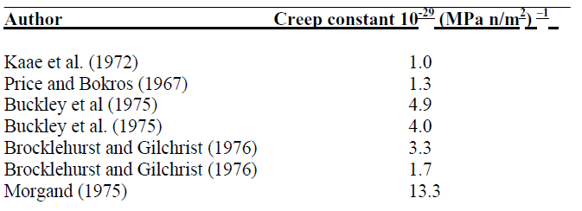

Table 2. The constant properties used for UN, low and high density pyrolytic carbon, and Zr-4 cladding. The NITE and CVD SiC use the same mechanical properties. At this time BISON did not allow for anisotropic properties with the exception of dimensional change. Hence the properties listed in the table are applied isotropically.
 | CVD-SiC | NITE-SiC | Kernel | Buffer | Dense PYC | Graphite | Cladding
Elastic Modulus [GPa] | 450 | 400 | 250 | 20 | 47 | 12 | 100
Elastic Poisson Ratio [ - ] | 0.21 | 0.2 | 0.35 | 0.30 | 0.21 | 0.15 | 0.37
Thermal Expansion [1x10⁻⁶] | 4.5 | 4.5 | 8.6 | 3.5 | 5.6 | 5.6 | 5.0
Specific Heat [J kg⁻¹ K⁻¹] | 1200 | 1200 | 250 | 500 | 500 | 500 | 330

Table 3. Below are the diffusion properties for the modeled elements. Data was lacking for palladium and cadmium. Data is taken from reputable sources as much as possible, but considerable gaps in knowledge exist.
 | SiC | SiC | PYC | PYC | UN | UN | Source
 | D_{o} [m² s⁻¹] | Q [kJ mol⁻¹] | D_{o} [m² s⁻¹] | Q [kJ mol⁻¹] | D_{o} [m² s⁻¹] | Q [kJ mol⁻¹]
Ag | 3.6x10⁻⁹ | 220 | 5.3 x10⁻⁹ | 154 | 6.7 x10⁻⁹ | 165 | [67]/[67]/[68]-UO₂
Cs | 5.5 x10⁻⁸ | 222 | 6.8 x10⁻⁸ | 222 | 5.6 x10⁻⁸ | 209 | [38]/[38]/[38]-UO₂
Pd | 3.6 x10⁻¹⁰ | 220 | 5.3 x10⁻¹⁰ | 154 | 6.7 x10⁻¹⁰ | 165 | 0.1 of Ag
Cd | 3.6 x10⁻¹¹ | 220 | 5.3 x10⁻¹¹ | 154 | 6.7 x10⁻¹¹ | 165 | 0.01 of Ag
Ba | 2.2 x10⁻¹⁰ | 200 | 5.1 x10⁻⁶ | 180 | 4.6 x10⁻⁸ | 209 | [69]/[69]/0.8x Cs
Xe | 1 x10⁻²⁰ | 0 | 1.12 x10⁻⁵ | 284 | 4 x10⁻¹⁰ | 271 | Approx/[69]/[70]

Table 4. A list of the thicknesses and outer radii of the TRISO particle layers used in the case 11 comparison.
Material | Outer Radius[µm] | Thickness[µm]
OPyC | 248.5 | 40
CVD-SiC | 342.5 | 36
IPyC | 383.5 | 41
Buffer | 419.5 | 94
Kernel | 459.5 | 248.5

Table 5. This table lists the parameters used for the fracture of the silicon carbide and high density PyC fracture and PyC debonding [71,3,56].
Parameter | Value
SiC Characteristic Volume [m³] | 1.57x10⁻⁹
SiC Characteristic Stress [MPa] | 426
SiC Scale Parameter [ - ] | 8.0
PyC Characteristic Through Wall Fracture Volume [m³] | 1.0x10⁻¹⁸
PyC Characteristic Debonding Volume [m³] | 2.25x10⁻¹²
PyC Characteristic Shear Stress [MPa] | 240
PyC Characteristic Normal Stress [MPa] | 100
PyC Characteristic Through Wall Fracture [MPa] | 1316
PyC Scale parameter [ - ] | 9.5

Table 6. a) This table lists the geometry of the 1130µm diameter TRISO particles used in the LWR FCM simulation. b) This table lists the geometry of the 900µm diameter TRISO particles used in the HTGR FCM simulation.
a)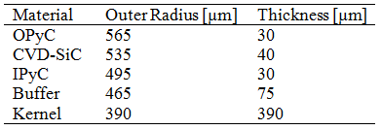 b)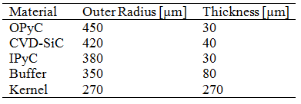

Table 7. List of the high temperature gas reactor and light water reactor geometry parameters.
 | HTGR | LWR
Coolant Temp [C] | 700 | 290
Pellet Diameter [mm] | 15.45 | 8.2
HTC [W m⁻² K⁻¹] | 3000 | 38200
Linear Power [kW m⁻¹] | 10 | 35
Max Burnup [at%] | 3.8 | 30
Packing Fraction [vol%] | 40.4 | 41.5

Table 8. The geometry for a RISO III fuel pellet. Dishes and chamfers were not used in the model. A smear power of 35kW m⁻¹ or 1.2W per particle with a 41.5vol% packing fraction was used in this model.
Layer | [mm]
Outer clad radius | 4.720
Inner clad radius | 4.150
Outer fuel pellet radius | 4.100
Fuel pellet length | 13.50
Gap diametral | 0.100

Table 9. The TRISO particle geometry as layer thickness and outer radii used in the FCM pellet in a light water reactor environment.
Material | Outer Radius [μm] | Thickness [μm]
OPyC | 565 | 30
CVD-SiC | 535 | 40
IPyC | 495 | 30
Buffer | 465 | 75
Kernel | 390 | 390

Table 10. List of the TRISO geometry for the NPR experiments [55].
Layer | Outer Radius [μm] | Thickness [μm]
OPyC | 328.5 | 43
SiC | 285.5 | 35
IPyC | 250.5 | 53
Buffer | 197.5 | 100
Kernel | 97.5 | 97.5

Table 11. NPR irradiation parameters [8].
 | NPR-A4 | NPR-A5 | NPR-A8 | NPR-A9
Time [EFPD] | 170 | 170 | 170 | 170
Fast Neutron Fluence [10²⁵ n m⁻²] | 3.8 | 3.8 | 2.4 | 1.9
Average Irradiation Temperature [C] | 746 | 987 | 845 | 1052
Burnup [at%] | 79 | 79 | 72 | 64
Particle Power [W] | 0.18 | 0.18 | 0.164 | 0.146

Table 12. List of the TRISO layer failure fractions from the NPR experiments [8,55].
 | Failed [%] | 95% Interval [%] | Sample Size | PARFUME [%] | PARUFME  1.8x Creep [%]
NPR-A4 IPyC | 65 | 54 - 76 | 83 | 100 | 99.8
NPR-A5 IPyC | 31 | 17 - 47 | 39 | 100 | 34.8
NPR-A8 IPyC | 6 | 2 - 16 | 53 | 100 | 94.0
NPR-A9 IPyC | 18 | 5 - 42 | 17 | 100 | 14.5
NPR-A4 SiC | 3 | 2 - 6 | 287 | 9.2 | 3.4
NPR-A5 SiC | 0.6 | 0 - 3 | 178 | 1.8 | 0.22
NPR-A8 SiC | 0 | 0 - 2 | 260 | 5.9 | 1.8
NPR-A9 SiC | 1 | 0 - 5 | 83 | 1.1 | 0.044

Table 13. List of the TRISO geometry used in the HFIR irradiations.
Layer | Outer Radius [μm] | Thickness [μm]
Matrix | 950 | 492
OPyC | 458 | 36
SiC | 422 | 31
IPyC | 391 | 41
Buffer | 350 | 85
Kernel | 265 | 265

Table 14. List of the irradiation parameters for the HFIR irradiations.
 | HFIR
Time [Days] | 88
Fast Neutron Fluence [10²⁵ n m⁻²] | 7.7
Average Irradiation Temperature [C] | 320
Gamma Heating [W] | 0.05

Table 15. Comparison of the NPR results with BISON calculations. In these simulations, the failure probability of the SiC is highly dependent on the fracture of the IPyC layer. As a result, the SiC failure probabilities are not included in this table. The FZJ correlation provides a moderate level of agreement however the LLNL correlations produce results that are significantly different than the observations. However, LLNL correlations were intended for lower temperatures than what was experienced in the NPR experiments.
 | Failed [%] | 95% Interval [%] | BISON FZJ [%] | BISON LLNL [%]
NPR-A4 IPyC | 65 | 54 - 76 | 100.0 | 1.79
NPR-A5 IPyC | 31 | 17 - 47 | 99.96 | 8.6x10⁻³
NPR-A8 IPyC | 6 | 2 - 16 | 100.0 | 0.26
NPR-A9 IPyC | 18 | 5 - 42 | 97.15 | 2.21x10⁻³

Table 16. List of the NPR failure fractions using hydrostatic stress limited dimensional change.
 | Failed [%] | 95% Interval [%] | BISON FZJ [%] | BISON FZJ Stress Limited [%]
NPR-A4 IPyC | 65 | 54 - 76 | 100.0 | 69.80
NPR-A5 IPyC | 31 | 17 - 47 | 99.96 | 33.08
NPR-A8 IPyC | 6 | 2 - 16 | 100.0 | 57.57
NPR-A9 IPyC | 18 | 5 - 42 | 97.15 | 23.03

Table 17. List of the failure probabilities for the IPyC layer in NPR simulations. The FZJ correlation used a Poisson ratio in creep of 0.4 and the LLNL use a value of 0.5 which is the reverse of the recommended values.
 | Failed [%] | 95% Interval [%] | FZJ 0.4ν_{c} [%] | LLNL 0.5 ν_{c} [%]
NPR-A4 IPyC | 65 | 54 - 76 | 99.92 | 13.55
NPR-A5 IPyC | 31 | 17 - 47 | 44.05 | 0.21
NPR-A8 IPyC | 6 | 2 - 16 | 99.73 | 5.12
NPR-A9 IPyC | 18 | 5 - 42 | 16.47 | 5.2x10⁻²

Table 18. Comparison of the predicted failure probabilities using the modified IIDC correlation with the experimental NPR results.
 | Failed [%] | 95% Interval [%] | Hybrid [%] | Hybrid Without Hydrostatic Stress Limit [%]
NPR-A4 IPyC | 65 | 54 - 76 | 64.45 | 99.35
NPR-A5 IPyC | 31 | 17 - 47 | 15.97 | 74.68
NPR-A8 IPyC | 6 | 2 - 16 | 45.18 | 99.86
NPR-A9 IPyC | 18 | 5 - 42 | 8.38 | 40.10

Table 19. This list the experimental data from Blandford et al. for SS 316L.
Temp[F] | Yield Strength[ksi] | UTS[ksi] | UE[-] | Neck Strain[-] | Area Reduction [%]
70 | 41.6 | 92.8 | 61.6 | 0.48 | 88
300 | 33.6 | 70.4 | 36.6 | 0.31 | 82
600 | 21.2 | 68.1 | 31.3 | 0.27 | 81

Table 20. lists the material constants used to calculate the crack growth per cycle [64].
 | C | N | P
25C | 5.9e-73 | 75.3 | 8.6
1300C | 3.3e-61 |  | 13.2
25C R=0.5 |  |  | 12.73
1300C R=0.5 |  |  | 20.26

Table 21. List of the material parameters used in the clad-steam reaction kernel [72,65,66].
Material | Rate Constant [mg cm⁻² s⁻¹] | Activation Energy [kJ mol⁻¹] | Heat of Reaction [J g⁻¹]
SS-316 | 3e7 | 209.0e3 | 500-1000
Zircaloy-4 T<890C | 5.52e4 | 121.3e3 | 6300
Zircaloy-4 890C<T<1577C | 3.58e5 | 140.2e4 | 6300
Zircaloy-4 T>1577C | 1.04e11 | 329.7e3 | 6300

Appendix of Figures

a)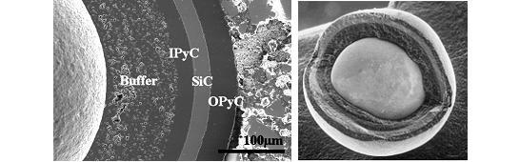
b)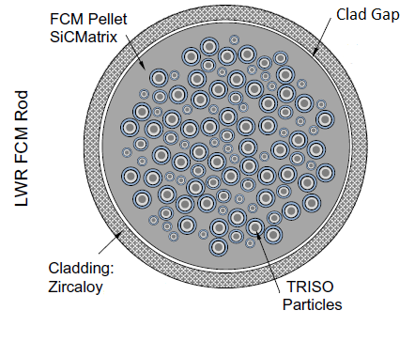
Figure 1. a) Photomicrographs showing a TRISO particle with its individual layers of porous carbon buffer, inner pyrolytic carbon, silicon carbide, and outer pyrolytic carbon. b) Schematic illustration of the geometrical model for an FCM particle containing 40% packing fraction of TRISO particles.

a) Graphite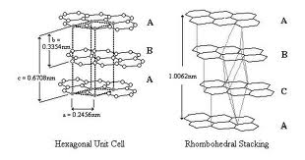b) HOPG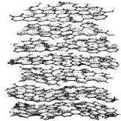
Figure 2. a) A representation for the hexagonal and rhombahedral stacking sequences in graphite. C-axis is in the vertical direction and A-axis is horizontal. Adapted from University of Strathclyde [15]. b) Representation of the turbostratic structure observed in HOPG. Adapted from a paper by B. Claub [16].

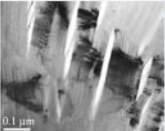
Figure 3. A TEM image of the cracks running parallel to the basal plane caused by thermal contraction. Adapted from Tongxiang Liang at Tsinghua University [19].

a)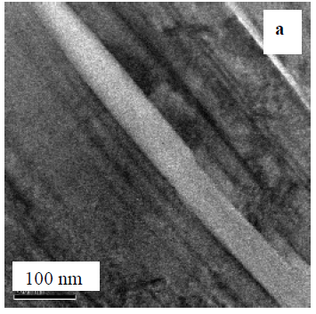b)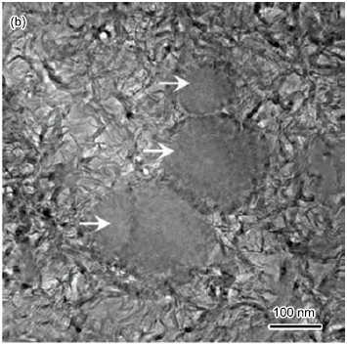
Figure 4. a) A micrograph of the turbostratic structure seen in HOPG [21]. The C-axis orientation is diagonal to the top right. Two thermal contraction cracks can be seen oriented parallel to the basal planes. b) A TEM image of as deposited PyC with a density of about 1.3 g cm⁻³ [27]. Note both images are similar in scale.

a)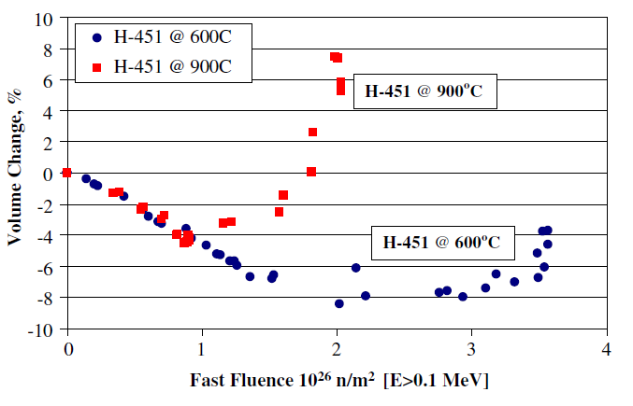
b)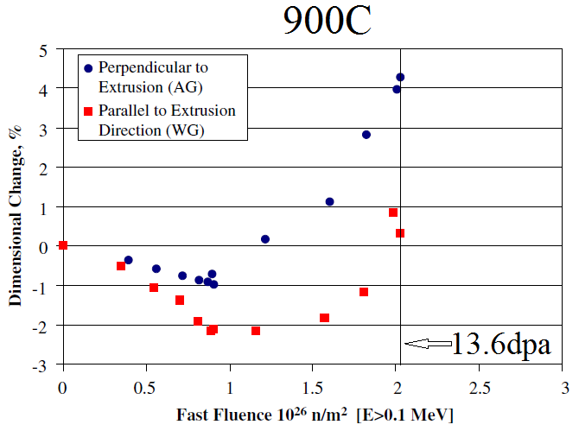 c)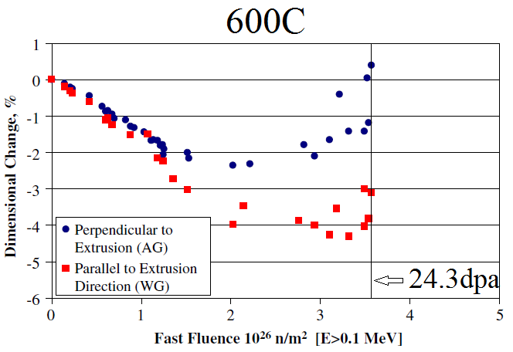
Figure 5. a) Plot of the volumetric change for graphite irradiated at 900 and 600C. b) Plot of the dimensional change for graphite irradiated at 900C. c) Plot of the dimensional change for graphite irradiated at 600C. The estimated conversion for fluence to dpa for these experiments is 0.148x10²⁶ n m⁻² dpa⁻¹. This produces a maximum dose of about 13.6, and 24.3 dpa for the 900 and 600C irradiations, respectively [23].

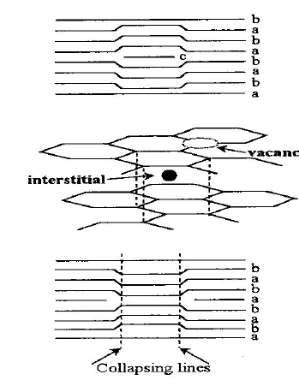
Figure 6. A schematic of the proposed interstitial loop driven dimensional change in graphite. The interstitial loop is thought to cause expansion in the perpendicular direction and contraction in the parallel axis.

a)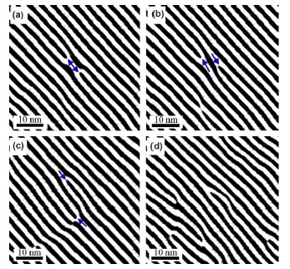b)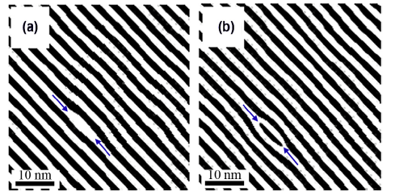
Figure 7. HREM images for room temperature electron irradiated graphite [24]. a) On the left are the images of vacancy loop formation and positive climb [24]. b) On the right are the images for interstitial loop formation.

a)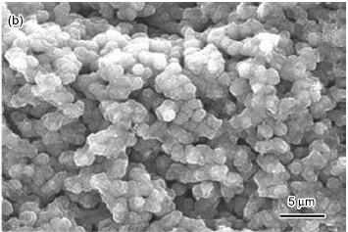 b)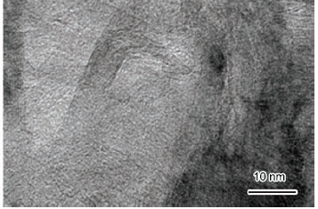
Figure 8. TEM images of as deposited low density PyC [27]. a) Image of the growth features. b) A close up image of the domains contained within each growth feature.

a)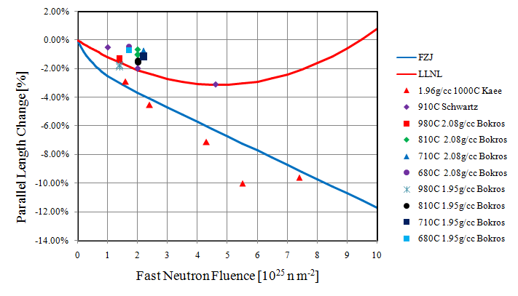b)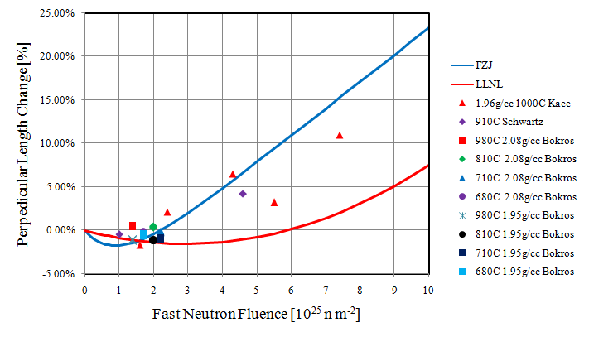 c)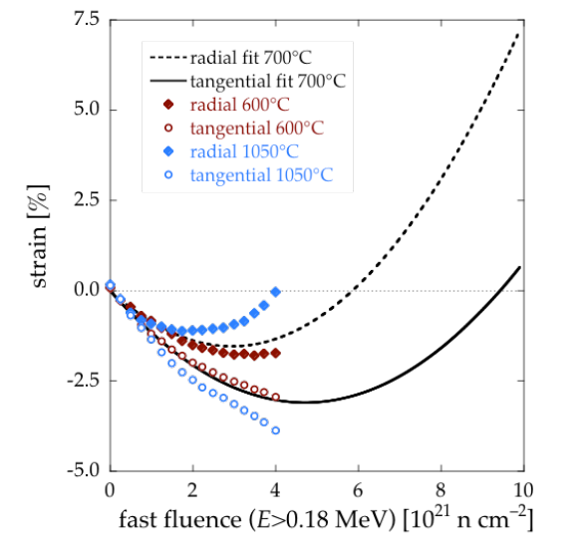
Figure 9. a) A plot of the parallel dimensional change data overlaid by the FZJ and LLNL correlations. b) A plot of the perpendicular dimensional change data overlaid by the FZJ and LLNL correlations. c) Curve fits to data from Ballenger et al. with the 700C interpolation and extrapolation also displayed [31].

a)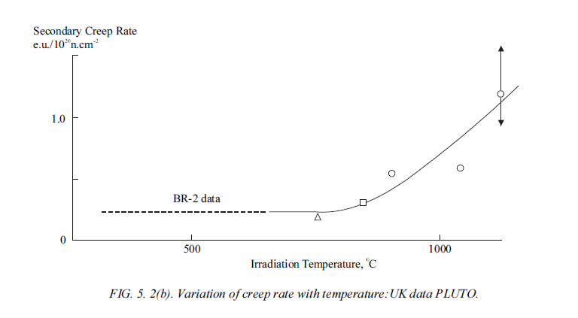 b) 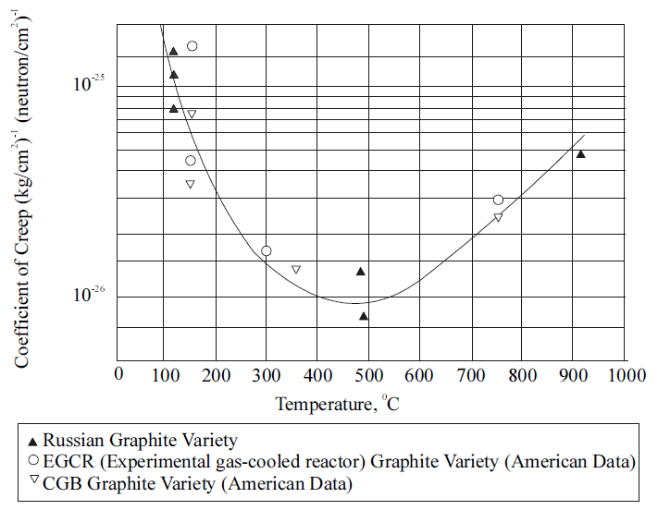
Figure 10. The above figures plot the different creep trends at low temperatures from British and American-Russian sources. Adapted from IAEA-Tecdoc-1154 Figure 5.2. a) A plot of the trend from Kelly and Brocklehurst. b) A plot of the data from Kennedy and Platonov.

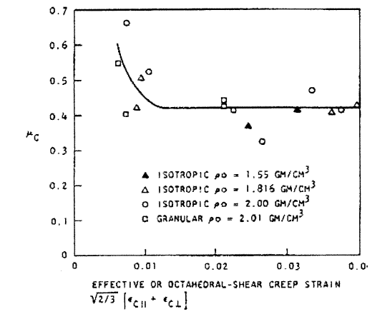
Figure 11. A plot of the Poisson ratio in creep data from Kaae for pyrolytic carbon [30].

a)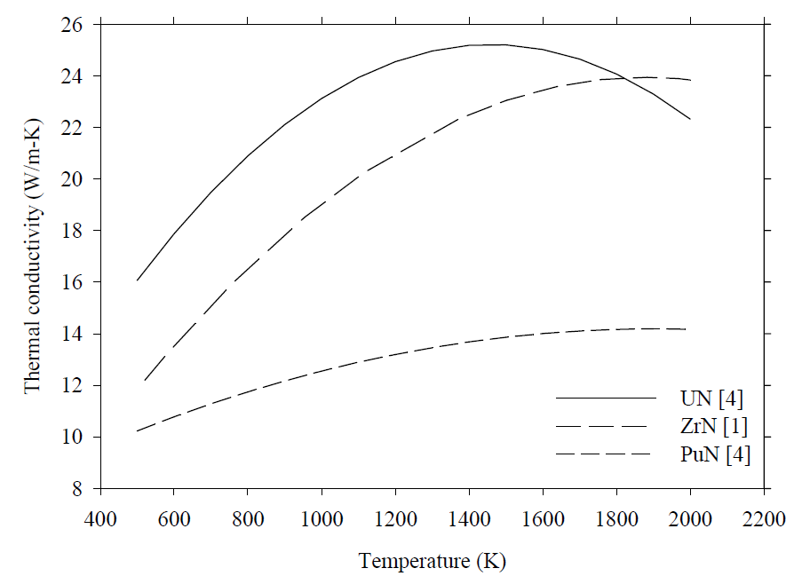 b) 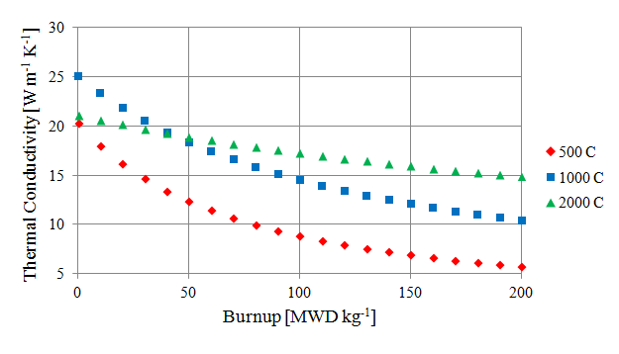
Figure 12. a) Plot of the unirradiated uranium nitride thermal conductivity fit. The figure indicates that the unirradiated UN reaches a maximum thermal conductivity around 1500 K. Measurements were done with the flash laser method. Adapted from Kim and Hoffman Figure 5-3 [39]. b) Plot of the modeled UN thermal conductivity versus burnup. This is a combination of the unirradiated UN data from Kim and Hoffman and the UO₂ thermal conductivity degradation data from Luceta et al. The trend predicts less degradation at higher temperatures.

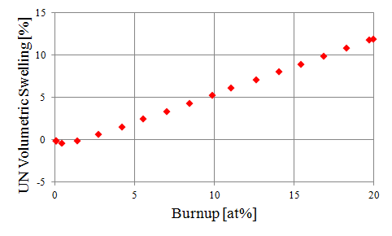
Figure 13. The uranium nitride swelling is based on the MATPRO library used in the SCDAP/RELAP5 program [40]. The densification and gaseous fission product swelling are temperature dependent, but the solid fission product swelling is not. Also, the fission gas release increases with temperature which allows the long term swelling slopes to be similar as a function of temperature at high burnups.

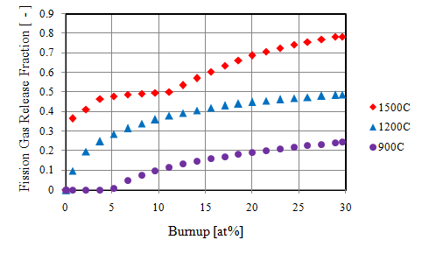
Figure 14. These are plots of the fission gas release using the SIFGRS model. Kernel density was set to 11.3 g cm⁻³. Changing the density of the kernel had no impact on the predicted fission gas release.

a)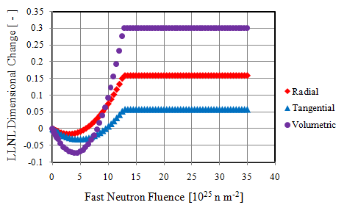 b) 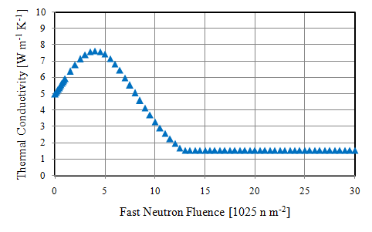
c)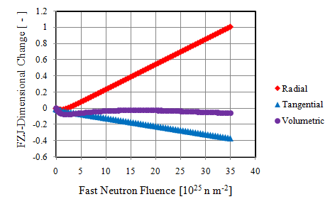 d)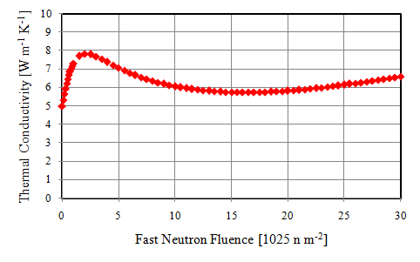
Figure 15. a) Plot of the irradiation dimensional change of the dense pyrolytic carbon using the LLNL correlation. At 30% volumetric swelling, the pyrolytic carbon is assumed to be too brittle to continue swelling. However, under load the pyrolytic carbon may stabilize at a considerably lower swelling amount. b) Plot of the predicted thermal conductivity using the LLNL IIDC correlations plotted in Figure 5a. Due to the dependence on density, the thermal conductivity is the inverse of the volumetric dimensional change. c) Plot of the FZJ IIDC. The FZJ correlation was originally intended for a maximum fluence of 5x10²⁵ n m⁻². However, it extrapolates very well. d) Plot of the PyC thermal conductivity using the FZJ IIDC correlation.

a) 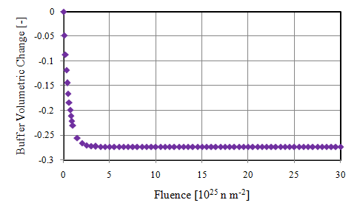 b) 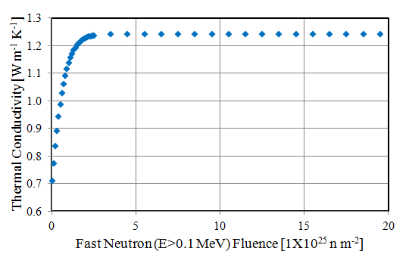

Figure 16. a) The swelling of the 50% dense pyrolytic carbon buffer, based on the German FZJ correlations [8]. The buffer is predicted to shrink isotropically. b) Plot of the predicted buffer thermal conductivity versus fluence assuming a saturation dimensional change as plotted in Figure 6a. As with dense PyC, the buffer thermal conductivity is expected to be solely dependent on density.

a)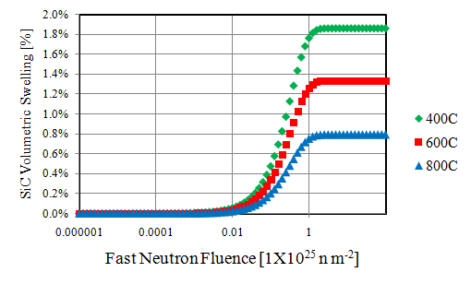 b) 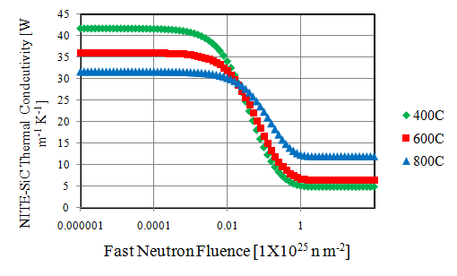
c)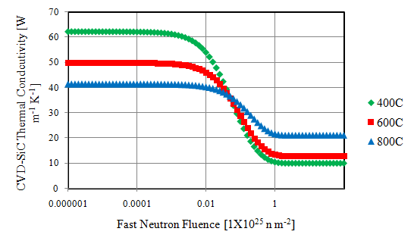
Figure 17. a) The swelling of NITE SiC as a function of fast neutron fluence [E > 0.1MeV]. The SiC swells due to the combined effects of dislocation loops and annealing. The resulting effect is greater swelling at low temperatures. This swelling gradient generates the compressive hoop stress in the perimeter of the matrix and is expected to provide an effective barrier to fission product release. b) Plot of the thermal conductivity for NITE-SiC. Thermal conductivity of SiC is a function of both volumetric swelling and temperature. c) Plot of the thermal conductivity for CVD-SiC. CVD-SiC is predicted to have the same trends as NITE-SiC but greater degradation with swelling. Silicon carbide irradiation creep appears to be dependent on swelling, and therefore it shows the same trend with fluence and temperature which is a rapid increase between 0.1-1x10²⁵ n m⁻² and then saturation [35]. Thermal creep is not considered here since it is essentially absent at T<1400°C [73]. Equation 6 shows the predicted dependence of silicon carbide creep on irradiation swelling.

a) b)
c)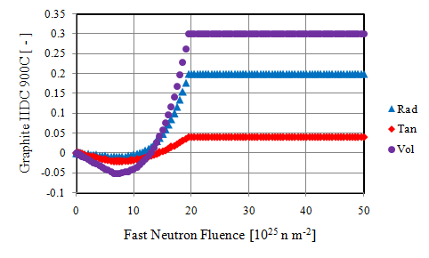
Figure 18. a) A plot of the H-451 graphite dimensional change from HFIR irradiations at 600C [23]. b) A plot of the H-451 graphite dimensional change from HFIR irradiations at 900C [23]. c) A plot of the resulting correlations from the graphite IIDC data for 900C.
a)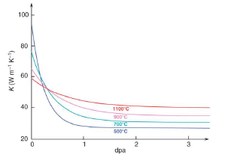 b)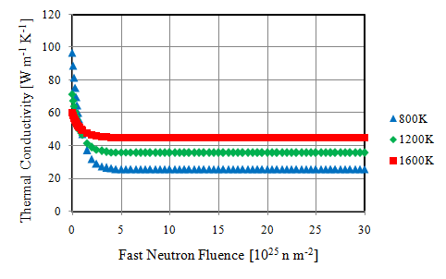
c)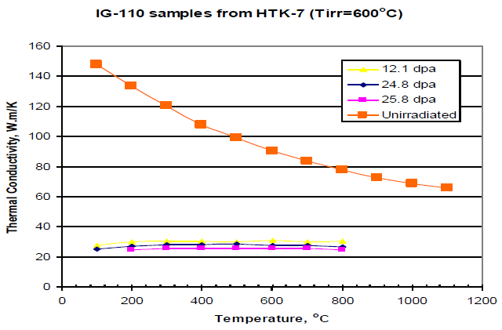d)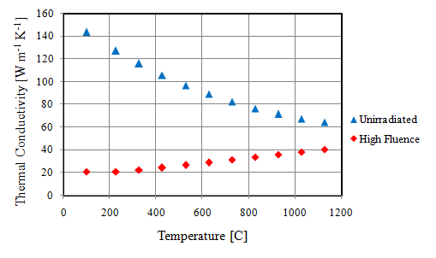
Figure 19. a) Curve fits to data obtained by Li and Mohokov [46]. b) A plot of the resulting correlations showing the fluence dependence of the thermal conductivity. c) Data for the thermal conductivity of graphite irradiated at 600C [47,74,75]. d) A plot of the temperature dependence of graphite thermal conductivity when unirradiated and at 10x10²⁵ n m⁻².

a)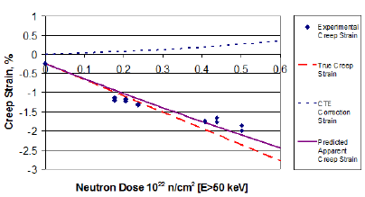 b)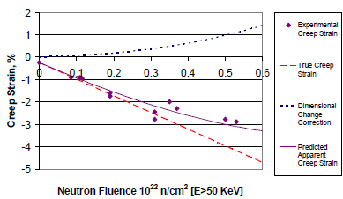 c)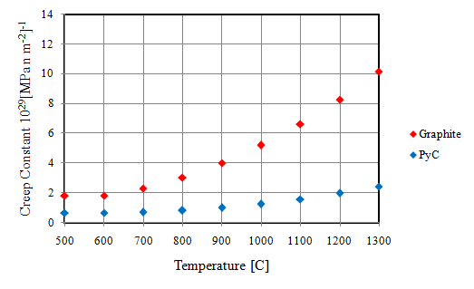
Figure 20. a) A plot of the data for graphite creep at 600C and -20.7MPa compressive stress [48]. b) plot of the data for graphite creep at 900C and -20.7MPa compressive stress [48]. c) A plot comparing the graphite and PyC creep constants with temperature. Both correlations are assumed to be constant below 600C.

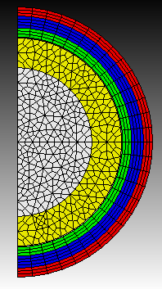
Figure 21. A representation of the mesh used on the 2D-RZ single particle comparison to PARFUME. This is a 2D-RZ mesh which is revolved about the centerline (left edge) to produce a spherical particle rather than an infinite cylinder [76].

a)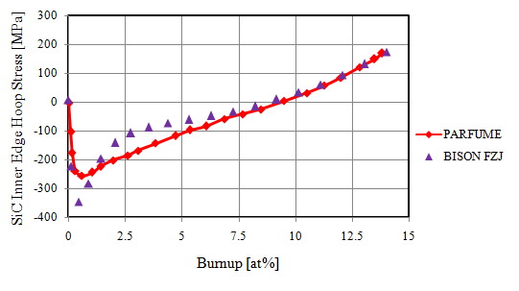b) 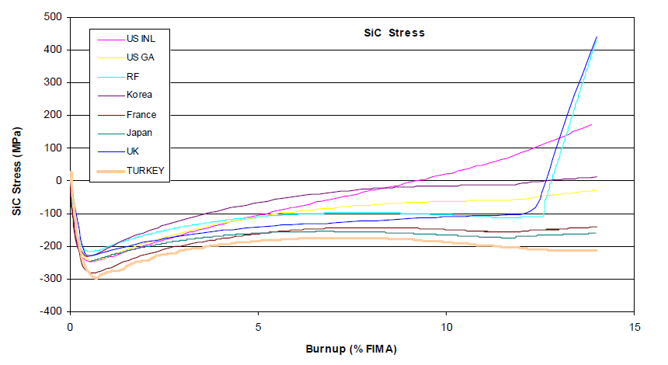 c)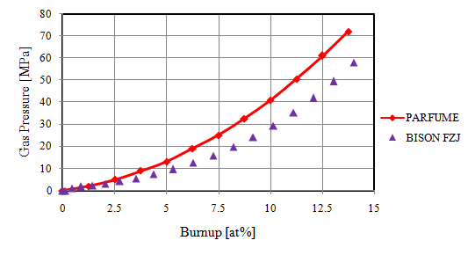 d) 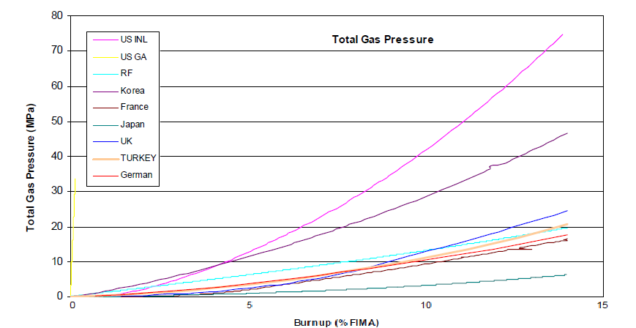

Figure 22. a) A plot comparing the BISON and PARFUME calculations for the SiC inner edge hoop stress. b) IAEA Tecdoc 1674 Figure 9-19 showing the calculated hoop stress from several TRISO fuel performance code [10]. c) A plot comparing the BISON and PARFUME calculation for the fission gas pressure applied to the Buffer/IPyC interface. d) IAEA Tecdoc 1674 Figure 9-19 showing the calculated gas pressures of the various codes [10].

a)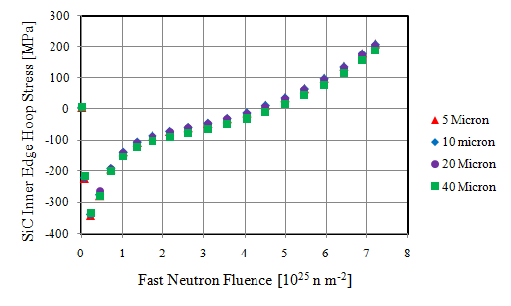 b)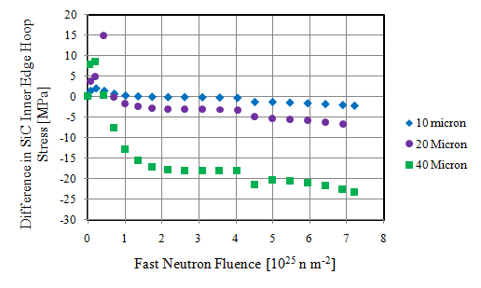
Figure 23. Mesh sensitivity for the IAEA Case 11 comparison. The mesh size was varied from 5 to 40μm. The maximum difference in gas pressure was 0.3 MPa and as a result is not plotted. a) Plot of the hoop stress at the inner edge of the SiC layer. b) Plot of the difference in hoop stress compared to the 5μm mesh simulation.

a)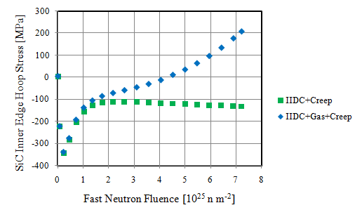 b) 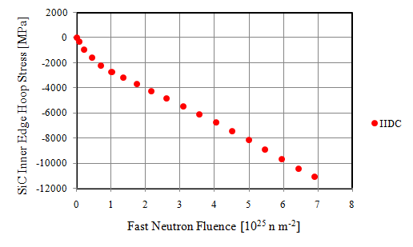
Figure 24. This figure separates the effects of dimensional change, creep, and gas pressure for the Case11 comparison. a) Comparing the hoop stress in the SiC layer for a full physics simulation with a simulation that has the gas pressure disabled. b) A plot of the hoop stress in the SiC layer when the creep and gas pressure are disabled. BISON had some difficulty calculating the stresses above 10GPa.

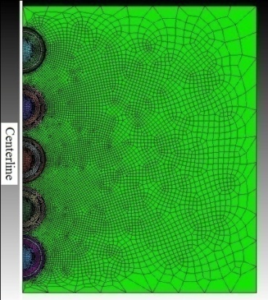
Figure 25. This is the mesh used for the five particles embedded in a matrix. Particles are spaced at 200, 100, 50, and 25µm increments top to bottom in the Z-direction.

a)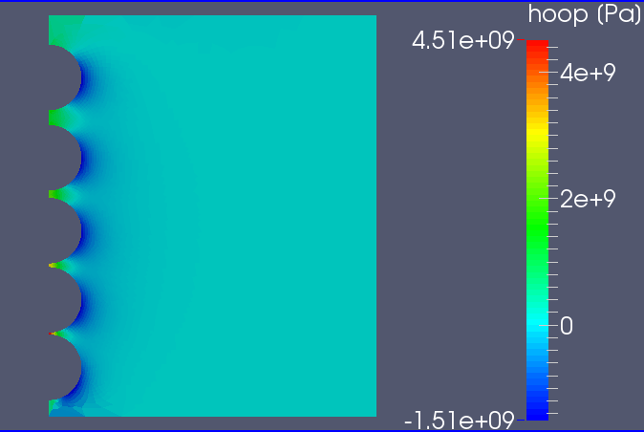 b)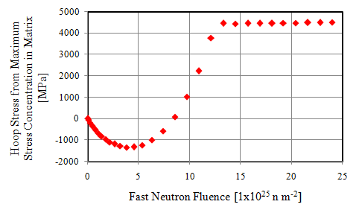
Figure 26. a) Image of the matrix hoop stress profile at 24x10²⁵ n m⁻². As expected, the largest stress occurs at the closest particle spacing. b) Plot of the hoop stress from the smallest particle spacing of 25µm which is a probable event in a FCM pellet. The plot of the hoop stress follows the volumetric PyC IIDC trend exactly.

a) 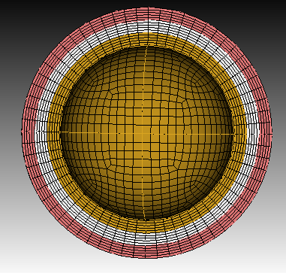b) 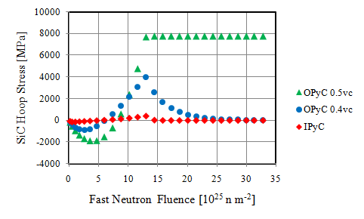
c)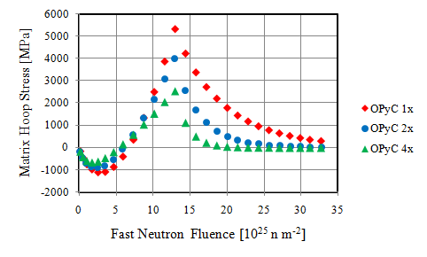
Figure 27. a) The mesh used in the shell simulations. Three layers each 50µm thick with an outer diameter of 1mm. The simulation was isothermal with no pressure boundary conditions. The “IPyC” condition has the outer two layers as silicon carbide but the inner is PyC. This approximates the partially restrained IPyC. The “OPyC” condition has the inner and outer layers as silicon carbide but the middle layer is OPyC. This illustrates the differences in creep behaviors when fully and partially restrained. b) A plot showing the importance of the Poisson ratio in creep if the PyC is fully constrained and the lack of importance if the PyC is not or only partially constrained. c) A plot showing the effect of creep rate for 1x, 2x, and 4x multipliers of the recommended CEGA creep constant [8].

a) 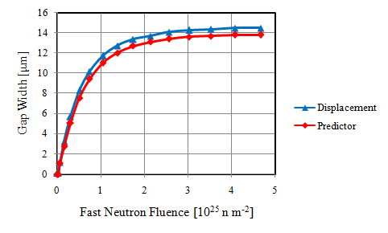 b)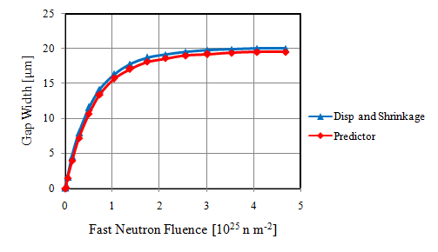
c) 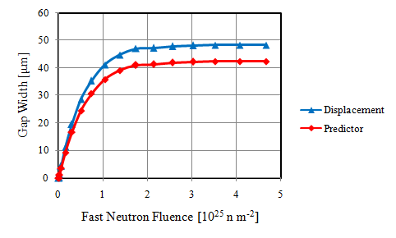
Figure 28. These plots compare the gap width predictor with the actual gap size. a) Plot of the gap width when the debondable layer has IIDC and thermal expansion disabled. Ideally the predictor should match the calculated displacements exactly. b) Plot of the predicted and expected gap widths when dimensional change is enabled in the debondable layer. The expected line accounts for the expected gap width contribution from shrinkage of the debondable layer. c) At large strains the accuracy of the predictor decreases. At 240% radial strain the gap width predictor is off by about 17%.

a)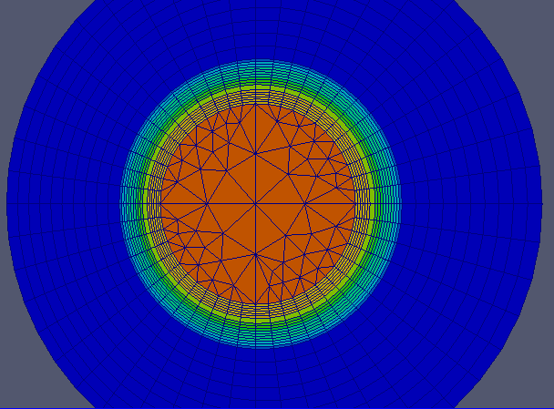 b)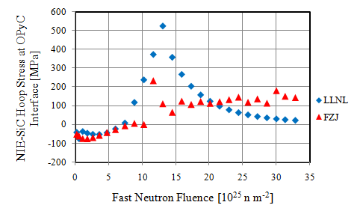
c)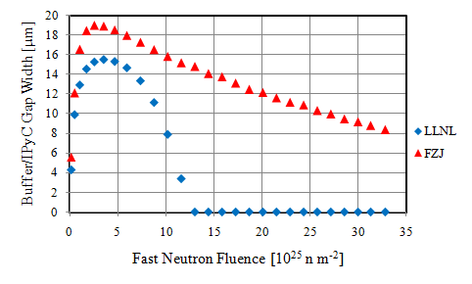d)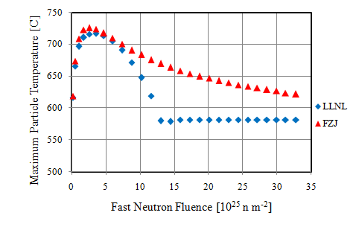

Figure 29. a) The mesh used in the single TRISO particle surrounded by a 500µm thick NITE-SiC shell. b) A plot of the hoop stress at the OPyC/NITE-SiC interface. c) A plot of the buffer/IPyC interface gap. The gap forms due to the rapid and large buffer shrinkage, and then closes due to the kernel and IPyC expansion. d) A plot of the maximum particle temperature. Due to the symmetry of the simulation the maximum temperature is found at the kernel center point. This is vastly different than in a FCM pellet. Also, note the similar trend to the buffer/IPyC gap width.

a) 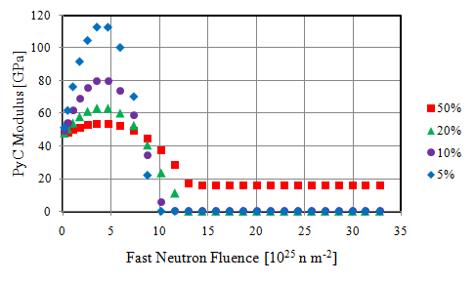 b) 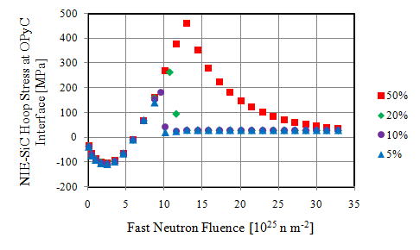
c) 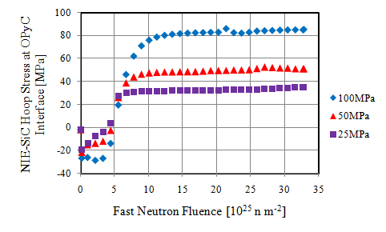

Figure 30. Plots illustrating the potential effects of variable elastic modulus and stress limited dimensional change in a single TRISO particle. a) Plot of the modeled elastic modulus for different sensitivities. b) Plot of the resulting hoop stresses at the NITE-SiC/OPyC interface. c) Plot of the hoop stresses resulting from stress limited dimensional change.

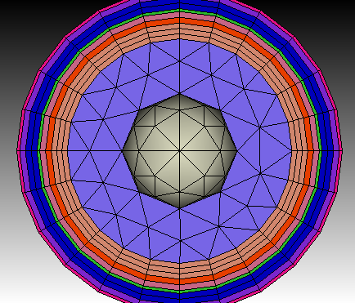
Figure 31. FCM TRISO particle mesh showing the various layers and debonding regions. The kernel is divided into inner and outer regions. This is to provide additional constraint when the buffer debonds. Also, the use of tetrahedral elements in the kernel regions was undesirable, but unavoidable due to the meshing limitations of the mesh program.

a)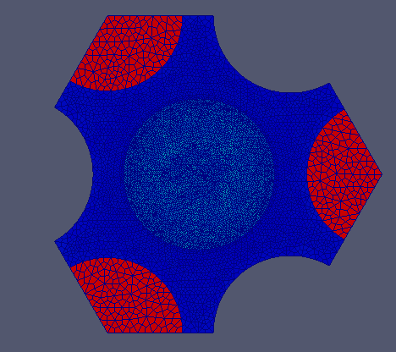 b)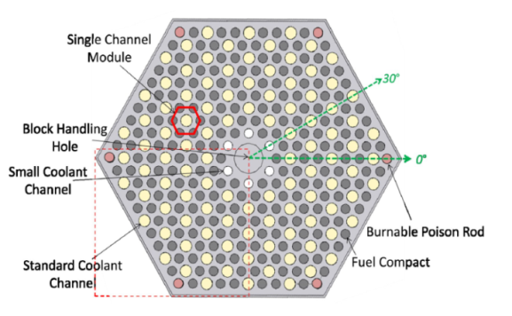
Figure 32. a) The mesh used in the HTGR simulation. Due to the lack of symmetry it was necessary to have a central FCM pellet. The lack meshing and computational capability required the use of three 120° segments of uniform NITE-SiC cylinders. b) A top down representation of the VHTR core [52].

a) 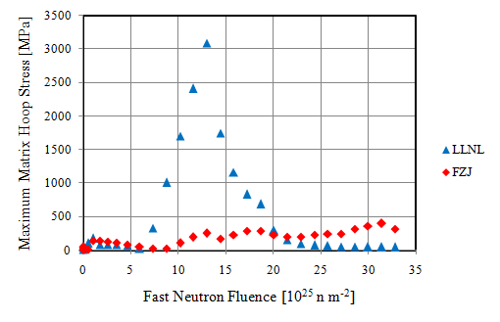 b) 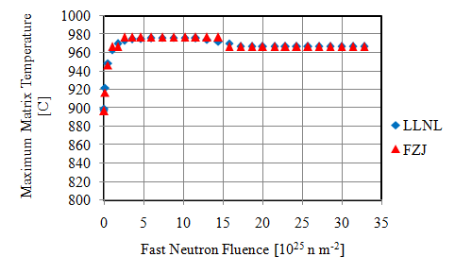
c) 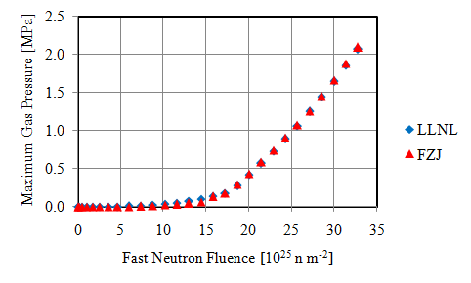d)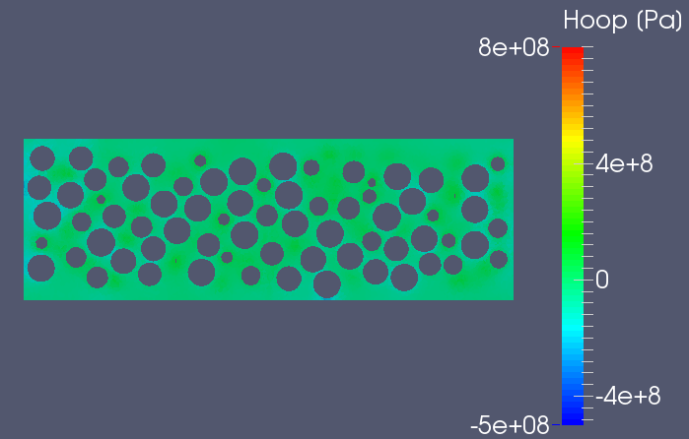
e) 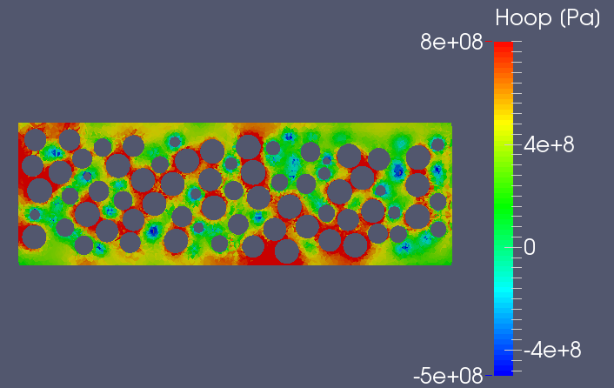

Figure 33. a) A plot comparing the maximum elemental hoop stress reported within the matrix of the central FCM pellet versus fluence for the FZJ and LLNL dimensional change correlations. b) A plot of the maximum temperature within the matrix of the central FCM pellet. Interestingly enough the trends are almost identical. c) A plot of the fission gas pressure. Given the same level of burnup and irradiation temperatures it is unsurprising to predict a similar gas pressure. As for the value for the gas pressure, it should be noted that the centerline temperature of the FCM pellet was less than a 1000C and the maximum burnup was 3.78at%. d) A vertical slice through the center of the FCM pellet showing hoop stress profile at 2.56x10²⁵ n m⁻². The stresses in the graphite were less than 35MPa which suggests that fracture and debonding will be limited. e) A vertical slice through the center of the FCM pellet showing hoop stress profile at 13x10²⁵ n m⁻².

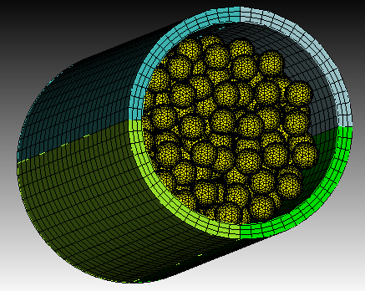
Figure 34. This is a representation of the mesh used for the FCM pellet in a LWR environment.

a)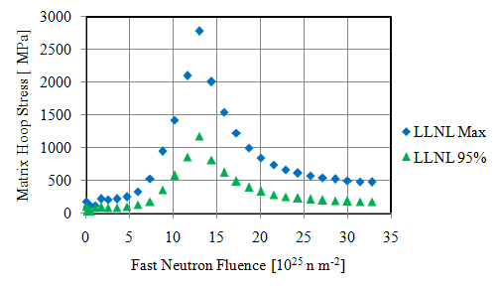 b) 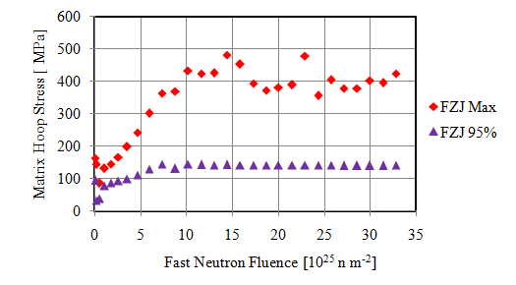
c)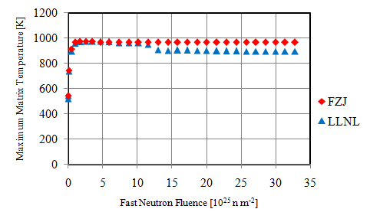d)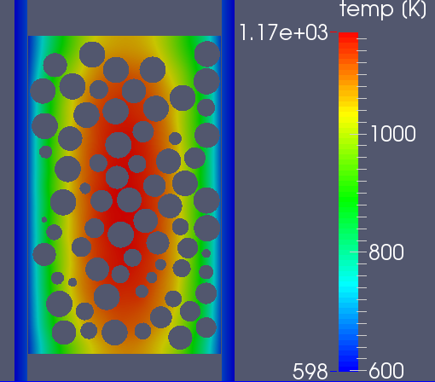
e)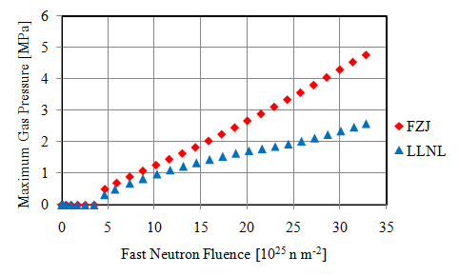

Figure 35. This figure illustrates the effects of constant volume growth versus large volumetric swelling in the PyC irradiation induced dimensional change. a) This is a plot comparing the maximum and 95% threshold matrix hoop stress using LLNL dimensional change correlations. The large increase in stress for the LLNL trend is due to the predicted PyC swelling. b) This plot shows the maximum and 95% threshold for the matrix hoop stress using FZJ dimensional change correlations. The unusual wave behavior shown in the FZJ trend seems to be from partial interface debonding/recontact. c) This is a plot showing the maximum temperature in the matrix. In the LLNL trend the buffer/IPyC gaps close at about 11-13x10²⁵ n m⁻². This reduces the maximum matrix temperature and the fission gas released to the buffer. d) This representation shows the temperature profile across the matrix and cladding at 33x10²⁵ n m⁻². The TRISO particles have been removed for visualization purposes. e) This figure compares the fission gas pressure for the LLNL and FZJ simulations. The burnup is quite high however, the difference in gas pressure is related to the lower temperature predicted with the LLNL dimensional change correlation.

a)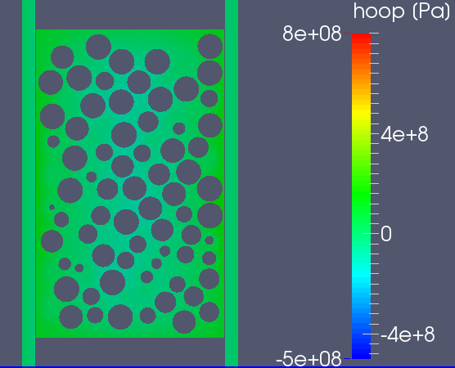 b)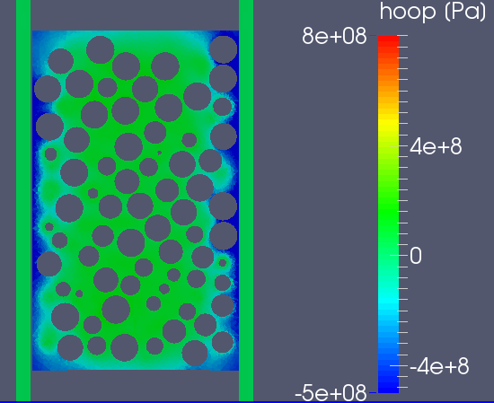
c)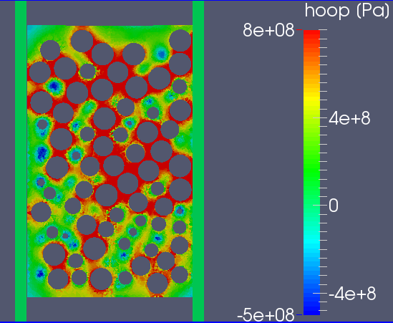 d)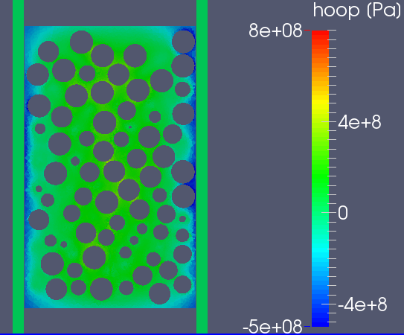

Figure 36. A vertical slice through the centerline of the pellet with the particles removed. The color scale shows the magnitude of the hoop stress. Tension is positive while compression is negative. a) The fluence is 0.02x10²⁵ n m⁻². At this low dose, the thermal stresses dominate. Consequently, the perimeter of the pellet is in tension while the interior is in compression. b) At a fluence of 3.2x10²⁵ n m⁻². The NITE-SiC matrix swelling has saturated and the swelling gradients dominate the stress profile. Note the compressive perimeter and tensile interior. SiC swells more at low temperature than at higher temperatures up to 1000°C. c) Hoop stress profile at 13.1x10²⁵ n m⁻². This shows the maximum effect of the dense pyrolytic carbon swelling. The high stress is due to the OPyC swelling. d) Hoop stress profile at 33x10²⁵ n m⁻². At this fluence the creep has relaxed the stress and returned to the SiC swelling dominated profile.

a)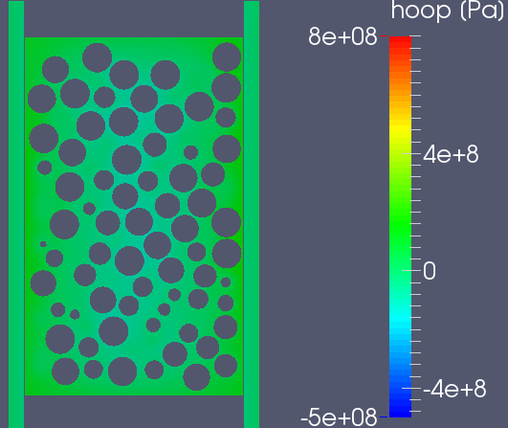 b) 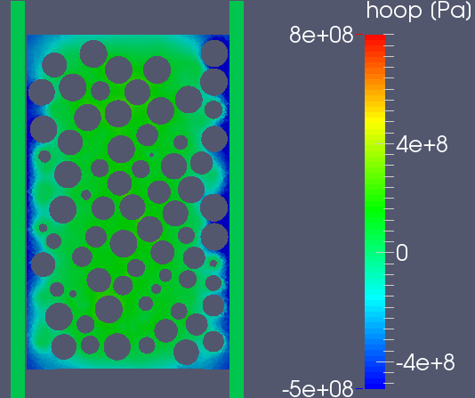
c)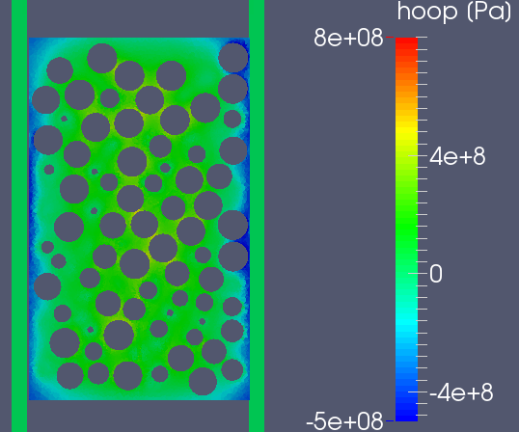 d) 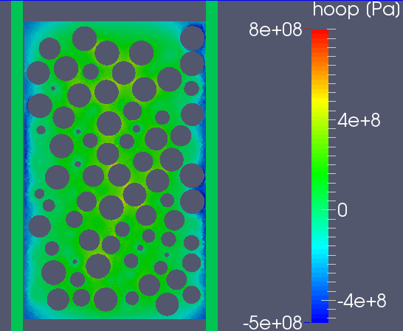
e) 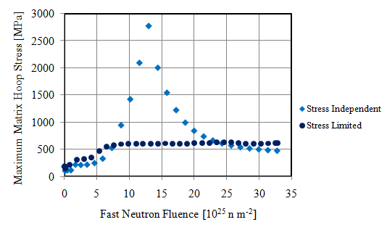 f) 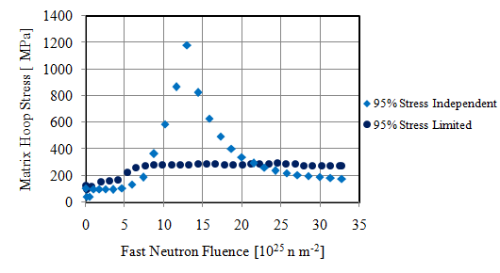

Figure 37. A vertical slice through the centerline of the pellet with the particles removed. The color scale shows the magnitude of the hoop stress. Tension is positive while compression is negative. a) The fluence is 0.02x10²⁵ n m⁻². At this low dose, the thermal stresses dominate. Consequently, the perimeter of the pellet is in tension while the interior is in compression. b) At a fluence of 3.2x10²⁵ n m⁻². The NITE-SiC matrix swelling has saturated and the swelling gradients dominate the stress profile. Note the compressive perimeter and tensile interior. SiC swells more at low temperature than at higher temperatures up to 1000°C. c) Hoop stress profile at 13.1x10²⁵ n m⁻². This shows the maximum effect of the dense pyrolytic carbon swelling. The high stress is due to the OPyC swelling. d) Hoop stress profile at 33x10²⁵ n m⁻². This profile shows the effect of continuous high temperature NITE-SiC matrix swelling. e) Plot comparing the global maximum hoop stress in the matrix for stress independent and stress limited IIDC. f) A plot of the 95% hoop stress which refers to the level that 95% of the matrix elements are less than. The 95% values are roughly half of the maximum elemental values.
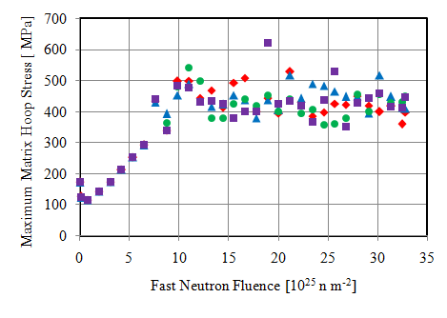
Figure 38. A comparison of the maximum matrix hoop stress using four different distributions for the debonding threshold values. The results show differences but the same general trends.

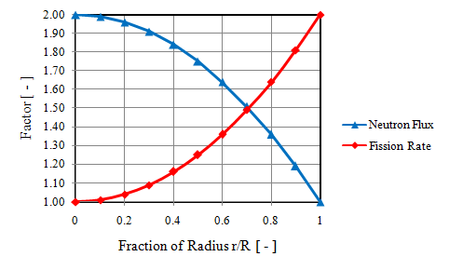
Figure 39. Radial power and fast neutron flux profiles across the FCM pellet. Spherical power profile within the kernels was not considered.

a)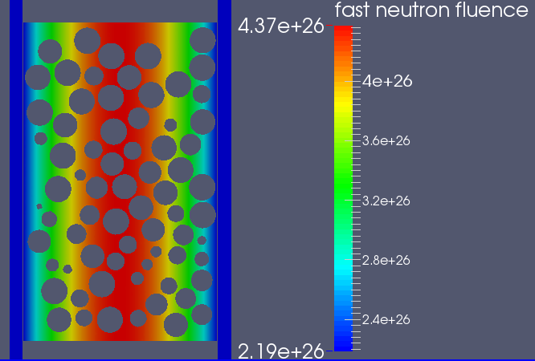 b) 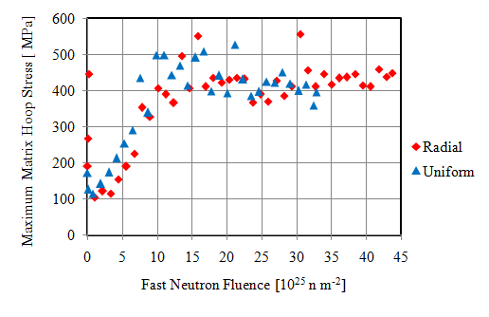
c)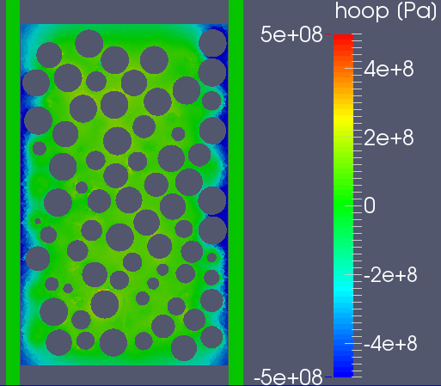 d)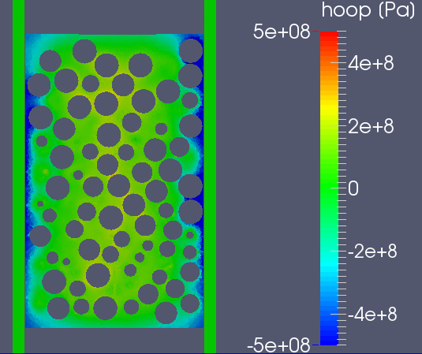
e)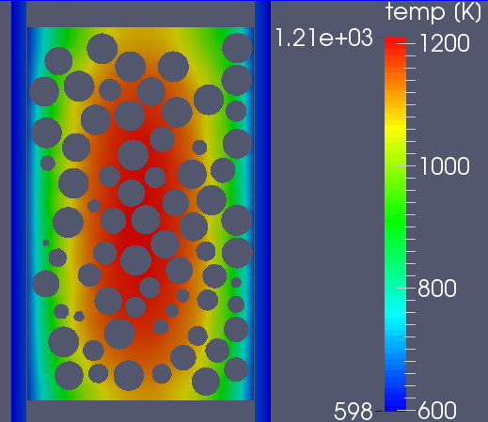 f)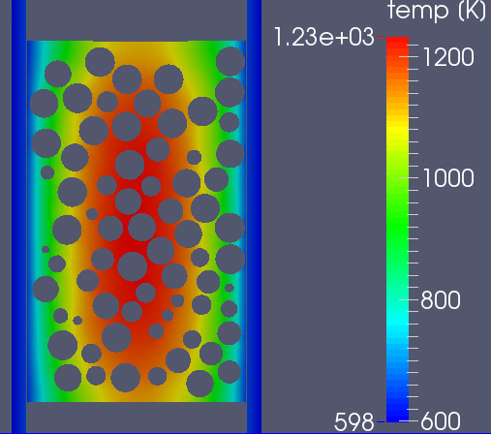

Figure 40. Comparison of the radial power and fast neutron flux profiles with uniform distributions. A factor of two variation was used. a) Fast neutron flux profile used in the radial distribution. The power profile was the same but reversed so that it was higher on the perimeter then in the center. b) Plot of the global maximum hoop stress in the matrix. The initial larger thermal stresses seem to be due to the differential thermal expansion of the PyC and SiC near the perimeter. Thermal expansion coefficients were 5.6 and 4.5 respectively. c) Hoop stress profile for the radial distribution at end of simulation 43.7x10²⁵ n m⁻² d) Hoop stress profile for the uniform distribution at end of simulation 33x10²⁵ n m⁻² e) Temperature profile for the radial distribution at 43.7x10²⁵ n m⁻² f) Temperature profile for the uniform distribution at 33x10²⁵ n m⁻².
a)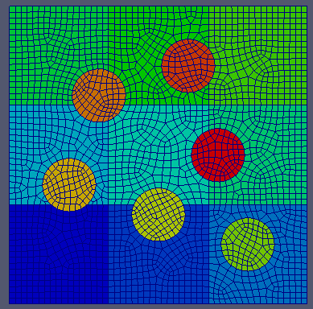 b)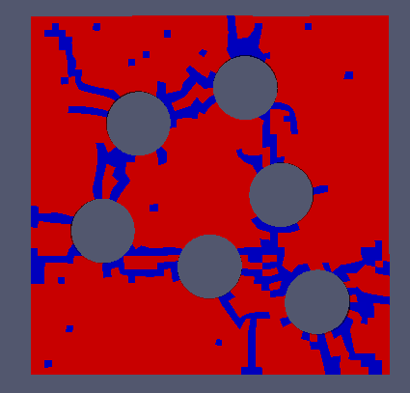
c)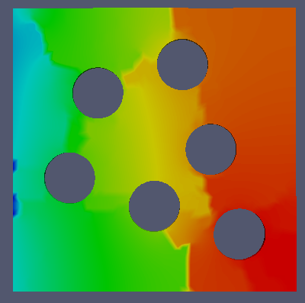

Figure 41. This shows the results of a test simulation for the cracking model. This geometry was selected due to its simplicity. a) The mesh used in the simulation. The five circular regions provide the stress necessary to cause significant cracking in the surrounding SiC plate. b) Resulting crack patterns from pressure boundary conditions applied in the circular regions. c) Temperature profile and discontinuities from the cracks. Heat was rejected through the left surface.

a) 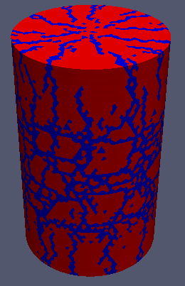 b)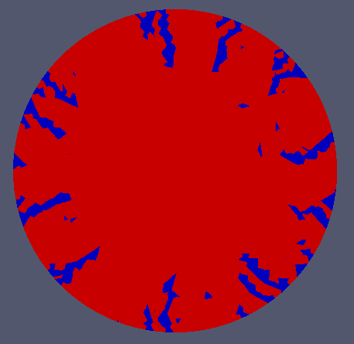
Figure 42. A comparison of the cracking patterns for a UO₂ pellet. a) Overview of the predicted surface cracks in the UO₂ pellet. The axial surface cracks near the middle are due to the axial thermal expansion of the pellet core which is limited by the cooler perimeter. These axial cracks are predicted to be about a 1mm deep. b) Cross section view of the UO₂ pellet 3.5mm below the midplane that shows the radial crack profile.

a)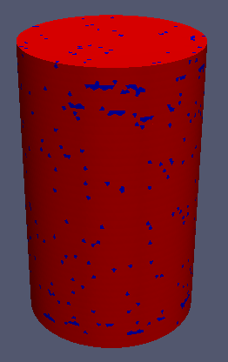 b)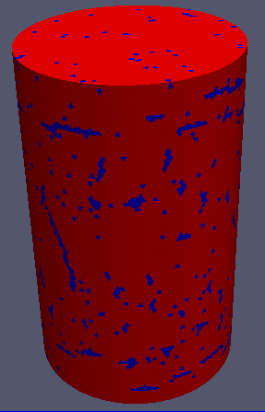c)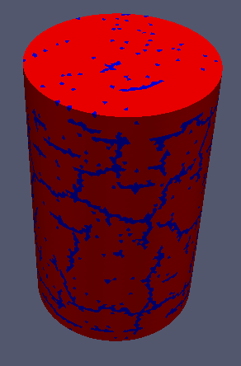
Figure 43. Plots of the predicted cracking at the FCM pellet surface. Representations are at PyC volumetric swellings of 12.61, 16.48, and 20.76% for a, b, and c respectively.

a)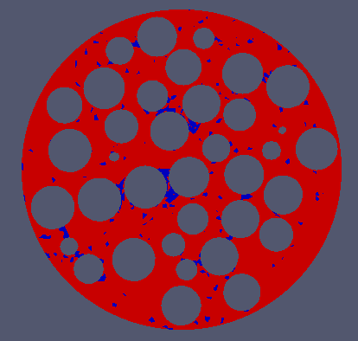 b)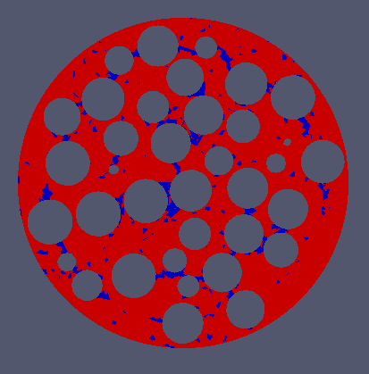
c)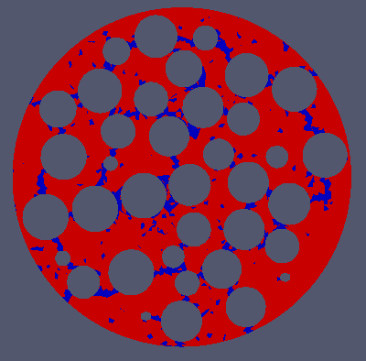 d)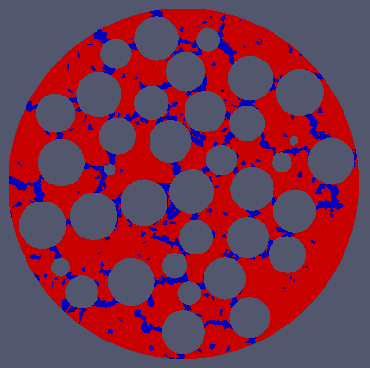
e)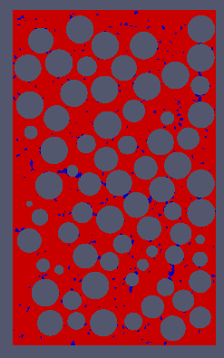f)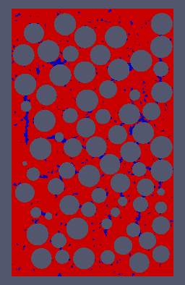g)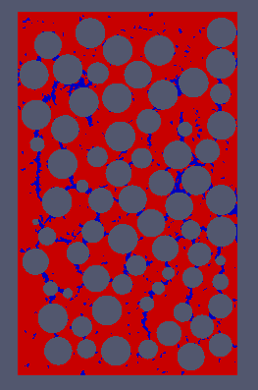h)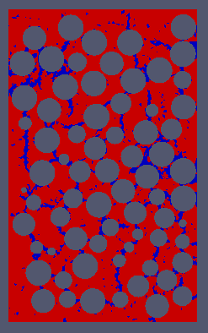
Figure 44. This shows the predicted development of the cracks within a FCM pellet with a characteristic stress of 426MPa. a-d) Rθ cross section view of the predicted cracking patterns at midplane for PyC volumetric swellings of 9.15, 12.61, 16.48, and 20.76%. e-h) RZ cross section view of the predicted cracking patterns at midplane for PyC volumetric swellings of 9.15, 12.61, 16.48, and 20.76%.
a)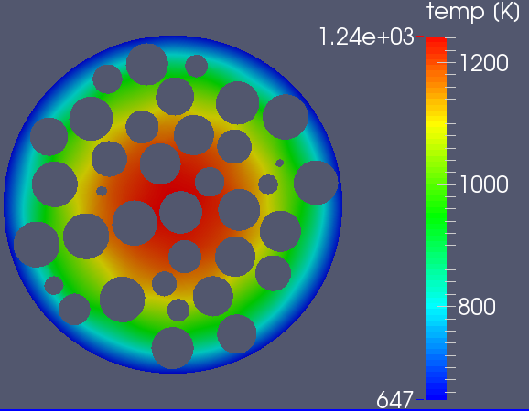 b)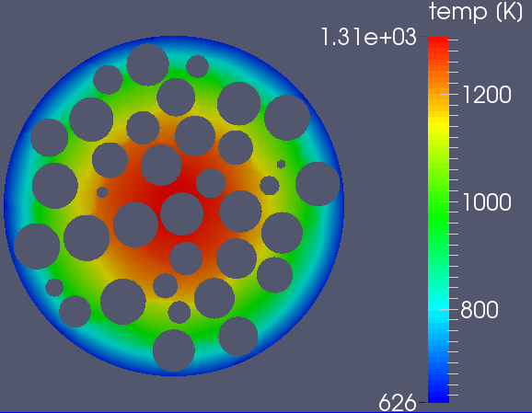 c)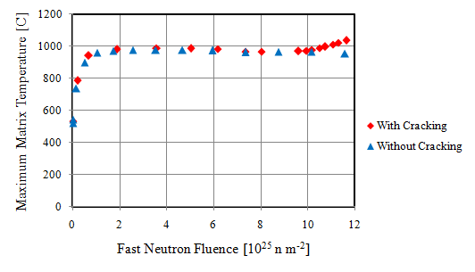
Figure 45. a and b) Temperature profiles at 9.15 and 20.76% volumetric swelling. c) Maximum temperature in the pellet or particles versus fluence.

a)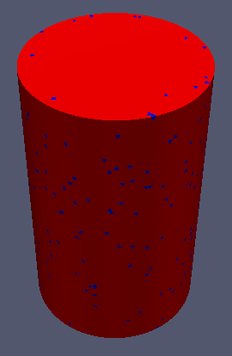 b) 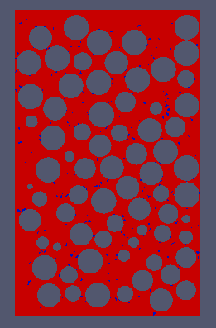 c)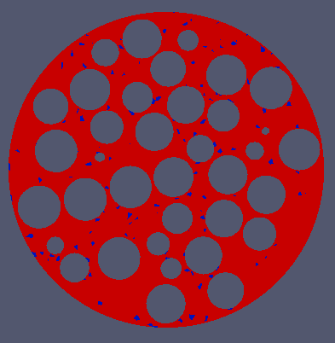
Figure 46. Representations of the predicted cracking patterns using the FZJ pyrolytic carbon dimensional change correlation which assumes a constant volume behavior. a) Overview of the predicted cracking patterns on the surface of the NITE matrix at 33x10²⁵ n m⁻². b) Vertical slice through the matrix that shows the predicted cracking patterns within the NITE matrix at 33x10²⁵ n m⁻². c) Horizontal slice through the matrix that shows the predicted cracking patterns within the NITE matrix at 33x10²⁵ n m⁻².
a) 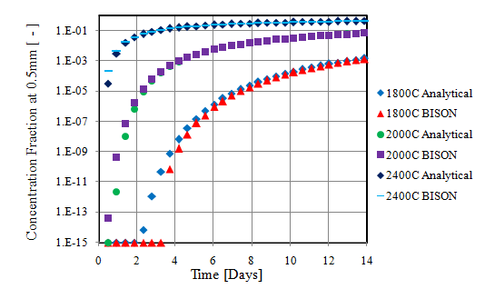 b)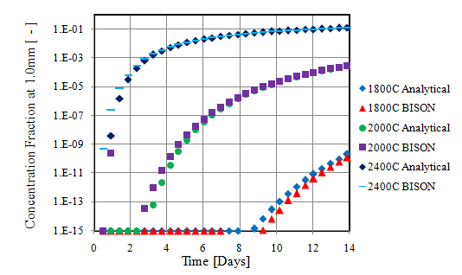
c)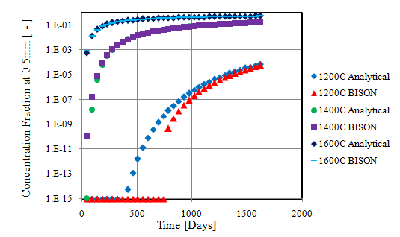 d)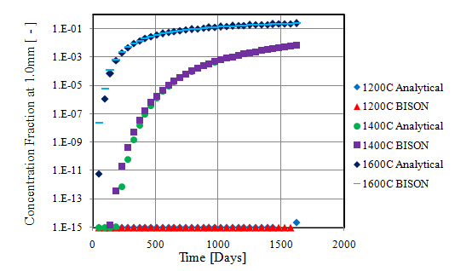
Figure 47. The plots above compare the BISON and analytical solutions to a time dependent 1D silver diffusion. The accuracy of the BISON model improves with increasing concentration. a) Short term and high temperature comparison plot of the silver concentration 0.5mm from the source. b) Short term and high temperature comparison plot of the silver concentration 1.0mm from the source. c) Long term and lower temperature comparison at 0.5mm. d) Long term and lower temperature comparison at 1.0mm.

a)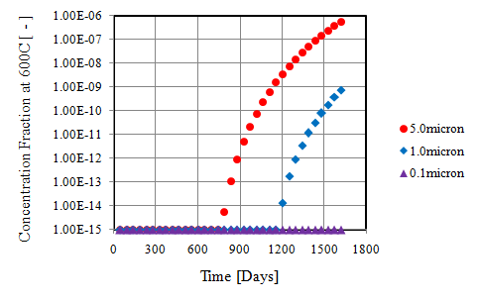 b) 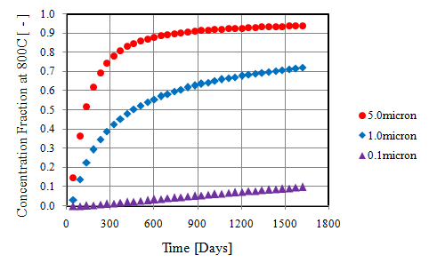
c)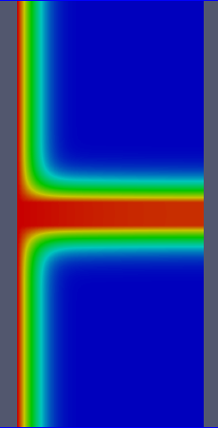 d)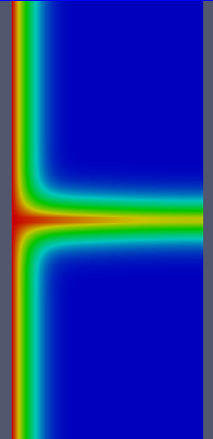 e)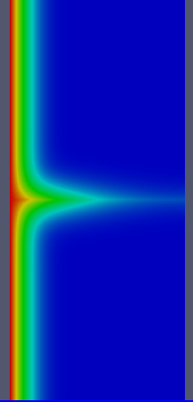
Figure 48. Plots of figures of the one dimensional silver diffusion through a cracked plate of silicon carbide. The crack diffusion coefficient was 1000x the intact coefficient. a) Plot comparing the concentration at the crack end for crack widths of 5, 1, and 0.1 microns. Temperature was 600C. b) Plot comparing the concentration at the crack end for crack widths of 5, 1, and 0.1 microns. Temperature was 800C. Minimal releases were predicted for 0.1micron case. c) Silver concentration at 1620 days and 800C for the 5micron wide crack. d) Silver concentration at 1620 days and 800C for the 1micron wide crack. e) Silver concentration at 1620 days and 800C for the 0.1micron wide crack.

a)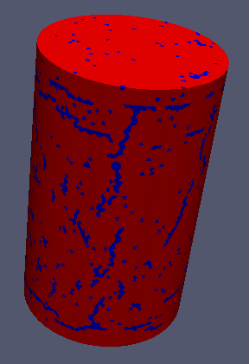 b) 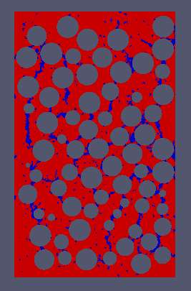
c)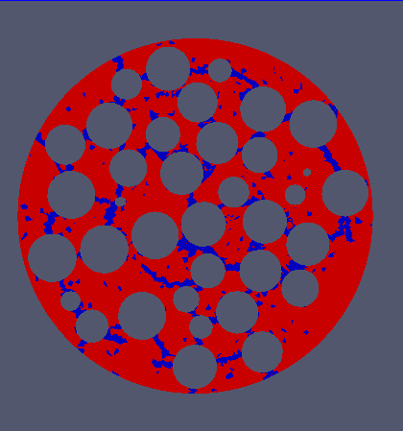 d)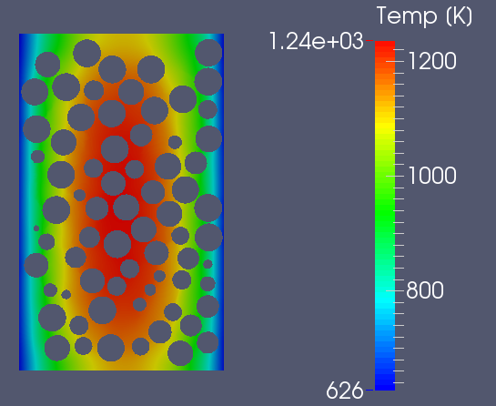
Figure 49. Representations of the predicted cracking patterns and temperature profiles in the matrix at 33x10²⁵ n m⁻³ and 671 full power days. a) external cracking pattern. b) Vertical slice through the centerline of the pellet. c) Horizontal slice through the midplane of the pellet. d) RZ slice showing the temperature profile in the matrix.

a)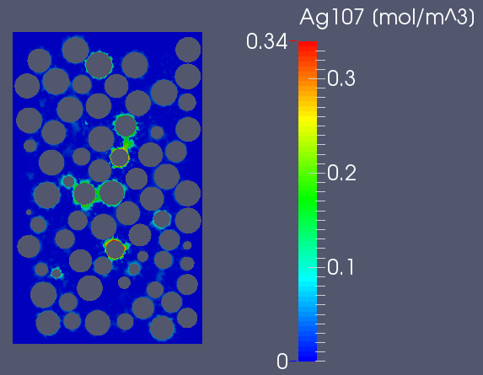 b) 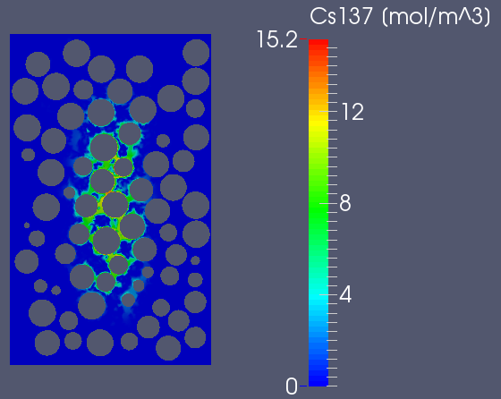
Figure 50. Representations of the silver and cesium transport in the matrix at 671 full power days and 440 days after PyC dimensional change was modeled as capping. a) Silver transport in the matrix. The model predicts a mostly crack driven movement. b) Cesium transport in the matrix. The model predicts a significant influence from thermal diffusion but the effects of cracks can still be seen.

a) 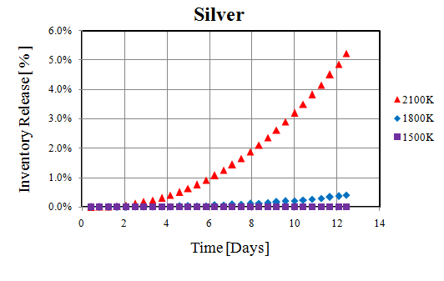 b)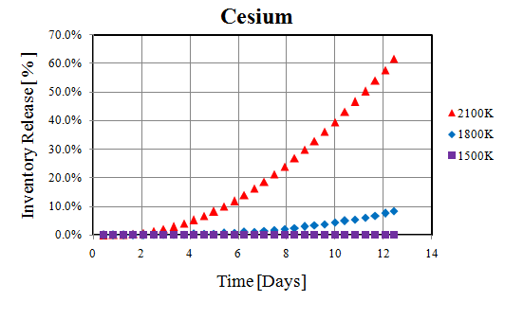
Figure 51. Plots of the silver and cesium transport in the NITE-SiC matrix. The power generation was removed and the coolant temperature was increased for about 12 days. a) Total silver release fraction. b) Total cesium release fraction.

a)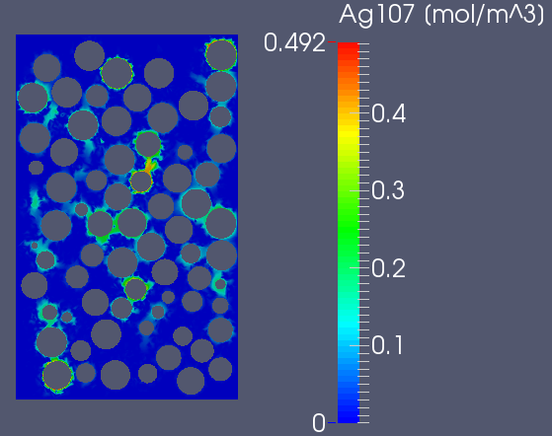 b)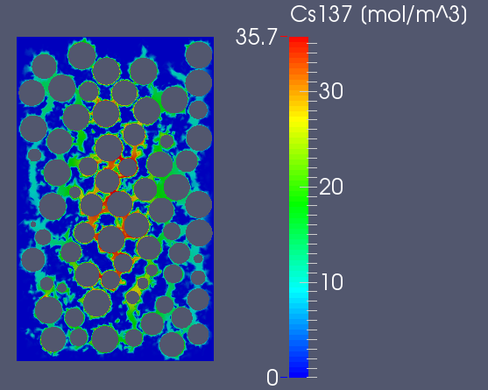
c)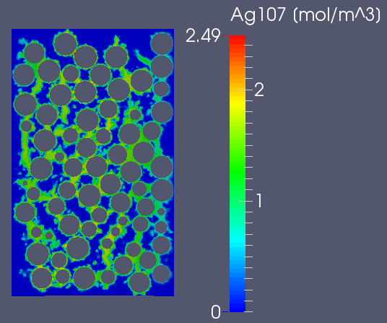 d)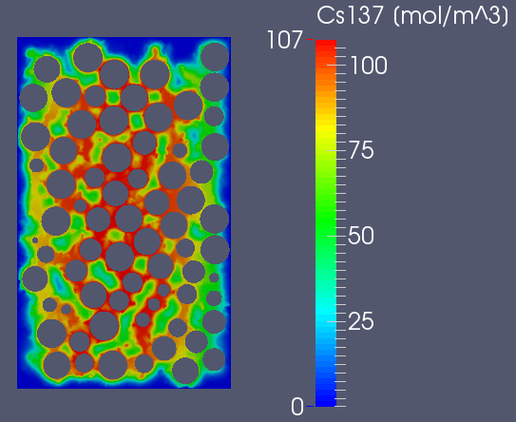
e)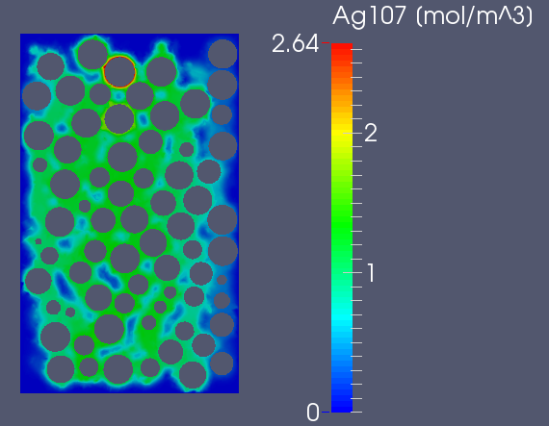 f)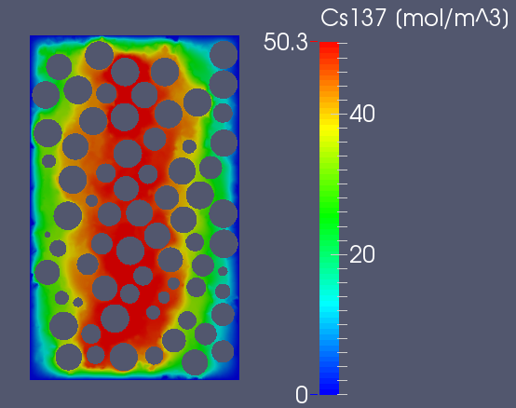
Figure 52. Representations of the silver and cesium transport through the matrix after 12 days at elevated temperatures. a, c and e) Silver transport at 1500, 1800, and 2100K respectively. b, d, and f) Cesium transport at 1500, 1800, and 2100K respectively.

a) 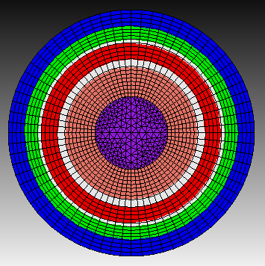 b) 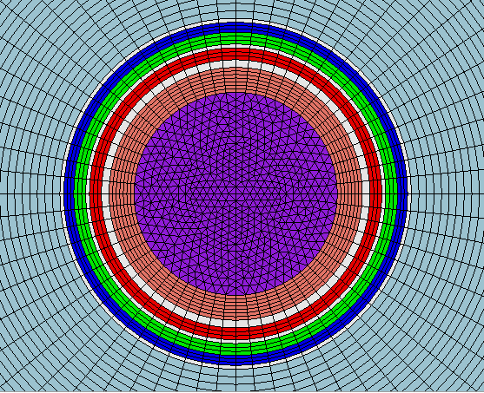
Figure 53. a) Representation of the mesh used to simulate the NPR experiments. Debondable layers are represented with the white regions. Blue, green, and red layers are the OPyC, SiC, and IPyC layers respectively. The buffer is represented by the salmon colored layer and the kernel by the purple region. b) The mesh used in the BISON model for HFIR simulations. The TRISO particle is embedded in a NITE-SiC matrix (gray region) which is approximated as a 500μm thick shell of NITE-SiC. Debondable layers at the OPyC/matrix, IPyC/SiC, and Buffer/IPyC interfaces were added.

a)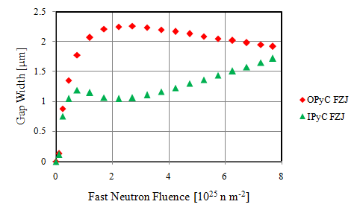 b)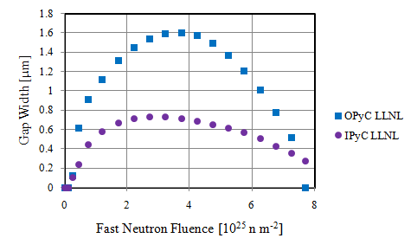

Figure 54. Plots showing the predicted OPyC/matrix and IPyC/SiC interface gap widths using FZJ and LLNL dimensional change correlations with 0.5 and 0.4 Poisson ratios in creep respectively. While the predicted gaps are small, the experiments did not find any evidence of these predicted interface gaps. a) Global maximum gap widths using FZJ correlations with a 0.5 Poisson ratio in creep. b) Global maximum gap widths using LLNL correlations with a 0.4 Poisson ratio in creep. The same creep correlation was used in all cases.

a) b)
Figure 55. The above figures plot the different creep trends at low temperatures from British and American-Russian sources. Adapted from IAEA-Tecdoc-1154 Figure 5.2. a) A plot of the trend from Kelly and Brocklehurst. b) A plot of the data from Kennedy and Platonov.

a)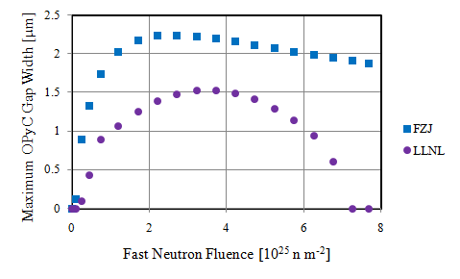 b)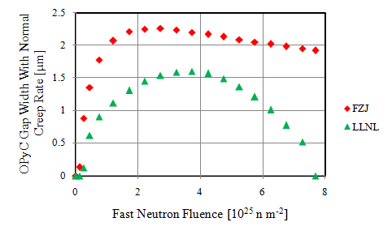
Figure 56. a) Plot of the OPyC/NITE-SiC gap widths when accelerated (2.9x CEGA) low temperature creep is used. b) Plot of the OPyC/NITE-SiC gap widths when normal (2x CEGA) low temperature creep is used. Only minor differences in the gap widths were predicted.

a)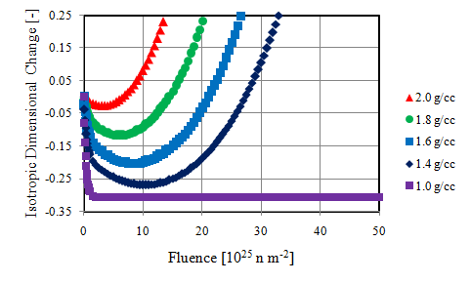
b)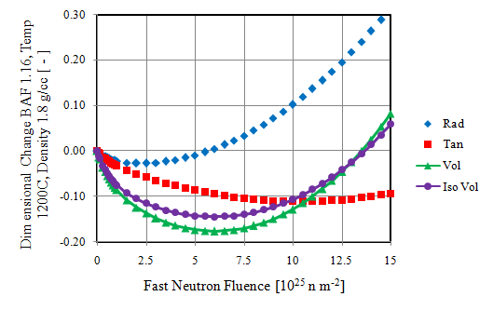 c)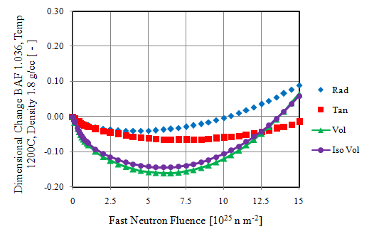
d)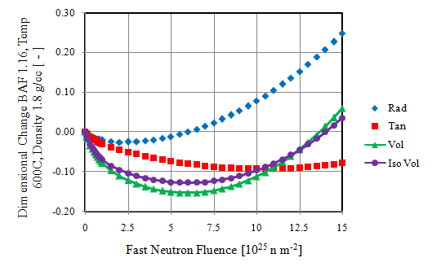 e)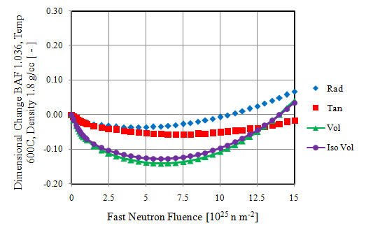

Figure 57. These are plots showing the dimensional change dependence on initial density, temperature, and anisotropy. a) Volumetric change at 800C and initially isotropic. b) Plot showing the tangential, radial behaviors and comparing the anisotropic and isotropic volume change at 1200C and BAF 1.16. c) Plot of the dimensional change at 1200C and BAF of 1.036. d) Plot of the dimensional change at 600C and BAF of 1.16. e) Plot of the dimensional change at 600C and BAF of 1.036. The density of figures b through d is 1.8 g cm⁻³.

a)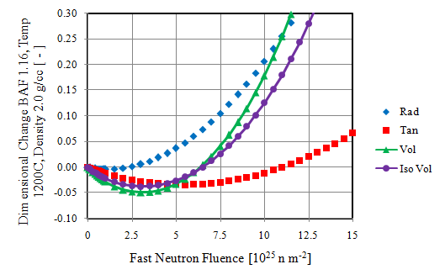 b)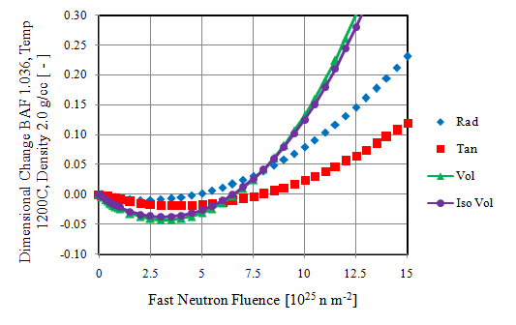
c)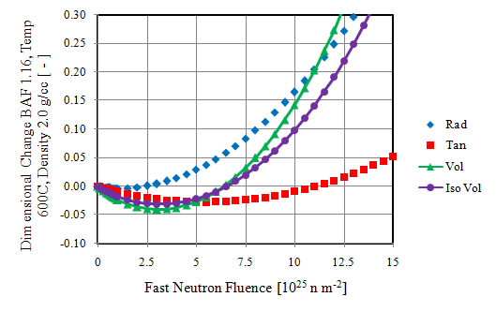 d)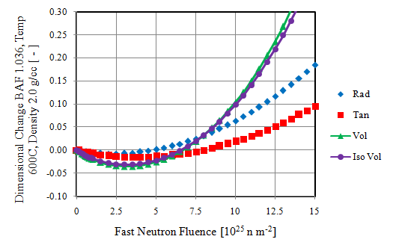
Figure 58. Plots showing the effect of anisotropy and temperature at 2.0 g cm⁻³. a and b) Plots showing the modeled effect of anisotropy at 1200C and initial density of 2.0 g cm⁻³. c and d) Plots showing the modeled effect of anisotropy at 600C and initial density of 2.0 g cm⁻³.

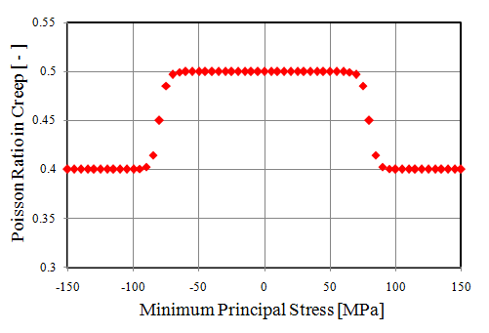
Figure 59. Plot of the Poisson ratio in creep for pyrolytic carbon as a function of minimum principal stress. The model can be configured to use the absolute value or only tensile stresses.

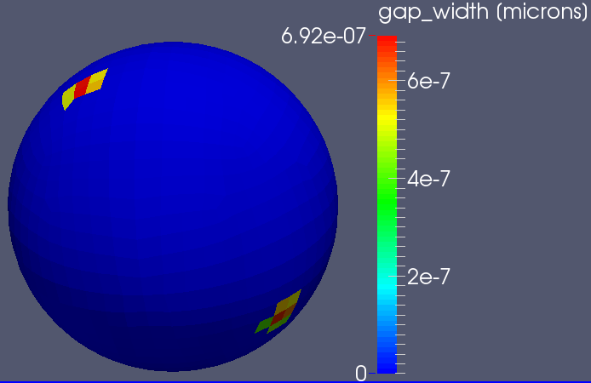
Figure 60. a) Maximum predicted OPyC interface debonding from the NITE-SiC shell at a neutron fluence of 4.25x10²⁵ n m⁻².

a)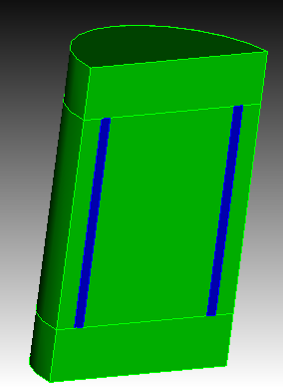 b)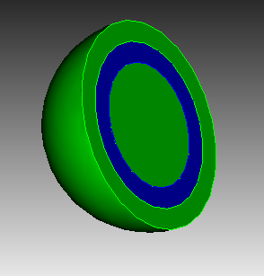
Figure 61. Two possible geometries for a fully constrained PyC sample. Green represents the SiC or constraining material, while blue indicates the PyC layer. a) A cylindrical geometry. b) A spherical geometry.

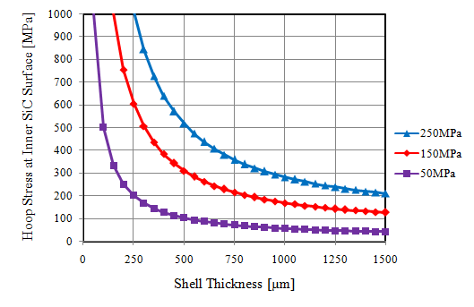
Figure 62. A plot of the expected stress in the outer SiC shell as a function of shell thickness. The different trends refer to the hydrostatic stress thresholds for PyC.

a)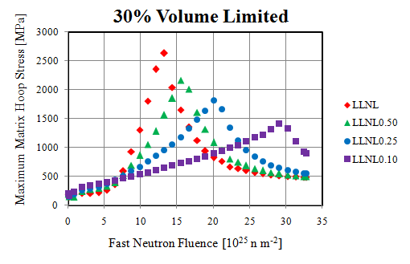 b) 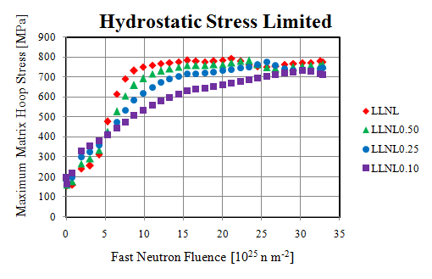
c) 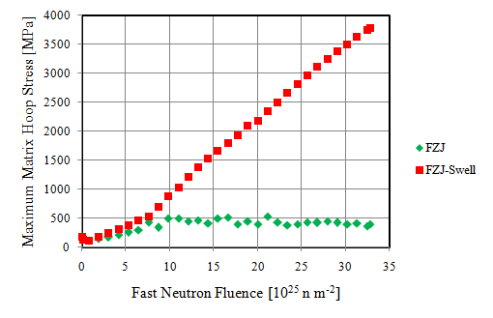 d) 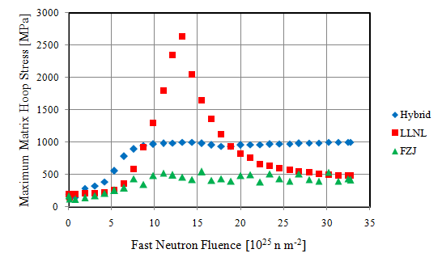
Figure 63. Plots of the predicted maximum hoop stress in the matrix for various dimensional change relationships. a) Plot of the maximum hoop stress using the LLNL correlation with reduced swelling rates of 0.5x, 0.25x, and 0.1x. b) plot showing the minimal effect of swelling rate when hydrostatic stress is active. Stress threshold was set to 160MPa and the temp dependent LLNL correlation was used for the PyC dimensional change but without the cap at 30% volume expansion. c) Plot of the maximum matrix hoop stress using the FZJ correlation and the FZJ with a reduced tangential shrinkage rate. d) Plot comparing the LLNL, FZJ, and hybrid correlations.

a)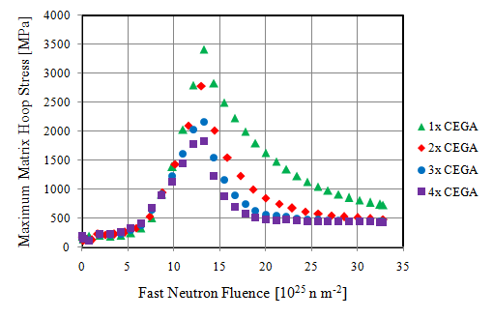 b)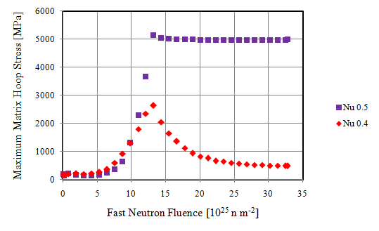
c)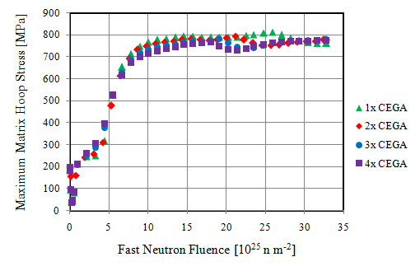
Figure 64. Plots comparing the effects from PyC creep rate and Poisson ratio in creep. a) Plot of the maximum matrix hoop stress using creep rates ranging from 1x to 4x the recommended CEGA correlation. The normal value used in other simulations 2x CEGA. b) Plot of effect of Poisson ratio in creep. A value of 0.5 constrains the OPyC to creep at constant value whereas a value of 0.4 allows it to expand and contract based on the stress. c) Effect of creep rate when hydrostatic stress limited dimensional change is used.

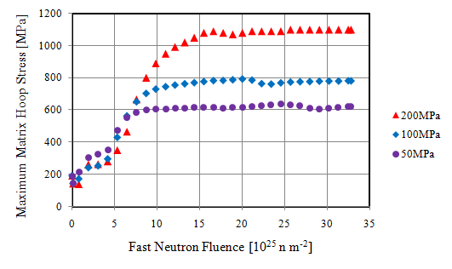
Figure 65. Plot of the effects from hydrostatic stress limited dimensional change. The threshold which was considered sufficient to prevent any additional volume increase was varied from 50 to 200MPa.

a)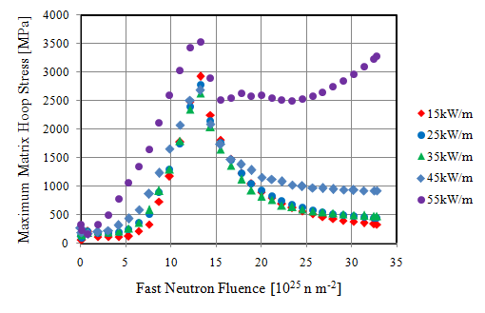 b) 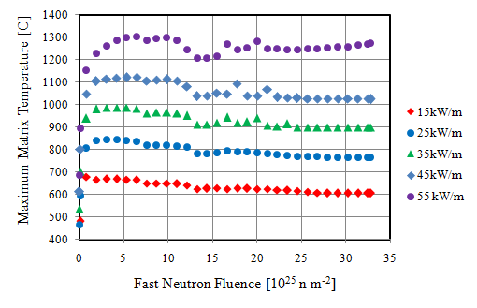
Figure 66. Plots of the effects from linear power varied from 15 to 55 kW m⁻¹. a) Maximum matrix hoop stress. b) The maximum temperature. Due to the geometry resulting in heat flow through other particles, the matrix centerline temperature and the maximum temperature anywhere in the fuel compact are about the same.

a)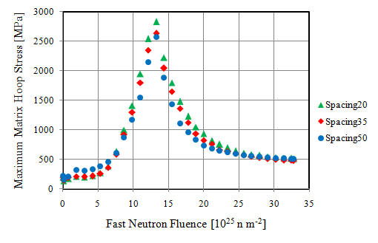 b)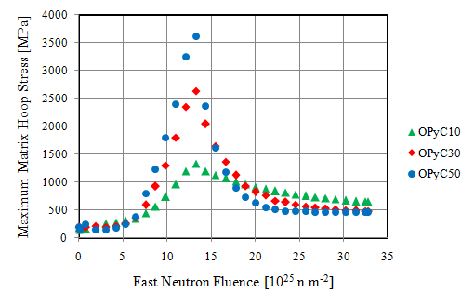
Figure 67. Effects of the TRISO particle spacing and OpyC layer thickness. a) Maximum matrix hoop stress versus increasing minimum particle spacing. b) Matrix hoop stress with a range of OPyC layer thicknesses.

a)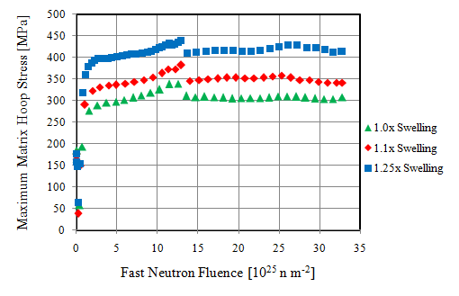 b)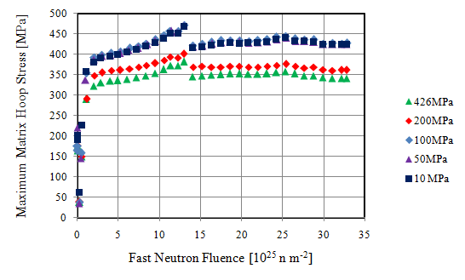
Figure 68. Plots for the effects of BISO particles on the matrix. a) Maximum matrix hoop stress for NITE-SiC having the same swelling (1x) as CVD-SiC, 1.1x, and 1.25x the CVD swelling. b) The maximum matrix hoops stress for various interface bond strengths between the CVD and NITE-SiC.

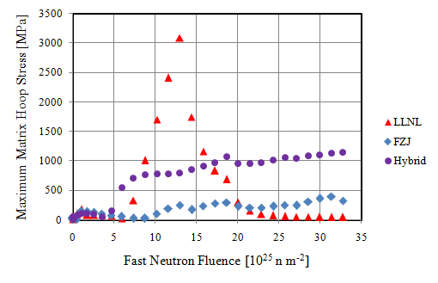
Figure 69. Plot of the maximum stress induced in the FCM matrix when used in a high temperature low power environment. LLNL correlation predicts volume expansion, FZJ constant volume, and hybrid includes a stress-limited behavior.

a)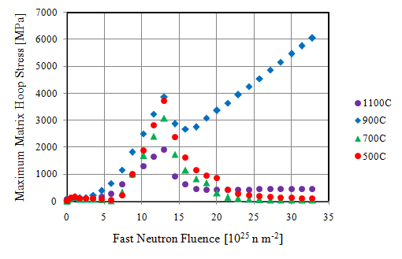b)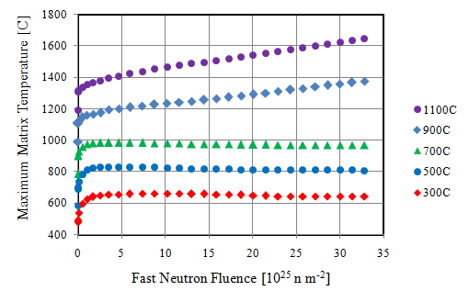
c) 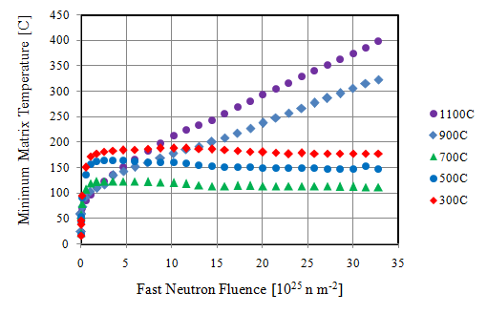
Figure 70. Effects of the coolant temperature on the matrix hoop stress. a) Maximum matrix hoop stress b) Maximum temperature. c) Minimum predicted matrix temperature.

a)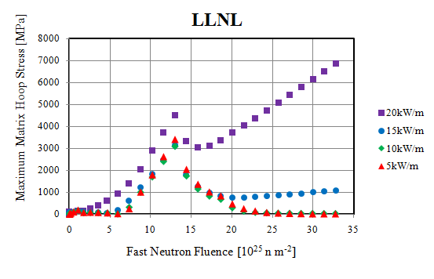 b)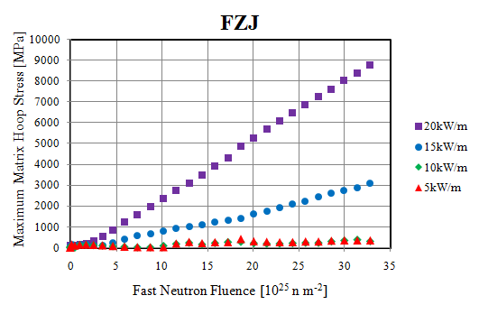
Figure 71. Plots for the linear power variation in a HGTR environment. a) Maximum matrix hoop stress using LLNL dimensional change correlation. b) Maximum matrix hoop stress using FZJ dimensional change correlation. The linear increase in stress is due to the high temperature SiC swelling.

a)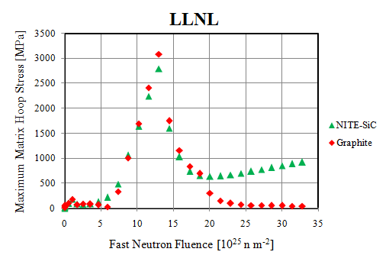 b)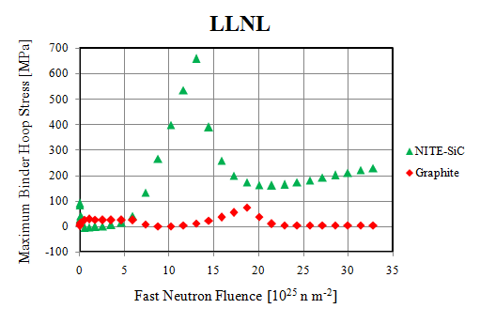
c)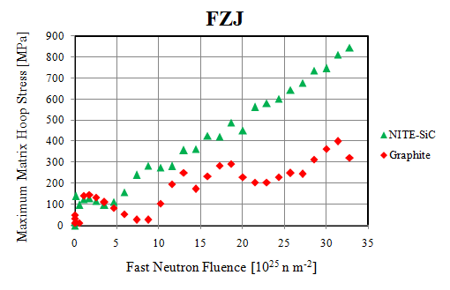 d)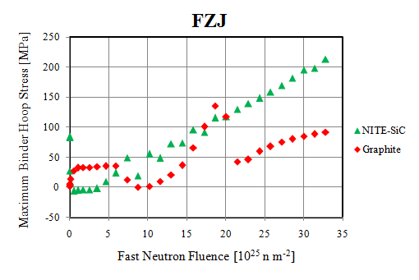
Figure 72. Plot of the maximum matrix hoops stress when using a NITE-SiC binder versus a graphite binder. a and b) Maximum matrix hoop stress and maximum binder hoop stress for LLNL dimensional change correlation. c and d) Maximum matrix hoop stress and maximum binder hoop stress for FZJ dimensional change correlation.

a)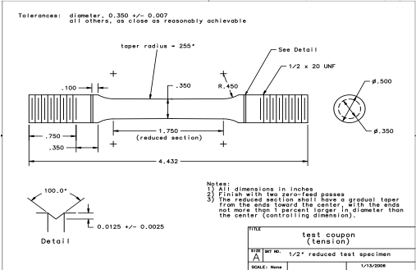 b) 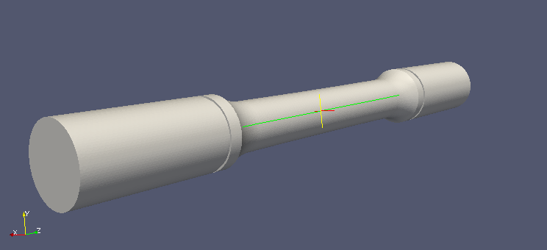
Figure 73. a) Tensile specifications from INL. Blandford et al. b) Mesh of the INL specimen.

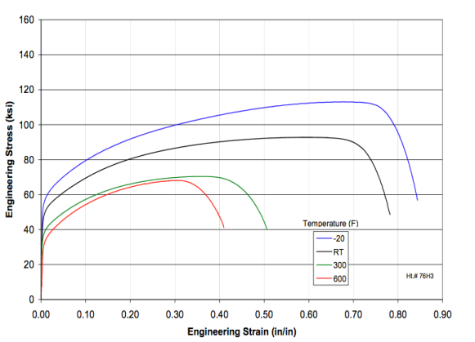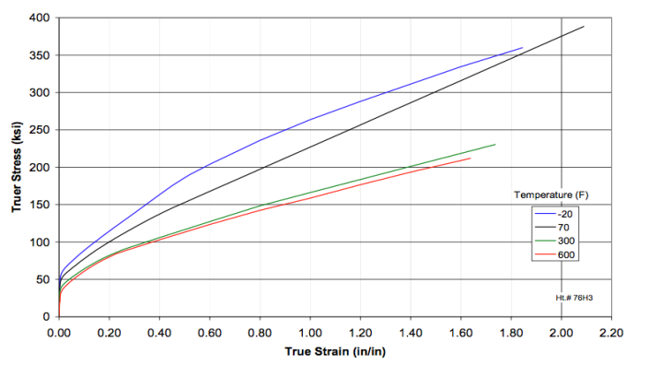
Figure 74. Figures from Blandford et al. showing the plots of the engineering and true stress for SS 316L [63].

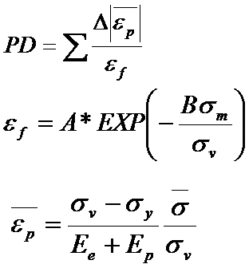
Figure 75. Plastic damage equation. The plastic damage is equal to the plastic strain divided by the failure strain. The failure strain is a function of the mean and vonMises stresses. The “A” and “B” variables are functions of temperature and curve fits to data from Blandford et al [63].

a)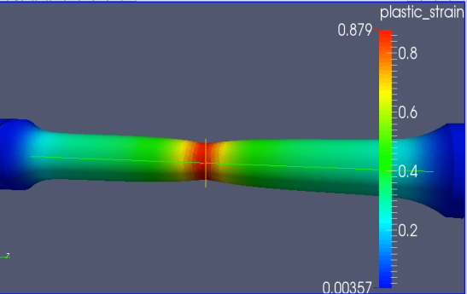 b)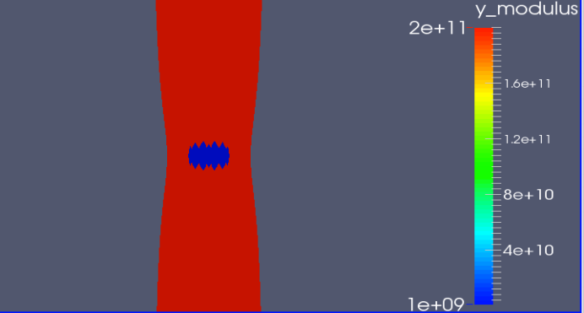
c) 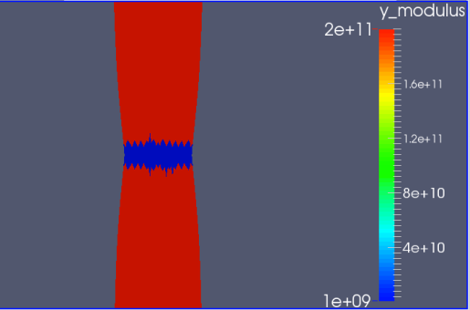
Figure 76. a) Plot of the plastic strain and resulting necking effect. b and c) Crack initiation and propagation patterns.
a)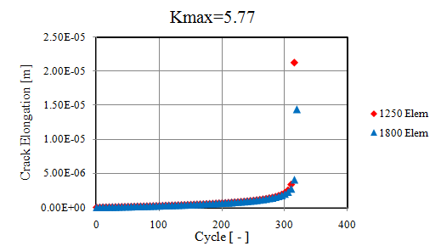 b) 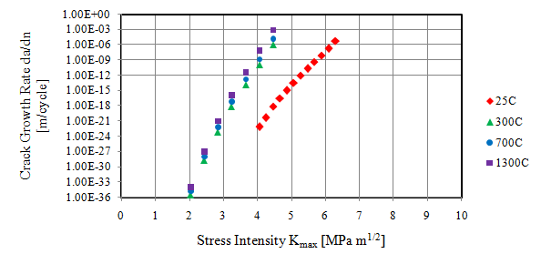
c) 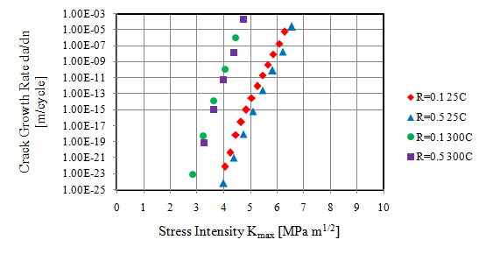
Figure 77. a) This plots the crack length for the 5x5x50mm bar with 1250 and 1800 mesh elements. b) This plots the crack growth rate for various temperatures. c) This plots the crack growth rate for load ratio 0.1 and 0.5 at 25 and 300C.

a)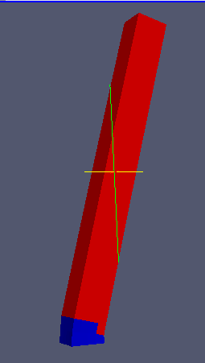 b) 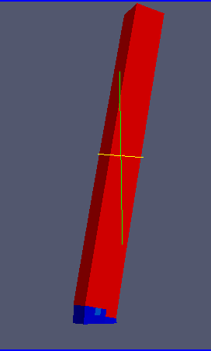 c) 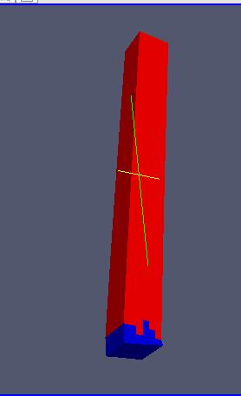 d) 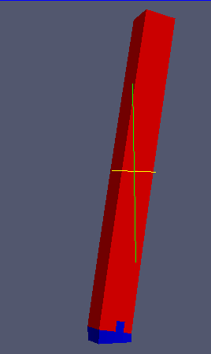
Figure 78. a) Signed von Mises failure criterion with 1250 elements. b) Signed von Mises with 1800 elements. c) Max principal stress failure criterion with 1250 elements. d) Max principal stress with 1800 elements. The 1800 element mesh using max principal had some difficulty cracking the last row of elements. As a result, using signed von Mises is recomened.

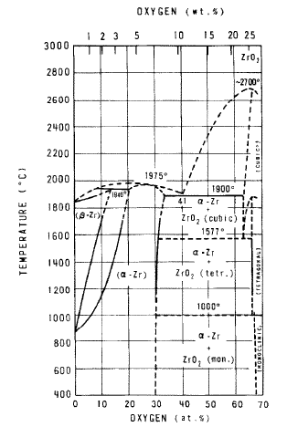
Figure 79. Diagram of the zirconium and oxygen phase diagram adapted from Urbanic and Heidrick [65]. Low temperature beta zirconium oxide is monoclinic, alpha zirconium oxide is tetragonal, and at high temperatures a cubic structure is formed.

List of References

[1] | J. J. Powers, W. J. Lee, F. Venneri, L. L. Snead, C. K. Jo, D. H. Hwang, J. H. Chun, Y. M. Kim, K. A. Terrani, "Fully Ceramic Microencapsulated (FCM) Replacement Fuel for LWRs," Oak Ridge National Laboratory, Oak Ridge, 2013.
[2] | K. Terrani, J. Kiggans, Y. Katoh, K. Shimoda, F. Montgomery, B. Armstrong, C. Parish, T. Hinoki, J. Hunn, and L. Snead, "Fabrication and Characterization of Fully Ceramic Microencapsulated Fuels," Journal of Nuclear Materials, vol. 426, pp. 268–276, 2012.
[3] | K.A. Terrani, J.O. Kiggans, C.M. Silva, C. Shih, Y. Katoh, L.L. Snead, "Progress on Matrix SiC Processing and Properties for Fully Ceramic Microencapsulated Fuel Form," Journal of Nuclear Materials, vol. 457, pp. 9–17, 2015.
[4] | K. Terrani, L. Snead, and J. Gehin, "Microencapsulated Fuel Technology for Commercial Light Water and Advanced Reactor Application," Journal of Nuclear Materials, vol. 427, pp. 209–224, 2012.
[5] | Jun Gyu Kima, E-Sul Kuma, Doo Jin Choia, Sung Soon Kima, Hong Lim Leea, Young Woo Leeb, and Ji Yeon Parkb, "Study of CVD SiC Deposition for TRISO Coated Fuel Material Fabrication by Computational Simulation and Actual Experiment," Journal of Ceramic Processing Research, vol. 8, pp. 388-392, 2007.
[6] | H. Nickel, H. Nabielek, G. Pott, and A. Mehner, "Long Time Experience with the Development of HTR Fuel Elements in Germany," Nuclear Engineering and Design, vol. 217, pp. 141–151, 2002.
[7] | J. Powers and B. Wirth, "A Review of TRISO Fuel Performance Models," Journal of Nuclear Materials, vol. 405, pp. 74-82, 2010.
[8] | D. Petti, P. Martin, M. Phélip, R. Ballinger, "Development Of Improved Models And Designs For Coated-Particle Gas Reactor Fuels," Idaho National Engineering and Environmental Laboratory, Idaho Falls, 2004.
[9] | G. K. Miller, D. A. Petti, J. T. Maki, D. L. Knudson, "PARFUME Theory and Model Basis Report," Idaho National Laboratory, 2009.
[10] | IAEA-TECDOC-1674, "Advances in High Temperature Gas Cooled Reactor Fuel Technology," International Atomic Energy Agency, Vienna, 2012.
[11] | J. Hales, S. Novascone, G. Pastore, D. Perez, B. Spencer, and R. Williamson, "BISON Users Manual," Idaho National Laboratory, Idaho Falls, 2013.
[12] | R.L. Williamson, J.D. Hales, S.R. Novascone, M.R. Tonks, D.R. Gaston, C.J. Permann, D. Andrs, "Multidimensional Multiphysics Simulation of Nuclear Fuel Behavior," Journal of Nuclear Materials, vol. 423, pp. 149–163, 2012.
[13] | D. Perez, R. Williamson, S. Novascone, G. Pastore, J. Hales, and B. Spencer, "Assessment of BISON: A Nuclear Fuel Performance Analysis Code," Idaho National Laboratory, Idaho Falls, 2013.
[14] | D. Gaston, C. Newman, G. Hansen, and D. Lebrun-Grandié, "MOOSE: A Parallel Computational Framework for Coupled Systems of Nonlinear Equations," Nuclear Engineering and Design, vol. 239, pp. 1768–1778, 2009.
[15] | A. Fletcher. (2008) University of Strathclyde. [Online]. http://personal.strath.ac.uk/Ashleigh.Fletcher/carbon.htm
[16] | B. Claub. Fibers for Ceramic Matrix Composites. [Online]. https://application.wiley-vch.de/books/sample/3527313613_c01.pdf
[17] | A. A. Campbell, "THE MECHANISM OF PROTON IRRADIATION-INDUCED CREEP IN ULTRA-FINE GRAIN GRAPHITE," University of Michigan, Dissertation 2014.
[18] | J.L. Kaae, "Irradiation-induced Microstructural Changes in Isotropic Pyrolytic Carbons," Journal of Nuclear Materials, vol. 57, pp. 82-92, 1975.
[19] | T. Liang, "Something About Nuclear Graphite," Tsinghua University, Presentation.
[20] | J. C. Bokros, G. L. Guthrie, R. W. Dunlap, and A. S. Schwartz, "Radiation-Induced Dimensional Changes And Creep In Carbonaceous Materials," Journal of Nuclear Materials, vol. 31, pp. 25-47, Septermber 1968.
[21] | K. Wen, J. Marrow, and B. Marsden, "Microcracks in Nuclear Graphite and Highly Oriented Pyrolytic Graphite (HOPG)," Journal of Nuclear Materials, vol. 381, no. 1-2, pp. 199-203, October 2008.
[22] | K. Liy, D. Zhang, L. Guo, and H. Li, "Micro- and Nano-structure Characterization of Isotropic Pyrocarbon Obtained via Chemical Vapor Deposition in Hot Wall Reactor," Journal of Materials Science and Technology, vol. 26, pp. 1133-1138, January 2010.
[23] | T. Burchell, L. Snead, "The effect of neutron irradiation damage on the properties of grade NBG-10 graphite," Journal of Nuclear Materials, vol. 371, pp. 18-27, September 2007.
[24] | C. Karthik, J. Kane, D.P. Butt, W.E. Windes, R. Ubic, "In Situ Transmission Electron Microscopy of Electron-Beam Induced Damage Process in Nuclear Grade Graphite," Journal of Nuclear Materials, vol. 412, pp. 321-326, December 2011.
[25] | T. Trevethan, P. Dyulgerova, C. D. Latham, and M. I. Heggie, "Extended Interplanar Linking in Graphite Formed from Vacancy Aggregates," PRL, p. 111, 2013.
[26] | H. Zhang, E. Lo´pez-Honorato , and P. Xiao, "Fluidized bed chemical vapor deposition of pyrolytic carbon-III Relationship between microstructure and mechanical properties," Carbon, pp. 346-357, 2015.
[27] | K. Li, D. Zhang, L. Guo and H. Li, "Micro- and Nano-structure Characterization of Isotropic Pyrocarbon Obtained via Chemical Vapor Deposition in Hot Wall Reactor," Journal of Materials Science and Technology, pp. 1133-1138, 2010.
[28] | L.L. Snead, K.A. Terrani, Y. Katoh, C. Silva, K. Leonard, A.G. Perez-Bergquist, "Stability of SiC-Matrix Microencapsulated Fuel Constituents at Relevant LWR Conditions," Journal of Nuclear Materials, vol. 448, pp. 389-398, 2014.
[29] | J. L. Kaae, J. C. Bokros, "Irradiation Induced Dimensional Change and Creep of Isotropic Carbon," Carbon, vol. 9, p. 111, 1969.
[30] | J. Wang, "An Integrated Performance Model for High Temperature Gas Cooled Reactor Coated Particle Fuel," MIT, Dissertation 2004.
[31] | P. DeMange, J. Marian, M. Caro, A. Caro, "TRISO-Fuel Element Performance Modeling for the Hybrid LIFE Engine with Pu Fuel Blanket," Lawrence Livermore National Laboratory, Livermore, 2010.
[32] | IAEA-Tecdoc-1154, "IAEA-Tecdoc-1154: Irradiation Damage in Graphite Due to Fast Neutrons in Fission and Fussion Systems," IAEA, Vienna, Technical Document 2000.
[33] | L. Snead, T. Nozawa, Y. Katoh, T. Byun, S. Kondo, and D. Petti, "Handbook of SiC Properties for Fuel Performance Modeling," Journal of Nuclear Materials, vol. 371, pp. 329–377, 2007.
[34] | Y. Katoh, T. Nozawa, L. Snead, K. Ozawa, H. Tanigawa, "Stability of SiC and its Composites at High Neutron Fluence," Journal of Nuclear Materials, vol. 417, pp. 400–405, 2011.
[35] | Y. Katoh, L. Snead, C. Parish, and T. Hinoki, "Observation and Possible Mechanism of Irradiation Induced Creep in Ceramics," Journal of Nuclear Materials, vol. 434, pp. 141–151, 2013.
[36] | R. J. Price, "Properties of Silicon Carbide for Nuclear Fuel Particle Coatings," Nuclear Technology, vol. 35, pp. 320-336, 1977.
[37] | CEGA Corporation, "NP-MHTGR Material Models of Pyrocarbon and Pyrolytic Silicon Carbide," vol. CEGA-002820, p. Rev. 1, 1993.
[38] | J.D. Hales, R.L. Williamson, S.R. Novascone, D.M. Perez, B.W. Spencer, G. Pastore, "Multidimensional Multiphysics Simulation of TRISO Particle Fuel," Journal of Nuclear Materials, vol. 443, pp. 531–543, 2013.
[39] | Y. Kim, and G. Hofman, "AAA Fuels Handbook," Argonne National Laboratory, Argonne,.
[40] | L. J. Siefken, E. W. Coryell.E. A. Harvego, J. K. Hohorst, "SCDAP/RELAP5/MOD 3.3 Code Manual," Idaho National Engineering and Environmental Laboratory, Idaho Falls, 2001.
[41] | Y. Arai, Y. Suzuki, T. Iwai, and T. Ohmichi, "Dependence of the thermal conductivity of (U, Pu)N on porosity and plutonium content," Journal of Nuclear Materials, vol. 195, pp. 37-43, 1992.
[42] | P.G. Lucuta, H. Matzke, and I.J. Hastings, "A Pragmatic Approach to Modelling Thermal Conductivity of Irradiated UO 2 Fuel: Review and Recommendations," Journal of Nuclear Materials, vol. 232, pp. 166-180, 1996.
[43] | G. Pastorea, L. Luzzia, V. Di Marcellob, P. Van Uffelenb, "Physics-Based Modeling of Fission Gas Swelling and Release in UO2 Applied to Integral Fuel Rod Analysis," Nuclear Engineering and Design, vol. 256, pp. 75–86, 2013.
[44] | J. F. Bates and E. R. Gilbert, "Experimental Evidence for Stress Enhanced Swelling," Journal of Nuclear Materials , vol. 59, pp. 95-102, 1976.
[45] | L.L. Snead, S.J. Zinkle, D.P. White, "Thermal Conductivity Degradation of Ceramic Materials Due to Low Temperature, Low Dose Neutron Irradiation," Journal of Nuclear Materials, vol. 340, pp. 187–202, 2005.
[46] | M.i Li, N. V. Mokhov, "Experience with Moving from Dpa to Changes in Materials Properties," ANL, Fermilab, Morschach, Switzerland, Presentation 2010.
[47] | N. Gallego, "Milestone Report ORNL/TM-2011/378 in completion of Task 1 for JCN N6988 / V6210," Oak Ridge National Laboratory, Oak Ridge, Milestone Report 2011.
[48] | T. Burchell, "Irradiation Damage in Graphite ," Oak Ridge National Laboratory, Oak Ridge, Presentation 2014.
[49] | Y. Rashid, R. Dunham, R. Montgomery, "Fuel analysis and licensing code: FALCON MOD01," Electric Power Research Institute, 2004.
[50] | G.A. Berna, C.E. Beyer, K.L. Davis, D.D. Lanning, "FRAPCON–3: A Computer Code for the Calculation of Steady-state, Thermal-Mechanical Behavior of Oxide Fuel Rods for High Burnup," Pacific Northwest National Laboratory, 1997.
[51] | T. Burchell, "Neutron Irradiation Damage in Graphite and Its Effects on Properties," Oak Ridge National Laboratory, , Oak Ridge, 2001.
[52] | B. Travis and M. El-Genk, "An Effective Methodology For Thermal-Hydraulics Analysis of a VHTR Core And Fuel Elements," Institute for Space and Nuclear Power Studies, Albuquerque, Technical Report 2012.
[53] | Korea Atomic Energy Research Institute. Table of Nuclides. [Online]. http://atom.kaeri.re.kr/
[54] | Japenses Atomic Energy Agency. Nuclear Data Center. [Online]. http://wwwndc.jaea.go.jp/cgi-bin/FPYfig?lib=11&mode=s&iso=nU235&typ=g1&ynuc=Ag-108&ysub=Show+Yield&yld=i&zlog=set&ylow=12&xpar=a&eng=e1
[55] | J. Wang, "Recent Predictions on NPR Capsules by Integrated Fuel Performance Model," MIT, Presentation 2002.
[56] | G. K. Miller, J. T. Maki, D. L. Knudson, D. A. Petti, "Calculating Failure Probabilities for TRISO-Coated Fuel Particles Using an Integral Formulation," Journal of Nuclear Materials, vol. 399, pp. 154-161, 2010.
[57] | A. K. Kercher, J. D. Hunn, "Results from ORNL Characterization of ZrO2-500-AK2 - Surrogate TRISO Material," Oak Ridge National Laboratory, Oak Ridge, 205.
[58] | D.Petti, J. Maki, J. Hunn, P. Pappano, C. Barnes, J. Saurwein, S. Nagely, J. Kendall, and R. Hobbins, "The DOE Advanced Gas Reactor Fuel Development and Qualification Program," Journal of Materials, vol. 62, pp. 62-66, 2010.
[59] | J. Klett, "Development of High Conductivity Low Density Graphite Foam.," Office of Energy Efficiency and Renewable Energy , 2001.
[60] | N. C. Gallego, T. D. Burchell, J. W. Klett, "Irradiation Effects on Graphite Foam," Carbon, vol. 44, pp. 618-626, 2006.
[61] | W. H. TAI, "Plastic Damage and Ductile Failure in Mild Steels," Engineering Fracture Mechanics, vol. 37, pp. 853-880, 1990.
[62] | Y. Nikaido, Y.i Mihara, S. Sawada and Y. Takahashi, "Improvement and Enhancement of Concrete Damage Plasticity Model," Kajima Corporation,.
[63] | R. K. Blandford, D. K. Morton, S. D. Snow, and T. E. Rahl, "Tensile Stress-Strain Results for 304L and 316L Stainless Steel Plate at Temperature," Idaho National Laboratory, Idaho Falls, 2007.
[64] | D. CHEN, C. J. GILBERT, X. F. ZHANG and R. O. RITCHIE, "High Temperature Cycle Fatigure Crack Growth Behavior in an in-situ Toughened Silicon Carbide," Acta Mater, pp. 659-674, 2000.
[65] | V.F. URBANIC and T.R. HEIDRICK, "HIGH-TEMPERATURE OXIDATION OF ZIRCALOY-2 AND ZIRCALOY-4 IN STEAM," Journal of Nuclear Materials, vol. 75, pp. 251-261.
[66] | P. W. Lanni, "METAL-WATER REACTIONS EFFECTS ON CORE COOLING AND CONTAINMENT," General Electric, 1968.
[67] | IAEA-Tecdoc-978, "Fuel Performance and Fission Product Behaviour in Gas Cooled Reactors," International Atomic Energy Agency, Vienna, 1997.
[68] | A. Ramlakan, E. Mulder, H. van der Merwe, "Modelling of Fission Product Release from TRISO Fuel During Accident Conditions: Benchmark Code Comparison," 2006.
[69] | A.S. Chernikov, Y. F. Khromov, R.A. Lyutikov, A.A. Gusev, "Fission Product Diffusion in Fuel Element Materials for HTGR".
[70] | D. L DeForest, "Transient Fission Gas Behavior in Uranium Nitride Fuel Under Proposed Space Applications," 1991.
[71] | T. Nozawa, L.L. Snead, Y. Katoh, and J.H. Miller, "Shear properties at the PyC/SiC interface of a TRISO-coating," Journal of Nuclear Materials, vol. 371, pp. 304–313, 2007.
[72] | L. Baker, "HYDROGEN-GENERATING REACTIONS IN LWR SEVERE ACCIDENTS," Argonne National Laboratory, Chicago,.
[73] | C. Carter, R. Davis, and J. Bentley, "Kinetics and Mechanisms of High-Temperature Creep in Silicon Carbide: 11, Chemically Vapor Deposited," Journal of the American Ceramic Society, vol. 67, pp. 732 - 740, 1983.
[74] | J. C. Bell, H. Bridge, A. H. Cottrell, G. B. Greenough, W. N. Reynolds, and J. H. W. Simmons, "Stored Energy in the Graphite of Power-Producing Reactor," Philos. Trans. Roy. Soc. London Ser. A Math. Phys., vol. 254, pp. 361–395, 1962.
[75] | B. T. Kelly, "Nuclear Reactor Moderator Materials," Nuclear Materials, vol. 10A, 1994.
[76] | B. Collin, "Modeling and Analysis of FCM UN TRISO Fuel Using the PARFUME Code," Idaho National Laboratory, Idaho Falls, 2013.

