BG-4, a bioactive peptide from Momordica charantia, promotes apoptosis in ovarian cancer cells
Ashley Bloom, Vermont Dia
Department of Food Science and Technology
College of Agricultural Sciences and Natural Resources
University of Tennessee, Knoxville, USA

Abstract
Momordica charantia is a perennial plant with reported health benefits. Food-derived molecules, like the novel peptide BG-4 found in Momordica charantia, have been shown to have anticancer properties by promoting apoptosis in colon cancer cells. Ovarian cancer (OVCA) is the deadliest form of all gynecological cancers. The high fatality rate of OVCA is due to late presentation of the disease, cancer persistence, and recurrence in patients. The objective of this study was to determine the ability of BG-4 to cause cytotoxicity to ovarian cancer cells (A27801AP and COV318) and determine the mechanism involved by measuring proteins associated with apoptosis. BG-4 treatment caused a decrease in viable cell count by 65.1% at 250 μg/mL (A27801AP) and 19.8% at 250 μg/mL (COV318). The mechanism involved in the decrease in viable cell count is due to promoted apoptosis as evidenced by increased percentage of A27801AP undergoing apoptosis from 7.1% (untreated) to 23.9% (BG-4 treated, 250 μg/mL). The molecular mechanism explanation for the induced apoptosis of ovarian cancer cells due to BG-4 is caused by the increase in expression of pro-apoptotic marker BAX while reducing expression of anti-apoptotic marker XIAP. This led to an increase in expression of capsase-3 and caused an affect on the expression of cell cycle proteins p21 and CDK2. These findings support the hypothesis that there is anti-cancer potential for the BG-4 peptide isolated from Momordica charantia in vitro against ovarian cancer and should be further addressed using in vivo models of ovarian carcinogenesis.

1. Introduction
Ovarian cancer (OVCA) is estimated to account for 14,170 new deaths in 2018, making it the most deadly form of gynecological cancer (Siegel et al, 2016). In 2012, GLOBOCAN reported that OVCA accounted for 239,000 new cases worldwide and 152,000 deaths worldwide. As a result, OVCA is the 7th most common cancer and 8th most common cause of death in women worldwide (Ferlay et al, 2015). OVCA incidence rates are higher in more developed regions causing it to be the 5th most common cause of death in women in the United States (Siegel et al, 2016)).
Breast cancer is ten times more common in American women than OVCA, but OVCA is more deadly (Committee on the State of the Science in Ovarian Cancer Research et al, 2016). The death-to-incidence ratio for OVCA is more than three times higher than for breast cancer (Committee on the State of the Science in Ovarian Cancer Research et al, 2016). In 2011, the 5-year survival rate for OVCA was 45.6% (Committee on the State of the Science in Ovarian Cancer Research et al, 2016). The 5-year survival rate for breast cancer, endometrial cancer, and cervical cancer was 90%, 80% and 70% respectively (Committee on the State of the Science in Ovarian Cancer Research et al, 2016).
Women have a 1 in 71 chance to become diagnosed with OVCA during their lifetime and a 1 in 95 chance to die from the disease (Razi et al, 2016). The high rate is correlated to the absence of screening which leads to diagnosis of disease at advanced stages (Razi et al, 2016). The high fatality rate of OVCA is due to late presentation of disease, cancer persistence, and chemotherapy resistance (Thibault et al, 2014). Most often, the treatment for OVCA is chemotherapy, which causes severe side effects including gastrointestinal toxicity, febrile neutropenia and peripheral neuropathy and other non-hematological toxicities (Dia & Pangloli, 2016).
Cancer cells grow through the avoidance of apoptosis, or programmed cell death (Hanahan et al, 2011). Apoptosis is controlled by various protein machineries, including proteins involved in intrinsic mitochondrial pathways and extrinsic death receptor-mediated pathways (Dia & Krishnan, 2016). A key approach to combatting cancer cell growth is the activation of the apoptosis pathway (Dia & Krishnan, 2016).
Momordica charantia, commonly known as the bitter melon or bitter gourd (BG), comes from the family Cucurbitacae (Dandawate et al, 2016). This plant is commonly cultivated in Asia, the Amazon, east Africa, and the Caribbean (Dandawate et al, 2016). BG is commonly used as folk medicine to treat malaria, peptic ulcers, kidney stones, and eczema (Dandawate et al, 2016). BG is also reported to have anti-oxidant, anti-inflammatory, anti-cancer, anti-diabetic, anti-bacterial, anti-obesity, and immunomodulatory activities (Dandawate et al, 2016).
Different portions of the BG plant possess anticancer properties (Dia & Krishnan, 2016) and previous studies have shown these anticancer properties. MAP30, an anti-HIV protein, has been shown to inhibit MDA-MB-231 breast cancer cells and has led to increased survival in mice with MDA-MB-231 tumors (Lee-Huang et al, 2000). Methanolic extract of BG has been shown to lead to reduced proliferation and autophagy of colorectal cancer (Kwatra et al, 2013). BG lectin has been shown to induce G2/M cell cycle arrest, autophagy, and apoptosis in hepatocellular cancer (Zhang et al, 2015). BG-4 has been shown to inhibit proliferation of colon cancer cells by promoting apoptosis through down-regulation of anti-apoptotic proteins (Bcl-2 and XIAP), up-regulation of pro-apoptotic proteins (BAX and capsase-3), and modification of cell cycle proteins (p21 and CDK2) (Dia & Krishnan, 2016). These previous studies on the beneficial roles of the BG plant on various forms of cancer and the previous study indicating that BG-4 inhibits growth of colon cancer due to the promotion of the apoptosis pathway serve as scientific premise to study the ability of BG-4 to cause cytotoxicity to ovarian cancer cells via promotion of the apoptotic pathway.

2. Methods and Materials
Cell lines and cell culture
A27801AP was a kind gift from Dr. Tito Fojo (National Cancer Institute, NIH), and COV318 was from Dr. Gabor Tigyi (University of Tennessee Health Science Center, Memphis TN). The cells were grown in RPMI 1640 growth medium supplemented with 10% heat inactivated fetal bovine serum, 1% penicillin-streptomycin and 1% sodium pyruvate. The cells were grown in a humidified incubator with 5% CO₂ at 37°C.

Cell proliferation Assay
Approximately twenty thousand ovarian cancer cells from the cell lines A27801AP and COV318 were grown in RPMI 1640 medium containing 10% fetal bovine serum, 1% penicillin-streptomycin and 1% sodium pyruvate. The cells were then plated in a 96-well plate in 200 μL volume and allowed to attach overnight in humidified 5% CO₂ incubator at 37 °C. Cells were treated with BG-4 extract ranging from 0 to 1000 μg/ml for 24-hours. After treatment, medium was removed and 20 μL of 3-(4,5-dimethylthiazol-2-yl)-5-(3-carboxymethoxyphenyl)-2-(4-sulfophenyl)-2H-tetrazolium, inner salt, (MTS, Promega, Madison, WI, USA)-phenazine methosulfate (PMS, Acros Organics) solution followed by 100 μL of growth medium were added. The plate was incubated at 37°C for 2 hours and absorbance was read at 490 nm. Proliferation was expressed as percentage of untreated control cells. The experiment was performed at time 24-hour with two independent trials and 4 replicates per trial.

Western Blotting
OVCA cells (cell line A27801AP only) were seeded in a 6-well plate at a density of 5 x 10⁵ cells /mL, allowed to attach overnight, treated with BG-4 for 24-hour and lysed with RIPA buffer. Cell lysates were vortexed for 5 minutes and centrifuged at 14,000 x g for 10 minutes at 4 °C. The supernatant was collected, mixed with Laemmli buffer containing 5% β-mercaptoethanol, boiled for 5 minutes and stored at -20 °C until analysis was performed. A portion of the supernatant was used for protein content determination using Bradford assay. The whole cell lysates used for Bax, Bcl-2, XIAP, caspase-3, p21 and CDK2 (Proteintech Group, Inc. Rosemont IL) and GAPDH (Santa Cruz Biotechnology, Santa Cruz, CA) expressions. Western blot analysis was conducted by loading whole cell lysates (25 μg protein) in 4-20% Tris-HCl gel (Bio-Rad Laboratories), and then run at 200 V for 35 minutes at room temperature. Once complete, the gels were transferred to a PVDF membrane (GE Healthcare Life Sciences, Pittsburg, PA) at 110 V for 1 hour at 4 °C. The blots produced were blocked with 5% non-fat dry milk for 1 hour at room temperature, then washed 3 times with TBS containing 0.1% Tween 20 (TBST) for 5 minutes and incubated with primary antibody overnight at 4 °C at 1:1000 dilution. The blots were washed with TBST 3 times for 10 minutes and incubated with anti-rabbit or anti-mouse secondary antibody at 1:5000 dilution for 2 hours at room temperature. After washing with TBST, the blots were imaged with C-Digit Blot scanner (Li-Cor Biosciences, Lincoln, NE) using WesternSure ECL Substrate (Li-Cor Biosciences, Lincoln, NE). The intensity of the bands was quantified using Image Studio Software (Li-Cor Biosciences, Lincoln, NE). Each experiment was performed in two independent replicates.

Apoptosis Assay
A27801AP cells were seeded at 5x10⁵ cells/mL in a 6-well plate and allowed to attach overnight in humidified 5% CO₂ incubator at 37 °C. Then, cells were treated with 0, 125, and 250 μg/mL BG-4 for 16 hours. Following treatment, growth medium was removed and cells were washed with ice-cold PBS twice and detached from the well plate. Cell suspension was centrifuged at 500 x g for 5 minutes at 4 °C and re-suspended in Annexin V binding buffer. Cell suspension (100 μL) was stained with 10 μL Annexin V-FITC (Biotium, Inc., Hayward, CA) and 10 μL propidium iodine (Biotium, Inc., Hayward, CA) for 15 minutes in the dark at room temperature. After staining, 400 μL of binding buffer was added to the suspension and analyzed using BD Accuri C6 flow cytometer (BD Biosciences, San Jose, CA). A total of 20,000 events were acquired and analyzed using BD Accuri C6 software package.

Statistical Analysis
Data analysis was done using Proc GLM of SAS Software version 9.4 and significance was reported at P < 0.05 with post-hoc Turkey test for separation of means as indicated by different letters. For expression of protein markers related to apoptosis and cell cycle, each concentration of BG-4 treatment was compared against the untreated sample. Mean values represented as bars with different letter(s) are statistically different from each other (P < 0.05, n=2).

3. Results
BG-4 caused cytotoxicity to ovarian cancer cells. As shown in Fig. 1, BG-4 dose-dependently led to proliferation inhibition in OVCA cells in vitro for COV318 ad 1AP-OVCA cell lines. At 0 μg/mL, both cell lines are labeled with 100% viable cells. At 250 μg/mL, COV318 proliferation significantly decreased by 19.8% after 24 hour treatment while 1AP significantly decreased by 65.1%.
BG-4 promoted modified expression of proteins associated with apoptosis and cell cycle. As shown in Fig. 2, protein expression associated with apoptosis and cell cycle was measured. In Fig. 2A, BG-4 at 250 μg/mL significantly modified the expression of different apoptotic markers in OVCA-1AP cells by increasing the expression of apoptosis executioner protein caspase-3 and pro-apoptotic protein Bax by 2.2-fold and 2.8-fold, respectively and decreasing the protein expression of anti-apoptotic protein XIAP by 0.8-fold. Anti-apoptotic protein Bcl-2 experienced no change in protein expression when treated with BG-4. In an effort to further understand the anti-proliferative effect of BG-4 on OVCA cells, the expression of protein markers associated with cell survival, particularly cell cycle proteins, was measured. As shown in Fig. 2B, BG-4 at 250 μg/mL significantly modified the expression of cyclin dependent kinase inhibitor p21 by 3.6-fold but reduced the expression of CDK2 by 0.6-fold.
BG-4 promoted apoptosis in 1AP OVCA cells. 1AP OVCA cells were treated with 0, 125, 250 μg/mL for 16 hours. The 16-hour time point was chosen based on previous proliferation studies. In these studies, 24-hour BG-4 treatment led to significant cytotoxic effects. The 16-hour time point allowed us to detect cells undergoing early apoptosis. As shown in Fig. 3A, there was a dose-dependent BG-4 treatment increase in the number of cells undergoing apoptosis (quadrant 2 in flow cytometry figures). As shown in Fig. 3B, the percentage of 1AP OVCA live cells went from 90.0% (untreated) to 73.9% and 68.8% for 125 μg/mL and 250 μg/mL treatment, respectively. Early apoptotic cells went from 7.1% (untreated) to 21.0% and 24.0% for 125 μg/mL and 250 μg/mL treatment, respectively. Late apoptotic cells went from 2.0% (untreated) to 3.7% and 5.4% for 125 μg/mL and 250 μg/mL treatment, respectively. Necrotic cells were from 1.0% (untreated) to 1.4% and 1.8% for 125 μg/mL and 250 μg/mL treatment, respectively.
4. Discussion
We report that BG-4 has the ability to induce cytotoxicity in ovarian cancer cells. BG-4 dose-dependently inhibited ovarian cancer cell growth as shown in Fig. 1. This inhibition of growth caused by BG-4 could be attributed to its capability to inhibit trypsin activity. Previous studies have shown that trypsin inhibitors from food sources, like the Kunitz trypsin inhibitor from soybean, possess anticancer properties (Dia & Krishnan, 2016). Previous studies have also shown that ethanolic protein extracts of BG-4 from Momordica charantia seed inhibited trypsin activity higher than purified soybean Kunitz trypsin inhibitor (Dia & Krishnan, 2016). As a result, these previous studies support our findings that BG-4 possesses anti-cancer properties, which could be attributed to its capability to inhibit trypsin, and may be used as either chemotherapeutic or chemopreventative against OVCA.
Next, we investigated the mechanism through which BG-4 caused a cytotoxic effect on OVCA-1AP ovarian cancer cells. As shown in Fig.2A and Fig. 2B, the potential mechanism of cytoxicity involves the induction of the apoptosis pathway. Apoptosis, or programmed cell death, consists of removal of damaged and mutated cells. Therefore, dysregulation of the apoptosis pathway can lead to an increase in the growth of ovarian cancer cells. Ovarian cancer cells grow through the avoidance of apoptosis by developing mechanisms to survive (Hanahan et al, 2011). Therefore, the induction of apoptosis through treatment of BG-4 in ovarian cancer cells is a good strategy to combat malignancy. BG-4 at 250 μg/mL significantly modified the expression of different apoptotic markers in OVCA-1AP cells as measured by flow cytometry. As shown in Fig. 3A, there was a dose-dependent BG-4 treatment increase in the number of cells undergoing apoptosis.
The treatment of BG-4 for OVCA-1AP cells activated the apoptosis pathway by modifying the expression of proteins associated with apoptosis and the cell cycle. At 250 μg/mL, BG-4 led to a significant increase in the expression of active caspase-3. The increase in caspase-3 could be responsible for the increase in apoptotic cells observed in flow cytometry experiments (Fig. 3a). Caspase-3 is an executioner protein that is responsible for executing apoptotic events, but can be inhibited by XIAP. At 250 μg/mL BG-4 treatment, XIAP expression was reduced significantly thus leading to an increase in expression of Caspase-3.
At 250 μg/mL, BG-4 led to a significant increase in the expression of pro-apoptotic Bax. Bax is a member of the Bcl-2 family and the activation of Bax can lead to mitochondrial outer membrane permeabilitization leading to the release of pro-apoptotic factors (Dia & Krishnan, 2016).Increased Bax expression in clinics is associated with increased cancer survival (Dia & Krishnan, 2016). Therefore, the increased expression of Bax due to BG-4 treatment indicated potential use of BG-4 as an anti-ovarian cancer therapy.
The capability of ovarian cancer cells to multiply and proliferate is an important aspect of cancer cell survival that is affected by different cell cycle proteins. CDK2 is a cyclin dependent kinase that regulates the cell cycle from G1 to S-phase. Therefore, CDK2 is important in cell proliferation and is overexpressed in ovarian cancer cells. A cyclin dependent kinase inhibitor, p21, is a regulator of tumor suppressor pathways and is important in combating ovarian cancer. The results indicate that BG-4 treatment at 250 μg/mL increased the expression of the antitumor p21 and led to the reduction in expression of CDK2 in OVCA-1AP ovarian cancer cells. Therefore, we conclude that BG-4 is capable of inducing apoptosis in ovarian cancer cells by affecting the expression of proteins involved in cell survival and proliferation.
In summary, we report that BG-4 from Momordica charantia possesses anticancer properties. In addition, this study reports that BG-4 has the capability of activating apoptosis in human ovarian cancer cells. Therefore, these findings support the idea for potential use of BG-4 as an ovarian cancer therapeutic agent and should be further studied using in vivo models of ovarian carcinogenesis.

Acknowledgements
The University of Tennessee Chancellor’s Honors Program for an Honors Undergraduate Research Grant.

References
- Committee on the State of the Science in Ovarian Cancer Research, Board on Health Care Services, Institute of Medicine, National Academies of Sciences, Engineering, and Medicine. 2016. Ovarian Cancers: Evolving Paradigms in Research and Care. Washington (DC): National Academies Press (US).
- Dandawate Prasad, et al. 2016. Bitter melon: a panacea for inflammation and cancer. Chinese Journal of Natural Medicines.
- Dia V, Krishnan H. 2016. BG-4, a novel anticancer peptide from bitter gourd (Momordica charantia), promotes apoptosis in human colon cancer cells. Nature.

- Dia V, Pangloli P. 2016. Epithelial-to-mesenchymal transition inn paclitaxel-resistant ovarian cancer cells is downregulated by luteolin. Journal of Cellular Physiology. 391-401.
- Ferlay J, Soerjomataram I, Dikshit R, Eser S, Mathers C, Rebelo M, Parkin DM, Forman D, Bray, F. 2015. Cancer incidence mortality worldwide: Sources, methods and major patterns in GLOBOCAN 2012. Int Cancer 136:E359-E386.
- Hanahan D, Weinberg R. 2011. Hallmarks of cancer: the next generation. Cell. 646-674.
- Kwatra, D, et al. 2013. Methanolic extracts of bitter melon inhibit colon cancer stem cells by affecting energy homeostasis and autophagy. Evid. Based Complement. Alternat. Med. 702869.
- Lee-Huang, S. et al. 2000. Inhibition of MDA-MB-231 human breast tumor xenografts and HER 2 expression by anti-tumor agents GAP31 and MAP30. Anticancer Res. 653-659.
- Razi, Saeid. et al. The incidence and mortality of ovarian cancer and their relationship with the Human Development Index in Asia. Ecancermedicalscience. 2016.
- Siegel RL, Miller KD, Jemal A. 2016. Cancer Statistics, 2016.CA Cancer J Clin 66:7-30.
- Thibault B, Castells M, Delord JP, Couderc B. 2014. Ovarian cancer microenvironment: Implications for cancer dissemination and chemoresistance acquisition. Cancer Metastasis Rev 33:17-39.
- Zhang C, Fang E, Zhang H, Liu L, Yun J. 2015. Momordica charantia lectin exhibits antitumor activity towards hepatocellular carcinoma. Invest. New Drugs. 1-11.

Figure 1A: BG-4 purified from Momordica chrantia caused dose-dependent cytotoxicity in COV318 OVCA cells. BG-4 treatment led to a decrease in viable cell count by 19.8% at 250 μg/mL. Mean values represented as bars with different letter(s) are statistically different from each other (P < 0.05, n=2).

Figure 1B: BG-4 purified from Momordica chrantia caused dose-dependent cytotoxicity in 1AP (A27801AP) OVCA cells. BG-4 treatment led to a decrease in viable cell count by 65.1% at 250 μg/mL. Mean values represented as bars with different letter(s) are statistically different from each other (P < 0.05, n=2).

A.) 1AP caspase-3, BAX, Bcl-2, and XIAP (apoptotic markers)
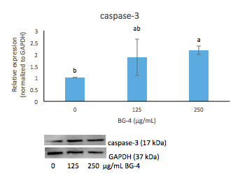

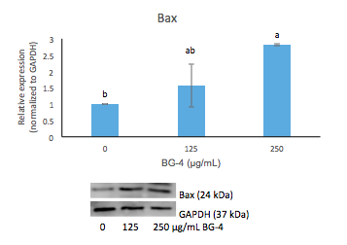

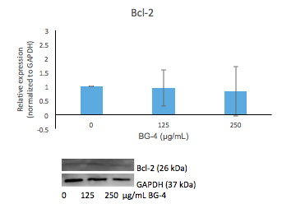

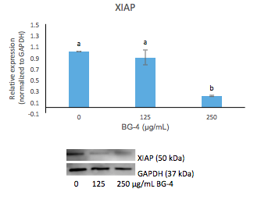

B.) 1AP p21 and CDK2 (cell cycle markers)

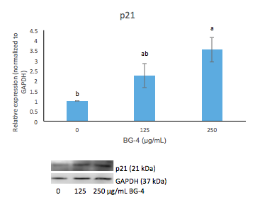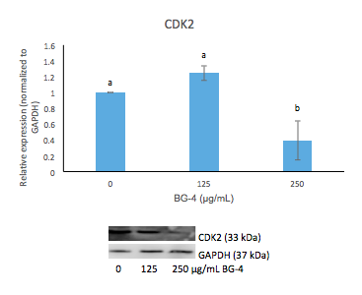

Figure 2: BG-4 mechanism of action in inducing apoptosis in OVCA cells (1AP cell line). (A) In 1AP-OVCA cells, BG-4 promoted apoptosis by increasing caspase-3 and BAX leading to a reduced expression of XIAP and no change in expression of Bcl-2. (B) In 1AP-OVCA cells, BG-4 increased the expression of p21 leading to a reduction in expression of CDK2. All analyses were done in at least two independent replicates. Mean values represented as bars with different letter(s) are statistically different from each other (P < 0.05, n=2).

A.)
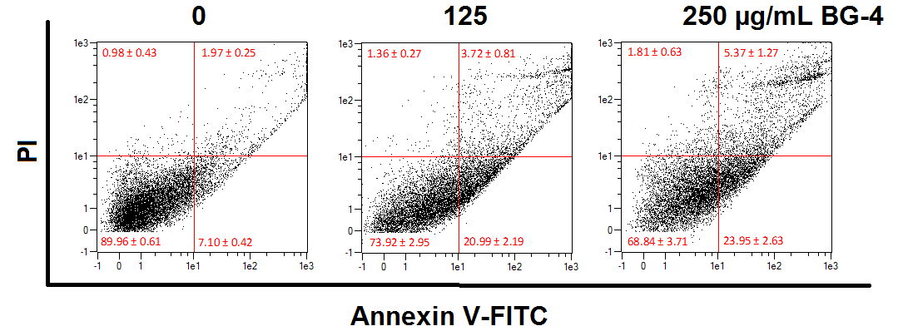

B.)

Figure 3: BG-4 induces apoptosis in OVCA 1AP cells as measured by flow cytommetry. (A) Treatment of cells with BG-4 led to an increased percentage of OVCA cells undergoing apoptosis. (B) Quantification of OVCA cells undergoing apoptosis as a result of BG-4 treatment. The live cells were from 90.0% (untreated) to 73.9% and 68.8% for 125 μg/mL and 250 μg/mL treatment, respectively. Early apoptotic cells were from 7.1% (untreated) to 21.0% and 24.0% for 125 μg/mL and 250 μg/mL treatment, respectively. Late apoptotic cells were from 2.0% (untreated) to 3.7% and 5.4% for 125 μg/mL and 250 μg/mL treatment, respectively. Necrotic cells were from 1.0% (untreated) to 1.4% and 1.8% for 125 μg/mL and 250 μg/mL treatment, respectively. Mean values represented as bars with different letter(s) are statistically different from each other (P < 0. 05, n=2).

