Gonadal Steroid Hormones Impact Perineuronal Net Density in an Age- Dependent Manner in the Medial Prefrontal Cortex of Mice

A Thesis Presented for the
Master of Arts
Degree
The University of Tennessee, Knoxville

Jessica Tremblay
December 2024

ACKNOWLEDGEMENTS
Thank you to my teammates and friends in Dr. Kalynn Schulz’ lab for always being there to provide advice and keep me sane- Marcia Chavez, AJ Castaneda, Sierra Lawler, Ian Warren, and Dr. Kalynn Schulz. A special thank you to my research assistants on this project, Kaitlin Parsons and Meg Maynor, for their time and energy. I literally could not have done this without you. Mom and Dad, I love you.

ABSTRACT
Adolescence is a key developmental period in which brain and behavioral changes coincide with pubertal onset and the secretion of gonadal steroid hormones. The brain's ability to reorganize and respond to stimuli, also known as neuroplasticity, is regulated by perineuronal nets (PNNs). PNN density increases across adolescence in the medial prefrontal cortex (mPFC); however, it remains unclear whether secretions of gonadal steroid hormones during puberty influence PNN development in the mPFC. The current study investigates if PNN density is regulated by hormones, age, or an interaction between these factors. To distinguish between these possibilities, male and female C57 mice were gonadectomized prior to the onset of puberty. After gonadectomy, males were administered testosterone and females were administered estradiol either prepubertally (P23), during adolescence (P40), or in adulthood (P63). Brains were collected after one week of steroidal hormone treatment. The prelimbic (PL) (A32) and infralimbic (IL) (A25) subregions of the mPFC were imaged on an immunofluorescent Keyence microscope, and the number of PNNs were counted. In the PL (A32) subregion, both male and female hormone-treated animals displayed an increase in PNN density only during adolescence and adulthood. These data suggest that gonadal steroid hormones regulate PNN development in an age-dependent manner. In contrast, no effects of hormone or age were observed in the IL (A25) subregion. These data may have implications for the increased mental health risks associated with early or late pubertal timing in humans.
Table of Contents
CHAPTER 1 INTRODUCTION 1
CHAPTER 2 MATERIALS AND METHODS 3
CHAPTER 3 RESULTS 7
CHAPTER 4 DISCUSSION 9
REFERENCES 13
APPENDIX 19
VITA 26

LIST OF TABLES
Table 1. PNN/ PV Colocalization in PL (A32) Males 20
Table 2. PNN/ PV Colocalization in PL (A32) Females 21
Table 3. PNN/ PV Colocalization in IL (A25) Males 22
Table 4. PNN/ PV Colocalization in IL (A25) Females 23

LIST OF FIGURES
Figure 1. Experimental Design 19
Figure 2. PNN density in the PL (A32) region of the medial prefrontal cortex 24
Figure 3. PNN density in the IL (A25) region of the medial prefrontal cortex 25

Chapter 1
Introduction
Gonadal steroid hormones are required for the normative development of biological systems important for cognition and behavior. Abnormalities in pubertal timing, particularly early pubertal onset in girls and late onset in boys, increase the risk of developing mental health disorders in the future. Puberty is a physiological event within adolescence that is characterized by a change in the neuroendocrine system that results in increased gonadal steroid hormone secretion. In addition to the hormonal and sexual development that occurs during puberty, adolescence is a period of heightened neural plasticity that influences cognitive, social, and emotional maturation. This cognitive growth is the result of increased development of the prefrontal cortex, a brain region responsible for attention, decision-making, and other higher-order cognitive processes. The brain is more susceptible to modification during periods of rapid developmental change (Scott et al., 1974). Underused neural connections are pruned, while others are strengthened through myelination (Johnson et al., 2009; Selemon, 2013). This process makes the brain more modifiable to experience, thus showing heightened neural plasticity. Certain developmental time points show increased sensitivity to these internal or external experiences (Fuhrmann et al., 2015; Reh et al., 2020; Knudsen, 2004). Previous research on these developmental periods focuses on sensory systems; for example, the neural underpinnings of vision are most responsive to light exposure in the early postnatal period compared to all other time points (Hubel & Wiesel, 1965). Less well understood are sensitive periods of behavioral development. Testosterone exposure before or during adolescence programs male reproductive behavior in rodents. For example, males that do not receive testosterone until adulthood fail to display adult-typical mating behavior (Schulz et al. 2009). This suggests a sensitive period for testosterone- dependent maturation of behavior closes after adolescence.
The neural mechanisms underlying the adolescent sensitive period for steroid-dependent behavioral maturation are currently unknown. One neural mechanism that may be involved is an extracellular matrix structure known as perineuronal nets (PNNs). This extracellular netting preferentially develops around inhibitory parvalbumin (PV) interneurons, stabilizing the PV cell’s synaptic connections and protecting its structural integrity (Carceller et al., 2022; Sorg et al., 2016). PNNs show unique developmental trajectories in different brain regions. In the medial prefrontal cortex (mPFC), these structures develop gradually across adolescence with their maturation coinciding with early adulthood (Carceller et al., 2022). A fully developed PNN then closes sensitive periods for sensory systems. However, it is unknown if PNNs in the mPFC are sensitive to steroid hormones, or if they regulate the timing of sensitivity to hormones during adolescence.
The current study aims to determine whether perineuronal net (PNN) development is sensitive to gonadal steroid hormones in an age-dependent manner in the medial prefrontal cortex (mPFC). We hypothesize that the age at which an animal receives gonadal steroid hormones will influence PNN density in the mPFC. We predict that hormone-treated animals will show an increase in PNN density during adolescence compared to the juvenile period and adulthood. Male and female C57 mice were used because they are a genetically identical inbred species. The mice were gonadectomized prior to puberty, after which they were given a hormone capsule implant as juvenile, adolescent, or adult animals. After one week of hormone treatment, brains were collected and processed with immunofluorescence to calculate PNN density and PNN/PV colocalization.

Chapter 2
Materials and Methods
2.1 Subjects
Seventy-two male and female genetically identical C57BL/6 mice were bred in the vivarium at the University of Tennessee Knoxville. Upon reaching postnatal day (PD) 21, animals were weaned and housed in 29.21 x 19.05 x 12.7cm cages with a same-sex and same-treatment partner. Cages were equipped with shredded aspen bedding (Teklad) and a nestlet. Animals had ad libitum access to phytoestrogen-free food (Teklad 2020x) and water in BPA free bottles and were housed in a 12:12 light/dark cycle. All procedures were done according to the University of Tennessee Knoxville’s Animal Care and Use Committee.
2.2 Experimental Design
On PD 22, all animals were either gonadectomized or received sham surgery in which they maintained intact gonads. Animals then received a subdermal implant of a silastic capsule that contained either estradiol (E), testosterone (T), or no hormone (blank) on PD 23 (juvenile), PD 40 (adolescent), or PD 63 (adult). Consequently, there were the following experimental groups (n = 3- 4): Juv. +E, +T, or +blank; Adol. +E, +T, or +blank; and Adult +E, +T, or +blank. Animals that received sham surgery did not receive a capsule and therefore have been separated from the aforementioned experimental groups. See Figure 1 in the Appendix for an experimental timeline of procedures. All Tables and Figures are located in the appendix.
2.3 Surgical Procedures
All surgeries were performed in a sterile manner under isoflurane anesthesia with a 2-5% flow rate. Buprenorphine (0.1 mg/kg) was administered subcutaneously prior to surgery, and ophthalmic ointment (Optixcare) was applied to the eyes to protect against corneal drying. The incision site was shaved and sterilized with 2% iodine swabs and 90% alcohol swabs. At the end of the surgery, animals were given subcutaneous injections of ketoprofen (0.3 mg/kg) and saline (0.3 mL) for pain relief and hydration.
For female ovariectomies, a 5 mm incision was made bilaterally through the skin and muscle wall of the hind flanks. Upon visualizing the ovary, it was clamped underneath with hemostats and removed by cauterization. The muscle wall was closed with a sterile suture (Monocryl, 5-0y303), and then the skin was closed with wound clips. For male castration, one 10 mm incision was made in the lower abdomen. The testes were then clamped underneath with hemostats; the vas deferens and blood vessels were tied with a sterile suture; and the testes were removed through cauterization. The muscle wall was then sutured, and the skin closed with wound clips.
On PD 23 (juvenile), PD 40 (adolescent) or PD 63 (adult), animals were administered a subcutaneous silastic capsule implant that contained untoasted sesame oil (Spectrum, Hain Celestial Group LLC) and either 17β-estradiol (MP Biomedicals, 101656), testosterone (Sigma-Aldrich, T1500), or a blank capsule containing only sesame oil. Intact, sham-surgery animals did not receive a capsule implant.
2.4 Perfusion and Brain collection
Animals were euthanized by transcardiac perfusion seven days after receiving the capsule implant. Before perfusions, animals were given an intraperitoneal injection of a ketamine/ xylazine (17 mg/ mL, 2.5 mg/mL) mixture (0.1 mg/kg). After they were anesthetized and unresponsive to a toe or tail pinch, 0.5 mL of cardiac blood was collected into EDTA-coated tubes and stored on wet ice to be centrifuged. The chest cavity was then opened. A 25G butterfly needle was inserted into the left ventricle, while the right atrium was cut to allow blood to flow out. After exsanguination, 0.9% saline, and then 4% paraformaldehyde, were pumped through the body to fix the tissue. The brain was then removed and stored in 4% paraformaldehyde for 24 hours before being moved into 30% sucrose for 48 hours. Finally, the brains were flash frozen on dry ice and stored in a -80°C freezer for future use.
2.5 Immunofluorescent staining
The brains were sectioned on a cryostat at 40µm sections. For staining, the borders of each slide were drawn with a hydrophobic pap pen. For the initial blocking procedure, the slides were incubated for 30 minutes at room temperature in 10% normal goat serum (G9023, Sigma), 5% triton-x (10% working stock solution), and phosphate-buffered saline (PBS). Then, the tissue was washed 3 times for 5 minutes each with PBS, after which they were incubated for 24 hours at room temperature with the primary antibodies Wisteria floribunda (WFA) (1:500, L1516-2MG, Sigma) and anti-mouse PV (1:1000, P3088, Sigma). Twenty-four hours later, the tissue was washed with PBS 3 times for 5 minutes each time. Secondary fluorescent fluorophore Alexa Fluor 488 streptavidin (1:1000, S32354, Invitrogen) and Cy5 were applied to the tissue sections and incubated for 4 hours at room temperature. The tissue was washed with PBS 2 times for 5 minutes each, and then a DAPI counterstain (1:1000, D1306, Invitrogen) was applied for 5 minutes. The tissue was then washed a final time with PBS for 5 minutes and put in a dark drawer to dry. The following day, all the slides were cover-slipped with Fluoromount-G (0100-20, Southern Biotech) and then stored at 4-8°C.
2.6 PNN and PV Quantification
The medial prefrontal cortex (mPFC) was imaged on an immunofluorescent BZ-X710 Keyence microscope at 20x magnification in the DAPI, GFP, and Cy5 channels. Every fourth tissue section was imaged, with a 120µm distance in between the imaged tissues. As such, the first tissue section was imaged, followed by the 5th section, and then the 9th section, etc. An average of 8-10 tissue sections per brain were imaged across the entire mPFC rostral to caudal. We then traced out the borders of the mPFC with ImageJ using a transparent template overlay of the 5th edition of Paxinos and Franklin's The Mouse Brain in Stereotaxic Coordinates (Paxinos & Franklin, 2019). The range in which we identified the mPFC was between bregma 2.77 and 1.33; we did not continue tracing beyond a fully formed corpus callosum.
In the 5th edition of Paxinos and Franklin's mouse brain atlas, Paxinos and Franklin (2019) associate each region of the mouse mPFC with its corresponding primate Brodmann’s Area (BA). The rodent prelimbic (PL) cortex is homologous to BA 32. The rodent infralimbic cortex is homologous to BA 25 (Bicks et. al., 2015). This study follows the guidelines of this newest edition; as such, the PL is referred to as A32, and the IL as A25 (Paxinos & Franklin, 2019). We chose to use these new guidelines for the mouse mPFC to provide further translational value to the study as it relates to potential mental health outcomes.
After tracing the mPFC, we used ImageJ to measure the cross-sectional area of each subregion from each brain section to later calculate density of perineuronal nets and PV neurons. This cross-sectional area was then used to calculate the sampled volume (µm³). We then manually counted the number of PNNs and PV cells within the region at a magnification of 150x with the computer screen on maximum brightness. A PNN was counted if it was at least 80% of a full circular ring shape, distinctly visible against the background, and if less than 80% full, included at least one visible neurite. A PV cell was counted if it was a solid, filled-in circle that was brighter than the surrounding background and visible from an average viewing distance of two feet from the computer screen. We counted individual PNNs and colocalized PNN/PV to address the phenotype of PNN-positive cells. Two researchers blind to experimental condition maintained inter- and intra-rater reliability (IRR) of at least 90% for counts. Halfway through data collection, PNN and PNN/PV colocalization were recounted in 1-2 tissue sections across 8 brains for a total of 11 sections. At the end of data collection, they were recounted in 1-2 tissue sections across 9 different brains for a total of 10 sections. The tissue sections chosen for IRR were equally representative of the rostral to caudal extent of the mPFC.
2.7 Statistical analysis
PNN density was analyzed by a two-factor between-subject ANOVA with age (juvenile, adolescent, adult) and treatment (GDX + blank, GDX + T/E) using the following calculation:
$$PNN density µm3 = \left(\frac{PNN \#}{sampled volume mm}\right)× 1000$$

PNN density analysis was done with a sample size of 3-4 per group. Data were separated by sex, but not by hemisphere due to an inability to distinguish between the left and right during tissue processing. A Fisher’s LSD test was conducted to follow up any significant interactions between age and treatment, and alpha was set to 0.05 for all analyses.
To investigate the cell phenotype around which PNNs form, the colocalization of PNN and PV cells was quantified in a subset of the animals (n = 1-2). The data are reported as percentages using the following calculation:
$$PNN+PV colocalization \%= \left(\frac{PNN+PV\#}{total PNN\#}\right)×100$$
All data Tables and Figures are located in the appendix.

Chapter 3
Results
3.1 PL (A32)
3.1.1 Males
PNN density
In the PL (A32) region of males, there was a significant main effect of age (F (2, 16) = 5.24, p = 0.02), in which adolescents (p = 0.03) and adults (p = 0.005) showed a higher PNN density than juveniles. There was also a significant main effect of testosterone, where testosterone-treated males showed a higher PNN density than blank-treated males (F (1, 16) = 5.53, p = 0.03). Additionally, there was a trending, but not statistically significant, interaction between age and testosterone treatment (F (2, 16) = 2.77, p = 0.09). Testosterone treatment increased PNN density in adolescents (t (5) = -4.12, p = 0.005) and in adult males (t (6) = -3.30, p = 0.008) compared to testosterone-treated juvenile males in the PL (A32) region of the mPFC (Figure 2A).
PNN colocalization with PV
The average percentage of PNNs that surrounded PV cells in the PL (A32) of male mice is presented according to age and testosterone treatment (see Table 1).
3.1.2 Females
PNN Density
In the PL (A32) region of females, there was a trend towards a main effect of age (F (2, 16) = 2.95, p = 0.08) in which PNN density increased in adolescents (p = 0.08) and adults (p = 0.03) compared to juveniles. However, there was no main effect of estradiol treatment (F (1, 16) = 0.54, p = 0.47) or an interaction between age and estradiol treatment (F (2, 16) = 1.71, p = 0.21). Although the interaction between age and estradiol treatment was not statistically significant, we conducted a follow-up comparison of the juvenile and adolescent animals that were treated with estradiol because we noticed non-overlapping variability in PNN density between these groups. These t- tests found that estradiol-treated adolescent (t (6) = -3.61, p = 0.006) and adult (t (5) = -3.53, p = 0.008) females showed significantly higher PNN density than juvenile females. After applying a Bonferroni correction, the p-values remained significant (Figure 2B).
PNN colocalization with PV
The average percentage of PNNs that surrounded PV cells in the PL (A32) of female mice is presented according to age and estradiol treatment (see Table 2).
3.2 IL (A25)
3.2.1 Males
PNN density
In the IL (A25) region of males, PNN density was not affected by age (F (2, 16) = 0.81, p = 0.46), testosterone treatment (F (1, 16) = 0.007, p = 0.93), or an interaction of age and testosterone (F (2, 16) = 0.11, p = 0.89) (Figure 3A).
PNN colocalization with PV
The average percentage of PNNs that surrounded PV cells in the IL (A25) of male mice is presented according to age and testosterone treatment (see Table 3).
3.2.2 Females
PNN density
In the IL (A25) region of female mice, there was no significant main effect of age (F (2, 18) = 0.43, p = 0.66) nor was there a main effect of estradiol (F (1, 18) = 2.35, p = 0.14). There was also no interaction between age and estradiol treatment (F (2, 18) = 0.96, p = 0.40) in PNN density in the IL (A25) of female mice (Figure 3B).
PNN colocalization with PV
The average percentage of PNNs that surrounded PV cells in the IL (A25) of female mice is presented according to age and estradiol treatment (see Table 4).

Chapter 4
Discussion
The current study investigated how the timing of gonadal steroid hormone exposure impacts perineuronal net (PNN) development and expression. We hypothesized that the age that an animal is exposed to gonadal steroid hormones will impact PNN development in the medial prefrontal cortex (mPFC). We predicted an increase in PNN density at the adolescent time point in hormone-treated animals compared to adolescent animals that did not receive hormone treatment. Final results show that, in the PL (A32) subregion of the mPFC, exposure to gonadal steroid hormones increases PNN density in adolescence and adulthood in C57 male and female mice, while blank- treated animals do not show significant differences in PNN density across age. Hormone-treated animals also show a near-identical increase in PNN density as the gonad-intact surgical controls. Given that age-dependent increases were not observed in the blank-treated animals, our data suggest that gonadal steroid hormones are required for PNN development in adolescence and adulthood.
Sensitive periods are developmental time periods during which an experience has the strongest impact on its respective neuronal wiring. The closure of a sensitive period in the visual system coincides with the maturation of perineuronal nets. However, our data suggests that PNNs themselves have a sensitive period of development. Considering that gonadal steroid hormones did not increase PNNs during the juvenile period but did increase them in the adolescent period, we suggest that adolescence marks the opening for a sensitive period to gonadal hormone exposure on PNN development in PL (A32) of the mPFC. Furthermore, PNN density is responsive to gonadal steroid hormones in both adolescence and adulthood, indicating that adolescence is not an isolated sensitive period for hormone-dependent PNN development, but rather the beginning of a sensitive period that persists into adulthood. This continued responsiveness to the presence of hormones indicates a protracted sensitive period that does not close in early adulthood.
Although previous studies have found age-dependent effects on PNN density, this literature does not provide the underlying catalyst for such changes, thus influencing possible interpretations of the data (Drzewiecki et al., 2020; Baker et al., 2017; Mauney et al., 2013; Paylor et al., 2016; Pizzorusso et al., 2002). Importantly, these studies do not describe what the developmental period is sensitive to. For example, the discovery that adolescent and adult rats showed increased PNN number compared to juveniles (Baker et al., 2017) allows for the interpretation that this is the closing of a sensitive period only if we are using PNNs as a tool to define a sensitive period. Rather, our own data show that there is a sensitive period for PNN development itself. Our experimental design takes into account what the brain is sensitive to and when the period begins and ends. Thus, we would argue that this pattern of increasing PNN density in adolescence is indicative of a sensitive period opening because we are showing that PNN development is sensitive to the presence of hormones specifically in adolescence compared to other time points. Given that our blank-treated animals did not show these age-dependent increases, we can further conclude that the gonadal steroid hormones were the driving factor of this sensitive period opening.
We conclude that this sensitive period opening is specific to the PL (A32) subregion because hormone exposure relative to age of exposure did not cause any changes in PNN density in either males or females in the IL (A25) region of the mPFC. However, the IL (A25) does have a unique PNN density pattern in female animals compared to the PNN density in IL (A25) of female controls. The gonad-intact surgical controls show a gradual increase in PNN density across age that is not seen in the blank-treated or estradiol-treated animals. Intact females had typical hormonal development, meaning they were exposed to ovarian secretions, importantly estradiol and progesterone. The traditional age-dependent pattern in the gonad- intact animals may be due to a combined effect of the estradiol and progesterone. Previous research shows that progesterone is required for PNN development in the medial preoptic area (mPOA) (Uriarte et al., 2020). This effect was seen in animals subjected to estradiol- and progesterone- stimulated pregnancy after ovariectomy, indicating the sustained levels of both of these gonadal hormones increases PNNs and that estradiol alone is not the driving factor of PNN development in the mPOA or IL (A25). Note that the possible involvement of progesterone is also a subregion-specific effect because we do not see any indication that progesterone is involved in the growth of PNNs in the PL (A32) subregion.
Although PL (A32) and IL (A25) show distinct PNN densities, they both show interesting patterns of PNN/ PV colocalization that bring to light a new question about the cell types that produce PNNs. In PL (A32), there is a notable decrease in colocalization of PNNs surrounding PV cells in adolescence in male animals treated with testosterone. However, since PNN density is increasing, this indicates that PNNs are continuing to mature, but they are not developing solely around PV neurons. In the IL (A25) region, adolescent and adult animals show a higher percentage of PNN/ PV colocalization than juvenile animals, but we do not see these age-dependent changes in PNN density. It is plausible that some of these PNNs in IL (A25) are enwrapping neurons that are not PV cells, and this was the population of PNNs that is stabilized across age. Therefore, only the PNNs that were colocalized with PV cells increased from the juvenile period to the adolescent period. Our data show that the percentage of PNNs surrounding PV cells was at most 54.6% in PL (A32) (Table 1-2) and 36.8% in IL (A25) (Table 3-4). Similarly, previous work has found that about one-third of PNNs surround other neuronal populations (Baker et al., 2017). PNNs develop around various cell types in a region-dependent manner, such as CamKII-expressing cells in the rodent hippocampus, stellate cells in the rodent medial entorhinal cortex, and excitatory bushy cells in the human cochlear nucleus of the brainstem (Carstens et al., 2016; Lensjø et al., 2017; Wagoner & Kulesza, 2009). However, as of this time, we are unaware of any literature that analyzes PNN colocalization with excitatory cells in the medial prefrontal cortex. Future research should aim to fill this gap in the literature.
Despite our growing knowledge of PNN formation and expression, we still do not know the mechanisms of how gonadal steroid hormones affect PNNs. One possibility involves the activation of estrogen receptors (Juraska, 2024). Estrogen receptors, particularly estrogen receptor-beta (ER-ß), are found throughout the brain, including regions important to cognition and emotion, such as the prefrontal cortex, hippocampus, and amygdala (Iqbal et al., 2024). Animals whose gonads release testosterone can still be impacted by ER binding events because testosterone is converted into estradiol through the aromatase enzyme. Administration of ER-ß agonists, such as estradiol, results in increased synapse density and increased mushroom dendritic spine density in the CA1 region of the hippocampus (Woolley & McEwen, 1992; Liu et al., 2008). Within the prefrontal cortex, ovariectomy leads to decreased spine density (Wallace et al., 2006). It has also been noted that gonadectomy in female rats results in more neurons and glial cells in the medial prefrontal cortex, indicating that estrogen may play a role in synaptic pruning or reorganization of gray matter during adolescence (Koss et al., 2015; Johnson et al., 2009; García-Segura et al., 1994). These findings provide further evidence that estradiol strengthens neural growth and connections through increased BDNF levels in brain regions that are important for memory and cognition (Luine, 2008; Luine & Frankfurt, 2013). Accordingly, estrogen administration promotes acquisition of spatial memories and recognition memories, such as object placement tasks, through activation of ER-ß in the hippocampus (Daniel et al., 1997; Luine et al., 1998; Liu et al., 2008). These functional implications of estrogen exposure indicate that it would be advantageous for the brain to protect these synaptic connections through the formation of PNNs. Parvalbumin (PV) interneurons also widely contain estrogen receptors, specifically ER-ß, to which estradiol can bind after being released by the gonads (Blurton-Jones & Tuszynski, 2002). It is plausible that estradiol binding to ER-ß on PV cells is the first step in a cascade of events that lead to the PV cell releasing the core molecules and proteins that comprise a PNN (Uriarte et al., 2020).
Perineuronal net formation and expression is becoming increasingly important in our quest to understand the neurobiology of human neuropsychiatric disorders (Pantazopoulos & Berretta, 2016). Post-mortem brain tissue of patients with schizophrenia, bipolar disorder, and those with psychosis showed reduced PNN density and intensity in the prefrontal cortex (Mauney et al., 2013; Alcaide et al., 2019; Enwright et al., 2016). In addition, symptoms of psychiatric illnesses, such as schizophrenia, typically present in adolescence or early adulthood (Weinburger, 1987). Our data supports that perineuronal net development also escalates in adolescence and early adulthood, likely accelerated by the surge of gonadal steroid hormones in adolescence. Although the underlying mechanisms are unknown, PNN development, or abnormal development as a result of atypical pubertal timing, may contribute to the pathophysiology of mental health disorders. In future research, it would be worthwhile to examine how hormonal influences on PNN development impact behavior and cognition in rodents through social interaction and memory testing to provide further translational value to this research.
In summary, exposure to hormones in both adolescence and adulthood increases PNN density in the medial prefrontal cortex in male and female C57 mice. Data indicate there may be a sensitive period for PNN development that responds to the surge in gonadal steroid hormones released during adolescence. Future research, such as manipulating PNN growth and function, is needed to better understand the systematic mechanisms behind hormones and synaptic plasticity, in order to further our understanding of how pubertal timing increases the risk of psychiatric disorders.

References
Alcaide, J., Guirado, R., Crespo, C., Blasco-Ibáñez, J. M., Varea, E., Sanjuan, J., & Nacher, J. (2019). Alterations of perineuronal nets in the dorsolateral prefrontal cortex of neuropsychiatric patients. International Journal of Bipolar Disorders, 7(1), 24. https://doi.org/10.1186/s40345-019-0161-0
Baker, K. D., Gray, A. R., & Richardson, R. (2017). The development of perineuronal nets around parvalbumin gabaergic neurons in the medial prefrontal cortex and basolateral amygdala of rats. Behavioral Neuroscience, 131(4), 289–303. https://doi.org/10.1037/bne0000203
Bicks, L. K., Koike, H., Akbarian, S., & Morishita, H. (2015). Prefrontal Cortex and Social Cognition in Mouse and Man. Frontiers in Psychology, 6. https://doi.org/10.3389/fpsyg.2015.01805
Blurton-Jones, M., & Tuszynski, M. H. (2002). Estrogen Receptor-Beta Colocalizes Extensively with Parvalbumin-Labeled Inhibitory Neurons in the Cortex, Amygdala, Basal Forebrain, and Hippocampal Formation of Intact and Ovariectomized Adult Rats. Journal of Comparative Neurology. DOI: 10.1002/cne.10393
Carceller, H., Gramuntell, Y., Klimczak, P., & Nacher, J. (2022). Perineuronal Nets: Subtle Structures with Large Implications. The Neuroscientist, 107385842211063. https://doi.org/10.1177/10738584221106346
Carstens, K. E., Phillips, M. L., Pozzo-Miller, L., Weinberg, R. J., & Dudek, S. M. (2016). Perineuronal Nets Suppress Plasticity of Excitatory Synapses on CA2 Pyramidal Neurons. The Journal of Neuroscience, 36(23), 6312–6320. https://doi.org/10.1523/JNEUROSCI.0245-16.2016
Daniel, J. M., Fader, A. J., Spencer, A. L., & Dohanich, G. P. (1997). Estrogen Enhances Performance of Female Rats during Acquisition of a Radial Arm Maze. Hormones and Behavior, 32(3), 217–225. https://doi.org/10.1006/hbeh.1997.1433
Delevich, K., Klinger, M., Okada, N. J., & Wilbrecht, L. (2021). Coming of age in the frontal cortex: The role of puberty in cortical maturation. Seminars in Cell & Developmental Biology, 118, 64–72. https://doi.org/10.1016/j.semcdb.2021.04.021
Dityatev, A., Bruckner, G., Dityateva, G., Grosche, J., Kleene, R., & Schachner, M. (2007). Activity- dependent formation and functions of chondroitin sulfate-rich extracellular matrix of perineuronal nets. Developmental Neurobiology. DOI: 10.1002/dneu20361
Drzewiecki, C. M., Willing, J., & Juraska, J. M. (2020). Influences of age and pubertal status on number and intensity of perineuronal nets in the rat medial prefrontal cortex. Brain Structure and Function, 225(8), 2495–2507. https://doi.org/10.1007/s00429-020-02137-z
Enwright, J. F., Sanapala, S., Foglio, A., Berry, R., Fish, K. N., & Lewis, D. A. (2016). Reduced Labeling of Parvalbumin Neurons and Perineuronal Nets in the Dorsolateral Prefrontal Cortex of Subjects with Schizophrenia. Neuropsychopharmacology, 41(9), 2206–2214. https://doi.org/10.1038/npp.2016.24
Franklin, K. B. J., & Paxinos, G. (2019). The mouse brain in stereotaxic coordinates (5th ed.). Academic Press.
Fuhrmann, D., Knoll, L. J., & Blakemore, S.-J. (2015). Adolescence as a Sensitive Period of Brain Development. Trends in Cognitive Sciences, 19(10), 558–566. https://doi.org/10.1016/j.tics.2015.07.008
García-Segura, L. M., Chowen, J. A., Párducz, A., & Naftolin, F. (1994). Gonadal hormones as promoters of structural synaptic plasticity: Cellular mechanisms. Progress in Neurobiology, 44(3), 279–307. https://doi.org/10.1016/0301-0082(94)90042-6
Granata, L., Gildawie, K. R., Ismail, N., Brenhouse, H. C., & Kopec, A. M. (2022). Immune signaling as a node of interaction between systems that sex-specifically develop during puberty and adolescence. Developmental Cognitive Neuroscience, 57, 101143. https://doi.org/10.1016/j.dcn.2022.101143
Hubel, D. H., & Wiesel, T. N. (1964). Effects of monocular deprivation in kittens. Naunyn-Schmiedebergs Archiv For Experimentelle Pathologie Und Pharmakologie, 248(6), 492–497. https://doi.org/10.1007/BF00348878
Iqbal, J., Huang, G.-D., Xue, Y.-X., Yang, M., & Jia, X.-J. (2024). Role of estrogen in sex differences in memory, emotion and neuropsychiatric disorders. Molecular Biology Reports, 51(1), 415. https://doi.org/10.1007/s11033-024-09374-z
Johnson, S. B., Blum, R. W., & Giedd, J. N. (2009). Adolescent Maturity and the Brain: The Promise and Pitfalls of Neuroscience Research in Adolescent Health Policy. Journal of Adolescent Health, 45(3), 216–221. https://doi.org/10.1016/j.jadohealth.2009.05.016
Juraska, J. M. (2024). The last stage of development: The restructuring and plasticity of the cortex during adolescence especially at puberty. Developmental Psychobiology, 66(2), e22468. https://doi.org/10.1002/dev.22468
Knudsen, E. I. (2004). Sensitive Periods in the Development of the Brain and Behavior. Journal of Cognitive Neuroscience. 16(8).
Koss, W. A., Lloyd, M. M., Sadowski, R. N., Wise, L. M., & Juraska, J. M. (2015). Gonadectomy before puberty increases the number of neurons and glia in the medial prefrontal cortex of female, but not male, rats: Prepubertal Gonadectomy and the mPFC. Developmental Psychobiology, 57(3), 305–312. https://doi.org/10.1002/dev.21290
Lensjø, K. K., Christensen, A. C., Tennøe, S., Fyhn, M., & Hafting, T. (2017). Differential Expression and Cell-Type Specificity of Perineuronal Nets in Hippocampus, Medial Entorhinal Cortex, and Visual Cortex Examined in the Rat and Mouse. Eneuro, 4(3), ENEURO.0379-16.2017. https://doi.org/10.1523/ENEURO.0379-16.2017
Liu, F., Day, M., Muñiz, L. C., Bitran, D., Arias, R., Revilla-Sanchez, R., Grauer, S., Zhang, G., Kelley, C., Pulito, V., Sung, A., Mervis, R. F., Navarra, R., Hirst, W. D., Reinhart, P. H., Marquis, K. L., Moss, S. J., Pangalos, M. N., & Brandon, N. J. (2008). Activation of estrogen receptor-β regulates hippocampal synaptic plasticity and improves memory. Nature Neuroscience, 11(3), 334–343. https://doi.org/10.1038/nn2057
Luine, V. N. (2008). Sex Steroids and Cognitive Function. Journal of Neuroendocrinology, 20(6), 866–872. https://doi.org/10.1111/j.1365-2826.2008.01710.x
Luine, V., & Frankfurt, M. (2013). Interactions between estradiol, BDNF and dendritic spines in promoting memory. Neuroscience, 239, 34–45. https://doi.org/10.1016/j.neuroscience.2012.10.019
Luine, V. N., Richards, S. T., Wu, V. Y., & Beck, K. D. (1998). Estradiol Enhances Learning and Memory in a Spatial Memory Task and Effects Levels of Monoaminergic Neurotransmitters. Hormones and Behavior, 34(2), 149–162. https://doi.org/10.1006/hbeh.1998.1473
Mauney, S. A., Athanas, K. M., Pantazopoulos, H., Shaskan, N., Passeri, E., Berretta, S., & Woo, T.-U. W. (2013). Developmental Pattern of Perineuronal Nets in the Human Prefrontal Cortex and Their Deficit in Schizophrenia. Biological Psychiatry, 74(6), 427–435. https://doi.org/10.1016/j.biopsych.2013.05.007
Pantazopoulos, H., & Berretta, S. (2016). In Sickness and in Health: Perineuronal Nets and Synaptic Plasticity in Psychiatric Disorders. Neural Plasticity, 2016, 1–23. https://doi.org/10.1155/2016/9847696
Paylor, J. W., Lins, B. R., Greba, Q., Moen, N., de Moraes, R. S., Howland, J. G., & Winship, I. R. (2016). Developmental disruption of perineuronal nets in the medial prefrontal cortex after maternal immune activation. Scientific Reports, 6(1), 37580. https://doi.org/10.1038/srep37580
Paylor, J. W., Wendlandt, E., Freeman, T. S., Greba, Q., Marks, W. N., Howland, J. G., & Winship, I. R. (2018). Impaired Cognitive Function after Perineuronal Net Degradation in the Medial Prefrontal Cortex. Eneuro, 5(6), ENEURO.0253-18.2018. https://doi.org/10.1523/ENEURO.0253-18.2018
Pizzorusso, T., Medini, P., Berardi, N., Chierzi, S., Fawcett, J. W., & Maffei, L. (2002). Reactivation of Ocular Dominance Plasticity in the Adult Visual Cortex. Science, 298(5596), 1248–1251. https://doi.org/10.1126/science.1072699
Reh, R. K., Dias, B. G., Nelson, C. A., Kaufer, D., Werker, J. F., Kolb, B., Levine, J. D., & Hensch, T. K. (2020). Critical period regulation across multiple timescales. Proceedings of the National Academy of Sciences, 117(38), 23242–23251. https://doi.org/10.1073/pnas.1820836117
Schulz, K. M., Zehr, J. L., Salas-Ramirez, K. Y., & Sisk, C. L. (2009). Testosterone Programs Adult Social Behavior before and during, But Not after, Adolescence. Endocrinology, 150(8), 3690–3698. https://doi.org/10.1210/en.2008-1708
Scott, J. P., Stewart, J. M., & de Ghett, V. J. (1974). Critical periods in the organization of systems. Developmental Psychobiology, 7(6), 489-513. https://doi.org/10.1002/dev.420070602
Selemon, L. D. (2013). A role for synaptic plasticity in the adolescent development of executive function. Translational Psychiatry, 3(3), e238–e238. https://doi.org/10.1038/tp.2013.7
Sorg, B. A., Berretta, S., Blacktop, J. M., Fawcett, J. W., Kitagawa, H., Kwok, J. C. F., & Miquel, M. (2016). Casting a Wide Net: Role of Perineuronal Nets in Neural Plasticity. The Journal of Neuroscience, 36(45), 11459–11468. https://doi.org/10.1523/JNEUROSCI.2351-16.2016
Uriarte, N., Ferreño, M., Méndez, D., & Nogueira, J. (2020). Reorganization of perineuronal nets in the medial Preoptic Area during the reproductive cycle in female rats. Scientific Reports, 10(1), 5479. https://doi.org/10.1038/s41598-020-62163-z
Villa, A., Vegeto, E., Poletti, A., & Maggi, A. (2016). Estrogens, Neuroinflammation, and Neurodegeneration. Endocrine Reviews, 37(4), 372–402. https://doi.org/10.1210/er.2016-1007
Wagoner, J. L., & Kulesza, R. J. (2009). Topographical and cellular distribution of perineuronal nets in the human cochlear nucleus. Hearing Research, 254(1–2), 42–53. https://doi.org/10.1016/j.heares.2009.04.008
Wallace, M., Luine, V., Arellanos, A., & Frankfurt, M. (2006). Ovariectomized rats show decreased recognition memory and spine density in the hippocampus and prefrontal cortex. Brain Research, 1126(1), 176–182. https://doi.org/10.1016/j.brainres.2006.07.064
Weinberger, D.R., 1987. Implications of normal brain development for the pathogenesis of schizophrenia. Arch. Gen. Psychiatry 44 (7), 660–669.
Woolley C.S. & McEwen B.S (1992). Estradiol mediates fluctuation in hippocampal synapse density during the estrous cycle in the adult rat. J Neuroscience; 12: 2549–2554.
Zuloaga, D. G., Heck, A. L., De Guzman, R. M., & Handa, R. J. (2020). Roles for androgens in mediating the sex differences of neuroendocrine and behavioral stress responses. Biology of Sex Differences, 11(1), 44. https://doi.org/10.1186/s13293-020-00319-2

Appendix
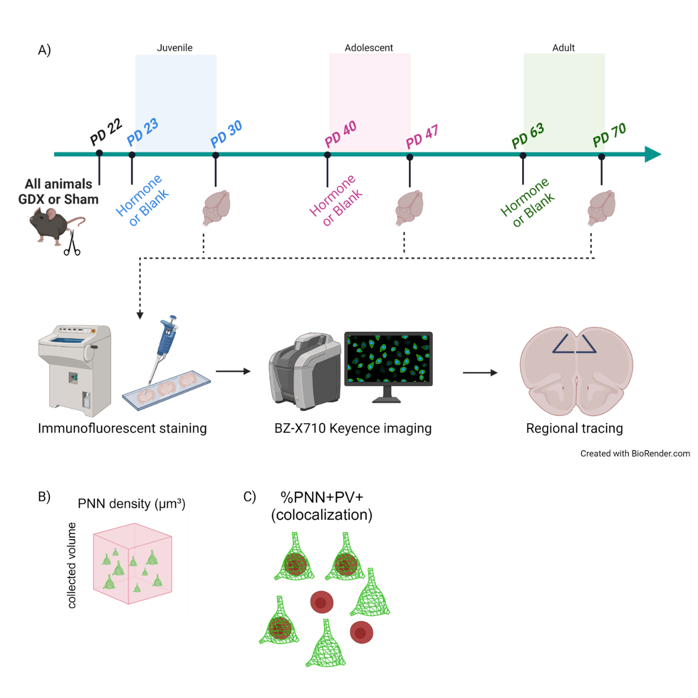
Figure 1. Experimental Design

Table 1. PL (A32) Male
 | Juvenile | Adolescent | Adult
 | M (SD) | M (SD) | M (SD)
Testosterone | 54.6% (9.03) | 23.61% | 53.60% (1.39)
Blank | 17.22% (8.30) | 39.09% (29.57) | 36.62%
Average percent of PNNs colocalized with PV cells in the PL (A32) of male mice. Sample size of 1-2 animals per group. Presented as M (SD). Those with a sample size of 1 do not have a SD.

Table 2. PL (A32) Female
 | Juvenile | Adolescent | Adult
 | M (SD) | M (SD) | M (SD)
Estradiol | 21.78% (23.87) | 21.97% (8.31) | 33.20% (3.12)
Blank | 37.60% (31.51) | 20.16% (14.48) | 37.41% (3.16)
Average percent of PNNs colocalized with PV cells in the PL (A32) of female mice. Sample size of 1-2 animals per group. Presented as M (SD).

Table 3. IL (A25) Male
 | Juvenile | Adolescent | Adult
 | M (SD) | M (SD) | M (SD)
Testosterone | 15.00% (7.07) | 33.33% | 18.75% (8.84)
Blank | 1.39% (1.96) | 28.90% (3.65) | 36.84%
Average percent of PNNs colocalized with PV cells in the IL (A25) of male mice, with a sample size of 1-2 animals per group. Presented as M (SD). Those with a sample size of 1 do not have a SD.

Table 4. IL (A25) Female
 | Juvenile | Adolescent | Adult
 | M (SD) | M (SD) | M (SD)
Estradiol | 16.75% (7.05) | 22.39% (17.52) | 21.78% (1.02)
Blank | 8.89% (12.57) | 16.96% (5.13) | 12.38% (10.78)
Average percent of PNNs colocalized with PV cells in the IL (A25) of female mice, with a sample size of 1-2 animals per group. Presented as M (SD).

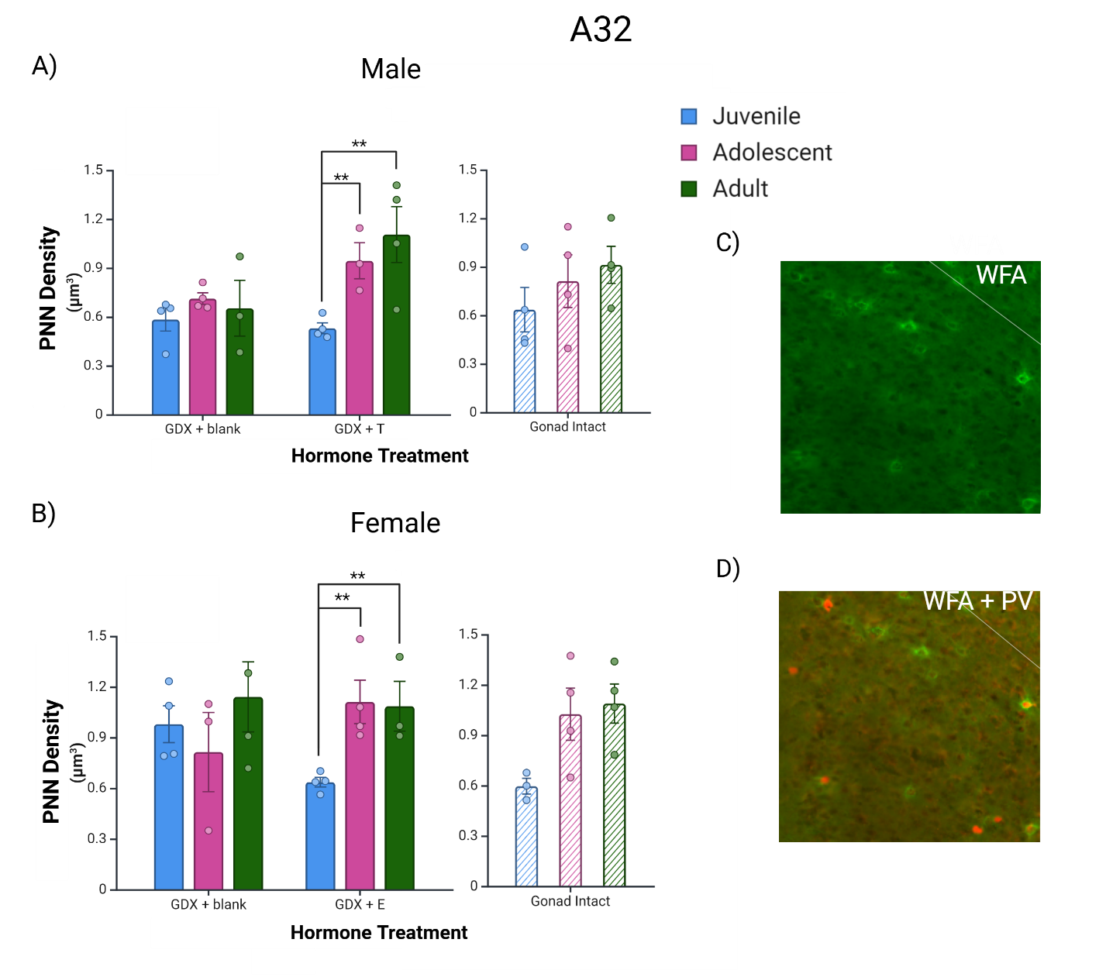
Figure 2. PNN density in the PL (A32) region of the medial prefrontal cortex. All male animals were treated with testosterone, and all female animals were treated with estradiol. (A) Hormone-treated males show higher PNN density when given hormone as adolescents and adults than when given hormone as juveniles. (B) Hormone-treated females also show higher PNN density when treated as adolescents and adults rather than juveniles. (C-D) PNNs (green WFA) and PNN/PV colocalization (green WFA/ red PV) in the PL (A32). Intact surgical controls are shown for comparison. T- testosterone, E- estradiol. **p < .01

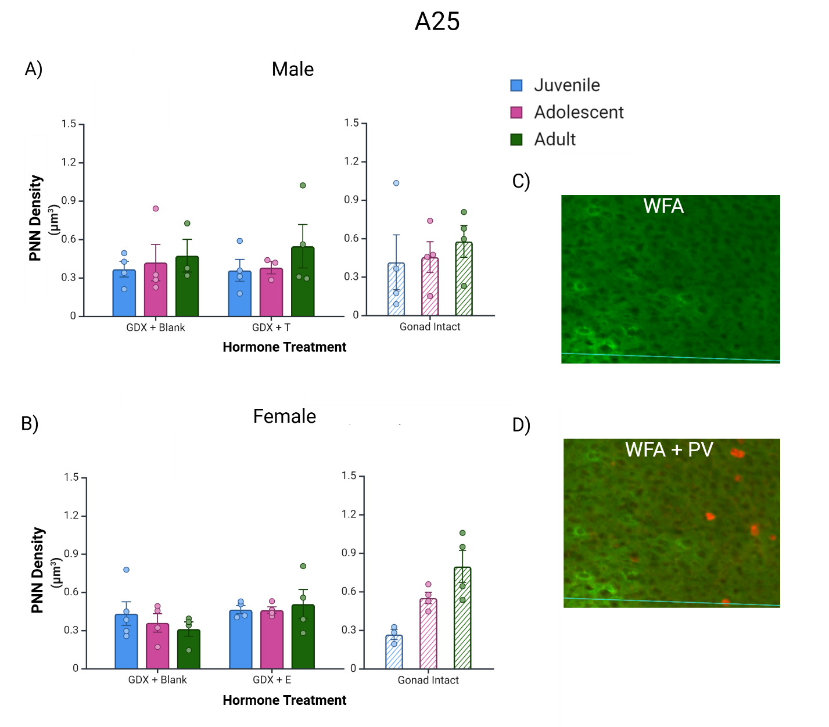
Figure 3. PNN density in the IL (A25) region of the medial prefrontal cortex. All male animals were treated with testosterone, and all female animals were treated with estradiol. (A-B) Neither male nor female animals show effects of hormone treatment or age on PNN density in the IL (A25) region. (C-D) PNNs (green WFA) and PNN/PV colocalization (green WFA/ red PV) in the IL (A25). Intact surgical controls are shown for comparison. T- testosterone, E- estradiol.

Vita
Jessica Tremblay began neuroscience research as an undergraduate research assistant in Dr. Rachel Kohman’s lab at the University of North Carolina Wilmington. After graduating from UNCW in 2020, she worked as a laboratory technician in Dr. Alexandra Badea’s lab at Duke University. In the fall of 2022, she started graduate school at the University of Tennessee Knoxville in the Department of Psychology to pursue a master’s degree in Experimental Psychology with a concentration in Neuroscience and Behavior. She will continue on in UTK’s PhD program in Experimental Psychology following her Master’s defense.

