Decoding the Precambrian silica cycle using silicon isotopes from quartz in chert and iron formation

A Dissertation Presented for the
Doctor of Philosophy
Degree
The University of Tennessee, Knoxville

Latisha A. Brengman
March 2015

Copyright © 2015 by Latisha A. Brengman.
All rights reserved.

DEDICATION

I dedicate this work to all those who helped in its creation.

ACKNOWLEDGEMENTS

Thank you to my committee, friends and family.

ABSTRACT

This is a sample Word document that can be used as a template in formatting your thesis/dissertation. Your abstract must be 350 words or fewer. If you are using special characters, you’ll want to spell them out between square brackets after each time you use them (this is in the abstract only. It’s not necessary elsewhere in the document, although use of special characters in the title is prohibited.)
For our purposes a special character is any character which cannot be found on your typical English language keyboard. Because of how your abstract is used in the cataloging process, you will want to tell people how to interpret your special character in case the character itself gets garbled. So, if I wanted to use the µ [micro] character in my abstract, I would have to tell people how to interpret it. Since you’re the expert, you decide how to best interpret that character. It could be µ [micro] or µ [mu], whichever would make the most sense if the symbol itself cannot be replicated
PREFACE

This page is optional.

TABLE OF CONTENTS

CHAPTER I Introduction to chert and iron formation 1
Defining chert 1
Heading 2 1
Heading 3 1
Heading 3 1
Heading 2 1

CHAPTER II Textures and geochemistry of a suite of altered volcanic rocks and jaspilite from the ~2.72 Ga Hunter Mine Group in the Abitibi Greenstone Belt: implications for using geochemical fingerprints
3
Heading 2 3
Heading 3 3
Heading 3 3
Heading 3 3
CHAPTER III Materials and Methods 5
Heading 2 5
Heading 3 5
Heading 3 5
Heading 2 5
Heading 3 5
Heading 3 5
Heading 2 5
CHAPTER IV Results and Discussion 7
Heading 2 7
CHAPTER V Conclusions and Recommendations 8
LIST OF REFERENCES 9
APPENDIX 11
Vita 13

LIST OF TABLES

Table Page

Table 1. Table title. 3

LIST OF FIGURES

Figure 1. Shapes. 5

CHAPTER I
Introduction TO CHERT AND IRON FORMATION

CHAPTER II

Textures and geochemistry of a suite of altered volcanic rocks and jaspilite from the ~2.72 Ga Hunter Mine Group in the Abitibi Greenstone Belt: implications for using geochemical fingerprints

ABSTRACT

We investigated a group of rocks from the 2.72 Ga Hunter Mine Group (HMG), Abitibi Greenstone Belt, Canada (Mueller and Mortensen, 2002) which represents a collapsed subaqueous caldera, associated with volcanogenic massive sulfide deposits (VMS), where pervasive hydrothermal alteration resulted in extensive silicification of volcanic edifice rocks (Mueller and Mortensen, 2002). The least altered volcanic rocks (Group 1: felsic volcanic rocks) have primary igneous rock textures, and are characterized by volcanic and/or volcaniclastic major element (ME), trace element (TE), and rare earth element (REE) chemistries expected for felsic igneous rocks in the region. Group 2 rocks (altered volcanic rocks) preserve volcanic phenocrysts and/or matrix material, but have been partly silicified, texturally evident by the development of chert lenses. Group 2 samples possess transitional ME, TE, and REE geochemistry, atypical of the host volcanic rocks, but similar to seawater. The most altered samples (Group 3) consist of chert ± iron-rich rocks (jaspilite), with remnant (locally very faint) clasts, glass shards, lapilli, pseudo-fiamme, and micro-brecciated textures. Mineralogically and compositionally, Group 3 jaspilite rocks resemble primary chemical sediments. However, remnant volcanic textures can be traced through Groups 2 and 3 and show a progressive compositional replacement from rhyolite, to rhyolite with patchworks of chert, to chert ± iron minerals. Based on textural evidence, we propose that in the HMG, primary igneous phenocrysts, volcaniclastic textures and glass shards have been compositionally replaced to chert, and original glassy matrix has been replaced to Fe-rich chlorite, chert, iron-oxides, and iron-sulfides to form the jaspilite. Based on geochemical evidence, we suggest that the chert ± iron-rich jaspilite rocks of the HMG likely formed through silicification via interactions of mixed hydrothermal fluid and seawater with primary glassy, felsic igneous rocks, and volcaniclastic material, a process consistent with alteration seen within associated Abitibi VMS deposits in the area. We conclude that the REE signatures of chert are not uniquely linked to a single geologic process, and therefore cannot be used as a geochemical fingerprint.

INTRODUCTION

A geochemical fingerprint represents combinations of elemental and/or isotopic signatures that connect a rock sample to the singular geologic process that formed it (Kamber, 2009). For example, previous studies have identified what is thought to be a geochemical fingerprint diagnostic of rocks formed through chemical precipitation from seawater (Bau, 1993; Lawrence and Kamber, 2006; additional refs). This fingerprint consists of a particular set of rare earth element (REE) patterns that are considered to be preserved through most geologic processes (Bau and Moller, 1993; Kato et al., 2006).
The REE geochemical signature of modern seawater consists of the following: (1) a positive slope seen as HREE enrichment (Pr_{SN}/Yb_{SN}<1, where _{SN} = shale normalized; Bohlar et al., 2004); (2) a positive Ce anomaly (Ce_{SN}/Ce_{SN}* >1) due to Ce³⁺ oxidation and subsequent Ce⁴⁺ precipitation under oxic conditions (Fryer et al., 1977); (3) a positive lanthanum anomaly (La_{SN}/La_{SN}* >1; ref), (4) Y/Ho > 34; and (5) Zr/Hf < 26. In addition to these key features, a positive Eu anomaly (Eu_{SN}/Eu_{SN}* > 1; Danielson et al., 1992), and is considered to be a part of the geochemical fingerprint of seawater during times of predominant hydrothermal input to the ocean. Today, REEs are primarily sourced from land through weathering and fractionated under low-temperature conditions in estuarine settings, resulting in the delivery of a distinct signature to the ocean (Bau and Moller 1993; Bau, 1996; Kamber and Webb, 2001; Lawrence and Kamber 2006). Chemical sediments that precipitate from the ocean capture the geochemical signature of seawater. In the Precambrian, seawater could have retained many of these geochemical features. As a result, the REE geochemical fingerprint of chemical sedimentary rocks has been used in many studies to document changes in ocean chemistry throughout geologic time (refs).
The most basic definition of chert is that it is a siliceous chemical sedimentary rock, generally thought to be formed by the chemical precipitation of an SiO₂ phase from seawater (Siever, 1992), or mixed hydrothermal fluids (Klein, 2005). During part of the Precambrian (>3.7 Ga – 1.8 Ga), chert also formed a rock type called banded iron formation (BIF), which commonly consists of alternating layers of chert and Fe-oxide minerals (Klein, 2005 and references therein). Banded iron formation and chert are thought to record the geochemical signature of the ocean and mixed hydrothermal fluids (Klein, 2005 and references therein).
During the Archean (>3.7 Ga – 2.5 Ga) chert and BIF predominantly formed proximal to hydrothermal systems (Huston and Logan, 2004). In this depositional setting, chert and BIF are typically interstratified with volcanic rocks of ultramafic to felsic composition (Bekker et al., 2010). Such sequences are generally characterized by extensive hydrothermal alteration, and are commonly affected by silicification (van den Boorn, 2007; van den Boorn, 2010), a process that involves the replacement of a precursor rock to chert regardless of its original composition, through fluid-rock interaction (e.g. Lowe, 1994; Duchac and Hanor, 1990; Hofmann and Harris, 2008; van den Boorn, 2007). Chert formed in this manner is not a chemical sedimentary rock, but instead is the result of replacement. In hydrothermal settings, silicification typically proceeds through the replacement of primary volcanic rocks by silica phases (van den Boorn, 2007; Duchac and Hanor, 1990). During this process, iron and silica leach from volcanic rocks and dissolve into hydrothermal fluids. Upon contact with seawater, silica and iron minerals precipitate from hydrothermal fluids to form bedded successions of chemical-sedimentary chert and BIF (Bekker et al., 2010). Because the processes of silicification and chemical sedimentation occur in the same depositional setting, both silicified rocks, and chert/BIF produced via exhalative chemical sedimentation often occur together within the same succession (Kimberley, 1979; 1989).
Despite the recognition that cherts can form by two distinct geological processes, (replacement and chemical sedimentation), their REE geochemical fingerprints have been used as the sole tool by which to establish a singular process of formation, chemical sedimentation. The purpose of this paper is to demonstrate that the REE signatures of chert are not uniquely linked to a single geologic process, and therefore cannot be used as a true geochemical fingerprint. We suggest that without geologic context and textural information to support a specific process of formation, the REE geochemical fingerprints of cherts and BIF are non-diagnostic, and cannot be used alone to differentiate between rocks formed via direct, primary chemical sedimentation, and those rocks formed via silicification of a precursor rock.

GEOLOGIC SETTING

To investigate the use of a geochemical fingerprint for chemical precipitation of chert, we specifically targeted a group of well preserved, progressively silicified volcanic rocks, and a jaspilite body of unknown depositional origin from the ~2.7 Ga Abitibi Greenstone Belt (AGB), in Canada. The AGB represents a well preserved composite arc terrane, proposed to have formed through several stages of arc formation, collision, fragmentation, and exhumation (Mueller et al., 1996) during a 65 million year period, from 2735-2670 Ma. The general tectonic evolution is represented by both plume-, and arc-related volcanism, and long depositional gaps, when exhalative chemical sedimentation, silicification of volcanic rocks, and concurrent mineralization occurred. During these periods of volcanic quiescence, formation of chert and BIF deposits are hypothesized to have formed due to: (1) hydrothermal circulation through existing volcanic stratigraphy, which led to precipitation proximal to VMS deposits; or (2) low sedimentation rates, which resulted in the formation of hard grounds, manganese nodules, zones of sulfide mineralization, and chert formation through water-rock interaction, and silicification of volcanic edifice rocks (e.g., Thurston et al., 2008).
The AGB is characterized by multiple volcano-sedimentary sequences, divided into the northern volcanic zone and the southern volcanic zone (Mueller et al., 2009; Muller and Mortensen, 2002). Typical volcano-sedimentary sequences of the northern volcanic zone include felsic and mafic volcanic suites, Algoma-type (greenstone-associated) BIF and chert, pervasively altered hydrothermal rocks, and localized volcanic massive sulfide mineralization. The 2.72 Ga Hunter Mine Group (HMG) of the northern volcanic zone (Mueller and Mortensen, 2002) represents a collapsed subaqueous caldera, associated with volcanogenic massive sulfide deposits (VMS), where pervasive hydrothermal alteration resulted in extensive silicification of volcanic edifice rocks (Mueller and Mortensen, 2002). The HMG crops out on the southern limb of the overturned, northward-plunging Lake Abitibi anticline, (Fig. 1; Chown et al., 2000; Mueller and Mortensen, 2002), and is overlain by two komatiite units, and the volcano-sedimentary Stroughton Roquemaure Group. Samples collected for this study come from locations 2.1, 2.3, and 2.4 (Fig. 1) from the detailed outcrop maps of Mueller and Mortenson (2002) and Chown et al. (2000). The entire area has experienced greenschist facies metamorphism (reference), but local preservation of delicate volcanic and sedimentary features has allowed detailed identification of graded pyroclastic flows, and delicate fluid escape structures (Mueller and Mortensen, 2002).
The HMG is divided into the lower, middle, and upper formational stages, characterized primarily by felsic and mafic volcanic rocks (Mueller and Mortensen, 2002). The units of interest to this study lie at the contact between the middle and upper formational stages, where primary volcanic rocks are intimately associated with jaspilite as well as silica, hematite, magnetite, and carbonate-replaced rocks and VMS-style mineralization (Fig. 2). Mueller and Mortensen (2002) interpreted this as a subaqueous caldera system, where continuous eruptions formed a significant zone in between inner and outer caldera depressions, which provided ample hydrothermal fluid circulation that facilitated extensive alteration, resultant in VMS deposit formation and silicification of host volcanic rocks (Mueller et al., 2009). Faults, fractures, and fissures associated with caldera collapse and volcanic edifice development provided conduits for hydrothermal fluid, resulting in the precipitation of hydrothermal minerals during volcanic arc evolution. The presence of a massive felsic dyke locality provides evidence for an extensive hydrothermal fluid transport network, where abundant seawater circulated through the system, possibly driven by the emplacement of the Fe-rich Roquemaure sill (Fig. 1; Mueller and Mortensen, 2002). Fluid circulation involved massive fluid-rock interactions and drove hydrothermal alteration and silicification of the volcanic edifice rocks, followed by later carbonitization and VMS mineralization (Mueller et al., 2009).
The purpose of this study is to investigate the origin of the jaspilite body and its potential genetic link to surrounding silicified rocks in the HMG. To do this, we divided the samples into three separate groups based on lithologic, mineralogic, and textural criteria (Table 1). Group 1 rocks include felsic volcanic rocks that preserve identifiable volcanic textures. Group 2 rocks include a range of hydrothermally altered rhyolite, andesite, pyroclastic rocks, that preserve of volcanic textures, but have been affected to varying degrees by silicification. Group 3 rocks include banded chert ± hematite and magnetite-rich rocks (jaspilite), the origin of which may be chemical sedimentation or silicification of host volcanic rocks. To determine the origin of the jaspilite rocks in the HMG, we use well-established major-, trace-, and rare-earth element geochemical proxies in addition to critical textural analysis.

ANALYTICAL TECHNIQUES

DEFINITION OF LITHOLOGIC GROUPS

Group 1 samples represent the volcanic edifice rocks (Fig. 3a-c), primarily felsic in composition, with primary volcanic textures including phenocrysts (Fig. 3b, c) and spherules. Group 1 felsic volcanic rocks have the following characteristics: (1) they do not contain >15% of precipitated mineral phases with Si or Fe; (2) they do not texturally resemble a chemical sediment (i.e. they lack sedimentary layering); (3) they do not look like iron formation in hand sample (by visual estimation); and (4) they do not compositionally resemble iron formation (Table 1). Group 2 samples possess large, lensoidal areas of silicified material (Fig. 3b-e), but retain primary phenocrysts and volcaniclastic textures (Fig. 3d, e), though compositional replacement to microcrystalline quartz ± hematite/magnetite has locally occurred (Fig. 3d, e). Some of these altered volcanic rocks do contain >15% Si (Fig. 3d, e) and/or Fe minerals, making them compositionally similar to chemical sediments, and some of the alteration occurs along primary layering in volcaniclastic rocks, providing a superficial textural resemblance to a chemical sediment. Group 3 samples resemble chemical sedimentary rocks such as jasper or banded iron formation (Fig. 3f-h), and primarily consist of layers of microcrystalline quartz ± hematite, magnetite (Fig. 3f) and local carbonate minerals. Macroscopic volcanic textures are not prevalent (Fig. 3f), but rare preservation of lapilli, remnant (locally very faint) clasts (Fig. 3g), glass shards (Fig. 3h), pseudo-fiamme (all now compositionally replaced by microcrystalline quartz), and micro-brecciated textures are observed in thin section. Petrography, major-, trace- and rare-earth element geochemistry for groups 1, 2 and 3 are presented and discussed separately throughout the remainder of the paper to quantify and compare the genetic relationships between each group of samples.
PETROGRAPHY

Group 1 petrographic characteristics

Group 1 felsic volcanic rocks (Fig. 3a, b) possess a general mineralogy that consists of fine-grained chloritic matrix (65 %), phenocrysts of feldspar and quartz (30 %), and minor phases pyrite, epidote, and titanite (< 5 %). Locally, mm-scale, irregular patches of micro-crystalline quartz exist (Fig. 3a-c) interspersed with fine-grained chlorite matrix (Fig. 3a, b). Quartz and feldspar igneous phenocrysts remain even in areas where irregular patches of microcrystalline quartz occur (Fig. 3c). Sample AB-11-11 is representative of Group 1 volcanic rocks overall, and in thin-section, the phenocryst mineral assemblage represents 35 % of the thin-section, and includes feldspar (15 %) and quartz (15 %), with accessory of secondary fracture-filling pyrite (4 %) and interstitial epidote (<1 %). The groundmass represents 65 % of the thin section, and is mostly quartz (35 %), chlorite and Fe-Mg-rich clay minerals (50 %), as well as remnant volcanic glass (10 %), and minor minerals: sphene, magnetite, pyrite, epidote and apatite (<5 %) (Fig. 3a, b). Large areas of concentrated, secondary, fracture-filling pyrite grains are associated with interstitial epidote and magnetite. Most quartz phenocrysts are 1-2 mm scale anhedral grains, and are sometimes broken, though nearly euhedral quartz phenocrysts are still present in thin-section. Feldspar phenocrysts are 1-3 mm scale, and range from anhedral to euhedral in shape, and show prevalent Carlsbad-twinning, but are heavily sericitized (Fig 3c). In addition, quartz spherules are present in some samples, indicating primary felsic volcanic composition, and preservation of delicate primary volcanic features (Reference – Simonson). Though Group 1 volcanic rocks represent the least altered samples, they contain minor diffuse patchwork areas of fine-grained quartz interpreted as replacement of matrix material (Fig. 3a, c). Centimeter-scale silicification fronts compositionally replace the groundmass, while enveloping original quartz and feldspar phenocrysts, which retain their original optical characteristics (Fig. 3c). Microcrystalline quartz crystals of the silicified areas exhibit irregular grain boundaries, and are not uniformly recrystallized to macro-crystalline quartz (Fig. 3c). Group 1 samples clearly represent the most primary volcanic rocks. Uniformly, these rocks preserve volcanic textures, and are only affected by incipient hydrothermal alteration.

Group 2 petrographic characteristics

Group 2 altered volcanic rocks possess a general composition consisting of fine-grained chloritic matrix (up to 30 %) surrounding lenses of quartz and/or layers (~10 to 90 %) in some samples, with varying amounts of feldspar and quartz phenocrysts (60 to <5 %), and alteration phases pyrite, magnetite, epidote, calcite, and titanite (<5 %) present in the groundmass (Fig. 3d-f). The quartz lenses possess diffuse edges (Fig. 3d –f), consistent with replacement origin, rather than a clastic origin. This interpretation is also supported by the presence of quartz clasts preserved both inside and outside of the silicification lenses (Fig. 3e, f), which consist of microcrystalline quartz, as well as by the textural observation of matching matrix material inside and outside of the silicification lenses (Fig. 4a, b). Here, petrographic evidence supports syn-formational alteration for the volcanic rocks, where volcanic clasts of the same material can be found in a single thin section (Fig. 4c, d). In addition, quartz ± magnetite replaced, armored lapilli can be identified (Fig. 4e, f), indicating preservation of primary volcanic features through this step in the silicification process. Microcrystalline quartz crystals of the silicified areas exhibit irregular grain boundaries (Fig. 4a-d) similar to Group 1 samples, and are similar in size. In addition to silica replacement of groundmass, in certain samples, large carbonate crystals replace groundmass, phenocryst material, and silicified areas. Group 2 samples represent different stages of silicification of group 1-type volcanic rocks. Hydrothermal alteration of Group 2 rocks has led to non-uniform preservation of volcanic textures, and overprinting of original textures by quartz during silicification.

Group 3 petrographic characteristics

Group 3 jaspilite rocks resemble chemical sediments, and generally consist of microcrystalline quartz (15 - 90 %) with varying amounts of hematite, magnetite (10 - 80 %) and minor phases apatite, chlorite, calcite, epidote, amphibole, and pyrite (5 - 10 %). Overall, samples possess uniform massive textures at both outcrop and hand sample scale, and mineralogy consistent with chemical sedimentary rocks like banded iron formation. However, some original volcanic features have been preserved and can be identified in thin section, including glass shards (Fig 5a) silicified lapilli (Fig. 5b), and remnant volcanic clasts (Fig. 5c, d, e), though all have been completely replaced by microcrystalline quartz ± hematite and/or magnetite. As in Group 2 samples, several veins of both silica and carbonate minerals exist and are pervasive in some samples (Fig. 5f). Group 3 rocks dominantly do not preserve macroscopic volcanic textures, though, due to the rare preservation of volcanic glass shards, volcanic clasts, and lapilli in thin sections, we conclude that jaspilite rocks likely represent silicified volcanic rocks that have been subsequently affected by Fe-mineralization. The apparent decoupling between textures and mineralogy observed in Group 3 samples led us to investigate the major, trace, and rare earth element geochemistry of these samples to: (1) better understand their genetic relationship to the other two lithologies (Groups 1 and 2), and (2) determine the preservation potential of original volcanic geochemical signatures in silicified rocks that superficially resemble chemical sediments.

GEOCHEMISTRY

Bulk-rock major-element, and individual mineral geochemistry

Group 1 volcanic rocks

Bulk-rock major-element and individual mineral geochemical data are presented in Tables 2-4. Group 1 volcanic rocks contain primary volcanic phenocryst and matrix assemblages and retain primary volcaniclastic textures, and display petrographic evidence for incipient silicification. Overall, group 1 rocks possess major-element geochemistry generally comparable to Late Archean felsic volcanic rocks (Condie, 1994). The main differences are SiO₂, FeO_{T}, MgO, and CaO, enrichment, and Al₂O₃, Na₂O, K₂O depletion (Table 4).
To better understand the chemical exchange involved in incipient alteration of the felsic volcanic rocks of group 1, we analyzed feldspar and quartz phenocryst composition inside and outside of the silicified areas by electron microprobe. Quartz phenocrysts have normal major element compositions, with elevated Al₂O₃ contents expected in hydrothermally-altered environments (Ref). Feldspars in almost all samples have been altered to albite (Ab₉₅₋₁₀₀), which suggests extensive albitization resulting in the loss of CaO, and gain of Na₂O. Feldspars both inside and outside of the silicification patches retain pure albite end-member compositions, and are compositionally unaffected by the silicification (Table 2 [EMP data of feldspar outside and inside silicification patch]). Original volcanic quartz phenocrysts also remain compositionally and optically unaffected by the silicification event (Table 2 [EMP data of quartz outside and inside silicification]). Backscatter electron images and X-Ray maps (Si Kα, Al Kα, and Fe Kα) were made in order to estimate major-element mobility proximal to, and within, silicified areas, and better determine the preservation state of quartz and albite phenocrysts (Fig. 6a-d). Quartz phenocrysts maintain their original chemical composition inside of the silicified areas, but matrix material has been completely compositionally replaced from remnant volcanic glass shards, chlorite and quartz and feldspar microlites, to micro-crystalline quartz (chert) (Fig. 6c) in roughly 10 to 15% of the sample. The silicification, however, is not uniform, and some amount of aluminum is retained from the original groundmass (Fig. 6b), in addition to having a diffuse boundary (Fig. 6c).

Group 2 altered volcanic rocks

Group 2 altered volcanic rocks contain primary volcanic phenocryst and matrix assemblages similar to group 1 samples, and retain primary volcaniclastic textures, but are heavily silicified, and thus enriched in SiO₂ up to 92 wt. %. Bulk-rock samples are enriched in SiO₂, FeO_{T}, MgO, and CaO, and depleted in Al₂O₃, Na₂O, and K₂O relative to average Late Archean felsic volcanic rocks (Table).
Within these samples, patchy silicification completely replaces original phenocryst and matrix material, leaving few traces of original volcanic material. Few feldspar phenocrysts were identified outside of the silicified lenses, and electron microprobe analyses revealed albite compositions comparable to samples from Group 1 (Table 3). Backscatter electron images and X-Ray maps (Si Kα, Al Kα, and Fe Kα) were made to identify remnant phenocrysts and/or clasts within silicified areas (Fig. 7a-d), which encompass >50% of the total rock. Textural variance was observed, where silicified patches internally consisted of rounded apparent clast-like objects that are compositionally outlined by minor amounts of Fe-enrichment and absence of silica along potential clast boundaries (Fig. 7c, d), consistent with petrographic observations. In addition, boundaries of the silicification lenses are diffuse, where an outer layer of the boundary is depleted in iron relative to the inner portion of the silicified lenses (Fig. 7d).

Group 3 jaspilite rocks

Group 3 jaspilite samples predominantly consist of SiO₂ ± Fe-oxides, and/or carbonate minerals. In thin section, some primary volcanic textures are preserved (see Section 5: Petrographic descriptions), but all remnant clasts, lapilli, and glass shards have been compositionally replaced to microcrystalline quartz ± hematite and/or magnetite. Group 3 jaspilite samples are further enriched in SiO₂, FeO_{T}, MgO, and CaO, and depleted in TiO₂, Al₂O₃, Na₂O, and K₂O relative to average Late Archean felsic volcanic rocks (Table 4), and compared to Group 1 and Group 2 samples from this study. In individual samples, electron microprobe X-ray maps (Si Kα, Al Kα, and Fe Kα) (Fig. 8a-d) were made to identify preservation of any compositional heterogeneity in areas containing volcanic textures (Fig. 8a). We expected minor amounts of Al to be present within the suspected remnant phenocrysts and volcanic clasts, due to its general immobility (ref), but none was found (Fig. 8a, c, d) providing evidence for complete compositional replacement of clasts to silica phases (Fig. 8c).

Trace- and Rare-earth elements

Trace-element and rare-earth element (REE) concentrations for Group 1, 2, and 3 samples are presented in Table 5.

Group 1 volcanic rocks

Group 1 felsic volcanic samples from the HMG generally possess TE geochemistry patterns consistent with average Late Archean felsic volcanic rocks (Fig. 9a; normalization values Condie, 1993). There are some minor differences demonstrated on the spider-plot (Fig. 9a), where Group 1 samples are slightly enriched in Th, U, V, Co, and Ni, and depleted in Ba, Y, Eu, and Sc relative to Late Archean felsic volcanic rocks. Group 1 volcanic rock samples are characterized by REE signatures similar to reference volcanic rocks (Fig. 9b; Condie, 1993), and clastic sediment derived from weathering of such rocks (normalization values PAAS, reference). These samples uniformly possess flat REE slopes (Fig. 9b), Y/Ho values 24 – 34, Eu/Eu*_{SN} < 1, Pr_{SN}/Yb_{SN} ≤ 1, and La/La*_{SN} < 1, all of which are characteristic of volcanic rocks.

Group 2 altered volcanic rocks

Group 2 altered volcanic rock samples, which preserve phenocrysts and/or matrix material, but have been partly silicified, generally possess TE geochemistry patterns that deviate slightly from average Late Archean felsic volcanic rocks (Fig. 10a; normalization values Condie, 1993), showing variation in certain high-field strength element, and trace metals. Overall, these samples are slightly depleted in Th, U, Nb, Zr, Hf, and Sr, and enriched in Sr, Eu, Sc, V, Cr, Co, and Ni relative to Group 1, felsic volcanic rocks (Fig. 10a). Group 2 altered volcanic rock samples are characterized by REE signatures that deviate from average felsic volcanic rocks (Fig. 10b). These rocks have a positive overall slope (Fig. 10b), Y/Ho values 23.9 – 34, Eu/Eu*_{SN} >1, Pr_{SN}/Yb_{SN} < 1, and La/La*_{SN} > 1 (Table 5), which is atypical of the host volcanic rocks, but similar to seawater composition (reference).

Group 3 jaspilite rocks

Group 3 jaspilite samples consist of chert ± iron-rich rocks, which mineralogical and compositionally resemble precipitated chemical sediments, but preserve remnant volcanic textures. These samples are depleted in all TE, especially Th, U, Nb, Zr, Hf, and Sr, relative to Group 1, and 2 rocks (Fig. 11a), though still enriched in Rb, Ba, V, Ni, and Co compared to seawater precipitates in the region (ref; Table 4). Group 3 jaspilite samples are characterized by REE signatures that do not resemble average felsic volcanic rocks, but instead closely resemble seawater chemical precipitates (Fig. 11b). These rocks possesses a positive slope (Fig. 11b), Y/Ho values from 25-55, Eu/Eu*_{SN} > 1, Pr_{SN}/Yb_{SN} < 1, and La/La*_{SN} > 1 (Table 5), all of which are characteristic of seawater and mixed hydrothermal fluid signatures.

Synthesis and interpretation of geochemical data for Groups 1, 2, 3

Major-Elements by group

To determine the relationship of major elements between the three different lithologic groups, we plotted each group in conventional AFM space for volcanic rocks (Fig. 12). A distinct trend of FeO and MgO enrichment can be identified from group 1 samples to group 3 samples. Group 1 felsic volcanic rocks generally follow a calc-alkaline trend (Fig. 12), consistent with other volcanic rocks in the area (Dostal and Mueller, 1996). Group 2 samples plot away from A, following a trend of FeO enrichment, possibly due to Fe-mineralization of the groundmass material, and depletion of alkali elements due to replacement by silica (Fig. 12). Group 3 samples are centered primarily at the F pole, due to further enrichment of FeO, and depletion of all other elements via SiO₂-replacement (Fig. 12). We interpret that major-element changes from Group 1 to Group 2 document progressive SiO₂ enrichment of volcanic rocks due to hydrothermal alteration and silicification, which resulted in the dilution of other elements. Group 2 to Group 3 major-element changes indicate Fe-mineralization of silicified, Group 2-type samples, and further dilution of all other major elements due to complete replacement by SiO₂ ± FeO/CaO.

Trace- and rare-earth elements by group

Trace-elements (TE) and rare-earth elements (REE) are of particular interest to this study due to their distinct signatures in clastic versus chemical sedimentary rocks when normalized to Post Archean Average Shale (PAAS) compositions (references). To determine the relationship between TE and REE for samples in this study, we compared several PAAS-normalized plots utilizing elements that are a part of the geochemical fingerprint for chemical precipitates. Samples with a seawater signature should possess a positive REE slope (Pr_{SN}/Yb_{SN}<1; Bohlar et al., 2004); (2) a positive Ce anomaly (Ce_{SN}/Ce_{SN}* >1) due to Ce³⁺ oxidation and subsequent Ce⁴⁺ precipitation under oxic conditions (Fryer et al., 1977); (3) a positive lanthanum anomaly (La_{SN}/La_{SN}* >1; ref), (4) Y/Ho > 34; and (5) Zr/Hf < 26, in addition to a positive Eu anomaly (Eu_{SN}/Eu_{SN}* > 1). Igneous rocks, by contrast should possess a flat REE slope, no positive Lanthanum anomaly, and should have Y/Ho ratios between 24 and 34, and Zr/Hf ratios between 26 and 46 (ref). To compare samples from this study, we will use the geochemical fingerprint of seawater, and compare our data to established data for seawater precipitates and igneous rocks defined within these geochemical fields. The only excluded parameter is the positive cerium anomaly, due to different redox conditions at the time of formation for rocks in this study, and complications associated with the alteration history of the samples.
Group 1 volcanic rocks possess the geochemical signature of average felsic volcanic rocks. This is demonstrated in a series of plots comparing several components of seawater REE signatures (Fig. 13a-f). Group 1 rocks consistently plot in the volcanic field on plots comparing Pr_{SN}/Yb_{SN}, Eu_{SN}/Eu_{SN}, Y/Ho, La_{SN}/La_{SN}, and Zr/Hf, and do not possess features characteristic of seawater (Fig. 13a-e). Group 2 rocks possess mixed signatures in between that of a pure igneous rock signature, and a pure seawater signature. These rocks plot in a transitional field when comparing Pr_{SN}/Yb_{SN}, Eu_{SN}/Eu_{SN}, Y/Ho, La_{SN}/La_{SN}, and Zr/Hf, and possess some features of seawater, including a positive slope (Pr_{SN}/Yb_{SN}<1), Eu_{SN}/Eu_{SN}* > 1, La_{SN}/La_{SN}* >1 (Fig. 13a-f). The only parameters where Group 2 samples plot in the expected field for igneous rocks are Y/Ho and Zr/Hf (Fig. 13f). Group 3 jaspilite samples, which still possess remnant volcanic textures, possess a geochemical signature similar to that of seawater (Fig. 13a, d). These samples plot consistently within the field for seawater precipitates, and have positive REE slopes (Pr_{SN}/Yb_{SN}<1; Fig. 13a, c; Bohlar et al., 2004); a positive lanthanum anomaly (La_{SN}/La_{SN}* >1; Fig. 13d, e; ref), and a positive Eu anomaly (Eu_{SN}/Eu_{SN}* > 1) (Fig. 13a, b, d). Despite possessing a REE geochemical signature diagnostic of seawater, all Group 3 samples, except for one, plot within the igneous rock field for Y/Ho, Zr/Hf (Fig. 13f).
Based on our textural observations, we interpret the geochemistry of Group 1 samples to represent original volcanic origin. We interpret the mixed geochemical signatures of transitional Group 2 samples to represent homogenization of original volcanic geochemical signatures in preserved volcanic material, with silicified material, which likely possesses a geochemical signature closer to seawater / mixed hydrothermal fluids, from which the silica precipitated, during bulk-rock analysis. Group 3 samples likely originated from the progressive, intense silicification and Fe-mineralization of Group 2-type samples. This replacement resulted in the preservation of remnant volcanic textures, but led to the complex compositional and geochemical replacement of original volcanic material by quartz, yielding a dominant geochemical signature similar to the fluid from which the silica and Fe-minerals precipitated.

A REPLACEMENT ORIGIN FOR GROUP 3 JASPILITE ROCKS

There are many documented mechanisms of silicification in different rock types. The type of silicification discussed in this study involves the replacement of precursor volcanic rocks by quartz phases during hydrothermal alteration, here termed replacement silicification. Replacement silicification is a well documented process in Precambrian greenstone belts around the world. For example, in the North Pole chert-barite unit of the Dresser formation in Australia, microcrystalline quartz has replaced euhedral and subhedral phenocrysts interpreted as precursor volcanic material (Orberger et al., 2006). In volcaniclastic sediments of the Swaziland Supergroup of the Barberton Greenstone Belt, primary volcanic grains are texturally preserved, but only quartz grains retain their original chemical composition, all other grains have been silicified. In these rocks, feldspar grains retain original twinning patterns, but have been altered chemically to microcrystalline quartz and sericite (Lowe, DR., 1999). In the sample locality, examples of silicified komatiite exist, where original spinifex crystals of olivine and pyroxene have been compositionally replaced by quartz (Duchac and Hanor, 1990, Hofmann and Harris, 2008). Based on textural preservation of volcanic features, and geochemical evidence for major-, trace-, and rare-earth element exchange during hydrothermal alteration, we propose that the Group 3 jaspilite rocks studied here were formed by replacement silicification, rather than chemical sedimentation. Below we present the textural and geochemical evidence to justify this interpretation.

Group 1 volcanic rock textures and geochemistry

Group 1 felsic volcanic rocks contain a preserved primary phenocryst assemblage of quartz and feldspar, with a matrix predominantly consisting of rutile, feldspar and quartz microlites, and some amount of chlorite. Textural evidence in thin sections for initial stages of hydrothermal alteration including albitization, early chloritization of matrix material, and some silicification and epidotization (Fig. 14a, b). Electron microprobe analyses of feldspar phenocrysts in group 1 samples demonstrate that all measured feldspar phenocrysts possess compositions of Ab₉₅ or greater, indicating albitization, and chemical exchange of Na⁺ and Ca²⁺, likely upon contact of volcanic rocks with seawater. Evidence for chloritization of matrix material is documented in thin section and confirmed by electron microprobe analyses where nearly all matrix material is compositionally replaced to both Fe- and Mg-rich chlorite. Epidotization of samples is confirmed by the presence of anhedral, non-magmatic epidote throughout Group 1 samples.
Feldspar albitization is well documented in many different geologic settings and is not restricted to a particular rock-type. Several experimental studies have confirmed that the albitization reaction proceeds via a pseudomorphic replacement process termed ‘interface-coupled dissolution re-precipitation’ (e.g., Putnis 2002). This mechanism is responsible for the coupled cation exchange of Ca²⁺ and Al³⁺ by Na⁺ and Si⁴⁺. The key to moving this pseudomorphic reaction forward is the development of a sharp chemical gradient between the parent and product phase, due to solubility differences, as well as the development of porosity in the product phase (Hovelmann et al., 2010). During this process, parent phase dissolution produces a thin supersaturated fluid film. The product phase is then precipitated onto the surface of the parent phase. This pseudomorphic replacement preserves the original crystallographic orientation of the grains, as well as preserving the original external grain boundaries. This is possible because the reaction front utilizes pre-existing grain fractures, moving from the surface and outer grain edges inward, with porosity generated during the process, allowing further replacement (Hovelmann et al., 2010). This type of hydrothermal alteration is common among felsic volcanic rocks and basalts in back-arc basin settings, where total replacement of primary calcic plagioclase releases Ca causing the re-precipitation of calcite, epidote and sphene (Van Lente et al, 2009), consistent with the mineralogy of Group 1 samples in our study.
Chloritization and epidotization of Group 1 samples likely occurred either prior to or at the same time as incipient silicification, due to the fact that some samples contain un-silicified, but chloritized and epidotized matrix material (ex: sample AB-11-11). During chloritization, original feldspar and quartz microlite matrix material was replaced by Fe- and Mg-chlorite, which likely involved the incorporation of heavy rare earth elements, Cr, Zn, Sb, Ta, Th, U, and the removal of Ti, Y, and other REE from the system (Ref). Epidotization likely involved the replacement of original feldspar microlites by epidote and quartz, as well as growth of void-filling epidote, which likely nucleated and replaced some ground mass material (Ref). Both chloritization and epidotization are common alteration processes associated with volcanic rocks found proximal to VMS deposits, the known environment of formation for Group 1 samples.
Incipient silicification is evidenced by the presence of patchy areas of micro-crystalline quartz with diffuse boundaries in both hand sample and thin section, the composition of which was confirmed through electron microprobe analyses. Group 1 rocks possess major and trace element compositions similar to average late Archean felsic volcanic rocks. On PAAS normalized REE plots, Group 1 volcanic rocks show primary volcanic REE chemistry, Pr_{SN}/Yb_{SN} > 1, Eu_{SN}/Eu_{SN}* < 1, Y/Ho = 24 – 34, La_{SN}/La_{SN}* ≥ 1, Ce_{SN}/Ce_{SN}* ~ 1, and Zr/Hf = 26 - 46. Overall, Group 1 felsic volcanic rocks have primary igneous rock textures, and are characterized by volcanic and/or volcaniclastic major element ME, TE, and REE chemistries expected for felsic igneous rocks in the region.

Group 2 altered volcanic rock textures and geochemistry

Group 2 rocks preserve volcanic phenocrysts and/or matrix material, but have been partly silicified, texturally evident by the development of chert lenses (Fig. 14c). In these samples, we document textural evidence in thin section for progressive alteration of primary volcanic rocks similar to group 1 samples, including albitization, chloritization, epidotization, and extensive silicification. Petrographic evidence for chloritization and epidotization is abundant, and albitization of feldspar phenocrysts, which have a composition of Ab₉₅₋₁₀₀, was confirmed through electron microprobe analyses. Extensive silicification is evidenced by the presence of large lensoidal areas of micro-crystalline quartz with diffuse boundaries in both hand sample and thin section, the composition of which was confirmed through electron microprobe analyses. Additionally, Group 2 rocks possess major and trace element compositions with much higher SiO₂ contents (up to 92 wt. %) compared to late Archean felsic volcanic rocks. On PAAS normalized REE plots, Group 2 samples possess transitional ME, TE, and REE geochemistry, atypical of the host volcanic rocks, but similar to seawater. Group 2 altered volcanic rocks show transitional REE chemistry, with Pr_{SN}/Yb_{SN} > 1, Eu_{SN}/Eu_{SN}* > 1, Y/Ho = 24 – 34, La_{SN}/La_{SN}* ≥ 1, Ce_{SN}/Ce_{SN}* ~ 1, and Zr/Hf = 26 - 46. Overall, Group 2 altered volcanic rocks have primary igneous rock textures, but are characterized by transitional ME, TE, and REE signatures that resemble a mixture between volcanic rocks and seawater. This is likely due to the mixed presence of preserved igneous phenocryst and matrix material, in addition to precipitated phases of silica ± hematite and magnetite, which likely carry the geochemical signatures of the fluids from which these minerals precipitated.

Group 3 jaspilite rock textures and geochemistry

Group 3 jaspilite rocks consist of chert ± iron minerals, with textural evidence of remnant clasts, glass shards, lapilli, pseudo-fiamme, and micro-brecciated textures (Fig. 14d). Mineralogically and compositionally, Group 3 jaspilite rocks resemble primary chemical sediments. However, remnant volcanic textures can be traced through Groups 2 and 3 and show a progressive compositional replacement from Group 1 felsic volcanic rocks, to Group 2 altered volcanic rocks with patchworks of chert, to Group 3 jaspilite rocks predominantly containing chert ± iron minerals. Group 3 rocks possess ME, TE, and REE compositions that generally resemble seawater. Given the textural evidence for volcanic/volcaniclastic components in these rocks, the seawater signature preserved in these samples is likely due to the presence of several mineral phases precipitated from mixed seawater and hydrothermal fluids, which likely overprinted the original igneous geochemical signatures of the rocks during replacement silicification, a process known to occur in systems where extensive hydrothermal alteration has taken place. On PAAS normalized REE plots (Fig. 14a-h), Group 3 samples possess ME, TE, and REE geochemistry that mostly resemble seawater mixed with hydrothermal fluids, with Pr_{SN}/Yb_{SN} < 1, Eu_{SN}/Eu_{SN}* > 1, , La_{SN}/La_{SN}* ≥ 1, though Y/Ho = 24 – 34, and Zr/Hf = 26 – 46, are values expected for igneous rocks. Overall, Group 3, jaspilite rocks do have primary igneous rock textures, but are dominantly characterized by ME, TE, and REE signatures of seawater.
Previous studies (Paris et al., 1985; Lowe et al., 1999; Hofmann and Harris 2008) have shown that during high fluid-rock ratio silicification, elements mobilize, causing hydrothermally silicified rocks to have a seawater-like REE signature. In the Archean Barberton Greenstone Belt, for example, where extensive chemical exchange and element mobility involved high water-rock ratios, silicified mafic and ultramafic rocks (Lowe et al., 1999; Paris et al., 1985; Duchac and Hanor, 1990) possess primary seawater-like REE patterns (Hofmann and Harris, 2008; Hofmann and Bolhar, 2007). We suggest a similar origin for Group 3 jaspilite samples in this study. Based on the textural evidence for the volcanic origin of Group 3 jaspilite rocks, we propose that silicification, and subsequent iron mineralization likely proceeded in a stepwise fashion. Group 1 felsic volcanic rocks likely represent the least silicified end members, which still possess original volcanic geochemical signatures, and only contain minor amounts of microcrystalline quartz that has replaced a small amount of matrix material. During progressive silicification, volcanic phenocrysts and matrix material of Group 1 rocks likely became replaced to yield Group 2 rocks with transitional geochemical signatures, and some preserved volcanic textures, but where >50 % of the sample has been significantly replaced by silica-phases. In the final stages of silicification, all volcanic material is completely replaced by silica-phases precipitated from mixed seawater and hydrothermal fluids, and samples possess a seawater-like REE pattern, and high-field strength and other immobile elements such as Al₂O₃, TiO₂, and Zr have been removed from the system. In this setting of extreme silicification, felsic volcanic rocks of Groups 1 and 2 were completely replaced by microcrystalline quartz ± hematite, and magnetite to form Group 3 jaspilite rocks resembling banded iron formation. In these rocks, original igneous REE chemistry was overprinted with increasing SiO₂ content, where the most silicified rocks, Group 3 jaspilite samples, possess seawater-like geochemical signatures. During this stage of alteration, subsequent Fe-metasomatism of silicified volcanic edifice rocks likely led to Fe-oxide and Fe-Cu sulfide formation during volcanogenic massive sulfide (VMS) mineralization, with fluid flow primarily through fractures and syn-volcanic faults (ref).

IMPLICATIONS FOR GEOCHEMICAL FINGERPRINTS OF CHERT

Many previous studies have identified the diagnostic REE signature for seawater (e.g., Bau, 1993; Lawrence and Kamber, 2006) as a tool by which to identify rocks formed by chemical precipitation from seawater and/or mixed hydrothermal fluids. As a result, such geochemical fingerprints have been used to identify chemical sedimentary protoliths in high-grade metamorphic rocks (Mojzsis et al., 2002; Mojzsis et al., 1996; Lepland et al., 2002; Craddock and Dauphas, 2011; Mloszewska et al., 2012; Cates and Mojzsis, 2007; Dauphas et al., 2007a, 2007b; O'Neil et al., 2007), where textural evidence for the origin of the rocks has been obliterated. Here we show that Group 3 jaspilite samples preserved in the HMG were formed by extensive replacement silicification of volcanic edifice rocks in a collapsing caldera system. As a result of the silicification process, these rocks possess the geochemical “fingerprints” of seawater and mixed hydrothermal fluids. If, in the absence of textural evidence, a seawater-like REE pattern alone is considered diagnostic of a chemical sedimentary origin, the Group 3 jaspilite rocks would be misclassified as chemical sediments. Because both silicified rocks, like Group 3 jaspilite samples in this study, and chemical sediments are preserved in greenstone belts around the world, a simple bulk rock geochemical REE fingerprint cannot be diagnostic of origin. Instead, without textural evidence to support origin via chemical sedimentation, versus replacement silicification, the bulk rock REE signature can only provide direct evidence for seawater/hydrothermal fluid involvement at some point during the evolution of the rock.
We have demonstrated that rocks other than those formed from chemical precipitation possess seawater-like REE signatures, and, therefore, the use of a diagnostic fingerprint for the genesis of a particular rock where textural evidence is lacking should be approached with caution. Overall, the results of our study illustrate the complication of using REE proxies alone for establishing a chemical sedimentary origin for any particular lithology, particularly in the case of identifying a sedimentary protolith in highly deformed, metamorphosed, and metasomatized terranes.

FIGURES
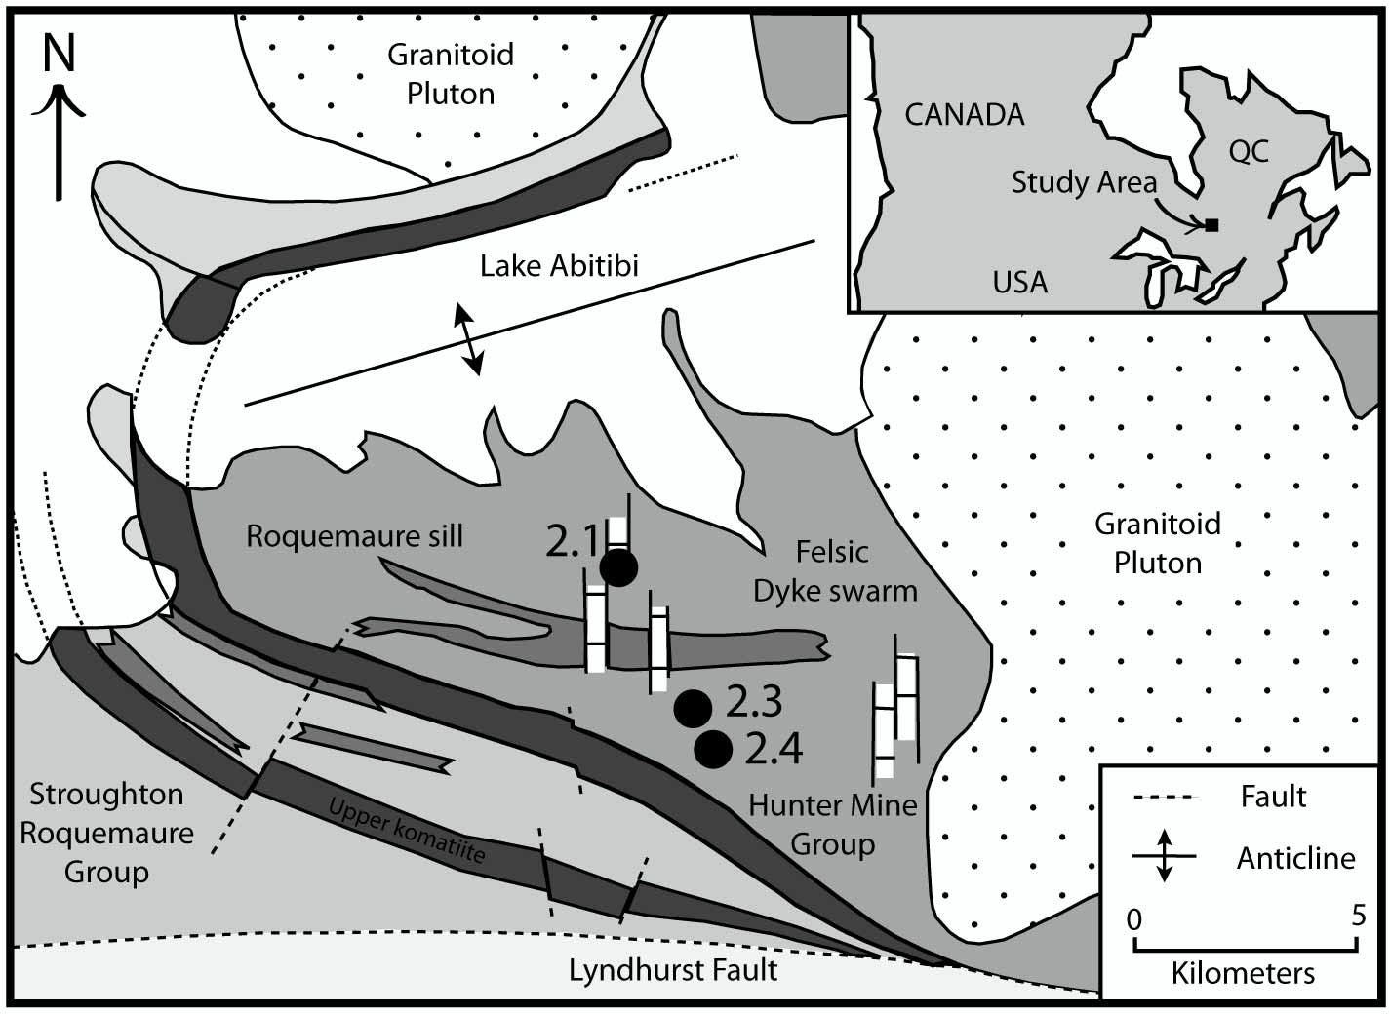Figure 1. Geologic map of Hunter Mine Group region, of the Abitibi Greenstone Belt, with an inset showing the location of the greenstone belt in Canada. Samples in this study come from outcrops labeled 2.1, 2.3, and 2.4. Modified from Dostal and Mueller, (2012).

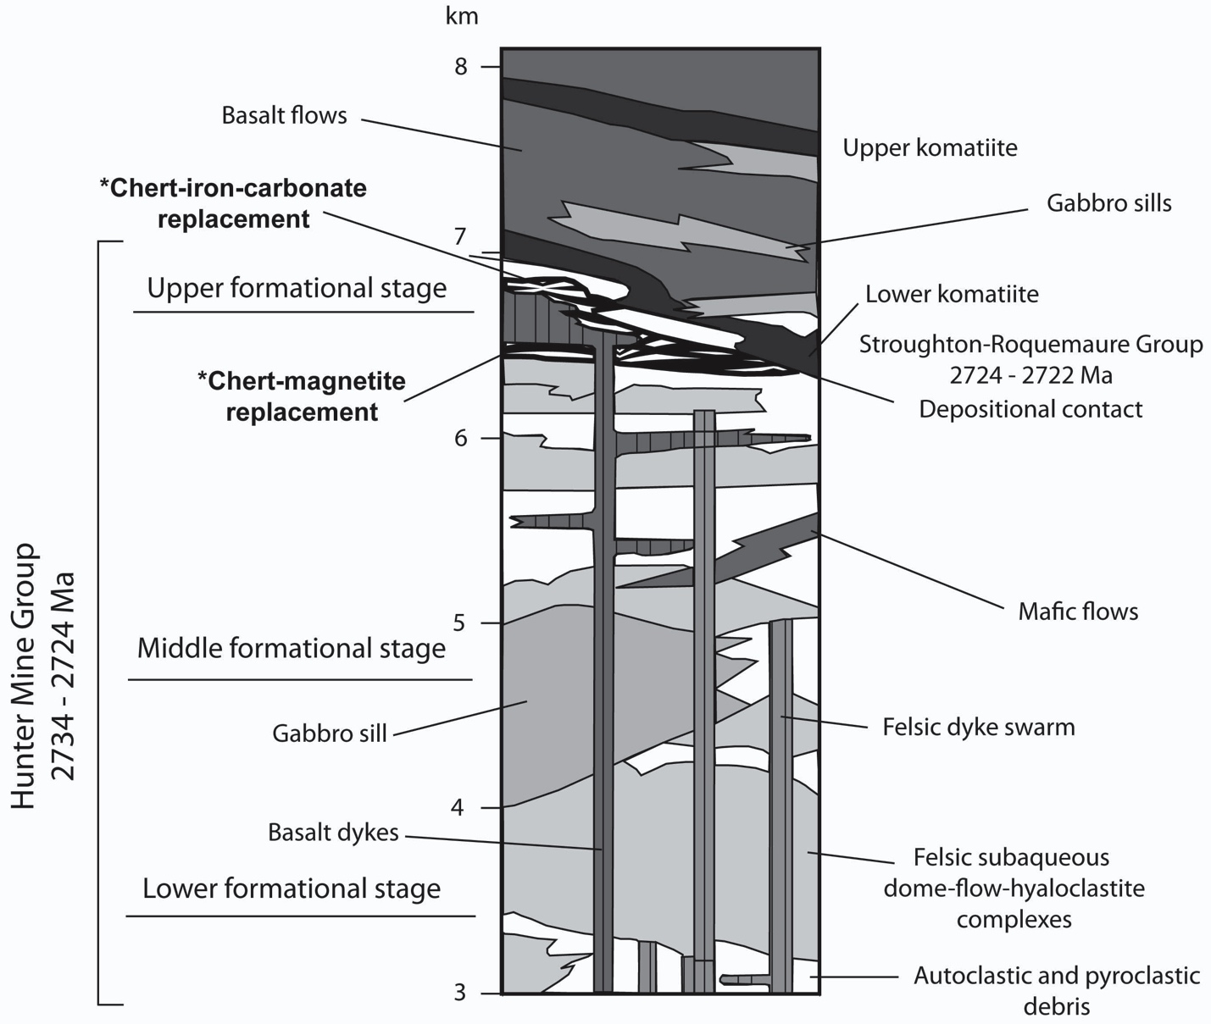Figure 2. Representative stratigraphic column of the Hunter Mine Group. All samples from this study come from the contact between the middle and upper formational stages. Modified from Mueller and Mortensen (2002). Star (*) denotes units of interest to this study.

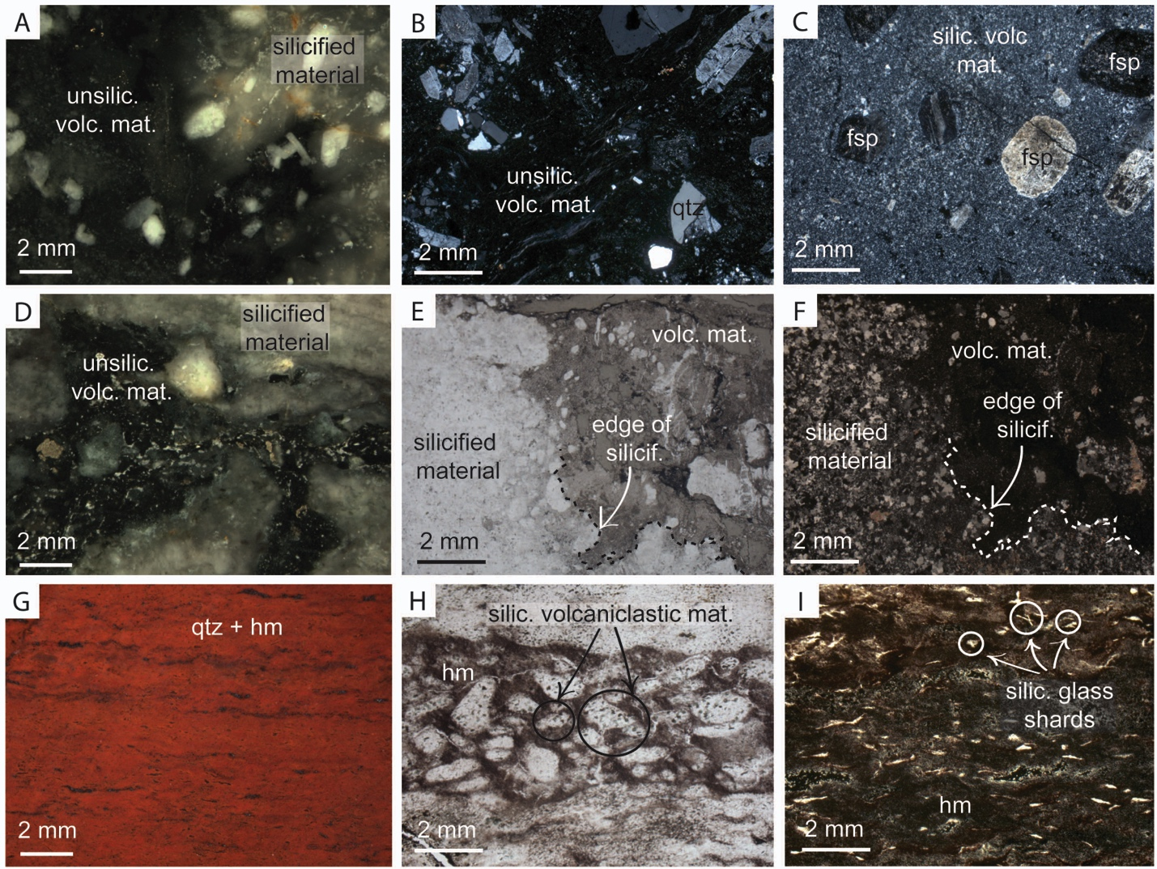
Figure 3. Incident light photographs, and plane and cross-polarized light photomicrographs of representative samples from Group 1, 2, and 3 rocks. (A) Incident light photograph documenting diffuse boundary between silicified and un-silicified volcanic material in Group 1 sample AB-11-11. (B) Cross-polarized light photomicrograph showing igneous quartz and feldspar phenocrysts surrounded by un-silicified volcanic matrix material in Group 1 sample AB-11-11. (C) Cross-polarized light photomicrograph showing preservation of primary igneous phenocrysts despite incipient silicification of matrix material in Group 1 sample AB-11-11. (D) Incident light photograph documenting diffuse nature of silicification in progressively altered Group 2 rocks (Sample AB-11-12). (E) Plane-polarized light photomicrograph of Group 2 sample AB-11-12 showing silicified material, and clear volcaniclastic material that passes through the edge of silicification from un-silicified volcanic matrix material indicating a replacement origin for the silicification, rather than a chemical sedimentation origin. (F) Cross-polarized light photomicrograph of (E). (G) Incident light photomicrograph showing only faint textural heterogeneity in some jaspilite Group 3 samples. (H) Plane-polarized light image showing textural evidence of silicified volcaniclastic material that is now compositionally hematite (hm) and quartz in representative Group 3 sample AB-11-23. (I) Plane-polarized light image showing preservation of pronged glass shards enveloped in a quartz and hematite matrix in representative Group 3 sample AB-11-19.

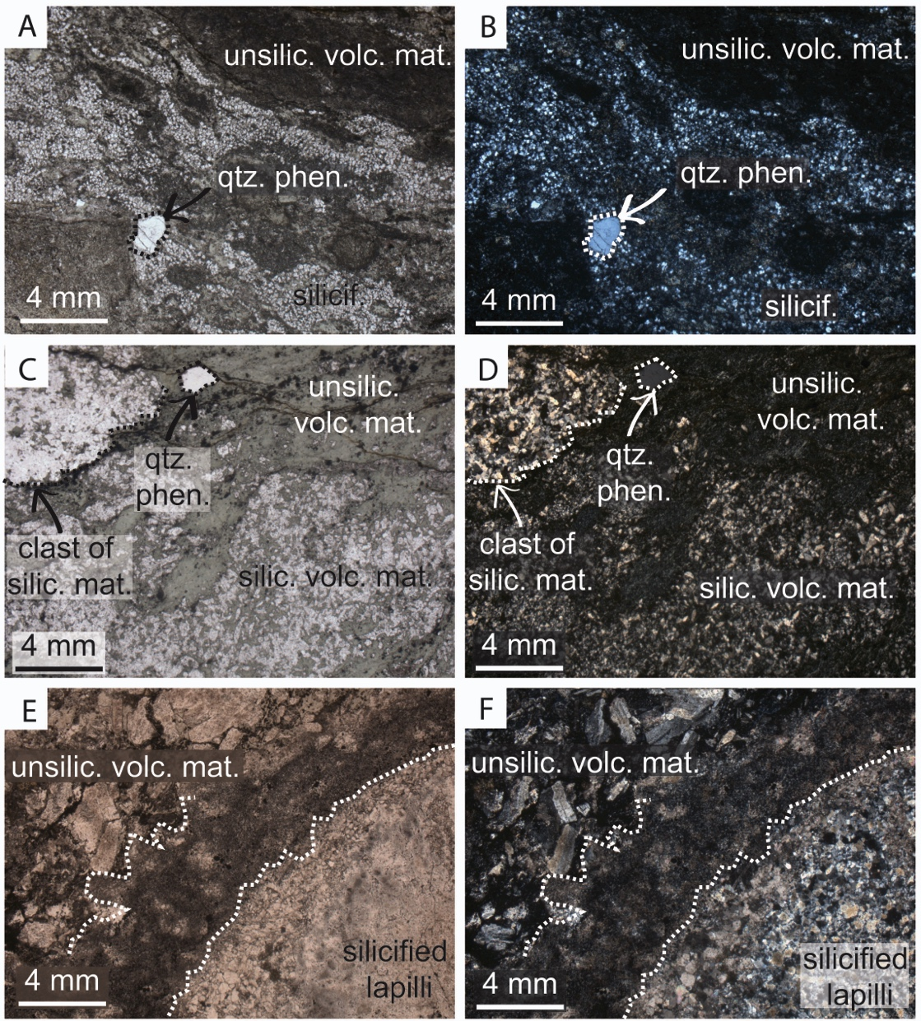
Figure 4. Plane-polarized light and cross-polarized light images of representative Group 2 altered volcanic rock samples. (A) Plane-polarized light image showing an example of discontinuous silicification and preservation of un-silicified volcanic matrix material and quartz phenocryst. (B) Cross-polarized light image of (A). (C) Plane-polarized light image showing an example of discontinuous silicification and preservation of quartz phenocryst and original volcanic matrix material, as well as preservation of a clast of similar silicified material. (D) Cross-polarized light image of (C). Plane-polarized light image showing un-silicified volcaniclastic matrix material, and a silicified armored lapilli. (F) Cross-polarized light image of (E).
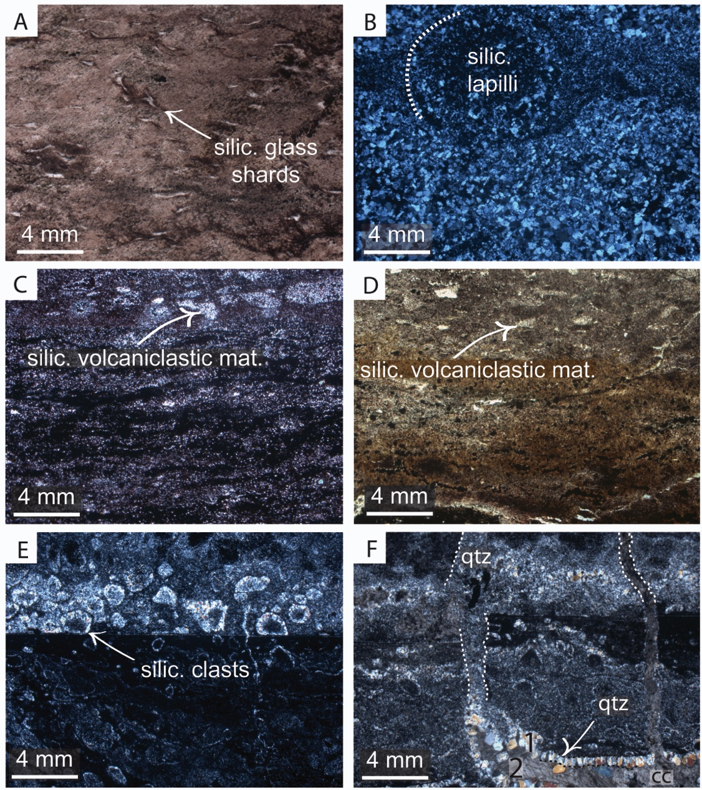
Figure 5. Plane-polarized light and cross-polarized light images of representative Group 3 jaspilite samples. (A) Plane-polarized light image showing preservation of glass shards. (B) Cross-polarized light image showing preservation of lapilli, now completely compositionally replaced by micro-crystalline quartz. (C) Plane-polarized light image showing volcaniclastic material now compositionally replaced by quartz and surrounded by hematite. (D) Same as (C). (E) Cross-polarized light image showing clastic textures preserved in the jaspilite, now compositionally entirely made of quartz. (F) Evidence of quartz and calcite veining.

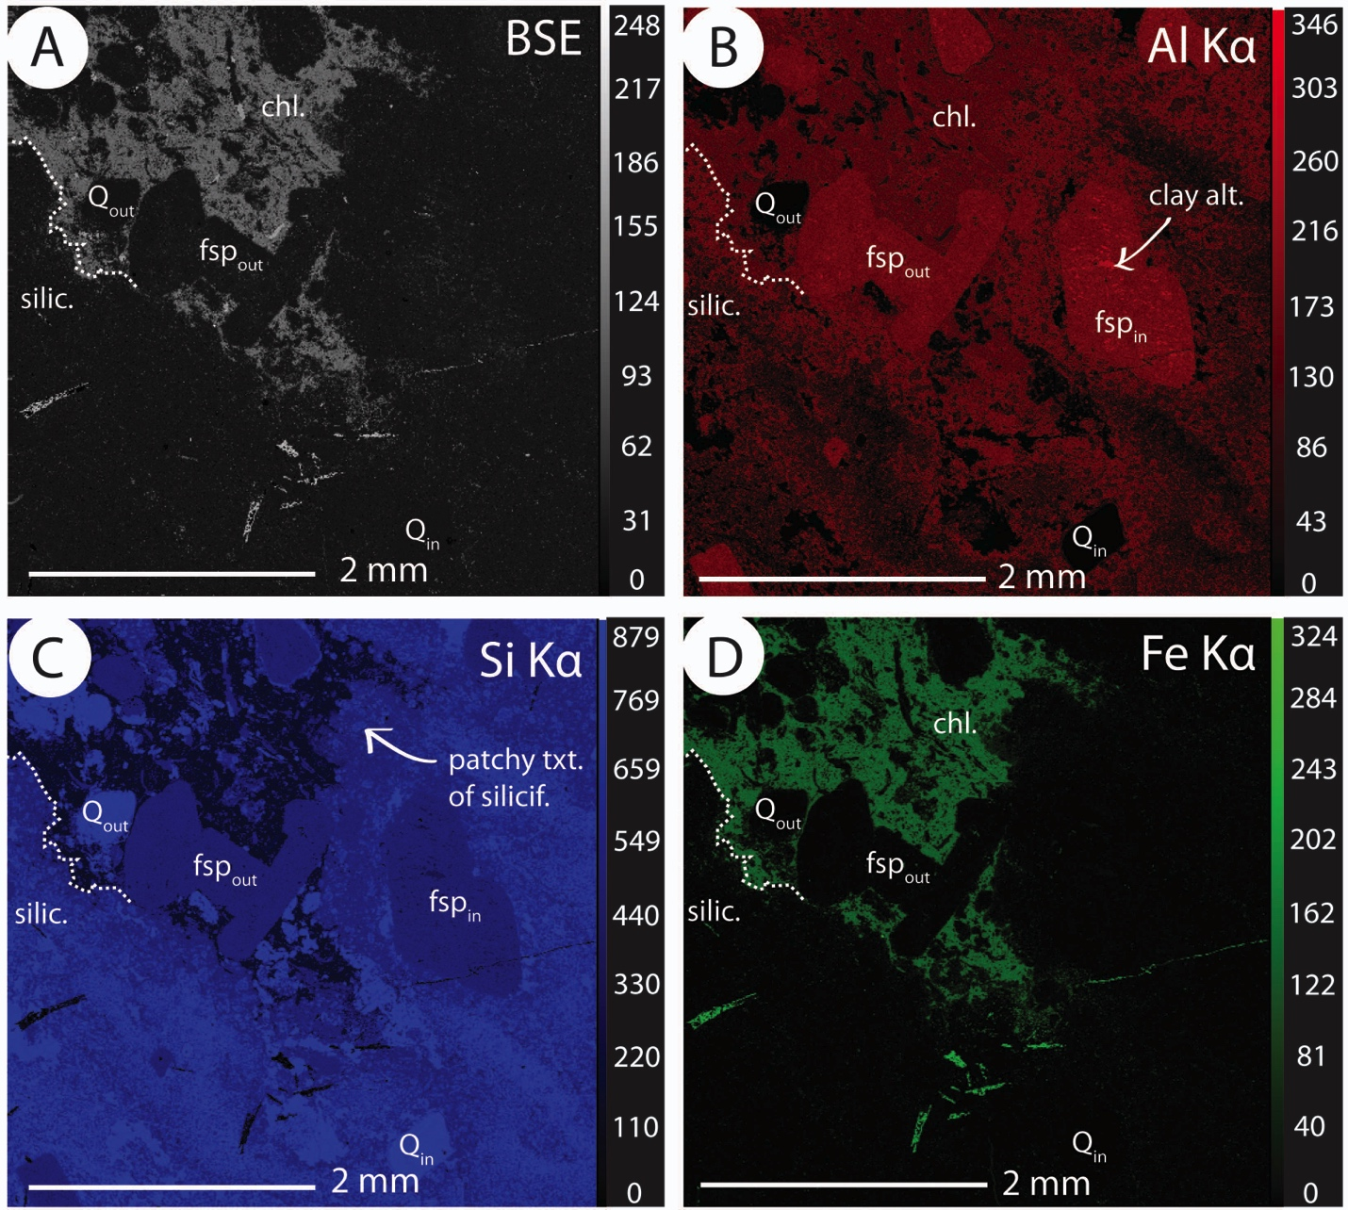
Figure 6. Elemental X-ray maps for representative Group 1 felsic volcanic rock sample AB-11-11. (A) Backscatter electron image of volcanic rock sample showing preservation of quartz and feldspar phenocrysts, both inside (Q_{in}) and outside (Q_{out}, and fsp_{out}) of the silicified areas which are surrounded by a chloritic matrix. (B) Aluminum Kα x-ray map showing the non-uniform nature of incipient silicification is representative group 1 sample. (C) Silica Kα x-ray map showing preservation of phenocrysts inside the silicification patch, as well as documenting the compositional heterogeneities inside the silicification patch. (D) Iron Kα x-ray map showing Fe-rich composition of chloritic matrix material.
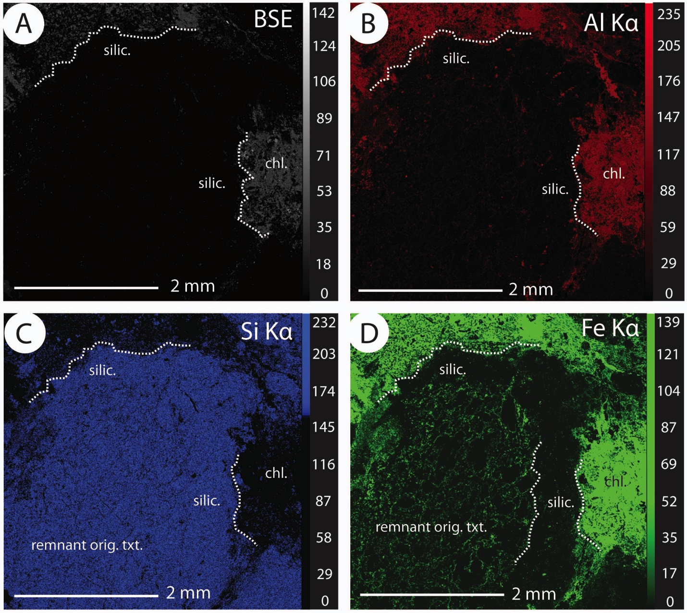
Figure 7. Elemental X-ray maps for representative Group 2 altered volcanic rock sample AB-11-12. (A) Backscatter electron image of volcanic rock sample showing silicified areas surrounded by a chloritic matrix. (B) Aluminum Kα x-ray map showing silicified areas surrounded by a chloritic matrix. (C) Silica Kα x-ray map showing silicified areas surrounded by a chloritic matrix, and documenting minor compositional heterogeneities inside the silicification patch. (D) Iron Kα x-ray map highlighting compositional heterogeneities and potential preservation of remnant original volcanic textures inside of the silicification patch.
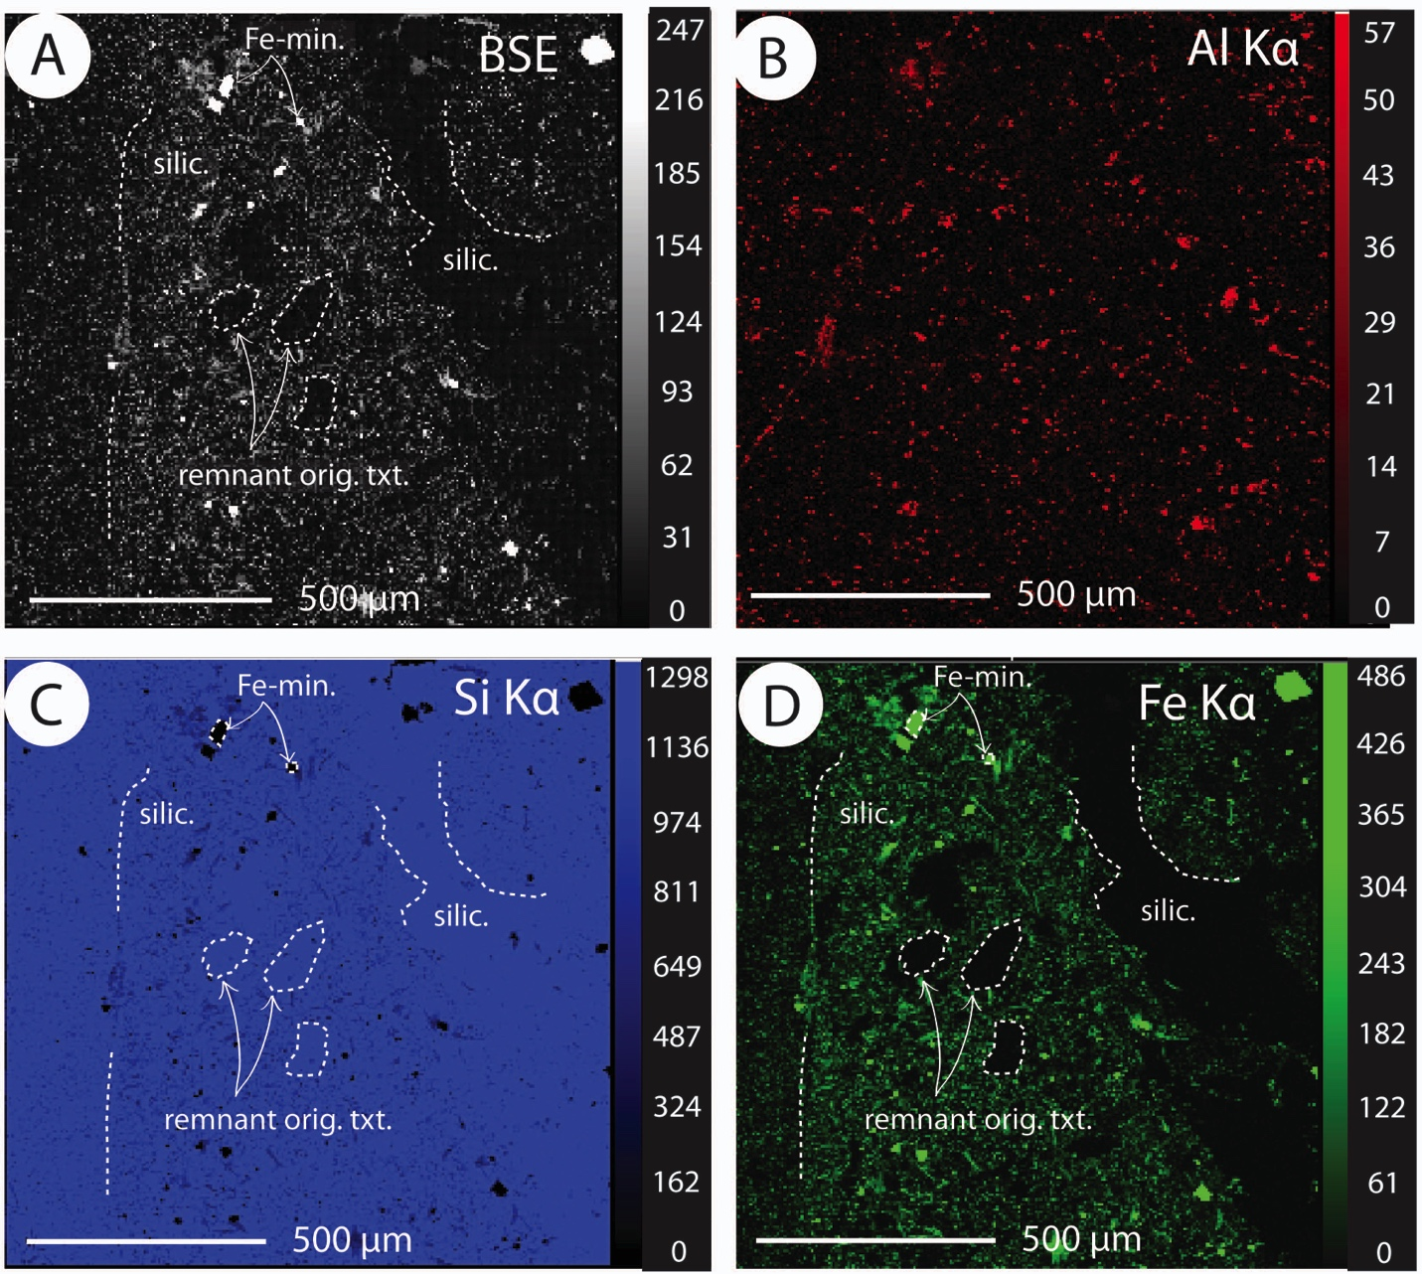
Figure 8. Elemental X-ray maps for representative Group 3 jaspilite rock sample AB-11-23. (A) Backscatter electron image of jaspilite rock sample showing silicified and iron-mineralized areas. (B) Aluminum Kα x-ray map showing silicified and iron-mineralized areas. (C) Silica Kα x-ray map showing silicified and iron-mineralized areas, potential preservation of remnant clastic textures. (D) Iron Kα x-ray map highlighting compositional heterogeneities in silicified and iron-mineralized areas, and potential preservation of remnant clastic textures.

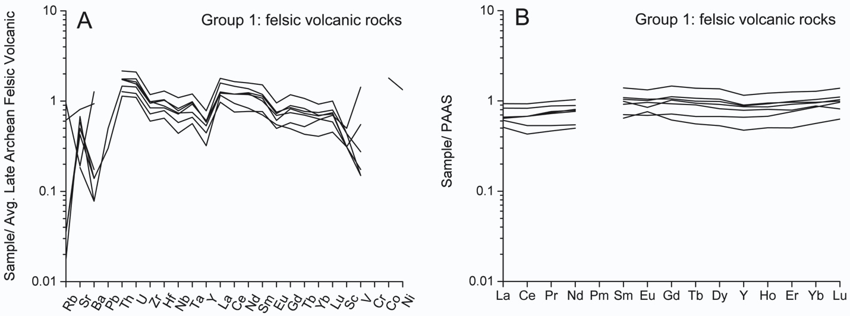
Figure 9. (A) Spider plot of Group 1 samples normalized to average late Archean felsic volcanic rocks (Condie, 1993). (B) Rare earth element plot of Group 1 samples normalized to post Archean average shale composite (ref.).

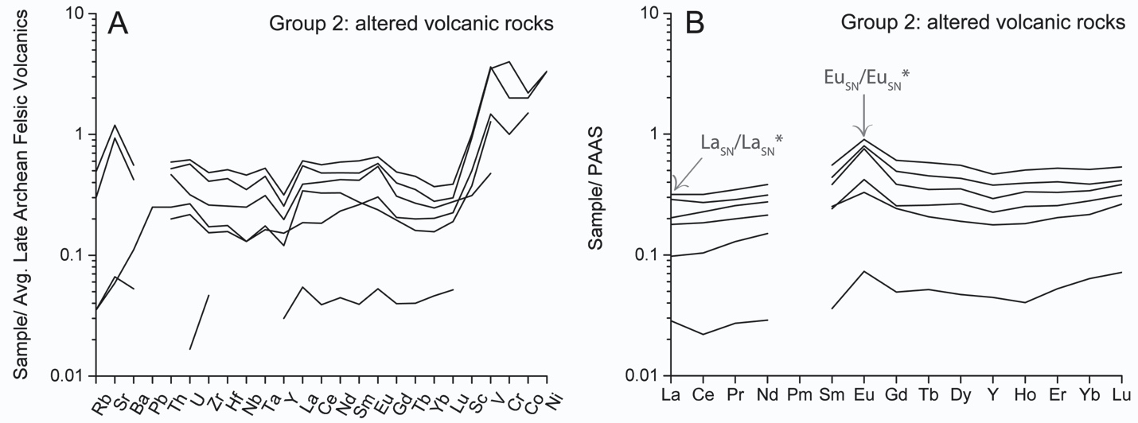
Figure 10. (A) Spider plot of Group 2 samples normalized to average late Archean felsic volcanic rocks (Condie, 1993). (B) Rare earth element plot of Group 2 samples normalized to post Archean average shale composite (ref.). Denotations mark important geochemical features of seawater as defined in the text.

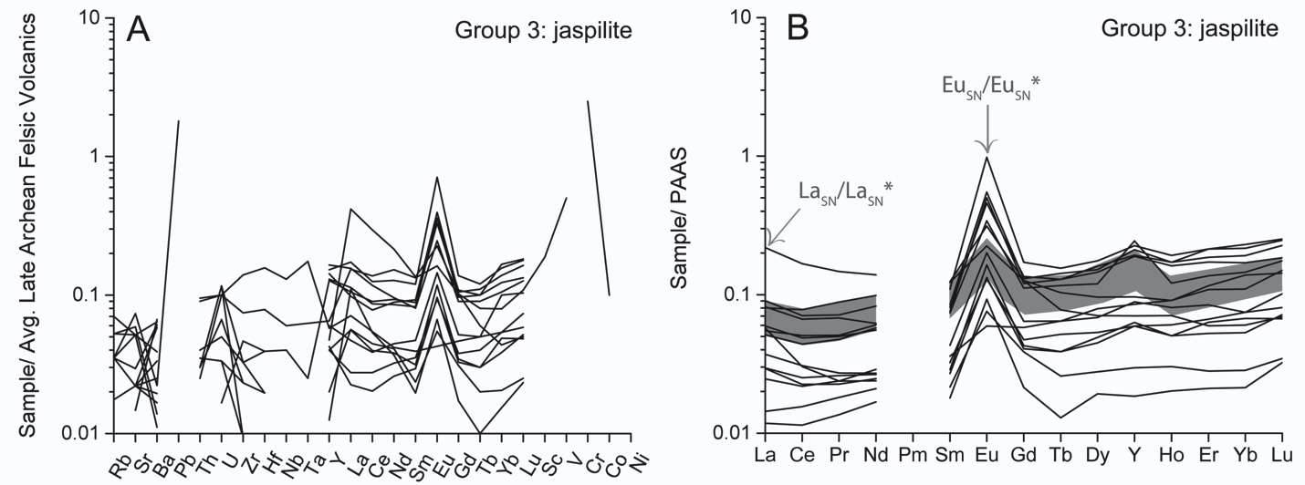
Figure 11. (A) Spider plot of Group 3 samples normalized to average late Archean felsic volcanic rocks (Condie, 1993). (B) Rare earth element plot of Group 3 samples normalized to Post Archean Average Shale composite (ref). La_{SN}/La_{SN}* and Eu_{SN}/Eu_{SN}* mark important geochemical features of seawater as defined in the text. Shaded area denotes typical pattern for Precambrian seawater.
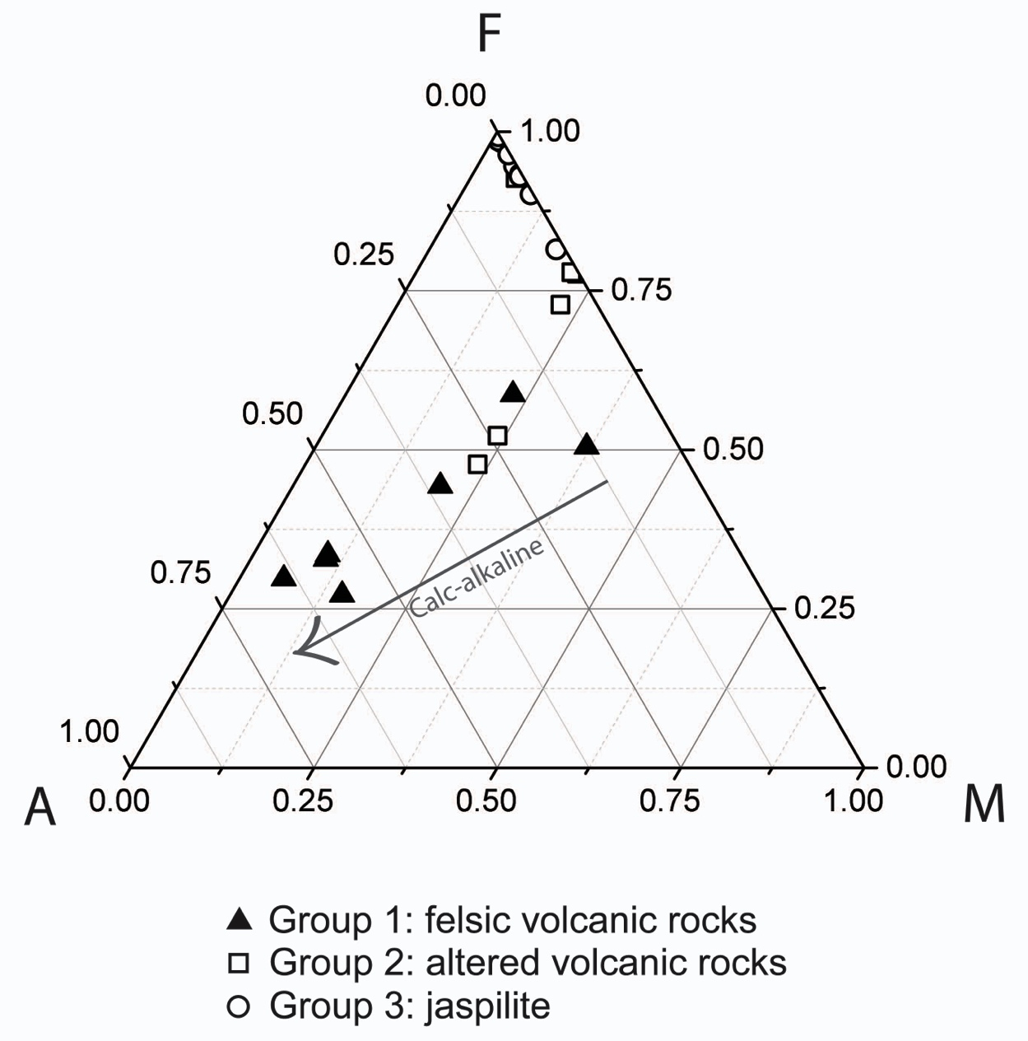
Figure 12. Traditional AFM volcanic discrimination diagram of group 1, 2, and 3 samples. Note the trend from groups 1 – 3 documenting Fe addition, and loss of other elements during the silicification process. Calc-alkaline volcanic trend marked for reference.

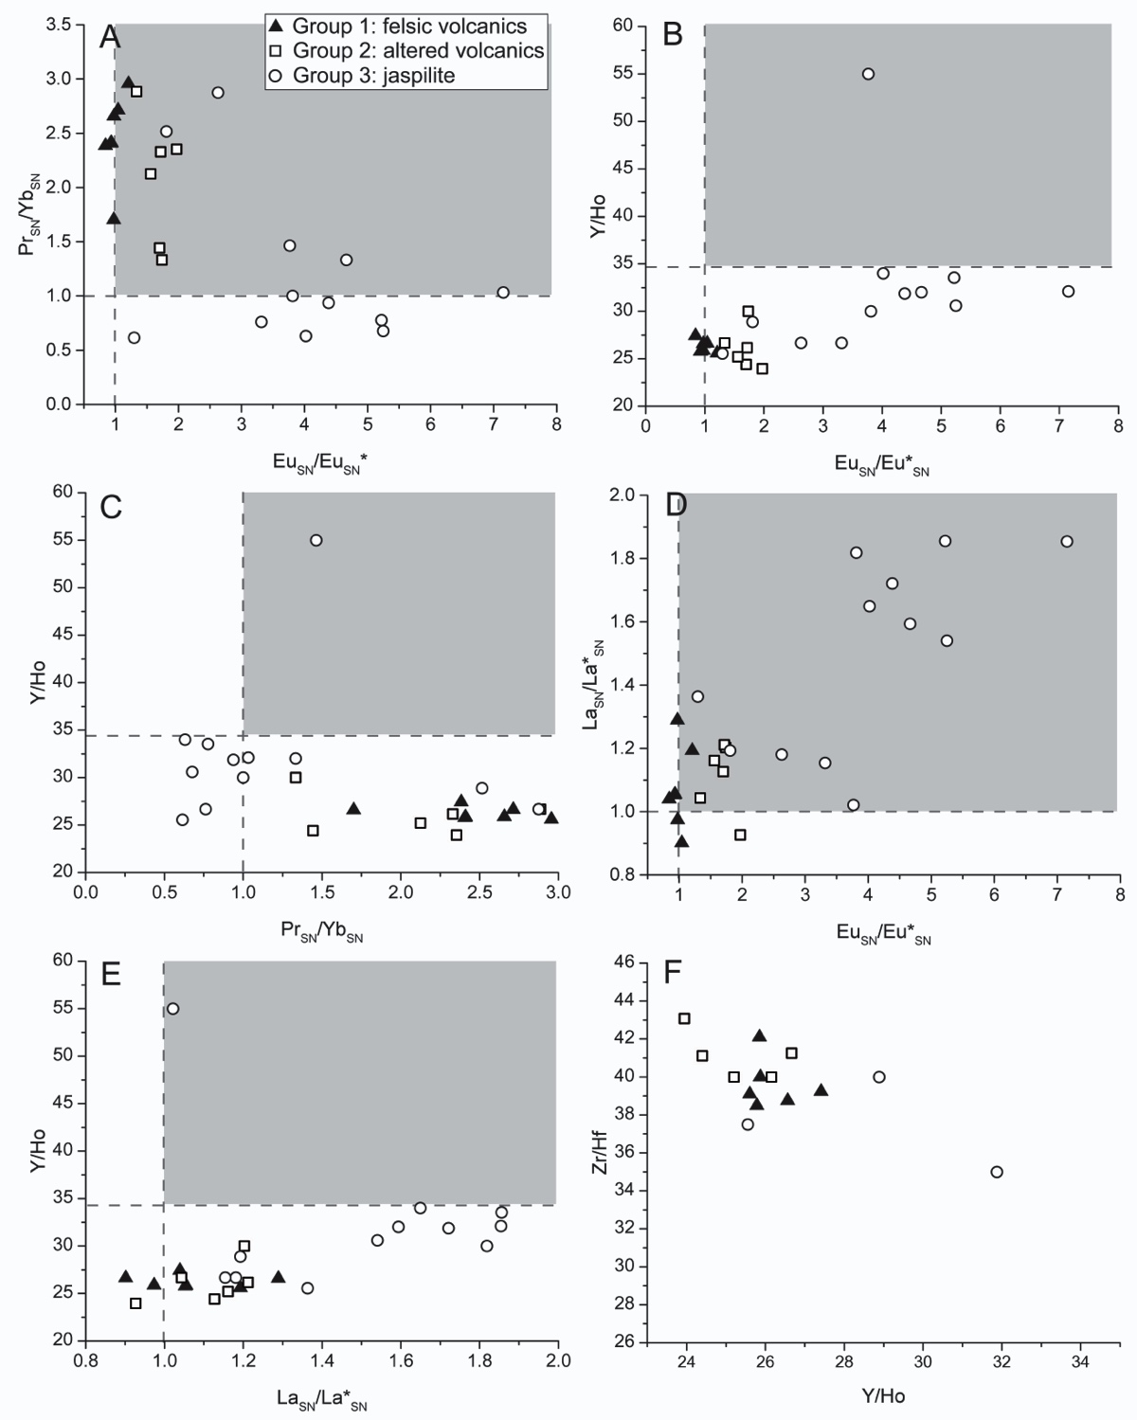
Figure 13. REE comparison plots for Group 1 (filled triangles), Group 2 (open squares), and Group 3 (open circles) samples. Grey shaded area indicates “seawater” signature. Note separation of Group 1 from Group 3 samples in plots A-E. (A) Plot showing slope (Pr_{SN}/Yb_{SN}) verses Europium anomaly (Eu_{SN}/Eu_{SN}*). (B) Plot showing Y/Ho verses Europium anomaly (Eu_{SN}/Eu_{SN}*). (C) Plot showing Y/Ho verses slope (Pr_{SN}/Yb_{SN}). (D) Plot showing Lanthanum anomaly (La_{SN}/La_{SN}*) verses Europium anomaly (Eu_{SN}/Eu_{SN}*). (E) Plot showing Y/Ho verses Lanthanum anomaly (La_{SN}/La_{SN}*). (F) Plot showing Y/Ho verses Zr/Hf. All samples fall within range expected for igneous rocks (24 < Y/Ho < 34, and 26 < Zr/Hf <46).

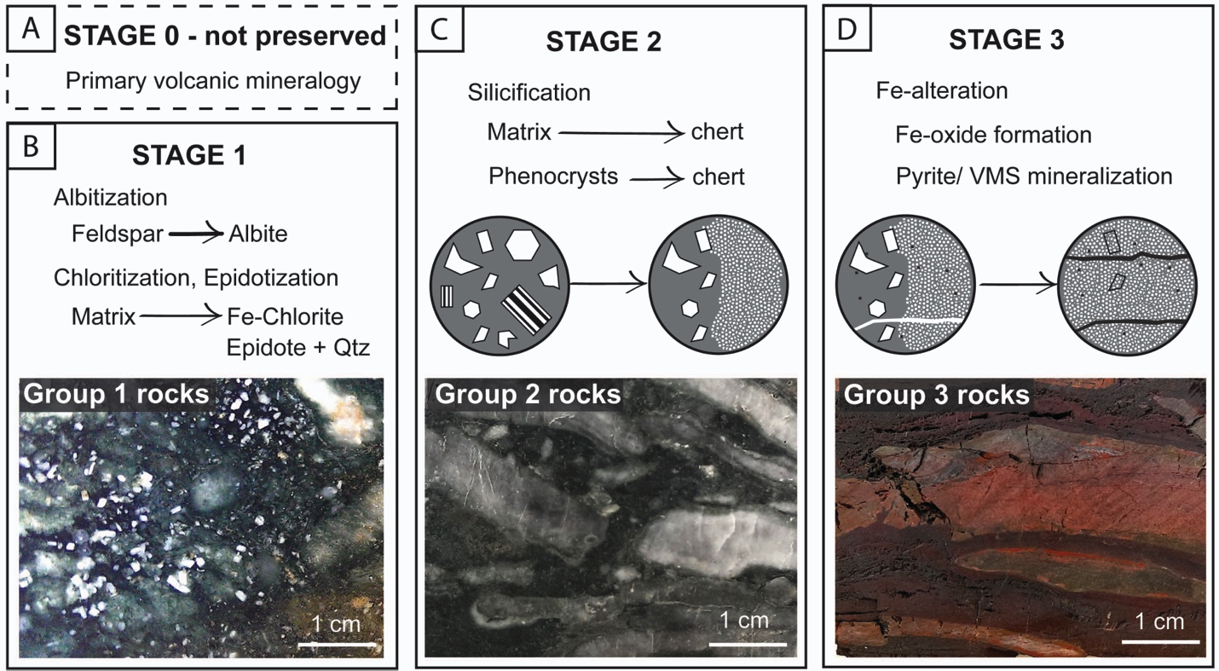
Figure 14. Schematic diagram showing stages of alteration for Group 1 , 2 and 3 samples. (A) Represents stage 0 where no alteration has occurred, and primary volcanic mineralogy is preserved. (B) Represents stage 1 of alteration, where albitization, chloritization, and epidotization of primary volcanic material occur. Incident light photograph is of representative Group 1 sample (AB-11-11), showing preservation of volcanic material and incipient stages of silicification marked by the presence of quartz patches (white areas) (C) Represents stage 2 of alteration, which is characterized by silicification of both volcanic matrix, and phenocrystic material. Incident light photograph is of representative Group 2 sample (AB-11-12), showing silicification lenses (white areas), and preservation of volcanic material in between (green areas). (D) Represents stage 3 of alteration, which is characterized by further silicification and Fe-alteration, resulting in the formation of Fe-oxides, and pyrite during VMS-style mineralization. Incident light photograph is of representative Group 3 sample (AB-11-23), showing silicified and Fe-altered areas.

LIST OF REFERENCES
Abraham, K., Hofmann, A., Foley, S.F., Cardinal, D., Harris, C., Barth, M.G., André, L., 2011. Coupled silicon–oxygen isotope fractionation traces Archaean silicification. Earth and Planetary Science Letters, 301: 222-230.
Bau, M. and Möller, P., 1993. Rare earth element systematics of the chemically precipitated component in Early Precambrian iron formations and the evolution of the terrestrial atmosphere-hydrosphere-lithosphere system. Geochimica et Cosmochimica Acta, 57: 2239-2249.
Bau, M., 1996. Controls on the fractionation of isovalent trace elements in magmatic and aqueous systems: evidence from Y/Ho, Zr/Hf, and lanthanide tetrad effect. Contributions to Mineralogy and Petrology, 123: 323-333.
Beaty, D.W., Taylor, H.P., Coad, P.R., An oxygen isotope study of the Kidd Creek, Ontario, Volcanogenic Massive Sulfide Deposit: Evidence for a high ¹⁸O Ore Fluid. Economic Geology, 83; 1-17.
Bekker, A., Slack, J.F., Planavsky, N., Krapež, B., Hofmann, A., Konhauser, K.O., Rouxel, O.J., 2010. Iron Formation: The Sedimentary Product of a Complex Interplay among Mantle, Tectonic, Oceanic, and Biospheric Processes. Economic Geology, 105: 467-508.
Bolhar, R., Kamber, B., Moorbath, S., Fedo, C., and Whitehouse, M., 2004. Characterization of early Archean chemical sediments by trace element signatures: Earth and Planetary Science Letters, 222: 43-60.
Clayton, R.N., O’Neil, J.R., Mayeda, T.K., 1972. Oxygen isotope exchange between quartz and water. Journal of Geophysical Research, 86; 2737-2755.
Chown, E.H., N’dah, E., Mueller, W.U., 2000. The relation between iron-formation and low temperature hydrothermal alteration in an Archean volcanic environment. Precambrian Research, 101: 263-275.
Danielson, A., Moller, P., Dulski, P., 1992. The europium anomalies in banded iron formations and the thermal history of the oceanic crust. Chemical Geology, 97: 89-100.
Ding, T., Wan, D., Wang, C., Zhang, F., 2004. Silicon isotope compositions of dissolved silicon and suspended matter in the Yangtze River, China. Geochimica et Cosmochimica Acta, 68: 205–216.
Ding, T. P., Ma, G. R., Shui, M. X., Wan, D. F., Li, R. H., 2005. Silicon isotope study on rice plants from the Zhejiang province, China. Chemical Geology, 218: 41–50.
Duchac, K.C., and Hanor, J.S., 1990. Origin and timing of the metasomatic silicification of an Early Archean komatiite sequence, Barberton Mountain Land, South Africa. Precambrian Research, 37: 125-146.
Fryer, B.J., 1977. Rare earth evidence in iron formations for changing Precambrian oxidation states. Geochimica et Cosmochimica Acta, 41: 361-367.
Gunnarsson, I., Arnosson, S., 2000. Amorphous silica solubility and the thermodynamic properties of H₄SiO₄º in the range of 0º to 350ºC at P_{sat}. Geochimica et Cosmochimca Acta, 64: 2295-2307.
Hofmann, A., 2005. The geochemistry of sedimetnary rocks from the Fig Tree Group, Barberton greenstone belt: Implications for tectonic, hydrothermal, and surface processes during mid-Archean times. Precambrian Research, 143: 23-49.
Hofmann, A., and Bolhar, R., 2007. Carbonaceous cherts in the Barberton greenstone belt and their significance for the study of early life in the Archean record. Astrobiology, 7: 355-388.
Hofmann, A., Harris, C., 2008. Silica alteration zones in the Barberton greenstone belt: A window into subseafloor processes 3.5–3.3 Ga ago. Chemical Geology, 257: 221-239.
Huston, D.L., Taylor, B.E., Bleeker, W., Watanabe, D. H., 1996. Productivity of volcanic-hosted massive sulfide districts: New constraints from the δ¹⁸O of quartz phenocrysts in cogenetic felsic rocks. Geology, 24: 459-462.
Kamber, B.S., Webb, G.E., 2001. The geochemistry of late Archaean microbial carbonate: implications for ocean chemistry and continental erosion history. Geochimica et Cosmochimica Acta, 65: 2509-2525.
Klein, C., 2005. Some Precambrian banded iron-formations (BIFs) from around the world: Their age, geologic setting, mineralogy, metamorphism, geochemistry, and origins. American Mineralogist, 90: 1473-1499.
Lawrence, M.G., Kamber, B.S., 2006. The behaviour of the rare earth elements during estuarine mixing – revisited. Marine Chemistry, 100: 147-161.
Lowe, D.R., 1994. Chapter 4, Archean Greenstone-Related Sedimentary Rocks, in: Condie, K.C. (Ed.), Developments in Precambrian Geology, Elsevier, 121-169.
Lowe, D.R., 1999. Petrology and sedimentology of cherts and related silicified sedimentary rocks in the Swaziland Supergroup. Geological Society of America Bulletin, 329: 83–114.
Mueller, W.U., Mortensen, J.K., 2002. Age constraints and characteristics of subaqueous volcanic construction, the Archean Hunter Mine Group, Abitibi greenstone belt. Precambrian Research, 115: 119-152.
Mueller, W.U., Stix, J., Corcoran, P.L., Daigneault, R., 2009. Subaqueous calderas in the Archean Abitibi greenstone belt: An overview and new ideas. Ore Geology Reviews, 35: 4-46.
Paradis, S., Taylor, B.E., Watkinson, D.H., Jonasson, I.R., 1993. Oxygen Isotope Zonation and Alteration in the Northern Noranda District, Quebec: Evidence for Hydrothermal Fluid Flow. Economic Geology. 88; 1512-1525.
Paris, I., Stanistreet, I.G., Hughes, M.J., 1985. Cherts of the Barberton greenstone belt interpreted as products of submarine exhalative activity. Journal of Geology, 93: 11-129.
Stakes, D.S., O’Neil, J.R., 1982. Mineralogy and stable isotope geochemistry of hydrothermally altered oceanic rocks. Earth and Planetary Science Letters. 57; 285-304.
Siever, R., 1992. The silica cycle in the Precambrian. Geochimica et Cosmochimica Acta, 56: 3265-3272.
Sugitani, K., 1992. Geochemical characteristics of Archean cherts and other sedimentary-rocks in the Pilbara block, Western Australia- evidence for Archean seawater enriched in hydrothermally derived iron and silica. Precambrian Research, 57: 21-47.
Taylor, H., 1974. The Application of Oxygen and Hydrogen Isotope Studies to Problems of Hydrothermal Alteration and Ore Deposition. Economic Geology, 69; 843-883.
Taylor, H.P. Oxygen and Hydrothermal Isotope Relationships in Hydrothermal Mineral Deposits in Geochemistry of Hydrothermal Ore Deposits, Vol 1.
Van den Boorn, S.H.J.M., van Bergen, M.J., Nijman, W., Vroon, P.Z., 2007. Dual role of seawater and hydrothermal fluids in Early Archean chert formation: Evidence from silicon isotopes. Geology, 35: 939-942.
Van den Boorn, S.H.J.M., van Bergen, M.J., Vroon, P.Z., de Vries, S.T., Nijman, W., 2010. Silicon isotope and trace element constraints on the origin of ~3.5 Ga cherts: Implications for Early Archean marine environments. Geochimica et Cosmochimica Acta, 74: 1077-1103.
Zhang, J., Nozaki, Y., 1996. Rare earth elements and yttrium in seawater: ICP-MS determinations in the East Caroline, Coral Sea, and South Fiji basins of the western South Pacific Ocean. Geochimica et Cosmochimica Acta, 60: 4631-4644.
CHAPTER III
EXTREME MICRO_SCALE SILICON ISOTOPE HETEROGENEITY OBSERVED IN >3.7 Ga HYDROTHERMAL QUARTZ PRECIPITATES: IMPLICATIONS FOR INTERPRETING THE δ³⁰Si RECORD OF CHERT

ABSTRACT
We present silicon isotope compositions of quartz crystals measured by secondary ion mass spectrometry (SIMS) from three lithologies, (quartz-cemented, amygdaloidal, basaltic, pillow breccia, chert, and chert clasts), thought to represent quartz precipitation under hydrothermal conditions from the >3.7 Ga Isua Greenstone Belt, SW Greenland. Chert, chert clasts, and quartz cement have overlapping δ³⁰Si values, while δ³⁰Si values of quartz amygdules span nearly the entire known dynamic range previously measured for quartz precipitates. This extreme heterogeneity does not result from metamorphism. Instead we suggest the heterogeneity to derive from primary kinetic isotope fractionation during quartz precipitation under disequilibrium conditions in a hydrothermal setting. We infer that heterogeneity in the compiled δ³⁰Si record of chert can be explained if samples were to be separated based on geologic context.

INTRODUCTION
Previous studies (e.g., Robert and Chaussidon, 2006) of Precambrian chert and banded iron formation (BIF) have identified a subtle trend toward heavier silicon isotope values through time (Fig. 1A). This trend has been attributed to gradual cooling of the oceans (Robert and Chaussidon, 2006) or mixing between hydrothermal and continental silicon input (Chakrabarti et al., 2012; Heck et al., 2011). For either interpretation to be valid, each must overcome significant concerns. First, interpreting a compiled survey of all published silicon isotope values obtained from chert, regardless of chert type, demands that all siliceous marine sediments precipitated under the same geochemical conditions, even though deposition occurs in a variety of settings and conditions (Kimberley, 1979). Second, simple source mixing between hydrothermal and continental silicon pools requires that the values and contributions of each are well constrained, and unchanging over geologic time, despite evidence for continental growth and emergence during the Archean, and a lack of constraints on the silicon isotope composition of hydrothermal precipitates (Marin-Carbonne et al., 2014). Such observations, then, preclude the possibility of developing a simple, unified interpretation for any perceived temporal trend in the silicon isotope archive of chert and BIF, and warrant a study to investigate silicon isotope values of hydrothermal silica precipitates to better constrain the isotopic composition of different silicon reservoirs.

Most silicon isotope investigations (e.g., Marin-Carbonne et al., 2012, 2014; Chakrabarti et al., 2012; Delvigne et al., 2012; Steinhoefel et al., 2010) and experiments (Geilert et al., 2014) have focused on chert hypothesized to form through progressive recrystallization of low-temperature amorphous opal-A, to opal-CT, to micro-quartz (<20 µm), to mega-quartz (>20 µm) (Marin-Carbonne 2014), a process termed ‘maturation theory’ (Calvert, 1977). Fewer studies have focused on chert formed in hydrothermal systems (van den Boorn 2007, 2010; André et al., 2006), where direct precipitation of quartz from hydrothermal fluids has been proposed (Calvert 1977; Knauth 1994), observed (Hopkinson, 1999), and experimentally demonstrated (Mackenzie and Gees, 1971; Oehler, 1976). In high-temperature seafloor hydrothermal systems, quartz precipitation occurs under disequilibrium conditions (Wells and Ghiorso, 1991), and reaction rates (kinetics) are important (Martin and Lowell, 2000). To date, no high-resolution silicon isotope studies of high-temperature hydrothermal quartz precipitates exist; consequently the sign and magnitude of any kinetic isotope effect (KIE) remains unknown. The purpose of this paper is to investigate the silicon isotope composition of hydrothermal quartz precipitates, and consider the effects of kinetics on the silicon isotope system, as well as assess the potential impact these results have on interpreting the compiled silicon isotope record of Precambrian chert and BIF. To do this, we use secondary ion mass spectrometry (SIMS) to measure the δ³⁰Si composition of quartz amygdules and encasing quartz cement of a brecciated pillow basalt, and adjacent chert and chert clasts from the >3.7 Ga Isua Greenstone Belt (IGB), in SW Greenland (Fig. 2).

METHODS
We report isotope values expressed in standard delta notation (δ^{H}X=[(^{H}X/^{L}X_{sample})/(^{H}X/^{L}X_{standard})–1]x1000, where H=heavy isotope, L=light isotope, and X=element measured). Samples were embedded in epoxy along with quartz reference material (NBS-28 or an internal standard), polished to 1 μm, mapped, and gold-coated (30 nm) prior to analysis. In-situ Si- and O-isotope measurements were made using a CAMECA-IMS 1280 SIMS instrument at the Swedish Museum of Natural History, Stockholm (NordSIMS facility). Silicon and oxygen isotope ratios were measured in separate analytical sessions. A ¹³³Cs⁺ primary beam (ca. 5nA for Si, 2.5 nA for O) with an incident energy of 20keV was used to sputter secondary ions from specifically targeted >20μm crystals. Sample charging was minimized by use of a low-energy normal-incidence electron gun. Secondary ions were measured at a mass resolution of 2,500 (M/ΔM) by multicollection on Faraday detectors attached to low-noise amplifiers housed in a thermally stabilized, evacuated chamber. The magnetic field was locked at high precision using an NMR field sensor. Fully automated analytical sessions regularly bracketed unknowns between reference analyses, and individual analyses comprised a pre-sputter to remove the Au coat, beam centering and 48 seconds (Si) and 64 seconds (O) of data acquisition. Corrections for instrumental mass fractionation were made using international standard NBS-28, with an accepted value of δ³⁰Si = 0 ‰. External reproducibility (1σ) for δ³⁰Si of ± 0.16 ‰, and δ¹⁸O of ± 0.46 ‰, was derived from bracketing NBS-28 analyses propagated onto within-run uncertainties.

GEOLOGIC CONTEXT OF SAMPLES AND QUARTZ PETROGRAPHY
Samples in this study include: (1) quartz-cemented, quartz-amygdaloidal basaltic pillow breccia, (2) bedded chert, and (3) chert clasts from a conglomerate. Detailed field relationships of samples in this study can be found in Fedo (2000), Appel et al. (2001), and Fedo et al. (2001). The pillow basalt unit occurs as cm-scale, quartz-amygdaloidal, brecciated basaltic pillow fragments encased by quartz “cement” (Fig. 2A). Fluid inclusions from quartz amygdules in this pillow breccia unit suggest that quartz could have formed during degassing in the initial eruption stages of the pillow basalt (Appel et al., 2001; Touret, 2003), precipitating from hydrothermal fluids, similar to other localities (Gibson et al., 1983). By contrast, encasing quartz cement (Fig. 2A) likely precipitated from mixed hydrothermal fluids and ambient seawater, after the pillow basalt had cooled enough to fracture brittly. Recrystallized bedded chert occurs adjacent to the pillow breccia unit as cm-thick layers associated with banded amphibolite (Fig. 2C; Appel et al., 1998; Fedo, 2000; Fedo et al., 2001). A polymictic conglomerate unit (Fig. 2D) crops out nearby, and consists of gravel-sized clasts of recrystallized chert, amygdaloidal mafic volcanic rocks, and dark schistose mafic volcanic rocks, set in a fine-grained biotite, garnet matrix (Fedo, 2000). Recrystallized chert clasts in the conglomerate likely represent pieces of bedded chert that have been eroded and re-deposited (Fedo, 2000). The clasts are mineralogically and texturally similar to pillow breccia cement and chert (Fedo, 2000).

Quartz crystals analyzed from all rocks in this study share similar textural characteristics. Crystals range from ~100 to 1000 µm, and generally show evidence for annealing, such as perfect 120° triple points (Fig. 2D-F). These features would be expected from the amphibolite-facies metamorphism that has affected the area (Rollinson, 2003). Amygdules commonly consist of polycrystalline quartz (Fig. 2D), though few amygdules are filled with single quartz crystals. Quartz crystals in the cement are texturally similar to those in amygdules (Fig. 2D), although smaller crystals form at the contact with the basalt. We analyzed individual quartz crystals in single and polycrystalline amygdules, and quartz cement across a distance of 2 mm from the brecciated basalt contact. For chert and chert clasts, we analyzed inclusion-free areas of single quartz crystals (Fig. 2E, F). Detailed petrographic descriptions of the pillow breccia sample can be found in Appel et al. (2001) and Touret (2003).

RESULTS
Silicon isotope composition
All silicon isotope values are reported in Table 1 in the Supporting Information. Quartz crystals that comprise amygdules possess values depleted in ³⁰Si, ranging from δ³⁰Si_{amyg} = -5.09 to +0.2 ± 0.3 ‰ (Fig. 1B). Such values span nearly the entire known dynamic range for silicon isotopes (roughly -5 to +3 ‰). By contrast, encasing quartz cement, separated only by millimeters, has δ³⁰Si_{NBS-28} values that range from δ³⁰Si_{cem} = +0.01 to +0.83 ± 0.3 ‰ (Fig. 1B). Silicon isotope compositions do not systematically vary with amygdule or crystal size, morphology, or distance from the brecciated cement contact. Quartz crystals from the bedded chert, and the chert clast possess a much smaller range of values (δ³⁰Si_{chert} = -1.61 to +1.24 ± 0.3 ‰; δ³⁰Si_{clast} = -0.78 to -0.23 ± 0.3 ‰; Fig. 1B).

Oxygen isotope composition
Because of the extreme heterogeneity of silicon isotope values in the pillow breccia sample, we measured the oxygen isotope composition of cement and amygdules to test if oxygen isotopes preserve similar-scale heterogeneity. Oxygen isotope compositions of quartz crystals in both amygdules and cement display relatively similar and uniform values, ranging from 16.81 to 18.02 ± 0.5 ‰ and 16.89 to 18.09 ± 0.5 ‰, respectively (Fig. 1C; Table 1, Supporting Information). Such isotopic compositions lie within the expected range for metamorphosed quartz precipitates in the region (δ¹⁸O_{chert} = 12.9 - 20.4 ‰; Perry et al., 1978; Gregory et al., 1989).

INTERPRETING SILICON ISOTOPES IN THE ROCK RECORD
Preservation potential of silicon isotope signatures
Previous studies (Marin-Carbonne et al., 2012; Marin-Carbonne et al., 2014) have used oxygen isotope compositions to determine the preservation state of chert and to infer the veracity of δ³⁰Si isotopes. Based on this screening method, a closed system, dissolution-precipitation model for equilibrium fractionation of oxygen and silicon isotopes has been developed to explain micro-scale heterogeneity in diagenetic chert formed from an original amorphous silica precursor (Marin-Carbonne and Chaussidon, 2012). If the δ³⁰Si heterogeneity measured in this study were the result of the above model, we would expect micro-scale δ¹⁸O isotope heterogeneity to be preserved in the same sample.

In the pillow breccia studied here, oxygen isotopes of quartz from amygdules and cement display relatively similar, uniform values (Fig. 1C), while silicon isotopes of the same crystals display substantial heterogeneity (Fig. 1C). Because oxygen isotope data is not heterogeneous, the range of silicon isotope values measured in the pillow breccia cannot easily be explained by equilibrium fractionation of both isotopic systems during differential diagenetic transformations at the micrometer scale. Consistent with other δ¹⁸O isotope studies of quartz (Perry et al., 1978; Gregory et al., 1989) we interpret the δ¹⁸O values were homogenized during metamorphism. Such an interpretation fits with studies that suggest that oxygen diffuses faster than silicon in quartz (Cherniak, 2003). However, heterogeneous δ³⁰Si values are preserved in rocks from this study, and require explanation.

Kinetic isotope effects in quartz precipitates
Because an equilibrium fractionation model does not fully explain decoupling of the oxygen and silicon isotope systems, here we consider a kinetic isotope fractionation model to explain the δ³⁰Si heterogeneity measured in this study. Kinetic processes are thought to govern the precipitation of minerals from aqueous solutions (DePaolo, 2011). Consequently, kinetic isotope effects should be recorded in the precipitated phase. For comparison, experimental evidence and molecular dynamics simulations for calcium isotopes of calcite precipitated from solution (DePaolo, 2011; Hofmann et al., 2012) demonstrated that changes in precipitation rate result in differences in the observed magnitude of the fractionation factor (α), generating a large isotopic difference between the solution and the precipitate (Δ_{ppt-solution} = δ_{ppt} - δ_{soln}). Under experimental conditions of rapid calcite precipitation, the system is in disequilibrium, and the light isotope preferentially incorporates into the precipitated phase (Tang et al., 2008; Δ^{44/40}Ca_{ppt-solution} < 0; α < 1). As the system approaches equilibrium, crystal growth rate slows, and the fractionation factor significantly decreases (Tang et al., 2008; Δ^{44/40}Ca_{ppt-solution} ~ 0; α ~ 1). In the SiO₂ system, temperature and precipitation rate are directly linked (Rimstidt and Barnes, 1980) and, under hydrothermal conditions, disequilibrium conditions control quartz precipitation (Wells and Ghiorso, 1991). In this light, we propose that the δ³⁰Si values of the quartz amygdules within the pillow breccia result from kinetic fractionation due to precipitation from dynamic hydrothermal fluids at different rates, rather than heterogeneous diagenetic recrystallization.

Application of a kinetic model to understand δ³⁰Si micro-scale heterogeneity
In hydrothermal systems, experimental and field evidence suggests that a maximum rate of quartz precipitation occurs at temperatures near 230 ºC (Rimstidt and Barnes, 1980) in solutions with dissolved silicon concentrations ranging from 15-20 mM (Von Damm et al., 1985), similar to concentrations proposed for Archean seawater (Siever, 1992). Below 230 ºC, net quartz precipitation decreases, and below 100 ºC, precipitation rates are extremely low, even under supersaturated conditions (Rimstidt and Barnes, 1980). In the temperature range allowing for rapid precipitation rates, (T > 230 ºC), we predict quartz precipitates would record a KIE (Δ^{30/28}Si_{ppt-solution} < 0), where the magnitude of fractionation (α < 1) should vary extensively under conditions of disequilibrium. By contrast, if the silica in solution precipitates at a slower rate, as is expected at lower temperatures, the system is more likely to be near equilibrium, and the silicon isotope value of the precipitate is likely to be similar to the source fluid and/or source rock.

Samples studied here represent different quartz lithologies formed in an Eoarchean hydrothermal system (Fig. 3A; Appel et al., 2001). Vesicular pillow basalts likely formed on the Precambrian seafloor (Polat et al., 2003) where, during initial stages of cooling, quartz precipitated from silica-saturated hydrothermal fluids to fill vesicles and form quartz amygdules (“a” in Fig. 3B). Because this process likely occurred at high-temperatures, where rapid quartz precipitation is possible, we interpret the ~5 ‰ range of negative isotope values measured in the quartz amygdules to be the result of KIEs, in accord with quartz precipitation under disequilibrium conditions. After the basalt cooled enough to brecciate (Fig. 3B), quartz likely precipitated around basalt fragments to form the cement (“c” in Fig. 3B). Because this process involved cooler seawater mixed with hydrothermal fluids, we interpret the much smaller, ~1 ‰ range of values measured in the quartz cement to be the result of slower quartz precipitation under lower-temperature conditions. As a result, δ³⁰Si values of cement could approximate those of the source fluid/rock from which the quartz precipitated. This situation is also likely true for chert (and chert clasts; Fig. 3B), and provides an explanation for the difference in values observed between these types of quartz, and the quartz amygdules. Future experimental studies focused on understanding the maximum fractionation factors achieved under these high-temperature conditions would help to clarify interpretations of the range of silicon isotope values observed in hydrothermal precipitates.

SIGNIFICANCE
In this paper, we have demonstrated the importance of kinetic isotope effects in the precipitation of quartz under disequilibrium conditions in an Archean hydrothermal system. The kinetic model proposed here predicts and explains the occurrence of extreme micro-scale δ³⁰Si heterogeneity in quartz precipitated from hydrothermal fluids. Because hydrothermal quartz precipitates in a system far from equilibrium, it forms under different geochemical conditions than quartz in shallow water cherts or diagenetic cherts hosted within carbonate successions. Therefore, we conclude that the geologic context of each chert sample should be evaluated in order to understand what information silicon isotopes record, and cherts formed under hydrothermal conditions, should be separated from those formed in other depositional settings. We finally suggest that the compiled silicon isotope archive should be separated by chert type in order to interpret any perceived temporal trends recorded in the δ³⁰Si record of chert.

ACKNOWLEDGMENTS
This work was funded by NASA grant EXOB08-0063 awarded to C. M. F., and student research grants awarded to L. A. B. from ExxonMobil, the Geological Society of America, the Sedimentary Division of GSA, and the Department of Earth and Planetary Sciences at the University of Tennessee. The NordSIMS facility is a joint Nordic infrastructure funded by the research funding agencies of Denmark, Norway and Sweden, the University of Iceland and the Geological Survey of Finland. This is NordSIMS contribution ###. We thank Ted Labotka for comments on a previous version of the manuscript.
LIST OF REFERENCES

Abraham, K., Hofmann, A., Foley, S.F., Cardinal, D., Harris, C., Barth, M.G., André, L., 2011, Coupled silicon-oxygen isotope fractionation traces Archean silicification, Earth and Planetary Science Letters, 301, 222-230.
André, L., Cardinal, D., Alleman, L.Y., Moorbath, S., 2006, Silicon isotopes in ∼3.8 Ga West Greenland rocks as clues to the Eoarchaean supracrustal Si cycle, Earth and Planetary Science Letters, 245, 162-173.
Appel, P.W.U., Fedo, C.M., Moorbath, S., Myers, J.S., 1998, Recognizable primary volcanic and sedimetnary features in a low-strain domain of the highly deformed, oldest known (≈ 3.7 – 3.8 Gyr) Greenstone Belt, Isua, West Greenland, Terra Nova, 10, 57-62.
Appel, P.W.U., Rollinson, H.R., Touret, J.L.R., 2001, Remnants of an Early Archaean (>3.75 Ga) sea-floor, hydrothermal system in the Isua Greenstone Belt, Precambrian Research, 112, 27-49.
Calvert, S.E., 1977. Mineralogy of silica phases in deep-sea cherts and porcelanites. Phil. Trans. R. Soc. Lond A. 286, 239-252.
Chakrabarti, R., Knoll, A.H., Jacobsen, S. B., Fischer, W.W., 2012, Si isotope variability in Proterozoic cherts. Geochimica et Cosmochimica Acta, 91, 187-201.
Cherniak, D.J., 2003. Silicon self-diffusion in single-crystal natural quartz and feldspar, Earth and Planetary Science Letters, 214, 655-668.
De la Rocha, C.L., Brzezinski, M.A., DeNiro, M.J., 2000, A first look at the distribution of the stable isotopes of silicon in natural waters, Geochimica et Cosmochimica Acta, 64, 2467-2477.
Delstanche, S., Opfergelt, S., Cardinal D., Elsass, F., André L., Delvaux, B., 2009, Silicon isotopic fractionation during adsorption of aqueous monosilicic acid onto iron oxide, Geochimica et Cosmochimica Acta, 73, 923–934.
Delvigne, C., Cardinal, D., Hofmann, A., L. André, 2012, Stratigraphic changes of Ge/Si, REE + Y and silicon isotopes as insights into the deposition of a Mesoarchean banded iron formation, Earth and Planetary Science Letters, 355-356, 109-118.
DePaolo, D.J., 2011, Surface kinetic model for isotopic and trace element fractionation during precipitation of calcite from aqueous solutions, Geochimica et Cosmochimica Acta, 75, 1039-1056.
Ding, T., 1996, Silicon isotope geochemistry, Geological Publishing house, pp. 1-105.
Dove, P.M., Rimstidt, J.D., 1994, Silica-water interactions: In Reviews in Mineralogy, 29, 259-308.
Fan, H., Wen, H., Zhu, X., Hu, R., Tian, S., 2013, Hydrothermal activity during Ediacaran-Cambrian transition: Silicon isotopic evidence, Precambrian Research, 224, 23-35.
Fedo, C.M., 2000, Setting and origin for problematic rocks from the >3.7 Ga Isua Greenstone Belt, southern west Greenland: Earth’s oldest coarse clastic sediments, Precambrian Research, 101, 69-78.
Fedo, C.M., Myers, J.S., Appel, P.W.U., 2001, Depositional setting and paleogeographic implications of earth’s oldest supracrustal rocks, the >3.7 Ga Isua Greenstone belt, West Greenland, Sedimentary Geology, 141-142, 61-77.
Fitoussi, C., and Bourdon, B., 2012. Silicon Isotope Evidence Against an Enstatite Chondrite Earth, Science, 335, 1477-1480.
Gibson, H.L., Watkinson, D.H., Comba, C.D.A., 1983, Silicification: Hydrothermal Alteration in an Archean Geothermal System within the Amulet Rhyolite Formation, Noranda, Quebec, Economic Geology, 78, 954-971.
Gregory, R.T., Criss, R.E., Taylor, H.P., 1989, Oxygen isotope exchange kinetics of mineral pairs in closed and open systems: Applications to problems of hydrothermal alteration of igneous rocks and Precambrian iron formations, Chemical Geology, 75, 1-42.
Heck, P.R., Huberty, J.M., Kita, N.T., Ushikubo, T., Kozdon, R., Valley, J.W., 2011, SIMS analyses of silicon and oxygen isotope ratios for quartz from Archean and Paleoproterozoic banded iron formations, Geochimica et Cosmochimica Acta, 75, 5879-5891.
Hofmann, A.E., Bourg, I.C., DePaolo, D.J., 2012, Ion desolvation as a mechanism for kinetic isotope fractionation in aqueous systems, Proceedings of the National Academies, 109, 18689-18694.
Hopkinson, L., Roberts, S., Herrington, R., Wilkinson, J., 1999, Self-organization of submarine hydrothermal siliceous deposits: Evidence from the TAG hydrothermal mound, 26°N Mid-Atlantic Ridge, Geology, 26, 347-350.
Kamber, B.S., Webb, G.E., 2001, The geochemistry of late Archaean microbial carbonate: implications for ocean chemistry and continental erosion history, Geochimica et Cosmochimica Acta, 65, 2509-2525.
Kimberley, M.M., 1979, Geochemical distinctions among environmetal types of iron formations, Chemical Geology, 25, 185-212.
Knauth, L.P., Lowe, D.R., 2003, High Archean climatic temperature inferred from oxygen isotope geochemistry of cherts in the 3.5 Ga Swaziland Supergroup, South Africa, GSA Bulletin, 115, 566-580.
Knauth, L.P., 1994, Petrogenesis of chert: In Reviews in Mineralogy, 29, 233-256.
Mackenzie, F.T., Gees, R., 1971. Quartz: synthesis at Earth-surface conditions, Science, 173, 533–534.
Marin-Carbonne, J., Chaussidon, M., Robert, F., 2012, Micrometer-scale chemical and isotopic criteria (O and Si) on the origin and history of Precambrian cherts: Implications for paleo-temperature reconstructions, Geochimica et Cosmochimica Acta, 92, 129-147.
Marin-Carbonne, J., Robert, F., Chaussidon, M., 2014, The silicon and oxygen isotope compositions of Precambrian cherts: a record of oceanic paleo-temperatures? Precambrian Research, 247, 223-234
Martin, J.T., and Lowell, R.P., 2000, Precipitation of quartz during high-temperature, fracture-controlled hydrothermal upflow at ocean ridges: Equilibrium verses linear kinetics, Journal of Geophysical Research, 105, 869-882.
Oehler, J.H., 1976, Hydrothermal crystallization of silica gel, Geological Society of America Bulletin, 87, 1143-1152.
Oelze, M., von Blanckenburg, F., Hoellen, D., Dietzel, M., Bouchez, J., 2014, Si stable isotope fractionation during adsorption and the competition between kinetic and equilibrium isotope fractionation: Implications for weathering systems, Chemical Geology, 380, 161-171.
Perry, E.,C, Ahmad, S.N., Swulius, T.M., 1978, The oxygen isotope composition of 3,800 m.y. Old Metamorphosed Chert and Iron Formation from Isukasia, West Greenland, The Journal of Geology, 86, 223-239.
Polat, A., Hofmann, A.W., Münker, C., Regelous, M, Appel, P.W.U., 2003, Contrasting geochemical patterns in the 3.7-3.8 Ga pillow basalt cores and rims, Isua Greenstone belt, Southwest Greenland: implications for postmagmatic alteration processes, Geochimica et Cosmochimica Acta, 67, 441-457.
Rimstidt, J.D., and Barnes, H.L., 1980, The kinetics of silica-water reactions, Geochimica et Cosmochimica Acta, 44, 1683-1699.
Robert, F., Chaussidon, M., 2006, A paleotemperature curve for the Precambrian oceans based on silicon isotopes in chert, Nature, 443, 969-972.
Rollinson, H., 2003, Metamorphic history suggested by garnet-growth chronologies in the Isua Greenstone Belt, West Greenland, Precambrian Research, 126, 181-196.
Siever, R., 1992, The silica cycle in the Precambrian, Geochimica et Cosmochimica Acta, 56, 3265-3272.
Steinhoefel, G., von Blanckenburg, F., Horn, I., Konhauser, K.O., Beukes, N.J., Gutzmer, J., 2010, Deciphering formation processes of banded iron formations from the Transvaal and the Hamersley successions by combined Si and Fe isotope analysis using UV femtosecond laser ablation, Geochimica et Cosmochimica Acta, 74, 2677-2696.
Tang, J., Dietzel, M., Bohm, F., Kohler, S.J., Eisonhauer, A., 2008, Sr2+/Ca2+ and 44Ca/4-Ca fractionation during inorganic calcite formation: II. Ca isotopes, Geochimica et Cosmochimica Acta, 72, 3733-3745.
Touret, J.J., 2003, Remnants of early Archaean hydrothermal methane and brines in pillow-breccia from the Isua Greenstone Belt, West Greenland, Precambrian Research, 126, 219-233.
Van den Boorn, S. H. J. M., van Bergen, M. J., Nijman, W., Vroon, P. Z., 2007, Dual Role of seawater and hydrothermal fluids in Early Archean chert formation: Evidence from silicon isotopes, Geology, 35, 939-942.
Van den Boorn, S.H.J.M., van Bergen, M.J., Vroon, P., de Vries, S.T., Nijman, W., 2010, Silicon isotope and trace element constraints on the origin of ~3.5 Ga cherts: Implications for Early Archaean marine environments, Geochimica et Cosmochimica Acta, 74, 1077-1103.
Von Damm, K.L., Bischoff, J.L., Rosenbauer, R.J., 1985, Quartz solubility in hydrothermal seawater: an experimental study and equation desecribing quartz solubility for up to 0.5M NaCl solutions, American Journal of Science, 291, 977-1007.
Wells, J.T., Ghiorso, M.S., 1991. Coupled fluid flow and reaction in mid-ocean ridge hydrothermal systems: The behavior of silica, Geochimica et Cosmochimica Acta, 55, 2467-2481.
FIGURES
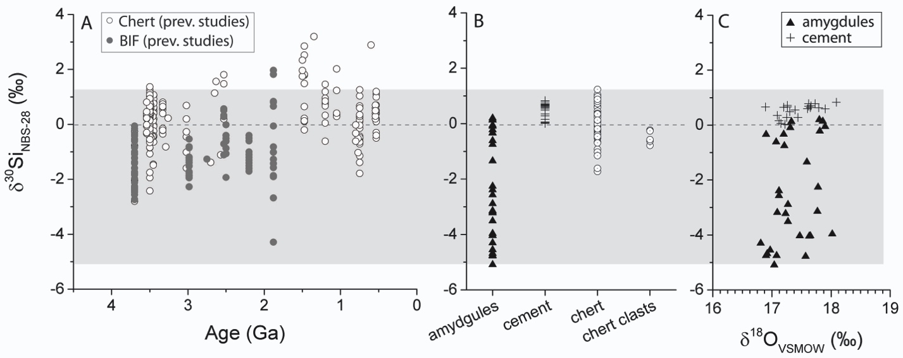
Figure 1. (A) Plot showing all compiled δ³⁰Si data (in ‰, n = 288; Van den Boorn et al., 2007, Abraham et al., 2011, André et al., 2006, Van den Boorn et al., 2010, Heck et al., 2011, Steinhoefel et al., 2010, Chakrabarti et al., 2012, Delvigne et al., 2012, Marin-Carbonne et al., 2012, Fan et al., 2013) from inorganic (non-biological) chert, and banded iron formation (BIF). Data were compiled from bulk (MC-ICP-MS, IRMS) and high-spatial resolution (SIMS, femtosecond laser ablation) techniques. To be comparable, spot data for individual samples were converted to a single value via the method outlined in Marin-Carbonne et al., (2012). Note the slight increasing trend through time. A single anomalously heavy data point (δ³⁰Si = +5.2 at 1.7 Ga) was omitted. (B) Plot showing SIMS δ³⁰Si (‰) data of quartz amygdules and quartz cement from a brecciated pillow basalt, bedded chert and a chert clast. Note the overlap between cement and chert/chert clast, potentially suggestive of similar precipitation mechanisms. (C) Plot showing SIMS δ³⁰Si (‰) vs. δ¹⁸O (‰) data of quartz cement and quartz amygdules within a single sample of basaltic breccia from the >3.7 Ga Isua Greenstone Belt. Oxygen isotope values range from δ¹⁸O_{VSMOW} = 16.81 to 18.09 ± 0.5 ‰. However, δ³⁰Si from the same crystals show a large range of values from δ³⁰Si_{NBS-28} = -5.09 to 0.83 ± 0.3 ‰. The heterogeneity indicates that the silicon isotopes have not been completely reset, even though the oxygen isotopes have. Shaded area highlights the maximum and minimum of data from this study, and a dashed line through δ³⁰Si = 0 ‰ is shown for reference. Both scales extend through geologically relevant ranges of δ³⁰Si and δ¹⁸O.
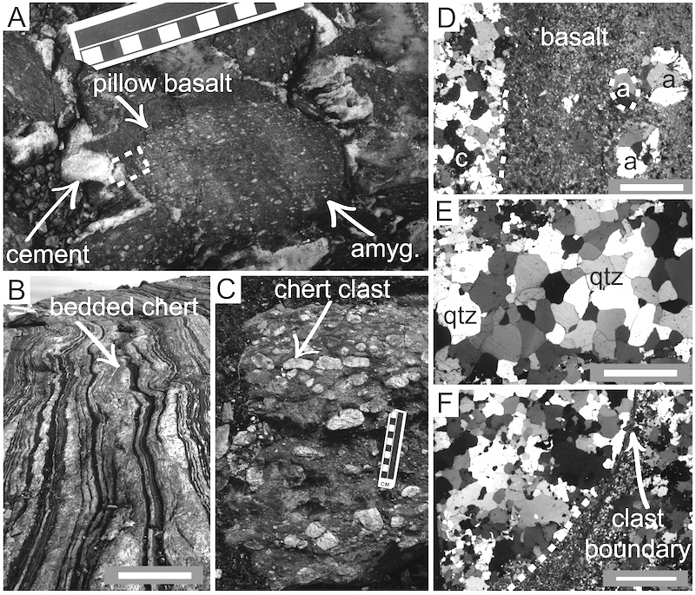
Figure 2. (A) Field photograph of quartz amygdaloidal, quartz-cemented pillow breccia from the >3.7 Ga Isua Greenstone Belt. Scale bar in cm. Dashed box shows the contact between cement and pillow fragment and outlines sample area used in this study. (B) Field photograph of bedded chert interlayered with amphibolite, adjacent to pillow breccia. Scale = 1.5 m. (C) Field photograph of the conglomerate unit showing chert clasts. Scale bar in cm. (D) Cross-polarized light image of quartz amygdules (a) and encasing quartz cement (c). Scale bar is 400 μm. (E) Cross-polarized light image of quartz crystals from bedded chert unit. Scale bar is 400 μm. (F) Cross-polarized light image of quartz crystals of chert clast. Scale bar is 500 μm.
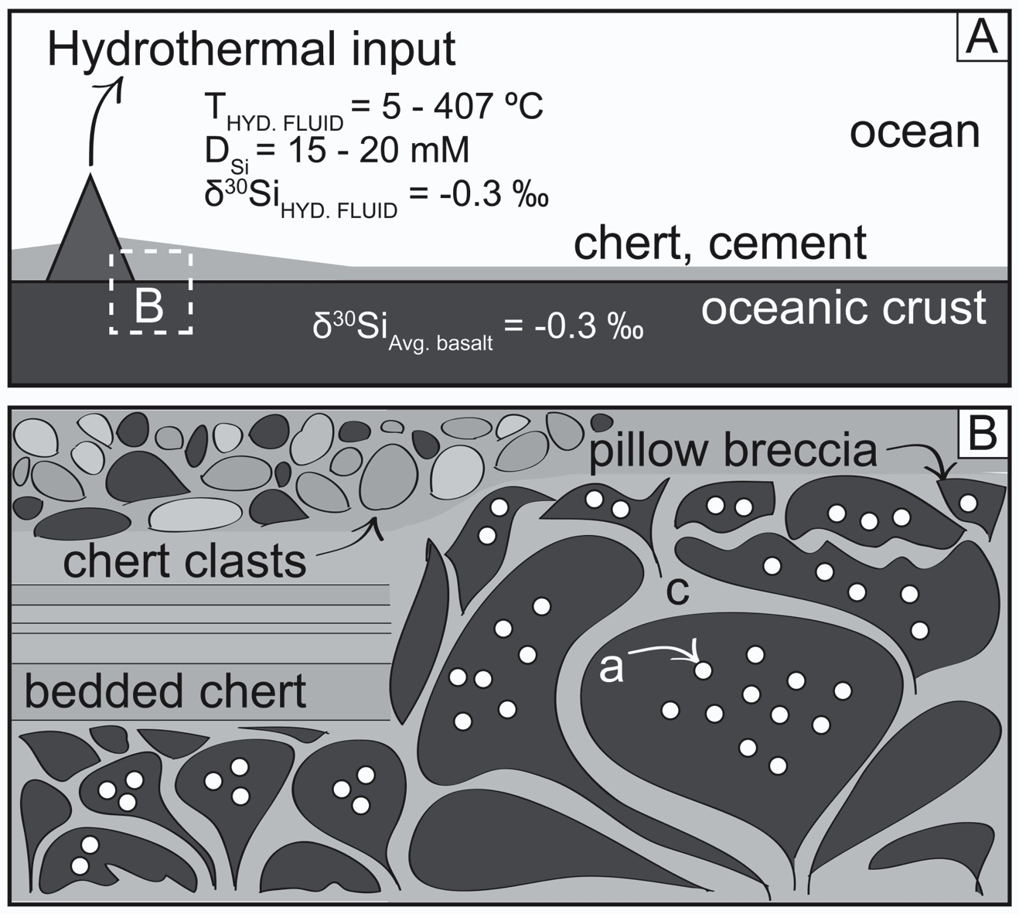
Figure 3. Cartoon showing different quartz lithologies used in this study. (A) Schematic of a typical hydrothermal system. Conditions of formation include vesicular standard pressures of 30-35 MPa, and hydrothermal fluid temperatures (T_{HYD. FLUID}) ranging from 5 – 407 °C, high dissolved silica (D_{Si}) concentrations, and silicon isotope signatures of basalt (δ³⁰Si_{Basalt} = -0.3 ‰; Fitoussi et al., 2012), and hydrothermal fluid (δ³⁰Si_{HYD. FLUID} = -0.3 ‰; De la Rocha et al., 2000). (B) Diagram of different types of quartz samples from this study including: pillow basalt breccia, with quartz-filled amygdules (a), encased in quartz cement (c), adjacent bedded chert, and chert clasts from a conglomerate. Under conditions of disequilibrium, rapid precipitation from high temperature fluids likely led to preferential incorporation of ²⁸Si into the precipitating quartz filling vesicles during initial eruption of pillow basalt. As conditions approached equilibrium, quartz precipitated as encasing cement at slower rates, and lower temperatures, resulting in cement δ³⁰Si values similar to source fluid/rock composition. Geochemical and isotopic conditions for formation of quartz in the bedded chert unit, and chert clasts, were likely similar to those that formed the cement.

CHAPTER IV
SILICON ISOTOPE EVIDENCE FOR CONTINENTAL EMERGENCE AT ~3Ga

ABSTRACT
The silicon isotope signatures (δ³⁰Si) of Precambrian Superior-type banded iron formation (BIF) from 3 Ga to 1.88 Ga, record a unidirectional shift in silicon sources to the ocean reservoir from dominantly hydrothermal, to continental. This shift is the result of continental emergence beginning at ~3 Ga. Over the period of deposition of Superior-type BIF, the production of ³⁰Si-enriched silicic acid during chemical weathering of newly exposed silicic continental crust, and subsequent delivery to the oceans, changed the isotopic composition of the marine reservoir from a dominantly hydrothermal signature (δ³⁰Si ~ 0 ‰), to a continental one (δ³⁰Si > 1 ‰). Based on our findings, the ~ 3 Ga – 2.5 Ga time interval should carry critical implications for increased and widespread delivery of bio-essential nutrients to surface oceans and the development of a terrestrial biosphere on newly emergent continents.

INTRODUCTION
The growth and emergence of continental crust radically changed the global geochemical cycling of elements, including bio-essential nutrients, through the Precambrian marine reservoir. However, few chemical proxies are known to record this unidirectional event. We suggest that the progression from predominantly high-temperature, sub-aqueous, hydrothermal weathering of low-SiO₂ (basaltic) oceanic crust to low-temperature, sub-aerial, chemical weathering of high-SiO₂ continental crust should result in the delivery of an expanded cation inventory to the ocean, including the non-redox sensitive element, silicon. Here we add crucial samples to the compiled silicon-isotope archive of supracrustal rocks, which allows us to decipher the δ³⁰Si record of Precambrian sedimentary and hydrothermal chert and banded iron formation (BIF). The record across time reveals an overall increase in the δ³⁰Si values of Superior-type BIF that can only be explained by increased input of isotopically heavy silicon (³⁰Si) to the ocean via low-temperature chemical weathering of exposed continental material. The results of this study suggest continental emergence and initiation of widespread sub-aerial chemical weathering of continental crust over the 3 – 2.5 Ga time frame. From a nascent biosphere perspective, this puts new emphasis on the time interval prior to the Great Oxidation Event, with implications for increased delivery of bio-essential nutrients, such as phosphorus, to the ocean, in addition to providing a template to explain the observed rapid increase in genetic innovation at ~3 Ga in concert with the development of a terrestrial biosphere on newly emergent continents.
Since the original use of silicon isotopes in chert (SiO₂) as a paleo-ocean thermometer (1), a number of studies have attempted to explain a perceived secular rise in the silicon isotope composition (expressed as δ³⁰Si) of marine siliceous precipitates (chert and BIF) through time (2-12) (Fig. 1a), as either a mixing of hydrothermal and continental silicon sources to the ocean (6), or, a gradual cooling of ocean temperatures since the Archean (10). Either interpretation of this heterogeneous data set raises two significant concerns. First, the pooling of all data together regardless of rock/chert type (e.g., silicified precursor rocks, shallow-water evaporitic chert, diagenetic chert, greenstone chert, Algoma-type [hydrothermal] BIF, and Superior-type [continental] BIF) requires that each distinct type of siliceous marine sediment records precipitation under identical geochemical conditions from a single, unchanging marine reservoir. Second, simple source mixing requires proportions of end-member hydrothermal and continental inputs to remain constant through time, despite ample evidence to the contrary (13). Here we propose an alternative explanation for the observed heterogeneity in the compiled δ³⁰Si record of chert and BIF, and provide a predictive model with which to decipher the evolving record of silicon sources to the Precambrian ocean. Using this approach, we document the first geologic evidence for continental emergence beginning at ~3 Ga.
To interpret the silicon isotope composition of Precambrian chert and BIF, it is necessary to establish the major Si sources to the ocean, and understand the abiotic processes that affect silicon isotope fractionation. Today, silica-utilizing organisms profoundly overprint the modern silicon cycle. Despite this, the sources to the present ocean reservoir, hydrothermal emanations and riverine inputs, maintain distinct δ³⁰Si isotopic signatures. In a Precambrian world devoid of silica-fixing organisms, abiotic kinetic processes responsible for creating distinct isotopic signatures in hydrothermal and continental settings must have dominated the silicon cycle. The main sinks for silicon, Precambrian silica-rich chemical sediments (chert, BIF), precipitate in diverse marine environments, in addition to forming from diagenetic and metasomatic replacement of precursor materials (e.g. silicified rocks, diagenetic nodular cherts within carbonates). Greenstone-belt chert and Algoma-type BIF occur in association with mafic volcanic rocks (14). By contrast, large-scale Superior-type BIF form in continental-margin settings and are commonly interbedded with shale, sandstone, and carbonate (14). Because chert, Algoma-, and Superior-type BIF accumulate in different depositional settings, we hypothesize these rocks could record distinct isotopic source signatures related to the silicon reservoir from which each precipitated. We further consider that dividing the current compiled silicon-isotope archive into rock/chert types based on depositional affinity (e.g., hydrothermal versus continental shelf) and mode of formation (primary versus secondary) will explain the observed heterogeneity and allow for mechanistic explanations of any perceived temporal trends.

RESULTS
To test our hypothesis, we measured the silicon isotope composition of quartz by secondary isotope mass spectrometry (SIMS) from different rock types (bedrock, sandstone, chert, Superior-type BIF, Algoma-type BIF) from the weakly metamorphosed ~3 Ga Buhwa Greenstone Belt (BGB), Zimbabwe (15), where the known silicon sources and sinks in a single basin could be identified. Quartz crystals from a gneissic bedrock sample (Tokwe segment; 16) possess an overall δ³⁰Si signature of ~1 ‰, with little internal heterogeneity (0.54 – 1.21 ‰; Fig. 1b; δ³⁰Si_{peak} (17) = 0.94 ± 41 ‰; Fig. 1c). Individual mono-crystalline quartz grains from a quartz arenite sample from the BGB with quartz sand likely derived from the Tokwe segment possess a similar, relatively homogeneous δ³⁰Si signature near ~1 ‰, (-0.24 – 1.02 ‰; Fig. 1b; δ³⁰Si_{peak} = 0.59 ± 0.44 ‰; Fig. 1c). The overlap in δ³⁰Si values between the bedrock and derived quartz sand indicates a lack of significant fractionation during the generation and physical transport of quartz sand originated from igneous sources.
By contrast, marine precipitates (chert and BIF) are ³⁰Si-depleted, and show additional inter- and intra-sample heterogeneity (Fig. 1b, c). Chert and BIF in the BGB appear in two separate associations, namely (1) interbedded with abundant mafic volcanic rocks (greenstones), and (2) overlying quartz arenite and shale as part of a km-thick succession (15). Greenstone-associated chert samples in association 1 range from δ³⁰Si = -1.5 to 1.6 ± 0.3 ‰ (Fig. 1b; δ³⁰Si_{peak} = 0.79 ± 1.37 ‰; Fig 1c). Algoma-type BIF samples in this association are, on average, ³⁰Si-depleted relative to bedrock, sandstone, and chert samples, possessing δ³⁰Si compositions that range from -3.6 to -1 ± 0.3 ‰ (Fig. 1b; δ³⁰Si_{peak} = -2.14 ± 0.57 ‰; Fig. 1c). Similarly, Superior-type BIF samples from association 2 are on average ³⁰Si-depleted (Fig. 1b; δ³⁰Si = -3.3 to -0.2 ± 0.3 ‰; δ³⁰Si_{peak} = -0.67 ± 1.41 ‰; Fig 1c) compared to bedrock, sandstone, and pure chert, although they are ³⁰Si-enriched relative to Algoma-type BIF. The extreme δ³⁰Si heterogeneity measured in rocks of approximately the same age, from a single ocean basin in this study spans nearly the entire dynamic range of silicon isotopes. We interpret the intra-sample heterogeneity to reflect differences in the magnitude of kinetic isotope effect, while inter-sample heterogeneity reflects variance in the δ³⁰Si source composition. Overall, the statistically significant δ³⁰Si differences between rock types (Fig. 1c) in the BGB demonstrate that distinct silicon-isotope fractionation mechanisms operate in shelf versus basinal settings. Consequently, the sedimentary record captures the transfer of distinct, process-specific, isotope compositions from the marine reservoir.
To better understand how sediments acquire their Si-isotope composition, we present additional new data of quartz from selected Archean BIF, chert, and silicified rock samples interpreted to represent silica precipitation across a spectrum of depositional environments and ages from the >3.7 Ga Isua Greenstone Belt (IGB), SW Greenland (18), and the ~2.7 Ga Abitibi Greenstone Belt (AGB), Canada (19). Combining our data with all published silicon-isotope values of Precambrian siliceous precipitates (Fig. 2, 3; Supplementary Table S4), and subsequently dividing the silicon isotope archive into different rock types, reveals that only Superior-type BIF preserve the δ³⁰Si record of the evolving open-ocean reservoir composition.

DISCUSSION
Silicification of volcanic rocks involves the transformation of precursor lithologies into chert adjacent to hydrothermal systems in greenstone belt terranes (2). Figure 2a contains our data from silicified volcanic rocks in the AGB, which, together with data compiled from previous studies (2-5) demonstrates that silicified rocks uniformly possess δ³⁰Si values near 0 ‰ (2, 3). During silicification, dissolution of igneous material results in quartz precipitation and replacement of the original rock. Quartz formed in this way precipitates in equilibrium with hydrothermal fluids (δ³⁰Si = -0.3‰; 20) saturated with silicon derived from original igneous material (δ³⁰Si = -0.6‰; 21), and yields no significant fractionation during precipitation. As a result, silicified volcanic rocks inherit the silicon-isotope signature of the precursor material, and thus cannot directly represent ocean chemistry.
When pooled together, all other chert types show an apparent increasing trend in δ³⁰Si values, followed by a decrease with respect to time after about 1.5 Ga (Fig. 2b). However, when separated into different chert types, this apparent trend disappears. Greenstone chert (Fig. 2c) dominantly of Archean age, likely formed in environments with profuse hydrothermal input, where quartz precipitates locally via conductive cooling in rapidly evolving hydrothermal systems. Diagenetic chert hosted within carbonate successions (Fig. 2d) is generally Proterozoic in age, and forms from dissolution and precipitation of locally or externally sourced siliceous material within carbonate beds, and likely acquires the isotopic composition of the source for the silicon (e.g., siliceous shale). In addition, the evolution of silica-fixing organisms with the potential to fractionate silicon occurred during the late Proterozoic (22), which could have shifted the ocean reservoir, or led to preservation of local effects. Therefore, neither greenstone chert, nor diagenetic chert can be used consistently to describe the silicon-isotope composition of the ocean reservoir.
Algoma-type BIF are thought to form from exhalative precipitation proximal to sub-aqueous hydrothermal systems, and commonly occur in greenstone-belt terranes interstratified with volcanic rocks and silicified equivalents (14). Figure 2 illustrates all published spot (Fig. 2e; SIMS, LA-ICP-MS) and bulk (Fig. 2f) data for Algoma-type BIF, including our data from the AGB (~2.7 Ga) and IGB (~3.7 Ga). We propose that the range of silicon-isotope values observed in Algoma-type BIF samples of a given age result from kinetic isotope effects due to precipitation via conductive cooling. In this model, under disequilibrium conditions of rapid quartz precipitation, ²⁸Si preferentially incorporates into the product phase, and Δ^{30/28}Si_{ppt-soln} < 0. As the system nears equilibrium and quartz precipitates at a slower rate, the product possesses values closer to the source rock/fluid composition, and Δ^{30/28}Si_{ppt-soln} ~ 0. The heterogeneous values measured for these Precambrian deposits overlap values measured for modern Fe-Si-rich deposits that flank modern mid-ocean-ridge hydrothermal systems (δ³⁰Si = -0.4 to -3.1 ‰; 21). We interpret the scattered but consistent range of δ³⁰Si values of Algoma-type BIF to indicate that the hydrothermal processes responsible for Algoma-type BIF deposition remained constant over this billion-year time frame, and most likely throughout Earth history.
In depositional settings distant from hydrothermal systems, silica precipitation occurs directly from the ambient water column due to adsorption to continentally sourced Al- and Fe-clays (23), Fe-oxides (24), or organic carbon (25), and/or via precipitation under super-saturated conditions (25). Silicon isotopes fractionate during both adsorption to Al- and Fe-oxides (23, 24) and clays, and precipitation directly from supersaturated fluids at ambient ocean temperatures (26). A record of continentally sourced silicon therefore should be recorded in the quartz deposited in Superior-type BIF, which form in such depositional settings. We report silicon-isotope data from one of the oldest known Superior-type BIF (~3 Ga; Buhwa Greenstone Belt, Zimbabwe), combined with previously collected data (6-10) that span the entire time frame of Superior-type BIF deposition (Fig. 3a, b). Both the bulk (Fig. 3a) and spot data (Fig. 3b) show a systematic increasing trend (more clearly represented in the spot data) from negative (δ³⁰Si_{peak} = -0.69 ± 1.5 ‰) to positive (δ³⁰Si_{peak} = 1.92 ± 0.76 ‰) across the 3 Ga to 1.9 Ga time frame, which we interpret as the result of incremental addition of isotopically heavy silicon (³⁰Si) to the oceans. The only documented ³⁰Si-enriched source for silicon during this time frame is mono-silicic acid (H₄SiO₄), a product of terrestrial chemical weathering, where hydrolysis reactions result in concurrent feldspar dissolution and in-situ authigenic clay precipitation. Such clays possess ³⁰Si-depleted signatures (δ³⁰Si ≈ -3 to -1 ‰; 27) complemented by resultant ³⁰Si-enriched silicic acid (δ³⁰Si ≈ +1 to +3 ‰; 27), which enters the ocean reservoir via riverine transport. Despite heterogeneities within samples of any single age, which are likely due to heterogeneous fractionation during adsorption or precipitation via super-saturation, the differences recorded in δ³⁰Si values of Superior-type BIF from 3 Ga to 1.9 Ga exceed what would be expected by fractionation from an isotopically unchanging ocean reservoir. We interpret this documented increase in silicon isotope values of Superior-type BIF to represent precipitation from an evolving ocean reservoir with respect to δ³⁰Si, due to the addition of ³⁰Si-enriched silicon delivered by riverine waters draining newly emergent, chemically weathered continents.
By modifying previous modern flux estimates for Precambrian hydrothermal and continental sources to the ocean (Supplementary Fig. S2), we can describe the evolving Precambrian marine reservoir, and determine broader implications for how the emergence of the continents would have changed habitable environmental niches for early life (Fig. 4). Early in Earth history, a hydrothermal silicon signature dominated the ocean (Fig. 4a), and silica deposition dominantly occurred in sub-aqueous hydrothermal settings (14). In this scenario, silicon isotopes of hydrothermally sourced quartz in Algoma-type BIF and associated greenstone chert (Fig. 4d) record silicon derived from igneous rocks and precipitated from hydrothermal fluids (Fig. 2c, e, f) in a mantle-buffered marine reservoir (28). After the initial establishment of continental shelf environments (Fig. 4b), which served as platforms for Superior-type BIF deposition (Fig. 4d), the continents became a new, and eventually dominant, source of silicon to the ocean. With increasing continental growth (29) and chemical weathering on extensive, emergent land surfaces (Fig. 4b), continentally derived Si was delivered in increasing quantity to the ocean resulting in a shift in reservoir composition. The silicon-isotope record of Superior-type BIF therefore provides the only known timeline of the unidirectional evolution from predominantly subaqueous, high-temperature hydrothermal weathering, to low-temperature, sub-aerial chemical weathering of emergent continental crust. After the cessation of Superior-type BIF deposition at ~1.8 Ga, the silicon-isotope record becomes dominated by shallow-water chert, and diagenetic chert formed via replacement of carbonate layers (Fig. 4d), neither of which likely consistently record whole-ocean chemistry. Once silica-fixing organisms evolved in the Neoproterozoic, abiotic isotopic signatures became obscured, and the sedimentary record of ocean chemistry dominantly reflects the biological utilization of silicon (Fig. 4c).
Overall, our findings presented here predict the heterogeneity that occurs within the current compiled δ³⁰Si isotope record. Furthermore, our research indicates that the evolution of BIF from Algoma- to Superior-type in the rock record occurred in response to the initiation of sub-aerial chemical weathering on newly exposed continental crust, recording the introduction of a continental source of silicon to the Precambrian ocean. In addition, weathering of emergent continental crust would initiate cycling of key, bio-essential nutrients, allowing enhanced delivery of these elements to the ocean. From an emerging biosphere perspective, this places new recognition of the 3 – 2.5 Ga time interval with implications for explaining the observed rapid increase in genetic innovation at 3 Ga (30) in concert with the development of a terrestrial biosphere (31).

METHODS
Samples (small rock chips) were embedded in epoxy along with a quartz reference material (UT-Q), polished to 1 μm, mapped and gold-coated (30 nm) prior to analysis. In situ Si-isotope measurements were made using a CAMECA IMS 1280 SIMS instrument at the Swedish Museum of Natural History, Stockholm (NordSIMS facility). ³⁰Si/²⁸Si ratios were measured in separate analytical sessions. A ¹³³Cs⁺ primary beam (ca. 5nA) with an incident energy of 20 keV was used to sputter secondary ions from specifically targeted <20 μm individual grains; microcrystalline domains were avoided (cf. ref. 10) except during methodological testing (see Supplementary Information). Sample charging was minimized by use of a low-energy normal-incidence electron gun. Secondary ions were measured at a mass resolution of 2,500 (M/ΔM) by multicollection on Faraday detectors attached to low noise amplifiers housed in a thermally stabilized, evacuated chamber. The magnetic field was locked at high precision using an NMR field sensor.

Fully automated analytical sessions regularly bracketed unknowns between reference analyses and individual analyses comprised a pre-sputter to remove the Au coat, beam centering and 48 seconds (Si) of data acquisition. Corrections for instrumental mass fractionation were made using internal standard UTQ with a bulk δ³⁰Si value of 0.08 ± 0.01 ‰, determined at the University of Western Ontario. External reproducibility (1 std. dev.) for δ³⁰Si of ± 0.15 ‰ was derived from the bracketing UTQ analyses (Supplementary Table S3, Supplementary Fig. S3) and propagated onto within-run uncertainties.

Following the approach of previous studies (10), probability density distributions were calculated with the R statistical package v2.14.1 to yield δ³⁰Si_{peak} (17) values.

ACKNOWLEDGEMENTS
This work was funded by NASA grant EXOB08-0063 awarded to CMF, and student research grants awarded to LAB from ExxonMobil, the Geological Society of America, the Sedimentary Division of GSA, and the Department of Earth and Planetary Sciences at the University of Tennessee. The data reported in this paper are tabulated in the Supplementary Materials Table S1, S2, S3, and S4. The NordSIMS facility is a joint Nordic infrastructure funded by the research funding agencies of Denmark, Norway and Sweden, the University of Iceland and the Geological Survey of Finland. This is NordSIMS contribution ###. We thank Balz Kamber, Grant Young, and Tom McCollom for comments on a previous version of the manuscript.

LIST OF REFERENCES

- Robert, F., Chaussidon, M, (2006) A paleotemperature curve for the Precambrian oceans based on silicon isotopes in chert. Nature 443: 969-972.

- Van den Boorn, S. H. J. M., van Bergen, M. J., Nijman, W., Vroon, P. Z. (2007) Dual Role of seawater and hydrothermal fluids in Early Archean chert formation: Evidence from silicon isotopes. Geology 35: 939-942.

- Abraham, K., Hofmann, A., Foley, S.F., Cardinal, D., Harris, C., Barth, M.G., André, L. (2011) Coupled silicon-oxygen isotope fractionation traces Archean silicification. Earth and Planetary Science Letters 301: 222-230.

- André, L., Cardinal, D., Alleman, L.Y., Moorbath, S. (2006) Silicon isotopes in ∼3.8 Ga West Greenland rocks as clues to the Eoarchaean supracrustal Si cycle. Earth and Planetary Science Letters 245: 162-173.

- Van den Boorn, S.H.J.M., van Bergen, M.J., Vroon, P., de Vries, S.T., Nijman, W. (2010) Silicon isotope and trace element constraints on the origin of ~3.5 Ga cherts: Implications for Early Archaean marine environments. Geochimica et Cosmochimica Acta 74: 1077-1103.

- Heck, P.R., Huberty, J.M., Kita, N.T., Ushikubo, T., Kozdon, R., Valley, J.W. (2011) SIMS analyses of silicon and oxygen isotope ratios for quartz from Archean and Paleoproterozoic banded iron formations. Geochimica et Cosmochimica Acta 75: 5879-5891.

- Steinhoefel, G., von Blanckenburg, F., Horn, I., Konhauser, K.O., Beukes, N.J., Gutzmer, J. (2010) Deciphering formation processes of banded iron formations from the Transvaal and the Hamersley successions by combined Si and Fe isotope analysis using UV femtosecond laser ablation. Geochimica et Cosmochimica Acta 74: 2677-2696.

- Chakrabarti, R., Knoll, A. H., Jacobsen, S. B., Fischer, W. W. (2012) Si isotope variability in Proterozoic cherts. Geochimica et Cosmochimica Acta 91: 187-201.

- Delvigne, C., Cardinal, D., Hofmann, A., L. Andre. (2012) Stratigraphic changes of Ge/Si, REE + Y and silicon isotopes as insights into the deposition of a Mesoarchean banded iron formation. Earth and Planetary Science Letters 355-356: 109-118.

- Marin-Carbonne, J., Chaussidon, M., Robert, F. (2012) Micrometer-scale chemical and isotopic criteria (O and Si) on the origin and history of Precambrian cherts: Implications for paleo-temperature reconstructions. Geochimica et Cosmochimica Acta 92: 129-147.

- Kejun, H., Yanhe, L., Jiangeng, G., Feng, L., Yan, Q. (2014). Ore Geology Reviews. 57: 288-298.

- Fan, H., Wen, H., Zhu, X., Hu, R., Tian, S. (2013) Hydrothermal activity during Ediacaran-Cambrian transition: Silicon isotopic evidence. Precambrian Research 224: 23-35.

- Isley, A.E. (1995) Hydrothermal plumes and the Delivery of Iron to Banded Iron Formation. The Journal of Geology 103: 169-185.

- Klein, C. (2005) Some Precambrian banded iron-formations (BIFs) from around the world: Their age, geologic setting, mineralogy, metamorphism, geochemistry, and origin. American Mineralogist 90: 1473-1499.

- Fedo, C. M., Eriksson, K. A. (1996) Stratigraphic framework of the ~3.0 Ga Buhwa Greenstone Belt: a unique stable-shelf succession in the Zimbabwe Archean Craton. Precambrian Research 77: 161-178.

- Wilson, J.F. (1990) A craton and its cracks: some of the behavior of the Zimbabwe block from the Late Archean to the Mesozoic in response to horizontal movements, and the significance of some of its mafic dyke fracture patterns. Journal of African Earth Sciences (and the Middle East) 10: 483-501.

- Subscript ‘peak’ refers to a probability density distribution calculated for each individual sample, and per locality based on the methods of ref. [10].

- Fedo, C. M., Myers, J. S., Appel, P. W. U. (2001) Depositional setting and paleogeographic implications of earth’s oldest supracrustal rocks, the >3.7 Ga Isua Greenstone belt, West Greenland. Sedimentary Geology 141-142: 61-77.

- Mueller, W. U., Mortensen, J. K. (2002) Age constraints and characteristics of subaqueous volcanic constructions, the Archean Hunter Mine Group, Abitibi greenstone belt. Precambrian Research 115: 119-152.

- De la Rocha, C.L., Brzezinkski, M.A., DeNiro, M.J. (2000) A first look at the distribution of the stable isotopes of silicon in natural waters. Geochimica et Cosmochimica Acta 64: 2467-2477.

- Ding, T., 1996, Silicon isotope geochemistry, Geological Publishing house, pp. 1-105.

- Perry, E.C., Lefticariu, L. (2007) Treatise on Geochemistry. Volume 7 Sediments, Diagenesis, and Sedimentary Rocks, pp. 1-27. Ch. 7.05 – Formation and Geochemistry of Precambrian Cherts.

- Oelze, M., von Blanckenburg, F., Hoellen, D., Dietzel, M., Bouchez, J. (2014) Si stable isotope fractionation during adsorption and the competition between kinetic and equilibrium isotope fractionation: Implications for weathering systems. Chemical Geology 380: 161-171.

- Delstanche, S., Opfergelt, S., Cardinal D., Elsass, F., André L., Delvaux, B. (2009) Silicon isotopic fractionation during adsorption of aqueous monosilicic acid onto iron oxide. Geochimica et Cosmochimica Acta 73: 923–934.

- Siever, R. (1992) The silica cycle in the Precambrian. Geochimica et Cosmochimica Acta 56: 3265-3272.

- Geilert, S., Vroon, P.Z., Roerdink, D.L., Van Cappellen, P., van Bergen, M.J. (2014) Silicon isotope fractionation during abiotic silica precipitation at low temperatures: Inferences from flow-through experiments. Geochimica et Cosmochimica Acta 142: 95-114.

- Ziegler, K., Chadwick, O. A., White, A. F., Brzezinski, M. A. (2005) δ³⁰Si systematics in a granitic saprolite, Puerto Rico. Geology 33: 817-820.

- Kamber, B.S., Webb, G.E. (2001) The geochemistry of late Archaean microbial carbonate: implications for ocean chemistry and continental erosion history: Geochimica et Cosmochimica Acta 65: 2509-2525.

- Hawkesworth, C. J., Kemp, A. I. S. (2006) Evolution of the continental crust. Nature 443: 811 – 817.

- David, L. A., Alm, E.J. (2011) Rapid evolutionary innovation during an Archean genetic expansion. Nature 469: 93-96.

- Battistuzzi, F., Andreia, F., Blair, H.S. (2004) A genomic timescale of prokaryote evolution: insights into the origin of methanogenesis, phototrophy, and the colonization of land. BMC Evolutionary Biology 4(44): 1-14.

FIGURES
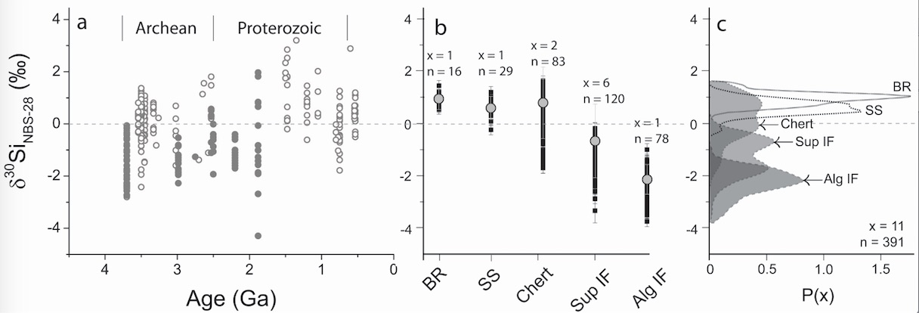
Fig. 1. Plots showing compiled silicon isotope record of chert and banded iron formation (BIF) through time, compared to the range of silicon isotope values of different chert and BIF types from this study from the 3 Ga Buhwa Greenstone Belt, Zimbabwe. (a) Plot showing all compiled δ³⁰Si data (2-12; in ‰, n = 288) versus time. Data were compiled from bulk (MC-ICP-MS, IRMS) and high-spatial resolution (SIMS, femtosecond laser ablation) techniques. Note what appears to be a slight increasing trend through time. A single anomalous data point (δ³⁰Si = +5.2 at 1.7 Ga) was omitted. (b) Plot showing our SIMS data from the ~3 Ga Buhwa Greenstone Belt, Zimbabwe. BR = bedrock, SS = quartz arenite sandstone, Chert = greenstone-associated chert, Sup IF = Superior-type banded iron formation, Alg IF = Algoma-type banded iron formation. X indicates the number of samples analyzed; n indicates the total number of spot analyses on x samples. (c) Probability density distribution plot (after reference 10) for each sample in (b).
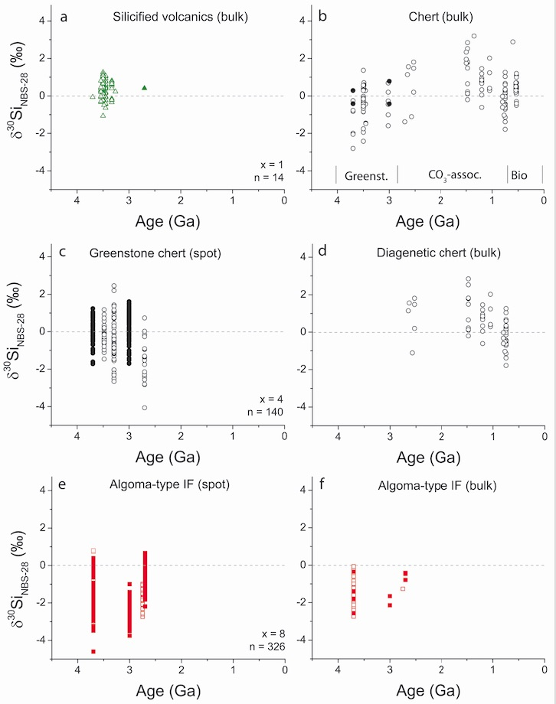
Fig. 2. All measured silicon isotope values separated into different rocks types. All points represent measured bulk values, or spot data that has been converted to bulk values utilizing a probability density distribution value as outlined in (10). Open symbols for each plot represent data from previous studies; closed symbols represent data from this study. Where indicated, x = the number of samples analyzed, and n = the number of analyses on x samples. Dashed line represents δ³⁰Si = 0 ‰ for reference. (a) Plot containing all compiled δ³⁰Si data for silicified volcanic rocks. (b) Plot containing all compiled δ³⁰Si data for non-silicified volcanic chert against time. Greenst. = Greenstone-associated chert, CO₃-assoc. = diagenetic chert hosted within carbonate rocks, and Bio = indicates chert formed after geologic evidence for silica-secreting organisms. (c) Plot showing spot δ³⁰Si data for greenstone chert. (d) Plot showing bulk δ³⁰Si data for diagenetic chert hosted within carbonate rocks. (e) Plot showing spot δ³⁰Si data for Algoma-type banded iron formation. (f) Plot showing bulk δ³⁰Si data for Algoma-type banded iron formation.
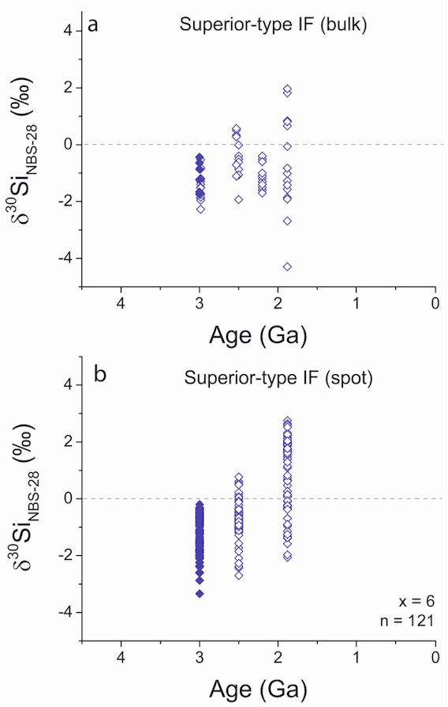
Fig. 3. All measured silicon isotope values of Superior-type banded iron formation. All points represent measured bulk values, or spot data that has been converted to bulk values utilizing a probability density distribution value as outlined in reference (10). Open symbols for each plot represent data from previous studies, while closed symbols represent data from this study. Where indicated x = the number of samples analyzed, and n = the number of analyses on x samples. Dashed line represents δ³⁰Si = 0 ‰. (a) Plot showing bulk δ³⁰Si data for Superior-type banded iron formation. (b) Plot showing spot δ³⁰Si data for Superior-type iron formation. Note the increasing trend from ~3 – 1.8 Ga.

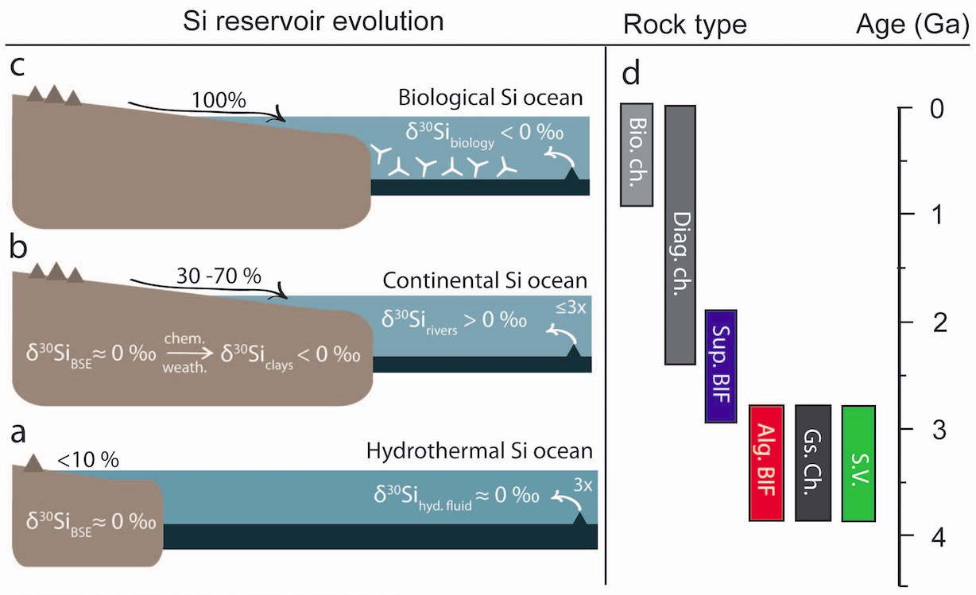
Fig. 4. Schematic diagram showing growth and emergence of continental crust, and distribution of different rock types represented in the compiled δ³⁰Si archive through time. (a) Diagram representing the Paleo- through Meso-Archean, where oceans were dominated by hydrothermal sources (δ³⁰Si_{hyd. fl.} ≈ 0 ‰) three times greater than modern values and little riverine input (< 10%; Supplementary Fig. S2) from small continents (δ³⁰Si_{BSE} ≈ 0 ‰ (21)). Hyd. fl. = hydrothermal fluids, BSE = bulk silicate Earth. (b) Diagram representing the increased riverine delivery (30 – 70 % of modern; Supplementary Fig. S2) of continentally sourced silicon (δ³⁰Si_{rivers} > 0 ‰) to the oceans from chemical weathering of newly emergent continental crust. (c) Diagram representing the Phanerozoic silicon cycle dominantly by continental: hydrothermal sources of 10:1, with silicon isotope composition of the ocean overprinted by biology (δ³⁰Si_{biology} > 0 ‰ (20)). Presence of silica-secreting organisms represented by siliceous sponge spicules. (d) Plot showing the distribution of rock types represented in the compiled silicon isotope record with respect to time. Note the temporal restrictions of certain rock types.

CHAPTER V
Conclusions

APPENDIX

Vita

