Understanding Linguistic Treatment Across Species: a Comparative Study at Zoo Knoxville

A Thesis Presented for the
Master of Arts
Degree
The University of Tennessee, Knoxville

Dynestee Fields
August 2022

ACKNOWLEDGMENTS
I give special thanks to each of my committee members: Dr. Sean Morey, Dr. Lisa King, and Dr. Jessica Grieser, for their guidance and insights during the duration of my research, writing, and editing.
I also thank Mary, my mother, and Shirley Fields, my grandmother, and Deborah Davis, my cousin, for their continued support throughout this process.
Finally, I thank my Creator for the ability to pursue such work.

ABSTRACT
Zoos are unique locations that bring the natural world into urban locations for the specific purposes of entertaining the public and gaining support for issues regarding conservation. However, the nature that zoos construct is imperfect in that it is tailored only to the aims described above. Engaging with environmental communication scholarship that explores how humans either listen to or silence the voices of nonhuman others, I use an ecolinguistic framework to inquire into how nonhuman animals are treated linguistically at Zoo Knoxville in comparison to one another based on species categories. I also seek the difference between this zoo’s communication about humans in relation to the zoo’s nonhuman animals as a whole. In order to accomplish this, I analyze zoo signage. The concepts used to discern such information are “ideology,” “framing,” “salience,” and “erasure.” The categories of nonhumans under study are “native,” “exotic,” and “pest” species. As seen through the lens of the four concepts, Zoo Knoxville is shown to adhere to particular geographic framing of its constructed nature, with nonhumans being divided into Eastern and Western “hemispheres.” This framing does appear to have an impact on the salience of native species. Salience and erasure is also shown to be precipitated by a species’ categorization as charismatic-a state which predominantly appears among exotic wildlife. Species that are considered pests are found to experience more erasure due to the zoo environment’s focus on cleanliness, protecting the endangered and the wild, as well as creating entertainment for visitors.

TABLE OF CONTENTS
Chapter 1: Environmental Communication and the Zoo………………………………………….1
Chapter 2: Ecolinguistics and Species Categories……………………………………………….16
Institutional Context……………………………………………………………………….20
Species………………………………………………………………………..22
Humans……………………………………………………………23
Red Wolves………….…………………………………………….24
Western Lowland Gorillas………………………………………...25
German Cockroaches…..………………………………………….25
Methods………………………………………………………………………………...…26
Concepts………………………………………………………………………………….27
Ideology………………………………………………………….28
Framing…………………………………………………………..29
Erasure………………………………………………………...…30
Salience…………………………………………………………..31
Chapter 3: Native Species………………………………………………………………………..31
Chapter 4: Exotic Species………………………………………………………………………..46
Chapter 5: Pest Species…………………………………………………………………………..61
Chapter 6: Discussion and Results………………………………………………………………76
References………………………………………………………………………………………..91
Appendix…………..……………………………………………………………………………..92
Vita……………………………………………………………………………………………….96

Chapter 2: Ecolinguistics and Species Categories

As stated in Chapter one, this study seeks to to identify species-based distinctions embedded in Zoo Knoxville’s technical discourse. Specifically, it asks what linguistic differences exist between the treatment of different species of nonhuman animals by zoo technical communicators. On a wider level, this study seeks to find the linguistic differences between the treatment of humans by zoo technical communicators and the treatment of nonhuman animals. In reference to nonhuman animals, it asks how linguistic treatment differs across species based on their categorization as either an exotic, native, or pest species. Using a methodology rooted in ecolinguistics, I sought similarities and differences across the following species: red wolves, western lowland gorillas, and German cockroaches. Each species was chosen because it represents a unique dimension of zoo life. The zoo’s red wolf population provides a native species for analysis. Its western lowland gorilla population provides an exotic species. German cockroaches serve as the pest species, which Rees (2011) notes is a species that frequents zoo environments. Due to the zoo’s dual purposes of entertaining humans and educating them about conservation, the zoo environment can accurately be termed a human-dominated space. As this species is both central to the zoo environment itself and to answering the first research question, the linguistic patterns surrounding it are those to which the three other species’ will ultimately be compared.
Before I describe my methods and strategies in detail, as well as the institution and species that are central to my study, it is necessary to first define “ecolinguistics” as well as describe what a methodology centered around this term entails.
Ecolinguistics is an umbrella term that covers two strands of linguistic research. The oldest of these concerns whether language diversity can exist in a globalized world. Linguistic diversity is compared to biological diversity, and discussion centers on the relationships between an individual’s languages and those languages’ relationship to the outside world. The second strand of research explores how language can be used to inflict harm or bring restoration to the natural world (Fill, 2017). It is this second strand that is foundational to this study’s methodology due to the attention it gives to the treatment of nonhuman animals as well as to the power structures that enable this, often destructive, behavior.
Ecolinguistics, through its analyses of language’s impact on nonhuman animals and the wider natural world, highlights this skill’s world-shaping capabilities. Language influences thought, which then proceeds to influence action. In order to identify and curb the destructive forces of language by replacing them with more harmonious discourses, those who have adopted ecolinguistics utilize distinct concepts to locate and diagnose “the stories that we live by” (Stibbe, 2015, p. 3). Approaches to ecolinguistics both identify smaller linguistic patterns, like Goatly and Trampe do, as well as discuss the larger constructs that they contribute to, like Stibbe’s disclosure of the eight story forms. There are a variety of conceptualizations that authors use, but some examples include Stibbe’s notable list of eight forms that stories manifest themselves in, Trampe’s exploration of the role of euphemization in masking the destruction of nonhuman animals, and Goatly’s analysis of how metaphors can be used to project human values and societal constructs onto nonhuman creatures (Stibbe, 2015; Goatly, 2006; Trampe, 2018). Such detail makes this methodology suitable for analyzing linguistic differences across the zoo environment and for identifying overarching themes.
Deriving from critical discourse analysis, ecolinguistics primarily focuses on written and spoken language. However, it does sometimes address imagery (Hansen, 2017; Hansen & Machin, 2008; Stöckl & Molnar, 2017). This is notable because much of this study’s data is derived from zoo signage and monuments. The work of Gavin Lamb and Aaran Stibbe illustrate what it looks like to apply ecolinguistics to objects and visual texts (Lamb, 2019; Stibbe, 2015). In his study, Lamb analyzes signage and the wider discursive infrastructure of a tourist trap in Hawaii. There, discourse about protecting sea turtles moves across sites and when used tethers the speaker to the wider network of wildlife conservation’s history and activity (Lamb, 2019). Stibbe takes a different approach when analysing photographs of farmed animals. Through measuring the level of detail in each photograph, as well as the amount of action individual animals are depicted as taking part in, he hypothesizes whether the photographer saw these creatures as worthy of attention (Stibbe, 2015). This methodology’s ability to engage with mediums beyond text brings greater potential for identifying salience in the zoo environment as it is present in imagery.
My methodology utilizes the concepts of “framing,” “ideology,” “erasure,” and “salience” to identify larger themes in the patterns embedded in zoo documentation, monuments, regulations, signage, and its pest management plan. As suggested in my discussion of ecolinguistics, being able to group more minute linguistic elements into larger frameworks will assist me with making comparisons across species. Below is a description of each.
Frames are structures that include semantic roles, the relationships between them, and relationships to other such structures (Lakeoff, 2010). Frames provide assistance with understanding seemingly disparate areas of life and can be evoked by a single word that is tied to another frame. For instance, when dog owners choose to euthanize their animals they transpose a frame from a less distressing aspect of life: slumber. Therefore, instead of terming the practice as what it is, euthanasia or mercy killing, it is termed “putting to sleep.” Framing is important to this study because it allows for the zoo’s governing framework to be more directly examined and it aids in bringing understanding about what other areas of life are being transposed into the zoo setting.
Ideologies are beliefs that are shared and distributed amongst members of a group (Djik, 2011). These beliefs are the rods against which reality is measured against. In sum, these beliefs refer to the ideal version of reality (Stibbe, 2015). One example of an ideology is the belief held among ethical vegans that nonhuman animals should not be killed to satisfy someone’s gustatory desires. The ideal reality being imagined is a world in which people avoid inflicting pain on intelligent, sentient life forces. Therefore, in the current reality, eating a cheeseburger derived from cows is considered unethical and counter. The role of ideology in this study is to identify the dominant beliefs held by the zoo (their ideology) and to interpret how those beliefs reflect onto the nonhuman animals in the environment as well as the zoo’s visitors.
The term erasure refers to an aspect of life that either does not fit into the framework being used or that is purposefully being censored because it has been tagged as detrimental (Irvine & Gal, 2000). One example of this might be an adolescent male arguing for admittance to an all girl boarding school. When he is turned away by the headmistress, it may not be that the boarding school has misandrist tendencies (as he suspects), it could be that he does not fit into the school’s existing framework and there is therefore no place for him. This concept is useful to this study because it allows for a discussion of why certain nonhuman animals are not discussed within the zoo context and possible reasons for why this is.
Finally, salience refers to the prominence of information compared to other information that surrounds it. Blurred backgrounds that bring a figure into more focus and the inclusion of more detail in discourse are both examples of salience. A specific example of this would be a photograph of a sparrow sitting among the branches of a forest. Here, the bird has very little salience. There is not much detail given to them in comparison with the trees. However, were the photograph a closeup of the bird swaying on the branches of the tree, then the bird would have high salience (Fouad, 2019). The concept of salience will benefit this study by enabling the identification of which animals are emphasized and which ones are not.
Now, in the next six sections, I describe the elements that compose this study. First, I introduce the institutional context of this research. Second, I elaborate on my rationale for selecting humans, red wolves, western lowland gorillas, and German cockroaches to provide the framework for this study. Third, I describe my methods for collecting the material for my analysis. Fourth, I describe the codes that I selected and their connections to ecolinguistics. Fifth, I will introduce the limitations of this study. And in sections six and seven, I conclude with the preliminary findings and their meaning in regards to the research questions.
Institutional Context
This study was conducted at Zoo Knoxville, a southeastern zoo that is home to over 800 animals and accredited by the Association of Zoos and Aquariums (AZA). As a member of this organization, the zoo seeks to progress in “the areas of conservation, education, science, and recreation” (About Us section, para. 1). Officially established in 1971, the zoo is known for facilitating the birth of the first African elephant born in the Western Hemisphere (History, para. 6). In addition to this accomplishment, the zoo is the first in the world to have hatched critically endangered northern spider tortoises, and is the second to have successfully bred “second generation of captive-born Arakan forest turtles and common spider tortoises” (History section, para. 6).
Presently, the zoo is actively involved in conservation initiatives. On a large scale, this work is in conjunction with AZA Species Survival Plans (Association of Zoos and Aquariums, n.d.). These plans seek to establish zoo populations that are demographically and genetically varied as well as biologically sound. If populations are threatened in the wild, these ex situ (off-site conservation) populations will exist. Taking a regional approach to conservation, the zoo also works to save East Tennessee’s bog turtle population in addition to conducting research on hellbenders and mudpuppy salamanders (who are also native to this area).
Entertainment is another value that the zoo holds closely. As of 2019, records indicate that the zoo has over 500,000 visitors per year (Farley, 2019). Primarily guests are encouraged to enjoy exploring the zoo environment. The “about us” statement on the organization's website states that it is “committed to sharing ‘wildly fun’ experiences that educate and inspire” and has “acres of creative habitats for animal lovers of all ages to explore” (About Us, para. 1). Visitors are further able to enjoy the surroundings through the zoo’s private party packages, which include: catered events, birthday parties, weddings, after-hour photography, and the options to host a non-profit charity walk on the zoo’s premises. Additional experiences that the zoo offers include carousel rides, a “Bedtime with the Beasts” program that includes a nighttime safari and a slumber party at the zoo, as well as a safari-themed water play area.
Finally, the zoo hosts a variety of educational programs. Educators are given the opportunity to bring their students to the zoo environment for a field trip. Educators are also able to teach a curriculum in conjunction with the zoo, which will culminate in a visit to the zoo’s premises. There are also other options available on-site, such as a classroom experience that includes a zoo educator and three animal ambassadors and an activity that encourages students to compose a research question and then find its answer in the zoo environment. These programs are treated as other ways in which visitors can have ‘wildly fun’ experiences (Zoo Knoxville, n.d.).
This continuous focus on entertainment is important to note because it reveals that the zoo environment must be interpreted beyond its conservation work. There are elements there included that appeal directly to their visitors’ sense of humor and any glib desires that they may hold. Trying to intercept everything within this environment as being educational or serious would severely limit this study as well as indicate that it is not founded on thorough analysis.
Species
As mentioned earlier, I selected three nonhuman species from this environment based on the unique dimension of zoo life that they bring to the study, as well as their status of endangerment. The species I have selected include red wolves (a native species), western lowland gorillas (an exotic species), German cockroaches (a pest species). Both red wolves and western lowland gorillas are critically endangered, a point which lessens the disparity between the species in this analysis, but still allows for their different categorizations. They are also viewed as belonging in the zoo environment. German cockroaches add another dimension of zoo life to this analysis as a species that is considered populous to the degree of being invasive and is not a welcome sight in the zoo environment. Humans serve as a fourth species in this analysis for the purpose of bringing more understanding to how nonhumans in this environment are discussed in reference to them. Below, I go into greater detail about each of these species and how they fit into the zoo environment.
Humans
Zoological gardens would not exist without humans, as these institutions are created and managed by them. Humans have, in fact, been collecting and displaying animals for at least two thousand and five hundred years (Guerinni & Osborne, 2018). During this time, animals have been held to illustrate the political and social power, to further understandings of nature and science, to provide the public with curiosities, and to prevent the extinction of nonhuman species (Guerinni & Osborne, 2018; Rothfels, 2002). From procuring the animals in the zoo (Braveman, 2012), designing the habitats (Rothfels, 2002), determining what constitutes a proper diet and veterinary care for the animals (Maple & Segura, 2018), and what must be done to conserve the wider species represented by the animals in the zoo (Barongi, 2018), humans are shown to be thoroughly in control of this environment.
It is also necessary to mention that because those composing the zoo’s technical discourse are human themselves, the material being produced might illustrate bias when it comes to their own species. Humans have a marked tendency to set themselves apart from nonhuman animals linguistically (Dunayer, 2001). On a more general level, this has manifested itself in definitions of humanity that set it apart from other species as well as in neglecting to use pronouns when discussing animals. On a more specific level, humans are able to describe the zoo environment, and the species contained therein, according to their human perspective of the situation. “Captivity” can be rephrased as “custodianship” (Dunayar, 2001, p. 77), and animal behavior can be falsely interpreted to fit an institutional narrative (Milstein, 2013). Therefore, humans are valuable to this study because they provide insight into the schema of the zoo. Ultimately, humans reveal the criteria that forms how other species are perceived.
Red Wolves
Red wolves are one of the most endangered canids in the world. Humans have played a major role in this plight (The National Wildlife Federation, n.d.). Human hunting practices, the loss of the wolves’ habitat, and the unavailability of their prey due to urbanization have specifically contributed to the wolf’s decline (AZA SAFE Species Profile: American Red Wolf section, para. 4). This species used to be common throughout the Eastern and South Central United States, but today only twenty to thirty wolves occupy this area (specifically in Eastern North Carolina) as a nonessential experimental population (IUCN, 2018). As a result of the red wolf’s decline, 241 red wolves exist in captive breeding facilities throughout the country who are participating in the Red Wolf Species Survival Plan. Zoo Knoxville is one of these locations (AZA SAFE Species Profile: American Red Wolf section, para. 8).
Offered through this brief history is an understanding about this species’ nativeness. Due to the fact that this wolf species resides solely on the coast of North Carolina, the AZA describes these creatures as being “a national treasure” (AZA SAFE Species Profile: American Red Wolf section, para. 1). In conjunction with analyzing broader discourse concerning the wolves’ nativeness, my study will also seek how this designation translates into the other technical discourse surrounding Zoo Knoxville and its red wolf population consisting of “two mated pairs and their offspring” (Red Wolf, para. 1). How do these two designations influence each other through technical discourse and signage?
Western Lowland Gorillas
Native to Africa, western lowland gorillas are located throughout the Congo Basin. Specifically, they can be found in Angola, the Central African Republic, Equatorial Guinea, Gabon Cameroon, and the Republic of Congo (IUCN, 2014). Western lowland gorillas are listed on the IUCN list of Threatened Species due to disease and poaching in connection with desire for their flesh and the pet trade. These have primarily resulted in the species’ decline over the last twenty-five years (World WildLife, n.d.). With that background having been stated, Zoo Knoxville is a participant in the Western Lowland Gorilla Species Survival Plan.
With gorillas being an exotic species, the items placed around their enclosure to convey their African origins presents itself as promising to my study of signage and monuments. In conjunction with sharing details about the lives of these animals, the exhibit is also tasked with conveying a sense of place. Understanding how exactly this is conveyed will contribute to my study.
German Cockroaches
Native to Ethiopia and Sudan, German cockroaches have migrated due to commerce and urbanization. They have followed the path of human activity. According to the Animal Diversity Web, (Burgeson, Amanda, & Kartik, Antani. 2011) “they have connected with all parts of the globe including Africa, Australia, North America, and the Oceanic Islands” (Geographic Range, para. 1). Even with their wide range, German cockroaches do avoid colder temperatures, and thrive in temperate and tropical locations. The prevalence of these creatures prevents them from receiving any special status among programs meant to judge the endangerment of a species (such as the IUCN Red list, CITES, and the U.S. Endangered Species List). While they do contribute to the ecosystem by consuming debris and breaking down nutrients, they act as parasitic hosts, can foul food, and create human allergens (Ecosystem roles, para. 1; Economic Importance for Humans; para. 1). Such creatures are viewed as pests in human spheres.
Due to their rapid proliferation and the risks that they pose to human and animal interests (such as the avoidance of disease), are unwelcome. This perspective is also held by zoos. In regards to the nonhuman animals who compose the zoo’s collection, cockroaches can act as hosts for the gut parasites of primates and birds (Rees, 2011). Therefore, they pose a threat to the animals in this environment. I seek to analyze how this perspective of German cockroaches appears in Zoo Knoxville’s technical discourse.
In sum, each offers a unique aspect to this study’s analysis. Humans provide the zoo’s framework and it is only through the lens of human sensibilities that this environment can be understood. As such, zoo signage and monuments are oriented towards appealing to human visitors. Gorillas offer an example of the treatment of an exotic animal. As an exotic animal, it is likely that the zoo will capitalize on this trait when it comes to exhibit design and the signage surrounding it. Given that zoos are styled as environments where people can visit exotics lands without actually traveling by air, boat, or safari, it’s likely that the native red wolves will not receive the same degree of attention as the exotic animals (particularly megafauna such as gorillas). Lastly, roaches are unlikely to be mentioned in the public sphere. The zoo framework demes them as threats to the health of both humans and nonhuman zoo animals. With this said, these creatures will likely only appear in more private zoo documentation, such as pest management plans and health codes.
Methods
Because the data for this thesis is meant to illustrate the technical discourse surrounding the aforementioned species, a variety of samples have been collected. These include photographs of Zoo Knoxville’s exhibits, monuments, and signage. Additionally, the samples also include the zoo’s visitor map, its pest management plan, and applicable zoo regulations. This range of materials works together to provide a wider understanding of the discourse surrounding the zoo, such as monuments and signage that directly engage with visitors and pest management plans that serve to veil some animals from the public eye.
Analyzing zoo exhibits and monuments is quintessential to this analysis as these sites are the most equipped to give visitors lasting impressions of the species that they are linked to. Zoo signage instructs visitors on the level of concern surrounding a species (whether it is critically endangered, threatened, or of least concern), how the zoo is helping curtail the decline of the species (if need be), and facts educating them about the lives of members of the species. Therefore, the material here is illustrative of the zoo’s public facing technical discourse.
The zoo’s visitor map serves as a way to measure whether the organization of the exhibits themselves communicates information about the species within them. Zoo Knoxville, for example, is organized by “East Zoo” and “West Zoo.” Many of the exhibits in East Zoo are species that are native to eastern nations. The same is true of those in West Zoo. An even closer examination of this grouping calls into question how animals are grouped according to the particular nations that they naturally inhabit.
Integrated pest management plans are environmentally conscious approaches to eliminating pests. For this study, Zoo Knoxville’s integrated pest management plan brings understanding of how this organization characterizes each pest species that is drawn to its environment. Access to this plan supplies the material needed for the study’s analysis of discourse surrounding German cockroaches. This species is rarely, if ever, featured in public facing discourse. With that said, it is necessary to analyze this plan for the vital information that it contains.
Finally, zoo regulations (governmental and professional) regarding the species being discussed are critical to this study because they add to the context of their treatment at Zoo Knoxville. Due to the multitude of regulations that surround zoos, analysis has been limited to zoo regulations that have a significant bearing on understanding the results of this work. What this means is that analysis has primarily been limited to AZA materials. As noted earlier, the zoo is both AZA accredited and a participant in multiple AZA species survival plans. That makes AZA regulations central to understanding this dimension of the zoo’s treatment of the corresponding species. This is particularly important to the analyses of red wolves and western lowland gorillas, as both species are on such plans.
Concepts
While some results are still forthcoming, those that I have received emerged from an analysis centered on the following concepts: ideology, framing, erasure, and salience. These four concepts have been adapted from Stibbe’s eight story forms (Stibbe, 2015). Each of these, in turn, has been adapted into an ecolinguistic framework from a discipline or theory that has already been firmly established, such as Critical Discourse Analysis, cognitive science, and theories of identity and salience (Stibbe, 2015).
It is worth noting that at the core of these eight story forms rests the concept of “ecosophy.” This concept unveils the subjectivity involved in analysis by identifying and putting forth the researcher’s own ecological philosophy. Rather than conveying an analysis that relies on the framework set forth by these concepts as objective, Stibbe notes that the researcher is evaluating discourses based on their personal principles about what it means to have a beneficial relationship with the earth and all that dwell on it.
Due to the aim of this study being to uncover linguistic variances among the discourse surrounding species, and not to express solutions about how to amend any perceived weaknesses, I do not see it as necessary to disclose an ecosophy.
The next four paragraphs will be dedicated to defining “ideology,” “framing,” “salience,” and “erasure.” Together, these four concepts form the framework for this study.
Ideology
Ideology is connected to both cognitive science and Critical Discourse Analysis in that it exists in the minds of individuals (cognitive science) and constructs a view of the world that is communicated through linguistic features used among members of a particular group (Critical Discourse Analysis). Due to the linguistic markers used to convey an ideology, they can be identified through a group’s favored linguistic features. One example of this is the belief that economic prosperity is the ultimate goal of a society. The linguistic markers for this ideology include assumptions about what is preferred by consumers and positive descriptions of efficiency. This, for example, might appear as language describing a consumer purchasing a vehicle that moves swiftly without any concern about its environmental footprint. According to Stibbe, this is an example of destructive discourse due to the fact that such discourse is adopted by policymakers who rely on these theories during decision making. Beneficial discourses and ambivalent discourses are two alternatives to the category of discourse described above (Stibbe, 2015). (Discourse that is not contradictory in encouraging individuals to act more ecologically friendly and discourse that is contradictory in trying to convince individuals to act more ecologically friendly, respectively.)
Framing
Framing is derived from several disciplines, including: artificial intelligence, cognitive science, linguistics, and sociology (Stibbe, 2015). This refers to transposing a story or framework from one area of life to bring understanding to another. Frames can also be used as device to create more involvement (Tannen, 2007). These can be identified through trigger words that call existing frameworks into reference. An example of this phenomenon appears in an analysis of online material derived from conservation charities. Blackmore and Holmes, who conducted the study, found that discussions about saving nature among conservation charities appeared in a transactional frame that compared saving nature to being a valued customer. The words triggering this frame include “shopped,” “discount,” and “customer.” Individuals were discussed as saving nature while completing their shopping (as discussed in Stibbe, 2015). Now that the nature of framing has been described, it is also necessary to note that multiple frames can exist simultaneously. Frame displacement, for example, occurs when a new frame begins to occupy the place of an old one without completely displacing it (Stibbe, 2015). Frames, in a process called frame chaining, can also be modified over the course of time to form new frames that include both old and new characteristics. An example of this would be a gradual move from a instrumentalist view of nature to a conservationist view to an eventual preservationist perspective.
Erasure
Erasure is a term derived from the social sciences and its wide range of concentrations, including gender studies and science and technology studies. Defined, this term defines means to undervalue a thing or to exclude it from consideration based on a view that it is unimportant. Or, it could also refer to neglect due to a lack of a suitable framework (Irvine & Gal, 2000). Erasure is intrinsic to the process of composing discourse, as these are composed with a purpose that will naturally underemphasize and exclude certain areas of life (Stibbe, 2015). Instances of this can be identified by looking for failed mentionings, backgrounding, or the distortion of some aspect of life (Stibbe, 2015). An example of this phenomenon can be found in when items being described gradually become less distinct. Stibbe provides an example of this as he analyzes the terms “badger,” “mammal,” “species,” “organism,” “fauna,” and “diversity” as they appear in ecological assessment reports (Stibbe, 2015). Despite trying to earn support for environmental protection from policymakers, these ecological assessment reports are counterproductive and erase the detailed description of the natural world that has been shown to gain that support.
Salience
Discussions of salience appear most frequently in visual analyses. Salience can be described as occurring when emphasis is placed on a thing in order to convey its importance and its worthiness of attention. The patternings to search for when trying to locate salience are concrete examples, detailed descriptions, and vivid depictions of the subject at hand (Stibbe, 2015). An example of this can be imagined in the form of photographs of factory farmed animals. A low salience photograph might contain an aerial shot of an entire flock of broiler chickens (those slaughtered for meat) inside of a grow-out house (which houses them for the six to seven weeks of their lives). Little attention would be given to individual birds and all of the individuals composing the flock would appear en masse. A high salience photograph in this situation might include a crippled bird lying on the litter as other birds stumbled over them. This would be meant to evoke concern in the viewer for either the welfare of the factory farmed birds or the quality of the food produced from them. In terms of linguistic patterns, salience is high when active verbs are used. This illustrates that the thing being described is an actor and is not a passive figure being acted on (Stibbe, 2015).

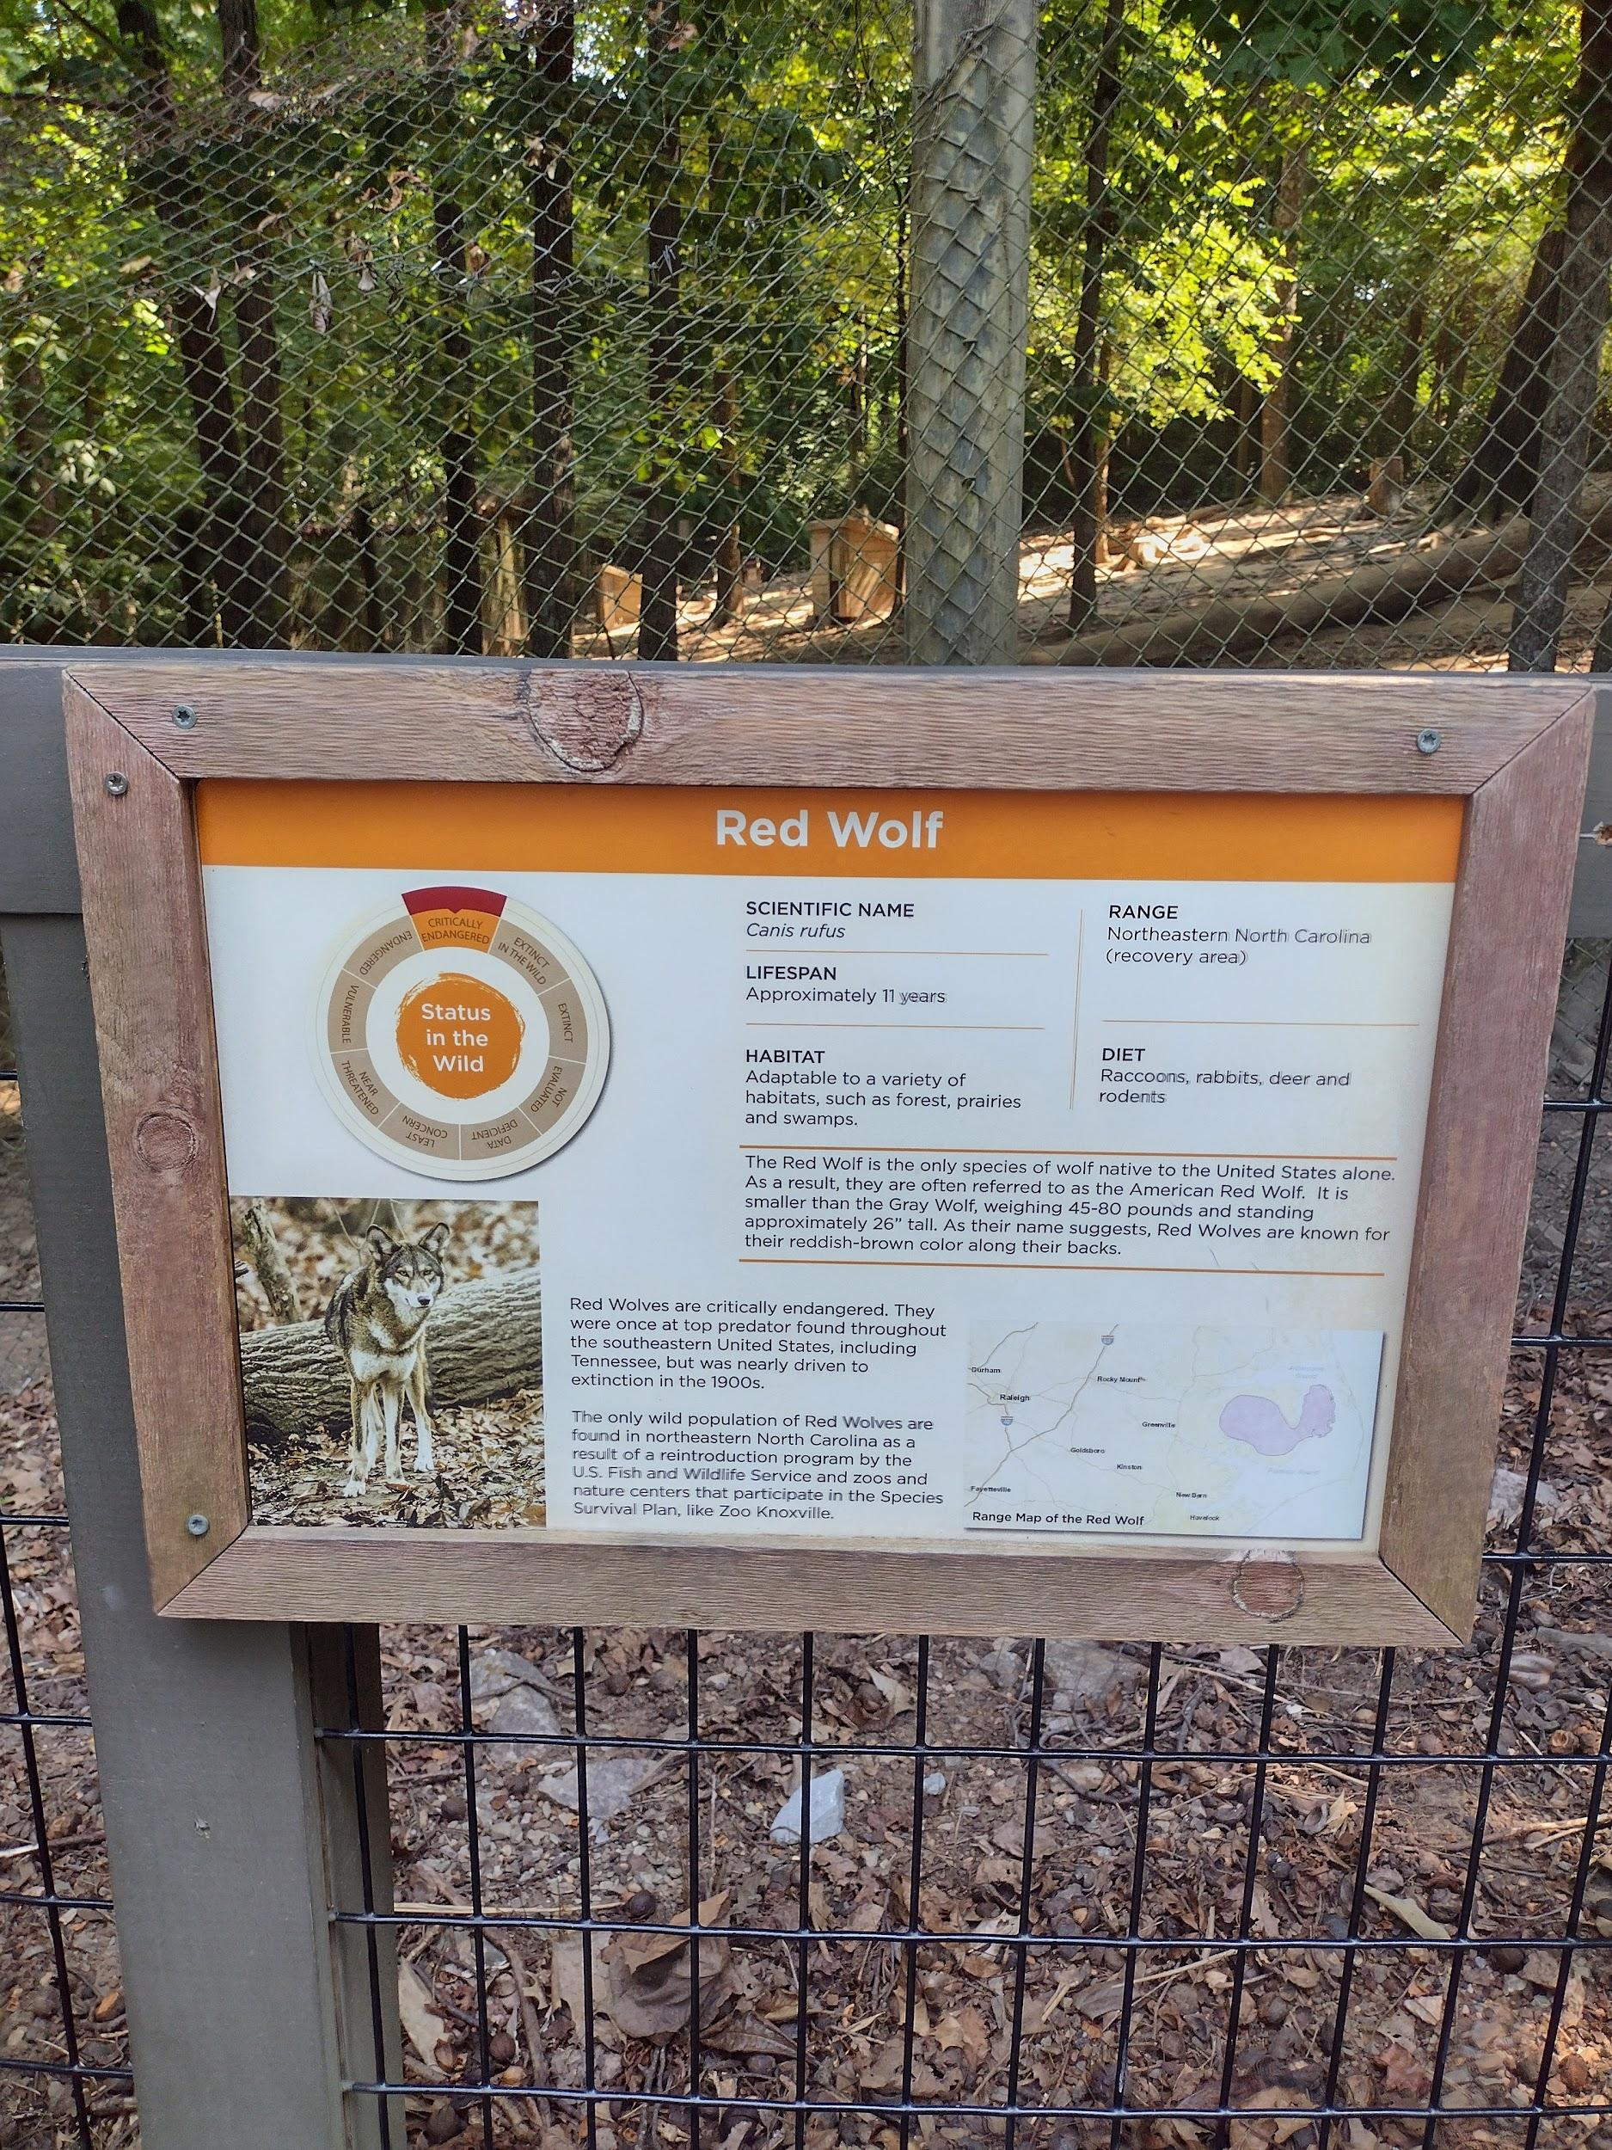
Appendix A
Figure 1: Red Wolf Scientific Name.
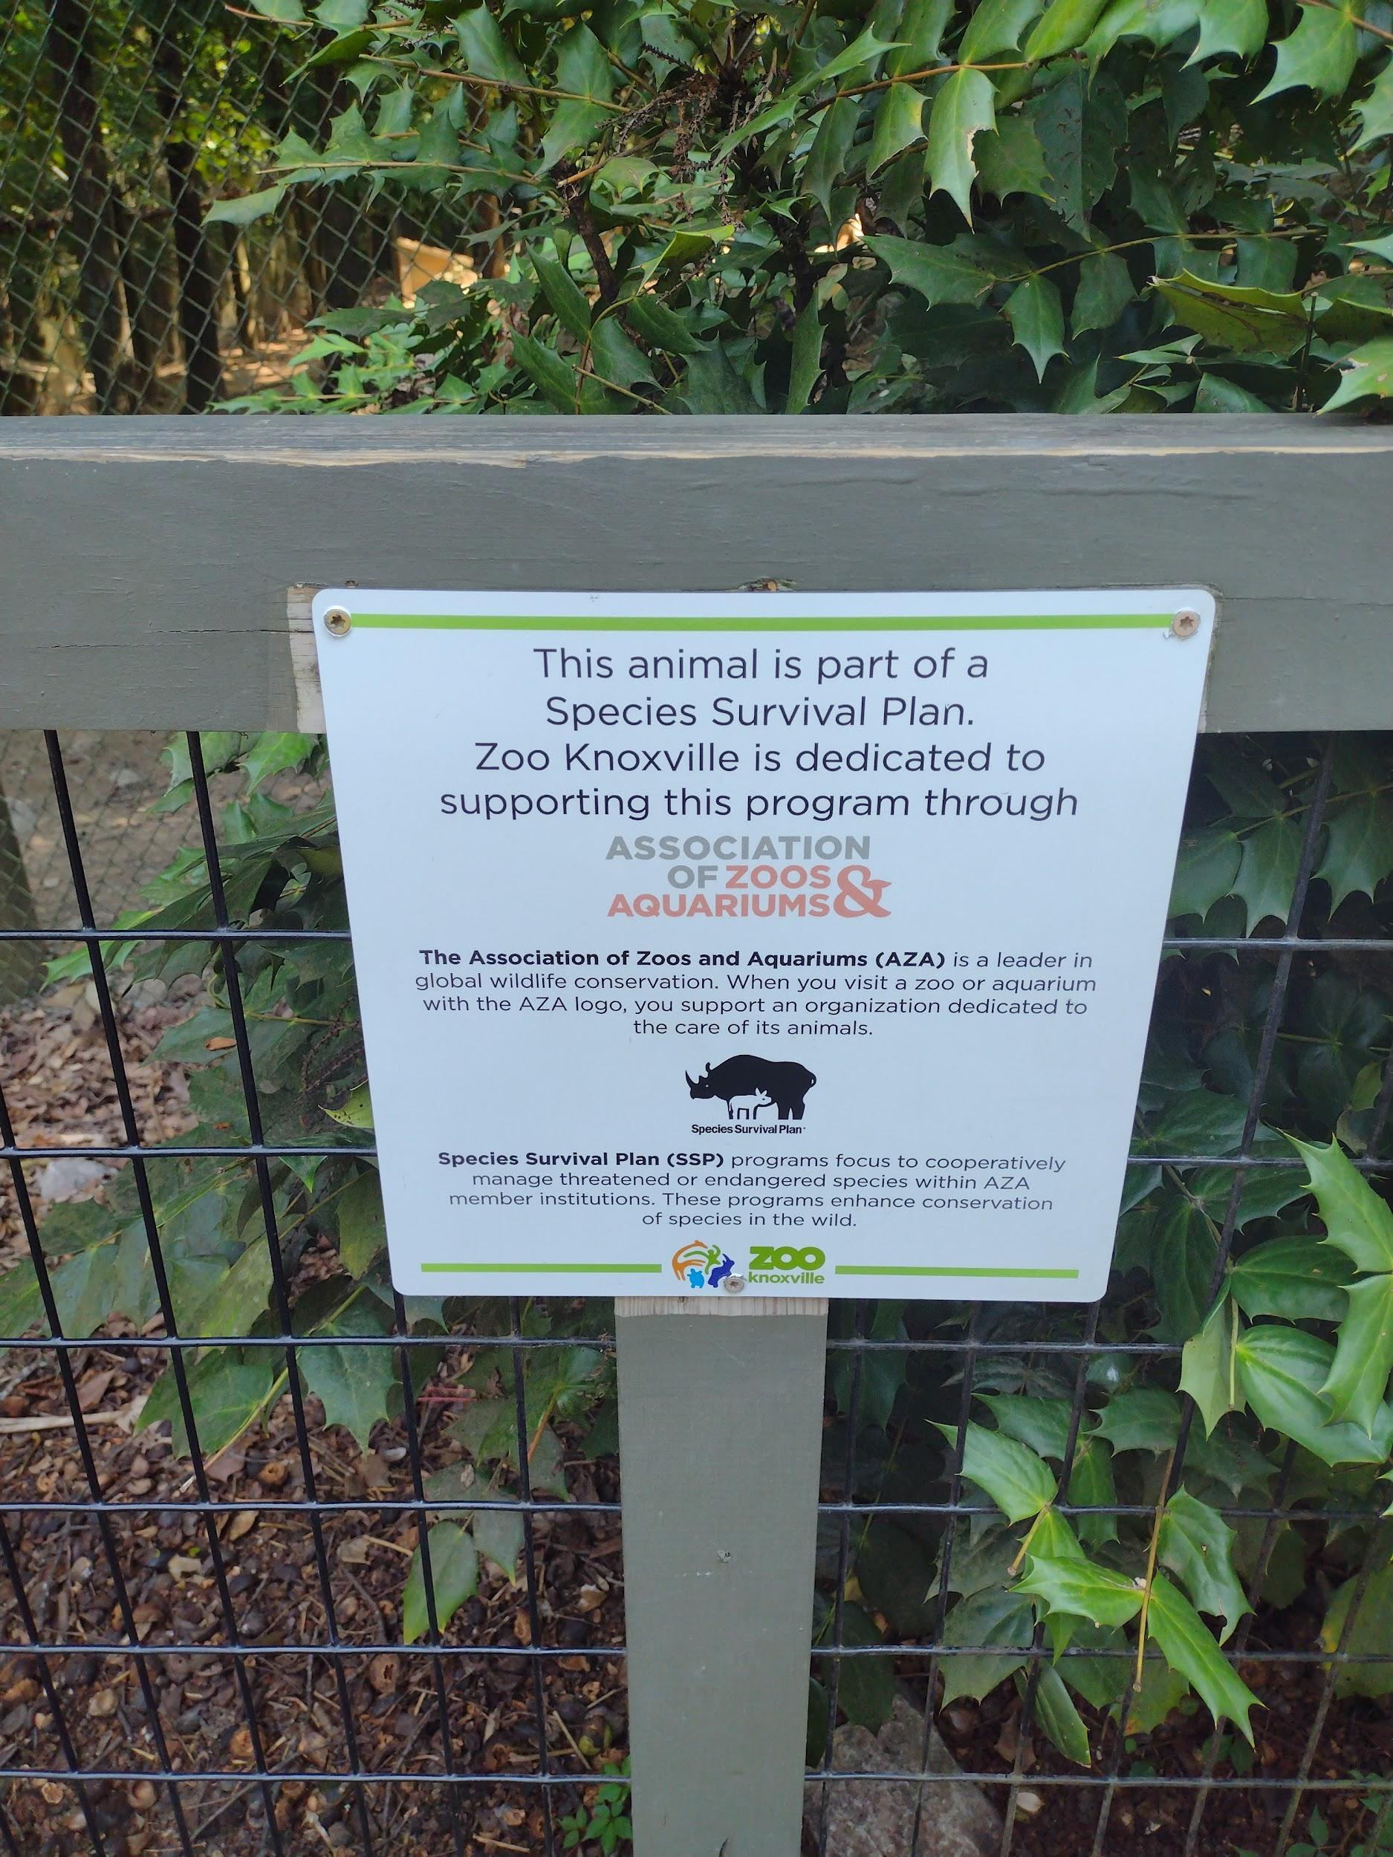
Figure 2: Red Wolf Species Survival Plan Notification.

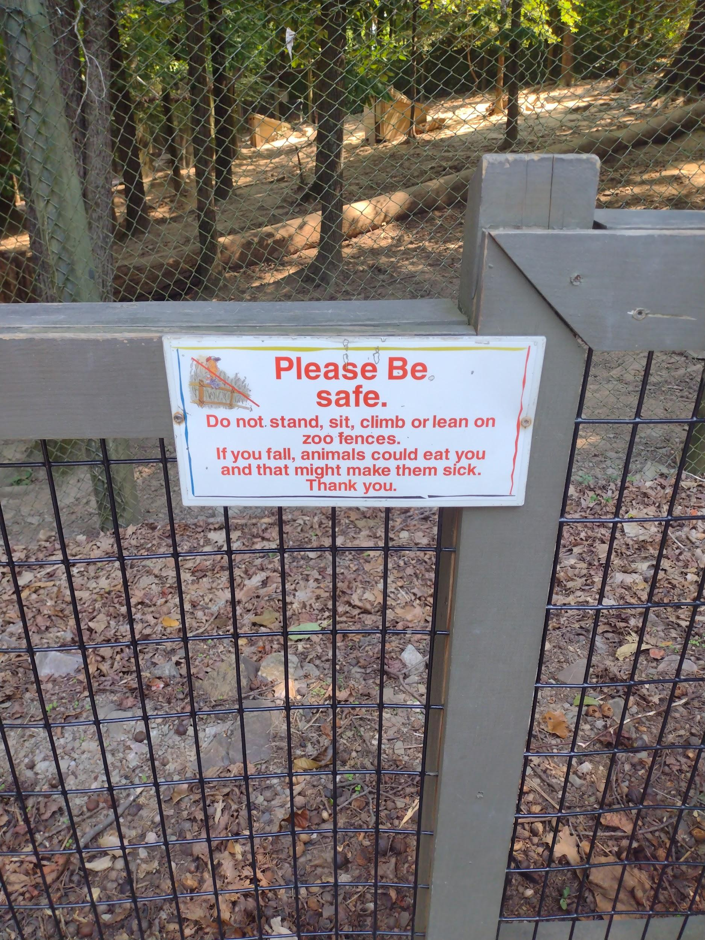
Figure 3: Red Wolf “Do Not Climb” Sign.
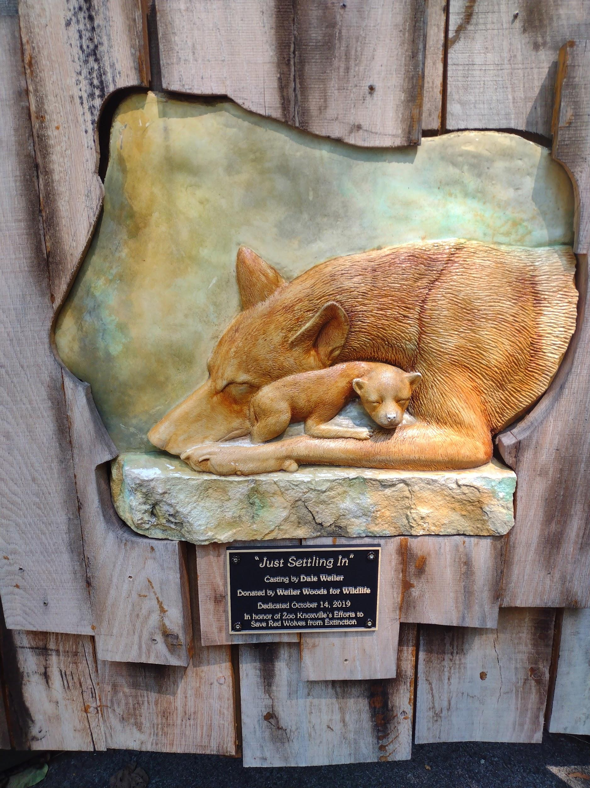
Figure 4: Red Wolf “Just Settling In” Monument.

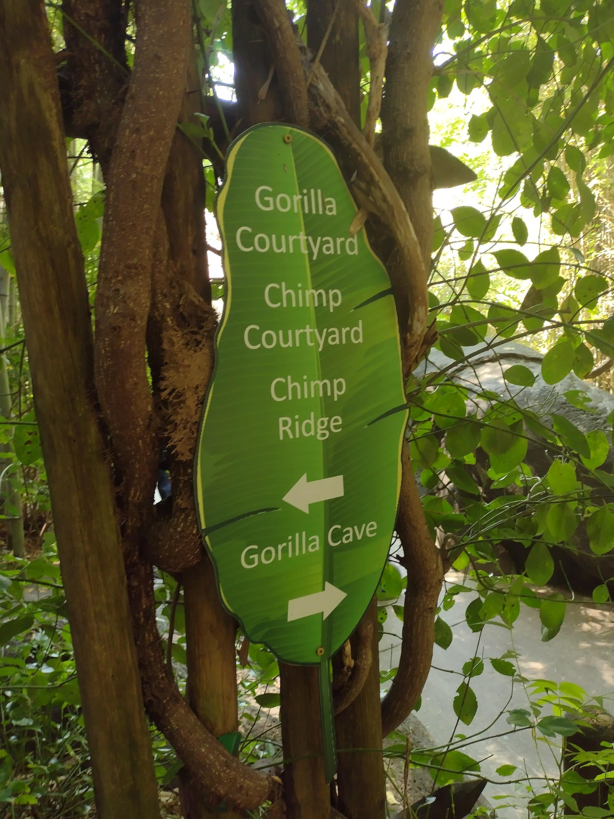
Figure 5: First Great Ape Exhibit Directions.

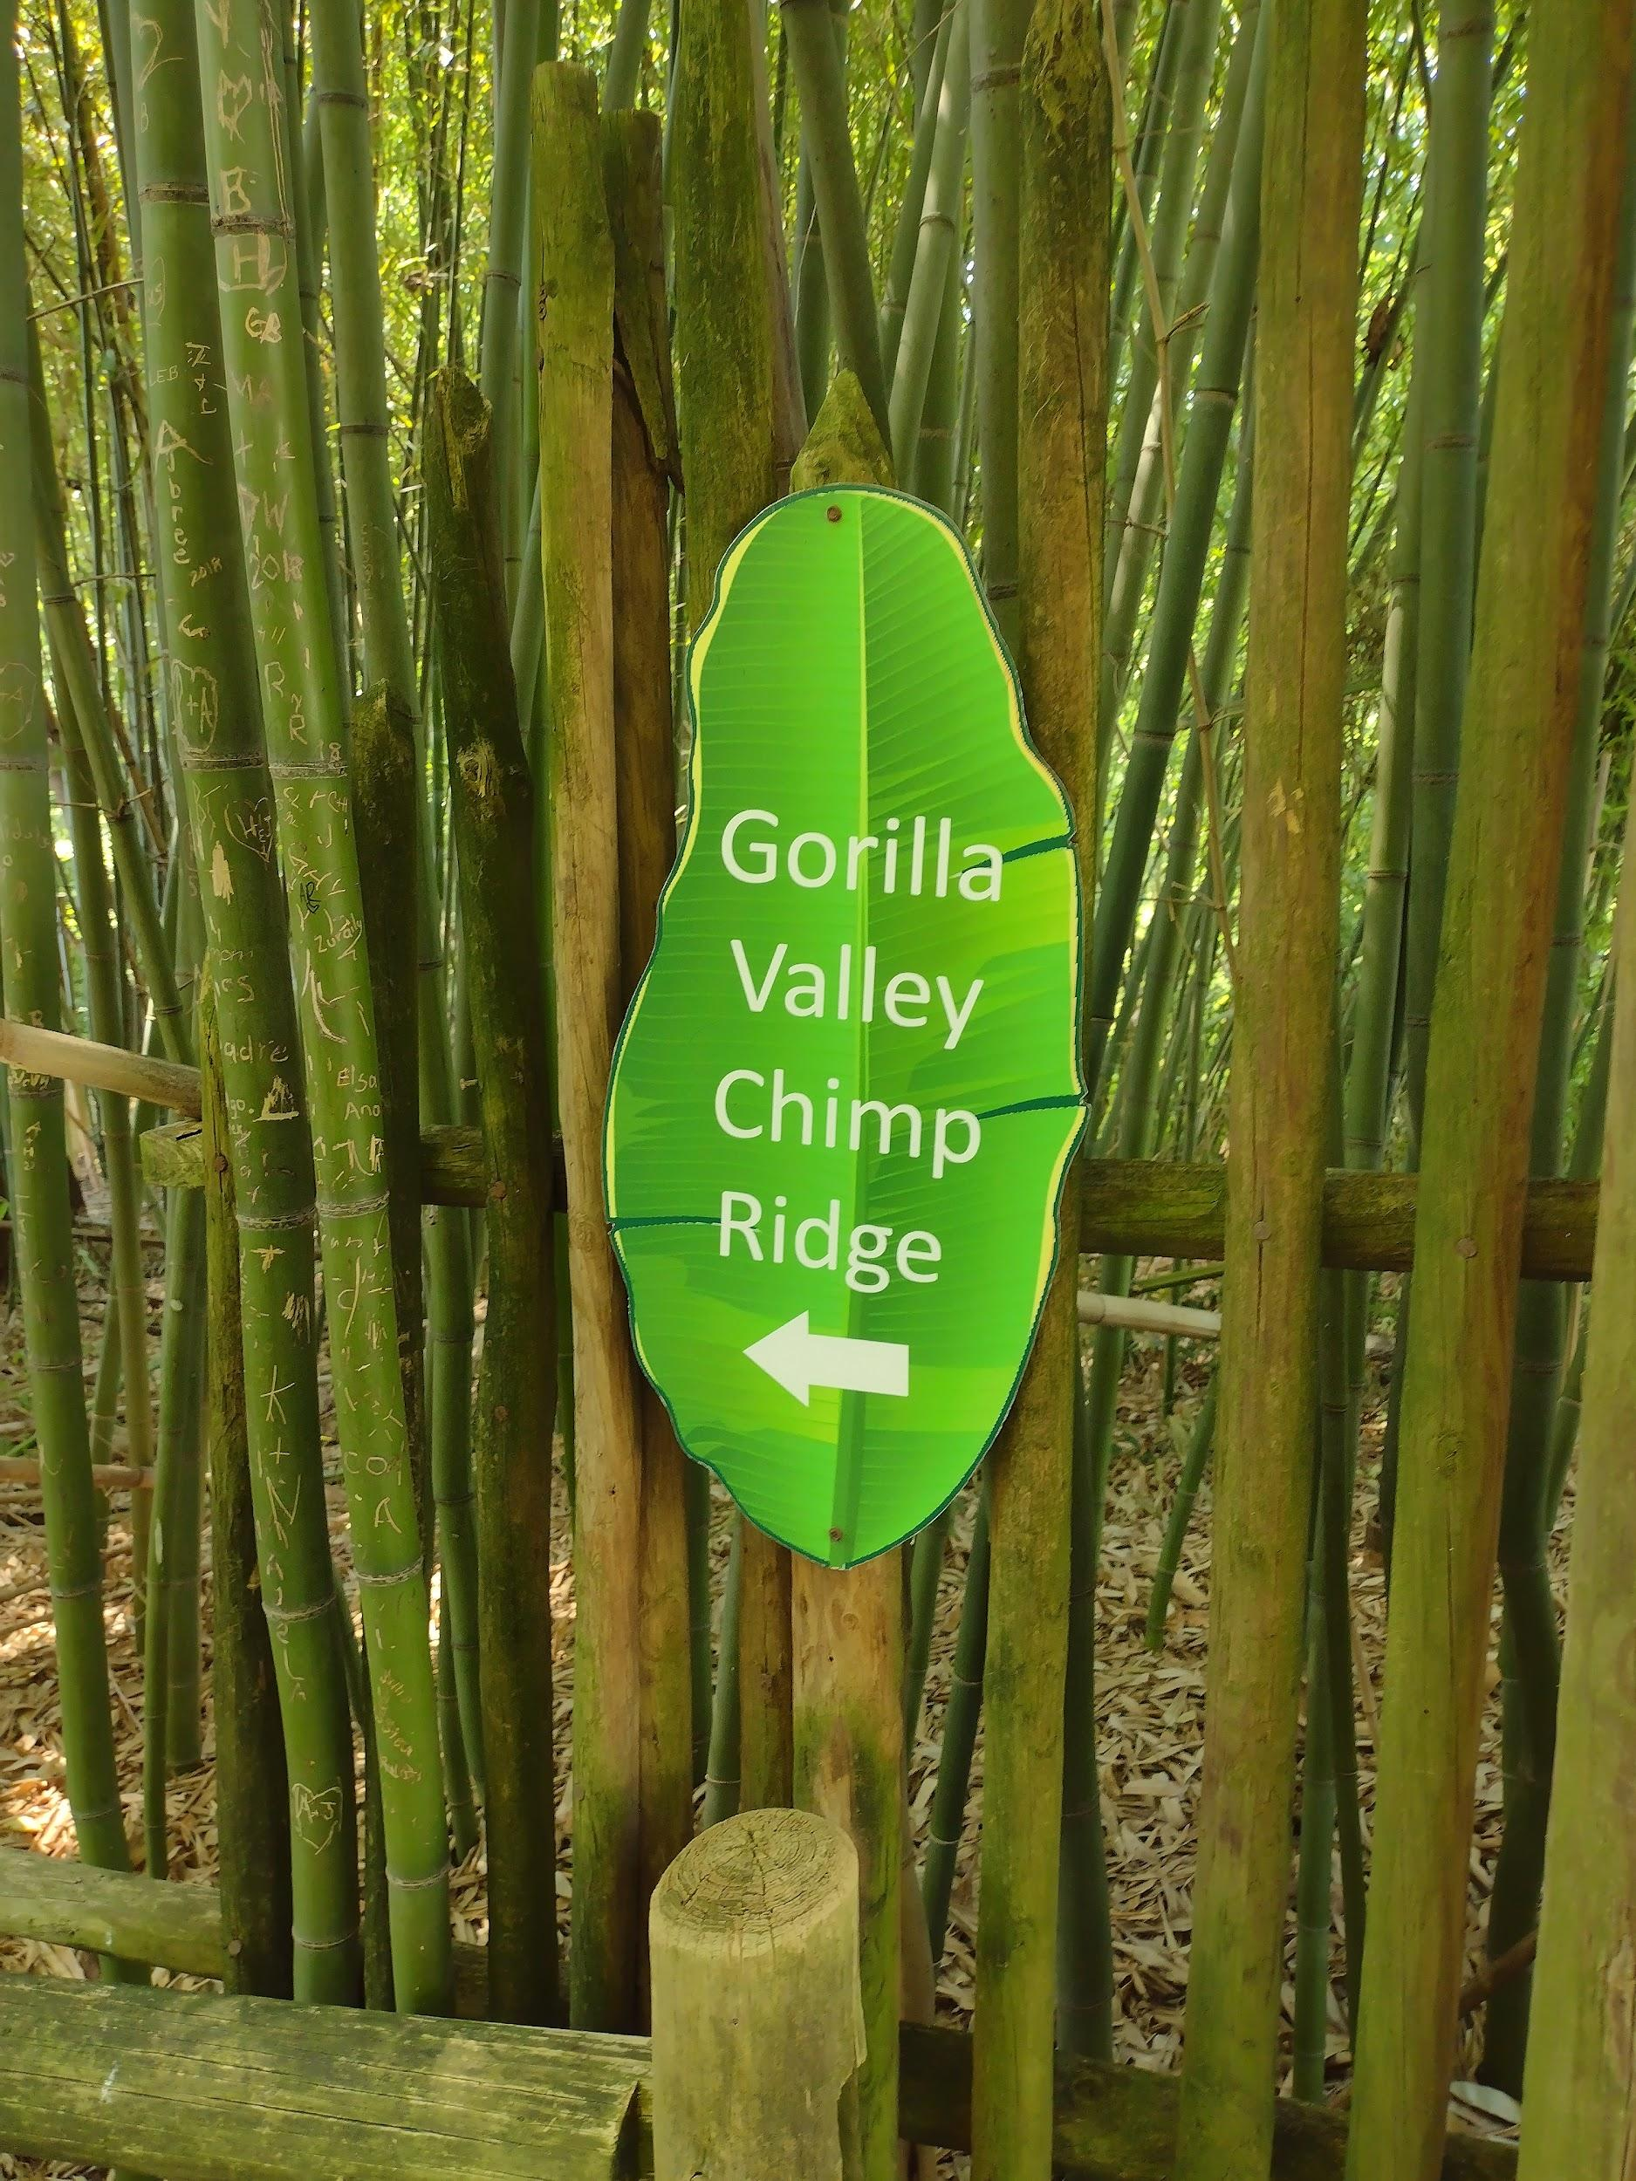
Figure 6: Second Great Ape Exhibit Directions.

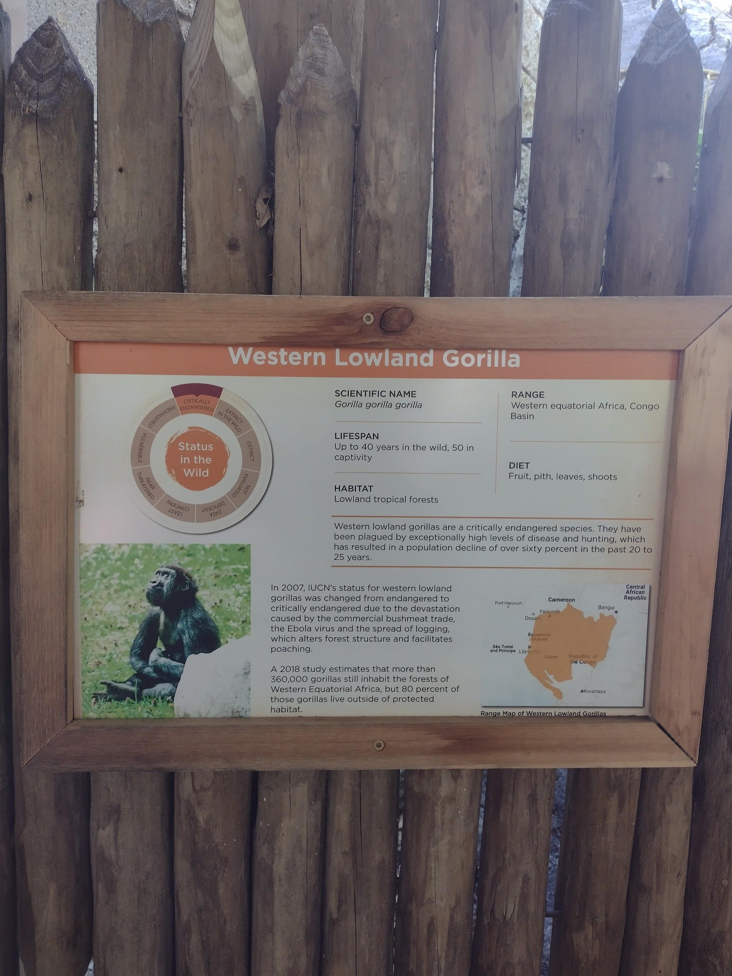
Figure 7: Western Lowland Gorilla Scientific Name.
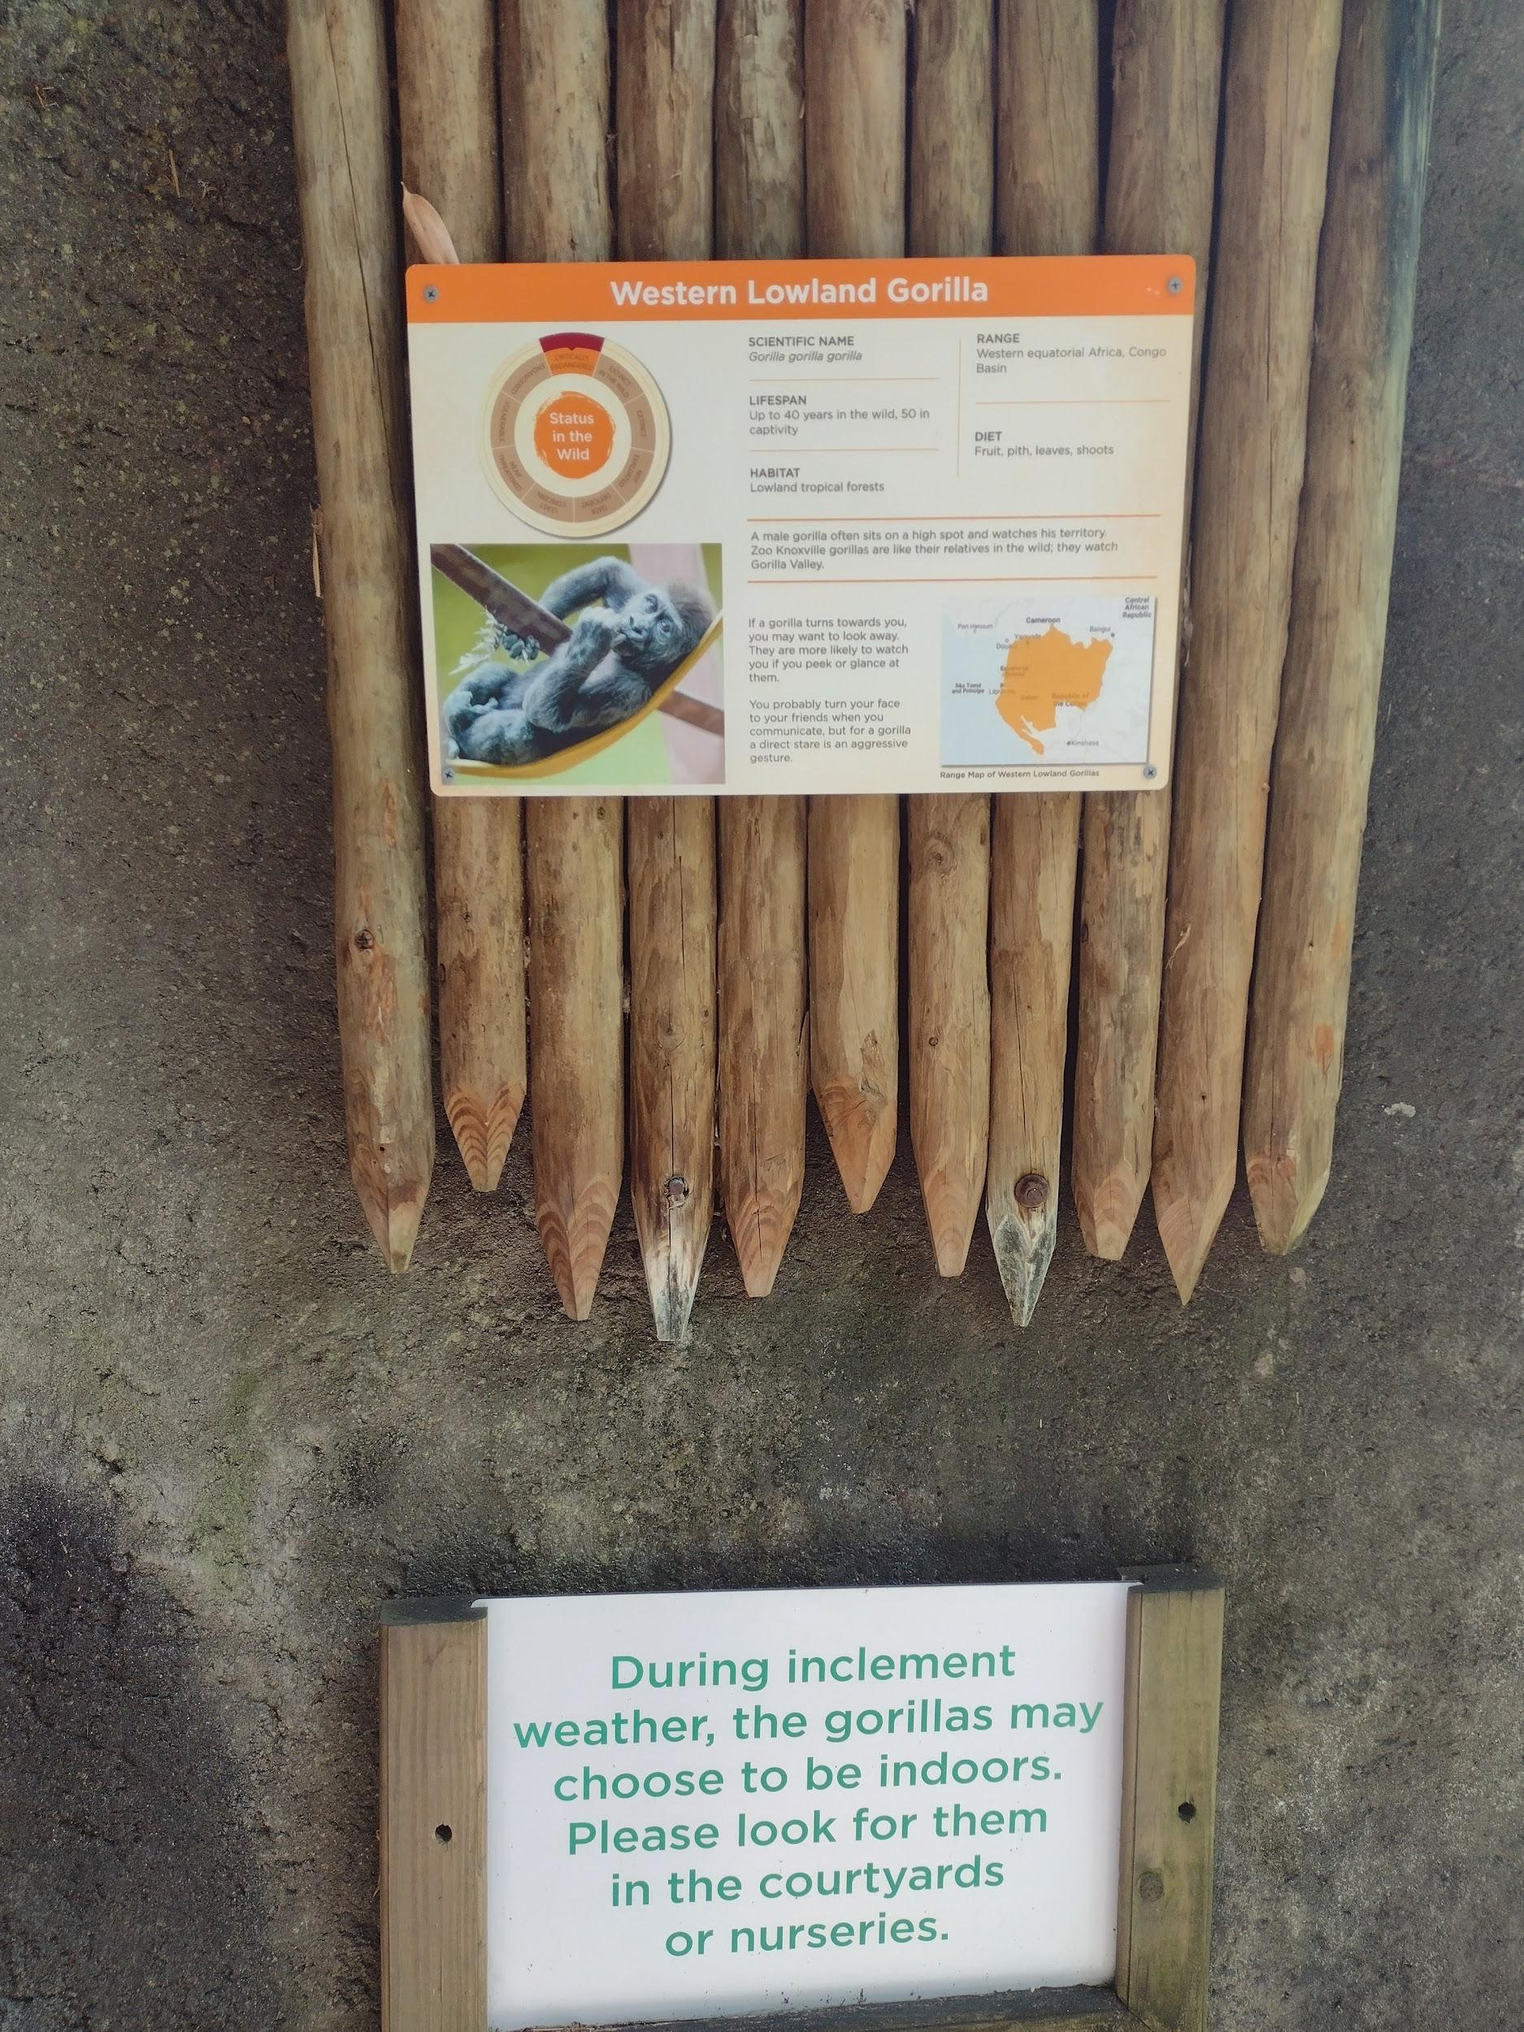
Figure 8: Second Western Lowland Gorilla Scientific Name.

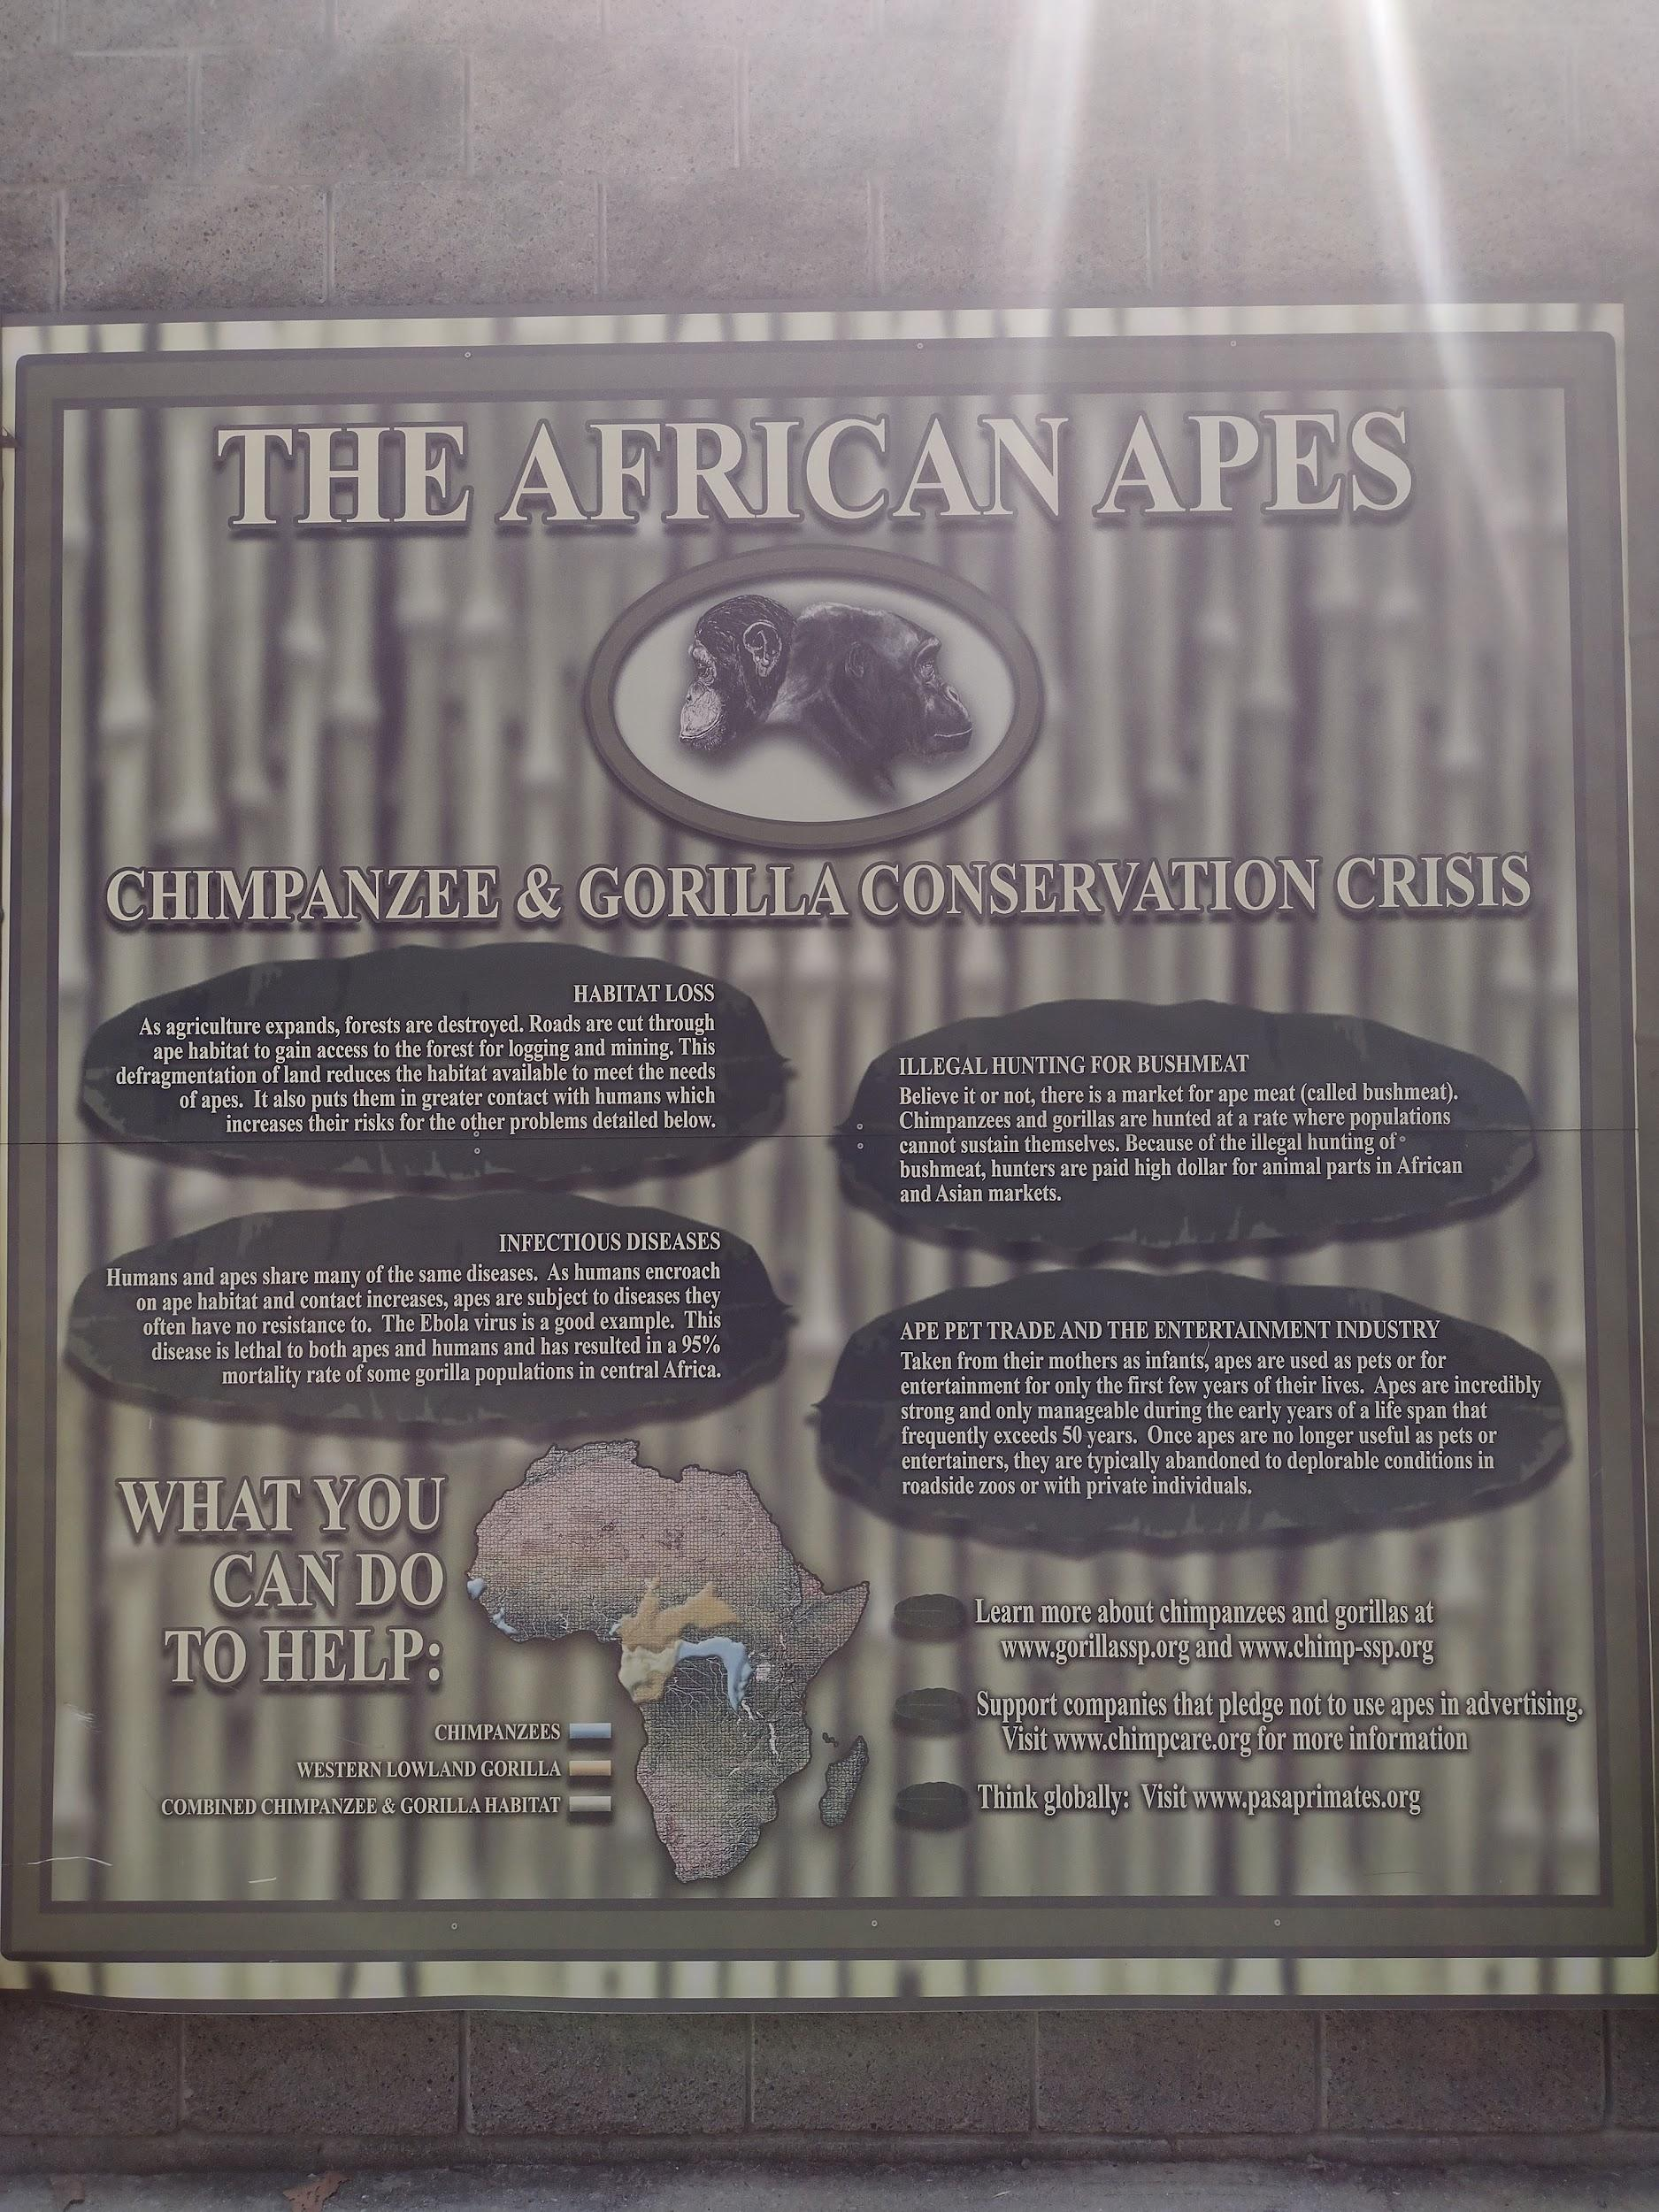
Figure 9: Great Ape “Conservation Crisis” Sign.

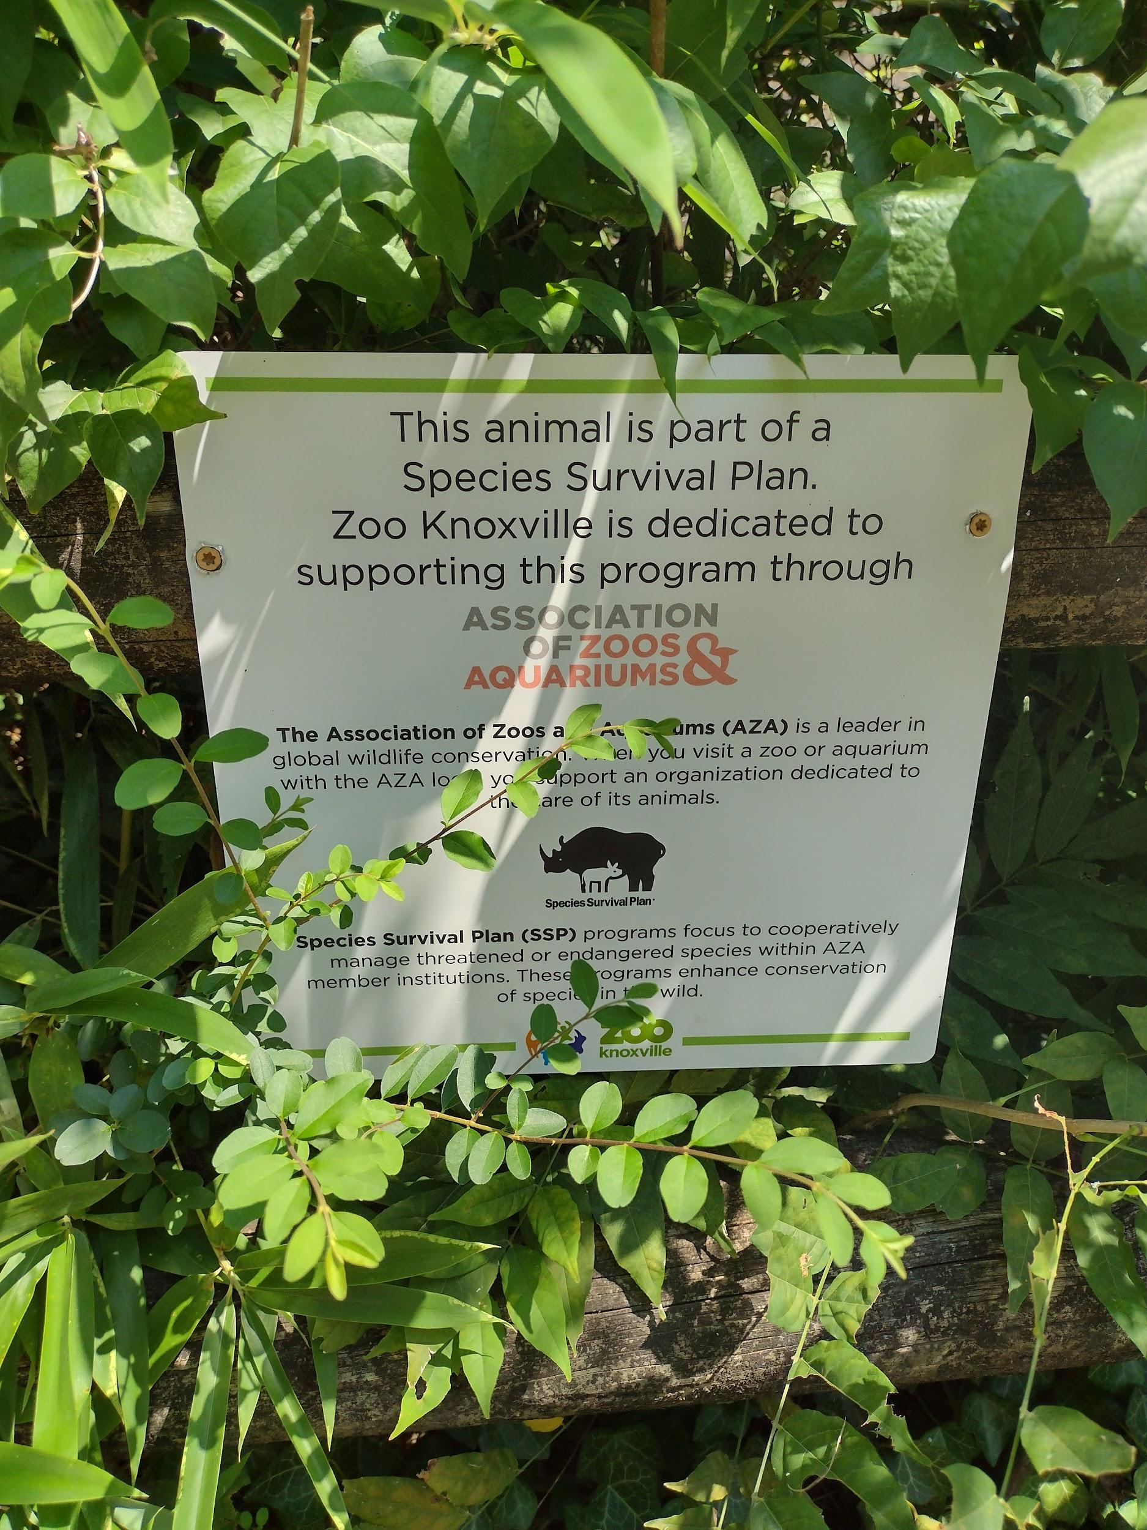
Figure 10: Western Lowland Gorilla Species Survival Plan Notification.

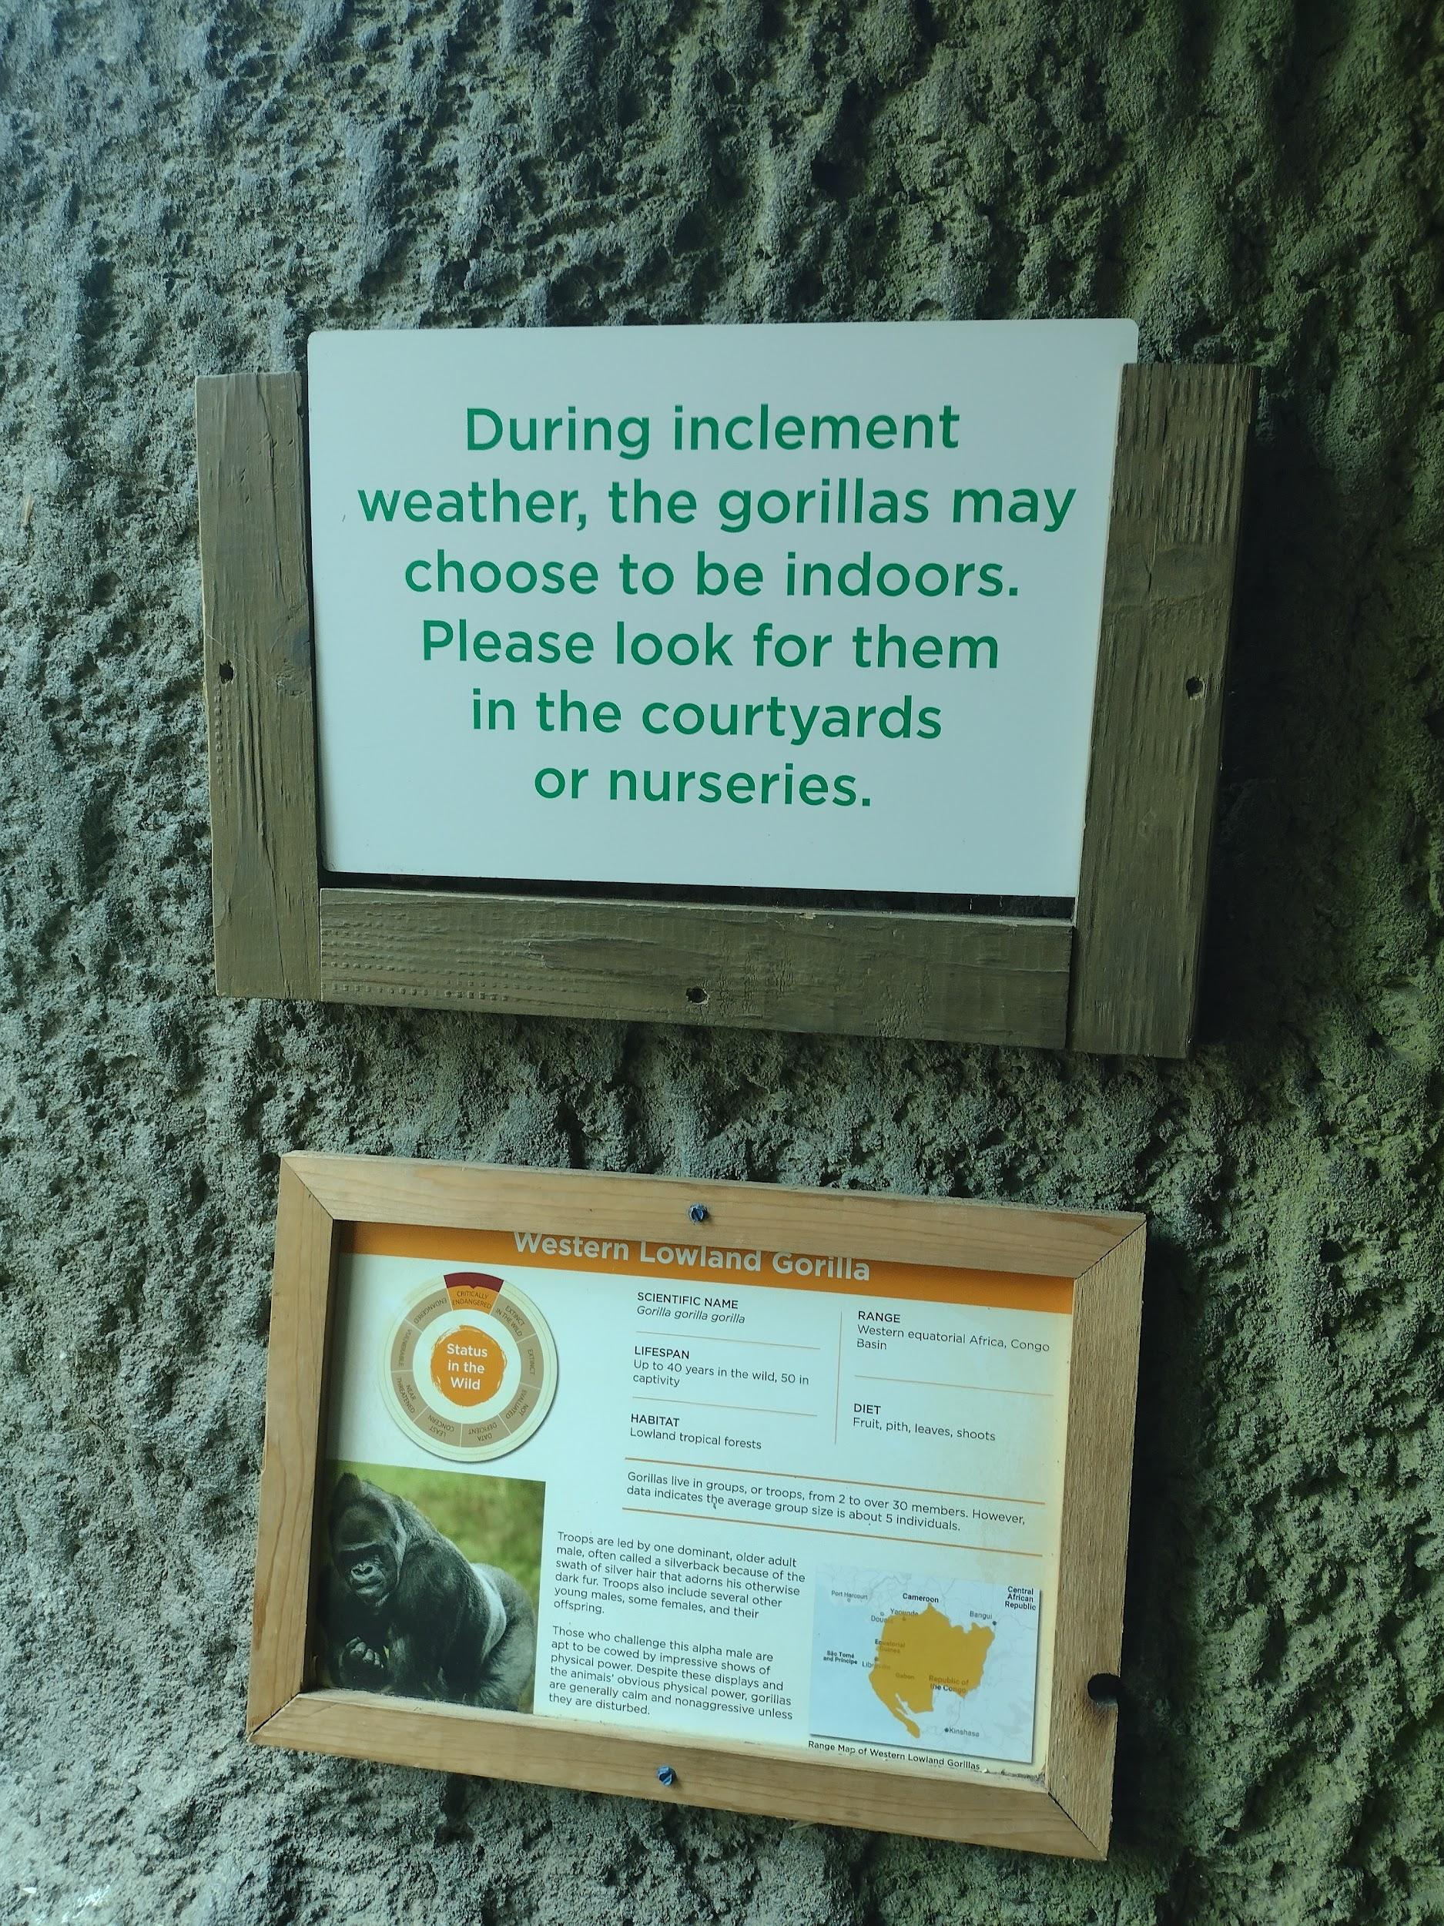
Figure 11:Western lowland Gorilla Inclement Weather Sign.
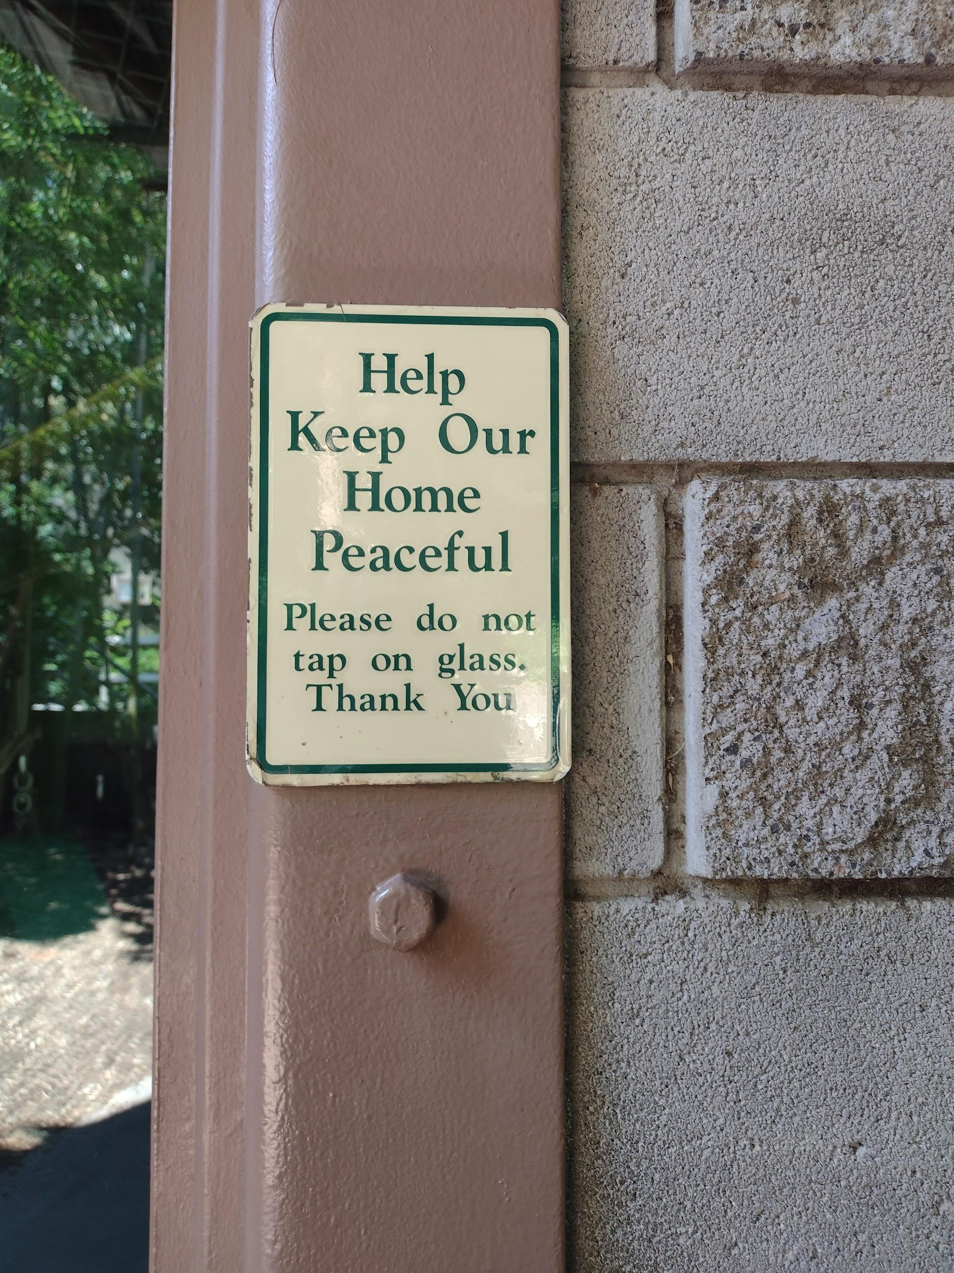
Figure 12: Western Lowland Gorilla “Keep Our Home Peaceful” Sign.
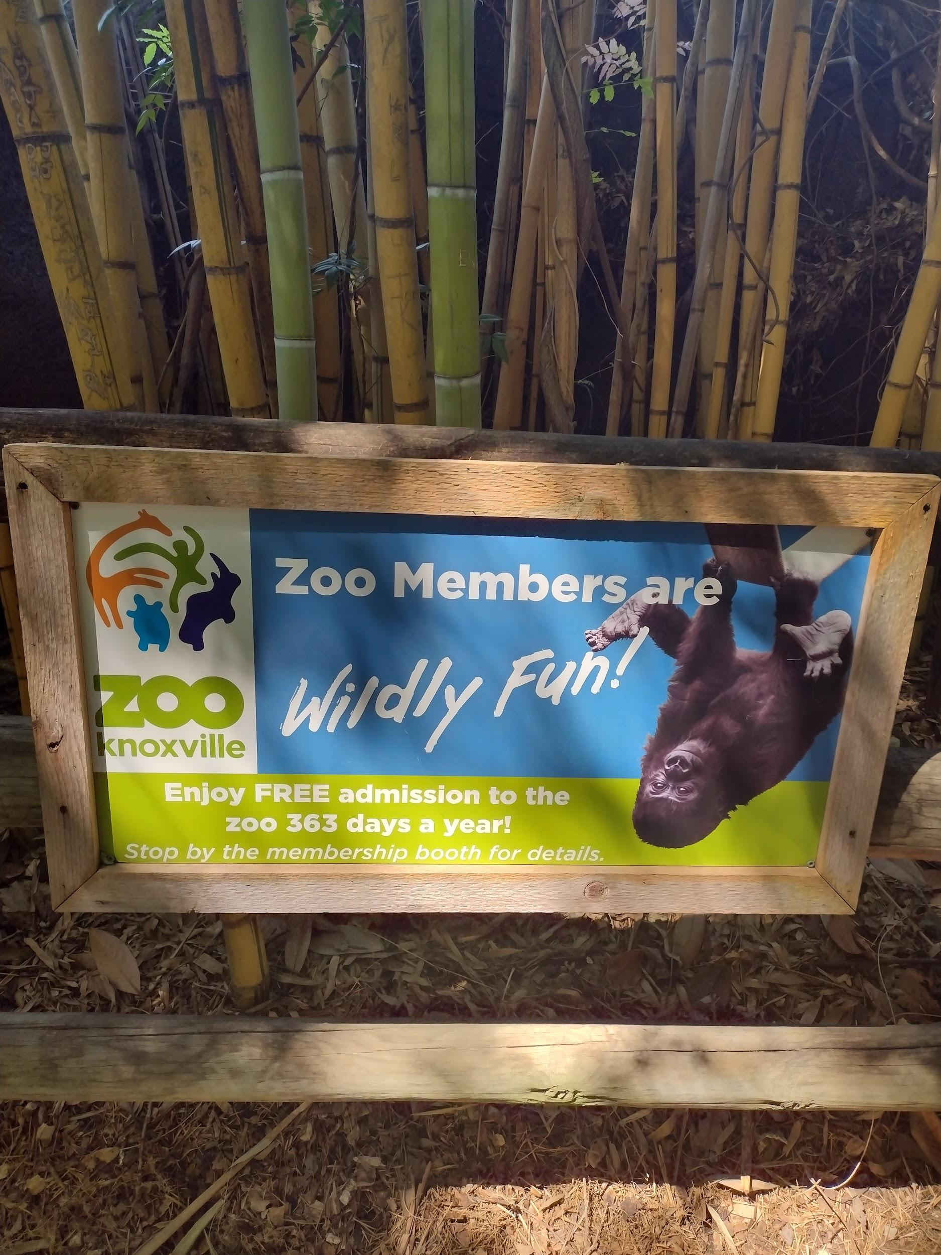
Figure 13: Western Lowland Gorilla “Wildly Fun! Zoo Membership” Sign.
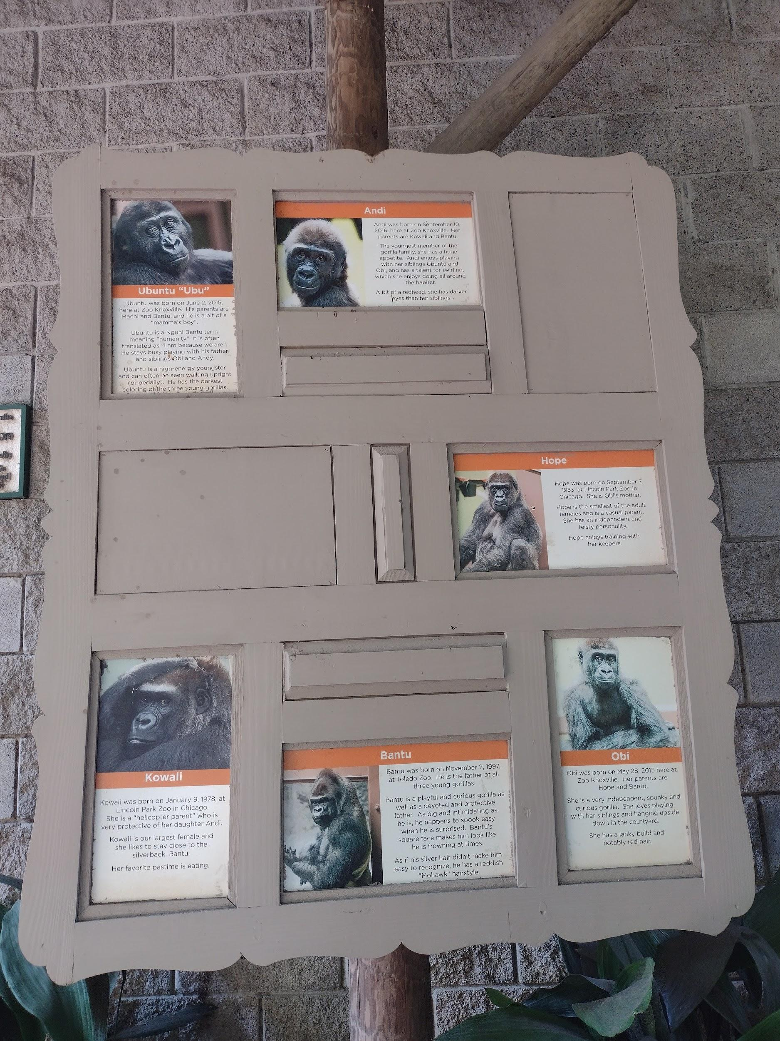
Figure 14: Western Lowland Gorilla Name Sign.

Figure 15: Western Lowland Gorilla Handprint Monument.

Figure 16: Western Lowland Gorilla “Gorilla” Overlook Monument.
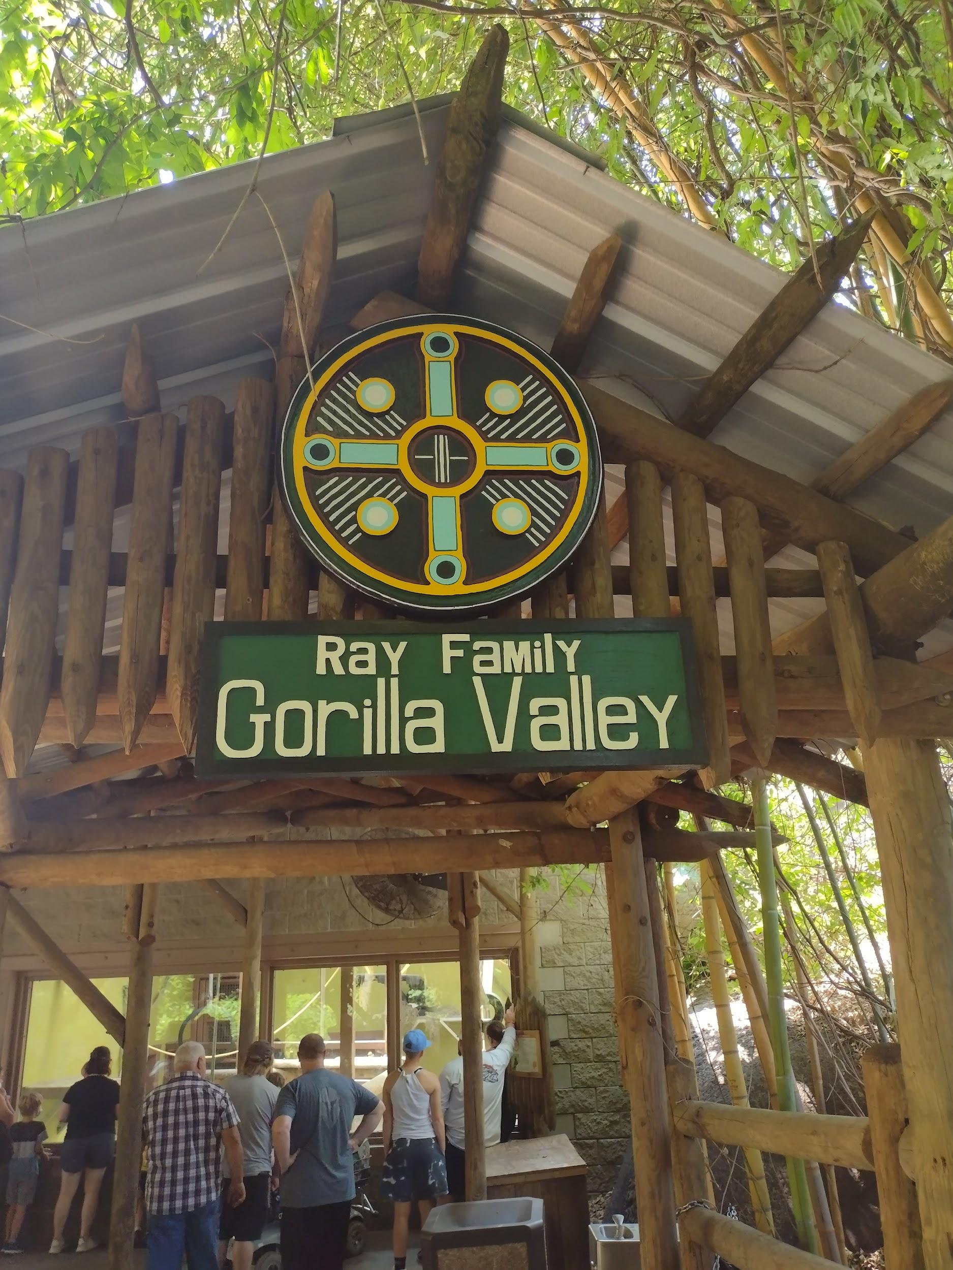
Figure 17: Western Lowland Gorilla “Gorilla Valley Monument.”
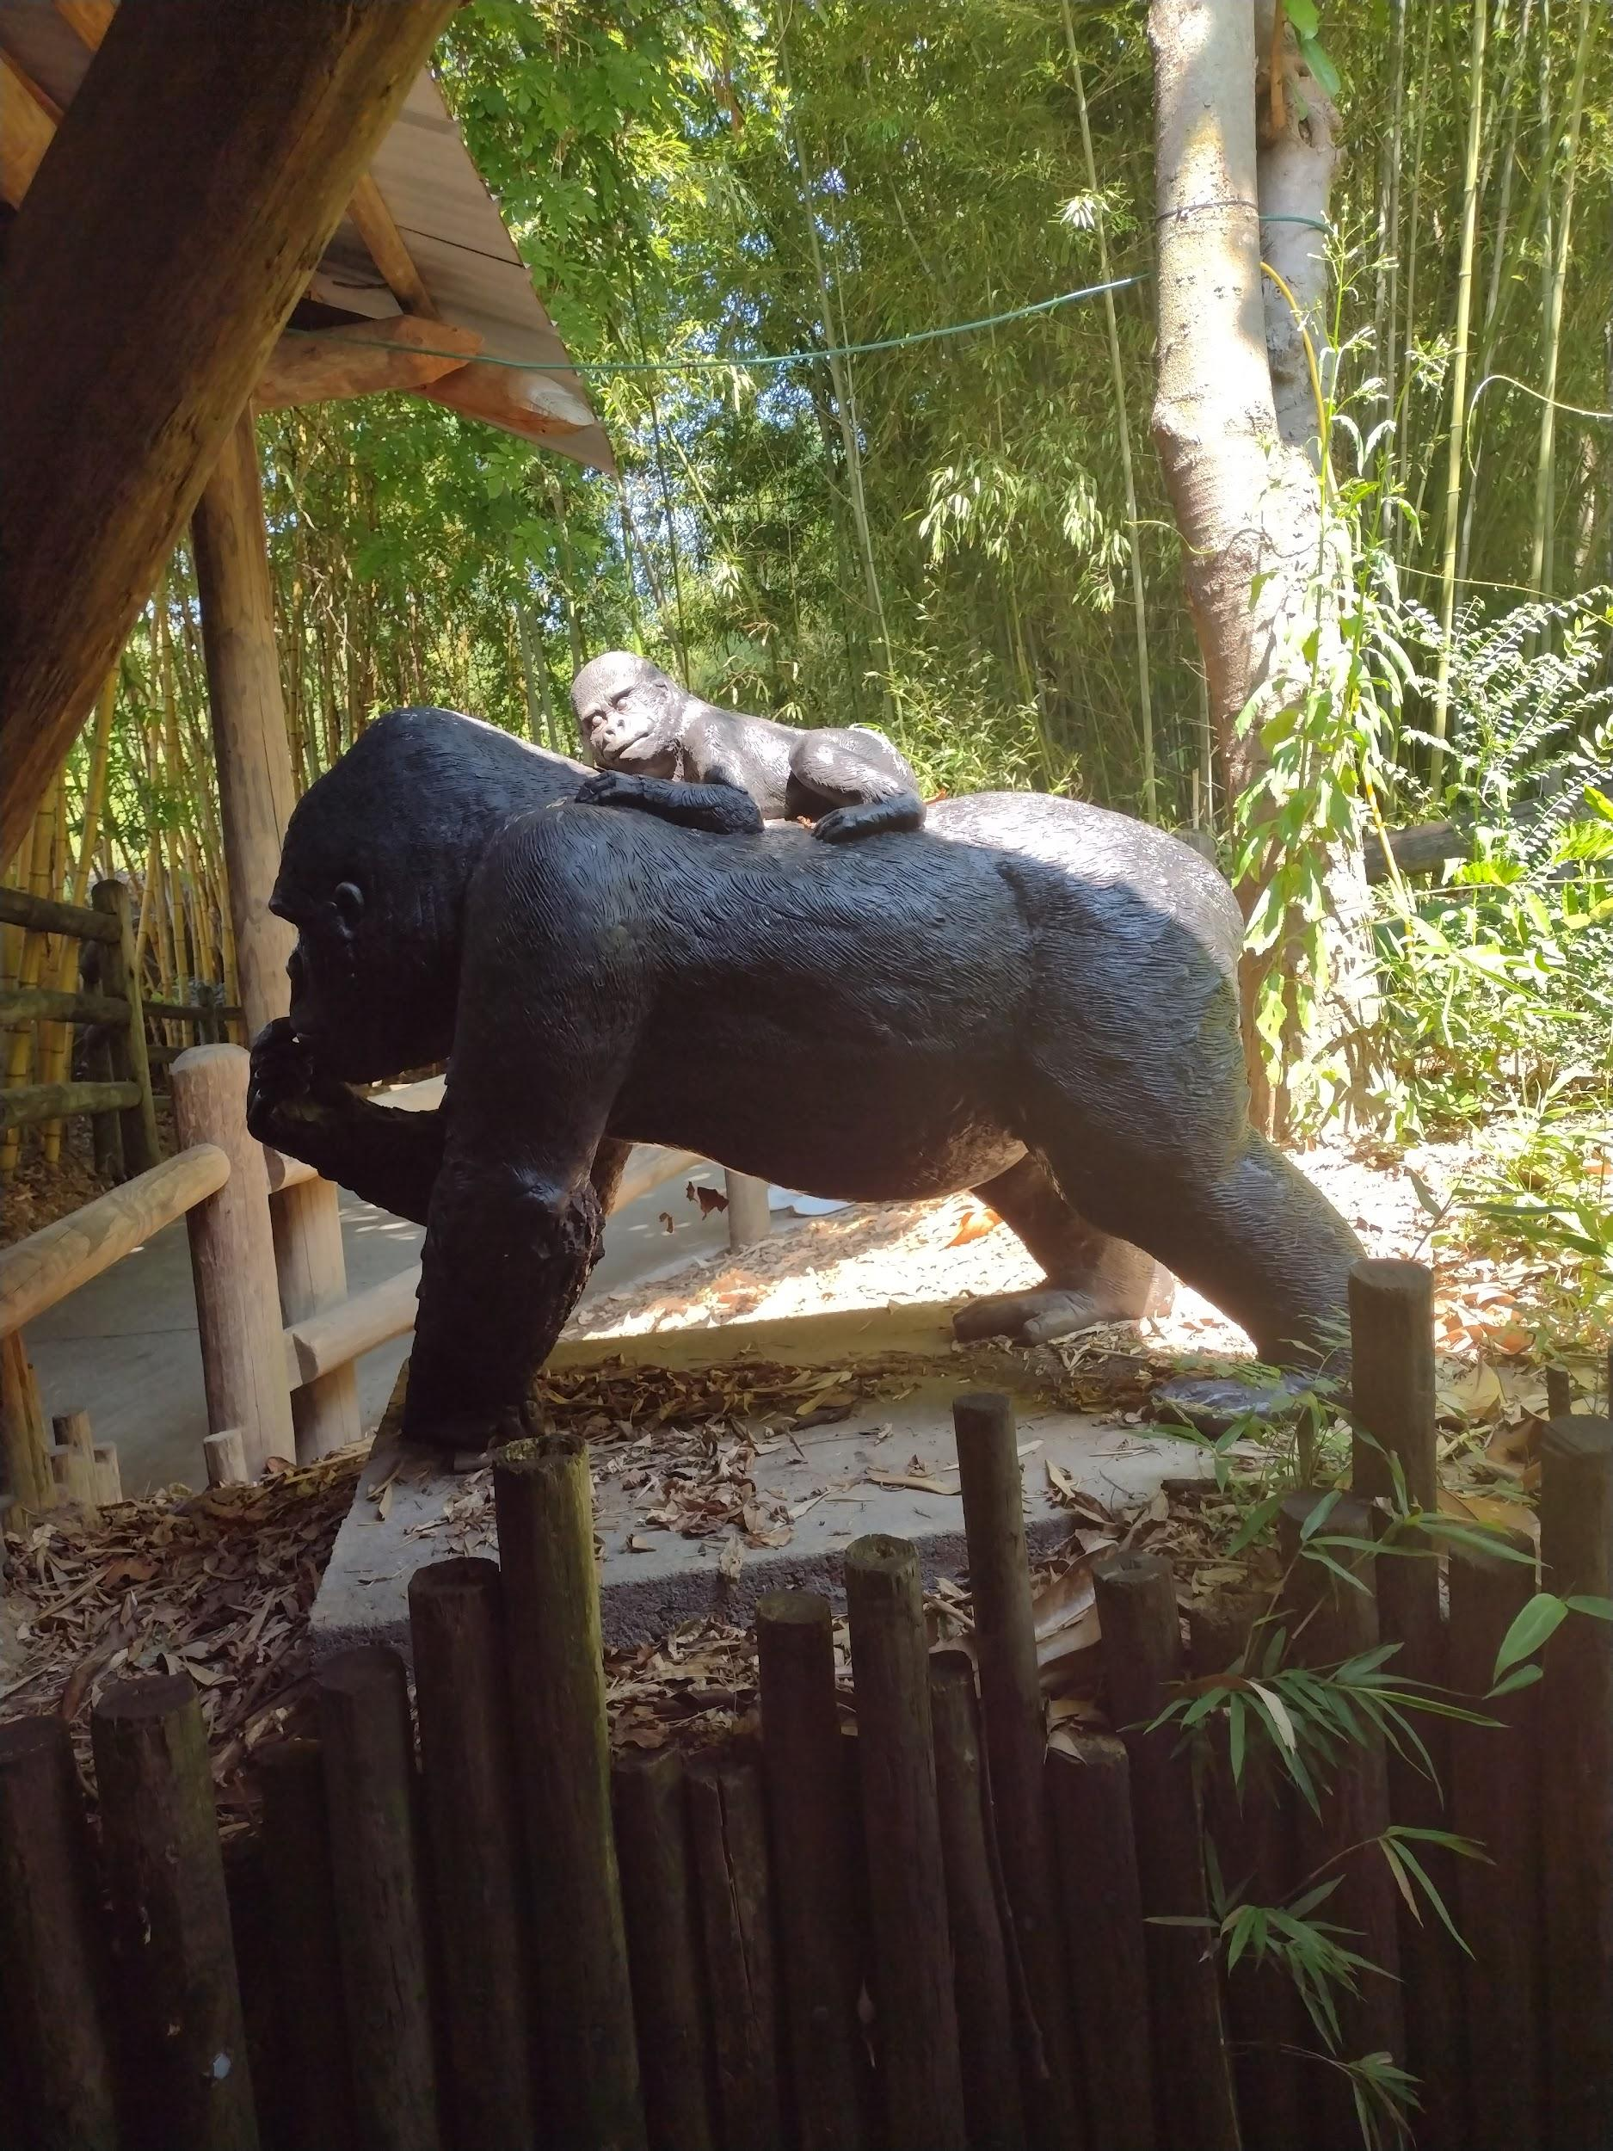
Figure 18: Western Lowland Gorilla “Mother and Child Monument.”
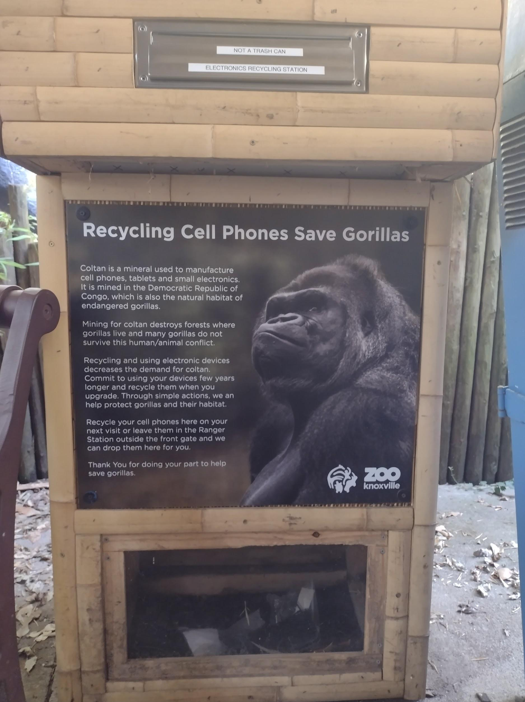
Figure 19: Western Lowland Gorilla “Recycling Cell Phones Save Gorillas” Monument.

References
AZA Staff. (2019, October 14).AZA SAFE Species Profile: American Red Wolf. https://www.aza.org/connect-stories/stories/saving-the-endangered-american-red-wolf?locale=en.
Association of Zoos and Aquariums. (n.d.). About Us. https://www.aza.org/about-us?locale=en
Barongi, R. (2018). 8. Committing to Conservation: Can Zoos and Aquariums Deliver on Their Promise?. In The Ark and Beyond (pp. 107-121). University of Chicago Press.
Burgeson, Amanda, & Kartik, Antani. (2011). Economic Importance for Humans: Negative. AnimalDiversityWeb.
https://animaldiversity.org/accounts/Blattella_germanica/
Burgeson, Amanda, & Kartik, Antani. (2011). Ecosystem Roles. AnimalDiversityWeb.
https://animaldiversity.org/accounts/Blattella_germanica/
Burgeson, Amanda, & Kartik, Antani. (2011). Geographic Range. AnimalDiversityWeb.
https://animaldiversity.org/accounts/Blattella_germanica/
Denver Zoo. (n.d.). Habitat and Range.
https://denverzoo.org/animals/western-lowland-gorilla/
Dunayer. (2001). Animal equality : language and liberation. Ryce Publishing.
Farley, Kristin. (2019, January 07). Zoo Knoxville Sets New Attendance Record for Fourth Consecutive Year.https://knoxvilletn.gov/archived_news_stories/2019/zoo_knoxville_sets_new attendance_record
Fouad, F. F. (2019). Salience and Erasure Techniques in Selected Egyptian Newspaper Articles Covering the Swine Flu: An Ecolinguistic Analysis. CDELT Occasional Papers in the Development of English Education, 68(1), 559-578.
Fill, A., & Penz, H. (Eds.). (2017). The Routledge handbook of ecolinguistics. London and New York: Routledge.
Goatly, A. (2006). Humans, animals, and metaphors. Society & Animals, 14(1), 15-37.
Guerrini, A., & Osborne, M. A. (2018). 1. Animals in Circulation: The “Prehistory” of Modern Zoos. In The Ark and Beyond (pp. 15-26). University of Chicago Press.
Irvine, J. T., Gal, S., & Kroskrity, P. V. (2009). Language ideology and linguistic differentiation. Linguistic anthropology: A reader, 1, 402-434.
Lakoff, G. (2010). Why it matters how we frame the environment. Environmental communication, 4(1), 70-81.
Lamb, G. (2020). Towards a Green Applied Linguistics: Human–Sea Turtle Semiotic Assemblages in Hawai ‘i. Applied Linguistics, 41(6), 922-946.
Maple, T. L., & Segura, V. D. (2018). 18. Wildlife Wellness: A New Ethical Frontier for Zoos and Aquariums. In The Ark and Beyond (pp. 226-237). University of Chicago Press.
Milstein, T. (2009). “Somethin’tells me it's all happening at the zoo”: Discourse, power, and conservationism. Environmental Communication, 3(1), 25-48.
Phillips, M. 2018. Canis rufus (errata version published in 2020). The IUCN Red List of Threatened Species 2018: e.T3747A163509841. https://dx.doi.org/10.2305/IUCN.UK.2018-2.RLTS.T3747A163509841.en. Accessed on 13 December 2021.
Red Wolf. National Wildlife Federation. (n.d.). Retrieved December 13, 2021, from https://www.nwf.org/Educational-Resources/Wildlife-Guide/Mammals/Red-Wolf.
Rees, P. A. (2011). An introduction to zoo biology and management. John Wiley & Sons.
Regional action plan for the conservation of western lowland gorillas and central chimpanzees 2015–2025. (2015). https://doi.org/10.2305/iucn.ch.2005.ssc-rap.1.en
Rothfels, N. (2002). Savages and beasts: The birth of the modern zoo. JHU Press.
Stibbe, A. (2015). Ecolinguistics: Language, ecology and the stories we live by. Routledge.
Tannen, D. (2007). Talking voices: Repetition, dialogue, and imagery in conversational discourse (Vol. 26). Cambridge University Press.
Trampe, W. (2017). Euphemisms for killing animals and for other forms of their use. In The Routledge handbook of ecolinguistics (pp. 325-341). Routledge.
U.S. Fish and Wildlife Service. (2021, November 9). Species Information. https://www.fws.gov/southeast/wildlife/mammals/red-wolf/
Van Dijk, T. A. (Ed.). (2011). Discourse studies: A multidisciplinary introduction. Sage.
World Wildlife Fund. (n.d.). Western Lowland Gorilla. WWF. Retrieved December 13, 2021, from https://www.worldwildlife.org/species/western-lowland-gorilla.
Zoo Knoxville. (n.d). History. https://www.zooknoxville.org/about/history/
Zoo Knoxville. (n.d.). Red Wolf. https://www.zooknoxville.org/animal/red-wolf/
Zoo Knoxville. (n.d.). Location: Western and Central Africa. https://www.zooknoxville.org/animal/western-lowland-gorillas/
Zoo Knoxville. (n.d.). Location: Western and Central Africa. https://www.zooknoxville.org/animal/western-lowland-gorillas/
Zoo Knoxville. (n.d.). Visitor Information.
https://www.zooknoxville.org/visitor-info/hours-and-tickets/

Vita
Dynestee Fields is a South Carolinian. She attended Southern Wesleyan University where she earned a bachelor or arts degree in English and a minor in Media Communication. After completing her Master of Arts degree in English with a concentration in Rhetoric, Writing, and Linguistics, Dynestee plans to use the knowledge that she has gained in public relations.

