​​The effects of adolescent stress and minocycline treatment on adult anxiety-related behavior in male and female Sprague Dawley rats

A Thesis Presented for the
Master of Arts
Degree
The University of Tennessee, Knoxville

Sierra Rose Lawler
May 2025
ACKNOWLEDGEMENTS
Thank you to my lab family and friends, Jessica Tremblay, Marcia Chavez, Arthur Castaneda, and Krystiana Rego for the endless support, mentorship, and guidance. A special thank you to Dr. Kalynn Schulz for providing me with the opportunity and resources to further my education these past two years. Another thanks to all those at my undergraduate institute, Slippery Rock University of Pennsylvania. Without my experience at the rock, I would have never followed my interests and found my path here at UTK. And of course, thank you to my mom, dad, brother, and all others who have supported my educational journey, no matter the distance.

ABSTRACT
During early developmental stages, such as adolescence, the brain is sensitive to experiences that continuously shape future behavior, cognition, neural plasticity, and neuroimmune function. Particularly, chronic psychological stress during adolescence significantly heightens the risk of developing abnormal behaviors and a range of psychiatric disorders in adulthood, such as anxiety, depression, and schizophrenia. The neural mechanisms behind the etiology of these disorders are not yet fully understood, although emerging evidence suggests that the neuroimmune system may play a role in this development and also offer a potential target for therapeutic intervention. The current study explored the extent to which neuroimmune responses modulate the effects of adolescent stress on anxiety-related behavior in adulthood. Male and female Sprague Dawley rats were subjected to chronic variable psychological stressors during adolescence in the presence or absence of minocycline in their drinking water. In adulthood (postnatal days 83, 86-89), behavioral testing was performed to assess anxiety-like behaviors using the elevated zero maze (EZM) and the open field test (OFT). Anxiety-like behaviors varied across sex, stress condition, behavioral tests, and minocycline treatment. Adult females displayed decreased anxiety-like behavior in the EZM relative to males, independent of adolescent stress or minocycline treatment, while males exhibited lower levels of anxiety in the OFT than females. Contrary to expectations, adolescent stress reduced anxiety in the OFT overall. Interestingly, minocycline increased anxiety in non-stressed males, suggesting that a reduction in microglial activity during adolescence alters the development of neural networks underlying anxiety in males. These data suggest that adolescent stress and minocycline exert complex and sex-specific effects on anxiety-related behaviors, highlighting the complexity of stress and neuroimmune interactions in shaping adult behavioral outcomes.
Table of Contents
Chapter 1 Introduction 1
Chapter 2 Materials and Methods 4
Chapter 3 Results 9
Chapter 4 Discussion 14
References 19
Appendix 26
VITA 35

LIST OF TABLES
Table 1. Example adolescent stress schedule.…………………...………………………26

LIST OF FIGURES
Figure 1. Experimental design……………………………………………………...……27
Figure 2. Stress condition and treatment group assignments…………………….………28
Figure 3. Behavioral scoring criteria: TopScan………………………………….………29
Figure 4. Minocycline treatment increased anxiety for non-stressed males…..…………30
Figure 5. Chronic adolescent stress reduces anxiety: more time in midsection, less in corners……31
Figure 6. Locomotor activity and center latency across stress and sex conditions…..….32
Figure 7. Open and closed arm duration in the elevated zero maze……………………..33
Figure 8. Open arm entries and latency to entry………………………………..……..…34

                - Chapter 1
Introduction
Anxiety disorders are among the most prevalent mental health conditions worldwide, affecting millions of individuals across various age groups (Yang et al., 2021). Despite significant progress in understanding the genetic, environmental, and psychological factors contributing to these disorders, the neural mechanisms underlying the development of anxiety-related disorders remain poorly understood. A substantial proportion of anxiety-related disorders are diagnosed during adolescence, specifically within the age range of approximately 11 to 18 years (Kim-Cohen et al., 2003), highlighting a critical phase for mental health development. Stress experienced during this time is frequently associated with the manifestation of anxiety and depression (Anyan & Hjemdal, 2016). Animal models demonstrate that the effects of adolescent stress persist into adulthood, suggesting that psychological stress experienced during adolescence programs a lifelong risk for anxiety (Cotella et al., 2019; Lovelock & Deak, 2019; Yohn & Blendy, 2017). However, the specific cellular mechanisms through which adolescent stress increases the risk of developing anxiety in adulthood remain unclear.
The physiological effects of stress are multifaceted. For example, chronic stress during adolescence can induce long-term and often permanent neuroendocrine alterations in hypothalamic-pituitary-adrenal (HPA) axis function. The HPA axis typically responds to stress by increasing the release of cortisol and other glucocorticoids, facilitating the body's adaptation to acute challenges. However, chronic adolescent stress can induce both HPA axis hyper/hyporesponsiveness in adult animals, with hyporesponsiveness being characterized by diminished cortisol secretion and adrenocorticotropic hormone (ACTH) in response to stressors (Wulsin et al., 2016). In addition, chronic stress-induced HPA axis dysregulation is causally linked to neuroinflammatory processes, particularly those mediated by microglia. Pro-inflammatory cytokines, such as interleukin-6 (IL-6) released by activated microglia, amplify HPA axis sensitivity, resulting in a heightened stress response and the development of anxiety and depressive symptoms and behaviors (Sălcudean et al., 2025). However, our understanding of how neuroinflammation modulates the impact of chronic adolescent stress on adult anxiety-related behaviors is not yet fully understood. Therefore, the current study investigates whether stress-induced neuroinflammation modulates the effects of adolescent stress on anxiety-related behavior in adulthood. To test this hypothesis, rats were exposed to chronic variable stress during adolescence in the presence or absence of minocycline and tested for anxiety-related behavior in adulthood. Minocycline is a known inhibitor of microglial activation and pro-inflammatory cytokine release (Romero-Miguel et al., 2021). If the effects of chronic adolescent stress are regulated by microglia activation and cytokine release, minocycline treatment will prevent the deleterious effects of adolescent stress on anxiety-related behavior in adulthood.
Recent evidence shows that a broad-spectrum antibiotic, minocycline, can suppress pro-inflammatory responses by microglia (Liu et al., 2018), as well as decrease anxiety-like symptoms induced by infection (Majidi et al., 2016). Furthermore, minocycline has been shown to impact neuropsychological disorders, including anxiety, by exerting neuroprotective effects through the inhibition of microglial activation in animal models of brain injury (Camargos et al., 2020). However, the long-term effects of adolescent stress on microglial activity and behavioral outcomes in both males and females, or whether minocycline treatment during adolescence can mitigate its lasting behavioral consequences in adulthood has not yet been fully investigated. Evidence suggests that adolescent immune disturbances may contribute to later cognitive deficits associated with immune system alterations (Brenhouse & Schwarz, 2016). Additionally, minocycline treatment during stress has been shown to mitigate cognitive deficits and impaired learning and memory function in adult mice (Wang et al., 2018; Y. Zhang et al., 2019), as well as decrease anxiety and depressive-like symptoms induced by early life inflammation (Majidi et al., 2016). In this study, we sought to determine the extent to which the immune system mediates the long-term anxiety-related behavioral effects of adolescent stress in adult rodents. We hypothesized that minocycline administration during adolescence would attenuate stress-induced neuroimmune responses and, consequently, mitigate the development of adult anxiety-related behaviors. To investigate this, adolescent male and female Sprague-Dawley rats were exposed to a chronic stress paradigm for 28 days, spanning early to late adolescence. During this period, half of the animals received minocycline dissolved in their drinking water. Minocycline treatment ceased alongside stress exposure, after which animals matured into adulthood. The elevated zero maze (EZM) and open field test (OFT), two well-established measures of rodent anxiety, were used to examine anxiety-like anxiolytic behaviors in adulthood, investigating the long-term effects of chronic adolescent stress and minocycline treatment on the development of adult anxiety.

Chapter 2
Materials and Methods
2.1 Animals
Fifty-three male and female Sprague Dawley rats (Rattus norvegicus) (Charles River, Wilmington, MA) were paired for 5 days (with day 0 representing the day of pairing) and bred to produce experimental animals in the University of Tennessee’s animal care facility. Animals were classified based on their birth-assigned genitalia, with males characterized by the presence of testes at birth and females by the presence of ovaries. Male and female pups remained with the dam until postnatal day 21, during which they were weaned, equally separated by sex (N=160, 80 males, 80 females), and divided into four different experimental groups. Breeding, weaning, and group assignments follow published guidelines to minimize the influence of litter effects on behavioral data (Golub & Sobin, 2020). At wean, animals were pair-housed with a same-sex non-sibling cagemate in the same experimental group. All animals were housed in standard caging measuring 10.75in X 19.25in x 8in (27.30 x 48.89 x 20.32cm), with Tek-Fresh bedding (Tekfresh, Harlan Laboratories Inc., Indianapolis, IN, T.7099), crinkle paper, and no enrichment. Animals had access to food (Teklad Global 18% Protein Rodent Diet, T.2018.15) and water (standard/vehicle or minocycline water) in either clear or UV filtered (Ancare, Macrolon 16 oz standard, No. MST16RHRD) plastic bottles ad libitum. Animals were maintained at a 12:12 light/ dark cycle, starting at 7:00 a.m. and ending at 7:00 p.m. The room temperature was maintained at 70°F-74°F (21-23°C) with 43% humidity. All procedures followed the guidelines of the Institutional Animal Care and Use Committee at the University of Tennessee, Knoxville.

2.2 Experimental Design
On postnatal day (PND) 21, animals were weaned and separated into experimental groups. First, animals were divided by sex and then separated into one of two stress groups: adolescent stress or no adolescent stress, referred to as non-stressed. Animals were then further divided into two subgroups: minocycline (treatment) or water (vehicle). This resulted in a factorial design with 4 experimental groups: adolescent stress + water (AS+H2O), adolescent stress + minocycline (AS+Mino), non-stress + water (NS+H2O), and non-stress + minocycline (NS+Mino), with 40 animals per group (n = 160) (see Figure 1). Minocycline treatment began on PND 22 to ensure the drug would be present in the bloodstream before chronic stressors began on PND 23. Adolescent-stressed animals received chronic variable stressors throughout the adolescent period (PND 23-51), with 2-3 stressors per day for 28 days (4 weeks) (see Figure 2). Non-stress animals, which were handled up to twice a week for weighing and cage changes, did not experience any chronic stressors during the adolescent period. After PND 51, stressors ceased, and designated animals were left to mature to adulthood for behavioral testing procedures. Beginning on PND 83, animals underwent behavioral testing to assess anxiety levels using an open-field test (OFT) and an elevated zero maze (EZM) to assess levels of anxiety. OFT testing was conducted on PND 83, followed by EZM testing on PNDs 86-89. On PNDs 151-152, animals were euthanized and tissue samples were collected for future analysis. All Tables and Figures are located in the Appendix.

2.3 Chronic Unpredictable Stress Procedures
Animals in the adolescent-stress (AS) condition were exposed to a variety of well-established unpredictable chronic stressors throughout their adolescent period (PND 23-51) (Chavez et al., 2021; Koenig et al., 2005; Willner, 1997). Stressors occurred for 28 days (4 weeks), with 2-3 unpredictable stressors per day at varying times (Table 1). Stressors included body restraint in a plastic cylinder tube (60 mins), cold room exposure at 39-41° F (3 hr), transportation around the animal facility on a noisy cart (30 min), overnight light exposure (36 hrs of lights on), overnight food removal (15-16 hrs), and the forced swim test at 71-77℉ (5 mins). Animals in the adolescent stress condition, both minocycline-treated and water (vehicle), were exposed to the same chronic unpredictable stress schedule throughout the adolescent period (PND 23-51).

2.4 Minocycline
Minocycline (TCI America, M22885G) was administered to animals in drinking water at a concentration of 0.4 mg/mL to deliver a daily dose of 40 mg/kg, based on the average water consumption of Sprague Dawley rats. The 40 mg/kg dose has been demonstrated to effectively reduce stress-induced behavioral changes, as well as mitigate associated neuroinflammatory markers, including microglial activity (Hinwood et al., 2012, 2013; W. Wang et al., 2018). Sprague Dawley rats typically consume 10-12 mL of water per day, per 100 grams of body weight. To ensure proper dosing, minocycline was dissolved in drinking water at a concentration of 0.4 mg/mL. This concentration was calculated based on the estimation that the animals would consume a minimum of 10 mL of water daily, which would provide the intended dose of 40 mg/kg. Rats had ad libitum access to the minocycline water from postnatal days (PND) 22-51, simultaneous to receiving the chronic unpredictable stressors from PND 23-51. Similarly, rats that did not receive minocycline had free access to standard drinking water throughout the testing period. All water bottles (minocycline and standard water) were weighed before every cage change and on the day of tissue collection.

2.5 Behavioral Testing Procedures
Behavioral assessments were conducted during the light phase of the standard 12-hour light/dark cycle. On the day of testing, animals were transported from the animal facility to the behavior space one hour before testing for acclimation. For the open field test, four identical enclosures were used simultaneously on test day. Lux level (lux = lumens/m2) was measured using a digital illuminance meter (Walfront Electronics, Digital Lux Meter AS803). Mean lux levels across all four open field enclosures was 106.5 ( ± 24.93) lux. For the elevated zero, open arm mean lux levels was 196.5 (± 37.5) lux, while the closed arm measured an average of 69 ( ± 5) lux. All behavior tests were recorded and analyzed using Topscan behavioral analysis software (CleverSys Inc., Reston, VA, USA). All sessions were visually reviewed alongside automated tracking to ensure scoring accuracy and consistency. In between each behavioral test, each apparatus was cleaned with an enzymatic solution (e.g. Simple Green) and allowed to dry before the next test.

2.5.1 Open Field Test (OFT)
The open field test (OFT) (Hall & Ballachey, 1932), was used to assess exploratory and anxiety-related behaviors in an open area (Prut & Belzung, 2003). The OFT consisted of a square enclosure made of durable matte black expanded PVC plastic, with four opaque walls and a square base (27.5 in x 27.5 in, wall height: 19 in). Testing occurred on postnatal day 83, with each animal being assessed once. Rats were placed along the midsection of the same wall and allowed to explore freely for five minutes. Behavior recognition software (TopScan, Cleversys Inc) was used to visually divide the arena into a central zone (occupying 60% of the floor area), with a surrounding perimeter and designated corner areas. TopScan recorded the number of area entries, duration, distance traveled, and velocity, along with center sniffing duration, sniffing bouts, and total distance. Subjects were considered to have entered a zone of the OFT when the center of its body crossed into that area. Sniffing was recorded when the animal's nose, head, and, in some cases, front paws were in the zone while the center of its body remained in the adjacent area (See Figure 3).

2.5.2 Elevated Zero Maze (EZM)
The elevated zero maze (Shepherd et al., 1994), a modification of the elevated plus maze model (Montgomery, 1955), was also utilized to measure rodent behaviors. The elevated zero maze (EZM) is an elevated, circular apparatus (diameter of circle = 48 in; width of runway = 8in) constructed of black non-porous ABS plastic (0.25in), with adjacent, alternating open and closed sections. (San Diego Instruments, San Diego, CA). TopScan (Cleversys, Inc.) recorded entries, duration, and latency in the open and closed areas of the EZM (center of body in the open/ closed area). The zero maze test was conducted on postnatal days 86-89. Every animal was tested only once. All animals were placed head first into a closed section of the maze and allowed to explore freely for 5 minutes, and following each test, animals were put back into their home cage while avoiding any residual contact or communication with their cagemate

2.6 Statistical Analysis
A linear mixed effects model was conducted in SPSS (Version 29.0.2.0) to examine the effects of Stress (nonstress vs. adolescent stress), Treatment (vehicle/ water vs. minocycline), and Sex (male vs. female) on multiple behavioral measures. To account for litter effects, the Dam ID was included as a random intercept, modeled with a variance components covariance structure (Goulub & Sobin, 2020). Main effects and significant interactions were interpreted using simple comparisons of the estimated marginal means (EMMs), a 95% confidence interval with mean differences, and pairwise comparisons adjusted using the Least Significant Difference (LSD) method. For significant interactions involving sex, the effects of treatment and stress were analyzed separately for males and females. In the behavioral analyses, when there was not a significant interaction, pairwise comparisons were still performed to explore patterns of the data. Statistical significance was set at p < 0.05.

Chapter 3
Results
3.1 Open Field Test (OFT)
3.1.1 Center Duration
There was a main effect of stress in which adolescent stressed animals spent more time within the center zone compared to non-stressed animals (Figure 4A; F_{(1,132.51)}=14.14, p<0.001). Sex and Stress also interacted, such that AS males spent more time in the center compared to AS females (F_{(1,132.51)}=5.09, p=0.03). There was no main effect of treatment (F_{(1,132.51)}=2.84, p=0.09), nor any other significant interactions. Because there was a significant interaction involving sex and stress, males and females were analyzed separately. When analyzed separately, stress had a main effect in males (F_{(1,57)}=13.25, p<0.001), as well as a trend towards a significant effect of treatment (F_{(1,57)}=3.51, p=0.07). Although the interaction between stress and treatment was not significant, F_{(1,57)} = 1.74, p = 0.19), a pairwise comparison revealed that minocycline treatment reduced center duration in non-stressed males (M=9.18) compared to non-stressed males who received vehicle treatment (H2O) (M=23.32), (p=0.028).

3.1.2 Center Bouts
There was a main effect of stress, in which AS animals had more entries into the center compared to NS animals (F_{(1,131.41)}=18.60, p<0.001). When analyzed separately by sex, a significant main effect of stress was observed in both females (F_{(1,57.24)} = 5.46, p = 0.02) and males (F_{(1,57)} = 13.13, p < 0.001). AS males made more center entries than NS males, and likewise, AS females made more center entries than NS females. Although the interaction between stress and treatment was not significant in males (F_{(1,57)}=3.00, p=0.18), a pairwise comparison revealed that minocycline treatment reduced center zone entries in non-stressed males (M=9.20) compared to non-stressed males who received vehicle treatment (H2O) (M=5.20) (p=0.03).

3.1.3 Center Sniff Duration
There was a significant effect of Stress (F_{(1,132.65)}=12.53, p<0.001), and Sex F_{(1,150.38)}=13.50, p<0.001), but not Treatment (F_{(1,132.65)}=1.69, p=0.19) on time sent sniffing the center of the OFT. AS animals spent more time sniffing the center than NS animals, and males spent more time sniffing the center than females (Figure 4B). There was a significant interaction between Sex and Treatment, such that males who received water spent more time sniffing the center zone compared to females who received water (F_{(1, 132.65)}=5.82, p=0.017). Sex and Stress also interacted, such that AS males spent more time sniffing the center compared to AS females (F_{(1,132.65)}=3.79, p=0.05). There was a trend towards a significant interaction between Stress and Treatment, such that non-stressed animals with minocycline treatment spent less time sniffing the center compared to non-stressed animals who received vehicle treatment (H2O) (F_{(1,132.65)}=2.82, p=0.09). When analyzed separately, male subjects had a main effect of both Stress (F_{(1,57)}=10.10, p=0.002) and Treatment (F_{(1,57)}=5.04, p=0.03), in which AS males spent longer sniffing the center than NS males, and males with minocycline treatment spent less time sniffing than males who received the vehicle (H2O) (F_{(1,57)}=5.04, p=0.03). Although the interaction between Stress and Treatment was not significant in males (F_{(1,57)}= 2.09, p=0.15), a pairwise comparison revealed that minocycline treatment reduced time spent sniffing the center zone (M=47.29) compared to non-stressed males who received H2O (M=27.52) (p=0.01).

3.1.4 Center Sniff Bouts
There was a significant main effect of Stress (F_{(1,130.15)}=7.68, p=0.006), and Sex (F_{(1,149.47)}=17.63, p<0.001), but not Treatment (F_{(1,130.15)}=0.18, p=0.67, such that AS animals had more center sniff bouts than NS animals, and males had a greater number of center sniffing bouts compared to females. There was a significant interaction of Stress and Treatment, such that non-stressed animals with minocycline treatment engaged in sniffing on the center zone fewer times than non-stressed animals who received the vehicle treatment (H2O) (F_{(1,130.15)}=3.72, p=0.05). When analyzed separately, females had a main effect of Stress in which AS females had more center sniff bouts compared to NS females (F_{(1,57.42)}=5.15, p=0.03). Males had a trend towards a significant main effect of Stress, such that AS males had more center sniff bouts compared to NS males (F_{(1,57)}=3.47, p=0.07). Males had a significant interaction of Stress and Treatment (F_{(1,57)}=3.91, p=0.05), in which minocycline treatment reduced the number of times non-stressed males sniffed on the center zone (M=16.45) compared to non-stressed males who received the H2O (M=22.40).
3.1.5 Midsection Duration & Bouts:
There was a significant main effect of Stress, in which AS animals spent more time in the midsection zones compared to NS animals (Figure 5A; F_{(1,131.80)}=7.58, p<0.007). There was also a significant main effect of Sex on midsection duration, such that males spent more time in the midsection compared to females (Figure 5B; F_{(1,150.62)}=12.38, p<0.001). There was no main effect of Treatment (F_{(1,131.80)}=2.08, p=0.15) and no other significant interactions. For midsection entries, there was a significant main effect of Stress, in which AS animals had a higher number of midsection entries than NS animals (F_{(1,128.84)}=4.43, p=0.037). There was no main effect of Sex (F_{(1,145.96)}=0.32), nor treatment (F_{(1,128.83)}=0.68), and there were no other significant interactions involving the number of midsection entries.

3.1.6 Corner Duration & Bouts
There was a significant main effect of Stress, in which NS animals spent more time in the corners compared to AS animals (Figure 5C; F_{(1,132.24)}=15.06, p<0.001). There was a significant main effect of Sex, in which females spent more time in the corners compared to males (Figure 5D; F_{(1, 150.27)}=10.22, p=0.002). There was no main effect of Treatment (F_{(1,132.24)}=0.06, p=0.81) and no other significant interactions. There was no main effect of Sex (F_{(1,144.83)}=1.54), Stress (F_{(1,129.55)}=1.33, p=0.25), Treatment (F_{(1,129.55)}=0.05, p=0.83), nor any interactions involving the number of entries into the corners of the OFT.

3.1.7 Center Velocity
There was a main effect of Stress (F_{(1,127.63)}=8.65, p=0.004) on velocity within the center of the OFT, in which AS animals traveled at a higher velocity in the center compared to NS animals (Figure 6A). There was also a main effect of Sex (Figure 6B; F_{(1,149.47)}=6.45, p=0.012) on velocity within the center, in which females traveled at a higher velocity in the center compared to males. There was no main effect of Treatment on velocity within the center zone (F_{(1,127.63)}=0.47, p=0.49).

3.1.8 Midsection Velocity
There was a main effect of Sex on midsection velocity, such that females traveled at a higher velocity than males in the center zone (F_{(1,146.90)}=11.78, p<0.001). There was no main effect of Stress (F_{(1,130.43)}=0.13, p=0.72) nor Treatment (F_{(1,130.43)}=0.05, p=0.083) on speed traveled in the center. There were no significant interactions.

3.1.9 Center Latency
There was a main effect of Stress on center latency, with AS animals exhibiting a reduced time to first center zone entry compared to NS animals (Figure 6C; F_{(1,128.39)}=8.80, p=0.004). There was no main effect of Treatment (F_{(1,128.33)}=0.14, p=0.70), Sex (F_{(1,145.35)}=0.60, p=0.044), nor any further interactions.

3.1.10 Total Distance Traveled
Total distance traveled in the open field test was calculated by summing the distances traveled within the corner, midsection, and center zones (Figure 6D). A significant main effect of Stress was found, with AS animals traveling a greater overall distance than NS animals, F_{(1,129.75)} = 6.51, p = 0.01. There was no main effect of Treatment, (F_{(1,129.75)}=0.06, p=0.81) Sex (F_{(1,146.18)}=0.31, p=0.58), nor any further interactions.

3.2 Elevated Zero Maze (EZM)
Time spent in the closed section of the apparatus indicates more anxiety, whereas time in the open sections of the maze indicates less anxiety (Rodgers & Dalvi, 1997). Female rats appeared to exhibit less anxiety-like behaviors than male rats on the elevated zero maze (EZM), as indicated by the longer total time spent in the open arms of the maze (F_{(1,149.44)} = 6.94, p=0.009) (Figure 7A). There was no difference in the total open-arm duration across stress groups (p=0.83), treatment condition (MINO or H2O) (p=0.67), nor an interaction between stress and minocycline treatment (p=0.23). The total number of entries into the open arms of the EZM was also greater in female rats compared to males, (F_{(1,148.85)} = 21.92, p<0.001) (Figure 8A). Consistent with this pattern, males appeared to exhibit increased anxiety-like behaviors, spending significantly more time in the closed arms compared to the females, (F_{(1,149.45)} = 7.08, p=0.009) (Figure 7B). In addition, male rats displayed a increased time to first open arm entry compared to females (F_{(1,150.24)} = 8.14, p = 0.005) (Figure 8B). Again, there was no difference in total closed-arm duration across stress groups, p=0.81, treatment condition (p=0.70), nor any interaction between stress and treatment (p=0.24).

Chapter 4
Discussion
This study demonstrates that sex, stress, and minocycline influence adolescent stress-induced anxiety behaviors in adult male and female rats. Contrary to our hypothesis, minocycline treatment did not ameliorate the effects of adolescent stress on adult anxiety behaviors. In the open field, adolescent-stressed animals were less anxious than non-stressed, regardless of minocycline treatment. Despite observing no effect of minocycline in adolescent stress animals, this antibiotic did increase anxiety-like behavior in non-stressed males in the OFT. Furthermore, females were more anxious in the OFT but not in the EZM in comparison to males. Overall, these results suggest that the effects of adolescent stress on anxiety-like behavior are not mediated through microglia, and males and females display different anxiety-like behavior phenotypes across tests.
In general, our findings are contrary to our prediction that adolescent stress would increase adult anxiety, and minocycline treatment during chronic stress would alleviate anxiety-related behaviors in adulthood. These results indicate that adolescent stress differentially impacts males and females, suggesting that stress during this period alters anxiety behavior through different mechanisms, neither of which are mediated by microglia. There is a possibility that the duration, timing, and age of animals during stress, and the type of minocycline administration, may have caused different behavioral outcomes between this study and previous investigations. Contrary to our prediction that the immune system mediated adolescent stress-induced adult anxiety, it is possible that corticosterone release, as a result of stress, impacted brain maturation during adolescence. During adolescence, an important period of brain development, elevated corticosterone levels can induce significant structural and functional changes. These changes could include decreases in neurogenesis (the brain's ability to form new neurons), alterations in dendritic complexity, or structural changes to brain regions involved in learning and emotional regulation, ultimately shaping the neural circuitry underlying adult behavior (Krugers et al., 2010).
The sex differences in anxiety-related patterns observed between the EZM and OFT indicate that males and females respond differently to these two tests, displaying varying levels of anxiety-like behaviors in each. Our findings are consistent with other reports demonstrating that females display lower anxiety-like behavior levels in the elevated plus and elevated zero maze (Aguilar et al., 2003; Bourke & Neigh, 2011; Lopez-Aumatell et al., 2008; Mundorf & Freund, 2024; Scholl et al., 2019). However, the mechanisms driving these sex differences in these measures are not fully known. The estrous cycle in female rodents is one potential factor influencing these results, due to fluctuations in estradiol and progesterone levels. For instance, rats in proestrus (i.e., high estradiol) exhibit greater anxiolytic behavior compared to stages like diestrus or metestrus (i.e., lower estradiol) (D’Souza & Sadananda, 2017). Given that our testing period of 4-6 days coincides with the typical length of a rat estrous cycle (Raimondi et al., 2024), fluctuations in estradiol levels could explain some of the differences observed across the testing period. Although the estrous cycle stages were not identified during our behavioral tests, future studies may seek to incorporate cyclicity as another possible explanation for results such as these. Overall, these findings emphasize the necessity for incorporating both test-specific and sex-specific variables into anxiety-related testing and interpretation of results.
While male and female rats expressed differences in anxiety-like behaviors, the impact of adolescent stress produced varying displays of anxiety-like behaviors only in the OFT. This was shown by increased center duration, center sniffing, and center entries. The duration of our study’s stress paradigm encompassed both early and late adolescence spanning a total of 28 days, whereas other studies targeted either early adolescence or late adolescence, for shorter durations, such as 16 (Kwarteng et al., 2022) or 21 days (R. Wang et al., 2018). It is plausible that our stress paradigm, encompassing the entire adolescent period, induced changes in anxiety-like behavior, such that adolescent stress decreased anxiety-like behavior, as compared to these previous studies. Taken together, these results suggest that the specific parameters of the adolescent stress paradigm, particularly its duration, significantly influence the observed stress- and sex-specific differences in anxiety-like behavior in adults.
Notably, we also observed alternations in locomotion within the OFT, with adolescent stressed animals exhibiting a higher velocity in the center and traveling a greater distance overall compared to non-stressed animals. This increased locomotor activity aligns with previous findings indicating that chronic adolescent stress can induce persistent impulsivity and increased premature responses, behaviors consistent with ADHD (Kwarteng et al., 2022). Interestingly, despite this increase in behaviors associated with ADHD, we found evidence that adolescent stress resulted in decreased anxiety-like behaviors in the OFT. While speculative, these findings suggest that adolescent stress may alter anxiety and ADHD-like behavior in adulthood, expanding our knowledge as to how adverse experiences shape complex adult behavioral phenotypes, including the potential for alterations in anxiety and hyperactivity. These findings underscore the intricate and multifaceted consequences of adolescent stress on adult behavioral outcomes, prompting us to further explore potential modulatory factors, including the effects of minocycline, which produced a surprising increase in anxiety-like behavior in non-stressed rats.
Our finding that minocycline increased anxiety-like behavior in non-stressed animals is a novel finding that is in contrast with previous studies. This decrease in anxiety-like behavior could possibly be due to the between-study differences in the length of minocycline treatment, as well as the method of administration. We chose to administer minocycline through drinking water instead of intraperitoneal injection to avoid introducing an additional source of stress to animals designated to receive no adolescent stress. To our knowledge, this is the first study to deliver minocycline orally to non-stressed animals for the entire duration of adolescence. Given that previous studies administered minocycline through intraperitoneal injection (Cheng et al., 2023; Liu et al., 2018; Y. Zhang et al., 2019), the stress associated with injections themselves might have impacted the animals' behavior, potentially masking or negating any effects of the drug on intended non-stressed controls. Additionally, another consideration is that oral administration via drinking water provides a more gradual and sustained delivery, whereas IP injections, delivered directly into the peritoneal cavity, result in rapid absorption and potentially higher peak concentrations (Al Shoyaib et al., 2019; Steinbaugh et al., 2007). This difference in administration route could significantly impact drug dynamics, potentially influencing the observed behavioral outcomes. Moreover, in this study, minocycline was administered throughout adolescence, whereas similar studies in adulthood employed shorter treatment durations.
Considering the different minocycline treatment timeframes across studies, the effects we observed in non-stressed males could be attributed to the developmental stage of microglial function in the brain, a key target of minocycline. For example, microglia undergo significant morphological and functional changes throughout development, influencing processes like axon guidance (Squarzoni et al., 2014), cell genesis (Shigemoto-Mogami et al., 2014), and synaptic patterning (Lenz et al., 2013; Paolicelli et al., 2011; Zhan et al., 2014). These processes rely on a balance of pro- and anti-inflammatory microglial states, with microglia numbers reaching some stability around postnatal day (PND) 28 (see Lenz & Nelson, 2018 for review). It is shown that there are three distinct stages of microglial development: early microglia (embryonic day 10.5-14), pre-microglia (embryonic day 14- PND 9), and adult microglia (PND 28+) (Matcovitch-Natan et al., 2016). In our study, minocycline, an anti-inflammatory agent, was administered at PND 22, a period of transitional microglial development, specifically within the pre- and adult-microglia stage. By administering minocycline during this important developmental period, we may have altered the microglial environment, potentially disrupting the strict timing of developmental programs and leading to impaired expression of gene pathways, such as for inflammation (Ugursu et al., 2024). This disruption could have differentially impacted males, making them more susceptible to behavioral alterations. Sex differences in baseline microglial activation could underlie this differential susceptibility. Specifically, unstressed females exhibit a higher baseline ratio of primed (active) to ramified (resting) microglia compared to males (Bollinger et al., 2016). Consequently, the minocycline-induced disruption of microglial development may have primarily affected males, making them more vulnerable to behavioral alterations, while females, potentially due to their more ramified baseline, were less sensitive to the drug's influence.
Conclusion
In summary, this study investigated the impact of adolescent stress and minocycline treatment on adult anxiety-related behaviors. This study reveals sex-specific and stress-related differences in anxiety-like behavior. Notably, while the elevated zero maze indicated reduced anxiety in females regardless of stress or minocycline treatment, the open field test showed the opposite, such that females displayed increased anxiety. Due to fluctuations in estradiol and progesterone levels, the estrous cycle in female rodents is one potential factor influencing these results (D’Souza & Sadananda, 2017). Adolescent stress was found to reduce anxiety in the open field test. Moreover, minocycline treatment in non-stressed males led to increased anxiety, highlighting context-dependent effects possibly related to developmental timing and baseline microglial activity. Perhaps we targeted an area of adolescence where microglia are developmentally vulnerable to stress. Specifically, administering minocycline during this critical developmental period may have altered the microglial environment. This alteration could have potentially disrupted the strict timing of developmental programs and led to misplaced expression of gene pathways, such as for inflammation (Ugursu et al., 2024). This research underscores the importance of considering sex-specific microglial responses and the potential for developmental interventions, such as minocycline treatment, to alter the developmental trajectory of the brain during adolescence. Specifically, our findings show that male brains might be more susceptible to disruption in development due to a lower baseline of activity in microglia.

                - References
Al Shoyaib, A., Archie, S. R., & Karamyan, V. T. (2019). Intraperitoneal Route of Drug Administration: Should it Be Used in Experimental Animal Studies? Pharmaceutical Research, 37(1), 12. https://doi.org/10.1007/s11095-019-2745-x
Aguilar, R., Gil, L., Gray, J. A., Driscoll, P., Flint, J., Dawson, G. R., Giménez-Llort, L., Escorihuela, R. M., Fernández-Teruel, A., & Tobeña, A. (2003). Fearfulness and sex in F2 Roman rats: Males display more fear though both sexes share the same fearfulness traits. Physiology & Behavior, 78(4), 723–732. https://doi.org/10.1016/S0031-9384(03)00043-X
Anyan, F., & Hjemdal, O. (2016). Adolescent stress and symptoms of anxiety and depression: Resilience explains and differentiates the relationships. Journal of Affective Disorders, 203, 213–220. https://doi.org/10.1016/j.jad.2016.05.031
Bourke, C. H., & Neigh, G. N. (2011). Behavioral effects of chronic adolescent stress are sustained and sexually dimorphic. Hormones and Behavior, 60(1), 112–120. https://doi.org/10.1016/j.yhbeh.2011.03.011
Brenhouse, H. C., & Schwarz, J. M. (2016). Immunoadolescence: Neuroimmune development and adolescent behavior. Neuroscience and Biobehavioral Reviews, 70, 288–299. https://doi.org/10.1016/j.neubiorev.2016.05.035
Camargos, Q. M., Silva, B. C., Silva, D. G., Toscano, E. C. de B., Oliveira, B. da S., Bellozi, P. M. Q., Jardim, B. L. de O., Vieira, É. L. M., de Oliveira, A. C. P., Sousa, L. P., Teixeira, A. L., de Miranda, A. S., & Rachid, M. A. (2020). Minocycline treatment prevents depression and anxiety-like behaviors and promotes neuroprotection after experimental ischemic stroke. Brain Research Bulletin, 155, 1–10. https://doi.org/10.1016/j.brainresbull.2019.11.009
Chavez, M. C., Ragusa, M., Brooks, K., Drake-Frazier, C., Ramos, I., Zajkowski, M., & Schulz, K. M. (2021). Developmental stress has sex-specific effects on contextual and cued fear conditioning in adulthood. Physiology & Behavior, 231, 113314. https://doi.org/10.1016/j.physbeh.2021.113314
Cheng, D., Qin, Z.-S., Zheng, Y., Xie, J.-Y., Liang, S.-S., Zhang, J.-L., Feng, Y.-B., & Zhang, Z.-J. (2023). Minocycline, a classic antibiotic, exerts psychotropic effects by normalizing microglial neuroinflammation-evoked tryptophan-kynurenine pathway dysregulation in chronically stressed male mice. Brain, Behavior, and Immunity, 107, 305–318. https://doi.org/10.1016/j.bbi.2022.10.022
Cotella, E. M., Gómez, A. S., Lemen, P., Chen, C., Fernández, G., Hansen, C., Herman, J. P., & Paglini, M. G. (2019). Long-term impact of chronic variable stress in adolescence versus adulthood. Progress in Neuro-Psychopharmacology and Biological Psychiatry, 88, 303–310. https://doi.org/10.1016/j.pnpbp.2018.08.003
D’Souza, D., & Sadananda, M. (2017). Estrous Cycle Phase-Dependent Changes in Anxiety- and Depression-Like Profiles in the Late Adolescent Wistar-Kyoto Rat. Annals of Neurosciences, 24(3), 136–145. https://doi.org/10.1159/000477151
Golub, M. S., & Sobin, C. A. (2020). Statistical modeling with litter as a random effect in mixed models to manage “intralitter likeness.” Neurotoxicology and Teratology, 77, 106841. https://doi.org/10.1016/j.ntt.2019.106841
Gouveia, K., & Hurst, J. L. (2017). Optimising reliability of mouse performance in behavioural testing: The major role of non-aversive handling. Scientific Reports, 7(1), 44999. https://doi.org/10.1038/srep44999
Hall, C., & Ballachey, E. L. (1932). A study of the rat’s behavior in a field. A contribution to method in comparative psychology. University of California Publications in Psychology, 6, 1–12.
Hinwood, M., Morandini, J., Day, T. A., & Walker, F. R. (2012). Evidence that microglia mediate the neurobiological effects of chronic psychological stress on the medial prefrontal cortex. Cerebral Cortex (New York, N.Y.: 1991), 22(6), 1442–1454. https://doi.org/10.1093/cercor/bhr229
Hinwood, M., Tynan, R. J., Charnley, J. L., Beynon, S. B., Day, T. A., & Walker, F. R. (2013). Chronic Stress Induced Remodeling of the Prefrontal Cortex: Structural Re-Organization of Microglia and the Inhibitory Effect of Minocycline. Cerebral Cortex, 23(8), 1784–1797. https://doi.org/10.1093/cercor/bhs151
Kim-Cohen, J., Caspi, A., Moffitt, T. E., Harrington, H., Milne, B. J., & Poulton, R. (2003). Prior juvenile diagnoses in adults with mental disorder: Developmental follow-back of a prospective-longitudinal cohort. Archives of General Psychiatry, 60(7), 709–717. https://doi.org/10.1001/archpsyc.60.7.709
Koenig, J. I., Elmer, G. I., Shepard, P. D., Lee, P. R., Mayo, C., Joy, B., Hercher, E., & Brady, D. L. (2005). Prenatal exposure to a repeated variable stress paradigm elicits behavioral and neuroendocrinological changes in the adult offspring: Potential relevance to schizophrenia. Behavioural Brain Research, 156(2), 251–261. https://doi.org/10.1016/j.bbr.2004.05.030
Krugers, H. J., Lucassen, P. J., Karst, H., & Joëls, M. (2010). Chronic stress effects on hippocampal structure and synaptic function: Relevance for depression and normalization by anti-glucocorticoid treatment. Frontiers in Synaptic Neuroscience, 2, 24. https://doi.org/10.3389/fnsyn.2010.00024
Kwarteng, F., Wang, R., Micov, V., Hausknecht, K. A., Turk, M., Ishiwari, K., Oubraim, S., Wang, A.-L., Richards, J. B., Haj-Dahmane, S., & Shen, R.-Y. (2022). Adolescent chronic unpredictable stress leads to increased anxiety and attention deficit/hyperactivity-like symptoms in adulthood. Psychopharmacology, 239(12), 3779–3791. https://doi.org/10.1007/s00213-022-06242-1
Lenz, K. M., & Nelson, L. H. (2018). Microglia and Beyond: Innate Immune Cells As Regulators of Brain Development and Behavioral Function. Frontiers in Immunology, 9. https://doi.org/10.3389/fimmu.2018.00698
Lenz, K. M., Nugent, B. M., Haliyur, R., & McCarthy, M. M. (2013). Microglia Are Essential to Masculinization of Brain and Behavior. The Journal of Neuroscience, 33(7), 2761–2772. https://doi.org/10.1523/JNEUROSCI.1268-12.2013
Liu, H.-Y., Yue, J., Hu, L.-N., Cheng, L.-F., Wang, X.-S., Wang, X.-J., & Feng, B. (2018). Chronic minocycline treatment reduces the anxiety-like behaviors induced by repeated restraint stress through modulating neuroinflammation. Brain Research Bulletin, 143, 19–26. https://doi.org/10.1016/j.brainresbull.2018.08.015
Lopez-Aumatell, R., Guitart-Masip, M., Vicens-Costa, E., Gimenez-Llort, L., Valdar, W., Johannesson, M., Flint, J., Tobeña, A., & Fernandez-Teruel, A. (2008). Fearfulness in a large N/Nih genetically heterogeneous rat stock: Differential profiles of timidity and defensive flight in males and females. Behavioural Brain Research, 188(1), 41–55. https://doi.org/10.1016/j.bbr.2007.10.015
Lovelock, D. F., & Deak, T. (2019). Acute stress imposed during adolescence yields heightened anxiety in Sprague Dawley rats that persists into adulthood: Sex differences and potential involvement of the Medial Amygdala. Brain Research, 1723, 146392. https://doi.org/10.1016/j.brainres.2019.146392
Majidi, J., Kosari-Nasab, M., & Salari, A.-A. (2016). Developmental minocycline treatment reverses the effects of neonatal immune activation on anxiety- and depression-like behaviors, hippocampal inflammation, and HPA axis activity in adult mice. Brain Research Bulletin, 120, 1–13. https://doi.org/10.1016/j.brainresbull.2015.10.009
Matcovitch-Natan, O., Winter, D. R., Giladi, A., Vargas Aguilar, S., Spinrad, A., Sarrazin, S., Ben-Yehuda, H., David, E., Zelada González, F., Perrin, P., Keren-Shaul, H., Gury, M., Lara-Astaiso, D., Thaiss, C. A., Cohen, M., Bahar Halpern, K., Baruch, K., Deczkowska, A., Lorenzo-Vivas, E., … Amit, I. (2016). Microglia development follows a stepwise program to regulate brain homeostasis. Science, 353(6301), aad8670. https://doi.org/10.1126/science.aad8670
Montgomery, K. C. (1955). The relation between fear induced by novel stimulation and exploratory behavior. Journal of Comparative and Physiological Psychology, 48(4), 254–260. https://doi.org/10.1037/h0043788
Mundorf, A., & Freund, N. (2024). Effects of Early Stress Exposure on Anxiety-like Behavior and MORC1 Expression in Rats. Biomolecules, 14(12), Article 12. https://doi.org/10.3390/biom14121587
Paolicelli, R. C., Bolasco, G., Pagani, F., Maggi, L., Scianni, M., Panzanelli, P., Giustetto, M., Ferreira, T. A., Guiducci, E., Dumas, L., Ragozzino, D., & Gross, C. T. (2011). Synaptic pruning by microglia is necessary for normal brain development. Science (New York, N.Y.), 333(6048), 1456–1458. https://doi.org/10.1126/science.1202529
Prut, L., & Belzung, C. (2003). The open field as a paradigm to measure the effects of drugs on anxiety-like behaviors: A review. European Journal of Pharmacology, 463(1–3), 3–33. https://doi.org/10.1016/s0014-2999(03)01272-x
Raimondi, G. M., Eng, A. K., Kenny, M. P., Britting, M. A., & Ostroff, L. E. (2024). Track-by-Day: A standardized approach to estrous cycle monitoring in biobehavioral research. Behavioural Brain Research, 461, 114860. https://doi.org/10.1016/j.bbr.2024.114860
Romero-Miguel, D., Casquero-Veiga, M., MacDowell, K. S., Torres-Sanchez, S., Garcia-Partida, J. A., Lamanna-Rama, N., Romero-Miranda, A., Berrocoso, E., Leza, J. C., Desco, M., & Soto-Montenegro, M. L. (2021). A Characterization of the Effects of Minocycline Treatment During Adolescence on Structural, Metabolic, and Oxidative Stress Parameters in a Maternal Immune Stimulation Model of Neurodevelopmental Brain Disorders. International Journal of Neuropsychopharmacology, 24(9), 734–748. https://doi.org/10.1093/ijnp/pyab036
Sălcudean, A., Popovici, R.-A., Pitic, D. E., Sârbu, D., Boroghina, A., Jomaa, M., Salehi, M. A., Kher, A. A. M., Lica, M. M., Bodo, C. R., & Enatescu, V. R. (2025). Unraveling the Complex Interplay Between Neuroinflammation and Depression: A Comprehensive Review. International Journal of Molecular Sciences, 26(4), 1645. https://doi.org/10.3390/ijms26041645
Scholl, J. L., Afzal, A., Fox, L. C., Watt, M. J., & Forster, G. L. (2019). Sex differences in anxiety-like behaviors in rats. Physiology & Behavior, 211, 112670. https://doi.org/10.1016/j.physbeh.2019.112670
Shepherd, J. K., Grewal, S. S., Fletcher, A., Bill, D. J., & Dourish, C. T. (1994). Behavioural and pharmacological characterisation of the elevated “zero-maze” as an animal model of anxiety. Psychopharmacology, 116(1), 56–64. https://doi.org/10.1007/BF02244871
Shigemoto-Mogami, Y., Hoshikawa, K., Goldman, J. E., Sekino, Y., & Sato, K. (2014). Microglia enhance neurogenesis and oligodendrogenesis in the early postnatal subventricular zone. The Journal of Neuroscience: The Official Journal of the Society for Neuroscience, 34(6), 2231–2243. https://doi.org/10.1523/JNEUROSCI.1619-13.2014
Shoyaib, A. A., Archie, S. R., & Karamyan, V. T. (2019). Intraperitoneal Route of Drug Administration: Should it Be Used in Experimental Animal Studies? Pharmaceutical Research, 37(1), 12. https://doi.org/10.1007/s11095-019-2745-x
Squarzoni, P., Oller, G., Hoeffel, G., Pont-Lezica, L., Rostaing, P., Low, D., Bessis, A., Ginhoux, F., & Garel, S. (2014). Microglia modulate wiring of the embryonic forebrain. Cell Reports, 8(5), 1271–1279. https://doi.org/10.1016/j.celrep.2014.07.042
Steinbaugh, G. E., Taylor, R. W., & Pfeiffer, D. R. (2007). Oral Administration versus Intra-peritoneal Injection of Pb Affects Its Concentration in Selected Rat Tissues. Inorganic Chemistry Communications, 10(11), 1371. https://doi.org/10.1016/j.inoche.2007.08.024
Ugursu, B., Sah, A., Sartori, S., Popp, O., Mertins, P., Dunay, I. R., Kettenmann, H., Singewald, N., & Wolf, S. A. (2024). Microglial sex differences in innate high anxiety and modulatory effects of minocycline. Brain, Behavior, and Immunity, 119, 465–481. https://doi.org/10.1016/j.bbi.2024.03.035
Wang, R., Wang, W., Xu, J., Liu, D., Jiang, H., & Pan, F. (2018). Dynamic Effects of Early Adolescent Stress on Depressive-Like Behaviors and Expression of Cytokines and JMJD3 in the Prefrontal Cortex and Hippocampus of Rats. Frontiers in Psychiatry, 9. https://doi.org/10.3389/fpsyt.2018.00471
Wang, W., Wang, R., Xu, J., Qin, X., Jiang, H., Khalid, A., Liu, D., Pan, F., Ho, C. S. H., & Ho, R. C. M. (2018). Minocycline Attenuates Stress-Induced Behavioral Changes via Its Anti-inflammatory Effects in an Animal Model of Post-traumatic Stress Disorder. Frontiers in Psychiatry, 9, 558. https://doi.org/10.3389/fpsyt.2018.00558
Willner, P. (1997). Validity, reliability and utility of the chronic mild stress model of depression: A 10-year review and evaluation. Psychopharmacology, 134(4), 319–329. https://doi.org/10.1007/s002130050456
Wulsin, A. C., Wick-Carlson, D., Packard, B. A., Morano, R., & Herman, J. P. (2016). Adolescent chronic stress causes hypothalamo-pituitary-adrenocortical hypo-responsiveness and depression-like behavior in adult female rats. Psychoneuroendocrinology, 65, 109–117. https://doi.org/10.1016/j.psyneuen.2015.12.004
Yang, X., Fang, Y., Chen, H., Zhang, T., Yin, X., Man, J., Yang, L., & Lu, M. (2021). Global, regional and national burden of anxiety disorders from 1990 to 2019: Results from the Global Burden of Disease Study 2019. Epidemiology and Psychiatric Sciences, 30, e36. https://doi.org/10.1017/S2045796021000275
Yohn, N. L., & Blendy, J. A. (2017). Adolescent Chronic Unpredictable Stress Exposure Is a Sensitive Window for Long-Term Changes in Adult Behavior in Mice. Neuropsychopharmacology: Official Publication of the American College of Neuropsychopharmacology, 42(8), 1670–1678. https://doi.org/10.1038/npp.2017.11
Zhan, Y., Paolicelli, R. C., Sforazzini, F., Weinhard, L., Bolasco, G., Pagani, F., Vyssotski, A. L., Bifone, A., Gozzi, A., Ragozzino, D., & Gross, C. T. (2014). Deficient neuron-microglia signaling results in impaired functional brain connectivity and social behavior. Nature Neuroscience, 17(3), 400–406. https://doi.org/10.1038/nn.3641
Zhang, C., Kalueff, A. V., & Song, C. (2019). Minocycline ameliorates anxiety-related self-grooming behaviors and alters hippocampal neuroinflammation, GABA and serum cholesterol levels in female Sprague-Dawley rats subjected to chronic unpredictable mild stress. Behavioural Brain Research, 363, 109–117. https://doi.org/10.1016/j.bbr.2019.01.045
Zhang, Y., Xu, H., Wang, J., Ren, F., Shao, F., Ellenbroek, B., Lin, W., & Wang, W. (2019). Transient upregulation of immune activity induced by adolescent social stress is involved in cognitive deficit in adult male mice and early intervention with minocycline. Behavioural Brain Research, 374, 112136. https://doi.org/10.1016/j.bbr.2019.112136
All figures created in https://BioRender.com.

Appendix
Table 1.
Example adolescent stress schedule. Adolescent stress occurred from postnatal days 23-51.

Day (D) | D1 | D2 | D3 | D4 | D5 | D6 | D7
Morning  9-11 a.m. | Restraint Tube  (1 hr) | Noisy Cart  (30 min) | Restraint Tube  (1 hr) | - | Restraint Tube  (1 hr) | Cold Room  (3 hrs) | -
Mid-day  11 a.m. - 2 p.m. | - | - | - | Forced Swim  (5 min) | - | - | Noisy Cart  (30 min)
Late Day  2 p.m. - 5 p.m. | - | Restraint Tube  (1 hr) | Forced Swim  (5 min) | Restraint Tube  (1 hr) | - | - | Forced Swim  (5 min)
Overnight  5 p.m. - 8 a.m. | - | Overnight Light |  | Overnight Light | - | - | Overnight Fast
Note. This table illustrates a 7-day example of a chronic stress schedule for adolescent animals, incorporating all 6 identified chronic mild stressors. While the example covers only 7 days, it is important to note that the animals were subjected to these chronic stressors over a 28-day period, with anywhere from 1-3 stressors a day.

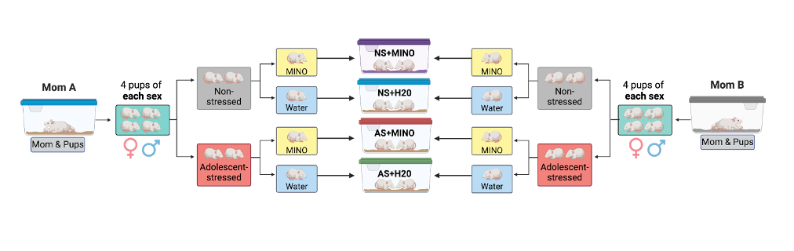
Figure 1. Stress condition and treatment group assignment example. Once weaned, all animals were separated by sex, with the intent that 4 females and 4 males would be taken from each litter to correspond with the 4 experimental groups. Next, 4 pups of each sex were separated into a stress group: adolescent stress (AS) or non-stress (NS). Further, animals were then assigned to a treatment group: minocycline (MINO) or water/ vehicle (H20). Each animal was housed with a non-sibling cagemate of the same sex, treatment, and stress condition from a different litter. Complete group assignments would result in both males and females being equally distributed into 1 of the 4 groups: non-stress + minocycline (NS+MINO), non-stress + water (NS+H20), adolescent stress + minocycline (AS+MINO), and adolescent stress + water (AS+H20). Figure created with Biorender.com.

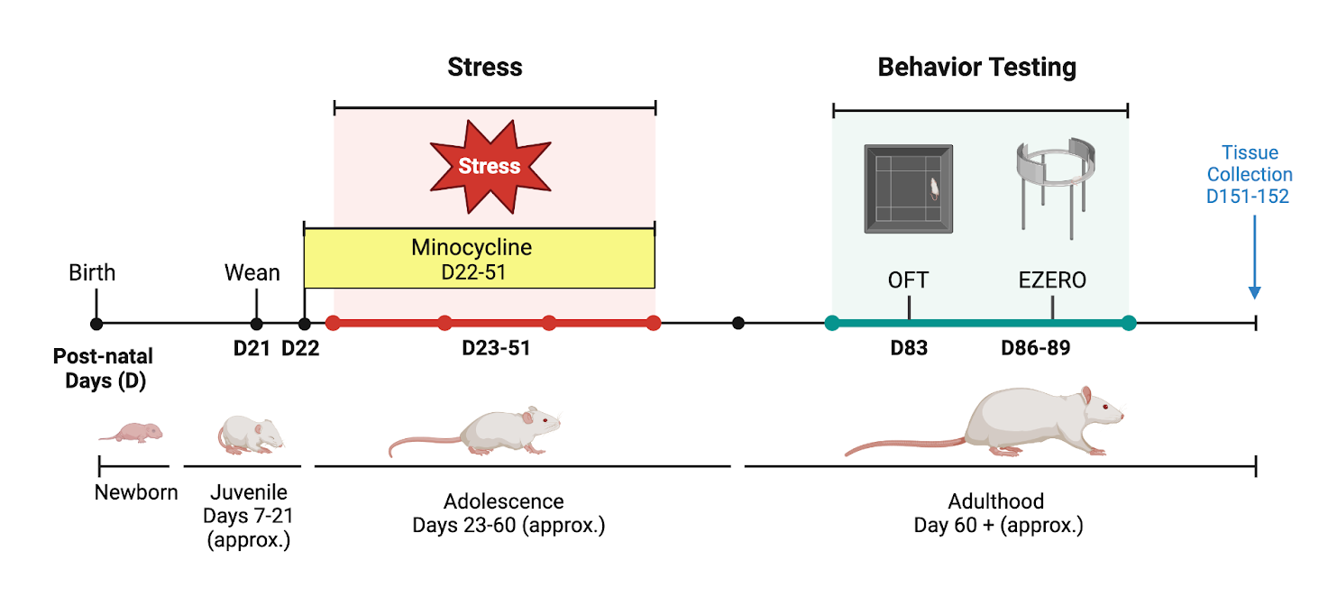
Figure 2. Experimental design. Timeline of experimental procedures. On postnatal day (D) 21, pups were weaned and housed with a nonsibling same sex, treatment, and stress condition cagemate. On D22, designated animals received their first dosage of minocycline dissolved in drinking water. Chronic unpredictable stressors began on D23, and occurred for 28 days, until D51. Anxiolytic behaviors were assessed in adulthood using the open field test (OFT) and the elevated zero maze (EZM) on D83, and D86-89. Brain and tissue collection occurred on D151-152. Figure created with Biorender.com.

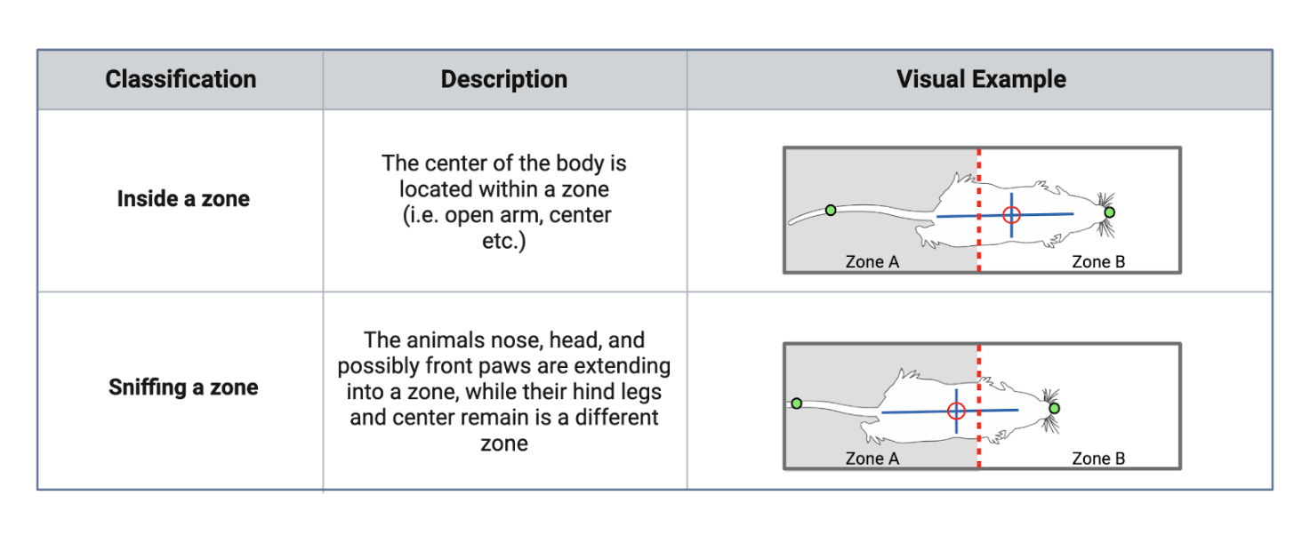
Figure 3. Behavioral criteria: TopScan. Description and example of scoring criteria recorded by TopScan automated software for the elevated zero maze (EZM) and open field test (OFT). Figure created with BioRender.com.

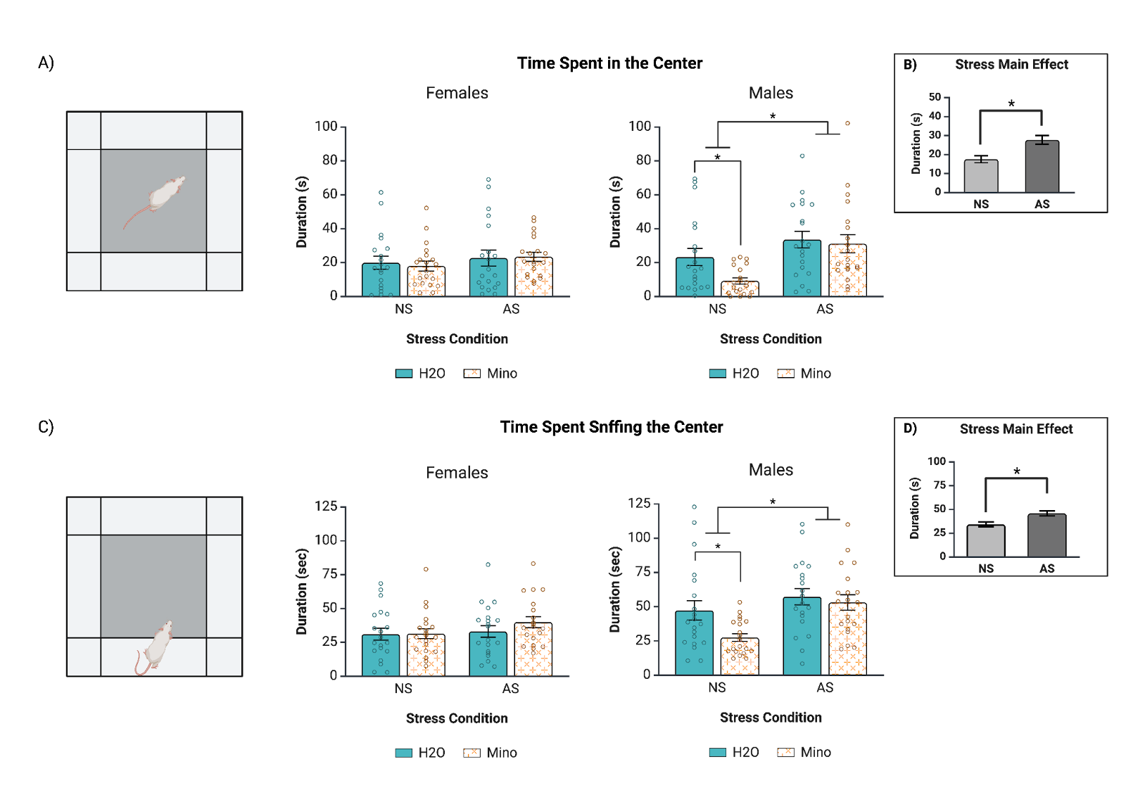
Figure 4. Minocycline treatment increased anxiety for non-stressed males. (A) Adult male NS+Mino animals spent less time in the center of the OFT compared to NS+H2O males. (B) AS animals spent more time in the center overall. (C) Male NS+Mino males spent less time sniffing the center. (D) AS animals spent more time sniffing the center. NS = Non-stressed, AS = Adolescent-stressed, Mino = Minocycline, H2O = water. Error bars represented mean +/- SEM. *denotes p<0.05.

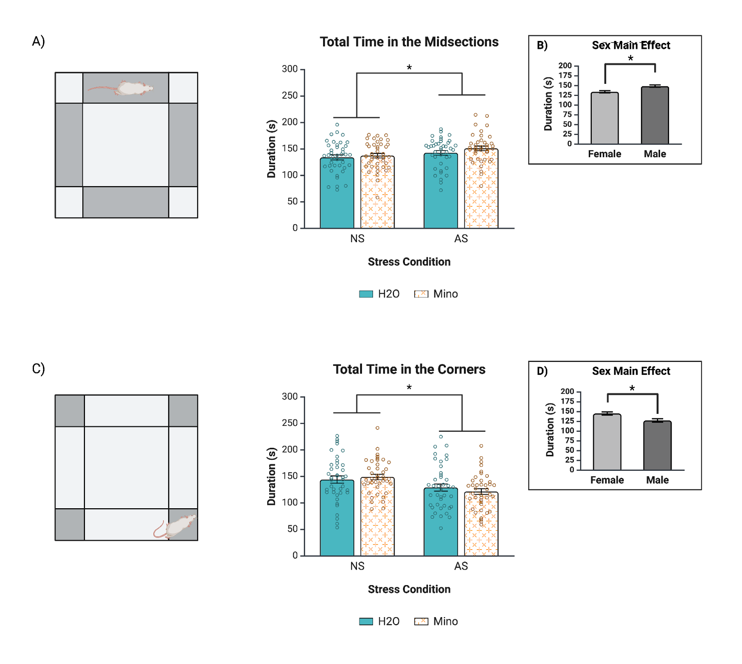
Figure 5. Chronic adolescent stress reduced anxiety: more time in midsection, less in corners. (A) AS animals spent more time in the midsections overall. (B) Males spent more time in the midsections of the OFT. (C) NS animals spent more time in the corners overall. (D) Females spent more time in the corners of the OFT. NS = Non-stressed, AS = Adolescent-stressed, Mino = Minocycline, H2O = water. Error bars represented mean +/- SEM. *denotes p<0.05.

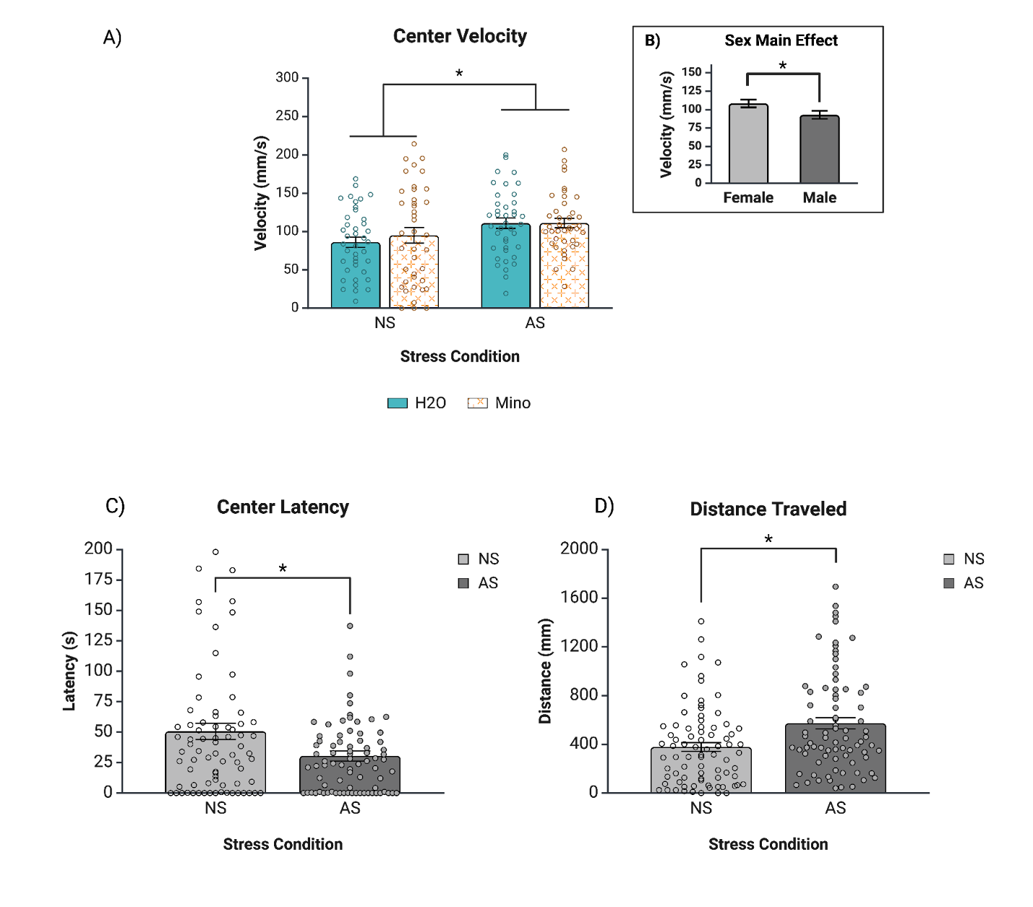
Figure 6. Locomotor activity and center latency across stress and sex conditions (A) AS animals traveled with higher velocity than NS animals. (B) Females traveled with higher velocity than males. (C) AS animals have a lower latency to center. (D) AS animals traveled greater distance overall. NS = Non-stressed, AS = Adolescent-stressed, Mino = Minocycline, H2O = water. Error bars represented mean +/- SEM.
*denotes p<0.05.

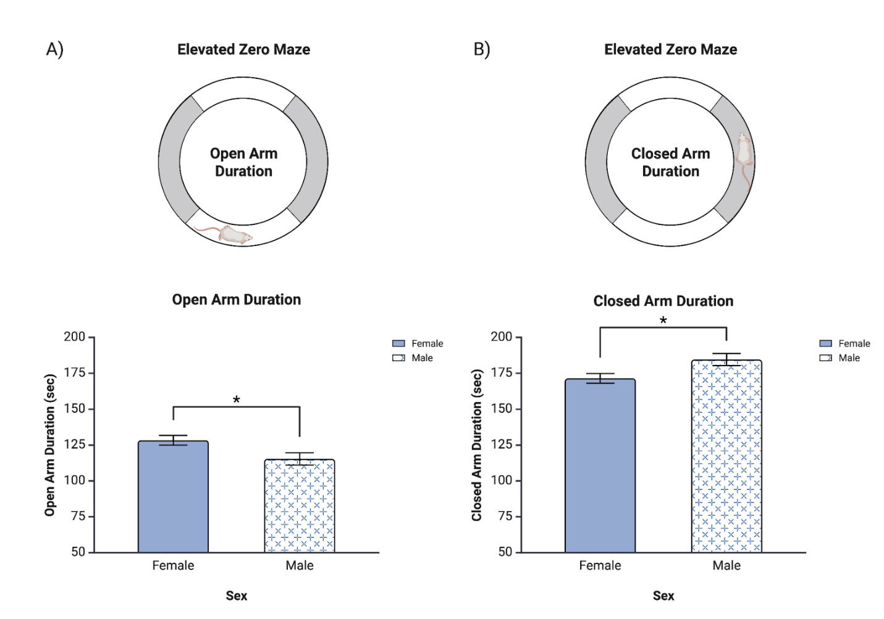
Figure 7. Open and closed arm duration in the elevated zero maze. Total time spent in either the open or closed arms of the elevated zero maze. (A) Females spent more time in the open arms of the maze, while (B) males spent more time in the closed arms of the maze. For clear visualization, the y-axis begins at 50 seconds instead of 0 seconds. Error bars represented mean +/- SEM. *denotes p<0.05.

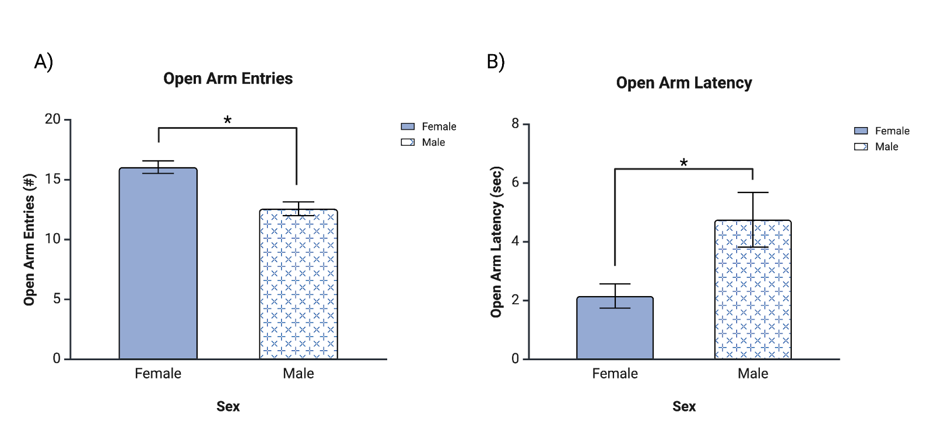
Figure 8. Open arm entries and latency to entry. (A) Females had a greater number of entries into the open arms across the test period. (B) Males had a longer latency before making their first entry into the open arms. Error bars represented mean +/- SEM. *denotes p<0.05.

VITA
Sierra Lawler began neuroscience research as an undergraduate research assistant at Slippery Rock University of Pennsylvania, with Dr. Beth Ann Rice. After graduating from SRU in 2023, she started graduate school at the University of Tennessee Knoxville in the Department of Psychology to pursue a Master’s degree in Experimental Psychology, with a concentration in Neuroscience and Behavior. She will graduate in May 2025.

