Biological Variation of Thromboelastography Variables in
Ten Healthy Female Horses

A Dissertation Presented for
the Master’s
Degree
The University of Tennessee, Knoxville

Jennifer Lee Scruggs
May 2014

DEDICATION

George Mason
Maya
Frannie
Fern
Lily Britches

ACKNOWLEDGEMENTS

I would like to thank Drs. Bente Flatland, Casey LeBlanc and Amy LeBlanc for serving on my thesis committee.

Abstract

Biological variability (BV) has important applications in laboratory medicine. It can be a source of variation in measured analyte values and provide guidance on reference interval use. BV has three components: between-individual variation (CVg), caused by differences in mean values of a particular analyte among members of a group, within-individual variation (CVi), caused by fluctuations around an individual’s inherent homeostatic set point, and analytical variation (CVa). Thromboelastography (TEG), a type of viscoelastic coagulation analysis, is becoming increasingly common in veterinary referral centers. Despite increased popularity, the optimal method of results interpretation is not clear. While population-based reference intervals (PRI) are used for many analytes, reference change values (RCV) are more sensitive for disease detection for other analytes. The relative sensitivity of PRI or RCV in detecting significant deviations of reported analyte values can be derived from BV data, via incorporation of CVi and CVg into a simple formula to calculate index of individuality (IOI). This study measured BV of four TEG parameters R, K, angle and MA in clinically healthy horses and, using calculated IOI, found that population-based reference intervals are appropriate when interpreting results from individual animals. Additionally, the ability to freeze a key reagent used in the TEG assay, tissue factor, was also investigated.

Table of Contents

Chapter 1: Introduction pg 1
References pg 5

Chapter 2: Effects of Freezing on Tissue Factor
Activity in a Thromboelastography Assay pg 7
References pg 19

Chapter 3: Biological variation of
thromboelastography variables in ten
clinically healthy horses pg 22
References pg 34

Chapter 4: Conclusions pg 38

Vita pg 39

List of Figures and Tables

Figure 1: Tissue factor activates quality control material II.
Figure 2: Freezing effects tissue factor’s ability to activate quality control material II.
Table 1: Biological variation data and IOI of four TEG variables in ten healthy horses.

ABREVIATIONS AND SYMBOLS

Alpha (α) Angle, a TEG variable
BSA Bovine Serum Albumin
BV Biological Variation
CVa Analytical Variation
CVg Between-group (or horse) Variation
CVi Within-individual (or horse) Variation
IOI Index of Individuality
K Kinetics of fibrin formation, a TEG variable
MA Mean amplitude, a TEG variable
R Time until initial fibrin formation, a TEG variable
RCV Reference Change Value
PBS Phosphate-Buffered Serum
PRI Population-based Reference Interval
TEG Thromboelastography
TF Tissue Factor

Chapter 1: Introduction

Variation is inherent to all laboratory measurements. Even repeated measurements from one animal of unchanged health status, performed in the same laboratory using the same analytical methods, will often result in slightly different reported values. Causes of this variation include pre-analytical and analytical factors, such as differences in patient preparation, sample acquisition and handling, and instrument calibration. An additional source of variation, not often considered in veterinary medicine, is biological variation (BV). BV of a given analyte is assessed by measuring within-individual variation (CVi) and between-individual variation (CVg). CVi is caused by natural fluctuations in an analyte’s concentration or activity relative to an individual’s homeostatic set-point. CVg occurs between members of a group, all of whom have their own unique homeostatic set-points caused by differences in genetic makeup, environmental factors, and health status.¹
Although population-based reference intervals (PRI) are often used to interpret laboratory data, a reference change value (RCV) may be a more sensitive means to detect medically significant deviations from “normal” for some analytes.² A PRI, by convention, encompasses values from the central 95% of a reference sample population and defines an upper and lower reference limit. Patient results falling outside of these limits are considered “abnormal” and are likely of medical significance.² As CVg increases relative to CVi, the central 95% of data also increases due to the wider range of measured values in the reference population. It is possible for a PRI to be so wide that medically significant deviations from an individual’s set point will still fall within the normal reference interval, rendering the PRI insensitive for disease detection. For these analytes, calculating reference change value (a.k.a. critical difference or subject-based reference values) will likely be of benefit. RCV defines the difference between two serial measurements from one individual that must be achieved for a change to be considered biologically significant, even if both results fall within a PRI. Recent papers describing biological variation in a healthy dog population and a reptile population concluded that results from most routine biochemical analytes and many coagulation tests are optimally interpreted using RCV, not population-based reference intervals.^{3,4,5}
The index of individuality (IOI) is a standard formula that generates a unitless value used to predict the need for PRI or RCV based on CVg and CVi.⁶ When IOI for a particular analyte is over 1.4, population-based reference intervals are considered a sensitive means by which to interpret analyte data from individual animals. When IOI is less than 0.6, reference change values are the more sensitive means to identify changes. In order to apply BV to clinical interpretation of laboratory data, analytical variation (CVa) must also be known. If CV_{a} is very high, medically important changes may become obscured in the wide range of values inherent to the particular automated machine. Additionally, analytical variation is incorporated into the IOI formula and very large CVa values may impact calculated IOI.⁶
Viscoelastic coagulation analyzers are becoming increasingly common in veterinary tertiary referral centers, creating availability of these assays for some horse populations. Four commonly reported thromboelastography variables include the time to initial fibrin formation (R), kinetics of fibrin formation and clot development (K and angle, respectively), and maximal clot strength (MA).⁷ A BV study on these TEG variables in dogs using a tissue factor-activated assay and frozen plasma, revealed a relatively small CVg and large CVi, suggesting that PRIs are appropriate for clinical interpretation of patient data.⁵ In contrast, a recent study in horses identified overlap of TEG data from healthy horses and horses with gastrointestinal disease; the extent to which BV may have contributed to these findings is not known.⁸
The main objective of this thesis work was to characterize biological variation (expressed as CVi and CVg) and analytical variation (CVa) of four TEG variables (R, K, angle and MA) in clinically healthy horses and to determine if use of population-based reference intervals is appropriate for clinical interpretation.
Before completing the biological variation study, investigation into the stability of a key reagent, Innovin (Dade-Behring, Marburg, Germany), was performed. Innovin is a lyophilized reagent containing human recombinant tissue factor (TF), synthetic phospholipids, calcium and a mix of other stabilizers and buffers marketed for prothrombin time assay.⁹ Innovin has also been used to activate viscocoelastic coagulation assays, including TEG assays.^{10,11,12} Benefits of TF-activated assays include faster reaction times and possibly improved precision and decreased intra-operator variability.^{11,12,13} Although anecdotal reports suggest that freezing does not harm Innovin’s activity for purposes of TEG (CR Wagg, DACVP, e-mail correspondence, July 15, 2011; RC Carroll, PhD, e-mail correspondence, April 12, 2013), the package insert warns it should not be frozen. The ability to prepare aliquots and store TF prior to use would increase laboratory efficiency and potentially decrease costs associated with its use, but published data regarding the effects of freezing on TF are not available. The purpose of the first part of the thesis work was to determine if TF could be frozen for extended periods of time without loss of activity, as assessed by activation of a quality control material (Level II Control, Haemoscope, Niles, IL) and TEG.

References

1. Fraser CG. Inherent biological variation and reference values. Clin Chem Lab Med. 2004; 42: 758-764.
2. Geffré A, Friedrichs K, Harr K et al. Reference values: a review. Vet Clin Pathol. 2009; 38:288-298.
3. Ruaux CG, Carney PC, Suchodolski JS and Steiner JM. Estimates of biological variation in routinely measured biochemical analytes in clinically healthy dogs. Vet Clin Pathol. 2012; 41:541-547.
4. Bertelsen MF, Kjelgaard-Hansen M, Howell JR, Crawshaw GJ. Short-term biological variation of clinical chemical values in Dumeril’s monitors (Varanus dumerili). J Zoo Wildl Med. 2007; 38:217–221.
5. Wiinberg B, Jensen AL, Kjelgarrd-Hansen, Rojkjaer R, Johansson PI, Gade, LP, Gram DX and Kristensen AT. Study on biological variation of haemostatic parameters in clinically healthy dogs. Vet J. 2007; 174:62-68.
6. Fraser CG. Biological Variation: From principals to practice. Washington: AACC Press; 2001, pp. 1-28.
7. Donahue SM and Otto CM. Thromboelastography: a tool for measuring hypercoagulability, hypocoagulability, and fibrinolysis. J Vet Emerg Crit Care. 2005; 15: 9-16.
8. Epstein KL, Brainard BM, Gomez-Ibanez SE et al. Thromboelastography in horses with acute gastrointestinal disease. J Vet Intern Med. 2011; 25:307-314.
9. Dade Innovin [package insert]. Marburg/Germany: Siemens Healthcare Diagnostics Products GmbH; 2009.
10. Wagg CR, Boysen SR and Bédard C. Thromboelastography in dogs admitted to an intensive care unit. Vet Clin Pathol. 2009; 38:453-461.
11. Epstein KL, Brainard BM, Lopes MAF, Barton MH and Moore JN. Thromboelastography in 26 healthy horses with and without activation by recombinant human tissue factor. J Vet Emerg Crit Care. 2009; 19 : 96-101.
12. Smith SA, McMichael M, Galligan A, Gilor S and Hoh CM. Clot formation in canine whole blood as measured by rotational thromboelastometry is influenced by sample handling and coagulation activator. Blood Coagul Fibrinolysis. 2010;21:692-702.
13. Marschner CB, BjØrnvad CR, Kristensen AT and Wiinberg B. Thromboelastography results on citrated whole blood from clinically healthy cats depend on modes of activation. Acta Vet Scand. 2010; 52:38-42.

Chapter 2
Effects of Freezing on Tissue Factor Activity in a Thromboelastography Assay

This chapter is based on a paper by Jennifer L. Scruggs, Bente Flatland and Ann Reed: Scruggs JL, Flatland B, Reed A. Effects of freezing on tissue factor activity in a thromboelastography assay. Vet Clin Pathol. 2014; In press.
My primary contributions include (i) partial development of experimental design (ii) gathering data (iii) suggestions on statistical approach, (iv) interpretation of data and (v) the majority of the writing.

Abstract
Human recombinant tissue factor (TF) can be used to activate viscoelastic coagulation assays, including TEG. Although the package insert of a commonly used product indicates that TF should not be frozen, published data supporting or refuting this claim are not available. Ability to store frozen aliquots of TF would increase laboratory efficiency and decrease costs associated with performing TF-activated assays. The objectives of this study were to determine the effects of freezing and storage time on TF’s ability to activate commercially available quality control material measured using TEG. In order to accomplish this, TF was diluted and frozen at -20°C and -70°C for 0 hours, 72 hours, 1 week, 2 weeks, 3 months and 6 months and its ability to activate control material was assessed. TF activation of control material was also assessed after TF aliquots were held at room temperature for 0, 24 and 48 hours. Four TEG variables, R, K, alpha and MA were measured, and ANOVA used to identify differences. We found no significant differences in mean angle and MA regardless of storage time or temperature. While mean values for R were not significantly increased at any time point when stored at room temperature or -70°C, significant increases in mean R were observed for aliquots frozen at -20°C starting at the 1 week time point and continuing to the 6 months’ time point. The data indicate TF can be stored at room temperature for at least 48 hours, stored at -20°C for 72 hours, and stored at -70°C for up to six months without significant loss of activity.

Introduction
Quality control material II, (QCM II) is the abnormal quality control material that mimics hypocoagulability and is used .as part of a routine, daily protocol to assess TEG analytical performance. QCM II rather than whole blood was used in this particular study because of two perceived advantages. First, QCM II components in a given lot are expected to be constant. In contrast, whole blood samples (even from the same individual) could be affected by biological variation, health status, hematocrit, sample handling, and other pre-analytical factors known to cause variation in TEG results.^{1,2} The increased sample stability of QCM II made it more likely that we could isolate and identify effects of freezing while minimizing variation attributable to other sources. Second, use of QCM II also simplified experimental design. The timing of assays was flexible, since QCM II could be prepared at any time, and animal use was precluded. The objectives of this study were to determine the effects of freezing and storage time on TF’s ability to activate commercially available quality control material (QCM II) measured using thromboelastography. Information from Haemonetics personnel indicated that QCM II can be activated (Elaine Haney, MT, email communication, September 26, 2011) and this ability was verified prior to assessment of freezing on TF.

Materials and Methods
A pilot study demonstrated that TF could only activate QCM II when prepared by adding 2.0 mL sterile, deionized water to a 10.0 mL vial of lyophilized Innovin (Figure 1). TEG variables from QCM II samples with and without added TF were compared by using a single sample t-test of the hypothesis that the mean difference between pairs, on average, would be 0. The normality assumption was met. Since four t-tests were performed, a Bonferroni corrected significance value of 0.0125 was used.
Accordingly, a 10 mL vial of TF was diluted using 2.0 mL sterile, deionized water, and aliquots of diluted TF were frozen at -70°C and -20°C or maintained at room temperature (21°C) until use. Innovin aliquots were removed from the freezer after 72 hours, 1 week, 2 weeks, 1 month, 3 months and 6 months, allowed to thaw and reach room temperature, and then used to activate QCM II. The Innovin aliquots stored at room temperature were used immediately (0 hours) and after being stored, in a drawer away from light, for 24 and 48 hours.
For each TEG assay, 20 uL 0.2 M Calcium Chloride and 10 uL TF (i.e., diluted Innovin) were added to the reaction well first, followed by 330 uL of QCM II. Weight of material in the Innovin vial is considered proprietary information, and the exact TF dilution achieved by reconstituting the 10 mL Innovin vial using 2.0 mL water could not be calculated. If the dilution used is considered 1:2 (w/v), then the final dilution of TF in the sample cup was 1:72. Temperature of the reaction well was

Figure 1: Tissue factor activates quality control material II.
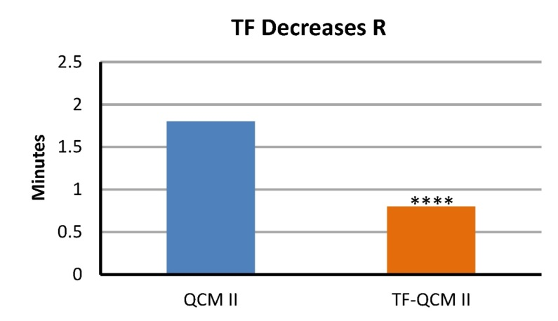
A.

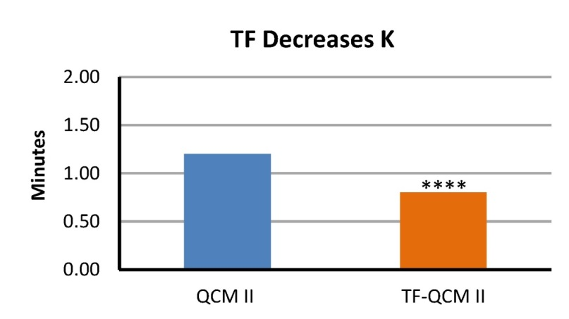
B.

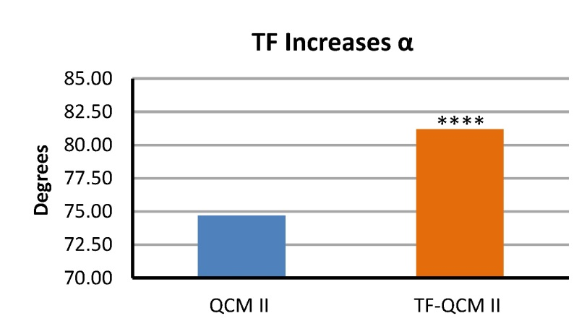
C.

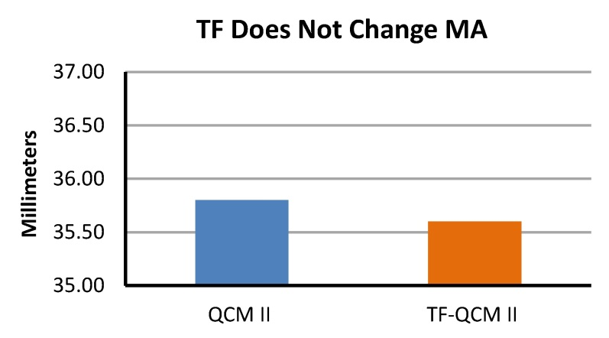
D.

Figure 1: Bar graphs demonstrating that adding tissue factor (TF) to quality control material II (QCM II) significantly decreases R and K (p < 0.0001, for both; see A and B, respectively) and significantly increases angle (α; p < 0.0001; see C) but has no effect on MA (see D). The label, QCM II, represents values obtained using quality control material alone, while bars labeled TF-QCM II represent values obtained by adding TF to QCM II.

was allowed to reach 37°C prior to adding any reagents and was maintained at 37°C for the duration of the assay. Assays were allowed to run until MA was finalized. Machine balance and e-test were assessed daily prior to sample analysis, according to manufacturer instructions. Additionally, TEG analytical performance was monitored daily prior to sample analysis, using two-level (normal and abnormal) quality control materials (Level I Control and Level II Control, respectively, Haemoscope, Niles, IL) run in duplicate. All QCM used in this study, both as daily control and experimental samples, were prepared according to manufacturer’s instruction and were of the same lot. Control data were considered acceptable if results fell within manufacturer-provided ranges for each control material. All data were collected electronically using instrument software (TEG Analytical Software Version 4.2, Haemonetics Corporation, Braintree, MA). Each TEG assay was completed by one operator (JLS) and performed in replicate; the average of the replicates was used for statistical analysis.

Statistical Analysis
Statistical analysis was performed using SAS/Stat software (SAS Institute Inc., Version 9.3 SAS for Windows, Cary, NC, 2010). ANOVA was used for means comparisons. Values of p < 0.05 were considered significant. A Bonferroni adjustment for multiple comparisons was used when appropriate. When significant effects were found, means were separated by use of the least significant difference test. The Shapiro-Wilk statistic was used to test normality of residuals from each ANOVA. The assumption of equal variances was tested using the Levene’s F test. Since assumptions were not adequately met, rank transformed data were used in all reported analyses.
Results
For Innovin aliquots stored at room temperature for 0, 24 and 48 hours, no significant differences were found in mean R, angle, or MA (p = 0.65, p = 0.81 and p = 0.68, respectively; data not shown). The mean value for K was the same at all time points, precluding analysis. For Innovin aliquots stored at -20°C and -70°C and freshly reconstituted Innovin (room temperature, 0 hours), effects of time and temperature were assessed for R, angle and MA. Values for K were the same at all time and temperature combinations and not analyzed further. There were no significant differences in mean angle and mean MA regardless of storage time or temperature (p = 0.43 and p = 0.067, respectively; Figure 2). There was a significant interaction of time and temperature for R (p < 0.0001; Figure 2). While mean values for R were not significantly increased at any time point when stored at -70°C, significant increases in mean R were observed for aliquots frozen at -20°C starting at the 1 week time point and continuing to the 6 months’ time point (p < 0.05). Mean R obtained using freshly reconstituted Innovin (room temperature, 0 hours) did not differ significantly from means obtained when Innovin was stored at -20°C for 72 hours.

Figure 2: Freezing effects tissue factor’s ability to activate quality control material II.
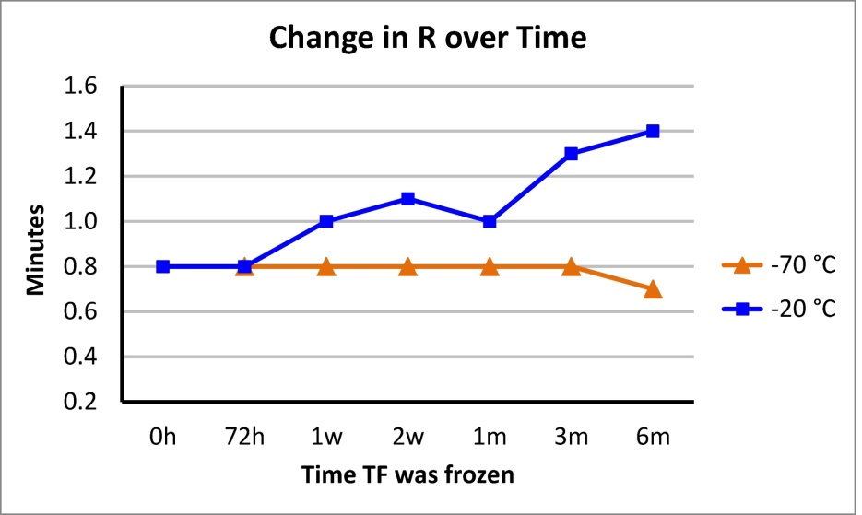
A.

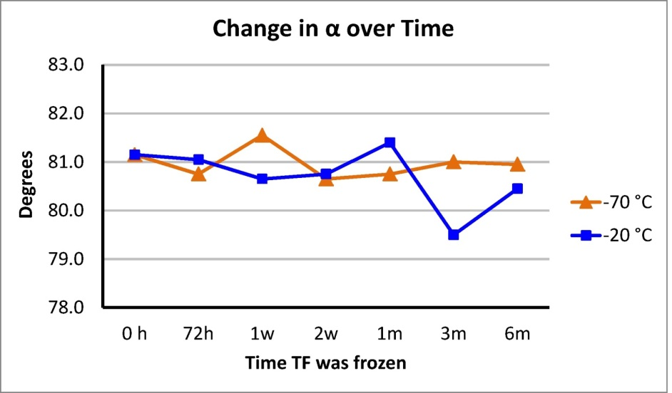
B.

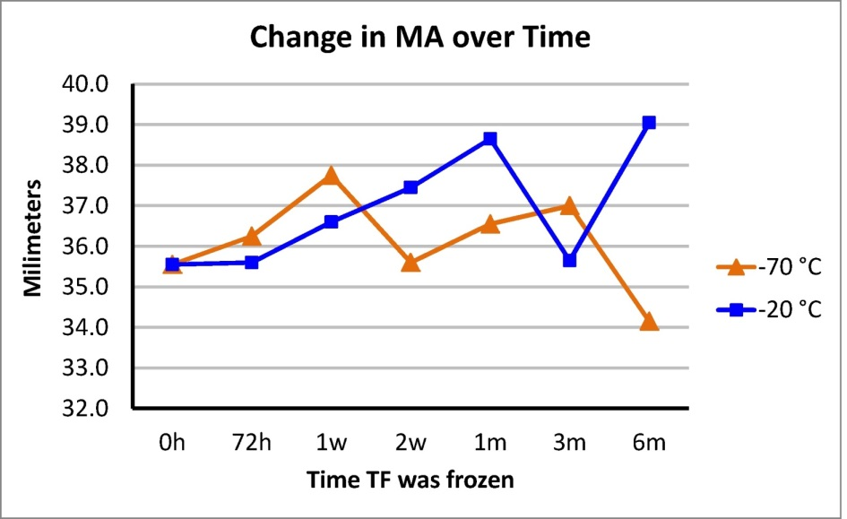
C.

Figure 2: Line graphs demonstrating effects of freezing at two different temperatures on tissue factor’s (TF) ability to activate quality control material II. A significant time by temperature interaction was found for R when TF was stored at -20°C (p < 0.0001; see A); R times increased starting at the 1 week (1 w) time point and continuing through the six month (6m) time point. A significant time by temperature interaction was not found for angle (α; p = 0.43; see B) or MA (p = 0.07; see C). The 0h time point reflects values obtained from using fresh, never frozen, TF. The other time points reflect length of time TF was frozen (h = hours, w = weeks, m = months).

Interpretation
Diluted Innovin can be frozen at -70°C for up to 6 months without significant loss of activity and at -20°C for up to 72 hours without significant loss of activity. Consistent with information in the Innovin package insert indicating that reconstituted TF is stable up to five days at temperatures between 15° and 25°C, we observed TF can be stored at least for 48 hours at room temperature (21°C).³

Discussion
As the matrix and composition of one lot of QCM material are expected to be constant, any changes in tracings in our assay are presumed due to the addition of the activator and its specific effects. The variable R is measured in minutes, reflects the time between assay initiation and initial fibrin polymerization, and is very much dependent on the rate of thrombin formation.⁴ The variable K is also measured in minutes and is the time from R until an amplitude of 20 mm is reached on the TEG tracing. In whole blood samples, K is dependent on factors II and VIII, fibrinogen, platelet count and function, hematocrit and thrombin formation.⁵
The TF used in this assay was much more concentrated than typically used with whole blood TEG assays and likely rapidly initiated and maximized formation of the tissue factor-Factor VII complex, resulting in a substantial and speedy thrombin burst. This thrombin burst, in turn, increased kinetics of fibrin polymerization, shortening R time in the activated QCM II assay. Freezing at -20°C presumably resulted in partial degradation or inactivation of TF that became more pronounced the longer TF was frozen, resulting in less initial thrombin formation and subsequent increasing R times. A study by Smith et al, using canine citrated whole blood, observed that the ROTEM variable CFT (the equivalent of K) seemed less sensitive to changes in concentration than did CT (the equivalent of R), suggesting that small changes in TF concentration due to freezing would most likely manifest as changes in R and not K. ⁶ It also seems plausible that the large TF concentration used in our study exceeded that required to maximize K; this could explain why K values were identical for all TF aliquots, regardless of storage time or temperature.
Although we did not observe a significant effect of freezing at -70°C, it is possible that a small amount of TF did degrade but our assay was not sensitive enough to identify this change. Previously reported whole blood assays use more dilute TF concentrations than used in this study, and it is possible that small losses of TF activity induced by freezing could impact R (and possibly other variables) in such whole blood assays.^{7, 8, 9} Further studies could potentially better characterize effects of freezing TF by investigating activity of more concentrations of TF than assessed in our study. Ideally, such studies should involve activation of whole blood samples; however, sample stability issues make design of such studies challenging. Based on the data presented above, we suggest that freezing Innovin at -70°C for up to six months is possible, while freezing at -20°C is recommended for only 72 hours or less. Accordingly, we prepared a large batch of dilute tissue factor and froze aliquots in preparation for the second study presented in this thesis.

References
1. Fraser CG and Harris EK. Generation and application of data on biological variation in clinical chemistry. Crit Rev Clin Lab Sci. 1989; 27: 409-437.
2. Smith SA, McMichael MA, Gilor S, Galligan AJ and Hoh CM. Correlation of hematocrit, platelet concentration, and plasma coagulation factors with results of thromboelastometry in canine whole blood samples. Am J Vet Res. 2012; 6: 789-798.
3. Dade Innovin [package insert]. Marburg/Germany: Siemens Healthcare Diagnostics Products GmbH; 2009.
4. McMichael MA and Smith SA. Viscoelastic coagulation testing: technology, applications, and limitations. Vet Clin Pathol. 2011; 40: 140-153.
5. Donahue SM and Otto CM. Thromboelastography: a tool for measuring hypercoagulability, hypocoagulability, and fibrinolysis. J Vet Emerg Crit Care. 2005; 15: 9-16.
6. Smith SA, McMichael M, Galligan A, Gilor S and Hoh CM. Clot formation in canine whole blood as measured by rotational thromboelastometry is influenced by sample handling and coagulation activator. Blood Coagul Fibrinolysis. 2010;21:692-702.
7. Wagg CR, Boysen SR and Bédard C. Thromboelastography in dogs admitted to an intensive care unit. Vet Clin Pathol. 2009; 38:453-461.
8. Epstein KL, Brainard BM, Lopes MAF, Barton MH and Moore JN. Thromboelastography in 26 healthy horses with and without activation by recombinant human tissue factor. J Vet Emerg Crit Care. 2009; 19 : 96-101.
9. Wiinberg B, Jensen AL, Rojkjaer R, Johansson P, Kjelgaard-Hansen M and Kristensen AT. Validation of human recombinant tissue factor-activated thromboelastography on citrated whole blood from clinically healthy dogs. Vet Clin Pathol. 2005; 43: 389-393.

Chapter 3
Biological variation of thromboelastography variables in
ten clinically healthy horses

This chapter is based on a paper by Jennifer L. Scruggs, Bente Flatland, Karen McCormick and Ann Reed: Scruggs JL, Flatland B, McCormick K, Reed A. Biological variation of thromboelastography values in ten clinically healthy horses. J Vet Emerg Crit Care (under review).
My primary contributions included: (i) development of experimental design, (ii) collection of data, (iii) analytical review and (iv) the majority of writing.

Abstract
Thromboelastography (TEG), a type of viscoelastic coagulation analysis, is becoming increasingly common in veterinary referral centers. Despite increased popularity, the optimal method of results interpretation is not clear. While population-based reference intervals (PRI) are used for many analytes, reference change values (RCV) are more sensitive for disease detection for other analytes. The relative sensitivity of PRI or RCV in detecting significant deviations of reported analyte values can be derived from BV data, via incorporation of CVi and CVg into a simple formula to calculate index of individuality (IOI). Analytical variation is also incorporated into this formula. BV of four TEG parameters R, K, angle and MA were measured in ten clinically healthy horses, and within- and between-horse biological variation (CVi and CVg, respectively) and analytical variation (CVa) were calculated using a nested ANOVA after removing outlier data. Index of individuality was then calculated. Results indicate that population-based reference intervals are appropriate for TEG variables R, angle and MA when interpreting results from individual horses. Population-based reference intervals are likely appropriate when interpreting K, but IOI could not be calculated for this variable.

Introduction:
Biological variability (BV) has important applications in laboratory medicine. It can be a cause of variation in analyte values and provide guidance on reference interval use. BV has three components: between-individual variation (CVg), caused by differences in mean values of a particular analyte among members of a group, within-individual variation (CVi), caused by fluctuations around an individual’s inherent homeostatic set point, and analytical variation (CVa).¹ Although BV data are commonly investigated in human medicine, they are less emphasized in veterinary species.
The optimal method of results interpretation of TEG data is not clear. While population-based reference intervals (PRI) are used for many analytes, reference change values (RCV) are more sensitive for disease detection for other analytes. The relative sensitivity of PRI or RCV in detecting significant deviations of reported analyte values can be derived from BV data, via incorporation of CVi and CVg can into a simple formula to calculate index of individuality (IOI). This section of thesis reports measured BV of the four TEG parameters R, K, angle and MA, and calculated IOI, in clinically healthy horses.

Materials and Methods:
Animals and sample handling
This prospective study was conducted over a five week period using ten clinically healthy horses randomly pulled from a research and teaching herd. Animal use and sampling of blood was approved by the Institutional Animal Care and Use Committee of The University of Tennessee (protocol number 2097-0612). Horses ranged in age from 8-15 years, were mares, and included two Quarter horses, two Tennessee Walking Horses, one Missouri Fox Trotter, and five mixed breed horses. Horses were housed on pasture with free access to water and were fed free choice, mixed grass hay daily. Animal health was assessed one week prior to beginning the study using physical examination by a board-certified large animal internist (KM) and routine laboratory evaluation consisting of a CBC (including platelet count; ADVIA 120, Bayer HealthCare LLC, Tarrytown, NY ), biochemical testing (Cobas c 501, Roche Diagnostics, Indianapolis, IN), and coagulation analysis (STA Compact, Diagnostica Stago, Parsippany, NJ). Blood smear review accompanied each CBC. Coagulation analysis consisted of prothrombin time, partial thromboplastin time, and fibrinogen concentration. Inclusion criteria required horses to have an unremarkable physical examination and medical history, laboratory values that were within institutional equine reference intervals, and no medication administration in the previous two weeks. Medications were not administered during the course of the study.
Horses were stall-confined overnight and fasted for approximately ten hours prior to each blood sampling event; blood was collected from each horse once weekly for five weeks by two large animal internists. To minimize pre-analytical variation, all samples were taken between 7:00 and 11:00 a.m. and were obtained from a jugular vein directly into a 3.2% citrated vacutainer tube (BD Vacutainer Evacuated Citrate Tube, Vacutainer Holder, and Precision Glide needles, Becton, Dickinson, and Company, Franklin Lakes, NJ) using a vacuum collection system and 1.5" 20 g needle.^{2,3} The jugular vein used was alternated each week. Blood samples were maintained at room temperature for approximately 30 minutes from the time of collection to the start of the TEG assay (TEG 5000, Haemoscope Corporation, Niles, IL) to mitigate variations in results due to different storage times.^{4,5}

Thromboelastography
A tissue factor (TF)-activated TEG assay performed at 37 °C was used throughout the study. TF (Innovin, Dade-Behring, Marburg, Germany) was diluted using phosphate-buffered saline (PBS; PBS powder, pH 7.4, Sigma-Aldrich, St. Louis, MO ) and bovine serum albumin (BSA; BSA 30% solution, Sigma-Aldrich, St. Louis, MO) according to previously published protocols.⁶ Weight of material in the TF vial is considered proprietary information, and the exact TF dilution achieved by reconstituting the 10 mL Innovin vial using 2.0 mL sterile, deionized water could not be calculated. If the dilution used is considered 1:2 (w/v), and the subsequent dilution created by adding an aliquot of the prepared Innovin to the BSA/PBS solution considered 1:50, the final dilution is estimated to be 1:100. TF target concentration in the TEG sample cup was 1:3600. Based on a study in our laboratory (see Chapter 2) and consultation with other investigators (personal communication: Catherine R. Wagg, Faculty of Veterinary Medicine, University of Calgary, Calgary, Canada, 2011 and Roger C. Carroll, Graduate School of Medicine, University of Tennessee, Knoxville, TN, 2013), TF is stable for at least six months when frozen at -70°C. Accordingly, TF was prepared prior to the start of the study and aliquots stored at -70°C until use.
For each individual TEG assay, the reaction cup held 10 μL of diluted TF (thawed to room temperature immediately prior to use), 20 uL of 0.2 M CaCl₂ (Haemonetics Corporation, Niles, IL) and 330 μL of citrate-anticoagulated whole blood. TF and calcium solutions were added to the reaction cup first, and whole blood was added when the temperature of the cup returned to 37°C. Contents of the reaction cup were immediately and gently mixed using re-aspiration into the pipette tip to ensure adequate mixing of all components before each TEG assay was started.⁷ All samples were run in duplicate.
Machine balance and e-test were assessed daily prior to sample analysis, according to manufacturer instructions. TEG analytical performance was monitored daily, using two-level (normal and abnormal) quality control materials (Level I Control and Level II Control, respectively, Haemonetics Corporation, Braintree, MA) run in duplicate. Control data were considered acceptable if results fell within manufacturer-provided ranges for each control material. All data were collected electronically using instrument software (TEG Analytical Software Version 4.2, Haemoscope Corporation, Braintree, MA). To minimize pre-analytical and analytical variation, all TEG assays (including control runs) were performed by one individual (JLS), and all reagents and supplies used during the course of the study were from one lot number, respectively.

Statistical Analysis
Statistical analyses were conducted using computer software (SAS Institute Inc., Version 9.3 SAS for Windows, Cary, NC) and an approach for biological variation suggested by Fraser and Harris.^{3,8} The data were screened for outliers, first using the Cochran’s C test to identify outliers in the duplicate results and then in the variance of subject means. Values for R and K from one horse obtained during week 3 were excluded as a result of this analysis. Reed’s criterion was then used to identify individuals with overall mean values for R, K, angle and MA that differed from all other subject’s means. Values for MA from one horse were subsequently excluded from further analysis. Between-horse variance, within-horse variance, and analytical variance were then obtained for each measurement using a nested ANOVA. Variances and the overall mean for each measurement were used to calculate the corresponding coefficients of variation, CVi, CVg and CVa. Values of P < 0.05 were considered significant for all statistical tests.
The index of individuality (IOI) was calculated using the formula
$$IOI=\sqrt{ \frac{{CV}_{i}^{2}+ {CV}_{a}^{2}}{{CV}_{g}^{2}}}$$
where CVi is within-horse variation, CVg is between-horse variation and CVa is analytical variation.

Results
Study population
All horses used in the study were healthy on physical examination and had hematologic, biochemical, and coagulation parameters that were within institutional equine reference intervals (data not shown).

Biologic Variation and IOI of TEG variables
CVi (%) for TEG variables R, K, Angle and MA are 26.8, 31.0, 9.4 and 3.4, respectively. CVg (%) for R, K, Angle and MA are 5.2, 0.0, 6.2 and 4.1, respectively. CVa (%) for R, K, Angle and MA are 5.9, 5.9, 21.7, 4.4, respectively. Calculated IOI for R, K, Angle and MA are 5.3, not assessed, 3.8 and 1.4, respectively (see Table 1).

Table 1: Biological variation data and IOI of four TEG variables in 10 healthy horses.

TEG variable | CVi (%) | CVg (%) | CVa (%) | IOI | Total # samples
R | 26.8 | 5.2 | 5.9 | 5.3 | 47
K | 31.0 | 0.0 | 5.9 | NA | 47
Angle | 9.4 | 6.2 | 21.7 | 3.8 | 48
MA | 3.4 | 4.1 | 4.4 | 1.4 | 43

Table 1. Summary of CVi, CVg, CVa and calculated IOI. The total number of samples is the number collected from all horses over the course of the experiment after removing outliers. NA – not assessed

Discussion
Biological variation estimates in people are made in clinically healthy individuals, even though resulting data are intended to be applied to all populations (sick, adult, geriatric, etc.).^{1,3,8-10} Although mean values for laboratory results can vary by sex, health status, breed, and age, the inherent biological variability around a given homeostatic set point appears constant, even in chronic disease states.¹¹⁻¹⁵ This suggests that BV data from our study are likely applicable to most horses, not just healthy, non-athletic mares.
Studies in humans indicate biological variation does not change significantly in disease; however, most data concerning non-healthy individuals were obtained from patients with chronic, stable diseases, not acute disease or emergent conditions. It seems plausible that, in acute disease, acute decompensation of chronic disease, or during times of growth and development (i.e., when measured homeostatic set points may be in flux), that BV may be greater than it is in steady states (health or chronic, stable disease). There is no prior published information regarding biological variation of TEG variables in horses in either health or disease, so it is not clear how or if BV might change in different homeostatic or pathologic conditions in horses. It is important to remember, particularly in the context of viscoelastic coagulation analysis, that changes in hematological variables influence patient data. For example, studies investigating effects of erythrocyte mass on thromboelastometry (ROTEM™) have shown that there is an inverse relationship between hematocrit and coagulability. Tracings appear hypocoagulable as hematocrit increases and hypercoagulable as hematocrit decreases.^{16,17} Erythrocyte and platelet mass changes occur in many critical care patients and have potential to affect results of viscoelastic testing.
Index of individuality (IOI) is a unitless index derived from a calculation using CVa, CVi and CVg. By convention, when the resulting number is greater than 1.4, population-based reference intervals are considered acceptable for clinical interpretation. When IOI is less than 0.6, use of RCV to interpret patient data is considered optimal. Results from this study suggest that R, K and angle data can be appropriately interpreted using PRIs. IOI for MA was exactly 1.4; PRIs are likely appropriate for this variable as well, but a small, clinically significant change may not be as easily detected as if IOI were greater. IOI for K is listed as NA (see Table 1). This is because the variation attributable to K’s CVg was zero, and CVg is in the denominator of the IOI formula; a number divided by zero is indeterminate. If CVg were very small (approaching zero but with a numeric value), the resulting IOI would be much greater than 1.4.
CVa was highest for angle (21.7 % vs. all other values less than 6.0%). The exact reason for this is not clear. It is possible that TF-activated TEG is not the optimal way to measure this particular variable, and that another method may increase precision. Our controls were within limits for all variables, suggesting analytical error did not contribute to the variation in angle. Additionally, CV calculated using quality control material (QCM I) for angle was less than 0.4%, perhaps suggesting whole horse blood has components or matrix effects that caused the relatively high CVa associated with angle measurement. The addition of TF has been reported to decrease analytical variability in TEG results.¹⁸ It could be that increasing TF concentration beyond that used here may decrease angle variability. A consequence of the high CVa for angle is that the degree of analytical variation may make it difficult to identify small, medically significant, changes in that variable.
Fraser and Harris and others advocate the ideal biological variation study would involve all samples being collected and then stored under conditions ensuring sample stability until one large analytical run can be performed.^{3,10} This design is favored because it mitigates the effect of between-run analytical variation on results. Due to the inherent sample instability associated with whole blood TEG assays and an inability to freeze whole blood intended for TEG analysis, a limitation of this study is that we analyzed samples in different runs, 30 minutes after collecting the blood.^{4,5,19} Although not the ideal approach, this experimental design is often used in instances where sample instability precludes long term storage ^{8,3} An advantage of our design is that it mirrors how TEG is performed in many routine clinical situations.

References
1. Fraser CG. Inherent biological variation and reference values. Clin Chem Lab Med. 2004; 42: 758-764.
2. Koenigshof AM, Scott MA and Brown AJ. Effects of delayed anticoagulation and use of evacuated tubes on non-activated thromboelastography in dogs. Vet Clin Pathol. 2012; 41: 63-70.
3. Fraser CG and Harris EK. Generation and application of data on biological variation in clinical chemistry. Crit Rev Clin Lab Sci 1989:409-437.
4. Leclere M, Lavoie JP., Dunn M and Bédard C. Evaluation of a modified thromboelastography assay initiated with recombinant human tissue factor in clinically healthy horses. Vet Clin Pathol. 2009; 38: 462-466.
5. Camenzind V, Bombeli T, Seifert B et al. Citrate storage affects thrombelastograph analysis. Anesthesiology. 2000; 92:1242-1249.
6. Wagg CR, Boysen SR and Bédard C. Thromboelastography in dogs admitted to an intensive care unit. Vet Clin Pathol. 2009. 38:453-461.
7. Epstein KL, Brainard BM, Lopes MAF, Barton MH and Moore JN. Thromboelastography in 26 healthy horses with and without activation by recombinant human tissue factor. J Vet Emerg Crit Care. 2009; 19(1): 96-101.
8. Fraser CG. Biological Variation: From principals to practice. Washington: AACC Press; 2001, pp. 1-28.
9. Ruaux CG, Carney PC, Suchodolski JS and Steiner JM. Estimates of biological variation in routinely measured biochemical analytes in clinically healthy dogs. Vet Clin Pathol. 2012; 41: 541-547.
10. Cotlove E, Harris, E and Williams GZ. Biological and analytical components of variation in long-term studies of serum constituents in normal subjects III. Physiological and medical implications. Clin Chem. 1970; 16:1028-1032.
11. Geffré A, Friedrichs K, Harr K et al. Reference values: a review. Vet Clin Pathol 2009; 38:288-298.
12. Sako T, Mori A, Lee P et al. Age-specific plasma biochemistry reference ranges in <1 year old dogs in Japan. Vet Res Commun. 2011; 35:201-9.
13. Dunlop MM, Sanchez-Vazquez MJ, Freeman KP et al. Determination of serum biochemistry reference intervals in a large sample of adult greyhounds. J. Small Anim Pract. 2011; 52:4-10.
14. Fraser CG, Cummings ST, Wilkinson SP et al. Biological variability of 26 clinical chemistry analytes in elderly people. Clin Chem. 1989; 35:783-786.
15. Ricos C, Iglesias N, Garcia-Lario, J et al. Within-subject biological variation in disease: collated data and clinical consequences. Ann Clin Biochem 2007; 44:343-352.
16. Paltrinieri S, Meazza C, Giordano A, Tunesi C. Validation of thromboelastometry in horses. Vet Clin Pathol. 2008; 37: 277-285.
17. McMichael MA, Smith SA, McConachie EL, Lascola K, Wilkins PA. In-vitro hypocoagulability on whole blood thromboelastography associated with in vivo expansion of red cell mass in an equine model. Blood Coagul Fibrinolysis 2011; 22:424-430.
18. Marschner CB, BjØrnvad CR, Kristensen AT, Wiinberg B. Thromboelastography results on citrated whole blood from clinically healthy cats depend on modes of activation. Acta Vet Scanda. 2010; 52: 38-42.
23. Fraser CG. Reference change values. Clin Chem Lab Med. 2012; 50: 807-812.
19. Wiinberg B, Jensen AL, Rojkjaer R et al. Validation of human recombinant tissue factor-activated thromboelastography on citrated whole blood from clinically healthy dogs. Vet Clin Pathol. 2005; 34:389-393.

Chapter 4: Conclusions
The first part of this thesis provides information regarding stability of a key TEG assay component, tissue factor. The data indicated tissue factor can be frozen at
-70°C for at least 6 months. Accordingly, a large batch of TF was prepared and aliquots frozen for the subsequent biological variation study. The second part of this document describes biological variation and analytical variation for the TF-activated TEG variables, R, K, angle and MA, in healthy horses. Incorporation of the BV and CVa data into the index of individuality formula demonstrates that population-based reference intervals are an appropriate way to interpret TF-activated TEG data from individual horses.

Vita
Jennifer Scruggs obtained a Bachelors of Science degree from the University of South Carolina in May 1997. She then obtained a PhD in neuroscience from Vanderbilt University in 2002 and a DVM from the University of Tennessee in 2006. She completed a veterinary medical residency in Clinical Pathology and graduated with a Master’s of Science degree in Clinical Pathology in 2014.

