Neural Mechanisms of Visual Stability

A Dissertation Presented for the
Doctor of Philosophy
Degree
The University of Tennessee, Knoxville

Jessica L. Parker
August 2025
ACKNOWLEDGEMENTS
I would not be where I am without the care and support of the wonderful people around me. I am grateful to my advisor, Caglar Tas, who has supported my learning and growth throughout my graduate program. She has inspired me scientifically and helped me learn the skills I need to continue my research. In addition, my committee members, Dr. Aaron Buss, Dr. David Sutterer, and Dr. Jared Porter have supported my work extensively and provided constructive feedback throughout the process. I am especially grateful to Dr. Aaron Buss, who has helped me throughout graduate school to learn more about NIRS through collaborations and has immensely supported my dissertation work with training and feedback. Outside of my committee, I want to acknowledge the endless motivation and encouragement that I have received from my partner since the time I started doing research as an undergraduate student. He has always listened to my ideas, fostered my creativity, and provided useful feedback. Finally, I would not be where I am without the love and support of my family, especially my parents who have always pushed me to work hard and have celebrated every milestone I have hit academically.
ABSTRACT
We examined the mechanisms that support processes of transsaccadic visual stability by measuring hemodynamic activity across cortical areas associated with spatial working memory and saccade updating during a transsasccadic change detection task. Participants were presented with a saccade target and instructed to execute a saccade to the target. In some trials, the color of the saccade target would change during the saccade, and participants were asked to report whether they detected a change in a two-alternative forced choice task. Further, we used the postsaccadic blanking paradigm, where the saccade target briefly disappears upon saccade onset and reappears after 250ms, to manipulate stability in half of the trials. To examine how stability processes generalize to non-target information, we further included a session where the item probed for report was a peripheral target, rather than the target of the saccade. The results demonstrated that blanking significantly improved sensitivity to changes of the target object during the saccade, both for the saccade target object and the peripheral target object. Neuroimaging data further demonstrated that both spatial memory mechanisms and saccade updating mechanisms were recruited across the task, however the saccade updating mechanisms were particularly recruited for disruptions of visual stability of the saccade target object and maintained stability for a peripheral target. Thus, while disruptions to visual stability result in similar behavioral results for the saccade target and a peripheral target item, the mechanisms of stability appear to differ, possibly due to differences in storage of information across the saccade or different attentional mechanisms.

Table of Contents
CHAPTER ONE INTRODUCTION AND GENERAL INFORMATION 1
Saccade Target Prioritization 2
Memory Mechanisms Supporting Transsaccadic Updating 3
Cortical Regions Associated with Saccadic Processes 4
Present Study 7
CHAPTER TWO METHOD 10
Participants 10
Stimuli and Apparatus 10
Hemodynamic Activity 10
Eye Tracking 11
Procedure 11
Data Processing and Analyses 13
CHAPTER THREE RESULTS 15
Behavioral 15
Hemodynamic Activity 16
CHAPTER FOUR GENERAL DISCUSSION 31
CONCLUSION 36
REFERENCES 37
VITA 44

LIST OF TABLES
Table 1. Hemodynamic Effects and Locations. 17

LIST OF FIGURES
Figure 1. NIRS Cap Configuration 10
Figure 2. Method Figure 12
Figure 3. Behavioral Results 15
Figure 4. Left MFG: Saccade Target Color Change x Hb Effect 18
Figure 5. Right MFG: Saccade Target Blank x Color Change x Hb Effect 18
Figure 6. Left MFG: Peripheral Target Blank x Hb Effect 19
Figure 7. Right MFG: Peripheral Target Blank x Color Change x Hb Effect 19
Figure 8. Left AG: Saccade Target Hb Effect 21
Figure 9. Right SPL: Saccade Target Hb Effect 21
Figure 10. Left AG: Saccade Target Blank x Hb Effect 22
Figure 11. Right AG: Saccade Target Blank x Color Change x Hb Effect 23
Figure 12. Left SPL: Peripheral Target Blank x Hb Effect 23
Figure 13. Left IPL: Peripheral Target Blank x Hb Effect 24
Figure 14. Left AG: Peripheral Target Color Change x Hb Effect 25
Figure 15. Right AG: Peripheral Target Blank x Color Change x Hb Effect 25
Figure 16. Left MOG: Saccade Target Hb Effect 27
Figure 17. Right MOG: Saccade Target Blank x Hb Effect 27
Figure 18. Right SOG: Saccade Target Blank x Hb Effect 28
Figure 19. Left SOG: Saccade Target Blank x Color Change x Hb Effect 28
Figure 20. Left MTG: Saccade Target Hb Effect 29
Figure 21. Right MTG: Peripheral Target Hb Effect 30
Figure 22. Left MTG: Peripheral Target Blank x Hb Effect 30

Introduction and General Information
Saccades are quick movements of the eye from one fixation point to another that optimize the amount of information that we obtain from the environment by shifting our small area of high acuity foveal vision within a visual scene. However, saccades also result in disruptions like the sweeping of information across the retina (Wurtz, 2008) and temporary suppression of information during the saccade (Matin, 1974). Due to the disruptions in visual information as a result of each saccade, the visual system is left with two representations: (1) the presaccadic representation of the intended saccade target (or object that the eyes are planning to saccade to) obtained from our periphery during saccade preparation and (2) the postsaccadic representation of the saccade target obtained at eye landing that is used to update the presaccadic representation. There are often errors in oculomotor movement (Becker & Fuchs, 1969, Gillen et al., 2013), as well as differences in acuity between presaccadic peripheral representations and postsaccadic foveal representations (Stewart, Valsecchi, & Schutz, 2020). Therefore, the visual system must rely on relevant information in a visual scene to make stability decisions that account for the errors introduced by each saccade. It has been proposed that the visual system attributes small spatial and featural discrepancies as errors of the visuomotor system, thus building a bias to treat information as stable (Atsma et al., 2016; Niemeier et al., 2003). As a result, sensitivity to slight changes that occur across saccades is generally low.
Early work examining sensitivity to transsaccadic changes of spatial information used a saccadic suppression of displacement task (SSD), where participants were instructed to execute a saccade to a target that was laterally displaced during the saccade (Bridgeman et al., 1975). They found that participants were generally insensitive to displacements of the saccade target for displacement magnitudes up to approximately one-third of the saccade amplitude. These findings support the accounts that the visual system maintains a bias towards stability unless transsaccadic changes are drastic enough to exceed what might be attributed to visuomotor error across saccades (Niemeier et al., 2003). Interestingly, later studies showed that sensitivity to the direction of the target displacement can be increased by temporarily removing the saccade target from the screen (blanking) upon saccade initiation so that it re-appears just after eye landing (Deubel et al., 1996). When stability is disrupted using this blanking manipulation, sensitivity to transsaccadic changes increases, likely as a result of maintaining both representations for comparison rather than updating the presaccadic representation with foveated information upon eye landing (Tas et al., 2021; Tas et al., 2012).
Taken together, the visual system maintains a bias towards stability across saccades, thus making slight changes that may be attributed to errors of the visuomotor system difficult to perceive. However, when transsaccadic changes are too large to be attributed to errors of the visuomotor system, that bias is disrupted and sensitivity to changes increases. Importantly, there are other ways to disrupt that bias, such as the brief disappearance and reappearance of the saccade target during the saccade. Increased sensitivity in cases of disrupted stability suggests that the visual system is able to access information obtained prior to saccade execution for comparison at saccade landing. To better understand how the visual system accomplishes a stable percept of the world, it is important to consider how the visual system (1) weights information in a visual scene is consulted for stability decisions and (2) what mechanisms support the maintenance of information across saccades for comparison upon eye landing. Below I discuss the possible mechanisms of transsaccadic updating, as well as the cortical regions associated with these mechanisms to further elucidate the interplay between different memory systems across saccades.

Saccade Target Prioritization
Naturalistic visual environments are typically complex and rich in information, providing the visual system with a broad array of potential information to use in stability decisions, making it important to understand how both the saccade target and non-target information inform visual stability decisions. Each saccade is preceded by a presaccadic shift of attention to the saccade target (Deubel, 2008; Hoffman & Subramaniam, 1995; Kowler et al., 1995). Due to the shift of attention to the saccade target, the target is preferentially encoded and more strongly represented (Carrasco, 2018; Deubel & Schneider, 1996; Kowler et al., 1995; Rolfs & Carrasco, 2012; Zhao et al., 2012), resulting in the prioritization of the saccade target for visual stability (Currie et al., 2000; Irwin et al., 1994; McConkie & Currie, 1996; Parker & Tas, 2025).
While it is clear that the saccade target is prioritized in stability processes, other work has highlighted that non-target information may also be consulted by the visual system for stability decisions. For example, the perceived location and stability of the saccade target can be influenced by items nearby the saccade target (landmarks; Deubel, 2004; Deubel, 1998), potentially due to benefiting from presaccadic attention shift to the saccade target that may spread to nearby location. Further, there is evidence showing that the saccade source object, or the object fixated before executing a saccade to the target, is consulted for stability decisions (Parker & Tas, 2025; Verfaille & De Graef, 2000), likely due to the attention it receives prior to saccade execution. Nonetheless, they found that the saccade target was still more strongly prioritized than any other information in a complex naturalistic scene. Taken together, these findings highlight that objects other than the saccade target can be consulted for stability.
While there is a growing area of literature on what information is consulted for stability decisions, the question remains whether the processes underlying visual stability processes and representation of information are similar for the saccade target and non-target objects in a scene. Visual stability relies both on the consultation of relevant information relevant to establish object correspondence and localize information across saccades and the maintenance of this information in some form of storage across the saccade for decisions upon saccade landing. Thus, while we know the visual system can consult non-target information for visual stability, there is less information on how similar stability processes are for target and non-target information. To better understand the mechanisms by which the visual system establishes stability, it is important to determine how the presaccadic and postsaccadic representations are stored and combined across saccades, and how underlying memory mechanisms represent saccade target information and non-target information in a visual scene.

Memory Mechanisms Supporting Transsaccadic Updating
An integral component of visual stability across saccades is transsaccadic memory (TSM), which is used to update visual information and establish a stable percept of the world. When considering the role of memory in the establishment of visual stability, it is important to note that disruptions to stability not only increased sensitivity to transsaccadic changes but also enabled participants to compare information obtained at eye landing to information obtained prior to the saccade (Deubel et al., 1996). For example, when the saccade target was spatially displaced during the saccade after a blank period, participants were significantly better at reporting the specific direction of the displacement relative to the direction of the saccade (Deubel et al., 1996), suggesting that presaccadic information was maintained across the saccade for postsaccadic comparison with foveated information.
Much of the work exploring TSM has highlighted similarities between TSM and visual working memory (VWM), which is the short-term storage of visual information that is typically studied in the absence of saccades. Both TSM and VWM have a similar capacity, similar decay profiles, and both stores abstract representations of objects (Aagten-Murphy & Bays, 2019; Irwin, 1992; Prime et al., 2011). Further, making a saccade to an irrelevant object during the retention interval of a VWM task decreases performance, suggesting that the saccade target is automatically encoded into VWM regardless of task relevance (Tas et al., 2016). These similarities indicate that visual stability across saccades may rely on VWM (Frost et al., 2019; Irwin, 1996). While behavioral evidence strongly suggests a relationship between memory mechanisms across saccades and fixations, there is a growing body of work on the neural mechanisms associated with different saccade processes and memory mechanisms. Thus, turning to the underlying neural substrates for TSM and VWM can help us better understand the memory mechanisms supporting visual stability processes.

Cortical Regions Associated with Saccadic Processes
While behavioral work has provided a solid foundation for better understanding visual stability processes, neuroimaging tasks can provide more information about the mechanisms underlying stability processes. There is a vast area of neural work examining transsaccadic updating that has contributed to our understanding of the spatial updating and memory mechanisms that support transsaccadic updating.
Previous work exploring neural activity associated with saccades have demonstrated that the posterior parietal cortex (PPC) is a part of the saccadic updating network associated with the postsaccadic updating of information (Melcher, 2011; Prime et al., 2008; Tanaka et al., 2014). More specifically, neural activation in the intraparietal sulcus (IPS), a region within the PPC, is associated with saccadic control and the coding of spatial information for saccades (Bender et al., 2013). To test whether TSM and VWM rely on similar neural pathways and whether PPC is a significant area in this pathway, Prime et al. (2008) used transcranial magnetic stimulation (TMS) where pulses were delivered over the PPC during both a TSM task and a VWM task. Their results demonstrated that TMS-induced disruption of the PPC resulted in decreased memory, both during fixation (VWM) and across saccades (TSM), suggesting that TSM and VWM rely on similar neural pathways that rely on the PPC. Work from our lab has shown that activation in the IPS increased when visual stability was disrupted in a transsaccadic task, and that sensitivity to transsaccadic changes in trials where stability was disrupted correlated with activity in the IPS, possibly reflecting the maintenance of both the pre- and postsaccadic representations for comparison (Tas et al., 2024) which corresponds well with data demonstrating that IPS activation scales up with VWM load (Todd & Marois, 2004).
Similar to the PPC, the dorsolateral Prefrontal Cortex (dlPFC) is also implicated in transsaccadic processes. Activation in the dlPFC is associated with memory-guided saccades (Pierrot-Deseilligny et al., 2003; Sawaguchi & Iba, 2001), inhibition of saccades and predictive saccades, (Pierrot-Deseilligny et al., 2003), and decisions regarding saccade target and saccade direction (Pierrot-Deseilligny et al., 2005). In a task similar to Prime and colleagues (2008, 2010), Tanaka et al. (2014) examined the role of the dlPFC in TSM by applying TMS to the dlPFC during a fixational VWM task and a TSM task. As expected, they found that memory performance for the TMS trials decreased in the VWM task compared to the control condition (no-TMS trials). In contrast, TSM performance for the TMS trials improved compared to the control condition. There are multiple hypotheses for why TMS to dlPFC resulted in increased performance for TSM. First, it is possible that dlPFC is involved in spatial updating mechanism by aiding the visual system during spatial remapping (Tanaka et al., 2014). Specifically, dlPFC may be involved in suppressing spatial locations that are irrelevant during a saccade (e.g., locations other than the saccade target) and thus TMS over this area may enhance such a suppressing mechanism which could result in improved TSM performance. Alternatively, TMS may suppress inhibition coming from dlPFC to saccadic updating areas of the brain which then allow extra resources to be sent to those updating areas, improving memory performance.
It is clear that both the PPC/IPS and the dlPFC play a significant role in saccadic processes, however the finding that disruptions to the dlPFC had a different impact on TSM than disruptions to the PPC raises the question of how each area differentially contributes to TSM. The dlPFC is associated with spatial working memory (Pierrot-Deseilligny et al. 2005; Tanaka et al., 2014), raising the possibility that the dlPFC is more integral to the higher-level cognitive control processes and spatial planning associated with saccades than to the active maintenance of representations. It has been suggested that the dlPFC activity is associated with spatial information being manipulated, rather than maintained, in memory (Barbey et al., 2013; Baumann et al., 2007), or if it interacts with other possible storage sites in posterior areas (Cohen et al., 1997; Curtis & D’Esposito, 2003).
While cortical regions associated with VWM, spatial working memory, and TSM are clear, how these mechanisms interact to support visual stability is unclear. The execution of saccades relies on the encoding and storage of feature information (VWM), coding of spatial information (spatial working memory), and the updating or comparison of representations stored across saccades upon eye landing (saccadic updating network). Importantly, the open question now is how these mechanisms interact to support the updating of information or separation of representations after saccade execution. Based on the finding that disruption of activity in areas associated with spatial working memory can result in the improvement of TSM, it is possible that disruptions to stability may similarly result in a stronger reliance on the saccadic updating network (PPC) than spatial working memory (dlPFC).

Present Study
The current project had two primary aims. The first aim was to examine the neural mechanisms of transsaccadic visual stability for the saccade target object by comparing hemodynamic activity between conditions where visual stability is established and disrupted to examine the mechanisms supporting visual stability processes. More specifically, we tested if disruptions to visual stability result in a stronger reliance on transsaccadic updating mechanisms and less on spatial working memory mechanisms. The second aim was to quantify the extent to which neural mechanisms of transsaccadic visual stability generalize to non-target information in a visual scene. Much of the prior work examining neural mechanisms underlying saccades probed report for an item that was not the saccade target (Prime et al., 2008, 2010; Tanaka et al., 2014), thus rendering the saccade target object irrelevant to the task. When the saccade target is always irrelevant to the task, the improvement in TSM performance could potentially occur at the cost of the representation of the saccade target. Prior work shows that the saccade target is obligatorily encoded into the VWM, regardless of relevance to the task (Tas et al., 2016), and the saccade target is prioritized for stability processes (Currie et al., 2000; Irwin et al., 1994; McConkie & Currie, 1996; Parker & Tas, 2025). However, the perception of stability (Deubel et al., 1998) and localization (Deubel, 2004) of the saccade target item can be influenced by non-target items. To address this, we measured sensitivity to transsaccadic changes of an object that was not the saccade target object (peripheral target) to examine whether the neural mechanisms of visual stability are similar for saccade target and non-target information.
In our experiment, participants completed a transsaccadic change detection task while we measured hemodynamic activity across cortical areas associated with spatial working memory (dlPFC) and saccadic updating network (PPC). Feature information about the saccade target or peripheral target changed in half of the trials. Importantly, the feature changes were subtle enough to avoid disrupting stability. To examine whether disruptions to stability modulate hemodynamic activity, we used the blanking paradigm, where the saccade target object or peripheral target was briefly removed from the screen upon saccade initiation and reappeared after 250 ms. After completion of the saccade, participants were asked to report whether or not feature information of the saccade target or peripheral target changed during the saccade. Participants were specifically instructed only to report a change if the feature of the item probed for report changed, regardless of whether or not the item was blanked.
Hypotheses
Based on prior work, disruptions to visual stability should increase sensitivity to transsaccadic changes compared to conditions where stability was maintained. If disruptions to visual stability improve sensitivity to transsaccadic changes by allocating more resources to the saccade updating network, then activation in the PPC should increase for stability disruptions compared to trials where stability was established. If this improvement to transsaccadic change detection relies more heavily on the saccadic updating network than the spatial working memory areas, then activation in cortical areas associated with spatial working memory (dlPFC) should decrease and activation in the saccadic updating network (PPC) should increase in conditions where visual stability is disrupted compared to conditions where stability is established. If the spatial working memory mechanisms are not impacted by visual stability processes, but only impact the saccadic updating network, then we should see activation in the saccadic updating network (PPC) increase with no change in activation in the spatial working memory area (dlPFC) across trials with disruptions to stability compared to trials where stability is established.
Furthermore, if the mechanisms of visual stability apply both to the saccade target object and other objects in a visual scene, then both the behavioral results and patterns of neural activation should be similar across trials where the saccade target is probed for report and trials where a peripheral target is probed for report. If visual stability mechanisms are specific to the saccade target, then the peripheral target may not be as strongly represented, lending to decreased sensitivity to changes of the peripheral stimulus. While the blanking paradigm is known to increase response biases, information at the saccade target location still benefits from the disruptions above and beyond the bias rate induced by blanking (false alarm rate; Irwin & Robinson, 2018; Tas & Parker, 2023; Parker & Tas, 2025). However, because the saccade target is prioritized in the process of visual stability, it is also possible that disruptions to visual stability for the peripheral target will only increase the bias without increasing sensitivity to transsaccadic changes. If stability disruptions only induce a bias without increasing accuracy in detecting transsaccadic changes of the peripheral target, then it is possible that (1) hemodynamic activity in spatial working memory areas (dlPFC) may not change or (2) resources allocated to the saccadic updating network do not change across manipulations of stability for a peripheral target.

Method

Participants
Based on a priori power analyses using effect sizes from our prior work using MorePower 6.0.4 (Campbell & Thompson, 2012), we needed a minimum of 24 participants for .90 power with α=0.5 but aimed to run 30 participants to account for any data loss due to noisy NIRS signal or eye-tracking. We recruited 32 right-handed young adults (18-28 years of age) with normal or corrected-to-normal vision, and each participant was screened for color deficiency using the 14-plate Ishihara color deficiency test. Participants received course credit in return for their participation.

Stimuli and Apparatus

Hemodynamic Activity
Hemodynamic activity was recorded with a TechEN continuous-wave NIRS system at 25 Hz with 8 light sources emitting light at 690nm and 830nm and 16 detectors placed at a 3 cm distance from light sources, with a total of 24 channels. The cap was configured to record activity from the bilateral dlPFC and the bilateral PPC (see Figure 1).
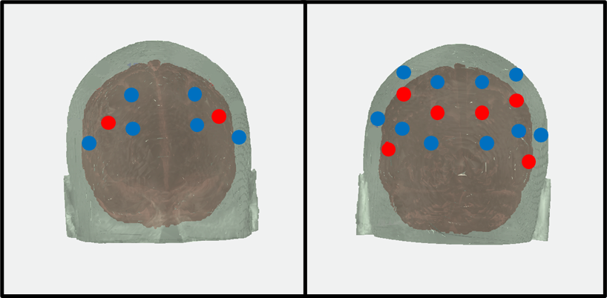
Figure 1. The figure above shows the configuration of the light sources and detectors, covering the bilateral dlPFC (left) and bilateral PPC (right).

Eye Tracking
Eye position was monitored with an SR Research Eyelink 1000 Plus eye tracking system using a 1000 Hz sampling rate monitoring the position of the right eye. We used a chin rest to stabilize the head and positioned the monitor at a distance of 94 cm from the eye.
Stimuli
The fixation dot was a black dot subtending approximately 0.17 dva, and the saccade target and peripheral target were a colored dot subtending 0.6 dva. Colors were selected from CIE L*a*b color space. Stimuli were drawn and presented with Psychtoolbox in Matlab R2018b on a calibrated ASUS TUF Gamine VG259QM monitor with a display area of 54.5 cm (width) x 30.5 cm (height) at 120 Hz.

Procedure
Participants completed a transsaccadic change detection task across two sessions (see Figure 2). The experiment was split into two counterbalanced tasks: a saccade target task and a peripheral target task. In both tasks, participants first fixated on a fixation dot in the center of the screen for a randomly selected duration between 500ms and 1000ms. A 100ms pulse was then sent to the NIRS machine to align the behavioral and neural data, at which point a dot appeared at a randomized eccentricity between 6-8° to the left or right of the fixation dot. In the saccade target task, this dot was filled with a randomly selected color from CIE L*a*b color space, and participants were instructed to execute a saccade to the colored dot. In the peripheral target task, the saccade target object was a black dot (identical to the fixation dot), and a peripheral dot with a randomly selected color was presented at the same time at half of the horizontal eccentricity of the saccade target position and 4 dva above or below the vertical center of the screen to avoid the object being within the fovea at any point during the saccade. In this session, participants were instructed to execute a saccade to the target dot, but to attend to the peripheral dot without looking at it, as it was the dot that was probed for report. In half of the trials, the color of the colored dot changed 25 degrees on the color wheel as soon as the saccade was initiated.
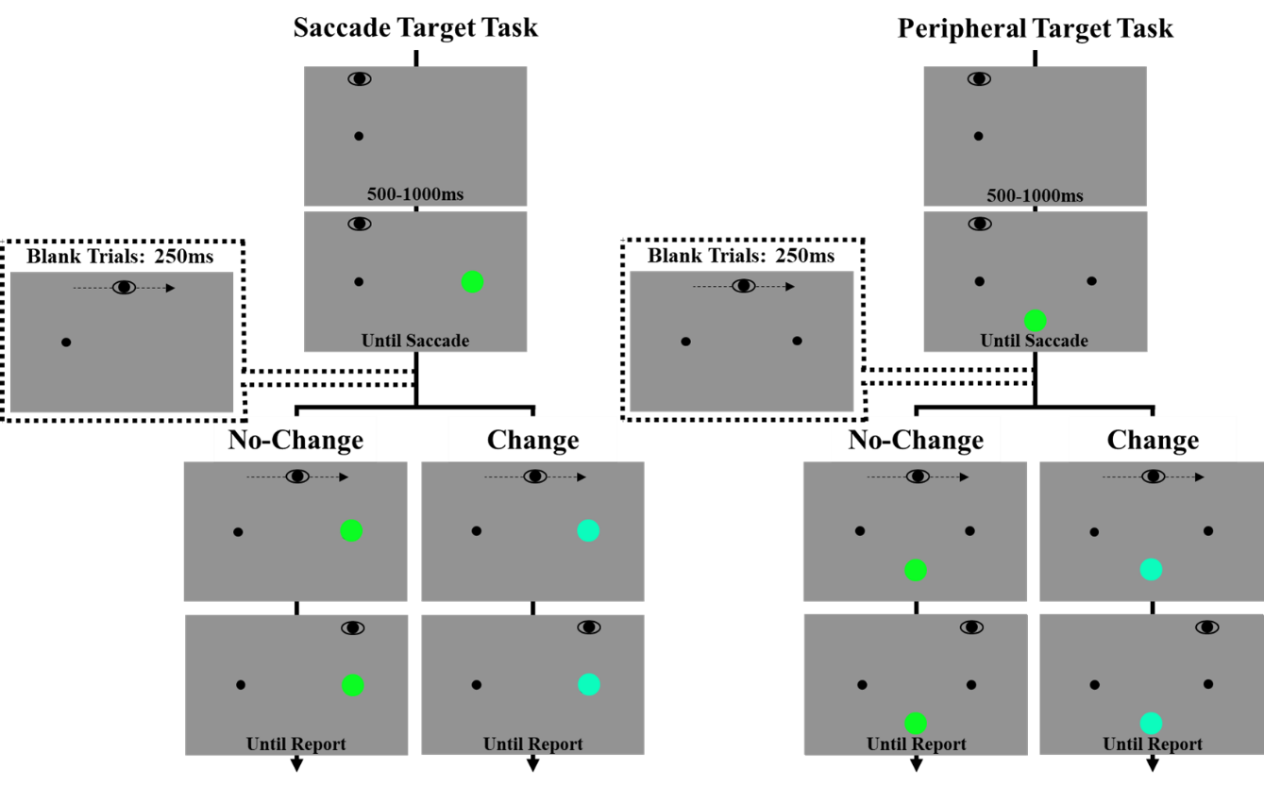
Figure 2. The figures above illustrate a display sequence and timing across trials in the Saccade Target Task (left) and Peripheral Target Task (Right).

The change magnitude was determined from a pilot task that was conducted to ensure that the color change in the absence of a blank would not be large enough to disrupt stability. We manipulated visual stability by blanking the colored dot for 250ms upon saccade initiation in half of the trials. In change trials, the dot re-appeared in a different color after this duration. In all conditions, participants were asked to report whether or not the color of the probed object changed (Change/No Change), using a button box. At the end of each trial, there was a brief delay before the start of the next trial (jitter) to enable blood flow to return to baseline. The jitter durations we used were 1.5 seconds, 3 seconds, or 5 seconds in a 2:1:1 ratio. Participants completed a total of 368 trials. The trials were blocked by task (saccade target task and peripheral target task), and each task had 24 practice trials followed by 160 test trials. Participants were offered a break every 10-15 minutes throughout the task. The entire task took approximately 1 hour, however the setup of the NIRS cap prior to the start of the task was approximately 30 minutes.

Data Processing and Analyses
Eye Tracking Data
Trials in which the position of the pupil was not at the center at the beginning of the trial, the saccade latency was less than 100ms or greater than 2.5 times the standard deviation, or where the timing of the display change occurred less than 10ms or greater than 50ms before saccade landing (in trials without a blank) were removed from analyses. This resulted in the removal of approximately 5% of trials. One participant was removed from analyses for having fewer than 20 trials for any condition after elimination, but all remaining participants had more than 20 trials per condition and were included in analyses.
Neural Data
Anatomical landmarks (Cz, nasion, inion, and left and right preauricular point) and locations of light sources and detectors were digitized using a Polhemus Patriot system and aligned with Colin’s atlas (Collins et al., 1998). Monte Carlo simulations were used with 100,000,000 photons to generate sensitivity profiles that were used to create masks for each participant, and then a group mask that included voxels that at least 75% of participants contributed data to. We used standard functions in HoMER2 for pre-processing steps to obtain the optical density measure before correcting for before correcting for motion artifacts with a modified wavelet filter with an interquartile range threshold of 0.72 using hmrMotionCorrectWavelet (Molavi & Dumont, 2012). Then data were projected onto the brain volume using a Tikhonov regularization method and converted into oxygenated hemoglobin (HbO) and deoxygenated hemoglobin (HbR) concentration using the modified Beer-Lambert law. We calculated hemodynamic response amplitudes across each voxel for each condition with general linear modeling. Using an affine transformation, we aligned each participant’s functional image to MNI space to then use 3dMVM in AFNI for group analyses (Chen et al., 2014). Familywise corrections (p<.05 and α<.05) were applied with 3dClustSim (Cox et al., 2017). Follow-up comparisons were conducted using the HbO and HbR beta values for each participant in IBM SPSS Statistics (Version 28.0.0).

CHAPTER THREE
results

Behavioral
Accuracy was analyzed in 2 (Change: No-Change, Change) x 2 (Blank: No-Blank, Blank) repeated measures of ANOVA, separately for the saccade target session and the peripheral session. Replicating prior work, accuracy was significantly higher in the blank condition (M_{peripheral}=0.839; M_{target}=0.857) than in the no-blank condition (M_{peripheral}=0.738; M_{target}=0.755) in both sessions, F(1,28)=21.403, p<.001, η_{p}²=.433 and F(1,28)=22.957, p<.001, η_{p}²=.451, respectively. Further, a significant main effect of change was found in both peripheral and saccade target sessions, F(1,28)=43.647, p<.001, η_{p}²=.609 and F(1,28)=47.200, p<.001, η_{p}²=.628, respectively. Specifically, accuracy was significantly higher in the no-change conditions (M_{peripheral}=0.919, M_{target}=0.929) than in change conditions (M_{peripheral}=0.657, M_{target}=0.676). We also found a significant Blank x Change interaction in the peripheral session (See Figure 3), F(1,28)=97.274, p<.001, η_{p}²=.776, and in the saccade target session, F(1,28)=86.582, p<.001, η_{p}²=.756. Follow-up comparisons revealed that participants were significantly better at reporting a change when the probed item was blanked (M_{peripheral}=0.7970, M_{target}=0.8302) than when the probed item remained on the screen (M_{peripheral}=0.5167, M_{target}=0.5223, both ps<.001). However, in no-change trials, accuracy was significantly higher in the no-blank condition (M_{peripheral}=0.9604, M_{target}=0.9776) than the blank condition (M_{peripheral}=0.8773, M_{target}=0.8812, both ps<.001), likely reflecting a bias to
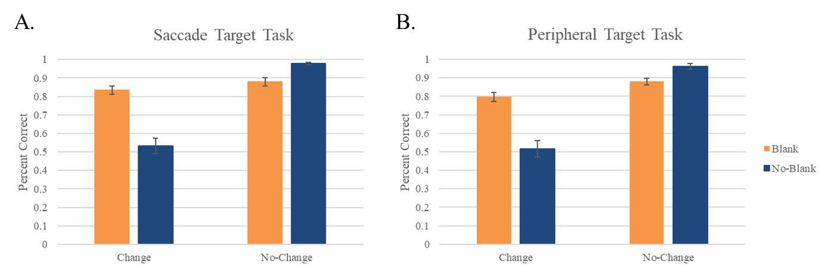Figure 3. The figure above shows the accuracy across blank (orange) and no-blank (blue) trials in change and no-change conditions for the saccade target task (A) and peripheral target task (B).
report a change that has been previously found the with postsaccadic blanking paradigm.

Hemodynamic Activity
                - Data were submitted to a 2 (Blanking: Blank, No Blank) x 2 (Change: Change, No Change) x 2 (Hemoglobin: HbO, HbR) repeated measures ANOVA, which resulted in 19 significant clusters. We determine activation by looking for an increase in HbO and decrease in HbR (Heeger et al., 2002). For follow up comparisons, we took the difference between HbO and HbR (activation difference) for each condition and task. Details of the significant clusters can be found in Table 1.
                - Spatial Memory
Spatial memory is often attributed to regions, such as the dlPFC, which is housed in the Middle Frontal Gyrus (MFG). Here, we found significant effects in the MFG for both the saccade target task and the peripheral target task. In the saccade target session, there was a significant Color Change x Hb interaction in the left MFG (Figure 4; see Table 1 for GES values). Change trials resulted in significantly more activity (M=0.009, SD=0.049) than no-change trials (M=-0.013, SD=0.055), t(30)=2.331, p=.027. There was also a significant Blank x Color Change x Hb interaction in the right MFG (Figure 5). The activation difference was higher for blank than no-blank in the change condition, but higher for no-blank than blank in the no-change condition, however the follow up comparisons failed to reach significance (ps>.05). If we instead look at the difference between change and no-change trials across conditions of blanking, there is a marginal difference in the no-blank condition showing the activation difference in the no-change trials (M=0.005, SD=0.036) to be higher than the change condition (M=-0.017, SD=0.060), t(29)=2.048, p=.050. In the peripheral target session, there was a significant Blank x Hb interaction in the left MFG (Figure 6). The activation difference was significantly higher in the no-blank condition (M=0.006, SD=0.057) than the blank condition (M=-0.013, SD=0.053), t(30)=2.913, p=.007. In the right MFG, the peripheral task resulted in a significant Blank x Color Change x Hb effect (Figure 7). The activation difference in the blank trials (M=-0.007, SD=0.046) was significantly lower than in the no-blank trials (M=0.011, SD=0.045) in change condition, t(29)=-2.059, p=.049. Interestingly, we also found a significant positive relationship between right MFG
Table 1. The table below shows the significant regions of activation, along with their MNI coordinates and cluster volume, for each significant effect from the ANOVA for both the saccade target and peripheral target tasks. All GES values are on the right side.

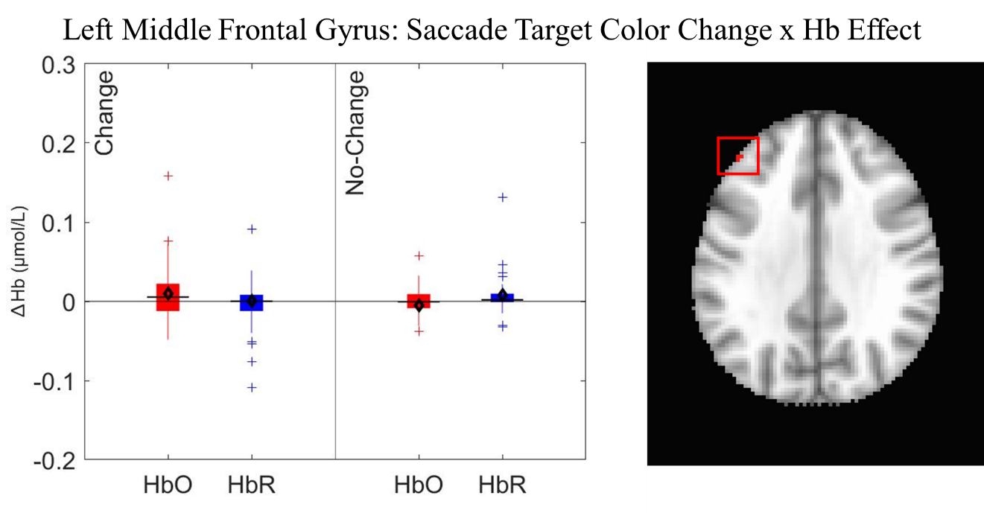
Figure 4. The figure above shows the change in HbO (red) and HbR (blue) in change and no-change conditions of the saccade target task. The location of the cluster is shown in the image on the right side inside the red box.
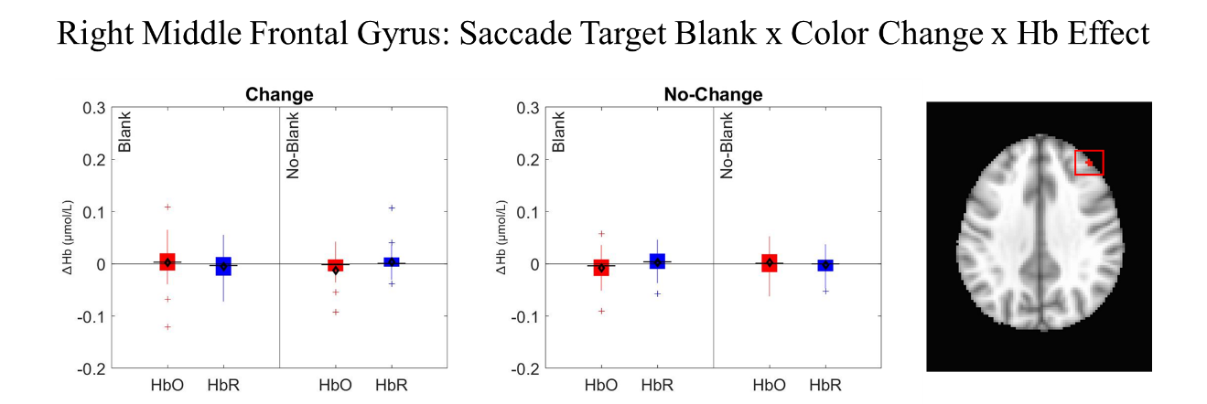Figure 5. The figure above shows the change in HbO (red) and HbR (blue) for blank and no-blank trials of the change and no-change conditions in the saccade target task. The location of the cluster is shown in the image on the right side inside the red box.
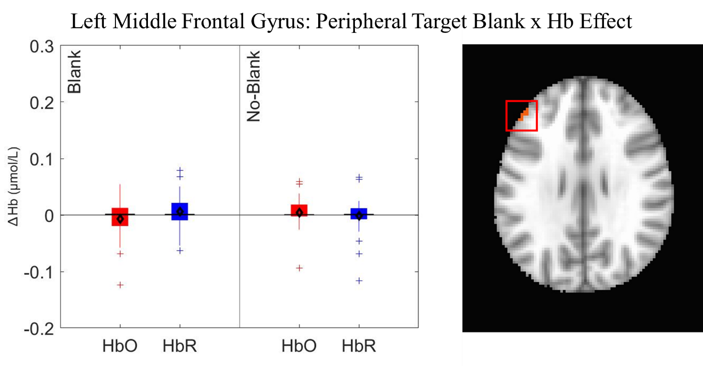
Figure 6. The figure above shows the change in HbO (red) and HbR (blue) for blank and no-blank trials in the peripheral target task. The location of the cluster is shown in the image on the right side inside the red box.
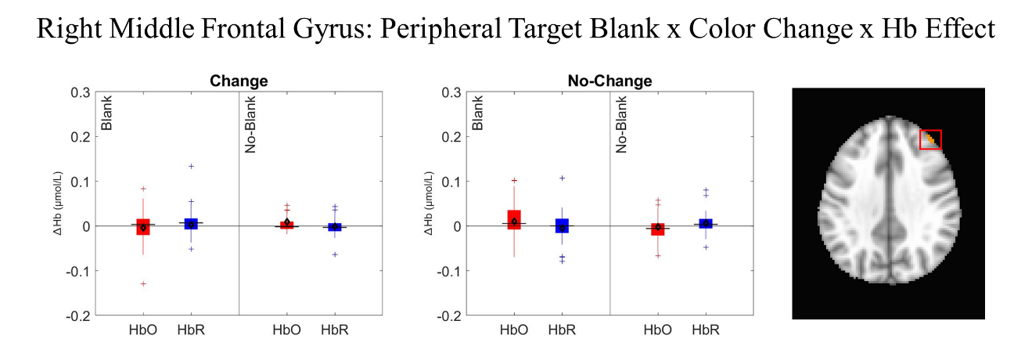Figure 7. The figure above shows the change in HbO (red) and HbR (blue) for blank and no-blank trials of the change and no-change conditions in the peripheral target task. The location of the cluster is shown in the image on the right side inside the red box.

activation difference and behavioral accuracy in the blank/no-change condition of the peripheral target session, r(29)=.365, p=.047. Further the difference between activation difference in the blank/change condition and the no-blank/change condition was negatively correlated with the difference in accuracy between the blank and no-blank condition, r(29)=-.479, p=.007. Thus, an increase in improvement in behavioral performance due to blanking in the change condition was associated with a decrease in the activation difference changes between blank and no-blank trials in the change condition.
Taken together, hemodynamic activity in the MFG suggests that spatial memory areas were activated across both the saccade target and peripheral tasks, however, the conditions in which activation was higher differed between tasks. For the saccade target task, the MFG was more active in change trials, with an additional interaction between blank, color change, and Hb. For the peripheral task, the MFG was more active in the no-blank condition, where visual stability was maintained. These findings highlight that spatial memory mechanisms play a role across saccades, however this role varies based on which information is probed for report.
Saccade Updating
The saccade updating network includes some areas of the PPC (Melcher, 2011; Prime et al., 2008). Here, we found significant effects in three different regions of the
PPC. In the saccade target session, there was a significant Hb effect (see Figure 8), showing significant activation of the left Angular Gyrus (AG), which is a region within the PPC. Specifically, HbO (M=0.015, SD=0.033) was significantly higher than HbR (M=-0.008, SD=0.021), t(30)=2.580, p=.015. In the saccade target session, there was also a significant Hb effect showing activation of the right Superior Parietal Lobule (SPL; see Figure 9). Specifically, HbO (M=0.009, SD=0.018) significantly exceeded HbR (M=-0.003, SD=0.010), t(29)=2.607, p=.014.
The Blank x Hb interaction was also significant in the left AG for the saccade target task (see Figure 10). Pairwise comparisons showed that the activation difference was higher for blank (M=0.038, SD=0.090) than no-blank (M=-0.005, SD=0.061),
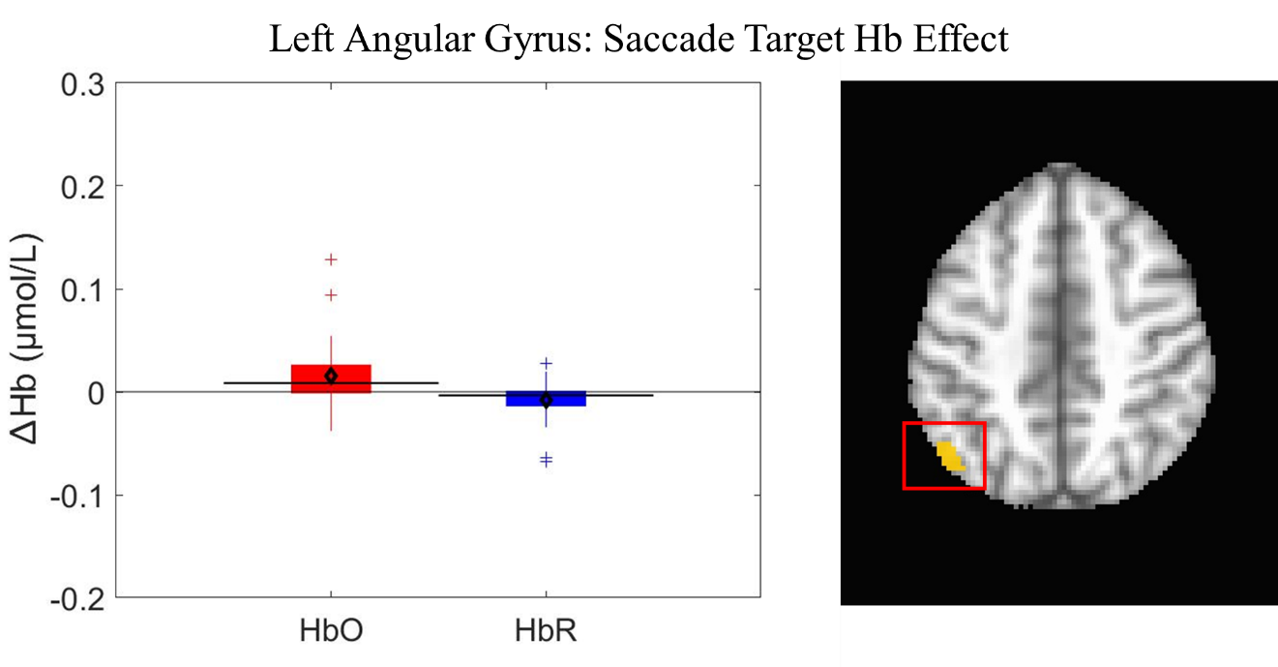Figure 8. The figure above shows the change in HbO (red) and HbR (blue) in the saccade target task. The location of the cluster is shown in the image on the right side inside the red box.
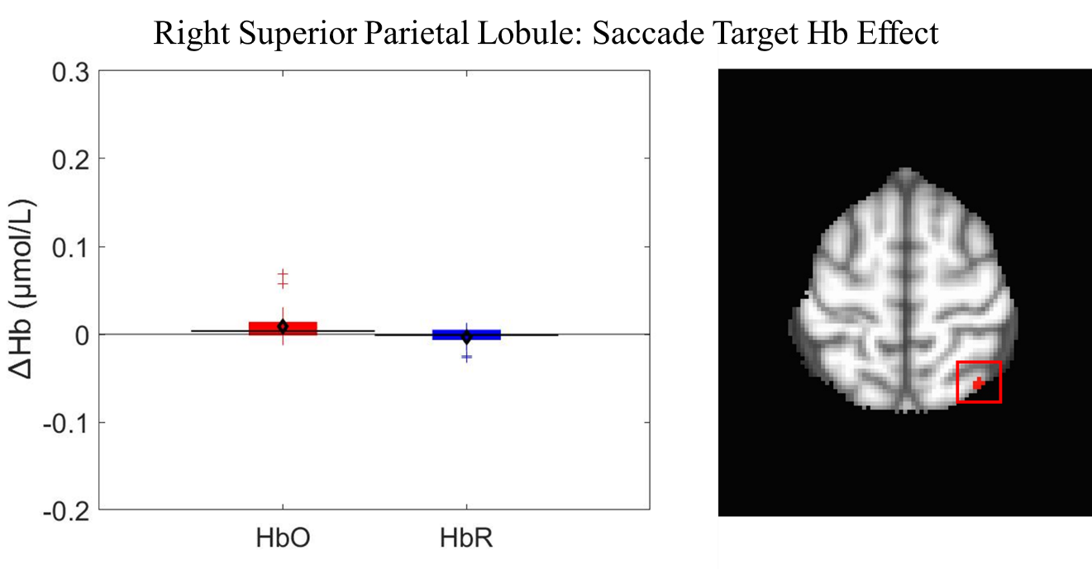Figure 9. The figure above shows the change in HbO (red) and HbR (blue) in the saccade target task. The location of the cluster is shown in the image on the right side inside the red box.

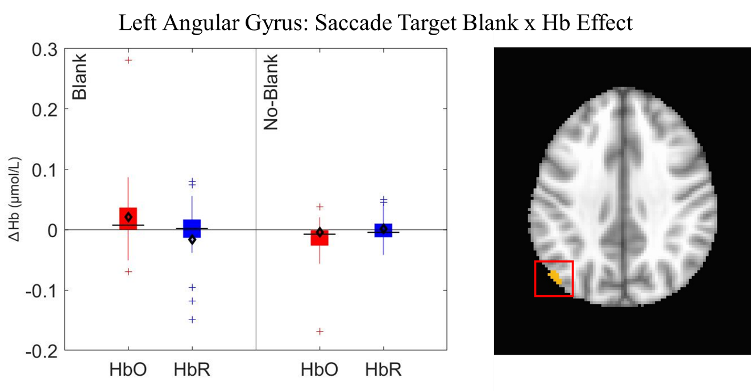Figure 10. The figure above shows the change in HbO (red) and HbR (blue) in the blank and no-blank conditions of the saccade target task. The location of the cluster is shown in the image on the right side inside the red box.
t(30)=2.588, p=.015. These results suggest that disruptions of stability recruited PPC regions associated with saccadic updating network more heavily when stability is disrupted than when stability was maintained. Interestingly, in the right AG, there was a significant Blank x Color Change x Hb interaction (see Figure 11). The activation difference was significantly higher lower in the no-blank condition (M=0.039, SD=0.120) than in the blank condition (M=-0.020, SD=0.094) of no-change trials, t(30)=2.886, p=.007. Importantly, behavioral results demonstrated that blanking hurt performance in the no-change trials. When examining the relationship between hemodynamic activity and behavioral performance, there was a significant positive relationship between activation difference and accuracy in the blank trials of the change condition, r(30)=.481, p=.006. Therefore, increased activation in saccadic updating network regions appear to be associated with increased accuracy as a result of disruptions to stability.
In the peripheral target session, there was a significant Blank x Hb interaction in the left SPL (see Figure 12). The activation difference was significantly higher in the no-blank condition (M=0.011, SD=0.046) than in the blank condition (M=-0.015, SD=0.050), t(30)=2.845, p=.008. The activation difference in the no-blank condition was

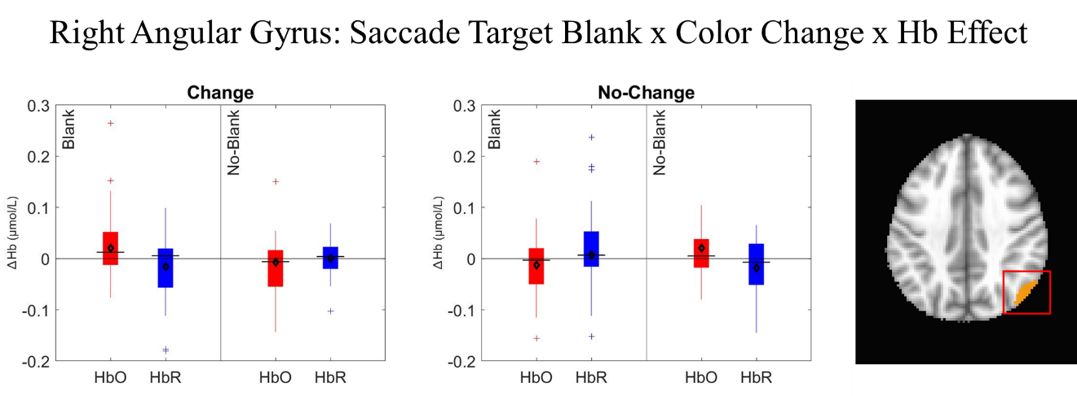Figure 11. The figure above shows the change in HbO (red) and HbR (blue) in the blank and no-blank trials of the change and no-change conditions in the saccade target task. The location of the cluster is shown in the image on the right side inside the red box.
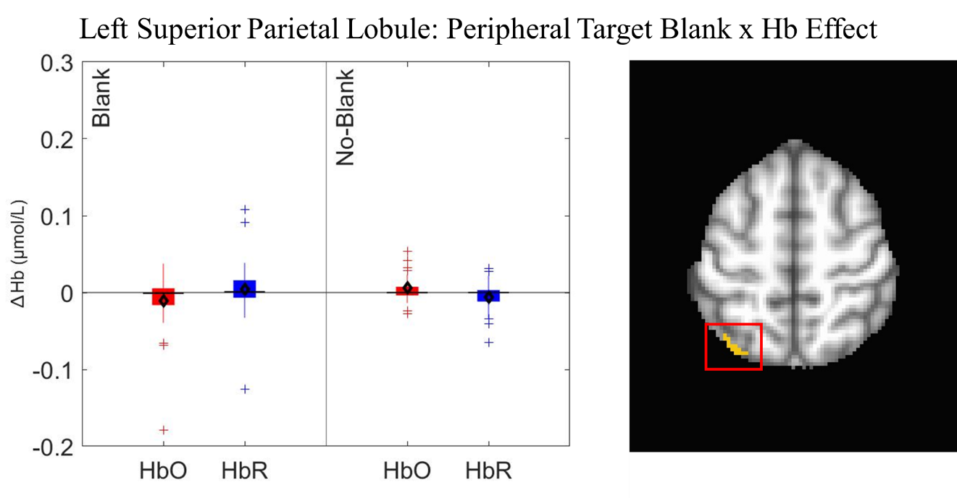Figure 12. The figure above shows the change in HbO (red) and HbR (blue) in the blank and no-blank conditions of the peripheral target task. The location of the cluster is shown in the image on the right side inside the red box.

also negatively associated with no-blank behavioral accuracy, r(30)=-.399, p=.026. There was also a significant Blank x Hb interaction in the left Inferior Parietal Lobule (IPL; see Figure 13). The activation difference in the blank condition (M=0.028, SD=0.073) exceeded the activation difference in the no-blank condition (M=-0.002, SD=0.052), t(30)=2.547, p=.016. There was also a negative relationship between the activation difference and behavioral accuracy in the no-blank condition, r(30)=-.434, p=.015.
The Color Change x Hb interaction was also significant in the peripheral target task for the left AG (see Figure 14). The activation difference in the no-change condition (M=0.026, SD=0.074) was significantly higher than in the change condition (M=-0.005, SD=0.096), t(30)=2.401, p=0.023. Further, the difference in activation difference between the change and no-change condition is positively associated with the difference between change and no-change behavioral accuracy, r(30)=.508, p=.004. In the right AG, there was also a significant Blank x Color Change x Hb interaction (see Figure 15). The activation difference in the no-blank trials (M=0.045, SD=0.076) was significantly higher than in the blank trials (M=-0,012, SD=0.142) of the change condition, t(30)=2.238,
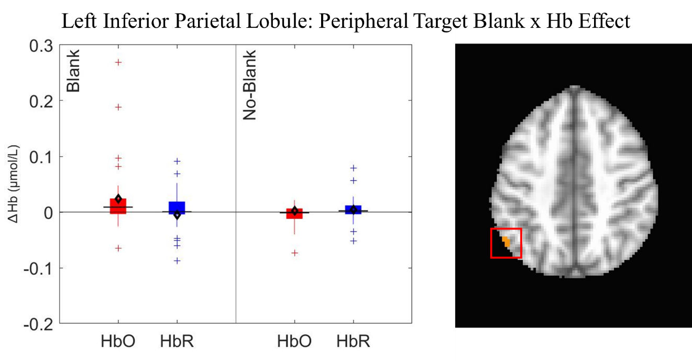Figure 13. The figure above shows the change in HbO (red) and HbR (blue) in the blank and no-blank conditions of the peripheral target task. The location of the cluster is shown in the image on the right side inside the red box.
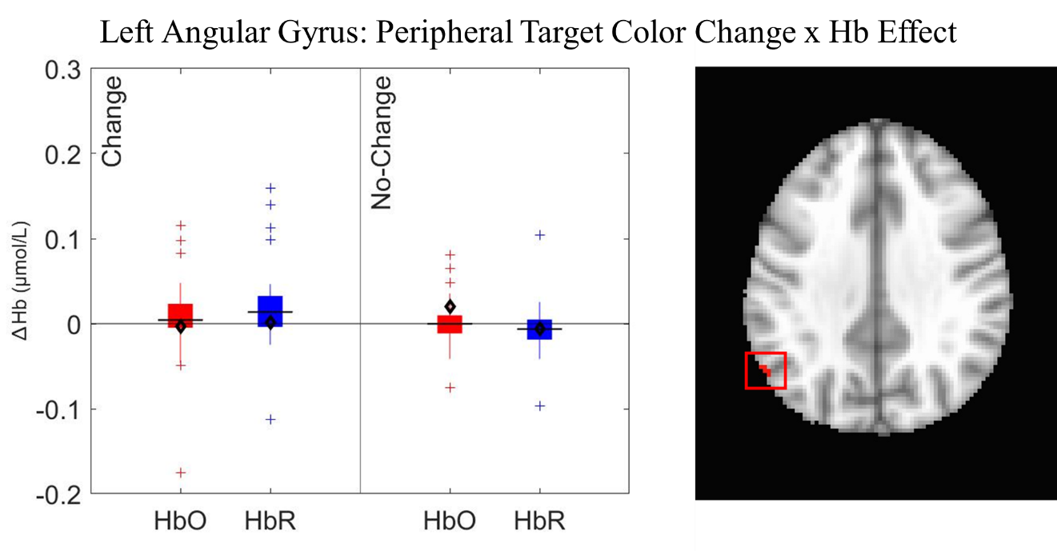Figure 14. The figure above shows the change in HbO (red) and HbR (blue) in the change and no-change conditions of the peripheral target task. The location of the cluster is shown in the image on the right side inside the red box.
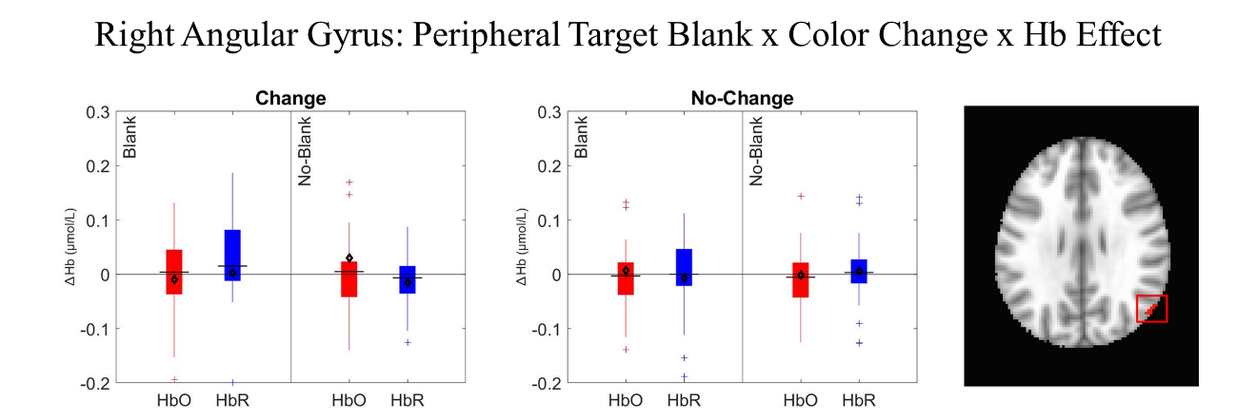Figure 15. The figure above shows the change in HbO (red) and HbR (blue) in the blank and no-blank trials of the change and no-change conditions in the peripheral target task. The location of the cluster is shown in the image on the right side inside the red box.

p=.033. Interestingly, this may reflect differential patterns of activation between the right and left hemisphere for the saccade updating network across disruptions of visual stability, with the left hemisphere being associated with increased activation during conditions associated with stronger accuracy and the right AG showing decreased activation in conditions with better accuracy performance behaviorally.
These results provide strong evidence of activation of the saccade updating network, with interactions suggesting that disruptions of stability resulted in stronger activation of these regions.
Visual Cortical Areas
We found significant activation in the occipital cortices, although only in the saccade target task. There was a significant effect of Hb in the left Middle Occipital Gyrus (MOG; see Figure 16), demonstrated by significantly lower HbO (M=-0.007, SD=0.016) than HbR (M=0.011, SD=0.015), t(29)=-3.991, p<.001. There was also a significant Blank x Hb interaction in the right MOG (see Figure 17). The activation difference was larger for the no-blank condition (M=0.018, SD=0.093) than the blank condition (M=-0.034, SD=0.097), t(29)=3.491, p=.002. There was also a significant Blank x Hb interaction in the right Superior Occipital Gyrus (SOG; see Figure 18). The activation difference was higher in the blank condition (M=0.030, SD=0.053) than in the no-blank condition (M=-0.016, SD=0.079), t(28)=2.373, p=.025. In the left SOG, there was a significant Blank x Color Change x Hb interaction (see Figure 19). While follow-up comparisons blank/no-blank trials within each color change condition did not reach significant, within the no-blank condition, the activation difference was significantly higher for change (M=0.019, SD=0.093) than for no-change (M=-0.022, SD=0.074), t(28)=2.209, p=.036. Taken together, these results suggest that the right SOG demonstrated activation, with some regions showing more activation due to disruptions of visual stability.
Saccade Suppression Areas
Prior work has demonstrated the role of the middle temporal region in saccadic suppression (Thiele et al., 2002), showing reduced activity of neurons in this region as a result of motion signals produced by saccades. In the saccade target session, there was a
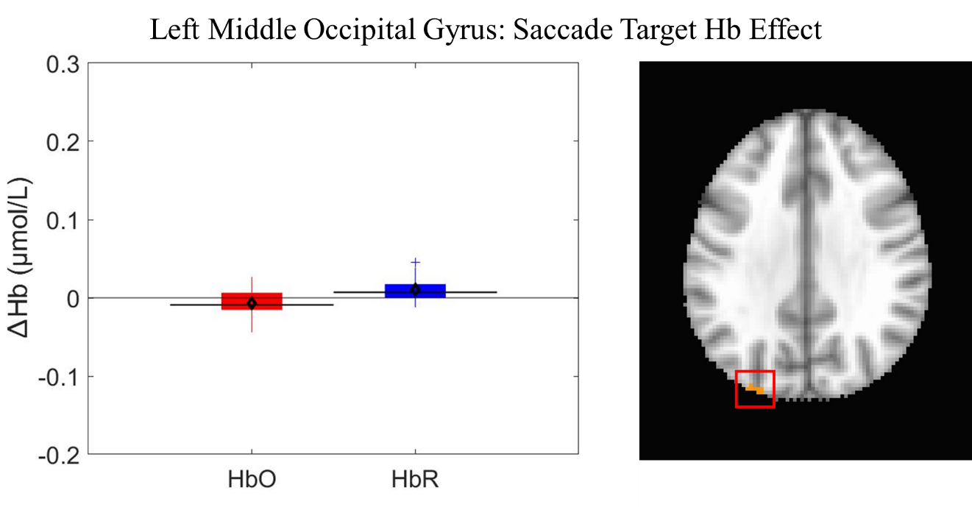Figure 16. The figure above shows the change in HbO (red) and HbR (blue) in the saccade target task. The location of the cluster is shown in the image on the right side inside the red box.
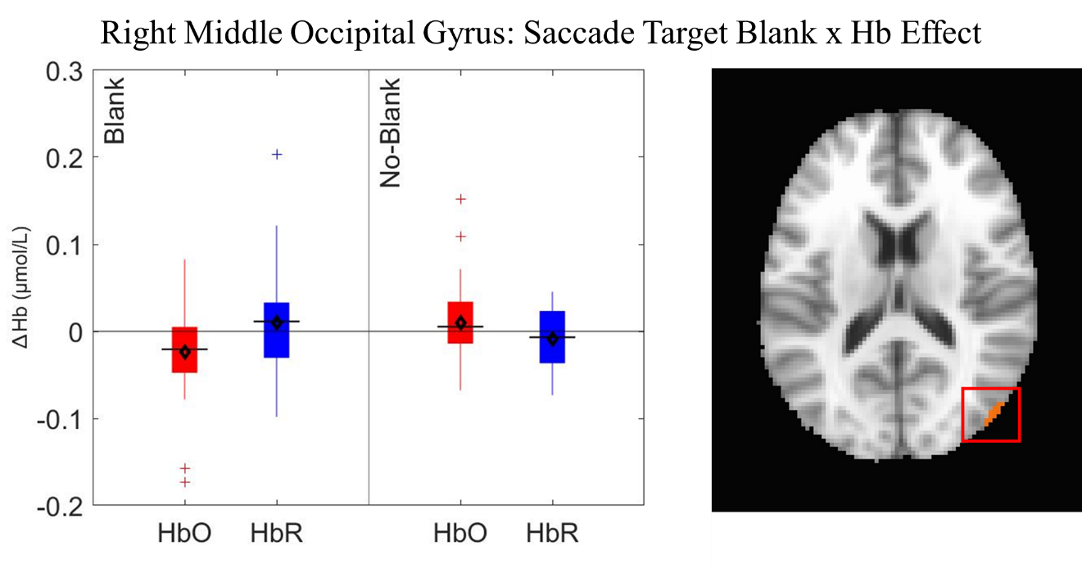Figure 17. The figure above shows the change in HbO (red) and HbR (blue) for the blank and no-blank trials in the saccade target task. The location of the cluster is shown in the image on the right side inside the red box.
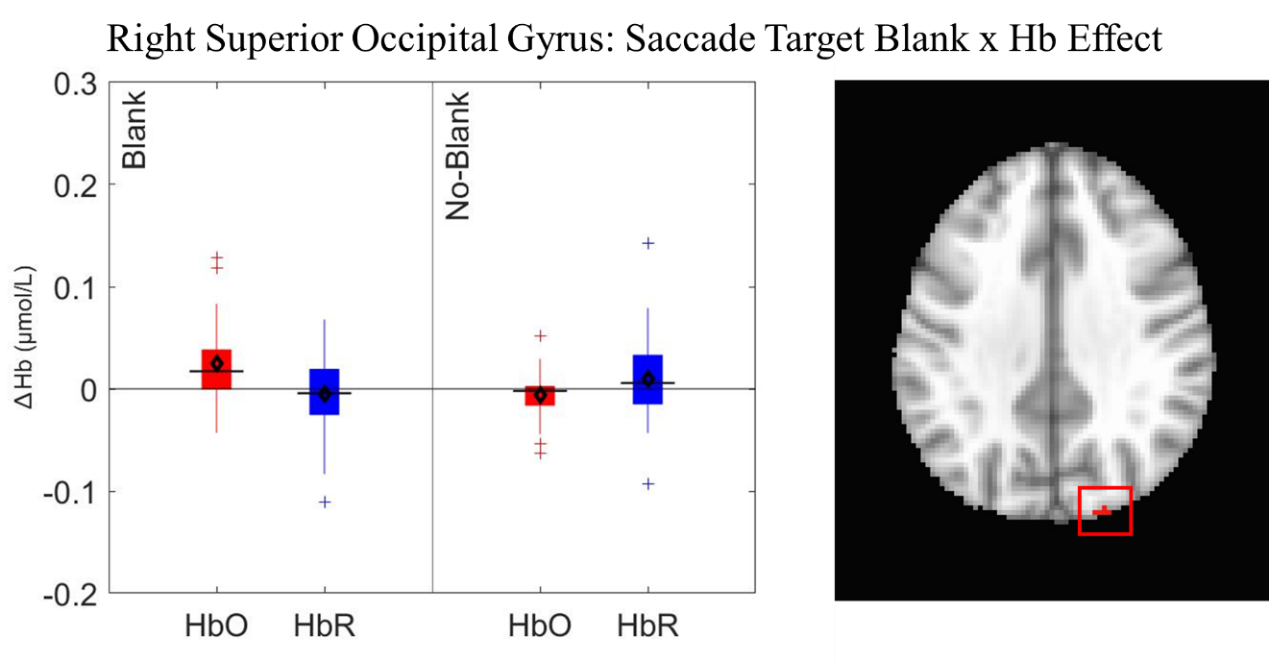Figure 18. The figure above shows the change in HbO (red) and HbR (blue) for the blank and no-blank trials in the saccade target task. The location of the cluster is shown in the image on the right side inside the red box.
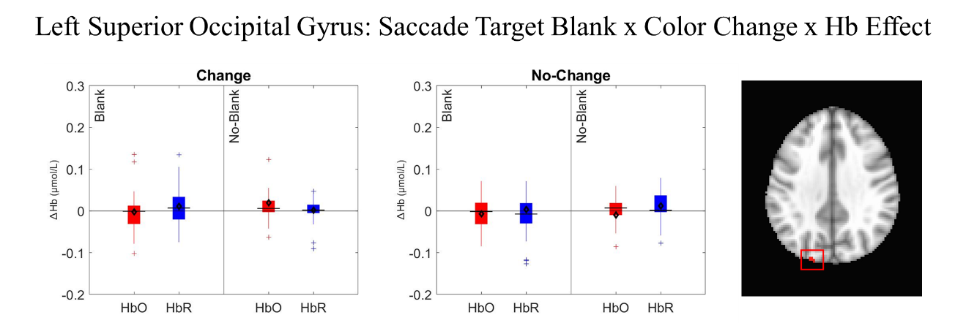
Figure 19. The figure above shows the change in HbO (red) and HbR (blue) for the blank and no-blank trials in the saccade target task. The location of the cluster is shown in the image on the right side inside the red box.

significant effect of Hb in the left Middle Temporal Gyrus (MTG), showing significantly lower HbO (M=-0.031, SD=0.070) than HbR (M=0.005, SD=0.025), t(29)=-2.205, p=.036 (see Figure 20). In the peripheral target session, there was also a significant effect of Hb in the right MTG, also showing significantly lower HbO (M=-0.0205, SD=0.044) than HbR (M=0.014, SD=0.039), t(28)=-2.447, p=.021 (see Figure 21). There was also a significant Blank x Hb interaction in the left MTG (see Figure 22). The activation difference was higher in the no-blank condition (M=0.024, SD=0.082) than in the blank condition (M=-0.003, SD=0.065), t(30)=2.738, p=.010. Taken together, both the saccade target and peripheral target tasks resulted in modulations of hemodynamic activity in the MTG, with some changes in activation in the peripheral target task being driven by condition-specific modulations. Thus, it is possible that the hemodynamic activity in the MTG was a result of the motion signal generated by saccade execution in the task.
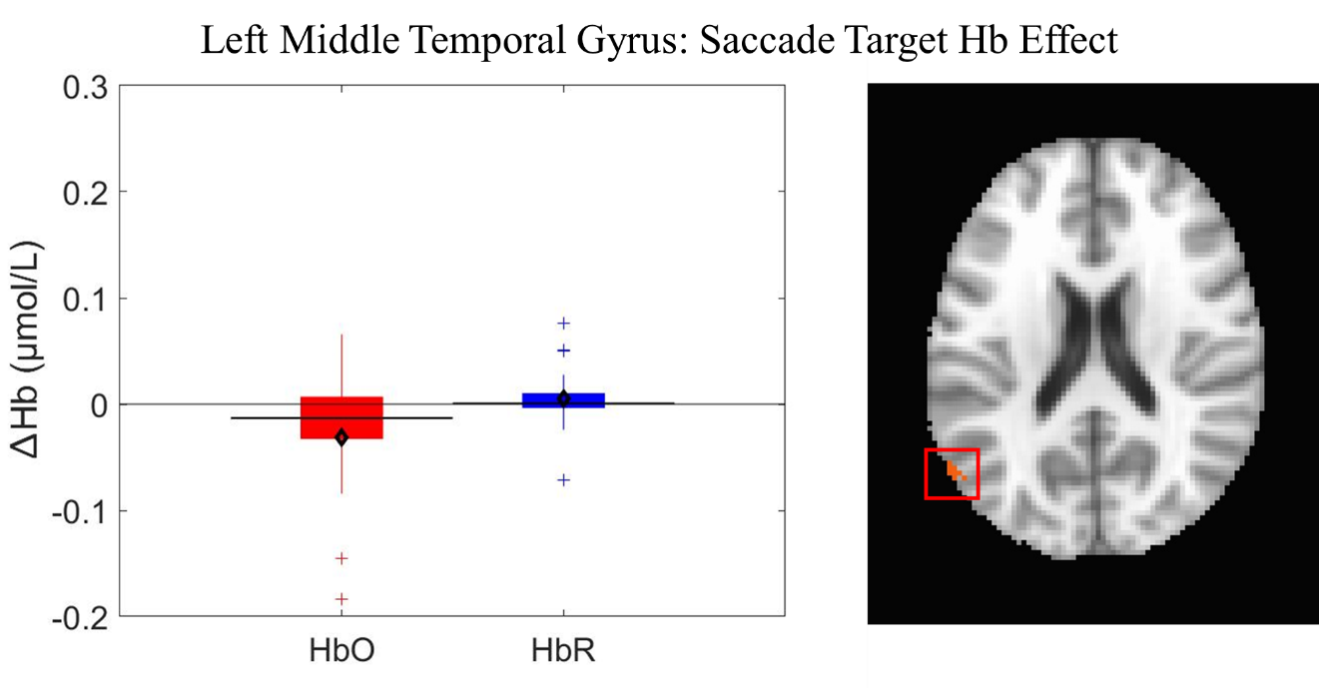Figure 20. The figure above shows the change in HbO (red) and HbR (blue) for the saccade target task. The location of the cluster is shown in the image on the right side inside the red box.
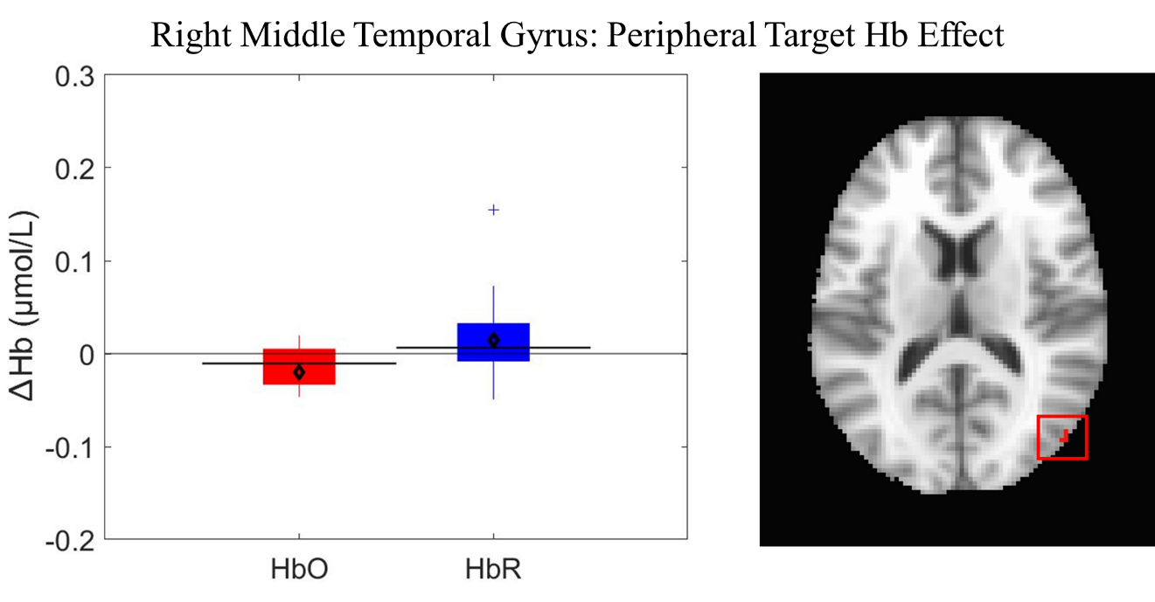Figure 21. The figure above shows the change in HbO (red) and HbR (blue) for the peripheral target task. The location of the cluster is shown in the image on the right side inside the red box.
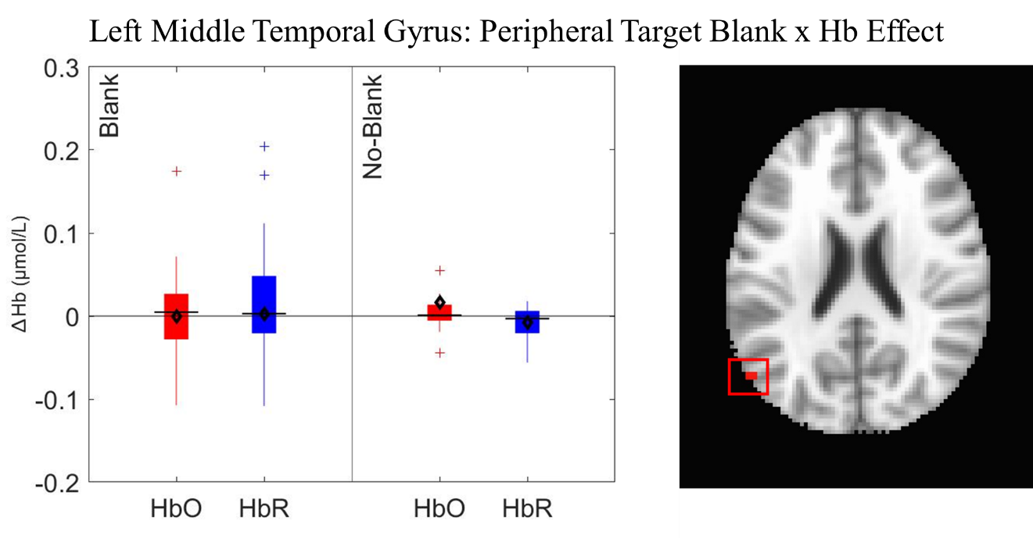Figure 22. The figure above shows the change in HbO (red) and HbR (blue) for the blank and no-blank trials of the peripheral target task. The location of the cluster is shown in the image on the right side inside the red box.

CHAPTER FOUR
General Discussion
The results of the current experiment shed light on patterns of behavioral and hemodynamic activity as they are associated with disruptions of visual stability, both for a saccade target object and a peripheral object. Supporting our hypotheses, disruptions to visual stability improved accuracy for the saccade target, however only in trials where feature information about the target actually changed. Further, this pattern of behavioral results generalized to the peripheral target task, demonstrating that disruptions to visual stability similarly impact sensitivity to transsaccadic changes of the saccade target and non-target peripheral information. When examining the neural mechanisms of visual stability, the results demonstrated modulation of hemodynamic activity in spatial memory areas and saccade updating areas, with evidence of stronger activation in the saccade updating areas in conditions where stability of the saccade target object was disrupted. However, activity in saccade updating areas was generally higher in conditions where stability was maintained for the peripheral target. Taken together, these results demonstrate that, while disruptions to visual stability similarly impact sensitivity to transsaccadic changes of the saccade target and a peripheral target, the underlying mechanisms supporting stability decisions for the saccade target and a peripheral target differ. Here, we will discuss in greater detail the mechanisms of visual stability that we explored and the limitations to generalizing these mechanisms to information other than the saccade target.
Mechanisms Supporting Visual Stability
Generally, frontal cortices areas more heavily associated with spatial working memory showed activation for both the saccade target and peripheral target tasks, however there was stronger activation for the no-blank condition than the blank condition in the peripheral target task. These results suggest that spatial memory mechanisms are heavily associated with saccades in the absence of stability disruptions, but these mechanisms are less recruited when stability is disrupted. These results may suggest that spatial memory mechanisms are crucial for the preparation of saccades, however the separation of representations obtained prior to saccade execution and upon saccade landing for comparison do not rely as heavily on these spatial mechanisms.
While early work exploring visual stability across saccades examined the impact of stability disruptions on sensitivity to spatial displacements of the saccade target object (Deubel et al., 1996), later work demonstrated that other types of information such as feature information, are also heavily consulted for visual stability decisions. More specifically, feature information, such as contrast polarity (Tas et al., 2012), shape (Demeyer et al., 2010), color (Tas & Parker, 2023) that can be used to establish object correspondence across saccades is consulted for stability decisions (Tas et al., 2012). Thus, feature information must also be maintained across saccades for comparison, making it likely that the visual system may rely more heavily on the saccade updating network, which has heavy overlap with VWM (Aagten-Murphy & Bays, 2019; Frost et al., 2019; Irwin, 1992; Prime et al., 2011), mechanisms for stability decisions (see Tanaka et al., 2014 for discussion).
In cortical areas associated with the saccade updating network (PPC), there were significant modulations to hemodynamic activity across the saccade target and peripheral target task. Interestingly, disruptions to visual stability resulted in stronger PPC activation in the saccade target task, while the peripheral target task showed trends of some activation increases in conditions where stability was maintained (with the exception of one cluster in the IPL). Together, these results suggest that, in contrast to cortical areas associated with spatial memory, the regions associated with saccade updating were activated more strongly by disruptions to visual stability. However, this effect is more pronounced in the saccade target condition, with the peripheral condition showing split effects of both activation in conditions where stability was disrupted in some clusters and activation in conditions where stability was maintained in other clusters. Further, the saccade target task resulted in significant modulations to hemodynamic activity in occipital areas as well, while these regions failed to show an effect in the peripheral target task.
The increased activation in saccade updating regions aligns well with previous work, similarly showing increased activity in posterior areas associated with saccadic tasks. Specifically, previous data from our lab has demonstrated an increase in activity in the PPC associated with disruptions of visual stability in a transsaccadic spatial displacement task (Tas et al., 2024). Earlier work has demonstrated that activity in the IPS has been found both to scale up with VWM load (Todd & Marois, 2004). The increase in activity in the PPC as a result of stability disruptions may reflect the maintenance of the presaccadic representation for comparison after the saccade. Therefore, while spatial attention and memory are necessary for the planning of the oculomotor movement, after the completion of a saccade, the visual system may rely more heavily on the saccade updating network and the overlapping VWM mechanism to access representations maintained across the saccade to compare information and establish object correspondence.
Visual Stability Processes Across Target and Non-Target Information
One important finding from this experiment was that the saccade target and peripheral target tasks resulted in different patterns of hemodynamic activity. The differences in neural activation by task are particularly interesting, given the behavioral results entirely overlapped between the two tasks. Replicating prior work, our behavioral results showed that participants were generally insensitive to changes occurring during the saccade in the absence of a blank (Bridgeman et al., 1975), but that disrupting stability with a blank significantly improved performance (Deubel et al., 1996). The interactions demonstrated that blanking hurt performance in the no-change condition for both tasks, however this may be explained by a bias induced by the blank to report a change incorrectly (Irwin & Robinson, 2018). The pattern of behavioral results between the saccade target and peripheral target tasks in the current experiment were strikingly similar. Interestingly, however, the patterns of activation in the neural data showed some differences between the two tasks.
Both tasks resulted in modulations of hemodynamic activity in the frontal, parietal, and temporal cortices, but only the saccade target task resulted in activation of occipital areas as well. Prior work has demonstrated the role of the occipital cortex in saccade execution (Matsuda et al., 2004) and in transsaccadic updating of spatial frequency information (Baltaretu et al., 2021). Thus, it is not surprising to see hemodynamic modulation in this region for the saccade target task. What is more interesting from these results is the lack of overlap between activation patterns in the saccade target and peripheral target tasks.
Patterns of hemodynamic activity across the peripheral target task did not reflect those from the saccade target task and generally support activation in saccade updating areas across conditions where stability was maintained. This may lend to two possible explanations. First, stability processes for the peripheral target object do not as heavily rely on the maintenance of two representations that would likely increase activation in these areas due to increased working memory load (Todd & Marois, 2004, Tas et al., 2024). Second, it is possible that different patterns of hemodynamic results between the saccade target and peripheral target task reflect a different attentional mechanism altogether. Unlike the saccade target task, the attention directed to the peripheral target was always covert, and potentially requiring a covert shift of attention prior to saccade execution, followed by another covert shift of attention upon eye landing. Prior work has demonstrated that exogenous and endogenous shifts of attention may be represented by different attentional mechanisms (Hopfinger & West, 2006). Importantly, while the attentional cues should not differ, the blanking paradigm involves the abrupt off-transient (disappearance) at saccade initiation followed by an on-transient just after eye landing (Deubel et al., 1996). Thus, it is possible that the on-transient in the blanking condition served to either increase the salience of the stimulus, thus potentially modulating the covert shift of attention to the peripheral target.
Slight differences in patterns of activation in our experiment may reflect (1) less reliance on working memory resources for the peripheral target than a saccade target, or (2) different attentional mechanisms across these two tasks. Thus, the neural mechanisms associated with visual stability and transsaccadic updating share many common areas of activation, but our results suggest some differences in patterns of activation between tasks probing report of the saccade target object and tasks probing a peripheral target for report. This highlights the importance of task design when exploring transsaccadic visual stability.

Future Directions
The current experiment sheds light on the possibility that visual stability processes for saccade target and non-target information may be served by different underlying mechanisms, potentially reflecting that memory resources are less recruited when stability of a peripheral target is disrupted or differences in attentional mechanisms. However, it is important to note that the current task implemented a two-alternative forced choice response method. Future work may be able to further parse apart the actual strength of representation between saccade target and peripheral target items by using a continuous report method and probe the report of both the first display (prior to the saccade) or the last display (after saccade landing) to more specifically address to what extent information is maintained about a peripheral target across manipulations of visual stability. Another important element that may impact both behavioral accuracy and hemodynamic activity is expertise. Expertise has generally shown evidence of decreased hemodynamic activity compared to novices (see Hannah et al., 2022 for review). Thus, future work could determine the extent to which the results of the current experiment differ by varying levels of expertise by implementing training sessions prior to the primary task or measuring hemodynamic activity in a longitudinal design to test for a negative relationship between activation and expertise.

Conclusion
These results have highlighted important differences in the mechanisms underlying visual stability across saccades and how these mechanisms vary by task. The results from the current experiment demonstrate the role of both spatial memory mechanisms and saccade updating mechanisms across saccades, with a stronger reliance on the saccade updating network in conditions where visual stability of the saccade target is disrupted. Behaviorally, visual stability disruptions similarly impact change detection accuracy for both the saccade target object and a peripheral object. Nonetheless, patterns of hemodynamic activity suggest that the underlying mechanisms supporting transsaccadic visual stability for the saccade target object and a peripheral object, while largely similar in areas recruited, show slight differences that may be attributed to either different mechanisms of information storage or attentional deployment between the two tasks.
REFERENCES
Aagten-Murphy, D., & Bays, P. M. (2019). Functions of memory across saccadic eye movements. Processes of visuospatial attention and working memory, 155-183. https://doi.org/10.1007/7854_2018_66
Atsma, J., Maij, F., Koppen, M., Irwin, D. E., & Medendorp, W. P. (2016). Causal inference for spatial constancy across saccades. PLoS Computational Biology, 12(3), e1004766. https://doi.org/10.1371/journal.pcbi.1004766
Baltaretu, B. R., Dunkley, B. T., Stevens, W. D., & Crawford, J. D. (2021). Occipital cortex is modulated by transsaccadic changes in spatial frequency: an fMRI study. Scientific reports, 11(1), 8611. https://doi.org/10.1038/s41598-021-87506-2
Barbey, A. K., Koenigs, M., & Grafman, J. (2013). Dorsolateral prefrontal contributions to human working memory. Cortex, 49(5), 1195-1205. https://doi.org/10.1016/j.cortex.2012.05.022
Baumann, O., Frank, G., Rutschmann, R. M., & Greenlee, M. W. (2007). Cortical activation during sequences of memory-guided saccades: a functional MRI study. Neuroreport, 18(5), 451-455. https://doi.org/10.1097/WNR.0b013e32805868ba
Becker, W., & Fuchs, A. F. (1969). Further properties of the human saccadic system: eye movements and correction saccades with and without visual fixation points. Vision Research, 9(10), 1247-1258. https://doi.org/10.1016/0042-6989(69)90112-6
Bender, J., Tark, K. J., Reuter, B., Kathmann, N., & Curtis, C. E. (2013). Differential roles of the frontal and parietal cortices in the control of saccades. Brain and cognition, 83(1), 1-9. https://doi.org/10.1016/j.bandc.2013.06.005
Bridgeman, B., Hendry, D., & Stark, L. (1975). Failure to detect displacement of the visual world during saccadic eye movements. Vision research, 15(6), 719-722. https://doi.org/10.1016/0042-6989(75)90290-4
Campbell, J. I., & Thompson, V. A. (2012). MorePower 6.0 for ANOVA with relational confidence intervals and Bayesian analysis. Behavior research methods, 44, 1255-1265. https://doi.org/10.3758/s13428-012-0186-0
Carrasco, M. (2018). How visual spatial attention alters perception. Cognitive Processing, 19(1), 77-88. https://doi.org/10.1007/s10339-018-0883-4
Chen, G., Adleman, N. E., Saad, Z. S., Leibenluft, E., & Cox, R. W. (2014). Applications of multivariate modeling to neuroimaging group analysis: a comprehensive alternative to univariate general linear model. Neuroimage, 99, 571-588. https://doi.org/10.1016/j.neuroimage.2014.06.027
Cohen, J. D., Perlstein, W. M., Braver, T. S., Nystrom, L. E., Noll, D. C., Jonides, J., & Smith, E. E. (1997). Temporal dynamics of brain activation during a working memory task. Nature, 386(6625), 604-608. https://doi.org/10.1038/386604a0
Collins, D. L., Zijdenbos, A. P., Kollokian, V., Sled, J. G., Kabani, N. J., Holmes, C. J., & Evans, A. C. (2002). Design and construction of a realistic digital brain phantom. IEEE transactions on medical imaging, 17(3), 463-468. https://doi.org/ 10.1109/42.712135
Cox, R. W., Chen, G., Glen, D. R., Reynolds, R. C., & Taylor, P. A. (2017). FMRI clustering in AFNI: false-positive rates redux. Brain connectivity, 7(3), 152-171. https://doi.org/10.1089/brain.2016.0475
Currie, C. B., McConkie, G. W., Carlson-Radvansky, L. A., & Irwin, D. E. (2000). The role of the saccade target object in the perception of a visually stable world. Perception & psychophysics, 62, 673-683. https://doi.org/10.3758/BF03206914
Curtis, C. E., & D'Esposito, M. (2003). Persistent activity in the prefrontal cortex during working memory. Trends in cognitive sciences, 7(9), 415-423. https://doi.org/10.1016/S1364-6613(03)00197-9
Demeyer, M., De Graef, P., Wagemans, J., & Verfaillie, K. (2010). Object form discontinuity facilitates displacement discrimination across saccades. Journal of Vision, 10(6), 17-17. https://doi.org/10.1167/10.6.17
Deubel, H. (2004). Localization of targets across saccades: Role of landmark objects. Visual Cognition, 11(2-3), 173-202. https://doi.org/10.1080/13506280344000284
Deubel, H. (2008). The time course of presaccadic attention shifts. Psychological Research, 72(6), 630-640. https://doi.org/10.1007/s00426-008-0165-3
Deubel, H., & Schneider, W. X. (1996). Saccade target selection and object recognition: Evidence for a common attentional mechanism. Vision Research, 36, 1827-1837. https://doi.org/10.1016/0042-6989(95)00294-4
Deubel, H., Bridgeman, B., & Schneider, W. X. (1998). Immediate post-saccadic information mediates space constancy. Vision research, 38(20), 3147-3159. https://doi.org/10.1016/S0042-6989(98)00048-0
Deubel, H., Schneider, W. X., & Bridgeman, B. (1996). Postsaccadic target blanking prevents saccadic suppression of image displacement. Vision research, 36(7), 985-996. https://doi.org/10.1016/0042-6989(95)00203-0
Eggebrecht, A. T., & Culver, J. P. (2019, June). NeuroDOT: an extensible Matlab toolbox for streamlined optical functional mapping. In European Conference on Biomedical Optics (p. 11074_26). Optica Publishing Group. https://doi.org/10.1117/12.2527164
Frost, A., Tomou, G., Parikh, H., Kaur, J., Zivcevska, M., &, M. (2019). Working memory in action: Inspecting the systematic and unsystematic errors of spatial memory across saccades. Experimental Brain Research, 237, 2939-2956. https://doi.org/10.1007/s00221-019-05623-x
Gagnon, L., Perdue, K., Greve, D. N., Goldenholz, D., Kaskhedikar, G., & Boas, D. A. (2011). Improved recovery of the hemodynamic response in diffuse optical imaging using short optode separations and state-space modeling. Neuroimage, 56(3), 1362-1371. https://doi.org/10.1016/j.neuroimage.2011.03.001
Gillen, C., Weiler, J. & Heath, M. (2013). Stimulus-driven saccades are characterized by an invariant undershooting bias: no evidence for a range effect. Experimental Brain Research, 230, 165–174. https://doi.org/10.1007/s00221-013-3640-z
Heeger, D. J., & Ress, D. (2002). What does fMRI tell us about neuronal activity?. Nature reviews neuroscience, 3(2), 142-151. https://doi.org/10.1038/nrn730
Hoffman, J. E., & Subramaniam, B. (1995). The role of visual attention in saccadic eye movements. Perception & Psychophysics, 57, 787-795. https://doi.org/10.3758/bf03206794
Hopfinger, J. B., & West, V. M. (2006). Interactions between endogenous and exogenous attention on cortical visual processing. NeuroImage, 31(2), 774-789. https://doi.org/10.1016/j.neuroimage.2005.12.049
Irwin, D. E. (1992). Memory for position and identity across eye movements. Journal of Experimental Psychology: Learning, Memory, and Cognition, 18(2), 307. https://doi.org/10.1037/0278-7393.18.2.307
Irwin, D. E. (1996). Integrating information across saccadic eye movements. Current directions in psychological science, 5(3), 94-100. https://doi.org/10.1111/1467-8721.ep10772833
Irwin, D. E., & Robinson, M. M. (2018). How post-saccadic target blanking affects the detection of stimulus displacements across saccades. Vision Research, 142, 11-19. https://doi.org/10.1016/j.visres.2017.09.004
Irwin, D. E., McConkie, G. W., Carlson-Radvansky, L., & Currie, C. (1994). A localist evaluation solution for visual stability across saccades. Behavioral and Brain Sciences, 17, 265-266. https://doi.org/10.1037/0096-1523.22.3.563
Kowler, E., Anderson, E., Dosher, B., & Blaser, E. (1995). The role of attention in the programming of saccades. Vision Research, 35, 1897-1916. https://doi.org/10.1016/0042-6989(94)00279-U
Matin, E. (1974). Saccadic suppression: a review and an analysis. Psychological bulletin, 81(12), 899. https://doi.org/10.1037/h0037368
Matsuda, T., Matsuura, M., Ohkubo, T., Ohkubo, H., Matsushima, E., Inoue, K., ... & Kojima, T. (2004). Functional MRI mapping of brain activation during visually guided saccades and antisaccades: cortical and subcortical networks. Psychiatry Research: Neuroimaging, 131(2), 147-155. https://doi.org/10.1016/j.pscychresns.2003.12.007
McConkie, G. W., & Currie, C. B. (1996). Visual stability across saccades while viewing complex pictures. Journal of Experimental Psychology: Human perception and performance, 22(3), 563. https://doi.org/10.1037/0096-1523.22.3.563
Melcher, D. (2011). Visual stability. Philosophical Transactions of the Royal Society B: Biological Sciences, 366(1564), 468-475. https://doi.org/10.1098/rstb.2010.0277
Molavi, B., & Dumont, G. A. (2012). Wavelet-based motion artifact removal for functional near-infrared spectroscopy. Physiological measurement, 33(2), 259. https://doi.org/10.1088/0967-3334/33/2/259
Niemeier, M., Crawford, J. D., & Tweed, D. B. (2003). Optimal transsaccadic integration explains distorted spatial perception. Nature, 422(6927), 76-80. https://doi.org/10.1038/nature01439
Parker, J.L., & Tas, A.C. (2025) The saccade target is prioritized for visual stability in naturalistic scenes. Vision Research, 227, 108541. https://doi.org/10.1016/j.visres.2025.108541
Pierrot‐Deseilligny, C. H., Müri, R. M., Nyffeler, T., & Milea, D. (2005). The role of the human dorsolateral prefrontal cortex in ocular motor behavior. Annals of the New York Academy of Sciences, 1039(1), 239-251. https://doi.org/10.1196/annals.1325.023
Pierrot‐Deseilligny, C., Müri, R. M., Ploner, C. J., Gaymard, B., Demeret, S., & Rivaud‐Pechoux, S. (2003). Decisional role of the dorsolateral prefrontal cortex in ocular motor behaviour. Brain, 126(6), 1460-1473. https://doi.org/10.1093/brain/awg148
Prime, S. L., Vesia, M., & Crawford, J. D. (2008). Transcranial magnetic stimulation over posterior parietal cortex disrupts transsaccadic memory of multiple objects. Journal of Neuroscience, 28(27), 6938-6949. https://doi.org/10.1523/JNEUROSCI.0542-08.2008
coll, S. L., Vesia, M., & Crawford, J. D. (2010). TMS over human frontal eye fields disrupts trans-saccadic memory of multiple objects. Cerebral Cortex, 20(4), 759-772. https://doi.org/10.1093/cercor/bhp148
Prime, S. L., Vesia, M., & Crawford, J. D. (2011). Cortical mechanisms for trans-saccadic memory and integration of multiple object features. Philosophical Transactions of the Royal Society B: Biological Sciences, 366(1564), 540-553. https://doi.org/10.1098/rstb.2010.0184
Rolfs, M., & Carrasco, M. (2012). Rapid Simultaneous Enhancement of Visual Sensitivity and Perceived Contrast during Saccade Preparation. The Journal of Neuroscience, 32(40), 13744-13752a. https://doi.org/10.1523/jneurosci.2676-12.2012
Savitzky, A., & Golay, M. J. (1964). Smoothing and differentiation of data by simplified least squares procedures. Analytical chemistry, 36(8), 1627-1639. https://doi.org/10.1021/ac60214a047
Stewart, E. E., Valsecchi, M., & Schütz, A. C. (2020). A review of interactions between peripheral and foveal vision. Journal of Vision, 20(12), 2-2. https://doi.org/10.1167/jov.20.12.2
Tachtsidis, I., & Scholkmann, F. (2016). False positives and false negatives in functional near-infrared spectroscopy: issues, challenges, and the way forward. Neurophotonics, 3(3), 031405-031405. https://doi.org/10.1117/1.NPh.3.3.031405
Tanaka, L. L., Dessing, J. C., Malik, P., Prime, S. L., & Crawford, J. D. (2014). The effects of TMS over dorsolateral prefrontal cortex on trans-saccadic memory of multiple objects. Neuropsychologia, 63, 185-193. https://doi.org/10.1016/j.neuropsychologia.2014.08.025
Tas, A. C., & Parker, J. L. (2023). The role of color in transsaccadic object correspondence. Journal of Vision, 23(8), 5-5. https://doi.org/10.1167/jov.23.8.5
Tas, A. C., Luck, S. J., & Hollingworth, A. (2016). The relationship between visual attention and visual working memory encoding: A dissociation between covert and overt orienting. Journal of experimental psychology: human perception and performance, 42(8), 1121. https://doi.org/10.1037/xhp0000212
Tas, A. C., Moore, C. M., & Hollingworth, A. (2012). An object-mediated updating account of insensitivity to transsaccadic change. Journal of Vision, 12(11), 18-18. https://doi.org/10.1167/12.11.18
Tas, A. C., Mordkoff, J. T., & Hollingworth, A. (2021). Object-mediated overwriting across saccades. Journal of Vision, 21(2), 3-3. https://doi.org/10.1167/jov.21.2.3
Tas, A.C., Parker, J.L., & Buss, A.T. (2024, April). The relationship between transsaccadic visual stability and visual working memory: An fNIRS study. Symposium talk presented at the Annual Meeting of Cognitive Neuroscience Society, Toronto, CA.
Thiele, A., Henning, P., Kubischik, M., & Hoffmann, K. P. (2002). Neural mechanisms of saccadic suppression. Science, 295(5564), 2460-2462. https://doi.org/10.1126/science.1068788
Todd, J. J., & Marois, R. (2004). Capacity limit of visual short-term memory in human posterior parietal cortex. Nature, 428(6984), 751-754. https://doi.org/10.1038/nature02466
Verfaillie, K., & De Graef, P. (2000). Transsaccadic memory for position and orientation of saccade source and target. Journal of Experimental Psychology: Human Perception and Performance, 26(4), 1243. https://doi.org/F10.1037/0096-1523.26.4.1243
Wurtz, R. H. (2008). Neuronal mechanisms of visual stability. Vision research, 48(20), 2070-2089. https://doi.org/10.1016/j.visres.2008.03.021
Zhang, Q., Brown, E. N., & Strangman, G. E. (2007). Adaptive filtering for global interference cancellation and real-time recovery of evoked brain activity: a Monte Carlo simulation study. Journal of biomedical optics, 12(4), 044014-044014. https://doi.org/10.1117/1.2754714
Zhao, M., Gersch, T. M., Schnitzer, B. S., Dosher, B. A., & Kowler, E. (2012). Eye movements and attention: The role of pre-saccadic shifts of attention in perception, memory and the control of saccades. Vision Research, 74, 40-60. https://doi.org/10.1016/j.visres.2012.06.017

VITA
Jessica Parker was born in Texas. They completed their Bachelor’s degree at the Ohio State University at Newark, where they worked in a cognitive lab studying multimodal processing. They completed their Master’s degree at the University of Tennessee in Knoxville while in the doctoral program. They started their work in transsaccadic updating, memory, and visual stability when they started the doctoral program here at the University of Tennessee.

