Comparative Life Cycle Assessment of Steel, Aluminum, and Glass Fiber Composite EV Battery Boxes

A Thesis Presented for the
Master of Science
Degree
The University of Tennessee, Knoxville

Bryant S. Stegman
May 2025

Copyright © 2025 by Bryant Stegman
All rights reserved.

ABSTRACT
As electric vehicles (EVs) become increasingly popular as a means of reducing carbon emissions and nonrenewable energy usage, it is necessary for automotive manufacturers to identify ways to further reduce EV energy consumption and increase vehicle range. This can be achieved by lightweighting high-mass automotive components to reduce electricity consumption and therefore environmental impact during vehicle operation. The EV battery pack (including the battery enclosure) can make up 20-30% of total vehicle weight. Hence, lightweighting the battery enclosure can lead to significant environmental impact reductions. This thesis follows a cradle-to-cradle Life Cycle Assessment (LCA) approach, analyzing the environmental impact of three battery boxes made from traditional steel, aluminum, and glass fiber sheet molding compound (GFRP-SMC) to determine how lightweight material substitution affects environmental impact. Six impact categories were considered, namely carcinogenics, non-carcinogenics, ecotoxicity, eutrophication, fossil fuel depletion, and global warming potential (GWP). A use phase comparison of GWP vs. driving distance is also presented along with a sensitivity analysis investigating how SMC matrix resin type affects GWP. A case study considering the impact of manufacturing 10,000 battery boxes is also presented. The results indicate that the GFRP-SMC battery box is the lowest-impact choice in four out of six impact categories and exhibits a 13.2% and 3.9% lower GWP than steel and aluminum respectively. The steel battery box exhibited the highest impact in all categories excluding carcinogenics, where it marginally outperformed aluminum by 0.4%. Aluminum exhibited a 3-11% lower impact than steel in all other categories, but a higher impact than GFRP-SMC in all categories excluding ecotoxicity and non-carcinogenics by a small amount (0.1-0.4%). The use phase comparison likewise highlighted GFRP-SMC as the best option of the three for driving distances greater than 13,000km, with aluminum becoming a lower-emission option than steel for distances beyond 155,000km. Sensitivity analysis results showed that SMC resin type does not significantly affect production-phase emissions. Results of the case study revealed that battery box production-phase GWP could be reduced by up to 65.6% and overall lifecycle GWP reduced by up to 13.2% by switching to GFRP-SMC. Overall, GFRP-SMC was shown to be an excellent choice for EV battery boxes in terms of environmental impact, and further work is recommended to make glass fiber and SMC composite production more economically competitive with traditional metals to encourage their increased use in the automotive industry.

TABLE OF CONTENTS
CHAPTER 1: INTRODUCTION 1
CHAPTER 2: LITERATURE REVIEW 5
Decarbonization & LCA 5
Goal and Scope Definition 5
Inventory Analysis 7
Impact Assessment 8
Results Interpretation 8
LCA in the Automotive Industry 8
Lightweighting in the Automotive Industry 12
Composites for Automotive Lightweighting 14
EV Battery Enclosures – Components & Materials 16
Components for EV Battery Enclosures 17
Materials for EV Battery Enclosures 18
EV Battery Enclosures – Design & Manufacturing Methods 22
Design of EV Battery Enclosures 22
Manufacturing Methods for EV Battery Enclosures 24
Summary & Research Gaps 26
CHAPTER 3: MATERIALS & METHODS 28
Goal and Scope Definition 28
Functional Unit 28
Data Sources 28
System Boundary 29
Life Cycle Inventory Analysis 29
Production Phase Inventory 29
Use Phase Inventory 35
EOL & Recycling Phase Inventory 35
CHAPTER 4: RESULTS & DISCUSSION 39
Life Cycle Impact Assessment 39
Production Phase Breakdown & Analysis 41
Use Phase GWP Comparison 43
SMC Matrix Resin Sensitivity Analysis 46
Discussion 49
Benefits of GFRP-SMC 49
Battery Box Manufacturing Case Study 50
Limitations Due to Data Uncertainty 50
CHAPTER 5: RECOMMENDATIONS & CONCLUSION 53
REFERENCES 55
VITA 66

LIST OF FIGURES
Figure 1. Life Cycle Assessment steps, as outlined in ISO 14040 [34]. LCA steps begin with Goal and Scope Definition, followed by Life Cycle Inventory, Impact Assessment, and finally Results Interpretation. Each steps informs the next step in the process, and interpretation of results references each individual step. 6
Figure 2. Contribution analysis of vehicle assembly systems to each environmental impact category for ICEVs and EVs, from Pero et al. (2018) [38]. While contribution to each impact category is varies widely with ICEVs, the main contributor to EV impact is drivetrain production (which includes EV battery production). 10
Figure 3. Graph showing predicted lightweighting fraction on the y-axis (percent of vehicle that incorporates lightweighting) and vehicle sales (represented by the line thickness) over time considering a widespread, low-cost lightweighting scenario, from Yang et al. (2024) [11]. 13
Figure 4. Depiction of an SMC composite recycling process, adapted from Perrin et al. (2008) [106]. 16
Figure 5. Exploded view of a typical EV battery pack, adapted from emobility-engineering.com [107]. 18
Figure 6. Graph depicting use phase GWP impact of steel, aluminum, and CFRP-SMC EV battery boxes, adapted from Li et al. (2024) [6]. Intersection points where driving distance and GWP meet for each box material are identified. CFRP-SMC exhibits the highest initial GWP (from the production phase), but the lowest overall slope (use phase GWP), making it a good option for driving distances beyond approximately 670,000km. Steel is the lowest impact option below 40,000km, but aluminum becomes the lowest-impact option for distances between 40,000km and 670,000km, which is within the expected lifetime of the vehicle (200,000km). 21
Figure 7. Tensile and flexural properties of glass fiber/epoxy and basalt fiber/epoxy SMCs, from Asadi et al. (2017) [52]. 23
Figure 8. Visual depiction of a cell spacer concept for mitigating thermal runaway risk, a) front view looking at the end of the battery cells and showing cell spacer placement, and b) top view showing the length of the battery cells and upper and lower spacer placement. Adapted from Arora et al. (2016) [15]. 25
Figure 9. Diagram of a typical SMC process, adapted from Arunadevi et al. (2023) [64]. 27
Figure 10. System boundary for EV battery box, assuming cradle-to-cradle approach. 30
Figure 11. Impact assessment results, showing a comparison of each battery box by impact category broken down by life cycle phase. 40
Figure 12. Breakdown of battery box production phase impact by material and process. 42
Figure 13. Carbon footprint comparison of each battery box during the use phase. A lifetime driving distance of 200,000 km is assumed. GWP error bars or upper/lower bounds are not included in this document but are expected to be included in journal paper publication. 44
Figure 14. Production stage environmental impact of several common SMC resins. 47

LIST OF TABLES
Table 1. Tensile test results for several synthetic and natural fiber/epoxy composites, adapted from Nachippan et al. (2024) [48]. 16
Table 2. Battery box materials for several common EV models, adapted from Arora et al. (2016) [15]. 19
Table 3. Steel battery box production phase inventory, including materials, energy, waste, and emissions along with their respective amounts. 31
Table 4. Aluminum battery box production phase inventory, including materials, energy, waste, and emissions along with their respective amounts. 31
Table 5. GFRP-SMC battery box production phase inventory, including materials, energy, waste, and emissions along with their respective amounts. 31
Table 6. Masses for the steel, aluminum, and GFRP-SMC battery boxes. 31
Table 7. Use phase energy consumption calculation inputs and results, using Equation 1. 36
Table 8. Recycling and landfilling percentages and amounts for each battery box material. 36
Table 9. Distance and GWP at which the steel box impact intersects with GFRP-SMC and aluminum. 44
Table 10. Comparison of GWP values resulting from the production, use, and EOL of 10,000 battery boxes. 51

CHAPTER 1: INTRODUCTION
Reducing energy consumption and greenhouse gas (GHG) emissions of man-made products has increasingly become a prominent issue globally. One area of increased focus for decarbonization efforts has been the automotive industry, whose emissions made up approximately 16% of total U.S. GHG emissions in 2022 [1]. Similarly, energy use from light-duty vehicles accounted for roughly 14% of total energy consumption in the U.S. in 2023 [2]. As a result of rising environmental impact and energy usage, governments worldwide have been looking into ways to reduce these impacts. This has led to increased pressure in recent years for automotive companies to produce EVs as an alternative to traditional internal combustion engine vehicles (ICEVs). Since 2016, worldwide EV sales have increased from less than one million vehicles to more than thirteen million vehicles sold per year [3]. This significant increase in EV production has required a shift in manufacturing methods and materials to accommodate this new vehicle type. A need has therefore arisen to quantify the environmental impact of EV manufacturing and identify areas to reduce energy consumption and emissions, increasing their attractiveness as sustainable alternatives to ICEVs.
LCA is a common method of quantifying environmental impact and energy consumption. LCA analyzes the effects of a product on the environment throughout its life cycle, with the goal of helping people make decisions that benefit the environment [4]. Standard LCA methodology follows a four-step process: 1) Goal and Scope Definition, where the intended audience, goal, system boundary, and functional unit of the study are clearly outlined; 2) Inventory Analysis, where material and process data is collected on each life cycle stage; 3) Impact Assessment, where results are compiled and impacts are quantified for each impact category being considered; and 4) Results Interpretation, where the results of the impact assessment are analyzed and conclusions are drawn to inform decision making. LCAs in the automotive industry have included comparisons of EV and ICEV environmental impact, analysis of how lightweight materials affect carbon emissions in each vehicle life cycle stage, study of different powertrains and how electricity mix affects their energy consumption, impact of EV battery production, and much more [5], [6], [7], [8]. The results of these assessments can help automotive industry leaders and policymakers alike make more informed decisions that will make future EVs and ICEVs more sustainable.
One method of reducing vehicle environmental impact that has grown in popularity in recent decades is lightweighting. Lightweighting is the process of reducing the weight of vehicle components through material or design changes. As overall vehicle weight is reduced through lightweighting individual components, energy consumption (and therefore environmental impact) is reduced in the vehicle’s use phase because less fuel or electricity is consumed during vehicle operation. One method for lightweighting is topology optimization, which can help reduce the amount of material used while maintaining required structural properties. Another method is substituting a heavier material for a lightweight one, such as aluminum for steel. Composites are increasingly becoming a popular choice for component lightweighting due to their high strength-to-weight ratios and customizability. In EVs, vehicle weight has a significant impact on electricity consumption and battery range. Weiss et al. reported that a 100kg increase in EV weight corresponds with a 0.6kWh increase in energy consumption per 100km [9], so reducing their weight can directly decrease the amount of electricity consumed and increase vehicle range, which is a critical factor influencing market adoption of EVs [10]. While lightweighting typically lowers vehicle use phase emissions, it can sometimes increase production stage emissions if more emission-heavy materials and processes are used to manufacture the lightweight component. LCA is therefore a valuable tool to analyze whether lightweighting a specific component would be environmentally beneficial or not. Costs associated with lightweighting should also be considered. One study by Yang et al. (2024) looked at how automotive manufacturer adoption of lightweighting in the U.S. changed with the cost of lightweighting, finding that with lower lightweighting costs, more manufacturers implemented lightweight designs, thereby reducing vehicle use phase GWP by over 50% [11]. Lightweighting has clear potential for improving EV emissions, and further research on lowering lightweighting costs would benefit automotive manufacturers and help make EVs more attractive both environmentally and economically.
An obvious target for lightweighting is the EV battery pack, which in many EVs can account for up to 25% of the total vehicle weight [12]. The battery enclosure specifically can make up 10-40% of the battery pack mass and has room for design flexibility, making it a good choice for lightweighting [13]. The function of the battery enclosure (also referred to as the battery tray or battery box) is to protect the battery internal components from external damage, seal the battery components to prevent leakage or fires during a crash, secure and isolate the battery components to prevent thermal runaway, regulate battery temperature, and securely mount the battery to the vehicle [14]. Historically, EV battery boxes have been made from steel because of its low cost and good mechanical properties, but many automakers including Tesla and BMW have switched to aluminum to reduce weight while maintaining necessary properties [15]. Some companies have investigated and began manufacturing battery enclosures in recent years using composite materials such as carbon fiber to reap further lightweighting benefits [16]. Composites show potential for use in an EV battery enclosure due to their high strength-to-weight ratio and customizable properties based on the matrix and reinforcement material chosen. SMC composites, which are formed by depositing matrix resin and reinforcement fiber between two films that are then sandwiched together and compression molded, have grown in popularity in the automotive industry in recent decades and have been used in both structural and body components [17]. The SMC manufacturing process is relatively simple and lower-cost compared to other composites, and component properties can be tailored to the specific application by selecting different matrix resins and reinforcement fibers, making it a strong choice for a battery box material.
Past work related to battery boxes has focused on mechanical design optimization [15], [18], [19], [20], [21], and studies on performance characteristics of battery boxes using new materials [22], [23]. Other work has studied the EV battery itself using LCA [8], [24], [25], [26], [27], [28]. Few studies use LCA to analyze the environmental impact of the battery box itself. Only one study was identified that uses LCA to analyze the environmental impact of an SMC composite battery box. This study by Li et al. (2024) compared the environmental impact of steel, aluminum, and carbon fiber reinforced polymer SMC (CFRP-SMC) battery boxes to determine if lightweighting with these materials is more environmentally beneficial [6]. This thesis builds on Li et al.’s study and distinguishes itself in several distinct ways. First, it considers GFRP-SMC rather than CFRP-SMC as the composite battery box material. Glass fiber has been used frequently in recent decades for automotive parts, is typically lower cost than carbon fiber, and its production stage has been shown to have lower carbon emissions than carbon fiber [29], [30]. Second, inventory and process data in this thesis is focused on a global market rather than solely on processes and data from China, allowing for broader application and insights. Third, the assumed geometry for the battery enclosure is larger in this study as compared to Li et al. One of the main challenges EVs have faced recently is achieving comparable range to ICEVs, so using the dimensions of a larger battery pack as a reference (similar to that of the Tesla Model S) will likely be more representative of future EV design. Fourth, the sensitivity analysis considers how the use of different matrix resins affects the production phase environmental impact of the composite battery box, rather than how power structure affects the use phase. Finally, an additional case study is presented that considers the GWP impact of a typical automaker manufacturing 10,000 battery boxes.
The goal of this thesis is to use LCA to compare the environmental impact of a GFRP-SMC battery box to that of traditional steel and aluminum boxes and address the identified research gaps related to LCA of an SMC composite EV battery box. The results of this LCA could be used as a reference for further research into sustainable battery box materials and other automotive components. It could also be used by automotive manufacturers to guide sustainable material selection decisions. This thesis begins with a thorough literature review on relevant topics, then details the materials and methods used in the study, following the LCA methodology framework. It then summarizes the results of the LCA and discusses their implications, considering a sensitivity analysis of varying SMC matrix resins and a hypothetical manufacturing case study. Conclusions and recommendations for future work are presented in the final chapter.

CHAPTER 2: LITERATURE REVIEW
This chapter presents a literature review covering material related to the research topic, including LCA and decarbonization in the automotive industry, automotive lightweighting, and EV battery enclosures.

Decarbonization & LCA
Decarbonization is the process of reducing carbon dioxide emissions from human activities. Its goal is to achieve carbon neutrality, meaning net zero carbon emissions. It involves two parts—reducing GHG emissions produced by fossil fuel combustion and capturing carbon emissions from the atmosphere [31]. Reducing GHG emissions can be achieved in a variety of ways, including using renewable energy sources (wind, solar, hydrothermal, etc.), switching to electric power, reducing energy consumption through efficiency improvements, and shifting to low-carbon energy sources. Capturing carbon emissions from the atmosphere can likewise be done in a number of ways (many of which are still in development), but one common method is to employ trees, plants, and soil to capture CO₂ [32]. Decarbonization has become an important issue globally, and policymakers worldwide have been taking steps to reduce carbon emissions from emission-heavy sectors such as the energy, manufacturing, and transportation sectors.
LCA is a tool used to analyze and quantify the environmental impact of a product, process, or system throughout its life cycle [33]. A product’s lifecycle can include the production of raw materials, transportation, manufacturing and assembly, product use and maintenance, and disposal or recycling. A typical LCA involves four steps: (1) Goal & Scope Definition, (2) Inventory Analysis, (3) Impact Assessment, and (4) Results Interpretation, as shown in Figure 1. The details of each step for a typical LCA are outlined below.

Goal and Scope Definition
The first step, Goal and Scope Definition, involves establishing the objectives, boundaries, and key assumptions of the LCA. This step defines the product system, specifies the functional unit (the reference point for comparisons), and determines the system boundaries to clarify which stages and processes are included or excluded from the analysis [34].
In LCA goal and scope definition, the boundaries set for analyzing the life cycle of a product, process, or service are often expressed using terminology like “cradle to cradle”, “cradle to gate”, “gate to gate”, and “cradle to grave”. Each approach defines where the assessment starts and ends, influencing the scope, data collection, and interpretation of results.
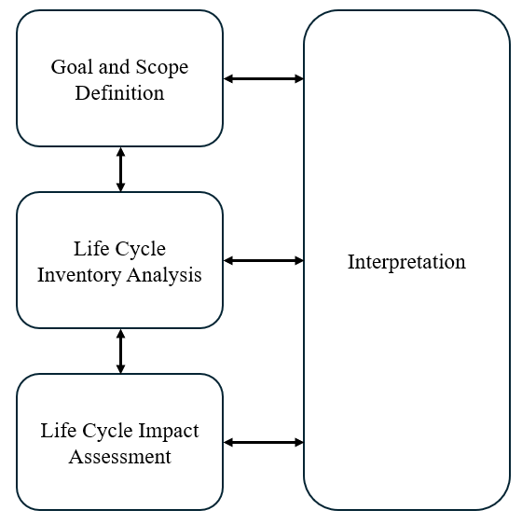
Figure 1. Life Cycle Assessment steps, as outlined in ISO 14040 [34]. LCA steps begin with Goal and Scope Definition, followed by Life Cycle Inventory, Impact Assessment, and finally Results Interpretation. Each steps informs the next step in the process, and interpretation of results references each individual step.

Cradle-to-gate: This approach considers the product’s life cycle from the extraction of raw materials (the "cradle") to the point where the product leaves the manufacturing facility (the "gate"). It excludes downstream processes including transportation to the location of use, the use phase itself, and end-of-life (EOL).
Gate-to-gate: This approach studies the life cycle of the product from the point where it enters the manufacturing facility (the first “gate”) to when it leaves the manufacturing facility at the second “gate”. It excludes upstream processes of raw material extraction, processing, and transportation to the manufacturing facility, in addition to excluding the downstream processes beyond the point where it leaves the manufacturing facility.
Cradle-to-grave: A cradle-to-grave approach is similar to cradle-to-gate in that it considers raw material extraction, transportation, and manufacturing processes, but it also considers transportation to the end user, the product’s use phase, and end of life. End of life processes include the disassembly and disposal of the product.
Cradle-to-cradle: This approach encompasses all the considerations in cradle-to-grave, but rather than stopping at product disposal, it promotes a circular economy model that considers waste as a resource, focusing on how the product can be recycled for reuse or composted in an environmentally beneficial way.
Well-to-wheel: This approach is typically utilized in the automotive and energy sectors and takes into account the environmental impact of fuels. Well-to-wheel analysis considers the fuel raw material extraction (the “well”), distribution, and the fuel use in the vehicle (the “wheel”).
This terminology helps clearly define the boundaries of the system and expresses simply what is considered in the LCA, which influences the subsequent steps of inventory analysis, impact assessment, and results interpretation. A well-defined goal and scope of an LCA ensure the study is transparent, consistent, and aligned with its intended purpose [35].

Inventory Analysis
The second step, Inventory Analysis (also known as Life Cycle Inventory or LCI), focuses on collecting and quantifying data on energy use, raw material inputs, emissions, and waste for each stage of the product’s life cycle. This is often the most intensive step of LCA, and involves process modeling, data collection, and allocating resource flows to the functional unit. The outcome of this step is a comprehensive dataset that forms the foundation for the subsequent impact assessment.

Impact Assessment
The third step involves creating the Impact Assessment (Life Cycle Impact Assessment or LCIA). In this step, the potential environmental impacts of the inputs and outputs identified in the inventory analysis are analyzed and often graphically depicted. These impacts (such as GWP, resource depletion, and water use) are categorized, assigned to impact categories, and their magnitudes are quantified using standard characterization factors. This step provides critical insights into the environmental consequences of the product or process.

Results Interpretation
Finally, the Interpretation of Results involves analyzing and synthesizing the findings to draw meaningful conclusions. This step involves identifying significant impacts (hotspots), evaluating data quality and limitations, and offering recommendations for improving environmental performance. The interpretation ensures that stakeholders have clear, evidence-based insights to inform product design, policy development, or process optimization [34], [35], [36].

LCA in the Automotive Industry
LCA has been performed extensively in the automotive industry, from comparing environmental impact of EVs and ICEVs to analyzing how using lightweight materials affects vehicle energy consumption [6].
Numerous studies have used LCA to compare the impact of ICEVs to that of EVs, highlighting the costs, benefits, and challenges of wide-scale implementation of EVs. Verma et al. (2022) reviewed the findings of several studies comparing LCAs done in six different countries that looked at impact of ICEVs and battery electric vehicles (BEVs). The authors found that across the six countries, overall GHG emissions were reduced with the adoption of EVs, but human toxicity impacts increased. This was likely a result of more energy and resource-intensive production processes for EV powertrain components, specifically the battery pack. The studies also showed that vehicle and battery weight are important factors affecting overall impact during the manufacturing phase [37]. Yang et al. (2021) reported similar findings in their China-based LCA, where they examined the CO₂ and air pollutants emitted from the production, use, and EOL phases of plugin hybrid electric vehicles (PHEVs), BEVs, and traditional ICEVs. They concluded that BEVs and PHEVs have a lower overall carbon footprint compared with ICEVs in China, but produce higher air pollutants harmful to human health, including PM_{2.5} and SO₂ [7]. The findings from these studies pose a concern for human health if EVs are adopted universally, and further work needs to be done to better quantify these emissions and identify ways to reduce them.
Pero et al. (2018) studied the environmental impact of the manufacturing phase of EV and ICEV broken down by each vehicle system (Body-in-White, Door and Closures, Drivetrain, etc.). The study looked at the production, use (energy production and operation emissions separately), and EOL phases. The results shown in Figure 2 indicate that, for almost all impact categories, the production phase constituted the highest environmental impact of all phases for both ICEV and BEV. In terms of the production phase impact by vehicle system, the drivetrain (including the battery, motors, and associated electronics) had the highest carbon footprint for BEV. This was likely due to the high contribution from the production of the EV battery, as well as other aluminum-heavy drivetrain components. Overall, the study found that the production stage impact was 80% higher for BEV, but because the use stage impact was so much lower it resulted in a 36% decrease in total life cycle impact for BEV as compared to ICEV. End of life stages were found to have a negligible contribution in all areas for both powertrains [38].
Onat et al.’s (2015) study was unique in that it compared LCA results for conventional, hybrid, and full-electric vehicles by U.S. State in 2015. They looked at three electricity generation mix scenarios: (1) state-based average electricity generation mix, (2) state-based marginal electricity generation mix, and (3) a solar energy scenario. For scenario 1, the results indicated that BEVs are the least carbon-intensive option in 24 states, while HEVs were the most energy-efficient choice in 45 states. For scenario 2, they found that HEVs are the most energy efficient choice in all 50 states. Only for solar energy use in scenario 3 were BEVs found to have significant reductions in GHG emissions and energy consumption with high adoption rates. These results suggest that given the existing marginal electricity generation mix in 2015, widespread adoption of BEVs would be an unwise strategy at the time. While the marginal electricity generation mix has certainly changed in the past decade, the authors’ conclusion that encouraging renewable energy usage to power EVs remains valid. As sustainable energy generation increases and more electricity used by EVs is produced through renewable methods, the environmental impact of EV use phase will decrease, making them a more environmentally beneficial choice. Yang et al. (2021) provides a similar perspective, recommending that to
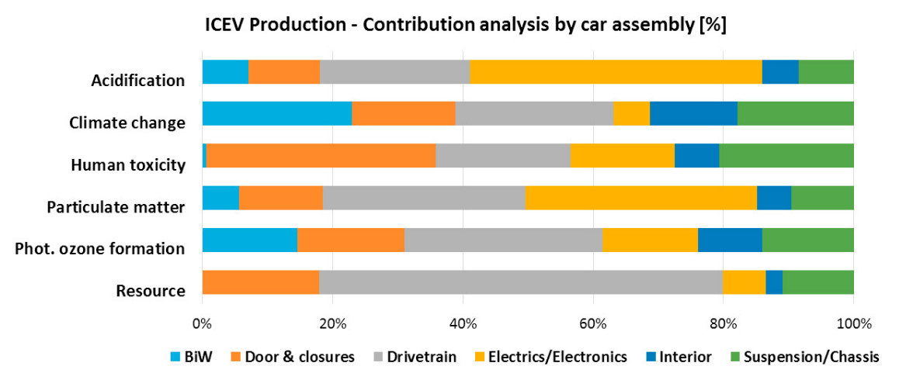
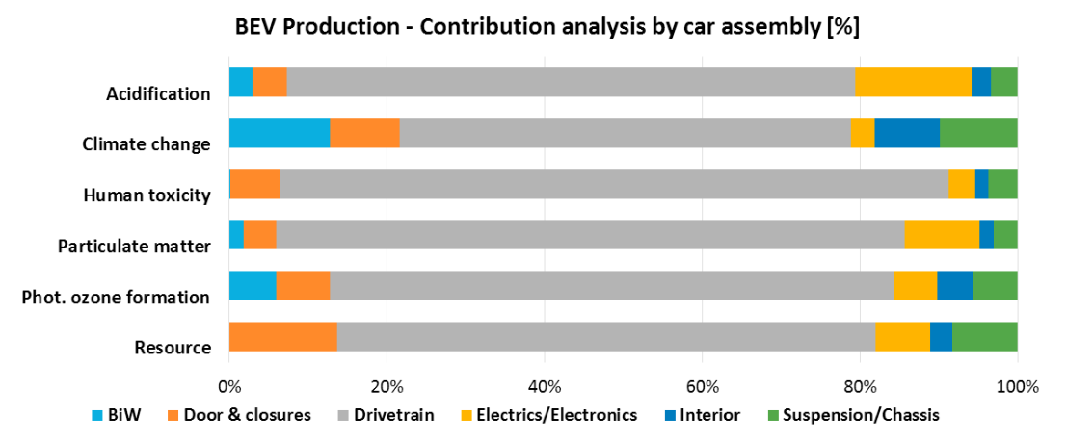
Figure 2. Contribution analysis of vehicle assembly systems to each environmental impact category for ICEVs and EVs, from Pero et al. (2018) [38]. While contribution to each impact category is varies widely with ICEVs, the main contributor to EV impact is drivetrain production (which includes EV battery production).

further decrease EV carbon footprint, material production and battery manufacturing should be sourced from areas with high renewable energy utilization. Several other studies including Pero et al. (2018) [38], Nordelöf et al. (2014) [39], and Bauer et al. (2015) [40] agree with this, concluding that large-scale implementation of EVs can only reduce carbon emissions significantly if the electricity consumed by the EVs during their use phase is produced from very low-emission (clean, non-fossil) energy sources. Pero et al. (2018) further state that encouraging BEV use in areas where electricity is not produced with renewable energy could be counterproductive, and policies should instead focus on limiting ICEV use stage exhaust in these areas. From these findings, it is apparent that to achieve maximum emissions reduction from a widespread transition to EVs, improving clean electricity production in the locations where these vehicles are manufactured and used must also be a high priority.
While it is important to understand how overall EV impact compares to ICEV, component-level LCAs comparing different materials and manufacturing methods for individual parts can drive informed decision making by providing engineers with concrete recommendations to improve environmental impact and energy efficiency. D. La Rosa et al. (2013) compared the environmental impacts of manufacturing vehicle interior door panels out of a hemp fiber/epoxy resin composite as opposed to a glass fiber/epoxy resin composite panel. They took a cradle-to-grave approach and found that by replacing the synthetic glass fiber with natural hemp fibers as the reinforcement material, the production phase GWP of the door panel can be reduced to less than 1/5 the original GWP while also reducing the weight by 280g. They also explored the potential of using a bio-based resin as the matrix material, which resulted in a 40% decrease in GWP [41]. While mechanical testing would need to be done to validate the use of the bio-based materials for this part, this study emphasizes the potential to reduce carbon footprint and improve recyclability of automotive parts through use of natural and bio-based materials. Studies like these are essential to provide specific recommendations for how to improve EV environmental impact on the component level and are backed by quantifiable results. More work in this vein is needed to help advise component design and material selection decisions in the automotive industry, and this thesis addresses this need in part for a high-impact EV component—the EV battery box.

Lightweighting in the Automotive Industry
Lightweighting is commonly used practice in the automotive industry to reduce overall vehicle weight by using new materials and improving designs. Lightweighting has several key benefits including improved fuel efficiency, cost, vehicle performance (braking, handling, and acceleration), and reduced vehicle emissions. It can be achieved by substituting heavier materials for lighter ones, eliminating unnecessary material in vehicle components while maintaining structural integrity and safety, and improving component design. Several studies indicate that a 10% reduction in vehicle weight can result in a 6-8% improvement in fuel economy for internal combustion engine vehicles [11], [42]. This improvement can significantly decrease tailpipe emissions, contributing to reduced GHG emissions during the vehicle's use phase. The adoption of lightweight materials such as high-strength steel, aluminum, and CFRP or GFRP plays a central role in emission reductions. While these materials often have higher production-phase emissions compared to traditional steel, studies show that operational emissions savings can often outweigh these initial environmental costs. This trade-off is particularly advantageous for EVs, where lightweight designs can enhance range and reduce battery demands, addressing key limitations in current EV technology [11].
In order to reap the benefits of lightweighting on a large scale, however, lightweighting cost to automotive manufacturers and customers must be affordable. Yang et al. (2024) considered how lightweighting cost can impact market adoption of lightweighted vehicles in the U.S. and its corresponding effects on GHG emissions. They utilized the Automotive Deployment Options Projection Tool (ADOPT) to estimate market penetration of lightweighting at varying cost levels and considered three lightweighting cost scenarios: Baseline (current industry trends), Advanced Technology (aggressive R&D), and Widespread (average cost target). They found that in the widespread case where lightweighting cost was comparatively lower, lightweighting adoption increased to 25% for lower and middle-priced vehicles as shown in Figure 3. This resulted in a 4% reduction in GHG emissions in one year, or 22 million metric tons of CO₂ equivalent. Results from the other scenarios however showed that if the cost of lightweighting exceeds a critical threshold of approximately $5/kg, lightweighting adoption among vehicles in the $20,000-$60,000 range hovers around 10%, thus failing to achieve the same level of GHG emission reductions [11]. It is clear from this study that lightweighting has high potential to
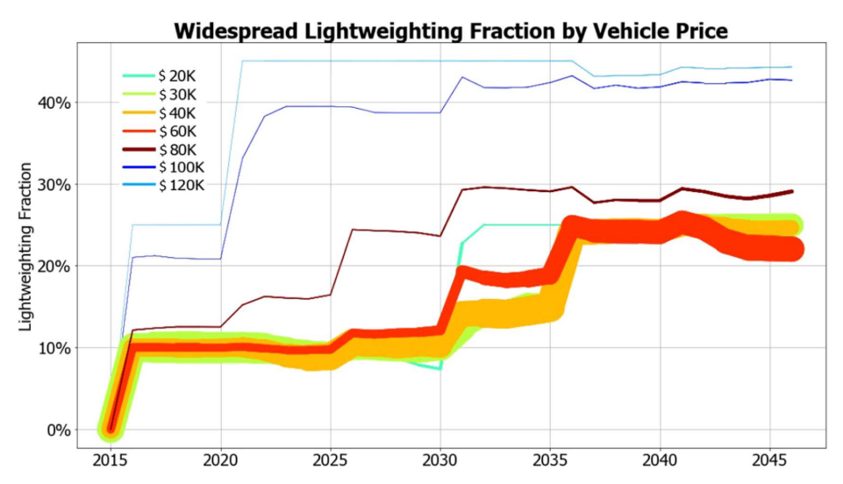
Figure 3. Graph showing predicted lightweighting fraction on the y-axis (percent of vehicle that incorporates lightweighting) and vehicle sales (represented by the line thickness) over time considering a widespread, low-cost lightweighting scenario, from Yang et al. (2024) [11].

reduce EV use phase environmental impact, and efforts to reduce the cost of lightweighting will increase adoption in lower-cost, higher-sales-volume vehicles.

Composites for Automotive Lightweighting
The use of composites for lightweighting in the automotive industry has gained momentum in recent years due to their unique combination of high strength, low density, and design flexibility [22]. Composites, particularly CFRPs and GFRPs, are being increasingly utilized to replace conventional materials like steel and aluminum in vehicle components. The substitution is driven by the need for materials with higher specific strength and stiffness. Studies have shown that the application of these composites can reduce the overall weight of structural components by up to 35% in luxury vehicles, which correlates with substantial improvements in fuel economy and reduced carbon emissions [43]. An example of successful composite use for lightweighting is the carbon fiber intensive BMW i3 released in 2013, which was the first vehicle to feature CFRP components that were economically viable for commercial vehicle production [44]. The Chevy Corvette is another great example, with main body and paneling components made up of a combination of fiberglass, GFRP-SMC, carbon nanotube composites, lightweight aluminum, and carbon fiber [17].
Some of the main challenges with using composites for lightweighting are the high production costs and difficulties in recycling these materials. Increased production costs with higher composite utilization often lead automakers to raise vehicle MSRP values. Higher vehicle prices can reduce demand and limit the potential environmental impact savings due to low adoption rates, as shown in Yang et al.’s (2024) study mentioned earlier. The global composites market is expected to see a 10.8% growth rate in coming years and is expected to reach $181.7 billion by 2028 [45]. While this will likely lead to economies of scale that decrease composite production costs, continued research is still needed to further reduce costs and make lightweight composites more attractive substitutes for traditional materials. Recycling composites in the automotive industry also poses significant challenges due to their complex nature and multi-material structure. Unlike metals, each type of composite may require a unique recycling approach, making it difficult to produce an efficient and cost-effective recycling system. Current SMC recycling methods involve mechanical processing (shredding, cutting, grinding) followed by chemical processing (dissolution, filtration, separation), resulting in reinforcing fillers that can be used in thermoplastics and other materials to improve properties. One standard SMC recycling method is depicted in Figure 4 below. These current solutions can be effective at producing reinforcing fillers but are still not viable for commercial use from both an economic and environmental impact standpoint [46]. While composite recycling is a growing field with high potential, further research into recycling methods (including LCA studies to identify opportunities to reduce environmental impact) is needed. More in-depth research focused on designing composites for improved recyclability would also be beneficial.
Nonsynthetic composite materials can be promising alternatives to synthetic fiber composites in terms of weight, strength, durability, and environmental impact. Natural fiber composites including hemp, jute, flax, basalt, banana, and others have received significant attention in recent years due to their excellent properties, lower carbon impact, lower cost, and improved recyclability as compared with synthetic fibers [47]. Nachippan et al. (2021) evaluated the material properties of a glass fiber/epoxy composite compared with a hybrid glass fiber/hemp fiber/epoxy composite material to see how the addition of natural fiber affects tensile strength, impact strength, and hardness. They assembled the composite test specimens via hand layup and performed tensile, impact, and hardness tests on each. In this study, the authors found that the addition of hemp fiber reduced tensile strength by about 70%, but increased impact strength by up to 160% and hardness by up to 38%, making them good for automotive applications requiring these properties (see Table 1) [48]. Other studies [49], [50], [51], [52] further support the usefulness of natural fiber reinforced composites (NFRCs) in the automotive industry, especially to help reduce environmental impact and contribute to vehicle lightweighting. These fibers can achieve comparable properties to synthetic fibers and are often compared to glass fiber as the baseline. These studies also highlight that NFRCs are currently being implemented extensively for automotive interior components, but face challenges related to moisture absorption and fiber property variation that can impact overall NFRC properties. Further research is needed to fully understand these natural fibers, their mechanical properties in different environments, and how to make them better substitutes for synthetic fibers in automotive lightweighting applications as they can significantly reduce environmental impact.
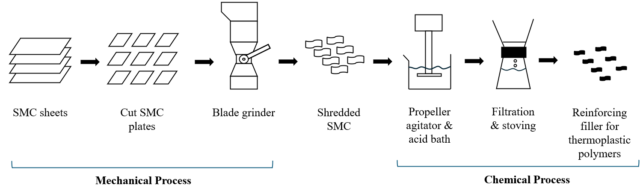
Figure 4. Depiction of an SMC composite recycling process, adapted from Perrin et al. (2008) [106].

Table 1. Tensile test results for several synthetic and natural fiber/epoxy composites, adapted from Nachippan et al. (2024) [48].
S. No | Material | Tensile strength, average (MPa)
1 | S-Glass Fiber / Epoxy Composite (C1) | 81.39
2 | S-Glass Fiber / Untreated Hemp Fiber / Epoxy Composite (C2) | 24.72
3 | S-Glass Fiber / Treated Hemp Fiber / Epoxy Composite (C3) | 23.85

EV Battery Enclosures – Components & Materials
EV battery boxes play a vital role in ensuring the safety, structural integrity, and performance of modern EVs. These enclosures protect battery cells from crash impacts, thermal runaway, and environmental exposure, while also facilitating efficient thermal management and energy distribution. This section will discuss their key components and common materials. See Figure 5 for an exploded view of a typical battery box.

Components for EV Battery Enclosures
Top Cover: The purpose of the top cover in an EV battery box is to protect the internal components from external damage (e.g. rocks and debris), as well as add stiffness to the structure and keep the battery pack sealed during normal use and potential crashes. It is important that the battery stays sealed to protect it from humidity and external temperature (including fires), and to keep the internal components (some of which contain hazardous materials) contained in a crash.
Bottom Housing Tray: The bottom tray typically is on the underside of the vehicle and is thus exposed to the most potential external damage from rocks, bumps, chips, and other road conditions. It is important that this component is designed to withstand these forces during normal use and resist cracking or breaking during collisions. Like the top cover, it keeps the internal components contained and must be highly resistant to corrosion, chemicals, and fire to avoid failing during a crash or thermal runaway [20].
Battery Frame: The battery box frame serves as the interface between the battery pack and the vehicle, allowing the pack to be mounted securely to the vehicle. It also serves to protect the battery pack from front or side impacts, and is designed to absorb energy from impact while minimizing forces on the battery box internal components [15].
Internal Crash Protection Structure: The internal crash structure is essential to keep the battery modules in place during use and impact, and can ultimately help prevent thermal runaway, which is explained in further detail in the EV Battery Box – Design & Manufacturing section.
Internal Cooling System: The internal cooling system helps regulate internal battery pack temperature, keeping it in a safe range (20-45°C) for optimal performance and safety. Unregulated battery pack temperature can lead to inefficiencies, deterioration of the battery cells, shorter battery lifespan, and higher risk of thermal runaway [53].
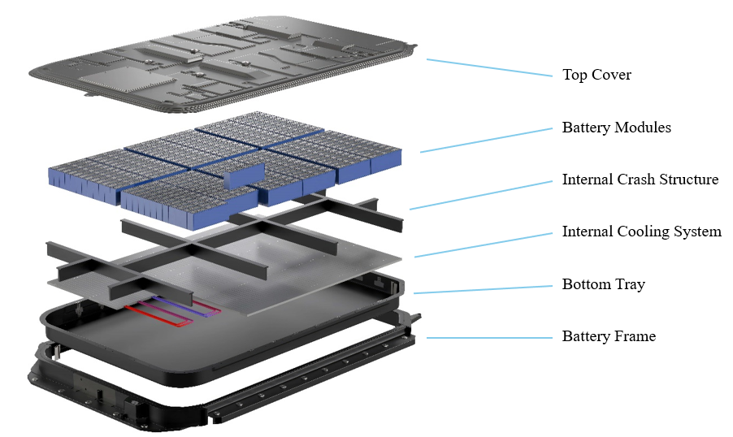
Figure 5. Exploded view of a typical EV battery pack, adapted from emobility-engineering.com [107].

Materials for EV Battery Enclosures
EV battery boxes and their components can be manufactured using a variety of materials, but must meet specific performance standards, the essential ones being mechanical properties, density, and flame retardance [23]. Traditional boxes are made of stainless or high tensile strength steel, while more lightweight boxes are made from 6000-series aluminum [21], [54]. See Table 2 for battery box materials for a few common EVs. Some automakers have experimented with composite boxes to reap further lightweighting benefits. Plasticstoday.com reported that the 2014 Chevy Spark EV featured a vinyl ester/rove cloth composite battery box [55]. TRB group produced an automated production line in 2018 that could manufacture a carbon fiber/epoxy resin battery box for use on a hybrid electric bus [16]. Plasticsengineering.org likewise reported that Mitsubishi announced the manufacturing of a two-part polymer composite battery box [56]. As composite use in the automotive industry increases, composite battery boxes will likely become an industry norm to further reduce vehicle weight.
Composite sheet molding compounds (SMCs) have been used in recent decades to replace metals in many automotive applications due to their short production cycle times, design flexibility, and customizable material properties (based on fiber, resin, and filler selection) which can often exceed that of metals. Their properties can be especially beneficial for battery boxes, as they possess excellent thermal insulation, electrical properties, strength, stiffness, and can be 20-50% lighter than metals [23]. They can also reduce production tooling costs by 25% to 75% as compared to metals, which reduces the total cost of the battery box.
Table 2. Battery box materials for several common EV models, adapted from Arora et al. (2016) [15].
Vehicle | Battery Box Material
Tesla Roadster | Aluminum
Honda Fit EV | Steel
Chevrolet Volt | Steel
Chevrolet Spark EV | Composite
BMW i3 | Aluminum

Environmental impact is also an important consideration in battery box material selection that can depend heavily on the materials chosen. Li et al. (2024) performed a comparative cradle to cradle LCA analyzing the environmental impacts of substituting a traditional steel battery enclosure with lightweight materials – aluminum and CFRP-SMC. The goal of their study was to determine which material had the lowest overall GWP impact, assuming a China-based energy mix and utilizing data provided by manufacturers in China including Xuancheng Yuanwei New Energy Equipment Manufacturing Co., Ltd. and Guangzhou GAC Dili Original Mold Stamping Co., Ltd. Their findings revealed that, of the three materials, the aluminum alloy enclosure achieved the most significant reduction in GWP, primarily due to substantial energy savings during use. In the use phase comparison, shown in Figure 6 below, aluminum was the most environmentally optimal choice within the assumed lifespan of the vehicle (about 200,000 km), and outperformed CF-SMC up to 670,000 km. Additionally, steel remained a better option than CF-SMC up to about 270,000 km. When considering multiple reuses for CF-SMC, the composite battery box becomes the best option for any distance beyond 670,000 km [6]. Considering that this is close to the end of the third use phase, the environmental impact of CF-SMC production will need to be improved before wide-scale use of this composite is an environmentally beneficial option for battery box lightweighting.
No known work beyond Li et al.’s study has explored the environmental impact of EV battery boxes made from composite SMC materials other than CFRP, however. Other composite materials including glass and some natural fiber SMCs show potential to be superior to traditional metals and even carbon fiber in terms of environmental impact and cost while maintaining sufficient mechanical properties. Glass fiber specifically is a commonly used reinforcement material in SMC composites and has been used widely in the automotive industry in recent decades. Wonderly et al. (2005) compared the material properties of a carbon fiber/vinyl ester composite with those of a glass fiber/vinyl ester composite. Tension, compression, open hole tension, open hole compression, transverse tension, indentation and ballistic impact tests were performed. The results showed that while carbon fiber excelled in tensile and indentation tests (situations where strength is fiber-dominated), glass fiber excelled in compression and ballistic impact tests (conditions where strength is resin-dominated) [57]. Given that battery boxes are often exposed to ballistic impacts (rocks, debris) as well as significant

(41040, 258.179)
(268800, 1577.56)
(668240, 2433.724)

Figure 6. Graph depicting use phase GWP impact of steel, aluminum, and CFRP-SMC EV battery boxes, adapted from Li et al. (2024) [6]. Intersection points where driving distance and GWP meet for each box material are identified. CFRP-SMC exhibits the highest initial GWP (from the production phase), but the lowest overall slope (use phase GWP), making it a good option for driving distances beyond approximately 670,000km. Steel is the lowest impact option below 40,000km, but aluminum becomes the lowest-impact option for distances between 40,000km and 670,000km, which is within the expected lifetime of the vehicle (200,000km).

compressive forces in the instance of a crash, glass fiber’s advantages with these properties may make it a better choice than carbon fiber in terms of mechanical properties as well. A deeper understanding of GFRP-SMC for use in EV battery boxes would help guide material selection decisions for automakers, and this thesis attempts to address a part of this knowledge gap.
Previous work has also shown that some natural fiber SMCs can match or even exceed mechanical properties of glass fiber and be more sustainable at a lower cost. Asadi et al. (2017) compared a 25% basalt fiber/epoxy SMC composite to a 25% glass fiber/epoxy SMC and found the basalt composite to meet or exceed the mechanical properties of the GFRP-SMC in most of the areas tested, concluding that basalt could be used in place of glass fiber in SMCs for common automotive applications [52]. Figure 7 shows the study’s results for several mechanical properties. However, this study did not consider how material properties are affected over time when exposed to different environments (which can be especially important for natural fiber materials in high-moisture environments). Further research is needed to determine how mechanical properties of natural fiber SMCs change in different environments, but the value of these NFRCs in further reducing environmental impact and manufacturing cost in the automotive industry is clear.

EV Battery Enclosures – Design & Manufacturing Methods
The design and manufacturing of EV battery boxes play a critical role in ensuring battery safety, thermal management, structural integrity, and overall vehicle performance. Battery boxes must be lightweight, durable, and capable of withstanding mechanical shocks, vibrations, and extreme temperatures.

Design of EV Battery Enclosures
Besides material selection (as was discussed previously), common design considerations include mounting method and location in the vehicle, modularity for ease of assembly, and (most importantly) safety features to prevent thermal runaway and other potentially dangerous issues. As EV adoption grows, innovations in battery box design aim to reduce weight, improve energy density, and enhance sustainability through recyclable materials and more efficient manufacturing processes.

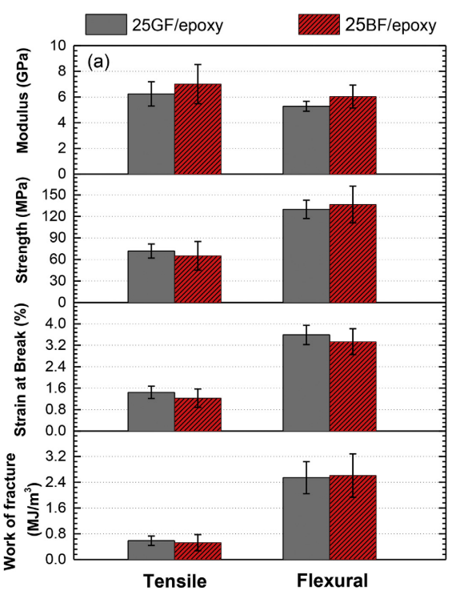
Figure 7. Tensile and flexural properties of glass fiber/epoxy and basalt fiber/epoxy SMCs, from Asadi et al. (2017) [52].

Design for Safety – Thermal Runaway
Thermal runaway occurs when the temperature within a battery cell rises uncontrollably, leading to a self-sustaining exothermic reaction that can cause neighboring cells to overheat, resulting in fire, toxic gas release, or even explosion. Thermal runaway is one of the most critical battery risks that must be mitigated through careful design, as its results can be catastrophic. Previous work related to design of battery boxes to avoid thermal runaway present various risk mitigation strategies. Arora et al. (2016) reviewed work done by more than 75 studies related to the mechanical design and placement of the battery pack in the vehicle, identifying key mechanical features and placement strategies that would minimize the probability of thermal runaway. They found that simple mechanical features could be implemented to mitigate these risks, including battery cell spacers to restrict movement (shown in Figure 8), a rigid mounting frame, a gas venting mechanism to prevent buildup of high pressures in the pack, and thermal barriers between modules. The authors also concluded that the battery pack should ideally be placed in the center of the vehicle chassis beneath the passenger seats to avoid common crash zones [15]. Chavan et al. (2023) analyzed the advantages and disadvantages of various proposed battery cooling methods to reduce thermal runaway risk, further recommending that temperature sensors be integrated into the battery pack along with thermal switches to proactively detect and respond to potential issues before they lead to thermal runaway [58]. Thermal runaway is a critical factor in battery pack safety, making it essential to prioritize the development of safer designs and materials for future battery packs.

Manufacturing Methods for EV Battery Enclosures
Manufacturing methods for steel and aluminum enclosures often involve stamping, casting, extrusion, and advanced welding or joining techniques. Due to the often-proprietary nature of battery box manufacturing, publicly available details about designs and processes can be difficult to find, but some general information on manufacturing processes is available. For aluminum enclosures, the top cover and bottom tray are often manufactured using stamping and bending, while structural members like the frame and internal crash structure are often extruded profiles. Common joining techniques for aluminum boxes include friction stir welding and wire arc welding. Some finishing machining is also common. Completed aluminum boxes typically undergo a powder coating and painting process to improve corrosion, chemical, fire, and weather resistance [59], [60], [61], [62]. Steel box components are often manufactured using stamping
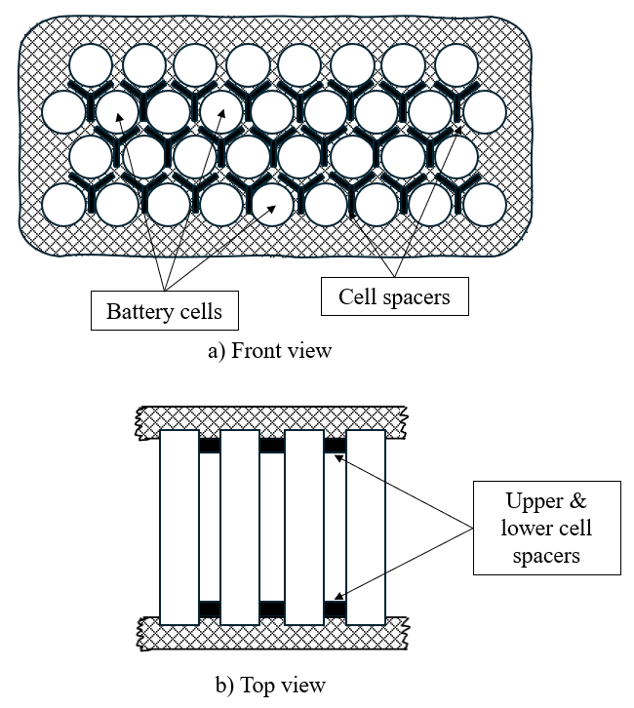
Figure 8. Visual depiction of a cell spacer concept for mitigating thermal runaway risk, a) front view looking at the end of the battery cells and showing cell spacer placement, and b) top view showing the length of the battery cells and upper and lower spacer placement. Adapted from Arora et al. (2016) [15].

and bending, deep drawing, or roll forming, as well as wire arc welding and machining. To improve surface durability, finished steel boxes can be treated using shot peening, followed by a corrosion-resistant coating [62], [63].
For composite battery boxes, manufacturing methods can vary depending on the composite material used. As mentioned in the previous section, composite SMCs have become popular in the automotive industry and show great potential as battery box materials. SMCs are produced by layering resin onto two carrier films (top and bottom), depositing chopped fibers onto the bottom film, which are then sandwiched between the top and bottom film and sent through compacting rolls that press the resin and fibers together. The finished SMC sheet can then be cut to length, layered in a mold to the desired thickness, and compression molded to form a rigid, finished part. A diagram of the process is shown in Figure 9.
Other composite manufacturing methods include hand layup, resin transfer molding, and filament winding, which are commonly used with CFRP and result in desirable fiber orientations and excellent strength to weight ratios. Azzopardi et al. (2023) studied composite design and manufacturing methods for automotive components and found that a hybrid steel/CFRP automotive B-pillar could be successfully manufactured using a prepreg compression molding technique. Defects could be further minimized by utilizing a combined vacuum-assisted prepreg compression molding technique, and they performed thorough mechanical testing that showed significant improvements in mechanical properties [22]. Overall, this study highlights some of the many manufacturing methods for composite automotive components and shows that continued design and manufacturing improvements will increasingly make composites feasible, lightweight, and potentially more environmentally beneficial options in the future.

Summary & Research Gaps
The value of SMC composites as lightweight, lower-cost, and potentially lower environmental impact substitutes to traditional steel and aluminum for EV battery boxes was identified in several of the works discussed in this section. The research presented by Li et al. (2024) [6] highlighted that the high-impact production phase of CFRP-SMC made it a less attractive option than the traditional materials, however. Glass fiber is a commonly used composite in the automotive industry and has been shown to have a lower environmental impact and cost than carbon fiber, yet no known work has analyzed the environmental impact of GFRP-SMC battery enclosures. A deeper understanding of the environmental impact of GFRP-SMCs for use in an EV battery box would inform material selection decisions for automakers, helping them lower overall EV impact and make them more viable alternatives to traditional ICEVs in coming years.

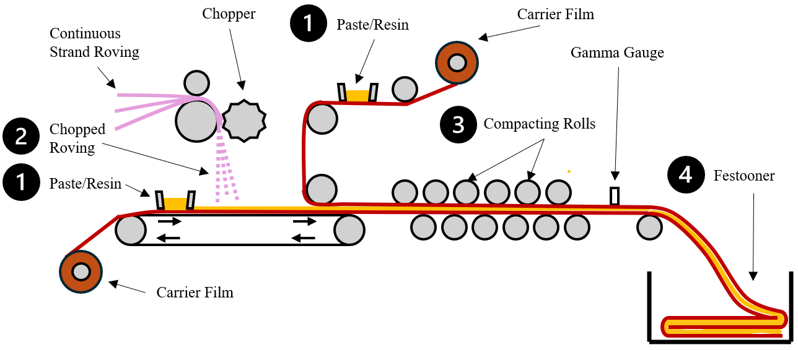
Figure 9. Diagram of a typical SMC process, adapted from Arunadevi et al. (2023) [64].

CHAPTER 3: MATERIALS & METHODS
This section outlines the materials and methods used in the research and follows the four-step LCA methodology as explained above and defined in the ISO 14040 and 14044 standards.

Goal and Scope Definition
The objective of this study is to compare the life cycle environmental impact of three EV battery boxes manufactured from steel, aluminum, and GFRP-SMC, and determine whether GFRP-SMC is a lower environmental impact alternative to traditional steel and aluminum. This LCA is intended for use by materials researchers and to aid automotive manufacturers in selecting sustainable materials and designs for future products. The subsequent sections present a “cradle-to-cradle” LCA analyzing GWP and other important impact categories for each battery box material.
SimaPro software is a widely used LCA tool that leverages data from multiple established databases along with common impact assessment methods to aid in modeling and analyzing the impact of a product, process, or service. With SimaPro, the user can input inventory data from databases like Ecoinvent and Agri-footprint, define system inputs, outputs, and waste, and analyze impact using various impact assessment methods such as TRACI, ReCIPe, and CML [65], [66], [67]. In this study, SimaPro version 9.5.0.2 was used to model all life cycle phases excluding the use phase.

Functional Unit
The functional unit of this study is defined as one entire battery box structure, excluding the components that make up the battery itself. Using the entire enclosure as the functional unit allows for side-by-side comparison of each battery box material. Dimensions of the battery box were assumed to be 2200mm x 1500mm x 100mm, which were approximated to resemble the dimensions of a Tesla Model S 100kWh battery pack. Component thicknesses for each box were determined based on an equivalent stiffness to traditional steel. Three battery box materials were considered in this comparative LCA: a high tensile strength steel that is typically found in traditional battery boxes, an aluminum alloy (6061) frequently used in lighter-weight boxes, and a composite GFRP-SMC that is commonly used in automotive applications.

Data Sources
Life cycle inventory data were obtained from the Ecoinvent 3.0, USLCI, and Industry Data 2.0 databases in SimaPro, as well as from various literature and publications. The Ecoinvent database is the world’s leading LCI database containing over 18,000 datasets on human activities and processes that can be used to analyze the environmental impact of a product. The USLCI database likewise contains a large repository of energy and resource data that can be used to investigate environmental impact of products in the U.S. and is run by the National Renewable Energy Laboratory (NREL). Industry Data 2.0 contains over 300 datasets related to the plastics, surfactants, detergents, and steel industries provided by global associations.

System Boundary
The system boundary for this LCA encompasses raw material production, transportation to the production facility, manufacturing and assembly of the product (battery box), product use phase in the vehicle, as well as EOL disposal and recycling, as shown in Figure 10. The product was assumed to be manufactured and assembled with the rest of the vehicle at an automotive manufacturing plant, so transportation of the finished product to the assembly location is ignored. Because transport distances can vary significantly depending on consumer use and disposal/recycling location, transportation of the product to disposal/recycling location is not included and assumed to have minimal impact on the overall results of this study.

Life Cycle Inventory Analysis
This section covers the materials, energy, and other data used to model the life cycles of the three battery boxes.

Production Phase Inventory
To simplify comparison of the battery boxes, the raw material extraction, transportation of raw materials, and manufacturing phases were combined into a single stage labeled the ‘production phase’. The material, energy, waste, and emissions inventory data of each battery box are outlined in Table 3, Table 4, and Table 5. The masses of the completed battery enclosures are given in Table 6. These values were calculated using the densities of each material along with the assumed geometry of each box. For engineering steel and aluminum 6061, standard densities were used, while for GFRP-SMC an average density of several commercial phenolic resin/GFRP-SMCs was used [68]. Thicknesses of individual components varied slightly between the three boxes and were calculated to ensure similar component stiffness for each material.
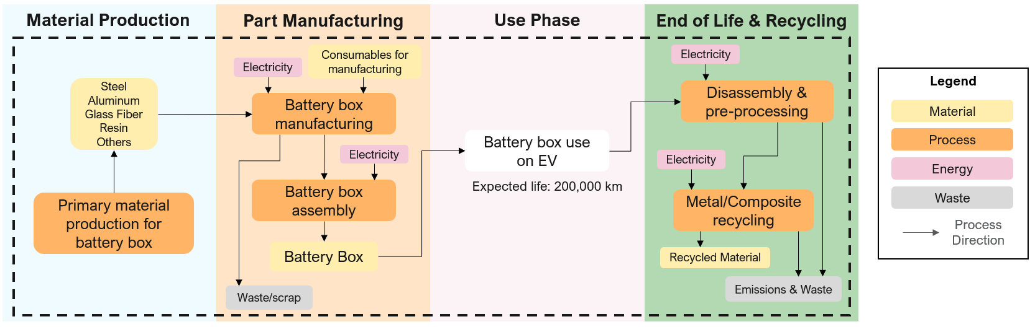
Figure 10. System boundary for EV battery box, assuming cradle-to-cradle approach.
Table 3. Steel battery box production phase inventory, including materials, energy, waste, and emissions along with their respective amounts.
Category | Name | Amount | Unit
Materials | Engineering steel | 165.44 | kg
Materials | Welding wire | 7.40 | m
Materials | E-Coating | 1.18 | kg
Energy | Electricity | 14.88 | kWh
Waste | None | 0 | kg
Emissions | SimaPro Impact Assessment - TRACI 2.1 V1.08 / US 2008

Table 4. Aluminum battery box production phase inventory, including materials, energy, waste, and emissions along with their respective amounts.
Category | Name | Amount | Unit
Materials | 6061 Aluminum, wrought alloy | 86.11 | kg
Materials | Welding wire | 7.40 | m
Materials | TGIC polyester powder coating | 1.85 | kg
Energy | Electricity | 54.13 | kWh
Waste | Aluminum scrap, recyclable | 3.73 | kg
Waste | Aluminum scrap, non-recyclable | 0.369 | kg
Emissions | SimaPro Impact Assessment - TRACI 2.1 V1.08 / US 2008

Table 5. GFRP-SMC battery box production phase inventory, including materials, energy, waste, and emissions along with their respective amounts.
Category | Name | Amount | Unit
Materials | Glass fiber | 26.33 | kg
Materials | Phenolic resin | 20.22 | kg
Materials | Nylon Films | 0.47 | kg
Energy | Electricity | 390.63 | kWh
Waste | GFRP-SMC scrap - non-recyclable | 4.28 | kg
Emissions | SimaPro Impact Assessment - TRACI 2.1 V1.08 / US 2008

Table 6. Masses for the steel, aluminum, and GFRP-SMC battery boxes.
Battery Box Material | Amount | Unit
Steel | 157.56 | kg
Aluminum | 82.01 | kg
GFRP-SMC | 42.74 | kg

Steel Enclosure Production Phase
For the steel box raw material production, engineering steel from the Industry Data 2.0 database in SimaPro was used to model process inputs and outputs (materials, energy, waste, emissions). This dataset also included transportation to the manufacturing facility. The amount of steel required was calculated based on box dimensions. An approximate 5% material loss from the stamping process was assumed, resulting in the final box weight shown in Table 6.
Steel battery boxes can be manufactured in several ways, but they generally utilize similar manufacturing processes. The process includes stamping and bending of steel plates to form the top cover and bottom tray, internal structural members, and frame. Once these components are formed, they are joined together via arc welding. The completed steel members then undergo a shot peening process, which increases surface durability and fatigue resistance, limiting crack propagation by inducing plastic deformation at the surface. Finally, the steel is subjected to a painting or coating process that improves corrosion resistance and surface finish. High-volume production was assumed, so materials and consumables (excluding electricity) associated with equipment and machinery used in these processes were assumed to be negligible.
For the painting/coating process, automotive electrocoating (E-coating) was assumed, and LCI data was obtained from the USLCI database in SimaPro. E-coating is a process commonly used on automotive parts in which a layer of protective coating is applied to a part using an electrical current that protects against corrosion, chemicals, and abrasion. E-coating is especially good for complex, high production parts because it can quickly and easily apply a uniform coating to the entire part, including cracks and hard-to-reach crevices, making it a good choice for this application.

Aluminum Enclosure Production Phase
Raw aluminum material production LCI data was obtained from the Ecoinvent 3.0 database and includes transportation to the manufacturing location. 6000-series aluminum is one of the most-used alloys for EV battery boxes [69], and 6061 aluminum wrought alloy was chosen due to its high corrosion resistance, excellent weldability, high strength, and light weight. The finished aluminum box weight is shown in Table 6. An approximate 5% material loss (allocated to recyclable and non-recyclable waste) was assumed from stamping and finishing machining.
The manufacturing process for aluminum battery enclosures can vary depending on the manufacturer, but the process typically involves aluminum extrusion, stamping, arc welding and friction stir welding, followed by powder coating and/or painting [6], [70], [71]. For the reference aluminum box, the main structural frame and internal crash structure were assumed to be extruded parts, as this increases the material strength and allows for more complex geometries. Electricity was assumed to be the primary input for the extrusion process, and the consumption rate was sourced from a U.S. DOE study on aluminum manufacturing [72]. Extrusion press and die preheating was assumed to be negligible since it can be divided across all parts produced in a single high-production run. Stamping was the chosen method for the top cover plate and bottom tray, and electricity was likewise assumed to be the primary input. Electricity consumption for this process was obtained from Argonne National Laboratory’s Greenhouse Gases, Regulated Emissions, and Energy Use in Transportation (GREET®) model [73].
Like the steel box, the arc welding process was modeled from the Ecoinvent 3.0 database in SimaPro, and the length of welding wire used was assumed to be the same. Friction stir welding is also commonly used in manufacturing aluminum boxes, and the electricity consumption for the friction stir welding process was modeled based on electricity consumption rate calculated in a study published in the CIRP Journal of Manufacturing Science and Technology [74]. Finishing machining electricity consumption was estimated to be 7 kJ per cm³ of removed material, based on a study by Newman published in the same journal [75]. The amount of material removed by machining was estimated to be 75% (by volume) of the material removed by stamping and machining combined. This resulted in an electricity usage of 2.14 kWh for the finishing machining process. Other inputs such as CNC cutting fluid and coolant were assumed to be negligible since the fluid can be reused and the total nonreusable amount per part decreases with increasing production volume. Finally, the powder coating process was modeled using the Ecoinvent 3.0 database. The amount of powder coat needed was calculated using the box dimensions along with coverage data of a typical aluminum powder coat [76], [77].

GFRP-SMC Enclosure Production Phase
The GFRP-SMC battery enclosure was assumed to be manufactured using the SMC process. Each SMC line can differ in several important ways including motors used, size of the line, dimensions of the finished SMC, and others. Therefore, energy consumption and environmental impact can vary depending on the SMC line configuration.
This study utilizes LCI data from the Ecoinvent 3.0 database along with energy consumption data from literature to model the SMC process for the GFRP battery box. For the glass fiber itself, LCI data for raw material production was sourced from Ecoinvent 3.0 and includes transportation to the manufacturing site. For the matrix resin, phenolic resin was chosen due to its excellent fire resistance coupled with high impact resistance and strength, making it a good choice for this application. It is also generally considered lower cost than other popular resins including polyester, vinyl ester, and epoxy. LCI data for phenolic resin production was also sourced from the Ecoinvent 3.0 database. Component weight percent for the finished SMC composite was assumed to be 56% glass fiber, 43% phenolic resin, and 1% nylon film. These weight percents were determined based on literature and existing glass fiber/phenolic resin SMC composites in the market [78], [79]. Typical nylon carrier film thickness varies, but a thickness of 20 μm was assumed, leading to an approximate 1% of total SMC box weight. Nylon film production, including raw materials and transportation, was likewise modeled from the Ecoinvent 3.0 database. The total weight of the completed GFRP-SMC battery box is 42.74 kg, assuming 10% SMC material waste during manufacturing as is common in a similar SMC process used by Volvo Cars [80]. This waste was considered non-recyclable.
The SMC process itself involves few inputs outside of the main SMC components (fibers, resin, films) and electricity for power. Electricity consumption was therefore chosen as the primary energy input of the SMC process. Likewise, electricity consumption was used to model the final compression molding process used to form the finished battery box components, and other materials and energy such as lubricating oil were assumed to be negligible when considering the usage per part. Electricity usage for the SMC process was obtained from a 2020 study by Jonsson. This study analyzes the life cycle energy usage for an automotive frame component manufactured using several different materials and methods, including GFRP-SMC. Energy consumption for the SMC process was estimated to be 29.4 MJ per kg SMC [80]. The subsequent compression molding step that forms the finished part was sourced from Suzuki & Takahashi (2005) as 3.5 MJ/kg [81]. Combining these two values, the energy consumption becomes 32.9 MJ/kg SMC, or 390.63 kWh for the manufacture of one complete GFRP-SMC battery enclosure.

Use Phase Inventory
The battery box use phase simply includes its use in the vehicle after installation up until the end of the vehicle’s life. The battery box is designed to last the expected lifetime of the vehicle (if not longer), so no removal or maintenance is required during this phase. Because of the passive nature of the battery box’s use within the vehicle and lack of maintenance requirements, the energy consumed by the vehicle to transport the box during vehicle use is the most significant factor affecting the box’s use phase impact. To quantify and compare the use phase energy consumption of each battery box, an equation adapted from Li et al. (2024) was used [6]. The formula is shown in Equation 1 below:
(1)
$$E_{ev}= \frac{Q*L*m_{1}}{μ*γ*100*\left(M_{2}+m_{1}\right)}$$

In this equation, E_{ev} represents the energy consumption of the battery box during its use phase (kWh), $Q$ represents vehicle power consumption per hundred kilometers (kWh), $L$ is the driving distance over the battery box lifetime (km), $m_{1}$ is mass of the battery pack (kg), $M_{2}$ is mass of the entire vehicle excluding the battery pack (kg), $μ$ is the charging efficiency, and $γ$ is the discharging efficiency. The reference vehicle was assumed to be a Tesla Model S, and inputs were chosen to be representative of this vehicle model. Equation inputs and calculated energy consumption values using the above equation are shown in Table 7.
The Ecoinvent dataset along with TRACI impact assessment in SimaPro were used to analyze GWP resulting from the electricity consumed in the product’s use phase. Results are shown and discussed in the next chapter.

EOL & Recycling Phase Inventory
The battery box end-of-life phase consists of product removal, disassembly, and waste (landfill) or recycling. Table 8 highlights the amount of material recycled vs. landfilled for each battery box material. EOL landfilling data was modeled in SimaPro as municipal solid waste to a sanitary landfill for simplicity. This captures the general landfilling process for a variety of materials, but some material-specific energy consumption and emissions may have been omitted through this simplification. Transportation of the waste materials to the landfill was assumed to be local and not have a significant impact on the process. Due to the low overall impact of the
Table 7. Use phase energy consumption calculation inputs and results, using Equation 1.
Variable | Unit | Steel | Aluminum | GFRP-SMC
Q | kWh | 19 | 19 | 19
L | km | 200,000 | 200,000 | 200,000
$$μ$$ | - | 90% | 90% | 90%
$$γ$$ | - | 90% | 90% | 90%
m₁ | kg | 675.56 | 600.00 | 560.74
M₂ | kg | 1,500 | 1,500 | 1,500
E_{ev} | kWh*km | 14,567.72 | 13,403.88 | 12,765.54

Table 8. Recycling and landfilling percentages and amounts for each battery box material.
 | Steel | Aluminum | GFRP-SMC
Percent recycled | 100% | 91% | 0%
Amount recycled (kg) | 157.56 | 74.63 | 0.00
Percent landfilled | 0% | 9% | 100%
Amount landfilled (kg) | 0.00 | 7.38 | 42.74

landfilling process, these simplifications are not assumed to have a significant impact on the overall EOL process.
Steel is recycled widely in the automotive industry, with some companies sourcing 100% of their steel from steel scrap [80]. One of the main reasons the steel recycling rate is so high is that its properties theoretically remain unaffected independent of the number of times it is recycled. The steel battery enclosure in this study was presumed to be 100% recyclable. The standard steel recycling process involves seven steps: 1) Collection, 2) Sorting, 3) Processing (compacting), 4) Shredding, 5) Melting, 6) Purification, and 7) Solidifying [82]. Steel battery box recycling was modeled in SimaPro using the Ecoinvent 3.0 database, where recycling costs and benefits were allocated to recycled steel production, which was modeled as an avoided product in the steel box EOL phase.
Aluminum is likewise a highly recyclable material that can be recycled almost infinitely without reducing material properties. According to one study, 75% of all aluminum produced is still in use today. On top of that, recycling aluminum uses approximately 5% of the energy required to produce new aluminum, making aluminum recycling beneficial from both a cost and environmental impact standpoint. In the automotive industry, aluminum recycling rates exceed 90% [83]. For the aluminum box, a recycling rate of 91% was assumed, based on a weighted average of recycling rates for automotive aluminum [84]. The typical recycling process consists of 1) Sorting, 2) Shredding, 3) Cleaning, 4) Melting, 5) Byproduct Removal, 6) Alloy Creation, and 7) Compounding [85]. Like the steel box, the aluminum box recycling process was modeled in SimaPro using the Ecoinvent 3.0 database, where the environmental costs and benefits of aluminum recycling were allocated to recycled aluminum production, which was modeled as an avoided product in the aluminum box EOL phase.
SMC composite battery box recycling poses a more difficult challenge than traditional metal box recycling. Due to the SMCs multi-material structure, no existing recycling methods can effectively separate the chopped fibers from the resin. The output of existing SMC recycling processes is fillers that can be used for reinforcement in thermoplastics and other matrix materials. Because many of these recycling processes are still in development, this study assumes 0% recycling of the GFRP-SMC box, with the entire box being landfilled at EOL. Processing for landfilling for the GFRP-SMC box as well as the non-recyclable material from the steel and aluminum boxes are modeled using the Ecoinvent 3.0 database in SimaPro.
Chapter 4 will cover the final two LCA steps: Impact Assessment and Results Interpretation.

CHAPTER 4: RESULTS & DISCUSSION
This chapter presents the results of the life cycle impact assessment, use phase comparison, and sensitivity analysis, along with a case study and discussion of the results.

Life Cycle Impact Assessment
Life cycle impacts were analyzed using the TRACI version 2.1 V1.08 / US 2008 impact assessment method. TRACI is a common impact assessment method that considers ten different categories of emissions [65], [86]. Only the top five categories by normalized impact, plus GWP, are considered in this study: carcinogenics, ecotoxicity, non-carcinogenics, eutrophication, and fossil fuel depletion. Figure 11 below provides a comparison of each battery box by impact category. It also breaks down impact by life cycle phase (production, use, EOL).
The results in Figure 11 show that, when accounting for the complete product life cycle, steel has the highest impact in each category. Aluminum has the second highest impact in every category excluding ecotoxicity and non-carcinogenics, where it is marginally lower than GFRP-SMC at 0.4% and 0.1%, respectively. GFRP-SMC follows aluminum with the lowest overall impact in every category except ecotoxicity and non-carcinogenics, with its largest improvement being a 11.5% reduction in carcinogenics compared with the aluminum box. A normalization of the data (comparison to a reference scenario, such as the average impact of one person over a year) [87] reveals carcinogenics as having the most significant impact across all three battery box materials. Non-carcinogenics and ecotoxicity are likewise in the top three categories by normalized impact for all three boxes. On the other hand, ozone depletion was the lowest impact category for all boxes, suggesting that, compared to the emissions produced by a typical person in one year, the manufacture and use of these boxes produces few emissions that have potential to damage the ozone layer. It is also interesting to note that despite the environmental benefits of recycling for the steel and aluminum boxes (which reduces GWP by approximately 260 and 1010 kg CO₂-eq, respectively), the GFRP-SMC box remains the most environmentally beneficial option in almost all categories. As composite recycling methods improve in coming years, it is expected that GFRP-SMC will set itself apart as an even better choice for automotive components.
For all impact categories, the battery box use phase clearly produces the highest overall emissions, accounting for at least 85% of total lifecycle emissions in every category. Assuming the same battery components are used across each box and each box is installed in the same
Figure 11. Impact assessment results, showing a comparison of each battery box by impact category broken down by life cycle phase.
vehicle type, use phase impact is primarily dependent on battery box weight and local electricity mix. The best methods to reduce use phase impact, therefore, are by lightweighting the battery box and increasing renewable energy production in the locations where these boxes will be used.

Production Phase Breakdown & Analysis
The production phase is the stage automotive manufacturers have the most control over, so assessing the contribution of each material and process that goes into this phase can help identify the best methods for reducing the overall vehicle impact. A breakdown showing the percent contribution of each material or process to human toxicity (carcinogenics), ecotoxicity, and GWP for each battery box material is shown in Figure 12.
For the steel box, the highest contributor to GWP was steel raw material production, accounting for 95.5% of the total GWP impact. This is not unexpected, given the carbon-intensive nature of steel production [88]. GWP is not the only important impact category to consider, human toxicity and ecotoxicity were several of the top normalized impact categories. The main contributor to human toxicity was the arc welding process, followed by steel raw material production. Ecotoxicity impact mainly stemmed from electricity usage (47.8%) and arc welding (35.7%), with a smaller 16% coming from steel production.
For the aluminum box, the highest contributor in all three categories was wrought aluminum alloy production, followed by the powder coating process. Raw aluminum smelting and refining is a very energy intensive and emission heavy process, so it is not surprising that the production process makes up most of the impact for all three categories [89]. It is also important to note, however, that around 83% of the raw aluminum production GWP is reclaimed through EOL recycling. Likewise, close to 86% of the GWP from steel production is reclaimed in EOL recycling for the steel box. This clearly indicates the value of recycling in reducing production-phase emissions, and further efforts to increase material recyclability and lower recycling costs would help further reduce EV environmental impact.
Finally, for the GFRP-SMC box, contributions were split more evenly among electricity usage (highest), phenolic resin production, and glass fiber production for each impact category. Given that electricity was the main input for the SMC process, it follows that it would be a significant contributor in each impact category. Notably, glass fiber and phenolic resin production have slightly higher contributions for human toxicity and ecotoxicity than for GWP, with both accounting for 51.4% of the total ecotoxicity. Nylon film production was essentially
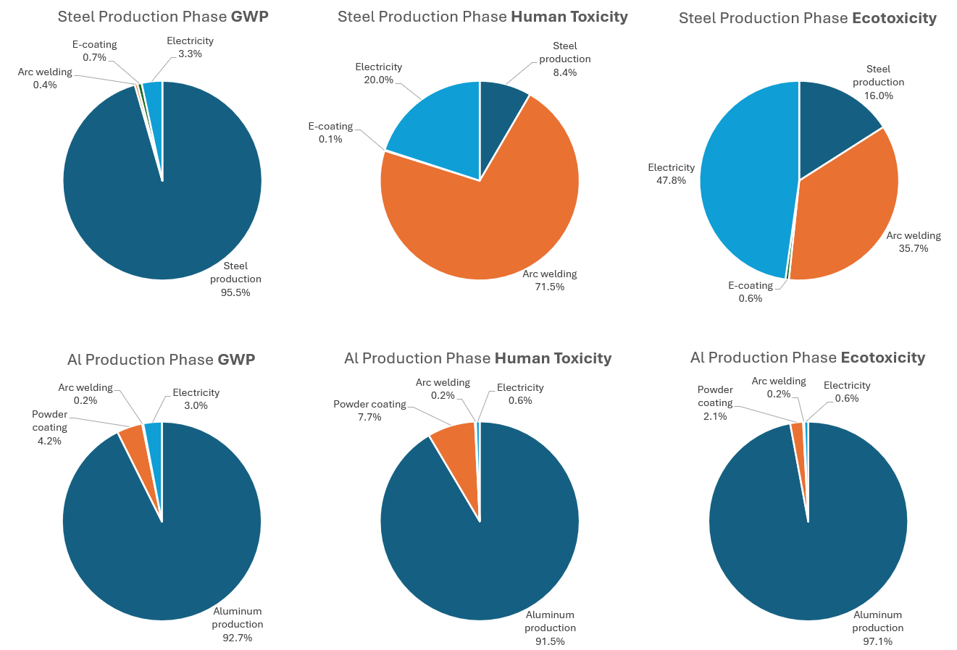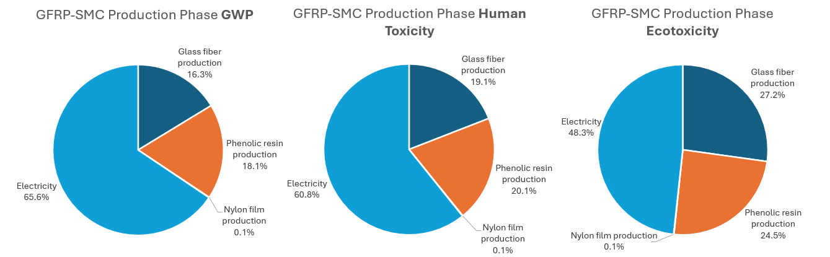
Figure 12. Breakdown of battery box production phase impact by material and process.

negligible in all three categories. Overall, these findings highlight the specific materials and processes that should be targeted to most effectively reduce emissions in each category and for each battery box. Production-phase GWP for the steel and aluminum boxes are validated by Li et al.’s (2024) study [6]. The GWP results found by Li et al. were normalized to kg CO2-eq per 1 kg of battery box and compared with the results found in this study. For the steel box, Li et al. calculated a slightly higher GWP of 2.83 kg CO2-eq compared with 1.89 kg CO2-eq in this study. For the Aluminum box, Li et al.’s GWP was slightly lower, at 10.08 kg CO2-eq compared to 14.78 kg CO2-eq in this study. Overall, these GWP values align fairly well, and their differences are within the expected margin given the differing assumptions and data used in both studies.

Use Phase GWP Comparison
Given that the use phase comprises the largest share of emissions of the three life cycle stages, it is important to consider how emissions change with driving distance and identify break-even distances where one battery box material becomes a more environmentally beneficial option than another. Figure 13 shows the GWP of each battery box as a function of driving distance. All three battery boxes are assumed to have a lifetime driving distance of 200,000 km, depicted in the chart as a vertical dotted line. Table 9 highlights the points of intersection in Figure 13 where GWP values meet for two battery boxes at specific driving distances. The y-intercept of the graph represents the production phase GWP, with steel having the lowest initial impact at 298 kg CO₂-eq, followed by GFRP-SMC at 417 kg CO₂-eq, then aluminum with the highest initial impact at 1212 kg CO₂-eq. The slopes differ however, with the steel box having the highest GWP per kilometer, passing the GFRP-SMC box at approximately 13,000 km and the aluminum box at close to 155,000 km. GFRP-SMC remains a lower GWP option than aluminum for all driving distances. These results indicate that, within the expected lifetime of the battery box (200,000 km), GFRP-SMC would be the best option from a GWP reduction perspective. The steel box remains a decent alternative to GFRP-SMC for lower driving distance applications, but aluminum becomes superior to steel with driving distances above 155,000 km.
Li et al. (2024) discussed the possibility of multiple use stages for the CFRP-SMC battery enclosure. Over time, the internal battery components degrade, reducing charging efficiency and capacity. These components can potentially be replaced with new ones while reusing the battery enclosure itself, thus creating the opportunity for multiple battery box use phases [6]. Given that

Figure 13. Carbon footprint comparison of each battery box during the use phase. A lifetime driving distance of 200,000 km is assumed. GWP error bars or upper/lower bounds are not included in this document but are expected to be included in journal paper publication.
Table 9. Distance and GWP at which the steel box impact intersects with GFRP-SMC and aluminum.
Intersection | Distance (km) | GWP (kg CO₂-eq)
Steel/GFRP-SMC | 13,157 | 990
Steel/Aluminum | 154,799 | 8,439

the use phase GWP lines for each box diverge before the first use phase is complete, considering a second use phase would be unnecessary as the results would still highlight GFRP-SMC as the best choice and an even more attractive option with increasing driving distance. In the use phase comparison presented by Li et al. (similar to the one in this study but with CFRP-SMC), the aluminum box was likewise shown to have lower impact at the end of the battery box’s lifetime (200,000km) than steel, but the point where aluminum becomes a better material choice than steel comes much sooner in their analysis, with steel surpassing aluminum’s GWP at approximately 41,000km. This variance could stem from differences in production-phase GWP assumptions and calculations, manufacturing processes, location-specific energy consumption, electricity mix and emissions, battery box geometry, or a combination of these. Because of the differences in assumptions between Li et al. (2024) and this study, it is expected that the results will differ in some ways, and this study provides a unique and valuable comparison of several viable battery box materials.
To allow for the calculation of use phase energy consumption of battery boxes with different component thicknesses than those assumed in this study, Equation 1 taken from Li et al. (2024) was adapted to include component thicknesses and composite material density. The resulting expression is shown in Equation 2 below.
(2)
$$E_{ev}= \frac{Q*L*\left(m_{box}+m_{c}\right)}{μ*γ*100*\left(M_{2}+m_{box}+m_{c}\right)}$$
(3)
$$m_{box}=ρ_{box}*\left[lw \left(t_{1}+t_{2}\right)+lh \left(n_{l}t_{3}+2t_{1}\right)+wh \left(n_{w}t_{3}+2t_{1}\right)\right]$$

Where $ρ_{box}$ is the density of the composite battery box material, $l$ is the length of the long side of the box, $w$ is the length of the short side of the box, $h$ is the height of the box, $n_{l}$ and $n_{w}$ are the number of internal crash structure members spanning the length and width of the box, respectively, $t_{1}$ is the thickness of the box top cover and sides, $t_{2}$ is the thickness of the bottom tray, $t_{3}$ is the thickness of the internal crash structure members, and $m_{c}$ represents the mass of the battery pack excluding the battery enclosure. If the same external box dimensions (2.20m x 1.50m x 0.10m, representative of a Tesla Model S 100kWh battery pack) and number of internal crash structural members as this study ($n_{l}=n_{w}=4$) are used, $m_{box}$ simplifies to:
(4)
$$m_{box}=ρ_{box}*\left[4.04t_{1}+3.3t_{2}+1.48t_{3}\right]$$

Substituting into Equation 2, we get:
(5)
$$E_{ev}= \frac{Q*L*\left(ρ_{box}*\left[4.04t_{1}+3.3t_{2}+1.48t_{3}\right]+m_{c}\right)}{μ*γ*100*\left(M_{2}+ρ_{box}*\left[4.04t_{1}+3.3t_{2}+1.48t_{3}\right]+m_{c}\right)}$$

Where E_{ev} once again represents the energy consumption of the battery box during its use phase (kWh), $Q$ represents vehicle power consumption per hundred kilometers (kWh), $L$ is the driving distance over the battery box lifetime (km), $M_{2}$ is mass of the entire vehicle excluding the battery pack (kg), $μ$ is the charging efficiency, and $γ$ is the discharging efficiency. This equation provides researchers and automotive manufacturers with a tool to calculate use phase energy consumption of a battery box of differing density and dimensions, which can then be inputted into LCA modeling software such as SimaPro to calculate environmental impact.

SMC Matrix Resin Sensitivity Analysis
A sensitivity analysis was performed to determine the influence of SMC matrix resin selection on the production phase impact of the GFRP-SMC box. The GWP of several matrix resins commonly used in SMC applications were compared, namely epoxy, unsaturated polyester, vinyl ester, and a soy-based polyester resin. Results are shown in Figure 14. LCI data for resin production was sourced from the Ecoinvent 3.0 database available in SimaPro, and the TRACI impact assessment method was again used to model GWP.
From the results shown in Figure 14, phenolic resin evidently has the lowest impact of the five matrix resins considered. Notably, its GWP is 12.4% lower than the natural soy-based polyester, which is the next lowest impact resin. This was unexpected, as bio-based resins tend to exhibit lower GWP emissions, and it is possible that the Ecoinvent dataset used for the bio-based resin did not include the soybean growth and harvesting in the system boundary, which could have further reduced the CO₂ emissions of the production phase. The phenolic, epoxy, and vinyl ester datasets include transport of the product to the consumer (automotive manufacturing facility), while unsaturated polyester and soy-based polyester exclude transport to consumers, so their GWP values are likely slightly higher than reported.

Figure 14. Production stage environmental impact of several common SMC resins.

Material properties of the five matrix resins considered differ, and each excels in different applications. Phenolic resin was selected as the primary material because of its excellent mechanical strength, corrosion resistance, and superior fire resistance compared with other resins. They are commonly used as adhesives or matrix binders in fiber-reinforced composites [90], [91], [92], [93]. These properties make phenolic resin a good choice for an SMC matrix resin for a battery box, which requires high durability, strength, and good heat and fire resistance in the instance of thermal runaway. Epoxy resins are commonly used as matrix thermosetting resins as they have high mechanical strength, heat, and chemical resistance, and adhere to a variety of materials. Their versatility allows their use in a variety of applications including aerospace components, paintings and coatings, and electrical systems, and when combined with reinforcing fibers can produce composites with some of the best mechanical properties of most thermosets [94], [95], [96], [97]. Vinyl ester resins excel in durability, moisture resistance, and corrosion resistance, and are less sensitive to temperature and humidity than some polyester resins [93]. Unsaturated polyester resins are widely used in pultrusion due to their excellent versatility and customizability. They also offer good mechanical strength, heat and corrosion resistance, and lower density, and are often used in fiber-reinforced composites and coatings [93], [98]. Soy-based polyester resins are manufactured from soybean oil and are general-purpose resins for molding applications including SMC. They offer low density and good strength and toughness [99]. One study highlights that bio-based, oil-derived unsaturated polyester resins can reduce environmental impact in most impact categories including GWP [100]. Further research is recommended to more accurately quantify the environmental benefits of implementing bio-based resins as they may help reduce production-phase emissions significantly.
Density variances between resins were considered, since they influence the overall weight of the battery box and therefore the total use phase emissions. When comparing density differences, the densities of each of the five resins incorporated in a GFRP-SMC component were used. The maximum change in density as compared with the Phenolic resin SMC was +120 kg/m³ (vinyl ester). Plugging this into the use phase energy consumption calculation reveals this increase in density to raise the energy consumption by 48 kWh across the battery box’s entire use phase. This increase is not significant enough to affect the overall results of the LCA. In fact, the use phase energy consumption would need to increase by 638 kWh (corresponding to a 1600 kg/m³ change in density) before the aluminum box achieves a lower-emission use phase. The density for the epoxy GFRP-SMC was also greater than the phenolic GFRP-SMC by 70 kg/m³, which is likewise not significant enough to affect overall results. Unsaturated polyester and soy-based polyester SMC were assumed to have equal density, with both being lower than that of the phenolic SMC by 10 kg/m³ [101], [102], [103].
Though GWP results vary between the five resins considered, the data indicates that the resin type does not affect the overall results of the LCA battery box comparison, and GFRP-SMC remains the best option for reducing environmental impact.

Discussion

Benefits of GFRP-SMC
In the LCA study by Li et al. (2024) [6], steel was compared with aluminum and CFRP-SMC for use as a battery box material. The researchers concluded that a CFRP-SMC battery box produces higher carbon emissions during the production phase than both aluminum and steel boxes, and it is not until the box reaches its third or fourth use phase (approximately 670,000km) that CFRP-SMC becomes a more environmentally friendly option than both standard materials. Evidently, the use-phase GWP savings from lightweighting with CFRP-SMC were offset by the material’s high production-phase emissions.
While carbon fiber offers superior stiffness and tensile strength, glass fiber’s advantages include lower production-phase environmental impact, energy consumption, and significantly lower cost as compared with carbon fiber, all while maintaining excellent mechanical properties (some of which can exceed those of carbon fiber) [57]. Moutik et al. (2024) compiled LCA results for carbon fiber and glass fiber production from several main studies and found the average GWP of carbon fiber to be 45.87 kg CO₂-eq, while glass fiber GWP was significantly lower at 1.18 kg CO₂-eq. Likewise, the study found the average energy consumption for carbon fiber and glass fiber production to be 725.22 MJ and 28.95 MJ respectively [29]. The energy and carbon emission reductions of using glass fiber as opposed to carbon fiber make it an excellent choice for automotive applications. From a cost standpoint, glass fiber ranges between $1,200 and $1,800 per ton, while carbon fiber’s cost can reach $12,500 per ton—roughly 7 times that of glass fiber [30]. In the automotive industry, where high production volumes are a given and manufacturing costs can quickly diminish company profits, identifying ways to reduce costs while meeting design requirements is crucial.

Battery Box Manufacturing Case Study
Given that automotive components such as the EV battery and battery enclosure are produced in high volumes, it would be beneficial to identify the total GWP reduction achieved in a high-volume production run of GFRP-SMC battery boxes as compared with steel and aluminum. For this case study, a production run of 10,000 units at a typical automotive manufacturing facility was assumed. This quantity is close to the number of Nissan Leaf and Hyundai Ioniq 6 EVs sold in the U.S. in 2024 [104], [105], and is intended to replicate the production of a single model year of a medium-sales-volume EV. The battery box GWP values in Figure 11 above assume high-volume production, so no modifications are needed to the life cycle inventory values or assumptions. The GWP values for each life cycle stage, assuming a production volume of 10,000 units, are listed in Table 10.
The results indicate that, were an EV manufacturer to change the material of their battery boxes from aluminum to GFRP-SMC, this would result in a 7.9 million kg CO2-eq reduction in carbon emissions across the production phase for 10,000 boxes. This corresponds with a 65.6% decrease in production-phase GWP. Total GWP reduction for all 10,000 boxes across their entire lifecycle would also improve by 3.9%, or 3.7 million kg CO2-eq. Switching from steel to GFRP-SMC shows slightly different results, with an increase in production stage emissions. However, with a 17% reduction in use-phase emissions through lightweighting, the overall lifecycle GWP would decrease by 13.2%. These are significant emission reductions that would help automotive manufacturers get closer to their carbon emission goals.

Limitations Due to Data Uncertainty
LCAs inherently contain some uncertainty in their inventory data due to data collection methods, simplifying assumptions, data variability with time and location, availability of up-to-date inventory data, and others. To mitigate these uncertainties and ensure quality LCA results, inventory data used should be selected from reputable, updated databases. In this study, inventory data from the Ecoinvent 3.0, USLCI, and Industry Data 2.0 databases were used to model the production, use, and EOL stages. While these databases are reputable sources, some Ecoinvent datasets used to model the production phase were not updated when transferring from Ecoinvent 2.0 to 3.0 and may contain outdated information.
Table 10. Comparison of GWP values resulting from the production, use, and EOL of 10,000 battery boxes.
GWP of Producing 10,000 Units (kg CO2-eq)
Life Cycle Phase | Steel | Aluminum | GFRP-SMC
Production | 2,979,410 | 12,118,507 | 4,173,029
Use | 105,182,214 | 93,417,708 | 87,306,856
EOL | (2,578,259) | (10,097,150) | 217,177
Total | 105,583,365 | 95,439,065 | 91,697,062

Additionally, many of the datasets used assumed a Global or Rest-of-World geography, indicating that the data used was not location or region-specific. While the intention of this study was to provide a comparison of the battery boxes from a broader perspective, results may vary depending on the location of the production, use, and EOL stages, and this should be considered in the analysis and decision-making process. The use phase likewise assumed electricity production from a Global geography perspective (assuming global averages for electricity production mix). Region-specific electricity mix should be considered when applying this analysis to a specific location, and further research providing location-specific results is recommended. Despite the uncertainty created by these limitations, this study nonetheless offers quality results comparing the life cycle impact of several battery box materials, providing automotive manufacturers with valuable data and insights to inform decision making.

CHAPTER 5: RECOMMENDATIONS & CONCLUSION
This study presents a comparative LCA of an EV battery box manufactured from three different materials – steel, aluminum, and GFRP-SMC. A life cycle impact assessment was performed, highlighting the environmental impact of each battery box across several impact categories including GWP, carcinogenics, non-carcinogenics, ecotoxicity, eutrophication, and fossil fuel depletion. A comparison of the use phase of each battery box material was performed to determine breakeven driving distances, and a sensitivity analysis analyzing the impact of varying the SMC resin type on the overall results was presented. Finally, a case study involving the production of 10,000 battery boxes was used to quantify the GWP emissions benefits of an automotive manufacturer switching an EV battery box material to GFRP-SMC. The following conclusions can be drawn from the results of the LCA:
- The GFRP-SMC battery box was found to be the best option in terms of GWP, Fossil Fuel Depletion, Eutrophication, and Carcinogenics. Ecotoxicity and non-carcinogenics were the only categories in which it was outperformed by aluminum by 0.4% and 0.1%, respectively. GFRP-SMC is a superior choice compared to steel in all impact categories.
- The steel battery box was found to have the highest impact in all categories apart from carcinogenics, where it outperformed aluminum by 0.43%.
- In terms of use phase GWP, GFRP-SMC achieved lower impact than both the steel and aluminum boxes for all driving distances greater than approximately 13,000km, where steel impact surpasses that of GFRP-SMC. The aluminum box maintains a higher GWP than GFRP-SMC for all driving distances but becomes a lower-impact option than steel for distances beyond 155,000km.
- SMC resin type was not found to have an impact on the overall results of the LCA, with only marginal differences in GWP between resins. Phenolic resin was found to have the lowest production-phase GWP of the 5 common SMC resins considered.
- A case study considering 10,000 battery boxes produced in a typical automotive factory showed that by switching from aluminum battery boxes to GFRP-SMC, production-phase GWP can be reduced by 65.6%. This corresponds with a 3.9% GWP reduction across the battery box’s entire life cycle. Likewise, by switching from steel to GFRP-SMC, overall lifecycle GWP can be reduced by 13.2%.

Recommendations for future work include:
- Further research into the environmental impact of natural fiber composites, especially for use in the automotive industry. Additionally further analysis into methods of improving mechanical properties of natural fiber composites to make them more competitive with traditional fiber composites like carbon and glass fiber.
- Further work related to bio-based resins, their environmental impact, and their production (including development and large-scale production to lower costs), as these can substantially decrease production-phase impact of automotive SMC composites.
- Further research identifying opportunities for EV lightweighting. Lightweighting can improve EV range and significantly reduce use-phase emissions, which is the highest-impact life cycle stage.

REFERENCES
[1] “Fast Facts on Transportation Greenhouse Gas Emissions | US EPA.” Accessed: Nov. 07, 2024. [Online]. Available: https://www.epa.gov/greenvehicles/fast-facts-transportation-greenhouse-gas-emissions
[2] “Use of energy for transportation - U.S. Energy Information Administration (EIA).” Accessed: Nov. 07, 2024. [Online]. Available: https://www.eia.gov/energyexplained/use-of-energy/transportation.php
[3] “Electric Vehicles - Worldwide | Statista Market Forecast.” Accessed: Nov. 07, 2024. [Online]. Available: https://www.statista.com/outlook/mmo/electric-vehicles/worldwide
[4] “life cycle assessment — European Environment Agency.” Accessed: Feb. 09, 2025. [Online]. Available: https://www.eea.europa.eu/help/glossary/eea-glossary/life-cycle-assessment
[5] N. C. Onat, M. Kucukvar, and O. Tatari, “Conventional, hybrid, plug-in hybrid or electric vehicles? State-based comparative carbon and energy footprint analysis in the United States,” Appl Energy, vol. 150, pp. 36–49, Jul. 2015, doi: 10.1016/J.APENERGY.2015.04.001.
[6] X. Li, Y. Zhang, Y. Liao, and G. Yu, “Environmental impact assessment of battery boxes based on lightweight material substitution,” Sci Rep, vol. 14, no. 1, Dec. 2024, doi: 10.1038/s41598-024-53238-2.
[7] L. Yang, B. Yu, B. Yang, H. Chen, G. Malima, and Y. M. Wei, “Life cycle environmental assessment of electric and internal combustion engine vehicles in China,” J Clean Prod, vol. 285, p. 124899, Feb. 2021, doi: 10.1016/J.JCLEPRO.2020.124899.
[8] Q. Dai, J. C. Kelly, L. Gaines, and M. Wang, “Life cycle analysis of lithium-ion batteries for automotive applications,” Batteries, vol. 5, no. 2, Jun. 2019, doi: 10.3390/batteries5020048.
[9] M. Weiss, K. C. Cloos, and E. Helmers, “Energy efficiency trade-offs in small to large electric vehicles,” Environ Sci Eur, vol. 32, no. 1, pp. 1–17, Dec. 2020, doi: 10.1186/S12302-020-00307-8/TABLES/4.
[10] T. Phuthong, T. Borisuth, Z. Yang, and P. Jarumaneeroj, “Identifying factors influencing electric vehicle adoption in an emerging market: The case of Thailand,” Transp Res Interdiscip Perspect, vol. 27, p. 101229, Sep. 2024, doi: 10.1016/J.TRIP.2024.101229.
[11] F. Yang, A. Brooker, S. Kleinbaum, and D. Gotthold, “Lightweighting cost impacts on market adoption and GHG emissions in U.S. light-duty vehicle fleet,” Environ Res Commun, vol. 6, no. 10, p. 101017, Oct. 2024, doi: 10.1088/2515-7620/ad82b3.
[12] “A Complete Guide on Electric Car Battery Weight.” Accessed: Feb. 09, 2025. [Online]. Available: https://getevgas.com/electric-car-battery-weight/
[13] “Cell to Pack Mass Ratio - Battery Design.” Accessed: Feb. 25, 2025. [Online]. Available: https://www.batterydesign.net/cell-to-pack-mass-ratio/
[14] “Electric Vehicle Battery Box | AEC.” Accessed: Feb. 10, 2025. [Online]. Available: https://aec.org/page/electric-vehicle-battery-box
[15] S. Arora, W. Shen, and A. Kapoor, “Review of mechanical design and strategic placement technique of a robust battery pack for electric vehicles,” Renewable and Sustainable Energy Reviews, vol. 60, pp. 1319–1331, Jul. 2016, doi: 10.1016/J.RSER.2016.03.013.
[16] “EV battery enclosure inspires material, process innovations | CompositesWorld.” Accessed: Dec. 11, 2024. [Online]. Available: https://www.compositesworld.com/articles/ev-battery-enclosure-inspires-material-process-innovations
[17] L. Deptula and A. Noah, “Assessing the Costs & Benefits of Effective Lightweighting Technologies,” 2015. [Online]. Available: www.cargroup.org
[18] L. Shui, F. Chen, A. Garg, X. Peng, N. Bao, and J. Zhang, “Design optimization of battery pack enclosure for electric vehicle,” Structural and Multidisciplinary Optimization, vol. 58, no. 1, pp. 331–347, Jul. 2018, doi: 10.1007/s00158-018-1901-y.
[19] Z. Xiaoyu, Z. Boming, and Z. Shuren, “LIGHTWEIGHT DESIGN OF BATTERY BOX FOR ELECTRIC VEHICLE.”
[20] C. Hout, “Innovation and design of the battery box for electric vehicles,” 2024. [Online]. Available: https://app.patentinspiration.com/#report/E57FA8D843A6/filter.
[21] Y. Pan, Y. Xiong, L. Wu, K. Diao, and W. Guo, “Lightweight Design of an Automotive Battery-Pack Enclosure via Advanced High-Strength Steels and Size Optimization,” International Journal of Automotive Technology, vol. 22, no. 5, pp. 1279–1290, Oct. 2021, doi: 10.1007/S12239-021-0112-5/METRICS.
[22] B. Azzopardi, A. Hapid, S. Kaleg, Sudirja, D. Onggo, and A. C. Budiman, “Recent Advances in Battery Pack Polymer Composites,” Sep. 01, 2023, Multidisciplinary Digital Publishing Institute (MDPI). doi: 10.3390/en16176223.
[23] J. Wu, L. Mason, T. Skelskey, D. King, and D. Dowdall, “ADVANCED SMC RESINS FOR ELECTRIC-VEHICLE BATTERY-ENCLOSURE APPLICATIONS.”
[24] Q. Lu, P. Wu, W. Shen, X. Wang, B. Zhang, and C. Wang, “Life cycle assessment of electric vehicle power battery,” in Materials Science Forum, Trans Tech Publications Ltd, 2016, pp. 403–410. doi: 10.4028/www.scientific.net/MSF.847.403.
[25] J. Porzio and C. D. Scown, “Life-Cycle Assessment Considerations for Batteries and Battery Materials,” Sep. 01, 2021, John Wiley and Sons Inc. doi: 10.1002/aenm.202100771.
[26] Y. Deng, J. Li, T. Li, X. Gao, and C. Yuan, “Life cycle assessment of lithium sulfur battery for electric vehicles,” J Power Sources, vol. 343, pp. 284–295, Mar. 2017, doi: 10.1016/J.JPOWSOUR.2017.01.036.
[27] F. Degen and M. Schütte, “Life cycle assessment of the energy consumption and GHG emissions of state-of-the-art automotive battery cell production,” J Clean Prod, vol. 330, p. 129798, Jan. 2022, doi: 10.1016/J.JCLEPRO.2021.129798.
[28] S. Wang and J. Yu, “A comparative life cycle assessment on lithium-ion battery: Case study on electric vehicle battery in China considering battery evolution,” Waste Management and Research, vol. 39, no. 1, pp. 156–164, Jan. 2021, doi: 10.1177/0734242X20966637.
[29] B. Moutik, J. Summerscales, J. Graham-Jones, and R. Pemberton, “Quality assessment of life cycle inventory data for fibre-reinforced polymer composite materials,” Sustain Prod Consum, vol. 49, pp. 474–491, Sep. 2024, doi: 10.1016/J.SPC.2024.07.005.
[30] P. Peças, H. Carvalho, H. Salman, and M. Leite, “Natural fibre composites and their applications: A review,” Journal of Composites Science, vol. 2, no. 4, 2018, doi: 10.3390/jcs2040066.
[31] “What Is Decarbonization, and How Do We Make It Happen? – State of the Planet.” Accessed: Nov. 07, 2024. [Online]. Available: https://news.climate.columbia.edu/2022/04/22/what-is-decarbonization-and-how-do-we-make-it-happen/
[32] “Can Removing Carbon From the Atmosphere Save Us From Climate Catastrophe? – State of the Planet.” Accessed: Nov. 07, 2024. [Online]. Available: https://news.climate.columbia.edu/2018/11/27/carbon-dioxide-removal-climate-change/
[33] “Design for the Environment Life-Cycle Assessments | Safer Choice | US EPA.” Accessed: Nov. 07, 2024. [Online]. Available: https://archive.epa.gov/epa/saferchoice/design-environment-life-cycle-assessments.html
[34] “Life Cycle Assessment Best Practices of ISO 14040 Series Ministry of Commerce, Industry and Energy Republic of Korea Asia-Pacific Economic Cooperation Committee on Trade and Investment,” 2004.
[35] “Life Cycle Assessment (LCA) explained - PRé Sustainability.” Accessed: Dec. 19, 2024. [Online]. Available: https://pre-sustainability.com/articles/life-cycle-assessment-lca-basics/#h-1-goal-and-scope-definition
[36] “Life Cycle Assessment (LCA) – Everything you need to know | Ecochain.” Accessed: Dec. 19, 2024. [Online]. Available: https://ecochain.com/blog/life-cycle-assessment-lca-guide/#four-phase-lca
[37] S. Verma, G. Dwivedi, and P. Verma, “Life cycle assessment of electric vehicles in comparison to combustion engine vehicles: A review,” Mater Today Proc, vol. 49, pp. 217–222, Jan. 2022, doi: 10.1016/J.MATPR.2021.01.666.
[38] F. Del Pero, M. Delogu, and M. Pierini, “Life Cycle Assessment in the automotive sector: a comparative case study of Internal Combustion Engine (ICE) and electric car,” Procedia Structural Integrity, vol. 12, pp. 521–537, Jan. 2018, doi: 10.1016/J.PROSTR.2018.11.066.
[39] A. Nordelöf, M. Messagie, A. M. Tillman, M. Ljunggren Söderman, and J. Van Mierlo, “Environmental impacts of hybrid, plug-in hybrid, and battery electric vehicles—what can we learn from life cycle assessment?,” Oct. 14, 2014, Springer Verlag. doi: 10.1007/s11367-014-0788-0.
[40] C. Bauer, J. Hofer, H. J. Althaus, A. Del Duce, and A. Simons, “The environmental performance of current and future passenger vehicles: Life cycle assessment based on a novel scenario analysis framework,” Appl Energy, vol. 157, pp. 871–883, Nov. 2015, doi: 10.1016/J.APENERGY.2015.01.019.
[41] A. D. La Rosa, G. Cozzo, A. Latteri, G. Mancini, A. Recca, and G. Cicala, “A comparative life cycle assessment of a composite component for automotive,” in Chemical Engineering Transactions, Italian Association of Chemical Engineering - AIDIC, 2013, pp. 1723–1728. doi: 10.3303/CET1332288.
[42] F. Czerwinski, “Current trends in automotive lightweighting strategies and materials,” Materials, vol. 14, no. 21, Nov. 2021, doi: 10.3390/ma14216631.
[43] S. Cecchel, “Materials and Technologies for Lightweighting of Structural Parts for Automotive Applications: A Review,” SAE International Journal of Materials and Manufacturing, vol. 14, no. 1, pp. 81–97, Sep. 2020, doi: 10.4271/05-14-01-0007.
[44] “A new era dawns: BMW Group begins series production of the BMW i3 electric car in Leipzig. / Industrial-scale manufacture of CFRP makes its debut in the car industry. / Commitment to a sustainable production process.” Accessed: Dec. 22, 2024. [Online]. Available: https://www.press.bmwgroup.com/global/article/detail/T0145644EN/a-new-era-dawns:-bmw-group-begins-series-production-of-the-bmw-i3-electric-car-in-leipzig-/-industrial-scale-manufacture-of-cfrp-makes-its-debut-in-the-car-industry-/-commitment-to-a-sustainable-production-process?language=en
[45] “Composites Market Size, Industry Share Growth Forecast, Global Trends Report, [Latest].” Accessed: Feb. 25, 2025. [Online]. Available: https://www.marketsandmarkets.com/Market-Reports/composite-market-200051282.html
[46] Y. Yang, R. Boom, B. Irion, D. J. van Heerden, P. Kuiper, and H. de Wit, “Recycling of composite materials,” Chemical Engineering and Processing: Process Intensification, vol. 51, pp. 53–68, Jan. 2012, doi: 10.1016/J.CEP.2011.09.007.
[47] V. Naik, M. Kumar, and V. Kaup, “A Review on Natural Fiber Composite Materials in Automotive Applications,” Engineered Science, vol. 18, pp. 1–10, 2022, doi: 10.30919/ES8D589.
[48] N. Murugu Nachippan, M. Alphonse, V. K. Bupesh Raja, S. Shasidhar, G. Varun Teja, and R. Harinath Reddy, “Experimental investigation of hemp fiber hybrid composite material for automotive application,” Mater Today Proc, vol. 44, pp. 3666–3672, Jan. 2021, doi: 10.1016/J.MATPR.2020.10.798.
[49] Y. Deng, Y. Guo, P. Wu, and G. Ingarao, “Optimal design of flax fiber reinforced polymer composite as a lightweight component for automobiles from a life cycle assessment perspective,” J Ind Ecol, vol. 23, no. 4, pp. 986–997, Aug. 2019, doi: 10.1111/JIEC.12836.
[50] A. Moudood, A. Rahman, A. Öchsner, M. Islam, and G. Francucci, “Flax fiber and its composites: An overview of water and moisture absorption impact on their performance,” Journal of Reinforced Plastics and Composites, vol. 38, no. 7, pp. 323–339, Apr. 2019, doi: 10.1177/0731684418818893/ASSET/IMAGES/LARGE/10.1177_0731684418818893-FIG11.JPEG.
[51] J. Holbery and D. Houston, “Natural-fiber-reinforced polymer composites in automotive applications,” JOM, vol. 58, no. 11, pp. 80–86, Nov. 2006, doi: 10.1007/S11837-006-0234-2/METRICS.
[52] A. Asadi, F. Baaij, H. Mainka, M. Rademacher, J. Thompson, and K. Kalaitzidou, “Basalt fibers as a sustainable and cost-effective alternative to glass fibers in sheet molding compound (SMC),” Compos B Eng, vol. 123, pp. 210–218, Aug. 2017, doi: 10.1016/J.COMPOSITESB.2017.05.017.
[53] J. Guo and F. Jiang, “A novel electric vehicle thermal management system based on cooling and heating of batteries by refrigerant,” Energy Convers Manag, vol. 237, p. 114145, Jun. 2021, doi: 10.1016/J.ENCONMAN.2021.114145.
[54] “Constellium aluminum EV battery enclosures.” Accessed: Dec. 15, 2024. [Online]. Available: https://www.sae.org/news/2021/02/constellium-aluminum-ev-battery-enclosures
[55] “NAIAS: Composite battery enclosure debuts on Chevy Spark EV.” Accessed: Dec. 11, 2024. [Online]. Available: https://www.plasticstoday.com/materials/naias-composite-battery-enclosure-debuts-on-chevy-spark-ev
[56] “Mitsubishi and Partners Launch Polymer Composite Battery Enclosure.” Accessed: Dec. 15, 2024. [Online]. Available: https://www.plasticsengineering.org/2023/09/mitsubishi_and_partners_launch_polymer_composite_battery_enclosure-002020/
[57] C. Wonderly, J. Grenestedt, G. Fernlund, and E. Cěpus, “Comparison of mechanical properties of glass fiber/vinyl ester and carbon fiber/vinyl ester composites,” Compos B Eng, vol. 36, no. 5, pp. 417–426, Jul. 2005, doi: 10.1016/J.COMPOSITESB.2005.01.004.
[58] S. Chavan et al., “Thermal runaway and mitigation strategies for electric vehicle lithium-ion batteries using battery cooling approach: A review of the current status and challenges,” J Energy Storage, vol. 72, p. 108569, Nov. 2023, doi: 10.1016/J.EST.2023.108569.
[59] A. Afseth, “Andreas Afseth Aluminum Battery Enclosure Design.” Accessed: Mar. 09, 2025. [Online]. Available: https://www.cargroup.org/wp-content/uploads/2021/02/Aluminum-Battery-Enclosures-Constellium-February-2021-FINAL.pdf
[60] “BENTELER Battery trays | Technologies & Trends.” Accessed: Dec. 18, 2024. [Online]. Available: https://www.benteler.com/en/products-services/automotive-products/battery-trays/
[61] “Evolution and Innovation in EV Battery Tray Design and Technology – XD Thermal.” Accessed: Dec. 18, 2024. [Online]. Available: https://www.xdthermal.com/evolution-and-innovation-in-ev-battery-tray-design-and-technology/
[62] “Magna Body & Chassis Capabilities.” Accessed: Dec. 18, 2024. [Online]. Available: https://www.magna-lightweighting-web.com/?
[63] “Safe EV battery housings using high-performance stainless steels | Outokumpu.” Accessed: Dec. 18, 2024. [Online]. Available: https://www.outokumpu.com/en/expertise/2021/safe-ev-battery-housings-using-high-performance-stainless-steels
[64] N. Arunadevi and S. Jone Kirubavathy, “Bionanocomposites for rejuvenation of heavily contaminated environment,” Nanobiotechnology for Bioremediation: Fundamentals and Mechanisms, pp. 75–125, Jan. 2023, doi: 10.1016/B978-0-323-91767-4.00014-8.
[65] U. Epa, O. of Research, and S. Technology Division, “Tool for the Reduction and Assessment of Chemical and Other Environmental Impacts (TRACI) TRACI version 2.1 User’s Guide”, Accessed: Dec. 26, 2024. [Online]. Available: www.epa.gov/research
[66] “ReCiPe - PRé Sustainability.” Accessed: Feb. 25, 2025. [Online]. Available: https://pre-sustainability.com/articles/recipe/
[67] “CML-IA Characterisation Factors - Leiden University.” Accessed: Feb. 25, 2025. [Online]. Available: https://www.universiteitleiden.nl/en/research/research-output/science/cml-ia-characterisation-factors
[68] “Overview of materials for Phenolic/Glass Fiber SMC.” Accessed: Jan. 01, 2025. [Online]. Available: https://www.matweb.com/search/DataSheet.aspx?MatGUID=133f0a14d118410fa4af8bf0bd198f43
[69] “Constellium aluminum EV battery enclosures.” Accessed: Jan. 07, 2025. [Online]. Available: https://www.sae.org/news/2021/02/constellium-aluminum-ev-battery-enclosures
[70] “Battery Enclosures - Magna Lightweighting.” Accessed: Jan. 08, 2025. [Online]. Available: https://www.magna-lightweighting-web.com/?a=product&id=18
[71] “EV Battery Box Design: How to Make it a Reality - APW.” Accessed: Jan. 08, 2025. [Online]. Available: https://autoprotoway.com/ev-battery-box-design/
[72] U. States Department of Energy, “Bandwidth Study on Energy Use and Potential Energy Saving Opportunities in the Manufacturing of Lightweight Materials: Aluminum,” 2017.
[73] Q. Dai, J. C. Kelly, and A. Elgowainy, “Update of Process Energy Requirement and Material Efficiency for Steel and Al Stamping in the GREET ® Model,” 2017.
[74] A. Shrivastava, M. Krones, and F. E. Pfefferkorn, “Comparison of energy consumption and environmental impact of friction stir welding and gas metal arc welding for aluminum,” CIRP J Manuf Sci Technol, vol. 9, pp. 159–168, May 2015, doi: 10.1016/J.CIRPJ.2014.10.001.
[75] S. T. Newman, A. Nassehi, R. Imani-Asrai, and V. Dhokia, “Energy efficient process planning for CNC machining,” CIRP J Manuf Sci Technol, vol. 5, no. 2, pp. 127–136, Jan. 2012, doi: 10.1016/J.CIRPJ.2012.03.007.
[76] “Cardinal Technical Data Sheet.” Accessed: Jan. 09, 2025. [Online]. Available: http://www.cardinalpaint.com/assets/Uploads/GR185-T013-TDS.pdf
[77] “Powder Coating Coverage Calculator - Cost per Sq/Ft | Prismatic Powders.” Accessed: Jan. 09, 2025. [Online]. Available: https://www.prismaticpowders.com/coverage-calculator?srsltid=AfmBOoq6EzhG57pc9Rhby3-uKwqxPQ2KIJzReGjTEp9pbMwwoXznrsYw
[78] I. Swentek, F. Defoor, and C. Ball, “PHENOLIC SMC FOR AUTOMOTIVE FIRE RESISTANCE.”
[79] “Quantum Composites QC-2150 50% Glass Reinforced Phenolic SMC.” Accessed: Jan. 12, 2025. [Online]. Available: https://www.matweb.com/search/DataSheet.aspx?MatGUID=8f1ea6f622bd4f8f8f50bf1cecbec185
[80] R. JONSSON, “Life cycle energy optimization as a tool to compare and evaluate the optimal design in the automotive industry,” 2020. [Online]. Available: www.kth.se
[81] T. Suzuki and J. Takahashi, “Prediction of energy intensity of carbon fiber reinforced plastics for mass-produced passenger cars,” 2005. [Online]. Available: https://www.researchgate.net/publication/264838761
[82] “How is Steel Recycled Step by Step? | Greenway Metal Recycling.” Accessed: Jan. 14, 2025. [Online]. Available: https://greenwaymetalrecycling.com/how-is-steel-recycled-step-by-step/
[83] “Sustainability – Recycling | Aluminum Association.” Accessed: Jan. 14, 2025. [Online]. Available: https://www.aluminum.org/Recycling
[84] S. Kelly and D. Apelian, “Automotive aluminum recycling at end of life: a grave-to-gate analysis.”
[85] “How is Aluminum Recycled? Step by Step | Greentumble.” Accessed: Jan. 14, 2025. [Online]. Available: https://greentumble.com/how-is-aluminum-recycled
[86] J. Bare, “TRACI 2.0: The tool for the reduction and assessment of chemical and other environmental impacts 2.0,” Clean Technol Environ Policy, vol. 13, no. 5, pp. 687–696, 2011, doi: 10.1007/S10098-010-0338-9.
[87] S. Tutorial, “SimaPro Tutorial,” 2023.
[88] A. Hasanbeigi et al., “HOW CLEAN IS THE U.S. STEEL INDUSTRY? An International Benchmarking of Energy and CO2 Intensities,” 2019. [Online]. Available: https://www.globaleeciencyintel.com
[89] S. H. Farjana, N. Huda, and M. A. P. Mahmud, “Impacts of aluminum production: A cradle to gate investigation using life-cycle assessment,” Science of The Total Environment, vol. 663, pp. 958–970, May 2019, doi: 10.1016/J.SCITOTENV.2019.01.400.
[90] S. Ray and R. P. Cooney, “Thermal Degradation of Polymer and Polymer Composites,” Handbook of Environmental Degradation of Materials: Second Edition, pp. 213–242, Sep. 2012, doi: 10.1016/B978-1-4377-3455-3.00007-9.
[91] T. M. De Resende and M. M. Da Costa, “Biopolymers of sugarcane,” Sugarcane Biorefinery, Technology and Perspectives, pp. 229–254, Jan. 2019, doi: 10.1016/B978-0-12-814236-3.00012-3.
[92] C. Yan, Y. Shi, Z. Li, S. Wen, and Q. Wei, “Research on preparation and forming technology of selective laser sintering inorganic nonmetallic materials,” Selective Laser Sintering Additive Manufacturing Technology, pp. 501–666, 2021, doi: 10.1016/B978-0-08-102993-0.00004-7.
[93] “Polyester, Vinyl Ester and Phenolic Resins.” Accessed: Jan. 26, 2025. [Online]. Available: https://www.tencom.com/blog/polyester-vinyl-ester-and-phenolic-resins
[94] “An Overview of Epoxy Resins | DragonPlate.” Accessed: Jan. 26, 2025. [Online]. Available: https://dragonplate.com/an-overview-of-epoxy-resins
[95] “Polymers for aerospace structures,” Introduction to Aerospace Materials, pp. 268–302, 2012, doi: 10.1533/9780857095152.268.
[96] T. Takeichi and N. Furukawa, “5.25 - Epoxy Resins and Phenol-Formaldehyde Resins,” Polymer Science: a Comprehensive Reference: Volume 1-10, vol. 1–10, pp. 723–751, Jan. 2012, doi: 10.1016/B978-0-444-53349-4.00157-6.
[97] G. Gibson, “Epoxy Resins,” Brydson’s Plastics Materials: Eighth Edition, pp. 773–797, 2017, doi: 10.1016/B978-0-323-35824-8.00027-X.
[98] “Unsaturated Polyester Resin | Polynt.” Accessed: Jan. 26, 2025. [Online]. Available: https://www.polynt.com/unsaturated-polyester-resin/
[99] “Soybean Oil Based Unsaturated Polyester Resin (SOYMER”, Accessed: Jan. 26, 2025. [Online]. Available: www.soyohio.org
[100] A. T. Shahid, J. D. Silvestre, M. Hofmann, M. Garrido, and J. R. Correia, “Life cycle assessment of an innovative bio-based unsaturated polyester resin and its use in glass fibre reinforced bio-composites produced by vacuum infusion,” J Clean Prod, vol. 441, p. 140906, Feb. 2024, doi: 10.1016/J.JCLEPRO.2024.140906.
[101] “Quantum Composites QC-8700 63% Glass Fiber Reinforced Vinyl Ester SMC.” Accessed: Jan. 27, 2025. [Online]. Available: https://www.matweb.com/search/DataSheet.aspx?MatGUID=b3009b14947741749c1a6edb70ee42be&ckck=1
[102] “Quantum Composites LYTEX® 4129 63% Glass Fiber Reinforced Epoxy SMC.” Accessed: Jan. 27, 2025. [Online]. Available: https://www.matweb.com/search/DataSheet.aspx?MatGUID=4f2ab660cc1b4a5780ecfc7580690383
[103] “Quantum Composites QC-7753 50% Glass Fiber Reinforced Polyester SMC.” Accessed: Jan. 27, 2025. [Online]. Available: https://www.matweb.com/search/DataSheet.aspx?MatGUID=02bbc1bab1b044ad95c886140e77e85b
[104] “Hyundai Motor America Reports All-Time December, Q4 and 2024 Sales Records - Hyundai Newsroom.” Accessed: Jan. 30, 2025. [Online]. Available: https://www.hyundainews.com/en-us/releases/4342
[105] “Huge Growth in Nissan LEAF & Ariya EV Sales in USA - CleanTechnica.” Accessed: Jan. 30, 2025. [Online]. Available: https://cleantechnica.com/2025/01/03/huge-growth-in-nissan-leaf-ariya-sales-in-usa/
[106] D. Perrin, L. Clerc, E. Leroy, J. M. Lopez-Cuesta, and A. Bergeret, “Optimizing a recycling process of SMC composite waste,” Waste Management, vol. 28, no. 3, pp. 541–548, 2008, doi: 10.1016/j.wasman.2007.03.026.
[107] “Battery case materials - E-Mobility Engineering.” Accessed: Dec. 12, 2024. [Online]. Available: https://www.emobility-engineering.com/battery-case-materials/

VITA
Bryant Scott Stegman was born on November 12, 1997 in Mesa, AZ. He graduated with his Bachelor of Science degree in Mechanical from Brigham Young University in 2023, and moved to Knoxville, TN to pursue his dual MBA and MS in Mechanical Engineering degrees at the University of Tennessee, Knoxville. During graduate school, he worked at the Fibers and Composites Manufacturing Facility as a graduate research assistant under the guidance of Dr. Uday Vaidya, where he performed research related to LCA and sustainability in the automotive industry. He graduated from UT with his dual MBA/MS degrees in 2025 and will transition to engineering work in the automotive industry.

