Modelling Maintenance Interrupts of Supercomputers and Reviewing the Maintenance Policy

A Thesis Presented for the
Master of Science
Degree
The University of Tennessee, Knoxville

Jagadish Cherukuri
May 2015
Acknowledgements

I would like to express my sincere gratitude to my graduate advisor, Dr. Xiaoyan Zhu for her support throughout my graduate studies. I am fortunate to have an advisor who gave me the freedom to explore on my own and guided me to overcome any difficulties in my thesis work. She taught me how important it is to put the thoughts and work on paper, which made the documentation part easy. Her advice in planning my course work helped me to complete it in time. I am thankful to her for forwarding my case to the department and help me get the graduate teaching assistantship. Her candid and stoic behavior has a positive influence on me.

I am grateful to Dr. Ramon Leon. His course instruction style and one on one interaction helped me increase my capabilities in statistical data analysis. His valuable insights into the analysis of maintenance record data are very useful for the thesis work. His down-to-earth nature and his ability to provide easy explanation on complex topics are something that I wish to inculcate.

I would like to thank Dr. Alberto Garcia and Dr. Mingzhou Jin for being my committee members. Various seminars organized by Dr. Jin, in the department are instrumental in enhancing my understanding of industrial engineering. Dr. Garcia emphasis on the importance of an engineer in building a healthy society always motivates.

I thank Dr. Seyed A. Niknam, Dr. Jamie B. Coble and other professors who have instructed my graduate courses. They are all instrumental in providing me a good understanding of reliability and maintainability concepts. I thank the department administrative staff for all the support that made things easy for me. I thank all my colleagues and friends who enriched my academic experience in the university.

I appreciate the financial assistantship provided by Industrial and Systems engineering department for my graduate studies. I appreciate Dr. Mark Fahey from ORNL for sharing the supercomputer maintenance data that formed the basis of my thesis.

My parents, brother and my friends in India, I cannot thank them enough for their constant love, care and support throughout my life. I am blessed to have them.

Abstract

A supercomputer is a repairable system with large number of compute nodes interconnected to work in harmony to achieve superior computational performance. Reliability of such a complex system depends on an effective maintenance strategy that involves both emergency and preventive maintenance. This thesis analyzes the maintenance records of four supercomputers operational at The National Institute of Computational Science located at Oak Ridge National Laboratory. We propose to use the generalized proportional intensities model (GPIM) to model the maintenance interrupts as it can capture both the reliability parameters and maintenance parameters and allows the inclusion of both emergency and preventive maintenance. We use this model to obtain the reliability parameters indicating the system performance and maintenance parameters indicating the effectiveness of maintenance actions for each of the four supercomputers. System performance measures such as reliability and availability are used to evaluate the effectiveness of the existing maintenance policy and to propose a new maintenance policy that increases the system availability and reduces maintenance cost.

Table of Contents

1 Introduction 1
1.1 Background 1
1.2 Motivation 2
1.3 Maintenance Records of the Supercomputers 2
1.4 Methodology 3
1.4.1 Repairable system model 3
1.4.2 Maximal maintenance model 5
1.4.3 Minimal maintenance model 6
1.4.4 Partial maintenance models 7
1.4.5 Generalized maintenance models 8
1.4.6 Repair time analysis 10
1.5 Purpose of the Thesis 11
1.6 Organization of the Thesis 11
2 Literature review 12
2.1 Failure Analysis of Repairable Systems 12
2.2 Failure Analysis on High Performance Computing Systems 14
2.3 Uniqueness of this Thesis 15
3 General proportional intensity model 16
3.1 Analysis Approach 16
3.1.1 MLE 16
3.1.2 MATLAB – fmincon 17
3.2 GPIM Parameters 17
3.2.1 Athena 18
3.2.2 Jaguar 20
3.2.3 Jaguar PF 21
3.2.4 Kraken 21
3.3 Summary 23
4 Minimal maintenance model 24
4.1 Analysis Approach 24
4.1.1 Trend test 24
4.2 NHPP Parameters 25
4.3 Summary 29
5 Repair times analysis 30
5.1 Analysis Approach 30
5.2 Model Selection Measures 30
5.3 Tested Distributions 31
5.3.1 Weibull distribution 31
5.3.2 Lognormal distribution 32
5.4 Emergency Maintenance 32
5.4.1 Athena 32
5.4.2 Jaguar 33
5.4.3 Jaguar PF 34
5.4.4 Kraken 34
5.5 Preventive Maintenance 35
5.5.1 Athena 35
5.5.2 Jaguar 36
5.5.3 Jaguar PF 36
5.5.4 Kraken 37
5.6 Emergency and Preventive Maintenance 37
5.6.1 Athena 38
5.6.2 Jaguar 38
5.6.3 Jaguar PF 39
5.6.4 Kraken 39
5.7 Summary 40
6 System performance measures 42
6.1 Reliability 42
6.1.1 Based on partial maintenance - GPIM 42
6.1.2 Based on minimal maintenance – NHPP 43
6.2 Maintainability 44
6.2.1 Athena 45
6.2.2 Jaguar 46
6.2.3 Jaguar PF 46
6.2.4 Kraken 47
6.3 Availability 47
6.3.1 Point availability 47
6.3.2 Achieved availability 48
6.3.3 Future availability 49
6.4 Summary 51
7 Conclusion 52
7.1 Summary of Thesis 52
7.2 Proposed Maintenance Policy 54
7.3 Future Scope of Work 54
Reference 56
Vita 60

List of Tables

Table 1: Number of maintenance records for each supercomputer 3
Table 2: GPIM model parameter estimates 18
Table 3: NHPP model parameter estimates and trend test results 26
Table 4: Distributions of emergency maintenance repair times for Athena 33
Table 5: Distributions of emergency maintenance repair times for Jaguar 33
Table 6: Distributions of emergency maintenance repair times for Jaguar PF 34
Table 7: Distributions of emergency maintenance repair times for Kraken 35
Table 8: Distributions of preventive maintenance repair times for Athena 35
Table 9: Distributions of preventive maintenance repair times for Jaguar 36
Table 10: Distributions of preventive maintenance repair times for Jaguar PF 36
Table 11: Distributions of preventive maintenance repair times for Kraken 37
Table 12: Distributions of all the maintenance repair times for Athena 38
Table 13: Distributions of all the maintenance repair times for Jaguar 38
Table 14: Distributions of all the maintenance repair times for Jaguar PF 39
Table 15: Distributions of all the maintenance repair times for Kraken 40
Table 16: Maintenance (repair) time statistics 40
Table 17: Failure intensity function using GPIM 43
Table 18: Failure intensity function using NHPP 44
Table 19: Failure intensity function using NHPP for and 48
Table 20: Achieved availability 49

List of Figures

Figure 1: Geometric interpretation of interruption process of a repairable system 4
Figure 2: Maximal maintenance model 6
Figure 3: Minimal maintenance model 7
Figure 4: GARM 9
Figure 5: GPIM 10
Figure 6: Athena failure intensity vs time – GPIM 19
Figure 7: Athena failure intensity vs time for first 10 interrupts in log-scale – GPIM 19
Figure 8: Jaguar failure intensity vs time – GPIM 20
Figure 9: Jaguar failure intensity vs time for first 10 interrupts – GPIM 21
Figure 10: Jaguar PF failure intensity vs time - GPIM 22
Figure 11: Kraken failure intensity vs time - GPIM 22
Figure 12: Athena failure intensity vs time – NHPP 27
Figure 13: Jaguar failure intensity vs time - NHPP 27
Figure 14: Jaguar PF failure intensity vs time - NHPP 28
Figure 15: Kraken failure intensity vs time – NHPP 28
Figure 16: Reliability vs time - GPIM 43
Figure 17: Reliability vs time – NHPP 45
Figure 18: Availability vs time – existing maintenance and proposed maintenance 50

Introduction
First, Sections 1.1and 1.2 provides the background and motivation of the thesis, respectively. Then, Sections 1.3 and 1.4 discuss the data and methodologies used in this thesis, respectively. Section 1.5 presents the purpose of the work. Finally, Section 1.6 gives the structure of this thesis.

Background
In modern times, human life is being increasingly dependent on various advanced technologies. There is a growing demand of handling huge data storage, analysis of big data, implementation of complex algorithms, etc. for addressing modern day problems. Modelling and simulating different real life scenarios are becoming increasingly important to scientific predictions. With these growing computational and simulation needs, supercomputers become necessary and play a critical role in various fields such as nuclear, oil and gas explorations, environmental studies, medical research, healthcare, communications, transportation, and so on.

A supercomputer is a system that provides supercomputing capabilities and has the highest performance with largest capability and capacity in a period of time (Xie, Fang, Hu, & Wu, 2010). The latest supercomputers are capable of reaching one thousand million floating point operations per second, usually called as one petaflop.

Supercomputer architecture is an interface between hardware and software. It can fail due to failures in processors, memory storage devices and other physical component(s), termed as hardware failures or due to failures in the input/output system and the interconnect system, termed as software failures. Any of these failures lead to improper functioning of supercomputer and consequently result in loss of data, termination or pause of on-going tasks, and so on. Supercomputers may run complex algorithms requiring a relatively long, a few months to solve. Any failure at an intermediate point will require the entire task to be restarted or to start from the previous checkpoint, if check pointing is possible and implemented. This makes the supercomputer unavailable not only during the emergency maintenance time, needed to fix the problem but also the entire period from which the job is started, considering that it should have successfully completed other smaller jobs during this time.

It is of high interest to design a highly dependable supercomputer to run the jobs without any interruption. With large number of components that can possibly fail, a supercomputer is a complex repairable system and its dependability is a function of its reliability, availability and maintainability (Stearley, 2005). In order to study the reliability, availability and maintainability of such a system, it is required to understand its failure characteristics such as stochastic process that defines the occurrence of failures and, time to repair distributions. It is also important to quantitatively study the effectiveness of maintenance activity to evaluate existing strategy and proactively implement improvements.

Motivation
This work is motivated by the demand to analyze the real time maintenance records of four supercomputers, namely, Athena, Jaguar, Jaguar-PF, and Kraken, which are located and operated at The National Institute for Computational Sciences in Oak Ridge National Lab, Tennessee, US.

Kraken is Cray XT5 supercomputer with a peak performance of 1.17 petaflop, 147 TB of compute memory and 9,408 compute nodes, it is the most powerful supercomputer used for academic purposes. SeaStar2+ router connects the compute nodes that have two 2.6 GHz hex-core processors (NICS, 2014). Athena, Cray XT4 supercomputer is dedicated for climate, weather and quantum chromo-dynamics research. With 18,048 cores, 4,512 compute nodes, two AMD Opteron 2.3 GHz quad-core processors at each node and 18 terabytes of memory, it can reach a peak performance of 166 teraflop (Baer, 2010). Jaguar and Jaguar-PF are used for the internal differentiation of Cray XT4 and Cray XT5 machines, respectively. Cray XT5 has a peak performance of 1.38 petaflop, while Cray XT4 has 0.26 petaflop. Both these put together have a system memory of 362 TB and 45,208 quad-core Opteron processors. SeaStar2+ 3D torus connects the compute nodes (Bland, Kendall, Kothe, Rogers, & Shipman, 2009).

Maintenance Records of the Supercomputers
The main data in the work are the maintenance records of the four supercomputers, Athena, Jaguar, Jaguar-PF and, Kraken. The data was collected for the period from October 2009 to December 2010. These records include the emergency maintenances that are performed as a result of system failure and the preventive maintenances that are performed per a pre-scheduled plan with an aim to detect potential system failures and decrease the probability of actual failures.

Each maintenance record is entered into the event log system manually and includes:
- Downtime: it is the date and time at which the system’s normal functioning is interrupted due to either emergency maintenance of preventive maintenance. This is also called as Incident Start Time.
- Uptime: it is the date and time at which the system is brought back to its normal functioning after either the emergency maintenance activity or the preventive maintenance. This is also called as Incident End Time.
- Type of the interrupt: it indicates if the interrupt is due to emergency maintenance or preventive maintenance.
Note that the maintenance records show that the preventive maintenance was not performed at a fixed interval for any of the four supercomputers, probably due to some practical restrictions. One does not intent to interrupt a job running on a supercomputer to perform preventive maintenance action.

The raw maintenance records obtained for each supercomputer are refined by eliminating any redundancies. Table 1 shows the number of emergency and preventive maintenance records after refining the raw data for each supercomputer over the recorded period.

Table 1: Number of maintenance records for each supercomputer
Maintenance Type | Supercomputer
Maintenance Type | Athena | Jaguar | Jaguar-PF | Kraken
Emergency | 36 | 58 | 133 | 53
Preventive | 12 | 31 | 42 | 23
Total | 48 | 89 | 175 | 76

Methodology
This section explains the analysis methodology used in this thesis. Section 1.4.1 elaborates on the consideration that a supercomputer is a repairable system. Sections 1.4.1-1.4.5 presents the models considered for modelling the maintenance records of the four supercomputers. Section 1.4.6 discusses the methodology used to analyze the repair times.

Repairable system model
A system that can be restored to satisfactory performance after failing to perform one or more of its intended functions satisfactorily by employing a method other than replacing the entire system is called a repairable system (Ascher & Feingold, 1984). This is the most commonly used definition of a repairable system. The method used to restore the system to satisfactory performance after a failure is called emergency maintenance. In modern times, the definition of repairable system is extended to include maintenance actions intended to improve the performance of the system and is called as preventive maintenance. The preventive maintenance can be done based on performance condition of the system or based on a predetermined time interval. A preventive maintenance usually involves a systematic inspection to aid detection and eradication of incipient failures.

A supercomputer is a combination of several clusters. Each cluster has several modules that have their own failure characteristic and can fail independently, causing a system failure. Each cluster can be repaired independently, which is done by repair or replacement of its module(s). Thus, the supercomputer is considered to be a complex repairable system in that the supercomputer can be restored to satisfactory functioning after failures via the maintenances. Maintenance records of the four supercomputers, Athena, Jaguar, Jaguar-PF, and Kraken show that they undergo both emergency maintenance and preventive maintenance. The preventive maintenance is intended to be a done at a predetermined interval of once every two weeks but the maintenance records show that the fixed interval is not maintained, probably due to operational restrictions.

We have a situation where each time there is an interruption of the system; a maintenance activity returns it to satisfactory operating condition, creating an interrupt-maintenance-interrupt-maintenance cycle. Generally, a probability life distribution models the time to first failure. However, this model is not adequate to model the time between successive interrupts of a repairable system, as they are not independent and identically distributed, in general. Stochastic point process provides appropriate basis for modelling this situation.

Let ${ T}_{1}$, $T_{2}$, $T_{3}$, … represent the time of occurrence of interrupts. Limiting the interest to system operating time only leads to the assumption that restoration time is negligible. Let $T_{k}$ be the random variable representing the system operating time to the kth interrupt, where${ T}_{0}=0$, and $X_{k}=T_{k}-T_{k-1}$ be the random variable representing the system operating time between interrupt $\left(k-1\right)$and interrupt$k$. Also the counting function $N\left(t\right)$ represents the number of interrupts, which occur during the interval $(0,t]$ for all $t>0$ (Leemis, 1995).

It is of primary interest to understand the behavior of the interruption process and is described by the intensity function, $ρ(t)$ which is the rate of change of expected number of interrupts with respect to time given by,
(1)

and is also called as rate of occurrence of interrupts. Figure 1 shows the notation of interrupt pattern and geometric representation of the counting function and the intensity function.

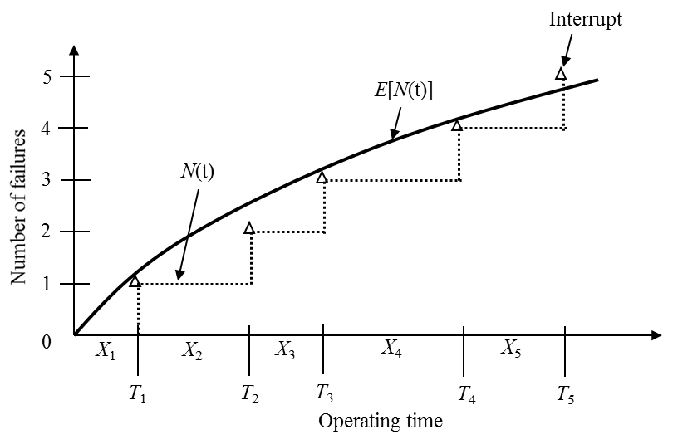
Figure 1: Geometric interpretation of interruption process of a repairable system

The intensity function can take many forms but the appropriate function is the one that corresponds to the hazard rate function of a familiar life distribution. This goes with the reason that for the time to first interrupt of a repairable system, the intensity function and the hazard rate function are identical. Thus, the intensity function can be a constant intensity, log linear intensity or a power-law intensity corresponding to an exponential hazard, Gumbel hazard and, Weibull hazard, respectively. The most commonly used model in the literature for a complex repairable system is the power-law intensity (Crow L. H., 1975; Huairui & Wenbiao, 2006) as it is flexible and can model increasing, decreasing and, constant failure rates and is given by,
(2)
for scale parameter, and shape parameter, corresponding to a Weibull hazard. It can be observed that:
- for the rate of occurrence of failures is decreasing i.e., the system is improving, exhibiting infant mortality phase of bathtub curve, and
- for the rate of occurrence of failures is increasing i.e., the system is deteriorating, exhibiting wear out phase of bathtub curve, and
- for the rate of occurrence of failures remains constant i.e., the system is in its useful phase of bathtub curve.

The power-law intensity is considered as the base model defining the failure characteristics of the four supercomputers for the remainder of this thesis. The power-law intensity function provides the base for estimating only the reliability parameters of the repairable system. A complete model that defines the repairable system should include the factor to which the system is restored, after every interrupt, which depends on the effectiveness of maintenance activities. The next three sections presents the important models that consider the system restoration factor and presents the argument on whether or not they can be considered as models for the supercomputers.

Maximal maintenance model
When a maintenance activity restores the system such that it is brought back to as good as new condition, in which it is just as it was first operated, then it is called maximal or perfect maintenance. In this case, the time duration between consecutive interrupts given by $X_{1}$, $X_{2}$, $X_{3}$,… form a sequence of random variables that can be treated as an independent and identically distributed. This is called as renewal process and the intensity function is given by
(3)
which shows that the intensity function is set to zero after every maintenance following an interrupt. Figure 2 shows the graph of intensity model for renewal process with linear baseline intensity used for illustration purpose.

The renewal process can be applied to systems where the time between interrupts can be treated as independent an identically distributed. This is only possible for components or systems that are completely replaced after a failure. Renewal process is a bad model for complex repairable systems as any maintenance will only fix a part of the system to restore it to a satisfactory performance but does not repair majority of other components. Predominant presence of aged components shows that the system is not renewed with respect to its reliability aspects. Thus, this model is ruled out for the supercomputers.

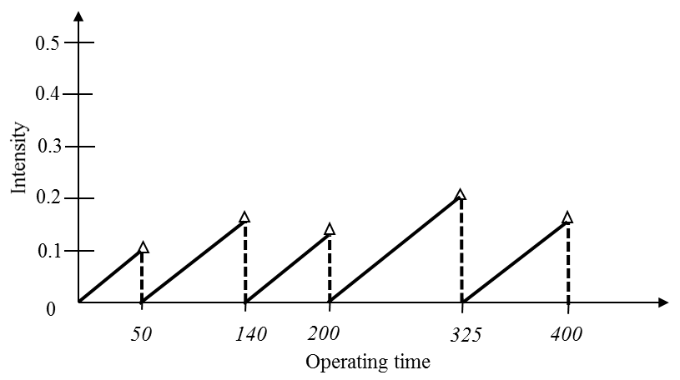
Figure 2: Maximal maintenance model

Minimal maintenance model
When a maintenance activity restores the system such that it is brought back to as good as old condition, in which it was immediately before the interrupt has occurred, then it is called minimal or perfect maintenance. In this case, the time duration between consecutive interrupts given by $X_{1}$, $X_{2}$, $X_{3}$,… form a sequence of random variables that are neither independent nor identically distributed. In this case, the appropriate model that describes the occurrence of interrupts is the Non-Homogeneous Poisson Process (NHPP) and satisfies the below conditions:
- number of interrupts at time, $t=0$ is zero,
- the increment in number of interrupts in an interval is independent of history of interrupts before the interval, and
- the number of interrupts follow a Poisson process failure pattern.

The intensity function for a repairable system under minimal maintenance is modelled by NHPP and is given by Equation (2). The likelihood function corresponding to this model is given by (Kimber, Crowder, Smith, & Sweeting, 1991)
(4)
where $Q\left(t\right)$ is the history of interrupts up to time $t$. Figure 3 shows the graph of intensity model for minimal maintenance process with linear baseline intensity used for illustration purpose.

NHPP can model the repairable systems with increasing, decreasing, and constant rate of occurrence of interrupts. If the rate of occurrence of interrupts is constant over time, i.e., constant failure intensity, it is a special case of NHPP that follows homogeneous Poisson process.

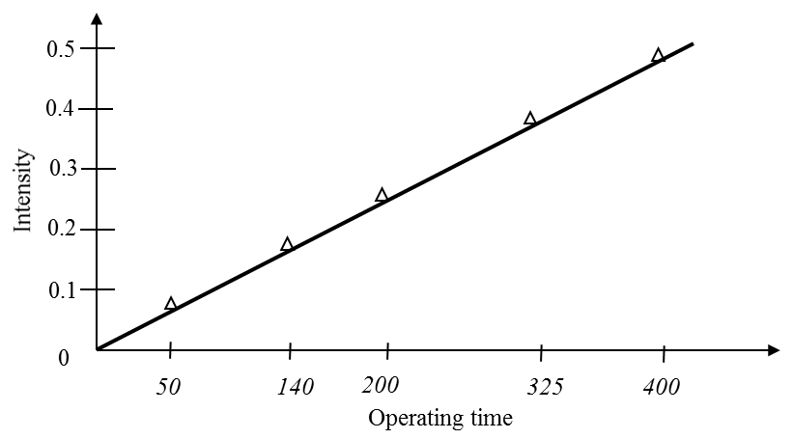
Figure 3: Minimal maintenance model

Thus, NHPP is a general case of homogeneous Poisson process (HPP) (Crow, 1975). NHPP is a poor model for systems with very few components for which the intensity function usually changes following maintenance but it can be considered for systems with large number of components. Thus, for the supercomputers this model cannot be ruled out but it has two limitations:
- it cannot model both the emergency maintenance and preventive maintenance interrupts together, and,
- it may not be a practical case always as it considers only one extreme possibility of restoration.

Partial maintenance models
Maximal maintenance and minimal maintenance models are extreme possibilities that a repairable system can be restored to. A more practical case may be that after the maintenance, the system is restored to a condition which is worse than new and better than the condition at which it was interrupted. An imperfect repair model is a model in which a maintenance renews the system with probability $p$ and has no effect with probability $\left(1-p\right)$ i.e., minimal restoration (Brown & Proschan, 1983). Even this model considers that all the maintenances are either maximal or minimal, thus creating a need for other models that can partially change the failure intensity after maintenance. The change can be increasing the failure intensity such as in case of photocopiers where the maintenance introducing defects, or, decrease the failure intensity where the maintenance has fixed the problem.

There are many models that consider the imperfect nature of the maintenance that are available in the literature. Chapter 2 makes an attempt to cover the prominent models. Age reduction model (Kijima, 1989) and proportional intensity model (PIM) (Cox, 1972; Percy, Kobbacy, & Ascher, 1998) are the most commonly used models to model a repairable system undergoing imperfect maintenances. Both these models include NHPP as the baseline model. Age reduction model modifies the intensity function considering a virtual age to which a system is reset to after maintenance. The virtual age is a fraction of the actual age whose magnitude is decided by the effectiveness of maintenance. This does not modify the baseline intensity. The PIM modifies the baseline intensity function after maintenance by a multiplicative or an additive factor which is quantified based on the effectiveness of maintenance. Multiplicative scaling of the intensity function after maintenance is a more recent proposed model and better fits the physical situation of a repairable system that is improving, deteriorating or constant with time (David F.P. & Babakalli, 2006). The limitation to all these models is that they cannot model both the emergency maintenance and preventive maintenance interrupts together, so other models are explored.

Generalized maintenance models
The maintenance records of the four supercomputers show that each of them is maintained with both emergency maintenance and preventive maintenance. In order to effectively understand the failure process of the supercomputers, the model should include the reliability parameters and maintenance parameters with the ability to accommodate both emergency and preventive maintenance. There are two such models that can be used in this situation:
- Generalized age reduction model (GARM), and,
- Generalized proportional intensity model (GPIM).
Both these models consider that the preventive maintenance is a right censored observation.

GARM is an extension of age reduction model with a provision to include a second type of maintenance, preventive maintenance, in this case. The likelihood function for this model is given by
(5)
(Arwa, Soufiane, & Mounir, 2013) where $δ_{i}=1$ for emergency maintenance and $δ_{i}=0$ for preventive maintenance and virtual age at $i$th interrupt is given by
(6)
where $a_{r}$ is the efficiency factor of emergency maintenance and $a_{p}$ is the efficiency factor of preventive maintenance. The values of $a_{r}$ and $a_{p}$ lie between zero and 1 with zero indicating a case of maximal maintenance and 1 indicating a case of minimal maintenance. GARM does not change the intensity function after a maintenance action, it only resets the system to an age lower than that at the time of interrupt. Figure 4 shows the graph of intensity for GARM with linear baseline intensity used for illustration purpose.

GARM is generally used for systems following a block replacement policy and can be a good statistical model but has a limitation that it does not provide a practical description of the failure process. Replacing a failed timing belt of a car does not reduce the age of the car as all the other components are not less likely to fail.

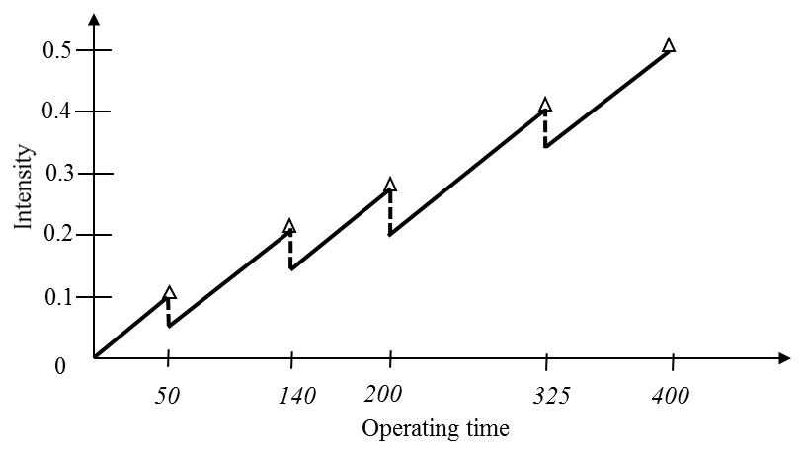
Figure 4: GARM

GPIM is an extension of PIM with the ability to include preventive maintenance. The intensity function of this model is given by
(7)
while $s_{i}>0$ and $r_{j}>0$ are the intensity scaling factors for emergency maintenance and preventive maintenance, respectively. $N(t)$ and $M(t)$ are the total number of emergency maintenance and preventive maintenance actions in the time interval $(0,t]$ (Percy & Babakalli, 2006). The scaling factors can take the form of random variables varying with interrupts or varying with operation time or simply positive constants. For the purpose of this thesis, a reasonable assumption for the analysis of the intensity function is that $s_{i}=s$ for all values of $i$ and $r_{j}=r$ for all values of $j$.
- $0<s,r<1$ , indicate that the failure intensity reduces after each maintenance action i.e., the maintenance has a positive effect on the system performance.
- $s,r=1$ , indicate that the failure intensity does not change after a maintenance action i.e., the maintenance has no effect on the system performance.
- $s,r>1$ , indicate that the failure intensity increases after each maintenance action i.e., the maintenance has a negative effect on the system performance.

The log-likelihood function for this intensity function is given by
(8)
for $=1,2,…,n$ , where $n=M\left(T\right)+N(T)$ and $c_{k}$ is the censor indicator. $c_{k}=1$ for emergency maintenance and $c_{k}=0$ for preventive maintenance. GPIM modifies the intensity function after each maintenance action. Figure 5 shows the graph of intensity for GPIM with linear baseline intensity used for illustration purpose.

GPIM is a more practical model for a repairable system as it can model systems that are improving, deteriorating, and, constant. This provides a better description of the actual physical situation of the system as after every maintenance activity, the failure intensity function is modified based on the effectiveness of the maintenance. Thus, GPIM forms the main model for the failure analysis of the four supercomputers. Chapter 3 explains the approach taken to estimate the reliability and maintainability parameters using the GPIM and presents the results for the four supercomputers.

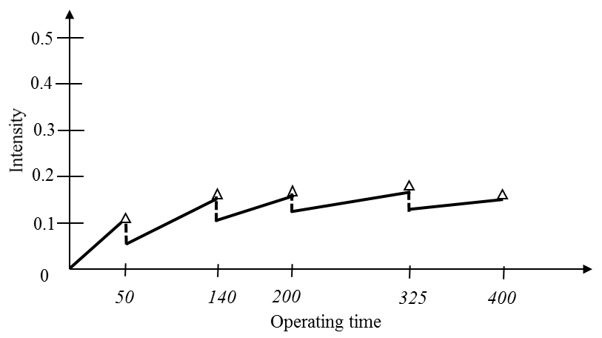
Figure 5: GPIM

Repair time analysis
The maintenance records are used to calculate the repair time required for maintenance. Repair time of maintenance does not depend on the repair time of any of the previous maintenance. It also does not depend on the time of interrupt or for that matter any of the previous history of the system. Thus for the purpose of this thesis, it can be assumed that the repair times are random variables that are independent and identically distributed. Thus, the best way to model them is to fit probability life distribution.

Six probability distribution models that are most commonly used in reliability analysis, exponential, logistic, log-logistic, lognormal, normal, and, Weibull distributions are considered to model the repair times of each supercomputer. The best model is selected based on the Akaike information criterion (AICc) and Bayesian information criterion (BIC) measures. The parameters of the selected models are estimated using maximum likelihood estimate (MLE) method. The basic statistics such as mean, 95% confidence interval of mean, median and variance for repair times are presented for each supercomputer.

Purpose of the Thesis
Dependability of a supercomputer is a function of its reliability, availability and maintainability. The purpose of this thesis is to analyze the maintenance records of the four supercomputers, Athena, Jaguar, Jaguar PF, and Kraken.

The real time maintenance data of the four supercomputers is used to obtain the below outcomes, for each of it.
- Fit the statistical model that defines the process of occurrence of maintenance interrupts
- Estimate the reliability and maintainability parameters
- Model the repair time to fit life probability distributions
- Calculate the system performance measures, reliability, and availability
- Comment on the existing maintenance policy and propose an improved maintenance policy

Organization of the Thesis
The remainder of the thesis is organized as follows. Chapter 2 presents the literature review on the basic reliability and availability models and those related to the reliability of high performance computing. Chapter 3 presents GPIM and the approach followed to obtain the reliability and maintainability parameters of each supercomputer, along with the results for each supercomputer. Chapter 4 presents the minimal maintenance model and the approach followed to obtain the reliability parameters, along with the results for each supercomputer. Chapter 5 presents the repair time analysis and the basic statistics of the repair times of each supercomputer. The analysis is conducted for the repair times of only the emergency maintenance, only the preventive maintenance, and both emergency and preventive maintenances. Chapter 6 presents the system performance measures for each supercomputer along with comments on existing maintenance policy and proposes a new maintenance policy. Chapter 7 summarizes the work done in this thesis and discusses future scope.

Literature review
This chapter is divided into three sections. Section 2.1 focuses on the literature review of failure analysis methods for repairable systems, in the context of this thesis. Section 2.2 focuses on the literature review of failure analysis done on high performance computing systems. Section 2.3 explains how the work done in this thesis is different from the other publications.

Failure Analysis of Repairable Systems
Given that supercomputers are computing systems with the highest capability that can handle the computational needs in a period of time, their history probably goes back to the development of computers. The evolutions of supercomputers propelled by the discoveries made in materials and manufacturing over the past 40 years is noteworthy and they have seen a 10-fold increase in the performance, every 4 years. This has come with changes in architecture, software, applications, etc., the latest being massive parallel processing and cluster systems that integrate large number of components (Riganati, 1984; Scheneck, 1990; Xie, Fang, Hu, & Wu, 2010; Yang, Liao, & Song, 2011). The failures on any component in hardware, software, input/output systems and interconnect can cease supercomputers normal functioning, requiring repairs to get it back to normal operational mode. This makes supercomputer a complex repairable system.

To model component reliability, one needs to fit proper probability distribution to the time between failures and repair times. Fitting probability distributions requires selecting a probability model that best fits the failure data of the system, from a list of models that are generally used in reliability analysis (Barlow & Proschan, 1975; ReliaSoft). Proper model selection criteria should be used to select the best model and needs a good understanding on various facets of multi-model selection (Akaike, 1974; Schwarz, 1978; Burnham & Anderson, 2004; Quesenberry & Kent, 1982; Ye, Meyer, & Neuman, 2008). Once the probable model is selected, it is required to estimate the parameters of the model that fit the data (Basu, 1964; Scholz, 2004). This approach is most appropriate to model a component that is replaced after failure. It can be considered for a renewal system, a system with very few components where failure of component causes system failure and replacement of failed component resets the system to as good as new condition.

Literature on repairable systems is primarily focused on modeling failure times using counting theory or point process theory. The time to failure of a repairable system are modelled by a process rather than a distribution (ReliaSoft). Duane model is the earliest developed and it accounts for the changes in failure rates over the system life (Duane, 1964). A model that is often considered to be more accurate for a specific test phase is AMSAA model (Crow L. H., 1984). Later, this area has seen lot of work and the various other models have been proposed. The summary of about fifteen distinct growth models is provided in The Military Handbook: Reliability Growth Management (Department of Defense, 1981). NHPP modelled by power law process is the most popular process that is used to obtain the failure intensity function of repairable systems as this process can model both varying and constant failure intensity (ReliaSoft; Park & Pickering, 1997). Reliability trend tests are used to statistically verify if the failure intensity is changing over time, if so increasing or decreasing (Coit, 2005; Kvaloy & Lindqvist, 1998).

The renewal process is a maximal repair process where the system is restored to as good as new condition after every repair action. The NHPP model is a minimal repair process and is applicable to systems that are restored to as good as old condition after every repair, i.e., to the condition the system was just before the failure. Though these two models are mathematically attractive, they only model two extremes possibilities of a system. A more practical situation is where the system is restored to a point between these two extremes and is called as imperfect repair. Brown and Proschan (Brown & Proschan, 1983) developed a model that considers that a repair can restore the system to a renewed state with probability $p$, while having $(1-p)$ probability of having no effect on failure intensity. This is one of the earliest approaches to consider imperfect repair. Chan and Shaw (Chan & Shaw, 1993) model, quasi renewal model (Jack, 1998) are also on the similar lines. However, these models still consider the system restoration at two extreme possibilities, so other models are required to consider a situation wherein the failure intensity is reduced partially following a repair.

The most commonly used models in literature that consider imperfect maintenance with change in intensity function of system after a repair are the age reduction model and proportional intensity model (PIM). The age reduction Kijima Type I and Type II models are proposed by Kijima (Kijima, 1989) and consider the effect of ith maintenance in reduction of virtual age just before the moment of failure, and the effect of ith maintenance in reducing the global virtual age of system, respectively. PIM is based on proportional hazard model proposed by Cox (Cox, 1972; Percy, Kobbacy, & Ascher, 1998) and uses a multiplicative scaling of failure intensity function after each repair. Doyen and Gaudoin (Doyen & Gaudoin, 2004) proposed models with failure intensity improvement factor after each repair and is based on two approaches, arithmetic reduction and geometric reduction. However, all these models do not have the capacity to accommodate both emergency and preventive maintenance together.

To the best of our search, we could only find two models, GARM and GPIM that can consider the reliability and maintainability parameters with the possibility of modelling both the emergency and preventive maintenance together. These models are introduced during the past five years and indicate the increase in awareness of inclusion of preventive maintenance in the maintenance protocol of industries. GARM (Arwa, Soufiane, & Mounir, 2013) is an extension of the age reduction model and GPIM (Percy & Babakalli, 2006) is an extension of the PIM model. Though GARM is a good statistical model and fits the maintenance data well, it is more of a theoretical model than a model that considers the true nature of the repairable system. GPIM provides more a practical physical model and a higher potential for maintenance decision making than GARM and has the possibility to accommodate future extensions to this study, such as including predictor variables and covariates. GPIM is finding an increased attention in the literature and has been applied to maintenance modelling in oil and gas industry (David & Babakalli, 2007) , gas turbines (Babakalli, 2012) and power transmission sector (Amin, Mahmood, & Mohsen, 2014).
GPIM has been used as the primary model in this thesis.

Failure Analysis on High Performance Computing Systems
The body of literature shows work done on failure analysis of high performance computing systems operational in laboratory and commercial setups. This work varies depending on the type of data collected and the focus of study. These studies categorize the causes as environmental, human related, interconnect, software and hardware.

Some studies focus on the cause of failure and present the basic statistical data. Tandem supercomputer is studied over a period of 3 years and the basic statistical data comparison based on the failure causes shows that the reliability of the hardware component of the system is improved by proper maintenance plan (Gray, 1990). The failure data analysis of a network system, Windows NT machines focusing on characterizing machine reboot causes is studied. The observations show that most of the reboots are caused by software and that rebooting does not solve the problem and add to the machine downtime (Kalyanakrishnam, Kalbarczyk, & Iyer, 1999). There are some publications that focus on understanding the correlation of failures with other factors. Failure analysis of a large scale server environment holding up to 400 servers show that system errors and failure patterns exhibit time varying behavior with periodic patterns. Failure rates have shown a strong correlation with workload and the hours of operation in a day. (Sahoo, Squillante, Sivasubramaniam, & Zhang, 2004).

Some studies focused on the distributions of time between failures and rate of failure. It is shown that Weibull distribution and exponential distributions are a good fit for the time to failures. Failure analysis on internet services as a collection of interconnected computers shows that time between failures is modelled by a Weibull distribution with shaper parameter less than 1, showing a decreasing failure rate (Heath, 2002). 23000 failures records of about 20 different large clusters are studied to understand the statistics of failure root causes and fit distributions to time between failures and repairs. Weibull distribution with shape parameters ranging from 0.7 to 0.8 are fitted for time between failures and lognormal distributions are fitted for repair times. It is reported that the failures show decreasing hazard rate and repair times vary a lot across different clusters (Schroeder & Gibson, 2010).

Three publications showed work done on understanding the availability of cluster computing. DEC VAX cluster multicomputer system failure analysis focuses on correlation between errors and the data analyzed shows that about 40% of failures occurs in bursts. It models the availability of system based on K out of n systems approach (Tang, Iyer, & Subramani, 1990). Individual server failures are studied to understand failure propagation between servers of Networked Windows NT system and are based on the field data of 503 servers in a production environment. It was observed that software and hardware failures are the major contributors and the average availability of individual server is over 99% (Xu, Kalbarcyzyk, & Iyer, 1999). Real time event logs from a 512 node clusters in Lawrence Livermore National Laboratory have been studied and a single framework that coordinates event monitoring, filtering, data analysis and dynamic availability modeling is presented based on functionality (Song, Chokchai, Nassar, Gottumukkala, & Scott, 2006).

To the best of our search, we did not find any work done on analyzing the maintenance records with both emergency and preventive maintenance, considering their effectiveness in restoring the system. Also, GPIM has not been used in modelling high performance computing systems.

Uniqueness of this Thesis
To the best of my knowledge, an exhaustive literature search on modelling maintenance records of supercomputers and high performance computing have shown that this thesis is different from others publications in below ways:
- It considers real time maintenance records of supercomputers in a laboratory environment, spanning over a period of one year.
- It presents the analysis on four supercomputers, rather than a single system analysis done in most other publications.
- It models the maintenance records using GPIM that provides insights into the system reliability and effectiveness of maintenance actions, both emergency and preventive.
- It estimates the supercomputer system performance measures, reliability and availability and uses them to comment on the effectiveness of the existing maintenance policy and proposes an improved maintenance policy.

General proportional intensity model
This chapter fits the GPIM to the maintenance records of the four supercomputers. Section 3.1 presents the analysis approach followed to estimate the reliability and maintainability parameters of GPIM. Section 3.2 presents the parameters of GPIM and comments on the system performance and effectiveness of maintenance actions for each supercomputer. Section 3.3 summarizes the observations to be carried further from this chapter.

Analysis Approach
GPIM is used to fit the maintenance records for each of the four supercomputers, namely, Athena, Jaguar, Jaguar-PF and Kraken. MLE method is used to estimate the reliability and maintainability parameters of the model. The next two sections elaborate on the MLE method and, the MATLAB $fmincon$ function used to estimate the parameters.

MLE
Once a particular model is specified with its parameters is chosen to fit an observed set of data, the next step is to estimate the parameters that best fits the data. This procedure is called parameter estimation. The two general methods used for parameter estimation are least-square estimation and MLE. The latter is the most common method used for wide range of applications. MLE of a parameter is that value of the unknown parameter that results in the highest probability of obtaining the observed data.

Let ${ X}_{1}$, $X_{2}$, $X_{3}$, …, $X_{n}$ be a random sample obtained from a distribution that depends on one or more unknown parameters${ θ}_{1}$, $θ_{2}$, $θ_{3}$, …, $θ_{m}$ with a probability density function $f({x_{i} ;θ}_{1}, θ_{2}, θ_{3}, …, θ_{m} )$ then the joint probability density function of ${ X}_{1}$, $X_{2}$, $X_{3}$, …, $X_{n}$ is called the likelihood function and is given by
(9)
This is read as likelihood of parameter(s) of a model is equal to the likelihood or probability of observing the given data as a function of parameter(s). The MLE of parameter(s) is the value(s) of parameter(s) that maximize the likelihood function.
If the $X_{i}$ are independent and identically distributed, the likelihood function simplifies to
(10)
Maximizing the product can get quite tedious and hence we often maximize the log likelihood which is an equivalent of likelihood due to the fact that logarithm is an increasing function. The log likelihood function is given by
(11)

MATLAB – fmincon
GPIM can get complex, especially if it is used to fit about 50 to 100 maintenance records. Thus, MATLAB is used to find these parameters that optimize the likelihood function of GPIM. MATLAB is a short form of matrix laboratory which is an interactive numerical computing environment using fourth-generation programming language. It is developed by MathWorks and allows various matrix computations, plotting of functions, algorithm implementation and can interface with programs written in different languages.

$fmincon$ is a predefined function in the optimization toolbox of MATLAB and minimizes a nonlinear function of several variables and finds the parameters at the minimum point. It takes into consideration the constraints on the variables or parameters and is generally called constrained nonlinear optimization. It optimizes based on the four optimization algorithms, trust-region-reflective algorithm, active set algorithm, interior-point algorithm, and sequential quadratic programming algorithm. To find a minimum of a constrained nonlinear multivariable function $f\left(x\right)=0$, subjected to $c\left(x\right)≤0$, $ceq\left(x\right)=0$, $A.x≤b$, $Aeq.x=beq$ and $lb≤x≤ub$ where $x$, $b$, $beq$,$lb$ and $ub$ are vectors, $A$ and $Aeq$ are matrices, $c\left(x\right)$ and $ceq(x)$ are functions that return vectors, and $f(x)$ is a function that returns a scalar, the syntax to be used in MATLAB is
$$[x, fval]=fmincon(fun, x0, A, b, Aeq, beq, lb, ub)$$
This starts at $x0$ and finds a minimum $x$ of the function with the given constraints and calculates$fval$, the value of function at$x$. In order to use $fmincon$ to find the MLE, the negative of the log-likelihood function is used.

GPIM Parameters
Section 1.4.5 defines the GPIM and this model is used to estimate and understand the reliability and maintainability characteristics of the four supercomputers. Equation (8) presents the likelihood function of GPIM, from which the log-likelihood function is given as
(12)
There are four unknown parameters in this equation,$λ$, $β$, $s$and, $r$ . $λ$ and $β$ provides the information on reliability of the system. $s$and $r$ provides the information on maintenance effectiveness of emergency maintenance and preventive maintenance, respectively. MATLAB $fmincon$ function is used to estimate the MLEs of the four unknown parameters for each of the four supercomputers and Table 2 presents the results. The optimization is performed at multiple initial points to make sure to capture the global maximum.

Table 2: GPIM model parameter estimates
Supercomputer | $$\hat{λ}$$ | $$\hat{β}$$ | $$\hat{s}$$ | $$\hat{r}$$ | log likelihood
Athena | 0.0026 | 1.0415 | 0.9467 | 1.6231 | -228.0823
Jaguar | 0.035 | 0.75 | 1.0882 | 0.8097 | -356.336
Jaguar PF | 0.0025 | 1.2063 | 1.0134 | 0.9965 | -686.8591
Kraken | 0.0048 | 1.0814 | 1.0251 | 0.9585 | -333.3181

The rest of this section presents the observations on reliability and maintenance parameters based on the results shown in Table 2.

Athena
The GPIM model fitted to the maintenance records of Athena show that:
- $\hat{β}\sim 1$ means that Athena has a constant failure intensity and is stationary i.e., the maintenance records follow HPP.
- $\hat{s}<1$ and $\hat{r}>1$ shows that each emergency maintenance slightly decreases the failure intensity function and each preventive maintenance action prominently increases the failures intensity function.
- The stationary behavior exhibited by Athena may be attributed to the reason that failure intensity is kept balanced by the decrease after emergency maintenance and increase after preventive maintenance. Though the scaling factor of preventive maintenance is prominently higher, the balance of failure intensity function might be attributed to the fact that only one-third of the total maintenance actions are preventive maintenance.
- There is a high possibility that Athena by nature is an improving system but the negative impact created by the preventive maintenance action may be keeping it stationary. More analysis should be done to confirm this.

Figure 6 shows the change in failure intensity with respect to time for Athena, as modelled by GPIM. It can be seen that the failure intensity between two interrupts is almost constant with a change in magnitude at after every interrupt indicating the effectiveness of maintenance action. We can see steep increase in failure intensity after every preventive maintenance action representing its scaling factor of 1.6231. Figure 7 shows a closer view of the failure intensity function variation with time for the first 10 interrupts. Preventive maintenance has been performed at system operating time (in hours) of 471, 1109, 2093 and one can see steep rise in failure intensity at these points. Emergency maintenance has been performed at 626, 632, 771, 881, 1329, 2093, 2226 and 2617 and one can see that the change in failure intensity is almost negligible representing the scaling factor of 0.9467.

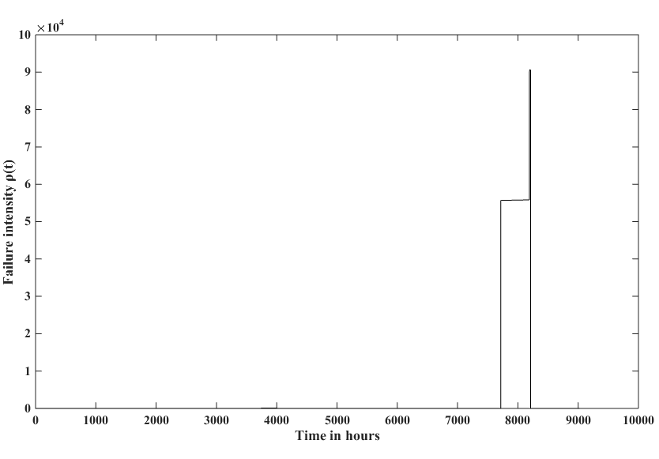
Figure 6: Athena failure intensity vs time – GPIM

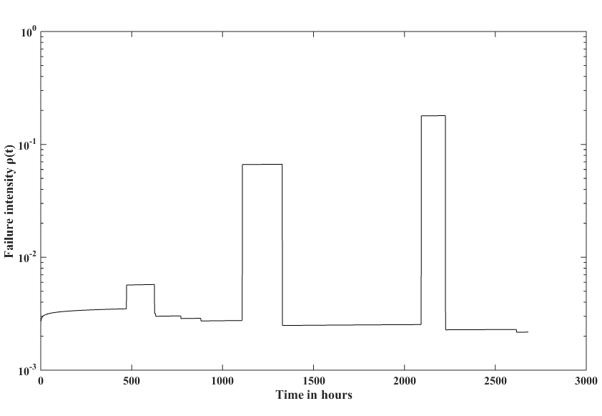
Figure 7: Athena failure intensity vs time for first 10 interrupts in log-scale – GPIM

Jaguar
The GPIM model fitted to the maintenance records of Jaguar show that:
- $\hat{β}<1$ shows that the failure intensity of Jaguar is decreasing i.e., its performance is improving as the time progresses.
- $\hat{s}\sim 1$ and $\hat{r}<1$ shows that emergency maintenance does not change the failure intensity function and each preventive maintenance action decreases the failures intensity function.
- The improving nature of Jaguar may be because of the positive effect of preventive maintenance and may not be the inherent nature of Jaguar. Preventive maintenance actions accounting to about one-third of the total maintenance actions may also support this fact.

Figure 8 shows the change in failure intensity with respect to time for Jaguar, as modelled by GPIM. Figure 9 shows a closer view of the failure intensity function variation with time for the first 10 interrupts. Preventive maintenance has been performed at system operating time (in hours) of 34, 152, 191, and 680 and one can see steep fall in failure intensity at these points and is representative of the preventive maintenance scaling factor of 0.8097. Emergency maintenance has been performed at 170, 173, 390, 411, 577, and 732, one can see that the change in failure intensity is almost negligible representing the scaling factor of 1.0882.

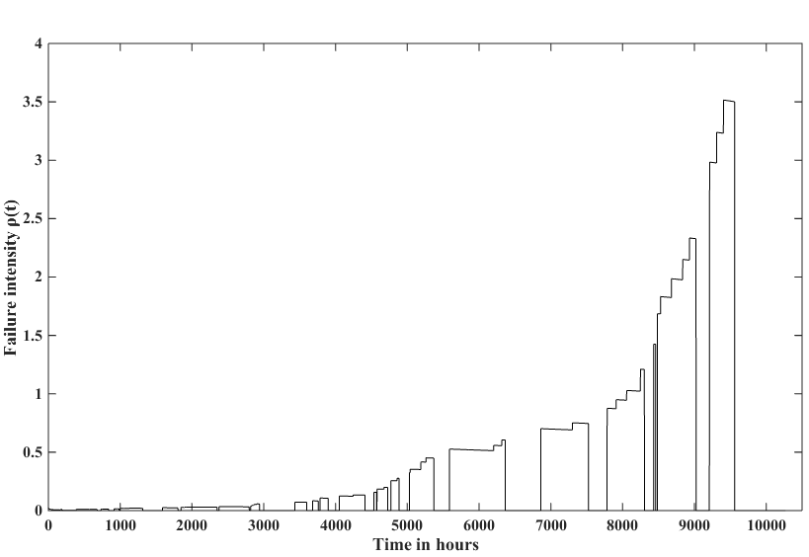
Figure 8: Jaguar failure intensity vs time – GPIM

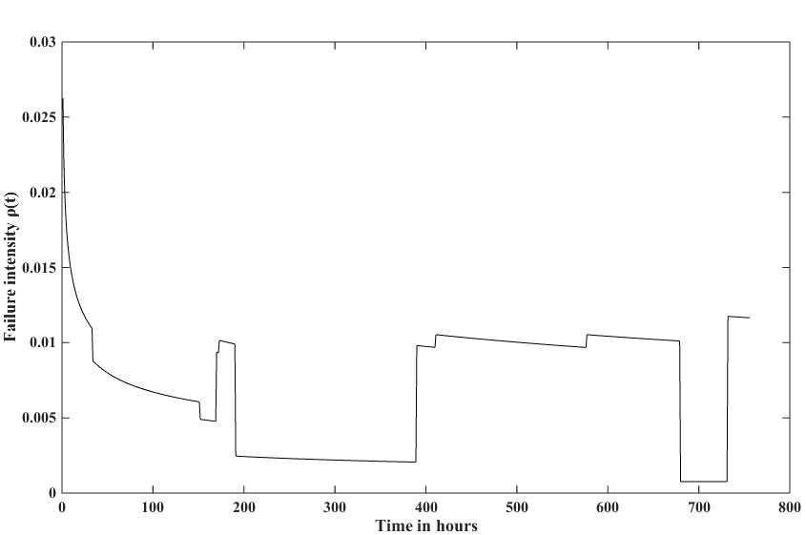
Figure 9: Jaguar failure intensity vs time for first 10 interrupts – GPIM

Jaguar PF
The GPIM model fitted to the maintenance records of Jaguar PF show that:
- $\hat{β}>1$ shows that the failure intensity of Jaguar PF is increasing i.e., its performance is deteriorating as the time progresses.
- $\hat{s}\sim 1$ and $\hat{r}\sim 1$ shows that both emergency maintenance and preventive maintenance does not change the failure intensity function. Thus, Jaguar PF can be treated to be under minimal maintenance.
- Since the maintenance action does not affect the intensity function, Jaguar PF may be deteriorating by its own nature, i.e., it may be in its wear out phase.

Figure 10 shows the change in failure intensity with respect to time for Jaguar PF, as modelled by GPIM.

Kraken
The GPIM model fitted to maintenance records of Jaguar PF show that:
- $\hat{β}\sim 1$ means that Kraken has a constant failure intensity and is stationary i.e., the maintenance records follow HPP.
- $\hat{s}\sim 1$ and $\hat{r}\sim 1$ shows that both emergency maintenance and preventive maintenance does not change the failure intensity function. Thus, Kraken can be treated to be under minimal maintenance.
- Since the maintenance action does not affect the intensity function, Kraken may be exhibiting a stationary behavior by its own nature, i.e., it may be in its useful life phase.

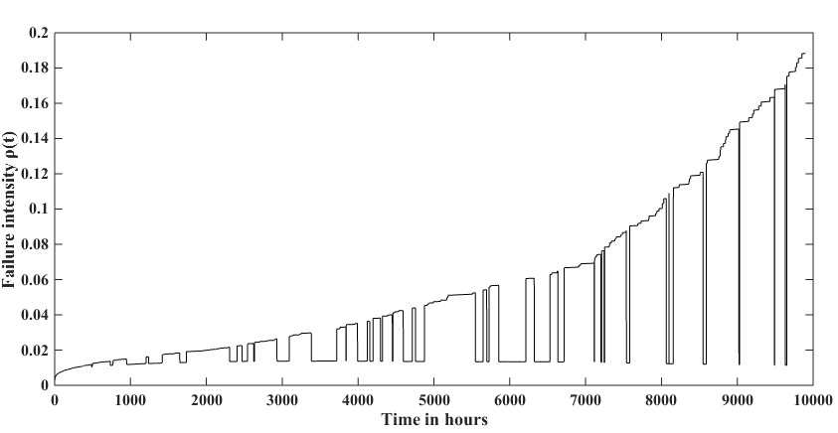
Figure 10: Jaguar PF failure intensity vs time - GPIM

Figure 11 shows the change in failure intensity with respect to time for Kraken, as modelled by GPIM. The failure intensity remains flat between the interrupts.

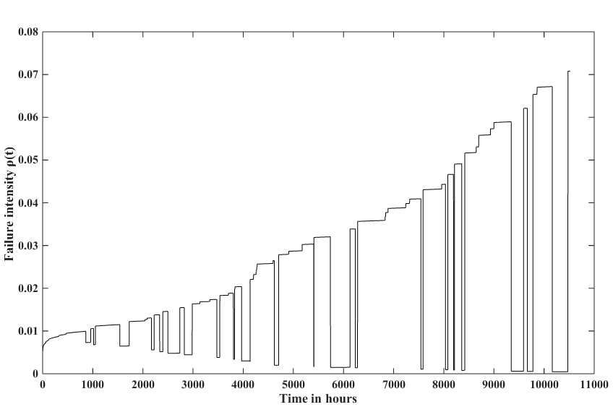
Figure 11: Kraken failure intensity vs time - GPIM

Summary
Of all the four supercomputers, only Jaguar exhibits an improving behavior but that can be due to the positive effect of preventive maintenance on it. Performance of Jaguar PF is the worst compared to the other three supercomputers. Kraken seems to be the best of all the four supercomputers though Athena has the potential to perform higher than Kraken if the preventive maintenance does not negatively influence it. The preventive maintenance has varied effects on each of the four supercomputers showing that the same maintenance policy for all the supercomputers is not an effective solution or that the maintenance policy for each computer is different.

The change in failure intensity is marginal after each emergency maintenance and preventive maintenance for all the four supercomputers, except for the preventive maintenance of Athena where it shows a noticeable increase. Thus, except for the preventive maintenance case of Athena, the four supercomputers can be assumed to be operating under minimal maintenance condition for all practical purposes. GPIM provides a more realistic model with failure intensity being a continuous function of time when considered between two interrupts and varies with the occurrence of interrupts. It can provide more accurate point estimates of reliability and availability of the system. With minimal maintenance model, the failure intensity is a continuous function of time throughout the systems life and can be useful in estimating reliability and availability of the system over a period of time. Therefore, given the results of GPIM, considering that all the four supercomputers are following a minimal maintenance policy for both emergency maintenance and preventive maintenance will provide an advantage of a simple statistical model that can be used to estimate the reliability, availability and maintainability characteristics.

Minimal maintenance model
This chapter fits the minimal maintenance model to the maintenance records of the four supercomputers. Section 4.1 presents the analysis approach followed to estimate the reliability parameters of NHPP. It also presents the statistical test to test the presence of trend in the occurrence of interrupts. Section 4.2 presents the parameters of NHPP and comments on the system performance for each supercomputer. Section 4.3 summarizes the observations to be carried further from this chapter.

Analysis Approach
A repairable system under minimal maintenance is modelled by a NHPP model. Section 1.4.3 presents the NHPP model. Maintenance records of the four supercomputers, Athena, Jaguar, Jaguar PF, and Kraken are fitted by NHPP model in three different ways as listed below:
- Considering only the emergency maintenance interrupts with emergency maintenance restoring the system to as good as old condition.
- Considering only the preventive maintenance interrupts with preventive maintenance restoring the system to as good as old condition.
- Considering both the emergency maintenance interrupts and preventive maintenance interrupts together with each maintenance action, emergency or preventive restoring the system to as good as old condition. Thus, from a statistical point of view, to fit the model, both emergency and preventive maintenance are treated as similar maintenance actions.
This approach of fitting the model in three different ways gives flexibility in forecasting the reliability and availability of the supercomputers based on any change in the proposed maintenance strategy as presented in Chapter 6.

The MLE method is used to estimate the parameters of the NHPP model that fits the maintenance records of the four supercomputers. Section 3.1.1 presents the details of MLE method. JMP Pro software is used to estimate the MLE of the NHPP parameters for each supercomputer. JMP is a statistical discovery software and is developed by SAS institute. Its interactive and visual paradigm provides a platform for powerful statistical analysis.

Trend test
A time trend test is usually performed on the time between interrupts of a repairable system to see if there is a trend. A trend can be decreasing, indicating that the system is improving or increasing, indicating that the system is deteriorating. If there is no trend then the system is stationary and the process becomes HPP, a special case of NHPP. Laplace trend test is the hypothesis test that detects the presence of trend. In this context, it is important to define $Type I$ and $Type II$ censoring with regard to a repairable system. If the data recording is event terminated then the system is said to be $Type II$ censored and the observation ends when the last interrupt is recorded. If the data recording is terminated based on a predetermined time, the system is said to be $Type I$ censored. The maintenance records of the four supercomputers are terminated by an interrupt, so all the supercomputers are considered to be $Type II$ censored.

The hypothesis of the Laplace trend test is given as:
Null hypothesis: the system does not exhibit time trend i.e. system is stationary; HPP
Alternate hypothesis: the system exhibits a time trend, either decreasing or increasing; NHPP

The Laplace test statistic is given by
(13)
where, $n$ is the number of interrupts and $t_{i}$ is the system operating time at $i$th interrupt.
The null hypothesis is rejected if $U$ is out of the range $[z_{\frac{alpha}{2}}, z_{1-\frac{alpha}{2}}]$, where $z$ represents the values at specified $alpha$ taken from standard normal distribution table. $alpha$ is the significance level and is related to confidence limit of the test by the equation, $alpha=1-(confidence limit/100)$. At 5% level of significance, $alpha=0.05$ and ${[z}_{0.025},z_{0.975}]=[-1.96,1.96]$ and at 1% level of significance, $alpha=0.01$ and ${[z}_{0.005},z_{0.995}]=[-2.58,2.58]$.

At a stage where the null hypothesis is rejected, it is of interest to know if the system is showing an increasing trend or a decreasing trend which is decided based on:
- $U<0$ means a decreasing trend, i.e., the interrupts are becoming less likely and the interval between interrupts are getting larger. System is improving.
- $U>0$ means an increasing trend, i.e., the interrupts are becoming more likely and the interval between interrupts are getting smaller. System is deteriorating.

NHPP Parameters
Section 1.4.3 presents the NHPP model and Equation (2) gives the failure intensity function. This is used to estimate the reliability parameters of the four supercomputers based on their maintenance records. Equation (4) presents the likelihood function of the failure intensity and the log-likelihood function is given by
(14)
$T$ is the time until which the system is observed. Each of the four supercomputer maintenance records show that the observations are event ended i.e., the observation is terminated at a particular interrupt and not terminated at a predefined time point. Thus, all the four supercomputers are considered to be $Type II$ and $T$ for each system is its operating time at the last interrupt.

JMP Pro software is used to estimate the MLE of the NHPP parameters that fit the maintenance records of each of the four supercomputers. JMP Pro employs MLE of $λ$ and $β$ proposed Larry (Crow L. H., 1975) for $Type II$ type of data and are given by
(15)
and MLE of $λ$ is given by
(16)
Table 3 shows the MLEs and trend test results of each supercomputer with maintenance records considered as described in Section 4.1.

Table 3: NHPP model parameter estimates and trend test results
 | Maintenance |  |  | 5% significance | 1% significance
Athena | Emergency | 0.0014 | 1.11 | Stationary | Stationary
Athena | Preventive | 0.0046 | 0.79 | Stationary | Stationary
Athena | Together | 0.0035 | 1.0301 | Stationary | Stationary
Jaguar | Emergency | 0.0169 | 0.88 | Stationary | Stationary
Jaguar | Preventive | 0.0486 | 0.7 | Stationary | Improving
Jaguar | Together | 0.0536 | 0.8096 | Stationary | Improving
Jaguar PF | Emergency | 0.0027 | 1.17 | Deteriorating | Deteriorating
Jaguar PF | Preventive | 0.0010 | 1.15 | Stationary | Stationary
Jaguar PF | Together | 0.0039 | 1.1646 | Stationary | Deteriorating
Kraken | Emergency | 0.0066 | 0.97 | Stationary | Stationary
Kraken | Preventive | 0.0007 | 1.12 | Stationary | Stationary
Kraken | Together | 0.0071 | 1.0129 | Stationary | Stationary

It can be observed that the MLE estimates of parameters of NHPP model for all the four supercomputer considering both the emergency and preventive maintenance actions together are comparable with the MLE estimates of reliability parameters of GPIM. At 1% level of significance, the trend test shows that Athena is stationary, Jaguar is improving, Jaguar PF is deteriorating, and Kraken is stationary considering both the emergency and preventive maintenance actions together. This is similar to the reliability performance of each supercomputer shown when maintenance records are fitted by GPIM.

NHPP model presents a representation of the inherent nature of the system as this model does not consider the effect of maintenance actions on the system performance. Figure 12 - Figure 15 show the variation of intensity function with time for Athena, Jaguar, Jaguar PF and Kraken, respectively.

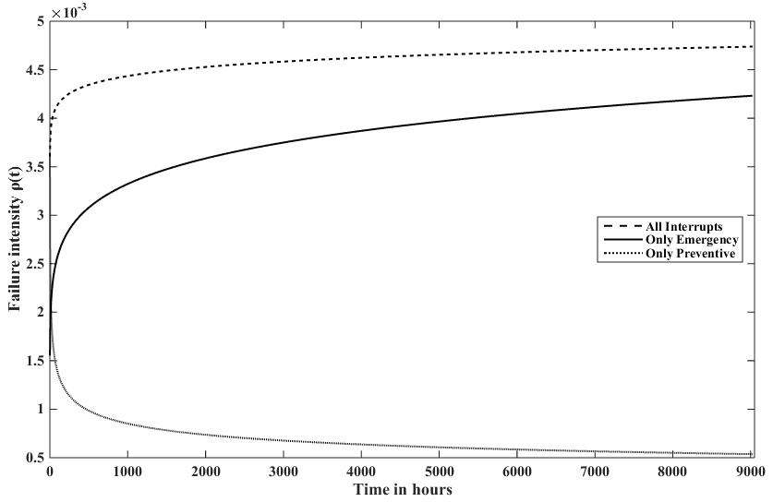
Figure 12: Athena failure intensity vs time – NHPP

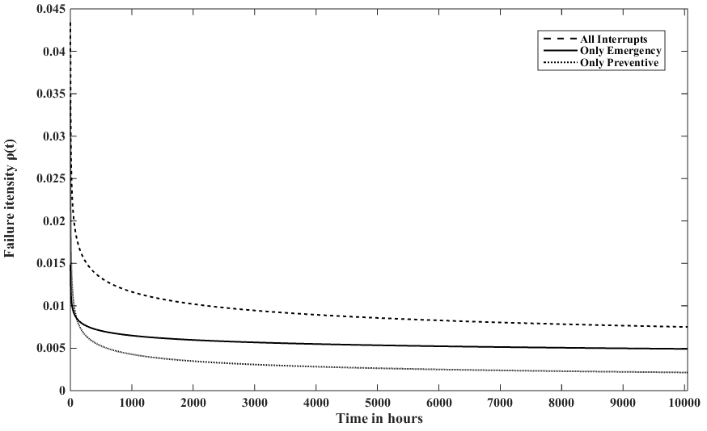
Figure 13: Jaguar failure intensity vs time - NHPP

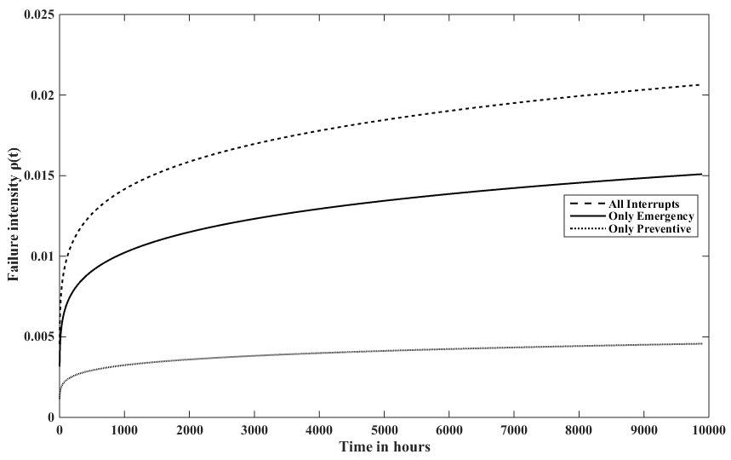
Figure 14: Jaguar PF failure intensity vs time - NHPP

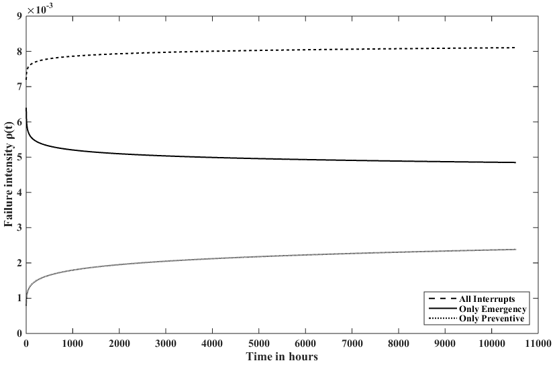
Figure 15: Kraken failure intensity vs time – NHPP

Each graph contains the failure intensity modelled by NHPP considering only emergency maintenance, only preventive maintenance, and both emergency and preventive maintenance together. It can be seen that Athena and Kraken exhibit stationary behavior with failure intensity remaining almost constant over the observed time period. Jaguar exhibits improving system performance i.e., decreasing failure intensity with increase in time. Jaguar PF exhibits deteriorating system performance i.e., increasing failure intensity with increase in time.

Summary
The reliability parameters and the system performance modelled by NHPP and GPIM are similar for each of the four supercomputers. Thus for the purpose of estimating the system performance measures, reliability, availability, and maintainability, NHPP model can be used to get a closer approximation. This helps in avoiding cumbersome calculations that are required with GPIM model as it considers that the failure intensity changes after every maintenance action. It is established that Athena and Kraken are stationary systems while Jaguar is an improving system and Jaguar PF is a deteriorating system (though the rate of improvement and deterioration are very low, respectively) as long as the systems performance is not altered by the maintenance actions.

Repair times analysis
This chapter focuses on the analysis of repair times of the four supercomputers. Section 5.1 describes the analysis approach followed in this chapter followed by Section 5.2 providing the criteria for selection of a model from the probability models. Sections 5.3 presents the probability models considered. Sections 5.4 - 5.6 analyze the repair times of emergency maintenance, preventive maintenance, and both emergency and preventive maintenance together, respectively, for the four supercomputers. Section 5.7 summarizes the results obtained in this chapter and presents the observations.

Analysis Approach
Emergency maintenance is a repair done when a system fails to function normally, it involves diagnosing the problem and then fixing it. The repair time can vary a lot depending on the inventory required to tackle the problem at hand. Preventive maintenance is a pre scheduled maintenance activity with a fixed protocol and most often than not, the inventory required is procured before starting the maintenance. In this case, there is a high possibility that the variation of maintenance time is low. Therefore, it is always better to model the repair times of emergency and preventive maintenance separately. JMP Pro software is used to model the probability life distributions of the repair times for each supercomputer.

Model Selection Measures
This section elaborates the measures used for selecting the best probability distribution that fits the repair times, among the six common distributions considered, exponential, logistic, log-logistic, lognormal, normal, and, Weibull distributions. Traditionally, log-likelihood values are calculated for all the distributions considered and the one with highest log-likelihood value is chosen to be the best distribution fitting that fits the data. But, this method has a limitation in that the log-likelihood can be increased by adding parameters to a model i.e., a model with higher number of parameters always has a higher log-likelihood value. Higher number of parameters in a model may lead to over fitting which is not always good. There should be a proper balance between fitting the best model and while avoiding the over fitting.

In order to address the limitation of the log-likelihood measure in selecting the best model among the considered models, AICc (Akaike, 1974) and BIC (Schwarz, 1978) measures are introduced by Akaike Hirotugu and Gideon Schwarz, respectively. Both these measures are based on the log-likelihood value and are in the form $2[-loglikelihood+Kp]$ , where $K$is the number of parameters in the model and $p$ is [$n/(n-K-1)]$ for AICc and $\ln{n}$ for BIC, $n$ being the sample size. AICc is a measure of relative distance between the unknown true likelihood function of the data and the fitted likelihood function of the model and a model with lower AICc is closer to the truth. BIC is a measure of the posterior probability of a model being true under a certain Bayesian setup and a model with lower BIC is more liker to be the true model.

BIC penalizes a complex model more heavily than AICc and the only way they may disagree is when BIC chooses a smaller model (model with lesser number of parameters) than AICc. AICc always tends to choose a bigger model (model with higher number of parameters), regardless of sample size whereas BIC has very little chance of choosing a bigger model if sample size is just sufficient to fit a model otherwise it usually tends to select a smaller model. AICc is a better measure in situations where a false negative selection would be more misleading than a false positive and BIC is a better measure otherwise (Burnham & Anderson, 2004).

Without loss of generality $-2loglikelihood$ is used instead of $loglikelihood$ whenever it is used against AICc and BIC to maintain the same sign and make it comparable to AICc and BIC in terms of magnitude.

Tested Distributions
Six probability distributions which are widely used to model the reliability data are tested for their fitness to the repair time data of each supercomputer. The six probability distributions are: exponential, logistic, log-logistic, lognormal, normal, and, Weibull distributions. It is observed from our results in this chapter that lognormal and Weibull distributions always fit the repair time data better than other four distributions. Therefore, the rest of this section introduces the lognormal and Weibull distributions.

Let $T$ be a continuous random variable representing the time to repair with a probability density function of $h(t)$ then the cumulative distribution function, $H(t)$ is the probability that the repair time is less than time$t$ . Let $MTTR$ and $t_{med}$denote the mean and median of the repair times.

Weibull distribution
The cumulative density function, $H(t)$ for Weibull distribution with scale parameter, and shape parameter, is give as:
(17)
The mean, median, standard deviation of time to repair times defined by the Weibull distribution are given by,
(18)
(19)
(20)

Lognormal distribution
The cumulative density function of failure, $H\left(t\right)$for lognormal distribution with location parameter, and shape parameter, is given by:
(21)
(22)
Where represent the cumulative density function of a normal distribution. The mean, median, standard deviation of time to repair times defined by the lognormal distribution are given by
(23)
(24)
(25)

Once the mean and standard deviation are calculated, the 95% confidence interval ${CI}_{0.95}$ (this is equivalent to 5% $alpha$) for the mean if given by
(26)
where, $z_{\frac{alpha}{2}}$ is the value corresponding to $\frac{alpha}{2}$ in the standard normal distribution table and $n$ is the number of sample size.

Emergency Maintenance
This section shows the analysis done on the repair time distributions of the emergency maintenance activities. For each data set of a supercomputer, the six probability distributions (in Section 5.3) are tested and compared by three measures$-2loglikelihood$, AICc and BIC (in Section 5.2). Sections 5.4.1 - 5.4.4 presents the results for the four supercomputers, Athena, Jaguar, Jaguar-PF, and Kraken, respectively and Section 5.7 summarizes the results.

Athena
For Athena, there are 36 emergency maintenance actions. The$-2loglikelihood$, AICc and BIC values for the six tested distributions are calculated. Table 4 shows the results for Athena. Lognormal distribution best fits the emergency maintenance repair times of Athena with the smallest$-2loglikelihood$, AICc and BIC values. The fitted lognormal distribution with = 0.46 and =1.19, is given by:
(27)
The estimate of mean repair time is 3.20 hours, standard deviation is 5.60 and the median is 1.58 hours. This shows that the repair time distribution is heavily skewed towards positive side. The 95% confidence interval of the estimated mean repair time is (1.61, 6.84). On an average, it will take 3.20 hours to perform an emergency maintenance on Athena and there is a huge variation in the repair times.

Table 4: Distributions of emergency maintenance repair times for Athena
Distribution | (-2Loglikelihod) | AICc | BIC
Lognormal | 143.37 | 147.75 | 150.48
Loglogistic | 145.67 | 150.05 | 152.78
Exponential | 150.59 | 152.71 | 154.15
Weibull | 149.02 | 153.39 | 156.13
Logistic | 189.05 | 193.42 | 196.16
Normal | 198.73 | 203.10 | 205.84

Jaguar
For Jaguar, there are 58 emergency maintenance actions. The$-2loglikelihood$, AICc and BIC values for the six tested distributions are calculated. Table 5 shows the results for Jaguar. Lognormal distribution best fits the emergency maintenance repair times of Jaguar with the smallest$-2loglikelihood$, AICc and BIC values.

Table 5: Distributions of emergency maintenance repair times for Jaguar
Distribution | (-2Loglikelihod) | AICc | BIC
Lognormal | 231.25 | 235.48 | 239.22
Loglogistic | 232.53 | 236.77 | 240.51
Weibull | 237.46 | 241.69 | 245.43
Exponential | 250.89 | 252.97 | 254.88
Logistic | 250.71 | 254.94 | 258.69
Normal | 264.03 | 268.26 | 272.00

The fitted lognormal distribution with = 1.14 and =0.76, is given by
(28)
The estimate of mean repair time is 4.17 hours, standard deviation is 3.69 and the median is 3.12 hours. On an average, it takes 4.17 hours to perform an emergency maintenance on Jaguar. The 95% confidence interval of the estimated mean repair time is (2.90, 5.02).

Jaguar PF
For Jaguar PF, there are 133 emergency maintenance actions. The$-2loglikelihood$, AICc and BIC values for the six tested distributions are calculated. Table 6 shows the results for Jaguar PF. Lognormal distribution best fits the emergency maintenance repair times of Jaguar PF with the smallest$-2loglikelihood$, AICc and BIC values. The fitted lognormal distribution with = 1.12 and =0.58, is given by

(29)

Table 6: Distributions of emergency maintenance repair times for Jaguar PF
Distribution | (-2Loglikelihod) | AICc | BIC
Lognormal | 491.15 | 495.25 | 500.86
Loglogistic | 492.89 | 496.99 | 502.60
Weibull | 522.02 | 526.12 | 531.73
Logistic | 543.45 | 547.55 | 553.15
Normal | 568.53 | 572.63 | 578.23
Exponential | 578.62 | 580.65 | 583.47

The estimate of mean repair time is 3.62 hours, standard deviation is 2.29 and the median is 3.06 hours. Thus, it will take 3.62 hours on an average to perform an emergency maintenance on Jaguar-PF. The 95% confidence interval of the estimated mean repair time is (3.25, 4.04).

Kraken
For Kraken, there are 133 emergency maintenance actions. The$-2loglikelihood$, AICc and BIC values for the six tested distributions are calculated. Table 7 shows the results for Kraken. Lognormal distribution best fits the emergency maintenance repair times of Kraken with the smallest$-2loglikelihood$, AICc and BIC values.
The fitted lognormal distribution with = 0.52 and =0.96, is given by
(30)
The estimate of mean repair time is 2.67 hours, standard deviation is 3.29 and the median is 1.68 hours. One an average, it takes 2.67 hours on an average to perform an emergency maintenance on Kraken but there is a huge variation in the repair times. The 95% confidence interval of the estimated mean repair time is (1.76, 4.19).

Table 7: Distributions of emergency maintenance repair times for Kraken
Distribution | (-2Loglikelihod) | AICc | BIC
Lognormal | 201.29 | 205.53 | 209.24
Loglogistic | 204.36 | 208.60 | 212.30
Exponential | 214.98 | 217.05 | 218.95
Weibull | 214.97 | 219.21 | 222.92
Logistic | 265.25 | 269.49 | 273.19
Normal | 271.33 | 275.57 | 279.27

Preventive Maintenance
This section shows the analysis done on the repair time distributions of the preventive maintenance activities. For each data set of a supercomputer, the six probability distributions (in Section 5.3) are tested and compared by three measures$-2loglikelihood$, AICc and BIC (in Section 5.2). Sections 5.5.1 - 5.5.4 presents the results for the four supercomputers, Athena, Jaguar, Jaguar-PF, and Kraken, respectively and Section 5.7 summarizes the results.

Athena
For Kraken, there are 12 preventive maintenance actions. The$-2loglikelihood$, AICc and BIC values for the six tested distributions are calculated. Table 7 shows the results for Kraken. Lognormal distribution best fits the preventive maintenance repair times of Kraken with the smallest$-2loglikelihood$, AICc and BIC values.

Table 8: Distributions of preventive maintenance repair times for Athena
Distribution | (-2Loglikelihod) | AICc | BIC
Lognormal | 29.19 | 34.69 | 33.99
Weibull | 30.23 | 35.73 | 35.03
Loglogistic | 30.32 | 35.82 | 35.12
Normal | 31.56 | 37.06 | 36.36
Logistic | 32.52 | 38.02 | 37.32
Exponential | 39.30 | 41.75 | 41.70

The fitted lognormal distribution with = 0.68 and =0.46, is given by
(31)
The estimate of mean repair time is 2.2 hours, standard deviation is 1.07 and the median is 1.97 hours. One an average, it takes 2.2 hours to perform a preventive maintenance activity on Athena. The 95% confidence interval of the estimated mean repair time is (1.56, 3.21).

Jaguar
For Kraken, there are 31 preventive maintenance actions. The$-2loglikelihood$, AICc and BIC values for the six tested distributions are calculated. Table 7 shows the results for Kraken. Lognormal distribution best fits the preventive maintenance repair times of Kraken with the smallest$-2loglikelihood$, AICc and BIC values. The fitted lognormal distribution with = 1.59 and =0.47, is given by
(32)
The estimate of mean repair time is 5.45 hours, standard deviation 2.69 and the median is 4.89 hours. On an average, it takes 5.45 hours to perform a preventive maintenance activity on Jaguar. The 95% confidence interval of the estimated mean repair time is (4.42, 6.83).

Table 9: Distributions of preventive maintenance repair times for Jaguar
Distribution | (-2Loglikelihod) | AICc | BIC
Lognormal | 139.06 | 143.49 | 145.93
Loglogistic | 139.90 | 144.33 | 146.77
Weibull | 143.79 | 148.22 | 150.66
Logistic | 145.38 | 149.81 | 152.25
Normal | 148.70 | 153.12 | 155.56
Exponential | 167.16 | 169.30 | 170.60

Jaguar PF
For Jaguar PF, there are 42 preventive maintenance actions. The$-2loglikelihood$, AICc and BIC values for the six tested distributions are calculated. Table 7 shows the results for Jaguar PF. Lognormal distribution best fits the preventive maintenance repair times of Jaguar PF with the smallest$-2loglikelihood$, AICc and BIC values.

Table 10: Distributions of preventive maintenance repair times for Jaguar PF
Distribution | (-2Loglikelihod) | AICc | BIC
Weibull | 260.87 | 265.18 | 268.35
Logistic | 265.19 | 269.50 | 272.67
Normal | 266.77 | 271.08 | 274.25
Lognormal | 267.01 | 271.32 | 274.49
Loglogistic | 268.55 | 272.86 | 276.02
Exponential | 279.87 | 281.97 | 283.61

The fitted Weibull distribution with = 11.6 and =1.18, is given by
(33)
The estimate of mean repair time is 10.3 hours, standard deviation is 2.4 and the median is 9.85 hours. On an average, it will take 10.3 hours to perform a preventive maintenance activity on Jaguar-PF. The 95% confidence interval of the estimated mean repair time is (8.81, 12.21).

Kraken
For Kraken, there are 23 preventive maintenance actions. The$-2loglikelihood$, AICc and BIC values for the six tested distributions are calculated. Table 7 shows the results for Kraken. Lognormal distribution best fits the preventive maintenance repair times of Kraken with the smallest$-2loglikelihood$, AICc and BIC values.
The fitted lognormal distribution with = 1.5 and =0.51, is given by
(34)

Table 11: Distributions of preventive maintenance repair times for Kraken
Distribution | (-2Loglikelihod) | AICc | BIC
Lognormal | 98.64 | 103.27 | 104.82
Loglogistic | 99.25 | 103.88 | 105.43
Weibull | 103.07 | 107.70 | 109.25
Logistic | 106.63 | 111.26 | 112.81
Normal | 108.42 | 113.05 | 114.60
Exponential | 115.98 | 118.18 | 119.07

The estimate of mean repair time is 5.11 hours, standard deviation 2.77 and the median is 4.50 hours. On an average, it will take 5.11 hours to perform a preventive maintenance activity on Kraken. The 95% confidence interval of the estimated mean repair time is (3.88, 6.89).

Emergency and Preventive Maintenance
This section shows the analysis done on the repair time distributions of the both emergency and preventive maintenance activities considered together. For each data set of a supercomputer, the six probability distributions (in Section 5.3) are tested and compared by three measures$-2loglikelihood$, AICc and BIC (in Section 5.2). Sections 5.4.1 - 5.4.4 presents the results for the four supercomputers, Athena, Jaguar, Jaguar-PF, and Kraken, respectively and Section 5.7 summarizes the results.

Athena
For Athena, there are 48 maintenance actions. The$-2loglikelihood$, AICc and BIC values for the six tested distributions are calculated. Table 4 shows the results for Athena. Lognormal distribution best fits the maintenance repair times of Athena with the smallest$-2loglikelihood$, AICc and BIC values. The fitted lognormal distribution with = 1.06 and =0.51, is given by:
(35)
The estimate of mean repair time is 2.93 hours, standard deviation is 4.24 and the median is 1.97 hours. On an average, it will take 2.93 hours to perform maintenance on Athena and there is a huge variation in the repair times.

Table 12: Distributions of all the maintenance repair times for Athena
Distribution | (-2Loglikelihod) | AICc | BIC
Lognormal | 207.92 | 212.19 | 215.62
Loglogistic | 209.01 | 213.28 | 216.71
Weibull | 216.55 | 220.82 | 224.25
Exponential | 224.40 | 226.49 | 228.25
Logistic | 287.05 | 291.32 | 294.75
Normal | 309.79 | 314.07 | 317.49

Jaguar
For Jaguar, there are 89 maintenance actions. The$-2loglikelihood$, AICc and BIC values for the six tested distributions are calculated. Table 5 shows the results for Jaguar. Weibull distribution best fits the maintenance repair times of Jaguar with the smallest$-2loglikelihood$, AICc and BIC values.

Table 13: Distributions of all the maintenance repair times for Jaguar
Distribution | (-2Loglikelihod) | AICc | BIC
Weibull | 434.39 | 438.52 | 443.37
Exponential | 440.93 | 442.97 | 445.42
Loglogistic | 441.45 | 445.59 | 450.43
Logistic | 455.17 | 459.31 | 464.14
Lognormal | 472.68 | 476.81 | 481.65
Normal | 493.93 | 498.07 | 502.91
The fitted Weibull distribution with = 4.69 and =1.24, is given by
(36)

The estimate of mean repair time is 4.69 hours and the standard deviation is 3.55. On an average, it takes 4.69 hours to perform maintenance on Jaguar.

Jaguar PF
For Jaguar PF, there are 175 maintenance actions. The$-2loglikelihood$, AICc and BIC values for the six tested distributions are calculated. Table 6 shows the results for Jaguar PF. Weibull distribution best fits the emergency maintenance repair times of Jaguar PF with the smallest$-2loglikelihood$, AICc and BIC values.
The fitted Weibull distribution with = 5.67 and =1.22, is given by
(37)

Table 14: Distributions of all the maintenance repair times for Jaguar PF
Distribution | (-2Loglikelihod) | AICc | BIC
Weibull | 869.56 | 873.63 | 879.83
Loglogistic | 894.30 | 898.37 | 904.57
Lognormal | 897.71 | 901.78 | 907.98
Exponential | 905.59 | 907.61 | 910.73
Logisitc | 985.37 | 989.44 | 995.64
Normal | 1024.61 | 1028.68 | 1034.88

The estimate of mean repair time is 5.31 hours and the standard deviation is 4.38. Thus, it will take 3.62 hours on an average to perform an emergency maintenance on Jaguar-PF.

Kraken
For Kraken, there are 76 maintenance actions. The$-2loglikelihood$, AICc and BIC values for the six tested distributions are calculated. Table 7 shows the results for Kraken. Lognormal distribution best fits the maintenance repair times of Kraken with the smallest$-2loglikelihood$, AICc and BIC values.

The fitted lognormal distribution with = 1.02 and =0.85, is given by
(38)

Table 15: Distributions of all the maintenance repair times for Kraken
Distribution | (-2Loglikelihod) | AICc | BIC
Lognormal | 347.17 | 351.33 | 355.83
Loglogistic | 352.37 | 356.53 | 361.03
Exponential | 364.28 | 366.33 | 368.61
Weibull | 363.83 | 368.00 | 372.50
Logistic | 431.11 | 435.27 | 439.77
Normal | 483.12 | 487.28 | 491.78

The estimate of mean repair time is 3.96 hours, standard deviation is 4.06 and the median is 4.5 hours. One an average, it takes 3.96 hours on an average to perform a maintenance on Kraken but there is a huge variation in the repair times.

Summary
It is observed that lognormal distribution is the best fit for the emergency maintenance repair times, for the four supercomputers. The preventive maintenance repair times of each of Athena, Jaguar and Kraken are fitted the best by lognormal distribution, whereas that of Jaguar PF is fitted by a Weibull distribution. Considering all the maintenance actions together, be it emergency or preventive, lognormal distribution is the best fit for the repair times of Athena, and Kraken and Weibull distribution is the best fit for the repair times of Jaguar, and Jaguar PF. Table 16 compares the repair time distributions and statistics of the four supercomputers.

Table 16: Maintenance (repair) time statistics
 | Emergency only |  | Preventive only |  | Emergency & Preventive
Supercomputer | Distribution |  | Distribution |  | Distribution
Athena | lognormal | 3.83 | lognormal | 2.20 | lognormal | 2.93
Jaguar | lognormal | 4.17 | lognormal | 5.45 | Weibull | 4.38
Jaguar PF | lognormal | 3.62 | Weibull | 10.3 | Weibull | 5.31
Kraken | lognormal | 2.67 | lognormal | 5.11 | lognormal | 3.96

An equivalent term for $MTTR$ when dealing with preventive maintenance is$MPMT$, mean preventive maintenance time and$MTTM$, mean time to maintenance when considering both emergency and preventive maintenance. The observations from the above tables are:
- The mean repair times of emergency maintenance for the supercomputers are comparable to each other, whereas the mean repair times for preventive maintenance are very dissimilar. This shows a possibility of different preventive maintenance protocols followed on each supercomputer.
- The variation in repair times of preventive maintenance for the supercomputers are lesser compared to the variation in repair times for emergency maintenance. This is obvious as the variation in a pre-scheduled activity will be less than the variation in an unplanned activity. The inventory requirements for the preventive maintenance would be standard and can be arranged for before the activity but in case of emergency maintenance, the inventory is comparatively unpredictable and may need time for procurement.
- The variation of emergency maintenance repair time for Athena is the highest, but the least in preventive maintenance repair times, compared to Jaguar, Jaguar-PF and Kraken. Thus for Athena, giving an estimate of repair time once a failure has occurred is challenging and is the least predictable but its repair time for a preventive maintenance is the most predictable of all the four supercomputers.
- $MPMT$ for preventive maintenance of Jaguar PF is almost twice of that of Athena or Jaguar or Kraken. More understanding on the actual activities performed during a preventive maintenance of Jaguar PF will help root-cause the reason for this and suggest an improvement plan.

System performance measures
This chapter discusses the system performance measures for the four supercomputers. Section 6.1 presents the analysis approach to calculate the reliability function and presents the results. Section 6.2 discusses the effectiveness of existing maintenance policy and proposes new maintenance policy. Section 6.3 presents the availability functions and compares the availability of each supercomputer with the existing and the proposed maintenance plans. Section 6.4 summarizes the observations made in this chapter.

Reliability
Reliability is the probability that a system or a component will function satisfactorily without failure under stated conditions for a specified amount of time period. The terms ‘satisfactory’ and ‘stated conditions’ are predefined and agreed upon by the stake holders. These can be internal or external to the system or component under consideration. Reliability of a supercomputer is the probability that the supercomputer with its hardware and software components is capable of performing its intended function under normal operating conditions over a specified period of time (Jane, 1996).

Let $f(t)$ be the probability density function of the failure distribution, $F(t)$ be the cumulative density function and $R(t)$ be the reliability function. $t$ being the time, the relation between these three functions and the failure intensity function is given by
(39)
Let $m(t_{1},t_{2})$ be the expected number of interrupts between the time interval $(t_{1},t_{2})$ and is given by
(40)
and is related to reliability function as,
(41)

Based on partial maintenance - GPIM
The failure intensity function changes after every maintenance action when it is modelled by GPIM. Thus, to understand the reliability of the system, it is important to calculate the failure intensity function of each supercomputer at the end of their last recorded maintenance. The number of maintenance records shown in Table 1 and reliability and maintainability parameters shown in Table 2 are used to come up with the failure intensity function of each supercomputer at the end of the last maintenance action. It has to be noted that the maintenance records are event terminated and thus the system operating time at the point of last interrupt is different for each supercomputer. Table 17 presents the failure intensity functions of each supercomputer at the end of the last interrupt.

Figure 16 shows the change in reliability with the increase in time. It can be clearly seen that the Jaguar is the most reliability system and Kraken, Jaguar PF, and Athena follow in decreasing order. The probability that Athena can perform a 50 hour job without interruption is almost zero, which is a very low performance for a supercomputer. This can be attributed to the fact at preventive maintenance the failure intensity function is increased by a scaling factor of 1.6231.

Table 17: Failure intensity function using GPIM
Supercomputer | $ρ(t)$ at the last interrupt
Athena | $$0.126t^{1.0415}$$
Jaguar | $$0.0051t^{0.75}$$
Jaguar PF | $$0.0153t^{1.2063}$$
Kraken | $$0.0073t^{1.0814}$$

There is only 50% probability that a 27 hour job can be completed without interruption on Jaguar PF and that a 6 hour job can be completed without interruption on Athena.

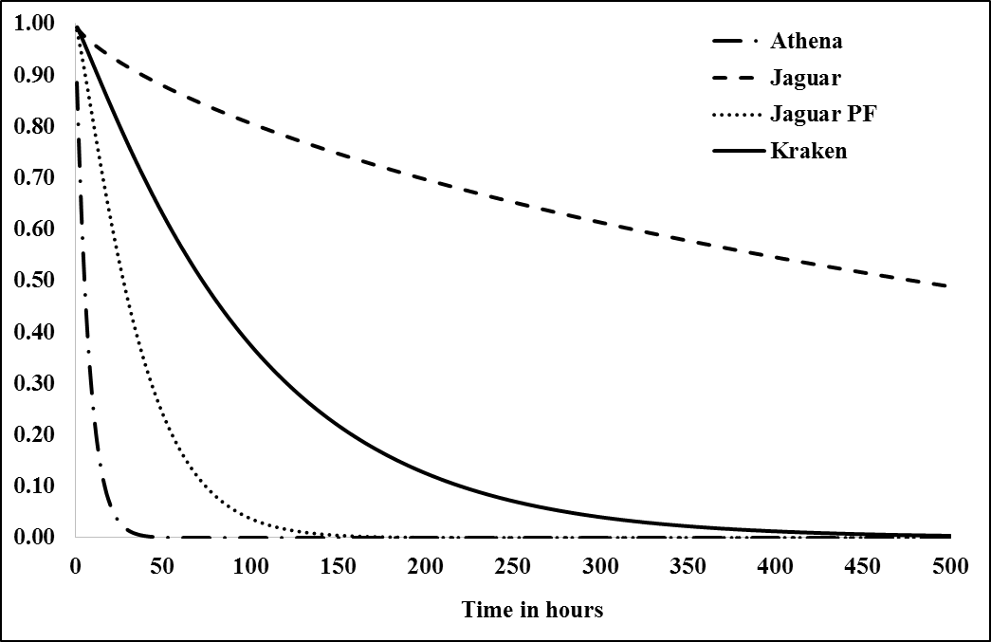
Figure 16: Reliability vs time - GPIM

Based on minimal maintenance – NHPP
The failure intensity function remains constant even after a maintenance action when the system is considered to be under minimal maintenance and is modelled by NHPP. NHPP model shows the inherent nature of the supercomputers. The NHPP parameters estimated considering both emergency and preventive maintenance together as shown in are for the intensity function in this section. This way, we can compare the reliability results of this section with that obtained using GPIM model. Table 18 presents the failure intensity functions of each supercomputer.

Figure 17 shows the change in reliability with the increase in time. It can be clearly seen that Athena is the most reliable and Jaguar the least reliable of the four supercomputers. This is in contrast with the results shown in Section 6.1.1 and can be explained by as below:
- The GPIM model shows that the performance of Athena is prominently reduced after each preventive maintenance action and thought it is not inherently a system with low performance compared to other three supercomputers. Since NHPP considers that the supercomputers are under minimal maintenance, the preventive maintenance negative effect is not considered by it. Thus, showing the inherent nature of Athena that it is more reliable than the other three supercomputers if its performance is not tampered by maintenance actions.
- The GPIM model shows that the performance of Jaguar is improved after every preventive maintenance action and though it is not inherently a system with higher performance than the other three supercomputers. Since NHPP considers that the supercomputers are under minimal maintenance, the positive effect of preventive maintenance is not considered by it. Thus, showing the inherent nature of Jaguar that it is lesser reliable than the other three supercomputers.

Table 18: Failure intensity function using NHPP
Supercomputer | $ρ(t)$
Athena | $$0.0035t^{1.0301}$$
Jaguar | $$0.0536t^{0.8096}$$
Jaguar PF | $$0.0039t^{1.1646}$$
Kraken | $$0.0071t^{1.0129}$$

The reliability performance of Kraken estimated using GPIM matches with that estimated by using NHPP model as the maintenance actions do not have any impact on its failure intensity function.

Maintainability
Entire Chapter 5 focuses on the analysis of repair times of the four supercomputers and provides insights into the maintenance in terms of the number of man hours spend for every maintenance activity. This section focuses on the quality (effectiveness) of the maintenance action along with the inherent nature of each of the four supercomputers and provides comments and suggestions on their maintenance policy. The effectiveness of the maintenance is quantified by the scaling factors of emergency and preventive maintenance actions presented in Table 2. The inherent nature of each supercomputer is represented by the reliability parameters estimated using GPIM and NHPP model, though the later model is more representative as it considers minimal maintenance, taking away the effect of maintenance actions on the system performance.

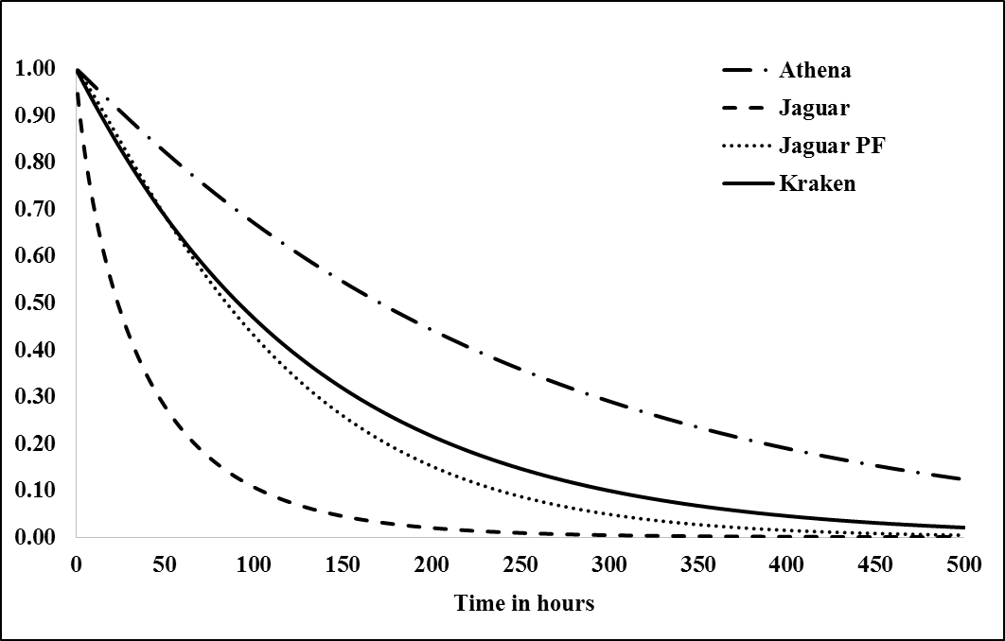
Figure 17: Reliability vs time – NHPP

Athena
Below are the comments on the existing maintenance policy of Athena.
- Athena exhibits a stationary performance and has the highest availability among the four supercomputers when modelled by NHPP. Thus Athena is inherently a stationary system.
- The failure intensity of Athena is decreased by a multiplying factor of 0.9467 after every emergency maintenance action and is increased by a multiplying factor of 1.6231 after every preventive maintenance action. Thus, the performance of Athena is marginally improved after every emergency maintenance action and prominently worsened after every preventive maintenance action. This explains why the Athena has the least reliability when modelled by GPIM as it captures the effectiveness of maintenance actions.

Below are the suggestions for the future maintenance policy of Athena.
- Maintain the existing emergency maintenance policy.
- Stop performing preventive maintenance actions as they are deteriorating systems performance.
- Root-cause the reasons for the preventive maintenance protocol not being effective and come up with improvement plans, if it is considered to perform preventive maintenance.
- Continue to monitor the system to see if the new plan improves the system performance and also watch out for the system phase transition to ‘wear out’.

Jaguar
Below are the comments on the existing maintenance policy of Jaguar.
- Jaguar exhibits an improving performance, based on its reliability parameters, when modelled by NHPP. Thus Jaguar is inherently an improving system.
- Jaguar has the least reliability among the four supercomputers, when modelled by NHPP.
- The failure intensity of Jaguar remains unchanged after every emergency maintenance action and is decreased by a multiplying factor of 0.8097 after every preventive maintenance action. Thus, the performance of Jaguar is not changed after every emergency maintenance action and is recognizably increased after every preventive maintenance action. This explains why the Jaguar has the highest reliability when modelled by GPIM as it captures the effectiveness of maintenance actions.

Below are the suggestions for the future maintenance policy of Jaguar.
- Maintain the existing emergency maintenance policy.
- Maintain the preventive maintenance protocol but perform it at regular intervals with the optimal preventive maintenance being determined to maintain the availability of the system at a desired value.
- As Jaguar is inherently improving, continue to monitor the system to check for a point where the preventive maintenance is no longer required. At that point make a decision on whether or not to continue the preventive maintenance, based on the cost it incurs on maintenance and decrease in system availability that it brings in.

Jaguar PF
Below are the comments on the existing maintenance policy of Jaguar PF.
- Jaguar PF exhibits a deteriorating performance, based on its reliability parameters, when modelled by NHPP. Thus Jaguar is inherently a deteriorating system.
- The failure intensity of Jaguar remains unchanged after each maintenance action, be it emergency or preventive maintenance.

Below are the suggestions for the future maintenance policy of Jaguar PF.
- Maintain the existing emergency maintenance policy.
- Stop performing preventive maintenance actions as the existing protocol does not help in improving the system performance.
- Root-cause the reasons for the preventive maintenance protocol not being effective and come up with improved protocol.
- As Jaguar PF is inherently deteriorating an effective preventive maintenance protocol can help to improve the systems performance. The preventive maintenance interval has to be determined considering the fact that it adds to the decrease in availability of the system.
- Continue to monitor the system. There may be a point where the rate of deterioration is so high that it is better to revamp the system than to spend huge amount of money on preventive maintenance.

Kraken
Below are the comments on the existing maintenance policy of Kraken.
- Athena exhibits a stationary performance based on its reliability parameters, when modelled by NHPP. Thus Kraken is inherently a stationary system.
- The failure intensity of Kraken is unchanged after every emergency maintenance action and is decreased by a multiplying factor of 0.9585 after every preventive maintenance action. Thus, the performance of Kraken does not change after each emergency maintenance action and is marginally improved after every preventive maintenance action.

Below are the suggestions for the future maintenance policy of Kraken.
- Maintain the existing emergency maintenance policy.
- Stop performing preventive maintenance actions as the existing protocol does not help in improving the system performance.
- Root-cause the reasons for the preventive maintenance protocol not being effective and come up with improved protocol.
- As Kraken is inherently a stationary system, there is no need for preventive maintenance. Nevertheless, evaluate if an effective preventive maintenance plan that can improve systems performance is worth, considering the additional cost and reduction in system availability it brings in.
- Continue to monitor the system to watch out for the system phase transition to ‘wear out’.

Availability
Availability is the probability that a system or component is performing its required function at a specified point of time or over a specified period of time when operated and under stated conditions. The terms ‘required function’ and ‘stated conditions’ are predefined and agreed upon by the stake holders. It is the fraction of a time period that an item is in a condition to perform its intended function upon demand (SEMI, 1986,2004).

Point availability
Point availability is the availability of the system at a specified time point, $t$. For a system which is not under maximal maintenance policy, the point availability is equivalent to the reliability of the system as whether or not the system is available at a particular time $t$ is nothing but the probability that the system is function up to and until $t$. Thus the results discussed in Section 6.1 also represent the point availability of each of the four supercomputers.

Achieved availability
Achieved availability is the average availability of the system over a period of time and it takes into emergency maintenance and preventive maintenance into account. It is the fraction of time that the supercomputer is working of the total calendar time for which the availability is calculated. The achieved availability of the system considering that the preventive maintenance is not done at regular intervals but is given by
(42)
(Availability, 2010) where $t_{n}$ is the calendar time until which the system is observed assuming that the observation of the system is started at time $0$. and are the expected number of emergency maintenance and preventive maintenance, respectively, during the interval $(0,t_{n})$.

Achieved availability is dealing with the time period $(0,t_{n})$. The failure intensity function keeps varying at each maintenance action if the maintenance records are modelled by GPIM and calculating the achieved availability becomes cumbersome with this model. Considering that the systems are under minimal maintenance policy and using NHPP model provides a closer approximation of the achieved availability. This can be even more appropriate if the results are only used to make a comparison between the four supercomputers. The MLE estimates of reliability parameters (presented in Table 3) obtained by using only the emergency maintenance for fitting the NHPP model are used to calculate and those obtained by using only the preventive maintenance are used to calculate . Results shown in Table 16 used for MTTR and for MPMT. Table 19 shows the intensity functions used for this purpose for each supercomputer.

Table 19: Failure intensity function using NHPP for and
Supercomputer | $ρ(t)$ for | $ρ(t)$ for
Athena | $$0.0014t^{1.11}$$ | $$0.0046t^{0.79}$$
Jaguar | $$0.016t^{0.88}$$ | $$0.0486t^{0.7}$$
Jaguar PF | $$0.0027t^{1.17}$$ | $$0.001t^{1.15}$$
Kraken | $$0.0066t^{0.97}$$ | $$0.00071t^{1.12}$$

Downtime per year is a frequently used availability metric. The four supercomputers run continuously throughout the year, 365 days, i.e., 8760 hours per year. Thus the downtime per year in days will be (Vargas, 2000),
(43)

Table 20 presents the approximate achieved availability and its 95% confidence limits, and downtime per year for each of the four supercomputers. These numbers quantify the availability of each supercomputer during the time period for which the maintenance records are available. It can be seen that Athena has the highest availability. Jaguar PF has the least availability and is explained by the fact that it has a 175 interrupts, much higher than the interrupts recorded on each of the other three supercomputers. Also Jaguar PF has the highest MPMT of all the four supercomputers and is equal to 10.3 hours, almost twice compared to MPMT of other three supercomputers. This means that Jaguar PF has a higher percentage of time spend on maintenance compared to that of Athena, Jaguar and Kraken.

Table 20: Achieved availability
Supercomputer | Achieved Availability  (approximate) | Lower 95% | Upper 95% | Downtime/year (days)
Athena | 0.9861 | 0.9717 | 0.9927 | 5
Jaguar | 0.9620 | 0.9538 | 0.9715 | 14
Jaguar PF | 0.9175 | 0.9064 | 0.9269 | 30
Kraken | 0.9757 | 0.9648 | 0.9827 | 9

Future availability
This section attempts to predict the availability of the four supercomputers for a future time, $t$, from the point of occurrence of the last interrupt, recorded in the available maintenance log, for each supercomputer.

Section 6.2 proposes a change in the maintenance policy considering the effectiveness of existing maintenance actions and system inherent nature for each of the four supercomputers. The proposed maintenance policy is to continue with the existing emergency maintenance plan and stop performing preventive maintenance for all the four supercomputers, except for Jaguar. For Jaguar, the existing preventive maintenance protocol has been effective in improving systems performance; hence it is proposed to continue with the existing preventive maintenance protocol but performed at regular interval that maintains the system’s availability at a desired value. Figure 18 shows the change in average availability of the system over a time period $(0,t)$ for each supercomputer and compares the results when the existing maintenance policy is followed and when a proposed maintenance policy is followed.

To calculate the availability of the existing maintenance policy, the failure intensity function modelled by GPIM, at the point of occurrence of the last interrupt of each supercomputer is considered. Table 17 presents these intensity functions. Since GPIM considers both emergency and preventive maintenance actions, the $MTTM$ values are used. The average availability in this case is given by
(44)
To calculate the availability of the proposed maintenance policy, the failure intensity function modeled by NHPP that considers only the emergency maintenance actions is used for each supercomputer. Table 19 presents these intensity functions.
(45)

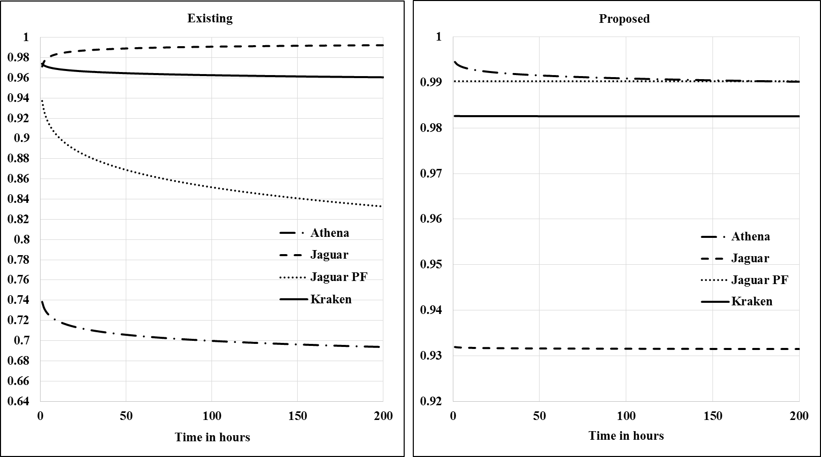
Figure 18: Availability vs time – existing maintenance and proposed maintenance

It can be seen that the availability has been increased with the proposed plan for Athena, Jaguar PF, and Kraken. Jaguar has a decrease in its availability. This can be explained by the fact that the graph shows the availability values considering no preventive maintenance, though that is not the actual proposed plan for Jaguar. With the preventive maintenance having a positive effect on the systems performance for Jaguar, the existing maintenance policy shows a higher value of availability. But, the proposed maintenance plan for Jaguar calls for a preventive maintenance at regular intervals. The interval time, $T_{PM}$ can be calculated by using,
(46)
The preventive maintenance interval to be maintained on Jaguar for it to have an average availability of 0.99 over a period of one month (using the values of $MTTR$ and $MPMT$ for Jaguar presented in Table 16) is calculated to be 220 hours i.e., about 9 days. With the existing preventive maintenance policy on Jaguar, on an average, about 4 preventive maintenance actions are performed for 9 days. The proposed plan has reduced this to a single preventive maintenance and still keeps the system availability at the desired level.

Though Jaguar PF is inherently a deteriorating system and seems to need preventive maintenance, it still shows a prominent improvement in average availability with the proposed maintenance policy which does not require any preventive maintenance. This can be explained by the fact that the rate of deterioration of Jaguar PF is very low, and the existing preventive maintenance policy has no effect on its performance and only contributes to increase in system downtime.

Summary
The reliability of the four supercomputers is compared using both GPIM and NHPP model. It is clear that the effect of maintenance actions can bring in a dramatic change in the performance of systems. Going by the inherent nature of the four supercomputers (represented by NHPP), Athena is the most reliable system. But, considering both reliability characteristics and effectiveness of maintenance action (represented by GPIM), Athena is the least reliable system.

Considering both the reliability and maintenance parameters, a change in the maintenance policy is proposed for each supercomputer. Going ahead, it is recommended to stop the preventive maintenance on Athena and, Kraken and it is recommended that preventive maintenance may be considered for Jaguar and Jaguar PF, though for separate reasons. The basic intent of the proposed maintenance policy is to improve the system availability and reduce the maintenance cost if possible. The availability of moving forward with the existing maintenance policy and proposed maintenance policy is compared for each supercomputer. Based on this comparison, it can be confirmed and suggested that the preventive maintenance is not required for Athena, Jaguar PF and, Kraken and for Jaguar, the preventive maintenance should be performed once every 9 days. With the proposed maintenance policy, the average availability of any given supercomputer is greater than or equal to 98.25% over a period of one month.

Conclusion
First, Section 7.1 summarizes the work done in this thesis along with a brief overview of the analysis approach. Section 7.2 presents the proposed maintenance policy for each of the four supercomputers. Finally, Section 7.3 discusses the scope for future study.

Summary of Thesis
The demand to analyze the maintenance records of four supercomputers, Athena, Jaguar, Jaguar PF and Kraken, collected over the period from October 2009 to December 2010 forms the motivation to this thesis. These supercomputers are located and operated at The National Institute for Computational Sciences in Oak Ridge National Lab, Tennessee, US.

Each supercomputer is a considered as a complex repairable system with the occurrence of events causing interruption to normal system operation being modelled by stochastic point process. In order to understand the system performance characteristics such as reliability, availability, and maintainability it is important to fit a mathematical/statistical model to the available maintenance record data. Different maintenance models to analyze the repairable systems available in literature are broadly classified into maximal maintenance model, minimal maintenance model, and partial maintenance model. These models are reviewed and compared. Partial maintenance model that provides the scope to include the effectiveness of maintenance actions has been considered to be more appropriate to analyze the four supercomputers.

Different approaches to model the partial maintenance models proposed in literature have been reviewed. Among these, GPIM and GARM are the appropriate models to maintenance data that contain both emergency maintenance and preventive maintenance, as is the case with the four supercomputers and allows inclusion of both reliability and maintainability parameters in a single model. Finally, GPIM is chosen to be the main model for this thesis as it provides more practical physical model and higher potential for maintenance decision making than GARM and has the possibility to accommodate future extensions to this study, such as including predictor variables and covariates.

The reliability and maintenance parameters of GPIM that fits the maintenance records are obtained based on MLE method, using MATLAB, for each supercomputer. Based on the reliability parameter estimates it has been observed that Athena and Kraken are stationary, while Jaguar is improving and Jaguar PF is deteriorating, though at a very low rate. The maintenance parameter estimates show that the emergency maintenance actions have very marginal effect on performance of the supercomputers, improving the performance of Athena and deteriorating the performance of Jaguar, Jaguar PF and Kraken. For practical purposes it can be considered that emergency maintenance does not have any effect on changing the performance of the system and they just bring them back to a point they were just before an interruption. The preventive maintenance actions have very marginally improved the performance of systems for Jaguar PF and Kraken and can be practically considered to have no effect. They have a prominent deteriorating effect on Athena and a considerable improving effect on Jaguar.

GPIM results show that except for the preventive maintenance actions on Athena and Jaguar, it can be considered that a maintenance action only restores the supercomputers to the state they were just before the interruption. Thus, minimal maintenance model where the maintenance records are modeled by NHPP is chosen as a model that can provide closer approximation to GPIM for the four supercomputers. The reliability parameter estimates of NHPP model that fit the maintenance records are estimated using MLE method for each supercomputer. These parameters closely match with those obtained using GPIM. While the occurrence of events interrupting system’s normal operation are modelled using GPIM and NHPP, the repair times are modelled by life distributions. The best life distributions fitting the repairs times, considering only the emergency repairs, only the preventive maintenance, and both emergency and preventive maintenance times are selected using AICc and BIC model selection measures. The parameters of the chosen distributions are estimated using MLE methods.

The system performance measures, reliability and availability are estimated using repair time distributions along with GPIM and NHPP. GPIM is used whenever a point estimate is calculated and NHPP is used whenever an estimate over a period of time is calculated as using GPIM which considers change in the failure intensity after every interruption can get very cumbersome. The observations that can be made based on the analysis of the maintenance records are:
- Athena and Kraken exhibit stationary performance while the performance of Jaguar is improving and that of Jaguar PF is deteriorating.
- The emergency maintenance action does not have considerable impact on the performance of the four supercomputers.
- The preventive maintenance action does not have considerable impact on the performance of Jaguar PF and Kraken while it has an improving effect on Jaguar and deteriorating effect on Athena.
- The reliability of Athena is the worst and that of Jaguar is the best, among the four supercomputers, when modelled by GPIM that considers both reliability aspect of the system and effectiveness of maintenance action. When modelled by NHPP that considers only the systems reliability aspect, Athena has the highest reliability and Jaguar has the least. This shows the importance of considering the effectiveness of maintenance while modelling the maintenance records.
- Athena has the highest availability over the observed period of time (achieved availability) while Jaguar PF has the least availability. This can be explained by the fact that Jaguar PF has the highest percentage of preventive maintenance actions and also the highest$MPMT$.
- If the existing maintenance policy is continued, Jaguar will have the highest availability over a period of the 200 hours, once the system starts working after the last interrupt has been fixed. It also shows an increase in availability with increase in time. Kraken is the next best. Availability of Jaguar and Jaguar PF will be very low and shows a decrease with increase in time.

Proposed Maintenance Policy
The supercomputers operate continuously and are only interrupted by emergency maintenance or preventive maintenance actions. The maintenance team plan is to perform preventive maintenance on each of the four supercomputers, once every two weeks. But, it is clear from the maintenance records that the preventive maintenance has not been done at regular intervals on any of the four supercomputers. It may be due to some practical difficulties and may depend on the existing work load on the supercomputers, etc. So the existing maintenance policy is the one modelled by GPIM and NHPP models based on the maintenance records. Based on the study of the existing maintenance records and understanding of the existing system performance and maintenance effectiveness, a new maintenance policy is proposed that improves the availability of the supercomputers and reduces the maintenance costs.

The proposed maintenance policy for each supercomputer is given below.
- Athena – Continue the existing emergency maintenance protocol and do not perform any preventive maintenance action. Monitor the system for a phase transition from stationary to wear out, where it may show reduction in availability.
- Jaguar – Continue the existing emergency maintenance protocol and perform preventive maintenance with the maintenance action as per the existing protocol but at regular interval, once every 9 days. Jaguar is an improving system, so monitor the system for a point where preventive maintenance is no longer needed to meet a specified system availability target.
- Jaguar PF – Continue the existing emergency maintenance protocol and do not perform any preventive maintenance action. Jaguar PF is a deteriorating system but has a low rate of deterioration. Continue to monitor the changes in the rate of deterioration that may bring down the system availability below the target.
- Kraken - Continue the existing emergency maintenance protocol and do not perform any preventive maintenance action. Monitor the system for a phase transition from stationary to wear out, where it may show reduction in availability.

Future Scope of Work
The analysis of maintenance records studied in this thesis provides good insights into the system performance and failure characteristics of the four supercomputers. Future extension of this thesis can be in the direction:
- It has to be noted that the proposed maintenance policy is based on the maintenance records available during the period from October 2009 to December 2010. The system performance characteristics might have changed since then and it is important to use the methodology followed in this thesis to model the latest maintenance records and form the base for a new maintenance policy proposal.
- It is observed there is a drastic difference in the way a preventive maintenance action affects each supercomputer. Also, there is lot of variation observed in the preventive maintenance times. This can be due to the fact that the preventive maintenance protocol is different for each supercomputer or the same preventive maintenance protocol for all the supercomputers is not an effective strategy. Root-cause analysis performed on this will lead to finding answers on how to make preventive maintenance more effective and come up with an improvement plan.
- Linking the statistical model governing the maintenance records to the inventory is one other practical use. It is required to understand the failures and their causes at a cluster or module level to explore solutions of improving supercomputer availability and suggest better ways to handle the inventory.
- Supercomputers take up huge space and have stringent cooling requirements; in this context further work can be done to understand the spatial locations of the failures to figure out any location correlations. Workload and failure correlations, failure clustering, time span of works run and failure correlations, failure statistics with respect to categories like human error, environmental effects, etc. are some important areas to consider for better understanding of failures.

Reference

(2010). In C. E. Ebeling, An Introduction to Reliability and Maintanability Engineering (2 ed., p. 443). Lon Groove, IL, USA: Waveland Press, Inc.
(2010). In C. E. Ebeling, An Introduction to Reliability and Maintainability Engineering (2 ed., pp. 283-297). Long Groove, IL, USA: Waveland Press Inc.
Akaike, H. (1974). A New Look at the Statistical Model Identification. IEEE Transactions on Automatic Control, 19.
Amin, M., Mahmood, R. H., & Mohsen, M. (2014). Failure rate modelling of electric distribution overhead lines considering preventive maintenance. IET Generation, Transmission $ Distribution, 1028-1038.
Arwa, N., Soufiane, G., & Mounir, S. (2013). Estimation of the Parameters for a Complex Repairable System with Preventive and Corrective Maintenance. Electrical Engineering and Software Applications (ICEESA) (pp. 1-6). Hammamet, Tunisia: IEEE.
Ascher, H., & Feingold, H. (1984). Repairable Systems Reliability. Modeling, Inferecnce, Misconceptions and Their Causes. New York: Dekker.
Babakalli, A. (2012). Evaluation of Generalised Proportional Intensities Models with Application to the Maintenance of Gas Turbines. Quality and Reliability Engineering International, 577-584.
Baer, T. (2010). Using Quality of Service for Scheduling on Cray XT Systems. Cray User Group.
Barlow, R. E., & Proschan, F. (1975). Statistical Theory of Reliability and Life Testing: Probability Models. Defense Technical Information Center.
Basu, A. P. (1964). Estimates of Reliability for Some Distributions Useful in Life Testing. Technometrics, 6, 215-219.
Bland, S. A., Kendall, A. R., Kothe, B. D., Rogers, H. J., & Shipman, M. G. (2009). Jaguar: The World's Most Powerful Computer. Cray User Group.
Brown, M., & Proschan, F. (1983). Imperfect Repair. Journal of Applied Probability, 851-859.
Burnham, K. P., & Anderson, D. R. (2004). Multimodel Inference: Understanding AIC and BIC in Model Selection. SOCIOLOGICAL METHODS & RESEARCH, 33, 261-304.
Chan, J., & Shaw, L. (1993). Modeling Repairable Systems with Failure Rates that Depend on Age and Maintenance. IEEE Transactions on Reliability (pp. 566-571). IEEE.
Coit, D. W. (2005). Repairable Systems Reliability Trend Tests and Evaluation. Retrieved from soe.rutgers.edu
Cox, D. (1972). The Statistical Analysis of Dependencies in Point Processes. New York: Wiley.
Crow, L. H. (1975). Reliability Analysis for Complex, Repairable Systems. Maryland: US Army Material Systems Anlaysis Activity Aberdeen Proving Ground.
Crow, L. H. (1984). Methods for Assessing Reliabilty Growth Potential. Proceedings of the Annual Reliability and Maintainability Symposium, (pp. 484-489). New York.
David F.P., D., & Babakalli, M. (2006). Generalized Proportional Intensities Models for Repairable Systems. IMA Journal of Management Mathematics, 171-185.
David, F. P., & Babakalli, M. A. (2007). Scheduling Preventive Maintenance for Oil Pumps Using Generalized Proportional Intensities Models. International Transactions in Operations Research, 547-563.
Department of Defense. (1981). Department of Defense Handbook Reliability Growth Management. Retrieved from http://web.amsaa.army.mil/
Doyen, L., & Gaudoin, O. (2004). Classes of Imperfect Repair Models Based on Reduction of Failure Intensity or Virtual Age. Reliability Engineering Systems Safety, 45-56.
Duane, J. T. (1964). Learning Curve Approach to Reliability Monitoring. IEEE Transactions of Aerospace, 563-566.
Gray, J. (1990). A Census of Tandem System Availability between 1985 and 1990. IEEE Transaction on Reliability, 409-418.
Heath, T. M. (2002). Improving cluster availability using workstation validation. AGM SIGMETRICS (pp. 217-227). New York: Association for Computing Machinery.
Huairui, G., & Wenbiao, Z. (2006). Practical Methods for Modeling Repairable Systems With Time Trends and Repair Effects. Reliability and Maintainability Symposium. Newport Beach, California, USA: IEEE.
Jack, N. (1998). Age-reduction Models for Imperfect Maintenance. IMA Journal of Mathematics Applied in Business and Industry, 347-354.
Jane, R. (1996). Standards Coordinating Committee 10 (Terms and Definitions). The IEEE Standard Dictionary of Electrical and Electronics Terms, 100-1996.
Jon, S. (2005). Defining and Measuring Supercomputer Reliability, Availability, and Serviceability. Linux Clusters Intitute Conference.
Kalyanakrishnam, Kalbarczyk, Z., & Iyer, R. (1999). Failure Data Analysis of a LAN of Windows NT Based Computers. Reliabie Distributed Systems (pp. 178-187). IEEE.
Kijima, M. (1989). Some Results of Repairable Systems with General Repair. Journal of Applied Probability, 89-102.
Kimber, A., Crowder, M., Smith, R., & Sweeting, T. (1991). Statistical Analysis of Reliability Data. London: Chapman and Hall.
Kvaloy, J. T., & Lindqvist, B. H. (1998). TTT-Bases Tests for Trend in Repariable Systems Data. Reliability Engineering and System Safety, 13-28.
Leemis, L. (1995). Reliability: Probabilistic Models and Statistical Methods. Englewood Cliffs, NJ: Prentice-Hall.
NICS. (2014, May). The National Institute of Computational Sciences. Retrieved from http://www.nics.tennessee.edu.
Park, W. J., & Pickering, E. H. (1997). Statistical Analysis of a Power-Law Model for Repair Data. IEEE Transactions on Reliability, 46.
Percy, D. F., & Babakalli, M. A. (2006). Generalized Proportional Intensities Models for Repairable Systems. IMA Journal of Management Mathematics, 171-185.
Percy, D., Kobbacy, K., & Ascher, H. (1998). Using Proportional-Intensities Models to Schedule Preventive-Maintenance Intervals. IMA Journal of Mathematics Applied in Business and Industy, 289-302.
Quesenberry, C. P., & Kent, J. (1982). Selecting among Probability Distributions Used in Reliability. Technometrics, 24, 59-65.
ReliaSoft. (n.d.). Life Data Analysis Reference. Tucson, Arizona, USA: ReliaSoft Corporation. Retrieved from http://www.ReliaSoft.com
ReliaSoft. (n.d.). Reliability Growth & Repairable System Data Analysis Reference. ReliaSoft Corporation. Retrieved from http://www.reliasoft.com
Riganati, J. P. (1984). Supercomputing. IEEE, 17(10), 97-113.
Sahoo, R. K., Squillante, M. S., Sivasubramaniam, A., & Zhang, Y. (2004). Failure Data Analysis of a Large-Scale Heterogeneous Server Environment. Dependable Systems and Networks (pp. 772-781). IEEE.
Scheneck, P. B. (1990). Supercomputers. Annual Review of Computer Sciences, 4, 13-36.
Scholz, F. W. (2004). Maximum Likelihood Estimation. In F. W. Scholz, Encyclopedia of Statistical Sciences. John Wiley & Sons, Inc.
Schroeder, B., & Gibson, G. A. (2010). A Large-scale Study of Failures in High Performance Computering Systems. Dependable and Secure Computing. IEEE.
Schwarz, G. (1978). Estimating the Dimension of a Model. The Annals of Statistics, 6, 461-464.
SEMI. (1986,2004). Semiconductor Equipment and Materials International. Specifications for Definition and Measurement of Equipment Reliability, Availability, and Maintainability. SEMI E10-0304.
Song, H., Chokchai, Nassar, R., Gottumukkala, N., & Scott, S. (2006). Availability Modeling and Analysis on High Performance Cluster Computing Systems. Availability, Reliability and Security. IEEE.
Stearley, J. (2005). Towards a Specification for Measuring Red Storm Reliability, Availability, and Serviceability (RAS).
Tang, D., Iyer, R. K., & Subramani, S. S. (1990). Failure Analysis and Modeling of a VAX Cluster System. IEEE.
Vargas, E. (2000). High Availability Fundamentals. Palo Alto: Sun Microsystems, Inc. Retrieved from http://www.sun.com/blueprints
Xie, X., Fang, X. F., Hu, S., & Wu, D. (2010). Evolution of supercomputers. Fronteriers of Computer Science, China, 4(4), 428-436.
Xu, J., Kalbarcyzyk, Z., & Iyer, R. K. (1999). Networked Windows NT System Field Failure Data Analysis. Dependable Computing 1999 Proceedings (pp. 178-185). IEEE.
Yang, X.-J., Liao, X.-K., & Song, J.-Q. (2011). The TianHEe-1A Supercomputer: Its Hardware and Software. Journal of Computer Secince and Technology, 26(3), 344-351.
Ye, M., Meyer, P. D., & Neuman, S. P. (2008). On Model Selection Criteria in Multimodel Analysis. Water Resources Research, 44.

Vita

Jagadish Cherukuri was born in India and is the elder son of Sivababu and Nagalakshmi. His entire schooling is done in Loyola Public School, India during the period 1990-2000. He completed his intermediate education in Yadava Junior College, India and then took up undergraduate studies in R.V.R & J.C College of Engineering under Acharya Nagarjuna University in Mechanical Engineering. He graduated in 2007 with a distinction.

Jagadish took up a role as product engineer and worked for about 5 years and 6 months in an engineering service providing company, Tech Mahindra (formerly Mahindra Satyam – Satyam Computer Services Ltd.). He worked for multiple clients to provide mechanical engineering services and his major area of work is product engineering for an appliance manufacturer. He later decided to complement his work experience with an academic degree and moved to USA in 2013 to pursue Master of Science in Reliability and Maintainability engineering in The University of Tennessee, Knoxville. He choose to graduate from the Industrial and System engineering department of the university and accepted graduate teaching assistantship for the academic year 2013-14.

